The Origins of Early Maladaptive Schemas: A Systematic Review of the Empirical Evidence

Abstract
Objectives: The effectiveness of Young’s Schema Therapy in ameliorating symptoms of enduring psychopathology and the proposed taxonomy of Early Maladaptive Schemas (EMS) are increasingly supported in the empirical literature. EMS are thought to result from adverse experiences and unmet core emotional needs in childhood. However, it is stated by major contributors to the Schema Therapy model that the theory of EMS development remains largely conceptual (Young, Klosko, & Weishaar, 2003; Lobbestael & Arntz, 2005; Rafaeli, Bernstein, & Young, 2011). The aim of the present systematic review is to identify and critically appraise the empirical evidence relating to Young’s (1994; 2003) conceptual theory of EMS development. Clinical, theoretical and research implications are explored.
Method: A systematic electronic search of relevant databases was undertaken using key search terms, and exclusion and inclusion criteria were applied. Qualifying studies underwent quality assessments based upon the Critical Appraisal Skills Programme (CASP) checklists.
Results: Fourteen papers met the final inclusion criteria. All were observational studies (twelve cross sectional and two longitudinal cohort studies) that focused on EMS and their relationship with a wide range of clinical presentations. Papers included in the final review were grouped into themes of EMS and their association with childhood experiences of sexual abuse, abuse and neglect, attachment relationships, experiences of being parented and ‘other factors’.
Conclusions: This review highlights a gap between Young’s widely accepted conceptual theory of EMS development and the evidence base. The quality of research identified by the review was poor to adequate, with many studies describing themselves as ‘small scale pilot studies’. Recommendations are made to improve the quality of future research in this area.
Young’s conceptual theory of schema development is somewhat supported, in that all studies included in the present review report significantly increased frequency and severity of EMS in a wide range of clinical populations that have also experienced adverse childhood experiences. Insufficient evidence was identified to consistently support or refute fine-grained models linking severity or subtype of childhood adversity to any individual or patterns of EMS.
This review concludes that the apparent relevance of EMS to a wide range of psychopathologies and forms of childhood adversity provides a rationale to continue developing and expanding research into their development.
Practitioner points:
- Schema theory may contribute to the understanding of mental health presentations of clients with a history of adverse childhood experiences.
- Findings are based largely on small, homogeneous sample groups and studies that require methodological refinement.
- Further research is required to elucidate further understanding of the association between childhood adversity and EMS development.

Introduction

Schema Therapy (ST) is gaining prominence in elucidating understanding of enduring adult psychopathologies and is evidencing a significant reduction in enduring mental health disorders that had been previously viewed as intractable (e.g. Giesen-Bloo et al., 2006; Young, Klosko, & Weishaar, 2003; Rafaeli, Bernstein, & Young, 2011). Core to ST is the concept of Early Maladaptive Schemas (EMS). EMS are thought to result from adverse experiences and unmet core emotional needs in childhood. However, it is stated by major contributors to the ST model that the theory of EMS development remains largely conceptual (Young et al., 2003; Rafaeli, et al., 2011). The aim of the present review is to identify and critically appraise the empirical evidence for EMS development.
To orientate the reader, this review will be structured in the following way: Firstly, there will be an introduction to EMS and the theory of EMS development. There then follows a rationale for the present review and a description of the review methodology. The main body of the review provides an appraisal of the empirical evidence for Young’s hypothesised associations between adverse childhood experiences and EMS development. Finally, methodological, theoretical and clinical implications of the review findings are discussed and recommendations made for future research.

Defining Early Maladaptive Schemas
Schemas or ‘internal working models’ are cognitive shortcuts that prevent a person from having to consciously process the minutiae of every experience. They are thought to be automatic, unconditional, self-perpetuating and highly resistant to change (Young, 1999). Functioning outside of a person’s conscious awareness, schemas provide comfort and familiarity, and incoming information is distorted in order to maintain cognitive consistency (Rafaeli at al., 2011). EMS are defined as:
“Broad, pervasive themes or patterns comprised of memories, emotions, cognitions and bodily sensations regarding oneself and one’s relationship with others. Developed during childhood or adolescence, [they are] elaborated throughout one’s lifetime, and [are] dysfunctional to a significant degree”.
Young, Klosko, and Weishaar (2003, p.7)

Young et al. (2003) state that EMS are present for everyone to differing degrees and there is empirical evidence of their presence and stability in children as young as nine (e.g. Stallard & Rayner, 2005; Rijkebor & Gerly, 2010). However, EMS are thought to manifest in more rigid and extreme ways in cases of psychopathology. EMS severity is considered to be on a spectrum according to the interaction between innate (e.g. temperament) and early environmental factors. It is conceptualised that the more ‘toxic’ or extreme the experiences of childhood adversity, the more severe the EMS developed, the more easily they are activated and the more intense their consequences (Rafaeli et al., 2011).

Empirical Evidence for EMS
Over the past two decades there has been increasing empirical support for the presence and varying strength of EMS in both clinical and non-clinical adult populations (e.g. Arntz & Bögels, 2000; Giesen-Bloo et al., 2006; Oei & Barnoff, 2007). The psychometric properties of Young’s Schema Questionnaires are well supported in the literature (e.g. Schmidt, Joiner, Young, & Telch, 1995; Lee, Taylor, & Dunn, 1999). This research is providing an increasing body of evidence for Young’s proposed taxonomy of 15 EMS, with factor analysis consistently demonstrating (e.g. Stopa, Waters, & Preston, 2001; Waller, Meyer, & Ohanion, 2001) that EMS group together to form five broad schema domains (see table 1).
There are currently no published EMS norms, although these are stated to be under development (Young, 2011). Clinically, scoring of Young’s
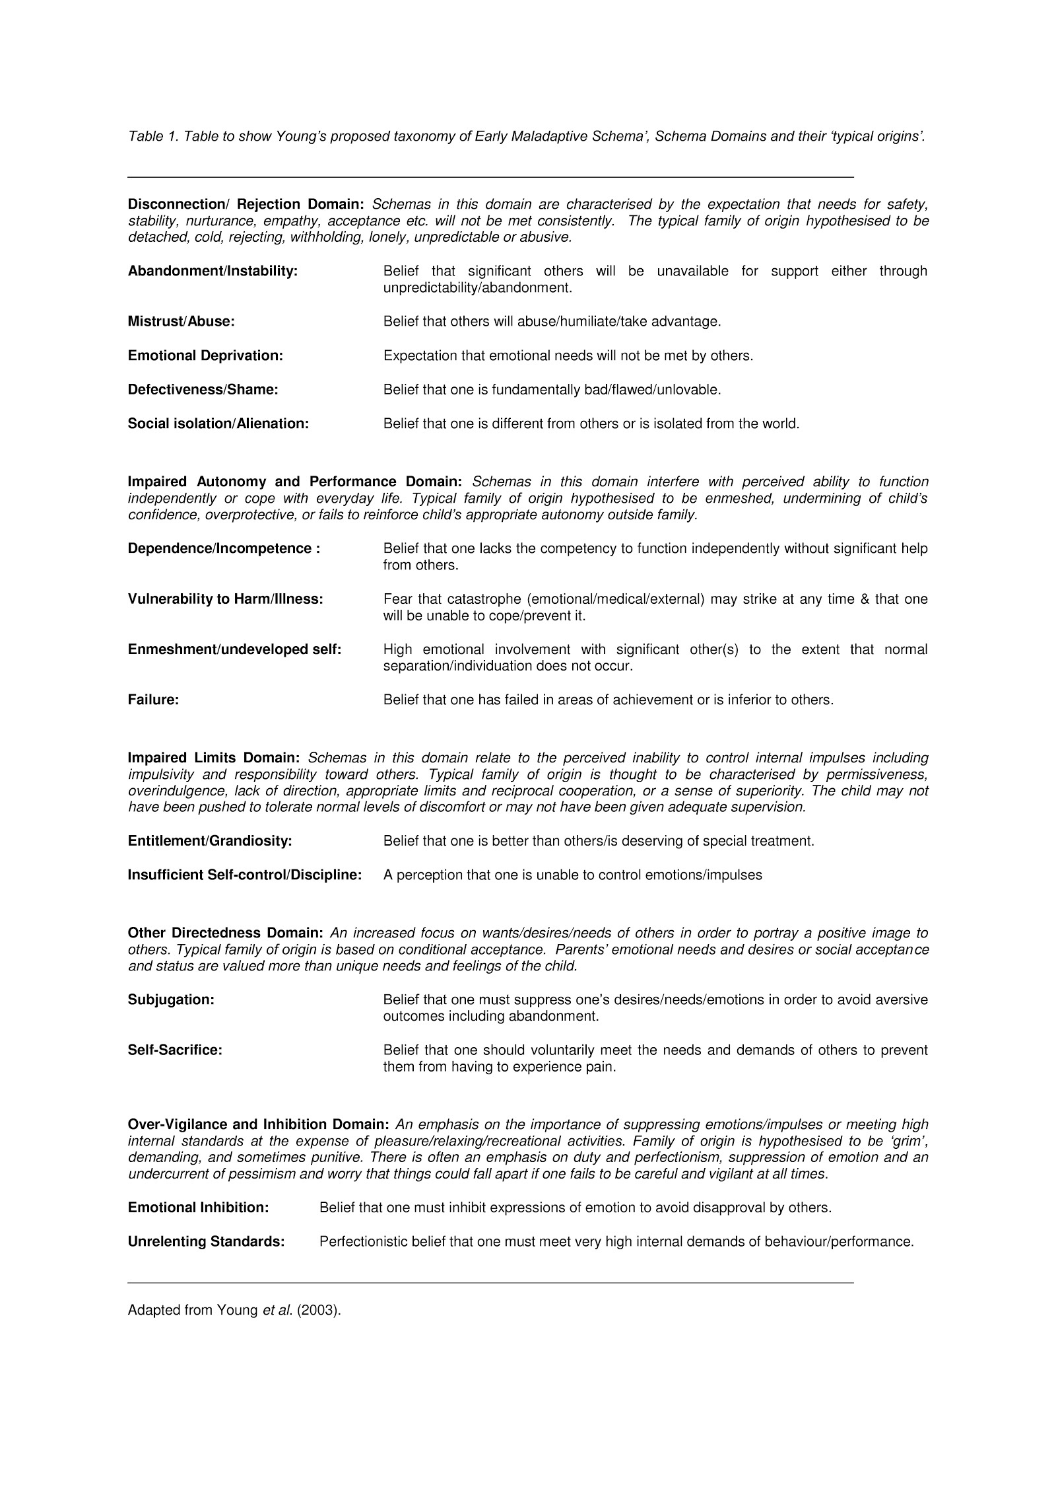
schema questionnaires is advised by identifying patterns of ‘clinically elevated’ EMS scores (EMS scores ≥4) on a 6-point Likert scale. In research, EMS scores are more typically averaged for subgroups of participants to enable between-group comparison and average scores ≥3 for any individual EMS are considered to be clinically relevant (Rafaeli et al., 2011).
Whilst EMS are evidenced to group together into domains and to distinguish clinical from non-clinical populations, Young et al. (2003) do not propose a content- specificity hypothesis linking particular EMS to particular life events or psychopathological diagnoses. Rather, they emphasise the importance of individual case conceptualisation based upon a detailed history taking and each individual’s schema profile (as measured using one of Young’s schema questionnaires).

The Theory of EMS Development
ST is an integrative approach, incorporating elements of cognitive behaviour therapy, interpersonal, experiential and psychodynamic approaches with attachment and child development theories (Rafaeli, Bernstein, & Young, 2011). Drawing on this evidence, Young et al. (2003) propose a number of universal core emotional needs that underpin psychological wellbeing. These include the need for secure attachment to others (including safety, stability, nurturance, and acceptance); autonomy, competence, and cohesive sense of identity; freedom to express needs and emotions; spontaneity and play; and a world with realistic limits that fosters self-control. When individuals are successful in getting these needs met in an adaptive manner most of the time, they are thought to develop schema that they are worthy, others are trustworthy and the world is a relatively safe place.
EMS are hypothesised to originate from four types of ‘toxic childhood experiences’ that prevent a child’s core emotional needs from being met in an adaptive manner (Young et al., 2003). These include: traumatisation or victimisation; emotional deprivation or abandonment; over-involvement with and over-protection from primary care givers; and/or selective internalisation or identification with significant others (e.g. a child learning from an over-anxious parent that the world is dangerous and unmanageable).
Young et al. (2003) hypothesise that particular intra and inter-familial experiences during childhood are associated with the development of EMS grouped within particular schema domains (see table 1). For example, Young states that traumatisation and victimisation in early childhood engender ‘the most powerful schemas’ of Abandonment/Instability, Mistrust/Abuse, Emotional Deprivation and Defectiveness/Shame. Clients scoring highly for these EMS (all categorised within the Disconnection/Rejection domain) are thought likely to have experienced the most ‘toxic’ childhood experiences and therefore to be amongst the most ‘damaged’ (Young et al., 2003).
Schemas in the Impaired Limits and Impaired Autonomy/Performance domains are thought to be linked less often to early trauma and to arise as a result of a child consistently experiencing too much, or too little, of a good thing (Rafaeli et al., 2011). Schemas within the Other-Directedness and Overvigilance/Inhibition domains are thought to develop in late childhood and therefore to be the most likely to arise as a result of experiences outside of the nuclear family: for example because of bullying (Young et al., 2003; Rafaeli et al., 2011).

Rationale for the present review
The main contributors to ST report that the origins of EMS have received scant research attention (Young et al., 2003; Lobbestael & Arntz, 2005; Rafaeli et al., 2011) and that current scientific understanding of the origins and processes involved in EMS development is founded largely on clinical observations within adult mental health services and an integrative understanding of a range of psychological theories. The aim of the present systematic review is to identify and critique the current empirical evidence for Young’s conceptual theory of EMS development. Implications for EMS theory, practice and research will be discussed.

Review objective
To review the evidence for EMS development as described by Jeffrey Young (Young, 1994; Young, 1999; Young et al., 2003). Primarily, the review aims to identify empirical evidence that EMS development is linked to any particular ‘toxic’ or adverse childhood experiences. Secondly, it aims to identify evidence that severity of EMS is linked to severity of childhood adversity. Finally, the review will identify any evidence to support Young’s hypotheses that EMS from within particular domains can be linked to particular types of adverse childhood experiences.

Review methodology
Inclusion and Exclusion Criteria
Studies met the review inclusion criteria if they specifically examined EMS as defined by Young and colleagues and explored their origins either directly or via their mediating role with some form of psychopathology. This was established both by examining the explicit aims of each study and by their inclusion of one of Young’s schema questionnaires in their methodology.
EMS content has been found to vary greatly between clinical and non-clinical groups, and between-group differences have been observed to be counter-intuitive (e.g. Overton, Selway, Strongman, & Houston, 2005). As a result of these findings, only studies that involved a clinical sample were included in the review.
As the schema model has seen much of its refinement and application to disorders other than personality disorders over the past decade (Rafaeli et al., 2011), it was decided that the search be limited to research articles that had been published within the past 10 years. Only English language studies were included due to a lack of translation resources.
Ideally literature reviews consider high-quality research evidence. As such, it was decided that only studies that had been published in peer reviewed journals would be included in the present study. Quality assessments were undertaken on all studies that met the initial inclusion criteria using the Critical Appraisal Skills Programme (CASP; 1995) questions (appendix 1). As per CASP guidelines, studies for which answers to any of the questions elicited a definite ‘no’ response were excluded from the final review.

Search Strategy
On 18th August 2011, an electronic search was conducted of research studies listed in Medline, Psycarticles, PsycINFO, Pubmed and CINAHL databases using variations on the following search terms: Schema*, Early Maladaptive Schema*, Development, Origins, Abuse, Neglect, Parent*, Attachment, Emotion*, Child*, Adolescent*, Young, Youth, Teenager* and Young People. The search strategy included searching for these terms within ‘key search terms’, title and abstract fields.

Results

The search resulted in the initial identification of 423 articles. Three hundred and seventy-six papers were excluded because they focused on ‘schemas’ as the term is used in education/literary analysis. Of the remaining 47 papers, 16 were non-clinical populations, 3 were theoretical papers, 5 examined EMS and inter-personal relationships in the present (but did not consider developmental origins of EMS) and 6 were excluded because they focused on other aspects of schema theory (e.g. schema modes). This reduced the number of papers to be subject to quality assessment to seventeen. Three further papers were rejected as a result of the CASP quality appraisals, reducing the final number of papers that met all inclusion criteria to fourteen (see figure 1).
The fourteen studies (summarised in Table 2) that met all the final review inclusion criteria were categorised by the CASP quality assessments
Titles and abstracts
screened
n =423
Excluded n = 376
(Not related to Schema Therapy)

Excluded n = 29
Non-Clinical Populations n = 16

Did not include any of Young’s Schema Questionnaires n = 3

Did not directly consider development /origins of EMS n = 5

Focused on Schema Modes as opposed to EMS n = 6

Full copies obtained and assessed for eligibility
n = 47

Publications subject to CASP appraisal tool
n = 17

Excluded n = 3

Did not meet CASP Criteria for Type-IV (observational) evidence

Publications included in review
n = 14

Figure 1. Flow chart of the study inclusion procedure. Key: EMS=Early Maladaptive Schema. CASP=Critical Appraisal Skills Programme.

as meeting, or partially meeting (in that they did not illicit a definite ‘no response to the CASP questions) the criteria for Type-IV or ‘observational’ research evidence (see table 3 for summary of CASP appraisals). Twelve of these studies were cross-sectional in design and two were prospective longitudinal cohort studies. The papers featured a wide range of clinical presentations and investigated the origins of EMS in terms of their developmental association with sexual abuse (n = 2), subcategories of abuse (emotional abuse, neglect, physical and sexual abuse; n = 4), attachment (n=3), retrospective reports of parenting experiences (n=2), temperament (n=1), maternal schemas (n=1) and negative life experiences (n=1). The themes of ‘childhood sexual abuse’, ‘abuse and neglect’, ‘attachment’, ‘retrospective parenting experiences’ and ‘other factors’ were utilised as subheadings to structure the review findings.

Within each subsection papers are presented in order of quality (with the better quality papers being presented first). This was determined by the papers with the most ‘yes’ answers to the CASP appraisals questions being considered highest quality. He quality of papers with ‘can’t tell’ answers to the CASP appraisal questions was differentiated by whether they mostly or only partially met each CASP criteria (see table 3; statements highlighted in bold). It was considered that the more each paper met each CASP criteria or provided sufficient information to be able to independently identify whether each criteria had been met, the higher its quality.

Review Findings

Childhood sexual abuse
Only two studies were identified that focused on links between EMS and any single form of childhood abuse. Both of these UK studies focused on relationship between childhood sexual abuse (CSA) and EMS development in participants with specific eating disorders (see table 2).
The more methodologically sound of the two papers (see table 3) was that of Waller, Meyer, Ohanian, Elliott, Dickson, and Sellings (2001), who investigated the relationship between CSA experiences (perpetrated by any adult before the participant was aged 14), psychopathology and EMS in bulimic women (n=61) attending an outpatient eating disorder clinic. This study found that women with a CSA history (n=21) had higher average scores for all individual EMS than ‘non-CSA’ women (n=40), and that ten of these between-group differences were significant. ‘CSA women’ scored significantly higher on all EMS within the Disconnection/Rejection domain, offering some support for the relevance of these particular schemas to this subgroup. However, the average EMS scores for the non-CSA subgroup were also clinically relevant for 8/15 schemas (from across all domains), with both subgroups demonstrating relatively large standard deviations (SDs) for the majority of EMS scores.
The Emotional Inhibition schema was found to have a mediating role in the relationship between CSA and eating binge frequency. Defectiveness/Shame, Abandonment and Mistrust/Abuse schemas were also found to act as primary mediators in secondary mediation models (suggesting that CSA leads to EMS development, which leads to psychopathology, which leads to eating disorder symptoms), but the authors’
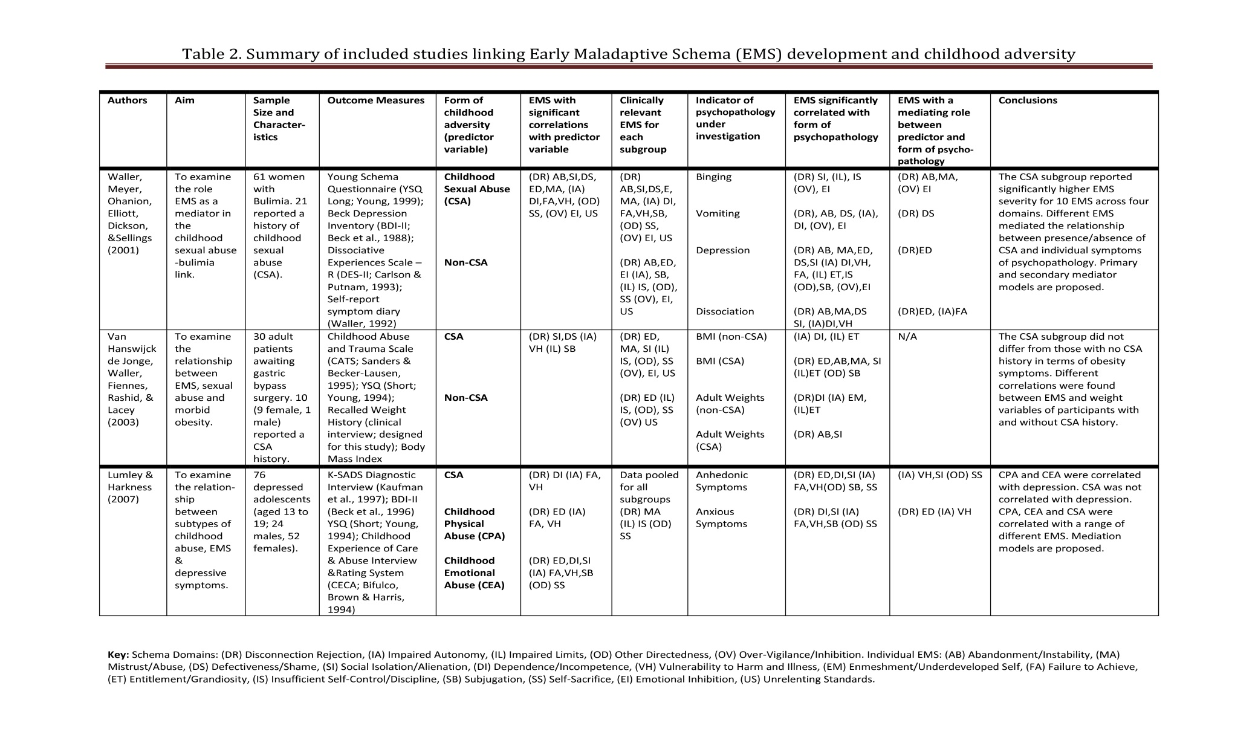
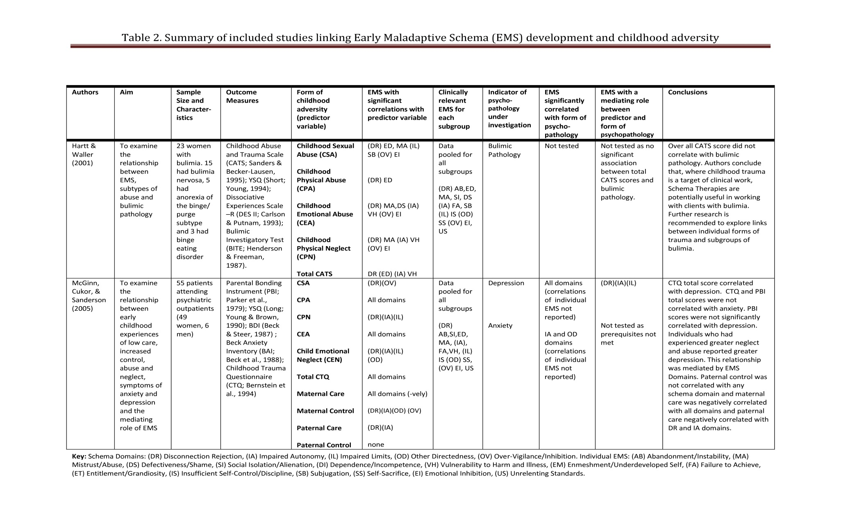
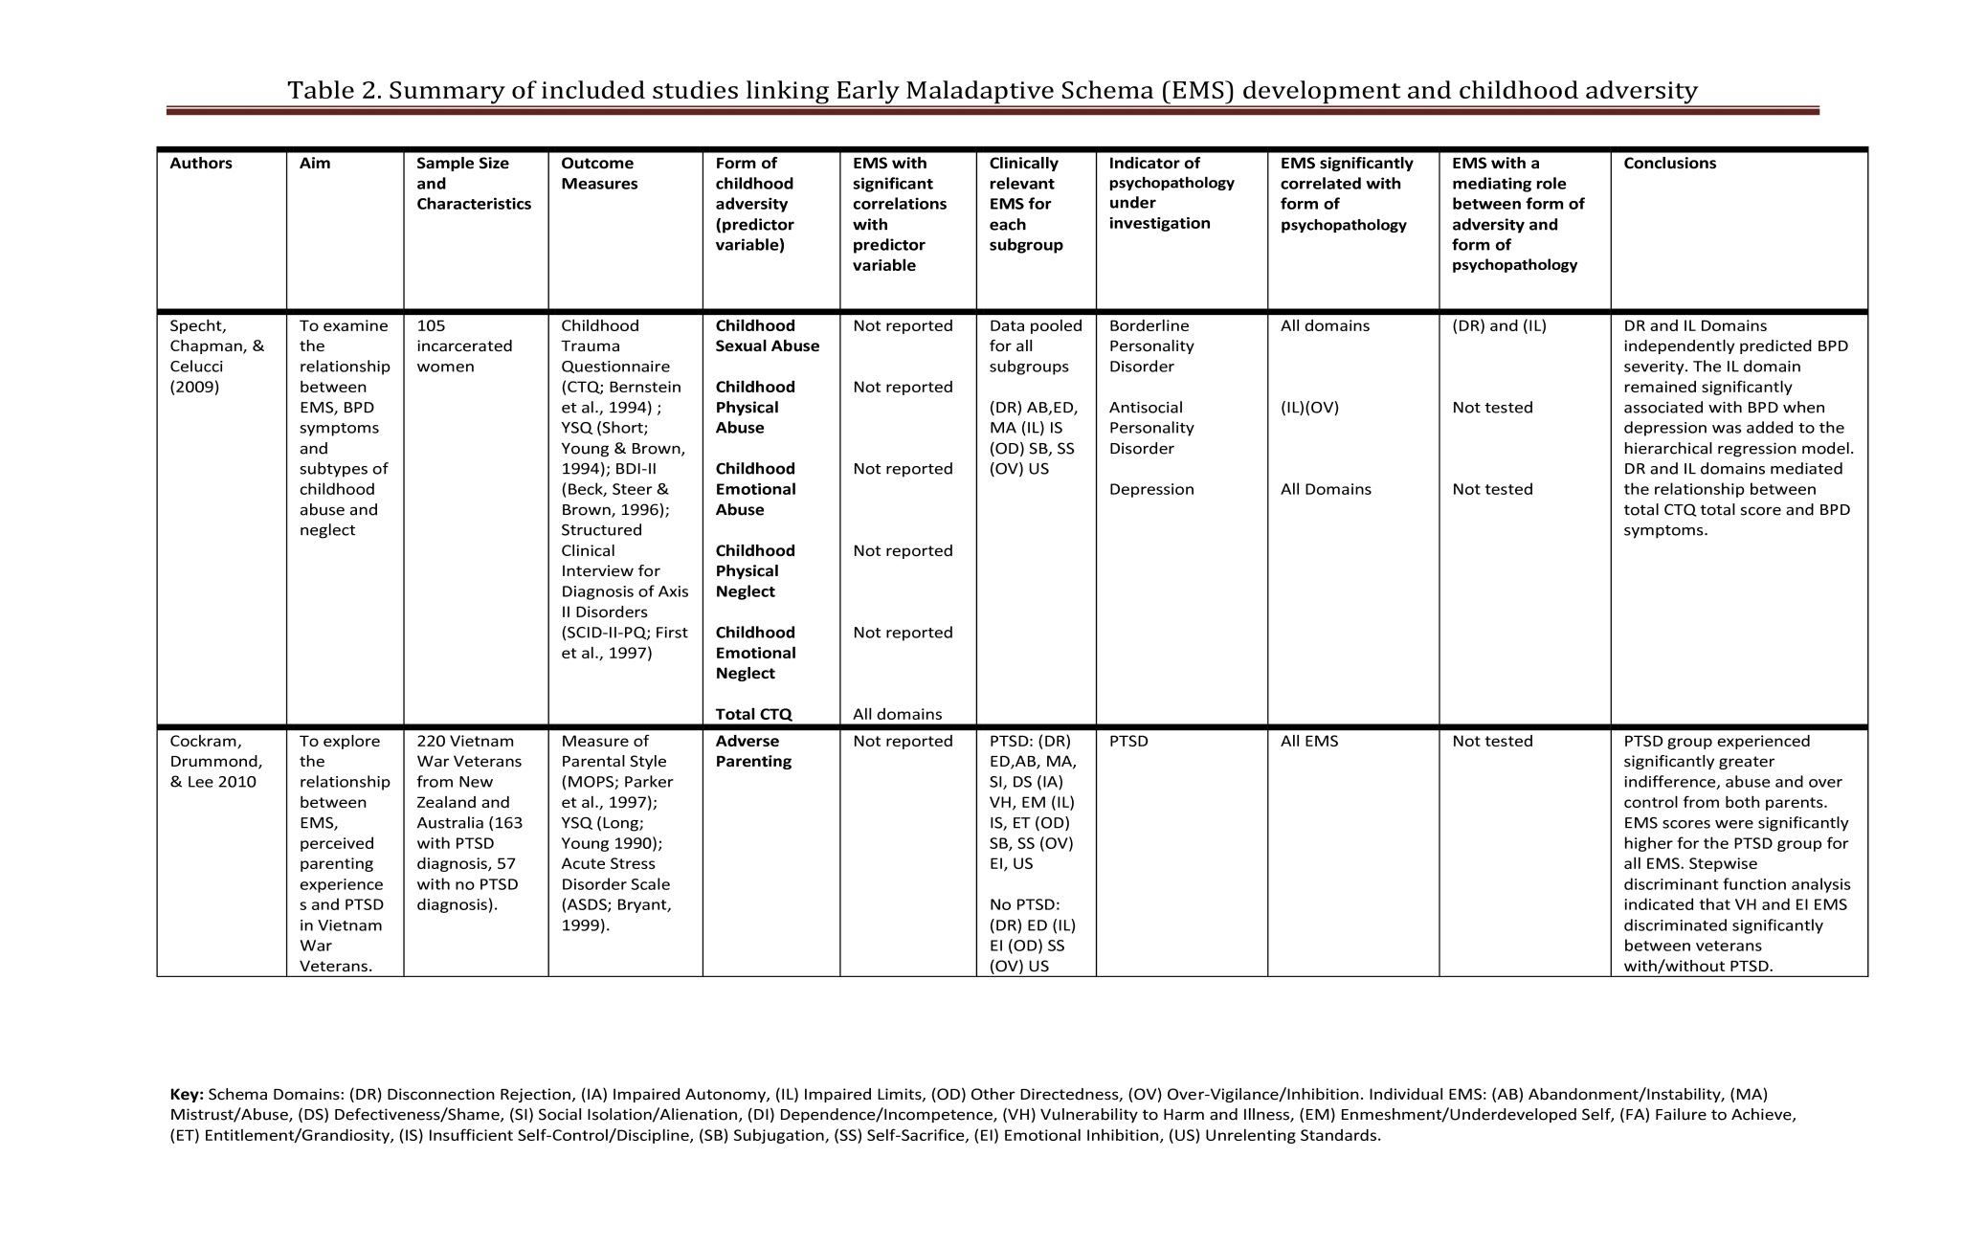
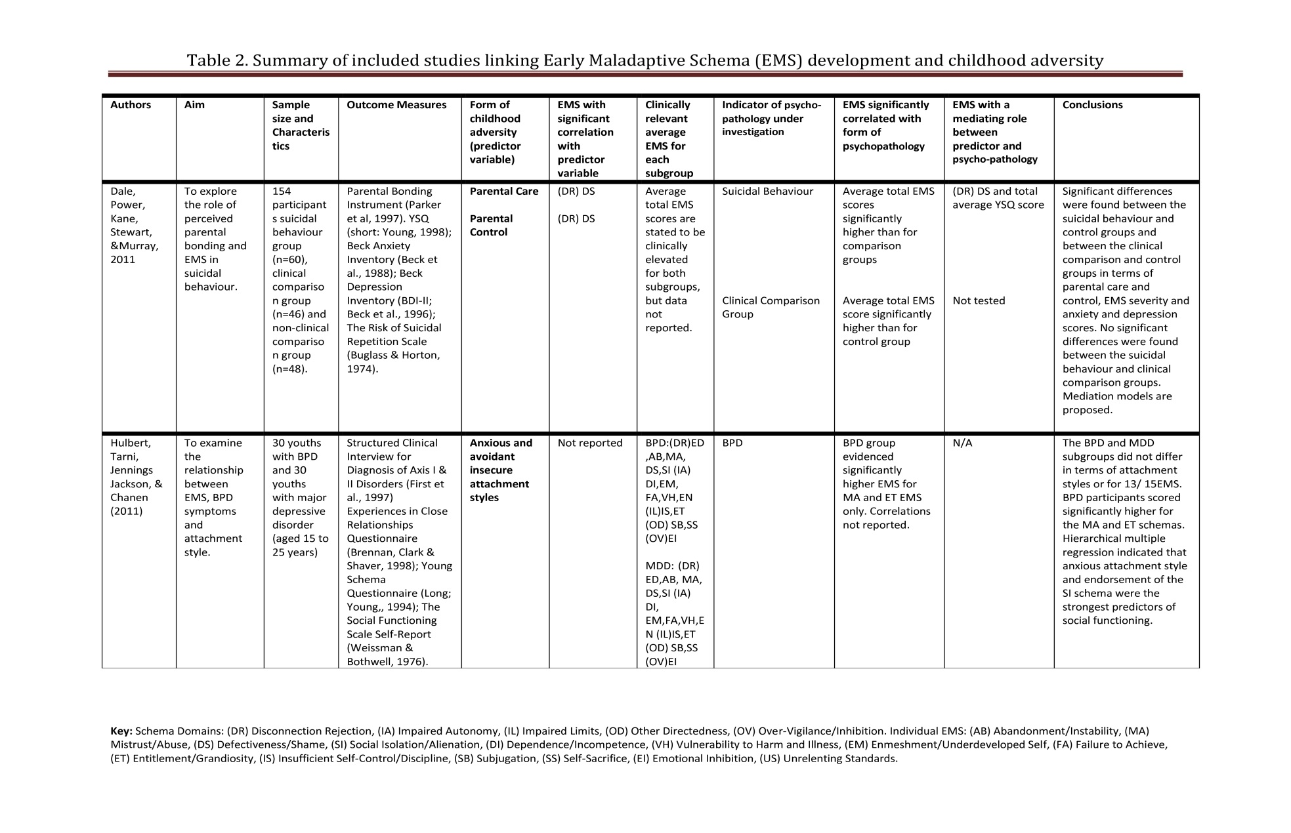

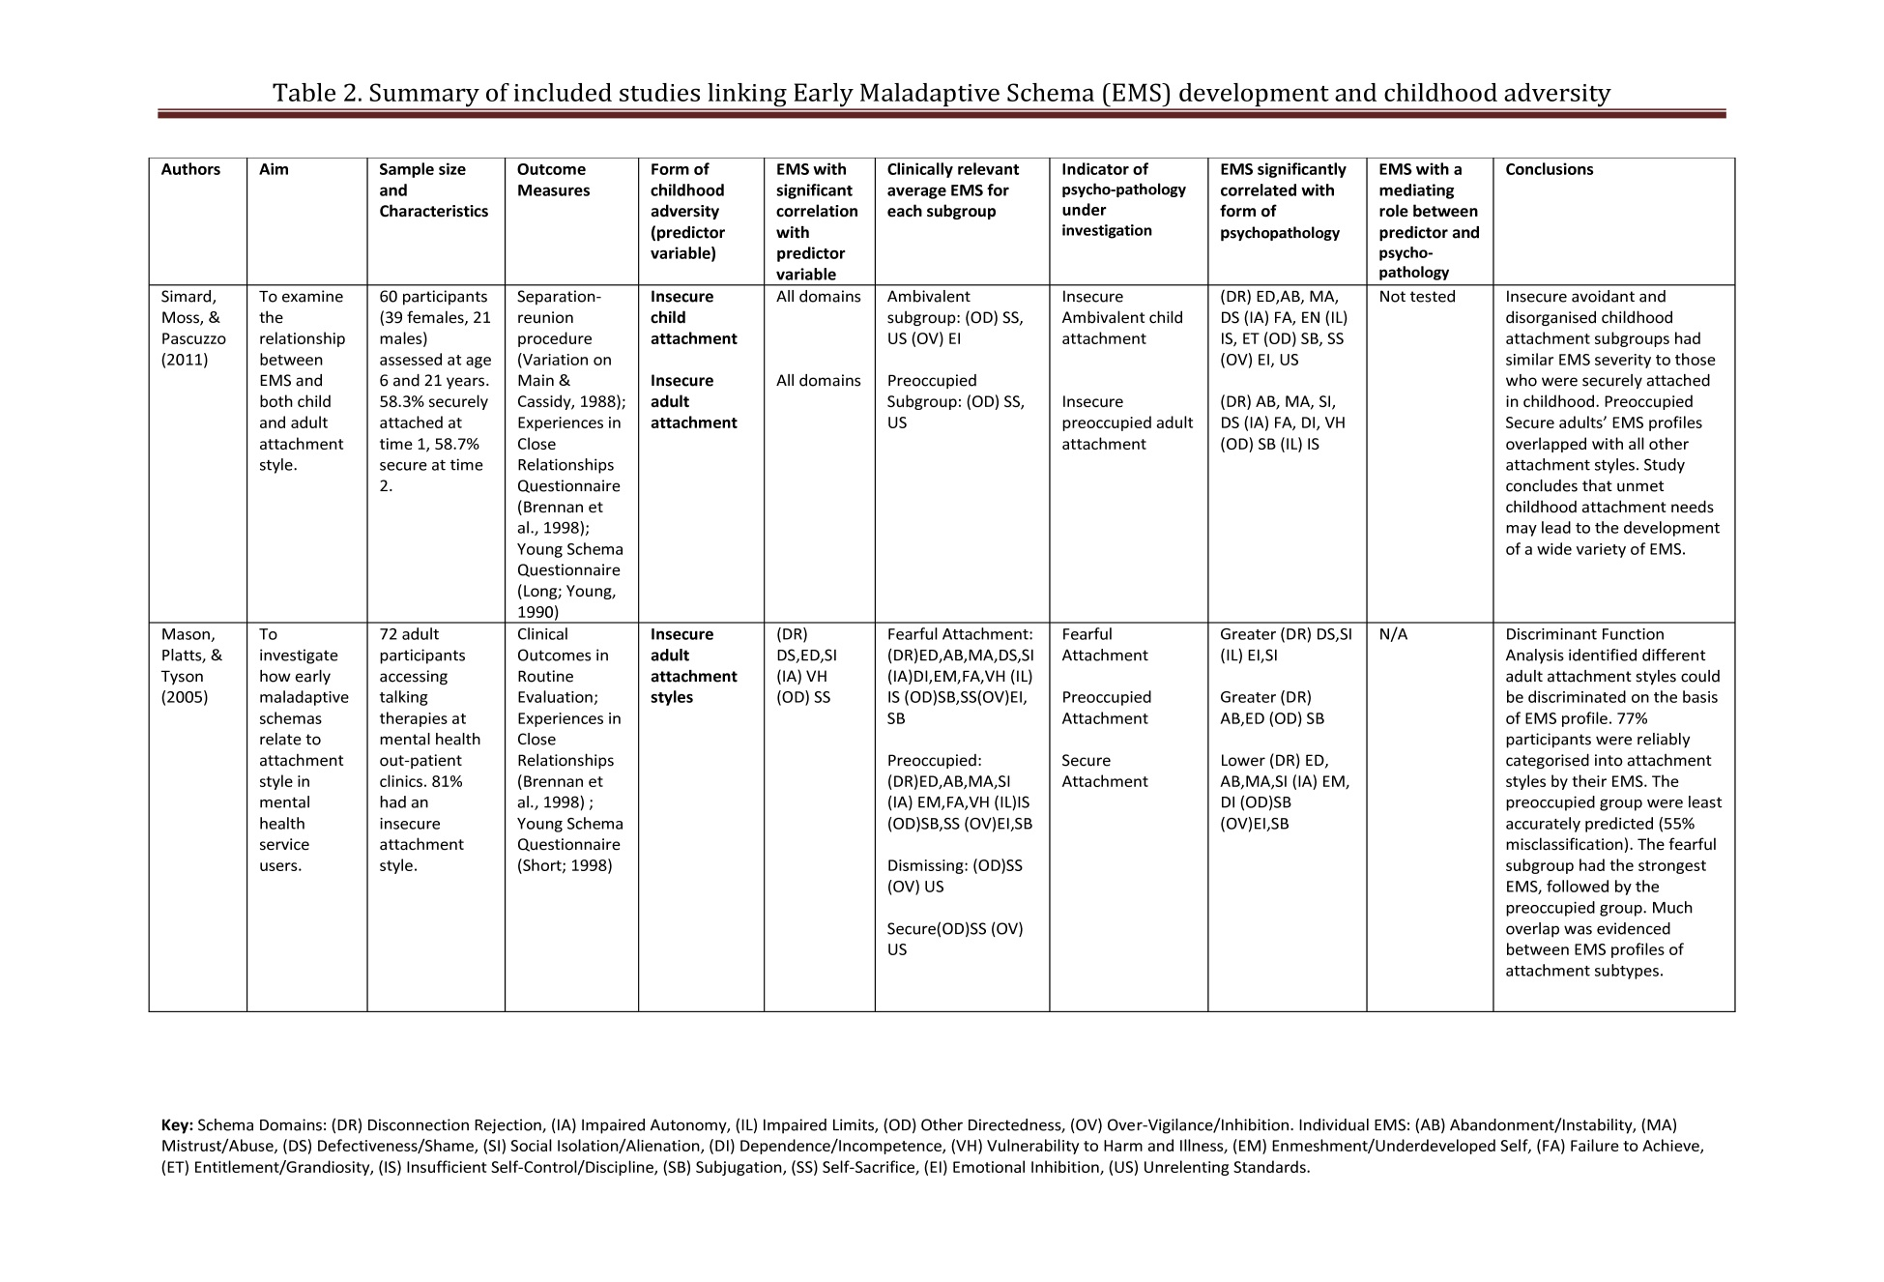
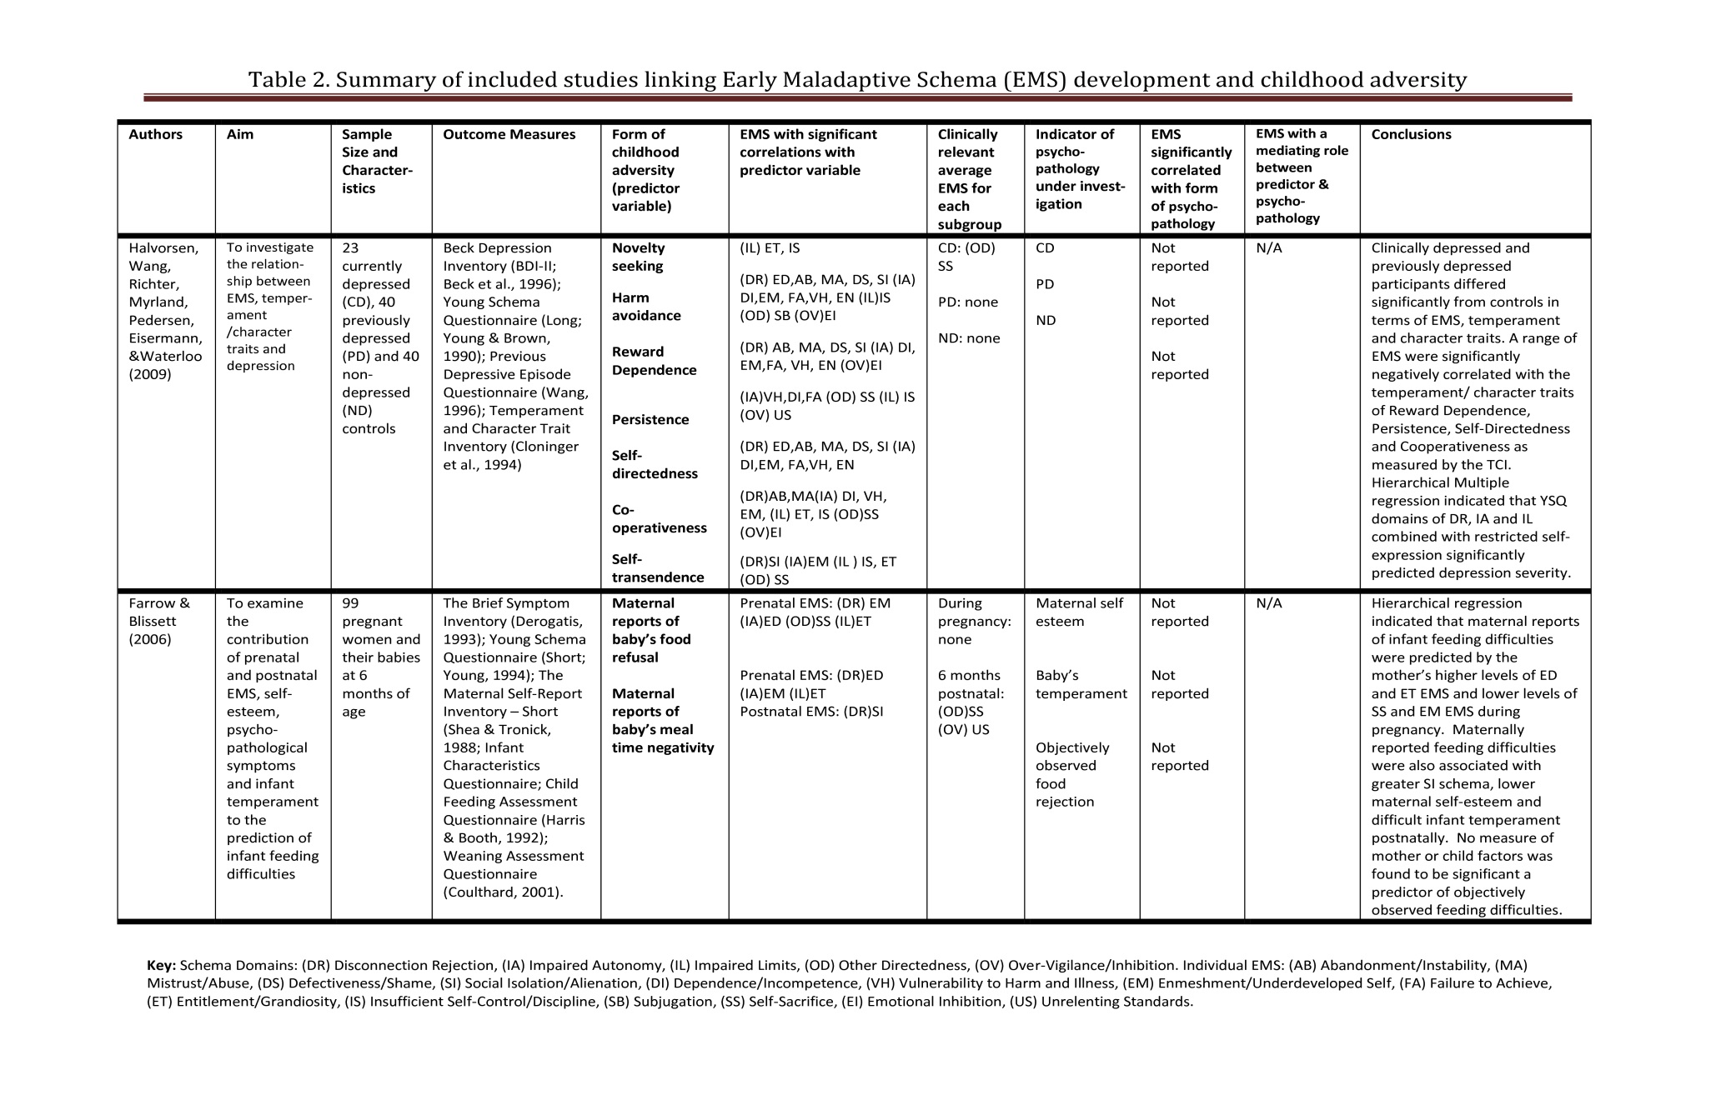
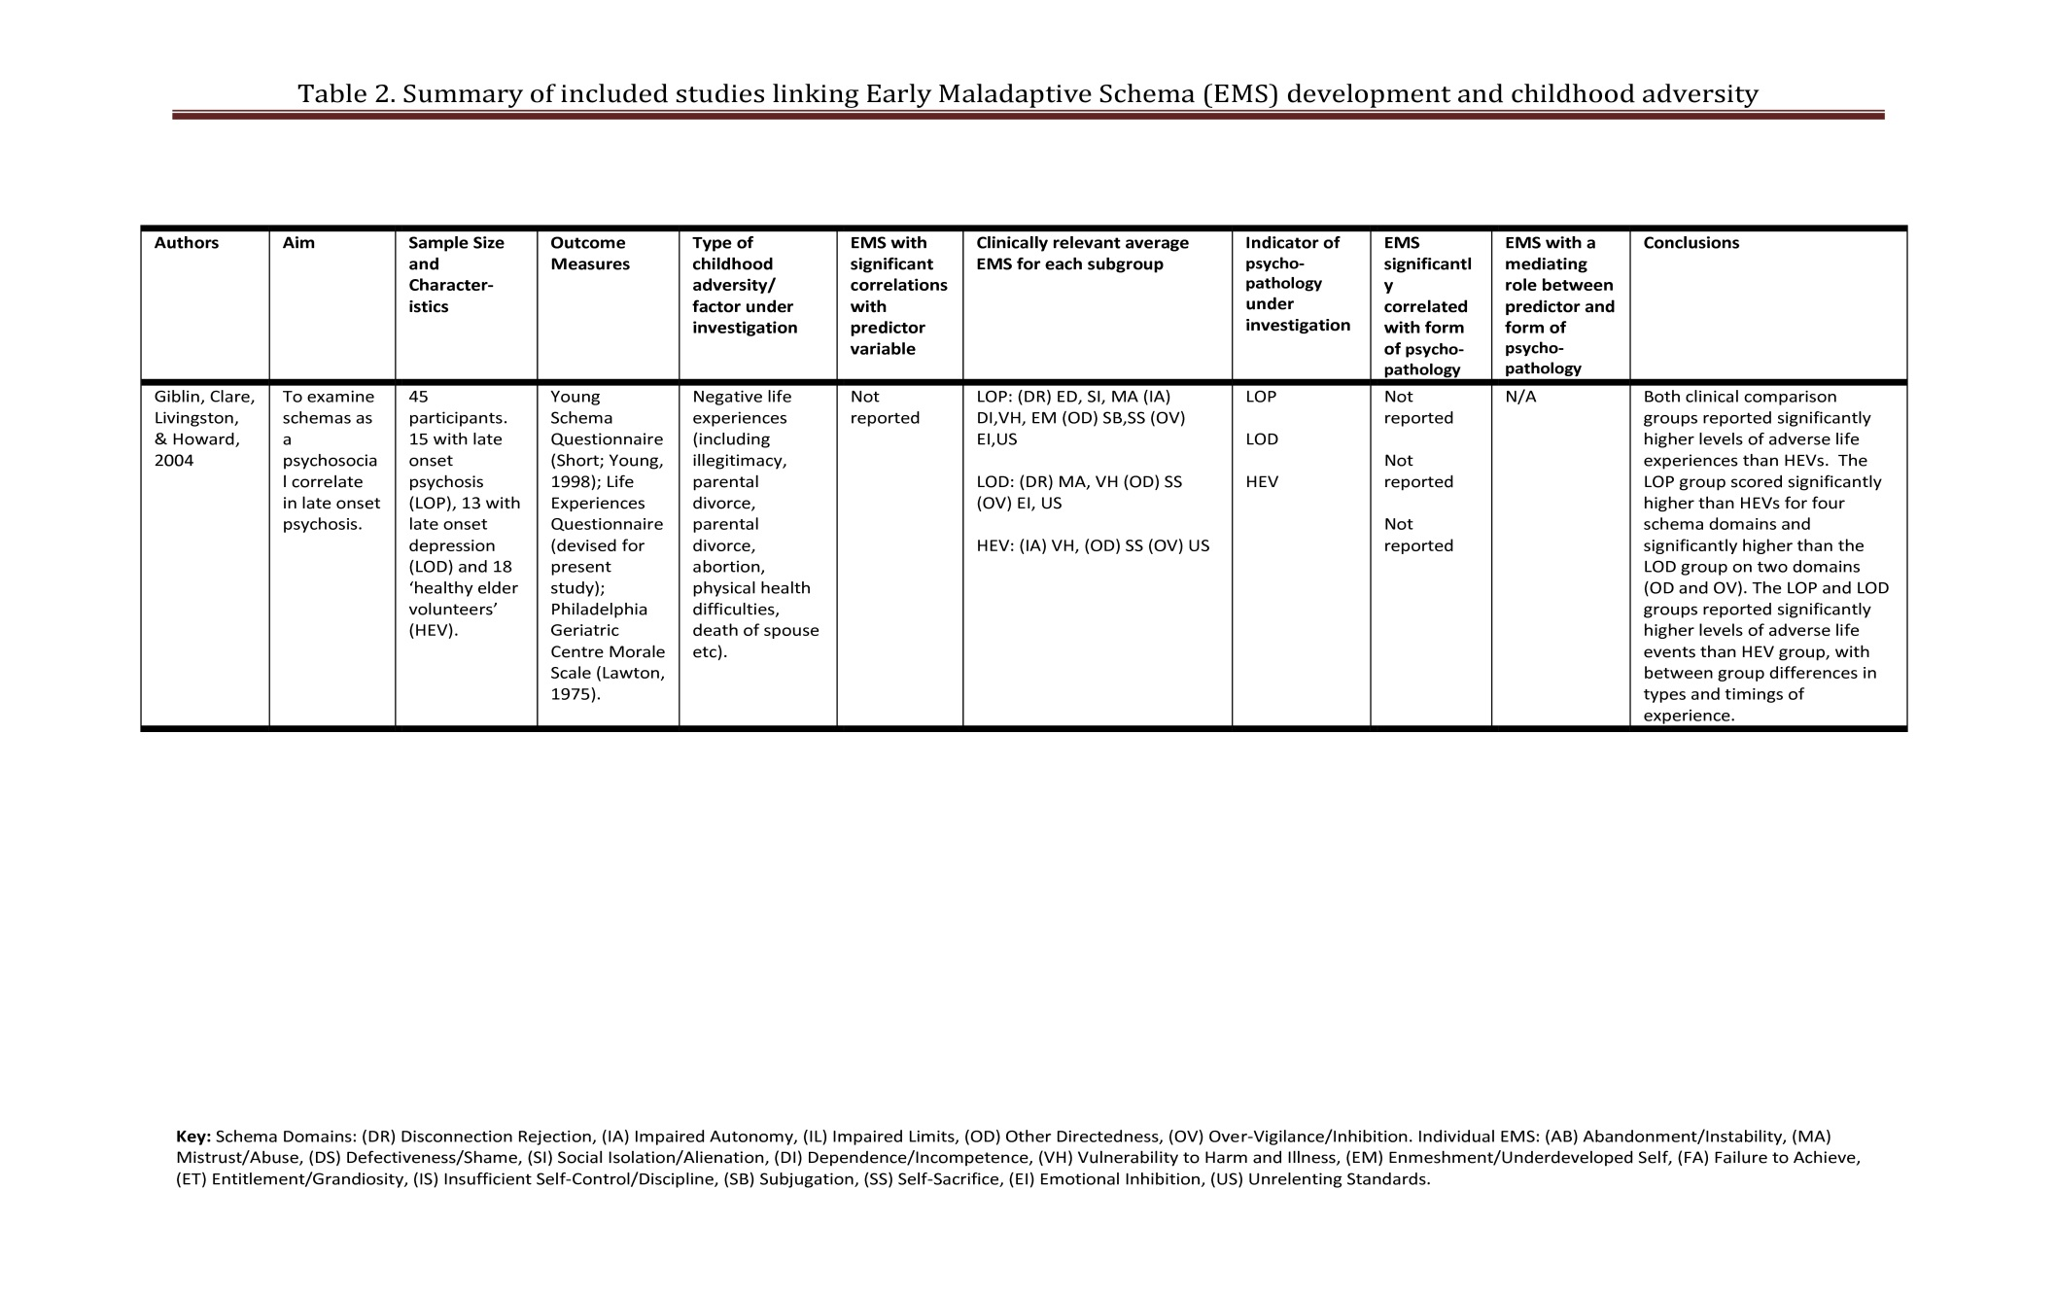
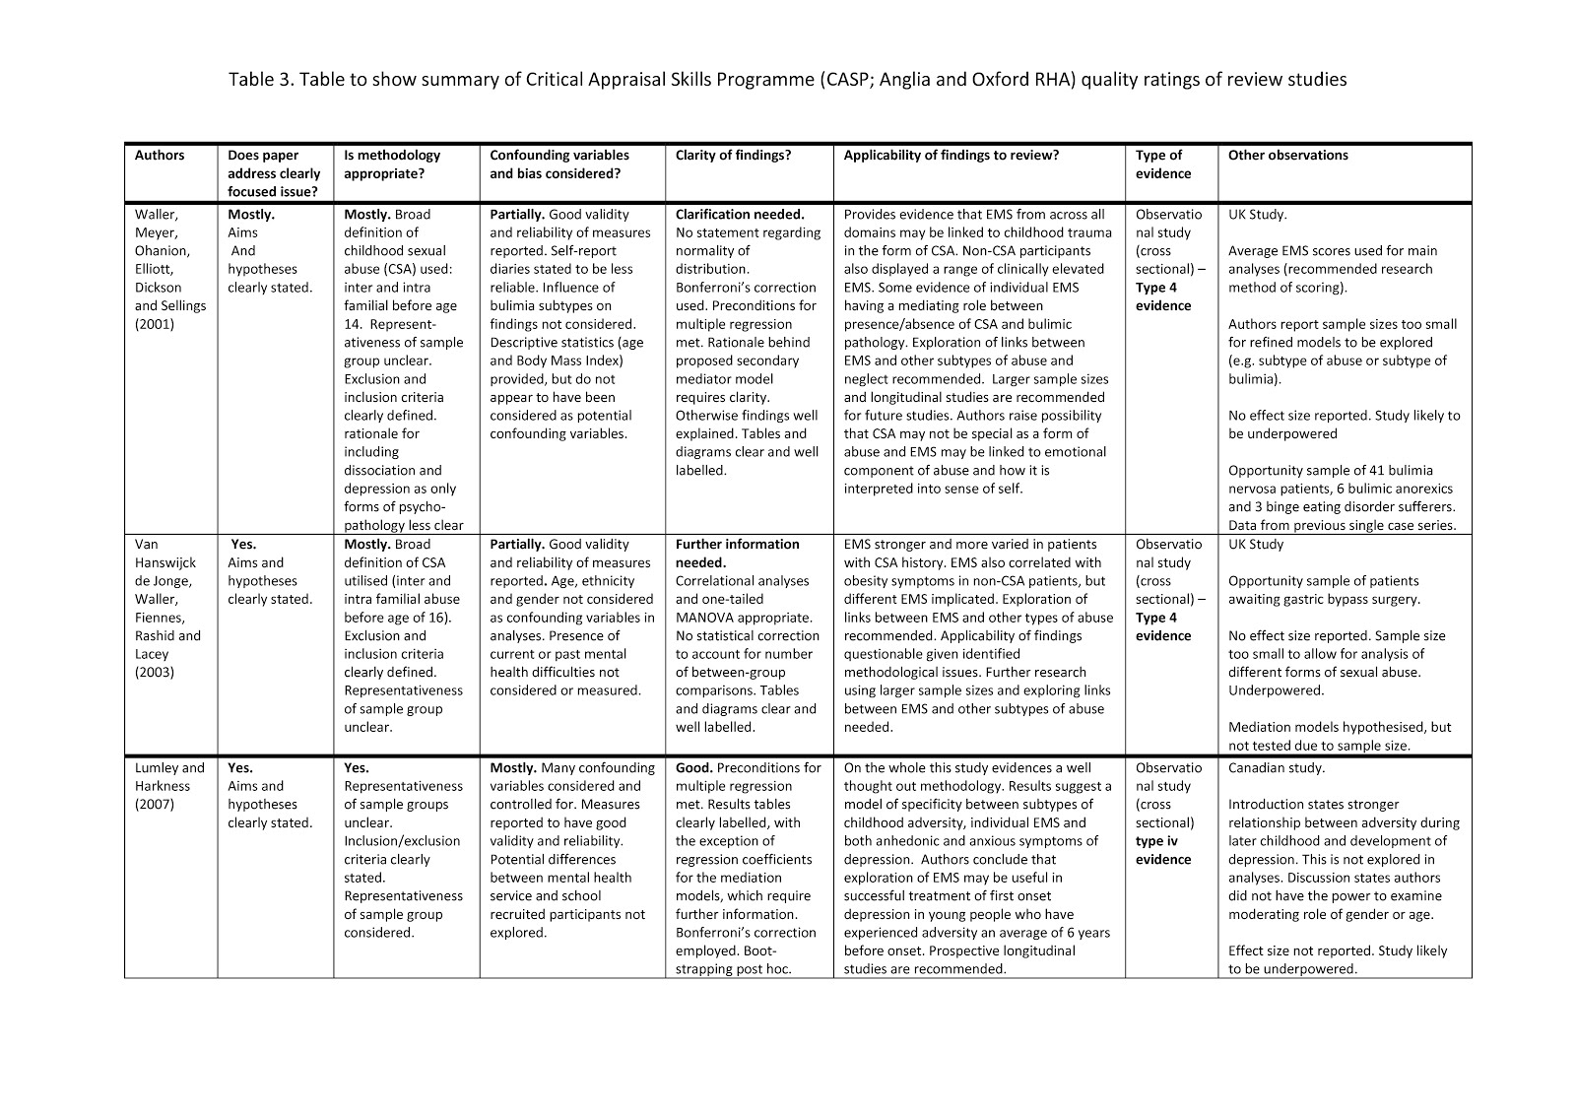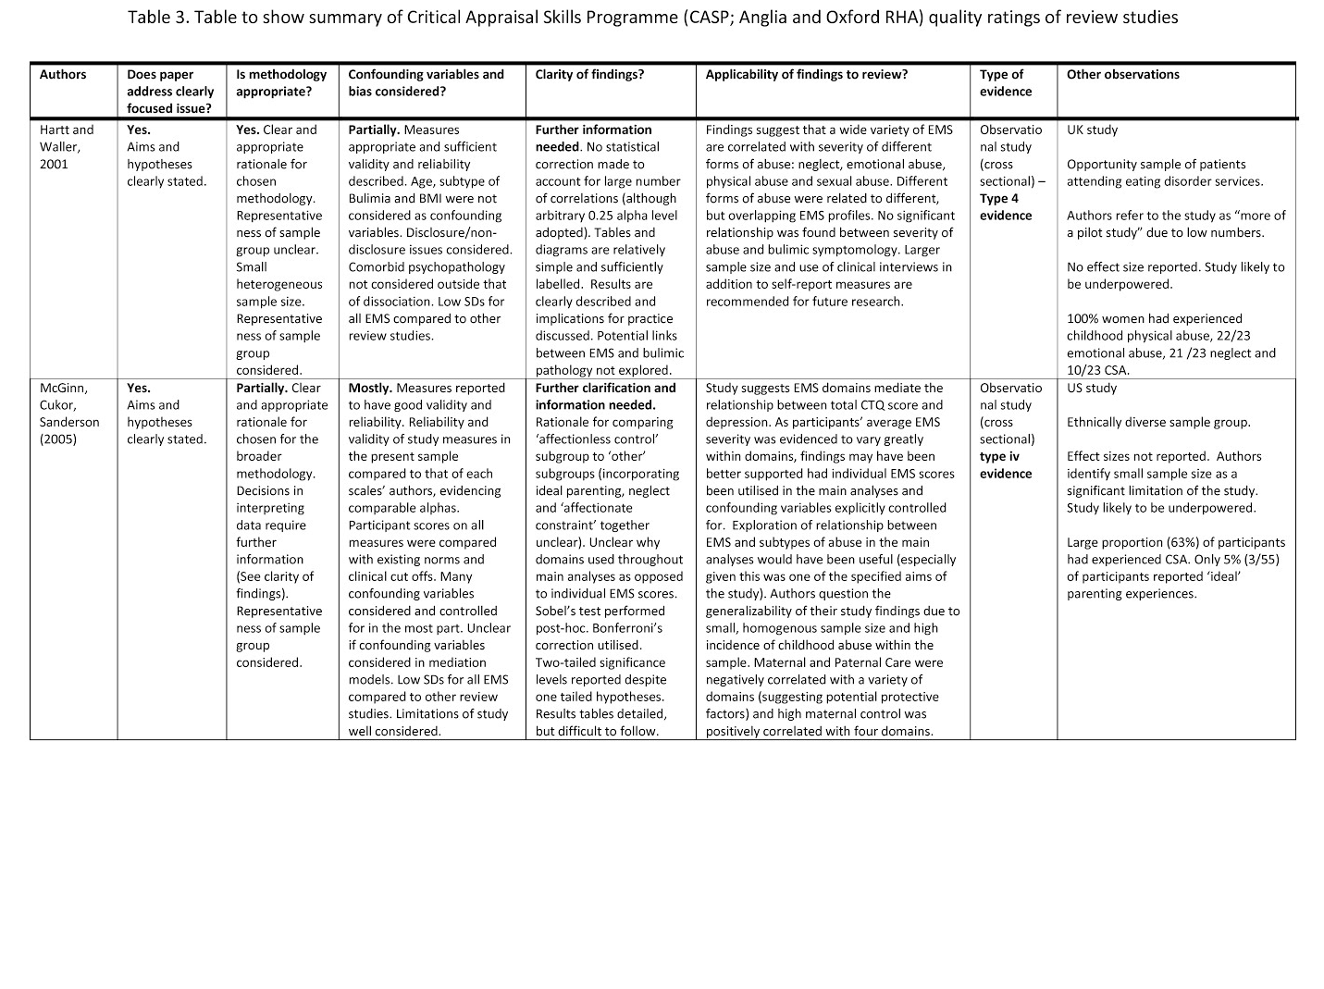
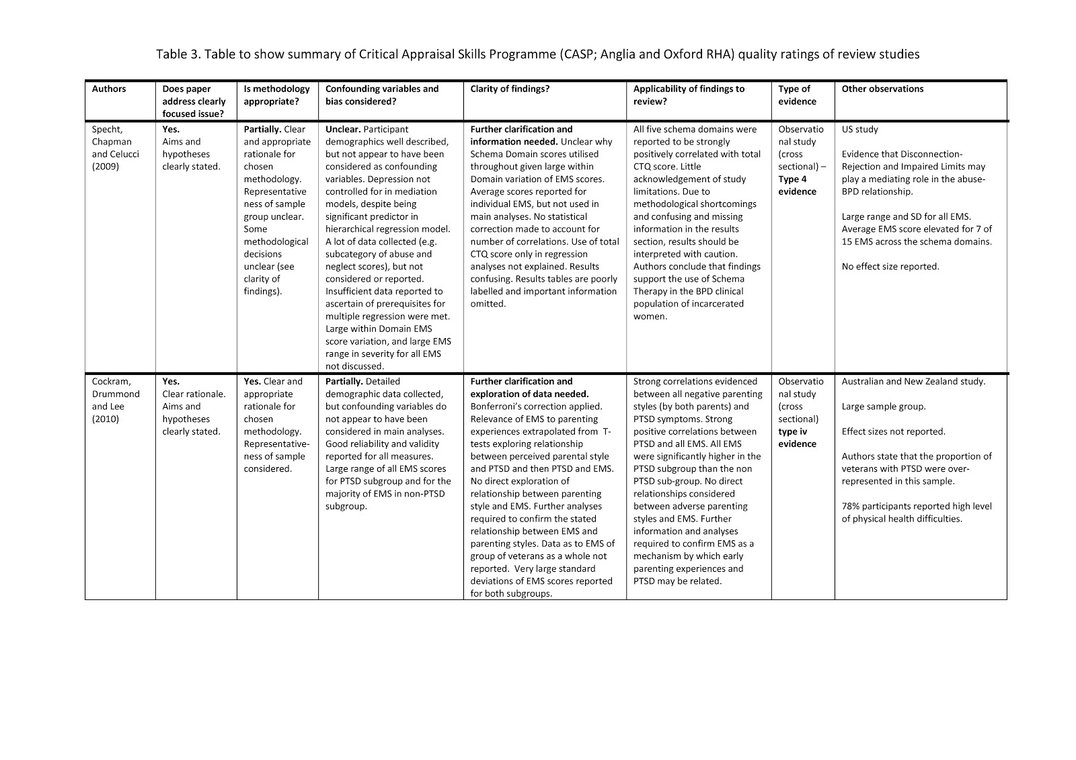
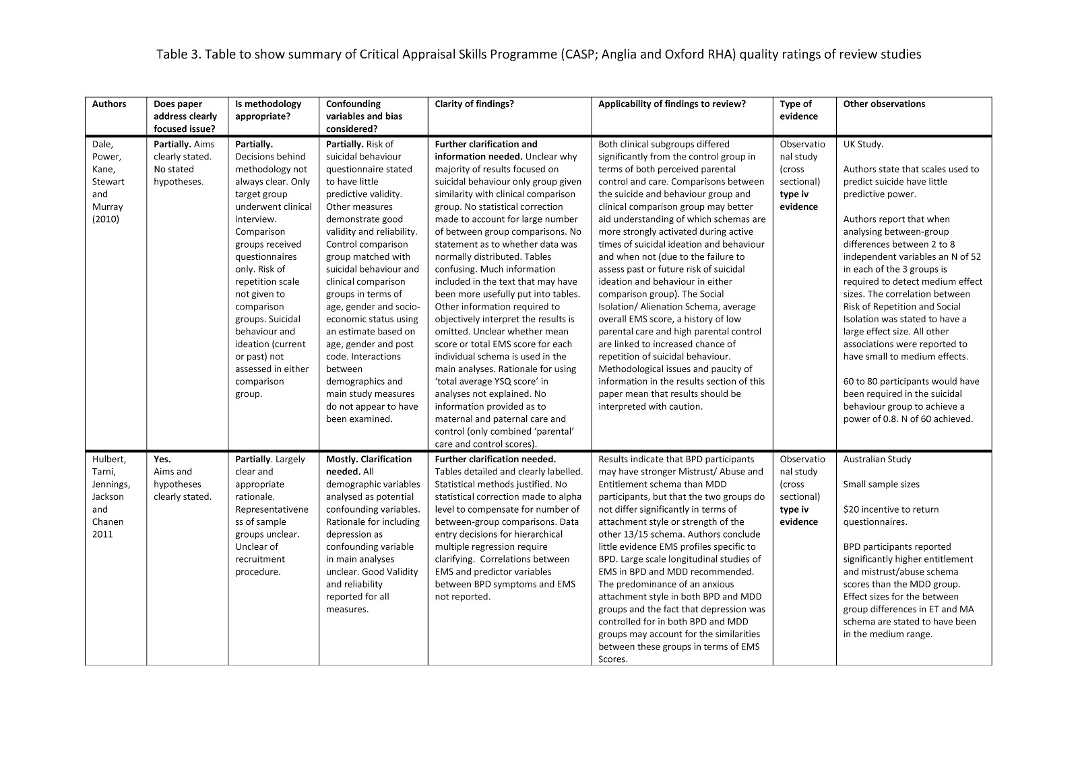
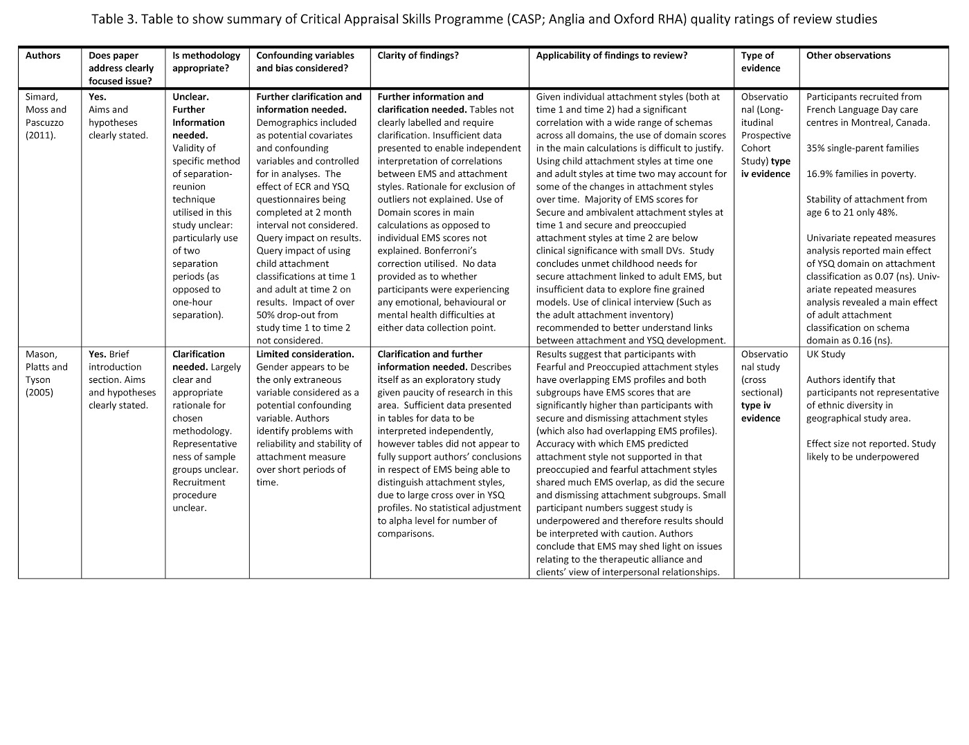
rationale for these models were less clear. As authors identify reliability issues with self-report diaries of eating disorder symptoms, an objective measure would afford more confidence in the study findings. This study does however offer support for Young’s theory that the EMS of those who have experienced childhood trauma (in the form of CSA) are stronger than those who have not had such childhood experiences. The study findings also suggest that Emotional Inhibition (a schema theorised to develop in an effort to prevent criticism/loss of impulse control) may play a particular role in the link between CSA and bulimia.
Van Hanswijck de Jonge, Waller, Fiennes, Rashid, and Lacey (2003) investigated the potential role of schemas in the relationship between CSA (perpetrated by any adult before the age of 16) and obesity symptoms of morbidly obese adults referred for gastric bypass surgery (n=30). Contrary to expectation, CSA participants (n=10) did not differ significantly from the non-CSA group in terms of either Body Mass Index (BMI) or weight fluctuation during adulthood and therefore mediation hypotheses were not tested. CSA participants evidenced higher scores for most EMS, but this between-group difference was statistically significant for only four of them (Defectiveness/Shame, Social Isolation, Vulnerability to Harm/Illness and Subjugation). The lack of statistical correction to compensate for the number of correlational comparisons utilised in this small scale study raises the question of a type 1 error in accepting these findings. Authors conclude that EMS were more severe and more varied in obesity patients who had experienced CSA and therefore schema targeted psychological interventions should be considered. However, the presence of clinically elevated average EMS scores and correlations between EMS scores and obesity symptoms for both sub-groups suggests that schema therapy may also be relevant to obesity patients without CSA experiences.
Taken in combination, these two studies provide some support for Young’s theory that childhood trauma and victimisation (in the form of CSA experiences) may be associated with increased severity of EMS in adulthood. Waller et al.’s (2001) study also introduces the prospect that particular schemas may have a mediating role in the relationship between CSA experiences and bulimic psychopathology. However, methodological issues and small sample sizes mean that further research evidence is required. Non-CSA as well as CSA participants demonstrated clinically elevated schema scores in both studies, and positive correlations were observed between eating disorder symptoms and a wide range of EMS. The link between CSA, EMS and eating disorder pathology may therefore be better explained by ‘third factors’ not included in these studies. Neither study considered non-disclosure issues and the use of the single question relating to whether the participant had experienced any unwanted sexual contact before the age of 14 or 16 meant that issues relating to frequency, severity, age of onset and relationship to perpetrator could not be explored. In their conclusions, Waller et al. (2001) recommend that future research explores whether mediation models can be retrieved with participants with other childhood abuse/neglect experiences. Specifically, they hypothesise that the relationship between CSA and eating pathology may be better accounted for by the emotional impact of abuse.

Schemas and subtypes of abuse and neglect
This review identified four papers that explored the relationship between different subtypes of abuse, EMS and a range of psychopathologies. All of these studies raised methodological queries when subject to CASP quality appraisals (see table 3) and they are described below in order of quality.
The most methodologically sound of these papers was that of Lumley and Harkness, (2007), who examined the relationship between specific forms of parent-perpetrated childhood adversity (in the forms of emotional maltreatment and childhood physical abuse; CPA), CSA perpetrated by any adult, EMS and depression symptom profiles (anhedonic and anxious symptoms). Seventy-six clinically depressed adolescents participated in this Canadian study. For the group overall, average EMS scores were clinically elevated for the Mistrust/Abuse, Self-Sacrifice and Insufficient Self-Control schemas, with all EMS demonstrating large SDs. All forms of childhood adversity were strongly correlated with a range of EMS (see table 2) and to both anhedonic and anxious symptoms. Multiple regression analyses indicated that the Vulnerability to Harm/Illness schema mediated the relationship between both emotional maltreatment (n=16) and CPA (n=18) with anxious symptomology. Social-Isolation and Self-Sacrifice schemas mediated the relationship between emotional maltreatment (n=16) and anhedonic symptoms. CSA (n=11) was not significantly associated with depressive symptoms, but was significantly correlated with Failure, Vulnerability to Harm/Illness and Dependence/Incompetence schemas.
Whilst during the introduction of their study authors emphasised the impact of age of onset of abuse as a key contributor to the development of depressive psychopathology, this was not considered as a potential confounding variable in their main analyses. It is also likely that the study findings were influenced by the fact that some of the clinical subgroup were recruited from mental health services and some from local schools. The potential differences between these subgroups and issues surrounding their representativeness of young people with clinical depression are not explored. Lumley and Harkness conclude that whilst none of their hypothesised mediation models were observed, further research is warranted with the goal of developing fine-grained models of understanding the links between particular types of childhood adversity and resultant psychopathology.
Hartt and Waller (2002) examined the relationship between four different forms of childhood abuse (parent perpetrated emotional abuse, neglect and CPA and CSA perpetrated by any adult), EMS with bulimic pathology and dissociation (n=23). All women were attending UK eating disorder services, all reported a history of CPA, 22 had experienced emotional abuse, 21 had experienced neglect and 10 had experienced CSA. Overall severity of abuse (as evidenced by the total Child Trauma Questionnaire; CTQ score) was significantly correlated with Mistrust/Abuse, Defectiveness/Shame, Emotional Deprivation, Vulnerability, Emotional Inhibition and Subjugation schemas; with different but overlapping schema profiles observed for each form of abuse (see table 1). The fact that authors adopted an arbitrary alpha of 0.25 to compensate for the large number of correlations involved in the analysis, combined with the fact that the study is undoubtedly underpowered, means that significant findings should be interpreted with caution. However, the finding that the women’s average scores were clinically elevated for 11/15 EMS supports Young’s theory that schemas are elevated in those who have a history of abuse or ‘toxic’ experiences during childhood.
McGinn, Cukor, and Sanderson (2005) recruited 55 adult patients receiving outpatient treatment at a New York Psychiatry Department. They aimed to investigate the relationship between family perpetrated childhood abuse and neglect, parenting style, EMS and symptoms of anxiety and depression. Authors reported their findings in great detail, considered many extraneous variables, used Bonferroni’s correction to avoid potential type 1 errors and compared the validity and reliability of the questionnaires in their sample with previously published norms. However, their rationale for reporting average schema domain scores (as opposed to average individual EMS scores) in their main analyses is poorly justified given the within-domain score variation reported and is not a recommended method of analysing Young’s schema questionnaires.
McGinn et al. (2005) found that participants’ average schema scores (n=55) were elevated for 11/15 EMS and that different subcategories of emotional abuse were significantly correlated with different schema domains. Of all the schema domains, the strongest correlations were reported between the Disconnection/Rejection Domain and Total CTQ Score, severity of emotional abuse, and severity of neglect. Levels of maternal and paternal care were significantly negatively correlated with Disconnection/Rejection and maternal over-control was significantly positively correlated with Other-Directedness and Overvigilance domains. Post-hoc Sobel tests supported the findings that the Disconnection/Rejection, Impaired Autonomy and Impaired Limits Domains mediated the relationship between total CTQ score and depression. However, these findings should be treated with caution as (in addition to the other identified methodological flaws) it is unclear whether the authors considered confounding variables in these particular calculations. Authors state that as their sample group contained a high proportion of participants who had experienced childhood abuse/neglect (only 5.5% participants identified having experienced ‘ideal parenting’, 20% reported their parents to have had affectionless constraint’, 63.3% reported ‘affectionless control’ and 10.9% reported neglectful parenting), their findings may not be generalisable beyond economically disadvantaged, urban, minority populations.
Specht, Chapman, and Cellucci (2009) investigated the links between borderline personality disorder (BPD) symptoms with childhood maltreatment (CPA, CSA, neglect, emotional maltreatment and lack of emotional support), depression and anti-social personality disorder (ASPD) symptoms in a sample of ‘incarcerated women’ in the United States (n=105). Whilst this study had a relatively large sample group, the authors appear to have given little consideration to the influence of potential confounding variables, or to providing sufficient information in their results section for their findings to be objectively interpreted. For the group as a whole 6/15 EMS scores were clinically relevant. These schemas, from across all domains, evidences large SDs and EMS scores showed great within-domain variation. It is therefore difficult to understand why authors chose to utilise domain scores in their main analyses.
Authors concluded that the Impaired Limits domain was a significant predictor of BPD severity when entered into a hierarchical regression (with depression severity controlled for) and the Disconnection/Rejection domain was a significant predictor of BPD severity (when ASPD was controlled for). Whilst CPA, emotional abuse and perceived lack of emotional support were related to BPD symptoms, CSA demonstrated no such association. Total CTQ score was strongly correlated with all schema domains, with the Disconnection/Rejection domain having the strongest association. Both the Disconnection/Rejection and Impaired Limits domains were stated to mediate the relationship between total CTQ score and BPD symptoms but, as depression was not controlled for in the regression (and was found to impact significantly in the hierarchical regression), these findings should be interpreted with caution. Authors felt that the fact that the majority of participants (63%) reported a CSA history may have artificially influenced results and that further exploration of their findings was required in larger sample groups.
Differences in the quality and methodologies of the studies described above make direct comparisons of findings difficult, with the latter three studies requiring clarification and further information to understand the rationale behind their analyses and all requiring further exploration in much larger clinical populations. Collectively the four studies do however support Young’s conceptual theory that EMS are more prevalent and severe in participants who have experienced childhood adversity (in the form of CSA, CPA, emotional abuse and neglect) than those who have not. They also suggest that total childhood abuse severity is linked to EMS severity. There is insufficient evidence to conclude that any one form of childhood adversity is associated with the development of any individual or combination of EMS, but there is some evidence to suggest that schemas within the Disconnection/Rejection domain are most elevated in those reporting the most severe overall abuse experiences. The studies also suggest that further exploration of the mediating role of EMS between particular childhood adversities and particular psychopathologies may be warranted (although it was not always explicit that studies had met the prerequisites for multiple regression analyses to be undertaken, nor that the correct mediation procedures had been followed).
Taken together, the studies described above could be interpreted as suggesting that CSA may not in fact be ‘special’ as a form of abuse in predicting particular psychopathologies, or strength of pathology. They also suggest that it may be the emotional impact of sexual abuse that leads to EMS that leads to psychopathology. However, the fact that the studies measured parental or familial perpetrators of physical and emotional abuse and neglect as compared to CSA perpetrated by any adult, means that these findings could be attributable to methodological issues. The influence of intra-familial versus extra-familial experiences of abuse and neglect during childhood, non-disclosure issues and the confounding influence of experiencing multiple forms of abuse/neglect (beyond that of total CTQ scores incorporating all forms of abuse) were not explored by any of the four studies.
Schemas and perception of parenting
Two studies were identified that examined the relationship between retrospective reports of parenting experiences, EMS and psychopathology.
Cockram, Lee, and Drummond (2010) investigated the relationship between perceived adverse parenting, Vietnam War veterans’ PTSD symptoms and EMS severity (n=220). Veterans with PTSD (n=163) scored significantly higher for all individual EMS and for maternal and paternal parenting experiences of indifference, abuse and over-control. Large SDs were evidenced for all EMS scores of both PTSD and non-PTSD subgroups. The authors concluded that EMS resultant of adverse childhood experiences perpetrated by either or both parents were likely to have predisposed soldiers to developing PTSD in highly-stressful schema-activating experiences during army training, during the war and/or as a result of perceived lack of support post-war. However, these findings are extrapolated from correlations between EMS and PTSD symptoms and correlations between PTSD symptoms and childhood adversity. No statistical analyses was conducted to evidence whether EMS were directly correlated with PTSD. Authors also felt that their findings may not be generalisable as a result of the large proportion of participants who met the PTSD diagnostic criteria.
Investigating EMS as a potential mediator in the association between perceived parenting experiences and suicidal behaviours, Dale, Power, Kane, Stewart, and Murray (2011) found that participants who had presented to Accident and Emergency as a result of suicidal behaviour (n=60) differed from an age, gender and socio-economic status matched clinical (n=46) and non-clinical (n=48) comparison group on measures of EMS, anxiety, and depression. Contrary to authors’ expectations, no significant difference was noted between the suicidal behaviour group and the comparison clinical group on a measure of parental care and control; although the fact that data for maternal and paternal parenting attributes were pooled and no measure of previous suicidal ideation/behaviour was taken from the clinical comparison group may account for some of the overlap. The suicidal behaviour subgroup did however differ from the clinical comparison group in terms of severity of Defectiveness/Shame, Dependency, Self-Sacrifice, Entitlement, and Insufficient Self-Control schemas.
The majority of Dale et al.’s (2011) main analyses focused on the suicidal behaviour subgroup. No other subgroup underwent the interview phase of this study and there is no evidence of any confounding variables being considered in the main analyses. Within the suicidal behaviour group, significant negative correlations were reported between perceived level of parental care and ‘risk of repetition of suicidal behaviour’ scores. Significant positive correlations were evidenced between both risk of suicidal behaviour and parental over control with total YSQ score, Social Isolation and Defectiveness/Shame schemas. Whilst much information is omitted from the results section of this study that would enable objective interpretation, this was the only study in the present review that undertook a power calculation. This indicated that 60 to 80 participants would be required in order to achieve a power of 0.80 and an ‘n’ of 60 was achieved.
Dale et al. reported that Total YSQ score, Defectiveness/Shame and Social Isolation schemas mediated the relationship between parental over-control and risk of repetition of suicidal behaviour. Total YSQ score and Social Isolation also mediated the relationship between parental care and risk of suicidal behaviour. The lack of inclusion of the clinical comparison group in the main analyses means that conclusions cannot be drawn as to whether the observed correlations and mediation models were unique to the suicidal behaviour subgroup. In their conclusions the authors emphasised the need to explore the role of EMS in the relationship between ‘parental bonding’ and predicting those at risk of suicidal behaviour. However, they also cite the lack of predictive validity and reliability of the ‘risk of suicide repetition’ measure as a study limitation.
These two studies conclude that specific parenting experiences may be associated with the formation of specific EMS, which lead to a predisposition to experiencing psychological difficulties in times of stress. Both sets of authors concluded that their findings suggest that experiences of parental over-control may predispose children to develop particular types of EMS. They also suggest that the degree to which children experienced warmth or rejection may be linked to EMS severity and subsequent levels of psychopathology; with greater experiences of parental warmth potentially providing a protective factor. Cockram et al.’s (2010) study combined with McGinn et al.’s (2005; see ‘subtypes of abuse and neglect’ above) findings suggest the relationship of the parent (maternal or paternal) to the subject may also bear a specific relationship to the subsequent manifestation of EMS. However, the identified methodological issues suggest that further corroboration of these findings is required.

Attachment and schemas
This review identified three studies that explored the links between attachment, EMS development and a range of clinical presentations. These studies are again discussed in order of research quality (see table 3).
Hulbert, Jennings, Jackson, and Chanen (2011) assessed attachment style, EMS and interpersonal dysfunction in two sub-groups of out-patient youths (aged 15-25). Contrary to authors’ predictions, BPD participants (n=30) did not significantly differ from major depressive disorder (MDD; n=30) participants in terms of attachment style or severity of 13/15 EMS. BPD participants scored significantly higher for Mistrust/Abuse and Entitlement schemas, evidenced clinically relevant scores on all but Enmeshment and Unrelenting Standards schemas, had a predominantly anxious attachment style, and reported poorer interpersonal functioning. The MDD subgroup had clinically relevant scores for 11/15 EMS.
Further information is required in order to follow Hulbert et al.’s rationale for controlling for depression as a confounding variable in their main analyses given that the distinction between depression and BPD was a main study focus. There is a paucity of information in the results section of this study and correlations between EMS and the main study variables are not reported. Hierarchical multiple regression indicated that an anxious attachment style and the Social Isolation schema were the strongest predictors of social functioning in youths with BPD, but results of MDD participants were not subject to this stage of analyses. Small sample sizes, the high proportion of participants in both subgroups with an anxious attachment style, the lack of transparency in the results section and the lack of statistical correction to account for the large number of comparisons in this study increase the likelihood of a type 1 error and therefore results should be interpreted with caution.
In the “first [study] to prospectively examine the relationship between attachment measured in childhood and EMS in adulthood”, Simard, Moss, and Prescuzzo (2011) compared the attachment and schema profiles of a group of adults (n=60, age=21) to their attachment classification assessed using a separation-reunion procedure at age 6. The description of this procedure does not appear to fit usual separation-reunion procedures (in that there were two separations as opposed to one) and therefore the accuracy with which childhood attachment classifications were made is called into question. Attachment styles did not demonstrate stability from time 1 (age 6) to time 2 (age 21) and significant drop-out was evidenced between data collection points (over 50%). Young adults (aged 21) who had been classified as having an insecure-ambivalent attachment style in childhood had higher scores for 11 EMS across all domains. However, those classified in childhood as having insecure-avoidant and insecure-disorganised attachment styles did not differ from securely attached participants with respect to EMS. Participants whose adult attachment style was classified as insecure-preoccupied did evidence significantly higher scores for 10 EMS from across domains, but with no particular defining schema profile. It is again therefore difficult to understand why the researchers chose to use schema domain and not individual EMS scores in their main study calculations. Schema domain scores were found to be significantly stronger for all participants with insecure adult attachment styles compared to secure peers.
Simard et al. (2011) did not collect any data with regard to perceived parenting, life events or psychopathology in adulthood and so no further dimensional models could be tested. This constitutes a real missed opportunity given that the majority of the other studies in the present review recommend well designed prospective longitudinal studies to map the development of EMS in relation to adverse childhood experiences and the development of psychopathology. The authors of this study conclude that insecure childhood attachment styles were more predictive of individual EMS severity in adulthood than adult attachment styles; that unmet needs for secure attachment in childhood may lead to the development of a wide variety of EMS; and that no specific attachment style-EMS profile relationships could be identified. They also recommend that future research investigates specific elements of attachment-based representational models and how they relate to the development of individual EMS using interview methods such as the Adult Attachment Interview.
Mason, Platts, and Tyson (2005) investigated the potential association of attachment styles and EMS in ‘a small pilot study’ of patients accessing mental health services. Participants (classified according to the experiences in close relationships questionnaire; ECR) in the fearful (n=34) and preoccupied (n=18) insecure attachment subgroups reported more difficulties functioning in close relationships and the fearful attachment group displayed more difficulties than the dismissing insecure (n=6) and secure attachment subgroups in functioning in social relationships. EMS differed significantly according to attachment style grouping, with the fearful group possessing the greatest frequency and severity of EMS, closely followed by the pre-occupied group. Much overlap was evidenced in the EMS profiles of the fearful and preoccupied subgroups and the dismissing subgroup’s EMS scores rarely strayed far from that of the secure group. Discriminant functional analysis indicated that nine individual EMS reliably distinguished the attachment subgroups and that 77% of participants could be accurately classified into attachment group according to their EMS profiles. The subgroup predicted with least accuracy were those with a preoccupied attachment style (55% misclassification), leading authors to suggest that EMS may better be able to explain the link between EMS, psychopathology and fearful or ‘externalising’ attachment styles, than preoccupied or ‘internalising’ styles. Authors felt that the predominance of participants with a fearful attachment style and difficulties with reliability and validity of the ECR may have influenced their findings. The measurement of adult attachment styles in this study means that it is also impossible to determine whether participants’ insecure attachments were in fact resultant of relationship experiences within the nuclear family or subsequent relationships in later life.
Whilst the research outlined above suggests that EMS profiles may differentiate between attachment styles, the studies provide mixed findings as to which attachment styles are more readily identifiable. This may be related to the various methodological issues that have been identified or that specific elements of attachment (such as parental mind-mindedness) may be implicated in the development of EMS. Links between attachment styles and EMS may also be attributable to the incorporation of attachment theory into the ST model and therefore may be illustrating crossover in attachment and schema theory as opposed to providing evidence that insecure attachment styles give rise to EMS development. Future studies should use more detailed attachment measures (such as the adult or child attachment interviews) to explore which early childhood attachment experiences are more predictive of EMS development.
Schemas and ‘other factors’
The review identified three studies that explored the association between EMS development, psychopathology and ‘other factors’, including temperament, maternal EMS and psychosocial factors. These studies are again presented in order of quality of research (see table 3).
Halvorsen et al. (2009) investigated links between temperament and schemas in clinically depressed (CD), previously depressed (PRD) and never depressed adult participants (n=140) recruited from a previous study, via GP surgeries and via a newspaper article. The participant inclusion/exclusion criteria require clarification. CD and PRD subgroups showed substantial variability in EMS scores and temperament when controlling for concurrent depression severity. As a main focus of the study was depression severity, it is unclear why this was controlled for in the main analyses. It is also unclear, given the variation of EMS scores within domains, why domain scores were utilised in the main analyses.
A wide range of EMS were significantly correlated with all character traits, with differing but overlapping schema profiles for each character trait. Schema domains of Disconnection/Rejection, Impaired Autonomy, Overvigilance/Inhibition and Impaired Limits were significant predictors of depression severity (effect sizes reported to be in the medium range). Temperament scores for high-harm and avoidance, low self-directedness and high-persistence emerged as significant predictors of depression severity. ‘Harm avoidance’ was positively associated with several EMS, and ‘self-directedness’ was negatively related to most schemas. It is unclear given the overlapping concepts between the Temperament and Character Trait Inventory and the YSQ how much significant correlations were identifying links between temperament and EMS development and how much the findings were attributable to theoretical crossovers.
As part of their exploration of the role of maternal mental health in the exacerbation of childhood feeding difficulties, Farrow and Blisset (2005) conducted a prospective longitudinal study to test the hypothesis that child feeding difficulties (at age 6-months) would be associated with pre- and post-natal maternal EMS (n=99). The representativeness of the sample group is not described and 16% of participants did not participate in the observational elements of the study. Results indicated that no measure of mother or child factors was predictive of objectively observed infant feeding difficulties as assessed by a trained professional. However, maternally reported feeding difficulties were significantly correlated with higher levels of Emotional Deprivation and Entitlement schemas and lower levels of Self-Sacrifice and Enmeshment EMS during pregnancy. Maternally reported child feeding difficulties were also associated with greater Social Isolation schema, lower maternal self-esteem, and ‘unadaptable and difficult postnatal infant temperament’. No maternal psychopathological symptoms were found to be significant predictors of maternally reported feeding difficulty.
Authors conclude that pre- and post-natal maternal EMS are implicated in the development of maternal reports of feeding difficulty and that ST may be beneficial to address the underlying negative self-beliefs that impede healthy functioning within the mother-child dyad. The finding that Self-Sacrifice and Enmeshment schemas were negatively correlated with childhood feeding difficulties suggests that the presence of these EMS during pregnancy may in fact be a protective factor for the developing baby. Longitudinal studies would be required to ascertain how and if maternal EMS impact on the development of EMS in the child.
Giblin, Clare, Livingstone, and Howard (2004) examined the relationship between late-onset psychosis (LOP; n=14), late-onset depression (DEP; n=13), and a wide range of adverse experiences across the lifespan (childhood abuse, parental divorce, illegitimacy, health difficulties etc.). A comparison group of ‘healthy elder volunteers’ (HEV; n=18) was also included in the study. The representativeness of these subgroups and the validity and reliability of study measures are not reported and it is unclear whether identified between-group differences (socio-economic and immigration status) are controlled for in the analyses. The rationale behind using schema domain scores as opposed to individual EMS scores also requires clarification.
The LOP and DEP groups reported significantly more adverse life experiences than the HEV group, with the LOP group having experienced most ‘discriminating-threatening’ (e.g. being abused or expelled from the family home) experiences. Both the LOP and DEP group had experienced equivalent losses throughout their lifetimes, with the DEP group experiencing a higher incidence of loss in childhood. Links between life experiences and EMS development are extrapolated from correlations between subgroups and PTSD symptoms and between PTSD symptoms and EMS. No statistical analyses of between-group EMS differences or correlations between EMS and life events were undertaken. The LOP group scored significantly higher than the HEV group on four schema domains and significantly higher than the DEP group on the Other-Directedness and Over-Vigilance/Inhibition domains. Over 30% of the DEP group demonstrated clinically elevated scores on the Mistrust/Abuse and Failure schema and over 30% of the HEV group demonstrated clinically elevated scores for Vulnerability to Harm/Illness, Self-Sacrifice and Unrelenting Standards schema.
Whilst the identified study limitations require addressing, findings suggest that further investigation may be warranted as to whether common experiences (such as illegitimacy and parental divorce) may be linked to EMS development. The possibility is raised that Self-Sacrifice and Unrelenting Standards EMS may be common or adaptive in this cohort and that Vulnerability to Harm/Illness schemas may reflect a realistic self-assessment of vulnerability to illness in the older adult population; as opposed to representing a ‘maladaptive’ schema. The authors suggest that the age at the time of the life experience and the way it is managed by the child’s support network may also be of particular relevance to EMS development.

Discussion
Overall this review highlights the gap between Young’s theory of EMS development and the current empirical evidence base. However, the apparent relevance of EMS to participants in all clinical subgroups (and many non-clinical comparison groups) described in the review provides a rationale to continue developing and expanding research in this field.

Methodological Considerations
The reviewed studies varied in quality from relatively poor to adequate, with many studies acknowledging their limitations; but countering this by describing themselves as ‘pilot studies’ justified by the paucity of research in this area. No one study identified by the review could be described as an exemplar of research into EMS development; although elements of good research practice were evidenced. The following methodological recommendations are made for future studies in this subject area:
- Use power calculations when planning sample size;
- Consider the representativeness of sample groups and match control groups where possible;
- Identify and control for covariates;
- Subject all subgroups to the same experimental conditions;
- Consider use of statistical correction to alpha levels to account for large numbers of pairwise comparisons;
- Prioritise clarity over complexity in designing and describing methodological rationale;
- Provide sufficient information for results to be objectively interpreted;
- Provide clarity for decisions made in the process of analyses;
- Report effect sizes of findings;
- Consider use of alternative methodologies (such as longitudinal, qualitative methods or single-case series), especially when the potential recruitment difficulties are anticipated.

Theoretical implications
The primary aim of the present review was to identify and appraise the empirical evidence for Young’s conceptual theory of EMS development. The findings outlined in this review largely support Young et al.’s (2003) conceptual theory that EMS are associated with ‘toxic’ childhood experiences and that severity of adverse experiences is associated with EMS severity. The review affirms evidence of strong positive correlations between a wide variety of EMS and presence/absence of traumatisation/victimisation in the form of sexual, physical and emotional abuse. It also finds evidence of strong positive correlations between severity of a wide range of EMS and emotional neglect, insecure attachment relationships and parenting experiences characterised by low care. The research into the association of EMS development and parenting experiences also provided some evidence of EMS development linked to over-involvement with/over-protection from primary care givers in the form of over-control, with some suggestion that the relationship to the subject (maternal or paternal) impacted on differential EMS development in the child.
Farrow and Blissett’s (2005) study on the relationship between maternal EMS and infant feeding difficulties was the only paper to explore the potential relationship between parental EMS and development of behavioural difficulties in the child. Longitudinal studies over a period of 15 to 20 years would be required to ascertain if the mother’s EMS may be passed to the child as a result of over-internalisation/identification of their parents’ internal working models.
In terms of the remaining aim of the review, the empirical evidence for the predominance of EMS from particular domains linked to incidence and severity of particular adverse childhood experiences is inconclusive. This may not least be resultant of a tendency for researchers in this field to utilise average EMS domain scores in their main study calculations, as opposed to individual EMS that are evidenced as having the strongest association with the form of adversity that is under investigation. Many of the review studies identified the high percentage of participants who had experienced multiple and severe childhood adversity and considered the ‘measurement error’ that this may have introduced to their findings.
The conclusions of the studies in this review are divided in their assertions as to whether fine-grained models linking abuse, EMS and psychopathology are evidenced and should be further explored, or if more qualitative studies are warranted with a view to exploration of how individual childhood abuse experiences are internalised and in turn may lead to the development of EMS. Strong positive correlations are evidenced throughout this review between a range of individual EMS and schema domains with both early adversity and mental health presentations, with some studies reporting stronger correlations between Disconnection/Rejection domain schemas and severity of adversity. Mediation models described throughout the review suggest that individual EMS or EMS domains may constitute the mechanism by which psychopathologies are linked with childhood abuse/neglect experiences, adverse parenting and insecure attachment. However, no consistency was observed between studies to affirm that any one particular schema, domain or schema combination mediated the relationship between any one predictor and any one mental health presentation.

Clinical implications
As is noted throughout this review, significant correlations between schemas and both predictor and outcome variables were observed in most studies over and above those identified by mediation models. Clinically relevant average schema scores were also identified for both clinical and control comparison groups. Individually, participants in many of the studies displayed unique schema profiles with a wide range of elevated schema, with few identified abuse subtype or diagnosis specific EMS patterns. The current empirical evidence therefore supports Young’s emphasis on the need for individual assessment and case formulation as opposed to the presumption of particular schema presence/absence based upon particular adversities or mental health diagnoses.
All studies included in this review concluded that EMS provided a new understanding of the particular form of psychopathology under investigation and all stated that schema therapy may offer an effective alternative to usual treatment protocols for participants who have experienced the respective form of childhood adversity. Schema therapy may therefore be indicated in the treatment of mental and physical health presentations including bulimia, BPD, late onset psychosis and depression, obesity, major depressive disorder, anhedonic and anxiety symptoms of depression, attachment difficulties, PTSD and reducing risk of repeated suicidal behaviour.
The present review provides preliminary evidence that psychological difficulties may arise, not only as a result of the nature/severity of adverse experiences in childhood, but through internal working models (schemas) that develop as a consequence of their experiences. Should these findings be corroborated by future large scale and high quality research, the proposed importance of the combined emotional and cognitive impact of childhood adversity has implications for clinicians in assessing mental health presentations that are rooted in childhood adversity; suggesting that assessment should focus not only on the detail of what has happened to a client, but how they have internalised and made sense of such adversity.
Should the differential impact of paternal and maternal parenting styles in EMS development be further substantiated, this provides support for both parents being involved in CAMHS appointments where possible. Further substantiation of Giblin et al.’s (2004) findings would indicate that clinicians should also be mindful of reports of common childhood experiences, such as an absent parent or parental divorce, and assess how the child has internalised these experiences.
Farrow and Blissett’s (2005) finding that mothers of babies with feeding problems had lower Self-Sacrifice and Enmeshment schemas, suggests that lack of these schemas as opposed to high severity may be implicated in difficulties in the mother-infant dyad. Whilst causal links between perinatal EMS and future EMS development in the baby require much further investigation, the suggestion that babies may develop maladaptive behaviours linked to their mother’s schemas, social isolation and low self-esteem highlights the perinatal period as an important juncture at which to intervene.
Giblin et al. (2004) identified elevated levels of Self-Sacrifice and Unrelenting Standards schemas in healthy older adult controls. These schemas may constitute a generational observation or a resilience factor in adapting to old age. Individual links for observed differences in schema presentations during particular developmental transitions not only add to the argument for individualised schema assessment, but also for using client-specific information to interpret schema profiles.
Finally, for many of the client groups included in this review, achieving sample sizes for large scale studies would be unachievable as an independent research project. However, for those practising ST and using Young’s schema questionnaires, collecting and analysing data as part of routine clinical practice would make these numbers more achievable.

Future Research Recommendations
Whilst much refinement and expansion of the empirical evidence identified in the present review is required, the apparent relevance of EMS to a wide range of psychopathologies and forms of childhood adversity provides a rationale to continue developing and expanding research into their development. Future research into the origins of EMS would enable a more developed understanding of how and why maladaptive ways of thinking become dominant, pervasive and dysfunctional. This in turn may lead to both targeted interventions for enduring adult psychopathology and the development of preventative interventions for children at risk of developing EMS, timed at an age when they are most responsive to change. Such investigation may also provide further empirical evidence to strengthen or challenge current theoretical understanding of the development of dysfunctional cognition.
Within the present review, several researchers commented that, contrary to their predictions, participants with differential mental health diagnoses demonstrated ‘surprising similarity’ in terms of their attachment style, parenting experiences etc. This was particularly noted in Hulbert et al.’s (2011) comparison of BPD participants and those with MDD. The two subgroups differed slightly in EMS profiles, but both groups had a large number of clinically relevant schemas. It is often assumed in clinical practice that personality disordered clients differ in some fundamental way from patients presenting with enduring Axis I disorders. Further research exploring the differences and similarities between the schema profiles of PD clients and those presenting with other mental health disorders may help to confirm or deny this distinction.
Differences in the ways YSQ measures were reported (EMS averages, total schema scores, average total schema scores and average domain scores) made comparison of research findings difficult. The development of schema norms (stated in the introduction to be currently under development by Young and colleagues) should make this process both simpler and more reliable in detecting clinically relevant schema severity.
The majority of studies contained in this review are retrospective in nature. Longitudinal cohort studies that also collect data on psychopathology and/or parenting experiences would add to theoretical understandings of schema development. Collecting data as part of a single-case series and/or treatment group comparison would also provide evidence of if and how schema change achieved through therapeutic intervention could reduce psychological distress.
Whilst some studies found that particular schemas may actually be common or even adaptive at particular life stages, and that high levels of parental care may be negatively correlated with EMS severity, few other resilience factors were considered. Not all people who reported childhood abuse experiences developed severe maladaptive schemas. Understanding of how schemas interact to manifest or not in psychological distress may add to our understanding of how and why maladaptive ways of thinking become dominant, pervasive and dysfunctional. The potential for investigating ‘adaptive’ as well as maladaptive schemas may also warrant further research investigation.
The studies in the present review utilised a wide range of measures to investigate the relationship of different forms of childhood abuse and adversity. However, none of these studies examined potential models of combined effects of abuse and neglect experiences (physical plus emotional abuse, or emotional abuse plus neglect, for example) outside the investigation of total abuse scores (comprising emotional, physical and sexual abuse and neglect experiences). They also failed to examine the more specific elements of abuse experiences that may potentially lead to ‘content-specific’ models: age of onset; longevity; relationship to the perpetrator; and how disclosure of abuse was managed.
Finally, many of the studies included in the present review identified the large proportion of participants who had experienced childhood adversity, multiple forms of adversity and particularly the high incidence of CSA as potential ‘measurement error’. Large scale studies investigating both the incidence of childhood adversity and schemas in clinical populations would enable researchers to conclude whether these findings were in fact atypical.

Conclusions
This review highlights a gap between Young’s widely accepted conceptual theory of EMS development and the current empirical evidence base. Young’s conceptual theory of schema development is somewhat supported, in that all review studies reported significantly increased frequency and severity of EMS in a wide range of clinical populations that had also experienced adverse childhood experiences. Insufficient evidence was identified to consistently support or dispute fine-grained models linking subtype of adversity with any individual or patterns of EMS. This review concludes that the apparent relevance of EMS to a wide range of psychopathologies and forms of childhood adversity provides a rationale to continue developing and expanding research into their development.

References
Beck, A. T., Epstein, N., & Brown, G. (1988). An inventory for managing clinical anxiety: Psychometric properties. Journal of Consulting and Clinical Psychology, 56, 893 – 897.
Beck, A. T., Steer, R. A., & Brown, G. K. (1996). Beck depression inventory manual (2nd ed). San Antonio: Psychological Corporation.
Beck, A. T., Steer, R., & Garbin, M. (1988). Psychometric properties of the BDI: Twenty-five years of evaluation. Clinical Psychology Review, 8, 77 – 100.
Bernstein, D. P., Fink, L., Handelsman, L., Foote, J., Lovejoy, M., & Wenzel, K. (1994). Initial reliability and validity of a new retrospective measure of childhood abuse and neglect. American Journal of Psychiatry, 151, 1132 – 1136.
Bifulco, A., Brown, G. W., & Harris, T. O. (1994). Childhood experience of care and abuse (CECA): A retrospective measure. Journal of Child Psychology and Psychiatry, 35, 1419 – 1435.

Brennan, K. A., Clark, C. L., & Shaver, P. R. (1998). Self-report measurement of adult romantic attachment: An integrative overview. In J. A. Simpson & W. S. Rholes (Eds), Attachment theory and close relationships (pp. 46-76). New York: Guilford Press.
Buglass, D. & Horton, J. (1974). A scale for predicting subsequent suicidal behavior. British Journal of Psychiatry, 124, 573-578.
Carlson, E. B. & Putnam, F. W. (1993). An update on the Dissociative Experiences Scale. Dissociation, 6, 16 - 27.
Cockram, D. M., Lee, C. W., & Drummond, P.D., (2010). Role and treatment of early maladaptive schemas in Vietnam War veterans with PTSD. Clinical Psychology and Psychotherapy, 17, 165 - 182.
Coulthard, H. A. (2001). A prospective, longitudinal study of early feeding problems in a normal population. Unpublished dissertation.
Cloninger, C. R., Pryzbeck, T. R., Svrakic, D. M., & Wetzel, R. D. (1994). The Temperament and Character Inventory (TCI): A guide to its development and use. St. Louis, MO: Centre for Psychobiology of Personality, Washington University.

Dale, R., Power, K., Kane, S., Stewart, A. M., & Murray, L. (2011). The role of parental bonding and early maladaptive schemas in the risk of suicidal behaviour repetition. Archives of Suicide Research, 14, 311 - 328.
Derogatis, L. R. (1993). Brief Symptom Inventory: administration, scoring and procedures manual. 4th ed. Minneapolis: National Computer Systems; 1993.
Farrow, C. & Blissett, J. (2006). Maternal cognitions, psychopathological symptoms, and infant temperament as predictors of early infant feeding problems: A longitudinal study. International Journal of Eating Disorders, 39, 128 – 134.
First, M. B., Gibbon, M., Spitzer, R. L., Williams, J. B., & Benjamin, L. S. (1997). User’s guide for the structured clinical interview for DSM-IV Axis II personality disorders (SCID-II). Washington DC: American Psychiatry Press.
Giblin, S., Clare, L., Livingstone, G., & Howard, R. (2004). Psychosocial correlates of late-onset psychosis: Life experiences, cognitive schemas, and attitudes to ageing. International Journal of Geriatric Psychiatry, 19, 611 - 623.

Giesen-Bloo, J., Dyck, van R., Spinhoven, P., Tilburg, van W. M. D, Dirksen, W., Asselt van T., Kremers, I., Nadort, M., & Arntz, A. (2006). Outpatient psychotherapy for borderline personality disorder: A randomized trial of schema focused therapy versus transference focused therapy. Archives of General Psychiatry, 63, 649 - 658.

Halvorsen, M., Wang, C. E., Richter, J., Myrland, I., Pedersen, S. K., Eisermann, M., & Waterloo, K. (2009). Early maladaptive schemas, temperament and character traits in clinically depressed and previously depressed subjects. Clinical Psychology and Psychotherapy, 16, 394 - 407.

Harris, G. & Booth, W. The nature and management of eating problems in preschool children. In Cooper, P. & Stein, A. (eds). Monographs in clinical paediatrics: feeding problems and eating disorders in children and adolescents. Chur, Switzerland: Harwood, 1992, p 61.

Hartt, J. & Waller, G. (2002). Child abuse, dissociation, and core beliefs in bulimic disorders. Child Abuse & Neglect, 26, 923 - 938.

Henderson, M. & Freeman, C. P. L. (1987). A self-rating scale for bulimia: The “BITE”. British Journal of Psychiatry, 150, 18 - 24.

Hulbert, C.A., Jennings, T.C., Jackson, H.J., & Chanen, A.M. (2011). Attachment style and schemas as predictors of social functioning in youth with borderline features. Personality and Mental Health, 5, 209 - 221.
Kaufman, J., Birmaher, B., Brent, D., Rao, U., Flynn, C., Moreci, P., Williamson, D., & Ryan, N. (1997). Schedule for affective disorders and schizophrenia for school-age children – present and lifetime version (K-SADS-PL); Initial reliability and validity data. Journal of the American Academy of Child and Adolescent Psychiatry, 36, 80 - 988.
Lawton, M. P. (1975). Philadelphia Geriatric Center Morale Scale: A revision. Journal of Gerontology, 30, 85 – 89.
Lee, C. W., Taylor, G., & Dunn, J. (1999). Factor structure of the schema questionnaire in a large clinical sample, Cognitive Therapy and Research, 23, 441 – 451.
Lobbestael, J. & Arntz, A. (2005). Schema modes and childhood abuse in borderline and antisocial personality disorders. Journal of Behavior Therapy and Experimental Psychiatry 36, 240–253.
Lumley, M. N. & Harkness, K. L. (2007). Specificity in the relations among childhood adversity, early maladaptive schemas and symptom profiles in adolescent depression. Cognitive Therapy and Research, 31, 639 - 657.

Main, M. & Cassidy, J. (1988). Categories of response to reunion with the parent at age six; Predictable from infant attachment classifications and stable over a 1-month period. Developmental Psychology, 24, 415 – 526.

Mason, O., Platts, H., & Tyson, M. (2005). Early maladaptive schemas and adult attachment in a UK clinical population. Psychology and Psychotherapy: Theory, Research and Practice, 78, 549 - 564.

McGinn, L. K., Cukor, D., & Sanderson. W. C. (2005). The relationship between parenting style, cognitive style, and anxiety and depression: Does increased early adversity influence symptom severity through the mediating role of cognitive style? Cognitive Therapy and Research, 29, 219 – 242.

Oei, T. P. S. & Baranoff, J. (2007). Young Schema Questionnaire: Review of psychometric and measurement issues. Australian Journal of Psychology, 59, 78-86. Parker, G., Tupling, H., & Brown, L. B. (1997). A parental bonding instrument. British Journal of Medical Psychology, 52, 1 - 10.
Rafaeli, E., Bernstein, D. P., & Young, J. (2011). Schema Therapy: The CBT distinctive features series. London: Routledge.

Rijkeboer, M. & Gerley, G. (2010). Early maladaptive schemas in children: Development and validation of the schema inventory for children. Journal of Behaviour Therapy and Experimental Psychiatry , 41, 102 - 109.

Sanders, B. & Becker-Lausen, E. (1995). The measure of psychologicl maltreatment: Early data on the child abuse and trauma scale. Child Abuse and Neglect, 19, 315-323.

Shea, E. & Tronick, Z. The Maternal Self-Report Inventory, a research and clinical instrument for assessing maternal self esteem. In: Fitzgerald, H. E., Lester, B. M. & Yogman, M. W. editors. Theory and research in behavioural pediatrics. New York: Plenum Press, 1988, p101.

Simard, V., Moss, E., & Pascuzzo, K. (2011). Early maladaptive schemas and child and adult attachment: A 15-year longitudinal study. Psychology & Psychotherapy, Theory, Research & Practice, 84, 349 - 366.
Schmidt, N. B., Joiner, T. E., Young, J. E., & Telch, M. J. (1995). The schema questionnaire: investigation of psychometric properties and hierarchical structure of a measure of maladaptive schemas. Cognitive Therapy and Research, 19, 295 – 321.
Specht, M. W., Chapman, A., & Cellucci, T. (2009). Schemas and borderline personality disorder symptoms in incarcerated women. Journal of Behavior Therapy and Experimental Psychiatry, 40, 256 - 264.

Stallard, P., & Rayner, H. (2005). The development and preliminary evaluation of the Schema Questionnaire for Children (SQC). Behavioural and Cognitive Psychotherapy, 33, 217-224.

Stopa, L., Waters, A., & Preston, J. (2001). Are the short and long forms of the Young schema questionnaire comparable and how well does each version predict psychopathology scores? Journal of Cognitive Psychotherapy, 15, 253 – 272.

Van Hanswijk de Jonge, P. V., Waller, G., Fiennes, A., Rashid, S., & Lacey, J. H. (2003). Reported sexual abuse and cognitive content in the morbidly obese. Eating Behaviours, 4, 315 - 322.

Waller, G. (1992). Sexual abuse and the severity of bulimic symptomology. British Journal of Psychiatry, 161, 90 – 93.

Waller, G., Meyer, C., & Ohanian, V. (2001). Psychometric properties of the long and short versions of the Young Schema Questionnaire: Core beliefs among bulimic and comparison women. Cognitive Therapy and Research, 25, 137 - 147.

Waller, G., Meyer, C., Ohanian, V., Elliott, P., Dickson, C., & Sellings, J. (2001). The psychopathology of bulimic women who report childhood sexual abuse: The mediating role of core beliefs. The Journal of Nervous and Mental Disease, 189, 700 - 707.

Wang, C. E. (1996). Questionnaire about previous depressive episodes (PDQ). Norway: University of Tromsѳ, Department of Psychology. Unpublished Manuscript.

Weissman, M. M. & Bothwell, S. (1976). Assessment of social adjustment by patient self-report. Archives of General Psychiatry, 33, 1111 - 1115.

Young, J. E. (1990). Cognitive therapy for personality disorders. Sarasota, Florida: Professional Resources Press.

Young, J. E. (199). Cognitive Therapy for Personality Disorders: A schema-focussed approach (2nd ed). Sarasota, Florida: Professional Resource Exchange.

Young, J. E. & Brown, G. (1994). Young Schema Questionnaire. New York: Cognitive Therapy Centre of New York.

Young, J. E. (1998). Young Schema Questionnaire Short Form (1st ed.). New York: Cognitive Therapy Centre.

Young, J. E. (1999). Cognitive therapy for personality disorders: A schema-focussed approach (3rd ed). Sarasota, Florida: Professional Resource Press.

Young, J. E., Klosko, J. S., & Weishaar, M. E. (2003). Schema Therapy: A practitioner’s guide. London: The Guilford Press.

Young, J.E. (2011). http://www.schematherapy.com Retrieved 14th April 2011.

Appendix 1
Health Evidence Bulletins - Wales: Questions to assist with the critical appraisal of an observational study e.g. cohort, cross-sectional, longitudinal, case-control. (Type IV evidence)
Sources used: Critical Appraisal Skills Programme (CASP, Anglia and Oxford RHA) questions.
 | Paper details | Authors:
 |  | Title:
 |  | Source:
A/ What is this paper about? |  |  |  | Yes |  | Can't tell |  | No
1. Is the study relevant to the needs of the Project?
2. Does the paper address a clearly focused issue?
Are the aims of the investigation clearly stated?
B/ Do I trust it?
3. Have the authors reflected the current state of knowledge according to an unbiased review of the literature?
- Has a sufficiently complete search of the relevant literature been carried out?
- Is evidence included which is unfavourable to the authors’ point of view?
4. Is the choice of study method appropriate?
5. Is the population studied appropriate?
Is an appropriate control group used?
6. Is confounding and bias considered?
- Have all possible explanations of the effects been considered?
- Were the assessors blind to the different groups?
- Could selective drop out explain the effect?
7. Was Follow up for long enough?
- Could all likely effects have appeared in the time scale?
- Could the effect be transitory?
- Was follow up sufficiently complete?
8. Was Dose Response demonstrated?
C/ What did they find?
9. Are tables/graphs adequately labelled and understandable?
10. Are you confident with the authors' choice and use of statistical methods, if employed?
11. What are the results of this piece of research?
Are the authors' conclusions adequately supported by the information cited?
D/ Are the results relevant locally?
12. Are the results applicable to the review?
Consider differences between the local and study populations (e.g. cultural, geographical, ethical) which could affect the relevance of the study.
13. Were all important outcomes/results considered?
14. Accept for further use as Type IV evidence?

Comments:

Attachment style and symptoms of psychopathology in Children in Care: An investigation of the mediating role of Early Maladaptive Schemas.

Abstract

Objectives: High levels of mental health difficulties are recognised in children in care. Quality of attachment relationship has been identified as a key component in increasing psychological resilience in this population. However, the mechanism through which insecure attachment style leads to psychopathology is poorly understood. The aim of the study was to consider whether early maladaptive schemas act as mediators in the association between attachment style and psychopathology in children in care.
Method: To test the study hypotheses, 42 children in care (aged 13 to 21) were recruited. Participants completed measures of attachment style (Attachment-Questionnaire for Children; Stallard, 2007), schemas (Young Schema Questionnaire; Young, 1998) and psychopathology (Brief Symptom Inventory (Goodman, Melzter, & Bailey, 1998) and the Strengths and Difficulties Questionnaire; Derogatis, 1993).
Results: In support of the hypothesis, total schema severity mediated the relationship between presence/absence of an avoidant attachment style and psychopathology as measured by the BSI. The individual schema of mistrust/abuse was found to mediate the relationship between presence/absence of an avoidant attachment style and psychopathology as measured by both the BSI and the SDQ.
Conclusions: Findings support the relevance of early maladaptive schemas in understanding the link between attachment style and psychopathology in children in care.
Practitioner points:
- Schema theory may provide a useful contribution to understanding the mental health needs of children in care.
- Replication of these findings in larger sample groups is required.
- Use of an alternate measure of attachment, such as the children’s attachment interview, is recommended for use in future studies.

Introduction

Mental Health of Children in Care
Over 0.5% of all children and adolescents in England are ‘looked after’ by local authorities (Department for Children, Schools and Families; DCSF, 2010). At least 60% of these ‘Children in Care’ are reported to have psychological difficulties and 72% of those living in residential care have a diagnosed mental health disorder (Ford, Vostanis, Meltzer, & Goodwin, 2007). Adults who have grown up in the care system have some of the worst health, educational and social outcomes of any subgroup in society (e.g. premature death, involvement in criminal activity, teenage pregnancy and low socioeconomic status; McAuley & Davis, 2009; Vinnerljung & Sallnas, 2008).
The majority of children enter the care system because of abuse, neglect, and/or family dysfunction and entry into care is often experienced as a secondary trauma (DCSF, 2009). In addition to the loss of attachment relationship with their main carer(s), children often experience further losses in terms of being separated from their siblings, school, friends and community. In the UK, children are rarely taken into care from birth: rather they ‘yo-yo’ between emergency foster placements, living with friends and family etc. before a final decision is made as to whether they will be placed on a care order, be freed for adoption or permanently placed with a family member (DCSF, 2011).

Attachment research has consistently found that accumulating risk factors (such as those experienced by children in care) significantly increase a child’s chances of developing mental health difficulties (Committee on Early Childhood, Adoption and Dependent Care, 2000). However, the mechanisms that link these cumulative risk factors to psychopathology are poorly understood (Cicchetti & Cohen, 2006). In addition to their increased prevalence of Axis I mental health disorders (National Institute of Clinical Excellence & Social Care Institute for Excellence; NICE & SCIE, 2010), adolescents who are looked after by their local authority (LA) are found to be more prone to psychological distress characterised by characterological, interpersonal and intrapersonal difficulties commonly associated with Axis II mental health disorders (NICE, 2009; Blower, Addo, Hodgson, Lamington & Towlson, 2004).
NICE & SCIE (2010) guidelines find a lack of supportive evidence for the effectiveness of any specific psychological intervention in ameliorating the mental health difficulties of children in care. However, training in attachment models is recommended in order to promote positive attachment relationships between the child and all those involved in parenting them.

Attachment Theory
Secure attachment in adolescence is positively associated with competence in peer relationships, lower levels of internalising behaviours, and lower levels of deviant behaviour (Allen, Moore, Kuperminc and Bell, 1998). Adolescents with insecure attachment styles demonstrate increased difficulty with affect regulation, intimacy, interpersonal problem-solving, social competence, and other markers of dysfunctional adjustment (Cooper, Shaver, & Collins, 1998; Lopez, 1995; Shaver & Hazan, 1993).
Attachment is a specific affectional bond, described by Ainsworth (1989) as a persistent and emotionally significant relationship with a primary attachment figure, who is not perceived to be interchangeable. Based on early attachment experiences, the securely attached child develops internal working models of the self as worthy, others as trustworthy and the world as a safe place. The insecurely attached child develops internal working models of the self as unworthy, others as untrustworthy and the world as an unsafe place. Ainsworth, Blehar, Waters, & Wall (1978) describe two distinct insecure attachment styles: Children in the anxious-ambivalent category are characterised by ‘protest,’ or ‘externalising’ behaviours, whilst children in the avoidant category show a tendency toward ‘detachment,’ or ‘internalising’ behaviours.
Attachment styles are theorised to exhibit considerable developmental continuity, and to serve as the basis for future relationship interactions that become habitual, automatic and hard to change (Bowlby, 1979). Corroborating evidence of the continuity of the three attachment styles has been found in studies of adolescent peer relationships (e.g. Muris, Meesters, van Melick & Zwamburg, 2001) and adult romantic relationships (Hazan and Shaver, 1987).
There is much discussion in the empirical literature about the difficulties inherent in measurement and classification of attachment styles, and particularly that of adolescents (e.g. Crittenden, 2006). However, self-report categorical measures of peer attachment relationships such as the Attachment Questionnaire for Children (AQ-C; appendix 2) show adequate validity and reliability, and are utilised by expert researchers in the field (personal correspondence with Paul Stallard, 2nd February 2011).

Attachment and psychopathology
Theoretical links have been made between attachment difficulties and a wide-range of psychopathologies, with high levels of co-morbidity (e.g. Sund & WichstrØm, 2002; Sarkar & Adshead, 2006). It is the “me-ness” that Bowlby (1969) describes which is thought not to develop in individuals with Axis II and pervasive Axis I disorders (Young, Klosko, & Weishaar, 2003). These individuals typically experience a lack of genuineness, continuity or coherence; the consequence of being a ‘false self’ (Winnecott, 1965). Adolescents with attachment difficulties often have difficulties in relationships with themselves, parents/carers, peers, and with their own children (e.g. Markiewicz, Doyle, & Brendgen, 2001).
Questions surrounding the developmental stability of attachment style (e.g. Ciccheti & Cohen, 2006) are mirrored by the debate in the literature as to the stability of symptoms of psychopathology in adolescence (e.g. Levy et al., 1999). However, some argue that it is precisely the fluid nature of both attachment relationships and psychopathology during this developmental period that makes adolescence an ideal window for psychological intervention (Morretti & Peled, 2004; Vizard, Jones, Viding, Farmer, & McCrory, 2009).

Schema Theory and Early Maladaptive Schemas
It is hypothesised that insecure early attachment experiences affect the development of cognitive structures which render the individual vulnerable to future psychological difficulties (Beck, 1976). Young & Brown (1990) propose that adult psychopathology arises from the formation of ‘Early Maladaptive Schemas’. Conceptually similar to the internal working models described in attachment theory, early maladaptive schemas (described hereafter only as schemas) are defined as ‘self-defeating’ emotional and cognitive patterns that begin early in our childhood and repeat throughout our life (Young et al., 2003).
Schemas have several defining characteristics (Rafaeli, Bernstein, & Young 2011): they are (1) a-priori truths that are implicit; (2) self-perpetuating and resistant to change;(3) dysfunctional, leading directly or indirectly to psychological distress; (4) activated by relevant environmental factors and (5) are thought to be the result of both the child’s innate temperament and his or her early experiences. Young & Brown (1990) suggest that rather than resulting from isolated traumatic events, schemas are formed through the on-going patterns of everyday negative experiences with others, which cumulatively strengthen the schema. Young et al. (2003) suggest that their proposed taxonomy of schemas (see table 1 overleaf) are present in normal populations, but become exaggerated and extreme in clinical populations.
Beck’s content specific hypothesis (Beck, Rush, Shaw, & Emery, 1979) postulates that the content of cognition is disorder-specific. Applied to schema theory, this would mean that schemas would be grouped together to distinguish particular types of adversity and that disorder-specific schema
profiles should in turn enable the development of targeted intervention programmes. Young et al. (2003) however emphasise the need for individual assessment and warn against presuming schema presence/absence based upon client history of particular adversities or mental health diagnoses.

Schemas of Children and Adolescents
Attempts to integrate cognitive and interpersonal perspectives of psychological disorder have frequently used attachment theory as a focal point (Reinecke & Rogers, 2001). Young and Brown (1990) hypothesise that aversive childhood experiences lead to the formation of schemas. Once in place, schemas selectively filter corroborating evidence, and so are extended and elaborated throughout the lifetime. Despite the assumption that schemas develop in childhood and adolescence, research that specifically focuses on the schemas of children and adolescents is relatively recent.
Studies of the schemas in non-clinical child populations (e.g. Stallard, 2007; Rijkeboer & Gerley, 2010) indicate that schemas with a similar factor structure to adults are present in children from as early as age 9, but may not be static across the developmental cycle. In non-clinical adolescents, schemas have been found to correlate strongly with symptoms of obesity, eating disorders, and depression (Turner, Rose, & Cooper 2005; Cooper, Rose, & Turner, 2006; Harris & Curtin, 2002).
Research focusing on schemas of clinical adolescent populations is further limited. Studies of referred youth (n=112), depressed adolescent girls (n=14), adolescent sexual offenders (n=54), adolescent girls with obesity (n=91) and adolescents with Borderline Personality Disorder (BPD; n=30) found that psychopathology was strongly correlated with higher total schema scores and increased scores on all five schema domains (Vlierberghe, Braet, Bosmans, Rosseel, & Bogels, 2010; Cooper et al., 2006; Richardson, 2005; Vlierberghe & Braet, 2007; Lawrence, Allen, & Chanen, 2010).

Attachment and psychopathology – schemas as a potential mediator
The majority of studies that specifically examine the relationship between attachment style and psychopathology are retrospective. Mason, Platts and Tyson (2005) found that schema clusters could reliably predict the self-reported attachment style of 77% of adults in a UK clinical population (n=72). In a non-clinical student population, Bosmans, Braet, & Vlierberghe (2010) (n=289) found that all schema domains fully mediated the relationship between psychopathology and self-reported attachment style.
In the first longitudinal study of schemas and attachment style, Simard, Moss, & Pascuzzo (2011) found that participants (n=60) identified during childhood as having an insecure-ambivalent attachment style demonstrated stronger and more varied schemas as adults than their secure counterparts. No consistent pattern of schemas was identified to explain this association.
Contrary to predictions, Hulbert, Jennings, Jackson, & Chanen (2011) found that mean scores for outpatient youths with BPD symptoms (n=30) did not differ significantly from those with major depressive disorder (MDD; n=30) in terms of attachment style, or for 13 out of 15 schemas. BPD participants scored significantly higher for mistrust/abuse and entitlement schemas and had a predominantly anxious attachment style. Both clinical subgroups demonstrated clinically elevated scores on a wide range of schemas. Anxious attachment style and the social isolation schema were the strongest predictors of social functioning.
There is also evidence that schemas mediate the relationship between psychopathology and retrospectively reported childhood experiences in both non-clinical and small-scale clinical adolescent samples (Thimm, 2009; Bosmans et al., 2010; Lawrence et al., 2010; Muris, 2006; Turner et al., 2005; Lumley and Harkness, 2007). These studies do not measure attachment style directly, but utilise measures that require participants to rate their perceptions of their parents’ childrearing behaviours toward them.
Participants within the clinical subgroups of the studies described above displayed a wide range of elevated schemas and in all cases, measures of attachment, schemas and psychopathology were highly correlated. Whilst overall schema score linked attachment style and measures of psychopathology in all studies, there is little consistency in evidence for particular schemas mediating the association between particular attachment styles and specific psychopathological presentations.

The present study
As outlined above, there is evidence to suggest that schemas are correlated with and mediate the association between self-reported attachment style and psychopathology. The present study aims to examine whether schemas as defined by Young and colleagues mediate the relationship between attachment style and psychopathology in a sample of children and young people living in care. Whilst the possibility of individual schemas mediating this association will be explored, it is anticipated that overall schema score is most likely to distinguish the attachment groups, and will therefore be the main focus.

Clinical implications of the study
There is little evidence to show that any therapeutic approach is effective in ameliorating the psychological difficulties of looked after children (NICE & SCIE, 2010). This study aims to contribute to a greater understanding of how attachment style relates to psychopathology and therefore increase understanding of why children with attachment difficulties experience greater levels of psychological distress. The study consequently has implications for selecting and developing interventions in working with this clinical population. In particular, it may provide a rationale for utilising schema therapy with young people in care and adolescents with attachment difficulties.

Theoretical implications of the study
Should schemas be demonstrated to have a mediating role in the correlation between attachment style and psychopathology in children in care, this study will provide theoretical underpinnings for the application of schema theory to the understanding of attachment based psychopathology in this population. These findings would also add weight to the theoretical evidence base of schema theory in understanding the origins of psychopathology in adults and would contribute to the literature on the efficacy of using cognitive therapies with adolescents.

Primary aim
- To investigate the mediating role of total early maladaptive schema score in the relationship between attachment style and symptoms of psychopathology in a sample of children in care.

Secondary aim
- To investigate the mediating role of individual early maladaptive schemas in the relationship between attachment style and symptoms of psychopathology in a sample of children in care.

Experimental Hypotheses
- Attachment style will predict a significant proportion of the variance in severity of overall symptoms of psychopathology as measured by the Brief Symptom Inventory (Derogatis, 1993) in a sample of children in care.
- Attachment style will predict a significant proportion of the variance in severity of overall symptoms of psychopathology as measured by the Strengths and Difficulties Questionnaire (Goodman, Meltzer & Bailey, 1998) in a sample of children in care.
- Attachment style will predict a significant proportion of the variance in severity of early maladaptive schemas.
- There will be a significant positive correlation between Early Maladaptive Schemas score and psychopathology as measured by the Brief Symptom Inventory (Derogatis, 1993) in a sample of children in care.
- There will be a significant positive correlation between Early Maladaptive Schemas score and psychopathology as measured by the Strengths and Difficulties Questionnaire (Goodman, Meltzer & Bailey, 1998) in a sample of children in care.
- Early Maladaptive Schemas will act as a mediator in the correlation between self-reported attachment style and symptoms of psychopathology (as measured by the Brief Symptom Inventory; Derogatis, 1993) in children in care.
- Early Maladaptive Schemas will act as a mediator in the correlation between self-reported attachment style and symptoms of psychopathology (as measured by the Strengths and Difficulties, Goodman, Meltzer & Bailey, 1998) in children in care.

Method

Participants
Two hundred and twenty-three children in care were identified by a Midlands inner-city LA as meeting the inclusion criteria for the present study. Inclusion criteria were that children should be: aged between 13 and 21, be either currently living in the care of, or be in receipt of leaving care services from the LA. They should have experienced being in care for over 6-months and should not be perceived by their social worker as being in crisis. Participants under the age of 16 should be on a full care order to enable the social care manager to legally provide consent to participate. All participants should have a good understanding of the English language (sufficient for them to be able to answer the questionnaires and understand the information sheets).
Forty-two (15 male, 27 female) participants returned completed questionnaires. This represents a response rate of 18.84%. Given the difficulties recruiting children in care to research projects (Heptinstall, 2000; Hayes, 2005) and the experience of the present LA being that between 4 and 25% of young people in its care had responded to previous research studies, this was accepted as a reasonable rate of return. It was decided not to include young people looked after by other LAs due to the extraneous variables this would likely introduce.
The mean age of participants (n=42) was 17.48 years (SD = 1.78) and the mean length of time having been in the care of the LA was 4.14 years (SD=2.05). Twelve participants were living in foster care, 11 in residential care, 3 had returned to live with their birth parents (all were post 16 and in receipt of leaving care services), and the remainder were living independently (hostels or own private-rented). Fifty-two per cent of participants reported they had been placed into care voluntarily under section 20 of the Children’s Act (1989), 33% of participants were taken into care on a full care order, and the remainder didn’t know on what basis they had originally come into care. Participants reported a mean number of 3 placement moves (SD=1.37) during their time in care. Twenty-seven respondents described themselves as being White-British, 4 as being black Afro-Caribbean, 6 as being of mixed heritage and 5 as Asian. Twenty-six participants reported that they had been in contact with mental health services at some point in their lives, 17 were currently receiving support of mental health services and 5 had a mental health diagnosis (3 with depression, 1 with anxiety and 1 with BPD).

Measures

The Attachment Questionnaire for Children
Children in care have often experienced multiple attachment figures and many live in residential units where multiple adults take on the role of their carers. It is therefore difficult to assess the relationship between a young person in care and a single main attachment figure who acts in loco parentis. Further to personal correspondence with Dr Paul Stallard (Clinical Psychologist, expert in child and adolescent mental health research with a specialist interest in the relevance of schemas to children and adolescents) in February 2011, the Attachment Questionnaire for Children (AQ-C) was selected to assess attachment relationships in the present clinical population. Dr Stallard’s reasoning for recommending this peer attachment measure was three-fold: firstly all young people included in the study were likely to have peer relationships, but many would not have a single ‘parental’ attachment figure, secondly peer relationships are developmentally salient to young people in adolescence and early adulthood as they begin to explore romantic relationships and long term friendships and finally, the AQ-C is short and quickly self-administered.
The AQ-C is a simplified version of Hazan and Shaver’s (1987) self-completed attachment measure that has been adapted to assess children and adolescents’ attachment styles with their peers (see appendix 2). Participants endorse one of three statements to best describe how they feel in their friendships. By so doing, they classify themselves as either securely, insecure avoidantly or insecure ambivalently attached. In their investigation of the validity of the AQ-C, Muris, Meesters, van Melick and Zwambag (2000) reported that it correlated well with the Inventory of Parent and Peer Attachment (IPPA): adolescents who classified themselves as securely attached on the AQ-C reported higher levels of trust in their parents (F = 13.70, p<0.001), lower levels of parental alienation (F = 5.7 p<0.05), higher levels of trust in their peers (F = 18.1, p<0.001) and lower levels of alienation by their peers (F= 10.2, p<0.001) than adolescents who classified themselves as insecurely (i.e. avoidantly or ambivalently) attached. Sharpe et al. (1998) reported that the AQ-C elicited classification distributions (68% secure, 32% insecurely attached) that were similar to those reported in studies of infant attachment (Hazan & Shaver, 1987; Holmes, 1993) and concluded that this consistency indicated that subjects’ responses to AQ-C were non-random.

Brief Symptom Inventory
The Brief Symptom Inventory (BSI; Derogatis, 1993; appendix 3) is a general measure of psychopathology commonly utilised in both child and adolescent mental health services (CAMHs) and adult mental health services. It was selected for use as a measure of psychopathology in the present study to enable comparison of study findings with research within both child and adolescent and adult mental health domains. It contains 53 items, each rated on a five-point Likert scale of distress. The BSI provides scores for nine primary symptom dimensions, and three global indices. The Global Severity Index (BSI-GSI) t-score indicates the depth of the disorder, by combining information about the number of symptoms reported with the intensity of the perceived distress. The BSI-GSI score will be utilised in the main analyses as a measure of psychopathology. Typically, a cut off score of 65 is utilised to identify clinical caseness. A t-score ≤30 is considered to be unusually low.
Although originally designed for use with adults, the BSI has been widely used in research with adolescents (McCaskill, Toro, & Wolfe, 1998), and separate norms have been developed for those aged 13 and above. Alpha coefficients ranging from .71 to .85 are reported for internal consistency, test-retest reliability from .68 to .91 and the stability coefficient is stated to be .90 (Derogatis,1993).

Strengths and Difficulties Questionnaire

The Strengths and Difficulties Questionnaire (SDQ; appendix 4) was selected as a second measure of psychopathology for the present study as total SDQ score is used as a UK national indicator of the psychological wellbeing of children in care (National Audit Office, 2011). It therefore enables comparison between the present study findings and this national data.
SDQs were used in a large national survey of child and adolescent mental health (Goodman et al., 2000). This representative British sample included 10,438 individuals aged between 5 and 15. The predicted five-factor structure (emotional, conduct, hyperactivity-inattention, peer, prosocial) was confirmed. Internalising and externalising scales were relatively 'uncontaminated' by one another. Reliability was generally satisfactory, whether judged by internal consistency (mean Cronbach's alpha: .73), cross-informant correlation (mean=.34), or retest stability after 4-6 months (mean=.62).
The SDQ is a 25 item questionnaire, comprising five scales (emotional symptoms, conduct problems, hyperactivity, peer problems and prosocial) each containing five items. Items are scored on 3-point Likert Scale from 0 (not true) to 2 (certainly true). The SDQ Total Difficulties score is generated by summing all the scales except the prosocial scale. SDQ total scores of between 16 and 19 indicate that the respondent is ‘borderline’ and is likely to be experiencing psychosocial difficulties requiring some intervention. SDQ total scores of 20+ are considered high and indicative of mental health difficulties warranting specialist mental health intervention.

Young Schema Questionnaire

The Young Schema Questionnaire-short version (YSQ-S; Young, 1998) is a 75-item self-report measure created to identify 5 schema domains and 15 individual schemas (see appendix 5). Each item is rated on a 6-point scale from 1 (completely untrue of me) to 6 (describes me perfectly). There are two methods of scoring the YSQ-S. The first is recommended for clinical use where only 4s, 5s, and 6s are counted (Rafaeli et al., 2011). The second uses total or mean scores for each schema and is the preferred method for research studies (Lee, Taylor, & Dunn, 1999: Schmidt et al., 1995). As YSQ norms are not yet available, the latter scoring method was chosen for the present research study.
The YSQ-S has adequate test re-test reliability (average r = .76), internal validity (average alpha = .90) and possesses good convergent and discriminant validity with regard to measures of psychological distress (Schmidt et al., 1995). Pearson's correlation with the Beck Depression Inventory (BDI; Beck et al., 1961) was .59, and the Personality Diagnostic Questionnaire - Revised (PDQ-R; Hyler & Rieder, 1987) was .71. Lee, Taylor and Dunn (1999) found good levels of internal consistency in the YSQ-L and that its primary factor structure was stable across clinical samples from different countries and for varying degrees of client psychopathology.
The current study uses the YSQ-S adapted for adolescents (Simmons & Free, 2000) by changing a few words and phrases to reflect British usage. The YSQ-S's readability was checked to ensure it was suitable for use with adolescents. Waller, Meyer, and Ohanian (2001) and Stopa et al., (2001) reported similar levels of internal consistency in the YSQ-L and the YSQ-S, parallel forms reliability and levels of concurrent validity that are largely similar to the long form.

Procedure
Having obtained ethical approval from the University Ethics committee and the present LA (see ethics procedure below), the researcher attended a monthly meeting of social care team managers to explain the research aims and procedures and to answer any questions that they had. The team managers then invited the researcher to attend one of their weekly meetings to explain to social workers and family support workers about the aims and procedures of the study and to answer any queries.
The social care manager and social workers for all potential participants were given an information letter about the research project (appendix 6). In collaboration with their team manager, social workers were then given two weeks to apply the inclusion criteria. The social care manager signed a consent form (appendix 7) for each of the identified participants in the 13 to 15 age range. The remainder of the research procedure was the same for all participants. The LA considered young people over the age of 16 to be able to provide or withdraw their own consent to participate in the research study. Each social care team generated a list of potential participants’ names and addresses, which they printed on to postal labels. The researcher then visited the department and sent out a participant pack to all potential participants. At no point did the researcher take any client identifiable information out of the LA social care buildings.
Participant packs included an information letter (appendix 8), two consent forms (appendix 9) and one of each of the research questionnaires described above. Participants were asked to return the completed questionnaires in a pre-paid envelope or via their social worker/support staff. Four packs were returned without the consent forms having been completed, however as the participant had completed and returned all the remaining questionnaires, their consent to their data being included in the present research study was assumed.
Five weeks after posting the original research packs to participants, the researcher returned to the social care department and sent out a reminder letter (appendix 10) to all potential participants. Again this was achieved by the LA preparing the relevant postage labels.

Effect Size Calculation
Assuming a medium effect size of f² = 0.15, a significance level of 0.05, 3 tested predictors (secure, avoidant and ambivalent attachment styles), an estimated total sample size of 77 is required to achieve 80% power. A large effect size f² = 0.35 would require an estimated sample size of 36 to achieve 80% power.

Analysis strategies
Statistical analyses were carried out using the Statistical Package for Social Sciences (SPSS) for Windows, version 19. Preliminary steps included data screening. As only 6 participants identified themselves as having an ‘insecure-ambivalent’ attachment style, and large within-group heterogeneity was observed for the main study measures, these participants were excluded from the main statistical analyses.
The remainder of the analyses focused only on the avoidant and secure subgroups. Descriptive analyses and independent t-tests were utilised to determine whether schemas were able to differentiate between participants with AQ-C self-reported secure, and avoidant attachment styles. Correlations were then calculated to test the primary hypotheses (with identified covariates of gender, number of placement moves and length of time in care controlled for where necessary; see table 3). Total schema scores (YSQ), BSI-GSI and total SDQ scores were found to meet the assumptions of a normal distribution (appendix 11) (Field, 2009). One-tailed tests of significance were utilised as the direction of the hypotheses had been predetermined. Due to the number of comparisons involved, Bonferroni’s correction was employed (one-tailed alpha=0.05/36) and an acceptable alpha of 0.0014 was adopted in order to reduce the risk of type I error.
Given that BSI global severity index (GSI) was reliably associated with both predictor variables (attachment and schemas), a fixed-model linear multiple regression was undertaken. Baron and Kenny’s (1986) rationale and regression-analytic procedures were followed to test for the mediating role of schemas in the relationship between attachment style and symptoms of psychopathology. In the first set of analyses, total schema score was tested as a potential mediator of the attachment-psychopathology relationship, where the measure of psychopathology was the BSI-GSI score. Secondly, individual schemas (identified in correlational analyses as having significant associations with the dependent variables) were entered into the regression equation to explore the possibility of a dimensional relationship between attachment style, individual schemas and the dependent variables. Finally these models were repeated with SDQ total score as the measure of psychopathology.
Providing all of Baron and Kenny’s (1986) theoretical assumptions are met, inclusion of the predictor variables into the regression equation should render insignificant (or in the case of complete mediation render zero; Kenny, 2007) the correlation between attachment style and psychopathology. It is acknowledged that there are alternative methods to test mediational models (e.g. Mackinnon et al., 2007), however Baron and Kenny’s approach was selected as it is currently the most favoured method within health and social science research (Kenny, 2007), and therefore most readily allows for between-study comparison of findings.

Post-hoc analyses
As potential recruitment difficulties had been identified by the LA (suggesting that the required sample size of n=77 to achieve 80% power may be potentially unachievable) it was decided that post-hoc analyses would be employed in order to improve support for the study findings in the event that it study numbers were in fact underpowered. Bootstrapping is a non-parametric resampling procedure that is recommended when the available sample is underpowered e.g. in the case of hard to reach populations (Preacher and Hayes, 2008).
Most power and sample size calculations are heavily dependent on the standard deviation of the statistic of interest. When the available study population is limited, bootstrapping provides a method of gaining a ‘true’ impression of the variation of the statistic in a small pilot sample and increases confidence that the data is not being skewed by small subsamples within the data set.
The basic idea of bootstrapping is that inference about a population can be modelled from sample data by resampling. The bootstrap sample is taken from the original sample using sampling with replacement, so it is not identical with the original "real" sample. This process is repeated a large number of times (5,000 times in the present study), and for each of these bootstrap samples the mean is computed (each of these are called bootstrap estimates). This provides an estimate of the shape of the distribution of the mean from a much larger sample.
In practical terms, the bootstrap or ‘resampling’ method involves taking the original data set, and, using Preacher and Hayes’ (2008) computer macro. Applied to the multiple regression analyses, the bootstrapping procedure allows estimation of the indirect effects of the independent variable (in this case attachment style) via a mediator (Total YSQ score) on the dependent variable (severity of psychopathology). The bootstrapping procedure will be considered to support the validity of the proposed mediator(s) if zero is not included in the resulting 95% confidence interval (i.e. if the upper and lower limits of the confidence intervals do not suggest a possibility that the indirect effect of the proposed mediator on the dependent variable could be zero, then the indirect effect is said to be significant with p<0.05).

Ethical Approval
As the study did not involve NHS patients, ethical approval for the project was obtained from the University Ethics Committee (appendix 1). This also involved enquiries to the LA child & family social care director, and a number of meetings with the LA CAMHs lead, the LA Children in Care Council (a service user group of children in care and care leavers) and service managers to ascertain their interest in the project and to gain permission from them for the research to go ahead.
The researcher met with the Children in Care Council at one of their monthly meetings. Eight service users and four staff members were present. The service users had been given a copy of the protocol at their previous meeting to give them time to consider the project. All 8 service user participants stated that they felt that the proposed project was useful and relevant to their service user group. They requested one revision to the protocol, which was that as the questionnaires had the potential to emotionally impact on participants, they should be given the opportunity to complete the questionnaires with a trusted adult of their own choosing.
Following the meeting with the Children in Care Council, the LA CAMHs lead circulated the research protocol to all child and family social care service managers and the research project was placed on the agenda for one of their monthly meetings. All service managers agreed that the research project could go ahead as outlined in the university approved research protocol and that they had no ethical concerns over and above those that had been addressed in the research protocol.

Ethical implications
It was recognised that completing the measures utilised in this study may cause participants to realise that they had some previously unrecognised psychological difficulties. Information that sign-posted participants to local mental health services was therefore included as part of the participant pack. Sign-posting information was also included with the information sheets sent to social workers and their team managers.
Social workers were asked in meetings and as part of the information sheet to exclude LA identified participants on their caseload whom they felt should not be approached (e.g. as a result of current difficulties, physical disabilities etc. that may prevent them from participating in the study and/or for whom a request to participate in the study may cause undue distress). They were not obliged to tell the researcher their reasoning for excluding a young person from the research project.
All participants were advised in the information sheet that their confidentiality would be preserved and no participant identifiable information would be included in any write-ups. The information sheet also advised that participants were invited to ask an appropriate adult (social worker, teaching assistant, foster carer, the researcher etc.) to help them to complete the questionnaire. Instructions as to how to support participants in completing the questionnaires were included in the information letter to the relevant parties. A statement was also included that, should participants request support from the researcher in completing the questionnaires, any appointment offered was for the purposes of participating in the research project and did not constitute a clinical session.

Results

Attachment style
Twenty (47.6%) participants endorsed the AQ-C statement classifying their attachment style as ‘avoidant,’ 16 (38%) participants classified themselves as having a ‘secure’ attachment style, and the remaining 6 (14%) classified themselves as having an ‘insecure-ambivalent’ attachment style.

Data screening
Early examination of the frequency distributions within the data indicated that the insecure-ambivalent attachment group (n=6) demonstrated large heterogeneity in scores on the three main study measures. Field (2009) recommends a minimum of 10 participants per predictor variable. Therefore, whilst descriptive characteristics of the sample are provided, it was decided to exclude the insecure-ambivalent participants from the main analyses. In terms of levels of psychopathology, this subgroup had a mean GSI score of 54.67 (SD=15.79), two participants had an unusually low GSI score, two were within the normal range and the remaining two had a score indicative of clinical caseness. The average total SDQ score for this subgroup was 17.50 (SD =5.58), with two participants demonstrating a low SDQ score, two having scores within the borderline range and 2 within the abnormal (high) range. The ambivalent subgroup’s mean total schema score appeared relatively high at 278.50 (SD=35.07), with all members of this group having clinically relevant scores for a wide range of individual schemas. It was decided not to pool the insecure-ambivalent and avoidant groups into one larger ‘insecure’ sub-group due to the likely suppressor effects this would introduce to the data (as ambivalent and avoidant attachment styles are at opposite ends of the attachment spectrum). Reasons for the heterogeneity in scores of the ambivalent subgroup are considered in the discussion.
Having excluded the insecure-ambivalent subgroup from the main analyses, the scores for the main scales remained normally distributed (appendix 12). The remaining two attachment subgroups did not differ significantly in terms of gender, age, ethnicity, length of time in care, or
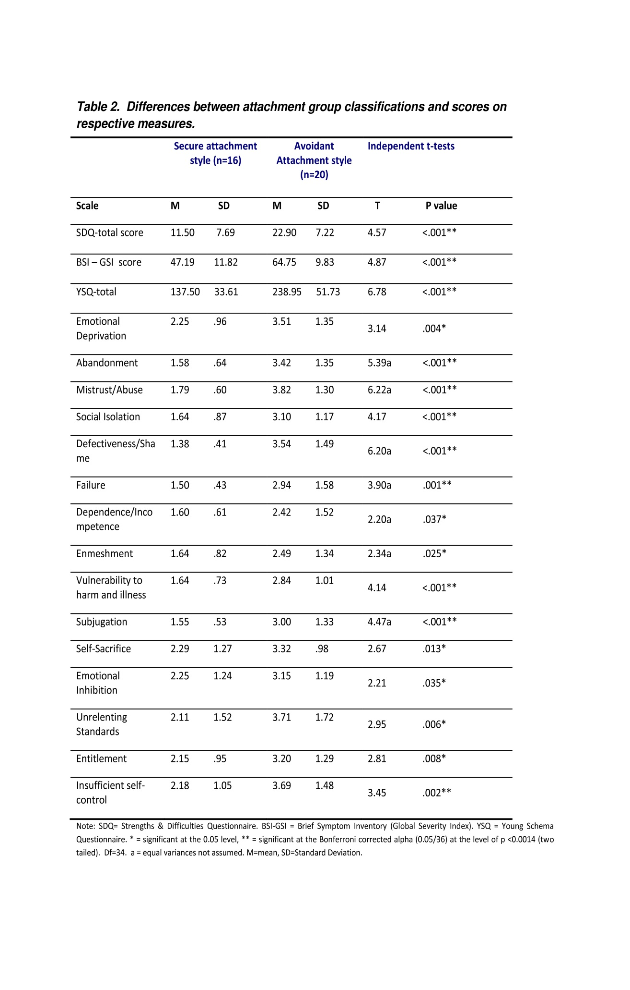
number of placement moves (all ps > .05) (see appendix 13.1 to 13.7 for all descriptive statistic outputs). The number of responses indicating that a participant was currently accessing support from mental health services, and/or that they had a mental health diagnosis varied significantly between attachment style sub-groups (p = .02 ;appendix 13.1). However, these factors were not entered into the main analysis as covariates as severity of mental health difficulties was already being accounted for by the BSI.

Between-group comparisons

Levels of psychopathology as measured by the BSI
Differences between the BSI-GSI scores of the secure subsample (mean= 47.38, SD=12.01) and those of the avoidant group (mean=64.75, SD=9.83) were both clinically and statistically significant at the Bonferroni corrected alpha level (t = 4.87, df = 34, p < .0014, see table 2), indicating that avoidantly attached participants experienced significantly higher levels of psychopathology than securely attached participants. Fifty per cent of avoidant participants had a BSI-GSI score within the clinical range (t≥60), and all securely attached participants’ scores were within the normal range. No significant associations were found between BSI-GSI scores and age, gender, ethnicity, length of time in care or number of placements (all ps > .05) (appendix 13.3 to 13.7).

Levels of psychopathology as measured by the SDQ
Differences between the SDQ scores of the secure and avoidant attachment groups were also both clinically and statistically relevant (i.e. scores ≥ 3, p<.0014; see table 3), suggesting that avoidantly attached participants experienced significantly more psychopathological difficulties than the securely attached group. The mean SDQ score for the secure subsample was 11.50 (SD=7.69), with 3 participants scoring within the abnormal range (≥20). The mean score for the avoidant group was 22.90 (SD=7.22), with 4 of this group scoring within the ‘borderline’ range, and 13 within the abnormal range. No significant associations were found between SDQ scores and age, gender, ethnicity, length of time in care or number of placements (all ps >.05 ;appendix 13.1 to 13.7).

Schema scores
Table 2 illustrates participants’ mean scores for the main study measures and for individual schemas. The mean total YSQ-S score (referred to hereafter as ‘YSQ Score’) for the securely attached subgroups was 137.50 (SD=33.61), with half of the secure participants demonstrating at least one clinically relevant (>3) average schema score. The YSQ score for the avoidant group was 238.95 (SD=51.73).
The avoidant subgroup reported higher scores than the secure group on all individual schemas. This difference was statistically significant at the Bonferroni corrected alpha of 0.0014 for 9 of these schemas (emotional deprivation, abandonment, mistrust/abuse, social isolation, defectiveness/ shame, failure, vulnerability to harm and illness, subjugation, insufficient self-control). Five of the six schemas with both statistically and clinically relevant schema score (mean scores ≥3, p≤ .0014) differences were categorised within the disconnection-rejection domain.
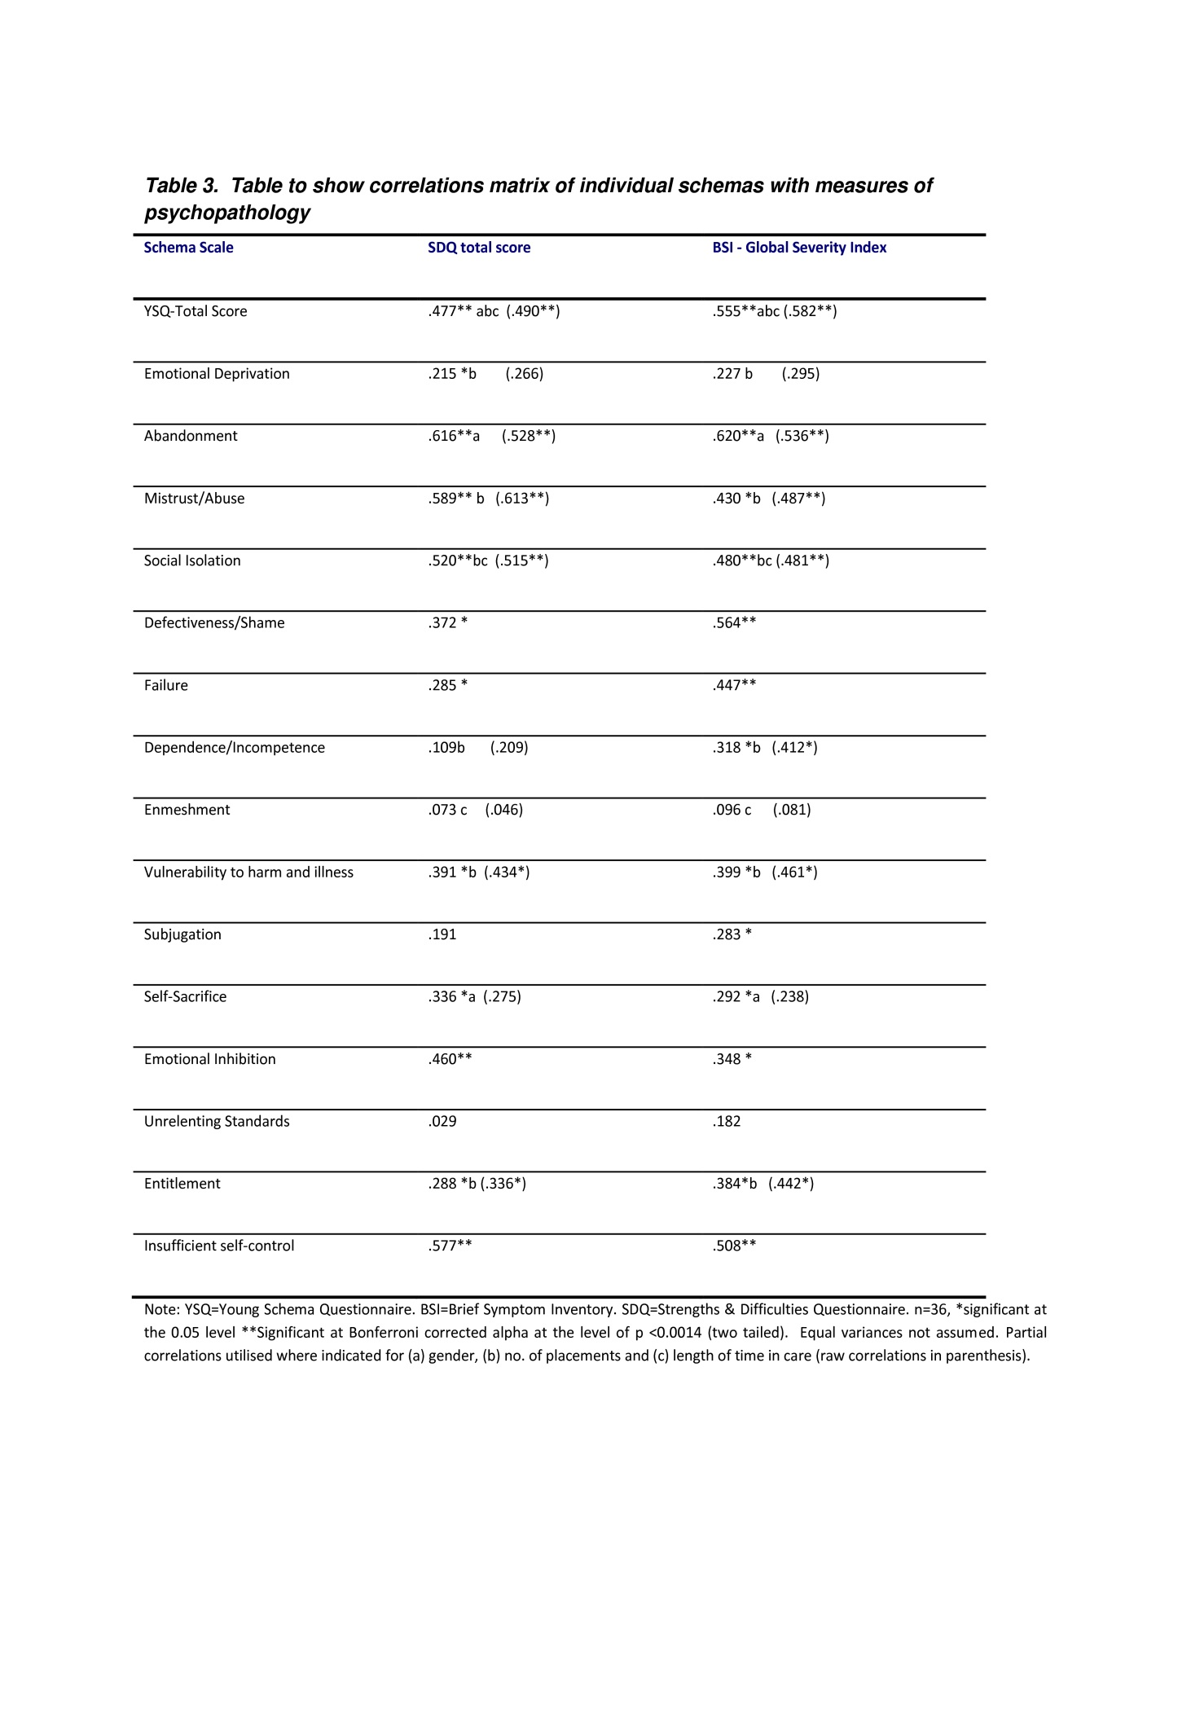
No significant associations were found between schema scores and age or ethnicity (ps all > .0014; appendix 13.3 to 13.7). Females however scored significantly higher than males on the abandonment and self-sacrifice schemas. YSQ score was correlated with number of placement moves (Pearson’s r = .345, p=0.039). Individual schemas were also found to correlate with length of time in care and number of placement moves (p<0.05). These factors were therefore included as covariates in the main analyses where appropriate.

Bivariate correlations
Correlational analyses (Pearson’s r, or partial correlations controlling for covariates where appropriate) were used to determine the levels of association between the hypothesised mediating variables (schemas) with the hypothesised dependent variables (behavioural difficulties and levels of psychopathology). Given the number of correlations conducted, Bonferroni’s correction was again used, and an acceptable alpha of .0014 was adopted. Table 3 shows the correlations between YSQ score and individual schema scores with the two measures of psychopathology.
YSQ score was significantly associated with severity of psychopathology as measured by both the SDQ and the BSI-GSI (p<0.001). The individual schemas of abandonment, mistrust/abuse, social isolation, emotional inhibition and insufficient self-control were significantly positively associated with psychopathology as measured by the SDQ, and abandonment, defectiveness/shame, failure and insufficient self-control schemas were significantly correlated with psychopathology as measured by the BSI-GSI.
YSQ score was strongly positively correlated with both the BSI-GSI score (r=.582, p<.001) and the SDQ total score (r=.490, p<.001). Whilst this indicates that measures were inter-correlated (a precondition of linear regression analyses), associations did not exceed accepted tolerance levels for multiple regression (see tolerance and Variance Inflation Factor or ‘VIF’ statistics in multiple regression summaries below).

The mediating role of schemas
Analysis of the mediating effect of total schema score on psychopathology as measured by the BSI-GSI
Having established significant differences between the YSQ scores of the secure and avoidantly attached subgroups (p<.0014), Baron and Kenny’s (1986) rationale and regression-analytic procedures were utilised to test the hypothesised model that total YSQ score would mediate the relationship between self-reported attachment style and levels of psychopathology. In the first analysis, multiple regression (forced entry method) was used to determine whether presence/absence of an avoidant attachment style predicts BSI-GSI scores. The analysis confirmed that presence/absence of an avoidant attachment style was a significant predictor of BSI-GSI score (F=23.706, p<0.001, β=.641; explained variance=41%).
In the second regression analyses YSQ score (controlling for gender, number of placement moves and length of time in care, which were entered on the first step of the regression and YSQ on the second) was confirmed to be a significant predictor of BSI-GSI score (F=5.607, p<0.001, β=.571; explained variance =38%).
The next stage of the analyses was to determine whether presence/absence of an avoidant attachment style retained any predictive power over the dependent variable (psychopathology as measured by the BSI-GSI) once the hypothesised mediator (YSQ total score) was taken into account. Presence/absence of avoidant attachment was entered on the first step, covariates were entered on the second step and YSQ total score was entered on the final step. When YSQ total score was taken into account, presence/absence of avoidant attachment style was no longer a significant predictor of BSI-GSI scores (t=1.375, p=.179). According to the model proposed by Baron and Kenny (1986), this result suggests that YSQ total score (controlling for covariates) is a perfect mediator in the relationship between presence/absence of an avoidant attachment style and BSI-GSI score.
Bootstrapping was then undertaken to test the reliability of the mediation model. Using Preacher and Hayes’ (2008) INDIRECT macro for SPSS, presence/absence of an avoidant attachment style was entered as independent variable, BSI-GSI score was entered as the dependent variable, YSQ total score was entered as the potential mediator and gender, number of placement moves and length of time in care were entered as covariates.

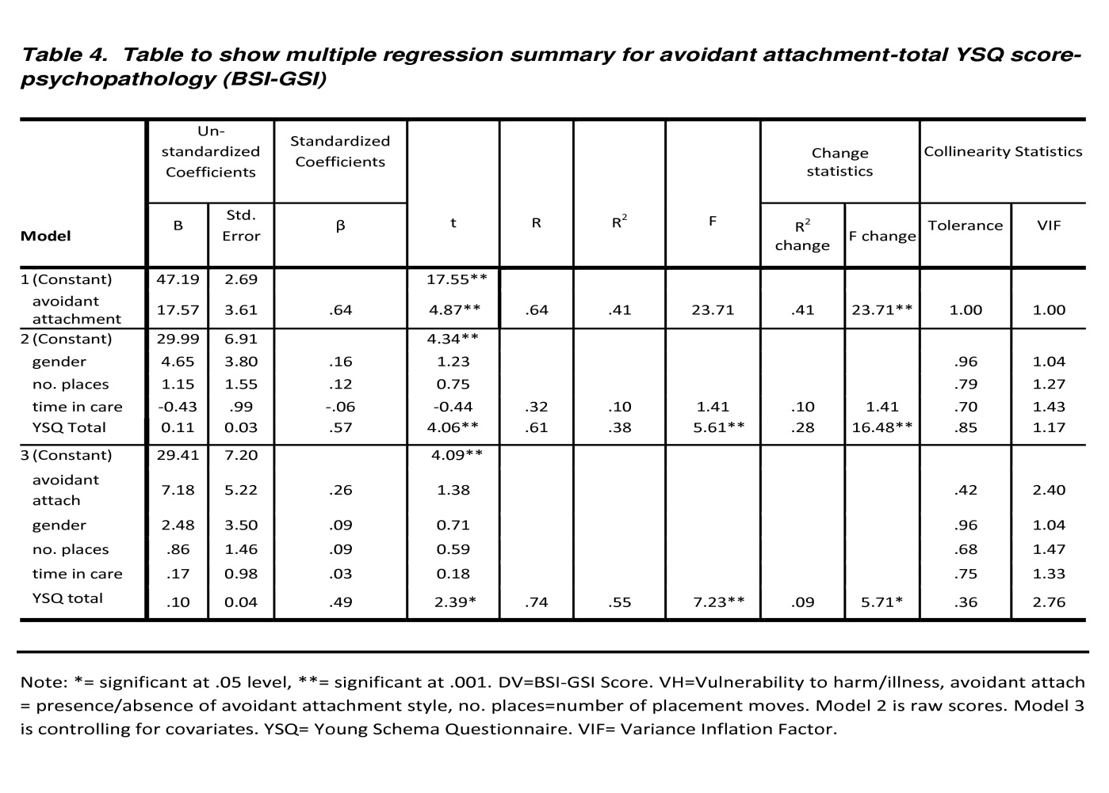
The bootstrap estimated the mean indirect effect of presence/absence of an avoidant attachment style on BSI-GSI score via YSQ score was 9.39 (i.e. the bootstrapping procedure estimated that the indirect effect of having an avoidant attachment style via total schema score would result in a mean difference of a 9.37 higher BSI-GSI score). The 95% bootstrap confidence interval (5000 trials) estimated that the indirect effect of the dependent variable (attachment style) via the mediator (Total YSQ) on BSI-GSI score was from 2.80 to 17.64 (see table 9) and because zero did not appear within this confidence interval, it is concluded that the indirect effect of the dependent variable (attachment style) via the mediator (Total YSQ) on BSI-GSI score is different from zero (p<0.05).

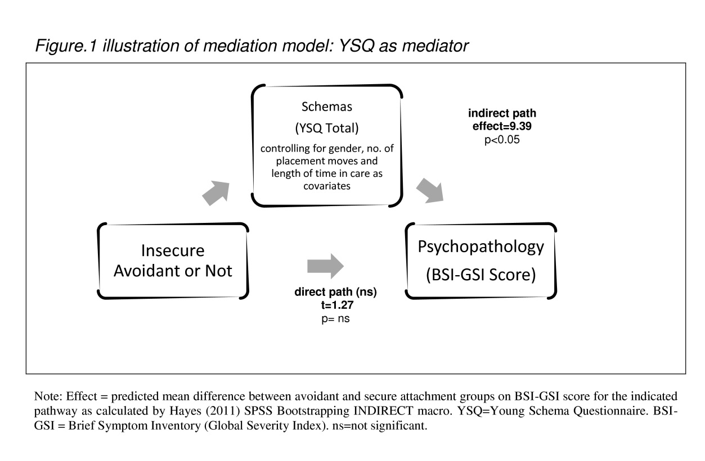

Analysis of the mediating effect of total schema score on psychopathology as measured by the SDQ

Baron and Kenny’s (1986) rationale and regression-analytic procedures, were again utilised to test the hypothesised model that overall schema score would mediate the relationship between self-reported attachment style and levels of psychopathology as measured by the SDQ total score. The initial analyses confirmed that presence/absence of an avoidant attachment style was a significant predictor of total SDQ score (F=20.916, p<0.001, β=.617; explained variance=38%).
In the second stage of this analysis YSQ score (controlling for gender, number of placement moves and length of time in care) was confirmed to be a significant predictor of SDQ total score (F=3.407, p=0.001, β=.503; explained variance =27%).
The next stage of the analyses was to determine whether avoidant attachment style retained any predictive power over the dependent variable (psychopathology as measured by the SDQ) once the hypothesised mediator (total YSQ score) was taken into account. Presence/absence of avoidant attachment was entered on the first step, covariates were entered on the second step and YSQ total score was entered on the final step (see table 5). When total schema score was taken into account, presence/absence of avoidant attachment style retained its direct predictive validity predictor of SDQ total score (t=2.119, p=.047). The indirect path, via total schema score
was not significant (t=1.070, p=.293). YSQ total score does not therefore have a mediating role in the relationship between presence/absence of an avoidant attachment style and variance in level of psychopathology as 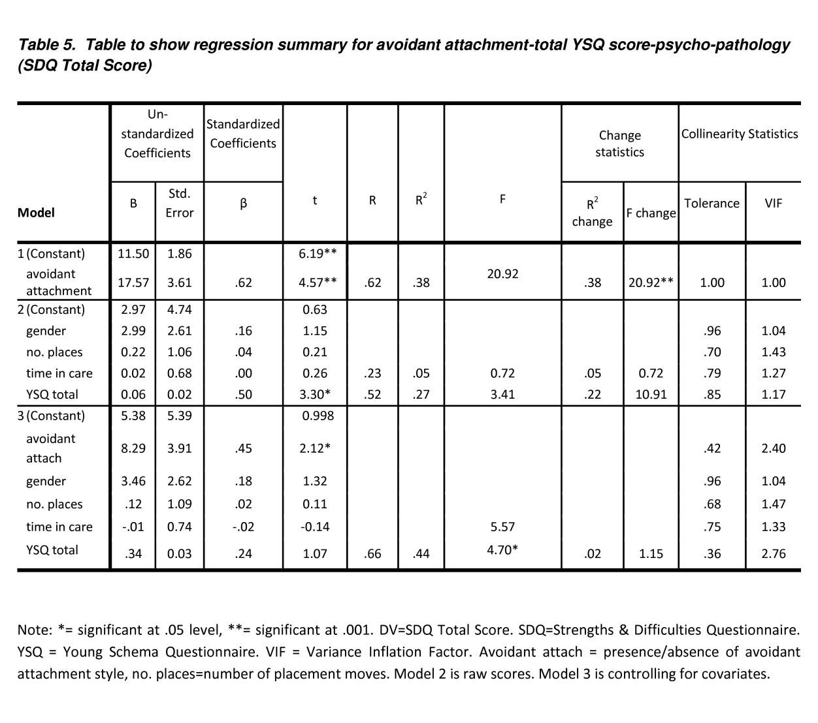

measured by total SDQ score. As the p value of the indirect path did not approach significance (p=.293), the testing of the model utilising the bootstrapping procedure was not indicated,

The mediating effect of individual schemas on psychopathology as measured by BSI-GSI scores
A series of regression analyses was undertaken to determine whether any of the individual schemas would meet Baron and Kenny’s (1986) preconditions to be entered into the multiple regression procedure as potential mediators between presence/absence of avoidant attachment style and psychopathology as measured by the BSI-GSI. Significant differences (p≤.0014) had been evidenced between the secure and avoidantly attached subgroups and their individual schema scores of abandonment, mistrust/abuse, social isolation, defectiveness/shame, failure, vulnerability to harm/illness, emotional inhibition, entitlement and insufficient self-control (see table 2). All of these schemas were subject to the first stage of multiple regression analysis and all but the subjugation schema were found to be predictive of BSI-GSI scores (p<.05; see appendix 14).
In the next stage of analyses, all of the schemas that reliably predicted BSI-GSI scores were investigated as potential unique mediators in the attachment style-psychopathology link. Multiple regression procedures were followed for each individual schema (see appendix 17). However, only the individual schema of mistrust/abuse was found to have a mediating role in the attachment-psychopathology (BSI-GSI) pathway (see table7). Avoidant attachment style did not retain its significant predictive power over the dependent variable (psychopathology as measured by the BSI-GSI) once the mistrust/abuse schema was taken into account (t=1.933, p=.067). According to the model proposed by Baron and Kenny (1986), this result suggests that
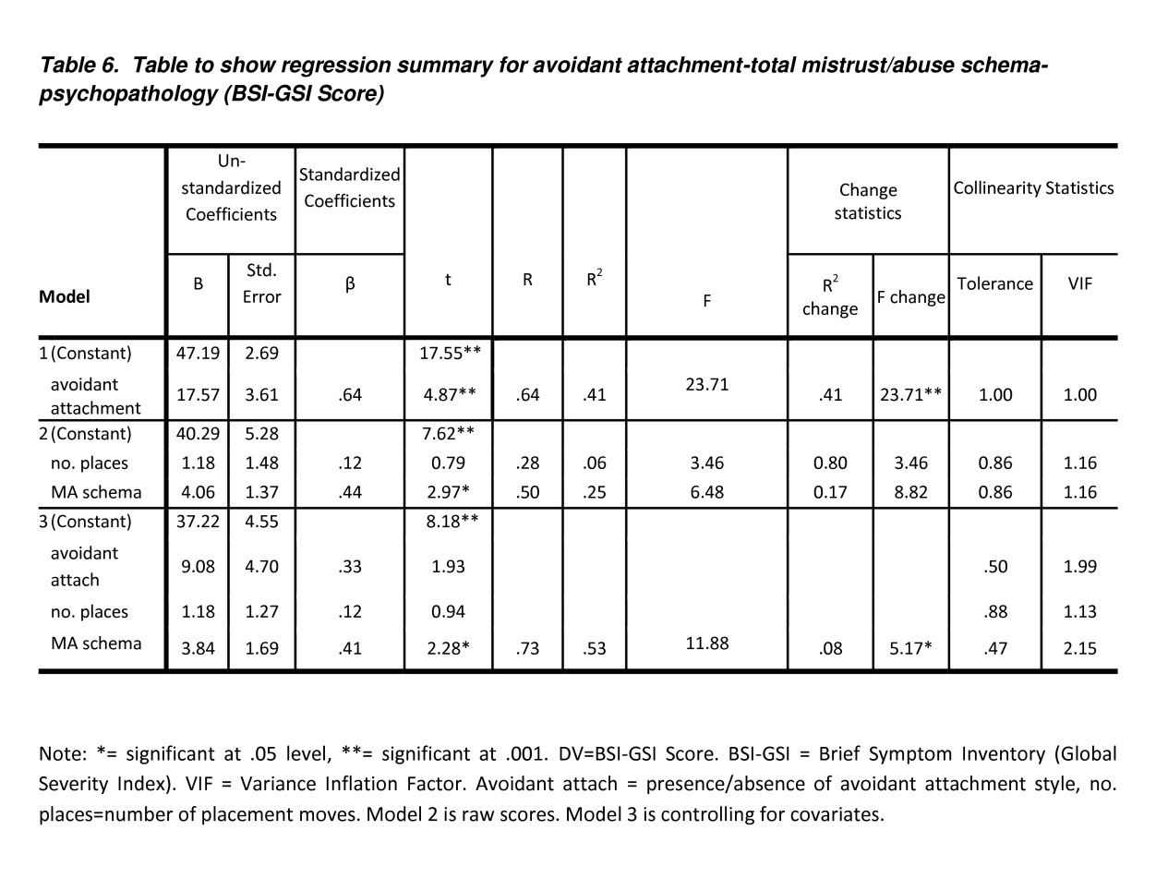
the mistrust/abuse schema (controlling for number of placement moves as a covariate) is a perfect mediator in the relationship between presence/absence of an avoidant attachment style and BSI-GSI score.
Bootstrapping was then undertaken to test the mediation model. Using Preacher and Hayes’ (2008) INDIRECT macro for SPSS, presence/absence of an avoidant attachment style was entered as the independent variable, BSI-GSI score was entered as the dependent variable, mistrust/abuse score was entered as the potential mediator and number of placement moves was entered as a covariate. The bootstrap estimated the mean indirect effect of presence/avoidance of an avoidant attachment style on BSI-GSI score via average mistrust/abuse schema score score was 7.78 (i.e. the bootstrapping procedure estimated that the indirect effect via average mistrust/abuse schema score would result in those with an avoidant attachment style having a mean difference of 7.78 higher BSI-GSI score than those with a secure attachment style). The 95% bootstrap confidence interval (5000 trials) estimated that the indirect effect of the dependent variable (attachment style) via the mediator (average mistrust/abuse schema score) was between 2.05 and 15.71. As zero does not appear within the upper and lower limits of this confidence interval, a model is supported whereby the individual schema of mistrust-abuse mediates the avoidant attachment-psychopathology link.

The mediating effect of individual schemas on psychopathology as measured by the SDQ

A series of regression analyses was undertaken to determine whether any individual schema would meet Baron and Kenny’s (1986) preconditions to be entered into the multiple regression procedure as potential mediators. Of those individual schemas that had previously been demonstrated to reliably differ between secure and avoidant attachment styles (see table 2), abandonment, mistrust/abuse, social isolation, defectiveness/shame, vulnerability to harm/illness, emotional inhibition, entitlement and insufficient self-control (when controlled for covariates) were also predictive of SDQ total score when subject to the first stage of regression analysis (p <.05; see appendix 14).
In the next stage of analyses, all of the schemas that both reliably differed between attachment styles and themselves predicted SDQ total score were investigated as potential unique mediators in the attachment style-psychopathology (as measured by the SDQ) link. Regression procedures were followed for each individual schema (see appendix 18). However, only the individual schema of mistrust/abuse was found to have a mediating role in the attachment-psychopathology (as measured by the SDQ) pathway (see table 8). Avoidant attachment style did not retain its significant predictive power over the dependent variable (psychopathology as
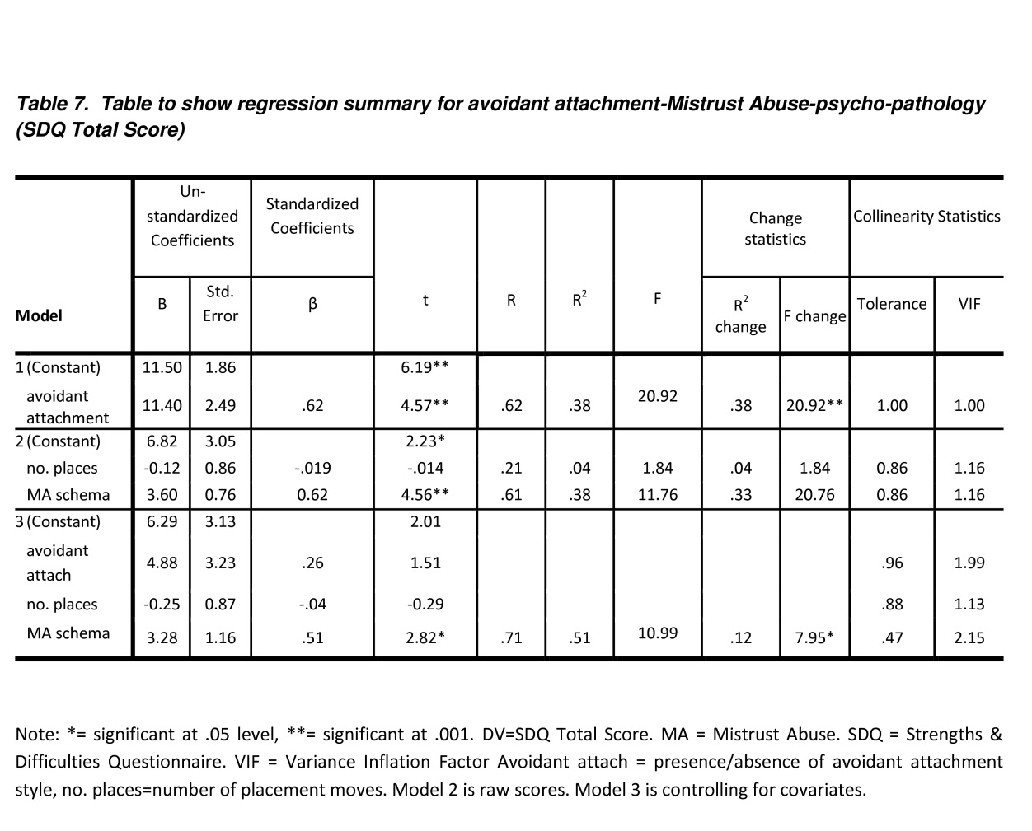
measured by the SDQ) once the mistrust/abuse schema was taken into account (t=1.511, p=.140). According to the model proposed by Baron and Kenny (1986), this result suggests that the mistrust/abuse schema (controlling for number of placement moves as a covariate) is a perfect mediator in the relationship between presence/absence of an avoidant attachment style and SDQ total score.
Bootstrapping was again undertaken to test the mediation model. Using Preacher and Hayes’ (2008) INDIRECT macro for SPSS, presence/absence of an avoidant attachment style was entered as the independent variable, SDQ total score was entered as the dependent variable, mistrust/abuse was entered as the potential mediator and number of placement moves was entered as a covariate. The bootstrap estimated

Table 8. Table to show Bootstrap output summaries for proposed mediation models

Mediation  Model | Estimated partial effects of covariates on dependent variable |  | Bootstrapping  estimate  of indirect effects of IV on DV via mediator (5000 trials) | Bootstrapping 95% confidence interval of effects
Mediation  Model | t | Sig. |  | LLCI | ULCI
Independent Variable: Avoidant attach  Mediator: YSQ Total  Dependent Variable: BSI-GSI  Covariates: Gender  No. of placement moves  Time in care | 0.71  0.17  0.59 | .48  .86  .56 | 9.37 | 2.80 | 17.64
Independent Variable: Avoidant attach  Mediator: MA Schema  Outcome: BSI-GSI  Covariates:  No. of placement moves | 0.94 | .36 | 7.78 | 2.05 | 15.71
Independent Variable: Avoidant attach  Mediator: MA Schema  Outcome: Total SDQ Score  Covariates:  No. of placement moves | -0.29 | .78 | 6.39 | 2.66 | 10.73
Nb. Avoidant attach=presence/absence of avoidant attachment style, LLCI=lower limit of confidence interval, ULCI=upper limit of confidence interval. YSQ = Young Schema Questionnaire. BSI-GSI = Brief Symptom Inventory (Global Severity Index). SDQ = Strengths & Difficulties Questionnaire. MA = Mistrust Abuse.

Effects of attachment style on total SDQ score via average mistrust/abuse score was 6.39 (i.e. the bootstrapping procedure estimated that the indirect effect via total schema score would result in those with an avoidant attachment style having a mean difference of 6.39 higher SDQ total score than those with a secure attachment style). The 95% bootstrap confidence interval (5000 trials) estimated that the indirect effect of the dependent variable (attachment style) via the mediator (average mistrust/abuse schema score) was between 2.66 and 10.73. As zero does not appear within the upper and lower limits of this confidence interval, a model is supported whereby mistrust-abuse schema severity mediates the avoidant attachment-psychopathology (as measured by the SDQ) link.

Discussion

Main findings
This study aimed to address the question of whether Young’s schemas would mediate the relationship between attachment style and psychopathology in children in care. The findings are compatible with a model where total level of schema severity mediates the relationship between presence/absence of an avoidant attachment style and levels of psychopathology as measured by the BSI (see figure 1), but not as measured by total SDQ score. The mistrust/abuse schema was found to have a unique mediating role in the avoidant attachment-psychopathology association as measured by both the BSI-GSI and total SDQ score.

Study limitations
Many of the individual findings are compatible with previous findings that schemas mediate the relationship between attachment disorder and psychopathology (e.g. Mason et al., 2006; Hulbert et al., 2011). These models should be treated as tentative, due to small sample size and the inevitable difficulties in interpreting the results of cross sectional data in order to generate a developmental model of psychopathology. Whilst a linear model is implied (e.g. avoidant attachment style leads to increased level of schemas, which leads to psychopathology), feedback, suppression and other potential interactions between variables are not accounted for by the present methodology.
The findings might also be interpreted in other ways. In particular, it could be hypothesised that children in care experience psychopathology via another set of mediators and that the development of schemas is a consequence of these ‘third factors’ not measured by the present study. For example, the precise nature of adverse experiences prior to coming into care, the age of the child when the experiences occurred, the relationship of the child to the perpetrator(s), the cumulative effects of adverse experiences whilst in care, and the emotional effect of all these experiences may all impact on the development of psychopathology.
Whilst the predictive ability of the mediation models were found to be significant, the need to enter covariates into the model means that the models presented on this study are undoubtedly underpowered (the modelling quickly fell below the minimum threshold of 10 participants per predictor variable when adding covariates to the mediation model). Higher response rates would have improved the reliability and validity of the study findings and may have allowed for the identification of more dynamic models. It may also be the case that the questionnaires were particularly relevant to those who chose to return them and that findings may not reflect the levels of difficulties experienced by children looked after by the LA as a whole. The results of a single study such as this therefore require replication and extension before strong conclusions could be drawn about the proposed attachment, schema-psychopathology pathways.

Attachment styles of children in care
Sixty-two per cent of the overall sample classified themselves as insecurely attached. Although epidemiological studies often quote high prevalence of attachment difficulties in children in care, precise figures are unknown (Barth et al., 2005). As mentioned in the introduction, van Ijzendoorn and Bakermans-Kranenburg’s (2009) meta-analysis of related research studies suggests incidence of up to 85% insecure attachment style in maltreated children and adolescents. Therefore, the secure-insecure split of the present sample is within accepted predictions.
The predominance of the avoidant attachment style amongst insecurely attached participants in the present study is contrary to other studies, which have found a tendency toward a ‘fearful’ attachment style and externalising attachment behaviours (Mason et al., 2006; Hulbert et al., 2011, Simard et al., 2011). Whilst direct comparison with these findings is difficult, given their use of adult attachment dimensions, authors in these studies question the accuracy with which self-report measures correctly classify participants into insecure attachment subgroups. Whilst they believe that the insecure/secure distinction to be reliable, it is suggested that classification into subcategories may be less so. Future studies are advised to consider the adult and child attachment interviews (whichever is age appropriate to the target population) as a more reliable, although more labour-intensive alternative.
Various explanations for the difference in findings of the present study are offered. Firstly, the AQ-C asks participants to self-categorise their attachment style using three statements according to their experiences in peer relationship (appendix 2). Participants may perceive peer relationships differently to relationships with carers and therefore misclassification of insecure attachment style may have occurred. An alternative measure, such as the 36-item experiences in Close Relationships Questionnaire (Brennan, Clark, & Shaver, 1998) may offer a more dimensional measure of attachment tendencies in future studies. Crittenden (2006) however hypothesises that attachment styles are evident only in times of threat and that, whilst securely attached individuals function well in environments with predictable boundaries, attachment-maintaining behaviours are still triggered during times of threat. ‘Misclassification’ of attachment style may therefore occur, for example, when individuals with a tendency toward secure attachments are feeling unsafe, and individuals with a tendency toward insecure attachment are living in a safer, more predictable environment.
One final explanation for the predominance of the avoidant attachment style in the present study may be that young people who have an anxious-ambivalent or ‘externalising’ attachment style may be moved around more frequently as carers struggle to manage their behaviours. They may be less stable in their placements due to their hyper-vigilance to threat, and perhaps have attracted the attention of the judicial system as a result of their attachment behaviours (and therefore no longer be living in the care of the LA). Children within the care system with an internalising, or avoidant attachment style may pose fewer difficulties to carers and therefore be more stable in their placements. This, in turn, may make them more likely to complete the questionnaire packs than their ambivalently attached counterparts.

Avoidant attachment style and psychopathology as measured by the BSI-GSI
In keeping with studies of the relationship of both attachment difficulties and adverse parenting experiences with psychopathology (e.g. Bosmans et al., 2010; Carr & Francis, 2010), between-group comparisons in the present study confirmed the hypothesis that insecurely (avoidantly) attached participants would demonstrate significantly higher levels of psychopathology than securely attached participants (see table 3). Fifty per cent of participants in the avoidant group reported levels of psychological distress indicative of clinical caseness. BSI-GSI scores indicated that two participants who had previously been in contact with mental health services classified themselves within the secure attachment group. Six participants who were currently accessing mental health services, one who had previously accessed mental health services, and three who had been given a formal mental health diagnosis, classified themselves within the avoidant attachment group. The remaining two participants who had formal mental health diagnoses were within the ambivalent attachment group. Whilst there are some misgivings about the accuracy of attachment classifications, this finding lends support to the ability of the presence/absence of an avoidant attachment style as measured by the AQ-C to distinguish between overall levels of psychopathology.

Avoidant attachment style and psychopathology as measured by the SDQ
Between-group differences (table 3) demonstrated that the avoidant attachment group also demonstrated significantly higher total SDQ scores than the securely attached subgroup. Only 3 participants from the secure group reported abnormally high SDQ scores, and 17 from the avoidant group had either ‘borderline’ or high scores, suggesting that presence/absence of an avoidant attachment style was a fairly accurate predictor of levels of psychopathology as measured by the SDQ. Four of the ambivalent attachment group also demonstrated either borderline or high scores.
Only 4% of young people in the non-clinical population would be expected to score above the SDQ total score cut-off for the normal range (Meltzer et al., 2000). With 62% of the participants overall (n=42) scoring within the borderline range or higher, this suggests that the present sample of children in care experience considerably higher psychopathology than the normal population. The average total SDQ score for the overall group (mean=17.79, SD=8.82) is also above the national indicator for children in care (age range 5 to 18, mean SDQ score of 13.8%; National Audit Commission, 2011). It is however noted that this instrument has only been validated for use with young people up to the age of 17. As the mean age of participants in the present study was 17 (range 13 to 21), high scores may reflect developmentally different life circumstances, such as leaving care.

Schemas and attachment difficulties
Participants with an avoidant attachment style demonstrated significantly higher overall schema scores than securely attached participants. This, combined with the finding that avoidantly attached participants also scored significantly higher on nine individual schemas, supports the hypothesis that schemas significantly differentiate between attachment styles. However, all participants demonstrated relatively large standard deviations in total schema scores, suggesting large within-group variations.
Although not statistically tested, the total schema scores for all six ambivalent participants appeared particularly high (mean=278.50, SD=35.07). As explained above, two of these participants demonstrated particularly low scores on the other study measures. Unusually low scores of psychopathology may result when an individual has developed deactivating strategies to avoid rejection in times of distress (Young et al., 2003). However, these clients often deny schemas and therefore also demonstrate low overall schema scores. Whilst this may not fully explain the observed unusual distribution of scores within the small anxious-ambivalent sub-group, the finding that anxious-ambivalent participants (n=6) have the highest overall YSQ scores is consistent with other studies of schemas and attachment style (e.g. Simard et al., 2011).
In comparison to unpublished non-clinical adolescent norms (Waller, Meyer, Beckley, Stopa, & Young, 2011), the average individual schema score for the secure attachment group ranged from a percentile score of 47 for mistrust/abuse and failure schemas to the 64th percentile for emotional inhibition. The avoidantly attached group demonstrated average individual schema scores ranging from the 78th percentile for dependence incompetence, to the 92nd percentile for mistrust/abuse. Standard deviations for individual schemas were larger for the avoidant than the secure group in most cases, with the exception of self-sacrifice and enmeshment schemas. This suggests more variation in individual scores within the avoidantly attached group, and is consistent with the finding that schema profiles may differ between clinical and non-clinical sub-groups (Overton, Selway, Strongman, & Houston, 2005).

Schemas and psychopathology
The hypothesis that total schema score would be significantly associated with psychopathology as measured by the GSI-BSI was supported. Significant positive correlations were observed between a scale of global psychological distress (the GSI score) and individual schemas of abandonment, defectiveness/shame, failure and insufficient self-control. Whilst different associations may have been identified had the individual scales of the BSI-GSI been examined, the present study had small number of participants and would not have had sufficient power to explore this further.
Despite the study limitations, the finding that both individual schemas and total schema score appear relevant to global psychological distress, suggests a need for further exploration of the precise pathways that mediate the relationship between adverse attachment experiences and psychopathology in this vulnerable population of young people.

Schemas and psychopathology as measured by the SDQ
As anticipated, total SDQ score was strongly, positively correlated with total schema severity. Significant correlations were also found with individual schemas, predominantly from within the disconnection/rejection domain, in addition to the individual schemas of emotional inhibition and insufficient self-control. This indicates that high total SDQ score is associated with schemas indicative of high levels of early childhood rejection and abuse and those associated with an inability to control one’s emotions and impulses and a belief that one must inhibit expressions of emotion to avoid being disapproved of by others (Young et al., 2003).
It is perhaps unsurprising that the SDQ demonstrates less significant associations with schemas within the domains of impaired autonomy and other directedness, especially given that the ‘clinical’ subgroup members within this study described themselves as being avoidantly attached. Whilst the SDQ (appendix 2) asks participants to respond in terms of whether they prefer to spend time alone, or with adults as opposed to peers, it considers help-seeking behaviours and proximity to friends and others only as ‘prosocial’ behaviours. Schema theory however places importance on schemas relating to difficulties with independence and detrimentally putting the needs of others before one’s own. It is noted, however, that different associations may have been observed had there been greater numbers of participants available, and particularly more participants with an ambivalent, or externalising, attachment style; given the SDQ total scores reliance on two of four scales that identify conduct and hyperactivity-inattention as key indicators of psychological distress.

Covariates
The overall (n=36) gender difference for the abandonment and self-sacrifice schema observed in the present study has also been evidenced in non-clinical samples (p<0.001; Waller et al., 2011), so is not a novel finding. The association between placement moves and total schema score and the individual schemas of emotional deprivation, mistrust/abuse, social isolation, emotional inhibition and insufficient self-control is perhaps to be expected, given the impact of multiple attachment distributions on internal working models. However, causal inferences cannot be made as it may be just as likely that internal working models associated with an expectation of not having one’s emotional needs met, may cause individuals to behave in a way that is consistent with these schemas and that this may result in placement moves.
The positive association between time in care and the schema of social isolation (p=0.007) may relate to the fact that this schema was also found to be associated with number of placement moves. The negative association between length of time in care and enmeshment (p=0.003), is less easy to explain and may be influenced by the inclusion of only the avoidant (and not the ambivalent) insecurely attached subgroup in the main analyses.

Mediation models
The main mediation models are described under ‘main findings’ above. The mistrust/abuse schema was found to be a unique mediator in the attachment style-psychopathology pathway for both measures of psychopathology, indicating that it may be important in understanding the psychopathological difficulties of children in care. However, the similarity of the statements within this domain (‘I don’t fit in, I don’t belong; I’m a loner,’ ‘I feel alienated by other people’ and ‘I always feel on the outside of a group’) have the most crossover of any items from the YSQ-S with the single AQ-C question by which young people classified themselves as having an avoidant attachment style (‘I am uncomfortable to be close friends with other children. I find it difficult to trust them completely, difficult to depend on them. I get nervous when another child wants to become close friends with me. Friends often come more close to me than I want them to’). Again, larger sample groups and a more detailed measure of attachment relationships are recommended in order to further explore the mediating role of any individual schemas in the attachment-psychopathology link.

Theoretical implications
Empirical evidence for Young et al.’s (1990; 2003) conceptual theory of schema development remains largely retrospective in nature. Whilst a proportion of the ‘children in care’ who participated in the present study are young adults (up to the age of 21), the fact that they are and have been in the care of the LA suggests that they have experienced adverse early attachment experiences including at least one major attachment disruption (the removal into care from their primary care givers). This study therefore provides support for Young’s theory that schemas arise from adverse attachment experiences during childhood, and adds to the theoretical evidence base of schema theory in understanding the origins of psychopathology in adolescence and adulthood.
As the work of Bowlby and Ainsworth is stated to underpin schema theory (Young, 2003), the associations between attachment and schemas found in the present study support the contribution of attachment difficulties to schema development. What is not clear, however, is why participants who classified themselves as ‘securely attached’ (with perhaps the exception of those with unusually low scores) have developed psychological resilience whilst being a child in care. One explanation for this may be the theoretical supposition that schemas are triggered only in times of threat. In this way, schema theory may complement Crittenden’s (2006) dynamic maturational model of attachment relationships as opposed to the traditional models associated with Bowlby (1969) and Ainsworth (1978). If this was to be supported, the finding that individuals who classified themselves within the secure attachment group, but demonstrate some elevated schemas, may be better considered as having a predisposition toward psychological difficulties in times of stress.

Clinical implications
If the models of the attachment-schema-psychopathology association proposed in this study were to be supported by future research, then this would suggest a case for assessing and treating early maladaptive schemas in children in care and care leavers presenting with mental health difficulties linked to adverse early attachment experiences.
The present study suggests that the assessment of schema level core beliefs (utilising an age-appropriate schema questionnaire e.g. Stallard, 2007; Rijkeboer & Gerly, 2010; Simmons & Free, 2000) may make significant contributions to the formulation of mental health presentations in children in care. It may also aid social care staff in the successful identification of young people requiring mental health intervention, by utilising a schema questionnaire.
The lack of dimensional models between attachment difficulties, particular schemas and psychopathology supports Young et al.’s cautionary advice that schema focused assessment should assess the schemas of the individual client (Young, 2003). Assumptions of the existence of particular schemas based upon client history and/or mental health diagnoses should be avoided, especially given the complex backgrounds of the present client group.
The most widely used models of psychological therapy for ameliorating the mental health sequelae of attachment difficulties currently focus on enhancing the attachment relationship between the child and their primary carer(s) (e.g. Hughes, 2009, Jernberg, & Booth, 2010). If the models suggested in the present study are correct, then schema therapy may offer an alternative or complementary therapy to those commonly utilised for children in care. This may be particularly important for adolescents and care leavers who may not have a primary carer and/or are developmentally placing more importance on relationships with their peers, are forming romantic relationships and are perhaps becoming parents themselves (Piaget, 1955).
By utilising schema-focused techniques, schema therapy could aid the formation of a more coherent sense of self. Theoretically, if schemas were ‘healed’ then levels of psychopathology would diminish and the relationship between avoidant attachment style and psychopathology would no longer exist. The opportunity to experience positive attachment relationships outside of therapy would doubtless improve the success of the model. The addition of schema theory to attachment-based training courses may aid understanding of internalising (or avoidant) attachment behaviours and may therefore be utilised as a preventative measure.

Future research
Finally, the present research model requires replication and could also be expanded. It would be valuable to consider whether the avoidant attachment style is in any way special, or if the results remain the same when all insecure attachment styles are considered. Equally, it would be pertinent to discover whether children in care differ in respect to the proposed models, or if similar models may be retrieved in those who have experienced abuse/neglect histories, but have remained out of the care system.
Research evidence for how different types of abuse/neglect experiences at different stages of development impact on attachment style formation and psychopathology is limited and empirical understanding of the inter-relationships between these factors is lacking. How much the development of schemas and psychopathology results from the emotional impact of early life experiences (Bernstein, 2002), and how much results from the confounding experiences of placement moves and other adverse experiences in care is unknown. Further research is required in order to develop a fine-grained model of understanding the sequelae of children in care’s life experiences, and would benefit particularly from adopting a longitudinal approach.

Largely based upon Beck’s et al.’s (1979) specificity hypothesis, the long-term research goal of mediation model research is to enable linking of particular types of early adversity with particular psychological symptom presentations and to develop interventions accordingly. It may be, however, that no truly dimensional relationship exists between attachment style and psychopathology, and that such models may be particularly difficult to develop in the present population. To consider all the potential third factors involved in the development of psychopathology in children in care (see study limitations), the number of potential predictors could run into hundreds. With a minimum requirement of ten participants per predictor (Field, 2009), combined with the difficulties in recruiting children in care to research studies, the pursuit of developing such a dimensional model may be unrealistic. Future studies should therefore consider research methods such as functional analysis and hierarchical multiple regression that allow factors to be added to the understanding of mental health presentations as opposed to mediating models that explore the unique contribution of individual factors.

Conclusions
In conclusion, the present study provides preliminary evidence that total schema severity may mediate the relationship between attachment style and psychopathology in children in care. Whilst further corroboration and expansion of the research findings is required, findings suggest that schema theory may provide a useful contribution to the understanding of the mental health needs of children in care.

References

Ainsworth, M., Blehar, M., Waters, E., & Wall, S. (1978). Patterns of attachment: A psychological study of the strange situation. Hillsdale, New Jersey: Erlbaum Associates.
Ainsworth, M (1989). Attachments beyond infancy. American Psychologist, 44, 709 - 716.
Allen, J., Moore, C., Kuperminc, G., & Bell, K. (1998). Attachment and adolescent psychosocial functioning. Child Development, 69, 1406 - 1419.

Baron, R. M., & Kenny, D. A. (1986). The moderator-mediator variable distinction in social psychological research: Conceptual, strategic, and statistical considerations. Journal of Personality and Social Psychology, 51, 1173 - 1182.
Beck, A. T., Ward, C. H., Mendelson, M., Mock, J., & Erbaugh, J. (1961). An inventory for measuring depression. Archives of General Psychiatry, 4, 561 - 571.
Beck, A. T. (1976). Cognitive therapy and the emotional disorders. New York: International Universities Press.
Beck, A. T., Rush, A. J., Shaw, B. F., & Emery, G. (1979). Cognitive therapy of depression. New York: Guilford Press.
Bernstein, D. P. (2002). Cognitive therapy of personality disorders in patients with histories of emotional abuse or neglect. Psychiatric Annals, 32 , 618-632.
Blower, A., Addo, A., Hodgson, J., Lamington, L., & Towlson, K. (2004). Mental health of ‘looked after’ children: A Needs Assessment. Clinical Child Psychology & Psychiatry, 9, 117-129.
Bosmans, G., Braet, C., & Vlierberghe, L. (2010). Attachment and symptoms of psychopathology: Early maladaptive schemas as a cognitive link? Clinical Psychology & Psychotherapy, 17, 374-385.

Bowlby, J. (1969). Attachment. London: Pelican.

Bowlby, J. (1979). The breaking and making of affectional bonds. London: Tavistock.

Brennan, K. A., Clark, C. L., & Shaver, P. R. (1998). Self-report measurement of adult romantic attachment: An integrative overview. In J. A. Simpson & W. S. Rholes (eds), Attachment theory and close relationships (pp. 46-76). New York: Guilford Press.

Bryant, R. A., Harvey, A. G., Dang, S. T., & Sackville, T. (1998). Assessing acute stress disorder: Psychometric properties of a structured clinical interview. Psychological Assessment, 10, 215-220.Carr, S.N. & Francis, A. J. P (2010). Early maladaptive schemas and personality disorder symptoms. An examination in a non-clinical sample. Psychology and Psychotherapy: Theory, Research and Practice, 83, 333-349.
Cicchetti, D. & Cohen, D. J. (2006). Developmental psychopathology: Theory and method. Wiley & Sons Inc: New Jersey.
Committee on Early Childhood, Adoption and Dependent Care (2000). Developmental issues for young children in foster care. Pediatrics, 106, 1145 - 50
Cooper, M. L., Shaver, P. R., & Collins, N. L. (1998). Attachment styles, emotional regulation and adjustment in adolescence. Journal of Personality and Social Psychology, 74 , 1380-1397.
Cooper, M. J., Rose, K. S., & Turner, H. (2006). The specific content of core beliefs and schema in adolescent girls high and low in eating disorder symptoms. Eating Behaviours, 7, 27-35.
Crittenden, P. M. (2006). A dynamic-maturational model of attachment. Australian and New Zealand Journal of Family Therapy, 27, 105-115.
Department for Children, Schools and Families (2009). Children looked after in England (including adoption and care leavers) year ending March 2009. London: Department for Children, Schools and Families.

Department for Children, Schools and Families (2010). Children looked after in England (including adoption and care leavers) year ending March 2010. London: Department for Children, Schools and Families.

Department for Children, Schools and Families (2011). Prospectus: Delivering intensive interventions for looked after children and those at the edge of care or custody. London: Department for Children, Schools and Families

Derogatis, L. R. (1993): Brief Symptom Inventory: Administration, Scoring and Procedures Manual. Baltimore: Clinical Psychometrics Research.
Field, A. (2009). Discovering statistics using SPSS (3rd edition). London: Sage.

Ford, T., Vostanis, P., Meltzer, H., & Goodman, R. (2007). "Psychiatric disorder among British children looked after by local authorities: comparison with children living in private households." British Journal of Psychiatry, 190, 319 - 325
Goodman R., Ford T., Simmons H., Gatward R., & Meltzer, H. (2000) Using the Strengths and Difficulties Questionnaire (SDQ) to screen for child psychiatric disorders in a community sample. British Journal of Psychiatry, 177, 534 - 539.
Harris, A. E. & Curtin, L. (2002). Parental perceptions, early maladaptive schemas, and depressive symptoms in young adults. Cognitive Therapy and Research, 26, 405 - 416.
Hayes, D. (2005). Gaining access to data sources in statutory social work agencies: The long and winding road. British journal of social work, 35 : 1193 - 1202.
Hayes, A. (2011). INDIRECT Macro for SPSS. Downloaded 12th October, 2011, from http://www.afhayes.com
Hazan, C. & Shaver, P. (1987). Romantic love conceptualised as an attachment process. Journal of Personality and Social Psychology, 52, 511 - 524.
Hepinstall, E. (2000). Research note. Gaining access to looked after children for research purposes: lessons learned. The British Journal of Social Work, 30 : 867 - 872.
Hughes, D. (2009). Principles of attachment-focussed parenting: Effective strategies to care for children. London: Norton Professional Books.
Hyler, S.E. & Rieder, R.O. (1987). PDQ-R: Personality Diagnostic Questionnaire - Revised. New York: New York State Psychiatric Institute.
Hulbert, C. A., Jennings, T. C., Jackson, H. J., & Chanen, A. M. (2011). Attachment style and schemas as predictors of social functioning in youth with borderline features. Personality and Mental Health, 5, 209-221.
Jernberg, A. M. & Booth, P. B. (2010). Theraplay: Helping parents and children build better relationships through attachment based play (3rd Edition). California: Jossey-Bass.
Kenny, D. A. (2007). Reflections on mediation. Organisational research methods, 11, 353 - 358.
Kenny, D. A. (2011). Mediation. Retrieved 15th October, 2011, from http://davidakenny.net/cm/mediate.htm#REF
Lawrence, K. A., Allen, J. S., & Chanen, A. M. (2011). A study of maladaptive schemas and borderline personality disorder in young people. Cognitive Therapy and Research. 35, 30 - 39.
Lee, C. W., Taylor, G., & Dunn, J. (1999). Factor structure of the schema questionnaire in a large clinical sample. Cognitive Therapy and Research, 23, 441 - 451.
Levy, K. N., Becker, D. F., Grilo, C. M., Mattanah, J. F., Garnet., K. E., Quinlan, D. M., Edell, W. S., & McGlashan, T. H. (1999). Concurrent and predictive validity of the personality disorder diagnosis in adolescent patients. American Journal of Psychiatry, 156, 1522 - 1528.
Lopez, F.G. (1995). Contemporary attachment theory: an introduction with implications for counselling psychology. The Counselling Psychologist, 23, 395-415.
Lumley. M. N. & Harkness, K. L. (2007). Specificity in the relations among childhood adversity, early maladaptive schemas, and symptom profiles in adolescent depression. Cognitive Therapy and Research, 31, 639 - 657.
Mackinnon, D. P., Lockwood, C. M., & Williams, J. (2004). Confidence limits for the indirect effect: distribution of the product and resampling methods. Multivariate Behavioural Research, 39, 99-128.
Markiewicz, D., Doyle, A. B., & Brendgen, M. (2001). The quality of adolescents‘ friendships: association with mothers‘ interpersonal relationships, attachment to parents and friends, and prosocial behaviours. Journal of adolescence, 24, 429-45.
Mason., O., Platts, H., & Tyson, M. (2005). Early maladaptive schema and adult attachment in a UK clinical population. Psychology and Psychotherapy: Theory, Research and Practice, 78, 549-564.
McAuley, C. & Davis, T. (2009). Emotional well-being and mental health of looked after children in England. Child & Family Social Work, 14, 147 - 155.
McCaskill, P. A., Toro, P. A., & Wolfe, S. M. (1998). Homeless and matched housed adolescents: A comparative study of psychopathology. Journal of Clinical Child Psychology, 2 , 306 - 319.
Morretti, M. M. & Peled, M. (2004). Adolescent-parent attachment: Bonds that support healthy development. Pediatrics and Child Health, 9, 551 - 555.
Muris P., Meesters C., Merckelbach, H., & Hulsenbeck P. (2000) Worry in children is related to perceived parental rearing and attachment. Behaviour Research and Therapy, 38 , 487 - 97.
Muris, P., Meesters, C., van Melick, M., & Zwamburg, L. (2001). Self-reported attachment style, attachment quality and depression in young adolescents. Personality & Individual Differences, 30 , 809-818.
Muris, P. (2006). Maladaptive schemas in non-clinical adolescents: Relations to perceived parental rearing behaviours, big five personality factors and psychopathological symptoms. Clinical Psychology and Psychotherapy, 13, 405-413.
National Audit Commission (2011). NI 58 Emotional and behavioural health of looked after children. London: Audit Commission.
National Institute for Health and Clinical Excellence (2009). Antisocial Personality Disorder: Treatment, Management and Prevention. London: National Institute for Clinical Excellence.
National Institute for Clinical Excellence & Social Care Institute for Excellence (2010). Promoting the quality of life of looked after children and young people. London: National Institute for Clinical Excellence.
Overton, A., Selway, S., Strongman, K., & Houston, M. (2005). Eating Disorders – the regulation of positive as well as negative emotion experience. Journal of Clinical Psychology in Medical Settings, 12, 39 - 56.
Piaget, J. (1955). The Construction of Reality in the Child. London: Routledge
Preacher, K. J. & Hayes, A. F. (2008). Asymptotic and resampling strategies for assessing and comparing indirect effects in multiple mediator models. Behavior Research Methods, 40, 879-891.
Rafaeli, E., Bernstein, D. P., & Young, J. (2010). Schema Therapy: Distinctive Features. London: Routledge.
Reinecke, M. A., & Rogers, G. M. (2001). Dysfunctional attitudes and attachment style among clinically depressed adults. Behavioural and Cognitive Psychotherapy, 29, 129 - 141.
Richardson, G. (2005). Early maladaptive schemas in a sample of British adolescent sexual abusers: Implications for therapy. Journal of Sexual Aggression, 11, 259 - 276. Rijkeboer, M. & Gerley, G. (2010). Early maladaptive schemas in children: Development and validation of the schema inventory for children. Journal of Behaviour Therapy and Experimental Psychiatry, 41, 102-109.

Sarkar, J. & Adshead, G. (2006). Personality disorders as disorganisation of attachment and affect regulation. Advances in psychiatric treatment, 12, 297-305.
Schmidt, N. B., Joiner, T. E., Young, J. E., & Telch, M. J. (1995). The Schema Questionnaire: Investigation of psychometric properties and the hierarchical structure of a measure of maladaptive schemas. Cognitive Therapy and Research, 19, 295 - 321.
Sharpe T. M., Killen J. D., Bryson S. W., Shisslak C. M., Estes L.S., & Gray N. (1998). Attachment style and weight concerns in preadolescent and adolescent girls. International Journal of Eating Disorders. 23, 39-44.
Shaver, P.R. & Hazan, C. (1993). Adult romantic attachment: theory and evidence. In D. Perlman & W. Jones (Eds.). Advances in Personal Relationships. London: Jessica Kingsley Publishers.
Simmons, J. & Free, M. (2000). Development of a children's schema questionnaire. Unpublished doctoral dissertation. Brisbane, Australia: Griffith University.
Simard, V., Moss, E., & Pascuzzo, K. (2011). Early maladaptive schemas and child and adult attachment: A 15-year longitudinal study. Psychology & Psychotherapy, Theory, Research & Practice, 84, 349 - 366.
Stallard, P. (2007). Early maladaptive schemas in children: Stability and differences between a community and clinic referred sample. Clinical psychology and Psychotherapy, 14, 10 - 18.
Stopa, L., Thorne, P., Waters, A., & Preston, J. (2001). Are the short and long forms of the Young Schema Questionnaire comparable and how well does each version predict psychopathology scores? Journal of Cognitive Psychotherapy: An International Quarterly, 15, 253 - 272.
Sund, A. M. & WichstrØm, L. (2002). Insecure attachment as a risk factor for future depressive symptoms in early adolescence. Journal of the American Academy of Child and Adolescent Psychiatry, 41: 1478 - 85.
Thimm, J. C. (2010). Mediation of early maladaptive schemas between perceptions of parental rearing style and personality disorder symptoms. Journal of Behavior Therapy and Experimental Psychiatry, 41, 52 - 59.

Turner, H. M., Rose, K. S., & Cooper, M. J. (2005). Schema and parental bonding in overweight and non-overweight female adolescents. International Journal of Obesity, 29, 381 - 387.
van IJzendoorn M. H. & Bakermans-Kranenburg M. J. Attachment security and disorganization in maltreating families and orphanages. In: Tremblay R. E., Barr R. G., Peters R. De V., Boivin M. (eds). Encyclopedia on Early Childhood Development [online]. Montreal, Quebec: Centre of Excellence for Early Childhood Development, (pp1-7), 2009. Available at: http://www.child-encyclopedia.com/ Accessed 5th September, 2011.
Vinnerljung, B. & Sallnas M. (2008). Into adulthood: a follow-up study of 718 young people who were placed in out-of-home care during their teens. Child & Family Social Work, 13, 144 - 155.

Vlierberghe, L. van, Braet, C., Bosmans, G., Rosseel, Y., & Bögels, S. (2010). Maladaptive schemas and psychopathology in adolescence: On the utility of Young’s schema theory in youth. Cognitive Therapy and Research, 34, 316-332

Vlierberghe, L. van & Braet, C. (2007). Dysfunctional schemas and psychopathology in referred obese adolescents. Clinical Psychology and Psychotherapy, 14, 342 - 351.

Vizard, E., Jones, A., Viding, E., Farmer, E., & McCrory, E. (2009). Early intervention in personality disorder: MST and other treatments for socially excluded high risk/high harm children and families. London: Authors.

Waller, G., Meyer, C., & Ohanian, V. (2001). Psychometric properties of the long and short versions of the Young Schema Questionnaire: Core beliefs among bulimic and comparison women. Cognitive Therapy and Research, 25, 137-147.
Waller, G., Meyer, C., Beckley, K., Stopa, L., & Young, J. (2011). Core beliefs in adolescents: Normative scores on the Young Schema Questionnaire across ages, and comparisons with adult norms. Manuscript submitted for publication.
Winnecott, D. W. (1965). The maturational processes and the facilitating environment. New York: International Universities Press.
Young, J. E. & Brown, G. (1990). Young Schema Questionnaire. New York: Cognitive Therapy Centre of New York.
Young (1998). The Young Schema Questionnaire - Shortened Inventory. http://www.schematherapy.com. Copyright Jeffrey Young and Gary Brown.
Young, J. E., Klosko, J. S., & Weishaar, M. E. (2003). Schema therapy: A practitioner’s guide. New York: Guilford Press.

Confirmation of Ethical Approval Appendix 1

-------- Original Message --------
Subject: Approval of your research proposal
Date: Sat, 30 Jul 2011 19:40:47 +0100
From: Psychology Research Ethics Application Management System <no_reply@Psychology Research Ethics Application Management System>
To: G.Hardy@sheffield.ac.uk

Your submission to the Department of Psychology Ethics Sub-Committee (DESC) entitled "Attachment style and symptoms of psychopathology in Children in Care: An investigation of the mediating role of Early Maladaptive Schemas." has now been reviewed. The committee believed that your methods and procedures conformed to University and BPS Guidelines.

I am therefore pleased to inform you that the ethics of your research are approved. You may now commence the empirical work.

Yours sincerely,

Prof Paschal Sheeran

Chair, DESC

The Attachment Questionnaire for children Appendix 2

The AQ-C consists of three descriptions concerning children’s feelings about and perceptions of their relationships with other children:

(1) ‘I find it easy to become close friends with other children. I trust them and I am comfortable depending on them. I do not worry about being abandoned or about another child getting too close friends with me.’ (secure attachment);

(2) ‘I am uncomfortable to be close friends with other children. I find it difficult to trust them completely, difficult to depend on them. I get nervous when another child wants to become close friends with me. Friends often come more close to me than I want them to.’ (avoidant attachment);

(3) ‘I often find that other children do not want to get as close as I would like them to be. I am often worried that my best friend doesn’t really like me and wants to end our friendship. I prefer to do everything together with my best friend. However, this desire sometimes scares other children away.’ (anxious attachment).

NB. Children and adolescents are provided with these descriptions and instructed to choose the description that applied best to them. In this way, they classify themselves as either securely, avoidantly, or ambivalently attached. The classification descriptions (in parenthesis) are omitted on the participants’ version.

Brief Symptom Inventory Appendix 3
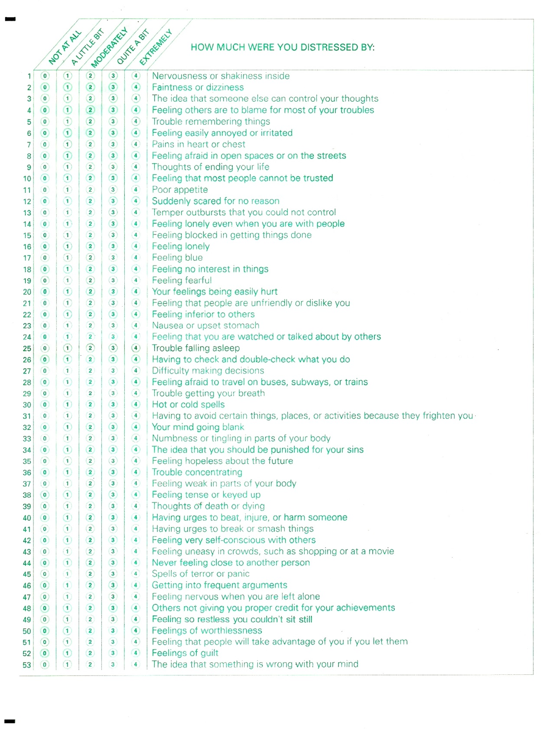

Strengths and Difficulties Questionnaire Appendix 4



YSQ-S adolescent/young adult version Appendix 5


YSQ-S adolescent/young adult version Appendix 5


YSQ-S adolescent/young adult version Appendix 5


YSQ-S adolescent/young adult version Appendix 5


YSQ-S adolescent/young adult version Appendix 5


YSQ-S adolescent/young adult version Appendix 5








Consent form (Social Care managers consent under 16 yrs) Appendix 7
Consent Form

Attachment style and symptoms of psychopathology in Children in Care: An investigation of the mediating role of Early Maladaptive Schemas.

Name of researcher: Jen Wilson: pcp08jhw@sheffield.ac.uk
Participant identification number for this study:
Name of Social Care team Manager:
Name of social worker:
Please initial
each box
1. I confirm that I have read and understood the information sheet dated xx/xx/xxxx for this study. I have had the opportunity to consider the information, ask questions and have had them answered satisfactorily
2. I understand that this young person’s participation is voluntary and that they are free to withdraw at any time without giving any reason.
3. I understand that the young person will be asked to complete questionnaires regarding their early maladaptive schemas, strengths and difficulties, attachment style and mental health.
4. I understand that the young person’s responses will be anonymised
before analysis and all identifying information will be stored securely and will remain confidential. I understand that their name will not be linked with the research materials and they will not be identified or identifiable in the report or reports that result from the research.

5. I agree that xxxxxx can participate in this study.

6. I confirm that I am authorised to make parental responsibility
decisions for this young person and can consent to their
participation in this study.

Consent form (Social Care managers consent under 16 yrs) Appendix 7 cont

To confirm your consent to the items that you have initialled overleaf, please sign here:

_____________________ _____________ ___________________
Name of person providing consent date signature

_________________________
Role of person providing consent
Copies: Along with a copy of the information sheet, one copy to be given to person providing consent, one copy to the participant, one copy to be retained by the researcher and stored in a secure location.





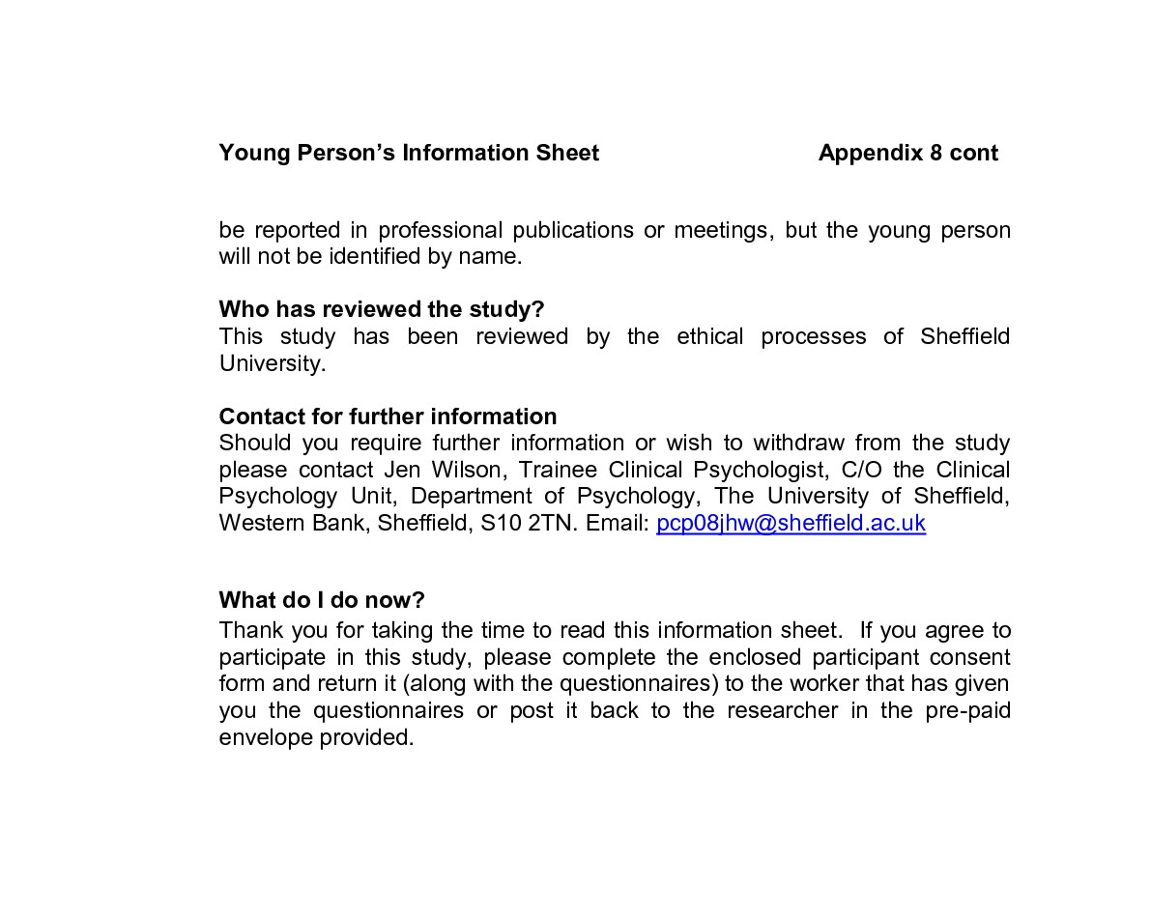

Consent form (Participant version) Appendix 9
Consent Form (all participants)
Research Title: Attachment style and mental health symptoms in Children in Care: An investigation of the mediating role of Young’s Schemas.

Name of researcher: Jen Wilson: pcp08jhw@sheffield.ac.uk
Participant name:
Participant identification no: Please initial
each box

1. I confirm that I have read and understood the information sheet for study. I have had the opportunity to consider the information, ask questions and have had them answered satisfactorily
2. I understand that my participation is voluntary and that I am free to withdraw at any time without giving any reason.
3. I understand that I have been asked to complete questionnaires about my schemas, strengths and difficulties, attachment style and mental health.
4. I understand that my responses will be anonymised before analysis and all identifying information will be stored securely and will remain confidential. I understand that their name will not be linked with the research materials and I will not be identified or identifiable in the report or reports that result from the research.

5. I agree to participate in this study.

To confirm your consent to the items that you have initialled above, please sign here:

__________________ _____________ ___________________
Name (please print) date signature
Copies: Along with a copy of the information sheet, one copy to be given to the participant, one copy to be retained by the researcher and stored in a secure location.



Distribution of main measures & demographics (n=42) Appendix 11

 | Skewness |  | Kurtosis
 | Statistic | Std. Error | Statistic | Std. Error
BSI Global Severity Index | -.508 | .365 | .162 | .717
SDQ overall stress score | .029 | .365 | -.895 | .717
YSQ total score | .224 | .365 | -.462 | .717

Table to show distribution of data for overall sample (n=42). Normal distribution is assumed as the sum z=statistic/standard error for both skewness and kurtosis is less than 1.96 (Field, 2009). NB. BSI=Brief Symptom Inventory. SDQ=Strengths & Difficulties Questionnaire. YSQ = Young Schema Questionnaire.

 | Skewness |  | Kurtosis
 | Statistic | Std. Error | Statistic | Std. Error
age of participant | .465 | .365 | -.270 | .717
time in LA care | .364 | .365 | -.625 | .717
no of placements | .282 | .365 | -.948 | .717

Table to show distribution of data for overall sample (n=42). Normal distribution is assumed as the sum z=statistic/standard error for both skewness and kurtosis is less than 1.96 (Field, 2009). NB. BSI=Brief Symptom Inventory. SDQ=Strengths & Difficulties Questionnaire. YSQ = Young Schema Questionnaire.

Distribution of main measures & demographics (n=36) Appendix 12

 | Skewness |  | Kurtosis
 | Statistic | Std. Error | Statistic | Std. Error
age of participant | .451 | .393 | -.353 | .768
time in LA care | .318 | .393 | -.578 | .768
no of placements | .425 | .393 | -.881 | .768

Table to show distribution of data for combined secure and avoidant subgroups (n=36). Normal distribution is assumed as the sum z=statistic/standard error for both skewness and kurtosis is less than 1.96 (Field, 2009). NB. LA = Local Authority.

 | Skewness |  | Kurtosis
 | Statistic | Std. Error | Statistic | Std. Error
SDQ overall stress score | .031 | .393 | -1.050 | .768
BSI global severity index | -.399 | .393 | .111 | .768
YSQ total score | .500 | .393 | .114 | .768

Table to show distribution of data for combined secure and avoidant samples (n=36). Normal distribution is assumed as the sum z=statistic/standard error for both skewness and kurtosis is less than 1.96 (Field, 2009). NB. BSI=Brief Symptom Inventory. SDQ=Strengths & Difficulties Questionnaire. YSQ = Young Schema Questionnaire.

Descriptive Statistics secure versus avoidant groups n=36 Appendix 13.1
Table to show output of gender of participant * SecureOrNot Chi-Square Test. No sig. difference found
 | Value | df | Asymp. Sig. (2-sided) | Exact Sig. (2-sided) | Exact Sig. (1-sided)
Pearson Chi-Square | .29 | 1 | .59
Fisher's Exact Test |  |  |  | .73 | .42
Table to show output for positive/negative mental health history * SecureOrNot Chi-Square Test. No sig diff found
 | Value | df | Asymp. Sig. (2-sided) | Exact Sig. (2-sided) | Exact Sig. (1-sided)
Pearson Chi-Square | 2.40 | 1 | .12
Fisher's Exact Test |  |  |  | .24 | .12

Table to show output of postitive/negative current mental health difficulties * SecureOrNot Chi-Square Test: Significant between-group differences observed, with more participants with current mental health difficulties in avoidant group
 | Value | df | Asymp. Sig. (2-sided) | Exact Sig. (2-sided) | Exact Sig. (1-sided)
Pearson Chi-Square | 5.76 | 1 | .02
Fisher's Exact Test |  |  |  | .02 | .02
Table to show output of Ethnicity Afro-Caribbean or not * SecureOrNot Chi-Square Test. No sig. between group differences observed
 | Value | df | Asymp. Sig. (2-sided) | Exact Sig. (2-sided) | Exact Sig. (1-sided)
Pearson Chi-Square | .06 | 1 | .81
Fisher's Exact Test |  |  |  | 1.00 | .61

Descriptive Statistics secure versus avoidant groups n=36 Appendix 13.2

Table to show Ethnicity Asian or not * SecureOrNot Chi-Square Tests. No significant differences observed
 | Value | df | Asymp. Sig. (2-sided) | Exact Sig. (2-sided) | Exact Sig. (1-sided)
Pearson Chi-Square | .57 | 1 | .45
Fisher's Exact Test |  |  |  | .64 | .39
Table to show output of Ethnicity Mixed Heritage or not * SecureOrNot Chi-Square Tests. No significant between group differences observed
 | Value | df | Asymp. Sig. (2-sided) | Exact Sig. (2-sided) | Exact Sig. (1-sided)
Pearson Chi-Square | .57 | 1 | .45
Fisher's Exact Test |  |  |  | .64 | .39
Table to show output Ethnicity: White British or not * SecureOrNot Chi-Square Test. No between group differences observed
 | Value | df | Asymp. Sig. (2-sided) | Exact Sig. (2-sided) | Exact Sig. (1-sided)
Pearson Chi-Square | .06 | 1 | .81
Fisher's Exact Test |  |  |  | 1.00 | .55

Descriptive Statistics Appendix 13.3
Table to show ouput of t-tests to assess potential differences between attachment style groups (avoidant versus secure) on demographics
NB. LA = Local Authority
 | t-test for Equality of Means
 | F | t | df | Sig. (2-tailed)
age of participant | .738 | -.49 | 28.671 | .630
time in LA care | 4.302 | -.313 | 33.284 | .756
no of placements | .450 | 1.238 | 33.570 | .224

Descriptive Statistics Appendix 13.4

Table to show T-test output to assess gender differences on main study measures. Sig diffs marked with an asterisk
T-tests Gender | t | Sig. (2-tailed)
SDQ overall stress score | -.59 | .56
YSQ total score | .99 | .33
BSI global severity index | -.57 | .57
unrelenting standards | 2.01 | .053
emotional inhibition | -.93 | .36
self-sacrifice | 2.90 | .01*
subjugation | .69 | .49
insufficient self-control | -.09 | .93
entitlement | .03 | .98
vulnerability to harm /illness | .38 | .71
failure | .63 | .54
enmeshment | .60 | .56
Dependence-incompetence | -.67 | .51
social isolation | .37 | .72
emotional deprivation | .76 | .45
Defectiveness-shame | .17 | .87
Mistrust/abuse | 1.00 | .33
abandonment | 2.87 | .01*
NB. BSI=Brief Symptom Inventory. SDQ=Strengths & Difficulties Questionnaire. YSQ = Young Schema Questionnaire.

Descriptive Statistics Appendix 13.5

Table to show T-test output to assess ethnicity differences (Afro Caribbean or not) on main study measures. No sig differences observed.
T-tests Gender | t | Sig. (2-tailed)
SDQ overall stress score | -1.02 | .37
YSQ total score | -2.21 | .31
BSI global severity index | -2.03 | .12
unrelenting standards | -1.38 | .25
emotional inhibition | -1.29 | .28
Self-sacrifice | .76 | .48
subjugation | -.87 | .44
insufficient self-control | -1.05 | .37
entitlement | -.43 | .06
vulnerability to harm and illness | -.92 | .75
failure | .72 | .48
enmeshment | -2.7 | .80
Dependence/ incompetence | -.26 | .31
social isolation | -1.19 | .24
emotional deprivation | -1.41 | .16
Defectiveness/shame | .67 | .55
Mistrust/abuse | -1.04 | .36
abandonment | -.66 | .56

NB. BSI=Brief Symptom Inventory. SDQ=Strengths & Difficulties Questionnaire. YSQ = Young Schema Questionnaire.

Descriptive Statistics Appendix 13.6

Table to show T-test output to assess ethnicity differences (White British or not) on main study measures. Sig diffs marked with an asterisk
T-tests Gender | t | Sig. (2-tailed)
SDQ overall stress score | 1.73 | .09
YSQ total score | -.57 | .58
BSI global severity index | .39 | .70
unrelenting standards | 2.03 | .12
emotional inhibition | -1.32 | .20
Self-sacrifice | -.52 | .61
subjugation | -.69 | .50
insufficient self-control | .24 | .81
entitlement | -.76 | .46
vulnerability to harm/illness | .37 | .71
failure | 1.20 | .24
enmeshment | -.05 | .96
dependence incompetence | 1.10 | .28
social isolation | -.09 | .93
emotional deprivation | -1.91 | .07
Defectiveness/shame | .39 | .70
Mistrust/abuse | .16 | .87
abandonment | .95 | .35

NB. BSI=Brief Symptom Inventory. SDQ=Strengths & Difficulties Questionnaire. YSQ = Young Schema Questionnaire.

Descriptive Statistics Appendix 13.7
Table to show outcome of 2- tailed Pearson’s correlation coefficients to assess for potential covariates
Scale | age of participant | time in LA care | no of  placements
SDQ Total Score | .03 | .04 | .21
BSI GSI score | .07 | .00 | .30
YSQ total score | -.21 | .02 | .32*
abandonment | -.11 | .07 | .11
Mistrust/abuse | -.14 | .29 | .37*
defectiveness/shame | -.19 | -.08 | .12
emotional deprivation | -.10 | .29 | .32*
social isolation | .09 | .41** | .40**
Defectiveness/incompetence | -.10 | -.11 | .58**
enmeshment | -.16 | -.45** | .03
failure | -.16 | .19 | .30
Vulnerability to harm/illness | -.30 | .16 | .38*
Entitlement | -.18 | -.15 | .34*
insufficient self-control | -.30 | -.01 | .12
subjugation | -.07 | -.15 | .02
self-sacrifice | -.19 | -.04 | .06
emotional inhibition | -.10 | -.19 | .08
unrelenting standards | -.04 | -.13 | -.06
**Correlation is significant at the 0.01 level (2-tailed).* Correlation is significant at the 0.05
level (2-tailed). NB. BSI=Brief Symptom Inventory. SDQ=Strengths & Difficulties Questionnaire. YSQ = Young Schema Questionnaire.

Appendix 14

Table to show regression summaries – Regressions to identify individual schemas for which Baron and Kenny’s (1986) assumptions for multiple regression have been met
Schema Scale | SDQ total score  F β R² | BSI - Global Severity Index  F β R²
Avoid attach | 20.92** .62 .38 | 23.71** .64 .41
YSQ total^{abc} | 3.41** .50 .27  (12.64** .49 .24) | 5.61** .55 .38  (20.50** .58 .34)
Abandonmentª | 12.22** .67 .39  (15.48** .53 .28) | 12.42** .67 .39  (16.17** .54 .29)
Mistrust/Abuse^{b} | 11.76** .62 .38  (24.08** .61 .38) | 6.49* .44 .25  (12.45** .49 .24)
Social Isolation^{bc} | 5.56* .58 .31  (14.43** .52 .27) | 5.54* .52 .30  (12.04** .48 .23)
Defectiveness/Shame | 6.41* .37 .14 | 18.64** .56 .32
Failure | ns | 10.00* .45 .20
Vulnerability to harm/illness^{b} | 4.59* .41 .19  (9.26* .43 .17) | 5.70 .41 .23  (10.82* .47 .21)
Subjugation | - - - | ns
Insufficient self-control | 19.92** .56 .33 | 13.94** .51 .26
Note: n=36.ns=not significant i.e. schema not predictive of level of psychopathology. *= significant at .05 level, **= significant at .001. Covariates entered into regression on second step where indicated for (a) gender, (b) no. of placements and (c) length of time in care (raw scores in parenthesis). BSI=Brief Symptom Inventory. SDQ=Strengths & Difficulties Questionnaire. YSQ = Young Schema Questionnaire.

Appendix 15
Table to show Multiple regression outputs for avoidant attachment-total YSQ score-psychopathology (BSI-GSI score) mediation model (without covariates)

Model |  | Unstandardised Coefficients |  | Standardised Coefficients | t | R | R² | Change statistics |  | Collinearity Statistics |  | Bootstrapping  estimate  of indirect effects of IV on DV via mediator | Bootstrapping 95% confidence interval of effects
 |  | B | Std. Error | β | t | R | R² | R²change | F change | Tolerance | VIF |  |  | LLCI | ULCI
1 | (Constant) | 47.19 | 2.69 |  | 17.55** |  |  |  |  |  |  | 10.83** |  | 3.54 | 18.45
1 | avoidant attach | 17.57 | 3.61 | .64 | 4.87** | .64 | .41 | .41 | 23.71** | 1.00 | 1.00 |  |  | 3.54 | 18.45
2 | (Constant) | 32.48 | 5.71 |  | 5.69** |  |  |  |  |  |  |  |  | 3.54 | 18.45
2 | avoidant attach | 6.71 | 5.03 | .25 | 1.33 |  |  |  |  | .42 | 2.40 |  |  | 3.54 | 18.45
2 | YSQ total score | 0.11 | 0.04 | .52 | 2.85* | .73 | .53 | .12 | 8.12* | .43 | 2.35 |  |  | 3.54 | 18.45

Nb. *sig at .05 level, **sig at <.001. YSQ= Young Schema Questionnaire. avoid attach=presence/absence of avoidant attachment style, LLCI=lower limit of confidence interval, ULCI=upper limit of confidence interval.
Table to show multiple regression outputs for avoidant attachment-average MA schema score-psychopathology (BSI-GSI score) mediation model (without covariate).

Model |  | Unstandardised Coefficients |  | Standardised Coefficients | t | R | R² | Change statistics |  | Collinearity Statistics |  | Bootstrapping  estimate  of indirect effects of IV on DV via mediator | Bootstrapping 95% confidence interval of effects
 |  | B | Std. Error | β | t | R | R² | R²change | F change | Tolerance | VIF |  |  | LLCI | ULCI
1 | (Constant) | 47.19 | 2.69 |  | 17.55** |  |  |  |  |  |  | 8.82* |  | 2.52 | 16.86
1 | avoidant attach | 17.57 | 3.61 | .64 | 4.87** | .64 | .41 | .41 | 23.71** | 1.00 | 1.00 |  |  | 2.52 | 16.86
2 | (Constant) | 39.53 | 3.81 |  | 10.37** |  |  |  |  |  |  |  |  | 2.52 | 16.86
2 | avoidant attach | 8.86 | 4.68 | .32 | 1.89 |  |  |  |  | .51 | 1.98 |  |  | 2.52 | 16.86
2 | MA schema | 4.28 | 1.62 | .45 | 2.64* | .72 | .51 | .10 | 6.70* | .51 | 1.98 |  |  | 2.52 | 16.86

Nb. *sig at .05 level, **sig at <.001. Avoid attach=presence/absence of avoidant attachment style, LLCI=lower limit of confidence interval, ULCI=upper limit of confidence interval. MA=Mistrust/Abuse.
Appendix 15 cont
Table to show multiple regression outputs for avoidant attachment-total YSQ score-psychopathology (total SDQ score) mediation model (without covariates)

Model |  | Unstandardised Coefficients |  | Standardised Coefficients | t | R | R² | Change statistics |  | Collinearity Statistics
 |  | B | Std. Error | β | t | R | R² | R²change | F change | Tolerance | VIF
1 | (Constant) | 11.50 | 1.86 |  | 6.19**
1 | avoidant attach | 17.57 | 3.61 | .62 | 4.57** | .62 | .38 | .38 | 20.92** | 1.00 | 1.00
2 | (Constant) | 6.90 | 4.32 |  | 1.60
2 | avoidant attach | 8.01 | 3.80 | .43 | 1.38* |  |  |  |  | .42 | 2.40
2 | YSQ total score | 0.03 | 0.03 | .24 | 1.18 | .64 | .41 | .03 | 1.39 | .43 | 2.35

Nb. *sig at .05 level, **sig at <.001. avoid attach=presence/absence of avoidant attachment style, LLCI=lower limit of confidence interval, ULCI=upper limit of confidence interval, YSQ=Young Schema Questionnaire. =.
Table to show multiple regression outputs for avoidant attachment-average MA schema score-psychopathology (Total SDQ score) mediation model (without covariate)

Model |  | Unstandardised Coefficients |  | Standardised Coefficients | t | R | R² | Change statistics |  | Collinearity Statistics |  | Bootstrapping  estimate  of indirect effects of IV on DV via mediator | Bootstrapping 95% confidence interval of effects
 |  | B | Std. Error | β | t | R | R² | R²change | F change | Tolerance | VIF |  |  | LLCI | ULCI
1 | (Constant) | 11.50 | 1.86 |  | 6.19** |  |  |  |  |  |  | 6.56** |  | 3.15 | 11.66
1 | avoidant attach | 11.40 | 2.49 | .62 | 4.57** | .62 | .38 | .38 | 20.92** | 1.00 | 1.00 |  |  | 3.15 | 11.66
3 | (Constant) | 5.81 | 2.59 |  | 2.24 |  |  |  |  |  |  |  |  | 3.15 | 11.66
3 | avoidant attach | 4.93 | 3.18 | .27 | 1.55 |  |  |  |  | .51 | 1.98 |  |  | 3.15 | 11.66
3 | MA schema | 3.19 | 1.10 | .50 | 2.89* | .71 | .51 | .13 | 8.38* | .51 | 1.98 |  |  | 3.15 | 11.66

Nb. *sig at .05 level, **sig at <.001. SDQ=Strengths & Difficulties Questionnaire. MA = Mistrust Abuse. avoid attach=presence/absence of avoidant attachment style, LLCI=lower limit of confidence interval, ULCI=upper limit of confidence interval.
Appendix 16

Preacher and Hayes Output for INDIRECT Macro. Mediation model: Avoidant Attach-BSI (GSI)- SDQ Total
Run MATRIX procedure:
*****************************************************************
Preacher And Hayes (2008) SPSS Macro For Multiple Mediation
Written by Andrew F. Hayes, The Ohio State University
http://www.afhayes.com
For details, see Preacher, K. J., & Hayes, A. F. (2008). Asymptotic
and resampling strategies For assessing And comparing indirect effects
in multiple mediator models. Behavior Research Methods, 40, 879-891
*****************************************************************
Dependent, Independent, and Proposed Mediator Variables:
DV = GSI IV = AQCanxio MEDS = ysqtotal
Statistical Controls:
CONTROL= Gender, timeincare, placementmoves
Sample size : 36

IV to Mediators (a paths)
Coeff se t p
ysqtotal 92.7129 14.9929 6.1838 .0000

Direct Effects of Mediators on DV (b paths)
Coeff se t p
ysqtotal .1000 .0419 2.3886 .0234

Total Effect of IV on DV (c path)
Coeff se t p
AQCanxio 16.4484 3.7494 4.3870 .0001

Direct Effect of IV on DV (c-prime path)
Coeff se t p
AQCanxio 7.1803 5.2212 1.3752 .1792

Partial Effect of Control Variables on DV
Coeff se t p
Sex 2.4799 3.5004 .7085 .4841
timeinca .1716 .9831 .1746 .8626
placemen .8566 1.4571 .5879 .5610

Model Summary for DV Model
R-sq Adj R-sq F df1 df2 p
.5463 .4707 7.2253 5.0000 30.0000 .0002

*****************************************************************
BOOTSTRAP RESULTS FOR INDIRECT EFFECTS
Indirect Effects of IV on DV through Proposed Mediators (ab paths)
Data boot Bias SE
TOTAL 9.2681 9.3655 .0975 3.6620
ysqtotal 9.2681 9.3655 .0975 3.6620

Bias Corrected and Accelerated Confidence Intervals
Lower Upper
TOTAL 2.8000 17.6438
ysqtotal 2.8000 17.6438
*****************************************************************
Level of Confidence for Confidence Intervals: 95
Number of Bootstrap Resamples: 5000
------ END MATRIX -----
Appendix 17
Regression model summaries for individual schemas found not to have a mediating role in the avoidant attachment-psychopathology link. Dependent Variable: BSI-GSI score.

Regression model: Abandonment Schema as potential mediator
Model |  | Unstandardised Coefficients |  | Standardised Coefficients | t | R | R² | F | Change statistics
 |  | B | Std. Err | β |  |  |  |  | R²change | F change
1 | (Constant) | 47.18 | 2.69 |  | 17.55** |  |  | 23.71**
1 | avoid att | 17.56 | 3.61 | .64 | 4.87** | .64 | .41 |  | .41 | 23.71**
2 | (Constant) | 42.00 | 3.61 |  | 11.64**
2 | avoid att | 11.49 | 4.55 | .42 | 2.53*
2 | AB | 3.29 | 1.61 | .34 | 2.05* | .69 | .48 | 15.07** | .07 | 4.20*
 | 3(Constant)  avoidant  gender  AB | 37.52  10.05  6.35  4.38 | 4.37  4.50  3.70  1.69 | .37  .23  .45 | 8.56**  2.24*  1.72  2.60* | .62  .64  .72 | .52 | 11.62** | .10 | 6.74*
Note: *= significant at .05 level, **= significant at .001.AB=Abandonment, avoid att = presence/absence of avoidant attachment style, no. places=number of placement moves. Model 2 is raw scores. Model 3 is controlling for covariates. BSI-GSI = Brief Symptom Inventory (Global Severity Index).

Regression model: Social Isolation Schema as potential mediator
Model |  | Unstandardised Coefficients |  | Standardised Coefficients | t | R | R² | F | Change statistics
 |  | B | Std. Err | β |  |  |  |  | R²change | F change
1 | (Constant) | 47.18 | 2.69 |  | 17.55**
1 | avoid att | 17.56 | 3.61 | .64 | 4.87** | .64 | .41 | 23.71 | .41 | 23.71**
2 | (Constant) | 43.56 | 3.90 |  | 11.16**
2 | avoid att | 14.32 | 4.39 | .52 | 3.26*
2 | SI | 2.22 | 1.74 | .20 | 1.27 | .66 | .44 | 9.20** | .03 | 1.62
 | 3(Constant)  avoid att  no. places  time in care  SI | 41.73  13.11  1.99  -.81  2.15 | 5.12  4.69  1.44  1.09  1.99 | .48  .20  -.116  .20 | 2.63**  2.41*  1.38  -0.74  1.08 | .69 | .47 | 12.88** | .02 | 1.17
Note: *= significant at .05 level, **= significant at .001. SI=Social Isolation, avoid att = presence/absence of avoidant attachment style, no. places=number of placement moves. Model 2 is raw scores. Model 3 is controlling for covariates. BSI-GSI = Brief Symptom Inventory (Global Severity Index)..

Regression model: Defectiveness/Shame Schema as potential mediator
Model |  | Unstandardised Coefficients |  | Standardised Coefficients | t | R | R² | F | Change statistics
 |  | B | Std. Error | β |  |  |  |  | R²change | F change
1 | (Constant) | 47.18 | 2.69 |  | 17.55**
1 | Avoid att | 17.56 | 3.61 | .64 | 4.87** | .64 | .41 | 23.71** | .41 | 23.71**
2 | (Constant) | 44.77 | 3.47 |  | 12.91**
2 | Avoid att | 13.76 | 4.99 | .50 | 2.76*
2 | DS | 1.76 | 1.60 | .20 | 1.10 | .66 | .43 | 12.52** | .02 | 1.20

Note: *= significant at .05 level, **= significant at .001. DS=Defectiveness/Shame, avoid att = presence/absence of avoidant attachment style. DV=BSI-GSI = Brief Symptom Inventory (Global Severity Index).

Appendix 17 Cont
Regression model: Failure as potential mediator
Model |  | Unstandardised Coefficients |  | Standardised Coefficients | t | R | R² | F | Change statistics
 |  | B | Std. Err | β |  |  |  |  | R²change | F change
1 | (Constant) | 47.18 | 2.69 |  | 17.55**
1 | avoidant attach | 17.56 | 3.61 | .64 | 4.87** | .64 | .41 | 23.71** | .41 | 23.71**
2 | (Constant) | 43.88 | 3.47 |  | 12.67**
2 | avoidant attach | 14.38 | 4.15 | .53 | 3.47**
2 | Failure | 2.21 | 1.50 | .22 | 1.48 | .67 | .45 | 13.56** | .04 | 2.19
Note: *= significant at .05 level, **= significant at .001. Avoid att = presence/absence of avoidant attachment style. DV=BSI-GSI score. Brief Symptom Inventory (Global Severity Index).

Regression model: Vulnerability to Harm/Illness as potential mediator
Model |  | Unstandardised Coefficients |  | Standardised Coefficients | t | R | R² | F | Change statistics
 |  | B | Std. Err | β |  |  |  |  | R²change | F change
1 | (Constant) | 47.18 | 2.69 |  | 17.55**
1 | Avoid att | 17.56 | 3.61 | .64 | 4.87** | .64 | .41 | 23.71** | .41 | 23.71**
2 | (Constant) | 40.07 | 4.07 |  | 9.84**
2 | avoid att | 12.33 | 4.13 | .45 | 2.99*
2 | VH | 4.35 | 1.94 | .34 | 2.24* | .70 | .49 | 15.76** | .08 | 5.02*
 | 3(Constant)  Avoid att  no. places  VH | 37.88  12.37  1.22  3.74 | 4.72  4.14  1.32  2.06 | .45  .12  .29 | 8.03**  2.99*  0.92  1.82 | .71 | .50 | 10.74** | .05 | 3.30

Note: *= significant at .05 level, **= significant at .001.VH=Vulnerability to harm/illness, avoid att = presence/absence of avoidant attachment style, no. places=number of placement moves. Model 2 is raw scores. Model 3 is controlling for covariates. BSI-GSI Brief Symptom Inventory (Global Severity Index).

Regression model: Entitlement as potential mediator

Model |  | Unstandardised Coefficients |  | Standardised Coefficients | t | R | R² | F | Change statistics
 |  | B | Std. Err | β |  |  |  |  | R²change | F change
1 | (Constant) | 47.18 | 2.69 |  | 17.55**
1 | Avoid att | 17.56 | 3.61 | .64 | 4.87** | .64 | .41 | 23.71** | .41 | 23.71**
2 | (Constant) | 38.72 | 3.64 |  | 10.63**
2 | avoid att | 11.66 | 3.75 | .43 | 3.11*
2 | IS | 3.90 | 1.26 | .42 | 3.09* | .74 | .54 | 15.27** | .13 | 14.14*
Note: *= significant at .05 level, **= significant at .001.SI=Insufficient Self-Control. Avoid att = presence/absence of avoidant attachment style. Brief Symptom Inventory (Global Severity Index).

Appendix 18
Regression model summaries for individual schemas found not to have a mediating role in the avoidant attachment-psychopathology link. Dependent Variable: SDQ total score.
Regression model: Abandonment Schema as potential mediator
Model |  | Unstandardised Coefficients |  | Standardised Coefficients | t | R | R² | F | Change statistics
 |  | B | Std. Err | β |  |  |  |  | R²change | F change
1 | (Constant) | 11.50 | 1.86 |  | 6.19**
1 | avoid att | 11.40 | 2.49 | .64 | 4.58** | .62 | .38 | 20.92** | .38 | 20.92**
2 | (Constant) | 8.54 | 2.54 |  | 3.36*
2 | avoid att | 7.93 | 3.21 | .43 | 2.47*
2 | AB | 1.89 | 1.13 | .29 | 1.66 | .66 | .43 | 12.38** | .05 | 2.76
3 | 3(Constant)  avoid att  gender  AB | 4.45  6.62  5.79  2.87 | 2.98  3.07  2.52  1.15 | .36  .31  .44 | 1.49  2.16*  2.30*  2.50* | .71 | .51 | 11.08** | .10 | 6.23*
Note: *= significant at .05 level, **= significant at .001. AB=abandonment, avoid att = presence/ absence of avoidant attachment style. Model 2 is raw scores. Model 3 is controlling for covariates. SDQ =Strengths & Difficulties Questionnaire

Regression model: Social Isolation Schema as potential mediator
Model |  | Unstandardised Coefficients |  | Standardised Coefficients | t | R | R² | F | Change statistics
 |  | B | Std. Err | β |  |  |  |  | R²change | F change
1 | (Constant) | 11.50 | 1.86 |  | 6.19**
1 | avoid att | 11.40 | 2.49 | .64 | 4.58** | .62 | .38 | 20.92** | .38 | 20.92**
2 | (Constant) | 8.55 | 2.67 |  | 3.20*
2 | avoid att | 8.76 | 3.01 | .47 | 2.91*
2 | SI | 1.80 | 1.19 | .25 | 1.51 | .65 | .42 | 12.00** | .04 | 2.76
 | 3(Constant)  avoid att  no. places  time LA care  SI | 9.44  7.92  0.29  -.55  2.19 | 3.58  3.28  1.01  0.76  1.39 | .43  .04  -.12  .30 | 2.63*  2.41*  0.28  -0.73  1.57 | .66 | .43 | 5.87** | .05 | 2.47

Note: *= significant at .05 level, **= significant at .001. SI=social isolation, avoid att = presence/absence of avoidant attachment style. Model 2 is raw scores. Model 3 is controlling for covariates. SDQ total score= Strengths & Difficulties Questionnaire.

Regression model: Defectiveness/Shame Schema as potential mediator

Model |  | Unstandardised Coefficients |  | Standardised Coefficients | t | R | R² | F | Change statistics
 |  | B | Std. Err | β |  |  |  |  | R²change | F change
1 | (Constant) | 11.50 | 1.86 |  | 6.19**
1 | avoid att | 11.40 | 2.49 | .64 | 4.58** | .62 | .38 | 20.92** | .38 | 20.92**
2 | (Constant) | 11.89 | 2.67 |  | 4.47**
2 | avoid att | 10.44 | 3.51 | .57 | 2.98*
2 | DS | 0.44 | 1.12 | .08 | 0.39 | .62 | .38 | 10.18** | .01 | 0.16
Note: *= significant at .05 level, **= significant at .001. SI=social isolation, avoid att = presence/absence of avoidant attachment style. SDQ total score Strengths & Difficulties Questionnaire.

Regression model: Vulnerability to Harm/Illness Schema as potential mediator
Model |  | Unstandardised Coefficients |  | Standardised Coefficients | t | R | R² | F | Change statistics
 |  | B | Std. Err | β |  |  |  |  | R²change | F change
1 | (Constant) | 11.50 | 1.86 |  | 6.19**
1 | Avoid att | 11.40 | 2.49 | .64 | 4.58** | .62 | .38 | 20.92** | .38 | 20.92**
2 | (Constant) | 8.55 | 2.30 |  | 3.29*
2 | avoid att | 10.21 | 3.04 | .55 | 3.53*
2 | VH | 0.99 | 1.43 | .11 | 0.69 | .62 | .39 | 10.54** | .01 | 0.48
3 | (Constant)  avoid att  no. places  VH | 9.41  10.22  0.26  0.86 | 3.52  3.09  0.98  1.53 | .55  .04  .10 | 2.68*  3.31*  0.27  0.58 | .63 | .39 | 6.85** | .06 | 0.31
Note: *= significant at .05 level, **= significant at .001. VH=Vulnerability to harm/illness, avoid att = presence/absence of avoidant attachment style, no. places=number of placement moves. Model 2 is raw scores. Model 3 is controlling for covariates. SDQ = Strengths & Difficulties Questionnaire.

Regression model: Emotional Inhibition Schema as potential mediator

Model |  | Unstandardised Coefficients |  | Standardised Coefficients | t | R | R² | F | Change statistics
 |  | B | Std. Err | β |  |  |  |  | R²change | F change
1 | (Constant) | 11.50 | 1.86 |  | 6.19**
1 | Avoid att | 11.40 | 2.49 | .64 | 4.58** | .62 | .38 | 20.92** | .38 | 20.92**
2 | (Constant) | 5.28 | 2.73 |  | 1.94
2 | Avoid att | 8.91 | 2.42 | .48 | 3.69**
2 | EI | 2.77 | 0.95 | .38 | 2.90* | .71 | .51 | 16.94** | .13 | 8.41*
Note: *= significant at .05 level, **= significant at .001. EI=Emotional Inhibition, avoid att = presence/absence of avoidant attachment style. SDQ = Strengths & Difficulties Questionnaire.

Regression model: Entitlement Schema as potential mediator
Model |  | Unstandardised Coefficients |  | Standardised Coefficients | t | R | R² | F | Change statistics
 |  | B | Std. Err | β |  |  |  |  | R²change | F change
1 | (Constant) | 11.50 | 1.86 |  | 6.19**
1 | avoidant attach | 11.40 | 2.49 | .64 | 4.58** | .62 | .38 | 20.92** | .38 | 20.92**
2 | (Constant) | 8.55 | 2.30 |  | 3.29*
2 | avoidant attach | 10.21 | 3.04 | .55 | 3.53*
2 | Entitlement | 0.99 | 1.43 | .11 | 0.69 | .63 | .39 | 10.74** | .01 | 0.73
 | 3(Constant)  Avoid att  no.places  ET | 9.01  10.35  0.24  0.87 | 3.57  2.81  0.97  1.17 | .56  .04  .12 | 2.53*  3.69**  0.24  0.74 | .63 | .36 | 6.98** | .01 | 0.55
Note: *= significant at .05 level, **= significant at .001.ET=Entitlement, avoid att = presence/absence of avoidant attachment style, no. places=number of placement moves. Model 2 is raw scores. Model 3 is controlling for covariates. SDQ Strengths & Difficulties Questionnaire

Regression model: Insufficient Self-Control Schema as potential mediator
Model |  | Unstandardised Coefficients |  | Standardised Coefficients | t | R | R² | F | Change statistics
 |  | B | Std. Err | β |  |  |  |  | R²change | F change
1 | (Constant) | 11.50 | 1.86 |  | 6.19**
1 | Avoid att | 11.40 | 2.49 | .64 | 4.58** | .62 | .38 | 20.92** | .38 | 20.92**
2 | (Constant) | 4.74 | 2.39 |  | 1.98
2 | avoid att | 6.69 | 2.46 | .36 | 2.72*
2 | IS | 3.11 | 0.83 | .50 | 3.76** | .76 | .57 | 21.57** | .19 | 14.14**
Note: *= significant at .05 level, **= significant at .001. EI=Emotional Inhibition, avoid att = presence/absence of avoidant attachment style. SDQ Strengths & Difficulties Questionnaire.

Young’s most recent questionnaires are the Young Schema Questionnaire (YSQ-3) long and short forms, both of which are available from www.schematherapy.com
Three further schema have been proposed, however there is varying empirical support for their independent existence when subject to factor analysis and so they are excluded from the majority of research studies.
Collinearity between measures is considered to be within acceptable limits for multiple regression when correlations are below .80, VIF is below 10 and tolerance is above .02 (Field, 2009).
See appendix15 for regression output when covariates not controlled.
See appendix 17 for full Bootstrap SPSS output for this mediation model.

