Chapter 4 – The effect of EPF manipulation on gas exchange

4.1 Introduction

This chapter describes experiments to investigate how altered EPF expression effects gas exchange properties of Arabidopsis. Gas exchange between the plant and its atmospheric environment occurs in the leaves, primarily through stomata which, as mentioned in chapter 1, balance the acquisition of CO₂ with water loss. In the previous chapter, the morphological effects of altering stomatal density (D) and stomatal size (S) in plants grown in a variety of environmental conditions. What follows is an examination of theoretical and actual gas exchange properties of these same plants. In addition, the effect that altered gas exchange properties of these plants has on photosynthesis will be explored.

4.1.1 Plant water uptake and loss

Leaf transpiration is the loss of water from the leaf by evaporation driven by a comparatively low Ψ_{atmosphere} (water potential in the atmosphere) to Ψ_{leaf} (water potential in the leaf). Due to the waterproofing effect of the cuticle, transpiration from stomata can constitute between 50% and 98% of total leaf transpiration depending on plant species (Opik and Rolfe, 2005, p.346-354). Short term stomatal responses to water restriction, CO₂ and light have already been extensively discussed in chapter 1 and are summarised below in Fig 4.1 to ease reading. Aside from stomatal aperture control, transpiration is affected by a number of environmental factors. For example, transpiration increases with leaf temperature which increases the vapour pressure in the leaf without a corresponding rise in external air. Air movement or wind also increases transpiration by sweeping away water vapour accumulating in the boundary layer (Opik and Rolfe, 2005, p.88).

Transpiration is vital for water uptake. Although in certain circumstances the xylem sap in the root is under positive hydrostatic pressure, the ascent of sap is due primarily to tension generated at the leaf end (Dixon and Joly 1894; Tyree, 1997). As cells in contact with air lose water, their Ψ decreases causing water to enter them from neighboring cells by osmosis, which in turn replenish their water from neighboring cells. Cells from the leaves to the roots thus form a chain pulling an uninterrupted column of water under tension. This is known as the cohension-tension theory and is accepted by the majority of plant physiologists (Hsiao, 2000; Kramer, 1937; McCully et al., 1998; Pockman et al., 1995; Wei et al., 1999).

Xylem transport is important for plant hormones: for example water stress sensed in the roots stimulates the synthesis of ABA which is transported to the leaves where it induces stomatal closure (Heilmeier et al., 2007), as well as the distribution of organic nitrogenous compounds and mineral ions. Although studies on sunflower plants may indicate that transpiration has no impact on the mineral ion uptake and distribution (Tanner and Beevers, 2001), one would assume that rapid xylem transport would be beneficial for transmission of minerals and hormonal signals (Opik and Rolfe, 2005, p 95).

The evaporative cooling effect of transpiration can also help counteract the heat generated by radiant energy and generally dissipates half of the heat built up in the leaf (Opik and Rolfe, 2005, p. 95). Cooling due to transpiration can increase yield of well irrigated plants grown in hot climates such as pima cotton (Gossypium barbadense) and bread wheat (Triticum aestivum) (Lu et al. 1998).

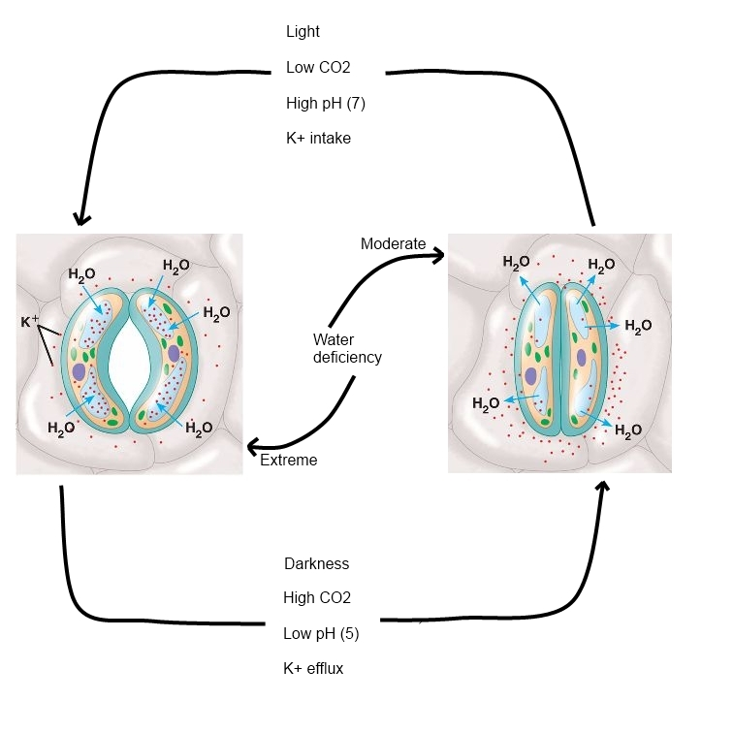
Figure 4.1: short term responses of stomata to environmental stimuli. In response to moderate water deficiency, darkness, high CO2, low pH or potassium efflux water leaves the guard cells and the stomata close (thus conserving water). In response to light, low CO2 high pH and potassium intake, guard cells fill with water and stomata open. When water deficiency is extreme, surrounding cells are unable to remain turgid and thus pull stomata open.

4.1.2 Photosynthesis

Experiments in this chapter examine differences in photosynthesis between plants with altered EPF expression so a brief description of the mechanisms involved in CO₂ acquisition is required. Photosynthesis from the greek photo -“light” synthesis - “composition” is a process which utilizes high energy quanta (light) to split hydrogen from water (light reactions) to combine with CO₂ (carbon reactions) (equation 4.1). In plants, photosynthesis occurs predominantly in the mesophyll cells which contain the bulk of chloroplasts and generate sugars which are the starting point for other plant constituents (Opik and Rolfe, 2005, p.9-12;Taiz and Zeiger, 1998).

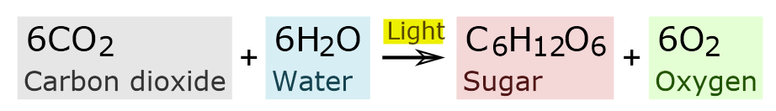
Equation 4.1: simplified equation of photosynthesis

The light reactions take place within the thylakoid membrane and convert light energy into chemical energy in the form of ATP and NADPH which can then be used to drive the reduction of CO₂. Four major membrane protein complexes are involved in the formation of ATP and NADPH: photosystem I, photosystem II, cytochrome b6f and ATP synthase (Fig 4.2). Pigments (primarily chlorophyll) in Photosystem II absorb photons, exciting electrons to a higher energy state thus “priming” them for the electron transport chain. Electrons are donated from water to NADPH passing through PSII, b6f and PSI allowing the creation of a proton gradient across the membrane which drives the phosphorylation of ADP to ATP. (Opik and Rolfe, 2005, p.12-18) Chlorophyll content and efficiency of the light reactions can be analysed by examining chlorophyll fluorescence (Gitelson et al. 1999). The fluorescence emitted from a leaf has a longer wavelength than the light absorbed by the leaf meaning that fluorescence can be measured by flashing a defined wavelength of light onto a leaf and measuring the level of light emitted at longer wavelengths. Experiments examining chlorophyll fluorescence on plants with altered EPF expression have been recently carried out by colleagues (data not shown) and have determined that altered D has no significant effect on the efficiency of photosynthetic light reactions. Importantly, this means that differences in photosynthetic rates between these plants explored in this section are due primarily to differences in the carbon reactions.
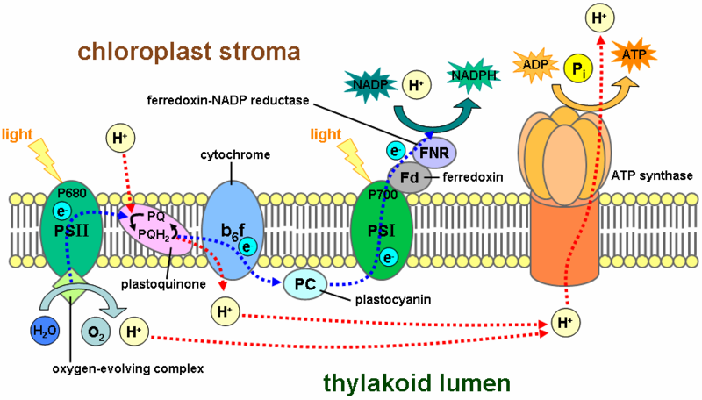
Figure 4.2: Diagramatic representation of the photosynthetic light reaction tylakoid membrane protein complexes (Image taken from Taiz and Zeiger, 1998)

All photosynthetic eukaryotes reduce CO₂ to carbohydrate via the Calvin cycle. What follows is a brief description of the Calvin cycle with a focus on carboxylation. The Calvin cycle can be categorised in 3 stages: (i) carboxylation of CO₂ forming two molecules of 3-phosphoglycerate; (ii) reduction of 3-phosphoglycerate forming glyceraldehydes-3-phosphate and (iii) regeneration of rubisco. These light independent carbon reactions require NADPH and ATP generated by the light reactions and release three-carbon sugars which are later combined to form starch and sucrose. In plants with C3 metabolism, like Arabidopsis, CO₂ is fixed by rubisco (ribulose-1-5-bisphosphate carboxylase-oxygenase) which is located in the chloroplast stroma. Ribulose-1,5-bisphosphate is carboxylated yielding two molecules of 3-phosphoglycerate. The affinity of rubisco for CO₂ is high enough to ensure rapid carboxylation at the low concentration of CO₂ found in mesohpyll cells (Taiz Zeiger, 1998, chapter 8). Rubisco also favours carboxylation of the lighter C¹² isotope over the C¹³ isotope and a comparison of the carbon isotope ratios in plant tissues can help determine the availability of carbon in the leaf (Farquhar et al. 1989). Analysis of carbon isotope discrimination as a proxy measurement for water use efficiency is explained in more depth in section 4.4.3.

4.2 Methods summary

As with the previous experiments, growth of plants with a large distribution of D (EPF2OE, EPFL9RNAi, Col-0, epf2, epf1epf2 and epf1epf2EPFL9OE) was carried out at three different CO₂ conditions: 200 ppm CO₂, 450 ppm CO2 and 1000 ppm CO₂ in 100mL pots. To examine the interaction of D and drought, a subset of plants (EPF2OE, Col-0 and epf1epf2) were grown at the same CO₂ conditions and transferred to larger 1L pots once 13-15 leaves were visible. The larger pots were used to reduce stress in the control group (by allowing the roots to expand more fully) and minimise soil water content fluctuations which were kept at 30% and 70% by weighing.

A FLIR SC660 camera was used to take single infrared images or IR images over the course of an hour of plants in their growth conditions. Temperatures were averaged from 60 readings of the widest areas of 3 fully mature and exposed leaves from at least 4 plants.

LI-6400 Infrared gas analyser was used to measure conductance and photosynthesis under a variety of environmental conditions as well as measure the speed and degree of these responses to changes in CO₂ and light. All LICOR experiments were carried out on mature leaves of EPF2OE, Col-0 and epf1epf2 plants grown in 100mL pots.

To determine the isotope ratio of ¹³C to ¹²C, dried leaf samples were ground up and combusted at 1800°C, passed into a gas chromatograph where components are separated and then passed into a mass spectrometer (ANCA GSL 20-20 Mass Spectrometer made by Sercon PDZ Europa) where ¹²CO₂ and ¹³CO₂ were ionized and separated by mass using a magnetic field.

4.3 The effect of stomatal density on gas exchange

The experiments in this section aim to determine the affect of manipulating stomatal density on conductance (the rate at which a gas passes in or out of the leaf) and more specifically transpiration. This was achieved indirectly by calculating the theoretical maximum conductance and examining leaf temperature. More direct conductance measurements on individual leaves were achieved with the LICOR infrared gas analyser.

4.3.1 Impact of stomatal density and environmental growth conditions on theoretical maximum conductance

Using stomatal size and density data outlined in chapter 3, it was possible to estimate the maximum conductance of the plants with altered expression levels of EPF family genes using the equation outlined in chapter 2. Determination of stomatal depth is difficult to achieve experimentally, so it was assumed to be the same length as aperture width. The first set of calculations were carried on data from stomata from EPF2OE, EPFL9RNAi, epf2, epf1epf2 and epf1epf2EPFL9OE plants grown in 100mL pots at 200 ppm CO₂, 450 ppm CO₂ and 1000 ppm CO₂ (Fig 3.4 and Fig 3.5, chapter 3; Fig 4.3). These calculations indicated a statistically significant effect of genotype on g_{wmax} (Table 4.1 can be found in the appendix). Leaves with smaller stomata and higher stomatal densities (such as epf1epf2 and epf1epf2EPFL9OE) had a higher predicted gwmax than plants with lower stomatal densities (such as EPF2OE and EPFL9RNAi). Unsurprisingly, in the case of these plants, it is stomatal density and not size which has a significant effect on g_{wmax}: the effect of changes in density in these plants dwarfs the opposite effect of changes in size on leaf conductance. Interestingly, there was also a statistically significant effect of CO₂ condition on g_{wmax} (Table 4.1). Compared with plants grown at 450 ppm CO₂, the g_{wmax} of plants grown at 1000 ppm CO₂ is significantly lower for epf2 and Col-0.

Figure 4.3: Theoretical abaxial Gwmax increases with D. Calculated g_{wmax} of EPF family mutants and Col-0 control plants grown at 200 ppm CO₂ (white), 450 ppm CO₂ (grey) and 1000 ppm CO₂ (black) in 100 ml plant pots (n=4) at 200 µmol.m⁻².s⁻¹ light calculated from measurements of S and D (Fig 3.4 and Fig 3.5). Error bars represent SE. Asterisks indicate significant difference from the same genotype grown at 450 ppm CO₂ (p<0.05).

Calculations of g_{wmax} were also carried out on the data collected from plants grown in 1L pots at different CO₂ and soil water conditions (see Fig 3.7 and Fig 3.9). As in the first experiment, there was a significant effect of CO₂ on g_{wmax}. For well watered plants, g_{wmax} was lowest at 1000 ppm CO₂ and highest at 200 ppm CO₂. Watering conditions also had a significant effect on g_{wmax} (Fig 4.4). At 200 ppm CO₂ and 450 ppm CO₂, epf1epf2 plants grown with less water had a reduced g_{wmax} compared with those grown in well watered conditions. Col-0 also had a significant reduction in g_{wmax} at 450 ppm CO₂. There was also a significant interaction between CO₂ and water conditions on g_{wmax}. In each case, plants with limited supply of water (30% SWC) had a higher predicted g_{wmax} at 1000 ppm CO₂ compared with plants grown at 450 ppm CO₂. Plants at 1000 ppm CO₂ may not have been subject to the same degree of stress associated with water limitations as their conductance is lower (Fig 4.8). The reduction in g_{wmax} for epf1epf2 observed at 200 ppm CO₂ and 450 ppm CO₂ when grown at 30% SWC was not observed at 1000 ppm CO₂. Finally, there was a significant triple interaction between CO₂ genotype and water supply on g_{wmax}. Plants with the lowest g_{wmax} (EPF2OE) varied little between the different conditions whereas plants with the highest g_{wmax} (epf1epf2) varied the most, with a reduction in g_{wmax} of 33.6% at 200 ppm CO₂ at a lower soil water content compared with no significant change at 1000 ppm CO₂ at a lower soil water content. It is important to note that the theoretical g_{wmax} values calculated in this section estimate the diffusivity of water through the abaxial epidermis per unit of leaf area. Conductance measurements using the LICOR (outlined in the next section: 4.3.3) estimate diffusivity of water through both the adaxial and abaxial epidermis per unit of leaf area. The differences of D on the abaxial and adaxial sides of the leaf are small (chapter 3, Fig 3.7 and Fig 3.8) so for comparisons between theoretical and actual conductances (section 4.3.3), theoretical abaxial g_{wmax} values have been doubled.

Figure 4.4: Theoretical abaxial g_{wmax} is decreased in epf1epf2 mutants when water is restricted. g_{wmax} of EPF family mutants and Col-0 control plants grown at 30% and 70% relative soil water content and at 200 ppm CO₂ (white), 450 ppm CO₂ (grey) and 1000 ppm CO₂ (black) in 1000 ml plant pots (n=3-4) at 200 µmol.m⁻².s⁻¹ light. Error bars represent SE. Letters indicate values that are significantly different from a, the same genotype grown at 450 ppm CO₂; b, the same genotype grown at 70% soil water content; and c, Col-0 controls grown in the same conditions (p<0.05).

4.3.2 Impact of stomatal density and environmental growth conditions on leaf temperature

The level of evaporative cooling due to transpiration can be used as a proxy measurement to compare conductance across genotypes and environmental conditions (Merlot et al., 2002; Hashimoto et al., 2006; Xie et al., 2006; Liang et al. 2010). Infrared thermography can be used to examine the impact of stomatal properties on leaf gas exchange and has been suggested as a non-invasive high throughput method to screen for Arabidopsis guard cell signaling mutants (Wang et al. 2004). The main aim of these studies was to determine whether the differences in maximum theoretical conductance between the genotypes (section 4.3.3) affect their levels of transpiration. Previous studies using plants with altered SDD expression has determined that Arabidopsis is able to normalise conductance on leaves with altered D, presumably by modulating the degree of stomatal closure (Bussis et al. 2006). However, changes in D are observed in plants’ developmental adaptation (Lake et al. 2001, Miyazawa et al., 2006, Lake and Woodward 2008) as well as longer term selective adaptation to changing environments (Woodward, 1987; Woodward and Kelly, 1995; Franks and Beerling, 2009; Franks et al., 2009). One would assume that changes in D have occurred because they are beneficial to plants by altering base conductance or conductance thresholds to suit the environment.

In the current study the first set of temperature measurements (Fig 4.5 and Fig 4.6) was taken directly after plants were removed from the growth chamber. It was later decided that this led to an avoidable variation in background temperature and so in subsequent experiments temperature readings were taken within the growth chamber. Although for this experiment differences in temperature across genotypes are accurate, exact temperatures as well as differences between leaf temperature of plants in different CO₂ conditions may not be a true reflection of conditions within the chambers.

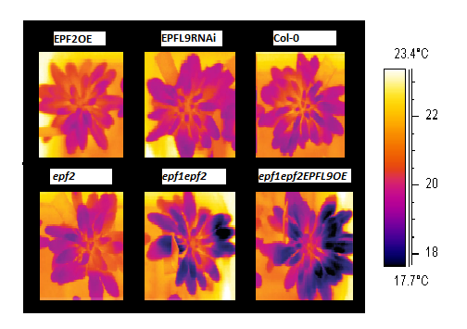
Fig 4.5 D is negatively correlated with leaf temperature. False colour infrared images of EPF2OE, EPFL9RNAi, Col-0, epf2, epf1epf2 and epf1epf2 EFL9OE, grown at 1000 ppm CO2. Temperature scale bar on right (Adapted from Doheny-Adams et al. 2012).

Fig 4.6 Transpiration decreases with reduced water availability, and at elevated atmospheric CO₂. Mean leaf temperature of EPF family mutants and Col-0 control plants grown at 200 ppm CO₂ (white), 450 ppm CO₂ (grey) and 1000 ppm CO₂ (black) in 100 ml plant pots (n=4) at 200 µmol.m⁻².s⁻¹ light. Error bars represent SE. Asterisks indicate significant difference from Col-0 in the same CO2 conditions. For all genotypes, temperatures were significantly different for each CO2 condition (p<0.05).

There were significant effects of genotype and CO₂ concentration on the mean rosette leaf temperatures (Fig 4.6). Mean temperatures for each genotype grown at 1000 ppm CO₂ were higher with respect to those grown at 450 ppm CO₂ which were in turn higher than those grown at 200 ppm CO₂, indicating that stomata of the EPF family mutants are functional in transpiration, and that their stomatal aperture opening/closing response to CO₂ is intact. These results suggest that plants with high D (epf1epf2 and epf1epf2EPFL9OE) transpired more than those with lower D (EPFL9RNAi, Col-0 and epf2) under all CO₂ conditions (Fig 4.6). The difference between mean leaf temperatures of genotypes with the most extreme D (EPFL9RNAi and epf1epf2EPFL9OE) was 0.65°C, 0.57°C and 0.68°C for plants grown at 200 ppm CO₂, 450 ppm CO₂ and 1000 ppm CO₂, respectively. Thus, a clear correlation between D and the rate of leaf transpiration was observed, which was remarkably consistent between the different CO₂ conditions. Furthermore, plants with high D, such as epf1epf2, had significantly smaller stomata (section 3.3.1) and the highest transpiration rates, confirming expectations from physical diffusion theory (Franks and Beerling, 2009).

The methods used in the above experiment were improved in the following by taking 60 temperature measurements in the growth chamber without disturbing the plants over the course of an hour (see chapter 2). These measurements were averaged and give a better indication of the exact leaf temperature in the daytime conditions the plants were grown at (Fig 4.7). In this experiment, the genotypes were maintained at 2 watering regimes.

Figure 4.7: Transpiration decreases with reduced water availability, and at elevated atmospheric CO₂. Mean leaf temperature of EPF family mutants and Col-0 control plants grown at 30% and 70% relative soil water content and at 200 ppm CO₂ (white), 450 ppm CO₂ (grey) and 1000 ppm CO₂ (black) in 1000 ml plant pots (n=3-4) at 200 µmol.m⁻².s⁻¹ light. Error bars represent SE. Letters indicate values that are significantly different from a, the same genotype grown at 450 ppm CO₂; b, the same genotype grown at 70% soil water content; and c, Col-0 controls grown in the same conditions (p<0.05).

As with the plants in the previous experiment, there was a significant effect of genotype on mean leaf temperature (Fig 4.7). Well-watered plants with lower D (EPF2OE) were significantly hotter than well-watered plants with higher D (epf1epf2). In addition epf1epf2 leaves were significantly cooler than Col-0 and EPF2OE leaves at 30% SWC, 1000 ppm CO₂ and 70% SWC, 200 ppm CO₂. There was also a significant effect of water availability on leaf temperature. As previously discussed, plants close their stomata when water is scarce to reduce transpiration and conserve water. For each genotype, and at each CO₂ condition (with the exception of Col-0 at 200ppm CO₂, where the increase was not significant), when grown at 30% SWS leaves were hotter indicating that transpiration was lower providing further evidence that stomatal closure is functional in plants with altered EPF expression. Interestingly, there was also a significant interaction between genotype and water availability suggesting that the increase in leaf temperature at 30% SWC varies between genotypes. Indeed, plants with the highest D (epf1epf2) also have the largest difference in leaf temperature between 70% and 30% (~0.8C at 200 ppm CO₂ compared with ~0.3C for EPF2OE at 200 ppm CO₂). An increase in D, as well as accruing higher maximum leaf conductance, appears to increase the range of leaf transpiration/conductance. At 30% SWS, leaf temperature of epf1epf2 plants, in contrast to Col-0 and EPF2OE plants, do not significantly change across the CO₂ conditions. Although at 200 ppm CO₂ and 450 ppm CO₂ epf1epf2 leaf temperature is not significantly different from Col-0; at 1000ppm it is significantly lower. Taken together, these data suggest that epf1epf2 may have a higher minimum conductance threshold: at conditions where stomata are expected to be closed (1000 ppm CO₂ and low water) epf1epf2 is unable to reduce transpiration to the same extent as Col-0 and EPF2OE.

4.3.3 Direct measurements of stomatal conductance.

Fig 4.8: Reduced stomatal density and higher atmospheric CO₂ decrease leaf conductance. Mean conductance results of individual leaves acclimatized to 200 ppm CO₂ (white), 450 ppm CO₂ (grey), 1000 ppm CO₂ (black). These plants were grown in a greenhouse (see chapter 2) so light intensity fluctuated. For conductance measurements, light was maintained at 1000 µmol.m⁻².s⁻¹. Asterisks indicate significant difference from Col-0 (un-paired t test (<0.05 ). n = 4)

In the next experiment leaf conductances were directly measured by IRGA. These plants were not grown over a gradient of CO₂ conditions. All three genotypes were grown at ambient CO₂ (approx. 380 ppm CO₂). In order to estimate the effect of CO₂ on conductance in these mutants, individual leaves were acclimatized to 200 ppm CO₂, 450 ppm CO₂ and 1000 ppm CO₂ in the IRGA chamber for 1-2 hours before conductance measurements were taken. Although these results are not directly comparable to data taken from plants growing at the different CO₂ conditions (eg. section 4.3.2), they do serve as an accurate approximation. Although changes in CO₂ conditions can result in small changes in stomatal density (D) (section 3.3.1), these changes are dwarfed by the differences in D between the genotypes and so are not likely to have a large statistical impact.

As expected from temperature data (Section 4.3.2), genotype has a significant effect on conductance (Fig 4.8). At all CO₂ conditions, plants with higher predicted g_{wmax} and transpiration (epf1epf2) have higher conductance than plants with a lower predicted g_{wmax} and transpiration (EPF2OE). Interestingly, whereas EPF2OE plants near their predicted maximum conductance (~0.12 mol.m⁻².s⁻¹), Col-0 plants barely attain half their predicted g_{wmax} and epf1epf2 mutants are unable to attain even a quarter of their predicted g_{wmax} (~1.4 mol.m⁻².s⁻¹) under these conditions (see section 4.3.1). Although epf1epf2 was able to attain a conductance of 0.5 mol.m⁻².s⁻¹ at 1000 µmol.m⁻².s⁻¹ light (Fig 4.9), this is still less than half its predicted g_{wmax}. It has been suggested that naturally developing stomata are only positioned above mesophyll junctions in order to maximise gas exchange (Serna and Fenoll, 2000a) and it is likely that an extreme increase in stomatal density, such as the case with epf1epf2, would result in disruption of this positional relationship. This is likely to contribute to restricting gas exchange accounting for the lower than expected conductance. Ion exchange between guard cells and neighboring epidermal cells is also vital to regulate turgor and thus stomatal aperture (Serna and Fenoll, 2000b). Given the occurrence of stomatal clustering in epf1epf2 mutants (approximately 2.9% of stomata are touching; Hunt and Gray, 2009), water and ion exchange are likely to be limited and depending on their position, some stoma may not be able to open efficiently. In addition, stomatal aperture may partially compensate for altered D as demonstrated with work on plants with altered SDD expression (Bussis et al. 2006). This result is discussed further in section 4.3.4.

As expected from thermal imaging results, D also has an effect on the range of conductance. EPF2OE only reduces conductance by 0.019 mol.m-2.s-1 (or ~23%) from 1000 ppm CO₂ to 450 ppm CO₂ whereas epf1epf2 increases conductance by 0.12 mol.m-2.s-1 (or ~50%). In these experiments, a higher D was shown to allow a more flexible response to changes in CO₂, whereas with the thermal imaging experiments a higher D was shown to increase the range of stomatal response to water availability and CO₂ growth conditions.

There is no significant difference between the conductance of EPF2OE leaves adapted to 200 ppm CO₂ and 450 ppm CO₂. It is possible that at 450 ppm CO₂, stomata on EPF2OE leaves have already approached their maximum aperture size and are unable to increase conductance further at lower CO₂ conditions.

Fig 4.9: Conductance response to light in leaves with a lower D (EPF2OE) is slower and spans a smaller range. Conductance of EPF2OE (white), Col-0 (grey) and epf1epf2 (black) leaves in function of time. Plants were kept in darkness and at t=0, 1000 µmol.m⁻¹.s⁻¹ light was applied to the leaf. Error bars represent standard error (n=3-4).

The effect of D on the rate of response and range of conductance to light was examined (Fig 4.9). The plants used in the following experiments were grown in a greenhouse at ambient CO₂ with an average day length of 10.5 hours. Before measurements were taken, plants were kept in the dark overnight, a leaf still attached to the plant was placed in the leaf chamber and saturating light (1000 µmol.s⁻¹.m⁻²) was applied (t=0). As with measurements at lower light across different CO₂ levels (Fig 4.8), the range of conductance response was positively correlated with D. EPF2OE (low D), Col-0 and epf1epf2 (high D) were able to change their mean conductance by ~ 0.1 mol.s⁻¹.m⁻², ~ 0.24 mol.s⁻¹.m⁻² and ~ 0.36 mol.s⁻¹.m⁻² respectively. As was the case at elevated [CO₂] (Fig 4.8), in darkness at the start of the experiment, epf1epf2 plants had higher mean leaf conductance than EPF2OE and Col-0 providing further evidence that these leaves may be unable to reduce conductance below 0.1 mol.s⁻¹.m⁻² (Fig 4.10). That minimum conductance is positively correlated with D suggests that even under dark conditions when pores are expected to be closed, stomata are leaky and allow limited gas exchange. IRGA measurements on leaves treated with additional closure stimuli, such as ABA, could help determine whether leaves in darkness are at their minimum conductance, and whether this value is indeed dependant on D. The initial rate of conductance response to light is approximately 3.55 mmol.m⁻².s⁻¹.min⁻¹ for EPF2OE, 8.82 mmol.m⁻².s⁻¹.min⁻¹ for Col-0 and 7.64 mmol.m⁻².s⁻¹.min⁻¹ for epf1epf2. With respect to Col-0, a lower D (EPF2OE) caused a decrease in the initial rate of conductance response to light, but a higher D (epf1epf2) did not result in an increase in the initial rate of conductance response. One would expect an increase in D to result in a faster change in conductance per unit area if stomata were acting independently and equally in response to light. As noted above, stomata in epf1epf2 may not be able to open efficiently due to their proximity and clustering.

The response of conductance change of leaves acclimatised to saturating light subjected to darkness was also measured. In order to obtain a proxy measurement of the rate of stomatal closure, conductance values were normalised with 100% corresponding to the steady state conductance at 1000 µmol.s⁻¹.m⁻² (t=0) and 0% corresponding to steady state conductance at 0 µmol.s⁻¹.m⁻² light (t=36 minutes) (Fig 4.10). Larger stomata have previously been associated with slower closure in deciduous trees (Aasama et al. 2001). It is possible that stomatal closure is slower for EPF2OE for the same reason.

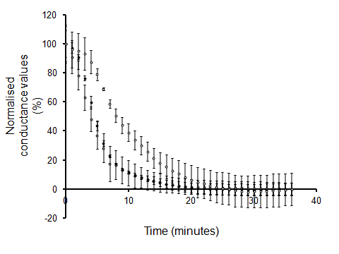
Fig 4.10: Larger stomata (EPF2OE) take longer to close. Normalised conductance values for EPF2OE (white), Col-0 (gray) and epf1epf2 (black); 100% corresponds to steady state conductance values at 1000 µmol.s⁻¹.m⁻² light (t=0) and 0% corresponds to steady state conductance values at 0 µmol.s⁻¹.m⁻² light (t=36 minutes). Error bars represent standard error (n=3-4).

4.3.4 epf1epf2 leaf conductance oscillates at saturating light

Despite the fact that the theoretical maximum conductance of epf1epf2 plants is four times higher than Col-0, conductance rates are only increased by approximately 75% in saturating light (Fig 4.9). A clue to understanding why epf1epf2 leaves conduct well below their potential lies in the oscillatory nature of their conductance which is not observed in Col-0 or EPF2OE (Fig 4.11). Oscillations in leaf conductance are a widely observed phenonomen the period of which can range from minutes to hours (Kaiser and Kappen 2001; Farquar and Cowan 1974; Raschke 1972; Marenco et al. 2006). A mechanism to explain conductance oscillations relies on a negative feedback loop: leaf transpiration reduces water potential in the leaf causing a loss of turgor and closure in guard cells. As the water potential of the leaf increases, stomata are able to open again (Barrs 1971; Farquhar and Cowan 1974; Raschke 1979). Leaf water potential (and therefore this hydropassive feedback loop) is dependent on g_{s} (stomatal conductance), short-term perturbations of humidity, xylem resistance, and soil water potential (Buckley, 2005). Restricted water supply to the leaves may trigger stomatal oscillation (Barrs and Klepper 1968). Given that xylem structure is likely to remain unchanged in plants with altered EPF expression levels, hydrolic resistance is likely to lower the water potential in leaves with higher g_{s} (epf1epf2). As a result, stomatal oscillation occurs exclusively in these leaves and g_{s} is limited below the maximum potential.

It has been demonstrated that conductance oscillations occur when stomatal apertures are small (0-4% open), as the largest differences in g_{s} occur in this region (Kaiser and Kappen 2001) resulting in short bursts of stomatal opening in a subset of stomata which cumulatively create conductance oscillations (Kaiser and Kappen 2001). As high g_{s} correlates with higher Ci and lower leaf water potential resulting in stomatal closure, and epf1epf2 leaves acquire a higher g_{s} more readily, a higher frequency of stomatal apertures are more likely to remain small or closed. Oscillations provide evidence of this negative feedback loop in leaves with higher D (epf1epf2) which, in addition to the potential structural constraints mentioned above, may contribute to limiting their maximum conductance.

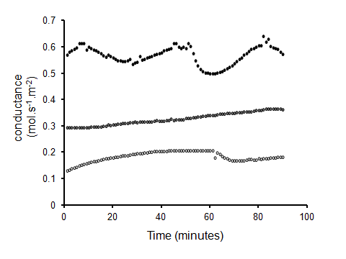
Fig 4.11 epf1epf2 conductance rates oscillate at steady state. Representative conductance rates of EPF2OE (white), Col-0 (gray) and epf1epf2 (black) leaves at steady state (1000 µmol.s⁻¹.m⁻² light, 390 ppm CO₂) over 90 minutes.

4.4 The effect of stomatal density on photosynthesis

Fig 4.12: Photosynthetic rate is positively correlated with D. Mean photosynthetic results of individual leaves acclimatized to 200 ppm CO₂ (white), 450 ppm CO₂ (grey), 1000 ppm CO₂ (black) grown and analysed under 200 µmol.s⁻¹.m⁻² light. Stars indicate significant difference from 450 ppm CO₂ (un-paired t test (<0.05)). n = 4

Despite extreme differences in D and predicted maximum conductance as well as moderate differences in actual conductance, this experiment found no significant difference between the photosynthetic rates of Col-0 and epf1epf2. Interestingly, acquisition of CO₂ was significantly lower for EPF2OE plants at all CO₂ conditions. As mentioned in section 4.1.2, the capacity for light reactions for EPF2OE plants were virtually identical to Col-0 and epf1epf2 plants suggesting that differences in CO₂ uptake are due primarily to gas exchange. In addition, conductance measurements in these plants are also significantly lower (Fig 4.8) leading to the conclusion that the severe reduction in D limits the range of conductance and photosynthetic capacity. An increase in lateral CO₂ diffusion due to higher stomatal spacing in EPF2OE is unlikely to limit carbon assimilation (Morison et al. 2005). These results are not entirely unexpected given that D is negatively correlated with atmospheric CO₂ levels over a geological timescale, it is assumed that the selective pressure of water loss from the leaf against the selective pressure of CO₂ acquisition has determined the porosity of the leaf (Franks and Beerling, 2009; Berry et al. 2010). Perhaps more intriguing is the relatively small and insignificant differences in photosynthesis between Col-0 and efp1epf2 despite a 2 to 3 fold difference in D. We have already seen how an increase in D above a certain threshold has a diminishing effect on leaf conductance (Fig 4.8) and these results suggest this is also true for photosynthesis. Altering expression levels of the EPF family of peptides, like SDD (Bussis et al. 2006), has not significantly improved photosynthetic rates in these experiments. That photosynthetic rates between Col-0 and epf1epf2 leaves (at 1000 ppm CO₂) are virtually identical despite small differences in conductance rates indicates that light reactions might be limiting carbon assimilation. It seems that wildtype (Col-0) has a well adapted D for a wide range of CO₂ conditions as it is able to photosynthesise as much as epf1epf2 despite having lower conductance. One would also assume that higher photosynthetic rates would result in larger leaves yet leaves were largest in plants which photosynthesise the least (EPF2OE) (Fig 3.13, chapter 3). This paradox is analysed in more depth alongside an analysis of rosette biomass in the next chapter.

4.4.1 A/Ci and light response curves

In order to further examine the effect D has on photosynthesis at differing light saturation levels, leaves were subjected to varying intensities of light in ambient CO₂ levels for periods of 3 minutes (Fig 4.13). Conductance rates remained relatively stable (maximum standard variation of 0.0059 mol.m-2.s-1) at 0.087 mol.m-2.s-1, 0.13 mol.m-2.s-1 and 0.15 mol.m-2.s-1 for EPF2OE, Col-0 and epf1epf2 respectively. For all genotypes, light saturation was achieved at roughly 400 µmol.m⁻².s⁻¹. CO₂ assimilation at light saturation varied from 9.8 µmol.m⁻².s⁻¹ for epf1epf2, 7.5 µmol.m⁻².s⁻¹ for Col-0 and 4.7 µmol.m⁻².s⁻¹ for EPF2OE. Between 0 µmol.m⁻².s⁻¹ and 100 µmol.m⁻².s⁻¹ light there was no significant difference between the assimilation rates of Col-0 and either epf1epf2 or EPF2OE indicating that the effect of D on photosynthesis is dependent on light intensity. In addition the range of differences in assimilation between epf1epf2 and EPF2OE plants increases as light intensity approaches saturating light levels: ~1, 2 and 4 differences in assimilation rate for 50 µmol.m⁻².s⁻¹ 100 µmol.m⁻².s⁻¹, and 200 µmol.m⁻².s⁻¹ light respectively. Light levels in previous experiments examining photosynthesis (Fig 4.12) were maintained at 200 µmol.m⁻².s⁻¹ and no significant differences in photosynthetic rates between Col-0 and epf1epf2 were noted. In this light response curve (Fig 4.13), epf1epf2 has a significantly higher rate of carbon assimilation than Col-0 at 200 µmol.m⁻².s⁻¹. It is unclear where this discrepancy arises, but there are a number of differences between the two experiments:

- Instantaneous photosynthetic measurements fluctuate. For the light curve, only one photosynthetic measurement per plant per light condition was taken whereas an average of ~10 measurements taken over 10 minutes were used for the photosynthetic results in 4.12.

- Chamber CO₂ was ambient for the light response curve and 200 ppm CO₂, 450 ppm CO₂ or 1000 ppm CO₂ for the previous set of measurements.

- Leaf conductance rates for the light curve experiment were not given time to adapt to the changes in light. As a result they are lower than expected for the higher light irradiance levels.

Despite the differences between the results of two experiments at 200 µmol.m⁻².s⁻¹ light, these results suggest that epf1epf2 can achieve higher photosynthetic rates than Col-0 at higher irradiance levels.
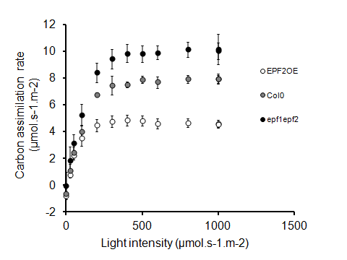
Figure 4.13: Carbon assimilation rates are positively correlated with light intensity and D. EPF2OE, Col-0 and epf1epf2 leaves were subjected to varying light intensities at ambient (400ppm) CO₂. Error bars represent standard error. n=4

Next it was examined whether altering EPF expression levels altered carbon assimilation rates for a given [CO₂] inside the leaf (Ci) (Fig 4.14). Plotting against measurements of Ci instead of Ca (atmospheric [CO₂]) negates the effect of conductance rates that are reported to vary between these genotypes (Fig 4.8 and Fig 4.9). Thus, any differences observed between the A/Ci curves of leaves with altered EPF expression levels indicate differences in biochemical carbon fixation properties such as the amount and activity of rubisco and the rate of rubisco regeneration supported by electron transport or differences in meophyll CO₂ conductance (Farquhar et al. 1980; Epron et al. 1995; Manter and Karrigan, 2004). No significant differences in assimilation between the genotypes for any Ci were noted suggesting that altered EPF expression and the knock-on effect of growth with altered conductance, has had no effect on intrinsic carbon fixation rates (Fig 4.14).

Figure 4.14: Carbon assimilation rates in function of internal [CO₂] (Ci) are consistent between the genotypes. Mean carbon assimilation rates of EPF2OE (white), Col-0 (gray), and epf1epf2 (black) in function of Ci. Light intensity was maintained at 1000 µmol.m⁻².s⁻¹. Error bars represent standard error (n=4).

4.5 WUE is increased in plants with lower stomatal densities

The following experiments aimed to determine whether the differences in conductance highlighted above translated in similar differences in water use. IR gas analysis measurements of conductance and photosynthesis, along with measurements of carbon isotope ratios allow an estimation of the water use efficiency of these plants under different conditions.

An examination of intrinsic water use efficiency ($iWUE=\frac{CO2 assimilation rate}{conductance of water}$) can be used to predict whether altered D can improve growth in water limited and drought conditions.

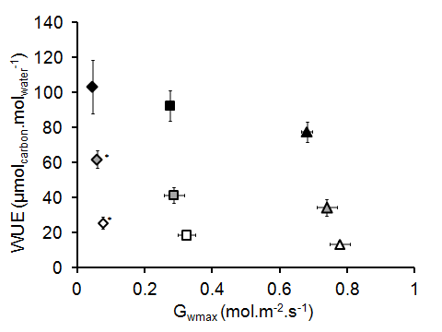
Fig 4.15: Mean intrinsic water use efficiency of leaves against maximum theoretical conductance values. Leaves of EPF2OE (diamond), Col-0 (square) and epf1epf2 (triangle) were acclimatised to to 200 ppm CO₂ (white), 450 ppm CO₂ (grey), 1000 ppm CO₂ (black). Asterisks indicate significant difference of WUE from Col-0 at the same CO₂ conditions (un-paired t test (<0.05). n = 4)

Intrinsic water use efficiency was calculated from the IRGA readings presented in figures 4.8 and 4.12. As expected, elevated CO₂ levels significantly increase the iWUE of leaves from all genotypes. There was also a significant effect of genotype on iWUE. A clear negative correlation between g_{wmax} and iWUE was apparent: EPF2OE leaves lose significantly less water per carbon assimilated than epf1epf2 leaves at all CO₂ conditions, and Col-0 leaves at 200 ppm CO₂ and 450 ppm CO₂. Despite a significantly lower level of photosynthesis at all CO₂ conditions (Fig 4.15), EPF2OE leaves lose less water per carbon assimilated than Col-0 and epf1epf2plants.
Fig 4.16: Mean intrinsic water use efficiency of leaves against actual conductance values. Leaves of EPF2OE (diamond), Col-0 (square) and epf1epf2 (triangle) were acclimatised to 200 ppm CO₂ (white), 450 ppm CO₂ (grey), 1000 ppm CO₂ (black). Stars indicate significant difference of WUE from Col-0 at the same CO₂ conditions (un-paired t test (<0.05). n = 4)

D was positively correlated with conductance at all CO₂ conditions (section 4.3.3). Altering EPF expression in Arabidopsis can thus provide an insight into how differences in conductance affect a variety of physiological properties. Figure 4.16 shows the direct impact of actual conductance on the leaf water use efficiency measured from the same leaf at the same time.

Interestingly, the level of CO₂ at which leaves were acclimitised modulates the gradient of iWUE against conductance (-310.22 µmol.m².s, -175.7 µmol.m².s and -47.4 µmol.m².s for 1000 ppm CO₂, 450 ppm CO₂ and 200 ppm CO₂ respectively). Leaf conductance influences iWUE more at higher CO₂ levels than at lower CO₂ levels. Across a gradient of Ci, as carbon assimilation rates reach a maximum the effect of increasing Ci is diminished (see Figure 4.14). At elevated atmospheric CO₂ levels, for a given conductance, Ci is less limiting to photosynthesis yet water loss remains the same. In other words, leaf WUE is affected by conductance more at elevated CO₂ because conductance has less affect carbon assimilation rates. Given the predicted rise in atmospheric CO₂, finding ways to reduce leaf conductance is likely to become an increasingly attractive means to increase the WUE of plants.

Another commonly used method to estimate water use efficiency is to examine the ratio of ¹³C to ¹²C in plant tissue (δ¹³C). This method, pioneered by Farquhar relies on rubisco discriminating slightly against the heavier isotope (Farquhar et al. 1982). For a leaf in which rubisco has less “choice” which istope to carboxylate, for example a leaf with a low Ci ([CO₂] inside the leaf), the leaf will have a higher ratio of ¹³C to ¹²C. For a given Ca ([CO₂] outside the leaf), a lower Ci indicates lower conductance which is directly correlated with transpiration. Thus the ratio of ¹³C to ¹²C gives an indication of the water lost through transpiration in relation to the carbon taken up via carboxylation (Farquhar et al. 1982; Farquhar 1983; Farquhar et al. 1989; Farquhar et al. 1993). δ¹³C analysis as a means to determine WUE provides a different measure than direct IRGA measurements. δ¹³C analysis determines the mean WUE of tissue over the course of its formation rather than at a specific time point (Adams and Grierson, 2001). With this method it was also possible to analyse the mean WUE of the plant as a whole, rather than individual leaves.

Mean δ¹³C values were obtained from fully expanded leaf samples by mass spectrometry and these values negatively correlated with maximum stomatal conductance (g_{wmax}) (Fig 4.17 and Fig 4.18). Unfortunately, comparisons between plants grown in different [CO₂] cabinets were not possible as the input proportions of CO₂ gas from fossil fuel sources varied between cabinets and δ¹³C gas sample collecting from the cabinets and analysis were unreliable. Plants with the lowest maximum conductance (EPF2OE) discriminated for ¹³C significantly less (i.e. higher δ¹³C) than Col-0 plants across all CO₂ conditions indicating improved transpiration efficiency (Fig 4.17). Plants with higher maximum conductance (epf1epf2) discriminated for ¹³C significantly more than Col-0 plants across all CO₂ conditions signifying a decrease in transpiration efficiency. These results are consistent with leaf temperature data (figures 4.6 and 4.7, section 4.3.1) and IRGA measurements (Fig 4.15) and indicate that modifying Arabidopsis stomatal densities alters both leaf conductance and water use efficiency at these CO₂ conditions and that the largest differences from wildtype are generally observed for plants with the least stomata (EPF2OE).

Fig 4.17: WUE is negatively correlated with theoretical maximum stomatal conductance. δ¹³C of tissue from plants grown at 200 ppm CO₂ (white), 450 ppm CO₂ (grey) and 1000 ppm CO₂ (black) at 200 µmol.m⁻².s⁻¹ light. Error bars represent standard error (n=4).

Consistent with our findings in the first experiment, plants with reduced stomatal densities (EPF2OE) had an increased ratio of ¹³C to ¹²C across all CO₂ conditions and epf1epf2 plants had significantly decreased ratio of ¹³C to ¹²C at 200 ppm CO₂ and 450 ppm CO₂. In accordance with the leaf temperature data, drought stress treatment of Col-0 and epf1epf2 plants at 200ppm resulted in reduced discrimination of ¹³C. However, no significant increase in the ratio of ¹³C to ¹²C was observed at 1000ppm CO₂. As reflected in both the temperature findings and the IRGA data, the largest differences from wildtype conductance levels occurred with EPF2OE. Despite the huge potential for increased conductance, epf1epf2 plants were able to attain a similar WUE level to wildtype plants presumably because actual leaf conductance at these [CO₂] and light conditions is similar to Col-0 (Fig 4.8).

There was a significant effect of water availability on δ¹³C values (Table 4.1). For each genotype grown at 200 ppm CO₂ δ¹³C values were significantly higher for plants grown with limited water (30% SWC). This relationship was also noted for EPF2OE plants grown at 450 ppm CO₂ and 1000 ppm CO₂ and epf1epf2 plants grown at 1000 ppm CO₂. Although [CO₂] conditions appear to modulate the degree of δ¹³C uptake between well watered and water-restricted plants, the atmospheric δ¹³C levels were not successfully measured so conclusions should not be drawn. In addition, no significant interaction of CO₂ and water availability on δ¹³C levels was found (Table 4.1). Generally, limited supply of water throughout the plants life increases the uptake of δ¹³C indicating increased WUE. These results are in agreement with leaf temperature data which showed lower levels of transpiration for plants grown at 30%SWS. It is well accepted that plants reduce leaf conductance when water is scarce in order to conserve water. As well as conserving water, reductions in conductance appear to increase WUE.

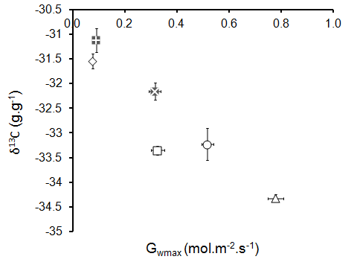

Fig 4.18: WUE is negatively correlated with theoretical maximum stomatal conductance and water availability. δ¹³C of tissue from plants grown at 200 ppm CO₂ (white), 450 ppm CO₂ (grey) and 1000 ppm CO₂ (black) at 200 µmol.m⁻².s⁻¹ light. Error bars represent standard error. n=4

4.6 Conclusions

General conclusions:

- g_{wmax}, leaf conductance and transpiration are all positively correlated with D. WUE is negatively correlated with D.

- For these plants, D plays a much greater role than S in determining theoretical maximum conductance (g_{wmax}).

- Largest differences from wildtype for leaf conductance, transpiration, photosynthesis and WUE occurred in leaves of plants with reduced D (EPF2OE). Surprisingly, epf1epf2 and not EPF2OE had the largest predicted difference in g_{wmax} from wildtype. epf1epf2 plants were unable to attain even a quarter of their g_{wmax} at even the lowest CO₂ condition (200 ppm CO₂).
This may be due to:
(i) Impaired stomatal function due to stomatal clustering.
(ii) Stomatal positioning over mesophyll cells rather than mesophyll cell junctions limiting gas diffusion.
(iii) Partial compensation of aperture size.

- Transpiration is the principle driving force for water uptake (section 4.1.1). These experiments have shown that transpiration is positively correlated with D and it is therefore reasonable to assume that water uptake is slower in plants with lower D. This may have indirect effects on plant health. It would be interesting to examine the uptake of nutrients or transport of plant hormones such as ABA across these genotypes.

Effect of limited water availability on gas exchange:

- At 200 ppm CO₂ and 450 ppm CO₂, theoretical g_{wmax} of epf1epf2 mutants was significantly reduced in response to reduced SWC. This is due primarily to smaller S (chapter 3).

- Plants with limited water (30% SWC) had a higher predicted g_{wmax} at 1000 ppm CO₂ than at 450 ppm CO₂.

- Transpiration was reduced for plants grown at 30% SWS. Plants with higher D (epf1epf2) reduced transpiration more than plants with low D (EPF2OE); presumably because EPF2OE leaves have a much smaller conductance range.

- WUE was increased for plants grown at 30% SWS.

Effect of CO₂ changes on gas exchange:

- g_{wmax} was reduced for all plants grown at elevated CO₂. This may help leaves achieve a lower conductance.

- Leaf transpiration and conductance in all plants were reduced at elevated CO₂ conditions as stomata responded by closing. EPF2OE leaves had the lowest conductance in all cases. The range of conductance change in response to changes in CO₂ was positively correlated with D and the most extreme differences from wildtype occured in EPF2OE plants.

- Photosynthesis increased at elevated CO₂. Photosynthetic rates for EPF2OE were reduced at all CO₂ conditions yet there was no significant difference between the photosynthetic rates of epf1epf2 and Col-0. Carboxylation rates in epf1epf2 may have been limited by the amount, activity, and kinetics of Rubisco (at low CO₂) or the rate of Rubisco regeneration supported by electron transport (at elevated CO₂).

- Unsurprisingly, WUE was increased at elevated CO₂ conditions. Changes in conductance impacted on WUE more at elevated CO₂ conditions.

- The initial rate of response of leaves with low D (EPF2OE) to a drop in [CO₂] was smaller than plants with higher D (Col-0 and epf1epf2). S may also play a role in this relationship as larger stomata (EPF2OE) closed more slowly.

