Chapter 2 - Materials and Methods

**2.1 General laboratory chemicals**

General laboratory chemicals and reagents, unless otherwise stated, were obtained from BDH, Bio Rad and Sigma.

**2.2 Plant Material**

All *Arabidopsis* plants used in these experiments with the exception of epf1epf2EPFL9OE have been described previously (Hunt et al. 2010; Hunt and Gray 2009). *EPF2*OE (P35S:EPF2-TAP), *EPFL9*RNAi (p35S:EPFL9RNAi) and *epf1epf2EPFL9*OE *Arabidopsis* *Thaliana* plants used in these experiments were generated by Dr. Lee Hunt. The predicted coding region of EPF2 was amplified from Arabidopsis Col-0 cDNA with KOD polymerase, recombined into pENTR/D/TOPO, and recombined into pCTAPi (Rohila et al. 2004) with LR clonase II to create EPF2OE (p35S:EPF2-TAP).The EPFL9RNAi (p35S:EPFL9RNAi) construct was generated by amplifying a PCR fragment with 5’-CACCATTCAAGGAGGAGGCATATGAT-3’  
5’-TACAACTAATATCTATGACAAACAC-3’ primers and recombining into pENTR⁄D⁄TOPO, then into pHells-gate12 (Wesley et al., 2001) with LR clonase II Plus. *epf1epf2EPFL9OE* was generated by transforming *epf1epf2* with *p35S:EPFL9-CTAPi*. Constructs were transformed via electroporation into *Agrobacterium tumefaciens* C58, and Arabidopsis was transformed by floral dipping (Clough and Bent, 1998). Transformants were selected with kanamycin, hygromycin or Basta (Liberty; Agrevo,Cambridge, UK) as appropriate. Gene accession numbers are *EPF1 At2g20875*, *EPF2 At1g34245*, *EPFL9 At4g12970*. T3 generation plants were used in these experiments following genotype confirmation by PCR.

Barley Flag leaves from various cultivars collected from dried plants grown in outdoor plots at the James Hutton Institute in Dundee were provided by Prof R. Waugh.

**2.3 Arabidopsis Growth Conditions**

In all cases, tray and plant positioning in the growth chambers were randomised weekly.

**For experiments examining leaf gas exchange (IRGA) which took place at the University of Sydney**

Mutant plants and their background ecotype Col-0, were stratified on wet M3 compost/perlite (4:1) at 4ºC in dark for 72 h to synchronise germination. Plants were grown under sunlight in a greenhouse in Sydney with mean day length of ~10.5h. After two weeks of growth, plants were transferred to 100 ml volume plant pots and grown to maturity (stage 3.9 on Boyes scale (Boyes et al. 2001)). Results of experiments carried out on these plants are described in figures 4.9, 4.10, 4.11, 4.14 (chapter 4).

**For experiments examining mesophyll structure, seed yield and leaf gas exchange (IRGA) which took place at the University of Sheffield**

Mutant plants and their background ecotype Col-0, were stratified on wet M3 compost/perlite (4:1) at 4ºC in dark for 72 h to synchronise germination. Plants were grown in a controlled environment growth chamber (Conviron model BDR16) at ambient CO2 at 22ºC/16 ºC 9h light/15h dark cycle at 200 µmol irradiance. After two weeks of growth, plants were transferred to 100 ml volume plant pots and covered with cling-film for the first 5 days and grown to maturity (stage 3.9 on Boyes scale (Boyes et al. 2001)). Results of experiments carried out on these plants are described in figures 3.2, 3.18 (chapter 3); 4.9, 4.12, 4.13, 4.15, 4.16 (chapter 4); and 5.11, 5.12, 5.13 (chapter 5).

**For experiments examining properties of plants grown at different [CO2] presented in figures 3.4 - 3.17 (chapter 3); 4.3, 4.4- 4.8, 4.10 - 4.11, 4.17 - 4.18 (chapter 4); and 5.1 - 5.4 (chapter 5)**

Mutant plants and their background ecotype Col-0, were stratified on wet M3 compost/perlite (4:1) at 4ºC in dark for 72 h to synchronise germination. Plants were grown in three matched controlled environment growth chambers (Conviron model BDR16) at 200 ppm CO2, 450 ppm CO2 and 1000 ppm CO2 and ambient (approx. 390 ppm CO2) at 22ºC/16 ºC 9h light/15h dark cycle. CO2 levels were constantly monitored by VAISALA CO2 sensors. In one cabinet CO2 was scrubbed from the air with a mixture of soda lime and charcoal, and CO2 free air mixed with ambient air to achieve 200 ppm CO2. In the other two cabinets ambient air was supplemented with CO2 from a gas cylinder, derived from fossil carbon sources (BOC).

After two weeks of growth, plants were transferred to 100 ml volume plant pots and covered with cling-film for the first 5 days. For experiments described in figures 3.4 - 3.6, 3.15 (chapter 3); and 4.3, 4.5, 4.6, 4.17 (chapter 4) plants were grown to maturity in these pots. When the plants were just beginning to initiate a floral bolt (stage 3.9 on Boyes scale (Boyes et al. 2001); at approximately 82 days, 74 days, and 68 days post germination for 200 ppm CO2, 450 ppm CO2 and 1000 ppm CO2 respectively), fully expanded leaves were removed for stomatal analyses. For experiments described in figures 3.7 - 3.17(chapter 3); 4.4, 4.7, 4.8, 4.10, 4.11, 4.18 (chapter 4) and 5.1 - 5.4 (chapter 5) plants were grown in 100 ml pots and well-watered for 4-6 weeks until the plants had developed 12-15 true leaves (41 dpg (days post germination), 32 dpg and 28 dpg for 200 ppm CO2, 450 ppm CO2 and 1000 ppm CO2 respectively), at which point they were transplanted to larger 1000 ml volume pots filled with M5 compost/perlite (4:1). Pots with established plants and water-saturated soil were weighed and water was withheld from a subset of ‘water-restricted’ plants until the compost reached 30% water saturation, whereupon the soil was watered to 30% water saturation every 2-3 days. ‘Well-watered’ plants were grown in the same manner except compost was maintained at 70% water saturation by watering every 2-3 days. The plants were maintained under well-watered and water restricted conditions for a further 49, 49 or 42 days for 200 ppm CO2, 450 ppm CO2 and 1000 ppm CO2 respectively.

Ideally experimental conditions would have been matched and replicated, and a number of CO2 chambers at each CO2 condition would have been used. This was not possible in terms of costs and time meaning that comparisons between CO2 cabinets should be carried out with caution.

**For short term severe drought experiments presented in figures 5.6, 5.7, 5.8, 5.9 and 5.10**

Mutant plants and their background ecotype Col-0, were stratified on wet M3 compost/perlite (4:1) at 4ºC in dark for 72 h to synchronise germination. Plants were grown in a controlled environment growth chamber (Conviron model BDR16) at ambient CO2 at 22ºC/16 ºC 9h light/15h dark cycle at 200µmol irradiance. After two weeks of growth, plants were transferred to 100 ml volume plant pots and covered with cling-film for the first 5 days and grown to maturity (stage 3.9 on Boyes scale (Boyes et al. 2001)). Watering was withheld for 13 days and resumed on day 13.

**2.4 Arabidopsis DNA extraction**

Leaf material from a single col-0 was used for DNA extraction. 700μl extraction buffer (200mm Tris-HCl, pH 8.0, 250 mM NaCl, 25 mM EDTA, pH 8.0 and 0.5% SDS) was added to the plant material after macerating in a 1.5ml Eppendorf tube. The tube was vortexed briefly and centrifuged for 1 min at 18,000 rpm. The supernatant (600μl) was then transferred to a fresh Eppendorf tube. 600µl absolute isopropanol was added and the sample centrifuged at 18,000 rpm for 5 min. Without disturbing the DNA pellet in the bottom of the tube, the supernatant was removed using a Pasteur pipette. The DNA pellet was dried to remove any remaining liquid and finally, DNA resuspended in 100μl of sterile deionized water and stored at -20°C.

**2.5 Polymerase chain reaction (PCR)**

The Polymerase Chain Reaction using Taq DNA polymerase (Biotaq, Bioline) was used to amplify specific genomic DNA fragments for a number of uses but mainly to check presence or absence of genes.

The following components were added to a micro centrifuge tube:

|  |  |
| --- | --- |
| Template DNA (50-1000ng) | 1µl |
| First primer (25pmol) | 0.1μl |
| Second primer (25pmol) | 0.1μl |
| MgCl2 (50mM) | 0.4μl |
| Taq DNA polymerase | 10μl |
| Sterile H2O | up to 20μl |

30-40 cycles of denaturation at 94°C for 15 sec, annealing at 55- 60°C (adjusted to be approx 5°C below the calculated melting temperature (Tm) for the specific primer sequences used) for 15 sec and elongation at 72°C for 1-3 min (depending on the expected product size, allowing 1 min per 1000bp).

**2.6 Agarose gel**

DNA was separated on agarose gel by electrophoresis in a Bio Rad mini subcell. Agarose was dissolved in 1X TAE prepared from 50X stock (2MTris base, 57.1 ml glacial acetic acid, 0.05M EDTA pH 8.0) and the solution made up to 1 litre with H2O. 40 mg agarose was dissolved in 40 ml of 1X TAE buffer by heating in a microwave at 700 Watts for 1-2 minutes. 4μl of the intercalating agent ethidium bromide (5ng/μl) was added to the gel to act a fluorescent indicator for DNA and the liquid solution was added to UV-transparent gel tray. Combs were added prior to the gel setting to create wells. Once set, the gel was submerged in TAE buffer and samples with loading buffer were added (0.2% w/v bromophenol blue, 50% v/v glycerol). To determine the size of DNA fragments, 2.5μl of Hyper Ladder 1 (Bioline) was used. The gel was run at 100 V for approximately 30 minutes using power supply (Bio Rad). The DNA was visualized in the gel and a digital image taken using an UVitech transilluminator attached to a digital camera.

**2.9 Stomatal measurements**

**2.9.1 Stomata density and index**

Dental resin (ColteneWhaledent, Switzerland) was applied to both surfaces of fully expanded leaves and nail varnish peels were taken from set resin. Cell counts were taken from the widest area (Fig 2.9.1) of 2 leaves each from at least 4 plants of each genotype at each growth condition.

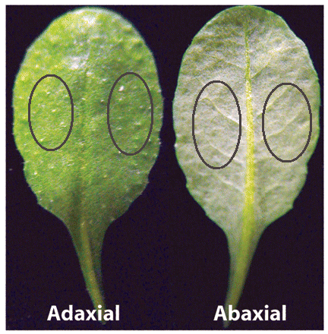  
**Fig 2.1: Stomatal counts were taken from the areas of leaves circled in dark red.**

**2.9.2 Stomatal size**

Stomata size (*S)* was calculated from measurements of guard cell length and width following incubation of leaf samples with the fungal toxin fusicoccin to open pores. Abaxial leaf epidermal peels of mature leaves were removed 2-3 hours into the photoperiod and floated on opening buffer (10mM KCl, 10mM MES , pH 6.2 , supplemented with 500nM fusicoccin (Sigma-Aldrich)) and incubated at 22ºC for 2h at 200 µmol light (Webb and Hetherington, 1997; Stout, 1988). Stomatal measurements and maximum apertures were determined by light microscopy (Olympus BX51), using a fitted camera (Olympus DP70), and measured using ImageJ software version 1.43u. Maximum pore area was estimated from the equation of an elipse (Fig 2.2, equations 1 and 2).

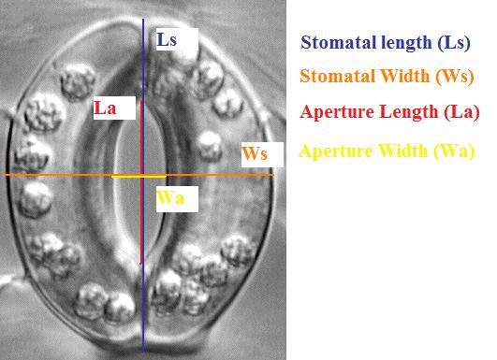

**Fig 2.2: measurements taken on open stomata to estimate stomatal size and aperture size.**

Calculation of maximum pore area (amax):

amax = (1),

whereW­a is aperture width and La is aperture length. Stomatal size (*S*) was estimated from:

*S* = $\frac{π*Ws*Ls}{4}$– amax (2),

whereWs is the width of the fully inflated guard cell pair and Ls is stomatal length.

**2.9.3 Theoretical maximum leaf conductance (**gwmax) **calculations**

Maximum leaf conductance to water vapour was calculated from:

gwmax =) (3),

d is the diffusivity of water vapour in air at 22ºC (m2·s−1), v is the molar volume of air at 22ºC and 1 atm (m3·mol−1), *D* is stomatal density (m-1) and Ws is defined as guard cell width (m) (Franks and Beerling 2009).

**2.10 Leaf and rosette size and leaf dimensions**

Leaf size was estimated from digital photos using ImageJ from the mean size of the 20 largest leaves for each plant. The mean sizes of the same leaves used for stomatal size and density measurements were used to calculate the number of stomata per leaf. Leaf width and length were also measured from digital photos using ImageJ (Fig 2.10). The length of the leaf was measured from the tip of the leaf to the end of the petiole and width was measured at the widest area of the leaf.

Rosette area was calculated as the sum of the visible areas of all mature leaves on a plant.

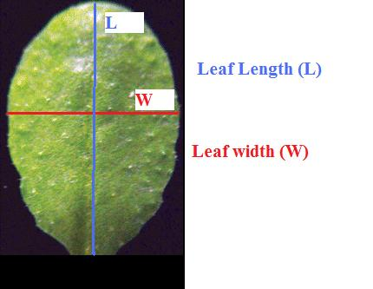

**Fig 2.3: Measurements of leaf width and length.**

**2.11 Leaf sectioning**

Mature leaves were gradually dehydrated in 10%, 30%, 50%, 70% 90%, 97%, 100% ethanol for 30 minutes each. Leaves were then placed in Carnoy’s fixative (4:1 = ethanol : acetic acid solution), vacuum infiltrated for 30 minutes and subsequently left at room temperature for 16-24 hours. Leaves were washed again in 100% ethanol (2 times for 20 minutes each) and then kept at room temperature for up to 3 weeks.

Leaf segments approximately 5 by 7 mm from the widest area of the leaf (Fig 2.9.1) were cut and pre-infiltrated in a technovit 1 : ethanol = 1:1 solution for 1-2 hours (Technovit 7100, order number T218 from TAAB). Samples were replaced into fresh 100% technovit for 2 days.

Samples were placed into 5ml of 100% technovit 1 with a pinch of Neutral red dye for 3-5 minutes to aid with visualising the sample. Hardener 2 and Technovit 1 were mixed in a 1:15 ratio and added to a detached upturned lid of a 1.5 ml Eppendorf tube. Samples were positioned vertically against the side of an Eppendorf lid and left to cure for 2-3 hrs (Fig 2.11). Once hardened, the resin was removed from the lid and fixed to histobloc mounting blocks (order number T395 from TAAB), under a fume hood, with a technovit 3040 solution and left to set for 30 minutes.

The resin was cut in half with a hacksaw (Fig 2.11) to facilitate handling and provide a pointed apex from which the microtome can cut. A rotation microtome (Leica RM 2145) was used to transversely cut 8µm sections from the resin which were then placed on slides and stained with Toluidine blue O. Samples were visualised by light microscopy (Olympus BX51), using a fitted camera (Olympus DP70).



Eppendorf lid

Cut

Sample

**Fig 2.4 Representative diagram of sample embedded in resin in an Eppendorf lid. Cuts with the hacksaw were made across the blue line.**

**2.12 Infrared thermal imaging**

Infrared images were taken using a FLIR SC660 camera (FLIR systems) vertically positioned approximately one metre above the leaf rosette. Infrared images of plants grown in smaller 100 ml pots (presented in Figures 4.5 and 4.6, chapter 4) were taken immediately after their removal from the growth cabinet. The method was refined for plants involved in the drought experiment grown in the larger pots (presented in Figures 4.7 and 4.8, chapter 4) (Fig 2.11). Sixty infrared images of plants involved were taken within the growth cabinets over a period of 1 hour, beginning 2 hours after the start of the photoperiod. 3-4 plants of each genotype were imaged and average temperature data was recorded from the widest uncovered regions of 3 leaves per plants. Background temperatures in growth cabinets were taken from green paper positioned at the same level as the plant rosettes. Images were analysed using ThermaCAM Researcher 2.9 Professional (FLIR systems) and corrected for small variations in growth cabinet temperatures in comparison to background temperatures recorded using the same camera system (<0.7ºC).

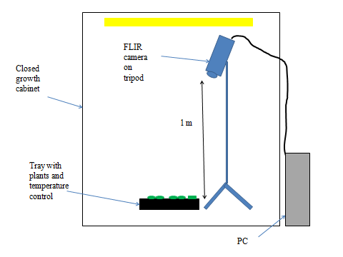

**Fig 2.5: Setup for analysing plant temperature in the growth chamber**

**2.13 Gas exchange using the LICOR-6400**

Infra-Red Gas Analysis (IRGA) was applied to wild–type and mutant plants to investigate their gas exchange and stomatal conductance properties. IRGA (model 6400, Li-COR, Lincoln, NE) is a portable open gas exchange system connected to a sensor head. External air was scrubbed of CO2 using soda lime and mixed with a supplyof pure CO2 from a liquid CO2 canister which allowed fine control of the cuvette's CO2 environment. In all experiments flow rate was 500µmol s-1 and humidity values of 60%-75% were maintained ( VPD ~ 1) using self-indicating desiccant. The leaf temperature was maintained at a temperature of 20°C. The leaf chamber was constructed of two parts: the upper half could bereplaced with the light-emitting diode light source, and the bottomhalf held the leaf-temperature thermocouple. Two GaAsP PAR sensorswere fitted, one positioned inside the upper half of the leaf chamberand the other positioned externally, beside the leaf chamber. The gas analyzer has two lines (**Figure 2.6)**, a sample line which passes by the chamber containing the leaf and an empty reference chamber.

A mature leaf was placed in the leaf chamber while still attached to the plant and left until gas exchange stabilized (minimum 45 minutes). Plants were placed in a small tray containing water throughout the experiments. Conditions (light intensity and CO2 levels) in the chamber were altered depending on the experiments and the gas exchange monitored until it stabilized again (minimum 1 hour). The IRGAs were matched at least once every 20 minutes. At least three plants of each genotype were analysed for each treatment*.*

Leaf size in the chamber was determined from images and analysed using ImageJ.

**IRGA.wmf**

**Figure 2.6 LICOR flow system (taken from LICOR LI-6100 manual).**

**2.14 Carbon Isotope Analysis and Water use efficiency**

Two to three dried fully matured *Arabidopsis* leaves from each plant were dried overnight at 75 ºC and ground to powder in 1.5ml ependorf tubes using plastic pestles. Barley flag leaf samples which were already dried were ground to powder following the same method. For *Arabidopsis* plants grown for the drought experiment, entire rosettes were dried and ground down. 1-2 mg of each sample was added to foil cups and combusted at 1800°C, passed into a gas chromatograph where components are separated and then passed into a mass spectrometer (ANCA GSL 20-20 Mass Spectrometer made by Sercon PDZ Europa) where 12CO2 and 13CO2 were ionized and separated by mass using a magnetic field.

**2.15 Leaf Turgor**

Leaf turgor was qualitatively determined based on leaf "floppiness". Leaves held from the middle which drooped more than 70° were considered to have lost turgor.

**2.16 Statistical analysis**

Two and three way analysis of variance was calculated using the R programming language available from CRAN family of internet sites. For a sample of the script used in R, please refer to annexe 1. Variance was considered significant for p<0.05. Individual un-paired student T tests were conducted with Microsoft Excel.