Chapter 1 - Introduction

During the day, plants photosynthesise, harnessing the sun’s energy to convert CO2 into useful organic compounds such as sugars. Photosynthesis in leaves is dependent on CO2 reaching mesophyll cells which contain the bulk of chlorophyll, yet most of the leaf is enveloped by a waxy cuticle which is almost impermeable to CO2 and water (Jenks et al., 2002). Gas exchange is enabled through pores on the leaf epidermis called stomata. A stoma is formed by two specialised guard cells which are morphologically distinct from general epidermal cells and are able to react to their environment by increasing or decreasing cell turgor. This enables the stomatal pores to open or close depending on the plant’s need to acquire CO2 or conserve water, allowing much needed flexibility in plant water relations (Farquhar and Sharkey, 1982). The development of the stomata on the epidermis also adapts to the environment, for example higher atmospheric CO2 levels or low light intensities result in fewer stomata forming in the developing leaf (Woodward et al., 1987).

The development and behavior of stomata is an important and active field of research for a number of reasons. Stomata are a vital component of global carbon and water cycles: an estimated 300 x 1015 g of CO2 and 35 x 1018 g of water vapour pass through stomata every year, corresponding to twice the total water content of the atmosphere (Hetherington and Woodward, 2003). Stomata regulate leaf conductance, which effects carbon assimilation, leaf cooling, metabolite fluxes, long distance signalling, microbial infection and ozone damage (Brownlee, 2001; Lake et al. 2001; Jia and Zhang, 2008; Meidner and Mansfield, 1968; Mansfield and Majernik, 1970; Lawson, 2009). Thus, ‘tweaking’ their development or sensitivity to environmental stimuli could improve the yield or water use efficiency of plants used for food or biofuels (Morison et al. 2007). Stomata also provide a model for studying asymmetric cell division and cell-cell signalling in plants (Bergmann and Sack, 2007).

**1.1 Origins and evolution of stomata**

The earliest fossils with recognizable stomata and vascular tissue have been found in deposits dating as far back as 418 million years ago (Edwards et al., 1998). This innovation, which would develop to allow plants to exploit water and nutrients stored in soils, was a major contribution to the scale of colonisation of land by plants (Berry et al., 2010). The total photosynthesis on land is now approximately equal to that occuring in the oceans (Field, 1998). For the most part, stomata have been a regular feature of the sporophyte of polysporangiophytes since the late Silurian (Kenrick and Crane, 1997; Edwards et al. 1998) and are also found in hornworts and in mosses but not in the sporophyte generation of liverworts (Kenrick and Crane, 1997).

Stomatal densities and sizes have been subject to change. Although it is well established that stomata found in extant plants function as valves allowing carbon uptake while minimising water loss (Farquhar and Sharkey, 1982; Hetherington and Woodward, 2003), their original purpose in ancient species may have been to increase the rate of dessication in the parental gametophyte to facilitate spore release (Ligrone et al. 2012).

It has been demonstrated that increases in atmospheric CO2 since the onset of the industrial revolution have paralleled decreases in stomatal density (Woodward, 1987)Stomata evolved more than 410 ma ago (Edwards et al., 1998; Edwards et al., 1994; Raven, 2002), but the origin of their short term physiological responses to environmental and endogenous stimuli remains contentious. Stomata in *Lycopodium* and the fern *Pterodium* are reported to lack abscisic acid (ABA) induced and epidermal cell-mediated responses to water fluctuations observed in angiosperms indicating that the transition from passive to active metabolic control of plant water balance occurred after the divergence of ferns (360ma) (Brodribb and McAdam, 2011; McAdam and Brodribb, 2012). However, the lycopsid Selaginella and mosses *Funaria* and *Physcomitrella*, like the angiosperm *Arabidopsis*, are able to modulate stomatal turgor in response to ABA and CO2 (Ruszala et al. 2011; Chater et al., 2011). In addition, a homologue of the ABA regulatory-protein kinase: OST1 in *Physcomitrella* or *Selaginella* can rescue the ABA response of an Arabidopsis mutant lacking OST1 (Chater et al., 2011, Ruszala et al., 2011). OST1, a key component of stomatal response to ABA, evolved more than 400 million years suggesting that control of stomatal aperture in response to ABA originated earlier than the divergence of ferns.

**1.2 Stomata respond to key environmental and endogenous signals**

**1.2.1 Stomatal response to light**

Vascular plants including *Arabidopsis* adjust leaf conductance in response to light both by altering stomatal development (long term response) and by modulating stomatal aperture (short term response). When grown at higher photon irradiances, the stomatal indices of mature leaves are significantly increased (Casson et al. 2009). Studies examining phenotypic differences in *Arabidopsis* mutants have determined a number of the genes involved in stomatal developmental responses to light (Fig 1.1). Plants defective in phyB, a phytochrome photoreceptor, have significantly lower stomatal indices than the Col-0 control when grown at 175 µmol.m-2.s-1 but no significant difference was observed at 50 µmol.m-2.s-1 suggesting that phyB plays an active role in increasing stomatal density in response to (red) light (Casson et al. 2009). Plants lacking a functional PIF4 gene, a phytochrome interacting factor shown to negatively regulate PhyB (Huq and Quail 2002; Castillon et al. 2007), are also unable to regulate stomatal development normally in response to light intensity indicating that PhyB regulates stomatal development by interacting with, but not exclusively with, PIF4 (Casson et al. 2009). Although the above study found no role of phyA in regulating stomatal development on true leaves, a *phyA* mutant is reported to produce hardly any stomata on the cotyledons under far-red light (Kang et al. 2009). *Arabidopsis* can also alter stomatal density in response to blue light. Plants overexpressing chromophores CRY1 and CRY2 have increased stomatal indices and clustering when grown in blue light but not when grown in red light. In addition, stomatal development in *cry1cry2* double mutants was inhibited in a blue-light dependent manner. COP1, a ring motif-containing E3 ubiquitin ligase and key repressor of photomorphogensis (Mao et al., 2005; Deng et al. 1992; Jang et al., 2003; Liu et al., 2008) plays a role in repressing stomatal development and differentiation in both light and darkness. In addition, double and triple mutants have shown that COP1 is epistatic to CRY1, CRY2, PHYA and PHYB suggesting that it may act in the same pathway (Kang et al., 2009). Although there is a reported epistatic relationship between COP1 and YDA, a MAP kinase kinase kinase involved in the stomatal development pathway (see section 1.3), the evidence is not convincing enough to conclude that they act in the same pathway due to the extreme phenotype of the plants expressing constitutively active YDA proteins (Kang et al., 2009).



**?**

**Fig 1.1: Phytochromes phyA and phyB and CRY chromophores act in the same pathway as COP1 to regulate stomatal development.** COP1 may also act in the same pathway as YDA (Figure adapted from Kang et al. 2009) See section 1.2 for more details about the signalling cascade involved in stomatal development.

Guard cell signalling leading to stomatal opening is stimulated by photosynthetically active red and blue light in a complex network comprised of many of the same photoreceptors and related proteins involved in modulating stomatal development in response to light (Fig 1.2). Blue-light induced opening is mediated by phototropins PHOT1 and PHOT2, and cryptochromes CRY1 and CRY2 (Kinoshita and Shimazaki, 2001; Talbott and Shmayevich 2003; Mao et al. 2005) in a rapid and more sensitive response than red light (Assmann, 1993). Blue light induced autophosphorylation of PHOT1 and PHOT2 stimulates a 14-3-3 protein signalling cascade, inducing guard cell H+ATPase phosphorylation and activation as well as K+in channel activation the net result of which is hyperpolerisation of the plasma membrane and stomatal opening (Kinoshita and Shimazaki, 2001; Shimazaki et al., 2007). COP1 has also been implicated in the short term stomatal response to blue light. Stomata of plants lacking a functional COP1 gene had constitutively open stomata in both light and dark conditions. These observations were also noted for *cop1cry1cry2* and *cop1phot1phot2* triple mutants highlighting the epistatic relationship of COP1 with CRY and PHOT light receptors (Mao et al. 2005).

Stomata open only to red light at high fluencies and continual illumination in a process which is dependent on the presence of chloroplasts and associated with photosynthetic activity (Olsen et al., 2002). A mesophyll-derived signal is thought to play a role in guard cell response to red light as isolated red light excitation on guard cells failed to induce opening (Roelfsema et al., 2002). PhyB is a positive regulator of stomatal opening in response to red and blue light. PhyB mutant plants have reduced stomatal apertures and plants overexpressing PhyB have greatly increased stomatal apertures compared with Col-0 in response to both red and blue light (Wang et al. 2010).



**Fig 1.2 Phototropins PHOT1 and PHOT2 as well as cryptochromes CRY1 and CRY2 signal in the same pathway as COP1 to repress stomatal closure in response to blue light.** PhyB induces stomatal opening in both blue and red light. Although it is likely that PhyB acts in the same pathway as COP1 to alter stomatal development, it is unknown whether this same pathway is involved in the short term stomatal aperture response to light.

**1.2.2 Stomatal response to CO2**

As with light, stomatal development and stomatal apertures are influenced by CO2. The influence of CO2 on driving evolutionary changes in stomatal density and size has already been discussed in section 1.1. Below, the plasticity of individual species to modify developmental stomatal properties in the developing leaf in response to CO2 is examined.

Although growth at higher CO2 conditions generally decreases stomatal densities (74% of 100 species examined) and indices (Woodward and Kelly, 1995), exceptions are plentiful (Ainsworth and Rogers, 2007; Woodward and Kelly, 1995). Free air CO2 enrichment (FACE) studies carried out on poplar trees over a 5 year period found that despite a decrease in overall conductance, SI and SD were not significantly altered at high CO2 (Tricker et al., 2005). In addition, opposite observations of increased stomatal density at higher CO2 have been reported in *Oryza sativia* (Rowland-Banmford et al., 1990), as well as 20% of *Dillinidae*, 30% of *Caryophillidae*, 27% of *Asteridae*, 13% of *Hamameldae* and 20% of *Rosidae* species examined in a meta-analysis of data published in and before 1995 (Woodward and Kelly, 1995). In the case of *Arabidopsis* Col-0, the background ecotype used in this study, a reduction in stomatal density of approximately 6% for plants grown at elevated CO2 has been reported (Woodward et al., 2002).

The HIC (High CO2) gene, which codes for a putative 3-keto acyl coenzyme A synthase—an enzyme involved in the synthesis of very-long-chain fatty acids, is involved in development of stomata in response to CO2 conditions. In contrast with wild-type *Arabidopsis*, increased CO2 growth conditions are correlated with denser stomata in a HIC mutant (Gray et al. 2000). Mutations in FDH (formaldehyde dehydrogenase), an enzyme thought to encode for condensing enzymes in fatty acid metabolism as well as other wax biosynthesis enzymes cer1 and cer2 (Gray et al. 2000; Yephremov and Wisman, 1999) result in abnormal epidermal cell development and stomatal indices respectively, further implicating fatty acids in the regulation of epidermal cell development. In addition to the involvement of fatty acid synthesis, systemic signalling in response to CO2 from mature leaves to developing leaves has been reported. Using a gas tight cuvette system to allow separate CO2 environments for mature *Arabidopsis* leaves from developing leaves, it was demonstrated that developing leaves alter their stomatal densities and indices according to the CO2 conditions which the mature leaves experience (Lake et al., 2001). This evidence of a long distance signal produced by mature leaves in response to elevated [CO2] which travels to developing leaves, altering their development has also been observed in *Sinapis Alba* (Lake et al. 2001). Stomatal size (*S*) is also reported to increase for plants grown at higher [CO2] conditions (Franks and Beerling, 2009; Lomax et al., 2009) (Table 1.1).

|  |  |  |  |  |
| --- | --- | --- | --- | --- |
| **SPECIES** | **S at low CO2 µm2** | **S at high CO2**  **µm2** | **S increase**  **%** | **REFERENCE** |
| *Zea Mays* | **918** | **1072** | **16.78** | **Driscol et al. 2006** |
| *Oryza sativa* cv. Pusa Basmati-1 | **209** | **231** | **10.53** | **Uprety et al. 2002** |
| *O*. *sativa* cv. P-677 | **155** | **281** | **81.29** | **Uprety et al. 2002** |
| *O*. *sativa* cv. P-834 | **185** | **251** | **35.68** | **Uprety et al. 2002** |
| *O*. *sativa* cv. P-2503-6-693 | **160** | **222** | **38.75** | **Uprety et al. 2002** |
| *Betula pubescens* | **618** | **705** | **14.08** | **Vanhatalo et al. 2001** |

**Table 1.1 Increase in stomatal size (S), in response to elevated atmospheric CO2** (Low CO2: 350ppm; High CO2: 700ppm) (Adapted from Franks and Beerling 2009).

That decreasing and increasing CO2 conditions respectively open and closed stomata was observed in *Canna* leaves (Freudenberger 1940) and confirmed by subsequent and comprehensive studies (Heath, 1950; Meidner and Mansfield, 1968; Raschke, 1975; Raschke, 1979). The speed of response varies between species. Maize, for instance, responds in under a minute (Raschke, 1972) whereas Scotch pine responds in 3 hours (Morison, 1980). CO2 is sensed in the epidermis and the stomatal guard cells (Young et al. 2006; Fitzsimons and Weyers, 1986; Mouravieff 1956) of which the inner walls are permeable to CO2 (Meidner and Mansfield 1965) suggesting that plants modulate stomatal aperture in response to Ci (internal [CO2]) rather than Ca (external [CO2]) (Mott 1988). Guard cell CO2 sensing involves malate imported from the surrounding mesophyll (Hedrich et al., 1994) as well as bicarbonate activation of S-type anion channels from CO2 catalysis by two carbonic anhydrases: βCA1 and βCA4 (Hu et al. 2010). It is believed that genetic redundancy is hindering attempts to identify other, as yet unknown CO2 binding and interacting proteins (Kim et al. 2010)

Regardless of the exact CO2 sensing mechanisms, elevated CO2 concentrations have been shown to depolarize guard cells, resulting in a decrease in cell turgor and stomatal closure by a number of downstream cellular mechanisms (Sheriff, 1979). At high CO2 concentrations, the activity of outward rectifying potassium channels and inward rectifying potassium channels is increased and decreased respectively, the activity of S type anion channels are enhanced, and chloride release from guard cells and guard cell calcium concentrations are increased. (Webb et al. 1996; Brearly et al., 1997; Hanstein and Felle, 2002; Raschke et al. 2003; Rob et al. 2005; Ainsworth and Rogers 2007).

**1.2.3 Stomatal response to water stress**

Given that more than 50% of the Earth’s surface area, including the majority of agricultural lands is vulnerable to drought (Kogan, 1997) and crop losses due to drought are predicted to increase due to global climate change (Battisti and Naylor, 2009), efforts to understand how plants modulate leaf gas exchange properties are vitally important (Hubbard et al. 2010).

During water stress, plants close their stomata to conserve water and increase their water use efficiency (Farooq et al., 2009). A number of mechanisms work together to close stomata such as chemical signalling from the stress hormone ABA and hydropassive closure. Hydropassive closure, though important in ferns and lycopods does not generally occur in angiosperms as concomitant loss of turgor from cells neighbouring guard cells pulls them apart, opening the stomata **(**Franks and Farquhar, 2007; Brodribb and McAdam, 2011). ABA was previously thought to be synthesized exclusively in the root but more recent work has determined that it is also synthesized in mesophyll, stomata and vascular tissue (Leonhardt et al., 2004, Christmann et al., 2005; Xie et al., 2006; Schroeder and Namabara, 2006). Increased levels of ABA in response to water deficit have been found in many photosynthetic organisms and a number genes involved in ABA synthesis (NCED and AAO) are upregulated during water stress (Qin and Zeevaart, 1999; Seo et al., 2000). As with guard cell response to CO2, response to drought via ABA causes a number of changes in guard cell ion channels and stores resulting in a net depolarization and subsequent loss of turgor in guard cells and closure of the stomatal pore (Hubbard et al., 2010). ABA induces depolarization at the plasma membrane (H+)ATPase (Goh et al. 1996), inhibits the K+ influx channel (Schroeder and Hagiwara 1989; Lemtiri-Chlieh and MacRobbie 1994) and activates the S-type anion channel (Schroeder and Hagiwara 1989).

Air relative humidity and water availability also have an impact on stomatal development and sensitivity. Plants grown in high humidity develop stomata which are malformed, and unable to close to ABA or darkness (Brainerd and Fuchigami, 1982; Santamaria et al., 1993; Sciutti and Morini, 1995; Joshi et al., 2006; Fordham et al., 2001).In addition, high air relative humidity is also responsible for decreasing stomatal sensitivity responses to CO2 of *Vicia faba* (Talbott et al., 2003). The number of stomata per leaf and stomatal indices are reported to increase whereas stomatal density decreases for plants grown in higher soil humidities or increased air humidity (Metwally et al., 1970; Metwally et al., 1971; Schurmann, 1959; Sciutti and Morini, 1995). These observations have been correlated with decreased ABA concentrations and increased transpiration (Lake and Woodward, 2008). Interestingly, water uptake was prioritized over water loss in *Vicia faba*, which increases stomatal densities and indices in response to drought and salinity stress (Yi et al., 2010).

**1.2.4 Targetting stomata to improve water use and yield in plants.**

Agriculture accounts for the use of 1.54 bn ha of arable land and 70% of global water withdrawal (FAOSTAT 2002, FAOSTAT 2006). The scale of our dependence on water to grow our food puts strain on ecosystems of and surrounding several major river systems. For instance, since the completion of a large irrigation project in 1969 the lower sections of the Yellow River in China have suffered from episodes of low-flow and increasingly zero-flow (Tang et al., 2008), consequently disrupting coastal and estuarine ecosystems. Making agriculture sustainable requires improving the return of yield per input of water. Most water used in irrigated agriculture is lost in run-off and drainage (44%), storage and transfer (30%) and soil evaporation (6-11%) which can be minimised by adopting modern irrigation techniques. However, roughly 13-18% of water available for irrigation is lost through the transpiration of crop leaves (Wallace and Gregory, 2002) which could potentially be reduced by altering flowering time, plant height (Richards, 2004) and stomatal characteristics (Morison et al. 2006).

The effect of stomatal conductance on photosynthesis has been extensively studied across numerous species (Collatz et al., 1991; Wang and Leuning, 1998; Bunce, 1992; Tuzet at al. 2003; Lake and Woodward 2008) and are strongly correlated (Wong et al. 1979; Zeiger & Field, 1982). A close correlation between photosynthetic efficiencies in guard and mesophyll cells has also been reported (Lawson et al., 2002, 2003). However, conductance is dependent on both stomatal density and stomatal aperture. In order to isolate the effect of stomatal density on photosynthesis from conductance, *Arabidopsis* stomatal density and distribution (sdd) gene knockouts or sdd overexpressors with decreased or increased stomatal densities respectively were compared alongside their wildtype. Interestingly, the authors reported that no significant differences in leaf assimilation rates were observed at constant light despite 7.5 fold differences in stomatal densities. For the most part, there were minimal differences in leaf conductance between these three genotypes suggesting they were able to compensate for altered stomatal densities by adjusting aperture size (Shluter et al., 2003; Bussis et al., 2006).

**1.3 Control of Stomatal development**

**1.3.1 Stomatal development and patterning.**

Stomata are found in aerial tissues and in various stages of development and in dicotyledons they are most prevalent on the abaxial leaf surface (Mott et al, 1982; Lake and Woodward, 2002). A meristemoid mother cell or MMC in the developing epidermis is the first cell in the stomatal pathway and divides asymmetrically to form a small meristemoid cell and a larger daughter cell. The larger daughter cell can (i) become an MMC, and divide asymmetrically, (ii) become a pavement cell or (iii) undergo symmetric division in which both daughter cells can follow any of these fates. The meristemoid can either continue asymmetric division or divide symmetrically and develop into two guard cells. (Fig 1.3) (Nadeau and Sack, 2002).

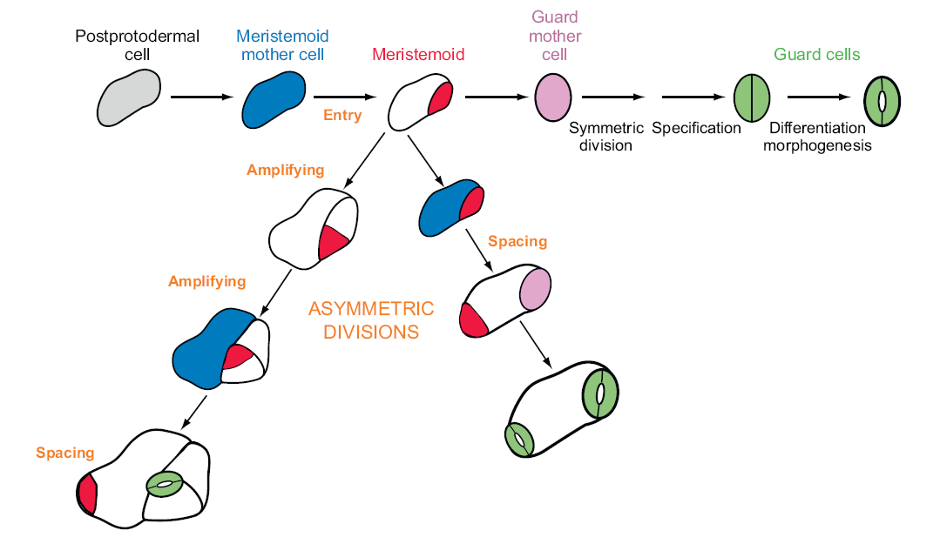

**Fig 1.3: Cell division involved in *Arabidopsis* stomatal development**. The meristemoid can either continue asymmetric division (amplifying) or differentiate into a guard mother cell. The larger daughter cell can divide asymmetrically away from the existing meristemoid (spacing). (taken from Bergmann and Sack 2007)

A striking feature observed in stomatal distribution is termed the one cell spacing pattern. Mature stomata are separated from one another by a minimum of one cell. Presumably, this distribution increases the efficiency of the individual stoma by reducing evaporation and maximizing the efficiency of CO2 uptake under ambient environmental conditions (Nadeau and Sack, 2002). More importantly this patterning allows stomatal movement, which is dependent on ion exchange between guard cells and neighboring cells (Serna and Fenoll, 2000a). The efficiency of stomatal patterning under different environmental conditions such as drought and heat has not been adequately assessed but the impact of CO2 concentration and light intensities on stomatal distribution and density has. In neither of these cases has a breakdown of the one cell spacing pattern been documented (Gray et al. 2000; Woodward 1987; Woodward and Kelly 1995; Casson et al., 2009).

The one cell spacing patterning is ensured by the orientation of meristemoid divisions and not the position of MMCs which can develop next to one another. When a meristemoid is formed next to another meristemoid, guard mother cell or stoma, it will divide away so the larger daughter cell occurs between the potential or actual stomata (Fig 1.4) (Nadeau and Sack, 2002).

In *Arabidopsis*, stomatal development is coordinated in relation to internal structures of the leaf. 90% of stomata and meristemoids are located above mesophyll cell junctions, presumably to maximize favourable gas exchange (Serna and Fenoll, 2000b).



**Fig 1.4: Position Independent and Dependent Events in the Stomatal Pathway**

**(A)** and **(B)** The placement of the first precursor cells, the MMCs, appears to be random so that MMCs sometimes form in contact

**(C)** The plane of asymmetric division in separated MMCs also appears to be random.

**(D)** and **(E)** Divisions of MMCs in contact are randomly oriented and can produce meristemoids in contact.

**(F)** The orientation of asymmetric divisions next to a single stoma or precursor is position-sensitive and patterns most stomata.

**(G)** Asymmetric divisions of adjacent meristemoids can be oriented and thus space stomata.

**(H)** Cells next to two stomata or precursors (asterisks) usually do not divide asymmetrically.

**(I)** The arrest of an adjacent meristemoid (asterisk) spaces some stomata.

(Taken from: Nadeau and Sack 2002)

**1.3.2 Transcription factors control stomatal development**

A family of related basic helix loop helix transcription factors are responsible for the consecutive initiation, proliferation and differentiation of stomatal lineage cells. SPCH is required for regulating initiation and amplification of stomatal lineage cells. It is also responsible for activation of its two paralogues: MUTE and FAMA. Protodermal cells in *spch* mutants are less likely to undergo entry divisions and *spch1*, which contains an early stop codon, is unable to produce any stomata. MUTE is responsible for differentiation of meristemoids into guard mother cells (GMCs). Silencing of MUTE results in the production of rosette cell patterns on the epidermis which do not form pores; these are SLCs (stomatal lineage cells) that have undergone excessive amplification. Overexpression of MUTE results in a leaf epidermis made up entirely of stomata (MacAlistar et al., 2007; Pillitteri et al., 2007; Pillitteri et al., 2008). In addition, non-stomatal lineage cells that have not undergone asymmetric divisions are able to respond to MUTE and differentiate into stomata. This suggests that MUTE alone can directly or indirectly activate stomatal differentiation genes (Pillitteri et al. 2008).FAMA restricts cell cycling at the end of the stomatal lineage and is also responsible for guard cell differentiation. Instead of producing stomata, *fama* mutants form stacks of thin epidermal cells in their place which lack guard cell identity markers (Fig 1.5). In cells in which FAMA is overexpressed even non-SLCs express guard cell markers (Ohashi-Ito and Bergmann, 2006).

Basic helix loop helix (bHLH) transcription factors act as dimers (Murre et al., 1989) yet only MUTE is able to homodimerise. A double bHLH paralogue mutant: scrm1-scrm2 results in the same phenotype as a triple SPCH, MUTE, FAMA mutant. Yeast two hybrid and BiFC analysis has determined that SCRM1 and SCRM2 form hetrodimers with SPCH, MUTE and FAMA and are required for their function. It was also shown that SPCH induces SCRM1 gene expression and that SCRM1 is required for SPCH expression and function (Kanaoka et al., 2008).

Two R2R3 MYB paralogues: FOUR LIPS (FLP) and MYB88 also impact on the later stages of stomatal development. Severe *flp* mutant phenotypes result in a higher frequency of clustered stomata; a result of extra symmetric divisions in cells with persistant GMC identity. *Myb88* single mutant phenotypes have no distinguishable difference from wildtype yet a *flp;myb88* double mutation results in a cluster frequency twice as severe as a single *flp* mutation (Fig 1.5). The action of these transcription factors differs from FAMA as they are not responsible for guard cell identity, only in terminating cell division (Ohashi and Bergmann, 2006).

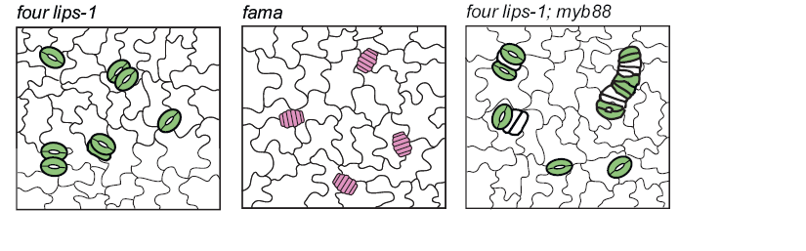

**Fig 1.5: Mutations in FLP, FAMA and MYB88 impact termination of cell division**. (Adapted from Bergmann and Sack, 2007)

Although all these transcription factors are sufficient to drive the events transitioning a protodermal cell into stomata, they cannot enforce the one cell spacing pattern alone. SPCH is expressed in all protodermal cells yet only a subset of these cells initiate stomatal cell lineages (Pillitteri et al., 2007). The proteins involved in controlling SPCH’s activity form a cell-cell signalling cascade.

**1.3.3 The one cell spacing pattern is enforced by cell-cell signalling**

Spacing of stomata is ensured by a cell-cell signalling pathway in which guard cells and their precursors release a processed signal to surrounding cells. The signal is internalised and passed down a MAP kinase cascade to repress stomatal lineage initiation. Mutants showing defects in the one cell spacing pattern have been used to identify proteins involved in this pathway. A recent study has confirmed the physical interactions of a number of the signalling molecules upstream of the stomatal development signalling cascade (Lee et al. 2012).

**1.3.3.1 Getting the message: EPF, SDD1, TMM and ERECTA family**

Too Many Mouths (TMM) is a putative leucine rich repeat membrane-bound receptor which lacks a kinase domain (Yang and Sack 1995). In the leaf, TMM is expressed in cells competent to divide asymmetrically but it is absent in fully differentiated guard cells as well as in pavement cells (Bergmann and Sack, 2007). A TMM mutation results in the breakdown of the one cell spacing pattern. *tmm* is unable to correctly orientate spacing divisions away from stomatal lineage cells and is unable to stop asymmetric divisions in cells neighboring two or more SLCs (Fig 1.6) (Geisler et al. 2000).

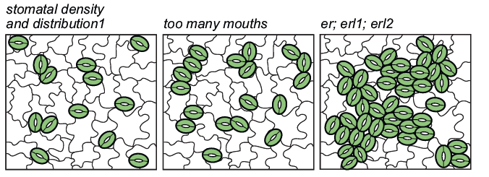

**Fig 1.6: mutations in SSD1, TMM and the ERECTA family genes cause breakdown in the one cell spacing pattern** (Bergmann and Sack, 2007).

The EPF family are small secretory peptides approximately 100 amino-acids long characterized by 8 (in the case of EPF1 and EPF2) and 6 (in the case of EPFL1-EPFL9) conserved cysteine residues which are thought to form disulfide bonds. Of the EPF family members studied, all have been shown to be processed at the non-conserved N terminal end. Overexpression and knockouts of these genes modify stomatal densities and patterning.

EPF1 encodes a small secretory peptide expressed in stomata and their precursors. Mutations in EPF1 result in an increase in stomatal density and clustering of stomata on the leaf epidermis. An increase of stomatal density is also observed on the stem. In a *tmm epf1* double mutant, however, no stomata are observed on the stem suggesting an epistatic relationship between TMM and EPF1 (TMM is a positive regulator of stomatal development in stems). In addition, overexpression of EPF1 results in an epidermis virtually devoid of stomata; but only in a functional TMM background (Hara et al. 2007). Surprisingly, EPF1 was found not to bind TMM on its own in a Co-immunoprecipitation pull-down experiment (Table 1.2)(Lee et al. 2012).

**Fig 1.7: expression patterns of EPF1 and EPF2 using GUS staining.** (From Hunt et al., 2009)

EPF2 is expressed in meristemoids and GMCs at a slightly earlier stage of stomatal development than EPF1 (Fig 1.7). Mutations in EPF2 result in excessive numbers of cells entering the stomatal lineage resulting in higher meristemoid and stomatal densities. Unlike *epf1* however, clustering of stomata is rare in *epf2* suggesting that these peptides control earlier stages in the stomatal development pathway. EPF1 and EPF2 act independently as double mutants and display additive phenotypes (Hunt and Gray, 2009). EPF2 was found to bind TMM in a Co-IP pull-down experiment (Table 1.2)(Lee et al., 2012).

EPFL9, or STOMAGEN, is the only member of the EPF family known to be expressed in the mesophyll cells of the leaf rather than SLCs (Fig 1.8). As discussed above, stomatal density is increased when plants are grown in lower CO2 environments. EPFL9 is a likely candidate for control of stomatal development in response to CO2 conditions as it is expressed in the photosynthetic tissues of the leaf. EPFL9 is also the only EPF acting as an inducer of stomata. Silencing of EPFL9 in an *epf2* background did not reduce the proliferation of non-stomatal cells suggesting that EPFL9 action is dependent on EPF2. Overexpression of EPFL9 in a *tmm* background failed to increase stomatal density implying that EPFL9 is dependent on TMM. It is likely that stomatal development is modulated by competitive binding of positive and negative regulators to the same receptor(s) (Hunt et al., 2010; Sugano et al., 2010).

In order to examine why members of the same family of peptides are able to have opposite effects on stomatal development, the structure of EPFL9 and EPF2 were examined in depth. Nuclear magnetic resonance (NMR) experiments carried out on EPFL9 determined its structure: 2 anti-parallel β-strands form the core (containing the conserved cystein residues) and are connected by a functional loop region consisting of non-conserved amino acids presenting a hydrophobic surface (Fig 1.9). Homology modelling of the other members of the EPF family suggests similar structures are shared by all EPFs. Functionality was examined by attaching the loop section of EPFL9 onto an EPF2 scaffold and attaching the loop section of EPF2 onto an EPFL9 scaffold. Despite swapping scaffolds, the EPF2 and EPFL9 loop sections were still able to confer function and reduce or increase stomatal density respectively. EPF2 antagonizes EPFL9 activity yet EPFL9 and EPF2 do not interact in vivo. This suggests that fine control of stomatal development by the EPFs is more likely to be a result of competitive binding to the same receptors, or different sites on these receptors. It is also possible that there are more, as yet unidentified factors involved in the regulatory system (Ohki et al., 2011).



**Fig 1.8 A cross-section of the 9th leaf of an 18-DAG pSTOMAGEN::GUS plant showing GUS staining in mesophyll** (Taken from Sugano et al., 2010)

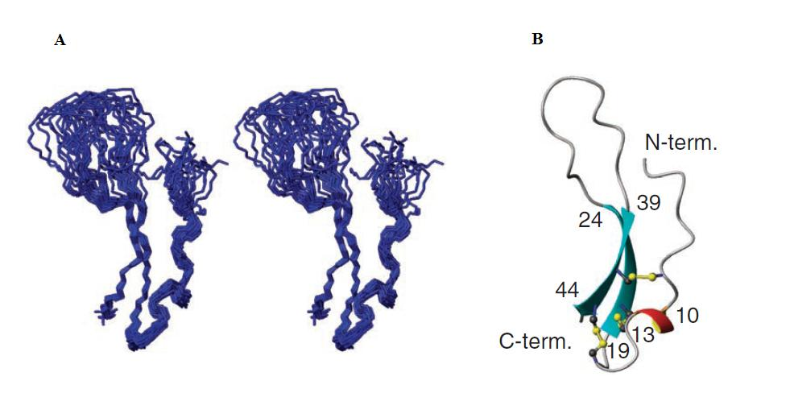**Figure 1.9:** (**A**) A stereoview of 20 NMR structures from stomagen. Only their backbones are depicted. (**B**) A ribbon model of stomagen. Three pairs of disulphide bonds are depicted in the ball-and-stick model. The secondary structural regions were estimated using MOLMOL. (Taken from Ohki et al. 2011)

**a**

|  |  |  |
| --- | --- | --- |
| Receptor \ ligand | EPF1 | EPF2 |
| ER | YES (the same affinity as ERL1) | YES (most affinity) |
| ERL1 | YES (the same affinity as ER) | YES |
| TMM | **NO** | YES (least affinity) |

**b**

|  |  |  |  |
| --- | --- | --- | --- |
| Receptor \ receptor | TMM | ER | ERL1 |
| TMM | **NO** | YES | YES |
| ER | n/a | YES | YES |
| ERL1 | n/a | n/a | YES |

**c**

|  |  |  |
| --- | --- | --- |
| Genotype \ additive | MEPF1 | MEPF2 |
| proERECTA::ERECTAΔK-YFP | Excessive asymmetric divisions without developing stomata | **Insensitive:** stomata develop. |
| proERL1::ERL1ΔK-CFP | **Insensitive:** Paired stomata | Inhibition of asymmetric division |
| *epf1* | Excessive asymmetric divisions without developing stomata | Inhibition of asymmetric division |
| *epf2* | Excessive asymmetric divisions  without developing stomata | Inhibition of asymmetric division |
| Col-0 | Excessive asymmetric divisions  without developing stomata | Inhibition of asymmetric division |

**Table 1.2 Interactions of (a) receptor/ligand, (b) receptor/receptor of proteins involved in development of stomata. (c) phenotypic observations of synthetic EPF1 and EPF2 peptides in various gentic backgrounds.** Tables compiled from data reported in Lee et al., 2012.

SDD1, a subtisilin-like serine protease expressed strongly in meristemoids and GMCs, is thought to be involved in processing a putative ligand for TMM. SDD1 is secreted from the cell and GFP fusion analyses suggest it is probably associated with the plasma membrane. Mutations in SDD1 lead to a two to fourfold increase in stomatal densities and breakdown of the one cell spacing pattern (Fig 1.6). Overexpression of SDD1 results in a twofold decrease in stomatal density. It is also epistatic to *tmm* suggesting that it acts in the same pathway (von Groll et al., 2002). Conversely, stomatal densities and clustering frequency is additive for *epf1,sdd1* and *epf2,sdd1* suggesting that EPF1 and EPF2 act independently from SDD1 (Hunt and Gray, 2009; Hara et al., 2009). These conflicting results point at the involvement of a third, as yet unknown, SDD1 processed TMM ligand or that SDD processes and activates TMM itself.

TMM is not able to internalize the signal by itself because it lacks a cytoplasmic domain (Geisler et al., 2000). It is believed to act as a heterodimer with a leucine rich repeat receptor like kinase (LRR-RLK) in a similar system to CLAVATA proteins which regulate stem cell proliferation at the shoot apical meristem (Fig 1.10). Genetic knockout studies determined the most likely candidates for such interactions: the ERECTA family. These LRR-RLKs act together as negative regulators of stomatal development. The one cell spacing pattern in a triple *er; erl1; erl2* mutant completely breaks down and stomatal density is massively increased.

Though all ERECTA family members have to be absent in order to obtain such a severe phenotype, discrete alterations in stomatal development occur in single or double mutants. In *erl1* and *erl2* and *erl1;erl2* a reduction of the number of stomatal precursor cells is observed though guard cells are still formed. In the *er* single mutant, precursor cells are more numerous and some fail to differentiate into mature guard cells. In an *er;erl1* double mutant, more SLCs differentiate into guard cells and an *er; erl2* double mutant results in even more precursor cells than *er* but no increase in stomatal index (number of stomata divided by the total number of epidermal cells). These conflicting results seem to suggest that different ERECTA family receptors are responsible for distinct stages of SLC development.

Phenotypic analysis of *Arabidopsis* mutants have been unable to fully elucidate the interactions between TMM and ERECTA family receptors. If TMM interacts exclusively as an activator with the ERECTA family one would expect *tmm* to have similar phenotypes as *ERECTA family* mutants in all tissues in which they are expressed. *tmm* is epistatic to *er* and *erl2* in the stem yet has an opposite phenotype to *erl1* mutants. In addition, a double *tmm;er* mutant’s SLCs were unable to differentiate into stomata, a phenotype distinct from either single mutant (Schpak et al., 2005). Though the ERECTA family’s involvement in stomatal patterning has been demonstrated, these genetic studies are insufficient to determine whether the ERECTA family interacts with TMM. To elucidate how and if ER, ELR1 and TMM dimerise, protein interaction experiments have been carried out. Co-immunoprecipitation (Co-IP) experiments determined that both ER and ERL1, unlike TMM, were able to homodimerise and that ER, ERL1 and TMM were all able to form heterodimers (Table 1.2)(Lee et al. 2012). These results may go some way to explain why EPF1 was unable to interact with TMM on its own, as dimer formation may be critical to binding.

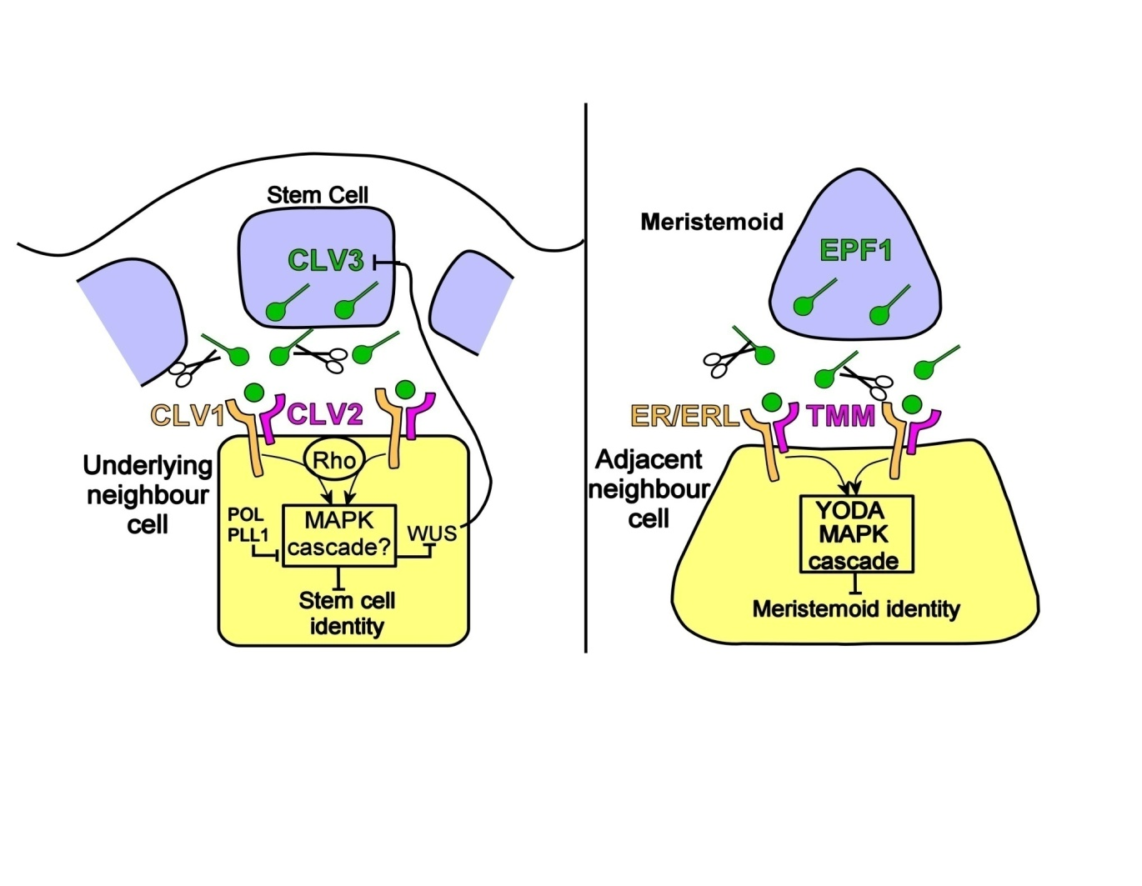

**Fig 1.10: CLV1, an LRR-RLK and CLV2, an LRR-RLP interact with the processed peptide CLV3.** This causes phosphorylation of the MAPK cascade resulting in repression of stem cell identity at the shoot apical meristem. It is thought that TMM, the ERECTA family and EPF1 may interact in a similar way.

**1.3.3.2 Passing on the message: A MAP kinase cascade**

YDA is a MAPKK Kinase involved in early cell fate specification during plant embryonic development. Though many *yda* mutants do not live past the embryo stage due to disruptions in the unequal divisions in the zygote, mutants that are able to survive produce an excessive number of stomata. Engineering a single copy of a constitutively active YDA into a *tmm* or *sdd1* mutant restores the correct distribution of cells suggesting that YDA acts downstream from TMM (Bergmann et al. 2004; Sack 2004).

The MKK4/MKK5- MPK3/MPK6 signalling module has been shown to act in a stress-responsive signalling cascade. Recently, their involvement in stomatal development downstream of YDA has been demonstrated. Double knockout mutations in MPK3 and MPK6 result in embryonic lethality so MPK6 was put under a steroid inducible system in a *MPK3*-/- background and RNA interference was used to knockdown expression of MPK3 in a *MPK6*-/- background. In both of these cases similar disruptions to the one cell spacing pattern and increased stomatal densities were observed. RNAi was also used to knockdown MKK4 and MKK5 displaying a significant but much weaker disruption of the one-cell spacing pattern. Nt-MEK2 is able to activate MKK4 and MKK5. An inducible Nt-MEK2 gene introduced into a *yda* mutant is able to partially restore the one cell spacing pattern and decrease density (Wang et al. 2007). Though this is strong evidence for MKK4/MKK5 acting downstream of YODA, direct interaction between these proteins has not yet been demonstrated.

MPK3 and MPK6 are able to phosphorylate SPCH, which contains a unique MAPK phosphorylation target domain. When this MAPKTD is deleted, the epidermis of transformed plants display large clusters of stomata. In addition, in vitro phosphorylation assays on the MAPKTD and SPCH with a MAPKTD deletion have determined that all phosphorylation target sites are found within the MAPKTD. MAPK3 and MAPK6 are able to phosphorylate regions of SPCH MAPKTD and repress its activity but this repression does not always manifest in identical ways. Depending on the specific region of phosphylation of the MAPKTD, different ratios of amplifying divisions and stomatal densities are observed. In addition, a positive role for phosphorylation has been indicated in one phosphorylation region of SPCH MAPKTD (Lampard., 2009). This evidence suggests a complex regulation of SPCH activity which could be mediated by a set of specific kinases.

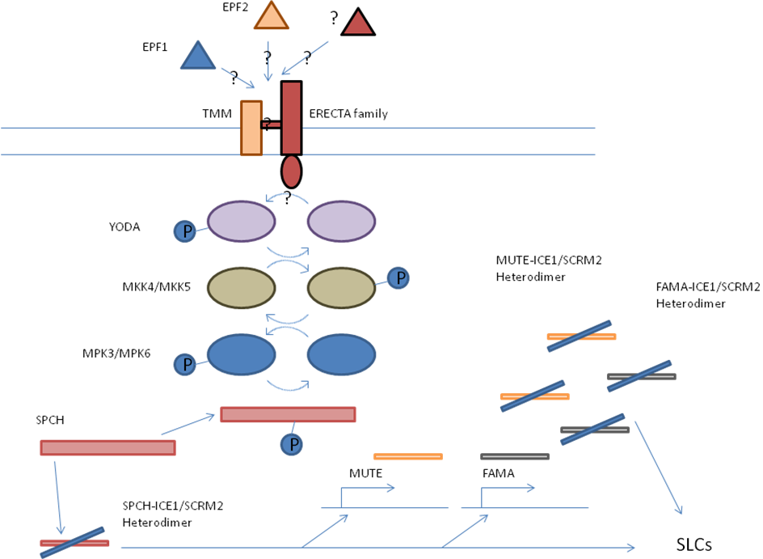

**Fig 1.11: An overview of molecular events controlling stomatal development in a one cell spacing pattern.** EPF family members bind to ERECTA family and TMM dimers which are then thought to pass the message down a kinase cascade starting with YDA and ending with the phosphorylation of SPCH. Once phosphorylated, SPCH is unable to upregulate genes involved in the initiation of stomatal identity.

The experiments detailed in this thesis have the broad aim of determining correlations between altered stomatal density, stomatal size, leaf gas exchange, drought tolerance, and plant water use efficiency. Chapter 3 addresses the question of how altering the EPF family of peptides affects leaf morphology and more specifically whether stomatal densities correlate with stomatal size in *Arabidopsis* plants with altered EPF expression patterns. Chapter 4 examines the leaf gas exchange properties of Arabidopsis and questions whether or not altering stomatal density impacts leaf water use efficiency and photosynthesis. Finally, experiments in chapter 5 highlight how combined changes to leaf morphology and gas exchange due to altered EPF expression impact drought tolerance, seed yield and rosette morphology. Although most of this work was carried out on Arabidopsis plants, stomatal densities and water use efficiencies were also examined in a set of Barley cultivars to determine whether similar trends could be observed in a directly agriculturally useful plant. Results of these experiments and suggested directions to pursue this work in barley are summerised in chapter 6.