Using Pupil Voice to Investigate Students’ Thoughts and Opinions on Cross-Curricular Language Teaching.

By Christopher Jarvis.

A thesis submitted in partial fulfilment of the requirements for the degree: Doctor in Education.

University of Sheffield.

School of Education.

September 2012

I wish to extend my deepest thanks to the following people that have helped me throughout the thesis process:
- Dr. Terry Lamb for his support, advice, and always useful feedback
- My fellow students on the EdD programme for all of the good memories
- The students who participated in the research for their insight and honesty
- Keira Borrill for her help in proof reading this thesis
- Itxaso for her love, support, patience, and understanding when potential holidays had to be side lined in favour of extended periods of time in the University’s libraries.

Table of Contents
Acknowledgements P. 2
Table of Contents P. 3
Abstract P. 7
Chapter 1 Introduction P. 8
1.1 Introduction P. 8
1.2 Summary P. 10
1.3 Additional Note P. 10
Chapter 2 Framing the Research P. 11
2.1 Boundaries of the Research P. 11
2.2 Formulating Research Questions P. 13
2.3 Ontology P. 15
2.4 Summary P. 17
Chapter 3 Literature Review P. 18
3.1 Pupil Voice P. 21
3.1.1 An Overview of Pupil Voice P. 21
3.1.2 Pupil Voice and Improving Learning P. 22
3.1.3 (Meta)cognition P. 23
3.1.4 Metacognition and Pupil Voice in Language Learning P. 24
3.1.5 Issues Surrounding the Implementation of Pupil Voice P. 25
3.1.6 Moving Towards a More Transformative Future P. 27
3.2 Cross-Curricular Teaching P. 29
3.2.1 The National Curriculum P. 29
3.2.2 Cross-Curricular Language Teaching Through Collaboration P. 32
3.2.3 Barriers to Cross-Curricular Language Teaching P. 33
3.2.4 The Andragogical Approach P. 34
3.3 Student Language Learning Motivation P. 36
3.3.1 The Socio-educational Model P. 36
3.3.2 Self-determination Theory P. 38
3.3.3 Overlaps between the Socio-educational Model and Self-determination
Theory p. 40
3.3.4 Goal Theories p. 42
3.3.5 Dörnyei’s Motivational Framework P. 44
3.3.6 The Problems of Motivating Years 8 and 9 P. 45
3.4 Summary: Responding to the Literature Review P. 48
3.4.1 Pupil Voice P. 48
3.4.2 Cross-Curricular Language Teaching P. 49
3.4.3 Student Language Learning Motivation P. 50
Chapter 4 Methods and Methodology P. 52
4.1 Interviews in Educational Research P. 52
4.2 Epistemology and Qualitative Interviews P. 54
4.3 Types of Interviews in Educational Research P. 56
4.4 Reasons for Using the Semi-Structured Interview P. 57
4.5 Using Semi-Structured Group Interviews to Collect Data P. 58
4.6 Being an Insider in the Research Process P. 60
4.7 Issues Surrounding Reliability and Validity P. 62
4.7.1 Validity P. 62
4.7.2 Reliability P. 64
4.8 Summary: Ethical Considerations P. 67
Chapter 5 The Research Process P. 70
5.1 The Sample P. 70
5.2 The Interview P. 71
5.2.1 Subsidiary Research Question 1 and Corresponding Interview Questions P. 71
5.2.2 Subsidiary Research Question 2 and Corresponding Interview Questions P. 73
5.2.3 Subsidiary Research Question 3 and Corresponding Interview Questions P. 74
5.3 Approach to Data Analysis P. 76
5.4 Approach to Transcript Analysis P. 78
5.5 Summary P. 82
Chapter 6 Data Analysis P. 83
6.1 Analysis of Subsidiary Research Question 1 P. 85
6.1.1 The Impact of Curriculum Subjects Outside the Walls of their Classroom P. 86
6.1.2 The Existing Cross-Curricular Opportunities within the School P. 89
6.1.3 The Failure of Previous Cross-Curricular Language Projects P. 99
6.1.4 Differences in Group Responses P. 100
6.1.5 Summary P. 101
6.2 Analysis of Subsidiary Research Question 2 P. 103
6.2.1 The Positive Points of Language Teaching within the School P. 104
6.2.2 The Negative Points of Language Teaching within the School P. 109
6.2.3 The Ability to Speak the Language P. 114
6.2.4 The Effects of the G.C.S.E Language Examinations and How these Influence the Topics Students Want to Study as Part of Any Such Cross-Curricular Language Collaborations. P. 117
6.2.5 Differences in Group Responses P. 122
6.2.6 Summary P. 123
6.2.7 Additional Note P. 124
6.3 Analysis of Subsidiary Research Question 3 P. 125
6.3.1 How Students Believed Cross-Curricular Language Projects Should be Conducted P. 125
6.3.2 Example Projects that Students Want to Study P. 131
6.3.2.1 Example Project 1 P. 132
6.3.2.2 Example Project 2 P. 135
6.3.2.3 Example Project 3 P. 137
6.3.2.4 Example Project 4 P. 139
6.3.2.5 Example Project 5 P. 141
6.3.2.6 Example Project 6 P. 143
6.4 Differences in Group Responses P. 147
6.5 Summary P. 148
6.6 Chapter Summary P. 149
6.6.1 The Higher Attaining Group P. 149
6.6.2 The Middle Attaining Group P. 151
6.6.3 The Lower Attaining Group P. 152
Chapter 7 Reflections on the Research Process P. 154
7.1 Reflections on the Interviews P. 154
7.2 Reflections on Pupil Voice P. 156
7.3 Reflections on the Lower Attaining Group P. 159
7.4 Reflections on the Cross-Curricular Examples Provided by Students P. 160
7.5 Reflections on Being an Insider Researcher P. 160
7.6 Reflections on Validity P. 163
7.7 Summary P. 164
Chapter 8 Conclusions P. 166
8.1 Addressing the Primary Research Question P. 166
8.2 Recommendations for School and Policy Makers P. 172
8.3 Areas for Future Research P. 175
8.4 Contribution to Knowledge P. 176
8.5 Contribution to the Researcher P. 176
References P. 178
Appendices P. 191
Appendix A Participant Consent Form P. 191
Appendix B University Consent Form P. 192

Abstract

The aim of this thesis is as follows: To investigate students’ thoughts and opinions on cross-curricular language teaching. This thesis arose from the context of my own work as a languages teacher in an inner-city comprehensive secondary school, and the fact that I wanted to conduct a piece of research that could inform my own, and potentially others’ teaching practices. In order to investigate such a topic the literature surrounding the concepts of pupil voice, cross-curricular teaching, and student language learning motivation theories were explored and a potential gap in the literature was identified, which was consequently investigated by adopting a methodology surrounding the use of semi-structured group interviews.
The research sample was made up of three groups of Year 9 language learners of differing levels of language attainment. One was a higher attaining group, one a middle, and the other a lower attaining group of students. Attainment was measured by which sets the students were in for their language lessons. All groups contained male and female participants, and were representative of the social and economic demographics of the school.
The research highlighted the fact that although there had been previous cross-curricular projects the students did not view these as being successful. Furthermore they had had little to no previous exposure to cross-curricular language teaching. Students wanted to study topics that taught them about the target culture, sparked their intrinsic motivations, allowed them to work independently in a group environment, and that were evaluated using a range of alternative methods rather than the traditional end of unit test. They were able to reinforce these desires by providing several examples of cross-curricular language projects that they would like to undertake.
The research also surfaced some of the sizeable barriers that may restrict the implementation of such projects. These included: The National Curriculum, departmental schemes of work, the G.C.S.E examinations, and the process of Key Stage 4 option choices.
As a result of the data analysis two frameworks were introduced: One was a student based framework for cross-curricular language teaching, and the other focussed on the barriers impeding such an approach. Finally this thesis provides some recommendations to policy makers and the school in which the research took place, with the aim of attempting to address some of the barriers presented in the barriers framework.
Chapter 1 – Introduction

1.1 Introduction
When I started this Doctorate in Education, like many doctoral students I had no clue as to the title I would use for my thesis. I didn’t even have ideas surrounding a topic or topics, area of reading, research methodology, approach to data analysis, nothing. In fact this was a persisting trend throughout the first and some of the second year of my studies, and it wasn’t through the lack of trying to come up with something! The only useful idea that I had was that I wanted to research something that would be relevant to my profession and to others in similar situations.
I am a languages teacher in a secondary school. I therefore wanted to conduct a piece of research that would inform and hopefully improve my language teaching, and consequently pupils’ language learning experiences. In one of my Year 9 language lessons we were having the recurring discussion on the importance of language learning. As part of the discussion students were asked to write down how important they believed language learning to be in school. One of the responses read:
“It’s not that I think learning languages is not important, I know that it is. I know that it is a very useful skill to have, and one that will be very useful for my future when I leave school and try to find a job. It’s just that, well, I don’t really see it as being as important as say English and Maths. English and Maths are everywhere in the school and Spanish and French don’t seem to fit into things like English and Maths do. We turn up to our Languages lessons and I think they are alright, but we just go in the room, learn stuff, and then forget about it until next lesson because it is not relevant anywhere else really is it” (Year 9 female – Top-set student 2010).
It was the above comment made by a student that initially got me thinking; why is the stuff you learn in language lessons not seen as relevant in any other curriculum areas? What can be done to change this? Thinking about these questions automatically made me think about cross-curricular language teaching, and the apparent lack of it throughout the school. The comment also made me realise how many valuable opinions students have about their learning, and that the vast majority do care about their learning and do want to talk about it. I also realised that students saw the relevance of learning languages for their futures, but were uninspired by what they were learning in lessons, as they were only described (perhaps over exaggeratedly) as being “alright”.
These realisations had given me three extremely broad areas that could be investigated: Pupil voice, cross-curricular language teaching, and student motivation towards language learning. What I really wanted to study was not one of these aspects individually, but rather something that incorporated and recognised the importance of all three. Thinking about the areas I wanted to focus my thesis on presented some more difficult questions that needed answering:
- What was the aim of this study?
- What did I want this thesis to explore?
I initially found it difficult trying to come up with what it was I wanted to study. I had three large topic areas but no real way of tying these three areas together. I decided that the thesis needed an aim. This aim needed to be relevant to all three topic areas as well as give me a long term goal to work towards. I decided that the overall aim for my thesis should be to try and use pupil voice to investigate students’ thoughts and opinions on cross-curricular language teaching.
Immediately after deciding on what my aim or long term goal would be for this thesis I needed to think about more medium and short term goals. After all, I needed to be clear on how I was going to achieve this aim. What did I want this thesis to explore? I decided that I wanted this thesis to have two medium term goals: Firstly, to investigate students’ attitudes and motivations towards language learning, and secondly, to provide student examples of cross-curricular language projects. The short term goals needed to facilitate the uncovering of any such investigations, and a methodology of using group interviews as a form of pupil voice was chosen.
The pages contained in this thesis are a detailed explanation of how these goals were suggested, developed, and implemented. In order to demonstrate this, the thesis is presented in the following chapters: Chapter 2, entitled Framing the Research, establishes the boundaries of the research and formulates the research questions; Chapter 3 is the literature review; Chapter 4 focuses on the research methodology used; Chapter 5 develops the research process and focuses on the questions to be asked during the interviews and the approach to data analysis; Chapter 6 is split into three parts in order to present the data from the research; Chapter 7 reflects on the research process and finally, Chapter 8 presents the conclusions of the research.

1.2 Summary
- What was the overall aim of the thesis? To use pupil voice to investigate students’ thoughts and opinions on cross-curricular language teaching.
- What were the medium term goals to help achieve the aim of this thesis? To acknowledge students’ attitudes and motivations towards language learning and provide student examples of cross-curricular language projects.
- How would I achieve these two goals? By using group interviews as a form of accessing pupil voice.

1.3 Additional Note
One of the challenges I faced when writing this thesis was the decision of when to use Language(s), and when to use language(s). For the purpose of clarification and consistency, when this thesis explicitly refers to the subject that is Languages, then it is written with a capital letter, but when it does not, such as when referring to terms like learning languages, language lessons, language learning, and language motivation, it is written with a lower case letter.

Chapter 2 - Framing the Research
The aims of this chapter are to:
- Place boundaries on the research.
- Formulate the research questions.
- Consider my own ontological position.

2.1 Boundaries of the Research
Although the introduction chapter highlighted what it was I wanted to investigate and gave me various goals to work towards, it provided little scope as to how or where my data would be collected. In an ideal world, one with no word limits or time constraints, an investigation using a large number of students and schools would have been preferable. However, the aforementioned constraints made this idea impossible. I quickly realised that the project needed severely down-sizing with some strict boundaries. The benefits of these boundaries were threefold: They helped me formulate my research questions, scaled down and focused the research project, and suggested whether the research should centre on qualitative or quantitative data.
The collection of data took place in one secondary inner-city comprehensive school; made up of Years 7 to 13 with approximately 1,800 students on roll. Around 500 of these students make up the schools’ Sixth Form, that is to say, Years 12 and 13. The rest of the pupils are made up of 5 year groups (Years 7-11), with each year group containing between 230 – 260 pupils. Although in the past the school used to be a traditional grammar school with boarding facilities, this has not been the case for many years and it is now, and has been for many years, recognised as a fully fledged secondary comprehensive.
In terms of national statistics and league tables the school outperforms the national average of students achieving five or more grades A*-C at GCSE level and there is competition for places within the school, as well as a waiting list that fluctuates between 30 – 70 pupils every year. When studying the regional statistics I noticed that the school is again outperforming the regional average, although there are a handful of secondary schools in the close surrounding area that have a higher percentage of GCSE and A-Level results at grades A*-C. Each of these schools also has a large waiting list, although I was unable to obtain exact figures.
In terms of the results for Languages at GCSE and A-Level the school obtains significantly higher GCSE and A-Level language results than the national and regional average. All students are required to study a language at Key Stage Four, to either GCSE or NVQ level one.
There are two principal reasons why I selected this school for this research. Firstly it is where I am currently employed. This is advantageous when considering issues surrounding gaining access and collecting data from students. However, I was aware of how my position of authority within the school may influence the data collected and commented on my position as an insider researcher throughout this project.
Secondly, the school selected for this investigation is representative of many modern day secondary schools. The school has a large student population with many of these students coming from varied social and economic backgrounds, from working to middle class, from native to non-native English-speaking students, and those considered as academically gifted or as having additional educational needs. ‘Academically gifted’ refers to students who are on the schools’ Gifted and Talented Register, and ‘additional educational needs’ refers to those students on the schools’ Additional Educational Needs register. It was not the work of this thesis to question how or why these students are classified and categorised, nor the theory or morality behind it. It was, however, the remit of this thesis to include these voices as part of the data collection process.
Data was collected from students in Year 9 at the school. The participants were both male and female and had differing levels of language attainment. I chose to limit this research to year 9 students for two reasons. Firstly, year 9 students are in their fourth year of language learning, as they have had three years of secondary and one year of primary school language teaching. They have had a good amount of exposure to language teaching and are familiar with the topics covered in lessons, and should be able to link these topics to other curriculum areas. Secondly, Year 9 is also when students in the school start their GCSE language studies. I believed it important that students are exposed to this style of language teaching at the start rather than the end of their GCSE studies when they tend to be more focussed on exams and various deadlines.
In terms of the data the conclusions drawn from the research can only be applied to the school where the data was collected. It is important therefore not to generalise any of the results beyond the boundaries of the school. I hoped, however, that by including many of the factors that make up the modern day inner city comprehensive school in my participant sample that the results obtained from this research may highlight certain trends and patterns that could inform professionals working in similar schools.
2.2 Formulating Research Questions
The process of formulating the research questions that were used in this thesis was a relatively long and drawn out process of thoughts surrounding the chopping, changing, deciding, changing again and mixing and matching of ideas. Even when completing this cycle in my head I had nothing down on paper to demonstrate my mental efforts. What did become infinitely apparent to me when considering various research questions is just how fundamental research questions are to a doctoral thesis. I knew that the number, ordering and wording of the research questions would impact heavily on the methodology used in the data collection process. It was not until I read various literature surrounding research questions that I could start to put my thoughts onto paper, and the following quote by Andrews (2003) helped this process immensely. “One of the first lessons to be learnt is that the aims of a thesis can be mirrored by the research questions”. (p. 23).
I then returned to the introduction of the thesis and decided whether the aim - to investigate students’ thoughts and opinions on cross-curricular language teaching - could be translated into a research question. I decided that it could, and that it would be the primary research question for this investigation. I also decided that having this question as the sole research question for the research did little to frame the research in terms of its context, boundaries, use of methodology or data collection methods. I therefore needed further subsidiary research questions to help focus and frame the research. I came up with a range of criteria by which all research questions needed to abide.
- Do they contribute to the overall aim of the thesis?
- Do they clearly present what I want to investigate?
- Are they of sufficient scale for the project?
- Do they relate to each other?
- Do they reflect the context and boundaries of the study?
Following the above criteria led me to the formulation of the following questions:
Primary research question.
- Can pupil voice be used to investigate students’ thoughts and opinions on cross-curricular language teaching?

Subsidiary research questions.

- To what extent do students already believe Languages are taught cross-curricularly compared to other subject areas?
- What topics would students want to study as part of any cross-curricular language projects?
- What subject areas could Languages work with to produce cross-curricular projects?
- Are there differences in responses from higher, middle, and lower attaining groups of language learners?
The primary research question is: Can pupil voice be used to investigate students’ thoughts and opinions on cross-curricular language teaching? The introduction stated that this question would be the overall aim of the thesis rather than a contributor. The fact that the question is the overall aim of the thesis indicates that this question takes prominence over the others and therefore was labelled as the primary research question, rather than a subsidiary research question. How pupil voice was used to investigate students´ thoughts and opinions on cross-curricular language teaching is discussed in the methods and methodology chapter.
The first subsidiary research question is: To what extent do students already believe Languages are taught cross-curricularly compared to other subject areas? I believe such a question is important in reflecting the context and framing of the study. The National Curriculum recognises the importance of Languages being taught cross-curricularly and I therefore wanted the question to investigate two things: If students believed they were already being exposed to cross-curricular language teaching and how this compared to other subject areas. If they didn’t believe they were being exposed to such teaching then it would be a good starting point to investigate the topics and activities students wanted to study as part of any future projects. The question, therefore, was a platform to launch the other subsidiary research questions.
The second question is: What topics would students want to study as part of any cross-curricular language projects? I hoped that eliciting responses from students would provide me with a wealth of research data, which, along with the data collected from the third research question, would be the main source of data used to tackle the primary research question. I hoped that this question would allow me to investigate two things: What students liked and disliked about their current language lessons and how this informs what they wanted from any cross-curricular language projects, and find out what topics they wanted to study as part of any such cross-curricular collaborations.
The third research question is: What subject areas could Languages work with to produce cross-curricular projects? This question followed the previous question and was closely related. I hoped that by using the data collected from the previous question students would be able to relate the topics they wanted to study as part of any cross-curricular language project to other school curriculum areas, as well as provide examples of cross-curricular projects.
The final subsidiary research question is: Are there differences in responses from higher, middle, and lower attaining groups of language learners? The word groups suggested that responses had to be analysed in terms of the group as well as the individual.

2.3 Ontology
After establishing boundaries on the scale of the research project and formulating the research questions to be used, I felt it necessary to consider my own ontological stance surrounding the research. I believed that doing so would help solidify and justify the methods and methodology used in addressing the research questions. When considering ontological issues, issues surrounding epistemology and the status of knowledge usually arise simultaneously. Epistemology is addressed later in the thesis when discussing the methods used for data collection.
Ontology is a difficult concept for researchers to grasp fully and I only aim to briefly describe the differences between ontological stances and how these stances affect the methods researchers employ for data collection. Crotty (1998) states that ontology is “the study of being, where the emphasis is on the theory of existence”. (p. 23). In terms of this research project I focused on a quote from Blaikie (1993) who states that ontology means “the claims or assumptions that a particular approach to social enquiry makes about the nature of social reality”. (p. 6). This definition, although initially difficult to understand, highlights the importance of having a philosophical perspective on a research methodology. Without having a perspective on how people interact and exist in the world it would be impossible to acknowledge what might count as relevant knowledge during the research process.
To attempt to unravel this quote further, a simple example is needed: If an individual believes that students’ behaviour in school is brought about by their social interactions with other students in a variety of social situations, then this view of social reality differs greatly from one considering that behaviour comes from genetics. These two views contrast greatly regarding the theory of existence. The first approach relates to the influences of social conditions, the second is biological, commenting that “what drives our being in the world is inherited and located within the individual”. (King and Horrocks, 2010, p. 9).
In an attempt to further break down this difficult definition, ontological stances are usually described as being relativist or realist. The relativist ideology is, as it suggests, centred on the philosophy that our understandings and experiences are relative to the situations and conditions we find ourselves in, and that these understandings and experiences differ from individual to individual. Society is seen as building up an exchange of social interactions between individuals under varying conditions. The realist ontology “subscribes to the view that the real world is out there and exists independently from us, made up of objects and structures that have identifiable cause and effect relationships”. (King and Horrocks, 2010, p. 9).
The distinction between relativist and realist is obviously an over-simplified one and I am by no means suggesting that our views on “existence” are either only relativist or realist. For example, taking the view that student behaviour is only influenced by the social interactions between students without considering the constraints placed upon them by the structured nature of education is a somewhat naive one. Similarly, considering that student behaviour is due to genetics and nothing to do with social interactions at lunch and break times is in my opinion equally naïve. Concepts such as critical realism (Bhaskar, 1993; 1997; 1998) have attempted to bridge this simplification by acknowledging that realist ideologies such as social class and economic background may encourage certain behaviours in social situations.
Although there are researchers who adopt a mixed-method approach to research, generally speaking, researchers adopting a realist stance to their research project use quantitative methods for data collection, whereas critical realist and relativists tend to opt for qualitative methods. When I considered how my own ontological position would affect this research in terms of a research methodology I decided to add two further criteria to my research questions:
- Are they informative in terms of suggesting a research methodology?
- Do they reflect my ontological position?
My ontological position in terms of this research favoured a relativist approach. I believed that the analysis of the social interactions between groups of students would do far more to inform my research than any quantitative research method. The fact that the term pupil voice is used in the first question, and that the term group is used in the final suggested the use of a qualitative research method to collect data, which in turn reflected my ontological position.
2.4 Summary
By placing strict boundaries upon the research, formulating the research questions, and considering my ontological stance, I felt that I was able to successfully frame the research by answering three fundamental questions:
- What were my primary and subsidiary research questions?

Primary Research Question
- Can pupil voice be used to investigate students’ thoughts and opinions on cross-curricular language teaching?

Subsidiary Research Questions
- To what extent do students already believe Languages are taught cross-curricularly compared to other subject areas?
- What topics would students want to study as part of any cross-curricular language projects?
- What subject areas could Languages work with to produce cross-curricular projects?
- Are there differences in responses from higher, middle, and lower attaining groups of language learners?

- What were the boundaries of my research? The research was carried out in one secondary school. The results obtained from the investigation will reflected the thoughts and opinions of groups of students attending that school and should not be generalised further afield. However, I hoped the data obtained from the research could be used to inform professionals working under similar conditions.
- What methodology and methods were suitable? An empirical investigation surrounding the collection of qualitative data focused on group and individual responses.

Chapter 3 - Literature Review
The aims of this chapter are to:
1. Decide on the areas of reading that will make up the literature review.
2. Produce bullet points to focus the areas of reading.
3. Present a literature review based on these bullet points.
4. Provide a summary by responding to the issues raised in the literature review and consider the implications for my own research.

Writing the literature review was the most daunting aspect of the thesis process. Not through a fear of reading but rather a fear of the amount of unanswered questions I had spiralling around my head: Who should I read? What should I include? How do I structure it? What is the best way of keeping a record of what I read? Is this relevant? How much do I need to cover? You can’t cover everything, right? What about if I miss something important? However, these questions paled in comparison to the constant concern of where and how do I start?
Although the introduction presented three broad areas of reading, I only gained any real sense of what to read when I saw my research questions written down on paper. As my reading progressed my research questions changed and adapted accordingly, yet I found that the initial broad areas of reading did not change.

Pupil voice

Student language learning motivation
Cross-curricular teaching

The literature review is presented under these three separate headings, although as the above Venn diagram suggests, the areas of reading tended to overlap. By studying the research questions further and framing and contextualising the research I was able to pinpoint certain topics within the three areas of reading that were relevant to my research. Pinpointing these topics allowed me to structure the literature review in the following way:
Section 3.1: Pupil voice.
- An overview of pupil voice.
- Pupil voice and improving learning.
- Metacognition.
- Metacognition and pupil voice in language learning.
- Issues surrounding the implementation of pupil voice.
- Moving towards a more transformative future.
Section 3.2: Cross-Curricular language teaching.
- The National Curriculum.
- Cross-curricular language teaching through collaboration.
- Barriers to cross-curricular language teaching.
- The andragogical approach.
Section 3.3: Student language learning motivation.
- The Socio-educational model.
- Self-determination theory.
- Overlaps between the socio-educational model and self-determination theory.
- Goal Theories.
- Dörnyei’s motivational framework.
- The problem of motivating Year 8 and 9 pupils.
I have also included a section entitled “Responding to the Literature Review”, that directly follows the literature review, with the aim of addressing issues that have been raised in the literature review that are likely to impact upon, direct, or shape my research.
On a final note, I quickly found that covering all of the bullet points within these three large areas of reading in detail was impossible, especially when considering the word restrictions of the thesis. Therefore, this literature review cannot and does not cover each of these reading areas in great length and detail, rather its goal is to give a brief overview of the available literature, whilst attempting to focus on areas integral to this research. In an attempt to focus the literature review further, I decided to place the following restrictions on the areas of reading:
- Only material contained in books, journals, conference papers and government publications / legislation were used.
- Sources coming from the internet needed to be endorsed either by an academic institution or governing body.
- Material published in the United Kingdom was preferred to material published elsewhere.
- These sources needed to focus on, or make mention of the British secondary schooling system.

3.1 Pupil Voice

3.1.1 An Overview of Pupil Voice
Robinson and Taylor (2007) state that “the United Nations Convention on the Rights of the Child gives children a right of participation, that is, a right to express their views, to be heard and take part in decisions that affect them”. (p. 5). In addition to this legislation, the 2002 Education Act requires schools to consult with students on aspects such as teaching, learning, and school improvement issues. In response to the Education Act of 2002, one of the criteria used by Ofsted when assessing schools is the ability of inspectors “to report on the degree to which schools seek and act upon the views of learners”. (Ofsted, 2005). Fielding (2001) confirms the importance Ofsted place on the role of pupil voice in schools as “the cost of ignoring student perspectives that point to a specific area of professional concern could well turn out to have tangible consequences in an inspection report or public perception of the schools´ local and regional standing”. (p. 124). The influential DfES publication Every Child Matters (2004) further fuels the importance recent governments have placed upon young people being able to participate in decision-making on issues that are important to them.
Research into the benefits of using pupil voice was evident before the introduction of the Rights of the Child (Woods, 1980; Meighan, 1977), but has seen a boom in the amount of published literature since the turn of the millennium, especially after 2003 when the “Economic and Social Research Council´s (ESRC) Teaching and Learning Research Programme´s (TLRP´s) Consulting Pupils about Teaching and Learning Project ended its research and development phase”. (Rudduck and Fielding, 2006, p. 219). The past ten to fifteen years have seen pupil voice explore such areas such as: Gender and voice (Arnot, 2006; Cruddas and Haddock, 2003), democratic schooling (Apple and Beane, 2007; Jensen and Walker, 1989), empowering students to be researchers (Kellett, 2005; Fielding and Bragg, 2003; Kirby, 1999; Steinberg and Kincheloe, 1998; Hart, 1997), and community development (Kirby, Lanyon, Cronin and Sinclair, 2003; Kirby and Bryson, 2002).
Even though various British governments have placed such importance on pupil voice, and various academics and researchers have used pupil voice to explore a plethora of different research areas, Rudduck and McIntyre (2007) argue that some of this interest carries a certain amount of ambiguity:
“Developing consultation is seen by many teachers as in competition with the government’s all-powerful performance agenda for the scarce resource of curriculum time … Teachers are uneasy about spending time on introducing and sustaining something as complex and demanding as consulting pupils about teaching and learning when they know that the priority for government is performance, and, consequently, that the priority for teachers is preparing pupils for high-stakes tests and examinations”. (p. 9).

3.1.2 Pupil Voice and Improving Learning
The benefits of consulting pupils about their learning have been well documented. Gross (1997) argues that “ongoing collaboration with students helps determine direction and develop emphases for specific changes toward an improved teaching-learning situation”. (p. 80). Flutter and Rudduck (2004) state that “where the objective of the investigation is to improve learning, then it is only the testimony of pupils and teachers themselves that can provide essential, first-hand evidence … as they offer perspectives based on direct experience”. (p. 2). Charlton (1996) similarly agrees that listening to pupils is a key way of improving their learning, although “it is rarely given the recognition and time it deserves in classrooms and schools, or elsewhere”. (p. 62). Finally, Flutter and Rudduck (2004) affirm that although consulting pupils about their learning is important, “research has demonstrated that giving pupils opportunities to participate more actively in the learning process is also important”. (p. 11).
Research has shown that consulting pupils about how to improve learning can also have positive effects beyond the walls of the classroom. Jelly, Fuller and Byers’ (2000) study of consulting pupils about their learning in a special needs school found that using pupil voice to question learners about their learning enhanced their self-esteem, confidence, and promoted stronger engagement and motivation to learn. Cooper and Hyland (2000) state that consulting pupils about learning can also inform teachers´ practice. “Matters of principle and pragmatism meet when it is recognized that pupils can actively contribute to teachers´ developing skills and professional knowledge”. (p. 22). This statement is echoed by Cullingford (1991) who states that “students show consistent judgement and evidence for what they are saying. Their views deserve to be taken into account because they know better than anyone which teaching and learning styles are successful”. (p. 2).

3.1.3 (Meta)cognition
Cognition is the scientific term for mental processes. It refers to information-processing abilities of humans, including perception, learning, remembering, judging, and problem solving. The term metacognition refers to a “students’ ability to think about their own thinking and learning process”. (Nisbet and Schucksmith, 1986, p. 8). So what is the difference between cognition and metacognition if they are both involved with an individual’s ability to think and learn? The distinction as Brown (1984) points out is that “metacognition might only be different from cognition precisely because it is a conscious monitoring process. If it were unconscious, there would be no point distinguishing it from cognition”. (p. 214). Therefore metacognition requires a conscious effort from students to think about, reflect upon, and evaluate their learning.
Flutter and Rudduck (2004) argue that giving students this capacity to reflect on their learning “gives young learners opportunities to think and talk about aspects of teaching and learning which can have a direct impact on pupils’ metacognitive development and on their understanding of how they learn”. (p. 8). “Improving students’ metacognitive abilities allows learners to monitor their learning using strategies which hinge on self-questioning, in order to get the purpose of learning clear, searching for connections and conflicts with what is already known”. (McCallum, Hargreaves and Gipps, 2000, p. 276). Doran and Cameron (1995) state that students make greater improvements in their learning when they explicitly engage in self-questioning exercises that help them take control of their learning; “Our own experience of teaching, and that of teaching colleagues we have worked with, has led us to the view that all pupils benefit by explicit self-questioning when presented with a given task/problem”. (p. 17).
Approaches such as Process Based Instruction (PBI) are aimed at helping pupils develop such metacognitive abilities. PBI stresses the importance of teaching pupils “how to make specific plans for the planning and completion of initially specific, and then more general, curriculum tasks”. (Ashman and Conway, 1993, p. 56). The plans involve formulating specific sequences of actions that go beyond simple routines as they involve and incorporate reflection from students about their learning and encourage self-questioning both at the planning and execution stages of the task. The role of the teacher or researcher in such situations would be to provide the tools or information to promote or encourage students’ ability to self-question or reflect upon their learning, if necessary. As Dorans and Cameron (1995) conclude; “encouraging students to begin planning their own activities and monitoring their plans should be an important feature of any Year R curriculum”. (p. 17).
Flavell (1979) highlights that a student’s ability to reflect on their learning and enhance their metacognitive skills comes from “intraindividual differences, interindividual difference and universals of cognition”. (p. 907). An example of the first would be the belief of a student that a “particular feature of his or her own learning was that s/he ‘took things in better’ when listening than reading, and of the second that the reverse was true of his or her friend”. (Quicke, 1994, p. 14). An example of universals of cognition would be a students’ belief that they had difficulty knowing how well they understood something, or alternatively they were confident that they knew whether their understanding would be adequate enough for the task at hand.

3.1.4 Metacognition and Pupil Voice in Language Learning
Although metacognition deals with a students’ ability to reflect on their learning, in language learning terms “gaining access to such knowledge is not easy, of course, since learners are not always accustomed to discussing it”. (Rudduck et al., 1997). Studies by Lamb (1996, 2001) and Lamb and Fisher (1999) have explored “learner autonomy as manifested in the metacognitive knowledge and beliefs about learning of young language learners, and the ways in which these appeared to relate to their motivation to learn a language”. (Lamb, 2010, p.105). These studies explored language learning from the perspective of the learners, and took the stance that the learners were experts in voicing their own understandings of learning.

These studies focussed on exploring “the learners’ metacognitive knowledge and beliefs about learning with a focus on specific motivational beliefs relating to control and responsibility. (Lamb, 2010, p.106). The data from the research highlighted, as I stated in the introduction to this thesis, that participants enjoyed talking about their language learning. They found the experience enjoyable because they were able to “speak about things that we’ve never spoke about before” and it allowed them to “speak their mind so that the teacher would know how they feel”. (Lamb, 2010, p.109). The conclusions from the research suggested that if an effective method is deployed in order to explore pupil voice in language learning (focus groups were used as the method), then gaining access to such metacognitive abilities is achievable, and is a powerful tool in facilitating the research area in question (assessment for autonomy was explored).

3.1.5 Issues Surrounding the Implementation of Pupil Voice
Although the notion of using pupil voice to access pupils’ metacognitive abilities in order to facilitate this research seems a worthwhile path of research to follow, there are some practical issues that need addressing before pupil voice can move towards a more transformative future. Fielding (2003) acknowledges that although the advantages of using pupil voice have been widely published, many of the problematic aspects of student voice work have been ignored. He elaborates that many of the problems surrounding such work come from problems of speaking about and for others.
Alcoff’s (1992) research, as cited by Fielding (2003), argues that there is a substantial overlap between speaking for and speaking about others:
“Whilst her claim that in speaking for others you are necessarily speaking about others is unproblematic, more contentious, and arguably even more important, is the claim that in speaking about others, even in the sense of describing what you take to be the case, you may, in effect, be speaking in their place, that is, speaking for them. The very language you use in your description is likely to be saturated with values, frequently your own”. (p. 297).
Fielding’s (2003) own statement that “no descriptive discourse, when talking about another individual or thing, can be completely free of personal values” (p. 297) views or opinions is difficult to argue against. Alcoff (1992) as part of her research admits:
“In both the practice of speaking for as well as the practice of speaking about others I am engaging in the act of representing the other’s needs, goals, situation, and in fact, who they are. I am representing them as such and such; or, in post-structuralist terms, I am participating in the construction of their subject positions”. (p. 9).
The central problem of speaking about others lies in our tendency as human beings, either deliberately or by mistake, to betray the realities and interests of those about whom we speak in favour of our own or those to whom we defer; “the problem of speaking for an individual compounds rather than alleviates these same difficulties”. (Fielding, 2003, p. 299).
Alcoff (1992) highlights two different kinds of difficulty when speaking for others: “Firstly, there is the extent to which the social location or identity of the speaker shapes the way they see and understand the world … In other words, a speaker’s location is epistemically significant”. (p. 7). Therefore, how is one individual or researcher able to accurately talk for another if they have different epistemological stances? For example, when Lincoln (1993) researched the rise of African-American studies in universities she concluded that “traditional epistemologies and methods grounded in white andocentric concerns, and rooted in values which are understood to be inimical to the interest of the silenced, will fail to capture the voices needed”.(p. 32). Attempting to speak for others with differing epistemological stances means “we lack not on understanding, but the means to understand those whose interests and causes we would represent”. (Fielding, 2003, p. 300).
Another difficulty when speaking for others arises around the notion of power. “The degree to which a particular location is epistemically salient seems to carry with the implication that those who do not share that location cannot speak on behalf of those that do”. (Lincoln, 1993, p. 30). “In particular, the practice of privileged persons speaking for or on behalf of less privileged persons has actually resulted (in many cases) in increasing or reinforcing the oppression of the group spoken for”. (Alcoff, 1992, p. 7). These issues of speaking about and for people are equally transferrable for students talking about or for another when consulting pupils, or the researcher talking about or for the student when presenting the research.
Finally, I wanted to address the problem of getting heard, or more importantly, who is listening. Fielding and Rudduck (2002) state that the key issue of pupil voice “is whose voice can be heard in the acoustic of the school, and by whom. Moreover, how what is said gets heard depends not only on who says it, but also on style and language”. (p. 2). They conclude that in order for pupil voice to be successful, the topics for discussion in such activities need to be deemed significant by the pupils, and these dialogues need to be undertaken “without fear of retaliation, of concerns, passions and interests which are rooted in their developing sense of justice and of self”. (Rudduck, 2002, p. 131).
It is also important to understand that “if we are to build open and trusting relationships as a basis for constructive dialogue then students need, at the very least, to know what is happening as a result of what they have told the visiting researcher or the researching teacher in school”. (Fielding and Rudduck, 2002, p. 4). Rudduck and McIntyre (2007) comment that much research on pupil voice involved “researchers going into schools, talking to pupils, writing up what they had to say and making their accounts available through publications”. (p. 4). There was very little or no acknowledgement of the school being open to, or committed to undertaking its own research and investigations using pupil voice. Finally, these investigations contained “no attempt to feed back the outcomes of the enquiry to the pupils involved, and no guarantee that the opportunity for pupils to talk about their experiences as learners will be kept open”. (Rudduck and McIntyre, 2007, p. 4). “Moreover, initiatives that seek student opinion on matters identified, framed and articulated by researchers or teachers that do not lead to recognisable action, or discussion of possible courses of action, are unlikely to sustain their significance for students”. (Fielding and Rudduck, 2002, p. 4). As Fielding (2002) concludes:
“Indeed, students will soon tire of invitations (a) to express a view on matters they do not think are important, (b) are framed in a language they find restrictive, alienating or patronising, and (c) that seldom result in actions or dialog that affects their lives”. (p. 1).

3.1.6 Moving Towards a More Transformative Future
In order to work towards a more transformative approach to pupil voice, Fielding (2003) states that “students and teachers need each other, need to work as active partners in the process if it is to be either worthwhile or successful”. (p. 307). The Student as a co-researcher is one such transformative approach to pupil voice. Such an approach as the name suggests, empowers both the teacher and student as a researcher. Fielding (2003) provides the following example to clarify such a situation: “A teacher may want to develop more independent learning techniques with their class. She and the class discussed these matters, developed an observation schedule, jointly videoed lessons, sat down and looked at the video data, discussed what it meant to them, and developed new learning and teaching practices together”. (p. 307). In such an example the teacher would be able to learn things about independent learning from her engagement with her student co-researchers that would not have been possible from traditional action research methods. Similarly, her students were able to learn things about independent learning that they would not have been able to learn if they were not empowered as being in a researcher’s position.
Empowering students as researchers is another transformative approach to pupil voice. In such research it is the students that identify the issues for investigation and are supported by their teacher or researcher. Student leadership is central to such an approach as they shape the subject, pace and pattern of the research. Central to the concept of such an approach is that “the standpoint of students and the standpoint of staff are different and in those differences lie the possibilities of creativity and renewal”. (Fielding, 2003, p. 307). Fielding (2003) further states that “students tend to see the world of school differently to the way that adults see it and, even if they identify similar issues as being of particular importance, invariably they will have different understandings of their nature and significance”. (p. 307).
There are various examples of such investigations in the secondary school sector (Raymond, 2001; Fielding, 2001; Crane, 2001; Harding, 2001). Interestingly, according to Fielding (2003) “not only the topics of research but the fact that in at least some instances the manner of the enquiry and the substance of the recommendations have challenged conventional wisdom at a profound level, especially those related to curriculum”. (p. 308). Such an approach to pupil voice I imagine would also give students a sense of empowerment within the school, as they had sensed that they were part of a mixed group of students and staff who have responsibility for the monitoring and evaluating of any new practices that were introduced due to previous research recommendations.
The previous two examples are about teachers or researchers and students working together in partnership to achieve a joint endeavour. Admittedly, although such approaches to pupil voice involve empowering students in the research process, there is often still a sense of hierarchy between teachers or researcher and student. Fielding (2006) acknowledges this non-eradication of power in his work:
“Whilst not eradicating either hierarchy or power, the centrality of negotiation, the foregrounding of values and the willingness to work through their consequences in an iterative way, the explicitly exploratory nature of what is undertaken, and the tolerance of ambiguity and unpredictability do a great deal to address both hierarchy and power in a recursive, on-going way”. (p. 308).

3.2 Cross-Curricular Teaching

3.2.1 The National Curriculum
The launch of the National Curriculum was shortly followed by a large range of diverse discussions amongst teachers, pupils, and academics about a range of issues. One of the hotly contested issues of the curriculum was the fact that some subjects had to be taught, such as music and physical education, and others not, such as drama and dance. The content of what had to be taught in these subjects also had to change; “one could site numerous examples of how individual subject content was changed in response to government “interference”, even at the level of individual government ministers”. (Verma and Pumfrey, 1993, p. 21).
Another of the hotly contested issues centred on what the National Curriculum referred to as cross-curricular dimensions, skills and themes. As Dufor (1990) states:
“While the status and context of different forms of knowledge will continue to be influenced by political and ideological considerations, political partiality should not be allowed to influence the final choice and status of particular subjects and cross-curricular themes for the school curriculum. The only question that should be asked is an educational one – how can all the subjects and themes fit together into the curriculum?” (P. 11).
As one notices from the quote, the idea of cross-curricular themes and teaching is by no means an emerging phenomenon. On the contrary, these themes were originally defined as:
“Elements that enrich the educational experience of pupils. They are more structured and pervasive than any other cross-curricular provision and include a strong component of knowledge and understanding in addition to skills. Most can be taught through other subjects as well as through themes and topics”. (National Curriculum Council, 1989, p. 6).
These cross-curricular themes “included topics such as economic and industrial understanding, health education, environmental education and citizenship. In addition to these themes, the inclusion of cross-curricular skills such as communication, numeracy, problem solving, information technology and study skills were implemented”. (Savage, 2010, p. 23). Verma and Pumfrey (1993), writing shortly after the introduction of the National Curriculum, commented that “the way in which various subjects and cross-curricular themes have been introduced into the secondary school syllabus has not been of the highest order. Too little preparation and consultation have led to controversial changes”. (p. 21). The individual teacher during the early days of the National Curriculum was struggling to cope with all of the radical changes this new curriculum imposed and cross-curricular themes “were often sidelined in favour of core subjects”. (Ball, 1990, p. 171). Savage (2010) states:
“The marriage of subjects and cross-curricular themes within the curriculum is not an easy one … large changes in curriculum design often mean that teachers will focus on what they know, i.e., their subject, and not make the wider links that might have been envisaged by a “whole curriculum”. Finally, although the benefits of a cross-curricular set of themes and skills were recognised by politicians and educators, the practical implementation of the curriculum itself meant that opportunities were missed and creative links were established between subjects or between subjects and cross-curricular themes”. (p. 25).
If that was the situation when the National Curriculum was first implemented, what is the situation towards cross-curricular teaching now? Has anything changed over the past 20 years and various revisions to the National Curriculum? The newest Key Stage Three curriculum was implemented over a three-year period from 2008-2011 and includes what have been called “cross-curricular dimensions”. These dimensions are non-statutory and cover the following areas of the curriculum:
- Identity and cultural diversity;
- Healthy lifestyles;
- Community participation;
- Enterprise;
- Global dimensions and sustainable development;
- Technology and the media;
- Creativity and critical thinking.

(QCDA, 2009d).

The QCDA have also outlined the purpose of these cross-curricular dimensions as “they reflect some of the major ideas and challenges that face us and will help make learning real and relevant” (2009d, 1). These dimensions are:
- Unifying areas of learning that span the curriculum and help young people make sense of the world;
- not subjects, but are crucial aspects of learning that should permeate the curriculum and the life of a school;
- adding a richness and relevance to the curriculum experience of young people;
- providing a focus for work within and between subjects;
- interdependent and mutually supportive.
(QCDA, 2009d, p. 1).
The languages curriculum has three aims: “To create successful learners who enjoy learning, make progress and achieve, b) create confident individuals who are able to live safe, healthy and fulfilling lives, and c) create responsible citizens who make a positive contribution to society” (The MFL National Curriculum, 2009). There are also various “statutory” dimensions; these dimensions can be seen in the Key Stage 3 curriculum booklet under “wider opportunities”. As these dimensions are statutory they must by law be addressed during the Key Stage, and heavily promote the incorporation of cross-curricular teaching. Some of these dimensions for Languages are as follows:
- Hear, speak, read and write in the target language regularly and frequently within the classroom and beyond;
- communicate in the target language, including native speakers where possible, for a variety of purposes;
- make links with English at word, sentence and text level;
- use a range of resources, including ICT, for accessing and communicating information in the target language;
- use the target language in connection with topics and issues that are engaging and may be related to other areas of the curriculum.
It is accurate to conclude therefore that there is more pressure on teachers now to include cross-curricular teaching in Languages than there was twenty years ago during its introduction. However what is also apparent is the increase in advice teachers can seek on how to incorporate these statutory dimensions into their teaching (QCDA, 2009b; 2009C).
The situation at Key Stage Four is a little different, as the revision of the National Curriculum only includes the core subjects, in which Languages is not included. Despite this, the importance of cross-curricular teaching is still recognised especially in terms of promoting cross-curricular cooperation with citizenship, ICT, Religious and Physical Education.
3.2.2 Cross-curricular Language Teaching Through Collaboration
In order to meet the National Curriculum’s statutory requirements, Languages are required to be taught cross-curricularly. The important question to ask here is; what benefits are students likely to see in terms of their learning when exposed to such an approach? Brown and Brown (1999) have long acknowledged the importance of such a method and state that a cross-curricular approach can:
- Help pupils to understand similarities and differences between life in their local community and the experience of children and communities around the world;
- link language learning activities with tasks and activities that pupils have met in other areas of the curriculum;
- give a global context to pupils’ language learning;
- help pupils explore and understand local and global issues and in the process set a model for lifelong learning.
(p. 9).
In an earlier publication, Brown and Brown (1996) also acknowledged that a cross-curricular approach can “heighten levels of motivation among pupils, encourage reflective practice, and encourage collaborative teaching and planning”. (p. 1).
The recent emphasis on collaborative planning to promote cross-curricular teaching in Languages has been supported by various U.K. based organisations. These organisations are dedicated to the sharing of project ideas, resources and best practice surrounding cross-curricular language teaching and learning. Examples from such organisations include: The Pathfinder series produced by the National Centre (CILT), which includes publications on cross-curricular language teaching, providing teachers with practical examples of lesson plans and resources for the teaching of numeracy, literacy and humanities in French; Languages Content and Language Integrated Learning (CLIL), “dedicated to introducing students to new ideas and concepts in traditional subjects (often humanities), using the target language as the medium of communication”; Languages Without Limits, a project aimed at providing language education for all, especially those students with additional educational needs, through making links with Citizenship; The Association for Language Learning (ALL) provides seminars and question and answer sessions on a range of issues surrounding language and cross-curricular language teaching; The Linked Up Languages Scheme, run by the Links into Languages Programme, offers teachers a wide range of advice, topic areas and resources to help with cross-curricular language planning, teaching and assessment.
There seems to be rather less attention to secondary school language planning in academic publications within the United Kingdom. Having said that, Pomphrey’s (2004) study of the use of collaborative planning between PGCE English and language students to teach poetry found that “collaborative planning enhanced these student teachers’ professional understanding and practice … and broke down some of the barriers and preconceptions inhibiting communication between the two groups and challenged narrow thinking about language and language teaching”. (p. 16). Similarly Bishop’s (2006) study of using the students as part of the collaborative planning process concluded that using students in the cross-curricular planning process “gave a boost to their confidence and enjoyment. One described the freedom to help choose and plan material and exploit it in her own way as being ‘inspirational’”. (p. 45).

3.2.3 Barriers to Cross-Curricular Language Teaching
If the National Curriculum emphasises the importance of cross-curricular teaching, and there are organisations committed to the cross-curricular teaching of Languages, and academic studies highlight the benefits to both pupils and educators, why do “separate subject departments still have little experience of joint curriculum planning?” (Hargreaves, 1991, p. 34). Although this quote may be twenty years old, I still believed it to be relevant and reflect the current situation.
One suggestion developed by Hargreaves (1991) is that “teachers still see the curriculum as divided up into schemes of work, syllabuses, lessons, tasks. Each element is supposedly like a brick and, through schooling the child builds the bricks into an edifice of the learnt curriculum”. (p. 35). This suggestion has been echoed more recently by James (2005) who states that “the lack of cohesion of secondary school subject teams can block opportunities for boundary crossing, preventing teachers from learning from different communities of practice”. (p. 106). Harris (2008) states that “the high level of prescription in the National Curriculum raises the walls surrounding them, and is perhaps one factor underlying the finding that pupils and teachers in secondary school are less likely to change their beliefs than those in primary schools”. (p. 256). Gereluk (2005) suggests that the modern day workload of teachers also provides a barrier to cross-curricular teaching:
“Collaboration requires time and effort amongst staff and a demanding curricular framework may overwhelm an already overworked teacher … The inflexibility of the curriculum may create a situation whereby teachers do not have time to collaborate or see the need to collaborate when every detail has been laid out”. (p. 8).
Previous studies such as Pomphrey and Moger (1999), and Mitchell, Hooper and Brumfit (1994) have also highlighted teachers’ reservations about teaching cross-curricularly with other subjects as they do not believe the topic to be taught would benefit from a cross-curricular approach. “English teachers did not believe that the teaching of grammar in languages could impact positively on students’ proficiency in the use of the language”. (Harris, 2008, p. 257). Jephcote and Davies (2007) believe that these types of reservations are common place in secondary schools; “school subject communities are neither harmonious nor homogeneous and members do not necessarily share particular values, subject definitions and interests”. (p. 10). Similarly Cooper (1983) states that “the diverse memberships of school subject communities create conditions conducive to contest, conflict and tension, both within a subject and between it and other subjects where we need to understand the effects of interaction across a series of boundaries between subject subcultures”. (p. 208).

3.2.4 The Andragogical Approach
Although never used to plan cross-curricular projects before, the andragogical approach is closely related to the concept of pupil voice, and in particular, using pupil voice to help plan institutions’ schemes of work. Andragogy is defined as the learning of adults, and although the approach “began as a specific theory of adult education, in contradistinction to pedagogy, the teaching of children, as developed by Whole Language theorists, the discourse of both camps is identical”. (Bishop, 2006, p. 40). Both approaches correspond to the view that learners’ interests dictate the content of what is to be studied and learnt, as opposed to rigidly following the curriculum. Therefore the notion of what to learn is self-directed by the learner or learners, supporting Doran and Cameron’s (1995) claims that “encouraging students to begin planning their own activities and monitoring their plans should be an important part of any Year R curriculum”. (p. 17).
There are few courses that adopt such an approach to learning, and articles based on empirical studies that have followed such an approach are equally scarce, especially in the secondary school sector. However, a study concluded in West Hartford College in the United States with adult learners concluded that such an approach had serious advantages of alleviating the workload of the class teacher and left them more time to “devote class time to reinforcement and communicative activities”. (Palmunen, 1995, p. 351). The study also highlighted some obstacles to tackle when adopting such an approach: “Approach to learning had to be overcome or reduced as we accumulate experience, we develop habits, biases, and presuppositions that tend to cause us to close our minds to new ideas, fresh perceptions, and alternate ways of thinking”. (Knowles, 1990, p. 59). “First learners have to be introduced carefully to these new ideas, since departing from the safety of old habits introduces feelings of anxiety. Anxiety was found to be a potent obstacle to self-direction”. (Palmunen, 1995, p. 357). However, “anxiety is ultimately overcome as students are made partners in the learning process, gaining a feeling of control and confidence that leads from dependency to self-directed learning” (Palmunen, 1995. P. 357). It is essential, therefore, that when adopting such an approach student anxiety is eliminated before constructing any course specific content.
In Bishop’s (2006) study of using such an approach with university students in the United Kingdom he eliminated this anxiety by creating a series of workshops consisting of two sessions:
“The aim of session one was to introduce students to the tools and strategies they would need to take control of their own programme of learning and to practise and develop the skills they most needed to acquire or develop… session two was based on applying the skills acquired in session one to the materials students had brought themselves to the workshop”. (p. 41).
Bishop’s (2006) study concluded that when using such an approach “the traditional role of the tutor as the fountain of all knowledge was relinquished … and the tutor was able to give control to the students not only for the material but also of the content of the course, the tutor’s role genuinely becomes that of a facilitator and a guide”. (p. 45). Furthermore:
“Feedback from this workshop was very positive. The students reported a boost to their confidence and enjoyment… Feedback from other universities which have been looking at this method has shown that they felt their students were expanding their thoughts on the possibilities which materials offered to develop their own learning styles, according to their individual requirements”. (p. 45).

3.3 Student Language Learning Motivation
There is no lack of theories or models that attempt to explain student language learning motivation; on the contrary, the plethora of existing models both old and emerging, drawing on various social disciplines, make the task of defining motivation an extremely difficult one. Student language learning motivation draws from “general educational, social theories and sociolinguistic theories … and the complexity surrounding the concept of motivation resides in its endeavours to explain individuals’ actions and behaviour which cannot be accounted for by one approach”. (Keblawi, 2009, p. 23). Works by Dörnyei (2001; 2005) and Dörnyei and Schmidt (2001) provide extensive reviews into the theories encompassing student language learning motivation.
Due to the word restrictions of this literature review, an in depth analysis of all theories and models surrounding student language learning motivation is impractical. Alternatively I will define three of the most influential models and theories central to this field of research: Gardner’s (1985; 2001) Socio-educational model, Deci and Ryan’s (1985; 2002) Self-determination theory, and finally the Goal Orientation theory.
I decided to focus on these three models as I believed they are the three most relevant models to my research. For the Socio-educational model I wished to analyse whether students wished to undertake cross-curricular projects in an attempt to integrate with members of the target language, or use them for more institutional reasons such as passing an exam. By using the Self-determination theory I wished to analyse whether students were motivated to undertake such projects if there were some extrinsic reward, or whether the idea of doing such projects provided sufficient intrinsic motivation. I also wished to see whether students could have a mixture of both intrinsic and extrinsic motivations, as extrinsic is seen to undermine intrinsic motivation.
Finally, I wished to include the Goal Orientation theory as it was designed in a classroom specific context, and use it to analyse what students wanted to achieve from doing such projects. Would their goal be to demonstrate how much they knew about a specific topic or to use a specific topic so that they could increase their knowledge of the target language or culture?

3.3.1 The Socio-educational Model
The most dominating model surrounding learner motivation and language learning over the past three decades has been the Socioe-ducational model developed by Gardner and colleagues (Gardner, 1985; 1988; Gardner, Lalonde, Moorcroft, and Evers, 1985; Gardner and Lambert, 1972; Garnder and MacIntyre, 1991; 1993; Gardner and Tremblay, 1994; Lambert, Gardner, Barik, and Tunstall, 1963). Gardner (1985) defines motivation as a “combination of effort plus desire to achieve the goal of learning the language plus favourable attitudes towards learning the language”. (p. 10). The model proposes that an individual’s motivation to learn a second language is “sustained by both attitudes toward the L2 community and the goals, or orientations, sought through the acquisition of the L2”. (Noels, Pelletier, Clément and Vallerand, 2003, p. 36). There are two kinds of motivation outlined in the theory: Integrative and instrumental with much emphasis on the former. Integrative refers to learners’ desires to communicate or integrate with members of the target language, while instrumental refers to the functional reasons behind learning a language such as increased job and wage prospects, or passing an examination.
There are a number of components in the model, which are measured using different attitudinal and motivational scales in what is referred to as the AMBT (Attitude / Motivational Battery Test). Three scales have been included in the AMBT to measure integrativeness. “One is Attitudes toward the Target Language Group, because it was expected that favourable attitudes toward the group would facilitate such openness, whereas negative attitudes would impede it”. (Masgoret and Gardner, 2003, p. 172). Another scale is integrative orientation, an individual’s interest in interacting, meeting and socialising with members of the target language group. The final scale refers to the learners’ interest in languages.
Motivation is also measured by three scales: “Motivational intensity (the amount of effort invested in learning the language), attitudes toward learning the target language, and the desire to learn the target language”. (Keblawi, 2009, p. 26). The model also takes into account students’ attitudes towards the learning situation, “which refers to the individual’s reaction to anything associated with the immediate context in which the language is taught”. (Masgoret and Gardner, 2003, p. 173). The attitudes towards the learning situation are measured on two scales: Attitudes towards the teacher, and attitudes towards the course.
The Socio-educational model has been subject to criticism from other researchers. Most criticism was raised about the definition of integrative motivation as “it has no parallels in any areas of mainstream motivational psychology”. (Dörnyei, 2003, p. 5). Integrative motivation is difficult to define, which explains Gardner’s (2001) conclusion that “the term is used frequently in the literature, though close inspection will reveal that it has slightly different meanings to many different individuals”. (p. 1). There is also confusion about what counts as being integrative or instrumental motivation, for example, “the concept of travel is considered by some as integrative and others as instrumental”. (Clément and Kruidenier, 1983, p. 284). Similarly, having friends or making acquaintances in the target language could be seen as integrative and/or instrumental depending on the nature of the relationship between the two parties. A cause of this ambiguity could be down to the lack of definition surrounding instrumental motivation.
Further criticism of the importance of integrative motivation comes from Pennycook (1995) who states: “We cannot reduce questions of language to social psychological notions such as integrative and instrumental motivation, but must account for the extent to which language is embedded in social, economic and political struggles”. (p. 41). Finally, although the model is named the Socio-educational model, the model itself does not have much reference to education, and there is little focus on the classroom environment in which languages are learnt. The reference to the learning situation with regards to attitudes towards the teacher and course is acknowledged, although the factors or beliefs surrounding these important issues are not explored.
Although there has been criticism of Gardner’s model, its importance to the research of language learning motivation is well documented, and researchers looked to expand upon and redefine parts of the model rather than disregard it (Dörnyei, 1990; 1996; Oxford and Shearin, 1994; Oxford, 1996).

3.3.2 Self-Determination Theory
“The Self-determination theory is one of the most influential theories in motivational psychology” (Dörnyei, 2003, P.3). Deci, Connell and Ryan (1989) state that “to be self-determining means to experience a sense of choice in initiating and regulating one’s own actions”. (p. 580). This is known as autonomy. At the beginning of the 1970´s Ed Deci reported the results from a series of experiments that spawned an extensive and influential body of literature on intrinsic and extrinsic motivation. Pittman and Boggiano (1992) state that the findings of Deci’s experiments found that:
“Rewarding students for engaging in activities the subjects inherently enjoyed caused a loss of interest in that activity, as indexed by the amount of time subjects spent with that activity during a subsequent free period in which there were no rewards or other external incentives for task performance”. (p. 3).
These results were contrary to the existing beliefs that using rewards helped maintain student behaviour and concentration. The experiments demonstrated that students engage in activities for two very different reasons defined as intrinsic and extrinsic motivations. The Self-determination theory introduced by Deci and Ryan (1985) was an elaboration of the intrinsic and extrinsic paradigm stating that extrinsically motivated behaviours are the ones that the individual performs to receive some extrinsic reward (e.g. good grades) or to avoid punishment. Vallerand (1997) states that “different types of extrinsic motivation can be classified along a continuum according to the extent to which they are internalized into the self-concept (that is, the extent to which the motivation is ‘self-determined’)”. (p. 342). “With intrinsically motivated behaviours the rewards are internal (e.g. the joy of doing a particular activity or satisfying one’s curiosity)”, (Dörnyei, 1994, p. 275). “and is founded upon innate needs for competence and self-determination”. (Deci, Vallerand, Pelletier and Ryan, 1991, p. 329).
Deci and Ryan argue that intrinsic motivation is a central motivator in education. “Intrinsic motivation is in evidence whenever students’ natural curiosity and interest energise their learning. When the educational environment provides optimal challenges, rich sources of stimulation, and a learning context of autonomy, this motivational wellspring in learning is likely to flourish”. (Deci and Ryan, 1985, p. 245). On the contrary, extrinsic motivation has been seen as something that undermines intrinsic motivation, as it is likely that “students will lose their natural intrinsic interest in an activity if they have to do it to meet some extrinsic requirement”. (Dörnyei, 1994, p. 275). Brown (1994) argues that “a host of institutional constraints that glorify content, product, correctness, competitiveness tend to cultivate extrinsic motivation and fail to bring the learner into a collaborative process of competence building”. (p. 388). These constraints are likely to include school examinations, coursework requirements and course content.
The work on intrinsic and extrinsic motivation “has been so evolutionary that it has been explored in over 800 publications to date” (Dörnyei, 1998, p. 121), although this number has likely increased significantly over the past 10 to 15 years. Such publications have led to further elaborations on the theory, most noticeably by Vallerand and other Canadian colleagues (Vallerand, 1997; Vallerand, Blais, Brière, and Pelletier 1989; Vallerand et al., 1992; 1993) who proposed a three-part taxonomy of both intrinsic and extrinsic motivation. According to Noels et al (2003) intrinsic motivation is split into:
“Intrinsic motivation knowledge, the motivation for doing an activity for the feeling associated with exploring new ideas and developing knowledge … intrinsic motivation accomplishment, refers to the sensations related to attempting to master a task or achievable goal … intrinsic motivation stimulation, related to motivation based simply on the sensations stimulated by performing the task, such as aesthetic appreciation or fun and excitement”. (p. 38).
External, introjected and identified regulation are the three levels of extrinsic motivation that have been developed. External regulation is similar to Gardner’s instrumental orientation and is defined as “sources external to the person, such as tangible benefits or costs. If the reason for learning the language is taken away, there is no incentive to continue engagement in the learning process”. (Noels et al, 2003, p. 39). Introjected regulation refers to the pressure that individuals place internally to perform or carry out an activity. It is important to mention that this pressure is not self-determined, nor is it the individual’s personal choice to carry out the activity, and completion will often be a result of the anxiety or pressure that builds up in order, for example, to pass an exam. Identified regulation is where “individuals invest energy in an activity because they have chosen to do so for personally relevant reasons … to achieve a valued goal” (Noels et al, 2003, p. 39), for example, the choice to practise oral exercises again and again to achieve spoken competence in the language.
Finally, Deci and Ryan (1985) mention the concept of amotivation in their self-detemination theory. Amotivation occurs when an individual possesses neither intrinsic nor extrinsic motivations towards language learning. In this instance an individual would be likely to give up learning the language as they see no internal or external benefit.

    - Overlaps between the Socio-educational Model and Self-determination Theory
One area of confusion surrounding the Socio-educational model and Self-determination theory is the overlap between binaries within each of these concepts, such as integrative and instrumental, and intrinsic and extrinsic. For example, think about this statement from a student in Year 9:
“I like learning languages and I want to be able to communicate with people from other cultures. I also want to get a good grade because I think they are important in getting a good job; also languages will be important if you work abroad or work for a company that deals with foreign companies” (Year 9 female – top-set student 2010).
Such a statement implies integrative and instrumental motivations; the wish of being able to communicate with people from other cultures demonstrates integrative motivation, whilst recognising that there may be a requirement for using languages in the work place demonstrates institutional motivation. Similarly, the fact that the student states that it is important to get a good grade demonstrates extrinsic motivation, and the fact that they are fulfilling a personal interest by learning languages demonstrates intrinsic motivation. It can be argued therefore that such a statement contains integrative, instrumental, intrinsic, and extrinsic motivations, and cannot be described as being predominantly one over the other.
The above quote also suggests that there are similarities between binaries across each of these concepts. For example, when the student makes reference to learning a language for a specific purpose, such as getting a good grade, or using a language in the workplace, then there is an overlap between instrumental and extrinsic motivations. There is a similar overlap between integrative and intrinsic motivations when the student talks about why they like learning languages and what they want to be able to achieve by doing it.
Therefore the question that needs to be asked here is: What are the differences between these theories and their binaries? I believe that the Socio-educational model describes the purpose or overall goal for which the learner wants to learn the language. For example, a learner may have integrative motivation because their purpose or goal is to integrate into a community that already speaks the language, whereas they may have instrumental motivation if their purpose or goal is to learn the language for a specific purpose, such as a requirement for a job. I believe that the Self-determination theory describes the activities or processes learners undertake in order to meet these purposes or goals; they could choose activities or processes for personal pleasure, coming from within the individual (intrinsic motivation), or activities or processes that are external to the individual (extrinsic motivation), such as exams or reward. For example, if a learner wanted to learn a language for the purpose of studying it at university then they may demonstrate extrinsic motivation as they would have been unable to apply for the course if they did not have sufficient grades. Alternatively, if a learner wanted to live abroad in then they may find satisfaction and interest practising communicating with native speakers, which demonstrates intrinsic motivation. Therefore the Socio-educational model highlights the purpose for learning a language, the Self-determination theory highlights the steps taken to reach this purpose, although there is always likely to be some overlap or a combination of these binaries.

    - Goal Theories
According to Locke and Latham (2002) there are four mechanisms by which goals affect an individual’s performance.
- Goals serve as a directive function as they direct attention and effort toward goal-relevant activities and away from irrelevant activities;
- Goals have an energizing function and they help individuals regulate their effort to the difficulty of the task;
- Goals positively affect persistence;
- Goals affect action indirectly by leading to the arousal, discovery, and / or use of task-relevant knowledge and strategies;
(p. 706-707).

There have been two goal theories that have been particularly influential in the study of language learning motivation: These are the Goal Setting theory (Locke and Latham, 1990) and the Goal Orientation theory. The Goal Orientation theory, “developed in a classroom context in order to explain children’s learning and performance in school settings” (Dörnyei, 2001, p. 27), will be the only theory discussed.
According to the Goal Orientation theory, an individual’s performance is closely related to his or her accepted goals. According to Dörnyei (1998) “an important contribution of the theory resides in its distinction between two types of goal orientation: A mastery (also labelled as task-involvement or learning goals), with the focus on learning the content”; “or they can follow a performance orientation in pursuit of performance goals (or ego-involvement goals) with the focus on demonstrating ability, getting good grades, or outdoing other students”. (p. 121). Williams and Burden (1997) state that “put simply, with performance goals, an individual aims to look smart, whereas with learning goals, the individual aims to become smarter”. (p. 131). Both mastery and performance goals represent different success criteria and different reasons for engaging in achievement activity:
“Central to the mastery goal is the belief that effort will lead to success and the emphasis is on one’s own performance and growth. In contrast, a performance orientation views learning only as a way to achieve a goal and the accompanying public recognition … Mastery goals are superior to performance goals in that they are associated with a preference for challenging work, an intrinsic interest in learning activities, and positive attitudes towards learning”. (Dörnyei, 1998, p. 121).
Despite many of the breakthroughs that the theories outlined above have made to the area of language learning motivation, research on the topic is still occupied with the questions of why? Why is this? Why has there not been a theory, model, or framework that completely accounts for all areas of language learning motivation? One consideration is that the plethora of theories (only three of which are described above) have highlighted the fact that language learning motivation, simply put, is too difficult a concept to define fully. Furthermore, many of the theories that have attempted to define the concept overlap, for example, the aforementioned similarities between integrative and instrumental integration with intrinsic and extrinsic motivation. In addition, data collected from research is requiring these theories and models to be continually reviewed or expanded upon.
Furthermore there is the recognition that motivations for language learning can change, and it is this mix or changing of motivations, especially for learners in the classroom, that has led researchers to adopt a “pick-and-mix method in conceptualizing motivation for their particular research purposes”. (Macaro, 2010, p. 251). One of the most influential models of classroom-based language learning motivation is Dörnyei’s (1994) motivational framework. I want to briefly outline this framework as part of the literature review as it was one of the earliest frameworks to recognise three individual components of language learning motivation: “Language level, learner level, and the learning situation level”. (Dörnyei, 1994, p. 280). I also believed it to be one of the most relevant models in terms of this research to evaluate students’ motivations for language learning inside the classroom.

3.3.5 Dörnyei’s Motivational Framework
Language Level
Integrative Motivational Subsystem
Instrumental Motivational Subsystem

Need for Achievement Self-Confidence
- Language use Anxiety
- Perceived L2 Competence
- Casual Attributions
- Self-Efficacy
Learner Level

Learning Situation Level:
Course-Specific Motivational Components

Teacher-Specific Motivational Components

Group-Specific Motivational Components
- Interest
- Relevance
- Expectancy
- Satisfaction

- Affiliative Motive
- Authority Type
- Direct Socialisation of Motivation
- Modelling
- Task Presentation
- Feedback

- Goal-orientedness
- Norm and Reward System
- Group Cohesion
- Classroom Goal Structure

The language level relates more to the Socio-educational model in terms of integrative and instrumental motivations. Integrative refers to an individual’s desire to communicate, make friends, and liaise with the target language culture, and instrumental refers to an individual’s belief that the language is useful in terms of personal development or economic enhancement. The learner level relates to the learner’s self appraisal of strengths and weaknesses and how this appraisal affects their learning; “this may include factors such as anxiety, perceived target language competence, perceptions of past experiences, self-esteem”. (Macaro, 2010, p. 8). The learner level has much of its theory grounded in the Goal Orientation theory.
What I believed to be the important level to this framework for secondary school language learning was the learning situation level. The level is split into three sub-sections: A) course-specific motivational components, stressing the need for a relevant syllabus, attractive course content, a range of teaching techniques focusing on students’ strengths and weaknesses, tasks that correspond with students’ language abilities, a varied routine of differing tasks and topics, and methods to demonstrate student success; b) teacher-specific motivational components, requiring the teacher to be empathetic and accepting, be a facilitator in helping access student work, promote learner autonomy, show enthusiasm and commitment to target language learning, help stimulate intrinsic motivation when introducing tasks, and use motivating feedback; and c) group-specific motivational components, requiring discussion in groups to achieve goals, discuss modes of behaviour that promote learning, encourage each student to be the best that he or she can be, promote the development of group cohesion, and use group work and group evaluation rather than an individual’s performance.

3.3.6 The Problem of Motivating Years 8 and 9
Despite all of the various theories and models surrounding language learning motivation there is still a national trend concerning the difficulties of motivating students in years 8 and 9. A review undertaken by Galton, Gray and Rudduck (1999) found that there are “twin peaks in student engagement – at years 7 and 11 … However in our system the in-between years (years 8 and 9) are times when students can easily lose commitment to school”. (p. 17). Rather surprisingly there has been little research into the reasons behind why students lose motivation, compared to the literature surrounding years 7 and 11. “We are so pre-occupied with the entrance and exit years that, in comparison, relatively little attention is given to sustaining progress across the years”. (Demetriou, Goalen and Rudduck, 2000, p. 428).
Despite the lack of attention to the area, academic studies have attempted to provide answers for this downturn in student motivation. Hirsh (1998) concludes that there are two competing commands as schools need to “a) offer a curriculum that is appropriate to the developmental and learning needs of young adolescents and b) the need to orient students to a future phase of learning”. (p. 73). Anderman and Maehr (1994) state that there is a “mismatch between the environment of learning in school and the students’ heightened awareness of emerging adulthood”. (p. 288). Hirsch (1998) concludes that “it is unlikely that any country has come to formulate the education of children mainly in terms of their own specific needs during this time”. (p. 71).
Demetriou et al’s (2000) study of students’ experience during the secondary schooling years concluded that:
“In Year 7 students’ attention is captured by the social novelties of the new school. Most students are caught up in the excitement of exploring new spaces, new opportunities and a wider range of facilities … Engagement peaks again in years 10 and 11, but this time it is driven by the 16+ examinations. What is missing for many students between the two high points is a clear understanding of the continuities of learning, not only in terms of content but also in terms of ways of working”. (p. 429).
This lack of continuity is not surprising as students often do not think of years 7, 8, and 9 as being part of the same key stage, in fact, “these years are often thought of as completely fenced off”. (Doddington, Flutter and Rudduck, 1998, p. 40). As stated in the above quote, years 8 and 9 also have no real identity for students. They are no longer the youngest in the school as they were in year 7, and although students in some schools take their GCSE option choices in the second half of year 9, they often do not start these studies until year 10. “There is often not much to do in year 8”. (Demetriou et al, 2000, p. 429).
Doddington et al (1998) conclude that “there is relatively little attention given to the teaching and learning styles that will challenge them and sustain their engagement … in these “middle years” students are ready for a challenge; if they are not stretched and excited by the academic content of the lessons then their attention will turn away from learning”. (p. 40).
Languages also suffers from a lack of student motivation during these “middle years”. Jones and Jones´ (2001) study of Year 9 boys’ performance in the subject states that “accounts by teachers suggest that boys´ enthusiasm for the subject tends to decline after years 7 and 8, and that this disaffection is not only limited to boys”. (p. 1). Similarly, Lee, Buckland and Shaw’s (1996) study of the “invisible learners”, those average attaining, quieter Year 9 students that often go unnoticed by classroom teachers concluded that “in overall preference terms Languages rated lowly against other subjects both in terms of enjoyment and lesson content”. (p. 58). Chambers’ (1999) study of four Year 9 students studying German found that:
“Among other things, pupils may have poor concentration, low self-esteem, make little or no effort to learn, reflect the “what’s the use?” syndrome, fail to respond to praise or when they do the response is negative, distract other pupils, shout out, fail to bring materials to lessons or claim to have lost them. This is by no means exhaustive”. (p. 5-6).
Chambers (1999) also alludes to a study of Year 9 pupils (13-14 year olds), although not language specific, undertaken by Keele University (Barber 1994b), and states that “the university found that disaffection is a disturbingly common feature in secondary schools: “More than 70% of 13- and 14-year-olds say that they count the minutes to the end of a lesson, and 30% think the work is “boring”… Between 30% and 40% of 14- to 16-year-olds say they “don’t want to go to school””.

3.4 Summary: Responding to the Literature Review

3.4.1 Pupil Voice
I chose to focus on improving learning through the use of pupil voice as the primary research question used in this study requires the investigation of students’ thoughts and opinions on cross-curricular language lessons and the secondary research questions back up this necessity.
The positive statements around using pupil voice to improve learning also highlighted some considerations, such as Charlton’s (1996) quote: “It is rarely given the recognition and time it deserves in classrooms and schools, or elsewhere”. (p. 62). In response, I felt it is important that I give sufficient time to the exploration of these voices, to not limit or go into the investigation with a pre-determined amount of hours or interviews with pupils which could possibly restrict these perspectives.
The benefits of using pupil voice to enhance students’ metacognitive abilities were also addressed. Although I had to accept that there would be no guarantee that such abilities would be improved as a direct result of this research, I knew I had to make students think about their language learning, and when necessary, use questioning and engaging activities to develop such abilities. I wanted students to question themselves as individuals as well as group learners when thinking about how they learnt best, what activities they enjoyed, what they believed they were good at and capable of achieving, and the factors and conditions that supported this optimal learning. I felt it essential, therefore, that I should pay attention to Ashman and Conway’s (1993) observation that the task of the “teacher or researcher in such situations would be to provide the tools or information to encourage students’ ability to self-question or reflect upon their learning”. (p. 56). I knew that the questions or activities used in the data collection process had to allow this reflection, and must not be guided by my own values.
It was essential to address how I would try to combat the practical issues of using pupil voice raised in the literature review. I had to attempt in every instance to distance learners from talking about or for another individual by using questions that focused solely on their own perceptions and beliefs about language learning. This would help combat Rudduck’s (2001) concerns surrounding the “fear of retaliation” (p. 131) that comes from speaking about or for others. Similarly from my perspective, the questions used during the consultations and the way the consultations were presented in the findings chapter of this thesis needed to be as value-free as possible. I deliberately use as possible as I agree with Fielding’s (2003) statement that “no descriptive discourse, when talking about another individual or thing, can be completely free of personal values”. (p. 297).
Another important aspect raised was that I had to understand that the language I used in the consultations would impact greatly on the voices heard. Condescending tones, tones of superiority, formal and complex language were all likely to distort any potential findings. I knew the language I used during the interviews had to be suitable for the participant sample. Students also needed to feel a sense of worth with regards to their participation in the research, and needed to be informed of the findings of this research.
It was important to consider the possible barriers preventing the investigation of pupils’ voices. The literature review presented two possible barriers: The first is mentioned by Rudduck and McIntyre (2007) who stated that “developing consultation is seen by many teachers as in competition with the government’s all-powerful performance agenda”. (p. 9). Teachers are so focused on using their teaching hours to prepare students for what have become important examinations for the school and pupil, that they do not want to sacrifice any of this contact time to consult pupils about their learning. The second is the National Curriculum. The National Curriculum is a centralised defined curriculum that imposes recommendations on the topics to be taught under each curriculum area. Unsurprisingly these topics are closely related to the topics appearing on the examination papers. As a consequence Individual curriculum areas inside schools build lessons and schemes of work based around the content contained in their subject specific National Curriculum booklets and guidelines. Therefore, just how detrimental could the National Curriculum be to the idea of involving students in pupil voice projects? Is it even possible to empower students if their views are futile in changing this defined curriculum? These were the questions that I wanted my data analysis to address.
Finally, I wanted students to feel that they have a sense of empowerment with this research project, perhaps not on the scale Fielding suggests as co- or student researchers, but I wanted students to feel that the responses they gave would be listened to.

3.4.2 Cross-Curricular Language Teaching
When writing the section on cross-curricular teaching it seemed appropriate to start with the National Curriculum, mainly because of the influence, rightly or wrongly, the legislation has on the secondary school sector. It provides subject areas with suggestions of the content to teach and how to teach it. This suggested content is closely followed in the school where the research is to be conducted, and I believed this to be a national rather than local trend. The National Curriculum also highlights the confusion surrounding the importance of cross-curricular teaching, regarding the general non-statutory cross-curricular dimensions and the subject specific statutory dimensions that almost certainly require a cross-curricular approach. I wanted to make clear to the reader the mixed messages this important government publication sends out to schools and practitioners surrounding the nature of cross-curricular teaching.
In addition to this apparent confusion surrounding the National Curriculum’s stance on cross-curricular language teaching, the literature also suggested that caught in the middle you often have the overworked teacher who does not have time to fit in all of the schemes of work before key examinations, let alone start to liaise with other overworked teachers in other overworked departments about planning and executing a cross-curricular project. There may also be the teacher that sees no benefit in cross-curricular teaching, who would be reluctant to work with other subject areas. I wanted to investigate what impact the National Curriculum has had on limiting the crossing of subject boundaries.
I chose to focus on the andragogical approach because of the parallels such an approach had to my research design. The fact the approach is based around a pupil voice methodology is similar to this research. The results obtained from listening to these pupils’ voices are then used to plan and implement schemes of work within the institution. I believed that the results obtained from this research would also be sufficient enough to plan schemes of work, or in this instance, cross-curricular language projects. I wanted to evaluate whether these projects would be able to be incorporated into the school’s schemes of work if current departments’ schemes of work run for the whole academic year to teach the prescribed content of the National Curriculum and prepare students for examinations.

3.4.3 Student Language Learning Motivation
I decided to include a section on language learning motivation because of the importance I believed this area of reading had on my research. My research questions required students to consider the positive and negative aspects of their language learning and how these would inform what they wanted any cross-curricular language projects to be like. All of these decisions would be based on their current motivations for language learning and I as the researcher knew that I had to relate these back to the language learning motivation theories presented in the literature review.
I also wished to demonstrate to the reader that defining such a concept as student language learning motivation is extremely difficult, mainly due to the mountain of different factors that concern the individual and the learning environment. There have been various theories and frameworks that have attempted to provide answers as to what motivates language learners, and over time these frameworks have become more complex as more factors that affect students’ motivation have been researched and acknowledged.
Including the problem of motivating students in years 8 and 9 was equally important to comment on, especially as I had already stated that it would be Year 9 students that would make up the participant sample. I wished to see if this thesis could support or contradict any of the theories surrounding why these pupils suffer from a lack of motivation for learning languages as presented in the literature review.
As a final summary I wished to try and identify a “gap” in the literature that this research project would fill. I believe that this “gap” in the literature is represented as the centre of the Venn diagramme presented at the beginning of this literature review chapter, where the three areas of reading overlap. During the search of the literature I discovered material that contained two of the areas of reading such as pupil voice and student language learning motivation, but was unable to find material that covered pupil voice, cross-curricular language teaching and student language learning motivation. I believe that this research addresses these three areas of reading.

Chapter 4 - Methods and Methodology
The aims of this chapter are to:
- Highlight the role of interviews in qualitative research.
- Consider my own epistemological position.
- Choose the method to be used in the data collection process.
- Comment on being an insider in the research process.
- Underline the steps to be taken to best ensure the reliability and validity of the data collection process.
- Comment on the ethical integrity of the research.

Although the previous chapters had given me direction in shaping my research methodology I was still faced with a number of challenges. Firstly, understanding my role in the research was a complicated process of labelling and mixing and matching. What was I trying to be? Was I attempting to be a theorist, a philosopher, an interviewer, an interpretive researcher, an insider researcher, a working professional, somebody trying to complete their Doctorate in Education? Truthfully speaking, I could not limit myself to being just one of these, rather I needed to dedicate myself to all of the above. Secondly, I felt responsible that my research should come up with conclusions related to my research questions.

4.1 Interviews in Educational Research
Kvale (1996) remarks that an inter-view is “an exchange of views between two or more people on a topic of mutual interest, sees the centrality of human interaction for knowledge production, and emphasizes the social situatedness of research data”. (p. 11). According to Laing (1967) “Interviews enable participants – be they interviewers or interviewees – to discuss their interpretations of the world in which they live, and discuss how they regard situations from their own point of view”. (p. 66).
The interview is a qualitative flexible research method used for data collection, “and is one of the commonest methods used in small-scale educational research”. (Drever, 2003, p. 1). It encourages the use of multi-sensory channels such as verbal, non-verbal, spoken and heard. It is not however “an ordinary everyday conversation” (Dyer, 1995, p. 56), it has a specific purpose, is primarily question-based and aims to illicit as much detail as possible from participants answering the questions.
There are many reasons why interviews are regarded as an important data collection method in educational research. Firstly, interviews should encourage respondents to “develop their own ideas, feelings, insight, expectations or attitudes” (Opie, 2004, p. 111) and in so doing “allowing the respondents to say what they think and to do so with greater richness and spontaneity”. (Oppenheim, 1992, p. 81). Another major advantage of the interview is its level of adaptability; it allows researchers to “follow up ideas, probe responses and investigate motives and feelings” (Bell, 2005, p. 156) which other research methods are unable to do. It also allows researchers to collect information that would normally be hidden if only the written word was used. This information may include: Body language, facial expressions, tone of voice, emotional state of the participant and degree of participant hesitation. Cohen, Manion and Morrison (2007) state that the qualitative interview in educational research serves three main purposes:
“First, it may be used as the principal means of gathering information having direct bearing on the research objectives. Second, it may be used to test hypotheses or suggest new ones; or as an explanatory device to help identify variables and relationships. Third, the interview may be used in conjunction with other methods in a research undertaking”. (p. 351).
Finally, Kvale (1996) puts forward some key characteristics of qualitative research interviews, which should:
- Engage, understand and interpret the key feature of the lifeworlds of the participants;
- Use natural language to gather and understand qualitative knowledge;
- Be able to reveal and explore the nuanced descriptions of the lifeworlds of the participants;
- Elicit descriptions of specific situations and actions, rather than generalities;
- Adopt a deliberate openness to new data and phenomena, rather than being too pre-structured;
- Focus on specific ideas and themes, i.e. have direction, but avoid being too tightly structured;
- Accept the ambiguity and contradictions of situations where they occur in participants, if this is a fair reflection of the ambiguous and contradictory situation in which they find themselves;
- Accept that the interview may provoke new insights and changes in the participants themselves;
- Regard interviews as an interpersonal encounter, with all that this entails;
- Be a positive and enriching experience for all participants.
(p. 30).

4.2 Epistemology and Qualitative Interviews
The characteristics highlighted by Kvale ask questions about what we understand and perceive to be knowledge, and such an issue cannot be tackled without acknowledging the concept of epistemology. As stated in the framing of the research chapter, ontological and epistemological issues of research often arise simultaneously, as a researchers ontological position, meaning the claims made about the nature of social reality, will likely affect what is perceived to be knowledge. Epistemology, therefore, can be defined as the philosophical theory of knowledge, and what we perceive to be knowledge will affect the methods and methodologies used when collecting data. As a researcher it is important that what you consider to be the concepts behind social reality, and what you consider to be knowledge, are underpinned by your research methodology and choice of research methods. Marshall and Rossman (2006) define this as “epistemological integrity”. (p. 54).
When considering the specific issues surrounding knowledge and interviewing a good place to start is to consider conversation as knowledge. The qualitative research interview is in itself a form of conversation, an exchange of dialogue between two or more parties. Breakwell (1990) states that “the interview approach relies heavily upon respondents being able and willing to give accurate information” (p. 81).
Although conversation has been defined as a form of knowledge, research is constantly trying to build upon the statement made by Breakwell. Rorty (1979) emphasised that knowledge is acquired through social practice as well as conversation. “So rather than knowledge being conveyed through conversation, it is brought into being”. (King and Horrocks, 2010, p. 17). Shotter (1993) states that “conversation is not just one of our many activities in the world. On the contrary, we constitute both ourselves and our worlds in our conversational activity”. (p. 6). Therefore, the idea that conversation in its purist form, a series of verbal exchanges, constitutes knowledge is continually being extended and challenged.
King and Horrocks (2010) believe that there are three epistemological positions surrounding qualitative interviews; “these are realist, contextual and constructionist”. (p. 18). As with a realist ontological position, a realist epistemological position holds the view that the individual is part of a real world that exists independently from the individual, and that there is an uncomplicated relationship between our view of the world and the world that exists. Therefore what is conversed in the interview is deemed to be knowledge, which would uphold Breakwell’s previous quote. The data that would be collected would be considered as the “answer” to the “problem”. The sample used for interviews would be representative of the topic in question and results would be generalised to a wider audience. The data collected would be coded and analysed statistically. The researcher remains unbiased and detached from the research.
A contextual epistemology assumes that everyday life is set in a particular time, consisting of a melange of factors that are constantly changing. “From this position “facts” cannot be commensurate with, or reducible to, a decontextualised view of human nature”. (Jaeger and Rosnow, 1988, p. 27). These ever changing factors are invaluable in informing us about how we live and understand the experiences we live. It implies that all knowledge that is produced is reliant on the context of the research. Therefore, the knowledge produced from such interviews is described as localised and context specific and such a researcher would not aim to generalise their findings. Pidgeon and Henwood (1997) state that knowledge is produced by considering four separate dimensions: “The participants’ own understandings, researcher’s interpretations, cultural meaning systems which inform both participants’ and researcher’s understandings; and acts of judging particular interpretations as valid by scientific communities”. (p. 250). The researcher will analyse responses subjectively and comment on how the research process may affect participant responses.
A constructionist approach contradicts that of a realist approach. A realist approach believes that the world is already “out there”, a constructionist view would state that language constructs the world in which we live. It uses discourse to produce objects of knowledge. “It governs the way a topic can be meaningfully talked about and reasoned about. It also influences how ideas are put into practice and used to regulate the conduct of others”. (Hall, 2001, p. 72). It sees knowledge as being historically and socially located.
I considered my own epistemological stance, which would influence the type of qualitative interview to be used. In order to evaluate my epistemological stance I answered two questions posed by Willig (2001):
- What kind of knowledge does the methodology aim to produce?
- How does the methodology conceptualise the role of the researcher in the research process?
(p 12-13).
I decided that my epistemological position followed a contextual epistemology. The respondents would give their views and opinions on a topic that is very much influenced by other factors impacting upon their experiences of language lessons and cross-curricular teaching. The responses collected from participants would vary according to their own personal beliefs and experiences, as well as the research setting, and the manner of the questioning in the interview, making the realist and constructionist epistemological stance redundant. The knowledge produced would remain very much context specific as in terms of this research project, the world is not already ‘out there’. I believed my role as the researcher was to understand and analyse how my role, the context of the research, the research setting, and the questions posed in interview affected student responses.

4.3 Types of Interviews in Educational Research
There are many types of interview used in qualitative educational research, and these interviews are classified in a variety of different ways: “Formal, less formal and informal; structured, semi-structured and unstructured; focussed or non-directive; informant interviews versus respondent interviews”. (Drever, 2003, p. 10). I chose to focus on the definitions surrounding structured, semi-structured and unstructured interviews.
The structured interview involves planning the structure and questions to be used in the interview in advance. “This means that the sequence and wording of the questions are determined by means of a schedule and the interviewer is left little freedom to make modifications”. (Cohen et al, 2007, p. 355). In many respects, “a structured interview is similar to a questionnaire in both form and use. They impose formality on a situation and any results are often used to try and make generalisations”. (Opie, 2004, p. 117). The fact that Opie states that the structured interview attempts to draw generalisations suggests to me that this type of interview would usually focus around the collection of quantitative data, involving short, simple responses using a range of closed questions, the responses of which would be analysed in a statistical manner.
The semi-structured interview is a flexible version of the structured interview. The questions used in the interview are more open-ended than those used in structured interviews and therefore allow participants to give their thoughts and opinions around the topic in question. “It allows for deviation from a pre-arranged text and to change the wording of questions or the order in which they are asked”. (Opie, 2004, p. 188). Another advantage of using semi-structured interviews is that it gives researchers a chance to ask an initial pre-planned question, and then formulate a range of further probing questions based on the responses of the participants.
Unstructured interviews can provide a wealth of information on a wide variety of topics for the researcher. Such interviews “require a great deal of expertise to control and a great deal of time to analyse”. (Bell, 2005, p. 161). The premise of the unstructured interview is that there is no pre-supposition surrounding the direction or questions to be asked and that it is likely to follow the views and opinions of the interviewee surrounding the topic to be studied, granting greater freedom to the interviewee. Such interviews are regarded as useful as they allow “respondents to develop their own ideas, feelings, insights, expectations or attitudes”. (Opie, 2004, p. 118). Analysing the wealth of data collected is a time consuming process, and the likelihood of the researcher being able to identify any trends or patterns in the results is unlikely due to the sheer diverseness of participant responses.

4.4 Reasons for Using the Semi-Structured Interview
Semi-structured interviews were chosen as the type of interview to be used in the data collection process. Firstly, I did not believe that structured interviews were the suitable choice as they rely on a number of closed questions being asked to participants. I would find it extremely difficult to ask a range of closed questions about cross-curricular language teaching. Secondly, I needed to remain true to the type of data I wished to collect as part of this investigation as well as my epistemological position. I did not wish to analyse student responses in terms of mass statistical data, and the manner in which this data would have to be analysed would be contradictory to that of an interpretive research project and my ontological stance. Such interviews would have left me very little freedom to explore the interpretive responses of the participants. Finally, as stated, structured interviews are often used to try and make generalisations. Generalising my results would have been impractical when considering the context of the research.
Similarly, I believed that the use of unstructured interviews would have been of little use to this research project. It should be remembered that I attempted to address what students would consider a complicated topic. If the interview simply consisted of me asking students to give their opinions on the way their voices could be used to inform language teaching then I think I would have been left with a lot of blank tape! I was required to try and keep students on topic by asking a range of pre-determined questions (which are presented in the next chapter) based around my primary and subsidiary research questions, whilst allowing students to contribute their own thoughts and opinions through the asking of more probing, non pre-determined questions during the interview process. As a researcher I needed not to lose sight of my primary research question during the interview, whilst allowing ample opportunity to collect interpretive qualitative data from the participants. I believe that the use of semi-structured interviews allowed me to fulfil both of these aims.

4.5 Using Semi-Structured Group Interviews to Collect Data
Data was collected by conducting group interviews. Group interviews allow students to discuss and develop their answers to the research questions. Bogdan and Biklen (1992) state that “group interviews are often quicker than individual interviews and hence are timesaving, and a group interview can also bring together people with varied opinions, or representatives of different collectives”. (p. 100). Laws (2003) states that group interviews are valuable when in-depth information is needed “about how people think about an issue – their reasoning about why things are as they are, why they hold the views they do”. (p. 299).
There are also potential disadvantages of using group interviews, which I needed to be aware of. Hayes (2000) states that the participants selected to form group interviews can sometimes be problematic. “Groups have to be carefully balanced in relation to the age, sex and ethnic states of respondents … or individuals may feel socially constrained and not take part in the discussion”. (p. 395). Denscombe (1998) states that “it’s men who tend to hog the centre stage in group discussions”. (p. 115). This quote is supported by Arksey and Knight (1999) who state that “one respondent may dominate the interview particularly if one respondent is male and the other female”. (p. 76). I believed that there was also the danger that if one of the participants has an opinion contrary to that of the rest of the group, they may remain silent, suppressing their opinion and desire to contribute to the interview.
Another highlighted disadvantage is the difficulty faced by the researcher to “ensure that no individual is either unnecessarily marginalized or subject to blame or being ostracized for holding a different view”. (Cohen et al, 2007, p. 374). I believed it would be necessary to listen to the various individual views and opinions that would arise in a group interview situation, and try to expand upon these individual voices whenever possible, if this view is shared by the group then this should be acknowledged, if it is just the view of an individual or number of individuals then this should still be included in the research.
In order to combat these potential drawbacks as much as possible during the interview process I attempted to make sure I:
- Directed the interview successfully, allowing the primary and all subsidiary research questions to be addressed.
- Ensured my attention was divided equally amongst participant responses, allowing each participant to contribute.
- Addressed each participant individually during each question to see if they had anything to add to the discussion.
- Gave participants opportunity to speak out against ideas put forward by other members in the group by asking them if they agree with the opinion of participant x/y/z.
- Asked the group if there is anything to add before finishing each question and moving on.
- Tried to pick up on facial expressions and body language, for example, identifying if there was a member of the group who looked ready to contribute.
- Only used groups of participants of similar attainment in Languages to avoid any form of hierarchy or superiority between group members.
- Ensured that the participants that made up the groups represented both gifted and talented pupils as well as pupils with additional educational needs, and were representative of the social and economic makeup of the school.
- Remembered that the view of the individual is as important as the view of the group.
Focus group style interviews were also considered as a technique for collecting data. However this style of interview was rejected for the same reasons as unstructured interviews were. “Focus groups are not a group interview in the sense of a backwards and forwards between interviewer and group. Rather, the reliance is on the interaction within the group who discuss a topic supplied by the researcher”. (Morgan, 1988, p. 9). As with unstructured interviews, if a group was given the primary research question for this project and then asked to discuss a response, I would be surprised if they could understand the terminology used in the question, or have the linguistic ability to form a detailed response.

4.6 Being an Insider in the Research Process
As stated in the Chapter 2, Framing the Research, I conducted the research in the school where I am employed, which made me an insider on this research project, and as Anderson and Jones (2000) state “being an insider carries unique epistemological, methodological, political, and ethical dilemmas”. (p. 430). This quote is supported by Labaree (2002) who states “there are hidden ethical and methodological dilemmas of insiderness”. (p. 109).
Merton (1972) describes an insider in the research process as somebody “that is a member of specified groups and collectives, or occupants of specified social statuses. Outsiders are non-members”. (p. 21). Griffith (1998) further defines this separation by stating “the insider is someone whose biography (gender, race, class, sexual orientation and so on) gives them a lived familiarity with the group being researched, while the outsider is a researcher who does not have any intimate knowledge of the group being researched, prior to entry into the group”. (p. 368). Robson (2002) defines the insider researcher as somebody “that has a direct involvement with the research setting” (p. 46), whereas Denzin and Lincoln (2000) state that “such research contrasts with traditional notions of scientifically sound research in which the researcher is an objective outsider, studying subjects external to his/herself”. (p. 67).
There are researchers that believe the distinction between outsider and insider researchers is an oversimplified one, and that in certain situations the researcher can be both an insider and outsider in the research process. As Mercer (2007) suggests:
“Some features of the researcher’s identity, such as his or her gender, ethnicity and sexual orientation are innate and unchanging: Other features, such as age, are innate but evolving. These features provide one dimension to the insider/outsider continuum. Other dimensions are provided by the time and place of the research (at both a micro and a macro-level); the power relationships within which the researcher and the researched co-exist; the personalities of the researcher and specific informants; and even the precise topic under discussion”. (p. 6).
Mullings (1999) suggests, therefore, that “the boundaries between the two are both permeable and highly unstable”. (p. 33). Deutsch (1981) states that because of this “we are all multiple insiders and outsiders moving back and forth across different boundaries”. (p. 174). Although there are suggestions that you can be both an insider and outsider researcher in the same research process, I maintained that my position in the school and familiarity I have with the research participants put me in a position of an insider rather than outsider researcher.
There are advantages and disadvantages to both approaches. Simmel (1950), one of the pioneering researchers of outsider and insider research stated that “only the neutral outsider can achieve an objective amount of human interaction, because only he or she possesses the appropriate degree of distance and detachment from the subjects being researched”; (p. 405). Whilst Burgess (1984) states that “it is only the outside researcher who can stand back and abstract material from the research experience”. (p. 23). However Shah (2004) argues that “a social insider is better positioned as a researcher because of his or her knowledge of the relevant patterns of social interaction required for gaining access and making meaning”. (p. 556). Similarly Merton (1972) argues that:
“The outsider has a structurally imposed incapacity to comprehend alien groups, statuses, cultures and societies…(because he or she)…has neither been socialized in the group nor has engaged in the run of experience that makes up its life, and therefore cannot have the direct, intuitive sensitivity that alone makes empathic understanding possible”. (p. 15).
In terms of this research project, I needed to recognise the potential advantages of being an insider using interviews as the method for data collection. According to Mercer (2007) “it is generally presumed that access is more easily granted to the insider researcher and that data collection is less time consuming”. (p. 10). I also believed that access to participants would be easier in terms of the flexibility to arrange and change interview times, and that interviews could be arranged on short notice.
Secondly, the teacher-student relationship that I already had means that I already had considerable credibility and rapport with participants, and I hoped that this would encourage participants to be more honest and open in their responses. This assertion is supported by Hockey (1993) who states that:
“In effect, because the wider social structure classifies the researcher and informants in a similar or identical fashion, this creates greater confidence between the parties … one of the results of this trust and exposure to the most intimate of details is that the insider researcher is able to appreciate the full complexity of the social world at hand. The result is a potentially accurate portrayal, rather than a simplistic caricature”. (p. 204).

4.7 Issues Surrounding Reliability and Validity

4.7.1 Validity
The concept of validity becomes problematic with insider research because of the researcher’s involvement with the subject of study or participants. Kvale (1995) states that “positivists may argue that, because of this involvement, the researcher is no longer objective and their results may be distorted. Thus, from this essentially correspondence view of validity – whereby “valid” or “true” knowledge corresponds to an objective world – the validity of insider research is threatened”. (p. 34). However, from an anti-positivist stance, insider research has the potential to increase validity due to the added richness, honesty, fidelity and authenticity of the information required.
Hockey (1993) believes that “greater familiarity (with participants) can make insiders more likely to take things for granted, develop myopia, and assume their own perspective is far more widespread than it actually is; the vital significance of the “unmarked” might not be noticed; the “obvious” question might not be asked”. (p. 206). Kanuha (2000) adds that “assumptions might not be challenged and shared norms might not be articulated; and the data might become thinner as a result”. (p. 442). Shah (2004), whilst acknowledging the potential advantages familiarity with participants can bring to bear, states that “people may not share information with an insider for fear of being judged”. (p. 569).
In order to try and address these disadvantages of being an insider, I knew I had to reflect on the following questions during the research process:
- Did my relationship with the students have a negative impact on their behaviour... were they behaving in a way that they would not normally?
- Would my insider knowledge make me make false assumptions on a topic because I assumed I knew what participants were trying to say without actually asking them the question?
- Would my existing position of authority mean that participants were reserved in their responses because of fear of reprisal?
I believed that my already established relationship and familiarity with the participants would allow me to answer these questions successfully, and although I cannot say with complete certainty that my position would or would not encourage any of the above points, I knew I had to address them if I believed they surfaced during the interviews.
Promoters of anti-positivism claim that these arguments surrounding insiderness and validity are applicable to all research, and argue that one can never guarantee the honesty and openness of subjects regardless of any formal personal or professional relationship. Cohen, Manion and Morrison (2000) therefore argue that “by making the research process transparent and honest, it is argued that readers can construct their own perspectives which are equally as valid as our own”. (p. 16). I believed that this transparency could be achieved by the honesty, depth, richness and scope of the data achieved, the participants approached, and the ability for the researcher to be both reflexive and reflective throughout the research. Finally, but importantly, the data collected must also address the research questions.
The term validity is also confusing as it is an extremely broad term with many different variations including: Content, construct, internal, external, concurrent, consequential, systematic, catalytic, ecological, cultural, descriptive, interpretive, theoretical and evaluative theory. Of course not all of these types of validity will apply to a single research project and indeed, some issues of validity focus more on the quantitative than qualitative methodology. Maxwell (1992) states that “there is a need to replace positivist notions of validity in qualitative research with “understanding”, as “understanding” is a more suitable term than “validity” in qualitative research” (p. 292). It is the term “understanding” as put forward by Maxwell that I wished to explore in order to tackle the issues of validity in this qualitative research project.
Maxwell, stated in Cohen et al (2007) argues that there are “five kinds of validity in qualitative methods that explore [the] notion of understanding”, these are: “Descriptive validity, interpretive validity, theoretical validity, generalizability and evaluative validity”. (p. 135). Descriptive validity is concerned with the accuracy of accounts during the investigation. It is concerned with describing the whole “truth” behind the data collected and questions the factual accuracy of the research. A piece of research that intentionally omits certain accounts from participants, or is selective about what accounts to include in the analysis of the results would not be considered descriptively valid. Interpretive validity is the ability of the research to capture the “meanings, interpretations, terms, intentions that situations and events, i.e. data, have for the participants / subjects themselves, in their terms”. (Cohen et al, 2007, p. 135). Are the methods used for data collection the best methods for capturing these meanings and terms? Is the research method used able to fully capture the responses of the participants?
Theoretical validity is concerned with the extent to which the research is able to explain phenomena, and is used as a tool for explanation of the trends and patterns from all participants that surface during the research process. Generalizability is concerned with the extent to which the findings of a research project can be generalised or can be considered as applicable (valid) to a wider audience. As a common rule, the results collected from quantitative experimental research are far more easily generalised than results from naturalistic qualitative research projects. Finally, Evaluative theory concerns itself not with the evaluation or explanation of the results achieved from the research (as theoretical validity does) but rather the researcher’s ability to evaluate what has been researched, and their ability to reflect on the project as a whole, acknowledging its strong points, shortcomings, and areas for future research.
In order to try to make my research as valid as possible, or according to Maxwell as “understanding” as possible, I attempted to:
- Make sure all interviews were recorded and the quality of each recording checked.
- Omit nothing from the interview transcripts, even if the opinion was contradictory from other participants / groups.
- Relate the results obtained from the research to the theoretical concepts outlined in the literature review.
- Use an appropriate approach to data analysis.
- Be honest about the research project, highlight what went well, what could have been improved, what could have been changed about the project, and areas for future research.

4.7.2 Reliability
In any type of academic research, regardless of the research paradigm and methodology used, there are always issues surrounding the reliability of the research. Researchers need to be aware that producing a piece of research that is 100% reliable is impossible. Rather researchers need to acknowledge the potential issues surrounding the reliability of their research project and highlight the steps they will take in the research process to combat such issues.
“Reliability is essentially a synonym for consistency and replicability over time, over instruments and over groups of respondents”. (Cohen et al, 2007, p. 117). Simplistically speaking, reliability asks that if another researcher were to replicate the research conducted in this thesis, would they come up with the same set of results or conclusions? This question is particularly significant to the insider researcher; does the familiarity of the researcher affect participant responses? If exactly the same questions were asked by an outsider would the responses be the same? I imagined that they wouldn’t be, although I imagined they wouldn’t be if a different insider asked the questions either. Variations such as the researcher’s mood, tone of voice, pitching of questions, use of additional questioning, transcribing process, approach to data analysis, and participant mood, tone of voice, depth of response, interest in the topic, are all likely to change regularly and are all likely to affect the conclusions and recommendations presented in a piece of research. Kvale (1996) states that “two researchers who are studying a single setting may come up with very different findings but both sets of findings might be reliable”. (p. 181). LeCompte and Preissle (1993) echo this and state that:
“The canons of reliability for quantitative research may be simply unworkable for qualitative research”. Quantitative scientific research assumes the possibility of replication, using the same instruments, using the same amount of liquids or solutions, and carrying out the same experiment under the same controlled conditions. Qualitative research that uses human participants is a far more complex issue where issues such as the relationship of the researcher to the participants, the choice of participants, the social situation and conditions, the methods used for data collection, the body language of the participants and the conclusions drawn by the researcher affect the replicability of the study”. (p. 332).
Although working with children has certain advantages, they can also impede upon the reliability of the research project. Arksey and Knight (1999) state that “children differ from adults in cognitive and linguistic development, attention and concentration span, ability to recall, life experiences, what they consider to be important, status and power”. (p. 116). Due to these differences I needed to make sure that the language used, and the pitch of the questions were suitable for the group being interviewed. I needed to be aware that the way I used language in the delivery of the questions may need to be modified from group to group.
Oppenheim (1992) states that “changes in wording, context and emphasis undermine reliability, because it ceases to be the same question for each group”. (p. 147). Although I take on board the comments of Oppenheim, I determined that the potential changing of the wording of the questions would be an essential aid to the reliability of the results achieved when working with children, and demonstrates the researcher’s ability to understand and acknowledge the differing linguistic and comprehension abilities of their participants.
Finally, the questions posed to each group had to be unbiased in their delivery as “children may be looking for cues as to how to respond”. (Cohen et al, 2007, p. 375). For example questions starting with “don’t you think that” are likely to be met with a “yes” from children rather than their own opinion. Similarly, when asking additional probing questions I needed to avoid any such bias.
The notion of power plays a large part in this research project. Scheurich (1995) argues that, typically, “more power resides with the interviewer: The interviewer generates the questions and the interviewee answers them; the interviewee is under scrutiny and the interviewer not”. (p. 246).
The way in which the interviews are transcribed leaves the door open for issues of reliability. “Transcriber selectivity is the tendency for interview transcripts to remain selective; since they are interpretations of social situations they can become decontextualized and abstract”. (Kvale, 1996, p. 163). It is without doubt that some information is lost when transcribing interviews after they have taken place; information such as the body language of the participants, their gestures and interactions between each other and their facial expressions. Attempting to code transcribed interviews without this information can impact upon the reliability of the results in terms of them being able to portray “the whole picture”. One way of combating such a problem is for the interviewer to take notes during the interview; however this could break the continuity of the interview and may be a source of distraction for the participant as they wonder what the interviewer has written down.
In order to address these issues of reliability to the greatest extent possible I adopted the following approaches to make sure that I:
- Remained constantly aware that I was working with groups of children, and if necessary I adjusted the delivery or wording of the questions from group to group.
- Avoided any kind of bias in the research or probing questions, and avoided giving participants any cues to a “right or wrong” answer.
- Reflected on my position of power as the interviewer and class teacher / authoritative figure and be aware of how this may have affected student responses.
- Understood that students may find it difficult to see me as an academic researcher.
- Stated that I was looking for honesty and openness in responses, and that every opinion and response is as valid as any other.
- Transcribed interviews shortly after their completion, adding any notes taken during the interview.
- Included a reflection chapter after the data analysis to address the bullet points mentioned above.

4.8 Summary: Ethical Considerations
I wished to summarise this section by not restating what has been read over the past number of pages, but to acknowledge the role that ethics played at every step of the formulation of this research project’s methodology. The use of interviews as a method of data collection is surrounded by various ethical and moral considerations. As the sole researcher I felt it necessary that I underline the various steps that were taken to make sure that this piece of research is ethically responsible.
I found myself confronted with the dilemma of how much to tell my participants about the research I was undertaking. Was it best to tell them everything about the research before the collection of data, or just the topic in question? Powney and Watts (1987) state that “research benefits from interviewees being fully informed from the start of what the researchers and the interviewees are trying to establish”. (p. 147). However, Bulmer (1982) contends that “all field research involves giving misinformation, less information or even mild deceipt to some extent”. (p. 243). Silverman (2000) acknowledges this and states that “researchers need to avoid contaminating their study by informing subjects too specifically about the research questions to be studied”. (p. 200).
To this end all participants signed a consent form that is included in the appendices of this thesis. The consent form informed the research subjects about the overall purpose of the investigation (to investigate cross-curricular language teaching), as well as its design (using a range of group interviews). The principal reason for not informing participants of the pre-determined questions to be asked was because I did not want them to think of their responses before the interview. Neither did I want them questioning why certain questions were included and others omitted. Similarly, I did not think it necessary to inform them of each research question as the purpose was not to discuss why I had chosen each research question, or for participants to focus solely on answering the research questions and thus compromise the semi-structured nature of the interview. I wished the interviews to be interviews and not just discussions about the research design.
The consent form also outlined my role in the interviews, i.e. that of an academic researcher and not of a class teacher. Truthful and open responses to questions were underlined as being integral to the research. It was made as clear as possible that participation in the study was entirely voluntary, and as such participants were free to withdraw from the investigation at any time if they so wished. I attempted to write the consent form using language that would be easily understood by Year 9 students.
The important issue of confidentiality was explained to all participants. It was explained both verbally and in the consent letter that all responses would be recorded but remain confidential. Furthermore, if students felt uncomfortable with the idea of their voice being recorded then they were given two options, either to withdraw from the research, or choose to have the recordings deleted after being transcribed, although it was explained that it would have to be a whole group decision to have the recordings deleted.
I also decided that the only data that would be analysed was data collected during the interviews. This was done in an attempt to eliminate “incidental data”. (Griffiths, 1985, p. 210). An example of such data would be to include something a participant may have said outside of the interview as part of an informal chat. Although there is a possibility that a participant may have responded more openly when not being recorded, or in an informal context or surroundings, I had not stated in the consent letter that any such data would be included, and it would therefore be unethical to include such data. I also wanted to place boundaries around the collected data and decided to do this by including only data collected from interviews.
I had a moral responsibility to maintain the integrity of the research. I was the main instrument for obtaining data and I needed to make sure that this data was collected with the highest level of integrity, not only by acknowledging the ethical issues surrounding data collection but also acting as the lead researcher in an appropriate manner. My manner and language used during the interviews had to be formal, and if possible I needed to maintain a professional distance with participants as any outside researcher would do. I did not wish to seem over-familiar or friendly with participants for fear of my familiarity influencing their responses. I realised that I needed to reflect on these issues after the data analysis, to evaluate whether my pre-established relationship with participants made maintaining a professional distance and over-familiarity an impossible barrier to overcome.
Furthermore, I knew I had a duty to ensure that this research reflected my ontological and epistemological positioning, and that these positions underpinned my use of research methodology. I believe I was been able to do this successfully. My relativist ontological stance has led to the formation of a methodology based around the collection of qualitative data. My contextual epistemological stance highlighted how the context of the research would potentially influence participant responses and the knowledge produced, and how as a researcher I needed to comment upon and acknowledge these.
Finally, this research was approved by the University of Sheffield’s Board of Ethics committee, meaning that this piece of research, and the methods used for data collection meet the high ethical standards outlined by the university. A copy of this approval is contained in the appendices.

Chapter 5 - The Research Process
The aims of this chapter are to:
1. Provide information on the sample and how the interviews were recorded.
2. Present a range of pre-planned questions that made up the deductive coding data.
3. Elect an approach to data analysis.
4. State how the transcripts were analysed.

5.1 The Sample
There were three separate groups of Year 9 students interviewed; one was made up of high attaining language students, the second middle, and the third a lower attaining group. The high attaining group was made up of students in the two top sets for Languages, the middle attaining group from the two middle sets, and the bottom attaining group from the two bottom sets. There were five students in each group which were made up of three boys and two girls, or vice-versa. The interviews were recorded using a digital voice recorder. Before each interview I undertook a test recording to check the quality of the recording that the digital recorder would produce. If it was necessary I adjusted the sensitivity of the microphone and distance of the digital recorder from the participants to ensure optimal recording quality. Shortly after the interviews were completed the digital file was loaded onto my personal computer. The interviews were transcribed shortly after.
Codes were used to anonymise responses from participants. Direct quotes were used from the interviews as part of reporting the findings from the investigation. The codes related to the group being interviewed and the gender of the individual to maintain the ethical integrity of the research. No names or personal information was given. The number (1) was used to refer to the group of high attaining students, (2) referred to the group of middle attaining students, and (3) referred to the group of lower attaining students. The letters M and F referred to the participants’ gender. For example, the code (1)M refers to something a high attaining male student said.

5.2 The Interview
As the interviews were semi-structured by definition there was a requirement to pre-plan some of the questions asked in the interview, as well as considering their method of delivery, with the exception of the fourth subsidiary research question, since the differences in learner responses was an aspect of the research that was analysed upon transcription of the interviews and did not require any pre-planned questions. I decided to dedicate four questions to each of the other three subsidiary research questions. I believed that four was an appropriate number in order to give the interview and respondents a sense of direction and purpose during the interview, without compromising its semi-structured nature.
The pre-planned questions should be considered as a list of initial questions or a starting point. I hoped that these initial questions gave participants the opportunity to think about and evaluate their learning and previous learning experiences. I considered that if these questions were successful in allowing participants to think about their learning and learning conditions, their answers to these questions would leave the door open for further non-determined probing or questioning.
The questions are presented below under the headings of each of the subsidiary research questions. As well as posing the question, I have included the method used to help respondents answer the questions, as well as outlining the desired goals or data to be considered by asking such a question. I stated in the literature review that the use of questioning and engaging activities would be beneficial in attempting to help students develop their ideas and responses. I hoped that by carefully considering these options and delivery, I would be able to achieve this development.

5.2.1 Subsidiary Research Question 1 and Corresponding Interview Questions
- To what extent do students already believe Languages are taught cross-curricularly compared to other subject areas?
Q1) – How often do you use what you have learnt in Languages outside the Languages classroom and how does this compare to other subjects?
Method: Participants were given a choice of five responses: All the time, very often, often, not very often, and never. There were flashcards produced, each having a subject written on it. For each flashcard, participants needed to respond with one of the five responses outlined above. For example, when the flashcard with “Maths” written on it was presented participants may have said “all the time” as they believed the skills learnt in Maths are transferrable to other subject areas. Music may have been met with the response “never”, as participants believed the skills they learnt in such lessons are confined to the walls of the music room and not applicable to other subject areas.
Goals: To analyse whether participants believed the skills learnt in language lessons are transferable to other subject areas, to evaluate how impactful participants believed the skills learnt in Languages are to other subject areas, to see how Languages compares to other subject areas.
Q2) – Which subjects often work together on projects or topics and how often does this happen?
Method: Participants used the flash cards to group subjects that usually work together. They then arranged these groupings according to the frequency of such projects or topics, with the most frequent at the top, and least frequent at the bottom. A photo was taken to record the results.
Goals: To identify in which subjects participants believed they were being exposed to cross-curricular projects, to consider the frequency of such projects, to investigate the position of Languages in the arrangement.
Q3) – Can you think of an example of two different subjects working together on a project or topic you have studied?
Method: Participants looked at the groupings of the cards from the last question in an attempt to encourage them to provide examples of such projects. Students tried to think of as many examples as possible in order to investigate which subjects were primarily involved in cross-curricular teaching.
Goals: To explore the types of cross-curricular projects participants have been exposed to, to gauge participants’ views on the enjoyment and success of such projects, to investigate how often these lessons took place.
Q4) – Can you think of an example of Languages working with other subjects on a project or topic?
Method: Flash cards were presented individually to participants, for each flash card they needed to say yes or no, depending on whether they were able to recall a cross-curricular experience involving Languages and the subject in question. Positive responses needed to be evidenced by examples.
Goals: To investigate if and where participants have been exposed to cross-curricular language teaching. To gauge student feelings towards the success or failure of such examples; understand why they were or were not successful.

5.2.2 Subsidiary Research Question 2 and Corresponding Interview Questions
- What topics and activities would students want to study as part of any cross-curricular language projects?
Q1) – What types of activities do you like to study in your language lessons?
Method: Brain storm using A3 paper / flip chart and board pens. Each participant wrote down various activities (reading, listening, ICT etc.) and commented on the paper how much they liked them. After a certain time had passed they decided as a group how much they liked each of the activities listed. They put them in rank order. A photo was taken to record the results.
Goals: To see what types of activities participants engaged well with in language lessons, to investigate if the trends were only language specific, to investigate which activities they disliked.
Q2) – Which topics have you liked and disliked in your language lessons?
Method: Brain storm using A3 paper / flip chart and board pens. Participants wrote down as many topics as they remembered studying. They commented on whether they liked or disliked studying them and thought of reasons to evidence their answers. A photo was taken to record the results.
Goals: To investigate the topics participants enjoyed or did not enjoy studying. Relate specific examples of what they did or did not like about the topic.
Q3) – What topics would you like to study as part of your language lessons?
Method: Brain storm using A3 paper / flip chart and board pens. Each participant in the group was given a pen and was free to write any topic they wished to study on the paper / chart. At the end of a given time period the group looked at every suggestion and decided whether they would like to cover the topic or not. A photo was taken to record the results.
Goals: To evaluate what topics participants would like to study in their language lessons, attempt to group these topics under different school subject areas.
Q4) – What do you dislike about your language lessons?
Method: Brain storm using A3 paper / flip chart and board pens. Previous material was added from the activities they said they disliked and these were put under similar headings. Headings were added for lesson content / lesson structure / any other comments, to paper or flip chart. Participants brainstormed other aspects they did not like about their language lessons and placed them under the relevant headings. A photo was taken to record the results
Goals: To give participants the opportunity to comment on negative aspects of language lessons that fall outside of the activities used, investigate whether these comments were specific to just Languages, evaluate how these comments were likely to impact upon cross-curricular language projects.

5.2.3 Subsidiary Research Question 3 and Corresponding Interview Questions
- What subject areas could Languages work with to produce cross-curricular projects?
Q1) – By looking at the topics you have enjoyed studying, and that you want to study, what subjects could Languages work with?
Method: The A3 paper / flip chart pages that included the information the groups of participants gave surrounding these two questions were re-presented to the participants. They looked at all or a selection of these suggestions depending on how many were initially written down by the groups. They then attempted to assign these topics to other curriculum areas. For example, if one group wrote “football” under the topics they wished to study as part of their language lessons, then they may well have decided to assign this under the heading of P.E. After assigning these topics to different curriculum areas the results were presented on a new flip chart page, and a photograph was taken.
Goals: To try and get participants to think logically about which subjects, if any, Languages could work with to study certain topics, to analyse whether participants favoured one subject area over another.
Q2) – By looking at the comments made about activities and other things you do not like about language lessons, what do you not want these projects to be like?
Method: As with the previous question the A3 paper / flip chart page containing the information provided by the participants was re-presented to them. By looking at their previous comments and the results from the previous question, the groups tried to come up with a list of bullet points containing information about what they did not want these projects to be like, and how they did not want them to be run or managed. This was a challenging question and some participants decided that what they had written previously was still valid for these types of cross-curricular projects. However, this question gave participants the opportunity to better state what they did not want these cross-curricular projects to be like, as well as giving them the opportunity to differentiate these comments according to the different topics or subject areas suggested.
Goals: To gain a greater understanding of how groups of participants wanted to see these projects managed, to analyse whether participants placed certain restrictions around a certain type of project, to analyse whether participants placed more restrictions around one subject area than another and why this might be.
Q3) – How long do you think these projects should last?
Method: Return to the flip chart page where participants linked the subjects they enjoyed or wished to study to different curriculum areas. Each of the topics were addressed separately and participants suggested a time scale for each topic in terms of lessons or weeks. For example, participants that suggested football may only state one week if they believed one week, i.e. two language lessons and two P.E lessons, was sufficient enough time for them to learn the relevant vocabulary and use this vocabulary during a football match. On the other hand participants could suggest a length of six weeks, 12 language lessons and 12 Geography lessons, to study a topic such as the effects of deforestation in South America if they believed such a topic merited such a time scale. A photo was taken to record the results.
Goals: To evaluate how long participants wished to spend on these types of cross-curricular projects, to analyse the difference in time scales between topics and / or subject areas, to investigate if / why this difference exists.
Q4) – Do you think projects like these would benefit your language learning?
Method: General discussion with no fixed time limit. Discussion moved towards whether or not participants believed projects like these would make their language lessons more interesting and why.
Goals: To evaluate whether participants believed these types of projects were likely to increase their motivation for language learning.
The pre-determined questions for the third subsidiary research question were an attempt to get students to start thinking about and planning cross-curricular language projects. Any example projects presented by students are included in the results of this investigation.

5.3 Approach to Data Analysis
There are many different approaches to data analysis in qualitative research such as: “Grounded theory, ethnography, the phenomenological approach, life histories and conversational analysis”. (Strauss and Corbin, 1990, p. 21). In this section I do not aim to provide a definition of each of the concepts outlined above, but argue why the grounded theory method is an appropriate, but not perfect approach to analysing the data obtained from the research.
The grounded theory method is an approach to the analysis of data that has been “diffused into many areas of the social sciences, including education”. (Strauss and Corbin, 1998, p. 150). It is also known as the “constant comparative method”. (Glaser and Strauss, 1967, p. 7). Rather than beginning with a hypothesis, the first step of the research is usually the collection of data. Key points that arise in the analysis of the data are then assigned a code. These codes are then grouped together and categories are formed, which are then the basis for the creation of a theory. “The researcher does not formulate hypotheses in advance of analysing the data since preconceived hypotheses result in a theory that is ungrounded from the data”. (Glaser and Strauss, 1967, p. 29). This contradicts the traditional model of research, where the researcher chooses a theoretical framework to apply to the phenomenon to be studied.
Hypotheses that are generated using the method are generated by using all of the collected data from the investigation, which may come from a variety of research methods. As the hypotheses are born from the analysis of the data the “researcher should refrain from doing a pre research literature review, so that freedom is optimal”. (Strauss and Corbin, 1990, p. 30). It is argued that by doing a pre research review of the literature the researcher could be tempted to “borrow” concepts or ideas from existing theories or hypotheses.
According to Glaser and Strauss (1967) “a well-constructed grounded theory will meet four central criteria: Fit, relevance, workability and modifiability”. (p. 237). Fit and relevance refer to how well the categories relate to the data, and is derived from constant comparison and conceptualisation of the data. Workability refers to the integration of the categories into the core category that emerges. Modifiability refers to ensuring that all concepts that are important to the theory are incorporated into it by the constant comparison process. A modifiable theory can be altered when new relevant data is compared to existing data.
The similarities between the grounded theory method and this research project were in the analysis of the data. Key points that arise in the analysis of the data were assigned a code, these codes were then grouped together to form categories, which formed the basis of any conclusions or hypotheses presented in the data analysis chapter. However, these conclusions or hypotheses did not solely come from the analysis of data as the grounded theory method dictates, but were born from the data and the theories discussed in the literature review, such as those surrounding student language learning motivation. Therefore Glaser and Strauss would label this investigation as “ungrounded”. The decision to base these conclusions and hypotheses on the data and literature also signifies that a pre literature research was necessary, and the investigation did not start with the collection of data.
The constructivist grounded theory approach allows “the researcher to move grounded theory methods further into the realm of interpretive social science consistent with a Bulmarian emphasis on meaning, without assuming the existence of a unidimensional external reality”. (Charmaz, 2006. P, 521). Such a method still requires the collection and analysis of data through the use of codes and categories, but assumes that data are co-constructed by researcher and participants, and coloured by the researcher’s perspectives, values, positions and interactions with participants. Within this approach Thornberg (2012) has discussed the problems of not undertaking a literature review before the collection of data, and states that “the literature review should be undertaken before the collection of data in a constructive and data-sensitive way, without unnecessarily forcing it on the data”. (p. 247). I therefore chose to label this research as using a constructivist grounded theory approach over the pure version for the similarities the approach has to this research design; in terms of its approach to data analysis, recognition that the researcher’s interactions with participants are likely to affect the conclusions drawn from the research, and recognition of the possibility of conducting a literature review.

5.4 Approach to Transcript Analysis
Before undertaking the interviews a researcher needs to be conscious of the type of analysis to adopt. In terms of this research, as with many others using qualitative group interviews, it was a process of analysing the transcriptions from the interviews. This, however, does not answer the question of exactly how the transcripts were analysed. In this following section I adopt a suitable method for transcript analysis for this research, because as Kvale (1996) puts it, “if you find yourself thinking; how shall I find a method to analyze the 1,000 pages of interview transcripts I have collected? The answer is simple – the question is posed too late! Never pose the question of how to analyze transcripts after the interviews have been conducted.” (p. 177).
As stated in the methodology chapter, in order to ensure both high levels of reliability and validity of the research, the transcripts were typed shortly after the interview had taken place, and the interviews were transcribed verbatim. Notes on the body language of the participants that were taken during the interview were also included in the interview transcription. The transcripts adopted a transcription system that was standardised across all of the interviews in the hope of conveying the contextual features often lost by a simple verbatim transcription:
- Pauses were represented by (p) for short pauses, and (pause) for longer pauses.
- Interruptions and overlaps in speech were represented by a hyphen (-).
- Emphasis was represented by the use of capital letters.
- Tone of voice was bracketed e.g. (angry) (surprised).
- Body language was bracketed and italicised e.g. (frowning with hands on hips).
After the interviews had been transcribed, they were analysed using a three-stage thematic analysis system. The original names for the three stages: Descriptive coding, interpretive coding, and overarching themes, are presented in King and Horrocks (2010) publication: Interviews in qualitative research. I have adapted parts of their three-stage analysis to better suit this research project.

Stage one: Descriptive coding.
- Read through the transcripts.
- Re-read and highlight relevant material and attach comments.
- Assign descriptive code to each highlighted section.
- Combine similar descriptive codes.

Stage two: Interpretative coding.
- Return to descriptive codes, make sure they are accurate and representative of intended meaning.
- Cluster the descriptive codes.
- Interpret meaning of clusters and assign interpretative codes.

Quality checks at any stage of the process

Stage three: Overarching themes.
- Identify the key themes emerging from the interpretative codes.
- When possible link these overarching themes to the literature presented in the literature review.
- Present these themes in the data analysis.

(King and Horrocks, 2010, p. 153) (adapted).

5.4.1 Stage 1: Descriptive Coding
“The emphasis of this first stage is to try and describe what is of interest in your participants’ accounts, rather than seeking to interpret its meaning”. (King and Horrocks, 2010, p. 152). The transcript was first read through once without any attempt to code it in order to refamiliarise myself with the interview as a whole conversation. I attempted to underline and footnote any parts in the transcript where the group referred back to something they said earlier or later in the conversation.
Following this initial reading I read through the transcript for a second time, highlighting with a highlighter pen anything that helped me understand a group’s views and opinions on the topic under investigation. I included a comment with each highlighted segment reminding myself of what was of interest. The final part of the primary stage of analysis was to assign descriptive codes to each of the highlighted segments. After assigning each highlighted segment a descriptive code I looked to see if any of these codes overlapped so that a number of highlighted segments could be assigned to the same descriptive code. This process was repeated for every interview transcript. Below is a sample of what I produced for each interview transcript upon completion of the first stage of analysis.
Highlighted Extract | Comment | Descriptive Code
- English and Maths are in every subject in the school | Importance of English and Maths | Cross-curricular nature of other subject areas
- and Languages doesn’t seem to fit into things like English and Maths do.
- We also learn things in Science that we use in Geography. | Projects in Science and Geography | Curriculum areas working together
- Yes, sometimes we do the same kind of projects and
- with Languages we have a lesson and don’t use the stuff | Language seen as separate | Languages removed from other subject areas
- until next weeks lesson
- It would be cool to use Spanish more during the week | Wants to use languages more | Level of student motivation for language learning
- because I enjoy the lessons
- To give an example I like football and P.E | Example to use languages more | Cross-curricular opportunity
- having a football match in Spanish would be cool.

5.4.2 Stage 2: Interpretative Coding
The second stage of the thematic system was to attempt to go beyond the descriptive coding and focus on my interpretation of the meaning of what was said during the interviews. The transcribing of emotional states, tone of voice and body language was beneficial when attempting to generate interpretive codes. In the main, interpretive codes are generated by “grouping together descriptive codes that seem to share some common meaning, and creating an interpretative code that captures it”. (King and Horrocks, 2010, p. 154). It was useful when attempting to generate interpretative codes to return to the original interview transcript to double check that the descriptive code mirrored what was said by the participant, as incorrectly assigning descriptive codes to interpretive codes would likely change the original meaning of the participant’s words. As with stage 1, this process was repeated for each of the interview transcripts. Below is a sample of what I produced for each interview transcript upon completion of the second stage of analysis.
Highlighted Extract | Descriptive Code | Interpretative Code
- English and Maths are in every subject in the school | Cross-curricular nature of other subject areas | Lack of cross-curricular language teaching
- and Languages doesn’t seem to fit into things like English and Maths do.
- We also learn things in Science that we use in Geography. | Curriculum areas working together | Success of other subjects
- Yes, sometimes we do the same kind of projects and
- with Languages we have a lesson and don’t use the stuff | Languages removed from other subject areas | Lack of cross-curricular language teaching
- until next week’s lesson
- It would be cool to use Spanish more during the week | Level of student motivation for language learning | Desire to use languages more
- because I enjoy the lessons
- To give an example I like football and P.E | Cross-curricular opportunity
- having a football match in Spanish would be cool.

5.4.3 Stage 3: Defining Overarching Themes
After the interpretative codes had been formulated they were compared and analysed in an attempt to identify key themes emerging from the research. These themes are presented as part of the data analysis chapter and are whenever possible compared to the literature presented in the literature review.

5.5 Summary
In order to try and summarise this section of the thesis, highlighted below is a diagram explaining the research process from conducting the initial interviews, analysing the transcripts, and presenting the research data.
The Research Process.
Interviews conducted
Interviews transcribed
Data analysis
Stage 2: Interpretive coding
Stage 1: Descriptive coding
Stage 3: Overarching themes
Presenting data
Present the interpretive codes and overarching themes emerging from the data.

Drawing conclusions
Use the interpretive codes and overarching themes to formulate conclusions and address the primary research question.

Chapter 6 – Data Analysis
Before launching into the data analysis, it is important to give the reader some information about the interviews. I conducted a total of 12 one hour interviews, which were split evenly between the three attainment groups, meaning that each group was involved in four, one hour interviews. These interviews were conducted over a four week period, with each group having a set time for their interview each week. I felt that this timescale worked well as students generally remembered, with help from what was written on their flip charts and revisiting questions from the previous week, what was said from week to week. I also felt that a one week gap between interviews meant students did not feel overwhelmed by the amount of interviews or time they were giving up, and they did not complain about missing lessons. Of the original three groups of five students only one of the students from one of the groups dropped out due to illness.

Presenting the Data
By following the approach to transcript analysis outlined in the previous chapter I found myself confronted with a mountain of descriptive codes. These descriptive codes were then grouped and assigned to interpretive codes but I still found it extremely difficult to organise these codes into anything resembling an organised structure. After much consideration, I decided to assign each interpretative code to a subsidiary research question in order to give my data analysis some kind of coherent structure, and then present these subsidiary research questions as separate sub-chapters. The assigning of these interpretive codes to each subsidiary research question involved drawing large circles on my living room floor, with each circle representing a subsidiary research question, and then dropping the interpretive codes into the circle that “best fit” what the interpretive code was attempting to present. Below is a diagram attempting to explain this process.
Subsidiary Research Question
Interpretive codes

Descriptive codes
As stated, the data analysis is presented as three sub-chapters according to the ordering of the subsidiary research questions:
- To what extent do students already believe Languages are taught cross-curricularly compared to other subject areas?
- What topics would students want to study as part of any cross-curricular language projects?
- What subject areas could Languages work with to produce cross-curricular language projects?
The fourth subsidiary research question - are there differences in responses from higher, middle, and lower attaining groups of language learners? - is not presented as a separate subchapter but a section is included at the end of each of the other three subchapters. This chapter will then be concluded by providing a summary of the important issues raised and discussed by each of the groups during the data collection process.

6.1 Data Analysis of Subsidiary Research Question 1

Focus of Subchapter: To What Extent do Students Already Believe Languages are Taught Cross-Curricularly Compared to Other Subject Areas?
In order to address this research question I decided to return to the framing of my research, to the point in the research process when I originally formulated the research questions and decided on what I wanted them to investigate. For this question there were two things I originally wanted to investigate:
- If students believed they were being exposed to cross-curricular language teaching.
- How this compared to other subject areas.
By using these two investigative points to analyse the interpretive codes I was able to highlight three key trends. Firstly, students’ perceptions about the amount of cross-curricular language teaching they have been exposed to within the school falls far short of that of other curriculum areas, and secondly, they believed the most proactive subject areas in terms of cross-curricular teaching in the school were Maths, Science, Geography and History. However, this does not mean that students found such projects exciting and academically fulfilling; during the interviews students were often critical of such projects and the way they were run and managed.
This subchapter is divided into the following interpretive codes:
- The impact of curriculum subjects outside the walls of their classroom.
- The existing cross-curricular opportunities within the school.
- The failure of previous cross-curricular language projects.
Each of these interpretive codes include a number of descriptive codes which contain a number of quotes participants made over the period of interviews, and, if relevant, are compared to the literature presented in the literature review. Comments on the differences in group responses are then considered. To finalise this chapter of the data analysis a summary of the key issues arising in this section of the data is presented in bullet-point form.

6.1.1 The impact of Curriculum Subjects outside the Walls of their Classroom

- What is learnt in English, Maths, and Science is transferrable to other curriculum areas
During the interviews all three groups regularly highlighted the importance of the content and skills learnt in these three subjects, and agreed that the topics and skills learnt in these lessons are widely useful in other subject areas.
…English? Oh yeah we use stuff we learn in English all the time in other subjects. Well actually maybe not so much in Maths, well actually, it is used in all of the subjects we need to write constructively in, and that’s a lot of subjects. 2F
...English is good, yeah, it’s ok, and the writing side of it really helps us with our writing in other lessons. 3F
…I think Maths is just everywhere really. Algebra and other equations are so useful in Science; so much so that if we did not learn Maths then it would be impossible to learn Physics. 1F
…I think Maths is useful because in Technology we measure things and we do that really often. 3M
…Well some of the stuff we learn in Science we use in Geography and Maths… Yeah like volcanoes and stuff. Science is also important for P.E because they tell you about your body and how your muscles work. So I would say we use Science often, really often in other subject areas. 1M
…I don’t really think that any of the lessons correspond to each other that much, apart from English and Maths, Maths and Science, you know, the core ones. 3M
The fact that a participant referred to English, Maths and Science as “the core ones” is interesting as this is the definition used by the National Curriculum and Ofsted. Ofsted’s newly revised (2012) evaluation schedule for the inspection of maintained schools states that “inspectors will look at how well pupils develop a range of skills, including reading, writing, communication and mathematical skills, and how well they apply these across the curriculum”. (Ofsted, 2012, p. 6). The data suggests, therefore, that students believed that the skills learnt in these lessons are being transferred to other curriculum areas.
- The isolation of Languages
Unlike the vast majority of other subjects, participants struggled to relate the skills and topics covered in language lessons to other curriculum areas. On occasion they were able to give examples about when such skills could be used in other subjects, but admitted that these were only examples, and that they had never actually happened.
…I guess that in Languages we are kind of learning about other cultures and stuff, so that could link into Geography. It may have happened once I think, but I can’t remember it. 1F
…Languages? I guess it could go with Geography and History. Thinking about it maybe Music as well because music has lyrics and things, but we have never studied foreign music or anything like that. 2M
…We learn things in our language lessons and then the next time we use them is in our next language lesson, or if we go to Spain, France, or Germany, which just doesn’t happen. 1M
…Languages are only really useful if you go abroad or something and I don’t plan on doing that anytime soon. 3F
…Languages is just kind of a subject by itself, I find it hard to link it with anything else. 1F
The isolation of Languages was further highlighted when the three groups were requested to arrange or group flashcards according to what they believed to be the most important school subjects, with regards to the transferability of skills to other subject areas.

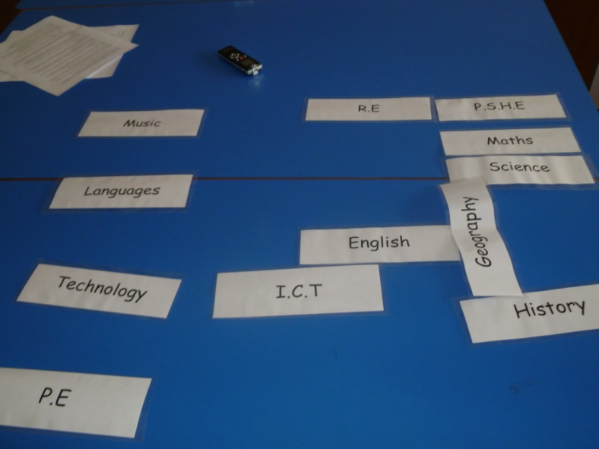Group A

Highly Important / influential
Not important / isolated from other subject areas

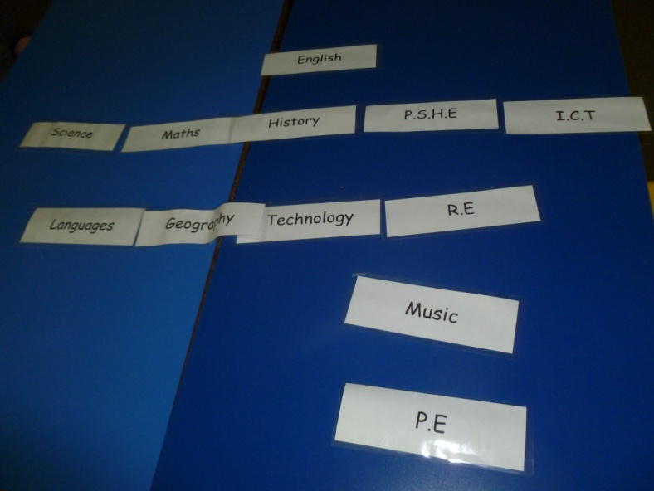
Group B
Highly Important / influential
Some importance / influence

Not important / isolated from other subject areas

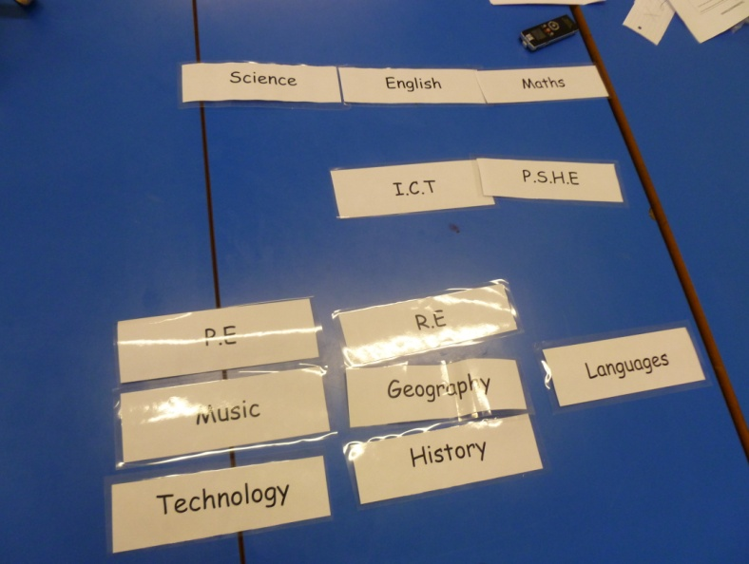Group C
Highly Important / influential

Not important / isolated from other subject areas

The comments and photos suggested that from the students’ perspective, the skills learnt in Languages are not transferrable to other subject areas. It is hardly surprising then that students believed Languages to be an isolated subject if they considered that the skills they learn in the lessons are not considered applicable to other curriculum areas. The question is why did they think this? I believe one reason is that there is a lack of regulation to ensure that the skills learnt in Languages are transferred to other subject areas, as well as a lack of recognition of the need for these transferable skills in the planning of the schools’ languages schemes of work. The pressure that Ofsted puts on the core subjects to ensure that they teach transferrable skills has led it to be one of its inspection criteria, and the impact this has had on student recognition of these skills was apparent from the data. Would a similar approach benefit students’ language learning? I am not a supporter of top-down government educational legislation, but I recognise the benefits of better integrating Languages into other curriculum areas, especially to promote cross-curricular language opportunities.

6.1.2 The Existing Cross-Curricular Opportunities within the School
- Students were able to recall such projects
Surprisingly all three groups seemed familiar with the term cross-curricular and required no further definition. All three groups were also able to provide examples of cross-curricular projects that they had undertaken in Years 7-9. However, individuals struggled to remember the specific details of each of the projects and required clarification or affirmation from others in the group. Answers from the three groups sometimes contradicted each other in terms of the details of the project and the curriculum areas involved.
…So I think Geography and Languages may have done one? History and Geography too? I think I remember Maths and Science working together as well, did they work with ICT? 1F
…I actually think that Maths and Science have worked together twice because we did that planet thing and then the bug thing. 1F
…I remember one with the planets and there was also a project that used string. Actually thinking about it, we have done more than I thought, more than I remember. 2M
…I certainly remember doing a project in English and Maths, but wasn’t Geography and History a part of that too, or was that something separate? 3M
…I think that maybe R.E and P.S.H.E did one? I might be making that up though because I really can’t remember. 3M
The interview transcripts indicated that students believed they had undertaken four previous cross-curricular projects during their time at the school. Students were asked to arrange flash cards to highlight which subjects worked together and how often they had worked together:
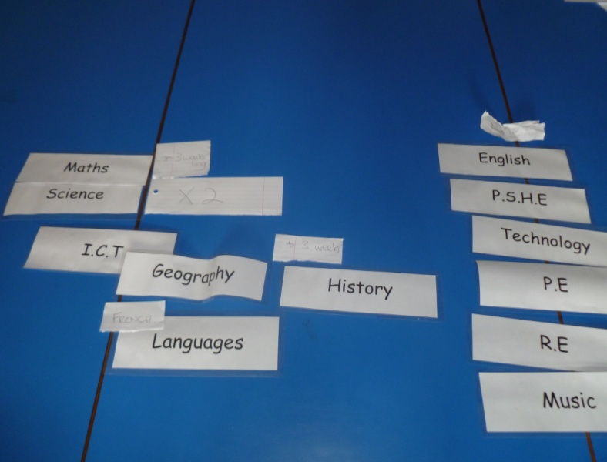Group A
Maths / Science X2

Geography / History (with some ICT) X1
No previous project

Languages (French) / Geography X1

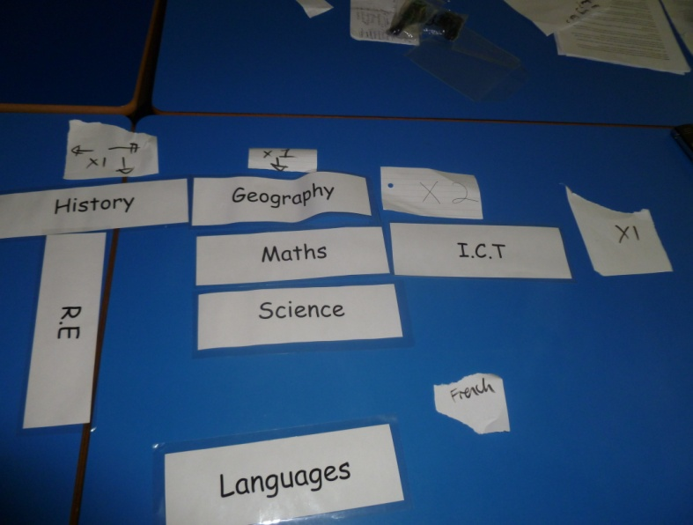Group B
Geography / History X1

Maths / ICT X1 (unable to remember details)
History / R.E X1 (unable to remember details)
Maths / Science X2

Languages (French) / Geography X1

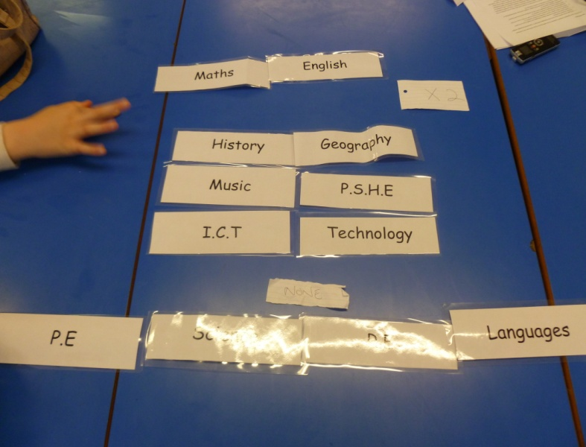Group C
Maths / English X2 (unable to remember details)

No previous project

The photos indicated that participants believed that Maths and Science had done two projects together, and that History and Geography, and French and Geography, had worked together once. In the section responding to the literature review I stated that I wanted this investigation to investigate what impact the National Curriculum has had on limiting the crossing of subject boundaries. The data from the photos suggested that for subjects that are not defined as “core” the opportunities to cross subject boundaries are extremely limited. Although I accept that the National Curriculum may not be the only reason why these boundaries have not been crossed, the literature suggested that it is an important factor: “The high level of prescription in the National Curriculum raises the walls surrounding them, and is perhaps one factor underlying the finding that pupils and teachers in secondary school are less likely to change their beliefs than those in primary schools”. (Harris, 2008, p. 256). This high level of prescription has led to individual departments dividing teaching content into different schemes of work, running from September to July, throughout years 7-11, in an attempt to cover the taught material suggested by the National Curriculum and prepare students for examinations. These schemes of work are thought of as impermeable “bricks” (Hargreaves, 1991, p. 35), blocking opportunities for crossing classrooms and collaboration.
Secondly, the idea of collaboration suggests the necessity of time and effort between staff and departments, a commodity in short supply if teachers’ main focus is to cover the content outlined in the departments’ schemes of work. It is this “inflexibility of the curriculum that may create a situation whereby teachers do not have time or need to collaborate when every detail has been laid out and pre-planned”. (Gereluk, 2005, p. 8) (my emphasis). This makes the marriage of subjects and cross-curricular themes within a defined curriculum a very difficult one, especially if one considers that much time and effort goes into updating or restructuring these schemes of work as suggested teaching content is changed. “Large changes in curriculum design often mean that teachers will focus on what they know i.e., their subject, and not make wider links that might have been envisaged by a whole curriculum”. (Savage, 2010, p. 25).
- The length of these projects is important
Throughout the interviews the groups agreed that the length of the projects was important, especially when considering whether they enjoyed the projects. Students believed that if a question was too long then they lost interest in the topic, too short and they believed it was rushed and saw no real benefit to their learning.
...I would say that each of the projects lasted about three weeks, which is two lessons a week in two different subjects, so about 12 lessons in total. 1F
…I think that these 12 lessons were a bit long really and it was a bit of a nightmare. Sometimes we have three lessons of one subject a week and one or two of another, it meant that things didn’t really work on time and sometimes we were getting further ahead in one subject than another. 1M
…It all depends what the topic is that you are studying, with some of the things that we have done we need more than 12 lessons and it all seems a bit of a rush and we don’t learn much from it, with others 12 lessons seems really long because you are done with it after a short time and it seems it is just being dragged out for the sake of it. 2F
- There is a lack of cross-curricular opportunities in Year 9
Although the data suggested that students were able to recall four separate cross-curricular projects, none of these had taken place in Year 9.
…I think I remember these projects happening last year. Yeah that’s right, the Geography and History one was in Year 7 and the Maths and Science ones were in Year 8, or something like that. 1F
…These happened last year I think. I remember the Geography and History one because we went into town but I can’t remember anything else about the others me. I can only remember going to the castle and that’s about it. 3M
…They did happen quite a long time ago and we have had nothing since. 1M
…We haven’t done these things in Year 9. Why not?... (pause 6 seconds) I don’t honestly know why, I suppose it’s because we are getting ready for our GCSEs and things. 3M
It seems, therefore, that the National Curriculum is not the only factor limiting the amount of cross-curricular teaching within the school. The number of additional responsibilities placed on students and teachers during this year was also acting as a barrier to the crossing of subject boundaries. Participants highlighted that they believed much tends to happen in Year 9: The selection of students’ Key Stage 4 option choices, the starting of the Key Stage 4 taught content for English, Maths, Languages, and Science, and the writing of GCSE coursework. Participants also stated that they had to take modular exams in Science and Maths that had the potential to count towards their GCSE grade. When questioned about why they had to do such things they responded: “Because the teachers say it will take a little bit of the pressure off Years 10 and 11” 1F, something which I believe highlights the content cramming that goes on in those years.
- Students were often unaware that they were doing a cross-curricular project
There was a general consensus amongst groups that they believed that there were occasions when their teachers hadn’t informed them that they would be doing a cross-curricular project with another curriculum area, and that it was the students themselves who had to infer it.
…It was strange sometimes because our normal teacher would say that ok now we are going to start a new topic and we would be like ok. We would then go to another lesson and the teacher would say right we are going to start this topic. I remember saying that we were doing this topic in another lesson. The teacher just said yeah I know that’s why we are doing it. Everyone just looked confused. 3M
…I remember this happening in Maths, they didn’t tell us that we were going to be doing the same topic in another class, and that we would be working together. 1F
…There are sometimes notes in our registers in the morning that say we will be doing a project involving these two subjects on these dates. Trouble is everybody forgets and we are not reminded. 2M
…Yeah also I think it is really (rarely – deliberate correction to transcript) explained what we are going to do. Even if they do tell us that this is a project or cross-curricular topic, there is little explanation as to why, what we are doing it for, and what we will have to do. 2M
I believe that the above comments also relate to the limiting of cross-curricular opportunities by the National Curriculum and additional responsibilities pupils face in Year 9. The data suggests that such factors clearly place a limit on the amount of spare curriculum time available, which impacts on teachers’ abilities to communicate with each other both at the planning and implementing stages of these cross-curricular projects.
- The importance of the group environment
All three groups agreed at numerous points during the interviews that they preferred doing cross-curricular projects in small groups, and that all previous projects were conducted with students being placed in small groups. Their perspectives indicated that they seemed to associate group work with cross-curricular project work, and individual work with individual day-to-day lessons, although there was some overlap. The group environment was one of the most discussed elements surrounding previous cross-curricular projects. It should be mentioned that although there was overwhelming support for working in groups, there was a minority view that students preferred to take full responsibility for their learning, and the best way they believed of doing this was to work individually.
…We had to work in our forms last year and my form was crazy. If we got to choose our own groups it would be better, but we didn’t, and I had a really bad time because I was in a stupid group. 1F
…The project had the potential to be interesting, but I was in a bad group, I didn’t like that one. 2M
…A lot of the enjoyment side of these things comes down to who we work with. It is all about who you work with I would say. In our normal lessons there are normally at least a few friends in the class that we know and it would make such a difference if we could work with them. 1F
…Sometimes in a group you work better than when you work individually. Some teachers don’t like it when you don’t do work in a group, they think you don’t put effort in. 3M
…Was the topic interesting? It was all right, it would have been better if I was with people I liked because I had to do all of the work. 1F
…I enjoyed the idea of working in groups, and I like group work because we share the responsibility. We should get to pick the people we work with though as it would be better and we would get more done. 2M
…I liked working in groups because we actually got to work with our friends, it was just lucky that the teacher put us together though. 3M
…The project would have been better if we could have chosen the groups, because we would have worked. We didn’t get the chance though because the teachers think that pupils will mess around if they are with their friends but we won’t because we are not as shy to show our ideas… and when you are with people you don’t like then you don’t want to share anything with them. 1F
…Actually I quite like working by myself rather than with others. I prefer getting on with it and not relying on other people. I know exactly what to do and it is up to me to do it. 2M
Student motivations surrounding group work were not discussed in the literature review but clearly played an important role in the data analysis. As a consequence I aim to briefly highlight some of the publicised advantages of student group work (below), and of cooperative learning in language learning (Chapter 6.2.1).
The use of group work in the classroom has long been supported by sound pedagogical arguments; some of these arguments have been echoed by the above student comments. Long and Porter (1995) argue that group work can increase the quality of dialogue between students as “face-to-face communication in a small group is a natural setting for conversation … students can engage in cohesive and coherent sequences of utterances, thereby developing discourse competence”. (p. 209).
The use of group work also gives students the opportunity to “work on different sets of materials suited to their needs” (Long and Porter, 1985, p. 210), who argue that group work is a step in the right direction to individualised learning. They argue that if a group project is made up of a variety of tasks, of varying difficulty requiring varying skills, with a view to achieving a final goal, then these tasks can be distributed to members of the group that are best equipped to deal with each task.
Helping to eradicate student shyness was an advantage of group work alluded to at various points during the interviews. As with the group interview, group work provides students with a supportive environment and freedom to talk and share ideas, as well as make mistakes, without persecution from the teacher. As Barnes (1973) states “our confidence in our friends allows us to take the first groping steps towards sorting out our thoughts and feelings by putting them into words”. (p. 19). Although this quote may be somewhat dated I believed it to be effective in explaining the fact that group work promotes confidence in learners.
The data suggested however that none of these advantages of group work are realised if students are not allowed to work with people they are friendly with. The importance of working with friends was stated by all three groups, and that many teachers’ fears that you should not let students work with their friends because they do not work well together were unfounded. Participants thought they should first be given the chance, and then accept the consequences if they were unable to work together effectively.
- Students value the importance of excursions and out of school visits to support such projects
The perspectives provided by students in all three groups suggested that the opportunity to go on trips was both an enjoyable and integral part of cross-curricular projects. They believed that the project seemed more relevant or “real” if they were able to see real life examples of what they were studying, and that it helped develop their interest in a topic. The lower attaining group recognised these advantages, but also the pleasure of being out of school for a day.
…I remember on the History and Geography one; we went to this castle in the country. It was quite good and to be honest we can say that it did help us complete the project because I remember being stuck for ideas, I mean who knows about castle landscapes? It was also a day out of school, a Wednesday, my worst day so I was happy even before I went which probably made the day go better for me. 3F
…I remember the Science and Maths one and looking at sea creatures. We went to the aquarium and that was good and we would not have gone on such a trip if we weren’t doing that project. Learning about things and then physically seeing and experiencing them is good. Obviously everyone likes trips, but these projects are especially good with a trip. 1F
…I like trips and I think that we should do more of them. Not only because it is a day out of school but because we learn more than what we can in these project lessons. Like, instead of being told about these landmarks and their important positioning and their history, we can actually see them for ourselves and make our own minds up. 2M
- There is insufficient acknowledgement of students’ work, and no chance for students to give feedback about the projects
Participants in the high attaining group commented on the fact that they believed that there was no real recognition of the work that they had done. They stated that they would undertake these projects, complete them to the best of their ability, and the next lesson they would move on to something else. They believed that there was no type of feedback session to let students know how they had done or what could be improved and no chance for them to voice their opinions on the positives or negatives of the project.
…I remember for the final piece of the project we had to make a massive poster with all of the planets and information, I can’t even remember what we did for the other Science and Maths one. All I remember is going down to another school and digging around in the soil. It could have been so much better because we had lots of ideas. 1F
…I believe that these big posters are now in some of the Science labs and not even all of the groups have a poster up there. They are not even that well-presented, I am guessing that they are just there because they wanted to make a wall display. We felt it didn’t do justice to our work but we couldn’t tell the teachers that. 1F
…It is true that the only evaluation we seem to do revolves around making posters or something similar and it is right to point out that they are in Science labs. I think that they are also in a couple of the Geography rooms. I am saying I think because I am not 100 per cent sure. 1M
…It just seems that every project we do is stuck up on a wall. It doesn’t really serve as a reminder and sometimes it isn’t even our work, it’s work from a few years ago, so they obviously make students do the same project year after year. They need updating and made more interesting. It wouldn’t be hard to do but I don’t know if teachers want or have time to listen. 1F
…It doesn’t bother me if the work is up on the walls or not, it actually makes me feel embarrassed. I don’t really want lots of people to see it. 1M
Participants were clearly uninspired about the evaluative methods used in such projects; there was little variation of evaluative tasks and current work was often not displayed. Therefore, if goals are used as an “energizing function that help individuals regulate their effort to the difficulty of the task” (Locke and Latham, 2002, p. 706), then the final goals of such projects were severely inadequate and in need of revision. Although it should be mentioned that the minority view was that students preferred not to see their work displayed.
I now wished to return to another of my research questions presented in the literature review: Just how detrimental can the National Curriculum be to the idea of involving pupils in pupil voice projects? It seems at the very least that students did not have the opportunity to give feedback nor have their opinions listened to as part of these cross-curricular collaborations. Whether this was solely down to the National Curriculum is unclear. What is clear is that the participants undoubtedly thought that the teachers either did not want or did not have time to listen. The literature suggested that the National Curriculum could be responsible for the lack of pupil voice opportunities as “developing consultation is seen by many teachers as in competition with the government’s all-powerful agenda for the scarce resource of curriculum time”. (Rudduck and McIntyre, 2007, p. 9). What would be interesting to do in order to clear up this situation is interview teachers about why these collaborations do not allow for any form of pupil voice activity, but this is beyond the boundaries of this research project.
- Students want to do topics that they find interesting, or that they believe will be relevant to their future education or lives
The perspectives gathered suggested that there was a general consensus across groups that previous subjects did not focus on topics that students considered to be overly interesting or important for their educational or professional development. Even if a project was considered enjoyable or fun to some students, the project seemed to lose significance when being evaluated in terms of its relevance to their future lives.
…I do think that generally the things we learn in Maths and Science are important and we will use what we learn again and again in our lives. However what we learn in these joint projects isn’t really, I mean there has to be more relevant things than digging for bugs or inventing imaginary aliens. Last time I checked that wasn’t an exam question. 1F
…For these projects to be really worthwhile, as strange as it is to admit, we need to forget about things like fun and think of things that will be useful to know in later life. It of course would help if they were interesting too. 1M
…Yeah I want to do things that benefit me, not just these projects that we do, go nowhere and then don’t really learn anything by the end of it. Like what we do in Maths sometimes. In Maths we sometimes do career things then we get to go into our ICT lessons and research about careers and stuff because it helps you with what you want to do and you learn lots from it, we will use it in the future, and won’t just forget about it. 2M
…What’s the ideal project? Doing one that is interesting, useful for life, that you can work with your friends and has a trip somewhere! 1M
…All I want from these is to work with my friends and do something interesting that I can use again. 3M
The data suggested that participants believed that the cross-curricular projects undertaken at this school fall somewhat short of the QDCA’s expectations that cross-curricular collaboration “should help young people make sense of the world, and, add a richness and relevance to the curriculum experience of young people” (QDCA, 2009d, p. 1), as none of the above comments supported the idea that these previous topics added relevance to the curriculum experience of young people.
It seems that the projects did little to encourage intrinsic motivation as participants saw little joy in doing such projects and they were not fulfilling any kind of internal curiosity. As well as a lack of intrinsic motivation there also seemed to be a lack of extrinsic motivational factors as participants thought that the topics studied in these projects were highly unlikely to be part of the GCSE exam, and so may not lead them to get better grades. Therefore, I believe that participants suffered from what Deci and Ryan (1985) mention in language learning terms as amotivation in language learning terms; when a learner possesses neither intrinsic nor extrinsic motivation, and may therefore show no desire to continue with their language learning. Although these terms principally surround language learning motivation, I believe it is equally applicable to this situation and therefore students were struggling to see the benefit of doing such collaborative projects.

6.1.3 The Failure of Previous Cross-Curricular Language Projects
Students in the sample believed they had had very little exposure to cross-curricular language projects; having experienced only one such project, which was a collaborative project between French and Geography exploring the topic of global warming. Senegal was the focus for the project and students learnt about the country in both their French and Geography lessons. The idea was to run the lessons in parallel; what they would learn in their Geography lesson would then be repeated in their French lessons, and so vocabulary was introduced in both English and French. As with previous projects students would then have to create a display highlighting the dangers of global warming in Senegal, in English and French.
The fact that students believed there had only been one cross-curricular collaboration involving Languages meant that the subject is falling well short of the dimensions outlined in the Languages Key Stage 3 curriculum booklet: “To hear, speak, read and write in the target language regularly and frequently within the classroom and beyond; and communicate in the target language, including native speakers where possible, for a variety of purposes”. (The MFL National Curriculum, 2009).
It is important to note that students have a choice to take either French or German as an additional language (as all students study Spanish in Years 7-9) from Year 8 onwards in the school. Therefore, only two to three individuals in each group (40-60% of the group) took French as their additional language, and could voice their opinions about the project.
- Inconsistency with the teaching
Students’ perspectives indicated that the biggest problem with the project was the inconsistency of what was being taught in both of the lessons. They often stated the fact that the lessons were not being taught in a parallel fashion, and they found the Geography element confusing as the Geography teachers would often swap between teaching about Senegal and another topic.
…The way this project was run was just not good, it was too complicated in Geography, too confusing. We knew we were meant to be learning about Senegal but often the teacher just taught something else. 1M
…To be honest I don’t even know if I remember doing it in Geography. I do in French though. I seem to remember her saying it loads in our Geography lessons but I don’t really have any memory of doing it like I do in French. 2M
…It wasn’t good to be honest. One day we would do about Senegal but on the next we were doing about another topic. 2M
…The project just didn’t work well. It seemed that they were not keeping up in Geography. French was moving too fast or Geography too slow, it just didn’t work, it wasn’t smooth. I don’t know if it’s because we had student teachers in Geography. 2F
…Oh yeah Senegal and Geography. I don’t remember too much apart from it was quite short and the teacher couldn’t really control the class. We didn’t learn anything. Well, we learnt that it was poor and suffers from global warming, but to be honest I could have told you that in about five minutes. 2M
There was a recurring trend when participants discussed previous cross-curricular projects. They believed that the communication between departmental members of staff was simply not good enough. In this instance a lack of communication led to a lack of cooperation between departments. There were no parallels between what was being taught in Geography and what was being taught in French. This lack of communication encouraged negative attitudes towards the learning environment and topic, especially in Geography, as well as negative attitudes towards the teacher.

6.1.4 Differences in Group Responses
Although there were differences in responses most noticeably between the higher and lower attaining groups, there were also many similarities, especially surrounding perceptions of the transferrable skills of the core curriculum subjects. All three groups found it initially difficult to reflect on their learning and provide detailed answers, especially during the first interview. In general terms, the lower attaining group found it more difficult to provide or elaborate on examples to support their answers, and their answers in general were shorter and less detailed.
The higher and middle attaining groups were also able to think creatively about where and how language skills could be made more transferrable. The lower attaining group found this more difficult and generally accepted things as they were because “that is just the way things are” (3F). Lower attaining students, along with middle and higher, acknowledged the benefits of group work and wanted to work with their friends.
Finally, the higher attaining group was very concerned about the lack of recognition of the work they produced through such projects, whereas the other two groups were less bothered. However all three groups were concerned about the choice of topics used in previous cross-curricular collaborations, and their comments could be interpreted as desires that topics should encourage intrinsic motivation as well as be useful for their future learning, although they did not refer to intrinsic motivation directly.

6.1.5 Summary
I believe that this section of the data analysis highlights the following key points:
- Ofsted’s inspection criteria states that core subjects should teach transferrable skills across curriculum areas. During the interviews students subsequently acknowledged this transferability in other subject areas. Languages is not a core subject and therefore students considered Languages to be an isolated subject, detached from other curriculum areas.
- The opportunities for “non-core” subjects to cross subject boundaries seemed to be extremely limited. The literature suggested that this is due to the prescriptive nature of the National Curriculum that encourages the implementation of inflexible departmental schemes of work that do not easily allow for cross-curricular opportunities.
- Curriculum time is scarce. As well as getting through the taught content student perspectives highlighted that they are faced with additional pressures in Year 9 such as Key Stage Four option choices and GCSE modular examinations and coursework.
- This lack of curriculum time seems to have had various implications: Students believed communication between staff and students had been poor, with students rarely being exposed to all the details of previous cross-curricular projects. They also believed that communication between staff members in different departments had also been poor, resulting in a lack of cohesive teaching. This lack of transparency between subject areas negatively affected students’ opinions on the learning environment, teacher, and topic. Furthermore, the perception of students was that they had no opportunity to have their voices heard or give feedback on these projects.
- In the past, participants indicated that they enjoyed group work and wanted to work in groups for these projects. Not allowing students to select who they want to work with had led to demotivating experiences.
- Student perspectives indicated that previous projects adopted an ineffective, unvaried evaluative system with little reward and recognition of student work.
- Although not directly referenced by students, the data suggested that the topics used in previous projects failed to fulfil any intrinsic motivation.

6.2 Data Analysis of Subsidiary Research Question 2

Focus of Subchapter: What Topics Would Students Want to Study as Part of Any Cross-Curricular Language Projects?
As with the previous question I returned to the point at which I came up with these research questions, to re-familiarise myself with what it was I wanted this question to investigate. There were two original concepts:
- To investigate what students liked and disliked about their current language lessons, and how this informs what they wanted any cross-curricular language projects to be like.
- To investigate what topics students wanted to study as part of any such cross-curricular language collaborations.
When addressing this research question participants were constantly reminded that their responses should be a reflection of what was happening, or indeed, what had happened in their language lessons up to the point of the interviews. They were asked specifically what they liked and disliked about their language lessons and why, and it was only in the final stages of tackling the research question that participants were asked to think about topics they would like to study, rather than what they had already studied.
Analysis of the interview transcripts highlighted four trends which consequently helped form the interpretive codes for this section of the data analysis. Firstly, participants recognised that there were both positive and negative features of their existing language lessons. Secondly, they placed an enormous amount of importance on the ability to speak the language, and considered that being able to speak the language was a sure sign that you were progressing or achieving a higher level of attainment. Thirdly, participants highlighted that the G.C.S.E. exams acted as a barrier to learning, stopping them from studying the topics or activities they would find most interesting. However, the importance of the G.C.S.E. exam to their futures was also heavily acknowledged.
This section of the data analysis looks to present these three themes under the following interpretive codes:
1. The positive points of language teaching within the school.
2. The negative points of language teaching within the school.
3. The ability to speak the language.
- The effects of the G.C.S.E. language examinations and how these influence the topics students want to study as part of any cross-curricular collaborations.

6.2.1 The Positive Points of Language Teaching within the School
  - Working in groups is favourable
As in the previous section the data suggested that students placed a lot of emphasis on the importance or benefit of not working individually. They explained that they wished to feel supported during their lessons and that the best way to do that was to have another student or group of students to consult with. They considered this to be the most positive and useful aspect of their language lessons. It was also the most discussed by all three groups. The minority view was again that students preferred to work individually so that they could take sole responsibility for their learning.
…I have to say that I hate both Spanish and French all of the time but group work makes me hate it less. 3M
…I like it when it is in groups, but if we are doing something that doesn’t require group work then I like being able to discuss things with a partner. 1F
…I like it when we have to work in groups to work out the right answer, rather than the teacher just telling us it. 2M
…Yeah working with another person or other people gives us a chance to interact with other people and get their opinions and then ideas. It can give you an idea if your ideas are wrong or not, it is useful for support. 1M
...In some of my lessons when we are doing a topic then I want it to be done in a group. It is good to have people to talk to about the work, if I can concentrate on it. 3F
…I consider working in pairs and working in groups as different things but kind of the same thing as well. We put it on our “likes” poster because we like to bounce ideas off a partner or people. It gives you that bit of extra stability and it’s not all complete silence. 1F
…I like it when we are given the task by the teacher and told what to do but then it is up to us to do it. 2M
…I sometimes prefer pair to group work because if you say like there is a group of four and there are two people that put no effort in then it is unfair on the other two. It is unfair for those that do put effort in if they get a bad grade because only 50% of the group was doing anything. 1F
Cooperative learning (CL) shares many advantages with group work and is the instructional use of small groups in order to achieve common learning goals via cooperation. It is one of the most researched areas of education “as we know more about cooperative learning than about almost any other aspect of education”. (Johnson, Johnson and Smith, 1995, p. 4). Collaborative learning is also a widely researched area in the field of education, and draws many parallels to cooperative learning. However collaborative learning is connected to a more “social constructionists’ view that knowledge is a social construct”. (Rockwood, 1995, p.8). Therefore the previous comments made by students favour more a cooperative learning technique as the instructors’ role in cooperative learning is more that of a centre figure, providing instruction on often closed-ended tasks that then require completion by the groups of students. Dörnyei (1997) states that there are three components of such an approach that make it cooperative:
“First, learners spend most of the class working in small groups of between 3 and 6 students. Second, learning is structured so that group members are motivated to ensure that their peers have also mastered the material or achieved the instructional goal, and therefore an intensive process of cooperation is generated, involving various creative collaborative learning strategies. Third, evaluating and rewarding the group’s achievement in a CL class becomes as important as or more important than evaluating and rewarding individual achievement”. (P. 483).
This creation of the cooperative classroom is characterised by a positive interdependence of the students and occurs when “one perceives that one is linked with others in a way so that one cannot succeed unless they do… it is the belief that students sink or swim together”. (Johnson et al, 1995, p. 31). This interdependence results in “promotive interaction” (Dörnyei, 1997, p. 484), through the sharing of ideas, joint problem solving and brainstorming. It is this notion of security and promotive interaction that students alluded to above when stating the need to bounce ideas off a partner or group.
Johnson and Johnson (1995) echo Dörnyei’s quote that rewarding the group’s achievement in tasks is important, but acknowledging individual effort is also important; “group rewards work best when the group rewards for learning are combined with individual accountability in order to ensure that participants perform their share of the work”. (p. 122). Such an approach should help alleviate participant concerns that certain members of the group often go unpunished for not doing any of the work, a common theme in the higher attaining group.
Dörnyei (1997) states that teachers and educators need an “awareness of the principles of group dynamics and how they can make CL less threatening, develop more efficient classroom management, and develop creative, well balanced, and cohesive groups” (p. 485), “this group cohesion is one of the most important attributes of the successful communicative language class”. (Forsyth, 1990, p. 10). The data suggested that students would rather pick who they work with; one of the reasons why is because they knew that working with people they were familiar or friendly with would promote cohesiveness between group members. Therefore, if the cooperative learning theory places such an emphasis on group cohesion, why did participants in the research believe teachers seemed reluctant to let students pick their own groups?
  - The number of activities covered in a lesson helps alleviate issues of boredom
During the interviews all three groups agreed that most language lessons included a varied range of activities, and that these activities often required the use of different language skills. It was not uncommon for students to do a mixture of writing, reading, speaking and listening exercises over a period of lessons. The perspectives gathered suggested that this was seen as preferable to working on just one activity for the entire lesson, which often happened in other subject areas, as working on the same writing or reading activity for the whole lesson would be seen as boring. The minority view was that in certain instances working on one activity was preferable.
...One of the things that I like most about my language lessons is that we don’t normally just do one thing for the whole lesson. We don’t spend the entire lesson doing one activity and yeah by changing the activities we do not lose interest in the lesson. 1F
…Well I think that doing one long task all lesson is more boring than doing smaller quicker ones, well it really depends what the one task is, if it is really interesting then it might be better. 2M
…I would say that we normally do about three or four different activities in a lesson and that seems about right. It helps it not to be boring anyway. 1M
…I think that we do about two or three activities in an hour which is good. I like the activities to be linked though, and I also like games. 2M
…Doing the same thing is really boring. Doing more things in a lesson is good but some of those things should be ICT activities as well. 3M
…For me it depends what the activity is, but sometimes I like only doing one thing for the whole lesson. It lets me get on with it and I don’t have to listen to the teacher for the whole lesson. 3F
  - PowerPoint presentations are preferred to worksheets
Students’ perspectives highlighted that participants enjoyed PowerPoint presentations as they were easy to follow. They enjoyed having vocabulary or tasks displayed by a projector at the front of the class, although they preferred the slides to not be text heavy. They agreed that the use of pictures or visual clues often helped with comprehension of tasks and vocabulary. On the other hand, worksheets were seen as detrimental to learning. Participants considered them to be badly presented, difficult to follow, and there was often not enough provided to complete them effectively.
…I feel good in lessons when I understand what it is I have to do. That is why I prefer PowerPoints over worksheets because teachers can present slides so that they are easy to understand. 1M
…The pictures that are on the slides are big and you can see them, probably because they are projected onto a big screen. Worksheets are difficult to use, especially for pictures because you often can’t see them properly, they are small and often photocopied from colour. 2M
…Worksheets are just terrible, there is never enough room to write and the questions are just silly. They are just hard to follow and impractical. 1F
…In that respect I would much rather have questions written on a PowerPoint slide so that everyone can see them. As long as it is not full of writing then it is ok. Worksheets are difficult and everything is squashed in, I don’t like working on sheets. 1F
…We often get bombarded with worksheets and I am fed up with them. I think the teacher gives us worksheets because we all find it hard to concentrate on the board. 3F
Students were asked to write down all of the aspects that they enjoyed about their language lessons. What they wrote down is highlighted in the following photos.

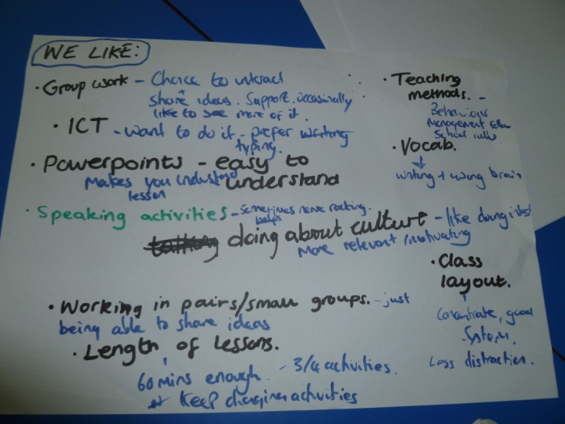GROUP A

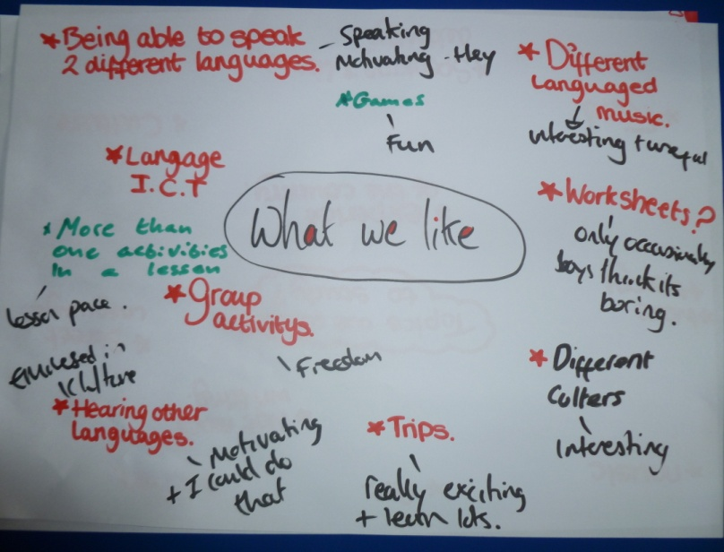
GROUP B

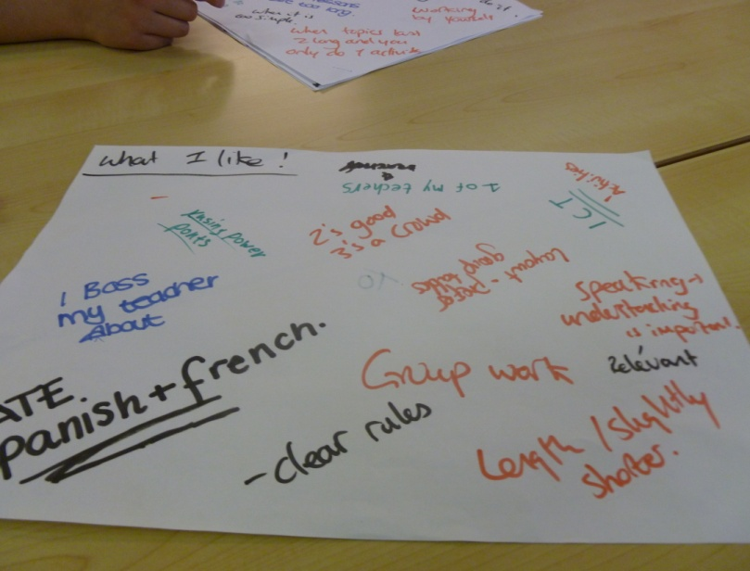GROUP C

6.2.2 The Negative Points of Language Teaching within the School
- The topics taught lack a cultural dimension
Participants were asked to note down all of the topics that they had studied as part of their language lessons during Years 7-9. They were then asked to evaluate whether they enjoyed studying the topics and the reasons why. The analysis of the data suggested that although the groups were not entirely negative about the range of topics studied, they agreed that most of the topics lacked a cultural dimension, and could not make links between what was studied and the target culture.
…It makes me appreciate and know what the language can help me with, or where the language came from, and it is just more interesting. It kind of gives the topics a bit of purpose and reason to study them. 1M
…I think that learning about culture all of the time would be boring but putting in bits of culture, yeah, that would make things more interesting and will help break up the more boring stuff. 3M
…Learning about the different types of houses and stuff was good and we did some stuff on food which was quite good actually. It made me feel hungry all of the time and it would have been good to make and taste things. 1F
…The teacher says we are doing a topic but there is never anything said about why, or why it is useful, or what people do in Spain. 3F
…I am not too interested in learning languages; if the topics were more cultural and personal then I think they would be more interesting. 2M
Students’ perceptions about the topics studied in Languages suggested that they failed to stimulate intrinsic motivations for language learning. The evidence collected from participants suggested that when the topics chosen did promote intrinsic motivations, such as the comment about food, they then showed enjoyment for their lessons. The comment about food also suggested that the participant’s interest for the topic was driven by their intrinsic motivation, for the feeling associated with exploring new ideas and developing knowledge, and intrinsic motivation stimulation, for the sensations inspired by performing the task.

- Participants didn’t see some of the topics as being relevant to their future language studies
As well as lacking a cultural dimension, participants perceptions were that they did not believe some of the topics that they studied in their language lessons would be relevant to their future language learning. Relevant was defined in two ways; either because it included language that could be used in the target country, or relevant because it might be a topic in the G.C.S.E. exam.
…Well I thought that doing about Fair Trade was fairly interesting at times but not really relevant and I couldn’t really remember much about it so yeah… not much good really, and I can’t imagine they would ask that in the exam. 1F
…I put that Fair Trade series of lessons between the ones I liked and disliked. It was quite interesting, and there was a lot of group work, but it is not really relevant and it dragged on a little bit too much and I can’t see myself talking to a Spanish person about that. 1F
…No I don’t think lots of things we do are relevant, they come and go and we never use them again. 3F
…I can’t see me using hardly anything I have done in the future. 3M
…The topics that we study are ok, some are good and will help me in the exams, they sometimes drag on a bit though, and we are never going to need to use some of them again. I mean, some of the things we learn are not going to be useful again, we should be learning things that we will need and use again and again, or that will be something to do with coursework or exams. 2M
As well as failing to stimulate participants’ intrinsic motivations, students believed that some of the topics also did little to encourage institutional or extrinsic motivations as responses about the topics centred around a “what is the point if we are not going to get a good grade from it” (1M) type of response. Interestingly, however, when participants did do a topic that they found interesting, such as fair trade, their intrinsic motivations were side-lined by extrinsic motivations, especially when participants considered the topics that would be in the exam. The more they thought about the exams the more introjected regulation built up in participants, which in turn superseded any intrinsic motivation they had for the topic.

- The topics place too much emphasis on writing
All participants kept highlighting the fact that the majority of their lessons included a large proportion of writing, either in the form of extended writing tasks, or copying vocabulary from the board. The general perception of students was that most felt these were far above their current level of language attainment, although the minority view, largely coming from the higher attaining group, was that the ability to write demonstrates a high level of language attainment.
…I am not good at writing in English and I even have extra support for it, so why does the teacher think I can write in Spanish? 3M
…Yeah there is too much writing in our language lessons and I feel that I would like to do more speaking. Also, when we do writing they are not exactly short tasks, they often involve writing quite long paragraphs and it takes a lot of time to get through those sorts of tasks, it is quite daunting when I think about it. 1F
…There is too much writing and I can’t do it, it makes me feel like I am dumb. 3F
…I don’t like writing, there is just too much of it, even if it is just copying, what’s the point? 2F
…To be honest I don’t mind if there is the odd writing exercise because it is an important skill and I would like to know how I am getting on. They are really piled on though and we don’t always get feedback. 1F
…If we did a project I would not want to see lots of writing in it, or see any form of report writing as a final exam or task. 1M
…There is a lot of writing, but I think it is ok because it is an important skill and it looks impressive if you can write a long piece of language. It makes you look very good at the language. I would say speaking and writing are the two skills that make you look good at languages. 1F
I believe that the above data highlighted the importance of the Goal Orientation theory and the recognition of students’ accepted goals. It seemed that the writing tasks that were set in lessons were above participants’ current level of language attainment and were therefore unable to access any mastery or performance goals from undertaking such tasks. Without accessing any mastery goals students were unable to improve their performance or grow in terms of their language attainment. Similarly, without performance goals students did not receive any public recognition from completing such tasks. Therefore, students saw no benefit in doing such tasks and found them counterproductive in terms of enhancing motivation.
- There is a lack of reinforcement activities
At various points throughout the interviews all groups agreed they found that they were often bombarded with new vocabulary or grammatical concepts and were unable to remember these shortly after studying them.
…We learn a lot of things in Languages and they move very quickly. All of the time we seem to be doing something new and I am thinking that I didn’t even get the last thing. 3M
…Well it is like you are taught something quite important and relevant, but you are only taught it once and it is not reinforced, so it is easy to forget it. 1F
…Verbs are important to be able to say or write what you want to. They are also complicated though and there are so many endings. We need more time to learn them and use them. 2M
…It is basically just an overload of information, especially the tenses. Yeah I know that can’t really change but if we didn’t do so many in such a short space of time we would remember more. For example in some lessons we learn the imperfect tense and the preterite tense so it jumbles together and it is too confusing. It is an overload of information basically, and I still don’t know the difference between the two. 1F
At the risk of not wanting to repeat the findings in the previous section I believe that this lack of opportunities for reinforcement are directly linked to the fact that teachers simply do not have the curriculum time to revise content learnt in lessons. I believe this links back directly to the content-packed nature of departments’ schemes of work, as they focus on teaching the suggested content highlighted in the National Curriculum to prepare students for various examinations and coursework deadlines. Again, the three groups were asked to write down what they did not like about their language lessons. The four most discussed themes are highlighted above.

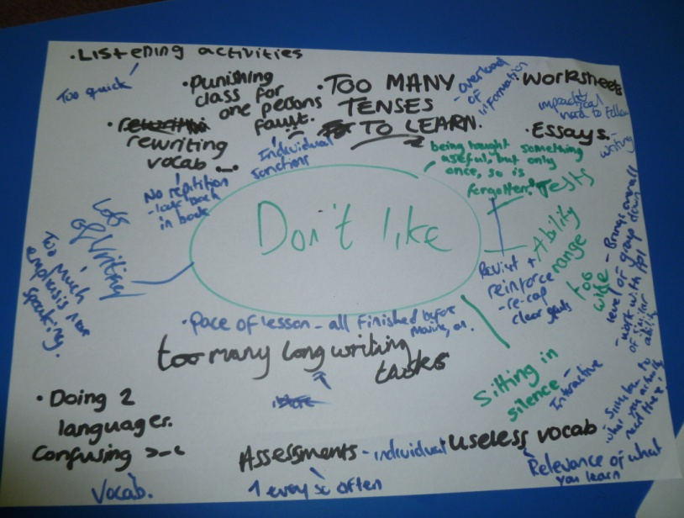GROUP A

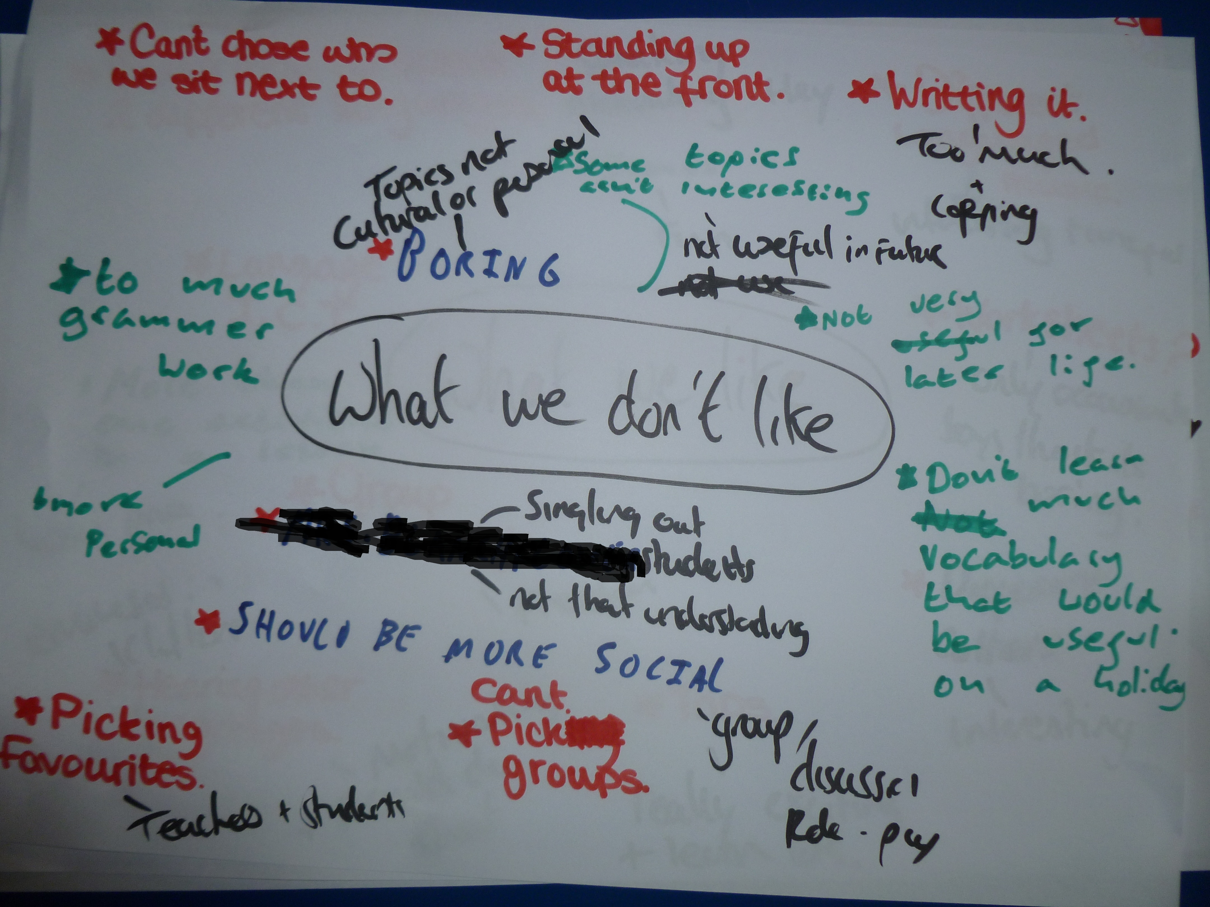GROUP B

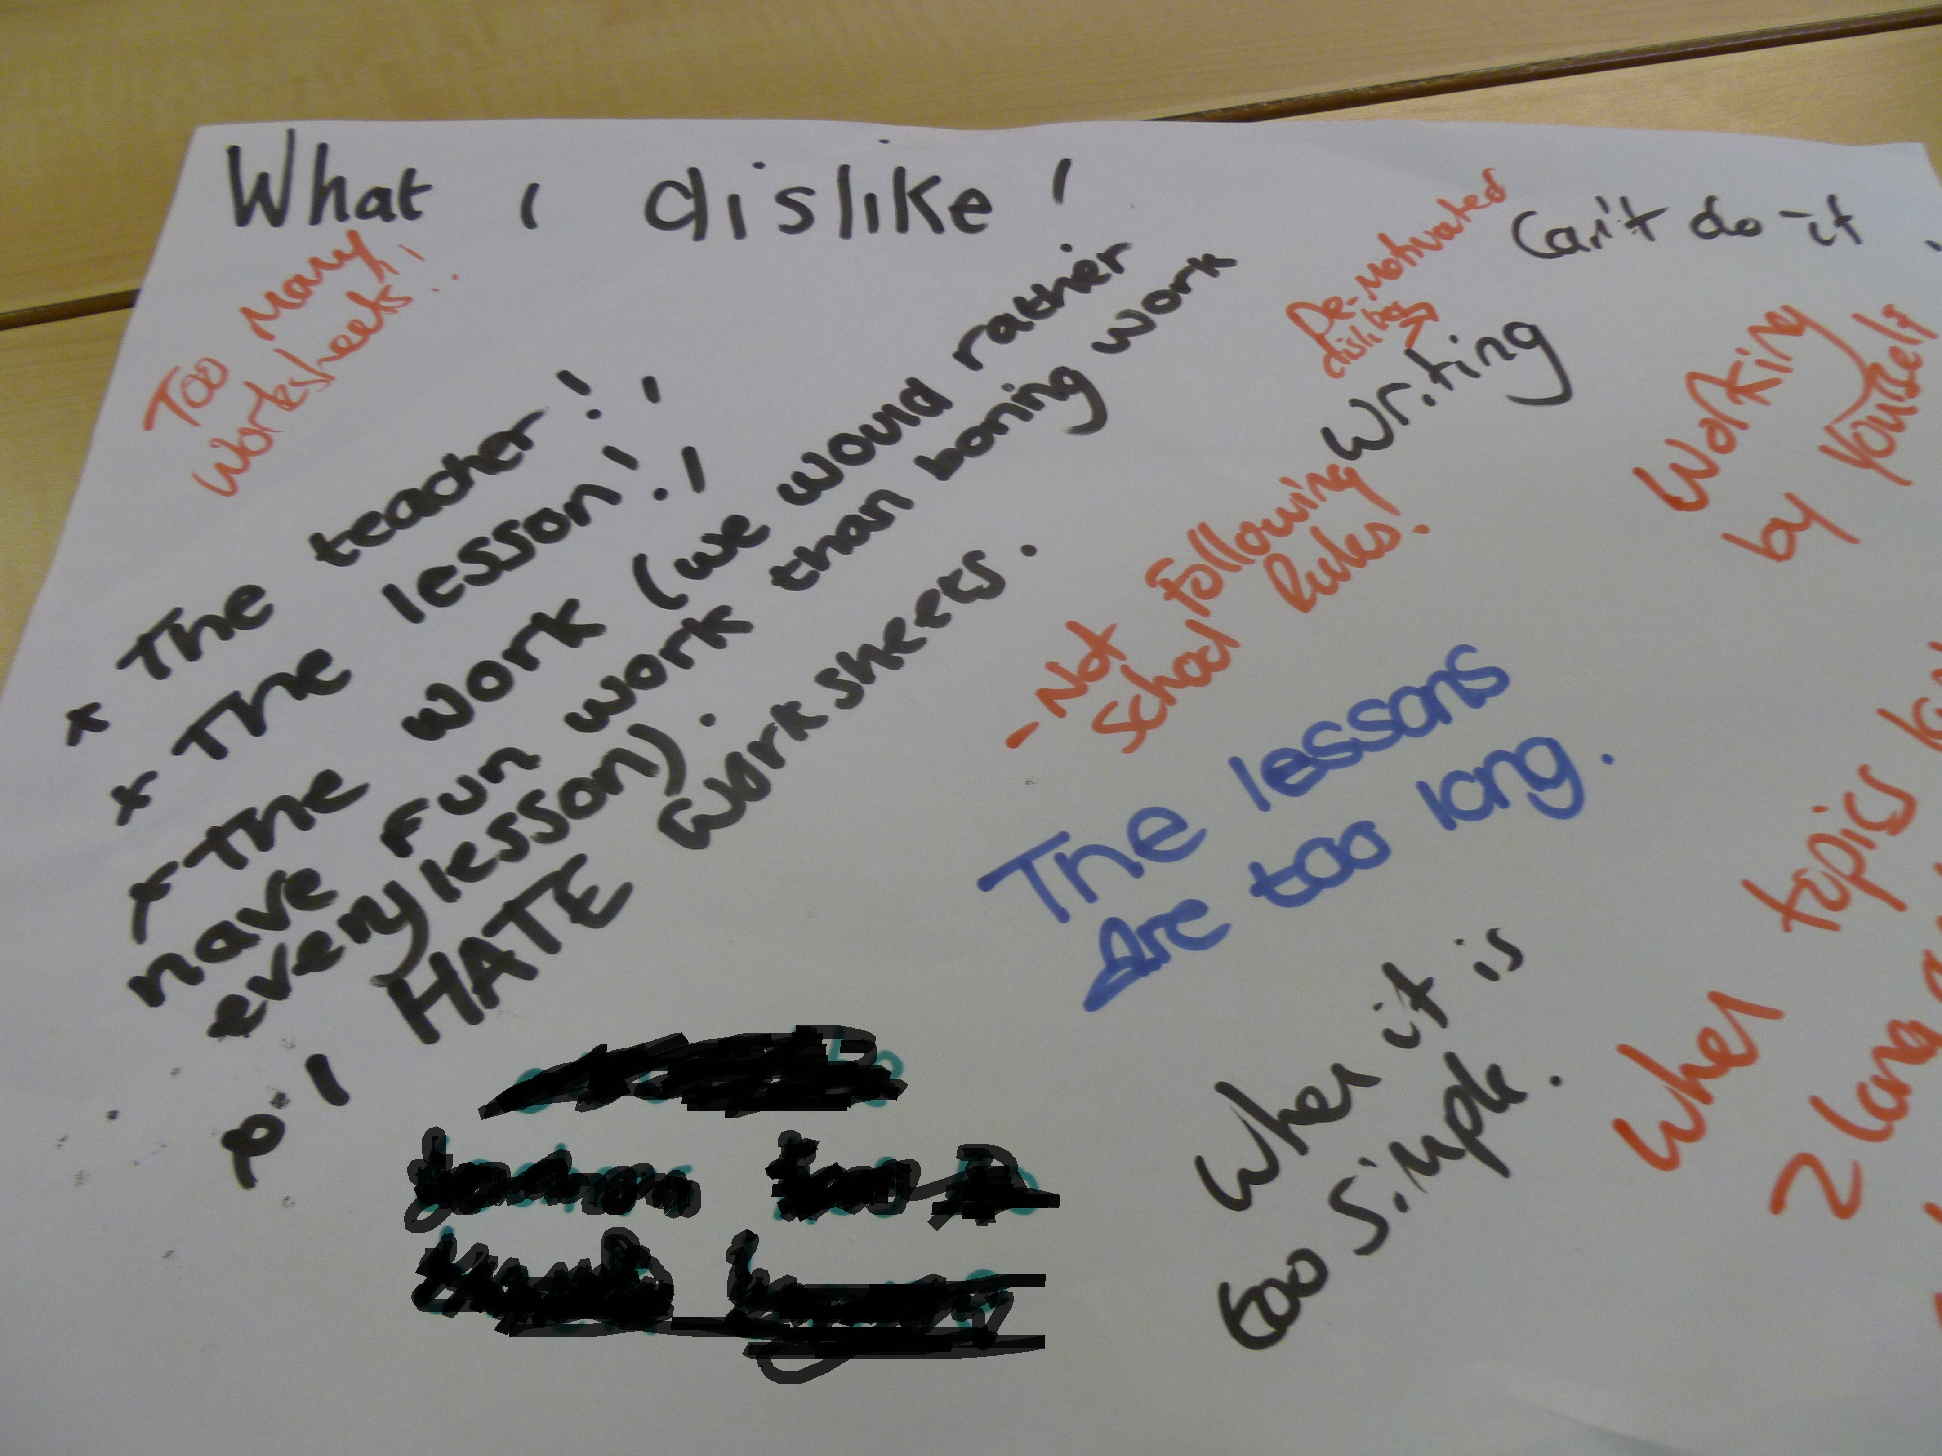GROUP C

6.2.3 The Ability to Speak the Language
- Being able to speak the language is a sign of successful language learning
The data suggested that students demonstrated favourable attitudes towards being able to speak the language and readily acknowledged that they considered speaking to be the most important language skill. They considered the ability to speak the language as a sign of successful language learning, and also enjoyed the challenge of speaking activities during lessons. They also valued the ability to communicate and imitate, or listen to native speakers. All groups agreed that speaking was a challenging, but extremely rewarding skill.
…I think that the most important skill is speaking. It makes you look good at languages and it can also help you with your writing and listening, well with everything really. 2F
…I think that if you are able to speak the language and you are taught how to speak it then you look really impressive. 3M
...It makes you look good if you can speak the language. You hear people and you are like yeah they must be good at it. 3M
…I think that speaking is useful because you get to practise speaking and it helps to build your confidence and it makes a change from just writing or something else. 1F
…Languages are fun when you get to hear native people speak, it makes you think that I might be able to do that. It would be good to have our language lessons in Spain so we can hear it and repeat it. 2M
…I also remember on a trip and I liked it when we went out to a market and we were free for a little bit and we could walk around and buy stuff, and haggle in Spanish and I actually really enjoyed that. It made me feel good after I had bought something without using a word of English, and I won the best Spanish speaker award, and I won a pen. 2M
…The little projects that we do when we do presentations on things we have to do it to the whole class and it’s nerve wracking, but you learn quite a lot, and I enjoy it quite a lot as well. 1F
…I do think that speaking is very important because it makes you feel good and motivated because you think, hey, I can speak another language and I am succeeding. 2F
The obvious desire participants showed to be able to communicate in the target language demonstrated that students have strong integrative motivations towards language learning. They showed extremely positive attitudes towards the target language group, as well as expressing integrative orientations in terms of wanting to use their spoken language for the purposes of interacting, meeting, and socialising with members of the target language community. It also supports the view that students were generally interested in their learning of languages as long as the skill or topic in question was of personal interest to them. If these requirements were fulfilled, students demonstrated high levels of motivational intensity and were willing to invest effort in their language learning.
This desire to practise a skill or topic of personal interest encouraged intrinsically motivated behaviours in participants, especially motivation accomplishment, where “individuals invest energy or in this case are willing to in an activity because they have chosen to do it for personally relevant reasons… to achieve a valued goal”. (Noels et al, 2003, p. 39) (my emphasis). Deci and Ryan argue that this intrinsic motivation is a central motivator in education. The enthusiasm and importance participants placed on being able to successfully communicate with members of the target language supports this claim.
According to goal theories, it is this valued goal that can improve an individual’s performance as they “positively affect persistence”. (Locke and Latham, 2002, p. 707). Furthermore, the ability to speak and communicate in the target language acted as a mastery goal for students as they believed that “effort will lead to success and the emphasis is on one’s own performance and growth” (Dörnyei, 1998, p. 121), as well demonstrating ability.
- The vocabulary learnt acts as a barrier to speaking
Student perspectives gathered from the data suggested that the vocabulary learnt in school is not useful. All groups expressed a desire to learn vocabulary that would be useful in everyday situations in Spain, or when visiting Spain on an exchange visit. They recognised that the language learnt in the classroom differed immensely from the day-to-day conversation Spanish used by natives.
...The vocab we learn doesn’t really help us speak anyway, well it does, but not in a very useful way. You can’t really walk up to a Spanish person and say “my favourite colour is blue”, what on earth are they going to think? 1F
…Imagine that I am in a restaurant in Spain and am really hungry so want to order some food, but all I can say is what I have got in my pencil case. What use is that? 2M
…We do not learn vocabulary for how to say relevant things. It would be relevant for example to learn how to say where is the train station, or how much is that loaf of bread? We don’t learn things like that. 1F
…The words we learn in lesson I don’t think I would ever say to a Spanish person. 3M
…With the stuff we know I just wouldn’t be able to hold a conversation. 3F
…Yeah but talking about exchanges I remember that I just didn’t know how to say important but basic things, like could I have more bread, or more juice, or no thank you I am fine. I can say the individual words because we do that vocabulary, but we don’t use it in those important situations. 1F
…I also want to be able to say things that are useful for the situation I am in because it helps it not be awkward with your exchange partner. 1F
The data suggested that it is clear that the current vocabulary being learnt in lessons is counterproductive in supporting students’ integrative motivations of wanting to meet, interact, and socialise with members of the target language, as it is inadequate in meeting students’ desires to learn and practise interactive phrases.
- There is a lack of opportunities to practise speaking outside of the classroom
Groups acknowledged that even if they learnt how to speak “street Spanish” they believed that there are very few opportunities to practise. They understood the importance of practising their speaking skills whenever possible in order to maintain or improve their level of spoken Spanish, but stated that outside of their language lessons the temptation to speak English was too overpowering.
…Apart from if we go on an exchange, which is only once in the school, I don’t have chances to speak Spanish outside of class. There are holidays but everyone speaks English. 2M
…I do sometimes talk in Spanish outside the class with my friends. Thing is we know so little that its only words and we can’t help each other with sentences so we give up. No one in my family knows it either so it isn’t easy. 1F
…If we had more to do with Spanish people then we would practise it more. 3M
…There is just no way to get better at it, I don’t holiday in Spain and I know no one who is Spanish. 3F
In the previous section participants expressed desires to go on more trips. It seems that this desire is not only confined to cross-curricular projects but also language lessons. The lack of cross-curricular teaching also meant students were not having opportunities to practise their spoken language outside of the languages classroom. The fact that participants alluded to this fact meant that they had a general interest in learning languages, but the lack of opportunities to practise their language skills meant that this need is often not met.

6.2.4 The Effects of the G.C.S.E. Language Examinations and How These Influence the Topics Students Want to Study as Part of Any Such Cross-Curricular Language Collaborations.
- Exams are important
When attempting to ask participants what topics they would like to study as part of their language lessons, each group commented that they didn’t want to change topics in case they selected topics that would not be in the exams. Students seemed to consider language exam grades as a marker for attainment, as well as a symbol for future success. The minority view was that students wanted to study topics they found interesting as they did not believe they would attain well in the exams anyway.
…Well we can’t just do what we want really because some of the stuff we do are the topics that might come up in the exam and that is what counts. 2M
…Some of these topics we do will help us in the exams, it is just that they are not too relevant to our future, but I think they are ok. For example, studying holidays is going to help us in the exams. 1F
…Yeah I don’t know if the topics we study are going to help us in life but they are going to help us in the exams, and that way with good exam grades you help yourself in later life. 1F
…I think that school would be better if exams didn’t exist. You could study what you wanted to study and stuff, but exams are important. 2F
…Is it more important to pass your exams or doing topics that are useful in later life? Well both because, no actually passing your exams because that is ultimately what helps you in later life. Like if there was a job interview and they had 50 people and they could only take 20, and some of them had language A-Level or G.C.S.E. then they would probably take that person, so it is useful. 1F
…If I am being honest I would say that I am unlikely to do well in the exams anyway, so I would rather study topics that were interesting but not on the exam. At least then I might enjoy the next few years. 3M
I was initially startled by the amount of importance students placed on succeeding in their G.C.S.E. exams. Success in these exams was considered as vitally important to participants, more important than being able to speak the language. However, after considering their responses I felt less startled. After all, I had already seen how extrinsic motivations seemed to overpower intrinsic in previous questions when asking students about the topics they enjoyed and disliked as part of their language lessons.
On a personal note, I have always found it difficult to accept how a grade on a piece of paper can be a true representation of a students’ language attainment. What happens if students have a good level of spoken language but not written, have a good knowledge of certain topics but not those that will be in the exam, are able to listen and understand the target language but have difficulties in responding, does this mean that they should be given a low grade and considered to have a lower level of attainment than students following the prescribed content? Clearly the examination boards think so.
Although it seems obvious that the G.C.S.E. exams promote external extrinsic motivations in participants I have reservations over the use of motivations here. The data suggested that many participants were not motivated to study languages. The extrinsic factor of achieving good grades did not motivate them as such. No participant said “I really like and want to study languages because I want to get a good grade in it”, it was more an acceptance of fact rather than a motivation, and it was the glorification of examination success that nurtured these extrinsic behaviours. Therefore, it was no coincidence that when talking about the importance of exams, intrinsic or integrative motivations did not feature.
- Students would change the topics if there were no exams
Before presenting the comments made by participants I wished to return to another of the questions asked in the literature review; is it impossible to empower students if their views are futile in changing a defined curriculum? It is clearly possible to empower students to come up with ideas surrounding teaching and learning as the previous responses clearly highlight. However, from the collected data participants believed that the topics they suggested would never be able to be covered in great detail because that would take time, which would consequently take time away from covering other topics that are in the schools’ schemes of work and the G.C.S.E. exams. Participants could never really detach themselves from the fact that there would be exams and the introjected regulation building up in participants is clear from the above comments. Therefore, are their views futile in changing a defined curriculum? It seems that as long as all parties that are involved in education: Government, teachers, parents and students continue to place the amount of importance that they currently do on having a defined curriculum and examinations, then views such as these presented have little impact on inspiring curriculum change.
…Yeah I would definitely change the topics. I wouldn’t for example want to learn about healthy living. I would pick topics that were more useful in later life rather than ones that just get us through the exams. It would make languages better. 1F
…I would like to do things like numbers, a little bit of politics, food, and artists, even if some people wouldn’t like it. I went to the Spanish museum once and I thought it was great because it included a lot of culture, which is what we should do. 1M
…Culture is good because we never like, we never learn what there is to do in Spain. Like I went to Germany once and I never knew much about their culture like how they are so polite, and I think they thought I was really rude. 1F
…I would pick film, I would pick music. I would pick all cultural things. Languages would be much more interesting as a result and I would enjoy it more and I wouldn’t get nervous in exams because I am worried about them even now. 2M
…I would like to see us do more things about the place itself like geography. We should know where Spanish cities are and the geography of Spain and South America. I put down economics too because it is a big topic in the news so why shouldn’t we learn about it? Surely the exam people would think that is relevant? 1M
…More things about the country for sure like: History of Spain, food, Spanish culture, laws, what there is to do in Spain, geography, weather, small talk, how to ask for help, how to keep a conversation, things like that. Basically things that the exams stop us doing now. 1F
…I would like to know the experiences of the country, what they do and things. I think that art would also be interesting. 2F
…I would like to learn about etiquette and different customs and also talk about the weather. Well not just the weather, but things in general, you know, like small talk. 1F
…I want to be able to order food, ask where the station is, you know like day-to-day language that we will need to use. I don’t know why at the moment we think it is more relevant to say “I like chicken” rather than learning how to talk to the police. Small talk is important and you can easily build it into topics. 1M
…Learning to talk like they do would be good and also learning about things that actually happen in Spain, instead of just imagining and writing. 3M
…I want to be able to say useful things, we seem to learn quite formal things to do with vocabulary but I would like to learn street language because people here do not speak formally to each other all of the time. I want to learn how people actually talk. 2M
Unlike the previous question where extrinsic motivations superseded intrinsic ones, it seemed that when extrinsic or institutional motivations no longer feature then instrumental and integrative motivations were allowed to flourish. As with participants’ desire to speak the language these suggested topics would score highly on the AMBT (Attitude / Motivational Battery Test) within the Socio-educational model to measure integrativeness. Responses demonstrated favourable attitudes towards the target language group, with a willing interest not only to meet and socialise with members from this group but also a vested interest about learning more about the target country and its culture. Within the intrinsic motivational framework the following topics would also encourage intrinsic motivation knowledge, as participants wanted to study such topics because of the feelings associated with new ideas. They would also promote intrinsic motivation accomplishment as students would strive to master a task or achievable goal such as speaking. Finally, they would provide intrinsic motivation stimulation as students would be studying these topics because they would ignite students’ internal curiosities, fun, and excitement.
These topics also strongly reflected participants’ intrinsic motivations. Deci and Ryan (1985) state that intrinsic motivation flourishes when “the educational environment provides optimal challenges, rich sources of stimulation, and a learning context of autonomy”. (p. 245). The topics that participants from all three groups wrote down provided this challenge and stimulation, whilst participants’ desire for cooperative learning provided a context of autonomy. Unlike the performance goal promoted by examinations, these topics provided students with mastery goals, focussed on content, with the result of the individual “aiming to become smarter”. (Williams and Burden, 1997, p. 131).
The three groups were asked to write down the topics they wanted to study and a photograph of the results was taken.
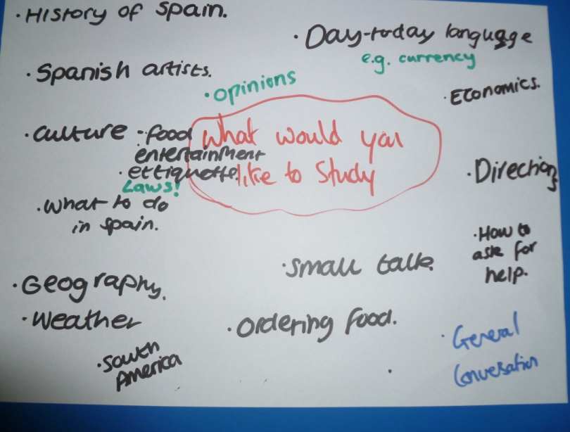GROUP A

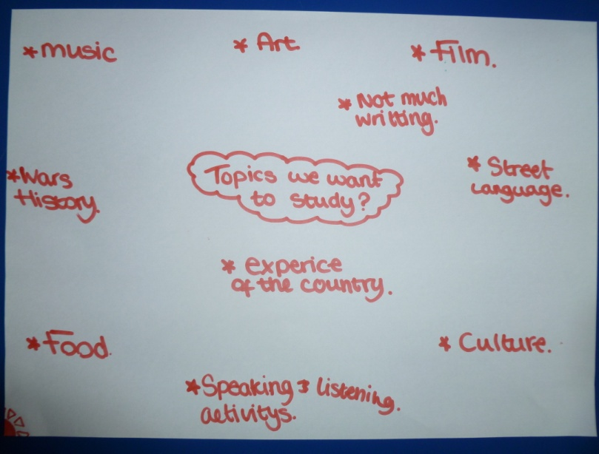GROUP B

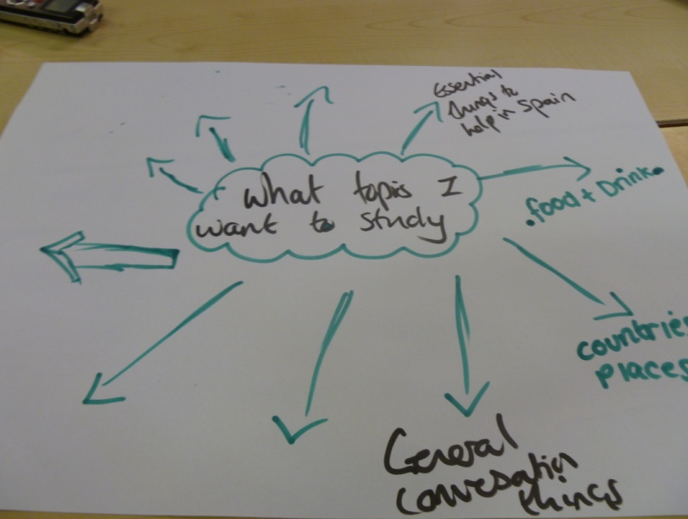GROUP C

6.2.5 Differences in Group Responses
There were areas of the research where participant responses seemed to support each other, especially around issues of the importance of the G.C.S.E. exams, and the fact that student perspectives suggested that many of the topics currently being studied lacked a cultural element. All three groups, although the selection of topics differed somewhat, agreed that they would significantly change the topics studied if there were no exams. The topics that higher attaining pupils wanted to study generally focussed on more traditional academic school subjects such as Business and Economics, Geography and History, whilst the lower attaining group was more focussed on practising conversation, or included more kinaesthetic subjects, such as Physical Education, Design Technology or Home Economics.
As with the last section, the lower attaining group found it more difficult to provide detailed answers when attempting to reflect upon their language lessons. The lower attaining group also came across as being more negative about their language learning experiences than the other two groups. Most of the negative comments coming from the lower attaining group focussed on the class teacher; it was often whether the members of the lower attaining group seemed to like their teacher that influenced whether they liked the subject or not. This group often felt victimised by the teacher and felt they were being unfairly told off or picked on, which negatively affected their view on the subject. Their attitudes towards the teacher seemed to make any other positive aspect of the learning environment redundant.
6.2.6 Summary
In summary there were two key areas to address regarding this section of the data analysis: Firstly, what students currently like and dislike about their current language studies, and how this informs what they want any cross-curricular language projects to be like and secondly, the types of topics they would like to study as part of any cross-curricular language projects.
What students currently liked and disliked about their current language studies, and how this informed what they wanted any cross-curricular language projects to be like.
- Participant perspectives suggested that students enjoyed and wanted the security a cooperative learning environment could give them.
- The data suggested that students favoured a fast-paced lesson containing a range of activities drawing on different skills.
- Students did not want text heavy documents or worksheets.
- The voices gathered from students suggested that they wanted the topics they studied to have a cultural element which promotes intrinsically motivated behaviours.
- Students believed that current topics placed too much emphasis on writing. These tasks were pitched at a level above students’ current level of language attainment, which led to demotivating experiences for participants.
- Students showed high levels of integrative motivation and wished to learn vocabulary and undertake speaking exercises in order to better communicate and socialise with members of the target language group.
- Participants believed that the vocabulary currently learnt in lessons was counterproductive in encouraging this integrative motivation.
- Students believed that a lack of trips and cross-curricular opportunities meant that there were limited opportunities to communicate with members of the target language group, and limited opportunities to practise spoken language outside the walls of the classroom.
The types of topics students wanted to study as part of any cross-curricular language projects.
- The importance placed on the examinations and other means of assessment promoted strong levels of introjected regulation and other external extrinsic motivations. These motivations dominated intrinsic motivations for language learning.
- When extrinsic motivations were removed from the equation the topics participants wanted to study as part of any cross-curricular collaboration differed greatly from those currently taught in the schemes of work.
- The data suggested that students selected topics based purely on their integrative (wanting to communicate with target language members) and intrinsic (joy of doing the topic and satisfying their internal curiosities) motivations.

6.2.7 Additional Note
As an additional note I wished to return to the introduction of this thesis and consider its first medium term goal: To acknowledge students’ attitudes and motivations towards language learning. I believe that this chapter has been able to acknowledge these attitudes. During the literature review I also decided to focus on three student language learning motivation models. The first was the Socio-educational model because I wanted to investigate whether students wanted to undertake these projects for integrative or instrumental reasons. Student perceptions clearly highlighted the fact that students wanted to do these projects for integrative reasons, for the purpose of interacting with members of the target language. Secondly I wished to see whether students wanted to undertake such projects for intrinsic or extrinsic motivations as described by the Self-determination theory. Students clearly wanted to do these projects for the fun and interest they would provide them, i.e, for intrinsic reasons. Finally the Goal Orientation theory was presented to investigate whether wanted to do these projects for mastery or performance goal reasons. Students wanted to do these projects to achieve mastery goals, to increase their knowledge of the target language and culture.

6.3 Data Analysis of Subsidiary Research Question 3

Focus of Subchapter: What Subject Areas Could Languages Work with to Produce Cross-Curricular Projects?
In order to tackle this third subsidiary research question, participants were asked to think about all of their previous answers and diagrams. They were then asked to do two things: Firstly, to consider the topics they said they had enjoyed studying as well as topics they said they wanted to study, and attempt to link these to other curriculum areas, and secondly, consider how they would want these projects to be conducted. The consideration of these points and the analysis of the interview transcripts highlighted two trends; that students had clear ideas on how they wanted aspects of such projects to be conducted, and that they were able to provide example projects that they wanted to study.
These two trends were translated into the two interpretive codes used for presenting the data and are introduced in the following order:
- How students believed cross-curricular language projects should be conducted.
- Example projects that students wanted to study.

6.3.1 How Students Believed Cross-Curricular Language Projects Should be Conducted
  - The projects need to be assessed using a number of different methods
Following on from participants’ concerns about how their work in these collaborations was insufficiently evaluated, participants’ perspectives indicated that the projects should build in a number of different evaluative methods. The main reason for this was to try and reduce the amount of writing used in the projects, as well as move away from the individual test paper or end of unit evaluation under exam conditions, in favour of more unconventional evaluative tasks, such as the use of video or performance. The work produced as part of these tasks should then be clearly displayed in classrooms as a symbol of recognition of student work. Participants also commented that they felt a reward system should be in place both for group and individual praise.
…I don’t really mind what we do. Whatever we do though should not mean that you have to sit in silence and complete a test like at the end of a topic because that’s boring. 2M
…What I want isn’t a test that just focuses on me. I always get low scores on my tests and that is why I am in the bottom set. The teacher knows this but keeps giving me tests anyway, even if she knows I’m going to fail. It should be a group test but not one where you sit in silence and have a time limit then add all of our scores together but it should be one test for the whole group. 3M
…Instead of doing writing all of the time perhaps we should finish these projects doing different things. For example with food I would like the idea of doing a recipe book; drawings with short but useful sentences. 1F
…Yeah let’s do a cooking programme and then we taste food and comment on it, we should film it. 2M.
…It would be better to use music and dance I think. Especially if we are doing it with drama, we could learn stuff about plays and then act out, that way we can speak rather than write. 1F
…We should do a festival, a cultural festival! We should display art and song and dance. 2F
…If you are going to display the work then writing is easiest, but it doesn’t have to be long writing or a poster, we could do different things with writing, like make a tourist guide for a place that can then be done in as many languages as you like. 1M
…Let’s evaluate what we learn about, so if its music we should play music, if it is sport then let’s do sport, keep it relevant to what we are doing. What we shouldn’t do is an end of unit test though that the teacher keeps scores of and then they go on our reviews. 3M
…There should be prizes for groups that have done well, I respond well to prizes and it makes things competitive. I don’t want competitive like we do the test and teachers write down our scores and then do tables and leagues and things. It takes the fun out of it. 2M
…We should have some kind of achievement when doing or completing these things, like a certificate. 3M
It was clear that students believed that the current method of evaluation negatively affected participants’ views on language learning. The logging and comparing of results promoted performance goals as students looked to outperform other students. The lower attaining group clearly thought that this was unfair as it further highlighted what they had already accepted, that they did not perform well in these situations compared to others in the year group. The fact that the focus of these tests was on performance meant that intrinsic motivations were not able to be realised as they “took the fun out of it” (2M).
The previous comments not only supported participants’ wishes to undertake these projects in groups, but also continued to highlight their preference for intrinsic over extrinsic motivations, when the importance placed on external or extrinsically motivating factors were diminished or taken away completely. As with the choice of topic participants wanted to study as part of any cross-curricular collaboration, any such decision seemed to be based on their intrinsic motivation accomplishment - the sensations related to attempting to master an achievable goal - and intrinsic motivation stimulation - the motivations based on performing such evaluative tasks. It seemed, therefore, that the schools’ current emphasis on individual performance through end of unit examinations was a complete contradiction to what students believed they wanted to see from their language evaluations.
  - The role of the teacher should be that of a facilitator
As part of these projects, the voices explored suggested that participants wanted the intervention from the teacher to be low, and that the teacher’s role should be that of telling students what they had to do each lesson and what the project and its goals would be, as well as presenting the tasks and giving them a target to work towards each lesson, whilst letting students work independently in groups for the majority of the allotted time in order to complete the tasks. The minority view was that intervention from the teacher should be high to maintain control over the classroom environment.
…The way I see it is that the teacher tells you what the project is, and what you are going to do. After that it is up to the groups and we have to get on with it. 2M
…I think the teacher should give us a brief and then we organise it ourselves. 2M
…The teacher should set challenges and work to do for each lesson and say, right this is what we are going to do this lesson and this is where you need to be by the end of it. 2M
…The role of the teacher should just be to assist or to supervise what we do in our groups after telling us what we are doing. 1F.
…It should be more of a student thing, the teacher tells us what to do and we should do it. 1F.
…The teacher should just let us know what we have to do and should just monitor and stuff so that they can see what each group is doing and if they are doing it properly. I don’t like it when it is stop and then start all of the time because you have to keep listening to the teacher half way through. 1M
…Well in Spanish the teacher can teach us vocab and we get on with the project, but in the other subject that is working with Languages the teacher will just have to monitor us and let us get on with it because they won’t know Spanish. 1M
…I disagree and would say the teacher should be telling us what to do each lesson and should be talking to us. If the teacher does not do this then I think students will get distracted and not do the work. Students are more likely to do the work if the teacher is watching them all the time. 2M
The importance that students put on the group environment did not completely exclude the teacher as the authority figure, but it required the teacher to be the central figure of attention for a minority of the time, providing the group and its members with a larger opportunity for self-regulation and autonomy. This more decentralised role of the teacher is one of the pre-requisites of Cooperative Learning. Such a role is also supported by the andragogical approach to teaching and learning. As alluded to in the literature review, the approach centres around the use of pupil voice activities to collect and analyse students’ view on learning, and, building from these views, an institution’s schemes of work are then planned and implemented. What is contained in these schemes of work is directed by the learners. The approach states that in the teaching phase of these schemes of work the role of the teacher “as the fountain of all knowledge was relinquished… and the tutor was able to give control to the students”. (Bishop, 2006, p. 45).
The claim that student autonomy is at the core of motivation to learn is also central to Deci and Ryan’s (1985) “Self-determination” theory. “The need for autonomy is an innate human need, referring to the desire to be self-initiating and self-regulating of one’s actions. Therefore, self-determination, that is, engaging in an activity with a full sense of wanting, choosing, and personal endorsement” (Deci, 1992, p. 44), is essential for any behaviour to be intrinsically rewarding. The role of the teacher as an initial source of input and then monitor helps provide a learning environment that fully supports self-determination; “the specific supports for self-determination we suggest include offering choice … with a general attitude of valuing children’s autonomy”. (Deci et al, 1991, p. 342).
Although the issue of student autonomy was not presented in the literature review, the role student autonomy can have on second language motivation has been covered by a range of academics in the field: (Kjisik, 2009; Pemberton, Toogood and Barfield, 2009; Lamb and Reinders, 2008; Allford and Pachler, 2007; Palfreyman and Smith, 2003; Benson and Toogood, 2002; Sinclair, McGrath and Lamb, 2000; Ushioda, (1996). The word limit placed upon this thesis meant that I had to focus on the areas I deemed most relevant to this research i.e. pupil voice, cross-curricular teaching, and student motivations towards language learning. Although I accept that the concept of student autonomy is one of the main ingredients of encouraging intrinsic motivations, I did not have the words to spare to focus on student autonomy as a separate entity.
  - Thinking about how long these projects need / should last is important.
When discussing how long projects should last participants seemed to struggle to give an exact answer, although their perspectives suggested that they should be longer than three weeks, but no longer than six. Participants stated that the length of the topic should be decided and communicated before starting the project and that this time scale should be thought through carefully and depend on a conservative estimate of how long groups of students would take to work through the various tasks.
…Four weeks is a nice amount of time, too much longer is too long and too much shorter is too short. 3M
…It depends on the topic but how long we will need should be thought out beforehand. Think about how long we will actually need and don’t be too generous with the time because it will not encourage the group to work fast or be organised. 2F
…As a general rule I would say that 4 weeks is about realistic and 6 weeks too long, especially if you have 2 lessons a week in that subject. What is important is thinking about all that we have to do before starting the project and then working out the time limit. 1F.
…We need to plan what we need to learn and what we need to do, we then work out how long a final project will take so we can have two deadlines, one for learning the work and another for the end of the project. 1M
…If we think of 6 weeks as being like from now until the end of the year then I would say that is too long for a topic, but if you say well you can have half of that time then that seems about right. I guess it is about thinking how much there is to do. 2M
The groups were asked to write down their thoughts on how these projects should be run. The photos are below. The four most discussed topics are the four outlined above.

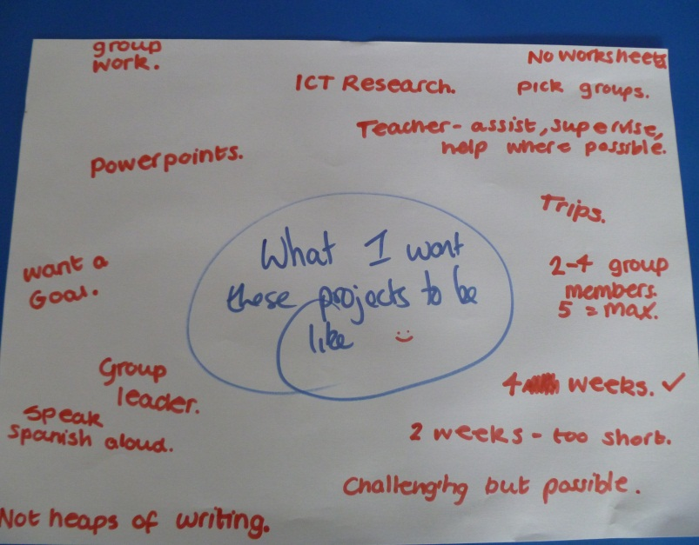GROUP A

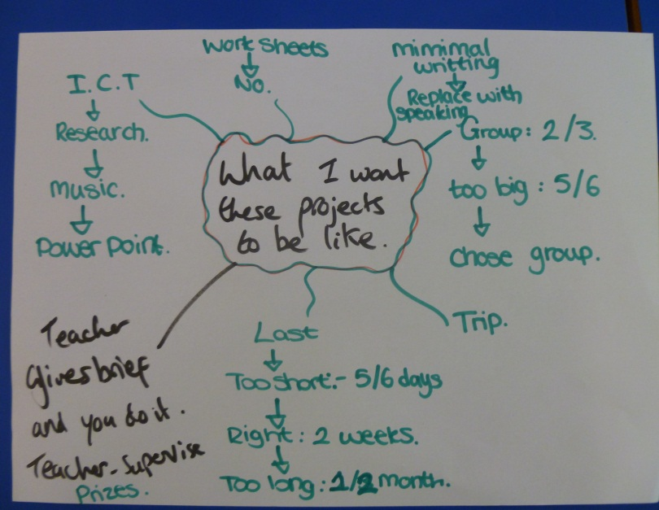GROUP B

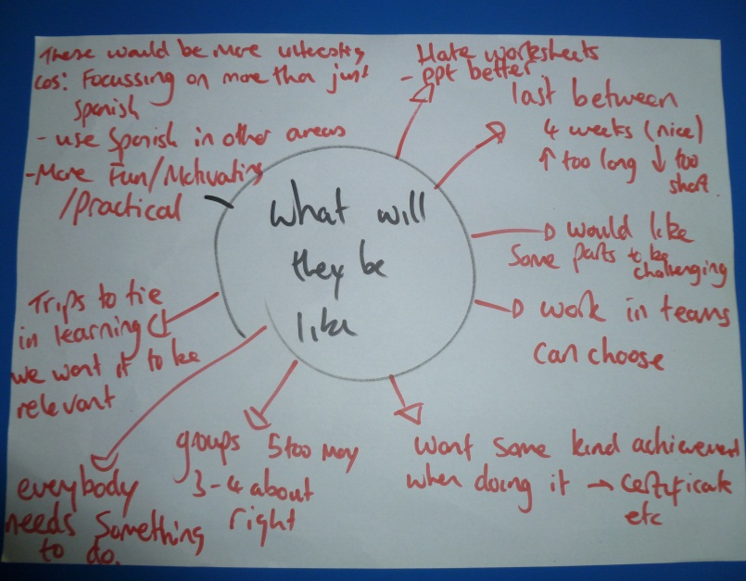GROUP C

6.3.2 Example Projects that Students Want to Study
I wished at this point to return again to the introduction of this thesis and reintroduce the second medium-term goal: To provide student examples of cross-curricular language projects. In order to address this goal, participants were asked to return to the topics they said they wanted to study as part of any such projects, and to think about the curriculum areas Languages could work with. Upon assigning these topics to a curriculum area they were asked to consider and comment on these additional questions:
- Which subject area(s) could Languages work with?
- What would be taught / learnt in language lessons?
- What would be taught / learnt in the other lesson?
- How would the topic be evaluated?
The higher attaining group originally came up with eight example projects, the middle group seven, and the lower attaining group five, although many of the projects were the same or similar in nature as groups kept coming up with the same ideas. After considering the three additional points, some of the projects were considered not feasible as participants believed that they could not cover all of the bullet points sufficiently. A total of six example projects are presented in the following pages.

6.3.2.1 Example Project 1
Topic – Spanish food.
…Paella, we could do paella. 1F
…we could also do other Spanish tapas and tacos. 1F
…I think that we should learn to cook paella and other Spanish traditional foods, like squid. 2M
- What subject would the project work with?
…It would have to work with food lessons, especially if we want to do some cooking and tasting. 1M
…If we were making food then we would have to use the facilities in the food room. 2M
- What would be learnt in language lessons?
…Well I guess the instructions should be in Spanish lessons (pause four seconds), yeah think about it, and let’s learn how we would say for example a spoon full of, mix, a pinch of. We could also learn about numbers and quantities. 1F
…We should learn all about food and ingredients too. That way we are also covering useful things like food and meals, eating out etc. That’s a point, we could learn how to order, set the scene in a restaurant. As long as we then make something out of it. 1M
…We should do food and ingredients; learn about food and how to make things like by following a recipe. 3F
…After we learn about the food and methods and things we should then write recipes in Spanish that we can take into food lessons and use because the food teacher don’t know Spanish but if we are following our instructions in Spanish then we are still kind of practising. 1M
…In our Spanish lessons we could learn about traditional Spanish foods and where they come from and stuff. We should use ICT to research them. 2M
…I think we should also practise speaking because we said we would. Let’s learn how to give opinions and give review like good, bad, needs salt and stuff like that. 2F
…We should learn how to say things that will be useful in any restaurant not just for this project like it was yummy, I loved it, nice texture, spicy, I liked it but… you know things like that. Simple things. 1F
- What would be learnt in the food lesson?
...The teacher should look at our recipes and things and make the food in our food lessons. 1F
…In food we should just make food from recipes and not learn about Spanish foods in English. 3M
…I guess speaking Spanish in our food lessons is going to be difficult because Miss doesn’t know Spanish. But I said we could follow our recipes that will be in Spanish. Also Miss could like make sure that we are only making Spanish food, for example, we shouldn’t be making pasta because it is Italian. 1M
…I think that in our food lessons we should be learning to cook the things we prepare in our Spanish lessons. The food teacher might also be able to teach us about some regional Spanish food, I have asked her before and she said it was her favourite type of food. 2F
…Yeah not only that but we know how to speak about food in English and we can ask advice and then go back to Spanish lessons to see how you would say the things we learnt in the food lesson. 2M
- How would the topic be evaluated?
…Well I think that after we have got all of the vocabulary done and the recipes written and stuff then we can do a review of it. Not like writing but like what they do on T.V on a cooking programme, eat it and taste it and then give feedback. 2M
...I think that we should record us tasting and commenting on it in Spanish. That should be done in food because as food and Spanish are not that close together we can’t leave the food for the Spanish lesson, but if we record it in Spanish then the Spanish teacher knows we would have done it properly because it would be in Spanish and we can look at the videos in the Spanish lesson. 2M
…I like the idea of making something and then tasting it, I would love to do a tapas tasting session. We could also then give feedback by commenting on what we thought they were like. 1F
…I think we should do like taster and say what we think but I don´t really like being filmed. We should put the recipes together in a book. 3F
…It would be better to video the feedback but also it would be good to display something. As well as a video I think we should do like a cook book, put all of the recipes together that we used. 1F

      - Example Project 2
Topic – War and Conflict
...We could do things in a historical context, the Spanish armada. 1F
…We could also cover the first and second world wars. 1M
…Thinking about conflicts between Spain and England like the Spanish armada would be interesting, or even the Spanish civil war. 2M
…Civil war and I also know that they used to occupy Morocco because I went there and heard about it, I thought it was interesting. 3M
- What subject would the project work with?
…I think that we would have to work with History if we did this kind of topic. 1M
…As we are doing about wars in the past then it should be done with History. 2M
…I think that it would be good if we could bring something in Drama as well, maybe a bit of acting. 1F
- What would be learnt in language lessons?
…Well in our Spanish lessons we could learn about the wars that Spain and England have had, and learn key dates in Spanish and stuff like that. 2F
…Well in our History lessons we learn about war a lot but it always seems to be about our side. For example, what the Allies did and when things happened. In German we could go into more detail about the Nazis and what they were and the key dates in their history. 1F
…I like that idea of looking at the other side because we don’t know much about the Nazis compared to the Allies. 1F
…It would give us the chance to look at both sides’ stories behind war. 1F
…Going back to working with Drama we could learn about the dates and stuff in our languages lessons and what happened and then act out a scene but in the other language in our Drama lesson. Even better, we could have half a group on one side and half on the other so it could be a dual language play that would be cool. 1F
…We would have to prepare any scripts in our languages lessons though and the teacher will need to look at them because the Drama teacher won’t be able to. 1F
- What would be learnt in the History / Drama lesson?
…I think that what we learn in History lessons won’t change that much because we do a lot about these wars. It would be Languages that change more. 1F
…In History we do about wars a lot so what we learn there will not really change, we will just be getting the other perspective from the other side during our languages lessons. 2M
…In Drama as well it will be preparing the script in English and setting the scene, things like that. 1M
…I reckon the change needs to happen more in Languages and not History or Drama because we are used to doing these kinds of things in those lessons. 1F
- How would the topic be evaluated?
…We could do like a poster but one that takes in both points of view. So like going back to the Nazis and Allies again we could have like a timeline poster split in two, on one half it can be key dates and details of Allies during WW2 written in English, and on the other half the same again but in German about the Nazis. 2M
…I like the idea of that because it gives you kind of like a perspective on war, like being two sides and two different languages etc. 2F
…Yeah on like some of the dates we could do like a little story, I know I said I don’t like writing but creative writing I quite like. 2M
…We could write a diary, we have had to do that in History already, we can imagine you are a character in the war and write a diary in English and then imagine you are another person on the other team and write it in the other language. 1F
…Yeah as long as it is nothing big. Small entries, things like that. 1F
…I like the idea of the dual-language play and then maybe recording it so both of the teachers can see it. 1M

6.3.2.3 Example Project 3
Topic – The Spanish Speaking World
...We could do something about South America. 1M
…I would like to compare things that are in Spain and South America. 1F
…What about the difference between South American countries? I know nothing about them. 1F
- What subject would the project work with?
…I think that we would have to do the research in Geography. 1F
…Maybe ICT as well because we need to get the information from somewhere; although we can use the computers in the Geography classrooms. 1M
- What would be learnt in language lessons?
…I think in our Spanish lessons we will need to learn lots of vocab, but vocab that is centred around Geography like population and capital city and landscape and exports, things like that. 1M
…Also we will need some culture as well, like know what the festivals and music and religion and other cultural things are. I know we can use the computers and obviously there are a lot of countries in South America but we could focus on one. 1F
…I think we should like learn about why they all speak Spanish. 1M
…I think that if we do most of the work in the Geography lesson we are going to need words that are going to help us, you know like words you would find in a fact file about the country. 1M
…I think that we should look at famous areas and maps and look at where cities are. 3M
- What would be learnt in the Geography lesson?
…I think that in the Geography is where the research needs to take place and then we can use what we find to translate into Spanish. 1F
…I think that everybody should have the general vocabulary but just focus on doing one country and assign a group to a country and then compare what we find out about each one in the end and then make facts about it in Spanish and English. 1F
- How would the topic be evaluated?
…Well if each group has a country to do, it doesn’t have to be massive or anything like that, but if we each have a country we could do like seven countries and then make a fact sheet on each one in Spanish and English and then we can put them together and make like a fact file. 1F
…Yeah we can include like facts and figures in it so people read it and learn things. 1M
…What about doing like a tourist guide? Each group has a country and like researches the most visited places in that country and then presents them alongside some facts and figures and we can then make a leaflet in Spanish and English that will be like a tourist guide. 1F

6.3.2.4 Example Project 4
Topic – Music and Dance
...It would be good to learn about Spanish music both like old and new. 2F
…Also there is that flamenco and the traditions and things. 2M
- What subject would the project work with?
...We should do something with music definitely, that would be fun. 1F
…It would have to be with Music really, don’t really know what other subject we could do that in. 2M
- What would be learnt in language lessons?
…I would like to learn about all types of music like tango and salsa and where it comes from. We could even put like Youtube videos on and practicse! 1F
…I think we should learn about the different types of music in our Spanish lessons, its history and things like that and how they dress too. 1F
…We should research all of the traditional dances in Spanish and learn the words and stuff and the routines and steps, and then in Music we listen to music and follow it by dancing. 1F
…I think that there are lots of different Spanish composers but I can’t name any, it would be good to research those in Spanish. 2M
…I think that if we were to come up with our own song we could start planning the lyrics and things in language lessons. 2M
- What would be learnt in the Music lesson?
…I would really like how to play different Spanish instruments like the castanets or Spanish guitar. 1F
…I think in Music we should be listening to foreign music that we have listened to in our language lesson and then start practising to dance them. We could play music too. 1F
…I think that we should use our music lessons to compose a simple bit of music with Spanish instruments, and then we can combine that with dance and have people dancing or singing. 2F
…Going back to our own song thing we could even sing our own song in music with Spanish instruments and everything. We could even film it; make our own Spanish music video! 1M
- How would the topic be evaluated?
...I think to summarise the whole thing we should be looking to film or record. Like if we make our own music with Spanish instruments then record it, if we make a music video then video it, if we make a dance then video that too. I don’t know how much we will have time to do though, it might be impractical to do all three. 1F
…Yeah or we could at least have a go at like doing those kind of things but even if we don’t get to film it we could always imagine it was going to be a show and we have to do a promotional poster for it, because I don’t really want to be filmed dancing. 1M
…I think it would be excellent if we made our own song, even if it is simple it would be really fun. 2M
…Yeah if we all like made songs or dances, not all of the lyrics have to be in Spanish but some could be, and even if the dances don’t use Spanish they can still be Spanish dances. We could then put on like a show or concert, or festival or something. 2M

6.3.2.5 Example Project 5
Topic – Art and Sculpture
…I know that Spain has famous painters like Dali and Picasso. 1M
…Barcelona is full of architecture. 1F
- What subject would the project work with?
…We will need to do something with Art. 2F
…It would have to be with art because we only have the facilities to paint in those rooms. 1M
- What would be learnt in language lessons?
…We should learn about famous artists in Spain and learn their styles. 3F
…I imagine that in our language lessons we would have to do the other things, like research, find out about artists and their paintings, and their styles. 1M
…I think that as well as paintings we could learn about interesting buildings and sculpture and architecture and things, look at pictures and find out about the people. 1F
…I think that we should be also looking at artists but as well like cultural things about like all of the festivals they have over there like the Bull Run and tomato fight and looking at images of that and learning about it, and then draw about it in art so it is about culture because we have nothing like that over here. 2M
…Also if we are thinking about drawing or painting then we should think about maybe describing photos, not in any great detail but it would be useful to learn shapes and things so you can write a few sentences. We can then use that stuff with more than paintings. 2M
…Yeah because like with describing things in Spanish the word order is all jumbled up and we could practise that with this vocab. 2F
- What would be learnt in the Art lesson?
…I think if we went for the festival theme then we should get images off the internet and then draw them or paint them in the Art lesson, we could then make a collage and it will be like this is what they do in Spain and we pretty much do nothing. 2M
…Yeah we can draw or paint in Art, recreate buildings and things, like that famous thing in Barcelona. 2F
…Art should be the more fun lesson where we can paint what we learn about in our Spanish lessons. 3F
…Yeah I would like us to go into the workshop and paint, maybe not copy things that Spanish artists have done but at least look at their style and try to do something similar. 1M
- How would the topic be evaluated?
…This might seem a bit weird and stuff but why does the evaluation have to be like a physical thing that we do? I don’t think it has to be. Like if we learn about artists and stuff or festivals and then do some drawings then that will be good, but why can’t we evaluate it by like experiencing it, maybe go to Barcelona and see the building or something. Do a joint cultural trip with Art. 2M
…I think that it would be really good to bring it all together in some sort of exhibition or something like that and have it displayed in the Art or languages rooms. 1F
…Yeah and then other students can like come and see it because I think that it will look really good. Or like our parents could come and see it as well. I think it will look good and I would like them to see it. 1F

6.3.2.6 Example Project 6
Topic – Sports (football)
…It would be cool to learn about football and things. 3M
- What subject would the project work with?
…Well if we are doing sports then it has to be with P.E. 3M
…Got to be P.E, who else would we do it with? I guess Science but that means that it would then be difficult with difficult work and I just want to play sport. 3M
- What would be learnt in language lessons?
…Right well I think we should learn words for things in those lessons like say we want to do football then we should learn words like that like referee and goalie, and pass, and shoot, corner etc, you know, things like that. 3M
…Yeah I think that we should learn commands like that, shouting left and right if you are the goalie lining up a wall, or foul if you think it was a foul, and shoot if you want the person to shoot. 3M
…Ha what about insults? No, I reckon we won’t be allowed but it is part of football, can I call it culture? That would be funny. 3M
…I don’t want to know about scientific things like what happens to your muscles and things in a game. I just want to play. 3M
…Yeah and also I think it would be good to learn about Spanish teams in general, how they are getting on in the league and what players they have and stuff. 3M
…It would be good to know like what stadium they play at and what their badge is and stuff and we could like make a display. 3M
- What would be learnt in the P.E lesson?
…I don’t think anything will be learnt to be honest, I just want to play football but you have to speak in Spanish, so if you want the ball you have to say pass it to me in Spanish. 3M
…Yeah and if you speak English then you should get a yellow and then if you do it again then a red. It would be easy to do because the P.E teacher will know if we are speaking English. I guess we could make it up and say anything but I think he will notice. 3M
- How would the topic be evaluated?
…Evaluated? Not too sure what that means, I just want to play. 3M
…I guess by doing it and practising the language we are evaluating it aren’t we? If it goes bad then we fail but if we do it then we pass. 3M
The groups were requested to write their example projects down on A3 paper, below are pictures of what they wrote down.
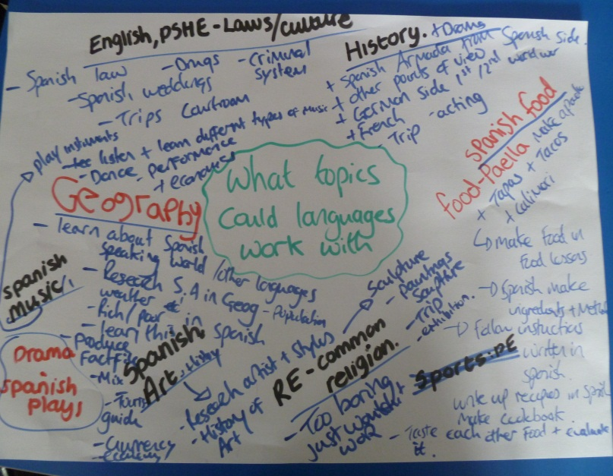GROUP A

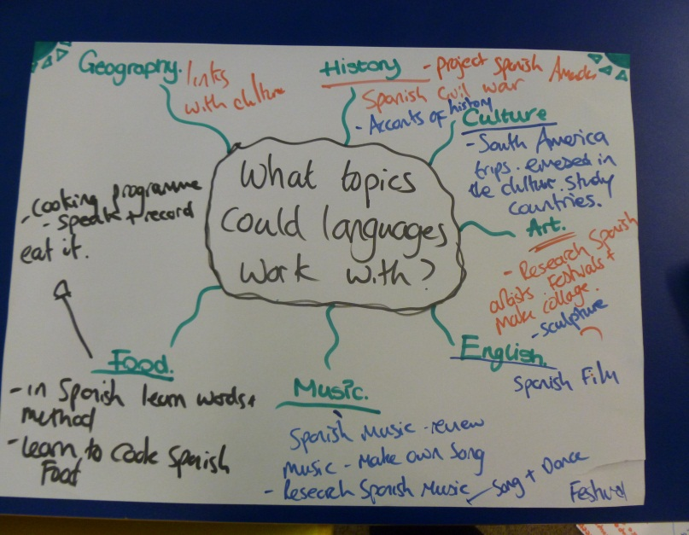GROUP B

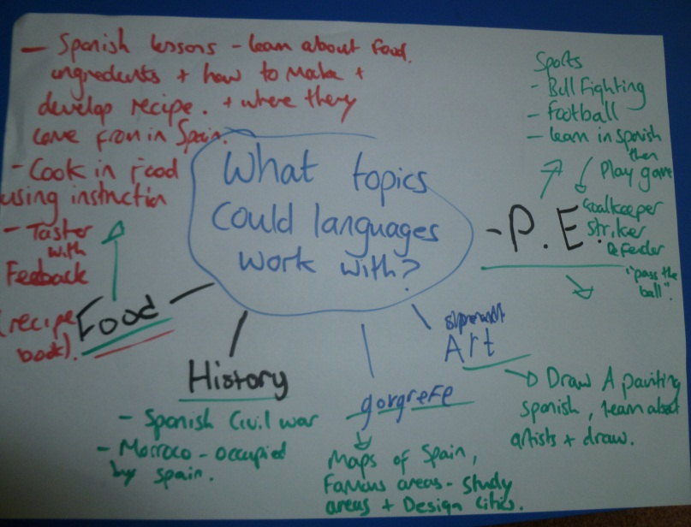GROUP C

The final question that was asked to all participants was: Do you think these projects would benefit your language learning and why?
…I think that doing these projects would be more interesting than normal lessons because we are focusing on more than just Spanish. We will get to use Spanish in more areas and the whole things will just be more fun. 3M
…It will make it more fun because if you were just doing vocab and practising every single lesson it just gets tiresome and you don’t look forward to it. It would make me look forward to the things we were going to do. 1F
…For me it will be more fun because I will be more engaged. It seems more individual and I will work in groups. It will be us deciding how we are going to do this and we will not be told. There will be more independence. 2M
…They will help me concentrate more, they will be more interesting and motivating for me, it gives us that something else to do. 1M
…For me it will make Languages a bigger part of the school and less by itself, it will make it part of other subjects as well. 1F
…These topics here would make me learn more that is not in my comfort zone, so it would be a bit more of a challenge. I don’t want them to be too hard though. I also think it would benefit me more as a person because when you are like just learning vocab then you are just learning vocab, but yeah, this will help me with my general knowledge as well. I will learn so many more things about the place. 1F
…It will make everything more realistic because you will be learning about the country and places in the country. It will give me a chance to know about these things. 2M
…To sum everything up we would prefer the G.C.S.E. to be more about art, history and other things but because there is the exam that is different to these topics then there needs to be a balance between what we normally do and these projects. 1M
…I would like to see this (these projects) happen. 2M
During the literature review I stated that I wanted to investigate whether this thesis could support or contradict any of the theories surrounding why Year 9 pupils suffer from a lack of motivation towards language learning. Lee et al (1996) stated that “in overall preference terms languages rated lowly against other subjects both in terms of enjoyment and lesson content” (p. 56), similarly according to Chambers (1999) students in Year 9 reflect a “what’s the use stance about their language learning”. (p. 5). When interviewing the groups of participants about the topics they study in their language lessons they voiced similar opinions. The content and topics studied did little to spark participants’ intrinsic motivations, and with many topics students failed to see any extrinsic benefit either. Whether their enjoyment for studying languages rated lower than other curriculum subjects was not investigated. What was clear, however, was that levels of enjoyment were not high.
The question to be asked is: Can anything be done to change this lack of motivation towards language learning? In its current state the content taught in language lessons in the school is failing to “offer a curriculum that is appropriate to the developmental and learning needs of adolescents”. (Hirsch, 1998, p. 73). The curriculum is failing to address students’ desires for intrinsic motivational factors, such as developing new ideas, challenges, developing knowledge, aesthetic appreciation, excitement, and fun. The above cross-curricular projects reflected this intrinsic motivational need that students require to maintain their interest in language learning. What needs to change in order to realise these benefits are revisions to the languages curriculum, the schools’ current approach to cross-curricular language teaching, and content taught in lessons to better reflect the thoughts and opinions participants offered as part of this research project. If these voices are not listened to and acted upon then I believe students’ motivations towards language learning in the school will remain low.
I find it interesting that there are many comparisons between what participants of this research wanted these projects to be like and the definition provided by Deci and Ryan (1985): “When the educational environment provides optimal challenges, rich sources of stimulation, and a learning context of autonomy, this motivational wellspring in learning is likely to flourish”. (p. 145). In this instance, the choice of activities provide students with optimal challenges. Choosing a topic that is of interest to them would provide rich sources of stimulation, and the group environment plus the empowerment of the group to complete activities provides the context for autonomy. Therefore, student motivation towards language learning when undertaking such projects should flourish.

6.4 Differences in Group Responses
There were, again, subtle differences in the responses between the higher and lower attaining groups. The lower attaining group found it especially difficult to provide examples of cross-curricular collaborations. They found it a particularly time-consuming exercise to think of a topic and link it to another curriculum area. Those participants also found it challenging to provide example activities for each of the curriculum areas, and the tasks suggested were more physical or kinaesthetic activities containing minimal target language input. In contrast, the higher and middle attaining groups had no difficulties in suggesting topics that covered a range of activities.
The lower attaining group also struggled with defining the role of the teacher. They found it a difficult concept to grasp that a teacher could or should be anything other than a constant source of input. Although the group seemed to respond positively to the idea that they could be given a range of activities to organise and complete themselves, all participants in the group expressed a desire to work with people in the “higher sets” through fear that they would not be able to comprehend what was required to complete the tasks. In contrast, participants in the higher attaining group wished to only work with people in their set as they thought that working with pupils from lower attaining groups could negatively affect the behaviour of the group, or increase the work load placed on the higher attaining students.
The higher and middle attaining groups managed to maintain their interest and engagement with the research from the first to the final interview. Both groups expressed a desire to continue the research process through continuing their weekly interviews, even when I was satisfied that I had enough data and participants had agreed that they couldn’t think of anything else to add. I therefore question whether these participants had any additional thoughts or opinions they had not expressed, or whether they preferred the atmosphere of the group interview over their normal language lessons. If indeed they did prefer the group interview situation, then this certainly supports participants’ claims throughout this research that they prefer to work cooperatively rather than individually.
On the other hand, I felt that the lower attaining groups’ concentration levels were wavering during their final interview. These participants were becoming increasingly distracted by other materials in the room, and continually started personal conversations that were irrelevant to the research. The group was also getting tired of completing the activities with the questions, and had no desire to write down any of their answers during the final interview. As a consequence, I wrote down their answers on the A3 paper and asked participants if they were happy with what I had written down at the end of the interview. Upon completion of the interviews participants in this group said they were pleased that they had done the interviews, but were pleased that there would be no more because they were starting to get a bit bored.

6.5 Summary
There were two trends that were used as the descriptive codes for this section of the data analysis: How students believed cross-curricular language projects should be run, and example projects students wanted to study. These are addressed individually.
How students believed cross-curricular language projects should be run
- Participant perspectives suggested that students disliked the current single-method evaluation tasks that focus on individual performance. They wanted projects to be assessed in terms of the group, using a multi-method approach.
- The data suggested that students did not want such evaluations to be marked and compared / analysed against others.
- Participants elaborated that at the start of the lesson the teacher should provide input, expectations and targets. They should then leave students to plan, organise and complete these tasks in their groups.
- Students believed that during the lesson the teacher’s role should be that of an observer, checking student progress and answering student questions rather than providing direction or instruction to groups, in order to encourage student autonomy.
Example projects students wanted to study
- Participants were able to provide a range of example projects covering a variety of curriculum areas.
- Participants were not only able to plan such projects in terms of thinking about a curriculum area and topic to study, but they also provided example activities of what to do in each subject and ideas for evaluative tasks.
- These projects included topics and activities that were primarily based on participants’ intrinsic motivations towards language learning and would better inform students about the target language group.
- Participants suggested that they wanted the activities in these projects to challenge them.

6.6 Chapter Summary
As stated in the introduction of this chapter I have decided to conclude this chapter by providing a summary of the important issues raised by each of the groups during the data collection process.

6.6.1 – The Higher Attaining Group
These pupils demonstrated a detailed knowledge of previous cross-curricular collaborations between subject areas, and were readily able to identify additional topics, not specific to languages, that could benefit from a cross-curricular approach. However students in this group were not satisfied with these experiences for a number of reasons, including the length, organisation, pace, frequency, and recognition of their work. These elements were considered as unchangeable as they felt they had no influence over the teachers in changing these details. Any intrinsically motivating behaviour encouraged by the choice of topic selection was quickly replaced by frustration due to students not being given control of who they could work with. The difference between students’ levels of attainment and accepted goals within the group soon led to demotivating experiences, with many students belonging to this higher attaining group not wishing to take any strategic action towards the completion of the project through fear of being left to do all of the work themselves, or through fear of bullying from other members of the group. These students believed that they should have been given more control over the learning environment, and be empowered to feedback to their teachers with the goal of changing some of the unchangeable elements listed above, and improving their own learning experiences.
In general this group demonstrated positive attitudes towards language learning, and the fast pace of their language lessons, which often incorporated a range of tasks and skills, helped maintain their interest and concentration. However many of the topics studied did not live up to their expectations in terms of content, which they often considered to be lacking a cultural element, failed to promote intrinsic or extrinsic motivations, or unchallenging compared to the topics studied in other curriculum areas. They did however appreciate the opportunity to work independently in small groups or pairs, and were grateful for the increased control such a working environment provided. These students demonstrated very ambitious beliefs about the purpose of language learning and what they should be able to achieve, and were therefore left frustrated when they realised they were not able to achieve what they wanted. An example of this was their belief that they should be able to readily communicate with members of the target language group about subjects similar to what they talk about with their friends in school, but the lack of suitable vocabulary and opportunities to practice such conversations generated frustration.
When students in this group were asked to provide example cross-curricular projects they demonstrated strong knowledge of the current evaluative methods used in language lessons, and side lined these traditional methods to incorporate more multimodal forms of evaluation, which often included examples of how, when and where the project should be evaluated, and how their evaluations could best be displayed or recognised. Once again they demonstrated very strong beliefs in the active role the learner plays in the process of learning, and felt that they should be given control over the learning environment over aspects such as the planning and completion of various tasks and length of the project, with the teacher acting solely as a figure of support. They were extremely confident that they could assume these responsibilities.
In conclusion this group would greatly benefit from designing cross-curricular language projects that encouraged independent learning in the form of working in small groups with students of similar levels of language attainment. From the data it was clear that these students had often academically challenging ideas regarding choice of topic and possible evaluation method, and the teacher, with or without the input of students, should design tasks that reflect this level of academic challenge. These projects should also empower students by giving them a voice to comment on how the project could be adapted or improved.

6.6.2 – The Middle Attaining Group
These pupils demonstrated a working knowledge of previous cross-curricular collaborations, but initially struggled to think of subject areas that Languages could work with as they had no previous examples of which to draw from, helping to solidify Languages as an isolated subject. As with the first group, students in this group were dissatisfied with previous cross-curricular projects due to their length, which often was considered as a barrier to concentration. They acknowledged that this lack of concentration was not what they considered to constitute a good learner, but they felt powerless in changing such behaviour. Students were generally more positive than the previous group about previous experiences of working in groups and stated that they were normally paired with people in their class, meaning that they were working with students of similar language attainment. These students also wanted increased levels of control, mainly in order to suggest topics that promoted intrinsically motivating behaviours, rather than changing aspects of the learning environment such as the organisation or pace of the lessons, as they believed these were unchangeable, although they agreed that an incorrect pace to such projects also hindered their concentration levels and behaviour.
These pupils were neither very satisfied nor dissatisfied with their current language lessons in the school, but expressed favourable attitudes towards lessons that included kinaesthetic activities. They also recognised that to some extent that the topics would be more engaging if they contained a cultural element, but this did not really ignite students’ intrinsic motivations as it did with the higher attaining group. They adopted a passive stance to their language studies and generally accepted the lessons were “the way they were”, but expressed desires for a greater level of control through independent learning in groups. These students were often left frustrated with tasks in lessons, especially if they believed that the work was above their current level of language attainment or accepted goals, and writing tasks were often considered as such. Students in the group responded extremely positively towards speaking activities and saw the ability to communicate with members of the target language group as the most motivating aspect of language learning.
When asked to provide example cross-curricular projects students demonstrated a distaste for the current evaluative methods but struggled to articulate any alternative methods apart from the use of video and performance. These students did not warm to performance goals, and agreed that comparing their performance with others in the class often led to demotivating and embarrassing experiences. When formulating their example projects students in this group started to express more concrete desires for control over the learning environment in terms of organising the completion of tasks in order to meet the aims of the project, but still believed that the teacher should be the authoritative figure at the beginning and end of lessons, providing details of the project and a goal to achieve by the end of the lesson.
In conclusion this group, along with the previous group, would benefit from cross-curricular projects that encouraged independent learning in the form of working in small groups with students of similar levels of language attainment. The choice of topic should not only encourage students’ intrinsic motivations, but additional reinforcement or explanation of why such a topic would be useful or interesting to study would also be beneficial. The teacher needs to select tasks that are suitable to the students’ current attainment level, and should act as a source of direction at the beginning and end of lessons, whilst providing support and a less central role through the bulk of the lesson. Exercises and evaluative methods that are kinaesthetic in nature and encourage the use of video and / or performance should help maintain student concentration levels.

6.6.3 – The Lower Attaining Group
These pupils struggled to recall previous cross-curricular collaborations, but accepted that they had probably taken place. One of the reasons for the lack of clarity could be down to insufficient knowledge of the definition surrounding cross-curricular, although the group assured me that they had heard of the term and understood its meaning. Another reason why these students encountered difficulties in recalling such projects could have been down to the lack of clear concise instructions provided by the teachers. Students felt that they were just told that they would be doing these projects, without any real understanding as to why, or what the project entailed. They felt that such projects were something that happened to them, and they were powerless in changing any of its details as the teacher would not listen. These students expressed no desires to have increased levels of control in order to influence the topic studied, but did express desires to work with friends or students with higher levels of language attainment.
The majority of students in this group did not enjoy their language lessons and believed that they have no control over their language learning, as with the previous cross-curricular projects, it was something that is done to them. They believed that they were simply not good at languages, and attributed this failure to the teachers failing to meet what they believe to be the factors allowing them to achieve a higher level of language attainment: The use of ICT and too many worksheets or writing activities. Students in this group were often left frustrated by the topics studied, not through their desires to study intrinsically motivating topics, but rather because they did not understand why they were studying such topics and struggled to evaluate them positively in terms of their future educational or professional lives. Their concentration and behaviour in lessons deteriorated as a result, and although they accepted that such behaviours did not constitute a good learner, they blamed the teacher and others in the class, rather than choosing to adopt self-regulation or self-management strategies to modify such issues. As with the previous group they agreed that being able to speak the language was very motivating and that it made you look “good”. However their limited knowledge of vocabulary made this desire unachievable, which led to feelings of under achievement in the group, which were consequently attributed to the failings of the teacher.
When asked to provide cross-curricular projects students in this group also expressed desires for evaluative methods that did not focus on individual performance or grading. They preferred evaluations to be undertaken as a group rather than the individual, which avoided the singling out of students. They accepted that they had low levels of language attainment, and did not want further attention to be bought to this fact, although they were unable to provide examples of alternative methods. They did not offer any views regarding the role of the teacher but did state that they wanted to work in groups and designed cross-curricular projects based on physical kinaesthetic activities such as football.
Although this group found it more difficult to offer and elaborate their views surrounding possible cross-curricular language projects this itself provides useful data in terms of suggesting the types of cross-curricular projects these learners would benefit from. For example, such projects should allow students to work in small groups and although the choice of topic plays a less important role than in the other two groups, it is of utmost importance that students understand why they are undertaking the project and how it is of interest to them. They need constant instructions on how to complete the project, in language that is comprehensible to the attainment level of the group. Clear and understandable instructions are fundamental in encouraging these students to take a more active role in the learning environment. The use of purely kinaesthetic activities will help maintain student concentration and behaviour levels. The unit of evaluation must focus on the group rather than the individual.

Chapter 7 – Reflections on the Research Process
The aims of this chapter are to:
1. Reflect on the interviews.
2. Reflect on the use of pupil voice.
3. Reflect on the lower attaining group.
4. Reflect on the cross-curricular examples provided by students.
5. Reflect on being an insider researcher.
6. Reflect on the validity of this research.

7.1 Reflections on the Interviews
I believe that the semi-structured interview was the correct type of interview for this research project but it was not without its problems. During the initial stages of the interview process I found that all three groups were able to respond to closed questions such as “do you like your language lessons” with relative ease, even if responses were often limited to one word, whereas more open pre-determined questions such as “tell me why you like or dislike your language lessons” were often met with silence or confusion by participants. As a consequence, after the first round of interviews I felt that the approach I was using was more structured than semi-structured, and, given that the research was conducted over four rounds of interviews, it would be a fair estimation to say that around 25% of the interviews adopted a more structured approach.
This may raise questions about the validity surrounding the approach to data analysis as the structured interview promotes a more quantitative approach to data analysis. I decided however to adhere to my original research methodology and analyse the data qualitatively. My main reason for doing this was that although 25% of the interview time could be considered as structured, the amount of usable data obtained from this time was insignificant compared to the data obtained in subsequent interviews. The frequent one word answers provided by groups provided very little scope or evidence regarding their thoughts and opinions on cross-curricular language teaching.
Despite this initial lull in the data the subsequent rounds of interviews provided what I believed to be a sufficient amount of data to tackle the subsidiary research questions, not least due to the combining of pre-determined questions with activities. The combining of activities with questions such as: “What topics or activities do you like to study as part of your language lessons?” were advantageous in a number of ways:
- They prevented participants from giving one word answers as they knew that they were required to produce something.
- This sense of need encouraged conversation between group numbers.
- This conversing between group members encouraged questioning and reflection on aspects of their learning.
- The views and opinions raised in such discussions aided the formulation of additional lines of questioning.
Although it could be argued that this sense of “requirement” to produce an answer may lead to participants providing any answer, and one not representative of their views or opinions, I would argue that the group environment helped significantly reduce any such concerns. Many of the initial ideas presented by participants were discussed and later changed or modified upon further discussion, and ideas were not written down on paper until a decision was made about what should be recorded. Furthermore, I believe that without these activities I would not have achieved the same depth of data, and the interviews would have continued to be of a structured nature, compromising both the approach to data analysis and validity of the research.
The combination of using questions with activities also, I believe, encouraged participants to develop their metacognitive abilities. These activities provided opportunities for participants to discuss, think about, reflect upon, and evaluate their learning. These reflections were made possible by participants’ self-questioning aspects of their own language learning, “searching for connections and conflicts with what is already known” (McCallum et al, 2000, p. 276), and using these connections to derive both positive and negative aspects of their previous language learning to inform how they wanted any future cross-curricular language projects to be managed.
The group interview environment provided more advantages than just allowing participants to discuss and develop their answers; I believe I was able to obtain far more data over the twelve hours of interviews than I would have been able to with individual interviews. I also believe that the group interview provided a more relaxed atmosphere for participants, and that the focus, pressure, and anxieties felt by participants during an individual interview were able to be dispersed amongst the group. Finally, as Bogdan and Bilken (1992) state, the group interviews allowed me to “bring together people with varied opinions” (p. 100), and the discussion of different individual responses not only made sure that nobody’s opinion was marginalised but also allowed me to recognise these different opinions in the data analysis process.
A further reason why I believe this type of interview was successful is that I was thorough with my participant selection. I made sure that I selected participants who would not dominate the interview process, who would not allow or attempt to marginalise other group members to express their views or opinions. I also made sure that there were no underlying friendship or social issues between group members, and that participants were familiar with each other, but not over-friendly, in a further attempt to try and encourage communication. I believe that my position as an insider researcher allowed me to achieve this.
One difficulty with the interviews came from the higher attaining group. After the initial difficulties in obtaining data during the first interview, opinions started to be discussed and exchanged at a fast pace. Even though I attempted to direct the interviews so that only one group member was talking at any one time, this exchanging of views often meant that participants would talk over each other in order to have their opinion heard. This made transcribing the interviews a difficult task. I cannot say for certain whether these overlaps in participant speech led to certain views being withheld and not discussed, and at every opportunity I asked the group if there was anything to add before moving on. Overall, I remain happy with the amount of data obtained from this group. If I were to conduct the interviews again I would have split the higher attaining group into two smaller groups for the final three interviews. It would be interesting to see if this would have yielded more data.
On a final note, one aspect of the research that did make the interviews easier to transcribe was that participants agreed that they did not mind if the interviews were not deleted after transcription. This means that I was given the freedom to transcribe the interviews, and then return to the recordings at any point if I felt that I had missed something important. There was no pressure to transcribe and then quickly delete the recordings.

7.2 Reflections on Pupil Voice
Throughout the research process I attempted to be mindful of the practical issues of pupil voice. Firstly, Alcoff (1992) outlined the problem of speaking about or for others and that the language used when doing so is often saturated with values. To try and avoid this, no question during the interview process, either pre-determined or otherwise, required participants to talk about anything apart from their own views or opinions on various topics. At times, participants from all three groups made reference to other students in their class or, more commonly, their class teacher. At such points I endeavoured to remind students that their responses should not make reference to anybody but themselves. These instances of talking about and for others were still transcribed after the interviews, but were not included in the data analysis.
The fact that participants discussed their own thoughts and opinions on a number of topics means that this research is laden with their values, and therefore this research must not be considered as value-free. I realise, therefore, that this research would not be considered valid or reliable by the positivist researcher. However, I defend this research as I have stated since the introduction that this was an interpretive piece of research and should be treated as such.
Rudduck (2002) stated that for pupil voice to be successful, dialogues need to be undertaken “without fear of retaliation from others”. (p. 131). At the beginning of the interview process all three groups seemed reluctant to share any negative opinions they had about Languages, but were forthcoming with positive comments. No doubt my position as a languages teacher acted as a barrier to expressing such opinions. At the beginning, and at various points throughout each interview, I reminded students that my position was one of a researcher and not of a languages teacher and that any negative comments would be welcomed and were important to the research. However, no matter how much I assured participants of my position as a researcher, I cannot say with certainty that no comments were withheld, and that if the research was undertaken by an outsider then the comments would be more negative or positive. What I do know is that my reassurances did elicit negative responses about Languages, and when participants saw one member of the group talking negatively others followed suit.
Another barrier to openly talking negatively about certain subjects was highlighted by participants who asked: “What about if they read this, they are going to know who I am”. It was a concept that I had not considered before conducting the interviews, but I knew that I had to take every step possible to try and protect the participants’ identities both during and before the research process.
Participants were interviewed during lesson time, and their class teacher had given them permission to miss a sequence of their lessons to work with me on a research project. However the class teachers did not know what the research was about, which interview group their students were a part of, or indeed the names of any other students from other classes taking part in the research. During the interview process, participants were reminded that all answers would be anonymous. As with the previous point, I cannot be certain that if teachers read this research then they would find it impossible to work out who said what. The direct quotes used in the research may act as clues, and I cannot account for what participants may have said outside of the interview, but I am confident that I have made the task of participant recognition as difficult as possible.
The concept of teachers reading this research brings me onto another of Rudduck’s practical concerns of using pupil voice: Letting students know what is happening as a result of the research. Firstly, participants involved in the research had the opportunity to read the results and conclusions of the research before it was submitted, and will have the option of having a copy of the research after submission, although all participants decided not to take up either offer. Secondly, participants were aware that the research would likely be read by members of the languages department, and that such staff would most likely be interested in reading the example cross-curricular language projects they provided. I use the word ‘likely’ here in relation to the previous point that staff did not know the topic I was researching. They will be informed about the research after submission as I have agreed to present the research in a departmental meeting. I believe they would most likely be interested in the cross-curricular examples, as various members of the department have previously expressed an interest in launching cross-curricular collaborations. Finally, all participants understood that the work would be read and assessed by examiners and academic staff from various universities.
It is important to acknowledge the contribution of my fellow languages teachers at the school to this research project. Throughout the research process they were extremely supportive, especially when allowing students involved in the research to miss a sequence of their lessons. I took the time to explain to the teachers how important confidentiality and anonymity were to the research process, and although I could not stop them communicating with other teachers to find out which pupils were involved in the research process, they said that they had no need to find out this information, and I believe they did not investigate this. They also understood when I explained that I was unable to provide any details of the dynamics of the groups, or which groups their students would be working in, as this could lead to readers working out exactly who said what. Finally, they were happy to be informed about the research in a departmental meeting after the thesis had been submitted. Throughout the research process I got no sense that colleagues were unhappy about the way I conducted, or informed them about the research. They were happy to remain detached from the research process.
Another concept that was presented in the literature review was the andragogical approach. The approach focuses on the planning and implementing of institutions’ schemes of work. These schemes of work are constructed based on the thoughts and opinions of learners explored through pupil voice exercises. Therefore, what is said by learners during these exercises directs what is included in the schemes of work. Was this approach successful? There can be no doubt that the information gathered would be sufficient in planning schemes of work, the example cross-curricular projects are evidence of this. However, in order for the approach to be fully adopted these examples would have to be incorporated into the existing topics, or replace some of the existing topics in the languages’ schemes of work.
Although this research centred on the exchange of information between participants and researcher, I do not believe that this pupil voice research could be described as transformative. Participants were not empowered as researchers and were not required to identify the issues to be researched during the investigation. Similarly, participants did not act as co-researchers; there was no exchange between researcher and participant to identify the issues to be researched, or how they would be researched.

7.3 Reflections on the Lower Attaining Group
The fourth subsidiary research question required me to focus on the responses between the top, middle, and lower attaining groups of students. When I was writing the data analysis chapter I felt that the summaries presenting the differences in group responses mainly focussed on the similarities in responses between the higher and middle attaining groups compared to the lower attaining group. I felt the higher and middle attaining groups were often cast in a positive light, demonstrating positive attitudes towards language learning, and the lower attaining group in more of a negative light, demonstrating typically stereotypical behaviours of disaffected and disengaged language learners such as: Negativity towards the teacher, poor communication and verbal skills compared to higher attaining students, and poor levels of concentration and behaviour.
It needs to be made clear to the reader that it was not the intention of this thesis to single out the lower attaining group, or further cement the stereotypes that already exist around such students. On the contrary I believe that the lower attaining group were able to provide some crucial data for this investigation and as a consequence I was able to provide recommendations as to how they may want such cross-curricular projects to be implemented and managed. If I were to undertake this investigation again then I would attempt to cast the lower attaining group in less of a critical light, by focussing more on what they are saying, rather than what they are not saying.

7.4 Reflections on the Cross-Curricular Examples Provided by Students
Following on from focussing on what the groups of students were saying during the interviews I believe that the cross-curricular examples provided by the groups generated some excellent ideas, incorporating a wide variety of language input and tasks that encourage a multimodal approach to learning. For example, the idea of studying the topic of food encouraged the learning of vital grammar constructions such as the imperative (mix, pour, drain), with equally vital vocabulary focussing on numbers and quantities, whilst the consideration of writing recipes, acting out role plays in restaurants, researching foods on the internet, cooking and tasting food, and creating written or oral critiques provided the foundations of introducing a range of multimodal tasks.
Similarly, in the next example about conflict and war the key language comes from learning key dates, whist the suggestion of acting out scenes from wars in drama lessons, preparing scripts for plays, and creating timelines in various languages provides the basis for multimodal learning. I was both impressed and surprised by the level of sophistication shown by students through their desires of wanting to study the sides of both parties involved in various wars. This got me thinking how interesting it would have been to study such things during my school language studies. There are similar examples of vital language input and suggestions for multimodal tasks in all of the example cross-curricular language projects suggested by students.
What surprised me about the choice of topics suggested by participants, apart from their level of sophistication, was that they seemed infinitely more interesting than the topics students currently study during their language studies. Although students during the interviews did not directly state that the topics currently studied were undemanding, I can’t help but think that they are compared to the topics suggested during the interviews. What is evidently clear however is that serious revisions to the languages’ schemes of work would be necessary in order to incorporate such topics.

7.5 Reflections on Being an Insider Researcher
During the methods and methodology chapter I argued that because I worked at the school and was familiar to participants then I would be seen as an insider rather than an outsider researcher. However, as the interviews progressed I became more and more aware that the distinction between these two variables was not as clear cut as it seemed, and that there was a lot of fluidity between the two, confirming Mulling’s quote that “the boundaries between the two are both permeable and highly unstable”. (Mullings, 1999. P. 33). In fact, upon reflection I would call myself both an insider and outsider researcher, with certain traits of the research being described as insider and others outsider.
From the outset of the interview process I realised some of the well documented advantages of being an insider researcher, such as ease of access to participants, and the ability to arrange or rearrange interviews with very little notice. However, at times during the interviews it was hard to determine whether I was considered an insider or outsider researcher by participants. I believe that there were three main reasons for this confusion: Positionality, power, and representation.
Positionality, in my interpretation, is determined by where the researcher stands in relation to the researched. Furthermore, it should be acknowledged that a researcher’s position vis-à-vis the researched can change. For example, my position before the interviews as being confident of being an insider researcher changed as the interviews progressed, so that by the end of the interviews I felt that I had changed from being an insider to an outsider researcher many times. The question I wish to address here is: Why did I feel that my position as an insider researcher was constantly changing?
According to Narayan factors such as “education, gender, sexual orientation, class and race may at different times outweigh the cultural identity we associate with insider or outsider status”. (Narayan, 1993. p. 671). I believe that this quote goes someway in explaining this constant changing of status. I believe that at the beginning of the interview process participants afforded me a general insider status due to the level of familiarity I had with them. However, as the interviews progressed and participants started talking in depth about their language learning it was clear that I was at times seen as an insider, and at times an outsider, or at least a teacher conducting interviews, which made me an outsider to the student community.
The fact that I was familiar to the students meant that total detachment was impossible, and the dialogue between researcher and participants was more personal than it would have been with a totally outsider researcher. Evidence of this was that participants would become side-tracked at various points during the interviews, wanting advice on topics not relevant to the research, such as what G.C.S.E. language option they should take; advice that I would be happy to give outside of the research setting. Participants also used this familiarity to relate to previous language learning experiences. For example, when participants were asked to think about the positive and negative aspects of their previous language learning responses often started with “you know when” or “do you remember when”. As a consequence, at certain points during the interviews it was difficult to maintain objective interaction, supporting Simmel´s (1950) dated but relevant quote that; “only the neutral outsider can achieve an objective amount of human interaction, because only he or she possesses the appropriate degree of distance and detachment from the subjects being researched”. (p. 405).
One advantage of this lack of detachment with participants was that it promoted, as the group interview did, a more informal, laid back, and less pressured environment during the interviews. I believe this atmosphere helped alleviate issues such as shyness or unwillingness to openly share opinions with the researcher, and as a result, information was free flowing, although not always completely objective.
Power relationships also played a big part in the confusion between my role as an insider or outsider. It is my belief that the insider researcher has an equal relationship to those being researched, but the fact that participants related to me primarily as a teacher meant that any chance of an equal power relationship was impossible. Evidence of this was that instructions such as “do you understand what you have to do?”, were often met with the response “yes sir”, or hands were raised when participants wanted to contribute to discussions, as they would be in a classroom situation.
Representation of the findings from this research project may well come into criticism if I cannot commit to being either an insider or outsider researcher. Positivists may argue that my relationship with participants “may mean that the results have become distorted” (Kvale, 1995, p. 34), or “that the “obvious” question may not be asked” (Hockey, 1993, p. 206), or “people may not share information with an insider for fear of being judged”. (Shah, 2004, p. 569). Similarly, as I was not seen as being part of the student community by the researched, participants may well have not related to me as a true insider, and certain views about their language learning may not have been shared, through fear of retaliation, or not being comfortable expressing certain views to an outsider. In order to try and combat the issue of representation and being an insider and outsider researcher I wish to return to the three questions I outlined in the methods and methodology chapter:
- Did my relationship with the students have a negative impact on their behaviour, were they behaving in a way that they would not normally?
I do not believe so. In fact I believe that the small numbers, the dynamics of the group, and the interview situation kept students focused.

- Would my insider knowledge make me make false assumptions on a topic because I assumed I knew what participants were trying to say without actually asking them the question?
I attempted to avoid this potential dilemma by asking students to explain every idea and answer in detail, even if I knew the answer. When participants used phrases like “do you remember when”, my response was always no, so that they had to fully elaborate the example they were attempting to give.

- Would my existing position of authority mean that participants were reserved in their responses because of fear of retaliation?
As stated in the section on reflecting on pupil voice I endeavoured to make my position as the researcher clear, and took various steps in protecting participant identities to all outside of the research.
Even though I have acknowledged that I was part insider, part outsider in the research process positivists may still argue that my inability to commit to being either an insider or outsider will detrimentally affect the validity of this research. However, anti-positivism states that arguments surrounding insiderness and the overlapping of insiderness and outsiderness are applicable to all research. For example, how can I be sure that my established relationship with participants affected their responses? I can’t. How can I be sure that because I was not part of the student community certain opinions were withheld? I can’t. All I can do as an insider or outsider researcher is attempt to make the research as honest as possible, which I have tried to do by recognising the implications of my mixed positionality. Would a purely outsider or insider researcher doing the same research with the same participants end up with the same set of data and conclusions? Probably not. Then again, I have my doubts as to whether I would achieve the same data and conclusions if I repeated the research. A reoccurring trend, I imagine, of qualitative subjective research.

7.6 Reflections on Validity
When considering the validity of this research, I needed to consider whether the research addressed the research questions. I believe it does. I also believe that the way I presented the data helps address the research questions. The decision to present the data under each of the research questions was an attempt not only to help present the data in a logical and structured manner, but also to ensure that the research addressed the research questions.
At this point I wished to return to Cohen et al’s (2007) citation of Maxwell’s “five kinds of validity in qualitative methods” (p. 135): Descriptive, interpretive, theoretical, generalisability, and evaluative, and discuss how each of these were addressed. Firstly, to ensure descriptive validity, I ensured that all accounts presented in this thesis were accurate. All interviews were transcribed, and opinions, whether supportive or contrary to the group decision, were included in the data analysis to ensure no accounts were intentionally or otherwise omitted.
In order to maintain the interpretive validity of this research and capture the meanings and intentions of what participants said during the interviews, body language and actions were also transcribed. I attempted to do this by taking notes during the interviews. However, this did not work as well as I expected. The fast pace of the group interview, and the overlaps in speech meant that I simply could not take these notes quickly enough. By the time I had written down that a participant seemed angry when explaining something, the conversation had often moved on and I had missed another two or three peoples’ points of view. On reflection, it would have been useful to film the interviews and then transcribe the body language afterwards. It would have led to greater interpretive validity, although it would have also brought additional ethical dilemmas to the fore.
In order to attempt to maintain the theoretical validity of the research I have linked participant quotes back to various theories presented in the literature review. I have also attempted to answer questions I posed myself throughout the literature review. In an attempt to maintain the generalisable validity of this research, I have stated throughout the thesis that this research is small-scale and context specific, and that the results cannot be generalised but may inform others in similar situations.
Finally, evaluative validity concerns the researcher’s ability to reflect on the project as a whole. Throughout this chapter I have attempted to reflect on the research process and my decisions on the method and methodology used in the research, recognising the advantages and disadvantages of such decisions as well as what I would change if the investigation were to be repeated. In order to further enhance the evaluative validity of this research, I consider the areas of future research in the next chapter.

7.7 Summary
I wished to summarise this chapter by posing the question; do I believe this research to be reliable? If “reliability is essentially a synonym for consistency and replicability over time, over instruments and groups of respondents” (Cohen et al, 2007, p. 117) then this research cannot be described as reliable. However, if Kvale (1996) states that qualitative researchers “who are studying a single setting may come up with very different findings but both sets of findings might be reliable” (p. 181), and LeCompte and Preissle (1993) ascertain that “using human participants is a far more complex issue where issues such as the choice of participants, the social situation and conditions, the methods used for data collection, the body language of participants and the conclusions drawn by the researcher affect the replicability of the study” (p. 332), then it seems that any carefully designed piece of qualitative research, including this one, could be described as reliable.
Rather than this thesis achieving reliability through replicability, I believe it achieves it through reflection, honesty, and openness about the decisions taken from start to finish: Throughout the scribbling of initial ideas, the construction of research questions, the formulation of a research methodology and the collection and analysis of data. It was this sense of reliability through reflection that prompted me to include this chapter in the thesis.

Chapter 8 – Conclusions
The aims of this chapter are to:
- Address the primary research question.
- Provide recommendations for schools and policy makers.
3. Acknowledge future areas of research.
4. Outline this thesis’ contribution to knowledge.
5. Outline this thesis’ contribution to the researcher.

8.1 Addressing the Primary Research Question
The primary research question for this thesis was: Can pupil voice be used to investigate students’ thoughts and opinions on cross-curricular language teaching? In order to address this question I needed to decide how I could effectively tie together the findings presented in the data analysis chapter. I decided that the best way of presenting or combining findings would be to produce a student-based framework for cross-curricular language teaching.
The framework presented has been labelled as a student-based framework as its creation came exclusively from the findings presented in the data analysis chapter, which were based on thoughts and opinions gathered from students during the group interviews. The framework consists of four levels: The topic, the activities, the learning environment, and the role of the teacher.

Student Based Framework for Cross-Curricular Language Teaching
- Intrinsically motivating.
- Inform students of target language culture.
- Uses target language outside of languages classroom.
- Uses multimodal forms of evaluation.
The topic
The activities
The role of the teacher
- Minimal input.
- Monitor rather than educator.
- Good communicator.
- Encourage and listen to student feedback.
The learning environment
- Groups selected by students.
- Promote co-operative learning.
- Group rewards with individual accountability.
- Display and recognise students’ work.
- Encourage integrative motivations.
- Short, varied exercises.
- Use PowerPoints.
- No text heavy documents.

Under the topic level, ‘intrinsically motivating’ refers to participants’ need for the choice of topic to promote intrinsic motivations. In order to help encourage these types of motivations, the topic must be of interest to the students. The research data suggested that a topic that informed students about the target culture would maintain student interest in a topic. The topic should also encourage the use of target language in environments other than the languages classroom, whether it be in other curriculum areas or outside of school. One of the participants’ frustrations with their language learning was that they did not have sufficient opportunities to practise the target language outside of the languages classroom. Participants also stated that they were unhappy with the language departments’ current evaluative methods; an end of unit test that encouraged extrinsically motivated behaviours. Participants wanted to see more variation in the methods used for evaluation purposes, such as video or performance.
Under the activities level, ‘encourage integrative motivations’ refers to participants’ desires that the work they undertake should help them meet, socialise, and integrate with members of the target language population. Short varied exercises allowing students to complete a range of activities during such exercises were preferred to working on one activity for the whole lesson. Participants also preferred that lesson content and activities be delivered using PowerPoint presentations. The main reason for this was to move away from text heavy documents such as worksheets. ‘Text heavy documents’ also references the fact that participants did not want these projects to require them to produce long pieces of writing, as students simply found it too challenging.
Under the learning environment level, ‘working in groups’ refers to participants’ firm beliefs that they should be allowed to choose who they work with for such projects, and that if they were unable to choose their groups they would not enjoy the topic, whatever it may be. The need for a cooperative learning environment underlines participants’ desires for all members of the group to be involved interdependently in the learning process through the sharing of ideas and problem solving strategies to complete tasks introduced by the teacher. The importance participants put on the approach led them to acknowledging work produced in terms of the group, whilst recognising individual accountability for those that excel or do not contribute sufficiently throughout these cross-curricular projects.
Under the role of the teacher level, ‘minimal input’ refers to participants’ views that the teacher should provide students with the details of the project, such as the topic to be studied and the curriculum area Languages will be working with, the aims of the project, details of how it will be evaluated, a time frame, distribute the tasks or activities to be completed by students, and provide groups with a target to achieve each lesson. After these issues have been communicated to students, the teacher should then monitor student progress whilst allowing them to organise and execute the project and activities on their own. As well as effectively communicating with students, teachers working in different curriculum areas involved in the running of any such projects must maintain high levels of communication, to ensure that the project is running smoothly and that the content is being taught effectively in parallel with the other subject area involved. Teachers should also encourage pupil voice exercises upon completion of such projects so that they may be better implemented or modified in the future.
It is important to note that the previous framework was constructed by analysing the responses from all three of the groups that took part in the research process, and therefore does not focus solely on the higher, middle, or lower attaining group, but attempts to represent, in some part, the voices and suggestions of all three. As a consequence the framework may need adjusting slightly if it were to be used to implement cross-curricular language projects using only the higher, middle, or lower attaining students. For example, under the role of the teacher level although the lower attaining group suggested that they wished the teacher to provide details such as the aims of the project, a time frame, explanation of tasks and lesson objectives, they struggled to accept that the teacher would then effectively leave them to complete the tasks, and preferred the teacher to play a more active role in providing support or help to students about how they may go about completing the tasks. In contrast, the higher attaining group wanted the teacher to play a secondary role in the learning environment after informing students about the details of the project and tasks, but the students themselves expressed desires about being consulted about how such tasks would be designed and implemented. It is the recognition of these that I believe will aid the successful implementation of any such cross-curricular projects.
An Incomplete Picture?
I believe that the above framework, although useful in presenting the thoughts and opinions of students surrounding cross-curricular language teaching, is incomplete. It is incomplete because it does not recognise any of the barriers to implementing such a framework for cross-curricular language teaching. These barriers were either caused by actions taken by the school or at a governmental level, and were alluded to by participants during the interviews or the literature presented in the literature review. What is required, therefore, is an additional framework running alongside the above framework entitled ‘Barriers to implementing the student based framework for cross-curricular language teaching’.

Barriers to Implementing the Student Based Framework for Cross-Curricular Language Teaching

G.C.S.E. Examinations
The National Curriclum
- No inspection criteria for cross-curricular language teaching.
- Impermeable and overloaded schemes of work.
- Lack of curriculum time.
- Key Stage 4 option choices.
- Modular exams and coursework.
- Extrinsic motivations (introjected regulation).
- Institutional motivations.
OfSTED framework 2012
Additional school responsibilities
The barriers presented in the above framework are likely to restrict the possibilities of implementing cross-curricular language projects within the school where the research took place. Therefore, in order to successfully implement any cross-curricular language project centred on the student-based framework for cross-curricular language teaching, the above barriers would first have to be addressed.
The importance that the participants, school, and government place on G.C.S.E. examinations promotes strong levels of extrinsic / institutional motivations within students. These motivations were evident in the Year 9 students who were interviewed. If these types of motivations are being nurtured in students starting the Key Stage Four syllabuses, who are still two years away from sitting their G.C.S.E. exams, how strong are they likely to be when they reach year 11? From experience of working in the school, some students, when reaching the second and third terms of Year 11, demonstrate such high levels of introjected regulation that they find it difficult to focus on anything but their performance in their forthcoming exams. This introjected regulation produces stress and anxiety for many students in the school. Participant perspectives suggested that the topics that participants want to study as part of any cross-curricular language project do not feature in the language exam papers, and therefore, as extrinsic motivations seem to dominate intrinsic motivations for many students at Key Stage Four, although students would be interested in studying such topics, they would choose not to as it would not help them succeed in the exams.
The additional responsibilities the school places on students during Year 9 further cement these extrinsic motivations. Students in Year 9 start the G.C.S.E. Science, Maths, English and Language studies syllabuses and are required to sit modular exams or write pieces of G.C.S.E. coursework throughout the year. Much of the curriculum time is tightly structured, so that the teaching content prepares students for these exams or pieces of coursework. Students also select their additional G.C.S.E. option choices at the beginning of the year, and start the taught content in some of these subjects soon after. These additional responsibilities leave very little spare curriculum time to undertake cross-curricular projects, as evidenced by the lack of cross-curricular opportunities in Year 9.
The OfSTED framework 2012 refers to the fact that there is no regulation stating that schools being visited by OfSTED will be judged on their ability to teach Languages cross-curricularly. Maths and English are regulated in this fashion and it is clear that the legislation has had an effect on participants at the school who regularly alluded to how the skills learnt in these subjects are transferrable and used in other subject areas. Having such legislation for Languages would, I believe, force the school and department to adopt a more cross-curricular approach to its teaching.
The National Curriculum was referenced many times throughout the data analysis chapter. The prescribed curriculum leads to departments creating detailed and inflexible schemes of work, running from September to July of each academic year throughout Key Stages Three and Four, which is certainly the case at this school. The additional responsibilities students face in Year 9, compounded by having to get through the languages’ schemes of work, means that there is often not enough curriculum time available to get through the six half terms worth of teaching content.
A Solution to the Prescribed Curriculum?
The creation of academies is at the forefront of government legislation in this country. However, could academy status be used to promote the cross-curricular teaching of languages? Academies are not required to follow the National Curriculum in subjects. They can follow their own curriculum as long as it is broad and balanced, and teaches English, Maths, Science and Religious Education. Aside from the requirement to teach these four subjects, they have the freedom to design a curriculum which meets their pupils’ needs, aspirations and interests, however, they will be held accountable for their performance in tests and exams which reflect the National Curriculum.
The freedom to design their own curriculum leaves the door open to create schemes of work for the language department that reflect learners’ interests, such as the projects presented in the data analysis. However, it is very much a double-edged sword, as, although the prescribed content of the National Curriculum will be abolished, students will still have to sit the same G.C.S.E. exams at the end of Year 11, which will include the topics listed in the National Curriculum. If the students have not studied these topics then they are unlikely to perform well in the exams. More worryingly, academy status means that, as long as the institution is teaching English, Maths, Science and Religious Education, they do not have to teach Languages at all! For example, an academy near to where this research was undertaken has currently abolished its teaching of Languages and has used this free time on their timetable to teach additional literacy, as the G.C.S.E. results obtained for English fell significantly short of the national average. I would much rather follow the National Curriculum than not have Languages on the timetable at all.

8.2 Recommendations for Schools and Policy Makers
In order to try and address the barriers presented in the previous framework I have made sets of recommendations. The recommendations below come solely from the participants’ voices that were listened to and explored as part of this thesis investigation. There are lists of recommendations to both the policy making bodies of OfSTED and the National Curriculum, and the school where this research was undertaken. I believe that by not taking note of these recommendations then students within the school will continue to receive little to no cross-curricular language teaching, and the sophisticated example cross-curricular projects provided by students will never be realised.
Recommendations for Policy Makers
- OfSTED
  - The Evaluation Schedule for the inspection of maintained schools states that “inspectors will look at how well pupils develop a range of skills, including reading, writing, communication and mathematical skills, and how well they apply these across the curriculum”. (Ofsted, 2012, p. 6). Students’ voices suggested that Maths, English, and Science are taught cross-curricularly in this school. Consider extending the wording of this policy to include Languages.
  - Students in the school saw Languages as an isolated subject, during school inspections, ask for evidence of cross-curricular planning in languages’ schemes of work, as done in English, Maths and Science.

- The National Curriculum
  - The data suggested that the opportunities for subjects that are not considered “core” (English, Maths, Science) to cross subject boundaries are limited. If it is important for Languages to be taught cross-curricularly then consider including it as a “core” subject.
  - If this is not possible then consider changing the wording in the languages curriculum so that it further stresses or prioritises the fact that elements of Languages should be taught in a cross-curricular fashion.
  - The literature suggests that the less prescriptively structured primary school curriculum has led to the crossing of subject boundaries. Losing some of the prescribed content from the languages curriculum could lead to departmental schemes of work becoming less crowded and allow periods of time where cross-curricular projects could be implemented.
  - Changing some of the topics in the languages curriculum to include topics that are described as having to have a cross-curricular element would encourage the crossing of subject boundaries.
  - Adapting some of the existing prescribed content in the languages curriculum would encourage the crossing of subject boundaries.
  - It takes teachers time to plan for changes in curriculum design, if cross-curricular content was introduced, allow a period of time for teachers to adapt before changing such content.
  - The design of the curriculum should include topics that encourage teacher – pupil consultation, or create periods of time where teachers can consult pupils about their learning.
  - The topics in existing or future curriculums, whether cross-curricular or not, should incorporate a larger element of target language culture.

Recommendations for Schools
- Schemes of work (languages)
  - Re-visit the schemes of work and attempt to either modify or remove certain tasks or topics (whilst still covering the National Curriculum content) to allow periods of time where cross-curricular opportunities could be implemented.
  - If time cannot be spared / found then examine the existing topics and evaluate whether any content could be taught in a cross-curricular context.
  - Revisit the topics studied during the schemes of work and see if these could be paired with the topics studied in other curriculum areas.
  - Modify existing / future topics (whether cross-curricular or not) to teach a greater amount of target language culture.
  - Modify existing / future topics (whether cross-curricular or not) to include more opportunities to practise verbal communication between students, or between students and native speakers.

- The Teachers
  - Communicate with teachers in other curriculum areas about the topics studied in their schemes of work, and see if any could be combined with the topics taught in Languages.
  - Plan any projects co-operatively and consider factors such as the time scale as well as the tasks / teaching content.
  - Seriously consider consulting with pupils and ask them to suggest or help develop any of the aforementioned details.
  - Consider that students enjoy tasks / activities that draw on a range of resources and skills, and enjoy a multimodal delivery.
  - Consider that students do not like to be compared to each other or singled out when undertaking tests or evaluations.
  - Maintain communication with the curriculum area or teacher you are working with throughout the project to ensure consistent, parallel teaching.
  - Listen to any feedback or advice from students either after or before the implementation of cross-curricular projects.

8.3 Areas for Future Research
In the second chapter of this thesis; Framing the Research, I outlined the limitations of this research. It is useful to once again state these before considering any further areas of research. This must be considered as a small-scale research project involving data collected from one secondary school. As such, the frameworks produced, and recommendations provided are based solely on the voices explored by the three groups of students that made up the participant sample. Therefore these results should not be generalised further afield, even though I believe they may be useful in informing others in similar contexts or situations.
If I had a suitable time frame and additional words I would be interested in taking this research a step further by interviewing pupils from a range of schools to see if the findings of this research are comparable to others, in an attempt to expand the very context-specific boundaries of this research. I would hope that the data from such schools would allow me to expand or modify my frameworks.
Secondly, this research project is very one-sided. What I mean by this definition is that it only gathers the views and opinions of one group of stakeholders in the school, the students. I would be interested in gathering the thoughts and opinions of teachers regarding cross-curricular language teaching, and pay attention to why they believe there is a lack of this type of teaching in the school, and the barriers preventing them from planning and implementing such projects.
Finally, if ever given the opportunity, I would like to use the example projects provided by participants as part of the data analysis to re-write the schools’ languages schemes of work for Year 9. I would then like to explore data from participants over the course of one academic year. I would interview students at the beginning of Year 9 about their attitudes and motivations towards language learning, and then again at the end of Year 9 after they had completed all of the suggested cross-curricular projects. It would be interesting to see if their attitudes and motivations had changed and in what respect.

8.4 Contribution to Knowledge
The contribution to knowledge this thesis makes is small and very specific. It does not attempt to add to the vast amount of published literature surrounding pupil voice, cross-curricular teaching, or student motivations towards language learning, although they are acknowledged in this thesis, but rather it strives to combine these three aspects in order to demonstrate to the reader how the thoughts and opinions of learners can be explored to develop a workable framework for cross-curricular language teaching. In my time searching the literature, I have found various examples of cross-curricular language resources, lesson plans and projects, as well as literature surrounding the advantages and barriers to adopting a cross-curricular approach to language teaching, but I failed to find a framework for the cross-curricular teaching of Languages that had been developed exclusively from exploring the views and opinions of those who secondary school teachers teach. This is what this thesis has attempted to do, and as such is its contribution to knowledge.

8.5 Contribution to the Researcher
I believe that an appropriate way to close this thesis is to acknowledge the impact it has had on me as a researcher. During the first paragraph of the introduction I stated that I wanted to research something that would be relevant to my profession and to others in similar situations. I believe that the word my is key in this statement. I believe it is key because I believe that this research has primarily benefited my own teaching and professional development, whether it will contribute to the profession of teaching languages or other languages teachers remains to be seen.
In terms of my professional development I feel that I have gained a valuable and enjoyable insight into the field of educational research, as well as a greater comprehension of interpretative empirical research. I found the task of writing a doctoral thesis an often extremely challenging, but equally rewarding task. The process has given me much more confidence in terms of my belief that I am able to write, hopefully successfully, in the world of academia.
In terms of my teaching development it has taught me a variety of things: Firstly, I am left in no doubt that pupil voice is a powerful tool in educational research, and that pupils can offer many valuable views and opinions on a variety of topics if given the chance. As a result of this research I hope to provide pupils at the school with more pupil voice opportunities to discuss aspects of their learning that are of interest to them, to hopefully inform my own, or whole school teaching practices. Secondly, this research has highlighted just how different the topics studied in the schemes of work are to those students expressed a desire to study as part of this research. As a result of these voices I will be revisiting the schemes of work with the hope of trying to incorporate these cross-curricular projects, or at the very least, modify the topics or teaching content in the existing topics to better reflect these voices.
Finally, when I was writing and subsequently reading through the data analysis chapter I became very aware that my comments surrounding the lower attaining group were largely stereotypical, with references to their behaviour, concentration, and disaffection with learning frequently mentioned. It was never my attention to highlight these stereotypical traits, and I felt that it was somewhat of an injustice that I was focussing on these aspects rather than what the group were trying to say by making such comments. I believe that the comparison of what the lower group said compared to the middle and higher attaining groups acted as the catalyst for these stereotypical comments. However I believe that this is no new phenomenon, and these types of learners are often compared to those with higher levels of attainment, with the lower attaining students often cast in a negative light as a result. I believe that this negativity surrounding such learners does nothing to try and alleviate these feelings of disaffectedness. I believe that this research has taught me an important lesson; to listen carefully to these learners and to try to investigate why their opinions may be negative, rather than simply comparing them to comments made by other groups of students. I hope that by doing this any future pupil voice exercise will allow me to focus more on what this group of learners are not saying, rather than what they are saying.

Bibliography
Alcoff, L. (1992). The problem of speaking for others. Cultural Critique, 20, 5-32. Retrieved from http://muse.jhu.edu/journals/cultural_critique/
Allford, D., & Pachler, N. (2007). Language, autonomy and the new learning environments. Oxford, England: P. Lang.
Anderson, G. L., & Jones, F. (2000). Knowledge generation in educational administration from the inside out: the promise and perils of site-based, administrator research. Educational Administration Quarterly, 26 (3), 428-464. Retrieved from http://eaq.sagepub.com/
Anderman, E. M., & Maehr, M. L. (1994). Motivation and schooling in the middle grades. Review of Educational Research, 64 (2), 287-309. Retrieved from http://rer.sagepub.com/
Andrews, R. (2003). Research questions. London, England: Continuum.
Apple, M., & Beane, J. (2007). Democratic schools: Lessons in powerful education. London, England: Heinemann.
Arksey, H., & Knight, P. (1999). Interviewing for social scientists. London, England: Sage Publications.
Arnot, M. (2006). Gender voices in the classroom. In B. Skelton, B. Francis, & L. Smulyan, (Eds.), Sage handbook on gender and education (pp. 407-422). London, England: Sage.
Ashman, A., & Conway, R. (1993). Using cognitive methods in the classroom. London, England: Routledge.
Ball, S. J. (1990). Politics and policy making in educational settings: Explorations in policy sociology. London, England: Routledge.
Barnes, D. (1973). Language in the classroom. Bletchley, England: Open University Press.
Bell, J. (2005). Doing your research project. A guide for first-time researchers in education, health and social care. Buckingham, England: Open University Press.
Benson, P., & Toogood, S. (2002). Learner autonomy 7, challenges to research and practice. Dublin, Ireland: Authentik Language Learning Resources.
Bhaskar, R. (1998). The possibility of naturalism: A philisophical critique of the contemporary human sciences. London, England: Routledge.
Bhaskar, R. (1997). A realist theory of science. London, England: Verso.
Bhaskar, R. (1993). Dialect: the pulse of freedom. London, England: Verso.
Bishop, G. (2006). True independent learning – an andragogical approach: giving control to the learner over choice of material and design of the study session. The Language Learning Journal, 33 (1), 40-46. Retrieved from http://www.tandf.co.uk/journals/rllj
Blaikie, N. (1993). Approaches to social enquiry. Cambridge, England: Polity Press.
Bogdan, R. G., & Biklen, S. K. (1992). Qualitative research for education. Boston, MA: Allyn and Bacon.
Breakwell, G. M. (1990). Interviewing: Problems in practice. London, England: Routledge.
Brown, G. (1984). Metacognition: new insights into old problems. British Journal of Educational Studies, 32, 213-219. Retrieved from http://www.tandfdc.com/journals/rbje
Brown, H. D. (1994). Teaching by principles. Englewood Cliffs, NJ: Prentice Hall.
Brown, K., & Brown, M. (1999). Changing places: Cross-curricular approaches to teaching languages. England: CILT Publications.
Brown, K., & Brown, M. (1996). New contexts for modern language learning: Cross-curricular aprroaches. England: CILT Publications.
Bulmer, M. (1982). When is disguise justified? Alternatives to covert participant observation. Qualitative Sociology, 5, 569-285. Retrieved from http://www.springer.com/social+sciences/journal/11133
Burgess, R. G. (Ed.) (1984) In the field: An introduction to field research. London, England: Unwin Hyman.
Chambers, G. N. (1999). Motivating language learners. Clevedon, England: Multilingual Matters LTD.
Charlton, T. (1996). The voice of the child in school: Listening to pupils in classrooms and schools. In R. Davie, & D. Galloway (Eds.), Listening to children in education (pp. 49-63). London, England: David Fulton.
Charmaz, K. (2006). Constructing Grounded Theory: A Practical Guide through Qualitative Analysis, London Sage Publications.
Clément, R., & Kruidenier, B. (1983). Orientations in second language acquisition: 1. The effects of ethnicity, milieu and target language on their emergence. Language Learning, 33, 273-291. Retrieved from http://www.tandf.co.uk/journals/rllj
Cohen, L., Manion, L., & Morrison, K. (2000). Research methods in education, (5th ed.). London, England: Routledge Falmer.
Cohen, L., Manion, L., & Morrison, K. (2007). Research methods in education, (6th ed.). London, England: Routledge Falmer.
Cooper, H., & Hyland, R. (Eds.) (2000) Children’s perceptions of learning with trainee teachers. London, England: Routledge Falmer.
Cooper, B. (1983). On explaining change in school subjects. British Journal of Sociology of Education, 4 (3), 207-222. Retrieved from http://www.tandf.co.uk/journals/bjse
Crane, B. (2001). Revolutionising school-based research. Forum, 43 (2), 54-55. Retrieved from http://www.tandf.co.uk/journals/authors/utefauth.asp
Crotty, M. (1998). The foundations of social research. London, England: SAGE.
Cruddas, L., & Haddock, L. (2003). Girls´ voices: Supporting girls´ learning and emotional development. London, England: Trentham.
Cullingford, C. (1991). The inner world of the school. London, England: Cassell.
Deci, E. L. (1992). The relation of interest to the motivation of behaviour: A self-determination theory perspective. In K. A. Renninger, S. Hidi, & A. Krapp, (Eds.), The role of Interest in learning and development (pp. 43-70). Hillsdale, NJ: Erlbaum.
Deci, E. L., & Ryan, R. M. (1985). Intrinsic motivation and self-determination in human behaviour. New York, NY: Plenum.
Deci, E. L., Connell, J. P., & Ryan, R.M. (1989). Self-determination in a work organization. Journal of Applied Psychology, 74, 580-590. Retrieved from http://www.apa.org/pubs/journals/apl/index.aspx
Deci, E. L., & Ryan, R. M. (Eds.) (2002) Handbook of self-determination. Rochester, NY: University of Rochester Press.
Deci, E. L., Vallerand, R. J., Pelletier, L.G., & Ryan, R. M. (1991). Motivation and education: self-determination perspective. Educational Psychologist, 26, 325-346. Retrieved from http://www.tandf.co.uk/journals/titles/0046-1520.asp
Demetriou, H., Goalen, P., & Rudduck, J. (2000). Academic performance, transfer, transition and friendship: listening to the student voice. International Journal of Educational Research, 33, 425-441. Retrieved from http://www.journals.elsevier.com/international-journal-of-educational-research/
Denscombe, M. (1998). The good research guide for small-scale social research projects. Buckingham, England: Open University Press.
Denzin, N.K., & Lincoln, Y.S. (2000). ‘Introduction: The discipline and practice of qualitative research. In N.K. Denzin, & Y.S. Lincoln, (Eds.), Handbook of qualitative research, (2nd ed.). (pp. 1-28). London, England: Sage Publications.
Deutsch, C. P. (1981). The behavioural scientist: insider and outsider. Journal of Social Issues, 37 (2), 172-191. Retrieved from http://onlinelibrary.wiley.com/journal/10.1111/(ISSN)1540-4560
DfES. (2004). Every child matters. London, England: HMSO.
Doddington, C., Flutter, J., & Rudduck, J. (1998). Year 8 – a suitable case for school improvement. Improving Schools, 3 (1), 39-42. Retrieved from http://imp.sagepub.com/
Doran, C., & Cameron, R J. (1995). Learning about learning: metacognitive approaches in the classroom. Educational Psychology in Practice, 11 (2), 15-23. Retrieved from http://www.tandf.co.uk/journals/EPIP
Drnyei, Z. (1990). Conceptualizing motivation in foreign-language. Language Learning, 40 (1), 45-78. Retrieved from http://www.tandf.co.uk/journals/rllj
Drnyei, Z. (1994). Motivation and motivating in the foreign language classroom. Modern Language Journal, 78, 273-284. Retrieved from http://onlinelibrary.wiley.com/journal/10.1111/(ISSN)1540-4781
Drnyei, Z. (1996). Moving language learning motivation to a larger platform for theory and practice. In R. Oxford, (Ed.), Language learning motivation: The new century (pp. 71-80). Honolulu: University of Hawai’I, Second Language Teaching and Curriculum Center.
Drnyei, Z. (1997). Psychological processes in cooperative language learning: group dynamics and motivation. The Modern Language Journal, 81 (4), 482-493. Retrieved from http://onlinelibrary.wiley.com/journal/10.1111/(ISSN)1540-4781
Drnyei, Z. (1998). Motivation in second and foreign language teaching. Language Teaching, 31 (3), 117-135. Retrieved from http://journals.cambridge.org/action/displayJournal?jid=LTA
Drnyei, Z. (2001). Teaching and researching motivation. Harlow, England: Longman.
Drnyei, Z. (2003). Attitudes, orientations, and motivations in language learning: Advances in theory, research and applications. Language Learning, 53 (1), 3-32. Retrieved from http://www.tandf.co.uk/journals/rllj
Drnyei, Z. (2005). The psychology of the language learner: Individual differences in second language acquisition. Mahwah, USA: Lawrence Erlbaum Associates.
Drnyei, Z., & Schmidt, R. (Eds.) (2001) Motivation, language attitudes and globalisation: A hungarian perspective. Clevedon, England: Multilingual Matters.
Drever, E. (2003). Using semi-structured interviews in small-scale research: A teacher’s guide. University of Glasgow, Scotland: The SCRE Centre.
Dufor, B. (Ed.) (1990) The new social curriculum: A guide to cross-curricular themes. Cambridge, England: CUP.
Dyer, C. (1995). Beginning research in psychology. Oxford, England: Blackwell.
Fielding, M. (2001). Students as radical agents of change. Journal of Educational Change, 2, 123-141. Retrieved from http://www.springer.com/education+%26+language/journal/10833
Fielding, M., & Rudduck, J. (2002). The transformative potential of student voice: Confronting the power issues: Proceedings of the BERA annual Conference, 2002, University of Exeter. Exeter, England: University of Exeter.
Fielding, M. (2002). Transformative approaches to student voice: theoretical underpinnings, recalcitrant realities: Proceedings of the BERA annual Conference, 2002, University of Exeter. Exeter, England: University of Exeter.
Fielding, M. (2003). Transformative approaches to student voice: theoretical underpinnings, recalcitrant realities. British Educational Research Journal, 30 (2), 295-311. Retrieved from http://www.tandf.co.uk/journals/carfax/01411926.html
Fielding, M., & Bragg, S. (2003). Student as researchers: Making a difference. Cambridge, England: Pearsons.
Fielding, M. (2006). Leadership, radical student engagement and the necessity of person-centred education. International Journal of Leadership in Education, 9 (4), 299-313. Retrieved from http://www.tandf.co.uk/journals/ijlee
Flavell, J. H. (1979). Metacognition and cognitive monitoring. American Psychologist, 34, 906-911. Retrieved from http://www.apa.org/pubs/journals/amp/index.aspx
Flutter, J., & Rudduck. J. (2004). Consulting pupils what’s in it for schools? London, England: Routledge.
Forsyth, D. R. (1990). Group dynamics. Pacific Grove, CA: Brooks/Cole.
Galton, M., Gray, J., & Rudduck, J. (1999). The Impact of school transitions and transfers on pupil progress and attainment. A DfEE Report. Norwich, England: Her Majesty’s Stationary Office.
Gardner, R. C. (1985). Social psychology and second language learning: The role of attitudes and motivation. London, England: Edward Arnold.
Gardner, R. C. (1988). The socio-educational model of second-language learning: assumptions, findings, and issues. Language Learning, 38, 101-126. Retrieved from http://www.tandf.co.uk/journals/rllj
Gardner, R. C. (2001). Integrative motivation: Past, present and future. Retrieved March, 2011 from: http://publish.uwo.ca/~gardner/GardnerPublicLecture1.pdf.
Gardner, R. C., Lalonde, R. N., Moorcroft, R., & Evers, F. T. (1985). Second language attrition: The role of motivation and use (Research Bulletin 638). London, Ontario: University of Western Ontario, Department of Psychology.
Gardner, R. C., & Lambert, W. E. (1972). Attitudes and motivation in second language learning. Rowley, MA: Newbury House.
Gardner, R. C., & MacIntyre, P. D. (1991). An instrumental motivation in language study: Who says it isn’t effective? Studies in Second Language Acquisition, 13, 57-72. Retrieved from http://journals.cambridge.org/action/displayJournal?jid=SLA
Gardner, R. C., & MacIntyre, P. D. (1993). A student’s contributions to second-language learning. Part II: Affective variables. Language Teaching, 26, 1-11. Retrieved from http://journals.cambridge.org/action/displayJournal?jid=LTA
Gardner, R. C., & Treblay, P. F. (1994). On motivation, research agendas, and theoretical frameworks. Modern Language Journal, 78, 524-527. Retrieved from http://onlinelibrary.wiley.com/journal/10.1111/(ISSN)1540-4781
Gereluk, D. (2005). Communities in a changing educational environment. British Journal of Educational Studies, 53:1, 127-134. Retrieved from http://www.tandf.co.uk/journals/RBJE
Glaser, B.G. (1978). Theoretical sensitivity. Mill Valley, CA: Sociology Press.
Glaser, B. G., & Strauss, A. L. (1967). The discovery of grounded theory: Strategies for qualitative research. Chicago, IL: Aldine.
Griffith, A. I. (1998). Insider / outsider: epistemological privilege and mothering work. Human Studies, 21, 361-376. Retrieved from http://www.springer.com/philosophy/journal/10746
Griffiths, G. (1985). Doubts, dilemmas and diary-keeping: some reflections on teacher-based research. In: R. Burgess, (Ed.), Issues in educational research: Qualitative methods (pp. 197-215). London, England: Falmer Press.
Gross, P. A. (1997). Joint curriculum design: Facilitating learner ownership and active participation in secondary classrooms. Mahwah, NJ: Lawrence Erlbaum Associates.
Hall, S. (2001). Foucault: power, knowledge and discourse. In M. Wetherell, S. Taylor, & S. J. Yates, (Eds.), Discourse theory and practice: A reader (pp. 72-81). London, England: SAGE.
Harding, C. (2001). Students as researchers is as important as the National Curriculum. Forum, 43 (2), 56-57. Retrieved from http://www.tandf.co.uk/journals/authors/utefauth.asp
Hargreaves, D. (1991). Coherence and manageability: reflections on the National Curriculum and cross-curricular provision. Curriculum Journal, 2 (1), 33-41. Retrieved from http://www.tandf.co.uk/journals/titles/09585176.asp
Harris, V. (2008). A cross-curricular approach to “learning to learn” languages: government policy and school practice. Curriculum Journal, 19 (4), 255-268. Retrieved from http://www.tandf.co.uk/journals/titles/09585176.asp
Hart, R. A. (1997). Children’s participation: The theory and practice of involving young citizens in community development and environmental care. London, England: Earthscan.
Hayes, N. (2000). Doing psychological research: Gathering and analysing data. Buckingham, England: Open University Press.
Hirsch, D. (1998). Schooling for the middle years: Developments in Europe, follow-up paper to D. Hirsch. Schooling for the middle years: Developments in eight European countries. Washington DC: Carnegie council on adolescent development.
Hockey, J. (1993.) Research methods – researching peers and familiar settings. Research Papers in Education, 8 (2), 199-225. Retrieved from http://www.tandf.co.uk/journals/rred
Jaeger, E. M., & Rosnow, R. L. (1988). Contextualism and its implications for psychological inquiry. British Journal of Psychology, 79, 63-75. Retrieved from http://www.bps.org.uk/publications/journals
James, M. (2005). Insights on teacher learning from the Teaching and Learning Research Programme. Research Papers in Education, 20 (2), 105-108. Retrieved from http://www.tandf.co.uk/journals/rred
Jelly, M., Fuller, A., & Byers, R. (2000). Involving pupils in practice: Promoting partnerships with pupils with special educational needs. London, England: David Fulton.
Jephcote, M., & Davies, B. (2007). “School subjects, subject communities and curriculum change: The social construction of economics in the school curriculum”. Cambridge Journal of Education, 37 (2), 201-227. Retrieved from http://www.tandf.co.uk/journals/titles/0305764x.asp
Jensen, K., & Walker, S. (Eds.) (1989) Towards democratic schooling. Milton Keynes, England: Open University Press.
Johnson, D. W., & Johnson, R. T. (1995). Cooperative learningand non-academic outcomes of schooling. In J. E. Pedersen, & A.D. Digby, (Eds.), Secondary schools and cooperative learning (pp. 81-150). New York, NY: Garland.
Johnson, D. W., Johnson, R. T., & Smith, K. A. (1995). Cooperative learning and individual student achievement in secondary schools. In J.E. Pedersen, & A.D. Digby, (Eds.), Secondary schools and cooperative learning (pp. 3-54). New York, NY: Garland.
Jones, B., & Jones, G. with Rudduck, J., Demetriou, H., & Downers, P. (2001). Boys’ performance in modern foreign languages – listening to learners. London, England: CILT.
Kanuha, V. K. (2000). “Being” native versus “going native”; conducting social work research as an insider. Social Work, 45 (5), 439-447. Retrieved from http://jsw.sagepub.com/
Keblawi, F. (2009). A review of language learning motivation theories. Retrieved July, 2011 from: http://www.qsm.ac.il/mrakez/asdarat/jamiea/12/eng-2-faris%20Keblawi.pdf
Kellett, M. (2005). How to develop children as researchers: A step by step guide to teaching the research process. London, England: Paul Chapman.
King, N., & Horrocks, C. (2010). Interviews in qualitative research. London, England: SAGE Publications.
Kirby, P. (1999). Involving young researchers: How to enable young people to design and construct research. York, England: Joseph Rowntree Foundation.
Kirby, P., & Bryson, S. (2002). Measuring the magic? Evaluating and researching young people’s participation in public decision making. London, England: Carnegie Young People’s Initiative.
Kirby, P., Lanyon, C., Cronin, K., & Sinclair, R. (2003). Building a culture of participation: Involving children and young people in policy, service planning, delivery and evaluation. London, England: Department for Education and Skills.
Kjisik, F. (2009). Mapping the terrain of learner autonomy: Learning environments, learning communities and identities. Tampere, Finland: Tampere University Press.
Knowles, M. (1990). The adult learner: a neglected species. Houston, TX: Gulf Publishing Co.
Kvale, S. (1996). Interviews. London, England: Sage.
Kvale, S. (1995). The social construction of validity. Qualitative Inquiry, 1 (1), 19-40. Retrieved from http://qix.sagepub.com/
Labaree, R. V. (2002). The risk of ‘going observationalist’: negotiating the hidden dilemmas of being an insider participant observer. Qualitative Research, 2 (1), 97-112. Retrieved from http://qrj.sagepub.com/
Laing, R. D. (1967). The politics of experience and the bird of paradise. Harmondsworth, England: Penguin.
Lamb, T.E. (1996). Self-management strategies in the secondary school languages curriculum. In Proceedings of the International Conference’ AUTONOMY 2000’: The Development of Learning Independence in Language Learning, held at King Mongkut’s Institute of Technology Thonburi, Bangkok, Thailand, in association with the British Council (pp. 101-115). Bangkok: KMITT.
Lamb, T. E, & Reinders, H. (2008). Learner and teacher autonomy: Concpets, realities, and responses. Amsterdam, Philadelphia: John Benjamins Publications.
Lamb, T.E. (2010). Assessment of autonomy or assessment for autonomy? In A. Paran and L. Sercu (eds) Testing the Untestable in Language Education (pp. 98-119). Multilingual Matters.
Lambert, W.E., Gardner, R.C., Barik, H. C., & Tunstall, K. (1963). Attitudinal and cognitive aspects of intensive study of a second language. Journal of Abnormal and Social Psychology, 66, 358-368. Retrieved from http://www.apa.org/redirect.html?aspxerrorpath=/journals/abn.aspx
Laws, S. (2003). Research for development. London, England: Sage Publications.
LeCompte, M., & Preissle, J. (1993). Ethnography and qualitative design in educational research. London, England: Academmic Press.
Lee, J., Buckland, D., & Shaw, G. (1998). The invisible child: The responses and attitudes to the learning of modern foreign languages shown by Year 9 pupils of average ability. London, England: Centre for Information on Language Teaching and Research.
Lincoln, Y. (1993). I and thou: Method, voice, and roles in research with the silenced. In: D. McLaughlin, & W. G. Tierney, (Eds.), Naming the silenced lives: Personal narratives and processes of educational change (pp. 29-47). New York, NY: Routledge.
Locke, E., & Latham, J. (1990). A theory of goal setting and task performance. Englewood Cliffs, NJ: Prentice Hall. Logan, G.E.
Locke, E., & Latham, J. (2002). Building a practically useful theory of goal setting and task motivation: A 35-year odyssey. American Psychologist, 57, 705-717. Retrieved from http://www.apa.org/pubs/journals/amp/index.aspx
Long, M. H., & Porter, P. A. (1985). Group work, interlanguage talk, and second language acquisition. TESOL quarterly, 19 (2), 207-228. Retrieved from http://www.tesol.org/s_tesol/seccss.asp?cid=209&did=1679
Macaro, E. (2010). The continuum companion to second language acquisition. London, England: Continuum.
Marshall, C., & Rossman, G. B. (2006). Designing qualitative research. Thousand Oaks, CA: SAGE Publications.
Masgoret, A-M., & Gardner, R. C. (2003). Attitudes, motivation, and second language learning: A meta-analysis of studies conducted by Gardner and associates. Language Learning, 53 (1), 167-210. Retrieved from http://www.tandf.co.uk/journals/rllj
Maxwell, J. A. (1992). Understanding and validity in qualitative research. Harvard Educational Review, 62 (3), 279-300. Retrieved from http://www.hepg.org/main/her/Index.html
McCallum, B., Hargreaves, E., & Gipps, C. (2000). Learning: the pupils voice. Cambridge Journal of Education, 30 (2), 275-289. Retrieved from http://www.tandf.co.uk/journals/titles/0305764x.asp
Meighan, R. (1977). The pupil as client: the learner’s experience of schooling. Educational Review, 29, 123-35. Retrieved from http://www.tandf.co.uk/journals/titles/00131911.asp
Mercer, J. (2007). The challenges of insider research in educational institutions: wielding a double-edged sword and resolving delicate dilemmas. Oxford Review of Education, 33 (1), 1-17. Retrieved from http://www.tandf.co.uk/journals/titles/03054985.asp
Merton, R. (1972). Insiders and outsiders; a chapter in the sociology of knowledge. American Journal of Sociology, 78, 9-47. Retrieved from http://www.jstor.org/page/journal/amerjsoci/about.html
Mitchell, R., Hooper, J., & Brumfit, C. J. (1994). Final Report: “Knowledge about language”, language learning and the National Curriculum. Occasional Papers 19, University of Southampton, England: University of Southampton.
Morgan, D. L. (1988). Focus groups as qualitative research. Beverly Hills, CA: Sage Publications.
Mullings, B. (1999). Insider or outsider: both or neither: some dilemmas of interviewing in a cross-cultural setting. Geoforum, 34 (4), 337-350. Retrieved from http://www.journals.elsevier.com/geoforum/
Narayan, K. (1993). How native is a “native” anthropologist? American Anthropologist, 95, p. 671-676. Retrieved from http://onlinelibrary.wiley.com/journal/10.1111/(ISSN)1548-1433
National Curriculum Council. (1989). Circular No. 6. York, England: NCC.
Nisbet, J., & Schucksmith, J. (1986). Learning strategies. London, England: Routledge.
Noels, K. A., Pelletier, L. G., Clément, R., & Vallerand, R. J. (2003). Why are you learning a second language? Motivational orientations and self-determination theory. Language Learning 53, 33-64. Retrieved from http://www.tandf.co.uk/journals/rllj.
Ofsted. (2005). Conducting the inspection: guidance of inspectors of schools. Retrieved January, 2010 from: http://www.ofsted.gov.uk/resources/conducting-school-inspections-guidance-for-inspectors-of-schools
Ofsted. (2012) The evaluation schedule for the inspection of maintained schools and academies. Retrieved January, 2012 from: http://www.ofsted.gov.uk/resources/draft-evaluation-schedule-for-inspection-of-maintained-schools-and-academies-january-2012.
Opie, C. (2004). Doing educational research: A guide to first time researchers. London, England: Sage.
Oppenheim, A. N. (1992). Questionnaire design, interviewing and attitude measurement. London, England: Pinter.
Oxford, R. (1996). New pathways of language learning motivation. In R. Oxford, (Ed.), Language learning motivation: The new century (pp. 1-9). Honolulu: University of Hawai’I, Second Language Teaching and Curriculum Center.
Oxford, R., & Shearin, J. (1994). Language learning motivation: Expanding the theoretical framework. The Modern Language Journal, 78 (1), 12-28. Retrieved from http://onlinelibrary.wiley.com/journal/10.1111/(ISSN)1540-4781
Palfreyman, D., & Cmith, R. C. (2003). Learner autonomy across cultures: Language education perspectives. Basingstoke, England: Palgrave Macmillan.
Palmunen, K. F. (1995). From dependency to self-directed learning: Implementing an elementary program for adults at the weekend college. Foreign Language Annals, 28 (3), 348-359. Retrieved from http://www.actfl.org/i4a/pages/index.cfm?pageid=3320
Pemberton, R., Toogood, S., & Barfield, A. (2009). Maintaining control: Autonomy and language. Hong Kong: Hong Kong University Press.
Pennycook, A. (1995). English in the world / The world in English. In J. W. Tollefson, (Ed.), Power and inequality in language education (pp. 34-58). Cambridge, England: Cambridge University Press.
Pidgeon, N., & Henwood, K. (1997). Using grounded theory in psychological research. In N. Hayes, (Ed.), Doing qualitative analysis in psychology (pp. 245-273). Hove: Psychology Press.
Pittman, T. S., & Boggiano, A. K. (Eds.) (1992) Achievement and motivation. Cambridge, England: Cambridge University Press.
Pomphrey, C. (2004). Professional development through collaborative curriculum planning in English and modern languages. The Language Learning Journal, 29 (1), 12-17. Retrieved from http://www.tandf.co.uk/journals/rllj
Pomphrey, C., & Moger, R. R. (1999). Cross-subject dialogue about language: attitudes and perceptions of PGCE students on English and modern languages. Language Awareness, 8 (3), 223-236. Retrieved from http://www.tandf.co.uk/journals/0965-8416
Powney, J., & Watts, M. (1987). Interviewing in educational research. London, England: Routledge and Keegan Paul Limited.
QCDA. (2009b). “Support for the New Secondary Curriculum”. Retrieved August, 2010 from: http://www.qcda.gov.uk/5856.aspx
QCDA. (2009c). Sustainable development in action: A curriculum planning guide for schools. London, England: QCA.
QCDA. (2009d). Cross-curriculum dimensions: A planning guide for schools. London, England: QCA.
Quicke, J. (1994). Pupil culture and the curriculum. Westminster Studies in Education, 17 (1), 5-14. Retrieved from http://www.tandf.co.uk/journals/titles/1743727x.asp
Raymond, L. (2001). Student involvement in school improvement: from data source to significant voice. Forum, 43 (2), 58-61. Retrieved from http://www.tandf.co.uk/journals/authors/utefauth.asp
Robinson, C., & Taylor, C. (2007). Theorizing student voice: values and perspectives. Improving Schools, 10 (1), 5-17. Retrieved from http://imp.sagepub.com/
Robson, C. (2002). Real world research: A resource for social scientists and practitioner researchers. Boston, MA: Blackwell Publishers.
Rockwood, H. S. III (1986). Cooperative and collaborative learning. The national teaching and learning forum, 5 (1), 8-10. Retrieved from http://www.ntfl.com
Rorty, R. (1979). Philosophy and the mirror of nature. Princeton, NJ: Princeton University Press.
Rudduck, J., Day, J. and Wallace, G. (1997). Students’ perspectives on school improvement. In A. Hargreaves (ed.) Rethinking Educational Change with Heart and Mind (pp. 73-91). Alexandria, VA: The Association for Supervision and Curriculum Development.
Rudduck, J. (2002). The transformative potential of consulting young people about teaching, learning, and schooling. Scottish Educational Review, 34 (2), 123-137. Retrieved from http://www.scotedreview.org.uk/
Rudduck, J., & Fielding, M. (2006). Student voice and the perils of popularity. Educational Review, 58 (2), 219-231. Retrieved from http://www.tandf.co.uk/journals/titles/00131911.asp
Rudduck, J., & McIntyre, D. (2007). Improving learning through consulting pupils. London, England: Routledge.
Savage, J. (2010). Cross-curricular teaching and learning in the secondary school. London, England: Routledge.
Scheurich, J. J. (1995). A postmodernist critique of research interviewing. Qualitative Studies in Education, 8 (3), 239-52. Retrieved from http://www.tandf.co.uk/journals/tf/09518398.html
Shah, S. (2004). The researcher / interviewer in intercultural context: a social intruder! British Educational Research Journal, 30 (4), 549-575. Retrieved from http://www.tandf.co.uk/journals/carfax/01411926.html
Shotter, J. (1993). Conversational realities. London, England: SAGE.
Silverman, D. (2000). Doing qualitative research: A practical handbook. London, England: SAGE Publications.
Sinclair, B., McGrath, I., & Lamb, T. (2000). Learner autonomy, teacher autonomy: Future directions. Harlow, England: Longman in Association with the British Council.
Simmel, G. (1950). The sociology of georg simmel. New York, NY: Free Press.
Steinberg, S., & Kincheloe, J. (Eds.) (1998) Students as researchers London, England: Falmer.
Strauss, A. L., & Corbin, J. (1998). Basics of qualitative research: Techniques and procedures for developing grounded theory (2nd ed.). Thousand Oaks, CA: SAGE.
Strauss, A. L., & Corbin, J. (1990). Basics of qualitative research: Techniques and procedures for developing grounded theory (1st ed.). Thousand Oaks, CA: SAGE.
The National Curriculum for Modern foreign Languages. (2009). The 11-19 Curriculum, from Implementation to Development. Retrieved July, 2010 from: http://curriculum.qcda.gov.uk/uploads/11-19%20National%20Curriculum_From%20Implementation%20to%20Development_tcm8-14716.pdf
Thornberg, R. (2012). Informed grounded theory. Scandinavian Journal of Educational Research, 56, 243-259. Retrieved from http://www.tandfonline.com/toc/csje20/current
Ushioda, E. (1996). The role of motivation. Dublin, Ireland: Authentik Language Learning Resources.
Vallerand, R. J. (1997). Toward a hierarchical model of intrinsic and extrinsic motivation. Advances in Experimental Social Psychology, 29, 271-360. Retrieved from http://www.sciencedirect.com/science/bookseries/00652601
Vallerand, R. J., Blais, M. R., Brière, N. M., & Pelletier, L. G. (1989). Construction et validation de l’Echelle de motivation en education (EME). Canadian Journal of Behavioural Science, 21, 323-349. Retrieved from http://www.apa.org/journals/cbs/
Vallerand, R. J., Pelletier, L. G., Blais, M. R., Brière, N. M., Senécal, C., & Vallières, E. F. (1992). The Academic Motivation Scale : A measure of intrinsic, extrinsic, and amotivation in education. Educational and Psychological Measurement, 52, 1003-1017. Retrieved from http://epm.sagepub.com/
Vallerand, R. J., Pelletier, L. G., Blais, M. R., Brière, N. M., Senécal, C., & Vallières, E. F. (1993). On the assessment of intrinsic, extrinsic and amotivation in education: Evidence on the concurrent and construct validity of the Academic Motivation Scale. Educational and Psychological Measurement, 53, 159-172. Retrieved from http://epm.sagepub.com/
Verma, G., Pumfrey, P. (Eds.) (1993) Cross-curricular contexts: Themes and dimensions in secondary schools. London, England: The Falmer Press.
Williams, M., & Burden, R. L. (1997). Psychology for language teachers: A social constructivist approach. Cambridge, England: Cambridge University Press.
Willig, C. (2001). Introducing qualitative research in psychology. Buckingham, England: Open University Press.
Woods, P. (Ed.) (1980) Pupil strategies. London, England: Croom Helm.

Appendices
Appendix A: Participant Consent Form
Dear Student,
I am writing to you to inform you about a research project that I will be undertaking during this year. The goal of this project is to make language lessons more interesting and relevant for students by asking you what topics and activities you would like to study in a cross-curricular context as part of your language lessons (this means combining language lessons with other lessons such as P.E, Geography, and History).
In order to complete this research project I need help. The whole idea of the project is to listen to students, gather their thoughts about what they think of their language lessons, and find out the kinds of activities and topics they want to cover, to make language learning a more interesting experience for all Year 9 students.
To collect the thoughts and opinions of Year 9 students I will be working with three different groups of students. Each group will contain four to six students and all groups are of equal importance to the research. Each group will be interviewed by asking a series of questions. There will be two interviews for each group, and each interview will last around one hour.
These interviews will be voice recorded and will be conducted by myself, and not by a researcher who you do not know. All students are encouraged to speak openly and honestly in the interviews, whether what you have to say is positive or negative. As the researcher I am interested in your honest opinions about language lessons and negative comments are just as important as positive ones. All of your responses and answers will be anonymous; therefore, anybody that reads the research will not know who said what. You are not required to give any personal details in the interviews.
The recordings of the interviews will be transferred to a computer and then transcribed (written up). I will be the only person to listen to the interviews. If you wish, the recordings can be deleted at the end of the research process. You are also free to discontinue your participation in the research at anytime with no consequences.
In summary, I am looking for three groups of students, with four to six students in each group, to be involved in group interviews. I wish these interviews to be conducted in a relaxed manner with honest responses from those involved. The goals of the interviews are to collect the thoughts and opinions of groups of students around the topics and activities they want to study as part of their cross-curricular language lessons.
Thank you for your time
C.Jarvis
…………………………………………………………………………………………..
No
Yes

I wish to take part in the research
I wish for the recordings to be deleted after the research process

Appendix B: University Consent Form
Christopher Jarvis |  | Head of School  Professor Jackie Marsh  Department of Educational Studies  The Education Building  388 Glossop Road  Sheffield S10 2JA
8 June 2011 |  | Telephone: +44 (0114) 222 8096  Fax: +44 (0114) 2228105  Email: jacquie.gillott@sheffield.ac.uk
Dear Christopher
Re: The Foreign Languages Curriculum: Using Pupil voice to Inform Cross-Curricular Language Teaching.
Thank you for your application for ethical review for the above project. The reviewers have now considered this and have agreed that your application be approved with the following optional amendments.
(Please see below reviewers’ comments)
7. Approved with the following suggested, optional amendments (i.e. it is left to the discretion of the applicant whether or not to accept the amendments and, if accepted, the ethics reviewers do not need to see the amendments):
- I think you might want to problematise the notion of high and low ‘ability’ in A5. Achievement can be measured but can ability?
- In A8 you note students may choose to take the consent letter home to show parents. I would encourage them to do this on ethical grounds.

Yours sincerely

Mrs Jacquie Gillott - Programme Secretary

