The first genome-wide screen for animal peroxins using RNAi in Drosophila melanogaster.
Peter John Michael Drake, M.Med.Sci., B.Sc.

This thesis is submitted to the University of Sheffield for the degree of Doctor of Philosophy

Department of Molecular Biology and Biotechnology
University of Sheffield

September 2012
Abstract
Peroxisomes are spherical, membrane-bound organelles found ubiquitously in Eukaryotes. They have very important metabolic functions, the loss of which has severely morbid consequences for human patients. Genes involved in peroxisome biosynthesis are evolutionarily conserved. There are now more than thirty known proteins (peroxins) involved in peroxisome biosynthesis (including peroxisomal matrix protein import, peroxisome multiplication and inheritance). Higher organisms are expected to have many more peroxins than yeasts and plants that have well established peroxisome families. Yet fewer peroxins are known of and consequently their interactions are poorly understood.
Recent technological advances in RNA interference (RNAi) and high-throughput screening have meant entire organisms can now be screened in negative gene function assays. The inauguration in 2010 of the Sheffield RNAi Screening Facility (SRSF) has meant that an on-site facility at Sheffield University can facilitate genome-wide screening of Drosophila melanogaster, an organism for which technologies into genetic manipulation are well established. The use of cell-culture and high-content, automated epifluorescence microscopy means that D. melanogaster cells can be screened for peroxins using well-established fluorescence assays.
Two genome-wide screens were performed on S2R+ cells in an attempt to uncover novel peroxins in fruitflies which may elucidate further peroxisomes in mammals. Both screens used fluorescent peroxisomal matrix markers. The first was transfected transiently and the second stably, improving the expression profile in the cellular population. A small number of aberrant phenotypes were quickly identified and many knockdown phenotypes had a milder presentation. The most statistically significant aberrant candidates were chosen to be compiled into a custom designed microtitre plate. We made many copies of this and we repeated the assay in triplicate. We were able to identify 3 newly aberrant phenotypes of knockdown of which 2 appear to effect peroxisomes directly. One of these appears to behave in a PEX16 like manner and we decided to investigate this further.

Acknowledgements
I would like to convey my sincerest gratitude to Ewald Hettema for the support and guidance he has shown me in the last four years. I would like to express my appreciation for the stimulating talks on all things scientific, linguistic and otherwise. My thanks also to Alison Motley whose expertise in yeast and fruitfly practices have been a great help to me in my studies.
For all his help in the screening I would like to thank Stephen Brown for always finding time to demonstrate first hand for the umpteenth time. To Amy Taylor (whom I will never call Vicki again!) my gratitude for all the assistance in and around the facility. To Katie, Joe and Rich from BMS, my thanks for all things fruitfly.
Particular thanks to Jimmy for always keeping the topic of conversation lively in the lab, the updates on the latest American TV dramas and for teaching me how to clone. Classically!
My thanks also to the rest of the members of the Hettema lab, Mohammed, Don, Gemma Mayyaddah, both Joannes and of course Paweł for the exploding agar.
To my friends and colleagues Rick, Chris, Laura, and Andy my thanks through all the good times, the bad and the last minute extras (especially Rick and Chris who go the extra mile when they could be in the pub).
Finally to my family who are always asking questions and cracking fly jokes, I will always be grateful for your love and support. To my brother Rich and his family for the Friday evening phone calls and to Mum and Dad who have supported me in everything I do,
I give all my love.

“There are no answers, only choices”
- Gibarian.
From “Solaris” by Stanisław Lem

Table of Contents
1 Introduction. 1
1.1 Peroxisomes and their functions 1
1.2 Peroxisome Biogenesis Disorders (PBDs) 2
1.2.1 Zellweger Syndrome (ZS) Spectrum Disorders 2
1.2.2 Non-Zellweger presentations of PBDs 3
1.2.3 Rhizomelic chondrodysplasia punctate (RCDP) 4
1.2.4 Complementation groups 5
1.3 Peroxisome Biogenesis Genes (Peroxins/PEX genes) 5
1.3.1 Models of peroxisome biogenesis 7
1.3.2 Peroxins involved in membrane trafficking 10
1.3.3 Peroxins involved in matrix protein import 13
1.3.4 Peroxins involved in maintenance of number 18
1.4 Non-PEX Biogenesis Genes 19
1.4.1 Dynamin-related proteins 19
1.5 Conservation of Peroxins in Eukaryotes 20
1.6 Drosophila as a model organism 22
1.7 RNA interference (RNAi) 22
1.7.1 History and Mechanism 22
1.7.2 Screening Drosophila with RNAi 23
1.7.3 A rationale for screening the D. melanogaster genome for peroxins. 25
1.8 Aims 26
2 Materials and methods 27
2.1 Chemicals, enzymes and Media 27
2.2 Strains and Plasmids 27
2.2.1 Saccharomyces Cerevisiae Strains: 27
2.2.2 Escherichia coli Strains: 27
2.2.3 Drosophila melanogaster Strains: 28
2.3 Plasmids 29
2.3.1 Primers 31
2.3.2 Design of Drosophila melanogaster-Saccharomyces cerevisiae shuttle vector. 32
2.4 Preparation of culture media 35
2.5 E. coli protocols 35
2.5.1 E. coli growth and maintenance 35
2.5.2 Making chemically competent DH5α cells 36
2.5.3 Transformation of chemically competent DH5α 36
2.5.4 Preparation of electroporation-competent E. coli 37
2.5.5 Transformation of electro-competent E. coli with ycplac33 plasmid by electroporation 38
2.6 DNA and RNA protocols 38
2.6.1 Plasmid restriction. 38
2.6.2 A Polymerase Chain Reaction to amplify and modify an ORF for subsequent restriction and ligation. 39
2.6.3 Extracting DNA amplicons and plasmids from PCR or restriction mixtures using agarose gel electrophoresis 40
2.6.4 Restriction of DNA amplicon for cloning. 40
2.6.5 Ligation of restricted plasmid and amplicon. 40
2.6.6 Long dsRNA design on E-RNAi webservice 41
2.6.7 Synthesis of long dsRNA probes 45
2.7 Fly cell protocols 45
2.7.1 Maintaining exponentially growing S2R+ cells 45
2.7.2 Freezing cells for storage 46
2.7.3 Thawing frozen cells 46
2.7.4 Transfection of reporter plasmids 46
2.7.5 Expression of fluorescent fusion proteins in 6-well plates for microscopic imaging on fixed microscope slides 46
2.7.6 Expression of fluorescent fusion proteins in Ibidi 8-well slides for microscopic imaging in live cells with MitoTracker 47
2.7.7 Protocol for seeding S2R+ cells into 384-well microtitre plates 48
2.7.8 Expression of fluorescent fusion proteins in 384-well microtitre plates 49
2.7.9 Cell fixation protocols 49
2.7.10 Microscope settings for capture of images from 384-well microtitre plates in Screen 1 51
2.7.11 Editions to the image capture settings for Screen 2 56
2.7.12 Numerical interpretation of images by METAXpress and statistical determination of results. 58
3 Assay Development 59
3.1 Abstract 59
3.2 Hypothesis and methodology rationale 59
3.3 A bioinformatic search to identify and compile putative PEX genes. 60
3.4 Parameters for optimisation 61
3.5 Expressing the green fluorescent peroxisomal reporter 62
3.6 Optimising transfection efficiency of peroxisomal eGFP 70
3.7 Knockdowns of Drosophila PEX orthologues using RNAi in S2R+ cells. 71
3.8 Determination of assay duration 72
3.9 Down-scaling and optimisation of the knockdown assay for 384-well microtitre plates 73
3.10 Development of cell-seeding density for 384-well microtitre plates 75
3.11 Cell-fixing protocols for a 384-well plate 79
3.12 Nuclear staining 80
3.13 Microscope settings configuration 81
3.14 Image evaluation and post-processing for 384-well plates 82
3.15 Segmentation development in 384 well-plates 82
3.16 Summary of progress so far 91
3.17 Results for Genome-wide Screen 1 91
3.18 3 Controls showed consistently greatly reduced numbers of peroxisomes per cell. 92
3.19 11 gene KDs homologous to genes known to have peroxisome biogenesis function gave loss-of-function phenotypes 95
3.20 3 novel genes achieve PEX KD phenotype in first Metazoan pan genomic screen for peroxins. 98
3.21 Mitosis derived and inconsistent phenotypes 100
3.22 Discussion 101
3.23 Performing the screen with a selectable peroxisomal marker will produce a stable cell-line and improve the statistical power of the screen. 102
4 Second pan-genomic screen in D. melanogaster for peroxins using stably transfected cells expressing eGFP-PTS1 103
4.1 Introduction 103
4.2 Culturing stably transfected cells 104
4.3 Re-establishing seeding density for stably transfected cells 105
4.4 Reduction of CuSO₄ concentration to induce expression of stably transfected cells 106
4.5 Adjustment of microscope settings 107
4.6 Optimising the Transfluor application and assay plate testing 108
4.7 Normalisation procedures 113
4.8 Results – Introduction 115
4.9 Control probes. 115
4.10 Screen 2 statistically identifies some known PEX genes 117
4.11 PEX gene KDs that are neither statistically nor visually significant 119
4.12 Some genes produced statistically significant data that may have PEX-like phenotypes. 121
4.13 Evaluation of genomic screen reliability and reproducibility. 129
4.14 Comparison of distributions of probes and controls 130
4.15 Plate 48 had a high number of high-scoring knockdowns 133
4.16 Average z-scores across both screens 135
4.17 Discussion 137
5 Secondary screening and subsequent labwork 139
5.1 Introduction 139
5.2 Selection of samples for the Secondary Screen plate 139
5.3 Choosing the control probes for the Secondary Screen secondary screening plate 141
5.4 The Secondary screen of 257 shortlisted sample probes from the genome wide screen for animal peroxins 144
5.5 Evaluation of controls 144
5.6 Visual analysis of KDs in Secondary Screen. 147
5.7 Three probes, including one positive control, showed apparent ubiquitous loss of signal 148
5.8 Two gene KDs produced loss of puncta phenotypes ubiquitously. 150
5.9 Three gene KDs showed dim peroxisomes contrasted with dim cytosolic eGFP-PTS1 150
5.10 Six gene KDs showed juxta-nuclear position of peroxisomes 151
5.11 Three gene KDs produced phenotypes with a low peroxisome per cell number or with enlarged peroxisomes 154
5.12 Eight gene KDs caused over-expression of the eGFP-PTS1 reporter and affected cellular morphology 155
5.13 29 gene KDs were visually reported in one of three replicate samples. 157
5.14 Statistical analysis of the secondary screen 162
5.15 Comparison of parameters of peroxisome count, peroxisome cross-sectional area and peroxisome fluorescence intensity per cell. 162
5.16 Experiment Reproducibility 169
5.17 Control evaluation for peroxisome count per cell. 170
5.18 Statistical analysis of screen based on peroxisome number per cell 172
5.19 Three novel genes consistently produced aberrations in phenotype, generating statistically significant z-scores from mean data. 176
5.20 Four known peroxins were among the statistically significant data. 176
5.21 57 novel genes were reported from visual and statistical screening in the secondary screen 177
5.22 5-day KD of nmd produces phenotypes similar to PEX16 KDs 178
5.23 Fluorescently tagged nmd localises to mitochondria and peroxisomes in WT cells. 185
5.24 Discussion of Secondary Screen and experiments on nmd. 188
6 General Discussion 192
6.1 Results of the first genome-wide screen for peroxisomes in D. melanogaster 192
6.2 Results of the second genome-wide screen for peroxisomes in D. melanogaster 192
6.3 Results from the secondary screen 193
6.4 Fluorescence microscopy assay with No mitochondrial derivative (nmd) 195
7 Further Work 196
7.1 Conservation in Eukarya. 196
7.2 Testing for cell-line specific peroxisome biogenesis function. 196
7.3 Whole-fly experiments 197
8 Bibliography 199

Abbreviations

3AT 3-amino-1, 2 ,4-triazole
A. thaliana Arabidopsis thaliana
aa Amino acids
AD Activation domain
ADP Adenosine diphosphate
APS Ammonium persulphate
ATP Adenosine triphosphate
CHO Chinese hamster ovary
C-terminal Carboxyl-terminal
D. melanogaster Drosophila melanogaster
DBD DNA binding domain
DNA Deoxyribonucleic acid
dATP Deoxyadenosine triphosphate
dCTP Deoxycytidine triphosphate
dGTP Deoxyguanosine triphosphate
dH₂O Deionised water
dNTPs Equimolar mixture of dATP, dTTP, dCTP, dGTP
dsRNA double-stranded Ribonucleic Acid
dts thermo-sensitive degron
DTT Dithiothreitol
dTTP Deoxythymidine triphosphate
DRP Dynamin related protein
E.coli Escherichia coli
ECL Enhanced chemiluminescence
EDTA ethylenediaminetetraacetic acid
ER Endoplasmic reticulum
GFP Green fluorescent protein
H. polymorpha Hansenula polymorpha
hr Hour(s)
HRP Horseradish peroxidase
IgG Immunoglobulin G
IRD Infantile Refsum disease
KD Knock-down
MDC Mouse dendritic cell
mPTS Peroxisomal membrane protein targeting signal
mRNA Messenger RNA
MVB Multivesicular body
NALD Neonatal adrenoleukodystrophy
N-terminal Amino-terminal
nt Nucleotides
OD Optical density
ORF Open reading frame
PEG Polyethylene glycol
P.pastoris Pichia pastoris
pAc Actin 5 promoter/ Actin 5.1 plasmid
PBD Peroxisome biogenesis disorder
PCR Polymerase chain reaction
PED Single peroxisomal enzyme deficiency
pER peroxisomal ER
PMP Peroxisomal membrane protein
pMt Metallothionein promoter/plasmid
PTS Peroxisomal targeting signal
RCDP Rhizomelic chondrodysplasia punctata
RNAi interfering RNA
RFP Red fluorescent protein
ROS Reactive oxygen species
S. cerevisiae Saccharomyces cerevisiae
SDS Sodium codicil sulphate
SDS-PAGE Sodium dodecyl sulphate-polyacrylamide gel electrophoresis
siRNA small inhibitory Ribonucleic Acid
ssRNA single-stranded Ribonucleic Acid
TEMED N, N, N, N-Tetramethylethylenediamine
UAS upstream activation signal
UASG GAL upstream activation signal
YFP Yellow fluorescent protein
WB Woronin body
WSC Woronin sorting complex
WT Wild type
X-gal 5-Bromo-4-chloro-3-inolyl-β-D-galactosidase
ZS Zellweger syndrome
Y.lipolytica Yarrowia lioplytica

List of Figures
Figure 1.1. Proposed models of peroxisome formation 10
Figure 1.2. A Schematic diagram showing peroxin biogenesis in S. cerevisiae and Metazoa. 13
Figure 1.3. A schematic diagram of Class I peroxin-mediated PTS1 matrix protein translocation. 18
Figure 2.1. The plasmid map of pMt/V5-HisA. 29
Figure 2.2. The plasmid map for pAc5.1/V5-HisA. 29
Figure 2.3. Multiple cloning site of the ycplac33 yeast expression vector. 33
Figure 2.4. Stepwise cloning of the four shuttle vectors by homologous recombination in S. cerevisiae. 33
Figure 2.5. Homologous recombination in yeast expression vector ycplac33. 34
Figure 2.6. E-RNAi target-gene input. 41
Figure 2.7. E-RNAi GeneBrowse target selection. 42
Figure 2.8. E-RNAi reagent design. 42
Figure 2.9. E-RNAi primer design. 43
Figure 2.10. E-RNAi reagent output page. 44
Figure 2.11. E-RNAi Reagent location in GeneBrowse. 45
Figure 2.12. Thermo Multidrop Plate-loader Schematic. 48
Figure 2.13. ELx405 Select CW Plate washer aspiration and fixative dispensation schematic. 50
Figure 2.14. ImageXpress Objective and Camera tab. 52
Figure 2.15. ImageXpress Sites to Visit tab. 53
Figure 2.16. ImageXpress Time-lapse tab. 53
Figure 2.17. ImageXpress Acquisition loop tab. 54
Figure 2.18. ImageXpress Wavelength 1 tab. 55
Figure 2.19. ImageXpress Wavelength 2 tab. 55
Figure 2.20. ImageXpress Post Acquisition tab. 56
Figure 2.21. 40X Objective tab. 56
Figure 2.22. ImageXpress 2nd Sites to Visit tab. 57
Figure 2.23. ImageXpress new wavelength settings tab. 57
Figure 3.1. Stages of development schematic 1. 62
Figure. 3.2. eGFP-PTS1 cloning schematic. 63
Figure 3.3. Cell-line and plasmid comparison. 64
Figure 3.4. Cross-section of S2R+ and Kc167 cells with pMt-eGFP-PTS1.57. 66
Figure 3.5. Timeline for 4-day KD. 67
Figure 3.6. Timeline for 6-day KD. 68
Figure 3.7. Images of 4-day and 6-day KDs. 69
Figure 3.8. DNA amplicon templates and long dsRNAs. 71
Figure 3.9. 6-day KDs of PEX3, PEX16 and PEX19 in S2R+ cells. 73
Figure 3.10. A schematic of the layout of the assay plate. 74
Figure 3.11. Stages of development schematic 2. 75
Figure 3.12. A schematic diagram showing how each seeding density was achieved. 77
Figure 3.13. Optimisation of cell-seeding density. 79
Figure 3.14. Stages of development schematic 3. 81
Figure 3.15. Stages of development schematic 4. 82
Figure 3.16. GFP segmentation of WT cells using Multi Wavelength Cell Scoring. 84
Figure 3.17. Nuclear segmentation of WT cells using Multi Wavelength Cell Scoring. 84
Figure 3.18. The combined MCWS segmentations of WT cells. 85
Figure 3.19. Binary Settings. 86
Figure 3.20. Transfluor setting and peroxisomal segmentation. 86
Figure 3.21. Journal application list. 88
Figure 3.22. Stepwise segmentation of PEX5 KD. 89
Figure 3.23. The equation for calculating a Z-score. 90
Figure 3.24. Screen 1 controls. 92
Figure 3.25. Schematic of a normal distribution curve. 93
Figure 3.26. Frequency distribution plots of genome-wide screen data and controls. 94
Figure 3.27. PEX gene hits from Screen 1. 96
Figure 3.28. Images of unconfirmed PEX genes from Screen 1 98
Figure 3.29. Images of Screen 1 hits. 99
Figure 3.30. Images of false positives. 101
Figure 4.1. The pMK33/pMtHy plasmid as constructed by Michael Koelle. 104
Figure 4.2. A schematic of serial dilution of stably transfected S2R+ cells. 106
Figure 4.3. Titration of pMt promoter. 107
Figure 4.4. The Transfluor settings and Data Log parameter selection 109
Figure 4.5. Transfluor segmentation of WT cells in Screen 2 110
Figure 4.6. Transfluor segmentation of PEX5 controls in Screen 2. 111
Figure 4.7. A heat-map of a Screen 2 Assay Plate. 113
Figure 4.8. The normalisation conversion formulae. 115
Figure 4.9. Images of control cells in Screen 2. 116
Figure 4.10. Images of statistical hits from Screen 2. 118
Figure 4.11. Images of non-statistically significant PEX KDs. 120
Figure 4.12. Group A – Class II/PEX16-like phenotype, vastly reduced number of peroxisomes per cell. 123
Figure 4.13. Group B – Class II/PEX3/PEX19-like phenotype, moderate reduction in peroxisome number per cell and cytosolic eGFP-PTS1. 124
Figure 4.14. Group C – change in peroxisomal morphology. 125
Figure 4.15. Group D – Reduction in quantity, increase in size and brightness, aggregation/possible fusing of peroxisomes. 126
Figure 4.16. Group E – Displaced cellular localisation of peroxisomes with moderate reduction in number. 127
Figure 4.17. Group F – Increased quantity of peroxisomes per cell. 127
Figure 4.18. Group G – Increase in peroxisome size and intensity, possible up-regulation of expression, ubiquitous cytosolic mislocalisation and increased peroxisome quantity per cell. 128
Figure 4.19. Frequency distribution plots of genome-wide screen data and controls 130
Figure 4.20. Box-whisker plots showing the distributions of the Screen 2 controls compared to the rest of the screen, measured in standard deviations. 132
Figure 4.21. A heatmap of the entire screen showing wells in plates. 134
Figure 4.22. Box-whisker plots of the distribution of data in each plate. 135
Figure 4.23. A Q-Q plot showing theoretical quantiles against the normalised Z-scores of the average of the two genome-wide screens. 137
Figure 5.1. A detailed layout of the Secondary Screen plate. 143
Figure 5.2. Heat map of means of triplicate data in Secondary screen. 145
Figure 5.3. Images of control KDs in Secondary Screen. 146
Figure 5.4. Images of cells with low expression or stability of eGFP-PTS1. 151
Figure 5.5. Images of loss of puncta KD phenotypes. 152
Figure 5.6. Images of Class I peroxin KD phenotypes. 153
Figure 5.7. Images of juxta-nuclear peroxisomes as KD phenotypes 155
Figure 5.8. Images of gene KDs with low peroxisome count. 155
Figure 5.9. Images of cells with gene KDs causing over-expression of eGFP-PTS1 marker. 157
Figure 5.10. . Images of cells with only one well in the triplicate showing aberrant phenotype – A. 159
Figure 5.11. . Images of cells with only one well in the triplicate showing aberrant phenotype – B. 160
Figure 5.12. Images of cells with only one well in the triplicate showing aberrant phenotype – C. 161
Figure 5.13. Cells showing increase in abundance of cells/ ATP synthase subunit KDs. 162
Figure 5.14. Heat maps of median z-scores taken across the triplicates of each KD for peroxisome count per cell (PCNC), peroxisome cross-sectional area per cell (PANC) and peroxisome fluorescent intensity per cell (PINC). 164
Figure 5.15. Scatterplots of z-scores of Peroxisome cross-sectional area (blue) and integrated fluorescence intensity (red) plotted against peroxisome count z-score (x-axis). 165
Figure 5.16. Median z-scores of peroxisomal fluorescence integrated intensity per cell plotted against median z-scores of peroxisomal cross-sectional area per cell. 166
Figure 5.17. Correlation tables for peroxisome count, area and intensity per cell. 168
Figure 5.18. Reproducibility plots per parameter. 169
Figure 5.19. Box whisker plots of z-scores for peroxisome per cell counts for control probes, including GFP and negative controls, compared to the plate samples. 170
Figure 5.20. A Q-Q plot of the median Z-scores for peroxisome count per cell for samples and negative controls in the Secondary Screen. 172
Figure 5.21. Images of the 9 top z-scores of KDs of peroxisome count per cell. Statistical outliers - A. 174
Figure 5.22. 5 Images of the top z-scores of KDs of peroxisome count per cell. Statistical outliers - B. 175
Figure 5.23. 5 Images of the top z-scores of KDs of peroxisome count per cell. Statistical outliers - C. 175
Figure 5.24. WT phenotype of double-labelled S2R+ cells. 180
Table 5.25. PEX5 phenotype of double-labelled S2R+ cells 181
Figure 5.26. PEX16 phenotype of double-labelled S2R+ cells. 182
Figure 5.27. nmd KD phenotype of double-labelled S2R+ cells. 183
Figure 5.28. All KD phenotypes of double-labelled S2R+ cells, shown to scale. 185
Figure 5.29. WT phenotypes of S2R+ cells double-labelled with mRFP-PTS1 and nmd-eGFP. 186
Figure 5.30. WT phenotypes of S2R+ cells double-labelled with MitoTracker and nmd-eGFP. 187

List of Tables
Table 1.1. A list of known human PEX genes in H. Sapiens and their clinical PBD phenotype. 4
Table 1.2. A list of known Peroxins with their general and molecular functions if known. 6
Table 1.3. Table of Peroxins from S. cerevisiae, D. melanogaster and H. sapiens. 21
Table 3.1. An example of the data recorded for screen one. The data displayed is for the 2 sites compared in this chapter, taken from an early assay plate. 89
Table 3.2. Assay plate control testing. 91
Table 3.3. Probe data summary for Screen 1. 95
Table 3.4. Z-scores of known PEX orthologues. 96
Table 3.5. Unconfirmed PEX Genes from Screen 1. 97
Table 3.6. Table of novel hits. 99
Table 3.7. False positives from Screen 1. 100
Table 4.1. A comparison of Transfluor data from both screens’ PEX5 controls.
112
Table 4.2. Mean Z-scores for the probes in Screen 2 for all 106 wells per probe. Z-scores are of normalised data. 116
Table 4.3. Controls from Screen 2 expressed in z-scores from data mean. 117
Table 4.4. A table of non-statistically significant data from PEX KDs. 120
Table 4.5. A table showing the candidate genes after statistical analysis and visual screening. 122
Table 4.6. The mean and standard deviation of each probe’s distributions of normalised data in terms of Z-scores for Screen 2. 131
Table 4.7. The complete hitlist of Screen 2. 136
Table 5.1. The list of genes included for seeding into the Secondary Screen plate prior to final visual screening. 140
Table 5.2. A table showing the quantities of the controls, and sample probes to be added to the Secondary Screen plate. 142
Table 5.3. A list of genes whose KDs caused visual aberrations in eGFP-PTS1 phenotype in the secondary screen. 148
Table 5.4. Mean z-scores peroxisome count per cell for controls across all replicates.
171
Table 5.5. A list of the probes with the highest and lowest median z-scores for peroxisome count per cell. 173

Introduction.

Peroxisomes and their functions
Peroxisomes are single membrane-bound, spherical organelles found ubiquitously in eukaryotic organisms in almost all tissue types. They are very small, in the region of 0.1-2.0 µm in diameter and can vary in size between tissues of the same organism. They are abundant in the cells of tissues which are involved in storage, synthesis and metabolism of lipids. They were described originally as vesicular compartments present in mouse kidney tubule cells (Rhodin 1954). They would later be purified in cell-fractionation techniques and subsequently characterised based on their function in the production and metabolism of the hydrogen peroxide-catalysing enzyme catalase (De Duve & Baudhuin 1966; Baudhuin, Beaufay & De Duve 1965).
As part of the evolution of eukaryotes to compartmentalise cellular functions, peroxisomes are the organelles which contain the enzymes necessary for key conserved metabolic functions. These include the metabolism of medium, long and very long-chain fatty acids (MCFAs, LCFAs and VLCFAs) mainly by and β-oxidation, oxidative stress defence and peroxide mediated respiration reactions (Lazarow & Fujiki 1985).
While there are other functions peroxisomes perform these generally depend on the organism and tissue type. β-oxidation is the main function in mammalian cells and is the biochemical process by which MCFAs, LCFAs and VLCFAs are reduced in chain length as well as long and very long chain unsaturated fatty acids and dicarboxylic acids. Peroxisomes are also instrumental in bile acid and plasmalogen synthesis. Human peroxisomes are able to convert glyoxylate into its non-toxic metabolite alanine (summarised by Wanders & Waterham, 2006).
Plant peroxisomes differ in a number of types according their function. Glyoxisomes are predominantly found in seedlings where the glyoxylate cycle is present; they contain the enzymes required for these metabolic processes. These are mainly involved in degrading lipid rich cells in seeds which is a vital process in germination. In contrast, leaf cells contain peroxisomes whose enzymes are crucial for photorespiration. Cell signalling is another role played by peroxisomes in plants. Molecules including nitric acid, jasmonate, and indole acetic acid are generated by plant peroxisomal enzymes (Brown & Baker 2003).
β-oxidation is a process that is completely compartmentalised to peroxisomes in yeast cells, while some other catalytic metabolic pathways occur in part in peroxisomes, like those of amino acids and hydrogen peroxide. Some of the metabolic stages of the glyoxylate cycle occur in peroxisomes as well (reviewed by Eckert & Erdmann, 2003)

Peroxisome Biogenesis Disorders (PBDs)
Despite the early identity and classification of peroxisomes their importance in the association of human diseases was more recently determined with the observation that renal and hepatic cells from patients with Zellweger syndrome did not contain peroxisomes (Goldfischer et al. 1973). Since then two main classes of heritable disease involving whole or partial loss of function of peroxisome associated metabolic pathways have been compiled and studied. The first are the peroxisomal biogenesis disorders and the second, the single peroxisomal enzyme deficiencies, the biochemical principles and clinical presentations of which are reviewed by Wanders & Waterham, (2006); and Steinberg et al., (2006) and Waterham & Ebberink, (2012).

Peroxisomal biogenesis disorders (PBDs) are by far the most profoundly severe of the peroxisome associated diseases. They present with defects ranging across complete loss of multiple peroxisomal metabolic functions and are characterised either by the loss of peroxisomal matrix protein import or the loss of peroxisomes themselves. There are four different autosomal recessive disorders: Zellweger syndrome (ZS), neonatal adrenoleukodystrophy (NALD) Infantile Refsum disease (IRD) and rhizomelic chondrodysplasia punctata (RCDP). Mutations that are responsible for the diseases have been mapped to 14 different genes (Waterham & Ebberink, 2012). These genes are known as peroxins or peroxisomal biogenesis genes (PEX)

Zellweger Syndrome (ZS) Spectrum Disorders
Also known as cerebrohepatorenal syndrome, ZS is an autosomal-recessive congenital disease. It is diagnosed in neo-natals and in utero and is a consequence of severely retarded peroxisomal function. It presents with hypotonia and neuropathological defects due to inhibited neuronal migration, craniofacial abnormalities, chondrodysplasia punctata and hepatomegaly. The craniofacial disturbances include high forehead, hypoplastic supraorbital ridges, mid-face hypoplasia, epicanthal folds and a large anterior fontanel. Patients experience seizures and have difficulty feeding. Almost every tissue type is affected due to the near-universal absence of peroxisomes, cysts occur in the kidney, bones undergo a “stippling” appearance and the eyes are profoundly and thoroughly underdeveloped and atrophied showing retinal disease, cataracts, clouding of the cornea and glaucoma. The adrenal glands are also affected displaying accumulations of esterified VLCFAs in the cytoplasm. Patients are most likely to die within the first 12 months post partem (Reviewed by Steinberg et al., 2006; Waterham & Ebberink, 2012).

Non-Zellweger presentations of PBDs
Less profound biochemical disturbances in peroxisome biogenesis lead to the presentation of clinically milder phenotypes in patients. While these are named for the presentation of their original biochemical defects they are considered less severe forms of PBD. They typically are fatal later in life, sometimes patients survive to adulthood. These diseases include neonatal adrenoleukodystrophy (NALD), infantile refsum disease (IRD) and hyperpipecolic acidaemia. These diseases fall into a continuous cline of severity within the Zellweger spectrum. Consequently, nominally classifying patients into a disease class gives way in importance to the need to determine the genetic abnormality and therefore its accompanied biochemical consequences to optimise treatment.
Firstly neurological symptoms vary in severity. Motor systems are affected, and children will function at levels of that below their own age in being able to control their own body; controlled head movement, speech, unsupported walking and sitting are examples. Sensorineural deafness is more commonly diagnosed in these patients due to better prognosis of neonatal survival. The organ and skeletal ZS symptoms mentioned above also present in less severe fashion though are likely to deteriorate with age as childhood and adolescent development become impaired. Renal and hepatic pathologies are likely to progress, and neurological degeneration will lead to the loss of motor and cognitive function and ultimately premature death.
A list of known peroxins is given in Table 1.1 together with their associated clinical phenotype and the function of the protein.

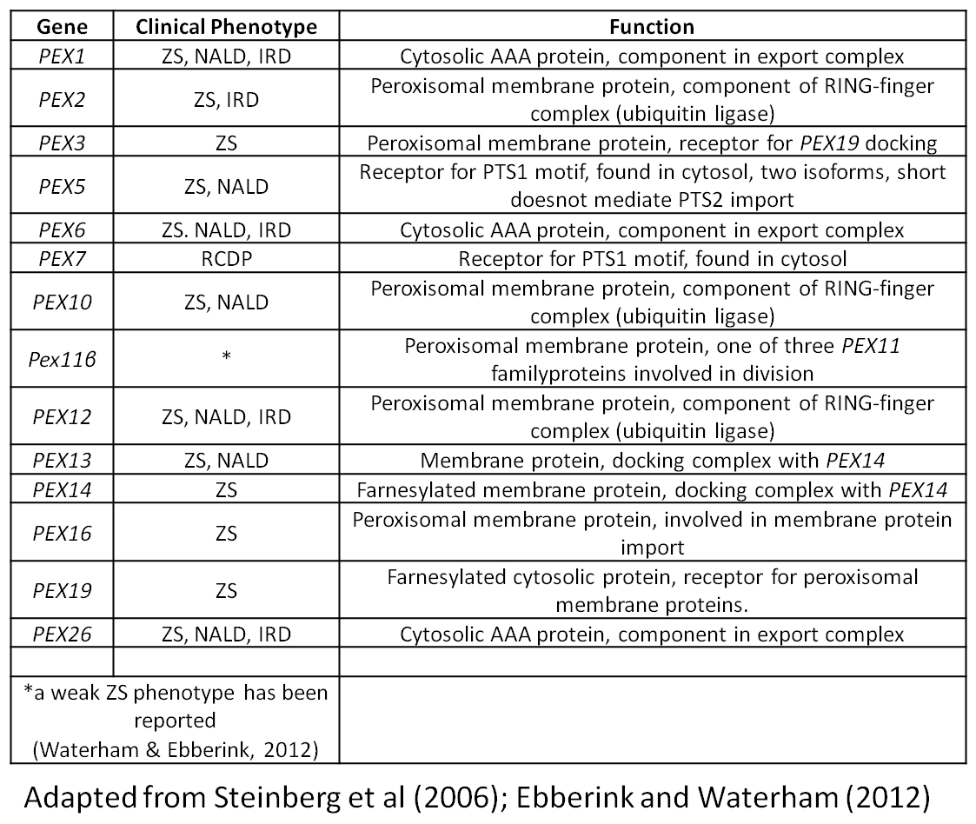
Table 1.1. A list of known human PEX genes in H. Sapiens and their clinical PBD phenotype.

Rhizomelic chondrodysplasia punctate (RCDP)
A distinct clinical presentation of PBDs is rhizomelic chondrodysplasia punctate. Named for its anomalies in long bone development, the eponymous presentation is of shortened proximal long bones (rhizomelia) and epiphyseal stippling (chondrodysplasia punctata) accompanied by vertebral coronal clefts and metaphyseal cupping. Ichthyosis is a possible development, while facial and eye disfiguration and cerebral atrophy is also present. Neuronal migration defects in the midbrain and errors in axonal myelination also occur. While some children may survive to adulthood morbidly fatal respiratory complications are most likely to cause infantile death, accompanied with seizure disorders. Its only known cause presently is loss of function of the PTS2 receptor PEX7 (Reviewed by Steinberg et al., 2006; Waterham & Ebberink, 2012).

Complementation groups
Summarised by Steinberg et al (2006) 14 complementation groups (CGs) had been identified in PEX genes, collected from three research groups in Amsterdam, Baltimore and Gifu. Each one typically is caused by mutations in one PEX gene though some PEX genes affect more than one CG but with different alleles. The mutant alleles of the most common PBD-causing PEX gene are of PEX1, responsible for approximately 59% of clinical phenotypes of ZS, NALD and IRD with PEX6 responsible for 16% of cases (Waterham & Ebberink 2012).

Peroxisome Biogenesis Genes (Peroxins/PEX genes)
Research into peroxisome biogenesis was instigated with the discovery that Saccharomyces cerevisiae cells grown on oleic acid had greatly increased peroxisome numbers (Veenhuis et al., 1987). It was subsequently learned that peroxisomes are essential for growth with oleate as the only carbon source and that mutants deficient in peroxisome structures could be screened for using this approach (Erdmann et al. 1989). A similar approach involved screening for Chinese hamster ovary (CHO) cells unable to synthesise plasmalogens for which peroxisomes are an essential requirement, thus identifying mutants (Tsukamoto et al., 1990). Genes involved in peroxisome biogenesis were identified by complementation studies using these mutants. Other research applied similar approaches to the identification of peroxisome biogenesis mutants in a variety of yeasts including Hansenula polymorpha, Pichia pastoris and Yarrowia lipolytica (Gould et al. 1992; Liu et al. 1992)
Research that used a positive-selection screening process included (Elgersma et al. 1993). They used a chimeric fusion protein of the bleomycin resistance protein and luciferase, a peroxisomal matrix protein. The bleomycin would give resistance to the antibiotic phleomycin in S. cerevisiae peroxisome mutants. WT cells compartmented the enzyme into the peroxisomes and were killed when treated. Mutants lacking peroxisomes or import machinery were resistant as the chimera remained active in the cytosol. Similar studies were performed by (Van der Leij et al. 1992; Zhang, Han & Lazar 1993)
A summary of the genes identified in these screens was compiled and they were named peroxins and given the code PEX on account of their roles in peroxisomal biogenesis and import pathways (Distel et al. 1996). Since then proteomic assays and DNA microarray screens have been able to identify novel genes (Smith et al. 2002; Vizeacoumar et al. 2003; Tam et al. 2003; Vizeacoumar et al. 2004).
Protein | General Function | Molecular Function/Features
Pex1p* | Matrix protein import | AAA-ATPase required for recycling of Pex5p
Pex2p* | Matrix protein import | RING-finger protein, required for poly or monoubiquitination of Pex5p
Pex3p* | PMP targeting and de novo synthesis | Membrane docking factor for Pex19p
Pex4p* | Matrix protein import | E2-ubiquitin-conjugating enzyme required for the mono-ubiquitination and recycling of Pex5p
Pex5p* | Matrix protein import | PTS1-receptor
Pex6p* | Matrix protein import | AAA-ATPase required for recycling of Pex5p
Pex7p* | Matrix protein import | PTS-receptor
Pex8p* | Matrix protein import | Forms the connection between the docking and RING complex of the importomer
Pex10p* | Matrix protein import | RING-finger protein, links Pex4p to the importomer, required for ubiquitination of Pex5p
Pex11p* | Regulation of peroxisome size and number | Peroxisomal fission co-ordination.
Pex12p* | Matrix protein import | RING-finger protein, required for ubiquitination of Pex5p
Pex13p* | Matrix protein import | Component of the docking complex of the importomer
Pex14p* | Matrix protein import | Component of the docking complex of the importomer
Pex15p* | Matrix protein import | Membrane anchor for Pex6p
Pex16p | PMP targeting and de novo synthesis | Recruitment of proteins to the peroxisomal membrane
Pex17p* | Matrix protein import | Component of the docking complex of the importomer
Pex18p* | Matrix protein import | PTS2 co-receptor in yeast
Pex19p* | PMP targeting and de novo synthesis | PMP chaperone and import receptor
Pex20p | Matrix protein import | PTS2 co-receptor in most fungi
Pex21p* | Matrix protein import | PTS2 co-receptor in yeast
Pex22p* | Matrix protein import | Membrane anchor for Pex4p
Pex23p | Matrix protein import | Matrix protein import in Yarrowia Lipolytica
Pex24p |  | Required for peroxisome assembly in Yarrowia lipolytica
Pex25p* | Regulation of peroxisome size and number | Interacts with Pex11p
Pex26p | Matrix protein import | Membrane anchor for Pex6p in Human cells
Pex27p* | Regulation of peroxisome size and number | Interacts with Pex11p
Pex28p* | Regulation of peroxisome size and number | Unknown
Pex29p* | Regulation of peroxisome size and number | Unknown
Pex30p* | Regulation of peroxisome size and number | Unknown
Pex31p* | Regulation of peroxisome size and number | Unknown
Pex32p* | Regulation of peroxisome size and number | Unknown
Pex33p | Matrix protein import | Interaction with Pex14p in Neurospora Crassa
Pex34p* | Regulation of peroxisome size and number | Interaction with Pex11p, Pex25p and Pex27p
*Present in S. cerevisiae
Table 1.2. A list of known Peroxins with their general and molecular functions if known.

Models of peroxisome biogenesis
The characterisations of peroxisomal components, their structure, function and disease, have been well established and continue with current research. There are still contentious debates as to the mechanism of formation of peroxisomes as existing and new evidence continues to conflict with established theories. Two key mechanisms for the formation and proliferation of peroxisomes are the de novo synthesis model and the growth and division model.
The de novo formation of peroxisomes (or maturation model) was postulated when morphological connections between peroxisomes and ER were revealed (Novikoff & Novikoff 1972). This was based on electron microscopy research and was later supported by biochemistry studies in plants. Enzymes required for germination of castor beans were localised first in ER compartments and in a later stage of growth were localised in glyoxisomes. (Gonzalez & Beevers 1976; Gonzalez 1986).
More recently the most emphatic evidence for this pathway of ER-derived peroxisomes comes from mutants lacking PEX3, PEX16 or PEX19 in which cells with no peroxisomes are found to have produced them de novo after the expression of the missing gene and the return to WT genotype. (Subramani 1998; Matsuzono et al. 1999; Sacksteder et al. 2000).
The inhibition of ER protein secretions has been examined. Mutations in the translocation protein SRP54 and the ER secretory protein SEC238 of Y. lipolytica decreased peroxisome size and number. Further analysis of Pex2p and Pex16p revealed that they have N-glycosyl groups that require glycosylation in the ER prior to peroxisome delivery (Titorenko et al., 1997; Titorenko & Rachubinski 1998). Experiments in mouse dendritic cells showed Pex13p and PMP70, both membrane proteins, to be in parts of the ER and lamellar structures using immunogold labelling (Geuze et al. 2003). Additionally continuities were shown between ER and lamellae and between lamellae and mature peroxisomes (Tabak et al. 2003). Peroxisomal matrix enzymes and PMPs were distributed through different reticular compartments, suggesting a stepwise collection of peroxisomal component proteins, eventually forming peroxisomes.
Peroxisomal membrane and matrix proteins have been demonstrated to concentrate in ER locations in A. thaliana (Mullen et al. 1999), H. polymorpha and S. cerevisiae (Baerends et al. 1996; Hoepfner et al. 2005) with particular attention being paid to Pex3p. Hoepfner et al. used epifluorescence microscopy to demonstrate how Pex3p tagged with YFP appears in the ER when newly synthesised. It concentrates into small, punctate ER structures termed pre-peroxisomes which separate from the ER in a Pex19p-dependent process prior to maturation into peroxisomes. They show also how cytosolic Pex19p concentrates in structures on the ER before the structures dissociate and form mature peroxisomes. Removing either one of Pex3p or Pex19p causes the other and its associated ER puncta to remain with the ER and the formation of pre-peroxisomal structures and peroxisomes ceases. This is in accord with the theory that Pex3p is the anchoring receptor protein for Pex19p and supports the findings that peroxisome biogenesis does not occur without either of these proteins functioning.
Research into the ER-targeting of Pex3p has yielded a partial mechanism using a truncated version of the protein. The N-terminal 46 residues are capable of targeting to peroxisomes or to ER sub-domains in WT S. cerevisiae cells. The truncation itself is incapable of peroxisome biogenesis in the absence of WT Pex3p. Their co-expression causes the migration of the truncated protein to mature peroxisomes from pre-peroxisomal ER structures, again in a Pex19p, but also in a Pex14p dependent mechanism (Tam et al. 2003).
The second mechanism that has been proposed to explain the proliferation of peroxisomes is the “growth and division” model. This model suggests that peroxisomes grow by the assimilation of matrix and membrane proteins cytosolically synthesised and delivered from the cytosol. Upon achieving a critical size the peroxisome divides into daughter peroxisomes and the process is repeated (Rachubinski et al. 1984). The model allows that the ER contribution is for the provision of membrane lipids to promote growth of the peroxisomal membrane.
There is strong opposition to this model (together with previously mentioned research) in studies that show that in peroxisome-lacking cells (ΔPEX3, ΔPEX16 and ΔPEX19) peroxisomes reappeared when the cells were rescued by expression of the WT gene. (Matsuzono et al. 1999; Sacksteder et al. 2000; South et al. 2000; Voorn-Brouwer et al. 2001). This requires the formation of de novo peroxisomes as without existing peroxisomes there can be no division.
More recently (van der Zand, Braakman & Tabak, 2010). have shown that in in ΔPEX3 S. cerevisiae cells the vast majority of PMPs C-terminally tagged with CFP (all the ones that they tested - Pex1p, Pex2p, Pex3p, Pex4p, Pex6p, Pex8p, Pex10p, Pex11p, Pex12p, Pex13p, Pex14p, Pex15p, Pex19p, Pex25p, Pex27p and Ant1p) colocalise with the ER marker SEC63 30 minutes after a 30-minute induction of Pex3p with galactose. Each
PMP was under WT driven by its chromosomal promoter. From 90-120 minutes the respective PMP is observed to form a punctate structure completely separate from SEC63. This coordinates with a parallel experiment in which the same ΔPEX3 cells show that peroxisomes become CFP-PTS1 import competent at between 120 and 300 mins post induction as cyan puncta become apparent where previously it was diffusely cytosolic. This would imply that a system of peroxisome formation where all PMPs are sorted via the ER would not require division of peroxisomes as de novo synthesis of peroxisomes by ER-derived vesicles supplies membrane lipids and PMPs that are sufficient to form the peroxisome.
Currently the model proposed by Hoepfner et al. (2005) is widely accepted. Division of peroxisomes cannot occur without some ER-derived proteins, regardless of their synthesis. Support for this model came with Motley and Hettema (2007) who showed that inheritance defects that leave daughter cells devoid of peroxisomes induce de novo biogenesis of peroxisomes. A schematic diagram for both models is given in Figure 1.1 showing the proposed derivation of PMPs and peroxisomal membrane.

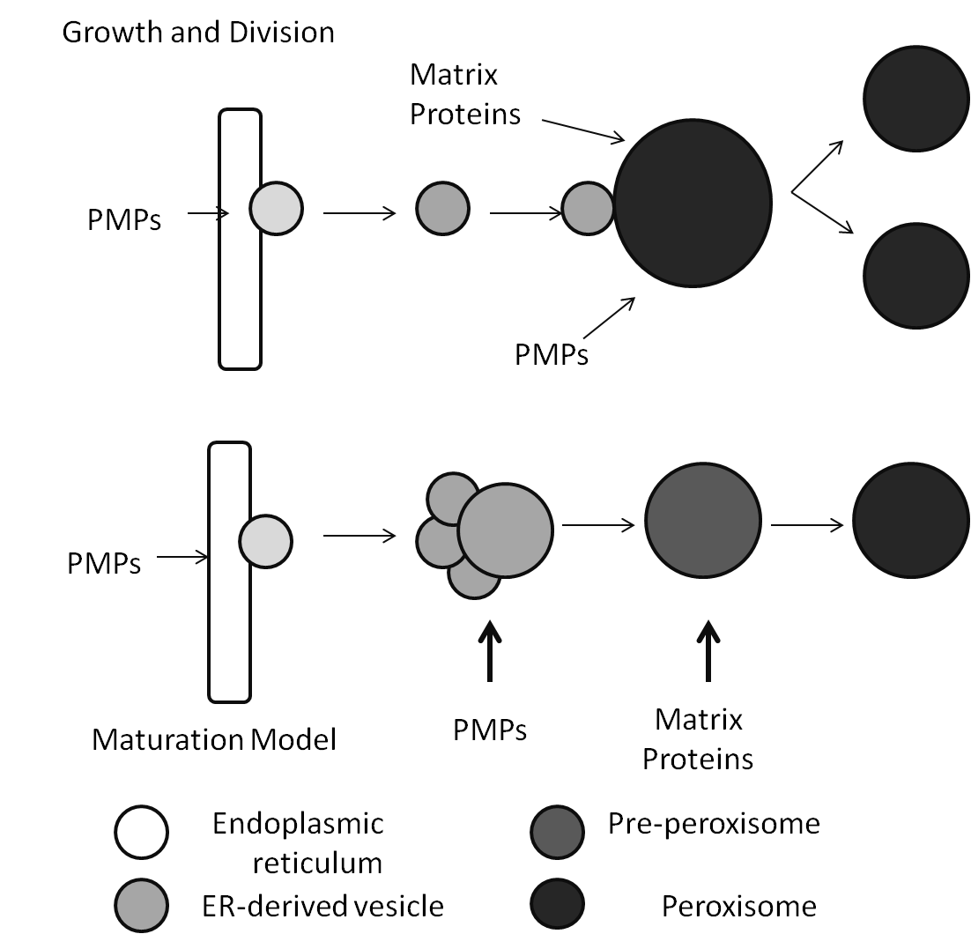
Figure 1.1. Proposed models of peroxisome formation, adapted from (Nuttall et al., 2011). The “Growth and Division” model (upper schematic) shows the addition of ER-derived vesicles that fuse with existing peroxisomes. As the peroxisomes grow in size they subsequently divide into “daughter” peroxisomes. Both matrix proteins and peroxisomal membrane proteins (PMPs) are targeted to the whole peroxisome. The lower schematic is of the maturation model which shows ER-derived vesicles which fuse together and form pre-peroxisomal vesicles which subsequently mature. PMPs are targeted to the ER-derived vesicles which facilitates the uptake of matrix proteins to the maturing peroxisome.

Peroxins involved in membrane trafficking
The realisation that peroxisomal membrane biogenesis and peroxisomal matrix protein trafficking are two fundamentally different processes came with experiments in ZS patients that had peroxisomal structures lacking matrix proteins (Santos et al. 1988) referred to as “ghosts”. Since then separate mechanisms for membrane and matrix protein transport have been investigated. Of all the peroxins PEX3, PEX16 and PEX19 mutants are the ones which completely lack peroxisomal structures of any kind. In S. cerevisiae Pex19p (Götte et al. 1998) and Pex3p (Hettema et al. 2000) are crucial for peroxisome formation. In humans PEX16 was also shown to be essential in this role (Honsho et al. 1998) and in D. melanogaster causes ZS-like phenotypes when mutated (Nakayama et al. 2011). Cells lacking function of these peroxins experience mis-localised peroxisomal membrane protein to the cytosol where rapid degradation follows.
The vast majority of experiments conducted in yeast models revealed that two main proteins are responsible for the formation, maturation and growth of peroxisomes; Pex3p and Pex19p.
Pex19p is a farnesylated protein which is responsible for the formation of peroxisomes through the import of peroxisomal membranes (James et al. 1994; Rucktäschel et al. 2009) though in humans farnesylation is apparently not essential for its function (Götte et al. 1998). Pex19p was originally shown to complement human fibroblasts deficient in peroxisome biogenesis capabilities. Matsuzono et al. (1999) showed that the addition of human PEX19 cDNA to ZS patient cells induced the production of peroxisomal membrane, where not even peroxisomal ghosts had previously been visible. It has been shown that PEX19 interactions with PMPs facilitate their insertion to the peroxisomal membrane in a PEX3-mediated mechanism (Sacksteder et al. 2000). PEX19 has been reported to interact with many PEX genes including PEX3, PEX10, PEX12, PEX13, PEX14, PEX16 and PEX18 (Snyder et al. 1999; Götte et al. 1998). Structural crystallography studies have shown that a C-terminal helical domain contains an mPTS motif that is responsible for Pex19p mediated insertion of PMPs into the peroxisomal membrane(Schueller et al. 2010). The same study claims that a motif in the N-terminal region of Pex19p (uncharacterised) has an equal affinity for the PMPs Pex3p and Pex11p, that the two motifs are not synergistic and that the effect on the C-terminal motif is attenuated by the presence of the region containing the farnesylation site. Sato et al. (2010) demonstrate that the N-terminal 44 residues of Pex19p form an amphipathic helix that interacts with a six-helix domain of Pex3p. This helix is disordered when not in complex but by treating with methanol in vitro the group have been able to achieve the N-terminal helix without complex. The group claims this behaviour presumably minimises non-specific binding with cytosolic proteins.
PEX3 has been able to complement PEX3Δ cells lacking in peroxisomal membrane bodies in H. polymorpha, P. pastoris, S. cerevisiae and in CHO cells. PEX3 has been shown to be an integral membrane protein; its N-terminal 40 amino acids target it to the peroxisomal membrane. PEX3 and PEX19 interaction is crucial for peroxisome formation; cells lacking either have no peroxisomes. Pex3p is capable of targeting to peroxisomes in the absence of Pex19p (Pinto et al., 2009) and is believed to act as a “docking” receptor to facilitate PEX19-mediated insertion of PMPs (Fang et al. 2004)
PEX16 is a protein also recognised as having a role in PMP import. Originally observed in Y lipolytica (Eitzen et al., 1997). It has been shown to be a crucial protein for peroxisome biogenesis in mammals and humans (Honsho et al. 1998). It appears to act as a receptor for PEX3-PEX19 complexes formed in the cytosol (Matsuzaki & Fujiki 2008) and subsequently facilitate peroxisome membrane and PMP localisation to mature peroxisomes(Schliebs & Kunau 2004).
The genes PEX3, PEX16 and PEX19 have been found in D. melanogaster and their knock-outs have been found to produce distinct phenotypes (Mast et al. 2011). A proposed model for the conserved functions of PEX3, PEX16 and PEX19 is given in Figure 1.2.

Figure 1.2. A model for post-translational insertion of PMPs into the peroxisomal membrane in S. cerevisiae (A-C) and Metazoa (D-F). Pex3p is directed to the ER and traffics via an ER sub-domain to peroxisomes (Black circle in A). In B cytosolic Pex19p in complex with its cargo, a peroxisomal membrane protein (PMP), docks with Pex3p and the PMP inserts into the peroxisomal membrane. C shows the unbound polypeptides with Pex19p returning to the cytosol and the PMP in the membrane, dissociated from Pex3p. In metazoa ER-derived pre-peroxisomal vesicles containing Pex16p associate with Pex3p that is bound to Pex19p in the cytosol (D); Pex3p inserts into the peroxisomal membrane in a Pex16p-dependent interaction. E shows PMPs cytosolically bound to Pex19p insert into the membrane via a Pex3p/Pex19p-mediated interation as in S. cerevisiae. F shows the completed insertion of PMPs into the peroxisomal membrane and the return of Pex19p to the cytosol.

Peroxins involved in matrix protein import
Sometimes referred to as Class I peroxins, these are involved in the uptake of proteins from the cellular cytosol into the peroxisomal matrix, having to pass through the peroxisomal single-membrane. In order for this to occur there must be a number of protein interactions between peroxins themselves and between them and the matrix proteins. Loss-of-function mutations and knock-outs of class I PEX genes typically cause the accumulation of cytosolic matrix proteins or greatly reduced matrix protein uptake with attributed loss of enzyme function.
In eukaryotes the most common form of peroxisomal matrix protein-targetting signature is the peroxisomal targeting signal (PTS) of which there are two. PTS1 is a tripeptide sequence found at the extreme C-terminus of the polypeptide first discovered by Gould et al. (1987). The consensus sequence is currently (S/A/C) – (K/R/H) – (L/M), most potent signal being S-K-L (Gould et al., 1989), with L as the terminal residue though others are found throughout Eukarya. The cytosolic receptor for PTS1 is PEX5 (Van der Leij et al., 1993).
The PTS2 sequence is much rarer among matrix proteins but still ubiquitous among Eukaryotes with the exception of C. elegans for whom the loss of PTS2 import into peroxisomes has meant sole reliance on PTS1 transport has become necessary (Motley et al. 2000). The recognising receptor for PTS2 is PEX7 (Marzioch et al., 1994). While the PTS2-mediated matrix protein transport machinery is well-conserved throughout many eukaryotes (Petriv et al. 2004), S. cerevisiae has only one PTS2-mediated peroxisomal matrix protein, 3-ketoacy-thiolase (Grunau et al. 2009). No matrix proteins are known in D. melanogaster that possess a distinctly recognisable PTS2 sequence, despite the presence of a PEX7 homologue.
PEX5 is the cytosolic PTS1 recognition protein that binds to peroxisomal matrix proteins and targets them to the peroxisomal membrane through binding with them at 2 sets of three tetra-tricopeptide repeat sequences (TPR) in its C-terminal portion (McCollum et al., 1991). It is a crucial protein for matrix protein import of PTS1 matrix proteins. In organisms lacking PEX5 function proteins with a PTS1 signal will remain cytosolic and thus a crucial step in β-oxidation will be absent from within the peroxisomal matrix compartment, leading to substrate accumulation and PBD pathology. In mammals two orthologues of PEX5 exist, PEX5L is 37 residues longer than its PEX5S paralogue; specifically in CHO cells and in human fibroblasts. It has been shown that the PEX5L paralogue has additional function in interacting with the PEX7-PTS2 complex prior to docking with the peroxisomal docking complexes on the peroxisomal membrane. In yeasts this convergence is not present and the two PTS complexes arrive separately at the peroxisome (reviewed by Holroyd & Erdmann, 2001).
D. melanogaster has only the single homologue of PEX5 indicating that this dependence of the PTS2 import machinery on PEX5L has been lost in Drosophila. This may be supported by the apparent absence of proteins with PTS2 import motifs. After docking with the peroxisomal docking proteins it is thought that the PTS1 cargo crosses the peroxisomal membrane still-bound to PEX5 as it has been observed that a small fraction of PEX5 proteins is found within the peroxisomal lumen (Erdmann & Schliebs 2005). The hypothesis remains that the PTS1 cargo is released subsequently from this transgression before the PEX5 protein is returned to the cytosol minus its cargo for continued PTS1 interaction, thus a PEX5 protein cycle is thought to exist (reviewed by Williams & Stanley, 2010).
As previously mentioned “docking machinery” exists to facilitate the reception and translocation of the PTS1-PEX5 complex. PEX13, PEX14 and PEX17 are peroxisomal membrane proteins that together comprise this machinery. PEX14 is a peripheral membrane protein which interacts with PEX5 and PEX7 as a receptor for translocation of matrix proteins. It also shares a binding site with PEX13, an integral peroxisomal membrane protein whose C-terminal region contains a Src-homology 3 (SH3) domain that projects into the cytosol. This SH3 domain interacts with both PEX5 and PEX14 directly (Schliebs et al. 1999). The N-terminal region, also in the cytosol, reacts with PEX7. Yeasts and A. thaliana contain PEX17. In S. cerevisiae PEX17 does not appear to directly react with either PEX5 or PEX7 but has been shown to interact with PEX14 in the peroxisomal membrane (Huhse et al. 1998) and is crucial for PTS1- and PTS2-mediated import. Both PEX13 and PEX14 appear to be the main receptors for mediating PEX5 and PEX7 targeted matrix protein transport. Otera et al. (2002) suggest that not only does PEX14 bind with PEX5 before PEX13 but that it occurs when PEX5 is bound to a PTS1 motif and that PEX13 has shown interactions with PEX5 unloaded. The binding of PEX5 seems to occur through a 25 residue α-helical domain which interacts directly with the SH3 domain on PEX13. Yet the interaction with PEX14 may well work upstream of this as by over-expressing PEX14 causes a build-up of PEX5 in mammalian peroxisomes; something which does not occur by over-expression of PEX13, PEX10 or PEX12. There is currently no known homologue of PEX17 in D. melanogaster.
PEX2, PEX10 and PEX12 are RING-finger peroxins believed to interact with PTS1 after the docking event as the removal of PEX10 and PEX12 is ineffective at diminishing the association of PEX5 with the peroxisomal membrane. PEX12 and PEX10 interact mutually with their zinc RING domains at their C-termini and also with PEX5 through these domains which project cytosolically (Okumoto et al., 2000). The RING finger proteins form a heterotrimeric complex which forms the translocation machinery for the PTS1 cargo across the membrane. Evidence shows stoichiometric interactions of PEX2 and PEX12 with PEX14 and PEX5 (Chang et al. 1999; Reguenga et al. 2001; Okumoto, Abe & Fujiki 2000) and non-stoichiometric binding with PEX13.
Most poorly understood of all the stages of receptor-complex cycling is currently that of translocation. After association with first the docking complex and then the RING-finger heterotrimer the receptor-complex needs to cross the peroxisomal membrane. The receptor complex does not require unfolding prior to translocation. Folded proteins, even oligomeric polypeptides, bound to a PTS-receptor are translocated, a process only previously described in the nuclear pore. There is no apparent structure constitutively present on the peroxisomal membrane and so it is hypothesised that such an event is facilitated “on demand” (Lanyon-Hogg, Warriner & Baker 2010). This reactionary facility to import matrix proteins does so without compromising peroxisomal compartmentalisation or, therefore, its function.
Two main models have been proposed for receptor-complex translocation, the simple and extended shuttle (Kunau 2001; Nair, Purdue & Lazarow 2004). The simple shuttle model hypothesises that the receptor maintains in association with the peroxisomal membrane while the cargo protein projects into the matrix prior to dissociation. The extended shuttle model developes on this by hypothesising that the complex completely enters the matrix for dissociation. More recently a third model has suggested that unladen Pex5p might create a pore in the membrane for cargo-bound Pex5p to pass through and then dissociate from the cargo (Erdmann & Schliebs 2005). Recently, evidence supports this showing that Pex5p and its receptor Pex14p form an ion-gated pore that allows the passage of the PTS1 cargo through the membrane. The addition of multiple units of cargo-laden Pex5p into the membrane helps to stabilise the pore in complex with Pex14p (Meinecke et al. 2010). The mechanism of dissociation of receptor and cargo is to date unclear but is known to occur prior to ubiquitin-mediated recycling (Alencastre et al. 2009) and the state if association is unaffected by its degree of ubiquitination (Grou et al. 2009).
Subsequent to the docking translocation and dissociation of the PTS1-cargo and PEX5 complex is the recycling of the Pex5p into the cytosol. This is performed at length by PEX1, PEX6, PEX4 and indirectly by PEX22. PEX4 is an E2-type ubiquitin-conjugating enzyme which is anchored to the cytosolic peroxisomal surface by PEX22. This poses a physical barrier between the unladen PEX5 and PEX4. PEX10 has been shown to be the linking protein for facilitating this process. Ubiquitinated PEX5 (Ub-Pex5p) requires removal from the lumen. Two ATPases PEX1 and PEX6 are key proteins in this step. Their combined function as a complex is dependent on their mutual, independent need to hydrolyse ATP and subsequently interact with the cytosolic, peroxisomal membrane surface(Matsumoto et al., 2003; Matsumoto et al., 2003) in a PEX15-dependent mechanism (Birschmann et al., 2003). In humans they interact with another PMP, PEX26, a process also dependent on ATP hydrolysis (Weller et al., 2005). The sub-cellular localisation of PEX1 and PEX6 is contra-indicated between species where they appear localised to the peroxisomal membrane in rats but are apparently associated with cytosolic vesicles in P. pastoris and Y. lipolytica (Kiel et al. 1999). PEX1 is the single most common peroxisome loss-of-function mutant in humans, alleles of which account for almost 60% of human hereditary disease (Waterham & Ebberink 2012). S. cerevisiae cells lacking any of PEX1, PEX6, PEX15 or PEX22 contain peroxisomes with an accumulation of poly-ubiquitinated Pex5p on the peroxisomal membrane(Collins et al. 2000).
Ub-PEX5 is returned to the cytosol in WT cells, the de-ubiquitinating enzyme responsible for its eponymous process is unknown. Mono-ubiquitinated PEX5 is recycled to the cytosol for subsequent matrix protein transport. Mono-ubiquitination occurs on a N-terminal cysteine residue conserved on PEX5, its recycling is prevented by the mutation of these conserved cysteine residues (Grou et al. 2009). While PEX4 is the yeast–specific E2-ubiquitin-conjugating enzyme (Ubc), in mammals the process is carried out by the UbcH5a/b/c family (Platta, Girzalsky & Erdmann 2004). The ubiquitinated E2-Ubc transfers the ubiquitin peptide to PEX5 via the RING-finger protein PEX12 that acts as the E3-Ubc (Platta et al. 2009). PEX1 and PEX6 then facilitate the dislocation of Ub-Pex5p from the membrane (Platta et al. 2008).
Poly-ubiquitination is executed using a different set of Ubcs. First Pex5p is conjugated to Pex2p, the E3 enzyme (Platta & Erdmann 2007) and then the subsequent ubiquitination is carried out by Ubc4p or if Ubc4p function is inhibited Ubc1p and Ubc5p (Kragt et al. 2005). In S. Cerevisia PEX10 (C et al. 2008) and PEX2 (Platta et al. 2009) have been shown to have ubiquitinating functions in both in vivo and in vitro experiments, each acting as the E3 ligase for the E2 ligases UbcH5a and Ubc4 respectively. It is therefore increasingly apparent that the RING-finger components play a role both in the translocation of Pex5p and its ubiquitin-dependent retrieval.
Homologues have been found for PEX1, PEX2, PEX5, PEX6, PEX7, PEX10, PEX12, PEX13 and PEX14 in D. melanogaster. Figure 1.3 shows the model of conserved Class I peroxins and their roles in Pex5p cycling.
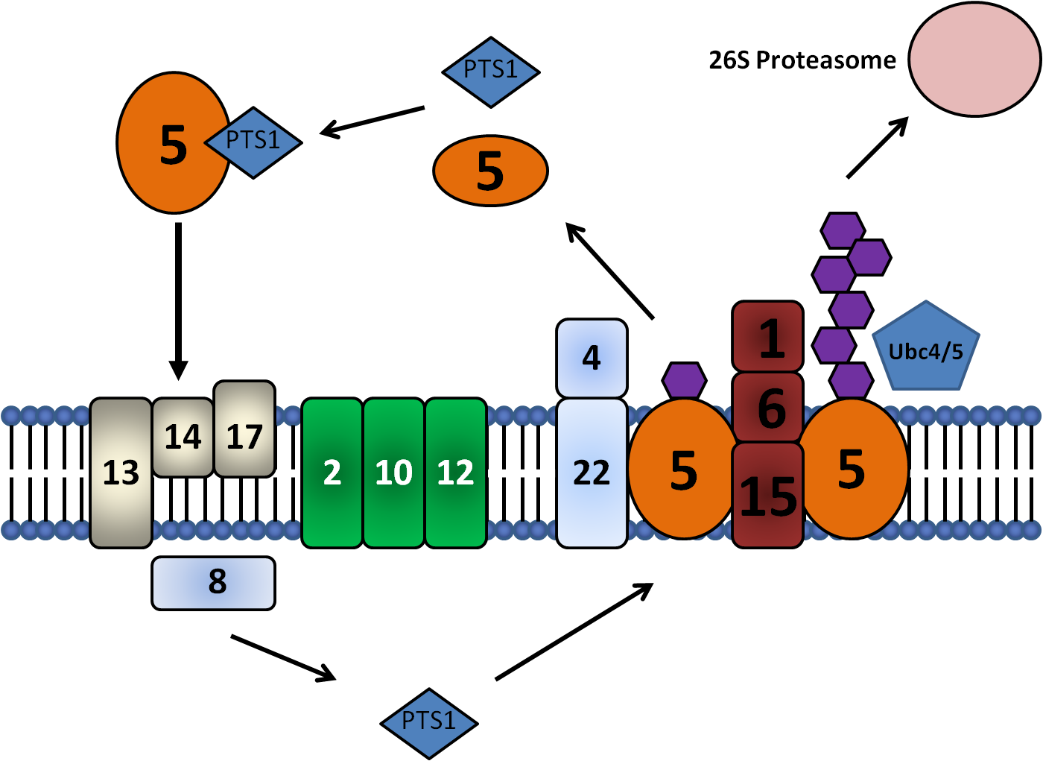Figure 1.3. A model Class I peroxin-mediated PTS1 matrix protein translocation (adapted from Platta & Erdmann, 2007). PTS1-bound Pex5p interacts first with the docking complex (Pex13p/Pex14p/Pex17p) and then with the RING-finger complex (Pex2p/Pex10p/Pex12p). Subsequently it is then either fully or partially translocated into the matrix (not shown). Here the PTS1 protein dissociates with Pex5p. Pex5p then is retrieved from the trans-side of the membrane by Pex15p and released to the cytosol via Pex6p/Pex1p synergy. While in transit the Pex5p is extracted from the membrane and re-used in another round of PTS-1 targeting dependent on the ubiquitination/de-ubiquitination cycle.

Peroxins involved in maintenance of number
These peroxins are responsible for the elongation, division and inheritance of peroxisomes. This is the least understood of the three main classes and includes some genes not nominally associated with peroxisome biogenesis. Of the peroxins discussed in this thesis PEX11 is the only one of these genes to be found so far in D. melanogaster. In S. cerevisiae there is the one allele PEX11α (Pex11p) while in D. melanogaster there are two alleles, PEX11β and PEX11γ. Humans have orthologues for all three. In yeast, depletion of Pex11p is believed to affect the curvature of the peroxisomal membrane and results in fewer, enlarged peroxisomes especially when grown on oleate (Erdmann & Blobel 1995). Further more, it has been shown that an N-terminal amphipathic helix that is well-conserved is required for insertion of Pex11p into the peroxisomal membrane and its subsequent curvature (Opaliński et al. 2011). It is thought that the insertion of the amphipathic region into the cis-layer of the phospholipid bilayer creates an asymmetry between the two layers and thus induces membrane curvature (Campelo, McMahon & Kozlov 2008). Functionally PEX11 is involved in elongation of existing peroxisomes. PEX25 and PEX27 have C-terminal sections that are highly homologous to PEX11 and the triple knockout causes the most severe phenotype in yeast (Koch & Brocard 2011). Metazoan orthologues have not been found for these two though there is believed to be functional redundancy in proteins such as FIS1 and DNM1L which are known to be effectors of peroxisome inheritance in yeast.

Non-PEX Biogenesis Genes

Dynamin-related proteins
The model for peroxisome multiplication utilises fission of peroxisomes supported by the delivery of ER-derived pre-peroxisomal structures for growth and maturation. In S. cerevisiae dynamin-related proteins (DRPs) Vsp1 and Dnm1 are responsible for peroxisomal fission. The absence of Vps1 causes peroxisome number to reduce in WT cells. Dnm1 causes a cell's peroxisome quantity to reduce compared to WT only when peroxisome proliferation is induced; in S. cerevisiae this occurs with growth on oleate. This suggests there may be partial redundancy in their functions of proliferation regulation(Kuravi et al. 2006).
In S. cerevisiae Dnm1p requires Fis1p, Caf4p and Mdv1p for recruitment to peroxisomes, though Mdv1p and Caf4p are each epistatic to the role of Fis1p; each requires a dual loss-of-function with Fis1p to prevent Dnm1p recruitment. The same proteins perform the Dnm1p recruitment to mitochondria but without this loss of effect (Motley, Ward & Hettema 2008). Vps1 does not require this recruitment for peroxisomal fission, instead it relies on PEX19 mediated recruitment (Vizeacoumar et al. 2006). Two mechanisms appear to be crucial in controlling fission in yeast, the Vps1-dependent fission mechanism appears to be dominant in that its knockout phenotype is the more severe (Kuravi et al. 2006; Motley, Ward & Hettema 2008)
In humans and Drosophila it is known that the DRPs Fis1 and Drp1 itself are functional at the peroxisomal membrane (Koch et al. 2003, 2005; Gandre-babbe & Bliek 2008) and recruited by PEX11 proteins in both CHO cells (Kobayashi et al, 2007) and human kidney cells (Koch et al. 2010). Drp1 appears to also be recruited by mitochondrial fission factor (Mff) and Fis1 is suggested to be more regulatory in DRP1 recruitment in mammals (Otera et al. 2010).
In D. melanogaster, RNAi screening revealed Mff knockdowns (KDs) show highly similar activity compared to those of Fis1 and Drp1 in their mutual abilities in inhibiting fission of mitochondria and peroxisomes, promoting elongation of both (Gandre-babbe & Bliek 2008).

Conservation of Peroxins in Eukaryotes
In Chapter 3.3 a detailed account of steps taken to compile a list of known orthologues and homologous candidates is described. During the course of this study this list was partially, functionally confirmed ( Chen et al., 2010; Mast et al., 2011).
The Homophila (Chien et al. 2002)and Online Mendelian in Man (OMIM, Reiter et al. 2001) databases were consulted online. Bioinformatic searches were performed using the Saccharomyces Genomic Database (http://www.yeastgenome.org) and the National Centre for Biotechnology Information (http://www.ncbi.nlm.nih.gov).
A list of known peroxins in the organisms S. cerevisiae, D. melanogaster and H. sapiens is shown in Table 1.3. The gaps in the table equate to where an orthologue for that organism is yet to be found.
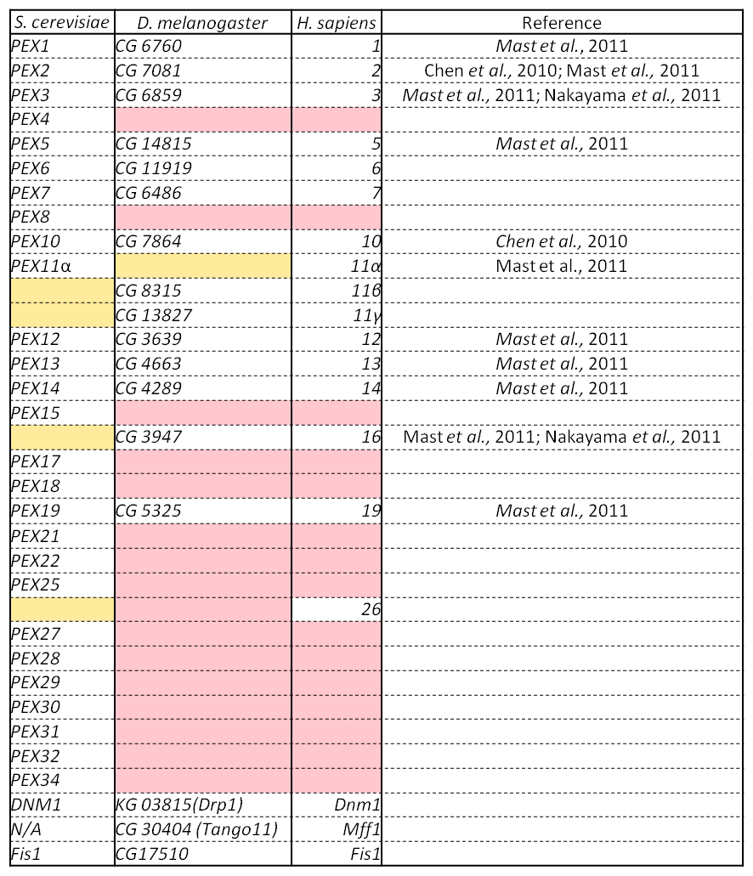
Table 1.3. Table of Peroxins from S. cerevisiae, D. melanogaster and H. sapiens. Mast et al. (2011) were able to achieve aberrant non-WT morphological presentations of S2 cells with fluorescent peroxisomal markers by performing single-gene RNAi knockdowns of some of the above list of CG numbers and sort them into “classes” based on their statistical analyses. Changes in morphology were noticed in PEX1, PEX5, PEX13, PEX16 (class I), PEX2, PEX3, PEX6, PEX12, PEX14 (class II), PEX11β, PEX19 (class III), PEX20 and PEX23 (class IV) from WT cells. The classes decrease in significant difference from the WT statistics of “number of punctate bodies, average volume of peroxisomes and percentage of fluorescent signal in punctate bodies”.

Drosophila as a model organism
Drosophila were first used in early genetic studies in 1910 by T. H. Morgan whose mating assays produced for him fly with white eyes. With his colleagues he was able to formulate a theory of heredity that involved chromosomes in a linear arrangement. They were able to prove that chromosomes contain genes, disproving a theory held at the time that they were separate entities. The physical mapping of chromosomes led the localisation of genes by T. S. Painter at the University of Texas in 1934. These “polytene” maps together those produced by Morgan’s colleague C. B. Bridges in the following years are still accurate and useable today. Since then Drosophila have been used to show that ionising radiation damages chromosomal arrangements and can be induced with x-rays. Clone libraries had been started by the 1975 and gene cloning had begun by 1980
In 1981 transposable elements were instrumental in achieving the first rescue of a mutant phenotype by transferral of a gene. While this became a powerful tool for transgene expression it discouraged whole genome sequencing aspirations. When the genome had been sequenced (Adams, 2000) so many genes had been sequenced individually that no other model organism came close to half of the same coverage of the genome (summarised by Rubin, 2000).

RNA interference (RNAi)

History and Mechanism
RNA interference (RNAi) is the use of RNA as a tool to determine gene function by inducing a blockade of expression at the translation level using complementary mRNA. Its gradual discovery began in the early 1990s by the loss of expression of genes of interest when high levels of exogenous transgene were induced in petunias (Napoli et al., 1990) and Neurospora crassa (Romano & Macino, 1992).
The use of RNA as a gene-silencing tool was first reported in C. elegans by Guo and Kemphues in 1995 whose work demonstrated the relatively equal efficacy of sense and anti-sense RNA in gene-silencing. Subsequent work by Fire et al. (1998) made the discovery of creating a synergistic mixture of complementary sense and antisense RNA. The resulting double-stranded RNA (dsRNA) was used to perform the same knockdown and was tenfold more effective. They were performing this in whole-organisms rather than a cell-line and were able to achieve the knockdown either by feeding the probe directly to the worm or by feeding them bacteria transformed to express the transcript. The knockdown was effective in all tissues and even carried over to the first generation of progeny, highlighting the probe’s tissue-pervasive capability. Further work in D. melanogaster showed that by detecting levels of ssRNA after successful KD with dsRNA, stable antisense ssRNA was detected in the region of 21-23 nucleotides. These co-purified in RNAi tests lacking target transcript and were termed small inhibitory RNAs (siRNAs)(Hammond et al. 2000; Zamore et al. 2000). siRNAs were confirmed to be the effector-molecule by their use as artificially polymerised 21-22mers in cell extracts containing firefly luciferase transgenes. The siRNAs were found to mediate cleavage of the target transcript(Elbashir, Lendeckel & Tuschl 2001).
Experiments in D. melanogaster cell extracts isolated the enzymes responsible for degradation of the target transcript. This was coined the RNA-induced silencing complex. The enzyme responsible for the cleavage of dsRNA into siRNAs was called dicer(Bernstein et al. 2001). Two phases of RNAi had been recognised, the initiator (cleavage of dsRNA) and the effector (RISC mediated cleavage of transcripts). The proteins which make up the RISC complex are known as Argonaut1 and Argonaut2 and are part of a well conserved family of RNAi-implicated proteins across Eukaryotes (summarised by Carmell et al. 2002).

Screening Drosophila with RNAi
A large number of types of RNAi screen are available for functional genomics studies (Mohr et al, 2010). It is a strong reverse genetic technique which accommodates well the design of experiments for those who study loss of function genetics such as peroxisome biogenesis disorders. It is able to identify genes within genetic families or reveal their involvement in biochemical and metabolic pathways. It is a type of chemical screen and thus the potential for scaling experiments to high-throughput analyses of genomes or transcriptomes is made easier by the simple handling of liquids and plastics, particularly with automation and bioinformatic analyses. Cell-based assays developed for chemical screens have helped lay a foundation for relatively simplistic implementation of assays into microtitre plates. This is particularly true of drosophila whose immortal cell-lines such as S2 cells have been a central approach for so many studies(Mohr et al, 2010). Transcriptome profiles for cell-lines of many tissues and organisms are available for helping researchers determine the best approach available for data interpretation (Neumüller & Perrimon 2011).
Drosophila is an exemplary organism for RNAi based screen research. The screening relies on the administration of single reagents into a sample of test cells. With Drosophila cell-lines the ability for soluble RNA to be taken up in growth medium and the absence of viral defence systems such as interferons facilitates the synthesis of in vitro long dsRNA as a reagent for screening. Mammalian responses require the use of siRNAs or small hairpin RNAs (shRNAs) as typical reagents (Mohr, Bakal & Perrimon 2010). The design of such RNAs is made possible by the efforts of the German Cancer Research Centre (wwe.dkfz.de) whose online tools for designing long dsRNAs and the tools with which to synthesise them make larger-scale approaches to experiment design easier. Evaluation of the reagents is done in silico and siRNAs are mapped against the D. melanogaster, genome transcriptome and exon ORFs. Facilities such as this are possibly the fastest growing aspect to RNAi screening (Sigoillot & King 2011).
The use of Drosophila cell culture permits the implementation of arrayed screening. Each reagent is assigned a designated well of a microtitre plate such as a 384 well plate. Using databases and cataloguing gene locations on probes, referencing each knockdown can be done retrospectively having acquired a list of identifiers. Miniaturisation means the reduction in cost of basic reagents and also allows “printing” of multiple copies of either specific plates from the desired library or custom designed replica plates for high copy parallel screening (e.g. performing analysis in triplicate). The handling of microtitre plates allows their treatment as a unit in automated processes such as seeding the wells with cells or reagent or applying drug treatments. Automation provides not just a way of saving time but also is a step towards reducing human error.
High-throughput screening requires high-throughput analysis. Recent technological advances include using automated epifluorescence microscopes and luminometry plate readers for fluorescence and luminescence-based screens. With particular attention to fluorescence microscopy, image-based screening has the potential to elucidate data in hundreds of user defined parameters for hundreds or thousands of cells in a single treatment. The sheer volume of data that can be generated across a genome-wide screen requires not just complicated analytical methods but top-end processing hardware that is capable of converting high-resolution images into massive multi-parametric datasets and then calculating with statistical robustness which tests in the experiment have produced phenotypes of interest(Neumann et al. 2006; Kamentsky et al. 2011). Standardised methods of automated visual phenotype determination are among the current projects at the cutting edge of bioinformatic analyses which are of interest to image-based screening departments (Held et al. 2010; Murphy 2011).

A rationale for screening the D. melanogaster genome for peroxins.
D. melanogaster is an organism for which peroxin study is in its relative infancy (Faust et al. 2012). Of the 30 peroxins identified in S. cerevisiae and the three additional ones found in H. sapiens, only 17 have recognisable homologues in D. melanogaster. Further homology database searches could not yield reliable candidates. It is expected that the D. melanogaster family of peroxins would exceed this number if it were to be entirely discovered. Families of conserved related genes tend to increase in size through evolution as proteins become individually more specialised in function. A good example of this is the Rab GTPase family where 11 members are known in S. cerevisiae, 29 in C. elegans, 26 in D. melanogaster and at least 60 in H. sapiens (Stenmark & Olkkonen 2001). With this in mind, research into peroxisome biogenesis could benefit massively if a significant portion of the unknown peroxins was to suddenly to be discovered.
More importantly, D. melanogaster is a species of animal for which research using RNAi as a screening technique is not only relatively easy but favoured over mammalian methodologies. The smaller pools of known peroxins and associated genes in higher organisms puts D. melanogaster research in an ideal situation for discovery of what could potentially be a large haul of genes which would otherwise go unnoticed. There could be consequences for a leap forward in comparative research in other metazoan or mammalian species, particularly humans. The implication that human patients with ZS clinical presentations that have unknown genotypes could benefit from a genetic based approach to treatment is also a consideration.
The Sheffield RNAi Screening Facility (SRSF) at the Department of Biomedical Sciences, University of Sheffield was newly inaugurated at the commencement of this project. It is a state of the art automated screening facility specialising in the use of high-throughput screening of the D. melanogaster genome. Two main methods of screening are employed there, luminescence screening and fluorescence-capable microscopy screening. Both methods use the same Heidelberg-2 “library” (Horn, Sandmann & Boutros 2010), a collection of long dsRNAs targeting the D. melanogaster transcriptome. The library consists of a total of 19708 reagents (long dsRNAs) which the SRSF have compiled into a battery of 53 384-well microtitre plates. The facility contains apparatus and reagents for the study and development of an assay that would eventually be used to screen the library for genes whose RNAi-induced gene silencing would produce useful phenotypes. The apparatus includes equipment that handles microvolumes and is capable of treating microtitre plates in a reproducible manner. An automated epifluorescence microscope can be used to image the 20,352 wells of the library and advanced software is able to process this in a user-generated series of analytical algorithms. Statistical software is used to determine which gene KDs are to become the focus of subsequent research.

Aims
As this project commenced only 17 members of the peroxins and genes associated with peroxisomal biogenesis, multiplication, inheritance and protein import could be found after an extensive search of literature and online database sources. The Sheffield RNAi Screening Facility provides a means for an unbiased genome-wide screen in an animal genome that has the potential for discovery of novel genes in Drosophila melanogaster. This project intends to establish a working metazoan paradigm for further peroxisomal research in animals, mammals and humans.
- A functional in vitro assay is required for expression of a fluorescent peroxisomal marker in a Drosophila melanogaster cell-line that can report knockdowns of known peroxins and present recognisable PEX-like phenotypes.
- The assay must be developed for High-throughput screening of a genome-wide RNAi-based screen. When it is imaged and processed by automation, the screen and its analyses must statistically confirm PEX phenotypes and phenotypes aberrant from wild-type simultaneously.
- The probes that target genes of statistically significant interest are to be consolidated into replicates of a single microtitre plate to be used in a secondary screen. This secondary screen will be performed in triplicate to confirm with robust statistical analysis the presence of PEX-like or aberrant phenotypes.
- The most promising validated candidates for further research will be chosen for characterisation with the aim of confirming peroxin-like behaviour and interactions and to begin work on mammalian or human orthologues.

Materials and methods

Chemicals, enzymes and Media
Chemicals for all experiments were supplied by Sigma unless otherwise stated in the Methods section.
Bioline supplied all PCR buffers and DNA polymerases, Ambion supplied the MEGAscript transcription kit. Qiagen supplied all Miniprep, Midiprep, Gel Extraction and Transfection kits. New England Biolabs supplied Enzymes and buffers for restriction.
Schneider’s growth media for Drosophila melanogaster experiments was supplied by Invitrogen as were the penicillin and streptomycin; Sigma supplied foetal calf serum. Bacterial and Yeast growth media reagents were supplied by Difco.
Fly-culture plastics were supplied by Nunc unless otherwise stated.
The Drosophila Genomic Resource Centre (DGRC) at Indiana University supplied all cDNA clones.

Strains and Plasmids

Saccharomyces Cerevisiae Strains:
Strain | Genotype | Usage | Source
Saccharomyces cerevisiae  BY4741 | Mat α, his3-Δ1, leu2-Δ0, met15-Δ0, ura3-Δ0 | Cloning constructs and source of gDNA. | EUROSCARF, Johann Wolfgang Goethe-University, Frankfurt, Germany

Escherichia coli Strains:
Strain | Genotype | Usage | Source
Escherichia coli  DH5α  Electroporation competent cells | supE44 ΔlacU169 (φ80 lacZ ΔM15) hsdR17 recA1 endA1 gyrA96 thi-1 relA1 | Recovery of plasmid DNA from Saccharomyces cerevisiae  following in vivo homologous recombination. | Hanahan, (1983)
Escherichia coli  DH5α  Chemically competent cells | supE44 ΔlacU169 (φ80 lacZ ΔM15) hsdR17 recA1 endA1 gyrA96 thi-1 relA1 | Constitutive expression of plasmid DNA for amplification of Drosophila melanogaster expression vectors or Shuttle Expression Vectors | Hanahan, (1983)

Drosophila melanogaster Strains:
Strain | Genotype | Usage | Source
Drosophila melanogaster Schneider 2, Oregon R+(S2R+) | +Dfrizzled-1,  +Dfrizzled-2 | Drosophila Expression System (DES) plasmids and shuttle vectors with and without dsRNA-induced gene-silencing. Microscopy. | Yanagawa et al., (1998)
Drosophila melanogaster Kc167 |  | Drosophila Expression System (DES) plasmids and shuttle vectors. Microscopy. | (Echalier & Ohanessian 1969a)

Plasmids
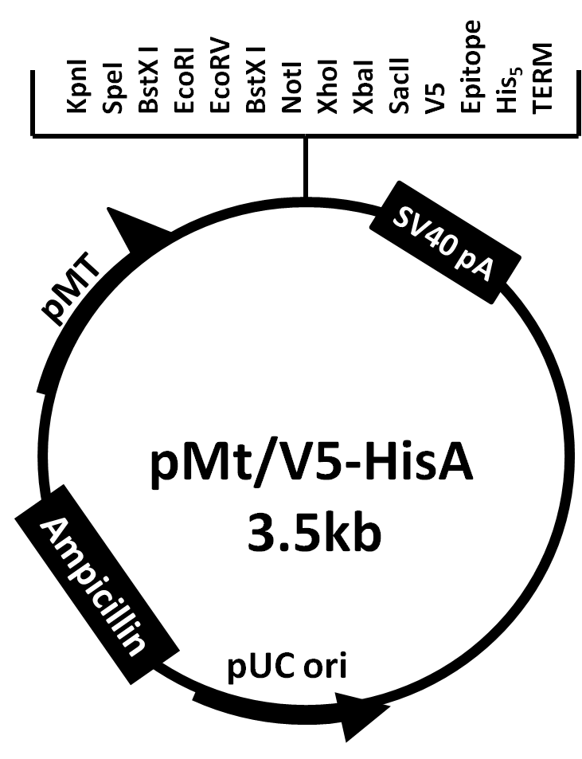
Figure 2.1 The plasmid map of pMt/V5-HisA (Invitrogen). This plasmid was used to clone the ORFs of eGFP-PTS1 and mRFP-PTS1, both between EcoRI and XbaI (see Ch. 3.5).
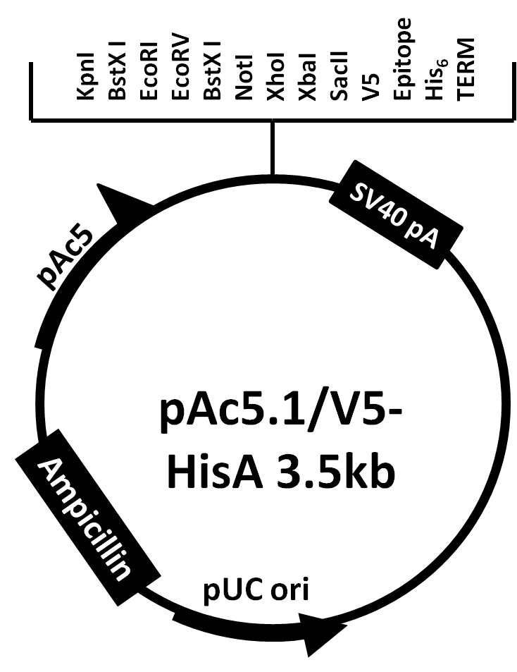
Figure 2.2. The plasmid map for pAc5.1/V5-HisA (Invitrogen). This was used to clone in the eGFP-PTS1 ORF between EcoRI and XbaI (see Ch. 3.5).
Plasmids | Promoter | Parental Plasmid | Lab Reference | Source | Usage
pMt-eGFP-PTS1 | pMt | pMt_V5HisA | pNUT07 | This study | Conditional Expression
pAc-eGFP-PTS1 | pAc5 | pAc5.1_V5HisA | pPD 003 | This study | Constitutive Expression
pMt-mRFP-PTS1 | pMt | pMt_V5HisA | pPD 010 | This study | Conditional Expression
pMK33-pMt-eGFP-PTS1 | pMt | pMK33-pMt/Hy | pPD 021 | This study | Conditional Expression
pMK33-pMt-mRFP-PTS1 | pMt | pMK33-pMt/Hy | pPD 022 | This study | Conditional Expression
pMK33-pMt-ABCD3-eGFP | pMt | pMK33-pMt/Hy | pPD 023 | This study | Conditional Expression
pMt-nmd-eGFP | pMt | ycplac33 | pPD 024 | This study | Conditional Expression
LD 43687 | N/A | pOT2 | LD 43687 | DGRC | CG6760 clone
LD 41491 | N/A | pOT2 | LD 41491 | DGRC | CG6859 clone
GH 08708 | N/A | pOT2 | GH 08708 | DGRC | CG14815 clone
LD 20358 | N/A | pFLc-1 | LD 20358 | DGRC | CG3947 clone
LD 11581 | N/A | pOT2 | LD 11581 | DGRC | CG12703 clone
LD 22567 | N/A | pOT2 | LD 22567 | DGRC | CG30404 clone
GH08677 | N/A | pOT2 | GH08677 | DGRC | CG5395 clone
LD14743 | N/A | pOT2 | LD14743 | DGRC | CG3595 clone
RE11768 | N/A | pFLc-1 | RE11768 | DGRC | CG5491 clone

Primers

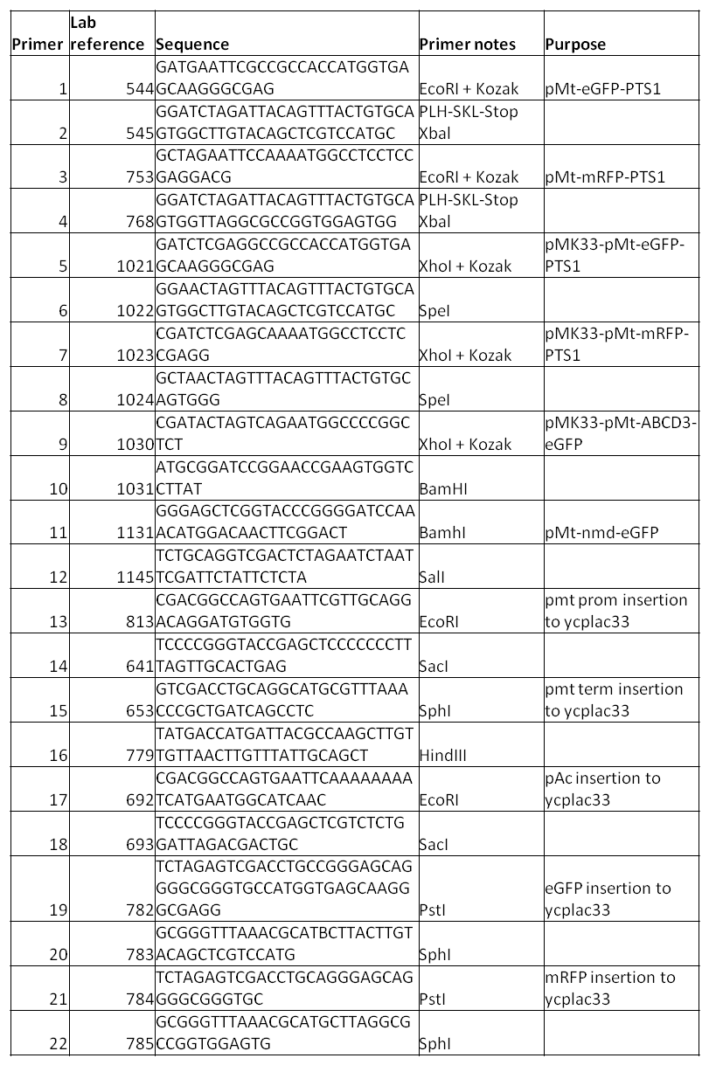
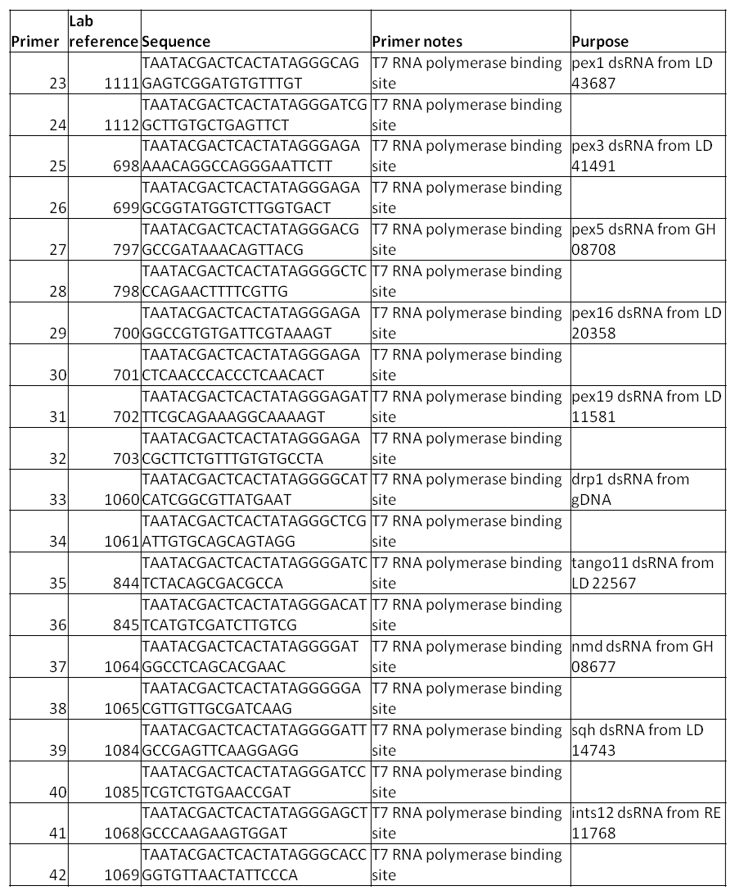

Design of Drosophila melanogaster-Saccharomyces cerevisiae shuttle vector.
A shuttle vector was constructed for the creation of C-terminal fusion proteins to be expressed in D. melanogaster cells. The plasmid ycplac33 was the parent plasmid (Gietz & Sugino 1988). Terminators, fluorophores, promoters and ORFs were inserted using the restriction map in Figure 2.3.1. A stepwise schematic of the construction of four shuttle vectors is given in Figure 2.3.2 using these restriction sites.
Figure 2.3. Multiple cloning site of the ycplac33 yeast expression vector. The shuttle vectors were constructed step-wise (see fig. 2.4.) by homologous recombination into the multiple cloning site (MCS).

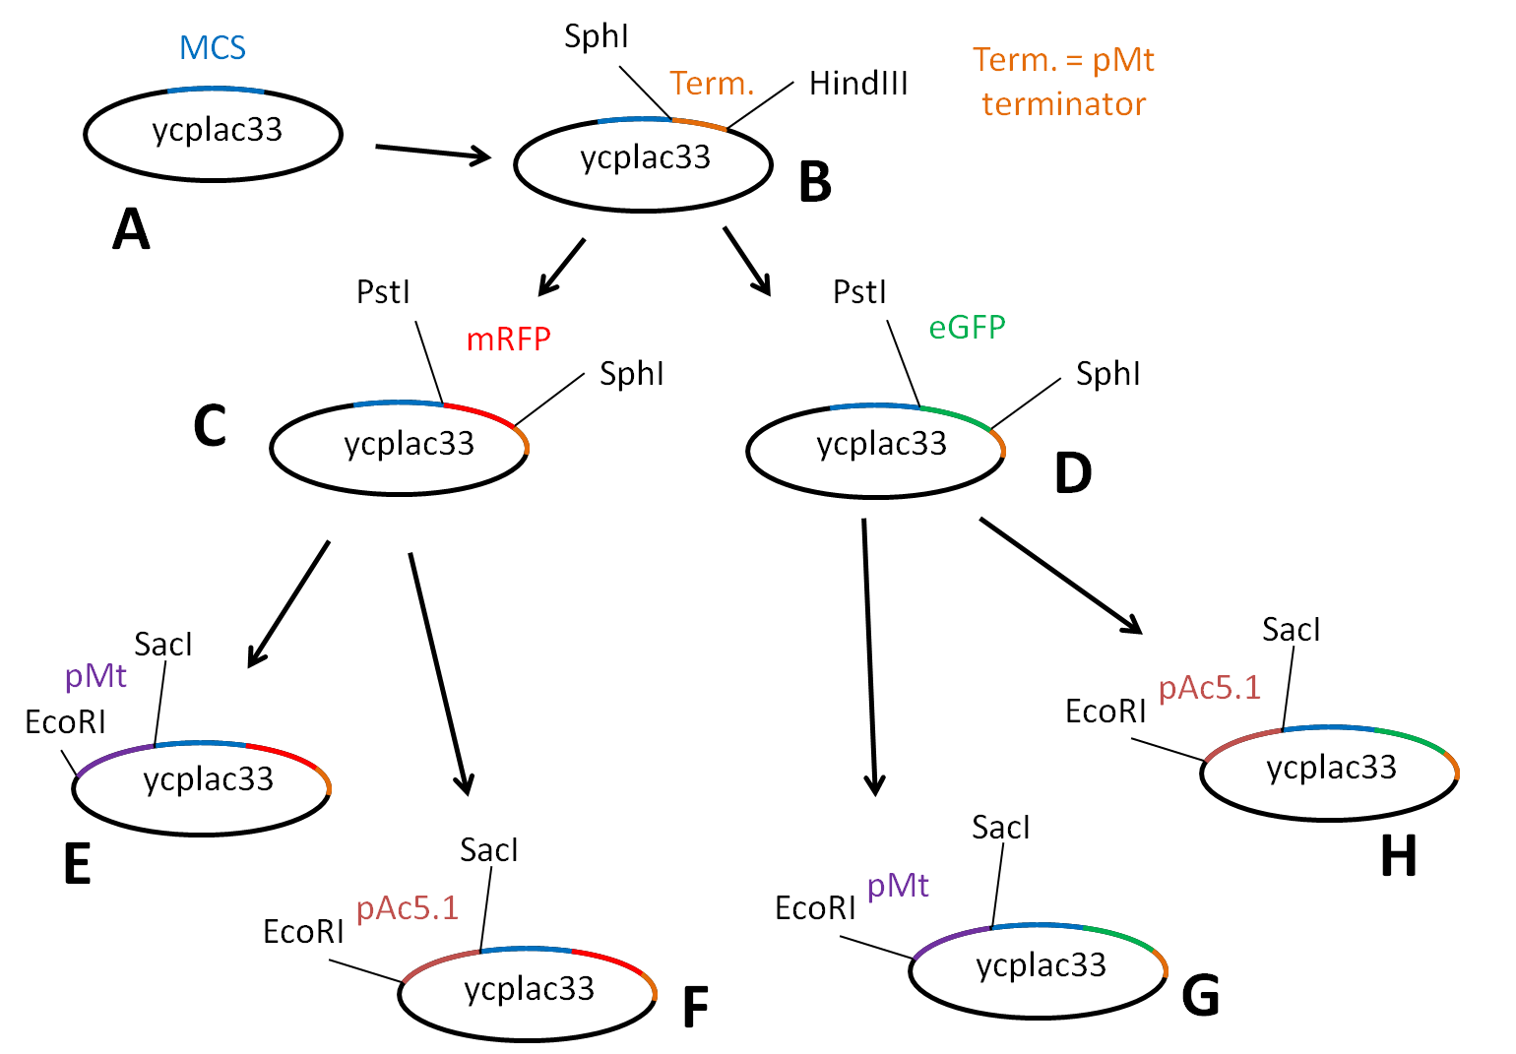
Figure 2.4. Stepwise cloning of the four shuttle vectors by homologous recombination. A The parent plasmid ycplac33 was used for the creation of the shuttle vector. B The pMt terminator is cloned between SphI and HindIII. C + D The fluorophores eGFP and mRFP are then cloned between PstI and SphI. The promoters pMT and pAc5.1 are then each cloned into the two plasmids containing the fluorophores. Four shuttle vectors are created: pMt-mRFP (E), pAc-mRFP (F), pMT-eGFP (G) and pAc-eGFP (H). No restriction sites were removed in any of the cloning steps. In this research only the pMt-eGFP is used to clone the nmd ORF (see Chapter 5).
The method of cloning by homologous recombination in yeast is described herein. The open reading frame (ORF) of interest was amplified by PCR. Primers were designed to anneal to the 5’ ends of the ORF. The 5’ ends of the primers contained an additional 18 nucleotides, an extension that was homologous to the sequences of the target linearised plasmid that flanked the insertion site. The amplicon and linearised plasmid (digested by restriction enzyme at the insertion site) were then transformed into yeast and selected for on yeast minimal medium 2 lacking uracil (YM2 Ura).
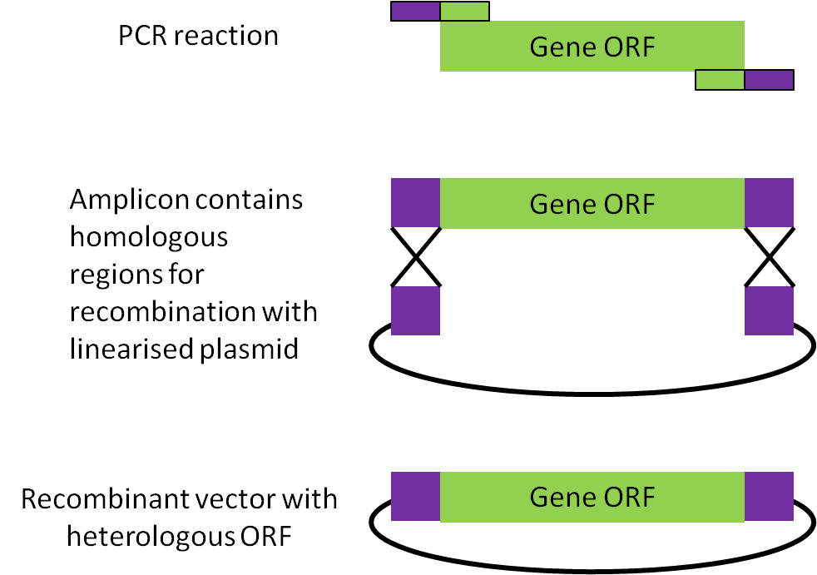
Figure 2.5. Homologous recombination in yeast expression vector ycplac33. The target ORF (green) is amplified with primers containing 18 nucleotide-long overhanging extensions (purple) homologous to the restricted target plasmid. The homologous recombination occurs at the sites marked crosses.

Preparation of culture media
Culture Media | Description
2TY | 1.6% Bacto tryptone, 1% Yeast extract, 0.5% NaCl. Where antibiotic-resistance selection was required, Ampicillin was added (to autoclaved media) to a final concentration of 75μg/ml when the media temperature had fallen to approx. 50°C.
YPD | 2% peptone, 1% yeast extract and 2% glucose.
Yeast Minimal Media 2  (for uracil and leucine selection) | 0.17% yeast nitrogen base (without amino acids and ammonium sulphate), 0.5% ammonium sulphate, 1% casamino acids, 2% glucose (or galactose, as required). Adjusted to pH 7.5. Leucine was added to the autoclaved media and either uracil or tryptophan, as required.
Solid Media | 2% agar was added to the dissolved liquid media, autoclaved and cooled to 50ºC before anti-biotics were added. The media was poured into sterile Petri dishes (Sterilin) and left to set. Once set, plates were stored at 4ºC.
Schneider’s Drosophila medium (Gibco) | Bought from Invitrogen and ultrafiltered with 0.22µm Steritops (Millipore). Medium either contained 10% foetal calf serum, 20% foetal calf serum or was serum-free (serum-free medium, SFM).
Foetal Calf serum (Sigma) | Ultrafiltered and added to Schneider’s Drosophila medium (see above).

E. coli protocols

E. coli growth and maintenance
E.coli were streaked from a frozen stock at -80°C onto a 2TY agar plate and then grown overnight at 37°C. The plate was removed the following morning for use before being wrapped in “Parafilm” (Pechiney, Chicago) and placed in a container at 5°C for use of up to a week. After a week, a single colony was re-streaked onto a fresh 2TY agar plate. For preserving frozen stocks of transformed E. coli a single colony was inoculated in 3ml 2TY liquid medium and incubated overnight at 37°C in an oscillating shaker at 180rpm. The next morning 0.9ml of the culture was removed to a 1.8ml cryotube (Nunc) containing 0.9ml autoclaved 30% (v/v) glycerol and placed in the -80°C freezer.

Making chemically competent DH5α cells
A single colony of DH5α E. coli was inoculated into 50ml autoclaved 2TY liquid for an overnight incubation. The following morning optical density (O.D._{λ600}) was measured in a Jenway 6300 spectrophotometer at 600nm wavelength. 50µl of the culture were added to a 1ml cuvette (?) containing 950µl 2TY liquid (a 20-fold dilution). The spectrophotometer was zeroed using 1ml 2TY liquid in a cuvette before the diluted culture was measured. The density reading given was then multiplied by 20 to give the density of the original culture. Enough of the culture was then added to 200ml 2TY to produce a starting culture of O.D._{λ600} of 0.1; it was then incubated at 37°C. Once the culture had reached O.D._{λ600} of 0.5-0.6 the culture was immediately removed and placed “on ice” in an ice-water slurry. The culture was aseptically transferred equally to two alcohol-sterilised 250ml centrifuge tubes and centrifuged at 5,000 RCF for 10 minutes at 5°C in a Sigma 4-16K centrifuge using the 11150 rotor. The supernatant was poured away and any remainder then aspirated; the pellet was very gently resuspended in 50ml of ice-cold, sterile 0.1M MgCl₂ by pumping the liquid over the pellet with a Gilson P200 at full volume with a sterile tip, then left on ice for 10 minutes. The suspended cells were again centrifuged and the supernatant removed as previously described before the cells were again carefully resuspended, this time in ice-cold, sterile 0.1M CaCl₂ and left on ice. After 10 minutes the cells were centrifuged and the supernatant removed as previously described before being carefully resuspended in 10ml ice-cold, sterile 0.1M CaCl₂/15%(v/v) glycerol and then placed on ice. The suspension was then dispensed into aliquots of 200µl in 1.5ml centrifuge tubes and immediately snap-frozen in liquid nitrogen. The tubes were labelled and transferred to -80°C storage.

Transformation of chemically competent DH5α
A single 50µl aliquot of chemically competent DH5α cells per required transformation was removed from -80°C storage and immediately placed on ice to thaw. 1µl plasmid DNA from a mini-prep reaction (1-2µg DNA) or 20µl from a ligation reaction were then added to the cells, still on ice and gently mixed by stirring with the pipette tip; they were left on ice for 20 minutes. Each tube was kept on ice but transferred to a float. The cells were heat-shocked in 42°C water for 120 seconds before being returned to ice for 5 minutes. Each sample had 0.9ml 2TY added to it before a 40min incubation at 37°C. The tubes were subsequently centrifuged at 15,000 RCF in an Eppendorf 5415D tabletop centrifuge and the supernatant poured away leaving approximately 50-100µl total of 2TY media and cells. The cells were resuspended in the residual media and streaked onto a 2TY-ampicillin (2TY-Amp) agar plate until the media had dried. The plates were stored overnight (approx. 16h) in a 37°C constant temperature room. The following morning the plates were sealed in Parafilm and removed to a 4°C room for storage or used for culture growth.

Preparation of electroporation-competent E. coli
On day one DH5α cells were streaked from -80°C onto a 2TY agar plate containing no antibiotics. The plate was incubated overnight at 37°C. On day two a single colony of E. coli was inoculated in 10ml of sterile 2TY containing no antibiotics and incubated overnight. A 5 litre flask containing 1 litre of 2TY was autoclaved for inoculation the next day and 2 x 0.5 litre centrifuge buckets for a Sigma 4-series centrifuge were rinsed with 70% ethanol and incubated in a 65°C oven. 1L of 10% glycerol (v/v) diluted in Millipore was mixed and stored in a 2 litre conical flask, sealed with Parafilm and stored at 4°C. On day three the centrifuge (Sigma 4-16K) was set to cool to 4°C and overnight culture (10ml) was measured for optical density. The 1 litre of 2TY was inoculated at OD₆₀₀ = 0.05 with the required volume of the overnight culture. The cells were then incubated for approximately 2 hours and then tested for optical density before the incubation was halted at OD₆₀₀ = 0.5-0.6 (mid-logarithmic growth phase). The culture was then divided into two 0.5 litre centrifuge buckets and placed on iced water to cool for ten minutes. The buckets had excess ice-water removed and were then centrifuged in a Sigma 4-16K at 5000 RCF for 15 minutes at 4°C and the glycerol removed from 4°C and then placed on ice. The supernatants were poured and aspirated away before the pellets were each resuspended in 250ml ice-cold 10% glycerol (v/v). The buckets were then immediately spun down again for 15 minutes at 5000RCF. The supernatants were again poured and then aspirated away and then resuspended each in 125ml ice-cold 10% glycerol (v/v). The buckets were again centrifuged at 5000RCF for 15 minutes. The supernatant was again removed by pouring and aspiration and the pellets resuspended in 50ml each of 10% glycerol (v/v) and moved to 50ml Falcon tubes. They were again centrifuged at 5000RCF, again in a Sigma 4-16K. The supernatant was aspirated and then the pellets resuspended and combined into one 0.7ml slurry. The Slurry was kept on ice while it was divided into 40µl aliquots and snap-frozen in liquid nitrogen prior to storage in a freezer at -80°C.

Transformation of electro-competent E. coli with ycplac33 plasmid by electroporation
A 2mm electroporation cuvette was placed unopened on ice. A 40µl aliquot of electro-competent cells were removed from -80°C and placed on ice. 1µl of S. cerevisiae genomic DNA (gDNA) containing the recombined plasmid was diluted with 9µl of dH₂O, vortexed and then added to the electro-competent cells on ice. The cuvette was then removed from its packaging and the cell/gDNA mixture added to the cuvette, carefully placed between the two metal plates. The cuvette was loaded into the cassette of a Biorad Micropulser and pulsed using the settings Ec2 (1 pulse, 2.5kV). 1ml of 2TY medium was added to the cuvette and the cells were transferred to 37°C for a 40 minute rescue-incubation. After the incubation cells were move to a 1.5ml spin tube, spun for 1 minute at 15000g and then the pellet removed and streaked onto an ampicillin 2TY agar plate.

DNA and RNA protocols

Plasmid restriction.
1-2 µg of plasmid DNA either pMt/V5-HisA, pAc5.1/V5-HisA or pMK33-pMt/Hy was restricted with typically 5 units of each required restriction enzyme per 1µg of DNA in a 20µl reaction containing 2µl of 10X restriction buffer specific to the restriction enzyme being used. The reaction was assembled on ice and its volume was made up to 20µl using ultra-filtered water. Usually two enzymes were required for restriction; if possible both enzymes were used simultaneously in a restriction reaction. In the one case where two separate restriction reactions were required due to insufficient restriction by either enzyme in any buffer the double restriction was carried out in two stages. Positive control ligation reactions required plasmid restrictions using only one enzyme (see Ch. 2.6.5). BamHI required medium salt buffer (100mM NaCl, 50mM TrisHCl, pH 7.5) and a reaction was set up as described above. After two hours the reaction was made up to 40µl containing 500mM NaCl, 100mM TrisHCl, pH 7.5 (high salt buffer) with 5 units of SpeI. Again the difference in volume was made up to 40µl using ultra-filtered water. All reactions were allowed 2 hours at the required temperature, in all reactions in this project this was at 37°C. The reactions were removed to room temperature and mixed in a 5:1 ratio with NEB 5X loading buffer. The reaction mixture was loaded onto a 1% agarose gel alongside 5µl of NEB Hyperladder I and run at 70V for 40 minutes. The DNA fragments were visualised in a UV-camera chamber (GeneSnap).

A Polymerase Chain Reaction to amplify and modify an ORF for subsequent restriction and ligation.
Two plasmids pMt and pBluescript (containing the ORF for eGFP) were provided to us from the Zeidler lab in the Department of Biomedical Science, University of Sheffield. The former contained an ORF of enhanced Green Fluorescent Protein (eGFP) which would be amplified with an addition of six codons to the C-terminus. The first three would encode the residues proline (P), leucine (L) and histidine (H); the three act as a buffering “linker” tripeptide to prevent functional interference of either peptide (eGFP or the SKL tripeptide terminus) by the structural presence of the other. The final three codons would encode the PTS1 sequence described in the introduction, serine(S) lysine (K) and leucine (L). The terminal stop codon TAA was added thus giving the functional protein eGFP-PTS1 or “Peroxisomal eGFP”. The ORF was flanked by a 5’ EcoRI site and a 3’ XbaI site. The primers were ordered from Sigma Aldrich and their online order form was used to make sure that the melting temperatures of the annealing portions of the primers lay in the region of 58-62°C; trying where possible to make the 3’ terminal nucleotide either a cytosine or guanine residue so to maximise annealing at the point where the polymerase would bind and begin extending the primer. The additions of the six codons to the 5’ end of the reverse primer and then the respective restriction sites to both primers at the 5’ end of each primer were made. A final two additional nucleotides were added to the 5’ end of each primer to facilitate restriction enzyme-DNA interaction and subsequent restriction (New England Biolabs Technical Reference, 2011).
The reaction itself was made in a PCR tube. A 50µl reaction contained 25mM MgCl₂, 1mM of each primer, 2ng of the template plasmid, 1.5u of Accuzyme DNA Polymerase, 5µl of 10x Accuzyme buffer and was made up to 50µl with sterile Millipore water. The reaction was run in a thermocycler (Biometra TGradient). The “lid” of the thermocycler was set to 100°C to prevent condensation forming on the lid of the tube. The reaction then ran at 95°C for 10 minutes to separate the DNA strands. The full cycle which was repeated consisted of three steps; firstly a 30 second step of 95°C which would separate the strands as just described after the subsequent two steps. The second of these three steps was a drop to 55-57°C depending on each Tm of the primers lasting for 30 seconds. This step permits annealing of the primers to the template at their specific locations. Once annealed step three is the extension step which is proportional in duration to the length of DNA being copied. With Accuzyme this meant two minutes for every kilobase (Kb) being copied. The eGFP-PTS1 amplicon was 720bp so 1 minute 30 seconds would have sufficed, the reaction actually ran at 1 minute 40 seconds to be certain it would complete on each cycle. The reaction was repeated (“cycled”) thirty times, theoretically to give 2³⁰ copies of the amplicon. This is then visualised on a 1% gel as described above.

Extracting DNA amplicons and plasmids from PCR or restriction mixtures using agarose gel electrophoresis
A 50µl PCR (or 100 µl restricted PCR, see Ch. 2.6.4) or 20µl plasmid restriction reaction (see Ch. 2.6.5) was added to 12 µl or 4 µl of 6X loading buffer (NEB) and then run on a 1% agarose gel (Bio-Rad Ultra Pure DNA Grade Agarose) made with 0.5X TBE buffer solution (0.04M Tris-acetate/ 0.04M boric acid/ 0.001M EDTA) and 0.5 µg/ml ethidium bromide for 40 minutes at 80V. Alongside the samples was run 5µl NEB Hyperladder I. The gel was visualised on a UV transilluminator and the sections of the gel containing the amplicons cut from the rest of the gel and placed in a 2ml centrifugation tube. The mass of the gel/DNA was weighed and the DNA extracted from it using the protocol described in the QIAquick Gel-extraction Kit (Qiagen Cat. 28704). This resulted in 50µl of TE containing the amplicon for subsequent restriction or 50 µl of linearised plasmid.

Restriction of DNA amplicon for cloning.
A 50 µl DNA amplicon purified by agarose gel extraction (see Ch.2.6.3) had added to it 10 µl restriction buffer. The buffer was specifically selected to facilitate optimal restriction with two enzymes or if not possible one enzyme to be followed by the second after the digested amplicon had been purified by gel-extraction. 10 units of each restriction enzyme were added to the mixture and the final concentration made up to 100 µl with ultra-filtered water. The reaction was allowed overnight to digest the amplicon before it was purified by gel-electrophoresis.

Ligation of restricted plasmid and amplicon.
Ligation reactions were assembled on ice. The mixture consisted of 50ng of restricted plasmid, 1 µg of restricted amplicon, both purified by gel-electrophoresis, 2 µl 10X ligation buffer and 5 units of T4 ligase. The volume was made up to 20 µl with ultra-filtered water. For a negative control the same procedure was assembled in parallel but without the restricted amplicon. For a positive control the plasmid digested with a single enzyme was substituted for the double-restricted one and again no restricted amplicon was added. The reaction was placed in ice-cold water and allowed to warm overnight to 25°C, crucially passing through the 16°C optimum functional temperature of the ligase. The following day 25ng of the reaction was transformed into chemically competent E. coli. Colonies transformed from the ligation reaction were selected for inoculation of 2TY media to produce minipreps for sequencing. Minipreps were performed according to the Qiagen miniprep protocol.

Long dsRNA design on E-RNAi webservice
Long dsRNA probes were designed on the E-RNAi website (E http://www.dkfz.de/signaling/e-rnai3//) hosted by the German Cancer Research Centre. The following figures (Fig. 2.6-11) show stepwise design of dsRNA for PEX1.
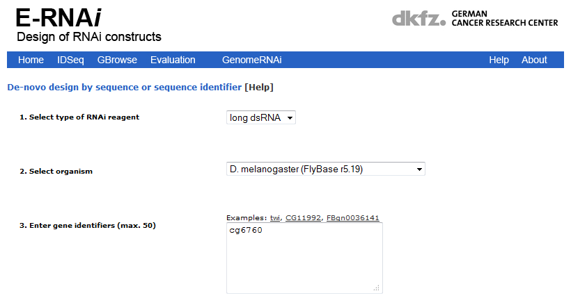
Figure 2.6. E-RNAi target-gene input. The IDSeq link provides a page where the user can put in the target gene of choice. The GeneID for PEX1 is shown in box 3 (CG6760).
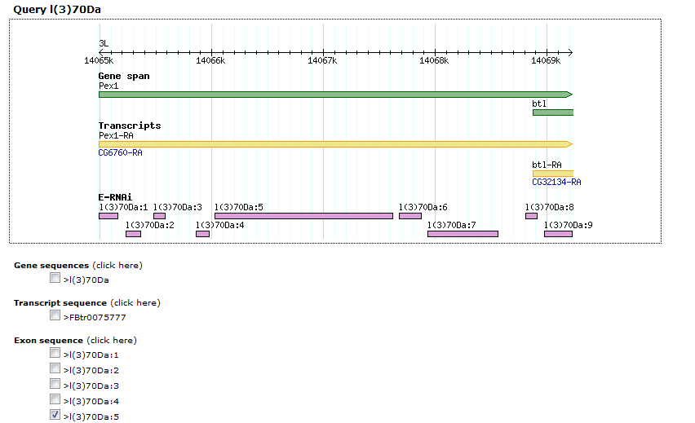
Figure 2.7. E-RNAi GeneBrowse target selection. PEX1 is located in Gene Browse and the gene (green), transcript (yellow) and exons (pink) are displayed as target sequences. The fifth Exon is chosen as part of an attempt to target mature mRNAs only and to avoid targeting introns which may contain low complexity sequence.
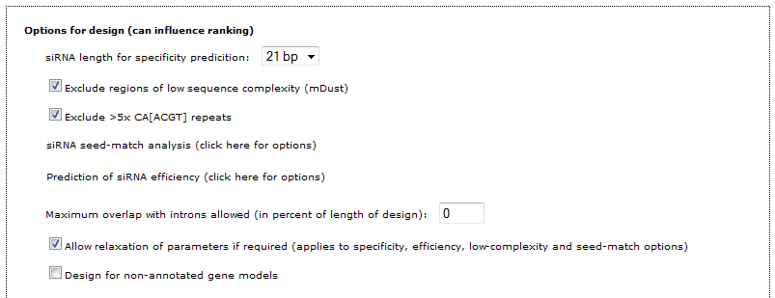
Figure 2.8. E-RNAi reagent design. Criteria for primer design are presented. 21bp is chosen as a siRNA length known to occur in D. melanogaster (Zamore et al., 2000). The next two choices are default selected to avoid low complexity regions and CAN repeated arrays. O% overlap with introns ensures mature mRNA is targeted and reduces the likelihood of off-target RNAi.
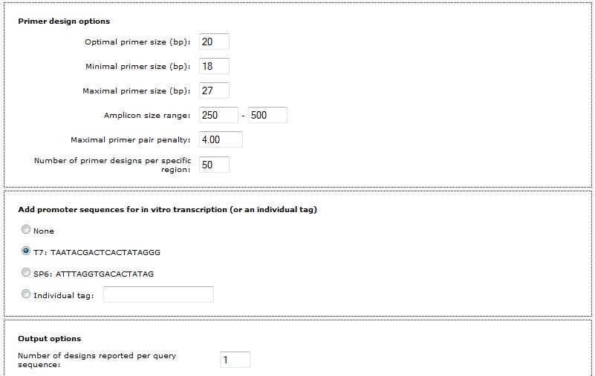
Figure 2.9. E-RNAi primer design. The page displayed in Figure 2.6.4 continues with the primer-specific options. The only option edited from default was the size range lower cut-off from 150bp to 250bp, facilitating observation of bands on agarose gel. The T7 RNA polymerase promoter is added to the 5’ end of each primer

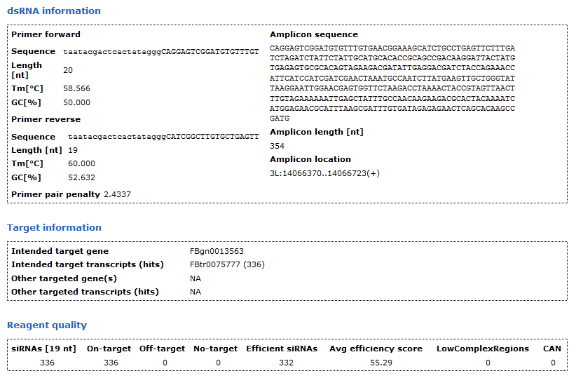
Figure 2.10. E-RNAi reagent output page. The output page gives details of all the long dsRNA amplicon designs, their statistics and those of its primers. Primers are shown with their T7 sequence attached (lower case), the amplicon is shown without the T7 sequence as the dsRNA would be synthesised. The reagent quality is shown below. This details the number of siRNAs that with be generated by the sense strand. These are almost always 100% on target but whether there are off-target effects is the most crucial statistic. Average efficiency is determined using a combination of “weighted” (Shah et al., 2007) and “rational” (Reynolds et al. 2004) efficiency prediction which score siRNAs on which bases occupy which position in the 21mer. The location of the long dsRNA target is highlighted in a final GeneBrowse schematic included in this webpage, shown in Figure 2.6.6.
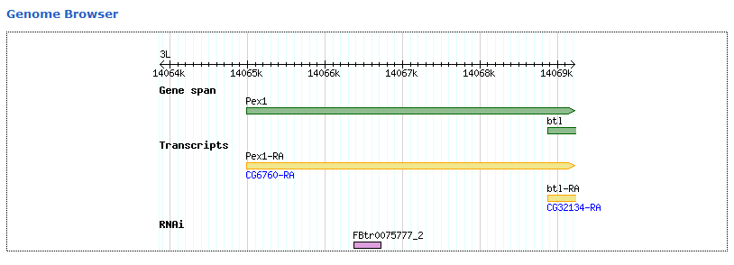
Figure 2.11. E-RNAi Reagent location in GeneBrowse. GeneBrowse schematic of the length of the long dsRNA shown in parallel with the target mRNA and gene.

Synthesis of long dsRNA probes
The primers designed in silico by the E-RNAi webservice were used in a PCR reaction to make a DNA amplicon with T7 RNA polymerase promoters on the 5’ termini. The PCR was carried out according to the protocol in Chapter 2.6.2. 2µl of the amplicon was loaded onto a 2% agarose gel and run at 100V for 30 minutes. The presence of the amplicon was confirmed. A 5µl in vitro transcription reaction was assembled on ice using MEGAScript high-yield transcription kit according to Ambion protocols and given 24 hours to react in 37°C (no thermocycling). The reaction was ethanol-purified according to Ambion protocols and the dry pellet dissolved in 100µl nuclease-free distilled water. 2µl of this was run on a gel alongside its DNA amplicon for size comparison (see Chapter 3.7) and the RNA concentration measured on a Nano-drop ND-1000 (Thermo). Long dsRNA was stored at -20°C. For KD experiments, dsRNA was dissolved to a working concentration of 50ng.µl⁻¹. Stock concentrations were periodically retested to check breakdown was not occurring in storage.

Fly cell protocols

Maintaining exponentially growing S2R+ cells
Cells were grown in 5ml of Schneider’s Drosophila Medium in a T25 flask in a Sanyo MCO-20C incubator at 25°C. Cells were maintained at 50-95% confluence (coverage of the growth surface). They were checked daily for confluence, upon reaching 90% confluence (2-5 x 10⁶cells.ml⁻¹), the cells were resuspended in the growth medium and 2.5ml was removed and placed into a fresh T25 flask. The flask was made up to 5ml with fresh medium. This is referred to as “passaging”.

Freezing cells for storage
Cells from a 90% confluent T25 flask at a passage lower than 10 were resuspended and the entire flask contents were transferred to and divided between 2 x T75 flasks each containing 12.5ml fresh medium; 15ml total. The cells were then allowed to reach 90% confluence over the next few days. On the day of near-confluence they were resuspended and a 10µl sample from each flask was mixed 1:1 with Trypan before being counted on a “Countess” automated cell-counter (Thermo). Cell concentration was given per millilitre and multiplied by 15. The suspended cells were centrifuged at 1000 RCF in 15ml Falcon-tubes (Fisher) and the supernatant removed. The cells were resuspended in ultra-filtered Freezing media (Schneider’s Drosophila media containing 20% foetal calf serum and 10% DMSO) at 10⁷ cells.ml⁻¹. The cells were transferred 1ml each to cryovials (Nunc) and placed in a “Mr. Frosty” Cryopreservation vessel (Nalgene) containing fresh isopropanol. The Mr. Frosty was placed in -80°C overnight. The following morning the tubes were removed from the Mr. Frosty and transferred to liquid nitrogen storage.

Thawing frozen cells
On the morning of thawing 4ml of Schneider’s Drosophila medium containing 20% foetal calf serum was warmed in a 25°C water bath then added to one well of a 6-well plate. A cryovial of frozen cells from nitrogen storage were placed in a 25°C water bath for 2 minutes then placed in the medium. 6 hours later the media was removed to another well, carefully leaving adherent cells on the growth surface and 2ml 10% serum-containing medium was added. The following day the cells were suspended and divided between 2 wells. The cells were passaged as normal from here. Cells which looked unhealthy or under confluent were transferred to 1 well of a 12-well microtitre plate before normal passaging continued.

Transfection of reporter plasmids
A detailed account of the optimisation of plasmid DNA transfection is provided in Chapter 3.6.

Expression of fluorescent fusion proteins in 6-well plates for microscopic imaging on fixed microscope slides
For all experiments in 6-well microtitre plates reagent volumes and concentrations were scaled up from those used in the 384-well microtitre plates in the SRSF (see Chapters 3.10 to 3.12). The 6-well plate protocol is as follows:
S2R+ cells were transfected with the desired plasmid according to Effectene protocols. Transfection medium was removed and cells were resuspended in SFM. 100µl of serum-free mediu (SFM) containing 3 x 10⁵ cells were carefully placed onto a sterile coverslip in a well of a 6-well plate. For knockdowns 2µg dsRNA dissolved in 25µl nuclease-free water was added to the cells and left for one hour. Experiments not requiring knockdowns added 25µl dH₂O. 125µl of 20% serum-containing medium was added drop-wise, evenly over the cells. On the day of induction 50µl 10% serum-containing medium containing 600µM CuSO₄ was added evenly over the cells and left for 24 hours. On the day of imaging medium was removed and cells were gently washed with 1X PBS three times. Cells were fixed with 3.6% formaldehyde in 1XPBS for 10 minutes. The fixing solution was removed and cells were washed again 3 times in 1X PBS. Cells were then treated with 0.1M NH₄Cl for 10 minutes to quench autofluorescent signals from the formaldehyde. Cells were washed again 3 times in 1X PBS. Cells were then mounted onto slides using Fluoromount mounting medium (Sigma) according to Fluoromount protocols. Slides were allowed to set for one hour before imaging.

Expression of fluorescent fusion proteins in Ibidi 8-well slides for microscopic imaging in live cells with MitoTracker
S2R+ cells were transfected with the desired plasmid according to Effectene protocols. Transfection medium was removed and cells were resuspended in SFM. 100µl of SFM containing 1 x 10⁵ cells were carefully placed into one well of an 8-well microscope slide (Ibidi). For knockdowns 2µg dsRNA dissolved in 25µl nuclease-free water was added to the cells and left for one hour. Experiments not requiring knockdowns added 25µl SFM. 125µl of 20% serum-containing medium was added drop-wise, evenly over the cells. On the day of induction 50µl 10% serum-containing medium containing 600µM CuSO₄ was added evenly over the cells and left for 24 hours. On the day of imaging medium was removed and cells were gently washed with SFM three times. Cells were immersed in SFM containing 25nM MitoTracker Deep Red M22426 and left for one hour. The MitoTracker-SFM was removed and Cells were washed 3 times in 10% serum-containing medium before being imaged live.

Protocol for seeding S2R+ cells into 384-well microtitre plates

Figure 2.12. Thermo Multidrop Plate-loader Schematic. Diagram of how the Thermo “Multidrop” plate loader seeds the 384 well plate. When all columns are selected each jet expels SFM with cells (20µl), 2X serum medium (25µl) or induction medium (10µl) per well. The entire array of eight jets moves along the first row of wells (green) before moving one row “down” and along the adjacent row in the reverse direction; each jet expelling liquid in each well it passes (48 per jet).
Transfected cells are diluted in SFM to the appropriate concentration for seeding into 384-well microtitre plate. The required volume for seeding n number of plates is 1.5 x n x 384 x20µl. 1.5 is a multiplication factor intended to prevent running out of reagents when priming the plate loader. An intake tube is used to draw liquid into an array of eight nozzles. These eight nozzles each run the length of the plate dispensing volumes into the wells, two rows per nozzle. Volumes are dispensed in multiples of 5µl. 50ml 70% ethanol is primed through the plate loader to sterilise the conduits and nozzles. The ethanol is washed out with 100ml distilled water. The plate loader is primed until empty and then the cell suspension medium is primed through. Plates are loaded using pre-defined settings (volume 5-50µl, number of columns 1-24, number of rows 8 or 16) at the press of a button in less than 10 seconds. The same protocol is used for addition of 20% serum-containing medium and induction medium (see following chapter).

Expression of fluorescent fusion proteins in 384-well microtitre plates
S2R+ cells were transfected with the desired plasmid according to Effectene protocols. Transfection medium was removed and cells were resuspended in serum-free Schneider’s medium (SFM). 0.2-1 x 10⁴ cells were seeded per well in a 384-well plate, in 20µl SFM. Wells were pre-seeded with 250ng dsRNA, dissolved in 5µl nuclease-free distilled water (Gibco). After 1 hour 25µl Schneider’s drosophila medium containing 20% foetal calf serum (20% serum-containing medium). On the day of induction, 10µl 10% serum-containing medium was added containing 600µM CuSO₄. After 24 hours induction cells were imaged after fixation (see Chapter 2.7.9).

Cell fixation protocols
Medium was removed from the wells in the microtitre plates using an ELx405 Select CW “Plate washer” (Biotek). This is an integrated liquid handling machine capable of dispensing volumes at low velocity and aspirating accurate volumes from each well. Cells in the assay development and the screens required aspiration of growth medium prior to the addition of fixative solution (3.6% formaldehyde with 1ng.µl⁻¹ Hoechst 33342).

Figure 2.13. ELx405 Select CW Plate washer aspiration and fixative dispensation schematic. Stepwise actions of aspiration of growth medium (A-C) and dispensation of fixative solution (D-H) from a single well. Arrows indicate action of aspirator. A shows the cells at the bottom of the well in 60µl induction medium (yellow). B shows the aspirator pin (vertical) descend to remove all but 20 µl of medium from the well. The pin returns to its rest position in C. In D the dispensing pin (angled) begins dispensing 150 µl of fixative (green) into the well. E shows the aspirator pin turns on when 110µl has been added (130 µl total). F shows both dispenser and aspirator on simultaneously creating a flow of fixative to remove induction medium. G-H shows the aspirator continuing after the dispenser is finished leaving the 50 µl of residual fixative on top of the cells before it is switched off and returned to the resting position. For the wash steps fixative was replaced with 1X PBS over three repetitions.
The fixation of cells in microtitre plates was a two-step process, aspiration of growth medium and fixative dispensation. Wells contained 60µl growth medium. 40µl of this was aspirated leaving 20µl with the cells. 150µl of fixative is then slowly added, dispensed down the side of the well to minimise removal of adherent cells. Once the dispenser has added 110µl the aspirator is turned on again and a constant flow of fixative from the dispenser washes over the cells and is then removed until the dispenser has finished adding fixative. After the dispensation of fixative ceases the aspirator continues until 50µl remains in the well. Cells were fixed and their nuclei stained for 50 minutes before the wells were washed with 1XPBS. This required exactly the same protocol as the fixation, the fixative was replaced with 1X PBS and the protocol was repeated 3 times.
NB. As this method does not completely remove the growth medium from the well, the fixative cannot be said to be technically 3.6% formaldehyde, nor 1ng.µl⁻¹ Hoechst 33342. As 20µl of growth medium remained in each well after aspiration, and 110µl of fixative was added before the continuous flow of fixative occurred the concentration of the fixative is altered to the factor of:
1-( 20/130) = 11/13 = 0.846
The concentration of formaldehyde at the point of aspiration therefore equalled:
0.036 x 0.846 = 0.030 i.e. 3%
The concentration of Hoechst 33342 therefore equalled 0.846 ng.µl⁻¹.
As 40µl more fixative was dispensed after this point and media was constantly being aspirated throughout, the real concentrations were much closer to their original ones. Successful fixation and nuclear staining was achieved using the protocol described.

Microscope settings for capture of images from 384-well microtitre plates in Screen 1
The METAXpress image capture and analysis suite (Molecular Devices) uses an automated epifluorescence microscope (“ImageXpress Micro”) to capture images of fluorescent signal. The settings used to capture these images in Screen 1 were different to those of Screen 2 and the Secondary Screen.
The “MD ImageXpress Micro” automated microscope was preconfigured to use Perkin-Elmer 15mm (total depth) 384-well microtitre plates by Stephen Brown from the SRSF. Much of the configuration was therefore already done. The choice of objective magnification (Figure 3.1.11.1.) was made based on the analysis of the images taken by both 20X and 40X magnification trials during assay development (discussed in next chapter). This was done on the “Objective and Camera” settings tab in “Plate Acquisition Setup” menu.
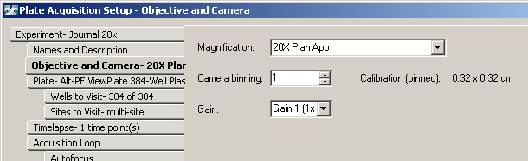Figure 2.14. ImageXpress Objective and Camera tab. The “Objective and Camera” tab for configuring objective. All screening uses binning of 1 and Gain of 1x. The choice of objective is from 2X, 10X, 20X and 40X objectives. After experimenting with both 20X and 40X objectives, the 20X objective was chosen for Screen 1 (numerical aperture: 0.75 (NA) resolution: 0.37µm).
Screen one required that a large proportion of each well be imaged to ensure that enough transfected cells were analysed to produce reliable data for the statistical analysis. This was chosen in the “Sites to Visit” tab. The final settings were for a 3x3 grid of nine sites to be photographed with no spacing between, ensuring a larger composite photograph could be analysed in nine parts. This was taken in the centre of the well, avoiding the overgrown corners where many of the cells inevitably settle.

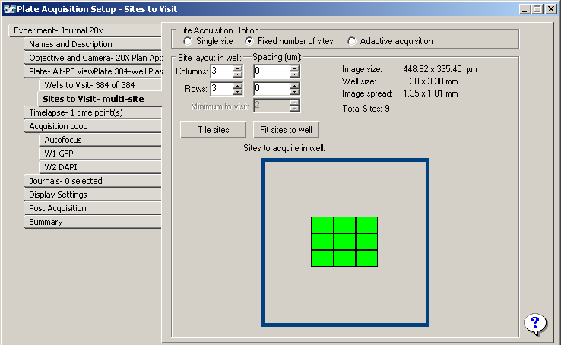Figure 2.15. ImageXpress Sites to Visit tab. The “Sites to Visit” settings for choosing number and arrangement of sites in the well. Nine 20X sites were arranged in a 3x3 grid with no spacing between.
The timepoints did not need to be altered as the cells were fixed. Only one photograph per channel per site was needed. This was selected in the “Time-lapse” tab of the setup.
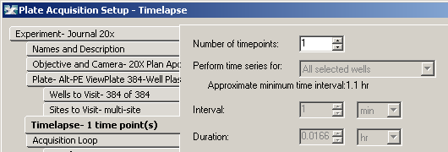
Figure 2.16. ImageXpress Time-lapse tab. The “Time-lapse” tab where number of timepoints was chosen as 1.
The “Acquisition Loop” tab is where the number of wavelengths and the type of focussing is chosen. The first screen needed only GFP and DAPI (Hoechst) channels. Laser-based focussing is standard. This uses a laser to determine where the interface between the clear plastic at the bottom of the well and the growth medium in the well is in focus. All subsequent focusing is determined with this z-location as a reference point which is different for each site.
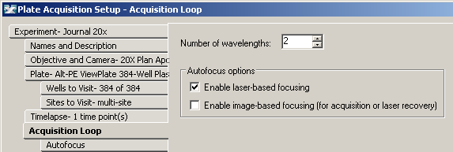Figure 2.17. ImageXpress Acquisition loop tab. The “Acquisition Loop” tab is where 2 wavelengths and laser-based Auto-focusing are chosen.
Wavelength 1 (W1) is the most important wavelength to be photographed. This was the GFP channel, wavelength 509nm. In this channel the maximum number of peroxisomes needs to be imaged. The cells are grown so that they are in exponential growth (60-80% confluence) after 6 days. This affects cell morphology to cause the cells to adhere much of their cytoplasm flat against the growth surface. Consequently most of the peroxisomes are in one focal plane. Every photograph needs to be an optimal height (z-offset) above the bottom of the well (found with laser autofocus). This optimal offset was determined to be at 0.5 microns. The exposure was automatically determined to be optimal at 300ms using the AutoExpose command and the range of image intensity (min and max grey-levels) is set at 4000. The “DAPI” channel (W2 measured Hoechst fluorescence) was configured in exactly the same way as the GFP channel. Exposure was automatically determined to be optimal at 112ms. The range of intensity is lower as there is less detail observed in segmenting nuclei, the range is therefore only 3000. The z-offset is taken from the first wavelength and was set to 0 microns (the same z-height as GFP).
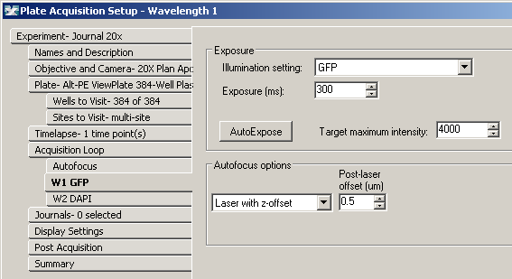Figure 2.18. ImageXpress Wavelength 1 tab. “W1 GFP” is where the GFP channel is configured. Exposure was automatically determined at 300ms, the maximum intensity is preset at 4000 grey-levels. Laser offset was determined at 0.5µm above the autofocus z-plane.
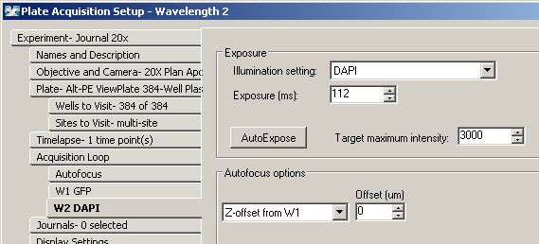Figure 2.19. ImageXpress Wavelength 2 tab. “W2 DAPI” for nuclear imaging of Hoechst fluorescence. Exposure set at 112ms, maximum intensity set at 3000 and Z-offset from W1 at 0µm (0.5µm from laser autofocus).
Finally each plate is given “Post Acquisition” settings. “Auto Run” means that as each plate is completed and added to the database the analysis computers begin their journal-based segmentation of the images on that plate. Auto Run is used so that manual initiation of the analysis of each plate is avoided, saving time (photography of each plate is completed in 2-4hr intervals).
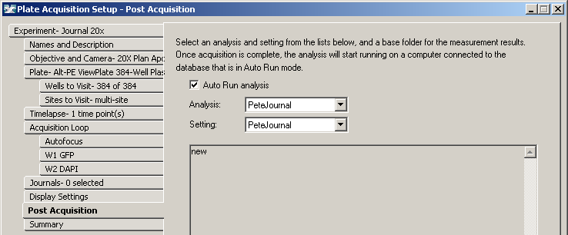Figure 2.20. ImageXpress Post Acquisition tab. “Post Acquisition” where the Journal “PeteJournal” was selected to run in Auto Run analysis mode.

Editions to the image capture settings for Screen 2
To increase the accuracy of the Transfluor application at counting the peroxisomes the microscope objective was increased in magnification from 20X to 40X. This is made possible by the even seeding of cells ubiquitously expressing eGFP. The smaller 40X image is able to capture enough cells to make robust statistical analyses. The change was made in the Plate Acquisition Setup menu.
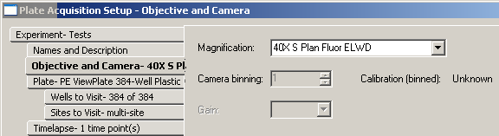Figure 2.21. 40X Objective tab. Magnification increased to 40X (NA 0.6, resolution 0.42µm) for the second screen in the Objective and Camera menu.
The area of the well that was photographed decreased from 10.4004mm² to 2.51001mm². A visual representation is given in Figure 3.2.5.2.
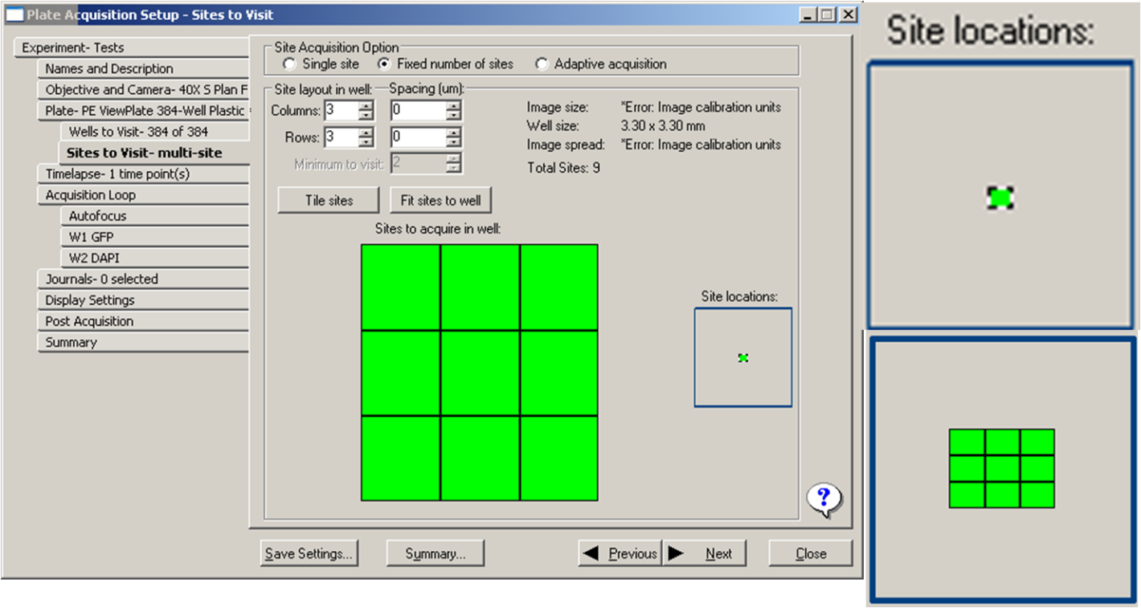 Figure 2.22. ImageXpress 2nd Sites to Visit tab. The Sites to Visit tab shows the 3x3 grid and its relative position in the centre of the well (left). Inset is the magnified site location (top right) and the one from the previous screen (bottom right).
The 40X objective has a thinner z-plane of focus than the 20X objective so the focusing offset needed fine-tuning for achieving the image with the optimal display of peroxisomes.
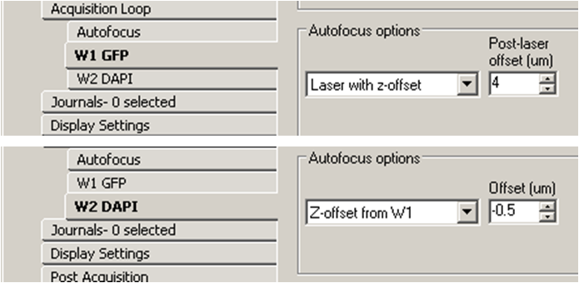
Figure 2.23. ImageXpress new wavelength settings tab. The settings are for GFP (top) and DAPI (bottom). GFP offset 4 microns above the laser autofocus; DAPI set 0.5 microns beneath GFP.

Numerical interpretation of images by METAXpress and statistical determination of results.
Chapters 3, 4 and 5 detail the processes required for the procurement of numerical data from the images captured in the three different screening experiments. Chapters 4 and 5 describe statistical analysis software that interprets this data.

Assay Development

Abstract
The aim of this chapter is to produce an unbiased genome-wide screen to identify novel genes involved in peroxisome biogenesis, multiplication and distribution. Most PEX genes have been identified by genetic screens in fungi and most of the proteins required for peroxisome protein import are conserved between yeast and humans. However there is a large number of PEX genes that have no metazoan equivalent. This latter group is important for peroxisome abundance. There may therefore be an animal specific set that regulates number. It was decided to develop an assay capable of identifying genes required for peroxisome biogenesis and regulation of abundance in animal cells. In general the machineries for membrane trafficking, organelle multiplication and protein targeting are more complex in animal cells and so we expect that there may be additional proteins required for these processes in animal cells. Based on these considerations a quantitative and qualitative assay was designed in D. melanogaster S2R+ cells. The assay development is described in detail separate from the more standard protocols previously described in the methods. Since we were the first high-throughput microscopy-based screen at the Sheffield RNAi Screening Facility (SRSF), additional parameters were needed for optimisation compared to the luminometry-based assays already routinely performed at the facility. The optimisation of these new parameters is described in this chapter followed by the analysis of the first genome-wide RNAi screen for peroxins in animal cells. From the preliminary analysis from this screen it became apparent that novel PEX genes were identified but further optimisation was required in order to obtain improved statistically significant data. This improved assay for a second screen is discussed in Chapter 4.

Hypothesis and methodology rationale
Genetic screens in yeast have identified many peroxins, some of which can be recognised in animal genomes, some of which cannot. In order to identify animal peroxins we have decided to use D. melanogaster as our model system as it has a relatively small genome (15,000 genes), cell-lines are readily available. The latter allows for single assays to be developed to study peroxisome formation and multiplication. Furthermore, an unbiased systematic screening of the whole genome for peroxins is possible and relatively cheap. The Sheffield RNAi Screening Facility (SRSF) is ideally situated within the neighbouring department of Biomedical Sciences (BMS). Another major advantage of the drosophila gene families is that while being more numerous than that of yeasts they are much less expanded than those of humans (Stenmark & Olkkonen 2001).
Recent technological advances in methodologies of RNAi and high-throughput screening mean that performing a genome-wide RNAi screen in D. melanogaster is not only practical but relatively simple. Drosophila will have less redundancy between genes within a gene family thus facilitating loss of function with the silencing of individual genes. Soluble dsRNA can elicit loss-of-function knockdowns on D. melanogaster cells simply by adding it to the growth medium in the absence of serum which allows its uptake. Compare this with the more arduous protocol of achieving the same effect in mammalian cells where each individual siRNA needs to be transfected into the cells. Using Drosophila allows the high-throughput batch knockdowns of each individual gene in the genome for a small sample of cells. This is achieved through the use of 384-well microtitre plates pre-seeded with highly specific “long dsRNA” polynucleotides (henceforth referred to as probes) in each well and high-throughput liquid handling apparatus used to seed cells in serum-free medium that facilitates dsRNA uptake. It is therefore possible to individually knockdown each D. melanogaster gene in hundreds of cells at a time. With the aid of automated microscopy images of a fluorescent reporter are taken of a sample of each of these knockdowns. Image analysis software then generates numerical data which is subsequently statistically analysed. The vast majority of each of the genes will not affect the phenotype under investigation. Gene knockdowns that affect the phenotype in an extreme way can be confirmed in the numerical data and re-screened in a smaller, custom-defined microtitre-plate in the same way as the pan-genomic screen. Once confirmed that particular knockdowns are causing a deviation in visual phenotype a detailed study can then be conducted to investigate further the function of the genes’ products.

A bioinformatic search to identify and compile putative PEX genes.
In order to identify putative Drosophila peroxins based on sequence homology with known human and yeast peroxins BLAST searches combined with literature searches were performed and compiled (see table 1.3). During the course of this study this list was partially, functionally confirmed (Mast et al. 2011); Chen, Liu & Huang 2010).
The Homophila database was used as a starting point to compile the list of PEX genes and proteins associated with peroxisomal biogenesis and multiplication. To improve on the list a bioinformatic search was performed using the Saccharomyces Genomic Database (http://www.yeastgenome.org) and the National Centre for Biotechnology Information (http://www.ncbi.nlm.nih.gov). I performed searches for specific peroxins and proteins involved in peroxisome multiplication and inheritance, plus the terms “peroxisome” and “PEX” to find associated genes. Homologene was used where applicable as many D. melanogaster peroxins are still referred to by their CG references (e.g. PEX1 as CG6760) but still not named after their respective peroxin’s orthologue and BLASTP to try and find proteins highly homologous to those yeast peroxins without a known orthologue. This would add suspected homologous candidates to a list of known orthologues. A summary of these searches is given in table 3.3.1.
Some organisms lack the PTS2 pathway yet D. melanogaster contains a putative PTS2 receptor in the form of a PEX7 sequence homologue (CG6486). However when we performed a pattern match search (pir.georgetown.edu/pirwww/search/pattern.shtml) for the PTS2 consensus sequence (R/K)(L/V/I)X⁵(H/Q)(L/A) in D. melanogaster 4 matches were returned (CG12869, CG33467, CG2457 and CG5092). The position of each of the identified sequences were however too distant from their respective N-terminus to be considered a typical PTS2 motif (R. A. Rachubinski & S. Subramani, 1995). Although not conclusive, this preliminary bioinformatic analysis shows the PTS2 to be either a minor pathway or may even be absent. Research by Faust et al. (2012) demonstrates that the canonical PTS2 sequence of thiolase from Rattus norvegicus localises the fluorophore mCherry to the peroxisomes in COS7 cells (Chlorocebus sabaeus – green monkey) but to the cytosol in S2 cells. If a PTS2-mediated pathway is present then the targeting sequence is likely to be different from the consensus.
The Drosophila genome encodes the many of the evolutionarily conserved peroxins required for peroxisome biogenesis and matrix protein import via the PTS1 pathway.

Parameters for optimisation
Cells defective in any of the processes of peroxisome formation, distribution or peroxisome protein import can be identified by analysis of the fluorescent pattern produced in cells expressing a fluorescent protein containing a PTS1. The parameters that require optimisation will be described in the course of this chapter. Those parameters are:
- The type of peroxisomal marker; matrix or membrane
- The type of cell line
- The choice of constitutive or inducible expression
- Optimisation of transfection efficiency, reagents and protocols
- Confirmation of KD protocol with PEX5 KD; design of long dsRNA and testing of further PEX KDs
- Down-scaling of KD assay to allow for 384-well microtitre plate analysis
- Plate testing; optimisation of seeding density, nuclear staining and cell-fixation protocols
- Determination of microscopy settings
- Design of analysis algorithm to discriminate WT peroxisome number, brightness and size from aberrant phenotypes.

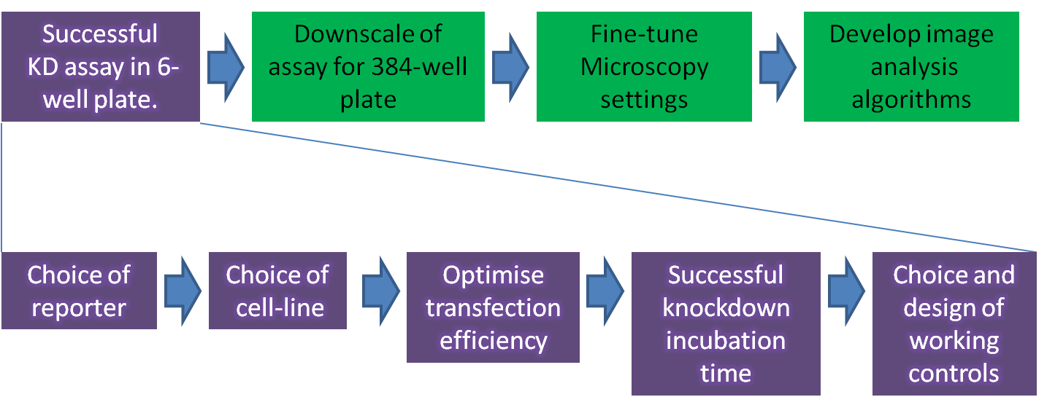Figure 3.1. Stages of development schematic 1. A schematic for the stages required in developing an optimised assay for reporting fluorescent peroxisomes in a microscopy-based screen in 384-well microtitre plates. The first step has been deconstructed into the steps taken to achieve that stage.

Expressing the green fluorescent peroxisomal reporter
It has been shown in organisms ranging from trypanosomes to fungi, plants and animal cells including D. melanogaster that the C-terminal tripeptide -SKL is an effective peroxisomal targeting signal type-1 (PTS1) that was first identified in firefly luciferase (Gould et al., 1987; Gould et al. 1989; Mast et al. 2011). GFP fused to SKL has been used as a marker for peroxisomes in a wide variety of organisms and our communications with Stephen Gould at Johns Hopkins in Baltimore, USA, revealed that eGFP-SKL localises to peroxisomes in D. melanogaster S2 cells. Chen et al. (2010) showed GFP-SKL to be effective at reporting peroxisomes in D. melanogaster testicular cells. It was therefore decided to use eGFP-SKL referred to from here on as eGFP-PTS1.
A pAct5.1v5HisA (pAc) and a pMtv5HisA (pMt) plasmid (for the plasmid maps see figures 2.1 and 2.2) were kindly supplied to us from the Zeidler lab in the Biomedical Sciences department at the University of Sheffield. They were both digested with EcoRI and XbaI to allow the cloning of the ORF of eGFP with a C-terminal S-K-L tripeptide. The SKL was separated by three more codons forming a “linker” tripeptide of P-L-H to provide a biological buffer between the function of the eGFP as a fluorophore and that of SKL as the PTS1. The pAc plasmid contains the actin5 (Ac5) promoter which in fly cells causes constitutive expression of transgenes and recombinant proteins (Chung & Keller, 1990). The pMt plasmid contains the metallothionein (Mt) promoter for expression of transgenes and recombinant proteins inducible with the addition of CuSO₄ into the growth medium (Maroni, Otto & Lastowski-perry 1986). Optimal translation of mRNAs requires that an initiator sequence of four nucleotides immediately precedes the translation initiation codon. This sequence should conform to the Drosophila-specific consensus sequence C/A-A-A-A/C (Cavener, 1987), for which was chosen C-A-A-C. The two plasmids produced were pMt-eGFP-PTS1 (inducible peroxisomal matrix marker) and pAc-eGFP-PTS1 (constitutive peroxisomal matrix marker).

Figure 3.2. eGFP-PTS1 cloning schematic. A schematic representation of the enhanced green fluorescent protein (eGFP) peroxisomal marker. Two variations were made, one with the constitutive actin5 promoter and the other with the metallothionein promoter for controlled inducible expression. The eGFP ORF includes one variation of the Drosophila-specific consensus Kozak sequence (C/A-A-A-A/C-A-T-G) upstream from the start codon. Not to Scale.
The two expression constructs were each transfected to two different immortal cell-lines, S2R+(Schneider, 1972) and Kc167 (Echalier & Ohanessian, 1969) using Effectene according to Invitrogen’s protocol. After a 24-hr incubation the transfection medium was removed and replaced with 1X Schneider’s medium, for the pMt-eGFP-PTS1 the medium added contained 100µM CuSO4. After 16 hr cells were analysed by fluorescence microscopy. Approx. 10-20% of cells were expressing the fluorescent marker protein; more than 20 puncta per cell were observed.
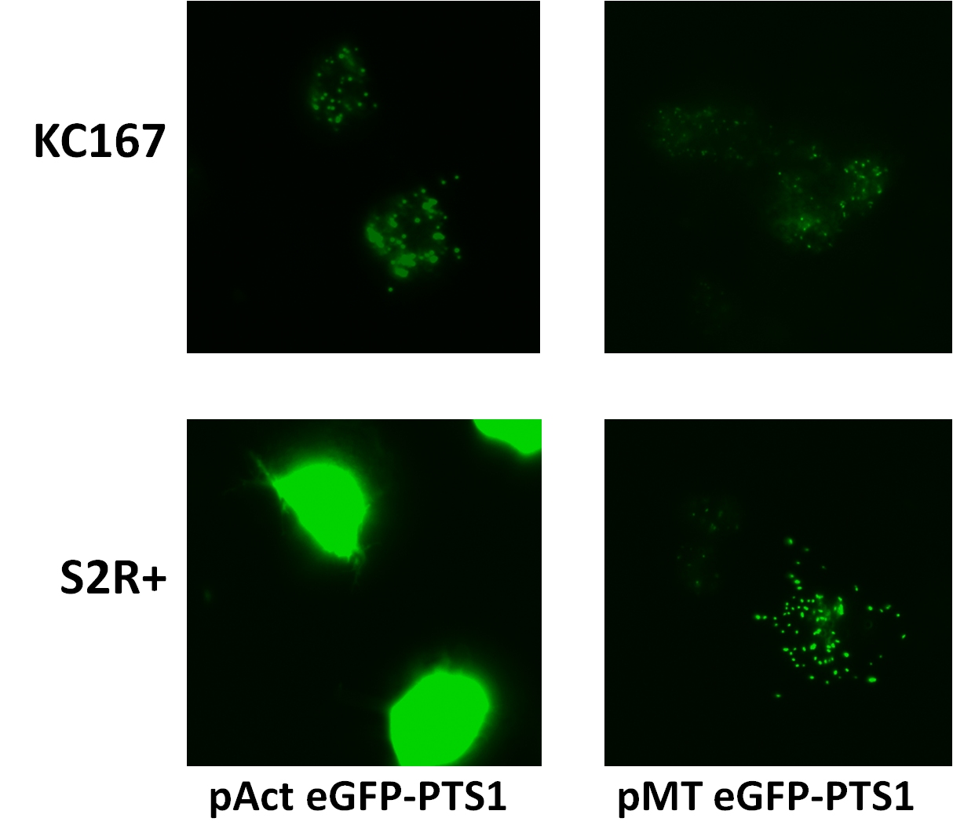
Figure 3.3. Cell-line and plasmid comparison. S2R+ and Kc167 cells were each transfected with both the pAc eGFP-PTS1 and pMt eGFP-PTS1. Cells were induced for 16 hours post transfection with 100µM CuSO₄. They were fixed and imaged at 40X magnification.
As expected, a clear, punctate peroxisomal pattern was observed. The peroxisomal nature is confirmed later in this chapter by initial KDs with PEX5 long dsRNA. The most detailed fluorescent peroxisomal patterns were observed using S2R+ cells transfected with the conditional pMt-eGFP-PTS1 plasmid after 24hrs induction with 100µM CuSO₄. Cells contained ≥20 peroxisomes, visible in a single image at 40X magnification. There was heterogeneity in the expression levels of the reporter, some cells’ peroxisomes were more brightly labelled than others, but this did not seem to have a morphological effect on the phenotype as peroxisome number and size and cell shape and size did not seem to be affected. Expression of the reporter in S2R+ cells transfected with pAc-eGFP-PTS1 is so high that import into peroxisomes is saturated resulting in a high level of cytosolic fluorescence. The punctate pattern is masked by this high level of cytosolic fluorescence and contrast is lost.
In Kc167 cells the inducible plasmid resulted in only low levels of fluorescence, too low to obtain a detailed pattern. The expression of pAc-eGFP-PTS1 resulted in good levels of expression for peroxisomal puncta but many of these puncta were out of focus. The Kc167 cells are so tall when sat on the growth surface that not only are many of the puncta out of focus but their peroxisome per cell quantities are visibly reduced and the out of focus fluorescence reduces the contrast with the puncta. The image is improved with creating a composite image by z-stacking but this is impractical for a high-throughput screen such as this. 53 plates, each containing 384 wells, are to be photographed in 9 locations in two fluorescent channels; 366,336 images totalling nearly 2TB of digital storage space will be produced. Taking z-stacks of each location is not practical. The puncta of the S2R+ cells are almost all visible in one focal plane as the cellular periphery spreads out over the growth surface (see Fig. 3.1.5.3). With many cells spread over the growth surface it is possible to view many cells’ peroxisomes in one image.
It was decided that the S2R+ cell line would be used transfected with the pMt-eGFP-PTS1 inducible peroxisomal fluorescent marker. With this combination in a single image almost all the peroxisomes in all the transfected cells can be imaged, removing the need for merging a z-stack of images.

Figure 3.4. Cross-section of S2R+ and Kc167 cells with pMt-eGFP-PTS1. S2R+ cells (a) transiently transfected with pMt-eGFP-PTS1 after 16 hours of induction with 100µM CuSO₄. S2R+ cells in exponential growth phase adhere flat to the growth surface in a stellate shape. Almost all of the peroxisomes in these cells are in one focal plane at 40X magnification. Kc167 cells (b) transiently transfected with pMt-eGFP-PTS1 grow taller in the z-dimension and are more rounded, consequently the peroxisomes are dispersed throughout the cellular body in more than one z-plane. This causes the peroxisomes that are out of focus to reduce the contrast between the peroxisomes in focus and the cytosol, consequently reducing the accuracy of the analysis software to identify the peroxisomes. The number of peroxisomes in focus is also reduced thus many peroxisomes will be missed by the analysis software.
In order to optimise the assay, it was decided to use the Class I peroxin, PEX5, for initial KD experiments. PEX5 is the receptor required for the recognition and binding of the PTS1 present on peroxisomal matrix proteins and is crucial for their subsequent targeting to and import into peroxisomes. The long dsRNA for PEX5 was designed using the “E-RNAi” website (see Methods section 2.6.6). We used a protocol adapted from Baum & Cherbas (2008) with dsRNA concentration comparable to that which will be used in the final genome-wide screen.

S2R+ cells transfected with eGFP-PTS1 were resuspended and diluted in serum-free medium and grown on sterile coverslips in two wells of a 6-well plate. PEX5 dsRNA was added to the test well. They were allowed to incubate for an hour at room temperature before an equal volume of medium containing 20% serum was added to the existing media. The cells were cultured for 3 days before being induced with medium containing 10% serum and 100 µM CuSO₄. A 600 µM CuSO₄ stock solution in 10% serum-containing medium was used throughout this chapter to induce expression of the reporter. The cells were incubated for a further 24 hours. The medium was removed and the cells were washed three times in PBS before being fixed in 3.6% formaldehyde. The cells were treated with 0.1M NH₄Cl to block active aldehyde groups before being washed in PBS and mounted and imaged on microscope slides. Images were taken at 40X magnification.

Figure 3.5. Timeline for 4-day KD. Timeline representation for a 4-day KD of PEX5 in S2R+ cells transiently transfected with pMt-eGFP-PTS1 which were grown for 3 days before a 24hr induction with 100µM CuSO₄.
The mislocalisation of eGFP-PTS1 to the cytosol shows that the PEX5 long dsRNA probe has resulted in a PEX5 defect thereby affecting the import of eGFP-PTS1 into the peroxisomal matrix (see Fig. 3.7). Despite this the presence of green puncta much brighter than the cytosol indicates that there is still functional PEX5 acting on the peroxisomal marker and therefore a complete knockdown had not occurred.
There are a number of reasons why a complete KD may not have been observed. Several factors determine the efficacy of a gene knockdown in a given cell, the most important of which are:
- The mass of long dsRNA taken up by the cell.
- The concentration of functional siRNAs in the cytosol (and nucleosol) produced from cleavage of the long dsRNA probe.
- The residual equilibrium concentrations of target pre-mRNA (if targeted) and mature mRNA at the time of administration.
- The half-life of the translation product of the target mRNA.
- The abundance of the target protein at the time of administration.
The above factors will determine two crucial aspects of the assay. The first is the beginning of an effective, complete or partial knockdown determined by loss of protein function below a critical point. The second is the reintroduction of protein function by its synthesis and that of its mRNA due to the exhaustion of specific messenger-silencing siRNAs (and long dsRNA). This creates a window of effective knockdown (loss of protein function). For the knockdown to be observed the timing of induction of the reporter and its subsequent observation needs to take place between the beginning of the effective knockdown and its termination. Therefore a sixth factor crucial for observation is the timing of induction of the peroxisomal reporter.
It was decided that a five-day growth period rather than three before addition of CuSO₄ to induce reporter expression would be attempted. The images from the PEX5 KD cells showed a complete loss of punctate signal in over 90% of transfected cells. The remaining transfected cells showed a variation from weak KD phenotype (as in the previous 3-day KD experiment) to no KD at all, indicating that up to 5% of the transfected cells did not experience an effective KD.

Figure 3.6. Timeline for 6-day KD. Timeline representation for the 6-day KD of PEX5. S2R+ cells transiently transfected with pMt-eGFP-PTS1 which were grown for 5 days before a 24hr induction with 100µM CuSO₄.
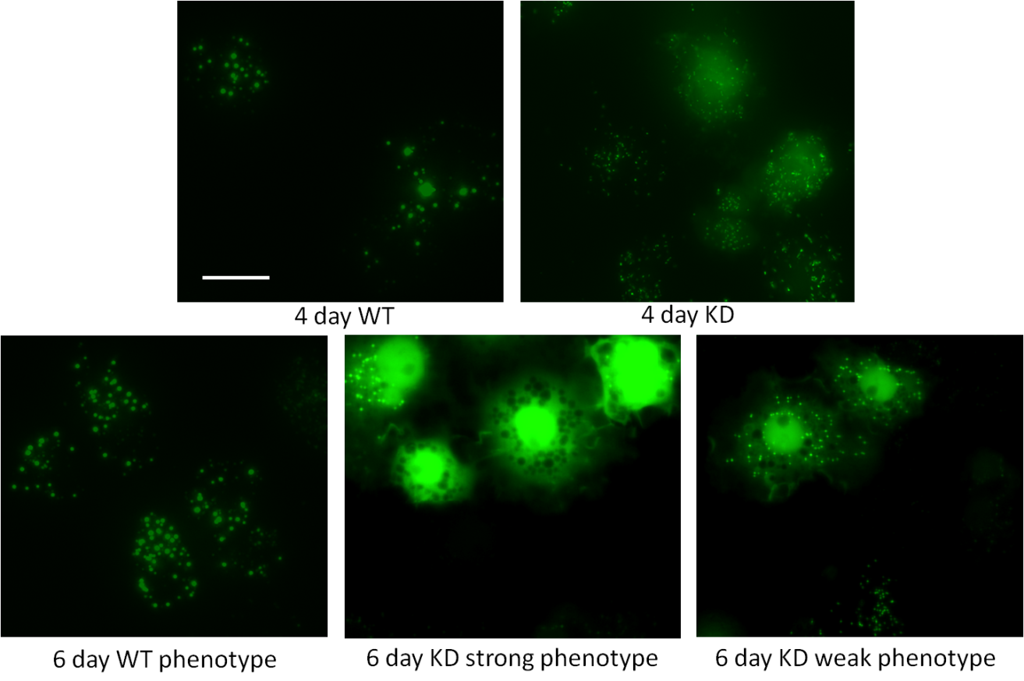
Figure 3.7. Images of 4-day and 6-day PEX5 KDs. S2R+ cells were transiently transfected with eGFP-PTS1 and knocked down with PEX5 dsRNA for either 3 or 5 days before induction with 100µM CuSO₄ for 24 hours. Cells were fixed with 3.6% formaldehyde and mounted onto coverslips with Moviol for imaging at 40X magnification. A 4 day KD displays only a partial inhibition of PEX5 function, shown by dim cytosolic eGFP accompanied by brighter puncta. The number of puncta per cell appears to be normal. 6 day KDs display both strong and weak phenotypes within the same sample, the majority are strong. The strongest KDs have very few or no visible puncta against a strong cytosolic presence of eGFP. WT controls were induced at the same time and imaged for comparison. Bar = 20µm.
It was decided that the peroxisomal matrix reporter eGFP-PTS1 should be used with S2R+ cells under the CuSO₄-inducible expression of the pMt promoter. These decisions were made due to the supporting evidence that it is an effective marker in fly cells, can differentiate phenotypes between PEX KDs and WT cells and that low to moderate expression does not alter peroxisome morphology nor WT phenotype despite variations in expression inherent to the population of S2 cells.
An inducible reporter is also desirable for a further important reason. The ability to control the induction of expression of the peroxisomal reporter avoids the labelling of import-competent peroxisomes prior to efficient KD, as would be observed with a constitutively expressed marker.

Optimising transfection efficiency of peroxisomal eGFP
The exact protocol for liposome-mediated transfection using Effectene (Quiagen) required optimisation specific to the assay as recommended by the Effectene manufacturer. There were potentially six parameters for optimisation; the number of cells, the mass of plasmid DNA, the volume of transfection buffer, the volume of “Enhancer”, the volume of “Effectene” and the volume of medium that they are all mixed with. In 1 well of a 6-well plate the buffer volume (100µl) and the medium volume (2400µl in total) was kept constant. The Enhancer has a strict 1µg of DNA: 8µl Enhancer ratio which did not change. This left the Effectene and the number of cells as the main variable factors. The first to be varied was the Effectene. This was tested in parallel at DNA (µg) to Effectene (µl) ratios of 1:10, 1:25 and 1:50 as recommended in the manufacturer’s manual, all with 2x10⁶ cells. There appeared not to be any real difference in efficiency itself, all at approximately 20%. Since the increasing cell toxicities of the higher ratios had caused more cells to die it was decided to use the lowest ratio. The experiment was repeated in triplicate with 2x10⁶ cells, 1x10⁶ cells and 5x10⁵ cells per well. All had a 1:10 ratio of DNA to Effectene. After 24 hours incubation and 24 hours induction no test seemed to excel against the others as all returned efficiencies of approximately 20%. After a repetition of both experiments it was concluded that no particular DNA to Effectene ratio held any advantage over the others as far as transfection efficiency was observed.
Based on my observations it was decided to transfect in a 6-well plate using 100µl buffer, 1µg DNA and 2400µl fresh medium with 10% serum, using 2x10⁶ cells, 8µl of Enhancer and 10µl of Effectene. Some transfection variation was observed using these conditions, frequently producing efficiencies of 20-30% of cells. During the course of this research we acquired a new 40X objective and renewed the fluorescent filters the combination of which made the fluorescent peroxisomes appear much brighter. This had the effect of apparently increasing the transfection efficiency in subsequent experiments as peroxisomes not previously observable due to their dim appearance became visible.

Knockdowns of Drosophila PEX orthologues using RNAi in S2R+ cells.
Performing specific gene knockdowns (KDs) required the specificity of each dsRNA probe to target only the desired gene transcripts and must not target those of other genes. The design of gene-specific KD probes is described in detail in the materials and methods (2.6.6). In short, gene-specific amplicons were created by PCR using primers incorporating 5’ T7 RNA polymerase promoter sequences. These amplicons are transcribed in vitro using MEGAScript (Ambion) T7 RNA polymerase in vitro transcription kit. The reaction synthesises two anti-parallel RNA strands simultaneously that anneal to from a dsRNA. The DNA template is subsequently removed by digestion with DNAse (Ambion). The quality of the PEX19 probe seems low. Repeated attempts to improve the quality and concentration of the probe, including the design of a second PEX19-specific long dsRNA failed to achieve probe qualities seen for PEX3, PEX5 and PEX16.
Figure 3.8. DNA amplicon templates and long dsRNAs. A photograph of an agarose gel electrophoresis. A-D are 1µl samples from a 50µl PCR reaction mixture showing amplicons designed for the transcription of long dsRNA, A PEX3 (448bp), B PEX5 (642bp), C PEX16 (562bp) and D PEX19 (925bp). 1-4 are 1µl samples from the 100µl dilutions of the long dsRNAs produced from the in vitro transcription reactions (after DNA digestion) made with those corresponding DNA amplicons.

Determination of assay duration
Experiments were started-off in 96-well plates. 0.5µg of dsRNA was added per well in 10µl of nuclease-free water and immediately added to it were 40µl of serum-free medium (SFM) containing 2x10⁴ S2R+ cells. After an hour, 50µl of 20% serum-containing medium was added to this for a final serum concentration of 10%. 24hrs later the cells were resuspended and transferred to sterile coverslips in 6-well plates. After 3 and 5 days cells were induced with 100µM CuSO₄. After a 24hr induction cells were fixed as described in the Methods section 2.7.9.
Phenotypes of 4-day KDs and 6-day KDs were compared. The knockdowns performed on S2R+ cells were probes against PEX3, PEX16 and PEX19, PEX5 was used as a control (not shown). In the first experiment after 3 days of incubation the cells were induced for 24hrs, a 4-day KD in total. After this period only a very weakly observable effect could be observed. Cytosolic presence of GFP was very weak in all cases, and was comparable to that of a much higher than normal expression level of a WT cell, with the exception of PEX19 which showed none. PEX19 showed no noticeable reduction in peroxisomes while PEX3 and PEX16 showed peroxisome number to have apparently decreased slightly and to have increased in size and brightness (images not shown). These findings could not at this stage be numerically determined but would be confirmed in later tests with computer-aided analysis software.
However after a 6-day KD, PEX3 KD showed a strong reduction in peroxisome number, approximately 1-5 per cell, and an increase in cytosolic GFP. Peroxisomes also appeared larger than in WT cells. In the PEX16 KD no punctate pattern could be observed indicating either that the peroxisomal GFP is fainter than that of the cytosol to the point of no visible contrast or that there are no peroxisomes present to concentrate the GFP expression. The latter is more likely as PEX16 loss-of-function in human patients is characterised by a lack of peroxisomal structures (Shimozawa, 2011). The PEX19 KD was the weakest of those tested, peroxisome number had lowered slightly and there was a small increase in cytosolic staining. This could be a result of the lower concentration of the probe visible in Figure 3.10. It is unlikely that the probe design itself is inefficient as all long dsRNAs produced for this research by E-RNAi had efficiency scores of 45-55% (of the total number of different siRNAs produced and analysed in silico). As discussed previously observation of phenotypes is dependent on several specific variables (see Chapter 3.5).
In all cases there was variability in the degree of each knockdown with some cells appearing like wild type suggesting that there was no KD in a small proportion of cells. Approximately 95% of transfected cells show a knockdown phenotype for PEX3, PEX5 and PEX16 in approximately 200 cells examined.
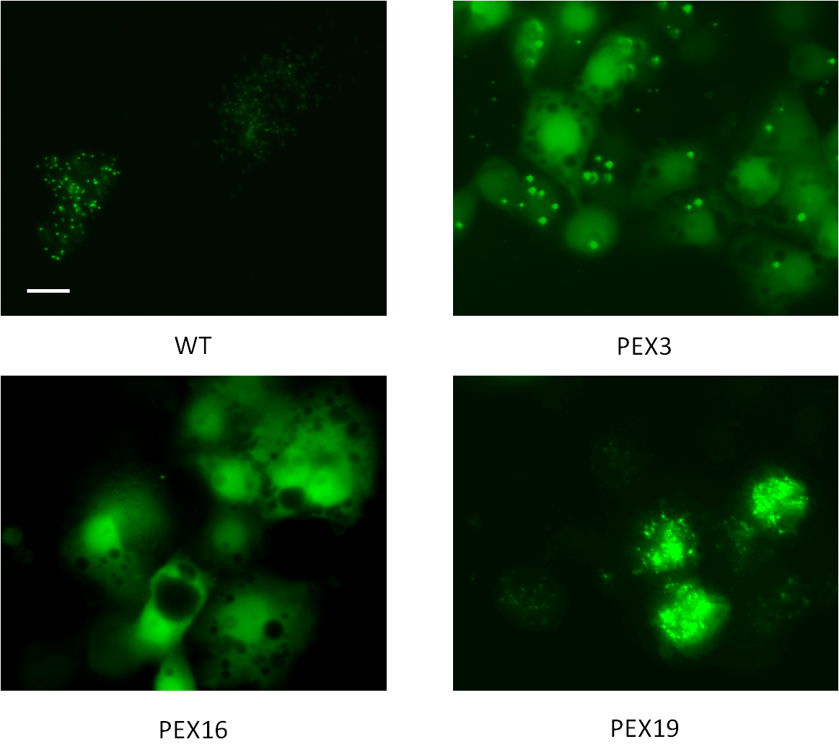Figure 3.9. 6-day KDs of PEX3, PEX16 and PEX19 in S2R+ cells. S2R+ cells transiently transfected with pMt-eGFP-PTS1 grown for 5 days before a 24hr induction with 100µM CuSO₄. Effective knockdowns can be observed for the PEX3 and PEX16 genes. PEX19 does not give such an effective KD however it does not present as WT cells either with partial mislocalisation of eGFP-PTS1 to the cytosol. Bar = 20µm.

Down-scaling and optimisation of the knockdown assay for 384-well microtitre plates
The genome-wide screen is conducted in 53 384-well microtitre plates. Each well is pre-seeded with 250ng of long dsRNA specifically targeted to a gene transcript, dissolved in nuclease-free distilled water. As part of the assay development the SRSF designed an “Assay Plate”, a single copy of a 384-well plate that contains long dsRNAs for developing the assay. The dsRNAs are arranged in 60 quadrants, 3 wells each of which contain a long dsRNA that targets a different D. melanogaster kinase per quadrant. Fourth is one that targets a C. elegans gene. All of which are intended to be negative controls thus enabling the user to generate a large amount of WT data and analyse it for mean and variance of data. A series of these assay plates would be used to optimise the assay before genomic screening could commence. Each plate also contains 16 wells for 8 duplicates of controls arranged in anti-parallel. This allows for inter-plate comparisons facilitated by normalisation software (see Ch. 4.7).
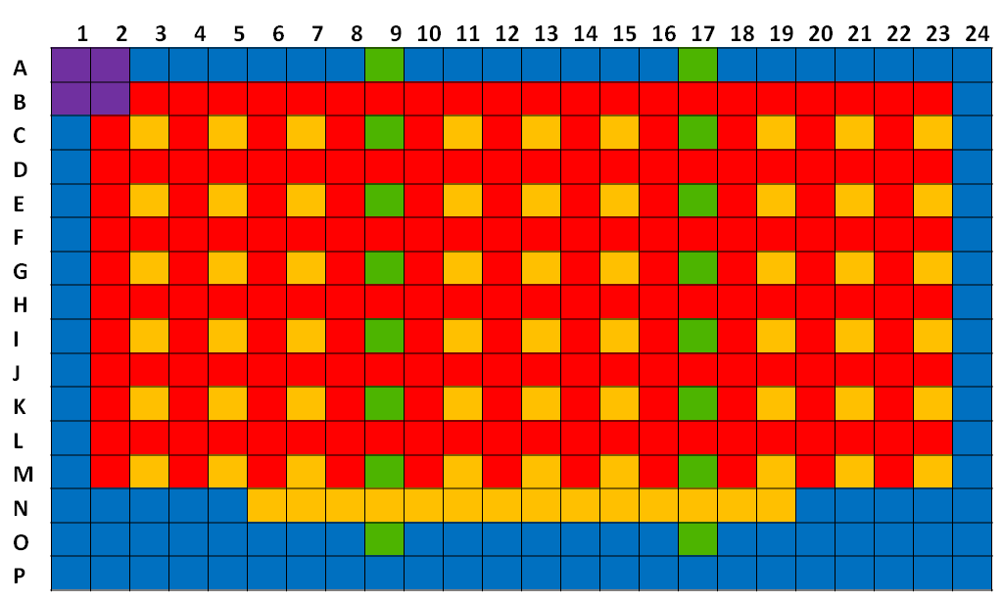
Figure 3.10. A schematic of the layout of the assay plate. Sixty kinases (red) arranged in triplicate in quadrants with a C. elegans negative control (yellow) in the bottom-right position of the quadrant. Those C. elegans probes displaced by controls (green) in columns 9 and 17 are arranged along row N. 4 DIAP (Drosophila Inhibitor of Apoptosis-lethal) controls are included in the top left quadrant. The controls are added in an anti-parallel arrangement. In Screen 1 the controls were (top to bottom in column 9, bottom to top in column 17) PEX3, PEX5, PEX16, PEX19 and Tango11. Leaving 3 control wells empty of dsRNA.
The knockdown experiments previously described require scaling down and to do this parameters from previous screens conducted at the Sheffield RNAi Screening Facility (SRSF) were used as guides. All of the previous screens had, however, been luminometry-based assays. Cells in a luminometry screen are not treated in the same way as in a microscopy-based screen. A major difference is the requirement for microscopy screens to have a near-confluent monolayer of cells. Microscopy screens needed fixing to halt the progress of KD and marker expression before image capture and nuclear staining was required by all microscopy screens analysed by the software in the SRSF. Three parameters therefore needed optimising at this stage of assay development:
- The density of cells seeded in each well
- The method of fixation
- Nuclear staining
These were all done in tandem with the optimisation of image acquisition on the ImageXpress microscope and the image processing and statistical analysis performed by the MetaXpress analysis software as these were required to critically evaluate the three parameters mentioned above. In the next sections the optimisation of these parameters will be described and discussed.
Figure 3.11. Stages of development schematic 2. A schematic showing the steps required to successfully downscale the KD assay for use in 384-well microtitre plates.

Development of cell-seeding density for 384-well microtitre plates
From experiments in 6- and 96-well plates it was already known that knockdowns of PEX3, PEX5 and PEX16 took as long as 6 days to achieve a visual phenotype with the fluorescent peroxisomal marker. Other screens in the facility were using 15,000 cells per well but for luminescent screens rather than fluorescence-microscopy screens and then only for 4-day experiments. To determine the most effective seeding density a serial dilution was performed using a microtitre-plate multi-dropper (“Multidrop Combi”, Thermo). This is a liquid handling machine that uses an array of 8 nozzles to jettison precise volumes in multiples of 5µl in a similar fashion to a multi-channel pipette. The array of nozzles is moved along the rows of the plate and as it passes over each column it pauses and each nozzle jettisons the required volume of media into the well below before the array is moved along to the next column (a detailed account is given in the Methods Ch 2.7.7). An entire plate can be seeded in less than 20 seconds which is a fraction of the time it would take to manually add liquid using a multi-channel pipette.
Seeding densities of 16000, 8000, 4000, 2000 and 1000 cells per well were dispensed in 10% serum medium using decreasing volumes of S2R+ cells transiently transfected with the inducible peroxisomal marker from a stock of 2x10⁵ cells.ml⁻¹. Four columns of a blank plate were assigned to each cell density. Each well was made up to a total of 80µl using 10% serum-containing medium. The final four columns were filled with 10% serum medium only (no cells). After an hour when the cells had settled to the bottom of the well 30µl of the medium was removed by aspiration leaving 50µl in each well (aspiration procedures are discussed in a later section in this chapter).

Figure 3.12. A schematic diagram showing how each seeding density was achieved. Serial dilutions were produced by halving the volume of 10%-serum medium containing S2R+ cells at a density of 200,000 cells.ml⁻¹ from 80µl down to 5µl. The wells were each made up to 80µl using cell-free 10%-serum medium. Each treatment was applied to 4 columns (64 wells) of the plate. One treatment contained no cells as a negative control.
After 5 days of incubation and a 24hr induction with 100µM CuSO₄ the cells were fixed with 3.6% formaldehyde and simultaneously nuclei were stained with Hoechst 33342 (Invitrogen - emission maximum of 461nm) and visualised on the Varioscan microscope (Molecular Devices). This is an automated microscope specifically designed for imaging of microtitre plates. All images shown in the rest of this chapter were taken with this microscope. This epifluorescence microscope contains multiple wavelength fluorescence channels, the two relevant for this study are “DAPI” and “GFP” which detect 447-60nm and 520-35nm wavelengths respectively. These two channels are also suitable for the detection for the Hoechst and eGFP channels respectively. In the wells with the two highest densities, cells had overgrown to the point of forming clusters of cells that grew above the plane of focus that visualised the majority of the cells. In the DAPI channel this created blurred regions that greatly reduced the contrast between the nuclei that were in focus and the immediately surrounding space. In the FITC channel the light from the fluorescent peroxisomal marker in the cells that were out of focus was diffracted through the cells that were in focus (the microscope is inverted). This would have been interpreted as cytosolic GFP by the analysis software though visually it clearly isn’t a KD phenotype. The seeding densities of these two treatments (16,000 and 8,000 cells.well⁻¹) were deemed too high. The next highest treatment (4,000 cells.well⁻¹) achieved a near-confluent and very even distribution of cells, with only very small areas affected by low confluence or overgrowth. The images produced from these wells had cells almost all of which had nuclei in focus and transfected cells, the majority of whose peroxisomes were also in focus. This was deemed to be the optimum seeding density as it did not need any improvement and the lower seeding densities, while in focus, simply lowered the number of visible cells in the image and which would reduce the statistical value of any measurements made by the analysis software.

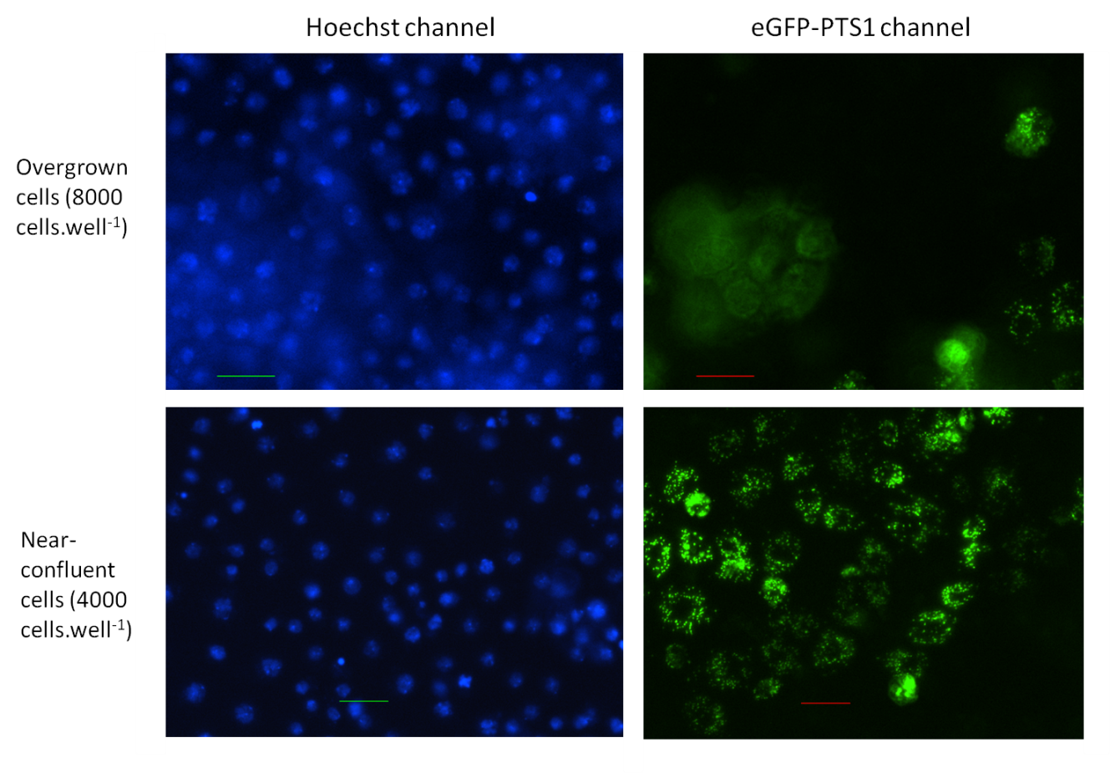Figure 3.13. Optimisation of cell-seeding density. Fluorescence microscopy analysis of fixed S2R+ cells transiently transfected with pMt-eGFP-PTS1 and with nuclei stained with Hoechst. The top two images are of the same site in a well containing overgrown cells seeded with 8,000 cell.well⁻¹. The bottom two images are from a site containing cells at near-confluence, seeded with 4,000 cells.well⁻¹. The overgrown cells cause peroxisomes not in the focal plane to appear diffuse as their light is refracted through the cells on the growth surface. Nuclei are poorly contrasted. On the bottom row cells in the focal plane have punctate peroxisomes and distinct nuclei.

Cell-fixing protocols for a 384-well plate
Concurrent to the cell-seeding testing was development of the plate fixing protocol. The possibility of imaging the plates without fixation was considered but immediately rejected as it takes over 2 hours to image a 384-well microtitre plate. Since 53 plates require imaging this would mean that there is a 5-day difference between imaging of the first plate and the last plate. During this time certain KD phenotypes may become more severe for some genes whereas others may lose their KD phenotype. A direct comparison of the whole dataset would no longer be possible. In previous luminometry screens cells had growth media removed using the “ELx405 Select CW” aspirator (BioTek) which removed the vast majority of the media leaving only 10µl remaining in each well. Luminometry reagents were then added to all the wells using the Thermo Multidrop immediately prior to luminometry.
This method was initially used for the removal of induction growth medium and the addition of cell fixative. However the addition of the 3.6% formaldehyde solution as fixative through the Multidrop caused the removal of the S2R+ cells from the growth surface as the fixative solution was jettisoned at high-pressure. The newly suspended cells were removed from the wells in subsequent aspiration steps and the wells could not be used for imaging.
The solution to this problem was to use the aspirator for both aspiration and fixative addition. The aspirator has an integrated liquid dispensing system that is able to administer controlled volumes, crucially at low velocity. The system dispenses liquid at an angle down the inside of the well to minimise the pressure of it as it reaches the growth surface and thus minimise the washing of cells from it. As S2R+ cells do not adhere well to the growth surface it was deemed necessary to leave an extra 10µl of volume in the well, in case the aspiration was having an effect on removing cells (see Methods Ch.2.7.9).

Nuclear staining
The microscopic image analysis software settings all require that the nuclei be stained with either DAPI or Hoechst nuclear staining solution so that per-nucleus (cell average) parameters can be calculated for all measurements taken. Usually with nuclear staining in fluorescence microscopy assays of D. melanogaster cells, the nuclear stain is dissolved in PBS and added to the cells after their fixation (Kiger et al. 2003). Despite the success of the development of linking the aspiration and dispensation steps, it was still prudent to minimise the number of wash steps and thus reduce the risk of washing cells from the well. It was decided to test the efficacy of staining the cells with Hoechst 33343 at 1ng/ml in 3.6% formaldehyde, 1XPBS. Logistically it was easier to add the Hoechst dye to all the plates in the screen before washing them 3 times in 1X PBS. This meant that cell would be fixed and stained in formaldehyde and Hoechst simultaneously for 40-60 minutes. This is 4-6 times the recommended fixing duration and 8-10 times the recommended nuclear staining duration. This needed testing as to whether this alternative protocol would be suitable in allowing successful reporting of the assay. Not only were the fixing and staining protocols successfully executed but the WT and control phenotypes appeared not to be adversely affected by this treatment (not shown).

Microscope settings configuration
Figure 3.14. Stages of development schematic 3. Schematic showing the steps required to optimise the microscope for imaging fluorescent peroxisomes and nuclei for subsequent computer-aided analysis.
The settings for image capture required optimising specifically for the screen. A detailed account is given in Methods Ch 3.1.11. The images taken of the 384-well microtitre assay plate highlighted two problems for data-logging. The first is that the low transfection efficiency (between 10-30% of cells) meant that there were many images at 40X magnification that had no transfected cells in any of the four images taken in a 2x2 quadrant in each well. Up to a quarter of each assay plate comprised wells which counted less than 10 cells. There were as many as twenty entire wells that registered no peroxisomes. The simplest way to improve this was to develop the screen for 20X magnification. The 20X images covered 4 times the area of the 40X and when the quadrant was increased to 3x3 sites there was a nine-fold increase in area imaged in each well; this made it more likely that enough cells could be imaged that would produce reliable data when an average was taken over all cells in all the sites of each well. Despite this, approximately 1-2 wells in each assay plate tested had no transfected cells in any of the nine images. This potentially meant that as many as 106 wells of the genome-wide screen would be randomly null-tested (0.52% of the screen), which was deemed acceptable. Because of the change in objective from 40X magnification (resolution 0.42µm, NA 0.60) to 20X magnification (resolution 0.37µm, NA 0.75) the image resolution decreased and peroxisomes situated closer together could no longer be resolved. An advantage of the 20X objective is that focal depth of the image is increased and so the number of peroxisomes in focus is negligibly affected.
In summary the screen would be imaged with the 20X objective at nine sites per well and standard exposure times and height above the surface of the well bottom were determined.

Image evaluation and post-processing for 384-well plates
Figure 3.15. Stages of development schematic 4. A schematic flow diagram showing the steps required to produce numerical data from the analysis software that statistically differentiates WT from non-WT phenotypes. The protocols were constantly adjusted throughout the development of the assay. These parameters needed minor adjustments for the individual experiments and most frequently required editing after tests with multiple controls had been included in these experiments.

Segmentation development in 384 well-plates
In order to interpret images as unbiased numerical data individual cells and their peroxisomes need to be identified. This process is called “segmentation”. The use of automated analysis software is crucial in forming an unbiased approach to evaluating images for 18,000 gene KDs as it would be impossible to do it by eye. It is therefore crucial that the same parameters can accurately discriminate between WT and aberrant phenotypes in the each field of data. The description of how this was achieved is described below. Its inclusion in this chapter helps demonstrate how this forms the basis of the generation of the numerical data and subsequently the analysis of the screen.
Segmentation using the METAXpress software requires the differentiation of fluorescent bodies from non-fluorescence or background noise, from each other and their subsequent quantitative characterisation. The process requires that a fluorescent image be presented in monochrome greyscale and treated with auto-contrast. It has each pixel in the image given a value of brightness; this brightness is referred to in the software user interface as its “grey-level”. The segmentation software is then able to report back which pixels exceed a user-defined threshold of grey-levels above their neighbouring pixels and then begin to draw a boundary along the bright/dark frontier. It then highlights the supra-threshold pixels in a solid colour, labelling Hoechst as grey and eGFP as green in the composite image, (see figures below 3.17 & 3.18). This highlight is the referred to as the segmentation. The segmentations are super-imposable upon others created from other fluorescent channels at the same site. Through trial and error the final settings for each fluorescent channel are determined. This allows the combination of multiple fluorescent probes; typically nuclear staining plus one or more fluorescent channels. Numerical data is then interpreted either for each image, each cell or both and what is reported is dependent on the specific application used (e.g. number of peroxisomes per cell, average fluorescent intensity per peroxisome).
The segmentation of the cells required the numerical interpretation of the visual phenotype of both WT and KD S2R+ cells expressing peroxisomal eGFP. The genome-wide screen would first be analysed by number of peroxisomes per cell, any other parameters would be interpreted secondarily. “Transfluor” is the main application for segmenting and counting puncta. It is very effective but because of the low transfection efficiency of the cells it became necessary first to discount the untransfected cells as the Transfluor application segments and counts all puncta and divides them between all segmented nuclei, massively reducing the average peroxisomes per cell count. A series of processes is required to achieve this.
The first application is “Multi Wavelength Cell Sorting” (MWCS). This is the more basic of the two fluorescence analysis applications as it simply acts to segment areas expressing eGFP within specified limits of size and intensity. . This application neither differentiates between puncta nor between puncta and cytosol. If they are bright enough it groups puncta together and assumes that they are peaks in a fluctuous and continuous, fluorescent cytosol. The same application is able to segment the nuclei and thus create two super-imposable segmentations, nuclear (“DAPI” – Figure 3.15.1, Panel C) and GFP (Figure 3.15.2, Panel C). MWCS is able to detect the eGFP-positive cells and these can be isolated using additional smaller applications provided in the METAXpress software (Figures 3.15.3 and 3.15.4).

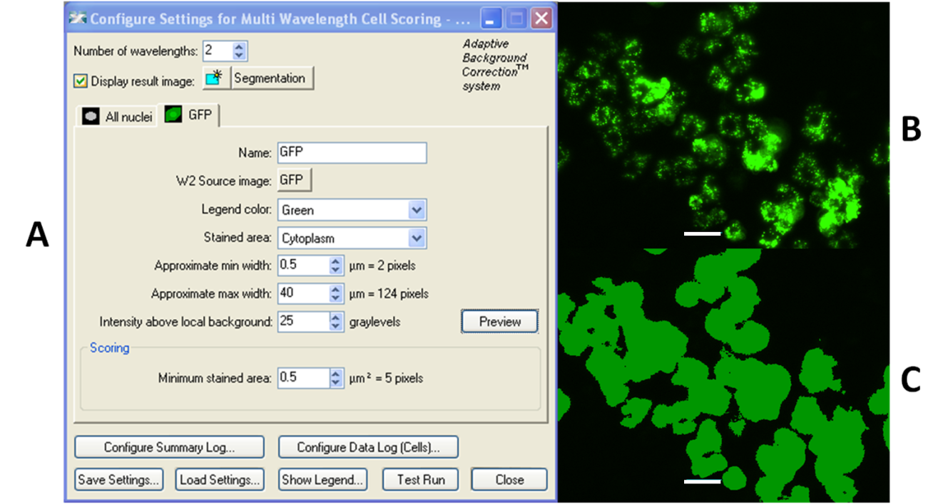Figure 3.16. GFP segmentation of WT cells using Multi Wavelength Cell Scoring. Settings (A) developed for the first screen. The software refers to the eGFP channel as the GFP channel throughout. The raw GFP image is shown in B, the segmentation in C. Bar = 20µm.
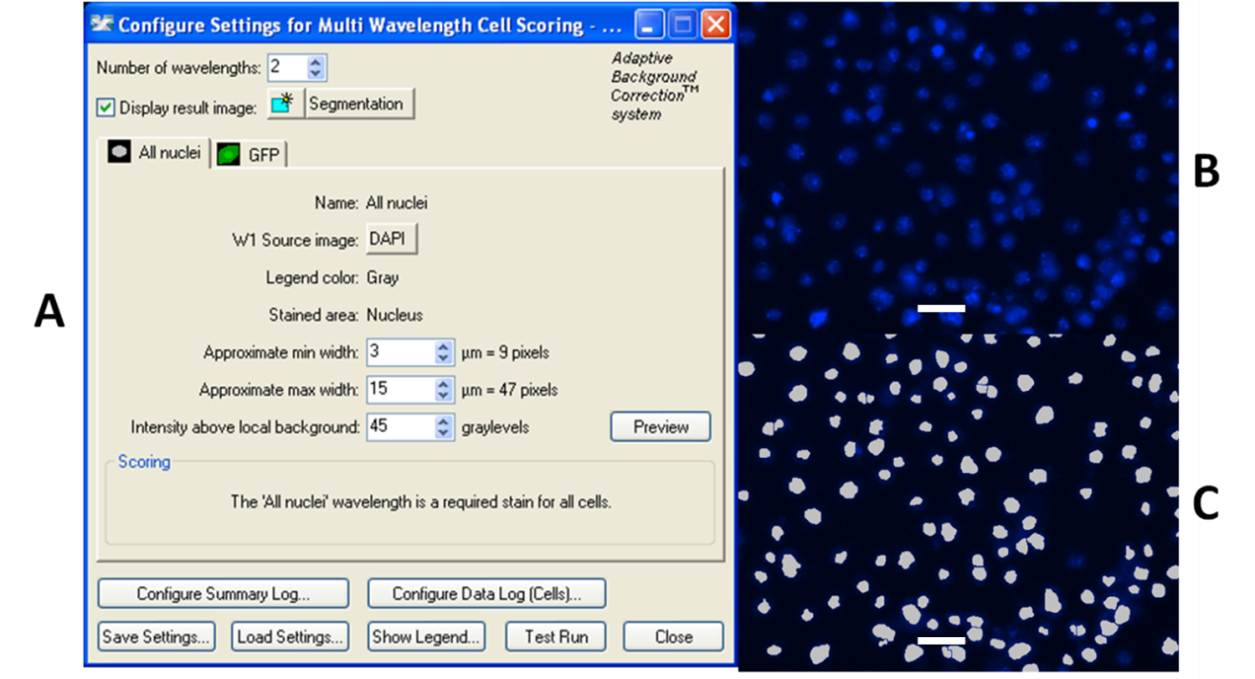
Figure 3.17. Nuclear segmentation of WT cells using Multi Wavelength Cell Scoring. Settings (A) developed for the first screen. The software refers to the nuclear Hoechst fluorescence channel as the DAPI channel throughout. The raw Hoechst staining is shown in B, the nuclear segmentation in C Bar = 20µm.
The “Threshold” command allows the user to combine the segmentations, Nuclear and eGFP, and choose how to present them. There are two sliders that can either include or exclude which nuclei are displayed based on their association with the eGFP. In this case there are just the nuclear channel and the eGFP channel which means that there are three populations of nuclei to display, those associated with eGFP, those not associated with eGFP, or all nuclei. Using the slider only the eGFP-positive nuclei are displayed. Those nuclei not expressing eGFP are removed from the segmentation image and considered removed from any further analysis.
Figure 3.18. The combined MCWS segmentations of WT cells. (A) is needed to select the eGFP-positive nuclei. The nuclei only display (B) is used by the Threshold application (settings in C) to remove the nuclei of non-transfected cells. The settings show that the two populations between the arrows (all nuclei and non GFP-associated nuclei, 0-2) are being excluded leaving the GFP-associated nuclei selected (2-3, D). Bar = 20µM.
The next command is “Binarise”. This is to convert the segmentation image with the eGFP-positive nuclei into a simple black and white image. The nuclei remain white on a black background. This would be sufficient for the Transfluor application to use as a nuclear channel to superimpose peroxisomes onto it except that the Binarise application created a 2-bit black and white image called “Binarised”. The Transfluor application requires a minimum quality of 16-bit images be used. The nuclear segmentation can be converted from 2-bit to 16-bit using an application called “Arithmetic”. Arithmetic makes a simple conversion without any visual alteration to the segmentation. The new image is created in a new window and named “Arithmetic”, signifying its progress in the overall segmentation process (not shown).
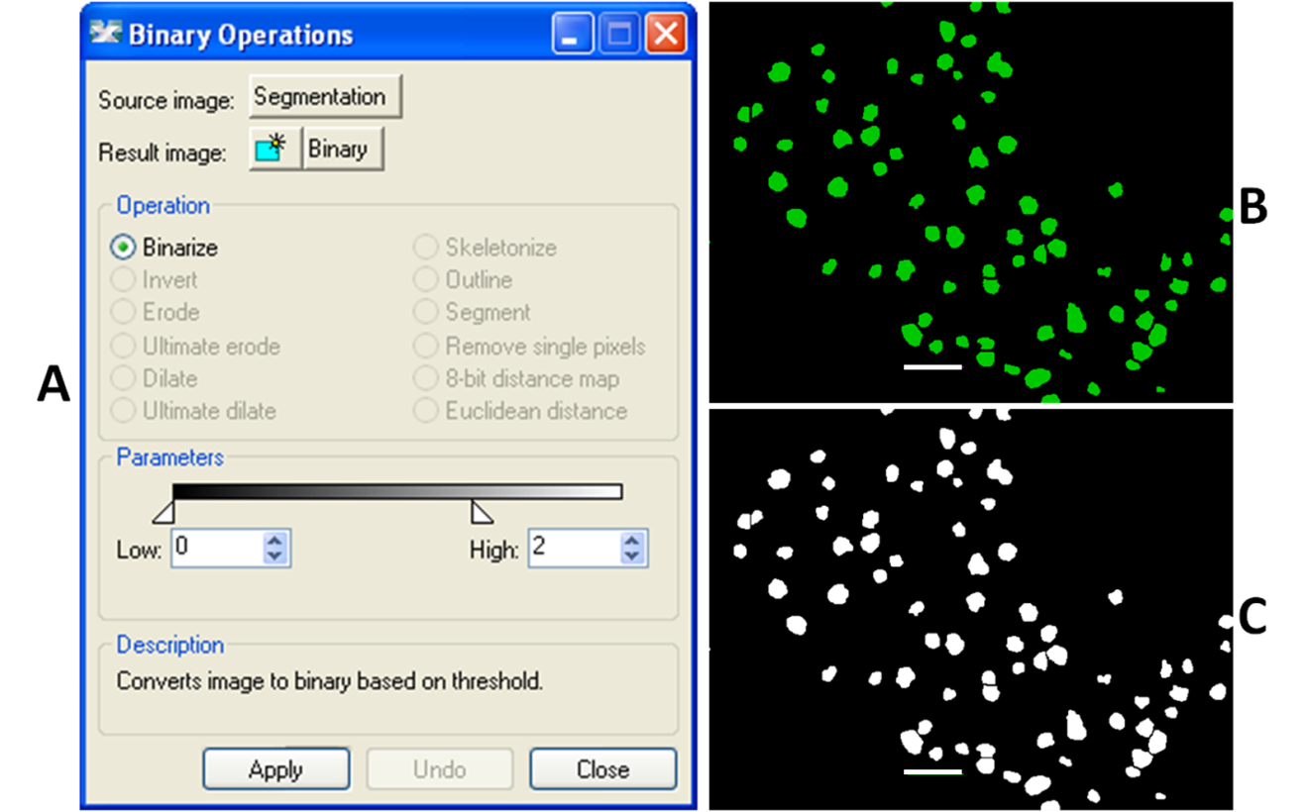Figure 3.19. Binary Settings. The Binary program settings (A) convert the threshold image (B) to a “binary”, black and white image (C). An application called arithmetic converts the binary image from 2-bit to 16-bit. Bar = 20µm.
The Transfluor application can now be executed but instead of it using the raw DAPI channel as its nuclear input, it now uses the “Arithmetic” image which has had all the eGFP-negative nuclei discounted. The eGFP channel can now be analysed for punctate structures. Transfluor uses a different algorithm to that of Multi Wavelength Cell Sorting, looking specifically for puncta. The puncta are measured for cross-sectional area, intensity and quantified on an average per cell, average per punctum and total per image basis as well as many other parameters not compared in this study. The settings needed extensive repetition and fine-tuning on a trial and error basis. The settings needed to reproducibly differentiate between the WT and PEX knockdowns based on peroxisome number per nucleus.
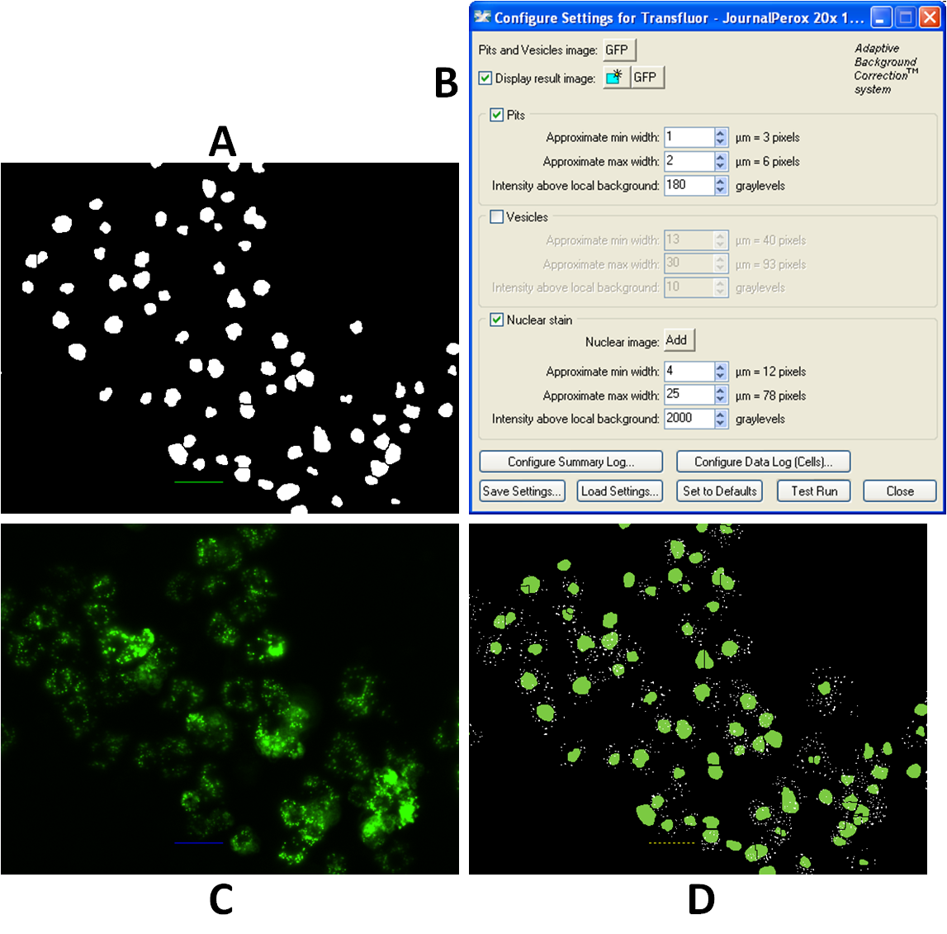Figure 3.20. Transfluor setting and peroxisomal segmentation of WT cells. The nuclei from the 16-bit “Arithmetic” image (A) are used as nuclear markers by the Transfluor application settings (B). The raw GFP image (C) is then analysed for puncta (referred to in the software as pits) which are segmented and then superimposed onto the Arithmetic image (D). Bar = 20µm.
All the applications need to be executed in the correct order. It is highly impractical to do it manually for the 183,168 sites in the genome library and so the METAXpress software has an application called a “journal”. Journals list the applications chronologically in the order that they require executing (Figure 3.22.). During the analysis of the screen the entire journal is executed for each site of every well, the applications are listed top to bottom and executed thus.
Figure 3.21. Journal application list. The journal application that lists and executes all the applications and processes in the order required, top to bottom. For the first screen the MWCS needed executing on each site prior to Transfluor. The summary log opens an excel file which records selected datafields in columns and logs each site’s data on a new row. Table 3.1/2 is a sample showing the data for the WT site already processed above and a PEX5 site processed in Figure 3.23 using the same settings. The final command closes the images that are open on the desktop before the new images are opened to prevent the accumulation of opened images, reducing processing power on the active computer.
The same settings for MWCS and Transfluor needed to be executed on all sites in the genome and be able to differentiate numerically between WT phenotypes and deviations from them. Figure 3.23. shows a PEX5 KD processed by MWCS and Transfluor with exactly the same settings as the WT image from above.
Figure 3.22. Stepwise segmentation of PEX5 KD. The raw GFP (A) and nuclear (not shown) images are segmented and merged (B). The eGFP positive nuclei are selected using Threshold (C) and are binarised and converted to 16-Bit (D). Transfluor then counts puncta in the original GFP image and nuclei in the binary image and presents them in a joint segmentation (E) from which puncta and nuclei can be counted and analysed. For comparison, the joint segmentation is laid over the original GFP image (F). Cells with the most puncta appear to be those with the more moderate KDs.
Test | Puncta Count | Puncta Per Cell | Pit Area Per Cell | Pit Average Intensity | Nuclear Count | Nuclear Area Per Cell (µm²)
WT | 1446 | 42.5 | 8.1 | 726.8 | 34 | 22.7
PEX5 | 48 | 2.5 | 0.4 | 649.8 | 19 | 20.5
Table 3.1. An example of the data recorded for screen one. The data displayed is for the 2 sites compared in this chapter, taken from an early assay plate.
These data are of course only as accurate as the limitations imposed on them by the capabilities of the apparatus (e.g. microscope objective) the image quality (e.g. resolution) and software (e.g. segmentation of peroxisomes and nuclei). Peroxisomes that are out of focus are not only discounted but reduce the contrast between the neighbouring peroxisomes that are in focus and the surrounding cytosol. As seen in the PEX5 KD, a small number of peroxisomes are segmented, and therefore counted, in parts of the cell where, by eye, no punctum is present. This is because the sensitivity of the software to find a contrast of grey-levels above the threshold has caused the segmentation of a pit. It may be because a pit is present that is not observable by eye or simply that the software is so sensitive that it treats fluctuations in cytosolic eGFP as pits. Nonetheless the settings are necessarily sensitive enough to segment much dimmer peroxisomes in WT cells with low peroxisomal marker expression. The net effect is of an approximation of peroxisomes per cell which is accurate enough to reproducibly differentiate between a WT site and one with a PEX phenotype.
The Transfluor application records a large number of statistics on both a per cell (technically per nucleus) basis and a per site basis. The most important statistic that the screen would be judged upon would be “Average pits (peroxisomes) per nucleus” and all others would be analysed secondarily. The assay was able to consistently show significantly different peroxisome per cell counts (recorded as “pits per cell”) between the some of the positive PEX controls and the average for the assay plate negative controls (see Table 3.2/3). For the screen significant differences would be considered to have a z-score greater than 2 standard deviations (σ) from the mean (µ). PEX5 has the strongest z-score. PEX3 and PEX19 showed less consistent KDs ranging from as low as 5 to as high as 25 peroxisomes.cell⁻¹ but consistently below the mean (hardly ever above). These data were derived from three separate assay plates with three different populations of cells transiently transfected separately with pMt-eGFP-PTS1 confirming the reproducibility of the screen.

Figure 3.23. The equation for calculating a Z-score (Z). A value (n) is expressed by its distance from the mean (µ) in terms of the standard deviation (σ).
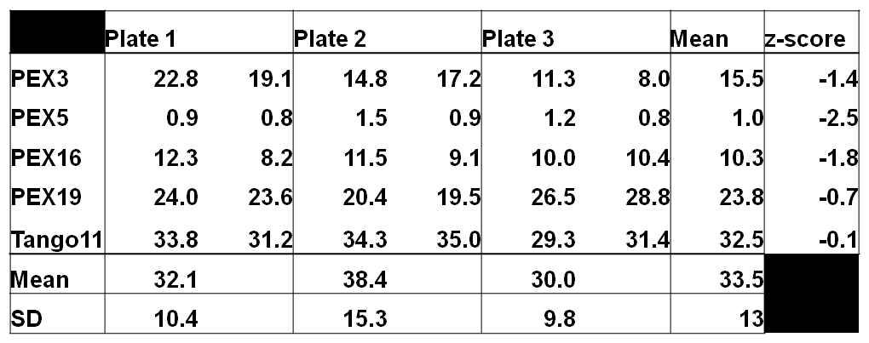
Table 3.2. Assay plate control testing. The peroxisome per cell counts for each control on each plate and their mean across all plates. The mean for each entire plate and its standard deviation (SD) and the mean and SD for all three plates are also given for comparison. The mean for each control is also represented as a z-score.

Summary of progress so far
The focus of assay development is to produce a working assay that reports numerical data from microscopic images that can differentiate non-WT phenotypes as statistically different data from WT phenotypes (the rest of the genome-wide screen). Whilst the use of PEX gene KDs in assay development has provided evidence that this is possible in the context of identifying peroxins, it is still evident that there are ways in which the assay is flawed. It has been shown that gene KDs producing strongly aberrant phenotypes such as PEX5 and PEX16 will be recorded as outlying data in assay plates, yet KDs of PEX3 and PEX19 do not produce the deviation required to immediately distinguish them from gene KDs that appear as WT. This would suggest that moderately affecting genes that may be of interest could in fact be missed by the statistical analysis, requiring visual confirmation. It is also apparent that the quality of a probe (its efficiency at producing effective siRNAs) will also determine whether a gene KD will occur. As discussed in Ch. 3.5, there are a number of factors which will determine a probe’s individual efficacy of gene KD. While no screen is perfect it is still anticipated that the most extreme phenotypes will be differentiated from the rest of the genome and with this purpose it was decided to commence with the screen but realising that it is unlikely to reveal all peroxins in D. melanogaster.

Results for Genome-wide Screen 1
The genome-wide screen was performed and analysed. The analysis of the screen is presented and discussed in the remainder of the chapter.

3 Controls showed consistently greatly reduced numbers of peroxisomes per cell.
Before the genome-wide screen was analysed in detail the efficacy of the included knockdown of our control PEX probes was visually determined. As expected from our previous experiments in our assay development PEX3 PEX5 and PEX16 KDs were each highly effective in generating an aberrant phenotype in contrast to WT images. Since these controls worked the complete genome-wide screen was analysed using our peroxisome analysis algorithm developed in METAXpress.
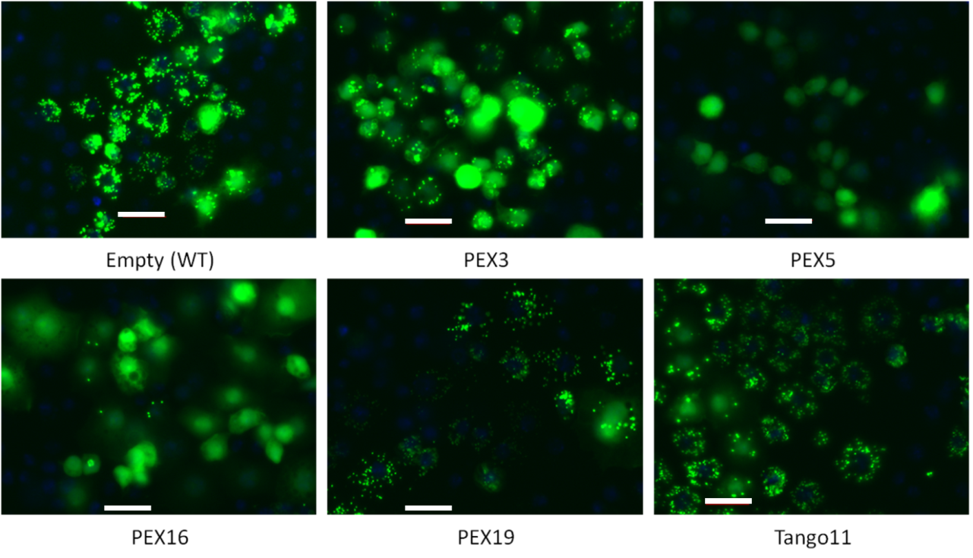 Figure 3.24. Screen 1 Controls. One image each from a site of the control probes taken from plate 1 of the screen. The “Empty” image is of Plate 1, Well A03, which was filled with 5µl nuclease-free de-ionised water, displaying a WT phenotype. Bar = 20.00 µm.
Each plate of the screen contained two copies of each control probe. This meant that 106 datapoints could be analysed per control. The positive controls PEXs 3, 5, 16 returned average peroxisome per cell numbers of 7.19, 0.79 and 3.11 respectively see table ?. PEX3, PEX5 and PEX16 have means of their 106 datapoints greater than 2 standard deviations (2σ, 7.42 peroxisomes per cell) of the entire screen from its mean (µ, 15.74) and only PEX5 and PEX16 have 95% of their datapoints greater than 2 σ from the mean. Despite this PEX3 shows a visible deviation from WT phenotypes in all wells in all plates, as do PEX5 and PEX16.
PEX19 and Tango11 probes were also included and as expected from our previous experiments proved to be ineffective at producing a non-WT phenotype. None of the PEX19 or the Tango11 datapoints exceed a Z-score of -2. Their means are both within one σ of the mean (-.09 and 0.12 respectively).
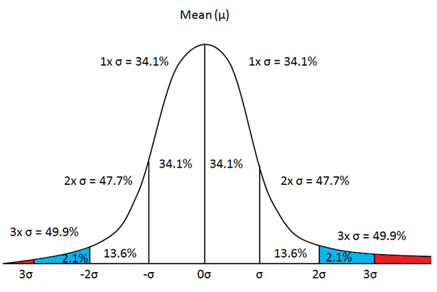Figure 3.25. Schematic of a normal distribution curve. A normal distribution curve showing the mean (µ) and lines representing standard deviations (σ) from the mean. The area under the curve and between each line is given as a percentage of the distributed data that it represents. Data that exceed a magnitude of 2σ are within the 4.55% (2 decimal places) of the most outlying data in the distribution. This exceeds a 95% Confidence Interval and data exceeding a magnitude of 2σ from µ are considered statistically significant aberrant phenotypes.

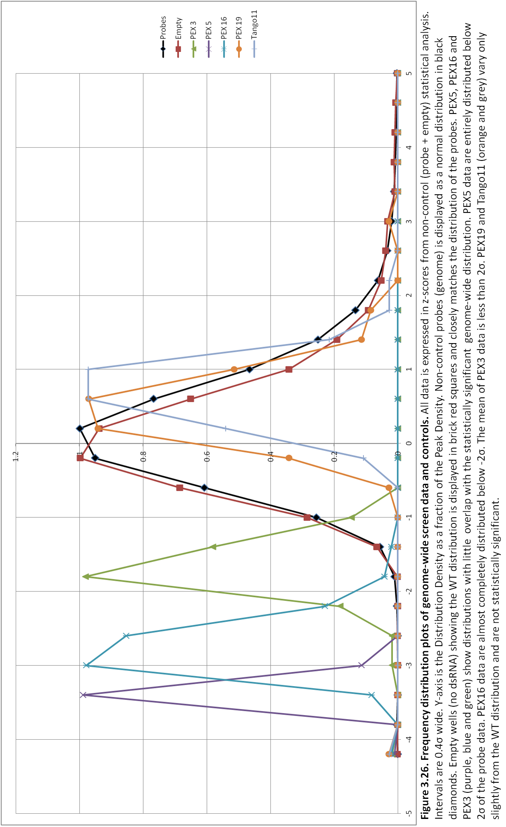
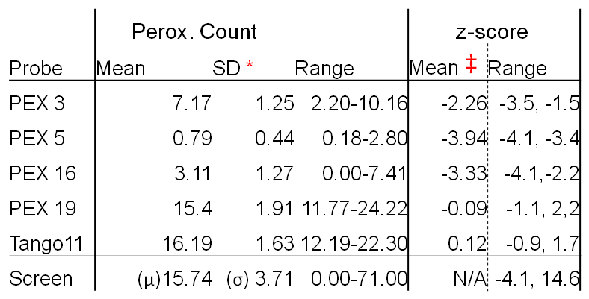
Table 3.3. Probe data summary for Screen 1. Number of peroxisomes per cell and Z-scores for each probe across all the plates (106 wells per probe) in non-normalised data. *The standard deviation of each control’s 106 data-points from its mean, the higher this SD the greater the variance of that probe’s values about its mean datapoint. σ = standard deviation of the entire screen’s data excluding controls, from which z-scores were determined for all probes. ‡The mean and range of that control’s data expressed in σ s from the mean of the screen data (µ = population mean, 15.74).

11 gene KDs homologous to genes known to have peroxisome biogenesis function gave loss-of-function phenotypes
KDs with z-scores greater than a magnitude of 2 (43 <-2.0, 472>2.0) were checked visually for PEX-like phenotypes. The screen reported PEX phenotypes for some, but not all, orthologues of, or genes known to be homologous to, PEX genes from either H. sapiens or S. cerevisiae. The screen revealed statistically significant aberrant phenotypes for the genes CG6760 (PEX1), CG6859 (PEX3), CG14815 (PEX5), CG4663 (PEX13), CG3947 (PEX16), and CG5325 (PEX19). Another gene known to be associated with peroxisome biogenesis whose homologue was reported is and CG30404 (Tango11).
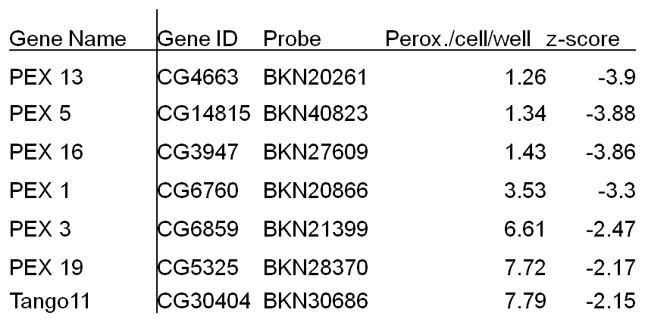
Table 3.4. Z-scores of known PEX orthologues. Table of known PEX orthologues with statistically significant average peroxisomes per cell per well and their corresponding Z-scores.

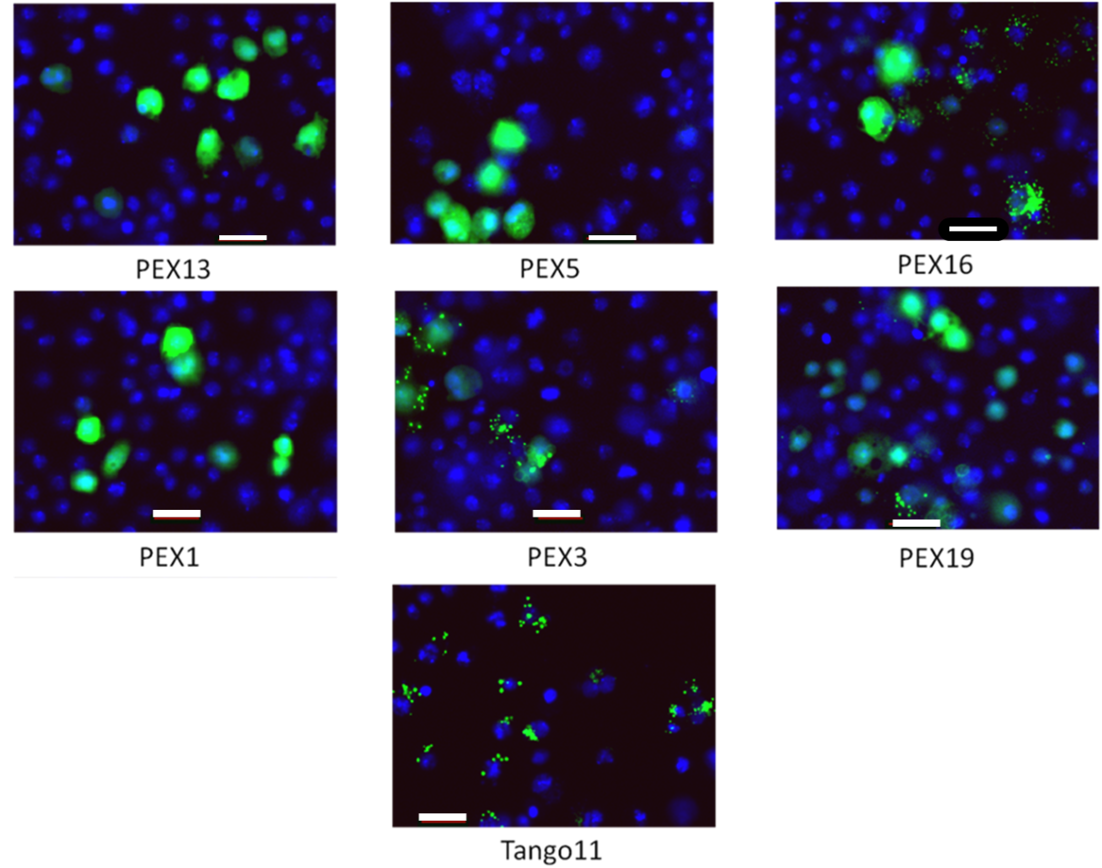Figure 3.27. PEX gene hits from Screen 1. Composite images of one site each of seven genes that returned statistically significant PEX phenotypes. Bar = 20.00 µm.
Those genes homologous to human or yeast peroxins that did not report a statistically significant z-score when knocked down were sought and their images visually screened. Four of those KDs had images of cells expressing eGFP-PTS1 that showed PEX-like phenotypes. Those genes were CG7081 (PEX2), CG8315 (PEX11β), CG4289 (PEX14) CG3210 (Drp1).
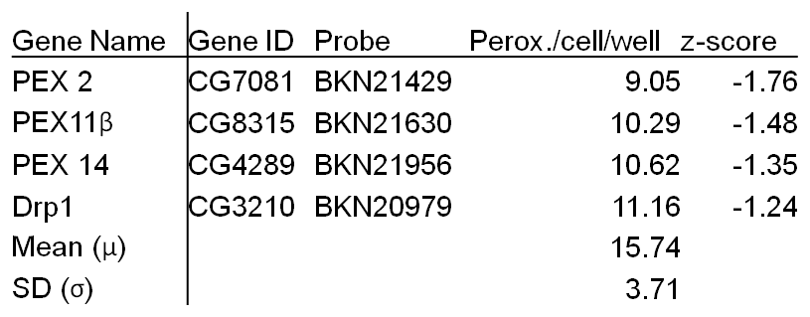
Table 3.5. Unconfirmed PEX Genes from Screen 1. Table of known PEX orthologues with average peroxisomes per cell per well and their corresponding Z-scores prior to normalisation.

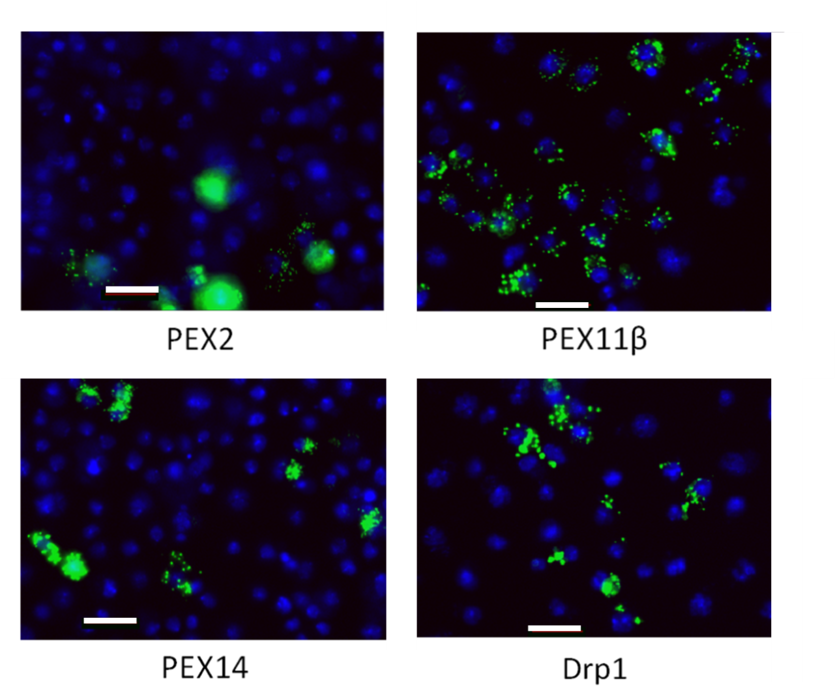
Figure 3.28. Images of unconfirmed PEX genes from Screen1. Composite images of one site each of four genes that returned non-statistically significant PEX phenotypes, discovered upon visual screening. Bar = 20.00 µm.

3 novel genes achieve PEX KD phenotype in first Metazoan pan genomic screen for peroxins.

The first fluorescence microscopy screen for peroxins in D. melanogaster S2R+ cells reveals that three gene KDs either cause phenotypes mimicking those of peroxin KDs or greatly disrupt numerical data and visual presentations when expressing eGFP-PTS1 . Two genes were statistically significant, CG5395 (Z-score -2.33), and CG3595 (two probes returned Z-scores of -2.20 and -2.09). Due to the presence of visually aberrant phenotypes of PEX homologues with z-scores greater than -2.0, all KDs scoring z-scores between -2.0 and -1.0 were visually screened (1268 gene KDs). One gene, CG6668 (Z-score -1.39), was statistically insignificant but returned an aberrant phenotype.
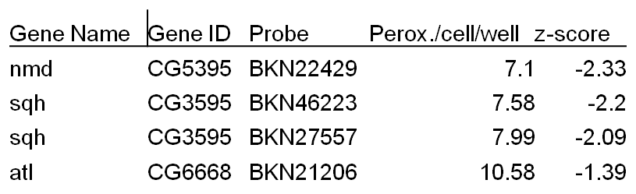
Table 3.6. Table of novel hits. Table showing peroxisome counts per cell per well and Z-scores for the four probes that produced visually aberrant phenotypes. atl was a statistically insignificant KD that was included upon visual screening.

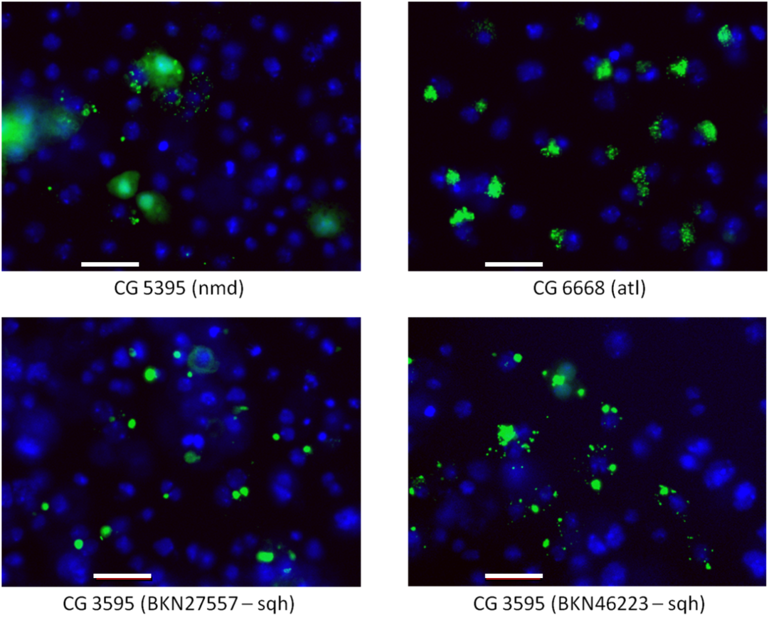Figure 3.29. Images of Screen 1 hits. Composite image from the four most convincing PEX-like KDs from novel genes previously not associated with peroxisome biogenesis. “nmd” (no mitochondrial derivative), atl (Atlastin) and sqh/myo2 (spaghetti squash/myosin light-chain II) were verified as candidates after visual screening. Bar = 20µm

Mitosis derived and inconsistent phenotypes
There were some phenotypes that while statistically significant and producing an aberrant phenotype, the deviation from WT could be attributed to reasons other than peroxisomal dynamics. Pavarotti (CG1258) is an example where a very high z-score was recorded in peroxisome per cell count. Upon inspection however Pavarotti had massively enlarged nuclei in pairs and tens of peroxisomes surrounding them in extremely large cytosolic bodies. This suggests that the phenotype is produced by cells in a stage of mitotic arrest, producing a false positive (see Figure 3.21.2). As another example three gene KDs had low scoring z-scores, but when they were visually screened one or two sites out of the nine contained colonies of cells that seemed to be showing PEX phenotypes. The low abundance of these KD cells and a large number of WT cells among the other images makes categorising them difficult.
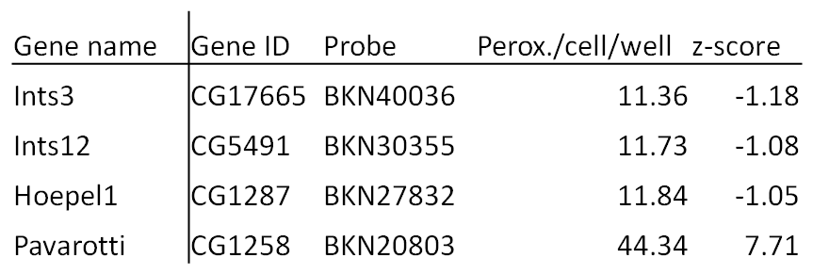
Table 3.7. False positives from Screen 1. Examples of gene KDs and their z-scores of false positives and possible PEX phenotypes that may have registered false negatives.
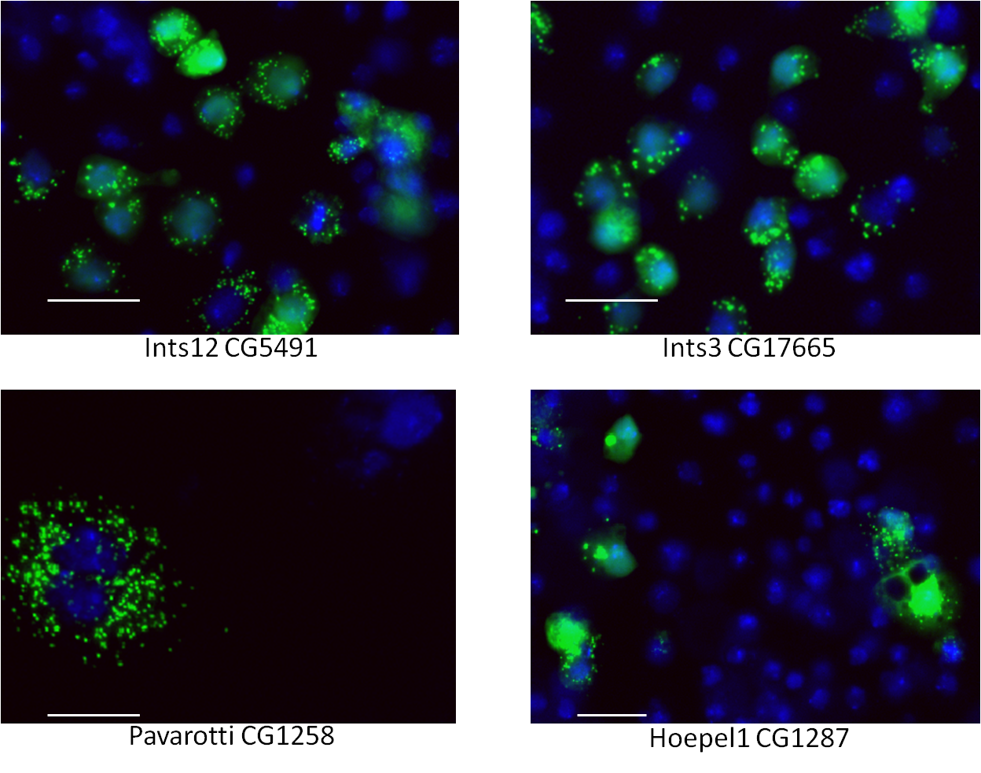
Figure 3.30. Images of False positives .Composite images of four examples of a false positive (Pavarotti) and three probable false negatives (Ints12, Ints3 and Hoepel1). The colonies shown are atypical of the remaining transfected cells in the KD images but suggest PEX-like phenotypes may be occurring. Bar = 20µm.

Discussion
This preliminary screen identified a subset of genes homologous to human or yeast peroxins expected to have PEX-like KDs. It also uncovered 3 new genes previously not implicit in peroxisomal formation, multiplication or distribution. The statistical significance of the phenotypes was, however, low. The main reason for this is the low number of cells expressing eGFP-PTS1 that were included in each gene’s analysis. This may have resulted in a larger number of false negatives than we would deem acceptable for a genome-wide screen.
A large number of false positives were also observed. These include genes whose loss of function induced large cell formation and subsequently high peroxisome per cell count (Pavarotti). Another phenotype included the high expression of the reporter to a level that reduced contrast between cytosol and peroxisomes (Ints3 and Ints12). These KDs caused an apparent PEX phenotype, probably by saturating the PTS1 import machinery.
It was decided that based on these findings a new screen would be developed that would address these weaknesses in the screen’s reliability. The main aim would be to increase the number of cells expressing eGFP-PTS1 as the primary parameter of the screen. It was decided not to analyse the screen in any further detail.

Performing the screen with a selectable peroxisomal marker will produce a stable cell-line and improve the statistical power of the screen.
A potential solution for the above-mentioned problems came early in the image-analysis phase of the screen. I was able to acquire the pMK33/pMtHy insect expression vector (see Ch. 3). This vector allows for the inducible expression of proteins under the metallothionein (Mt) promoter and is selectable in D. melanogaster by selection with hygromycin B. With the eGFP-PTS1 ORF cloned into the pMK33/pMtHy plasmid, it would be possible to have a population of cells ubiquitously expressing peroxisomal eGFP in medium containing Hygromycin B. It would then be possible to massively increase the number of transfected cells photographed and analysed in each image even while increasing magnification. This will increase the reliability of the screen by improving the statistical analysis with more cells analysed. Each probe will be better reported in terms of the number of cells knocked down and the degree to which this is apparent.
It was decided that the screen be repeated with a cell-line stably transfected with pMt-eGFP-PTS1.

Second pan-genomic screen in D. melanogaster for peroxins using stably transfected cells expressing eGFP-PTS1

Introduction
The first screen did not yield the number of candidate genes that were expected despite returning convincing evidence that a small number of genes were producing PEX-like phenotypes when knocked down. Before the statistical evaluation of the screen was finished it had been noticed that there were a large number of wells that contained very few transfected cells. From the database produced it was shown that 3716 wells contained less than 20 transfected cells (18.3%), of which 1358 contained less than 10 transfected cells (6.6%), 54 wells from the screen contained no transfected cells (0.3%). After accounting for lethal KDs and those that produce cell-cycle inhibition these statistics changed very little. There were also instances of sites within wells which when imaged were not properly focused and the entire site registered zeroes for all datafields. The low cell number in all of these wells meant that robust statistical analysis was compromised. Not only might phenotypes have been missed in these KDs, nearly a fifth of the screen, but that the numerical data (specifically standard deviations) of all other KDs would be affected.
A solution to this was to perform the assay again with a cell-line stably transfected with the conditionally expressed eGFP-PTS1 fluorescent, peroxisomal marker. This was made possible through the acquisition of the pMK33-pMt/Hy plasmid from the Whitworth lab in the Department of Biomedical Sciences, University of Sheffield. The plasmid contains a hygromycin B resistance cassette and expression of the reporter is under control of the inducible pMt promoter (see Figure 4.1.1) with CuSO₄, as with the pMt plasmid. While this was the main change to the screen some editions to the protocols in the assay were required in order to optimise the screen for stably transfected cells. The details of these are included in the methods chapter but some are outlined here to emphasise the differences and benefits from using a stably transfected marker and for general clarity.
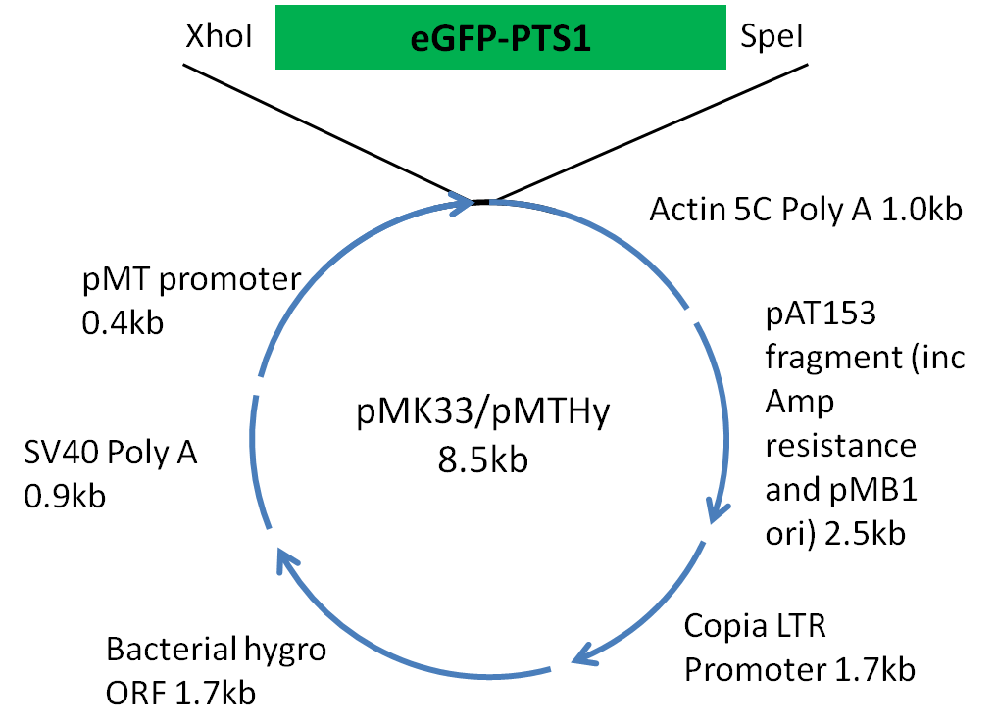Figure 4.1. The pMK33/pMtHy plasmid as constructed by Michael Koelle (1989). Expression of eGFP-PTS1 is under controlled induction of pMt promoter. Hygromycin resistance is affected using a bacterial Hygromycin B phosphotransferase gene under expression of the constitutive Copia LTR promoter.

Culturing stably transfected cells
The pMK33 plasmid was generously supplied to us from the Whitworth lab in the Biomedical Science Department of Sheffield University. S2R+ cells were transfected normally and enriched by hygromycin B selection. Baum & Cherbas (2008) recommend using a range of 200-300µg.ml⁻¹ in media with serum.
To explore the efficacy, toxicity and speed of the selection of the plasmid the transfected cells were split equally between three wells of a six-well plate and then induced selection at 150µg.ml⁻¹ (½X selection medium), 300µg.ml⁻¹ (1X selection medium) and 450µg.ml⁻¹ (1½X selection medium) of hygromycin B. Samples were removed every other day and plasmid induction performed overnight at 100µM CuSO₄. For the two lower hygromycin B concentrations, selection was slow and the 1X selection medium sample took six weeks of passaging before over 95% of cells were visibly displaying peroxisomal eGFP. The ½X selection medium was too slow to even make 50% cells express eGFP-PTS1 after 6 weeks of passaging. Conversely, transfected S2R+ cells in 1½X selection media died within 2 weeks. The recommended concentration of hygromycin B was used as selection medium at 300µg.ml⁻¹.

Re-establishing seeding density for stably transfected cells
With almost ubiquitous expression of eGFP-PTS1 in S2R+ cells (a small proportion of cells expressed the reporter at a low level, detectable only with long exposures on a fluorescence microscope using the 40X high NA objective) the possibility of reducing the seeding density was investigated.
Using the Thermo Multidrop and a single blank plate it was possible to perform a serial seeding of the plate, 3 columns at a time at eight seeding densities ranging from 500 to 4,000 cells per well. This was achieved by adding cells in SFM medium at 100 cells per µl in 5 µl increments up to 40µl. All well were then made up to 50µl with 10% serum-containing medium. The cells allowed to grow for five days before 10µl of medium containing 10% serum and 600µM CuSO₄ (final conc. 100µM) were added to induce them. While the cells weren’t being checked for induction, this mimicked screening conditions and thus removed errors that may be responsible for changing growth speed that would falsely report the optimum seeding density. Cells were near-confluent at 2000 cells per well and approximately 40-50% confluent at 1000 cells per well, ranging from 60-70% confluence at 1500. Ideally the near-confluent wells would be used but there was enough variation between the wells that some had grown over-confluent. Conversely no wells in the 1500-cell wells were over-confluent. The wells were fixed and counted using the METAXpress apparatus and each site of each of the 1500-cell wells recorded >100 cells with some sites containing >200 cells at 20X magnification. At 40X magnification the sites were reporting on average 49 cells per site and over 400 cells per well with nine sites counting cells. These data are a significant improvement over that which was being recorded in the first screen and would provide more statistically significant data in the second screen.
Figure 4.2. A schematic of serial dilution of stably transfected S2R+ cells. Three columns of an assay plate (48 wells) per cell density were filled in 5µl increments of 10⁵ cells.ml⁻¹ (500 cells per 5 µl) in SFM and made up to 40µl with SFM. 40µl 20% serum-containing medium containing no cells was added to make 10% serum-containing medium in total. After an hour the cells settled and 30µl was aspirated.

Reduction of CuSO₄ concentration to induce expression of stably transfected cells
The use of selectable plasmids in cell lines causes the formation of “transgene arrays” (Karpova et al. 2006) and is the main cause of high heterogeneity in transgene expression. In short this is the uneven number of copies of the selectable plasmid that are multiplied in high quantity within each cell. After transcription takes place this amplifies the uneven levels of transcript from which the marker protein can be translated. The result for the current assay was that many cells had excessively bright peroxisomes at 100µM induction concentration, much brighter than required for segmentation. A significant presence of the marker accumulated in the cytosol of WT cells.
To increase the contrast between the peroxisomal and the cytosolic eGFP signal it was investigated to see if the pMt promoter was able to be variably induced by using a range of different CuSO₄ concentrations, thus titrating the optimum induction concentration. Cells transfected stably with selectable eGFP-PTS1 were grown on coverslips in 6-well plates, seeded at 1x10⁶ per well. They were immediately induced with copper sulphate at 100µM, 50µM, 20µM, 10µM, 5µM, 2µM and compared with WT. After 16 hours more than half of the cells induced at 100µM CuSO₄ had varying levels of cytosolic eGFP and many had extremely bright peroxisomes. This is the concentration that had been used since re-developing the assay for the new plasmid had begun. Those with the brightest cytosol obscured the presence of puncta and would have appeared as a KD phenotype in the screen had these conditions been used. The 50µM and 20µM CuSO4 showed virtually no cytosolic eGFP. Visually the 50µM cells had the highest contrast with the cytosol compared with 100µM and 20µM. The 10 µM, 5 µM and 2 µM cells showed decreasing brightness of puncta against an apparently empty cytosol, the 5 µM and 2 µM tests were barely visible. In uninduced cells a barely visible punctate pattern was also observed, comparable to those of 5mM and 2mM. This indicates that the pMt promoter on the pMK33-pMt/Hy plasmid is not completely quiescent when not induced.
Figure 4.3. Titration of pMt promoter. The optimal concentration of CuSO₄ was titrated and found at 50µM at which distinct puncta could be viewed. 100µM shows a strong cytosolic presence of peroxisomal eGFP with bright puncta. 20µM shows dim puncta, one cell with brighter puncta shows the heterogeneous nature of transgene expression. Images at 40X magnification. Bar = 10µm.

Adjustment of microscope settings
To increase the accuracy of the Transfluor application at counting the peroxisomes the microscope objective was increased in magnification from 20X to 40X. This is made possible by the even seeding of cells ubiquitously expressing eGFP. The smaller area of the 40X image is still able to capture enough cells to make statistical analyses. The change was made in the Plate Acquisition Setup menu.
It is worth comparing the proportion of the well that is photographed with that of the previous screen. The area of a 20X site is approximately 1.11556mm² (334µm)². The 40X site is approximately 0.27889mm² (167µm)², exactly ¼ the area. The number of sites photographed is unchanged so the area of the well photographed (2.51001mm²) is also ¼ of the original (10.04004mm²). A visual representation is given in Methods Figure 2.19. Despite the drastic reduction in area of the well bottom photographed the increases in the number of cells imaged and the accuracy of peroxisome counting will produce a more reliable screen.
The 40X objective has a thinner z-plane of focus than the 20X objective so the focusing offset needed fine-tuning for achieving the image with the optimal display of peroxisomes. The GFP channel was set to 4µm above the growth surface, the DAPI channel 0.5µm below that of the GFP channel.

Optimising the Transfluor application and assay plate testing
As the cells transfected with the stable peroxisomal marker were almost ubiquitously expressing peroxisomal eGFP under hygromycin B selection it was decided that it would not be necessary to use the Multi Wavelength Cell Sorting application in tandem with the Transfluor application. This reduced computer processing time greatly from 19 seconds per site to just 6 which theoretically meant that the overall processing time for the screen went from approximately 40 computer-days to just 12.5. With up to four computers processing the images the duration of analysis could potentially be reduced to less than 4 days. The use of a 40X magnification meant greater accuracy could be used in segmenting the peroxisomes and nuclei.
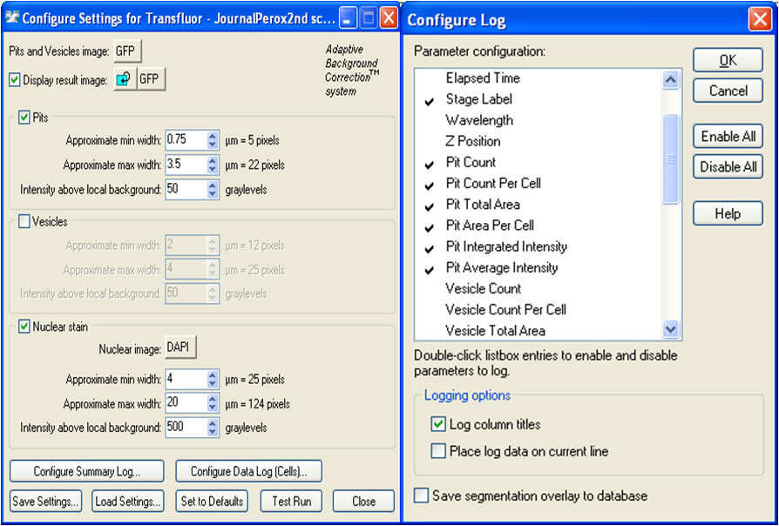Figure 4.4. The Transfluor settings and Data Log parameter selection. Transfluor can now be more precise in segmenting both nuclei (DAPI) and peroxisomes (GFP).
The segmentation of both WT and PEX5 images can now be executed by Transfluor.

Figure 4.5. Transfluor segmentation of WT cells in Screen 2. 40X images taken of fixed and Hoechst nuclear-stained WT S2R+ cells stably transfected with pMt-eGFP-PTS1 and induced with 50µM CuSO₄ for 24 hours after 5 days of growth. The images were analysed with the new Transfluor settings. The raw DAPI channel (top left) is segmented into nuclei (top right), the raw GFP channel (bottom left) is segmented into puncta and superimposed onto the segmented nuclei (bottom right).
Figure 4.6. Transfluor segmentation of PEX5 controls in Screen 2. Cropped 40X images taken of fixed and Hoechst nuclear-stained S2R+ cells stably transfected with pMt-eGFP-PTS1, knocked down with PEX5 dsRNA and induced with 50µM CuSO₄ for 24 hours after 5 days of growth. The images were analysed with the new Transfluor settings. The raw DAPI channel (top left) is segmented into nuclei (not shown), the raw GFP channel (top right) is segmented into puncta and superimposed onto the segmented nuclei (bottom left). The superimposed segmentations are overlaid onto the raw DAPI image (bottom right) for comparison. Bar = 20µm.

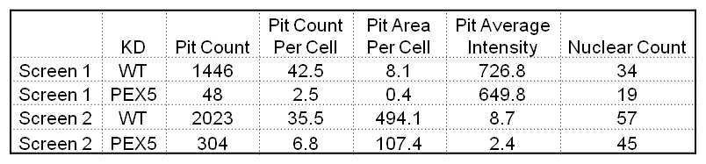
Table 4.1. A comparison of Transfluor data from both screens’ PEX5 controls. A data table giving a comparison of logged data from assay plates using Transfluor settings from the old assay (Screen 1) and the new (Screen 2).
The data table in Figure 3.2.6.4 shows typical values for WT and PEX5-treated cells in assay plates. WT and PEX5 treatments are still easily distinguishable. The increased sensitivity of the Transfluor application in the second assay is reflected in displaying an increased peroxisome (Pit) count per cell in PEX5 cells over that of the 20X images. The settings may be too sensitive as it records a small number of Pits in areas where no peroxisomes are apparent. This is unfortunately unavoidable as it is this sensitivity to contrast in grey levels (Fig. 3.2.6.1) which allows the dim peroxisomes in the WT cells to be distinguished (see Fig. 3.2.6.2). These settings were altered and tested with high repetition to determine where the best compromise could be found in making an accurate determination of the differences between WT cells and KDs of PEX1, PEX3, PEX5, PEX16, NMD and Tango11. Pit count was the most important data field for differences to be distinguished. No adjustments were deemed necessary to distinguish the two tests in peroxisome average intensity or area (cross-sectional) per cell.
Once the parameter settings had been optimised and tested repeatedly on sample wells from an assay plate, three assay plates were then tested using only the Transfluor application, without a journal governing it. The controls used were (descending in column 9) PEX1, PEX3, PEX5, PEX16, PEX19, Ints12, Drp1 and nmd. For this triplicate of tests Drp1 was substituted in for Tango11. An E-RNAi-derived Drp1 dsRNA had proven effective in lab tests and was more effective in producing a non-WT phenotype than the Tango11 probe. Ints12 was a KD which scored low in the first screen but there were a small number of colonies among the images which showed a drastic reduction in peroxisomes and a strong presence of eGFP-PTS1 mislocalised to the cytosol. In lab tests the E-RNAi derived probe proved ineffectual at producing a non-WT phenotype. It was included as a negative control for the screen though the library probe targeting .
The assay plates that were tested showed clear differences between positive and negative controls for peroxisome count: PEX3, PEX5, PEX16, Drp1 and NMD showed reduced numbers of peroxisomes per cell (11, 15, 5, 10 and 4 respectively, average of 6-wells, σ = -2.5, -1.75, -4.25, -3 and -4.5). The negative control Ints12 giving an average peroxisome count of 23, σ = 0.25. PEX19 only gave an average of 18 peroxisomes per cell (σ = -1). The PEX1 dsRNA failed to cause a significant effect, registering σ = 1. While not intentional the failure of the PEX1 probe to produce an effective KD meant that an additional negative control could be screened.
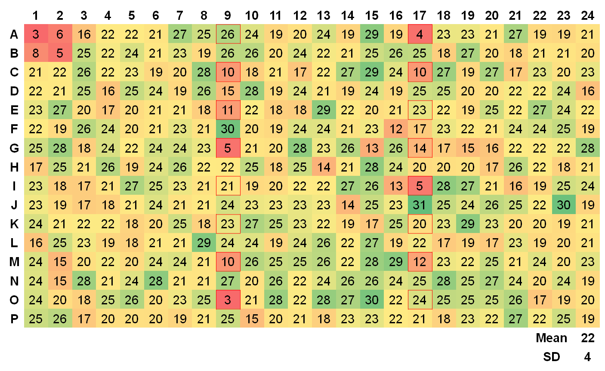Figure 4.7. A heat-map of a Screen 2 Assay plate. An Excel-derived heat-map of the mean average of the three plates used to test WT and control peroxisome per cell numbers for the assay. Each number is rounded to 0 d.p.. Positive controls are in red borders (column 9 descending and column 17 ascending) PEX1, PEX3, PEX5, PEX16, Pex19, Ints12, Tango11 and nmd.

Normalisation procedures
The previous chapter and its relevant sections on data analysis are of interpretation of raw data. The main datafield analysed was peroxisome count per cell and the numbers returned were converted to z-scores. These data were not quantile-normalised.
The process of quantile normalisation is important for this assay as certain assumptions are made of the way the data are produced with reference to the methods involved in carrying out the screen. All 20,352 wells of the 53 plates are seeded with same batch of transfected S2R+ cells collated from 3 different T75 flasks (the flasks were each seeded from a T25 flask, all three of which were seeded with 1/3 of a single T25). Theoretically they should each be treated as equal wells in a high through-put experiment but the fact that they exist in arrays of 384 per plate means that certain biases with inevitably manifest in the course of the experiment. A simple example of this would be that the plates are stacked on top of each other in 5 columns 11 or 10 plates high in the incubator. Each well has its own proximity to its nearest two sides of the plate and its own height within the stack. All three of which determine the wells’ distances from the air and the walls in the incubator and would therefore have an effect on the movement of thermal energy from the 25°C environment. This theoretically could affect the rate of growth of the cells, the rate of kinetics of the RNAi reactions and subsequently the severity of the knock-down. Not only would each well be affected individually but also each plate as well.
While there is no way to normalise the wells according to their geography within the well, there is a way to normalise the wells within each plate according solely to their values and then each plate normalised across the entire screen. This process makes several assumptions:
- Each plate equally represents a cross-section of all the dsRNAs in the screen, from the highest scoring gene KDs through to the lowest.
- Any differences experienced between plates are experienced equally between all the wells in each plate.
A formula can then be applied to the datafields, first to each well/gene across each plate. This requires performing the quantile normalisation calculations one plate at a time for all of its constituent genes, each raw value is converted from v to v’ (see figure 4.9). Once all 53 plates are done, the formula is repeated for each v’ in the genome giving a normalised v’ for the entire dataset. This final value is then converted to a z-score.
Figure 4.8. The normalisation conversion formulae. The raw value (v) is converted to a normalised value (v’) by multiplication with the scaling factor and then the addition of the offset value. For both Screen 1 and Screen 2 the target range (X-Y) was 0-100, the range of data is given as x-y. The target range is the target minimum and maximum nominal value that the puncta count is converted into (in the scaling factor Y-X therefore becomes 100 thus converting the range of raw data into percentiles). The v’ data can then be converted to z-scores. This formula is reproduced from the AcuityXpress user manual.

Results – Introduction
The implementation of data analysis software for Screen 2 meant that data could be normalised. This increased the robust nature of the screen statistically, firstly for the more accurate comparison of KDs on different plates. Secondly the data could be compared between screens by normalising the data of the first screen and determining which KDs produced numerically similar results. The software is also able to give statistics on the reproducibility of the data and give graphic interpretations of a dataset for 19,114 KDs. In this chapter the second Screen will be reported on its own merit before the combined data are interpreted and the two assays evaluated.

Control probes.
The controls used for the second screen spanned a larger range of z-scores than in the first screen. One effect of the normalisation process is that the outlying z-scores had higher magnitudes. The controls for Screen 2 were PEX1, PEX3, PEX5, PEX16, PEX19, Ints12, Drp1 and nmd. Mean z-scores for the 106 wells for each of the probes are given in Figure 4.11.

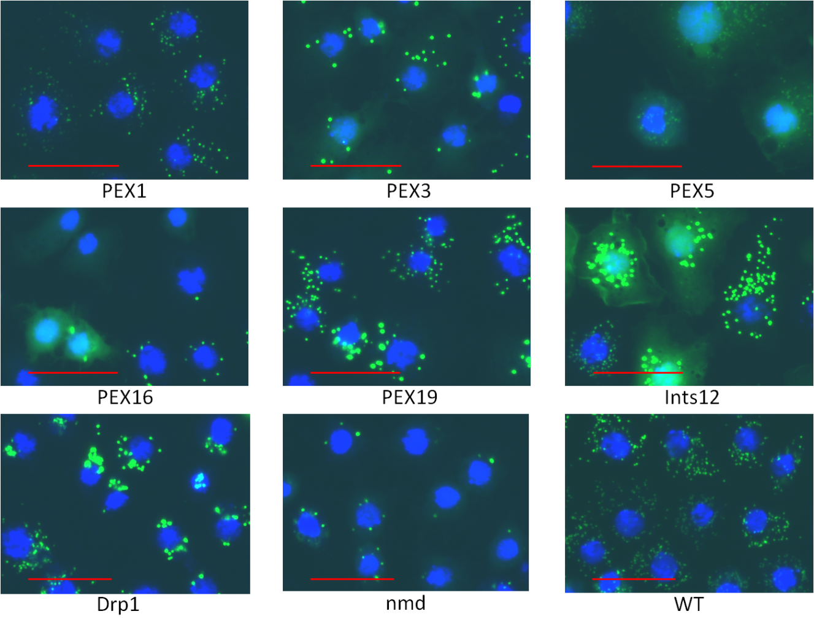Figure 4.9. Images of control cells in Screen 2. Cropped 40X magnification images of S2R+ cells stably transfected with pMt-eGFP-PTS1. Controls were knocked down and incubated for 5 days before induction with 50µM CuSO₄. WT image is of an empty well with z-score of 0.01. Bar = 20µM.
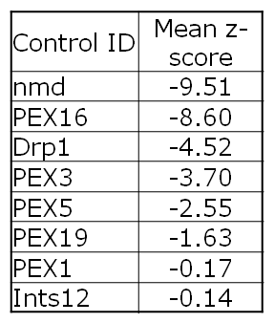
Table 4.2. Mean Z-scores for the probes in Screen 2 for all 106 wells per probe. Z-scores are of normalised data.
Controls were imaged and their mean z-scores calculated across all 106 wells for each control in the 53 plates. The controls with the strongest phenotypes were nmd and PEX16 and this was reflected numerically with mean z-scores of -9.51 and -8.60 respectively. Both dsRNAs caused a large reduction in peroxisomes per cell and many cells even showed no peroxisomes at all. Drp1, PEX3, PEX5 and PEX19 also showed reductions in peroxisomes per cell. Their z-scores were -4.52,-3.70, -2.55 and -1.63 respectively. These data suggest that the PEX19 KDs did not produce an outlier phenotype but from the images it produced the cells do not appear to be of WT presentation. PEX1 did not produce a strong KD as seen in Screen 1, the cells appear to have a WT phenotype. Ints12 did not affect peroxisome number but the cells responded with increased peroxisomal and cytosolic eGFP, as observed in screen 1 (data not shown).
Overall these data suggest it may be possible to screen solely using numerical identification of data that lie outside of 2 σ from the mean. Despite this, based on experience from Screen 1 and the fact that the PEX 19 control appears to have produced some effect while achieving a mean z-score of only -1.63, it was deemed necessary to first find out what z-scores were achieved by KDs of genes known to have an effect on the assay.

Screen 2 statistically identifies some known PEX genes
Screen 2 data for peroxisome count per cell were normalised and compiled on a spreadsheet. Before analysis of outliers began, known PEX genes were identified by their Gene Ids and visually determined if a PEX phenotype had occurred.
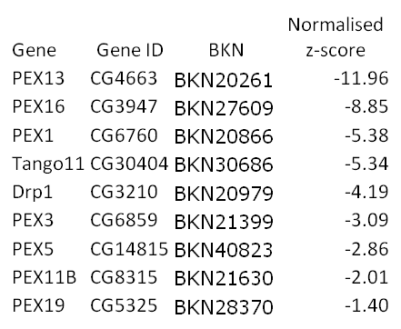
Table 4.3. Controls from Screen 2 expressed in z-scores from data mean. A table from Screen 2 data showing gene and library identifiers and z-scores for KDs of genes homologous to peroxins or biogenesis-associated proteins from S. cerevisiae, H. sapiens or both. These gene KDs visually show phenotypes when knocked down while producing a statistically significant z-score. PEX19 is the only KD to have a normalised z-score that does not exceed -2.0.
Figure 4.10. Images of Statistical hits from Screen 2. Cropped 40X magnification images of S2R+ cells stably transfected with pMt-eGFP-PTS1. Each KD was incubated for 5 days before a 24hr induction with CuSO₄ at 50µM. Bar = 20 µm.
The nine images in the above figure show examples of cells that represent the most commonly seen phenotype across all the nine sites of each gene KD that they are taken from. Their normalised peroxisome counts per cell for the entire gene (average of all nine sites) are given in Fig. 4.12 and show them in descending numerical severity of phenotype. While it is clear that PEX13, PEX16 and PEX1 show the most visual deviation from WT cells as supported by the z-scores, PEX5 is shown to score a lower z-score magnitude than Tango11, Drp1 and PEX3; despite the greater presence of cytosolic eGFP. The number of puncta in the PEX5 images is not greatly reduced due in part to the increased sensitivity of the Screen 2 Transfluor settings at detecting puncta with low contrast to their surrounding cytosol, and the fact that the selectable pMK33 pMt/Hy plasmid (into which the peroxisomal eGFP-PTS1 marker was cloned) has less well controlled expression when not induced. One might have expected to see higher numbers of puncta in PEX13 and PEX1 KDs as well but the cells in these wells appeared by chance not to be so strongly expressing the marker. Tango11, Drp1, and PEX3 have fewer and brighter peroxisomes and so score a larger magnitude of z-score than PEX5. The significant increase in cytosolic presence of eGFP in the PEX3 images does little to reduce contrast with the peroxisomes. Tango11 and Drp1 have uneven distribution of cells through the cytosol suggesting roles in peroxisome inheritance to daughter cells. PEX11β has a significant number of cells with a moderate reduction in peroxisome number. These peroxisomes appear bigger and brighter than those surrounding cells which appear not to have been knocked down, of which there are few. These cells have a similar appearance to those of Drp1 and Tango11 but with only a slightly uneven distribution of the peroxisomes and with a small increase in cytosolic eGFP. While PEX19 was not a statistically significant result upon visual screening it showed that it had a reduced number of peroxins that appeared larger and brighter. The images did show a disproportionately high number of WT-looking cells that may not have been knocked down.

PEX gene KDs that are neither statistically nor visually significant
Some of the genes known to be homologous to or functional orthologues of human or yeast peroxins did not produce statistically significant data, nor did they produce images which would otherwise indicate PEX phenotypes had been produced. While this may have been expected from PEX7, the PTS2 receptor, PEX2, PEX6, PEX10, PEX12 and PEX14 were hoped to produce PEX phenotypes or at least significantly statistical results. In Screen 1 PEX2 and PEX14 were included as hits as there were PEX-like phenotypes present among the transfected cells. It was thought that stably transfected cells would report more PEX-like phenotypes and produce statistically significant data. There was also hope in that the PEX12 KD had a normalised z-score of 1.76 in Screen 2 which would make it comparable to KDs like PEX19 and PEX11β. However, when the data and images were observed there were no more cells with cytosolic eGFP than there were in WT images and the cells presented with a near-ubiquitous WT phenotype, albeit a faint one. This was also true of the other 4 genes mentioned and the six of them have been presented in Fig. 4.9.1. The raised magnitude of z-score in PEX10 and PEX12 KDs is likely attributable to a significant proportion of cells with very low expression of eGFP, some not visible by eye. It is possible that in D. melanogaster there is an unexpected level of redundancy among peroxins that prevents PEX-like phenotypes in single-gene KDs. One of the expected benefits from screening D. melanogaster is that of lower redundancy of gene functions compared to that of Mus muscularis which has been shown in some experiments to be incapable of producing reliable phenotypes of gene KOs which were producible in D. melanogaster (Zhang et al. 2008).
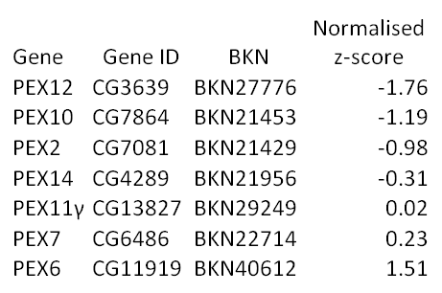
Table 4.4. A table of non-statistically significant data from PEX KDs. A table from Screen 2 data showing gene and library identifiers and z-scores for KDs of genes homologous to peroxins or biogenesis-associated proteins from S. cerevisiae, H. sapiens or both. None of these genes produced statistically significant results, nor did they produce images with PEX-like phenotypes.
Figure 4.11. Images of non-statistically significant PEX KDs. Cropped 40X magnification images of S2R+ cells stably transfected with pMt-eGFP-PTS1. Each KD was incubated for 5 days before a 24hr induction with CuSO₄ at 50µM. Images represent the most commonly presented phenotype across all 9 sites. Bar = 20 µm.

Some genes produced statistically significant data that may have PEX-like phenotypes.
In order to evaluate which gene KDs had produced phenotypes worth investigating normalised data were converted to z-scores and ordered on a spreadsheet. Those KDs whose z-scores were less than -1.0 (3,367) or greater than 2.0 (351) were screened visually, a total of 3,718 (20.3% of the “samples” – neither controls nor DIAP). These limits were decided due to presence of functional KDs of PEX genes within these bounds in the previous screen. As PEX19 also scored a z-score of greater than -2.0 (magnitude less than 2) and that it appeared to be functional, it was felt that the decision to visually screen with these limits was justified. The following table lists those gene KDs within these limits that appear to visually have had an effect on the assay, either in a PEX-like manner, with similarity to non-PEX KDs or otherwise affecting peroxisome presentation or cytosolic mislocalisation of peroxisomal reporter. Also included in this list are KDs that were visually screened in error which were considered possible hits despite having z-scores that fell outside of the visual screening inclusion criteria.
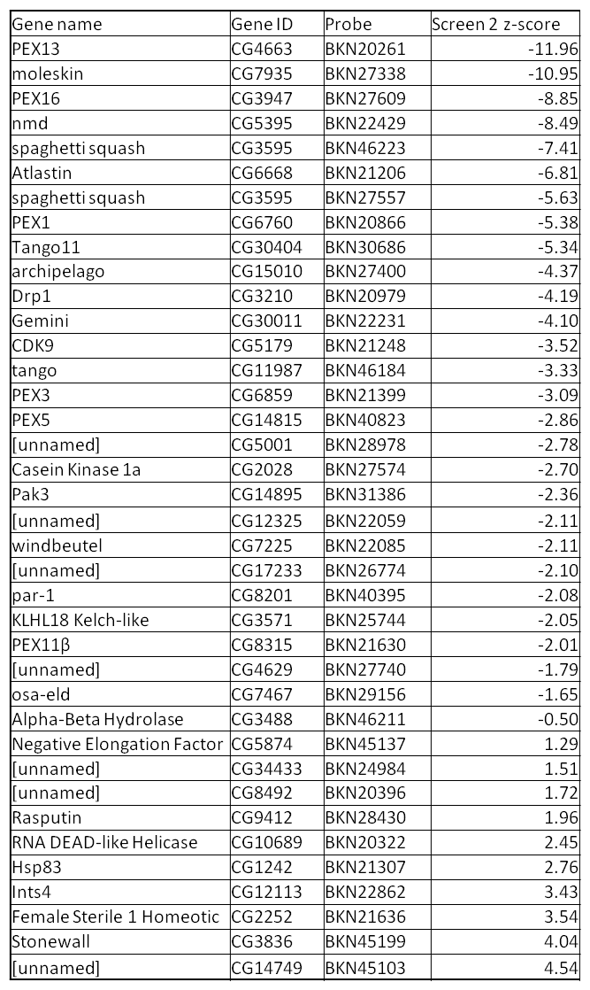
Table 4.5. A table showing the candidate genes after statistical analysis and visual screening. Data from Screen 1 and 2 were normalised and an average taken between the two of them. Genes with average z-scores above 2.0 (349) and below -1.0 (3366) were visually checked for PEX phenotypes or phenotypes with a ubiquitous or thorough deviation from WT.
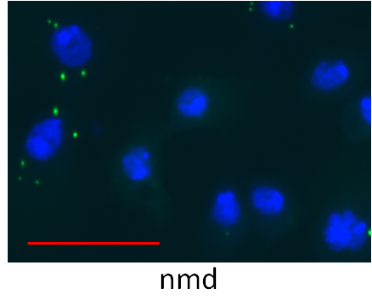
Figure 4.12. Group A – Class II/PEX16-like phenotype, vastly reduced number of peroxisomes per cell. S2R+ cells stably transfected with pMt-eGFP-PTS1 grown for 5 days before a 24hr induction with 50µM CuSO₄. This KD was with a long dsRNA specific to nmd (CG5395). The normalised z-score of -8.49, together with visual verification of low peroxisome per cell count and cytosolic mislocalisation of peroxisome marker indicates that nmd may function like a Class II peroxin. PEX16 would be the most similar to nmd in z-score and presentation. Bar = 20µm.
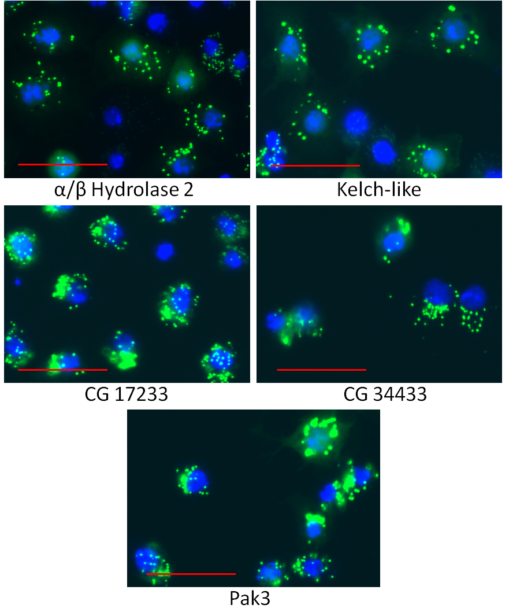
Figure 4.13. Group B – Class II/PEX3/PEX19-like phenotype, moderate reduction in peroxisome number per cell and cytosolic eGFP-PTS1. KDs of S2R+ cells stably transfected with pMt-eGFP-PTS1 grown for 5 days before a 24hr induction with 50µM CuSO₄. These “Group B” KDs produced similar phenotypes with a range of z-scores from -2.36 to 1.51. They all produced images where the majority of cells expressed phenotypes of eGFP-PTS1 that resemble those of the Class II peroxins PEX3 or PEX19. A fall in peroxisome number per cell is observed alongside cytosolic mislocalisation of the reporter. The higher z-scores in the cases of CG34433 and α/β Hydrolase 2 are due to an equal presence of cells of this phenotype and WT cells with above average peroxisome per cell numbers. Bar = 20µm.

Figure 4.14. Group C – change in peroxisomal morphology. KDs of S2R+ cells stably transfected with pMt-eGFP-PTS1 grown for 5 days before a 24hr induction with 50µM CuSO₄. “Group C” produced images that apparently show peroxisomes with morphological changes that produce either ring-like or sickle-shaped peroxisomes. These phenotypes occurred in only a small percentage of cells. The knockdowns of archipelago and CG5001 produced z-scores of -4.37 and -2.78 respectively. Bar = 20µm.

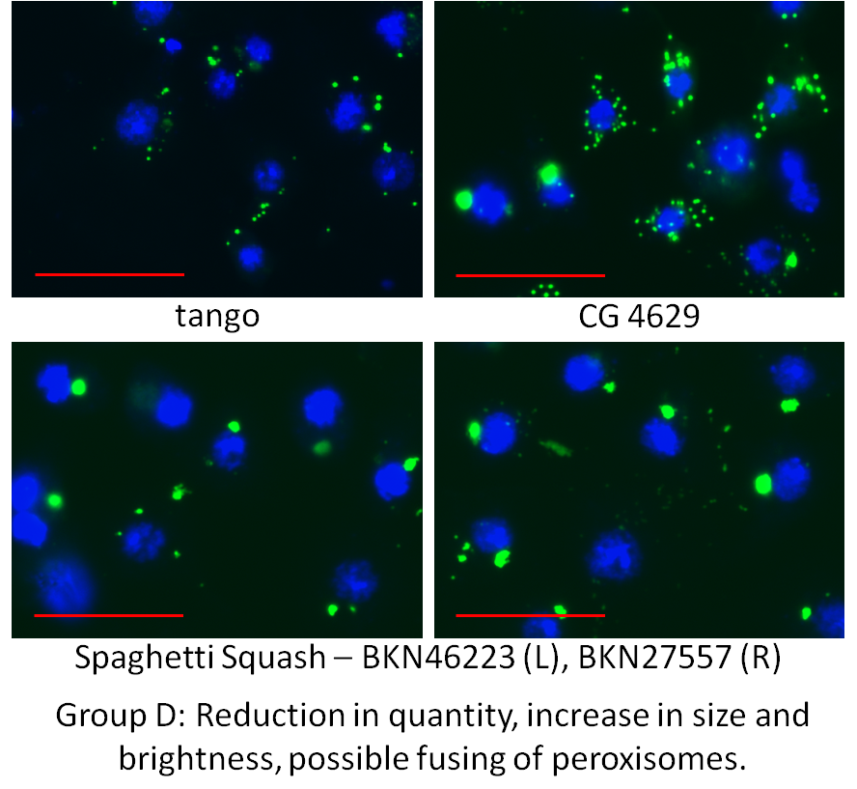
Figure 4.15. Group D – Reduction in quantity, increase in size and brightness, aggregation/possible fusing of peroxisomes. Cropped images of KDs of S2R+ cells stably transfected with pMt-eGFP-PTS1 grown for 5 days before a 24hr induction with 50µM CuSO₄. The “Group D” KDs produced z-scores in the range of -7.41 to -1.79. The most severe phenotype is that of Spaghetti Squash where a near-ubiquitous phenotype of 1-5 large, bright puncta per nucleus could be observed. The cells with this phenotype in “tango” and CG4629 images were among a large number of small WT cells, dimly expressing eGFP-PTS1. Only a handful of cells showed this phenotype for both of these KDs. Bar = 20µm.
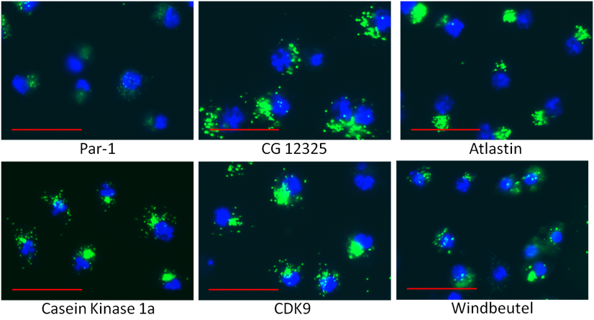Figure 4.16. Group E – Displaced cellular localisation of peroxisomes with moderate reduction in number. Cropped images of KDs of S2R+ cells stably transfected with pMt-eGFP-PTS1 grown for 5 days before a 24hr induction with 50µM CuSO₄. The images of “Group E” phenotypes produced z-scores in the range of -6.81 to -2.08. The majority of peroxisomes are mislocalised to one sector of the cell leaving an uneven distribution of cells. This is enough to decrease the resolution of the peroxisomes and therefore the reported peroxisome per cell count without necessarily decreasing their number, though this may happen anyway. It is unclear whether peroxisomes fuse together, if they do then it is not to the degree that they appear do so in Group D. Bar = 20µm.
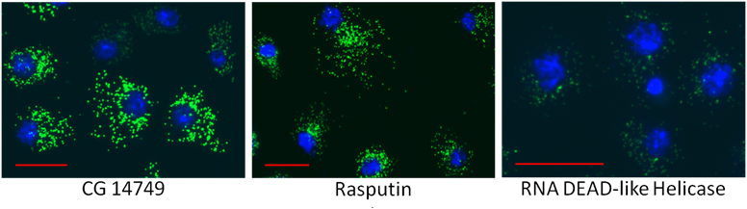
Figure 4.17. Group F – Increased quantity of peroxisomes per cell. Cropped images of KDs of S2R+ cells stably transfected with pMt-eGFP-PTS1 grown for 5 days before a 24hr induction with 50µM CuSO₄. The images of “Group F” phenotypes produced z-scores of 1.96 to 4.54. They showed ubiquitously increased peroxisome per cell counts. Nuclear sizes were also increased, larger images are shown of Rasputin and CG14749. Bar = 20µm.

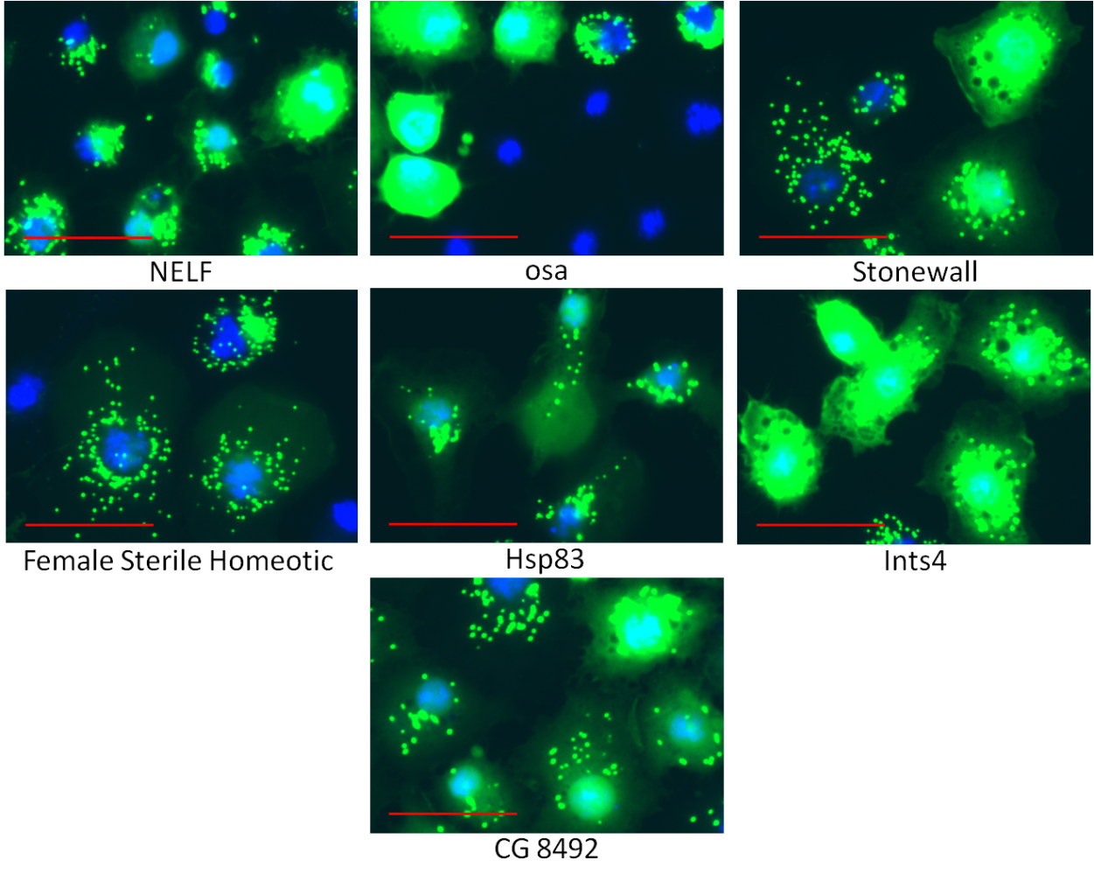
Figure 4.18. Group G – Increase in peroxisome size and intensity, possible up-regulation of expression, ubiquitous cytosolic mislocalisation and increased peroxisome quantity per cell. Cropped images of KDs of S2R+ cells stably transfected with pMt-eGFP-PTS1 grown for 5 days before a 24hr induction with 50µM CuSO₄. Images in Group G increased cytosolic eGFP-PTS1 and very bright peroxisomes. Z-scores range from -1.65 to 4.04 though most are positive. Cellular morphology is affected in all cases, cells appear to have increased cross-sectional cytoplasmic area and irregular shape. Negative elongation factor (NELF), osa and CG8492 do not have statistically significant z-scores. Bar = 20 µm.
One limitation of the screen is that the eGFP-PTS1 fluoresces indiscriminately with respect to which cellular location or compartment it is in. This is used to determine cytosolic mis-localisation where contrast between diffuse and punctate eGFP is reduced or absent. This does not however distinguish between eGFP that is faithfully translocated to the peroxisomal marker and that which is mis-localised to other compartments such as the lysosome or vacuole. With this lack of distinction it is theoretically possible that cells without peroxisomes may have falsely reported higher numbers of them if their lysosomes are filled with the marker protein. Initially this is not a serious concern as in PEX1, PEX5 PEX13 and PEX16 KDs enough of the affected cells show no puncta or puncta too small/dim to be recognised by the software. These cells are abundant in cytosolic marker and so one might expect that lysosomes would be fluorescing if they were accumulating it. This does not however rule out the possibility than certain KDs may cause mis-localisation of the fluorescent marker specifically to another compartment to create a punctate accumulation in tandem with a decrease in peroxisomal puncta.

Evaluation of genomic screen reliability and reproducibility.
The normalisation of the data for the second genome-wide screen allowed a better statistical determination of z-scores. These normalised z-scores would be used for determining statistical hits from the second screen. This also meant that comparisons could be made of the controls based on their distribution as a separate population relative to the rest of the screen. By normalising the data of the first screen the two screens can be directly compared, seeing how the change in assay (from transient to stable transfection) has affected the screen results. Average data can also be made of the two screens to determine the average strength of each probe between the two assays.
The following sub-chapters show interpretations of the data in an attempt to draw conclusions on the reliability of the significant hits. For some graphs and presentations, a program called HTS2 (a data analysis suite based in “R” programming) has been used to generate them.

Comparison of distributions of probes and controls
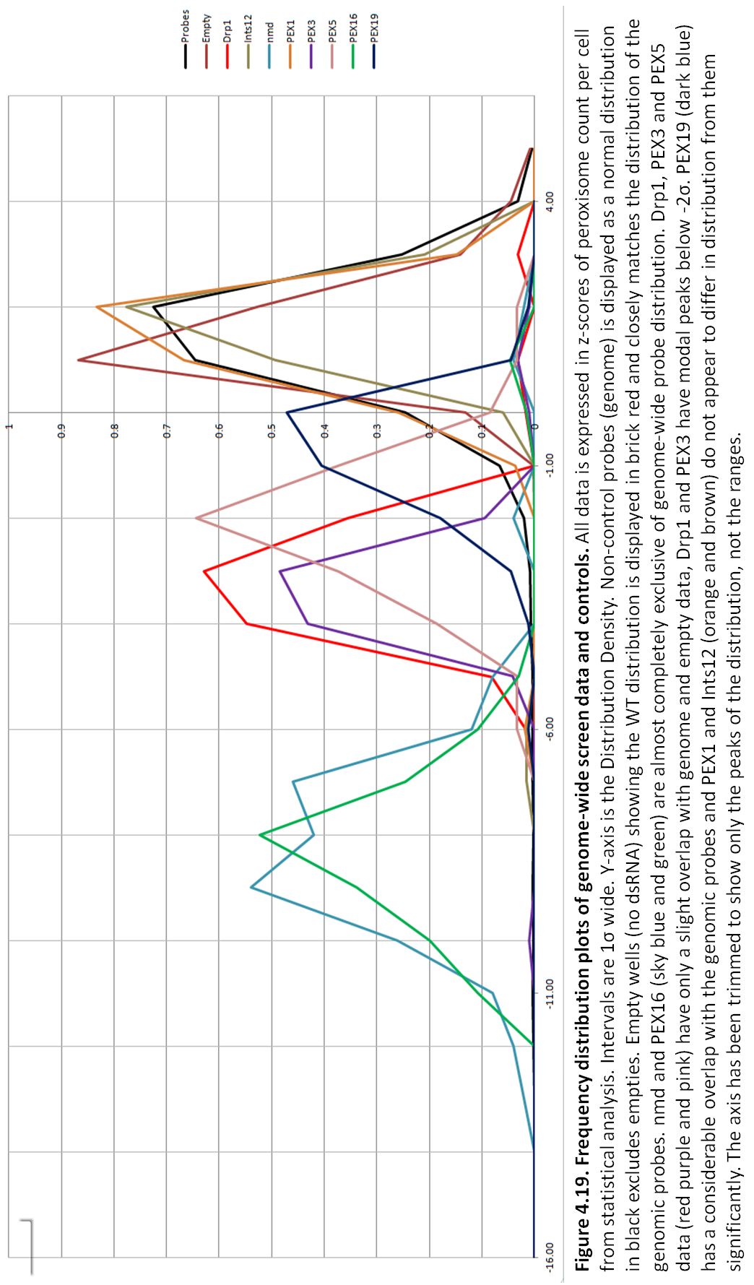
Figure 4.24 shows the frequency distributions of the controls, the empty wells (true WT) and the genomic probes between the values of -16 σ and 6 σ (not produced in HTS2). Within these x-axis bounds the modal peaks of all the control probe distributions can be viewed with those of the non-controls’. The distributions show clearly the differences between each other and the stronger the phenotype the greater the distance between the modal peaks. PEX19 and PEX5 distributions overlap with the mean (µ) which shows that while these KDs are capable of producing strongly aberrant phenotypes, they are also capable of producing average data. Compare this with PEX16 or nmd where the distributions are so disparate from the genome wide probes, a low scoring value from these probes would still produce a large z-score because it caused a highly aberrant phenotype.
Control | Mean | SD | t-test P-value from Screen Probes
nmd | -9.51 | 1.73 | 7.52x10⁻⁷²
PEX16 | -8.60 | 2.15 | 8.44x10⁻⁶⁴
Drp1 | -4.52 | 1.31 | 9.94x10⁻⁵⁸
PEX3 | -3.70 | 1.10 | 2.02x10⁻⁵⁷
PEX5 | -2.55 | 1.38 | 5.51x10⁻³³
PEX19 | -1.63 | 3.77 | 1.59x10⁻⁰⁴
PEX1‡ | -0.17 | 0.79 | 6.47x10⁻⁰²
Ints12 | 0.14 | 0.68 | 3.04x10⁻¹¹
Empty | 0.02 | 0.89 | 1.78x10⁻⁰⁵
Table 4.6. The mean and standard deviation of each probe’s distributions of normalised data in terms of Z-scores for Screen 2. Each distribution was compared to the genome-wide screen’s distribution using a two-tailed, multi-variance t-test. ‡ Only PEX1 had a t-test that did not reach a confidence interval of 0.05, all other probes had statistically different distributions.
The frequency distribution is a good visual indicator of the reproducible strength of a probe to cause a deviation in z-score. The HTS2 software has another visualisation graph for looking at the extent of the outlying individual data for each probe. A box-whisker graph shows the distribution of the σ for each probe but without any indication of frequency of the values within. What HTS2 then does is mark on the graph where the outliers for each probe have scored with a hollow ring. This can be seen in Figure 4.26.

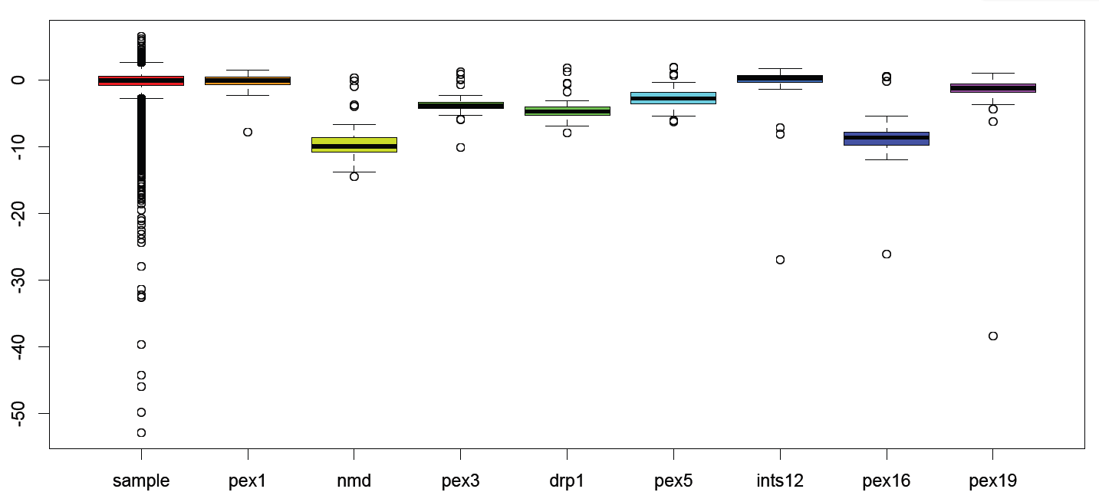
Figure 4.20. Box-whisker plots showing the distributions of the Screen 2 controls compared to the rest of the screen, measured in standard deviations. (σ). Boxes show the distribution of 1σ, whiskers show distribution of 2σ. Outlying data are shown as rings. The mean for each control is shown as a black line. The genome-wide data are displayed in the same way in the first column.
For probes like PEX1, Ints12, and PEX19 there appear to be very few outlying data compared to the other four. This would indicate that these outliers have a very large values compared to the variance of the distribution of that probe. These are also the probes with the lowest mean z-score (see figure 4.13.2) and therefore the least effective controls. For the controls nmd, PEX3, Drp1, PEX5 and PEX16 there is a negative skew, the majority of the outlying data is on the positive side of the whiskers. This indicates that more effective probes produce negative skews as well as a greater deviation of the mean and the standard deviations from the genome-wide data.
One observation from figure 4.13.3 is that even the most effective probes, particularly nmd and PEX16, still have outlying data that register within 1σ, or even on the mean, of the genome-wide data. This shows that even reliably effective probes have the potential to return data that would not deviate from a WT phenotype. If this principle was applied to the probes of the genomic library then there may be a small number of probes that return WT phenotypes when they would otherwise produce significantly different z-scores in the dataset. Similarly Ints12 and PEX19 each have a value that far exceeds its mean in terms of z-scores. These are due to a large number of cells expressing very low levels of eGFP-PTS1. The similarly high z-score from the PEX16 distribution is an artefact from Plate 48 which has an abnormally high number of KDs with high-scoring negative z-scores (see following chapter).

Plate 48 had a high number of high-scoring knockdowns
Once the genome-wide dataset had been normalised and converted to z-scores it was immediately noticed that Plate 48 had the largest single proportion of negatively scoring hits. The HTS2 software was able to visualise the entire genome-wide library of knockdowns in a coloured heat map. Each plate is organised into its 16 x 24 well arrangement and the plates are themselves arranged 1-8 across the top in 7 descending rows. The wells themselves are individually coloured according to their z-scores, those that are grey are between 3 and -3 z-scores. Negative z-scores below -3 are coloured blue getting darker with increasing magnitude, positive z-scores above 3 are coloured orange getting darker (browner) with increasing magnitude. Columns 9 and 17 contained the control probes, arranged as described in chapter 4.6 (p.106) and their distinct pattern can be seen in all plates. Plate 48 (column 8, row 7) shows a high density of highly negative z-scores arranged mostly in columns. Upon visual inspection these wells contained very little distinguishable cellular or sub-cellular morphology, disseminated Hoechst signal and out of focus GFP channel were the most common images that could be identified. The overall effect was of a disproportionate number of both positively but mainly negatively-scoring KDs with z-scores of high magnitude. This defect only occurred in the odd-numbered columns and not in all wells of that column. As there were statistically, significantly negative z-scores in all columns it was deemed necessary for all of these wells to be visually screened.
The effect that this anomaly had on the distribution of values within the plate can be seen in Figure 4.27. However the effect that this had on the rest of the genome-wide screen and its KD z-scores could not be gauged without re-calculating the z-score for the entire screen. As less than 1% of the screen had been affected by this anomaly it was thought that re-calculating would cause negligible change to the existing z-scores and so the genome-wide calculation was not altered. 147 non-control, non-empty wells were affected and then visually screened of which 121 were found not to contain cells. Theoretically the mathematical effect that this would have had on the entire screen would have reduced the value of the mean and reduced the magnitude of the negative z-scores (making the assumption that the σ is unchanged). As the z-scores of the screen that were below -1.0 were being visually screened anyway, it was decided that the next lowest 121 KDs be visually screened on top of 3,367 gene KDs scoring below -1.0, taking the total of positive and negative KDs having been visually screened to 3,839 (21.01%).

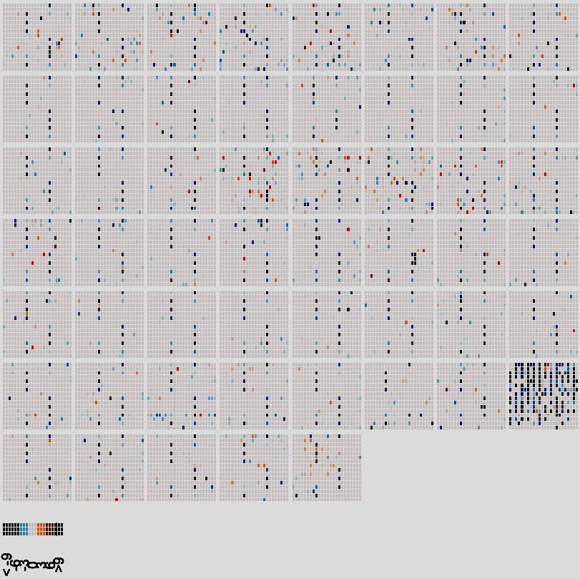
Figure 4.21. A heatmap of the entire screen showing wells in plates. Plates are arranged 1-53 from left to right, then top to bottom. Low z-scores are shown in blue, high z-scores are shown in orange/brown.
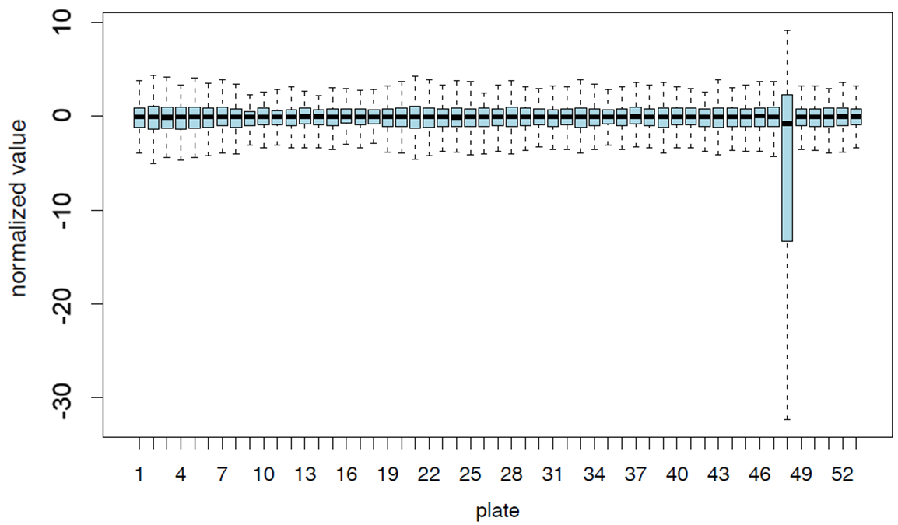
Figure 4.22. Box-whisker plots of the distribution of data in each plate. Boxes show the distribution of 1σ, whiskers show distribution of 2σ. Mean for each plate is represented by the black line.

Average z-scores across both screens
Finally it was decided to see what comparison could be made between the two screens with regards to the most promising candidates for further screening. By taking an average z-score of the KDs of PEX genes and genes causing the most aberrant phenotypes it is possible to see which genes have been consistent at producing an effective knockdown in two independent assays. The HTS2 software has two helpful visualisations for this, one is the Q-Q plot (Q = “quantile”). This compares a given distribution to another in this case the distribution of the average of both genome-wide screens and a theoretical normal distribution.
The Q-Q plot determines if a distribution is more dispersed than, in this case, a theoretical distribution (as opposed to another dataset). Each individual gene KD had its z-score for both genes averaged and plotted in order, lowest to highest, from left to right. If the data were normally distributed then it would lie along the line of fit of theoretical distribution. The shape shown in Figure 4.30 shows deviation from this line of fit implying that the normalised average data have “heavier” tails than a normal distribution would. This means that outlying data have higher z-scores than outliers in a normal distribution. In this screen the deviation is caused by effective KD of gene function. From looking at the location of the genes marked on the Q-Q plot the deviation from theoretical normal occurs in the region between PEX2 and PEX14 (z-scores of -2.23 and -1.41 respectively).
Gene name | Gene ID | Probe | Screen 2 z-score | Screen 1 z-score | Ave. z-score
PEX13 | CG4663 | BKN20261 | -11.96 | -14.33 | -13.14
PEX16 | CG3947 | BKN27609 | -8.85 | -14.04 | -11.44
PEX5 | CG14815 | BKN40823 | -2.86 | -13.94 | -8.40
PEX1 | CG6760 | BKN20866 | -5.38 | -8.76 | -7.07
NMD | CG5395 | BKN22429 | -8.49 | -5.00 | -6.75
moleskin | CG7935 | BKN27338 | -10.95 | -2.02 | -6.48
spaghetti squash | CG3595 | BKN46223 | -7.41 | -3.57 | -5.49
spaghetti squash | CG3595 | BKN27557 | -5.63 | -4.33 | -4.98
Tango11 | CG30404 | BKN30686 | -5.34 | -4.16 | -4.75
Atlastin | CG6668 | BKN21206 | -6.81 | -2.55 | -4.68
PEX3 | CG6859 | BKN21399 | -3.09 | -5.30 | -4.20
Gemini | CG30011 | BKN22231 | -4.10 | -3.26 | -3.68
Drp1 | CG3210 | BKN20979 | -4.19 | -2.06 | -3.12
PEX11β | CG8315 | BKN21630 | -2.01 | -2.62 | -2.31
archipelago | CG15010 | BKN27400 | -4.37 | -0.03 | -2.20
CDK9 | CG5179 | BKN21248 | -3.52 | -0.71 | -2.11
windbeutel | CG7225 | BKN22085 | -2.11 | -1.86 | -1.98
[unnamed] | CG5001 | BKN28978 | -2.78 | -1.00 | -1.89
[unnamed] | CG4629 | BKN27740 | -1.79 | -1.96 | -1.87
tango | CG11987 | BKN46184 | -3.33 | -0.32 | -1.83
Pak3 | CG14895 | BKN31386 | -2.36 | -1.08 | -1.72
[unnamed] | CG17233 | BKN26774 | -2.10 | -1.33 | -1.72
par-1 | CG8201 | BKN40395 | -2.08 | -1.34 | -1.71
Casein Kinase 1α | CG2028 | BKN27574 | -2.70 | -0.70 | -1.70
[unnamed] | CG12325 | BKN22059 | -2.11 | -1.16 | -1.64
osa-eld | CG7467 | BKN29156 | -1.65 | -1.31 | -1.48
KLHL18 Kelch-like | CG3571 | BKN25744 | -2.05 | 0.04 | -1.00
Alpha-Beta Hydrolase | CG3488 | BKN46211 | -0.50 | -0.60 | -0.55
[unnamed] | CG8492 | BKN20396 | 1.72 | -0.73 | 0.49
[unnamed] | CG34433 | BKN24984 | 1.51 | -0.16 | 0.67
Negative Elongation Factor | CG5874 | BKN45137 | 1.29 | 0.27 | 0.78
Rasputin | CG9412 | BKN28430 | 1.96 | -0.19 | 0.88
RNA DEAD-like Helicase | CG10689 | BKN20322 | 2.45 | -0.64 | 0.91
Hsp83 | CG1242 | BKN21307 | 2.76 | 1.20 | 1.98
Stonewall | CG3836 | BKN45199 | 4.04 | 2.03 | 3.03
Ints4 | CG12113 | BKN22862 | 3.43 | 2.65 | 3.04
Female Sterile 1 Homeotic | CG2252 | BKN21636 | 3.54 | 3.27 | 3.41
[unnamed] | CG14749 | BKN45103 | 4.54 | 2.34 | 3.44

Table 4.7. The complete hitlist of Screen 2.
The assay is overly sensitive to outlying WT phenotypes. The screen is particularly sensitive to negatively affected values.

Figure 4.23. A Q-Q plot showing theoretical quantiles against the normalised Z-scores of the average of the two genome-wide screens. Controls (n=848) are shown in red, genome-wide screen (n=19504)are shown in black. Included are the locations of the average z-scores for KDs of the PEX gene homologues and the three main gene KDs to come out of both screens (nmd, sqh and atl). The data shows that on average the two screens cause a more dispersed distribution than is normal.

Discussion
The second genome-wide screen in D. melanogaster was able to obtain further candidate genes for investigation. The screen identified 37 gene KDs from 38 probes including 7 known PEX gene homologues and two genes known to be involved in peroxisome biogenesis, multiplication or inheritance; these were confirmed visually from 21% of the screen.
Initially these data sound promising but it has been observed upon visual screening of several of the aberrant phenotypes that some of the z-scores have been produced by wells with disproportionally high numbers of cells expressing very low levels of eGFP-PTS1. The assay was induced with a decreased concentration of CuSO₄ to prevent the over-expression of the reporter, and the sensitivity of the analysis software was increased to detect the reporter in cells with reduced expression. There could still be observed in some wells colonies of cells which have been reported as statistically significant yet have very dimly visible WT phenotypes.
From data returned it was then decided that secondary screening would be the next stage. This involved visually determining the best candidate probes and putting them into a custom-designed 384 well plate and performing the assay on them one final time in triplicate. This was made possible with the help of the SRSF and its staff. This final stage of screening would determine which genes would be the focus of subsequent experiments, and the direction of future work.

Secondary screening and subsequent labwork

Introduction
Analysis of the second genome-wide screen produced several results:
- Some long dsRNA probes targeting certain PEX gene homologues were functional in producing aberrant phenotypes in the eGFP-PTS1-based assay when counting peroxisomes per cell.
- Three novel genes discovered in the first screen produced the same distinct KD phenotypes in Screen 2, revealing aberrations in the eGFP-PTS1 assay (nmd, Atlastin, spaghetti squash).
- Visual screening of KDs of genes with z-scores less than -1 and greater than 2 produced a list of genes that caused aberrant phenotypes in a large number of cells within each well. These KDs were not ubiquitously affected nor were the phenotypes consistently produced in the cells. There were, however, enough cells showing similar non-WT phenotypes within each KD to suggest that further screening on them may yield more candidates from this assay.
To make use of this list secondary screening would be used to test the probes with outlying z-scores from the analyses of both screens. A custom-designed 384-well plate would be seeded with approximately 250 probes from the BKN library of the best candidates. The plate would be made into 27 copies from which multiple experiments could be conducted in future research as well as in the current project. For this secondary screen the plate would be screened in triplicate using the assay from the second genome-wide screen, the stably transfected eGFP-PTS1 with controlled expression using the pMt promoter. The analysis of the secondary screen is given in this chapter.

Selection of samples for the Secondary Screen plate
The gene KDs from both screens were averaged and z-scores compiled smallest to largest. The 384-well micro-titre plate that was to be seeded and copied is henceforth referred to as the Secondary Screen plate. The plate had assigned for it 275 wells for candidate probes. This meant that the plate could contain 1.4% of the non-control genome-wide probes. During visual screening of statistically significant z-scores, including those added after visual screening of Plate 48, KDs of genes which were of potential interest were highlighted and compiled into a shortlisted database. The candidates from Screen 2 (see Chapter 4.12) were analysed, selected and segregated from this list. The list contained 598 probes which caused KDs that may have produced phenotypes of interest in a proportion of the cells. The list had to be downsized visually to a shortlist of 275 of the best candidates including those from Chapter 4.2. 18 probes were included to the shortlist before the final visual screen took place. These were homologues of 9 peroxins that consistently failed to produce an aberrant phenotype in the two screens, plus 3 peroxisomal membrane proteins required for transmembrane solute transfer. The rest were 6 genes whose proteins were considered hits in a yeast two-hybrid screen for D. melanogaster protein interactions with S. cerevisiae Pex3p. The summary of which is given in Figure 5.2.1.
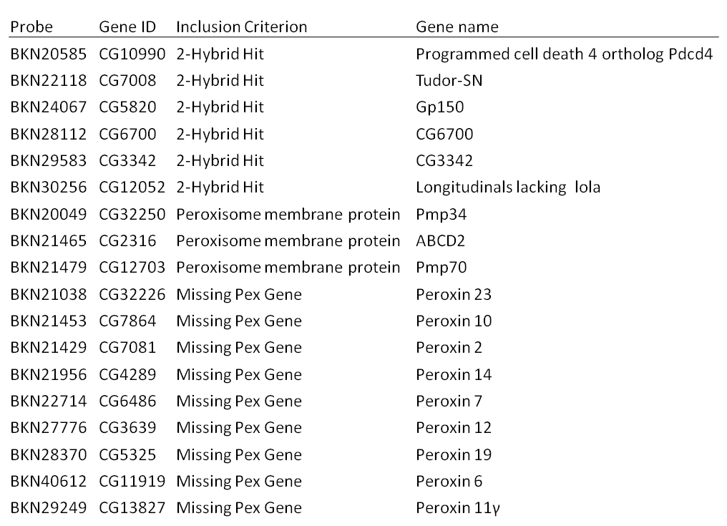
Table 5.1. The list of genes included for seeding into the Secondary Screen plate prior to final visual screening. 6 genes were homologues of candidate S. cerevisiae genes that showed an interaction with Pex3p in a yeast 2-hybrid screen conducted previously for our laboratory. 3 were peroxisomal membrane proteins associated with transmembrane transport of solutes across the peroxisomal membrane. 9 were genes homologous to H. sapiens or S. cerevisiae peroxins. None were hits in Screen 2.
The final visual screen then shortlisted 257 probes for addition to the Secondary Screen plate. These included the candidate genes from Chapter 4.12. The list was compiled and then submitted to the SRSF for plate design and probe seeding.

Choosing the control probes for the Secondary Screen secondary screening plate
The secondary screening plate for this project was the fifth to be designed and seeded by the SRSF and so had been named Secondary Screen (custom plate 5) by them. The Secondary Screen plate was to be treated like any other plate in that it would be loaded with fifteen controls as like the two screens in columns 9 and 17. It would be filled with as many candidate probes as possible to maximise the number of genes that could be analysed. As the plate is to have a large number of tests, it needs to have a significant number of negative controls to provide low z-scores for the analyses to be made on them. Two negative controls would be used. The first was a probe targeting luciferase (FBgn0043065). This is a foreign gene from Renilla reniformis and is used as a negatively-scoring positive control in luciferase based screens (Dorner et al. 2006). In a GFP-based screen such as this, the luciferase is intended as a negative control. It is abbreviated to Rluc (Renilla luciferin 2-mono-oxygenase). A second negative control is ZKZ686.3, a C. elegans–targeting control used in the assay plate that is not designed to target any specific D. melanogaster genes. Finally a positive control for the plate was that of GFP. As GFP and eGFP differ by only one point mutation the GFP probe should effectively target eGFP. The final numbers for controls to be loaded into the plate were 30 copies of Rluc, 30 copies of ZKZ686.3 and five copies of GFP probe. On the day of seeding the secondary screen 2 each of 8 controls, designed on the E-RNAi website would be loaded into the control wells (“E-RNAi” controls, total 16). In total 81 wells were taken up with controls of Rluc, ZKZ686.3 (60 negative) and GFP (5 positive) plus the E-RNAi ones. In addition to this 28 wells were left empty to ensure WT phenotypes would be counted. 109 wells in total would have controls or be empty, over 25% of the plate. This added to the 275 wells to be filled with candidate genes totalled 384.
The 8 E-RNAi –derived controls needed to be chosen before adding to the Secondary Screen plate. PEX1 was re-synthesised from the first amplicon that was created for it (designed using E-RNAi). The primers for the synthesis of an amplicon to produce the PEX1 probe from the BKN library (BKN20866) were acquired from the SRSF as it had proved to be effective in producing a high magnitude average z-score across both screens. The PEX19 probe was redesigned on E-RNAi in the hope that a second design might be more effective. A probe targeting sqh was designed. Though at this point not considered a PEX-like phenotype it produced one of the strongest aberrations and so its inclusion was desirable from a statistical point of view. The four were all tested on S2R+ cells expressing stably transfected eGFP-PTS1 in a 6-day KD experiment in 6-well plates. With the exception of PEX19 the efficacy of the newly synthesised probes had much improved and the BKN PEX1 appeared to be as effective as the E-RNAi designed one. Both probes had caused peroxisomes to be very dim on a background of cytosolic eGFP-PTS1 as seen with the BKN20866 probe in the second genome-wide screen. The new, smaller PEX19 probe seemed to cause no noticeable improvement on the original design, an apparent fall in peroxisome number was visible in most cells. It was decided not to use this probe in favour of more effective ones. The sqh probe produced very strong visual aberrations in the 6-well experiment. The two PEX1 probes and the sqh probe were used alongside five of the probes shown to be effective controls in the previous screen: nmd, PEX16, Drp1, PEX3 and PEX5.(see table 5.3.1)
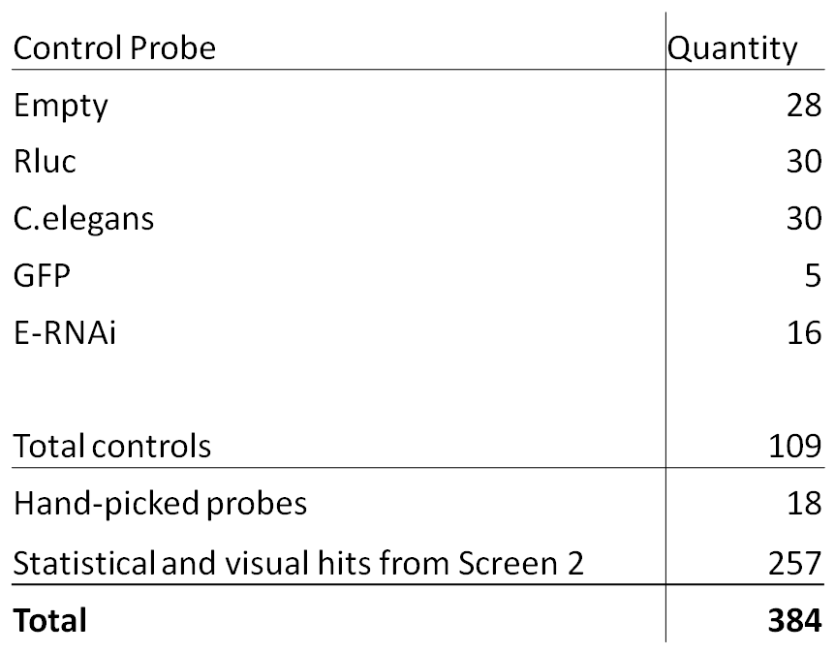
Table 5.2. A table showing the quantities of the controls, and sample probes to be added to the Secondary Screen plate.
The E-RNAi-derived probes that were included for the secondary screening were: PEX1 (A09, O17), PEX1 (BKN20866 –C09, M17), PEX3 (E09, K17), PEX5 (G09, I17), PEX16 (I09, G17), Drp1 (K09, E17), nmd (M09, C17) and sqh (O09, A17). BKN20866 is the PEX1 probe taken from the library as a control to guage the relative efficacy between it and the comparatively poor PEX1 probe designed independently. The brackets denote the locations of each probe in their anti-parallel arrangement given by their well-identifier. This is illustrated in Fig. 5.3 where the positive and negative controls a have been dispersed throughout the plate.
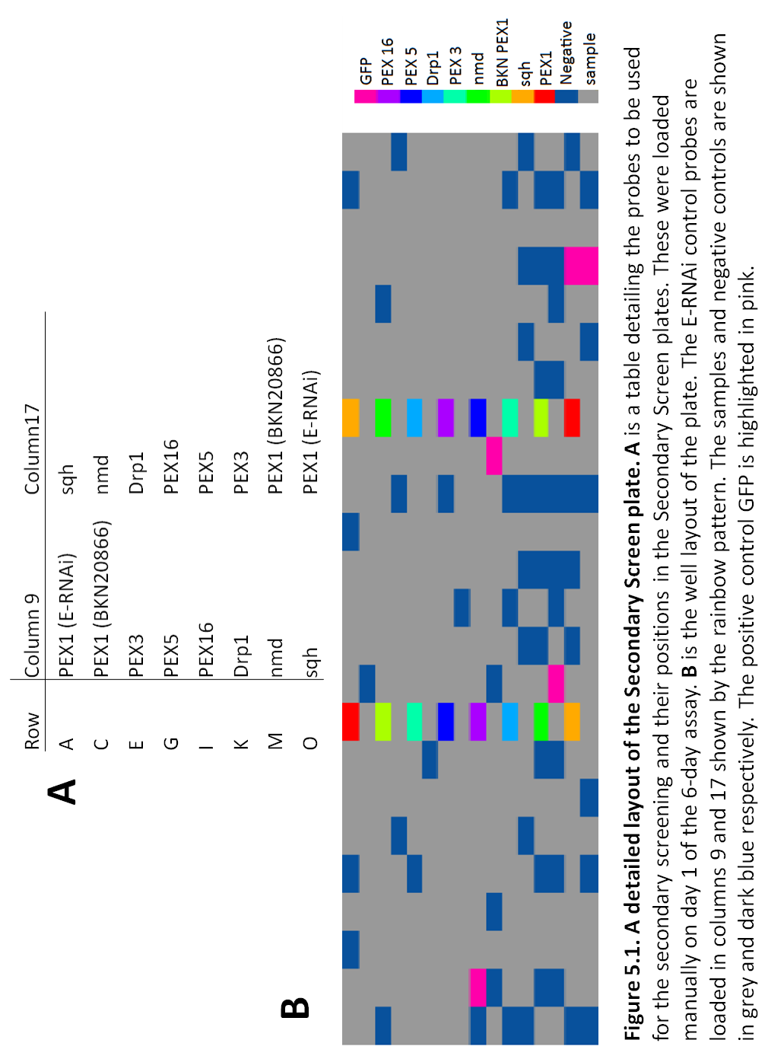

The Secondary screen of 257 shortlisted sample probes from the genome wide screen for animal peroxins
The Secondary Screen plate was assayed with a 6-day KD using S2R+ cells stably transfected with pMt-eGFP-PTS1. The assay protocol was the same as that described for the second screen. Three Secondary Screen plates each containing 258 shortlisted sample probes from the analysis of screen two were assayed. The analysis of this secondary screen is described in the following paragraphs.

Evaluation of controls
Before the statistical analysis was conducted with HTS2 software the three Secondary Screen plates were to have mean values made of each KD across all three plates. These mean values would be used to judge the relative efficacy of the control probes to that of the probes of the Secondary Screen plate. This did not require normalisation as the three plates themselves were not to be compared to each other. The three plates were completely visually screened for aberrant phenotypes. Average peroxisome per cell counts for each probe were included as indicators of the effect of the KD.
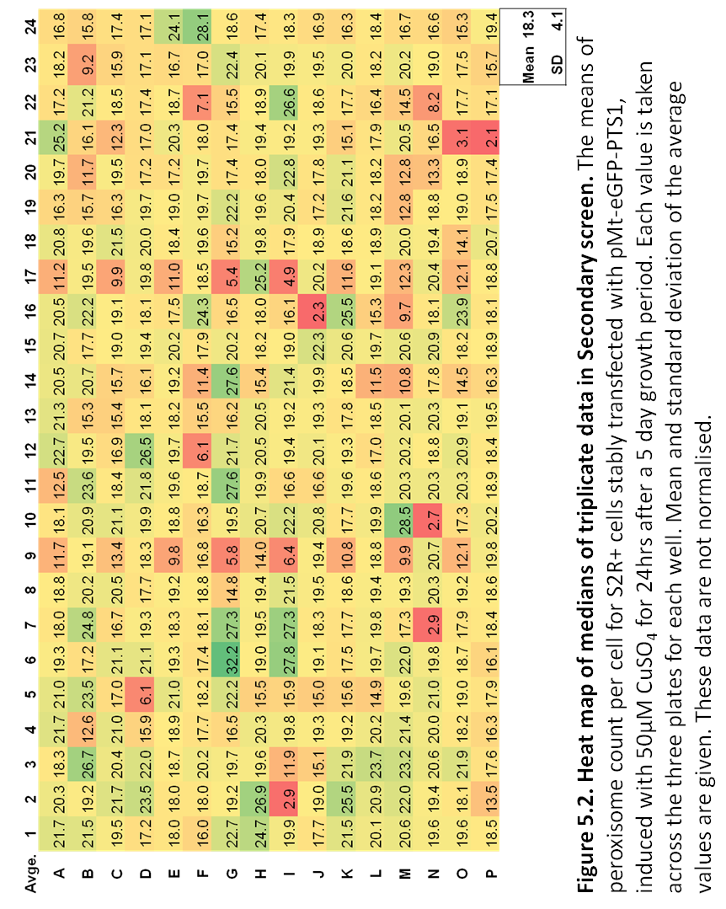
The controls have all achieved low average peroxisome per cell counts as indicated by the heat map in Figure 5.5.1. Their average values are among the lowest of all average values indicating that the controls may prove to have relatively high efficacy compared to the rest of the probes. From an analysis point of view however, few of the sample probes appear to be as well distinguished in the heat map as the controls. This suggests that there may be ineffective KD in the sample wells or simply that few sample probes have produced phenotypes resulting in a decrease in peroxisome number per cell. Upon inspection the images of the control probes show that the heat map has been a good indication of the severity of their KDs. PEX5, PEX16 and nmd show almost ubiquitous cytosolic eGFP-PTS1 with very few puncta in any of the knocked-down cells. The two PEX1 probes are approximately equal in KD efficacy. They both have an almost ubiquitous KD showing a presence of dim cytosolic eGFP-PTS1 and the majority of these cells have only dimly fluorescing peroxisomes. PEX3, like the PEX1, probes has a dim cytosolic presence of eGFP-PTS1 but with few fluorescent puncta. Drp1 and sqh also show a large reduction in peroxisome number. There are a few WT phenotypes among the cells in all of these samples. The images of the controls are given in Figure 5.5.2.
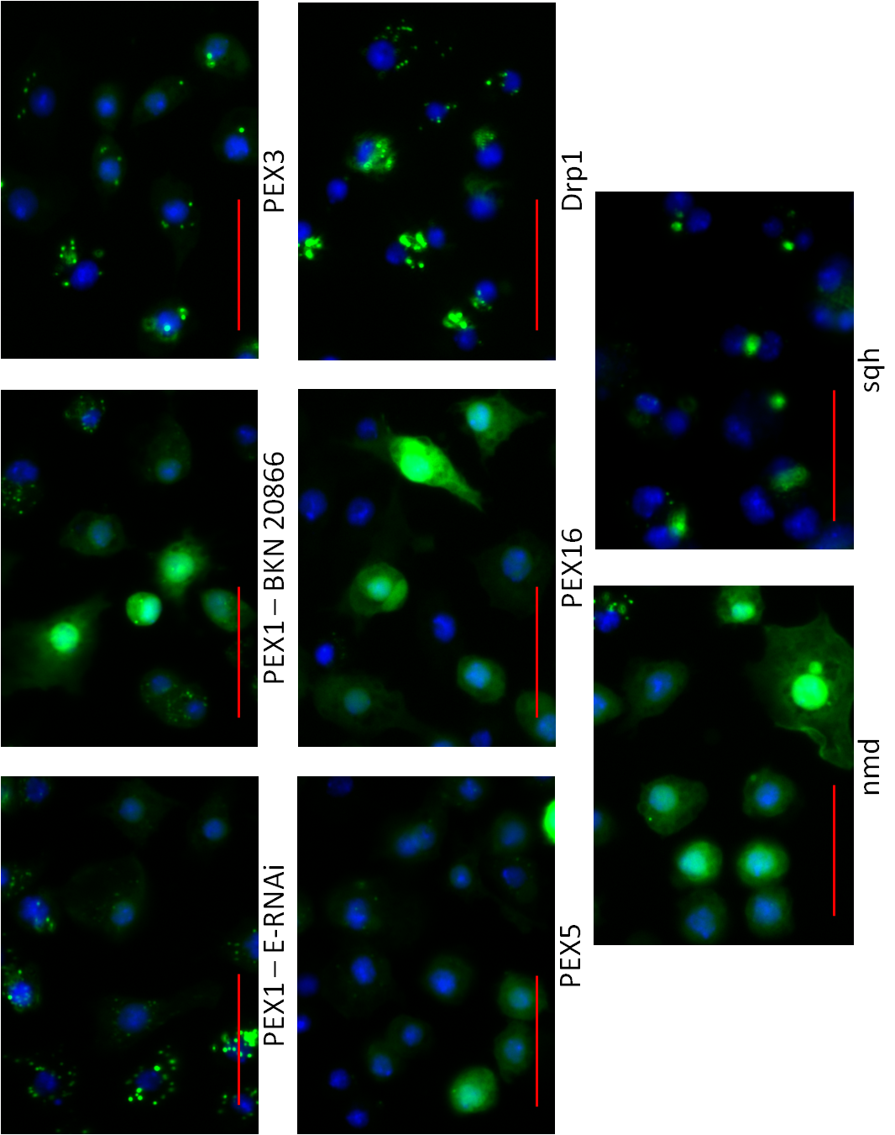Figure 5.3. Images of control KDs in Secondary Screen. Images of control KDs of S2R+ cells stably transfected with pMt-eGFP-PTS1 grown for 5 days before a 24hr induction with 50µM CuSO₄. Bar = 20µm.

Visual analysis of KDs in Secondary Screen.
The Secondary Screen plate contains 257 probes (66% of the plate) targeting genes that either had statistically significant z-scores, greater than a magnitude of 2, or were included because they had visually aberrant phenotypes that were deemed worthy of subsequent investigation. This means that two thirds of the secondary screen is expected to produce high deviations in peroxisome per cell number from the mean. This means that the statistical analysis that HTS2 uses to determine the most aberrant phenotypes is likely to exclude approximately 60% of the sample probes elected from Screen 2 as its default analysis setting is to use the KDs as the population distribution instead of WT. It was therefore decided that prior to statistical analysis, a complete visual screen of all 1,152 samples (10,368 images) be taken in an attempt to include more of the aberrant phenotypes that would be excluded from analysis. This type of analysis would apply a subjective approach to the secondary screen and so certain criteria needed applying.
- The images would be viewed without any knowledge of which KD was being observed to prevent subjective bias.
- To compare with known WT phenotypes the locations of 6 empty wells were used, the top left quadrant (A01, A02, B01, B02) and centrally, L08 and L09.
- Probes would be ranked first by the number of replicates they created aberrative phenotypes in, 3 being the most effective, 1 being the least.
- Probes would then be ranked by the mean peroxisomes per cell for the probe triplicate; at this stage the data were neither normalised nor reported in terms of z-scores.
Each plate was completely screened visually. Despite the highly aberrant visual phenotypes of the control probes used in this triplicate assay, few such profound effects could be observed from the sample KDs. Each probe would be judged on whether ubiquitous aberrations from WT phenotype had occurred. If KDs were neither ubiquitous nor nearly so across the nine images then it would be determined whether a sufficiently large proportion of cells had experienced a common deviation from WT phenotype for a KD to be said to have occurred. A list was then compiled of the well locations that had experienced 3, 2 or 1 sample-wide KDs. A list of those that returned phenotypes confirmed visually is shown in Figure 5.6.2.
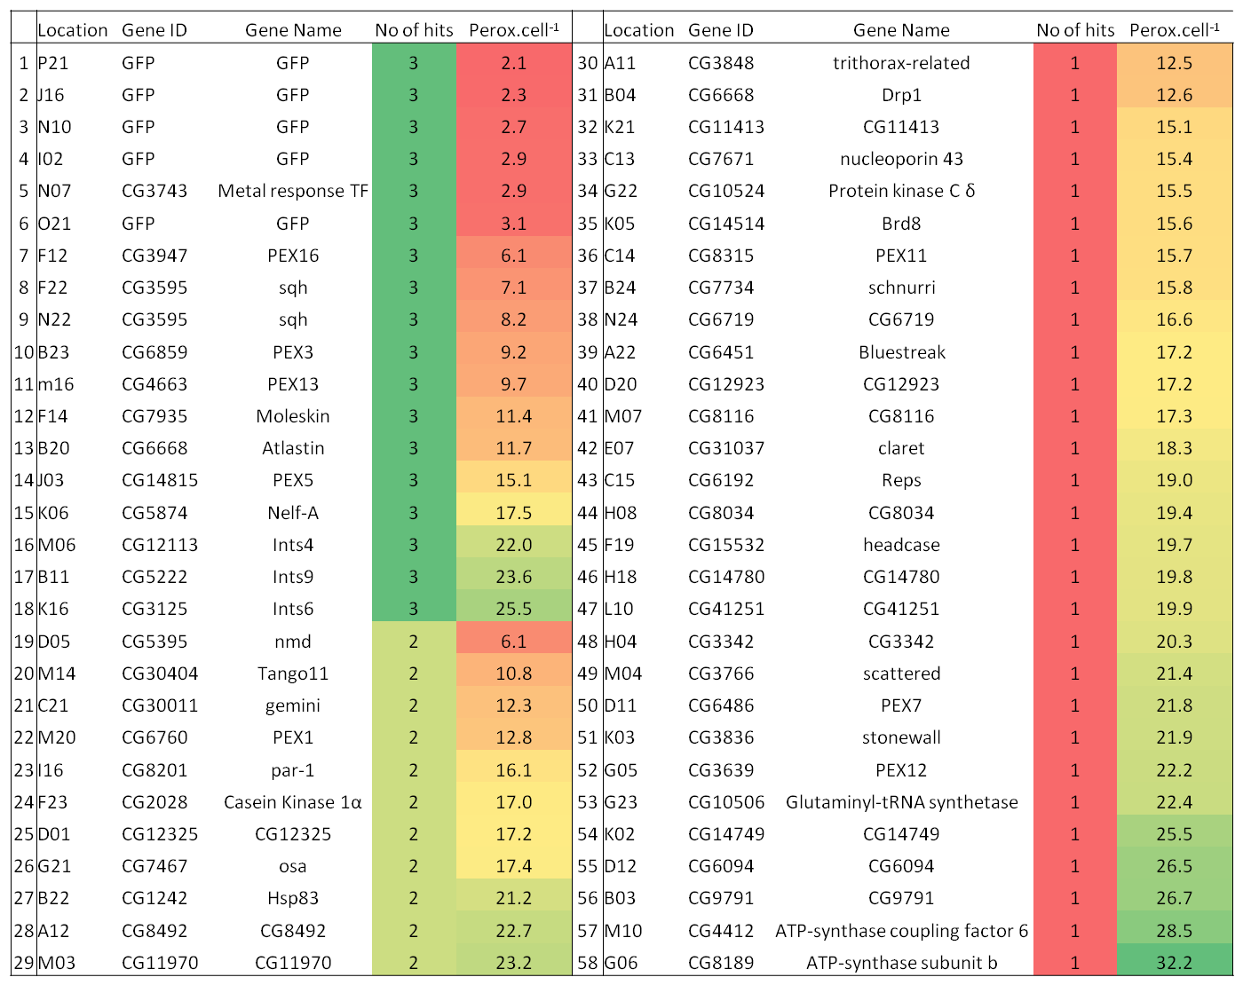
Table 5.3. A list of genes whose KDs caused visual aberrations in eGFP-PTS1 phenotype in the secondary screen. No. of hits is the number of plates that recorded a visual aberration. The peroxisome per cell count is colour-coded from few in red to many in green. Number of hits is colour coded, 3 in dark green, 2 in lime green, 1 in red. The peroxisome per cell count is not normalised. μ = 18.3 peroxisomes per cell, σ = 4.1 peroxisomes per cell.
The visual screen revealed 18 gene KDs that achieved an aberrant phenotype on all three plates. 11 gene knockdowns could be viewed in 2 of the three wells. 29 KDs were only apparent in 1 well from the three plates.

Three probes, including one positive control, showed apparent ubiquitous loss of signal
Five of the probes that scored the lowest peroxisome per cell scores were the GFP targeting probe positive controls which scored in the top six KDs. All of these occurred across all three plates indicating that it is an effective probe at preventing eGFP-PTS1 expression. Producing a very similar effect and peroxisome count was of one of the samples that was included as a high-scoring sample from the previous two screens. The probe targets a transcription factor called Metal Response element-binding Transcription Factor-1 (Dmel/MTF-1, CG3743). This is unsurprising as MTF-1 is a metal-responsive transcription factor as the name suggests (Egli et al. 2006), the loss of which has had a detrimental effect on eGFP-PTS1 expression under CuSO₄ induction. These two probes were capable of producing peroxisome per cell counts of less than 3. Producing a similar visual phenotype but with a higher peroxisome per cell count was Moleskin (CG7935). Images of the KDs seen across all three plates of these genes are shown in Figure 5.6.3. The dim but visible pattern of fluorescent puncta among apparently normal nuclei suggests that the expression of the reporter was inhibited.
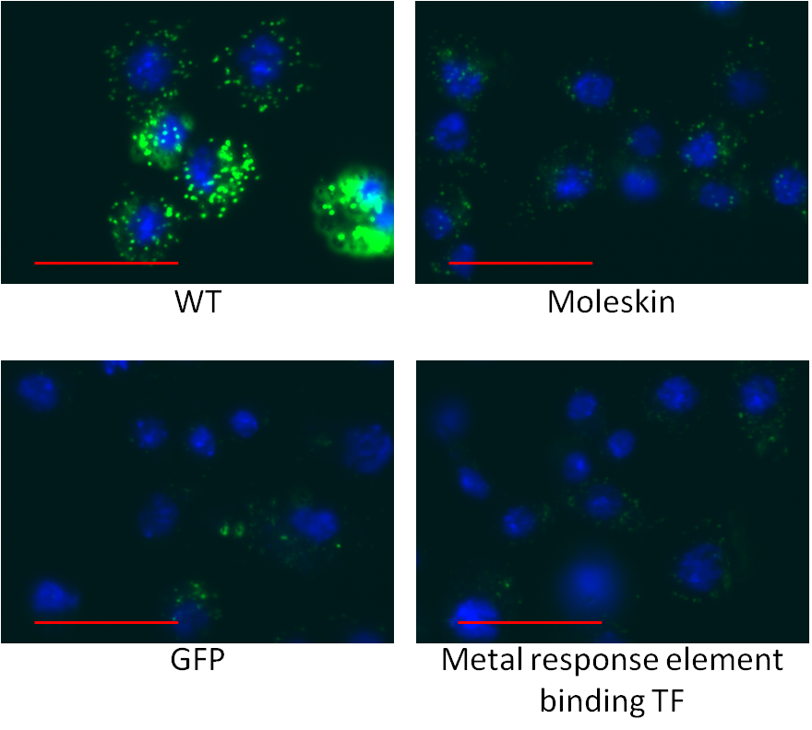Figure 5.4. Images of cells with low expression or stability of eGFP-PTS1. S2R+ cells stably transfected with pMt-eGFP-PTS1 were grown for 5 days and then induced for 24hrs with 50µM CuSO₄ before fixation and imaging. WT cells (upper left) show the typical brightness of peroxisomes. Gene KDs using long dsRNA against Moleskin (upper right), GFP (lower left) and MTF-1 (lower right) are shown. Cells appear to have a very dim presentation of eGFP-PTS1 puncta with no noticeable cytosolic fluorescence. Bar = 20 µM.

Two gene KDs produced loss of puncta phenotypes ubiquitously.
Only two sample probes produced an apparent loss of puncta in knocked-down cells in the secondary screen. PEX16 has shown this phenotype consistently in the previous two screens, both as a control and as a sample. The other is nmd which also has shown a near ubiquitous absence of peroxisomes or very low z-score representing low peroxisome per cell count. In the secondary screen PEX16 produced an average of 6.1 peroxisomes per cell across the 3 wells. In the nmd sample an average of 6.1 was also achieved but only across 2 wells as upon visual screening one nmd sample did not cause a visual phenotype. Images for the two samples are shown in Figure 5.6.4.

Figure 5.5. Images of loss of puncta KD phenotypes. S2R+ cells stably transfected with pMt-eGFP-PTS1 were grown for 5 days and then induced for 24hrs with 50µM CuSO₄ before fixation and imaging. Gene KDs using long dsRNA against nmd (left) and PEX16 (right) are shown. Near-ubiquitous mislocalisation of eGFP-PTS1 to the cytosol was achieved with only a small number of cells with green fluorescent puncta. Bar = 20µM

Three gene KDs showed dim peroxisomes contrasted with dim cytosolic eGFP-PTS1
Three of the probes targeting Class I peroxins produced a phenotype with cytosolically mislocalised eGFP-PTS1. The cytosolic fluorescence was not as intense as that observed in the PEX16 or nmd KDs. This would imply one of two situations, that the targeting and import into the peroxisomes was not completely inhibited under these assay conditions. Alternatively that the background expression of eGFP-PTS1 under a less poorly regulated pMt promoter in the pMK33 plasmid meant that what would have been functional “ghost” peroxisomes actually contained some peroxisomal fluorescent marker. Despite this the PEX13 and PEX5 KDs produced phenotypes in all three wells and the PEX1 KD was observed in two. The peroxisome counts per cell were not so well reduced for PEX13 and PEX5 as they had been in the previous screen. The PEX5 sample probe was not as effective as the PEX 5 control probe either. The PEX1 sample probe was comparable both in peroxisome count per cell and in phenotype appearance to those of the two PEX1 control probes. Figure 5.10.1 shows their images.
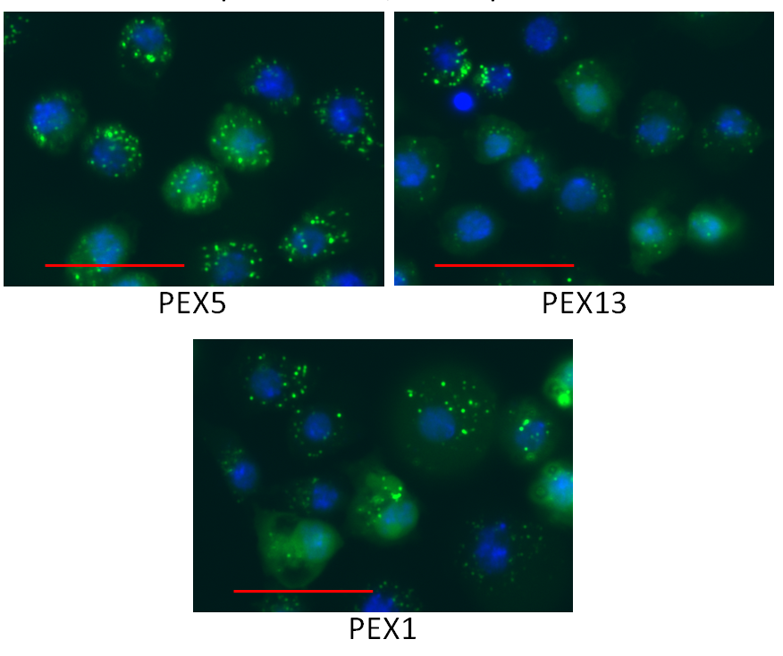
Figure 5.6. Images of Class I peroxin KD phenotypes. S2R+ cells stably transfected with pMt-eGFP-PTS1 were grown for 5 days and then induced for 24hrs with 50µM CuSO₄ before fixation and imaging. Gene KDs using long dsRNA against PEX5, PEX1 and PEX13 produced cells with cytosolic mislocalisation of eGFP-PTS1 and a reduction in peroxisome number per cell with some dim peroxisomes still contrasting with the cytosol. Bar = 20 µm.

Six gene KDs showed juxta-nuclear position of peroxisomes
Six gene KDs showed peroxisomes converging to a point immediately adjacent to the nucleus of the cell. Atlastin and sqh probes caused an almost ubiquitous KD. Atlastin KD cells had the phenotype of many small peroxisomes in one group to one side of the nucleus. The sqh phenotype was one of a larger fluorescent body, between two mitotic nuclei; smaller peroxisomes were also present close to the nucleus. The par-1, Casein Kinase 1α and CG12325 phenotypes were not so ubiquitously affected in the sample cells. They instead presented in several smaller colonies among the images making identification difficult. They do present with very similar phenotypes to the ones from their images in Screen 2. This is a reassuring confirmation of the probes ability to reproduce a phenotype, even though it is not ubiquitously affected among the cells in the sample well. Atlastin reduced peroxisome count to 11.7 per cell and sqh to 8.2 and 7.1 with a near ubiquitously presented phenotype in all three of each probe’s respective wells. Casein Kinase 1α, par-1 and CG12325 only returned phenotypes in 2 of their probe’s three wells and on average returned 17.0, 16.1 and 17.1 peroxisomes per cell respectively, less than one standard deviation below the mean.
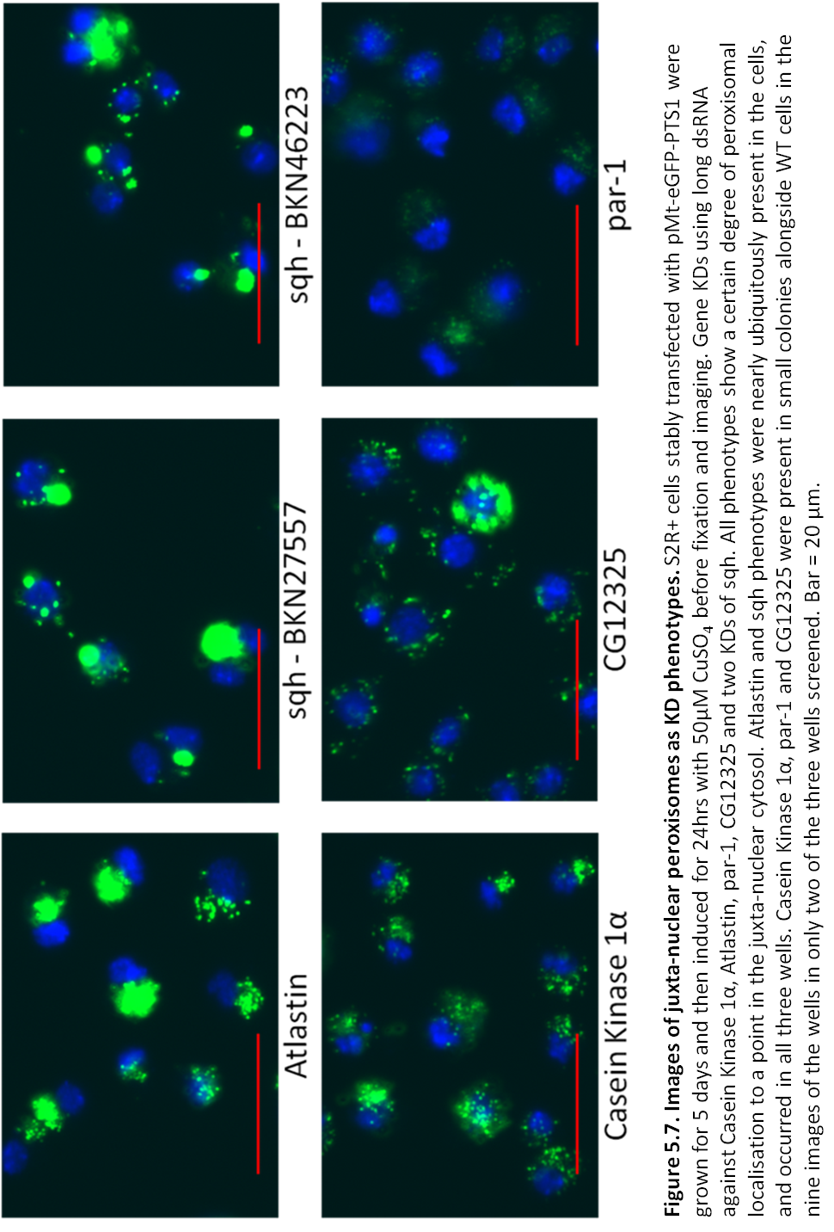

Three gene KDs produced phenotypes with a low peroxisome per cell number or with enlarged peroxisomes
Three gene KDs achieved reduced peroxisome count per cell with bright, enlarged peroxisomes. This indicates that PTS1 protein targeting and uptake is likely not affected and that the cause may be a defect in peroxisomal biogenesis. Peroxisomes are in no specific arrangement about the nucleus like they are with Atlastin KD. PEX3 is a Class II peroxin and its KD has proved to be a robust agent in producing statistically significant results as a control probe and as a sample in all the experiments to this point. It caused visual deviations from WT in all three of the wells confirming it as an effective probe in this secondary screen assay. Tango11 like PEX3 has produced statistically significant data through the screening process, though as a control probe it proved ineffective. In the secondary screen it only produced two aberrant phenotypes, although expressed ubiquitously in the images. Gemini is a gene whose KD was found to be effective in the previous screen. It produced a very similar phenotype to the current one and in both cases was not ubiquitously expressed. In Screen 2 it was accompanied by WT cells that did not express eGFP-PTS1 brightly and in the secondary screen by cells expressing peroxisomes with varying brightness, size and number. This may have been why it only reported two aberrant phenotypes from the three wells in which it was knocked down. Despite this the three KDs report similar peroxisome counts of 9.2 (PEX3), 10.8 (Tango11) and 12.3 (Gemini).
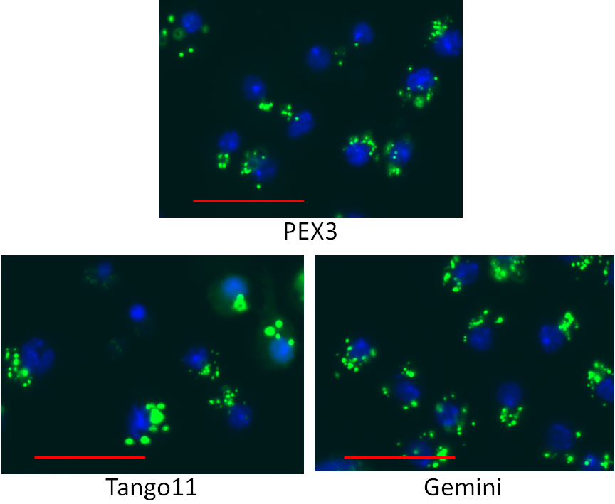
Figure 5.8. Images of gene KDs with low peroxisome count. S2R+ cells stably transfected with pMt-eGFP-PTS1 were grown for 5 days and then induced for 24hrs with 50µM CuSO₄ before fixation and imaging. Gene KDs using long dsRNA against PEX3, Tango11 and Gemini. PEX3 and Tango11 KDs ubiquitously show reduced peroxisome number, increased peroxisome size, and frequently increased fluorescent intensity. The Gemini KD was not ubiquitously expressed and was only present in colonies within the images taken. The cells in these colonies also had decreased peroxisome number, increased peroxisome size and increased peroxisome intensity. PEX3 KD phenotype was visually reported in 3 wells across the triplicate of plates, Tango11 and Gemini in only 2. Bar = 20 µm.

Eight gene KDs caused over-expression of the eGFP-PTS1 reporter and affected cellular morphology
Eight gene KDs caused significant cellular morphological aberrations which affected not just the appearance of the cell but caused massive increases in the levels of peroxisomal reporter. This had the effect of causing cytosolic levels of eGFP-PTS1 to rise and give the appearance of a PEX16 or nmd-like fluorescent cytosol. Yet there appeared to be no impairment of targeting and uptake of eGFP-PTS1 into the peroxisomes. Consequently peroxisomal eGFP-PTS1 was able to contrast brightly with the cytosol. The effect on peroxisome number per cell went above mean levels. This is highly likely to be due to massively contrasting levels of eGFP in parts of the cell other than the peroxisomes such as the plasma membrane (see Ints9 in Fig. 5.12), nuclear envelope (see Ints6 in Fig. 5.12), lysozomal structures (also Ints6) or simply fluctuations in the cytosolic fluorescence that are indistinguishable to the human eye. The latter is very common in cells with brighter than expected fluorescent cytosol. Nelf-A, Ints4, Ints6 and Ints9 were all visually confirmed three times and returned peroxisome per cell counts of 17.5, 22.0, 23.6 and 25.5. The other four, osa, Hsp83, CG8492 and CG11970 each had a site that did not record a third site. While having a profound effect on the appearance of the cells, these KD phenotypes do not report any peroxisomal anomalies other than the appearance that they have increased in size/diameter. While possible, it is far more likely that the peroxisomes appear larger because they contain huge amounts of eGFP, the high intensity of which will cause the threshold of the peroxisome to appear wider. These KDs are unlikely to be considered for further investigation. Their images are presented in Figure 5.12.

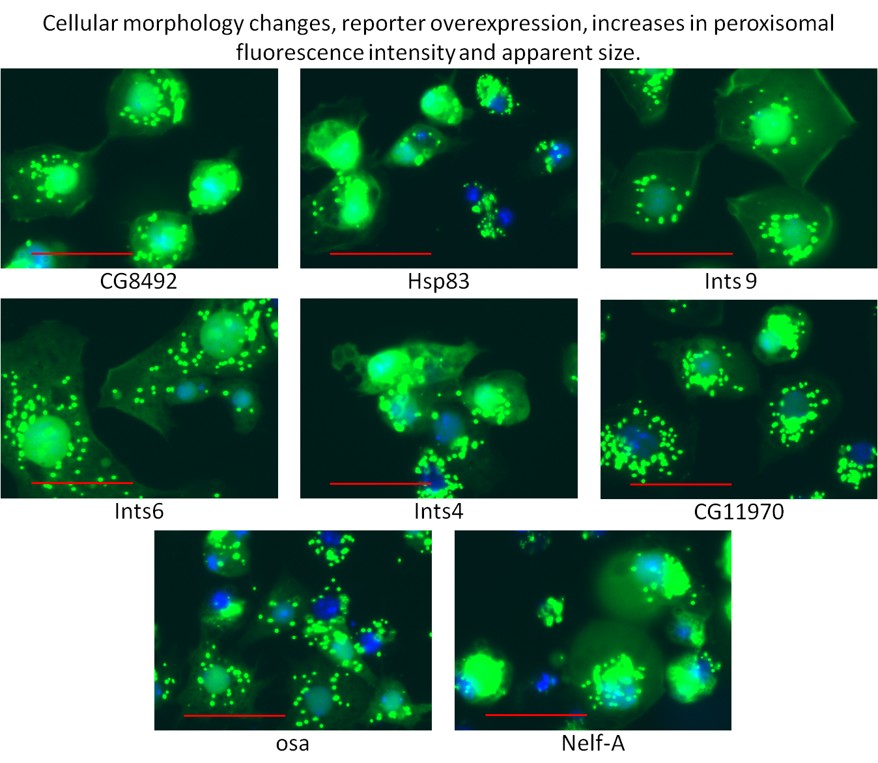
Figure 5.9. Images of cells with gene KDs causing overexpression of eGFP-PTS1 marker. S2R+ cells stably transfected with pMt-eGFP-PTS1 were grown for 5 days and then induced for 24hrs with 50µM CuSO₄ before fixation and imaging. Gene KDs using long dsRNA against CG8492, Hsp83, Ints9, Ints6, Ints4, CG11970, osa and Nelf-A. eGFP-PTS1 is overexpressed but peroxisomes are still visible and numerous suggesting no aberrant peroxisomal phenotype. Cell morphology is greatly altered indicating a greatly unhealthy population of cells and disturbed cellular processes. Bar = 20 µm.

29 gene KDs were visually reported in one of three replicate samples.
The visual screening of the three Secondary Screen plates was deemed necessary as it was understood that the statistical evaluation of KDs as peroxisome counts per cell in terms of z-scores from a mean would likely cause the reporting of many false negatives. Each probe in the Secondary Screen plate was considered either a statistical outlier of the second genome-wide screen or an aberrative phenotype included from a visual screen with extended inclusion parameters. Even with 88 expected negative controls added each KD phenotype would experience a relative fall in the magnitude of its z-score from the new mean of the Secondary Screen data, with only the very strongest outliers remaining statistically significant as sample KDs. This is due to the altered relative distribution of the population, a large relative increase, and its reduction in size to less than 2% of what it was in the genome-wide screens. Visual screening of all the wells ensured that any phenotypes that looked like aberrations from WT would be noticed regardless of whatever magnitude of z-score they have produced from this new dataset. Statistical analysis would then follow the visual screening of 1104 wells (3 x 384 wells – 48 user-synthesised controls).
This still produced a statistical grey area when there were 29 wells that only returned a visual phenotype once after its three wells had been viewed. This meant that twice upon viewing it appeared indistinguishable from WT phenotype. Because of this relatively little significance was given to these gene KDs compared to those described earlier in this chapter. While it may at first seem promising that PEX7 and PEX12 have finally been considered as hits in some way, they were chosen due to their apparent increase in peroxisome number per cell and not because they present in any small way like PEX1, PEX5 or PEX13. The fact that stonewall is among these 29 KDs after being reported in Screen 2 may have been more reassuring if it hadn’t failed to be reported in the other parallel visual tests. Even Drp1 is included in these results; a robust probe from previous screens, it is one of the highest scoring of this third subset of sample KDs yet two of its wells appeared like WT phenotypes. This uncertainty is due to the heterogeneous nature of the S2R+ cells and the heterogeneous marker expression experienced with the use of stable reporter transfection (see Ch. 4.4). In some images cells may report several phenotype presentations , even in WT or control wells, thus compounding the difficulty of being able to differentiate aberrations from WT. Indeed the most uniform phenotypes seen in any of the wells are ones where functional probes have produced a ubiquitous and highly effective change in cellular protein expression, thus KDs of PEX16, sqh, PEX5 and Ints9 are immediately recognisable as ubiquitously aberrant phenotypes.
An image each is included for these 29 samples, showing exemplary cells from the wells that did return the positive result in the visual screen of the three Secondary Screen plates. From here it may be decided whether to continue with further work, based on these images and the subsequent statistical analysis that would be performed on them. The statistical analysis of the secondary screen begins in Ch 5.14.
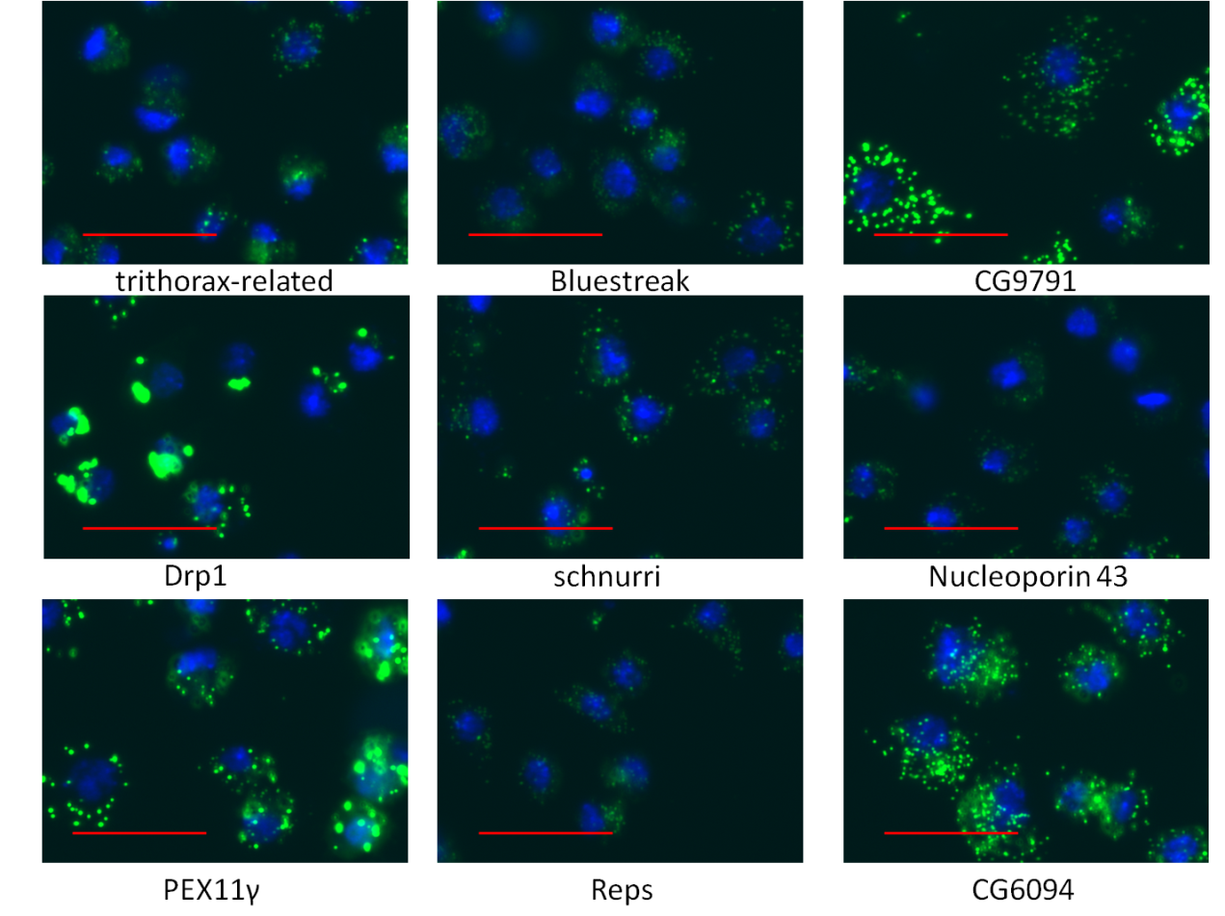
Figure 5.10. Images of cells with only one well in the triplicate showing aberrant phenotype – A. S2R+ cells stably transfected with pMt-eGFP-PTS1 were grown for 5 days and then induced for 24hrs with 50µM CuSO₄ before fixation and imaging. Gene KDs using long dsRNA are shown against trithorax-related, Bluestreak, CG9791, Drp1, schnurri, Nucleoporin 43, PEX11γ, Reps and CG6094. Images are of cells whose KD phenotype best represents that which was observed upon visual screening. Bar = 20 µm.
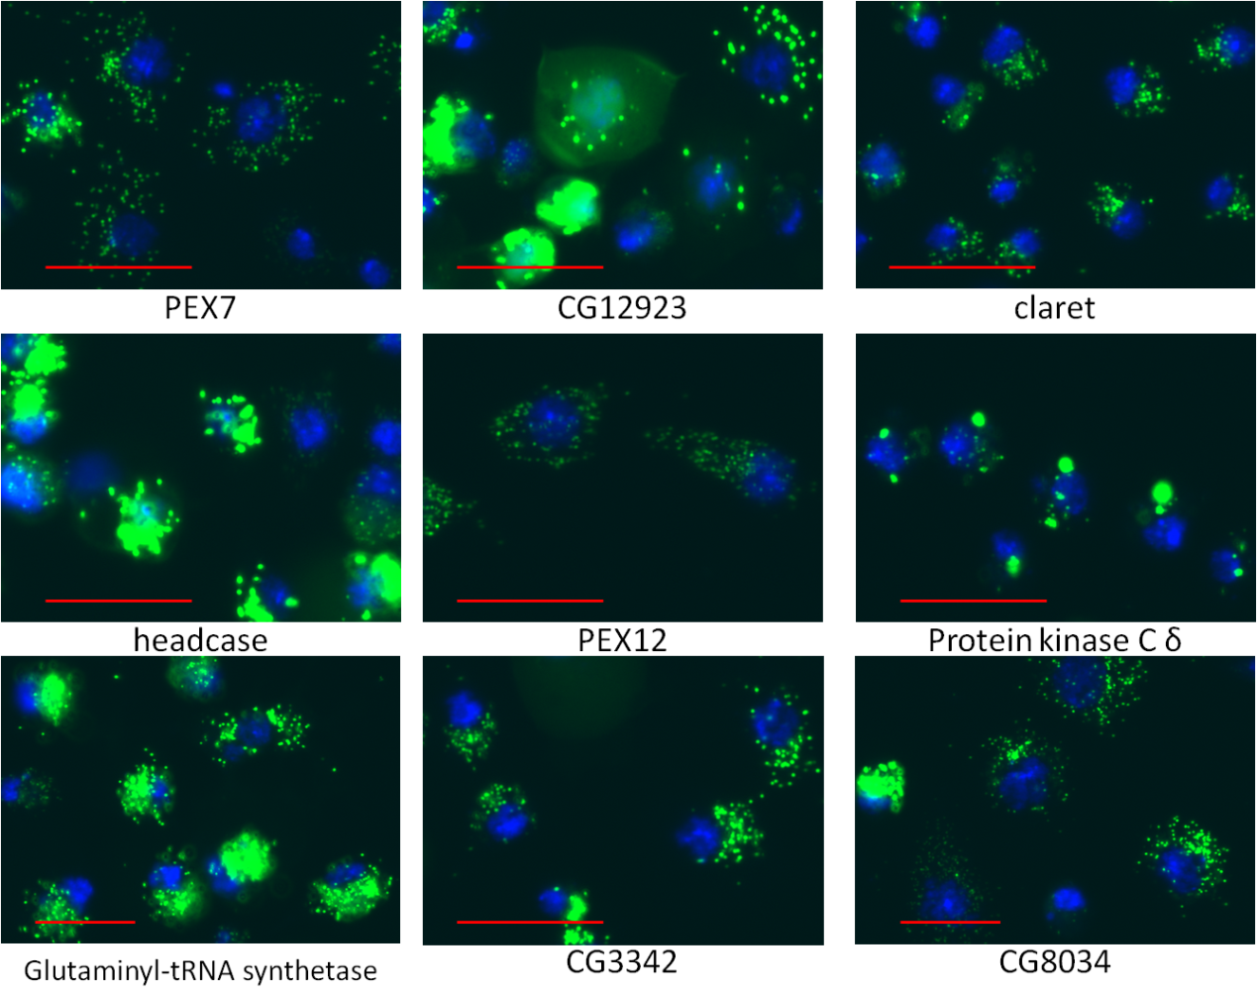
Figure 5.11. Images of cells with only one well in the triplicate showing aberrant phenotype – B. S2R+ cells stably transfected with pMt-eGFP-PTS1 were grown for 5 days and then induced for 24hrs with 50µM CuSO₄ before fixation and imaging. Gene KDs using long dsRNA are shown against PEX7, CG12923, claret, headcase, PEX12, Protein Kinase Cδ, Glutaminyl-tRNA synthase, CG3342, CG8034. Images are of cells whose KD phenotype best represents that which was observed upon visual screening. Bar = 20 µm.
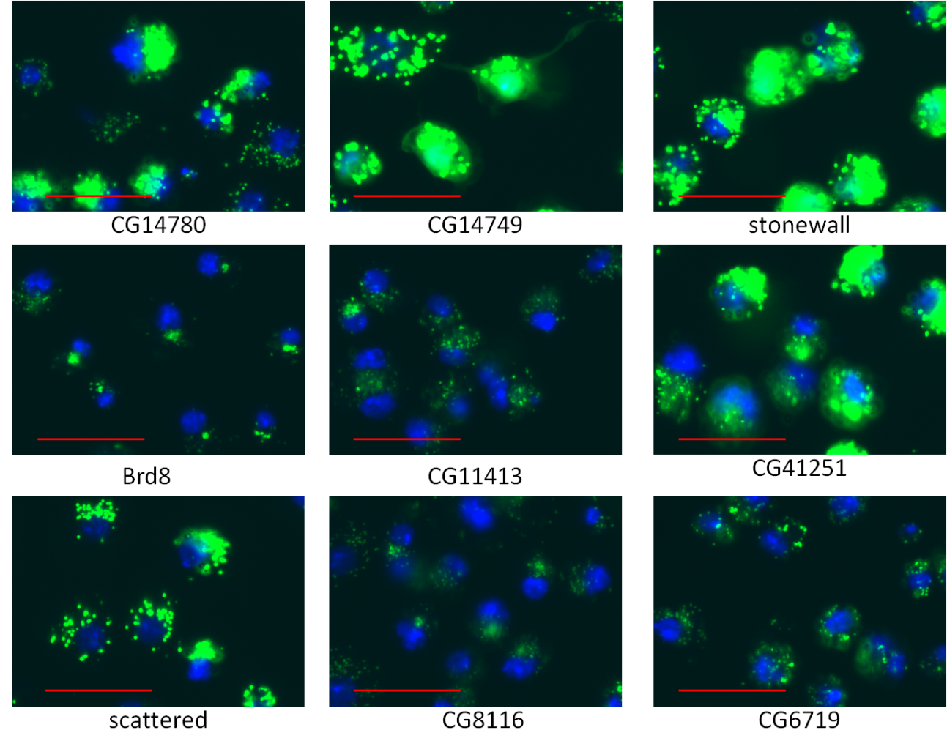
Figure 5.12 Images of cells with only one well in the triplicate showing aberrant phenotype – C. S2R+ cells stably transfected with pMt-eGFP-PTS1 were grown for 5 days and then induced for 24hrs with 50µM CuSO₄ before fixation and imaging. Gene KDs using long dsRNA are shown against CG14780, CG14749, stonewall, Brd8, CG11413, CG41251, scattered, CG8116 and CG6719. Images are of cells whose KD phenotype best represents that which was observed upon visual screening. Bar = 20 µm.

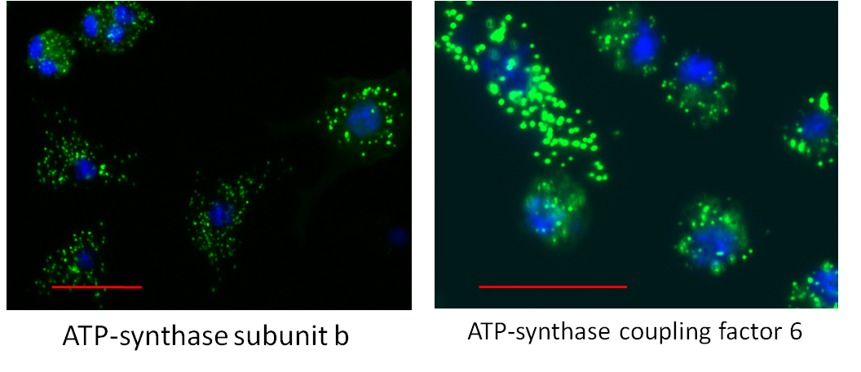
Figure 5.13. Cells showing increase in abundance of cells/ ATP synthase subunit KD. S2R+ cells stably transfected with pMt-eGFP-PTS1 were grown for 5 days and then induced for 24hrs with 50µM CuSO₄ before fixation and imaging. Gene KDs using long dsRNA are shown against ATP-synthase subunit b and ATP-synthase coupling factor 6. Bar = 20 µm.

Statistical analysis of the secondary screen
With the resources available at the SRSF it would not be prudent to accept the subjective visual screening undertaken earlier in the chapter. As stated in Chapter 5.14 the statistical robustness of the secondary screening would be greatly different to the genome-wide screening. The Secondary Screen plate contains the outliers of the genome-wide screen for this assay, its relative distribution should be much higher. The addition of 109 negative and positive controls should help reduce this. Even so, normalised z-scores of the screen are likely to miss a great deal on their own. This dataset would therefore be analysed for three of the parameters measured by the Transfluor application. Peroxisome count per cell, as with Screen 2, peroxisome cross-sectional area per cell and peroxisome integrated intensity per cell. This would be done in the same way as the genome-wide screen using HTS2 analysis software.

Comparison of parameters of peroxisome count, peroxisome cross-sectional area and peroxisome fluorescence intensity per cell.

Three main parameters were analysed by HTS2 analysis software. Peroxisome count per cell was analysed as in the previous genome-wide screen. This has been the main parameter for identifying KDs of biogenesis, fission or inheritance function and was also able to identify PTS1 targeting and uptake loss-of-function with a strong enough knockdown. The Transfluor segmentation application was capable of recording many types of parameters. These could be done on a per cell or per image basis, or both. Without wanting to overcomplicate the analysis, three parameters in total were considered worth investigating. As well as mean peroxisome count (PC) per cell it was decided to investigate mean peroxisome cross-sectional area (peroxisomal area, PA) and mean peroxisomal integrated fluorescent intensity (peroxisomal intensity, PI) also on a per cell basis (nuclear count, NC). This gave the three abbreviations PCNC, PANC, PINC. Values for these were calculated for each well on each plate and z-scores made across each plate. A median z-score could now be taken from the three KDs of every gene on the plates. The median z-score was then plotted on a heat map for each parameter. These heat maps can be compared to see if the same genes score highly in all parameters or whether different parameters cause different KDs to become more significant. These heat maps are given in Figure 5.16.1.
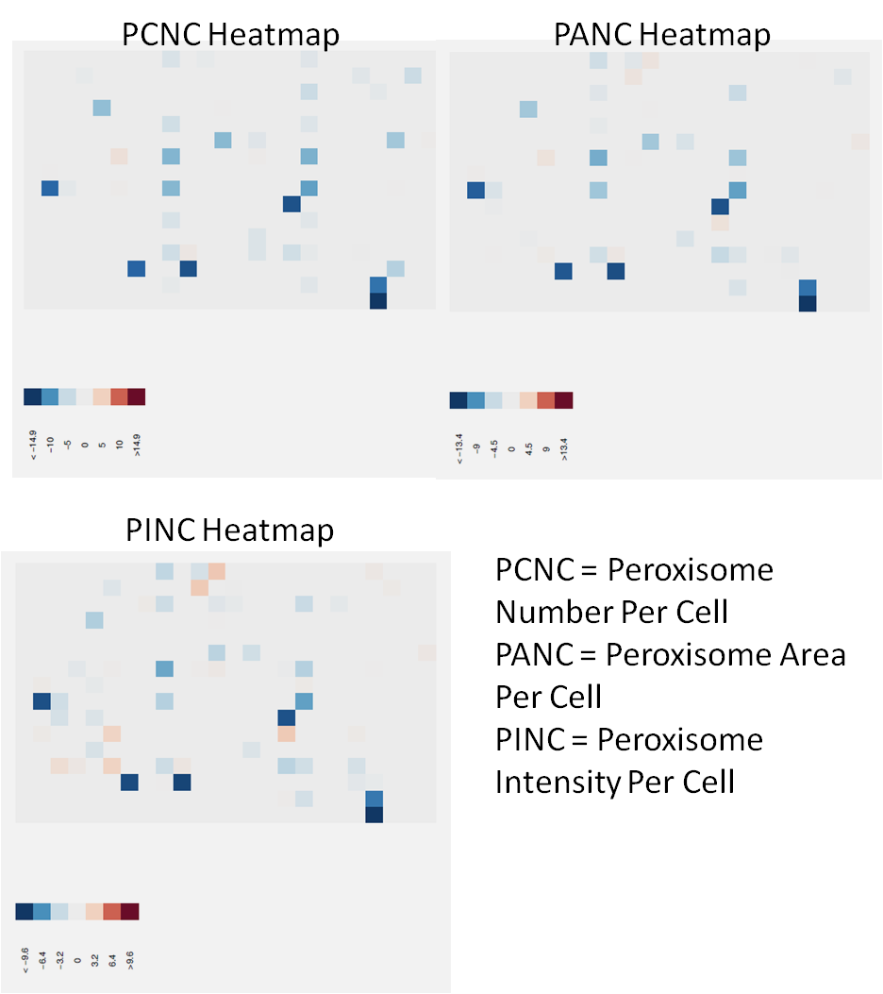
Figure 5.14. Heat maps of median Z-scores taken across the triplicates of each KD for peroxisome count per cell (PCNC), peroxisome cross-sectional area per cell (PANC) and peroxisome fluorescent intensity per cell (PINC). All three heat maps show negatively skewed distributions signified by the increased abundance of blue rather than orange cells. The 5 GFP probes (darkest blue) are consistent highly negative scores in all three parameters. The heat maps differ between each other but there are some similarities, particularly between the PINC and PANC heat maps.
To investigate the relationship between median scores for peroxisome count, area and intensity the three were plotted against each other on graphs.
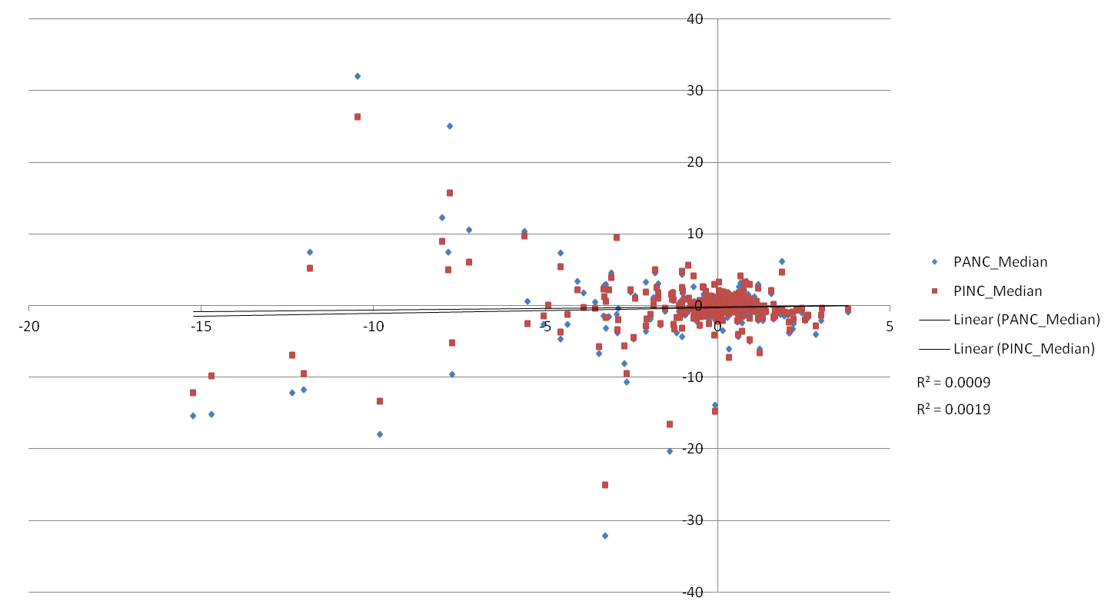
Figure 5.15. Scatterplots of z-scores of Peroxisome cross-sectional area (blue) and integrated fluorescence intensity (red) plotted against peroxisome count z-score (x-axis). Linear lines of fit are given for both the R-squared valued for PINC is 0.0009, for PANC is 0.0019. These suggest that there is a very low correlation between peroxisome count and either of the other two parameters. The two scatterplots are very closely distributed for each individual value, magnitudes for PANC exceed those for PINC in many cases.
The close positioning of the values of PANC and PINC and PCNC suggest that there may be a close relationship between the two. This is further supported by the similar lines of fit and R-squared values on the same plot. It was investigated to see if the two have a correlation in this assay.
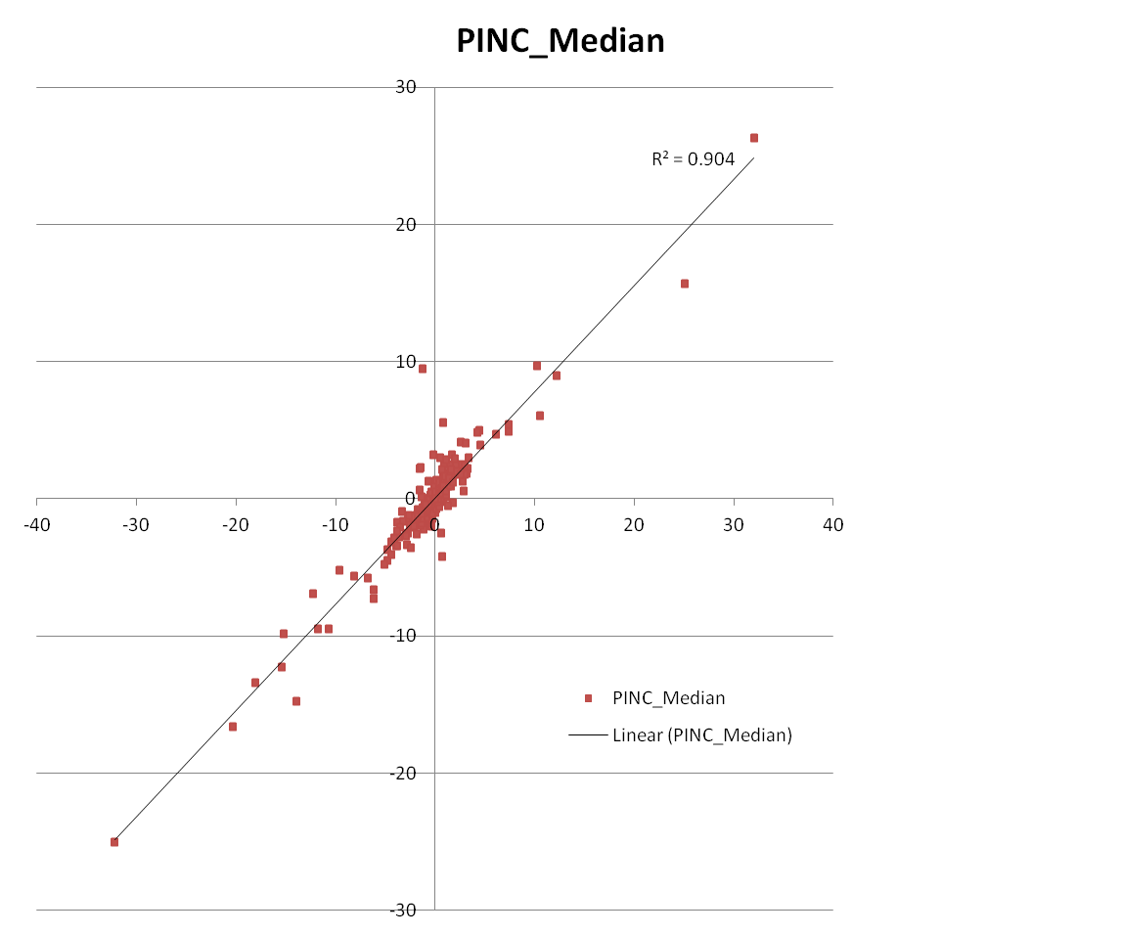
Figure 5.16. Median z-scores of peroxisomal fluorescence integrated intensity per cell plotted against median z-scores of peroxisomal cross-sectional area per cell. There is a very strong, proportional relationship, the R-squared value is very high at 0.904 suggesting the correlation between the two datasets is a very strong linear one.
The outlying data point with an intensity of 9.4 and an area of -1.3 is Gemini. This fits well with its visual presentation. It has few peroxisomes (z-score of -2.9) from which its relatively low peroxisomal area would be derived. These peroxisomes are on average the same size but brighter than WT phenotypes but there are a small proportion of cells in these images that have very bright peroxisomes which are abundant within the cell.
The implication of this graph is that as the cross-sectional area of peroxisomes per cell increases, the integrated intensity of the fluorescence increases in the same order. As peroxisomal cross-sectional area is a 2-dimensional measurement, it can therefore be claimed that integrated intensity is also 2-dimensional. A number of conclusions can be drawn from this relationship:
- On average (per image or well), fluorescence is equal for any given area of a peroxisome whether it comes from a large or small one. This implies equal distribution of fluorescent protein in the matrix.
- Fluorescence that is not in focus is not measured. One would expect to see a binomial relationship if the fluorescence of the entire peroxisome was measured; this assumes even distribution of fluorescence and spherical peroxisomes.

This could mean that when analysing cells of this assay, it may not be necessary to consult both parameters as it can be assumed they will increase proportionally with each other to the mathematical order of 1.
The directly proportional relationship between the two parameters is further supported by looking at a correlation table for the three plates within each parameter.
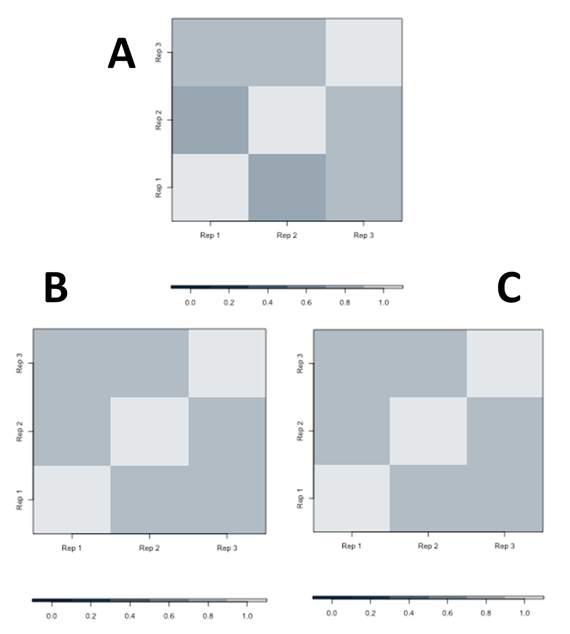
Figure 5.17. Correlation tables for peroxisome count, area and intensity per cell. Each replica plate is plotted against the others for each parameter. The colour of each square represents the correlation of a scatter plot of each probe’s z-score matched against one of its replica’s. The colour of the square determines the R-squared score of all probes’ correlated values between the two replica plates. In peroxisome count.cell⁻¹ (A) replicates 1 and 2 correlate the least with a correlation of approx. 0.4. Replicate 3 correlates with both replicates 1 and 2 with a score of approx. 0.6. In both peroxisome area.cell⁻¹ (B) and peroxisome intensity.cell⁻¹ (C) all replicate plates score approx. 0.6 between each other.

Experiment Reproducibility
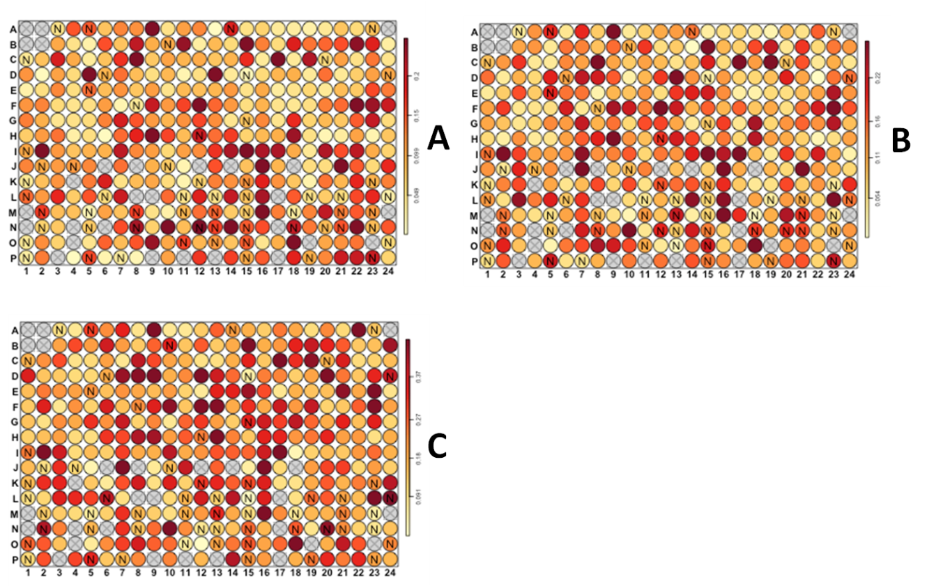
Figure 5.18. Reproducibility plots per parameter. Standard deviations for each sample across the three replicates. A is of peroxisome count per cell. B is of peroxisome area per cell. C is of peroxisome fluorescent intensity per cell. The darker the red, the higher the standard deviation between replicates for that well. This suggests a low reproducibility.
The reproducibility plots show many probes caused high variation between the replicates despite there being some that had low standard deviations. In general the assay looks as though there are many probes which had greatly differing values in their parameters. This may be the result of heterogeneous cell morphologies. If this variation is enough to mask the appearance of aberrant phenotypes then the plates may have produced a large volume of false negatives. If this is true then a better more homogeneous assay would be required in order to allow the appearance of aberrant phenotypes from effective gene KDs.

Control evaluation for peroxisome count per cell.
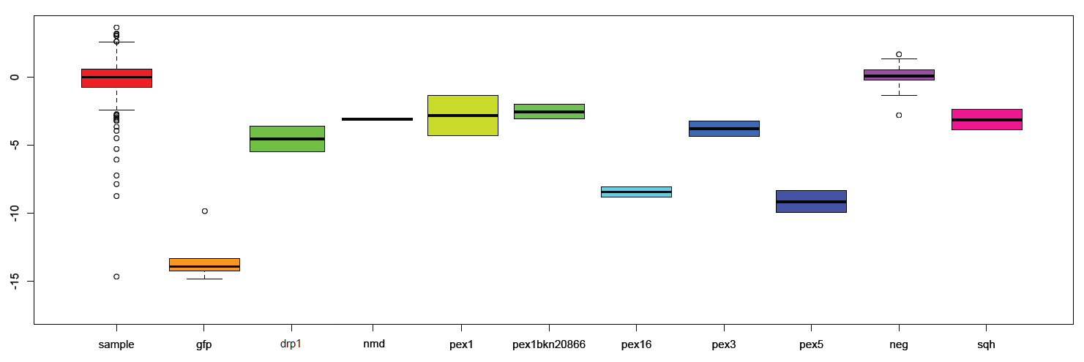
Figure 5.19. Box whisker plots of Z-scores for peroxisome per cell counts for control probes, including gfp (GFP) and negative controls, compared to the plate samples. Boxes show 1σ, whiskers show 2σ, the black band is its median. Outlying data are displayed as rings, one per replicate. Each control box represents six data points, 2 wells in triplicate. “gfp” represents fifteen data points, 5 wells in triplicate. “neg” represents 327 data points, 109 in triplicate. “sample” represents 825 data points, 275 in triplicate. μ = -0.15, σ = -1.66.
The control plot for peroxisome count per cell has shown that the controls have been more effective than the majority of the sample probes at producing z-scores below 2σ. All mean z-scores are below 2 σ (-2.33). The positive and negative controls provided by SRSF have also been highly effective. Negative controls almost entirely occur within 2σ of the sample mean, GFP controls have the highest z-scores of the dataset. Mean z-scores for the controls are given in Figure 5.18.2.

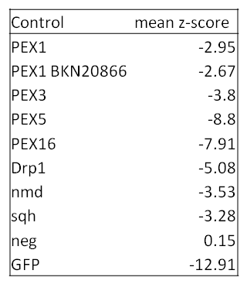
Table 5.4. Mean z-scores peroxisome count per cell for controls across all replicates. Includes GFP and non-GFP negative controls.

Statistical analysis of screen based on peroxisome number per cell

Figure 5.20. A Q-Q plot of the median z-scores for peroxisome count per cell for samples and negative controls in the secondary screen. Sample probes are denoted with black rings, negative controls with blue rings. The gene KDs with z-scores less than -2 are shown pointing to their datapoint.
As with the previous two screens the secondary screen would be analysed statistically based on the number of peroxisomes per cell. In previous screens data were normalised within each plate and then across all the plates before z-scores were taken. The same was done for this dataset but z-scores were calculated for each probe within its plate. A median was then taken of the triplicate of values for that probe across the three plates. This reduces the impact of uneven distribution and variance within a small population (triplicate of probes) which would have such a large effect on determining the mean (Dytham 2003). Table 5.25. shows which probes were among the outliers of this distribution of median z-scores.
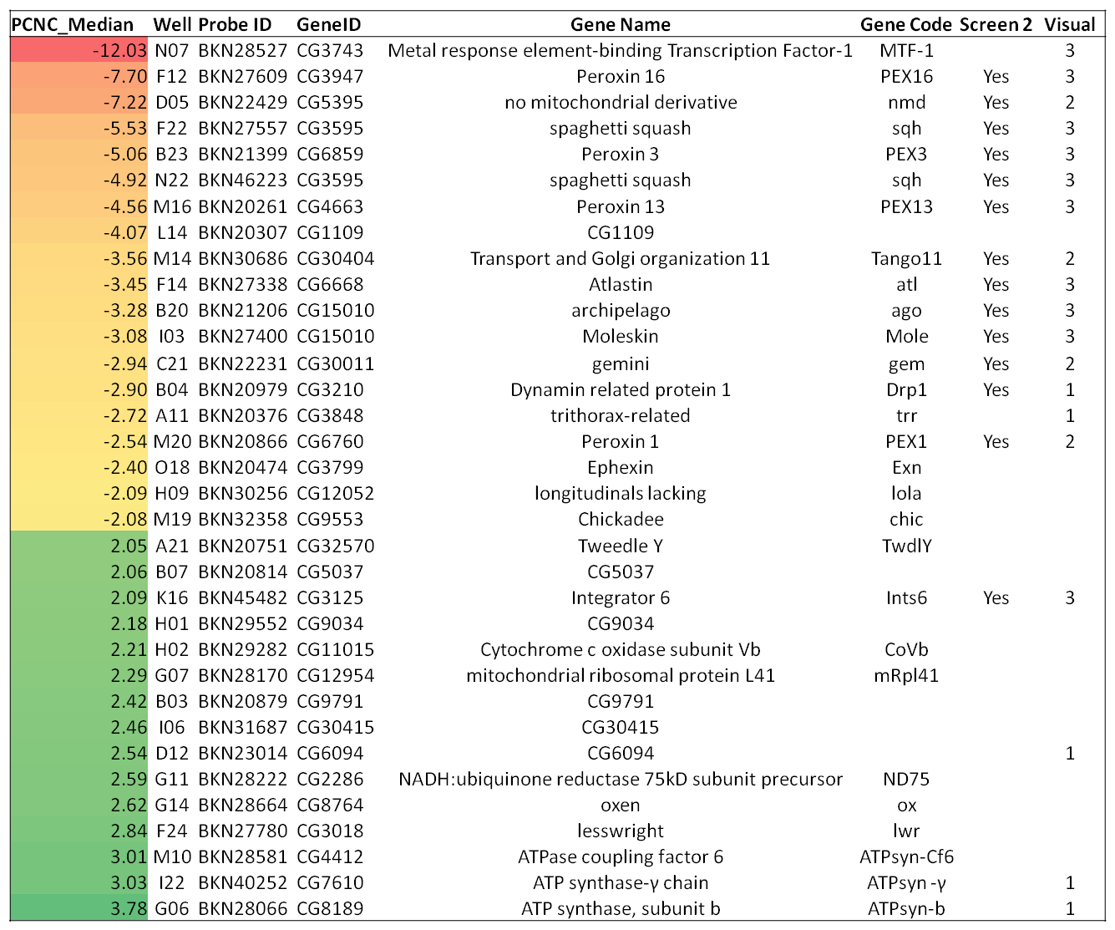Table 5.5. A list of the probes with the highest and lowest median z-scores for peroxisome count per cell. Peroxisome per cell count was converted to a replicate z-score and a median was taken of these, displayed in the first column. The plate locations, Gene Identifiers (target gene), names and codes for the targeted genes are also given. Genes that were both statistically significant and visually aberrant in Screen 2 are confirmed. Genes which were visually aberrant from the WT in the visual secondary screen have the number of plates counted in the final column.
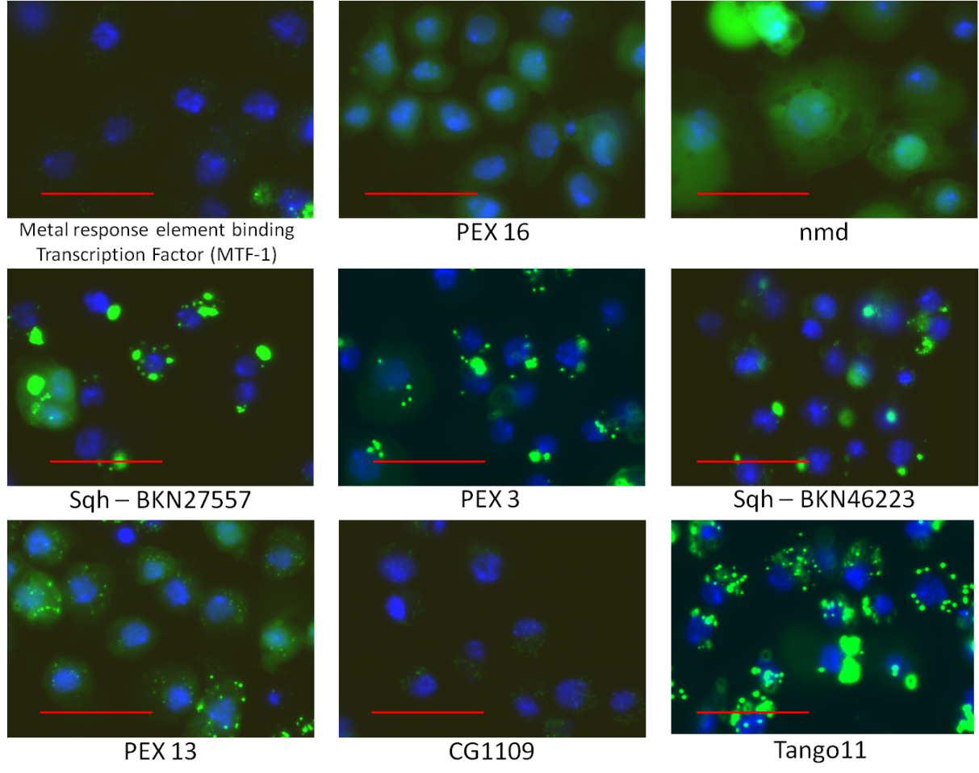
Figure 5.21. Images of the 9 top z-scores of KDs of peroxisome count per cell. Statistical outliers - A. S2R+ cells stably transfected with pMt-eGFP-PTS1 were grown for 5 days and then induced for 24hrs with 50µM CuSO₄ before fixation and imaging. Gene KDs using long dsRNA are shown against the 9 probes with the lowest z-scores. These were MTF-1, PEX16, nmd, sqh (2), PEX3, PEX13, CG1109, and Tango11. Bar = 20 µm.

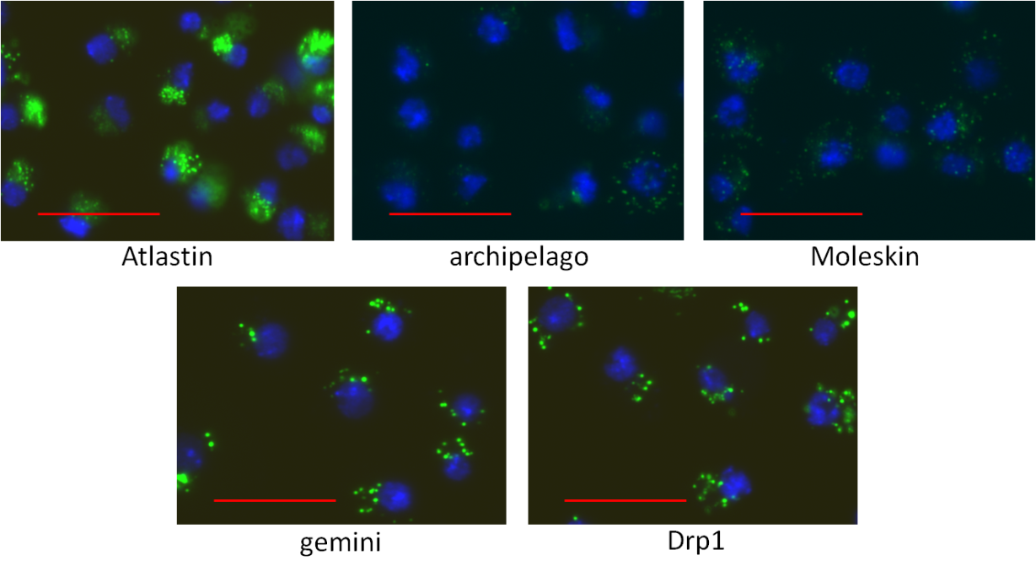 Figure 5.22. 5 Images of the top z-scores of KDs of peroxisome count per cell. Statistical outliers - B. S2R+ cells stably transfected with pMt-eGFP-PTS1 were grown for 5 days and then induced for 24hrs with 50µM CuSO₄ before fixation and imaging. Gene KDs using long dsRNA are shown against 5 of the probes with the lowest z-scores that exceed -2. These were Atlastin, archipelago, Moleskin, Gemini. Bar = 20 µm

Figure 5.23. 5 Images of the top z-scores of KDs of peroxisome count per cell. Statistical outliers - C.S2R+ cells stably transfected with pMt-eGFP-PTS1 were grown for 5 days and then induced for 24hrs with 50µM CuSO₄ before fixation and imaging. Gene KDs using long dsRNA are shown against the 5 genes whose probes produced the z-scores below -2 with the lowest magnitude. These were trithorax related, PEX1, Ephexin, Chickadee and lola. Bar = 20µm.
34 gene KDs that exceeded a standard deviation magnitude of 2 were returned from the statistical analysis of peroxisome count per cell. Of the negatively scoring KDs 13 were recognised as statistically aberrant in the second screen while 6 had uncertain phenotypes that were manually included. The three genes whose knockdowns were found in the first screen, nmd, sqh and atl, were not only present in the secondary screening but 2 of them were among the top four results; they were all in the top ten results of Screen 2. This shows that these probes’ KDs are effective enough at producing aberrant phenotypes that achieve statistically significant data from mean populations in both the transiently and stably transfected cell-lines. These three genes are statistically the three best novel candidates for further research.

Three novel genes consistently produced aberrations in phenotype, generating statistically significant z-scores from mean data.
From the first genome-wide screen using transiently transfected pMt-eGFP-PTS1 as a marker, the KD of CG5395 (nmd), CG3595 (sqh) and CG6668 (atl) produced non-WT phenotypes that produced statistically significant z-scores; the exception was atl which would produce statistically significant z-scores in subsequent normalised analyses. The three genes continued to produce not just aberrant phenotypes and data but data that occurred among the KDs with the highest z-scores such as PEX16, PEX5, PEX1 and PEX13. Other novel genes also were reported as statistically significant in deviating from WT data in Screen 2 and the secondary screen; some of them had recurring phenotypes. None of these other genes affected their respective population of imaged cells with the same ubiquitous presence that is observed with these three. There are many reasons why this may occur, including those stated in chapter 3.5. In addition there may be aspects of the assay such as the cell-line used or induction concentration that mean that these probes were incapable of affecting a KD sufficient enough to noticeably change the phenotype from WT, either visually or statistically. From the experiments done these three are the best candidates and further work continues with them.

Four known peroxins were among the statistically significant data.
Peroxins 16, 13, 3 and 1 were the highest scoring peroxins the secondary screen reported. PEX16 has consistently been a high scoring KD throughout the screening process. The images show almost the entire population of cells with very few peroxisomes or none at all and bold, cytosolic mis-localisation of eGFP-PTS1. This was especially true of the cells knocked down with PEX16 in the secondary screen. The other three PEX genes in the secondary screen that were knocked down had only a moderate reduction in cell number compared with Screen 2. In Screen 2 these KDs presented phenotypes with an apparent lack of peroxisomes and cytosolically mis-localised eGFP-PTS1. For some reason these KDs were not as effective in reducing peroxisome count per cell in the secondary screen and this is evident from the images. The assay was carried out with the same protocol as Screen 2, the conditions that were different were the sample of S2R+ cells used and the batch of dsRNAs. It may be possible that the dsRNA probes were not as concentrated in the secondary screen though this would be difficult to prove. More likely is that the two different samples of cells had differing background expression levels of the poorly regulated pMt promoter in the pMK33 plasmid. As these three peroxins are involved in import of PTS1 proteins, the fall in peroxisome number that was reported is from the lack of contrast between peroxisomal and cytosolic eGFP-PTS1; in the most effective knockdowns, there is no peroxisomal marker. A slight increase in background eGFP-PTS1 expression during the period that peroxisomes are import-functional would make peroxisome-matrices fluoresce. This fluorescence would continue into the period where PTS1 matrix protein uptake is blocked. This would explain the co-presence of cytosolic eGFP-PTS1 and the punctate pattern that is dimmer than in WT cells.
This shows PEX16 to be a gene crucial in maintaining peroxisome number. The fact that nmd has throughout the screening processes had an almost identical appearance to that of PEX16 is promising evidence that there may be a fourth Class II peroxin functional in animal cells.

57 novel genes were reported from visual and statistical screening in the secondary screen
Combining the two results datasheets for peroxisome count per cell gives 92 gene KDs in total, 58 from visual screening and 34 from statistical analysis. 12 of these were PEX genes, 8 from visual observations, 4 from statistical analysis. 4 were of non-PEX genes associated with peroxisomal fission and segregation; Drp1 and Tango11, both counted twice. 5 were GFP controls in the visual screen. Spaghetti squash had two probes, both of which were recorded twice, only one counts in this sum. Finally 12 of the remaining gene KDs were reported twice. This leaves 57 novel genes whose KDs could be of interest when investigating peroxisomal function. This is a vast improvement since the results from Screen 1 which were unable to report enough genes to fill in the gaps with missing homologues of yeast peroxins. With this current finalised list there would be enough candidates even if the D. melanogaster family of peroxins proved to be 50% larger than that of S. cerevisiae. It would be impractical to pursue all of them in subsequent research for this thesis. For two of these genes, loss of function has been replicated with probes designed on the E-RNAi website. Probes for KDs of nmd and sqh were used effectively as positive controls for the Secondary Screen.
It was decided that the best gene to investigate further is nmd. The high similarity of both phenotype and z-score in all three screenings with those of PEX16 and the implied possibility of another Class II peroxin was sufficient to confirm nmd as the best choice for performing further experiments.

5-day KD of nmd produces phenotypes similar to PEX16 KDs
From the Screens performed with eGFP-PTS1 two key observations are important of the nmd KDs.
- Peroxisome number appears to be greatly reduced or zero.
- eGFP-PTS1 is widely mislocalised to the cytosol.
To investigate whether this phenotype is caused by a true reduction in peroxisome number, or a block in matrix protein uptake further investigation was required.
The long dsRNA probes used as controls for Screen 2 and the Secondary Screen to knock down PEX5, PEX16 and nmd were compared with WT presentations of S2R+ cells. Cells were to be stably transfected with two constructs using the pMK33 vector. The first was a red fluorescent peroxisomal matrix marker, monomeric red fluorescent protein (mRFP) with a PTS1 motif in the form of C-terminal SKL. The second was a peroxisomal membrane marker, ATP-binding cassette D3 (ABCD3) C-terminally tagged with eGFP. The aim of this experiment was to determine if nmd function was affecting peroxisome number maintenance or inhibiting the PTS1-targeting and translocation machinery. The ABCD3-eGFP localises to the peroxisomal membrane. Assuming peroxisomal membrane protein delivery is unaffected by RNAi then ABCD3-eGFP should localise to peroxisomes in a punctate pattern. In WT cells this pattern would colocalise with the punctate pattern produced by the mRFP-PTS1.
When performing KDs the deviation in phenotype will help determine what effect the KD of nmd is having and suggest what function it may be performing. If PTS1-import machinery is inhibited then one would be expected to observe mislocalisation of the mRFP-PTS1 to the cytosol while ABCD3-eGFP remains in a punctate pattern. If peroxisome population maintenance is affected, either by the inhibition of biogenesis, fission or segregation into daughter cells, then there would be a reduction in the number of green fluorescent puncta observed. There would likely still be some colocalisation with mRFP-PTS1 if its import remains unaffected, but this would also likely be accompanied by some cytosolic mRFP-PTS1 as observed with PEX16 KDs in Screen 2 and the Secondary Screen with 1-2 puncta per cell. Inhibition of function of peroxisomal membrane delivery to the peroxisome would cause mislocalisation of ABCD3 to the cytosol. This could potentially attenuate the biological pathways of both peroxisome population maintenance and the functions of PTS1 machinery proteins. Both require the delivery of proteins to the peroxisomal membrane to function properly. If cytosolic mislocalisation of both ABCD3-eGFP and mRFP-PTS1 occur then this may be the most likely cause.
The cells were transfected and grown in 6 well plates as described in Chapter 2 and selected for in hygromycin B selection media as described in Chapter 4. Once reporter expression had reached 90% of cells experiments were begun. Approximately 2/3 of the cells were expressing both reporters with the remaining transfected cells expressing one of the others. Cells were knocked down and seeded in 6-well plates as described in Chapter 3. Probes used were PEX5, PEX16, nmd and a WT population was also tested. After 5 days the cells were induced with 50µM CuSO₄ for 24 hours. Cells were fixed and mounted as described in Chapter 3.

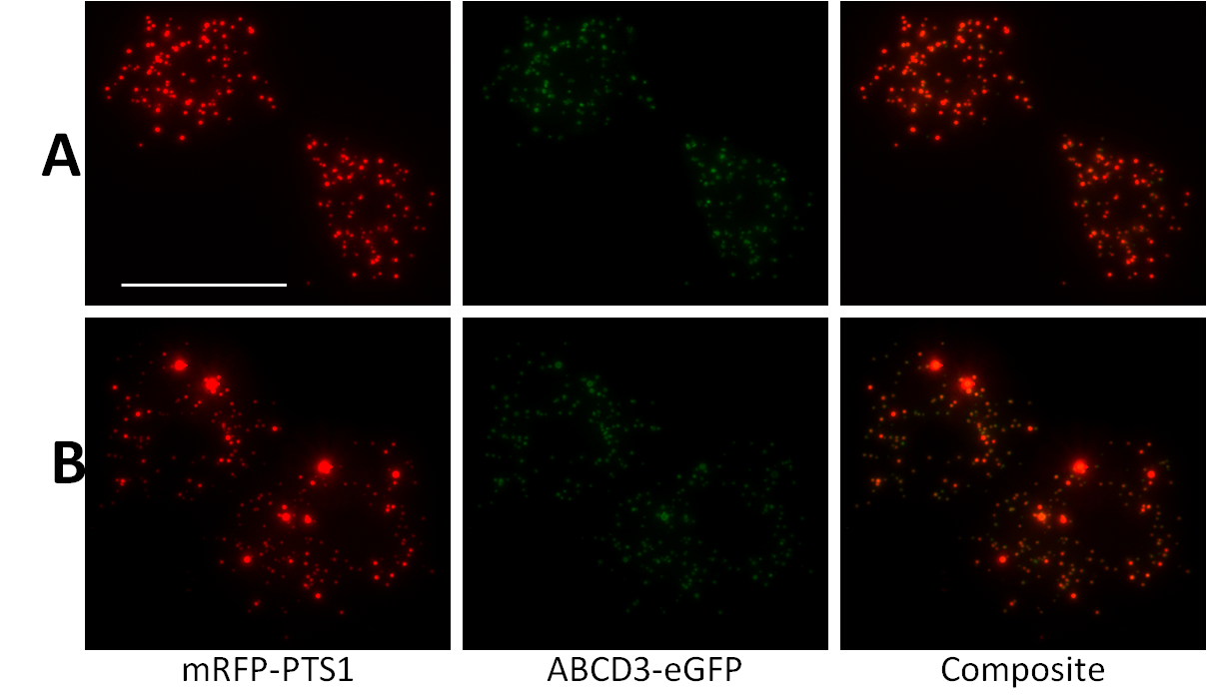
Figure 5.24. WT phenotype of double-labelled S2R+ cells. S2R+ cells stably transfected with ABCD3-eGFP and mRFP-PTS1 were grown for 5 days before induction for 24 hours with 50µM CuSO₄. Cells were then fixed and imaged. A shows 2 cells with peroxisomes of a consistently small size. The matrix protein (mRFP-PTS1) and membrane protein (ABCD3-eGFP) colocalise without any noticeably high cytosolic mislocalisation. B shows two cells from the same sample as A that have colocalising matrix and membrane proteins but with more variety in size of peroxisome. The larger peroxisomes appear as above average-sized rings in the green channel and as massive red puncta in the red. All images are merged z-stacks taken at 60X magnification. Bar = 50µm.
The addition of a membrane protein in this assay appears to have made some peroxisomes larger than others in some cells. Consequently these puncta have much brighter matrix protein than the smaller ones. This needs to be considered when viewing cells that have been knocked down as it may affect the KD phenotype in a way that omission of membrane protein from the assay would not.

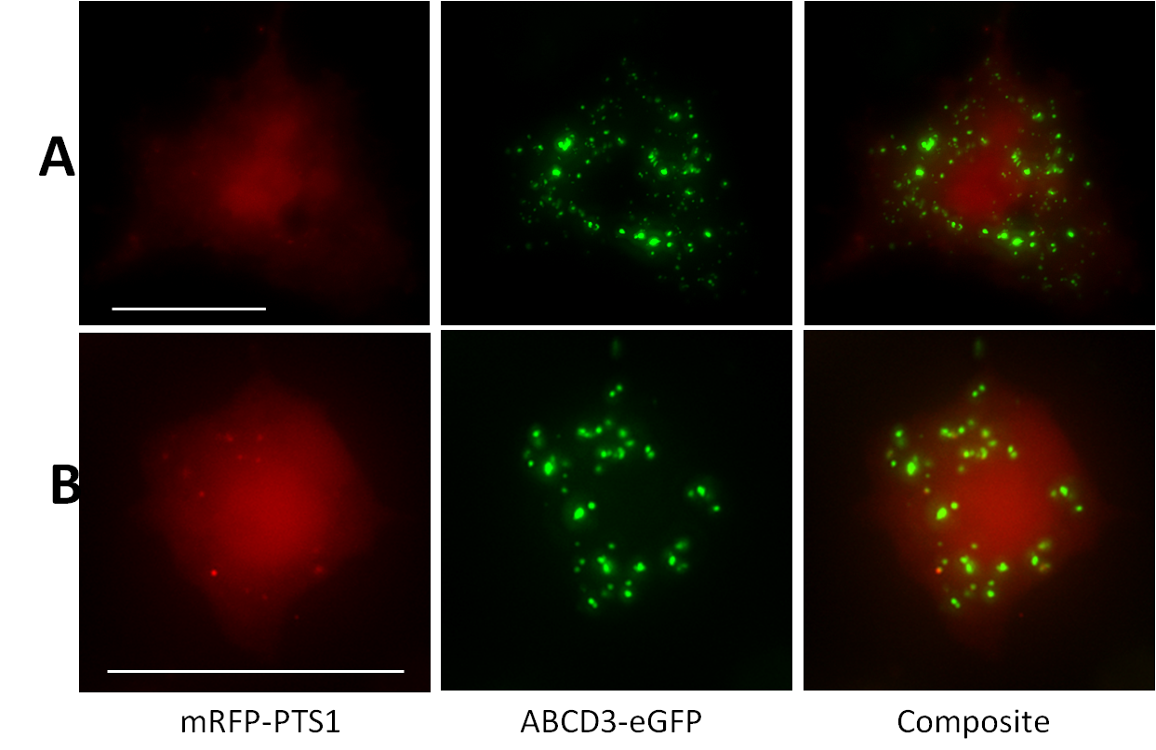
Figure 5.25. PEX5 phenotype of double-labelled S2R+ cells. S2R+ cells stably transfected with ABCD3-eGFP and mRFP-PTS1 were seeded with 2 µg PEX5 dsRNA and grown for 5 days before induction for 24 hours with 50µM CuSO₄. Cells were then fixed and imaged. A shows a cell with cytosolic mislocalisation of mRFP-PTS1. Puncta are seen of ABCD3-eGFP which do not colocalise with any contrasting puncta from the red channel. B shows a different cell from the same sample as A that has mislocalised matrix protein but with some contrasted puncta. They are not as numerous as the puncta from the green image. All images are merged z-stacks taken at 60X magnification. Bar = 50µm.
As with the PEX5 KDs from the screen, these PEX5 KDs produced a large mislocalisation of matrix marker protein to the cytosol. The presence of membrane protein in numerous puncta suggests PEX5 not to be functional in reducing peroxisome number. The presence of faintly contrasting puncta in B suggests that the loss of function in this cell is not complete. This evidence suggests that if nmd KD causes PT1-targeting interference then a PEX5-like phenotype will occur using this assay.
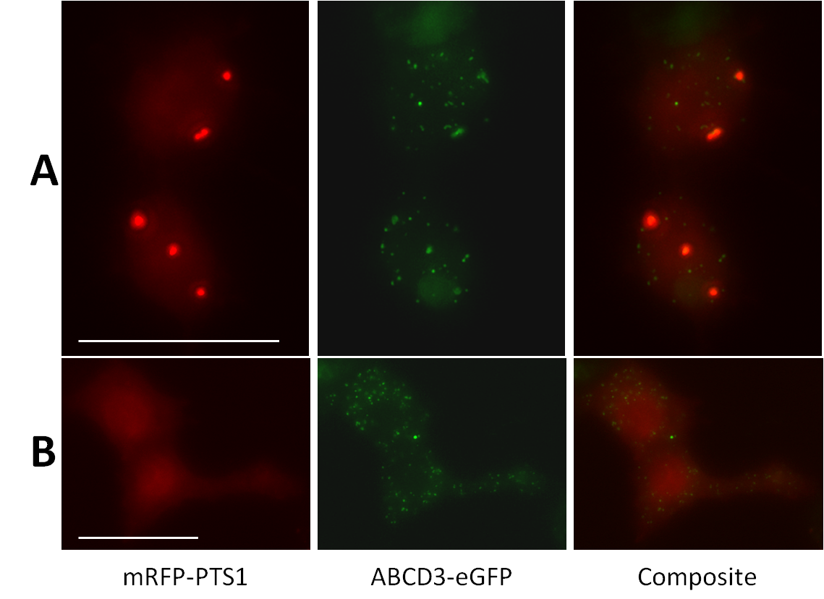
Figure 5.26. PEX16 phenotype of double-labelled S2R+ cells. S2R+ cells stably transfected with ABCD3-eGFP and mRFP-PTS1 were seeded with 2 µg PEX16 dsRNA and grown for 5 days before induction for 24 hours with 50µM CuSO₄. Cells were then fixed and imaged. A shows 2 cells each with 3-4 large, bright red puncta and considerable mislocalisation of matrix protein to the cytosol. These puncta colocalise with the larger puncta in the green channel. There are many very small puncta dispersed throughout the cytosol in the green channel with no colocalised red fluorescent puncta. B Shows 2 cells with no red fluorescent puncta of any size while still containing many small green puncta in the green channel. All images are merged z-stacks taken at 60X magnification. Bar = 50µm.
The most common phenotype observed in PEX16 KD cells in the Screens is that of cells with no fluorescent puncta and cytosolic mislocalisation of eGFP-PPTS1. There were also a minority of cells with 1-2 large bright puncta as well as the cytosolic fluorescent pattern. In the latest assay, mRFP-PTS1 is mislocalised to the cytosol in the same way as eGFP-PTS1 was in the screens. The two phenotypes just described appear in equal proportion in this latest assay when PEX16 is knocked down.

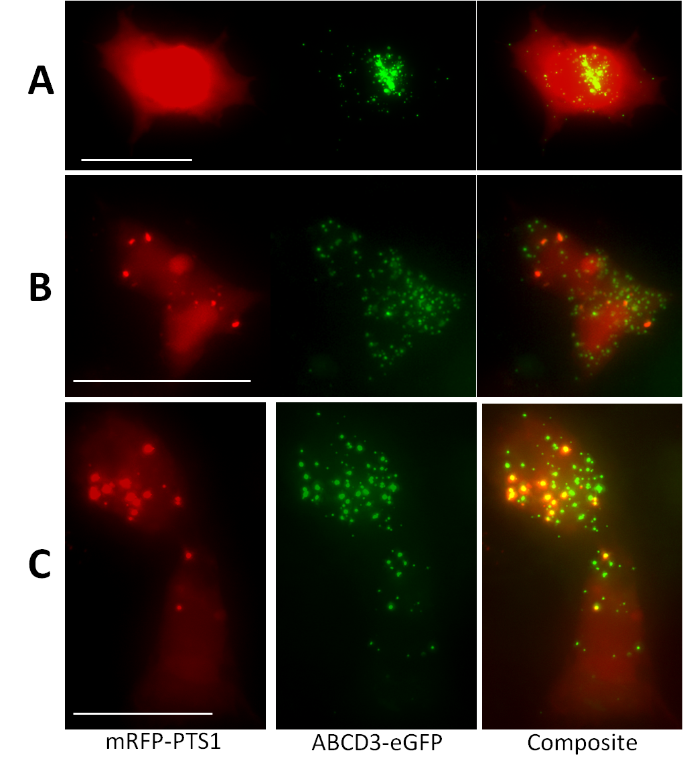
Figure 5.27. nmd KD phenotype of double-labelled S2R+ cells. S2R+ cells stably transfected with ABCD3-eGFP and mRFP-PTS1 were seeded with 2 µg nmd dsRNA and grown for 5 days before induction for 24 hours with 50µM CuSO₄. Cells were then fixed and imaged. A shows a cell with bright cytosolically mislocalised mRFP-PTS1. ABCD3-eGFP is punctate both in very small, dim, cellularly dispersed puncta, and in a perinuclear cluster of larger, bright puncta. B shows a dim, cytosolically mislocalised presence of mRFP-PTS1 in 2 cells plus a bright concentration of the matrix marker in puncta of variable size; larger puncta are brighter. In the green channel there are many green puncta. The green puncta that colocalise with the red puncta are larger and dimmer. C shows 2 cells with larger, brighter red puncta. In the green channel, different sizes of punctum can be seen. Of the larger ones, half appear to colocalise with the red puncta, a small proportion of the smaller green puncta colocalise while the majority don’t. There are 2-3 small red puncta which do not colocalise with green puncta. All images are merged z-stacks taken at 60X magnification. Bar = 50µm.
It is difficult to determine exactly what effect an nmd KD is having in this assay. The screens’ phenotypes show cytosolic mislocalisation of PTS1-marker, sometimes with fewer, larger puncta than WT cells. This is reported faithfully by the mRFP-PTS1 marker in this assay as shown by panels A-C in Figure 5.22.4. Based on the use of a matrix marker throughout this research it was thought that nmd might mimic the phenotype of either PEX5 or PEX16 which could then be confirmed using the membrane marker. Panel A shows the presence of green puncta with cytosolic mRFP-PTS1 which resembles a PEX5-like phenotype and implies loss of function in PTS1 targeting and/or membrane translocation. Conversely panel B shows large, bright red puncta which colocalise with large, dim green puncta many smaller bright, green puncta dispersed throughout the cytosol. There is widespread cytosolic mislocalisation of mRFP-PTS1 in these cells too. This is similar to the PEX16 phenotype. Observation of panel C shows these cells to be similar in appearance to those of B and PEX16 phenotype. They differ by having five or more distinguishable populations of puncta:
- Large red with green
- Large green
- Small red
- Small red with green
- Small green
This occurs only in two cells imaged from the slide and therefore is not a robust example of the action of nmd KD. However if the phenotype in panel C is real then the implications for the function of nmd in peroxisomal biochemical pathways could be numerous. Figure 5.22.5 shows the composite images adjusted from each KD adjusted to scale.

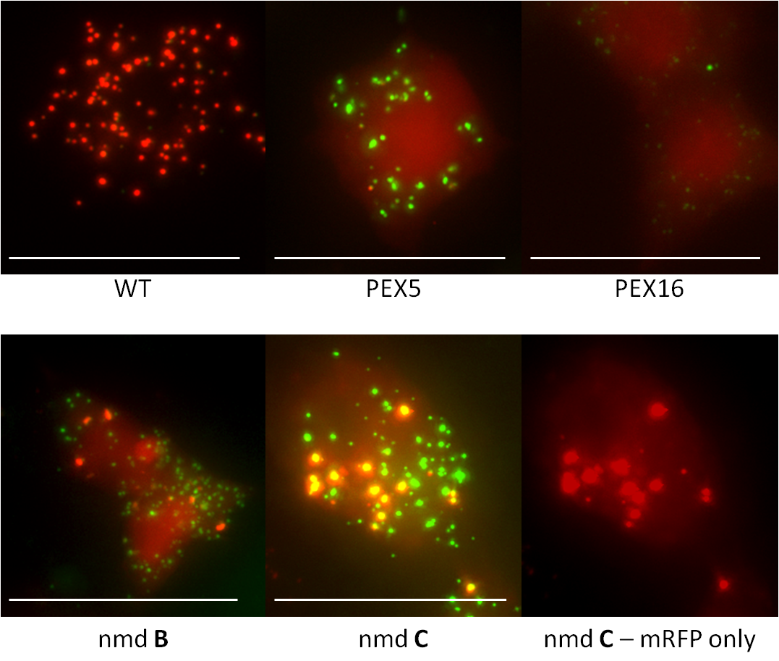
5.28. All KD phenotypes of double-labelled S2R+ cells, shown to scale. S2R+ cells stably transfected with ABCD3-eGFP and mRFP-PTS1 were seeded with 2 µg of either PEX5, PEX16 or nmd dsRNA probe or none and grown for 5 days before induction for 24 hours with 50µM CuSO₄. Cells were then fixed and imaged. Images are of the same cells examined in Figures 5.29-33 but adjusted to scale for comparison of puncta sizes. All images are merged z-stacks taken at 60X magnification. Bar = 50µm.

Fluorescently tagged nmd localises to mitochondria and peroxisomes in WT cells.
To investigate where nmd is localised in S2R+ cells the nmd ORF was cloned into the shuttle vector for inducible C-terminal green fluorescent fusion proteins (see methods and materials Chapter 2.4). The translated protein would contain a C-terminal GFP tag and would be inducible under the expression of the pMt promoter. Due to the effect of nmd KD on reduction of peroxisome number the construct would be co-transfected with mRFP-PTS1 to see if co-localisation occurs. The following experiments were all performed in the absence of any dsRNA probes.
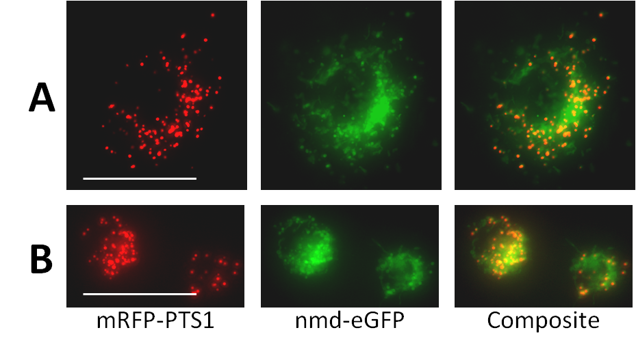
Figure 5.29. WT phenotypes of S2R+ cells double-labelled with mRFP-PTS1 and nmd-eGFP. S2R+ cells transiently transfected with nmd-eGFP and mRFP-PTS1 were grown for 5 days before induction for 24 hours with 50µM CuSO₄. Cells were then fixed and imaged. Panels A and B show the punctate pattern of a fluorescent PTS1 marker in the red channel. This colocalises with puncta in the green channel. The nmd-eGFP partially colocalises with the punctate pattern of mRFP-PTS1. There are irregular shapes in the green channel which cannot be attributed to peroxisomal puncta. All images are merged z-stacks taken at 60X magnification. Bar = 50µm.
The transient co-transfection of nmd-eGFP and mRFP-PTS1 shows that nmd is localised to at least 2 cellular compartments when C-terminally tagged with eGFP. The first that we can see is the peroxisome. In the composite image it can be seen that red puncta co-localise with part of the green fluorescence of nmd. The rest of the nmd pattern is irregular in shape. It appears to be contained within structures in the cytosol as shown by the void of fluorescence created by the presence of the nucleus. These irregular structures are found in the very periphery of the cell in the same way that the peroxisomes are, as observed in Panel A. Due to the mitochondrial reference in its name and the appearance that the unknown GFP signal could be on a peripheral organellar structure, experiments were conducted to see if the non-peroxisomal signal was mitochondrial. MitoTracker is a fluorescent dye used to label mitochondria in living cells. It is used in the following experiment to show the location of mitochondria in the red fluorescent channel (see Methods chapter 2.8). Invitrogen claim that it is retained in fixed cells that are properly treated yet attempts at fixing S2R+ cells stained with MitoTracker failed to produce clear images. Cells were then grown and treated using Ibidi 8-well live imaging slides and treated the MitoTracker according to live imaging protocols (see Methods Chapter 2.9).

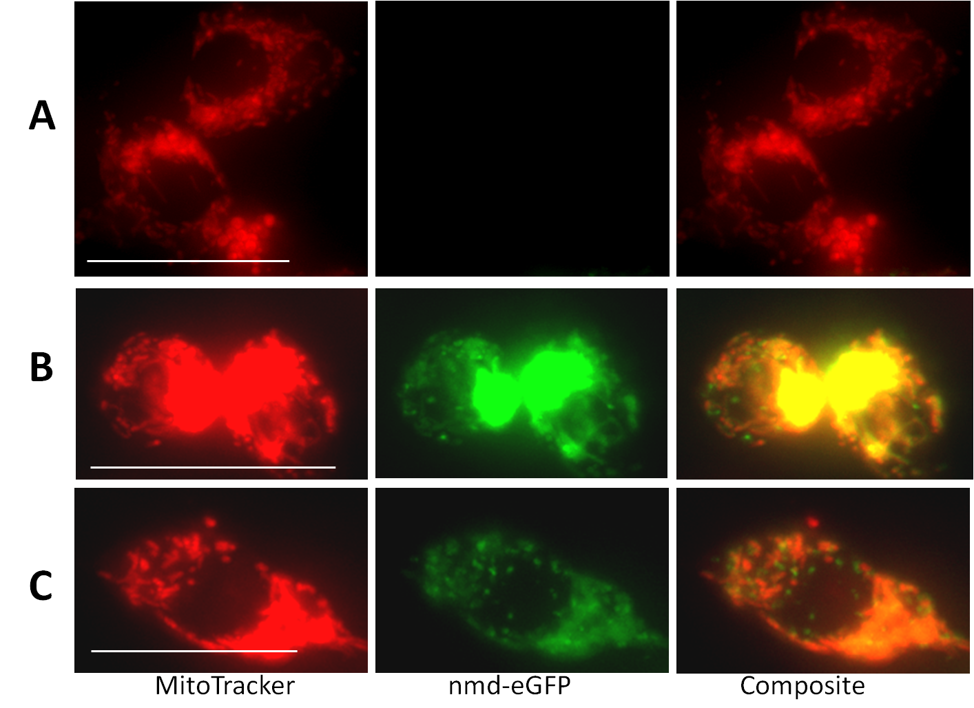 Figure 5.30. WT phenotypes of S2R+ cells double-labelled with MitoTracker and nmd-eGFP. S2R+ cells transiently transfected with nmd-eGFP were grown for 5 days before induction for 24 hours with 50µM CuSO₄. Cells were then washed with serum-free media containing 25nM MitoTracker Deep Red for one hour before being imaged in 10% serum-containing medium. Panel A shows 2 untransfected cells from the sample that were stained with MitoTracker Deep Red. These cells are unaffected by nmd-eGFP expression. Panel B shows two cells also stained with MitoTracker and expressing nmd-eGFP. The nmd expression is high and has caused a large central core of the protein to form in one part of each cell. There is partial colocalisation of the nmd-eGFP signal with parts of the MitoTracker staining. Panel C shows a transfected cell with lower nmd-eGFP expression and a distinct mitochondrial staining pattern seen. Partial colocalisation can be observed. All images are merged z-stacks taken at 60X magnification. Bar = 50µm.
The MitoTracker stain was able to produce reasonably well-contrasted elongated puncta. In live imaging these are motile and can appear more elongated in images than they do in real time. In panel A the mitochondria are relatively well-dispersed throughout the cytoplasm. In Panel B the presence of nmd-eGFP expression has caused both the fusion protein and mitochondria to form a dense bolus in one part of the cell. Despite this the mitochondria on the opposite side of the cell are visible. Parts of the mitochondria colocalise with the nmd-eGFP but the less-defined signal of the latter means that it is difficult to confirm the presence with any certainty. The punctate part of the nmd-eGFP pattern does not colocalise with the mitochondria. Panel C has lower nmd-eGFP expression, removing the presence of a large body of it. Again the nmd-eGFP signal is similar to that of the mitochondria. There are fronds of mitochondria at the bottom of the image, projecting in towards the nucleus that colocalise with diffuse fronds in the equivalent position, reported with nmd-eGFP. They are, however, diffuse enough that confirmations cannot be made of true colocalisation. While the two signals appear colocalised in the composite images of both panels B and C, there is sufficient overlap to make the spatial relationship questionable. The relationship is no clearer when looking at the individual images in the stacks (not shown).

Discussion of Secondary Screen and experiments on nmd.
The Secondary screen plate was filled with the hits and the most promising visual candidates from Screen 2. Despite the plate containing negative controls in over 25% of its wells the vast majority of the plate would be comprised of the statistical outliers of Screen 2. A statistical analysis conducted on the secondary screen in the same way as Screen 2 would in theory only return in the region of 20 candidates based on approximately 5% of the KDs being statistical outliers. When over 250 candidate genes were being tested a more thorough analysis was needed to try to return a potentially higher quantity of candidates. Visual screening of the triplicate of plates in its entirety decided as the best solution to pick all KDs with a major visual aberration in phenotype, regardless of the z-scores they achieved.
All wells were observed for visually aberrant phenotypes and 58 candidates were selected prior to knowing what the KDs were against. They were identified by Gene name and then grouped in order of the number of replicates on which each KD scored a hit, from 3 to 1. They were then arranged by raw peroxisome count per cell within each group.
It was already known that the secondary screen had experienced highly aberrant phenotypes in the E-RNAi controls, not just with the high degree of severity but with the high percentage of the cells displaying aberrant phenotypes. It was hoped that the PEX probes within the BKN library would be as effective at producing such profoundly effective and widely incurred non-WT presentations. Like Screen 2, among the best of the library probes was PEX16. It has become clear that PEX16 plays a crucial role in peroxisome biogenesis in D. melanogaster. Also among this top group and scoring highly was PEX13 which also scored well in Screen 2. Spaghetti squash had also found its place as one of the most aberrant KD phenotypes, but as this KD consistently showed mitotic defects in all images the gene has been considered to be of little interest. Atlastin, Moleskin and PEX5 were sorted to this top group and achieved convincing phenotypes. Moleskin is a novel gene that may be of interest in subsequent investigations.
In the second group nmd was found. Despite only achieving a visual phenotype in 2 of the three plates, the very low peroxisome per cell count is indicative that the gene KD has had a profound effect on peroxisome biogenesis. Also in the second group was PEX1 and three of the candidates from Screen 2 with high z-scores and KDs of interest; Gemini, par-1 and Casein Kinase 1α. Their presentations were very similar to those of their Screen 2 images but in both cases all three genes were treated with caution as high variety in cellular phenotype was present in their images. Such images that produced multiple phenotypes have to be considered as to whether the variation in cellular phenotype is in fact the true phenotype of the population of cells knocked down in this sample or an artefact. The fact that they recurred and repeated their aberrant cellular presentation suggests that there is reproducibility with this irregular conformation.
The samples found in the group scoring a hit in only one plate include probes that have been among the highest scoring z-scores for peroxisome count per cell. Drp1 has shown consistent changes in peroxisome morphology that were expected to be universally observed in the Secondary Screen. The loss of such a severely aberrant phenotype in two of the three plates is difficult to explain. None of the KDs in this group scored peroxisome per cell counts below 10. This might indicate that there may be innate uncertainty in trying to determine whether moderated KDs have occurred. Yet this wouldn’t account for the high peroxisome per cell count seen among the ATPase subunits. These too were spotted in only one plate of the three yet scored a high enough average across the triplicate of samples that a KD seems increasingly likely.
Statistical evaluation was performed on the data using HTS2 bioinformatic software. This analysis was used to determine the most statistically significant hits from this screen despite the theoretically high relative distribution expected. It could at least be compared to the visual screen results. There are obviously many differences between the two analyses but two important ones are that the visual data was neither normalised nor expressed in terms of z-scores. Secondly it was a mean average of raw peroxisome count that was included in the heat map and the table. The statistical analysis normalised the data across each plate but not across all three. These normalised data were expressed in z-scores in terms of their respective plate σ from their plate mean. The median value was taken from the triplicate of each KD.
The Q-Q plot provided the most remarkable visualisation. High-scoring negative z-scores with the exception of the MTF-1 included the most aberrant of the PEX genes (PEX16, PEX3, PEX13, PEX1), and many of the notable candidate genes from Screen 2 and the visual analysis of the Secondary Screen. The three favourites from Screen 1, which are three of the most robustly effective KDs in the library to affect this assay are among the highest scorers in this shortlist of aberrant phenotypes.
Re-examination of the images of those novel genes on the Q-Q plot that were not found in the visual screen (Ephexin, lola, Chickadee) shows, like many of the novel candidates, a high degree of variability in phenotype among the cells imaged. There was however enough of an aberration to show that the assay was more than likely affected.
PEX-like phenotypes have been consistently displayed by nmd throughout the screening process. Statistically the images have caused low peroxisome per cell counts which have translated as high-scoring hits when expressed in terms of z-score. An E-RNAi-derived probe was designed after Screen 1 results to target nmd. Its success at producing a PEX-like phenotype meant it could be used in the following screens as a control. It was and it produced some of the largest z-scores of the screens.
After the secondary screen it was decided that nmd would be the most suitable of the novel genes to pursue as a candidate for PEX-related research. The first experiment required attempting to classify nmd’s function. Based on images from all three screens nmd has caused cytosolic accumulation of eGFP-PTS1 ubiquitously. This can also be claimed of PEX16 and to a lesser extent PEX5 and PEX13. PEX16 has been the only peroxin to show consistently fewer than 5 peroxisomes per cell, frequently only one is visible or none at all. PEX16 has in all the screens been the KD which, both in the BKN library and the E-RNAi-derived probes has best resembled the phenotype of nmd. The best evidence for this is shown in Screen 2 and in the Secondary Screen. Screen 2 shows PEX16 and nmd controls to have a low number of peroxisomes per cell, less than 5. Comparing the z-scores of the controls and the sample genes reveals the means of nmd and PEX16 to be -9.51 and -8.60 respectively. The sample probes scored -8.49 and -8.85. While this 1 dimensional marker for KD severity cannot be an indicator of mechanism of action or peroxin class, it supports the theory that their functions could be similar based on their phenotypes in the images.
The first follow-up research to be conducted on nmd was a comparison of its phenotype to those of WT, PEX5 and PEX16 cells when stably transfected with inducible matrix (mRFP-PTS1) and membrane (ABCD3-eGFP) markers. The 6-day KD experiment including a 24hour induction with 50µM CuSO₄ was used.
The control cells presented with matrix and membrane protein colocalised in dots. The matrix protein consistently concentrated into brighter dots than the membrane protein. In Panel B unevenly sized peroxisomes show disproportionately bright mRFP-PTS1 compared to the slightly enlarged membrane structure surrounding them.
PEX5 KDs presented in a typical matrix protein import defect phenotype with ghost structures unable to concentrate the matrix protein into puncta contrastable with the cytosol.
PEX16 KD theoretically should show no peroxisomal structures as the PEX3-PEX19 complex has lost its receptor for membrane protein and lipid membrane vesicular transport to peroxisomes. The presence in these cells of membrane ghosts could be the cytosolic PEX3-PEX19 complex, mislocalised and unable to fuse with the existing peroxisomes, which appear to be enlarged.
Nmd appears to have a similar presentation to PEX16 but with more import competent peroxisomes and fewer ghosts. If nmd is functionally similar to PEX16 it may have less of a dominant role in pre-peroxisomal fusion with mature peroxisomes.

General Discussion

Results of the first genome-wide screen for peroxisomes in D. melanogaster
The first genome-wide screen in D. melanogaster did not reveal the large number of candidate genes that it was hoped it might. As mentioned in the introduction there is expected to be a large number of peroxins in the animal peroxin families. When it is taken into account that nearly half of the peroxins in S. cerevisiae are unaccounted for in D. melanogaster and H. sapiens as demonstrated by database and literature searches, it quickly becomes apparent that the potential number of as yet undiscovered peroxins is in the region of tens of genes. A genome-wide screen that could discover half or even a quarter of these genes would provide a massive impetus for continued peroxisome research in animal model organisms.
Despite the poor yield of novel genes, there were three gene KDs that were able to produce aberrant phenotypes in the transfected cells, CG5395, CG3595 and CG6668 (their given names on flybase were “no mitochondrial derivative”, “spaghetti squash” and “Atlastin”).
A number of peroxins did produce hits from Screen 1 and some of them were very convincing either in the images produced or by the statistics that were derived from them or both. Of these genes PEX16, PEX5, PEX13, PEX1 and PEX3 were the genes that not only had the most aberrative phenotypes but would continue to return statistically significant data in subsequent Screens. Of the non-PEX genes that were of significance Drp1 and Tango11 produced images of larger than normal peroxisomes, relatively fewer in number.
The low transfection efficiency was a complicating factor that lead us to question whether a more robust assay would be capable of returning more PEX genes in a second genome-wide RNAi screen. We were able to acquire the pMK33 plasmid used in fly cell research which allowed us to conditionally express the eGFP-PTS1 marker in stably transfected cells.

Results of the second genome-wide screen for peroxisomes in D. melanogaster
The second screen had an altered assay from the first. The same fluorescent peroxisomal marker, eGFP-PTS1, was being conditionally expressed in cells stably transfected with it under hygromycin B selection. With the number of cells being photographed in each image no longer an issue for robust statistical analysis a higher magnification could be used in the automated microscope. This was intended to raise the accuracy in determining peroxisome per cell count as peroxisomes could be better resolved. In reality, the thinner focal plane of the objective meant that fewer peroxisomes were in focus for analysis in the majority of cells.
The Screen 2 was still a comparative success compared to Screen 1. Many of the peroxins from Screen 1 were returned, this time with normalised z-scores that showed the peroxins to be among the most statistically significant gene KDs in the screen. It was however still required that a visual element determine which high z-scores were false positives and which weren’t. On this basis it was also deemed necessary to visually recover false negatives down to a z-score of -1. Positive z-scores were not deemed necessary to visually screen below a z-score of 2. A list was compiled of statistically significant candidates(see Chapter 4.16) and their subsequent analysis took into account their peroxisome per cell counts from the previous screen, now normalised. The list contained 8 PEX genes or genes associated with peroxisome fission: PEX13, PEX16, PEX5, PEX1, Tango11, PEX3, Drp1 and PEX11β. The three genes from the first screen that showed phenotypes that may have been of interest were now high value z-scores in the assay of Screen 2. The remainder of the list were of the most promising candidates to be screened secondarily. The full list of genes that were included for seeding into the custom-designed plate contained 275 genes; 18 were hand-picked and 257 were derived from the results of the two screens. Secondary screening could now commence.

Results from the secondary screen
The custom-designed plate for the Secondary Screen was two-thirds filled with probes that achieved outlying z-scores when the data from both screens were analysed together. This would theoretically pose problems at a statistical level if an ordinary z-score based analysis were to be conducted. In the first two screens, a probe’s peroxisome count was expressed in terms of standard deviations from the mean value of all probe peroxisome counts. In other words, the entire library was treated as the population of WT values that would determine the distribution that z-scores were calculated from. This would not be a problem for a genome-wide screen as enough WT values would be produced from probes ineffective on the eGFP-PTS1 assay to give a robust population distribution. The Secondary Screen potentially has 75% of its probes that theoretically score outlying hits and the statistical analysis technique currently employed would treat the whole plate as a population distribution. To make sure that every KD was checked for aberrant phenotypes, all three plates were screened visually and probes were scored as to how many were found within their triplicate. The results can be seen in Figure 5.6.
As the statistical analysis on the Secondary Screen was performed anyway we attempted to draw conclusions from it. Two extra parameters were analysed in the same way as the peroxisome per cell count, peroxisome area per cell and peroxisome integrated intensity per cell. Comparisons of these found no correlation between number and either area or intensity of peroxisomes per cell. There was however a highly correlating relationship between peroxisomal area per cell and peroxisomal intensity per cell. This unfortunately turned out to be a linear rather than a binomial relationship. This indicates that as area increases, total intensity increases by the same proportion. Essential what this implies is that larger peroxisomes are no brighter than smaller peroxisomes and that there is no concentration of fluorescent signal, nor integration of fluorescence that it is out of focus. An examination of the outliers of peroxisomal area per cell gave us an almost identical list of genes (not discussed) as the list derived from the Q-Q plot in Figure 5.19.1. High z-scores in the assay for peroxisome count per cell are displayed in Figure 5.19.1 and a list of both negative and positive scoring outliers is presented in Figure 5.19.2.
Combination of the hit lists from the two different analyses in this chapter yields PEX genes that have been considered strongly aberrant phenotypes of gene KD throughout the progress of this research. PEX16, PEX3, PEX13 and PEX1 clearly have significant roles either in peroxisome proliferation or matrix protein uptake. Among the top ten KDs, non-PEX genes include nmd, sqh, Atlastin, Tango11 and MTF-1 (Metal response-binding transcription factor). The very high z-score for this gene KD is attributable to the fact that it is a positive response element to transcription induced by cupric (II) ions (Marr et al., 2006; Southon et al., 2004). Its image shows a massive reduction in eGFP-PTS1. The recurrence of some of the hits from Screen 2 in this list shows a promising start to the future evaluation of 57 novel genes with aberrant phenotypes in this assay. The images and high z-scores of Casein Kinase 1α, archipelago, and Gemini indicate that the new assay is effective in eliciting genes with some functional aspect to peroxisomal biogenesis.

Fluorescence microscopy assay with No mitochondrial derivative (nmd)
The most promising candidate for a PEX-like phenotype was nmd. It showed a consistently highly aberrant phenotype throughout the project and it was decided to investigate the nature of this.
Nmd is a AAA-type ATPase. This is a large and diverse group of ATPases which are involved in many biological processes (reviewed by Joly et al., 2012). Two peroxins are already known to be AAA-ATPases, PEX1 and PEX6 (Grimm et al, 2012). They are involved in the removal of poly-ubiquitinated PEX5 from the peroxisomal matrix and do not play a direct role in peroxisome biogenesis. It has also been shown in mice to have a role in the internalisation of post-synaptic AMPA receptors (α-amino-3-hydroxy-5-methylisoxazole-4-propionate). Under the pseudonym “Thorase”, its deletion in mouse neurons causes increased presence of the receptor which caused the mice to experience “learning and memory deficits” (Zhang et al. 2012).
Experiments to elucidate a functional role for nmd did not produce convincing data. This is likely a problem with the assay. PEX16 KD of mRFP-PTS1 and ABCD3-eGFP produced ghost-like structures in S2R+ cells. This does not fit with the consensus loss of PEX16 function where peroxisomal structures are prevented from forming. This may however be the cytosolic pre-peroxisomes described by Matsuzaki & Fujiki (2008) which require PEX16 to dock with peroxisomes. If they are partially labelled with the membrane marker then this presentation may fit our assay. Nmd may then have a similar role to PEX16 in acting as a receptor for PEX19 and PEX3 complexes.
Finally we tagged nmd with c-terminal eGFP to see where it localises. It appears to form a half-punctate, half-mitochondrial pattern in the cytosol of the cell. The punctate pattern was confirmed with co-expression of mRFP-PTS1 (Figure 5.23.1) and the mitochondrial presentation was at least partly colocalised with MitoTracker (Figure 5.23.2). Further research is needed to confirm these findings.

Further Work

Conservation in Eukarya.
The most aberrant PEX-like gene KD phenotype shown in all of the screens was by far that of nmd. The reduction in peroxisome number elucidated in many cells and a void of them in some cells is highly comparable to the observations seen with PEX16 KDs. This suggests that it has a crucial role in peroxisomal biogenesis, possibly involved in mobilisation of peroxisomal membrane vesicles from the ER. If true, then this would be only the fourth gene of this type to be discovered. Should its crucial role be conserved among eukaryotes then it would be considered an important find in peroxisome biogenesis studies and could possibly be considered a novel peroxin. It is therefore interesting to know that nmd has conserved homologues in many Eukaryotes including H. sapiens and S.cerevisiae, named ATAD1 (ATPase family, AAA domain containing 1) and Msp1 (Mitochondrial sorting protein 1) respectively. This means that experiments can be conducted on these to try and prove if nmd’s apparent biogenesis role is conserved. It should be possible first to try and produce a loss of function knockdown-assay that is essentially identical to that of the screens using RNAi and a fluorescent PTS1 reporter in a human cell-line such as HeLa cells. Subsequently, knockouts in cells of both H. sapiens and S. cerevisiae species can be produced in our lab to try and elucidate the same (or a similar) phenotype. Work has already begun on this line of research.

Testing for cell-line specific peroxisome biogenesis function.
The RNAi screens have been successful in confirming the effects of some known peroxins as well as the discovery of “nmd”, potentially a new gene involved in peroxisome biogenesis. The fact that some known peroxins did not produce a PEX-like phenotype and were therefore not considered statistical hits in any of the screens performed leaves unanswered questions about the efficacy of the assay. The potential that further genes with peroxisome biogenesis function may lie undiscovered is another real consideration. A possible solution is to rescreen the genome with a different cell-line, such as the KC167 cells used in the Assay Development (Chapter 3.5). By using a different cell-line one would be utilising a different, specific set of genes and therefore their transcripts. It is theoretically possible that there are peroxisome biogenesis genes which are only expressed in one cell-line whose loss of expression in the other does not elucidate a PEX-like phenotype due to a secondary redundancy caused by the co-incidental addition or loss of another gene. As we have been able to observe punctate structures in KC167 cells during assay development this assay is theoretically possible to perform. Possible problems may arise in the imaging and image analysis stages of developing the assay for this as the majority of the cells are taller and occupy a smaller cross-sectional area than S2R+ cells. It is expected that if a project such as this were to be undertaken then a large amount of work towards developing the assay would be required. It is therefore not considered a first choice approach at this stage.
If development of the KC167 assay was to be commenced then a good starting point would be to test the cells in the custom-developed assay plate used for secondary screening. This would provide several key indicators of the screen:
- It would provide an indication of KC167 cells’ ability to be accurately screened using the eGFP-PTS1 assay.
- It would help validate any of the loss-of-function KDs that occur in both cell-lines; of particular interest would be nmd.
- The nature of the biogenesis function of nmd could be determined; i.e. if it is a function specific to S2R+ cells or to both cell-lines, indicating a role possibly ubiquitous in D. melanogaster.
After screening of the custom-designed plate, based on the number of aberrant phenotypes in KC167 cells and the disparity observed between the frequencies of KDs in each cell-line, further genome-wide screening could be considered. A large disparity would indicate that the transcriptome of each cell-line differs enough that the epigenetics of peroxisome biogenesis are dissimilar. This would require further genome-wide screening to investigate if the screens with S2R+ did in fact miss genes that may have otherwise incurred aberrant loss-of-function with KC167.

Whole-fly experiments
A natural progression of the work is to observe the effect of loss of nmd function in whole organisms, specifically in fruitflies. According to both the Bloomington Drosophila Stock Centre and the Vienna Drosophila RNAi Centre, nmd knockout flies (Δnmd) are lethal at the larval stage (information taken from www.flybase.org). As shown by Mast et al. these larvae can be dissected and different tissue cells examined for the presence of peroxisomes using a constitutive reporter. It is still possible, however, to try and observe loss of function in whole organisms. Currently work has begun on this line of research. Flies heterozygous for a loss-of-function mutation in nmd can be crossed with ones homozygous for an inducible hairpin RNA. Half of the progeny will be heterozygous for the mutant allele and can mature to adulthood. Upon hatching the adult flies can be induced to ubiquitously express the hairpin RNA which will behave like a long dsRNA probe. The subsequent production of siRNAs will cause interference with the expression of nmd and we will have 10 days to observe the effects of nmd knockdown on adult flies. This will also hopefully lead to the examination of adult tissues deficient in nmd polypeptides and the determination of whether a PEX-like phenotype is visible in adult cells.

Bibliography
Adams, MD 2000, “The Genome Sequence of Drosophila melanogaster,” Science, vol. 287, no. 5461, pp. 2185–2195.
Alencastre, IS, Rodrigues, T a, Grou, CP, Fransen, M, Sá-Miranda, C & Azevedo, JE 2009, “Mapping the cargo protein membrane translocation step into the PEX5 cycling pathway.,” The Journal of biological chemistry, vol. 284, no. 40, pp. 27243–51.
Baerends, RJ, Rasmussen, SW, Hilbrands, RE, Van der Heide, M, Faber, KN, Reuvekamp, PT, Kiel, J a, Cregg, JM, Van der Klei, IJ & Veenhuis, M 1996, “The Hansenula polymorpha PER9 gene encodes a peroxisomal membrane protein essential for peroxisome assembly and integrity.,” The Journal of biological chemistry, vol. 271, no. 15, pp. 8887–94.
Baudhuin, P, Beaufay, H & De Duve, C 1965, “Combined biochemical and morphological studyof particulate fractions from rat liver. Analysis of preparations enriched in lysosomes or in particles containing urate oxidase, D-amino acid oxidase and catalase.,” Journal of Cell Biology, vol. 26, no. 1, pp. 219–43.
Baum, B & Cherbas, L 2008, “Drosophila cell lines as model systems and as an experimental tool.,” in C Dahman (ed.), Drosophila: Methods and Protocols, Humana Press, Totawa, NJ.
Bernstein, E, Caudy, a a, Hammond, SM & Hannon, GJ 2001, “Role for a bidentate ribonuclease in the initiation step of RNA interference.,” Nature, vol. 409, no. 6818, pp. 363–6.
Birschmann, I, Stroobants, AK & Berg, M Van Den 2003, “Pex15p of Saccharomyces cerevisiae Provides a Molecular Basis for Recruitment of the AAA Peroxin Pex6p to Peroxisomal Membranes,” Molecular biology of the cell, vol. 14, no. June, pp. 2226–2236.
Brown, L & Baker, A 2003, “Peroxisome biogenesis and the role of protein import,” Journal of Cellular and Molecular Medicine, vol. 7, no. 4, pp. 388–400.
C, W, Van den Berg, M, Geers, E & Distel, B 2008, “Pex10p functions as an E3 ligase for the Ubc4p-dependent ubiquitination of Pex5p,” Biochemical and Biophysical Research Communications, vol. 374, no. 4, pp. 620–624.
Campelo, F, McMahon, HT & Kozlov, MM 2008, “The hydrophobic insertion mechanism of membrane curvature generation by proteins.,” Biophysical journal, vol. 95, no. 5, pp. 2325–39.
Carmell, M a, Xuan, Z, Zhang, MQ & Hannon, GJ 2002, “The Argonaute family: tentacles that reach into RNAi, developmental control, stem cell maintenance, and tumorigenesis.,” Genes & development, vol. 16, no. 21, pp. 2733–42.
Cavener, DR 1987, “Comparison of the consensus sequence flanking transtational start sites in Drosophila and vertebrates.,” Nucleic Acids Research, vol. 15, no. 4, pp. 1353–1361.
Chang, CC, Warren, DS, Sacksteder, K a & Gould, SJ 1999, “PEX12 interacts with PEX5 and PEX10 and acts downstream of receptor docking in peroxisomal matrix protein import.,” The Journal of cell biology, vol. 147, no. 4, pp. 761–74.
Chen, H, Liu, Z & Huang, X 2010, “Drosophila models of peroxisomal biogenesis disorder: peroxins are required for spermatogenesis and very-long-chain fatty acid metabolism.,” Human molecular genetics, vol. 19, no. 3, pp. 494–505.
Chien, S, Reiter, LT, Bier, E & Gribskov, M 2002, “Homophila: human disease gene cognates in Drosophila.,” Nucleic acids research, vol. 30, no. 1, pp. 149–51.
Chung, Y & Keller, EB 1990, “Positive and Negative Regulatory Elements Mediating Transcription from the Drosophila melanogaster Actin 5C Distal Promoter,” Molecular and Cellular Biology, vol. 10, no. 12, pp. 6172–6180.
Collins, CS, Kalish, JE, Morrell, JC, McCaffery, JM & Gould, SJ 2000, “The peroxisome biogenesis factors pex4p, pex22p, pex1p, and pex6p act in the terminal steps of peroxisomal matrix protein import.,” Molecular and cellular biology, vol. 20, no. 20, pp. 7516–26.
Distel, B, Erdmann, R, Gould, SJ, Blobel, G, Crane, IDI, Cregg, IJM, Dodt, G, Fujiki, Y, Goodman, JM, Just, WW, Kiel, DJAKW, Kunau, W, Lazarow, PB, Mannaerts, GP, Moser, HW, Osumi, T, Rachubinski, RA, Roscher, A, Subramani, S, Tabak, HF, Tsukamoto, T, Valle, D, Klei, I Van Der, Veldhoven, PP Van & I, MVI 1996, “Mini-Review A Unified Nomenclature for Peroxisome Biogenesis Factors,” Journal of Cell Biology, vol. 135, no. 1, pp. 1–3.
Dorner, S, Lum, L, Kim, M, Paro, R, Beachy, P a & Green, R 2006, “A genomewide screen for components of the RNAi pathway in Drosophila cultured cells.,” Proceedings of the National Academy of Sciences of the United States of America, vol. 103, no. 32, pp. 11880–5.
De Duve, C & Baudhuin, P 1966, “Peroxisomes (microbodies and related particles),” Physiological reviews, vol. 46, pp. 323–57.
Dytham, C 2003, Choosing and Using Statistics - A Biologist’s Guide, 2nd ed, Blackwell Publishing, pp. 7–22.
Echalier, G & Ohanessian, A 1969a, “Isolation, in tissue culture, of Drosophila melangaster cell lines,” C R Acad Sci Hebd Seances Acad Sci D, vol. 268, no. 13, pp. 1771–3.
Echalier, G & Ohanessian, A 1969b, “Isolation, in tissue culture, of Drosophila melangaster cell lines.,” C R Acad Sci Hebd Seances Acad Sci D, vol. 268, pp. 1771–3.
Eckert, JH & Erdmann, R 2003, “Peroxisome Biogenesis,” Rev Physiol Biochem Pharmacol, vol. 147, pp. 75–121.
Egli, D, Domènech, J, Selvaraj, A, Balamurugan, K, Hua, H, Capdevila, M, Georgiev, O, Schaffner, W & Atrian, S 2006, “The four members of the Drosophila metallothionein family exhibit distinct yet overlapping roles in heavy metal homeostasis and detoxification.,” Genes to cells : devoted to molecular & cellular mechanisms, vol. 11, no. 6, pp. 647–58.
Eitzen, GA, Szilard, RK & Rachubinski, RA 1997, “Enlarged Peroxisomes Are Present in Oleic Acid–grown,” Journal of Cell Biology, vol. 137, no. 6, pp. 1265–1278.
Elbashir, SM, Lendeckel, W & Tuschl, T 2001, “RNA interference is mediated by 21- and 22-nucleotide RNAs,” Genes and development, pp. 188–200.
Elgersma, Y, Van den Berg, M, Tabak, HF & Distel, B 1993, “An efficient positive selection procedure for the isolation of peroxisomal import and peroxisome assembly mutants of Saccharomyces cerevisiae.,” Genetics, vol. 135, no. 3, pp. 731–40.
Erdmann, R & Blobel, G 1995, “Giant peroxisomes in oleic acid-induced Saccharomyces cerevisiae lacking the peroxisomal membrane protein Pmp27p.,” The Journal of cell biology, vol. 128, no. 4, pp. 509–23.
Erdmann, R & Schliebs, W 2005, “Peroxisomal matrix protein import: the transient pore model,” Nature Reviews Molecular Cell Biology Biology, vol. 6, no. September, pp. 738–742.
Erdmann, R, Veenhuis, M, Mertens, D & Kunau, WH 1989, “Isolation of peroxisome-deficient mutants of Saccharomyces cerevisiae.,” Proceedings of the National Academy of Sciences of the United States of America, vol. 86, no. 14, pp. 5419–23.
Fang, Y, Morrell, JC, Jones, JM & Gould, SJ 2004, “PEX3 functions as a PEX19 docking factor in the import of class I peroxisomal membrane proteins.,” The Journal of cell biology, vol. 164, no. 6, pp. 863–75.
Faust, JE, Verma, A, Peng, C & McNew, J a 2012, “An Inventory of Peroxisomal Proteins and Pathways in Drosophila melanogaster.,” Traffic (Copenhagen, Denmark), vol. 13, no. 10, pp. 1378–92.
Fire, A, Xu, S, Montgomery, MK, Kostas, SA, Driver, SE & Mello, CC 1998, “Potent and specific genetic interference by double-stranded RNA in Caenorhabditis elegans,” Letters to Nature, vol. 391, no. February, pp. 806–811.
Gandre-babbe, S & Bliek, AM Van Der 2008, “The Novel Tail-anchored Membrane Protein Mff Controls Mitochondrial and Peroxisomal Fission in Mammalian Cells,” Molecular and cellular biology, vol. 19, no. June, pp. 2402–2412.
Geuze, HJ, Murk, JL, Stroobants, AK, Griffith, JM, Kleijmeer, MJ, Koster, AJ, Verkleij, AJ, Distel, B & Tabak, HF 2003, “Involvement of the Endoplasmic Reticulum in Peroxisome Formation,” Molecular biology of the cell, vol. 14, no. July, pp. 2900–2907.
Gietz, R & Sugino, A 1988, “New yeast-Escherichia coli shuttle vectors constructed with in vitro mutagenized yeast genes lacking six-base pair restriction sites.,” Gene, vol. 74, no. 2, pp. 527–34.
Goldfischer, S, Moore, CL, Johnson, AB, Spiro, AJ, Valsamis, MP & Wisniewski, HK 1973, “Peroxisomal and mitochondrial defects in the cerebro-hepato-renal syndrome,” Science, vol. 182, no. 107, pp. 62–4.
Gonzalez, E 1986, “Role of the Endoplasmic Reticulum in Glyoxysome Formation in Castor Bean Endosperm,” Plant physiology, vol. 80, pp. 950–955.
Gonzalez, E & Beevers, H 1976, “Role of the Endoplasmic Reticulum in Glyoxysome Formation in Castor Bean Endosperm,” Plant Physiology, vol. 57, pp. 406–409.
Gould, SJ, Keller, G a, Hosken, N, Wilkinson, J & Subramani, S 1989, “A conserved tripeptide sorts proteins to peroxisomes.,” The Journal of cell biology, vol. 108, no. 5, pp. 1657–64.
Gould, SJ, Keller, G & Subramani, S 1987, “Identification of a Peroxisomal Targeting Signal at the Carboxy Terminus of Firefly Luciferase,” Journal of Cell Biology, vol. 105, no. 6, pp. 2923–2931.
Gould, SJ, Mccollum, D, Spong, AP, Heyman, JA & Subramani, S 1992, “Development of the yeast Pichia pastoris as a model organism for a genetic and molecular analysis of peroxisome assembly.,” Yeast, vol. 8, no. 8, pp. 613–28.
Grimm, I, Saffian, D, Platta, HW & Erdmann, R 2012, “The AAA-type ATPases Pex1p and Pex6p and their role in peroxisomal matrix protein import in Saccharomyces cerevisiae.,” Biochimica et biophysica acta, vol. 1823, no. 1, Elsevier B.V., pp. 150–8.
Grou, CP, Carvalho, AF, Pinto, MP, Huybrechts, SJ, Sá-Miranda, C, Fransen, M & Azevedo, JE 2009, “Properties of the ubiquitin-pex5p thiol ester conjugate.,” The Journal of biological chemistry, vol. 284, no. 16, pp. 10504–13.
Grunau, S, Schliebs, W, Linnepe, R, Neufeld, C, Cizmowski, C, Reinartz, B, Meyer, HE, Warscheid, B, Girzalsky, W & Erdmann, R 2009, “Peroxisomal Targeting of PTS2 Pre-Import Complexes in the Yeast Saccharomyces cerevisiae,” Traffic, vol. 10, no. 4, pp. 451–460.
Götte, K, Girzalsky, W, Linkert, M, Baumgart, E, Kammerer, S, Kunau, WH & Erdmann, R 1998, “Pex19p, a farnesylated protein essential for peroxisome biogenesis.,” Molecular and cellular biology, vol. 18, no. 1, pp. 616–28.
Hammond, SM, Bernstein, E, Beach, D & Hannon, GJ 2000, “An RNA-directed nuclease mediates post-transcriptional gene silencing in Drosophila cells.,” Nature, vol. 404, no. 6775, pp. 293–6.
Held, M, Schmitz, MHA, Fischer, B, Walter, T, Neumann, B, Olma, MH, Peter, M, Ellenberg, J & Gerlich, DW 2010, “Cellcognition: time-resolved phenotype annotation in high-throughput live cell imaging,” Nature Methods, vol. 7, pp. 745–54.
Hettema, EH, Girzalsky, W, Van Den Berg, M, Erdmann, R & Distel, B 2000, “Saccharomyces cerevisiae pex3p and pex19p are required for proper localization and stability of peroxisomal membrane proteins.,” The EMBO journal, vol. 19, no. 2, pp. 223–33.
Hoepfner, D, Schildknegt, D, Braakman, I, Philippsen, P & Tabak, HF 2005, “Contribution of the endoplasmic reticulum to peroxisome formation.,” Cell, vol. 122, no. 1, pp. 85–95.
Holroyd, C & Erdmann, R 2001, “Protein translocation machineries of peroxisomes,” FEBS letters, vol. 501, pp. 6–10.
Honsho, M, Tamura, S, Shimozawa, N, Suzuki, Y, Kondo, N & Fujiki, Y 1998, “Mutation in PEX16 is causal in the peroxisome-deficient Zellweger syndrome of complementation group D.,” American journal of human genetics, vol. 63, no. 6, pp. 1622–30.
Horn, T, Sandmann, T & Boutros, M 2010, “Design and evaluation of genome-wide libraries for RNA interference screens.,” Genome biology, vol. 11, no. 6, p. R61.
Huhse, B, Rehling, P, Albertini, M, Blank, L, Meller, K & Kunau, W 1998, “Pex17p of Saccharomyces cerevisiae Is a Novel Peroxin and Component of the Peroxisomal Protein Translocation Machinery,” Journal of Cell Biology, vol. 140, no. 1, pp. 49–60.
James, GL, Goldstein, JL, Pathak, RK, Anderson, RG & Brown, MS 1994, “PxF, a prenylated protein of peroxisomes.,” The Journal of biological chemistry, vol. 269, no. 19, pp. 14182–90.
Joly, N, Zhang, N, Buck, M & Zhang, X 2012, “Coupling AAA protein function to regulated gene expression.,” Biochimica et biophysica acta, vol. 1823, no. 1, Elsevier B.V., pp. 108–16.
Kamentsky, L, Jones, TR, Fraser, A, Bray, M-A, Logan, DJ, Madden, KL, Ljosa, V, Rueden, C, Eliceiri, KW & Carpenter, AE 2011, “Improved structure, function and compatibility for CellProfiler: modular high-throughput image analysis software.,” Bioinformatics (Oxford, England), vol. 27, no. 8, pp. 1179–80.
Karpova, N, Bobinnec, Y, Fouix, S, Huitorel, P & Debec, A 2006, “Jupiter, a new Drosophila protein associated with microtubules.,” Cell motility and the cytoskeleton, vol. 63, no. 5, pp. 301–12.
Kiel, J, Hilbrands, R, Klei, I van der, Rasmussen, S, Salomons, F, Heide, M van der, Faber, K, Cregg, J & Veenhuis, M 1999, “Hansenula polymorpha Pex1p and Pex6p are peroxisome-associated AAA proteins that functionally and physically interact.,” Yeast, vol. 1078, no. October 1998, pp. 1059–1078.
Kiger, A, Baum, B, Jones, S, Jones, M, Coulson, A, Echeverri, C & Perrimon, N 2003, “A functional genomic analysis of cell morphology using RNA interference,” Journal of Biology, vol. 2, no. 4, pp. 27.1–15.
Kobayashi, S, Tanaka, A & Fujiki, Y 2007, “Fis1, DLP1, and Pex11p coordinately regulate peroxisome morphogenesis.,” Experimental cell research, vol. 313, no. 8, pp. 1675–86.
Koch, A, Thiemann, M, Grabenbauer, M, Yoon, Y, McNiven, M a & Schrader, M 2003, “Dynamin-like protein 1 is involved in peroxisomal fission.,” The Journal of biological chemistry, vol. 278, no. 10, pp. 8597–605.
Koch, A, Yoon, Y, Bonekamp, NA, Mcniven, MA & Schrader, M 2005, “A Role for Fis1 in Both Mitochondrial and Peroxisomal Fission in Mammalian Cells,” Molecular Biology of the Cell, vol. 16, no. November, pp. 5077–5086.
Koch, J & Brocard, C 2011, “Membrane elongation factors in organelle maintenance : the case of peroxisome proliferation,” Biomolecular Concepts, vol. 2, no. 5, pp. 353–364.
Koch, J, Pranjic, K, Huber, A, Ellinger, A, Hartig, A, Kragler, F & Brocard, C 2010, “PEX11 family members are membrane elongation factors that coordinate peroxisome proliferation and maintenance.,” Journal of cell science, vol. 123, no. Pt 19, pp. 3389–400.
Kragt, A, Voorn-Brouwer, T, Van den Berg, M & Distel, B 2005, “The Saccharomyces cerevisiae peroxisomal import receptor Pex5p is monoubiquitinated in wild type cells.,” The Journal of biological chemistry, vol. 280, no. 9, pp. 7867–74.
Kunau, WH 2001, “Peroxisomes: the extended shuttle to the peroxisome matrix.,” Current biology : CB, vol. 11, no. 16, pp. R659–62.
Kuravi, K, Nagotu, S, Krikken, AM, Sjollema, K, Deckers, M, Erdmann, R, Veenhuis, M & Van der Klei, IJ 2006, “Dynamin-related proteins Vps1p and Dnm1p control peroxisome abundance in Saccharomyces cerevisiae.,” Journal of cell science, vol. 119, no. Pt 19, pp. 3994–4001.
Lanyon-Hogg, T, Warriner, SL & Baker, A 2010, “Getting a camel through the eye of a needle: the import of folded proteins by peroxisomes.,” Biology of the cell / under the auspices of the European Cell Biology Organization, vol. 102, no. 4, pp. 245–63.
Lazarow, PB & Fujiki, Y 1985, “Biogenesis of peroxisomes,” Annual review of Cellular Biology, vol. 1, pp. 489–530.
Van der Leij, I, VanDen Berg, M, Boot, R, Franse, M, Distel, B & Tabak, HF 1992, “Isolation of Peroxisome Assembly Mutants from Saccharomyces cerevisiae with Different Morphologies Using a Novel Positive Selection Procedure,” Journal of Cell Biology, vol. 119, no. 1, pp. 153–162.
Van der Leij, I, Franse, MM, Elgersma, Y, Distel, B & Tabak, HF 1993, “PAS10 is a tetratricopeptide-repeat protein that is essential for the import of most matrix proteins into peroxisomes of Saccharomyces cerevisiae.,” Proceedings of the National Academy of Sciences of the United States of America, vol. 90, no. 24, pp. 11782–6.
Liu, H, Tan, X, Veenhuis, M, McCollum, D & Cregg, JM 1992, “An efficient screen for peroxisome-deficient mutants of Pichia pastoris.,” Journal of bacteriology, vol. 174, no. 15, pp. 4943–51.
Maroni, G, Otto, E & Lastowski-perry, D 1986, “Molecular and Cytogenetic Characterisation of a Metallothionein Gene of Drosophila,” Genetics, vol. 123, no. 3, pp. 493–504.
Marr, MT, Isogai, Y, Wright, KJ & Tjian, R 2006, “Coactivator cross-talk specifies transcriptional output.,” Genes & development, vol. 20, no. 11, pp. 1458–69.
Marzioch, M, Erdmann, R, Veenhuis, M & Kunau, WH 1994, “PAS7 encodes a novel yeast member of the WD-40 protein family essential for import of 3-oxoacyl-CoA thiolase, a PTS2-containing protein, into peroxisomes.,” The EMBO journal, vol. 13, no. 20, pp. 4908–18.
Mast, FD, Li, J, Virk, MK, Hughes, SC, Simmonds, AJ & Rachubinski, R a 2011, “A Drosophila model for the Zellweger spectrum of peroxisome biogenesis disorders.,” Disease models & mechanisms, vol. 4, no. 5, pp. 659–72.
Matsumoto, N, Tamura, S & Fujiki, Y 2003, “The pathogenic peroxin Pex26p recruits the Pex1p–Pex6p AAA ATPase complexes to peroxisomes,” Nature Cell Biology, vol. 5, pp. 454–60.
Matsumoto, N, Tamura, S, Furuki, S, Miyata, N, Moser, A, Shimozawa, N, Moser, HW, Suzuki, Y, Kondo, N & Fujiki, Y 2003, “Mutations in novel peroxin gene PEX26 that cause peroxisome-biogenesis disorders of complementation group 8 provide a genotype-phenotype correlation.,” American journal of human genetics, vol. 73, no. 2, pp. 233–46.
Matsuzaki, T & Fujiki, Y 2008, “The peroxisomal membrane protein import receptor Pex3p is directly transported to peroxisomes by a novel Pex19p- and Pex16p-dependent pathway.,” The Journal of cell biology, vol. 183, no. 7, pp. 1275–86.
Matsuzono, Y, Kinoshita, N, Tamura, S, Shimozawa, N, Hamasaki, M, Ghaedi, K, Wanders, RJ, Suzuki, Y, Kondo, N & Fujiki, Y 1999, “Human PEX19: cDNA cloning by functional complementation, mutation analysis in a patient with Zellweger syndrome, and potential role in peroxisomal membrane assembly.,” Proceedings of the National Academy of Sciences of the United States of America, vol. 96, no. 5, pp. 2116–21.
Mccollum, D, Monosov, E & Subramani, S 1991, “The pas8 Mutant of Pichia pastoris Exhibits the Peroxisomal Protein Import Deficiencies of Zellweger Syndrome Cells-The PAS8 Protein Binds to the COOH-Terminal Tripeptide Peroxisomal Targeting Signal, and Is a Member of the TPR Protein Family,” Journal of Cell Biology, vol. 121, no. 4, pp. 761–774.
Meinecke, M, Cizmowski, C, Schliebs, W, Krüger, V, Beck, S, Wagner, R & Erdmann, R 2010, “The peroxisomal importomer constitutes a large and highly dynamic pore.,” Nature cell biology, vol. 12, no. 3, Nature Publishing Group, pp. 273–7.
Mohr, S, Bakal, C & Perrimon, N 2010, “Genomic screening with RNAi: results and challenges.,” Annual review of biochemistry, vol. 79, pp. 37–64.
Motley, AM, Hettema, EH, Ketting, R, Plasterk, R & Tabak, HF 2000, “Caenorhabditis elegans has a single pathway to target matrix proteins to peroxisomes,” EMBO Reports, vol. 1, no. 1, pp. 40–46.
Motley, AM, Ward, GP & Hettema, EH 2008, “Dnm1p-dependent peroxisome fission requires Caf4p, Mdv1p and Fis1p.,” Journal of cell science, vol. 121, no. Pt 10, pp. 1633–40.
Mullen, RT, Lisenbee, CS, Miernyk, J a & Trelease, RN 1999, “Peroxisomal membrane ascorbate peroxidase is sorted to a membranous network that resembles a subdomain of the endoplasmic reticulum.,” The Plant cell, vol. 11, no. 11, pp. 2167–85.
Murphy, RF 2011, “Communicating Subcellular Distributions,” NIH Public Access, vol. 77, no. 7, pp. 686–692.
Nair, DM, Purdue, PE & Lazarow, PB 2004, “Pex7p translocates in and out of peroxisomes in Saccharomyces cerevisiae.,” The Journal of cell biology, vol. 167, no. 4, pp. 599–604.
Nakayama, M, Sato, H, Okuda, T, Fujisawa, N, Kono, N, Arai, H, Suzuki, E, Umeda, M, Ishikawa, HO & Matsuno, K 2011, “Drosophila carrying pex3 or pex16 mutations are models of Zellweger syndrome that reflect its symptoms associated with the absence of peroxisomes.,” PloS one, vol. 6, no. 8, p. e22984.
Napoli, C, Lemieux, C & Jorgensen, R 1990, “Introduction of a Chimeric Chalcone Synthase Gene into Petunia Results in Reversible Co-Suppression of Homologous Genes in trans.,” The Plant cell, vol. 2, no. 4, pp. 279–289.
Neumann, B, Held, M, Liebel, U, Erfle, H, Rogers, P, Pepperkok, R & Ellenberg, J 2006, “High-throughput RNAi screening by time-lapse imaging of live human cells,” Nature Methods, vol. 3, no. 5, pp. 385–390.
Neumüller, R a & Perrimon, N 2011, “Where gene discovery turns into systems biology: genome-scale RNAi screens in Drosophila.,” Wiley interdisciplinary reviews. Systems biology and medicine, vol. 3, no. 4, pp. 471–8.
Novikoff, PM & Novikoff, a B 1972, “Peroxisomes in absorptive cells of mammalian small intestine.,” The Journal of cell biology, vol. 53, no. 2, pp. 532–60.
Nuttall, JM, Motley, A & Hettema, EH 2011, “Peroxisome biogenesis: recent advances.,” Current opinion in cell biology, vol. 23, no. 4, Elsevier Ltd, pp. 421–6.
Okumoto, K, Abe, I & Fujiki, Y 2000, “Molecular anatomy of the peroxin Pex12p: ring finger domain is essential for Pex12p function and interacts with the peroxisome-targeting signal type 1-receptor Pex5p and a ring peroxin, Pex10p.,” The Journal of biological chemistry, vol. 275, no. 33, pp. 25700–10.
Opaliński, Ł, Kiel, J a KW, Williams, C, Veenhuis, M & Van der Klei, IJ 2011, “Membrane curvature during peroxisome fission requires Pex11.,” The EMBO journal, vol. 30, no. 1, pp. 5–16.
Otera, H, Setoguchi, K, Hamasaki, M, Kumashiro, T & Shimizu, N 2002, “Peroxisomal Targeting Signal Receptor Pex5p Interacts with Cargoes and Import Machinery Components in a Spatiotemporally Differentiated Manner : Conserved Pex5p WXXXF / Y Motifs Are Critical for Matrix Protein Import,” Molecular and cellular biology, vol. 22, no. 6, pp. 1639–1655.
Otera, H, Wang, C, Cleland, MM, Setoguchi, K, Yokota, S, Youle, RJ & Mihara, K 2010, “Mff is an essential factor for mitochondrial recruitment of Drp1 during mitochondrial fission in mammalian cells.,” The Journal of cell biology, vol. 191, no. 6, pp. 1141–58.
Petriv, OI, Tang, L, Titorenko, VI & Rachubinski, R a 2004, “A new definition for the consensus sequence of the peroxisome targeting signal type 2.,” Journal of molecular biology, vol. 341, no. 1, pp. 119–34.
Pinto, MP, Grou, CP, Fransen, M, Sá-Miranda, C & Azevedo, JE 2009, “The cytosolic domain of PEX3, a protein involved in the biogenesis of peroxisomes, binds membrane lipids.,” Biochimica et biophysica acta, vol. 1793, no. 11, Elsevier B.V., pp. 1669–75.
Platta, HW, Debelyy, MO, El Magraoui, F & Erdmann, R 2008, “The AAA peroxins Pex1p and Pex6p function as dislocases for the ubiquitinated peroxisomal import receptor Pex5p.,” Biochemical Society transactions, vol. 36, no. Pt 1, pp. 99–104.
Platta, HW & Erdmann, R 2007, “The peroxisomal protein import machinery.,” FEBS letters, vol. 581, no. 15, pp. 2811–9.
Platta, HW, Girzalsky, W & Erdmann, R 2004, “Ubiquitination of the peroxisomal import receptor Pex5p.,” The Biochemical journal, vol. 384, no. Pt 1, pp. 37–45.
Platta, HW, El Magraoui, F, Bäumer, BE, Schlee, D, Girzalsky, W & Erdmann, R 2009, “Pex2 and pex12 function as protein-ubiquitin ligases in peroxisomal protein import.,” Molecular and cellular biology, vol. 29, no. 20, pp. 5505–16.
Rachubinski, RA, Fujiki, Y, Mortensen, RM & Lazarow, PB 1984, “AcyI-CoA Oxidase and Hydratase-Dehydrogenase, Two Enzymes of the Peroxisomal/ -Oxidation System, Are Synthesized on Free Polysomes of Clofibrate-treated Rat Liver,” Journal of Cell Biology, vol. 99, pp. 2241–2246.
Rachubinski, RA & Subramani, S 1995, “How Proteins Penetrate Peroxisomes Minireview,” Cell, vol. 83, pp. 525–528.
Reguenga, C, Oliveira, ME, Gouveia, a M, Sá-Miranda, C & Azevedo, JE 2001, “Characterization of the mammalian peroxisomal import machinery: Pex2p, Pex5p, Pex12p, and Pex14p are subunits of the same protein assembly.,” The Journal of biological chemistry, vol. 276, no. 32, pp. 29935–42.
Reiter, LT, Potocki, L, Chien, S, Gribskov, M & Bier, E 2001, “A Systematic Analysis of Human Disease-Associated Gene Sequences In Drosophila melanogaster,” pp. 1114–1125.
Reynolds, A, Leake, D, Boese, Q, Scaringe, S, Marshal, WS & Khvorova, A 2004, “Rational siRNA design for RNA interference,” Nature Biotechnology, vol. 22, pp. 326–330.
Rhodin, J 1954, Correlation of ultrastructural organisationand function in normal and experimentally change proximal convoluted tubule cells of the mouse kidney., Stockholm.
Romano, N & Macino, G 1992, “Quelling: transient inactivation of gene expression in Neurospora crassa by transformation with homologous sequences.,” Molecular microbiology, vol. 6, no. 22, pp. 3343–53.
Rubin, GM 2000, “A Brief History of Drosophila’s Contributions to Genome Research,” Science, vol. 287, no. 5461, pp. 2216–2218.
Rucktäschel, R, Thoms, S, Sidorovitch, V, Halbach, A, Pechlivanis, M, Volkmer, R, Alexandrov, K, Kuhlmann, J, Rottensteiner, H & Erdmann, R 2009, “Farnesylation of pex19p is required for its structural integrity and function in peroxisome biogenesis.,” The Journal of biological chemistry, vol. 284, no. 31, pp. 20885–96.
Sacksteder, K a, Jones, JM, South, ST, Li, X, Liu, Y & Gould, SJ 2000, “PEX19 binds multiple peroxisomal membrane proteins, is predominantly cytoplasmic, and is required for peroxisome membrane synthesis.,” The Journal of cell biology, vol. 148, no. 5, pp. 931–44.
Santos, MJ, Imanaka, T, Shio, H & Lazarow, PB 1988, “Peroxisomal integral membrane proteins in control and Zellweger fibroblasts.,” The Journal of biological chemistry, vol. 263, no. 21, pp. 10502–9.
Sato, Y, Shibata, H, Nakatsu, T, Nakano, H, Kashiwayama, Y, Imanaka, T & Kato, H 2010, “Structural basis for docking of peroxisomal membrane protein carrier Pex19p onto its receptor Pex3p.,” The EMBO journal, vol. 29, no. 24, Nature Publishing Group, pp. 4083–93.
Schliebs, W, Agianian, B, Dodt, G, Herberg, FW & Kunau, W 1999, “Recombinant Human Peroxisomal Targeting Signal Receptor PEX5,” journal of biological chemistry, vol. 274, no. 9, pp. 5666–5673.
Schliebs, W & Kunau, W-H 2004, “Peroxisome membrane biogenesis: the stage is set.,” Current biology : CB, vol. 14, no. 10, pp. R397–9.
Schneider, I 1972, “Cell lines derived from late embryonic stages of Drosophila melanogaster,” Journal of Embriology and Experiment Morphology, vol. 27, no. 1969, pp. 353–365.
Schueller, N, Holton, SJ, Fodor, K, Milewski, M, Konarev, P, Stanley, W a, Wolf, J, Erdmann, R, Schliebs, W, Song, Y-H & Wilmanns, M 2010, “The peroxisomal receptor Pex19p forms a helical mPTS recognition domain.,” The EMBO journal, vol. 29, no. 15, Nature Publishing Group, pp. 2491–500.
Shah, JK, Garner, HR, White, M a, Shames, DS & Minna, JD 2007, “sIR: siRNA Information Resource, a web-based tool for siRNA sequence design and analysis and an open access siRNA database.,” BMC bioinformatics, vol. 8, p. 178.
Shimozawa, N 2011, “Molecular and clinical findings and diagnostic flowchart of peroxisomal diseases.,” Brain & development, vol. 33, no. 9, The Japanese Society of Child Neurology, pp. 770–6.
Sigoillot, FD & King, RW 2011, “Vigilance and Validation: Keys to Success in RNAi Screening,” American Cheical Society: Chemical Biology, vol. 6, no. 1, pp. 47–60.
Smith, JJ, Marelli, M, Christmas, RH, Vizeacoumar, FJ, Dilworth, DJ, Ideker, T, Galitski, T, Dimitrov, K, Rachubinski, R a & Aitchison, JD 2002, “Transcriptome profiling to identify genes involved in peroxisome assembly and function.,” The Journal of cell biology, vol. 158, no. 2, pp. 259–71.
Snyder, WB, Faber, KN, Wenzel, TJ, Koller, a, Lüers, GH, Rangell, L, Keller, G a & Subramani, S 1999, “Pex19p interacts with Pex3p and Pex10p and is essential for peroxisome biogenesis in Pichia pastoris.,” Molecular biology of the cell, vol. 10, no. 6, pp. 1745–61.
South, ST, Sacksteder, K a, Li, X, Liu, Y & Gould, SJ 2000, “Inhibitors of COPI and COPII do not block PEX3-mediated peroxisome synthesis.,” The Journal of cell biology, vol. 149, no. 7, pp. 1345–60.
Southon, A, Burke, R, Norgate, M, Batterham, P & Camakaris, J 2004, “Copper homoeostasis in Drosophila melanogaster S2 cells.,” The Biochemical journal, vol. 383, no. Pt 2, pp. 303–9.
Steinberg, SJ, Dodt, G, Raymond, G V, Braverman, NE, Moser, AB & Moser, HW 2006, “Peroxisome biogenesis disorders.,” Biochimica et biophysica acta, vol. 1763, no. 12, pp. 1733–48.
Stenmark, H & Olkkonen, VM 2001, “Protein family review The Rab GTPase family,” Genome Biology, vol. 2, no. 5, pp. 1–7.
Subramani, S 1998, “Components involved in peroxisome import, biogenesis, proliferation, turnover, and movement.,” Physiological reviews, vol. 78, no. 1, pp. 171–88.
Tabak, HF, Murk, JL, Braakman, I & Geuze, HJ 2003, “Peroxisomes start their life in the endoplasmic reticulum.,” Traffic (Copenhagen, Denmark), vol. 4, no. 8, pp. 512–8.
Tam, YYC, Torres-guzman, JC, Vizeacoumar, FJ, Smith, JJ, Marelli, M, Aitchison, JD & Rachubinski, RA 2003, “Pex11-related Proteins in Peroxisome Dynamics : A Role for the Novel Peroxin Pex27p in Controlling Peroxisome Size and Number in Saccharomyces cerevisiae,” journal of biological chemistry, vol. 14, no. October, pp. 4089–4102.
Titorenko, VI, Ogrydziak, DM & Rachubinski, R a 1997, “Four distinct secretory pathways serve protein secretion, cell surface growth, and peroxisome biogenesis in the yeast Yarrowia lipolytica.,” Molecular and cellular biology, vol. 17, no. 9, pp. 5210–26.
Titorenko, VI & Rachubinski, R a 1998, “Mutants of the yeast Yarrowia lipolytica defective in protein exit from the endoplasmic reticulum are also defective in peroxisome biogenesis.,” Molecular and cellular biology, vol. 18, no. 5, pp. 2789–803.
Tsukamoto, T, Yokota, S & Fujiki, Y 1990, “Isolation and characterization of Chinese hamster ovary cell mutants defective in assembly of peroxisomes.,” The Journal of cell biology, vol. 110, no. 3, pp. 651–60.
Veenhuis, M, Mateblowski, M, Kunau, WH & Harder, H 1987, “Proliferation of microbodies in Saccharomyces cerevisiae,” Yeast, vol. 3, no. 2, pp. 77–84.
Vizeacoumar, FJ, Torres-guzman, JC, Bouard, D, Aitchison, JD & Rachubinski, RA 2004, “Pex30p , Pex31p , and Pex32p Form a Family of Peroxisomal Integral Membrane Proteins Regulating Peroxisome Size and Number in Saccharomyces cerevisiae,” Molecular biology of the cell, vol. 15, no. February, pp. 665–677.
Vizeacoumar, FJ, Torres-Guzman, JC, Tam, YYC, Aitchison, JD & Rachubinski, R a 2003, “YHR150w and YDR479c encode peroxisomal integral membrane proteins involved in the regulation of peroxisome number, size, and distribution in Saccharomyces cerevisiae.,” The Journal of cell biology, vol. 161, no. 2, pp. 321–32.
Vizeacoumar, FJ, Vreden, WN, Fagarasanu, M, Eitzen, G a, Aitchison, JD & Rachubinski, R a 2006, “The dynamin-like protein Vps1p of the yeast Saccharomyces cerevisiae associates with peroxisomes in a Pex19p-dependent manner.,” The Journal of biological chemistry, vol. 281, no. 18, pp. 12817–23.
Voorn-Brouwer, T, Kragt, a, Tabak, HF & Distel, B 2001, “Peroxisomal membrane proteins are properly targeted to peroxisomes in the absence of COPI- and COPII-mediated vesicular transport.,” Journal of cell science, vol. 114, no. Pt 11, pp. 2199–204.
Wanders, RJ a & Waterham, HR 2006, “Biochemistry of mammalian peroxisomes revisited.,” Annual review of biochemistry, vol. 75, pp. 295–332.
Waterham, HR & Ebberink, MS 2012, “Genetics and molecular basis of human peroxisome biogenesis disorders,” Biochimica et Biophysica Acta (BBA) - Molecular Basis of Disease, vol. 1822, no. 9, Elsevier B.V., pp. 1430–1441.
Weller, S, Cajigas, I, Morrell, J, Obie, C, Steel, G, Gould, SJ & Valle, D 2005, “Alternative splicing suggests extended function of PEX26 in peroxisome biogenesis.,” American journal of human genetics, vol. 76, no. 6, pp. 987–1007.
Williams, CP & Stanley, W a 2010, “Peroxin 5: a cycling receptor for protein translocation into peroxisomes.,” The international journal of biochemistry & cell biology, vol. 42, no. 11, Elsevier Ltd, pp. 1771–4.
Yanagawa, S, Lee, JS & Ishimoto, a 1998, “Identification and characterization of a novel line of Drosophila Schneider S2 cells that respond to wingless signaling.,” The Journal of biological chemistry, vol. 273, no. 48, pp. 32353–9.
Zamore, PD, Tuschl, T, Sharp, P a & Bartel, DP 2000, “RNAi: double-stranded RNA directs the ATP-dependent cleavage of mRNA at 21 to 23 nucleotide intervals.,” Cell, vol. 101, no. 1, pp. 25–33.
Zand, A Van Der, Braakman, I & Tabak, HF 2010, “Peroxisomal Membrane Proteins Insert into the Endoplasmic Reticulum,” vol. 21, pp. 2057–2065.
Zhang, J, Fang, Z, Jud, C, Vansteensel, MJ, Kaasik, K, Lee, CC, Albrecht, U, Tamanini, F, Meijer, JH, Oostra, BA & Nelson, DL 2008, “Fragile X-Related Proteins Regulate Mammalian Circadian Behavioral Rhythms,” no. July, pp. 43–52.
Zhang, J, Wang, Y, Keuss, M, Pai, Y-ME, Kang, HC, Shin, Joo-ho, Kang, C, Shin, Jooho, Bugayenko, A, Wang, H, Xiong, Y, Mikhail, V, Mattson, M & Dawson, T 2012, “The AAA+ ATPase, Thorase Regulates AMPA Receptor- Dependent Synaptic Plasticity and Behavior,” Cell, vol. 145, no. 2, pp. 284–299.
Zhang, JW, Han, Y & Lazar 1993, “Novel Peroxisome Clustering Mutants and Peroxisome Biogenesis Mutants of Saccharomyces cerevisiae,” Journal of Cell Biology, vol. 123, no. 5, pp. 1933–47.

