“Fly on the wall”: A mixed methods exploration of the perspectives of those who grew up with a sibling with additional needs

Carlene Alexander

A thesis submitted in partial fulfilment of the requirements for the
Doctor of Educational and Child Psychology
The University of Sheffield
School of Education
January 2025

Abstract
The experiences of those who grow up with a sibling with additional needs is a largely unexplored area of research. Where research exists, it is often quantitative and based on parental report. Research participants are often siblings of those with autism, learning difficulties, and/or “disability”. Most research is not British and there is little research regarding school experiences.
This research aimed to answer three research questions:
- How much do those who grew up with a sibling with additional needs perceive that their life was affected? This was measured via self-rating scales.
- What do those who grew up with a sibling with additional needs tell us about their experiences?
- How can schools better support these children and young people?
A mixed methods approach was taken, with a Phase 1 survey, followed by Phase 2 interviews. Surveys were completed by 44 participants, of whom five were interviewed. Quantitative data was analysed using descriptive statistics and qualitative data was analysed using reflexive thematic analysis. Survey respondents were over 18 with no upper limit. Those who were interviewed were aged 18-28.
Results demonstrate a heterogeneity of experiences with a mixture of enrichment and challenge. Participants talked about three main themes:
- The high and lows of their experiences: happy memories, the impact on their character and the challenges which they, their sibling, and their family experienced.
- What it was like to be a “Fly on the wall”, to observe the experiences of family members and the world of disability, whilst rarely shining the spotlight upon themselves.
- Being the eldest sister and “second mum”
Whilst participants did talk about school, this was usually in the context of witnessing their sibling’s struggles.
Key words: siblings, mixed methods, additional needs, eldest sister, school, interviews, surveys, disability
Acknowledgements
I would like to express my gratitude to the many people who helped me get to the point of finishing this thesis: Lorraine Campbell, for introducing me to mixed methods, Frankie Wint for giving me just the right amount of challenge and validation as my research supervisor, my many participants, those who helped me pilot the questions, the many who shared details of my study and especially the young women who I interviewed. None of this would have been possible without your involvement.
I would also like to express my infinite gratitude to my good friend Sonya Lengweiler for showing me the way through the thesis-writing experience and letting me bounce ideas with her, and to Amber and Mike for bringing me coffee and cake and allowing me to shut the door on you for so many months.

Contents | Page number
Abstract | 3
Acknowledgements | 4
Contents | 5
Chapter One: Literature Review  - Introduction  1.1.1 Sibling studies  1.1.2 Families of children with additional needs  1.2 Literature Review  1.3 Research findings  1.3.1 Scope of my literature review  1.3.2 Key themes arising from the literature  1.3.3 Research about schools  1.3.4 Grossman’s study  1.4 Critique of existing research  1.5 Summary of the literature review  1.6 The social model of disability  1.7 Ecological systems theory  1.8 Conclusion and rationale for current study | 9  9  9  11  13  14  14  16  21  27  32  36  36  43  49
Chapter Two: Methodology  2.1 My Positionality  2.1.1 Critical Realism  2.1.2 Social justice and advocacy  2.1.3 My changing perspectives  2.2 Aims  2.3 Research questions  2.4 Design and methodology  2.5 Terminology  2.6 Procedures  2.6.1 Phase One (survey)  2.6.2 Phase Two (interviews)  2.7 Recruitment  2.8 Sample  2.9 Ethical considerations  2.10 Analysis  2.11 Chapter summary | 50  50  55  57  60  60  61  61  64  68  68  72  74  77  79  81  86
Chapter Three: Results  3.1 Research findings from Phase 1 survey (quantitative data)  3.1.1 Key findings (quantitative)  3.1.2 Differences between subgroups  3.1.3 Summary of Phase 1 (quantitative) findings  3.2 Research findings from Phase 1 survey (qualitative data)  3.2.1 Summary of key findings of Phase 1 qualitative  data  3.3 Research findings Phase 2 Interviews  3.3.1 Theme One: Highs and Lows  3.3.2 Theme Two: Fly on the Wall  3.3.2i Unobtrusive  3.3.2.ii Family  3.3.2ii The World of Disability  3.3.3 Theme Three: Eldest sister, second mum  3.4 School and learning  3.5 Contradictions within the findings  3.6 Summary of Phase 2 qualitative findings | 87  87  87  87  94  95  98  99  100  102  102  104  111  115  119  128  131
Chapter Four: Discussion  4.1 Comparison of findings with previous research  4.1.1 Negativity and Positivity  4.1.2 Family Life  4.1.3 Secrecy and shame  4.1.4 Difficult emotions  4.1.5 School  4.1.6 Grossman’s study  4.1.7 Different findings: Different methods and a  different time  4.2 The social model of disability  4.3 Ecological systems theory  4.3.1 The chronosystem  4.4 Research questions  4.4.1 Research Question 1: How much do those who  grew up with a sibling with additional needs  perceive that their life was affected?  4.4.2 Research Question 2: What do those who grew  up with a sibling with additional needs tell us  about their experiences?  4.4.3 Research Question 3: How can schools better  support these children and young people?  4.5 Implications and Recommendations  4.5.1 Recommendations for schools  4.5.2 Recommendations for local authorities  4.5.3 Recommendations for educational psychologists  4.5.4 Recommendations for systemic change  within the UK educational system  4.6 Strengths, Limitations and Future Research  4.6.1 Strengths  4.6.2 Limitations  4.6.3 Future Research  4.7 Personal reflections and concluding thoughts | 132  132  132  134  136  137  138  140  140  141  143  146  151  151  151  160  155  155  156  159  160  161  161  162  165  165
References | 167
Appendices  - Appendix A Measures used in Grossman’s study  - Appendix B: Results from Grossman’s study  - Appendix C: Measurement tools used in previous studies  - Appendix D: Information sheet  - Appendix E: Signposting statement included at end of survey  - Appendix F: Piloting process  - Appendix G: Interview prompt questions  - Appendix H: Recruitment posters  - Appendix I: Facebook statistics  - Appendix J: Additional demographic information about Phase  1 survey respondents  - Appendix K: Pen portraits  - Appendix L: Scores given by interviewees in Phase 1  - Appendix M: Extracts from ethics application  - Appendix N: Ethics approval certificate  - Appendix O: Request for amendment to increase interview  participant age  - Appendix P: Survey themes  - Appendix Q: Extract from Transcripts with initial coding of  possible themes  - Appendix R: Tables and Figures comparing subgroups  - Appendix S: Advice for schools | 203  203  206  208  218  220  223  226  229  231  232  235  238  242  244  245  246  258  280  308
Chapter One: Introduction and Literature Review
1.1 Introduction
In this chapter I will first discuss broader research relating to siblings and families with children with additional needs. I will then explore research, perspectives, and conclusions regarding the uniqueness of being a sibling to a brother or sister with additional needs, I will also explore the social model of disability and Bronfenbrenner’s Ecological Systems Theory since these both affected my positioning and my interpretation of the data. Finally I will outline the rationale for this particular piece of research.
1.1.1 Sibling studies
From Freud to Bowlby to Ainsworth. researchers and therapists have considered the role of the parents as preeminent (Davies, 2023), and the influence of siblings has been largely neglected (Edwards, Hadfield, Lucey & Mauthner, 2006). Even official statistics have focused on “households” rather than children (ONS, 2018).
Yet throughout history, siblings have always been a source of fascination: Old Testament stories such as Cain and Abel and Joseph and his brothers, fairy tales such as Cinderella and Hansel and Gretel, families in Enid Blyton’s Famous Five and the Harry Potter stories, TV programmes such as The Simpsons, and even Princes William and Harry (Byock, 2024; Davies, 2023) are all well known in popular culture. Only children imagine life with a sibling; those with siblings imagine being an only child (Davies, 2023; Scott, 2019a). Children and adults wonder about the brother they never had, the half-siblings they never met (Scott, 2019b) or the sibling who died (Towers, 2023).
Having a sibling is an opportunity to learn how to cooperate and deal with competition, practice relationships with others (White & Hughes, 2018), someone to form an alliance with against the parents (Davies, 2023; Lobato, 1990), share the loss of family members, someone who grew up in the same family environment and who shares biological traits (Greif & Woolley, 2016). Often a sibling is the longest relationship people have (Greif & Woolley, 2016). Siblings know things about each other and their family that no one else knows (Davies, 2023; Dyregrov & Dyregrov, 2005). They see each other at their best and worst (Smart, 2007) wearing pyjamas, without makeup, sharing both the front and back stages of life (Goffman, 1959), often away from the adult gaze (Edwards, Hadfield, Lucey & Mauthner, 2006).
They are sources of information and expertise (Davies, 2019), providers of social capital (Davies, 2019), carers (Edwards, Hadfield, Lucey & Mauthner, 2006), role models, attachment figures, playmates, rivals, sparring partners, and social tutors (White & Hughes, 2018). Siblings are not chosen and will always be connected in some way (Davies, 2023; Smart, 2007).
Being a sibling is “sticky” (Davies 2019, 2023; Smart, 2007) because siblings go between and share places their parents never do. Interactions go beyond the family home to “… the street, the stairways and walkways of flats, the homes of neighbours, friends and wider family, parks and playgrounds, places of worship, schools, buses and trains, sports centres, shopping centres and out-of-school classes” (Edwards, Hadfield, Lucey & Mauthner, 2006, p.102). They are lateral relationships (Davies, 2023), horizontal rather than the vertical ones with parents (Solomon, 2014), built on proximity (Davies, 2023), a place where nature and nurture combine (Davies, 2023) and, if close in age, siblings live through key life and world events together (Davies, 2023).
There are also ‘normative’ social expectations and tropes about siblings: only children are spoilt, siblings are close, siblings are loyal, they “stick up for” each other, whilst sibling rivalry and conflict is deemed to be normal too (Davies, 2023). Birth order is perceived to be important (Davies, 2019, 2023; Edwards, Hadfield, Lucey & Mauthner, 2006; Lobato, 1990; White & Hughes, 2018) as is gender (Davies, 2019, 2023; Edwards, Hadfield, Lucey & Mauthner, 2006; White & Hughes, 2018).
People develop their identities based on similarities and differences to their siblings (Davies, 2023) often being used as comparison tools (Davies, 2023). Reputations “rub off” (Davies, 2019, 2023), particularly when there is a family resemblance (Davies, 2019) and when siblings embarrass each other (Davies, 2023; Edwards, Hadfield, Lucey & Mauthner, 2006). Beyond a certain age, siblings in many ways are more influential than parents and yet their influence is rarely acknowledged in psychology.

1.1.2 Families of children with additional needs
Estimates of the number of children with long-term disabilities vary according to the type of definition, source of data and when data was gathered, varying from 2% (Pinney, n.d.) to 11% (Kirk-Wade, 2023). The 2021 Census identified 5% of children as young carers (All Party Parliamentary Group for Young Carers & Young Adult Carers, 2023, 2023) and the charity Sibs estimates that 5.1% of school-age children have a sibling with a disability, equating to half a million or 50 children per secondary school (Sibs, 2024a). Yet historically, much of the research about families with disabled children has focused on parents rather than siblings.
As part of my background research for this study, I completed a search within the University’s online library comparing the search terms
Sibling* OR sister* OR brother* AND disability OR disabled
and
Parent* OR mother* OR father* AND disability OR disabled
The results can be seen in Table 1 and Figure 1 below and highlight how little research there has been about siblings’ experiences compared to those of parents who have a child with additional needs.
Table 1
Number of publications about siblings of children with disabilities compared to number of publications about parents of children with disabilities

Search terms | Number of  publications | Number of publications 2023 – April 2nd 2024
Sibling* OR sister* OR brother* AND disability OR disabled | 8381 | 333
Parent* OR mother* OR father* AND disability OR disabled | 65550 | 3685

Figure 1 Number of publications about siblings of children with disabilities
compared to number of publications about parents of children with disabilities

Some literature exists concerning the needs of young carers (All Party Parliamentary Group for Young Carers & Young Adult Carers, 2023; Miller, 2021) with a recent All-Party Parliamentary Group for Young Carers & Young Adult Carers (2023) report highlighting that young carers are at risk of dropping out of college, anxiety, depression, self-harm and suicidal attempts, social isolation, unemployment, and financial pressure (All-Party Parliamentary Group for Young Carers & Young Adult Carers, 2023). Yet, whilst the two groups overlap, not all of those who have a sibling with additional needs consider themselves young carers and not all young carers care for siblings.
It is worth also noting that many of the charities who support families with children with additional needs have historically focused on the child and parents, although some charities are now publishing advice for and about siblings (e.g. Beat Eating disorders, 2024; Epilepsy Foundation, 2024; National Deaf Children’s Society, n.d.) and the charity Sibs supports siblings of all ages, whatever their sibling’s additional needs (Sibs, 2024a).
Furthermore, whilst research into the siblings of children with disabilities and medical conditions is growing, such literature is largely quantitative and limited to certain conditions, usually autism, learning difficulties, cancer or generic disabilities treated as a homogenous group. Research findings also do not reach a consensus.

1.2 Literature Review
Research on the effect of having a disabled child on parents has shown that parents who have a disabled child face additional pressure, including a large effect on work, leisure, and family life, with challenges including difficulties accessing childcare, isolation, and exclusion (Griffin, 2019). Such parents struggle because family routine is regularly disrupted, there are more time pressures, and it is harder to balance the demands of each of their children (Griffin, 2019).
Typically developing children in a family with a disabled child will have similar experiences to those of their parents, potentially observing their parents’ struggles, experiencing not just their own helplessness but seeing adults as helpless (Fullwood & Cronin, 1989; Harris, 1994). Where parents might have each other, professionals, and other parents to talk to, typically developing siblings may feel alone (Strohm, 2005) and ignored by others (Hanvey, Malovic & Ntontis, 2022).
This means that typically developing siblings are affected not just directly by having a sibling with additional needs but also indirectly, whether via their parents, peers, the community, or other influences. The effect is bidirectional since both siblings affect each other. The effect can also be direct or indirect since family life takes place within an ecological system. I have represented this in Figure 2 below.

Figure 2 The influence of a sibling with additional needs on their typically developing sibling and the influence of the typically developing sibling on the sibling with additional needs (author’s own graphic)

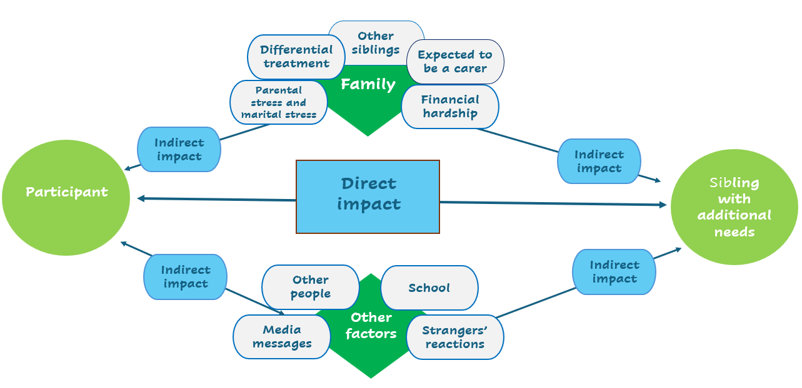

However, it is important to remember that as well as being the sibling of a child with additional needs, experiences of siblinghood overlap with those of all children with siblings. Thus, many of the positives and challenges would still be the same even if their sibling did not have additional needs (Dodd, 2004).
1.3 Research findings
1.3.1 Scope of my literature review
Whilst giving primacy to research from academic peer-reviewed articles, I did not confine my research to the academic literature. In general, my sources fell into three types of literature: quantitative and qualitative studies published in journal articles and books, “Grey literature”, and published books best described as memoirs or collections of memoirs from adults who have themselves grown up with a sibling with additional needs.
In using the term “grey literature” I am referring to “… literature which is produced by all levels of government, academics, business and industry, but which is not controlled by commercial publishers” (University of Southampton, 2024) including
“… documents created by government departments, academics, professional bodies, charities, non-governmental organisations, royal colleges, businesses, and industries … interviews, research reports, blogs, working papers, podcasts, conference proceedings (some published by academic publishers), theses, white papers, policy documents, guidelines, clinical trials, and social media posts” (University of Southampton, 2024).
Online literature from charities was especially relevant.
The danger of using grey literature and memoirs is that these have not been peer-reviewed. However, these are often written by “experts by lived experience” (Lynch et. al., 2024), providing rich qualitative data. Reading first person accounts enriched my understanding of the area and allowed me to notice common themes which may have been less striking when reported on by academic researchers. Additionally, although newspaper articles are not usually included within the definition of grey literature since they are published, I included these too on occasion, because they often provided up to date information, statistics and lived experience stories (University of Southampton, 2024).
Much of the research about growing up with a sibling with additional needs is quantitative, based on parental reports and correlational analysis. It is only relatively recently that qualitative data has become available, often only in books rather than journal articles. Much of the richest data has been collected by authors who themselves grew up with a sibling with additional needs and those who have gathered first-hand reports from adult siblings (Safer, 2012; Strohm, 2005). Arguably, it is these detailed studies collected by those with lived experience and biographies of now adults who grew up with siblings with additional needs which have the greatest ring of authenticity to them, often highlighting the significant challenges siblings go through. Many of these accounts, along with some of the findings from my Phase 1 surveys, make uncomfortable reading.

1.3.2 Key themes arising from the literature
The key aim of my literature review was to look for common themes and after highlighting the findings of quantitative studies which have considered correlational data, I will highlight themes which were common across several sources, including both quantitative and qualitative studies and the writings of those with lived experience.
Previous literature has not reached a consensus regarding whether growing up with a sibling with additional needs is positive or negative and researchers such as Grossman (1972) have highlighted that there is no universal experience. Different siblings have different experiences since siblings’ experiences occur in a context and each family is different.
Researchers who have used a quantitative approach have often reached negative conclusions suggesting that, overall, siblings of children with additional needs have worse mental health (Cederlof, Larsson, Lichtenstein, Almqvist & Serlachius, 2016; Dinleyici, Carman, Özdemir, Harmancı, Eren, Kırel, Şimşek, Yarar., Duyan Çamurdan, & Şahin Dağlı, 2020; Goudie, Havercamp, Jamieson & Sahr, 2103), worse physical health (Dinleyici, et.al., 2020; Goudie et. al., 2103), and higher rates of behaviour problems (Goudie et. al., 2013; Tritt & Esses, 1988). Benson & Karlof (2008) found a higher rate of adjustment difficulties and lower rates of pro-social behaviour and Chien, Tu & Gau (2017) found poorer attitudes to schoolwork and a higher level of behavioural problems at school. It is important to note that most previous studies are contextualised within a medical model. The medical model views the difficulties which families face as arising from having a child with a disability, rather than from a lack of support systems and societal attitudes towards disability.
In contrast, other researchers have highlighted the positives of having a sibling with additional needs. Many of the positive examples and conclusions relate to character development; such positives include greater perspective-taking skills (Shivers, McGregor & Hough, 2019), opportunities to teach things to their sibling, helping the family, developing problem-solving skills, meeting others, understanding difference, and opportunities to skip theme park queues! (Pavlopoulou & Dimitriou, 2019, 2020). Children whose siblings have additional needs have been reported to be more mature (Barak-Levy, Goldstein & Weinstock, 2010; Peddar, 2015), more likely to be independent and trusted by adults (Fleitas, 2020) and more likely to be grateful for their own health (Carpenter, 1997; Lobato, 1990). Adults who grew up with a sibling with additional needs are also more likely to go into medical and caring careers (Chambers, 2007; Gorelick, 1996; Grossman, 1972; Herrmann, Engelhardt-Lohrke, Martini, Christiansen & Scheppe, 2019).
Previous researchers have found that home life is significantly affected by having a disabled child. Many typically developing siblings are expected to take on additional care of their sibling (Harris, 1994; Klein & Schleifer, 1993; Siegel & Silverstein, 1994; Tritt & Essen, 1988), particularly sisters (Cridland, Jones, Stoyles, Caputi, & Magee, 2016; Harris, 1994; Grossman, 1972). This can lead to a situation where the sibling becomes a quasi-parent, sometimes not only to the sibling with additional needs but also other children and even to the parent, when acting as a confidante (Strohm, 2005; Treasure, Smith & Crane, 2017).
Another common theme in the literature is differential parental treatment with some researchers suggesting that differential treatment can lead to depression, risk-taking behaviours, jealousy, and poor self-worth (Meunier, Roskam, Stievenart, De Moortele., Browne, & Wade, 2021) as well as negatively affecting relationships (Boll, Felling & Filipp, 2005).
Some siblings in previous literature have described feeling that their siblings with additional needs got away with things that they were expected to do such as completing homework (Ford & Thompson, 2021) and that they were held to different standards than their siblings (Harris, 1994; Klein & Schleifer, 1993). Some described this as their sibling with additional needs having power over them, being allowed to always have their own way, get away with things and get them into trouble (Dimitropoulos, Klopfer, Lazar & Schacter, 2009; Dodd, 2004). Some also felt that their parents did too much for the sibling with additional needs (Cridland, Jones, Stoyles, Caputi, & Magee, 2016).
Siblings in some of the literature talked about how, because they could see that their parents were already stressed, they felt that they could not ask for help and support (Carpenter, 1997; Malcom, 2014; Marsh & Dickens, 1997), for example 79% of siblings in Marsh & Dickens study said that their needs had been neglected and 61% said they felt abandoned. It is also important to recognise that not only are time and attention in smaller supply but also that financial resources are diluted (Ford & Thompson, 2021; Grossman, 1972; Marsh & Dickens, 1997; McHale, Updegraff & Whiteman, 2012), just as they are in other families with two or more children.
Many siblings told researchers that their parents had never fully explained their sibling’s condition and the cause (Connors & Stalker, 1997; Grossman, 1972), perhaps wanting to “protect” them from worries (Dodd, 2004). However, a lack of information led to typically developing siblings being frightened (Grossman, 1972; Strohm, 2005), making up their own explanations and blaming themselves (Grossman, 1972; Strohm, 2005). Secrecy also sometimes led to the sibling believing they should be ashamed and that they should keep their sibling’s disability a secret (Edwards, Hadfield, Lucy & Mauthner, 2006; Grossman, 1972; Marsh & Dickens, 1997).
Reports of aggression and violence are not uncommon in the literature (Miller, 2021; Peddar, 2015) with many describing how they have been hurt by their sibling with additional needs (Dodd, 2004; Ward, 2015), an experience made harder because they were forbidden from retaliating (Dodd, 2004). Peddar (2015) described families where the typically developing sibling had been threatened with knives and in one case where a young person had had to attend boarding school for their own safety. Many siblings also described how even when things were fine, it felt like a “ticking time bomb” (Peddar, 2015, p.8) since any respite was perceived to be temporary.
Many siblings have a greater share of household responsibilities whether directly related to their sibling with additional needs, even their medical care (Batarilo, 2022), or more general household tasks such as chores (Grossman, 1972; Peddar, 2015; Tritt & Esses, 1988).
The logistics of taking equipment, wheelchair access, difficulty in finding childcare and fears about the other sibling’s behaviour also meant family trips happened less often, were cancelled, or even abandoned (Fricker, 2022; Miller, 2021; Peddar, 2015).
Another common theme in the literature is for typically developing siblings to report that they had felt the need to be the perfect child, with regards to behaviour and achievement, in order to reduce their parents’ stress and to make up for their parents’ disappointment (Fleitas, 2020; Ford & Thompson, 2021; Grossman, 1972; Harris, 1994; Marsh & Dickens, 1997; Safer, 2002). Grossman found that, in the 1970s, this was a particular pressure for boys. Some talked about how their sibling was praised for any small achievement whilst they were expected to achieve and be good (Ford & Thompson, 2021; Harris, 1997). Some were even conceived as a “savior child” to donate stem cells (Fasbender, 2009, p.18).
Although some researchers did highlight that positive emotions can exist alongside the negative, (Conners & Stalker, 2003; Grossman, 1972; Sporer, Speropol & Monahan, 2019), much of the research suggests that typically developing siblings experience very negative feelings. Many siblings in the literature talked of the sadness they felt for the “normal” sibling they never had (Featherstone, 1980; Strohm, 2005), having less time with their parents (Ford & Thompson, 2021), the things they missed out on such as holidays and day trips as a family (Fricker, 2022), the times when their parents didn’t attend events such as school plays (Ford & Thompson, 2021; Klein & Schleifer, 1993) and a sense of being invisible to others (Hanvey, Malovic & Ntontis, 2022).
Research suggests that many siblings grew up worrying (Connors & Stalker, 2003), fearful that something bad might happen (Marsh & Dickens, 1997; Peddar, 2015), worried about catching their sibling’s condition (Featherstone, 1980; Safer, 2002; Strohm, 2005), worrying about the future (Barak-Levy, Goldstein & Weinstock, 2010), especially future caring responsibilities (Goodwin, Alam & Campbell, 2017), and fear that their own children might have the condition (Batarilo, 2020; Klein & Schleifer, 1993). Children in Tritt & Esses' (1988) study described themselves as the unhappiest member of the family, because of the worrying and feelings of loss and exclusion.
Siblings of those with additional needs are reported to experience guilt: survivor guilt (Lobato, 1990; Marsh & Dickens, 1997; Strohm, 2005), guilt about being jealous of the attention given to their sibling (Klein & Schleifer, 1993), guilt at having a better life (Safer, 2002), guilt at wishing their sibling did not exist (Safer, 2002; Strohm, 2005), guilt at delegating care to professionals (Hanzawa, Bae, Bae, Chae, Tanaka & Nakane, 2013), guilt because they believed they had caused their sibling’s condition (Beavis, 2007; Featherstone, 1980; Fleitas, 2020; Strohm, 2005), and guilt at being embarrassed and secretive about their sibling’s condition and behaviour (Harris, 1994). Some typically developing siblings also report feeling guilty for achieving, knowing that their sibling never would (Lobato, 1990; Strohm, 2005).
Although the stigma related to disability is decreasing (Calhoun & Gold, 2020; Evans-Lacko, Corker, Williams, Henderson & Thornicroft, 2014; Mendle, 2017), families with disabled children still report disapproval from others (Howlin, 1988). Stigma is especially the case when a family member has a mental illness (Abreu-Ellis & Ellis, 2013) and stigma can vary across cultures (Dickinson, 2020; Hanzawa, Bae, Bae, Chae, Tanaka & Nakane, 2013; Tsai, Cebula, Liang, Fletcher-Watson, 2021). Staring is a common theme, with siblings describing strangers staring as one of the worst aspects of having a sibling with additional needs (Fullwood & Cronin, 1989; Pavlopoulou & Dimitriou, 2019; Strohm, 2005). Many siblings reported not wanting to be seen in public with their sibling (Featherstone, 1980) and some siblings reported that they were unable to bring friends homes, due to embarrassment (Abrams, 2009; Carpenter, 1997; Fullwood & Cronin, 1989; Peddar, 2015) or household responsibilities (Pavlopoulou, Burns, Cleghorn, Skyrla & Avnon, 2022; Pavlopoulou & Dimitriou, 2019, 2020; Peddar, 2015).
In a study by Hanvey, Malovic & Ntontis (2021), interviews with 16 older siblings (aged 20-68) found four themes: feeling invisible during social interactions, psychological difficulties resulting from family roles or life conditions, feelings of guilt and self-blame, and social support. Many of their participants were older, and thus we might argue that things have changed. However, a recent social media trend has seen Tik Tok users make videos of themselves talking about their experiences of having a sibling with additional needs leading to them feeling like “glass children” who were invisible to others (Baldwin, 2023; Butler, 2023; Charlton & Charlton, 2023). These Tik Tok videos and recent newspaper articles (Ayoub, 2023; Batarilo, 2022; Dooney, 2023) demonstrate that ambivalent and negative experiences still exist.
Reviewing the literature with its such stark findings left me feeling deeply uncomfortable because of the evident “negative narrative” (Hayden, Hastings, Kassa & Danylec, 2022, p.997.). The writers of existing literature largely framed these difficult experiences within the medical model, locating the challenges within the child themselves as being the source of negative experiences rather than within the social model which locates the challenges within the barriers which families experience. At the same time, I wanted to acknowledge the voice of those who had had such difficult experiences. This was what led to my including the two survey questions “What would you say was the best thing about having a sibling with additional needs?” and “What would you say was the most difficult thing about having a sibling with additional needs?”
1.3.3 Research about schools
Research about families with disabled children from the sibling’s point of view is rare, research about school experiences is even rarer, practical suggestions from siblings themselves are rarer still and few researchers have considered school experiences. Research about academic experiences is also largely non-European (e.g. Barak-Levy, Goldstein & Weinstock, 2010 [Israel]; Chien, Tu & Gau, 2017 [Taiwan]; Gan et. al., 2018 [Australia]; Grossman, 1972 [USA]) and quantitative (e.g. Barak-Levy, Goldstein & Weinstock, 2010; Goudie, Havercamp, Jamieson & Sahr, 2103, Orsmond & Seltzer, 2007).
A handful of studies which explore academic and school experiences stand out: those of Fletcher, Hair & Wolfe, (2012), Gan, Lum, Wakefield, Donnan, Marshall, & Burns, et al. (2018), and Gregory, Hastings & Kovshoff (2020), along with more recent studies by Pavlopoulou and colleagues (Kassa & Pavlopoulou, 2024; Pavlopoulou, Burns, Cleghorn, Skyrla & Avnon, 2022; Pavlopoulou & Dimitriou, 2019, 2020) which will be discussed later.
Having conducted a systematic literature review of 28 studies about siblings of children with chronic illness, Gan, Lum, Wakefield, Donnan, Marshall, & Burns, et al. (2018) concluded that “Overall siblings experience negative effects in psychological, social and academic domains of school functioning” (p.31) which might “present symptomatically in a school environment” soon after finding out about their sibling’s diagnosis (p.31). Gan et. al. also highlighted changes in family daily routine, poorer attendance and academic outcomes, and a risk of post-traumatic stress. Students in the study reported mixed experiences of teachers’ support and interactions and Gan et. al. suggested that “more targeted school support networks may provide siblings with the support that they need or otherwise lack within the family context” (p.31), although they recommend further research rather than make concrete recommendations about what such support might entail.
A study by Gregory, Hastings & Kovshoff (2020) comparing 65 students with an autistic sibling with a control group of 57 students whose sibling did not have autism, found lower levels of academic self-concept and school belonging, poorer school-related outcomes, and higher levels of challenging behaviour for those with an autistic sibling.
A longitudinal, multi-generational study of 4,800 families by Fletcher, Hair & Wolfe (2012) found reduced maths and language achievement when a sibling had epilepsy, autism or learning difficulties. A drawback of longitudinal studies however is that the data is relatively old and so participants in Fletcher et. al.’s sample would be from an older generation. The impact of societal changes on disabled people and their families will be considered in Chapter 4.
Where researchers have considered school experiences, this has often been via parental reports (e.g. Cuzzocrea, Larcan, Costa & Gazzano, 2014; Gan, Lum, Wakefield, Donnan, Marshall, & Burns, et al., 2018) and where teacher perspectives are sought, this is nearly always via a rating-scale (e.g. Lobato, Kao, Plante, Seifer, Grullon, Cheas & Canino, 2011). Thus, the voice of the sibling is missing. Teacher predictions have been shown to be slightly more in line with sibling self-report than those of parents (Verhulst, Koot & Van der Ende (1994). Whilst it is important to note that whilst considering teachers’ perspectives as well is likely to give a more holistic picture, it is important to recognise that teachers too often cannot recognise internalising problems.
Findings of some quantitative studies suggest a correlation between having a sibling with additional needs and negative school outcomes (Dinleyici, Carman, Özdemir, Harmancı, Eren, Kırel, Şimşek, Yarar, Duyan Çamurdan, & Şahin Dağlı, 2020; Gregory, Hastings & Kovshoff, 2020). Children with siblings with additional needs have been shown to have more academic difficulties (Barak-Levy, Goldstein & Weinstock, 2010), poorer attitudes to schoolwork (Chien, Tu & Gau, 2017), achieve lower grades (Bortes, Strandh & Nilsson, 2020; Fletcher, Hair & Wolfe, 2012), have more difficulties with social skills and worse mental health (Cuzzocrea, Larcan, Costa & Gazzano, 2014). Cuzzocrea et. al. also note the potential effect of this on teachers who often “… live in a state of material and emotional uneasiness” (p.56).
Whilst such findings can sound pessimistic and determinist, it is of course important to highlight that such findings are often based on correlation. Whilst there is a statistical correlation between having a sibling with additional needs and the outcomes listed above it does not necessarily mean that having a sibling with additional needs causes these negative outcomes (Australian Bureau of Statistics, 2023) any more than a correlation between ice cream sales and shark attacks means that buying ice cream leads to shark attacks (Bobbit 2024).
Just as the correlation between sales and shark attacks is due to a third variable (hot weather) the correlation between having a sibling with additional needs and negative outcomes may be correlated with financial difficulties, stressed parents, housing, and/or constraints on other areas of life. In fact, Hayden, Hastings Kassa & Danylec (2022) found that siblings who experienced subjective poverty had worse outcomes than those from more financially well-off families. Grossman (1972) also highlighted that better support for less well-off families would likely reduce the need for the institutionalisation of disabled children. I will consider an alternative social model perspective later in this chapter.
Furthermore, it is important to emphasise that effects such as poorer school outcomes do not occur in a vacuum and “Schools can provide an island of tranquillity and routine, a secure base for children whose lives are chaotic or dangerous” (Masten, 2015, p.218) and that, for some, school can be a place of respite, providing an opportunity to forget about their responsibilities (Miller, 2021).
Too often in schools though, the typically developing sister (and it usually is the sister) also becomes an informal carer at school, acting as “big sister”, “mother-hen,” “maternal”, “protector”. and “bodyguard”. (Cridland, Jones, Stoyles, Caputi & Magee, 2016, p.199), being taken out of class to de-escalate a sibling who is having a meltdown (Miller, 2021) or becoming the go-between linking school and parents (Pavlopoulou, Burns, Cleghorn, Skyrla & Avnon, 2022). This is a practice which schools can change, if they are made aware of the importance of removing responsibility from the sibling.
Literature also suggests that typically developing siblings are often invisible within the school system (Peddar, 2015; Thomas, Stainton, Jackson, Doubtfire & Webb, 2003) and are often only drawn to teachers’ attention via the school disciplinary systems due to absence or lateness (Peddar, 2015; Thomas et. al., 2003), failure to complete homework to a satisfactory standard (Goudie, Havercamp, Jamieson & Sahr, 2103; Pavlopoulou & Dimitriou, 2019, 2020) or difficulty in concentrating, due to either lack of sleep (Beavis, 2007; Pavlopoulou, Burns, Cleghorn, Skyrla & Avnon, 2022) or preoccupation with worries beyond the classroom (Dodd, 2004; Marsh & Dickens, 1997; Pavlopoulou & Dimitriou, 2019, 2020; Peddar, 2015; Whiley, 2009). Sometimes typically developing siblings exhibit challenging behaviour (Alderfer & Hodges, 2003; Miller, 2021) or become withdrawn (Alderfer & Hodges, 2003; Peddar, 2015) and frequently schools focus their attention on the child with additional needs rather than their sibling (Gan, Lum, Wakefield, Donnan, Marshall, Burns et. al., 2018).
Many typically developing siblings talk about bullying, either of their sibling (Cridland, Jones, Stoyles, Caputi & Magee, 2016; Miller, 2021) or themselves (Cridland, Jones, Stoyles, Caputi & Magee, 2016; Featherstone, 1980; Miller, 2021; Ward, 2015). Some report that there is a family expectation that they will protect their sibling (Pavlopoulou, Burns, Cleghorn, Skyrla & Avnon, 2022; Peddar, 2015; Pavlopoulou & Dimitriou, 2019, 2020) and some report that they kept bullying secret (Connors & Stalker, 1997; Miller, 2021).
Arguably, typically developing siblings “… may lack control over their lives if most of their time is spent helping others and meeting their parents’ needs” (Barak-Levy, Goldstein & Weinstock, 2010, p.163) and there is a danger that schools reinforce an expectation of helpfulness by encouraging peer mentoring and praising students for being helpful. Yet perhaps schools should be taking active steps to advocate that such siblings have alternative experiences and respite, providing extra-curricular opportunities and supporting families with overcoming barriers to involvement such as financial costs and difficulties with transportation (Barak-Levy, Goldstein & Weinstock, 2010; Miller, 2021).
A recent study by Pavlopoulou, Burns, Cleghorn, Skyrla & Avnon (2022) explored the experiences of 28 students with an autistic sibling, investigating shared time at home and school and the support which the sibling had received and/or felt they needed. Pavlopoulou et. al. found that home experiences affected schoolwork because of the lack of personal time and disruptions to sleep. The summer holidays were particularly hard because of unstructured time and on returning to school after a “holiday” the students were exhausted.
Pavlopoulou et. al. (2022) found that at school, their sibling’s additional needs still often affected them because of disruptions such as helping teachers and intervening to avoid situations escalating. Being in the same school, especially being in a nearby classroom, was particularly difficult as the typically developing sibling witnessed and heard about their sibling’s behaviour. Siblings often had to resolve conflicts during break and often felt staff did not intervene enough. Siblings also often had to educate other children about why their autistic sibling behaved the way they did (Pavlopoulou, Burns, Cleghorn, Skyrla & Avnon, 2022). Students in the study really appreciated extra-curricular activities as an opportunity to socialise and develop other skills (Pavlopoulou et, al., 2022). This is particularly important given that some researchers have found that siblings of children with additional needs are less likely to take part in leisure activities (Barak-Levy, Goldstein & Weinstock, 2010).
Students in Pavlopoulou et. al.’s study (2022) also said their parents rarely helped them with their homework, either because they were busy with their sibling or because their parents presumed they were able to study without help. Siblings stated that having an opportunity to complete homework at school would be really helpful.
One new finding was that participants talked about feeling especially connected to peers and teachers who were either autistic themselves or who had personal experience with autism. Talking to these people normalised the experience and helped them offload (Pavlopoulou et. al., 2022). Participants said it was difficult to talk about their autistic sibling because they expected negative reactions and feared being stigmatised. Some talked about how only others with an autistic sibling could understand. This finding suggests that there is a place for schools to facilitate siblings meeting each other, being aware of each other and the value of staff being open about their own lived experiences.
Pavlopoulou et. al. (2022) also found that siblings of those with additional needs appreciated opportunity to talk to staff about home issues and to debrief after incidents. They also wanted to challenge staff misconceptions about autism and described how staff were often inflexible when working with their autistic sibling. A key recommendation from Pavlopoulou et. al.’s (2022) study was the importance of a whole school approach towards disability which needed to be embedded within the school culture and curriculum, proposing that families of autistic children should be involved in co-designing this, so affecting ethos, vision, and programmes.
Likewise, Dickinson’s (2020) study demonstrated that when a special school in Southern India provided outreach and support for the whole family and the local community, attitudes became more accepting. This study was especially important because it demonstrated the power of schools in the community, in a region where previously there had been a lot of shame and stigma about disability.
Pavlopoulou et. al. (2022) also made recommendations for the involvement of educational psychologists (EPs), suggesting that the EPs’ role might include systemic work such as training, consultation, and promoting autism awareness amongst staff and students. Pavlopoulou et. al. suggested that
“Educational psychologists might use adjustment questionnaires and experience-based conversations employing a Lifeworld framework to assess siblings’ needs, or strengths and the position siblings hold in each other’s lives at home and school. Understanding, for instance, the sense of belonging or the sense of place drawn upon siblings’ accounts might equip professionals to make suggestions that could improve educational outcomes, identify wellbeing struggles, and co-develop solutions. An experience-based approach also benefits by drawing attention to the siblings’ experience in their human relationships” (Pavlopoulou et. al., 2022, p.12).
However, it is important to note that Pavlopoulou et. al. (2022) limit their recommendations to students with autistic siblings and that there is a paucity of research about those whose siblings have different types of needs.
Another recent study commissioned by the charity Sibs (Kassa & Pavlopoulou, 2024) surveyed over 200 siblings (aged 5-16 about school) and found that: 43% felt the school did not understand what it was like for them, 34% had problems getting homework done, 30% found friendships hard, 30% were tired from lack of sleep, 19% found being on time difficult and 5% had to help their sibling with additional needs at school. 74% of children said that they had received no help from school.
Kassa & Pavlopoulou (2024) recommended that schools actively seek to support siblings including stressing that they are not responsible for the care and support of their sibling at school, by creating sibling groups, making reasonable adjustments regarding lateness, homework and organisation, and giving discreet individual support including asking students how they are (not in relation to their sibling) and taking every opportunity to let them come first. However, it is important to note that there was no comparison group and many children without siblings with special needs may have also answered yes to such questions.
1.3.4 Grossman’s study
In closing this section, I wish to mention one of the oldest studies in this area, that of Grossman (1972). Whilst one of the earliest studies, it proved surprisingly still relevant when I came to analyse my results, especially since Grossman’s findings stressed the impact of contextual and external factors on families. Grossman’s study compared 83 college students (aged 18-25) who had a sibling with learning difficulties (in her words “retardation”), and 66 control group participants. She divided her sample into four subgroups: men who attended an Ivy League institution, women who attended a private college, men who attended a community college and women who attended a community college. Participants in Grossman’s study provided demographic data, took part in semi-structured interviews, and completed several tests. Transcripts were then quantitatively coded using 40 different measures (See Appendix A) and statistically analysed to look for correlations between each of the measures. The data was also reported on qualitatively, with quotations used to illustrate discussion of the data.
In many ways, Grossman’s study (1972) was unique. Although predating Bronfenbrenner, and in the early days of the disability movement when the social model was in its infancy, Grossman (1972) analysed her data from the social model and ecological perspectives. Additionally, she looked for correlations between multiple measures and across the four groups. These comparisons allowed her to find differences between students according to gender, birth order and socio-economic backgrounds, all of which proved relevant to my own findings. She also considered variables such as religion, family size, time spent with the sibling, participant’s relationships with their sibling and parents, and family openness to talking about the disability, even comparing this to family discomfort in talking about sex.
Regarding socio-economic status and class, Grossman concluded that having financial resources made a difference since when families could “purchase services”, siblings (especially men) were often “protected” by their parents, with men often “exempt from intensive caretaking responsibility” (p.177). Grossman also highlighted the impact of socio-economic factors in what was sometimes the primary challenge of having a disabled child. For families with less financial resources, it was the financial and caring pressures which were the main challenges whilst for more affluent families, psychological factors had greater influence through the
“… frustration… [of parents’] “… aims and goals. both in terms of what they want from their children and their image of a “happy family life” … The heavy emphasis placed on the growth and development of the children inevitably heightens the psychological impact on the well-to-do family of a child with limited ability to develop” (p.62).
Gender of both the participant and their sibling was key. Being the same gender as the disabled sibling led to greater embarrassment and there were different patterns according to whether the disabled sibling was a boy or girl, with participants more likely to talk about a brother than a sister.
Gender expectations also played a part with different pressures according to a sibling’s gender. In America in the 1970s, boys were rarely expected to play a significant role in caring for siblings. When the participant was a boy, this often led to pressure on them to fulfil the family’s dreams of a successful career and family and to carry the family name on. Parents, especially fathers, often found it easier to accept the disability of a daughter than a son because their expectations for daughters were in the domestic realm.
Grossman’s participants also talked about their mothers being involved with caring for the disabled sibling more than their fathers. Sometimes they were unaware of how much their mother did for their sibling. For girls, especially those attending the community college, there was a presumption that they would take responsibility for their sibling, whether by being a second mother or helping out at school, something which restricted freedom to take part in peer group activities.
Birth order made a difference. Elder siblings had better coping scores, knew more about their sibling’s condition and described their family as being more accepting of disability. Grossman (1972) attributed this to multiple factors, including being older when their disabled sibling was born, being expected to be more independent as the older child and being able to take a more “parental stance” (p.189). She also stressed that helping a younger sibling provided participants with “a sense of mastery … reducing their sense of impotence and frustration [since] Disciplining and controlling [their sibling] allows an acceptable outlet for their aggression” (p.190).
Conversely, younger siblings identified more with their sibling’s disability, sometimes competing with their disabled sibling, and struggling with issues such as “who should be the boss of whom and who should have the privileges of the older child” (p.190) such as bedtime and allowances. Grossman also highlighted how, since parents often found it easier to accept a disabled child when they already had a “normal” older child, birth order affected how parents demonstrated acceptance of the disabled sibling.
Grossman also highlighted how family size made a difference, especially for community college women. Taking gender and family size together she stressed that having a child with learning difficulties is most difficult when a child, whether disabled or not, “carries a major part of the hopes, wishes, and aspirations of the parents” (p.190). A large family means that the need to need to fulfil the dreams of the parents are shared, as are any household caring responsibilities.
A further key factor was to what extent the participant’s mother and/or father had accepted the disabled child. Where the disabled child was an only boy this was especially difficult for parents to cope with. Parental acceptance also varied according to which of the college groups the participant was part of and the gender of both siblings, showing the interplay of factors within the participants’ ecological systems.
Another crucial factor was the extent of the sibling’s disability, whether their disability was visible and whether the disability was intellectual or physical. This also varied according to social class, for example the women in the community college were more distressed by their sibling’s mild learning difficulties since this meant that their sibling with additional needs was aware of their difficulties. However, the community college women coped better when physical disabilities were less, presumably because they had fewer caring responsibilities, and their workload was lower. However, Ivy League men were better adjusted when the sibling’s physical disability was greater. Perhaps this was because their sibling’s very visible physical disability meant there was less ambiguity about their development and so family members did not hold out false hope for a better outcome.
Grossman’s analysis also found that information and parental responses to children’s curiosity were particularly important. Where parents had withheld information or been reluctant to talk about the topic, not only did this mean that the participants had been unclear about the cause of their sibling’s disabilities, perhaps developing “elaborate and terrible fantasies … far worse than the realities could ever be” (p.121) but also, Grossman argued, that they had also learnt that curiosity in itself was to be avoided, which would potentially affect their learning and academic progress.
Grossman analysed the data to allocate each participant to one of three groups according to whether she considered their experiences to be negative, neutral, or positive (See Figures 27 and 28 in Appendix B). She concluded that:
- overall, private school students had been affected either more negatively or more positively than community college students, with college students more likely to fall into the neutral category
- overall, more women were negatively affected than men
- overall, about 45% of Grossman’s participants had benefited from having a disabled sibling, 45% had been harmed and 10% had neither benefited nor been harmed.
- of the 45% who Grossman considered harmed she described

“students who were bitterly resentful of the family’s situation, guilty about their rage at their parents and at the retarded sibling, fearful that they might be defective or tainted; sometimes truly deprived of the time and resources they needed to develop because every support the family had was used in the care of the handicapped child” (p,176).

One of Grossman’s key goals was to look for characteristics of siblings who had benefited from growing up with a sibling with learning difficulties. She identified “gains” for her participants as greater tolerance for those who are different, a sense of family closeness and that their experiences had led to them pursuing careers where their experiences would give them greater insight and empathy. She identified “harms” as shame, “angry bitterness”, guilt about their own health and resentment towards their sibling, as well as feeling cheated of attention from their parents
Grossman’s book (1972) also included her reflections on a family where she had treated a sister of a boy with learning difficulties who had been institutionalised, and a support group for adolescents who were living with a sibling with learning difficulties; her reflections on these other two studies influenced her interpretation of the data in her college student study.

Grossman (1972) argued that the original organic basis for the child’s learning difficulties “…comes to have a variety of meanings for the family” (p.38), highlighting that not all families respond in the same way and that some families find positive adaptive ways of coping. Grossman argued that certain parental behaviours and attitudes are key to siblings’ experiences: how parents respond to stress, talk about the child’s disability, deal with their own feelings towards the child and teach siblings to do so, how parents explain and help other children in the family to understand their sibling’s disability and how they handle community relations.

Grossman considered the ecological settings of the participants and challenged a “within child” view of the time. Although not using the terms social model and medical model, Grossman (1972) critiqued the medical model, highlighting that in America
“… mental retardation and other serious handicaps often are viewed and treated as if they were primarily – or only – problems residing in the affecting individual … as the child and his slow development … are the whole of the problem, and if we can only help him to be different … we will have solved the problem…” (p.2)
Instead, Grossman sees the children’s experiences as contextualised within the child’s ecological system, stressing” … the importance of the cultural response to retardation” (p.3) and highlighting the narrowness of a “change the child” (p.2) approach.

Grossman also stressed that any impact of growing up with a sibling with learning difficulties is affected by wider factors in the ecological system, including the family’s response to the child’s learning difficulty, age, gender and birth order, the financial resources of the family, societal views about institutionalisation, and the degree of the disabled child’s difficulties. Thus, the experience of growing up with a sibling who has additional needs always interacts with wider factors.

Grossman also argued that the differing challenges created by social class called for different interventions. For families from upper socio-economic classes, the intervention which would most benefit siblings would be to work directly with their parents early on so that parents come to terms with their disabled child and are then more open with other children. For those of lower socio-economic classes, Grossman argued that more practical help should be available within the community so that families can keep the disabled child at home and so that other children can cope more adaptively with their sibling’s disabilities.

It is important to stress that Grossman’s study took place at a time when many disabled children were institutionalised often “for the sake of the other children” (p.158), and when children with disabilities did not often attend mainstream schools; this meant most Americans had never met a disabled person. Also at the time, giving birth to a disabled child was seen as even more of a tragedy, and gender roles were more rigid. Additionally, since Grossman’s participants were American students who had coped sufficiently well to get to higher education, the impact of financial pressures and access to education and medical care would have been even more challenging for those families who had limited means and where the siblings had not gone to college.
1.4 Critique of existing research
Previous researchers have reported negative outcomes for siblings, although there is a small body of research which highlights positive effects (Barak-Levy, Goldstein & Weinstock, 2010; Fleary & Heffer, 2013; Fleitas, 2020; Herrmann, Engelhardt-Lohrke, Martini, Christiansen & Scheppe, 2019; Pavlopoulou & Dimitriou, 2019, 2020; Peddar, 2015; Shivers, McGregor & Hough, 2019).
There are multiple explanations for the differing findings:
Different quantitative studies use different measures. Over a hundred measurement tools have been used in quantitative studies (See Appendix C). Some studies use parent-report and some self-report by the typically developing siblings themselves. This is significant because often parent and self-report elicit different results. For example, parent ratings in Alderfer & Hodges’ (2010) study suggested that siblings were more likely to have borderline or clinical scores for internalising, externalising and aggressive behaviour, anxiety and depression, somatic complaints, and aggressive behaviour, whilst scores from the siblings themselves were in the normal range.
However, in other studies, parents have rated their typically developing child as having greater difficulties than the child self-rated (Raghuraman, 2008); this could be explained by a socially desirable response from the child or an unsubstantiated fear of the parent that their child is hiding their worries. Senner & Fish (2012) also note that the divergence between parent and child reports can be in both directions, something which might be smoothed out in meta-analysis or large-scale studies.
One weakness of quantitative studies is that measuring and comparing, does not describe nor explain such differences, suggest ways to mitigate negative experiences nor suggest protective factors and ways to support siblings. Nor do such studies take account of individual differences, report on the range of scores, or discuss outliers in the data. Thus, there is a need for more qualitative studies.
Where qualitative studies exist, these often gather information from parents and thus risk bias (Connors & Stalker, 2003; Ferrey, Hughes, Simkin, Locock, Stewart & Kapur et al., 2016; Gan, Lum, Wakefield, Donnan, Marshall, Burns et. al., 2018). Some studies do include children but where participants under 18 are interviewed directly this is often in their parents’ presence (albeit for good ethical reasons), often in the family home, and certainly with their parents’ knowledge of the interview (Bhattashali, Ostrosky & Monda-Amaya, 2018; Connors & Stalker, 2003).
Such practice runs the risk of children giving socially desirable answers (Camerini & Schulz, 2018; Edwards, Hadfield, Lucey & Mauthner, 2006; Davies, 2023). This is especially the case in some cross-cultural studies. For example, in Dickinson's (2020) Indian study the children were not only interviewed in their parents’ presence, but the translator was a member of the community, thus underlining that the researcher comes from another cultural background and is an outsider. Given the expectation of keeping things within the family and/or community in some cultures, this calls into question the validity of such studies if only positive results are found.
Additionally, little research captures the voice of siblings themselves. Research has suggested that many children and young people do not want to burden their parents with their concerns and thus they internalise their feelings, often with consequences in the long term (Cederlof, Larsson, Lichtenstein, Almqvist & Serlachius, 2016; Hayden, Hastings, Kassa & Danlyec, 2022; Strohm, 2005). Collections of biographies of adults often talk about how, as children, they had felt that there was a pressure to be the perfect family, even to be saintly (Featherstone, 1980: Fullwood & Cronin, 1989; Safer, 2002), which meant participants only talked about positive experiences and feelings. Many adults who reported more negative experiences described how media, family and community members made them feel that they should be positive about their family’s experience (Strohm, 2005), and criticism of the family is sanctioned in some cultures (Tsai, Cebula, Liang & Fletcher-Watson, 2021).
Furthermore, gathering data via parental voice is a step removed from that of the siblings themselves and in taking parental accounts of children’s experiences at face value, the researcher is interpreting the parents’ interpretation of the children’s experiences, which is problematic from a critical realist perspective (Fryer, 2020; Montague, Phillips, Holland & Archer, 2020).
Samples are also often convenience samples and many studies do not include control groups. Another factor is that it is not easy to compare studies because studies use different categories of additional needs in their samples and not all samples are homogeneous, for example, Dodd’s (2004) sample included siblings with Down’s (sic) syndrome, developmental delays, other chromosomal disorders, autism, cerebral palsy, profound and multiple learning disabilities, and medical conditions. The research base is also biased towards siblings with autism (e.g., Brouzos, Vassilopoulos & Tassi, 2017; Gregory, Hastings & Kobshoff, 2020), learning difficulties (e.g., Bailey, Hastings & Totsika, 2021; Grossman, 1972; Hayden, Hastings, Kassa & Danylec, 2022) cancer (e.g. Kaplan, Kaal, Bradley & Alderfer, 2013) and mixed medical conditions (e.g. Olivier-D’Avignon, Dumont, Valois & Cohen, 2017a, 2017b). In some cases, the sample inclusion criteria were as vague as “disability” (Goudie, Havercamp, Jamieson & Sahr, 2013) or “life-threatening” (Olivier-D’Avignon, Dumont, Valois & Cohen, 2017a, 2017b).
It is also important to highlight that, even where siblings have the same diagnosis, the samples may still be different. Rixon, Hastings, Kobshoff & Bailey (2021) subdivided their sample into five categories of autism and found that siblings of autistic children with higher adaptive skills, fewer autistic traits, and less internalising and/or externalising problems had more positive outcomes, whilst neurotypical siblings who had the most problems themselves tended to have siblings who had higher internalising and externalising problems and lower levels of social skills, thus highlighting the importance of taking an ecological systems approach.
As well as the methodological limitations of existing research, most research comes from a medical (e.g. Kaplan, Kaal, Bradley & Alderfer, 2013), academic (e.g. Beavis, 2007; Shivers, McGregor & Hough, 2019) or social work perspective (e.g. Liegghio, 2016; Shor & Birnhaum, 2012) and considers experiences solely within a family setting (e.g. Pit-Ten Cate & Loots, 2000; Woodgate, 2006). Apart from recent studies by Pavlopoulou et. al. (2022) and Kassa & Pavlopoulou (2024), there is little qualitative research about schools. Yet 45.2% of parents in Gan et. al.’s (2018) study said that they believe their typically developing child had school difficulties, including worrying about their sibling, absences, caring responsibilities and having less parental attention. Hastings (2022) recommended that more attention is needed regarding problems siblings may experience in school, difficulties in peer relationships, other domains such as embarrassment in public and the effect of other people’s responses to the child with a developmental disability.
It is important also to remember that there may well be other compounding variables, for example, Hayden, Hastings, Kassa & Danylec (2022) found that “where adult siblings had low levels of subjective poverty, carer status was associated with siblings’ mental distress, wellbeing, and quality of life” (p.995).
Furthermore, much of the research has been done in America (e.g. Fleary & Heffer, 2013; Rosenthal, Gillette & DuPaul, 2021; Shivers, 2019), Australia (e.g. Bowman, Alvarez-Jimenez, Wade, Howie & McGorry, 2017; Cridland, Jones, Stoyles, Caputi & Magee, 2016; Gan, Lum, Wakefield, Donnan, Marshall & Burns, 2018) and Canada (e.g. Fisman, Wolf, Ellison & Freeman, 2000; Liegghio, 2016; Marquis, McGrail & Hayes, 2019). There are significant political, cultural, and geographical differences between those countries and the UK which may affect findings (Pit-Ten Cate & Loots, 2000). These include smaller distances between cities in the UK, a free NHS, and the existence of Disabled Living Allowance (DLA) for families (Gov.uk, 2023). These may mean that financial and other pressures on families in the UK with a disabled child are not as strong and decisions about where to live, work, and go to university are less hampered by barriers such as distance from the family (Hayden, Hastings, Kassa & Danlyec, 2022).
One further factor is that much of the literature is quite old (e.g. Burke, 2004; Carpenter, 1997; Featherstone, 1980; Grossman, 1972) and therefore often reflects the experiences of older adults.

1.5 Summary of the literature review
- Far more literature exists which relates to parents’ experiences than that of siblings
- Most research is not British
- Predominantly, research has been into participants whose sibling has autism, learning difficulties and/or a medical condition
- Some of the literature relates to those who are now considerably older than the current cohort of school children
- Predominantly, previous researchers have reported negative experiences and negative outcomes
- Academic research has been biased towards quantitative research
- The main source of rich qualitative data has been that of those with lived experience rather than peer-reviewed academic research
- Common themes in the literature are: parentification, differential treatment, invisibility, secrecy, and a lack of information about the disabled sibling’s condition, reports of physical harm, additional responsibilities, the need to be the perfect child, positive and negative emotions, and stigma
- Research about schools has suggested: academic functioning is negatively affected; siblings often support their disabled sibling at school; siblings are often given additional responsibilities at school because they have the skills; siblings needs are often invisible; bullying happens; siblings’ home experiences affect their schoolwork; siblings appreciate the opportunity to talk about their experiences to staff with personal lived experience

1.6 The Social Model of Disability
My approach was also informed by the social model of disability. The social model arose within the disability civil rights movement (Lisicki, 2013; Mason, 2005; Oliver, Sapey & Thomas, 2012; Oliver, 2013; Sheldon, 2006; UPIAS, 1976) and separates out impairment: “… a characteristic of the mind, body or senses within an individual” (Oliver, Sapey & Thomas, 2012, p.16) and disability: “…the disadvantage or restriction of activity caused by the political, economic and cultural norms of a society which takes little or no account of people who have impairments and this excludes them from mainstream activity” (Oliver, Sapey & Thomas, 2012, p.16. See also Lisicki, 2013; Shakespeare, 2002; Thomas, 1999; UPIAS, 1976).
As can be seen in Figures 3 and 4 below, the traditional medical (or individual) model of disability presumes a “within-patient” view of disability, focusing on the physical and mental restrictions of disabled people (Oliver, Sapey & Thomas, 2012; Titchkosky, 2011), considering disability from a tragedy perspective (Goodley, 2001; Mason, 2005; Titchkosky, 2011), and focusing on what a disabled person can’t do (Lisicki, 2005).
The medical model also presumes that the disabled person needs medical intervention and care from other non-disabled people, placing disabled people in a position of powerlessness, vulnerability, and dependency on non-disabled people (Lisicki, 2013; Oliver, Sapey & Thomas, 2012; UPIAS, 1976). This is represented in Figure 3 below (Lisicki, 2013).
Figure 3 The Medical Model of Disability
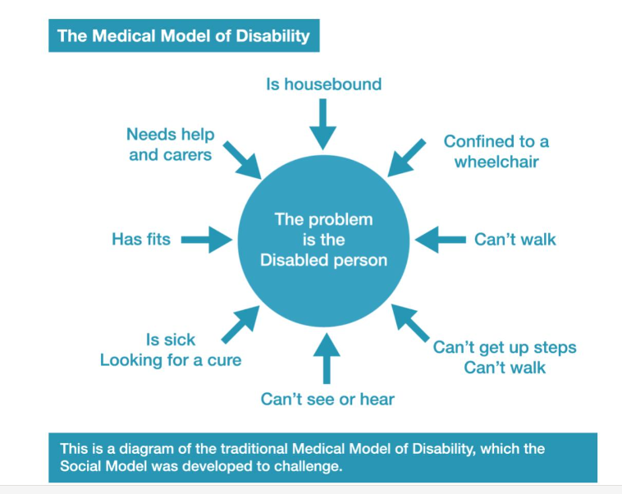
(Lisicki, 2013)
Thus, the disabled person is seen as a “departure from the desired and expected” (p.5, Titchkosy, 2011, P.5) and is reduced to
“… that of a dependent, in which his right to free choice, action and association are curtailed in direct proportion to the degree of his disability and the extent of his financial means … causing the disabled person’s isolation and exclusion from full participation in society” (UPIAS, 1976, p.22).
which Titchkosky (2011) equates to “the oppression of the ruling orders of the day – colonialism, patriarchy, classism, and able-ism … supported by the capitalistic enterprise of scientific knowledge” (p.131). The word colonialism struck me as an apt metaphor because often disabled people have been overruled by the powers of others, by medical professionals who “invade” their bodies, staff in residential homes who control their activities and perform personal care, whilst living in a climate where politicians and the media demand disabled people find work.
In contrast, the social model of disability takes the view that the difficulties which disabled people experience are due to the environment and the beliefs and attitudes of non-disabled people, which create a “disabling world” (Lisicki, 2013). The social model highlights three key disabling barriers: social and cultural attitudes, physical barriers, and information and communication barriers (Lisicki, 2013). This means that, for children with additional needs “… disability is caused by the reactions of the society into which the child is born” (Oliver, Sapey & Thomas, 2012, p.37) and it is the world which needs to change. This is represented in Figure 4 below (Lisicki, 2013)

Figure 4 The Social Model of Disability
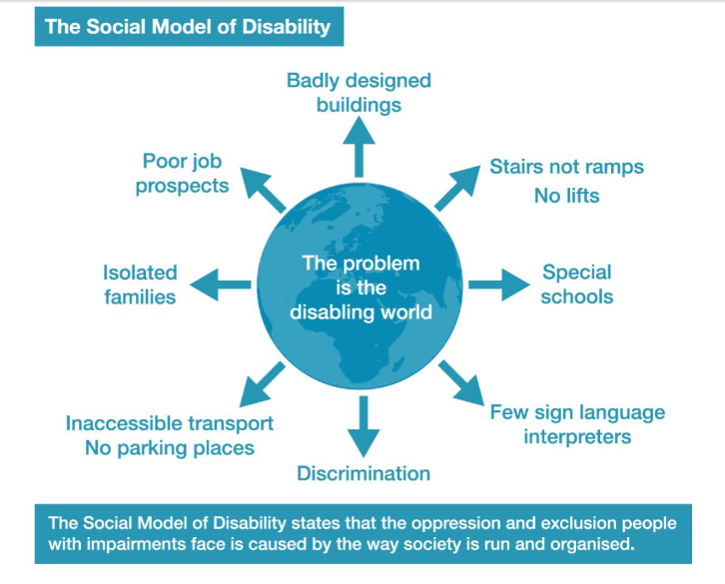
(Lisicki, 2013)
Proponents of the social model argue that when society and the physical environment change, disabled people can live as full and enriched lives as non-disabled people (Oliver, Sapey & Thomas, 2012). For example, Feeley (2016) describes how the Eyegaze software (which generates speech when the user looks at words and symbols on a screen) made it possible for a man with cerebral palsy to speak and write songs.
The social model has come under criticism (Lisicki, 2013; Morris, 1991; Oliver, Sapey & Thomas, 2012; Shakespeare, 2002; Sheldon, 2006) for overstressing external barriers and not recognising the very real medical and cognitive experiences many disabled people experience which will never be overcome by societal change alone (Oliver, 2012; Morris, 1991; Thomas, 1999). As Morris argues
“We should not be made to feel that we have to deny these negative things in order to assert that our lives have value … I would still rather walk than not be able to walk … … This is, however, most definitely not to say that my life is not worth living” (p.71)
I would argue that a ‘strong’ social model stance (Shakespeare, 2002), in highlighting environmental and social factors which can and should be changed, risks excluding person centred approaches (Aruma, 2019; NHS, 2022) and making invisible within-person experiences such as pain and learning difficulties, which cannot be completely eradicated by societal change (Morris, 1991; Shakespeare, 2002; Thomas, 1999). Thus, I would argue for a bio-ecological model which recognises both within-person and external factors (Thomas, 1999).
The social model also fails to fully consider the diversity of types of disability and thus whether disabled people share a collective identity (Corker, 1999; Thomas, 1999). Indeed, the early disability movement was spearheaded by people with physical difficulties, thus ignoring the diversity of disabilities, individual identity, and experience, which cannot be reduced to disability alone (Morris, 1991; Shakespeare, 2002; Sheldon, 2006). Disability also intersects with other types of oppression, such as racism, sexism, social class, age, and sexuality and arguably the disability movement has failed to recognise this (Thomas, 1999).
The social model’s division of humanity into disabled and non-disabled people is also, arguably, a false dichotomy since, some disabled people (and some who identify as able-bodied people) have fluctuating conditions (Corker, 1999; DWP, 2013; Morris, 1991), because most “non-disabled” people experience medical limitations on occasion, and because many people move “…from the ranks of the non-disabled (the non-oppressed…) into the company of ‘the disabled’ (the oppressed)” (Thomas, 1999, p.8) in later life when they have formed their identity as a non-disabled person (Shakespeare, 2002). Nevertheless, I believe that the social model does reflect the reality of many disabled people (Riddle, 2020, p.1511) appropriately highlighting the responsibility of non-disabled people to change what can be changed.
It is important to recognise that the social model is not just a theoretical way of viewing “medical” conditions but underpins a political movement. It is no coincidence that the disability rights movement was historically concurrent with other rights-based movements: the black civil rights movement in America (Campbell & Oliver, 1996), the rise of the trade union movement (Grayson, 2016) and the feminist movement (Dyson, 2016). Thus, the rights of all minoritised voices were becoming louder. For proponents of the social disability movement to truly believe that disability is created within physical and social environments, which could be changed, demanded pressure for change. Although in the early days of the disability movement the focus was on jobs, money, and independent living (Thomas, 1999; UPIAS, 1976) members of the disability movement have also drawn attention to and campaigned about many issues which disabled people and their families face for example:
- The continued use of special schools segregates disabled children from their non-disabled peers, limiting their aspirations and qualifications (Miller, 1991). Although some in the Deaf community wish for Deaf schools to continue (Campbell & Oliver, 1996), arguably, if Deaf culture were to be embraced in mainstream schools true inclusion would be possible for all, as it has been in communities like Bengka (Bali), and nineteenth-century Martha’s Vineyard where Deaf people have not faced barriers with communication because everyone in the community uses sign language (Groce, 1985; Solomon, 2014).
- Representations of disabled people in the media reinforce stereotypes since “Disabled people are missing from mainstream culture. When we do appear, it is in specialised forms – from charity telethons to plays about an individual struck down by tragedy” (Miller, 1991, p.85) or as ugly, evil characters (Morris, 1991). Even in “triumph over tragedy” stories the disabled character is often “rescued” by a non-disabled rescuer (Morris, 1991)
- Writers such as Reeve (2006) and Thomas (1999) have also highlighted the psycho-emotional effects of the medical model, since society emphasises the perfect body and because physical barriers reinforce feelings of exclusion (Titchkosky, 2011).
In considering the UK educational system, I cannot but conclude that the social model and the disability movement perspective are in direct conflict with UK legislation when it comes to special needs and disability. The UK system relies on a medical model perspective where an individual child is given an Educational Health and Care Plan (EHCP) so that the school receives additional resources and/or so the child can access different provision to their peers. This means that
“Instead of expanding what is ‘normally provided’ to cater for a greater diversity of need, an individualised package of support is drawn up for the child. This leads to the current process of assessments, diagnosis, individual educational programmes, specialist help, and possible removal from mainstream school into a separate school or unit …” (Mason, 2005, pp.87-88)
Thus, the UK system focuses on “…’treating’ the child’s defects, not the defects of the system” (Mason, 2005, p.88). Successive Codes of practice on special educational needs and disability (SEND), especially the most recent version (Department for Education and the Department of Health and Social Care, 2015) have been predicated on the medical model, focusing the attention on the individual child in need of help rather than changing the educational system. This often leads to excluding the child with additional needs from being educated alongside non-disabled children and denies non-disabled children exposure to direct experience of disability, making disability invisible, leaving stereotypes unchallenged and perpetuating the “othering” of disabled people.
The barriers highlighted above are the context of the families in which my participants grew up, namely physical and social exclusion and stereotypes about disability. This has been illustrated in Figure 2 earlier which stresses that any impact of growing up with a sibling with additional needs is influenced not just directly between the two siblings but indirectly via other forces.
1.7 Ecological systems theory
Finally, a belief in an ecological systems approach to research (Bronfenbrenner, 1979; 1986, 1993; Bronfenbrenner & Ceci, 1994) underpinned my approach to the research. Bronfenbrenner is credited with developing the ecological systems theory, proposing that human development does not exist in a vacuum but that the environment, and an individual’s perceptions of that environment affects their development. He recognised that there are multiple influences on families. Thus, I recognise that for those who grow up with a sibling with additional needs many other influences are also at work. To quote
Grossman (1972), reflecting on her work as a therapist
“… the “case” is never just the retarded infant, the delinquent adolescent. The “case” is the entire system, influencing and being influenced by the identified child’s problem. It always includes the family and often the neighbourhood, the schools, and the community … part of an entire network of family interactions and patterns” (Grossman, 1972, p.8).
Prior to developing his theory, Bronfenbrenner (1970) had conducted cross-cultural research comparing the way children were brought up in the 1960s in the USSR and America. As an American Russian, Bronfenbrenner was uniquely placed to compare the two cultures and demonstrate the influence of parents, school staff, peers, and the state. Bronfenbrenner considered aspects such as the impact of poor nutrition and health care, widow-headed families, childrearing styles, peer-discipline and the need for peer approval, gender expectations, the loss of the extended family and community housing, the segregation of social spheres by age, the impact of financial pressure on families, the status of teachers, social class and ethnicity. Bronfenbrenner also wrote about the influence of role models and the early impact of TV. The seeds of Bronfenbrenner’s theory arose out of his research contrasting the Russian and American systems, his other cross-cultural research and that of other psychologists who looked at the effects of modelling on children.
Bronfenbrenner modified his model over time (Rosa & Tudge, 2013) but in his early ecological systems theory (1979), he theorised that we are all influenced by four systems: the microsystem, the mesosystem, the exosystem and the macrosystem. Later Bronfenbrenner (1994) and Bronfenbrenner & Ceci (1994) added fifth and sixth systems, those of the chronosystem and genetic inheritance (Bronfenbrenner, 1993; Bronfenbrenner & Ceci, 1994), as illustrated in Figure 5 below:
Figure 5 Bronfenbrenner’s five systems
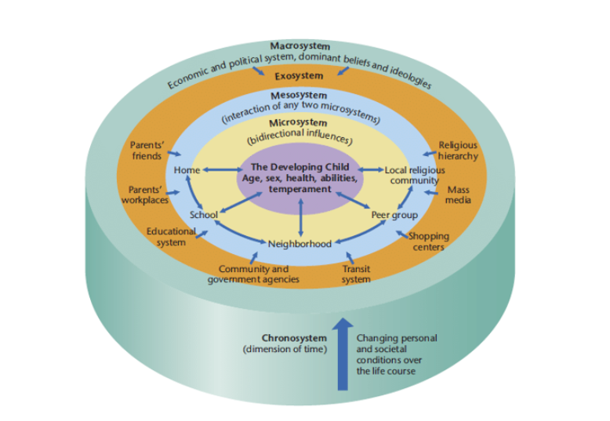
(Mutiara, Mariati, Beng & Tiatri, 2020)

- The microsystem is the environment in which a child lives including the family, school, friendships, and their neighbourhood. Bronfenbrenner described the microsystem as
“a pattern of activities, social roles, and interpersonal relations experienced by the developing person in a given face-to-face setting with particular physical, social, and symbolic features that invite, permit, or inhibit engagement in sustained, progressively more complex interaction with, and activity in, the immediate environment” (1993, p.39)
- The mesosystem is where two microsystems connect e.g. the child’s parents interact with their teachers,
- The exosystem is a system which a child may not directly experience but which they are still affected by e.g. their parents’ work, their sibling’s experiences at a different school or their sibling’s experience of medical services
Finally, Bronfenbrenner talks about the macrosystem which he describes as
“… the overarching pattern of micro-, meso-, and exosystems characteristic of a given culture or subculture, with particular reference to the belief systems, bodies of knowledge, material resources, customs, lifestyles, opportunity structures, hazards and life course options that are embedded in each of these broader systems … the societal blueprint for a particular culture or subculture” (1993, p.40).
This means that any child will be influenced by the social and cultural context in which they grow up and that children in different countries will experience life differently, for example that a child’s development will be affected by cultural norms such as religious faith, and whether societies are individualistic or collective (Hofstede & Minkov, 2010). One example of this is a study by Tsai, Cebula, Liang & Fletcher-Watson (2021) which compared the experiences of families who have a child with autism in the UK and Taiwan and found that differing beliefs about autism influence families of children with autism. Other researchers have highlighted the potential effects of cultural norms around dating (Pit-Ten Cate & Loots, 2000), attitudes to disability (Ryan, 2019) and information around self-harm (Susi, Glover-Ford, Stewart, Bevis, & Hawton, 2023). It is important to also stress that no country has a homogeneous culture and diversity is the norm.
I would also include within the macrosystem a particular culture’s use of everyday language and symbols. For example, attitudes to disability are reinforced by metaphors such as the traffic being “crippled”, the teacher being “blind” to bullying or “deaf” to students’ views, offering “lame” excuses, and everyday terms like “crazy” and “insane” (Titchkosky, 2011), whilst the white wheelchair on a blue background symbol emphasises the stereotype of all disabled people as wheelchair users (Titchkosky, 2011). Portraying disability as something to be feared is used in campaigns against drink driving and children being told to be careful when crossing the road (Titchkosky, 2011). Thus, disability is never conceptualised “in a social vacuum” but perceived through cultural assumptions (Titchkosky, 2011, p.55).
Bronfenbrenner later extended his theory to include the chronosystem and genetic inheritance (Bronfenbrenner, 1993; Bronfenbrenner & Ceci, 1994; Rosa & Tudge, 2013), calling his later version the “bioecological model”. Of these two new ideas the chronosystem is essential to our understanding of disability at the individual and family level, and in wider society.
The chronosystem highlights that all individuals are affected in two ways: events which happen at a particular time in history, such as wartime or the COVID-19 lockdowns, and the age of the individual when the event happens. For example, a toddler’s social skills and language development might have been affected by lockdown but the impact on an adolescent may have been because their peer-relationships were disrupted or through experiencing bereavement.
In considering genetic inheritance and epigenetics (Carey, 2012), Bronfenbrenner & Ceci (1994) additionally considered people’s individual biology, in particular, the interconnection of the child’s genetic inheritance and their environment growing up, arguing that where environmental factors are changed or interventions take place, the child’s genetic inheritance does not solely determine development since nature is expressed and developed via nurture. It struck me that Bronfenbrenner’s early theory, in many ways, bore similarities to the social model of disability because he recognised multiple effects on a developing person, and his later bioecological model, mirrors later adaptations of the social model where the biology of the person is considered alongside that of the wider society (Morris, 1991; Shakespeare, 2002; Thomas 1999).
I would also argue that Bronfenbrenner’s model should now be updated with a further ring recognising the influence of globalisation and technology and especially the influence of the internet, for example through the impact of social media on children and young people. Drakenberg & Malmgren (2013) and Christensen (2010) call this the ex-macro system. Bronfenbrenner’s theory was developed in the early days of the internet when people were less exposed to cultural influences from abroad. Arguably globalisation could fall under the chronosystem because it relates to changes in the wider world over time, or the macrosystem because globalisation influences wider culture. However, I believe that globalisation and the rise of the internet need to be considered as a new layer because the ex-macro system has become increasingly important since Bronfenbrenner devised his initial theory 45 years ago. These broader influences are now permanent and expose people to a wider range of cultural influences, impacting in particular on younger generations who have grown up with social media.
Bronfenbrenner & Ceci (1994) later highlighted the way in which nature and nurture interact and how “… genetic predispositions of the individual can find realization for which the necessary opportunity structures exist, or are provided, in the particular immediate settings in which that person lives” (p.575). For example, Bronfenbrenner & Ceci discussed the impact of nutrition, parental monitoring on adolescent’s school achievement and access to resources, stressing that people can never become skilled at learning a foreign language or playing a musical instrument unless given the opportunity, thus favouring children with advantageous backgrounds.
Bronfenbrenner & Ceci (1994) also emphasised that all interactions are bi-directional, stressing especially the importance of parent-child interactions. Bronfenbrenner & Ceci cited a study by Riksen-Walraven (1978) which reported on intervention programmes for working-class parents. One intervention encouraged parents to provide more stimulation to their baby whilst the second encouraged parents to respond to baby-initiated behaviour. Riksen-Walraven’s study showed that babies whose parent had received training in stimulation were more interested in novel objects and learnt faster, whilst babies whose parents had received training in responsiveness showed more exploratory behaviour. The control group showed neither trend.
Thus, Bronfenbrenner & Ceci (1994) argued that a child’s development is not solely due to the impact of the systems on the child but that the child has some agency and “… some aspects of the immediate setting become partially transformed through the child’s capacity to shape their own environment” (p.575). Thus, any environmental impact becomes bidirectional.
Bronfenbrenner considered the child’s school as part of their microsystem and his theory can therefore be used as a lens through which to analyse schools. All siblings in my study were affected by their sibling’s school experiences and even when they attended different schools the siblings’ schools were part of their exosystems because their sibling’s school had an indirect effect on them (Neal & Neal, 2013). However, most of Bronfenbrenner & Ceci’s work focused on the home.
Building on Bronfenbrenner & Ceci (1994), El Zaatari & Maalouf (2022) applied ecological systems theory to schools, highlighting the importance of interactions between children and their environment and factors outside of school which have already shaped and continue to shape the child. For example, differing expectations of male and female students in the macrosystem permeate into schools affecting day-to-day interactions between the child and their teachers within the school microsystem.
El Zaatari & Maalouf (2002) also describe the impact of children’s existing advantages, for example, in schools the reputation of a child affects the teacher-child interactions as do students’ communication skills. El Zaatari & Maalouf also highlight how interactions between members of the school community are key to creating a positive school climate and ensuring that students have a sense of belonging. El Zaatari & Maalouf identified six key areas which impact on students: an effective learning environment, teacher-student relationships, school safety, extracurricular activities, peer interactions and parental involvement.
El Zaatari & Maalouf (2022) also consider the impact of the chronosystem on the way which schools run, noting that when, for example, the curriculum changes and assessment becomes more central, teachers become more stressed and focus on exam-orientated achievement which affects their relationships with students. This change in the school may have originally been as a result of distal political and cultural changes, such as a desire for that country’s students to outperform those in other countries, and so the macrosystem permeates into the microsystem.
The school’s physical environment will also impact on the child, for example, students with sensory difficulties will be impacted by the noise of a school which may lead to anxiety and emotionally based school avoidance (Jones, Hanley, & Riby, 2020). Poor ventilation and heating will also impact on children within a school (Cho, 2017).
It is important to also recognise that other people within the school community are part of their own ecological system and that the microsystem of other people in the school community become part of the student’s mesosystem systems, for example the relationship they have with a particular teacher will be affected by the death of that teacher’s partner and any issue which staff are divided on may be sensed by students (Harkonen, 2001).
Finally, it is important to highlight two other emphases of ecosystemic theory. Firstly, whilst often understood as a way of recognising the multiple influences on a child, Bronfenbrenner’s theory is a human development theory, and so relevant through the whole lifespan (Harkonen, 2001). Secondly, the theory focuses on social relationships more than the physical environment. It therefore complements the social model which considers all types of barriers including physical and social ones.
1.8 Conclusion and rationale for current study
Thus, there is a need for research into the experiences of siblings who have grown up with a brother or sister who has additional needs which includes the siblings of children with a broader range of additional needs, those who grew up in Britain, and which explores their school experiences. Additionally, much existing research is solely quantitative, and there is a need for research which extends the research beyond the quantitative research base to collect both quantitative and qualitative data and to give centre stage to the voices of siblings themselves.
My ultimate interpretation of the data was also informed by two perspectives, that of the social model of disability and that of ecological systems theory. My shifting perspective in relation to feminism is outlined in Chapter 2 in my positionality statement.
Chapter Two: Methodology
In this chapter I will outline my positionality as a researcher, my key research questions and the process by which I gathered my data. It is important and inevitable that researchers “write the self” (Thomas, 1999, p.69) and so important that I tell the reader where I am “… ‘coming from’ both experimentally and intellectually … and to make my positioning explicit since these inform my interpretation of the data (Thomas, 1999, p.69).
2.1 My Positionality
In conducting this research, I took a critical realist perspective, with my goal being that the findings and implications would have a transformative effect within schools, families and beyond. I also interpreted the data from a social model of disability and using both a social model and an ecological systems perspective.
2.1.1 Critical Realism
Critical realism is underpinned by four key principles:
- Knowledge is fallible and varies across space and time
- Objects of research exist independently of the researcher’s conceptions
- Only parts of reality are observable at a given time
- Correlations exist and causal explanations often advance knowledge, but causal connections are complex and often unproven (Ryba, Wiltshire, North, & Ronkainen, 2022)
A critical realist approach was chosen because participants’ reports intertwine objective facts and subjective interpretations and because with regard to a sibling’s disability “…the event does not carry either the psychological impact or importance of the event. Those stem from the interpretations given to it, and the context in which it occurs” (Grossman, 1972, p.103) Critical realism states that concrete reality exists, for example, participants and their siblings lived in a particular locality, had attended a real physical school, their sibling had been diagnosed with a medical condition, and incidents such as injuries sustained during bullying were “materially real” (Fleetwood, 2016). However, interpretations that the participants had placed on those events were subjective, for example, that teasing comments had been bullying rather than banter and that strangers’ behaviour was due to their beliefs about disabled people, all of which are matters of interpretation (Jackson, 1998; Shannon-Baker, 2016).
In 2015, social media was dominated by a debate about the colour of a dress in a photo (Conway, 2015; Leschziner, 2023; Schupak, 2015). This debate highlighted that we all see things in different ways and often cannot even agree about what we see. To use Plato’s shadow analogy (1955), reality exists but what we see differs according to our standpoint and to the light being shone on what we are looking at, illustrated in Figure 6 below.
Figure 6 Photograph of a family represented as shadows (photograph author’s own)
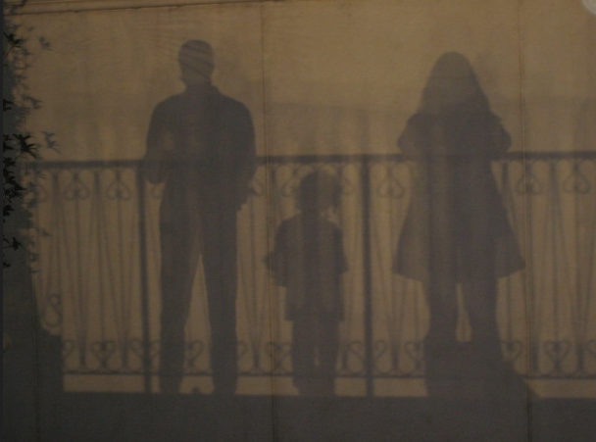
In taking a critical realist and reflexive approach, I recognised that “… knowledge is always gathered or derived through a selection process” (Howell, 2013, p.52). Stories are not fixed but are told, and as Schembri & Abela (2016) remind us “The stories the participants told were therefore constructed in a particular time and place for a particular purpose” and had I “interviewed the participants at a different time or in a different context, their stories might have been different” (p.413). I recognised the dangers of the double hermeneutic (Howell, 2013; Montague, Phillips, Holland & Archer, 2020), whereby I was interpreting the participants’ words who in turn were interpreting and curating their own memories and that participants might therefore consciously or unconsciously select what they revealed, leaving some aspects of their experience unsaid since they may have wanted to protect those whom they talked about (Miller, 1997), and themselves to ensure that I thought well of them (Chung & Monroe, 2003).

It is important to also recognise that power always plays a part in interactions (Shannon-Baker, 2016; Yardley, 2000). Participants’ awareness that my research was at doctoral level might have led them to perceive me as an “expert” and affected their answers. For the Phase 2 participants, meeting me virtually would have highlighted that I am an older, white woman which also may have affected which stories, perspectives, and ideas they chose to share. They may have also inferred other information about me such as that I am British and made other inferences which they may not have even been aware of themselves (Atewologun, Cornish, & Tresh, 2018). However, by my placing them as experts (Lynch et. al., 2024), I hoped to minimise any feelings of power (Mertens, 2021).
Additionally, I was aware that

“…part of our personality resists certain memories, impulses or wishes that cannot be admitted into conscious thought because that part of our personality feels them to be bad or forbidden, or because they do not make sense. However, although they are suppressed, they remain alive in our unconscious and continually strive for expression” (Edwards, Hadfield, Lucey & Mauthner, 2006, p.12).
It is important to also recognise that in my selection of themes, I too would have been demonstrating conscious or subconscious bias (Atewologun, Cornish, & Tresh, 2018), privileging certain themes over others and having read previous research, I may have been predisposed to notice themes which were in line with my expectations and discard any contradictory findings.
“The interaction of individual biography and social location shape the research relation in complex ways” (Griffith, 1998, p.361) and my interpretation of my findings was inevitably affected by my life experiences. Any claims to Insider status “rest on biography, political activities, research practices, and the relation between the researcher and the community she studies” (Griffiths,1998, p.367). My professional and personal experience would therefore place me as a partial insider and partial outsider (Griffith, 1998; Herod, 1999; Kusow, 2023).
As a teacher and SENDCo I had heard staff voice concerns that meeting the needs of children with additional needs added to their workload pressure (NASUWT, n.d.) and that staff often felt ill-equipped to support children with additional needs. I was also aware that funding for children with additional needs is not ring-fenced (TES, 2024) meaning that the resources which staff need to support children with additional needs in mainstream schools were not always available to them. These experiences may well have predisposed me to expect that participants might report a shortfall in provision for the needs of their siblings and meant that I would have empathy towards staff who had been unable to ensure that provision. However, I had presumed a level of empathy and understanding from staff, and so was shocked by some of the experiences participants reported which demonstrated a lack of empathy.
I am British and had worked in British schools and one school overseas. One of my selection criteria was that my participants had attended a British school, because research on British schools is limited. Whilst this may have minimised any cultural differences and meant that I was familiar with terminology (Herod, 1999, Hofstede, 2010), it is important to recognise that there is no one “British” culture and that I would have been influenced by my own experiences, namely growing up in a working-class community and yet now being a middle-class professional. All of the Phase 2 participants who I interviewed were women and my being a woman may also have affected the extent to which the interviewees shared their reflections on gender. For example, it is possible that Georgia and Jenny may have talked very differently about their brothers to a male interviewer.
At the same time, I did not grow up with a sibling with additional needs and I have only one child so the experience of growing up with a sibling with additional needs is not something which I share or have observed at close hand, making me an outsider who was keen to learn about the experiences of my participants. Most importantly, my lack of insight into what it is like to grow up with a sibling with additional needs, allowed me to position the participants as experts in the area (Lynch et. al., 2024) reducing any power imbalance (Mertens, 1999).
It is important to also note that, like my interview participants, I am not disabled and therefore, my own perceptions about the experiences of disabled people are based on observation and by what I have been told by those who have additional needs and their parents.
My previous experiences as a Teacher, Special Educational Needs and Disability Co-ordinator (SENDCo), someone who had worked as a SENDIASS (Special Educational Needs Information and Advice Service) officer and as the parent of a young adult with additional needs has given me a “lived familiarity” (Griffith, 1998, p.361) with the experiences of children and young people with additional needs and their parents.
I recognise that I can never undertake research in a neutral way, and it would be naïve to presume my experiences would play no part in my construction of interview questions, non-verbal signals in interviews and my interpretation of the data (Willig, 2013). I have strong views about disability, what it is like to be a parent of a child with additional needs, and how inclusive schools are. However, in recognising my biases and employing a reflexive and participatory approach, I hoped that in listening to the participants, my own life and perspective would change (Cresswell, 2002; Willig, 2013). I was also aware that power relations exist and that my having the role of researcher (and thus potentially being perceived as an “expert”) as well as being an older, white woman, would possibly affect aspects of their life story and ideas which participants might curate and share (Willig, 2013).
All my prior experiences likely affected my interactions with participants, expectations of what they might say, and my prioritisation of themes, since my positionality has shaped my work, my “interpretation, understanding, and … belief in the truthfulness and validity of other’s research” (Holmes, 2020, p.3).
It is important to stress too that whilst my personal and professional experience have shaped my perspective, I do not have a disability myself, did not grow up with a sibling with additional needs myself and nor have I directly observed the experiences of siblings of children with additional needs. This in many ways, placed me as a “fly on the wall” myself, since I had never experienced nor observed closeup the daily experiences which my participants had. I recognise the questionability of whether anyone can ever speak for anyone other than themselves (Alcoff, 1991) and recognise that as a non-disabled person I can never have true insight into what it is like to be a person with additional needs (Morris, 1991).
My awareness of existing literature may also have led me to make certain presumptions, for example that participants would have had negative experiences when growing up. However, by recognising and reflecting on my own potential biases (Burdick, 2021) and listening reflexively, I hoped that I would learn from the participants and that my own perspective and practice would be changed (Braun & Clarke, 2022; Creswell, 2002; Willig, 2013).
Taking a critical realist approach, allowed me to also combine two perspectives:
- the social model’s bio-ecological approach to disability, considering both the material reality (Fleetwood, 2016) of medical conditions and physical barriers, alongside the subjective interpretations arising from experiences of being treated differently due to being disabled and
- the ecological model which focuses more on social factors (Bronfenbrenner, 1986, 1993; Bronfenbrenner & Ceci, 1994).

2.1.2 Social justice and advocacy
Throughout the research, my goal was one of intentional social justice, advocacy and the transformation of schools (Creswell, 2003). To quote Mertens (2012) “The philosophical assumptions associated with the transformative paradigm emanate from an ethical stance that emphasizes the pursuit of social justice and the furtherance of human rights” (p.256). My perspective is strongly influenced by the work of Smail and those whom his work has inspired (Bostock, 2017; Hagan & Smail, 1997; Smail, 2005) and my approach was informed by an awareness that power works in the lives of my participants and their families via political systems, media messages, professionals, the education and health systems. I also felt it imperative that research from a social model perspective “must aspire to be emancipatory” (Thomas, 1999, p.153).
Researching this area provided me with a potential opportunity to create social change since
“A transformative lens applied to research increases impact in … providing support for actions that increase social, economic, and environmental justice … [with] the research design consciously addressing inequities and providing a platform for transformative change. Engagement with members of marginalized and vulnerable communities is critical and needs to be approached in ways that value the knowledge they bring and addresses power inequities … viewing the role of the researcher as a social change agent …” (Mertens, 2021 p.1).
Contributing to this study would provide participants with a voice and thus an opportunity to potentially change schools to support siblings better (Mertens, 2021). I intended for my research method to value the experiences and reflections of the participants and involve them in the planning of research questions (Mertens, 2021) and I intended that my research findings would “… contain an action agenda for reform that may change the lives of the participants, the institutions in which individuals work or live, and the researcher’s life” (Creswell, 2002, pp. 9-10). My findings also brought to light some of the negative school experiences of children with additional needs themselves.
Disabled people face discrimination at multiple levels (Reeve, 2006; Ryan, 2019) and family members can face discrimination by association (Government Equalities Office, 2010). Critical realism has historically been an approach which “makes it possible to criticise and challenge what goes on in social life” (Blaikie & Priest, 2017, p.183) since it recognises that there are many ways of looking at reality. Thus, using the social model as an alternative lens through which to consider disability and neurodiversity fitted with my positionality.
The literature suggests that children and young people who grow up with a sibling with additional needs, are often forgotten, invisible and so marginalised (Fleitas, 2000; Hanvey, Malovic & Ntontis, 2021), having little voice since much of “their” perspective comes either via parent voice (e.g. Carpenter, 1997; Chien, Tu & Gau, 2017) or at least with the knowledge of their parents (Bhattashali et. al., 2018; Connors & Stalker, 2003). They may also have experienced indirect discrimination in relation to their sibling’s disability (Government Equalities Office & Equality and Human Rights Commission, 2010).
My use of a two-phase research approach made it possible for the outcomes of the Phase 1 study to inform questions for the Phase 2 interviews and the overall outcomes of the study would suggest good practice for schools. Thus, my intention was (and is) that my findings would “… contain an action agenda for reform that may change the lives of the participants, the institutions in which individuals work or live, and the researcher’s life” (Creswell, 2002, pp. 9-10).
2.1.3 My changing perspectives
My approach was informed by the social model of disability, ecological systems theory, and a desire for social justice. The social model and ecological systems theory have been discussed in the literature review. Below I include a section outlining how my feminist perspective changed throughout the process but still affected my interpretation of the data.
Whilst I did not set out with any expectation that gender would become a significant theme, once I began the analysis of interviews, it became apparent that not only was gender an important element of the themes but the emotional reaction that this produced in me made me aware that my personal views and interpretations had been shaped by a feminist perspective on gender (Brown, 1998; Jackson, 1998).
The Cambridge Dictionary (2019) defines feminism as “The belief that women should be allowed the same rights, power and opportunities as men and be treated in the same way…”. My belief was that women should have the same opportunities outside the home. Yet as a professional I had too often seen that it was predominantly mothers who took the most active role in ensuring that the needs of their child with additional needs were met. Furthermore, articles which I had read (e.g. Contact, n.d.; Tirraro, 2024) suggested a culture and educational system where mothers of disabled children feel that they cannot work.
My own feminist perspective has been influenced mostly by second wave feminism (Evans & Chamberlain, 2015; Osborne, 2001; Shriver, 2010) which shaped me during my own time in education (e.g. Friedman, 1963). I had been encouraged to study science to redress the male dominance in the field and studying ‘A’ level Sociology had made me aware of gender stereotypes. As a young woman I had expected that by 2024 gender stereotypes would no longer be influential.
A recent study by Sky News and the charity Support Send Kids (Sky News, 2024a, 2024b) found that three out of four parents of children with special educational needs had been forced to give up work or cut their hours and that this disproportionately affects women (Sky News, 2024a, 2024b). Respondents in the study cited employer inflexibility, lack of special schools and reduced timetables for children with additional needs. Thus, the mothers I have met professionally have not been unusual.
In my time as a SENDCo and my time working for SENDIASS (special educational needs information and advisory service) it was rare for a father to contact me and my personal connections with families with children with additional needs had followed a very similar pattern.
I came to the research with the view that what women choose to do with their lives is influenced by pervasive messages and restrictions within society about what women should choose to do with their lives, especially in relationship to motherhood (Friedman, 1963). As a professional I had witnessed a culture and educational system which, by not meeting the needs of families who have a child with additional needs, had often impacted on mothers (Contact, n.d.; BBC, 2024; Opinium, 2024a, 2024b; Sky News, 2024a, 2024b; Tirraro, 2014, 2024). The experiences of mothers of disabled children who did not work since they felt that their lives were restricted by forces beyond their control did not sit well with me.
Later, when interpreting interview transcripts, I became aware that the mothers of the participants appeared to have subjugated their careers to that of their partners, in order to be available for their children and one of the participants had said she had no desire for a career herself. This evoked an uncomfortable emotion in me because I had hoped that by 1984, we would be living in a world where gender stereotypes were seen as outdated. Thus, the question
“If women refuse to put themselves forward for jobs or promotion, are they making a genuine, if possibly regrettable, judgement, or could they be more accurately described as acting against their own self-interest, and, even more cruelly, against the interests of women more generally?” (Schuller, 2017, p.100).
resonated with me.
Another bias that I became aware of was that “As a white, middle-class young woman accustomed to academic success as the route to mastery” (Burman, 1998, p.216), I was predisposed to initially view a participant’s rejection of going to university as a self-limiting missed opportunity.
However, throughout and following the data analysis stage of the research, I read books by Schuller (2017) and Roiphe (1996) and changed my perspective. In her critique of feminism, Roiphe (1996) highlighted that
“The point of feminist politics was always to give women fuller, better lives … and an opportunity to use all their human potential … Feminism, which was all about self-fulfillment, forgot that giving up some of the self, which is necessary for motherhood, is part of most women’s self-fulfillment” (p.206).
Having interviewed 40 women and collated responses to a survey on his website (the website no longer exists), Schuller (2017) concluded that five factors influenced decisions women made about whether to pursue promotion: discrimination and values, caring responsibilities, self-confidence and identity, social capital, and choice. 15% of Schuller’s participants said that they had actively chosen not to take on a more challenging job “… opting instead for quality of work and a good work-life balance…” (p.165) and that that many women felt freer to choose not to pursue promotion. Schuller concluded that, for men, career “is defined very much as a continuous rising through the ranks” (p.195), arguing that it is time for a cultural shift so that men’s life choices become more feminised, just as women’s lives have become more masculinised.
Schuller (2017) does not outline his methodology with sufficient rigour (Stuart, 2018) and it is possible that his being male may have influenced his interpretation of the data. However, he is not alone. Roiphe (1996) argues that whilst feminism has been a power for good, many feminists have judged women who choose motherhood over careers. Yet “… most of us did not after all want to be liberated from that basic biological experience” (p.47) and “… women have real needs that include being near and with their children. The effort to deny these needs is as cruel as the prefeminist effort to deny women their minds … the same maneuver, just turned inside out” (p.235).
Schuller’s use of the term “choice” and Roiphe (1996) arguing that pressurising women to choose career over motherhood is as oppressive as pre-feminist views, challenged my personal bias, making me aware that my belief that women should pursue higher education, and a career path was just as restrictive an expectation as the historical presumption that women should be housewives and mothers. It is also important to recognise that attitudes to work-life balance are changing for Generation Z emerging adults (Brower, 2022; Deloitte, 2024; Hoier, 2023); many more young people are rejecting university as an aspiration with work-life balance and meaningful work becoming more important (Deloitte, 2024).
I have also been heavily influenced by the concept of emotional labour (Hackman, 2023; Hochschild, 1983; Hartley, 2017, 2018) and this affected my interpretation of the data. The concept of emotional labour refers to the practice of many women who take on the emotional and mental labour within families (Hackman, 2023; Hartley, 2017, 2018). Whilst the concept of emotional labour was initially used in the context of work (Hochschild, 1983), it is one adopted by some feminists in relation to the domestic experiences of women. Hartley (2018) describes herself as a mother:
“… I find myself carrying all the domestic upkeep that relives others of the mental load. I am the one who notices when things need to be done … I am also the schedule keeper who makes appointments and knows what is on the calendar … I carry in my mind exhaustive lists, not because I want to, but because I know no one else will”. (pp. 3-4)
The concept of emotional labour likely led to my noticing aspects of the Phase 2 participants’ narratives as relating to the idea of emotional labour, particularly when Georgia and Jenny compared their brothers’ involvement to their own.
2.2 Aims
As a former teacher and SENDCo, someone who had worked in a special school and a trainee educational psychologist (TEP), I was aware that most schools offer little or no support to children and young people who grow up with a sibling with additional needs and indeed often schools do not even know this information. In my experience, where schools do offer support, this is almost always in the context of a young carers support group and not all those who grow up with a sibling with additional consider themselves carers, a theme which was apparent in interviews
Therefore, the key aim of my research was to gather the voices of those who are part of this often-forgotten group (Hanvey, Malovic, & Ntontis, 2022) so that schools and other professionals can take steps to better recognise, identify, and support these young people.
2.3 Research questions
My three key research questions were
- How much do those who grew up with a sibling with additional needs perceive that their life was affected?
- What do those who grew up with a sibling with additional needs tell us about their experiences?
- How can schools better support these children and young people?
Whilst I was open to any unexpected themes, I was interested in better understanding the effect of growing up with a sibling with additional needs on individual, family, community, and school life. Additionally, I was open to the possibility that participants might provide incidental information about how schools and EPs might better support the children and young people who themselves have additional needs. This proved to be of greater importance than I expected.
2.4 Design and methodology

The study was a mixed-methods exploratory study. Phase 1 was the less-dominant data collection method and used a survey to gather both quantitative and qualitative data. Phase 2 was the dominant data collection method using semi-structured interviews to gather qualitative data. Interview questions were informed by the results of the survey, thus involving those with lived experience in identifying areas to explore further (Lynch et. al., 2024). In choosing a mixed method approach I used both a deductive top-down approach because interview questions in Phase 2 were informed by survey responses in Phase 1, and an inductive, bottom-up approach, allowing participants to talk about their experiences in an open-ended way so that I noticed themes which had been largely unnoticed in previous literature. I have depicted this process in Figure 7 below.

Figure 7 Methodological steps used to gather and analyse data (author’s own graphic)

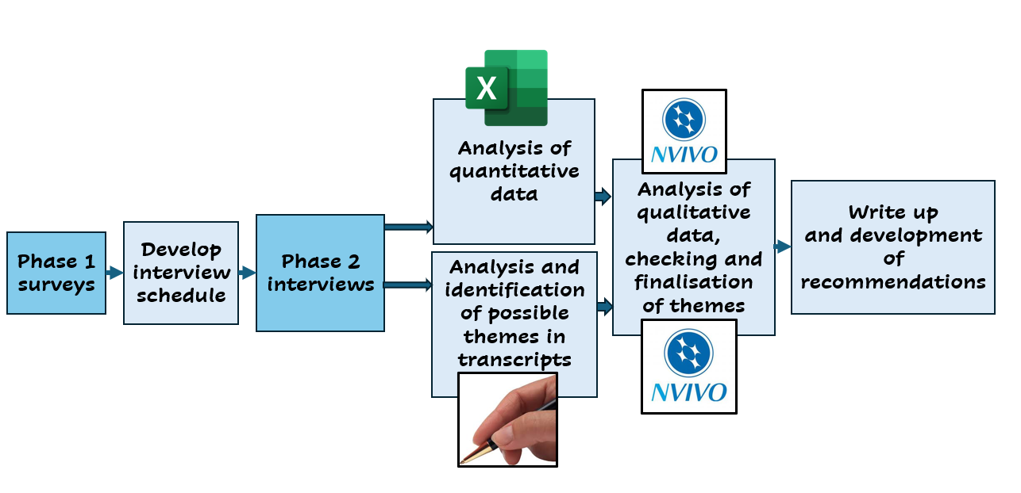

A mixed methods approach was used so that the results of Phase 1 could inform the questions in Phase 2. Surveys were also used to gain a larger sample than interviews might to gather data to compare with existing research and to complement Phase 2 interview data (Creswell, 2003; Tashakkori & Teddlie, 1998). Both quantitative and qualitative methods are known to have drawbacks and in using both I hoped that “… biases inherent in any single method could neutralize or cancel the biases of other methods” (Creswell, 2003, p.15). The dominant data-collection approach was qualitative because existing research has often been quantitative, looking at large group correlations and averages. I wanted to also use a qualitative approach in order to gather data which might be richer and deeper and so inform a greater understanding of siblings’ experiences.

My choice of a two-phase mixed method approach also related to my desire to co-construct interview questions with those whose personal experiences made them experts in this area. Additionally, the anonymity provided by a survey would extend my sample beyond those who were willing to spend time and make themselves vulnerable via an interview. I hoped that interviews would provide depth whilst the larger sample size of a survey would provide a broader range of views to supplement those gathered via interviews.

Reflexive thematic analysis was chosen because reflexivity “provides critical examination of different standpoints and perspectives … may guard against levels of projection and selection that could misrepresent the objective reality … [and] uncovers the mirage of total separation of researcher and researched” (Howell. 2013, p.52), whilst recognising that the “researcher’s position and contribution is necessary, unavoidable, and an integral ingredient of the process … a valuable resource to draw on” (Devine, 2021, p.2).
Reflexive thematic analysis recognises that “multiple interpretations exist and are equally valid” (Willig, 2013, p.174). Yardley (2000) identifies four elements of good qualitative research, namely “sensitivity to context … commitment to rigour … transparency and coherence … impact and importance” (p.219). I therefore ensured the following checks and balances:
- Piloting survey and interview questions
- Where I realised that I was formulating an interpretation based on what I had heard I reflected back to the interviewee “It sounds like ….”, allowing them to correct my interpretation
- Discussing my perceptions of possible themes and interpretations in supervision
- Returning to survey data and transcripts to triangulate information and to check whether themes in interviews also appeared (or were contradicted) in survey data
- Double-checking my statistical calculations and interpretations as I went along and during the write-up checking again
- Recording the interviews with google-meet and two audio recording devices, playing back both audio-devices to ensure that what I had heard on the first device confirmed the initial transcript if the second audio-recording was clearer
- Using NVivo to complement my hand-written identification of themes and, having identified themes, running it again
- Including additional data in the appendices for transparency

Reading existing research provided a backdrop for my methodology, making it possible to identify where my findings were in agreement or different to previous literature. Awareness of findings of previous research, also led me to consider gaps in the research.

2.5 Terminology
In considering which terms to use to describe the sibling with additional needs, I considered various other terms. I was mindful that many terms are not just descriptors but that over time such terms have become pejorative and terminology changes when it is has become tainted (Shriver, 2010). Table 2 illustrates the process I went through before choosing the term “sibling with additional needs”.
Table 2
Consideration of possible terminology
Possible term for siblings with additional needs | Possible term for participants | Arguments for | Arguments against
Disabled sibling | Able/ non-disabled sibling | Used throughout literature  Widely understood | Medical model – sees the disability as within the individual  Not all people with additional needs see themselves as disabled.
Atypically developing | Typically developing | Used throughout literature  Easily distinguishes between both siblings | This was the term I used at the research proposal stage – however I later discarded it because i) the term atypical can be seen as “abnormal” and is beginning to become perjorative ii) I do not believe that any child is “typically developing” e.g. some children talk before they walk, some children grow more slowly, and many children find some parts of the curriculum hard.  In addition, whilst they had self-identified as having grown up with a sibling with additional needs, some of my participants had received later diagnoses themselves, blurring the line between the two groups.
Sibling with special (educational) needs | Sibling without special (educational) needs | Widely understood within schools | Educational needs is limited to the area of learning and school. I wanted to learn about my participants’ experiences across their whole ecosystem.
“special” |  |  | Outdated and a term which one of my participants said her sister hated. Suggestive of favouritism and special treatment; implies fragility.
Sibling with medical/ health needs | Well/ healthy sibling |  | Siblings with additional needs are more than their medical condition. Medical model approach.  Not all participants had siblings with medical/ health needs.  To include siblings with e.g. autism, learning difficulties within the definition of medical/ health needs implies that the sibling could (and should) be “treated” and so relies on the medical model.  The term “well” often describes non-disabled people who are not currently experiencing ill health and thus a temporary and relative state of being.
neurodiverse | neurotypical | The term is becoming more widely understood and is currently seen as a positive term | Neurotypical is not widely used to describe people with physical and sensory difficulties. In my recruitment, I wanted to recruit participants whose siblings had a broader range of conditions and not just autism.  I do not believe that all “neurotypical” people are the same, thus there is no “typical”.
Sibling with impairment | Sibling without impairment | Differentiates clearly between the two siblings; the term impairment is used by the disability rights movement to differentiate between within-person and environmental impact of disability | Medical model. Has become pejorative. Implies the sibling is defective rather than different.
Sibling with additional needs | … who grew up with a sibling with additional needs | Fits with the social model – the person needs adjustments and environmental changes  Not perjorative  A term used in some schools  Makes explicit that the disability is only part of the person  Can be used broadly for individuals with any kind of disability, whether diagnosed or not  Recognises the diversity of those with additional needs | Suggests that participants have no additional needs themselves. It was clear from the data that in several cases the participant also had additional needs themselves (sometimes which had only been diagnosed in adulthood). However, given that my participants self-identified as growing up with a sibling with additional needs, I believe that they largely made the distinction themselves, believed that their sibling had greater additional needs than them and that this had been clear whilst they were growing up.
SWAN |  | Shorthand  Saves words and typing | The word SWAN has another meaning and therefore suggested the image of a fragile creature – I did however use this in my personal notes as a shorthand acronym.

I therefore chose to use the term additional needs when talking about my participants’ siblings at the individual personal level; this is to reflect my belief that human beings are multifaceted, and disability is only one aspect of a person. The term also, in line with the SEND Code of Practice (Department for Education and the Department of Health and Social Care, 2015), recognised that whilst most children have some difficulties with the curriculum, some children have
“… significantly greater difficulty in learning than the majority of others of the same age … which prevents or hinders him from making use of facilities of a kind generally provided for others of the same age in mainstream schools …” (Department for Education and the Department of Health and Social Care, 2015, pp.19-20).
However, I recognise that other terms are often used in research, wider culture, as well as by the disability movement (Oliver, Sapey & Tomas, 2012; Lisicki, 2013; Shakespeare, 2002; UPIAS, 1976). When talking about the theme of ‘The wider ‘World of Disability’ it made sense for me to use the term disability which is broadly understood, and more broadly applicable than the term additional needs. Additionally, where participants used a term, I used their chosen terms. Thus, in writing my introduction, literature review and methodology, I used the term disabled and when quoting participants, I used the words which they used. This meant that I was able to make a distinction between when describing the individual sibling with having additional needs and the wider collective world of individuals with disabilities. However, whilst I did use Grossman’s term “retarded” when quoting her, I substituted the phrase “learning difficulties” when citing her and others as I consider the term “retarded” pejorative. I recognise that, whilst her term was unremarkable in 1970s America, it would now be offensive. In 2024 the term used to describe the difficulties which these children have would be “learning difficulties”.

2.6 Procedure

2.6.1 Phase One (survey)

Additional information about the research (See Appendix D) and consent forms were included at the start of the survey Participants were required to provide consent in response to the statements in the consent form. Survey respondents were also required to confirm that they had been educated in a UK school, for at least two years whilst living with their sibling. This was because I wanted to learn about British schools to supplement existing research.

Information was also gathered regarding factors such as age and the sibling’s condition to look for between-group differences. This is because samples in many previous studies have used samples where the participants’ siblings had autism, a learning difficulty or cancer and I believed that it was possible that being a sibling to a brother or sister with other conditions might reveal different outcomes. Gathering additional information about the participants’ siblings’ category of need would allow me to consider whether there was bias in the sample when analysing similarities and differences in findings compared to previous research. Taking an ecological systems approach (Bronfenbrenner, 1986, 1993), I recognised that many other factors might also affect participants’ experiences, but these seemed the least intrusive and most pertinent categories of data to gather. I had also intended to be able to report any differences between subgroups. However, the final sample size was too small to make any generalisations about between-group differences.

Phase 1 surveys gathered quantitative data using Salmon lines via drop-down boxes and qualitative data via open-ended questions. Google Forms (Google, 2019) was used, and the survey was piloted first. In using Salmon lines and asking respondents to “score” their perceptions of their experiences, I was creating a new tool to measure the participant’s own perceptions (i.e. not that of their parents or teachers) and to focus on their perceptions of how growing up with a sibling with additional needs had affected them. I felt it important to create a new scale because existing scales (see Appendix C) have been largely based on parental perceptions and measurable long-term outcomes such as academic achievement or health outcomes. This did not align with my social model standpoint nor my desire for sibling voice to be central and not that of their parents.

Salmon lines using a 0-10 ordinal scale were used to collect data because I felt that responses could not be reduced to yes/ no answers. Since Salmon lines make the poles explicit, I believe that they are less likely to be affected by acquiescence bias (Smith, 2004; Tashakkori & Teddlie, 1998) and less subject to potential confusion arising from reverse-coded items (Southern Illinois University, 2023). I provided a positive statement on the left pole because I did not want to lead participants to rate their experiences negatively, a criticism which might have been levelled at previous research with negative findings, although this then risked falling into the positivity bias trap (Tashakkori & Teddlie, 1998). I included a zero on the scale because I wanted participants to be able to highlight if they felt that there had been no effect at all. Having an odd number also made it possible for respondents to express that the two poles were balanced e.g. overall there was a mixture of enriching and difficult experiences.

The questions which were asked to gather quantitative data were as follows:

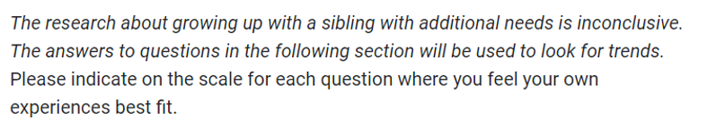

Question 1:
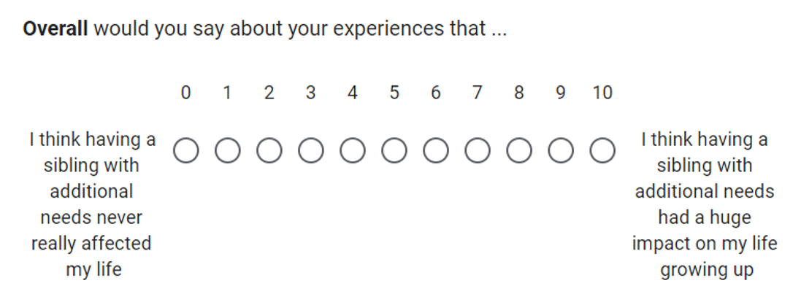

Question 2:
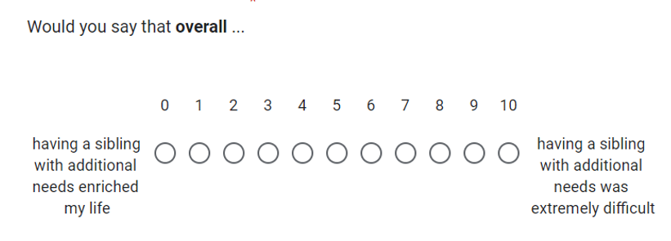

Question 3:
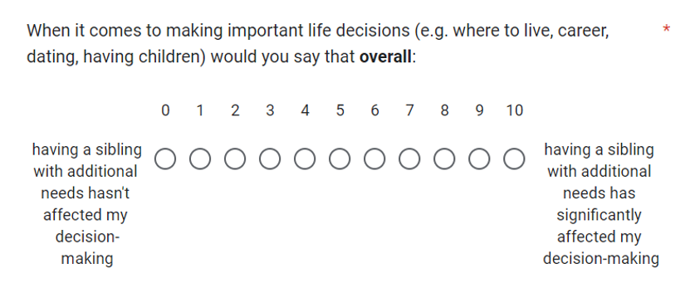
Question 4:
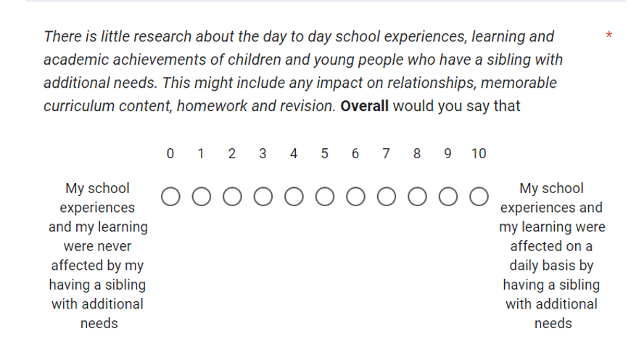

Four open-ended questions were also included:

- What would you say was the best thing about having a sibling with additional needs?
- What would you say was the most difficult thing about having a sibling with additional needs?
- What do you think might be good interview questions to ask someone who grew up with a sibling with additional needs? (This information will help inform the phase 2 interview questions).
- Please add here any information which you are comfortable sharing.

Participants were also asked if they would be interested in being interviewed for Phase 2. Participants were asked if they were interested in being interviewed with possible answers being “yes”, “no” or “possibly but I would like more details”. Participants were invited to provide an email address if they were interested in being interviewed.

Participants were told that they could withdraw their data for up to 10 days after completing the survey. The survey ended with signposting to organisations who could support participants. This can be found in Appendix E.

It was anticipated that completing the survey would take 10-15 minutes, longer if respondents provided detailed answers to the open-ended questions. 44 participants returned surveys. The process of piloting the survey can be found in Appendix F.

2.6.2 Phase Two (interviews)

Interview participants were recruited via the survey. All survey respondents who were under 25 who had expressed an interest in being interviewed were approached by email and provided with further information. Not all responded and so I made a further ethics application in order to raise the age limit to above 25. I was then able to recruit six participants, one of whom was used for the pilot study. Five participants allowed for not only “… sufficient in-depth engagement with each individual case but also … a detailed examination of similarity and difference, convergence, and divergence” (Smith & Osborne, 2009, p.57).

Using a semi-structured interview approach allowed me to gather more detailed information to supplement the survey data. Interview questions were informed by the existing literature, my personal interest informed by my experiences working in schools, and by questions derived from survey suggestions (Tashakkori & Teddlie, 1998).
Questions which had been suggested by survey respondents included:
- How did having a sibling with additional needs affect your relationship with your family?
- How has your sibling with additional needs helped shape you as a person?
- What support would you have liked growing up?

Over 50 questions were suggested by survey respondents and additionally many of the responses were phrased more as areas to explore than questions. I therefore did not lift questions verbatim from those suggested by survey participants but looked for the most common topics. I also rephrased some of the questions to make them more open-ended and less leading. For example, the question “Have you forgiven your parents?” gave rise to the question “Do you think that your relationship with your parents was impacted by having a sibling with additional needs?”

Participants were invited to choose what they talked about. However, I had a list of prompt questions should the participant run out of things to say, and, in all five cases, I did use those questions. A list of prompt questions is included in Appendix G. Participants were also sent the optional prompt questions in advance so that, if they wished, they could prepare in advance, to forewarn them of any questions that they were uncomfortable with and to remind them that they could still withdraw from the study and/or refuse to answer some questions. Additionally, during each interview I asked personalised additional prompt questions such as “You mentioned … tell me more about that” and “It sounds like … would you say? …”. These questions opened new areas of discussion, for example, Sabrina talked about the impact of growing up living in a working-class community and yet, how despite this, she and her brother had gone to university.

Interviews took place using Google Meet, a virtual platform used by the university. Participants were offered interviews for as long as they wished. Interview lengths varied from 35 minutes to 1 hour 38 minutes. Examples of questions which I used as prompts can be found in Appendix G. The process of piloting the interview questions is outlined in Appendix F.

Interviews were recorded using Google Meet and audio-recording devices. I used Google Meet’s transcription of the recording as a starting point, playing and pausing the audio recording whilst editing the transcript. I then played the second audio recording to check and edit my transcript.

Member checking did not take place because this had not been considered at the ethics application stage since it was felt that to ask for this additional commitment from participants might have further deterred participants from volunteering to be interviewed. However, in choosing not to allow participants to check my interpretations, there is a risk that I misunderstood what they told me in interviews. However, in taking a critical realist approach, I recognise that multiple interpretations can coexist. Participants had shared only a part of their story and different stories at a different time may have led to different interpretations (Schembri & Abela, 2016).

2.7 Recruitment

Participants had to be over 18 to take part. There was no upper age limit to complete the survey. I deliberately recruited older participants who might provide reflections on their experiences and identify what had helped them as well as suggest what schools might have done better.

I recruited adults because some previous studies (e.g. Bhattashali, Ostrosky & Monda-Amaya, 2018; Connors & Stalker, 2003) where children had been interviewed either with their parents present or with their parent's knowledge found more positive findings which conflicts with most other research and I wondered whether this had led to children giving socially desirable answers (Grimm, 2010). I was also interested that a study by Dyb, Holen, Braenne, Indredavik & Aarseth (2003) had shown a significant discrepancy between child reports and parents reports of the child’s post-traumatic stress reactions after a traffic accident, suggesting parents are not always aware of their children’s emotions.

Hanvey, Malovic & Ntontis (2022) had also highlighted how their older participants had only later in life recognised the impact of their earlier experiences so interviewing adults would allow me to hear their reflections years later.

However, I also recognise that by only recruiting those who had already left school there was a danger because memories fade (Cooper, Kensinger & Ritchey, 2019) and are shaped by interpretations and subsequent narratives which we create for ourselves in order to make sense of our experiences (Edwards, Hadfield, Lucey & Mauthner, 2006), something particularly recognised from a critical realist perspective. Additionally, in line with an ecological systems’ perspective (Bronfenbrenner, 1986, 1993; Bronfenbrenner & Ceci, 1994), I recognised that younger adults grew up in a quite different cultural setting to those who are older.
I recruited via university research networks, social media, and word of mouth. I did approach some charities directly and local parent groups but found this was not as effective as snowballing via social media and word of mouth (Tashakkori & Teddlie, 1998).
The University of Sheffield has a research network system whereby staff can share details of research projects on behalf of their students via an email network. My supervisor arranged for details of my study to be disseminated via this system.
I also approached several charities directly asking them to disseminate details of the project. Few responded to me directly. Additionally, details of the study were circulated via the Association of Educational Psychologists (AEP) newsletters, colleagues in my placement Educational Psychology Service, local parent-carer forums and the local authority’s SEND young people’s voice panel.
Social media has been shown to be an effective way to disseminate awareness of research projects (Tashakkori & Teddlie, 1998) and a further advantage of using social media is that survey respondents remained completely anonymous unless they chose to express interest in being interviewed. Allowing participants to remain anonymous would have increased willingness to participate and to give honest answers (Grimm, 2010).
Thus, I set up a Facebook account with a public profile and posted both posters and posts on the theme within the feed. Making the page public meant that my posts could be freely shared by others, which would not have been possible via a private account. These posters can be found in Appendix H. My first poster was uploaded, and the survey went live on 9th July 2023. Those who saw these posts were able to share them more widely. I successively added new adapted posters. This kept the feed alive and ensured more people saw the posts. I also adapted the posters once it became clear that most of the surveys were being completed by participants who were over 25 and those whose siblings had learning difficulties and/or autism, since I hoped to recruit from a wider, more diverse sample including participants who were under 25 and whose siblings had a greater variety of conditions. The colour of the poster also changed in order to make them more eye-catching. The final poster was one thanking those who had taken part and, at this point on 30th November 2023, the survey was closed.
The posters included both a link and a QR code. The link was also posted within the comments section of social media posts so that people could click on the link to take them to the survey. A QR code on the poster also took the user straight to the survey. This was designed to ensure that people could easily find the link to the survey. I also included my university email address so that people could email me directly for further details.
Facebook allows users to see the statistics relating to the last 28 days which means I was able to see that thousands of people had seen my post. The statistics can be found in Appendix I and illustrate that the posters were seen by thousands of people.
Facebook tends to be used for social connections whilst Twitter is used more for professional connections (Forsey, 2021). Therefore, on 25th July 2023, I set up a Twitter page to broaden the reach of my posters. At this point I discovered that the poster had already been placed onto Twitter by people who had either seen the post on Facebook or by other people who knew of my study and were already using Twitter.
Participants for Phase 2 were recruited via the survey. Respondents were invited to volunteer to be interviewed within the survey and were asked to provide an email address. The survey demographic data meant that I was able to identify the approximate age of the volunteers. Of those who volunteered and provided email addresses, ten were in the age range 18-25. When I followed up these volunteers via email, not all of these respondents replied. A further respondent volunteered but we were unable to set a mutually convenient date.

I therefore made a further ethics application asking to extend the age range to make it possible to interview participants who were over 25. This meant that I was able to expand my initial pool of three interview participants to five. Thus, the five participants in Phase 2 were aged 18-28. Of note is that richer data was provided by the older participants, often including reflections on how their relationship with their sibling and parents had changed and how only recently had they begun to realise how unusual their childhoods had been.

2.8 Sample

I used opportunity sampling for both data-collection phases.
The two most pertinent features of the Phase 1 survey sample were the age of the participants and the category of identified needs that their siblings had. This is illustrated in Figure 8 and 9.
Figure 8 Phase 1 survey participants by age group

Figure 9 Frequency of categories of additional needs of survey respondents’
siblings*

*Many siblings had co-occurring needs and so are counted more than once

The most common conditions of siblings of survey respondents were autistic spectrum condition, learning difficulties, medical conditions and speech and language needs. Previous researchers have focused on learning difficulties, autism, and cancer and thus the sample was more diverse than existing research, although it is important to stress that almost half of the Phase 1 participants identified autistic spectrum conditions and/or learning difficulties as categories of need.

Further details regarding the shared or different gender, young carer status, number of siblings in the family and whether the participant attended the same school as their siblings can be found in Appendix J.

Key data (pseudonym, age, and family structure) of the five participants for Phase 2 can be found below in Figure 10 and pen portraits can be found in Appendix K. These pen portraits were created to allow readers to both gain a “flavour” of each participant’s character and to more easily distinguish between each of the five participants. Additionally, the scores that the interviewees gave in their surveys can be found in Appendix L for comparison with the other 39 survey respondents and each of the other four interviewees.

Figure 10 Family structure and ages of Phase 2 participants (author’s own
graphic)
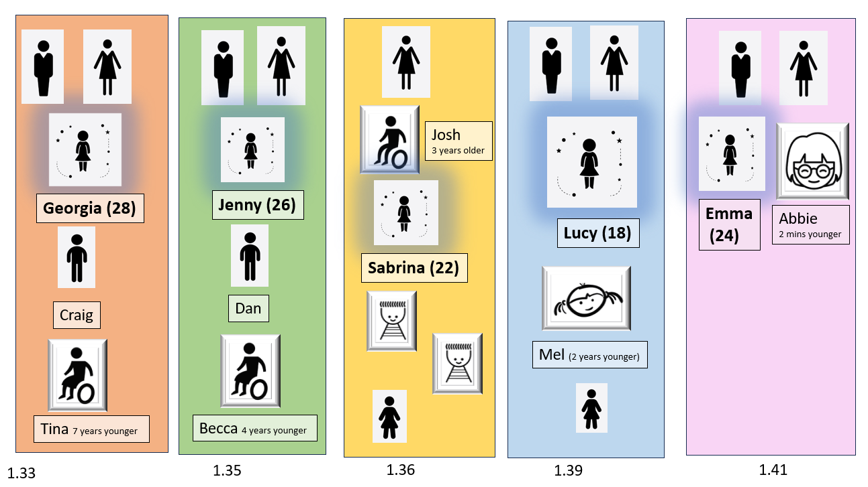

Participants were required to
- be over 18.
- have lived with their sibling for two or more years of their school years. The 2-year inclusion criteria was chosen because I wanted to find out about the effect on the participant’s life over a longer period rather than a snapshot and because this would be more likely to identify if experiences changed over time, for example at different stages of schooling.
- have attended a UK school. This was because I wanted to find out about experiences within the British school system as much of the previous research had been conducted in other countries.

2.9 Ethical considerations

At the request of the ethics committee and following discussion with my supervisor, I amended my initial application to give greater consideration to potential sensitivity of the research for both participants and me (Appendix M). The research was then approved by the University of Sheffield’s ethics committee The ethics approval certificate can be found in Appendix N.

I subsequently submitted a request for a further amendment. This was due to my difficulties in recruiting enough participants to interview who were under 25. This can be found in Appendix O.

Participants were provided with an information sheet (Appendix D) and consent sheet before taking part. I was aware that completing the survey might be upsetting for participants, especially if this evoked old memories. The survey would be completed anonymously and, unless they had provided an email, I would not be able to contact them. I felt it important that respondents did not have to provide a means of contact as this would have identified them but was aware that not being able to contact participants meant that I would not be able to offer any follow up or support. I therefore included a section at the end of the survey which signposted participants to various organisations that could support them after both the survey and the interviews. This section of the survey can also be found in Appendix F.

For the survey, participants were allowed to provide an anonymised identifier if they thought they might wish to contact me to ask that their data be withdrawn. No participant withdrew their data. Survey participant codes were allocated according to the order in which surveys were received and used for analysis and in the discussion. Pseudonyms were allocated for all interviewees and other family members. The genetic condition of the sibling of one participant was not reported as this is a rare condition and may have identified the participant. All other identifying features, such as place names, and careers of the participants, were also removed.

Those who were interviewed were sent a list of questions prior to the interview. This was so that they could prepare their thoughts, be aware of any questions which they might find difficult and to stress that they could decline to answer any questions which they were not comfortable answering. This email also reminded them that they could withdraw from the study. Participants were told before and at the start of the interview that it was OK to be upset, that they could take a break and that they could ask for material to be retracted. No participant withdrew and none asked for a break.

Following the interviews. Participants were emailed to thank them for their involvement, to remind them of their right to withdraw their data within 10 days and to signpost them again to support.

Because of the sensitive nature of the area of study, I was aware that my role might become emotional containment (OxfordCBT, 2022; Reid, 2013), drawing on my skills as a psychologist. However, it is important to note that all the participants had volunteered knowing they might be asked sensitive questions, and it is possible that those who might have found the topic emotionally demanding had not volunteered (Saliba & Ostojic, 2014). At one point, I could hear in a participant’s voice that they were becoming emotional when talking about the difficulties her mother had faced because she had not been given enough help. This happened only very briefly, and she carried on talking through the moment.

At the ethics application stage, I was also aware that I would be hearing incredibly moving stories and that I might be affected personally by hearing these stories. I knew that I would have access to supervision were I to find any of the conversations difficult and I was made aware that the university have a peer led ‘Emotionally demanding research’ network.

Interview data was anonymised at the point of transcription and stored on the university’s Google Drive system in line with the 2018 Data Protection Act (Queen’s Printers of Acts of Parliament, 2018).

2.10 Analysis

I analysed the data in four ways, by hand (see Appendix P), using Excel (Phase 1), using NVivo (Phase 1 qualitative questions and Phase 2 interview transcripts) and using a word cloud generator tool (Word It Out, 2024) to analyse the answers to the final survey question. Using Excel allowed me to more easily create tables and graphs.

NVivo is a tool where the researcher highlights and codes sections of the text, (Kent State University, 2018; Lumivero, 2023; Sutopo, 2023). A list of themes is then generated and excerpts from the text illustrating each theme are grouped together.

The process of using NVivo is as follows:
The user imports transcripts into NVivo and gives each transcript a project name. The user then creates codes (themes). This can be seen in Figure 11 below.

Figure 11 Screenshot of NVivo showing transcript and codes
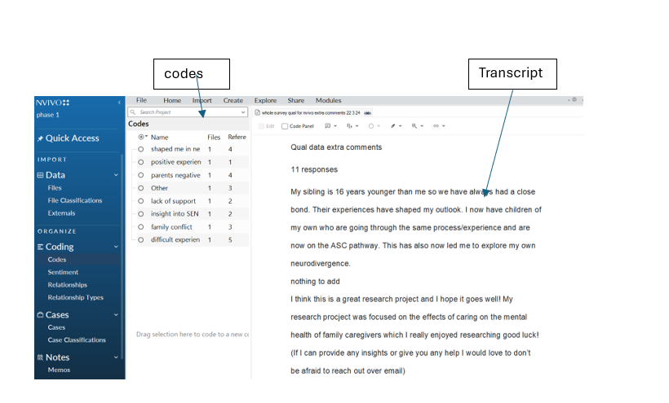
The user highlights a section of the transcript and then drags and drops the extract into the relevant code. The software counts the number of times when an extract has been dropped into a code descriptor tallying both the number of participants who spoke about the theme and the number of times when the theme appeared across all the transcripts. This can be seen in Figure 12 below.
Figure 12 Collating themes in N Vivo
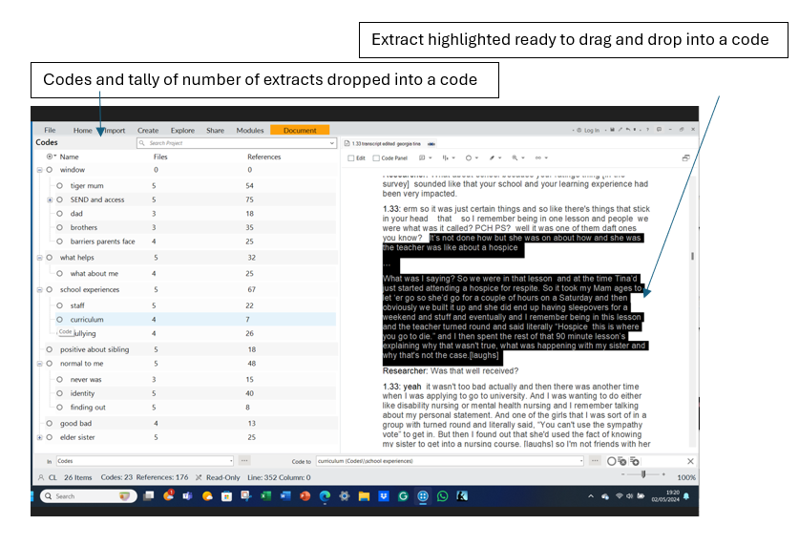
Nvivo creates “code books” (tables) and “hierarchy charts” as seen in Figures 13 and 14 below:
Figure 13 NVivo Code book
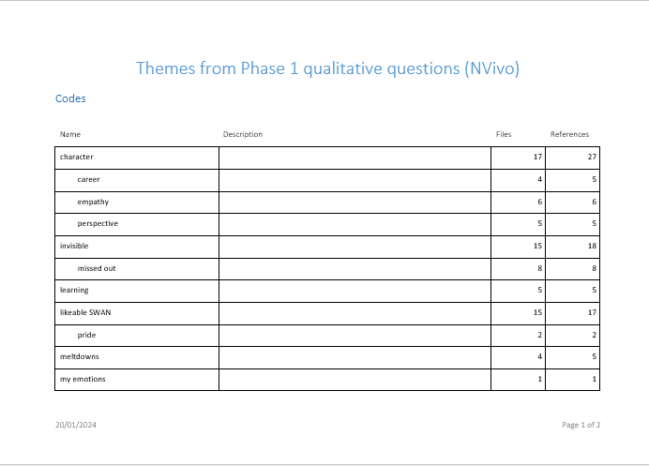

Figure 14 NVivo hierarchy chart
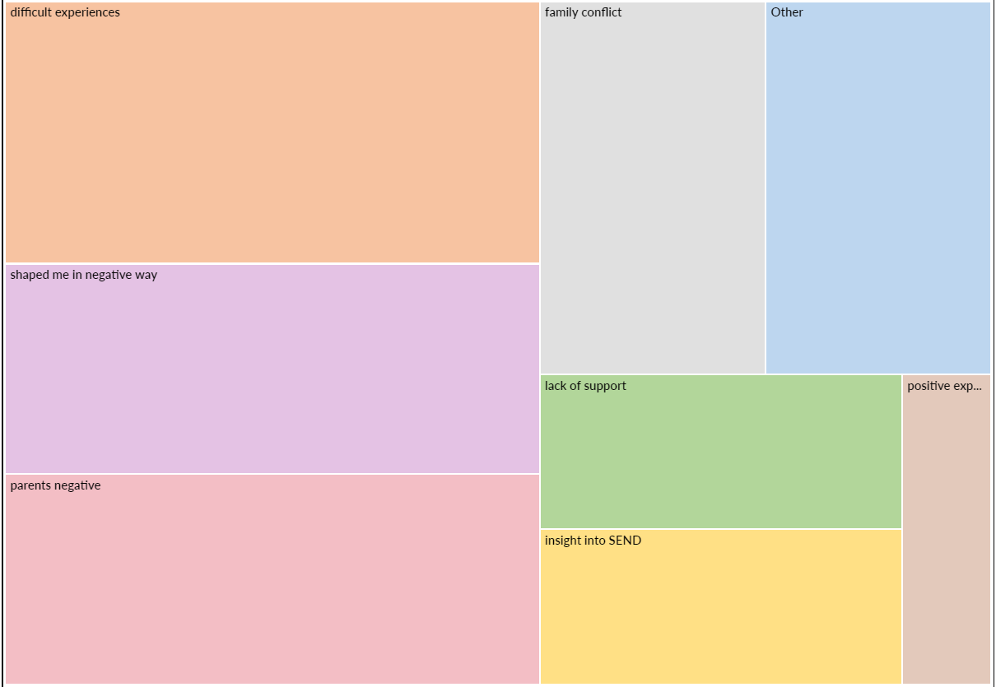
The hierarchy charts and the tally numbers allowed me to see at a glance which themes were occurring most often, and I was then able to hone my list of themes.
However, the most helpful aspect of the software was that it then collated the extracts relevant to each code so that when I came to write about each theme, I had all the quotes grouped together without having to manually find the relevant quotes. It was also possible to include overlapping themes in both separate files e.g. where a participant talked about an experience at school, this could be saved under the codes for both school and elder sister. One limitation of the software, however, was that to print each theme file and/or highlight sections, I had to copy and paste the file into word first. Figure 15 shows part of a file relating to the theme of mothers.
Figure 15 Extracts of transcripts relating to the theme of mothers
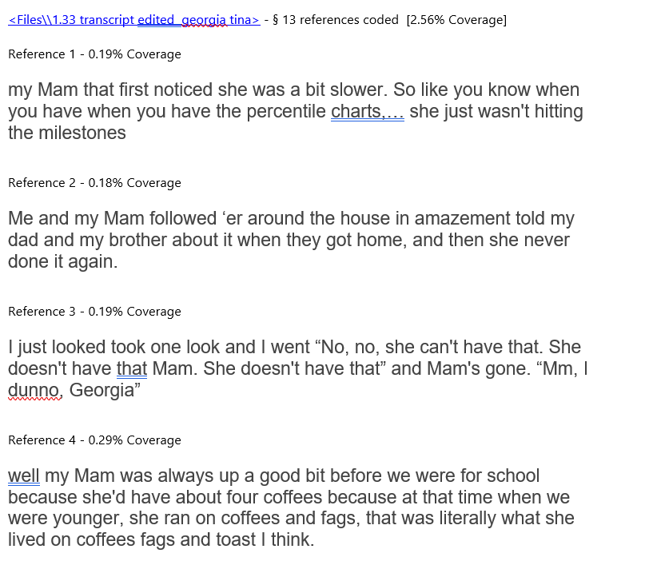

I used NVivo four times:
- Having hand analysed and annotated transcripts (see Appendix Q), I used NVivo to look for extracts within the interview transcripts which might illustrate themes which I had identified in the hand analysis
- I then ran a second NVivo cycle using only the most prominent themes from the first NVivo cycle.
- I later ran the transcripts through NVivo a further time to highlight where participants had talked about school.
- I used NVivo to analyse answers to the Phase 1 qualitative questions. I then used NVivo’s tally of codes to create graphs.

Quantitative data from Phase 1 was analysed using Excel. Qualitative data from Phase 1 was first analysed by hand (see Appendix P) and later analysed using NVivo. Collating this initial table helped me to identify potential themes in the survey data which I then used as themes with the NVivo programme. A word cloud was also created to illustrate answers to the final question where participants were invited to suggest areas to explore in interviews.

Data from Phase 2 was gathered using semi-structured interviews. Data was cyclically analysed using reflexive thematic analysis (Braun & Clarke, 2022; Willig, 2013). I first familiarised myself with the dataset by reading and annotating the transcripts. This process can be seen from the extracts in Appendix Q. I then used NVivo twice, the first time to code for all themes and then, having reviewed NVivo’s report and identified possible themes, I ran a second NVivo cycle coding the more prominent themes. I then returned to the transcripts and cross-checked these themes. I reviewed the themes throughout, reduced the number of themes and considered whether some themes should become subthemes. When analysing interview transcripts, I cross-referenced these with data from the survey, looking for common and contradictory themes. I did not provide a separate thematic analysis of qualitative data from the Phase 1 surveys, because survey qualitative data was small. However, key themes from the survey were used. Qualitative data from surveys was also later cross-referenced and used to supplement interview data.

When analysing Phase 2 data using a reflexive thematic analysis approach (Braun & Clarke, 2022), I realised that participants rarely talked about the effect of having a sibling with additional needs on their own school experiences (although they did talk often about their sibling’s school experiences). However, although this had not been a key theme, this area had been my third research question and central to my transformative intention, so I felt it important to still explore this aspect which I did so through an additional NVivo analysis relating solely to this aspect of the data and wrote a separate section in the results chapter.

2.11 Chapter summary

A mixed-methods research method was used. 44 participants completed surveys which included both quantitative and qualitative questions. Five of those participants were then interviewed. Descriptive statistics and reflexive thematic analysis were used. Themes to explore in interviews were suggested by participants in Phase 1. A critical realistic approach underpinned the research.

Chapter Three: Results
In this chapter I will report on quantitative data from the survey and qualitative data from the Phase 2 interviews. Qualitative data from the survey will be summarised here and then discussed in Chapter 4.

3.1 Research Findings from Phase 1 Survey (quantitative data)
The aim of this section is to illustrate the key findings of the survey’s data and to discuss the findings in the context of previous research, in order to answer

3.1.1 Key findings from Phase 1 (quantitative data)
Research question 1: How much do those who grew up with a sibling with additional needs perceive that their life was affected?

Question 1: To what extent does having a sibling with additional needs affect the life of the other sibling?

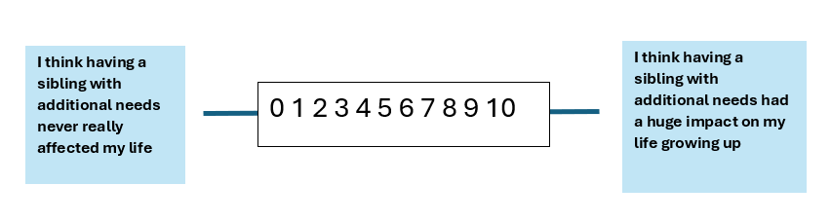
Table 3
Perceived overall effect of having a sibling with additional needs
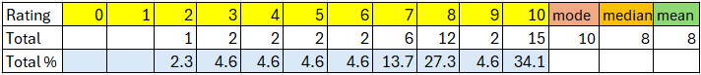

Figure 16 Perceived overall effect of having a sibling with additional needs

Question 2: To what extent does having a sibling with additional needs affect quality of life?
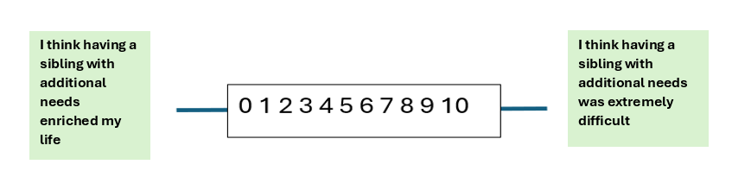
Table 4
Perceived overall effect of having a sibling with additional needs on quality of life
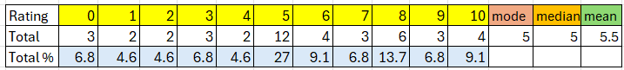

Figure 17 Perceived overall effect of having a sibling with additional needs on
quality of life
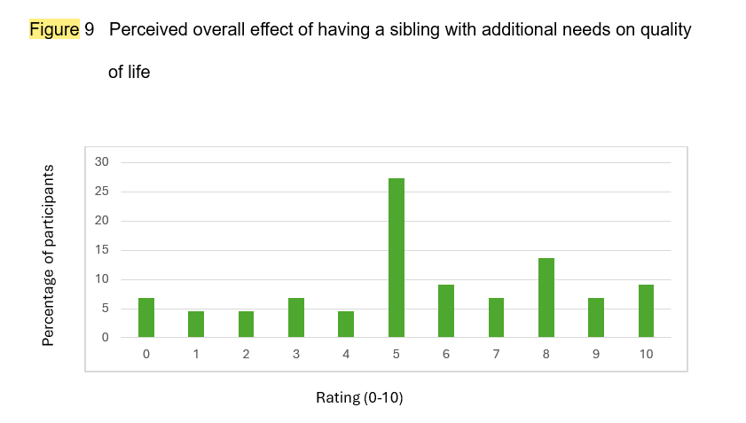

Question 3: To what extent does having a sibling with additional needs affect decision-making for the typically developing sibling?
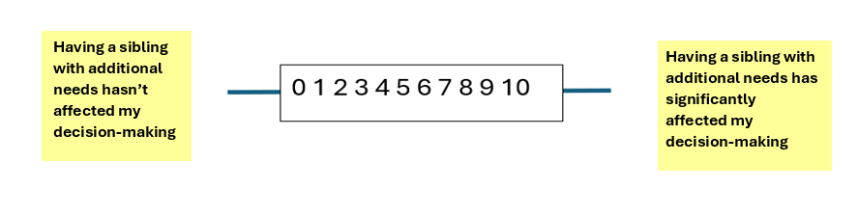
Table 5
Perceived overall effect of having a sibling with additional needs on life decisions
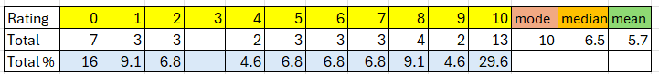

Figure 18 Perceived overall effect of having a sibling with additional needs on life
decisions

Question 4: To what extent does having a sibling with additional needs affect the typically developing sibling’s school experiences and learning?
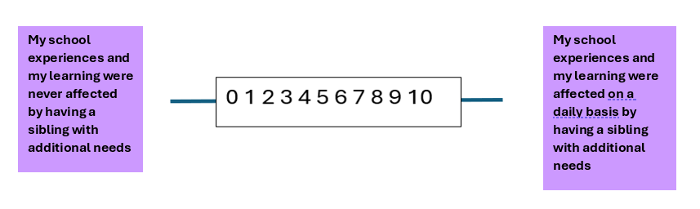
Table 6
Perceived overall effect of having a sibling with additional needs on schooling and learning
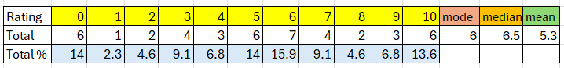

Figure 19 Perceived overall effect of having a sibling with additional needs on
schooling and learning

Cross-question comparison
Table 7
Comparisons of mode, median and mean for the four quantitative questions of the Phase 1 survey
 | mode | median | mean
Q1. Perceived effect overall | 10 | 8 | 7.9
Q2. Perceived effect on quality of life (high score is negative) | 5 | 5 | 5.5
Q3. Perceived effect on decision-making | 10 | 6.5 | 5.7
Q4. Perceived effect on school/ learning | 6 | 6.4 | 5.3

The sample size and data set were too small to make generalisable findings about what it is like to grow up with a sibling with additional needs. However, I have included here a brief analysis which may provide an interesting stimulus for further research to investigate whether large scale studies yield similar results
- Q.1 All survey respondents gave a score of 2 or higher as their rating for the effect of growing up with a sibling with additional needs. In contrast, for all other questions, some participants voted 0. However, the variability in scores suggests a heterogeneity of experiences and perceptions of the effect of growing up with a sibling with additional needs (Table 3 and Figure 16. Q.1)
- Q.2 Some participants said that having a sibling with additional needs was only enriching (rating of 0). Other participants rated this as extremely difficult (rating of 10). This suggests that sweeping generalisations cannot be made about whether having a sibling with additional needs is entirely positive or entirely negative. (Table 4 and Figure 17, Q.2)
- Q.2 The mode, median, mean and graph all suggest that most participants tended to rate the overall effect of having a sibling with additional needs on quality of life at the midpoint. This suggests either that participants experienced little of the two extremes or that extreme difficulty coupled with extreme enrichment balanced each other. This is a key difficulty in interpreting quantitative data. (Table 7 Q.2).
- Q.3 Where participants rated an overall effect on decision-making, scores were spread relatively evenly across the range. This again demonstrates the variation in individual siblings’ life experiences (Table 5/ Figure 18, Q.3).
- Q.4 There were no obvious conclusions to be drawn from participants’ ratings of overall impact on learning. However, 6 participants said this had had no effect on their schooling and 6 participants said it had had an enormous effect (Table 6/ Figure 19, Q.4.). This again shows that generalised statements cannot be made.
Thus, the overall finding of the survey's quantitative questions is that experiences vary and that there is no norm whereby everyone who has a sibling with additional needs is affected to the same degree and in the same way. This may be a partial explanation for conflicting findings in previous research.

3.1.2 Differences between subgroups
In order to look more closely at the data, I wanted to see if certain subgroups had tended to rate in similar ways. If this were the case it might explain both divergent scores and why previous research had produced conflicting conclusions. However, Overall, there were few obvious differences between sub-groups for most quantitative data. Tables and graphs are included in Appendix R. However, I have included my reflections on possible differences as they may provide an interesting stimulus for further research to investigate whether possible trends would be found in a large-scale study.

Question 1
- Overall, older participants gave higher scores for perceived overall effect of having a sibling question 1with additional needs (Table 11/Figure 43 in Appendix R)
- Overall, participants who self-identified as carers gave higher scores for perceived overall effect of having a sibling with additional needs (Table 15/ Figure 51 in Appendix R)
Question 2
- On the whole bar charts for all sub-groups followed a roughly similar shape with the tendency for participants to score at the mid-point rather than extremes

Question 3
- On the whole bar charts for all sub-groups followed a roughly similar shape with less tendency for participants to score at the mid-point

Question 4
- Overall, participants who had a sibling with autism and/or Attention Deficit Hyperactivity Disorder gave higher scores for perceived effect on schooling (Table 27 and Figures 71 and 72 in Appendix R).
- Overall, participants who had four or more siblings gave higher scores for perceived effect on schooling (Table 27 and Figures 71 and 73 in Appendix R)
- Overall, those who self-identified as young carers and those who now realised that they may have been young carers gave higher scores for perceived effect on schooling (Table 30 and Figure 78 in Appendix R).

3.1.3 Summary of Phase 1 quantitative findings
Findings suggest that some siblings perceive themselves to have been only weakly affected whilst others perceive themselves to be strongly affected. Similarly, some siblings report their experiences to be positive and some report their experiences to be extremely difficult. For all four questions, some participants rated their experiences at the mid-point. These findings suggest that differences are more nuanced than previous research might suggest and that a variety of outcomes are possible.

3.2 Research Findings from Phase 1 Survey (qualitative data)
In addition to answering the self-rating questions of the Phase 1 survey, participants were invited to respond to four short answer questions. Answers were used to identify broad themes and identify areas to discuss in Phase 2 interviews. Results are summarised below. Survey responses were reviewed again later alongside questionnaire transcripts.

Q.5: What would you say was the best thing about having a sibling with additional needs? (83 parts of the text were coded and responses totalled 1181 words)
Figure 20 Frequency of themes regarding the best aspects of growing up with a
sibling with additional needs (number of statements across all surveys
which were coded as positive)

Q.6: What would you say was the most difficult thing about having a sibling with additional needs? (132 parts of the text were coded and responses totalled 2002 words)

Figure 21 Frequency of themes regarding the most difficult aspects of growing up
with a sibling with additional needs (number of statements coded (number
of statements across all surveys which were coded as negative)

Q.7: Please add here any information which you are comfortable sharing (21 parts of the text across all surveys were coded and responses totalled 719 words)
Figure 22 Frequency of themes mentioned in the optional question (number of
statements coded)

Q.8: What do you think might be good interview questions to ask someone who grew up with a sibling with additional needs?
Because I did not want to create a cumbersome list of suggested questions, which would often overlap, I chose to represent the suggested areas to explore and frequency of those suggestions as a word cloud. This can be seen in Figure 23 below. The size of the word represents the frequency of suggested questions.

Figure 23 Word cloud representing frequency of suggested areas to explore in
Phase 2 interviews as suggested by survey respondents (number of
statements coded)

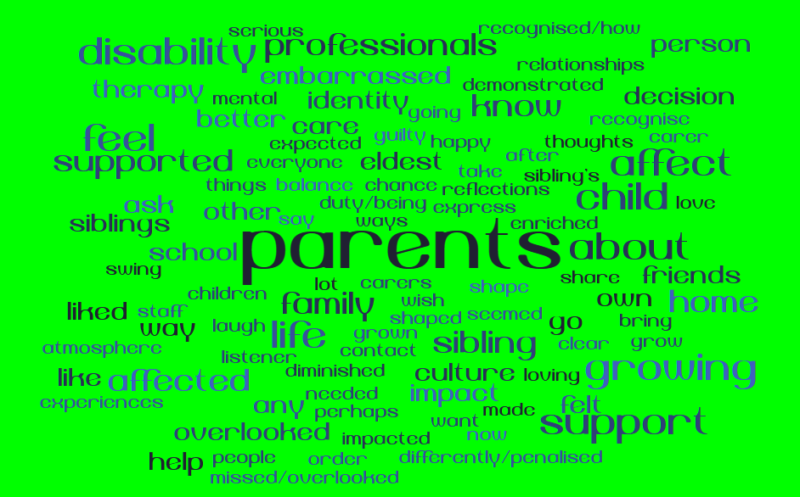

    - Summary of key findings of Phase 1 qualitative data
- Overall, the answers to the qualitative questions suggested a less positive experience of growing up with a sibling with additional needs
- When asked what the best thing was about having a sibling with additional
needs four participants (10%) said that they were unable to think of anything
good about the experience
- More lengthy answers were given to the question asking about the most
difficult thing about having a sibling with additional needs
- The most frequent themes in the question regarding the most difficult thing
about having a sibling with additional needs were negative emotions (19%),
injustice/ unfairness (18%), feeling ignored/ missing out (17%) and having to
do things which they would not have otherwise had to do (17%) e.g. caring
responsibilities or helping with schoolwork.
- For the (optional) additional information questions there were four comments
(19%) talking about the way the participants had been shaped negatively by the
experience, with the most frequent themes being difficult experiences (24%),
being shaped in a negative way (19%), negative comments about their parents
(19%) and family conflict (14%), suggesting that those with less positive
experiences were more willing to answer this question and to write at length.
- The most frequent theme (41% of coded extracts) for the answer to the question about the best thing was a positive effect on the participant’s character e.g. being more empathetic, rather than a positive statement about the experience itself. 15 comments (18%) related to having a better understanding of disability.
- Whilst 22 comments (27%) were made about a positive quality of their sibling, this was still only the third most frequent theme.
- When suggesting areas to explore via interviews, parents was the most common area suggested.

3.3 Research Findings from Phase 2 Interviews
Introduction
The aim of this section is to discuss the key themes arising from a close reading of the five transcripts. Education did not appear as a major theme but is discussed in Chapter Four because it was a research question.
The key themes are illustrated in Figure 24 below
Figure 24 Main themes of Phase 2 interviews (author’s own graphic)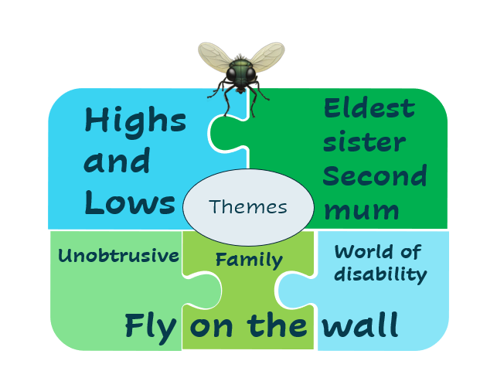

3.3.1 Theme One: Highs and Lows
“It was the best of worlds; it was the worst of worlds … it was the season of light, it was the season of darkness, it was the spring of hope, it was the winter of despair” (Dickens, 1859/ 2012, p.3).
Here Dickens, describes a world where the desired and the undesired exist alongside each other. This also described the experiences of many of my participants whose lives were full of paradoxes. The interviewees clearly loved their siblings but had had difficult experiences, meaning their lives had both joy and sadness, pride and pain.
All the participants talked about the positives and negatives of growing up with a sibling with additional needs, best described by Georgia who summed up her experience of having a sister with a life-limiting condition as
“Shit … but perfect at the same time, like special, it was just magic like it was just happy all the time, even in the bad bits. We were always laughing. I think it actually brought us closer together as a family”
Georgia went on to talk about her experiences as “bittersweet” and even “I don't know like it's weird to explain but I wouldn't have had it any other way as horrible as that sounds”. She described what it was like once her sister exceeded her life expectancy:
“Obviously, them 12 years you were waiting for something to happen then got to 12 and it was like every birthday, every Christmas, every New Year's Eve was bittersweet bittersweet like you found yourself overthinking it what it would be like and even though you don't want to, but it's always sort of there”,
illustrating that not only were Georgia’s experiences a mix of highs and lows but that she could feel positive and negative emotions even in the same moment.
Jenny told me that when she had seen my email inviting her to be interviewed her initial reaction had been: “I can't wait to let you know all about like the negatives and things but actually … I don’t feel like there are that many … I guess my my negatives are things that I've ascribed to myself”.
Childhood memories were talked about as largely positive. Jenny said, “We’ve always had … a very close kind of bond … we had a very happy childhood”. Lucy described her sister as “fun” and a really important person in her life.
Sometimes the sisters talked about their sibling with great admiration, affection, and fondness. Sabrina talked about Josh, her elder brother as “… probably the only child in a wheelchair that they’ve known to just zoom up and down the corridors and everyone’s like idolising him because he was really smart and really great”. She went on to talk about what an inspiration Josh had been. He had gone on to study at a prestigious University:
“I think like he’s everyone’s aspiration to be honest, with what he’s been able to do … he was way behind in school because of all the time he’s spent in hospital and suddenly he’s off doing his [postgraduate study] right now. That’s amazing”.
Georgia kept circling back to her happy memories of her late sister:
“Oh, I miss having that little warm thing in my nook. I miss getting up on a Saturday morning to give her a bath and give ‘er ‘er breakfast through a tube while she sings us a song … she was just always so happy … if I could keep her forever the ways she was … that would be amazing, but I wouldn’t change it”.
Although sometimes the sisters alluded to difficult times, they would then put a positive spin on the outcomes. Georgia, Jenny, and Lucy all talked about the positive impact on their character of growing up with a sister with additional needs. Both Lucy and Georgia said it had made them better people and Jenny attributed her empathy as due to “being through all the crap that you go through and actually just learning from it”.
Sometimes the participants talked explicitly about recognising these two extremes of their experiences. Georgia weighed up the effect which her experiences had had on her physical and mental health against her personal growth and concluded that the “positives outweigh the negatives” and Jenny described her “in-depth understanding” of other people and how “sometimes that’s a blessing and sometimes that’s a curse”.
3.3.2 Theme Two: Fly on the wall
Throughout the interviews and especially when reviewing the transcripts, I was struck by how much the participants talked about others rather than themselves and how much insight they provided into the world of others through their descriptions of family and school experiences. When they did speak in the first person this was nearly always talking about themselves observing or reflecting, using phrases such as “I remember” and “I think”. Initially, this reminded me of a camera operator filming a scene. However, on reflection, I realised that “fly on the wall” was a better metaphor because when a scene is being filmed the camera operator is very obvious to those around them and sometimes a distraction from the action of the central characters, whereas a fly may go unnoticed.
3.3.2i Unobtrusive
Because of the subject matter of the research and because of previous literature which I had read, I had expected the participants to talk about themselves and their own experiences. However, they talked much more about other people, their parents, their siblings with additional needs and the world of special educational needs and disability (SEND). Georgia and Jenny also talked in depth about their brothers, who had been less involved than they had and who had both struggled with school and their emotions, speculating that their brothers had found their family situation difficult yet had not been able to articulate their feelings.
The metaphor of the fly on the wall seemed pertinent because people only notice the fly if it draws attention to itself. The participants talked very much from an observer perspective, and underneath the surface of the main themes, it appeared that the siblings had in some ways been invisible. There was very little sense of “what about me?” in the participants’ narratives and sometimes it seemed almost as if the participants felt that they had no right to personal support. However, it was clear that participants had often behaved in ways which did not draw attention to themselves at school. Jenny talked about how “I kind of just went under the radar” and Georgia described how she “… seemed quite healthy because I was a smiley kid “but was really “just very good at hiding it all … I never sort of cried at school … I took it home and then dealt with it, myself later on”.
Comments from those who I interviewed often echoed those of some survey respondents who described being “cast aside” (Participant 1.29) “feeling overlooked” (Participant 1.25) and “being forgotten” (Participant 1.31). Participant 1.37 had described her life growing up as leading to depression and suicidal ideation because “I was used as a counsellor and vessel for the family issues, regardless of what my own needs were … and even decades later [I] find it difficult to recognise or voice my own needs”. Sabrina too commented that if her mother had not had to be an advocate “as well as having all the kids, then there’d be a lot more time for her, and then a lot more time for me”.
Georgia told me she had volunteered to take part in the research because she had once looked online for details about siblings and concluded “There’s nothing. Absolutely nothing. It’s always parents this, parents that, even grandparents seem to have more of a push”. She had asked fellow siblings, who had voiced “You basically are like an extra parent, and everyone treats you like the help”, contrasting care for parents
“Everywhere I went it was “Your mam’s so good at doing this. Your dad’s so good at doing that … you’ve got to help your mam and dad” … and I was like “What the fuck about me? What am I supposed to do?” … I’d do anything for anyone … but I never had that from anyone else … I don’t think anyone asked if I was all right even if I went in and said, “Oh she’s poorly” … [it] was never “Are you OK?” It was “How’s your mam? How’s your dad?”

3.3.2.ii Family
From their viewpoint as a fly on the wall, each participant had observed those around them. Observations of family members were described in detail. In particular, participants talked about family members and especially the barriers the family had faced in accessing support.
Parents
When describing her parents’ experiences, Jenny talked about how her parents had had to go to the Special Educational Needs and Disability (SEND) Tribunal four times.
“They fought for the school then they got the school, but then they had to fight for the transport and then it was something else … there’s still kind of everyday battles and things that they have to do together”.
I was interested that sourcing transport and the need for Jenny’s mother becoming Becca’s chauffeur were part of Jenny’s family’s story. Tirraro (2024) has recently highlighted how lack of transport and refusal to provide transport for children and young people with additional needs causes further stress and unpredictability for children and young people with additional needs and their families, and how this is fuelling parents having to give up work. Here Jenny described not only observing her parent’s stress and the financial consequences resulting from her sister’s additional needs, but how this had had a direct impact on her because of time she lost with her mother, who was transporting Becca and preparing for the SEND Tribunal.
Jenny had chosen to write her university dissertation on a similar topic to my thesis. She told me how one common theme in her findings had been “fighting, having to know what to fight for” and how this mirrored her own family’s experiences since that she had known “from an early age …that it’s hard work for the parents”.
At the school level, Lucy talked about how her parents had pushed for additional provisions for her sister, in particular, sensory activity interventions and exam access arrangements, suggesting such provisions would not have been made by the school without pressure and advocacy from her parents.
Jenny’s parents had also attempted to take the overseas hospital where her sister had been born to court because of her birth injuries. She talked about the financial cost of her parents’ legal actions, including having to remortgage the house to pay legal fees.
Sometimes the participants talked about how having a sibling with additional needs had changed the dynamics within the family and how family systems and wider societal expectations placed these sisters as additional adults, stepping into a role which usually a parent’s partner would fill. Jenny talked about how her parents confided in her about their battles. Sabrina talked about how she used to “hang out” with her Mum in the hospital car park and Georgia talked about how her mother had shared her thoughts with Georgia when researching Tina’s genetic condition, talking to her as an equal.
Mothers
Often having a child with additional needs had led to the mother taking on a traditional stay-at-home mother role and, where mothers did work, their career had taken second place to the father’s. Georgia’s mother had not gone back to work as planned once it became clear that Tina was not meeting milestones. She talked about the family’s morning routine: “My mam was always up a good bit before we were … she ran on coffee and fags … everything was like clockwork”, showing the importance of her mother as the person who organised the children, whilst her father’s role in the morning routine was never mentioned.
Hearing how the practical activity and emotional load often fell on the mothers, reminded me of recent research which has highlighted the disproportional impact of having a child with SEND on mothers. For example, a recent poll of 1000 mothers of children with special educational needs (BBC; 2024; Opinium Research, 2024a, 2024b) found that 33% of mothers of children with additional needs have given up work, a further 25% have considered it and 30% have reduced their hours. Reasons given include needing more time for their child (53%), their child’s emotional health (40%), inconsistent support from the school (30%), no suitable school (13%), and lack of appropriate funded transport (12%)
Emma’s mother had taken a job as a teaching assistant at her daughters’ school, and I wondered whether this had been a pragmatic choice as it allowed her to be more available for the twins after school and in the holidays and to be close by during the school day.
Jenny’s father worked away whilst her mother did shift work as a nurse. Jenny and her brother had an after-school childminder because their mother had to collect Becca from her out-of-area school until the SEND Tribunal forced the local authority to provide a taxi. Jenny also alluded to her mother not being able to come to sports day because Becca had an appointment but did not mention that her father had not come either. Jenny said that once her sister had a taxi to school her mother was “more available for us”, suggesting she had missed out because her mother had had had to be Becca’s taxi driver. Jenny also contrasted the different relationships she had with each of her parents which had resulted from her father working away and her mother being the one to ask Jenny for support. Looking back Jenny could see how “there was a bit of strain between us … because my dad was never the one to be like “oh can you come round and help Becca”. It was always my mum”.
I was particularly struck with the how much the interview participants admired their mothers. Whilst many in the survey had criticised their parents, often their mother, the interview participants did not. The term matrophobia, (Sukenich, 1973; Rich, 1986) which describes “the fear of becoming one’s mother” (Rich, 1986, p.235) appeared absent from their thoughts. Most of the participants were pursuing demanding careers and saw no obstacles to this. This was most striking in Jenny’s case because she was doing this alongside being her sister’s carer. Interestingly, Georgia’s aspiration to be a mother was in spite of the challenges which she had seen her mother experience.
Although fathers are sometimes described as advocates, day-to-day situational battles more often fell to mothers and mothers were often portrayed as fighting not just for their own children but for wider justice for people with additional needs.
In Sabrina’s case, her mother’s advocacy encompassed not just her children with additional needs but also Sabrina. It was never clear whether Sabrina’s mother wanted to have Sabrina at home to help out or whether she felt Sabrina had been given a detention without considering her personal circumstances. However, Sabrina’s mother often intervened, especially when Sabrina received a detention. Sabrina described how, “She’d just storm in and say “No, She’s got stuff to do” … I think they were just scared of my mum”.
Their mothers had also been unafraid to make a public scene. Jenny talked about a time when her mother had argued with a cinema usher who had insisted that the family should have booked a wheelchair space and although Jenny remembered being incredibly embarrassed at the time, she said she would do the same herself now, suggesting that her mother’s warrior-type behaviour was now replicated in her own actions.
Georgia described a time when three buses did not stop because the wheelchair spaces had been used by prams. Later her mother had phoned the bus company and, soon after, signs appeared on the buses asking people to give up space for wheelchairs. Here, Georgia had not only witnessed her mother as advocate, but also seen positive change result from her mother’s assertiveness.
At the same time, Emma’s mother had advocated for her daughter’s independence: “She was just really good at knowing when she needed to step in and when she needed to let Abbie figure it out”. For example, declining the offer of school transport because “She’s gonna have to learn to get a bus … do it now when she’d be with her sister”. Emma also described how when their mother had discovered Abbie was being allowed to opt out of PE because of her blindness, she responded, “No, legally you have to be in sport”. Thus, Emma’s mother was not just asking other people to make reasonable adjustments for her daughter’s additional needs but also asking her daughter to develop independence.
Sabrina and Jenny both talked about their mother having high expectations for their children. Sabrina credited her mother with her and her brother going to university despite their working-class backgrounds, describing her mother as “driven to get us into education” and Jenny described her sister as “very driven … that comes from my parents … pushing her to get qualifications and go to university and … do things with her life”.
At the same time, the participants described their mothers’ struggles.
Sabrina’s mother was a single parent of five children, one of whom was a wheelchair user, and two of whom had autism. It was clear from how Sabrina talked about her childhood that her mother had been under pressure:
“Home’s a bit more difficult … just having a mum … it would have been a lot more manageable for my mum because she wouldn’t have to do everything all at once and be the advocate as well … she was the only advocate for their special needs … My mum should have got a lot more help”.
Georgia also talked about her mother’s mental health struggles, and I wondered to what extent her mental health would have been better were she to have had more support and had to do less to ensure that her daughter’s needs were met. Georgia also talked about running errands for her mother and going to visit her grandparents and I wondered whether this was a way to reduce the load on her mother who she could see needed support.
I was also mindful of what Friedman (1963) termed “the problem that has no name”, whereby mothers whose lives were limited to the home, with no outside interests often experienced “a sense of contraction, of closing horizons and lost opportunities” (Friedman, 1963, p.43) and wondered if this had contributed to Georgia’s mother’s mental health difficulties.
Mirroring some of the survey comments, Georgia also talked about how frustrated she had often been with her mother, describing one time when Tina had been winding their mother up and wrecking the house. Georgia had challenged her mother about letting Tina get away with things and her mother had said that it was just so much easier to let her. Georgia had then acted herself to enforce boundaries, getting Tina to apologise after a big battle, and throughout the battle also checking in on her mother.
Fathers
Whilst the participants talked much more about their mother’s life being affected than their father’s, they did sometimes talk about their fathers, often talking about them taking on more practical and advocacy roles.
Emma described how her father scanned books, enlarging the font, and printing them off so that Abbie could read them. She also talked about how her father had taken on the role of problem-solver and advocate when her blind sister had become separated from them at airport passport control, telling staff that his daughter could not see so they needed to let him back through passport control to find her.
Jenny’s father was physically absent for most of the week, working abroad, which meant her limited weekend time with him had been “fun and amazing whereas my mum had to deal with all the rest of it”. However, her father had a good understanding of what her sister was entitled to and had applied for grants and funding.
Georgia’s father had been the sole breadwinner once her mother had become unable to return to work. It was clear that Tina had less interaction with her father and that he would sometimes ask Georgia to talk to her sister when Tina would not listen to him. Georgia also described her dad as more distant from Tina than she and her mother were, noting however, that he had been the one to challenge and advocate for Tina with hospital staff.
Brothers
As well as talking about parents and their siblings with additional needs those with brothers also talked a little about them and speculated on their experiences of having a sibling with additional needs. Whilst Lucy and Emma did not have brothers, Sabrina, Georgia, and Jenny did have brothers. Both Georgia’s brother Craig and Jenny’s brother Dan were the middle child. Sabrina had both her older brother Josh who had a physical disability and three younger siblings, a sister and two autistic brothers.
Georgia and Jenny contrasted their relationship with their sisters and the care they gave with that of their brothers. Georgia described this as “I was always in amongst it whereas my brother sort of wasn’t really. He wasn’t interested” and Jenny contrasted how when she cancelled her plans to care for Becca, “I can’t imagine my brother doing the same thing”.
Georgia also talked about Craig’s naivety regarding their sister’s condition being life-limiting.
“Mam and Dad thought they were being clever being like “Oh your sister’s got this but we’re going to America [on a charity-funded trip for dying children] my brother fell for it … and I was there like what sort of game are youse playing? … it was just like the difference between what we understood was quite a lot”
Georgia said she did not think Craig had realised how ill Tina was until a short while before her death, and that this had been the case for their father too. She also talked about how she had found dealing with their sister’s death much easier than he had, and the difficulty Craig had had in understanding his feelings and I wondered whether this reflected cultural expectations about boys being tough
“I don’t think he understood what he was feeling or how he was feeling so that’s why it was worse for him. So, he ended up going to counselling and things in the end like anger management. Obviously, he wasn’t just an angry kid … everything that he was going through”
Georgia contrasted Craig’s behaviour once he came home from school where he locked himself in his bedroom, shut the door, and sat in front of the computer screen, whilst she spent her evenings enjoying time with Tina. Georgia also talked about their family visits to conferences with other families with children with the same condition; at these events, Georgia was fully involved with the other families, whilst the boys would play on their Xboxes.
Jenny too talked about how her brother closed off his emotions
“He is an incredibly closed book. He does not talk about emotions really or show emotions … I think he did take a brunt of it … just accepting that his parents weren’t around … he was getting less attention than he needed”.
Jenny told me about how Dan had been excluded from nursery because
“He was always kind of the one … acting out just misbehaving … whether that was because there was attention, he wasn’t getting … my mum and dad they felt really guilty … they felt they hadn’t noticed because they were dealing with my sister … I could see how that might be true. I could see how it [ADHD] could go unnoticed, and he could just be naughty because the attention was elsewhere”.
The similarity between the two families made me wonder whether having a sibling with additional needs was harder for boys to come to terms with and I also wondered whether their brothers’ lesser role mirrored that of their fathers’ lesser role.
The sibling with additional needs
As well as talking about other members of the family, the participants talked about their sibling with additional needs more than themselves. Much of what they talked about related to school and being stared at in public, both of which are covered later, but they also talked about witnessing their sibling’s struggles. Georgia told me about a difficult time for Tina:
“She went into herself when she lost her hearing … she wasn’t as outgoing … she’d always climb about the house … but then she just stopped doing that … she loved music … but then she went completely in on herself”
One of Tina’s close friends had died around this time and when they had told Tina “she sort of sat all the time dead … really quiet. You could tell that she wasn’t right”
Participants also talked about struggles which their siblings had faced which might not have been obvious.
Emma talked about how Abbie’s visual impairment meant that she could not see expressions and that meant that she struggled to recognise other people’s thoughts and feelings. In a similar way to some autistic people, she “could learn it, but she’ll never just instinctively detect” which had led to “social blunders”.
Lucy talked about her sister’s disability being invisible because her needs were “on the inside” and so meant “people wouldn’t really be able to recognise that she needed that extra help”. To avoid Mel’s public reaction to sensory overload and her fear of birds, the family would never go to concerts or the beach. Thus, we see here what lengths families often go to in order to reduce the risk of distressing situations for their children with additional needs.
3.3.2iii The World of Disability
Having used the term “sibling with additional needs” throughout to describe the participants’ siblings I turn here to consider the wider world of disabled people as described by the participants. Here too the participants provided insight, by telling me what they had observed their siblings experience, especially in school and in the wider community. Their experiences underlined for me the social model of disability, whereby the participants’ experiences of having a sibling with additional needs had led to them becoming extremely aware of what it is like to be disabled in a world which is not designed with disabled people in mind (Reeve, 2006; 2006; Titchkosky, 2011). In particular, they talked about access issues and staring.
Georgia described two challenges with public transport, buses which did not stop because prams were taking up the wheelchair space, and another occasion when public transport had been problematic because she had been taking time to transfer Tina from her wheelchair and fold the wheelchair up on a train whilst other passengers loudly complained about the hold-up.
Jenny talked about how having a sibling with additional needs means she notices access issues
“There are things that you will only notice if you’ve lived them … things like access … you might have a ramp, but do you have a disabled toilet? And you might have a disabled toilet but are the doors wide enough? You just wouldn’t consider it. It didn’t cross your mind”.
Jenny described talking to her fiancé about access issues: asking him not to park on pavements because people needed wheelchair access and considering access issues in choosing a wedding venue, something which was second nature to her. She described her guilt when she went to social events in [the city] “because it’s a logistical nightmare to get her into [the city]… it’s things like that she definitely missed out on”. She talked about the injustice of her sister being refused a place at her own school because they would need to put in ramps and lifts and how, when her parents separated, her mother’s house had had to be rebuilt to include access ramps and a wet room.
The participants talked frequently about staring and how this was unavoidable.
“She got stared at a lot …it was just pure nosiness … supermarkets …walking through town and it was just constant … just constant. I don’t think people realise they’re doing it … I don’t want people to feel like how we felt” (Georgia).
Sabrina talked about her autistic brothers having meltdowns in public, describing being stared at as “pretty normal” since she was used to people staring: “People were amazed about a wheelchair for some reason. So that’s not anything new to us”. Sabrina talking about staring in a very matter-of-fact way, and how she had grown up “to stare back at them”.
The participants also talked about the discomfort that non-disabled people sometimes felt around disability. Georgia said that when she shows people a picture of her sister: “They’re dumbfounded like “I just don’t know what to say to that”. Jenny also talked about her own discomfort, especially when younger. She had often found herself talking for Becca when other people could not understand what Becca was saying. This had been a strategy to avoid people having to ask Becca to repeat things, whereas now Jenny had changed her perspective to wanting other people to make adjustments.
One survey respondent talked about how the embarrassment she they had felt at her brother’s meltdowns had had a long-lasting effect whereby they were still “incredibly self-conscious” if anything ever drew attention to them in public (Participant 1.25).
I wondered if this might stem from “the lack of … cultural rules for the interactions between disabled and non-disabled people [which] can lead to anxiety and confusion about how one ‘ought’ to behave with the result being avoidance rather than engagement” (Reeve, 2006, p.99). Participants’ exposure to the world of disability had given them an insight into what disabled people wanted those cultural rules to be.
The participants were also sensitised to noticing discrimination and pejorative language. Georgia talked about how much she hated the word “spaka” and often Emma talked about how her sister hated the term “special needs”. Emma talked about how accompanying her sister on holidays for disabled children of all types had led to her being much more aware of neurodiversity and disability and meant that she had grown up with an awareness that “not everybody is able-bodied or neurotypical” and how she was shocked to hear other people’s prejudices:
“If it’s a friend I can call them out and say … you know that’s not something I agree with but if it’s at work people will say something… you’re higher up than me. I can’t call you out. I don’t really like you saying … thinking that I agree with you”
I was interested that although Emma saw physical disability and neurodiversity as two different categories, she had generalised her experience of her sister’s sensory impairment to understand the experiences of those with other conditions. Emma had also described an incident at work where colleagues had criticised a colleague for being different when his differences likely resulted from neurodiversity.
Jenny had been unaware of the stigma surrounding disability for a long time. She told a story about how when she was younger, she had found a snail in the garden and naively called it “Spazzy”, enraging her father
“I have never seen someone so angry … I had no idea why he was shouting … my dad said, “Oh that’s what horrible people call your sister”. That was the first I’d ever heard of … people being horrible to people with disabilities … I remember this feeling of like my god, people call her names, and I didn’t know that”.
The participants also talked about how people often had low expectations of disabled people. Emma talked about how people often conflate all disabilities with low intelligence. She described how Abbie had been written off and not expected to achieve academically yet she has now completed a master's degree. Emma also talked about how the presumption of disability and low intelligence had also been applied to her as Abbie’s twin, thus experiencing discrimination by association (Government Equalities Office, 2010).
In Emma’s case, stereotypes about disabled people had led to people not believing Abbie was visually impaired, that was until they saw her chopping things. She talked about a dispute among members of the extended family about whether Abbie could be classed as disabled since she was living a normal life. Emma’s experience included not only the dispute whether Abbie was disabled, but the presumption that Emma would agree with those who said Abbie was not disabled.
Georgia too talked about how people presumed Tina was less able than she was, talking about her as if she was not there.
“I think they just thought she was summat cute and cuddly whereas she had her own opinions, she had her attitude … like she wasn’t stupid ... she could speak, and we understood every single word that came out of her mouth … I think they just sort of looked past her”.”
On one occasion a nurse had come in and told her parents in front of Tina, “If we lose her, we won’t bring her back” as if Tina had not been there. Georgia also told me about someone she knew who had experienced being told that her dying daughter was “like they’re a member of the family” and how her death had been “like losing a pet”.
Thus, it is clear that, even in 2024, disabled people are too often seen as “other”, almost non-human (Titchkosky, 2011) and how those with disability live in a world centred around the “… normate man … a presence that is not imagined, not welcomed … being “the unimagined in flesh and blood” (Titchkosky, 2011, p.26).

3.3.3 Theme Three: Eldest sister, Second Mum
All the participants who I interviewed were the eldest sister in the family and they all talked about their family position and gender as being central to their experiences. Having come to believe as a young woman that gender stereotypes were unnecessary, I had expected that by 2024 gender stereotypes would be considered outdated. However, hearing the participants speak made me feel that little progress has been made and that gender stereotypes still affect family functioning.
Having talked about their mothers and fathers in very gendered ways, participants talked about their own role in the family resulting from being the eldest sister. Participant 1.18 had described this as “Eldest daughter syndrome” (see also Floyer, 2024) which aptly gave a label to the common experiences of the five participants whom I interviewed. I was interested that all who volunteered were eldest sisters and wondered whether this particular role had led to their self-selection as participants who were willing to talk about their experiences (Saliba & Ostojic, 2014).
Jenny talked about how when Becca’s carers could not be there “I will cancel anything … I think that’s just being a sister”, contrasting her brother and herself as “… a gender thing but I think also it’s a me being the oldest thing”. Lucy described her caring for her sister as was “just like any older sister would do for her younger sister” and how “I’m obviously the older one … just expected, not expected but I would know more what to do”, stating too that she had helped her other younger sister with homework just as much. Even Emma who was a twin voiced this: “… obviously I’m only older by two minutes, but it’s hard to draw the line between … is it because I’m older? … it’s hard to say what our relationship would have been like … if I was younger”. Later, she described Abbie as having a “younger sibling personality” and how she had “internalised that I’m the older one”, even though they were twins.
Another common theme is parentification. Participants talked about themselves as having a quasi-parental role. Georgia talked about how she was Tina’s second mother, often describing her relationship with Tina as “motherly” and saying, “She had two mams … if my mam wasn’t there, she wanted me … if she was upset, she wanted me or mam”. Georgia would often be the adult who set boundaries and de-escalated incidents, describing times when her Dad would call and say, “Will you come and see this child and see if she’ll talk to you?” stressing how frequent this was by adding “… every time”.
Georgia talked about family conferences where “I’d tap in, our Mam’d tap out” looking after Tina, and how on weekends when Tina woke up early, their mother would bring Tina to Georgia in bed. Georgia talking about accompanying Tina and her mother to medical appointments, because she “liked to know what was going on ‘cause you always got half a story otherwise” and how she too would ask the doctors questions.
Often people would mistake Georgia for Tina’s mother. She described a time when someone had called her mother “Grandma” and how when her boyfriend had first seen her dating site profile he had been disinterested because he thought Georgia had a child. Sabrina too talked about how being the eldest sister “you’re kind of like a second mum” but how growing up where she did, it was expected that all eldest daughters took on the role of “second parent”.
I got the impression that Georgia had such happy memories of her role as second mother to Tina, that her dream was to replicate that experience as a mother herself. She described Tina fondly, “She was just a tiny … very childlike … she liked to cuddle … she liked to be bathed and played with”. Georgia told me that she had no career aspirations
“All I want is have a little house with a couple of kids, a job that pays the bills, go on a couple of holidays … when I'm going to school and they're telling us to go to University … I was like,” Well where’m I gonna fit my babies in around that?” … I think I've always … had … the idea that I'll grow up and have kids … I mothered Tina that much … a 28-year-old girl … shouldn't be thinking, “Oh I miss having that little warm thing in my nook”. “
Whilst all five participants did work, they had placed other restrictions on their lives, consciously or unconsciously “self-handcuffing”, a term which has been applied more widely to women in general (Schuller, 2017). This term seemed to particularly apply to my interviewees and their mothers, although all the participants were adamant that this had been voluntarily done and had not been an expectation from their parents.
Jenny had applied for a university placement nearer home. She stressed that her parents never had any expectation of the restrictions which she had placed upon herself, and she reflected that in choosing which university to go to she did not
“ever remember thinking I’m gonna choose a uni close to home so that I can get back for her but I do remember thinking I’m going to choose a uni close to home so I can come home, So whether that’s a subconscious thing?”
Jenny had now taken on the official status of carer and described how she would often cancel her plans to care for Becca. She and her partner had recently looked for somewhere to live and Jenny had considered whether she would be able to drive to her sister’s home quickly “just in case anything happened”.
Jenny frequently contrasted her brother with herself:
“We have a good relationship but I’m often very jealous of just the bliss that he lives in, the ignorance that he has sometimes … I think it’s just through being a male … also I think the role I’ve adopted within the family … I’ve always been the next one that’s not a parent”.
Sabrina was more explicit about how her siblings’ additional needs had restricted her life. She described her school years
“I knew I had responsibilities. I couldn’t just gallivant off and do what I wanted. I had stuff to do … I knew how to do a full roast dinner and you have to wash, iron clothes, all that sort of thing which I thought was normal, but it wasn’t”
Sabrina had chosen a university 45 minutes from home, and it had been intentional that she did not go further. However, it was not clear whether this related to her siblings’ disabilities or her sharing the load of her mother who was a single parent. Since university, Sabrina had moved back home and she talked about how, because she now only had two siblings at home, “it’s not as heavy” and she could now “…kind of just float around”. She contrasted her school years as “difficult and busy” whereas now she was “sort of free … more independent … I could just do what I want really now” because she had fewer responsibilities since now not all her siblings lived at home now.
Emma also talked about how looking back she now realises that she had “internalised that it was my job to make sure that she was liked … I’d internalised that if people don’t like Abbie, then that’s a problem that I have to sort out”. The fact that she only came to this understanding once she and Abbie went to different universities made me wonder whether the relationship between the twins was like the attachment and responsibility which many mothers sometimes feel.
Only Georgia and Jenny spoke of having a partner. Having a sibling with additional needs had clearly impacted on their choice of partner. Both Georgia and Jenny talked about how important it was that their partner got on with their sisters with additional needs. Jenny said that she was glad her partner was so understanding since she would always choose her sister over other people. Georgia talked about introducing her boyfriend to Tina and how: “Her opinion mattered … As soon as she warmed up to him, I thought, “It’s all right” ‘cause she's a good judge of character … She couldn't see or hear but she understood when someone was nice”.
Jenny described how her caring responsibilities were a large part of her life. She Jenny often talked about how guilt was “a massive thing” if she handed her sister’s care over to agency staff and if she went to places which were inaccessible by wheelchair without her. She described how if she did not cancel nights out with her friends to care for Becca, she would feel so guilty that she couldn’t enjoy herself anyway. It was clear that Becca’s needs came before her own and all the other important people in her life, in some ways, mirroring the life choices of many mothers. The fact that Jenny had chosen to take on the role as official carer demonstrated how she shared the responsibility, taking on the role of third parent.
I have talked earlier about how the interviewees’ brothers’ involvement differed from theirs. It was clear that the differences between brothers and sisters extended to different caring responsibilities within the families. It was clear that Sabrina in particular had taken on significant caring responsibilities including cooking roast dinners and laundry. She described how she had grown up in a working-class community where many of the families were headed by single mothers, and it had been widely accepted that eldest daughters were second parents. It also struck me that Georgia’s and Jenny’s roles were very linked to the concept of emotional labour, not just taking on the workload but taking on the mental juggling and foresight required as a second mother. I will expand on this in the discussion chapter.
3.4 School and learning
Overall, those I interviewed talked little about the effect of having a sibling with additional needs on their own school experiences and learning, especially if their sibling had attended a different school, perhaps something which had lessened any effect. When participants did talk about school this was often about observing their siblings, a fly on a different wall. Thus, this was not a key theme. However, I include this section here since this was one of my key research questions and my aim has been to develop advice for schools about how to support siblings. Thus, I felt it important to still talk about schools, even though this was not a major theme.
Participants recalled both positive and experiences at school, sometimes directly and often as an observer of their siblings with additional needs and their brothers’ experiences.
When participants talked positively about school experiences, they often highlighted individual staff. Emma talked about a time when a teaching assistant had taken Abbie’s side after a bullying incident. Emma also singled out Abbie’s history teacher and Abbie’s sixth form teacher who had been “amazing” and helpful. Jenny too talked about her sixth-form tutor telling Jenny how empathetic she was and saying that she thought this had come from looking after Becca.
Sabrina talked positively about how the support staff (“the nice ladies”) could see her background and took her into a lunchtime social group for children with special needs. It had never been explained why this had happened, but it had been a quieter place and she had enjoyed it.
Georgia also talked about how, whilst, on most occasions, Craig, her brother had been (unfairly) disciplined, there had been one member of staff, who “was always looking after kids that were a bit different” and they had “sorted it out”.
Lucy talked positively about some of the adjustments that school staff had made for Mel for example, the school providing access arrangements in exams including a separate quiet exam room and allowing Mel to skip the lunch queue and go back into the school building.
However, when participants did talk about school, on the whole, they described more negative experiences than positive ones. Frequently they had observed incidents where their siblings, in particular, had experienced bullying and where they believed that the school had turned a blind eye. Reasonable adjustments had not always been made. Becca had been refused a place at Jenny’s school because it did not have ramps or lifts and Emma talked about how teachers often failed to enlarge work for Abbie, including one teacher who had complained, “It’s so much effort to print everything out”.
Participants who had completed the survey anonymously also alluded to the effect having a sibling with additional needs had had on their school life, nearly always in a negative way, for example, Participant 1.25 talked about the atmosphere at home meaning she underachieved, gaining only 3 Cs at A level but once she left home she had got a 1st at university.
Participants 1.17 and 1.18 both talked about how staff had used them as unpaid staff who could make their own lives easier. Lucy talked about calming her sister down because Mel’s sensory issues and “behavioural issues” had resulted in incidents which sounded like autistic overwhelm (NeuroLaunch, 2024). Lucy described how “sometimes she [Mel] would hit people with pencils or lash out and then people would get really upset”. Sometimes Mel’s anxiety would become overwhelming and sometimes Mel would cry. As a result of her sister’s “behavioural issues”, Lucy had often been sucked into incidents, “if she’d get upset in the playground or if she’d get angry … then either a member of staff or one of the other kids would come and get me”. She also talked about how sometimes she wanted to just ignore the problem: “It just depended on how I was feeling that day and what the situation was … most of the time I was just like [you] help her. I can’t be bothered”, demonstrating how at some level Lucy had taken on an involuntary carer role at school. Interestingly, this had been a much bigger issue at primary school as the size of secondary school had meant Lucy had been “more disconnected” from Mel, although there were still occasions when a friend would come and find her.
Not all the participants went to the same school as their siblings, but Lucy and Emma explicitly talked about their sisters being bullied. Emma talked about how boys hid in the corridor alcoves and jumped out to scare Abbie and times when they would pretend to flirt with Abbie and then laugh saying “It would never happen”.
Most of the participants identified specific incidents where they felt the school had handled things badly. Emma talked about teachers “not understanding or caring”, citing an incident which had happened when she and Abbie were about 9 or 10 where, despite Despite knowing that Abbie was being bullied, a teacher had made Abbie stand at the front of the class and explain why she needed special adjustments.
Emma talked about a situation in primary school where a teacher had insisted that she have Abbie and another disabled child in her class since disabled children were spread across classes and because “they weren’t as hard to work with, hard to manage” suggesting that the school treated all disabled children as if the children were a homogenous group and also that there was a perceived hierarchy of types of special needs.
Emma also talked about bullying and how this was brushed aside. In one incident at primary school, a girl had been bullying Abbie but because the girl’s mother worked at the school “none of the teachers wanted to go against this mum” which had resulted in the school letting “her daughter do what she wanted”. Emma also talked about an incident where a boy had deliberately run into Abbie, claiming that he was chasing a butterfly and how when Abbie had complained, she was told that she probably hadn’t seen him, and she had been made to apologise
Emma talked about primary school being especially difficult, and secondary school being better because she and Abbie were in different classes, but even secondary school had been difficult. Being a twin was a key element of Emma’s story. She talked about how because Abbie was her twin, other children would equally stereotype her as disabled, something which had been magnified by there being another blonde girl with a visual impairment.
Emma also talked about how she became known as her sister’s protector and how the bullying would never happen in front of her because “it was pretty clear that if anyone did anything to Abbie, I wouldn’t have been very happy”. She went on to describe how when people tried to pick fights “I’d shower them” and “it became obvious what would happen so people didn’t really push it with me”, citing an incident in a sewing lesson where another student had said something horrible about Abbie and she had stabbed him with a sewing needle. I got the impression that she had felt the need to challenge this herself because no one else would.
At secondary school, Emma had tried to separate herself from Abbie by joining a different friendship group until they fell out and she started hanging out with Abbie’s friends. Being with Abbie’s friends meant “it wasn’t really a big deal in that group”. It sounded possible that Emma’s attempts to dissociate herself from her sister had been too much effort so that it became easier to just join Abbie and her friends.
Jenny talked about how Year 7 had been a time when she had felt “I just don’t want to be doing this right now. I just want to be being me”. She was meeting new people and wanted to make friends for herself before people found out she had a “sister in a wheelchair”.
Georgia talked almost bitterly about her whole experience of school where staff had seemed completely oblivious to students’ personal lives:
“I don’t think they click that when I went home … I didn’t go home and sit on my arse like all the other kids … it was sort of dead set that in your mind you had nothing else going on at home … you came to school, you were supposed to behave, shut up and do your work, do homework when you got home”.
Georgia also talked about how policies were implemented in a blanket way. For example, when her family went on their term-time trip to America (funded by a charity because her sister was terminally ill), she and her brother were then forced to miss lessons to go to an assembly to be told the importance of good attendance. She described schoolteachers’ attitude towards students as “These are just kids at school and that’s all you are. You’re a task ... You’ve got to learn to pass the test not understand what it means and then off you go”.
Georgia also talked about a girl she knew who was struggling at school but “It doesn’t matter how many times the Mam said, “Look she’s just not coping”. They don’t get it”. She also knew a mother who was
“… always going back to the school telling them that they were doing things that they shouldn’t be doing with adopted kids, but then they’re … getting sent home for wearing … trainers … shouldn’t they focus on something different? Have they not got bigger fish to fry?”
Georgia talked about how she had kept a low profile at school, being on time, doing enough homework, and finding her way around things, for example forging her mother’s signature on forms rather than pestering her mother. She described how she and her friends were “… clued up … We went to school. We got on with it … I always found it easier just to shut up and just get on with it … I had my head screwed on”.
To For Georgia, ”School was a massive thing when you think about it … all the time I spent there but when it comes down to it, I was just there to get it out the way”. She had put minimal effort into her schoolwork and said about her qualifications:
“I just picked things up dead easy … I could tell you … what genes are, all her alterations … the symptoms. So, picking up and figuring out how to use apostrophes and stuff it didn’t seem to take that long”,
highlighting that she had got an A* in the Health and Social Care module about children with special needs because to her it was just common sense.
Jenny and Georgia also made observations about their brother’s experiences at school, much of it relating to their school’s reactions to their brother’s externalising behaviours. Georgia talked about how Craig had often got into trouble because of his reactions to being teased about his disabled sister and how her parents were frequently called into school:
“My brother got bullied … he was sort of the class clown … he’d be punished for hitting someone when they’d said something really horrible about Tina … it wasn’t like just name-calling a sister … it was saying something that was horrible about someone with special needs”.
Jenny told me about how her brother Dan had often been in detentions and even been excluded from nursery because of his behaviour. He was now undergoing assessment for ADHD, and she and her parents wondered whether the signs of this would have been spotted earlier had the family not needed to be so involved with Becca.
Georgia also talked about how the attitude of staff towards her brother had a spillover effect on her, for example at his parents’ evening Craig’s teachers often told him and their parents that “You’re nothing like your sister, the complete opposite” and how staff would “tar [both siblings] with the same brush”. Thus, having a sibling with additional needs affected Georgia indirectly as her brother’s externalising behaviour (which she believed stemmed from him struggling to come to terms with his sister’s life-limiting condition) had led to Georgia being viewed more negatively by staff (see Figure 2).
Most of the participants said that disability had not been covered in the curriculum. Jenny and Lucy said they had no memories of disability or neurodiversity in the curriculum and Sabrina and Emma said that disability had never been talked about. Only Georgia recalled anything, and I got the impression that these were topics which teachers had not realised might be sensitive. She told me about a lesson where the teacher had described hospices as places where people go to die. Tina was spending time in a hospice as respite and Georgia had “spent the rest of that 90-minute lesson explaining why that wasn’t true”. Were it not for Georgia’s confidence in correcting the teacher and this being well-received by the teacher, her classmates would have carried around wrong beliefs about hospices for the rest of their lives. Here Georgia demonstrated that her own personal experiences meant she had greater knowledge and insight into the curriculum than some teachers and that she was unafraid to challenge inaccurate presumptions.
Georgia also talked about religious education teachers “trying to make everything sound too chipper” and I got the impression that she believed that teachers were naïve and unexposed to the harder side of life. She described a lesson about euthanasia where, although the teacher had given the students the option of opting out of watching a video, Georgia had not. She remembered “watching it like getting welled up thinking imagine making the decision to go and do that … I don’t think that should be done. That wasn’t easy”.
Mostly the participants only indirectly talked about their sibling’s needs affecting their learning. Georgia talked about how it was only after running errands for her mother, checking on her grandma and putting Tina to bed, that she started her homework and Sabrina talked about how she and her siblings were “left to our own devices” when it came to doing homework.
Two survey participants and Sabrina talked about how their own additional needs had gone unnoticed and undiagnosed. Jenny also talked about how her brother was now investigating a diagnosis of ADHD for himself and how she wondered whether she and her parents had overlooked the signs of this because they were focused on Becca. Sabrina talked explicitly about how her own autism had been overlooked because her siblings’ needs overshadowed her own, her presentation appearing neurotypical in comparison to her brothers. It had taken until university when she sought a diagnosis herself that she had received a diagnosis of autism. Sabrina felt it important that one of the outcomes of my research should be to “ … let anyone in education to keep a look … out for [conditions such as autism] because I mean statistically there is a chance any of the siblings will also have additional needs”, suggesting that the needs of siblings with identified additional needs often overshadow that of their siblings who are often used as a comparative yardstick for “normality” so that their own additional needs are missed.
Participant 1.18 had also been diagnosed with autism and a specific learning difficulty at university. She has two mental health diagnoses and a chronic illness but her parents’ poor experiences of CAMHS had led to them being resistant to her getting diagnosed. Participant 1.40 also wrote that her own additional needs (ADHD and dyslexia) had gone unnoticed and undiagnosed because of her sister’s complex needs and how no one had questioned her struggles since she appeared fine by comparison.
It is important to note that the participants’ experiences had not been consistently the same throughout their school years and that the effect of having a sibling with additional needs had ebbed and flowed. Lucy and Emma talked about how primary school had been more difficult. Georgia talked about how things had been OK when Tina was thriving, but once Tina’s health deteriorated, things had become more difficult. Jenny talked about how at primary school her life had been affected by having an after-school childminder because her mother was collecting Becca. However, once the local authority provided transport, Jenny’s mother became “more available” to Jenny and her brother. The effect of her sister’s needs had also reduced at secondary school, by which time Becca was attending a different (specialist) school.
Interestingly participants, on the whole, did not think that schools could do more to support students who had siblings with additional needs. When asked if there had ever been anything which they wished the school had done differently, Lucy and Sabrina said that they couldn’t think of anything, and Emma said
“I don’t really know what could have been done … I didn’t make a big deal of it, so they didn’t … I don’t know if I’d been really upset or cried about it or said that it was really hard, they would have reached out, but no one really did. I think everyone just kind of left us to it”.
It was interesting the way she referred here to “us”, suggesting that it was her and Abbie who should have had support rather than her individually. Emma also talked about how better support for Abbie would have been useful for her too. Emma also said that “greater awareness of disability” and challenging stereotypes would have been the most helpful thing that the school could have done. However, she then went on to say that lessons about disability might actually have made things worse, since, for example, any discussion about inappropriate and offensive terms may have led to other students using those terms.
Often participants did not know whether staff knew about their circumstances although they wondered whether they had but just never let them know. In contrast, Georgia was aware that teachers knew about Tina but still did not take her challenging circumstances into account
“Yeah, they all knew … she was always a big part of me and what I was talking about … I was always known as Tina’s sister … I’d go into school and be like “Guess what Tina did?” … it was constant. Everything I’d done was sort of referenced back to her”.
Georgia and Emma were the only ones who talked about how they would have liked more support at school. Georgia talked about how she was always asked how her sister, her mum and dad were but no one ever asked her how she was and she now wondered if she should have reached out more. She talked about how she had been on anti-depressants for years and had accessed counselling when it was on offer. She knew that nobody could have done anything to make things better but that she would have appreciated an adult at school that
“wasn’t a teacher … just someone that would pull you out like maybe half an hour ... just to be like “You alright?” … ‘cause I don’t think anyone ever asked … I think I would have benefited from an adult ‘cause I’d never really spoke to my mam and dad because I didn’t want to upset them”.
Here Georgia alludes to a sense of isolation because not only did she have her own struggles, but she felt that she could not add to her parents’ stress by talking to them, and having an adult outside the family would have provided an outlet.
Mirroring Georgia’s thoughts, Jenny told me “I do think there is a place for schools making the young person aware that they know … I would have really appreciated at the beginning of the year someone saying … “We know what’s kind of your home life”.”
None of the participants said they would have wanted a school sibling support group. Jenny talked about how her mother had encouraged her to go to a group for young carers and she had been adamant she was not going stating that
“I was adamant I wasn’t a young carer … at the time I didn’t want to acknowledge, and I didn’t want anything else to be different. There was so much that was different in our family. I didn’t want it to be another thing: and she’s a carer”.
She went on to wonder whether she should have been offered a sibling or young carers’ group stating, “It would have been nice to be offered just so that they know what I’m going through but still to this day I don’t think I would have gone”. Jenny then reflected on how, as a professional, she recommended carers’ groups to young people and now “having this conversation should I recommend it? ‘cause I wouldn’t actually go”. She and concluded that the offer should be there for the young person to decide themselves.
Georgia voiced similar thoughts saying she too had declined to go to a sibling support group
“I don’t know whether it’s ‘cause of the age I was and because I understood too much about what’s going on with Tina. I just didn’t want to sit with other kids that were going through the same thing … I just wanted my life to be normal … I didn’t want to sit and wallow in it with a group of other kids that were doing the same thing.”
Whilst participants did not specifically say that they would have liked a siblings’ group at school, it was apparent that Georgia had really benefited from a charity that supports families with children who have the same rare genetic condition that Tina had. Georgia’s family went to annual conferences with other families and this group had been immensely important to Georgia. This did not seem to be because she had been offered support herself but just because she knew that her family were not alone:
“It’s just like a family … you can literally take one look at them, and cry and it’d be normal … I looked at one of the little girls and she was the spit of Tina … I was smiling one minute and crying the next … you can see parents across the room … and you know exactly what they’re feeling”
Thus, whilst the participants talked very little about how they believed having a sibling with additional needs had impacted on them at school, it is clear that, schools can do more than they are and that, in some cases, schools can behave in actively harmful ways. This will be discussed in the next chapter.
3.5 Contradictions within the findings
I was particularly struck by two contradictions within my data, conflicting overall findings between Phase 1 and Phase 2 and the way in which all five participants sometimes emphasised the positives in interviewees when they had given more negative survey scores (see Appendix L).
Quantitative data from the 44 survey participants had, overall, described more negative experiences, some of it difficult to hear. In contrast, the interview data provided a more positive counter-narrative, with the interviewees talking warmly about their siblings with whom they had a close bond.
There are number of possible explanations for this. Firstly, over half of the survey respondents were over 25 and, whilst the age categories had not been sufficiently fine-grained to identify how much older these respondents were, some of the comments suggested that they were a lot older than 25. Given that societal expectations of how much responsibility children should towards their siblings have changed (Goodnow, 1988; Wikle, Jensen & Hoagland, 2018), it may mean that siblings today have less responsibility for caring for siblings with additional needs than a generation or two ago.
Another possible explanation is that the survey respondents were more honest than the interviewees because they knew that their responses were anonymous and so felt less need to give socially desirable answers (Grimm, 2010). It is also possible that those who had had more difficult childhoods were less willing to be interviewed and talk about those experiences (Saliba & Ostojic, 2014).
It is also important to note that when filling in surveys people respond with how they feel in that moment and that in an interview, especially when the questions had been provided in advance, more reflective answers would have been given. Indeed, Jenny said “… when I got your emails, ohhh I can't wait to let you know all about like the negatives and things but actually I don't know. I don’t feel like there are that many in terms of my experience. I guess my my negatives are things that I've ascribed to myself”, suggesting that, on reflection, her experiences had been less negative than she thought.
There were also sometimes contradictions within participants’’ transcripts. For example, although Jenny had declared that she couldn’t think of any negatives, she did allude to other more difficult experiences, for example, she said that her empathy “… comes with being through all the crap that you go through and actually just like learning from it”, suggesting that she knew that she had had difficult experiences but that these had led to post-traumatic growth (Joseph, 2012) so she now saw those experiences as having a positive impact on her life.
Georgia talked about how she and her family could tell each anything, but she also talked about how she would have benefited from an adult at school to talk to because she did not want to upset her parents, and how she was worried about the impact it might have on her mother’s mental health. However, it is important to note that the time in her life when she felt she could not be honest with her parents was when her sister was ill but now (two years after her sister’s death)
“it just makes us closer. I think there's nothing I wouldn't tell my Mam and Dad and even my brother it’s like most people don't talk to the’ brothers the way I do. …he had night out once and I remember him being upset and he texted us and just to talk to him about the whole thing … most brothers wouldn't do that … if I got upset, I’d phone ‘im”.
Suggesting that, whilst they were struggling in their own private ways when Tina was terminally ill and eventually dying, living through those experiences together had made them now a tight-knit unit.
Sabrina was quite ambivalent about her siblings, talking warmly about her older physically disabled brother and almost avoiding talking about her younger autistic brothers. She talked proudly about being known as Josh’s brother:
“… my older brother was very well known in school … everyone's like idolising him because he was like really smart and really great, and everyone just knew him so well … It's like kind of still being mentioned in the school which I was at which was quite nice”
but when asked if her teachers knew about her younger brothers she responded with “they know … that they're related to me … I don't know… how I feel about that”, suggesting that her association with her younger autistic brothers was not something with which she was as comfortable.
It was clear that she had very different feelings towards her three brothers, suggesting that either they were very different people or that her brother with a physical disability was easier to get on with than the two brothers who were autistic. This perhaps complements existing research which suggests negative experiences when the sibling is autistic.
There were also discrepancies when comparing a participant’s transcript with their survey ratings, although this was far less evident (See Appendix L). In particular, I was struck that, whilst Georgia had talked so much about the positives, she had scored a 10 for the question regarding how difficult her experiences had been. This might suggest she was more honest in the survey and gave more socially desirable answers in the interview (Grimm, 2010). However, perhaps in the survey she was comparing herself to most other people and, in the interview, reflecting on all her happy memories of her sister, her perspective changed. Alternatively, this apparent incongruity may have reflected my using the terms enriched and difficult in the survey which may have led to her focusing on the word difficult.

3.6 Summary of Phase 2 qualitative findings
Participants in Phase 2 talked about three key themes
- The high and lows of their experiences: happy memories, the impact on their character and the challenges which they, their sibling, and their family experienced.
- What it is like to be a “Fly on the wall”, to observe the experiences of family members and the world of disability, whilst rarely shining the spotlight upon themselves.
- Eldest sister and second mum: the way in which gender and birth order affect
relationships and expectations
Participants also talked about school but again this was more about their observations than the support they had or would have benefited from

Chapter Four: Discussion
In this chapter, I will discuss the findings of the study in the context of previous research the social model of disability and ecological systems theory. I then discuss the three research questions, the implications of the research, the strengths and limitations of the study and recommendations for future research. I also include a personal reflections section.

4.1 Comparison of findings with previous research
I will turn now to discussing the findings in the context of previous research.
4.1.1 Negativity and positivity
Some previous quantitative research has suggested that outcomes for typically developing siblings of brothers and sisters with additional needs are negative. Cederlof, Larsson, Lichtenstein, Almqvist & Serlachius (2016), Dinleyici, Carman, Özdemir, Harmancı, Eren, Kırel, Şimşek, Yarar., Duyan Çamurdan, & Şahin Dağlı (2020), and Goudie, Havercamp, Jamieson & Sahr (2103) all found a correlation with poorer mental health. Dinleyici, et.al. (2020), Goudie et. al., (2103) found a correlation with poorer physical health, Goudie et. al. (2013) and Tritt & Esses (1988) found higher rates of behaviour problems. Benson & Karlof (2008) found a significantly high score for adjustment difficulties and pro-social behaviour. Chien, Tu & Gau, 2017; Rivers & Stoneman, 2008) found poorer attitudes to schoolwork and more behavioural problems at school.
However, it is clear from this current study there is large variation in experiences, with some participants quantifying the effect as high and others quantifying the effect as low, although all participants agreed that it had some effect. Likewise, there was heterogeneity in how much decision-making and school had been affected and whether experiences had been overall enriching or difficult. The interviews also added depth to this finding because participants highlighted that both enriching and difficult experiences existed, sometimes alongside each other.
Because some writers have described negative experiences, my comparisons with existing literature have focused on negative experiences. However, much of the Phase 2 research provided a counter-narrative to existing literature. None of the interviewees talked about secrecy as previous research suggests (Connors & Stalker, 1997; Dodd, 2004; Edwards, Hadfield, Lucy & Mauthner, 2006; Grossman, 1972; Marsh & Dickens, 1997; Strohm, 2005). Nor did any interviewees report violence and aggression as in some other literature (Dodd, 2004; Miller, 2021; Peddar, 2015), although Participant 1.25 did talk about her fear of her brother. None of the interviewees reported feeling that they had to be the perfect child to make up for their parents’ loss as some previous researchers have found (Fleitas, 2020; Ford & Thompson, 2021; Safer, 2002; Strohm, 2005). However, some survey participants did talk about this, for example, Participant 1.12 talked about the pressure to be “a high achiever no matter what the cost to me”.
What was very striking here, was that the qualitative data from many survey respondents described predominantly negative experiences, whereas those who were interviewed talked about a mixture of experiences. This may have reflected the fact that questions on the survey specifically asked participants to talk about both the highs and the lows of their experiences separately, whereas in the interviews the two types of experience were more intertwined. Thus, the survey data supported previous findings more than the interview data did.
Much of what was described by participants as positive, especially in the surveys, focused on personal development, rather than experiences. Survey respondents talked about their experiences making them more patient (Participants 1.18, 1.42) and having more empathy (Participants 1.2, 1.15, 1.22, 1.28, 1.35 [Jenny], 1.37, 1.41 [Emma]), This is in line with the findings of many studies (Barak-Levy, Goldstein & Weinstock, 2010; Fleitas, 2020; Pavlopoulou & Dimitriou, 2019, 2020; Peddar, 2015; Shivers, McGregor & Hough, 2019).

Whilst such positive traits may be well regarded by schools, families, and society, I was reminded of Barak-Levy, Goldstein & Weinstock (2010) study. Barak-Levy et. al. had found young people who had siblings with autism tended to have higher levels of traits such as helpfulness but cautioned that “an exaggerated tendency to help others and a sense that one is obliged to be responsible and helpful around the house” (p.161), traits valued by adults, might actually be unhealthy because siblings “are rating helpfulness and responsibility above their own welfare” (p.162).

4.1.2 Family life

Whilst a dominant theme across both the literature and this study is character-shaping, participants in both phases still talked about their day-to-day experiences. Often, they talked about having more caring responsibilities, another common theme in previous research (Harris, 1994; Klein & Schleifer, 1993; Siegel & Silverstein, 1994; Tritt & Essen, 1988), particularly for sisters (Cridland, Jones, Stoyles, Caputi, & Magee, 2016; Harris, 1994; Grossman, 1972). The theme of Eldest Sister and Second Mum in interviews and survey respondents’ reference to caring responsibilities, echoes the findings of others such as Strohm (2005) and Treasure, Smith & Crane (2008) who highlighted the risk of siblings becoming quasi-parents, not just to the sibling with additional needs, but their other siblings and even their parents. Interviewees were very clear that they took on caring responsibilities willingly and not in response to parental pressure, whilst some of the comments in the survey suggested that the older participants had been given little choice. The differing findings may also reflect changes in attitudes towards children and beliefs about how much responsibility children should have (Goodnow, 1988; Wikle, Jensen & Hoagland, 2018).
Parentification is a key theme in much of the previous research (Marsh & Dickens, 1997), was frequently mentioned by survey respondents and appeared within the theme Eldest Sister and Second Mum in the interviews. Some survey participants talked explicitly about being “parentified” (Participant 1.8) and feeling like “being an extra parent” (Participant 1.28). Participants 1.18 and 1.3 described having to supervise their siblings out of the home. Some research has found that it is a parental expectation that typically developing siblings look after their sibling with additional needs (Pavlopoulou, Burns, Cleghorn, Skyrla & Avnon, 2022; Peddar, 2015; Pavlopoulou & Dimitriou, 2019, 2020). Whilst this was mentioned by some survey respondents (Participants 1.3, 1.8, 1.18, 1.37), this was less of a theme for interviewees. Interestingly Jenny and Georgia both stressed that this was a choice and one which their parents had neither expected nor forced upon them.
Survey participants also frequently criticised their parents, for example, Participant 1.37 described how her sibling had “enriched my life immensely” but “my parents [sic] management of us was really what caused difficulty”. Participant 1.37 described being “extremely overburdened by [my] parents [sic] intensity” and both Participants 1.19 and 1.22 described their childhood and adolescent role as being a support for their parents. Georgia and Jenny both explicitly talked about parental-type roles and responsibilities. Sabrina talked about hanging out with her mother in hospital car parks and taking on roles such as cooking. Lucy talked about her role in de-escalating her sister’s meltdowns and Jenny talked about how from a young age she had tube-fed Becca. However, most of the interviewees talked about these responsibilities in a matter-of-fact way rather than something which they resented. It is important to stress that none of the interviewees talked of feeling invisible to their parents, and Emma explicitly talked about the Tik Tok glass children videos as unlike her experience at all (Baldwin, 2023; Butler, 2023; Charlton & Charlton, 2023), although some survey respondents clearly had felt like this.
Previous research has highlighted how typically developing siblings of children with additional needs observe their parents struggling (Fulwood & Cronin, 1989; Harris, 1984) and this was echoed in this study. Participants also sometimes saw their parents as failing to set boundaries. Participant 1.32 described the frustration of seeing how their parents would ‘deal’ with situations: “they were ‘colluding’ … [they] seemed to be unable to tolerate the distress of my sibling, so that they would ‘give in’ and remove any challenge or demand". Georgia too described having to take on the role of disciplinarian because her mother was letting Tina get away with poor behaviour. This description of parental weakness with regard to setting boundaries, mirrored that of research by Dimitropoulos, Klopfer, Lazar & Schacter (2009) and Dodd (2004).

To see one’s parents as weak is a challenge and may lead to typically developing siblings feeling that they cannot burden their parents (Carpenter, 1997; Malcom, 2014; Marsh & Dickens, 1997). In previous research, one side-effect of seeing their parents struggle and focus on the child with additional needs was that any other children felt invisible (Hanvey, Malovic & Ntontis (2021). Some survey respondents, talked about being “forgotten” (Participant 1.31), “invisible” (Participant 1.22) “overlooked” (Participants 1.26 and 1.36), and “cast aside” (Participant 1.29). Whilst this was less of an explicit theme in interviews, the very fact that Phase 2 participants described what they saw as if they were an invisible fly on the wall, suggests that they, perhaps unconsciously, put the needs of other members of the family before their own.
Another minor theme was restrictions resulting from their sibling’s additional needs. Participant 1.25 talked about having to stay in their bedroom to avoid her brother who she was frightened of, and Participant 1.26 talked about having to avoid foods and activities because of her brother’s dietary restrictions. Jenny talked about the logistical difficulties of taking her sister’s wheelchair into [the city] and I got the impression that this led to her avoiding going into [the city] for pleasure herself. Lucy talked about having to avoid birds and beaches, because of her sister’s phobia and several participants talked about limitations on holiday destinations, mirroring findings by Fricker (2022), and Peddar (2015). Jenny talked about missing out on time with her mother after school and her mother missing sports day, although Jenny was the only interviewee to mention this. This too mirrored previous findings (Ford & Thompson, 2021; Klein & Schleifer, 1993).
Previous researchers have highlighted differential treatment (Boll, Felling & Filipp, 2005; Meunier, Roskam, Stievenart, De Moortele., Browne, & Wade, 2021). In the interviews, only Emma talked of feeling any sense of injustice regarding differential treatment and she had stopped feeling this once her mother explained the extent of Abbie’s visual impairment. Many survey respondents however did highlight differential parental treatment (Participants 1.4, 1.13, 1.15, 1.16, 1.18, 1.24, 1.26, 1.31, 1.32, 1.36, 1.37, 1.40, 1.42, 1.44). However, it is clear from the findings of this study that generalisations simply cannot be made about the feelings of siblings regarding differential treatment.
4.1.3 Secrecy and shame
Some researchers have highlighted children feeling that their sibling’s condition had never been explained to them (Connors & Stalker, 1997; Dodd, 2004; Strohm, 2005). In some cases, this had led to siblings imagining their own explanation and even blaming themselves (Strohm, 2005). Secrecy had also sometimes led to the sibling believing they should be ashamed and that they should keep their sibling’s condition secret (Edwards, Hadfield, Lucy & Mauthner, 2006; Grossman, 1972; Marsh & Dickens, 1997).
Secrecy did not appear as a theme in this research. Whilst this was not a direct question in the surveys, this was touched on in interviews, with most participants telling me that they had never really thought of their own experiences as being anything other than normal, just something which they had always known about. Georgia’s mother talked to her about Tina’s diagnosis as she discovered it herself, via discussions regarding which syndrome Tina had. Whilst many writers have highlighted the dangers of not sharing information with siblings, the Phase 2 participants appeared simply accepting of their differences. Recent advice from the charities Together for Short Lives (2024) and Sibs (2024b) however is that parents avoid lengthy explanations and simply answer questions as they come up, so it may be that the interviewees’ experiences were ones of very natural sharing of information at age-appropriate levels over time.
Thus, it would appear that this study is not in agreement with other literature where children had not had their siblings’ additional needs explained to them. However, I did also wonder whether easy access to information about disabilities via the internet means that parents have more access to information and siblings can look up information themselves.
Given the implications of hiding information from siblings, as described in previous literature, this is a positive change, although it is important to recognise that my findings were those of just 44 participants, that survey participants had not been asked if and how their siblings’ conditions had been explained to them, and that the siblings of most Phase 2 participants had visible disabilities.
Wider literature suggests that stigma related to disability has decreased (Evans-Lacko, Corker, Williams, Henderson & Thornicroft, 2014; Mendle, 2017), but that disapproval (Howlin, 1988) and staring are still common experiences (Fullwood & Cronin, 1989; Pavlopoulou & Dimitriou, 2019; Strohm, 2005). Studies by Fullwood & Cronin (1989) and Featherstone (1980) talked about some siblings wanting to keep family and public lives separate. These are older studies so may reflect past experiences of now older siblings; however, staring is clearly still common.
4.1.4 Difficult emotions
Difficult emotions were only touched on by interviewees but were mentioned by survey respondents. Participants in some previous studies have talked about the guilt which they have felt (Hanzawa, Bae, Bae, Chae, Tanaka & Nakane’s study, 2013; Lobato, 1990; Marsh & Dickens, 1997; Strohm, 2005). Jenny talked about guilt when going out socially and leaving Becca with carers, but this was only as an adult. Whilst difficult emotions were not a key finding of interviews, survey participants talked more about this, mentioning anxiety (Participant 1.13), worry (Participants 1.28, 1.35), exhaustion (Participant 1.18), depression (Participant 1.37), cynicism (Participant 1.28), powerlessness (Participant 1.23) and guilt (Participant 1.37).
Georgia talked about worrying about her sister’s health and knowing that her condition was life-limiting but, on the whole, worry was not a key feature of Phase 2 participants’ lives in contrast to the findings of many studies (Connors & Stalker, 2003; Marsh & Dickens, 1997; Peddar, 2015), perhaps because the interviewees were still quite young and so were not yet considering future caring responsibilities when their parents become old (Goodwin, Alam & Campbell, 2017). Klein & Schleifer (1993) found that many siblings worried about passing on any genetic condition to their own children, a worry voiced by Batarilo (2022) and Whiley (2009) who both wrote about their fears of passing on their sibling’s conditions, I was interested that only Georgia touched on this saying “Kid comes out as it comes out, long as it's ‘appy”. Georgia had told me she had had genetic tests to find out if she was a carrier and, although she did not share the results with me, it was clear that any prospect of having a child with additional needs was something she would take in her stride.
Embarrassment was discussed by interviewees a little in relation to being stared at and when their mothers made a fuss. Jenny talked about not wanting to be known as the sister of the girl in the wheelchair, but this seemed to be more about wanting an identity in her own right. Interviewees rarely talked about embarrassment when with their sibling in public, but this was a theme amongst survey participants, for example Participant 1.25 described how her brother’s aggression had not only been embarrassing at the time but that even now they are “incredibly self-conscious” of anything which draws attention to them. This may be because Participant 1.25 was older. Thus, the findings of this study might reflect changes in the chronosystem and suggest the possibility of a more optimistic future for siblings in 2024.
4.1.5 School
As noted already, there is limited research about school experiences of siblings. However, there are commonalities between this research and the findings of existing studies, including sisters finding themselves acting as informal carers at school (Cridland, Jones, Stoyles, Caputi & Magee, 2016; Pavlopoulou, Burns, Cleghorn, Skyrla & Avnon, 2022), and being called out of class to de-escalate a sibling who is having a meltdown (Miller, 2021). These studies are more recent which may explain the overlap of findings with the current study.
Bullying was another common theme as found in much of the literature (Cridland, Jones, Stoyles, Caputi & Magee, 2016; Featherstone, 1980; Miller, 2021; Ward, 2015) Survey respondents also talked about staring, bullying, stigma and ostracism (Participants 1.5, 1.30, 1.34. 1.38, 1.41).
Georgia and Jenny’s reference to the externalising behaviour of their brothers at school mirror Alderfer & Hodge (2003) and Peddar’s (2015) findings that sometimes typically developing siblings exhibit challenging behaviour or become withdrawn. The findings in Phase 2 did not overall suggest that schools focused their attention on the child with additional needs rather than their sibling as Gan, Lum, Wakefield, Donnan, Marshall, Burns et. al., (2018) found. However more generically, this was highlighted by Phase 1 survey respondents and Georgia highlighted how the needs of her parents were deemed as more important than hers and how no one had ever asked her how she was even when they knew that her sister was seriously ill.
Some of the findings of this study echoed those of Pavlopoulou, Burns, Cleghorn, Skyrla & Avnon (2022), in particular, their findings that home experiences do affect schoolwork (due to having less personal time, sleep being disrupted, and parents not being available to support with homework), that staff use siblings to deescalate and help out and that talking to adults who have family members with similar needs helps. It is important to note that Pavlopoulou et. al.’s study included only siblings of those with autism so caution should be taken about how valuable any support group is for those whose sibling is not autistic, especially where a group is formed of those with very heterogenous experiences. Pavlopoulou et. al.’s study also highlighted the value of students being aware of staff experiences and, whilst this was not something explicitly stated by participants, it was clear that having understanding and empathetic adults was key.

4.1.6 Grossman’s study
For the last part of this section, I would like to reference Grossman’s (1972) findings. The findings of my study also highlighted the role of sisters, birth order and the impact of available resources for families with children with additional needs. This suggests that whilst Grossman’s study is over 50 years old, social expectations and experiences from half a century ago still live on.
4.1.7 Different findings: different methods and a different time
Whilst my findings were often different to those of previous studies, it is important to recognise that my methodology and the sample used were different. Differences in methodology and sample may explain some conflicting findings. For example, I used a more diverse sample regarding types of additional needs than many previous studies. Most notably the samples in many studies have been siblings of those with autism (e.g. Benson & Karlof, 2008; Chien, Tu & Gau, 2017). To generalise findings of families with an autistic child with those where the child has different additional needs is perhaps too large a leap because other factors are at play within families with autistic children, for example it is known that there is a genetic element to autism; it may be that other siblings in the family share the broad asd phenotype so that the problems reported by parents are bidirectional and/or the response of an undiagnosed autistic child to the behaviour of their sibling who has the diagnosis (Rivers & Stoneman, 2008; Ruzich, Allison, Smith, Watson, Auyeung, Ring, & Baron‐Cohen, 2015).
It is important to highlight that the criteria for diagnosing autism has also changed. There has been a 787% increase in recorded autism between 1998 and 2018 and a twenty-fold increase in UK diagnoses, at the same time as diagnostic criteria for autism has changed. (Russell, Stapley, Newlove-Delgado, Salmon, Warren, Pearson & Ford, 2022). It is possible that participants in previous studies had autistic siblings who had been diagnosed using the previous more rigid diagnostic criteria and the needs of those autistic children would have had a greater impact on the family.
Additionally, it is important to recognise that families with children with autism face fewer physical barriers compared to those whom I interviewed, and that autism is a less visible disability. An additional factor was that Georgia’s sister had a life-limiting condition
Another difference between this study and previous research is that I deliberately used a British sample. The UK is smaller in size than Australia, Canada, and America, has a free health system and additional state-funded benefits for families with disabled children. There are also cultural differences. A study by Pit-Ten Cate & Loots (2000) suggested that differences in findings between their Dutch study and American studies might be partially explained by “clear differences in culture, laws and health care services” (p.401) between the two countries. Such cultural differences may also have affected British siblings’ experiences.

The measurement tool was also unique. Many previous studies were based on parental perceptions of sibling distress (See Appendix C). The current study asked typically developing siblings to self-rate and I considered the breadth of scores rather than solely averages and correlations. However, reasons for ratings were not collected.

4.2 The Social Model of Disability
In my initial research proposal and in my methodology, I had spoken of the possibility that my research might discover incidental findings about how schools might better support children and young people with special educational needs and disabilities themselves. These incidental findings proved to be a stronger element of the interviews than I had expected. Furthermore, much of what the participants talked about related to experiences of disabled people in the community. Whilst much of these incidental findings best fit into the field of Disability Studies, which was beyond the scope of my literature review, it is important to not ignore these themes, and, in particular, it is important to consider the deeper implications of attitudes to disabled people and accessibility barriers.
The contrast between the medical and social model of disability was discussed in more detail in the literature review. Throughout the research, I was struck how much the data pointed towards the still prevalent existence of the medical model within 21st century Britain (Lisicki, 2005; Oliver, Sapey & Thomas, 2012). I was also struck by how much my participants’ siblings experienced exclusion, whether through buses not allowing space for wheelchairs or schools saying they could not meet need and recognised that this potentially had a psycho-emotional effect (Reeve, 2006; Thomas, 1999; Titchkosky, 2011) on not just the participants’ siblings but also on the siblings themselves, although perhaps the overwhelming emotion for the participants had been anger rather than exclusion.
Social attitudes to disability were frequently mentioned: through stereotypical beliefs, unequal treatment, low expectations, infantilisation and dehumanisation. Emma talked about how people conflated learning difficulties with other types of disability and talked down to disabled people (and their siblings). Georgia talked about how medical staff ignored Tina and talked about her as if she was not there, how people she had met talked about her sister as “cute and cuddly” and the death of a disabled child as “it’s like losing a pet”. Emma and Sabrina’s siblings had gone to university, but people had presumed they never would.
Tregaskis (2006) has written about her experiences as a child growing up in the 1960’s when a doctor had advised her mother to send her to a residential special school at the age of five and how when she was 14, a consultant had told her she was not clever enough to go to university. Sabrina’s pride at her brother going to [a prestigious university] and now doing postgraduate research, despite all he had had to overcome, and Emma’s righteous indignation at people’s presumption that Abbie would never go to university demonstrate that such low expectations still exist.
Accessibility is another key issue for disabled people. Despite changes to the law (Equality and Human Rights Commission, 2018; Public Health England, 2020) it is clear from Emma’s descriptions of the difficulties with Becca getting into [the city] by public transport in 2023 and Georgia’s tales of bus drivers driving past wheelchair users, that physical barriers still exist. Furthermore, barriers are not just physical barriers; they have a psychological impact since “the experience of being excluded from physical environments reminds [disabled people] that they do not belong in places where non-disabled people spend their lives” (Reeve, 2006, p.97). When disabled people experience being viewed as a source of fear or a figure of curiosity, social interactions with non-disabled people can lead to “psycho-emotional disabilism” (Reeve, 2006, p.97). Reeve describes how being physically “flawed” means a disabled person can be made to feel like they fail “to meet the required standard” (p.100) and how being stared at is “an act of invalidation” because it highlights “public narratives” about what is normal, beautiful, and perfect”.
What the participants described was also consistent with Smail’s Power, Interest and Psychology model (Bostock, 2017; Hagan & Smail, 1997; Smail, 2005) and the Power Threat Meaning Framework (Boyle & Johnstone, 2020) since the participants’ experiences of individual professionals (medical, educational, and local authority) cannot be separated from distal powers such as the law, political influences, and NHS systems. Thus, we need to recognise that whilst things can be changed at the individual, family and school level, broader changes across society are needed.
Whether looking at participants’ experiences from an ecological systems perspective (Bronfenbrenner, 1986, 1993; Bronfenbrenner & Ceci,1994), the social disability model (Lisicki, 2013: Oliver, Sapey & Thomas, 2012 ; Oliver, 2013), or models which recognise the effect of power, (Bostock, 2017; Boyle & Johnstone, 2020; Hagan & Smail, 1997; Smail, 2005), it is clear that physical and psychosocial problems should not be seen as residing within “the individual but more often in cultural, economic, political and social relationships that encircle the individual” (Kagan, Lawthom, Duckett & Burton, 2006, p.173).

4.3 Ecological systems theory
The ecological systems model, as developed by Bronfenbrenner (1986, 1993) and later by Bronfenbrenner & Ceci (1994), proposes that people’s lives and individual differences cannot be considered independently of their environment. This has been discussed in more detail in the literature review and was illustrated by the image in Figure 5 (Mutiara, Mariati, Beng & Tiatri, 2020). Ecological systems theory highlights the importance of considering the whole ecosystem within the lives of children and young people growing up with a sibling with additional needs. Participants talked about how other factors interacted with their having a sibling with additional needs. Each participant’s story demonstrated that their experiences took place in the context of their family’s unique circumstances and that each of them had a unique microsystem, mesosystem, exosystem, macrosystem and chronosystem. This was particularly the case for those who were interviewed.
In considering their microsystems, participants talked about their home and school, their relationships with family members, school staff and other young people. This was especially the case when talking about their family and schools under the theme “Fly on the wall”.
However, as well as talking about the microsystem (especially home and school), they talked about wider forces in their family’s lives.
Bronfenbrenner’s mesosystem emphasises interactions between individuals and settings in the system. Participants talked about not just school and not just home but interactions between the two, such as Emma’s mother having to challenge the school over set changes and Georgia talking about her teachers comparing her with her brother at parents' evening. Jenny talked about how her father’s job meant he worked away in the week and how this affected her relationship with her mother.
The participants also talked about exosystems, referring to the local authority, lawyers, and funding cuts. All of these exosystems had affected them, for example, Jenny talked about the money the family had had to spend on lawyers and how her family had had to employ an after-school childminder because her mother had to drive Becca to and from school until the SEND Tribunal directed her local authority to provide transport.
Bronfenbrenner’s macrosystem refers to broader factors such as belief systems, political and economic systems, and social norms. Participants talked about how they and their families were affected by social norms about birth order, gender and disability, themes which are discussed later in this chapter and aspects of the education system were also touched on. It is important to recognise that day to day practices relating to birth order and gender are influenced (often at an unconscious level) by social norms. All five participants talked about how they took on the role of elder sister, suggesting that messages about gender and birth order are still pervasive.
Class and material wealth also featured. Sabrina talked about how in her working-class community, all the eldest sisters helped at home, a norm so entrenched she did not realise that other girls did not do this and that although she did not go on school trips, this had been more to do with cost than her sibling’s additional needs. Jenny could remember feeling “Thank God my mum and dad are educated and have some money because we could be in a whole other ball game if they didn't”.
Additionally, the participants talked about experiences of prejudice and stereotypes towards their disabled siblings. Attitudes towards disability are shaped at the individual level by wider societal norms and media messages, and the social model itself is very much predicated on certain beliefs about disability (Goodley & Lawthom, 2006; Lisicki, 2013; Oliver, Sapey & Thomas, 2012; Oliver, 2013; Ryan. 2019). Although the stigma relating to disability is decreasing (Evans-Lacko, Corker, Williams, Henderson & Thornicroft, 2014; Mendle, 2017; Tregaskis, 2006), it was clear from participants’ experiences that prejudice and stereotyping of disabled people still exists and that access and reasonable adjustments are not seen as priorities; as Goodley & Lawthom (2006) highlight “disability is created – through the social, economic, political, cultural, relational – and psychological – exclusion of people with disabilities … people with impairments are constantly threatened with being excluded from mainstream life … a form of apartheid of the 21st century” (p.3).
I have represented the different ways in which siblings’ lives are influenced when they grow up with a sibling with additional needs in Figure 25 below.
Figure 25 Bronfenbrenner’s ecological system theory as experienced in the lives of
the participants
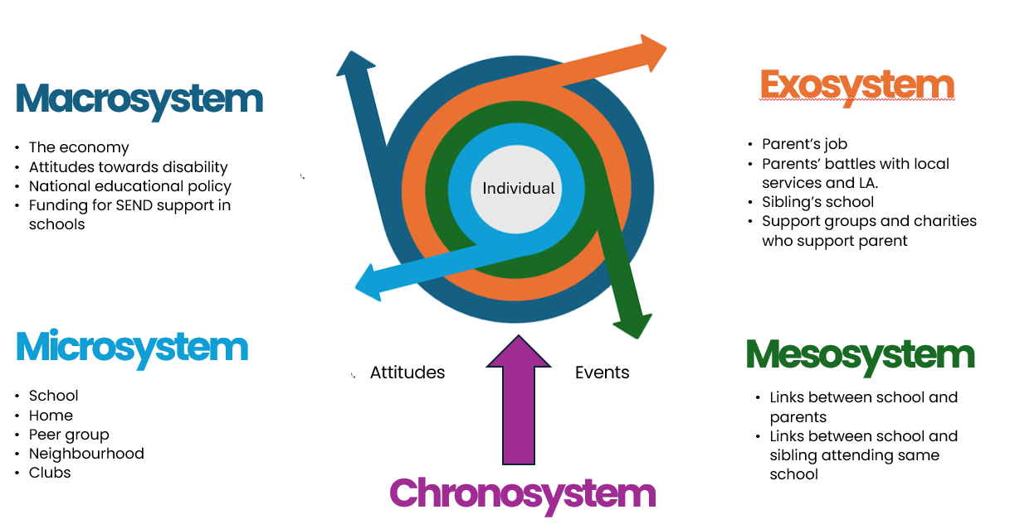
I was also interested in how Emma’s experience as an identical twin fitted into Bronfenbrenner’s later bio-ecological systems approach which considered genetic inheritance. (Bronfenbrenner, 1993; Bronfenbrenner & Ceci, 1994; Rosa & Tudge, 2013). Emma and Abbie’s life experiences were clearly very different despite sharing DNA and growing up in the same home. Abbie’s disability had led to the two sisters going to different schools and other people treating them differently. Expectations about disabled people had also had an impact on Abbie’s life due to low expectations of her academically. However, such low expectations had also affected Emma because people often saw her and her twin as so similar. This illustrates how whilst Emma and Abbie’s shared genetic inheritance and shared upbringing might have led to similarities in their lives, Abbie’s biological difference, emerging from her visual impairment, had irrevocably changed her life experiences.
4.3.1 The chronosystem
However, of all the systems, I believe it is the chronosystem, which is most relevant to this study, in relation to both participants’ experiences at various stages in their lives and in relation to wider events.
The participants talked about how their experiences ebbed and flowed over time, including difficult and less difficult times. Georgia talked about how things became more difficult once her sister’s health deteriorated, and Sabrina talked about how things were easier now that not all her siblings lived at home. Both Emma and Lucy talked about how primary school was more difficult than secondary school.
Most importantly the differing results between the survey participants (over half of whom were older) and those who were interviewed, should be considered from a chronosystem perspective. Using the chronosystem as a lens allows us to consider the way in which the experiences of disabled people has changed over time, including a reduction in the institutionalisation of disabled people, changing attitudes towards disability, and changing language.
As can be seen in Figure 26 below, the experiences of disabled people have not been static over time. Arguably there are three key factors which have changed their experiences, namely law and policy, broader changes in society and educational and the impact of new technology.

Figure 26 The chronosystem and the changing experiences for disabled people and
their families (author’s own graphic)
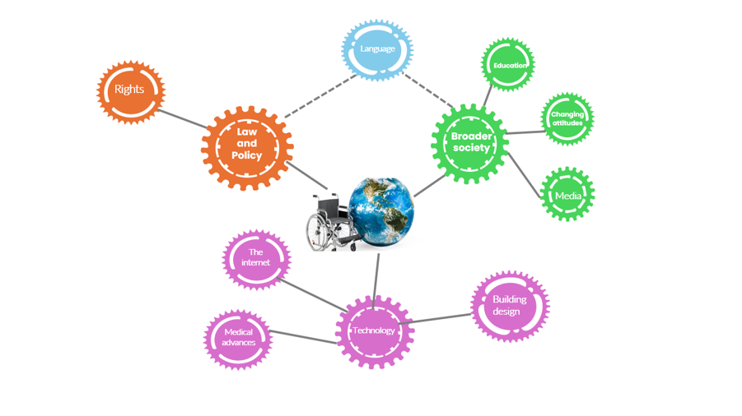
Changes in the law have increased the rights of disabled people, most notably the 2010 Equality Act (Equality and Human Rights Commission, 2010) and the United Nations Convention on the Rights of Persons with Disabilities (United Nations, 2006).
Educational changes in legislation and policy have also had an impact such as the Warnock Report (Lindsay, Wedell & Dockrell, 2020; Warnock, 1978), Education Act (Gov.uk, 1996), the Children and Families Act (Gov.uk, 2014) and successive SEND Codes of Practice, the most recent being in 2015 (Department for Education and the Department of Health and Social Care, 2015).
Previous legislation has also often impacted on the language around disability, for example The 1913 Mental Deficiency Act (Education in England, 2019) used terms such as “idiots”, “imbeciles” and feeble-minded” whilst the Warnock Report (1978) replaced the categories of “educationally subnormal” and “mentally handicapped” with the term “special educational needs”, which is still the term used in the most recent SEND Code of Practice (Department for Education and the Department of Health and Social Care, 2015).
References to language which participants and their siblings found offensive also demonstrated how, whilst previous terms such as “retarded” and “cripple” may no longer no longer be used (Clark & Marsh, 2002; Jarrett, 2012), other terms which have superseded them such as “special needs” have already become or at least are now becoming offensive.
It is important also to recognise that the educational landscape in 2024 is quite different to that fifty years ago. Previously, 90% of schools were run by local education authorities (LEAs) who funded schools directly and employed their own local authority advisers. Schools had freedom to choose the curriculum which best matched the needs of their community, and neither league tables nor Multi-Academy Trusts (MATs) existed (Lindsay, Wedell & Dockrell, 2020). Now, Ofsted has taken over the role of local educational advisers, and free schools, academies and MATs have grown. Thus, the role of the local authority and their financial budget have decreased whilst their responsibility for children with SEND has remained. The number of teaching assistants in schools has also increased (Department for Education, 2023; Lindsay, Wedell & Dockrell, 2020) so that the way in which children with SENDs are included within schools has changed.
The introduction of league tables led to some schools “judging success solely on examination grades” (Mason, 2000, p.107) meaning some schools became less welcoming of students who were less likely to gain good qualifications (Lindsay, Wedell & Dockrell, 2020). An increasing focus on behaviour has also led to some schools being fearful of taking children with SENDs (Daniels, Thompson & Tawell, 2019). At the same time, a culture which “treats education as a commodity” (Lindsay, Wedell & Dockrell, 2020, p.5; see also Daniels, Thompson & Tawell, 2019) has grown. A marketing philosophy which theoretically allows parents more choice, has also increased the focus on children as individuals rather than on a system which could be changed. Furthermore, schools can refuse to take children with Education, Health, Care Plans if “the attendance of the child or young person there would be incompatible with the efficient education of others, or the efficient use of resources” (Department for Education and the Department of Health and Social Care, 2015, p.172).
I would argue that this has likely increased what Reeve (2006) describes as the psycho-emotional effects of a system which places disability within the child rather than the school or educational system and which, whether consciously or not, risks families feeling rejected when a school says they cannot meet a child’s needs.
There have also been broader changes in society which have impacted on disabled people and their families, for example, in the past, people were more accepting of authority (Campbell & Oliver, 1996) so people would have been less likely to question whether the institutionalisation of disabled people was right. British society has also become more accepting of diversity. In recent decades, more immigration has meant white people have been exposed to other races and cultures, greater awareness of LGBTQ+ , Gay Pride and the neurodiversity movement, have also increased people’s awareness of diversity and the civil rights and feminist movements have challenged previous givens about what it is to be “normal”.
Another factor which may explain differences in the reporting of experiences by older and younger adults relates to changes in attitudes towards children and beliefs about how much responsibility children should have (Goodnow, 1988; Wikle, Jensen & Hoagland, 2018). Wikle, Jensen & Hoagland (2018) described how, whilst caring for siblings in the family was previously the norm, societal attitudes have changed, so that instead of being viewed as adults “… youth today are more likely to be seen as dependent on parents and not ready for caretaking” (p.73).
Rutherford (2009) analysed issues of a parenting magazine between 1929 and 2006 and talks about how during this time, “children became idealized as sacred cultural icons, the work of parenting – most especially mothering – became increasingly demanding in terms of time, expense and emotional involvement” (p.353). During this period, advice to parents, also changed, recommending that parents allow teenage children more autonomy, concluding that “… as the prevailing disciplinary preferences became more permissive during the twentieth century. It came to be seen as crucial that parents not damage children’s permissive psyches by forcing them to do anything against their will” (p.338). Instead, parenting advice was to provide children with greater choice. At the same time, Rutherford (2006) found that children were experiencing greater restrictions on their freedoms outside of the home, leading parents to ferry their children between extra-curricular activities and to rarely leave any children outside of adult surveillance.
I would speculate therefore that siblings of disabled children in 2024, along with their peers, are less likely to be expected to take on the care of their sibling. When children and teenagers do care for their siblings nowadays, this is often within the home and can therefore be “low intensity care” (Wikle, Jensen & Hoagland, 2018) whereby the carer sibling can combine caring for their sibling with an activity such as watching TV. This reduces both the expectation that siblings should spend time directly caring for their sibling and the expectation that they should take their siblings outside the home. This has lowered the intensity of sibling caretaking, for example remaining vigilant about safety in public places, and reduced the likelihood of being seen in public with their disabled sibling.
Media portrayal of disability has also changed. Historically, children’s books portrayed children with disabilities as sources of shame (e.g. Burnett, 1998; Byars, 2004; Choldenko,2006). Positive images of disabled people such as the scientist Steven Hawkins (Pring, 2018) and the dancer Rose Ayling-Ellis (BBC, 2021) have become more prominent, and many more celebrities are talking about their neurodiversity (Smith, 2024). The Paralympics (DWP, 2013; Gray & Verdonck, 2016; Jarrett, 2012) and the visibility of veterans who have become disabled in the service of their country (Jarrett, 2012) have also changed people’s views of disability.
The number of disabled people in the UK is also increasing (DWP, 2013; Kirk-Wade, 2023) making disabled people more visible. Institutionalisation has decreased. Those born with disabilities are more likely to survive (Tommy’s, 2022) and to have increased life expectancy (Alldred, Martini, Patterson, Hendrix & Granholm, 2021). Diagnoses of autism has increased (Russell, Stapley, Newlove-Delgado, Salmon, Warren, Pearson, & Ford, 2022), and an ageing population means more people are becoming disabled in later life, all of which means that those who are not disabled increasingly come into contact with disabled people.
Technology has also made a difference for many disabled people. Buildings are now built with accessibility in mind (H M Government, 2010). The development of equipment and software such as Eygaze (Feeley, 2016) and prosthetics (Walsh, 2021) have improved the lives of many disabled people. Many disabled people are now wearing their medical and assistive technology devices with pride (Migdol, 2018; Vlachaki, 2020). I would argue that these technological changes have supported the normalisation of disability. Additionally, the rise of the internet and search engines has made it possible for any individual to find out about a disability, making it less necessary for parents and professionals to explain a child’s additional needs to their siblings.
However, it should also be recognised that life has not improved for some disabled people. There are still not enough buildings which have been built with wheelchair access in mind (Taylor, 2022) and able-bodied drivers still frequently use disabled parking bays (Disabled Motoring UK, 2024). There has been an increase in hate crime (DWP, 2013) and disabled people are still often the target of rhetoric in relation to austerity (Ryan, 2020).

4.4 Research questions
I will turn now to considering my three research questions

4.4.1 Research question 1: How much do those who grew up with a sibling with additional needs perceive that their life was affected?
This study’s findings suggest that there is no simple answer to this question because scores given by survey respondents were heterogenous. The study found that whilst some participants felt that their lives had been profoundly affected, others felt the effect was only small. These findings suggest that differences are more complex than those which previous researchers have suggested. This was a finding in both phases of the study.

4.4.2 Research question 2: What do those who grew up with a sibling with
additional needs tell us about their experiences?
I will summarise here the findings of the interviews since this is the richest data. Those who I interviewed described an intertwining of all kinds of emotions and experiences and it would be impossible to identify experiences which would be common to all siblings. Nevertheless, I wish to highlight four unexpected findings stood out for me: a sense of normality about siblings’ experiences, positive experiences and feelings, relationships with parents, and gender-based restrictions.

One striking finding was how the participants had grown up with a real sense that their experiences were all that they had ever known, so that it was only now looking back that they could recognise how unusual their lives had actually been. There was also a sense that they had not realised that they were taking on an unusually high level of caring responsibilities. Sabrina talked about how eldest sisters in her community always took on caring roles and Jenny talked about how, only now, looking back at videos of her tube-feeding her sister did she realise how unusual this had been for a four-year-old and told me that when younger she had resisted any suggestion that she was a young carer.

A second unexpected finding was how warmly the participants talked about their siblings and families and how they portrayed their childhoods as largely happy. They all clearly cared for their siblings and viewed them as positive people in their lives, seeming glad to have them as siblings. The only exception to this was Sabrina who clearly had an extremely good relationship with her older physically disabled brother but who did not describe the same warmth towards her younger autistic siblings. This strengthens the theory that having an autistic sibling may be a more difficult experience, particularly where the autistic sibling exhibits more challenging behaviour, which Sabrina had alluded to.

I was also struck by the way in which the participants’ relationships with their parents had been different. I got the sense that their relationships had been somewhere between parent-child and partner-partner. There was little talk of their parents taking a disciplinary role towards them and I wondered if this was because they had been extremely helpful and compliant in the home and at school, so their parents had seen no reason to adopt a disciplinary approach. They also talked less about friends than family.

It was also apparent that the older sisters had chosen to put restrictions on their life and that decisions about where to study, where to live, and even their choice of partner, had been influenced. Both Georgia and Jenny talked about curtailing their social lives and Emma talked about the guilt she felt that she had not been more “available” to her sister when they went to different universities. This was an unexpected finding for me, especially as this appeared to be related very much to gender expectations, surprising me since it almost a half century since the 1975 Sex Discrimination Act (UK Government, 2023).

Participants were aware that they were self-handcuffing (Schuller, 2017) but did not ever question whether this was the right thing to do. However, those who had brothers contrasted their brother’s level of involvement with their sibling compared to their own and it struck me that not only were the women taking on more practical and caring roles but that Jenny and Georgia in particular, in accepting their brother’s lesser involvement, were taking on a greater share of emotional labour (Hackman, 2023; Hartley, 2017, 2018; Hochschild 1983; Williams, 2023).
I have described the concept of emotional labour in my literature review (Hackman, 2023; Hochschild, 1983; Hartley, 2017, 2018; Williams, 2023) and this seemed highly relevant when considering what Georgia and Jenny said about their brothers. In her book, Hackman makes explicit what is often invisible, that although men now share physical labour more equally, they rarely take on the hidden emotional labour. Although I would argue that emotional labour is a misnomer since Hackman actually talks about mental labour, the executive function skills which many women use to foresee potential crises and plan to minimise them. The way Georgia and Jenny describe their brothers suggested that they, as young women, were taking on the mental and emotional load, which their brothers were oblivious to. I was particularly struck by Jenny’s comment that she always did the long-distance driving, that her brother would if she asked but that he never thought to volunteer. I also wondered if these participants were following what they had seen their mothers do within the family and taking on this role.
In interpreting Georgia and Jenny’s descriptions of their brothers, I wondered if their self-restriction related to gender expectations which they had inculcated when younger. Hartley describes this process here, stating that she had
“… been conditioned my whole life to think one step ahead, to anticipate the needs of those around me and care about them deeply. Emotional labor was a skill set I had been trained in since childhood. My husband … hadn’t received that same education” (p.6)
Similarly, Beashel’s (2024) fictional character Bea says of her father “… because he’d lived blissfully unaware of all that backstage work that goes into running a family” (p.176), a quote which particularly struck me as Jenny had referred to her brother’s involvement as “… just bliss that he lives in, the ignorance that he has sometimes”.
However, I was struck too by the fact that career-wise this did not always seem to have restricted them. Jenny and Lucy are studying on highly competitive university courses in order to enter challenging career fields.

In answering the second research question regarding experiences, it is crucial to recognise the heterogeneity of experiences and differences between responses in the survey and interviews. It is important to acknowledge that, whilst much of the interview data suggested a counter-narrative to negative findings of previous studies, some survey responses highlighted that for many siblings their experiences had been extremely difficult. After intensive analysis of the interview transcripts which were overly positive, I returned to cross-reference the Phase 1 data, where this really stood out. Two survey participants especially stood out for me: Participant 1.25 who still feels
“incredibly self-conscious … a deep sense of dread at raised voices and any conflict … I still struggle with confidence … I am very quiet, and struggle to have my voice heard”
and Participant 1.37 who talked about the long-term effect of their difficult experiences growing up
“I was raised to be his nurse to take care of him if [my parents] should die … I was used as a counsellor and vessel for the family issues, regardless of what my own needs were … I became extremely introverted and suicidal and even decades later find it difficult to recognise or voice my own needs … I'd had several breakdowns and substance misuse issues before I finally undertook therapy and learnt how to step out of the family role for me”.
Grossman (1972) had found many siblings whose lives had been enriched by having a sibling with additional needs (see Figures 27 and 28 in Appendix B) but she also described how a sizeable minority of her participants seemed “damaged … bitterly resentful … guilty about their rage … deprived of the time and resources they needed to develop …” (p.176). This description holds true for a minority of my survey participants. The recent TikTok trend where siblings speak about being metaphorically “glass children” (Baldwin, 2023; Butler, 2023; Charlton & Charlton, 2023; Gurney, 2023) and recent newspaper articles (Ayoub, 2023; Batarilo, 2022; Dooney, 2023) demonstrate that ambivalent and negative experiences still exist, and it is important that such voices are still heard. It is also important to recognise that it is frequently other circumstances rather than the child with additional needs themselves which creates the challenges, emphasising the importance of the social model.
4.4.3 Research question 3: How can schools better support these children and young people?
Participants’ comments suggested that changes can be made to systems and staff thinking which would benefit both students with additional needs and their siblings. There are also important lessons to be learnt from participants about how sibling in-school support groups might not be the right way forward to support siblings and that out-of-school connections, especially with others whose sibling has the same condition might be more powerful. Recommendations arising from the study’s findings can be found below.

4.5 Implications and recommendations
My third research question and the ultimate aim of my study was to find out “How can schools better support these children and young people?” and below I list recommendations at four levels: the school level, local authority level, the educational psychologist level, and the wider educational system.
My aim had always been more than to report on what my participants had told me about their experiences. Ultimately, I wanted to use what my participants told me to change the ways in which schools support students who are growing up with a sibling with additional needs and students with additional needs themselves because to quote Emma, “… better support for her would always be useful for me”. Thus, I would argue that in meeting the needs of those with SEND, we better meet the needs of their siblings.

4.5.1. Recommendations for schools
One of the goals of my study was that the outcomes of the research would be used to identify how schools can support siblings, something which will be possible for me as an EP. I am considering how I can use my combined research and professional role to make this happen. As a first step, I have begun work on a leaflet for schools. This is very much a work in progress, but the current draft can be found in Appendix S
It is difficult to make generic recommendations for schools since participants talked about how their experiences varied across their school lives, according to their phase of schooling, whether their sibling attended the same school and the struggles their sibling was facing at different times in their lives.
Interview participants often reported that schools did little to take account of their home experiences and that, even when their sibling’s needs did impact on them at school, either directly or indirectly, this was unacknowledged by school staff.
Some writers, especially that those who have been commissioned by the charity Sibs (Hayden, McCaffrey, Fraser‐Lim & Hastings, 2019) have advocated the opportunity for siblings to join sibling support groups. However, participants were not necessarily in favour of a within school group. Whilst Emma and Georgia said that they would have liked more support at school (and Jenny did talk in the 3rd person about how siblings should have more support), Georgia said she actively would not have wanted to talk to other students about her experiences and Jenny said she would have declined the opportunity. However, participants did believe that something should be done to support siblings, perhaps on a 1:1 basis. Georgia’s positive experiences of conferences held by the charity which was specific to her sister’s terminal condition also suggests that families benefit from meeting other families with the same condition.
When it came to participants talking about the curriculum, memories of how schools talked about disability were barely recalled and largely dismissed as never having taken place. However, Georgia talked about two lessons where issues relating to disability had been raised, once in relation to a misunderstanding about hospices and another time when euthanasia had been raised. However, it appeared that no more thought had been given to such potentially emotive topics than any other curriculum content.
These findings suggest that schools should
- find out if students have siblings with additional needs
- offer personalised support to siblings and recognise their right to decline support. Ask what would help they would like and offer suggestions e.g. a group, regular check-ins, time away from their sibling, or counselling.
- recognise siblings’ right to decline support but explain when and where siblings can seek support if they change their mind.
- recognise that the good times and the bad may ebb and flow and that siblings may need different levels of support at different times.
- make every effort to ensure the student feels noticed and valued.
- consider the effect of sensitive curriculum material and assembly content on those who have siblings (or other family members) with additional needs
- signpost to organisations outside of school who can help.
- make it explicit that students should not be expected to support their siblings at school; staff should not take siblings out of class to ask for assistance, nor should students be expected to support staff or siblings in the playground.
Much of what participants talked about in relation to schools was about bullying and how staff turned a blind eye to ableist bullying. They also talked about experiences in the community which had happened because of societal beliefs about disabled people. These findings suggest that schools should take action to prevent bullying and actively seek to provide a positive view of disability so that all students grow up with positive attitudes towards those with disabilities and a determination to challenge stereotypes and ableist behaviour. Participants also talked about how they felt the need to support their sibling at school, especially where the sibling was vulnerable to bullying. Thus, schools should
- take allegations of bullying seriously and frame responses in terms of diversity. Ableist comments and acts should be taken as seriously as racism, sexism, and homophobia
- consider the reasons why a sibling may have got into an argument or fight and establish whether this was in reaction to an ableist comment
- present disability within the framework of diversity and the social model
- take opportunities to promote positive messages about disability, normalise talking about disability and so challenge stereotypes.
The study also revealed that some siblings have restrictions on their lives which schools do not consider. Most schools have behaviour policies which require after-school detentions and extra-curricular activities often happen beyond the school day which is problematic for some siblings. Sabrina and Georgia talked about additional responsibilities at home. Jenny also talked about how she would avoid committing to netball fixture dates because she was wary of being away from home. Some of the participants also talked about considering distance from home in deciding both whether to go to university at all and how far away from home they could go. Thus, schools should
- recognise that some siblings have additional, time-consuming responsibilities at home
- where possible provide opportunities to complete homework and attend extra-curricular activities at different times e.g. at lunchtime or before school
- When discussing options for the future, be aware that having a sibling with additional needs may affect decisions about whether to go to university at all and which universities siblings may choose
Georgia also talked about how messages about attendance were applied in a blanket way so that she and her brother got the same consequence for going on a term-time holiday despite the very reason for that trip.
- This suggests that schools should consider reasonable adjustments to blanket policies and practices, for example responses to absence.
Another theme brought up by Sabrina and several survey respondents was that their own additional needs e.g. autism and/or dyslexia had not been diagnosed whilst they were at school, so they had had to seek a diagnosis for themselves later. Schools should
- remember that just as all students may have undiagnosed additional needs, where a family have a child with significant needs any needs of other siblings might be overlooked because their needs are dwarfed by those of their sibling.
- remember too that conditions such as autism and dyslexia often run in families.
Georgia talked about hiding her feelings at school and then going home and crying. She also talked about how she had taken anti-depressants for many years. This highlights that schools should
- consider whether the sibling is masking difficult emotions

4.5.2 Recommendations for local authorities
One of the things which struck me was how local authorities were part of families’ ecological systems. Jenny talked about the effect on her and her brother because her mother had had to take Becca to and from school. Thus,
- in considering the need for transport for students with additional needs, local authorities should consider the needs of other members of the family, including siblings. In the same way that parents should have “the right to live an ordinary life” (Broach & Clements, 2020, p.5) so should siblings. Children and young people’s lives should not be affected because their parent has to transport their sibling.

4.5.3 Recommendations for educational psychologists
Whilst none of the participants mentioned EPs, likely because siblings go under the radar of most EPs, the findings of this study are in agreement with Pavlopoulou, Burns, Cleghorn, Skyrla & Avnon (2022)’s recommendations regarding the involvement of EPs. For example, Pavlopoulou et. al. suggested that typically developing siblings should have their own needs assessed and that EPs’ role might include training, consultation, and whole school support. I intend to use my position as an EP to reach these children and young people and their families, both directly and through systemic work. Having listened to the participants, I also now recognise that by working systemically with schools to challenge ableism and to support children and young people with additional needs, siblings too will benefit.

4.5.4 Recommendations for systemic change within the UK educational system
As noted earlier, the SEND Code of Practice (Department for Education and the Department of Health and Social Care, 2015) views special educational needs and disability as located within the child and allocates resources at the individual level, “…’treating’ the child’s defects, not the defects of the system” (Mason, 2005, p.88). Yet this system is incompatible with the social model of disability which argues for changes within society in order to reduce barriers for disabled people. Fully considering the social model and taking on board the findings of this study would require changes to buildings (Titchkosky, 2011), an emphasis on inclusion and a move away from academic results as a measure of a school’s success.
A recent Open Letter from the AEP (2024) argued that the SEND crisis cannot be resolved without considering the “wider education system as a whole” (p.1), highlighting that
“The 2014 National Curriculum was introduced with intentions to raise educational standards but in doing so brought a much more rigid, prescriptive and narrow focus to learning with increased expectations for attainment … a culture of competition … these were not congruent with … inclusive education” (p.1)
and “… true inclusion is impossible within current competing pressures and stretched resources and with teachers often feeling that they don’t have adequate training …” (AEP, 2024, p.2), arguing that SEND must be repositioned within the whole system rather than as a “bolt-on” or “afterthought” (p.2).
The findings of this study demonstrate that the current British education system needs significant systemic change to replace the medical model of SEND with that of the social model. The study also raises questions about the purpose of schooling. Whilst not a theme common to all participants, Georgia was highly critical of her school and the education system in general, talking about it as something to be endured with little connection to real life. Her cynical portrayal of school reminded me of Chomsky’s description of the education system as “a system of indoctrination of the young … supposed to train people to be obedient, conformist, not think too much, do what you’re told, stay passive, don’t cause any crises of democracy, don't raise any questions” (Chomsky’s philosophy, 2016, 0:18). Thus, Georgia’s contribution to the study for me raised questions about the whole British education system: the problematic nature of a “one size fits all” approach, the importance of relationships in schools, the extent to which education should be about more than gaining qualifications, and whether critical thinking should be taught in schools.
4.6 Strengths, limitations, and future research
I believe that the mixed methods approach was appropriate. The survey allowed me to gather a broader range of data, whilst the interviews approach allowed me to investigate experiences in depth. One example where the two approaches complemented each other was that the survey revealed differences in experiences between participants whilst the interviews allowed me to witness differences between experiences within the individual life course and even at the same time.
Yardley (2000) argues that the four elements of good qualitative research are: sensitivity to context, commitment to rigour, transparency and coherence and impact and importance. The strengths listed below demonstrate that all four elements were evident in the study.

4.6.1 Strengths
The strengths of the research have included
- The use of a mixed methods approach has made it possible to gather a broader range of information, both quantitative and qualitative
- Most importantly, the use of a Phase 1 survey made it possible to involve siblings in identifying areas to explore within interviews
- Inclusion of UK participants made it possible to explore the experiences of British siblings to complement existing studies in other countries
- Inclusion of the voice of emerging adults who stand at the crossroads between leaving school and becoming a fully-fledged adult, making it possible for them to share relatively recent memories alongside their reflections now that they have left school
- The use of a mixed methods approach made it possible to explore some of the reasons underpinning the quantitative findings; in particular, the interviewees' stories highlighted that growing up with a sibling with additional needs is often wonderful and yet often extremely difficult, in Georgia’s words “shit … but perfect … just magic”.) This ‘double-edged sword’ finding may partially explain conflicting findings in previous research, since the heterogeneity of experiences had been hidden in quantitative research
- By gathering the voices of those who have experienced being “a fly on the wall”, it has been possible to gain participants’ unique insight into the world of disability
- Since many previous writers have focused on participants with autism, learning difficulties and generic “disability”, this study has added to the research base by considering the experiences of participants whose siblings have other conditions
- My goal was to gather insight into what might be good practice for schools. Most of the previous research has been carried out by researchers who work within a medical, academic, or social work perspective. Thus, this research adds to the area of school experiences
- The results will inform advice to schools and thus have a practical impact and one which I believe fits with my social justice approach to the research
- Difficulties identified due to environments not being built with disabled people (Titchkosky, 2011) in mind and societal attitudes towards disabled people support the social model of disability, demonstrating that disability is to an extent created rather than something intrinsic to the disabled person

4.6.2 Limitations
The limitations of the research have included
- The sample size was small for both phases, increasing the likelihood of sample bias. The differing findings from the two phases also suggest that those with more positive experiences may be more likely to volunteer to be interviewed
- The use of Salmon lines minimised confusion about reverse code items but may still have been subject to central tendency and or extremity bias (Tashakkori & Teddlie, 1998). The clustering around the midpoint in the results for Q.2. may have been partially affected by central tendency bias (Figure 17) and the bias towards the high scores in Q.1 and Q.3 might be partially explained by extremity bias (Figures 16 and 18). However, the varying overall shape of the four graphs would suggest that this was not the case (Figures 16, 17, 18 and 19)
- Placing a positive description on the left of the scale may have increased the risk of positivity bias (Figures 16, 17, 18 and 19)
- The sample was recruited via university emails, social media, and word of mouth. This means that participants were self-selected and thus happy to share their thoughts. This was especially the case for participants in Phase 2 who gave up time and made themselves vulnerable by sharing their experiences. Thus, it is unlikely that the participants constituted a representative sample (Saliba & Ostojic, 2014).
- Participants who responded via university email systems are from a specific demographic group. Especially given that one participant (Sabrina) stated that social class had played a key part in her experiences, it should be emphasised that the participants’ level of education may not reflect the experiences of all families with a child with additional needs.
- All who volunteered were eldest sisters and interviewing men may have led to different findings (Saliba& Ostojic, 2014).
- Of those who were interviewed in Phase 2, all were aged 18-28. Phase 1 findings suggest that it was more difficult to have a sibling with additional needs in the past and interviews with older participants would make it possible to explore changes over time.
- Any analysis of themes is based on what stood out for me, what I found interesting and the way the participants in Phase 2 responded to me as a human being and researcher. Another researcher may have elicited different information and highlighted different themes (Chung & Monroe, 2003; Miller, 1997; Montague, Phillips, Holland & Archer, 2020; Schembri & Abela, 2016)
- Similarly, the ratings which survey respondents gave and what participants chose to share were just a snapshot of their feelings, reflections, and memories on the day. Since their stories “were … constructed in a particular time and place for a particular purpose” and may have been different if interviews had happened at a different time (Schembri & Abela, 2016, p.413).
- The survey design could also have been improved because of a lack of clarity regarding some categories on the survey, and because of the brevity of the survey this was a missed opportunity to gather additional data. Improvements include:

- asking about the participants about their own gender and not just whether it was the same as their siblings. This would have made it possible to cross-check some of the issues about gender raised in interviews.
- providing more fine-grained categories of age for the over 25 group. This would have made it possible to consider changes in siblings’ experiences over time.
- including additional questions such as:

- If you were to describe your experiences in 3-5 words what would those words be?
- Was there anything memorable that your school did that helped you?
- Was there anything memorable that your school did that made things more difficult?
- Was there anything that you wish your school had done differently or anything additional that they could have done which would have helped you?
- Was your mental or physical health affected in any way by your having a sibling with additional needs?
In considering the strengths and limitations of the study, I have come to realise that often in making methodological decisions what is a strength can also be a limitation. For example, when choosing to make my survey anonymous I ruled out the possibility of going back to participants, either to reassure them about what they had said, to ask for clarification or to gather further information. However, I still believe that anonymity should be available to participants, that anonymising data treats the participant’s contributions with respect and that it potentially leads to participants speaking more freely.

4.6.3 Future research
Future research should consider
- using a larger sample; this would increase statistical validity, making it possible to generalise findings
- interviewing young people who are still at school might garner richer data regarding what schools can do, as memories would be fresher (Cooper, Kensinger & Ritchey, 2019)
- interviewing non-female siblings. This would be particularly interesting given the importance of the theme of gender in the findings.
- the use of focus groups might lead to participants exploring ideas in greater detail and elicit multiple perspectives
- given the apparent lower scores for Questions 2 and 4 for those with fewer siblings, research which compares family size would add to this study. Grossman (1972) had identified an impact due to the intersectionality of family size and socio-economic circumstances and this would be an interesting area to revisit in the 21st century.

4.7 Personal reflections and concluding thoughts
The findings from interviews complement and provide a counter-narrative to previous literature. Identifying and addressing the gaps in previous research and using a mixed method approach, made it possible to explore the perspectives and experiences of siblings themselves, and to look at some of the reasons for the ratings of Phase 1 within the interviews. I was surprised by some of the findings, most noticeably that
- generalisations made by previous researchers based on correlational studies may have camouflaged the heterogeneity of experiences
- siblings can have both extremely positive and extremely negative experiences, experiencing the whole gamut of emotions, and experiences of having a sibling with additional needs cannot be separated out from other aspects of a sibling’s life. The binary positive/ negative position of previous literature reminds me of the historical nature/ nurture debate which is now recognised as too simplistic an approach
- the participants I interviewed spoke less about school and less about supporting themselves, talking more about forces in their family’s lives and wider society
- whilst siblings would appreciate support at school, this is not necessarily wanted via support groups. However, when reflecting on this I realised that unless experiences of those in the group are heterogenous, meeting others may simply underline how unusual some siblings’ experiences are. This would especially be the case where a sibling has a life-limiting condition
- ableism, prejudice, and inaccessibility are still widespread in Britain in 2024, at the individual and school level and in wider society
- gender and birth order still play a key role in the expectations we place upon families with children with additional needs. These social norms particularly affect mothers and sisters.
The “sibling as witness” accounts provide a unique perspective on what life is like for disabled people, demonstrating that prejudice and barriers still exist, and that disabled people are still marginalised. In doing so the importance of the social model is brought to centre-stage. I set out with an intention of advocacy and social justice and, whilst I set out to advocate social justice for siblings, my endpoint is an awareness that by providing social justice for disabled people in our communities and schools we increase social justice for siblings.

References
Abrams, M. (2009). The Well Sibling: Challenges and Possibilities. American Journal Of Psychotherapy, 63(4), 305-317. doi: 10.1176/appi.psychotherapy.2009.63.4.305
Abreu-Ellis, C. R., & Ellis, J. B. (2013). Segregation and mental health: understanding stigma from family perspectives. In Proceedings for the thirteenth biennial conference of the international association of special education: The bridge from segregation to inclusion … a long journey (pp. 82–83). Vancouver; International association of special education.
Alcoff, L. (1991). The Problem of Speaking for Others. Cultural Critique, 20, 5–32. https://doi.org/10.2307/1354221
Alderfer, M. A., & Hodges, J. A. (2010). Supporting siblings of children with cancer: A need for family–school partnerships. School Mental Health, 2(2), 72–81. https://doi.org/10.1007/s12310-010-9027-4
Alldred, M. J., Martini, A. C., Patterson, D., Hendrix, J., & Granholm, A.-C. (2021). Aging with Down Syndrome-Where Are We Now and Where Are We Going? Journal of Clinical Medicine, 10(20), 4687. https://doi.org/10.3390/jcm10204687
AEP. (2024). Open Letter: A drastically different approach is needed to tackle SEND crisis. Retrieved November 17, 2024 from AEP website: https://www.aep.org.uk/system/files/2024-08/Open%20Letter%20to%20Bridget%20Phillipson%20about%20the%20SEND%20Crisis.pdf
All Party Parliamentary Group for Young Carers & Young Adult Carers. (2023). “Being a young carer you have to choose between your future and the future f the person you care for” Inquiry into the life opportunities of young carers and young adult carers Retrieved November 17, 2024 from https://carers.org/downloads/appg-for-young-carers-and-young-adults-carers-reportlr.pdf
Aruma. (2019). Person Centred Approach and Active Support | Aruma. Retrieved November 17. 2024 from Aruma Disability Services website: https://www.aruma.com.au/about-us/about-disability/person-centred-approach-and-active-support/
Atewologun, D., Cornish, T., & Tresh, F. (2018). Equality and Human Rights Commission Research report 113. Retrieved November 17, 2024, from https://archive.equalityhumanrights.com/sites/default/files/research-report-113-unconcious-bais-training-an-assessment-of-the-evidence-for-effectiveness-pdf.pdf
Australian Bureau of Statistics. (2023). Correlation and causation. Retrieved November 17, 2024, from Australian Bureau of Statistics website: https://www.abs.gov.au/statistics/understanding-statistics/statistical-terms-and-concepts/correlation-and-causation
Ayoub, S. (2023b, June 24). “Your needs came second”: love, resentment and being the other child. The Guardian. Retrieved November 17, 2024, from https://www.theguardian.com/lifeandstyle/2023/jun/25/your-needs-came-second-resentment-love-and-being-the-other-child

Bailey, T., Hastings, R. P., & Totsika, V. (2021). COVID‐19 impact on psychological outcomes of parents, siblings and children with intellectual disability: longitudinal before and during lockdown design. Journal of Intellectual Disability Research, 65(5). https://doi.org/10.1111/jir.12818

Baldwin, S. (2023, March 21). What is the TikTok Glass Child trend? Retrieved May 11, 2024, from Evening Standard website: https://www.standard.co.uk/news/uk/tiktok-glass-child-trend-disabilities-b1068809.html

Barak-Levy, Y., Goldstein, E., & Weinstock, M. (2010). Adjustment characteristics of healthy siblings of children with autism. Journal of Family Studies, 16, 155-164.
Batarilo, D. (2022). My brilliant brother has Down’s syndrome. Is it wrong to fear getting pregnant myself? Retrieved 30 March 2022, from https://www.theguardian.com/lifeandstyle/2022/mar/12/my-brilliant-brother-has-downs-syndrome-is-it-wrong-to-fear-getting-pregnant-myself?CMP=Share_iOSApp_Other
Batte, S., Watson, A. R., & Amess, K. (2005). The effects of chronic renal failure on siblings. Pediatric Nephrology, 21(2), 246–250. https://doi.org/10.1007/s00467-005-2064-9

BBC. (2021). Strictly: Rose Ayling-Ellis praised for deaf tribute dance. BBC News. Retrieved November 17, 2024, from https://www.bbc.co.uk/news/entertainment-arts-59287964
BBC. (2024). Woman’s Hour - Is the SEND system working for children with special educational needs and disabilities? - BBC Sounds. Retrieved September 13, 2024, from BBC website: https://www.bbc.co.uk/sounds/play/m0022ss7?partner=uk.co.bbc&origin=share-mobile
Beashel, A. (2024). Spilt Milk. London: Harper North.
Beat Eating Disorders. (2024). Sibling solidarity. Retrieved May 19, 2024, from Beat website: https://www.beateatingdisorders.org.uk/your-stories/anorexia/sibling-solidarity/

Beavis, A. (2007). What about brothers and sisters? helping siblings cope with a new baby brother or sister in the NICU. Infant, 3(6), 239-242.
Benson, P. R., & Karlof, K. L. (2008). Child, parent, and family predictors of latter adjustment in siblings of children with autism. Research in Autism Spectrum Disorders, 2(4), 583–600. https://doi.org/10.1016/j.rasd.2007.12.002
Bhattashali, A., Ostrosky, M. M., & Monda-Amaya, L. (2018). Perceptions of typically developing children in India about their siblings with disabilities. International Journal of Inclusive Education, 22(12), 1257–1271. https://doi.org/10.1080/13603116.2017.1420253
Blaikie, N. W. H., & Priest, J. (2017). Social research: paradigms in action. Cambridge: Polity Press.
Bobbitt, Z. (2021). Correlation Does Not Imply Causation: 5 Real-World Examples. Retrieved November 17, 2024, from Statology website: https://www.statology.org/correlation-does-not-imply-causation-examples/
Boll, T., Ferring, D., & Filipp, S. (2005). Effects of Parental Differential Treatment on Relationship Quality with Siblings and Parents: Justice Evaluations as Mediators. Social Justice Research, 18(2), 155-182. doi: 10.1007/s11211-005-7367-2
Bortes, C., Strandh, M., & Nilsson, K. (2020). Sibling Ill Health and Children's Educational Outcomes. Journal Of School Health, 90(5), 407-414. doi: 10.1111/josh.12887
Bostock, J. (2017). Understanding power in order to share hope: A tribute to David Smail. Clinical Psychology Forum, 1(297), 13–17. https://doi.org/10.53841/bpscpf.2017.1.297.13

Bowman, S., Alvarez-Jimenez, M., Howie, L., McGorry, P., & Wade, D. (2015). The impact of first episode psychosis on sibling quality of life. Psychiatry Interpersonal and Biological Processes, 78(2), 141–155. https://doi.org/10.1080/00332747.2015.1051444

Bowman, S., Alvarez-Jimenez, M., Wade, D., Howie, L., & McGorry, P. (2017). The Positive and Negative Experiences of Caregiving for Siblings of Young People with First Episode Psychosis. Frontiers in Psychology, 8(730). https://doi.org/10.3389/fpsyg.2017.00730

Bowman, S., Alvarez-Jimenez, M., Wade, D., Howie, L., & McGorry, P. (2014). The impact of first episode psychosis on sibling quality of life. Social Psychiatry and Psychiatric Epidemiology, 49(7), 1071–1081. https://doi.org/10.1007/s00127-013-0817-5

Boyle, M., & Johnstone, L. (2020). A Straight Talking Introduction to the Power Threat Meaning Framework: an alternative to psychiatric diagnosis. Monmouth: PCCS Books.

Braun, V., & Clarke, V. (2022). Thematic analysis: A practical guide. London: SAGE Publications.
Broach, S., & Clements, L. (2020). Understanding disabled children’s lives. Retrieved November 17, 2024, from https://councilfordisabledchildren.org.uk/sites/default/files/uploads/files/Disabled%20Children%20Legal%20Handbook-final-Understanding%20disabled%20children%20lives%20Chapter%201.pdf
Bronfenbrenner, U. (1970). Two Worlds of Childhood: USA and USSR. London: George Allen & Unwin Ltd.
Bronfenbrenner, U. (1979). The Ecology of Human development: Experiments by Nature and design. (1st ed.). Cambridge: Harvard University Press.
Bronfenbrenner, U. (1986). Ecology of the family as a context for human development: Research perspectives. Developmental Psychology, 22(6), 723-742. doi: 10.1037/0012-1649.22.6.723
Bronfenbrenner, U. (1993). Ecological models of human development. In Readings on the development of children (pp. 37–43). New York: Freeman.

Bronfenbrenner, U., & Ceci, S. J. (1994). Nature-nuture reconceptualized in developmental perspective: A bioecological model. Psychological Review, 101(4), 568–586. https://doi.org/10.1037/0033-295x.101.4.568

Brooten, D. A., Youngblut, J. M., Roche, R. M., Caicedo, C. L., & Page, T. F. (2018). Surviving Siblings’ Illnesses, Treatments/Health Services over 13 Months after a Sibling’s Death. Journal of Child and Family Studies, 27(6), 2049–2056. https://doi.org/10.1007/s10826-018-1044-1

Brouzos, A., Vassilopoulos, S. P., & Tassi, C. (2017). A Psychoeducational Group Intervention for Siblings of Children With Autism Spectrum Disorder. The Journal for Specialists in Group Work, 42(4), 274–298. https://doi.org/10.1080/01933922.2017.1350230

Brower, T. (2022, May 11). How the term “work-life balance” is changing for the youngest group of workers. Retrieved November 17, 2024, from Fast Company website: https://www.fastcompany.com/90749429/how-the-term-work-life-balance-is-changing-for-the-youngest-group-of-workers

Brown, L. M. (1998). Voice and Ventriloquation in girls’ development. In Standpoints and differences: essays in the practice of feminist psychology (pp. 91–114). London: Sage.

Bryant, L., Hewison, J. D., & Green, J. M. (2005). Attitudes towards prenatal diagnosis and termination in women who have a sibling with Down’s syndrome. Journal of Reproductive and Infant Psychology, 23(2), 181–198. https://doi.org/10.1080/02646830500129214
Burdick, A. (2021b). Unconscious bias: everything you need to know about our hidden prejudices. London: Summersdale Publishers Ltd., Part Of Octopus Publishing Group Limited.
Burke, P. (2004). Brothers and sisters of children with disabilities. London; New York: Jessica Kingsley.

Burnett, F. H. (1998). The secret garden. New York: Harper Collins (Original work published 1911)
Burman, E. (1998). The child, the woman and the cyborg: (Im) possibilities of feminist developmental psychology. In Standpoints and differences: Essays in the practice of feminist psychology (pp. 210–232). London: Sage.

Butler, S. (2023). The TikTok “Glass Child” trend explained | indy100. Retrieved April 5, 2024, from www.indy100.com website: https://www.indy100.com/tiktok/glass-child-tiktok-trend-explained

Byars, B. (2004). The summer of the swans. New York, N.Y.: Puffin Books. (Original work published 1970)

Byock, S. D. (2024). Quarterlife. London: Penguin.

Calhoun, A., & Gold, J. (2020). “I Feel Like I Know Them”: the Positive Effect of Celebrity Self-disclosure of Mental Illness. Academic Psychiatry, 44(2), 237-241. doi: 10.1007/s40596-020-01200-5
Campbell, J., & Oliver, M. (1996). Disability politics: understanding our past, changing our future. London: Routledge.
Cambridge Dictionary. (2019). Feminism: meaning in the Cambridge English Dictionary. Retrieved November 17, 2024, from Cambridge Dictionary website: https://dictionary.cambridge.org/dictionary/english/feminism
Camerini, A., & Schulz, P. (2018). Social Desirability Bias in Child-Report Social Well-Being: Evaluation of the Children’s Social Desirability Short Scale Using Item Response Theory and Examination of Its Impact on Self-Report Family and Peer Relationships. Child Indicators Research, 11(4), 1159-1174. doi: 10.1007/s12187-017-9472-9
Carey, N. (2012). The epigenetics revolution: how modern biology is rewriting our understanding of genetics, disease, and inheritance. London: Faber & Faber.
Carpenter, B. (1997). Families in Context: emerging trends in family support and early intervention. London: David Fulton.
Cebula, K., Gillooly, A., Coulthard, L. K., Riby, D. M., & Hastings, R. P. (2019). Siblings of children with Williams syndrome: Correlates of psychosocial adjustment and sibling relationship quality. Research in Developmental Disabilities, 94, 103496. https://doi.org/10.1016/j.ridd.2019.103496
Cederlöf, M., Larsson, H., Lichtenstein, P., Almqvist, C., Serlachius, E., & Ludvigsson, J. F. (2016). Nationwide population-based cohort study of psychiatric disorders in individuals with Ehlers–Danlos syndrome or hypermobility syndrome and their siblings. BMC Psychiatry, 16(1). https://doi.org/10.1186/s12888-016-0922-6
Chambers, C. (2007). Siblings of Individuals with Disabilities who Enter Careers in the Disability Field. Teacher Education And Special Education: The Journal Of The Teacher Education Division Of The Council For Exceptional Children, 30(3), 115-127. doi: 10.1177/088840640703000301
Charlton, S., & Charlton, A. (2023). Glass Child Syndrome: TikTok Fad or Unaddressed Area of Need? - Psi Chi, The International Honor Society in Psychology. Retrieved November 17, 2024, from www.psichi.org website: https://www.psichi.org/blogpost/987366/487234/Glass-Child-Syndrome-TikTok-Fad-or-Unaddressed-Area-of-Need

Chien, Y.-L., Tu, E.-N., & Gau, S. S.-F. (2017). School Functions in Unaffected Siblings of Youths with Autism Spectrum Disorders. Journal of Autism and Developmental Disorders, 47(10), 3059–3071. https://doi.org/10.1007/s10803-017-3223-0
Cho, H. (2017). The effects of summer heat on academic achievement: A cohort analysis. Journal of Environmental Economics and Management, 83, 185–196. https://doi.org/10.1016/j.jeem.2017.03.005
Choldenko, G. (2006). Al Capone does my shirts: Tales from Alcatraz Series, Book 1. Bicester: Bloomsbury.
Christensen, J. (2010). Proposed Enhancement of Bronfenbrenner’s Development Ecology Model. Education Inquiry, 1(2), 117–126. https://doi.org/10.3402/edui.v1i2.21936
Clark, L., & Marsh, S. (2002). 2.1 Disabled People Patriarchy in the UK: The Language of Disability. Retrieved November 17, 2024, from https://disability-studies.leeds.ac.uk/wp-content/uploads/sites/40/library/Clark-Laurence-language.pdf
Chomsky's Philosophy. (2016). Noam Chomsky - The Educational System. Retrieved November 17, 2024, from https://www.youtube.com/watch?v=tgXZuGIMuwQ

Chung, J. & Monroe, G.S. (2003). Exploring social desirability bias. Journal of Business Ethics, 44, 291–302.

Connors, C., & Stalker, K. (2003). The views and experiences of disabled children and their siblings. London: Jessica Kingsley.
Contact. (n.d.). Research. Retrieved August 23, 2024, from Contact website: https://contact.org.uk/help-for-families/campaigns-and-research/research/
Conway, B. (2015). Why do we care about the colour of the dress? The Guardian. Retrieved November 17, 2024, from https://www.theguardian.com/commentisfree/2015/feb/27/colour-dress-optical-illusion-social-media?CMP=Share_iOSApp_Other
Cooper, R. A., Kensinger, E. A., & Ritchey, M. (2019). Memories fade: The relationship between memory vividness and remembered visual salience. Psychological Science, 30(5), 657–668. https://doi.org/10.1177/0956797619836093
Corker, M. (1999). Differences, Conflations and Foundations: The limits to “accurate” theoretical representation of disabled people’s experience?. Disability & Society, 14(5), 627–642. https://doi.org/10.1080/09687599925984
Creswell, J. W., & Creswell, J. D. (2002). Research design: Qualitative, quantitative, and mixed methods approaches. SAGE.
Cridland, E., Jones, S., Stoyles, G., Caputi, P., & Magee, C. (2016). Families Living With Autism Spectrum Disorder: roles and responsibilities of adolescent sisters. Focus On Autism And Other Developmental Disabilities, 31(3), 196-207. doi: 10.1177/1088357615583466
Cuzzocrea, F., Larcan, R., Costa, S., & Gazzano, C. (2014). Parents' competence and social skills in siblings of disabled children. Social Behavior and Personality, 42(1), 45–57. https://doi.org/10.2224/sbp.2014.42.1.45
Daniels, D., Moos, R. H., Billings, A. G., & Miller, J. J. (1987). Psychosocial risk and resistance factors among children with chronic illness, healthy siblings, and healthy controls. Journal of Abnormal Child Psychology, 15(2), 295–308. https://doi.org/10.1007/bf00916356

Daniels, H., Thompson, I., & Tawell, A. (2019). After Warnock: The Effects of Perverse Incentives in Policies in England for Students With Special Educational Needs. Frontiers in Education, 4. https://doi.org/10.3389/feduc.2019.00036

Davies, K. (2019). “Sticky” proximities: sibling relationships and education. The Sociological Review, 67(1), 201–225.

Davies, K. (2023). Siblings and sociology. Manchester University Press.
Deloitte. (2024). 2024 Gen Z and Millennial Survey: Living and working with purpose in a transforming world. In Deloitte (pp. 1–36). Retrieved November 17, 2024, from https://www.deloitte.com/global/en/issues/work/content/genz-millennialsurvey.html
Department for Education and the Department of Health and Social Care. (2015). Special Educational Needs and Disability Code of Practice: 0 to 25 Years Statutory Guidance for Organisations Which Work with and Support Children and Young People Who Have Special Educational Needs or Disabilities. Retrieved November 17, 2024, from https://assets.publishing.service.gov.uk/media/5a7dcb85ed915d2ac884d995/SEND_Code_of_Practice_January_2015.pdf
Department for education. (2023). School Workforce in England, Reporting Year 2022. Retrieved November 17, 2024, from explore-education-statistics.service.gov.uk website: https://explore-education-statistics.service.gov.uk/find-statistics/school-workforce-in-england
Department for Education. (2024). Call for evidence. Retrieved November 17, 2024, from https://consult.education.gov.uk/curriculum-and-assessment-team/curriculum-and-assessment-review-call-for-evidence/supporting_documents/Curriculum%20and%20Assessment%20Review%20%20Call%20for%20Evidence.pdf
Devine, R. (2021, November 12). Reflexive Thematic Analysis – The What, Why and How. Retrieved November 17, 2024, from Richard Devine’s Social Work Blog website: https://richarddevinesocialwork.com/2021/11/12/reflexive-thematic-analysis-the-what-why-and-how/
Dickens, C. (2012). A Tale of Two Cities. London: Penguin. (Original work published 1859)
Dickinson, R. (2020). Siblings of individuals with disabilities: Experiences in Southern India. Journal of Family Issues, 42(9), 1–21. https://doi.org/10.1177/0192513x20960794
Dimitropoulos, G., Freeman, V. E., Bellai, K., & Olmsted, M. (2013). Inpatients with Severe Anorexia Nervosa and Their Siblings: Non-shared Experiences and Family Functioning. European Eating Disorders Review, 21(4), 284–293. https://doi.org/10.1002/erv.2230
Dinleyici, M., Carman, K. B., Özdemir, C., Harmancı, K., Eren, M., Kırel, B., Şimşek, E., Yarar, C., Duyan Çamurdan, A., & Şahin Dağlı, F. (2020). Quality-of-life evaluation of healthy siblings of children with chronic illness. Balkan Medical Journal, (37), 14–42. https://doi.org/10.4274/balkanmedj.galenos.2019.2019.7.142
Disability Rights UK. (2024). Disabled People Are Not a Scapegoat for Governmental Failures | Disability Rights UK. Retrieved November 17, 2024, from Disabilityrightsuk.org website: https://www.disabilityrightsuk.org/news/disabled-people-are-not-scapegoat-governmental-failures-0
Disabled Motoring UK. (2024). Don’t be a Selfish Parker. Retrieved November 27, 2024, from Disabledmotoring.org website: https://www.disabledmotoring.org/news-and-features/news/post/811-dont-be-a-selfish-parker
Dodd, L. (2004). Supporting the Siblings of Young Children with Disabilities. British Journal Of Special Education, 31(1), 41-49. doi: 10.1111/j.0952-3383.2004.00325.x
Dooney, E. (2023). My brother is the reason I don’t want kids even though he’s my favourite human. Retrieved April 5, 2024, from Metro website: https://metro.co.uk/2023/01/13/my-brother-is-my-favourite-human-but-hes-also-the-reason-i-dont-want-kids-17948669/
Drakenberg, M., & Malmgren, T. V. (2013). School Principals’ Perceptions of “Basic Values” in the Swedish Compulsory School System in Regard to Bronfenbrenner’s Ecological Systems Theory. Citizenship, Social and Economics Education, 12(2), 118–128. https://doi.org/10.2304/csee.2013.12.2.118
DWP. (2013). Fulfilling Potential Building a deeper understanding of disability in the UK today. Retrieved November 17, 2024, from https://assets.publishing.service.gov.uk/media/5a7ed6abed915d74e6226c78/building-understanding-summary-report.pdf
Dyb, G., Holen, A., Brænne, K., Indredavik, M. S., & Aarseth, J. (2003). Parent-child discrepancy in reporting children’s post-traumatic stress reactions after a traffic accident. Nordic Journal of Psychiatry, 57(5), 339–344. https://doi.org/10.1080/08039480310002660
Dyregrov, K., & Dyregrov, A. (2005). Siblings After Suicide- “The Forgotten Bereaved.” Suicide and Life-Threatening Behavior, 35(6), 714–724. https://doi.org/10.1521/suli.2005.35.6.714
Dyer, H. (2016). The little book of feminism. Chichester: Summersdale.
Education in England. (2019). Mental Deficiency Act 1913 - full text. Retrieved November 17, 2024, from web.archive.org website: https://web.archive.org/web/20191209004456/http://www.educationengland.org.uk/documents/acts/1913-mental-deficiency-act.html
Edwards, R., Hadfield, L., Lucey, H., & Mauthner, M. (2006). Sibling identity and relationships: sisters and brothers. Abingdon: Routledge.
El Zaatari, W., & Maalouf, I. (2022). How the Bronfenbrenner Bio-ecological system theory explains the development of students’ sense of belonging to school. SAGE Open, October -December 2022, 1–18.
Epilepsy Foundation. (2024). Supporting siblings. Retrieved May 19, 2024, from Epilepsy Foundation website: https://epilepsyfoundation.org.au/managing-epilepsy/children-and-epilepsy/supporting-siblings/#:~:text=Managing%20Epilepsy&text=Your%20child

Equality and Human Rights Commission. (2018). Equality Act 2010 | EHRC. Retrieved November 17, 2024, from www.equalityhumanrights.com website: https://www.equalityhumanrights.com/equality/equality-act-2010
Evans, E., & Chamberlain, P. (2015). Critical waves: exploring feminist identity, discourse and praxis in western feminism. Social Movement Studies, 14(4), 396–409.
Evans-Lacko, S., Corker, E., Williams, P., Henderson, C., & Thornicroft, G. (2014). Effect of the Time to Change anti-stigma campaign on trends in mental-illness-related public stigma among the English population in 2003–13: an analysis of survey data. The Lancet Psychiatry, 1(2), 121-128. doi: 10.1016/s2215-0366(14)70243-3
Fasbender, W. (2009). The savior child: having a child to save a sibling ... Is this right?. The Journal Of Undergraduate Nursing Writing, 3(1), 18-24.
Featherstone, H. (1980). A difference in the family: living with a disabled child. Harmondsworth: Penguin Books.
Feely, M. (2016). Disability studies after the ontological turn: a return to the material world and material bodies without a return to essentialism. Disability & Society, 31(7), 863–883. https://doi.org/10.1080/09687599.2016.1208603
Ferrey, A., Hughes, N., Simkin, S., Locock, L., Stewart, A., & Kapur, N. et al. (2016). The impact of self-harm by young people on parents and families: a qualitative study. BMJ Open, 6(1), e009631. doi: 10.1136/bmjopen-2015-009631
Fisman, S., Wolf, L., Ellison, D., & Freeman, T. (2000). A longitudinal study of siblings of children with chronic disabilities. The Canadian Journal of Psychiatry, 45(4), 369–375. https://doi.org/10.1177/070674370004500406
Fleary, S. A., & Heffer, R. W. (2013). Impact of Growing Up with a Chronically Ill Sibling on Well Siblings’ Late Adolescent Functioning. ISRN Family Medicine, 2013, 1–8. https://doi.org/10.5402/2013/737356
Fleetwood (2016). Bhaskar and critical realism. In Adler, P. S., Gay, D. P., Morgan, G., & Reed, M. I. (Eds.). The Oxford Handbook of Sociology, Social Theory, and Organization Studies: Contemporary currents (pp. 182–219). Oxford University Press.
Fleitas, J. (2000). When Jack fell down...Jill came tumbling after. MCN, The American Journal of Maternal/Child Nursing, 25(5), 267–273. https://doi.org/10.1097/00005721-200009000-00010
Fletcher, J., Hair, N., & Wolfe, B. (2012a). Am I my brother's keeper? sibling spillover effects: The case of developmental disabilities and externalizing behavior. https://doi.org/10.3386/w18279
Fletcher, J., Mailick, M., Song, J., & Wolfe, B. (2012b). A Sibling Death in the Family: Common and Consequential. Demography, 50(3), 803–826. https://doi.org/10.1007/s13524-012-0162-4

Floyer, Y. (2024). MSN. Retrieved May 19, 2024, from www.msn.com website: https://www.msn.com/en-gb/health/other/eight-signs-you-have-eldest-daughter-syndrome-and-what-to-do-about-it/ar-BB1mpFxZ?ocid=msedgntp&pc=U531&cvid=e80313287cab46f5a2ed0f4a62a0d48b&ei=8

Ford, A. & Thompson, J. (2021). Siblings of children with disabilities stories of emotional problems in home. Amazon.
Forsey, C. (2021, July 26). Twitter, Facebook, or Instagram? Which Platform(s) You Should Be On. Retrieved August 17, 2024, from Hubspot.com website: https://blog.hubspot.com/marketing/twitter-vs-facebook#:~:text=Twitter%20vs.%20Facebook%20vs.%20Instagram%20Demographics%201%20Twitter
Fricker, E. (2022). The family experience of PDS: an illustrated guide to pathological demand avoidance. London: Jessica Kingsley.
Friedman, B. (1963). The Feminine Mistique. London: Penguin.
Friedman, C. (2019). Family members of people with disabilities’ explicit and implicit disability attitudes. Rehabilitation Psychology, 64(2), 203–211. https://doi.org/10.1037/rep0000265

Fryer, T. (2020, August 5). A short guide to ontology and epistemology: why everyone should be a critical realist. Retrieved March 21, 2024, from Tom Fryer website: https://tfryer.com/ontology-guide/

Fullwood, D. and Cronin, P., 1989. Facing the crowd: managing other people's insensitivities to your disabled child. Burwood, Vic.: Royal Victorian Institute for the Blind.
Gan, L., Lum, A., Wakefield, C., Donnan, B., Marshall, G., & Burns, M. et al. (2018). The School Experiences of Siblings of Children With Chronic Illness: Australian Parents’ Perceptions. The Educational And Developmental Psychologist, 35(1), 36-50. doi: 10.1017/edp.2018.3
Goffman, E. (1959). The Presentation of Self in Everyday Life. London: Penguin.

Gold, J. I., Treadwell, M., Weissman, L., & Vichinsky, E. (2008). An expanded Transactional Stress and Coping Model for siblings of children with sickle cell disease: family functioning and sibling coping, self-efficacy and perceived social support. Child: Care, Health and Development, 34(4), 491–502. https://doi.org/10.1111/j.1365-2214.2008.00810.x
Goodley, D. (2001). “Learning Difficulties”, the ethic of Disability and Impairment: Challenging epistemologies. Disability & Society, 16(2), 207–231. https://doi.org/10.1080/09687590120035816
Goodley, D., & Lawthom, R. (2006). Disability Studies and Psychology: New Allies? In Disability & Psychology: Critical Introductions and Reflections (pp. 1-17). Basingstoke: Palgrave MacMillan.
Goodnow, J. (1988). Children’s household work: its nature and functions. Psychological Bulletin, 103(1), 5–26.
Goodwin, J., Alam, S., & Campbell, L. E. (2017). “At the end of the day, it is more important that he stays happy”: an interpretative phenomenological analysis of people who have a sibling with 22q11.2 deletion syndrome. Journal of Intellectual Disability Research, 61(9), 888–898. https://doi.org/10.1111/jir.12397

Google. (2019). Google Forms: Free Online Surveys for Personal Use. Retrieved March 30, 2024, from Google.co.uk website: https://www.google.co.uk/forms/about/

Gorelick, J. (1986). A strong sibling network: forgotten children no more. In 10th world congress of the international association for the scientific study of intellectual disabilities. Helsinki. Retrieved November 17, 2024, from https://files.eric.ed.gov/fulltext/ED404814.pdf
Goudie, A., Havercamp, S., Jamieson, B., & Sahr, T. (2013). Assessing functional impairment in siblings living with children with disability. Pediatrics, 132(2). https://doi.org/10.1542/peds.2013-0644
Government Equalities Office. (2010). Equality Act 2010: What do I need to know> Quick start guide to discrimination by association and perception for voluntary and community organisations. Retrieved November 17, 2024, from https://assets.publishing.service.gov.uk/government/uploads/system/uploads/attachment_data/file/85022/vcs-association-perception.pdf#:~:text=Discrimination%20by%20association%20occurs%20when%20a%20person%20is
Gov.uk. (1996). Education Act 1996. Retrieved November 17, 2024, from Legislation.gov.uk website: https://www.legislation.gov.uk/ukpga/1996/56/contents
Gov.uk. (2014). Children and Families Act 2014. Retrieved November 17, 2024, from Legislation.gov.uk website: https://www.legislation.gov.uk/ukpga/2014/6/contents
Gov.uk. (2023). Disability Living Allowance (DLA) for Children. Retrieved November 17, 2024, from Gov.uk website: https://www.gov.uk/disability-living-allowance-children

Gray, M., & Verdonck, M. (2016). The Paralympics is changing the way people perceive disabilities. Retrieved November 17, 2024, from https://research.usq.edu.au/download/7bcdd903fdd3fec9a729e6eaa8ec521fb8e0b1fdf1cd4447436700d3fc426b3e/777516/PDF%20-%20Published%20Version%20%28Open%20Access%29.pdf
Grayson, J. (2016). Developing the Politics of the Trade Union Movement: Popular Workers’ Education in South Yorkshire, UK, 1955 to 1985. International Labor and Working-Class History, 90, 111–132. https://doi.org/10.1017/s0147547916000090
Gregory, A., Hastings, R., & Kovshoff, H. (2020). Academic self-concept and sense of school belonging of adolescent siblings of autistic children. Research In Developmental Disabilities, 96, 1-10. doi: 10.1016/j.ridd.2019.103519
Greif, G., & Woolley, M. (2016). Adult sibling relationships. New York: Columbia University Press.
Griffin, J. (2019). A report into the Emotional impact of parenting a disabled child'. Researchgate. https://doi.org/DOI: 10.13140/RG.2.2
Griffith, A. I. (1998). Insider / Outsider: Epistemological Privilege and Mothering Work. Human Studies, 21(4), 361–376. https://doi.org/10.1023/a:1005421211078
Grimm, P. (2010). Social desirability bias. In Wiley International Encyclopedia of Marketing. Retrieved November 17, 2024, from
https://onlinelibrary.wiley.com/doi/abs/10.1002/9781444316568.wiem02057

Groce, N.E. (1985) Everyone here spoke sign language: Hereditary Deafness on Martha’s Vineyard. Cambridge, Massachusetts: Harvard University Press.

Grossman, F. (1972). Brothers and sisters of retarded children. An explanatory study. New York: Syracuse University Press.
Gurney, F. (2023, March 23). Young people on TikTok are sharing what it means to be a glass child and their experiences. Retrieved May 11, 2024, from The Tab website: https://thetab.com/uk/2023/03/23/glass-child-explained-tiktok-300202

Hackman, R. (2023). Emotional Labor. New York: Flatiron Books.

Hagan, T., & Smail, D. (1997). Power-mapping—I. Background and basic methodology. Journal of Community & Applied Social Psychology, 7(4), 257–267. https://doi.org/10.1002/(sici)1099-1298(199709)7:4%3C257::aid-casp428%3E3.0.co;2-p

Hanvey, I., Malovic, A. & Ntontis, E. (2022). Glass children: the Lived Experiences of Siblings of People with a Disability or Chronic Illness. Journal of Community & Applied Social Psychology, 32(5). https://doi.org/10.1002/casp.2602

Hanzawa, S., Bae, J., Bae, Y., Chae, M., Tanaka, H., & Nakane, H. et al. (2013). Psychological impact on caregivers traumatized by the violent behavior of a family member with schizophrenia. Asian Journal Of Psychiatry, 6 (1), 46-51. doi: 10.1016/j.ajp.2012.08.009
Harkonen, U. (2001). The Bronfenbrenner ecological systems theory of human development. Retrieved November 17, 2024, from https://d1wqtxts1xzle7.cloudfront.net/78412107/Bronfenbrenner_in__20English_07_sent-libre.pdf?1641737060=&response-content-disposition=inline%3B+filename%3DThe_Bronfenbrenner_ecological_systems_th.pdf&Expires=1731863155&Signature=ADCXvPIug3M~TrVQ~R-SOM9cac-nheApnc60gCqt9th3ZoqWIt1~2oZZyoZC5mtQMAHqKXyyErCZthJOLvMQ4PwDAf5zAbu56Is4nWgqwr1CAGCt1lhOGH3uORd09kLQitOzS~sWASgyrrXNiVny7Q4fWCxmua3FkSO~Ib3791PaiQOWR8W9gIe-M5I~XeoVXpQDaSLnSAo3MJMDQ2oIMcdhfuf95Tvfqtxv-IfloChtLiNeNAIbJg4e0Owgl3uPSR3Yvg~U~nw2k3PPFN1JFHemd9riJK5VGd~L2RHATIr1ZUYxbbUUscGSrxI3gS2ERdIfHGOVeAFVLnPolsO5OA__&Key-Pair-Id=APKAJLOHF5GGSLRBV4ZA
Harris, S. (1994). Siblings of children with autism: a guide for families. Bethesda, MD: Woodbine House.
Hartley, G. (2017). Women Aren’t Nags—We’re Just Fed Up Emotional labor is the unpaid job men still don’t understand. Harper’s Bazaar. Retrieved November 17, 2024, from https://www.harpersbazaar.com/culture/features/a12063822/emotional-labor-gender-equality/
Hartley, G. (2018). Fed Up. Navigating and defining emotional labour for good. London: Hodder & Stoughton.
Hastings, R. (2022). Children and adolescents who are the siblings of children with intellectual disabilities or autism: Research evidence. Retrieved 30 June 2022, from https://www.sibs.org.uk/wp-content/uploads/2015/09/Children-and-adolescents-who-are-the-siblings-of-children-with-intellectual-disabilities-or-autism-Research-evidence-Professor-Richard-Hasting-2013.pdf
Hayden, N. K., Hastings, R. P., Kassa, C., & Danylec, F. (2022). Subjective Poverty Moderates the Association Between Carer Status and Psychological Outcomes of Adult Siblings of People with Intellectual and Developmental Disabilities. Journal of Autism and Developmental Disorders, 53(3), 987–999. https://doi.org/10.1007/s10803-022-05520-3

Hayden, N. K., McCaffrey, M., Fraser‐Lim, C., & Hastings, R. P. (2019). Supporting siblings of children with a special educational need or disability: An evaluation of Sibs Talk, a one‐to‐one intervention delivered by staff in mainstream schools. Support for Learning, 34(4), 404–420. https://doi.org/10.1111/1467-9604.12275
Hemati Alamdarloo, G., Shojaee, S., Khaghaninejad, M. S., & Teymori Asfichi, M. M. (2019). Relationships of Iranian siblings of children with sensory disabilities and typically developing children. International Journal of Inclusive Education, 25(4), 531–544. https://doi.org/10.1080/13603116.2018.1563644
Herod, A. (1999). Reflections on interviewing foreign elites: praxis, positionality, validity, and the cult of the insider. Geoforum, 30, 313–327.
Herrmann, J., Engelhardt-Lohrke, C., Martini, J., Christiansen, H., & Schepper, F. (2019). Aufwachsen als Gesundes Geschwisterkind. Prävention Und Gesundheitsförderung, 14(4), 313–318. https://doi.org/10.1007/s11553-019-00717-4 in translation
H M Government. (2010). The building regulations 2010: Access to and use of buildings. Retrieved November 17, 2024, from https://assets.publishing.service.gov.uk/media/5a7f8a82ed915d74e622b17b/BR_PDF_AD_M1_2015_with_2016_amendments_V3.pdf
Hochschild, A. R. (1983b). The Managed Heart: Commercialization of Human Feeling. Berkeley: University of California Press.
Hofstede, G., & Minkov, M. (2010). Cultures and organizations: software of the mind : intercultural cooperation and its importance for survival (3rd ed.). New York: McGraw-Hill.
Hoier, M. (2023, June 3). Gen Z: Redefining Work-Life Balance in the Modern Workplace. Retrieved May 6, 2024, from www.linkedin.com website: https://www.linkedin.com/pulse/gen-z-redefining-work-life-balance-modern-workplace-maria-hoier
Holmes, A. G. D. (2020). Researcher Positionality - a Consideration of Its Influence and Place in Qualitative Research - a New Researcher Guide. Shanlax International Journal of Education, 8(4), 1–10. https://doi.org/10.34293/education.v8i4.3232
Arlie Russell Hochschild. (1983). The Managed Heart: Commercialization of Human Feeling. Berkeley, Calif.: University of California Press.
Howell, K. E. (2012). An Introduction to the Philosophy of Methodology. SAGE.
Jackson, S. (n.d.). Telling stories: memory, narrative and experience in feminist research and theory. In Standpoints and differences: essays in the practice of feminist psychology (pp. 45–64). London: Sage.
Howlin, P., (1988). Living with impairment: The effects on children of having an autistic sibling. Child: Care, Health and Development, 14(6), 395–408. https://doi.org/10.1111/j.1365-2214.1988.tb00591.x
Jackson, S., (1998). Telling stories: memory, narrative and experience in feminist research and theory. In Standpoints and differences: essays in the practice of feminist psychology (pp. 45-64). London: Sage.
Jarrett, S. (2012). A History of Disability: from 1050 to the Present Day | Historic England. Retrieved November 17, 2024, from Historicengland.org.uk website: https://historicengland.org.uk/research/inclusive-heritage/disability-history/
Jones, E. K., Hanley, M., & Riby, D. M. (2020). Distraction, distress and diversity: Exploring the impact of sensory processing differences on learning and school life for pupils with autism spectrum disorders. Research in Autism Spectrum Disorders, 72(72), 1–12. https://doi.org/10.1016/j.rasd.2020.101515
Joseph, S. (2012). What doesn’t kill us: the new psychology of post-traumatic growth. New York: Basic Books.
Kagan, C., Lawthom, R., Duckett, P., & Burton, M. (2006). Doing community psychology with disabled people. In Disability & Psychology: Critical Introductions and Reflections (pp. 170–186). Basingstoke: Palgrave MacMillan.
Kaplan, L. M., Kaal, K. J., Bradley, L., & Alderfer, M. A. (2013). Cancer-related traumatic stress reactions in siblings of children with cancer. Families, Systems, & Health, 31(2), 205–217. https://doi.org/10.1037/a0032550

Kassa, K. & Pavlopoulou, G. (2024). If only you knew. Retrieved April 27, 2024, from Sibs website: https://www.sibs.org.uk/supporting-young-siblings/ifonly/

Kent State University. (2018). LibGuides: Statistical & Qualitative Data Analysis Software: About NVivo. Retrieved November 17, 2024, from Kent.edu website: https://libguides.library.kent.edu/statconsulting/NVivo

Kirk-Wade, E. (2023). UK disability statistics: Prevalence and life experiences. Retrieved November 17, 2024, from Research briefings website: https://researchbriefings.files.parliament.uk/documents/CBP-9602/CBP-9602.pdf

Klein, S., & Schleifer, M. (1993). It isn't fair!: siblings of children with disabilities. Westport, Conn.: The exceptional parent press.
Kusow, A. M. (2003). Beyond Indigenous Authenticity: Reflections on the Insider/Outsider Debate in Immigration Research. Symbolic Interaction, 26(4), 591–599. https://doi.org/10.1525/si.2003.26.4.591
Leschziner, G. (2023). The Man Who Tasted Words. London: Simon & Schuster.
Levinson, F., & Parritt, S. (2006). Against stereotypes: experiences of disabled psychologists. In Disability & Psychology: Critical Introductions and Reflections (pp. 111-122). Basingstoke: Palgrave MacMillan.
Liegghio, M. (2016). ‘Not a good person’: Family stigma of mental illness from the perspectives of young siblings. Child & Family Social Work, 22(3), 1237–1245. https://doi.org/10.1111/cfs.12340
Lindsay, G., Wedell, K., & Dockrell, J. (2020). Warnock 40 Years on: the Development of Special Educational Needs since the Warnock Report and Implications for the Future. Frontiers in Education, 4(164). https://doi.org/10.3389/feduc.2019.00164
Lisicki, B. (2013). Factsheet: The social model of disability. Retrieved November 17, 2024, from Inclusion London website: https://view.officeapps.live.com/op/view.aspx?src=https%3A%2F%2Fwww.inclusionlondon.org.uk%2Fwp-content%2Fuploads%2F2015%2F05%2FFactSheets_TheSocialModel_Sept2015.doc&wdOrigin=BROWSELINK
Lobato, D., 1990. Brothers, sisters, and special needs. Baltimore: P.H. Brookes Pub. Co.
Lobato, D., Kao, B., Plante, W., Seifer, R., Grullon, E., Cheas, L., & Canino, G. (2011). Psychological and school functioning of Latino siblings of children with intellectual disability. Journal of Child Psychology and Psychiatry, 52(6), 696–703. https://doi.org/10.1111/j.1469-7610.2010.02357.x
Lumivero. (2023). NVivo. Retrieved March 21, 2024 from Lumivero website: https://lumivero.com/products/nvivo/
Lynch, E., Earle-Bandaralage, L., Eley, S., Gancia, A., Larcombe, S., Muthuralingam, S., Townsin, L., Wardill, H., & Corsini, N. (2024). Credit where it’s due: Recognising lived experience in research authorship. Patient Education and Counselling, 130, 1–4.
Malcolm, C., Gibson, F., Adams, S., Anderson, G., & Forbat, L. (2013). A relational understanding of sibling experiences of children with rare life-limiting conditions. Journal of Child Health Care, 18(3), 230–240. https://doi.org/10.1177/1367493513485825
Marquis, S. M., McGrail, K., & Hayes, M. V. (2019). A population-level study of the mental health of siblings of children who have a developmental disability. SSM - Population Health, 8, 100441. https://doi.org/10.1016/j.ssmph.2019.100441
Marsh, D., & Dickens, R. (1997). Troubled journey: coming to terms with the mental illness of a sibling or parent. New York: J.P. Tarcher/Putnam.
Mason, M (2005). Incurably human. Inclusive Solutions: Nottingham.
Masten, A. (2015). Ordinary magic: Resilience in development. New York: Guilford Press.
McHale, S. M., & Gamble, W. C. (1989). Sibling relationships of children with disabled and nondisabled brothers and sisters. Developmental Psychology, 25(3), 421–429. https://doi.org/10.1037//0012-1649.25.3.421
McHale, S., Updegraff, K., & Whiteman, S. (2012). Sibling Relationships and Influences in Childhood and Adolescence. Journal Of Marriage And Family, 74(5), 913-930. doi: 10.1111/j.1741-3737.2012.01011.x
Mendle, J. (2017). How Princess Diana Changed Lives by Discussing Her Mental Health. Retrieved 11 August 2022, from https://time.com/4918729/princess-diana-mental-health-legacy/
Mertens, D. M. (2021). Transformative research methods to increase social impact for vulnerable groups and cultural minorities. International Journal of Qualitative Methods, 20, 1–9. https://doi.org/10.1177/16094069211051563
Meunier, J., Roskam, I., Stievenart, M., De Moortele, G., Browne, D., & Wade, M. (2012). Parental differential treatment, child’s externalizing behavior and sibling relationships: Bridging links with child’s perception of favoritism and personality, and parents’ self-efficacy. Journal Of Social And Personal Relationships, 29(5), 612-638. doi: 10.1177/0265407512443419
Migdol, E. (2018, July 12). 20 Awesome Ways People Personalized Their Mobility Devices. Retrieved November 10, 2024, from The Mighty website: https://themighty.com/topic/chronic-illness/wheelchair-cane-walker-decoration-ideas/
Miller, E. (2021). Ask me - I'm here too! A research and evaluation project into the lived experiences of young carers providing care for siblings with a long-term illness or disability. Edinburgh: Edinburgh Young Carers/ University of Strathclyde.
Miller, K. (1997). All in the Family: Family Folklore, Objectivity and Self-Censorship. Western Folklore, 56(3/4), 331.
Montague, J., Phillips, E., Holland, F., & Archer, S. (2020). Expanding hermeneutic horizons: Working as multiple researchers and with multiple participants. Research Methods in Medicine & Health Sciences, 1(1), 25–30. https://doi.org/10.1177/2632084320947571davie
Morris, J. (1991). Pride Against Prejudice. Women’s Press (UK).
Mutiara, M. W., Mariati, M., Beng, J.T. & Tiatri, S. (2020). Parenting style and community relationship pattern in Tanjungpinang city in the context of chinese new year celebrations two months before the COVID-19 pandemic in Indonesia. 710–717. https://www.atlantis-press.com/proceedings/ticash-20/125948246
NASUWT. (n.d.). Special and Additional Educational Needs. Retrieved August 23, 2024, from www.nasuwt.org.uk website: https://www.nasuwt.org.uk/advice/in-the-classroom/special-educational-needs.html
National Deaf Children’s Society. (n.d.). Supporting siblings of deaf children | Family relationships. Retrieved May 19, 2024, from www.ndcs.org.uk website: https://www.ndcs.org.uk/siblings
Neal, J. W., & Neal, Z. P. (2013 B.C.E.). Nested or networked? Future directions for ecological systems theory. Social Development, 22(4), 722–737.
NHS. (2022). Person centred practice. Retrieved November 17, 2024, from Health Education England website: https://www.hee.nhs.uk/our-work/enhancing-generalist-skills/enhance-learning-resources/handbook/person-centred-practice
NeuroLaunch editorial team. (2024). Autistic Overwhelm: Understanding and Managing Sensory Overload. Retrieved November 29, 2024, from NeuroLaunch.com website: https://neurolaunch.com/autistic-overwhelm/
Oliver, M. (2013). The social model of disability: Thirty Years on. Disability & Society, 28(7), 1024–1026. https://doi.org/10.1080/09687599.2013.818773
Oliver, M., Sapey, B., & Thomas, P., (2012) Social work with disabled people. London: Macmillan. (Original work published 1983)
Olivier-D’Avignon, M., Dumont, S., Valois, P., & Cohen, S. R. (2017a). The needs of siblings of children with a life-threatening illness, part 1: Conceptualization and development of a measure. Palliative and Supportive Care, 15, 644–664.

Olivier-D’Avignon, M., Dumont, S., Valois, P., & Cohen, S. R. (2017b). The needs of siblings of children with a life-threatening illness, part 2: Psychometric validation of the IBesFEMS. Palliative and Supportive Care, 15, 20-31.

ONS. (2023, May 18). Families and households in the UK - Office for National Statistics. Retrieved April 5, 2024, from www.ons.gov.uk website: https://www.ons.gov.uk/peoplepopulationandcommunity/birthsdeathsandmarriages/families/bulletins/familiesandhouseholds/2022v
Opinium Research. (2024a). SEND mothers. Retrieved November 17, 2024 from BBC website: https://www.opinium.com/wp-content/uploads/2024/09/UK26553-BBC-Womens-Hour-SEND-Mothers-Final-Report.pdf
Opinium Research. (2024b). Retrieved September 13, 2024, from Live.com website: https://view.officeapps.live.com/op/view.aspx?src=https%3A%2F%2Fwww.opinium.com%2Fwp-content%2Fuploads%2F2024%2F09%2FUK26553-BBC-Womens-Hour-SEND-Mothers-Final-Tables.xlsx&wdOrigin=BROWSELINK
Orsmond, G. I., & Seltzer, M. M. (2007). Siblings of individuals with autism or Down Syndrome: Effects on adult lives. Journal of Intellectual Disability Research, 51(9), 682–696. https://doi.org/10.1111/j.1365-2788.2007.00954.x
Osborne, S. (2001). Feminism. Harpenden: Pocket Essentials.
OxfordCBT. (2022). What is Emotional Containment? Retrieved November 17, 2024, from Oxford CBT website: https://www.oxfordcbt.co.uk/emotional-containment/
Pavlopoulou, G., Burns, C., Cleghorn, R., Skyrla, T., & Avnon, J. (2022). “I often have to explain to school staff what she needs”. School experiences of non-autistic siblings growing up with an autistic brother or sister. Research in Developmental Disabilities, 129, 104323. https://doi.org/10.1016/j.ridd.2022.104323

Pavlopoulou, G., & Dimitriou, D. (2019). ‘I don't live with autism; I live with my sister’. Sisters’ accounts on growing up with their preverbal autistic siblings. Research In Developmental Disabilities, 88, 1-15. doi: 10.1016/j.ridd.2019.01.013
Pavlopoulou, G., & Dimitriou, D. (2020). In their own words, in their own photos: Adolescent females’ siblinghood experiences, needs and perspectives growing up with a preverbal autistic brother or sister. Research In Developmental Disabilities, 97, 103556. doi: 10.1016/j.ridd.2019.103556
Peddar, J. (2015). Do Siblings matter too? Retrieved from https://councilfordisabledchildren.org.uk/sites/default/files/uploads/files/FF_Siblings_Matter_Too_Report.pdf
Pinney, A. (n.d.). Understanding the needs of disabled children with complex needs or life-limiting conditions What can we learn from national data? Exploratory analysis commissioned by the Council for Disabled Children and the True Colours Trust. Retrieved November 17,2024, from https://councilfordisabledchildren.org.uk/sites/default/files/uploads/attachments/Data%20Report.pdf
Pit-Ten Cate, I. M., & Loots, G. M. P. (2000). Experiences of siblings of children with physical disabilities: An empirical investigation. Disability and Rehabilitation, 22(9), 399–408. https://doi.org/10.1080/096382800406013
Plato. (1955). The Republic. Aylesbury: Penguin. (Original work published 375 C.E.)
Pring, J. (2018). Stephen Hawking: Scientist, role model and defender of rights. Retrieved November, 17, 2024 from Disability News Service website: https://www.disabilitynewsservice.com/stephen-hawking-scientist-role-model-and-defender-of-rights/
Public Health England. (2020, September 15). Reasonable adjustments: a legal duty. Retrieved November, 17, 2024 from GOV.UK website: https://www.gov.uk/government/publications/reasonable-adjustments-a-legal-duty/reasonable-adjustments-a-legal-duty
Queen's Printer of Acts of Parliament. (2018). Data protection act 2018. Legislation.gov.uk. Retrieved February 24, 2023, from https://www.legislation.gov.uk/ukpga/2018/12/contents/enacted
Raghuraman, R. S. (2008). The emotional well-being of older siblings of children who are deaf or hard of hearing and older siblings of children with typical hearing. The Volta Review, 108(1), 5–35. https://doi.org/10.17955/tvr.108.1.591
Reeve, D. (2006). Towards a psychology of disability: the emotional effects of living in a disabled society. In Disability & Psychology: Critical Introductions and Reflections (pp. 94–107). Basingstoke: Palgrave MacMillan.
Reid, A. (2013). The X factor: reflections on containment. Scottish Journal of Residential Child Care, 12(3), 20–22.
Rich, A. (1986). Of woman born: motherhood as experience and institution. Tiptree: Virago. (Original work published 1976)
Riddle, C. A. (2020). Why we do not need a “stronger” social model of disability. Disability & Society, 35(9), 1509-1513. https://doi.org/10.1080/09687599.2020.1809349
Riksen-Walraven, J. M. (1978). Effects of Caregiver Behavior on Habituation Rate and Self-Efficacy in Infants. International Journal of Behavioral Development, 1(2), 105–130. https://doi.org/10.1177/016502547800100202
Rivers, J., & Stoneman, Z. (2008). Child temperaments, differential parenting, and the sibling relationships of children with autism spectrum disorder. Journal Of Autism And Developmental Disorders, 38, 1740-1750.
Rixon, L., Hastings, R., Kovshoff, H., & Bailey, T. (2021). Sibling Adjustment and Sibling Relationships Associated with Clusters of Needs in Children with Autism: A Novel Methodological Approach. Journal Of Autism And Developmental Disorders, 51(11), 4067-4076. doi: 10.1007/s10803-020-04854-0
Roiphe, A. (1996). A Mother’s Eye: motherhood and feminism. London: Virago Press.
Rosa, E. M., & Tudge, J. (2013). Urie Bronfenbrenner’s theory of human development: its evolution from ecology to bioecology. Journal of Family Theory and Review, 5, 243–258.
Rosenthal, E., Franklin Gillette, S., & DuPaul, G. J. (2021). Pediatric siblings of children with special health care needs: Well-being outcomes and the role of family resilience. Children’s Health Care, 1–14. https://doi.org/10.1080/02739615.2021.1933985
Russell, G., Stapley, S., Newlove-Delgado, T., Salmon, A., Warren, F., Pearson, A., & Ford, T. (2022). Time trends in autism diagnosis over 20 years: a UK population-based cohort study. The Journal of Child Psychology and Psychiatry, 63(6), 674–686.
Rutherford, M. B. (2009). Children’s Autonomy and Responsibility: An Analysis of Childrearing Advice. Qualitative Sociology, 32(4), 337–353. https://doi.org/10.1007/s11133-009-9136-2
Ruzich, E., Allison, C., Smith, P., Watson, P., Auyeung, B., Ring, H., & Baron‐Cohen, S. (2015). Subgrouping siblings of people with autism: Identifying the broader autism phenotype. Autism Research, 9(6), 658-665. doi: 10.1002/aur.1544
Ryan, F. (2020). Crippled: austerity and the demonization of disabled people. S.L.: Verso.
Ryba, T. V., Wiltshire, G., North, J., & Ronkainen, N. J. (2022). Developing mixed methods research in sport and exercise psychology: Potential contributions of a critical realist perspective. International Journal of Sport and Exercise Psychology, 20(1), 147-167.

Safer, J. (2003). The normal one. New York: Bantam Dell.
Saliba, A., & Ostojic, P. (2014). Personality and Participation: Who Volunteers to Participate in Studies. Psychology, 05(03), 230–243. https://doi.org/10.4236/psych.2014.53034
Schembri Lia, E., & Abela, A. (2016). Not Broken but Strengthened: Stories of Resilience by Persons with Acquired Physical Disability and Their Families. Australian and New Zealand Journal of Family Therapy, 37(3), 400–417. https://doi.org/10.1002/anzf.1156

Schuller, T. (2017). The Paula principle: how and why women work below their level of competence. Brunswick, Vic.: Scribe Publications.

Schupak, A. (2015). Science explains why people can’t agree on the color of this dress. Retrieved November, 17, 2024 from www.cbsnews.com website: https://www.cbsnews.com/news/blue-black-white-gold-dress-science-explains-why-people-cant-agree-on-the-color/

Scott, S. (2019a). The Social Life of Nothing. Routledge.

Scott, S. (2019b). The unlived life is worth examining nothings and nobodies behind the scenes. Symbolic Interaction, 43(1), 156–180.

Senner, J., & Fish, T. (2012). Comparison of Child Self-Report and Parent Report on the Sibling Need and Involvement Profile. Remedial And Special Education, 33(2), 103-109. doi: 10.1177/0741932510364547
Shakespeare, T. (2002). The social model of disability: an outdated ideology? Research in Social Science, 2, 9–28.
Shannon-Baker, P. (2016). Making paradigms meaningful in mixed methods research. Journal of Mixed Methods Research, 10(4), 319–334. https://doi.org/10.1177/1558689815575861
Sheldon, A. (2006). Disabling the disabled people’s movement? the influence of disability studies on the struggle for liberation. In Centre for disability studies. Retrieved November, 17, 2024, from https://disability-studies.leeds.ac.uk/wp-content/uploads/sites/40/library/Sheldon-disabling-the-dps-movement.pdf

Shivers, C. M. (2019). Empathy and perceptions of their brother or sister among adolescent siblings of individuals with and without autism spectrum disorder. Research in Developmental Disabilities, 92, 103451. https://doi.org/10.1016/j.ridd.2019.103451

Shivers, C. M., & Dykens, E. M. (2017). Adolescent Siblings of Individuals With and Without Intellectual and Developmental Disabilities: Self-Reported Empathy and Feelings About Their Brothers and Sisters. American Journal on Intellectual and Developmental Disabilities, 122(1), 62–77. https://doi.org/10.1352/1944-7558-122.1.62

Shivers, C., Jackson, J., & McGregor, C. (2019). Functioning among typically developing siblings of individuals with autism spectrum disorder: A meta-analysis. Clinical Child and Family Psychology Review, 22, 172–196. https://link.springer.com/article/10.1007/s10567-018-0269-2

Shivers, C. M., McGregor, C., & Hough, A. (2019). Self-reported stress among adolescent siblings of individuals with autism spectrum disorder and Down syndrome. Autism, 23(1), 112–122. https://doi.org/10.1177/1362361317722432

Shor, R., & Birnbaum, M. (2012). Meeting Unmet Needs of Families of Persons with Mental Illness: Evaluation of a Family Peer Support Helpline. Community Mental Health Journal, 48(4), 482-488. doi: 10.1007/s10597-012-9504-3
Shriver, L. (2010). Introduction. In The feminine mystique (pp. v–xi). London: Penguin.
Sibs. (2024a). About Sibs. Retrieved April 28, 2024, from Sibs website: https://www.sibs.org.uk/about-sibs/

SIBS. (2024b). Talking to your sibling child about disability. Retrieved November 17, 2024, from Sibs website: https://www.sibs.org.uk/supporting-young-siblings/parents/explaining-disability-to-your-sibling-child/

Siegel, B., & Silverstein, S. (2007). What About Me? growing up with a developmentally disabled sibling. Cambridge, MA: Da Capo Press.
Sky news. (2024a). Three out of four parents of children with special educational needs and disabilities have been forced to give up work, or cut their hours, Sky News has learned. Retrieved September 7, 2024, from Sky News website: https://news.sky.com/video/parents-of-children-with-special-educational-needs-forced-to-give-up-work-13210891
Sky News. (2024b). Three out of four parents of children with special educational needs and disabilities forced to give up work or cut hours, Sky News learns. Retrieved September 7, 2024, from Yahoo News website: https://uk.news.yahoo.com/three-four-parents-children-special-141400126.html
Smail, D.S. (2005). Power, Interest and Psychology. PCCS Books.

Smart, C. (2007). Personal Life. Cambridge: Polity.
Smith, P. B. (2004). Acquiescent response bias as an aspect of cultural communication style. Journal of Cross-Cultural Psychology, 35(1), 50–61. https://doi.org/10.1177/0022022103260380
Smith, J. A. & Osborn, M. (2009). Interpretative phenomenological analysis. In: J. A. Smith, P. Flowers & M. Larkin, Interpretative phenomenological analysis: Theory, method and research (pp. 53-80). Los Angeles: SAGE.

Smith, T., & Perry, A. (2005). A Sibling Support Group for Brothers and Sisters of Children with Autism. Journal on Developmental Disabilities, 11(1), 77–88.

Smith, C. (2024). Celebrities who have been diagnosed with autism as adults. Retrieved November 9, 2024, from Wales Online website: https://www.walesonline.co.uk/news/health/celebrities-who-been-diagnosed-autism-28944285
Solomon, A. (2014). Far from the tree: parents, children and the search for identity. New York: Scribner.

Southern Illinois University (2023). Scale-related pet-peeves. Retrieved March 21, 2024, from Southern Illinois University website https://scaleresearch.siu.edu/petpeeve5.html
Sporer, K., Speropolous, L., & Monahan, K. E. (2019). Finding the “Golden moments”: Strategies of perseverance among parents and siblings of persons with severe mental illness and violent tendencies. Journal of Family Issues, 40(17), 2658–2683. https://doi.org/10.1177/0192513x19860170
Stewart, D. A., Stein, A., Forrest, G. C., & Claris, D. M. (1992). Psychosocial Adjustment in Siblings of Children with Chronic Life-Threatening Illness: a Research Note. Journal of Child Psychology and Psychiatry, 33(4), 779–784. https://doi.org/10.1111/j.1469-7610.1992.tb00913.x

Strohm, K. (2005). Being the other one. Boston, Mass.: Shambhala. Strohm, K. (2018).
Stuart, R. (2018). Book Review: The Paula Principle - Gender and Development. Retrieved November 17, 2024, from Gender and Development website: https://www.genderanddevelopment.org/263-young-feminisms/book-review-the-paula-principle/
Sukenick, L. (1973). Feeling and Reason in Doris Lessing’s Fiction. Contemporary Literature, 14(4), 515–535.
Susi, K., Glover-Ford, F., Stewart, A., Bevis, R. K., & Hawton, K. (2023). Research Review: Viewing self-harm images on the internet and social media platforms: systematic review of the impact and associated psychological mechanisms. The Journal of Child Psychology and Psychiatry, 64(8), 1115–1139.
Sutopo, A. (2023). Qualitative research: analyzing using NVivo. Bantan: Topazart.
Toman, W. (1961). Family Constellation. New York: Springer.

Tashakkori, A. and Teddlie, C. (1998) Mixed methodology: Combining qualitative and quantitative approaches. Thousand Oaks, CA: Sage.
Taylor, A. (2022). Revealed: Major cities failing to plan for any wheelchair accessible homes. BBC News. Retrieved from https://www.bbc.co.uk/news/uk-62638644
TES. (2024). SEN Money | Tes. Retrieved November 17, 2024 from Tes.com website: https://www.tes.com/en-gb/for-schools/blog/article/sen-money
Thomas, C. (1999). Female forms: experiencing and understanding disability. Open University Press Cop.
Thomas, N., Stainton, T., Jackson, S., Cheung, W., Doubtfire, S., & Webb, A. (2003). ‘Your friends don’t understand’: Invisibility and unmet need in the lives of ‘young carers’. Child & Family Social Work, 8(1), 35-46. doi: 10.1046/j.1365-2206.2003.00266.x
Tirraro, T. (2014). Getting back to paid work when your child has special needs. Retrieved November 17, 2024, from Special Needs Jungle website: https://www.specialneedsjungle.com/getting-back-paid-work-child-special-needs/
Tirraro, T. (2024). An epidemic of SEND school transport failings leaves disabled children at risk and missing school. Retrieved September 13, 2024, from Special Needs Jungle website: https://www.specialneedsjungle.com/no-school-la-fails-send-transport/
Titchkosky, T. (2011). The Question of Access. University of Toronto Press.

Together for Short Lives. (2024). Supporting the emotional wellbeing of your other children. Retrieved May 17, 2024, from Together for Short Lives website: https://www.togetherforshortlives.org.uk/get-support/emotional-and-listening-support/supporting-your-other-children-emotionally/

Tommy's. (2022). Premature birth statistics. Retrieved November 17, 2024, from www.tommys.org website: https://www.tommys.org/pregnancy-information/premature-birth/premature-birth-statistics

Towers, L. (2023). Knowing What You’ve Got Once It’s Gone: Identifying Familial Norms and Values through the Lens of (Sibling) Bereavement. Sociology, 57(5), 1175–1190.

Treasure, J., Smith, G., & Crane, A. (2017). Skills-based caring for a loved one with an eating disorder (2nd ed.). Abingdon: Routledge.
Tresgaskis, C. (2006). Parents, professionals and disabled babies: personal reflections on disabled lives. In Disability & Psychology Critical Introductions and Reflections: (pp. 19–33). Palgrave Macmillan: Basingstoke.
Tritt, S. G., & Esses, L. M. (1988). Psychosocial adaptation of siblings of children with chronic medical illnesses. American Journal of Orthopsychiatry, 58(2), 211–220. https://doi.org/10.1111/j.1939-0025.1988.tb01582.x

Tsai, H., Cebula, K., Liang, S., & Fletcher-Watson, S. (2018). Siblings’ experiences of growing up with children with autism in Taiwan and the United Kingdom. Research In Developmental Disabilities, 83, 206-216. doi: 10.1016/j.ridd.2018.09.001
UK Government. (2023). Sex Discrimination Act 1975. Retrieved November 24, 2024, from Legislation.gov.uk website: https://www.legislation.gov.uk/ukpga/1975/65/enacted
United Nations. (2006). Convention on the Rights of Persons with Disabilities - Articles | Division for Inclusive Social Development (DISD). Retrieved November 17, 2024, from social.desa.un.org website: https://social.desa.un.org/issues/disability/crpd/convention-on-the-rights-of-persons-with-disabilities-articles
University of Southampton. (2024). LibGuides@Southampton: Using Grey Literature In Literature Reviews: Grey Literature. Retrieved November 17, 2024, from Soton.ac.uk website: https://library.soton.ac.uk/GreyLiterature/Home#s-lg-box-wrapper-19518035
UPIAS. (1976). Centre for disability studies. Retrieved November 17, 2024, from https://disability-studies.leeds.ac.uk/wp-content/uploads/sites/40/library/UPIAS-fundamental-principles.pdf
Verhulst, F., Koot, H., & Van der Ende, J. (1995). Differential predictive value of parents' and teachers' reports of children's problem behaviors: a longitudinal study. Journal Of Abnormal Child Psychology, 22(531-546).
Verte, S., Hebbrecht , L., & Roeyers , H. (2006). Psychological adjustment of siblings of children who are deaf or hard of hearing. Volta Review, 106(1), 89–110. https://doi.org/10.17955/tvr.106.1.543
Vlachaki, A. (2020). Prosthetic Limbs Affect Our Attitudes to Disability – Expressive Design Might Change Things for the Better. Retrieved November, 17, 2024, from The Conversation website: https://theconversation.com/prosthetic-limbs-affect-our-attitudes-to-disability-expressive-design-might-change-things-for-the-better-140796
Walker, P. (2012). Benefit cuts are fuelling abuse of disabled people, say charities. Retrieved November, 17, 2024, from the Guardian website: https://www.theguardian.com/society/2012/feb/05/benefit-cuts-fuelling-abuse-disabled-people
Walsh, T. J. (2021). Since Gulf War, Advanced Prosthetic Technology Saves Lives, Careers. Retrieved November, 17, 2024 from Military Health System website: https://health.mil/News/Articles/2021/08/09/Since-Gulf-War-Advanced-Prosthetic-Technology-Saves-Lives-Careers
Ward, C. (2015). Foreword. In J. Peddar, Do siblings matter too? Retrieved November 17, 2024, from https://councilfordisabledchildren.org.uk/sites/default/files/uploads/files/FF_Siblings_Matter_Too_Report.pdf
Warnock, M. (1978). Warnock Report (1978). Retrieved from education-uk.org website: https://education-uk.org/documents/warnock/warnock1978.html
Whiley, J. (2009). My World in Motion. London: Virgin.
White, N., & Hughes, C. (2018). Why Siblings Matter The Role of Brother and Sister Relationships in Development and Well-Being. London: Routledge.

Williams, M. E. (2023). The toll of emotional labor: “You have a hierarchy of whose experience matters and whose doesn’t.” Retrieved November 17, 2024, from Salon website: https://www.salon.com/2023/04/02/the-toll-of-emotional-labor-you-have-a-hierarchy-of-whose-experience-matters-and-whose-doesnt/

Willig, C. (2013). Introducing qualitative research in psychology. Open University Press.
Wikle, J. S., Jensen, A. C., & Hoagland, A. M. (2018). Adolescent caretaking of younger siblings. Social Science Research, 71, 72–84. https://doi.org/10.1016/j.ssresearch.2017.12.007
Woodgate, R. (2006). Siblings' Experiences With Childhood Cancer. Cancer Nursing, 29(5), 406-414. doi: 10.1097/00002820-200609000-00010
Word It Out. (2024). WordItOut – enjoy word clouds, create word art & gifts. Retrieved November 17, 2024, from Worditout.com website: https://worditout.com/
Yardley, L. (2000). Dilemmas in qualitative health research. Psychology & Health, 15(2), 215–228. https://doi.org/10.1080/08870440008400302

Appendices

Appendix A
Demographic data and measures used in Grossman’s study (1972)

Demographic data collected
- Type of college attended
- Family religion
- Number of children in family
- Diagnosis of affected child
- Sex of both siblings
- Age difference between the participant and their sibling
- Relative sibling position
- Social class of family
- Intactness of the parent’s marriage
- Whether the sibling was residing in an institution and at what age they had been institutionalised
Tests used
- Weschler Adult Intelligence Scale (WAIS) subtests: Information, Vocabulary, Block Design, Similarities
- Information Test to measure participants’ factual knowledge about “mental retardation”
- Test anxiety questionnaire

Measures applied to analyse and quantify interview transcripts (rated by interviewer, mostly using a 6-point scale)
Characteristics of participant’s sibling
- Degree of “mental retardation” of sibling (measured by IQ)
- Degree of physical handicap
- Extent of institutionalisation
- Age relationship
- Sex of both siblings
Relationship between participant and sibling
- Participant’s perceived similarity with sibling
- Extent to which participant sees their sibling as a person
- Extent to which the participant can describe their sibling’s feelings about self
- Participant’s feelings towards their sibling (positive/ negative)
- Amount of time spent with sibling as playmate/ companion growing up
- Amount of time spent with sibling relative to amount of time possible
- Time participant had responsibility for their sibling
- Extent to which parents encouraged/ insisted participant spent time with their sibling
Family characteristics
- Participant’s feelings towards parents
- Participant’s feelings towards “normal” siblings
- Father’s acceptance of disabled child and their condition
- Mother’s acceptance disabled child and their condition
- Family’s acceptance disabled child and their condition
- Religious orientation of family
- Social class of family by occupation
- Marital intactness
Psychological variables
- Open discussion and expressed curiosity about sibling’s disability
- Overall judgement of extent to which family was open about sibling’s disability and answering questions
- Extent of participant’s remembered interest/ curiosity about sibling
- Extent to which parents permitted/ encouraged questions about sibling’s disability
- Participant’s factual knowledge about their sibling’s disability
- Extent to which disability was openly discussed in family
- Extent of participant’s curiosity about sex (for comparison)
- Extent to which parents permitted/ encouraged questions about sex (for comparison)
- Extent of participant’s acknowledgement/ comfortableness about remembered curiosity about family matters
Mental Health
- Overall adjustment at college
- Social adjustment at college – extent of friendships
- Social adjustment – extent of dating
- Social adjustment at college – participation in school activities
- Social adjustment at college – participation in sports
- Participant’s effectiveness in coping with sibling’s disability in the external world (clinical judgement)
- Participant’s concerns about having a disabled child themselves
- Extent to which participant talks to close friends about their sibling
- Extent to which participant feels embarrassed about sibling
- Punctuality to research study appointments

Appendix B
Results from Grossman study
Table 8
Effect of having a disabled sibling on students according to gender and type of education (community or private college: a proxy for socio-economic status) as seen in the study by Grossman (1972)
 | negative | neutral | positive
community college women | 9 | 2 | 9
% | 45 | 10 | 45
community college men | 6 | 3 | 5
% | 43 | 21 | 36
private college women | 12 | 0 | 9
% | 57 | 0 | 43
private college men | 11 | 3 | 14
 | 39 | 11 | 50
all | 38 | 8 | 37
% | 46 | 10 | 45

Figure 27 Effect of having a disabled sibling on students according to
socio-economic status (community or private college: a proxy for
socio-economic status) by % as seen in the study by Grossman (1972)

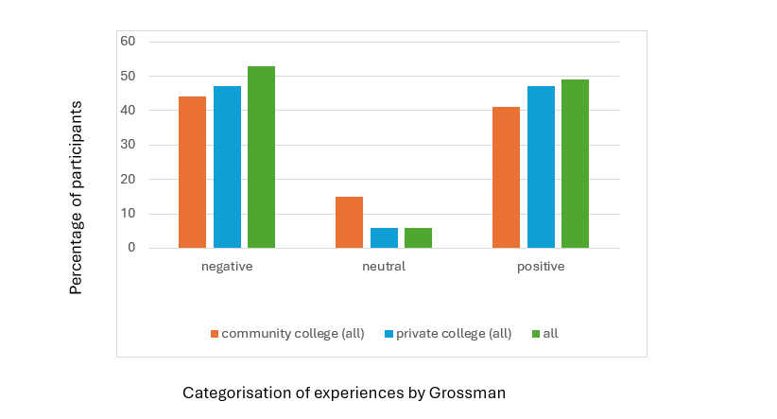

Figure 28 Effect of having a disabled sibling on students according to gender by %
as seen in the study by Grossman (1972) (%)

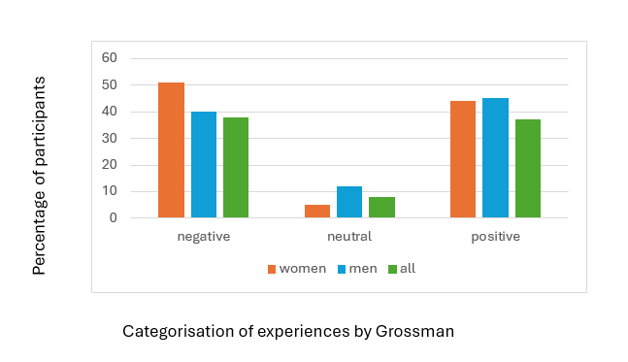

Appendix C
Measurement Tools used in previous studies
Table 9
Measurement tools used in previous studies (* = source of sample)
Measurement tool | First author
Activities of daily living (ADL) | Shivers & Dykens (2017)
Academic Competence Evaluation Scale (ACES) | Alderfer & Hodges (2010)
Adaptive Behaviour Scale | McHale & Gamble (1989)
ADI-R (Rutter & Le-Couteur) (mother) | Chien, Tu & Gau (2017)
Adult Sibling Relationship Questionnaire | Bowman, Alvarez-Jimenez, Howie, McGorry & Wade (2015)  Bowman, Alvarez-Jimenez, Wade, Howie & McGorry (2017)
Autism Knowledge Measure for Young Children | Smith & Perry (2005)
Autism -Spectrum Quotient (AQ) | Ruzich, Allison, Smith, Watson, Auyeung, Ring, & Baron‐Cohen, S. (2015).
Beck Depression Inventory (BDI) | Fisman, Wolf, Ellison & Freeman (2000)  Shivers, Jackson & McGregor (2019) *
Behavior Assessment System for Children (Self-Report) (BASC-SR) | Lobato, Kao, Plante, Seifer, Grullon, Cheas & Canino (2011)
BASC- 2 | Shivers, Jackson & McGregor (2019) *
Behavior problem checklist Quay & Peterson (1975) | Tritt & Esses (1988)
Behavior Problems Index (BPI) | Fletcher, Hair & Wolfe (2012)  Shivers (2019)  Shivers & Dykens (2017)
Behavioural and Social Emotional functioning of the designated sibling (adapted from Child Behaviour Checklist (CBCL) | Fisman, Wolf, Ellison & Freeman (2000)  Shivers, Jackson & McGregor (2019) *
Bene & Anthony family relations test | Stewart, Stein, Forrest & Claris (1992).
Benefit Finding Questionnaire | Shivers, Jackson & McGregor (2019) *
Bespoke surveys | Shivers, Jackson & McGregor (2019) *
Birleson depressive rating scale (Chinese translation) | Stewart, Stein, Forrest & Claris (1992).
Caregiver Strain Questionnaire | Shivers, Jackson & McGregor (2019) *
Center for Epidemiological Studies Depression Scale for Children | Shivers, Jackson & McGregor (2019) *
Child and Adolescent Social Support Scale (CASSS) | Alderfer & Hodges (2010)
Child Behavior Checklist (CBCL) | Alderfer & Hodges (2010)  Barak-Levy, Goldstein, & Weinstock (2010)  Gold, Treadwell, Weissman & Vichinsky (2008) Raghuraman (2008)  Shivers, Jackson & McGregor (2019) *  Smith & Perry (2005)
Child Development Supplement (PSID-CDS) | Fletcher, Haire & Wolfe (2012)
Child psychosocial functioning variables (Health and Daily living form – HDL) | Daniels, Moos, Billings, & Miller (1987)
Child Somatization Inventory (CSI) | Lobato, Kao, Plante, Seifer, Grullon, Cheas & Canino (2011)
Children’s Attributional Style Questionnaire | Shivers, Jackson & McGregor (2019) *
Children’s Depression Inventory-short form (CDI – short form) | Alderfer & Hodges (2010)  Kaplan, Kaal, Bradley & Alderfer (2013)
Children’s Depression Inventory | Shivers, Jackson & McGregor (2019) *
Children’s post-traumatic stress scale (CPSS)  Child PTSD Symptom Scale (CPSS) | Alderfer & Hodges (2010)  Kaplan, Kaal, Bradley & Alderfer (2013)
Children’s Self-efficacy for Peer Interaction Scale (CSPI) | Gold, Treadwell, Weissman & Vichinsky (2008)
CIS Youth version | Goudie, Havercamp, Jamieson & Sahr (2013)
Conners Parent Rating Scale | McHale & Gamble (1989)
COPE Inventory | Shivers, Jackson & McGregor (2019) *
Coping Adjustment scale (Perry, 1989) | Brouzos, Vassilopoulos & Tass (2017)
Coping Health Inventory for Parents (CHIP) | Gold, Treadwell, Weissman & Vichinsky (2008)
Coping response inventory-youth form (CRI-YF) | Pit-Ten Cate & Loots (2000)
Culture-Free Self-Esteem Inventories 2 | Shivers, Jackson & McGregor (2019) *
DA-IAT Disability themed based on Implicit Association Test (IAT) | Friedman (2019)
Depression, Anxiety & Stress Scale (DASS) | Shivers, Jackson & McGregor (2019) *
Devaluation of consumers and consumer families scale (DCCFS) | Dimitropoulos, Freeman, Bellai & Olmsted (2013)
Development and use of a tool (using focus groups)  Inventaire des Besoins de la Fratrie d’Enfants Malades Sévèrement (IBesFEMS) – Needs Inventory for siblings of critically ill children | Olivier-D’Avignon (2017a)  Olivier-D’Avignon (2017b)
Developmental behaviour checklist – short form (DBC-P24) | Shivers, McGregor & Hough (2019)
Diagnostic Interview Schedule for Children (DISC) Predictive Scales (DPS) version 4.32 | Lobato, Kao, Plante, Seifer, Grullon, Cheas & Canino (2011)
Dyadic Adjustment Scale (DAS) | Fisman, Wolf, Ellison & Freeman (2000)
Eating Disorders Examination Questionnaire (EDE-Q) | Dimitropoulos, Freeman, Bellai & Olmsted (2013)
Eating Disorders Symptom Impact Scale (EDSIS) | Dimitropoulos, Freeman, Bellai & Olmsted (2013)
Experience in Close Relationships-Revised | Shivers, Jackson & McGregor (2019) *
Experience of Caregiving Inventory (ECI) | Bowman, Alvarez-Jimenez, Wade, Howie & McGorry (2017)
Family adaptability and cohesion evaluation scales (FACES III) | Fisman, Wolf, Ellison & Freeman (2000)
Family Impact Questionnaire (FIQ) (subscales) | Shivers & Dykens (2017)
Family Relations Scale (FRS) | Gold, Treadwell, Weissman & Vichinsky (2008)
Follow-up use of health services | Brooten, Youngblut, Roche, Caicedo & Page (2018)
General Health Questionnaire (parent) | Stewart, Stein, Forrest & Claris (1992).
Global Family Checklist (GFC) | Pit-Ten Cate & Loots (2000)
Global Self-Worth Score | Rixon, Hastings, Kovshoff & Bailey (2021)
Go4KIDDS Brief Adaptive Scale | Bailey, Hastings & Totsika (2021)
Growing up with a Sibling with Autism: Adult Perspectives Survey | Shivers, Jackson & McGregor (2019) *
Harter Self Perception Profile | Rixon, Hastings, Kovshoff & Bailey (2021)
HIFAMS | Hayden, McCaffrey, Fraser-Lim & Hawkins (2019)
Hospital Anxiety and Depression Scale (HADS) | Shivers, Jackson & McGregor (2019) *
ICD-10/ICD-9 | Shivers, Jackson & McGregor (2019) *
Impact of Event Scale (IES-15)  Impact of Event Scale-Revised (IES-R) (caregiver) | Dyregrov & Dyregrov (2005)  Hanzawa, Bae, Bae, Chae, Tanaka et. al. (2013)
Information test (to test factual knowledge about sibling’s “mental retardation” | Grossman (1972)
Interpersonal Reactivity Index (IRI: Davis) | Shivers (2019)  Shivers & Dykens (2017)
Inventory of Behaviour (SIB: Schaeffer & Edgerton, modified by McHale & Gamble) | Rivers & Stoneman (2008)  McHale & Gamble (1989)
Inventory of Complicated Grief (parent) | Dyregrov & Dyregrov (2005)
Kessler 6 | Bailey, Hastings & Totsika (2021)
Kidscope Inventory | Gold, Treadwell, Weissman & Vichinsky (2008)
Klein’s Sibling Questionnaire + “hunches” | Tritt & Esses (1988)
K-SADS | Shivers, Jackson & McGregor (2019) *
Likert scales (Flourishing, school engagement, interpersonal peer functioning, family resilience) | Rosenthal, Franklin Gillette & DuPaul (2021)
Likert scales (attitudes to prenatal diagnosis, beliefs about coping, perceived beliefs of others) | Bryant, Hewison & Green (2005)
Matson Evaluation of Social Skills with Youngsters (MESSY) | Verte, Hebbrecht & Roeyers (2006)
McMaster family assessment – general functioning scale (FAD-GFS) | Dimitropoulos, Freeman, Bellai & Olmsted (2013)
Medical Files | Bowman, Alvarez-Jimenez, Howie, McGorry & Wade (2014, 2015)  Bowman, Alvarez-Jimenez, Wade, Howie & McGorry (2017)
Mental Illness and Disorder Understanding Scale (MIDUS) (caregiver) | Hanzawa, Bae, Bae, Chae, Tanaka et. al. (2013)
Most recent report card | Lobato, Kao, Plante, Seifer, Grullon, Cheas & Canino (2011)
Multidimensional Anxiety Scale for Children (MASC) | Shivers, Jackson & McGregor (2019) *
Multidimensional Coping Inventory | Shivers, Jackson & McGregor (2019) *
Multidimensional Scale of Perceived Social Support (MSPSS) | Shivers, McGregor & Hough (2019)
Multiple Affect Adjective Checklist-Revised (MAACL-R) | Shivers (2019)
Multiple Affect Adjective Checklist-Revised (MAACL-R)  Words adapted | Shivers & Dykens (2017)
My Feelings and Concerns Sibling Questionnaire (MFCSQ) | Fleary & Heffer (2013)
Myself as a learner scale (MALS) | Gregory, Hastings & Kovshoff (2020)
National longitudinal study of adolescent health (Add Health) | Fletcher, Mailick, Song & Wolfe (2012).
National register  National Health Interview Survey (NHIS)  patient registry | Bortes, Strandh & Nilsson (2020)  Cederlöf, Larsson, Lichtenstein, Almqvist, Serlachius & Ludvigsson (2016).
National Survey of Children’s Health (NSCH) voluntary annual survey | Rosenthal, Franklin Gillette, & DuPaul (2021)
Norwicki-Strickland Locus of Control Scale | Shivers, Jackson & McGregor (2019) *
Panel study of income dynamics (PSID) | Fletcher, Hair & Wolfe (2012)
Parental Attachment Questionnaire | Shivers, Jackson & McGregor (2019) *
Parent Bonding Instrument (PBI) (mother) | Chien, Tu & Gau (2017)
Parenting Stress Index- Short Form (PSI-SF) | Benson & Karlof (2008)  Cuzzocrea, Larcan, Costa & Gazzano (2014)  Fisman, Wolf, Ellison & Freeman (2000)
Pediatric Quality of Life Inventory (PedsQL) | Dinleyici, Carman, Özdemir, Harmancı, Eren, Kırel, Şimşek, Yarar, Duyan Çamurdan & Şahin Dağlı (2020)
Perceived Competence Scale for Children | Shivers, Jackson & McGregor (2019) *
Perceived Stress Scale (PSS-10) | Shivers, McGregor & Hough (2019)
Personality Assessment Screener (PAS) | Fleary & Heffer (2013)
Pictorial Scale of Perceived Competence | Shivers, Jackson & McGregor (2019) *
Piers-Harris self-concept scale | Shivers, Jackson & McGregor (2019) *  Smith & Perry (2005)  Stewart, Stein, Forrest & Claris (1992).
Quality of Relationships Inventory (QRI) | Bryant, Hewison & Green (2005)
Questionnaire for the Assessment of Parental Educational Competence | Cuzzocrea, Larcan, Costa & Gazzano (2014)
Revised Children’s Manifest Anxiety Scale (RCMAS) | Alderfer & Hodges (2010)  Kaplan, Kaal, Bradley & Alderfer (2013)  McHale & Gamble (1989)
Revised Life Orientation Test (LOT-R) (parent) | Shivers & Dykens (2017)
Rosenberg Self-Esteem Scale | Shivers, Jackson & McGregor (2019) *
Rutter A2 questionnaire (parent) | Stewart, Stein, Forrest & Claris (1992).
Satisfaction with Life Scale | Shivers, Jackson & McGregor (2019) *
Self-appraisal Inventory (SAI) (Frith & Narikawa) | Tritt & Esses (1988)
Self-perception Profile for Children | Fisman, Wolf, Ellison & Freeman (2000)
Short Acculturation Scale (in Spanish) | Lobato, Kao, Plante, Seifer, Grullon, Cheas & Canino (2011)
Sibling Inventory of Differential Experience (SIDE) | Dimitropoulos, Freeman, Bellai & Olmsted (2013)
Sibling Perception Questionnaire (SPQ) | Raghuraman (2008)
Sibling Relationship Inventory (SRI) | Pit-Ten Cate & Loots (2000)  Shivers, McGregor & Hough (2019)  Verte, Hebbrecht & Roeyers (2006)
Sibling Relationship Questionnaire – brief version (SRQ) | Fisman, Wolf, Ellison & Freeman (2000)
Sibling Relationship Questionnaire (SRQ) | Cebula, Gillooly, Coulthard, Riby & Hastings (2019)  Hemati Alamdarloo, Shojaee, Khaghaninejad & Teymori Asfichi (2019)  Raghuraman (2008)  Rixon, Hastings, Kovshoff & Bailey (2021)
Social Adjustment Inventory for Children and Adolescents (SAICA) – Chinese translation (mother) | Chien, Tu & Gau (2017)
Spence Children’s Anxiety Scale (SCAS) | Batte, Watson & Amess (2005)  Cebula, Gillooly, Coulthard, Riby & Hastings (2019)
Social adjustment scale (parent) | Stewart, Stein, Forrest & Claris (1992).
Social Provisions Scale (SPS) | Dimitropoulos, Freeman, Bellai & Olmsted (2013)
Social Skills Rating System | Shivers, Jackson & McGregor (2019) *
Social Responsiveness Scale (SRS) (mother) | Chien, Tu & Gau (2017)
Social Support Scale for Children | Fisman, Wolf, Ellison & Freeman (2000)
Social Support Scale for Children (SSSC) | Gold, Treadwell, Weissman & Vichinsky (2008)  Fisman, Wolf, Ellison & Freeman (2000)
Spielberger anxiety rating scale | Stewart, Stein, Forrest & Claris (1992).
Strengths and Difficulties Questionnaire (SDQ) | Bailey, Hastings & Totsika (2021)  Benson & Karlof (2008)  Brouzos, Vassilopoulos & Tass (2017)  Cebula, Gillooly, Coulthard, Riby & Hastings (2019)  Gregory, Hastings & Kovshoff (2020)  Hayden, McCaffrey, Fraser-Lim & Hawkins (2019)  Rixon, Hastings, Kovshoff & Bailey (2021)  Shivers, Jackson & McGregor (2019) *
Stress Response Scale | Shivers, Jackson & McGregor (2019) *
Survey | Bowman, Alvarez-Jimenez, Wade, Howie & McGorry (2017)
Survey of children’s social support – short version (SCSS-SV) | Cebula, Gillooly, Coulthard, Riby & Hastings (2019)
Swanson, Nolan & Pelham, Version IV (SNAP-IV) (mother) | Chien, Tu & Gau (2017)
Systemic model for self-assessment of family functioning (TDS and parents) | Cuzzocrea, Larcan, Costa & Gazzano (2014)
Teacher’s Report Form (TRF) | Lobato, Kao, Plante, Seifer, Grullon, Cheas & Canino (2011)
Temperament Questionnaire | Raghuraman (2008)
Test Anxiety Questionnaire (Sarason & Mandler, 1952) | Grossman (1972)
Test for the assessment of behavioural and emotional problems (SEDS) | Cuzzocrea, Larcan, Costa & Gazzano (2014)
Test of Interpersonal Relationships (TRI) | Cuzzocrea, Larcan, Costa & Gazzano (2014)
The Belonging Scale (TBS) | Gregory, Hastings & Kovshoff (2020)
The Social Communication Questionnaire (SCQ: Rutter et. al., 2003) (parent) | Chien, Tu & Gau (2017)  Rixon, Hastings, Kovshoff & Bailey (2021)
The Three Wishes question | Shivers (2019)
Vineland Adaptive Behavior Rating Scales (Sparrow et. al, 2005) (parent) | Rixon, Hastings, Kovshoff & Bailey (2021)
Warwick Edinburgh well-being-scale – short form (SWEMWBS) | Hayden, Hastings, Kassa, & Danylec (2022)
Weinberger Adjustment Inventory (WAI) | Barak-Levy, Goldstein, & Weinstock (2010)  Shivers, Jackson & McGregor (2019) *
Weschler Adult Intelligence Test (WAIS) | Grossman (1972)
What I think and feel questionnaire (WITF) Reynolds & Richmond) | Tritt & Esses (1988)
What’s it like to have a brother or sister with a developmental disorder (Coping/ Adjustment Scale: Perry, 1989) | Smith & Perry (2005)
Wisconsin Longitudinal Study (WLS) | Fletcher, J., Mailick, M., Song, J., & Wolfe, B. (2012)
Woodcock-Johnson (WJ-R) tests of achievement | Fletcher, Hair & Wolfe (2012)
World Health Quality of Life Scale (WHOQoL-Bref) | Bowman, S., Alvarez-Jimenez, M., Wade, D., Howie, L., & McGorry, P. (2014).  Bowman, Alvarez-Jimenez, Wade, Howie & McGorry (2017)
Youth Self-Report | Shivers, Jackson & McGregor (2019) *
Zarit Caregiver Burden Interview (ZBI-8) (caregiver) | Hanzawa, Bae, Bae, Chae, Tanaka et. al. (2013)
*Shivers, Jackson & McGregor (2019) is a meta-analysis
Appendix D
Information sheet
This information sheet was part of the survey and was also available on request without accessing the survey

Introduction: What is the study about and why is it taking place?
This research aims to explore the experiences and retrospective reflections of young adults about their time living with a sibling with additional needs (a disability, special educational needs, a chronic medical condition and/or mental health difficulties). I am keen to explore everyday experiences as well as one-off incidents and especially interested in hearing participants’ reflections about their school experiences.

Whilst there is a large body of research relating to parental experiences, siblings are a little heard voice and where research does exist, the findings often contradict. Very few studies involve British participants and research into school experiences is minimal. Many schools offer support to young carers but not all siblings are young carers. I am interested to find out if there is anything which schools can do to support siblings, regardless of whether they are young carers or not.
Why have I been invited to take part?
You have been invited to take part because you grew up and went to school in Britain and whilst growing up you lived with a sibling who had additional needs. Your involvement is entirely voluntary and if you do not wish to take part please disregard this sheet.
If I decide to take part what will happen?
There are two phases to the study: and you can take part in the first phase, the second phase or both.
The first phase is a brief questionnaire. The link to the survey can be found at the end of this sheet. The survey will likely take less than 15 minutes to complete unless you wish to add extra detail.
The second phase involves interviews. If you are interested, you would be invited to take part in an online interview using Googlemeet (which is the university’s virtual platform). The interview will consist of open-ended questions, and you can say as little or as much as you are comfortable all.
In compiling the interview schedule I will take account of responses to the question “What do you think might be good interview questions to ask someone who grew up with a sibling with additional needs?”, a question which is on the phase 1 questionnaire. This is because young people who have experienced having a sibling with additional needs are best placed to identify relevant material to talk about.
If you take part in the interviews, you will be provided with the questions in advance. This will give you opportunity to think about your answers and if you think you will find talking about the topic upsetting, you can withdraw before being interviewed.
What is talked about in the interview will be recorded and transcribed anonymously. It is anticipated that interviews will take approximately an hour.
I am interested. What should I do next?
Please read through this information sheet. If you are happy with the contents of the information sheet you can then either complete the survey or email me at clalexander1@sheffield.ac.uk. You can also use this email to contact me with any questions which you might have. The link to the survey can be found at the bottom of this sheet or via the QR which can also be found on this information sheet.
How will the data be analysed?
The data from the phase 1 surveys will be analysed quantitatively, used to inform questions asked in phase 2 interviewers and it is possible that additional qualitative data will be gathered via the optional questions.
For phase 2 interviews, the data will be anonymised and transcribed and then I will use a process called thematic analysis to look for common themes in what participants say. I will also use a form of analysis called I-Poems whereby I link together statements participants have made which begin with I.
The results will be used to learn more about participants’ experiences and the roles which schools may have played in these experiences.
Are there any risks involved in taking part?
I understand that it can be anxiety-provoking to talk about childhood experiences, about other members of your family and your school. However, please be assured that your involvement will not be identifiable to anyone other than myself and my supervisor. Anything you tell me will be anonymised. It is entirely up to you how much and what you share and you can change your mind and ask me to delete your data.
If you complete the questionnaire you have opportunity to provide an identifier code so that you can then ask me to delete all the data attached to that code for up to 10 days after you completed the questionnaire.
If you choose to be interviewed and change your mind at any point before, during or after the interview for any reason, you can withdraw your data up to 10 days after your involvement. After that point your data will be transcribed and anonymised. if you wish, you can choose the pseudonym which I will use yourself.
Are there any benefits involved in taking part?
I hope that through taking part you have an opportunity to reflect on your experiences in a safe place. I also hope that what you share can inform how Educational Psychologists help schools understand the lives of students who live with a sibling with a disability. As well as being reported on in my thesis, the findings may be published, disseminated at conferences and be used in training others.
Will what I say be confidential?
All the information that I collect about you during the course of the research will be kept strictly confidential and will only be accessible to my supervisor and me. You will not be able to be identified in any reports or publications. If you agree to us sharing the information you provide with other researchers (e.g. by making it available in a data archive) then your personal details will not be included.
However, there is a limitation to confidentiality; if through any of the information you share during interview I have concerns about harm to yourself or others I may have to follow safeguarding procedures. If you are concerned about any safeguarding issues then there are details of who to contact in the Concerns and Complaints section of this information sheet.

How will my data be processed?
According to data protection legislation, we are required to inform you that the legal basis we are applying in order to process your personal data is that ‘processing is necessary for the performance of a task carried out in the public interest’ (Article 6(1)(e)). Further information can be found in the University’s Privacy Notice https://www.sheffield.ac.uk/govern/dataprotection/privacy/general . Your personal data will be securely stored in University of Sheffield secure drives. consent form details and email addresses will be stored separately to your interview data and will not be linked. Data will be stored anonymously until the end of the research project. All personal information will be delated once I complete my studies at the university.
The University of Sheffield will act as Data Controller for this study. This means that the university is responsible for looking after your information and using it properly. I will only use your data and information for the reasons already mentioned to fulfil the aims of the research. Due to the nature of this research it is possible that other researchers may find the anonymised transcripts useful in answering future research questions. We will ask for your explicit consent for your data to be shared in this way.
You will be able to withdraw from the study and thus withdraw your data up to 10 days after the interview. After this point your data will be anonymised and any personal data will no longer be linked to your survey answers or interview data.
Ethical review
This project has been ethically approved via the University of Sheffield's Ethics Review Procedure, as administered by the School of Education. The University 's Research Ethics Committee monitors the application and delivery of the University 's Ethics Review Procedure across the University.
Concerns or complaints
If you are dissatisfied with any aspect of the research and wish to make a complaint, please contact my research supervisor, [redacted] in the first instance. If you feel a report you have made to this contact has not been handled in a satisfactory way you can contact the Head of the Department, Rebecca Lawthom r.lawthom@sheffield.ac.uk
If the complaint relates to how your personal data has been handled, you can find information about how to raise a complaint in the University’s Privacy Notice: https://www.sheffield.ac.uk/govern/data-protection/privacy/general.
Next steps
If you are still interested in taking part, having read this information sheet, you can complete the survey using either the QR code below or the link https://docs.google.com/forms/d/e/1FAIpQLSd15l53VE2YaFyO5oQAXCmU72sQRrxxYi0HR-ESsSNE64CZUw/viewform?vc=0&c=0&w=1&flr=0 and/or you can contact me at calexander1@sheffield.ac.uk . You may just complete the survey, offer only to be interviewed or both. You will be required to sign consent forms at the start of the survey and prior to any interview.
Thank you for taking the time to read this information sheet and consider taking part in the research. 5/7/23

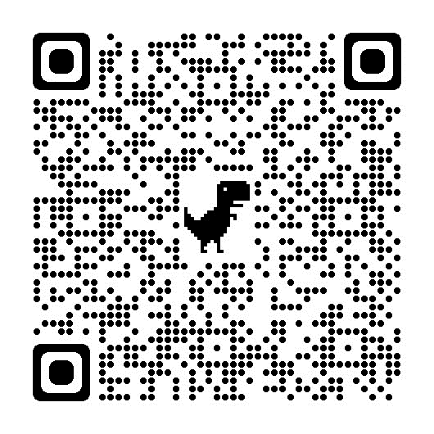
Appendix E
Signposting statement included at end of survey
If you have been affected by thinking about this topic, you may want to talk further with a professional or fellow sibling. The charity SIBS offers support to people like yourself and details can be found at www.sibs.org.uk.
There are also many charities who can offer advice to siblings, sometimes these are specific to particular disabilities including www.contact.org.uk, www.ndcs.org.uk/siblings (for siblings of deaf children) https://www.beateatingdisorders.org.uk/your-stories/anorexia/sibling-solidarity/ (for siblings of those with eating disorders).

You may also find the following links helpful:
https://www.ucl.ac.uk/ioe/news/2020/jun/wellbeing-disabled-childrens-siblings-severely-impacted-lockdown

https://www.youtube.com/watch?v=6ooWPy7HuTc&t=2s (a video produced by the NHS)

Details about how to source counselling can be found at https://www.nhs.uk/mental-health/talking-therapies-medicine-treatments/talking-therapies-and-counselling/counselling/

If you are a university student, you can access support via the university wellbeing service.

Appendix F
Piloting process
When? | How it took place | How using a pilot influenced the research
Phase 1: survey  June 2023 | I asked a colleague who had a sibling with additional needs to look at my list of questions – they said, “The questions are relevant and expressed sensitively”. | This gave me the confidence to use the questions in the survey.  I also rephrased one question to recognise that participants’ relationships with their siblings may have changed throughout their life.
Phase 1: survey  July 2023 | I asked a fellow researcher to complete the form to check  i) appropriateness and any ambiguity of questions  ii) time taken to complete the survey  iii) for any IT glitches  iii) whether using an identifier in the survey worked | They told me that it took them 10 minutes to complete, there were no IT glitches but that the survey did not display well on a phone – it altered the pagination  I did not change any of the survey content but did check whether the survey itself had an IT glitch – the survey original link worked and displayed correctly on a laptop
Phase 2: interviews  August 2023 | I conducted the pilot interview with a postgraduate researcher from another university  This helped me  i)Practice how googlemeet and record/google transcription and audio recording devices worked  ii) helped me to trial the questions – interviewing a fellow researcher made it possible to discuss their perspective on the questions as well as answer them | I changed one of the questions – I had asked the participant to quantify what proportion their experiences were because of their sibling having additional needs and what proportion were just usual sibling experiences which all children and young people experience – because the participant had said that this varied over time, I amended my question list to include the possibility of varying answers.  The participant also told me about how to use hashtags in twitter to increase my readership and I then went back and updated my profile to include the hashtags #TEP #doctorate #Thesis: #sibling #disability #SEND - this meant that if anyone clicked on any of these hashtags elsewhere on twitter my feed would appear in their search.  I also amended the questions to start with more open-ended questions and then only check the list when the participant ran out of ideas  I discussed with my supervisor the tension between being a neutral researcher and a psychologist who wanted to reassure and contain e.g. the interviewee had apologised for saying negative things about the experience and I had found myself reassuring them that this was very similar to what the research said

Appendix G
Interview prompt questions
Participants were initially asked
- Tell me about your sibling (setting the scene/ warm up questions/ open-ended question so that participant could choose what to talk about)
- If you were to describe your experiences in 5 words what would those 5 words be? (setting the scene/ warm up questions/ open-ended question so that participant could choose what to talk about)
- Tell me about your experiences of growing up with a sibling with additional needs (setting the scene/ warm up questions/ open-ended question so that participant could choose what to talk about)
If participants ran out of ideas to talk about, I had a list of prompt questions which I could use. Participants had been sent these questions in advance in case they wanted to prepare. I have annotated in brackets where questions derived from survey answers, literature review, or my own interest based on my professional observations. I recognise my personal bias in relation to school experiences and therefore only asked my additional prompt questions later in the interviews where interviewees had initially been asked open-ended questions. I also recognise that my own experiences may have blinded me to asking alternative questions.
In some cases, a question was one suggested by a survey respondent but mostly these questions were based on themes which arose across the survey answers. This is because many of the questions suggested by survey participants overlapped. Thus, as outlined in section 3.2, themes were identified across the survey qualitative data and these themes informed the interview questions (see word cloud in Figure 23).
School
- Was there ever anything in the curriculum which related to disability or being a sibling? (my interest)
- Was your sibling ever mentioned to you by staff or other students and how did you feel about this? (my interest)
- Did the school ever make allowances for anything which happened as a result of your situation e.g. being allowed to leave school early? (survey)
- Was there anything your school did which you really appreciated? (my interest/ survey)
- Was there ever a situation where you wish things had been done differently? (my interest/ literature)
- What might have helped but wasn’t available? (survey)
- Did you ever feel that the school relied on you too much in helping out with your sibling? (literature)
- Did you feel that your school took your personal situation into account in any way? Would you have liked them to, or would you have viewed this as too personal? (literature/ survey)
- Were you ever in trouble because of something relating to your situation e.g. homework not being done or an argument where you challenged another student for making negative comments about disability. (survey/ literature/ my interest)
- Did having a sibling with additional needs affect your relationships with other children and young people? (survey/literature)
- Were you ever unable to take part in an extracurricular activity or trip as a result of your sibling’s needs? (e.g. your parents could not transport you) (literature)
Life outside of school
- Tell me about the impact of having a child with additional needs on other members of the family e.g. your parent(s)/ siblings/grandparent(s)? (survey)
- Do you think your relationship with your parent/s was affected? (survey/ literature)
- Did having a sibling with additional needs affect things like finances, holidays etc. (literature/ survey)
- Did you bring friends home? Was this different to when you visited your friends’ homes? (literature/ survey)
- How did your friends react to meeting your sibling? (literature/ survey)
- Do you think birth order, gender and/or your cultural background had any impact? (survey/literature)
- Was there a key adult in your life who was important to you? How did they support you? (survey/ my interest)
- Did you ever have any contact with professionals (e.g. medical specialists) growing up and were these helpful? Would you have liked to have had more contact? (literature/ survey)
- Did anyone ever explain your sibling’s condition to you? (literature/ survey)
- Was there ever anything which you wish you had been told? (literature)
- Was your experience in public places different if your sibling was with you? (survey/ literature)
- Everyone has positive and negative experiences of being a sibling regardless of whether the sibling has additional needs or not. To what extent (as a ratio/ percentage) would you say your experiences of siblinghood would have been the same if your sibling did not have additional needs and how much of your experience was specific to them having additional needs? (e.g. 60% would still have been the same) – at different times in your life (literature)
- How would you say your childhood and teenage experiences were similar to and different to that of your friends? (survey)
- Would you say that there were different expectations on you compared to your friends? (survey)
Adult life
- Do you think your experiences growing up with a sibling with additional needs has affected you as an adult? Are you a different person than you might have been? Has this affected your sense of identity? Have your thoughts about your childhood experiences, your sibling and your relationships with family members changed over time? (survey)
- Have decisions about your life been affected by having a sibling with additional needs? (e.g. where to live, choice of job, dating/ marriage/having children, choice of friends) (literature/ survey)
Other
- Are there any memorable incidents which stick out? (to elicit further memories)

Appendix H
Recruitment posters
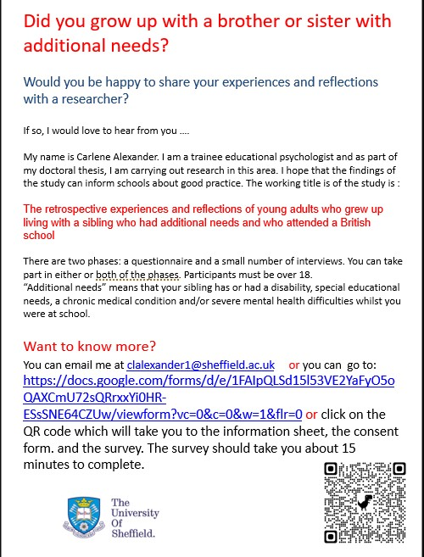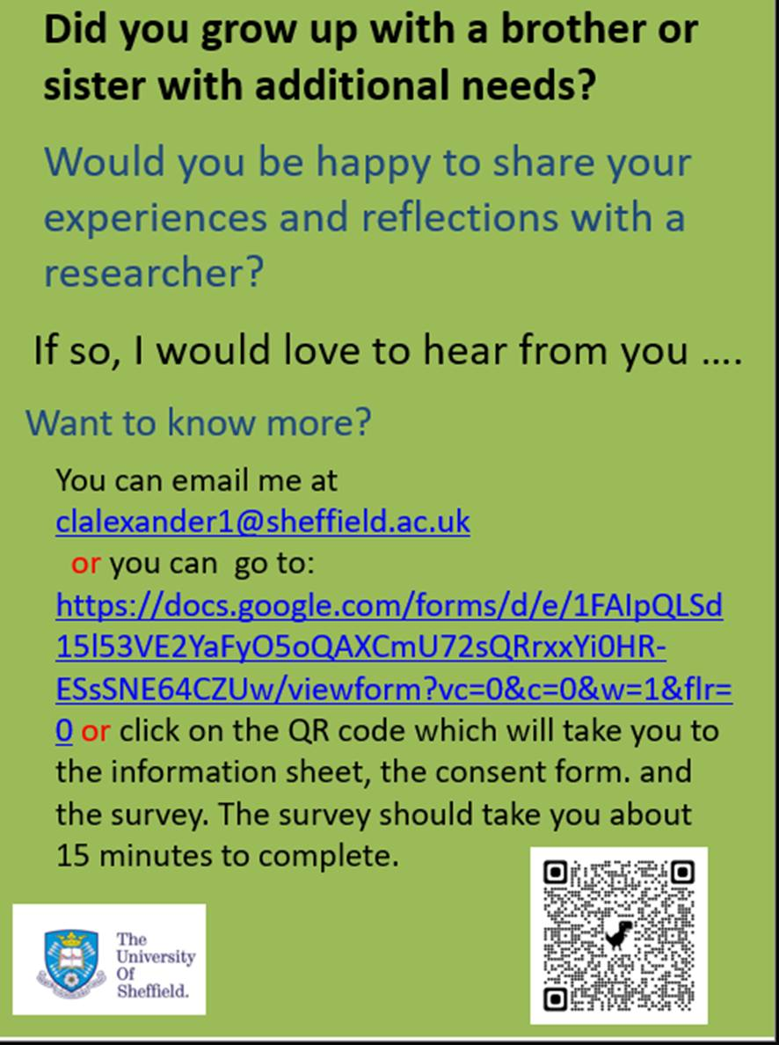
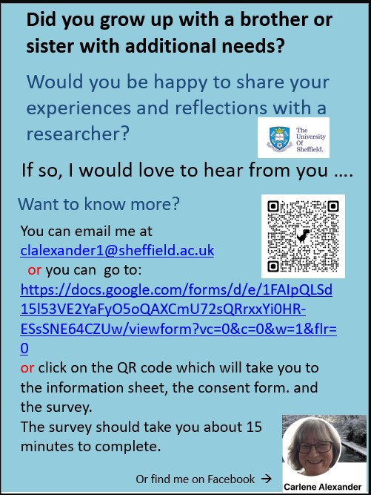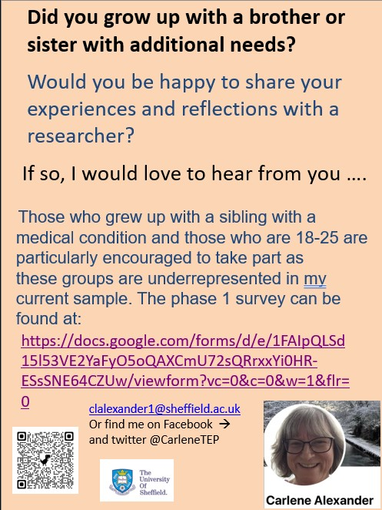

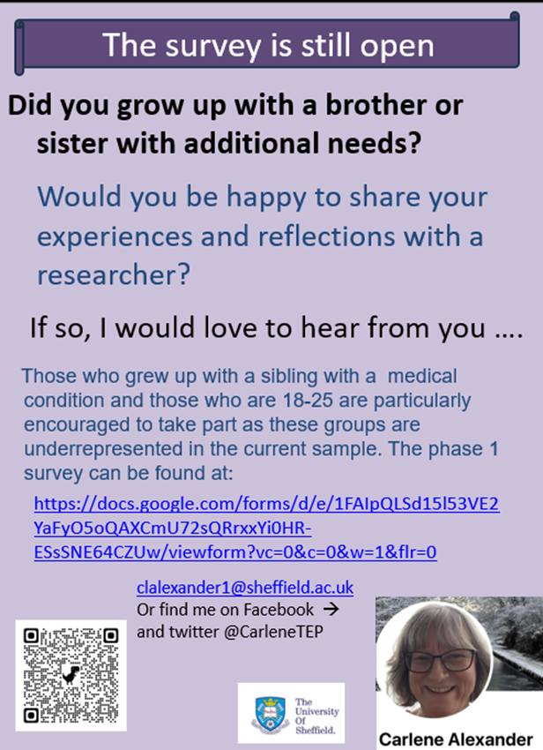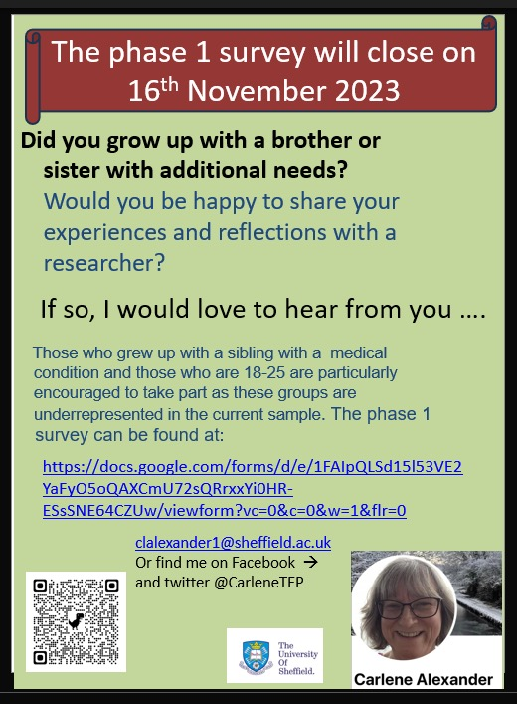

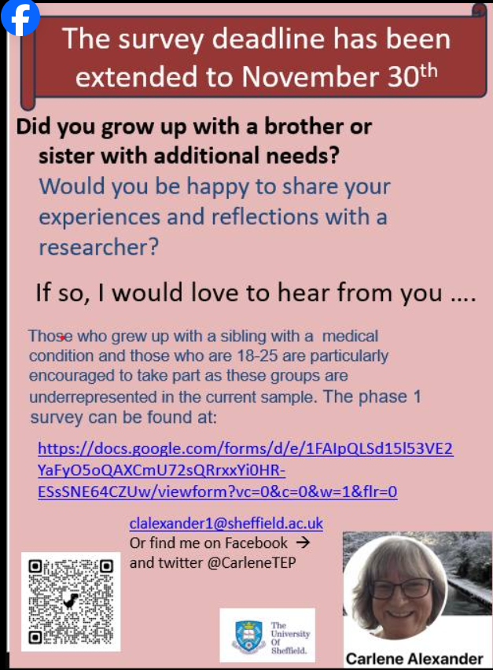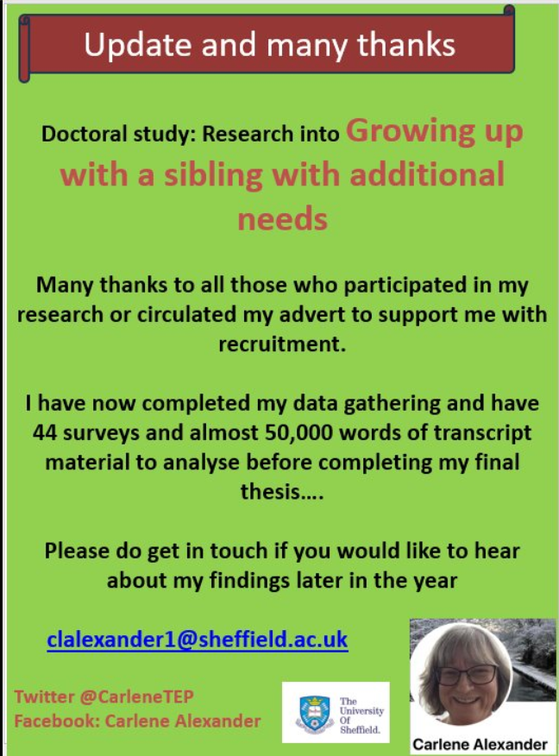

Appendix I
Facebook statistics
Figure 29 Statistics showing the snowball effect of recruiting via Facebook in the
first three weeks
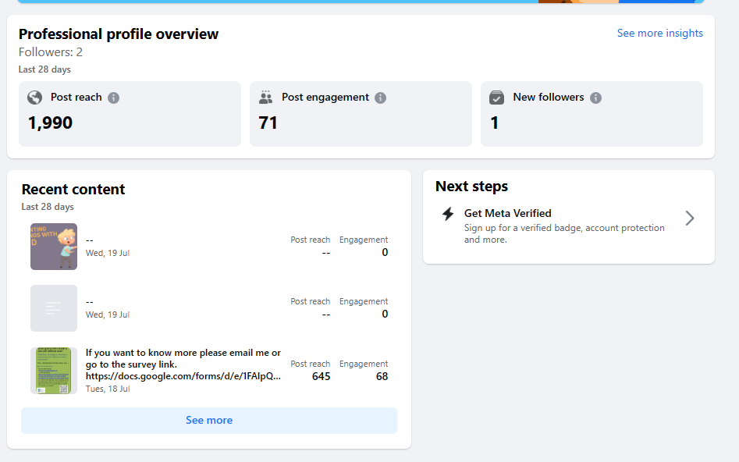

Figure 30 Statistics showing the snowball effect of recruiting via Facebook in the
first month

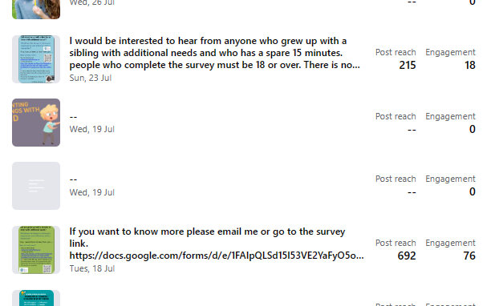

Figure 31 Statistics showing the snowball effect of recruiting via Facebook in the
last 28 days of the first 6 weeks after the survey was posted

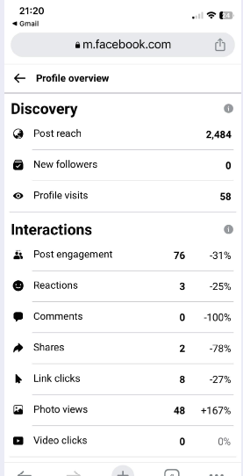

Appendix J
Additional demographic information about Phase 1 survey respondents

Figure 32 Gender of both siblings

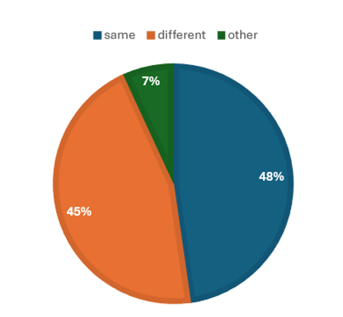
*other related to having more than one sibling with additional needs

Figure 33 Participants by young carer status
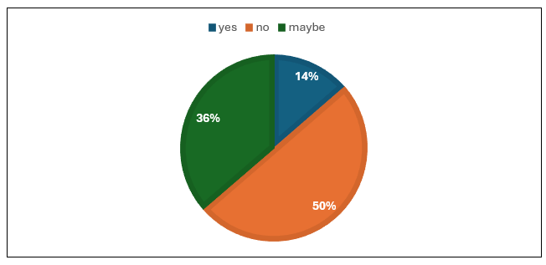

Figure 34 Number of siblings of respondents

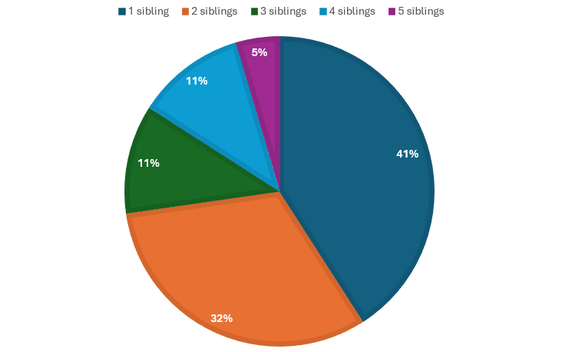

Figure 35 School attended by the participant and their sibling

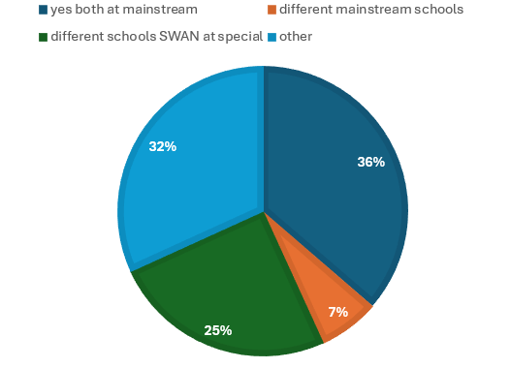
Responses to this question, along with data gathered in interviews, suggested that my question had not allowed for the possibility that this had been different at primary than at secondary school (SWAN = sibling with additional needs).
Appendix K
Pen portraits

Figure 36 Pen portraits
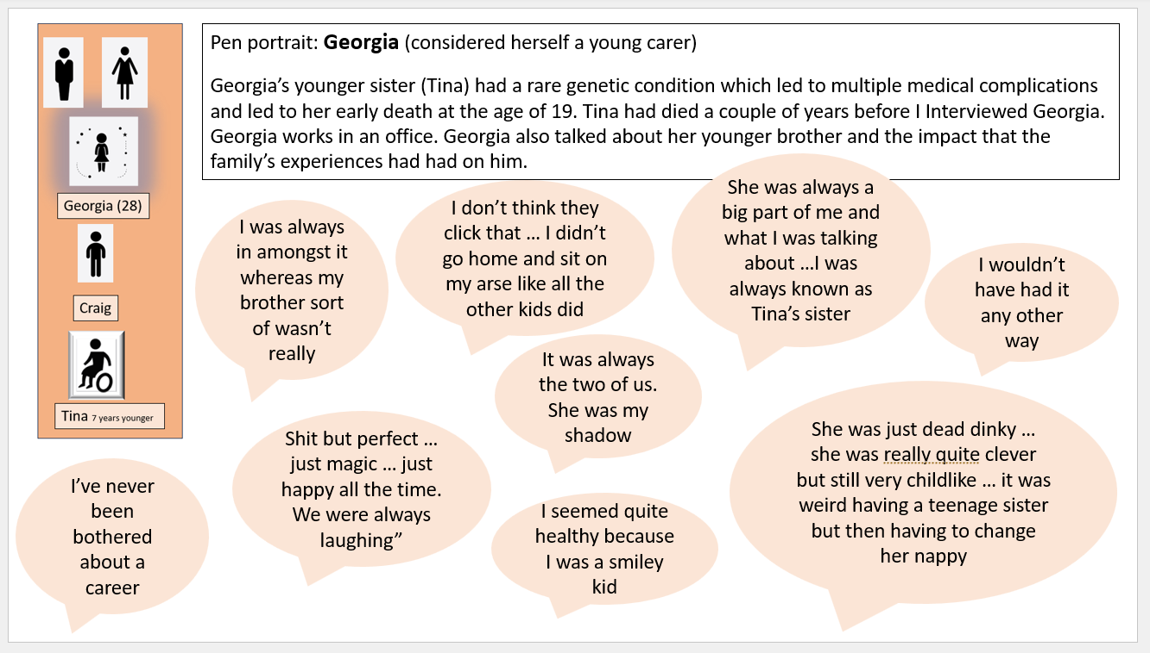
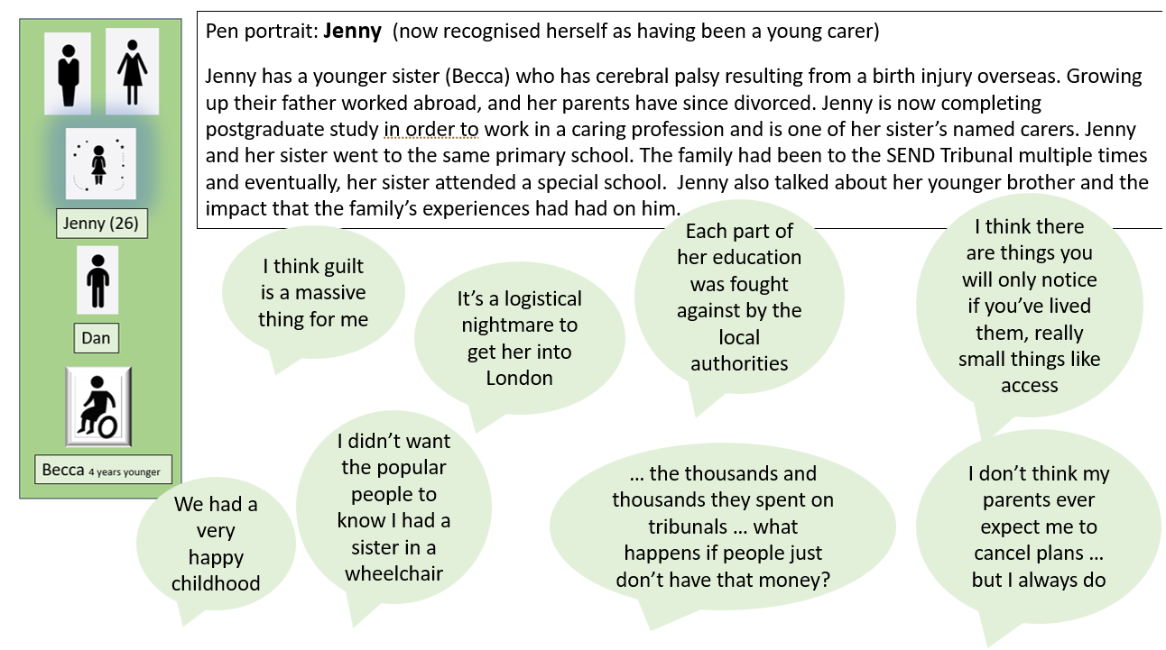

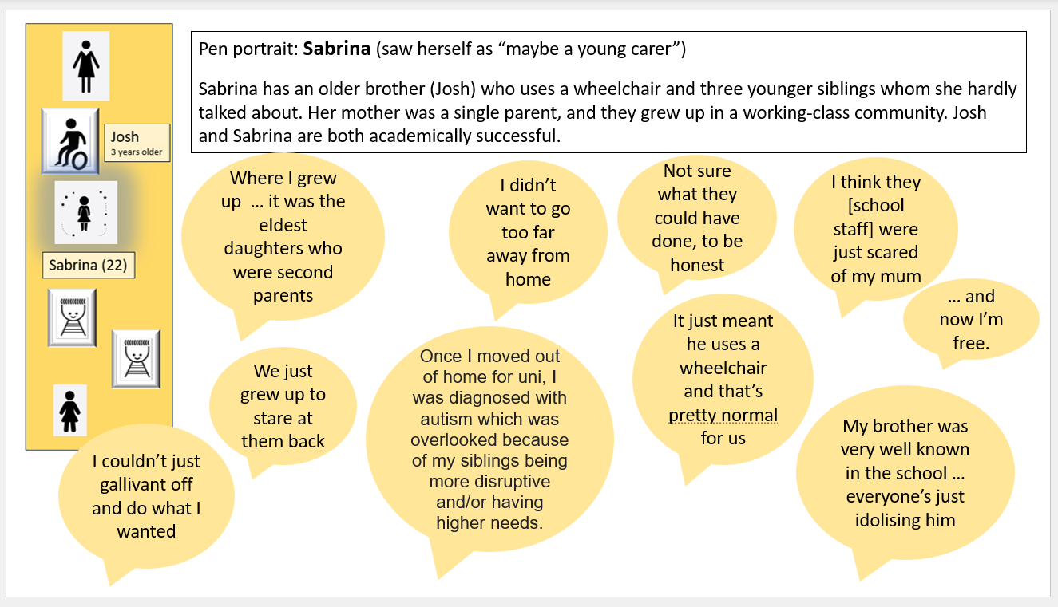

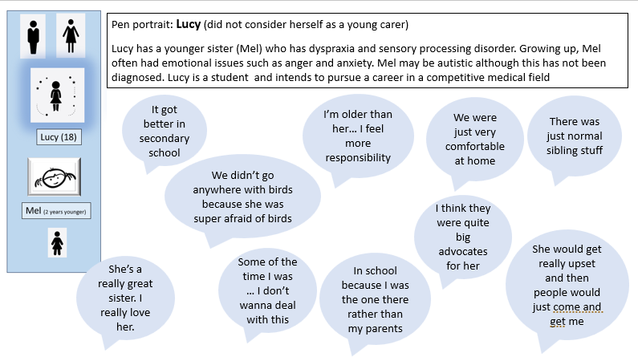

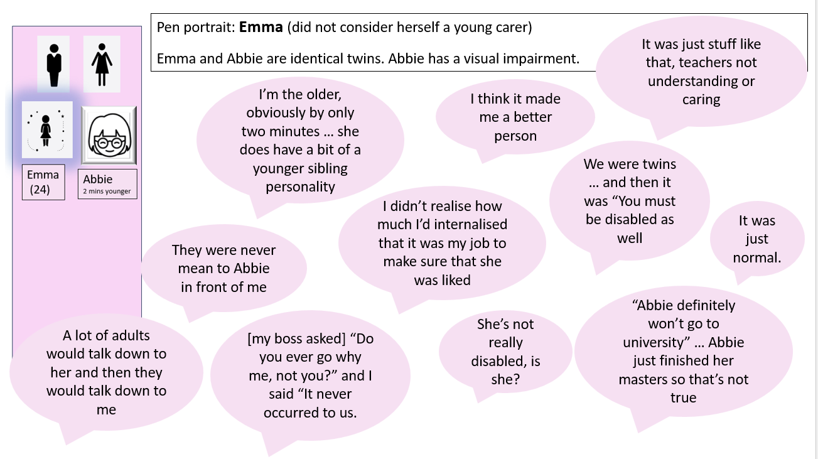

Appendix L
Scores given by interviewees in Phase 1
Question 1: To what extent does having a sibling with additional needs affect the life of the other sibling?

Figure 37 Perceived effect of having a sibling with additional needs by overall
survey results and by identified interview participants

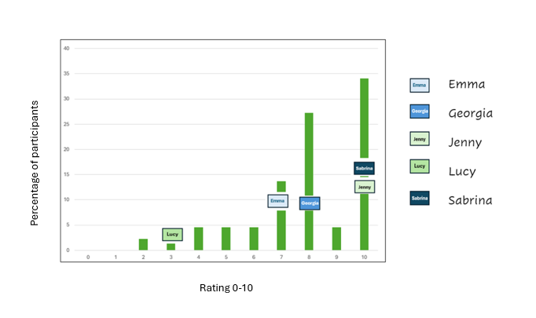

Question 2: To what extent does having a sibling with additional needs affect quality of life?
Figure 38 Perceived effect of having a sibling with additional needs on quality of life
by overall survey results and by identified interview participants
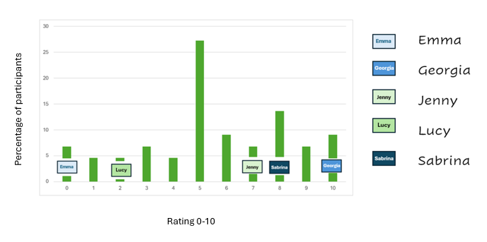

Question 3: To what extent does having a sibling with additional needs affect decision-making for the typically developing sibling?
Figure 39 Perceived effect of having a sibling with additional needs on life
decisions by overall survey results and by identified interview
participants

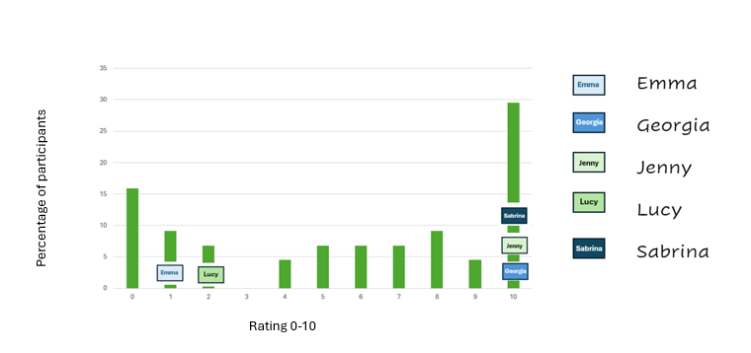

Question 4: To what extent does having a sibling with additional needs affect the typically developing sibling’s school experiences and learning?
Figure 40 Perceived effect of having a sibling with additional needs on schooling
and learning by overall survey results and by identified interview
participants
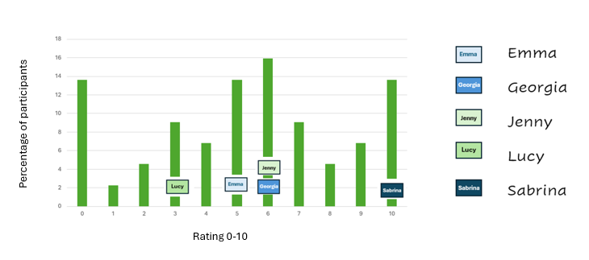

Appendix M
Extracts from ethics application
3. Personal Safety
Listening to participants talk about what may be painful subjects may be emotionally demanding for me, especially if I feel that there is nothing which can be done to mitigate their difficult circumstances.
I would hold these experiences as I do as a TEP when talking to children, young people and adults when hearing about difficult circumstances and painful memories. If I find what is talked about in interviews emotionally difficult I would seek supervision in the same way as I do for difficult casework. I am also aware of the university specialist guidance paper about emotionally demanding research and risk to the researcher.
5. Potential Harm to Participants
What is the potential for physical and/or psychological harm/distress to the participants?
In asking participants to talk about childhood and young adulthood experiences, there is a risk of reminding a participant of difficult and/or traumatic experiences which may potentially lead to psychological and emotional harm. I consider this to be a risk comparable to that of discussing such experiences with friends and professionals and I will direct participants to support services.
I will also provide interview questions to participants in phase 2. This will make it possible for them to consider whether taking part in the interviews might be distressing. They would then have the option to withdraw before, during or after the interview. Participants who withdrew would still be signposted to support services.
How will this be managed to ensure appropriate protection and well-being of the participants?
Participants will be reminded that they can take a break from the interview and can withdraw from the survey. My questions will be adapted if a particular area is causing the participant distress.
Following their involvement, participants will be signposted to support and wellbeing services e.g. university wellbeing services, the charity SIBS who support those with similar experiences and relevant online and known resources and groups relevant to the identified disability/medical condition. This information will be included at the end of the survey. Following the interviews I will email participants to thank them for taking part and also provide a debrief sheet signposting to the same services
6. Potential harm to others who may be affected by the research activities
Which other people, if any, may be affected by the research activities, beyond the participants and the research team?
Because the participants will be talking about their family experiences and their school memories this could potentially affect their feelings towards those people e.g. family members, school friends, members of staff at their previous school
What is the potential for harm to these people?
Because the sibling with additional needs will not be present during research activities and because I will not come into direct contact with them, they will not be directly harmed.
However, I recognise that the participants' reflections on their childhood may lead to future difficult conversations and influence the relationship between the participant and their family members. I consider that this level of risk is similar to that which happens following a conversation with a friend, relative or professional,
How will this be managed to ensure appropriate safeguarding of these people?
signposting to support groups, wellbeing services and the charity SIBS who can help any affected participant to process their thoughts beyond completing the survey and/or taking part in the interview.
All participants, siblings and identifying details (e.g. part of the country) will be anonymised. When participants complete the survey, I will not know who they are. Where participants name particular individuals or places e.g. school names, places, family members, friends or school staff I will ensure I use a pseudonym for those people and places as well as the participant.

Appendix N
Ethics Approval certificate
Figure 41 Screenshot of letter of ethical approval with confirmation that a change to
the initial proposal had been approved; this change to the first ethics
application related to my giving more detail regarding the potential
sensitivity of the research for both participants and myself
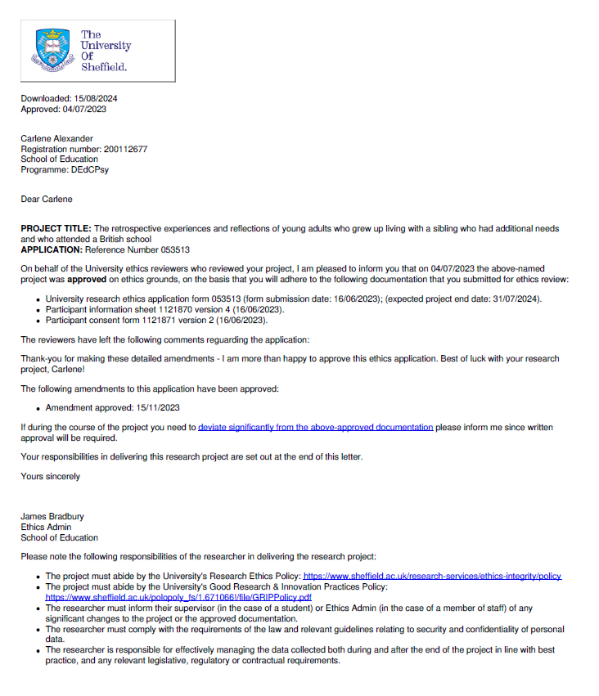
Appendix O
Request for amendment to increase interview participant age
Figure 42 Screenshot of amended ethics application
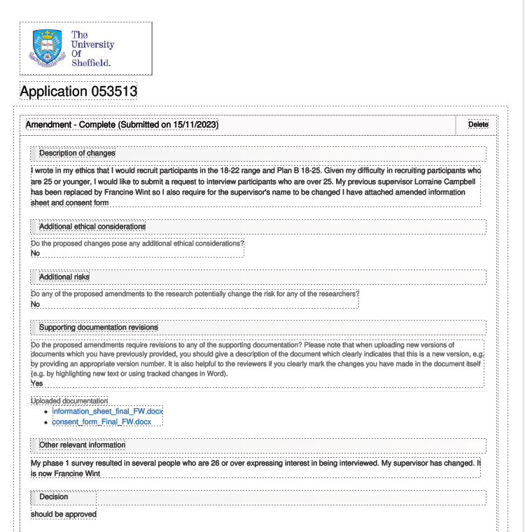

Appendix P
Survey Themes
Table 10
Phase 1 Themes Summary Table based on survey showing initial impressions of potential themes prior to using NVivo (qualitative data)
Codes have now been added in 1st column

Code (potential themes arising from survey responses (qualitative data) |  | Best thing  (participant code) | Worst thing  (participant code) | Extra info (participant code) | Suggested interview Qs (participant code)
LAS | Learnt things from experience/ SWAN* | 1.1, 1.2,
SMGW | Learnt skills | 1.37
SMGW | Flexibility when approaching communication | 1.40
PCS | SWAN nice personality/ lovely | 1.7, 1.26, 1.37
PCS | Best friend | 1.33
PCS  SMGW | She taught me things | 1.33
PEX | “everything” | 1.33
PCS | SWAN is caring | 1.26
? | Expected to die | Impact made live for moment 1.37 |  |  | 1.37
PCS  PEX | Took risks and then I copied/ reckless (live for the moment) | 1.26, 1.37
PCS  PEM | Makes me happy | 1.7
PEX | Got to take days off school | 1.37
PCS | gratefulness from them | 1.8
PCS | Close | 1.9, 1.18, 1.37, 1.19
PCS | Cute | 1.17
PEM  PCS | Laugh/ fun | 1.5, 1.37
SNW | Had to be serious |  |  |  | 1.37
? | Are you the listener? |  |  |  | 1.37
PCS | SWAN creativity and skills | 1.18
NEX | SWANs very sick/ in hospital | (now know) |  |  | 1.43
NEM | Lonely when they were in hospital |  |  |  | 1.43
NEM  NEX  NCS | Strained/ SWAN has grudge | 1.5
NEM | Powerless/ SWAN can’t help it/ I can’t change things | 1.18 | 1.20, 1.23, 1.38
PCS | SWAN = inspiring | 1.4, 1.7, 1.14
PCS | Pride towards SWAN/ their achievements | 1.23
PCS  SMGW | SWAN special interests/ niche topics | 1.18, 1.40
LAS  SMGW | Learnt about send/ insight into those with SEND/ accessibility | 1.11, 1.36, 1.38, 1.44 |  | 1.2 | 1.41 did anyone discuss with you?
LAS  SMGW | Aware of diversity/ ND | 1.12, 1.31, 1.43
SMGW | Acceptance of others | 1.37
LAS  SMGW | Learnt about inclusivity/ inclusion | 1.16, 1.38 |  | 1.2
? | More aware of dynamics in larger household | 1.32
NEX | Having to explain to school/ employers where he is if absent |  | 1.26
PEM | Love/ “pure unconditional love” | 1.8, 1.34, 1.27
NEM  SNW | Made me cynical |  | 1.28
SMGW  LAS? | Affected my choice of career | 1.11, 1.16, 1.37 |  | 1.14
SMGW | Advocate/ raise awareness | 1.8, 1.34 |  |  | 1.14
NEX | Other people |  | 1.2, 1.34, 1.38, 1.41
NEX | Others stereotyping when SWAN able |  | 1.41
NEX | Prejudice by association |  | 1.41 “Peers ostracising her because of her disability, and then ostracising me as well/viewing me as the same (we're twins)”.
NEX | Professionals  What would like profs to know |  | 1.1, 1.2, 1.8, 1.17, 1.18, 1.28 |  | 1.24  1.35
NEX | Others don’t understand |  | 1.14
 | Personality
SMGW | Empathy | 1.2, 1.11, 1.15 1.22, 1.28, 1.35, 1.37, 1.41
SMGW | Appreciation/ appreciate life/ small things/ own health | 1.2, 1.22, 1.29, 1.30, 1.38, 1.43
SMGW | Saw world in a different way/ provides different perspective | 1.38, 1.39, 1.43
SMGW | Light touch
SMGW | Understand others | 1.6, 1.42
SMGW | Understanding challenges/ other people | 1.35  1.41
SMGW | Kind/caring | 1.7, 1.28
SMGW | Positive outlook on life | 1.7
SMGW  LAS | Being aware of others’ needs | 1.35
SMGW | patient | 1.18, 1.42
SMGW | tolerance | 1.22
SMGW | hope for others with MH difficulties | 1.22
? | Dark humour | 1.37
SMGW | Mature/ maturity | 1.28
SNW  NE  FI? | still self-conscious/ quiet |  | 1.25
SNW  NE | Still dread loud voices/ conflict |  |  | 1.25
SMGW | Closer to family | 1.8
SMGW | Closer to religion | 1.8
NEX  NEM | Seeing SWAN suffer |  | 1.2, 1.38
NEX | SWAN’s death |  | 1.33
 | emotions
NEM | Worry (about SWAN)  Didn’t want sibling to die | 1.5 | 1.28, 1.33, 1.35  1,37
NEM | Sadness  Sad can’t protect |  | 1.33  1.38
NEM | dread |  |  | 1.25
NEM | Anticipatory grief |  | 1.8, , 1.33
NEM | Embarrassment |  |  |  | 1.12
NEM | anxiety |  |  |  | 1.13
NEM | anger |  | 1.18
NEM | Guilt when she can’t be involved  Guilt their extroverted SWAN didn’t get a choice in their death sentence/ if happy  Guilt I don’t face those issues |  | 1.35  1.37  1.38
NEX  NEM | Exhaustion |  | 1.8, 1.23
NEX  FI? | Responsibility |  | 1.23, 1.26, 1.36
NEM  SNW  FI? | MH problems self/ depression | 1.37 (burnout/ substance abuse/ depression) | 1.18, 1.37 | 1.37 “I became extremely introverted and suicidal and even decades later find it difficult to recognise or voice my own needs. Learning a little too late how to live my own life and not be my siblings caretaker. Burn out. I'd had several breakdowns and substance misuse issues before I finally undertook therapy and learnt how to step out of the family role for me”.
? | Protective of SWAN |  | 1.5, 1.38
NEM  NEX  NCS?  NCP?  FI? | Nothing/ can’t think of anything | n/a | 1.3, 1.13, 1.20, 1.25
NEX | Had therapy
SNW  NEM  FI? | Unable to express own emotions |  | 1.37, 1.40  “It also made expressing my needs difficult when they weren't compatible with those of my siblings.” 1.40 | 1.37 “It did take a long time to step out from the shadow of my sibling and the family in general, so it's a bit complicated”. | 1.37
? | Growing up early |  | 1.3, 1,22, 1.36 |  | 1.12
NEX  NEM  FI | Silenced/ not allowed to complain |  | 1.25 | 1.25
? | Having to adapt to them |  | 1.6
 | Parents
PS | Supporting parents |  | 1.22, 1.19
NCP | Parentification |  | 1.22, 1.19, 1.28 |  | 1.28
PS | Impact on them  Watching them struggle  Workload/ demands on them/ stress |  | 1.7, 1.19, 1.21, 1.24
PS  NEM  NCP  NEX | Parents intensity overburdened – used as their “counsellor and vessel for the family issues” |  | 1.37  1.37
NCP  PCS  NEM  NEX | Reminded me he would die (now in his 40s) |  |  | 1.37 “I found the "enriched or made life difficult" question difficult- his personality has undoubtedly 100% enriched my life immensely, my parents management of us was really what caused difficulty, his condition only caused a little actual difficultly overall, but it was heavily emotionally omnipresent over everything, constantly reminded daily by our parents that he would die”. | 1.37 “I found the "enriched or made life difficult" question difficult- his personality has undoubtedly 100% enriched my life immensely, my parents management of us was really what caused difficulty, his condition only caused a little actual difficultly overall, but it was heavily emotionally omnipresent over everything, constantly reminded daily by our parents that he would die”.
NCP?  NCS?  FI? | Stress taken out on me |  | 1.29
NEX  NCS  NCS? | Sib got their way to avoid conflict |  | 1.32
NCP  NEX | Resentful towards parents |  | 1.18 |  | 1.12
NEX  NCP?  NEM | Lost loving relationship towards/ from parents |  | 1.21 |  | 1.12
NCP  FI? | Lax to SWAN/ colluding |  | 1.18, 1.32 |  | 1.12, 1.32
NCP  NEM | Impact on TDS feelings where parents lax |  |  |  | 1.32
NCP  NEM | Differential parenting
?  FI? | No one explained |  | 1.29
NEM | Long term impact |  | 1.32
PS | Stress/ impact on marriage |  | 1.21
NCP  PS? | Think Stress felt back by SWAN |  | 1.21
PS? | Single parent |  | 1.21
? | How parents could support |  |  |  | 1.25
NEM  NEX | Lack of attention/ ignored/ invisible/ neglected/ coming 2nd/ divided attention/ needs of SWAN paramount/ cast aside |  | 1.3, 1.12, 1.13, 1.15. 1.16, 1.18, 1.22, 1.24, 1.25, 1.29, 1.31, 1.36, 1.37, 1.42, 1.43 | 1.22, 1.27 | 1.36
NEM?  NCP?  SNW | Had to be high achiever to compensate |  | 1.12 | 1.25
NEX?  NEM?  NCP  FI | Seen as OK |  |  | “My own learning disabilities - ADHD & dyslexia - went unnoticed and undiagnosed as a result of my sisters complex needs. I was more independent socially and academically, but it did mean my parents and teachers saw me as the 'fine' child and never questioned my struggles” 1.40
 | school
NEX |  | Missing school 1.37  Taken out of lessons with SWANs for support 1.42 | 1.8, 1.17, | 1.22, 1.25 | 1.43
NEX  NEM | School was difficult as a carer |  | 1.8, 1.17
NEX  NEM | stigma |  | 1.30, 1.25, 1.41
 | Other
OF | Impact of culture/ religion |  |  |  | 1.8
OF | Birth order | 1.21 | 1.18, 1.19 | 1.22, 1.36 | 1.8, 1.37
OF | Twin effect |  | 1.41
OF | Gender |  | 1.18 |  | 1.8
OF | SEC impact/ finance |  | 1.18
? | Did you take time off? |  |  |  | 1.9
? | Having a sibling/ good to have a sib | 1.10, 1.21, 1.24
NEX  FI | Alter plans/ missing out on plans |  | 1.10, 1.14, 1.35
NEX  NCS  NEM | Don’t get along with SWAN |  | 1.11
NEM | Missed out on close sib relationship |  | 1.11
NCS  NEM  NE | Meltdowns/ aggression from SWAN/ anger/ screaming |  | 1.13, 1.25, 1.23, 1.25, 1.26
NCP  NEX  FI? | Expected to care |  | 1.17
NEX  NCP?  NEM? | Carer  Nurse/ look after/ chores |  | 1.8, 1.17  1.37, 1.3, 1.18.1.19, 1.36 | 1.18 | 1.37, 1.41
? | Affect relationships |  | 1.43 |  | 1.18
? | Has relationship changed |  |  |  | 1.19
? | Being different to others |  |  |  | 1.21
? | Were you treated differently |  |  |  | 1.33
? | Bringing friends home |  |  |  | 1.21
? | Opportunity to offload |  |  |  | 1.21
? | All I know/ normal to me | 1.24, 1.36, 1.43 |  |  | 1.43
? | Later diagnosis of self |  | 1.8, 1.18, 1.36, 1.40 | 1.2, 1.36 | 1.24, 1.36
NEX  NCS? | Scenes in public |  | 1.25 | 1.25
NEX  FI? | Restrictions e.g. food/ activities/ limitations |  | 1.26, 1.38
SMGW?  SNW? | How shaped you/ enriched your life/ affected your identity/ how would you be different |  |  | 1.42 | 1.26, 1.31, 1.34
? | Relationship now cf past |  |  |  | 1.26
? | Wish anything had been different/ what support would have liked |  |  |  | 1.26, 1.35  1.42
? | How did people discuss disability/ your sib with you? |  |  | 1.41
? | Do you get others to listen to you? |  |  |  | 1.37
? | Did you notice anything different when younger/ how did you know? |  |  | 1.43

Code | Meaning
DE  FI  THTD  LAS  NCP  NCS  NEM  NEX  OF  PCS  PCP  PEM  PEX  PS  SFC  SMGW  SNW  *SWAN  U | Difficult experiences  Feeling invisible/ missing out  Things I had to do which I wouldn’t have had to do otherwise  Learnt about SEND/ disability  Negative comments about parents  negative comments about sibling  Negative emotions  Negative experiences mentioned  Other factors  Positive comments about sibling  Positive comments about parents  Positive emotions  Positive experiences mentioned  Parents’ struggles  Stories of family conflict  Shaped me in a good way  Shaped me in a negative way  Sibling with additional needs  Unfairness

Appendix Q
Extract from Transcripts with initial coding of possible themes
Left and right margin notes are of equal weight. Colour coding is used to match annotations to text sections.

Extract from Transcript (Emma).

Margin notes (annotation colour relates to text colour) | Transcript | Margin notes (annotation colour relates to text colour)
Funding cuts  Stereotypes about disability and twins/ discrimination by association  Contrast between schools  Not sure if disability or character  Protector  Protector  “pale disabled girl” – staff can’t tell the two blind girls apart  Seeing the funny side of mistakes  Labelling  Bullying  Protector role  Just felt normal  Bullying  Acceptance / normalisation of bullying | So we were talking about Secondary School.  1.41: So we went to secondary school. Yeah, there was a girl. So she got year seven to nine. They kind of had a shared teaching assistant. And then funding got cut so they lost that.  1.41: But they had like the sendco for a while she managed for about a year She managed to swing it that she got out of PE because they had found out that obviously balls and things to move in wasn't great for her so they got out of PE and they went and played Just Dance for an hour. Then my mom found out and said no legally you have to be in sport.  1.41: So she put a stop to that and then Abbie had to go back to PE but erm so that was better. we were same form but different classes because they asked us and I think they asked all twins that I think they were also a bit like, do you want to be separate? Obviously, it was still like kids knew she was disabled it didn't help as well that obviously we were twins. So we looked very similar and then this other girl was also very pale and maybe blonde but much blonder than we were so we were kind of viewed as triplets and then it was all like “they're disabled. So you must be disabled as well”. “but actually I’m not but okay”.  1.41: And then it was the classic like my school had the corridors had like alcoves like cupboards and… things were like older boys mostly would hide and then jump out which they did to all year sevens but especially to my sister because they knew that she couldn't see  1.41: but I think the support was better there And I don't think she has anything particularly bad to say about it. And I don't either I think it was more kind of. And then we went to sixth form at the same place. And she had a really good teacher our form tutor in sixth form. I don’t think she taught anything specific, but I think she dealt with in the sixth form kids with the disabilities and she was amazing. She was really really good and I remember and it's hard to tell because obviously bullies and things like that. It's like a mix of personality like they know they never did it to me and they were never mean to Abbie in front of me especially as we got older and I think we had a friend there that in sixth one was pretty bad to her pushed up against a wall and was like, I'll kill you and stuff like that never in front of me and… Abbie didn’t tell me about it either but never in front of me because I think by that point yeah, it's pretty clear that if anyone did anything to Abbie I wouldn't have been very happy with them. Because we used to have friends try and pick fights with her and then I'd shower them.  1.41: yeah, but she was really great and Abbie complained to her and they got it sorted out and they didn't make excuses or anything like And she was really helpful and then she had a history teacher. who did GCSE and A level he was also really good I think by then it was pretty obvious that. I think they did still kind of mess things up. So I remember one time again. This isn't so much. This is twins because it turned out they had moved me down a set in science. But they had sent the letter to Abbie and said they were moving Abbie down a set which we all thought Okay, that's really weird like that. Okay, that makes kind of sense , I guess for whatever even though then when it was like no Abbie gets better grades than you do in Science and… then they were like, no, we've made a mistake and then they did it again at maths. And they moved me down a set and then my mom was like that makes no sense. Emma is much better at maths than Abbie is.  1.41: Yeah, and then I remember they turned up to This is parents evening in year seven. They turned up to my sister’s French teacher and she was saying Abbie doesn't try Abbie has an attitude Abbie's like, she just gives up and stuff and mom was like well that doesn't sound like Abbie and it doesn't sound like what any of the other teachers have been saying? Not in like my daughter's perfect. Not that she can do wrong. It just doesn't sound like her and… basically what we reckoned was she’d gotten the two disabled girls mixed up. because they were in the same French class and then Abbie asks us and the stuff that they said the friends that they said about her. She'd gotten them mixed up. And my mum kept saying oh cos Abbie does this trying to be like are you sure you've got the right girl?  Researcher: Did they look alike?  1.41: Was probably “pale disabled girl”. Yeah.  Researcher: Wow.  1.41: So yeah, it wasn't great still but I think obviously larger school and there was a better support system and I think because we were in different classes. I mean we were still labelled the same by most people I'd say and kids would give us grief, but it's just kind of how it goes.  Researcher: you sound very matter of fact that you had that protector role, but it was instinctive not something put on you by other people.  00:30:00  1.41: Yeah, yeah, I guess I guess so I guess yeah, I never really questioned it because for ages I didn't really realise that's what was happening. And I think obviously in primary school I didn't do that at all. And then I guess because I’d grown up obviously steps and going around, she couldn't see depth perception. She can't you know crowds freak her out. So you'd have to when we go into a crowd I'd hold her arm or hold her hand and be like, okay and then like steps, I'd help her down steps. I still do that now and Yeah, I don't know I guess because I never had a time where that wasn't the case. And because we were always together anyway,… so we were the same age. it wasn't it was just like other people were mean so I guess that's just how it went. | Assertive mother – not allowing her to be mollycoddled  Bullying  Exploitation of blindness  That memorable good professional  Bullying  Bullying  Great individual professionals  Systems which failed  More a twin thing  Comparison of schools  Tolerance of discrimination – just put up with it/ expected it  Practical helper  Just felt normal

Extract from Transcript (Lucy)

Margin notes (annotation colour relates to text colour) | Transcript | Margin notes (annotation colour relates to text colour)
Parents as advocates  Not limited by sister – moved 100 miles away  (slight?) embarrassment  Carer/ defuser at school  (small amount? of) difference to friends  Sister was bullied  Carer/ defuser at school  Vagueness about level of involvement at school – appears to suggest was pulled out of class | Researcher: Do you think that your parents and the school generally were on the same page or were there any difficulties there? or any really good practice?  1.39: and yeah, I think there were some like having the erm sensory things she did before school. I think that was one of the things that like my parents helped to push for because I don't think that existed in the school like before like my sister and I think there was like one other person in her class in primary school who used to do that as well. So then like they pushed for that for her and yeah I think they were like quite big advocates for her to like get some additional support, especially like recently exams and stuff like getting the like her a room and her extra time and rest breaks and stuff. So …  Researcher: You mentioned a primary school that if she was having some kind of anxiety attack or meltdown or getting angry and I think you said she might have hit people ? did I remember that right?  1.39: Yeah.  Researcher: You've already told me that you got called in did your parents also get called in to meetings?  1.39: yeah, yeah like I think they have like some some like they would always talk to my parents about it either like on the phone during the day or after school, you know just pulled on the side and like tell them what had happened and stuff.  Researcher: Okay. I'm looking at my list. Have you moved out from home now? did you go away to University?  1.39: Yeah, I am at the University.  Researcher: So how many miles approximately?  1.39: a hundred yeah.  Researcher: Okay, and did your sister factor into that at all? Or was that just not part of your decision-making at all?  1.39: It wasn't really part of my decision-making. No  Researcher: Did you bring friends home?  1.39: erm Not that much sometimes but I think I would more like go to their house. I'm not sure…if that was like in any way related. I think occasionally It was but like not all the time.  Researcher: So there was just coincidental I was just interested for you if there was anything you could could tell me about that … but  Researcher: Have you got any memorable incidents when you're out in public places, you mentioned the park, shopping centres, stuff like that … Perhaps not given it was an invisible disability.  1.39: yeah, I think that like erm just I can't think of anything specifically but I know there were times where like like especially with like the birds (laughs) i think that was like a big thing. It's like if you'd see one she'd run off of it or like have a scream or something.  Researcher: Did other people react to that do you remember?  1.39: I don't think I really like looked at other people but I think I was more like “oh my gosh this is so embarrassing”  Researcher: Yeah, yeah. Would you say that your childhood and teenage experiences were similar or different to your peers?  1.39: erm I think mostly similar but like in some ways it was like different. because like yeah there was things that like other people would do that like we wouldn't do yeah like, erm they're just like I think the fact that like people would like come up to me and talk to me about her in the playground and stuff and like I wouldn't see anyone saying that to like any of my friends or anything.  00:40:00  Researcher: and did they talk about you talk about her talk and you in a concerned manner or a teasing manner or can I help?  1.39: I think it was more just concerned like can you come and help with this? like she's upset again  Researcher: did you experience either yourself or her … any bullying?  1.39: er I didn't but she definitely did.  Researcher: Can you tell me about that?  1.39: Yeah there was like some boys in a class, who would like tease her about stuff and would like er say like not very nice stuff to her. Yeah and just generally not very kind. but  Researcher: did the teachers deal with that in a way that you felt was right?  1.39: erm just trying to remember erm I think that like there was I remember like her I’m trying to think i think with most of them they like they dealt with it okay, but there was one person who was like he kept on bullying her for a while, which like I don't think they really did like what they could have done. I'm not sure what they could have done but  Researcher: And did you get sucked into any of that or was it very much it was dealt with apart from you?  1.39: I think like when it made her like visibly upset in school, then that's when I would erm like be involved erm especially like if it was a lunch time or something. Erm but if it was like erm if she wasn’t like didn't get too upset by it then usually they wouldn't like bother me.  Researcher: Okay. Can you remember any situations where you wish things had been done differently? by professionals or the family or …  1.39: er, I dunno I can't. I can't think of anything specifically erm I’m sure there was like I think yeah I'm sure I think was I'm not really sure. Sorry.  Researcher: Did you ever feel that either school or your parents relied on you to support her or to support something happened at school or something at home? Did you ever feel that you were relied on more than other girls weren't?  1.39: erm yeah, I think definitely in school because like I was the one there rather than my parents like they were at work and stuff. And so I would be like the ones that they go to I think at home my parents were quite good at like then dealing with it, but yeah.  Researcher: Did you get pulled out of class or was it just you heard and went over yourself?  1.39: I think I might have a couple of times but I think mostly it was like people would come over to me in the playground and be like “oh, like she’s upset again she’s anxious like really angry again. With her and sometimes I’d go over  Researcher: Do you think that your experiences of having a sibling with additional needs has affected you as you've become older as you've become a young adult, gone off to university and stuff when you look at your er flatmates and stuff who haven't grown up with a sibling with additional needs, can you see a way it's influenced you as a person?  1.39: erm I think it's like allowed me to understand. things a bit like it's meant that I like if people are like a little bit different in like if they like have any additional needs or like any different like neurodiversity stuff (unclear) it's allowed me to understand that a bit more and like if as opposed to if I didn't really know much about it because my sister like as she's grown up, she's definitely become like more aware of like of stuff and she's like taught me a lot about about it and what like helps in certain situations so | Parents having to be involved  Didn’t bring friends home but probably no connection  Some limitations  Playground advocate  Not allowed independence  Bullying  Not sure school could have done anything  Substitute parent at school  At home parents dealt with difficulties  Awareness of different, additional needs  Impact on character: understanding

Extract from Transcript (Sabrina)

Margin notes (annotation colour relates to text colour) | Transcript | Margin notes (annotation colour relates to text colour)
Warrior mother  School  Liked being known as his sister/ pride/ admiration/ pride by association with his disability  School didn’t get it right but not sure what could have been done  No ideas  Money had more impact than disability  Staring is normality | 1.36: then if I'd get detention because of that she’d just storm in and say no she's just stuff to do no. So I never had to do anything like that. Really  Researcher: That's good What else have I forgot to ask you. did the school make any allowances for you being late after that? (laughing)  1.36: I think they were just scared of my mum so yeah.  Researcher: any late homework? or  1.36: I think I always tried to do my homework and…  Researcher: yeah.  1.36: but if I got detention because of that, I still wouldn't have to do it cos Mum would say no,  Researcher: Yeah. Yeah, it sounds like she was very protective of you. And did other staff ever mention your siblings to you?  1.36: erm my older brother was very well known in school because he's probably the only child in a wheelchair that they've known to just zoom up and down the corridors and everyone's like idolising him because he was like really smart and really great and everyone just knew him so well.  Researcher: Yeah.  1.36: Yeah, you're and so’s sisters like yes that’s me because I was a few years younger, It's like kind of still being mentioned in the school which i was at which was quite nice.  Researcher: And you just said you the word. Nice. So, you were comfortable with that? What about your younger siblings?  1.36: Yeah.  Researcher: Did they ever mention them to you?  1.36: And I don't think so because I think I'd left school by the time they had moved up.  Researcher: Yeah. Yeah.  1.36: But they know about that they're related to me which I don't know… how I feel about that (laughing)  Researcher: Did you ever get asked to advise them and support them with your older brother..  1.36: No,  Researcher: Was there ever a situation where you wish things had been done differently, either at school or outside of school?  1.36: definitely in school and stuff but yeah, not sure what they could have done, to be honest.  Researcher: So you felt they were doing the best job that they could.  1.36: Yeah.  Researcher: OK. Was there anything that you think might have supported you that wasn't available or  1.36: I can't think of anything off the top of my head, but  Researcher: Okay, we talked a little bit about difference and you talked, particularly about how you felt, you were different because of your own autism. How would you say that your own childhood teenage experiences were similar or different to your friends or had you not had your brother and younger siblings. So, talk to me a little bit about how things were different for you.  1.36: I feel like it was different because I knew I had responsibilities, I couldn’t just gallivant off and do what I wanted. I had stuff to do and I had much more knowledge than people my age. So I knew how to do a full roast dinner and you have to wash, iron clothes, all that sort of thing which I thought was normal but it wasn't.  Researcher: Was there ever a time when you wished you could do something that you were limited by your family situation?  1.36: er I don't think so cos I went on a few school trips and stuff but some school trips. I didn't go on not because of the family situation but because they were just too expensive generally.  00:15:00  Researcher: Yeah, yeah, so it's kind of like an intersection with all kinds of these other factors as well.  1.36: Yeah.  Researcher: Have you got any memorable incidents?  1.36: I'm not sure.  Researcher: was there ever a time when you're out in public, for example,  1.36: oh we had a few times in public when like shopping centres and stuff which can be loud any way where my little my younger brothers would just have meltdowns and stuff which is understandable. Shopping centres are awful  Researcher: Yeah.  1.36:. You always you were used to people staring at you, so, To me, that was pretty normal because people stare still stared at us as anyway when it was just older brother out with us because people were amazed about a wheelchair for some reason. So that's not anything new to us…  Researcher: Yeah.  1.36: but there’s lots of stares.  Researcher: how did you feel when people were staring at you as a family.?  1.36: We just grew up to stare at them back and (laughing) | Admiration and fondness towards sibling  Avoidance of discussion about younger autistic siblings – contrast to older brother  Own late diagnosis of autism alluded to again?  Caring responsibilities (whole family)  Parentification?  Mention of younger autistic brothers  Amusement or sarcasm? At people’s reactions to wheelchairs

Extract from Transcript (Jenny)

Margin notes (annotation colour relates to text colour) | Transcript | Margin notes (annotation colour relates to text colour)
Normality  Downplaying  Not wanting to be different (age 5-6)  Disabled child being defined by their disability  Impact on character – maturity  Reflection on how she was  Protecting self. Recognising discomfort of others – wanting to smooth over  What I learnt  Character - empathy | I don't remember ever feeling resentful or anything like that it was just that's what it was, cos that’s what we did and I guess that's when I'm reflecting on it. That's a lot of what my experiences is this is just what it is and I think it’s for me, it would be very different if we had I guess a neurotypical sibling who then became disabled. I think that would be horrendous and really challenging but for us, this is what it is. I don't know what it's like to have a younger sister who's not disabled erm because yeah, I've had conversations with friends and my parents and stuff before about like what would be different and I just can't imagine having a sister who would who like isn't in a wheelchair and stealing my clothes and going on nights out with me. It's just not so for me. It's yeah, I don't feel like I've missed out on anything. I just feel like that's what's happened. that's what it was.  Researcher: Can you remember when you first started to realise that you and your sibling were different to other families?  1.35: erm I don't know if I can pinpoint a specific moment. I remember when I was a lot younger maybe five six. thinking so when Becca started coming to our school with us, so I would have been four or five I remember not not I remember feeling different. I remember wanting to kind of not be known as her sister and she I think it was a transition between her so she had like a buggy like a pram for a while and then she went into a wheelchair and I think it was the transition from the wheelchair and then all of a sudden she was the girl in the wheelchair in a very small school who'd never had a child in a wheelchair before and I think that was the transition and then because it was a very small village everyone knew everyone that kind of went away again a bit and then I remember going to secondary school and it was huge and there was thousands of children and I remember looking round it with my parents and we had my sister in her wheelchair and I just did not want to be there did not want to go through a new school being known as the sister of the kid in the wheelchair and that's that’s the last time I ever remember kind of feeling like that was going .... the start of secondary, and I think it's also it’s such a big time in terms of my life in terms of moving on but also you're meeting all these people erm new people and I didn’t want like I think what I'm saying is I think I didn't want the first experience to be “Oh you're the girl whose sister’s in a wheelchair” and as people got to know me that is what it was and that is what I was but I wanted to kind of make friends for myself and like do things for myself before eventually people would find out but I think there’s such there is a such maturity. I don't know when it happened, but I think now like I do just I’ve never had qualms about going out with her erm I remember used to get really like I would try to do everything for her so when we've ordered in restaurants she can talk but she's got kind of like a different voice and… and some people would be like, oh I don't know and so that I would just kind of I would just instinctively talk for her and… whereas now I'm like “no it's on you whether you can understand her. she she can communicate” but part of that is growing up and part of that is not caring anymore and part of that is kind of doing a psychology course and understanding how to get children involved. I think it is it is all of the above. But I do really remember when I was a lot younger doing all the talking for her because I didn't want her to feel embarrassed also I didn't want to feel embarrassed as in people had to ask us to repeat things but now yeah, just let her get on with things and it's interesting because I always remembered her saying that it would really annoy her when people kind of babied her but yes looking back that's exactly what I was doing. I was kind of well obviously not intentionally, but I was also protecting me and just was very much like I'll just take over and do this but now yeah, it's very different. But yeah, I don't know if there was an exact point.  I just I really really remember the beginning of year seven as quite a time where I felt like oh, I just don't want to be doing this right now. I just want to be being me but I can't think of anything.  For me, it's just like I have an awareness of things that other people might not so like for example I just I don't know if I see neurodivergent people out on the street or like people in wheelchairs and stuff I just have such like empathy towards them in their situation that I think goes on beyond just being empathetic. I think it's a real like I really get what you're doing even from things like we’ll park up on the verge and I'd be like to my partner “You can't park here because people can't get past their wheelchair”. He's “Alright, Yeah”, and it’s not it's these things that you wouldn't even think of unless you've experienced it. Erm And I often get told that like in my job I'm quite empathetic and I think I am but I think it comes with being through all the crap that you go through and actually just like learning from it, which I think is yeah a good way to do it, but I think it's not. I don't want to sound like a martyr because that's definitely not what it was, but I think it does force you to look at situations otherwise you just wouldn't even consider | Alternative imagined life  Alternative imagined life  Identity  Wanting own identity separate from family (age 10-11)  Overly doing stuff for her – infantilising?  I did what annoyed her  Embarrassment  Reflecting back  Identity/ embarrassment
.

Extract from Transcript (Georgia)

Margin notes (annotation colour relates to text colour) | Transcript | Margin notes (annotation colour relates to text colour)
Future dreams and goals  School messages  Restrictions on life/ caring responsibilities  Second mum  Inflexible school policies and systems  School acting like challenges don’t exist  identity  what learnt by experience helpful  life skills benefit academic  brother not coping  Disability discrimination/ prejudice  Parentification – looking after brother too  Taking on role of parent (signing form)  Maturity  Brother  Downplaying  Curriculum took no account  Insensitivity  Downplaying  Impact of non-school learning on academic – school sounds secondary to the rest of life  Life’s challenges pile up and you get stronger  Enduring school/ get it over with  Caregiver  Extra parent  responsibilities  Brother took himself away  Impact on decisions – self-handcuffing? Knowing what is important and treasuring it | I've never been career orientated I think especially when you go to sixth form ‘n’ that forcing and forcing and forcing the subject of University go and do this and go and do that and like there's other things to life than making money like I don't think they click that when I went home from school, I didn't go home ‘n’ sit on my arse like all the other kids did. I went home and made my sister tea because she wouldn't eat what my Mam made because she wanted to have cheese pasta with her sister and then I had to bath her because at the time she was going through a phase where she’d only let me give her a bath. It was it was you had everything that I've done had to be around her not that I didn't want to do it or mind doing it. It was just that that's the way it was if she wanted me to bath her I’m sorry I can’t come She needs a bath so I’m gonna give her a bath. She won’t let me Mam. It was just completely different. I think the way everyone else seen things. And how everyone else planned their futures as well, but I think when you were at school, it was sort of dead set that in their mind that you had nothing else going on at home, whether it was me with my sister or my friend with something else it was, You came to school. You were supposed to behave, you were supposed to sit down, shut up and do your work, do homework when you got ‘ome even though me Mam and Dad didn't have time to help us with it because of she’d be sorting Tina out or things like that and it was just what and we even when we went on that end-of life-trip to America erm it was in school term time. So when we got back from I was this end-of-life trip to America, me and my brother were put into like assemblies about attendance. So they were taking us out of lessons that we’d missed to tell us about our attendance that we’d only missed school for because we went to America on a all-expenses-paid trip for our sister.  Researcher: How much did they actually know? I mean you mentioned the thing about hospice so it doesn't sound like that was something you hid, but how much did the staff know at all?  1.33: Yeah, they all knew. She was never it was never like “Oh, by the way”. she was always a big part of me and what I was talking about if that makes sense. It was never I think I’ve even when I was at little school it was like you know my Mam used to come pick us up from school or whatever and then she'd have Tina there in the buggy. It was like I was always known as Tina’s sister. So it was always sort of like who I was as a person like I'd go into school and be like “Oh guess what Tina did? Or guess what she threw at us yesterday?” Or it was constant like everything I’d done was sort of referenced back to her if that makes sense. So when I was doing Health and Social exams like I got an A* in the one that was about special needs children an’ it was to me it was like ‘cos to me it like writing common sense. So it was always there.  1.33: I think I handled everything a lot better than my brother did. I had quite a good friendship group though, like the girls I was with at school were we were all quite clued up. We weren’t daft We went to school, we got on with it. If that makes sense, whereas my brother my brother got bullied quite a bit and he was sort of class clown didn't really see the point in going. So it just ‘n’ he got picked on. For Him’s, I think he used to wind people up as well. But then they'd always come back at him with something about Tina and it was just never handled quite right so like he'd be punished for hitting someone when they’d said something really horrible about Tina. So it was like it didn’t it wasn’t like you were just name-calling a sister uh not normal. [laughs] it was saying something that was horrible about someone with special needs like the word “spaka”. That was thrown around all the time. I think that's the first time I've said the words since I was about 10 [laughs] I hate it. It was thrown around that much when we were at school. And it just used t’ wind us up. But I used to control my anger and my feelings quite well, my brother didn't.  Researcher: Was there ever? apart from this attendance story? Were there any other times when maybe you were late or you hadn't got something signed by your parents or anything like that that happened?  1.33: to be honest No, I wasn't. I was always on time because I could get myself out of bed [laughs] and then because I was always out of bed. I could always get Craig outa bed. Erm and the school that we were at was literally a five-minute walk up the road. So it wasn't that bad that way and when it comes to signing things I could forge my Mam's signatures. So she's Geraldine. I'm Georgia. So it was basically the same [laughs] and I just used to find my way around things. So but it was I dunno I think I was quite lucky. But I think I was a lot more mature than what I should have been for my age whereas my brother struggled a bit more with it, but then I don't think he understood what he was feeling or how he was feeling so that's why It was worse for him. So he ended up going to counselling and things in the end erm like anger management, but obviously he wasn't just an angry kid who was obviously everything that he was going through. Erm so he had a journal to write in and everything and he was always in fights and Mam and Dad were always getting called into school, but there was one teacher that was really really good with him. So she was basically like the head of so we obviously just went to a normal school, but they had er you know like ones for people just with slight learning difficult. It's like …  Researcher: Yeah, like a learning support department.  1.33: yeah so they were in a different set sort of thing. So she was like the head of this set anyway, so she looked after those kids and she really stuck up fully when she found out what the other kids were saying because obviously that was her that’s what she dealt with all the time. She was always looking after kids that were a little bit different. So when obviously she found out that Craig was getting picked on because of Tina like it was it was good she sorted it out. but I think it was just people just it's like even now though and like just before Tina passed away if I ever met someone and said like, “Oh, yeah, I've got a sister and I showed ‘em a picture and explained, it was always like they're just dumbfounded like “I just don't know what to say to that” D’ya know? And then at the same time you put into the equation that you're a kid and you're going through puberty and everything else. You've got things that you think are a big deal like your friend’s gone to the park with somebody else and you're not invited and but then you throw in everything else that's going on at home. I didn't do too bad considering. But I can imagine what other kids would There was a girl there's a girl I know through the charity and she's having a lot of difficulty with like teachers and stuff and failing her for exams and this that and the other and it doesn't matter how many times the Mam says, “Look she's just not coping”, they just don't get it. But I think ‘cause Tina done quite well when I was at school. When I was at school Tina was like she she thrived. They were like her good years. when I was coming going to school and she was still managing to go to school. And then it was sort of as I went to sixth form and I started working that was when she sort of took the dip. So everything got a bit more difficult then. When it come to needing an appointment, so the amount of times I came out of work to go and take ‘er to the hospital or pick her up or whatever else. But all in all they weren’t that bad. I think they could have been better with my brother. Er I just think. As like one of my best friends when we were at school. I remember sitting in science with her and she later just said, “Oh I wish my brother was dead”. And I remember looking ‘er dead in the eye and being “Are you serious? Like why would you say something like that?” I was like, “You literally know exactly what's going on. I mean like you come to me ‘ouse. D’ya know what I mean, so why would you say that?” erm but I think I was just very good at hiding it all. I didn't. I never sort of cried at school or I never went to school and got upset about what was happening with Tina sort of I took it home and then dealt with it myself later on so But yeah.  Researcher: Have you got any other memorable stories about school in relation to your situation?  1.33: It’s that long ago now. [laughs]  Researcher: Was there anything that? you mentioned the Hospice discussion in PSHE. Was there anything else in the curriculum about disability?  1.33: erm. And I think it was the same sort of lesson they done the whole and you've like you know that whole youth and nick nigh?  Researcher: euthanasia?  1.33: Yeah, that's the word. So there was like a video you could watch about that and they made the class … it was like if you want to watch it you can watch it. And I remember thinking well that's not really. I remember sitting there watching it like getting welled up thinking like imagine making the decision to go and do that? I didn't think that was I don’t think that should be done. That wasn't easy. Or even like the religious lessons and stuff. It was always very It's not I think they’re trying to make everything sound too chipper. Nothing was like … nothing actually that they taught you prepared you for real life when you left. Like they were planning year for going, leaving school, going to University, finding your dream partner, settling down, having kids, earning loads of money, buying a house when in reality [laughs] you leave school, you get a part-time job you get a full-time job. You work your way up slightly., you have a couple of shit relationships and then you finally sort yourself out if you're lucky [laughs] But no. but no. It wasn't too bad. I did have a few sort of because an argument and stuff with teachers, but I was I always found it easier just to shut up and just get on with it.  Researcher: Do you think you' underperformed in your qualifications or do you think you just managed to balance it very well?  1.33: I think I'm just a fluke [laughs]. I'm probably not actually very helpful to your research at all because [laughs] I got basically I got like A's and B's right away through. And everyone was like “Well what did you do? Did you revise?” and I was like, “No, it's just common sense”. But I don't know whether ‘cause of the way I was brought up and what I had to deal with ‘n’ that I just picked everything up dead easy. Like if I was showed how to do something with Tina within five minutes I knew how to do it. Like I could tell you what I could tell at the age 13 I could tell you what genes are, all ‘er alterations were. I could tell you all the symptoms of what she had. So picking up and figuring out how to use apostrophes and stuff it didn't seem to take that long  …  1.33: Yeah, but it wasn't I think because of the Friendship group and stuff I had. And the fact that I do not I think my Mam's always said as well like I just had my head screwed on. I just knew that I had to go in to sort of listen to what they said. I just had to get on with it and come home. whereas obviously some kid and then everything. I don't know whether cause everything and I know some people go on a downward spiral when stuff happens. Like you fight or flight, but I think I was just every time something happened, it just made me sort of do summat else. So like obviously we went through everything with Tina's diagnosis and that and going to America … And then my brother was all therapy ‘cause o’ bullying and then my grandma got poorly we lost my grandma and then my sister got poorly and then I think everything happens and it's just sort of like before you know it you just roll with it. So it was never like I've never seen school as Obviously school was a massive deal when you think about it and all the time I spent there but when it come down to it, I was just I just went there to get it out the way. And then when I come home, I got everything done that I needed to get done. Like even when I was in that year 10 11, I was coming on from school and then going to the shop for my Mam and then running up to my grandma's to check she was all right, and then maybe nipping up to the pharmacy to get her prescriptions and then running back home and sorting Tina out in her pyjamas before she went to bed. And then I’d finally go to up the stairs and do my homework and go to bed. So whereas my brother just sort of locked himself in his bedroom shut his bedroom door. And that was him in front of his computer screen for the foreseeable [laughs].  Researcher: And what about decision making? So you didn't go to university - was that related to her or was there other reasons for that?  1.33: I just didn't wanna leave her. | Self-handcuffing? Or clarity of desire?  Naivety of school “other things to life”  School don’t know what happens after 3  Gender roles?  School unfair  School making no allowances  Discrimination by association  Strategies to avoid getting in trouble  Impact of that one person/ professional  Brother failed by school?  That one professional  Other people uncomfortable/ shutting down conversations (silencing?)  Friends  Anger at other girl’s school not understanding  School failed with her brother  Insensitivity of other teenagers/ set apart? – wall between/ bubble?  Becoming invisible at school / masking emotions  School curriculum did not consider emotional impact  Hiding distress at school – internalising/ masking  Being forced to confront sister’s terminal condition whilst in classroom  Insensitivity of others “they don’t get it” (adults)  Assertiveness  Dissonance between school and life  school something to get through  school’s one size fits all approach  Got by on luck/ intelligence – did she underachieve? Did staff realise?  teachers lack of life experience  School trivial  Survive the day  friends  The future  Dissonance between school mantra and G’s life experience  strategy of keeping out of trouble  Evasion of talking about difficult feelings?  Brother dealt with things differently – gender roles?

Appendix R
Tables and Figures comparing subgroups

Self-reported impact on life arising from having a sibling with additional needs by subgroup (Q.1)
Table 11
The overall impact of having a sibling with additional needs by age of respondent (Q.1)

 | 0 | 1 | 2 | 3 | 4 | 5 | 6 | 7 | 8 | 9 | 10 | mode | median | mean
18-22 |  |  |  | 1 |  | 2 |  | 2 | 1 |  | 2 | 5 and 7 and 10 | 7 | 7.88
% |  |  |  | 12.5 |  | 25 |  | 25 | 13 |  | 25
22-25 |  |  | 1 |  |  |  | 1 | 2 | 3 | 2 | 1 | 8 | 8 | 7.4
% |  |  | 10 |  |  |  | 10 | 20 | 30 | 20 | 10
25+ |  |  |  | 1 | 2 |  | 1 | 2 | 8 |  | 12 | 10 | 8 | 8.27
% |  |  |  | 3.85 | 8 |  | 4 | 7.7 | 31 |  | 46.2

Figure 43 The overall impact of having a sibling with additional needs by age by
percentage (Q.1)

Comparisons by type of disability
Table 12
The overall impact of having a sibling with additional needs for the four most common types of additional needs (Q1) 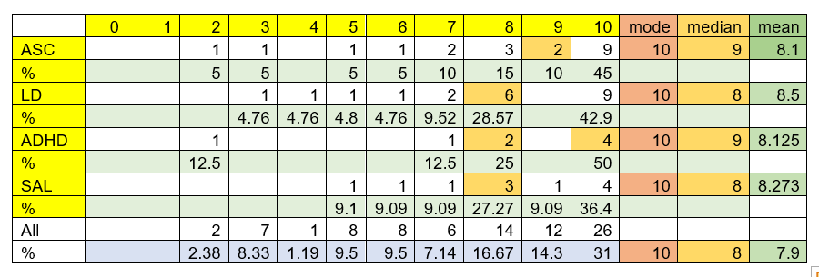
Not all categories of additional needs were included separately due to lower numbers for some categories and some siblings were counted more than once because siblings had multiple additional needs and so fitted in more than one category

Figure 44 The overall impact of having a sibling with additional needs for the four
most common types of additional needs by percentage (Q1)

Siblings with Autism
Figure 45 The overall impact of having a sibling with autism by percentage (Q1)

Siblings with ADHD
Figure 46 The overall impact of having a sibling with ADHD by percentage (Q.1)

Siblings with learning difficulties
Figure 47 The overall impact of having a sibling with learning difficulties by
percentage (Q.1)

Siblings with speech and language difficulties
Figure 48 The overall impact of having a sibling with Speech and language
difficulties by percentage (Q1)

Comparisons by gender of respondent and their sibling with additional needs

Table 13 The overall impact of having a sibling with additional data according to
shared or different gender (Q.1)
 | 0 | 1 | 2 | 3 | 4 | 5 | 6 | 7 | 8 | 9 | 10 | mode | median | mean
same gender |  |  |  | 1 |  | 1 | 1 | 3 | 7 | 1 | 6 | 8 | 8 | 8
% |  |  |  | 5 |  | 5 | 5 | 15 | 35 | 5 | 30
diff Gender |  |  |  | 1 | 2 | 1 | 1 | 1 | 6 | 1 | 7 | 10 | 8 | 7.8
% |  |  |  | 5 | 10 | 5 | 5 | 5 | 30 | 5 | 35
Other * |  | 1 |  |  |  |  |  | 1 |  |  | 2 | 10 | 8.5 | 7
% |  | 25 |  |  |  |  |  | 25 |  |  | 50
*participants had more than one sibling with additional needs

Figure 49 The overall impact of having a sibling with additional data according to
shared or different gender by percentage (Q.1)

Comparisons by number of siblings in the family
Table 14
The overall impact of having a sibling with additional needs according to the number of siblings (Q.1)

 | 0 | 1 | 2 | 3 | 4 | 5 | 6 | 7 | 8 | 9 | 10 | mode | median | mean
1 |  |  | 1 | 1 | 1 |  | 2 | 1 | 6 |  | 6 | 8 and 10 | 8 | 7.6
1% |  |  | 5.56 | 5.6 | 5.6 |  | 11 | 6 | 33 |  | 33
2 |  |  |  | 1 |  | 2 |  | 1 | 3 | 2 | 5 | 10 | 8.5 | 9.3
2% |  |  |  | 7.1 |  | 14 |  | 7 | 21 | 14 | 36
3 |  |  |  |  |  | 1 |  | 1 | 2 |  | 1 | 8 | 8 | 7.6
3% |  |  |  |  |  | 20 |  | 20 | 40 |  | 20
4 |  |  |  |  |  |  |  | 2 | 1 |  | 2 | 7 and 10 | 8 | 8.4
4% |  |  |  |  |  |  |  | 40 | 20 |  | 40
5 |  |  |  |  |  |  |  |  | 1 |  | 1 | 8 | 9 | 9
5% |  |  |  |  |  |  |  |  | 50 |  | 50

Figure 50 The overall impact of having a sibling with additional needs according to
the number of siblings by percentage (Q.1)

Comparisons by young carer status
Table 15
The overall impact of having a sibling with additional needs according to young carer status (Q.1)
 | 0 | 1 | 2 | 3 | 4 | 5 | 6 | 7 | 8 | 9 | 10 | mode | median | mean
maybe |  |  |  |  | 1 | 1 |  | 1 | 4 | 1 | 8 | 10 | 9 | 8.563
% |  |  |  |  | 6 | 6 |  | 6 | 25 | 6.3 | 50
YCN |  |  | 1 | 2 | 1 | 1 | 2 | 3 | 6 | 1 | 5 | 8 | 8 | 6.227
% |  |  | 4.5 | 9 | 5 | 5 | 9.1 | 14 | 27 | 4.5 | 23
YCY |  |  |  |  |  |  |  | 1 | 3 |  | 2 | 8 | 8 | 8.5
% |  |  |  |  |  |  |  | 17 | 50 |  | 33
total |  |  | 1 | 2 | 2 | 2 | 2 | 5 | 13 | 2 | 15 | 10 | 8 | 7.841
total% |  |  | 2.8 | 6 | 6 | 6 | 5.6 | 14 | 36 | 5.6 | 19

Figure 51 The overall impact of having a sibling with additional needs according to
young carer status by percentage (Q.1)

Impact of having a sibling with additional needs on quality of life (Q.2)
Comparisons by age

Table 16
Impact of having a sibling with additional needs on quality of life by age of respondent (Q.2)
 | 0 | 1 | 2 | 3 | 4 | 5 | 6 | 7 | 8 | 9 | 10 | mode | median | mean
18-22 |  | 2 |  | 1 | 1 | 3 |  |  | 1 |  |  | 5 | 4.5 | 4
% |  | 25 |  | 12.5 | 13 | 38 |  |  | 13
22-25 | 1 |  |  | 1 |  | 4 | 1 | 1 | 1 |  | 1 | 5 | 5 | 5.4
% | 10 |  |  | 10 |  | 40 | 10 | 10 | 10 |  | 10
25+ | 2 |  | 2 | 1 | 1 | 5 | 3 | 2 | 4 | 3 | 3 | 5 | 6 | 6.04
% | 7.7 |  | 7.7 | 3.85 | 4 | 19 | 12 | 7.7 | 15 | 12 | 11.5

Figure 52 Impact of having a sibling with additional needs on quality of life by age
of respondent by percentage (Q.2)

Comparisons by type of disability
Table 17
The impact of having a sibling with additional on quality of life for the four most common types of additional needs (Q.2)
 | 0 | 1 | 2 | 3 | 4 | 5 | 6 | 7 | 8 | 9 | 10
ASC % | 5 |  |  | 15 |  | 40 | 5 | 5 | 20 | 5 | 5
LD % | 9.52 | 4.76 | 4.76 |  | 9.524 | 33.3 | 9.52 |  | 14.3 | 4.8 | 9.524
ADHD % |  |  | 12.5 |  |  | 25 | 12.5 |  | 12.5 | 13 | 25
SAL % |  | 9.09 |  | 9.09 | 18.18 | 9.09 | 9.09 | 9.091 | 18.2 | 9.1 | 9.091
All % | 6.82 | 2.27 | 6.82 | 6.82 | 4.545 | 27.3 | 9.09 | 6.818 | 13.6 | 6.8 | 9.091

ASC = autistic spectrum conditions
LD = learning difficulties
ADHD = attention deficit hyperactivity disorder
SAL = speech and language difficulties
Not all categories of additional needs were included separately due to lower numbers for some categories and some siblings were counted more than once because siblings had multiple additional needs and so fitted in more than one category

Figure 53 The impact of having a sibling with additional needs on quality of life for
the four most common types of additional needs by percentage (Q.2)

Siblings with Autism
Figure 54 The impact on quality of life arising from having a sibling with autism by
percentage (Q.2)

Siblings with ADHD
Figure 55 The impact on quality of life arising from having a sibling with ADHD by
percentage (Q.2)

Siblings with learning difficulties
Figure 56 The impact on quality of life arising from having a sibling with learning
difficulties by percentage (Q.2)

Siblings with speech and language difficulties
Figure 57 The impact on quality of life arising from having a sibling with Speech and
language difficulties by percentage (Q.2)

Comparisons by gender of respondent and their sibling with additional needs
Table 18
The impact of having a sibling with additional on quality of life according to shared or different gender (Q.2)

 | 0 | 1 | 2 | 3 | 4 | 5 | 6 | 7 | 8 | 9 | 10 | mode | median | mean
same gender | 3 | 1 | 1 | 2 |  | 4 | 3 | 1 | 2 |  | 3 | 5 | 5 | 4.85
% | 15 | 5 | 5 | 10 |  | 20 | 15 | 5 | 10 |  | 15
diff Gender |  |  | 2 | 1 | 2 | 6 | 1 | 2 | 2 | 3 | 1 | 5 | 5 | 7.4
% |  |  | 10 | 5 | 10 | 30 | 5 | 10 | 10 | 15 | 5
other |  |  |  |  |  | 2 |  |  | 2 |  |  | 5 and 8 | 6.5 | 6.5
% |  |  |  |  |  | 50 |  |  | 50
total | 3 | 1 | 3 | 3 | 2 | 12 | 4 | 3 | 6 | 3 | 4 | 5 | 5 | 5.932
total% | 6.8 | 2 | 7 | 6.8 | 5 | 27 | 9.1 | 7 | 14 | 6.8 | 9

Figure 58 The impact of having a sibling with additional on quality of life according to
shared or different gender by percentage (Q.2)

Comparisons by number of siblings in the family
Table 19
The impact of having a sibling with additional needs on quality of life according to the number of siblings (Q.2)
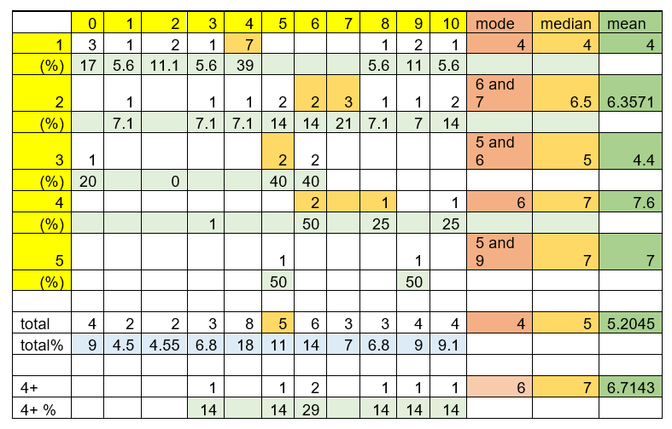

Figure 59 The impact of having a sibling with additional needs on quality of life
according to the number of siblings by percentage (Q.2)

Comparisons by young carer status
Table 20
The impact of having a sibling with additional data on quality of life according to young carer status by percentage (Q.2)
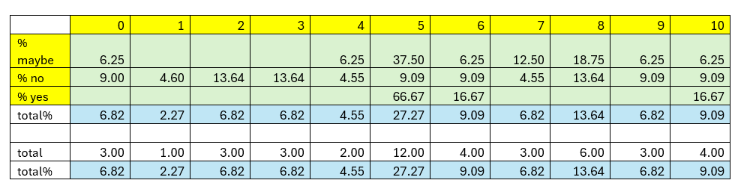

Figure 60 The impact of having a sibling with additional data on quality of life
according to young carer status by percentage (Q.2)

Impact of having a sibling with additional needs on decision-making (Q.3)
Comparisons by age
Table 21
Impact on decision-making arising from having a sibling with additional needs by age of respondent (Q.3)
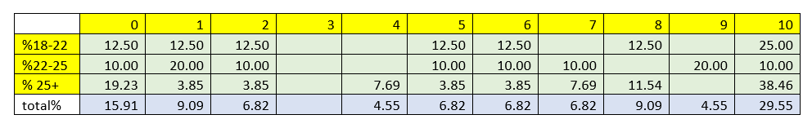

Figure 61 Impact on decision-making arising from having a sibling with additional
needs by age of respondent by percentage (Q.3)

Q3. Comparisons by type of disability
Table 22
Impact on decision-making arising from having a sibling with additional needs for the four most common types of additional needs (Q3)
 | 0 | 1 | 2 | 3 | 4 | 5 | 6 | 7 | 8 | 9 | 10 | mode | median | mean
Autism | 3 |  | 1 |  |  | 1 | 3 | 3 | 1 | 3 | 5 | 10 | 7 | 6.55
% | 15 |  | 5 |  |  | 5 | 15 | 15 | 5 | 15 | 25
LD | 3 | 2 | 3 |  | 1 | 1 | 2 | 2 |  | 2 | 5 | 10 | 6 | 5.29
% | 14 | 10 | 14 |  | 5 | 5 | 10 | 10 |  | 10 | 24
ADHD | 1 |  |  |  |  | 1 | 1 | 1 | 2 |  | 2 | 8 and 10 | 7.5 | 7.71
% | 13 |  |  |  |  | 13 | 13 | 13 | 25 |  | 25
SAL | 1 |  | 1 |  | 1 |  |  |  | 1 | 3 | 4 | 10 | 9 | 7.73
% | 9 |  | 9 |  | 9 |  |  |  | 9 | 27 | 36
All | 7 | 4 | 3 |  | 2 | 3 | 3 | 3 | 4 | 2 | 13 | 10 | 6.5 | 5.73
% | 16 | 9 | 7 |  | 5 | 7 | 7 | 7 | 9 | 5 | 30

Not all categories of additional needs were included separately due to lower numbers for some categories and some siblings were counted more than once because siblings had multiple additional needs and so fitted in more than one category

Figure 62 Impact on decision-making arising from having a sibling with additional
needs for the four most common types of additional needs by
percentage (Q3)

Siblings with Autism
Figure 63 Impact on decision-making arising from having a sibling with autism by
percentage (Q3)

Siblings with ADHD
Figure 64 Impact on decision-making arising from having a sibling with ADHD by
percentage (Q.3)

Siblings with learning difficulties
Figure 65 Impact on decision-making arising from having a sibling with learning
difficulties by percentage (Q.3)

Siblings with speech and language difficulties
Figure 66 Impact of having a sibling with Speech and language difficulties by
percentage (Q3)

Comparisons by gender of respondent and their sibling with additional needs
Table 23
Impact on decision-making arising from having a sibling with additional needs according to shared or different gender (Q.3)
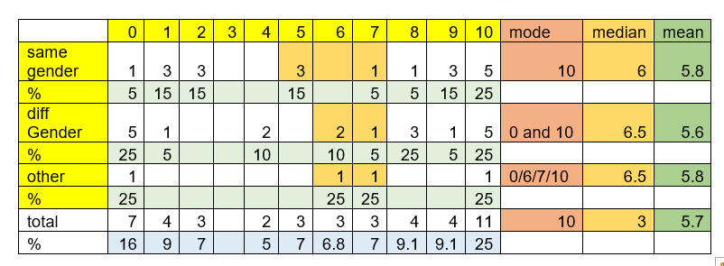

Figure 67 Impact on decision-making arising from having a sibling with additional
needs according to shared or different gender by percentage (Q.3)

Comparisons by number of siblings in the family
Table 24
Impact on decision-making arising from having a sibling with additional needs according to the number of siblings (Q.3)
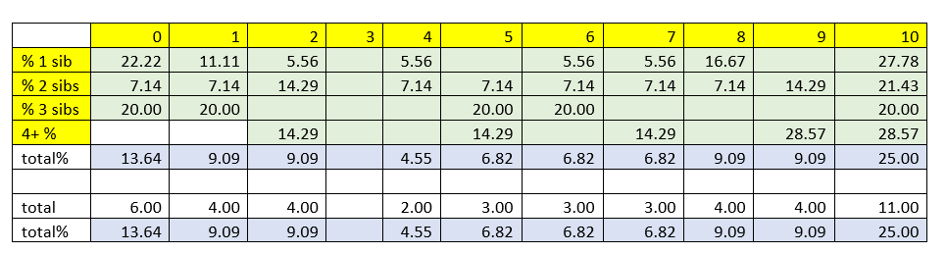

Figure 68 Impact on decision-making arising from having a sibling with additional
needs according to the number of siblings by percentage (Q.3)

Comparisons by young carer status
Table 25
Impact on decision-making arising from having a sibling with additional data according to young carer status (Q.3)
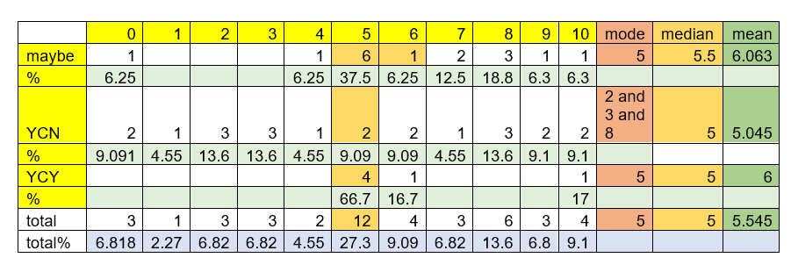

Figure 69 Impact on decision-making arising from having a sibling with additional
data according to young carer status by percentage (Q.3)

Impact on school and learning (Q.4)

Comparisons by age
Table 26
The impact of having a sibling with additional needs on school and learning by age of respondent (Q.4)
 | 0 | 1 | 2 | 3 | 4 | 5 | 6 | 7 | 8 | 9 | 10 | mode | median | mean
18-22 | 1 |  |  | 2 | 1 | 1 |  | 2 |  |  | 1 | 3 and 7 | 4.5 | 4.9
% | 13 |  |  | 25 | 13 | 13 |  | 25 |  |  | 13
22-25 | 3 |  |  |  |  | 2 |  | 2 |  | 1 | 2 | 0 | 6 | 5.3
% | 30 |  |  |  |  | 20 |  | 20 |  | 10 | 20
25+ | 2 | 1 | 2 | 2 | 2 | 3 | 7 |  | 2 | 2 | 3 | 6 | 6 | 5.4
% | 7.7 | 3.9 | 7.7 | 7.69 | 8 | 12 | 27 |  | 8 | 8 | 12
total | 6 | 1 | 2 | 4 | 3 | 6 | 7 | 4 | 2 | 3 | 6 | 6 | 6.5 | 5.3
% | 14 | 2.3 | 4.5 | 9.1 | 7 | 14 | 16 | 9.1 | 5 | 7 | 14

Figure 70 The impact of having a sibling with additional needs on school and
learning by age of respondent by percentage (Q.4)

Comparisons by type of disability
Table 27
The impact of having a sibling with additional needs on school and learning for the four most common types of additional needs (Q.4)
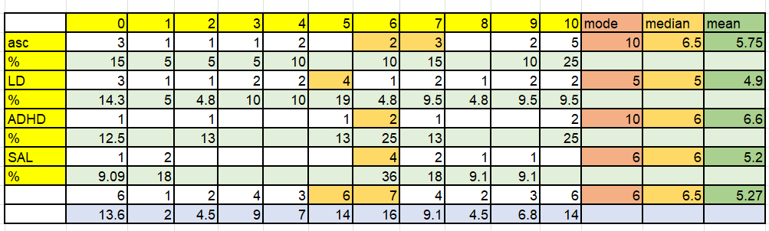
Not all categories of additional needs were included separately due to lower numbers for some categories and some siblings were counted more than once because siblings had multiple additional needs and so fitted in more than one category

Figure 71 The impact of having a sibling with additional needs on school and
learning for the four most common types of additional needs by
percentage (Q.4)

Siblings with Autism
Figure 72 The impact on school and learning arising from having a sibling with
autism by percentage (Q.4)

Siblings with ADHD
Figure 73 The impact on school and learning arising from having a sibling with
ADHD by percentage (Q.4)

Siblings with learning difficulties
Figure 74 The impact on school and learning arising from having a sibling with
learning difficulties by percentage (Q.4)

Siblings with speech and language difficulties
Figure 75 The impact on school and learning arising from having a sibling with
Speech and language difficulties by percentage (Q.4)

Comparison by gender of respondent and their sibling with additional needs

Table 28
The impact on school and learning arising from having a sibling with additional needs according to shared or different gender (Q.4)

 | 0 | 1 | 2 | 3 | 4 | 5 | 6 | 7 | 8 | 9 | 10 | mode | median | mean
same gender | 2 | 1 | 1 | 2 |  | 5 | 2 | 3 | 1 | 1 | 2 | 5 | 5 | 5.2
% | 10 | 5 | 5 | 10 |  | 25 | 10 | 15 | 5 | 5 | 10
diff Gender | 2 | 1 | 1 | 2 | 2 | 1 | 5 | 1 | 1 | 2 | 2 | 5 | 6 | 5.25
% | 10 | 5 | 5 | 10 | 10 | 5 | 25 | 5 | 5 | 10 | 10
other | 1 |  |  |  | 1 |  |  |  |  |  | 2 | 10 | 7 | 6
% | 25 |  |  |  | 25 |  |  |  |  |  | 50
total | 5 | 2 | 2 | 4 | 3 | 6 | 7 | 4 | 2 | 3 | 6 | 6 | 5.5 | 5.3
total% | 11 | 5 | 5 | 9.1 | 7 | 14 | 16 | 9 | 4.5 | 6.8 | 14

Figure 76 The impact on school and learning arising from having a sibling with
additional needs according to shared or different gender by percentage
(Q.4)

Comparisons by number of siblings in the family
Table 29
The impact on school and learning according to the number of siblings (Q.4)
 | 0 | 1 | 2 | 3 | 4 | 5 | 6 | 7 | 8 | 9 | 10 | mode | median | mean
1 | 3 | 1 | 1 | 1 | 1 | 1 | 4 | 3 | 1 | 1 | 1 | 6 | 6 | 4.8
1% | 17 | 5.6 | 5.6 | 5.6 | 5.6 | 6 | 22 | 17 | 5.6 | 6 | 5.6
2 | 2 |  |  | 2 |  | 3 | 2 | 1 | 1 | 2 | 1 | 5 | 5.5 | 5.4
2% | 14 |  |  | 14 |  | 21 | 14 | 7 | 7.1 | 14 | 7.1
3 |  |  | 1 | 1 | 2 |  |  |  | 1 |  |  | 4 | 4 | 4.2
3% |  |  | 20 | 20 | 40 |  |  |  | 20
4 | 1 |  |  |  |  | 1 | 1 |  |  |  | 2 | 10 | 6 | 6.2
4% | 20 |  |  |  |  | 20 | 20 |  |  |  | 40
5 |  |  |  |  |  | 1 |  |  |  |  | 1 | 5 and 10 | 7.5 | 7.5
5% |  |  |  |  |  | 50 |  |  |  |  | 50
total | 6 | 1 | 2 | 4 | 3 | 6 | 7 | 4 | 3 | 3 | 5 | 6 | 5.5 | 5.2273
total% | 14 | 2.3 | 4.55 | 9.1 | 6.8 | 14 | 16 | 9 | 6.8 | 7 | 11
4+ | 1 |  |  |  |  | 2 | 1 |  |  |  | 3 | 10 | 5.5 | 7.2
4+ % | 14 |  |  |  |  | 29 | 14 |  |  |  | 43

Figure 77 The impact on school and learning according to the number of siblings
By percentage (Q.4)

Comparisons by young carer status
Table 30
The impact on school and learning according to young carer status (Q.4)
 | 0 | 1 | 2 | 3 | 4 | 5 | 6 | 7 | 8 | 9 | 10 | mode | median | mean
maybe | 1 |  | 1 | 2 | 2 | 4 | 1 | 1 | 1 |  | 3 | 10 | 4 | 5.438
% | 6 |  | 6.3 | 13 | 13 | 25 | 6.3 | 6 | 6.3 |  | 19
YCN | 4 | 3 |  | 2 |  | 2 | 5 | 2 | 1 | 1 | 2 | 6 | 5.5 | 4.545
% | 18 | 14 |  | 9 |  | 9 | 23 | 9 | 4.5 | 4.5 | 9
YCY |  |  |  |  | 1 |  | 1 | 1 |  | 2 | 1 | 9 | 8 | 5.833
% |  |  |  |  | 17 |  | 17 | 17 |  | 33 | 17
total | 5 | 3 | 1 | 4 | 3 | 6 | 7 | 4 | 2 | 3 | 6 | 6 | 5.6 | 5.273
% | 11 | 7 | 2.3 | 9 | 7 | 14 | 16 | 9 | 4.5 | 6.8 | 14

Figure 78 The impact on school and learning according to young carer status by
percentage (Q.4)

Appendix S
Advice to schools
Figure 79 Leaflet for schools (work in progress)
