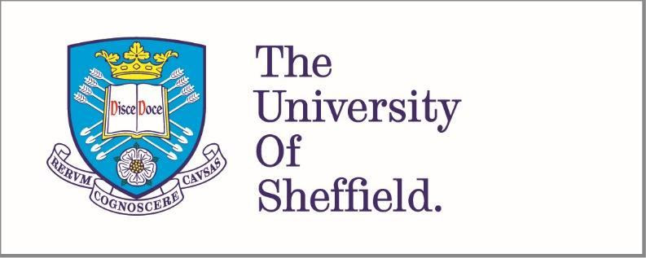

Key areas of learning for primary school children in England: An exploratory study.
Hannah Peduzzi
210103225

A thesis submitted in partial fulfilment of the requirements for the degree of Doctor of Educational and Child Psychology
The University of Sheffield
School of Education

May 2024
43,007 words

Acknowledgements

I extend my gratitude to all the participants who generously devoted their time and insights to contribute to this research project.

I would also like to thank my thesis supervisor, Dr. Sahaja Davies, whose invaluable guidance and support have greatly enriched the development and refinement of my ideas.

I am deeply grateful to my family for their unwavering interest in my work, especially my mam, Sally, and Guillaume for their continuous encouragement and interest in my progress.

Most of all, I want to express my thanks to my husband, Peter, whose love and constant support have supported me through the entire doctoral process, particularly during the more stressful times. Thank you for my chocolate bars.

*Please note - midway through the process I changed my name and so please know that Hannah Pearson and Hannah Peduzzi are the same person.

Abstract
The national curriculum was introduced in the UK in 1989 and has been developed over time (Oates, 2011). The current primary national curriculum in England aims to prepare pupils for the demands and opportunities of their society and of adult life through the delivery of 11 subject areas: English; mathematics; science; art and design; computing; design and technology; geography; history; languages; music; and physical education (DfE, 2013). The national curriculum has been criticised for focusing on external attainment measures in English and maths at the expense of other curriculum areas (Boyle & Bragg, 2006). A lack of focus on wider skills such as those involved in social and emotional development may also not prepare children for later life (Barnard et al., 2017). If these areas were to be incorporated into the national curriculum, they may help to support children’s wellbeing which has been declining in recent years (The Children’s Society, 2023).

This study used a Delphi consensus procedure to explore a group of educational psychologists’ and academics’ views on what they feel the purpose of primary education in England should be and what primary school pupils should learn at school. Three desired purposes of primary education were identified: to develop skills to support their own development and wellbeing; to support the acquisition of knowledge; and to develop skills needed to support and interact with society. Nine suggested areas of learning were developed through thematic analysis of participant responses: interpersonal development; literacy; maths; creativity; metacognition; physical health and development; exploring personal interests, understanding the world; and intrapersonal development. Each purpose and area of learning has been explored in relation to the current national curriculum and wider research. Implications for future curriculum development, educators and educational psychologists are discussed.

Table of Contents
Acknowledgements 1
Abstract 2
Glossary of Abbreviations 1
List of Figures and Tables 2
Chapter 1. Introduction 3
1.1. Introduction 3
1.2. Personal and Professional Significance of Project and Positionality 3
1.2.1. Background 3
1.2.2. The Purpose of Education 5
1.2.3. Educational Psychology 8
1.2.4. Special Educational Needs 10
Chapter 2. Critical Literature Review 12
2.1. Introduction 12
2.2. Themes in Education 12
2.2.1. Innate ‘Intelligence’ 12
2.2.2. Personal Growth 19
2.2.3. Constructivism 21
2.2.4. Critical Pedagogy 25
2.2.5. Politicisation 27
2.3 The History of Education in England 29
2.3.1. Early 20th Century: Hadow, Spens and the Butler Education Act 29
2.3.2. Mid 20th Century: The Plowden Report 32
2.3.3. Late 20th Century: Introduction of a National Curriculum 34
2.3.4. Millennium: The Literacy Hour and Every Child Matters 37
2.3.5. 2010s: The Gove Reforms 40
2.4. The Present-Day Primary Curriculum and its Purpose 43
2.4.1. The National Curriculum 43
2.4.2. Personal, Social, Health and Economic (PSHE) Education 45
2.5. Children’s Mental Health and Wellbeing 47
2.5.1. Children’s Mental Health 47
2.5.2. Social and Emotional Mental Health as a Special Educational Need 48
2.5.3. Children’s Wellbeing 48
2.5.4. What Impact Can the Curriculum Have? 49
2.6. Alternative Curricula 51
2.6.1. The Northern Irish Primary Curriculum 52
2.6.2. The Scottish Primary Curriculum 53
2.6.3. The Welsh Primary Curriculum 55
2.7. Rationale for This Research 56
2.7.1. Research Questions 59
Chapter 3. Methodology 61
3.1. Introduction 61
3.2. Philosophical Paradigm 61
3.3. Design - Delphi Consensus 62
3.3.1. Alternative Research Designs Considered 65
3.4. Sample 66
3.4.1. ‘Experts’ and Inclusion Criteria 66
3.4.2. Sample Size 69
3.4.3. Sampling Method 69
3.5. Method and Analysis 70
3.5.1. Stage 1a 71
3.5.2. Stage 1b 74
3.5.3. Stage 2 75
3.5.4. Stage 3 76
3.5.5. Principle of Anonymity 77
3.6. Pilot study 78
3.7. Ethical Considerations 79
Chapter 4. Results 81
4.1. Introduction 81
4.2. Sample Demographics 81
4.2.1. Roles and Qualifications 81
4.2.2 Years of experience 83
4.3. Stage 1 83
4.3.1. Number of responses 83
4.3.2. Stage 1a 84
4.3.3. Stage 1b 91
4.4. Stage 2 91
4.4.1. Thematic Analysis 95
4.5. Stage 3 108
Chapter 5. Discussion 111
5.1. Introduction 111
5.2. Research Question One: What do a sample of academics and professional psychologists working with primary school aged children in England believe that the purposes of primary education should be? 111
5.2.1. Theme 1: To Develop Skills to Support their own Development and Wellbeing 112
5.2.2. Theme 2: To Support the Acquisition of Knowledge 116
5.2.3. Theme 3: To Develop Skills Needed to Support and Interact with Society 119
5.2.4. How do these themes compare to other UK curricula? 121
5.3. Research Question Two: Based on reflection around these purposes, which areas of learning do a consensus of my participants believe are important for primary school aged children to learn about at school? 122
5.3.1. Theme 1: Interpersonal Development 124
5.3.2. Theme 2: Literacy 127
5.3.3. Theme 3: Maths 129
5.3.4. Theme 4: Creativity 132
5.3.5. Theme 5: Metacognition 133
5.3.6. Theme 6: Physical Health and Development 134
5.3.7. Theme 7: Exploring Personal Interests 136
5.3.8. Theme 8: Understanding the World 137
5.3.9. Theme 9: Intrapersonal Development 139
5.3.10. How do these themes compare to other UK curricula? 142
5.4. Research Question Three: Who and what may this research impact on? 145
5.5. Strengths and Limitations 146
5.5.1. Limitations of Delphi Methods 149
5.6. Next Steps 151
References 154
Appendices 196
Appendix A: Participant Demographics 196
Appendix B: Participant Information Sheet 199
Appendix C: Consent Form and Demographics 206
Appendix D: Stage 1a Google Form 213
Appendix E: Stage 1a Participant Responses 216
Appendix F: Thematic Analysis Coding of Participant Responses in Stage 1a 218
Appendix G: Theme development in Thematic Analysis of Responses in Stage 1a 222
Initial Themes and Codes 222
First Refinement of Themes, Subthemes 223
Final Themes and Subthemes 224
Appendix H: Jamboard for Stage 1b 225
Appendix I: Responses to Stage 1b 226
Appendix J: Stage 2 Google Form 229
Appendix K: Stage 2 Responses 247
Appendix L: Stage 2 Thematic Analysis Codes 252
Appendix M: Theme development in Thematic Analysis of Responses in Stage 2 255
Initial Themes and Codes 255
First refinement of themes and subthemes 264
Second refinement of themes and subthemes 269
Third refinement of themes and subthemes 271
Final themes and subthemes 272
Appendix N: Stage 3 Google Form 273
Appendix O: Stage 3 Responses 284
Appendix P: Pilot Study Participant Information Sheet 286
Appendix Q: Pilot Study Consent Form 293
Appendix R: Ethical Approval Letter 298

Glossary of Abbreviations

Abbreviation | Complete Phrase
AEP | Association of Educational Psychologists
APA | American Psychological Association
BoE | Board of Education
BPS | British Psychological Society
CCEA | Council for the Curriculum, Examinations and Assessment
DES | Department of Education and Science
DHSC | Department of Health and Social Care
DHSC | Department of Health and Social Care
DfE | Department for Education
DFEE | Department for Education and Employment
DFES | Department for Education and Skills
DoH | Department of Health
EHCP | Education, Health, and Care Plan
EP | Educational Psychologist
EYFS | Early Years Foundation Stage
HMI | Her Majesty’s Inspectorate
HCHSCC | House of Commons Health and Social Care Committee
HCPC | Health and Care Professions Council
MHST | Mental Health Support Teams
NHS | National Health Service
OECD | Organisation for Economic Cooperation and Development
PE | Physical Education
PSHE | Personal, Social, Health, and Economic Education
RE | Religious Education
SEMH | Social, Emotional, and Mental Health
SEN | Special Educational Needs
SEND | Special Educational Needs and/or Disability
UK | United Kingdom
UoS | University of Sheffield

List of Figures and Tables

- Figure 1. Flowchart of Method and Analysis
- Figure 2. Number of Years Worked with Primary School Aged Children (Age 5-11).
- Figure 3. Thematic analysis of participant responses to the question ‘What should the purpose of primary education be?’: Final themes and subthemes.
- Figure 4. Thematic analysis of participant responses to the question ‘What should primary school children learn?’: Final themes and subthemes.
- Figure 5. Relationship between what participants believe should be the purposes of primary education and what they believe children should learn within an English primary curriculum.

- Table 1. Roles of participants.
- Table 2. Qualifications of participants.
- Table 3. Suggested items that children should learn at primary school.
- Table 4. Participants’ rating of themes around what children should learn at primary school.
- Table 5. Comparison of areas of learning discussed in this research with those of the English, Northern Irish, Scottish and Welsh primary curricula, as well as those suggested in the Cambridge Primary Review.

Chapter 1. Introduction
  - Introduction
The primary phase of education was first implemented in England as a result of the 1944 Butler Education Act. This was then followed by the introduction of a national curriculum in 1989 (Department of Education and Science & Welsh Office, 1987). The curriculum for primary education has been reformed several times during this period, most recently in 2014 (Department for Education, 2013), although much of the overarching structure has remained the same since its inception. It has now been ten years since the last major government review and some individuals, including myself, question whether the primary curriculum is still fit for purpose.

  - Personal and Professional Significance of Project and Positionality

1.2.1. Background
My positionality is based on influences from my own experiences and my socioeconomic and cultural background (Savin-Baden & Howell Major, 2013). I have grown up in a family where most people were employed within public services, and have never considered an occupation outside of public services myself. My family instilled strong values around social justice, equality and helping less fortunate groups of people. Within my own professional career, which has largely been within the education sector, I have been drawn to working with marginalised groups within education systems. At university, I worked as a mentor for looked after children within a secondary school, before becoming a teacher upon graduation through the Teach First Programme. This is a graduate teacher training programme that places trainees in schools in economically disadvantaged areas. Throughout my teaching career, I was drawn to supporting children with special educational needs (SEN) in particular, and after leaving the profession I started working for the National Health Service (NHS) on a study looking at educational support for autistic children. Following this, I have worked as an assistant educational psychologist and trainee educational psychologist, and in both positions, I have worked exclusively in socially disadvantaged communities, much of my work has also supported looked after children. Through this experience, I have come to find that education systems aren’t working for many children, and particularly not those from marginalised groups and disadvantaged backgrounds.

I am extremely fortunate to have experienced a high level of social mobility: I am a homeowner, with a comfortable income and a high level of education. Neither of my parents went to university and my dad grew up in social housing. None of my grandparents left school with any qualifications and each generation of my family has progressively improved their socio-economic status. Both the Institute for Fiscal Studies (IFS) (van der Erve, 2023) and educational charity, The Sutton Trust (Eyles et al., 2022) cite education as being the biggest predictor of social mobility. Throughout my career in education, I have not seen the same educational opportunities presented to young people, and particularly those from disadvantaged backgrounds and from marginalised groups, such as children with special needs and looked after children, as I received as a child and has ultimately benefitted my own life. This observation is supported by research collated by the IFS (van der Erve, 2023) and The Sutton Trust (Eyles et al., 2022) among a general decline in social mobility in the United Kingdom (UK). I am concerned that the content and structure of the current national curriculum is limiting opportunities for many children. Dewey (1902) describes the purpose of education as providing greater personal growth, this aligns with my own views on education, and I feel that the current national curriculum does not provide this for all children.

1.2.2. The Purpose of Education
The purpose of education has been debated throughout human history and views on the aims of education vary depending on the values of each society. For example, in Ancient Greece education in the polis of Athens focused on developing well-rounded citizens, whereas in the polis of Sparta the purpose of education was to create a strong army (Mintz, 2018). James (1899) argued that the purpose of education is to shape behaviour and conduct. Through education individuals learn how to respond or behave in varying situations, and can draw on, from memory, the information that they have learned in order to shape their responses. Different education systems across cultures then lead to differing behaviours (James, 1899). For example, at that time in Germany, education focused largely on scientific research and method, meaning that educated individuals in that country displayed strong analytical and scientific skills and would approach problems with this mindset. In contrast, at the time of James’ (1899) writing, education in England was focused around being ‘gentlemanly’ and consequently educated individuals in this country learned how to behave in social situations in a way that was deemed appropriate in the culture of that period.

Although James (1899) ideas on what the purposes of education should be don’t necessarily align with my own, they do describe what some of the purposes have been/are and how this has resulted in differing education systems across cultures and time periods. This raises ontological questions around the purpose of education and whether there is an ideal form of education. Descartes (1985) proposed a dualist ontology with a separation between the mind and the body, and consequently between the mind and the physical world. This leads to a perception of the world as divided into a subject capable of thinking and an object which does not think. In contrast, Heidegger (1927) argues that such a distinction between subjects and objects does not exist. The way that humans interpret experiences defines their reality. According to Heidegger's (1927) perspective, experiences are always interpreted by the individual, making reality unique, subjective, and constantly debated rather than something fixed.

I would align more with Heidegger’s (1927) ontology in relation to the purpose of education and what should be taught. Although I believe that there are some universal processes involved in child (or early human as the concept of child is arguably socially constructed itself) development that could be supported through education (and this concept of universal development may align more with Descartes’ (1985) dualism), much of the content of education will need to be frequently re-evaluated and adapted as society evolves and values change and is ultimately socially constructed. Equally I believe how we understand child development and how it can be supported is situated within cultural and societal values, and therefore take a subjectivist epistemological position. So, while some parts of human development may be objectively ‘real’, other purposes of and values in education are socially constructed and ever changing; how we understand all of these components is in my opinion highly subjective and developed through the lens of our own experiences.

As discussed earlier, I align with the view of the purpose of education being around future personal growth and development (Dewey, 1902). I believe that education is important for people of all ages, so whereas future development and opportunity is often situated within secondary education (in my own experience), having worked in primary settings, I can see how foundations of learning and skills are important at an earlier age. As such, I have chosen to focus on the primary phase of compulsory education in England for this research. This is also where the majority of my professional experience lies. There is a commonly held misconception that learning must take place through direct teacher instruction and more formalised educational set ups (i.e. while sitting at a desk) (Baxter, 2020; Manyukhina, & Wyse, 2019). This constrains the curriculum to areas of learning that can be easily and effectively taught in this way and so while this research primarily focuses on what should be taught, pedagogical approaches also have an important role in facilitating these different areas of learning. I have experienced this misconception around the nature of learning in my own professional practice, for example when teaching a reception class, the headteacher commented ‘I don’t know why they’re playing when they should be learning’.

As a primary school teacher, I first considered alternative approaches to the curriculum when I was introduced to the Early Years Foundation Skills (EYFS) curriculum (DfE, 2017) after taking over teaching of a reception class. Implementing the EYFS curriculum led me to wonder why we stop having a strong focus on many elements of whole child development, such as personal, social and emotional development, when a child turns five and begins to access a primary education curriculum. I believe that this relates to the fixed pedagogical views around the nature of learning, and a desire to move towards more formalised systems (Baxter, 2020), as discussed earlier. Since working in other professions that are associated with, but outside of, school setting, including in educational research and educational psychology, I have found increasing opportunities to consider and reflect on alternative approaches to the current national curriculum.

As a trainee educational psychologist, I have come across a significant number of children who are not getting their needs met within current schooling systems, particularly in relation to social, emotional, and mental health needs. These children are often without support for wider areas of their development that are both impacting on their wellbeing and access to the current knowledge-based curriculum in schools. This can result in them being excluded from receiving education, whether this be through a formal move away from their school setting or through being unable to access learning whilst physically present in school.

1.2.3. Educational Psychology
When I first spoke with family and friends about the topic of my thesis, some (of those outside of the educational psychology profession) questioned how curriculum was relevant to educational psychology. Often others see the role of an educational psychologist as only relating to the provision of education for children with special educational needs. But how do we decide what a special educational need is? Ultimately, special educational needs describe a set of needs, or differences, that make it difficult for a child to access the curriculum. If the presented curriculum was different then our understanding of what constituted a special educational need would likely also be different. I think that a curriculum that teaches the skills of emotional regulation could result in less children with presenting social, emotional and mental health needs as a barrier to accessing other areas of learning.

There is a wide range of research that criticises current curriculum arrangements in schools, particularly in relation to a narrowing of the curriculum towards literacy and numeracy (e.g. Ogier, 2022; Reay, 2017). Within the educational psychology profession specifically, research has explored how the curriculum can be adapted to better support children and young people’s wellbeing (Clarke & Hoskin, 2022). Educational psychologists can make an important contribution to curriculum development (Mallon & Tee, 1991) and historically research conducted by educational psychologist has impacted on government reviews of education and educational policy (Swinson, 2023).

The British Psychological Society (BPS) Division of Educational and Child Psychology (DECP) (2022) has set out in a position paper that the role of educational psychologists (EPs) is to promote inclusive education for all children and young people. They state that EPs should strive to do this by working to change systemic factors that limit inclusion (BPS, 2022), one of which could arguably be the current national curriculum. Similarly, the Association of Educational Psychologists (AEP) (2024) have produced a manifesto calling on the government to reform education systems in order to make them more inclusive. They also highlight the need for the government to prioritise the mental health and wellbeing of children and young people (AEP, 2024), something which I believe could be partially addressed through curriculum reform.

These documents align with my own views and experiences as a trainee educational psychologist, where I have seen that the curriculum is often not inclusive to all groups of children. Almost all of my workload now involves supporting children with mental health difficulties, and it is clear from both experience and monitoring statistics (e.g. NHS Digital, 2023) that children’s mental health and wellbeing is declining. I would personally advocate for a community psychology approach to addressing such issues, and believe that education systems could play an important role within this. Community psychology focuses on the community context of human behaviours and our relationships with one another (Kloos et al., 2012). Intervention is then focused on supporting and adapting these contexts, taking a preventative approach to sociocultural and health issues, rather than intervening at a within person level once a problem has already occurred (Kloos et al., 2012).

1.2.4. Special Educational Needs
Linked to the ideology of community psychology, I believe that achievement and success within education systems is multifactorial and impacted on by wider social, cultural, environmental, and economic influences. Schools cannot ignore these wider factors and assume that progress in school can be achieved independently of these. Similarly, I believe that special educational needs and disabilities can have multifactorial and complex determining factors. While some additional needs may be the product of biology, others may be determined by a child’s environment including their curriculum. Most are likely a complex interrelation of many areas and don’t have a single ‘cause’. Again, this means that schools can’t operate as discrete systems, only focusing on teaching children to acquire knowledge, in the absence of consideration of other areas of child development and other areas of a child’s life.

The social model of disability situates the disabling nature of disability within the non-inclusive community context (Shakespeare, 2017). This model describes the difficulties that such people may face as resulting from a lack of appropriate adaptations, support and acceptance within society rather than from within the person themselves. I would argue that education is currently a major non-inclusive component of this. In my own professional practice, I have often witnessed interventions for children and young people with SEN, to be focused on changing their behaviour to match that of their peers rather than for those around them to remove the barriers to accessing education. The medical model of disability takes the approach of situating difficulties within the person and ‘treating’ the person to limit these difficulties (Shakespeare, 2017). In my own experience, both society and education systems tend to view special educational needs through the lens of the medical model.

My own views align with the social model of disability. This is something I have set out in a previous position paper relating to autism (Wright et al., 2020). This paper argued for a move away from a deficit-based, medicalised understanding of autism to that of an appreciation and support of difference. Although this paper was specifically focused on autism, these ideas translate to other special educational needs. Arguably, the label of special educational needs is in itself marginalising, and I would hope that in the future education can move towards understanding all individual children’s strengths and needs and tailor support as appropriate without categorising some children because the curriculum does not meet their needs. However, at present the concept of special educational needs provides a shared understanding and is a central component of how the educational psychology profession is understood, and so I have continued to refer to the concept of SEN throughout this research.

I think that early intervention to health, social and educational issues, for example through a more inclusive and holistic curriculum, has a greater impact on individuals and can in many cases prevent the need for higher level intervention. This aligns with my views around community psychology and there is a wide range of research showing that early intervention is effective within education in supporting children’s physical and socio-emotional wellbeing (Tollan et al., 2023) I believe that we all have a collective responsibility for children’s education and wellbeing. The children of today will play incredibly important roles in the future of our society.

Chapter 2. Critical Literature Review

2.1. Introduction
This chapter will first explore key themes in education that have shaped views on the purposes of education as well as curriculum content. I will then give a brief overview of the history of education in England, including the varying purposes of education over the last 100 or so years. This is to give context around how educational systems and policies have developed over time in relation to the current curriculum that is in place in England. More focus is given to the primary phase of education for children aged five to eleven. This is a very broad area and so this literature review will only touch on some key periods, theories, policies, and legislation. It should be noted that some of the language used in older legislation around special educational needs (SEN) that is referenced in this review is outdated and does not represent appropriate language in the present day. The current national curriculum will then be analysed critically, particularly in relation to the absence of social and emotional learning in the curriculum and the potential implications of this. Comparisons will then be made to curricula in other countries of the United Kingdom (UK). Finally, the rationale for this piece of research will be set out along with research questions.

2.2. Themes in Education

2.2.1. Innate ‘Intelligence’
A growing interest in child psychology in the 1920s and 1930s led to a shift in understanding of child development (Gillard, 2018). In the early 20th century, Cyril Burt made the case that intelligence was both measurable and inheritable (Burt, 1909). He became the first professional educational psychologist (EP) in the UK and was employed by London County Council (Chitty, 2007). Burt (1909) became concerned with measuring intelligence to identify ‘subnormal’ individuals, he argued that intelligence was innate and therefore these individuals would not be able to be educated at the same level as others. He felt that there was a need for intelligence testing within education systems to identify more and less able students and adapt their curricula accordingly. Burt’s ideologies were situated within eugenic movements of the time and a desire to preserve what he perceived as an intellectual superiority of the white Anglo-Saxon race as well as the higher social classes (Chitty, 2007). Much of Burt’s academic findings on the heritability of intelligence were established through now discredited twin studies, with evidence emerging that many of his findings were falsified and therefore fraudulent (Tucker, 1997).

The implication of Burt’s (1909) ideology is that if intelligence is a fixed and innate construct, then it is fruitless to attempt to educate ‘less intelligent’ children beyond a certain level. This not a position that I agree with, and I personally don’t believe that there are limits on what an individual can learn. In relation to the purpose of education, this would suggest that the purpose is to educate children to fulfil their predetermined position in life. This aligns with Aristotle’s teachings; he believed that different roles have different skills and virtues, and that people should be educated to fulfil their specific role in life (Noddings, 2018). However, I would argue that this approach serves to reinforce embedded social differences based on areas such as existing socio-economic status and race, effectively eliminating opportunities for social mobility.

The impact of Burt’s (1909) work lives on in modern education, despite the established flaws in his research. This is most notably apparent in the continued existence of the eleven plus exam as a means of accessing grammar schools in some areas of England. The eleven plus exam was first introduced in the 1940s as a direct consequence of Burt’s work (Chitty, 2007) and based on earlier reports that he was involved in, such as the Spens report (Board of Education (BoE), 1938). Even outside of tripartite educational systems, grouping by attainment is very common in secondary schools (Taylor et al., 2018) and often also used in primary schools (Hallam & Parsons, 2013). In my own experience as a primary school teacher, although a few pupils may move between ability groups, in reality most don’t, consequently putting a limit on what many children are given the opportunity to achieve. The whole concept of ability grouping also infers that some children are less able creating a deficit-based view of these individuals.

Between 2002 and 2010, the new Labour government established a ‘gifted and talented’ programme which supported schools to identify and provide further opportunities for more able children (Chitty, 2007). Although the intention was stated to be to provide greater opportunity for children from a variety of backgrounds, the programme was criticised by many to be elitist and that the focus of education should be on all children rather than a select few (Chitty, 2007). I myself, was identified as a ‘gifted and talented’ child, I am not aware if the scheme provided me with any additional support in school, if so, this was not overtly apparent, however the scheme was ended when I was midway through my GCSEs so that may have had an impact. The scheme did however give me a sense of smugness and a feeling that I was more intelligent and therefore in some way ‘better’ than my peers, so I would agree with the criticism around the scheme being elitist. These kind of schemes could result in a wider societal impact where certain individuals are seen to hold greater value than others and consequently some individuals are provided with less access to opportunities and less confidence to work towards opportunities.

Research from Campbell et al. (2007) found that there was an overrepresentation of children with a Chinese or mixed race (predominantly white-Asian) ethnic background identified by the gifted and talented scheme and an underrepresentation of black pupils. Children from lower socio-economic backgrounds were also underrepresented (Campbell et al., 2007). This concerningly aligns with the ideas presented by Burt (1909) and in the Bell Curve (Herrnstein & Murray, 1994). Eugenic ideology linked to that of Burt (1909) has been openly shared among the scientific community in surprisingly recent history. A major example of this is the publication of ‘The Bell Curve’ in the 1990s which set out a position around specific ethnic groups being more intelligent than one another (Herrnstein & Murray, 1994). This book made the claim that there was evidence of Asian Americans being genetically more intelligent than European Americans who were in turn more intelligent than African Americans (Herrnstein & Murray, 1994). This led them to make the case that what should be taught in schools should be differentiated based on race, as individuals from certain ethnic backgrounds had no chance of achieving the same as others (Herrnstein & Murray, 1994).

Similar demographic outcomes to that of the gifted and talented programme can still be seen in recent GCSE and SATs outcomes where individuals from Asian ethnic backgrounds (particularly Indian and Chinese) tend to perform better, whereas lower performance is seen among black, Roma and Irish traveller pupils as well as those on free school meals (DfE 2023a; 2023b). Some may see this as supporting evidence for Burt (1909), Herrnstein and Murray’ s (1994) theories; however, I would argue that this actually demonstrates a continuation of the educational disadvantage experienced by these groups due to a range of complex social factors. Stereotypes and existing expectations of specific groups of individuals embedded in society as a result of the ideas of people such as Burt (1909) may partially perpetuate some of these differences.

Various issues have been identified relating to the reliability of measuring intelligence, particularly in relation to the appropriateness of measures for individuals from different cultural backgrounds. Despite this, psychometric assessments are still widely used in UK educational psychology practice over 100 years on from Burt’s original theories. Although favour does seem to be falling away from their use within educational psychology more generally, with one study finding practitioners to view them as low value tools that do not provide definitive evidence of need (Sewell & Ducksbury, 2013).

Some argue that the standardisation of such tests allows for an impartial assessment of cognitive ability (Higgins, 2009), and that this then provides equal opportunities and access to support and education. However, I would argue that this claim only stands true if it assumed that intelligence is a real, measurable construct that is innate and not impacted on by other factors such as culture and socio-economic status, something I don’t believe to be the case. Many scholars have described the construct of intelligence as undefinable and vague (Binet & Simon, 1916; Jensen, 1999). Despite this, special educational needs coordinators (SENCos) have been reported to find IQ scores from educational psychologists relatively helpful in understanding a student’s educational needs (Freeman & Miller, 2001) suggesting that such measures are valued across education more widely.

As discussed earlier, psychometric assessments have been used in the past to claim intellectual superiority of certain ethnic groups over another, particularly in relation to claiming superiority of white ethnic backgrounds over others (Suzuki & Valencia, 1997). For example, Garth (1930) reviewed several studies from the early 20th century finding white Americans to be intellectually superior to other races, particularly African Americans. Similarly, a study by Brigham (1923) found Americans with South and Eastern European heritage to be less intelligent than those with Nordic heritage. Studies such as these were used to justify immigration, sterilisation and eugenic stances in the early 20th century (Brigham, 1923; Cattell, 1937). Many educational psychologists now choose not to use such assessments due to their discriminatory purpose in recent history.

Despite these claims of intellectual superiority of some races over others, the majority of variation in IQ scores occurs within racial groups rather than between them (Loehlin et al., 1975). Many psychologists now don’t consider psychometric assessments to be a valid measure of intelligence across all races, and cultural differences likely explain much of the variation in performance (Suzuki & Valencia, 1997). Different ethnic groups have stronger performance across different measures which may be explained by cultural differences in the way information is used and processed and many studies have also found racial differences to be minimised when socio-economic status is controlled for. Parental attitudes, interaction with children and qualification levels also have an impact (Suzuki & Valencia, 1997). In addition, IQ scores tend to corelate with years in education, however it is unclear if this is a result of the impact of education or if those with higher intelligence due to other factors are simply able to access higher levels of education (Kaufman, 1990).

Many standardised assessments of intelligence include a measure of vocabulary. However, a limitation of measuring vocabulary in cognitive assessments is that vocabulary is largely impacted by the experiences that an individual is exposed to and can be affected by a person’s social background (Schwab & Lew-Williams, 2016). Differences in vocabulary performance across ethnic backgrounds on cognitive assessments are generally more understood, firstly due to language exposure and secondly due to exposure to different cultural experiences. On the other hand, some may see non-verbal skills as more innate; however, Dolean and Cãlugãr (2020) also found that cultural differences in test performance could be explained by environmental factors in their study of Roma children. Roma people experience discrimination across Europe and in some countries, such as Slovakia, Roma children have been segregated within mainstream education. In many European countries Roma children are over-represented in special education: for example, in England, special educational needs (SEN) are most prevalent in Irish traveller and Roma communities, (32 and 27% respectively, compared with 17% overall) (DfE, 2023d).

Dolean and Cãlugãr’s (2020) study measured non-verbal abilities of Roma and non-Roma children from the same communities using Raven’s progressive matrices (Raven & Raven, 2003). They found that Roma children had a lower IQ than non-Roma children. They then looked at possible mediating factors related to socio-economic factors (parental education, income and living conditions). Parental education was positively correlated with IQ and living conditions were negatively correlated with IQ, suggesting that both of these are mediating factors in the relationship between ethnicity and IQ. There wasn’t a significant correlation between income and IQ, however income is likely to also be interrelated with parental education and living conditions.

Dolean and Cãlugãr (2020) then re-analysed their data again to look at relationship between ethnicity and IQ whilst controlling for parental education, income and living conditions; it was found that the relationship between ethnicity and IQ was considerably reduced. However, there was still a significant effect, suggesting that there may be more mediating factors such as school attendance and attitude to school/ education. There is a risk that Roma and other minority ethnic groups may be more likely to be labelled as having SEN due to their SES (as well as white low SES groups) through the use of such psychometric assessments. This could have an impact on their own and family’s aspirations of them and whether they attend a mainstream school. Ultimately, standardised cognitive assessments could be used to justify differing curriculums for specific children, despite there being considerable evidence that they are impacted on by a range of sociocultural factors. This risks the discrimination of children from certain sociocultural backgrounds.

2.2.2. Personal Growth

John Dewey, an influential American philosopher of the time, focused his attention on education systems and learning processes (Dewey, 1902). Dewey did not believe that children are born to be intrinsically good or bad but that they have the potential to grow up to be either. He searched for observable explanations for natural occurrences showing a strong interest in evolution and science, whilst rejecting supernatural explanations of phenomena and events (Dewey, 1902).

Dewey (1902) described two opposing models of education. The first model is one where experience and knowledge are segmented into separate subjects ignoring the interrelating whole experiences of the child. In this model, there is a desire to understand knowledge impartially and separate from experience. Dewey (1902) argued that this can then create conflict between the child’s experiential understanding and the curriculum that they are being taught. The aim of this model of education is to substitute the child’s vague and confusing experiences with an ordered and categorised curriculum where learning can easily be designed and measured. Dewey (1902) also presented an opposing model to this one where education is more concerned with the development of the whole child. In this model, the experiences and personality of the child are highly valued, and the purpose of education then becomes self-realisation rather than knowledge of ‘fact’. The child is at the centre of their own learning and teaching is done with, rather than to, them.

Dewey viewed education as synonymous with growth, with the aim of accessing even further personal growth and education (Dewey, 1902). While he did not advocate for removing traditional subjects from the curriculum, he strongly believed that such subjects should be meaningfully taught so that they are genuinely useful to children in addressing problems. He suggested that curricula should not be developed prior to learning but instead develop naturally through enquiry-based learning (Dewey, 1902).

Implementation of Dewey’s ideas into education systems were slow for several reasons. One of these being the strong continuing influence of Burt’s theory around the heritability of intelligence, with testing and streaming becoming common practice in schools in the twentieth century (Galton et al., 1980). Socioeconomic factors also made developmental theories harder to implement in schools. In the early twentieth century many school classes had fifty or more students, teachers were often without any formal qualifications and school buildings were not always fit for purpose (Simon, 1991). Many people at this time saw the purpose of schools as simply ensuring children got through and passed examinations (Galton et al., 1980).

Dewey’s (1902) ideas differ from that of Burt (1909) in that there is a clear message that personal growth and learning is possible for all individuals and that the purpose of education should allow this for all children rather than just a select view. In terms of the implications of how this purpose translates into what is taught, a high level of flexibility and individualisation is needed. This could be challenging to implement in an education system at a national scale, largely due to resources. At present most children in primary and secondary schools are taught in class sizes of around 30 pupils, in my own experience of teaching a class of this size I feel that it would be difficult to offer such a personalised and child led curriculum to this many pupils with only one teacher. As such the current structure of education makes Dewey’s ideas difficult to implement fully and a major reform to this structure would be needed in order to adopt this approach.

Burt’s (1909) impact on education has been one that, in my own opinion, has resulted in a high level of inequity. Although Dewey’s (1902) ideas appear at the surface to be more equitable and to promote learning for all pupils, challenges with implementation again could make the delivery of such an educational philosophy difficult to deliver equitably. It is likely that different teachers will have different views on what the same child may need, and this will also be based on their own interests and expertise. Dewey (1902) considers how the child needs to be central and involved in their own learning, but I would argue that there needs to be more thought around the interaction between the values of both the student and teacher and how this influences the direction of learning. While Dewey’s (1902) ideas align more with my own idealised views on the purpose of education around pursuing personalised growth and adapting to individual needs through experiential learning, I can see how the implementation of such an approach could be challenging.

2.2.3. Constructivism

Shortly after the ideas of both Burt and Dewey became relatively mainstream, Jean Piaget (1936) published his own constructivist theory of cognitive development in childhood. Although not specifically related to education, this theory did have implications on what and how children should be taught at different stage of development (Gillard, 2018). Piaget suggested that children don’t think in the same way as adults, and unlike Burt purported that intelligence is not fixed but can be developed through a series of interactive processes (Piaget, 1936). The concept of knowledge being explicitly taught by teachers through direct instruction did not align with his views around child development and was rejected by Piaget (Dixon, 2015). Differentiation, Piaget argued, should be based on the child’s stage of development and not their chronological age, although age ranges were given for each stage (Piaget, 1936). He believed that children could not progress to the next stage of their development until they had securely developed their skills in prior stages, suggesting that children cannot be taught specific concepts until they have reached the appropriate stage of development (Black & Ammon, 1992).

Piaget’s theory of child cognitive development, and resulting implications on education, challenged traditional education systems. Children had been traditionally taught in schools through direct teacher instruction (Lawson & Silver, 2007), moving towards interactive learning processes would have been a considerable shift away from these methods. This also raised the question of teacher education, and would teachers have the skills to deliver this different type of curriculum?

Later constructivist theorists, such as Bruner (1974) and Vygotsky (1978), disagreed with some of Piaget’s ideas, refuting the need for stages and instead describing child development as a continuous process. Vygotsky (1978) was a Russian psychologist and although much of his work was produced in the early twentieth century it did not become known in Western countries until much later in the century (Dixon, 2015). Vygotsky (1978) highlighted the importance of social interaction in learning processes with a zone of proximal development created through interactions with a more skilful other. Vygotsky (1986) describes a different role of the teacher to that of Piaget, where the teacher can extend children’s learning through scaffolding of the curriculum. Unlike in Piaget’s theory, children don’t need to wait until they are developmentally ready to move on with their learning, instead the level of support can be adjusted to help the child learn a new skill or concept (Vygotsky, 1986). Vygotsky (1978) also understood the development of language and thought to occur together and therefore placed a great emphasis on the use of language to facilitate learning through interactive processes, this differed from Piaget (1936) who described thought as preceding language and was less interested in the impact of language on development. Vygotsky’s (1986) theories around education have significant implications on the level of personalisation needed within the curriculum, whereby learning is scaffolded to different extents to suit the needs of different learners.

Piaget (1936) describes learning as an individual process that becomes external, whereas Vygotsky (1986) describes it as an interactive process that then becomes internalised. This creates conflicting positions around whether education should focus on group, community, and social processes or more on individualistic traits and development. Purposes of education around both benefitting the community and developing social processes as well as developing the individual may be considered important. It may initially seem that Piaget’s (1936) methods would align with this individual development purpose and Vygotsky’s (1986) with the other. However, I would argue that both learning styles could support both purposes of education. For example, while emotional regulation could be viewed as an internal process, there is a large body of evidence for coregulation, an interactive process, is an effective strategy of teaching emotional regulation (Gus et al., 2015).

This research primarily focuses on what children should learn, once this is established, further consideration will be needed to explore how such areas of learning could or should be delivered effectively. I would argue that the what needs to come first, whereas historically the how has been the predecessor limiting the what to that that can be more easily delivered (Noddings, 2018). I also think that it would be limiting to adopt only one pedagogy for all learning, each pedagogical approach will have its own strengths and limitations. Some may be better suited for different areas of learning and some better suited for different children. Therefore, I believe that range and flexibility in approach will be important in successful learning. However, as discussed previously much more research will be needed to establish which approaches are more suitable to different areas of learning once these areas of learning have been further established.

Bruner (1979) built on Vygotsky’s constructivist educational theory. He supported Vygotsky’s ideas around how social interaction is essential in the development of language and cognition, and warned against education systems that were centred around the memorisation of facts (Bruner, 1979). He refuted the need for stages, as in Piaget’s (1936) earlier theory, and instead suggested that children were capable of learning specific concepts at any age providing the right scaffolding was put in place. Bruner (1979) suggested that learning should be represented through a series of increasingly more abstract phases: enactive (action phase), iconic (pictorial phase) and finally, symbolic (language phase). While Bruner (1979) agreed with Dewey (1902) around the importance of learning being meaningful and relevant to students, he did not believe that learning needed to be centred around children’s interests, as he felt that the act of learning is intrinsically interesting in itself.

This contradicts research which has found personal interests to motivate learning (Assor et al., 2002; Hoyt-Oukada, 2003). Some research has also found that incorporating children’s interests into learning can improve outcomes in areas such as writing (Kirby, 2019). Bruner’s (1979) suggestion that personal interests do not have a place in the curriculum conflicts with Dewey’s (1902) ideas around the purpose of education relating to personal growth. How can children’s individual skills flourish if they are not given the opportunity to explore and develop their own interests? I would also caution that limiting learning around children’s interests also risks developing a homogenous society with little individualism. This could prevent the whole of society from benefiting from the skills and talents that different individuals may possess.

2.2.4. Critical Pedagogy
The Brazilian philosopher, Paulo Freire (1970), argued that the purpose of education is politically determined and used as a tool to enforce conformity to politically proscribed values. He described education as a process whereby teachers deposit information onto children, leading to what he called ‘narration sickness’. The teachers narrate and the students are simply expected to contain the narration. He termed this phenomenon the ‘banking concept of education’. Freire (1970) argued that this system of education lacks creativity and leads to a situation where students retain a series of statements without underlying understanding of what those statements mean. Freire (1970) also pointed out the power imbalance in this ‘banking’ system of education, where the teacher holds all the knowledge (and therefore power), and the student is considered ignorant. He argued that true understanding of concepts is developed through communication between teacher and student, and that the teacher’s thinking cannot simply be deposited onto the student.

Freire (1970) highlighted the importance of consciousness within literacy; in addition to simply learning to read and write, individuals need to know about how their literacy can be exploited by more dominant social groups. Henry Giroux (1985) brought this into his ideas around critical pedagogy and critical literacy, whereby individuals also need to learn how to question, analyse and solve problems, to avoid oppression by more dominant cultures and individuals. Bowles and Gintis (1976) suggest that the values taught in schools correspond with those in the workplace, through a hidden curriculum designed to create a conformant workforce. While not an explicit part of most school curricula, they argue that schools teach pupils to be subservient, accept hierarchy, and to be motivated by external rewards to create a future oppressed workforce that will work in the interests of the more powerful few (Bowles & Gintis, 1976).

Bowles & Gintis (1976) make the case that the purpose of education has therefore become to create a conformant future workforce that doesn’t challenge those in positions of power. This then leads children to be taught workplace skills. There has been a political focus on supporting the development of workplace skills through education in recent years (Ofsted ,2016). However, the underlying purpose of this is less clear. While having a workforce benefits people in a position of power in business, as well as those in power in government through tax revenue, it also benefits others. Having a society where most people are economically active also benefits the average person and tax revenue collected by the government as a result of this funds public services. Many people’s occupations also give meaning and focus to their lives (Steger & Dik, 2009). Ultimately, while I think it is reasonable for education to at least partly focus on future workplace skills for both the benefit of the individual and society, there needs to be careful balance where education provides opportunity to move into an individual’s chosen profession and whereby individuals also have opportunities for social mobility. I would argue that the purpose of education would then be around the wellbeing of the individual and of their society, which working can contribute too, rather than the production of a workforce being the purpose in and of itself.

2.2.5. Politicisation
White (2012) describes the national curriculum as introducing a top-down system where there is a significant power imbalance between the government, individual schools and teachers. They argue that the structure of the national curriculum leads to the positioning of teachers as implementers rather than facilitators of education (White, 2012). This contrasts with the interactive learning processes advocated for by Dewey (1902), Piaget (1936), Freire (1970), Vygotsky (1978) and Bruner (1979). Some argue that the introduction of the national curriculum represents a shift whereby education systems became less grounded in education theory and more politically influenced (Boyle & Bragg, 2006).

This results in an educational system which has its purposes and values intertwined with the purposes and values of the government. So, where a government has a focus on economic growth, as in the case if the newly in power Labour government (Labour, 2024), it could be assumed that education could then be used to serve this purpose. How this translates to what is taught will also depend on the values and beliefs of those in power in the government, for example they may seek to develop economic growth through education by fostering the skills of enterprise and creativity, or they may aim to develop a more conformant workforce that will potentially deliver a high output of work. Economic growth and future workforce will not be the only area that the government may want to focus on. Some governments may use education to limit dissent through a lack of education around critical thinking. For example, in various points during the post-medieval period, reading of the bible by laypeople was made illegal: Chitty (2007) suggests that the government and Church were concerned that mass education may lead to rebellion against existing hierarchal structures. Others may aim to reduce crime by teaching either morals or conformity (or both).

The national curriculum was in part introduced to provide consistency of educational content for all children, with a desire to make the education system ‘fairer’ (Oates, 2011). This desire for ‘fairness’ opens the debate between equality and equity. It can be argued that providing the same education for all, ignores individual needs and differences and in fact serves to benefit only a few children through the guise of equality. This is demonstrated through the differing educational outcomes for children from different backgrounds (DfE 2023a; 2023b). However, it would also be dangerous and limiting to assume that a child needs a certain type of education based solely on their background. I would argue that their needs to be more flexibility to adapt the curriculum to children’s needs at an individual level, rather than all children, or whole groups of children, simply receive the same thing.

The national curriculum is strongly grounded in the principles of accountability, standards and assessment (Wrigley, 2014). Noddings (2018) argues that the idea of accountability in education has come from practice within business. The way in which employees are held accountable for profits within a business has been translated into teachers being held accountable for learning outcomes of students. The difficulty with this model of accountability, is that the purposes of education are much more complex than that of businesses and many of these aims can be much more difficult to assess (Noddings, 2018). This desire for accountability within educational systems has led to a shift towards content that is easily measurable at the expense of other areas of learning. This has led to a system whereby what is taught is determined by what can be easily to be taught or measured (the how). Instead, I would advocate for researchers, politicians and educators to go back to what they hope the purpose of education should be to inform what should then be taught in the curriculum; something I hope to do through this research.

2.3 The History of Education in England

2.3.1. Early 20th Century: Hadow, Spens and the Butler Education Act
At the turn of the 20th century, there was a greater consensus within society around a collective responsibility for social issues and education was increasingly included in government election manifestos (Lawson & Silver, 2007). Education sought to prepare individuals for employment and to promote cultural values in society (Lawson & Silver, 2007).

The influence of Burt and other’s work around intelligence testing and supposed innate properties of intelligence influenced the development of the 1913 Mental Deficiency Act (Chitty, 2007). The Act required local educational authorities to identify children who were deemed to be uneducable, even within specialist provisions (Warnock, 1978). These uneducable children were sent to institutions under the care of local mental deficiency committees and the responsibility of local authorities to educate these children was not put into law until the 1970s (Chitty, 2007). In the 1914 Education Act, Local Authorities became duty bound to provide education for ‘mentally defective’ children who were still deemed educable, and the 1918 Education Act expanded this to children with physical disabilities and epilepsy (Warnock, 1978).

In the 1920s and 1930s, the board of education consultative committee produced several influential reports under the direction of Sir Henry Hadow (Gillard, 2018). The 1923 Hadow report promoted differences in education for boys and girls, with girls deemed more fragile. It was suggested that there should be greater freedom of curriculum particularly in girls’ schools with more opportunities to children to follow their own interests (BoE), 1923). The 1924 Hadow report went on to propose that intelligence tests should not be used independently to determine if a child is or isn’t educable and that this should be determined through triangulation with other information including teacher assessment (BoE, 1924; Gillard, 2018).

The 1931 Hadow report dedicated it’s focus entirely on the primary school, introducing the idea of splitting compulsory schooling into two phases: primary and secondary (Gillard, 2018). The report suggested a topic-based curriculum for primary education that moved away of the traditional splitting of instruction into separate subjects, although reading, writing and arithmetic would still be of central importance (BoE, 1931). It was also recommended that class sizes should not exceed 40 pupils (BoE, 1931). Teachers should be trained in meeting the needs of ‘retarded’ children and such children should be taught in small classes. The most ‘severely retarded’ children should be educated in special schools that are closely linked in with mainstream education systems (BoE, 1931; Gillard, 2018).

Within the report, Cyril Burt wrote an appendix on the mental development of children aged 7-11 (Chitty, 2007) and the main report recommended that intelligence tests, along with school records and teacher assessment should be used as a formal assessment of children’s skills at age seven (Gillard, 2018). The report did however state that these assessments should be seen as provisional and not a determinable measure of a child’s future ability (Gillard, 2018). Finally, as a further development to the recommendations around the structures of compulsory schooling systems, the 1933 Hadow report recommended further separation of primary schools into closely linked infant and junior schools (Gillard, 2018). It was suggested that education within the infant schools should be child-led and focused on activities and experiences rather than the acquisition of memorised knowledge (BoE, 1933).

A report was produced by Sir William Spens in 1938 considering the best way to organise secondary education, with a section written by Burt on the mental capacity of secondary school aged pupils (BoE, 1938). This lay the foundation for the tripartite system of secondary education introduced by the 1944 Butler Education Act (Chitty, 2007). The Act replaced the system of elementary schools for pupils aged 5 to 14 with a system of primary (age 5-11) and secondary (age 11-15) schools as suggested in the Hadow reports (Chitty, 2007). Although the restructuring recommended in the Hadow reports was put in place the curriculum recommendations from the reports were not implemented in the Act (Chitty, 2007).

The Act also set out an eleven plus exam to determine whether children should progress to grammar, technical or secondary modern schools following their primary education. Wooldridge (1994) argued that this selective streaming of secondary education was a progressive viewpoint for the time and represented a move towards child-centred educational systems, whereby the curriculum was personalised to needs and ability of the child. It could be argued that this allowed for greater social mobility where more intelligent working-class children would have access to a higher level of education. However, tripartite systems often reinforced existing class separations (Chitty, 2007; Wyse & Torrance, 2009). Burt believed that these separations were justified as the upper classes were innately more intelligent that the working class. The Act also reinforced the education in special schools for children with disabilities, unless they were assessed to be ‘uneducable’ (Warnock, 1978).

2.3.2. Mid 20th Century: The Plowden Report
No further major government reviews of primary education were conducted after the Hadow reports until the Plowden Report of 1967 was commissioned by the government (Gillard, 2018). The report was strongly influenced by Piaget’s cognitive development theory (Gillard, 2018) and presented a child-centred approach to primary education (Department of Education and Science (DES), 1967). The report set out the purpose of primary education as being to develop children’s interest in learning so that they are intrinsically motivated to learn and do not do so based on desire for, or fear of, extrinsic praise or sanctions (DES, 1967). There was a focus on children’s social, emotional, and physical development and flexible, discovery-based learning was promoted (Gillard, 2018). The report stressed the importance of holistic teacher assessment of children’s development beyond what was externally measurable, with the message that value is not derived through measurement (DES, 1967).

The paper recommended ending the practices of streaming and selective intelligence tests as a way of accessing secondary schools (Gillard, 2018). The report was generally well received by the public (Simon, 1991), however, there was a significant proportion of conservative party members who hoped to retain the existing tripartite system of secondary education (Gillard, 2018). Right wing critics of the proposed educational reforms produced black papers (in retaliation to government white papers) that denounced progressive primary curriculums and insisted that streaming was necessary to promote hard work and produce a competitive future workforce (Gillard, 2018). Despite these criticisms, the use of streaming in primary classes reduced throughout the 1970s as a result of recommendations in the report (Gillard, 2018).

The Plowden report (DES, 1967) also recommended an alternative three-tier structure to compulsory education made up of first, middle and secondary schools. The DES produced a pamphlet in 1970 which featured opinions from psychologists that middle schools could provide good pastoral support for pre-teens and protect them from the pressure of exams (Gillard, 2018). Three tier systems grew rapidly across local authorities in the 1970s as a result (Gillard, 2018). 1970 also saw the introduction of the 1970 Education (Handicapped Children) Act which finally transferred provision of education for all ‘mentally handicapped’ children from the health service to local education authorities (Gillard, 2018).

The Plowden Report (DES, 1967) called for further research into education and future surveys of the quality of primary education to be commissioned at least every ten years. Her Majesty’s Inspector (HMI) produced five surveys covering a range of school ages between 1978 and 1985, the first of these being the 1978 Primary Education in England Survey (Gillard, 2018). This survey reported generally positive findings around the quality of primary education at the time. It was stated that teachers worked hard to ensure that children were well-behaved, literate, and numerate and found no evidence to suggest that a narrower curriculum promoted children’s outcomes in basic literacy and numeracy skills (Gillard, 2018). The Warnock report was also produced in 1978 around provision for children with SEN. This report replaced the term ‘educationally subnormal’ to ‘children with learning difficulties’ (Warnock, 1978). The report suggested that there should be a designated specialist teacher in each school with responsibility for children with SEN. Specialist classes should be, where possible, attached as units within mainstream schools and where this is not possible close links should be established between the mainstream and specialist schools (Warnock, 1978). Finally, the report identified a need for more EPs to be employed by local authorities to support schools in meeting children’s SEN (Gillard, 2018).

2.3.3. Late 20th Century: Introduction of a National Curriculum
Margaret Thatcher became Conservative prime minister in 1979. Her government aimed to make education achieve the outcomes needed for the growth of industry and the economy by increasing central government control over the curriculum taught within schools (Gillard, 2018). The 1981 Education Act put into policy some of the recommendations of the Warnock (1978) Report, including assessments and statement of pupil’s SEN (Gillard, 2018). The act was criticised however for only providing minimal support for children with additional needs within a wider context of severe budget cuts (Rowan, 1988).

Several government reports detailing the organisation of the curriculum were issued in the early 1980s. HMI (1980) shared ‘A View of the Curriculum’ which stated that primary school children needed a curriculum whereby they could develop social relationships with other children and adults. Reading and writing, both of information and for imagination, were deemed important, as well as the development of fine and gross motor skills for writing, sports, and crafts. The report emphasised the importance of learning a wide range of skills which included both the acquisition of information and the development of interpersonal skills (HMI, 1980). The DES and Welsh Office produced a booklet on ‘The School Curriculum’ in 1981. This booklet set out the purpose of primary education to be around developing children’s understanding of themselves and the world around them, to develop relational skills and self-confidence. The booklet argues that this purpose could not be achieved through a curriculum of separate subjects with set amount of time assigned, although English and maths should still be prioritised (DES & Welsh Office, 1981). These documents released by the government were only advisory and appeared to have little impact on practices within school at the time (Chitty, 1989). The government tried to rectify this by ensuring that all local education authorities had a written statement of their curriculum policies in the Education (no.2) Act of 1986. This act also set out requirements to inform parents about each school’s curriculum and for schools to have a formal sex education policy that promoted moral values and the values of family life if this subject was taught.

In Thatcher’s second term as prime minister, the government produced a report proposing a national curriculum comprising of ten subjects that all primary and secondary schools would need to follow (DES & Welsh Office, 1987). Priority would be given to the core subjects of maths, English, and science, while the other foundation subjects of technology, history, geography, art, music, physical education (PE) (and modern foreign languages in secondary schools) would also be included in the new curriculum. Religious Education (RE) would continue to be taught as a statutory requirement but outside of the national curriculum. The curriculum would be set out in detail by the government, along with attainment targets and national tests to check progress against these targets (DES & Welsh Office, 1987).

Many educationalists criticised the proposals as only including traditional subject areas and dismissing other important subjects often taught in schools at the time such as psychology, sociology, economic and personal and social development (Chitty, 1989). Others felt that the proposals did not set out a school curriculum but instead simply a testing regime (Aldrich, 2005). The 1988 Education Reform Act put these government recommendations into policy, introducing a centrally controlled national curriculum for all maintained schools UK wide with the aim of reducing educational disparities between schools (Oates, 2011). Key stages of education were also set out in the act, with key stage one (KS1) covering children aged five to seven and key stage two (KS2) including children aged seven to eleven within the primary phase.

John Major became conservative prime minister in 1990, implementing the first national curriculum tests in 1991 across all key stages. Major adopted a traditional approach to education, including the reintroduction of streaming as part of his electoral campaign policy and the child centred approaches of the Plowden report were heavily criticised by his campaign team (Wrigley, 2014). The government issued a report titled ‘Curriculum Organisation and Classroom Practice in Primary Schools: A Discussion Paper’ (Alexander et al., 1992) to justify their approach. The reported blamed falling standards in English and maths on questionable learning approaches including the influence of Piaget’s stages of development on the Plowden report and subsequent educational policy. The paper repositioned teachers as instructors rather than facilitators and reinforced the use of teaching time on national curriculum subjects (Wrigley, 2014). The report also promoted ability grouping of children within their classes, although did recognise that pupil ability is not fixed, and these groupings would need regular review (Alexander et al., 1992). This report had a significant impact on curriculum practices, with around half of all teaching time being devoted to the teaching of English and maths in primary classes in the early 1990s (Wyse et al., 2008).

During Major’s premiership, there was some criticism that the national curriculum was overly complex, resulting in the government commissioning the Dearing Review in 1994 (Gillard, 2018). This review recommended a reduction of statutory content in the curriculum, with more time freed up to use at the school’s discretion (Dearing, 1994). English and maths lessons were still recognised as extremely important, and it was recommended that this additional discretional time should firstly be used to address gaps in knowledge in these areas. The report also highlighted the importance of making the national curriculum accessible to children with SEN through differentiation (Dearing, 1994). Differentiation of learning to support children with SEN, is supported by both Vygotsky’s (1978) and Bruner’s (1979) constructivist theories of learning, whereby all children have the ability to access learning when the right level of scaffolding is put in place. This contrasts with Piaget’s (1936) cognitive development theory, which argues that children need to work within their own developmental level and can’t access learning at later stages until they are secure at this level.

2.3.4. Millennium: The Literacy Hour and Every Child Matters
Tony Blair became Labour prime minister in 1997, with a manifesto that included a greater emphasis on literacy in the primary curriculum (Gillard, 2018). A literacy task force was set up and it was proposed that at least one hour each day should be spent on literacy lessons in primary schools, known as the literacy hour, with the aim of improving pupil outcomes in this subject (Gillard, 2018; Literacy Task Force, 1997). Some educationalists criticised the literacy hour for separating literacy from the rest of the curriculum instead of providing more natural opportunities for reading and writing through wider topic areas (Wrigley, 2014). A large part of the literacy hour was also made up of teacher instruction and did not provide many opportunities for interactive learning processes (Wrigley, 2014), going against the advice of Dewey (1902), Piaget (1936), Freire (1970), Vygotsky (1978) and Bruner (1979). Similarly, a numeracy hour was also introduced into the primary curriculum (Gillard, 2018). Critics, including the Chief Inspector of schools in 2004, raised concerns that the increased focus on literacy and numeracy created a two-tier curriculum where other subjects weren’t as valued (Gillard, 2018.) A longitudinal survey from Boyle and Bragg (2006) showed a reduction in time spent on foundation subjects in primary schools, particularly towards the end of KS2.

An independent review of the teaching of early reading was also commissioned by the government and published in 2006. This report advised the teaching of reading through synthetic phonics (Rose, 2006) and as a result the government advised that early reading should be taught using synthetic phonics only and by no other method (Gillard, 2018). This was heavily criticised by educationalists as neglecting the teaching of reading for understanding, with many arguing that phonics is only one part of learning how to read (Gillard, 2018). Again, synthetics phonics teaching usually takes the form of instructional learning and is criticised as a stand-alone approach due to teaching the components of reading without meaning (Davis, 2013).

Although most of New Labour’s educational policy was focused on literacy and numeracy there were developments in some other subject areas. Further advice around sex and relationship education was provided by the Department for Education and Employment (DfEE) in 2000. Sex education remained optional for schools and traditional values around marriage and family life were still reinforced (DfEE, 2000). It was recommended that content in the final year of primary school should be carefully planned with input from parents and be limited to puberty and how a baby is conceived and born (DfEE, 2000). A national strategy document published in 2002 also set up an entitlement for learning a modern foreign language in KS2 (Department for Education and Skills (DfES), 2002). In 2003, the government green paper ‘Every Child Matters’ introduced five outcomes for children’s wellbeing: being healthy; staying safe; enjoying and achieving; making a positive contribution; and economic well-being (DfES, 2003). This formed the basis of the 2004 Children Act which highlighted the need for a multi-agency approach, including school systems, to supporting children’s wellbeing (Gillard, 2018).

Gordon Brown became Labour prime minister in 2007, with his government continuing many of the strategies from the previous Labour administration, including a focus on literacy and delivering on the ‘Every Child Matters’ agenda (Gillard, 2018). ‘Every Child Matters’ placed a responsibility on schools to promote children’s wellbeing, however although many schools taught personal, social, health and economic education (PSHE), this was not statutory, and practice varied widely (Macdonald, 2009). As such, it was recommended by Macdonald (2009), in his independent government review, that PSHE become part of the national curriculum. The government commissioned another independent review of the primary curriculum, which was published in 2009 with the aim of introducing a new curriculum from 2011. The final report recommended a primary curriculum made up of six learning areas: understanding English, communication, and languages; mathematical understanding; scientific and technological understanding; human, social and environmental understanding; understanding physical health and wellbeing; and understanding the arts and design (Rose, 2009).

The Cambridge Primary Review (2009a, b, c) was commissioned independently from the government in 2006 and published its results at a similar time to that of Rose’s (2009) review. This review criticised the over politicisation of the primary curriculum and argued that the intense focus on literacy and numeracy was at the expense of other subjects (Cambridge Primary Review, 2009a; b; c). This review made the case for a reformed national curriculum with a more broad and balanced content, made up of eight domains: arts and creativity; citizenship and ethics; faith and belief; language, oracy, and literacy; mathematics; physical and emotional health; place and time; and science and technology (Cambridge Primary Review 2009c). It also suggested that teacher assessments should be used in more subjects instead of SATs (Cambridge Primary Review, 2009b; c). The review’s recommendations were dismissed by the government as leading to a less accountable system of education (Gillard, 2018). This may relate to the difficulty in measuring some of the described domain areas (Noddings, 2018), for example creativity, citizenship, ethics, faith and belief are all areas that would be difficult for the government to externally assess and hold teachers accountable for. A major issue with this being that there becomes a premise whereby we don’t value education in many areas simply because we cannot measure it.

2.3.5. 2010s: The Gove Reforms
In 2010, David Cameron became prime minister, forming a coalition government between the Conservatives and Liberal Democrats. The Conservative Member of Parliament, Michael Gove, was appointed Secretary of State for Education and, within a month of his appointment, abandoned the planned Labour reforms to the primary national curriculum and PSHE (Gillard, 2018). A new government white paper argued that the national curriculum of the time was overly prescriptive (Department for Education (DfE), 2010) and the government continued to review the curriculum with the intention of implementing their own reforms (Gillard, 2018). Darren Henley was invited by the government to publish reviews into music education in 2011 and cultural education in 2012. The first review recommended a broad music education, with the inclusion of singing throughout the primary phase, as well as the opportunity to learn an instrument in KS2 (Henley, 2011). In his second review he advised a minimum level of cultural education so that children could become well-rounded and understand the world around them (Henley, 2012). In 2011, the government also announced that a synthetic phonics check would be introduced at the end of national curriculum year one. Concerns were raised from a wide range of educationalists and stakeholders (Gillard, 2018), with a report from the All-Party Parliamentary Group for Education published in 2011 warning that a focus on only synthetic phonics would not be appropriate for all children and that the check may reduce reading for pleasure. Despite these criticisms, the check was implemented and is still in place today (Standards and Testing Agency, 2017).

Although the national curriculum had provided a national structure for education whereby all schools offered the same curriculum and had arguably raised standards in some subjects, it was also recognised as having too much content and overbearing assessments that led to teaching to test syllabuses rather than for understanding (Oates, 2011). A government review of the national curriculum was published in 2011, although the scope of the review was limited and did not allow for consideration of changes to the overarching structure of the curriculum (DfE, 2011). The review recommended removing statutory programmes of study in some subjects and minimising content in others (DfE, 2011). A purpose around recognising future individual and economic workforce needs was established, and the importance of communication, literacy and numeracy skills were highlighted (DfE, 2011).

The review also discussed the importance of supporting personal development and self-confidence in ensuring that children can meet their educational potential (DfE, 2011). Gove proposed a new curriculum off the back of this review, although many of the proposals were widely criticised in the media and by public figures as promoting too much rote learning without understanding and minimising critical thinking skills (Gillard, 2018). Some of the expert panels involved in the review have formally distanced themselves from the resulting curriculum and published statements detailing their discomfort with the conclusions that were developed by government as the result of their research (James, 2012).

When introducing the proposed curriculum reforms, Gove highlighted the need for even higher levels of standards and accountability within educational systems (DfE & Gove, 2013). This strengthened the premise of curriculum delivery to be relating to the transference of memorised knowledge from teachers onto pupils (Dixon, 2015). Again, this goes against the interactive learning processes advocated for by Dewey (1902), Piaget (1936), Freire (1970), Vygotsky (1978) and Bruner (1979). As part of the reforms, assessment within the primary curriculum moved to a statement of whether a child was working within ‘age-related expectations’. This contrasts with Piaget’s (1936) ideas around developmental readiness and the need to learn within a child’s developmental stage rather than at the same point as all chronological age peers. Age-related expectations may also limit the content offered to challenge pupils, which some constructivist theorists, such as Vygotsky (1978) and Bruner (1979) argue could be accessed by all children with the right level of teacher scaffolding. Age-related expectations appear to offer a conformity of content delivery, perhaps this is in relation to creating a future workforce with the skills currently desired by the political elite, a function criticised by Freire (1970), Bowles and Gintis (1976). Gove’s proposals do highlight access to employment opportunities, such as apprenticeships. However, they also describe pupils having the skills to access other forms of higher education, alongside greater aspirations for pupils to achieve the best of their ability (DfE & Gove, 2013). This could relate to Dewey’s (1902) purpose of education around allowing for more personal growth and learning.

2.4. The Present-Day Primary Curriculum and its Purpose
The current English primary national curriculum (DfE, 2013) states that it incorporates the necessary learning for students to become ‘educated citizens’, preparing pupils for the demands and opportunities of their society and of adult life. It claims to be broad and balanced and to encompass all areas of human development, including moral, spiritual, cultural, and physical development. Schools are encouraged to teach beyond the national curriculum which aims to provide pupils with core knowledge. Academy schools do not have to follow the national curriculum (Roberts & Danechi, 2019). In addition to the requirements of the national curriculum, there is also now a statutory requirement for all primary schools to teach relationship education and all state funded primary schools to teach health education (DfE, 2019a).

2.4.1. The National Curriculum
The current English primary national curriculum (DfE, 2013) segregates learning into eleven academic subjects: English; mathematics; science; art and design; computing; design and technology; geography; history; languages; music; and PE. RE must also be taught. Although schools must teach health and relationship education (DfE, 2019a), this is not included in the actual national curriculum and an emphasis is placed on acquiring traditional academic knowledge as opposed to more holistic development of the whole child. Subjects within the national curriculum are classified into ‘core’ (English, maths, and science) and ‘foundation’ subjects (DfE, 2013). More guidance is given for what to teach in ‘core’ subjects and this is broken down into requirements for year one, year two, lower KS2 and upper KS2. Guidance for ‘foundation’ subjects is given by whole key stage.

Within the national curriculum there is a recognition that fluency in ‘core’ subjects, and particularly in English and maths, underpins success in other subject areas (DfE, 2013). However, the structure of literacy teaching withing the current curriculum has been criticised, for example, some argue that the focus on spelling, grammar and punctuation does not benefit the development of fluency in writing (Wyse et al., 2022). Similarly, some argue that the current approaches to teaching reading neglect the emotional aspects of reading and may limit reading for pleasure (Wyse & Bradbury, 2022).

The development of functional literacy and numeracy skills are extremely important in preparing children for their future adult life. A lack of these skills can lead to difficulties with employment, social exclusion, and unequal access to resources (Kuczera et al., 2016). Low functional numeracy skills also correlate with poorer health status even when other variables, such as socio-economic status, are controlled for (Moon et al., 2015). Currently, difficulties in these core functional skills are highly prevalent within the English adult population, with over one quarter of working age adults having low skills in either numeracy or literacy or both (Kuczera et al., 2016). Unlike other Organisation for Economic Cooperation and Development (OECD) countries, in England the proportions of adults without these skills are similar across younger and older adults (Kuczera et al., 2016), suggesting that changes in education systems over time have not positively impacted on this.

Despite the importance of English and mathematics, there are concerns that too much of a focus on these subjects can lead to a narrowing of the curriculum (Boyle & Bragg, 2006). The primary national curriculum aspires to be broad and balanced (DfE, 2013). In some ways it does appear to be broad as many subjects are covered, however, all these areas of study are around traditional academic content as opposed to the development of wider skills, such as social and emotional skills, suggesting that perhaps the curriculum is not balanced. Reay (2017) highlighted that the revisions to the current curriculum have limited teaching on creative subjects such as art and music, despite these subjects contributing to children’s wellbeing. Several authors argue that the greater emphasis on English and maths in schools, due to formal national assessment procedures i.e., SATs, has led to a narrowing of the curriculum (Boyle & Bragg, 2006; Ogier, 2022), and that this has been further marked by the curriculum reforms in 2014 (Ogier, 2022). Berliner (2011) argues that these ‘high stakes’ testing arrangements mean that many essential skills for adult life are not taught in schools, and that the future economy and society will suffer as a result.

2.4.2. Personal, Social, Health and Economic (PSHE) Education
PSHE education was commonly taught in primary schools in England prior to 2020, however, it only became a statutory subject in 2020 and before this no subject specific guidance was provided by the government prior to this (DfE, 2019a). Now that statutory guidance is in place, it is referred to as two separate subjects: relationship education and health education. Guidance is given to schools on what to cover, however it is up to schools how they deliver this content and how frequently to incorporate it in lessons. Relationship education in the primary phase covers: family, friendship, being respectful, online relationships and being safe. Sex education is not compulsory in primary schools, although recommended by the DfE, and is taught at the school’s discretion Health education in the primary phase includes mental wellbeing, internet safety, physical health, healthy eating, drugs, health prevention, first aid and puberty (DfE, 2019a).

Previous research has raised concerns around a lack of protected time for teaching PSHE (Willis & Wolstenholme, 2016). This may relate to issues highlighted earlier around a narrowing of the curriculum away from subjects that are not formally assessed. Other barriers include lack of time in the school day, concerns around quality and availability of teaching materials and minimal subject coverage during initial teacher training (Hilton, 2021; Mead, 2004; Willis & Wolstenholme, 2016). Despite these challenges, PSHE does appear to be valued by teaching staff and seen as important for supporting pupil wellbeing and preparation for adulthood (Willis & Wolstenholme, 2016). Much of the research carried out around PSHE delivery in school is from before the statutory guidance was put in place, so it is possible that things may have improved since then. However, I would argue that many of the same barriers will exist, particularly as the subject still sits outside the national curriculum. PSHE may be seen as an ‘add on’ and not a priority for delivery, particularly where there are competing demands and a shortage of time.

Older research has found that the quality of teaching of PSHE is highly variable and often of low quality (Barnard et al., 2017), despite most primary schools believing that their PSHE provision is effective (Willis et al., 2013). Even though PSHE is not included in the national curriculum, evidence suggests that it can indirectly improve academic attainment through improved pupil wellbeing (Barnard et al., 2017). Economists argue that the positive impacts that PSHE has on academic attainment, as well as in preparing students for adult life, have a long-term positive impact on labour market outcomes-demonstrating an economic case for investing in the topic in schools (Barnard et al., 2017).

Returning to the purpose of the English primary curriculum - to prepare students for the demands and opportunities of society and adult life (DfE, 2013) - it can be questioned as to whether the current curriculum really does meet this purpose. There is an intense focus on core academic skills, supposedly to lead to the acquisition of qualifications for workforce entry. Despite this, a considerable proportion of adults, including young adults who have recently completed compulsory education, lack functional numeracy and literacy skills (Kuczera et al., 2016). New statutory PSHE provision may support wider pupil wellbeing and indirectly improve academic attainment, although as this subject is not part of the national curriculum it may be deemed less important and school staff may find it difficult to prioritise teaching time in this area. A lack of central focus in the curriculum on social and emotional wellbeing does not seem to support preparation for adult life. Even when looking at working life, only one part of adult life, many job specifications highlight the importance of wider ‘soft’ skills such as teamwork, time management and resilience (Bee & Hie, 2015).

2.5. Children’s Mental Health and Wellbeing

2.5.1. Children’s Mental Health
Mental health disorders are medically diagnosed syndromes that significantly disrupt a person’s cognitive, emotional, or other mental functioning (World Health Organization, 2019). Recently, incidence of mental health disorders among children and young people have increased (Thapar et al., 2021). Among children aged between eight and sixteen incidence of probable mental health disorder have increased from one in nine children in 2017 to one in five children in 2023 (NHS Digital, 2023). This suggests a clear pattern of decline in children’s mental health over the past six years. Although, children’s mental health does seem to have been additionally negatively impacted by the coronavirus pandemic, data suggests that mental health was declining among children before this (House of Commons Health and Social Care Committee (HCHSCC), 2021).

The increase in prevalence of mental health disorders among children, combined with the wider impacts of the coronavirus pandemic, have put increased pressures on the National Health Service (NHS) making it difficult for many children to access mental health support services (HCHSCC, 2021). However, there have been some recent improvements, with the number of children with mental health disorders accessing support rising from 25% to 40%. Long waiting lists and high access thresholds for support have resulted in smaller mental health concerns escalating to crisis point (HCHSCC, 2021). The most common source of services that parents of children with a probable mental health disorder seek support from are education services (NHS Digital, 2023) showing the important role that schools play in addressing mental health concerns.

2.5.2. Social and Emotional Mental Health as a Special Educational Need
The special educational needs and disability (SEND) code of practice (DfE & Department of Health (DoH), 2015) categorises SEND into four areas of need, one of which is social, emotional, and mental health (SEMH) needs. The code of practice describes this area of need as encompassing children with mental health and/or behaviour difficulties (DfE & DoH, 2015). Some children with these needs will have a diagnosable mental health disorder, however, many others will not have a diagnosis and will not be receiving mental health support outside of their school provision. The proportion of children in state primary schools with SEMH needs (both at SEND support and educational health care plan (EHCP) level) has been increasing annually since the 2015/16 academic year (DfE, 2023d).

2.5.3. Children’s Wellbeing
Many more children, without a mental health disorder or identified SEMH need, appear to have poor wellbeing (The Children’s Society, 2023). There is no single common definition of wellbeing although it is generally understood to involve how an individual feels, in terms of happiness and life satisfaction, as well as how they function, for example, in relationships and purpose (Thapar et al., 2021). Evidence suggests that wellbeing can impact on many other life outcomes including physical health and mortality (Thapar et al., 2021). Although mental health and wellbeing are correlated, one does not necessarily predict or predate the other and it is possible for an individual to have both a mental health disorder and positive wellbeing at the same time (Thapar et al., 2021).

The Children’s Society (2020; 2021; 2022; 2023) produce an annual ‘Good Childhood Report’ that explores child wellbeing in the UK. Through surveying 10 -17-year-old children, they have noticed a decline in children’s happiness since 2010 (The Children’s Society, 2020; 2021; 2022; 2023). Similarly, as to with mental health, this declining trend predates the coronavirus pandemic. The pandemic did cause an additional decline in children’s wellbeing greater than the overall trend of decline, although there has since been some recovery from this (The Children’s Society, 2021). Children’s happiness appears to have specifically reduced in relation to life as a whole, appearance, friends (The Children’s Society, 2023), and school in recent years (DfE, 2023e; The Children’s Society, 2023). Children’s happiness in relation to family has remained stable over time (The Children’s Society, 2021; 2022; 2023). When comparing data with that of other countries, it appears that children in the UK are among the least happy in Europe (The Children’s Society, 2020).

2.5.4. What Impact Can the Curriculum Have?
Research demonstrates that there has been a general decline in children’s mental health and wellbeing in England over time (The Children’s Society. 2023). Some may question what relation this has with the national curriculum and schooling and may view the matter as a health issue. However, others argue that, given the increasing prevalence of mental health issues, they cannot be targeted by health services alone (Thapar et al., 2021). A report from the HCHSCC (2021) describes children’s mental health as a whole society issue that requires a multi-agency response. Evidence suggests that mental health and wellbeing also impact on schooling and academic achievement. For example, children with poor wellbeing are less likely to have good attendance at school (DfE, 2019b); children with mental health disorders were more than seven times as likely to have missed 15 or more days of school in Autumn 2022 than those without (NHS Digital, 2023). Children with higher wellbeing are also reported to be able to concentrate better at school (DfE, 2021).

The HCHSCC (2021) recommends that the government improve their offer for prevention and early intervention of children’s mental health issues. Some initiatives are already set up to support children’s mental health within school settings. Mental health support teams (MHSTs) are in place in many areas of England to identify and support young people’s mental health, and the support has generally been well received by schools, parents, and children (Ellins et al., 2023). The government have taken on board the recommendation of the HCHSCC around expansion of the programme (Department of Health and Social Care (DHSC), 2022), although even with increased expansion of MHSTs, only 44% of children were predicted to have access to these teams in April 2024 (Garratt et al., 2024). The HCHSCC (2021) also recommended that the DfE and DHSC work together to improve the whole school offer for mental health, and that the government provide support for schools to have a whole school approach to mental health and wellbeing (DHSC, 2022).

A reformed national curriculum could play a role in supporting children’s mental health and wellbeing. Evidence suggests that social and emotional learning has a positive impact on many areas of a child’s life, such as academic achievement and attendance at school, in addition to their core wellbeing (Barnard et al., 2017). Even where behaviour interventions don’t have a significant impact on behaviour, there is still evidence that they do have a positive impact on academic achievement (Barnard et al., 2017). Education in the areas of social, emotional and health may have an even larger impact on children from disadvantaged backgrounds, helping to close the gap between outcomes for these pupils (Barnard et al., 2017).

Child development is more than academic achievement and it could be argued that the current national curriculum neglects the whole child. That is not to say that academic achievement is not important, it is, along with a wide variety of other interrelating factors: evidence has shown that by supporting children’s wellbeing they are more likely to achieve academically (DfE, 2021). Mental health and wellbeing are reported to be declining in our children (Thapar et al., 2021; The Children’s Society, 2023), suggesting that something needs to change, and although schemes have been put in place to support this in schools, they are not a core part of the curriculum and add pressure to an already overstretched education system. Since its introduction in 1989, the national curriculum has always largely consisted of subject specific academic study (Boyle & Bragg, 2006; Ogier, 2022) despite many reforms, however, society has changed considerably in this time and the national curriculum needs to catch up.

2.6. Alternative Curricula
There are now divergent primary curricula across all four nations of the UK as a result of devolution (Sibieta & Jerrim, 2021). While England has retained a more traditional subject specific curriculum, Northern Ireland, Scotland and most recently Wales have moved towards a more holistic curriculum with emphasis on cross-curricular and wider skill learning. The minimum requirements in terms of amount of content to cover is much higher in the English curriculum, compared to that of the other nations, particularly since reforms in 2014 (Sibieta & Jerrim, 2021). As the English curriculum has a very different focus to the other UK curricula it can be difficult to compare outcome measures between curricula which are not always working towards or valuing the development of the same skills.

Research from the Education Policy Institute has attempted to compare how cognitive skills have developed among cohorts of students born in 2000/2001 across all four nations using data from the Millennium Cohort Study (Sibieta & Fullard, 2021). It is important to note that educational reform has happened at different points within this time for each nation during this period. The current Northern Irish primary curriculum was implemented from 2007, the Scottish Curriculum for Excellence from 2010 and the new Welsh curriculum was only implemented from September 2022, before which- the curricula of England and Wales were very similar. As you might expect, the cohorts from England and Wales in this study showed very similar outcomes after controlling for family background (Sibieta & Fullard, 2021). In Scotland, outcomes relating to cognitive skills were high for younger children but then lagged behind for older cohorts. In Northern Ireland, primary students scored similarly or significantly higher than English students (Sibieta & Fullard, 2021). Northern Ireland have had this more holistic style of curriculum in for the longest, and children born in 2000/2001 would have experienced this curriculum for almost all their education; it is possible that this may have impacted on their improved cognitive skill outcomes compared to other nations.

2.6.1. The Northern Irish Primary Curriculum
The curriculum in Northern Ireland has been managed by the Council for the Curriculum, Examinations and Assessment (CCEA) since 1994. A new curriculum was designed in 2004 following a period of review, and gradually phased in through all phases of education from 2007 (Sibieta & Jerrim, 2021). In the primary phase (ages 6-11) the curriculum is split into seven areas: language and literacy; mathematics and numeracy; arts; the world around us; personal development and mutual understanding; and PE (CCEA, 2007). The aim of the curriculum is to develop children’s skills as individuals so that they are, in the future, able to contribute to society, the economy and the environment (Sibieta & Jerrim, 2021). Educators have a high degree of autonomy and flexibility to plan lessons within these broad areas that meet the needs of their students (Sibieta & Jerrim, 2021).

Research from the OECD has found that Northern Ireland has some of the best outcomes, when compared internationally, for primary English, mathematics, and science (Shewbridge et al., 2014). Inequity in primary outcomes for children from different socio-economic backgrounds is also reducing (Shrewbridge et al., 2014). This would suggest that the Northern Irish primary curriculum is effective in raising standards and delivering quality education. However, it is important to consider different values in how and which outcomes are measured. Curricula such as this one may improve outcomes more in areas such as personal and emotional development and in skills development rather than in traditional subjects; although in this case it would appear that the curriculum is also positively impacting on what are often considered ‘core’ areas of academic learning.

2.6.2. The Scottish Primary Curriculum
Following devolution, the Scottish government held a ‘National Debate on Education’, finding that the original UK national curriculum was too exam focused, over concerned with traditional academic subjects, and lacked the adaptability to respond to societal changes (Sibieta & Jerrim, 2021). The new ‘Curriculum for Excellence’ was published in 2008 and implemented in most schools from 2010, spanning the whole range of compulsory education (Sibeita & Jerrim, 2021). Learning is split into the following areas for students aged 3-14: expressive arts; health and wellbeing; languages; mathematics; religious and moral education; sciences; social studies; and technology (The Scottish Government, 2008). The aim of the curriculum is to prepare children and young people for life in the 21st century, aiming for students to become successful learners, confident individuals, responsible citizens, and effective contributors (Sibieta & Jerrim, 2021). There is an expectation that literacy, numeracy, and health will be covered throughout all subject areas and that all staff have a responsibility for the development of these skills. There are many areas of similarity within this curriculum and the Northern Irish curriculum, and educators in Scotland are also given a high degree of autonomy to plan and adapt the curriculum to the needs of their pupils (Sibieta & Jerrim, 2021).

The OECD (2021) recently reviewed Scotland’s Curriculum for Excellence, describing it as ‘inspiring’: it has foundations on widely supported educational philosophies and has even been replicated internationally. The framework allows students to realise their future potential and the vision to achieve excellence is widely supported among stakeholders. However, there has been a mismatch between the concepts of the curriculum and how these have been implemented in schools. Confusion around how the curriculum should be delivered, possibly in relation to the high degree of teacher autonomy, has led to inequalities in how the curriculum is used in different settings (OECD, 2021). This report demonstrates that while the curriculum itself has solid foundations and the potential to improve education for children, considerable support and thought is required around the implementation of this and any future curricula.

2.6.3. The Welsh Primary Curriculum
There were no major changes to the Welsh national curriculum since its introduction until a new curriculum was introduced in 2022 (Sibieta & Jerrim, 2021); up until this point the Welsh and English curricula have been very similar. The new Welsh curriculum is now more aligned with those of Scotland and Northern Ireland (Sibieta & Jerrim, 2021). The new Welsh curriculum was implemented following a review by Professor Donaldson (2015) who had also been involved in the development of Scotland’s Curriculum for Excellence (Sibieta & Jerrim, 2021).

Prior to the introduction of the new curriculum, educational outcomes in Wales had been declining (Donaldson, 2015; OECD, 2020). There were also concerns around children’s wellbeing in relation to the previous curriculum and the lack of creativity implemented through a highly prescriptive curriculum (Donaldson, 2015). Concerns were raised around how a curriculum first introduced in the late 1980s could effectively support a modern cohort of children who now have very different experiences and demands, particularly in relation to digital technology (Donaldson, 2015; OECD, 2020). The review by Donaldson (2015) consulted with many stakeholders including 60 schools with a range of cohorts: staff, parents and students within these settings were all consulted. In addition, the review team met with representatives from further education settings and universities, as well as employment providers to gain their views. A call for evidence was put out asking about the best parts of education in Wales; over 700 replies were received including over 300 from children and young people themselves. The review found that many children and young people were worried about the curriculum being outdated, most specifically in relation to digital technology. A wide variety of stakeholders, including students, also raised the need for a greater focus on personal and social development, life skills, core basic skills such as literacy and numeracy and preparation for future careers and vocations (Donaldson, 2015).

Donaldson’s (2015) review has led to the implementation of a new curriculum across all phases of compulsory education in Wales. It was rolled out in primary schools from September 2022. The curriculum incorporates: expressive arts; health and wellbeing; humanities; languages; literacy and communication; mathematics and numeracy; and science and technology (Llywodraeth Cymru/ Welsh Government, 2024). Literacy, numeracy, and digital competence are mandatory cross-curricular skills that all teachers have responsibility for. Key stages have been removed and have been replaced with progression steps - these broadly relate to age related expectations, however, also recognise that children will develop at different paces and need to work within their own level. Like the Scottish and Northern Irish curricula, teachers are also given a high level of autonomy to plan their own content within these areas to meet the individual needs of their pupils (Llywodraeth Cymru/ Welsh Government, 2024).

As the new Welsh curriculum has only recently been introduced, it is not yet possible to evaluate the impact of the changes made. It is important, however, that care is taken in the implementation of the new curriculum so that school staff can understand what it may look like in practice and be able to use it effectively (OECD, 2020). This may help to avoid some of the challenges seen in Scotland when translating policy into practice.

2.7. Rationale for This Research
Is it time to develop a new English primary national curriculum? Many could argue that the current curriculum does not meet the needs of our children and is no longer appropriate in our modern world. Despite some reforms, the English national curriculum has largely remained the same since its inception in 1989 (Boyle & Bragg, 2006; Ogier, 2022). It could be argued that the function of memorising large amounts of facts and information is not a useful way of learning in our more digitalised modern age. Now that most information is readily available on the internet, should the focus of education not be more on higher level thinking skills around how we process and use that information rather than on the retention of facts?

Despite a strong curriculum focus on the acquisition of literacy and numeracy skills, many adults in England do not have functional skills in these areas (Kuczera et al., 2016). The exact reasons underlying this remain unclear, however evidence does show that positive wellbeing supports the development of academic skills (Chernyshenko et al., 2018), yet the wellbeing of our children is in decline. This is leading to huge pressures on mental health services, classroom behaviour and school attendance (DfE, 2019b; Barnard et al., 2017; Thapar et al., 2021). Surely, a curriculum that really prepares children for the everyday demands of adulthood and society needs to also teach resilience, social skills, and emotional wellbeing. The current primary national curriculum neglects these areas and the development of the whole child. Where policies have been put in place they are ‘add-ons’ to an already overstretched busy curriculum, and their lack of incorporation in the central curriculum suggests that these skills are not as valued or only need to be targeted towards some specific pupils.

Some may argue that there isn’t a strong argument for curriculum reform in England, as England performs well in international rankings for primary aged pupils (Jerrim et al., 2017). However, when this data is explored further, there is a very high degree of variation in outcomes and the curriculum is failing a large proportion of children, particularly vulnerable pupils, and those from disadvantaged backgrounds (Jerrim et al., 2017). These gaps between higher and poorer performers are much greater than in many other economically developed countries (Jerrim et al., 2017). What is measured also needs to be considered; measuring the wellbeing or self-actualisation of a child is much more difficult than measuring academic test scores, and arguably not really quantitively measurable at all - a lack of quantitative measurement should not necessarily diminish the value of a skill or way of being.

The foundation of this research is based on the presented evidence that the current primary curriculum does not currently serve its purpose of preparing pupils for the demands and opportunities of their society and of adult life. Despite psychological theories of child development and pedagogy having a large influence on the educational policy of the early and mid-20th century, more recent changes to educational systems appear to be heavily politically motivated and have little grounding in scientific theory or research (Wrigley, 2014). This research aims to explore the foundations of a potential new revised curriculum for primary schools in England. The focus is on early theory building rather than full curriculum design.

Existing curriculum review and development can be highly biased towards the socio-political views and values of individual governments (Wrigley, 2014). Usually, government-appointed expert reviewers possess subject-specific expertise, however, their appointment may often rely on past research alignment with governmental values. For example, when the Welsh government selected Professor Graham Donaldson (2015) for their curriculum review, following his substantial role in developing Scotland's curriculum for excellence, it was foreseeable that Wales might adopt a curriculum like that of Scotland's (Sibieta & Jerrim, 2021).

Another challenge in such reviews is the potential for the commissioning government to limit the breadth of any review. For instance, in the 2011 national curriculum review commissioned by the UK government (DfE, 2011), the expert panel acknowledged that alterations to the overarching framework of the curriculum fell beyond the review's scope. Instead, they recommended adjustments that aligned with the existing structure. Throughout their report they highlighted the significance of supporting individual development and social and emotional learning. However, given that this aspect wasn't explicitly covered in the existing national curriculum, and a separate report on PSHE had been commissioned by the government, the panel refrained from providing detailed recommendations in this area. Additionally, government officials retain the prerogative to emphasise and implement specific aspects of a curriculum review. When Michael Gove, the education secretary during the 2011 review, presented the findings in a written ministerial statement, he accentuated the importance of enhancing subject knowledge expectations in English, mathematics, and science, but omitted reference to the authors' remarks regarding social and emotional learning and holistic child development from the report (HC Deb, 2011).

2.7.1. Research Questions
To explore this area further I have developed the following research questions:
- What do a sample of academics and professional psychologists working with primary school aged children in England believe that the purposes of primary education should be?
- Based on reflection around these purposes, which areas of learning do a consensus of my participants believe are important for primary school aged children to learn about at school?
- Who and what may this research impact on?

Chapter 3. Methodology

3.1. Introduction
This chapter describes my research design and the rationale for using particular methodology. Firstly, I have described my ontological and epistemological position in relation to this piece of research. I have then described in more detail the design and processes used in the study.

3.2. Philosophical Paradigm
I have adopted a critical realist paradigm for this research. Critical realism, first developed by Bhaksar (1989), holds a realist ontological and subjectivist epistemological position (Gorski, 2013). The paradigm uses retroductive reasoning to search for the best logical explanations of phenomenon, while recognising that these explanations are theory dependent and may change (Bygstad & Munkvold, 2011). Critical realism holds the ontological position of realism, suggesting that there is a world reality which exists beyond our own perception of it (Fryer, 2022). Ontologically, I believe that there are universal processes in child development that exist outside of our perceptions of said processes. There is also a real world that children need to learn how to navigate and exist within, and although elements of societal structures are socially constructed, these have a real impact on our existence. However, our understanding of these mechanisms and how best to support them is fallible and impacted on by changing societal and cultural values. This aligns with the epistemological position of subjectivism within critical realism, whereby knowledge is constructed within the limits of our own understanding and experience, and where we can’t claim to objectively find truths about the ‘real’ world (Fryer, 2022).

Critical realist research often uses mixed methods to investigate research questions (Lawani, 2021). Value is seen in both qualitative and quantitative methods; whereby qualitative methods can provide richer descriptions of phenomenon and quantitative methods can test the strength of a theorised element (Lawani, 2021). I have chosen to use a Delphi consensus style procedure to explore my research questions that incorporates both quantitative and qualitative elements (more details on research design are below). This research will draw on participants’ understanding of education and child development, to consider which areas should be included within their learning at the primary education phase. It is recognised that this understanding is based within participants’ own historical and cultural contexts. The focus of the research is on theory building and early development of curriculum proposals, the ideas generated will need to be further refined and developed. Over time, as both understanding and societal structures change further adaptations will be needed and our understanding of what children should learn will likely be ever changing.

3.3. Design - Delphi Consensus
I used an adapted Delphi-style procedure to explore the research questions outlined above. Delphi consensus techniques aim to answer complex questions through a structured consensus process between a group of experts (Linstone & Turnoff, 1975). They are often used as an exploratory method to identify areas for further research (Habibi et al., 2014). Historically, Delphi procedures have been used in a wide range of fields including military (Dalkey, 1968), economic (Kauko & Palmroos, 2014), social sciences (Landeta, 2006) and health (Hasson et al., 2000; Wright et al., 2022) research. Many versions of Delphi methods have been used throughout research and there isn’t an agreed and well-defined set procedure (Habibi et al., 2014; Hasson et al., 2000; Powell, 2003). This is often presented as a limitation of the methodology and several researchers have attempted to provide a clearer description of the procedure (e.g., Habibi et al., 2014; Hasson et al., 2000; Seyaki & Kennedy, 2017). On the other hand, the flexibility of the methodological style also allows for greater adaptability of process to best suit different research questions and sample populations.

Some features of Delphi methods are more widely agreed, for example, they involve a multi-stage process designed to allow participants to reach a consensus in the topic area (Dalkey & Helmer, 1963). There have typically been four stages used to reach this consensus, although fewer stages are often now used (Rowley, 2022); this is an example of flexibility in Delphi processes which allows use for a wide range of types of research questions and designs. The first stage of a Delphi study usually involves data generation: this can be done in several ways but typically involves some element of free response from participants (Seyaki & Kennedy, 2017). The data generated is then presented back to participants to rate, again this can be done in several ways but is often completed using Likert scales (Seyaki & Kennedy, 2017). Likert scales are multi-point linear scales used to allow responders to indicate the strength of their opinion around a given statement or item (Likert, 1932). Controlled feedback is another typical feature of Delphi methodologies, whereby ‘results’ from previous rounds are presented back to participants for further rating or adjustment of their original rating (Meijering & Tobi, 2016).

Anonymity of participants is an essential feature of Delphi methodologies (Habibi et al., 2014). The purpose of this being to reduce the impact of social desirability bias whereby people may otherwise be more likely to express views that conform to societal norms or agree with more dominant or influential participants in the group (Habibi et al., 2014). The anonymity component of Delphi methodologies may help to avoid the phenomenon of groupthink (Habibi et al., 2014; Shariff, 2015). This is where a group’s desire to reach consensus supresses any alternative views or opinions at the expense of critical thinking around a topic (Janis, 1972). Groupthink has been suggested to be a common issue both in educational reform (Fullan, 1993; Kingsbury, 2022) and in UK policy making more generally (Grube & Killick, 2023). Anonymity is featured within Delphi research designs to mitigate the impact of these phenomena to add further credibility to any findings (Habibi et al., 2014).

As described above, a key advantage of Delphi-style procedures over other group opinion gathering techniques, such as focus groups, is that it helps to avoid these groupthink and social desirability bias issues. However, despite anonymity being useful in allowing participants to express these different views away from group or societal norms, these views are still unlikely to be included in the final outcome of Delphi studies as this would require a consensus of participants to agree with them (and therefore would probably already be a mainstream opinion within the group). Although, I would argue that Delphi techniques still allow for differing views to be expressed and considered critically before they are dismissed.

There is much debate over whether Delphi methodologies are quantitative, qualitative, or mixed method (Brooks, 1979; Custer et al., 1999; Doyle, 1993; Murry & Hammons, 1995). The confusion over methodology type is likely due to the lack of clarity over design procedure and varying adaptations to technique. I would describe most Delphi research designs to be mixed methods designs. Many involve some elements of free response qualitative data generation (Seyaki & Kennedy, 2017) and qualitative methods of analysis, such as thematic analysis, are increasingly common (Rowley, 2022). Most also involve quantitative analysis or descriptors of the data in relation to reaching a consensus, for example statements such as ‘75% of participants agree that…’ (Meijering & Tobi, 2016).

3.3.1. Alternative Research Designs Considered
Interviews, focus groups and Delphi consensus techniques can all be used to address complex, real world research questions within applied psychology fields (Brown, 2018). Interviews involve a conversation between participant and researcher to explore a subject area, involving questions that may be delivered in a structured, semi-structured or unstructured format (Brown, 2018). Interviews often provide rich data; responses can be explored in depth and participant’s meaning within responses can be further clarified. On the other hand, participant responses and collected data may be influenced by researcher bias that guides the conversation towards exploring their own views or positions (Brown, 2018). Researchers can attempt to partially address this by seeking awareness of their own biases and seeking to consciously limit the impact of these, although it would be naïve to assume that these could be removed completely. However, this doesn’t necessarily act as a limitation to this data collection method as long as the researcher’s own subjectivity is acknowledged in the research.

Focus groups involve a wider discussion by several participants that is facilitated by a researcher. The collaborative nature of focus groups may feel more comfortable for participants who are less confident to talk one on one with a researcher (Brown, 2018). Collaborative discussion can also support idea generation and reflection among participants (Dugosh & Paulus, 2005). On the other hand, the group dynamics within a focus group may lead to a power imbalance where a more dominant member of the group holds the focus on their own views (Brown, 2018). Delphi consensus procedures avoid this issue, by providing anonymity that may encourage more honest responses and limit bias from more dominant personalities (Brown, 2018, Habibi et al., 2014, Rowley, 2022).

Research design should be considered in relation to how data can best be collected to answer specific research questions (Brown, 2018). Within this research, one research question asked was ‘which areas of learning do a consensus of my participants believe are important for primary school aged children to learn about at school?’. The focus on finding a consensus, directed me towards using a Delphi method, rather than an interview or focus group where a consensus wouldn’t have necessarily been achieved (or a primary focus of the method). Delphi consensus research designs can support discovery of a level of agreement between participants in areas where there isn’t a clear or empirical answer (Brown, 2018; Rowley, 2022). This level of agreement can help produce a final set of outcomes that can then be implemented into practice, where there may be some ambiguity around best practice. Reaching a level of agreement may allow researchers to move beyond an initial research question so that they can move to further develop their research and the implications of this. However, I would be cautious in interpreting this agreement as a definitive answer and encourage researchers to continue to revisit their initial question over time.

3.4. Sample

3.4.1. ‘Experts’ and Inclusion Criteria
A well-defined feature of Delphi studies is that ‘experts’ in the subject area are selected as participants (Seyaki & Kennedy, 2017). Experts are generally considered to be people with a very high level of knowledge around a specific topic (McIntosh, 2013). However, there is no universal cut off or criteria that allows us to definitively say who is and isn’t an expert (Shanteau et al. 2002). The high level of subjectivity in defining experts is a commonly identified limitation of Delphi methodologies (Baker et al., 2006). Education professionals including teachers, teaching assistants and EPs could all be considered ‘experts’ in education. Equally parents, who are naturally experts in their own children, could by extension be considered experts in their children’s education. There is a wide range of supporting research for this among parents of children with SEND who require a more personalised curriculum (Denman, 2014; De Geeter et al. 2003; Macleod & Tett, 2019).

Senge and Sterman (1992) suggest that reflective thinking within systems is more challenging in top-down organisations, particularly those which feature high levels of compliance, a way in which some would argue many schools typically operate (Glatter, 2021). There is, however, a strong focus on values such as reflexivity and independent thinking within communities of professional psychologists (Hyland, 2023; Mahdi, 2020). Engagement with research may also allow for more consideration of the possibility of change within systems, something which academic researchers in the fields of education and psychology are naturally involved with within their role. Professional psychologists are also required to keep up to date with current research in their field (British Psychological Society (BPS) 2023; Health and Care Professions Council (HCPC), 2023). Based on their access to research and supported values around reflexivity, I decided to target EPs and academic researchers in the field of education, psychology, and child development as participants for my study. I do believe, however, that the views and expertise of other educational professionals, parents, children, and the public are incredibly important in the development of any new curriculum, and hope that this research will be further developed to include their views in the future.

The following inclusion criteria was used to recruit participants:
- Participants must have a doctoral level qualification (or equivalent relevant qualifications and experience) in the areas of child psychology, educational psychology, child development and/or education.
- Participants must be working with and have worked with children of primary school age (5-11 years) in England for at least the past 5 years (this does not need to all be post-doctoral qualification), either directly or through research.

Number of years in a profession is often used as an indicator of expertise (Shanteau et al., 2002) and was used in the inclusion criteria for this study. Although, experts typically have many years of experience, not all individuals with a lot of experience can be presumed to be experts (Shanteau et al., 2002). For example, research has found that accuracy of diagnosis by clinical psychologists did not increase with years of experience (although practitioners’ confidence in their diagnoses did) (Goldberg, 1968). To increase reliability of participants expertise, this research also required them to have a doctoral (or equivalent) qualification in a relevant topic area. These qualifications require individuals to hold a high level of knowledge in the area and to meet a range of relevant competencies. For example, in the case of educational psychology doctoral (and previously masters) qualifications, individuals must be assessed as competent in many relevant areas as set out by the BPS (2023) and HCPC (2023). For the purposes of this research, this population felt large enough to sample from and included all qualified EPs as well as allowing for the inclusion of many academic researchers. As discussed earlier, consultation with a wider population will be needed in future research and this study is designed to provide a starting point for discussion. Descriptive statistics around participants’ years of experience, occupation and qualifications were collected (see Appendix A) so that any implications of these can be considered in the study’s discussion.

3.4.2. Sample Size
Reported sample sizes in Delphi research is highly variable and an ideal sample size for this kind of study has not been strictly defined (Habibi et al., 2014; Rowley, 2022). This likely reflects the needs of different research areas, questions and aims as well as study confinements such as the size of the research team and finances. Access to participants may also be another factor in determining sample sizes. Few studies include a sample size of less than ten (Akins et al., 2005). Some researchers who have attempted to better describe the methodology recommend a sample size of between 20 and 30 participants. This is thought to provide an adequately diverse range of opinions within the panel, whilst also providing a small enough group for consensus to be reasonably achieved (Seyaki & Kennedy, 2017). A sample size in this range felt achievable for this study, based on the time available to recruit and my own access to potential participants. Other Delphi research in areas including educational psychology found relatively high dropout rates of around 30% (Akins et al., 2005; Henderson & Rubin, 2012; Rowley, 2022). A target of at least 29 participants was set for recruitment, this would then allow for a final sample size of 20 participants, assuming a 30% dropout rate.

3.4.3. Sampling Method
Recruitment was conducted over a six-week period using opportunity sampling. This involved sending emails and the participant information sheet (see Appendix B) to local authority educational psychology teams, private educational psychology practices and university departments in the areas of education and psychology in England. I also shared recruitment information through EPNET (an educational psychology email forum) and through a weekly update email from the Association of Educational Psychologists. Individuals interested in participating in the study were able to sign up and complete an electronic consent form (see Appendix C) that was included within this information. As participation was voluntary, and there are likely varying factors influencing why some individuals would be more likely to take part than others, it cannot be assumed that the views and outcomes of this research are representative of the views (or a consensus of views) of all EPs or academic researchers in this area.

3.5. Method and Analysis
A three-part Delphi-style procedure (see Figure 1) was used to explore participants’ views around what children should learn at primary school. In the first stage, participants were asked to share their ideas on a group online mind map on Google Jamboard. This is an online whiteboard style tool where individuals can add text, ‘post-it notes’ and shapes with other users viewing and interacting with this in real time. These ideas were then collected in the second stage and presented back to participants for them to rate their agreement with using an online questionnaire. The items that had a consensus of agreement were then classified into themes in the final stage and again these were presented back to participants to rate. Each stage is described in more detail below.

Figure 1
Flowchart of Method and Analysis

Participant Stage 1a. Participants asked ‘what should the purpose of primary education be?
Participant Stage 1b. Collective mind map around the following question ‘What should primary school children learn?’
Participant Stage 2.
Questionnaire-Rate on Likert scale how important it is for primary school children to learn about each item.
Participant Stage 3.
Questionnaire-Rate on Likert scale how important it is for primary school children to learn about each area of learning.
Outcome 2. Creation of areas of learning that a consensus of participants believe are important for primary school aged children to learn at school.
Analysis Stage 1b. All items from mind map put into a list.

Analysis Stage 2. All items with mean Likert score of less than five removed.
Thematic analysis of remaining items to form areas of learning.
Analysis Stage 3. All areas of learning with mean Likert score of less than five removed.

Analysis Stage 1a. Thematic analysis to identify themes.

Outcome 1. Key themes around participants’ views on the purpose of primary education identified.

3.5.1. Stage 1a
Before participants started the Delphi process, a preliminary question around the purpose of primary education was asked and analysed separately so that this could be used to understand where participants were positioned in relation to the topic and Delphi results. This question was considered within certain societal constraints around the primary model of education so that any discussion around findings has more potential to be pragmatically applied within current educational systems in England. The full question asked was:

“Primary education in England is delivered through a well-established model of primary schools for children aged 5-11 taught by primary teachers who have achieved undergraduate or postgraduate qualifications specifically in this area. Education is provided in designated buildings, usually specifically designed for the delivery of education in the primary phase, with access to some outdoor area although the nature of this outdoor area can vary greatly between settings. Children are mostly taught in classrooms in class sizes of around 30 pupils with one teacher, there is often also some support from a teaching assistant. The school day typically starts between 8am and 9am and ends between 2.45pm and 3.45pm, many parents rely on school for childcare during these hours. Working within the above constraints of this system, what should the purpose of education in primary schools be?”
Research Proposal - (Pearson, 2022).

By asking this question at the start of the study, it gave participants the opportunity to reflect on their own values and beliefs around education before sharing ideas around what children should learn. This question was asked as a free response question using Google Forms (see Appendix D). Free response was used to allow a broader range of responses and avoid limiting answers to predefined options generated by myself, which may not have captured participant’s own views.

Responses (see Appendix E) were analysed using a six-phase thematic analysis process as described by Braun and Clarke (2006). Thematic analysis can be applied to a wide range of research questions and is used to uncover themes within qualitative data (Clarke & Braun, 2017). It is often applied to research that is based within a critical realist paradigm (Braun & Clarke, 2022). An inductive approach was applied to the analysis where the themes identified were closely related to the data collected rather than fitting the data to an existing model (or curriculum) (Patton, 1990). However, it is important to still acknowledge the subjectivity of this method of analysis (Braun & Clarke, 2006); themes were interpreted in relation to my own experiences and existing knowledge Other related research was also used to interpret and further define themes.

After familiarisation of the data through repeated sessions of reading and reflection, features of the data that related to the research question were coded (see Appendix F) and then sorted into potential themes (see Appendix G). Themes represent an important concept that has emerged as a pattern in the data (Braun & Clarke, 2006). As this is a form of qualitative analysis, there were no set quantitative rules around how often something needs to be mentioned in the data to constitute a theme, instead this relied on the judgement of the researcher. Braun & Clarke (2006) suggest flexibility in approach to identifying themes within a data set, and argue that the importance of a feature of the data may relate to its relevance to the research question rather than its frequency.

The set of potential themes and subthemes developed were then further refined (see Appendix G). Patton’s (1990) criteria for judging the external heterogeneity and internal homogeneity of categories was applied to ensure that different themes were distinct from one another, and that data within each theme represented the same concept. Supporting data for each theme was re-read to check that it did still fit within the meaning of the theme, and then the whole data set was checked to ensure the themes identified accurately represented what was shared.

Once the themes were finalised, the meaning of each theme was described in detail - these meanings are included within the results chapter. Braun & Clarke (2006) recommend that themes are not only described at a surface level, but that there should be further interpretation of the meaning and significance of themes in relation to other research. Finally, each theme is explored further in relation to my research questions in the discussion chapter.

3.5.2. Stage 1b
Delphi studies typically start with some form of data generation from participants, which is often qualitative in nature (Seyaki & Kennedy, 2017). In many cases, this is done with participants individually, as more collaborative processes can be harder to use while still maintaining participant anonymity. After considering individual response methods, I chose to use a collaborative method of group mind mapping for this first Delphi stage. Allowing participants to be exposed to the ideas of others can help them to generate more of their own ideas and develop those of others (Dugosh & Paulus, 2005). The first stage of this study involved participants adding to a shared mind map on Google Jamboard around the question, “What should primary school children learn?” (see Appendix H). Participants were given guidance that their responses could be as specific or broad as they wished. The use of the online tool, Google Jamboard, allowed participants to share and view ideas anonymously.

All responses from the mind map were collected and put into a list for use in the second stage of the study (see Appendix I). Responses were not edited, separated into smaller points, or amalgamated with other similar responses, as I did not want to introduce my own interpretations at this stage. There may have also been elements of the whole comment that participants felt were needed to understand the meaning they were trying to confer with each statement.

3.5.3. Stage 2
For the second stage of the study, the list of items generated in stage one was presented to participants using Google Forms for them to rate individually (see Appendix J). As the University of Sheffield (UoS) has access to a secure Google Drive, using associated Google programmes such as Google Forms and Goole Drive to collect data meant that this data could be automatically uploaded and stored within this secure system. Google programmes are also used widely in the UK (Public First, 2018), making it more likely that participants would be familiar with them and comfortable using them. This was intended to reduce the impact of confidence in using technology systems as a barrier to participation.

Items on the form were given alongside a Likert scale where participants were asked to rate how important each item is for primary school children to learn. Some research has found seven-point Likert scales to confer superior validity and reliability over Likert scales with other numbers of points (Diefenbach et al., 1993). As such, a seven-point Likert scale was used, where one represented ‘not at all important’ and seven represented ‘very important’. Likert scales allow responders to indicate their strength of opinion to a finer degree, rather than a binary important/ not important response. This can prove useful in both finding consensus among items and comparing strength of opinion between items (Jamieson, 2004). However, how each point on a Likert scale is interpreted is subjective and a rating of five may not mean the same thing for two different responders (Jamieson, 2004).

Average Likert scores were then calculated for each item (see Appendix K). Average scores can be calculated using either the mean, median or mode (Cao, 2021). Mode was not used as a method of calculating the average, as it is possible to have more than one or no mode within a data set, making it difficult to then ascertain an average score (Cao, 2021). Mean scores are considered inappropriate for use with ordinal data, as the distances between each point are unknown and not necessarily consistent (Sullivan & Artino, 2013). Therefore, the median was deemed the most appropriate method to calculate average Likert scores. Median scores are also less affected by outliers in the data (Cao, 2021).

Median scores were calculated computationally using Google Sheets to avoid human error. Sense checks, such as comparing the number of data points in the table with the number of responses received, were carried out. Delphi studies using seven-point Likert scales, typically remove average scores lower than five and accept score of five or above as a representing consensus (Habibi et al., 2014); this procedure was followed in this study to remove items with median Likert scores of less than five from the data set before further analysis. Thematic analysis is increasingly commonly used in Delphi studies to analyse data (Linstone & Turoff, 1975; Rowley, 2022) and was used in this study to create overarching themes in the data from the remaining items. Braun and Clarke’s (2006) six-phase process as described in Stage 1a was used for this (see Appendices L & M). Included items from stage two were broken down into component codes as part of this process.

3.5.4. Stage 3
For the final stage, the analysed data was then presented back to participants as themes for further rating. I could have included additional rounds of controlled feedback prior to completing the thematic analysis to further refine consensus around items with a median Likert score of four. However, I felt that the addition of further rounds may affect participant engagement and Delphi methods are known to have reasonably high participant dropout rates (Kenney et al., 2011). Practical considerations, such as likelihood of dropout and availability of researcher time, need to be considered when deciding on the number of rounds to include in any Delphi study (Hasson et al., 2000).

The themes were presented to participants individually as items on a Google Form (see Appendix N). Again, participants were asked to rate how important each theme was for primary school aged children to learn using a seven-point Likert scale and any items with a median Likert score of less than five were removed (see Appendix O). The remaining themes represented the final output of the study - areas of learning that a consensus of participants believe are important for primary school aged children to learn about at school.

Participants were invited to complete each stage of the study via email. They were given a period of two weeks for each stage where they could add or go back to edit their responses at a time convenient to themselves. To limit participants to one response, participants signed into a Google account to complete each questionnaire. This prevented participants from adding multiple responses which could have skewed the data towards overrepresenting their views within the later analysis. By signing in, participants were also able to go back and edit their responses whilst the questionnaire was open. All participants were sent a reminder email before the questionnaire closed to ask them to complete or edit their responses if they had not yet done so.

3.5.5. Principle of Anonymity
Anonymity is a key element of Delphi procedures (Habibi et al., 2014). Although I was aware of which participants had consented to take part in the study, all their responses were also anonymous to myself as the researcher. I felt that this was important as many of my participants were EPs, the community of individuals within this profession is relatively small and is also a community that I am part of, and I am likely to come across and work with some of my participants. The purpose of anonymity in Delphi studies is to enable participants to feel comfortable expressing their opinions without the influence of potential judgement from others, or pressure to align to others’ views (Habibi et al., 2014) and I felt that this would only be possible if responses were also made anonymous to myself. As a result of this, and the processes of the data collection tools that I used (Google Forms), I was not able to see which participants had responded to which questions, only a total number of responses. As I was unable to see this detail, reminder emails were delivered generically to all participants and not targeted to those who had not completed that stage. It also meant that some participants may have completed some stages but not others. As all participants had the opportunity to complete all stages, I don’t feel that this is a major limitation and feel that it is valuable for participants to still input into later stages even if they had missed earlier ones. Some Delphi studies in the area of educational psychology have even varied the number of participants in each stage of the process to best suit different elements (e.g., Green & Birch, 2019).

3.6. Pilot study
A pilot study (see Appendices P & Q) was conducted to identify and resolve any issues in operating this study. The same method was used with a group of three trainee EPs, who were recruited using opportunity sampling. Participants in the pilot study were given a shorter time scale of two days to complete each stage. The quality of responses in this pilot was unimportant and the purpose of the pilot was to ensure that the methodology and associated processes were clear and fit for purpose. Feedback was sought from pilot participants at the end of the process. Two participants felt that all the instructions and processes were clear. One participant fed back that more clarity was needed to ensure that participants submitted their responses to the first question in the first stage of the study and so an additional instruction reminding participants to press submit was added into the main study.

3.7. Ethical Considerations
Ethical approval for this study was granted by the UoS Ethics Committee (reference number 052684) (see Appendix R) and guidelines from the BPS Code of Human Research Ethics (Oates et al., 2021) were followed whilst conducting the research. Participants were sent an electronic copy of the participant information sheet outlining who I am, my contact details, my supervisor’s contact details, and the ethics board of approval’s contact details in case they wished to raise a concern (see Appendix B). It also included details of the purpose of the research, full procedure, possible risks, how their data would be managed and anonymised, who their data would be shared with, that their anonymised data may be used in future publications, and their right to withdraw.

Participants had the right to withdraw from taking part at any point even if they had already taken part at an earlier stage. Due to the anonymous nature of data collection, they were not able to withdraw previously submitted responses as these were not linked to their personal information. They were free to withdraw their personal information at any point. Informed consent was gathered via a Google Form so responses could be saved directly to the secure UoS Google Drive. Participants were asked to give consent (see Appendix C) to take part in an online Google JamBoard activity and questionnaires, consent to hold data as described in the participant information sheet, consent to share anonymised results of the study through wider publication and dissemination, and to confirm that they had the opportunity to ask any questions before taking part. Participants were informed that collected data would be stored for up to five years after the study ends to allow time for potential publication of the research. Following publication of this thesis or five years post-participation (whichever is sooner) all personal data will be destroyed.

As a result of engaging in the study, participants may have experienced adverse emotional reactions through reflection around education systems and the impact of these on their own practice and on their families. The level of distress experienced because of this reflection was considered to be unlikely to be at a significantly greater level than that participants would normally experience through their occupation and engagement with the media and wider community. Participants were made aware of the potential risk of harm, so that they could make an informed choice about taking part in the study. Many participants were practitioner psychologists and, as part of this role, would typically have access to supervision where they could explore uncomfortable feelings around this topic further.

Chapter 4. Results

4.1. Introduction
This chapter describes the results of this study. Sample demographics are first described in relation to participants’ roles, qualifications, and years of experience. Detailed results from each stage of the study are then described. Further interpretation of and implications of the described results will be included in the discussion chapter.

4.2. Sample Demographics
Thirty-two participants signed up to complete the study. One participant was unable to take part as they did not meet the inclusion criteria of currently working with primary school aged children. Thirty-one participants were recruited into the study.

4.2.1. Roles and Qualifications
All participants were working in roles as either EPs (20 participants) and/or university professionals (13 participants). Some individuals were working in both areas, for example EPs who also worked as course tutors. A full break down of roles can be seen in table one below.

Table 1.
Roles of participants.
Professional Role | Number of participants
Educational Psychologist | 20
Senior Educational Psychologist | 5
Senior Educational Psychologist and Practice Tutor | 1
Educational Psychologist (Specialist) and Course Tutor | 1
Main Grade Educational Psychologist | 2
Educational Psychologist (unspecified) | 11
Lecturer | 4
Senior Lecturer | 2
-Senior Lecturer in Initial Teacher Education | 1
-Senior Lecturer (unspecified) | 1
Lecturer | 2
-Lecturer in Education | 1
-Lecturer (unspecified) | 1
Director | 2
Director of Primary Initial Teacher Education | 1
Director of Professional Practice | 1
Postdoctoral Research Fellow | 1
Professor | 3
Professor of Education | 1
Associate Professor in Primary Science Education | 1
Associate Professor (unspecified) | 1
Head of Primary Teacher Education | 1

All participants reported that they had a doctoral level qualification (or equivalent relevant qualifications and experience) in the areas of child psychology, educational psychology, child development and/or education. Qualifications were self-reported and so depend on participants responding truthfully, however targeted recruitment to educational psychology services and universities mean that it could be assumed that it is likely that respondents would have these qualifications. A full breakdown of qualifications that conferred eligibility to take part in this study can be seen in table two below.

Table 2.
Qualifications of participants.
Qualification | Number of participants
Doctoral or master’s level qualification in Educational Psychology | 20
Doctor of Education (EdD) | 2
Doctor of Philosophy (PhD)  In areas including Developmental Psychology, Education, Learning Strategies, Psychology, and Science Education. | 9

4.2.2 Years of experience
All participants had at least five years of experience working with primary school aged children (age 5-11) directly or through research, as per the inclusion criteria. Some of participants’ experience may have been gained prior to their doctoral qualification. Over half of participants had 16 years or more experience with this age group. A summary of participants’ experience level can be seen in figure two below.

Figure 2.
Number of Years Worked with Primary School Aged Children (Age 5-11).
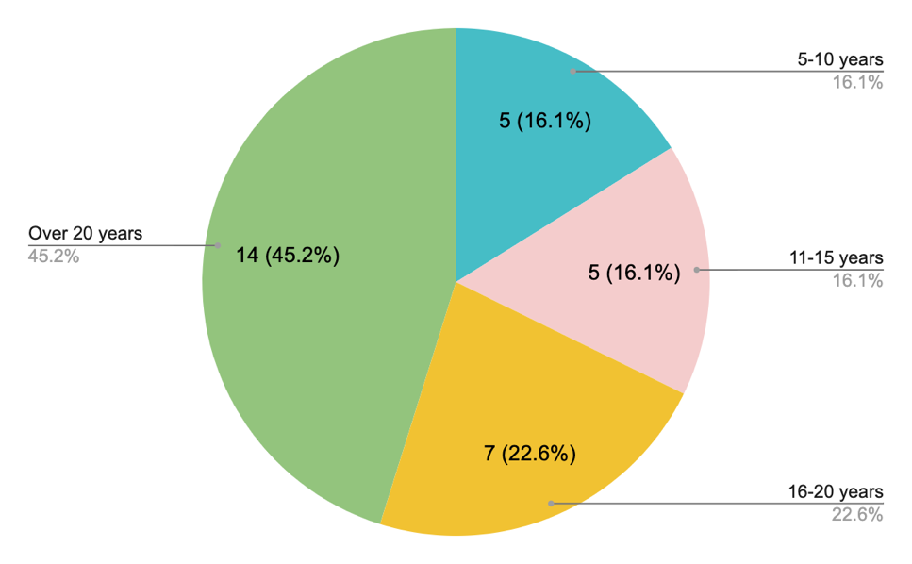

4.3. Stage 1

4.3.1. Number of responses
Twelve participants completed stage one of the study. This represented less than half of all participants. Participation was higher in later stages of the study, low participation in the first stage may have been related to the higher demands on participant time required for this stage. Implications of participant response rates will be discussed in the discussion chapter.

4.3.2. Stage 1a
Thematic analysis was completed using the responses from participants around what the purpose of primary education should be. Initial codes generated from the data (see Appendix F) were sorted and through a process of revisions (see Appendix G), combined into the final themes shown in figure three below.

Figure 3.
Thematic analysis of participant responses to the question ‘What should the purpose of primary education be?’: Final themes and subthemes.

4.3.2.1. Theme 1: To Develop Skills to Support Their Own Development and Wellbeing. This theme relates to the role of primary education in supporting child development, both in terms of human specific developmental outcomes and in relation to supporting overall positive wellbeing. It is made up of three subthemes: to develop character strengths and wellbeing; to promote developmental outcomes; and to develop capacity for self-agency.

The first subtheme relates to character strengths, these are positive aspects of personality which may be highly valued by self or others (Park & Peterson, 2009). To be ‘confident’ (Response 3, see Appendix E) can be considered one such strength and relates to a person’s belief in their own judgements and abilities (Snyder & Lopez, 2001). Primary education should strive to ‘to build physical and intellectual confidence’ (Response 1, see Appendix E), ‘enabl[e] children to learn to be confident human beings’ (Response 2, see Appendix E) and support children ‘to develop confidence as a learner’ (Response 11, see Appendix E). Another character strength is resilience, this involves the ability to keep going, not give up and recover emotionally following challenge, difficulty and/or failure (Goldstein & Brooks, 2013). Primary education should endeavour to ‘develop academic resilience’ (Response 8, see Appendix E) and support children ‘to be resilient’ (Response 10, see Appendix E). Self-regulation and the development of ‘emotional skills’ (Response 6, see Appendix E) can also be considered a positive character strength (Weber & Ruch, 2012). The character strength of self-awareness allows children to ‘understand themselves’ (Response 9, see Appendix E). ‘Get[ting] to know yourself’ (Response 2, see Appendix E) involves children ‘learn[ing] about their own skills and strengths and areas for development’ (Response 5, see Appendix E).

The development of character strengths as described in this first subtheme can support positive wellbeing (Park & Peterson, 2009), allowing children to ‘feel happy in [their] own body’ (Response 2, see Appendix E). Happiness, enjoyment, and positive wellbeing can also be found through activities such as ‘play’ (Response 2, see Appendix E) (Storli & Sandseter, 2019) and ‘be[ing] creative’ (Response 1, see Appendix 1) (Collard & Looney, 2014).

The second subtheme centres on ‘support[ing] developmental outcomes’ (Response 11, see Appendix E) as a purpose of primary education to ‘develop the whole child’ (Response 5, see Appendix E) and ‘to give children a well-rounded start to life’ (Response 11, see Appendix E). This relates to the processes and growth that children go through to develop into adulthood, including the ‘develop[ment] of physical skills, both fine and gross motor’ (Response 11, see Appendix E), as well as the acquisition of emotional, cognitive and language skills. ‘Play’ (Response 2, see Appendix E) executes an important role within this whole child development (Burris & Tsao, 2002). As children grow, they need to ‘learn practical skills and develop problem solving in real life situations’ (Response 9, see Appendix E), such as learning ‘about structuring [their] day’ (Response 2, see Appendix E), as they develop increasing independence in preparation for adolescence and adulthood.

The third subtheme in this area relates to a purpose of primary education being around developing capacity for self-agency. Self-agency relates to the relationship between intentions and future actions, through conscious decision making (Pacherie, 2013). Primary education should support children to develop the skills needed to be ‘able to make choice[s]’ (Response 10, see Appendix E). Through choice and self-direction children should also be able to 'follow some of their own interests’ (Response 1, see Appendix E): a broad and innovative curriculum may ‘spark [such] interest’ (Response 11, see Appendix E). Self-agency allows us to guide the direction of our lives, to an extent, and work towards goals and aspirations (Gecas, 2003).

4.3.2.2 Theme 2: To Support the Acquisition of Knowledge. Primary school education should support children to ‘to build initial academic skills’ (Response 8, see Appendix E) and develop their knowledge through both topic specific knowledge learning and through learning the wider skills needed to acquire such knowledge. This theme is made up of two subthemes: to develop specific academic knowledge and to develop wider skills that support learning processes.

The first subtheme involves the development of specific academic knowledge, particularly that related to ‘skills in reading, writing and mathematics’ (Response 1, see Appendix E). The ‘develop[ment of] basic skills in literacy [and] numeracy’ (Response 12, see Appendix E) is important in supporting future outcomes around employment, social inclusion, and access to resources (Kuczera et al., 2016). It is also important for children to ‘acquire basic cultural knowledge around science, history and geography’ (Response 12, see Appendix E) to broaden their knowledge of the world around them.

The second subtheme moves away from subject specific skills and relates to ‘more generic skills that can apply in different contexts - such as questioning, thinking scientifically [and] being imaginative’ (Response 1, see Appendix E). This subtheme describes how the primary curriculum should equip children with skills and qualities that can support them to learn in, and around, a wide range of situations and topics. This can be described as ‘learning to learn/ study’ (Response 12, see Appendix E). Primary education should ‘encourage children to become independent learners who are curious [and] enjoy learning’ (Response 1, see Appendix E). It should ‘develop independence’ (Response 8, see Appendix E), ‘spark curiosity’ (Response 11, see Appendix E) and ‘allow them to problem solve’ (Response 1, see Appendix E). The curriculum should encourage children to ‘enjoy learning and to feel self-motivated to do so’ (Response 2, see Appendix E).

4.3.2.3 Theme 3: To Develop Skills Needed to Support and Interact with Society. This theme describes the role of primary education in supporting children to develop the skills needed to interact with and support society. Primary education should encourage the development of both the socio-communication skills needed to interact with one another, as well as the wider values and skills needed to contribute to society both now and in the future. This theme was made up of two subthemes: to develop socio-communication skills; and to develop skills needed to be part of and contribute to society.

The first subtheme within this theme relates to supporting children to develop ‘effective communication’ (Response 10, see Appendix E) skills and ‘to begin developing the skills to be social, understand and enjoy friendships’ (Response 2, see Appendix E). Primary education should ‘equip them with skills in communication’ (Response 1, see Appendix E) so that children are able ‘to communicate effectively with a range of people from different backgrounds’ (Response 7, see Appendix E). ‘Learn[ing] how to interact and communicate with others’ (Response 12, see Appendix E) is essential for social connection; information sharing and receiving; and ensuring one’s needs are met (Burnip, 2002). The curriculum should include a ‘focus on developing children's social and emotional skills including how to develop friendships and build positive relationships with others’ (Response 6, see Appendix E). Humans are ‘social beings’ (Response 9, see Appendix E) with interaction with other people a core part of our nature (Berscheid, 2003) and so the primary curriculum should allow children to ‘explore social interactions with their peers’ (Response 4, see Appendix E).

The second subtheme relates to the purpose of education being around developing the skills needed to be part of and contribute to society, both now and in the future. This includes ‘academic skills they need to be part of society’ (Response 4, see Appendix E) as well as those which support tolerance and acceptance of others to ‘promote inclusive values’ (Response 1, see Appendix E). Society needs children to ‘learn how to be alongside other children who have different thoughts, feelings, behaviours and backgrounds to them’ (Response 4, see Appendix E). Teaching children tolerance and acceptance of difference can support positive interactions with others and greater community harmony (Zakin, 2012). Primary education should ‘creat[e] conditions whereby children can develop a global outlook’ (Response 7, see Appendix E) ‘to be knowledgeable about the world around them and beyond’ (Response 10, see Appendix E) and ‘to learn about the wider environment’ (Response 9, see Appendix E). Primary education should also ‘prepare [children] for life as an adult’ (Response 5, see Appendix E) in the many roles this may take, for example ‘citizen, parent and employee’ (Response 3, see Appendix E).

Dilemmas and Reflections Through the Thematic Process. I found it challenging to develop titles for my first and third themes around the purpose of primary education: to develop skills to support their own development and wellbeing; and to develop skills needed to support and interact with society, that fully captured the concepts which they are describing. The first refers to development within and for the individual and the latter relates to development that supports interaction with and for others. The latter is, however, beyond interaction but also the wider actions that primarily benefit human beings and society collectively rather than just the individual. I considered using terms around ‘individualism’ and ‘collectivism’, however I didn’t feel as though the concept of ‘collectivism’ fully captured the social-communication skills development included in the latter theme, which although can be beneficial for a collective group can also be of primary importance to the individual. Human development is complex however, and elements of all of my themes can be considered to support individual and community goals in different situations, arguably the nature of humans as social beings (Berscheid, 2003) means we can’t fully separate the two.

The second theme around the acquisition of knowledge could relate to either of the other two themes, however there wasn’t enough explanation of and justification for ‘why’ the acquisition of knowledge should be a purpose of education within participant responses to determine if this was instead part of one of those themes. I wonder how much the ‘why’ has been considered or whether we assume that knowledge acquisition is a fundamental part of education due to our experiences and societal constructs of education rather than questioning this.

4.3.3. Stage 1b
Based on the proposed purposes of education discussed in stage 1a, participants added seventy suggested items for children to learn at primary school to the collective mind map in stage 1b (see Appendix I). One response was removed from further stages and analysis after discussion with my supervisor due to the possibility of it being misinterpreted (see Appendix I), leaving 69 responses as shown in table three below. The removed comment related to humans being all from one race, and while the author may have had the intention of unity and acceptance within their comment, it may have been misconstrued as diminishing the real experiences of people from minority ethnic groups.

4.4. Stage 2
Seventeen participants completed stage two of the study, where they rated how important each item from the mind map in stage 1b is for children to learn in primary school, on a seven-point Likert scale. Of the participants that responded, all of them rated all 69 of the items. Median Likert scores of responses can be seen in table three below. A score of one represents ‘unimportant for children to learn’ and a score of seven represents ‘very important for children to learn’. Items with a median Likert score of five or higher were included in a thematic analysis of responses.

Table 3.
Suggested items that children should learn at primary school.
 | Item No. |  | Items included in Thematic Analysis (median of five or greater) | Median
 | 1 |  | How to problem solve and approach unfamiliar tasks. | 7
 | 2 |  | To find their own skills and strengths - be they academic or curriculum specific, or vocational or creative. | 7
 | 3 |  | To use their voice effectively and to listen to others. | 7
 | 4 |  | To be able to build on their strengths rather than focus on difficulties only. | 7
 | 5 |  | 'Soft skills' how to relate to others, how to support their own interests, how to learn. They need to understand that learning can be fun, engaging and that it is a reward in itself. | 7
 | 6 |  | How to build relationships with others. | 7
 | 7 |  | Learning how to learn. | 7
 | 8 |  | How to work with others on a range of different tasks. | 6
 | 9 |  | How to approach learning tasks - getting started, keeping going when something is challenging, being independent in learning. | 7
 | 10 |  | To love stories and books, less emphasis on testing reading skills until a genuine interest in engaging with reading/being read to is there. | 7
 | 11 |  | To be inquisitive problem solvers. | 6
 | 12 |  | To be a caring person, developing empathy for others and learning about the world and our history more widely in the widest sense. | 6
 | 13 |  | How to work collaboratively and deal with conflict. | 6
 | 14 |  | Develop independence and curiosity for learning, have the chance to follow their own interests. | 7
 | 15 |  | To understand what it means to feel safe and understand what this looks and feels like. | 7
 | 16 |  | To be creative and try things out without fear of failure. | 6
 | 17 |  | To be a human being - how to relate to others, how to like themselves, how to feel, how to make things, how to have fun, how to play. | 6
 | 18 |  | Independent learning skills - how to be an effective and inquisitive learner. | 6
 | 19 |  | Physical skills both fine and gross motor | 6
 | 20 |  | How to develop and maintain positive relationships and friendships. | 7
 | 21 |  | The skills they need to succeed in life - team work, communication, resilience, problem solving, leadership. | 6
 | 22 |  | To feel secure in oneself as a person, knowing one's strengths and one's worth as an individual, to have a positive narrative about oneself as a learner. | 6
 | 23 |  | How to communicate with others - in class, in public, in the home, formally and informally. To recognise emotions in selves and others. | 6
 | 24 |  | Enabling children to develop their thinking and decision making skills, encouraging them to develop opinions and listen to others P4C, PSHCE and RE, collaborative activities. | 6
 | 25 |  | That getting things right can take time and that you should not stop at the first failure. | 6
 | 26 |  | Curriculum subjects, with an emphasis on spoken language and literacy as the means to access the rest of the curriculum. | 6
 | 27 |  | Learning how to be someone who contributes to their community and society more widely. | 6
 | 28 |  | To listen to, relate to and interact with others including to persuade others, make an argument as well to be reflective in their relationships and take account of others' views. | 6
 | 29 |  | To problem solve to help them cope in life and in school and in work. | 6
 | 30 |  | How to keep oneself healthy both mentally and physically, how to look after self and others. | 6
 | 31 |  | Working on how to manage their emotions and feelings, making sense of the demands on them and how to apply the right approaches/strategies. | 5
 | 32 |  | Physical education should be integral to the school day, preparing children to lead healthy and active lives. | 6
 | 33 |  | Develop foundation skills in reading, writing and maths | 6
 | 34 |  | Academic resilience so they can have better understanding of independence skills as learners. | 6
 | 35 |  | Basic skills in numeracy - how to use and apply the four rules of number to common situations. basic learning in other areas of maths such as shape and measurement. | 6
 | 36 |  | Key topics in geography, history and science taught with an emphasis on both local and national concerns and global perspectives. | 5
 | 37 |  | Practical skills, making and doing, continued past the early years. | 5
 | 38 |  | Overall emotional resilience so they can deal with set-back, and see that practice makes a difference. To help them build resilience for life. | 6
 | 39 |  | To work cooperatively and collaboratively with peers in a non-competitive environment. | 6
 | 40 |  | Making mistakes, tolerating getting it wrong, going back to repair/redo. | 6
 | 41 |  | The skills needed to succeed in life - spanning all areas of development from core education, to motor skills, socioemotional wellbeing, critical thinking, health. | 6
 | 42 |  | Critical thinking skills. | 6
 | 43 |  | How to interact with others individually, within a group and when delivering to an audience. | 6
 | 44 |  | To learn about themselves as people: to develop and adapt their identity in an ever-changing world: especially in relation to new technologies and health developments. | 6
 | 45 |  | To learn the skills and knowledge of particular subjects to learn what they are passionate about and interested in. | 5
 | 46 |  | Applying basic curriculum teaching to real life and creative, collaborative projects and activities. | 6
 | 47 |  | A greater emphasis on life skills such as healthy eating, exercise, not just a short project in year three for example. | 6
 | 48 |  | To consider what social justice issues influence them and the rest of the world - to learn how they can challenge and influence change. | 6
 | 49 |  | An introduction to key themes and practice in music and art, opportunity to have fun and be creative and try new things in these areas. | 6
 | 50 |  | Identity, confidence, dealing with set-backs, building resilience - actually doing it, not just the rhetoric. | 6
 | 51 |  | Resilience and the ability to manage minor conflict, resolve problems independently. | 5
 | 52 |  | Creative project work - holistic approaches to incorporating the curriculum. | 5
 | 53 |  | Curriculum skills like maths, English in interactive ways, starting with what the child can do already rather than using arbitrary made-up age related standards as a starting point. | 5
 | 54 |  | Discover the opportunities that are in the world e.g. inspiring big dreams and belief. | 6
 | 55 |  | The primary curriculum should be less politically motivated as at present and not led by the assessment and accountability regime. | 6
 | 56 |  | A knowledge-rich curriculum ignores the need for a balance of Cognitive Intelligence (IQ), Emotional Intelligence (EQ) and Cultural Intelligence (CQ). So a more balanced curriculum. | 6
 | 57 |  | More about what they are interested in, with the depth to be able to apply that knowledge to real world experiences. | 5
 | 58 |  | Managing conflict, developing self-awareness, mastering their bodies and behaviours. | 5
 | 59 |  | Knowledge about the world through geography, history and science as well as pursue one hobby: playing instrument, completing DT/ Art project as well as competitive sports. | 5
 | 60 |  | They should learn how they best learn, not be tied to the current thinking on which method is best, thinking about maths method in particular. | 6
 | 61 |  | Basic skills in literacy - how to read and write a full page of text fluently and understand what they have read. | 5
 | 62 |  | Improve children's relationship between movement and activity. | 5
 | 63 |  | Mindfulness, meditation, extended opportunities to play, healthy living - including permaculture. | 5
 | 64 |  | Teach games that are better with two or more, fun and engaging, not just PE related, playing cards, board games, provide opportunities to learn to love something before IT takes over. | 5
 |  |  | Items excluded from Thematic Analysis (median of less than five)
 | 65 |  | The primary curriculum should be a higher level framework which is interpreted locally by schools on a longer cycle: Finland has a 10 year curriculum cycle vs. 5 years in UK. | 4
 | 66 |  | To recognize that feelings are transient and fleeting and not to pay too much attention to them but instead pursue activity and develop skills through an activity. | 4
 | 67 |  | To be able to understand and utilise money - budgets, how much things tend to cost. Understanding of mortgages, rent, taxes, bills - basically, how to live. | 4
 | 68 |  | How to take a test without anxiety, change how testing is done so children see it as an opportunity to show what they can do - test them on what they already know when younger. | 4
 | 69 |  | EPs tend to favour learning to learn, dynamic approaches, mediation and ignore domain specific knowledge, diffs with transfer and their own privilege. | 4

4.4.1. Thematic Analysis
Thematic analysis was completed on the 61 included items as shown in table three. These items were used as initial codes in the thematic analysis process; where items were interpreted as including several points, they were separated further (see Appendix L). These codes were combined into final themes as shown in figure four below (see Appendix M for the process of refinement of themes and subthemes).

Figure 4.
Thematic analysis of participant responses to the question ‘What should primary school children learn?’: Final themes and subthemes.

Creativity
Opportunities to make things and explore through practical activities, music, and arts.

Physical Health and Development

Motor Skills
Fine and gross

Literacy
Foundation skills in reading and writing as a means to access the wider curriculum.

Keeping Healthy Including healthy eating and exercise

Maths
Foundation skills in maths, including number, space, shape, and measure.
Understanding the World
At both a local and global level.

Material world
Developing an in depth understanding through geography and science.

People and animals
Opportunities to understand communities, religions, and philosophies, as well as developing community relations. Understanding of people and animals through science and history.

Interpersonal development

Exploring personal interests
Opportunities to explore and excel in areas of personal interest.

Maintaining and understanding positive relationships
Including conflict resolution, developing empathy and how to relate to others and teamwork.

Communicating effectively with others
Formally and informally; one to one, in a group and to an audience. Listening skills.

Intrapersonal development

Self-awareness and understanding identity.
Self-esteem and confidence

Emotions
Both recognition and management

Resilience
Both personal and academic

Metacognition
Problem solving, critical thinking skills and learning how to learn.
4.4.1.1. Theme 1: Interpersonal Development. Interpersonal means relating to relationships between individuals (Park et al., 2017) Interpersonal skills involve those that support communication and interaction with others. This theme includes the two subthemes of: maintaining and understanding positive relationships; and communicating effectively with others.

The first of these subthemes focusses on relational skills: ‘how to develop and maintain positive relationships and friendships’ (Item No. 20, Table 3), ‘to listen to, relate to and interact with others’ (Item No. 28, Table 3); ‘how to relate to others’ (Item No. 5 & 17, Table 3); ‘how to build relationships with others (Item No. 6, Table 3). There are several components involved in the development and maintenance of positive relationships, one of which is ‘managing conflict’ (Item No. 58, Table 3). The development of relational skills allows children to ‘work cooperatively and collaboratively with peer[s]’ (Item No. 39, Table 3) and the ability to ‘deal with conflict’ (Item No. 13, Table 3). Conflict serves different purposes at different stages of child development, however social emotional learning around areas such as perspective taking, emotional regulation and empathy can support conflict resolution (Sandy, 2014).

‘Team work’ (Item No. 21, Table 3) and ‘work[ing] with others on a range of different tasks’ (Item No. 8, Table 3) can also present opportunities for children to learn ‘leadership’ (Item No. 21, Table 3) skills: the success of working together in a group on ‘collaborative activities’ (Item No. 24 & 46, Table 3) is often supported by individuals taking on different roles (Tuckman, 1965). The development of relational skills doesn’t only support group collaboration skills but also supports children to develop meaningful relationships with others. Part of learning ‘how to build relationships with others’ (Item No. 6, Table 3) involves ‘developing empathy for others’ (Item No. 11, Table 3), ‘be[ing] reflective in their relationships, and tak[ing] account of others’ views’ (Item No. 28, Table 3). Empathy allows us to understand and feel the emotions of another person (Smith, 2017). It plays an important role in the development of relationships through shared connection and the promotion of caring behaviours towards one another (Betzler, 2020; Gulin, 2020).

The second subtheme in the wider theme of ‘Interpersonal Development’, describes learning how to communicate effectively with others across a wide range of situations: ‘how to communicate with others: in class, public and at home; formally and informally’ (Item No. 23, Table 3); ‘how to interact with others, individually, in a group and delivering to an audience.’ (Item No. 43, Table 3). Learning skills around ‘communication’ (Item No. 21, Table 3) and how ‘to use their voice effectively’ (Item No. 3, Table 3) aims to allow children to communicate effectively for a wider range of purposes ‘including to persuade others [and to] make an argument’ (Item No. 28, Table 3). Communication skills impact on all areas of a child’s life, including making friendships, getting their needs met, and the development of academic skills (Dockrell & Howell, 2015) as well as supporting skills needed for adulthood such as employment (Mishra & Mishra, 2020) and accessing services (Shady et al., 2022). Learning how to ‘listen to others’ (Item No. 3, 24 & 28) is an important component of effective interpersonal communication; listening provides the information needed to develop conversation and respond appropriately to others (Kirkgöz, 2018).

Dilemmas and Reflections Through the Thematic Process. Interpersonal development felt like a particularly strong theme within my data and covered a broad range of areas. I originally created five subthemes as part of this theme: maintain and understanding positive relationships (including conflict resolution); communicating effectively with others (formally and informally, one to one, and in a group); teamwork; listening skills; and developing empathy and how to relate to others. When I reviewed my themes with another TEP, we noticed that this theme appeared to be broken down into smaller separate subthemes whereas other themes, such as ‘Understanding the World’, had fewer broader subthemes, suggesting a lack of consistency in my approach to theming. When reviewing themes as part of a thematic analysis it is important to explore a theme’s external heterogeneity, that is whether each theme (or subtheme) is describing something different from one another (Braun & Clarke, 2006; Patton, 1990). On reflection, I felt that actually many of the subthemes within the overarching theme of ‘Interpersonal Development’ were describing the same thing and weren’t distinct from one another. As a result of this, I recategorsied the subthemes of ‘teamwork’ and ‘developing empathy and how to relate to others’ as part of the wider existing subtheme of ‘maintain and understanding positive relationships’. I felt that both of these areas were relational in nature and therefore fit into this subtheme. I also moved ‘listening skills’ into the wider subtheme of ‘communicating effectively with others’, as I feel that such skills are an important component of effective communication.

4.4.1.2. Theme 2: Literacy. Literacy relates to the skills of reading and writing. In this context there is a focus on the ‘develop[ment of] foundation skills’ (Item No. 33, Table 3), that is the ‘basic skills in literacy’ (Item No. 61, Table 3) that act ‘as a means to access the rest of the curriculum’ (Item No. 26, Table 3). This would suggest a strong focus and use of literacy skills in other curriculum areas. There should be a focus on developing skills that build on ‘what the child can already do [rather than teaching within the parameters of] age-related standards’ (Item No. 53, Table 3). An intense focus on meeting age-related standards may lead to superficial learning of literacy skills rather than securing and developing on children’s understanding (Reay, 2017). Literacy teaching should foster ‘a love [of] stories and books, [and] a genuine interest in reading’ (Item No. 10, Table 3). There is evidence that interest in reading can develop self-confidence in literacy and promote the acquisition of literacy skills (Marhayani, 2024).

4.4.1.3. Theme 3: Maths. Maths (or mathematics) involves skills in manipulating and understanding the value of numbers, as well as an understanding of shape, space, and measurement. Again, in this context the focus is on the ‘develop[ment of] foundation skills’ (Item No. 33, Table 3). Understanding ‘basic skills in numeracy – how to use and apply the four rules of number to common situations and basic learning in other areas of maths such as shape and measurement’ is important for many areas of life including understanding and managing money and finances, and in the development of technology (Budd, 2015). Like with literacy skills, a desire to maintain age-related standards and national testing outcomes can lead to teaching of mathematical skills without understanding of the core underlying concepts; this can limit progression in, and wider application of, the topic (Reay, 2017). As such, there should be a focus on developing mathematical understanding that develops from ‘what the child can already do [rather than teaching within] arbitrary age-related standards’ (Item No. 53, Table 3).

4.4.1.4. Theme 4: Creativity. Creativity can involve thinking in different ways, generating new ideas and solving problems (Collard & Looney, 2014). It is associated with positive wellbeing and future social and economic innovation (Collard & Looney, 2014). This theme relates to practical opportunities for, and nurturing of, creativity: ‘applying basic curriculum teaching to real life and creative, collaborative projects and activities’ (Item No. 46, Table 3); ‘creative project work - holistic approaches to incorporating the curriculum’ (Item No. 52, Table 3). There are many ways ‘to be creative’ (Item No. 16, Table 3). For example, exploring ‘how to make things’ (Item No. 17, Table 3) with ‘practical skills, making and doing, continued past the early years’ (Item No. 37, Table 3). Creativity can also be found within music, art, and design. Children should experience ‘key themes and practice in music and art, opportunity to have fun and be creative and try new things in these areas’ (Item No. 49, Table 3). They should have opportunities to engage in creative activities such as ‘playing [an] instrument [or] completing [a] DT/ Art project’ (Item No. 59, Table 3).

4.4.1.5. Theme 5: Metacognition. Metacognition involves an understanding of how knowledge is structured as well as strategies for monitoring one’s own learning (Lai, 2011). The development of these skills is thought to promote learning in a wide range of situations and support children to learn independently rather than simply retain specific factual knowledge (Lai, 2011). This theme relates to ‘learning how to learn’ (Item No. 5 & 7, Table 3), so that children can develop ‘independent learning skills - how to be an effective and inquisitive learner’ (Item No. 18, Table 3). They should learn ‘how to approach learning tasks - getting started, keeping going when something is challenging, being independent in learning’ (Item No. 9, Table 3) so that they can ‘develop independence and curiosity for learning’ (Item No 4., Table 3). Adults should recognise and allow children to ‘learn how they best learn, not be tied to the current thinking on which method is best’ (Item No. 60, Table 3).

The use of metacognitive strategies should ‘enabl[e] children to develop their thinking and decision making skills’ (Item No. 24, Table 3) and their ‘critical thinking skills’ (Item No. 41 & 42, Table 3). Metacognitive skills have been found to significantly impact on the development and use of critical thinking skills (Magno, 2010). Similarly, metacognitive strategies can help children develop ‘problem solving’ (Item No. 21, Table 3) skills. Children with poor metacognitive skills often have difficulties with problem solving: Güner and Erbay (2021) found that metacognitive strategies play an important role in effective problem solving. The development of metacognition in children can support them to become ‘inquisitive problem solvers’ (Item No. 11, Table 3) who know ‘how to problem solve and approach unfamiliar tasks’ (Item No. 1, Table 3). It is important to teach children how ‘to problem solve to help them cope in life and in school and in work’ (Item No. 29, Table 3).

Dilemmas and Reflections Through the Thematic Process. The inclusion of problem-solving skills within the theme of metacognition was questioned by my research supervisor, as problem-solving skills can be argued not to be metacognitive. However, given the evidence around how metacognitive strategies play a significant role in problem-solving processes (Grüner & Erbay, 2021), I felt that it made sense to include problem-solving within this theme. Some studies have even found that problem-solving mediates the impact of metacognition on learning performance (Zhao et al., 2019). The same applied to critical thinking skills, which arguably not a direct metacognitive strategy, is supported by strong metacognitive skills (Magno, 2010). Metacognition support wider learning across a range of subjects and topics, at least partly through its impact on these processes.

4.4.1.6. Theme 6: Physical Health and Development. The theme of physical health and development relates to the development of physical skills as well as physical wellbeing. It is made up of two subthemes: motor skills and keeping healthy. The development of ‘motor skills’ (Item No. 41, Table 3) are important in supporting children with ‘mastering their bodies’ (Item No. 58, Table 3). They are made up of ‘both fine and gross motor’ (Item No. 19, Table 3) skills. Fine motor skills are important in the development of handwriting, drawing cutting, crafting, and dressing (Syafril et al., 2018). Gross motor skills support movement, balance and participation in physical activity and sport (Barnett et al., 2016). There is evidence of a correlation between motor skills and academic outcomes (Carlson et al., 2013; Piek et al., 2008).

Children should also learn ‘how to keep oneself healthy’ (Item No. 30, Table 3). This subtheme relates to physical health, whereas mental health and wellbeing are captured within the theme of intrapersonal development. To support positive physical ‘health’ (Item No. 41, Table 3) there should be ‘a greater emphasis on life skills such as healthy eating [and] exercise [in the curriculum], not just a short project in year three for example’ (Item No. 47, Table 3). ‘Physical education should be integral to the school day, preparing children to lead healthy and active lives’ (Item No. 32, Table 3). Physical activity is also positively associated with improved academic functioning (Sibley & Etnier, 2003) and wellbeing (Kliziene et al., 2021).

4.4.1.7. Theme 7: Exploring Personal Interests. Children should have the chance to learn ‘more about what they are interested in’ (Item No. 57, Table 3) and be able to ‘discover the opportunities that are in the world [to] inspire[e] big dreams and belief’ (Item No. 54, Table 3). They should be able ‘to find their own skills and strengths - be they academic or curriculum specific, or vocational or creative’ (Item No. 2, Table 3) and ‘learn what they are passionate about and interested in’ (Item No. 45, Table 3). Educators should help children to learn ‘how to support their own interests’ (Item No. 5, Table 3), and provide children with the ‘chance to follow their own interests’ (Item No. 14, Table 3). Children are usually more engaged in learning when it is relevant to their own interests (Assor et al., 2002). Child led learning around pupils’ own interests has also been shown to promote the development of independence, social and emotional skills (Smith, 2015).

Dilemmas and Reflections Through the Thematic Process. When I first developed this theme, I gave it the title of self-actualisation. Self-actualisation can be described as involving the realisation and achievement of one’s potential (Maslow, 1962). I originally thought that perhaps the purpose of exploring personal interests was around this achievement of potential. However, after further reflection and discussion with others, I felt that this seemed both oversimplistic and overambitious as an all-encompassing purpose. Although the opportunities to explore interests can lead to the identification and fostering of skills and talent, this is not always the case. Would we say that someone had failed in exploring a personal interest if they tried, or even tried and enjoyed, a certain activity but weren’t very good at it? Can we not instead promote exploring personal interests simply for the humanistic value of enjoying them? Engaging in personal interests can result in many positive psychological concepts such as happiness (Chaplin, 2009), motivation (Assor et al., 2002) and resilience (Gilligan, 1999) without achieving self-actualisation. This reflection led me to change the title of the theme to ‘exploring personal interests’ as I felt it captured more of these potential outcomes and purposes.

4.4.1.8. Theme 8: Understanding the World. Understanding the world is important in relation to ‘both local and national concerns and global perspectives’ (Item No. 36, Table 3). This theme is made up of two subthemes which encompass different parts of our world: people and animals, and the material world. ‘Knowledge about the world through geography, history and science’ (Item No. 59, Table 3) includes the study of people and other animals. At a scientific level this relates to the biology of living things. ‘Learning about the world and our history more widely’ (Item No. 12, Table 3), along with ‘philosophy’ and ‘religion’ (Item No. 24, Table 3) can help children ‘to consider what social justice issues influence them and the rest of the world [and] to learn how they can challenge and influence this change’ (Item No. 48, Table 3). This supports the development of ‘cultural intelligence’ (Item No. 56, Table 3) and helps children to understand ‘how to be someone who contributes to their community and society more widely’ (Item No. 27, Table 3). Learning about social justice issues as well as different cultures and communities can help children to understand and value diversity (Hawkins, 2014).

Learning about the material world includes the development of ‘knowledge about the world through geography and science’ (Item No. 59, Table 3). Again, ‘key topics in geography and science [should be] taught with an emphasis on both local and national concerns and global perspectives’ (Item No. 36, Table 3). Encompassing the areas of science such as physics and chemistry with geography can help to develop our understanding of the physical aspects of our world, in relation to many important issues, for example climate change. The subjects also continue to interrelate when considering phenomena beyond planet Earth and help us to understand a world wider than just our planet. Children are naturally curious and strive to develop theories about their world through their experiences (Gopnik & Wellman, 2012), however children will not be able to experience all parts of the physical world and as such they will need further opportunities to develop this knowledge through research and instruction.

4.4.1.9. Theme 9: Intrapersonal Development. Intrapersonal means that which takes place within an individual’s mind (Park et al., 2017) and in this context is related to emotions and understanding of self. Both peer relationships and educational outcomes have been found to be associated with intrapersonal qualities in children (Park et al., 2017). Intrapersonal development covers a wide range of areas and four subthemes have been identified: self-awareness and understanding identity; self-esteem and confidence; emotions; and resilience. ‘Developing self-awareness’ (Item No. 58, Table 3) can relate to many areas of a child’s life. Children can become aware of their own wellbeing and how to support it; ‘how to keep oneself healthy mentally [and] how to look after [them]self’ (Item No. 30, Table 3). Children can also develop their awareness of ‘knowing one’s strengths’ (Item No. 22, Table 3) and what they are good at. Children may need support to develop and explore their understanding of their own ‘identity’ (Item no. 50, Table 3) or identities; ‘to learn about themselves as people: to develop and adapt their identity in an ever-changing world’ (Item No. 44, Table 3). Developing self-awareness around one’s mental state, strengths, limitations, and identities can support positive wellbeing (Brown & Shay, 2021; Cloninger, 2006).

Self-esteem relates to a person’s opinion of their intrinsic worth (Orth & Robins, 2014). Self-confidence relates to a person’s belief in their own judgements and abilities (Snyder & Lopez, 2001). The development of self-esteem and ‘confidence’ (Item No. 50, Table 3) allows children ‘to feel secure in oneself as a person, knowing one's strengths and one's worth as an individual, to have a positive narrative about oneself as a learner’ (Item No. 22, Table 3). Self-esteem and confidence can occur differently across different areas of a child’s life, including socially and academically. Through the development of self-esteem and confidence children can feel able to ‘develop opinions’ (Item No. 24, Table 3) and learn ‘how to like themselves’ (Item No.17, Table 3).

Children need to learn both how ‘to recognise emotions in [them]selves and others’ (Item No. 32, Table 3) and ‘how to manage their emotions and feelings, making sense of the demands on them and how to apply the right approaches/strategies’ (Item No. 31, Table 3). Children need support through coregulation and the development of emotional literacy to understand and learn 'how to feel’ (Item No. 17, Table 3), including ‘to understand what it means to feel safe and understand what this looks and feels like’ (Item No. 15, Table 3). The first step in supporting ‘socioemotional wellbeing’ (Item No. 41, Table 3) and learning is ensuring that children feel safe to explore their emotions (Shean & Mander, 2020). Once children can understand how they feel, they can then learn strategies and techniques involved in ‘mastering their behaviours’ (Item No. 58, Table 3) through emotional regulation. The term ‘Emotional Intelligence’ (Item No. 56, Table 3) has been coined by Goleman (1995) to describe the ability to understand, perceive and manage emotions. Some research has found strong relationships between emotional intelligence and academic outcomes for children (Billings et al., 2014).

‘Resilience’ (Item No. 21, 50 & 51, Table 3) describes the ability to keep going, not give up and recover emotionally following challenge, difficulty and/or failure (Goldstein & Brooks, 2013). Resilience can relate to both ‘academic’ (Item No. 34, Table 3) and personal situations. Children should be supported to develop ‘overall emotional resilience so they can deal with set-back[s], and see that practice makes a difference. To help them build resilience for life’ (Item No. 38, Table 3). Resilience can involve ‘dealing with setbacks’ (Item No. 50, Table 3), ‘making mistakes, tolerating getting it wrong, going back to repair/redo’ (Item No. 40, Table 3) ‘and keeping going when something is challenging (Item No. 9, Table 3). Children who are more resilient are more likely to ‘try things out without fear of failure’ (Item No. 16, Table 3), understand ‘that getting things right can take time and that you should not stop at the first failure’ (Item No. 25, Table 3) and ‘to be able to build on their strengths rather than focus on difficulties only’ (Item No. 4, Table 3).

Dilemmas and Reflections Through the Thematic Process. When I was beginning to sort my codes into themes, I found that there were lots of codes related to resilience. It felt as though the concept of resilience was strongly represented in my data and this led me to initially categorise ‘resilience’ itself as a full theme. When I went back through my themes to refine them, I further considered whether ‘resilience’ was a stand-alone theme in itself. I considered the theme’s external homogeneity, as described in the thematic analysis method by Braun and Clarke (2006) and came to the conclusion that it could not be categorised as something distinct from intrapersonal development. Reflecting on the definition that I have used of intrapersonal development - relating to that which take place within an individual’s mind (Park et al. 2017) and within the context of emotional and personal development, resilience appears to fit into this larger theme.

4.5. Stage 3
Seventeen participants completed stage three of the study, where they rated how important each theme and subtheme generated from the thematic analysis completed in stage two is for children to learn in primary school, on a seven-point Likert scale. Median Likert scores of responses for each theme and subtheme (shown in italics) can be seen in table four. A score of one represents ‘unimportant for children to learn’ and a score of seven represents ‘very important for children to learn’. All themes and subthemes had a median Likert score of greater than five, indicating a consensus, and so represent a final output of the study: which areas of learning do a consensus of my participants believe are important for primary school aged children to learn about at school?

Table 4.
Participants’ rating of themes around what children should learn at primary school.

Themes  and Subthemes | Median
Interpersonal Development: Maintaining and understanding positive relationships; and Communicating effectively with others. | 7
Maintaining and understanding positive relationships: Including conflict resolution, developing empathy and how to relate to others and teamwork. | 7
Communicating effectively with others: Formally and informally; one to one, in a group and to an audience. Listening skills. | 7
Literacy: Foundation skills in reading and writing as a means to access the wider curriculum. | 7
Maths: Foundation skills in maths, including number, space, shape and measure. | 7
Creativity: Opportunities to make things and explore through practical activities, music, and arts. | 6
Metacognition: Problem solving, critical thinking skills and learning how to learn. | 7
Physical Health and Development: Motor skills and Keeping Healthy. | 7
Motor Skills: Fine and gross | 6
Keeping Healthy: Including healthy eating and exercise | 6
Exploring personal interests: Opportunities to explore and excel in areas of personal interest. | 7
Understanding the World: At both a local and global level. People and animals; and the Material world. | 6
People and animals: Opportunities to understand communities, religions, and philosophies, as well as developing community relations. Understanding of people and animals through science and history. | 6
Material world: Developing an in depth understanding through geography and science. | 6
Intrapersonal development: Self-awareness and understanding identity; Self-esteem and confidence; Emotions; and Resilience. | 6
Self-esteem and confidence | 6
Emotions: Both recognition and management. | 6
Resilience: Both personal and academic. | 6
Self-awareness and understanding identity | 6

Chapter 5. Discussion

5.1. Introduction
This research focuses on key areas of learning for primary school aged children. In this chapter, I will firstly discuss what my participants felt that the purpose of primary education should be and how this relates to the purpose of the current primary national curriculum. Secondly, I will explore, based on these purposes, what my participants believe children should be learning at primary school. I will then consider who and what these findings may impact on, and the strengths and limitations of this piece of research. Finally, I will discuss the possible next steps in developing this research and applying the findings.

5.2. Research Question One: What do a sample of academics and professional psychologists working with primary school aged children in England believe that the purposes of primary education should be?
In response to my first research question, three themes were identified around participant’s views on what the purposes of primary education should be: to develop skills to support their own development and wellbeing; to support the acquisition of knowledge; and to develop skills needed to support and interact with society (see Figure 3). I have explored each theme below by relating the purposes identified to research to unpick the possible benefits and rationale behind each purpose. I have also critically compared these purposes to that of the current primary curriculum in England to explore how these relate to the structures currently in place. Finally, I have compared these purposes with those of primary aged curricula in other UK nations and those suggested by other research in England. Whilst sharing many cultural similarities and values, the other countries of the UK have divergent curricula to that of England (Sibieta & Jerrim, 2021). It is interesting to reflect on how curricula with differing purposes may have worked for these countries and how the proposed purposes within this research align with their curricula.

5.2.1. Theme 1: To Develop Skills to Support their own Development and Wellbeing
The first purpose identified included a subtheme centred on wellbeing and character strengths, such as confidence, resilience, self-regulation, and self-awareness. Understanding of self has been a frequent theme in the philosophy of education, as far back as the teachings of Socrates (Noddings, 2018). Some character strengths have been found to be associated with life-satisfaction and wellbeing, for example: gratitude, hope, zest, curiosity, and love (Park & Peterson, 2009). Support to develop such character strengths could help to counteract the rising incidence of poor wellbeing among children (The Children’s Society, 2023) discussed earlier in this thesis. Resilience, self-regulation, self-awareness, and self-confidence can also promote positive wellbeing (Brown & Shay, 2021; Cloninger, 2006; Noble & McGrath, 2011), and can be enhanced through creative activities (Collard & Looney, 2014), access to nature (Rocca, 2022) and positive relationships (Noble & McGrath, 2011). Positive wellbeing in turn is associated with positive academic outcomes within primary education (Miller et al., 2013). The DfE (2013) state that the current primary curriculum in England should promote moral and mental wellbeing. Although wellbeing and character strengths aren’t covered in the national curriculum, separate relationships, and health education guidance (DfE, 2019a) sets out a need for children to understand what is meant by good wellbeing, and aims to promote the development of character strengths.

Decisions around which characteristics to emphasise within individuals have been criticised, and Banicki (2014) argues that areas of personality that are promoted as character strengths are situated in Western cultural ideology, despite claiming to be universal. Some may feel that this isn’t a particular issue within a Western educational system, however, in a culturally diverse society, such as England, does this risk marginalising those from other backgrounds? The idea of character strengths focuses on within-person traits, again this may be in response to individualistic, Western ideologies (Banicki, 2014). I think that while this doesn’t mean that the idea of character strengths needs to be completely dismissed, they do need to be approached with cultural sensitivity. This links back to the discussion around a more tailored and adaptable curriculum to meet the needs of different children. The prescriptive nature of the national curriculum may limit opportunities for this at present. The current national curriculum in England has been criticised for presenting a monocultural world view centred around those from a white, Anglican background (Moncrieffe et al., 2020). This conflicts with evidence showing that students benefit academically from having their own experiences mirrored in their curriculum (Moncrieffe et al., 2020), the current content of the curriculum therefore creating a potential disadvantage for some ethnic groups. In my own experience as a teacher, curriculum content based on non-Anglocentric cultures, has often felt tokenistic and I myself have not always had the experience or understanding of other cultures in order to effectively present such content.

Moving back to the debate around character strengths: does focusing on individuals at this level ignore the impact of environment and experience which I personally also believe has a significant impact on wellbeing? Or does it help us to proactively prepare individuals for an environment that we can’t always control? I believe that there needs to be a balance between preparing children for such an environment while also actively seeking to change that environment in a positive way. This relates back to the debate around education creating a submissive, compliant population that serves the more powerful few (Bowles & Gintis, 1976). Character strengths could be used as a tool to promote conformity by focusing only on specific ‘strengths’. However, positive psychologists do encourage all strengths to be built upon and developed, recognising that these will be different for different individuals (Park & Peterson, 2009). Although, it is still worth considering which areas are conceptualised as strengths and what values these are based on.

The second subtheme identified describes supporting developmental outcomes including emotional, cognitive, language and physical skills to promote the development of the whole child. This aligns with the DfE (2013) purpose of ‘promot[ing] the spiritual, moral, cultural, mental and physical development of pupils at the school and of society’. However, although this is an aim of the current primary curriculum, it can be argued that the current curriculum neglects the development of the whole child in favour of focusing on the acquisition of core academic skills (Boyle & Bragg, 2006; Ogier, 2022). There is a stark contrast when children move from the EYFS curriculum (DfE, 2023c), which has areas such as social and emotional and language development as central themes, to that of the primary curriculum (DfE, 2013). Even within cognitive development, the intense focus on knowledge retention in the current curriculum may not aid the evolution of cognitive processes (Reay, 2017).

The idea of developing the ‘whole child’ is vague and difficult to define. Dewey (1902) described education as synonymous with growth, and that the purpose of growth is more growth, in the same way that the purpose of life is more life. Whilst criticised by many for such ambiguity, Dewey (1902) was concerned that the purpose of education often became beyond the interest of the individual themselves and towards some greater good. Instead, he argued that education should foster greater interest and experience in an area, and ultimately in more personal growth.
The whole child, and such ‘growth’ towards its development, is a complex concept and will be highly dependable on the individual (Noddings, 2018). This does, however, make it harder to define, teach and measure within educational systems. This then becomes difficult to implement within high-accountability educational systems, as is the case for the current national curriculum (Noddings, 2018). While such accountability is in place to raise standards of education and promote consistency, they also serve to limit the content of and the pedological approaches available to deliver the curriculum. There is evidence that accountability associated with high stakes testing limits some types of learning including conceptual learning and creativity (Sahlberg, 2008). In Finland, a country often praised for its successful education system (Morgan, 2014), greater collective responsibility and trust between schools and communities has improved educational outcomes (Sahlberg, 2008).

The final subtheme within this area relates to a purpose of primary education being around developing capacity for self-agency. Self-agency relates to the relationship between intentions and future actions, through conscious decision making (Pacherie, 2013). Manyukhina & Wyse (2019) investigated learner agency across curricula in high performing OECD countries. They identified three curriculum types: knowledge-based, skills-oriented, and learner-centred. The English national curriculum was described as knowledge-based, with the acquisition of a high level of prescriptive knowledge a primary outcome, and a lack of focus on wider generic skills, values, or attitudes. They found little focus on the child as an agent in their own learning or on learning processes. They argue that this lack of learner agency situates educators in a position of authority with the role of transmitting knowledge onto their students (Manyukhina & Wyse, 2019).

Freire (1970) criticises this ‘banking concept of education’ where teachers are seen as the gatekeepers to information and hold an imbalance of power. The lack of curriculum content that is tailored to the child’s strengths, interests and experiences may lead them to not be able to find personal relevance in the curriculum, to feel unmotivated, and does not help to develop their sense of agency (Manyukhina & Wyse, 2019). Dewey (1902) also emphasises a need for education to be interesting and meaningful for children in order for it to be purposeful and support their development. While this contrasts with the ideas of Bruner (1979) who argued that learning is intrinsically motivating in itself, research has consistently found learning to instead be supported by association with personal interests (Assor et al., 2002; Hoyt-Oukada, 2003; Kirby, 2019). I wonder if the idea of learning being intrinsically motivating is more relevant to those individuals who find it easy to succeed in learning. That being the opportunities for learning presented by their curriculum, which will likely be more suitable for some than others. It may actually be the success within learning that is intrinsically motivating rather than the learning itself, and more challenge in learning may instead lead to frustration. There is evidence that a balance between challenge and achievability promotes learning and positive affect towards learning in areas such as mathematics (Schweinle et al., 2006).

5.2.2. Theme 2: To Support the Acquisition of Knowledge
The second theme that was identified as a desired purpose of primary education was to support the acquisition of knowledge. This theme is more in line with the structure and purpose of the current English primary national curriculum which is heavily knowledge based (Manyukhina & Wyse, 2019). Elements of this theme could relate to preparation for adulthood and contributing to society as described in the theme: ‘To Develop Skills Needed to Support and Interact with Society’. Some responses specifically related to this for example ‘to teach children the academic skills they need to be part of society’ (Response 4, see Appendix E). However, many did not explicitly explain why the acquisition of knowledge and academic skills are important. This is one of the limitations of a free response questionnaire rather than a more interactive data collection method such as an interview or focus group where participant’s responses could be explored further. As well as to prepare for adulthood, the acquisition of knowledge can help children to understand their world better (Lingard et al., 2008) and make informed choices (Siegler, 1991); and can spark interest, enjoyment, and curiosity (Wade & Kidd, 2019).

This theme was made up of two subthemes: the first subtheme was around the acquisition of specific academic knowledge in areas such as literacy, maths, science, history, and geography. The second is around general skills that support learning across a range of subjects and situations, such as problem solving, questioning, and monitoring of own learning. Cattel (1963) describes two types of intelligence: crystallised and fluid. Crystallised intelligence relates to specific acquired knowledge, whereas fluid intelligence describes the related supporting processes (Cattel, 1963). Cattel’s (1987) Investment Theory suggests that fluid intelligence supports the development of crystallised intelligence over time and supporting evidence has been found for this process in learning of children (Thorsen et al., 2014). The current national curriculum focuses on instructional learning of specific knowledge (Manyukhina & Wyse, 2019) and could be argued to neglect these more general learning skills. However, others argue that teaching of domain specific knowledge is highly effective and that instructional strategies should be promoted (Tricot & Sweller, 2014); it is likely that both types of learning have their advantages (Siegler, 1991).

Intelligence is often conceptualised as a fixed inherent quality that can be accurately measured; however, this presents as a contentious area of debate (Schlinger, 2003). In my own view, our understanding of intelligence is often determined around individual educational success, and this largely depends on what we are teaching within our education systems and how this is measured. I believe that the concept of intelligence is socially constructed and highly correlated with educational outcomes in areas which are also socially constructed dependent on the values of a specific society. This concept has been used in the past to justify social inequality in society (Chitty, 2007). As a result of this, value is put on areas of inclusion within educational curricula whereby success in these areas is equal to intelligence. Where the purpose of education is to develop knowledge and promote this ideas of intelligence, more traditional academic areas of learning will then be favoured in order to achieve this goal.

How would our understanding of intelligence, be changed if areas of learning in the curriculum were also to change? I would argue that incorporating other areas of learning within the curriculum would increase their perceived value in society and possibly challenge existing conceptualisations of intelligence. Spearman (1904) developed the idea of intelligence in the early 20th century as a measurable phenomenon. Interestingly, he felt that intelligence testing had no place in schools as the purpose of education should be to draw out the best of children’s abilities rather than set a limit on these (Spearman, 1930). Intelligence testing, however, quickly became concerned with determining which children should be excluded from the newly implemented offer of universal education in England, through the work of Burt (1909). Standardised intelligence tests continue to be used by some within the educational psychology profession to determine appropriate educational provision for children (Atkinson et al., 2022). Burt (1909) and others also used the concept of innate intelligences to justify racial and socioeconomic inequalities within English society (Chitty, 2007). Some psychologists have attempted to conceptualise other kinds of intelligence, such as emotional intelligence (Goleman, 1995), however, these may be seen as an aside to the central concept of intelligence. Situating other areas of skill as an ‘intelligence’ also risks these areas being understood as innate, fixed traits and could discourage individuals from pursuing such skills where they find this more difficult.

5.2.3. Theme 3: To Develop Skills Needed to Support and Interact with Society
The final theme identified among participants’ views on the purpose of primary education was to develop the skills needed to support and interact with society. The first subtheme within this relates to the specific development of socio-communication skills. Socio-communication skills are not explicitly mentioned within the purposes of the current primary national curriculum, except for within the English programme of study where the purpose includes the communication of ideas and emotions (DfE, 2013). However, the curriculum for English only includes communication through spoken language and writing and does not cover other forms of communication such as non-verbal communication (DfE, 2013). Relationships education, which has been statutory since 2020, does cover many interpersonal skills relating to the development and maintenance of relationships with others (DfE, 2019a).

There is no specific guidance on how often relationships education should be taught and some research suggests that teaching time is limited (Willis & Wolstenholme, 2016) and variable (Barnard et al., 2017) potentially due to a stronger focus on externally assessed subjects (Boyle & Bragg, 2006). It is not clear if the promotion of interpersonal skill development has improved since relationships education became compulsory in primary schools; some schools may incorporate interpersonal skills among other related subjects making it potentially harder to assess the extent of inclusion of this area within the curriculum. Even with the inclusion of relationships education within the wider primary curriculum, there only seems to be a small focus on socio-communication skills compared to other areas such as the acquisition of subject specific knowledge (Manyukhina & Wyse, 2019).

The second subtheme in this area, focuses on the skills needed to contribute to, and be part of, society. Similarly, the current primary national curriculum aims to prepare children for the responsibilities of adult life. Part of this includes the development of skills that will support employment and the wider economy. Academic skills are needed to eventually gain qualifications that confer eligibility for employment and literacy and numeracy skills are also highly important skills for success in the workplace (Kuczera et al., 2016). Elements of PSHE also prepare students for adult life and have a positive impact on the economy through fostering beneficial employment skills (Barnard et al., 2017). While the current national curriculum may prepare children well to achieve later qualifications, it could be argued to neglect focus on many of these ‘soft’ skills (Barnard et al., 2017).

A focus on workplace skills within any curriculum, however, has been criticised by Bowles & Gintis (1976) as simply preparing individuals for future subservience without real power and control over their lives. Society is wider than just employment and individuals also contribute to their society through culture, including art, music, and sport (Wheatley & Bickerton, 2016); altruism (Cohen, 1992); innovation (Ahlstrom, 2010); morality and social norms (Frerichs & Münch, 2010). While the current primary national curriculum strives to promote the cultural development of children (DfE, 2013), it has been criticised to have narrowed focus away from the arts and creativity in recent years (Reay, 2017). If the purpose of education is to support society, then this needs to include more than workplace skills. Does this support of society relate to only a powerful few as Bowles and Gintis (1976) would suggest? Or does it relate to the whole of society. I would argue that the powerful few do not represent the whole of society and in order to support wider society goals and cohesion a wider range of skills need to be taught and opportunities be available.

5.2.4. How do these themes compare to other UK curricula?
As described above, although the current English wider primary curriculum incorporates elements of the themes identified as important purposes of primary education for my participants, the main focus of the curriculum, and especially the national curriculum is on the acquisition of domain specific knowledge. This differs from the curriculum purposes of the other UK nations. In Northern Ireland, the primary curriculum aims to help young people develop as individuals; as contributors to society; and as contributors to the economy and environment (CCEA, 2007). This curriculum doesn’t set out the acquisition of knowledge as a core purpose although the development of knowledge in specific areas is included in relation to those three overarching aims.

The Scottish curriculum for excellence sets out to support pupils to be confident individuals, responsible citizens, effective contributors, and successful learners (The Scottish Government, 2008). Similarly, the Welsh curriculum aims to support its learners to become: healthy, confident individuals, ready to lead fulfilling lives as valued members of society; ethical, informed citizens of Wales and the world; enterprising, creative contributors, ready to play a full part in life and work; and to support its learners to become ambitious, capable learners, ready to learn throughout their lives (Llywodraeth Cymru/ Welsh Government, 2024). These purposes could be considered as similar to the themes identified in this research, with perhaps a slightly stronger focus on contributing to society: each curriculum has more than one aim relating to this area.

The curricula of other UK countries share many similar purposes, whereas the English curricula differs dramatically (Sibieta & Jerrim, 2021). Is it time for England to move to a more holistic primary curriculum like those of the other UK nations? I believe so. This is not a new idea, and previous research has identified similar idealised themes to structure the English primary curriculum around. The Cambridge Primary Review (2009c) identified twelve aims for primary education, split into three wider areas: the individual; self, others, and the wider world; and learning, knowing and doing. These themes are very similar to the ones that I identified among participant responses in this study - should there not be a focus on establishing a new primary curriculum for England with purposes such as these which have been established within independent research?

5.3. Research Question Two: Based on reflection around these purposes, which areas of learning do a consensus of my participants believe are important for primary school aged children to learn about at school?
In relation to my second research question, nine proposed areas of learning for primary school children in England were identified through this research: interpersonal development; literacy; maths; creativity; metacognition; physical health and development; exploring personal interests, understanding the world; and intrapersonal development (see Figure 4). All were deemed important by a consensus of participants. Each overarching theme had an average Likert score of six (out of seven) or higher based on how important participants felt these areas were for primary school children to learn. Interpersonal Development; Literacy; Maths; Metacognition; Physical Health and Development; and Exploring Personal Interests all had particularly high median scores of seven, suggesting a very strong consensus among participants.

I have explored each theme below by relating the areas identified to research to further unpick possible implications of each area of learning on children. I have also critically compared these areas of learning to that of the current primary curriculum in England to explore how these relate to current learning systems. Finally, I have compared these areas of learning with those of primary aged curricula in other UK nations, and those suggested by other research in England, to explore similarities and differences between these areas of learning and those used by countries with similar cultures.

Figure five below shows how I have understood these areas of learning to relate to the curriculum purposes outlined in the first part of this research. I have based this on my interpretation of each proposed purpose and area of learning, as explored in the results and discussion chapters of this thesis. Where elements of an area of learning appear to relate to a proposed purpose, I have matched these together. Some areas of learning relate to more than one purpose. There weren’t any areas of learning that didn’t fit in to the identified purposes, suggesting that participants were using their beliefs around what they think the purpose of the primary curriculum should be to inform their suggestions around what they think children should learn at primary school.

Figure 5.
Relationship between what participants believe should be the purposes of primary education and what they believe children should learn within an English primary curriculum.

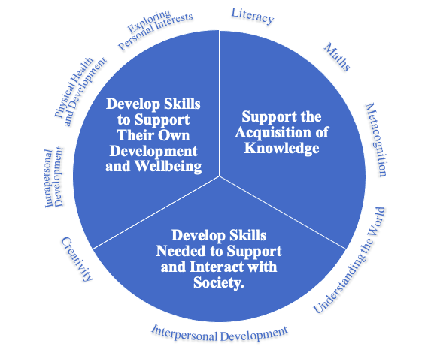

5.3.1. Theme 1: Interpersonal Development
There was a consensus between participants that interpersonal skills are important for children to learn at primary school. This theme was made up of two subthemes: maintaining and understanding positive relationships; and communicating effectively with others. There are a rising number of children with identified social, emotional, and mental health difficulties in schools in England (DfE, 2023d). Specific learning around social skills and conflict resolution may support these pupils in this area, allowing them to access other areas of their curriculum (Carroll & Hurry, 2018; Webster-Stratton et al., 2001). Similarly, children with communication and interaction difficulties, such as autism, may benefit from explicit learning around social relationships (Rose & Anketell, 2009).

Social skills learning doesn’t just benefit children with SEN, positive outcomes have also been demonstrated where interpersonal skills are developed at a whole class level (Ashdown & Bernard, 2011; Elliot, 2012). Stronger social skills have been associated with long term benefits such as increased happiness (through experience of friendships) (Demir et al., 2012) and higher levels of entrepreneurialism (Baron & Markman, 2000). Whole class social skills teaching has been found to increase self-esteem and self-efficacy, and reduce social anxiety, aggression, and bullying behaviours among pupils (DeRosier, 2004).

Some may question if social skills are an area that can be taught to children. The traditional teaching methods often used to implement learning in the current primary national curriculum, i.e., direct teacher instruction (Manyukhina & Wyse, 2019), may not be as effective for teaching this topic. Whereas other styles of teaching, for example, through cooperative learning activities, have been found to be effective in helping children to develop their interpersonal skills (Buchs & Butera, 2015; Fad et al., 1995). Piaget’s (1936) theory of child development is less compatible with direct teacher instruction methods (Dixon, 2015). Instead, he advocated for learning through interactive processes. This was built upon by Vygotsky (1978) and Bruner (1979) who promoted the scaffolding of learning through interaction with a more knowledgeable other. Exploring practice from other curricula, such as the EYFS curriculum (2023c) may give guidance on how such interpersonal skill development could be scaffolded. In the EYFS curriculum (2023c) children are supported to develop their communication skills through teacher scaffolding in natural play and interaction opportunities, as well as through carefully planned group activities with adult support to model and support interactions where needed (Bain et al., 2015).

In my own experience as a teacher, opportunities for interaction with others are often much more limited in primary classrooms compared with those in the EYFS. This may relate to a push from the recent Conservative government to promote more traditional standards of ‘good behaviour’. Media created by this government included messages such as ‘put[ting] teachers back in charge of the classroom’ (DfE & Gove, 2014). This power imbalance which positions children as subservient, has led to an increase in authoritarianism in schools (Reay, 2022). More interactive learning processes may be avoided in schools where they could be perceived as giving teachers less control of their classrooms and the children within them.

The second subtheme within the wider theme of interpersonal development was around the development of communication skills. Communication and interaction needs are common among children with SEN. The most prevalent type of need among children on SEN support are speech, language, and communication needs, and among those with EHCPs is autism spectrum condition (DfE, 2023d). Specific teaching of communication skills has been shown to support children with autism (Goldstein, 2002; Mancil, 2006) and speech and language disorders (Law et al., 2005).

Whilst some children with SEN are likely to need more personalised intervention around their communication needs than the rest of the class, whole class teaching of communication skills has been shown to have a positive benefit for all types of pupils. For example, Westgate & Hughes (2016) found that a focus on the development of communication in primary schools where teachers gave pupils lots of opportunities for dialogue in learning, had a positive impact on understanding in knowledge-based learning and on their social skills. In this study, teachers also noticed a positive effect on wider cognitive strategies such as reasoning (Westgate & Hughes, 2016). Vygotsky (1978) describes learning as a social process, where interaction, through communication with others, is essential. Strong communication skills have positive effects on many other areas of life including expression of ideas and opinions; self-confidence; self-esteem; future workplace success; and relationships (Sharma, 2020).

5.3.2. Theme 2: Literacy
Literacy is another area of learning that participants felt was important for primary school children to learn. Literacy skills are important in both allowing children to access their wider curriculum and to access employment, social opportunities, and resources in adulthood (Kuczera et al., 2016). There are potential benefits of adult literacy to the wider economy (Cameron & Cameron, 2006) and literacy ability is also associated with a greater engagement in community activities and politics (Stromquist, 2008). Within this theme, participants described children learning functional literacy skills that would give them the means to access learning in other areas.

In the Scottish Curriculum for Excellence (The Scottish Government, 2008) literacy isn’t a stand-alone subject but is instead weaved among all other areas of learning. When Blair’s Labour government introduced the ‘literacy hour’ in primary schools, this was criticised by the centre for labour and social studies as separating literacy from the rest of the curriculum and limiting opportunities for children to learn through reading and writing (Wrigley, 2014). Opportunities for interactive learning were diminished as a result (Wrigley, 2014) and literacy has remained largely separate from other areas of the primary curriculum since. The findings of this study would suggest a move for literacy to be reincorporated back into a more holistic curriculum rather than delivered as a stand-alone subject. Evidence suggests that integrating literacy within the wider curriculum promotes attainment both in literacy as well as other areas of the curriculum, and that such an approach can particularly benefit those from economically disadvantaged backgrounds (Fantuzzo et al., 2011).

Literacy already features heavily in the current primary national curriculum (DfE, 2013) and there is a strong focus on understanding grammar. Y6 SATs data show that performance in reading increased between the 2015/16 and 2017/2018 academic years and has since remained relatively stable with 73% of pupils meeting the expected standard in 2022/23 (DfE, 2023f). Performance in writing at the end of primary school appears to be much lower since the coronavirus pandemic with 71% of pupils achieving the expected standard in 2022/23 (down from 78% in 2018/19) (DfE, 2023f). This data would suggest that the introduction of the current national curriculum introduced in 2014 has had a positive impact on reading and writing skills among primary pupils, but writing skills have been negatively impacted by the coronavirus pandemic. However, there are criticisms that within the current curriculum many pupils are only learning skills to pass a test and that literacy skills aren’t being fully embedded in learning (Reay, 2017).

The current national curriculum teaches children explicit rules around grammar and spelling through direct instruction from the teacher, rather than through engagement in activity (Wrigley, 2014). This contrasts with constructivist pedagogical theories, such as those of Vygotsky (1978) and Bruner (1979), which propose mediating children’s learning through language and interaction, thus making learning both accessible and meaningful. Wrigley (2014) criticises the curriculum for expecting children to spell words outside of their vocabulary and apply grammatical logic beyond their understanding. This then leads children to memorise knowledge without underlying understanding. Even though literacy features prominently as an area of learning in the current curriculum and that suggested in this research, does the teaching of literacy need to be applied differently in any future curriculum?

5.3.3. Theme 3: Maths
Maths was also highlighted as an important area of learning for primary school children by participants. Achievement in maths has been found to be associated with children’s overall academic wellbeing (Rodríguez et al., 2020). The development of maths skills is important in many different aspects of life, including in understanding and experiencing art, time, space, and quantity (Mulero et al., 2013). Strong maths skills have also been found to be associated with positive outcomes in adulthood, in areas such as: employment, economic wellbeing, self-esteem, following the law (Parsons & Bynner, 2005) and health (Moon et al., 2015). Some may question if the role of maths in everyday life is diminishing because of computer automation, particularly for processes such as calculation, however mathematical understanding is still needed to program computers to automate these functions and to develop automation (and other) technology (Gravemeijer et al., 2017).

Maths is a core element of the current primary national curriculum (DfE, 2013). End of primary maths SATs assessments show that scores in this subject increased between 2015/16 and 2018/19 but have been lower since the pandemic, with 73% of children achieving the expected standard in 2023 (compared with 79% in 2019) (DfE 2023f). This would suggest that the current primary curriculum was having a positive impact on outcomes in maths, although progress has been affected by the impacts of the coronavirus pandemic. However, similarly as to literacy, there are concerns around teaching to the test in the current curriculum without consolidation of understanding around underlying concepts (Reay, 2017). Anxiety around maths appears common among primary school aged children, particularly girls, and has been associated with poor achievement in maths in later educational phases (Hill et al., 2016). Teacher focused instructional learning practices and teaching to the test without supporting underlying understanding, both arguably features of the current national curriculum (Manyukhina & Wyse, 2019; Reay, 2017), may have a negative impact on maths anxiety (Massey, 2019), suggesting a new approach to structuring mathematical learning may be beneficial.

Schools are under immense pressure to ensure that pupils achieve in assessments of core subjects, such as maths (Wrigley, 2014). A desire to maintain ‘high standards’ within education have led to an increase in emphasis on such assessments (Noddings, 2018). However, how well understanding can be measured in a written test is debatable, and many children may learn skills only to pass a test, rather than to consolidate and strengthen their understanding of mathematical concepts (Reay, 2017).

In my own experience of teaching within a primary school, there has been considerable pressure from senior management to ensure children achieve well in such tests and this has led to teaching to the test. As children move through school, I have noticed a lack of consolidation of core areas of learning, for example place value, that makes it harder for children to learn new concepts, in favour of learning ‘tricks’ without understanding that will help them to pass tests in each year group. This pressure to ensure children pass tests, at the expense of embedding learning, is in my own opinion perpetuated by the linking of teacher pay to these test outcomes. In a bid to improve accountability, teacher pay progression is dependent on such outcomes (Sharp et al., 2017). The DfE (Sharp et al., 2017) argue that implementing performance related pay has some positive impacts on outcomes. However, other research reviews, independent from government departments, have found that performance related pay in England does not improve teaching quality and can lead to gender inequalities in the career progression of teachers (Barnes et al., 2016). International research has also shown no positive impacts of performance related pay for teachers on pupil outcomes (Barnes et al., 2016). The strive for high levels of accountability in the English education system (Noddings, 2018) appears to have led to a curriculum that includes how to pass a test rather than one that builds on and develops conceptual understanding.

Wrigley (2014) suggests that these educational ‘standards’ are often set beyond what is achievable for students in an attempt to introduce elitism into educational systems. Rosen (2012) argues that an increase in educationally successful individuals can no longer be supported within our capitalist society, where there aren’t enough highly qualified occupations for everyone. Therefore, educational standards have been raised to limit opportunities for everyone, and provide justification for the few who succeed. Bowles and Gintis (1976) emphasise how educational systems are used to develop a future workforce that meets the desired societal needs of those with the most power.

This links back to the desired purposes of education; both the national curriculum and this research has established one purpose to be around preparation for adulthood with an element of this including access to employment. It needs to be considered as to whether such employment is in an area that is both meaningful and interesting to an individual or in an area that serves the rest of society best. Any future curriculum needs to make clear its aims in this area. There also needs to be consideration of assessment processes within any future curriculum and how these processes may limit or support learning within an area of learning such as maths.

5.3.4. Theme 4: Creativity
Another theme developed from participants responses around what children should learn at primary school was creativity. Research has found a positive relationship between creative activities, such as acting, dancing, painting, and singing, and wellbeing (Acar et al., 2020). As discussed in an earlier chapter, declining levels of wellbeing have been found among English children (The Children’s Society, 2023), engagement in creative activities may help to mitigate some of this. The arts have also been found to have a positive role in supporting people with specific difficulties including mental health difficulties and neurodevelopmental conditions (Fancourt & Finn, 2019) both of which impact a significant number of English children (DfE 2023d; NHS Digital 2023). More widely, there is evidence to show that the arts can support child development, encourage healthy behaviours, prevent illness (Fancourt & Finn, 2019), and support future social and economic innovation (Collard & Looney, 2014).

There are opportunities for creativity within the current primary national curriculum through the subjects of: art and design; music; and design and technology (DfE, 2013), however, it is at schools’ discretion how much time should be spent on these subjects. A research review from Ofsted (2023a) found a reduction in the quantity and quality of art and design teaching in primary schools in recent years, they suggest that this may be the result of a narrowing of the curriculum towards externally assessed subjects; a decline in funding needed to purchase arts resources; and limited skills of teachers. On the other hand, music appears to be taught frequently (weekly) and effectively (Ofsted, 2023b). Integration of the arts throughout the curriculum, rather than as stand-alone subjects, has been suggested as an effective way of teaching art and may also promote learning retention in other areas (Hardiman et al., 2014)

Creative subjects such as art and music, may be given less value within the current curriculum due to the associated pedagogies used in teaching such subjects. Effective pedagogies associated with teaching these subjects have been found to include autonomy, agency and co-construction (Cremin & Chappel, 2019). This aligns more with the interactive and constructivist approaches espoused by Dewey (1902), Piaget (1936), Bruner (1979) and Vygostky (1986). More traditional concepts of intelligence, such as that purported by Burt (1902) are highly associated with reading, writing and arithmetic and direct instructive teaching styles. Creativity is conceptualised differently from being ‘intelligent’ (Jauk et al., 2013) and as intelligence is highly valued in our society (Cave, 2020), this may reflect a lack of value in creative subjects. Is the purpose of education, simply to foster this conceptualisation of intelligence? I would argue not, and this research has established much broader purposes both around the acquisition of knowledge as well as around wider intra and interpersonal growth.

5.3.5. Theme 5: Metacognition
The next theme identified was around the development of metacognition and associated skills such as problem solving and critical thinking skills. Metacognition involves understanding of how knowledge is structured and applying strategies for monitoring own learning (Lai, 2011). The Education Endowment Fund (Quigley et al., 2021) recommends that metacognitive strategies are explicitly taught in school, with evidence that the use of such strategies can accelerate learning progress by around seven months on average. There is some evidence to suggest that the impact of metacognition on learning may be mediated by other associated skills such as problem solving (Zhao et al., 2019). As well as the strong evidence that metacognition can improve academic learning, there is also some evidence of a positive effect on wellbeing (Perry et al., 2019). Metacognition isn’t specifically covered in the current primary curriculum and there isn’t evidence of widespread implementation in schools (Perry et al., 2019). Incorporating metacognition into the primary curriculum may support the acquisition of learning in other areas, an established purpose of education. It may, however, support knowledge acquisition through mechanisms such as critical thinking, rather than simple fact retention. Critical pedagogies have been endorsed by Freire (1970) as providing power to individuals allowing them to make more informed choices. The alternative to this is a system of oppression through education where it is used to limit thinking that could challenge those in positions of power.

5.3.6. Theme 6: Physical Health and Development
Physical health and development is another theme captured from participants responses around what primary school children should learn: this is made up of keeping healthy as well as fine and gross motor skills. Just over 20% of year 6 pupils are obese, and around 30% are obese among those living in the most deprived areas (NHS England, 2023). More children are also under weight than they were ten years ago (NHS England, 2023). Being either under or overweight can have negative impacts on health and wellbeing (Buttitta et al., 2023; Uzogara, 2016), and so it is therefore important that children learn about how to be healthy and have opportunities for physical exercise in school. This is provided for in the current primary curriculum through PE and health education (DfE, 2013; 2019a). Most primary schools teach PE for two hours each week (Ofsted, 2023c), this is less than the 60 minutes each day of physical activity recommended by government guidelines (DHSC, 2019) although children will have other opportunities for exercise outside of PE lessons, for example at playtimes and after school. Physical activity has also been found to be beneficial for emotional wellbeing (Kliziene et al., 2021) and overall good physical health has overall positive impacts on wellbeing and academic attainment (Public Health England, 2014).

Children learn about healthy eating within the current primary curriculum through health education (DfE, 2019a). However, there is evidence that experiential learning around food has the biggest impact on healthy eating (Dudley et al., 2015), which is not explicitly covered within this subject (DfE, 2019a). Although children should learn to cook and prepare food through the subject of design and technology (DfE, 2013), there is often only limited coverage of the subject in primary schools (Jamie Oliver Food Foundation, 2017). Over half of primary schools spend less than ten hours a year teaching food education, and many schools find that the delivery of the subject is constrained through limited budgets, resources, and facilities (Jamie Oliver Food Foundation, 2017).

Fine and gross motor skills are also taught in the current primary curriculum: gross motor skills are taught through PE and fine motor skills through literacy and art (DfE, 2013). Poor motor skills are associated with difficulties in completing everyday tasks and lower academic attainment (Zwicker et al., 2012). A recent study showed that less than 20% of primary school children, out of a sample of almost 500, had mastered the skills of running, jumping, throwing, and catching (Duncan et al., 2020). This suggests that more of an emphasis on the development of motor skills is needed in the current curriculum.

5.3.7. Theme 7: Exploring Personal Interests
Exploring personal interests is not currently a specified part of the English primary curriculum. Often self-selected activities of interest, or hobbies, are considered to be ‘extracurricular’ and such activities are more available to the middle classes than to children with a lower socioeconomic status background (Holloway & Pimlott-Wilson, 2014). Participation in some such extracurricular activities, such as sports clubs, has been found to have beneficial effects on socio-emotional wellbeing and academic attainment (Chanfreau et al., 2016). Education that is centred around children’s interests may also serve to motivate engagement in learning (Assor et al., 2002; Hoyt-Oukada, 2003). Children have little opportunities for agency within the current primary curriculum beyond conformity (Kirby, 2019). Some researchers have noticed that when primary students are given the opportunity to follow their own interests, for example writing about a chosen topic rather than a proscribed one, they demonstrate better academic performance (Kirby, 2019). Perhaps, a curriculum that included more opportunities for children to follow their own interests would lead to a happier and higher academically achieving cohort of pupils. This area may be missing from the current curriculum due to difficulties with external measurement.

The idea of engaging children in learning centred around their own interests, contrasts with Bruner’s (1979) theories around learning. He made the case that centring teaching around a child’s interests was unimportant as learning is intrinsically motivating and interesting in itself. However, Bruner did emphasise that teachers need to scaffold learning to support and maintain this interest, through ensuring that they understand each learning task and breaking learning down into smaller components (Wood et al., 1976). Dewey (1902), on the other hand, advocated for a child centred curriculum that was developed alongside each child through their own interests and discovery-based learning. This, he argued, would support the greater personal growth of the child (Dewey, 1902). Dewey’s (1902) ideas align more with my own, and I have personally experienced, through my own practice, how personal interests can motivate learning. This position is also supported by a wide range of research (e.g. Assor et al., 2002; Hoyt-Oukada, 2003). I also believe, however, that the purpose of exploring personal interests is not only to motivate learning in other areas, but is also intrinsically beneficial in supporting wellbeing and life satisfaction.

Maslow (1962) describes the realisation and achievement of an individual’s potential, using the term self-actualisation. Exploring personal interests could be considered as supporting children to move towards self-actualisation, however in my own opinion exploring personal interests goes beyond this in supporting wider wellbeing and personal growth whether or not self-actualisation is achieved. Opportunities to explore interests can support personal growth through the fostering of resilience (Gilligan, 1999), challenge and innovation (Khambari, 2019). While some of the purpose of education may be to develop content specific knowledge, and this may be supported through interests, this research has also established a purpose around interpersonal development and wellbeing which could also benefit from opportunities to explore personal interests.

5.3.8. Theme 8: Understanding the World
The theme of understanding the world takes a more holistic, cross curricular approach to incorporating many of the topics found in subjects such as science, history, geography, and RE. It is split into two subthemes: people and animals; and the material world. Many important world issues, such as climate change, cannot be understood in relation to one subject alone but have implications across areas such as science, geography, sociology, and ethics. By situating this within a wider learning area, pupils could have the opportunity to explore world phenomena from multiple perspectives. As well as understanding different elements of the world, this theme highlighted the importance of children being given opportunities to engage in social justice issues. There are mixed opinions among educators around whether younger children can engage in or are interested in learning and discussion around social justice (Kelly & Brooks, 2009). This may relate to a societal concept of children as ‘innocent’ and needing to be shielded from difficult topics (Kelly & Brooks, 2009), an idea reinforced by the teachings of Rousseau (1974) who argued that children are born intrinsically good before being corrupted by society. However, some critics argue that the perception of children as ‘vulnerable’ leads to limited opportunities for them to understand their world (Jackson, 2006).

Social justice is inherently political (Buettner-Schmidt & Lobo, 2012). While teachers are required to show political impartiality, the DfE (2022) does encourage balanced coverage of political topics. However, research has shown that most teachers don’t feel confident in discussing controversial political issues in school (Weinberg, 2021). The study referenced only relates to secondary school teachers and similar research relating to primary schools was not found, perhaps due to the societal notions around what issues are ‘age-appropriate’ to raise with younger children. A diverse curriculum, which includes experiences of learning about different backgrounds and ethnicities, can support children’s understanding of modern life in a multicultural country and promote engagement in social justice issues (Maylor, 2021). However, while efforts were made to diversify the national curriculum when New Labour were in power, there are criticisms that the 2014 national curriculum has become less diverse (Maylor, 2021).

5.3.9. Theme 9: Intrapersonal Development
The final theme developed from participant responses around what primary school children should learn was intrapersonal development. This was made up of four subthemes: self-awareness and understanding identity; self-esteem and confidence; emotions; and resilience. As discussed in earlier chapters, a significant number of children (estimated to be around 20%) have a probable mental health disorder (NHS Digital, 2023). This in turn has a negative impact on children’s access to learning (NHS Digital, 2023). There is evidence that the development of intrapersonal skills, such as resilience, can protect against risk of mental health disorder (Lass, 2018). There is also an increasing number of children identified to have social, emotional, and mental health needs as a special educational need (DfE, 2023d). I believe that many such needs have resulted from children’s environments and experiences, including the impact of austerity and the recent pandemic.

Research from the public services union, UNISON (2016), has reported significant cuts to youth services and the associated negative impacts on children’s wellbeing and education. Across the UK, there is evidence that austerity has contributed in a decline to the public’s mental health both in relation to a lack of support services and through widening social inequality (Mattheys, 2015). This corresponds with a continuing decline in children’s subjective wellbeing since 2010, as reported by the Good Childhood Report (2023). An additional dip in wellbeing was also found during the coronavirus pandemic (Good Childhood Report, 2023) and the negative impacts of the pandemic and associated restrictions on children’s wellbeing and mental health has been well documented. I also feel that the absence of social emotional skills education in the curriculum has contributed to the increasing number of children who have an SEMH need that restricts their access to learning in the wider curriculum.

Research from the teacher’s union, NASUWT (2023), has found high levels of reported behaviour issues from pupils in schools, including physical aggression towards others. Half of teachers surveyed in this report felt that children’s poor mental health was contributing to a decline in behaviour (NASUWT, 2023). Often behaviour difficulties are the result of emotional dysregulation and are a way of children communicating their emotions (Gus et al., 2015). Teaching children about emotions, using strategies such as explicit teaching, labelling and co-regulation, can help children to understand their emotions and communicate these with less incidences of dysregulation (Gus et al., 2015; Hallam, 2009). I strongly believe that early interventions have the greatest impact in supporting many societal and health issues, and I feel that a reformed curriculum could be used as an early intervention to support children’s mental health and wellbeing. While mental health and wellbeing is often viewed as surplus to the core curriculum, this research has established a proposed purpose of education that includes the support of wellbeing. Beyond this, supporting children’s wellbeing has also been shown to have positive impacts on the more traditional focus of education relating to knowledge acquisition (Miller et al., 2013).

Many more children have poor wellbeing (The Children’s Society, 2023). Wellbeing impacts across many areas of children’s lives and education, including school attendance and academic achievement (DfE, 2019b). The development of intrapersonal skills can support good wellbeing, as well as later positive outcomes in education and work (Chernyshenko et al., 2018). Higher levels of cognitive functioning cannot replace the positive impacts of strong emotional skills, demonstrating the importance of providing intrapersonal skills learning for children (Chernyshenko et al., 2018). The current national curriculum includes some intrapersonal skills development through health education (DfE, 2019a). However, this is a very small part of the wider curriculum and as already discussed the teaching of externally assessed subjects is often prioritised (Willis & Wolstenhome, 2016) and teaching quality varies (Barnard et al., 2017).

There is a debate around where intrapersonal skills should be taught and whether or not they can be taught at all. One of my participants emailed me after taking part in the study to say that they felt that learning around intrapersonal skills while important, was less important as a focus in schools, as there was a greater place for this within families and within the community. They felt that the focus on teaching such skills should be directed more towards children who may not have the opportunity for such learning at home. It may be that other participants had similar views, however due to the design of this study this was not something that was explored in depth within this research. I personally feel that intrapersonal skills are so important to human life and wellbeing that these should be encouraged at every opportunity both within and outside of school. It may be difficult to assess whether or not children are developing these skills in other settings, particularly before significant concerns develop, whereas a universal approach to delivery offers this as an early intervention for everybody.

Assumptions around whether some children are receiving support to develop such skills at home and need additional support in schools, could also lead to blame and shame for parents, many of whom are experiencing additional pressures to their own wellbeing in the current socio-economic context. Additionally, in my own experience, areas outside of the school curriculum such as socio-emotional learning in the current curriculum, are rarely holistically assessed to identify such students needing support. This is particular the case in students where gaps in learning have less explicit behavioural representations.

Some people may consider aspects of intrapersonal development as innate and there is a particular debate relating to this around the concept of resilience. Some research suggests that certain components of resilience are innate, such as optimism, control, sociability and vitality, whereas other can be acquired, including problem solving, understanding of self and of others (Hirano, 2011). This research would suggest that we therefore only have a limited capacity to alter or improve human resilience. Positive psychology positions resilience as a within-person character strength, where it is already there, we can foster the skill and improve it (Park & Peterson, 2009). What if a person doesn’t already possess resilience as a particular strength, can this then still be developed? In my own view, resilience is the result of and shaped by, our own experiences. This is supported by research around post-traumatic growth, the idea that our capacity to deal with challenging events grows through our recovery from trauma (Jayawickreme et al., 2020). It would not be ethical to deliberately expose children to trauma just to build their resilience, however, there is evidence that resilience can be taught to children in other ways (Neihart, 2006). Examples of this include supporting children to develop the social skills that can facilitate an emotional support network, developing emotional regulation skills to manage emotionally challenging situations (Knight, 2007) and supporting positive thinking patterns (Bernard, 2008).

5.3.10. How do these themes compare to other UK curricula?
The areas of learning in the current English primary curriculum differ significantly from that of the other UK nations (Sibieta & Jerrim, 2021). There are many similarities, however, with the areas of learning discussed in this research with those of the Northern Irish (CCEA, 2007), Scottish (The Scottish Government, 2008) and Welsh curricula (Llywodraeth Cymru/ Welsh Government, 2024), as shown in table five, below. There are also many similarities with the areas of learning proposed by the Cambridge Primary Review (2009c).

Table 5.
Comparison of areas of learning discussed in this research with those of the English, Northern Irish, Scottish and Welsh primary curricula, as well as those suggested in the Cambridge Primary Review.
Current Research | England | Northern Ireland | Scotland | Wales | Cambridge Primary Review
Interpersonal Development | Health & Relationships Education | Personal Development & Mutual Understanding | Health & Wellbeing (includes relationships) | Literacy & Communication | Language, Oracy & Literacy
Literacy | English | Language & Literacy | (Literacy is taught throughout all areas) | Literacy & Communication | Language, Oracy & Literacy
Maths | Mathematics | Mathematics & Numeracy | Mathematics | Mathematics & Numeracy | Mathematics
Creativity | Art & Design  Music  Design & Technology | Arts | Expressive Arts | Expressive Arts | Arts & Creativity
Metacognition
Physical Health and Development | Health and Relationships Education  Physical Education | Physical Education | Health & Wellbeing | Health & Wellbeing | Physical & Emotional Health
Exploring Personal Interests
Understanding the World | Religious Education  Geography  History  Science  Computing | The World Around Us | Languages  Religious & Moral Education  Sciences  Social Studies  Technology | Humanities  Languages  Science & Technology | Citizenship & Ethics  Faith & Belief  Place & Time  Science & Technology  Language, Oracy & Literacy
Intrapersonal Development | Health and Relationships Education | Personal Development & Mutual Understanding | Health & Wellbeing  Religious & Moral Education | Health & Wellbeing | Physical & Emotional Health

Many areas of learning feature across all curricula to some extent, including interpersonal development; literacy; maths; creativity; physical health and development; understanding the world; and intrapersonal development. Several of the other curricula have areas of learning that include digital technology. Within this research, although one participant mentioned learning about ‘new technologies’ (Item No. 44, Table 3), this was the only mention in the data around technology and a theme was not identified around this area. The acquisition of digital skills can provide access to online opportunities and information, however there is also exposure to risk, particularly in relation to internet use (Livingstone et al., 2021). One of the identified proposed purposes of primary education in this research was around contribution to society and preparation for adulthood. Given the increasing use of technology in our lives and the role of digital skills in employment, it feels as though this area may have been missed. In Donaldson’s (2015) review of the Welsh curriculum, digital technology skills were identified by many children as needing a greater emphasis in the curriculum. Perhaps, the selection of participants in this research has led for this area to be missed and would have been highlighted if others had been sampled for their views, for example businesses and young people.

This research identified two areas of learning that were not explicitly included as areas in the other curricula: metacognition and exploring personal interests. Elements of these areas may be incorporated within other parts of the curricula or may be taught at the discretion of schools. Both areas have been found to support wider academic learning (Assor et al., 2002; Chanfreau et al., 2016; Hoyt-Oukada, 2003; Kirby, 2019; Quigley et al., 2021) and exploring personal interests is also beneficial in relation to pupil wellbeing (Chanfreau et al., 2016). We live in a constantly evolving world with ever changing needs, and it is likely that we will need to continually come back to review the primary curriculum as society and the world around us changes. The curricula described above have been developed at varying points in the past, with some more recent than others, not all may still reflect all the needs of our pupils. Although the current English primary national curriculum was implemented ten years ago, the overall structure and subject areas haven’t changed substantially since its inception in 1989 (Boyle & Bragg, 2006; Gillard, 2018).

5.4. Research Question Three: Who and what may this research impact on?
This research proposes purposes for, and areas of learning within, the primary curriculum in England that differ in several ways from existing structures. This research could impact on the practices of policy makers; educators, both within mainstream and specialist education; and EPs. These purposes and areas of learning could be used as a starting point to begin to consider primary national curriculum reform: they may provide a reference point for further consultation and discussion around such reform. Any reform to the primary curriculum is likely to take time, however not all schools have to follow the national curriculum, for example academies, and they may wish to embed some of the findings of this research into their whole school curricula earlier.

EPs are often engaged in supporting children and young people with SEN (Cameron, 2007). But how do we decide what a special educational need is? Ultimately, SEN describe a set of needs, or differences, that make it difficult for a child to access the curriculum. If the presented curriculum was different then our understanding of what constituted a special educational need would likely also be different. For example, if we had a curriculum that focused only on the development of physical skills, then cognition and learning difficulties would not present as a barrier to access this curriculum and consequently may not be seen as a special educational need. Similarly, if we had a curriculum that taught the skills of emotional regulation there may be less children with presenting social, emotional, and mental health needs as a barrier to accessing other areas of learning. A more holistic primary curriculum with a focus on areas such as social and emotional development, as well as cognitive development may be more inclusive and meet a wider range of children’s needs. This could potentially allow more children’s SEN to be met within the wider curriculum, and reduce the need for separate intervention or adaptations. If this were to happen, it may also free up resources to support children with more complex SEN.

EPs have knowledge and experience in child development and learning across several domains including in traditional academic subjects as well as in their intrapersonal and interpersonal development (Cameron, 2007). Should any curriculum reform take place, whether this be at a national, local, school, or individual level, EPs would be well placed to support school staff to navigate this change and to learn about newly introduced curriculum areas. EPs often already support educators to implement individual or small group personalised curricula, and are also experienced in supporting organisations to achieve larger scale systemic change (Cameron, 2007). Even without any major curriculum reforms, EPs may wish to use the findings of this research to aid them in supporting school staff to develop personalised curricula to meet the needs of children with SEN.

5.5. Strengths and Limitations
A strength of this research is that expertise was sought from more than one group: both EPs and academic researchers in education and/or child psychology. Both groups were represented among participants, and there were a wide range of roles within each profession. Many participants also had several years of experience in their field, with over half having 16 years or more of experience working with primary school aged children. The research isn’t however generalisable to the views of all EPs and academics in this area; Delphi methods don’t aim to be generalisable but instead gather views from a purposive sample of individuals with relevant expertise (Brady et al., 2016). Despite this, similar purposes of primary education have been found in other research with greater scope, for example the Cambridge Primary Review (2009c), suggesting they may align with other views.

While the development of curricula independently from government influence could potentially mitigate some political biases, it would be simplistic to presume that any curricula could remain uninfluenced by the developers’ backgrounds, societal norms, educational experiences, media influences, and broader socio-political contexts. Specific professional groups may also share common values and political perspectives within their field. For instance, studies have indicated that EPs often adopt a social constructivist epistemological standpoint (Fox, 2003). In addition, it's plausible that those who were inclined to volunteer could have shared similar values, introducing a form of self-selection bias.

Participant engagement in each stage of the study was low, with 12 participants completing stage one and 17 participants completing stage two and three (out of 31 participants in total). Some researchers argue that sample sizes of 10-20 are sufficient for Delphi studies (Brady et al., 2016), although others suggest that a sample size of 20-30 allows for an adequately diverse range of opinions (Seyaki & Kennedy, 2017). A sample size of less than 10 is discouraged in Delphi research (Akins et al., 2005) and this study did have more than 10 at each stage. Different numbers of participants took part in each stage of the study. As all participants had the opportunity to complete all stages, I don’t feel that this is a major limitation and feel that is valuable for participants to still input into later stages even if they had missed earlier ones – this is a benefit of the flexibility of a Delphi study. Some Delphi studies in the area of educational psychology have even varied the number of participants in each stage of the process to best suit different elements (e.g., Green & Birch, 2019). If stages two and three were limited to only the participants who completed stage one this would have limited their participation rates further. Yardley (2000) suggests that in research with qualitative analysis sampling of a small number of people with specific attributes is preferable to a large ‘generalisable’ sample, so that richer data can be collected and analysed.

Other Delphi research in areas including educational psychology have found relatively high dropout rates of around 30% (Akins et al., 2005; Henderson & Rubin, 2012; Rowley, 2022). However, this research had even higher rates of participant non-engagement. Educational psychology doctoral research may be considered as less valuable than other types of research and less likely to have an impact on wider systems. Most academic research is funded through grants with strict criteria, including likely impact and future publication, whereas this isn’t the case for this course. Research in the USA has found only 25% of PhD psychology dissertations to be published, and this figure was considerably lower in professional subfields (Evans et al., 2015). Thesis research impact is often also limited by resources and study team size in relation to larger well-funded studies. It may be the case that if this research had been commissioned by the government, or even by a prominent academic in the field, and had larger scope, potential participants may have felt that the study was likely to have a bigger real-world impact and engaged more with the research.

This research engaged with the expertise of particular groups of professionals, and the expertise of other key stakeholders has not been considered. The group of people who could be potentially impacted the most by this research are children, and neither they nor their teachers or parents have been consulted. Children are often constructed as less able than adults within society, resulting in a power imbalance where decisions are made for them, and actions done to them, rather than with them (Moore, 2020). It is important that children are consulted in any further development of this research for any proposed curricula to be truly child centred.

Finally, it is important to note the interpretation of themes within thematic analysis is subjective (Braun & Clarke, 2006) and different themes could have been generated by researchers with different knowledges and experiences to me using the same data. To help mitigate this, I did review my themes both with my supervisor and with other TEPs, however this research still does not claim to be objective. I have experience that has helped guide my theme selection, as a pupil who completed her primary education phase in schools in England, as a primary school teacher in schools in England, and through my experience working in EP services across different English local authorities. I first considered alternative approaches to the curriculum when I was exposed to the Early Years Foundation Skills (EYFS) curriculum (DfE, 2017) after taking over teaching of a reception class. Since working in other professions that are associated with, but outside of, school systems, including in educational research and educational psychology, I have found increasing opportunities to consider and reflect on alternative approaches to the current national curriculum. These experiences are likely to have influenced how I interpreted participant responses in my research, and themes were generated through the lens of this experience.

5.5.1. Limitations of Delphi Methods
Several limitations of Delphi methodology were noticed throughout this research process, many of these echoed those identified in other educational psychology doctoral research using a Delphi consensus procedure, such as that undertaken by Rowley (2022). One area noted both in this research and by Rowley (2022), was the absence of key themes that felt both important to the researcher and that had been established in prior research. In relation to this research, I felt that the absence of responses relating to digital technologies was surprising and a possible oversight given the prominence of digital technology within our everyday lives. Many of the desired purposes of education established in this research, such as those around preparation for adulthood, contributing to society and communicating with others are arguably strongly impacted on by digital competence in many areas of modern society.

Another limitation identified by both Rowley (2022) and myself related to a lack of depth of response from participants. The anonymous, indirect structure of the method meant that ideas and concepts could not be explored further with participants. As a result, there wasn’t always clarity behind the meaning of responses and it could also be that participant’s interpreted other statements in different ways to those intended by one another, influencing their responses. This was particularly noticeable in responses to my first research question around what the purpose of primary education should be. Some responses aligned more to what children should learn at school rather than why they should learn these things. This part of the research design took the form of a free response questionnaire and preceded the Delphi element of the study. However, the design of this component was limited by the constraints of the later Delphi portion of the study, primarily the feature of anonymity. It may be that this research question could have been explored through another research collection method which offered more depth, such as through a focus group. This would have made the anonymity element of the later Delphi portion of the study more difficult, perhaps making individual interviews more appropriate.

Finally, justification around selection of the research method strongly relates to the desire of reaching a consensus among participants, a major component of Delphi designs. However, is finding a consensus really that important within this stage of exploratory research? I feel that while consensus has been helpful in offering some level of agreement around ideas that can be presented to others to be further explored, such ideas could also have been presented without this consensus.

Ultimately, if curriculum reform is to take place at a national level some definitive decision on content will need to be made, but is that the role of research or something that will instead be established at a political level using research as guidance? The overpoliticisation of the previous curricula, with a lack of foundation in research has been criticised (Boyle & Bragg, 2006; Cambridge Primary Review, 2009a; b; c). In my own view I would encourage a move to a greater emphasis on decisions being made based on research rather than the current highly political focus. While many politicians may have the best intentions for education, they may have limited experience in the field. I believe that research that incorporates a wide range of views from both those with experience in the sector and those directly impacted by changes should hold a strong influence in direction of any change. Regardless of that debate, however, this research only strives to be exploratory and it is acknowledged that further refinement of ideas through consultation with a wide range of stakeholders is needed before any finalised curriculum proposal can be established.

5.6. Next Steps
As discussed previously, an essential next step to this research is consultation with other key stakeholders including children, their parents, school staff and the wider public. It is likely that following such consultation the purposes of primary education and areas of learning described in this research will need further refinement. Careful consideration is needed around how to organise such a large-scale consultation. The areas and purposes identified could be used as a starting point for this, where consultees could express their agreement or disagreement with those proposed and suggest amendments. It is likely that consultees will have varying views on the purposes and content of the primary curriculum and so there will also need to be consideration of how decisions on final content are made following any consultation.

Should the purposes and areas of learning for the primary curriculum be further developed from this research, there will then need to be discussion around other parts of its structure. For example, will there be set stages or ages within the curriculum? The new Welsh curriculum has removed key stages and replaced them with progression steps - these broadly relate to age related expectations, however, also recognise that children will develop at different paces and need to work within their own level (Llywodraeth Cymru/ Welsh Government, 2024). There is much debate among constructivist educational theorists around whether children need to work within their own developmental level (e.g. Piaget, 1936) or whether they have the capacity to learn at more advanced levels where the corrects support is put in place (e.g. Bruner, 1979; Vygotsky, 1978).

How much proscribed content will be included within each learning area and potential stage? The Scottish Curriculum for Excellence has allowed for considerable teacher autonomy around content so that they can adapt learning to the needs of their pupils (The Scottish Government, 2008), however, this has led to some confusion among educational professionals and difficulties with effectively embedding aims of the curriculum in practice (OECD, 2021). Will the areas of learning in a revised curriculum be taught in a holistic cross curricular way like in the Scottish and Welsh curricula, or will they be taught as discrete subjects as in the current English national curriculum? What associated assessments of learning will there be within a revised curriculum, and will these be external or internal and for all areas? There is evidence of a narrowing of the current national curriculum towards externally assessed subjects (Boyle & Bragg, 2006; Ogier, 2022). All the above factors would need to be considered in the design and implementation of any future primary curriculum for England.

References
Acar, S., Tadik, H., Myers, D., van der Sman, C., & Uysal, R. (2020). Creativity and well-being: a meta-analysis. Journal Of Creative Behavior, 55(3), 738-751. doi:10.1002/jocb.485
Aldrich, R. (2005). Lessons from history of education: The selected works of Richard Aldrich. https://doi.org/10.4324/9780203006863
Alexander, R., Rose, J. & Woodhead, C. (1992). Curriculum Organisation and Classroom Practice in Primary Schools: A discussion paper. Department of Education and Science. https://dera.ioe.ac.uk/id/eprint/4373/1/curriculum_organisation.pdf
Ahlstrom, D. (2010). Innovation and growth: How business contributes to society. Academy of management perspectives, 24(3), 11-24. https://doi.org/10.5465/amp.24.3.11
All-Party Parliamentary Group for Education (2011). Report of the Inquiry into Overcoming the Barriers to Literacy. https://dera.ioe.ac.uk/id/eprint/15786/1/APPG-for-Education-Literacy-Inquiry-final-report.pdf
American Psychological Association. (2022). APA Style numbers and statistics guide. https://apastyle.apa.org/ instructional-aids/numbers-statistics-guide.pdf
Ashdown, D.M. & Bernard, M.E. (2012). Can Explicit Instruction in Social and Emotional Learning Skills Benefit the Social-Emotional Development, Well-being, and Academic Achievement of Young Children? Early Childhood Education Journal, 39, 397–405. https://doi.org/10.1007/s10643-011-0481-x
Association of Educational Psychologists (2024, July 11). A New Government: AEP Manifesto 2024. https://www.aep.org.uk/articles/new-government-aep-manifesto-2024
Assor, A., Kaplan, H., & Roth, G. (2002). Choice is good, but relevance is excellent: Autonomy‐enhancing and suppressing teacher behaviours predicting students' engagement in schoolwork. British journal of educational psychology, 72(2), 261-278. https://doi.org/10.1348/000709902158883
Atkinson, C., Barrow, J., & Norris, S. (2022). Assessment practices of educational psychologists and other educational professionals. Educational Psychology in Practice, 38(4), 347-363. https://doi.org/10.1080/02667363.2022.2109005
Bain, J., James, D., & Harrison, M. (2015). Supporting communication development in the early years: A practitioner’s perspective. Child Language Teaching and Therapy, 31(3), 325-336. https://doi.org/10.1177/026565901559679
Baker, J., Lovell, K., & Harris, N. (2006). How expert are the experts? An exploration of the concept of ‘expert’ within Delphi panel techniques. Nurse researcher, 14(1). https://doi.org/10.7748/nr2006.10.14.1.59.c6010
Banicki, K. (2014). Positive psychology on character strengths and virtues. A disquieting suggestion. New Ideas in Psychology, 33, 21-34. https://doi.org/10.1016/j.newideapsych.2013.12.001
Barnard, A., Carey, A., Regan, A., Seth, J., & Sharma, R. (2017). Literature Review Evaluating the Impact of PSHE on Students’ Health, Wellbeing and Academic Attainment. Pro Bono Economics & The PSHE Association. https://www.wiltshirehealthyschools.org/documents/evidence/Pro_Bono_Economics_PSHE_evidence_review_FINAL.pdf
Barnes, S. A., Lyonette, C., Atfield, G., & Owen, D. (2016). Teachers’ pay and equality: a literature review (Longitudinal research into the impact of changes to teachers’ pay on equality in schools in England). NASUWT. https://wrap.warwick.ac.uk/id/eprint/79224/7/WRAP_nasuwt_015478.pdf
Barnett, L. M., Lai, S. K., Veldman, S. L., Hardy, L. L., Cliff, D. P., Morgan, P. J., Zask, A., Lubans, D. R., Shultz, S. P., Ridgers, N. D., Rush, E., Brown, H. L. & Okely, A. D. (2016). Correlates of gross motor competence in children and adolescents: a systematic review and meta-analysis. Sports medicine, 46, 1663-1688. https://doi.org/10.1007/s40279-016-0495-z
Baron, R. A., & Markman, G. D. (2000). Beyond social capital: How social skills can enhance entrepreneurs' success. Academy of Management Perspectives, 14(1), 106-116. https://doi.org/10.5465/ame.2000.2909843
Baxter, Judith (2020) Exploring the experiences of reception class teachers to understand the perceived factors affecting the enactment of personal pedagogical beliefs and values in their practice. (Doctoral dissertation, University of Sheffield).
Bee, O. K., & Hie, T. S. (2015). Employers’ emphasis on technical skills and soft skills in job advertisements. The English Teacher, 44(1), 1-12.
Berliner, D. (2011). Rational responses to high stakes testing: The case of curriculum narrowing and the harm that follows. Cambridge journal of education, 41(3), 287-302. https://doi.org/10.1080/0305764X.2011.607151
Bernard, M.E. (2008). The effect of You Can Do It! Education on the emotional resilience of primary school students with social, emotional, behavioural and achievement challenges. Proceedings of the Australian Psychological Society Annual Conference, 43, 36-‐40.
Berscheid, E. (2003). The human's greatest strength: Other humans. In L. G. Aspinwall & U. M. Staudinger (Eds.), A psychology of human strengths: Fundamental questions and future directions for a positive psychology (pp. 37–47). American Psychological Association. https://doi.org/10.1037/10566-003
Betzler, M. (2020). The relational value of empathy. In M. Baghramian, M. Papazian & R. Stout (Eds). The Value of Empathy (pp. 15-39). Routledge. https://doi.org/10.4324/9781003036685
Bhaskar R. (1989) Reclaiming reality: a critical introduction to contemporary philosophy. Routledge. https://doi.org/10.4324/9780203843314
Billings, C. E., Downey, L. A., Lomas, J. E., Lloyd, J., & Stough, C. (2014). Emotional Intelligence and scholastic achievement in pre-adolescent children. Personality and Individual Differences, 65, 14-18. https://doi.org/10.1016/j.paid.2014.01.017
Binet, A., & Simon, T. (1916). New methods for the diagnosis of the intellectual level of subnormals. (L'Année Psych., 1905, pp. 191-244).
Black, A., & Ammon, P. (1992). A developmental-constructivist approach to teacher education. Journal of teacher education, 43(5), 323-335. https://doi.org/10.1177/0022487192043005002
Board of Education (1923) The Differentiation of the Curriculum for Boys and Girls Respectively in Secondary Schools. Report of the Consultative Committee. His Majesty’s Stationary Office. https://education-uk.org/documents/hadow1923/hadow1923.html
Board of Education (1924) Psychological Tests of Educable Capacity. Report of the Consultative Committee London. His Majesty’s Stationary Office. https://www.education-uk.org/documents/hadow1924/hadow1924.html
Board of Education (1931) The Primary School. Report of the Consultative Committee. His Majesty’s Stationary Office. https://www.education-uk.org/documents/hadow1931/hadow1931.html
Board of Education (1933) Infant and Nursery Schools. Report of the Consultative Committee. His Majesty’s Stationary Office. https://www.education-uk.org/documents/hadow1933/hadow1933.html
Board of Education (1938) Secondary Education with Special Reference to Grammar Schools and Technical High Schools. Board of Education. His Majesty’s Stationery Office. https://education-uk.org/documents/spens/spens1938.html
Boyle, B., & Bragg, J. (2006). A curriculum without foundation. British Educational Research Journal, 32(4), 569-582. https://doi.org/10.1080/01411920600775225
Bowles, S., & Gintis, H. (1976). Schooling in Capitalist America: Educational Reform and the Contradictions of Economic Life. Basic Books.
Brady, S. R., Jason, L. A., & Glenwick, D. S. (2016). The delphi method. In L. A. Jason & D. Glenwick (Eds.). Handbook of methodological approaches to community-based research: Qualitative, quantitative, and mixed methods (pp61-67). Oxford university press.
Braun, V., & Clarke, V. (2006). Using thematic analysis in psychology. Qualitative research in psychology, 3(2), 77-101. https://doi.org/10.1191/1478088706qp063oa
Braun, V., & Clarke, V. (2022). Thematic analysis: a practical guide. SAGE.
Brigham, C.C. (1923). A study of American intelligence. Princeton, NJ: Princeton University Press.
British Psychological Society (2022). The role of educational psychology in promoting inclusive education. https://cms.bps.org.uk/sites/default/files/2022-05/DECP%20Position%20Paper%20-%20The%20role%20of%20educational%20psychology%20in%20promoting%20inclusive%20education.pdf
British Psychological Society (2023). Standards for the accreditation of doctoral programmes in educational psychology: England, Wales and Northern Ireland. https://cms.bps.org.uk/sites/default/files/2023-12/Educational%20Psychology%20Handbook%20-%20Standards%20for%20Accreditation.pdf
Brooks, K. W. (1979). Delphi technique: Expanding applications. North Central Association
Quarterly, 54(3), 377-385.
Brown, J. (2018). Interviews, focus groups and Delphi techniques. In P. Brough (Ed.), Advanced Research Methods for Applied Psychology: Design, Analysis and Reporting (pp. 95-106). Routledge.
Brown, C., & Shay, M. (2021). From resilience to wellbeing: Identity‐building as an alternative framework for schools’ role in promoting children’s mental health. Review of Education, 9(2), 599-634. https://doi.org/10.1002/rev3.3264
Bruner, J. S. (1974). Toward a theory of instruction. Harvard University Press.
Buchs, C., & Butera, F. (2015). Cooperative learning and social skills development. In R. Gillies (Ed.), Collaborative Learning: Developments in research and practice (pp. 201-238). Nova Science.
Budd, C. J. (2015). Promoting maths to the general public. In R. Cohen Kadosh & A. Dowker (Eds.) The Oxford handbook of numerical cognition (pp. 3-16). Oxford University Press.
Buettner-Schmidt, K. and Lobo, M.L. (2012), Social justice: a concept analysis. Journal of Advanced Nursing, 68: 948-958. https://doi.org/10.1111/j.1365-2648.2011.05856.x
Burnip, B. (2020). Communication skills. In L. Porter (Ed.) Educating Young Children with Additional Needs (1st Ed) (pp. 154-173). Routledge. https://doi.org/10.4324/9781003115472
Burriss, K. G., & Tsao, L. L. (2002). Review of research: How much do we know about the importance of play in child development? Childhood Education, 78(4), 230-233. https://doi.org/10.1080/00094056.2002.10522188
Burt, C. (1909). Experimental tests of general intelligence. British Journal of Psychology, 3(1), 94. https://doi.org/10.1111/j.2044-8295.1909.tb00197.x
Buttitta, M., Iliescu, C., Rousseau, A. & Geurrian, A. (2014). Quality of life in overweight and obese children and adolescents: a literature review. Quality of Life Research, 23, 1117–1139. https://doi.org/10.1007/s11136-013-0568-5
Bygstad, B., & Munkvold, B. E. (2011). In search of mechanisms. Conducting a critical realist data analysis. ICIS 2011 Proceedings. 7.
Cambridge Primary Review (2009a) Towards a New Primary Curriculum: a report from the Cambridge Primary Review. Part 1: Past and Present. University of Cambridge Faculty of Education. https://cprtrust.org.uk/wp-content/uploads/2014/06/Curriculum-report-1.pdf
Cambridge Primary Review (2009b) Towards a New Primary Curriculum: a report from the Cambridge Primary Review. Part 2: The Future. University of Cambridge Faculty of Education. https://cprtrust.org.uk/wp-content/uploads/2014/06/Curriculum-report-2.pdf
Cambridge Primary Review (2009c) Children, their World, their Education: Final Report and Recommendations of the Cambridge Primary Review. Routledge
Cameron, J., & Cameron, S. (2006). The Economic benefits of increased literacy. Paper commissioned for the EFA Global Monitoring Report 2006, Literacy for Life. United Nations Educational, Scientific and Cultural Organization.
Campbell, R. J., Muijs, R. D., Neelands, J. G. A., Robinson, W., Eyre, D., & Hewston, R. (2007). The social origins of students identified as gifted and talented in England: a geo‐demographic analysis. Oxford Review of Education, 33(1), 103-120. https://doi.org/10.1080/03054980601119664
Cao, W. (2021). Discussion on mean, median, mode and its validity and table number. Journal of Contemporary Educational Research, 5(3).
Carlson, A. G., Rowe, E., & Curby, T. W. (2013). Disentangling fine motor skills’ relations to academic achievement: The relative contributions of visual-spatial integration and visual-motor coordination. The Journal of genetic psychology, 174(5), 514-533. https://doi.org/10.1080/00221325.2012.717122
Carroll, C., & Hurry, J. (2018). Supporting pupils in school with social, emotional and mental health needs: a scoping review of the literature. Emotional and Behavioural Difficulties, 23(3), 310-325. https://doi.org/10.1080/13632752.2018.1452590
Cattell, R. B. (1937). The fight for our national intelligence. P. S. King.
Cattell, R. B. (1963). Theory of fluid and crystallized intelligence: A critical experiment. Journal of Educational Psychology, 54(1), 1–22. https://doi.org/10.1037/h0046743
Cattell, R. B. (1987). Intelligence: Its structure, growth and action. Elsevier.
Chanfreau, J., Tanner, E., Callanan, M., Laing, K., Skipp, A., & Todd, L. (2016). Out of school activities during primary school and KS2 attainment. Centre for Longitudinal Studies Working Paper Series, UCL Institute of Education.
Chaplin, L. N. (2009). Please may I have a bike? Better yet, may I have a hug? An examination of children’s and adolescents’ happiness. Journal of Happiness studies, 10, 541-562. https://doi.org/10.1007/s10902-008-9108-3
Cave, S. (2020, February). The problem with intelligence: its value-laden history and the future of AI. In Proceedings of the AAAI/ACM Conference on AI, Ethics, and Society (pp. 29-35).
Chernyshenko, O. S., Kankaraš, M., & Drasgow, F. (2018). Social and emotional skills for student success and well-being: Conceptual framework for the OECD study on social and emotional skills. OECD Education Working Papers, 173, 3-136. https://doi.org/10.1787/19939019
Chitty, C. (2007). Eugenics, race and intelligence in education. Bloomsbury Publishing.
Chitty, C (2017). Towards a New Education System: The Victory of the New Right? Falmer Press. https://doi.org/10.4324/9781315084688
Clarke, V., & Braun, V. (2017). Thematic analysis. The Journal of Positive Psychology, 12(3), 297–298. https://doi.org/10.1080/17439760.2016.1262613
Clarke, T., & Hoskin, S. (2022). Teaching children and adolescents about mental wellbeing: An exploratory multi-site case study in England. Educational Psychology in Practice, 38(3), 317-340. https://doi.org/10.1080/02667363.2022.2100321
Cloninger, C. R. (2006). The science of well-being: an integrated approach to mental health and its disorders. World psychiatry, 5(2), 71.
Cohen, R. (1992). Altruism and the evolution of civil society. In P. M. Oliner, S. P. Oliner, L. Baron, L. A. Blum, D. L. Krebs & M. Z. Smolenska (Eds.). Embracing the Other: Philosophical, Psychological, and Historical Perspectives on Altruism, (pp.104-129), New York University Press.
Collard, P., & Looney, J. (2014). Nurturing creativity in education. European Journal of Education, 49(3), 348-364. https://doi.org/10.1111/ejed.12090
Council for the Curriculum, Examinations and Assessment (2007). The Northern Ireland Curriculum Primary. https://ccea.org.uk/downloads/docs/ccea-asset/Curriculum/The%20Northern%20Ireland%20Curriculum%20-%20Primary.pdf
Cremin, T., & Chappell, K. (2019). Creative pedagogies: a systematic review. Research Papers in Education, 36(3), 299–331. https://doi.org/10.1080/02671522.2019.1677757
Cunningham, P. (2011). Politics and the Primary Teacher. Routledge https://doi.org/10.4324/9780203135891
Custer, R. L., Scarcella, J. A., & Stewart, B. R. (1999). The modified Delphi technique: A rotational modification. Journal of Vocational and Technical Education, 15(2), 1-10. https://doi.org/10.21061/jcte.v15i2.702
Dalkey, N. C. (1968). Experiments in group prediction. Rand Corporation.
Dalkey, N. C., & Helmer, O. (1963). An experimental application of the Delphi method to the use of experts. Management Science, 9(3), 458-467. https://doi.org/10.1287/mnsc.9.3.458

Davis, A. (2013). To read or not to read: Decoding synthetic phonics. Impact, 2013(20), 1-38. https://doi.org/10.1111/2048-416X.2013.12000.x
Dearing (1994). The National Curriculum and its Assessment: Final Report. School Curriculum and Assessment Authority. https://www.education-uk.org/documents/dearing1994/dearing1994.html
De Geeter, K. I., Poppes, P., & Vlaskamp, C. (2002). Parents as experts: the position of parents of children with profound multiple disabilities. Child: Care, Health and Development, 28(6), 443-453. https://doi.org/10.1046/j.1365-2214.2002.00294.x
Demir, M., Jaafar, J., Bilyk, N. & Ariff, M. R. M. (2012). Social Skills, Friendship and Happiness: A Cross-Cultural Investigation. The Journal of Social Psychology, 152(3), 379-385. https://doi.org/10.1080/00224545.2011.591451
Denman, S. J. (2014). Parents as experts on children with disabilities: Being prepared for the long-haul. International Journal of Disability, Development and Education, 61(4), 434-440. https://doi.org/10.1080/1034912X.2014.956003
Department for Education. (2010). The Importance of Teaching. White Paper, Cm 7980. The Stationary Office. https://assets.publishing.service.gov.uk/media/5a7b4029ed915d3ed9063285/CM-7980.pdf
Department for Education, (2011). The Framework for the National Curriculum. A report by the Expert Panel for the National Curriculum review. https://assets.publishing.service.gov.uk/media/5a7572c5ed915d6faf2b3104/NCR-Expert_Panel_Report.pdf
Department for Education (2013). The national curriculum in England: Key stages 1 and 2 framework document. https://assets.publishing.service.gov.uk/government/uploads/system/uploads/attachment_data/file/425601/PRIMARY_national_curriculum.pdf
Department for Education (2017). Statutory framework for the early years foundation stage Setting the standards for learning, development and care for children from birth to five. https://www.icmec.org/wp-content/uploads/2018/01/EYFS_STATUTORY_FRAMEWORK_2017.pdf
Department for Education (2019a). Relationships education, relationships and sex education (RSE) and health education: Statutory guidance for governing bodies, proprietors, head teachers, principals, senior leadership teams, teachers. https://assets.publishing.service.gov.uk/government/uploads/system/uploads/attachment_data/file/1090195/Relationships_Education_RSE_and_Health_Education.pdf
Department for Education (2019b). State of the nation 2019: Children and young people’s wellbeing. https://assets.publishing.service.gov.uk/government/uploads/system/uploads/attachment _data/file/906693/State_of_the_Nation_2019_young_people_children_wellbeing.pdf
Department for Education [DfE] (2021). COVID-19 parent and pupil panel: July 2021 findings. https://assets.publishing.service.gov.uk/government/uploads/system/uploads/attachment _data/file/1028036/COVID-19_Parent_and_Pupil_Panel._July_findings.pdf
Department for Education (2022). What you need to know about political impartiality in schools. https://assets.publishing.service.gov.uk/media/61f137688fa8f5058a4b2f44/6.7731_DfE_Political_Impartiality_Guidance_Pamphlet_WEB__004_.pdf
Department for Education (2023a). GCSE Results (Attainment 8). https://www.ethnicity-facts-figures.service.gov.uk/education-skills-and-training/11-to-16-years-old/gcse-results-attainment-8-for-children-aged-14-to-16-key-stage-4/latest/#by-ethnicity
Department for Education (2023b). Key stage 2 attainment. https://explore-education-statistics.service.gov.uk/find-statistics/key-stage-2-attainment
Department for Education (2023c). Early years foundation stage statutory framework: For group and school-based providers: Setting the standards for learning, development and care for children from birth to five. https://assets.publishing.service.gov.uk/media/65aa5e42ed27ca001327b2c7/EYFS_statutory_framework_for_group_and_school_based_providers.pdf
Department for Education (2023d). Special educational needs in England. https://explore-education-statistics.service.gov.uk/find-statistics/special-educational-needs-in-england/2022-23
Department for Education (2023e). State of the nation 2022: Children and young people's wellbeing. https://assets.publishing.service.gov.uk/media/63e11487d3bf7f172b673731/State_of_the_nation_2022_-_children_and_young_people_s_wellbeing.pdf
Department for Education (2023f). Key Stage 2 Attainment. https://explore-education-statistics.service.gov.uk/find-statistics/key-stage-2-attainment
Department for Education & Department of Health (2015). Special educational needs and disability code of practice: 0 to 25 years. https://assets.publishing.service.gov.uk/government/uploads/system/uploads/attachment_data/file/398815/SEND_Code_of_Practice_January_2015.pdf
Department for Education & Gove, M. (2013, June 11). Oral statement by Michael Gove on education reform. https://www.gov.uk/government/speeches/oral-statement-on-education-reform
Department for Education & Gove, M. (2014, February 5). Gove gives green light to teachers to use tough sanctions to tackle bad behaviour. https://www.gov.uk/government/news/gove-gives-green-light-to-teachers-to-use-tough-sanctions-to-tackle-bad-behaviour
Department for Education and Employment (2000). Sex and Relationship Education Guidance. https://education-uk.org/documents/dfee/2000-sex-education.pdf
Department for Education and Skills (2002). Languages for all: languages for life. https://www.education-uk.org/documents/pdfs/2002-languages-for-all.pdf
Department for Education and Skills (2003). Every Child Matters. Green Paper, Cm. 5860. The Stationery Office. https://assets.publishing.service.gov.uk/media/5a7c95a4e5274a0bb7cb806d/5860.pdf
Department of Education and Science (1967). Children and their primary schools: A Report (Research and Surveys). Her Majesty’s Stationery Office. https://education-uk.org/documents/plowden/plowden1967-1.html
Department of Education and Science. (1970). Towards the middle school. Education Pamphlet, 57. https://www.education-uk.org/documents/des/middleschool-1970.html
Department of Education and Science & Welsh Office (1981). The School Curriculum. Her Majesty’s Stationery Office. https://education-uk.org/documents/des/schoolcurric.html
Department of Education and Science & Welsh Office (1987). The National Curriculum 5-16: a consultation document. Her Majesty’s Stationery Office. https://www.education-uk.org/documents/des/nc-consultation.html
Department of Health and Social Care (2019). UK Chief Medical Officer’s physical activity guidelines. https://www.gov.uk/government/publications/physical-activity-guidelines-uk-chief-medical-officers-report
Department of Health and Social Care (2022). The government’s response to the Health and Social Care Committee report: children and young people’s mental health. https://www.gov.uk/government/publications/children-and-young-peoples-mental-health-government-response/the-governments-response-to-the-health-and-social-care-committee-report-children-and-young-peoples-mental-health#mental-health-support-in-schools
DeRosier, M. E. (2004). Building Relationships and Combating Bullying: Effectiveness of a School-Based Social Skills Group Intervention. Journal of Clinical Child & Adolescent Psychology, 33(1), 196-201. https://doi.org/10.1207/S15374424JCCP3301_18
Descartes, R. (1985). The philosophical writings of Descartes. Cambridge University Press.
Dewey, J. (1902). The Child and The Curriculum. The University of Chicago Press.
Dixon (2015). Teacher narratives of domestic violence. (Doctoral dissertation, University of Sheffield). https://etheses.whiterose.ac.uk/8536/
Donaldson, G. (2015). Futures: Independent review of curriculum and assessment arrangements in Wales. https://gov.wales/sites/default/files/publications/2018-03/successful-futures.pdf
Doyle, C. S. (1993). The Delphi method as a qualitative assessment tool for development of outcome measures for information literacy. School Library Media Annual (SLMA), 11, 132-44.
Dockrell, J. E., & Howell, P. (2015). Identifying the challenges and opportunities to meet the needs of children with speech, language and communication difficulties. British Journal of Special Education, 42(4), 411-428. https://doi.org/10.1111/1467-8578.12115
Dolean, D., & Cãlugãr, A. (2020). How Reliably Can We Measure a Child’s True IQ? Socio-Economic Status Can Explain Most of the Inter-Ethnic Differences in General Non-verbal Abilities. Frontiers in Psychology, 11, 2000. https://doi.org/10.3389/fpsyg.2020.02000
Dudley, D.A., Cotton, W.G. & Peralta, L.R. (2015). Teaching approaches and strategies that promote healthy eating in primary school children: a systematic review and meta-analysis. International Journal of Behavioural Nutrition and Physical Activity, 12, 28. https://doi.org/10.1186/s12966-015-0182-8
Dugosh, K.L. and Paulus, P.B. Cognitive and social comparison processes in brainstorming. Journal of Experimental Social Psychology 41, 3 (2005), 313-320. https://doi.org/10.1016/j.jesp.2004.05.009
Duncan, M. J., Roscoe, C. M., Noon, M., Clark, C. C., O’Brien, W., & Eyre, E. L. (2020). Run, jump, throw and catch: How proficient are children attending English schools at the fundamental motor skills identified as key within the school curriculum? European Physical Education Review, 26(4), 814-826. https://doi.org/10.1177/1356336X19888953
Ellins, J., Hocking, L., Al-Haboubi, M., Newbould, J., Fenton, S-J., Daniel, K., Stockwell, S., Leach, B., Sidhu, M., Bousfield, J., McKenna, G., Saunders, K., O’Neill, S. & Mays, N. (2023). Early evaluation of the children and young people’s mental health trailblazer programme: A rapid mixed-methods study. Health and Social Care Delivery Research, 11(8). https://doi.org/10.3310/XQWU4117
Elliott, D. M. (2012). Benefits general education students receive from inclusion classes and social skills training groups (Doctoral dissertation, Fairleigh Dickinson University). https://www.proquest.com/docview/1034472107?sourcetype=Dissertations%20&%20Theses
Evans, S. C., Amaro, C. M., Herbert, R., Blossom, J. B., & Roberts, M. C. (2018). " Are you gonna publish that?" Peer-reviewed publication outcomes of doctoral dissertations in psychology. PloS one, 13(2), e0192219. https://doi.org/10.1371%2Fjournal.pone.0192219
Eyles, A., Major, L. E. & Machin, S. (2022). Social mobility-past, present and future: The state of play in social mobility, on the 25th anniversary of the Sutton Trust. The Sutton Trust. https://www.suttontrust.com/wp-content/uploads/2022/06/Social-Mobility-%E2%80%93-Past-Present-and-Future.pdf
Fad, K. S., Ross, M., & Boston, J. (1995). We’re Better Together: Using Cooperative Learning to Teach Social Skills to Young Children. TEACHING Exceptional Children, 27(4), 28-34. https://doi.org/10.1177/004005999502700407
Fancourt, D. & Finn, S. (2019). Health evidence network synthesis report 67. What is the evidence on the role of the arts in improving health and well-being? A scoping review. World Health Organization Regional Office for Europe. https://www.who.int/europe/publications/i/item/9789289054553
Fox, M. (2003). Opening Pandora's Box: Evidence-based practice for educational psychologists. Educational Psychology in Practice, 19(2), 91-102. https://doi.org/10.1080/02667360303233
Freeman, L., & Miller, A. (2001). Norm-referenced, criterion-referenced, and dynamic assessment: what exactly is the point?. Educational Psychology in Practice, 17(1), 3-16.
Freire, P. (1970). Pedagogy of the oppressed. Penguin Books.
Frerichs, S., & Münch, R. (2010). Morality, modernity, and world society. In S. Hitlin & S. Vaisey (Eds.). Handbook of the Sociology of Morality (pp.529-548). Springer. https://doi.org/10.1007/978-1-4419-6896-8
Fryer, T. (2022). A short guide to ontology and epistemology: why everyone should be a critical realist (2nd Ed.). https://tfryer.com/ontology-guide/
Fullan. (1993). Change forces : probing the depths of educational reform. Falmer. https://doi.org/10.4324/9780203059005
Galton, M. J., Simon, B., & Croll, P. (1980). Inside the primary classroom. Routledge and Kegan Paul.
Garratt, K., Kirk-Wade, E. & Long, R. (2024). House of Commons Research Briefing, Number CPB-7196. Children and young people’s mental health: Policy and services (England). House of Commons Library. https://researchbriefings.files.parliament.uk/documents/CBP-7196/CBP-7196.pdf
Garth, T. R. (1930). A review of race psychology. Psychological Bulletin, 27, 329-356.
Gecas, V. (2003). Self-Agency and the Life Course. In J. T. Mortimer & M. J. Shanahan (Eds). Handbook of the Life Course. Springer. https://doi.org/10.1007/978-0-306-48247-2_17
Gillard, D. (2018) Education in England: a history. www.educationengland.org.uk/history
Gilligan. (1999). Enhancing the resilience of children and young people in public care by mentoring their talents and interests. Child & Family Social Work, 4(3), 187-196. https://doi.org/10.1046/j.1365-2206.1999.00121.x
Giroux, H. A. (1985). Critical pedagogy, cultural politics and the discourse of experience. Journal of education, 167(2), 22-41. https://doi.org/10.1177/002205748516700204
Glatter, R. (2021). The ‘independent state school’ and its aftermath: implications for the processes and structures surrounding school leadership. School Leadership & Management, 41(1-2), 93-116. https://doi.org/10.1080/13632434.2020.1814236
Goldberg, L. R. (1968). Simple models or simple processes? Some research on clinical judgments. American Psychologist, 23(7), 483. https://doi.org/10.1037/h0026206
Goldstein, H. (2002). Communication Intervention for Children with Autism: A Review of Treatment Efficacy. Journal of Autism and Developmental Disorders, 32(5), 373–396. https://doi.org/10.1023/A:1020589821992
Goldstein, S. & Brooks, R. B. (2013). Handbook of Resilience in Children. Springer. https://doi.org/10.1007/978-1-4614-3661-4_1
Goleman, D. (1995). Emotional Intelligence: Why it can matter more than IQ. Bloomsbury Publishing.
Gopnik, A., & Wellman, H. M. (2012). Reconstructing constructivism: Causal models, Bayesian learning mechanisms, and the theory theory. Psychological Bulletin, 138(6), 1085–1108. https://doi.org/10.1037/a0028044
Gorski, P. S. (2013). What is critical realism? And why should you care? Contemporary Sociology, 42(5), 658-670. https://doi.org/10.1177/0094306113499533
Gravemeijer, K., Stephan, M., Julie, C., Lin, F. L., & Ohtani, M. (2017). What mathematics education may prepare students for the society of the future? International Journal of Science and Mathematics Education, 15, 105-123. https://doi.org/10.1007/s10763-017-9814-6
Green, R., & Birch, S. (2019). Ensuring quality in EPs’ use of dynamic assessment: a Delphi study. Educational Psychology in Practice, 35(1), 82-98. https://doi.org/10.1080/02667363.2018.1538938
Grube, D. C., & Killick, A. (2023). Groupthink, polythink and the challenges of decision-making in cabinet government. Parliamentary Affairs, 76(1), 211-231. https://doi.org/10.1093/pa/gsab047
Gulin, W. (2020). Empathy in social relations of the modern world. 21st Century Pedagogy, 4(1), 1-7. https://doi.org/10.2478/ped21-2020-0001
Güner, P. & Erbay, H. N. (2021). Metacognitive skills and problem-solving. International Journal of Research in Education and Science, 7(3), 715-734. https://doi.org/10.46328/ijres.1594
Gus, L., Rose, J., & Gilbert, L. (2015). Emotion coaching: A universal strategy for supporting and promoting sustainable emotional and behavioural well-being. Educational & Child Psychology, 32(1), 31-41.
Habibi, A., Sarafrazi, A., & Izadyar, S. (2014). Delphi technique theoretical framework in qualitative research. The International Journal of Engineering and Science, 3(4), 8-13.
Hallam, S. (2009). An evaluation of the Social and Emotional Aspects of Learning (SEAL) programme: promoting positive behaviour, effective learning and well‐being in primary school children. Oxford Review of Education, 35(3), 313-330. https://doi.org/10.1080/03054980902934597
Hallam, S., & Parsons, S. (2013). Prevalence of streaming in UK primary schools: Evidence from the Millennium Cohort Study. British Educational Research Journal, 39(3), 514-544. https://doi.org/10.1080/01411926.2012.659721
Hardiman, M., Rinne, L., & Yarmolinskaya, J. (2014). The effects of arts integration on long‐term retention of academic content. Mind, Brain, and Education, 8(3), 144-148. https://doi.org/10.1111/mbe.12053
Hasson, F., Keeney, S., & McKenna, H. (2000). Research guidelines for the Delphi survey technique. Journal of advanced nursing, 32(4), 1008-1015. https://doi.org/10.1046/j.1365-2648.2000.t01-1-01567.x
Hawkins, K. (2014). Teaching for social justice, social responsibility and social inclusion: a respectful pedagogy for twenty-first century early childhood education. European Early Childhood Education Research Journal, 22(5), 723-738. https://doi.org/10.1080/1350293X.2014.969085
HC Deb col 135WS (2011, December 19). Hansard. https://publications.parliament.uk/pa/cm201011/cmhansrd/cm111219/wmstext/111219m0001.htm
Health and Care Professions Council (2023). The standards of proficiency for practitioner psychologists. https://www.hcpc-uk.org/standards/standards-of-proficiency/practitioner-psychologists/
Heidegger, M. (1927). Being and time. Blackwell
Henley, D. (2011). Music Education in England. Department for Education and Department for Culture, Media and Sport. https://assets.publishing.service.gov.uk/media/5a7af45be5274a319e77beac/DFE-00011-2011.pdf
Henley, D. (2012). Cultural Education in England. Department for Culture, Media and Sport and Department for Education. https://assets.publishing.service.gov.uk/media/5a7cd5a040f0b6629523c187/Cultural_Education_report.pdf
Her Majesty’s Inspectorate [HMI] (1980). A View of the Curriculum. Her Majesty’s Stationery Office. https://education-uk.org/documents/hmi-discussion/viewofthecurric.html
Herrnstein, R. J., & Murray, C. A. (1994). The bell curve: intelligence and class structure in American life. Free Press.
Higgins, M. J. (2009). Standardised tests: wristwatch or dipstick?. Research in Education, 81(1), 1-11.
Hill, F., Mammarella, I. C., Devine, A., Caviola, S., Passolunghi, M. C., & Szűcs, D. (2016). Maths anxiety in primary and secondary school students: Gender differences, developmental changes and anxiety specificity. Learning and individual differences, 48, 45-53. https://doi.org/10.1016/j.lindif.2016.02.006
Hilton, G. L. (2021). Sex and Relationships Education in England-A Policy Causing Problems for Schools. Bulgarian Comparative Education Society.
Hirano, M. (2011). A study of the classification of resilience factors: development of the Bidimensional Resilience Scale (BRS). Japanese Journal of Personality/Pasonariti Kenkyu, 19(2), 94.
Holloway, S. L. & Pimlott-Wilson, H. (2014). Enriching Children, Institutionalizing Childhood? Geographies of Play, Extracurricular Activities, and Parenting in England. Annals of the Association of American Geographers, 104(3), 613-627. https://doi.org/10.1080/00045608.2013.846167
House of Commons Health and Social Care Committee (2021). Children and young people’s mental health: Eighth report of session 2021-2022. House of Commons. https://committees.parliament.uk/publications/8153/documents/170201/default/
Hoyt-Oukada, K. (2003). Considering Students’ Needs and Interests in Curriculum Construction. The French Review, 76(4), 721–737.
Hyland, P. (2023). All we like sheep: The need for reflection and reflexivity in IO psychology. Industrial and Organizational Psychology, 16(1), 77-95. https://doi.org/10.1017/iop.2022.87
Jackson, L. (2006). Childhood and youth. In H.G. Cocks & M. Houlbrook (Eds). Palgrave advances in the modern history of sexuality (pp.231-255). Palgrave Macmillan.
James, M. (2012, June 11). ‘For the Record’- some (lesser known) factual background to the work of the Expert Panel for the National Curriculum Review in England 2010-2012. https://www.bera.ac.uk/bera-in-the-news/background-to-michael-goves-response-to-the-report-of-the-expert-panel-for-the-national-curriculum-review-in-england
Jamie Oliver Food Foundation (2017). A Report on the Food Education Learning Landscape. https://www.akofoundation.org/wp-content/uploads/2017/11/2_0_fell-report-final.pdf
Jamieson, S. (2004). Likert scales: how to (ab) use them. Medical Education, 38(12), 1217-1218. http://dx.doi.org/10.1111/j.1365-2929.2004.02012.x
Janis, I. L. (1972). Victims of groupthink: A psychological study of foreign-policy decisions and fiascoes. Houghton Mifflin.
Jauk, E., Benedek, M., Dunst, B., & Neubauer, A. C. (2013). The relationship between intelligence and creativity: New support for the threshold hypothesis by means of empirical breakpoint detection. Intelligence, 41(4), 212-221. doi: 10.1016/j.intell.2013.03.003
Jayawickreme, E., Infurna, F. J., Alajak, K., Blackie, L. E., Chopik, W. J., Chung, J. M., Dorfman, A., Fleeson, W., Forgeard, M. J. C., Frazier, P., Furr, R. M., Grossman, I., Heller, A. S., Laucelle, O. M., Lucas, R. E., Luhmann, M., Luong, G., Meijer, L., McClean, M. C., Park, C. L., Roepke, A. M., al Sawaf, Z., Tennen, H., White, R. M. B. & Zonneveld, R. (2021). Post‐traumatic growth as positive personality change: Challenges, opportunities, and recommendations. Journal of personality, 89(1), 145-165. https://doi.org/10.1111/jopy.12591
Jensen, A. R. (1999). The g factor: The science of mental ability. Psycoloquy, 10(2).
Jerrim, J., Perera, N. & Sellen, P. (2017). English education: World class in primary? Education Policy Institute. https://epi.org.uk/publications-and-research/english-education-world-class-primary/
Jordan, W. K. (2013). Philanthropy in England, 1480-1660: A study of the changing patterns of English social aspirations. Routledge. https://doi.org/10.4324/9780203715543
Kaufman, A. S. (1990). Assessing adolescent and adult intelligence. Allyn & Bacon.
Kauko, K., & Palmroos, P. (2014). The Delphi method in forecasting financial markets—An experimental study. International Journal of Forecasting, 30(2), 313-327. https://doi.org/10.1016/j.ijforecast.2013.09.007
Keeney, S., Hasson, F., & McKenna, H. (2011). The Delphi Technique in Nursing and Health Research. Wiley-Blackwell.
Kelly, D. M. & Brooks, M. (2009). How Young is Too Young? Exploring Beginning Teachers' Assumptions about Young Children and Teaching for Social Justice. Equity & Excellence in Education, 42(2), 202-216. https://doi.org/10.1080/10665680902739683
Khambari, M. N. (2019). Instilling innovativeness, building character, and enforcing camaraderie through interest-driven challenge-based learning approach. Research and Practice in Technology Enhanced Learning, 14(1), 19.
Kingsbury, I. (2022). Demystifying goliath: An examination of the political compass of education reform. Journal of School Choice, 16(2), 258-274. https://doi.org/10.1080/15582159.2021.2004491
Kirby, P. (2020). Children’s agency in the modern primary classroom. Children & Society, 34(1), 17-30. https://doi.org/10.1111/chso.12357
Kliziene, I., Cizauskas, G., Sipaviciene, S., Aleksandraviciene, R., Zaicenkoviene, K. (2021). Effects of a Physical Education Program on Physical Activity and Emotional Well-Being among Primary School Children. International Journal of Environmental Research and Public Health, 18, 7536. https://doi.org/10.3390/ijerph18147536
Knight, C. (2007). A resilience framework: Perspectives for educators. Health Education, 107(6), 543-555.
Kuczera, M., Field, S., & Windisch, H. C. (2016). Building skills for all: a review of England. Policy Insights from the Survey of Adult Skills. OECD Skills Studies. https://www.oecd.org/unitedkingdom/building-skills-for-all-reviewof-england.pdf.
Kurkgöz, Y. (2018). Fostering young learners’ listening and speaking skills. In S. Garton & F. Copland (Eds) The Routledge handbook of teaching English to young learners (pp. 171-187). Routledge.
Labour (2024). Change. The Labour Party Manifesto 2024. https://labour.org.uk/change/
Lai, E. R. (2011). Metacognition: A literature review. Pearson.
Landeta, J. (2006). Current validity of the Delphi method in social sciences. Technological forecasting and social change, 73(5), 467-482. https://doi.org/10.1016/j.techfore.2005.09.002
Lass, H. (2018). Developing intra-personal skills as a proactive way to personal sustainability: The preventative side of the mental health equation. In O. Parodi & K. Tamm (Eds.). Personal Sustainability (pp. 95-115). Routledge. https://doi.org/10.4324/9781315159997
Law, J., Garrett, Z., & Nye, C. (2005). Speech and language therapy interventions for children with primary speech and language delay or disorder. Campbell systematic reviews, 1(1), 1-85. https://doi.org/10.4073/csr.2005.5
Lawani, A. (2021). Critical realism: what you should know and how to apply it. Qualitative research journal, 21(3), 320-333. https://doi.org/10.1108/QRJ-08-2020-0101
Lawson, J., & Silver, H. (2007). A social history of education in England. Taylor & Francis Group.
Likert, R. (1932). A Technique for the Measurement of Attitudes. Archives of Psychology, 140, 1–55.
Lingard, B., Ranson, S., & Nixon, J. (2008). Transforming Learning in Schools and Communities. Bloomsbury Publishing.
Linstone, H. A., & Turoff, M. (1975). The Delphi method: Techniques and applications. Addison-Wesley.
Literacy Task Force (1997) The Implementation of the National Literacy Strategy. Department for Education and Employment. https://www.education-uk.org/documents/literacytaskforce/implementation
Llywodraeth Cymru/ Welsh Government (2024, January). Curriculum for Wales. https://hwb.gov.wales/curriculum-for-wales/
Loehlin, J. C., Lindzey, G., & Spuhler, J. N. (1975). Race differences in intelligence. Freeman.
Macdonald, S. A. (2009). Independent Review of the proposal to make Personal, Social, Health and Economic (PSHE) education statutory. Department for Children, Schools and Families. https://www.education-uk.org/documents/pdfs/2009-macdonald-pshe.pdf
Macleod, G., & Tett, L. (2019). ‘I had some additional angel wings’: Parents positioned as experts in their children’s education. International Journal of Lifelong Education, 38(2), 171-183. https://doi.org/10.1080/02601370.2019.1574922
Magno, C. (2010). The role of metacognitive skills in developing critical thinking. Metacognition and learning, 5, 137-156. https://doi.org/10.1007/s11409-010-9054-4
Mahdi, S. (2020). Preparing to be an ethically minded educational psychologist: Examining conceptualisations of social justice and a reflexive exploration of values. Educational Psychology Research and Practice, 6(1), 1-7. https://doi.org/10.15123/uel.8911z
Mallon, F., & Tee, G. (1991). Psychologists and the National Curriculum: Identifying relevant skills. Educational Psychology in Practice, 6(4), 187-190. https://doi.org/10.1080/0266736910060402
Mancil, G. R. (2006). Functional Communication Training: A Review of the Literature Related to Children with Autism. Education and Training in Developmental Disabilities, 41(3), 213–224.
Manyukhina, Y., & Wyse, D. (2019). Learner agency and the curriculum: A critical realist perspective. The Curriculum Journal, 30(3), 223-243. https://doi.org/10.1080/09585176.2019.1599973
Marhayani, A. (2024). The relationship of reading interest and confidence in elementary school students' English literacy abilities. Esteem Journal of English Education Study Programme, 7(1), 144-160. https://doi.org/10.31851/esteem.v7i1.14085
Maslow, A. H. (1962). Some basic propositions of a growth and self-actualization psychology. In A. W. Combs (Ed.), Perceiving, behaving, becoming: A new focus for education (pp. 34–49). National Education Association. https://doi.org/10.1037/14325-004
Massey, S. A. (2019). The Aetiology of Maths Anxiety: Identifying the Influential Factors of Year 4 Pupils’ Attitudes to Mathematics attending Schools in North West England (Doctoral dissertation, Manchester Metropolitan University). https://e-space.mmu.ac.uk/626067/1/Simon%20Massey%20PhD%20Revised%20Thesis.pdf
Mattheys, K. (2015). The coalition, austerity and mental health. Disability & Society, 30(3), 475-478. https://doi.org/10.1080/09687599.2014.1000513
Maylor, U. (2021). Curriculum Diversity and Social Justice Education: From New Labour to Conservative Government Control of Education in England. In A. Ross (Eds.). Educational Research for Social Justice. Education Science, Evidence, and the Public Good (pp.233-247). Springer. https://doi.org/10.1007/978-3-030-62572-6_11
McIntosh, C. (2013). Cambridge Advanced Learner’s Dictionary & Thesaurus (4th ed.). Cambridge University Press.
Mead, N. (2004). The provision for personal, social, health education (PSHE) and citizenship in school-based elements of primary initial teacher education. Pastoral Care in Education, 22(2), 19-26. https://doi.org/10.1111/j.0264-3944.2004.00259.x
Meijering, J. V., & Tobi, H. (2016). The effect of controlled opinion feedback on Delphi features: Mixed messages from a real-world Delphi experiment. Technological Forecasting and Social Change, 103, 166-173. https://doi.org/10.1016/j.techfore.2015.11.008
Miller, S., Connolly, P., & Maguire, L. K. (2013). Wellbeing, academic buoyancy and educational achievement in primary school students. International Journal of Educational Research, 62, 239-248. https://doi.org/10.1016/j.ijer.2013.05.004
Mishra, S. K., & Mishra, P. (2020). Functional aspects of communication skills for professional empowerment. Journal of English Language and Literature, 7(1), 79-85. https://doi.org/10.333329/joell.7.1.79
Moncrieffe, M., Race, R., Harris, R., Chetty, D., Riaz, N., Ayling, P., Arphattananon, T., Nasibullov,K., Kopylova, N. & Steinburg, S. (2020). Decolonising the curriculum. Research Intelligence, 142(9).
Moon, G., Aitken, G., Roderick, P., Fraser, S., & Rowlands, G. (2015). Towards an understanding of the relationship of functional literacy and numeracy to geographical health inequalities. Social science & medicine, 143, 185-193. https://doi.org/10.1016/j.socscimed.2015.08.045
Moore, A. (2020). Pathological demand avoidance: What and who are being pathologised and in whose interests? Global Studies of Childhood, 10(1), 39-52. https://doi.org/10.1177/2043610619890070
Morgan, H. (2014). Review of research: The education system in Finland: A success story other countries can emulate. Childhood Education, 90(6), 453-457. https://doi.org/10.1080/00094056.2014.983013
Mulero, J., Segura, L., & Sepulcre, J. M. (2013). Is Maths everywhere? Our students respond. In INTED2013 Proceedings (pp. 4287-4296). IATED.
Murry, J. W., & Hammons, J. O. (1995). Delphi: A versatile methodology for conducting qualitative research. The Review of Higher Education, 18(4), 423. https://doi.org/10.1353/rhe.1995.0008
NASUWT (2023). Behaviour in Schools: September 2023. https://www.nasuwt.org.uk/static/357990da-90f7-4ca4-b63fc3f781c4d851/Behaviour-in-Schools-Full-Report-September-2023.pdf
Neihart, M. (2006). Building Resilience in Gifted Children: Can Resiliency Be Taught or Is It Innate?. Understanding Our Gifted, 18(2), 3-6.
NHS Digital (2022). Mental Health of Children and Young People in England 2022 - wave 3 follow up to the 2017 survey. https://digital.nhs.uk/data-and-information/publications/statistical/mental-health-of-children-and-young-people-in-england/2022-follow-up-to-the-2017-survey
NHS Digital (2023). Mental Health of Children and Young People in England 2023 - wave 4 follow up to the 2017 survey. https://digital.nhs.uk/data-and-information/publications/statistical/mental-health-of-children-and-young-people-in-england/2023-wave-4-follow-up#
NHS England (2023). National child measurement programme, England, 2022/23 school year. https://digital.nhs.uk/data-and-information/publications/statistical/national-child-measurement-programme/2022-23-school-year/final-page
Noble, T. & McGrath, H. (2012). Wellbeing and Resilience in Young People and the Role of Positive Relationships. In Roffey, S. (Eds.) Positive Relationships. Springer. https://doi.org/10.1007/978-94-007-2147-0_2
Noddings, N. (2018). Philosophy of Education (4th Ed.). Routledge.
Norman, G. (2010). Likert scales, levels of measurement and the “laws” of statistics. Advances in Health Sciences Education, 15, 625–632. https://doi.org/10.1007/s10459-010-9222-y
Oates, T. (2011). Could do better: Using international comparisons to refine the National Curriculum in England. Curriculum journal, 22(2), 121-150. https://doi.org/10.1080/09585176.2011.578908
Ofsted (2016, November 24). Schools should be doing more to prepare young people for the world of work. https://www.gov.uk/government/news/schools-should-be-doing-more-to-prepare-young-people-for-the-world-of-work
Ofsted (2023a). Research review series: Art and design. https://www.gov.uk/government/publications/research-review-series-art-and-design/research-review-series-art-and-design#curriculum
Ofsted (2023b). Striking the right note: The music subject report. https://www.gov.uk/government/publications/subject-report-series-music/striking-the-right-note-the-music-subject-report#main-findings
Ofsted (2023c). Levelling the playing field: The physical education subject report. https://www.gov.uk/government/publications/subject-report-series-pe/levelling-the-playing-field-the-physical-education-subject-report
Ogier, S. (2022). A Broad and Balanced Curriculum in Primary Schools: Educating the whole child (2nd Ed.). Learning Matters: A SAGE Publishing Company.
Organisation for Economic Cooperation and Development (2020). Achieving the New Curriculum for Wales. OECD Publishing. https://www.oecd.org/publications/achieving-the-new-curriculum-for-wales-4b483953-en.htm
Organisation for Economic Cooperation and Development (2021). Scotland’s Curriculum for Excellence: Into the Future. OECD Publishing. https://www.oecd.org/education/scotland-s-curriculum-for-excellence-bf624417-en.htm
Orth, U., & Robins, R. W. (2014). The development of self-esteem. Current Directions in Psychological Science, 23, 381-387. http://dx.doi.org/10.1177/0963721414547414
Pacherie, E. (2011). Self‐Agency. In S. Gallagher (Ed.). The Oxford Handbook of the Self (pp.440-462). Oxford University Press. https://doi.org/10.1093/oxfordhb/9780199548019.003.0020
Park, N., & Peterson, C. (2009). Character strengths: Research and practice. Journal of college and character, 10(4), 1-10. https://doi.org/10.2202/1940-1639.1042
Park, D., Tsukayama, E., Goodwin, G., Patrick, S., & Duckworth, A. L. (2017). A tripartite taxonomy of character: Evidence for intrapersonal, interpersonal, and intellectual competencies in children. Contemporary Educational Psychology, 48, 16–27. https://doi.org/10.1016/j.cedpsych.2016.08.001
Parsons, S., & Bynner, J. (2005). Does numeracy matter more? National Research and Development Centre for Adult Literacy and Numeracy.
Patton, M. Q. (1990). Qualitative evaluation and research methods. SAGE Publications
Pearson, H. (2022). Research Proposal [Unpublished assignment submitted for DEdCPsy]. University of Sheffield.
Perry, J., Lundie, D., & Golder, G. (2019). Metacognition in schools: what does the literature suggest about the effectiveness of teaching metacognition in schools? Educational Review, 71(4), 483-500. https://doi.org/10.1080/00131911.2018.1441127
Piaget, J. (1936). Origins of intelligence in the child. Routledge & Kegan Paul.
Piek, J. P., Dawson, L., Smith, L. M., & Gasson, N. (2008). The role of early fine and gross motor development on later motor and cognitive ability. Human movement science, 27(5), 668-681. https://doi.org/10.1016/j.humov.2007.11.002
Powell, C. (2003). The Delphi technique: myths and realities. Journal of advanced nursing, 41(4), 376-382. https://doi.org/10.1046/j.1365-2648.2003.02537.x
Power, J. C. (1863). The Rise and Progress of Sunday Schools: A Biography of Robert Raikes and William Fox. Sheldon.
Public First (2018). Google’s impact: At home, at school, at work. https://www.publicfirst.co.uk/wp-content/uploads/2018/10/GoogleImpact2018.pdf
Public Health England (2014). The link between pupil health and wellbeing and attainment: A briefing for head teachers, governors and staff in education settings. https://assets.publishing.service.gov.uk/media/5a7ede2ded915d74e33f2eba/HT_briefing_layoutvFINALvii.pdf
Quigley, A., Muijs, D. & Stringer, E. (2021). Metacognition and self-regulated learning: Guidance report. Education Endowment Fund https://educationendowmentfoundation.org.uk/education-evidence/guidance-reports/metacognition
Reay, D. (2017). The State Education Is In: Recognising the Challenge of Achieving a Fair Educational System in Post-Brexit, Austerity England. Forum for Promoting 3-19 Comprehensive Education, 59(3), 325. https://doi.org/10.15730/forum.2017.59.3.325
Reay, D. (2022). The slide to authoritarianism in English schools. FORUM, 64(3), 126-139. https://doi.org/10.3898/forum.2022.64.3.13
Roberts, N. & Danechi, S. (2019). House of Commons Briefing Paper, Number 07059. FAQs: Academies and Free Schools. House of Commons Library. https://researchbriefings.files.parliament.uk/documents/SN07059/SN07059.pdf
Rocca, E. M. (2022). From the Roots Up: How Does Forest School affect Children’s Wellbeing? (Doctoral dissertation, University of Manchester). https://pure.manchester.ac.uk/ws/portalfiles/portal/274925023/FULL_TEXT.PDF
Rodríguez, S., Regueiro, B., Piñeiro, I., Valle, A., Sánchez, B., Vieites, T., & Rodríguez-Llorente, C. (2020). Success in mathematics and academic wellbeing in primary-school students. Sustainability, 12(9), 3796. https://doi.org/10.3390/su12093796
Rose, J. (2006) Independent review of the teaching of early reading. Department for Education and Skills. https://dera.ioe.ac.uk/id/eprint/5551/2/report.pdf
Rose, J. (2009). Independent Review of the Primary Curriculum: Final Report. Department for Children, Schools and Families. https://dera.ioe.ac.uk/id/eprint/30098/2/2009-IRPC-final-report_Redacted.pdf
Rose, R. & Anketell, C. (2009). The Benefits of Social Skills Groups for Young People with Autism Spectrum Disorder: A Pilot Study. Child Care in Practice, 15(2), 127-144 https://doi.org/10.1080/13575270802685377
Rosen, M. (2012, July). Dear Mr Gove. Marxism conference, London, July.
Rousseau, J-J. (1974). Emile. (A. Bloom, Trans.). Basic Books.
Rowan, P. (1988). Special schools. In M. Morris and C. Griggs (Eds.) Education - the Wasted Years? 1973-1986 (pp. 89-115). The Falmer Press.
Rowley, J. (2022). What are the key features of good practice when working with children and young people at risk of exclusion? A Delphi Study (Doctoral dissertation, University of Essex & Tavistock and Portman NHS Foundation Trust). https://repository.essex.ac.uk/33252/1/JR_Thesis_with_corrections.pdf
Sahlberg, P. (2008). Rethinking accountability in a knowledge society. Journal of educational change, 11(1), 45-61.
Sandy, S. V. (2014). The Development of Conflict Resolution Skills. In P, T. Coleman, M., Deutsch & E. C. Marcus (Eds.). The Handbook of Conflict Resolution: Theory and Practice (3rd Ed) (pp. 430-464). Jossey-Bass: A Wiley Brand.
Savin-Baden, M., & Howell Major, C. (2013). Qualitative Research: The Essential Guide to Theory and Practice. Abingon; Routledge.
Schwab, J. F., & Lew‐Williams, C. (2016). Language learning, socioeconomic status, and child‐directed speech. Wiley Interdisciplinary Reviews: Cognitive Science, 7(4), 264-275.
Schweinle, A., Meyer, D. K., & Turner, J. C. (2006). Striking the right balance: Students' motivation and affect in elementary mathematics. The Journal of Educational Research, 99(5), 271-294. https://doi.org/10.3200/JOER.99.5.271-294
Sekayi, D., & Kennedy, A. (2017). Qualitative Delphi method: A four round process with a worked example. The Qualitative Report, 22(10), 2755-2763. https://doi.org/10.46743/2160-3715/2017.2974
Senge, P. M., & Sterman, J. D. (1992). Systems thinking and organizational learning: Acting locally and thinking globally in the organization of the future. European journal of operational research, 59(1), 137-150. https://doi.org/10.1016/0377-2217(92)90011-W
Sewell, A., & Ducksbury, L. (2013). Exploring educational psychologist's perceptions of the use and implications of standardised cognitive assessment and IQ. Educational and Child Psychology, 30(3), 96-106.
Shady, K., Phillips, S., & Newman, S. (2022). Barriers and facilitators to healthcare access in adults with intellectual and developmental disorders and communication difficulties: an integrative review. Review Journal of Autism and Developmental Disorders, 1-13. https://doi.org/10.1007/s40489-022-00324-8
Shakespeare, T. (2017). The social model of disability. In L. J. Davis (Ed.). The disability studies reader (5th Ed.), Routledge.
Shanteau, J., Weiss, D. J., Thomas, R. P., & Pounds, J. C. (2002). Performance-based assessment of expertise: How to decide if someone is an expert or not. European Journal of Operational Research, 136(2), 253-263. https://doi.org/10.1016/S0377-2217(01)00113-8
Shariff, N. (2015). Utilizing the Delphi survey approach: A review. Journal of Nursing and Care, 4(3), 246. http://dx.doi.org/10.4172/2167-1168.1000246
Sharma, T. (2020). A study on psychological benefits of healthy communication. International Research Journal of Human Resource and Social Sciences, 7(2), 64-70.
Sharp, C., Walker, M., Lynch, S., Puntan, L., Bernardinelli, D., Worth, J., Greaves, E., Burgess, S. & Murphy, R. (2017). Evaluation of Teachers' Pay Reform. Department for Education. https://www.teachertoolkit.co.uk/wp-content/uploads/2018/01/Evaluation_of_Teachers__Pay_Reform-Final_Report.pdf
Shean, M. & Mander, D. (2020). Building Emotional Safety for Students in School Environments: Challenges and Opportunities. In: R. Midford, G. Nutton, B., Hyndman & S. Silburn, (Eds.) Health and Education Interdependence. Springer. https://doi.org/10.1007/978-981-15-3959-6_12
Shewbridge, C., Hulshof, M., Nusche, D. & Staehr, L. S. (2014). OECD Reviews of Evaluation and Assessment in Education: Northern Ireland. OECD Publishing, United Kingdom. https://www.gov.gg/CHttpHandler.ashx?id=97548&p=0
Sibieta, L. & Fullard, J. (2021). The evolution of cognitive skills during childhood across the UK. Education Policy Institute. https://epi.org.uk/wp-content/uploads/2021/07/EPI_UK-Comparisons-Cognitive-outcomes-1.pdf
Sibieta, L. & Jerrim, J. (2021). A comparison of school institutions and policies across the UK. Education Policy Institute. https://epi.org.uk/wp-content/uploads/2021/04/EPI-UK-Institutions-Comparisons-2021.pdf
Sibley, B. A., & Etnier, J. L. (2003). The relationship between physical activity and cognition in children: a meta-analysis. Pediatric exercise science, 15(3), 243-256. https://doi.org/10.1123/pes.15.3.243
Siegler, R. S. (2014). How domain-general and domain-specific knowledge interact to produce strategy choices. In P. Light, S, Sheldon & M. Woodhead. Learning to think (pp. 236-262). Routledge. https://doi.org/10.4324/9781315824758
Simon, B. (1991) Education and the Social Order 1940-1990. Lawrence & Wishart.
Smith, I. (2015). Child led learning beyond the Early Years Foundation Stage: Year 3 pupils’ perspectives on the ‘Learning Zone’. Journal of Trainee Teacher Education Research, 6, 74-106. https://doi.org/10.17863/CAM.100577
Smith, J. (2017). What is empathy for? Synthese, 194(3), 709–722. https://doi.org/10.1007/s11229-015-0771-8
Snyder, C. R., & Lopez, S. J. (Eds.). (2001). Handbook of positive psychology. Oxford university press.
Spearman, C. (1904). The Proof and Measurement of Association Between Two Things. American Journal of Psychology, 15(1), 72-101.
Spearman, C. (1930). C. Spearman. In C. Murchison (Ed.), A history of psychology in autobiography (Vol. 1, pp. 299–333). Clark University Press; Russell & Russell/Atheneum Publishers. https://doi.org/10.1037/11401-010
Standards and Testing Agency (2017). Assessment framework for the development of the Year 1 phonics screening check. https://assets.publishing.service.gov.uk/media/5a82b304e5274a2e8ab58e2c/Y1_Phonics_assessment_framework_PDFA_V3.pdf
Steger, M. F., & Dik, B. J. (2009). If one is looking for meaning in life, does it help to find meaning in work?. Applied Psychology: Health and Well‐Being, 1(3), 303-320. https://doi.org/10.1111/j.1758-0854.2009.01018.x
Storli, R. & Sandseter, E. B. H. (2019) Children's play, well-being and involvement: how children play indoors and outdoors in Norwegian early childhood education and care institutions. International Journal of Play, 8(1), 65-78, https://doi.org/10.1080/21594937.2019.1580338
Stromquist, N. P. (2008). The political benefits of adult literacy: Presumed and real effects. International Multilingual Research Journal, 2(1-2), 88-101. https://doi.org/10.1080/19313150802010285
Sullivan, G. M., & Artino Jr, A. R. (2013). Analyzing and interpreting data from Likert-type scales. Journal of graduate medical education, 5(4), 541-542. https://doi.org/10.4300/JGME-5-4-18
Suzuki, L. A., & Valencia, R. R. (1997). Race–ethnicity and measured intelligence: Educational implications. American Psychologist, 52(10), 1103.
Swinson, J. (2023). The influence of educational psychology on government policy and educational practice. Educational Psychology in Practice, 39(3), 331-344. https://doi.org/10.1080/02667363.2023.2210279
Syafril, S., Susanti, R., El Fiah, R., Rahayu, T., Pahrudin, A., Yaumas, N. E., & Ishak, N. M. (2018). Four ways of fine motor skills development in early childhood. https://doi.org/10.31227/osf.io/pxfkq
Taylor, B., Francis, B., Craig, N., Archer, L., Hodgen, J., Mazenod, A., Tereshchenko, A. & Pepper, D. (2019). Why is it difficult for schools to establish equitable practices in allocating students to attainment ‘sets’?. British Journal of Educational Studies, 67(1), 5-24. https://doi.org/10.1080/00071005.2018.1424317
Thapar, A., Stewart-Brown, S. & Harold, G.T. (2021). What has happened to children's wellbeing in the UK? The Lancet Psychiatry, 8(1), 5-6. https://doi.org/10.1016/S2215-0366(20)30481-8
The Children's Society (2020). The good childhood report 2020. https://www.childrenssociety.org.uk/sites/default/files/2020-11/Good-Childhood-Report-2020.pdf
The Children's Society (2021). The good childhood report 2021. https://www.childrenssociety.org.uk/sites/default/files/2021-08/GCR_2021_Full_Report.pdf
The Children's Society (2022). The good childhood report 2022. https://www.childrenssociety.org.uk/sites/default/files/2022-09/GCR-2022-Full-Report.pdf
The Children's Society (2023). The good childhood report 2023. https://www.childrenssociety.org.uk/sites/default/files/2023-09/The%20Good%20Childhood%20Report%202023.pdf
The Scottish Government (2008). Curriculum for excellence: Building the curriculum 3: A framework for teaching and learning. https://education.gov.scot/documents/btc3.pdf
Thorsen, C., Gustafsson, J. E., & Cliffordson, C. (2014). The influence of fluid and crystallized intelligence on the development of knowledge and skills. British Journal of Educational Psychology, 84(4), 556-570. https://doi.org/10.1111/bjep.12041
Tollan, K., Jezrawi, R., Underwood, K., & Janus, M. (2023). A review on early intervention systems. Current Developmental Disorders Reports, 10(2), 147-153. https://doi.org/10.1007/s40474-023-00274-8
Tricot, A. & Sweller, J. (2014). Domain-Specific Knowledge and Why Teaching Generic Skills Does Not Work. Educational Psychology Review, 26, 265–283. https://doi.org/10.1007/s10648-013-9243-1
Tucker, W. H (1997). Re-reconsidering Burt: Beyond a reasonable doubt. Journal of the History of the Behavioral Sciences, 33 (2), 145–162. https://doi.org/10.1002/(SICI)1520-6696(199721)33:2%3C145::AID-JHBS6%3E3.0.CO;2-S
Tuckman, B. W. (1965). Developmental sequence in small groups. Psychological bulletin, 63(6), 384. https://doi.org/10.1037/h0022100
UNISON (2016). A future at risk: Cuts in youth services. https://www.unison.org.uk/content/uploads/2016/08/23996.pdf
Uzogara, S. G. (2016). Underweight, the Less Discussed Type of Unhealthy Weight and Its Implications: A Review. American Journal of Food Science and Nutrition Research, 3(5), 126-142.
van der Erve, L., Krutikova, S., Macmillan, L. & Sturrock, D. (2023). Intergenerational mobility in the UK. IFS Deaton Review of Inequalities. https://ifs.org.uk/inequality/intergenerational-mobility-in-the-uk/#:~:text=Previous%20work%20has%20shown%20that,of%20recovery%20from%20that%20decline.
Vygotsky, L. S. (1978). Mind in society: The development of higher psychological processes. (M. Cole, Trans.). Harvard University Press.
Vygotsky, L. (1986). Thought and Language. The Massachusetts Institute of Technology.
Warnock, M. (1978). Special Educational Needs. Report of the Committee of Enquiry into the Education of Handicapped Children and Young People. Her Majesty's Stationery Office. https://webarchive.nationalarchives.gov.uk/ukgwa/20101007182820/http:/sen.ttrb.ac.uk/attachments/21739b8e-5245-4709-b433-c14b08365634.pdf
Weber, M. & Ruch, W. (2012). The Role of a Good Character in 12-Year-Old School Children: Do Character Strengths Matter in the Classroom? Child Indicators Research, 5, 317–334. https://doi.org/10.1007/s12187-011-9128-0
Webster-Stratton, C., Reid, J., & Hammond, M. (2001). Social skills and problem-solving training for children with early-onset conduct problems: Who benefits? The Journal of Child Psychology and Psychiatry and Allied Disciplines, 42(7), 943-952. https://doi.org/10.1017/S0021963001007776
Weinberg, J. (2021). The missing link: An updated evaluation of the provision, practice and politics of democratic education in English secondary schools. All Parliamentary Group on Political Literacy. https://www.shoutoutuk.org/wp-content/uploads/2021/11/The-Missing-Link-Report-Digital-APPG-on-Political-Literacy-Report-Shout-Out-UK-Dr-James-Weinberg.pdf
Westgate, D. & Hughes, M. (2016). Speaking and listening in the primary curriculum: some themes and their impact. Education 3-13, 44(4), 478-495. https://doi.org/10.1080/03004279.2014.1002515
Wheatley, D., & Bickerton, C. (2017). Subjective well-being and engagement in arts, culture and sport. Journal of cultural economics, 41, 23-45. https://doi.org/10.1007/s10824-016-9270-0
White, J. (2012). The role of policy in philosophy of education: An argument and an illustration. Journal of Philosophy of Education, 46(4), 503-515. https://doi.org/10.1111/j.1467-9752.2012.00875.x
Willis, B., Clague, L., & Coldwell, M. (2013). Effective PSHE education: Values, purposes and future directions. Pastoral Care in Education, 31(2), 99-111. https://doi.org/10.1080/02643944.2012.747556
Willis, B., & Wolstenholme, C. (2016). Personal Social Health and Economic (PSHE) Education Under the Coalition Government: Research Report January 2016. Sheffield Hallam University, Sheffield Institute of Education. https://www.wiltshirehealthyschools.org/documents/evidence/PSHE_Research_report_January_2016.pdf
Wood, D., Bruner, J. S., & Ross, G. (1976). The role of tutoring in problem solving. Journal of child psychology and psychiatry, 17(2), 89-100.
Wooldridge, A. (1994) Measuring the Mind: Education and Psychology in England, c. 1860 – c. 1990. Cambridge University Press.
World Health Organization (2019) International Statistical Classification of Diseases and Related Health Problems (11th ed.; ICD-11). https://icd.who.int/browse11.
Wright, B., Phillips, H., Allgar, V., Sweetman, J., Hodkinson, R., Hayward, E., Ralph-Lewis, A., Teige, C., Bland, M. & Le Couteur, A. (2022). Adapting and validating the Autism Diagnostic Interview-Revised for use with deaf children and young people. Autism, 26(2), 446-459. https://doi.org/10.1177/13623613211029116
Wright, B., Spikins, P., & Pearson, H. (2020). Should autism spectrum conditions be characterised in a more positive way in our modern world?. Medicina, 56(5), 233. https://doi.org/10.3390/medicina56050233
Wrigley, T. (2014). The politics of curriculum in school. Centre for Labour and Social Studies. https://www.education-uk.org/documents/pdfs/2014-wrigley-politics-of-curriculum-in-schools.pdf
Wyse, D., Aarts, B., Anders, J., de Gennaro, A., Dockrell, J., Manyukhina, Y., Sing, S., & Torgerson, C. (2022). Grammar and writing in England’s National curriculum: A randomised controlled trial and implementation and process evaluation of Englicious. Institute of Education, University College of London. https://discovery.ucl.ac.uk/id/eprint/10144257
Wyse, D., & Bradbury, A. (2022). Reading wars or reading reconciliation? A critical examination of robust research evidence, curriculum policy and teachers’ practices for teaching phonics and reading. Review of Education, 10(1). https://doi.org/10.1002/rev3.3314
Wyse, D., McCreery, E., & Torrance, H. (2008). The trajectory and impact of national reform: Curriculum and assessment in English primary schools. University of Cambridge Faculty of Education. https://cprtrust.org.uk/wp-content/uploads/2014/06/research-survey-3-2.pdf
Wyse, D., & Torrance, H. (2009). The development and consequences of national curriculum assessment for primary education in England. Educational research, 51(2), 213-228. https://doi.org/10.1080/00131880902891479
Yardley, L. (2000). Dilemmas in qualitative health research. Psychology and health, 15(2), 215-228. https://doi.org/10.1080/08870440008400302
Zakin, A. (2012). Hand to Hand: Teaching Tolerance and Social Justice One Child at a Time. Childhood Education, 88(1), 3-13. https://doi.org/10.1080/00094056.2012.643709
Zhao, N., Teng, X., Li, W., Li, Y., Wang, S., Wen, H. & Yi, M. (2019). A path model for metacognition and its relation to problem-solving strategies and achievement for different tasks. ZDM Mathematics Education, 51, 641–653. https://doi.org/10.1007/s11858-019-01067-3
Zwicker, J.G., Missiuna, C., Harris, S. R., Boyd, L. A. (2012). Developmental coordination disorder: A review and update. European Journal of Paediatric Neurology, 16(6), 573-581. https://doi.org/10.1016/j.ejpn.2012.05.005.

Appendices

Appendix A: Participant Demographics

What is your current role/ occupation? | Please add details of any relevant qualifications that you hold (qualification type and subject). | Do you currently work with primary school aged children (age 5-11), either directly or through research? | For how many years have you worked with primary school aged children (age 5-11), either directly or through research? (Please include experience pre-doctoral qualification).
Senior Educational Psychologist | DEdPsych (Educational Psychology) University of Birmingham, December 2011 | Yes | Over 20 years
Senior Educational Psychologist | Doctorate Educational and child psychology | Yes | Over 20 years
Educational Psychologist (specialist) and course tutor | DEdCPsy | Yes | 11-15 years
Senior Educational Psychologist | BSc Psychology, PhD (Cognitive Psychology), PGCE (Primary) DEdCPsy | Yes | 16-20 years
Senior EP | DChEdPsy; PGDip (parenting therapies); PGCE (primary) | Yes | 16-20 years
Educational Pychologist | MA Educational Psychology | Yes | Over 20 years
Senior Educational Psychologist | MSC Educational Psychology and 21 years practice | Yes | Over 20 years
Educational Psychologist | Bachelor of Education, Master of Science and Doctorate in Educational Psychology | Yes | 16-20 years
Educational Psychologist | DEdChPsychol University of Manchester | Yes | 11-15 years
Psychologist | DECPsy, BSc | Yes | 16-20 years
Educational Psychologist | Masters degree in Psychology | Yes | 11-15 years
Educational psychologist | Doctorate and masters in Ed psychology | Yes | Over 20 years
Educational psychologist | Doctorate in educational and child psychology | Yes | 5-10 years
Educational Psychologist | Doctorate | Yes | 16-20 years
Main grade Educational Psychologist | Doctorate in Child, Community and Educational Psychology | Yes | 5-10 years
EP | PhD, MEd, PGCE, BSc | Yes | Over 20 years
Lecturer | EdD | Yes | 16-20 years
Director of Primary ITE | PGCE with QTS; PhD | Yes | Over 20 years
Mingrade EP | DEd Psy, Ma Ed, BEd, Cert Ed | Yes | Over 20 years
Postdoctoral Research Fellow | BSc (Psychology), MSc By Research (Developmental Psychology), MA (Social research), PhD (Developmental Psychology) | Yes | 5-10 years
Senior Educational Psychologist and Practice Tutor | Doctorate in Educational and Child Psychology | Yes | Over 20 years
Director of Professional Practice | B.Ed (Hons), MA Education, PGCert in Teaching and Learning in HE, PhD. | Yes | Over 20 years
Educational Psychologist | Applied doctorate in Educational Psychology | Yes | 11-15 years
Senior Lecturer | Phd, QTS primary education | Yes | 5-10 years
Associate Professor in Primary Science Education | PhD in science education; PGCE,; BPharm | Yes | Over 20 years
Senior lecturer in initial teacher education | PhD | Yes | Over 20 years
Associate Professor | Doctor of Education | Yes | 11-15 years
Professor of Education | PhD Psychology | Yes | 16-20 years
Lecturer in Education | PhD Education, MA Education and Child Development, PGCE primary education, BA English Literature | Yes | Over 20 years
Head Primary Teacher Education, Warwick | BA Linguistics, MA Education education, Ph.D learning strategies | Yes | Over 20 years
Educational psychologist | Doctorate, PGCE PCET, MSc Child Development, | Yes | 5-10 years

Appendix B: Participant Information Sheet

Key areas of learning for primary school children in England: An exploratory study.

You are being invited to take part in a research project. Before you decide whether or not to participate, it is important for you to understand why the research is being done and what it will involve. Please take time to read the following information carefully and discuss it with others if you wish. Ask us if there is anything that is not clear or if you would like more information. Take time to decide whether or not you wish to take part. Thank you for reading this.

- Background to the project
“Every state-funded school must offer a curriculum which is balanced and broadly based and which: promotes the spiritual, moral, cultural, mental and physical development of pupils at the school and of society, and prepares pupils at the school for the opportunities, responsibilities and experiences of later life.” DfE (2013)
There is considerable debate over what the purpose of education is and should be. Each of us will have our own opinions around this. These philosophies also align to what we think children should be learning in school.
The national curriculum was introduced in the United Kingdom in 1989 (UK Government, 1988) to provide consistency in the curriculums that are delivered across schools. Since devolution, Scotland, Wales and Northern Ireland have gradually moved away from this curriculum and developed their own curriculums to meet the needs of their children and young people. There have been several reforms to the primary national curriculum in England, the most recent of which being in 2014, although it still consists of a programme of subject specific study (Boyle & Bragg, 2006). Academies do not have to follow the national curriculum in England, although they still must partake in national assessment processes in line with the national curriculum (UK Government, n.d).
Primary schools in England are expected to provide a wider curriculum than just that of the national curriculum (DfE, 2013), although little guidance is given to schools around what this should include. Since 2020, there is a statutory requirement for primary schools to also teach relationship education and health education (DfE, 2019).

- What is the project’s purpose?

For this piece of research, I am interested in exploring participants’ views on the purpose of education and what primary school children should be learning. The aim of this research is to open discussion, through a consensus of participants, around which areas of learning it is important for primary school aged children to learn about.

My research questions are:

1. What do a sample of academics and professional psychologists working with primary school aged children in England believe that the purposes of primary education should be?

2. Based on reflection around these purposes, which areas of learning do a consensus of my participants believe are important for primary school aged children to learn about at school?

3. Who and what may this research impact on? For example, professional practice of educational psychologists, policy makers and others.

Key definitions:
- Learn- to gain knowledge or improve a skill.
- Area of learning- a broad, overarching description of a topic area or skill set
- Primary school- the phase of education for children aged 5-11 years in England.

- Why have I been chosen?

You will meet the following inclusion criteria for participants in the study if:

- You have a doctoral level qualification (or equivalent relevant qualifications and experience) in the areas of child psychology, educational psychology, child development and/or education.
- You are working with and have worked with children of primary school age (5-11 years) within education settings in England for at least the past 5 years (this does not need to all be post-doctoral qualification), either directly or through research.

I am specifically targeting professionals with this background and experience as these professionals are likely to be highly involved within the education system yet are also more removed from these systems than school staff. It can be harder to consider alternative ways of working when tightly embedded within a system. Research suggests that reflexivity is harder in top-down organisations where a high degree of compliance is required (Senge & Sterman, 1992), and it could be argued that schools often work in this way (Glatter, 2021). In addition, current teacher training doesn’t always include content on areas outside of the current national curriculum, such as wider child development (Carter, 2015). Professional psychologists and academic researchers may be more likely to be up to date with current research. This is a requirement for professional psychologists (BPS, 2017; HCPC, 2015), and naturally academic researchers will also be aware of current research due to the nature of their profession.

- Do I have to take part?
It is up to you to decide whether or not to take part. If you do decide to take part you will be given this information sheet to keep (and be asked to sign a consent form) and you can still withdraw at any stage of the research without any negative consequences. You do not have to give a reason. If you wish to withdraw from the research, please contact myself, contact details can be found at the end of this document. All responses from participants throughout the study process will be collected anonymously. As such, it will not be possible to remove these responses from the data set once collected should a participant wish to withdraw from the study.

Please note that that by choosing to participate in this research, this will not create a legally binding agreement, nor is it intended to create an employment relationship between you and the University of Sheffield.

- What will happen to me if I take part? What do I have to do?
During the consent process, you will be asked some demographic questions around your qualification level, job title and experience of working with primary school aged children. This is so that we can understand which types of people have contributed to the final outcomes of the study. This will be completed anonymously through Google Forms, you will need to sign up to a Google Account to access this but your responses will not be linked to your account or personal details.

You will then be asked to take part in a three-stage process, as described below. All of the stages will be conducted online, and you will be able to give your responses at any-time you find convenient within a two-week window for each stage. You will also be able to go back and edit your responses within each two-week window. Most of the data collection will be conducted through Google Forms, you will need to sign up to a Google account in order to access this. This allows you to go back and edit your answers and prevents repeat submissions from the same participant. Responses will not be linked to Google accounts, and all responses will be anonymous to the research team. You will be invited to participate in each stage via email.

Stage 1. (12th-25th June 2023). You will be asked to answer a free response question around your own opinions on the purpose of education. This will be done through Google Forms and data from this will be exported into Google Sheets. All data will be stored on a secure university Google drive. Responses will be analysed collectively using thematic analysis (Braun & Clarke, 2006) to identify themes in participants’ views on the purpose of education.

Following this, you will be able to access a shared mind map where participants will be asked to collectively mind map ideas around what they think primary school children should learn. This will be done through Google Jamboard and although this is a collective activity participants will be anonymous from one another. All of the ideas added to this collective mind map will then be made into a list of possible things for primary school children to learn.

Stage 2. (3rd-16th July 2023). You will be sent another questionnaire through Google Forms. In this questionnaire you will be asked to rate how important each item (from the list made in stage 1) is for primary school children to learn about on a seven-point Likert scale (where 1 is not important at all and 7 is extremely important.)

Data from this questionnaire will be exported into Google sheets and all items with a mean average Likert score of less than five will be removed from the data set. The remaining items will then be analysed using thematic analysis to create a set of ‘areas for learning’.

Stage 3 (11th-24th September 2023). The ‘areas of learning’ created in stage 2 will be presented back to you through another Google Forms questionnaire. You will again be asked how important each area is for primary school children to learn about on a seven-point Likert scale. Data will be exported into Google Sheets and areas with a mean average Likert score of less than five will be removed. The remaining areas will be presented as proposed areas of learning that a consensus of participants feel are important for primary school aged children to learn about.

Completions reminders may be sent to all participants: the study team will be unable to see which participants have completed which elements so these will be generic emails sent to all participants. All email addresses will be added to email communication using the bcc function so that these details are not shared with other participants.

- What are the possible disadvantages and risks of taking part?
As part of the reflective nature of engaging in the surveys, such as reviewing components of educational practice and considering their importance, you may reflect on significant experiences within your own practice, life, and the life of your family. This may result in some adverse emotional reactions. You may wish to seek out supervision to support you with this if this is available to you. If you feel uncomfortable at any point you can stop and withdraw yourself from the study at any time.

Each stage of the study will take up some of your time. It is envisaged that it should be possible to complete each section in less than 30 minutes, however you may choose to spend more time reflecting on your responses. You will be given a two-week window to respond to each stage of the study, so that you can do this at a time that is convenient to yourself.

The study uses a Delphi procedure where the output is created through a consensus among participants. This means that expressed opinions which are very different from the majority view may not be expressed in the final output. You may find this frustrating if you don’t feel that the final output represents your views or values.

What are the possible benefits of taking part?
I am hoping that this research will contribute to wider professional thinking around what primary school aged children are learning about. You will be able to contribute to this discussion which could be a driver for change in the future.
Findings and implications from the study, as well as your own reflections during the process of taking part, may support you within your wider practice. Educational psychologists may use the findings of this study to support them with the development of bespoke curriculums for groups of children with SEN, as well as wider systemic curriculum support in schools.

- Will my taking part in this project be kept confidential?
Informed consent forms and personal information including your name and email address will be kept strictly confidential and will not be accessible to members outside of the research team. All other information that we collect about you during the course of the research will be kept strictly confidential and will not be accessible to members of the research team or other participants. You will not be able to be identified in any reports or publications.

All email addresses will be added to email communication using the bcc function so that these details are not shared with other participants.

- What is the legal basis for processing my personal data?
According to data protection legislation, we are required to inform you that the legal basis we are applying in order to process your personal data is that ‘processing is necessary for the performance of a task carried out in the public interest’ (Article 6(1)(e)). Further information can be found in the University’s Privacy Notice https://www.sheffield.ac.uk/govern/data-protection/privacy/general.

- What will happen to the data collected, and the results of the research project?
Informed consent will be saved to Google Drive. All other data will be saved to Google Drive, it will be collected anonymously and not linked to your name or online accounts.

Your personal details from the consent form will only be accessed by the myself and my supervisor who works in the University of Sheffield, in order to contact you via email to share the forms/links needed to access each stage of the study.

You will be contacted to share the publication of this thesis on the university website and any academic publications in peer reviewed journals, if you consent to being contacted about this on the consent form.

Data will be stored for up to five years after the study ends to allow time for potential publication of the research. Following publication or after five years (whichever is sooner) all personal data will be destroyed.

- Will I be recorded, and how will the recorded media be used?

You will not be audio or video recorded during the course of this study.

- Who is organising and funding the research?

This research is being organised by the University of Sheffield, no external funding has been received.

- Who is the Data Controller?
The University of Sheffield will act as the Data Controller for this study. This means that the University is responsible for looking after your information and using it properly.

- Who has ethically reviewed the project?
This project has been ethically approved via the University of Sheffield’s Ethics Review Procedure, as administered by the School of Education. Ethics approval reference number 052684.

- What if something goes wrong and I wish to complain about the research or report a concern or incident?
It you are dissatisfied with any aspect of the research please speak to myself (contact details below). If you wish to make a complaint, please contact Dr Sahaja Davis/ t.s.davis@sheffield.ac.uk in the first instance. If you feel your complaint has not been handled in a satisfactory way you can contact the Head of School [Professor Rebecca Lawthom/ r.lawthom@sheffield.ac.uk]. If the complaint relates to how your personal data has been handled, you can find information about how to raise a complaint in the University’s Privacy Notice: https://www.sheffield.ac.uk/govern/data-protection/privacy/general.

If you wish to make a report of a concern or incident relating to potential exploitation, abuse or harm resulting from your involvement in this project, please contact the project’s Designated Safeguarding Contact [Dr Sahaja Davis/ t.s.davis@sheffield.ac.uk] and/or the University’s Chair of Ethics (Dr Anna Weighall/edu.ethics@sheffield.ac.uk). If the concern or incident relates to the Designated Safeguarding Contact, or if you feel a report you have made to this Contact has not been handled in a satisfactory way, please contact the Head of School [Professor Rebecca Lawthom/ r.lawthom@sheffield.ac.uk] and/or the University’s Research Ethics & Integrity Manager (Lindsay Unwin; l.v.unwin@sheffield.ac.uk).

- Contact for further information
Research Team:

Hannah Pearson
Trainee Educational Psychologist
Hpearson2@sheffield.ac.uk

Project Supervisor:

Dr Sahaja Davis
Lecturer in Educational Psychology
t.s.davis@sheffield.ac.uk

If you would like to speak to someone outside of the research team in the event of a complaint, please contact:

Professor Rebecca Lawthom
Head of School
r.lawthom@sheffield.ac.uk
School of Education, The University of Sheffield Western Bank Sheffield S10 2TN

Thank you for your reading this information sheet.
If you have any further questions, please speak to a member of the research team.

Appendix C: Consent Form and Demographics
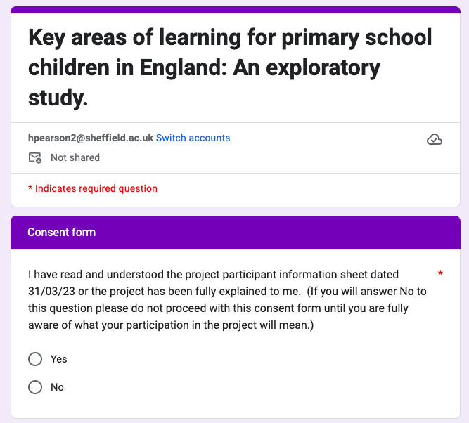 Questionnaire
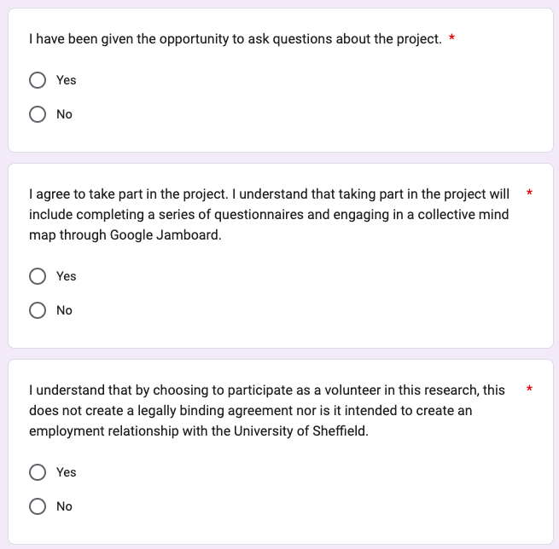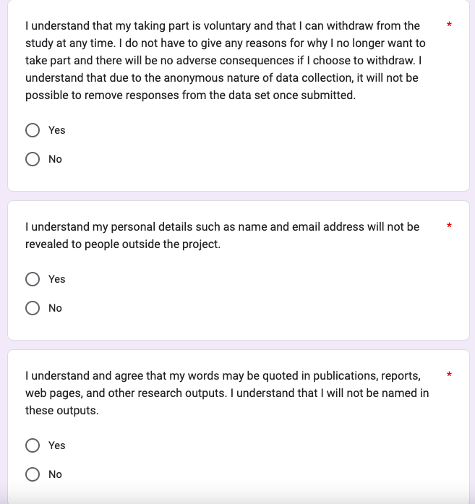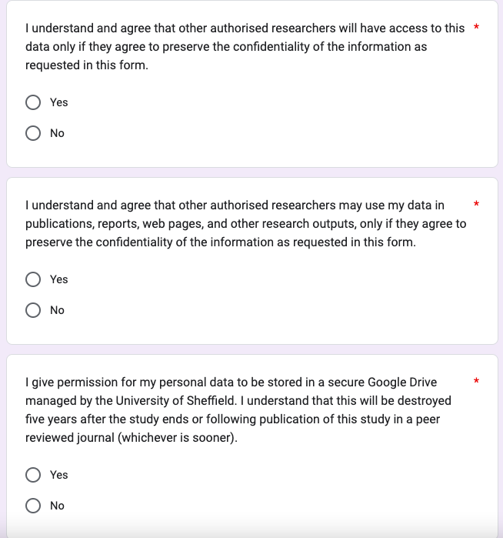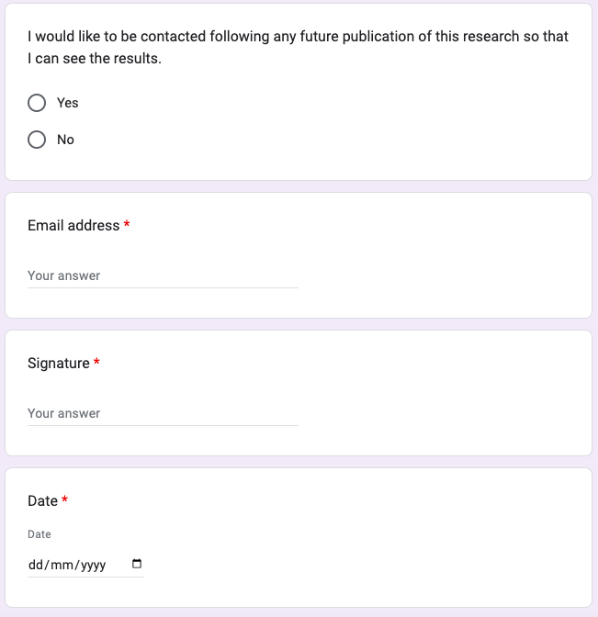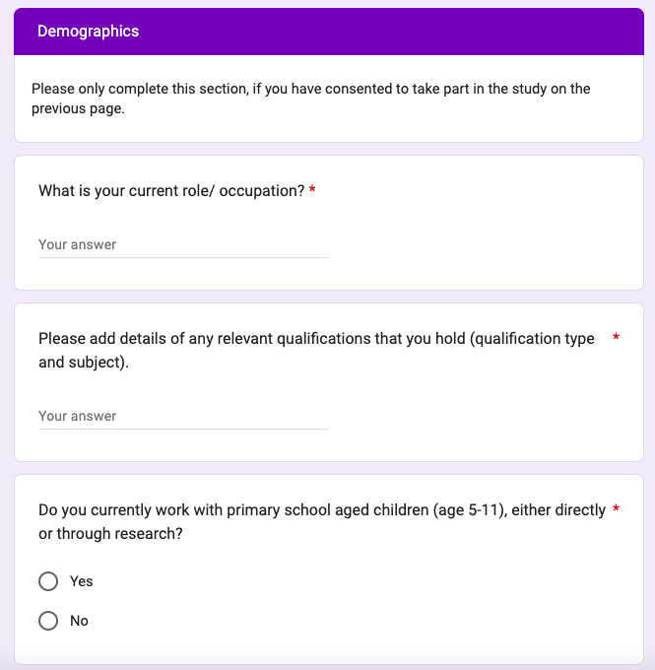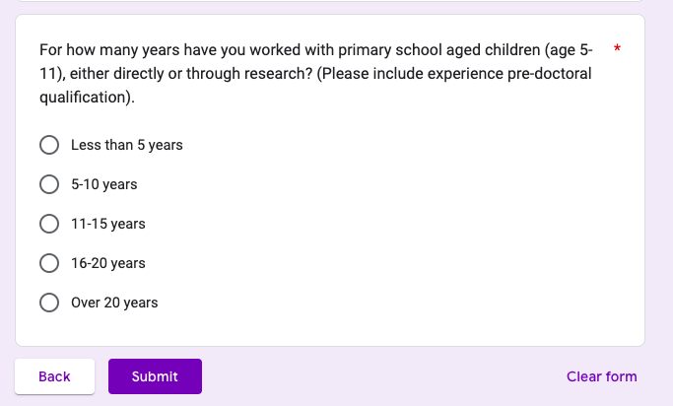

Appendix D: Stage 1a Google Form
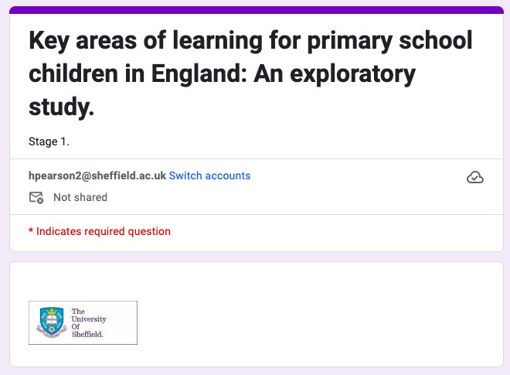
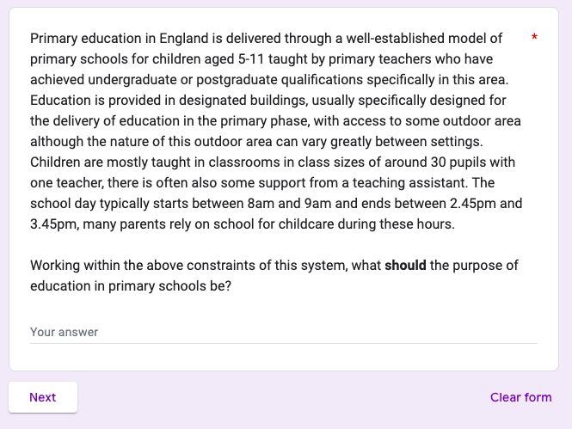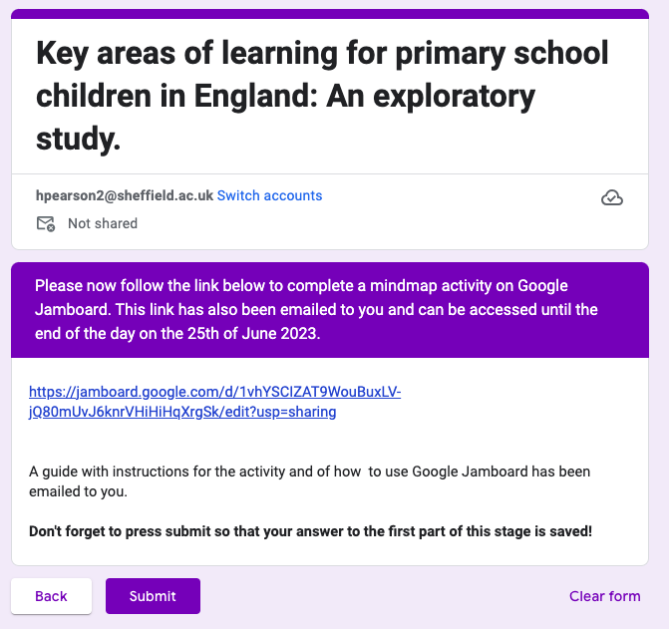

Appendix E: Stage 1a Participant Responses
Response | Primary education in England is delivered through a well-established model of primary schools for children aged 5-11 taught by primary teachers who have achieved undergraduate or postgraduate qualifications specifically in this area. Education is provided in designated buildings, usually specifically designed for the delivery of education in the primary phase, with access to some outdoor area although the nature of this outdoor area can vary greatly between settings. Children are mostly taught in classrooms in class sizes of around 30 pupils with one teacher, there is often also some support from a teaching assistant. The school day typically starts between 8am and 9am and ends between 2.45pm and 3.45pm, many parents rely on school for childcare during these hours.  Working within the above constraints of this system, what should the purpose of education in primary schools be?
1 | To encourage children to become independent learners who are curious enjoy learning. To allow them to follow some of their own interests without judgement or assessment. To build physical and intellectual confidence so that children are thinking, doing and being. To introduce them to things that are new to them, and allow them to experiment, problem solve and be creative. To equip them with skills in reading, writing, communication, and mathematics and more generic skills that can apply in different contexts- such as questioning, thinking scientifically, being imaginative. To promote inclusive values which enable children to be seen as individuals and celebrating difference. To help children learn how to collaborate and work respectfully with others.  Not to be measuring and constantly making children feel that they can fail.
2 | I believe that primary education should be about enabling children to learn to be confident human beings, to begin developing the skills to be social, understand and enjoy friendships, to learn how to play (by themselves and with others), to learn about structuring your day, to get to know yourself and feel happy in your own body. To enjoy learning and to feel self-motivated to do so (eventually) and so learning should foster enjoyment of learning.  I remember sitting in my infant classroom and the teacher introducing us to maths that was too hard and feeling upset that I couldn't do it. When another teacher took over and I suddenly felt able to access the learning, it was a relief. She was warm and caring. That made a huge difference to me. It was also very interactive. It helped me feel confident but I also began to enjoy learning, and I have carried that with me into my life.
3 | To develop the whole child, for the present and the future: as a caring, successful and confident learner, citizen, parent and employee
4 | The purpose of primary education should be to teach children the academic skills they need to be part of society and make the choices they want into their adulthood. It should provide a safe space where children can explore social interactions with their peers and learn how to be alongside other children who have different thoughts, feelings, behaviours, backgrounds and needs to them.
5 | To play, learn about their own skills and strengths and areas for development (curricular and pastoral) and to prepare for life as an adult - working with others, listening, to use their voice effectively, to learn ways of solving problems and to learn the skills needed for being an adult (practical, pastoral and in work).
6 | I believe that education in primary schools should include social, emotional and cultural development. I feel that the role of a teacher is to ensure that children have access to a variety of curriculum subjects and yes, support children to develop their subject knowledge but more importantly to develop their skills and problem solving abilities in these subjects. The role of a school is to ensure that children are safe but also teach them to keep themselves safe. In addition to the national curriculum, children should learn high quality RSHE and how to keep themselves safe through PSHE and protective behaviours. Education should also allow children the opportunity to develop independently and understand how to risk assess. It should give children access to opportunities that they might not have outside of a school context. I also feel that it should focus on developing children's social and emotional skills including how to develop friendships and build positive relationships with others. As a past PSHE coordinator and PSHE teacher educator, these values are also important to me and form part of my rationale for responding as I have.
7 | Creating conditions whereby children can develop a global outlook and see themselves as people who have agency and influence through developing competence in basic foundational skills, pursuing value aligned goals and being able to communicate effectively with a range of people from different backgrounds.
8 | To build initial academic skills and develop academic resilience and independence
9 | To develop confidence as learner and as social beings. To understand themselves and how to interact with others. To learn underpinning skills such as how to attend, wait, take turns, accept stretch and challenge with learning, make mistakes, resolve minor conflict, and make and maintain friendship. To learn about the wider environment, not just curriculum based subject which will be tested on. To learn practical skills and develop problem solving in real life situations.
10 | schools should meet the needs of every individual to encourage and challenge them to be knowledgable about the world around them and beyond; to be resilient and be able to solve problems through deeper thinking, team work and effective communication; be confident and adventurous; to be knowledgable and able to make choice to lead healthy and active lifestyles
11 | To give children a well-rounded start to life, spark interest and curiosity and support developmental outcomes.
12 | Develop basic skills in literacy, numeracy, learning to learn / study, acquire basic cultural knowledge around science, history and geography, learn how to interact and communicate with others, develop physical skills both fine and gross motor, learn how to keep healthy physically and mentally - how to care for self-and others

Appendix F: Thematic Analysis Coding of Participant Responses in Stage 1a
Code | To become independent learners | To develop curiosity | To enjoy learning | To follow own interests | To build confidence | To develop skills in literacy | To develop skills in mathematics
Response 1 | To encourage children to become independent learners | who are curious | enjoy learning | To allow them to follow some of their own interests | To build physical and intellectual confidence | To equip them with skills in reading, writing | mathematics
Response 2 |  |  | To enjoy learning and to feel self-motivated to do so |  | enabling children to learn to be confident human beings
Response 3 |  |  |  |  | confident
Response 4
Response 5
Response 6
Response 7
Response 8 | independence
Response 9 |  |  |  |  | To develop confidence as learner
Response 10
Response 11 |  | curiosity |  | spark interest
Response 12 |  |  |  |  |  | Develop basic skills in literacy, | numeracy

Code | To develop skills in science | To develop general skills that will support academic learning | To develop problem solving skills | To be creative | To develop communication skills | To promote inclusive values | To develop social skills
Response 1 | thinking scientifically | more generic skills that can apply in different contexts- such as questioning, thinking scientifically, being imaginative. | problem solve | be creative | communication | To promote inclusive values
Response 2 |  |  |  |  |  |  | to begin developing the skills to be social, understand and enjoy friendships
Response 3
Response 4 |  |  |  |  |  | learn how to be alongside other children who have different thoughts, feelings, behaviours, backgrounds and needs to them. | can explore social interactions with their peers
Response 5
Response 6 |  |  |  |  |  |  | focus on developing children's social and emotional skills including how to develop friendships and build positive relationships with others
Response 7 |  |  |  |  | being able to communicate effectively with a range of people from different backgrounds
Response 8
Response 9 |  |  |  |  |  |  | social beings, how to interact with others
Response 10 |  |  |  |  | effective communication;
Response 11
Response 12 | basic cultural knowledge around science, | learning to learn / study |  |  | learn how to interact and communicate with others

Code | To have opportunities to play | To develop skills for everyday life | To understand self | To have positive wellbeing | To develop the whole child | To prepare for adulthood | Skills needed to be part of society
Response 1
Response 2 | to learn how to play (by themselves and with others) | to learn about structuring your day | to get to know yourself | feel happy in your own body
Response 3 |  |  |  |  | To develop the whole child, | citizen, parent and employee
Response 4 |  |  |  |  |  |  | The academic skills they need to be part of society
Response 5 |  |  | learn about their own skills and strengths and areas for development |  |  | to prepare for life as an adult
Response 6
Response 7
Response 8
Response 9 |  | To learn practical skills and develop problem solving in real life situations. | To understand themselves
Response 10
Response 11 |  |  |  |  | To give children a well-rounded start to life
Response 12

Code | To develop emotional skills | To develop a global outlook | To develop academic skills | To develop resilience | To be able to make choices | To support developmental outcomes | To develop physical skills
Response 1
Response 2
Response 3
Response 4
Response 5
Response 6 | focus on developing children's social and emotional skills including how to develop friendships and build positive relationships with others
Response 7 |  | Creating conditions whereby children can develop a global outlook
Response 8 |  |  | To build initial academic skills | develop academic resilience
Response 9 |  | To learn about the wider environment
Response 10 |  | to be knowledgable about the world around them and beyond |  | to be resilient | able to make choice
Response 11 |  |  |  |  |  | support developmental outcomes. | develop physical skills both fine and gross motor,
Response 12

Appendix G: Theme development in Thematic Analysis of Responses in Stage 1a

Initial Themes and Codes
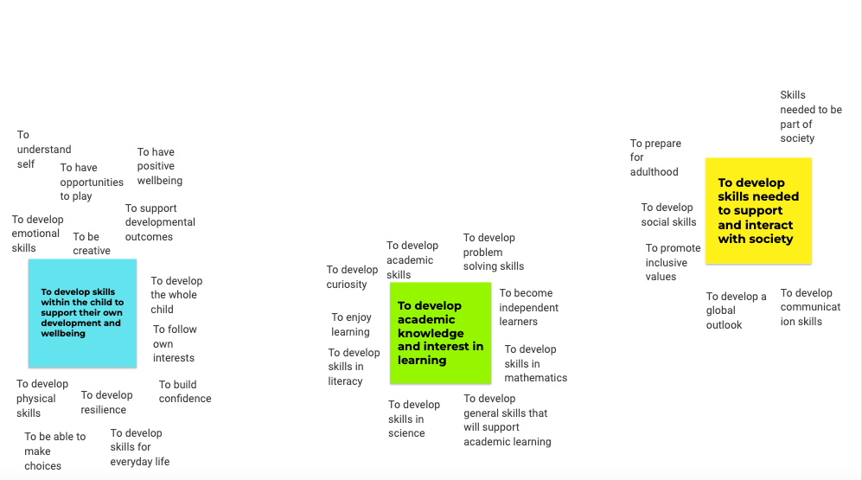

First Refinement of Themes, Subthemes
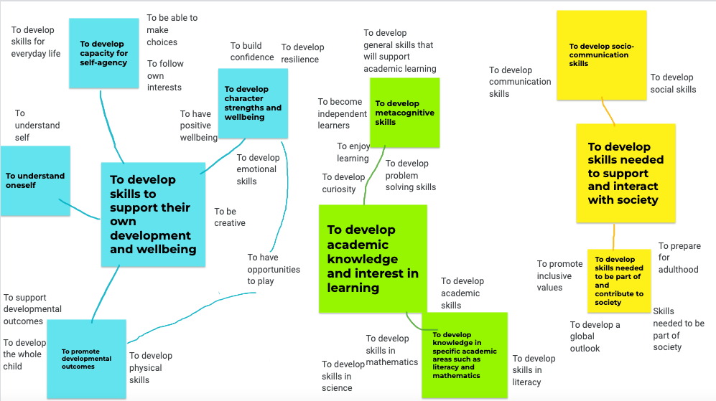

Final Themes and Subthemes
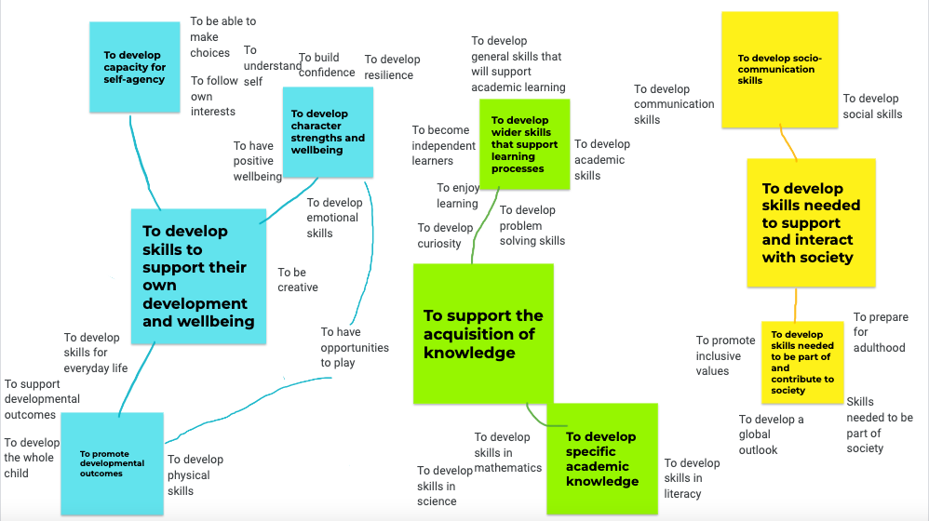

Appendix H: Jamboard for Stage 1b
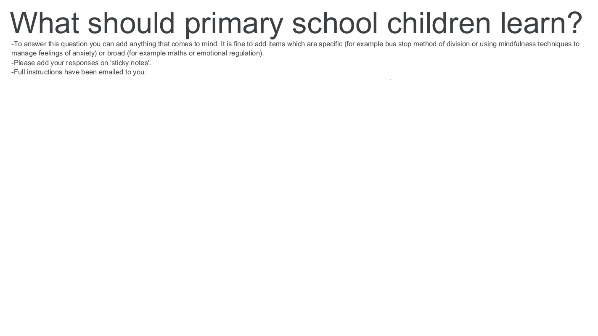

Appendix I: Responses to Stage 1b
How to problem solve and approach unfamiliar tasks.
To find their own skills and strengths - be they academic or curriculum specific, or vocational or creative.
To use their voice effectively and to listen to others.
To be able to build on their strengths rather than focus on difficulties only.
'Soft skills' how to relate to others, how to support their own interests, how to learn. They need to understand that learning can be fun, engaging and that it is a reward in itself.
How to build relationships with others.
Learning how to learn.
How to work with others on a range of different tasks.
How to approach learning tasks - getting started, keeping going when something is challenging, being independent in learning.
To love stories and books, less emphasis on testing reading skills until a genuine interest in engaging with reading/being read to is there.
To be inquisitive problem solvers.
To be a caring person, developing empathy for others and learning about the world and our history more widely in the widest sense.
How to work collaboratively and deal with conflict.
Develop independence and curiosity for learning, have the chance to follow their own interests.
To understand what it means to feel safe and understand what this looks and feels like.
To be creative and try things out without fear of failure.
To be a human being - how to relate to others, how to like themselves, how to feel, how to make things, how to have fun, how to play.
Independent learning skills - how to be an effective and inquisitive learner.
Physical skills both fine and gross motor
How to develop and maintain positive relationships and friendships.
The skills they need to succeed in life - team work, communication, resilience, problem solving, leadership.
To feel secure in oneself as a person, knowing one's strengths and one's worth as an individual, to have a positive narrative about oneself as a learner.
How to communicate with others - in class, in public, in the home, formally and informally. To recognise emotions in selves and others.
Enabling children to develop their thinking and decision making skills, encouraging them to develop opinions and listen to others P4C, PSHCE and RE, collaborative activities.
That getting things right can take time and that you should not stop at the first failure.
Curriculum subjects, with an emphasis on spoken language and literacy as the means to access the rest of the curriculum.
Learning how to be someone who contributes to their community and society more widely.
To listen to, relate to and interact with others including to persuade others, make an argument as well to be reflective in their relationships and take account of others' views.
To problem solve to help them cope in life and in school and in work.
How to keep oneself healthy both mentally and physically, how to look after self and others.
Working on how to manage their emotions and feelings, making sense of the demands on them and how to apply the right approaches/strategies.
Physical education should be integral to the school day, preparing children to lead healthy and active lives.
Develop foundation skills in reading, writing and maths
Academic resilience so they can have better understanding of independence skills as learners.
Basic skills in numeracy - how to use and apply the four rules of number to common situations. basic learning in other areas of maths such as shape and measurement.
Key topics in geography, history and science taught with an emphasis on both local and national concerns and global perspectives.
Practical skills, making and doing, continued past the early years.
Overall emotional resilience so they can deal with set-back, and see that practice makes a difference. To help them build resilience for life.
To work cooperatively and collaboratively with peers in a non-competitive environment.
Making mistakes, tolerating getting it wrong, going back to repair/redo.
The skills needed to succeed in life - spanning all areas of development from core education, to motor skills, socioemotional wellbeing, critical thinking, health.
Critical thinking skills.
How to interact with others individually, within a group and when delivering to an audience.
To learn about themselves as people: to develop and adapt their identity in an ever-changing world: especially in relation to new technologies and health developments.
To learn the skills and knowledge of particular subjects to learn what they are passionate about and interested in.
Applying basic curriculum teaching to real life and creative, collaborative projects and activities.
A greater emphasis on life skills such as healthy eating, exercise, not just a short project in year three for example.
To consider what social justice issues influence them and the rest of the world - to learn how they can challenge and influence change.
An introduction to key themes and practice in music and art, opportunity to have fun and be creative and try new things in these areas.
Identity, confidence, dealing with set-backs, building resilience - actually doing it, not just the rhetoric.
Resilience and the ability to manage minor conflict, resolve problems independently.
Creative project work - holistic approaches to incorporating the curriculum.
Curriculum skills like maths, English in interactive ways, starting with what the child can do already rather than using arbitrary made-up age related standards as a starting point.
Discover the opportunities that are in the world e.g. inspiring big dreams and belief.
The primary curriculum should be less politically motivated as at present and not led by the assessment and accountability regime.
A knowledge-rich curriculum ignores the need for a balance of Cognitive Intelligence (IQ), Emotional Intelligence (EQ) and Cultural Intelligence (CQ). So a more balanced curriculum.
More about what they are interested in, with the depth to be able to apply that knowledge to real world experiences.
Managing conflict, developing self-awareness, mastering their bodies and behaviours.
Knowledge about the world through geography, history and science as well as pursue one hobby: playing instrument, completing DT/ Art project as well as competitive sports.
They should learn how they best learn, not be tied to the current thinking on which method is best, thinking about maths method in particular.
Basic skills in literacy - how to read and write a full page of text fluently and understand what they have read.
Improve children's relationship between movement and activity.
Mindfulness, meditation, extended opportunities to play, healthy living - including permaculture.
Teach games that are better with two or more, fun and engaging, not just PE related, playing cards, board games, provide opportunities to learn to love something before IT takes over.
The primary curriculum should be a higher level framework which is interpreted locally by schools on a longer cycle: Finland has a 10 year curriculum cycle vs. 5 years in UK.
To recognize that feelings are transient and fleeting and not to pay too much attention to them but instead pursue activity and develop skills through an activity.
To be able to understand and utilise money - budgets, how much things tend to cost. Understanding of mortgages, rent, taxes, bills - basically, how to live.
How to take a test without anxiety, change how testing is done so children see it as an opportunity to show what they can do - test them on what they already know when younger.
EPs tend to favour learning to learn, dynamic approaches, mediation and ignore domain specific knowledge, diffs with transfer and their own privilege.
Developing world knowledge and how they form part of one race, not the mainstream image of segregation. Celebrating different cultures, beliefs and religions.*

*Item removed.

Appendix J: Stage 2 Google Form

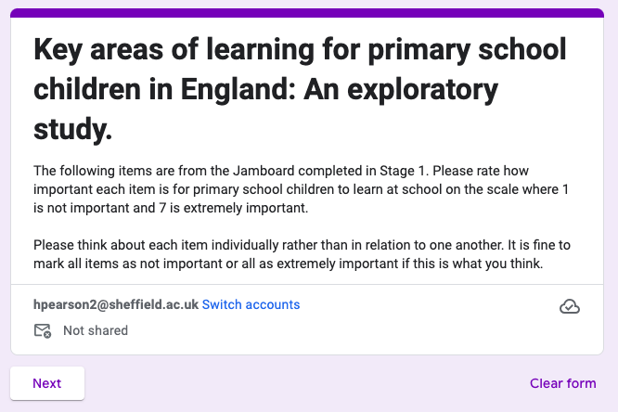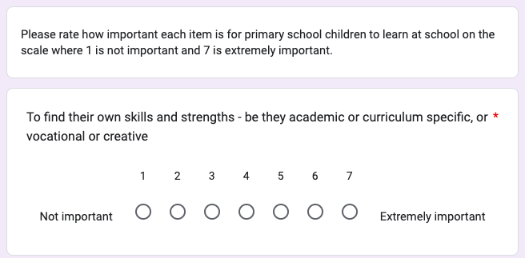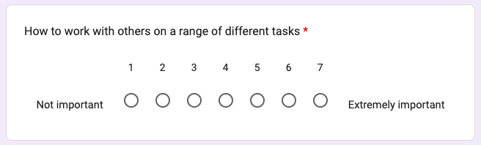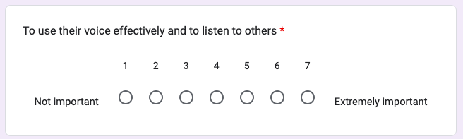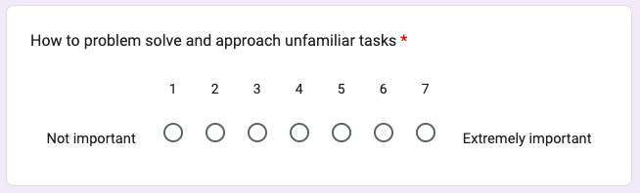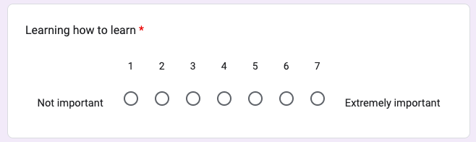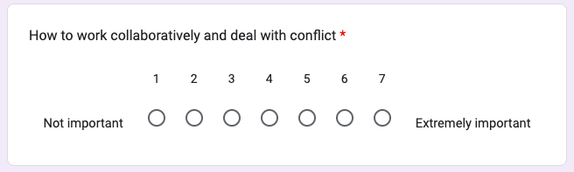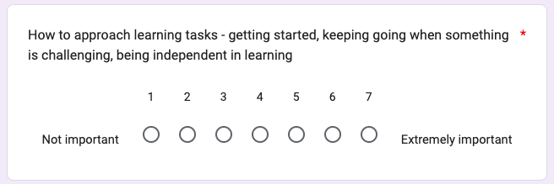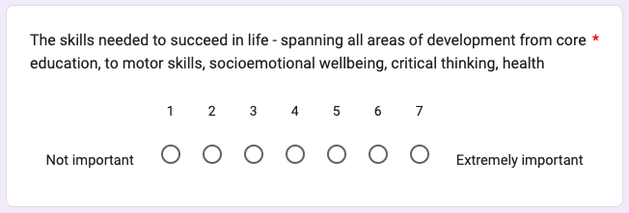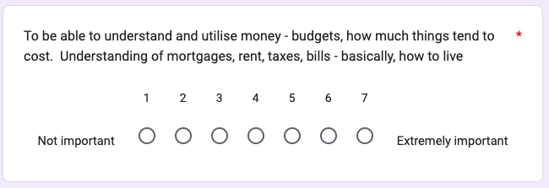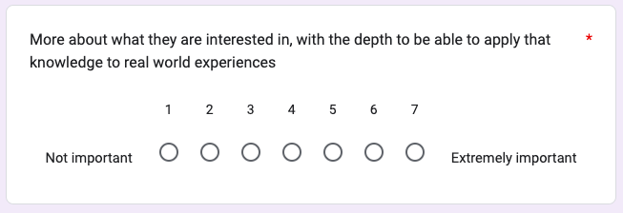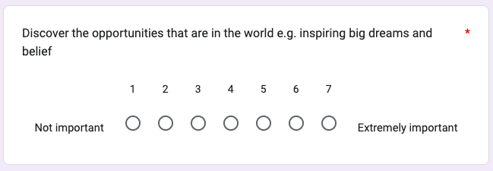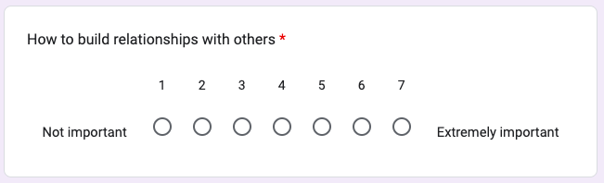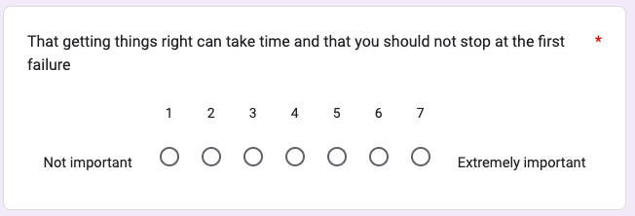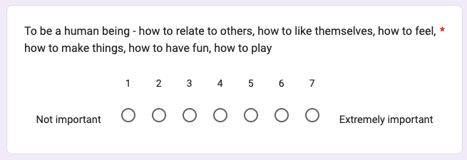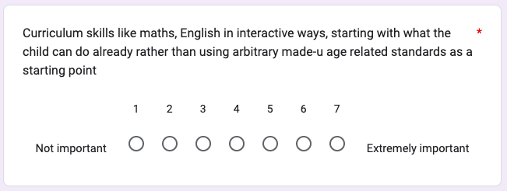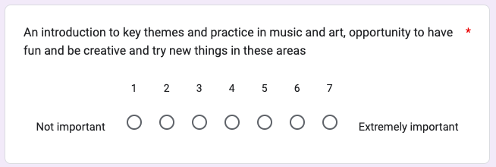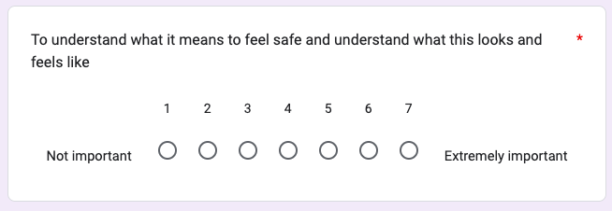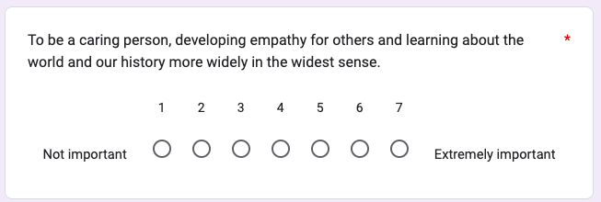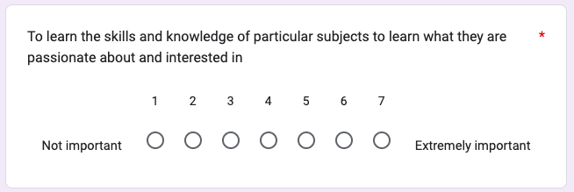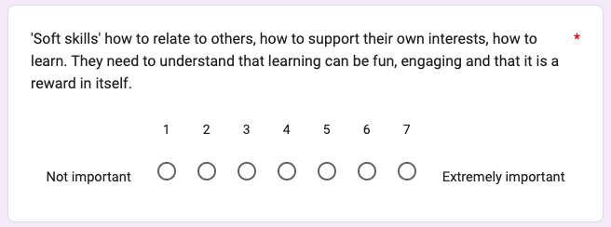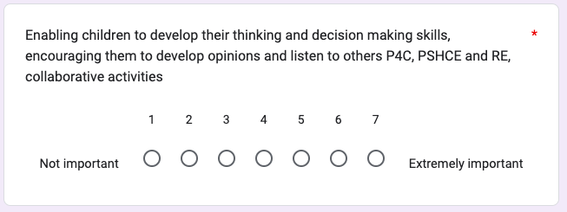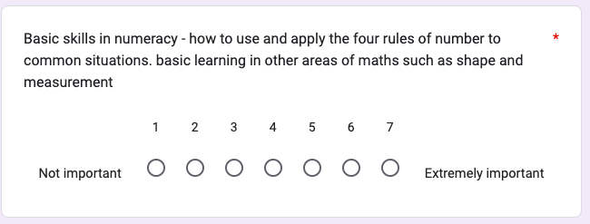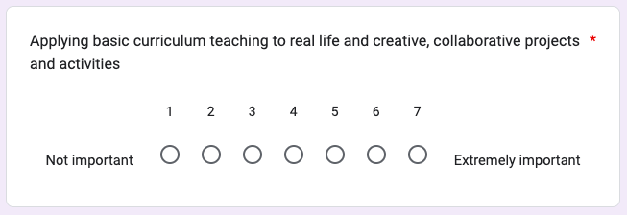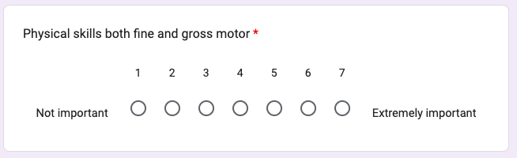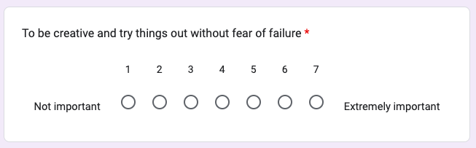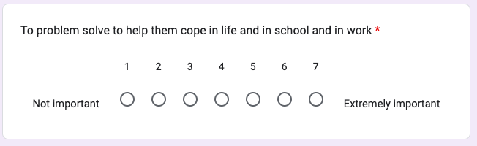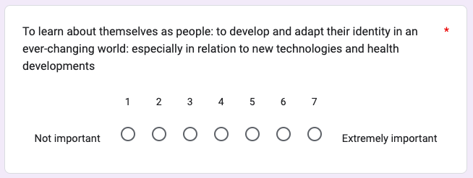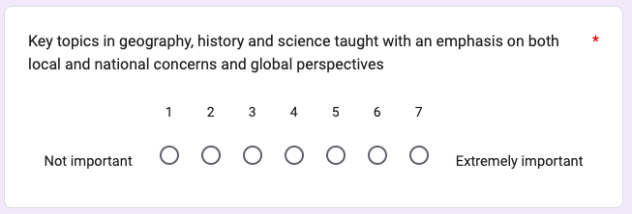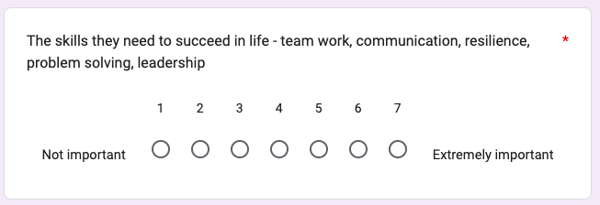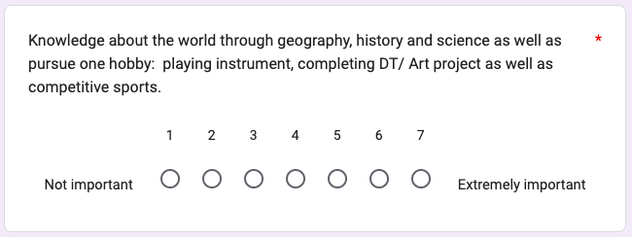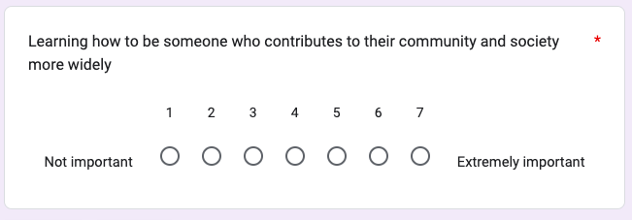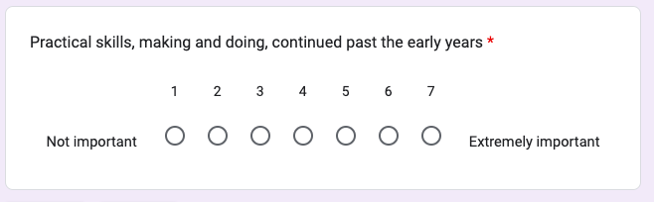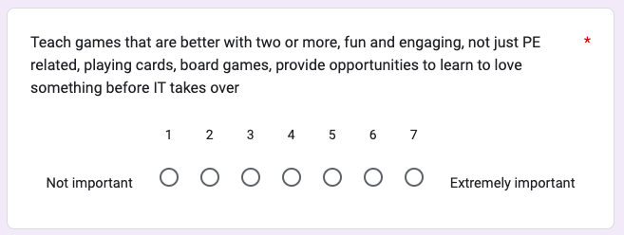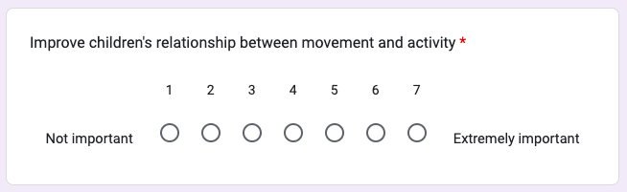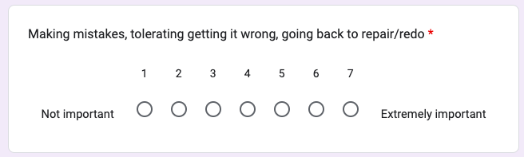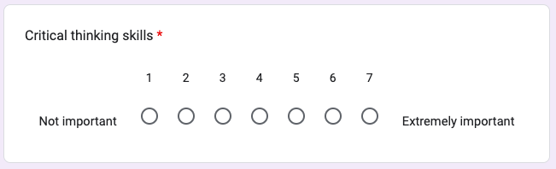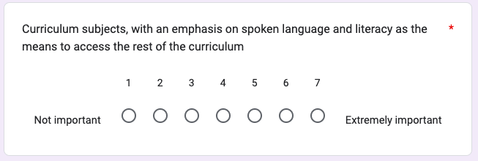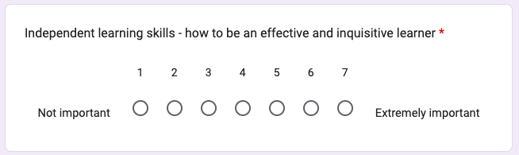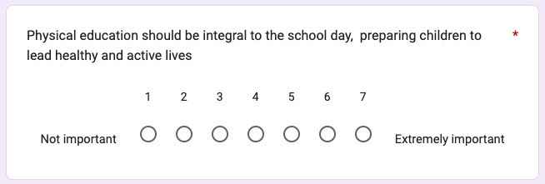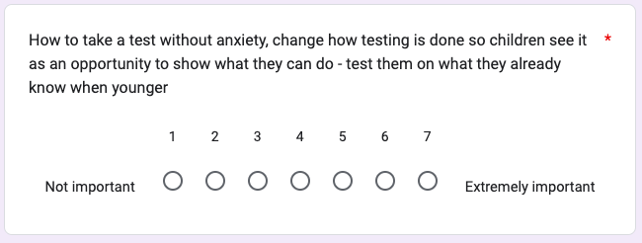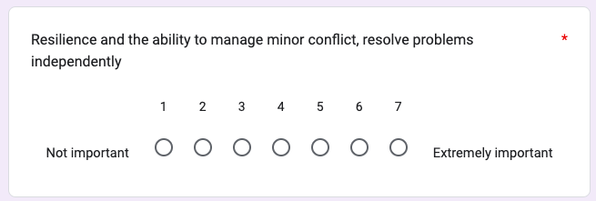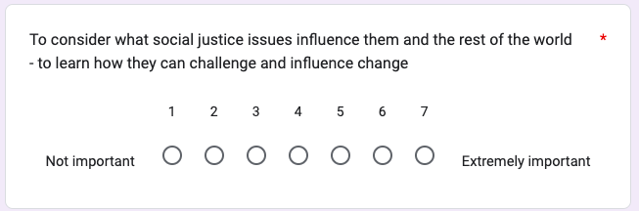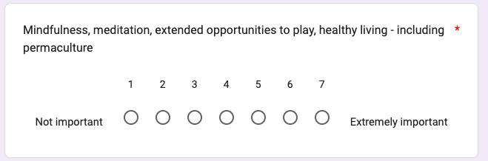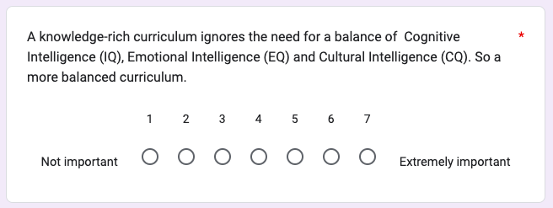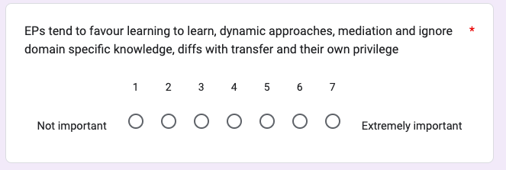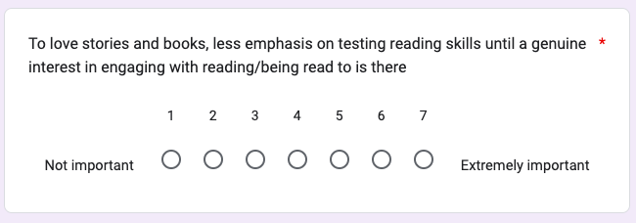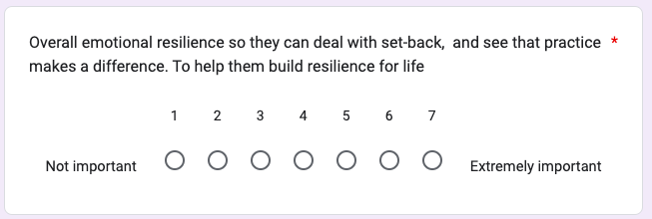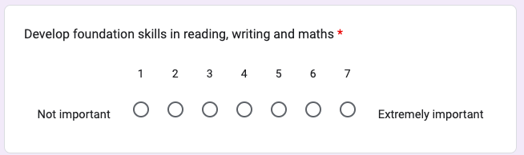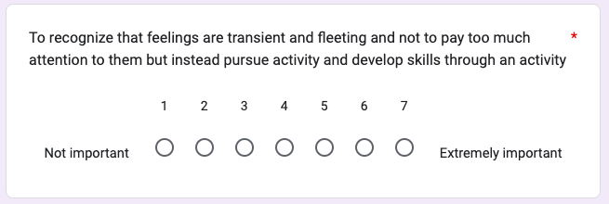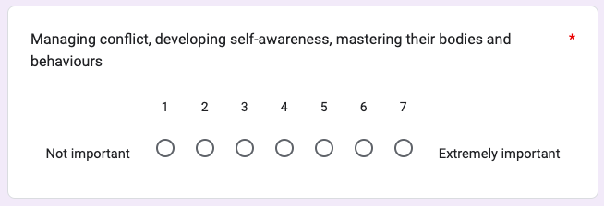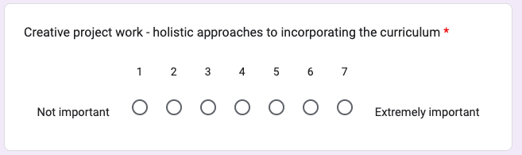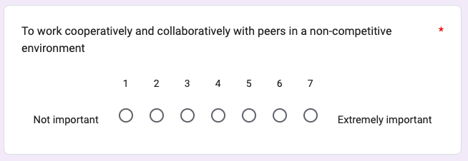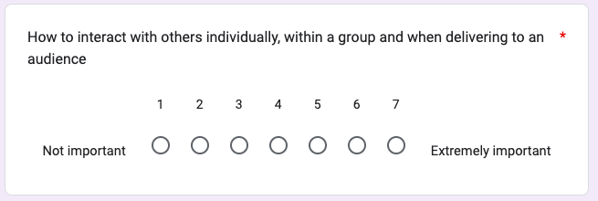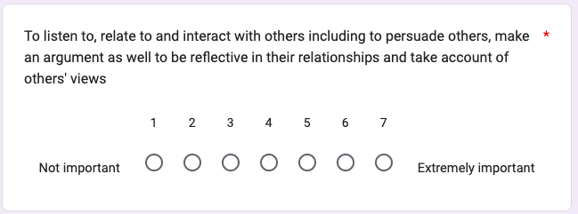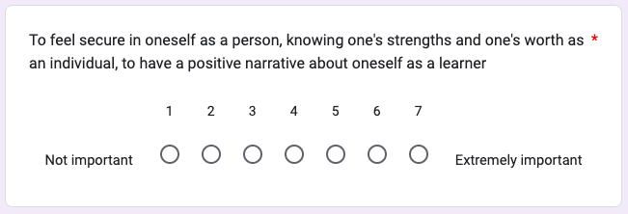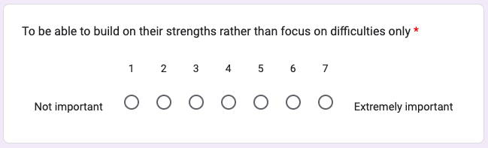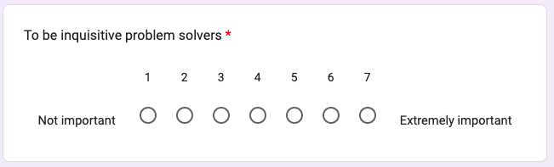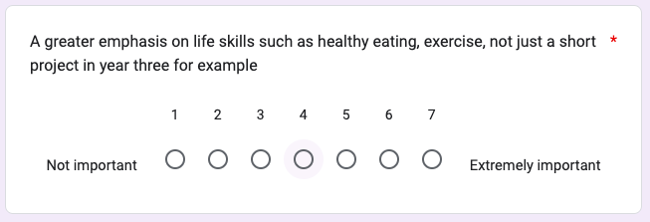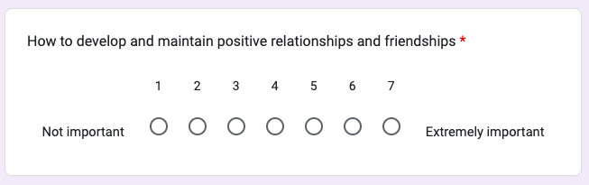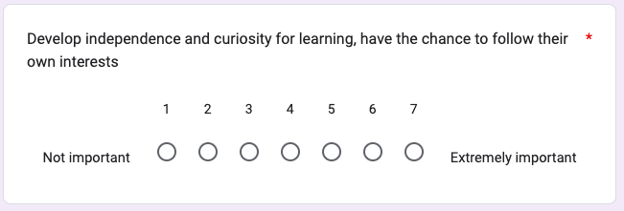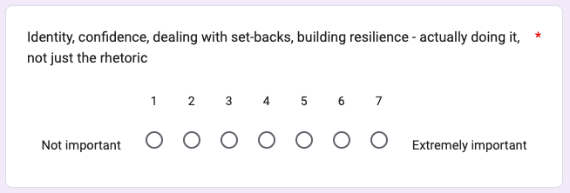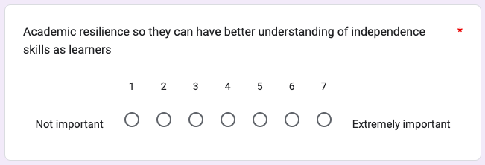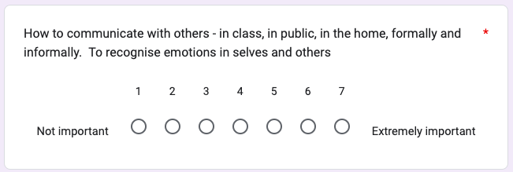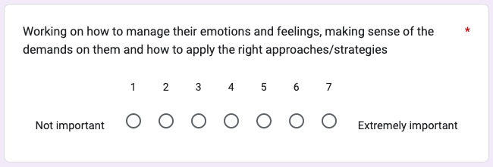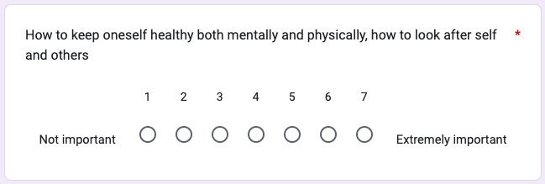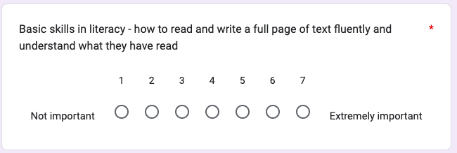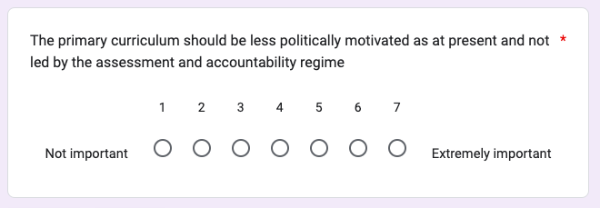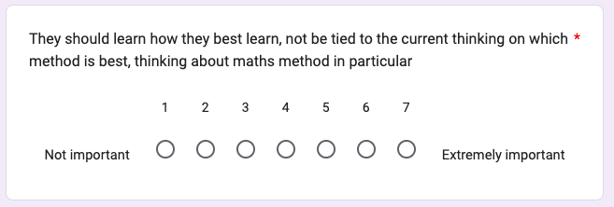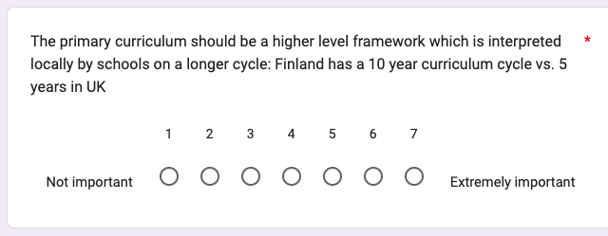

Appendix K: Stage 2 Responses
Item | Respondent No. |  |  |  |  |  |  |  |  |  |  |  |  |  |  |  |  | Median
Item | 1 | 2 | 3 | 4 | 5 | 6 | 7 | 8 | 9 | 10 | 11 | 12 | 13 | 14 | 15 | 16 | 17 | Median
To find their own skills and strengths - be they academic or curriculum specific, or vocational or creative | 6 | 7 | 7 | 4 | 6 | 7 | 7 | 4 | 7 | 7 | 7 | 7 | 7 | 7 | 7 | 7 | 7 | 7
How to problem solve and approach unfamiliar tasks | 5 | 6 | 7 | 7 | 7 | 7 | 7 | 4 | 7 | 7 | 7 | 6 | 7 | 6 | 7 | 7 | 7 | 7
To use their voice effectively and to listen to others | 5 | 7 | 7 | 7 | 5 | 7 | 7 | 4 | 6 | 7 | 7 | 7 | 7 | 7 | 7 | 7 | 6 | 7
To be able to build on their strengths rather than focus on difficulties only | 3 | 7 | 7 | 6 | 5 | 6 | 7 | 6 | 7 | 6 | 7 | 7 | 7 | 7 | 7 | 7 | 6 | 7
'Soft skills' how to relate to others, how to support their own interests, how to learn. They need to understand that learning can be fun, engaging and that it is a reward in itself. | 4 | 6 | 7 | 7 | 6 | 7 | 7 | 3 | 7 | 7 | 7 | 7 | 7 | 6 | 7 | 7 | 5 | 7
How to build relationships with others | 7 | 6 | 6 | 5 | 6 | 7 | 7 | 3 | 6 | 7 | 6 | 7 | 7 | 7 | 7 | 7 | 5 | 7
Learning how to learn | 7 | 5 | 7 | 7 | 7 | 5 | 7 | 2 | 7 | 7 | 7 | 6 | 7 | 5 | 7 | 7 | 5 | 7
How to work with others on a range of different tasks | 4 | 7 | 7 | 6 | 6 | 6 | 7 | 4 | 5 | 7 | 7 | 5 | 7 | 7 | 7 | 6 | 6 | 6
How to approach learning tasks - getting started, keeping going when something is challenging, being independent in learning | 6 | 5 | 6 | 7 | 5 | 7 | 7 | 3 | 7 | 7 | 7 | 7 | 6 | 5 | 7 | 7 | 5 | 7
To be a caring person, developing empathy for others and learning about the world and our history more widely in the widest sense. | 5 | 7 | 7 | 6 | 6 | 7 | 7 | 3 | 7 | 7 | 7 | 4 | 7 | 6 | 7 | 5 | 5 | 7
To love stories and books, less emphasis on testing reading skills until a genuine interest in engaging with reading/being read to is there | 6 | 6 | 7 | 7 | 5 | 7 | 4 | 4 | 5 | 6 | 7 | 7 | 6 | 6 | 7 | 6 | 7 | 6
To be inquisitive problem solvers | 3 | 7 | 7 | 4 | 6 | 7 | 7 | 6 | 7 | 6 | 7 | 6 | 6 | 5 | 7 | 7 | 5 | 6
How to work collaboratively and deal with conflict | 5 | 7 | 7 | 6 | 6 | 7 | 5 | 3 | 7 | 7 | 7 | 5 | 6 | 6 | 7 | 6 | 5 | 6
To be a human being - how to relate to others, how to like themselves, how to feel, how to make things, how to have fun, how to play | 4 | 5 | 7 | 4 | 6 | 7 | 6 | 2 | 7 | 7 | 7 | 7 | 7 | 7 | 7 | 7 | 5 | 7
To understand what it means to feel safe and understand what this looks and feels like | 5 | 7 | 7 | 4 | 6 | 6 | 7 | 4 | 7 | 7 | 7 | 5 | 7 | 7 | 7 | 5 | 4 | 7
To be creative and try things out without fear of failure | 3 | 7 | 7 | 6 | 7 | 7 | 6 | 3 | 5 | 7 | 7 | 7 | 6 | 6 | 7 | 5 | 6 | 6
Develop independence and curiosity for learning, have the chance to follow their own interests | 4 | 7 | 7 | 4 | 6 | 7 | 6 | 4 | 7 | 6 | 7 | 7 | 5 | 6 | 7 | 5 | 7 | 6
Independent learning skills - how to be an effective and inquisitive learner | 4 | 7 | 7 | 6 | 6 | 6 | 7 | 1 | 7 | 6 | 7 | 7 | 7 | 5 | 7 | 6 | 5 | 6
Physical skills both fine and gross motor | 7 | 5 | 7 | 5 | 7 | 7 | 4 | 4 | 7 | 6 | 7 | 4 | 7 | 5 | 7 | 5 | 6 | 6
The skills they need to succeed in life - team work, communication, resilience, problem solving, leadership | 2 | 6 | 7 | 7 | 7 | 7 | 6 | 2 | 7 | 7 | 7 | 7 | 7 | 4 | 7 | 6 | 4 | 7
How to develop and maintain positive relationships and friendships | 3 | 6 | 7 | 7 | 6 | 7 | 5 | 3 | 5 | 6 | 7 | 7 | 7 | 6 | 7 | 6 | 5 | 6
To feel secure in oneself as a person, knowing one's strengths and one's worth as an individual, to have a positive narrative about oneself as a learner | 3 | 7 | 7 | 7 | 6 | 4 | 6 | 6 | 4 | 6 | 7 | 7 | 6 | 7 | 7 | 5 | 4 | 6
That getting things right can take time and that you should not stop at the first failure | 3 | 5 | 7 | 7 | 6 | 5 | 7 | 3 | 4 | 7 | 7 | 7 | 6 | 6 | 7 | 7 | 4 | 6
Enabling children to develop their thinking and decision making skills, encouraging them to develop opinions and listen to others P4C, PSHCE and RE, collaborative activities | 4 | 7 | 6 | 5 | 6 | 6 | 7 | 2 | 6 | 7 | 7 | 5 | 6 | 6 | 7 | 6 | 5 | 6
How to communicate with others - in class, in public, in the home, formally and informally. To recognise emotions in selves and others | 4 | 7 | 7 | 7 | 6 | 6 | 5 | 4 | 7 | 6 | 7 | 4 | 6 | 6 | 7 | 5 | 4 | 6
To problem solve to help them cope in life and in school and in work | 3 | 6 | 6 | 4 | 6 | 7 | 6 | 3 | 7 | 7 | 7 | 6 | 7 | 5 | 7 | 6 | 4 | 6
Learning how to be someone who contributes to their community and society more widely | 5 | 7 | 5 | 3 | 6 | 6 | 7 | 4 | 7 | 6 | 7 | 6 | 7 | 5 | 7 | 4 | 5 | 6
Curriculum subjects, with an emphasis on spoken language and literacy as the means to access the rest of the curriculum | 7 | 5 | 6 | 4 | 4 | 7 | 6 | 6 | 7 | 5 | 5 | 5 | 7 | 5 | 5 | 7 | 6 | 6
To listen to, relate to and interact with others including to persuade others, make an argument as well to be reflective in their relationships and take account of others' views | 3 | 7 | 7 | 7 | 5 | 7 | 5 | 4 | 6 | 6 | 7 | 5 | 5 | 6 | 7 | 6 | 4 | 6
Physical education should be integral to the school day, preparing children to lead healthy and active lives | 6 | 4 | 6 | 6 | 7 | 6 | 5 | 5 | 7 | 6 | 7 | 4 | 7 | 3 | 7 | 5 | 5 | 6
Develop foundation skills in reading, writing and maths | 7 | 5 | 5 | 7 | 4 | 3 | 4 | 7 | 5 | 5 | 7 | 7 | 7 | 5 | 7 | 7 | 4 | 5
Academic resilience so they can have better understanding of independence skills as learners | 2 | 6 | 5 | 7 | 6 | 2 | 7 | 6 | 7 | 6 | 7 | 6 | 7 | 4 | 7 | 7 | 4 | 6
Working on how to manage their emotions and feelings, making sense of the demands on them and how to apply the right approaches/strategies | 4 | 4 | 7 | 5 | 6 | 7 | 6 | 4 | 7 | 6 | 7 | 6 | 6 | 5 | 7 | 5 | 4 | 6
How to keep oneself healthy both mentally and physically, how to look after self and others | 4 | 5 | 7 | 6 | 6 | 5 | 5 | 4 | 6 | 6 | 7 | 5 | 7 | 6 | 7 | 5 | 5 | 6
The skills needed to succeed in life - spanning all areas of development from core education, to motor skills, socioemotional wellbeing, critical thinking, health | 2 | 4 | 7 | 7 | 6 | 7 | 5 | 2 | 7 | 7 | 7 | 5 | 7 | 5 | 5 | 7 | 5 | 6
Basic skills in numeracy - how to use and apply the four rules of number to common situations. basic learning in other areas of maths such as shape and measurement | 7 | 4 | 5 | 7 | 4 | 5 | 5 | 5 | 4 | 5 | 7 | 6 | 7 | 5 | 7 | 7 | 5 | 5
Key topics in geography, history and science taught with an emphasis on both local and national concerns and global perspectives | 5 | 7 | 5 | 7 | 6 | 5 | 7 | 5 | 6 | 5 | 7 | 3 | 4 | 4 | 7 | 7 | 5 | 5
Practical skills, making and doing, continued past the early years | 4 | 7 | 7 | 5 | 4 | 6 | 4 | 4 | 7 | 7 | 7 | 5 | 7 | 4 | 6 | 5 | 6 | 6
Making mistakes, tolerating getting it wrong, going back to repair/redo | 2 | 6 | 7 | 7 | 5 | 5 | 5 | 4 | 5 | 6 | 7 | 7 | 6 | 5 | 7 | 7 | 4 | 6
Critical thinking skills | 2 | 7 | 6 | 5 | 7 | 6 | 5 | 1 | 7 | 6 | 7 | 6 | 6 | 5 | 7 | 7 | 5 | 6
Overall emotional resilience so they can deal with set-back, and see that practice makes a difference. To help them build resilience for life | 3 | 6 | 7 | 6 | 6 | 3 | 5 | 4 | 5 | 6 | 7 | 7 | 7 | 5 | 7 | 6 | 5 | 6
To work cooperatively and collaboratively with peers in a non-competitive environment | 3 | 7 | 7 | 6 | 6 | 6 | 5 | 3 | 5 | 4 | 7 | 5 | 7 | 5 | 7 | 7 | 5 | 6
To learn about themselves as people: to develop and adapt their identity in an ever-changing world: especially in relation to new technologies and health developments | 4 | 6 | 7 | 3 | 6 | 7 | 7 | 3 | 7 | 7 | 7 | 5 | 4 | 5 | 7 | 5 | 4 | 6
How to interact with others individually, within a group and when delivering to an audience | 3 | 6 | 7 | 7 | 6 | 6 | 5 | 5 | 5 | 5 | 7 | 4 | 6 | 5 | 7 | 6 | 4 | 6
To learn the skills and knowledge of particular subjects to learn what they are passionate about and interested in | 4 | 7 | 4 | 3 | 6 | 5 | 7 | 5 | 5 | 7 | 7 | 7 | 4 | 5 | 6 | 6 | 5 | 5
Applying basic curriculum teaching to real life and creative, collaborative projects and activities | 2 | 5 | 5 | 4 | 6 | 6 | 5 | 3 | 6 | 6 | 7 | 7 | 6 | 5 | 7 | 7 | 6 | 6
To consider what social justice issues influence them and the rest of the world - to learn how they can challenge and influence change | 2 | 7 | 6 | 4 | 6 | 7 | 7 | 3 | 7 | 7 | 7 | 3 | 5 | 5 | 7 | 5 | 5 | 6
A greater emphasis on life skills such as healthy eating, exercise, not just a short project in year three for example | 2 | 5 | 7 | 6 | 7 | 5 | 3 | 3 | 7 | 6 | 7 | 5 | 7 | 6 | 7 | 6 | 4 | 6
An introduction to key themes and practice in music and art, opportunity to have fun and be creative and try new things in these areas | 5 | 2 | 6 | 5 | 6 | 7 | 5 | 4 | 6 | 7 | 4 | 4 | 7 | 5 | 7 | 6 | 6 | 6
Resilience and the ability to manage minor conflict, resolve problems independently | 3 | 7 | 7 | 6 | 6 | 2 | 6 | 3 | 5 | 6 | 7 | 6 | 6 | 4 | 7 | 6 | 5 | 6
Identity, confidence, dealing with set-backs, building resilience - actually doing it, not just the rhetoric | 2 | 5 | 7 | 6 | 6 | 5 | 5 | 4 | 5 | 6 | 7 | 6 | 7 | 5 | 7 | 5 | 4 | 5
Discover the opportunities that are in the world e.g. inspiring big dreams and belief | 2 | 5 | 4 | 4 | 6 | 7 | 7 | 3 | 7 | 7 | 7 | 7 | 7 | 5 | 5 | 5 | 3 | 5
Curriculum skills like maths, English in interactive ways, starting with what the child can do already rather than using arbitrary made-u age related standards as a starting point | 1 | 5 | 5 | 5 | 5 | 5 | 5 | 4 | 6 | 7 | 5 | 7 | 7 | 5 | 7 | 7 | 5 | 5
Creative project work - holistic approaches to incorporating the curriculum | 3 | 6 | 7 | 2 | 5 | 6 | 5 | 3 | 5 | 5 | 7 | 7 | 6 | 5 | 6 | 7 | 6 | 6
The primary curriculum should be less politically motivated as at present and not led by the assessment and accountability regime | 1 | 6 | 7 | 3 | 6 | 7 | 1 | 4 | 7 | 6 | 7 | 5 | 7 | 4 | 7 | 7 | 6 | 6
A knowledge-rich curriculum ignores the need for a balance of Cognitive Intelligence (IQ), Emotional Intelligence (EQ) and Cultural Intelligence (CQ). So a more balanced curriculum. | 1 | 5 | 6 | 5 | 4 | 7 | 7 | 2 | 5 | 6 | 5 | 7 | 7 | 6 | 7 | 7 | 3 | 6
More about what they are interested in, with the depth to be able to apply that knowledge to real world experiences | 4 | 6 | 5 | 4 | 5 | 7 | 5 | 4 | 5 | 7 | 7 | 5 | 4 | 5 | 5 | 5 | 6 | 5
Knowledge about the world through geography, history and science as well as pursue one hobby: playing instrument, completing DT/ Art project as well as competitive sports. | 4 | 4 | 5 | 6 | 6 | 5 | 5 | 6 | 5 | 6 | 7 | 4 | 5 | 3 | 7 | 7 | 4 | 5
Managing conflict, developing self-awareness, mastering their bodies and behaviours | 3 | 6 | 7 | 4 | 5 | 6 | 5 | 4 | 5 | 5 | 7 | 5 | 6 | 5 | 7 | 5 | 4 | 5
They should learn how they best learn, not be tied to the current thinking on which method is best, thinking about maths method in particular | 1 | 5 | 7 | 2 | 6 | 5 | 3 | 4 | 6 | 6 | 7 | 7 | 7 | 5 | 6 | 7 | 5 | 6
Basic skills in literacy - how to read and write a full page of text fluently and understand what they have read | 7 | 4 | 6 | 7 | 4 | 4 | 4 | 6 | 5 | 5 | 5 | 5 | 5 | 2 | 7 | 7 | 5 | 5
Improve children's relationship between movement and activity | 1 | 6 | 6 | 4 | 7 | 5 | 4 | 4 | 7 | 6 | 7 | 3 | 7 | 4 | 5 | 5 | 3 | 5
Mindfulness, meditation, extended opportunities to play, healthy living - including permaculture | 2 | 2 | 6 | 2 | 5 | 6 | 5 | 1 | 4 | 7 | 7 | 5 | 7 | 5 | 5 | 5 | 4 | 5
Teach games that are better with two or more, fun and engaging, not just PE related, playing cards, board games, provide opportunities to learn to love something before IT takes over | 1 | 6 | 6 | 2 | 2 | 4 | 3 | 4 | 5 | 6 | 7 | 6 | 7 | 4 | 6 | 5 | 3 | 5
The primary curriculum should be a higher level framework which is interpreted locally by schools on a longer cycle: Finland has a 10 year curriculum cycle vs. 5 years in UK | 1 | 3 | 7 | 1 | 4 | 7 | 1 | 4 | 4 | 6 | 7 | 4 | 6 | 4 | 5 | 6 | 6 | 4
To recognize that feelings are transient and fleeting and not to pay too much attention to them but instead pursue activity and develop skills through an activity | 1 | 4 | 6 | 1 | 4 | 3 | 5 | 7 | 5 | 4 | 7 | 5 | 6 | 3 | 2 | 4 | 4 | 4
To be able to understand and utilise money - budgets, how much things tend to cost. Understanding of mortgages, rent, taxes, bills - basically, how to live | 2 | 4 | 4 | 3 | 5 | 7 | 5 | 2 | 3 | 7 | 4 | 3 | 3 | 6 | 2 | 7 | 2 | 4
How to take a test without anxiety, change how testing is done so children see it as an opportunity to show what they can do - test them on what they already know when younger | 1 | 2 | 7 | 3 | 2 | 1 | 5 | 3 | 5 | 4 | 7 | 2 | 6 | 4 | 7 | 7 | 2 | 4
EPs tend to favour learning to learn, dynamic approaches, mediation and ignore domain specific knowledge, diffs with transfer and their own privilege | 1 | 1 | 6 | 2 | 5 | 5 | 1 | 4 | 3 | 6 | 5 | 4 | 4 | 4 | 4 | 1 | 1 | 4

Appendix L: Stage 2 Thematic Analysis Codes

- How to make things
- Practical skills- making and doing
- Apply basic curriculum teaching to real life and creative, collaborative, projects and activities
- Creative project work-curriculum
- -To be creative
- Introduction to key themes in music and art, opportunities to have fun and be creative
- Pursue one hobby: instrument, DT/art, competitive sports
- Curriculum skills like English in interactive ways starting with what the child can already do rather than arbitrary age related standards
- To love stories and books, genuine interest in reading
- Foundation skills in writing
- Basic skills in literacy- how to read and write a full page of text fluently and understand what they have read
- Core education
- Cognitive intelligence
- Foundation skills in reading
- Curriculum subjects with an emphasis on spoken language and literacy as a means to access the rest of the curriculum
- Physical health
- Motor skills
- Physical education, preparing children to lead healthy and active lives
- Physical skills, both fine and gross motor
- PSHE
- Health
- Mastering their bodies
- Life skills such as healthy eating and exercise
- How to keep oneself healthy, physically
- Leadership
- To use their voice effectively
- Team work
- communication
- How to relate to others
- listen to others
- PSHE
- Collaborative activities
- To listen to others
- How to work collaboratively
- How to deal with conflict
- How to work with others on a range of different tasks
- To persuade others, make an argument
- To be reflective in their relationships, take account of others views
- How to relate to others
- How to develop and maintain positive relationships and friendships
- The ability to manage minor conflict
- Managing conflict
- How to interact with others, individually, in a group and delivering to an audience
- How to look after others
- How to listen to, relate to and interact with others
- How to communicate with others: in class, public and at home; formally and informally
- How to play
- How to build relationships with others
- To be a caring person, developing empathy for others
- Work cooperatively and collaboratively with peer in a non-competitive environment
- Foundation skills in maths
- cognitive intelligence
- Basic learning in other areas of maths such as space, shape and measure
- Curriculum skills in maths starting with what the child can already do rather than using arbitrary age related standards
- Basic skills in numeracy- how to use and apply the four rules of number to common situations
- Core education
- What they are interested in
- Skills and knowledge of particular subjects to learn what they are passionate about and interested in
- How to support their own interests
- To find their own skills and strengths-academic/ curriculum specific
- Discovering the opportunities that their are in the world e.g. inspiring big dreams and beliefs
- Have the change to follow their own interests
- To find their own skills and strengths- vocational/ creative
- PSHE
- To understand what it means to feels safe and understand what this looks and feels like
- Socioemotional wellbeing
- Developing self awareness
- Develop opinions
- How to like themselves
- How to have fun
- Mastering their behaviours
- Identity
- Learn about themselves as people
- Confidence
- To develop and adapt their identity in an ever changing world, especially in relation to new technologies and health development
- How to feel
- How to manage their emotions and feelings, making sense of the demands on them a how to apply approaches and strategies
- To feel secure in one's self as a person, know one's strengths and one's worth, positive narrative about self
- To recognise emotions in self and others
- Emotional intelligence
- How to look after self
- How to keep oneself healthy mentally
- Overall emotional resilience, deal with set backs, see that practice makes a difference. Build resilience for life.
- Dealing with set backs
- To try things without fear of failure
- Resilience
- Keeping going when learning task is challenging
- Being independent in learning
- Making mistakes, tolerating getting it wrong, going back to repair/redo
- Resilience
- To be able to build on their strengths, rather than focus on difficulties
- Academic resilience so they can have better understanding of independence skills
- That getting things right takes time and that you should not stop at the first failure
- Resolve problems independently
- Resilience
- How to get started with learning tasks
- Critical thinking
- Learn how they learn best- not tied to one particular method
- To problem solve, to help them cope in life and in school and in work
- Problem solving
- How to learn
- Develop thinking and decision making skills
- How to problem solve and approach unfamiliar tasks
- Developing independence and curiosity for learning
- Learning how to learn
- Understand that learning can be fun, engaging and a reward in itself
- How to approach learning tasks
- Independent learning skills-how to be effective and inquisitive learner
- Critical thinking skills
- To be inquisitive problem solvers
- Knowledge about the world through geography, history and science
- Learning how to be someone who contributes to their community and society more widely
- P4C
- RE
- Learn about the world and our history more widely
- To consider social justice issues- learn how they can challenge and influence change
- Cultural intelligence
- Apply knowledge to real world experiences
- Key topics in geography, history and science taught with an emphasis on both local and national concerns and perspectives

Appendix M: Theme development in Thematic Analysis of Responses in Stage 2

Initial Themes and Codes

First refinement of themes and subthemes

Second refinement of themes and subthemes

- Creativity
  - Making things
  - Music
  - Art
- Physical Health and Development
  - Motor Skills
    - Fine motor
    - Gross motor
  - Keeping Healthy
    - Healthy eating
    - Exercise
- Literacy
  - Foundation skills in writing
  - Foundation skills in reading
    - A love of reading
  - Means of access to wider curriculum
- Interpersonal development
  - Maintaining and understanding positive relationships
    - Conflict resolution
  - Communicating effectively with others
    - Formally and informally
    - One to one, in a group and to an audience
  - Teamwork
  - Listening skills
  - Developing empathy and how to relate to others.
- Maths
  - Foundation skills in maths
    - Number
    - Space, shape and measure
- Understanding the World
  - People and animals
    - Science
    - Communities
    - RE
    - Social justice
    - Local issues
    - Global issues
    - History
    - Philosophy
  - Material world
    - Science
    - Geography
    - Local issues
    - Global issues
- Achieving potential
  - Opportunities to explore and excel in areas of personal interest.
- Intrapersonal development
  - Self-awareness and understanding identity.
  - Emotions
    - Recognition
    - Management
  - Self-esteem and confidence
  - Resilience
    - Personal
    - Academic
- Metacognition
  - Problem solving
  - Critical thinking
  - How to learn

Third refinement of themes and subthemes
Creativity
Opportunities to make things and explore through practical activities, music, and arts.

Physical Health and Development

Motor Skills
Fine and gross

Literacy
Foundation skills in reading and writing as a means to access the wider curriculum.

Keeping Healthy Including healthy eating and exercise

Maths
Foundation skills in maths, including number, space, shape, and measure.
Understanding the World
At both a local and global level.

Material world
Developing an in depth understanding through geography and science.

People and animals
Opportunities to understand communities, religions, and philosophies, as well as developing community relations. Understanding of people and animals through science and history.

Achieving potential
Opportunities to explore and excel in areas of personal interest.

Interpersonal development

Maintaining and understanding positive relationships
Including conflict resolution

Communicating effectively with others
Formally and informally; one to one, in a group and to an audience.

Teamwork
Listening skills
Developing empathy and how to relate to others.
Intrapersonal development

Self-awareness and understanding identity.
Self-esteem and confidence

Emotions
Both recognition and management

Resilience
Both personal and academic

Metacognition
Problem solving, critical thinking skills and learning how to learn.

Final themes and subthemes
Creativity
Opportunities to make things and explore through practical activities, music, and arts.

Physical Health and Development

Motor Skills
Fine and gross

Literacy
Foundation skills in reading and writing as a means to access the wider curriculum.

Keeping Healthy Including healthy eating and exercise

Maths
Foundation skills in maths, including number, space, shape, and measure.
Understanding the World
At both a local and global level.

Material world
Developing an in depth understanding through geography and science.

People and animals
Opportunities to understand communities, religions, and philosophies, as well as developing community relations. Understanding of people and animals through science and history.

Interpersonal development

Exploring personal interests
Opportunities to explore and excel in areas of personal interest.

Maintaining and understanding positive relationships
Including conflict resolution, developing empathy and how to relate to others and teamwork.

Communicating effectively with others
Formally and informally; one to one, in a group and to an audience. Listening skills.

Intrapersonal development

Self-awareness and understanding identity.
Self-esteem and confidence

Emotions
Both recognition and management

Resilience
Both personal and academic

Metacognition
Problem solving, critical thinking skills and learning how to learn.

Appendix N: Stage 3 Google Form
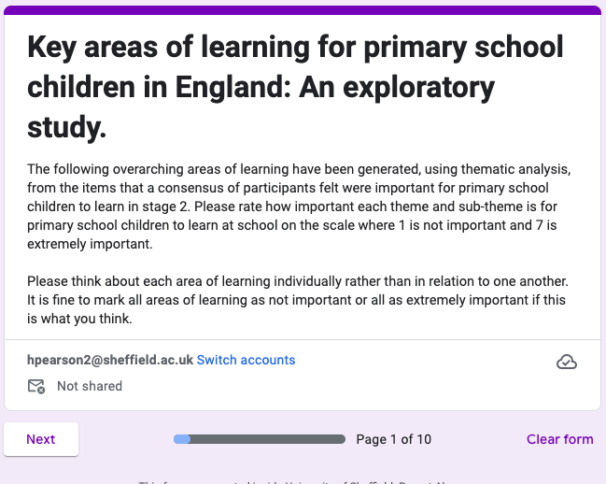
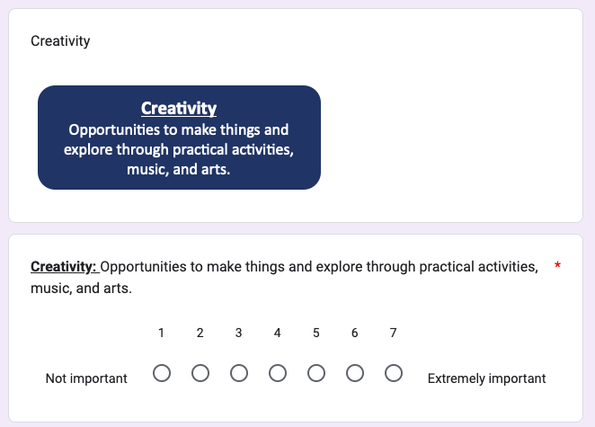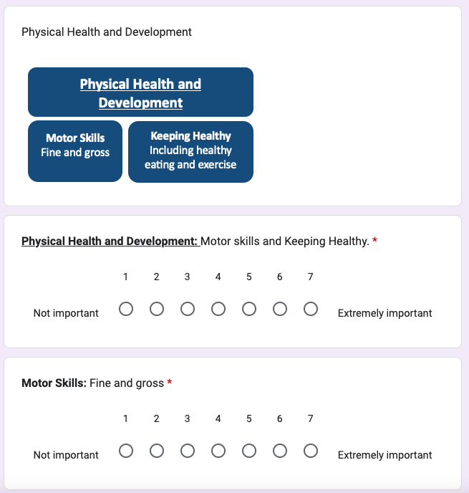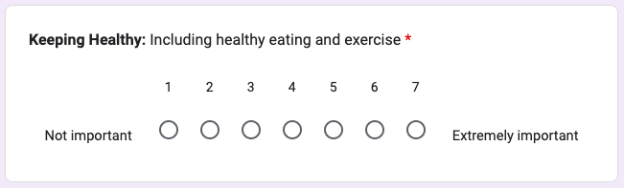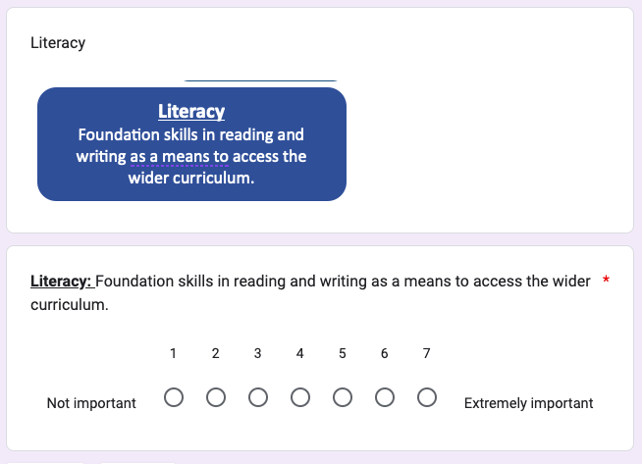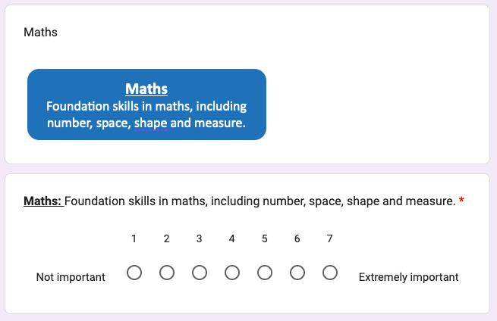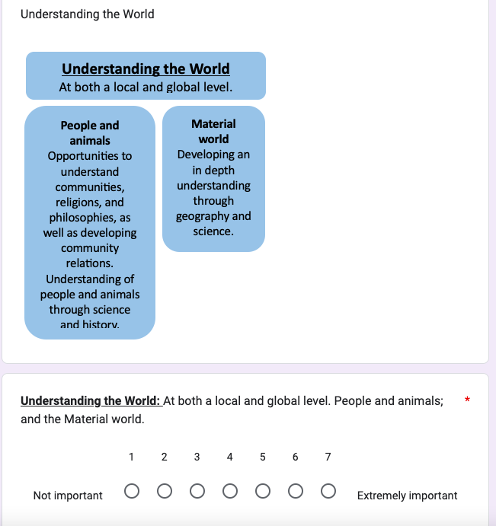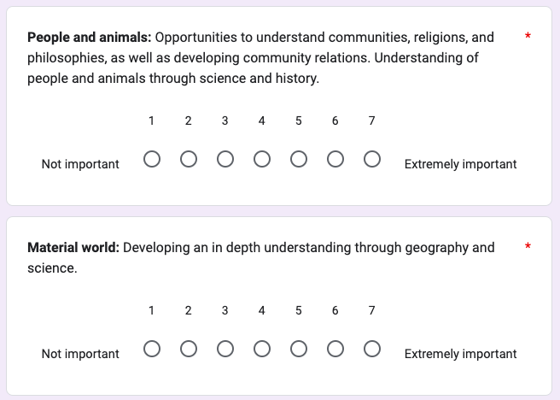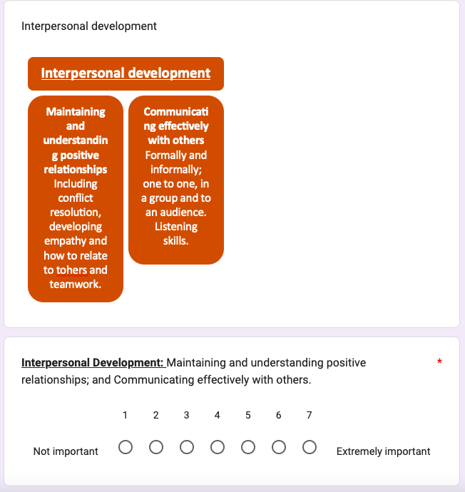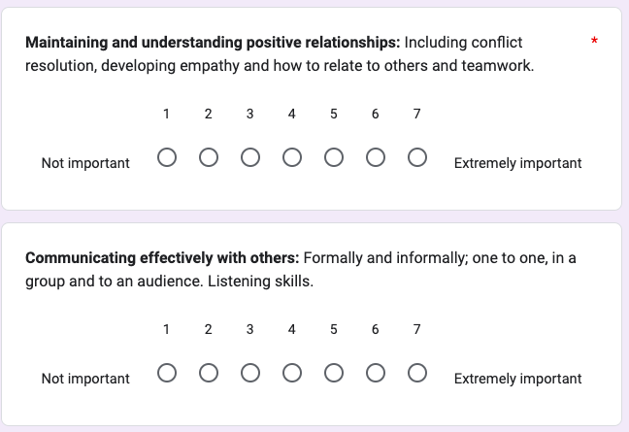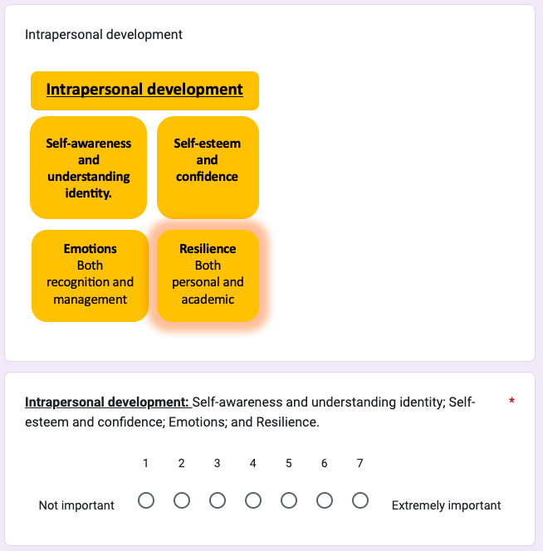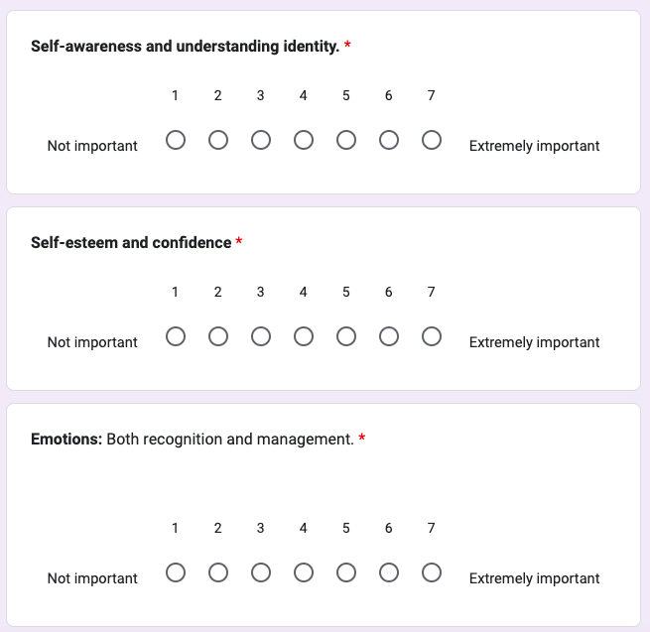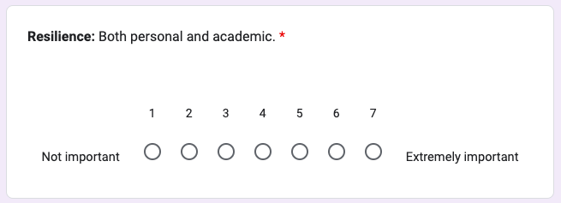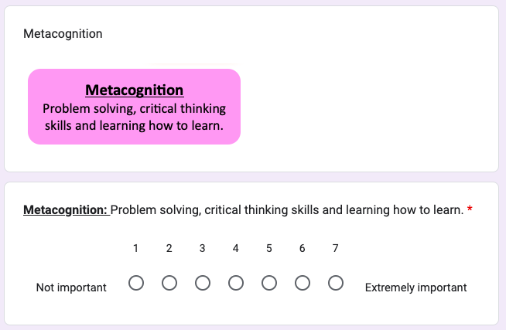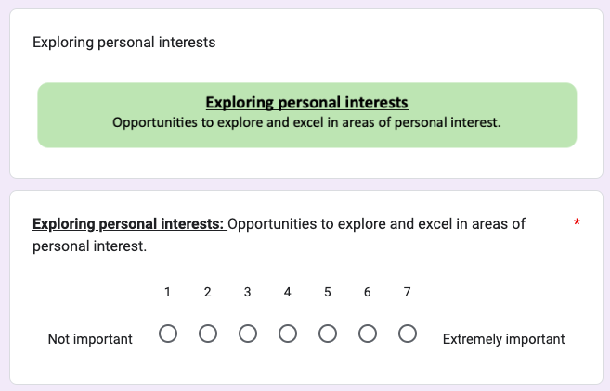

Appendix O: Stage 3 Responses
Themes (and Subthemes) | Respondent No. |  |  |  |  |  |  |  |  |  |  |  |  |  |  |  |  | Median
Themes (and Subthemes) | 1 | 2 | 3 | 4 | 5 | 6 | 7 | 8 | 9 | 10 | 11 | 12 | 13 | 14 | 15 | 16 | 17 | Median
Creativity: Opportunities to make things and explore through practical activities, music, and arts. | 4 | 6 | 5 | 7 | 6 | 7 | 6 | 7 | 7 | 7 | 7 | 6 | 7 | 6 | 6 | 7 | 6 | 6
Physical Health and Development: Motor skills and Keeping Healthy. | 7 | 6 | 7 | 3 | 7 | 7 | 6 | 7 | 7 | 7 | 7 | 5 | 7 | 6 | 6 | 6 | 5 | 7
Motor Skills: Fine and gross | 7 | 6 | 7 | 5 | 7 | 7 | 5 | 7 | 7 | 6 | 7 | 5 | 7 | 6 | 6 | 6 | 5 | 6
Keeping Healthy: Including healthy eating and exercise | 7 | 5 | 7 | 2 | 5 | 7 | 6 | 7 | 7 | 6 | 7 | 5 | 7 | 6 | 6 | 5 | 5 | 6
Literacy: Foundation skills in reading and writing as a means to access the wider curriculum. | 7 | 7 | 7 | 7 | 7 | 7 | 5 | 7 | 6 | 6 | 7 | 7 | 7 | 7 | 6 | 7 | 7 | 7
Maths: Foundation skills in maths, including number, space, shape and measure. | 7 | 7 | 7 | 6 | 6 | 7 | 5 | 7 | 6 | 6 | 7 | 7 | 7 | 7 | 5 | 7 | 6 | 7
Understanding the World: At both a local and global level. People and animals; and the Material world. | 7 | 5 | 5 | 7 | 6 | 6 | 4 | 7 | 7 | 5 | 7 | 5 | 7 | 6 | 5 | 7 | 6 | 6
People and animals: Opportunities to understand communities, religions, and philosophies, as well as developing community relations. Understanding of people and animals through science and history. | 7 | 6 | 7 | 7 | 6 | 6 | 6 | 7 | 7 | 6 | 7 | 5 | 7 | 6 | 6 | 7 | 4 | 6
Material world: Developing an in depth understanding through geography and science. | 7 | 5 | 7 | 6 | 6 | 5 | 5 | 6 | 7 | 5 | 7 | 4 | 7 | 6 | 5 | 7 | 4 | 6
Interpersonal Development: Maintaining and understanding positive relationships; and Communicating effectively with others. | 7 | 7 | 6 | 7 | 7 | 6 | 7 | 7 | 7 | 7 | 7 | 7 | 7 | 7 | 7 | 6 | 5 | 7
Maintaining and understanding positive relationships: Including conflict resolution, developing empathy and how to relate to others and teamwork. | 7 | 7 | 6 | 7 | 7 | 6 | 7 | 7 | 7 | 7 | 7 | 7 | 7 | 6 | 7 | 7 | 6 | 7
Communicating effectively with others: Formally and informally; one to one, in a group and to an audience. Listening skills. | 7 | 7 | 7 | 7 | 7 | 6 | 7 | 7 | 7 | 6 | 7 | 6 | 7 | 6 | 7 | 7 | 7 | 7
Intrapersonal development: Self-awareness and understanding identity; Self-esteem and confidence; Emotions; and Resilience. | 7 | 7 | 5 | 5 | 6 | 5 | 6 | 7 | 7 | 7 | 6 | 7 | 3 | 5 | 7 | 7 | 5 | 6
Self-awareness and understanding identity. | 7 | 7 | 5 | 2 | 6 | 5 | 6 | 7 | 7 | 7 | 6 | 7 | 3 | 5 | 7 | 4 | 5 | 6
Self-esteem and confidence | 7 | 7 | 7 | 5 | 6 | 6 | 6 | 7 | 7 | 7 | 6 | 7 | 3 | 5 | 7 | 6 | 6 | 6
Emotions: Both recognition and management. | 7 | 7 | 7 | 5 | 6 | 5 | 6 | 7 | 7 | 7 | 7 | 6 | 3 | 5 | 7 | 5 | 6 | 6
Resilience: Both personal and academic. | 7 | 7 | 7 | 3 | 6 | 5 | 5 | 7 | 7 | 5 | 7 | 6 | 3 | 7 | 6 | 7 | 6 | 6
Metacognition: Problem solving, critical thinking skills and learning how to learn. | 7 | 6 | 7 | 7 | 7 | 6 | 5 | 7 | 6 | 6 | 6 | 7 | 3 | 7 | 6 | 7 | 7 | 7
Exploring personal interests: Opportunities to explore and excel in areas of personal interest. | 7 | 7 | 5 | 7 | 5 | 6 | 7 | 7 | 7 | 7 | 6 | 5 | 7 | 5 | 7 | 4 | 5 | 7

Appendix P: Pilot Study Participant Information Sheet
Pilot Study: Key areas of learning for primary school children in England: An exploratory study.

You are being invited to take part in a research project. Before you decide whether or not to participate, it is important for you to understand why the research is being done and what it will involve. Please take time to read the following information carefully and discuss it with others if you wish. Ask us if there is anything that is not clear or if you would like more information. Take time to decide whether or not you wish to take part. Thank you for reading this.

- Background to the project
“Every state-funded school must offer a curriculum which is balanced and broadly based and which: promotes the spiritual, moral, cultural, mental and physical development of pupils at the school and of society, and prepares pupils at the school for the opportunities, responsibilities and experiences of later life.” DfE (2013)
There is considerable debate over what the purpose of education is and should be. Each of us will have our own opinions around this. These philosophies also align to what we think children should be learning in school.
The national curriculum was introduced in the United Kingdom in 1989 (UK Government, 1988) to provide consistency in the curriculums that are delivered across schools. Since devolution, Scotland, Wales and Northern Ireland have gradually moved away from this curriculum and developed their own curriculums to meet the needs of their children and young people. There have been several reforms to the primary national curriculum in England, the most recent of which being in 2014, although it still consists of a programme of subject specific study (Boyle & Bragg, 2006). Academies do not have to follow the national curriculum in England, although they still must partake in national assessment processes in line with the national curriculum (UK Government, n.d).
Primary schools in England are expected to provide a wider curriculum than just that of the national curriculum (DfE, 2013), although little guidance is given to schools around what this should include. Since 2020, there is a statutory requirement for primary schools to also teach relationship education and health education (DfE, 2019).

- What is the project’s purpose?

For this piece of research, I am interested in exploring participants’ views on the purpose of education and what primary school children should be learning. The aim of this research is to open discussion, through a consensus of participants, around which areas of learning it is important for primary school aged children to learn about.

My research questions are:

1. What do a sample of academics and professional psychologists working with primary school aged children in England believe that the purposes of primary education should be?

2. Based on reflection around these purposes, which areas of learning do a consensus of my participants believe are important for primary school aged children to learn about at school?

3. Who and what may this research impact on? For example, professional practice of educational psychologists, policy makers and others.

Key definitions:
- Learn- to gain knowledge or improve a skill.
- Area of learning- a broad, overarching description of a topic area or skill set
- Primary school- the phase of education for children aged 5-11 years in England.

- Why have I been chosen?

You have been chosen to take part in a pilot study for this research. The purpose of the pilot study is to test the procedure and methodology of the study so that any changes can be made to the methodology of the main study.

- Do I have to take part?
It is up to you to decide whether or not to take part. If you do decide to take part you will be given this information sheet to keep (and be asked to sign a consent form) and you can still withdraw at any stage of the research without any negative consequences. You do not have to give a reason. If you wish to withdraw from the research, please contact myself, contact details can be found at the end of this document. All responses from participants throughout the study process will be collected anonymously. As such, it will not be possible to remove these responses from the data set once collected should a participant wish to withdraw from the study.

Please note that that by choosing to participate in this research, this will not create a legally binding agreement, nor is it intended to create an employment relationship between you and the University of Sheffield.

- What will happen to me if I take part? What do I have to do?
During the consent process, you will be asked some demographic questions around your qualification level, job title and experience of working with primary school aged children. This is so that we can understand which types of people have contributed to the final outcomes of the study. This will be completed anonymously through Google Forms, you will need to sign up to a Google Account to access this but your responses will not be linked to your account or personal details.

You will then be asked to take part in a three-stage process, as described below. All of the stages will be conducted online, and you will be able to give your responses at any-time you find convenient within a two-day window for each stage. You will also be able to go back and edit your responses within each two-day window. Please bear in mind that participants in the main study will have a two-week window for each stage. You do not need to worry about answering the questions in detail as the purpose of the pilot study is to test the process. Most of the data collection will be conducted through Google Forms, you will need to sign up to a Google account in order to access this. This allows you to go back and edit your answers and prevents repeat submissions from the same participant. Responses will not be linked to Google accounts, and all responses will be anonymous to the research team. You will be invited to participate in each stage via email.

Stage 1. (Dates). You will be asked to answer a free response question around your own opinions on the purpose of education. This will be done through Google Forms and data from this will be exported into Google Sheets. All data will be stored on a secure university Google drive. Responses will be analysed collectively using thematic analysis (Braun & Clarke, 2006) to identify themes in participants’ views on the purpose of education.

Following this, you will be able to access a shared mind map where participants will be asked to collectively mind map ideas around what they think primary school children should learn. This will be done through Google Jamboard and although this is a collective activity participants will be anonymous from one another. All of the ideas added to this collective mind map will then be made into a list of possible things for primary school children to learn.

Stage 2. (Dates). (You will be sent another questionnaire through Google Forms. In this questionnaire you will be asked to rate how important each item (from the list made in stage 1) is for primary school children to learn about on a seven-point Likert scale (where 1 is not important at all and 7 is extremely important.)

Data from this questionnaire will be exported into Google sheets and all items with a mean average Likert score of less than five will be removed from the data set. The remaining items will then be analysed using thematic analysis to create a set of ‘areas for learning’.

Stage 3 (dates). The ‘areas of learning’ created in stage 2 will be presented back to you through another Google Forms questionnaire. You will again be asked how important each area is for primary school children to learn about on a seven-point Likert scale. Data will be exported into Google Sheets and areas with a mean average Likert score of less than five will be removed. The remaining areas will be presented as proposed areas of learning that a consensus of participants feel are important for primary school aged children to learn about.

Finally, you will be asked to feedback with myself in a short verbal session around any difficulties you had with the procedure of the study. This can be organised at your own convenience and should not take longer than 30 minutes.

- What are the possible disadvantages and risks of taking part?
As part of the reflective nature of engaging in the surveys, such as reviewing components of educational practice and considering their importance, you may reflect on significant experiences within your own practice, life, and the life of your family. This may result in some adverse emotional reactions. You may wish to seek out supervision to support you with this if this is available to you. If you feel uncomfortable at any point you can stop and withdraw yourself from the study at any time.

Each stage of the study will take up some of your time. It is not yet clear how long each stage will take (this is part of the purpose of the pilot study). You will be given a two-day window to respond to each stage of the study, so that you can do this at a time that is convenient to yourself.

Your responses won’t be included in the data analysis of the main study, you may find it frustrating that your views are not being included.

What are the possible benefits of taking part?
I am hoping that this research will contribute to wider professional thinking around what primary school aged children are learning about. You will be supporting research around this discussion which could be a driver for change in the future.
Findings and implications from the study, as well as your own reflections during the process of taking part, may support you within your wider practice. Trainee Educational psychologists may use the findings of this study to support them with the development of bespoke curriculums for groups of children with SEN, as well as wider systemic curriculum support in schools.

- Will my taking part in this project be kept confidential?
Informed consent forms and personal information including your name and email address will be kept strictly confidential and will not be accessible to members outside of the research team. All other information that we collect about you during the course of the research will be kept strictly confidential and will not be accessible to members of the research team or other participants. You will not be able to be identified in any reports or publications.

All email addresses will be added to email communication using the bcc function so that these details are not shared with other participants.

- What is the legal basis for processing my personal data?
According to data protection legislation, we are required to inform you that the legal basis we are applying in order to process your personal data is that ‘processing is necessary for the performance of a task carried out in the public interest’ (Article 6(1)(e)). Further information can be found in the University’s Privacy Notice https://www.sheffield.ac.uk/govern/data-protection/privacy/general.

- What will happen to the data collected, and the results of the research project?
Informed consent will be saved to Google Drive. All other data will be saved to Google Drive, it will be collected anonymously and not linked to your name or online accounts.

Your personal details from the consent form will only be accessed by the myself and my supervisor who works in the University of Sheffield, in order to contact you via email to share the forms/links needed to access each stage of the study.

You will be contacted to share the publication of this thesis on the university website and any academic publications in peer reviewed journals, if you consent to being contacted about this on the consent form.

Data will be stored for up to five years after the study ends to allow time for potential publication of the research. Following publication or after five years (whichever is sooner) all personal data will be destroyed.

- Will I be recorded, and how will the recorded media be used?

You will not be audio or video recorded during the course of this study.

- Who is organising and funding the research?

This research is being organised by the University of Sheffield, no external funding has been received.

- Who is the Data Controller?
The University of Sheffield will act as the Data Controller for this study. This means that the University is responsible for looking after your information and using it properly.

- Who has ethically reviewed the project?
This project has been ethically approved via the University of Sheffield’s Ethics Review Procedure, as administered by the School of Education. Ethics approval reference number 052684.

- What if something goes wrong and I wish to complain about the research or report a concern or incident?
It you are dissatisfied with any aspect of the research please speak to myself (contact details below). If you wish to make a complaint, please contact Dr Sahaja Davis/ t.s.davis@sheffield.ac.uk in the first instance. If you feel your complaint has not been handled in a satisfactory way you can contact the Head of School [Professor Rebecca Lawthom/ r.lawthom@sheffield.ac.uk]. If the complaint relates to how your personal data has been handled, you can find information about how to raise a complaint in the University’s Privacy Notice: https://www.sheffield.ac.uk/govern/data-protection/privacy/general.

If you wish to make a report of a concern or incident relating to potential exploitation, abuse or harm resulting from your involvement in this project, please contact the project’s Designated Safeguarding Contact [Dr Sahaja Davis/ t.s.davis@sheffield.ac.uk] and/or the University’s Chair of Ethics (Dr Anna Weighall/edu.ethics@sheffield.ac.uk). If the concern or incident relates to the Designated Safeguarding Contact, or if you feel a report you have made to this Contact has not been handled in a satisfactory way, please contact the Head of School [Professor Rebecca Lawthom/ r.lawthom@sheffield.ac.uk] and/or the University’s Research Ethics & Integrity Manager (Lindsay Unwin; l.v.unwin@sheffield.ac.uk).

- Contact for further information
Research Team:

Hannah Pearson
Trainee Educational Psychologist
Hpearson2@sheffield.ac.uk

Project Supervisor:

Dr Sahaja Davis
Lecturer in Educational Psychology
t.s.davis@sheffield.ac.uk

If you would like to speak to someone outside of the research team in the event of a complaint, please contact:

Professor Rebecca Lawthom
Head of School
r.lawthom@sheffield.ac.uk
School of Education, The University of Sheffield Western Bank Sheffield S10 2TN

Thank you for your reading this information sheet.
If you have any further questions, please speak to a member of the research team.

Appendix Q: Pilot Study Consent Form
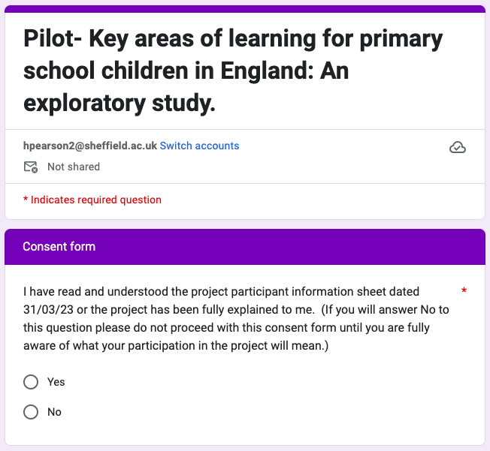
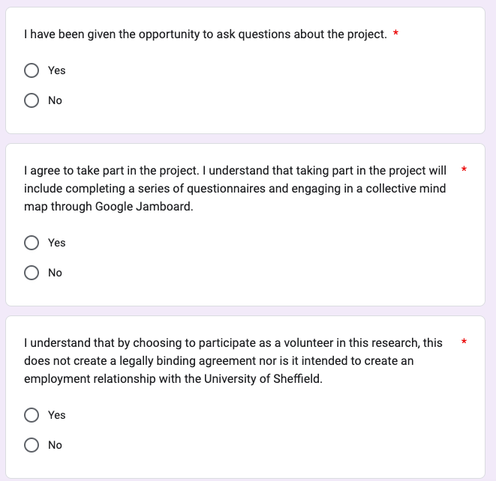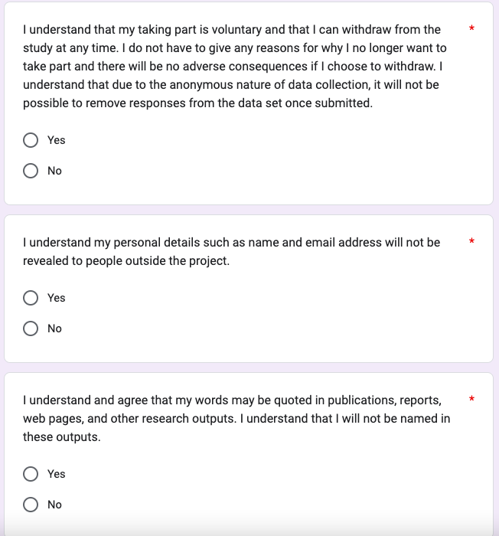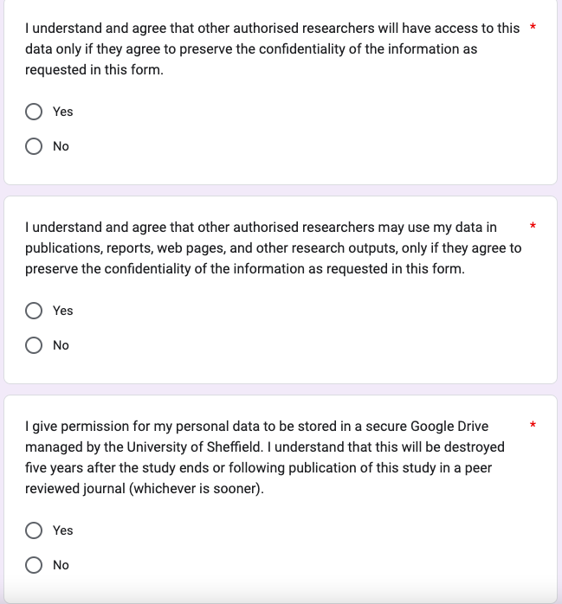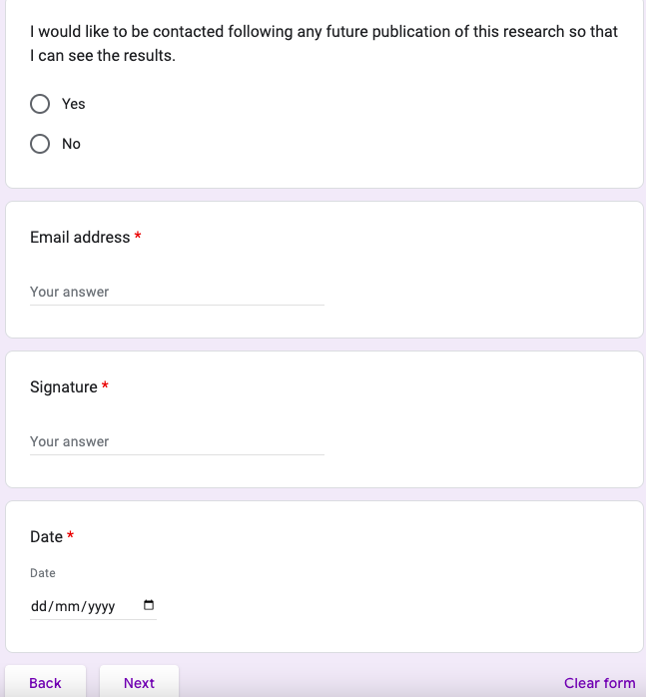

Appendix R: Ethical Approval Letter

