
Implementing Organisational Change in Adult Acute Psychiatric Inpatient Settings

Evie McLoughlin

A thesis submitted in partial fulfilment of the requirements for the award of Doctor of Clinical Psychology at the University of Sheffield

Clinical and Applied Psychology Unit Department of Psychology
The University of Sheffield

May 2024

Declaration

I, the author, declare that this work has not been submitted for any other degree at the University of Sheffield or any other institution. This thesis is my own original work and all other sources have been referenced accordingly.

Structure and Word Count

Section One: Systematic Review
Excluding references and tables: 7,999
Including references and tables: 12,479

Section Two: Empirical Study
Excluding references and tables: 7,998
Including references and tables: 9,311

Total Word Count
Excluding references and tables: 15,997
Including references and tables: 21,790

Acknowledgements

First and foremost, I would like to thank my research supervisors, Dr Claire Bone and Professor Gillian Hardy. Thank you Claire, for your support, guidance, and enthusiasm throughout my thesis journey and for sharing your passion for research in this field with me. Gillian, thank you for your academic brilliance and the sense of calm you brought to every research meeting. You have been so reassuring throughout this process.

Thank you to Helen Barlow, NHS Librarian. Your knowledge and patience have been so appreciated. To the NHS ward and psychology staff who generously offered their time to take part in my empirical project, the insights you provided were invaluable and the project would not have been possible without you all. Your commitment to providing high quality care and willingness to learn and adapt makes me proud to work in the NHS. Thank you.

The ‘Hanging Climb’ – Lucy, Erin, Rachel, Jen and Rosa – thanks a million for being the most glorious humans. It’s been a pleasure to train alongside you all, the world of Clinical Psychology is lucky to have you. Thank you to Joanna for being a rock of a mentor for the past three years.

The biggest thank you must go to Julie, Brian and Erin Mc. I don’t quite have the words to express my gratitude, but I’ll try. Thank you for your encouragement, tolerance and – most importantly – ability to make me laugh through the most challenging times. Thank you for helping Sheffield to feel more like ‘home away from home’ with each visit, and for providing much needed respite in Liverpool whenever needed. I love you all enormously and I wouldn’t be at this point without you. I’ll await the invoices…
Lay Summary

Literature review
Mental healthcare services are constantly undergoing organisational change. However, change is difficult to embed in these settings, despite changes being necessary to relieve pressures and provide patient-centred care. Adult acute psychiatric inpatient (AAPI) wards face certain complexities, making implementing change here particularly difficult. While recent studies have identified specific barriers and facilitators to change in AAPI settings, research has not yet been synthesised. This review aimed to comprehensively synthesise the barriers and facilitators to change on AAPI wards.
Four databases were searched, and six studies were included. The quality of studies was assessed, highlighting some issues with reliability and validity. Data was synthesised using the Capability, Opportunity, Motivation – Behaviour (COM-B) Model. Barriers and facilitators were mapped onto the Behaviour Change Wheel (BCW) Framework to inform recommendations for clinical practice.
Using ‘best fit’ framework synthesis, 16 themes were found to fit under the COM-B components, as well as an additional theme of ‘staff demographics’ which could not be mapped onto the model. Using the BCW, findings suggested that to address barriers to change, services should inform staff of the benefits of change and provide training for staff around implementation. A ward culture ‘shift’ – led by compassionate leadership – and protected time for change-project activities are required.
The current review provides initial information on barriers and facilitators to change in AAPI settings. However, additional research of high quality is required to further inform understanding and clinical practice.

Empirical project
An aim of organisational change in National Health Service (NHS) mental health services is to ensure care is as person-centred and effective as possible. However, implementing change in adult acute psychiatric inpatient (AAPI) settings is difficult. While an NHS ‘model of change’ has been shown to help implement change in several settings, it has not yet been tested in AAPI settings. Understanding barriers and facilitators to change in these settings is important to develop a model of change that is tailored to AAPI settings, hopefully aiding implementation of organisational change.
This study used realist evaluation (RE) to tailor the NHS Change Model for AAPI settings. Recruitment was attempted via an NHS mental health service. Recently, a process named ‘Purposeful Inpatient Admissions’ has been trialled on three AAPI wards within this service. Using this change as a basis for questions, focus groups and interviews were conducted to gather views about organisational change. Overall, 17 ward and psychology staff participated.
Based on prior research, knowledge of the wards, and pre-existing models of change, it was theorised that four resources were needed to overcome barriers to change: facilitator attributes, frequency of meetings, change tools and leadership “buy-in”. Findings provided evidence for these assumptions. However, five new themes were found: staffing, safety, energy for change and sustainability, communication, and practical resources. A revised model of change for the AAPI setting was developed.
Realist evaluation should be conducted across additional NHS AAPI wards to further understand barriers and facilitators to change, and resources needed for effectively and sustainably implemented change. Testing of the revised model of change is required.

Table of Contents

Section One: Literature Review
Understanding barriers and facilitators to change in the adult acute psychiatric inpatient setting: a mixed-methods systematic review

Abstract .....................................................................................................................................2 Introduction ..............................................................................................................................4
Aims………...............................................................................................................................8Method…...................................................................................................................................9
Search Strategy ........................................................................................................................10
Screening..................................................................................................................................13
Quality Assessment...……........................................................................................................16
Data Extraction.........................................................................................................................16
Data Synthesis….......................................................................................................................17 Results .....................................................................................................................................19
Summary of Included Papers……............................................................................................20
Quality Appraisal Results…….................................................................................................28 Framework Synthesis................................................................................................................28 Discussion ...............................................................................................................................49
Strengths, Limitations and Future Research Directions............................................................49 Clinical Implications ................................................................................................................53
Conclusions.............................................................................................................................54 References ...............................................................................................................................55
Appendices..............................................................................................................................63

Section Two: Empirical Study
Embedding formulation reviews in adult acute psychiatric inpatient units: Using a multi-perspective realist evaluation to develop an acute model of change

Abstract ...................................................................................................................................81 Introduction ............................................................................................................................83
Aims……….............................................................................................................................87Method ....................................................................................................................................87
Results ...................................................................................................................................106 Discussion .............................................................................................................................115
Clinical Implications ..............................................................................................................120 Strengths, Limitations and Future Research Directions..........................................................121
Conclusions...........................................................................................................................123References .............................................................................................................................124
Appendices............................................................................................................................134

Section One: Literature Review
Understanding barriers and facilitators to change in the adult acute psychiatric inpatient setting: a mixed-methods systematic review

Abstract
Objectives
Implementing changes in psychiatric inpatient settings is vital to relieve the pressures of the services and deliver excellent patient care. Adult acute psychiatric inpatient (AAPI) wards have specific challenges. This review aimed to systematically appraise and synthesise research to understand the barriers and facilitators to change in this setting and provide guidance for those seeking to implement effective, lasting change.
Method
Four databases were systematically searched for qualitative, quantitative, and mixed-method studies. Six studies were included. Framework synthesis was undertaken, using the Capability, Opportunity, Motivation, Behaviour (COM-B) model. Barriers and facilitators were categorised into the subcomponents of the COM-B. The Behaviour Change Wheel (BCW) was employed to provide strategies for implementation. The Mixed-Method Appraisal Tool was utilised to appraise quality.
Results
Overall, 16 themes were found to fit under the COM-B components. No factors were identified for the COM-B subcomponent ‘physical capability’. Additional barriers and facilitators that did not fit the model were staff age and occupational status, themed as ‘staff demographics’. BCW strategies included: training packages for staff, skills modelling for junior staff, and using incentivisation to increase motivation to engage.
Conclusions
The COM-B provided a framework for understanding the complexity of implementing change in AAPI settings. While this review cannot state which component represents the most salient influence on change, multiple barriers and facilitators were identified relating to psychological capability, and physical and social opportunity. When implementing change, relevant strategies should be utilised.
Practitioner Points
- Findings highlight the need for relevant strategies to be used to overcome barriers and leverage facilitators; training packages for staff, skills modelling for junior staff, and using incentivisation to increase motivation to engage are important to consider.
- Clinical psychologists can play an instrumental part in organisational change through implementing compassionate leadership.
Keywords:
Psychiatric; Inpatient; Change; Barriers; Facilitators; Framework Synthesis; Systematic Review

Introduction
Acute inpatient psychiatric wards provide assessment and short-term treatment to people with mental health disorders who require intensive support (Delaney & Johnson, 2012). In the United Kingdom (UK), access to acute inpatient services is free via the National Health Service (NHS), funded by tax and national insurance contributions. People can opt for private care. Chaudhry and Pereira (2009) found that, in the UK, the demographic profiles of NHS and private Psychiatric Intensive Care Units (PICUs) patients were similar. However, there are notable differences between inpatient NHS care and inpatient care delivered by non-NHS organisations. Chaudhry Pereira (2009) reported private PICUs have more beds, nursing staff, and overall facilities, whilst NHS patients on average had a shorter length of stay compared to those accessing private care. Despite differences, any healthcare provider in the UK requires Care Quality Commission registration as a legal requirement under the Health and Social Care Act 2008, affording some level of standards regulation.
Over recent decades, NHS services have been reconfigured with services striving to pivot from hospital to community care. In line with this, the number of beds available in acute inpatient psychiatric wards has reduced, which has impacted the inpatient population. Hospitals now treat those with the most severe and complex presentations, particularly in metropolitan areas (Saxena & Barrett, 2007). A major source of stress for staff working on acute inpatient wards is extreme staff shortages (Johnson et al., 2018). It is recognised that NHS inpatient psychiatric wards are demanding, unpredictable and sometimes hostile environments to work in (Mullen, 2009; Ward, 2011; Kaunomäki et al., 2017).
Implementing organisational change is necessary to relieve pressures and consideration of the principles for implementing successful change – rather than the specifics of the change to be introduced – is imperative. Organisational change is defined as “change that involves differences in how an organisation functions, who its members and leaders are, what form it takes, and how it allocates resources” (Huber et al., 1993). Within healthcare there are different types of change: planned versus unplanned; episodic versus continuous; developmental, transitional, and transformational change; and systems thinking change (Huber et al., 1993). It is critical to understand exactly how change can be successfully implemented in healthcare settings, to avoid being caught in a cycle of inertia and to facilitate better quality evaluation of such changes.
Research has suggested several barriers and facilitators to change within mental health services. Barriers can be defined as any factors that hinder change being implemented or embedded, and facilitators as any factors that enable change to be implemented or embedded. When exploring barriers and facilitators to embedding trauma-informed principles in North American youth psychiatric inpatient and community settings, a realist systematic review found that five factors were imperative for implementation: commitment from senior leadership, adequate support for staff, inclusion of patients’ and families’ voices, aligning policies with trauma-informed principles, and using data to help encourage change (Bryson et al., 2017). A recent meta-synthesis conducted by Raphael et al. (2021) highlighted the challenges acute psychiatric inpatient services face when attempting to implement psychosocial interventions. Barriers included cost and time available for staff to implement changes, whilst facilitators included strong team cohesion and positive team dynamics (Raphael et al., 2021). These findings illustrate that multidisciplinary working and a whole team approach are crucial to making changes within acute psychiatric inpatient settings, and thus to improving patient care.
However, Raphael et al. (2021) only focused on examining barriers and facilitators to implementing specific psychosocial interventions and excluded other organisational change. Their narrow focus makes the findings less reliably transferable to change processes in the acute multidisciplinary inpatient setting more broadly. Focusing on organisational change more broadly can help aid understanding of successful restructuring, new initiatives, process improvements and cultural transformations, all of which are commonplace events in modern NHS settings. It is important for the current review to focus on broader organisational change given the key role that Psychologists are expected to play in acute inpatient psychiatric settings, i.e. reaching beyond direct psychosocial interventions to working systemically with multi-disciplinary teams (MDTs) and senior leadership groups to influence quality of care. West et al. (2022) conducted a large-scale study on acute NHS settings, finding positive links between leadership behaviours, staff experience and autonomy, and patient outcomes. The British Psychological Society (BPS; BPS, 2019) describes a core competency for Clinical Psychologists of ‘organisational and systemic influence and leadership’. This includes ‘influencing service delivery, working effectively in multidisciplinary teams and understanding change processes in service delivery systems.’ These skills are particularly relevant in acute psychiatric inpatient settings where Clinical Psychologists are in leadership positions and work with MDTs to enhance psychologically informed care provision (BPS and Association of Clinical Psychologists UK, 2021).
Additionally, Raphael et al. (2021) focused on various acute inpatient environments, rather than specifically NHS adult acute psychiatric inpatient (AAPI) settings, which may have a specific set of barriers and facilitators to change. For example, research suggests that barriers to implementation in AAPI settings include staff feeling a sense of ‘organisational unfairness’ in response to change (Laker et al., 2019). Studies that have reported barriers and facilitators to organisational change in AAPI settings have not been synthesised in a systematic way. A second aim of the review is to feed into a realist evaluation (RE) which will look at the NHS Change Model – an evidence-based framework used to guide change within the NHS – and its applicability to the AAPI setting. It is therefore necessary to limit the scope of the current review to NHS AAPI settings, as opposed to other acute settings, as investigated by Raphael et al. (2021). Additionally, as the NHS Change Model is predominantly used by staff and policy makers, it is important to capture the views of staff in relation to barriers and facilitators to change to ensure change models are applicable to them. Studies focusing on patient views of change are important, however patients may focus on different aspects of care whereas staff may have a ‘behind the scenes’ insight into why change does or does not work.
Systematic reviews aim to understand whether an intervention works or not, for which groups of people, and under what circumstances. Different methods are required to synthesise review findings based on the research questions. ‘Best fit’ framework synthesis (BFFS) is one method that can be employed, it originates from Framework Analysis, and allows researchers to capture new understandings of primary data integrated into the framework. BFFS has been described as a pragmatic and flexible approach and uses an a priori framework, such as a theoretical model which appears applicable to the area under review, to guide the synthesis (Carroll et al., 2013). The model is applied, tested and – if necessary – refined to better integrate the data. Its ability to enhance rigour of complex systematic reviews by increasing transparency is an advantage of the method (Huberman & Miles, 2002). While BFFS has been increasingly used in both qualitative and mixed-methods evidence syntheses (Brunton et al., 2020), the current review also included quantitative primary research. This decision was made to accommodate studies that quantified barriers and facilitators to change in AAPI settings.
The Behaviour Change Wheel (BCW; Michie et al., 2011) is a theory-based framework for intervention development (Michie et al., 2011). The BCW was developed from 19 frameworks of behaviour change which were identified in a systematic review (Michie et al., 2011), and consists of three ‘layers’. The inner ‘layer’ of the BCW uses the COM-B (‘capability’, ‘opportunity’, ‘motivation’ and ‘behaviour’) model to identify the foundations of the behaviour that could establish effective targets for intervention. Capability refers to a person’s psychological and physical ability to participate in a particular behaviour. Opportunity refers to social and physical factors that allow behaviour to occur. Motivation refers to the automatic and reflective processes that unconsciously and consciously influence behaviour (Michie et al., 2011). The COM-B model can be used on the level of an individual, group or population (Michie et al., 2011). The ‘layer’ surrounding the COM-B includes nine intervention functions to choose from based on the COM-B analysis. The outer ‘layer’ of the BCW identifies seven policy categories that can support delivery of these intervention functions. Overall, the BCW provides a systematic way of understanding the ‘goal’ behaviour and from this identifies relevant intervention functions and policy categories. Specific techniques for behaviour change can then be assumed from the identified intervention functions.
The COM-B model was used as the theoretical framework for the current synthesis to explore perceived barriers and facilitators to change in AAPI settings. Barriers and facilitators were then mapped onto the BCW to help inform potential implications for practice. Whilst the Theoretical Domains Framework (TDF) could be used, the COM-B is preferred due to it being able to capture broader organisational change elements and supporting the analysis of links between different factors necessary for change. The TDF is purely descriptive, not allowing for researchers to make links between domains (Francis et al., 2004). Given the challenges that are faced when delivering AAPI care, it is important to understand what enables or hinders change, and to provide recommendations that are tailored to this setting. While Raphael et al.’s (2021) review did discuss and provide recommendations, mapping of codes and themes to the COM-B can facilitate the identification of interventions using the BCW for healthcare professionals, which will be undertaken in the current review.
Aims
The current review aimed to summarise and synthesise research findings from primary studies exploring barriers and facilitators to change in the AAPI setting. The objective was to provide guidance for those seeking to implement change in these settings, as well as to feed into a further empirical project seeking to develop a model of change which is applicable to the AAPI setting to guide future projects. The following research questions were posed:
- What are the facilitators and barriers to organisational change in the NHS AAPI setting?
- What are the implications and key recommendations for AAPI settings undergoing organisational change?

Method

Design

A mixed-method systematic review was performed to understand the facilitators and barriers to change in the AAPI setting. A mixed-method approach was used as the review questions can be addressed by including both quantitative and qualitative research designs to account for the inherent complexity of embedding organisational change. This approach helps to maximise findings by not only minimising the chance of excluding relevant studies, but through each design building on the weaknesses of the other.
A systematic review protocol was developed (Appendix A). The review was pre-registered on PROSPERO by the author in June 2023 and updated in February 2024 (reference: CRD42023436944). The review was conducted with adherence to the Preferred Reporting Items for Systematic Reviews and Meta Analyses (PRISMA) checklist (Page et al., 2021; Appendix B) to support the transparency and quality of reporting. Additionally, the ‘enhancing transparency in reporting the synthesis of qualitative research’ (ENTREQ) framework was completed by an independent researcher (CG) (Appendix C).

Search Strategy

The SPIDER (Sample, Phenomenon of Interest, Design, Evaluation, Research type) framework was used to develop the search strategy, an adaptation of the PICO tool for mixed-method reviews (Cooke et al., 2012; Table 1).

Table 1
Research criteria identified with the SPIDER tool
Criteria | Description
Sample | Staff working in services identified as NHS adult acute mental health inpatient services
Phenomenon of Interest | Implementation of organisational change
Design | Interviews, focus groups, observations, surveys
Evaluation | Staff perceptions of barriers and facilitators to organisational change
Research type | i) qualitative studies  ii) quantitative studies  iii) mixed-methods—studies combining qualitative and quantitative methods of data collection and analysis which included cross sectional studies, case-control studies, cohort studies, quasi-experimental studies, and randomised control trials

In June 2023, the author conducted a comprehensive systematic search of published literature using four electronic databases: MEDLINE, EMBASE, CINAHL and PsycINFO. The lead author consulted an external NHS librarian on the search strategy (Table 2) to ensure a robust search methodology and enhance results. Keywords used in a related review (Raphael et al., 2021) were considered and adapted to incorporate broader change projects when determining the search terms. Prior to beginning the searches, search terms were discussed and agreed in supervision. Research has indicated that two or more databases are necessary for a comprehensive search (Suarez-Almazor, 2000), therefore using four in the present study was considered sufficient to ensure the capture of all relevant publications. Inclusion of grey literature – i.e. literature which is not formally published – is deemed to broaden the scope of identified studies and can provide valuable insights. However, there is no consensus around robust methods to search for it. Given the quality and validity of information in grey literature may vary significantly due to self-published research not undergoing a peer-review process, it is necessary to balance inclusion of grey literature whilst also maintaining rigorous evidence synthesis (Mahood et al., 2014). Grey literature was searched for with caution, however, no relevant literature was found.
In March 2024, the search was re-run as the registered PROSPERO protocol was updated in February 2024. The update was necessary as the analysis was changed from a narrative synthesis to ‘best fit’ framework synthesis. ‘Best fit’ was chosen for two main reasons related to the review’s topic and aims: it allows production of context-specific conceptual models that help to describe or explain decision-making behaviours; and it is helpful for researchers and policymakers in tailoring interventions based on the models produced.
Truncation was used to expand the search terms to include varied word endings. For example, using embed* rather than embedding or embedded. Search terms were modified to include Medical Subject Headings (MeSH) and adapted to meet the requirements of different databases. For example, the search of MEDLINE included MeSH terms, but quotation marks were removed when performing the search on PsycINFO. When MeSH terms were available, they were exploded and combined. Manual forward and backward citation searches of reference lists of included papers and a relevant literature review (Raphael et al., 2021) were conducted to aid retrieval of all relevant papers. No additional papers were identified.
Table 2
Search Terms
Search Terms
Barrier* OR facilitat* OR block* OR constraint* OR embed* OR obstacle* OR enable* OR promot* OR resist* AND
Mental health personnel AND
Psychiatric hospital OR mental disorders AND
Adult*

Study Selection
The inclusion and exclusion criteria are presented in Table 3.
Table 3
Inclusion and exclusion criteria
Inclusion Criteria
Acute psychiatric inpatient settings (identified as adult acute mental health inpatient services)
Participants should be staff working in the above setting
International (in countries where healthcare is considered ‘NHS’)
Papers involving National Health Service (NHS) settings / majority NHS organisational health settings
English language
Findings are reported on organisational change processes, barriers and facilitators
Primary research papers
Papers that directly examine barriers and facilitators of change
Exclusion Criteria
Other inpatient or community settings
Child / adolescent or older adult settings
Focusing on patient views only / not capturing staff perceptions of change
Studies including solely non-NHS organisational settings
Non-English language (due to the need for quality checking by the reviewing team)
Findings must be transferable to other change projects (i.e. not specific to one intervention)
Secondary studies e.g. reviews
Papers that do not directly examine barriers and facilitators of change as a research aim

Results
Screening
The PRISMA diagram for the search is shown in Figure 1. Searches generated 2006 papers (MEDLINE, EMBASE, CINAHL and PsycINFO). Papers were exported to the reference manager RefWorks, and duplicates were removed (n=502). Papers in non-English language were removed by hand (n=768). The author conducted a title and abstract screening of the remaining papers to assess eligibility for inclusion (n=736). Papers that did not meet inclusion criteria were excluded (n=673). A full-text review of shortlisted articles eligible for full-text review was completed (n=63). Overall, six papers met the inclusion criteria and were eligible for inclusion in the synthesis. To support the reliability of the study selection process, a second reviewer independently assessed the eligibility of all papers during full-text screening. It was agreed in advance that conflicts would be discussed, and any disagreements resolved by consensus. No discussions were necessary as there was 100% consistency between reviewers.
There are no agreed minimum numbers for systematic reviews as they should seek to answer the research question, however the pros and cons of broad versus narrow reviews should be considered. Narrow reviews can be easier for readers to make sense of. Unfortunately, this may mean that evidence is limited and can lead to misleading conclusions if not interpreted cautiously. A pro of broader reviews is a more comprehensive summary of the literature, increasing generalisability. However, clear rationale may be lacking (Thomas et al., 2019). The author considered how to increase the number of studies that informed the findings, for example including studies conducted in non-NHS organisations, those looking at a specific intervention or research focusing on patient views as well as staff. However, as discussed, an aim of the review was to feed into a realist evaluation (RE) evaluating the NHS change model for the AAPI setting, through focusing on staff perspectives of broader organisational change. It was therefore necessary to limit the scope of the current review to NHS AAPI settings and broader organisational change as opposed to all interventions across all inpatient settings. Findings from such studies might have been too specific to the intervention to generalise to broader barriers and facilitators to change in the AAPI setting. Additionally, whilst understanding patient views is necessary and important, staff will have ‘behind the scenes’ insight into barriers and facilitators of organisational change which are pertinent to the current study, and patients may not hold this systemic knowledge.

Figure 1
PRISMA Diagram, adapted from Moher et al. (2009)
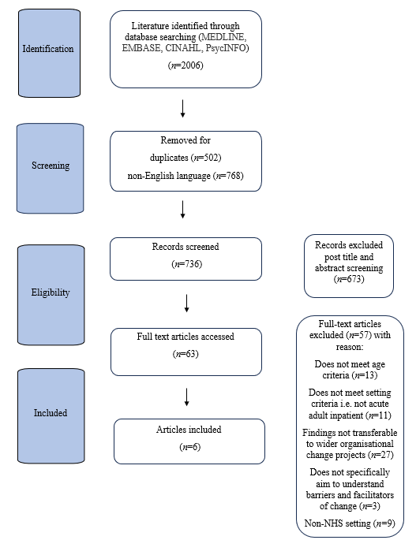

Quality Assessment
Debate surrounds the critical appraisal of studies. Currently, whilst there is an agreement studies should not be excluded based on quality (Hong et al., 2018), it is agreed that quality assessments should be completed, and quality should be acknowledged. Therefore, irrespective of the number of included studies, it is the quality, relevance and rigour of studies that is of upmost importance when selecting studies for systematic reviews. These aspects allow for transparent and accurate evidence synthesis (PRISMA, 2020). The quality of eligible studies was appraised using the Mixed-Method Appraisal Tool (MMAT; Hong et al., 2018; Appendix D). This tool was developed for the appraisal of qualitative, quantitative, and mixed-methods studies and has been used in a similar mixed-method systematic review (Raphael et al., 2021). Quality assessment was conducted by the lead author and an independent reviewer, separately. There was an almost perfect inter-rater reliability (κ = 0.81; Landis & Koch, 1977). Disagreements between the reviewers were resolved through discussion.
Data extraction
Study characteristics were extracted from the included studies by the lead author using a bespoke data extraction form. Data included author, year of publication, participant characteristics, setting, country, aims, design, method, reflexivity, overview of results (Table 4).
Data transformation
The author takes a position of critical realism, recognising it is useful to understand causal mechanisms, whilst holding that such knowledge is socially constructed. This position also takes a pragmatic stance to bridging positivist and constructivist approaches to understand such phenomena, allowing for the integration of both quantitative and qualitative data to provide an explanatory framework for those seeking to implement change. The review question can be addressed by including both quantitative and qualitative research designs to account for the inherent complexity of embedding organisational change. As such, a convergent integrated approach was followed, as according to the Joanna Briggs Institution (JBI) methodology for mixed-methods systematic reviews (Stern et al., 2020).
The JBI methodology involved simultaneously integrating and synthesising quantitative and qualitative data through data transformation. As specified in JBI’s convergent integrated approach for mixed-methods reviews (Stern et al., 2020), the quantitative data extracted from survey studies and quantitative component of mixed-methods studies were “qualitised”. This involved transforming quantitative data that answers the research question, such as relevant statistical results, into descriptive text. Subsequently, the “qualitised data” was merged with the qualitative data extracted from qualitative studies and the qualitative component of mixed-methods studies.
Data synthesis and integration
BFFS was used to synthesis and integrate data. Glenton et al. (2018) discuss that in qualitative research a focus should be maintained on the richness of data rather than quantity. BBFS therefore has particular value for synthesising fewer papers because it enables the researcher to investigate what is there but also to identify what is not there, i.e. where the gaps are. The author chose the framework synthesis approach because a published model – the COM-B model – was identified from the literature that conceptualised behaviour change in public health settings (Figure 2). The approach therefore was initially augmentative and deductive (i.e., building on the existing model), rather than grounded or inductive (i.e., starting with a completely blank framework). The model identified did not entirely match the topic under study, but it was a “best-fit” and provided a relevant pre-existing framework and themes against which to map and code the data from the studies identified for this review.
A deductive and inductive approach was then taken to identify barriers and facilitators, as proposed by Carroll and Booth (2013), starting with, an overarching theme framework informed by the COM-B model (Michie et al., 2011). Data were extracted from the results and discussion sections of articles, including participant quotations and author interpretations. Data were initially extracted by shortening and condensing as codes and categorised deductively as either a barrier or facilitator. Data were then grouped thematically; the first author read and re-read the coded items, and then grouped similar/related items into iteratively developed themes. Each theme was then categorised according to the predefined constructs of the COM-B model. A second reviewer cross-checked the data and coding. Barriers or facilitators that could not be categorised or fit with the predefined constructs were coded as ‘other’. An inductive approach was used to theme these additional data to develop additional barriers or facilitators of change. Themes were then mapped onto the BCW to help inform potential implications for practice.

Figure 2
The Capability, Opportunity, Motivation, Behaviour (COM-B) model (Michie et al., 2011)

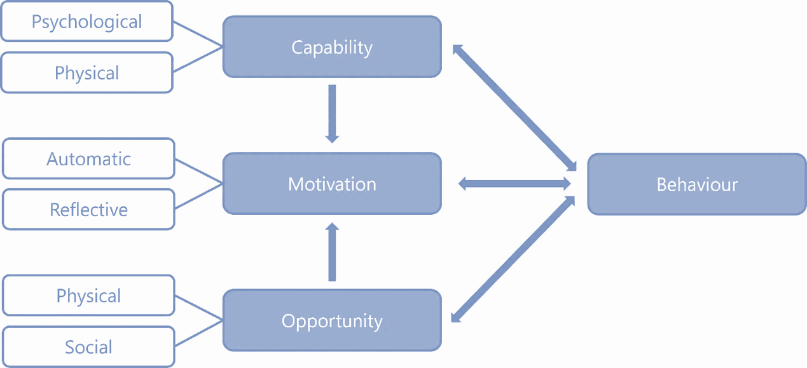

Reflexivity and validity

Both the author and research supervisor have experience of working in inpatient psychiatric settings undergoing organisational change. Although neither have formally investigated barriers and facilitators to change in this setting, through personal experience there may be preconceived ideas of what barriers and facilitators exist. The influence of these preconceptions was minimised through regular reflective discussions. This discussion process helped ensure other interpretations were considered which enhanced the validity of the findings. A reflexive diary was kept throughout the process and used to record thoughts, reflections and potential biases whilst conducting the analysis (Appendix E).

Summary of Included Papers
Six studies met the inclusion criteria. Figure 2 details the PRISMA diagram of the screening process for included studies.
The characteristics of each study were summarised within Table 4. The publication dates of the studies ranged from 2006-2022. All studies were based in the UK.
The exact number of participants could not be calculated as two studies failed to report this (Brennan et al., 2006; Taylor et al., 2022). Laker et al. (2014) reported the number of staff who took part in the qualitative interviews (n=32) and factor analysis (n=125); however, it is not known if staff overlapped between the two parts of the study. The inclusive number of participants for the three studies who reported the total number of participants was 394. For most studies, participants consisted of clinical (nurses, nursing assistants, psychiatrists, therapists, psychologists, and social workers) and managerial staff. Less frequently, administrators, a peer provider, a nursing scientist, and a quality officer were included.
For the qualitative studies, one used semi-structured interviews and group interviews to gather data and two used field notes of various team meetings including supervision and reflective practice. Thematic analysis was used for two studies. Brennan et al. (2006) failed to report the analysis used.
For the quantitative studies, one study utilised a cross-sectional design and employed random-effects models, while the second was a cluster randomised controlled trial using unstructured multivariate linear regression models.
For the mixed-method study, semi-structured interviews and group interviews were used to gather qualitative data. Data was analysed using thematic analysis. The quantitative element was of correlational design and employed exploratory factor analysis and random effects models to measure associations.
Quality Appraisal Results
Table 4 details the quality appraisal summary of the included studies using the MMAT tool (Appendix D). The MMAT tool does not suggest generating an overall score of quality from the rating of each criterion, nor excluding studies based on the quality (Hong et al., 2018), therefore it is important to consider aspects which could further contribute to the appraisal of the studies and highlight specific limitations, discussed below.
Summary of Methodological Quality of Studies
According to Stenfors et al. (2020), four criteria - credibility, dependability, confirmability, and transferability – should be used to appraise the quality of research. Five out of the six studies could be deemed largely credible, dependable, confirmable, and transferable through: being transparent regarding the design and data collection methods (as well as giving justification for the methodology chosen), comprehensively exploring and integrating data to explain their findings, and discussing the broader relevance and applicability of the study beyond the immediate context. All studies detailed ethical approval.
No papers discussed their epistemological standpoint. Taylor (2022) and Brennan (2006) failed to report the number of participants. Two studies failed to discuss consent, and only two studies clearly described recruitment. Laker et al. (2014) failed to report quotes to evidence data. They also, along with Brennan et al. (2006) failed to consider reflexivity, which is important for transparency and credibility of findings (Dodgson, 2019). Brennan et al. (2006) failed to report the analysis used, however this was the oldest paper included, and so could indicate the more recent development of qualitative methodology (Howitt & Cramer, 2010).
There is debate over minimum response rate-criterion, but the consensus is that there is a greater likelihood of nonresponse bias when there is a lower response rate. In Laker et al. (2020)’s study, 64% of staff invited to participate took part. The authors note efforts were made to minimise response bias by visiting wards outside of normal office hours. Some journals require a response rate of at least 60% for a study to be considered for peer review (JAMA, 2013), therefore the risk of non-response bias is technically low according to this guideline but is something to consider as non-response can compromise external validity.
As this review is concerned with examining implementation of organisational change in the AAPI setting, the methodological limitations of the included studies are of interest. The limitations further highlight challenges within AAPI settings, there may be parallels in terms of challenges with conducting research and challenges with making changes.

Table 4
Summary of study characteristics including critical appraisal of the quality of included studies

Study | Authors (year) | Population & sample | Setting | Country | Design of study | Aim(s) | Data collection method & analysis | Reflexivity (if applicable) | Brief overview of results & key discussion points | *MMAT  (0 = no, 1 = yes, 2 = can’t tell)
The challenge of change in acute mental health services: measuring staff perceptions of barriers to change and their relationship to job status and satisfaction using a new measure (VOCALISE) | Laker et al. (2014) | Mental health nursing staff at varying levels - nursing assistants, entry level qualified nurses, senior  nurses and ward managers  For qualitative interviews n=32 For factor analysis n=125 | An acute mental health NHS Trust in London (number of hospitals/wards unknown) | England | Two staged study:  Stage1 - qualitative  Stage 2 - quantitative (correlational design) | i) To understand how health staff perceive the climate for implementing changes. Specifically focused on barriers to change  ii) To create a measure to assess this construct (VOCALISE)  iii) To examine associations between VOCALISE scores, occupational status and job satisfaction | Stage 1: Semi-structured individual and group interviews - analysed using thematic analysis to determine measure items  Stage 2: Survey using measure items - exploratory factor analysis and random effects models used to measure associations | Not reported for qualitative element | Seven overall themes were identified from the interviews:  communication, generation of ideas, outcomes of  changes, resistance, strategy, support, and monitoring,  and team dynamic.  The exploratory factor analysis indicated three hidden psychological components:  -Factor one: unsuccessful change linked to staff  Perceiving change as beyond their control, highlighting a sense of powerlessness and poor work-related autonomy.  -Factor two:  staff confidence related to how the process of change occurs.  -Factor three:  disillusionment and loss of motivation impacts on the team relationship, leading to a lack of group commitment.  Staff with higher organisational status view changes more favourably than junior staff. | **S.1 = 1  S.2 = 1  1.1 = 1  1.2 = 1  1.3 = 1  1.4 = 2  1.5 = 1  4.1 = 1  4.2 = 1  4.3 = 1  4.4 = 1  4.5 = 1  5.1 = 1  5.2 = 1  5.3 = 1  5.4 = 1  5.5 = 1
The impact of ward climate on staff perceptions of barriers to research‐driven service changes on mental health wards: A cross‐sectional study | Laker et al. (2020) | Mental health professionals consisting of direct care staff (healthcare assistants and qualified nursing staff) and managers were (clinical charge nurses, practice development nurses and team leaders) (n=125) | Seven acute inpatient psychiatric wards,  and a specialist inpatient women’s service, in a mental  health NHS trust | England | Quantitative (cross‐sectional design) | i) To build a model that provided the best explanation of the effects of ward climate on staff perceptions of barriers to change  ii) Use the model to answer the question ‘Does ward climate influence mental health nurse's perceptions of barriers to change?’ | Data from surveys were analysed using random-effects models | N/A | Five factors significantly and negatively affected perceptions of barriers to change: perceptions of ward climate, incidents, temporary staffing, occupational status and burnout.  Staff with low job satisfaction and high interaction anxiety were demotivated to engage in change projects and had low confidence in change projects. | S.1 = 1  S.2 = 1  4.1 = 1  4.2 = 1  4.3 = 1  4.4 = 1  4.5 = 1
Constraints and blocks to change and improvement on acute psychiatric wards–lessons from the City Nurses project | Brennan et al. (2006) | Mental health nurses (number of participants not recorded) | Two acute inpatient psychiatric wards within a mental health NHS trust, each with 18 beds | England | Qualitative | To describe some of the structural and organisational constraints on change in acute psychiatry | Data collected through fieldwork notes, team discussion notes and supervision notes (analysis not named) | Not reported | Data analysis produced five overall themes: basic resource issues (staffing levels and quality), basic resource issues (environment), basic resource issues (beds), ‘who leads what?’, and risk, fear, and change | S.1 = 1  S.2 = 1  1.1 = 1  1.2 = 1  1.3 = 2  1.4 = 1  1.5 = 1
Barriers and enablers to implementation of the therapeutic engagement questionnaire in acute mental health inpatient wards in England: A qualitative study | Taylor et al. (2022) | Nurse directors, senior clinicians (nurse consultants, quality improvement and innovation managers, matrons, Band 8 nurses) ward managers, and nurses (number of participants not included) | 15 acute inpatient psychiatric wards within six mental health NHS Trusts and one private provider of mental health care facilities | England | Qualitative | To  understand the barriers and enablers to implementation of a therapeutic engagement measurement tool, the TEQ, in acute mental health inpatient settings.  Specifically, to understand how barriers be overcome to enable successful implementation of the TEQ | Data was collected via ethnographic field notes collected during the facilitative discussion meetings (41 h of meetings), and documents on the project. Analysis was undertaken via thematic analysis | Yes | Several facilitation methods were brought together in a conceptual model, including encouragement of reflective, facilitative discussion meetings among stakeholders and researchers, effort put into winning nurse ‘buy-in’ and identifying and supporting ward-level agents of change | S.1 = 1  S.2 = 1  1.1 = 1  1.2 = 1  1.3 = 1  1.4 = 1  1.5 = 1
The side effects of service changes: exploring the longitudinal impact of participation in a randomised controlled trial (DOORWAYS) on staff perceptions of barriers to change | Laker et al. (2019) ¹ | Mental health professionals consisting of direct care staff (healthcare assistants and qualified nursing staff) and managers were (clinical charge nurses, practice development nurses and team leaders) (n=125) | Seven acute inpatient psychiatric wards,  and a specialist in-patient women’s service, within a  NHS mental  health trust | England | Quantitative (cluster randomised controlled trial) | To understand:  i) whether nursing participation in a programme of change affected their perceptions of barriers to change  ii) the effects of occupational status and ward on perceptions of barriers to change | Data was collected via surveys and analysed using unstructured multivariate linear regression models | N/A | Participation in this program of change worsened staff perceptions of barriers to change.  In addition, occupational status (being from the direct care group) had a negative effect on perceptions of barriers to change, an effect that continued across time and was worse in the intervention group.  Those providing direct care should be offered extra support when changes are introduced and through the implementation process. | S.1 = 1  S.2 = 1  2.1 = 1  2.2 = 1  2.3 = 1  2.4 = 1  2.5 = 1
Why is change a challenge in acute mental health wards? A cross‐sectional investigation of the relationships between burnout, occupational status and nurses’ perceptions of barriers to change | Laker et al. (2019) ² | Mental health professionals consisting of direct care staff (healthcare assistants and qualified nursing staff) and managers were (clinical charge nurses, practice development nurses and team leaders) (n=125) | Seven acute inpatient psychiatric wards,  and a specialist inpatient women’s service, within a mental  health NHS Trust | England | Quantitative (cross sectional design) | To examine whether burnout and workforce characteristics influence psychiatric nurses’ perceptions of barriers to change | Data was collected via surveys and analysis undertaken using random-effects regression models | N/A | Perceptions of barriers to change were correlated with burnout, occupational status, and age.  Burnout and occupational status predicted perceptions of barriers to change.  Emotional exhaustion predicted low motivation regarding changes.  Ward staff expressed significantly more powerlessness and significantly less confidence than managers.  Emotional exhaustion and low personal accomplishment predicted powerlessness.  Overall conclusion was that for changes to be successful in psychiatric wards, burnout will need to be addressed. | S.1 = 1  S.2 = 1  4.1 = 1  4.2 = 1  4.3 = 1  4.4 = 1  4.5 = 1

* MMAT questions can be found in Appendix D
** Screening questions
S1. Are there clear research questions?
S2. Do the collected data allow to address the research questions?

Framework Synthesis
The barriers and facilitators to implementing change in AAPI settings are discussed using the framework of the COM-B model (Michie et al., 2011). Table 5 provides a summary of the identified barrier and facilitator themes, their definitions and frequency, the articles contributing to the theme and BCW strategies which link. The most frequently identified barriers and facilitators were consistent across different ward contexts, while others were more specific to the setting. For example, nearly all studies identified ‘inadequate staffing levels’, ‘irregular staffing’ and ‘lack of teamwork/poor team dynamic’ as barriers, and ‘good communication’ as a facilitator. However, one study identified barriers relating to ‘unprecedented changes to context of the ward’. It is notable that this barrier was identified in the most recent study, undertaken in the recent COVID-19 pandemic.
In some cases, the authors reported actual barriers or facilitators, and the opposite was hypothesised, e.g. if time was reported as a facilitator, staff believed that if they were not given protected time to implement changes then this would be a barrier to change.
Table 6 – ‘Practical Implementations Summary’ – explains potential interventions identified using the BWC, from which implications and suggestions that are clear and directly linked to the themes are produced. A revised COM-B model is presented (Figure 3).

Table 5

COM-B construct, themes, barriers and facilitators, contributing articles and application to BCW

COM-B component | Inductive theme | Barriers | Facilitators | Contributing articles | Sample of indicative quotes | BCW interventions
Capability (Psychological): knowledge or psychological skills, strength or stamina to engage in the necessary mental processes | Knowledge and education related to the change project | Staff involved in the change not having knowledge of the change project | Staff involved in the change having sufficient knowledge of the change project | Laker et al., 2019¹  Taylor et al., 2022  Laker et al., 2019²  Laker et al., 2014 | “Inadequate nursing skills and knowledge to deliver against TEQ statements” – Taylor et al., 2022  “Well, there is another thing about people not really being aware of the bigger picture” – Laker et al., 2014  “I do not really understand how to deliver some of the changes that are suggested by the management” – Laker et al., 2019 | Education  Training  Environmental restructuring  Modelling  Enablement
 | Ward level change agents |  | Ward staff and patients having knowledge of the ward and ward routines | Taylor et al., 2022 | “Regular discussion of the TEQ in community meetings helped SUs and nurses become aware of its improvement role and the need for completion at discharge” – Taylor et al., 2022
 | (Perceived) quality and competence of staff | Management not confident in staff abilities |  | Brennan et al., 2006 | “If we can get someone (i.e. a client) to complain we  could do something. HR wouldn’t do a thing on the  basis of our worries. (Ward Manger talking about a  member of staff and recorded in City Nurse reflective diary)” – Brennan et al., 2006  “However, from the outset some stakeholders expressed concerns that not all nurses would have the skills to deliver the stated therapeutic engagement activities in practice” – Taylor et al., 2022
Opportunity (Physical): opportunity afforded by the environment involving time, resources, locations, cues, physical affordance | Staffing | Irregular staffing  Inadequate staffing levels  High turnover of staff | Regular staffing  Adequate staffing levels | Brennan et al., 2006  Taylor et al., 2022 | “If the staff were temporary agency, they were not as knowledgeable about the ward rules, the patients or the culture of the ward. If they were the ward’s bank staff, there was often an understanding that, as they are ‘doing the ward a favour’ they could demand certain privileges, such as not being ‘in charge’ or ‘taking things easy’ if they were due to do a long day as opposed to a single shift” – Brennan et al., 2006 | Training  Restriction  Environmental restructuring  Enablement
 | Burden of change on staff | Change is difficult to implement into ward activities  Competing priorities  Workload increases  Staff don’t have enough time | Change fits into daily ward life easily | Brennan et al., 2006  Laker et al., 2019¹  Taylor et al., 2022  Laker et al., 2019² | “Trying to fulfil all these demands is highly stressful and nearly impossible, and we observed ward managers working, unpaid, well above their hours, in order to try to do so” – Brennan et al., 2006  “‘We felt it was an added burden we felt that we had no choice.’” – Laker et al., 2014
 | Pacing of changes | Too much change at once  Unprecedented and large changes to context of the ward | Change is paced in way that feels manageable | Taylor et al., 2022 | “The most frequently discussed challenge in all sites was the COVID-19 pandemic. Intervention implementation and prioritization were reported to be hindered by a range of pandemic-associated ward environmental factors, including high rates of admission and discharge, increased acuity and complexity of admissions, requirements to self-isolate, depleted permanent staff numbers, and use of agency staff” – Taylor et al., 2022
 | Physical resources | High financial cost of change  Lack of space  Lack of technology  High number of beds/bed management problems | Facilities to undertake change related tasks | Brennan et al., 2006  Taylor et al., 2022 | “There are ongoing (environmental) issues. The use of the  (patients) “quiet” room for ward rounds and handovers  means that, in effect, it is shared between clients and  staff. (observation recorded in City Nurse Reflective  Diary)” – Brennan et al., 2006  “However, this conflicts with the efficient management of  beds, which requires patients to be treated as objects,  shunted around the system, moving beds and sometimes  wards, with little notice” – Brennan et al., 2006  A charge nurse could not show his supervisees this material as  suitable equipment (a computer with sound card and  speakers) was unavailable. There seems to be little consideration of these realities in the expectations on the service” – Brennan et al., 2006
Opportunity (Social): opportunity afforded by the interpersonal influences, social cues and cultural norms that influence the way that we think about things | Advice and support | Lack of organisational support  Lack of monitoring of change progress  Lack of ‘buy in’ from senior leadership and champions  Lack of support available in terms of champions/leadership  Discouragement of thinking about barriers/other ways of working by senior stakeholders | Support for innovation  Support and coordination among staff at all levels  Senior leadership ‘buy in’ | Taylor et al., 2022  Laker et al, 2014  Brennan et al., 2006  Laker et al., 2019¹ | “An example during the project was a new worker who mentioned that another ward had a good system for a certain clinical routine, but was told that it was not possible to transfer the practice and, in addition, that they were naïve in assuming the practice could be translated across” – Brennan et al., 2006  “Poor leadership prevents changes happening on my ward” – Laker et al., 2019  “[Ward manager] was the torch carrier but when they left it hadn't become embedded…If the champion leaves and there isn't a new champion soon enough it can quickly fall away. (Facilitative discussion meeting – Nurse Director/Senior Clinician, ID 01)” – Taylor et al., 2022 | Environmental restructuring  Modelling  Enablement  Incentivisation
 | Communication | Poor communication about changes | Good communication about changes  Regular meetings | Laker et al., 2014  Taylor et al., 2022  Brennan et al., 2006  Laker et al., 2019² | “Facilitative discussion meetings among stakeholders and researchers also played a valuable role in addressing context-related implementation barriers” –  Taylor et al., 2022  “As communication appears to be a key factor, it may be beneficial to engage with staff to develop changes that staff find feasible” – Laker et al., 2019²  “Given DOORWAYS was an externally devised change delivered in the form of a randomised controlled trial that was imposed at the ward level using a top down approach, it is perhaps unsurprising that staff responded negatively” – Laker et al., 2019
 | Ward climate | Lack of teamwork  Poor team dynamic  Staff having competing priorities  Distressed ward climate  Interaction anxiety  Criticism | Positive team dynamic  Celebrating successes | Laker et al., 2014  Brennan et al., 2006  Laker et al., 2019¹  Laker et al., 2019²  Taylor et al., 2022 | “They are subject to sustained overt or implied criticism for the perceived failures of acute care” – Brennan et al., 2006  “Story sharing of successful implementation practice” – Taylor et al., 2022  “You know I mean when you, you know you hear people saying oh about team, teamwork and all that you wouldn’t know teamwork if you were hit by Man United in a bus’” – Laker et al., 2014
Motivation (Reflective): reflective processes involving plans (self-conscious intentions) and evaluations (beliefs about what is good and bad) | Power | Conflict with autonomy  Powerlessness |  | Laker et al., 2014 Laker et al., 2019² | “As the qualitative data identified, the direct care staff also made links between powerlessness and feasibility issues, feeling a sense of injustice because they were not able to deliver changes if neither their clients nor they perceived much benefit” – Laker et al., 2014 | Education  Persuasion  Modelling  Enablement  Incentivisation  Coercion
 | Perceptions of change project | Negative belief of potential outcomes of change  Lack of interest in/resistance of change from patients | Feeling that the change project is relevant to the role  Belief that the change project is evidence-based  Belief that the change project will demonstrate improvement | Laker et al., 2014  Taylor et al., 2022  Laker et al., 2020  Laker et al., 2019¹ | “I was keen to do this [implementation] as demonstration of what nurses do. That was the appeal to me. This is about what nurses do. (Facilitative discussion meeting – Nurse Director/Senior Clinician, ID 01)” – Taylor et al., 2022  “A lack of interest in innovation existed amongst the client group, which affected staff motivation to deliver some changes” – Laker et al., 2014  “Staff with low job satisfaction and high interaction anxiety also had low confidence regarding changes” – Laker et al., 2020
 | Learning | Lack of sharing of learning | Sharing of learning  Reflection  Evaluation/auditing of outcomes from change project implementation | Taylor et al., 2022 | “‘For audits it is a struggle to find evidence of what registered mental health nurses are doing’. (ID 02). Some nurse directors/senior clinicians described seeing potential for the TEQ to catalyse an improved awareness and understanding of the value of the profession in tandem with more prominence given to therapeutic engagement” – Taylor et al., 2022  “Another ward manager described monthly skills training sessions with nurses in which anonymized TEQ data were shown and discussed. This was said to encourage a sharing of ideas about how improvements might be made in relation to statements receiving lower scores from Sus” – Taylor et al., 2022  “There was further benefit if nurse directors/senior clinicians recognized the value of these agents of change, advocating their ideas and recommending and distilling their use across other wards” – Taylor et al., 2022  “…the conversations were frequently distinguished by their informal and non-hierarchical character, combining a reflective, ‘think-aloud’ approach” – Taylor et al., 2022
Motivation (Automatic):  automatic processes involving emotional reactions, desires (wants and needs), impulses, inhibitions, drive states and reflex responses | Responses to work | Negative emotional responses to work  Low job satisfaction  Burnout | Positive emotional responses to work | Laker et al., 2020  Laker et al., 2019²  Laker et al., 2014 | “Those with negative perceptions of the barriers to change also had poor job satisfaction after controlling for age and occupational status” – Laker et al., 2014  “Staff with higher burnout had more pessimistic perceptions of barriers to change” – Laker et al., 2019² | Training  Incentivisation  Coercion  Environmental restructuring  Persuasion  Modelling  Enablement
 | Confidence in skills | Lack of confidence in skills | Confidence in skills | Taylor et al., 2022  Laker et al., 2019¹ | “The engagement of some nurses in implementing the TEQ was reported to be restricted by their perceived lack of therapeutic engagement skills” – Taylor et al., 2022  “I feel confident when delivering new changes” – Laker et al., 2019
 | Responses to change | Negative experience of a previous change  Fear to take risks  Resistance  Sense of unfairness |  | Brennan et al., 2006  Laker et al., 2014  Taylor et al., 2022  Laker et al., 2019¹ | “The continually changing demands from an ambiguous management have led to well-learnt strategies of avoidance, through postponement of compliance, and a lack of identification with the goals of the organization” – Brennan et al., 2006  “‘And initially they, they were happy with this. And there wasn’t much resistance then it was when they actually seen us doing what we were doing. I think because we weren’t always working long days. Our initial shifts were four days a week it was I think it was half eight in the morning to half six. And, and I think people thought that that was not fair basically. So what it boils down people would be quite resentful and resist it in terms of, well – it’s jealous.’” – Laker et al., 2014  “Staff perceptions of barriers to change worsened in those who participated in the intervention group” – Laker et al., 2019
Other | Staff demographics | Younger age of staff  Lower occupational status | Higher occupational status | Laker et al., 2019²  Laker et al., 2014  Laker et al., 2020  Laker et al., 2019¹ | “Occupational status was significantly associated with staff perceptions of barriers to change after controlling for age… Staff in leadership roles  are more likely to be involved in the planning stages of new changes and therefore have an increased sense of  control and responsibility over them” – Laker et al., 2014  “Staff that were more senior felt less powerless and more confident than those in more junior positions” – Laker et al., 2019²  “Both occupational status and burnout significantly affected perceptions of barriers to change. Direct care staff an those with high levels of burnout had more negative perceptions of  barriers to change” – Laker et al., 2020

Capability
Implementation of change can be affected by staff psychological capability (e.g. cognitive and emotional capacity, and knowledge and skills) and physical capability (e.g. the physical skills/ ability to implement the change projects).
Physical
The data did not explicitly reference physical capability barriers or facilitators in relation to implementing change on AAPI wards.
Psychological
Three themes were identified: knowledge and education related to the change project; ward level agents of change; and (perceived) quality and competence of staff. For knowledge and education related to the change project, staff having inadequate training, expertise, or awareness of the change was found to be a barrier to change, whilst staff having a good level of understanding facilitated change implementation.
For ward-level agents of change, utilising the knowledge of ward staff – who had a thorough understanding of the day-to-day running of the ward – to promote and implement the change was considered a facilitator.
For (perceived) quality and competence of staff, senior management having little confidence in staff abilities was a barrier to organisational change whereas management who felt confident in staff abilities enabled change.
Opportunity
Implementation of change can be affected by physical opportunities (e.g. resourcing, time, and location) and social opportunities (e.g. opportunities arising from interpersonal influences, and social cues/cultural norms that influence thinking). In the current review, the identified barriers and facilitators most frequently mapped onto the COM-B model domain of opportunity.
Physical opportunity
Four themes were found for physical opportunity: staffing; burden of change on staff; pacing of changes; and resources. For staffing, ‘inadequate staffing levels; ‘irregular staffing’ and ‘high turnover of staff’ were all barriers to change, whilst ‘regular staffing’ and ‘adequate staffing levels’ allowed for the implementation of change.
For burden of change, Staff reported that the change creating an ‘additional workload’ was an issue and hindered change efforts; thinking about COM-B, this would interact with understanding the value of the project. Staff identified that if team members have ‘competing priorities’ and if the ‘change is difficult to implement into the ward routine’, change is more challenging. On the other hand, a change to the ward that ‘fits into the daily ward life’ allowed for better facilitation.
A third theme – pacing of change – was identified. If ‘too much change at once’ occurred, or if the change was ‘large and unprecedented’, this was a barrier. Conversely, ‘pacing of changes’ allowed for facilitation as it helped change feel more manageable.
A fourth and final theme of resources was found. ‘High financial cost of change’, ‘lack of space’, ‘lack of equipment/technology’, ‘high number of beds/bed management problems’ and ‘time constraints’ were all barriers to change. Having appropriate facilities and adequate time to complete change related tasks were facilitators.
Social opportunity
Three themes were identified for social opportunity: advice and support; communication; and ward climate. For advice and support, ‘support for innovation’ from senior leadership was helpful to enable change; it allowed staff to engage in positive risk taking related to the change and in turn facilitated implementation. On the other hand, ‘discouragement of thinking about barriers/other ways of working by senior stakeholders’ was a barrier to change. ‘Support and coordination among staff at all levels’, i.e. collaborative decision-making, clear role coordination, and encouragement among staff at all levels, was helpful to foster team cohesion and motivation. ‘Senior leader buy-in’ to support change implementation through actively promoting change and providing support to ward staff/staff implementing the change, was also a facilitator. The opposite – ‘lack of buy-in’ – was found to be a barrier, as was ‘lack of organisational support’, and ‘lack of monitoring of change progress’.

For communication, ‘poor communication’ of relevant information between ward staff, senior leadership/management and/or change leaders was a barrier whilst ‘good communication’ – when information regarding the change is communicated promptly and regularly to staff at all levels – was a facilitator. ‘Regular meetings’ was also a facilitator, as this allowed for better communication.
For ward climate, having a ‘positive team dynamic’ and ‘celebrating successes’ facilitated change. Staff receiving positive feedback on change efforts increased pride and motivation to implement change, with a positive team dynamic fostering a feeling of togetherness. However, a ‘distressed ward climate’, which included a high number of physical incidents, was a barrier. In addition, staff experiencing ‘interaction anxiety’ (perceived or real negative interactions between staff members and/or staff and patients) was a barrier, as was staff having ‘competing priorities’ in relation to the change related tasks.

Motivation
Implementation of change can be affected by reflective motivation (e.g. emotional reactions, desires, impulses) and automatic motivation (e.g. plans and evaluations).
Reflective
Three themes were identified for reflective motivation: power; perceptions of change project; and learning. For power, staff reported that when the change causes feelings of ‘conflict with autonomy’ and ‘powerlessness’, these are barriers to implementation.
With regards perceptions of change project, staff having a ‘negative perception of potential outcomes of change’ was a barrier. Conversely, positive perceptions such as ‘feeling that the change is relevant to the role’, ‘belief that the change is evidence-based’ and ‘belief that the change will demonstrate improvement’ were all facilitators.
Within the theme of learning, engaging in ‘reflection’, ‘sharing of learning’ and ‘evaluation/auditing of outcomes from change implementation’ were important for change to be successfully implemented. Staff wanted to value the change and demonstrated an interest in wanting to develop care. They wanted the change to fit with organisational goals and values and for the project to be helpful to their role. A ‘lack of sharing of learning’, i.e. there was no forum to share knowledge and experience of the change project to allow stakeholders to learn from each other, was a barrier.
Automatic
Three themes for automatic motivation were found: responses to work; confidence in skills; and responses to change project.
In terms of responses to work, staff having ‘positive emotional responses to work’ was a facilitator to change and included high job satisfaction. However, ‘negative emotional responses’, ‘burnout’ and ‘low job satisfaction’ were barriers.
For confidence in skills, ‘lack of confidence’ hindered change efforts, whereas staff who had ‘high confidence’ in their skills and abilities to complete their job role was a facilitator of change.
Lastly, within the theme responses to change project, a more active sense of ‘resistance’ from staff, staff having had a ‘negative experience of a previous change’, staff having a ‘fear to take risks’ were all barriers to change.
Additional theme
An additional theme of ‘Staff demographics’ was found, which did not fit with the COM-B model. Younger staff and those of lower occupational status were found to have more negative perceptions of change and those of higher occupational status were found to have more positive perceptions of change. Although no concrete causal explanations can be drawn, hypotheses are considered in the Discussion.

Figure 3
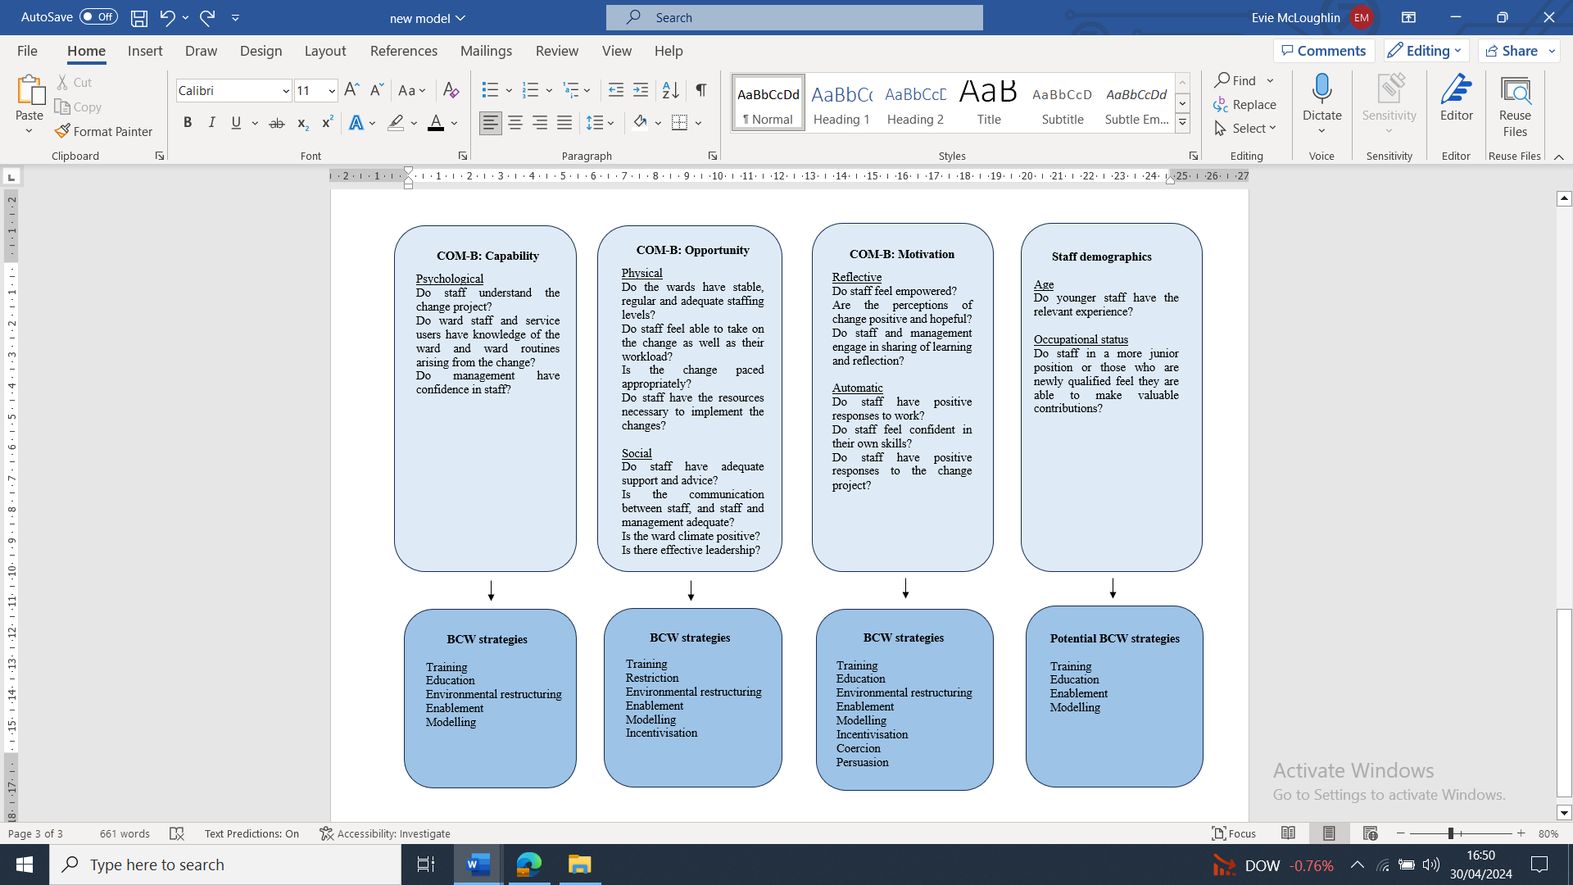
A revised COM-B model integrating BCW strategies

Table 6
Practical Implications Summary

Interventions identified using the BCW | Application in practice
Training | Ward staff should be provided with relevant training in relation to the change project. This should be provided for both staff who are employed at the time of the change implementation and as a package for new starters to avoid any gaps in knowledge. Training packages would need to: equip staff with knowledge of the change project and the value of it to the service; provide staff with necessary psychological and practical skills to undertake change-related tasks; and help change leaders understand how to empower staff/have confidence in them.
Education | Education for ward staff about the change project differs from more formal training. Education involves reinforcing that changes are being made for specific reasons, usually at the heart of the change is improving the care of those who access the service. Supporting people who access a service is a responsibility of all healthcare professionals and therefore implementing changes are also their responsibility. Education incorporates establishing roles within the change project and the provision of clear signposting of resources and support structures. If staff do not feel empowered, providing education by making not only their role in the change project clear, but by making clear sources of additional information/support, can help staff to feel more confident and autonomous in relation to change.
“Coercion”/ Professional role management | Coercion is the language used in the BCW. It can sometimes be necessary to drive forward changes if there is some resistance. However, it can be viewed as ‘force’ or ‘oppression’, and it is acknowledged that this can lead to broken trust between staff and management. Instead of using explicit coercion, it will be beneficial for leaders to use professional role management to establish targets and guidelines. This in turn can drive goals in clinical practice. For example, if staff and management are not engaging in the sharing of learning around change projects and this is a barrier to implementation, being explicit about service-wide targets/goals of sharing of learning – as well as being clear about the reasons for these targets – may help to overcome this barrier.
Persuasion | Using persuasion to aid implementation of organisational change involves attempting to encourage staff to participate. For example, using evidence to ‘back up’ arguments for the implementation of the change project. Evidence should be from a reliable source to maximise belief in the information, and presented in an accessible format so that staff can engage with the material. If staff had negative or ambivalent perceptions of the change project, and this was a barrier to implementation, providing evidence of the utility of change or how it relates to the values of the service will be important.
Incentivisation | Incentivisation is the idea of promoting and motivating staff to aid implementation of the change project, using ‘rewards’ or returns for staff. A ‘reward’ in acute inpatient services may look like encouraging staff to have a voice and active participation/role in the changes, which can be promoted through particular leadership styles and commitment from management. This can help staff to feel more motivated to engage in the change project, and can also develop good employee relationships, which in turn can aid the implementation of the change project. Services can also promote the importance of staff mental and physical health, which are important for staff feeling able to engage in the change project. Regular and sufficient appraisals for staff should be developed and implemented; these can help staff to feel more positively toward their work and identify any necessary or desired training which can also help staff to feel motivated.
Enablement | To enable staff to engage in the change project, practical elements need to be in place which includes staff having the necessary space and time to complete tasks in relation to the change project. It also includes having regular and adequate staffing levels to help staff complete both their routine ward activities and tasks related to the change project, without them feeling overwhelmed or overburdened. Regular staffing will ultimately help to foster a healthy, positive ward climate, even when factors beyond staff control exist (e.g., staff facing aggression from people accessing the service). Resources to help staff build self-efficacy, e.g., reflective practice, staff well-being support, will also be important.
Modelling | Conversations around the change should become routine for staff, leadership, and management, perhaps through regular and frequent meetings. Modelling can take place through staff having the opportunity to shadow/observe more senior staff undertaking change related tasks. Shadowing can provide staff, particularly those of lower occupational status, or who may be younger and newer to the profession and thus may feel less confident, with a safe environment to learn, ask questions and engage in reflective practice.
Environmental restructuring | Environmental restructuring to allow change to be implemented effectively can be social or physical. Social environmental restructuring might look like fostering a ‘leadership by all’ culture amongst staff by giving staff the resources and confidence to know that they can help to drive change. Whilst staff do not always see it as their role to influence change, a system-wide approach is required for sustainable and successful change. In terms of physical restructuring, physical barriers to change should be addressed forthright, e.g. lack of time or perceived lack of time. Change projects can be organised in such a way that they can fit in easily with daily ward routines. The implementation should be flexible enough that staff at all levels can contribute to the change efforts.

Discussion
The aim of this review was to identify, appraise and synthesise primary research to investigate staff perspectives of barriers and facilitators to implementing change on AAPI wards. The current review used the COM-B model to describe barriers and facilitators to organisational change in AAPI settings, and the BCW to identify strategies to overcome barriers.
Notable facilitators included: ‘buy in’ from senior leadership and champions; staff having positive responses to work; and staff having confidence in their knowledge and abilities. Notable barriers included: staff having a negative perception of potential outcomes of change; staff demographics; staff having competing priorities to the change project; lack of organisational support and monitoring; lack of teamwork/poor team dynamic; irregular staffing; and inadequate staffing levels. It is notable that staff did not reference barriers or facilitators which could be linked to ‘physical capability’ i.e. physical strength, stamina or skill. Whilst this may be because there are no physical capability barriers to organisational change, it may be because they are less obvious. For example, aging, which is relevant to the rising age of healthcare workers (Ng & Feldman, 2013) and physical tiredness as a result of shift working (Costa, 2007).
In the current review, age was considered in relation to perceptions of change, a finding not identified by Raphael et al. (2022). Younger staff – as well as lower occupational status – were associated with feelings of lower confidence and powerlessness in relation to change. While no causal explanations can be drawn, Ho et al. (2021) found that newly qualified nursers feel ‘thrown in at the deep end’ in busy, stressful environments with little support. Younger staff and those of lower occupational status may be more likely to be newly qualified. Interestingly, the quantitative papers or papers with a quantitative element (Laker et al., 2014; Laker et al., 2019¹; Laker et al., 2019²; Laker et al., 2020) reported these findings. Perhaps the use of quantitative measures which directly asked about age and perceptions of change was able to determine a correlation more confidently. Again, there may be reasons why staff did not discuss age or occupational status in qualitative interviews, e.g. staff may feel uncomfortable talking about age due to societal taboos around aging.

For the barriers and facilitators identified, most were placed within the ‘Opportunity’ component of the COM-B model. However, given the components may interact to produce actions, this review recommends that each component is considered equally important. For example, having regular and adequate staffing (Opportunity) can facilitate change as it allows change to be implemented without it being a burden on staff time/workload (Opportunity) but also allows for ward-level agents of change to be used (Capability) and reduces any feelings of conflict with autonomy or powerlessness (Motivation).
With an understanding of the capability, opportunity and motivational barriers and facilitators to organisational change in the acute inpatient psychiatric setting, the BCW can be used by those involved in change to identify ‘intervention functions’ which serve as building blocks for designing effective interventions (Michie et al., 2011). Through application of the BCW in the current synthesis, nine strategies are proposed to address the barriers identified to implementing change in the AAPI setting. These strategies can be utilised by policy makers and those in leadership roles, such as Clinical Psychologists.
For example, for Capability, the current review found staff were less likely to engage when they had a lack of knowledge/skills to engage in the change project or when the change did not align with their own values. Education and training regarding the change are potential interventions to overcome these barriers. Capability links to the concept of self-efficacy – an individual’s belief in their ability to succeed or achieve a goal, or complete a task (Bandura, 1977) – which can impact staff engagement in change. To overcome low self-efficacy, individuals implementing interventions in healthcare settings should ensure staff receive enough information to understand the aims and methodology of the intervention (Geerligs et al., 2018). The current review additionally found that for change to be effective in AAPI settings, senior leadership and the wider organisation must support training for staff. It was also found to be important to include staff in intervention development to ensure interventions align with their values.
Another barrier identified in the current review was staff having previous negative experiences during participation in change projects, for example stressful experiences of change. A systematic review exploring barriers and facilitators to implementing hospital-based physical healthcare interventions found staff perception of psychological stressors was a barrier to staff engagement in change (Geerligs et al., 2018). Services implementing change need to consider ways for staff to overcome perceived and actual distress. The current review suggested that good team relationships can help; a finding which was supported by Day et al. (2017) who found that supervisor support buffered the negative relationship between change stressors and exhaustion and between change stressors and cynicism.
The review found ward environmental factors, e.g. low staffing levels, can hinder implementation of change, and point towards a task-oriented organisational culture in which staff may not feel able to take on the burden of the change as well as their other responsibilities. Gamble (2006) found that due to administration demands, nurses spend much less time with patients. In task-oriented ward cultures, staff are unable to prioritise activities related to change implementation if they already feel overburdened, particularly when understaffed. The current review found that staff need to be supported to prioritise change, e.g. by integrating change tasks into the ward routine and providing staff with ‘protected time’. Including the change processes as a task may help overcome barriers created by task-oriented ward cultures.
A task-oriented ward culture can also be linked to the findings of the current review that ‘conflict with autonomy’ and ‘powerlessness’ can also be barriers to implementation. If staff do not feel that they have any control over their time or role and feel overburdened, this may lead to further feelings of powerlessness and a resistance to change. This is corroborated by Day et al.’s (2017) findings that ‘job control’ was directly related to burnout and negatively impacted on perceptions of change. Job control moderated the negative relationship between change and professional value. The BCW suggests that incentivisation is helpful for overcoming for motivation related barriers. In the NHS, Clinical Psychologists are well placed to advocate for and encourage staff to have a voice and an active role in changes, and to help to foster positive working relationships within teams. Clinical Psychologists might offer psychotherapeutic ‘containment’: helping staff discuss issues and supporting discreet raising of difficulties within the team, whilst containing anxieties. This may be particularly helpful for staff of lower occupational status or younger in age, who may be particularly susceptible to feelings of powerlessness, as found by Laker et al. (2019). Containment can help staff to feel more empowered and motivated to engage in organisational change. Thorndycraft and McCabe (2008)’s paper explores the challenges of working with staff groups in mental healthcare settings and their poor engagement in reflective practice, noting that creative ways of facilitating engagement may be required.
Strengths, Limitations and Recommendations for Future Research
To the author’s knowledge, this is the first systematic review aiming to understand the barriers and facilitators to organisational change in AAPI settings. A previous meta-synthesis looked at barriers to implementing psychosocial interventions in the acute inpatient settings, however the focus was solely on barriers to implementing psychosocial interventions (Raphael et al., 2021). Whilst there is some overlap in findings, such as the findings related to ward climate and leadership, the current review was interested in facilitators and barriers to broader organisational change, rather than just psychosocial interventions. A rationale for the current review was to work with a local NHS trust to provide recommendations for how to embed change in AAPI settings, and to feed into an evaluation of organisational change processes on AAPI wards. This meant the current review widened the search strategy out in terms of intervention and kept a clear focus on papers whose primary aim was to identify barriers and facilitators to organisational change. Three papers (Laker et al., 2019a; Laker et al, 2019b; Taylor et al., 2022) were not included in Raphael et al.’s (2021) review but were important to include in the current study. The Laker papers addressed ward climate and burnout to directly see if this impacts on making changes in AAPI settings, and informed thinking around staff demographics as barriers and facilitators to change. Only Taylor et al.’s (2022) paper discussed the role of ‘too much change’ being a barrier to implementation. Interestingly, this was also the only paper included which was published after the pandemic, when a lot of change occurred on acute wards (Puangsri et al., 2021). Furthermore, this is the first review to map identified barriers and facilitators onto the central constructs of the BCW. Mapping helped to explore the reasons why the factors identified are barriers and facilitators; findings can be used to inform the development of strategies to minimise barriers to change and support facilitation.
The review has various methodological strengths. Librarian involvement in refining the search strategy was a strength; several studies have indicated it improves the reproducibility of the literature searching (Hameed et al., 2020; Koffel, 2015; Rethlefsen et al., 2015). In accordance with Tong et al. (2012), guidance transparency was utilised for the search strategy and analysis. Study selection was conducted by the first author, which was validated by a second researcher. The quality appraisal rating of all included studies was a strength of the review. Reliability was strengthened further with an independent reviewer affirming quality assessment. The review was supported by the mixed-methods approach which enabled a comprehensive review and integration of qualitative and quantitative findings. Overall, the review was conducted following Cochrane guidance to ensure the methodology was robust and systematic.
The current review was interested in international studies as well as those in the UK given that other countries also have publicly funded mental health services. Ideally, non-English language studies would have been used to avoid publication bias. However, due to the limitations of translating studies, this was not possible. Given the included studies were conducted in the UK, the findings of this review cannot be generalised to other countries. Additionally, the quality appraisal tool used has limitations. For example, there is some scoring ambiguity; some criteria lack precise scoring guidelines, leading to interpretation challenges. As such, reviewers may struggle with assigning scores consistently and it may not have been sensitive enough. Another limitation is that since the final step of the synthesis was based on discussion until consensus was reached, a measure of inter-rater agreement was not calculated and the agreement and consistency of the coding could not be tested (Burla et al., 2008). Additionally, there is subjectivity in mapping of barriers and facilitators onto the COM-B components; some barriers and facilitators could map onto different components depending on the readers’ interpretations. While practising reflexivity meant that possible biases were considered, perspectives of a researcher with no previous experience of AAPI settings may have strengthened validity of results.
The current study did not assess the strength of the barriers and facilitators identified. Both frequency and importance of reported barriers across change projects are important to identify. Future work should examine the strength of barriers and facilitators in services undergoing change, and determine which barriers significantly limit implementation to add to the current findings. The use of COM-B and BCW enabled identification of interventions that could address some of the barriers and strengthen the facilitators. Further research is needed however to refine these strategies, ideally through a co-design approach and the involvement of relevant stakeholders. Patient and carer involvement play an important role in delivering high quality, person-centred care that is accessible, effective, and inclusive (Soffe, 2003). The current study revealed a paucity of research conducted on AAPI wards regarding organisational change more broadly, and so further exploration is needed. It is worth researchers considering facilitators, as more barriers than facilitators were reported in the studies included in this review.
Clinical Implications
There are several implications of this review that could be considered valuable for clinical practice; implications will be based on the UK’s NHS model where the studies included in this review were conducted.
Key factors to change were identified. Given that failure to prioritise these factors may result in poor implementation of change, successful organisational change will likely require policies to promote a collaborative team approach, as well as addressing workload issues. Such policies can be developed based on the findings of this review.
Regarding knowledge and skills, training should be provided to staff around the change project and the role staff have in implementing change. Training can also be used as a means of increasing empowerment and accountability for the delivery of the change project, which in turn increases staff buy-in. Training should include practical skills which can be modelled by management to increase staff self-efficacy. However, training as a means to reduce barriers to staff engagement is affected by staff perception of whether the training is helpful; training should be designed with this in mind.
Sustaining changes at a ward level may be difficult as following initial implementation, change efforts can diminish (Stirman et al., 2012). This may be due to several factors, such as declining motivation or staff feeling overburdened. Sustaining changes can be hindered further when new staff start without relevant education/training, and perhaps lack confidence. Providing a brief training package as part of local ward induction for new starters would help to overcome this barrier, particularly if someone is allocated to maintain and update the training. Additionally, the implementation of ‘Safewards’ has found successful ongoing promotion of change is helped by having a change ‘champion’; it can be helpful to have individuals maintaining a focus on the change efforts (Knauf, et al., 2023). To support emotional capacity, Clinical Psychologists are well placed to offer reflective practice and supervision for staff, along with staff well-being support (Berry et al., 2020).
For those with management responsibilities, implementing change as collaboratively as possible and remaining sensitive to the needs of junior staff may improve staff experience of change. While staff may not have a say in what change is implemented, influencing how it is implemented may be possible. Evidence suggests compassionate leadership allows for a more engaged and motivated team, who have a higher level of wellbeing; key factors which facilitate high quality care (West, 2017). As Clinical Psychologists are increasingly working in more senior positions, this point is relevant to the profession.
Clinical Psychologists have a range of skills which could facilitate the successful planning and implementation of change, particularly in terms of considering systemic issues, maintaining focus on patients through formulation, and conducting/reviewing service-related audits and evaluations. Clinical Psychologists can help to promote the psychology offer by providing regular psychology ‘launches’ to all staff. Whilst Clinical Psychologists need to promote their skills, organisational contexts need to support their influence.

Conclusions
This is the first systematic review aiming to understand the barriers and facilitators of organisational change in AAPI settings. Whilst barriers and facilitators relating to Opportunity were most referenced by staff, psychological Capability factors and Motivational factors remain significant for successful implementation of change, due to the interaction between them. Physical Capability was not found to be linked to barriers or facilitators. An additional theme of ‘staff demographics’ was identified. Findings have potential to inform clinical guidance about how to support wards in successfully implementing organisational change, particularly from a Clinical Psychology perspective.

References
*Papers included within the synthesis.
Atkins, L., Francis, J., Islam, R., O’Connor, D., Patey, A., Ivers, N., & Michie, S. (2017). A guide to using the Theoretical Domains Framework of behaviour change to investigate implementation problems. Implementation science, 12, 1-18.
Bandura, A. (1977). Self-efficacy: toward a unifying theory of behavioral change. Psychological Review, 84(2), 191.
*Brennan, G., Flood, C., & Bowers, L. (2006). Constraints and blocks to change and improvement on acute psychiatric wards–lessons from the City Nurses project. Journal of Psychiatric and Mental Health Nursing, 13(5), 475-482.
Brunton, G., Oliver, S., & Thomas, J. (2020). Innovations in framework synthesis as a systematic review method. Research Synthesis Methods, 11(3), 316-330.
Bryson, S. A., Gauvin, E., Jamieson, A., Rathgeber, M., Faulkner-Gibson, L., Bell, S., & Burke, S. (2017). What are effective strategies for implementing trauma-informed care in youth inpatient psychiatric and residential treatment settings? A realist systematic review. International Journal of Mental Health Systems, 11, 1-16.
Burla, L., Knierim, B., Barth, J., Liewald, K., Duetz, M., & Abel, T. (2008). From text to codings: intercoder reliability assessment in qualitative content analysis. Nursing Research, 57(2), 113-117.
Carroll, C., Booth, A., Leaviss, J., & Rick, J. (2013). “Best fit” framework synthesis: refining the method. BMC Medical Research Methodology, 13, 1-16.
Chaudhry, K., & Pereira, S. M. (2009). A comparison of NHS and private psychiatric intensive care units: Unit and patient characteristics. Journal of Psychiatric Intensive Care, 5(1), 5-13.
Cooke, A., Smith, D., & Booth, A. (2012). Beyond PICO: the SPIDER tool for qualitative evidence synthesis. Qualitative Health Research, 22(10), 1435-1443.
Costa, G., & Sartori, S. (2007). Ageing, working hours and work ability. Ergonomics, 50(11), 1914-1930.
de Girolamo, G., Bassi, M., Neri, G., Ruggeri, M., Santone, G., & Picardi, A. (2007). The current state of mental health care in Italy: problems, perspectives, and lessons to learn. European Archives of Psychiatry and Clinical Neuroscience, 257, 83-91.
Day, A., Crown, S. N., & Ivany, M. (2017). Organisational change and employee burnout: The moderating effects of support and job control. Safety Science, 100, 4-12.
Dixon-Woods, M. (2011). Using framework-based synthesis for conducting reviews of qualitative studies. BMC Medicine, 9, 1-2.
Dodgson, J. E. (2019). Reflexivity in qualitative research. Journal of Human Lactation, 35(2), 220-222.
Edmondson, A. C., & Lei, Z. (2014). Psychological safety: The history, renaissance, and future of an interpersonal construct. Annual Review of Organizational Psychology and Organizational Behavior, 1(1), 23-43.
Gamble, C. (2006). The zoning revolution. Mental Health Practice, 10 (4), 14–17.
Geerligs, L., Rankin, N. M., Shepherd, H. L., & Butow, P. (2018). Hospital-based interventions: a systematic review of staff-reported barriers and facilitators to implementation processes. Implementation Science: IS, 13(1), 36. https://doi.org/10.1186/s13012-018-0726-9
Hameed, I., Demetres, M., Tam, D. Y., Rahouma, M., Khan, F. M., Wright, D. N., & Gaudino, M. (2020). An assessment of the quality of current clinical meta-analyses. BMC Medical Research Methodology, 20, 1-8.
Ho, S. S., Stenhouse, R., & Snowden, A. (2021). ‘It was quite a shock’: A qualitative study of the impact of organisational and personal factors on newly qualified nurses' experiences. Journal of Clinical Nursing, 30(15-16), 2373-2385.
Hong, Q. N., Fàbregues, S., Bartlett, G., Boardman, F., Cargo, M., Dagenais, P., & Pluye, P. (2018). The Mixed Methods Appraisal Tool (MMAT) version 2018 for information professionals and researchers. Education for Information, 34(4), 285-291.
Howitt, D., & Cramer, D. (2010). Thematic analysis. Qualitative Research and Educational Sciences: A reader about useful strategies and tools, 179-202.
Huberman, M., & Miles, M. B. (2002). The Qualitative Researcher's Companion. sage.
JAMA. 2013. http://Jama.Jamanetwork.Com/Public/Instructionsforauthors.Aspx. American
Medical Association.
Janner, M., & Delaney, K. R. (2012). Safety issues on British mental health wards. Journal of the American Psychiatric Nurses Association, 18(2), 104-111.
Jenkins, R., & Elliott, P. (2004). Stressors, burnout and social support: nurses in acute mental health settings. Journal of Advanced Nursing, 48(6), 622-631.
Johnson, J., Hall, L. H., Berzins, K., Baker, J., Melling, K., & Thompson, C. (2018). Mental healthcare staff well-being and burnout: A narrative review of trends, causes, implications, and recommendations for future interventions. International Journal of Mental Health Nursing, 27(1), 20–32. https://doi.org/10.1111/inm.12416
Kaunomäki, J., Jokela, M., Kontio, R., Laiho, T., Sailas, E., & Lindberg, N. (2017). Interventions following a high violence risk assessment score: a naturalistic study on a Finnish psychiatric admission ward. BMC Health Services Research, 17, 1-8.
Knauf, S. A., O’Brien, A. J. & Kirkman, A. M. (2023). An analysis of the barriers and enablers to implementing the Safewards model within inpatient mental health services. International Journal of Mental Health Nursing, 32, 1525–1543. https://doi.org/10.1111/inm.13188
Koffel, J. B. (2015). Use of recommended search strategies in systematic reviews and the impact of librarian involvement: a cross-sectional survey of recent authors. PloS One, 10(5), e0125931.
*Laker, C., Callard, F., Flach, C., Williams, P., Sayer, J., & Wykes, T. (2014). The challenge of change in acute mental health services: measuring staff perceptions of barriers to change and their relationship to job status and satisfaction using a new measure (VOCALISE). Implementation Science, 9, 1-11.
*Laker, C., Cella, M., Callard, F., & Wykes, T. (2019). Why is change a challenge in acute mental health wards? A cross‐sectional investigation of the relationships between burnout, occupational status and nurses’ perceptions of barriers to change. International Journal of Mental Health Nursing, 28(1), 190-198.
*Laker, C., Cella, M., Agbediro, D., Callard, F., & Wykes, T. (2019). The side effects of service changes: exploring the longitudinal impact of participation in a randomised controlled trial (DOORWAYS) on staff perceptions of barriers to change. BMC psychiatry, 19, 1-12.
*Laker, C., Cella, M., Callard, F., & Wykes, T. (2020). The impact of ward climate on staff perceptions of barriers to research‐driven service changes on mental health wards: A cross‐sectional study. Journal of psychiatric and mental health nursing, 27(3), 281-295.
Landis, J. R., & Koch, G. G. (1977). An application of hierarchical kappa-type statistics in the assessment of majority agreement among multiple observers. Biometrics, 363-374.
Mahood, Q., Van Eerd, D., & Irvin, E. (2014). Searching for grey literature for systematic reviews: challenges and benefits. Research Synthesis Methods, 5(3), 221–234. https://doi.org/10.1002/jrsm.1106
Medlin, H., Clark, L., Monroe, C., Weiser-Rose, M., Hawkins, J., & Nussbaum, A. (2017). Trauma-informed program development on an acute inpatient psychiatric unit. (Doctoral dissertation, University of Colorado Anschutz Medical Campus Strauss Health Sciences Library).
Michie, S., Van Stralen, M. M., & West, R. (2011). The behaviour change wheel: a new method for characterising and designing behaviour change interventions. Implementation Science, 6, 1-12.
Mullen, A. (2009). Mental health nurses establishing psychosocial interventions within acute inpatient settings. International Journal of Mental Health Nursing, 18(2), 83-90.
Ng, T. W., & Feldman, D. C. (2013). How do within-person changes due to aging affect job performance?. Journal of Vocational Behavior, 83(3), 500-513.
Page, M. J., Moher, D., Bossuyt, P. M., Boutron, I., Hoffmann, T. C., Mulrow, C. D., & McKenzie, J. E. (2021). PRISMA 2020 explanation and elaboration: updated guidance and exemplars for reporting systematic reviews. BMJ, 372.
Puangsri, P., Jinanarong, V., & Wattanapisit, A. (2021). Impacts on and care of psychiatric patients during the outbreak of COVID-19. Clinical Practice and Epidemiology in Mental Health: CP & EMH, 17, 52.
Raphael, J., Haddock, G., Edge, D., Lovell, K., Bucci, S., Winter, R., & Berry, K. (2020). Conducting a consensus conference to design a psychology service model for acute mental health wards. British Journal of Clinical Psychology, 59(3), 439-460.
Raphael, J., Price, O., Hartley, S., Haddock, G., Bucci, S., & Berry, K. (2021). Overcoming barriers to implementing ward-based psychosocial interventions in acute inpatient mental health settings: A meta-synthesis. International Journal of Nursing Studies, 115, 103870.
Saxena, S., Lora, A., Van Ommeren, M., Barrett, T., Morris, J., & Saraceno, B. (2007). WHO's Assessment Instrument for Mental Health Systems: collecting essential information for policy and service delivery. Psychiatric Services, 58(6), 816-821.
Skinner, P., Toogood, R., Cate, T., Jones, G., Prescott, T., Coak, A., & Rooney, N. (2010). Clinical psychology leadership development framework. Leicester, UK: British Psychological Society.
Stenfors, T., Kajamaa, A., & Bennett, D. (2020). How to… assess the quality of qualitative research. The Clinical Teacher, 17(6), 596-599.
Stern, C., Lizarondo, L., Carrier, J., Godfrey, C., Rieger, K., Salmond, S., & Loveday, H. (2021). Methodological guidance for the conduct of mixed methods systematic reviews. JBI Evidence Implementation, 19(2), 120-129.
Suarez-Almazor, M. E., Belseck, E., Homik, J., Dorgan, M., & Ramos-Remus, C. (2000). Identifying clinical trials in the medical literature with electronic databases: MEDLINE alone is not enough. Controlled Clinical Trials, 21(5), 476-487.
Tees, Esk and Wear Valleys NHS Foundation Trust (2022). Admission, Transfer and Discharge Policy (Ref: CLIN-0012-v8). Tees, Esk and Wear Valleys NHS Foundation Trust. https://www.tewv.nhs.uk/content/uploads/2021/11/Admission-Transfer-and-Discharge-Policy.pdf
*Taylor, F., Galloway, S., Irons, K., Mess, L., Pemberton, L., Worton, K., & Chambers, M. (2022). Barriers and enablers to implementation of the therapeutic engagement questionnaire in acute mental health inpatient wards in England: A qualitative study. International Journal of Mental Health Nursing, 31(6), 1467-1479.
Thomas, J., & Harden, A. (2008). Methods for the thematic synthesis of qualitative research in systematic reviews. BMC Medical Research Methodology, 8(1), 1-10.
Thorndycraft, B., & Mccabe, J. (2008). The challenge of working with staff groups in the caring professions: The importance of the ‘Team Development and Reflective Practice Group’. British Journal of Psychotherapy, 24(2), 167-183.
Tong, A., Flemming, K., McInnes, E., Oliver, S., & Craig, J. (2012). Enhancing transparency in reporting the synthesis of qualitative research: ENTREQ. BMC Medical Research Methodology, 12, 1-8.
Virtanen, M., Vahtera, J., Batty, G. D., Tuisku, K., Pentti, J., Oksanen, T., & Kivimäki, M. (2011). Overcrowding in psychiatric wards and physical assaults on staff: data-linked longitudinal study. The British Journal of Psychiatry, 198(2), 149-155.
Ward, L. (2011). Mental health nursing and stress: Maintaining balance. International Journal of Mental Health Nursing, 20(2), 77-85.
Ward, L. (2013). Ready, aim fire! mental health nurses under siege in acute inpatient facilities. Issues in Mental Health Nursing, 34(4), 281-287.
West, M. A., & Markiewicz, L. (2016). Effective team working in health care. The Oxford Handbook of Health Care Management, 231-254.
West, M., Eckert, R., Collins, B., & Chowla, R. (2017). Caring to change. How compassionate leadership can stimulate innovation in health care. London, UK: The King's Fund.
West, T. H., Daher, P., Dawson, J. F., Lyubovnikova, J., Buttigieg, S. C., & West, M. A. (2022). The relationship between leader support, staff influence over decision making, work pressure and patient satisfaction: a cross-sectional analysis of NHS datasets in England. BMJ open, 12(2), e052778

Appendices

Appendix A – Review Protocol
Appendix B – PRISMA checklist
Appendix C – ENTREQ Framework Audit
Appendix D – MMAT Tool
Appendix E – Reflexive Diary Example

Appendix A

Review Protocol

SYSTEMATIC REVIEW PROTOCOL

Proposed Title: Understanding barriers and facilitators to change in the adult acute psychiatric inpatient setting: A Systematic Review
Organisation: University of Sheffield, UK
Author: Evie McLoughlin (Trainee Clinical Psychologist, emcloughlin2@sheffield.ac.uk()
Research Supervisor: Dr Claire Bone (Clinical Psychologist, c.bone@sheffield.ac.uk)
Protocol version: 2.0
Date: March 2024

Introduction
Acute inpatient mental health services face particular challenges. One challenge is the current national ‘bed/admission crisis’, where there are insufficient resources to meet demand. The crisis is a result of societal changes (e.g. rising rates of homelessness and mental health problems) and system pressures (e.g. recruitment and retention of workforce and reduction of bed numbers) (Wyatt et al., 2019).
In order to relieve pressures, implementing and evaluating changes is necessary. Organisational change is defined as ‘change that involves differences in how an organisation functions, who its members and leaders are, what form it takes, and how it allocates resources’ (Huber et al., 1993). There are different types of change in health care. For example, planned versus unplanned change; episodic versus continuous change; developmental, transitional, and transformational change; systems thinking and change.
Lumbers (2018) describes how in the public sector, change can come with challenges and it is thought that these challenges are reflected in the National Health Service (NHS), due to the reasons described above. It is therefore critical to understand how change can be successfully introduced and embedded in these settings, to avoid being caught in a cycle of inertia and to facilitate better quality evaluation of such changes.
Research has suggested a number of barriers and facilitators to change within mental health services. Barriers to implementing change in acute inpatient settings include cost and time available for staff to implement changes (Medlin et al., 2017). Negative patient views and staff feeling a sense of ‘organisational unfairness’ in response to change can also impact successful change (Laker et al., 2019). A recent meta-analysis examined barriers and facilitators to change specifically related to the implementation of psychosocial interventions. The researchers found that a facilitator to change in acute inpatient settings is strong team cohesion and positive team dynamics, demonstrating that multidisciplinary working and whole team interventions are often necessary to improve patient care.
However, there are currently no existing systematic reviews specifically focusing on staff experiences of making organisational changes in a broader sense, in acute psychiatric inpatient services. Given the challenges that are faced when delivering acute psychiatric care it is particularly important to understand what enables or hinders change, in order to provide recommendations that are more tailored to this setting.
Objective
A systematic review of the literature will be performed. The aim is to understand barriers and facilitators to change in the acute inpatient setting. The objective is to provide guidance for those seeking to implement change in these settings.
Review questions
The SPIDER framework (Cooke et al., 2012) was used to develop the review question:
Sample | Phenomenon of Interest | Design | Evaluation | Research type
Staff working in services identified as NHS adult acute mental health inpatient services | Implementation of organisational change | Interviews, focus groups, observations, surveys | Staff  experiences and/or attitudes to organisational change | Qualitative, quantitative and mixed primary research
- What are the facilitators and barriers to change in the adult acute psychiatric inpatient setting?
- What are the implications and key recommendations for adult acute psychiatric inpatient environments undergoing organisational change?

Outcomes
The main outcome to be examined in this review is the barriers to, and facilitators of, change in acute inpatient environments. For example, facilitators and barriers to improvement in the NHS can be divided into those relating to the initiative itself (e.g. how easy an initiative is to use), practical issues (e.g. financial resources), those relating to the skills and attitudes of individuals (e.g. confidence among professionals to make change), those relating to organisational context (e.g. formal reinforcement or championing by management, or lack of) and those relating to a broader system level (e.g. does the project fit into existing rules, regulations or legislation) (de Silva, 2015).

Methods
Search strategy
Search terms
Barrier* OR facilitat* OR block* OR constraint* OR embed* OR obstacle* OR enable* OR promot* OR resist* AND
Mental health personnel AND
Psychiatric hospital OR mental disorders AND
Adult
Inclusion/exclusion criteria
Inclusion criteria | Exclusion criteria
Acute psychiatric inpatient setting  Working age adults (18-65)  Participants should be staff working in the above settings  International  NHS settings  English language  Findings are reported on organisational changes processes, barriers and facilitators  Primary research papers  Papers that directly examine barriers and facilitators of change | Other inpatient or community settings  Child / adolescent or older adult settings (which may have different challenges)  Focusing on patient views only / not capturing staff perceptions of change  Non-English language (due to the need for quality checking by the reviewing team)  Findings must be transferable to other change projects (not specific to one intervention)  Secondary studies e.g. reviews  Papers that do not directly measure barriers and facilitators of change as a research aim

Database and other literature sources
In May 2023, we consulted with a qualified librarian and identified relevant scientific electronic databases; MEDLINE, EMBASE, CINAHL, and PsycINFO. Further searches will be performed using Google Scholar, forwards and backwards reference list searches, direct author contact and expert network consultation. The search strategy will be designed to access both published and unpublished materials. Grey literature will be searched for using Google Scholar, databases and library catalogues containing grey literature, and consulting with authors of acquired papers. As grey literature can provide data not found in commercially published literature, it can reduce publication bias and help to create a balanced view of available evidence. A scoping search of the data bases identified below has been used to identify relevant keywords contained in the title, abstract and subject descriptors. Terms identified in this way, and the synonyms used by respective databases, will then be used in an extensive search of the literature. Reference lists and bibliographies of the articles collected from those identified in stage two above will be searched, in addition to recommended articles (forwards and backwards searches).
Full copies of articles identified by the search based on their title, abstract and subject descriptors, will be subject to full review to ensure they meet inclusion criteria. Articles identified through reference list and bibliographic searches will also be considered for data collection based on their title.
Data extraction
A standard protocol which varies by type of study to capture different types of data (numerical, categorical, or textual) will be used. Data to be extracted include study setting, participants, design and methods, measures and outcome criteria, findings including relevant statistics and themes (including supporting evidence), and conclusions Data will be entered into an excel sheet.
Risk of bias assessment
The mixed methods appraisal tool (MMAT) was developed for critically appraising different study designs and has been widely used in mixed methods systematic reviews (Hong et al., 2018). MMAT will be used to assess risk of bias based on the MMAT checklist
Data analysis/synthesis
It was initially proposed that a narrative synthesis of the literature would be conducted. As the review question can be addressed by both quantitative and qualitative research. In March 2024, an update to the original protocol was necessary as the analysis was changed from a narrative synthesis to ‘best fit’ framework synthesis. ‘Best fit’ was chosen for two main reasons related to the review’s topic and aims: it allows production of context-specific conceptual models that help to describe or explain decision-making behaviours; and it is helpful for researchers and policymakers in tailoring interventions based on the models produced. The author chose the framework synthesis approach because a published model – the COM-B model – was identified from the literature that conceptualised behaviour change in public health settings.
The JBI methodology involves simultaneously integrating and synthesising quantitative and qualitative data through data transformation. As specified in JBI’s convergent integrated approach for mixed-methods reviews (Stern et al., 2020), the quantitative data will be extracted from survey studies and quantitative component of mixed-methods studies and “qualitised”. This involves transforming quantitative data that answers the research question, such as relevant statistical results, into descriptive text. Subsequently, the “qualitised data” will be merged with the qualitative data extracted from qualitative studies and the qualitative component of mixed-methods studies.
The approach will be initially augmentative and deductive (i.e., building on the existing model), rather than grounded or inductive (i.e., starting with a completely blank framework). A deductive and inductive approach will then be taken to identify barriers and facilitators, starting with, an overarching theme framework informed by the COM-B model (Michie et al., 2011). Data will be extracted from the results and discussion sections of articles, including participant quotations and author interpretations. Data will initially be extracted by shortening and condensing as codes and then categorised deductively as either a barrier or facilitator. Data will then be grouped thematically. Each theme will then be categorised according to the predefined constructs of the COM-B model. Barriers or facilitators that cannot be categorised or fit with the predefined constructs were coded as ‘other’. An inductive approach will then be used to theme these additional data to develop additional barriers or facilitators of change. Themes will then be mapped onto the Behaviour Change Wheel (Michie et al., 2011) to help inform potential implications for practice.
Epistemological position
The researchers’ take a position of critical realism. This position takes the stance that it is useful to understand causal mechanisms, whilst also recognising that such knowledge is socially constructed. This position also takes a pragmatic stance to bridging positivist and constructivist approaches in order to understand such phenomena, allowing for the integration of both quantitative and qualitative data to provide an explanatory framework for those seeking to make and embed change.
Reflexivity
Reflexivity is concerned with the researcher acknowledging how their role, prior experiences, assumptions and beliefs can influence the research process. Reflexivity is a critical aspect of qualitative research as it can provide a thorough understanding of the data and reduce researcher bias (Braun & Clarke, 2006). It is recognized that the researcher may not be aware of their own presumptions. To aid reflexivity, a reflective diary will be kept throughout the research process. This will include reporting on assumptions, biases and agendas, and considering the impact of these at every level of the process including the development of interview questions and the analysis stage. The researcher will discuss issues in supervision with the research supervisor.
Dissemination
The review is intended to be prepared for publication in a peer reviewed journal. Findings will also be shared with the university and wider research colleagues and networks.
Keywords
Adult, acute inpatient, mental health, psychiatric, barriers, blocks, constraints, facilitators, implementing change, embedding change, change process, organisational change, organisational improvement.

Appendix B

PRISMA checklist

Topic | No. | Item | Location where item is reported
TITLE

Title | 1 | Identify the report as a systematic review | P2
ABSTRACT
Abstract | 2 | See the PRISMA 2020 for Abstracts checklist | P4
INTRODUCTION

Rationale | 3 | Describe the rationale for the review in the context of existing knowledge | P5
Objectives | 4 | Provide an explicit statement of the objective(s) or question(s) the review addresses. | P5
METHODS

Eligibility criteria | 5 | Specify the inclusion and exclusion criteria for the review and how studies were grouped for the syntheses. | P9
Information sources | 6 | Specify all databases, registers, websites, organisations, reference lists and other sources searched or consulted to identify studies. Specify the date when each source was last searched or consulted. | P10
Search strategy | 7 | Present the full search strategies for all databases, registers and websites, including any filters and limits used. | Table 3
Selection process | 8 | Specify the methods used to decide whether a study met the inclusion criteria of the review, including how many reviewers screened each record and each report retrieved, whether they worked independently, and if applicable, details of automation tools used in the process. | P10
Data collection process | 9 | Specify the methods used to collect data from reports, including how many reviewers collected data from each report, whether they worked independently, any processes for obtaining or confirming data from study investigators, and if applicable, details of automation tools used in the process. | P16
Data items | 10a | List and define all outcomes for which data were sought. Specify whether all results that were compatible with each outcome domain in each study were sought (e.g. for all measures, time points, analyses), and if not, the methods used to decide which results to collect. | P16
 | 10b | List and define all other variables for which data were sought (e.g. participant and intervention characteristics, funding sources). Describe any assumptions made about any missing or unclear information. | P16
Study risk of bias assessment | 11 | Specify the methods used to assess risk of bias in the included studies, including details of the tool(s) used, how many reviewers assessed each study and whether they worked independently, and if applicable, details of automation tools used in the process. | Table 4
Effect measures | 12 | Specify for each outcome the effect measure(s) (e.g. risk ratio, mean difference) used in the synthesis or presentation of results. | N/A
Synthesis methods | 13a | Describe the processes used to decide which studies were eligible for each synthesis (e.g. tabulating the study intervention characteristics and comparing against the planned groups for each synthesis (item 5)). | P17
 | 13b | Describe any methods required to prepare the data for presentation or synthesis, such as handling of missing summary statistics, or data conversions. | P17
 | 13c | Describe any methods used to tabulate or visually display results of individual studies and syntheses. | P17
 | 13d | Describe any methods used to synthesize results and provide a rationale for the choice(s). If meta-analysis was performed, describe the model(s), method(s) to identify the presence and extent of statistical heterogeneity, and software package(s) used. | P17
 | 13e | Describe any methods used to explore possible causes of heterogeneity among study results (e.g. subgroup analysis, meta-regression). | N/A
 | 13f | Describe any sensitivity analyses conducted to assess robustness of the synthesized results. | P18
Reporting bias assessment | 14 | Describe any methods used to assess risk of bias due to missing results in a synthesis (arising from reporting biases). | N/A
Certainty assessment | 15 | Describe any methods used to assess certainty (or confidence) in the body of evidence for an outcome. | N/A
RESULTS

Study selection | 16a | Describe the results of the search and selection process, from the number of records identified in the search to the number of studies included in the review, ideally using a flow diagram | P19
 | 16b | Cite studies that might appear to meet the inclusion criteria, but which were excluded, and explain why they were excluded. | P19
Study characteristics | 17 | Cite each included study and present its characteristics. | Table 4
Risk of bias in studies | 18 | Present assessments of risk of bias for each included study. | Table 4
Results of individual studies | 19 | For all outcomes, present, for each study: (a) summary statistics for each group (where appropriate) and (b) an effect estimate and its precision (e.g. confidence/credible interval), ideally using structured tables or plots. | Table 4
Results of syntheses | 20a | For each synthesis, briefly summarise the characteristics and risk of bias among contributing studies. | Results section P19-44
 | 20b | Present results of all statistical syntheses conducted. If meta-analysis was done, present for each the summary estimate and its precision (e.g. confidence/credible interval) and measures of statistical heterogeneity. If comparing groups, describe the direction of the effect. | Results section P19-44
 | 20c | Present results of all investigations of possible causes of heterogeneity among study results. | N/A
 | 20d | Present results of all sensitivity analyses conducted to assess the robustness of the synthesized results. | N/A
Reporting biases | 21 | Present assessments of risk of bias due to missing results (arising from reporting biases) for each synthesis assessed. | N/A
Certainty of evidence | 22 | Present assessments of certainty (or confidence) in the body of evidence for each outcome assessed | N/A
DISCUSSION

Discussion | 23a | Provide a general interpretation of the results in the context of other evidence. | Discussion P55-62
 | 23b | Discuss any limitations of the evidence included in the review. | Discussion P55-62
 | 23c | Discuss any limitations of the review processes used. | Discussion P55-62
 | 23d | Discuss implications of the results for practice, policy, and future research. | Discussion P55-62
OTHER INFORMATION

Registration and protocol | 24a | Provide registration information for the review, including register name and registration number, or state that the review was not registered. | PROSPERO reference: CRD42023436944
 | 24b | Indicate where the review protocol can be accessed, or state that a protocol was not prepared. | Appendix.
 | 24c | Describe and explain any amendments to information provided at registration or in the protocol. | Appendix.
Support | 25 | Describe sources of financial or non-financial support for the review, and the role of the funders or sponsors in the review. | University of Sheffield.
Competing interests | 26 | Declare any competing interests of review authors. | None.
Availability of data, code and other materials | 27 | Report which of the following are publicly available and where they can be found: template data collection forms; data extracted from included studies; data used for all analyses; analytic code; any other materials used in the review | Appendix.

Appendix C
ENTREQ Framework Audit

Item | Guide and Description | Reported on Page/ Table/ Figure | Signed off by independent researcher
Aim | Clearly stating the research question to address synthesis | P4 | ✓
Synthesis Methodology | Identification of theoretical framework that is used for synthesis and the rationale for employing this framework | P5 | ✓
Approach to searching | Detailing comprehensive search strategy to seek all available studies | P9 | ✓
Inclusion criteria | Identify the inclusion and exclusion criteria | Table 3/P9 | ✓
Data sources | Describe the databases searched and information sources used | P10 | ✓
Electronic search strategy | Describe the literature search | P16 | ✓
Study searching methods | Describe how the study identified and screened studies | P16 | ✓
Study characteristics | Inclusion of study characteristics of each study included | P16 | ✓
Study selection results | Identify the number of studies screened and identify reasons for study exclusion | Figure 2 | ✓
Rationale for appraisal | Describe how studies were appraised and assessment of validity, robustness, and transparency | P18 | ✓
Appraisal item | Identify the tools, criteria or framework used to appraise the included studies (e.g., CASP, COREQ, QARI) | MMAT Tool | ✓
Appraisal process | Clarify how the appraisal was conducted and whether independent reviewers were involved | P18 | ✓
Appraisal results | Results are presented of the quality assessment | Table 4/ P19 | ✓
Data extraction | Describe how the studies were analysed and how was the data extracted (e.g., all text under the headings results/ conclusions were extracted and entered into computer database) | P17 | ✓
Software | Describe what software was used to analyse | N/A | ✓
Number of reviewers | Identify who was involved in coding and analysis | P17 | ✓
Coding | Detail process for how the data was coded | P18 | ✓
Study comparison | Detail how comparisons were made within and across studies |  | ✓
Theme development | Process of deriving themes | P19 | ✓
Quotations | Quotations are provided from the primary studies to illustrate themes | Table 5 | ✓
Synthesis output | Results are presented that interpret and draw upon evidence, models and analytical frameworks | P19-62 (results and discussion) | ✓

Appendix D
Reflexive Diary Example
My positioning remained largely the same throughout the review and it was felt that most findings confirmed my initial ideas about the most frequent barriers and facilitators. However, some points challenged my views. For example, it was surprising to me that just two studies referenced staffing levels due to the extensive literature discussing the staff shortages, given my knowledge (both personal and referenced in the literature) of the extent of staff shortages. It was interesting that staff referenced barriers and facilitators related to social opportunity more frequently, inferring that perhaps the quality of communication, teamwork and support is perceived as more important than the number of staff on shift. This seems imperative in terms of providing recommendations; financially it may be extremely difficult to increase staffing, however there are ways to support communication and teamwork.

Appendix E

MMAT Tool

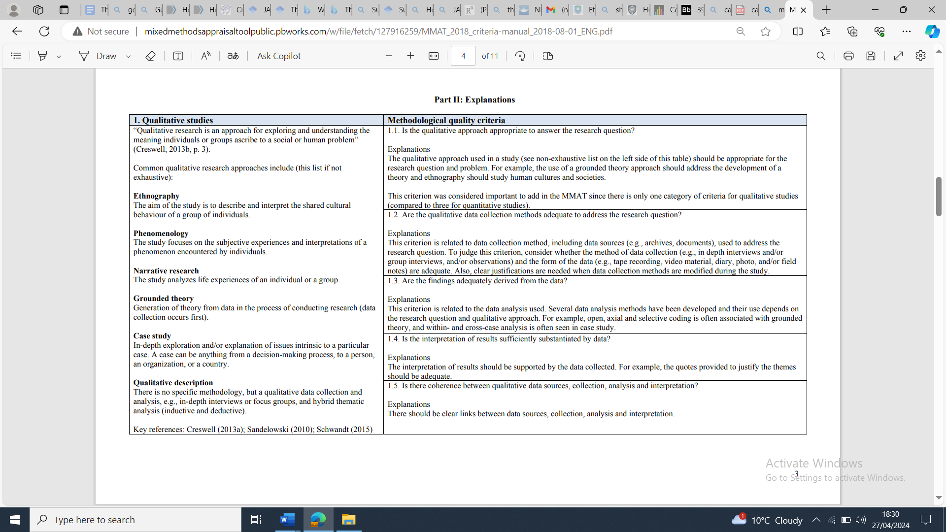
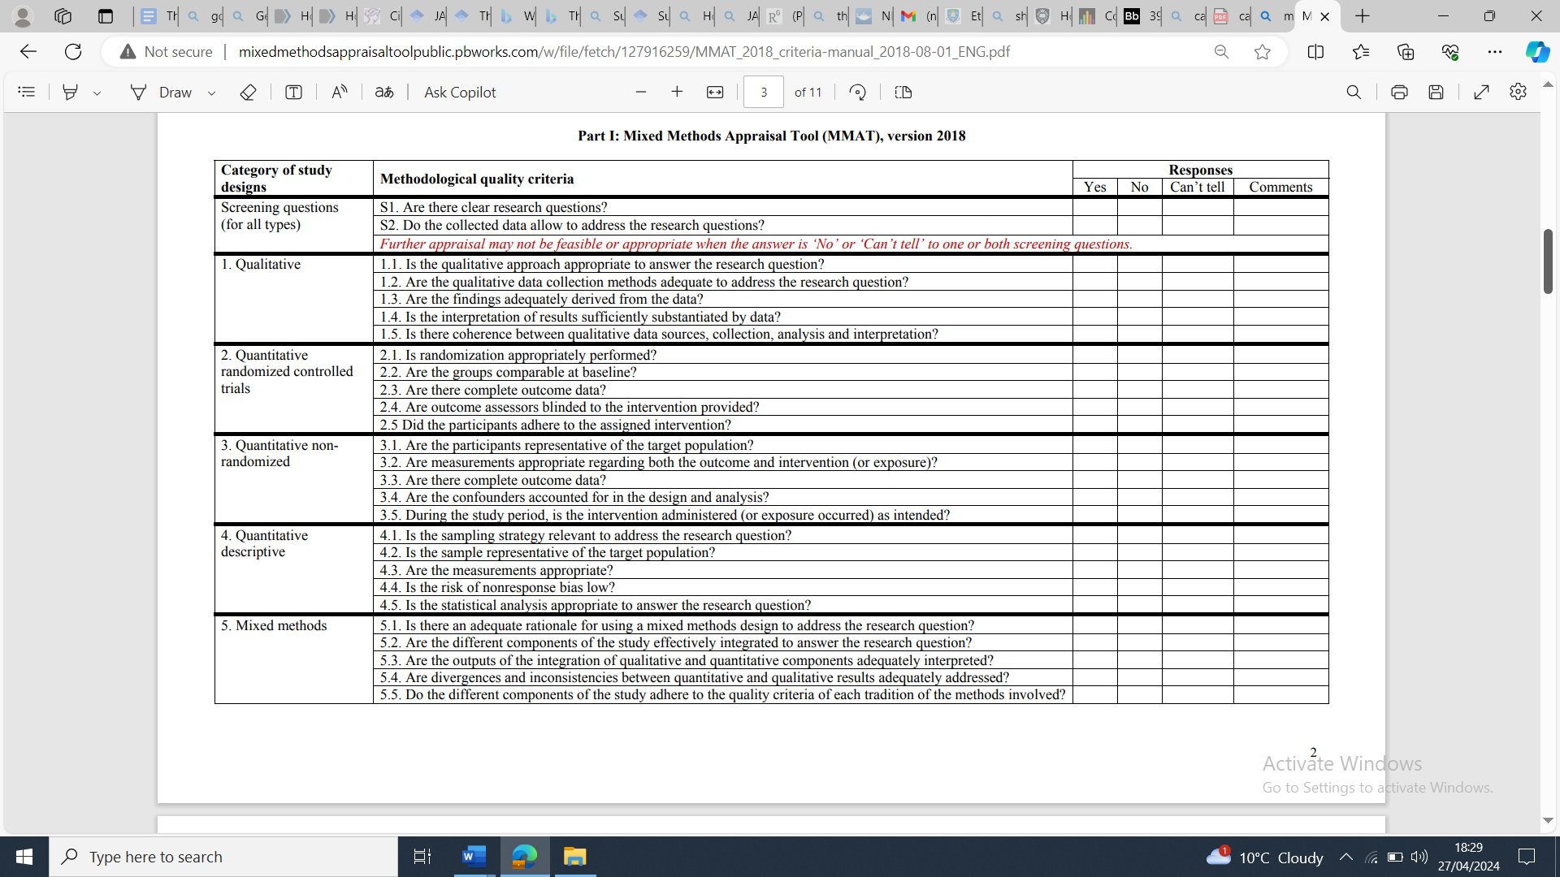

Section Two: Empirical Project

Embedding formulation reviews in adult acute psychiatric inpatient units: Using a multi-perspective realist evaluation to develop an acute model of change.

Abstract

Objectives
A process named Purposeful Inpatient Admissions (PIPA) has been trialled in adult acute psychiatric inpatient (AAPI) settings within the National Health Service (NHS), to improve the efficiency of patient care. However, system pressures impact on services’ ability to embed organisational changes. This study aimed to understand barriers and facilitators of change and investigate whether an updated NHS Change Model tailored to AAPI settings is needed.
Design and Methods
A qualitative realist evaluation design was employed with 17 staff members working across three AAPI wards, who took part in semi-structured interviews and focus groups.
Results
Eight overarching themes were identified: ‘Leadership’, ‘Collaboration’, and ‘“Buy-in”’ supported the existing NHS Change Model. ‘Safety’, ‘Practical resources’, ‘Staffing’, ‘Communication’ and ‘Energy for change and sustainability’ were identified as new themes.
Conclusions
Barriers and facilitators to change in AAPI settings were identified, along with the resources required necessary for the wards to implement successful change despite different contexts. The NHS Change Model does explain the processes necessary to embed change within AAPI settings to some extent. However, a revised model is necessary. Clinical Psychologists’ contribution to implementing organisational change is important.

Practitioner points
- Organisational change can be implemented on AAPI wards when appropriate key factors are provided.
- Testing of the refined model of change for the AAPI setting is necessary.

Key words
Change, Barriers, Facilitators, Psychiatric, Inpatient, Realist Evaluation, Qualitative

Introduction

Modification of culture, strategies, or procedures of an organisation is known as organisational change (Quattrone & Hopper, 2001). As evidence from research emerges, leading to new practices and transformations in the workplace, the NHS as an organisation is continually changing and adapting (Lumbers, 2018).
There are however numerous barriers to implementing change in adult acute psychiatric inpatient (AAPI) settings including cost, time, and staff uncertainty (Medlin et al., 2017). Negative patient views (Filia et al., 2016) and staff feeling a sense of ‘organisational unfairness’ in response to change can impact successful change (Laker et al., 2019). Another major barrier is the current national ‘bed/admission crisis’, where there are insufficient resources to meet demand. The crisis is a result of societal changes (e.g. rising rates of homelessness, mental health problems) and system pressures (e.g. staff recruitment and retention, bed number reductions) (Wyatt et al., 2019).
One promising initiative designed to improve quality of care for people admitted to AAPI wards is the Purposeful Inpatient Admissions process (PIPA). PIPA was developed in 2009 by Tees, Esk and Wear Valleys (TEWV) NHS Foundation Trust and includes processes such as daily multi-disciplinary team (MDT) meetings and progress boards to highlight tasks that are essential to facilitate care. The ‘Purposeful’ aspect is shaped patient, family and MDT perspectives in ‘formulation reviews’, where care is planned. This takes place within 72 hours of admission (TEWV NHS Foundation Trust, 2022).
Formulation reviews can be led by any discipline, and staff at all levels can attend. Formulations are developed using the 5Ps model of formulation from Cognitive Behavioural Therapy. The 5Ps aid understanding of a person’s predisposing, precipitating, presenting, perpetuating and protective factors (Dallos & Johnstone, 2006). Formulations aim to improve quality of care through developing a multi-faceted understanding of an individual’s needs. A tailored ‘purpose of admission statement’ is created using the formulation, directing the tasks required to meet that person’s needs.
TEWV reported promising outcomes, including reductions in lengths of stay, bed occupancy, and sickness absence, and £20 million in efficiency savings. TEWV subsequently implemented PIPA in various inpatient and community services (Ross & Naylor, 2017). PIPA is now being trialled in NHS trusts across the UK. However, given changes are often difficult to embed in the first place due to the pressures, understanding how change can be successfully introduced and embedded in these high-pressured settings is critical. Developing such understandings could help services avoid being caught in a cycle of inertia whilst also facilitating better quality evaluation of the impact of changes.
While various models of organisational change exist, the NHS Change Model was developed to guide effective and sustainable change for NHS staff, patients, and communities. It is proposed to work for change of any size (NHS, 2013). The model is based on approaches from fields including organisational development, management and leadership, and improvement science. Key principles underpinning the model are intrinsic and extrinsic motivation, energy for change, and commitment and compliance (NHS, 2013). The Change Model is nonlinear and has eight interdependent, equally important components to consider when planning and implementing change: Leadership by All, Spread and Adoption, Improvement Tools, Project and Performance Management, Measurement, System Drivers, and Motivate and Mobilise (Appendix A).
NHS staff have found the model to be practical and valuable in effecting change (Martin et al., 2013) and although areas for improvement are acknowledged – staff have reported difficulty putting all the components of the model into practice – it has strong face validity and is evidence-based (NHS, 2013). However, the model has not yet been evaluated within AAPI settings. Given the numerous barriers to change described above in these settings, to what extent the model can be realistically or effectively applied in its current form is unclear and a significant revision may be needed.
An additional model of change is the Capability, Opportunity, Motivation – Behaviour Model (COM-B; Michie et al., 2011). The COM-B is a component of the Behaviour Change Wheel (BCW), a theoretical framework used to understand and analyse behavioural change. COM-B stands for three essential conditions required for behavioural change: Capability refers to an individual’s psychological and physical ability to participate in an activity, Opportunity considers social and physical factors that facilitate a behaviour, and Motivation refers to automatic and reflective processes that unconsciously and consciously influence behaviour (Michie et al., 2011). Although not specifically designed to help understand organisational change, it has been used in a systematic review to understand barriers and facilitators to implementing psychosocial interventions in the acute inpatient setting (Raphael et al., 2021). Many of the elements of COM-B are captured within the NHS Change Model, although the Change Model also includes broader systemic aspects of change including change tools.
Critical realism and realist evaluation
Organisational change processes and mechanisms can be studied through realist evaluation (RE), a retroductive theory-driven approach to evaluation. Based on the assumption that programmes work under certain conditions, RE aim to generate the best explanation for why something works (or not), for whom, and under which circumstances. RE was founded on Bhaskar’s critical realism (Archer, 2013; Bhaskar, 2008). The philosophical underpinnings of critical realism bridge positivist and constructivist approaches, taking the ontological position that reality exists but that this reality operates independently of observation. It takes the epistemological position that we can attempt to understand causal mechanisms, whilst recognising that knowledge is socially constructed (Collier, 1994). This makes it important for evaluating real world phenomena in complex social systems.
Realist evaluation is gaining pace in healthcare as the information it can provide about the outcomes of interventions is actionable (Jagosh et al., 2022). Additionally, while REs do not seek to generate universal causal explanations because the mechanisms only operate in specific social contexts, transferability is likely where those contexts are sufficiently similar.
The current study therefore aimed to use RE to tailor the NHS Change Model for the AAPI setting. The RE focused on embedding formulation reviews as described above. Asking interview questions around a recent change project meant that the concept of organisational change was based on something tangible for staff. Data collection is method neutral (Pawson & Tilley, 1997; Sayer, 1992) and can thus be qualitative or quantitative depending on the evidence needed.
Clinical implications
The introduction of PIPA requires knowledge of cognitive behavioural theory, the development of formulations and the skills to introduce and embed psychologically informed interventions. Given that Clinical Psychologists working within NHS AAPI wards are likely to experience similar pressures and barriers within their roles, this project is anticipated to support the field more broadly through understanding the factors necessary to introduce and embed psychologically informed interventions in this setting. Before we can develop more robust outcome studies in these settings, we need to address the issue that changes are extremely challenging to implement and embed in the first place. It is hoped that following this study, the model can be tested across other acute settings within other trusts, which may in turn facilitate more robust trials of future interventions.
Aims
The research questions guiding the study were:
- How well does the NHS change model explain the processes of change necessary to implement and embed change within AAPI settings?
- Can we develop a refined change model to suit AAPI settings?
- What are the different facilitators and barriers to change in AAPI settings? What works, for whom, and in what context?

Method
Ethical Approval
Ethical approval was obtained and granted by the University of Sheffield. Health Research Authority (HRA) approval was obtained through the Integrated Research Application System (IRAS) application process (Appendix B and C). Although the study was considered low risk, participants were being asked to comment on the processes of change in the organisation they were currently employed, which could potentially be difficult for them. Participants were informed of the limits of confidentiality (i.e. disclosure of harm/potential harm to self/others) but assured that information would be kept anonymous within these limits. Benefits included the opportunity to share experiences of change within an AAPI setting, to improve understanding of the contexts necessary for successful changes and to facilitate future implementation of change in this setting.
Design
Manzano’s (2022) three-part approach to RE was used to guide the three phases of data collection and analysis: phase 1 ‘theory gleaning’, phase 2 ‘parallel testing and refinement of theories’, and phase 3 ‘theory consolidation’. Each phase informs the next phase. Therefore, the procedure and findings of each phase are described in turn.
Although both quantitative and qualitative data are used in realist evaluation, qualitative methods are the most commonly used in realist evaluations. This is because there is generally more emphasis on the iterative gathering of qualitative data to allow for theory to be developed and explored, and for hidden mechanisms to be uncovered (Pawson & Tilley, 1997).
Phase 1: Theory Gleaning (Procedure)
Realist research proceeds in iterative cycles that start and end with the formulation of a programme theory (Pawson & Tilley, 1997). It is recommended that the initial programme theory (IPT) can be created by drawing on multiple sources of information including insider knowledge (Jagosh et al., 2022). An IPT consists of a context, mechanism, and outcome of interest – ‘CMO’ hypotheses. While the word hypothesis is typically reserved for quantitative research, in the context of RE, this refers to a hypothesis about which mechanisms are likely to operate in different contexts and the outcomes that will be observed when they do.
In the current study, the IPT was built on the results of systematic review of barriers and facilitators to change in the AAPI setting (conducted by the author of the current study), knowledge from the literature regarding existing change models (NHS change model and COM-B), as well as from an initial consultation with a Clinical Psychologist working on one of the AAPI wards at the time PIPA and the formulation reviews were implemented. The Clinical Psychologist was not involved in data collection nor a participant.
In RE, the ‘context’ within an IPT considers the social, political, economic, and cultural factors that could impact an intervention. In the current study, context refers to the barriers and facilitators to organisational change that the wards experience.
‘Mechanisms’ have two components: resources offered as part of the intervention and the hypothesised responses from offering these resources. In the current study, resources refer to the intervention components that were offered as part of embedding formulation reviews: regular meetings, leadership by an experienced, enthusiastic facilitator, Quality Improvement (QI) project management, and support or “buy-in” from senior leadership in the trust.
The ‘outcomes’ in a CMO refer to the outcome of interest, which in this case is the successful embedding of formulation reviews on the acute inpatient wards.
Phase 1: Theory Gleaning (Results)
Four initial programme theories were developed through Phase 1. Initial programme theories can be presented as “if-then” statements. These statements hypothesise how a programme is expected to work, under specific conditions, to produce certain outcomes. Essentially, they help in understanding the causal mechanisms at play. They are also presented as CMOs.
The four theories included ‘Frequency of meetings’, ‘Facilitator Attributes’, ‘Change Tools’ and ‘Leadership “buy-in”’. The CMOs consisted of; context (barriers and facilitators to change), e.g. staffing, staff feeling burnout/hopeless, practical resources and NHS values; mechanisms, e.g. staff experiencing shared purpose and increased intrinsic motivation to engage in change; and the positive outcomes, e.g. formulation reviews are embedded, there is an increased sense of hope amongst staff.
The four theories are described in detail in Table 1, and related CMOs are presented in Figures 2-5.
Table 1
Initial Programme Theories
Theory A: Frequency of meetings
As part of the PIPA process, initial monthly meetings were proposed with the aim of keeping the change project on the agenda and connecting teams across the wards. The NHS change model guidance suggests that energy for and maintaining a focus on the change can be created through the ideas of ‘project and performance management’, ‘spread and adoption’ and ‘motivation and mobilisation’. The following theory was therefore proposed:
If regular and frequent shared meetings across and within wards are offered by Leadership teams and Quality Improvement teams,
then ward teams will engage with and sustain the project better,
because this will increase the opportunity for ward teams to create a sense of shared purpose. A focus will be maintained on the main aims of the change project through providing feedback and generating ideas for the next meeting, while balancing the energy and pace of change to avoid burnout. Within and across wards, there will be sharing of learning.
Theory B: Facilitator attributes
The NHS change model places an emphasis on team ownership and avoidance of top-down leadership styles through the ideas of ‘shared purpose’ and ‘leadership by all’. The aim is to motivate and empower staff and build hope through staff at all levels understanding the project and roles and playing a role in the project themselves. The TEWV guidance for implementing PIPA (TEWV NHS Foundation Trust, 2022) has a similar emphasis and it was noted this leadership style was embraced by the project leads in SHSC. The following theory was therefore proposed:
If the facilitator avoids a ‘top down’ approach and provides a space for staff to come together
and share ideas,
then teams will engage with and sustain the project better,
Because staff will have access to a safe space to have open, genuine two-way conversations to tap into common values and goals (e.g. quality of care) despite diverse backgrounds and professional demands. This will help them to feel involved and empowered and feel that change is co-produced. Sharing and generating ideas will increase staff understanding of the project and confidence in their ability to implement changes.
Theory C: Change tools
In addition to ‘project and performance management’ and ‘spread and adoption’, the NHS change model states that ‘measurement’ and ‘improvement tools’ are important for successful, sustainable change. One ward team initially trialled the project before other wards commenced and were supported by the QI team to embed formulation reviews using fortnightly Plan, Do, Study, Act (PDSA) cycles. It was hoped that this would encourage shared learning and accountability, as well as helping to define roles, and monitor/evaluate change through project planning. The following theory was proposed:
If Quality Improvement change tools (such as QI project management, PDSA cycles, measurement tools) which help people with the planning, management, reviewing of projects from the beginning to end are used,
then teams will engage with and sustain the project better,
because a rigorous approach to the planning and monitoring of progress will allow teams to gain a clear picture of how well they are progressing towards goals, ensuring sufficient attention is being given to the project so that it can become reality. Everyone in the team involved in the change will have an awareness of the progress of the project and plans for the next stages. Resultantly, there will be shared accountability and clearly defined roles. This will allow wards to create a culture of sharing good practice, as well as sharing what has not worked, through critical reflection, to deliver safe and effective care.
Theory D: Leadership “buy in”
When the formulation reviews were trialled, ward leadership teams had a strong presence at the monthly meetings. The change project was initially prioritised to increase extrinsic motivation and there were clear job roles and autonomy provided around creating change. This is in line with the NHS change model that suggests that ‘system drivers’ are necessary for engagement with change projects through extrinsic and intrinsic motivation. The following theory was proposed:
If ward staff have the necessary resources provided by Senior Leadership,
then teams will engage with and sustain the project better,
because being supported by management to attend regular, face-to-face meetings, during usual working hours, will allow staff to prioritise the change project efforts and ‘system drivers’ to align. This will help to create extrinsic motivation, which is necessary for the dedication, focus and momentum needed for successful change, as well as intrinsic motivation, helping to create creativity and build energy. Staff will feel comfortable with change and can adapt to it as part of their job roles, because Leadership sets the norms for implementation of changes.

Figure 2
CMO Frequency of meetings
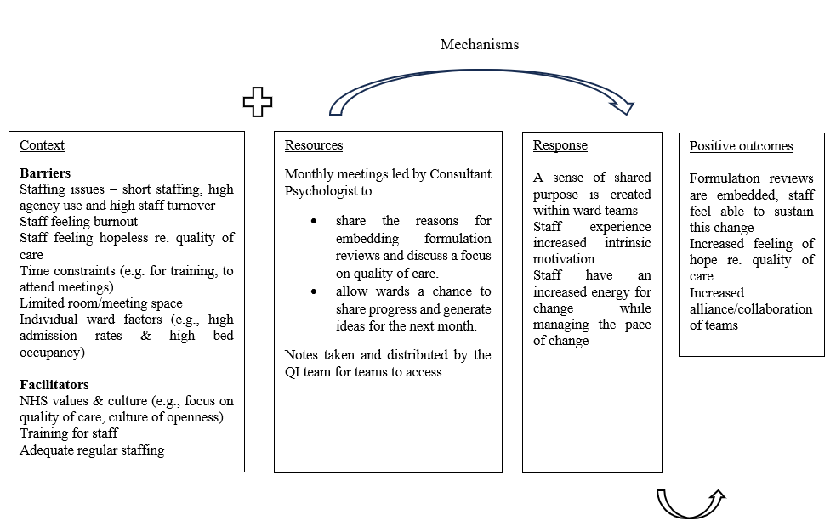
Figure 3
CMO Facilitator attributes

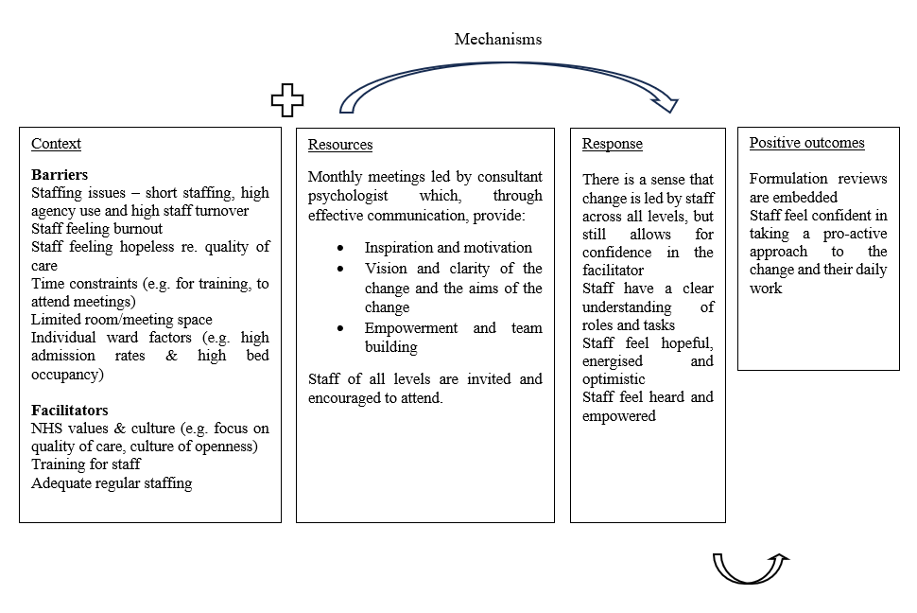

Figure 4
CMO Change tools

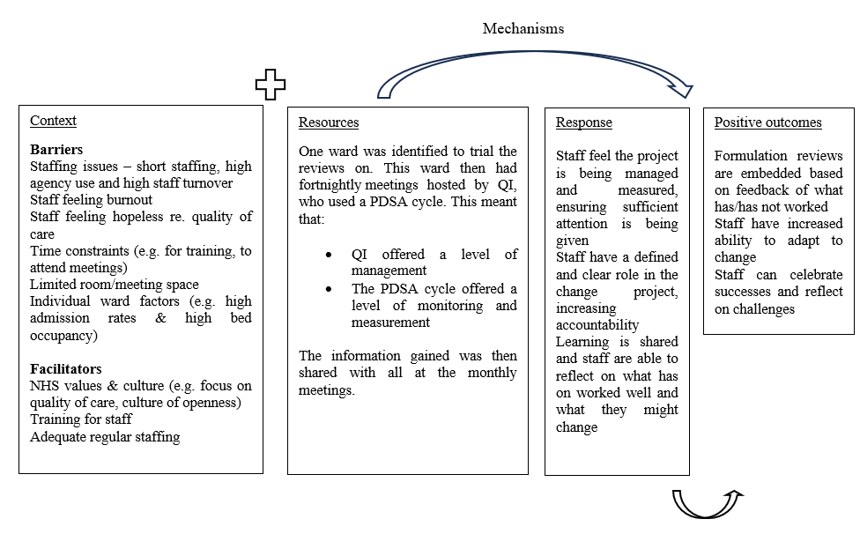

Figure 5
CMO Leadership “buy in”
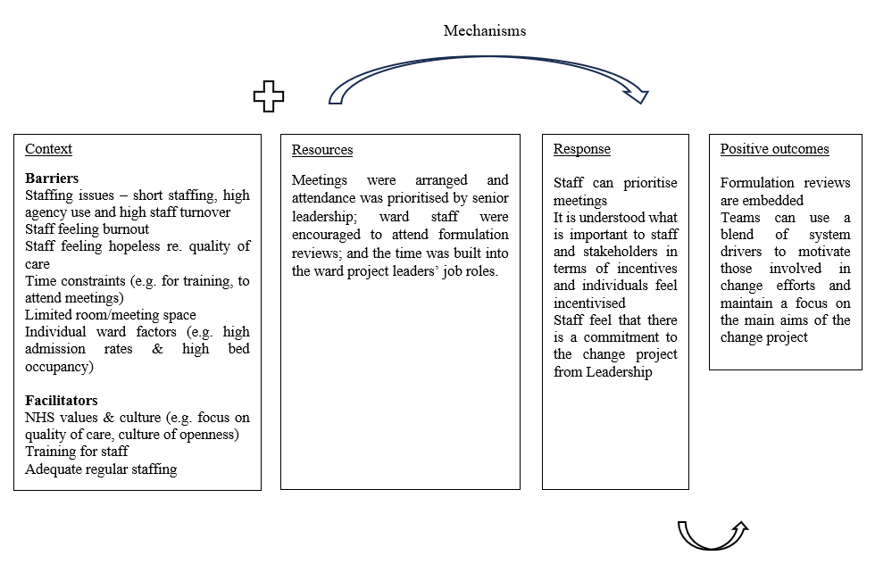

Phase 2: Parallel Testing and Refinement of Theories (Procedure)
Setting and Participants
To develop an understanding of how organisational change is embedded in practice, three AAPI wards that had recently undergone organisational change (i.e. introducing PIPA) were purposefully selected. The wards include one female ward (12 bed), one male ward (16 bed) and one mixed ward (19 bed). These wards have shared overall experiences in terms of seeking to implement PIPA formulation reviews, but also unique contexts, which was hypothesised to help shed light on mechanisms. At the time of the current study, the PIPA changes were at different stages of implementation on different wards, which also facilitated an examination of what works, for whom, and in what context.
The RAMESES guidelines (Greenhalgh et al., 2015) highlight the roles of participants within RE. Participants are asked whether a programme works more or less well across different sites of implementation (and if so, how and why). Different participants will have different views about how and to what extent interventions work, and it is important to sample this range of views (Wong et al., 2016). Participants consisted of ward staff working across the three wards. The inclusion and exclusion criteria are summarised in Table 2. All clinical staff who had participated in the PIPA changes across the wards were invited to participate in the interviews to gain broad and diverse perspectives. A range of perspectives via professional roles were purposefully sought to contribute to refinement of the program theory. Participants also included the Clinical Psychologists and Clinical Associate Psychologists who played an instrumental role in embedding formulation reviews. Demographic information can be found in Table 3.
Verbal and written communication to the managers of each ward was undertaken. Purposive sampling was utilised meaning that the advert (Appendix D) stating the inclusion and exclusion criteria required to partake in the study was sent to staff via their managers, and participants self-identified as to whether they met the requirements. Staff were then invited to participate through communication from the ward psychologist and managers, or to contact the researcher directly. Overall, 26 staff members were invited to participate. Those who replied received an information sheet and consent form (Appendix E and F). No participants withdrew from the study once data collection began; however, three participants accepted the invitation to participate but did not respond to follow-up emails. Overall, 17 staff members participated.
Table 2
Inclusion and exclusion criteria
Inclusion criteria
Clinical staff
Managerial staff
Staff currently working in the service and who have left the service
Staff who worked in the service whilst PIPA was implemented
Staff who had active involvement in the PIPA formulation reviews
Exclusion
Non-clinical staff
Staff who did not work in the service whilst PIPA was implemented

Table 3
Demographic Information of Participants
Category | Sub-category | Frequency
Sex | Male | 2
 | Female | 15
Age | <25 | 0
 | 26-35 | 6
 | 36-45 | 6
 | 46-55 | 5
 | 56+ | 0
Position | Support worker | 1
 | Clinical psychologist | 3
 | Clinical associate in psychology | 3
 | Mental health nurse | 4
 | Psychiatrist | 1
 | Ward manager | 2
 | Occupational therapist | 3

Data collection
In RE, data collection is typically obtained via face-to-face semi-structured interviews (Pawson & Tilley, 1997). The current study utilised this approach with focus groups being preferred to 1:1 interviews. Focus groups allow for the generation of ideas formed within a social context. Given that team understandings and narratives around change processes are integral to shaping and influencing outcomes, focus groups are considered an appropriate method to examine the phenomenon (Kitzinger, 1994). An article by Manzano (2022) discussed the use of focus groups in RE. A key advantage of using focus groups is that when homogeneous groups of participants are used, individuals may find it easier to discuss shared experiences than when interviewed on a 1:1 basis. However, limitations include participants not speaking up or conforming to dominant ideas, managing confidentiality, and interviewers influencing findings (Smithson, 2000). Open questions were used to allow group members to talk in-depth. The researcher offered individual interviews for those who would prefer 1:1 or were unable to make it to a focus group. While consistency in the approach to data collection would have been preferred, the decision was made to offer both due to the challenges of research in this setting and the resultant scarcity of evidence (Awenat et al., 2017).
Focus groups and interviews took place with staff across the three AAPI wards, at their place of work, conducted by the author. Due to limited uptake from staff across two wards, a joint interview was conducted with two members of staff from one ward, and two 1:1 interviews were held with members of staff from the second ward. A focus group was held with staff from the third ward (n=7). A focus group for Psychology staff across the three wards was held (n=6). Psychologists were interviewed separately given their key role in implementing formulation reviews to allow teams to speak freely. Overall, 17 participants participated in the study. In the context of RE, data saturation is used to ensure that the mechanisms, contexts, and outcomes being studied are fully understood and that the data collected is comprehensive enough to support, refute, or refine the programme theory. Realist evaluation focuses on understanding "what works, for whom, under what circumstances, and how", and reaching data saturation helps in achieving a thorough understanding of these aspects. In research supervision, it was agreed that data saturation was achieved as no new themes were identified after the final interview (Saunders et al., 2018).
At the beginning of the focus groups/interviews, the study, confidentiality, and withdrawal rights were explained. University approved audio technology was used to record, and data stored on the University secure drive. The focus groups lasted for 90 minutes each. The 1:1 interview lasted 60 minutes, and the joint interview 100 minutes. No repeat interviews took place. At the end, participants were given a debrief form. Audio data was transcribed by a University approved transcriber.
A semi-structured interview schedule (Table 4) was developed considering the study aims and RAMESES II realist interviewing guidelines (Westhorp & Manzano, 2017). It was hypothesised that wards may have different pressures so questions exploring any differences in context were considered important. A consultation was held with an expert in realist methodology, Dr Justin Jagosh, on 18th December 2023. Dr Jagosh suggested that one way to approach interviews was to directly ask questions about the IPTs (J. Jagosh, Personal Communication, December 18, 2023). In the interview schedule, the researcher wanted to allow some breadth to understand staff perceptions of change and any differences in conditions across the wards, whilst also exploring specific components of the change theories hypothesised in line with RE principles and consult guidance. The decision was made to focus questions on a recent change project so that the concept of organisational change was not too vague for staff and has relevance for future psychological change projects. Perceptions on the outcomes of embedding the reviews were considered important in terms of understanding more about the processes leading to successful outcomes, as well as tapping into factors such as intrinsic and extrinsic motivators.
Table 4
Interview schedule
Interview questions | Additional prompts
- Can you tell me about the formulation reviews that have been introduced on the ward? | What was your role in this?  How do they work?
- What do you think the outcomes of introducing formulation reviews have been – for yourself, the ward staff and patients? | Can you give an example?
- Do you think that the outcomes have been the same for all staff working across the wards on which the formulation reviews have been introduced? | In what ways have they been the same/different?
- We are interested in understanding how the implementation of organisational change projects within the NHS cause their outcomes. What is it about the way formulation reviews were introduced that made a difference to how it worked/did not work? | So, what exactly was the outcome of X? How did that help cause (the outcome specified)?  Give examples if necessary:  What was your experience of leadership on the project?  To what extent was there a sense of shared purpose or motivation?  How well was learning shared across the wards?  How collaborative was the project?  What was your experience of the energy for change felt throughout the project?  Were there any other aspects that impacted on the change project, such as practical resources or the environment?
- We’ve seen that formulation reviews work differently across the three acute wards. What is it about this ward that makes them work well/ less well? | What was the impact of that?  Can you tell me what made that possible/how that was facilitated?  Can you tell me what hindered that?  Can you tell me what might have been needed for xxx to be achieved?
- If you could change something about the way formulation reviews were introduced to make them work more effectively here, what would you change and why? | If there was xxx, can you tell me about how you think the project would have been impacted?  If there wasn’t xxx, can you tell me about how you think the project would have been impacted?
- What else do you think we need to know, to really understand how the introduction of formulation reviews has worked here? | Why is that important?
- Is there anything else that we haven’t talked about that you think makes change (more broadly) possible in acute inpatient settings? | Why do you think that makes a difference?

Data Analysis
Thematic analysis (TA) was used to organise the qualitative data. TA is commonly used for RE (Gilmore et al., 2012), the goal being to identify themes, i.e. patterns in the data that are important or interesting, and use themes to address the research question or comment on an issue. TA stays close to the data rather than interpreting, which is more useful for a realist approach as the intention was to stay close to what participants described as being critical for change. TA is not tied to one theory, can be employed flexibly to support data analysis, and is more readily disseminated to wide audiences. Data was analysed using Braun and Clarke’s (2006) stages of TA. ‘Familiarisation’ involved reading and re-reading the findings to get to know the data. ‘Coding’ involved generating initial codes that represented important chunks of information in the data. The author engaged in inductive line-by-line coding to understand the meaning and content of each interview, utilising research supervision throughout. ‘Generating themes’ entailed grouping codes into broader themes that captured the main ideas of the data. ‘Reviewing themes’ then took place, which necessitated checking the validity and consistency of the themes. Lastly, themes were ‘defined and named’.
Quality Control
Validity
Braun and Clarke (2006) argue that a rigorous TA can produce reliable findings, however the criteria for quality assurance in qualitative research is different to that in quantitative. O’Reilly and Kiyimba (2015) suggest employing transparency, reflexivity, transferability, and ethicality to ensure validity.
Firstly, transparency suggests that any claims made in research should be credible and justified. Accordingly, data collection was systematic and transparent. For data analysis and interpretation, full accounts of the decisions made, and details of the context were provided. The Consolidated Criteria for Reporting Qualitative Research (COREQ; Tong et al., 2006) is a 32-item checklist which promotes a clear and complete report of interviews and focus groups. The checklist was used to facilitate this (Appendix G). In addition, “member checking” took place. This involved returning to participants and asking them whether the themes reflect the meaning they intended (Birt et al., 2016). Additionally, an audit of the analytical process was conducted by the research supervisor and an independent researcher (CG) (see Appendix H).
Reflexivity is a critical aspect of qualitative research; it can provide a thorough understanding of the data and reduce researcher bias (Braun & Clarke, 2006). In the current study, whilst no personal experiences of the researcher were used to inform the analysis, it is recognised that the researcher may not be aware of their own presumptions (Appendix I). To aid reflexivity, a reflective diary was kept throughout the research process (Watt, 2007) which included reporting on assumptions and biases, and considering the impact of these throughout the process. The researcher discussed issues in research supervision (Appendix J).
Thirdly, transferability relates to the degree to which findings can relate to other contexts. To ensure transferability, detailed and transparent reporting was utilised.
Lastly, ethicality is detailed in the Ethical Approval section.
Co-production
At both the development stage of the IPTs and the refining stage, a consultation was held with an expert in realist methodology, Dr Justin Jagosh, on 18th December 2023. This allowed the researcher to buy into and continuously engage with the underlying philosophy behind RE as well as to provide quality control for the study
A pilot interview was conducted with a Clinical Psychologist who worked on one of the AAPI wards at the time the formulation reviews were implemented but had since left. Feedback on the interview schedule, information sheet and consent form was sought and materials revised accordingly (Appendix K).
This research was co-produced with a Clinical Psychologist working on one of the AAPI wards at the time PIPA and the formulation reviews were implemented. The Clinical Psychologist was not involved in data collection nor a participant. In consultation with Dr Jagosh, it was agreed that this subjective insider knowledge was appropriate for developing initial theories to be tested within RE (J. Jagosh, Personal Communication, December 18, 2023). The data collection then allows for alternative ideas and theories to be shaped.
Phase 2: Parallel Testing and Refinement of Theories (Results)
Overall, eight themes and 18 sub-themes were found, details of which can be found in Appendix L. An example bank of codes can be found in Appendix M. A selection of participant quotes per theme can be found in Appendix N.

Results
Phase 3: Theory Consolidation (Procedure)
Once finalised, the TA findings were used to examine the hypotheses, and to evaluate and refine the four IPTs to produce a revised acute change model (ACM).
For each IPT, the supporting data is presented, and any unsupported hypotheses are noted. A summary of new themes that arose from the data is then reported. Themes are presented in bold, with sub-themes in ‘’. Theoretical themes are presented in italics.
An overall CMO (Figure 6) was subsequently created based on a revised understanding of the contexts necessary for successful change that would feed into a refined ACM, all based on the current data (Figure 7).

Phase 3: Theory Consolidation (Results)

Theory A: Frequency of meetings
Three overall themes were found in the data in support of Theory A: Communication, Energy for change and sustainability, and Buy-in of change. Participants described that Communication was an important aspect in embedding change; particularly in terms of having ‘QI involvement’ of the project and opportunity for sharing learning. Problems with communication developed alongside facilitators leaving. Facilitators were not replaced, and meetings were not sustained. Energy for change and sustainability was described as important as ‘generating and sustaining energy’ and allowed for consistency and commitment to the project. Considering the amount of concurrent change was critical to avoid overwhelming teams. Buy-in of change also supported this IPT, particularly ‘buy-in of ward staff’ where participants felt that understanding the project and its benefits was important. Where understanding was not in place, there could be resistance and a sense of change feeling unfair.
These findings supported the following components of this IPT: for teams that have regular opportunity to meet this could lead to a sense of shared purpose, shared learning, energy for change, understanding the project, and hence intrinsic motivation.
The following components of the NHS Change Model included in this IPT are: Project and performance management, Spread and adoption and Motivation and mobilisation. All were supported by the data.
Theory B: Facilitator attributes
Two overall themes were found in the data in support of this IPT: Collaboration and Leadership. Participants described that Collaboration was an important aspect in embedding change in terms of ‘team working’; team working allowed staff to feel valued and influential and increased team collaboration and cohesion. Staff extended on the theme of collaboration by highlighting encouragement from facilitators to utilise ‘patient and carer involvement’ was a facilitator of change as it allowed them to connect to their values of collaborative, person-centred care. Leadership was described as important in terms ‘leadership style’; the lack of a top-down approach of the facilitator helped the teams feel a part of the project, and at the same time staff felt contained by a firm but fair stance towards the implementation of change.
Findings supported the following components of the IPT: motivation, empowerment, led by all, understanding the project and roles, and confidence in the facilitator.
The following components of the NHS Change Model included in this IPT are: Shared purpose and Leadership by all. Both were supported by the data.

Theory C: Change tools
Two overall themes were found in the data in support of this IPT: Communication and Energy for change and sustainability. Participants described that Communication at ‘ward level’ was an important aspect in embedding change. Staff discussed the importance of ward staff at all levels coming together for meetings about the changes so that everyone understood their roles and there was a sense of accountability for progress. Energy for change and sustainability was described as important in terms of staff remaining consistent and committed to the change project, with ‘QI oversight’ helping to facilitate the monitoring of the change project.
Findings supported the following components of the IPT: shared learning, accountability, defined roles, and project planning. Monitoring was somewhat supported by the data. Evaluating change was not.
The following components of the NHS Change Model included in this IPT are: Project and performance management, Spread and adoption, Measurement and Improvement tools. While Project and performance management and Spread and adoption were supported by the data, Improvement tools was seldom mentioned by participants. Measurement was not supported.
Theory D: Leadership ‘buy in’
Two overall themes were found in the data in support of this IPT: Leadership and “Buy-in” of change. Participants described that Leadership was important in terms of ‘leadership roles and structure’ which helped to scaffold staff, for example, by being supported to attend meetings and time being prioritised for meetings. “Buy-in” of change, particularly ‘“buy-in” from leadership’, was important for the implementation of change. Leadership understanding the aims and importance could lead to staff at all levels feeling encouraged to contribute. Leadership being able to provide the practical resources needed was important. Staff needed to have trust and hope in leadership, as absence of hope could lead to staff having a lack of energy for change as they felt change efforts were futile.
Findings supported the following components of the IPT: being supported to attend meetings, change project being prioritised, increased intrinsic and extrinsic motivation, and increasing momentum and energy for change.
System drivers was the component of the NHS change model included in this IPT, which was supported by the data.
New Themes
Despite support for the initial four IPTs, the resources offered were not always sufficient to leverage a successful outcome. Five new themes arose in the data that were important for change in the acute setting which are not adequately captured in the NHS change model or original IPTs: Safety, Practical resources, Staffing, Communication and Energy for change and sustainability.
Safety
Feeling safe to make change is briefly mentioned in the NHS change model in terms of motivate and mobilise, however it was a more significant theme within this data along with physical safety. This may reflect the particular environment of acute wards, which can be emotive and challenging places to work. Physical safety of staff and patients and psychological safety of staff were not specifically referred to in the original IPTs, therefore Safety emerged as a key theme to encapsulate these. On one ward, staff talked about psychological safety being a facilitator of change. They discussed the importance of reflective practice in helping the team develop a sense of psychological safety, and how this enabled them to engage in change processes. An absence of psychological safety appeared to hinder attempts to make changes, as staff reported that the wards who had found the implementation more difficult were not offered the resource of reflective practice. Psychological safety was needed to be felt both on an individual level and collectively within teams and increased a sense of connection. Physical safety was also key, as this was of upmost importance to staff and was prioritised over change efforts when necessary. The resources provided were not always sufficient to overcome barriers experienced in different settings; staff discussed the importance of staff wellbeing and the sense of some wards being in ‘fight or flight’ which made it difficult to think about managing change long-term.
Practical resources
Practical resources was theorised as a barrier; however, it is not specifically mentioned in the NHS change model, yet it appeared much more of a priority for the current participants in the context of ward work. A lack of practical resources – such as ‘time’, ‘training of staff’, and ‘physical resources’ e.g. technology – was mentioned as a barrier to change by wards where time could not be protected, or resources were not provided. For example, staff on wards with increased staffing pressures (and therefore less protected time) found the burden of change was sometimes split in a way that they felt was unfair and this was a barrier to change. When there was a lack of connection staff felt unable to express this. Staff also reported that it was not always possible to attend meetings due to the lack of flexibility in their schedules/needing to prioritise other tasks, again highlighting an issue with being able to connect as a team.
Staffing

Staff reflected that it is not just the quantity but quality of staff that is important for implementing change. For example, under the subtheme ‘staffing levels’, irregular and unstable staffing increased resistance to implementation, as well as staff lacking confidence in the change-related tasks, highlighted under ‘qualities of staff’. The resources provided were not always sufficient to overcome barriers experienced in these settings; staff discussed that lack of experienced staff impacted their ability to engage in change, as wards being under-resourced and largely relying on agency staff meant that those on shift could lack knowledge of the ward(s) and/or the change. Staff required connection and strong working relationships for change to be implemented, again impacted by lack of consistent staffing.
Communication

Although Communication was an element of the original IPTs in terms of meetings, this theme was much more significant for the current participants on an acute ward, e.g. considering the impact of changing shift patterns and communication needing to fit in with the ward routine, it warranted its own theme. Under the subtheme ‘ward level communication’, staff discussed not understanding the change project or the aims, and therefore not buying in, being a barrier to change. A lack of staff forums was a barrier as this impeded staff defining clear roles and organising change-related meetings. Staff discussed the sharing of learning being helpful initially. However the resources offered were not always enough to overcome barriers; inconsistency in facilitators from a QI perspective halted progression of change as communication regarding the change stopped due to facilitators leaving and not being replaced. There was also a lack of sharing of learning between wards, which staff reported would have been of benefit, again highlighting a lack of connection.
Energy for change and sustainability

While energy for change was included the NHS change model, it does not fully capture the theme of Energy for change and sustainability, for example the need to adapt and evolve, which may be more relevant to acute wards that are fast paced environments than other settings. The subtheme of ‘adjusting and evolving’ to change captures this. A lack of sharing of learning within and between wards was a common barrier. Staff talked about the lack of standardisation of change due the lack of sharing of learning, and again, the lack of ‘connection’ felt between wards. It is notable that the ward who had implemented the change successfully felt able to think about how the change could be adapted for each ward, whereas those who had not been as successful voiced a preference for standardisation across wards. The resources offered were not always enough to overcome barriers to change; staff on one ward discussed that staff and management needed to acknowledge staff needed to “find their feet” before they felt comfortable with the change. This period was particularly necessary when concurrent changes were occurring.

Revised CMO and model of change

A revised CMO was required based on the findings (Figure 6). The findings uncovered mechanisms for change that were not previously identified, therefore a revised model of change for the acute setting is recommended (Figure 7).
Figure 6
Revised CMO
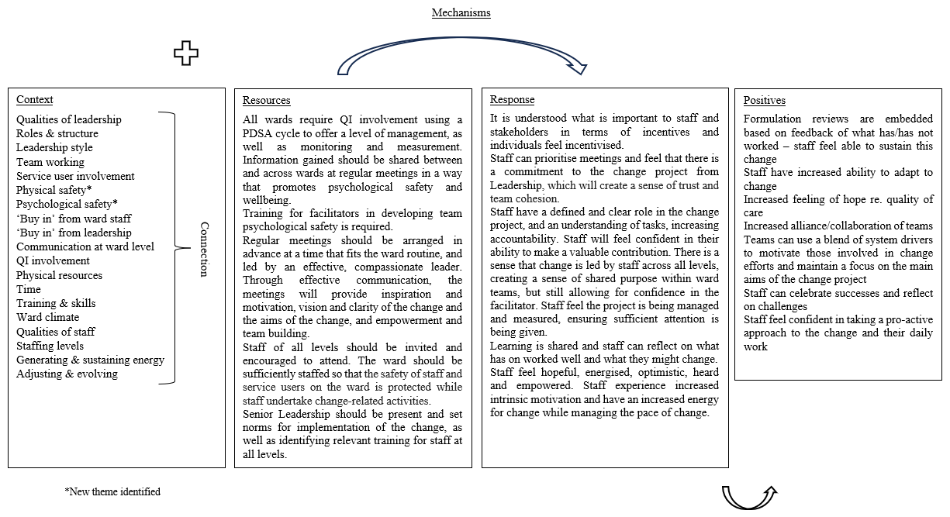

Figure 7
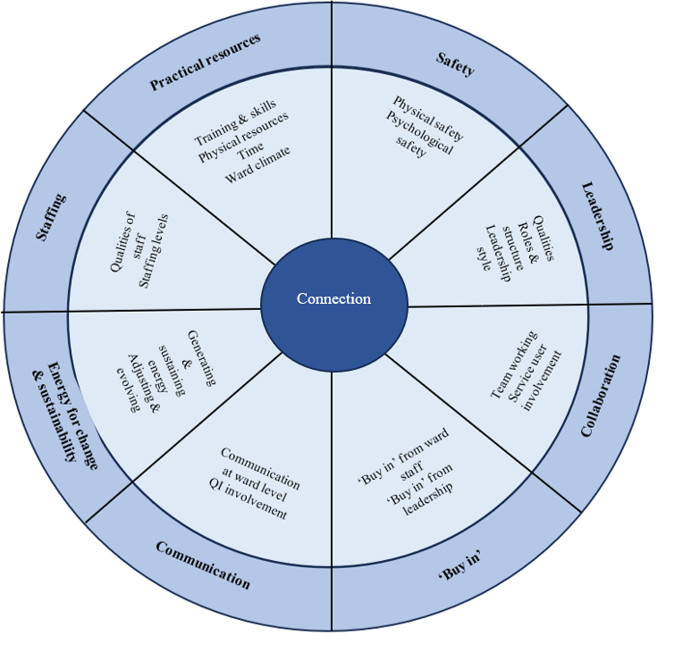
Revised ACM

Discussion
The current study used realist methodology to understand in the context of AAPI settings (i) the facilitators and barriers to change; (ii) how well the NHS Change Model explains the processes of change necessary to embed change; and (iii) if necessary, can the NHS Change Model be refined?
The IPTs hypothesised barriers and facilitators to organisational change and the mechanisms – frequency of meetings, facilitator attributes, change tools and leadership buy-in – needed to overcome the barriers and leverage facilitators. These theories were partially supported by the findings of the current study.
In terms of frequency of meetings, inclusion of staff in the development of change, was a facilitator of change, supporting the IPT. Regarding facilitator attributes, wards reported the need for leadership and facilitators to avoid a top-down approach, whilst providing clear directions, again supporting the IPT. For change tools, in line with the IPT, the wards who received the most involvement from QI reported stronger implementation of the change, and all wards reported the need for sharing of learning between and across wards. Lastly, for leadership buy-in, an understanding and promotion of the change facilitated implementation, as well as a strong leadership presence. This finding supported the IPT.
Most components of the NHS Change Model were supported to some extent and captured under the three themes of ‘Leadership’, ‘“Buy-in” of change’ and ‘Collaboration’. Six (out of eight) components of the NHS Change Model were regularly referenced by staff at points during data collection: Shared purpose, Spread and adoption, Project and performance management, System drivers, Motivate and mobilise and Leadership by all. Measurement was not mentioned by staff, and Improvement Tools was seldom referenced; a reason for this might be that staff were not directly involved with the PDSA cycle that was offered as part of the trial, or staff did not have an awareness of such tools due to their occupational status. It was in the Psychologists focus group that Improvement Tools were referenced; perhaps due to Psychologists requiring an understanding of service re-design as per The British Psychological Society guidelines (BPS; BPS, 2019) which may be due to Measurement of change outcomes may not have occurred due to facilitators of change leaving and not being replaced, or similarly, staff may not have been aware of the measurements. However, the NHS Change Model does not adequately cover other themes that arose in your data that seemed more critical for the AAPI setting, suggesting the need for a refined change model.
The importance of ‘Safety’ was highlighted, i.e. considering staff and patients’ physical safety and staff psychological safety when implementing change. This was particularly necessary for wards which have a greater number of incidents and staffing issues, and reduced opportunity for reflective practice in a containing environment.
In the context of the current study, ward staff voiced the need to prioritise safety over change-related projects. Slemon et al. (2017) found that mental health nurses viewed maintaining physical safety as an integral part of their role and this value influenced their clinical practice. Nurses have been found to prioritise safety over other aspects of practice, such as therapeutic interventions (Wilson et al., 2017). In terms of psychological safety, staff who had access to wellbeing support reported both a strong team bond and an increased ability to implement changes compared to other wards. Whilst this cannot be formally regarded as cause and effect, Molloy et al. (2024) found that when nurses had a psychologically safe space to share views, there was increased team cohesion due to shared decision-making. In the current study, staff were caught in a perpetual state of “fight or flight”, although to various degrees depending on the context of the ward and the resources offered. Psychological safety is important for teams. It is not only about knowing each other well but helping staff to feel safe to share ideas and try new things, reduce systemic blame culture which can create fear and anxiety around change, and provide a buffer against burnout (Edmondson, 2018).
‘Practical resources’ is not specifically noted in the NHS Change Model. However, resources appeared a significant priority for the current participants in the context of ward work. Staff highlighted the need for training to be delivered to both agency and permanent staff due to the high turnover of staff and shift working. Other physical resources such as a quiet, confidential place to meet and sufficient technology were found to be difficult to come by on the wards. This finding was corroborated by Brennan et al. (2006).
While ‘Staffing’ links to ‘Practical resources’ above, it warrants its own theme and includes reflection on the qualities of staff in terms of experience and confidence. Laker et al. (2019) found that age and occupational status are correlated with negative perceptions of change, perhaps due to younger staff being more newly qualified as thus less experienced and confident in their abilities.
The importance of communication is referenced in the NHS Change Model, however considering the impact of shift patterns and specific ward routines, ‘Communication’ warranted its own theme. Sutter et al. (2022) discuss how staff who work 12-hour shifts can feel ‘out of touch’ following extended time away from the ward and this can increase anxiety. Anxiety does not support readiness for change, demonstrating the need for better, increased communication.
Lastly, although energy for change is included the NHS Change Model, it does not fully capture the current identified theme of ‘Energy for change and sustainability’. The sub-theme ‘adapt and evolve’ feels more relevant to the fast-paced environments of acute wards than other settings such as rehabilitation wards (Barrera et al., 2019).
A common thread underpinning the barriers was connection. The need for staff to build strong working relationships was evident through the more obvious concepts such as team collaboration and cohesion, and so was categorised under the theme of Collaboration. However, it was evident through ideas such as confidence, in which staff described junior staff having less confidence in their ability to implement change effectively than more senior staff and needing support of colleagues.
Weller (2012) discusses the phenomenon of “tribalism” in healthcare, commenting that development of professional identify is strong within disciplines such as psychiatry and nursing. Tribalism has benefits but can also cause ‘in’ and ‘out’ groups, leading to more junior staff feeling that they have little influence. Weller et al. (2014) discusses the importance of defining inclusive teams and training teams together to create a sense of connection within teams, an idea corroborated by Totman et al. (2011).
Additionally, under the sub-theme ‘team working’, staff having a lack of trust in leadership was an additional barrier that had not previously been hypothesised. Wards where trust was evident were able to embed change, and conversely wards who were more untrusting of leadership, did not. Staff can develop “change fatigue”, and this can raise anxieties regarding change (Dean, 2013). A need for trust in leadership appeared to be particularly necessary during times of concurrent changes. West et al. (2015) found that supportive teams which have clear goals and strong leadership have staff who experience considerably less stress.
Implications for Clinical Practice
In the current study, staff noted the value of the interview experience, stating that their reason for participating in the research was because they felt that staff experiences were not considered by those in more senior positions. Services should therefore consider making their approach to change more holistic, aiming to ensure the experience of all staff is considered. Staff should be supported to consistently raise thoughts and feelings about changes in reflective practice. The results of the current study indicate further research into how ‘compassionate leadership’ can be introduced and sustained in AAPI services, as research indicates this will allow for change to be embedded more successfully. An effective leader encourages change while supporting communication and maintaining a relaxed and safe environment (Barr & Dowding, 2012). Compassionate leadership is therefore suggested to resolve performance problems through promoting a learning and positive risk-taking culture within teams; it is accepted that not all change will be successful, but there is a collective responsibility to problem-solve (West & Markiewicz, 2016). The values of compassionate leadership could provide a basis for an approach to organisational change within AAPI settings.
Clinical Psychologists could play a crucial role in facilitating this compassionate leadership culture shift. The BPS (2019) describes a core competency for Clinical Psychologists of ‘organisational and systemic influence and leadership’. This competency includes ‘influencing service delivery, working effectively in MDTs and understanding change processes in service delivery systems.’ These skills are particularly relevant in AAPI settings where Clinical Psychologists are in leadership positions and work with MDTs to enhance psychologically informed care provision (BPS and Association of Clinical Psychologists UK, 2021).
Staff in the current study suggested that staff can generally engage with change if there is a clear and communicated rationale. A significant barrier to implementation is poor communication; it results in staff feeling disengaged and potentially resistant to change, as well as lacking in protected time to complete change related tasks. Regular supervision and reflective practice sessions provide an opportunity for staff to reflect on their practice to ensure a person-centred approach is taken and develop their skills and confidence whilst accessing support in a safe environment (Cutcliffe et al., 2018; Hamilton et al., 2023).
In the context of organisational change, Clinical Psychologists are well-placed to deliver supervision and reflective practice to ward staff and management, to allow open and honest conversations about thoughts and feelings regarding change which otherwise may hinder implementation. Supporting staff to develop skills and confidence in performing change-related tasks will aid empowerment to engage in change. Policy makers should also recognise the value of consulting with ward staff from the initial planning stages of change to achieve staff “buy-in”. Recruiting and retaining experienced and competent staff, and ensuring consistent staffing, is essential to ensuring staff have the resources to implement and maintain change.
Strengths, Limitations and Directions for Future Research
To the author’s knowledge, this is the first study exploring organisational change in the AAPI setting using RE and the NHS Change Model. A strength of using RE is that it allows for the development of understandings about underlying mechanisms that drive program outcomes, and it goes beyond more basic cause-and-effect relationships. RE allows for greater clarity and depth of knowledge of a topic as it seeks to explore not just what works, but for who, why and under what conditions (Punton et al., 2020). If policymakers and staff understand and focus on hidden mechanisms, the design and implementation of change can be based on informed decisions. The multiple perspectives of staff with different expertise and experiences – reflected in the range of professionals who took part – is a strength of this study. The breadth of input helped to validate findings and provide a comprehensive understanding of the topic.
The process of analysing and synthesising realist data is based on the interpretation and judgment that a researcher applies. The author utilised supervision throughout the process of analysing and interpreting data to minimise bias. As the author and supervisor having different backgrounds and perspectives, employing investigator triangulation helped to reduce risk of bias and increase validity of results. The author also engaged in reflexivity to maintain awareness of values and beliefs which could potentially influence the research process (Darawsheh, 2014). Rigour and confidence in the credibility of the research is increased with researcher transparency (Anderson, 2008).
There are real challenges to conducting research in AAPI settings, which mirror the barriers to organisational change. It is widely acknowledged that a barrier to the implementation of change is staffing issues, and so to get through shifts safely, staff often need to ‘firefight’. Thus, there can be less energy and time for thinking about organisational change. It was evident that staffing affected study recruitment. The focus group on the ward which described having a more stable workforce was well attended (n=7), but it was only possible to hold interviews with wards with fewer regular staff. The wards that were less represented in the current study have higher rates of aggression and self-harm related incidents. It is important to consider how to facilitate greater inclusion in future research.
As with any small sample size, caution must be exercised in generalising implications from findings. The current research sought to examine specific theories related to the identified intervention and the resources offered. It is possible that different elements of change might be highlighted in other settings. That said, the theories were developed in line with background literature and existing models. Given they are consistent with previous research in the area, the current findings do appear to contain a significant degree of ‘theoretical transferability’ to other acute settings. Therefore, despite its small scale, there is significant applicability for the findings beyond this study. Utilising data triangulation, e.g. via a survey/questionnaire, would have been useful to support findings and allow greater reach in terms of number of staff and range of professions.
At the time of conducting the study, benchmarking data indicated the inpatient acute psychiatric wards in Sheffield were experiencing low bed availability, high admission numbers and a high number of patients with no fixed abode (Appendix O). The focus on one NHS mental health facility might mean that the views and perspectives of staff in this study differ from staff elsewhere, particularly organisations with more stable workforces and different contextual factors. The views reported may also have been influenced by professional orientations. Whilst therapy staff and nurses were involved, psychiatrists – who hold status in seniority and authority within wards – were underrepresented. Support workers were also underrepresented; support workers play an integral part in the daily running of inpatient wards. During recruitment it was notable that two senior members of staff agreed to participate but both left the trust before interviews could be conducted.
One limitation of collecting data via qualitative interviews is that interviewer characteristics, such as job role or perceived differences (e.g. class), can influence interviewee responses (e.g. Britten, 1995). The current participants were aware of the researcher’s profession. It may have been easier or harder for participants to identify and speak openly with someone also working within the NHS. Participants appeared relaxed (evidenced by sharing ‘in jokes), and response bias was deemed minimal. Member checking was used to confirm that findings accurately reflected the participants’ perspectives, helping to increase validity and credibility.
The use of theoretical models allows a framework to be implemented, providing support in achieving change. The NHS Change Model had not previously been evaluated within AAPI settings. The findings of this study indicate that although many elements of the existing model were supported, given the numerous barriers to change described throughout the current study, a significantly revised model was needed. It was beyond the scope of the current RE to test the revised model; however, this is a crucial step in the evaluation process which future research in this area should prioritise.

Conclusions
The NHS change model can partially explain the processes of change necessary in AAPI settings, however key additional themes of ‘Safety’, ‘Practical resources’, ‘Communication’, ‘Energy for change and sustainability’ and ‘Staffing’ were found in this study. A revised ACM was therefore developed. Future research should seek to test this model across other acute services. The current RE was limited to a specific NHS Trust; experiences of change in different AAPI settings should be examine

References

Anderson, F., Howard, L., Dean, K., Moran, P., & Khalifeh, H. (2016). Childhood maltreatment and adulthood domestic and sexual violence victimisation among people with severe mental illness. Social Psychiatry and Psychiatric Epidemiology, 51(7), 961-970. https://doi.org/10.1007/s00127-016-1244-1
Archer, M., Bhaskar, R., Collier, A., Lawson, T., & Norrie, A. (2013). Critical realism: Essential readings. Routledge.
Awenat, Y., Peters, S., Shaw-Nunez, E., Gooding, P., Pratt, D., & Haddock, G. (2017). Staff experiences and perceptions of working with in-patients who are suicidal: qualitative analysis. The British Journal of Psychiatry: The Journal of Mental Science, 211(2), 103–108. https://doi.org/10.1192/bjp.bp.116.191817
Barr, J., & Dowding, L. (2022). Leadership in health care. Sage.
Barrera, A., Attard, C., & Chaplin, R. (Eds.). (2019). Oxford textbook of inpatient psychiatry. Oxford Textbooks in Psychiatry.
Beckett, P., Holmes, D., Phipps, M., Patton, D., & Molloy, L. (2017). Trauma-informed care and practice: Practice improvement strategies in an inpatient mental health ward. Journal of Psychosocial Nursing and Mental Health Services, 55(10), 34-38. https://doi.org/10.3928/02793695-20170818-03
Bhaskar, R. (2008). A realist theory of science. Routledge.
Biggerstaff, D., & Thompson, A. R. (2008). Interpretative Phenomenological Analysis (IPA): A qualitative methodology of choice in healthcare research. In Qualitative Research in Psychology, 5, 214–224. https://doi.org/10.1080/14780880802314304
Birt, L., Scott, S., Cavers, D., Campbell, C., & Walter, F. (2016). Member checking: a tool to enhance trustworthiness or merely a nod to validation? Qualitative Health Research, 26(13), 1802-1811. https://doi.org/10.1177/1049732316654870
Borge, L., & Fagermoen, M. S. (2008). Patients' core experiences of hospital treatment: Wholeness and self-worth in time and space. Journal of Mental Health, 17(2), 193-205. https://doi.org/10.1080/09638230701505996
Braun, V., & Clarke, V. (2006). Using thematic analysis in psychology. Qualitative Research in Psychology, 3(2), 77-101. https://doi.org/10.1191/1478088706qp063oa
Bryson, S. A., Gauvin, E., Jamieson, A., Rathgeber, M., Faulkner-Gibson, L., Bell, S., Davidson, J., Russel, J., & Burke, S. (2017). What are effective strategies for implementing trauma-informed care in youth inpatient psychiatric and residential treatment settings? A realist systematic review. International Journal of Mental Health Systems, 11(1), 1-16. https://doi.org/10.1186/s13033-017-0137-3
Cilia Vincenti, S., Grech, P., & Scerri, J. (2022). Psychiatric hospital nurses' attitudes towards trauma‐informed care. Journal of Psychiatric and Mental Health Nursing, 29(1), 75-85. https://doi.org/10.1111/jpm.12747
Collier, A. (1994). Critical realism: An Introduction to Roy Bhaskar's Philosophy. Verso Books.
Collins, D. (2005). Organisational Change: Sociological Perspectives. Routledge.
Crisp, N., Stuckler, D., Horton, R., Adebowale, V., Bailey, S., Baker, M., & Warwick, C. (2016). Manifesto for a healthy and health-creating society. The Lancet, 388(10062), e24-e27.
Cutcliffe, J. R., Sloan, G., & Bashaw, M. (2018). A systematic review of clinical supervision evaluation studies in nursing. International Journal of Mental Health Nursing, 27(5), 1344–1363.
Dallos, R., & Johnstone, L. (2006). Formulation in psychology and psychotherapy: Making sense of people's problems. Routledge.
DeLeon, P. H., Giesting, B., & Kenkel, M. B. (2003). Community Health Centers: Exciting Opportunities for the 21st Century. Professional Psychology: Research and Practice, 34(6), 579. https://doi.org/10.1177/1525822X05279903
Dean, E. (2013). Day of national action became biggest improvement event in history of the NHS. Nursing Management (through 2013), 20(5), 8.
Edmondson, A. C. (2018). The fearless organization: Creating psychological safety in the workplace for learning, innovation, and growth. John Wiley & Sons.
Fallot, R. D., McHugo, G. J., Harris, M., & Xie, H. (2011). The trauma recovery and empowerment model: A quasi-experimental effectiveness study. Journal of Dual Diagnosis, 7(1-2), 74-89. https://doi.org/10.1080/15504263.2011.566056
Filia, S. L., Baker, A. L., Richmond, R., Castle, D. J., Kay-Lambkin, F. J., Sakrouge, R., & Kulkarni, J. (2011). Health behaviour risk factors for coronary heart disease (CHD) in smokers with a psychotic disorder: baseline results. Mental Health and Substance Use, 4(2), 158-171.
Gilmore, B., McAuliffe, E., Power, J., & Vallières, F. (2019). Data analysis and synthesis within a realist evaluation: toward more transparent methodological approaches. International Journal of Qualitative Methods, 18, 1–11. https://doi.org/10.1177/1609406919859754
Greenhalgh, T., Wong, G., Jagosh, J., Greenhalgh, J., Manzano, A., Westhorp, G., & Pawson, R. (2015). Protocol—the RAMESES II study: developing guidance and reporting standards for realist evaluation. BMJ Open, 5(8), e008567.
Guest, G., Bunce, A., & Johnson, L. (2006). How many interviews are enough? An experiment with data saturation and variability. Field Methods, 18(1), 59-82. https://doi.org/doi: 10.1177/1525822X05279903
Heale, R., & Forbes, D. (2013). Understanding triangulation in research. Evidence-based nursing, 16(4), 98-98.
Johnstone, L., Durrant, C., James, L., Lewis, H., Maybury, E., McCann, S., Sandford, C. (2015). Team formulation developments in AMH services in South Wales. Clinical Psychology Forum, 275, 38-42.
Jagosh, J., Stott, H., Halls, S., Thomas, R., Liddiard, C., Cupples, M., & Walsh, N. E. (2022). Benefits of realist evaluation for rapidly changing health service delivery. BMJ open, 12(7), e060347.
Kings Fund. (2017). Quality improvement in mental health. Kings Fund. https://www.kingsfund.org.uk/sites/default/files/field/field_publication_file/Quality_improvem ent_mental_health_Kings_Fund_July_2017_0.pdf
Kitzinger, J. (1994), The methodology of Focus Groups: the importance of interaction between research participants. Sociology of Health & Illness, 16, 103-121. https://doi.org/10.1111/1467-9566.ep11347023
Llewelyn, S., & Cuthbertson, A. (2009), Clinical Psychology in Practice. Blackwells.
Lumbers, M. (2018). Approaches to leadership and managing change in the NHS. British Journal of Nursing, 27(10), 554-558.
Macneil, C. A., Hasty, M. K., Conus, P., & Berk, M. (2012). Is diagnosis enough to guide interventions in mental health? Using case formulation in clinical practice. BMC Medicine, 10(1), 1-3. https://doi.org/10.1186/1741-7015-10-111
Manzano, A. (2022). Conducting focus groups in realist evaluation. Evaluation, 28(4), 406–425. https://doi.org/10.1177/13563890221124637
Martin, G. P., Sutton, E., Willars, J., & Dixon-Woods, M. (2013). Frameworks for change in healthcare organisations: a formative evaluation of the NHS Change Model. Health Services Management Research, 26(2-3), 65-75.
Mauritz, M. W., Goossens, P. J., Draijer, N., & Van Achterberg, T. (2013). Prevalence of interpersonal trauma exposure and trauma-related disorders in severe mental illness. European Journal of Psychotraumatology, 4(1), 19985. https://doi.org/10.3402/ejpt.v4i0.19985
McComb, J. (2013). Is current NHS leadership sufficient or defficient?. British Journal of Healthcare Management, 19(7), 342-347.
Medlin, H., Clark, L., Monroe, C., Weiser-Rose, M., Hawkins, J., & Nussbaum, A. (2017). Trauma-informed program development on an acute inpatient psychiatric unit. (Doctoral dissertation, University of Colorado Anschutz Medical Campus Strauss Health Sciences Library).
Molloy, L., Wilson, V., O’Connor, M., Merrick, T.T., Guha, M., Eason, M. (2024). Exploring safety culture within inpatient mental health units: The results from participant observation across three mental health services. International Journal of Mental Health Nursing, 00, 1–9. https://doi.org/10.1111/inm.13312
Hamilton, J., Cole, A., Bostwick, R., & Ngune, I. (2023). Getting a grip on Safewards: The cross impact of clinical supervision and Safewards model on clinical practice. International Journal of Mental Health Nursing, 32(3), 801-818.
Jagosh, J., Stott, H., Halls, S., Thomas, R., Liddiard, C., Cupples, M., & Walsh, N. E. (2022). Benefits of realist evaluation for rapidly changing health service delivery. BMJ open, 12(7), e060347.
NHS. (2013). From shared purpose to joint action: telling the story and capturing the learning from the NHS Change Model. NHS England. https://www.england.nhs.uk/improvement-hub/wp-content/uploads/sites/44/2018/06/From-Shared-Purpose-to-Joint-Action.pdf
NHS Providers. (2016). Old problems, new solutions: Improving acute psychiatric care for adults in England. NHS Providers. https://nhsproviders.org/media/1750/otdb-independent-commission-on-acute-adult-inpatient-p sychiatric-care-final-report.pdf
O’Dwyer, C., Tarzia, L., Fernbacher, S., & Hegarty, K. (2021). Health professionals’ experiences of providing trauma-informed care in acute psychiatric inpatient settings: A scoping review. Trauma, Violence, & Abuse, 22(5), 1057-1067. https://doi.org/10.1186/s13033-017-0137-3
O’Reilly, M., & Kiyimba, N. (2015). Advanced qualitative research: A guide to using theory. Sage.
Pawson, R., Tilley, N., & Tilley, N. (1997). Realistic evaluation. Sage.
Punton, M., & Vogel, I. (2020). Keeping it real: using mechanisms to promote use in the realist evaluation of the building capacity to use research evidence program. New Directions for Evaluation, 2020(167), 87-100.
Quattrone, P., & Hopper, T. (2001). What does organizational change mean? Speculations on a taken for granted category. Management Accounting Research, 12(4), 403-435. https://doi.org/10.1006/mare.2001.0176
RDASH, NHS. (2021). Admissions to Older People’s Mental Health Services Wards. Standard Operating Procedure. Rotherham Doncaster and South Humber NHS Foundation Trust. https://www.rdash.nhs.uk/wp-content/uploads/2015/09/Admission-OPMHS-SOP-v2. pdf
Ross, S., & Naylor, C. (2017). Quality improvement in mental health. London: King's Fund.
Saldaña, J. (2021). The Coding Manual for Qualitative Researchers. London, England: Sage. https://uk.sagepub.com/en-gb/eur/the-coding-manual-for-qualitative-researchers/book273583
Slemon, A., Jenkins, E. & Bungay, V. (2017). Safety in psychiatric inpatient care: the impact of risk management culture on mental health nursing practice. Nursing Inquiry, 24(4), e12199.
Smithson, J. (2000). Using and analysing focus groups: limitations and possibilities. International Journal of Social Research Methodology, 3(2), 103-119. https://doi.org/10.1080/136455700405172
Spencer, L., & Ritchie, J. (2011). Qualitative Research Methods in Mental Health and Psychotherapy: A Guide for Students and Practitioners. John Wiley & Sons Ltd. https://doi.org/10.1002/9781119973249.ch16
Sullivan, P. S. (2017). The Relationship of Self-Awareness to Leadership Effectiveness for Experienced Leaders [Doctoral dissertation, University of South Florida]. Digital Commons. https://digitalcommons.usf.edu/etd/6764/
Sweeney, A., Clement, S., Filson, B. & Kennedy, A. (2016). Trauma-informed mental healthcare in the UK: what is it and how can we further its development? Mental Health Review Journal, 21(3), 174-192. https://doi.org/10.1108/MHRJ-01-2015-0006
Tong, A., Sainsbury, P., & Craig, J. (2007). Consolidated criteria for reporting qualitative research (COREQ): a 32-item checklist for interviews and focus groups. International Journal for Quality in Health Care, 19(6), 349-357. https://doi.org/10.1093/intqhc/mzm04226
Totman, J., Hundt, G. L., Wearn, E., Paul, M., & Johnson, S. (2011). Factors affecting staff morale on inpatient mental health wards in England: a qualitative investigation. BMC Psychiatry, 11, 1-10.
The British Psychological Society (2019). Standards for the accreditation of Doctoral programmes in clinical psychology. The British Psychological Society. https://cms.bps.org.uk/sites/default/files/2022-07/Clinical%20Accreditation%20Handbook%202019.pdf
The British Psychological Society. (2021). BPS Code of Human Research Ethics. British Psychological Society. http://www.bps.org.uk/guideline/bps-code-human-research-ethics-0
The British Psychological Society and The Association of Clinical Psychologists UK (2021). Psychological services within the acute adult mental health care pathway. The Association of Clinical Psychologists UK. https://acpuk.org.uk/wp-content/uploads/2021/09/Acute-Care-Pathways-Briefing.pdf
Thomas, J., Kneale, D., McKenzie, J. E., Brennan, S. E., & Bhaumik, S. (2019). Determining the scope of the review and the questions it will address. Cochrane Handbook for Systematic Reviews of Interventions, 13-31.
Walsh, J., & Boyle, J. (2009). Improving acute psychiatric hospital services according to inpatient experiences. A user-led piece of research as a means to empowerment. Issues in Mental Health Nursing, 30(1), 31-38. https://doi.org/ 10.1080/01612840802500733
West, M. A., Armit, K., Loewenthal, L., Eckert, R., West, T., & Lee, A. (2015). Leadership and leadership development in health care. London: FMLM and The King’s Fund/Brussels: Center for Creative Leadership.
West, T. H. R., Daher, P., Dawson, J. F., Lyubovnikova, J., Buttigieg, S. C., & West, M. A. (2022). The relationship between leader support, staff influence over decision making, work pressure and patient satisfaction: A cross-sectional analysis of NHS datasets in England. BMJ Open, 12, e052778. https://doi.org/10.1136/bmjopen-2021-052778
Westhorp, G., & Manzano, A. (2017). Realist evaluation interviewing–A ‘starter set’ of questions. The RAMESES II Project. Retrieved August, 26, 2022.
Weller, J. (2012). Shedding new light on tribalism in health care. Medical education, 46(2), 134-136.
Weller, J., Boyd, M., & Cumin, D. (2014). Teams, tribes and patient safety: overcoming barriers to effective teamwork in healthcare. Postgraduate Medical Journal, 90(1061), 149-154.
Willig, C. (2008). Introducing qualitative research in psychology. Open University Press. https://doi.org/10.4135/9780857029034
Wilson, A., Hutchinson, M. & Hurley, J. (2017). Literature review of trauma-informed care: implications for mental health nurses working in acute inpatient settings in Australia. International Journal of Mental Health Nursing, 26(4), 326–343.
Wong, G., Westhorp, G., Manzano, A., Greenhalgh, J., Jagosh, J., & Greenhalgh, T. (2016). RAMESES II reporting standards for realist evaluations. BMC medicine, 14, 1-18.
Wyatt, S., Aldridge, S., Callaghan, D., Dyke, A., & Moulin, L. (2019). Exploring mental health inpatient capacity across sustainability and transformation partnerships in England. The Strategy Unit. https://www.strategyunitwm.nhs.uk/sites/default/files/2019-11/Exploring%20Mental%20Health%20Inpatient%20Capacity%20accross%20Sustainability%20and%20Transformation%20Partnerships%20in%20England%20%20191030_1.pdf
Yardley, L. (2000). Dilemmas in qualitative health research. Psychology and Health, 15, 215–228. https://doi.org/10.1080/08870440008400302
Yardley, L. (2008). Qualitative Psychology: A Practical Guide to Research Methods. Sage.

Appendices
Appendix A: Description of the eight stages of The NHS Change Model
Appendix B: University Ethical Approval
Appendix C: HRA approval
Appendix D: Recruitment Poster
Appendix E: Participant Information Form
Appendix F: Participant Consent Form
Appendix G: COREQ Checklist
Appendix H: Audit
Appendix I: Reflexive Statement
Appendix J: Reflexive Diary Extract
Appendix K: Interview Schedule Feedback
Appendix L: Codebook with Descriptions of Themes
Appendix M: Bank of Codes
Appendix N: Selection of Participant Quotes per Theme
Appendix O: Benchmarking data

Appendix A
Description of the eight stages of The NHS Change Model

1. Shared purpose – The ‘why’ of change is the purpose and is important for sustainable change. Purpose becomes shared when people work towards a common goal.
2. Spread and adoption – Learning needs to be shared to deliver safe and effective care, through sharing what did and did not previously work.
3. Improvement tools – Using evidence-based quality improvement tools provides structure for change efforts, increasing the chances of successful change.
4. Project and performance management – A clear plan and an ongoing review of actions and targets is necessary.
5. Measurement – Using outcome measures monitors if change is occurring and if desired results are being achieved. Plans are changed accordingly.
6. System drivers - System drivers are incentives (e.g., payment) and sanctions (e.g., penalties if standards are not met). Together they motivate everyone involved.
7. Motivate and mobilise - Understanding what motivates and matters to individuals can encourage people to use their strengths to implement change. To reduce burnout during periods of change, energy for change must be well-managed.
8. Leadership by all - Shared purpose and collaboration is the style of leadership which is most likely able to effect change. Leaders can be of any occupational background, and at any point of the organisation.

Appendix B
University Ethical Approval
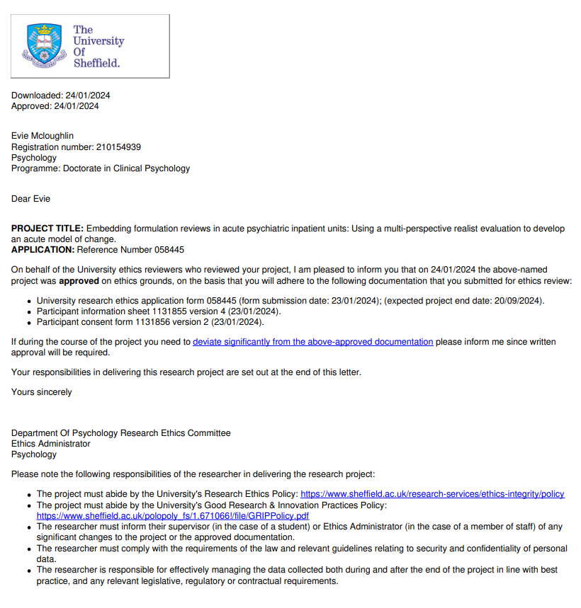

Appendix C
HRA Approval

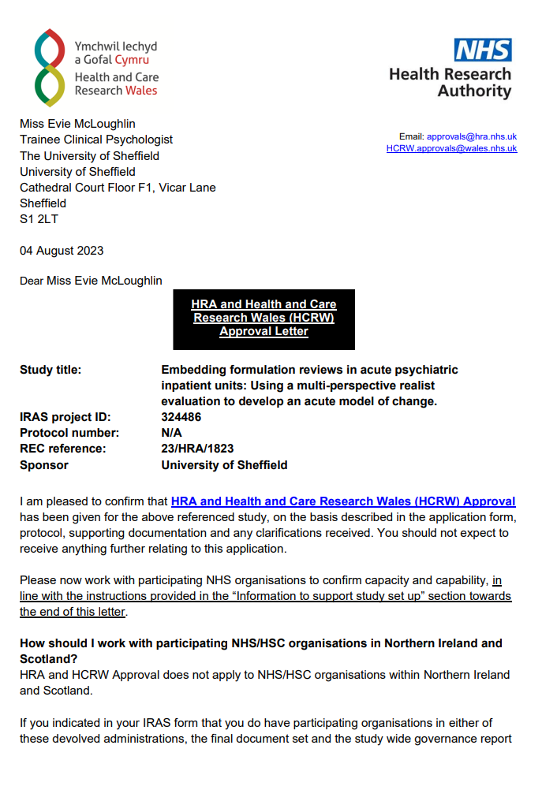

Appendix D
Recruitment Poster

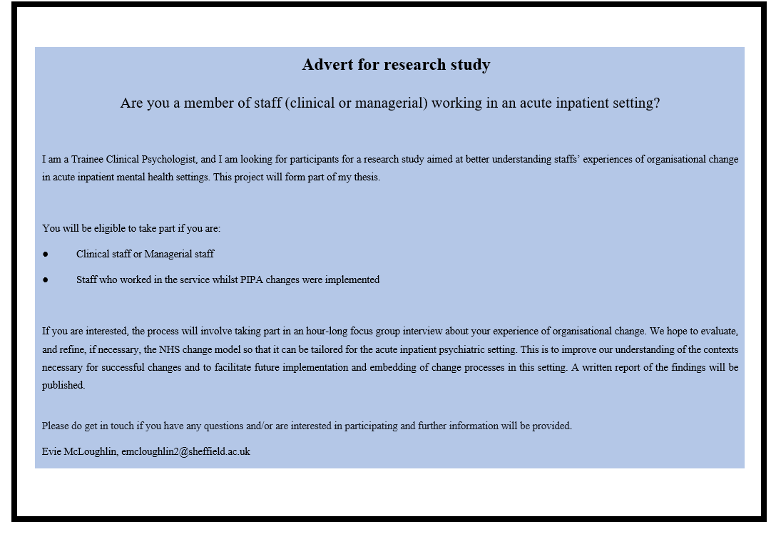

Appendix E
Participant Information Form

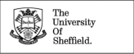
Evie McLoughlin, Trainee Clinical Psychologist
University of Sheffield Department of Psychology, Floor F, Cathedral Court
1 Vicar Lane, Sheffield, S1 2LT UK
Email: emcloughlin2@sheffield.ac.uk

PARTICIPANT INFORMATION SHEET

Study Title: Embedding formulation reviews in adult acute psychiatric inpatient units: Using a multi-perspective realist evaluation to develop an acute model of change.

You are being invited to take part in a research project. Before you decide, it is important to understand why the research is being done and what it will involve. Please read the following information carefully and ask me any questions you have.
Why have I been invited?
You have been invited to take part in this research project because you are a) clinical staff on Stanage ward, Burbage ward or Endcliffe ward, or b) you are part of the senior management team across the wards.
Do I have to take part?
No, it is up to you whether you would like to take part. Participation in this study is voluntary. If you decide to take part, you can keep this information sheet and will be asked to sign a consent form. You can stop participating in the study at any time without giving a reason. However, if you decide to stop participating after the focus group has begun, we will not be able to withdraw any of the data you have provided up until that point.
What will happen if I take part?

You will be asked to take part in an hour-long focus group where you will be asked some questions about your experience of organisational change – specifically, the introduction of MDT clinics and formulation reviews for patients and families/carers within the first week of admission. Participants have an option to take part in an individual interview if they would not like to take part in the group interview, or cannot attend the scheduled focus group but would still like to take part. Participants can contact the researcher on the email provided at the top of this form to request this.
The interview will take place at your place of work. The researcher will come to the wards to carry out the focus groups.
This interview will be recorded and then transcribed using an approved University of Sheffield transcriber. Transcription will be anonymised, and the audio recording will be deleted after transcription. Following this, it will be analysed using Thematic Analysis and Realist Evaluation. Your responses will be kept confidential meaning that you will not be identified or identifiable in the report or reports that result from the research, meaning that taking part in the study should not affect your job (unless in specified circumstances, such as needing to break confidentiality for safety reasons, covered below).
How will we use information about you?
We will need to use information from you for this research project.
This information will include your name and contact details. People will use this information to do the research or to check your records to make sure that the research is being done properly.
People who do not need to know who you are will not be able to see your name or contact details. Your data will have a code number instead.
We will keep all information about you safe and secure. Anonymised transcriptions of audio files will be stored on the University research repository. Other authorised researchers may use your data in publications, reports, web pages, and other research outputs, only if they agree to preserve the confidentiality of the information as requested in this form.
Once we have finished the study, we will keep some of the data so we can check the results. We will write our reports in a way that no-one can work out that you took part in the study. Some of your comments may appear in the write up as quotes, however they will be anonymised.

What are your choices about how your information is used?
You can stop being part of the study at any time, without giving a reason, but we will keep information about you that we already have.
We need to manage your records in specific ways for the research to be reliable. This means that we won’t be able to let you see or change the data we hold about you.
What are the benefits of taking part?
You have the opportunity to share your experience of organisation change within an acute inpatient mental health setting. We hope to evaluate, and refine, if necessary, a current theory of change so that it can be tailored for the acute inpatient psychiatric setting. This is to improve our understanding of the contexts necessary for successful changes and to facilitate future implementation and embedding of change processes in this setting. A written report of the findings will be published.
What if there is a problem?
If you feel that there is a problem at any time, you can let the researcher know. If you experience any distress whilst sharing your experience, the researcher will be able to discuss this with you and discuss what further support might be of help (e.g., from your supervisor or through contacting your GP).
Will all the information be kept confidential?
Identifiable data such as consent form will be transferred outside of the Trust to the Sponsor for storage. However, all the information we collect about you will be kept strictly confidential. You will not be identifiable in any reports or publications.
The only exception to this would be if during the interview the researcher became concerned about a risk of harm to yourself (e.g., suicidal risk), or someone (e.g., a child or another adult) you talk about (e.g., risk of neglect or physical harm). In such a situation the researcher would discuss the need to breach confidentiality with you; the aim of this would always be in order to support yourself and those you mention and ensure safety (for example, it may involve letting relevant services know about the situation in order to help provide those involved with support).

Will I receive any reimbursement of expenses for taking part in this research?
There will be no reimbursement for taking part in this research. However, the focus groups will take place during staff working hours, so staff should not expect to be at a loss.

What will happen to the results of the study?
The results will be submitted as part of the researcher’s doctoral thesis in May 2024, then prepared for publication in 2024. You can let the researcher know at the start of the study if you would like a copy of this and this can be sent to you.
The University of Sheffield is organising and funding this research. This project has been ethically approved via the Health Research Authority, using the NHS Ethics Review Procedure.

What if I wish to complain about the way the study has been carried out?
In the first instance you can contact the lead researcher, Evie McLoughlin EMcLoughlin2@sheffield.ac.uk. Alternatively, you can contact the other researchers involved in the project; Dr Claire Bone on C.Bone@sheffield.ac.uk or Prof Gillian Hardy on G.Hardy@sheffield.ac.uk.
If you feel that your complaint has not been handled to your satisfaction following this, you can contact Chris Martin, Head of Department on psy-hod@sheffield.ac.uk or Mr Amrit Sinha, Chair of the University Ethics Committee on A.Sinha@sheffield.ac.uk

Contact Information
This research is being conducted by Evie McLoughlin, Trainee Clinical Psychologist. This research will be used to write a thesis which fulfils part of their doctoral training. If you have any questions about the research, you can leave a telephone message with the Research Support Officer on: 0114 222 6650 and he will ask Evie McLoughlin to contact you.

Where can you find out more about how your information is used?
New data protection legislation came into effect across the EU, including the UK on 25 May 2018; this means that we need to provide you with some further information relating to how your personal information will be used and managed within this research project.
The University of Sheffield will act as the Data Controller for this study. This means that the University is responsible for looking after your information and using it properly. In order to collect and use your personal information as part of this research project, we must have a basis in law to do so. The basis that we are using is that the research is ‘a task in the public interest’.
You can find out more about how we use your information
● By asking one of the research team by sending an email to emcloughlin2@sheffield.ac.uk, or by ringing us on: 0114 222 6650
● By contacting the Data Protection Officer via email dataprotection@sheffield.ac.uk
● By visiting www.hra.nhs.uk/patientdataandresearch
● Further information, including details about how and why the University processes your personal information, how we keep your information secure, and your legal rights (including how to complain if you feel that your personal information has not been handled correctly), can be found in the University’s Privacy Notice https://www.sheffield.ac.uk/govern/data-protection/privacy/general

Appendix F
Participant Consent Form
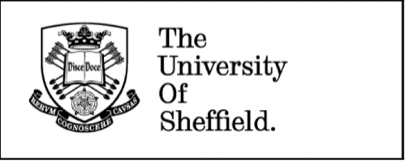

Evie McLoughlin, Trainee Clinical Psychologist
University of Sheffield Department of Psychology Floor F, Cathedral Court
1 Vicar Lane Sheffield S1 2LT UK
Email: emcloughlin2@sheffield.ac.uk

IRAS Project ID: 324486

Study Title: Embedding formulation reviews in adult acute psychiatric inpatient units: Using a multi-perspective realist evaluation to develop an acute model of change.

 | Please tick the appropriate boxes | Yes | No
1. | I have read and understood the project information sheet or the project has been fully explained to me.  N.B. If you answer No to this question please do not proceed with this consent form until you are fully aware of what your participation in the project will mean.
2. | I have been given the opportunity to ask questions about the project.
3 | I agree to take part in the project. I understand that taking part in the project will include participating in a focus group interview that will be audio recorded.
4 | I understand that my participation is voluntary and that I am free to stop participating in the study at any time during the focus group, without giving any reason and without there being any negative consequences. In addition, should I not wish to answer any particular question or questions, I am free to decline. However, I understand that after the recording of the focus group has started, I will not be able to withdraw any data I have provided up until that point.
6 | I understand that my responses will be kept confidential meaning that I will not be identified or identifiable in the report or reports that result from the research, meaning that taking part in the study should not affect your job (unless in specified circumstances, such as needing to break confidentiality for safety reasons).
7 | I understand and agree that my words may be quoted in publications, reports, web pages, and other research outputs. I understand that I will not be named in these outputs unless I specifically request this.
8 | I understand and agree that other authorised researchers may use my data in publications, reports, web pages, and other research outputs, only if they agree to preserve the confidentiality of the information as requested in this form.

- I agree for the data collected from me to be anonymously
and potentially used in future research.
- I agree to take part in the above research project.
12 I agree to assign the copyright I hold in any materials generated as part of this project to The University of Sheffield.

To be signed and dated in presence of the participant:

Name of Participant Date Signature

Lead Researcher Date Signature

Copies:
Once this has been signed by all parties the participant should receive a copy of the signed and dated participant consent form and the information sheet. A copy of the signed and dated consent form should be placed in the project’s main record (e.g., a site file), which must be kept in a secure location.
Thank you for taking part in this research today. I have aimed to understand staff members' experiences of organisational change. I am going to analyse all the interviews I have conducted. I will aim to evaluate, and refine, if necessary, a current model of change so that it can be tailored for the acute inpatient psychiatric setting. I will then write a report of my findings. This is to improve our understanding of the contexts necessary for successful changes and to facilitate future implementation and embedding of change processes in this setting.

Do you feel that you need to talk about anything further? If you do when you leave today, you can contact the lead researcher, Evie McLoughlin EMcLoughlin2@sheffield.ac.uk. Alternatively, you can contact the other researchers involved in the project; Dr Claire Bone on C.Bone@sheffield.ac.uk or Prof Gillian Hardy on G.Hardy@sheffield.ac.uk

Appendix G
COREQ- checklist

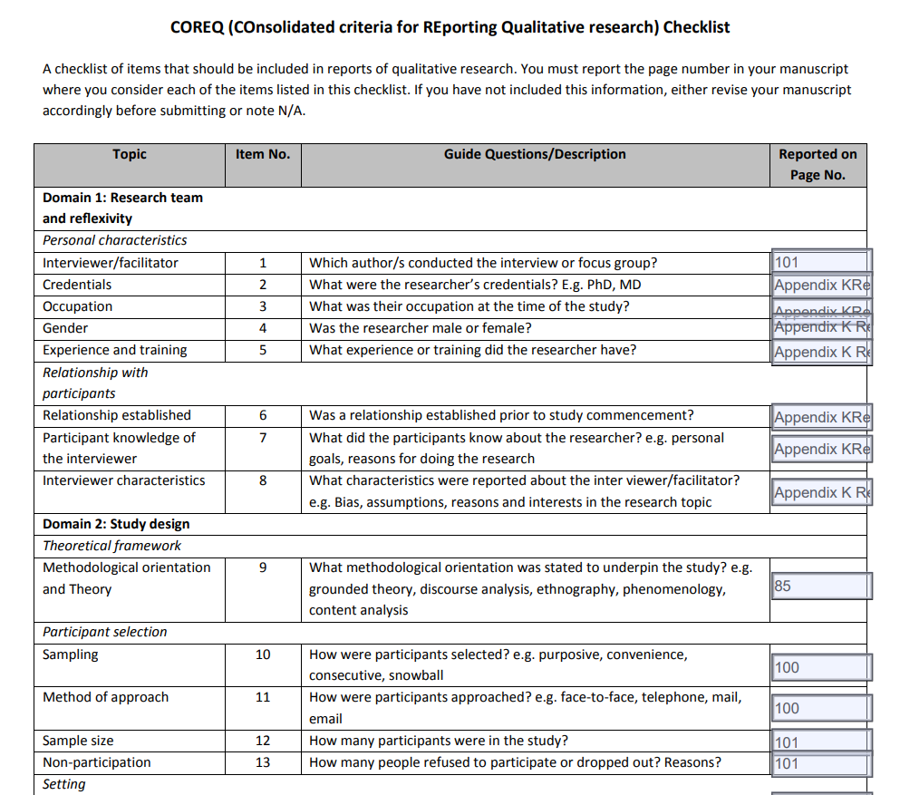

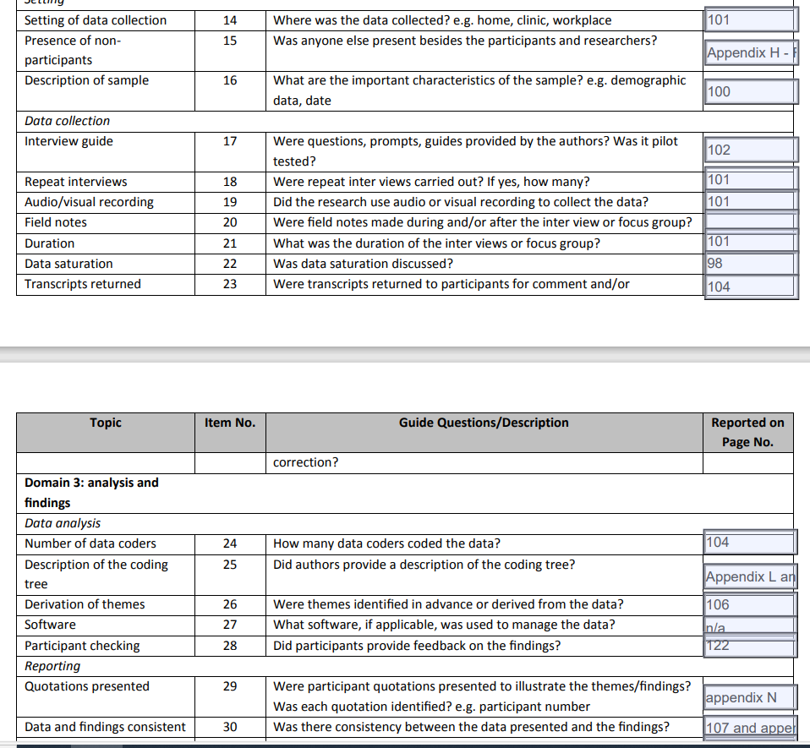
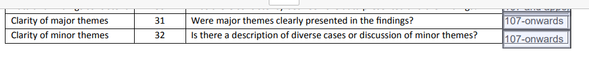

Appendix H
Audit

Worthy Topic  1. Is the topic of research relevant and justified?  Rich Rigor  2. Does the study include clear theoretical constructs?  3. Does the study comprise of rich data?  4. Does the study describe the sample and provide demographic information?  5. Does the study describe how organisational change is conceptualised?  6. Does the study sufficiently justify and describe the data analysis process?  7. Has the data been thoroughly coded adhering to the chosen analysis?  8. Has the researcher engaged in a reflexive process to define personal and group experiential themes?  Sincerity  9. Does the researcher record self-reflexivity including values,  biases, and personal experiences?  10. Does the research address the chosen methods limitations?  Credibility  11. Are participant quotes evidenced for themes and sub-themes?  12. Has the researcher engaged in appropriate supervision to support research quality?  Resonance  13. Are the research findings documented clearly and insightfully?  Significant Contribution  14. Does the study extend current knowledge of organisational change within adult acute psychiatric inpatient services?  15. Do the study’s provide implications clinical practice?  16. Does the study make recommendations for research?  Ethical  17. Does the research have ethical approval?  18. Are the participants experiences appropriately represented?  Meaningful Coherence  19. Does the study achieve its reported aims?  20. Does the study relate its findings with previous research? | Yes / Partially / No  Yes / Partially / No  Yes / Partially / No  Yes / Partially / No  Yes / Partially / No  Yes / Partially / No  Yes / Partially / No  Yes / Partially / No  Yes / Partially / No  Yes / Partially / No  Yes / Partially / No  Yes / Partially / No  Yes / Partially / No  Yes / Partially / No  Yes / Partially / No  Yes / Partially / No  Yes / Partially / No  Yes / Partially / No  Yes / Partially / No  Yes / Partially / No

Name of Researcher Evie McLoughlin Researcher Signature E. McLoughlin
Name of Auditor Charlotte Graham Auditor Signature C. Graham

Appendix I
Reflexive Statement

The primary investigator is a female Trainee Clinical Psychologist and is currently employed by the NHS. As part of clinical training, the researcher has some experience with research, including service evaluations and auditing, and training in qualitative and quantitative approaches. The investigator has previously worked as an assistant psychologist and support worker. In these roles, the investigator worked in inpatient psychiatric services. However, the investigator has not been employed to work on adult acute psychiatric inpatient wards. The investigator has no personal experience of acute inpatient wards.

Appendix J
Reflexive Diary Extract
Undertaking this focus group was extremely interesting. I felt privileged that so many staff from varying disciplines took time out of their busy working days to contribute their insightful perspectives. I was surprised at how open staff were. I was aware that I was asking them to discuss potential issues with their workplace, whilst in their workplace during a working day. I wasn’t sure if it would feel ‘safe’ for them as I had not established a relationship with participants before commencement of the study. We discussed reasons for conducting the study, including the research being part of my training and my employment within the Trust. I was glad that they felt able and willing to share, and it felt that it was a positive shared experience for the staff who attended.
It was clear that this staff team had cohesion in terms of how they were able to speak to each other, I noticed that they asked each other questions about their experiences and were interested in what each other had to say. They used humour appropriately to lighten difficult discussions. This was reflected in how they spoke about the ward’s approach to change being a whole team effort.
However, I found it saddening that they were clearly feeling demoralised, not only in the sector which I am currently working in and plan to continue working in, but also the same profession. Whilst carrying out the group, I was aware that I was logging my own experiences of working within the NHS in psychology-related roles. I was increasingly aware that there were parallels to the emotions and feelings I was hearing people describe within interviews and my own. I was able to remind myself to separate my personal views from my role of ‘interviewer’ and was able to prepare myself for this prior to the following interviews.

Appendix K
Interview Schedule Feedback

Grammatical changes and slight changing to the wording was made following feedback. No questions were added/removed. The participant was satisfied that the questions were appropriate and relevant. We did wonder together whether some of the questions were too long, however in research supervision we reflected that whilst on paper the questions could seem lengthy, there was ways to ask them in a way that felt more digestible. This was agreed by the participant providing feedback. The participant was thanked for their contribution and informed how these suggestions were implemented into the schedule when the changes were made.

Appendix L
Codebook with Descriptions

2nd order Code | Description
Practical resources

Physical resources

Space to meet | Staff discussed how the space where they meet to complete change-related tasks did impact on the productivity of the meetings, for example meetings taking place in meeting rooms on the ward were often interrupted or compromised productivity
Technology | Staff frequently discussed the impact of poor technology on the efficiency of change-related tasks, mostly related to the lack of easy access to information or sharing of information.
Time

Burden of change and workload | Staff reported that they felt a major barrier to engaging in change-related tasks was not having the time due to their workload, and thus any additional demands felt like a burden on their time.
Prioritisation of other tasks | Staff discussed how they often felt they needed to prioritise other tasks particularly those relating to the care of patients and maintaining the safety of the ward, over change-related tasks, for example the high rates of admission/discharge. This impacted the time they could dedicate to the change project as they prioritised processes and safety.
Protected time | Staff spoke about how having protected time to engage in tasks was necessary, and that backing by managers/leadership was necessary to allow this to happen. This also linked to adequate staffing.
Training/skill development

Training and skills | Staff discussed the importance of staff having training to support staff in implementing change-related activities or identified this as a gap.
Awareness for new/agency staff | Staff spoke about how any training/skill development is needed for new staff and agency staff, particularly due to the high staff turner and use of agency staff.
Safety

Physical safety

Physical safety | Staff discussed how the physical safety of the ward was of utmost importance and keeping both patients and staff physically safe was prioritised over change related tasks. For example, if attending meetings would leave the ward short staffed, they would not attend the meeting, the level of self-harm/risk being a barrier to implementing change.
Psychological safety

Psychological safety | Staff discussed how staff needed to feel psychologically safe with leaders/facilitators and the ward team to implement change.
Staff wellbeing | Staff on one ward discussed how staff wellbeing could be improved through staff wellbeing sessions with psychologists and that this was linked to a greater sense of autonomy on an individual level but could also create a sense of connection when delivered in groups.
Fight or flight | Staff reported that they often felt in fight or flight mode, referring to the high levels of stress staff are under due to pressures from leadership, and therefore in a constant state of perceived (and in some cases, real) threat.
Ward environment/climate | Staff discussed how the ward environment in terms of the social and emotional climate affected their ability to implement change, for example staff perceptions of their jobs, staff feeling burnt out, staff wanting to leave their jobs, and the ward’s client group characteristics, and the impact of this on the implementation of change.
Leadership

Qualities

Qualities of leaders/facilitators | Staff discussed the importance the qualities of leadership – e.g. their ability to give supervision and guidance, and encourage reflection.
Roles and structure

Clear roles and structure | Staff discussed the challenges experienced around not understanding roles and responsibilities in terms of who was leading/facilitating the changes.
Leadership style

Top-down leadership | Staff discussed how a top-down approach fuelled resistance in staff – top-down was considered to be: scrutiny, not feeling that there is any compromise, being dictated to without any explanation or thinking around the consequences for staff. Staff talked about the need for leadership to allow the ward to propose changes they saw fit
Firm but fair | Staff discussed the importance of having leaders who could tell staff that changes were non-negotiable, whilst allowing them to feel listened.
‘Buy in’ of change

‘Buy in’ from ward staff

Change being understood and valuable | Staff discussed the importance of staff at all levels understanding the reasons for the change and understanding the value in the change.
Staff experiencing the benefits of change | Staff reported that a significant enabler of change was staff experiencing how the change benefitted patients, the ward or staff – this included increasing person-centred care, facilitating conversations with patients and increasing multi-agency working.
Resistance to change | Staff discussed how there could be a sense of active resistance within the team, and that everyone needed to be on board for change to be implemented effectively.
Change feeling unfair | Staff often felt that changes could feel unfair for staff if they already felt overburdened and the change was adding extra work for them.
‘Buy in’ from leadership

‘Buy in’ from leadership | Staff discussed how ward staff and management needed leadership to buy in to the changes and for this encouragement to be communicated with staff at all levels, as well as leadership providing the practical resources needed.
Lack of hope/trust in leadership | Staff found it difficult to trust in leadership, as they felt that promises were often unfulfilled, and this could lead to a lack of hope in any positive messages which were communicated by leadership. This could lead to staff having a lack of energy for change as they did not feel there was ‘any point’.
Collaboration

Team working

Staff feeling valued and influential | Staff shared that feeling valued and influential was important as this could lead to intrinsic motivation to engage in the change project as well as increasing staff wellbeing/attitude towards work and the change project.
Involvement of staff and ownership at all levels | Staff discussed the benefits of staff at all levels being involved at every stage of the change implementation, and staff feeling that they had something to contribute to the change. This could lead to staff attending meetings and therefore improve team working.
Connection | Staff felt that good working relationships between teams was important for team working and therefore implementing change, and this could be achieved through regular face to face meetings.
Shared values | Staff discussed the importance of staff understanding their own values and these values being shared across the whole team, and this could improve team working which in term allowed staff to implement changes.
Burden of change feeling shared | Staff discussed how change efforts could be hindered when staff/certain professions felt that most of the change was their responsibility.
Team collaboration and cohesion | Staff spoke about the need for staff groups to work together to reach goals, and for this to happen the team need to feel unified. This could improve efficiency, communication, and organisation.
Patient and carer involvement

Service user and carer involvement | Staff reflected on how the involvement of patients and carers in the change project had helped them to ensure they were working in a person-centred way, and therefore felt that their values were aligning with their practice.
Staffing

Qualities of staff

Experience | Staff discussed that newly qualified staff were being put in more senior positions more quickly, due to the lack of staffing. This meant that they were making decisions with a lack of experience, and this could impact the implantation of change and the ward climate more broadly.
Confidence | Staff felt that junior staff could lack confidence in their skills/their ability to contribute in a significant way to the change efforts and this could impede implementation.
Staffing levels
Consistent staffing | Staff discussed the impact of high use of agency staff on change implementation, in terms of a) staff who are invested in the ward and b) who know the ward routine/change related activities.
Substantive staffing | Staff on each ward talked about the staffing recruitment and retainment issue currently, and the need for teams to be fully staffed for change to be implemented effectively.
Shift patterns | Staff discussed that shift patterns could affect how often staff saw each other and therefore inhibit communication. It also meant that, as things change quickly on acute wards, staff could often feel ‘out of the loop’ when they returned back to work. A recent change in shift patterns meant that staff had less time during the day to meet.
Communication

QI involvement

QI oversight | Staff discussed how one ward had QI oversight, and this was very helpful. However, they discussed how the facilitators left and were not replaced, and this happened without a plan/roadmap for the future of the change. Staff from other wards discussed how there had been no QI oversight and thus they had had to ‘figure it out’ for themselves.
Communication between and with staff at all levels | Staff spoke about the importance of staff at all levels coming together for meetings about the changes, so that everyone is involved and on the same page. There was a sense that this communication needed to be managed by someone external who could take and distribute minutes.
Learning and sharing of learning | Staff believed that there was a lack of learning through audits/feedback about the change and a lack of sharing of learning between the wards. It was felt that this contributed to difficulties to implementation as wards could not hear what was working well or wasn’t working well and think about how to adapt their practices to improve implementation.
Ward level communication

Miscommunication between staff/wards regarding the changes | Staff discussed how miscommunication between ward staff/wards could lead to staff believing/thinking different things about the change, and how this could lead to difficulties in implementing changes. This could be due to wards working ‘in silo’.
Staff forums | Staff discussed having regular meetings or forums to discuss change and for staff to ask questions/raise concerns (emphasis is on regularity of meetings or opportunities to meet, rather than speed of help).
Fitting change in with ward practices | Staff discussed how it was difficult to implement changes when their time was limited and there were other things they needed to priories, and so communication about how and when change related activities would need to take place within the ward team was very important for implementing change.
Energy for change and sustainability

Generating and sustaining energy

Amount of change at one time | Staff discussed how multiple concurrent changes contributed to a feeling of overwhelm and thus low energy for change. Change was more likely to feel like a burden and staff were more likely to be resistant to change.
Energy for change | Staff spoke about the amount of energy change that existed at the beginning of the change project and how this was generated through the coming together and sharing ideas, and there being a sense of hope amongst staff (or not generated if there was a lack of energy).
Consistency and commitment | Staff discussed the importance of sustaining the energy for change through remaining consistent and committed to implementing change related activities change.
Proactivity vs reactivity | Staff reflected on the importance of being proactive with changes, rather than reactive. However, it felt that currently, a lot of the changes made in the acute inpatient setting were more reactive than proactive and this contributed to a feeling of unpredictability.
Adjusting and evolving

Evolution of change | Staff talked about how change can evolve over time, whether that is because changes to changes are enforced, or more organically through learning of best practice. Evolution of change could also occur more unconsciously, e.g. change related activities being modified to fit with the ward routine.
Allowing time to implement | Staff discussed that staff and management needed to acknowledge there would be a necessary time period for staff to implement the change and ‘find their feet’ before it felt natural and/or helpful.
Standardisation | Staff spoke about how common or standardised approaches to change would be helpful or unhelpful.

Appendix M
Bank of Codes (example)

Bank of codes

Staff involved in development | Engagement | Building confidence | Detrimental to other jobs getting done
Freedom | Designated roles | In the context of other changes | Scrutiny
Ad hoc | Teaching | Continuity | Change tasks taking a long time
Preparation | Benefits of change on care delivery | Being stopped from doing something that feels beneficial | Importance of easy access to information
Efficiency | Staff not having time | Family/carers input | Multi-agency working
Sharing of information about changes | Shift patterns | Allows for reflexive practice | Views of own impact of participation
The importance of when things happen | Standardisation not being possible | Team stability/consistency | Organisation/structure
Staff cohesion | Differences in ward cultures | Autonomy to make decisions/ownership | Proactiveness
Learning/evaluating in order to replicate on other wards | Reasons for the changes feeling unfair | Defensiveness/resistance | Senior leadership visibility on the wards
Splitting up teams | Another ‘thing’ to do | Value in the number of staff/different professionals being able to be involved in the task | Compromise
Perceptions about job | Change taking away from important service user related tasks | Leadership qualities | Feeling of psychological safety
Views about different wards performing differently | Top-down leadership approach | Values of staff not aligning with changes | Staff wellbeing/support
Rate of discharge | Experience/competence of staff | Feedback to inform learning | Shared values between staff
‘Buy in’ from ward staff | Unpredictability of the nature of ward working | Staff feeling ‘good’ about work | Changes to the changes
Changes feeling purposeless | Communication between staff and senior management | QI keeping focus on change | Changes helping make other tasks easier/connectivity

Appendix N
Selection of Participant Quotes per Theme

Theme | Subthemes | Quote
Practical resources | Physical resources | P2: Erm we started the meeting about how we can do this better and today we did it, strangely in the nursing office which I think more just that people didn’t feel that they could get off the ward for half an hour to sit round and do something that.
 | Time | P1: It’s nearly impossible to do in an hour cos it’s just everyone is like scattered.  P2: I used to attend before but sometimes I don’t always get the time to come and attend.  P3: We had more time then.  P2: We had more time.  P1: I mean there’s times when we’ve tried to tweak things haven’t we with the handover and it’s been perceived, and probably rightly so as another thing to do on top of the other things that we need to do.  P2: It’s like, but then patients will come and go and they can come in and they might have four new patients, you know that have been here a while and its, its them learning all about that patient again and actually being expected to do the PIPA board and being the nurse in charge when they come onto the ward and they’ve not been here for ten days.
 | Training/skill development | P3: I mean I know they're accessible to everyone, but I don't know if it's promoted say to when they're inducted new staff members or agency staff or whether they're sign posted to refer to someone's formulation when coming on the ward.
Safety | Physical safety | P3: I think environment wise as well where you have them, you can't take that number of staff off them away from the ward for any extended period of time, wouldn’t be physically safe to do so.
 | Psychological safety  ‘Fight or flight’  Ward climate | P2: I think the nurses are learning fight or flight, very young but then there are some students that they learnt in covid so are used to fight or flight, things being hectic and then they are entering services that have really low staffing and it’s the learning, this is how you work as a nurse in this mode because that’s what everybody else is doing and then just look outside of that at formulation, care plans, makes people better and makes your job easier and we’ve been unable to do as part of their skills  they’ve learnt from their placements is how to manage a chaotic crazy environment and get through the shift.
Leadership | Qualities | P2: …Making us feel important to what the work he is doing and not just a team and it does, it has a really, really good effect, everybody just calls him NAME – (Dr), you know but he is the Consultant (LAUGH).
 | Roles and structure | P4: The thing that does make it challenging is that I think that there has been a shortage in staffing but a shortage in changeovers within the leadership team and although I think it's getting better, the leadership team itself doesn't feel very cohesive.  P1: I think with any change on the ward, whether it be a staffing accompaniment, whether it’s the registered nurses or support staff, it's really hard to make any changes by then because then tasks or various things pigeon holed as belonging to a certain profession, which I think it's happening because the psychology team started to lead on facilitating these formulations, it then becomes ‘well that’s what psychology do and we have that with community meetings because OT started facilitating the community meetings on the ward, it then becomes,’ well that's what a OT’s do’.  P1: …just fizzled out when we were reducing leadership structure, I don’t know, the person who was leading it is not there anymore, (SIGH).
 | Leadership style | P1: …There are people who see this as part of a tick boxing exercise, something that is kind of enforced upon them to do and they may or may not see value  P1: So obviously there is nobody there to kind of more or less force people to do it and attend it, just what these wards often need is it drilling into people to have regular practice and erm if there is nobody there to do that it just won’t happen
‘Buy in’ of change | ‘Buy in’ from ward staff | P3: This trust has not talked about recovery at all how are we making people well enough to leave hospital  It’s not sold as something that reduces beds, average length of stay or recurrence. A safe ward makes it safe but it doesn’t lengthen stay so. P2: But they are the things, they are the quality initiatives that we should be focussing on and I think that’s hopefully we all strive to think about quality rather than flow.  P3: And that’s the thing isn’t it, if we are going to make a change, it has to be something that’s gonna benefit staff and patients, not about, if you benefit everyone it will naturally you know, be allowed…  P1: It would naturally be a better place wouldn’t it.  P2: But actually in the grand scheme of things, looking after the patients should be our number one priority.  P4: It’s not even numbers, its reducing patients to this in, like in, like not even numbers, what is flow, where is the person, where is the individual there, its like waves of patients that just come in and out and directed to… I loathe it.  P3: When people get to wards and their value like just completely just goes, just goes into the flow doesn’t it.  P4: So people thought that if you were doing PIPA then you would get people through the wards quicker, so it went from something that was improving quality, to something that was about bed numbers and patient flow.  P1: Its just a tick box now.  P6: Yeah so it feels at the minute that the stuff that were being asked to do is to make life easier there (LAUGH) rather than here or here so yeah.  P3: I know there’s been quite often, changes often, you hear it and you just think ‘oh they want us to do more’. It’s never really changing, it’s not replacing, its not like a more efficient way of doing things, it’s always more, do more, another form to fill in and that.
 | ‘Buy in’ from leadership
Collaboration | Team working | P4: The reason that they probably do stay engaged is because they like that team that they work in.  P1: …it always gets a bit awkward and people don’t engage that well.  P3: …it’s not, it’s never very team led but you know there are lots of people kind of putting excuses out there and putting it off, its often mostly us sitting there.
 | Service user and carer involvement | P2: I think it's been nice to have been part of one where we managed to have a service user actually involved in part of that discussion, so that was really good, but erm again like you said about the team having people involved in their discussions isn't always appropriate I guess, that's certainly at the point of admission, and again it’s like, yeah, I think it could be quite impactful for service users if we could get up and running because it's a chance for the whole team to become reflect, learn a bit about their background, about their current situation, how what we can help support them, which kind of saves people have to continually repeat themselves, especially if there's been a lot of trauma  P3: actually adding to that as well like it would been a common place for service users to be invited I, like a lot of these are such closed spaces, it just seems like yeah, for it to become common place for service users to be invited in to be part of their formulation. And some of it may not feel appropriate to be discussing with known like background to like, using the five keys, that's not always comfortable say for people to reflect, especially with the group of people, but something's about you know, what people's interest are, what their needs are and how to support them. You know what great conversation.
Staffing | Qualities of staff | P4: Knowledge and experience as well, kind of like, we’ve got lots of experience and lots of knowledge whereas if you look downstairs, completely the opposite, not many staff that are experienced, there is not many staff at all so that puts a lot of pressure on that nurse because they are working with preceptee’s, you know the preceptee’s need that support.  P3: And trying to build people’s confidence in starting to attend and facilitate and contribute to the meetings.
 | Staffing levels | P1: I think it’s after a night shift people are so desperate to go home aren’t they.  P4: Oh yeah and at 7 o'clock in a morning you can’t concentrate as well as you could (LAUGH) at like 1 o'clock in the afternoon could you.  P1: But like in the morning and on the night shift you couldn’t do it to the same extent.  P3: Bring back the midday handover, bring back, I mean I know that they’re shorter shifts, although I know that the longer shifts really work for staff, it actually is a massive barrier to a lot of things  P2: The staff don’t see each other either.  P3: It’s actually just the staff seeing each other, I cannot see some staff members for ten days and they’re not even on annual leave, they’re just not at work (LAUGH).  P4: I would love for daily jobs to be put on there and allocated and erm there be a system where, you know, you do the daily jobs that are gonna be purposeful for that patient and that moves them on a little bit more but actually because of the shift pattern, there’s no continuity in staff so things get lost.
Communication | QI involvement | P1: We had a fantastic QI person called NAME and he used to.  P3: (LAUGH) that name will live with us forever NAME.  P1: He used to facilitate all the minutes. He would facilitate meeting, he used to keep people on track with it because when in busy clinical roles, its really easy just to let things slide and focus on other things, whatever, the most demanding things at that time.  P5: When you said slide its not because, you really get pulled into more acute things that are needed to be done there and then so QI generally it sort of tends to be the lower priority when it shouldn’t be. If someone has got a specific role in QI, that’s there, that’s what they’re they for and they will constantly make it their agenda.  P1: Initially, so as part of the QI Department… so they used to come into areas and support the teams to deliver what change they wanted to deliver. Erm and then I don’t know what happened in QI but the coaches all ended up leaving and now they can only offer erm support or advice to us whereas we needed that initially to kind of keep us going and to keep us kind of driving forwards with it.  P1: Yeah it was the latter, I don’t really recall how we run but I don’t recall any input from QI, I would have thought if QI were involved that would have been over the course of time rather than just you know, one bit and I would recall that, so no they weren’t involved. I think erm yeah, I think it just arrived, this is what were doing now and the sort of support and training that we had for that was kind of inhouse
 | Ward level communication | P3: I think the key thing is just communication and I think that is certainly something that could be improved on here, the methods of communication, its timing and when in the day are things are being done.
Energy for change and sustainability | Generating and sustaining energy | P2: It’s always because people are too busy, this is going on, X and Y is happening, erm which then makes it harder to be consistent when sometimes you will get them and if it’s a quiet day you will get more, you will get people together who work really well, erm the next day or a couple of days after it, it could work really poorly  P1: It doesn't seem great, I don’t think people aren’t particularly excited for change, I think there has been a lot of change, erm even this past week, there's been a lot of change and a lot of sudden change but hasn't been communicated or handled very well, which isn’t very well received.  P5: …otherwise you will see what always happens is you will do it for six weeks and then it will straggle out and then no one will talk about it for a year… make these changes and then nothing will happen, usually things will fizzle out after a period of time
 | Adjusting and evolving | P4: Yeah. What we’re doing and what [WARD] are doing even though we’ve had meetings so we know what we’re doing, they still drift apart. Everywhere is different.  P5: Which in itself isn’t a bad thing I guess.  P4: No.  P5: I think it’s when people try to standardise it.  P1: Yeah and you don’t want it like that because all the wards are different, you know, and it’s not McDonalds, its not globalisation.  P2: Yeah their favourite word is to standardise everything, every little thing across the whole of, you know the acute wards. They must be standardised and they must all be in this one place  P1: Thinking about kind of evolution is really important, so when things are put in place they naturally, depends on the ward, they quite quickly, its more things INAUDIBLE, (14.4) they separate so quickly into their own little thing and that, if that’s allowed to happen then they can grow into that area, I don’t know how much that is allowed to happen, things always brought back to being the same.  P2: Oh right so you will do all the acute wards and they are all different. Erm but they need to be and they say, ‘oh the PIPA board can be the same on every ward’, and it can’t, cos our patients have different needs, you know, so.  I: Who said the PIPA boards can be the same on every ward.  P2: Senior management.  P1: Senior management.  P2: I think [WARD] are probably in a better position because we delayed implementing it, I mean not, not consciously really (LAUGH), it was just we hadn’t quite got the time to do it but we could see how it was working on other wards so there was some familiarity of what formulation review was by the time we said “right, I think we maybe need to start looking at this on [WARD]”.  P1: And I think that’s what [WARD] did because they have the advantage of being physically close to [WARD] but also just hearing how it evolved over time and what was working, so I think right from the start they were able to say – right, what’s important about it, and that tis owned by the team and that the Psychologist on there at the time made a point of not, not taking them all on, whereas all the other wards have tried to embed them first through Psychology and then hoped to move and it hasn’t really happened has it.

Appendix O

Benchmarking Data

Sheffield Health and Social Care’s (SHSC) Bespoke Adult Acute Psychiatric Inpatient Benchmarking report for 2022/23

