

The Potential use of Social Robots in Acute Paediatric Settings:

A mixed-methods exploration of feasibility, acceptance, and utility.
Brenda Littler

A thesis submitted in partial fulfilment of the requirements for the degree of
Doctor of Philosophy

The University of Sheffield
Faculty of Medicine, Dentistry and Health
School of Health and Related Research

Originally submission date: July 2023
Resubmission date: March 2024
PhD Project Supervisors

Professor Luc de Witte
Dr Christine Smith
Professor Paul Dimitri
Dr Steven Ariss

Declaration
I, Brenda Littler, confirm that the Thesis is my own work. I am aware of the University’s Guidance on the Use of Unfair Means (www.sheffield.ac.uk/ssid/unfair-means). This work has not previously been presented for an award at this, or any other, university.
This thesis is submitted in the form of the publication format thesis which allows the thesis to be composed of academic publications alongside the traditional thesis sections.
One published paper, of which I am the first author is included in this thesis, chapter 3. It was originally published in the Journal Archives of Disease in Childhood.
Chapter 5 has been submitted to the International Journal of Social Robots. We have received comments from reviewers and plan to resubmit in March 2024.

Acknowledgements

I am grateful for my faith and God for giving me the strength and courage to complete my PhD. Firstly, I want to express my deepest gratitude to my husband Joel, who has been my unwavering supporter throughout this journey. I am also immensely thankful to my incredible children, Eve, and Asher, for their understanding and allowing me the time and space to work on my research, even during early mornings, late evenings, and overnight travels.
Secondly, I want to acknowledge the invaluable support and belief in me provided by my supervisors: Prof Luc de Witte, Dr Christine Smith, Prof Paul Dimitri, and Dr Steven Ariss. Your guidance and encouragement have been instrumental in helping me overcome challenges and persevere.
Lastly, I would like to extend my appreciation to my lovely friends and family. To my dear queens Francine, Grace, Akua, and Anu, thank you for standing by me, offering support in both my moments of strength and vulnerability, and for your prayers. Your presence and laughter have uplifted me throughout this journey.
To my parents, Joao and Lyly Maleco, and my parents-in-law, David and Suzanne Littler, I am immensely grateful for all you have done for our family, especially in taking care of the little ones. Your presence and assistance have been invaluable.
I am truly grateful for love and support I have received on this journey.
Publication from this thesis
- Chapter 3

Littler, B.K.M., Alessa, T., Dimitri, P., Smith, C. and de Witte, L., 2021. Reducing negative emotions in children using social robots: systematic review. Archives of Disease in Childhood, 106(11), pp.1095-1101.

My contribution to this paper was creating the systematic review protocol, conducting the data extraction, preparation, analysis and writing the initial manuscript. TA assisted with the systematic review extraction, preparation, and analysis. PD, CS and LdW advised on the protocol, the data extraction, preparation, analysis, and reviewed the manuscript drafts. All authors contributed to the draft and approved the final manuscript.

Currently under review for publication
- Chapter 5

Littler, B.K.M., Dimitri, P., Smith, C., de Witte, L., and Ariss, S.
Paediatric patients' interaction with social robots: an observational study was submitted to the International Journal of Social Robots, and currently reviewing comments sent from reviewers. We plan to resubmit in March 2024.
My contribution to this paper was creating the protocol, planning the research sessions, conducting all the research session, and writing the initial manuscript. PD, CS and LdW advised on the protocol, LdW reviewed the manuscript drafts. All authors contributed to the draft and approved the finial manuscript.
Associated publication during the PhD registration period
Van den Heuvel, R., Jansens, R., Littler, B., Huijnen, C., Di Nuovo, A., Bonarini, A., Desideri, L., Encarnação, P., Lekova, A. and De Witte, L., 2022. The potential of robotics for the development and wellbeing of children with disabilities as we see it. Technology and Disability, 34(1), pp.25-33.
My contribution to the paper was conceptualisation, methodology, formal analysis, investigation, data curation, writing-review, and editing.

Conference presentations
Oral presentations
- University of Sheffield, School of Health and Related Research Conference (2020) – Title: Introducing Social Robots into the Sheffield Children’s hospital
Runner-up in the 'Best Oral Presentation' award
Poster presentations
- University of Sheffield, School of Health and Related Research Conference (2019)

Other work
Created a research based coursebook relating to KS3 mathematics with HeppSY: https://heppsy.org

Publicity about the PhD research
Articles about the research
Sheffield Children’s host robot research study - https://www.sheffieldchildrens.nhs.uk/news/sheffield-childrens-hosts-robot-research-study/ (February 2022)

- Sheffield Children’s Hospital brings in robots in effort to reduce anxiety for young patients - https://www.thestar.co.uk/health/childrens-hospital-introduces-robots-to-help-patients-3592473 (2nd March 2022)

- Sheffield Children’s Hospital hosts robot study for paediatrics - https://www.digitalhealth.net/2022/03/sheffield-childrens-hospital-hosts-robot-study/ (4th March 2022)

- Social robots help entertain and soothe kids undergoing treatment at Sheffield Children’s Hospital - https://inews.co.uk/news/social-robots-sheffield-childrens-hospital-anxiety-stress-1499316 (7th March 2022)

Radio
- BBC Radio Sheffield with Howard Pressman: The robots doing the hospital rounds - https://www.bbc.co.uk/sounds/play/p0bs9s1s (2nd March 2022)

Table of Contents
Acknowledgements 4
Table of Contents 7
Abstract 12
Chapter 1 13
General Introduction 13
1.1 Hospital anxiety 14
1.2 Social Robot 14
1.3 Types of play interventions 15
1.4 The growing use of social robots in healthcare 17
1.5 Aims and outline of the thesis. 18
1.6 Structure of the Thesis 19
1.7 References 21
Chapter 2 24
The story behind paediatric anxiety and the development of social robots: Background 24
2.1 Anxiety in paediatric patients 25
2.2 Difference between Worry and Anxiety 25
2.3 Interventions used to reduce anxiety in paediatric patients. 26
2.4 Social robots as an intervention 29
2.5 Using social robots to improve wellbeing. 34
2.6 Conclusion 36
2.7 Reference 39
Abdollahi, H., Mollahosseini, A., Lane, J. T., & Mahoor., M. H. (2017). A pilot study on using an intelligent life-like robot as a companion for elderly individuals with dementia and depression. Birmingham, United Kingdom: In 2017 IEEE-RAS 17th International Conference on Humanoid Robotics (Humanoids). 39
Chapter 3 43
Reducing negative emotions in children using social robots: systematic review 43
3.1 Introduction 45
3.2 Methods 45
Screening 48
Included 48
Eligibility 48
Identification 48
3.3 Results 49
3.4 Discussion 57
3.5 Conclusion 57
3.6 References 59
3.7 Extended Discussion 61
Chapter 4 63
Methodology and methods 63
4.1 Introduction 64
4.2 Research Questions, Aims and Objectives 65
4.3 Theoretical underpinnings 66
4.4 Study Design 68
4.5 Sampling 71
4.6 Recruitment 72
4.7 Data collection 73
4.8 Setting 74
4.9 Intervention 75
4.10 Data Analysis 80
4.11 Mitigating Researcher Bias in Ethnography 82
4.12 Public Involvement 82
4.13 Ethical and regulatory considerations 83
4.14 References 84
Chapter 5 88
Paediatric patients' interaction with social robots: an observational study 88
5.1 Introduction 90
5.2 Materials and methods 92
5.3 Results 106
5.4 Discussion 121
5.5 Conclusion 125
5.6 References 127
Chapter 6 131
Parents' views of the use of Social Robots in a Hospital Environment 131
6.1 Introduction 133
6.2 Materials and Methods 134
6.3 Results 142
6.4 Discussion 147
6.5 Conclusion 149
6.6 References 150
Chapter 7 153
The acceptance of social robots in a hospital environment: experiences and perceptions of healthcare professionals 153
7.1 Introduction 155
7.2 Materials and methods 156
7.3 Results 158
7.4 Discussion 169
7.5 Conclusion and recommendations 171
7.6 References 173
Chapter 8 177
General Discussion 177
8.1 Study Summary 177
8.2 Main findings 179
8.3 Study strength and limitation 186
8.4 Recommendations 188
8.5 Conclusion 190
8.6 References 191
Appendices 193
Appendix 1 – Search strategy 193
Appendix 2 – Information sheet for participant aged 5 to 8 years old. 195
Appendix 2 - Information sheet for participant aged 9 to 12 years old. 196
Appendix 3 – Consent form for paediatric patients 198
Appendix 4 – Information sheet for parents and guardians of paediatric patients 200
Appendix 5 – Parents and guardians consent form 203
Appendix 6 – Information sheet for healthcare professionals 204
204
Appendix 7 – Healthcare professional consent form 205
Appendix 8 – Parents and guardians questionnaire before the interaction 206
Appendix 9 – Paediatric patients’ questionnaire after the interaction 206
Appendix 10 – Parents and guardians questionnaire after the interaction 208
Appendix 11 – Healthcare professional interview topic guide 209
Appendix 12 – First page of the HRA and Health and Care Research Wales approval letter 210


If you click on this icon, it will return you to the table of contents
List of Tables Page
Table 3.1 | Characteristics of studies included in the systematic review | 51
Table 3.2 | Social Robots used in studies included in the systematic review | 54
Table 4.1 | Pepper’s play scenarios | 76
Table 4.2 | Miro’s play scenarios | 78
Table 5.1 | Description of the hour hospital setting | 94
Table 5.2 | Description of Pepper Scenarios | 101
Table 5.3 | Description of MiRo scenarios | 102
Table 5.4 | Statistic for the ages of participants | 106
Table 5.5 | Participant's characteristics | 107
Table 6.1 | Details about the parents and guardians and their child | 134
Table 6.2 | Results from the questionnaires | 139
Table 7.1 | Participant characteristics | 159

List of figures
Figure 1.1 | Pepper the robot | 15
Figure 1.2 | MiRo the robot | 15
Figure 2.1 | A participant interacting with Ryan | 30
Figure 2.2 | Paro the Seal Robot | 31
Figure 2.3 | Pleo | 32
Figure 2.4 | KASPER | 33
Figure 2.5 | NAO in Belanson et al. 2013 Study | 33
Figure 2.6 | Betty | 35
Figure 3.1 | PRISMA flow diagram | 48
Figure 5.1 | Pepper the robot standing outside of the hospital waiting room | 100
Figure 5.2 | MiRo the robot siting on empty hospital bed 0 | 100
Figure 5.3 | Overview of the initial framework | 105
Figure 5.4 | Framework with description | 105
Figure 5.5 | Codes with description from the observation | 106
Figure 5.6 | Participant 3 is sitting on the floor with MiRo stroking its head | 110
Figure 5.7 | Participant 22 is sitting on the bed with MiRo beside her | 110
Figure 5.8 | Participant 14 is sitting in his wheelchair and taking part in Pepper Says | 111
Figure 5.9 | Participant 8 is standing up to take part in Pepper Says | 112
Figure 5.10 | A graph representing response the from the paediatric questionnaire about their experience: Did you like playing games with the robot? | 113
Figure 5.11 | A graph representing the response from the paediatric questionnaire about their experience: How much fun did you have playing with the robot? | 114
Figure 5.12 | Participant 5 is sitting on the chair while they watch Pepper read a book. | 115
Figure 5.13 | Participant 2 is standing face to face with Pepper. | 115
Figure 5.14 | A graph representing the response from the paediatric questionnaire about their experience: How did you feel playing with the robot? | 116
Figure 5.15 | A graph representing the response from the paediatric questionnaire about their experience: did the robot scare you? | 117
Figure 5.16 | A graph representing the response from the paediatric questionnaire about their experience: do you think the robot can help you relax? | 118
Figure 5.17 | A graph presenting the response from the paediatric questionnaire about their experience: Social robots in the hospital. | 119
Figure 5.18 | A graph representing when the participants interacted with a social robot during their journey through the hospital. | 120
Figure 5.19 | The responses from the questionnaire regarding likes and dislikes | 121
Figure 6.1 | Pepper the robot standing outside of the hospital waiting room. | 141
Figure 6.2 | MiRo the robot sitting down on an empty hospital bed. | 141
Figure 6.3 | the results from the questionnaire pre and post the interaction with a social robot, relating to the worriedness of the children from the parents’ perspective. | 144
Figure 6.4 | The results from the questionnaire pre and post the interaction with a social robot, relating to the extent to which the children were considered anxious from the parents’ perspective | 144
Figure 6.5 | The results from the questionnaire pre and post the interaction with a social robot, relating to the enjoyment of the children from the parents’ perspective. | 145
Figure 6.6 | The results from the questionnaire pre and post the interaction with a social robot, relating to the social robot being a good tool at a hospital. | 146

Abstract

The hospital can be an anxious place for paediatric patients. Reducing and managing anxiety in children is important; finding tools and interventions to support this is essential to the healthcare of paediatric patients. Social robots offer a new way of interacting with children and have the potential to reduce negative emotions.
Even though research has found that social robots could potentially be an anxiety-preventing tool, there is no research exploring how children play in hospital settings and which features are required for social robots to impact paediatric patients positively. There are also gaps regarding parents of paediatric patients' and healthcare professionals' views on social robots and how they feel about using them as a tool within a hospital setting.
This thesis examined the feasibility of using social robots in four hospital settings to address this gap. Observations of paediatric patients revealed the importance of tactile play and games with rules as popular forms of interaction with social robots. Questionnaires and interviews gathered feedback from paediatric patients, parents, and healthcare professionals. Overall, the response to social robots was positive, with parents and healthcare professionals acknowledging their potential benefits in reducing anxiety.
However, some paediatric patients did not find the social robot relaxing, and there were mixed opinions on its anxiety-reducing capabilities. While parents noticed a change in their children's negative moods and enjoyed the interaction, a few were uncertain about anxiety reduction. Healthcare professionals expressed excitement about social robots but sought further clarity on their practical implementation in a hospital setting.
Despite the promising aspects, this thesis highlights the need for further research and development. Large-scale comparisons of social robots in diverse hospital settings and longitudinal studies with paediatric patients are warranted to gain deeper insights and enhance the practicality of using social robots as anxiety-reducing tools in paediatric care.

Chapter 1

General Introduction

- Introduction

  - Hospital anxiety

Attending the hospital can be stressful for many paediatric patients (Li et al., 2016). It is a busy, noisy, and sometimes unpleasant place. Hospitalisation has been known to cause children to feel lost, isolated, and uncertain (Moerman, van der Heide and Heerink, 2019). For a paediatric patient already experiencing pain, the additional activities of strangers asking questions, can increase anxiety and stress levels. Studies have found that paediatric patients can be emotionally devastated when admitted to the hospital and sometimes manifest their anxiety through crying, withdrawing, and acting nervously (Li and Lam, 2003; Li and Lopez, 2006; Jeong et al., 2015). These emotions, if not mitigated or managed, can have huge effects, they have been known to cause delays in medical treatment, enhance anxiety which can lead to trauma, and anxiety has been associated with more extended recovery periods (Nilsson, Buchholz and Thunberg, 2012; Lerwick JL., 2016).

  - Social Robot
The use of social robots has gained significant attention in various domains, ranging from healthcare to customer service (Mubin et al., 2018; Shariati et al., 2018). These robots are designed to interact with humans in a social and natural manner, often incorporating features like facial expressions, gestures, and conversational abilities (Ko and Kim, 2018). Customer service social robots are designed to enhance and streamline customer interactions in various industries, ranging from retail to hospitality (Mubin et al., 2018). In healthcare settings, social robots have been designed to provide companionship to patients, assist with therapeutic activities, and support rehabilitation efforts (Beran et al., 2015; Jeong et al., 2015; Moerman, van der Heide and Heerink, 2019). With the growing use of social robots’, research has suggested that social robots could hold a promising position in their ability to reduce negative emotions in children visiting the hospital and become a tool that can be used as an intervention (Dawe et al., 2019).
Social robots come in all shapes and sizes, and two social robots, Pepper and MiRo, were picked for this study. These social robots were chosen to explore difference between humanoid and animal-like robots. The first social robot is Pepper by Softbank, a 4ft tall humanoid social robot. It can recognise faces and is a self-standing social robot that can move its body, including arms and head, and engage in limited conversation. Figure 1.1 shows Pepper standing outside a hospital waiting area. The second social robot chosen and used was MiRo. MiRo by Sheffield Robotics is the second social robot used in the study. MiRo is an animal-like robot. It generates animal-like sounds and has sensory and motor abilities. MiRo is an autonomous robot that can perceive and react to its environment. Figure 1.2 shows MiRo sitting on an empty hospital bed.
Figure 1.1: Pepper the robot | Figure 1.2 MiRo the robot
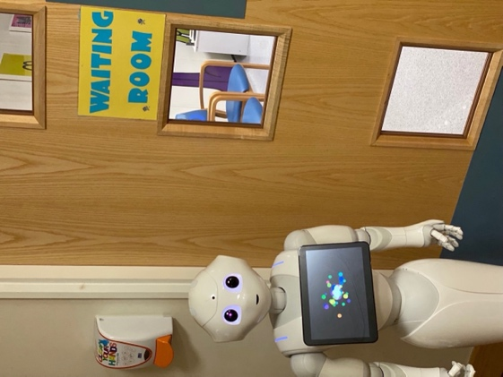 | 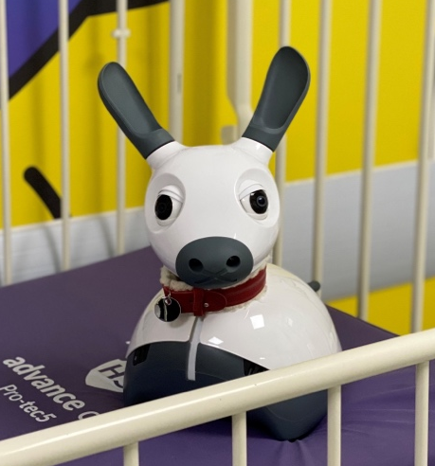

  - Types of play interventions

Many hospitals have been working hard to create spaces and play interventions that provide paediatric patients with a better hospital experience. Li et al. (2016) wrote about four types of play used in hospitals to manage paediatric patients' anxiety levels better: preparation play, medical play, developmental play, and distraction play. These types of play have been used successfully in the healthcare sector to reduce anxiety and distress in paediatric patients visiting the hospital for several years (Li et al., 2016). Preparation play has been around for a long time, and studies have shown there are benefits to preparing families and making them aware of the medical procedure (Brewer et al., 2006). Schwartz (1983) compared three groups of paediatric patients due to visit the hospital for in-hospitalised dental operations. One group received no preparation, the second group received the unrelated play, and the third group, as part of their preoperative session, received play which focused on the hospital and surgical procedures. Results showed that paediatric patients who received hospital surgical-related play benefited the most from the session with more cooperative behaviour out of the three groups (Schwartz and Albino, 1983; Brewer et al., 2006).
Medical play involves familiarising children with the hospital setting and procedures and encouraging children to express their feelings through medically playing with dolls, all while using hospital equipment and outfits (Li and Lopez, 2006). For example, Ellerton and Merriam (1994) had nurses visit children with dolls and hospital equipment to help children familiarise themselves and rehearse for their day surgery. The aim was to help them clarify their understanding and have a run-through of the upcoming event (Ellerton and Merriam, 1994). Another example of an intervention designed to address the psychosocial well-being of children in a hospital setting is the implementation of development play. This approach, as highlighted by Li and Lopez (2006), is specifically geared towards preventing regression in psychosocial development that children may experience during their hospitalisation. Developmental play involves age-appropriate activities and interactions that encourage cognitive, emotional, and social growth. These activities can include art projects, games, storytelling, and other creative endeavours tailored to the child's developmental stage. By providing opportunities for play and social interaction, this intervention not only helps maintain a sense of normalcy but also contributes to the child's overall well-being (Li and Lopez, 2006).
The last type of play discussed in the Li et al. (2016) paper is distraction play. Distraction play involves children in activities that consist of games and toys, puppets, music and other relaxation techniques to reduce anxiety and distress in children visiting the hospital (Li et al., 2016). Distraction play is a valued method widely used to reduce negative emotions in healthcare (Li et al., 2016). It has been used with paediatric patients coming in for surgery. Music and sound have been used as a method of distraction play for paediatric patients visiting the emergency departments (EDs) (Weiland et al., 2011; Tranquada, Chen and Chisik, 2013), as well as blowing soap bubbles for patients on the oncology unit (HedÉn, Von Essen and Ljungman, 2009). Research has shown that through play, children are happier expressing their feelings about the hospital and have reduced anxiety and distress (Li et al., 2016; Dawe et al., 2019).

  - The growing use of social robots in healthcare

Social robots are gradually being used and assessed in healthcare settings for paediatric patients (van Bindsbergen et al., 2022). Social robots are autonomous robots that interact with human beings through games, play, and conversations (Beran et al., 2015). There are different types and forms of social robots, some are anthropomorphic, like KASPER, a child-like male with a head, arm and hands that move, and others are non-anthropomorphic, like PARO, a sealike robot with tactile sensors all around its body (Cabibihan et al., 2013). The use of social robots in the healthcare sector is slowly increasing due to their significant potential to support paediatric patients in managing their negative emotions (Dawe et al., 2019; Littler et al., 2021). Social robots are a helpful tool for encouraging interaction from children of all ages and abilities. Studies have researched the impact social robots have had on children in the classroom (Woo et al., 2021), including children suffering from several disabilities (Van den Heuvel et al., 2017) and children with Autistic Spectrum Disorder (ASD) (Huijnen et al., 2016). Social robots are a popular interaction tool because they can be programmed to play games, tell stories and act as a companion. (Jibb et al., 2018; Dawe et al., 2019).
Despite the growing interest, fewer studies have explored the types of impact social robots have on paediatric patients and how they play within a stressful environment. Many studies have focused on elderly care but only ten for paediatric patients (Littler et al., 2021). One study investigated if a social robot named Paro could act as a companion to reduce pain and anxiety in paediatric patients aged 6 to 16 in hospitals. In this study, pain was reduced slightly, and there was a decrease in negative emotions (Okita, 2013). However, the participants were only females, and a parent was present and involved in the interaction. Another study used a social robot to interact with paediatric patients with cancer. The social robot was programmed to perform a series of 8 psychotherapy tasks to address emotions around cancer with the children involved. However, these sessions were carried out over a month. The study saw a drop in the children's anger, anxiety and depression levels (Alemi et al., 2016). Both studies showed that social robots have a promising role in the healthcare sector. However, there is still a lack of understanding and evidence about the role social robots play in a hospital environment, the types of interactions that occur and the insights from key stakeholders involved such as paediatric patients themselves, parents and healthcare professionals. The four hospital settings used in this research are the Theatre Admission Unit, Medical Day Care Unit, the Oncology and Haematology Unit, and a mixed internal medicine clinical ward.
While interventions aimed at reducing anxiety in children during hospital visits are crucial, it is essential to consider additional factors such as ethical implications and any associated costs (Ahn et al., 2018; Rossi et al., 2018). Ethical concerns may arise in the collection and use of sensitive data, ensuring the well-being and autonomy of the children involved, and maintaining a balance between technological solutions and the human touch in healthcare interactions (Parviainen, Turja and Van Aerschot, 2018; Vänni, Cabibihan and Salin, 2018). Moreover, the implementation of these interventions involves financial considerations, including the cost of technology, training and programming, and ongoing maintenance, cleaning and sterilisation (Ahn et al., 2018; Schneider and Kummert, 2018). However, the financial impacts as well as the potential benefits of different social robot interventions can vary considerably, and should be compared with the costs, benefits and potential harm of other types of interventions on a case-by-case basis. Striking a balance between the benefits of anxiety reduction and the ethical and financial implications is pivotal for the sustainable and responsible integration of such interventions in paediatric healthcare settings (Broadbent, Johanson and Shah, 2018; Rossi et al., 2018).

  - Aims and outline of the thesis.

This thesis focuses on the potential use of social robots at children's hospitals and aims to 1) examine the feasibility of using a social robot with paediatric patients in four different hospital settings; 2) observe how paediatric patients interacted with the different social robots in each of the hospital settings; 3) to gather feedback on paediatric patients’ and their parents’ experience with the social robots; 4) to obtain insights into the opinions of healthcare professional in the use of social robots mitigating anxiety in paediatric patients.
The main objectives of this study were:
- To gather available evidence on the use of social robots in hospital environments by conducting a literature review – Chapter 2

- To gather background information on which social robots that have been used to reduce anxiety and distress in hospitals with a systematic review – Chapter 4

- To examine the effects of introducing two social robots into four hospital settings on paediatric patients by observing the interaction – Chapter 5

- To gain insight from parents or guardians on the use and effectiveness of social robots in a hospital environment – Chapter 6

- To gain insight from health professionals on their opinions and views on the use of social robots in a hospital environment – Chapter 7

  - Structure of the Thesis

Chapter 1: Introduction (presented above)
This chapter gives a general overview of the PhD's research and the thesis's structure.
Chapter 2: Background
This chapter introduces the literature on paediatric patients and the types of interventions used to reduce anxiety and negative emotions. There is also an introduction to social robots in the healthcare sector.
Chapter 3: Systematic Review
This chapter presents a systematic review which assesses the current evidence on the impact social robots have on paediatric patients' levels of anxiety or distress when visiting the hospital.
Chapter 4: Methodology and Methods
This chapter details the methodological approach and methods used throughout the thesis to collect and analyses data, including sampling processes and ethical considerations.
Chapter 5: Paediatric patients' interaction with social robots: an observational study
This chapter describes the study's results involving thirty-two participants interacting with Pepper and MiRo. This study explored the ways paediatric patients played, the benefits, and any barriers.
Chapter 6: Parents' Perceptions of the Use of Social Robots in a hospital environment
This chapter describes the results from the questionnaires given to parents or guardians before and after their child interacts with a social robot. Quantitative measures were used to evaluate aspects of acceptability and utility from the parent's point of view.
Chapter 7: The acceptability of social robots in a hospital environment through the eyes of healthcare professionals
This chapter describes the results of qualitative semi-structured interview with healthcare professionals from the Sheffield Children's Hospital. Eight healthcare professionals participated in this study and were asked to share their opinions and thoughts on social robots being an intervention tool for mitigating anxiety and distress in children visiting the hospital.
Chapter 8: General Discussion
This chapter provides a summary and discussion of the main findings and highlights the implications for research and practice.

1.7 References

Ahn, H. S., Zhang, S., Lee, M. H., Lim, J. Y., & MacDonald, B. A. (2018). Robotic healthcare service system to serve multiple patients with multiple robots. In Social Robotics: 10th International Conference, ICSR 2018, Qingdao, China, November 28-30, 2018, Proceedings 10 (pp. 493-502). Springer International Publishing.
Alemi, M. et al. (2016) ‘Clinical Application of a Humanoid Robot in Pediatric Cancer Interventions’, International Journal of Social Robotics, 8, pp. 995–1124. Available at: https://doi.org/10.1007/s12369-015-0294-y.
Beran, T.N. et al. (2015) ‘Humanoid robotics in health care: An exploration of children’s and parents’ emotional reactions’, Journal of Health Psychology, 20(7), pp. 984–989. Available at: https://doi.org/10.1177/1359105313504794/FORMAT/EPUB.
van Bindsbergen, K.L.A. et al. (2022) ‘Social robots in pediatric oncology: opinions of health care providers’, Journal of Psychosocial Oncology Research & Practice, 4(2), p. e073. Available at: https://doi.org/10.1097/or9.0000000000000073.
Brewer, S. et al. (2006) ‘Pediatric Anxiety: Child Life Intervention in Day Surgery’, Journal of Pediatric Nursing, 21(1), pp. 13–22. Available at: https://doi.org/10.1016/J.PEDN.2005.06.004.
Broadbent, E., Johanson, D., & Shah, J. (2018). A new model to enhance robot-patient communication: applying insights from the medical world. In Social Robotics: 10th International Conference, ICSR 2018, Qingdao, China, November 28-30, 2018, Proceedings 10 (pp. 308-317). Springer International Publishing.
Cabibihan, J.J. et al. (2013) ‘Why Robots? A Survey on the Roles and Benefits of Social Robots in the Therapy of Children with Autism’, International Journal of Social Robotics. Kluwer Academic Publishers, pp. 593–618. Available at: https://doi.org/10.1007/s12369-013-0202-2.
Dawe, J. et al. (2019) ‘Can social robots help children in healthcare contexts? A scoping review’, BMJ Paediatrics Open. BMJ Publishing Group. Available at: https://doi.org/10.1136/bmjpo-2018-000371.
Ellerton, M. ‐L and Merriam, C. (1994) ‘Preparing children and families psychologically for day surgery: an evaluation’, Journal of Advanced Nursing, 19(6), pp. 1057–1062. Available at: https://doi.org/10.1111/J.1365-2648.1994.TB01188.X.
HedÉn, L., Von Essen, L. and Ljungman, G. (2009) ‘Randomized interventions for needle procedures in children with cancer’, European Journal of Cancer Care, 18(4), pp. 358–363. Available at: https://doi.org/10.1111/J.1365-2354.2008.00939.X.
Van den Heuvel, R.J.F. et al. (2017) ‘Robots supporting play for children with physical disabilities: exploring the potential of IROMEC’, Technology and Disability , 29(3), pp. 109–120.
Huijnen, C.A.G.J. et al. (2016) ‘Matching Robot KASPAR to Autism Spectrum Disorder (ASD) Therapy and Educational Goals’, Int J of Soc Robotics, 8, pp. 445–455. Available at: https://doi.org/10.1007/s12369-016-0369-4.
Jeong, S. et al. (2015) ‘A Social Robot to Mitigate Stress, Anxiety, and Pain in Hospital Pediatric Care’, in ACM/IEEE International Conference on Human-Robot Interaction. IEEE Computer Society, pp. 103–104. Available at: https://doi.org/10.1145/2701973.2702028.
Jibb, L.A. et al. (2018) ‘Using the MEDiPORT humanoid robot to reduce procedural pain and distress in children with cancer: A pilot randomized controlled trial’, Pediatric Blood & Cancer, 65(9), p. e27242. Available at: https://doi.org/10.1002/pbc.27242.
Lerwick JL. (2016) ‘Minimizing pediatric healthcare-induced anxiety and trauma’, World Journal of Clinical Pediatrics, 5(2), pp. 143–150. Available at: https://doi.org/10.5409/wjcp.v5.i2.143.
Li, H.C.W. and Lam, H.Y.A. (2003) ‘Paediatric day surgery: Impact on Hong Kong Chinese children and their parents’, Journal of Clinical Nursing, 12(6), pp. 882–887. Available at: https://doi.org/10.1046/J.1365-2702.2003.00805.X.
Li, H.C.W. and Lopez, V. (2006) ‘Assessing children’s emotional responses to surgery: a multidimensional approach’, Journal of Advanced Nursing, 53(5), pp. 543–550. Available at: https://doi.org/10.1111/J.1365-2648.2006.03756.X.
Li, W.H.C. et al. (2016) ‘Play interventions to reduce anxiety and negative emotions in hospitalized children’, BMC Pediatrics, 16(1). Available at: https://doi.org/10.1186/s12887-016-0570-5.
Littler, B.K.M. et al. (2021) ‘Reducing negative emotions in children using social robots: Systematic review’, Archives of Disease in Childhood, 106(11), pp. 1095–1101. Available at: https://doi.org/10.1136/ARCHDISCHILD-2020-320721.
Moerman, C.J., van der Heide, L. and Heerink, M. (2019) ‘Social robots to support children’s well-being under medical treatment: A systematic state-of-the-art review’, Journal of Child Health Care, 23(4), pp. 596–612. Available at: https://doi.org/10.1177/1367493518803031/FORMAT/EPUB.
Mubin, O., Ahmad, M. I., Kaur, S., Shi, W., & Khan, A. (2018). Social robots in public spaces: A meta-review. In Social Robotics: 10th International Conference, ICSR 2018, Qingdao, China, November 28-30, 2018, Proceedings 10 (pp. 213-220). Springer International Publishing.
Nilsson, S., Buchholz, M. and Thunberg, G. (2012) ‘Assessing Children’s Anxiety Using the Modified Short State-Trait Anxiety Inventory and Talking Mats: A Pilot Study’, Nursing Research and Practice, 2012, pp. 1–7. Available at: https://doi.org/10.1155/2012/932570.
Parviainen, J., Turja, T., & Van Aerschot, L. (2018, November). Robots and human touch in care: desirable and non-desirable robot assistance. In International Conference on Social Robotics (pp. 533-540). Cham: Springer International Publishing.
Rossi, S., Bove, L., Di Martino, S., & Ercolano, G. (2018). A two-step framework for novelty detection in activities of daily living. In Social Robotics: 10th International Conference, ICSR 2018, Qingdao, China, November 28-30, 2018, Proceedings 10 (pp. 329-339). Springer International Publishing.
Okita, S.Y. (2013) ‘Self-Other’s Perspective Taking: The Use of Therapeutic Robot Companions as Social Agents for Reducing Pain and Anxiety in Pediatric Patients’, Cyberpsychology, Behavior, and Social Networking, 16(6). Available at: https://doi.org/10.1089/cyber.2012.0513.
Schneider, S., & Kummert, F. (2018). Comparing the effects of social robots and virtual agents on exercising motivation. In Social Robotics: 10th International Conference, ICSR 2018, Qingdao, China, November 28-30, 2018, Proceedings 10 (pp. 451-461). Springer International Publishing.
Schwartz, B.H. and Albino, J.E. (1983) ‘Effects of psychological preparation on children hospitalized for dental operations’, The Journal of Pediatrics, 102(4), pp. 634–638. Available at: https://doi.org/10.1016/S0022-3476(83)80211-X.
Tranquada, S., Chen, M. and Chisik, Y. (2013) ‘Hospital hero: A game for reducing stress and anxiety of hospitalized children in emergency room’, Lecture Notes in Computer Science (including subseries Lecture Notes in Artificial Intelligence and Lecture Notes in Bioinformatics), 8253 LNCS, pp. 638–641. Available at: https://doi.org/10.1007/978-3-319-03161-3_71/COVER.
Vänni, K. J., Cabibihan, J. J., & Salin, S. E. (2018). Attitudes of heads of education and directors of research towards the need for social robotics education in Universities. In Social Robotics: 10th International Conference, ICSR 2018, Qingdao, China, November 28-30, 2018, Proceedings 10 (pp. 472-482). Springer International Publishing.
Weiland, T.J. et al. (2011) ‘Original sound compositions reduce anxiety in emergency department patients: a randomised controlled trial’, Medical Journal of Australia, 195(11–12), pp. 694–698. Available at: https://doi.org/10.5694/MJA10.10662.
Woo, H. et al. (2021) ‘The use of social robots in classrooms: A review of field-based studies’, Educational Research Review, 33, p. 100388. Available at: https://doi.org/10.1016/J.EDUREV.2021.100388.

Chapter 2

The story behind paediatric anxiety and the development of social robots: Background

This chapter introduces the literature on paediatric patients and the types of interventions used to reduce anxiety and negative emotions. There is also an introduction to social robots in the healthcare sector.
2 Introduction

2.1 Anxiety in paediatric patients
Anxiety is common among children in stressful situations (Shirley, N. Thompson, & Johnston, 1998). Approximately sixty percent of children who undergo anaesthesia encounter notable levels of anxiety during the process (Fortier & Kain., 2015; Kain, Mayes, & O'Connor, 1996). Anxiety and fear have been known to provoke challenging behaviour in children, such as refusing to cooperate, withdrawing from a situation, or kicking and screaming (Caumo, et al., 2000). When children scheduled to have elective surgery were asked about the worst and most worrying parts of their hospital visit, they reported that these were; the operation, the needles, staying overnight, and the smell of the hospital (Wollin, et al., 2004). Further research has linked high levels of anxiety in children during anaesthesia to bedwetting, food rejection and nightmares after their procedures (Lumley, Melamed, & Abeles, 1993; Wollin, et al., 2004; McCann & Kain, 2001). Since each child is different, they can be affected by anxiety in different ways. Researchers have stressed the crucial importance of reducing anxiety in children visiting the hospital (Kerimoglu, Neuman, Paul, Stefanov, & Twersky, 2013). In recent decades, healthcare professionals have been developing preparation programs and interventions to reduce anxiety in children visiting the hospital (McCann & Kain, 2001; Brewer et al., 2006; Fortier & Kain, 2015).

2.2 Difference between Worry and Anxiety

Worry and anxiety represent distinct yet interconnected concepts in psychological literature. Worry is a cognitive process involving the contemplation of potential problems or uncertainties, often accompanied by feelings of unease (Borkovec et al., 1983). This mental preoccupation can be transient, responding to specific situations, or it may manifest as a more persistent cognitive pattern (Davey & Wells, 2006).
In contrast, anxiety describes an emotional state characterised by heightened apprehension, uneasiness, or nervousness, particularly in anticipation of uncertain future events (American Psychiatric Association, 2013). Anxiety, as an emotional response to perceived threats or stressors, involves a more intense and pervasive experience compared to occasional worry (Barlow et al., 2002). While worry primarily involves cognitive processes, anxiety encompasses a broader emotional and physiological spectrum, reflecting a deeper and more visceral response to perceived challenges (Craske et al., 2009).
Both worry and anxiety are recognised as normal aspects of the human experience (Davey & Wells, 2006), but when they become chronic or significantly impact daily life, they may warrant attention and intervention.

2.3 Interventions used to reduce anxiety in paediatric patients.
Researchers have concentrated on studying the effectiveness of interventions that aim to ease anxiety in paediatric patients in four key areas. These interventions include music therapy, play therapy, video clip interventions, and mobile phone applications. Investigating the impact of these approaches provides valuable insights into their potential contributions to reducing anxiety among young patients.

2.3.1 Music therapy intervention
Music therapy has been a recognised form of intervention in the medical and rehabilitation field for a long period of time. It is an effective intervention which has been known to reduce pain and anxiety among children with mental health disorder (Shuman, Kennedy, DeWitt, Edelblute, & Wamboldt., 2016). McClurkin et al. (2016) conducted a study comparing anxiety levels among hospital patients who listened to music before their procedures and those who did not. Participants in the experimental group selected their preferred music and played it on an MP3 player for either 15 or 30 minutes. Anxiety levels were assessed using the State-Trait Anxiety Inventory (STAI) and the Numerical Visual Analog Anxiety Scale (NVAAS) before and after the intervention. The study found that participants who listened to music for at least 15 minutes experienced significantly reduced anxiety levels, as measured by both the STAI and NVAAS. These findings suggest that music therapy can effectively alleviate anxiety in hospital patients (McClurkin & Smith, 2016).
There has been a selection of studies which have combined music with other forms of intervention. Nelson et al. 2017, examined the effects of introducing music assisted relaxation training to young people between the ages of 10 to 19 before surgery in a healthcare environment. The participants were shown a 12-minute video about music relaxation, with the opportunity to practise beforehand. They were also given a music therapy session with a certified music therapist. The study found a significant reduction in anxiety and pain in the participants who took part (Nelson, Adamek, & Kleiber, 2017). Similarly, a study by Ortiz et al., 2019, combined music therapy and visit from the child life specialist to investigate the efficacy of minimising distress levels in children between the ages of 4 to 11. They had parents answer two 4 item questionnaires before and after the interaction. The study found that parents reported the intervention had helped their child by reducing distress levels (Ortiz, et al., 2019).

2.3.2 Play therapy intervention
Play therapy or creative play has been recognised as highly therapeutic for hospitalized children (Koukourikos, Tzeha, Pantelidou, & Tsaloglidou, 2015). In a study conducted by Li et al. (2008), the effectiveness of therapeutic play on 203 hospitalised children aged 7 to 12 was examined. Prior to their appointments, children participated in therapeutic play interventions, which included activities like hospital tours and demonstrations using dolls. Anxiety levels were measured using a Chinese version of the State Anxiety Scale for Children (CSAS-C). The results revealed that children who underwent the play therapy intervention exhibited lower anxiety scores. These findings underscore the value of preparation programs and play therapy in mitigating anxiety among hospitalized children (Li & Lopez, 2008).
Puppet play can also be effective in reducing anxiety levels. An experienced puppet play psychologist carried out the preparation program, in a study by Athanassiadou et al, a day before their minor surgery. During the play, the child was informed about their hospital visit and briefed on what to expect. The study established that the intervention was successful in managing challenging behaviour and distress levels specifically in children between age 4 to 6 (Athanassiadou, Tsiantis, Christogiorgos, & Kolaitis, 2009). Today many hospitals understand the importance of play and have invested time and money in creating playrooms for children. A group of researchers designed a playroom next to the operating room to study whether play sessions before surgery, could reduce anxiety levels in children. They recruited 200 children with a mean age of 4.33 (+/-1.5) and used a modified Yale Preoperative Anxiety Scale (mYAS) to measure the anxiety levels. The mYAS is efficient easy and a validated assessment tool for measuring children’s anxiety levels. The study discovered that a playroom intervention was a very effective method of preventing anxiety among children (Hosseinpour & Memarzadeh., 2010).

2.3.3 Video clips interventions
Preparing children for the hospital or distracting them from worrying, through v0ideo clips, has been an effective method in the healthcare sector. A study by Melamed and Siegel in 1975 showed 40 children aged 4 to 12 a relevant peer modelling film or an independent control film. The children who watched the peer modelling film of a child being hospitalised showed lower levels of sweat gland activity and displayed fewer anxiety-related behaviours (Melamed & Siegel, 1975). Thirty-seven years later, a study by Mifflin et al. 2012, recruited 89 children aged between 2 and 10 and randomly assigned them into a video distraction group. The aim of this study was to determine if video distraction could be a clinical tool for anaesthesiologists to use in order to help children reduce anxiety levels. The study used the mYAS to evaluate anxiety levels on the day before and after the interaction. They found children who were in the video groups were significantly less anxious during their medical procedur0e (Mifflin, Hackmann, & Chorney, 2012).
In a study by Lee et al. (2012), 130 children aged 3 to 7 were randomly assigned to one of three groups: a control group, a group provided with toys, and a group that watched animated cartoons. Anxiety levels were assessed using the modified Yale Preoperative Anxiety Scale (mYAS). The third group watched their preferred animated cartoon using a notebook and personal tablet. The study concluded that allowing children to watch animated cartoon clips effectively reduced anxiety levels before surgery (Lee et al., 2012).
In contrast, Kerimoglu et al. (2013) conducted a randomized study involving 96 children aged 4 to 9 scheduled for outpatient surgery. Utilizing the same measurement tool, the researchers provided the children with video glasses as a behavioural distraction method. These glasses enabled the children to watch movies and cartoons of their choice before surgery. The study found that the use of video glasses prevented anxiety levels from escalating among participants before the administration of anaesthesia (Kerimoglu et al., 2013; Chow et al., 2016)..

2.3.4 Mobile application intervention
Edge Hill University conducted a study investigating anxiety levels among children visiting the Royal Manchester Children’s Hospital. The study introduced an app called Xploro to children attending hospital appointments. Xploro, an augmented reality and gameplaying app, provided engaging information for children and their parents or carers. Feedback regarding the app was overwhelmingly positive, with both children and parents expressing appreciation for its interactive and informative features. The study revealed that children who used the app reported lower anxiety levels and felt better prepared for their hospital visits, resulting in a more positive overall experience (Bell, 2019).
Similarly, Norfolk and Norwich University Hospitals implemented a mobile app named ‘The Little Journey App’. This app features a virtual reality doctor and nurse, as well as a hospital tour, with the goal of reducing anxiety in children prior to their hospital appointments. By offering information and familiarizing children with the hospital environment from the comfort of their homes, the app aims to alleviate anxiety and improve the hospital experience (Norfolk and Norwich University, 2019).
These initiatives reflect a growing trend in leveraging technology to enhance healthcare experiences, with social robots emerging as a promising avenue for future interaction.

2.4 Social robots as an intervention
An increasing number of studies have shown how social robots can be used in the health care sector. Studies have mainly explored the use of social robots with the ageing population and children. Social robots possess unique characteristics that other distraction techniques do not, and that is the ability to promote interaction and engagement through people projecting personalities onto the social robot and have people assume intentionality of action as an enhanced mechanism. A study by Graaf et al. (2015) explored the character of a social robot from a user's perspective by introducing it into homes and discovering which social behaviours and features social robots should contain if they are to act more human-like. Results found people expected the social robots to be able to have two-way conversations expressing that two-way interaction was a desired factor. The second most popular characteristic was thoughts and feelings, indicating that social robots should act as though they had thoughts and feelings and display actions that could be interpreted as human-like emotions. Other factors were cosiness, social awareness, and social support. This study concluded that whilst people involved would agree the social robot was a machine while interacting with it, they would also respond to the social robot similarly to other humans (De Graaf et al., 2015).

2.4.1 Social robots for the ageing population
There is growing interest and adoption of social robots in the healthcare field. Evidence from the literature suggests social robots have the potential to support the wellbeing of the ageing population (Hutson, Lim, Bentley, Bianchi-Berthouze, & Bowling, 2011). In 2017, a pilot study was conducted by Abdollahi et al. to assess the feasibility of a social robot named Ryan (see figure 2.1), as a companion robot. The study involved six elderly individuals who had depression and dementia. The robot was programmed to play cognitive games, music and allowed participants to view family albums. Each participant had access to Ryan 24/7 for a 4 to 6-week period. At the end of the study, each individual had a 5-point scale questionnaire to complete about their experience. The results showed that each participant accepted the robot as a companion, enjoyed interacting with its functions and would be interested in welcoming a social robot into their living space. Caregivers, licensed nurses, also gave feedback about the interactions between the robot and the participants and said that the robot was able to develop a deep connection with the participants (Abdollahi, Mollahosseini, Lane, & Mahoor., 2017).
Figure 2.1: A participant interacting with Ryan
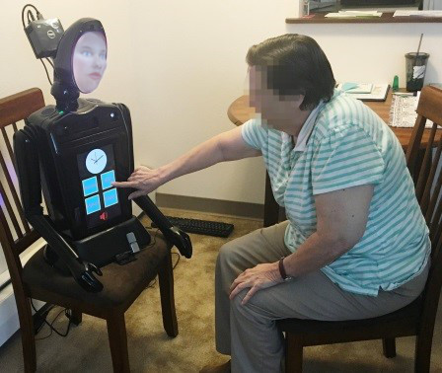
© Abdollahi et al. 2017 IEEE

Similarly, a study explored robot therapy with patients with dementia using a robot called Paro, a seal-like robot (see figure 2.2). Fourteen participants were given a robot to interact with during therapy. A 5-minute electroencephalogram (EEG) recording was performed on each patient to analyse their pattern of brain activity during the interaction. 20 minutes after the interaction, a questionnaire was administered to gather information about their impression of Paro. The study reported that the interaction reduced stress and encouraged the participants to engage more actively during their therapy sessions. One participant treated Paro as their grandchild, and she hugged and spoke to Paro while smiling (Wada, Shibata, Musha, & Kimura, 2008). Paro received Guinness World Record Certification in 2002 for the “World’s Most Therapeutic Robot (Okita, 2013).
Figure 2.2: Paro the Seal Robot

Robinson et al. 2015 © John Wiley and Sons

2.4.2 Social robots for children with Autism Spectrum Disorder (ASD)
Alongside supporting the well-being of the ageing population, social robots are increasingly designed to interact and improve the social behaviours and emotional interactions of children with ASD. A study introduced a dinosaur toy robot called Pleo, which has been programmed to interact with children with ten different conditions as well as socially expressive acts (see figure 2.3). The study examined the social reactions of 24 children with ASD during their interaction with the social robot, alongside an adult. The social robot displayed frequent movements such as walking, picking up food with its mouth, and dancing by moving its head and body. Each child took part in semi-structured interviews. One potential challenge with conducting semi-structured interviews with children after interacting with a social robot is the issue of rapport and comfort. Children may feel intimidated or uncomfortable sharing their experiences and feelings with an adult interviewer, especially if they perceive the interaction as formal or intrusive. This discomfort may be exacerbated if the child is already experiencing heightened anxiety or apprehension, particularly in a hospital or clinical setting. The study found that social robots were a useful tool for teaching children with ASD social skills and could be used successfully in communication therapies. A key finding was that all children used more verbal communication, at different extent, when interacting with the robot (Kim, et al., 2013).
Figure 2.3: Pleo

Kim et al. 2013 © Springer Nature

KASPER is a small humanoid robot designed by the University of Hertfordshire designed originally to support children with ASD (see Figure 2.4.). KASPER is programmed to act as a social companion to improve the wellbeing of children with ASD and help them develop their communication skills. KASPER mimics human expressions, something done purposely due to research feedback received from parents, healthcare professionals and teachers (Huijnen, Lexis, & Witte, 2016; Hertfordshire, 20019). KASPER has been used to investigate robot-assisted play with children with ASD. The aim was to teach the children about the human body in order to increase their awareness. Children were in a common room in their school and would sit opposite KASPER. KASPER would identify a body part such as the head and then ask the child to point to their head. If the child was correct, KASPER would respond with positive reinforcement. If the child was wrong, KASPER would encourage the child to try again. The results from this study showed that children were spending an extended period looking at different body parts and enjoyed touching the robot. Overall, the study concluded KASPER could be used as a tool to support attention span and can be an additional tool in learning environments (Costa, Lehmann, Robins, Dautenhahn, & Soares, 2013).
Figure 2.4: KASPER
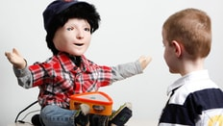
© 2019 The University of Hertfordshire

2.4.3 Social robots supporting children with type 1 diabetics mellitus (T1DM)
Children with type 1 diabetes are encouraged to manage their diabetes with the correct support. Researchers have been investigating the potential of having social robots support children in managing their diabetes and to educate them about their condition. A pilot study recruited five children aged 8 to 12 with T1DM and had them interact with a social robot named NAO over three sessions (see figure 2.5.). The first session was at the clinic, and the other two were at the children’s homes. The robot was programmed to support the children answer with quizzes on diabetes, engage in small talk by asking their names, favourite colours and more. The robot shared facts about diabetes with the child and interacted with the child playfully. The study found that children enjoyed interacting with the social robot and indicated that social robots could help to improve children’s understanding of their condition (Blanson, et al., 2013).
Figure 2.5: NAO in Belanson et al. 2013 Study
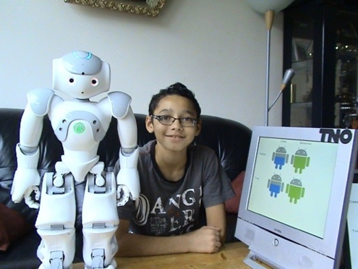
Belanson et al. 2013 © 2013 Elsevier

2.5 Using social robots to improve wellbeing.
Social robots are being designed and developed to improve the well-being and mental health of adults and children. They have been used to support patients with mental health problems, children with educational anxiety, and recently children who have been hospitalised.

2.5.1 Mental health and well-being
Paro the seal robot (see figure 2.2) was introduced to 83 elderly individuals across 10 care facilities for a period of 5 months in a study conducted by Wada et al. 2014. The aim of the study was to assess and observe the behaviours relating to mood e.g. anxiety, depression, and aggression within the elderly participants. Two evaluation sheets were created to collect data, before and after the participant’s interactions with Paro. The second evaluation sheet was an observation sheet to evaluate the influence of Paro. It explored the likes and dislikes of Paro as well as the interaction and change in dementia symptoms. The inclusion of an observation sheets offers a comprehensive approach, capturing both subjective experiences and objective behaviours. The study saw a decrease in perceived anxiety, depression or aggression among some of their participants. One participant, who had Parkinson’s disease, was known to react angrily to various situations and according to his wife and children, he would sometimes feel anxious and irritated. The participant responded positively to Paro and moreover, he talked to his wife more with a smile. The study found Paro to be a useful tool for supporting mental health and well-being (Wada, et al. 2014).
Likewise, another study introduced a robot named Betty to young adults with neuropsychiatric conditions. Betty is a socially assistive robot developed to respond with human-like gestures. Betty can be programmed to the preference of the user and offers the ability to play music, read books and play games. Betty's programmability to cater to user preferences presents a notable advantage, allowing customization of its functionalities to suit individual needs. Furthermore, its diverse capabilities, including playing music, reading books, and engaging in games, offering users a versatile and immersive experience tailored to their interests and preferences. The study’s aim was to assess the well-being, enjoyment, and quality of life of the participant after their interaction with Betty (see figure 2.6). Betty was presented for a period of 12 weeks and participants could engage with the robot as much as they wanted. Staff nurses were asked to complete pre and post questionnaires based on their perception before and after their interaction with Betty. The staff reported that patients enjoyed being comforted by Betty and that Betty improved the well-being of their patients. Relying solely on staff feedback presents a limitation in capturing the direct perspectives and experiences of patients themselves. Without direct input from patients, there's a risk of overlooking nuanced aspects of their interactions with Betty and their true feelings towards the robotic intervention. This could potentially lead to a lack of comprehensive understanding and may limit the validity and reliability of the assessment of Betty's effectiveness in improving patient well-being. (Loi, et al., 2018).
Figure 2.6: Betty
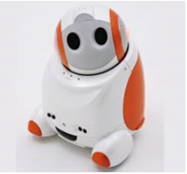
Scoglio et al. 2019 © Journal of Medical Internet Research

2.5.2 Educational anxiety
A study included forty-six children aged 12 from an Iranian high school. The aim of the study was to examine the effort of robot assisted language learning on children learning English. Additionally, the study investigated the anxiety levels of the student’s English vocabulary acquisition as well as attitude. The intervention involved the NAO robot (see figure 2.5) and a teacher. Researchers used two questionnaires to measure the anxiety and attitude levels of the students. One of the questionnaires was the Foreign Language Classroom Anxiety scale (FLCAS). It has been named one of the most accurate scales for classroom anxiety. Another questionnaire was based on Vandewaetere and Desmet’s questionnaire, which is used to evaluate attitude. The robot was used as an assistant teacher and programmed to teach for a few minutes in each lesson. The results showed the groups with the robot had a much more enjoyable time learning English vocabulary and had lower anxiety levels in the classroom as well as a positive attitude towards learning (Alemi, Meghdari, & Ghazisaedy., 2015).

2.5.3 Reducing anxiety and distress in paediatric patients.
Significant strides have been made in applying social robots within specific healthcare settings, enhancing interaction and communication. Considering the effectiveness of previous interventions in reducing anxiety in hospital settings, there is potential for social robots to be introduced as a means of alleviating anxiety. However, progress in this area has been limited thus far. A recent systematic review examined the existing evidence supporting the positive impact of social robots on children visiting hospitals. The review identified ten studies investigating the reduction of anxiety or distress in paediatric patients following interactions with social robots. While the review revealed a promising role for social robots in healthcare, further research is needed to bolster these findings and strengthen their applicability in clinical practice (Littler, Alessa, Dimitri, Smith, & Witte, 2021).

2.6 Conclusion
In the realm of interventions to ease anxiety in paediatric patients, various approaches have been explored, each offering unique benefits and considerations. Music therapy interventions involve the use of music to promote relaxation and emotional well-being. Play therapy, a well-established method, engages children in therapeutic play activities to address emotional and psychological challenges. Video clip interventions leverage visual stimuli to distract and comfort young patients. Mobile phone applications provide interactive tools for relaxation and information dissemination. Notably, social robots have emerged as a novel intervention, offering interactive companionship and assistance. While music and play therapies have demonstrated effectiveness, video clips and mobile applications provide accessible and technologically driven alternatives. Social robots, with their ability to elicit emotionally and interactionally focused engagement, present a promising avenue for future exploration. In addition to distracting children from elements of the environment that they might find distressing, there is also potential for social-robot interactions to be designed with wider therapeutic or educational benefit, such as helping them to come to terms with their experiences and circumstances or preparing them for clinical procedures.
Anxiety levels among children in the UK are on the rise, with a notable increase in children aged nine and under receiving treatment for anxiety in 2016/2017, as reported by NHS Digital (Donnelly, 2017). Hospitals are experiencing heightened activity, resulting in longer waiting periods (Matthews-King, 2018; Matthews & Blanchard, 2019). Social robots offer a unique multi-sensory experience that integrates various interventions such as music, play, and mobile interaction into one cohesive approach (Beran, Ramirez-Serrano, Vanderkooi, & Kuhn, 2013). Unlike mobile phone applications, music therapy, and video theory, social robots provide a broader range of functionalities and experiences. With their diverse capabilities, social robots have the potential to positively impact children's anxiety levels during hospital visits (Littler et al., 2021).
While previous studies have highlighted the areas where social robots have shown promise, there remains a lack of understanding regarding children's specific needs and preferences when interacting with these robots in hospital settings. Therefore, further research is needed to address gaps in knowledge, including understanding how children respond to social robots in stressful situations, their role in different hospital environments, and their feasibility within busy hospital settings. These unanswered questions underscore the necessity for additional research to determine the true potential of social robots as a tool for reducing anxiety among paediatric patients.
Due to the potential challenges associated with conducting semi-structured interviews with children after interacting with a social robot, such as issues of rapport and discomfort, alternative methods like questionnaires could be more suitable for data collection in clinical settings. However, relying solely on staff feedback presents a significant limitation as it overlooks the direct perspectives and experiences of patients themselves. To address this limitation and enhance the validity and reliability of assessments, questionnaires allow children to express their experiences and feelings in a less intimidating and formal manner, potentially yielding more honest and nuanced responses, which can be particularly beneficial in hospital or clinical settings where children may already be experiencing heightened anxiety or apprehension. Future studies should involve both children and parents as well as health professionals, ensuring that their voices are heard, and their experiences accurately captured.
Furthermore, it is important to consider the programmability and diverse capabilities of social robots like Betty in facilitating interactions with children. By incorporating features such as music, reading books, and engaging in games, social robots offer a versatile and immersive experience tailored to children's interests and preferences, thus enriching their interaction experiences. These considerations highlight important avenues for further research, providing valuable insights into refining methodologies and enhancing the effectiveness of interventions like social robots in clinical settings. Addressing these factors will be crucial for advancing our understanding of patient experiences and optimising the impact of such interventions on well-being. Moving forward, integrating these insights into future research endeavours will be essential for achieving meaningful advancements in healthcare practices and improving patient outcomes.

Research Questions
- How do children in a hospital environment interact and play with social robots?
- What are the benefits and barriers to introducing social robots into a hospital environment?
- Exploring the feasibility and utility, of the use of social robots, in several varied hospital environments

2.7 Reference

Abdollahi, H., Mollahosseini, A., Lane, J. T., & Mahoor., M. H. (2017). A pilot study on using an intelligent life-like robot as a companion for elderly individuals with dementia and depression. Birmingham, United Kingdom: In 2017 IEEE-RAS 17th International Conference on Humanoid Robotics (Humanoids).

Alemi, M., Meghdari, A., & Ghazisaedy., M. (2015). The impact of social robotics on L2 learners’ anxiety and attitude in English vocabulary acquisition. International Journal of Social Robotics, 7(4), 523-535.

American Psychiatric Association, DSM-5 Task Force. (2013). Diagnostic and statistical manual of mental disorders: DSM-5™ (5th ed.). American Psychiatric Publishing, Inc.. https://doi.org/10.1176/appi.books.9780890425596
Athanassiadou, E., Tsiantis, J., Christogiorgos, S., & Kolaitis, G. (2009). An Evaluation of the Effectiveness of Psychological Preparation of Children for Minor Surgery by Puppet Play and Brief Mother Counseling. Psychotherapy and Psychosomatics, 78(1), 62-63.

Barlow, D. H., Raffa, S. D., & Cohen, E. M. (2002). Psychosocial treatments for panic disorders, phobias, and generalized anxiety disorder. A guide to treatments that work, 2, 301-336.
Bell, L. (2019). Study shows app reduces anxiety in children going to hospital. Retrieved September 18, 2019, from https://www.edgehill.ac.uk/news/2019/09/academic-study-shows-app-reduces`anxiety-in-children-going-to-hospital/

Beran, T. N., Ramirez-Serrano, A., Vanderkooi, O. G., & Kuhn, S. (2013). Reducing children's pain and distress towards flu vaccinations: A novel and effective application of humanoid robotics. Vaccine , 31(25), 2772-2777.

Blanson, H. O., Bierman, B. P., Janssen, J., Neerincx, M. A., Looije, R., Bosch, H. v., & Giessen., J. A. (2013). Using a robot to personalise health education for children with diabetes type 1: A pilot study. Patient education and counseling, 92(2), 174-181.

Brewer, S., Gleditsch, S.L., Syblik, D., Tietjens, M.E. and Vacik, H.W., 2006. Pediatric anxiety: child life intervention in day surgery. Journal of pediatric nursing, 21(1), pp.13-22.
Borkovec, T. D., Robinson, E., Pruzinsky, T., & DePree, J. A. (1983). Preliminary exploration of worry: Some characteristics and processes. Behaviour research and therapy, 21(1), 9-16.
Caumo, W., J. C., B., Fialho, L., S. M. G., P., O., B., D., B., . . . M. B. C., F. (2000). Risk factors for postoperative anxiety in children. Acta anaesthesiologica scandinavica , 44(7), 782-789.

Chow, C. H., Ryan J., V. L., Louis A., S., Kathleen G., D., & Buckley, N. (2016). Systematic Review: Audiovisual Interventions for Reducing Preoperative Anxiety in Children Undergoing Elective Surgery. Journal of Pediatric Psychology, 41(2), 182-203.

Costa, S., Lehmann, H., Robins, B., Dautenhahn, K., & Soares, F. (2013). ”Where is Your Nose?” - Developing Body Awareness Skills Among Children With Autism Using a Humanoid Robot. International Academy, Research, and Industry Association (IARIA).

Craske, M. G., Roy-Byrne, P. P., Stein, M. B., Sullivan, G., Sherbourne, C., & Bystritsky, A. (2009). Treatment for anxiety disorders: Efficacy to effectiveness to implementation. Behaviour research and therapy, 47(11), 931-937.
Davey, G., & Wells, A. (2006). Worry and its psychological disorders. Sussex, UK: Wiley.
Donnelly, L. (2017). Soaring numbers of children seeing psychiatrists amid anxiety epidemic. Retrieved December 1, 2017, from https://www.telegraph.co.uk/news/2017/12/01/soaring-numbers-children-seeing-psychiatrists-amid-anxiety-epidemic/

Fortier, M. A., & Kain., Z. N. (2015). Treating perioperative anxiety and pain in children: a tailored and innovative approach. Pediatric Anesthesia, 25(1), 27-35.

Hertfordshire, U. o. (20019). Kasper the social robot. Retrieved from https://www.herts.ac.uk/kaspar/meet-kaspar

Hosseinpour, M., & Memarzadeh., M. (2010). Use of a Preoperative Playroom to Prepare Children for Surgery. European journal of pediatric surgery, 20(6), 408-411.

Huijnen, C. A., Lexis, M. A., & Witte, L. P. (2016). Matching Robot KASPAR to Autism Spectrum Disorder (ASD) Therapy and Educational Goals. International Journal of Social Robotics, 8(4), 445-455.

Hutson, S., Lim, S. L., Bentley, P. J., Bianchi-Berthouze, N., & Bowling, A. (2011). Investigating the suitability of social robots for the wellbeing of the elderly. (pp. 578-587). Berlin, Heidelberg: In International Conference on Affective Computing and Intelligent Interaction.

Kain, Z. N., Mayes, L. C., & O'Connor, T. Z. (1996). Preoperative Anxiety in Children: Predictors and Outcomes. Archives of pediatrics & adolescent medicine, 150(12), 1238-1245.

Kerimoglu, B., Neuman, A., Paul, J., Stefanov, D. G., & Twersky, R. (2013). Anesthesia Induction Using Video Glasses as a Distraction Tool for the Management of Preoperative Anxiety in Children. Anesthesia and Analgesia, 117(6), 1373-1379.

Kim, E. S., Berkovits, L. D., Bernier, E. P., Leyzberg, D., Shic, F., Paul, R., & Scassellati, B. (2013). Social Robots as Embedded Reinforcers of Social Behavior in Children with Autism. Journal of Autism and Developmental Disorders, 43(5), 1038-1049.

Koukourikos, K., Tzeha, L., Pantelidou, P., & Tsaloglidou., A. (2015). The importance of play during hospitalization of children. Materia socio-medica, 27(6), 438-441.

Lee, J., Lee, J., Lim, H., Son, J.-S., Lee, J.-R., Kim, D.-C., & Ko, S. (2012). Cartoon Distraction Alleviates Anxiety in Children During Induction of Anesthesia. Anesthesia & Analgesia, 115(5), 1168-1173.

Li, H. C., & Lopez., V. (2008). Effectiveness and appropriateness of therapeutic play intervention in preparing children for surgery: a randomized controlled trial study. Journal for Specialists in Pediatric Nursing, 13(2), 63-73.

Littler, B., Alessa, T., Dimitri, P., Smith, C., & Witte, L. d. (2021). Reducing negative emotions in children using social robots: systematic review. Archives of Disease in Childhood, 106, 1095-1101.

Loi, S. M., Bennett, A., Pearce, M., Nguyen, K., Lautenschlager, N. T., Khosla, R., & Velakoulis., D. (2018). A pilot study exploring staff acceptability of a socially assistive robot in a residential care facility that accommodates people under 65 years old. International psychogeriatrics , 30(7), 1075-1080.
Lumley, M. A., Melamed, B. G., & Abeles, L. A. (1993). redicting children's presurgical anxiety and subsequent behavior changes. Journal of Pediatric Psychology, 18(4), 481-97.

Matthews, S., & Blanchard, S. (2019). The A&E map of shame: Graphic reveals the 10 NHS trusts where the most patients are waiting more than four hours to be treated. Retrieved March 26, 2019, from https://www.dailymail.co.uk/health/article-6839963/A-E-patients-waiting-longer-four-hours-Englands-worst-performing-casualty.html

Matthews-King, A. (2018). Why were NHS hospital beds busier than they've ever been in winter? Retrieved May 24, 2018, from https://www.independent.co.uk/news/health/nhs-hospital-beds-winter-weather-cuts-rising-patient-surgeons-a8367726.html

McCann, M. E., & Kain, Z. N. (2001). The Management of Preoperative Anxiety in Children: An Update. Anesthesia & Analgesia, 93(1), 98-105.

McClurkin, S. L., & Smith, C. D. (2016). The Duration of Self-Selected Music Needed to Reduce Preoperative Anxiety. Journal of PeriAnesthesia Nursing, 31(3), 196-208.

Melamed, B. G., & Siegel, L. J. (1975). Reduction of anxiety in children facing hospitalization and surgery by use of filmed modeling. Journal of consulting and clinical psychology, 43(4), 511-521.

Mifflin, K. A., Hackmann, T., & Chorney, J. M. (2012). Streamed Video Clips to Reduce Anxiety in Children During Inhaled Induction of Anesthesia. Anesthesia & Analgesia, 115(5), 1162-1167.

Nelson, K., Adamek, M., & Kleiber, C. (2017). Relaxation Training and Postoperative Music Therapy for Adolescents Undergoing Spinal Fusion Surgery. Pain management nursing, 18(1), 16-23.

Norfolk and Norwich University, H. (2019). New virtual tour launches at children’s hospital. Retrieved July 22, 2019, from http://www.nnuh.nhs.uk/news/2019/07/new-virtual-tour-launches-at-childrens-hospital/

Okita, S. (2013). Self–Other’s Perspective Taking: The Use of Therapeutic Robot Companions as Social Agents for Reducing Pain and Anxiety in Pediatric Patients. Cyberpsychlogy, Behavior, and Social Networking, 16(6), 436-441.

Ortiz, G. S., O'Connor, T., Carey, J., Vella, A., Paul, A., Rode, D., & Weinberg., A. (2019). Impact of a child life and music therapy procedural support intervention on parental perception of their child's distress during intravenous placement. Pediatric emergency care, 35(7), 498-505.

Shirley, P. J., N. Thompson, M. K., & Johnston, G. (1998). Parental anxiety before elective surgery in children A British perspective. Anaesthesia, 53(10), 956-959.
Shuman, J., Kennedy, H., DeWitt, P., Edelblute, A., & Wamboldt., M. Z. (2016). Group music therapy impacts mood states of adolescents in a psychiatric hospital setting. The Arts in Psychotherapy, 49, 50-56.

Shuman, J., Kennedy, H., DeWitt, P., Edelblute, A. and Wamboldt, M.Z., 2016. Group music therapy impacts mood states of adolescents in a psychiatric hospital setting. The Arts in Psychotherapy, 49, pp.50-56.
Wada, K., Shibata, T., Musha, T., & Kimura, S. (2008). Robot therapy for elders affected by dementia. IEEE Engineering in Medicine and Biology Magazine.
Wada, K., Takasawa, Y., & Shibata., T. (2014). Robot therapy at facilities for the elderly in Kanagawa prefecture-A report on the experimental result of the first week. (pp. 757-761). Edinburgh: The 23rd IEEE International Symposium on Robot and Human Interactive Communication.

Wollin, S. R., Plummer, J. L., Owen, H., Hawkins, R. M., Materazzo, F., & Morrison., V. (2004). Anxiety in children having elective surgery. Journal of pediatric nursing, 19(2), 128-132.

Chapter 3

Reducing negative emotions in children using social robots: systematic review

Littler, B.K.M., Alessa, T., Dimitri, P., Smith, C. and de Witte, L., 2021. Reducing negative emotions in children using social robots: systematic review. Archives of Disease in Childhood, 106(11), pp.1095-1101

This chapter presents a systematic review which assesses the current evidence on the impact social robots have on paediatric patients' levels of anxiety or distress when visiting the hospital.
ABSTRACT

BACKGROUND: For many children, visiting the hospital can lead to a state of increased anxiety. Social robots are being explored as a possible tool to reduce anxiety and distress in children attending a clinical or hospital environment. Social robots are designed to communicate and interact through movement, music and speech. OBJECTIVE: This systematic review assesses the current evidence on the types of social robots used and their impact on children’s anxiety or distress levels when visiting the hospital for outpatient appointments or planned admissions. METHODS: The databases searched were MEDLINE, PubMed, IEEE Xplore, Web of Science, Psych INFO and Google Scholar for papers published between January 2009 and August 2020. RESULTS: A total of ten studies reporting the interaction of children and social robots in a hospital or clinical environment were located and included. Across these ten studies, seven different types of robots were used. Anxiety and distress were found to be reduced in the children who interacted with a social robot. CONCLUSIONS: Overall, the evidence suggests that social robots hold a promising role in reducing levels of anxiety or distress in children visiting the hospital. However, research on social robots is at an early stage and requires higher-quality studies to strengthen the evidence base.

KEYWORDS: Anxiety · Distress · Hospital · Social Robots · Children

3.1 Introduction

Social robots can potentially change the way professionals deliver interventions within the healthcare sector. Social robots are assistive robots designed to interact with human beings through play, gestures, and movements. Studies have recently shown that they can provide companionship for the ageing population [1], as well as teach social cues to children with Autism Spectrum Disorder (ASD) [2]. Social robots can be personalised for each child’s needs [3], giving them the potential to be a useful tool within the healthcare sector. Ways in which social robots have previously engaged with children in the healthcare setting are through music, games, and conversations [4]. This multifactorial sensory experience is known to be an effective form of intervention for distracting children from stressful situations [5,6]. Despite increased interest in the area, more research is required to understand where and how social robots fit into the hospital and clinical environment. This review aims to synthesise the existing evidence on the effectiveness of social robots for reducing anxiety or distress in children visiting the hospital or a clinical setting.

3.2 Methods

3.2.1 Eligibility criteria
The inclusion criteria were dependent on the PICOS framework [7] as described below:

Population
The population was children (age 0-18 years) who were visiting the hospital or clinical environment with any psychological or physical health condition. There was no limitation on the children’s gender or socio-demographic characteristics.

Intervention
The intervention was a social robot that provided companionship with verbal or physical interactions. The interactions could occur at any point of the visit, before, during or after the treatment.

Comparator
The comparator was either usual care or another control intervention such as a teddy bear or a virtual character.

Outcomes
The outcomes of the studies included the effects each social robot had on anxiety, or distress on their participants.

Study Design
The eligible study designs included both qualitative and quantitative studies.

3.2.2 Information sources
Eight electronic databases were searched: MEDLINE (via OvidSP), PubMed (via OVidSP), IEEE Xplore Digital Library, Web of Science (via WoS), PsychINFO (via OvidSP), and Google Scholar. With two grey literature databases: BASE and Clinical Trials. Hand searches for studies were completed through review papers’ references and the references of included studies.

3.2.3 Search Strategy
A building block approach identified search terms for each concept which were added using the Boolean AND Operator [8]. All searches were limited to studies published between January 2009 and August 2020, due to the use of social robots in the hospital being a new area of research. The review was restricted to peer-reviewed English language. The following search strategy was used (see appendix 1), and the pattern was adapted to suit each database: ((anxiety* OR distress* OR fear* OR worry*) AND (children* OR paediatric* OR infant*) AND (hospital* OR clinic* OR healthcare*) AND (social robots OR humanoid OR robotics*).

3.2.4 Study Selection
The first phase consisted of removing duplications and reviewing the titles of the studies found on the electronic databases. Each study was assigned a score ranging from 0 to 2 by two reviewers (BL and TA). 0 meant the study was irrelevant, 1 indicated that it might be relevant, and 2 meant it was relevant. If the study received 2 points or more, it was included in the next phase. Both reviewers independently scanned titles against the eligibility criteria. The second phase consisted of screening the abstracts of the selected titles. Cohen’s kappa was calculated to determine the inter-rater reliability between the reviewers for each step of selecting titles and abstract. Then the full articles of the studies that had total scores of 2 points or more were reviewed. If there was any disagreement between the two reviewers, the authors (PD, CS, and LdW) were introduced to reach a consensus.

3.2.5 Exclusion Criteria
The studies that were excluded were based on the following criteria:
- Studies that did not focus on children in a hospital or clinical environment.
- Papers that solely focused on children with ASD, since this has been reviewed in the past [9,10].
- Studies that did not have social robots as an intervention.
- Studies that did not aim to reduce anxiety or distress.
- Academic thesis papers and protocols were not included.

3.2.6 Data collection process
The data from the selected studies were extracted by two authors (BL and TA) independently. The information obtained from the selected ten studies is shown in table 3.1. The Cochrane Collaboration’s Risk of Bias Tool [11] was used to assess the risk of bias of each the studies, and a quality assessment was done using the Critical Appraisal Skills Programme (CASP) [12].
Figure 3.1: PRISMA flow diagram
Records identified through database searching
(n = 1598)

[Medline n= 1321; Web of Science n= 50; Psych INFO n=74; PubMed n=44; IEEE Xplore n=8; Clinical Trial n=4; BASE n=23; Google n=74]

Additional records identified through other sources
(n = 0)

Screening

Included

Eligibility

Identification
Records after duplicates removed
(n = 1435)
Records after screening by title
(n = 93)
Records excluded
(n = 1342)
Full-text articles assessed for eligibility
(n = 13)
Full-text articles excluded, with reasons
(n = 45)
Reasons:
- Not about children or study not in a hospital or clinical environment (9)
- Not about social robots (6)
- Literature reviews and protocols (9)
- Concept design (4)
- Coping strategies/health education (12)
- Could not locate full text (1)
- No results/outcome (4)
Studies included in the qualitative synthesis
(n = 10)
Records after screening by abstract
(n = 58)
Records excluded
(n = 35)

Full-text articles excluded, with reasons
(n = 3)
Reasons:
- papers that reported the same study

No. of duplicates
(n=163)

3.3 Results

3.3.1 Identification and classification of studies
The identification and classification processes are summarised in Figure 3.1. The electronic databases yielded a total of 1598 titles. Duplicates were removed, leaving 1435 to be screened. The Cohen’s kappa for agreement between the two reviewers (BL and TA) was 0.75. Next, both reviewers screened the abstracts of the 88 remaining studies; Cohen’s kappa for the agreement was K=0.72 (substantial agreement). Of those, 58 studies were chosen for full-text assessment, which led to 45 studies being excluded, due to not meeting the inclusion criteria. Thirteen studies remained for the full-text evaluation. Both reviewers identified three papers that presented the same study in multiple journals which was resolved by selecting only the latest version for inclusion in the review. In total the review encompassed ten studies.

3.3.2 Study Characteristics
Four studies were conducted in the USA [18–20,23], two in Canada [15, 21] two in Italy [14,22], one in Iran [13], and another from the Netherlands [16]. Four of the studies were Randomised Controlled Trials (RCTs) [15,19,20-21], with the others classed as quasi-experimental [13], an observational study [14], a pilot study [23], and three explorative studies [16,18,22]. Risk of bias assessment was conducted for all studies, and the method of randomisation was examined. Two studies used a computer or central web-based programme to assign their participants into groups [15,20]. Two studies used block randomisation, where they divided their participants into blocks, depending on age [19,23]. Three studies reported that participants were randomly assigned but did not explain which randomisation method was used [13,14,21]. The remaining three did not report how allocations were made, and therefore, had a high risk of bias [16,18,22] (see Table 3.1).

3.3.3 Types of Robots
Four studies used the NAO robot, an autonomous humanoid robot that walks, talks, and has the functions to detect and produce sounds. NAO was personalised to perform a mix of tasks, such as performing gestures and interacting verbally and physically, alongside other activities depending on the objectives [13, 15, 20, 22] (see Table 3.2). Pepper and Sanbot ELF were both used in one study as an intervention [14]. Pepper is a human-shaped autonomous humanoid robot that interacts with humans verbally and physically. Pepper expresses itself through changing eye colour and tone of voice. Sanbot Elf is a cartoonish built robot designed to be a health care companion. It expresses itself through body movement, different expressions in the display screen, and responds to touch. Alongside humanoid robots, there are animal-like robots, and one study used a baby dinosaur robot named Pleo. Pleo is a small robot that displays behaviours of a pet and encourages petting and nurturing. It responds to touch, enjoys being fed, and it is commercially available [16].
The Huggable Robotic Bear was used in two studies; it is an app-controlled robot that has been designed by the MIT Media Lab, for young patients at the Boston Children’s Hospital. In both studies, it was operated by a Certified Child Life Specialist (CCLS) using a Wizard-of-Oz method to communicate [18-19]. The second animal-like robot used is a seal-like robot named Paro, which responds to touch and makes seal-like noises to capture users’ attention. It has a tail that wiggles and eyes that blink [21]. In 2009 Paro was classed as a class II medical device in the United States. The last robot used is called Maki, a 3D printable robot, who’s head, eyes and eyelids move using a six-servo motor. In the selected study, the robot was renamed to IVEY, and a mouth was added onto the robot to increase stimulation and interaction between the participants and the robot.

Table 3.1: Characteristics of studies included in the systematic review
The first author (Country) | Study design and objective | Target population | Type of robot | Purpose of the Robot | Number and type of intervention | Data Collection Methods | Outcome and Key findings
Alemi et al.  (Iran)  [13] | Quasi-experiment  To explore the effect of utilising a social humanoid robot as a therapy-assistive tool in dealing with paediatric distress. | 11 children, aged 7 to 12, with cancer | NAO Robot | To help the kid get more acquainted with the hospital and its different sections, to establish positive images about the hospital | Randomly assigned to either: an intervention group (with social robot), or a control group (without a robot) | Self-report by children, with help from a psychologist and trained person if children needed support. The questionnaires were, MASC*, CDI* and CIA*.  Taken before and after | For the intervention group, anxiety level lowered, depression decreased, and anger levels came down. For the control group, anxiety level increased, depression had no change and anger level increased.
Beraldo et al.  (Italy)  [14] | Observational study  To use humanoid robots as a technique to manage negative feelings and promote positive moods in hospitalised children before sedation and analgesia | 28 patients, aged 3 to 19, patients who stayed at Azienda Ospedaliera of Padua after a painful procedure | Pepper robot and Sanbot Elf | The purpose of the robots was to entertain the patients through interaction, in order to decrease negative feelings | Randomly assigned to either a group with Pepper or with the robot Sanbot Elf | Negative emotions via questionnaires designed by the team. They analysed twelve emotions, such as anxiety, fear, sadness and more | They found a significant decrease of the negative feelings and an increase of positive emotions in both groups. Overall the children enjoyed interacting with both robots, but Pepper appeared more to the older children.
Beran et al.  (Canada)  [15] | Randomised controlled trial  To study feasibility and collection effectiveness data on reducing child pain and distress during subcutaneous port accesses | 57 children, age 4 to 9, who are receiving a flu vaccination | NAO Robot | Gives commands to blow and act as a supportive buddy for the child. A few times, the robot would say, “I will be here with you to help you feel brave”. | Randomly assigned to either: the robot group, or the comparison condition group | Self-report by children, parents, nurse and researchers. They used FPS-R*.  Videotaped and coded using the BAADS | This study found when distractions are facilitated by a robotic device. Children experience significantly less pain and distress compared to children who are given little or no distraction during a commonly performed medical procedure, vaccination.
MASC – Multidimensional Anxiety Children Scale; CDI – Children’s Depression Inventory; CIA – Children’s Inventory of Anger; FPS-R – Face Pain Scale-Revised; BAADS - Behavioral Approach Avoidance Distress Scale; CCLS – Certified Child Life Specialist; CFS – Children’s Fear Scale; STAIC – State-Trait Anxiety Inventory for Children; STAI – State-trait Anxiety Inventory
The first author (Country) | Study design and objective | Target population | Type of robot | Purpose of the Robot | Number and type of intervention | Data Collection Methods | Outcome and Key findings
Eind and Heerink  (Netherlands)  [16] | Explorative study  To a decrease of stress and anxiety among children in a healthcare-related environment | 2 children  2 – 3 years old  Child consultation clinic, visiting for a vaccination | Pleo | Pleo will distract children by performing behaviours that will request petting and nurturing | Each participant interacted with Pleo | Observations and interviews | Findings indicated that applications of Pleo are very useful in decreasing anxiety. Both children felt more relaxed during the interaction.
Jeong et al.  (USA)  [18] | Explorative study  To compare the effects of a social robot, a virtual character on screen and a plush teddy. | 4 children, aged 3 to 10, suffering from chronic and severe pain | Huggable Robotic Bear | Programmed to talk with a child about likes/dislikes, to sing nursery rhymes and play ‘I Spy’ games. Acts as a play buddy. With the intention to mitigate stress and anxiety. | Assigned to either one of the three conditions, the teddy bear, the virtual Huggable Bear, or Huggable Robotic Bear | Qualitative analysis of child responses via videotaping | Both interventions modalities succeeded in entertaining participants; children who interacted with the robot appeared to be more physically and mentally motivated to engage with it.
Jeong et al.  (USA)  [19] | Randomised controlled trial  To study the impact of different embodiments on the socio-emotional engagement of child and co-present family members | 54 children, aged 3 to 10, suffering from chronic and severe pain | Huggable Robotic Bear | Programmed to talk with a child about likes/dislikes, to sing nursery rhymes and play ‘I Spy’ games. Acts as a play buddy. Aimed to mitigate stress and anxiety | Block randomisation either to one of the three groups: the teddy bear, the virtual Huggable bear, or the Huggable Robotic Bear | Children were video trapped, and measurements of engagement were codded.  CCLS were given a questionnaire regarding their views and perspectives on social robots in paediatric care settings | They found evidence that children interacted longer and talked more when given a social robot than when given a virtual character or a plush toy. The result indicated a social robot might significantly impact a paediatric patient’s socio-emotional engagement and wellbeing,
Jibb et al.  (USA)  [20] | Randomised controlled trial  To study feasibility and collection effectiveness data | 40 children, aged 4 to 9, actively undergoing cancer treatment | NAO Robot | Programmed to execute a series of vocalisations and movements that were consistent with evidence-based combined psychological interventions to migrate procedural pain | Children were randomised to either a cognitive-behavioural based group or an active control group. Both had a Nao robot as the intervention. | Children self-reported using FPS-R*, CFS* and the observer used BAADS* to rate | This study demonstrated that it is feasible to test the clinical effectiveness of an interactive humanoid robot in treating children’s pain and distressing during outpatient appointments.
MASC – Multidimensional Anxiety Children Scale; CDI – Children’s Depression Inventory; CIA – Children’s Inventory of Anger; FPS-R – Face Pain Scale-Revised; BAADS - Behavioral Approach-Avoidance Distress Scale; CCLS – Certified Child Life Specialist; CFS – Children’s Fear Scale; STAIC – State-Trait Anxiety Inventory for Children; STAI – State-trait Anxiety Inventory
The first author (Country) | Study design and objective | Target population | Type of robot | Purpose of the Robot | Number and type of intervention | Data Collection Methods | Outcome and Key findings
Okita (Canada)  [21] | Randomised controlled trial  To explore if a robotic animal could reduce pain and emotional anxiety in patients and their parents | 18 children, aged 6 – 16, on the oncology unit | Paro the seal robot | To act as a companion animal to reduce the pain and emotional anxiety the patient is experiencing | Randomly assigned to either the condition alone with a robot or together with parent and robot. | Children and parent completed two questionnaires, and the Wong-Baker FACES pain rating scale and the STAIC and STAI, a version for the children and another for the adults. | For patients in the “together with parent” condition, there was a significant decrease in negative emotional traits from patients and parents.
Rossi et al.  (Italy)  [22] | Explorative study  Trying to eradicate fear and pain sensation from the medical procedure | 73 children  3 and 12 years  Children receiving vaccination | Nao | To attract the children attention by applying distraction strategies that are used in human-human interaction. | Depending on the baseline test participant were assigned to one of two groups with a Nao. | A questionnaire assessing anxiety and distress by parents. FPS * completed by the children, and the FLACC by the nurse | The robot was able to supply actual relief to the children in a situation of discomfort. Robot distraction strategies were able to reduce fear and anxiety.
Trost et al.  (USA)  [23] | Pilot study  To test that empathic and distracting robots’ interactions with children reduce pain and distress in children receiving an IV in a hospital setting | 33 children, aged 4 to 14, children receiving a peripheral intravenous (IV) catheters | IVEY | To empathise with the patient and decrease pain and fear associated with peripheral IV placement | Block randomisation and participants were placed in either one of the three conditions: usual child life specialists (CCLS) and robot, usual CCLS and non-empathetic robot, or the usual distraction services provided by CCLS | Patient’s parent (or legal guardian) completed the validated the Children’s Behaviour Questionnaire (CBQ), and the Beck Anxiety Inventory and questions about previous experience with and pain/anxiety  Children completed a baseline Medical Fears Scale and Wong-Baker FACES scale, and the Children’s Fear Scale | Children who were in condition 1 (empathy robot) had the lowest self-reported mean score on the FACES scale, which relates to the level of pain, immediately after interacting with the robot. There was no different on the FEAR scale  Overall the mean scores on all pain and distress were the lowest in the empathy group
MASC – Multidimensional Anxiety Children Scale; CDI – Children’s Depression Inventory; CIA – Children’s Inventory of Anger; FPS-R – Face Pain Scale-Revised; BAADS - Behavioral Approach-Avoidance Distress Scale; CCLS – Certified Child Life Specialist; CFS – Children’s Fear Scale; STAIC – State-Trait Anxiety Inventory for Children; STAI – State-trait Anxiety Inven
Table 3.2: Social Robots used in studies included in the Systematic Review
Robot | Picture | Description
- NAO  [13,15, 20, 22] | 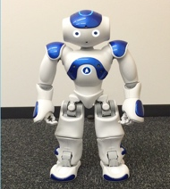  © 2018 John Wily and Sons | 58cm tall  Microphone and loudspeakers  LED (Eyes, ears and feet)  21 degree of freedom  Communication and physical movement
- Pepper  [14] | 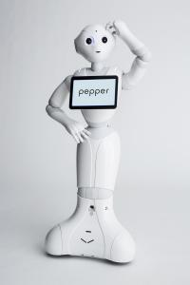  © 2020 Softbank Robotics | 120 cm tall  Microphone and loudspeakers  LED (eyes, ears and shoulders)  Human shaped  Communication  Sound localisation
- Sanbot ELF  [14] | 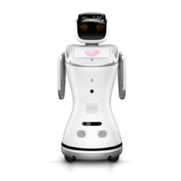  © 2020 Sanbot website | 90 cm tall  Microphone and loudspeakers  LED (ears and arms)  Cartoonish aspect  Communication and people detection
- Pleo  [16] |   © 2012 Springer Science + Business Media | 21 inches long, 6 inches wide, and 8 inches high  Dinosaur like robot  Expresses emotions using body movement  Makes sound to get attention
- Huggable Robotic Bear  [18-19] | 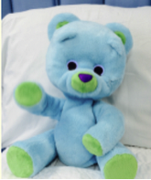  © 2017 IEEE | Teddy bear robot  Express verbally through Wizard-of-Oz teleoperation  Move arms through remote laptop device
- Paro  [21] |   © 2013 John Wily and Sons | 16cm tall, 2.7 kg weight  Seal like robot  Sophisticated sensors  Speech recognition  Autonomous behaviour  Reactive behaviour from tactile sensing
- Maki  (also known as IVEY)  [23] | 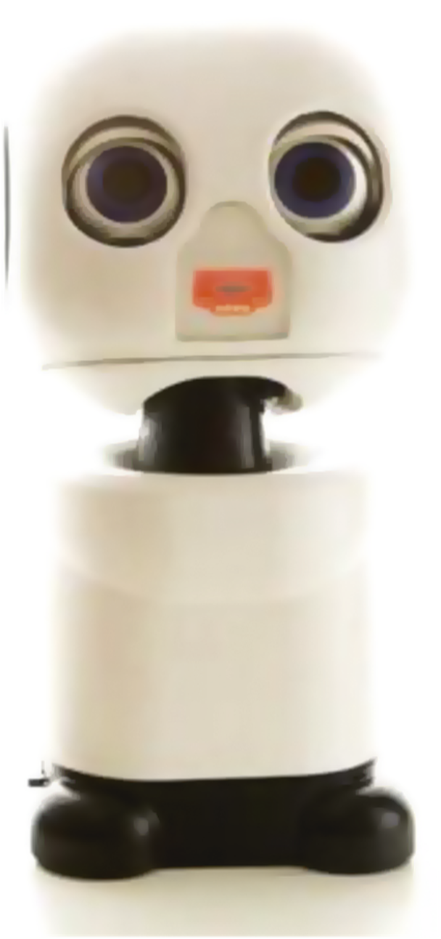  © 2020 Margaret J Trost et al. | 34.2 cm tall  Zig bee wireless  Light-emitting diode  Used alongside a tablet device  Webcam and microphone  6 degree of freedom

3.3.4 Purpose and role of the Robots
The purpose of these robots is to act as a companion and as a form of distraction the child. In each study the robot acted in a variety of ways, through entertainment and play, to either reduce anxiety or distress. One study renamed the NAO robot to Nima, a Persian name, to appear more acceptable and friendly to the target population [13]. Another study tailored their robot depending on the participant’s anxiety levels at the start. If the participant had low levels of anxiety, the robot would perform happy animations with green LED eyes, but if the anxiety levels were high, the robot would have blue LED eyes and act upset, shaking its head and having a closed pose [22]. Pepper and Sanbot Elf were both used in the same study to entertain the participants with gestures, animations, voices and displaying screens to interact. Pepper used its arms and hands more, whereas Sanbot Elf used its face display to express emotions and interact [14]. The Huggable Robotic Bear had a CCLS play the role of tele-operator. They talked to the participants about their likes/dislike, sang nursery rhymes and played games [18-19]].
Animal-like robots, like Pleo and Paro, are programmed to act as pets, and therefore do not speak but act out gestures and make animal noises. The study that used Pleo had participants care for it in order for their attention to be diverted and their anxiety levels to decrease [16]. This was similar to the study that used Paro. Paro was intended to act as a companion to reduce participant’s anxiety levels. It has multiple sensors, a coat of fur and autonomous behaviours that invite individuals to stroke and respond to it [21].

3.3.5 Outcome Measures
3.3.5.1 Anxiety
Four studies evaluated the levels of anxiety before and after the intervention and clearly reported a reduction in anxiety levels when using a series of robot interventions [13-14, 21-22]. Alemi et al. used the Multidimensional Anxiety Scale (MASC) to measure anxiety levels and found a 15% reduction in anxiety levels when participants interacted with the NAO robot [13]. Beraldo et al. explored the use of two different robots (Pepper and Sanbot Elf) to reduce anxiety. Twelve feelings were measured by providing participants with a questionnaire before, during and after their interaction with each robot. They found a significant reduction in anxiety levels for both groups. In those who interacted with Pepper and Sanbot Elf, anxiety levels decreased by 50%, and 44.44% respectively [14]. In contrast, Okita adopted the State-trait Anxiety Inventory for Children (STAIC) to measure anxiety after interaction with Paro. There was a significant decrease in emotional anxiety when the participant had a parent in the room, along with Paro [21]. In the study with Rossi et al., they had parents fill in a questionnaire regarding their child’s anxiety levels before and after their intervention with Nao. Parents had recognised a decrease in anxiety levels among their children, especially children who had high levels of anxiety at the start [22]. These studies showcase the positive effect of robot intervention and its capability of reducing anxiety in a hospital or clinical settings, as well as the different approach to measuring anxiety.

3.3.5.2 Distress
Three studies examined the level of distress among their participants, with two using the Behavioural Approach-Avoidance Distress Scale (BAADS) and the third using Observational Scales of Behavioural Distress-Revised (OSBD-R) [15, 20, 23]. Beran et al. used the NAO robot as a means of distraction whilst the child received an injection. NAO would instruct children to blow and purposely divert their attention to fun topics. The BAADS showed that children experienced less distress when they were intentionally distracted [15]. Jibb et al. adopted a similar approach to distract a child while receiving an injection using the NAO Robot. Their two-arm study incorporated asocial robot as an intervention. The first arm was an active distraction comparator where the NAO robot conducted standard movements. The second arm was a cognitive-behavioural arm with a social robot programmed to execute a series of actions influenced by evidence-based psychological interventions for reducing stress. Overall their results demonstrated a reduction in distress in both arms, and there was a positive reaction from the parents, children and nurses towards the robot [20]. In the third study, IVEY is used to distract children during an IV-line placement. Trost et al. found children enjoyed the robot that showed empathy a lot more than the IVEY that played dress up, and results from the OSBD-R scale displayed a lack of distress when children interacted with IVEY [23]. This suggests that having a social robot in a hospital room, despite the action and the verbalisation employed, can mitigate insertion-related distress.

3.4 Discussion

This systematic review aimed to gather evidence on the effectiveness of social robots on reducing anxiety or distress in children within a hospital or clinical environment. The review identified ten studies that met the specified inclusion criteria. Despite finding a large number of titles, studies that did not take place in a hospital or clinical environment were removed, which lead to a small number being included. Each study took place at a single site, which is useful when investigating effectiveness, and the multi-national spread of studies helps to define the impact of the social robots in varying cultural settings. Children receiving a vaccination, or IV-line placement were the most common target population [15-16, 22-23]. The NAO robot was the most frequently used robot in the selected studies. This could be due to NAO’s autonomous abilities and the capability to personalise it. Each study provided evidence of programming their social robot, to adapt to their target population needs, offering a multifactorial sensory experience. The studies presented changes to anxiety and distress in children with associated positive responses from parents and hospital staff, thus highlighting the opportunities for using social robots in a hospital environment to reduce anxiety levels in children.
Early findings from this systematic review show evidence that social robots have the potential to reduce anxiety and distress in children and young people, however, the number of studies is low and there is variation in the quality of the studies. In addition, results from three of the studies show equivocal findings. Thus, more work is required to provide a more in-depth understanding of the role and impact of social robots in the delivery of children’s healthcare. Despite the limitations, this is the first systematic review that investigates the effectiveness of social robots on reducing anxiety or distress in children in a hospital or clinical environment and acts as a catalyst for the development of future studies in this field.

3.5 Conclusion

This review highlights the potential impact that social robots have on reducing anxiety or distress in children when attending hospital. More detailed and high-quality research is required within this field to gain further understanding of how social robots can add value to health intervention in children.

Acknowledgements
We thank all authors for their contribution. BL is a PhD student with the Centre for Assistive Technology and Connected Healthcare (C.A.T.C.H), the School of Health and Related Research at the University of Sheffield.

Author Considerations
BL created the systematic review protocol; conducted the data extraction, preparation, analysis and wrote the initial manuscript. TA assisted with the systematic review extraction, preparation, and analysis. PD, CS and LdW advised on the protocol, the data extraction, preparation, analysis, and reviewed the manuscript drafts. All authors contributed to the draft and approved the final manuscript.

Conflict of Interest
None declared

What is already known on this topic?
- Social robots have a positive impact on supporting an ageing population with dementia
- Socially interactive robots have proven to be a useful tool when conducting therapy in children with Autism

What does this study add?
- Social robots have the potential to reduce anxiety in children undergoing painful and distressing procedures
- A variety of social robots exist with different functionalities
- Further and more in-depth research is required to understand the role of social robots in paediatric healthcare

3.6 References

- Broekens, J., Heerink, M. and Rosendal, H., 2009. Assistive social robots in elderly care: a review. Gerontechnology, 8(2), pp.94-103.
- Huijnen, C.A., Lexis, MA and de Witte, L.P., 2016. Matching robot KASPAR to autism spectrum disorder (ASD) therapy and educational goals. International Journal of Social Robotics, 8(4), pp.445-455.
- Alemi, M., Meghdari, A., Ghanbarzadeh, A., Moghadam, L.J. and Ghanbarzadeh, A., 2014, October. Effect of utilising a humanoid robot as a therapy-assistant in reducing anger, anxiety, and depression. In 2014 Second RSI/ISM International Conference on Robotics and Mechatronics (ICRoM) (pp. 748-753). IEEE.
- Meghdari, A., Shariati, A., Alemi, M., Vossoughi, G.R., Eydi, A., Ahmadi, E., Mozafari, B., Amoozandeh Nobaveh, A. and Tahami, R., 2018. Arash: A social robot buddy to support children with cancer in a hospital environment. Proceedings of the Institution of Mechanical Engineers, Part H: Journal of Engineering in Medicine, 232(6), pp.605-618.
- DeMore, M. and Cohen, L.L., 2005. Distraction for pediatric immunisation pain: A critical review. Journal of Clinical Psychology in Medical Settings, 12(4), pp.281-291.
- Beran, T.N., Ramirez-Serrano, A., Vanderkooi, O.G. and Kuhn, S., 2015. Humanoid robotics in health care: An exploration of children’s and parents’ emotional reactions. Journal of health psychology, 20(7), pp.984-989.
- Booth, A., Sutton, A. and Papaioannou, D., 2016. Systematic approaches to a successful literature review. Sage.
- Booth, A., 2008. Unpacking your literature search toolbox: on search styles and tactics. Health Information & Libraries Journal, 25(4), pp.313-317.
- Pennisi, P., Tonacci, A., Tartarisco, G., Billeci, L., Ruta, L., Gangemi, S. and Pioggia, G., 2016. Autism and social robotics: A systematic review. Autism Research, 9(2), pp.165-183.
- Cabibihan, J.J., Javed, H., Ang, M. and Aljunied, SM, 2013. Why robots? A survey on the roles and benefits of social robots in the therapy of children with autism. International journal of social robotics, 5(4), pp.593-618.
- Higgins J, Green S. Cochrane handbook for systematic reviews of interventions. Version. Oxford: The Cochrane Collaboration; 2011. [2018-06-09]. http://handbook-5-1.cochrane.org/
- Critical A. Published. 2006. 10 questions to help you make sense of systematics review URL: https://casp-uk.net/wp-content/uploads/2018/01/CASP-Systematic-Review-Checklist_2018.pdf
- Alemi, M., Ghanbarzadeh, A., Meghdari, A. and Moghadam, L.J., 2016. Clinical application of a humanoid robot in pediatric cancer interventions. International Journal of Social Robotics, 8(5), pp.743-759.
- Beraldo, Gloria, Emanuele Menegatti, Valentina De Tommasi, Roberto Mancin, and Franca Benini. “A preliminary investigation of using humanoid social robots as non-pharmacological techniques with children.” In 2019 IEEE International Conference on Advanced Robotics and its Social Impacts (ARSO), pp. 393-400. IEEE, 2019.
- Beran, T.N., Ramirez-Serrano, A., Vanderkooi, O.G. and Kuhn, S., 2013. Reducing children’s pain and distress towards flu vaccinations: A novel and effective application of humanoid robotics. Vaccine, 31(25), pp.2772-2777.
- Eind, Reensina, and Marcel Heerink. “Evaluation of the use of a Pleo robot at a child consultation clinic.” In Proceedings of the third international conference on social robots in therapy and education. Panama, pp. 41-43. 2018.
- Farrier, Christian E., Jacqueline DR Pearson, and Tanya N. Beran. “Children’s fear and pain during medical procedures: A quality improvement study with a humanoid robot.” Canadian Journal of Nursing Research (2019): 0844562119862742.
- Jeong, S., Logan, D.E., Goodwin, M.S., Graca, S., O’Connell, B., Goodenough, H., Anderson, L., Stenquist, N., Fitzpatrick, K., Zisook, M. and Plummer, L., 2015, March. A social robot to mitigate stress, anxiety, and pain in hospital pediatric care. In Proceedings of the Tenth Annual ACM/IEEE International Conference on Human-Robot Interaction Extended Abstracts(pp. 103-104). ACM.)
- Jeong, S., Breazeal, C., Logan, D. and Weinstock, P., 2017, August. Huggable: Impact of embodiment on promoting verbal and physical engagement for young pediatric inpatients. In 2017 26th IEEE International Symposium on Robot and Human Interactive Communication (RO-MAN) (pp. 121-126). IEEE.
- Jibb, L.A., Birnie, K.A., Nathan, P.C., Beran, T.N., Hum, V., Victor, J.C. and Stinson, J.N., 2018. Using the MEDiPORT humanoid robot to reduce procedural pain and distress in children with cancer: a pilot randomised controlled trial. Pediatric blood & cancer, 65(9), p.e27242.
- Okita, S.Y., 2013. Self–Other’s Perspective Taking: The Use of Therapeutic Robot Companions as Social Agents for Reducing Pain and Anxiety in Pediatric Patients. Cyberpsychology, Behavior, and Social Networking, 16(6), pp.436-441.
- Rossi, Silvia, Marwa Larafa, and Martina Ruocco. “Emotional and Behavioural Distraction by a Social Robot for Children Anxiety Reduction During Vaccination.” International Journal of Social Robotics (2020): 1-13.
- Trost, Margaret J., Grace Chrysilla, Jeffrey I. Gold, and Maja Matarić. “Socially-Assistive Robots Using Empathy to Reduce Pain and Distress during Peripheral IV Placement in Children.” Pain Research and Management (2020).
- Kim, Elizabeth S., Lauren D. Berkovits, Emily P. Bernier, Dan Leyzberg, Frederick Shic, Rhea Paul, and Brian Scassellati. “Social robots as embedded reinforcers of social behavior in children with autism.” Journal of autism and developmental disorders 43, no. 5 (2013): 1038-1049.
- Overview ‹ Huggable: A social robot for pediatric care — MIT Media Lab n.d. https://www.media.mit.edu/projects/huggable-a-social-robot-for-pediatric-care/overview/ (accessed August 11, 2020).

3.7 Extended Discussion

This systematic review aimed to gather evidence on the effectiveness of social robots on reducing anxiety or distress in children within a hospital or clinical environment. The review identified ten studies that met the specified inclusion criteria. Despite finding a large number of titles, studies that did not take place in a hospital or clinical environment were removed. Each study took place at a single site, which is useful when investigating effectiveness. The multi-national spread of studies helps to define the impact of the social robots in varying cultural settings. Children receiving a vaccination, or IV-line placement were the most common target population [15-16, 22-23]. The NAO robot was the most frequently used robot in the selected studies. This could be due to NAO’s autonomous abilities and the capability to personalise its activities. Each study provided evidence of programming their social robot, to adapt to their target population needs, offering a multifactorial sensory experience. The studies presented generally positive changes to anxiety and distress in children with associated positive responses from parents and hospital staff, thus highlighting the opportunities for using social robots in a hospital environment to reduce anxiety levels in children.
The preliminary insights gleaned from this systematic review indicate a promising potential for social robots to mitigate anxiety and distress among children and young individuals within healthcare settings. However, a critical examination reveals the need for a cautious interpretation due to the limited number of studies available and variations in their methodological quality. This scarcity in the existing literature underscores the infancy of research in this domain, necessitating a tempered assessment of the observed effects.
Furthermore, the emergence of ambiguous findings in three studies introduces a layer of complexity to our understanding of the relationship between social robots and paediatric anxiety. The variability in results may stem from diverse study designs, intervention protocols, or population characteristics, emphasising the need for a more nuanced exploration of contributing factors.
In light of these challenges, a call for more extensive and rigorous research becomes imperative. A deeper dive into the multifaceted aspects of social robots' roles and impacts in the realm of children's healthcare is essential. This involves not only expanding the number of studies but also enhancing their methodological rigor to establish a more robust evidence base. The identified limitations serve as critical signposts, guiding researchers towards areas that require meticulous investigation and refinement.
Despite these challenges, it is noteworthy that this systematic review stands as a pioneering effort, marking the inaugural attempt to systematically examine the effectiveness of social robots in alleviating anxiety or distress among children in hospital or clinical environments. While the current findings are preliminary, the significance lies in the groundwork laid for future studies. This review, with all its constraints, acts as a catalyst for the initiation and development of subsequent research endeavours, urging the scientific community to delve deeper, refine methodologies, and unravel the intricate dynamics between social robots and the well-being of paediatric patients. As a pioneering exploration in this evolving field, it not only highlights existing gaps but also serves as an impetus for the generation of more comprehensive insights and advancements in the utilisation of social robots for the betterment of children's healthcare experiences.

Chapter 4

Methodology and methods

This chapter details the methods used throughout the thesis to collect and analyses data, including sampling processes and ethical considerations.

4.1 Introduction

Chapters 2 and 3 of this thesis reported on the study background from the existing literature and conducted a systematic review, revealing notable gaps in research related to paediatric patients and the nuanced dynamics of play and interaction with social robots. While previous studies have suggested the potential of social robots as a promising intervention for addressing negative emotions and improving moods in children, critical questions remain unanswered. The literature underscored the need for a deeper exploration of how children engage with social robots in stressful healthcare environments and the multifaceted impacts on children, parents, healthcare professionals, and the overall setting. This synthesis of literature, informed by the systematic review, served as the cornerstone for shaping the research design. It not only identified key variables but also highlighted the limitations in existing studies, guiding the formulation of research questions and the development of a comprehensive study design aimed at addressing these critical gaps in the current understanding of social robot interactions in paediatric healthcare contexts.
The literature review yielded valuable lessons that were integrated into the observational study design. Firstly, insights from existing studies emphasised the need for a child-centric approach, recognising the unique ways in which paediatric patients engage with social robots. This understanding influenced the choice of qualitative methods, particularly participant observation, enabling a detailed exploration of children's behaviours and interactions in real-time rather than semi-structured interviews with children or questionnaire alone. Secondly, the literature underscored the significance of assessing the impact of social robots not only on children but also on parents, healthcare professionals, and the broader healthcare setting. Some studies in the literature review only took account of staff or parents’ point of view. By broadening the perspectives it led to the decision to conduct in-depth interviews with healthcare professionals, offering a holistic understanding of the implications and potential challenges associated with introducing social robots in a healthcare environment.
Additionally, the literature highlighted the importance of considering the stressors inherent in healthcare settings and how they might influence a child's interaction with a social robot. This insight guided the meticulous collection of observational data, including video and audio recordings, to capture the subtleties of these interactions and any variations in response under different circumstances.
Furthermore, the literature review revealed gaps in the understanding of specific types of play and interaction with social robots in paediatric settings. To address this, the observational study incorporated a detailed analysis of play patterns, building on existing knowledge while exploring novel aspects of the child-robot interaction. In essence, the literature review served as a compass, steering the observational study towards an exploration of the complexities identified in prior research. By incorporating these lessons, the observational study aimed to contribute not only to the academic understanding of social robot interactions but also to the practical considerations of implementing such technology in paediatric healthcare contexts.
This chapter beings with the research questions, aims, and objectives and considers the underpinning theories and methodology of the research.

4.2 Research Questions, Aims and Objectives
Research questions:
- How do children in a hospital environment interact and play with social robots?
- What are the benefits and barriers to introducing social robots into a hospital environment?
- Exploring the feasibility and utility, of the use of social robots, in several varied hospital environments

Research aim:
This study aims to understand how children visiting the hospital interact and play with social robots in four hospital settings at the Sheffield Children's Hospital.

Research objectives:
- To observe, in four different hospital environments, children visiting the hospital interact and play with a social robot.
- To collect parents' feedback, by using a structured questionnaire, on their child's play and response to the social robot their child interacts with.
- Conduct semi-structured in-depth interviews to receive valuable opinions and feelings health professionals have towards social robots as an intervention tool in hospital environments.

4.3 Theoretical underpinnings
Researchers are influenced by how they interpret reality (ontology) and understand knowledge and truth when conducting research and collecting and analysing data; this is known as epistemology (Merriam & Tisdell, 2016). This research philosophically position is a pragmatism approach. A pragmatism approach focuses on individual decision-making and behaviour (Converse, 2012; Stuhr, 2010). There is also a focus on combining different research designs to interpret the world from other perspectives and investigate reality (Clarke & Visser, 2019; Goldkuhl, 2012). William James is a crucial figure in this philosophy, believing that pragmatism research displays various truths and provides meaning (Clarke & Visser, 2019; Stuhr, 2010). At the same time, the approach values human experiences through language and communication and believes knowledge is constructed based on real-world experiences (Alghamdi & Li, 2013; Pansiri, 2005; Understanding Pragmatic Research, n.d.). This approach aligns with the aims and objectives of this thesis. To explore how children visiting the hospital play with social robots and, instantaneously, the opinions and insights of parents and healthcare professionals.
Ethnography is the methodological approach used to understand the interactions between the social robots and the children visiting the hospital and learn from their perspective (Abdul Rehman & Alharthi, 2016). Ethnography identifies with pragmatic views and practices more than other areas (Van Maanen, 2010). Conducting ethnography research is about learning and gaining insight from real people. Understanding and analysing what people say, do and mean. It is about becoming physically and mentally embedded into an area of research. Still being aware that the real-life setting is under investigation, and facts and behaviour depends on social relations (Blond, 2019), but focusing on the richness of human behaviours. Ethnography is a process and a product. It is a way to do research, and at the same time, it is a way to write up findings. There are many types of ethnography; a couple is critical and performance ethnography. Susan Bracken 2011 conducted a critical ethnography study which involved understanding program planning within a feminist community (Bracken, 2011). Joni Jones conducted a performance ethnography (embedding people in the culture to learn) to explore how people reacted to the Nigerian cultural experience when visiting an Art Centre. However, ultimately the focus is human interaction with society, culture, and technology (Blond, 2019; Merriam & Tisdell, 2016).
Ethnography emerged in the eighteen and early nineteenth centuries from missionaries, travellers, and medical doctors, providing a space and materials for anthropologists in the late nineteenth century (Tedlock, 1991). In the last decade, ethnography has been recognised as an effective methodology within the healthcare sector. Ethnography has become a practical methodology for understanding patients' experiences and how they use the healthcare sector. It has been an effective method in allowing patients' voices to be heard and exploring the norms and behaviours of individual patients (Strudwick, 2021). A focused ethnography study was conducted involving Somali patients and healthcare professionals. The study investigated the experience of dragonising and managing tuberculosis while attending clinical appointments (Gerrish et al., 2013). Loyd Pettegrew wanted to pay greater attention to specific areas where healthcare is practised, so they set out to do an ethnography study at a radiation oncology centre. He provided evidence that humour and ritual were vital elements for cancer patients and their well-being (Pettegrew, 2017). Ethnography captures the complexities of the healthcare sector and, at the same, the social and cultural factors that play a part in human response, behaviours, and health experience (Vindrola-Padros & Vindrola-Padros, 2018).
Although ethnography provides rich insights and allows researchers to immerse themselves in social settings, some limitations exist (Greenhalgh & Swinglehurst, 2011). The first is the reliability and validity of ethnography research. The reliability of an ethnography study can sometimes come into question because the investigation takes place in one natural location, which is hard to reproduce. A way to overcome this problem is by providing precise and descriptive methodology and findings (Marliana Nurani & Mei, 2008). If ethnographic field notes, also known as thick descriptions, are made and accompanied by video footage, or screen capture technology, it can make the research valuable because triangulation can occur (Greenhalgh & Swinglehurst, 2011). Triangulation happens when different methods are used to collect data. Another way to enhance the validity of the research is by conducting the study in multiple locations so the findings can be applied to a broader group of people (Marliana Nurani & Mei, 2008).
Another limitation for researchers when conducting an ethnography study is that participants may respond or behave how they think the researcher would like them to act. Nurani (2008) suggests a way to overcome this is to treat the participants naturally and not as research subjects (Marliana Nurani & Mei, 2008).

4.4 Study Design
This research employed a mixed-method approach to comprehensively investigate how children interact with social robots during clinical appointments at a hospital. The study design, rooted in ethnography, aimed to provide a holistic understanding of the dynamics involved. Qualitative methods, such as participant observation, were crucial in capturing the nuances of interactions. Through systematic observation, detailed field notes were generated and video and audio recordings captured the intricacies of children's behaviours and expressions during their encounters with social robots. Additionally, in-depth interviews with healthcare professionals enriched the qualitative insights, offering a broader perspective on the implications of these interactions in a healthcare context.
To ensure the reliability of the study, a triangulation approach was adopted, utilizing both observational data and insights from healthcare professionals. The research also employed reflexivity, acknowledging the researcher's positionality to mitigate potential biases.
In tandem with qualitative methods, quantitative data were collected through questionnaires administered to parents. This approach allowed for a comprehensive exploration of children's experiences with social robots, providing a quantitative lens to complement the rich qualitative data. By administering questionnaires both before and after their child's interaction with a robot, the study captured not only baseline perceptions but also potential shifts in attitudes or behaviours.
Ethical considerations were paramount throughout the study, with a focus on obtaining informed consent from both children and their guardians. Anonymity and confidentiality measures were implemented to safeguard participant privacy.
Despite potential criticisms of subjectivity in ethnographic research, this mixed-method approach, encompassing a range of qualitative and quantitative approaches, enhances the robustness and depth of the findings. An iterative approach to the development of themes, and constant triangulation of data ensured that the findings were informed by the data and sense-checked by participants. The use of frameworks and perspectives informed by existing evidence also ensured a systematic approach to the analyses and minimised the potential for researcher bias. The study's comprehensive design allows for a nuanced exploration of the impact of social robots on children in a healthcare setting, shedding light on both the qualitative intricacies and some key quantitative elements that emerge in this unique context.

4.4.1 Participant Observation
Participant observation is the critical data collection method used in ethnography. This method involves the researcher having a part or role in the research, participating, and observing. However, it doesn't mean being involved in all that takes place but interacting with the participant in various degrees (Heigham & Croker, 2006). In this study, participants must interact with social robots they are meeting for the first time, so the researcher must show and support these interactions as little as possible. Keith Richards (2003) highlights there are four key features researchers should pay attention to when involved in participant observation, and these are the setting, the people, the behaviour, and the systems (procedures) (Heigham & Croker, 2006; Kisin, 2015). When observing, the researcher must instantly maintain an emic and etic position. Ethnographers gain access to a group, intending to understand them better and develop an insider perspective about the culture. Still, it is also vital the researchers stay objective and maintain a distance as a researcher (Heigham & Croker, 2006).
Keiko Sakui (2007) conducts an ethnography study using participant observation to explore the classroom management difficulties in Japanese English as a foreign language class. She discovered the problems and strategies used while taking an emic and etic position. During this research, she was an English teacher and spoke Japanese, relating to the teacher being observed. She acknowledged she had an emic perspective, but sometimes her experience was foreign because she was an outsider holding an etic position (Sakui, 2007). Patton (2002) explains that Observation is a method of describing behaviours from an open, inductive, and holistic perspective – it allows one to see behaviour in a new light.

4.4.2 Questionnaire (Likert scale)
Likert scales were used to gather data from the paediatric patients after interacting with one of the social robots. Two questionnaires were given to parents/carers before and after the interaction. When creating the questionnaires, the Likert scale was decided as the best form to collect information. Likert scales are commonly used in research. It requires the respondent to specify agree or disagree on a symmetric sale with a series of statements (Barua, 2013). Some advantages of using a Likert-scale questionnaire are that data can be gathered easily and quickly from a large sample, and data can be combined and compared with qualitative data. Lastly, it captures peoples' perspectives in a structured format (Nemoto & Beglar, 2013). In a study with 1293 university students from the University of Cordoba, Leon-Mantero et al. (2020) conducted research exploring and improving the estimation of student attitudes towards mathematics by using a Likert scale. Students were given 25 questions and had five scoping options, strongly disagree to agree strongly. Extra information was also gathered, such as age and gender (León-Mantero et al., 2020).

4.4.3 Semi-structured interviews
Interviews are a conversation with a purpose and have been described by Silverman (2000) as 'the gold standard of qualitative research' (Heigham & Croker, 2009; Silverman, 2000). Semi-structured interviews give the researcher a clear picture of the topic and allow the interviewee to expand and share their thoughts and opinions freely. To conduct the interviews, an interview guide was created by using the findings from the literature and systematic review, using previous work as the foundation. The interview guide had topics and key questions identified as areas needing more understanding, allowing the researcher to probe beneath the surface (Heigham & Croker, 2009). Fylan (2005, ch.6) writes about the labour of conducting semi-structured interviews and the importance of planning and preparation. She offers four tips on writing an interview guide, (1) keep it brief, (2) differentiate the processes you are interested in, (3) ensure the question order is logical, and (4) develop a series of prompts (Fylan, 2005).
A semi-structured interview is the most frequent qualitative method used in the healthcare sector. The healthcare sector has seen this method as a useful data source that gathers patients' thoughts, feelings and beliefs (DeJonckheere & Vaughn, 2019). Griffiths et al. 2008 conducted semi-structured interviews with women living with pre-gestation type 1 diabetes and exploring their journeys of becoming pregnant. Semi-structured interviews were used due to them being suitable for exploring issues, and because of the sensitivity of the topic, it allowed participants to feel safe and listened to. An interview guide was created for this study, and eight topics were designed to capture the journey of becoming pregnant and the impact healthcare has had on each participant (Griffiths et al., 2008). Another study on GPs' workload in England used semi-structured interviews to gather and understand GPs' perceptions and attitudes towards workload. A topic guide was created based on existing literature, with all interviews being audio recorded (Croxson et al., 2017). Using semi-structured interviews in a healthcare setting allows a researcher to collect qualitative data, explore the participant's thoughts and feelings, and delve deeper into sensitive and personal topics (DeJonckheere & Vaughn, 2019).

4.5 Sampling
The selection of paediatric patients for the Observation and interaction and the selection of the parents was purposive Sampling. The selection for the healthcare professionals was convenience sampling, both nonprobability sampling techniques (Etikan et al., 2016). Purposive Sampling is a deliberate choice of a participant due to the potential of information and insight the participants possess. It involves identifying and selecting participants who add rich and useful data to the research, especially if those people are hard to reach (Tongco, 2007). Runyoro et al., 2006 wanted to reach and interview familiars who used traditional treatment methods for Candida infections. Due to the unique requirement, purposive Sampling was the correct technique for this research piece of research (Runyoro et al., 2006). Convenience sampling is selecting participants based on their ease of availability and recruiting individuals who are willing, able, and ready to take part in Research (Given, 2008).
This study included paediatric patients aged from 5 to 12 years old. Each participant could speak English and was visiting the hospital for a medical reason. The other set of participants was parents or guardians of the paediatric patients, who spoke English at a level allowing them to consent and fill in questionnaires. The final group was the healthcare professional. They were individuals who worked in a hospital setting that was involved in the study. Sufficient sample size was achieved with data saturation for all groups. Thirty-two paediatric patients were recruited 32 parents/guardians were recruited, and eight healthcare professionals. Data was collected over five months (September 2021 – January 2022).

4.6 Recruitment

4.6.1 Paediatric patients
Healthcare professionals made the first approach to inform the potential participants about the study and asked if they would like to learn more. If yes, researcher BL will be invited to talk with the potential participant. BL would hand them an age-appropriate information sheet, which they were welcome to review with their parent/guardian. Parents and guardians were also given an information sheet about the study. They would get up to 60 minutes to decide on their participation, and there was space for them to decide to participate within the 60 minutes timeframe. The information sheet included the goals of the study and what to expect if they participated. They were also informed through the information sheet that their details would be kept confidential, and the Observation would be video and audio recorded for research purposes. There were two types of information sheets: (1) for participants aged 5 to 8 (appendix 2) and (2) for participants aged 9 to 12 (appendix 3). If individuals were happy to participate, their parents signed a consent form on their behalf. The form asked several questions ensuring the participant understood the study's aims, what it involved, and that they could stop participating at any time (appendix 4).

4.6.2 Parents or guardians of paediatric patients
Parents or guardians were also given an information sheet regarding the purpose of the study and their child's involvement (appendix 5). Information about the risks and benefits and what they will be required to do was also explained on the sheet. Parents or guardians were asked to complete two questionnaires, one at the start, regarding information about the child's age, health and emotions towards the hospital visit. Once the robot interaction was over, another questionnaire was given to explore their views on social robots being a tool within a hospital environment. A consent form was also given to the parent to fill in (appendix 6).

4.6.3. Healthcare professionals
Researcher BL approached a potential healthcare professional who had witnessed the social robot within the hospital and seen some of its interaction. They were given an information sheet (appendix 7) that explained the study and gave them all the relevant information. After some consideration, up to 24 hours, a consent form was given for them to sign if they chose to take part (appendix 8).

4.7 Data collection

4.7.1 Observation
For the Observation, two cameras were used, one facing the paediatric patient to capture their reaction and the other facing the paediatric patient and the social robot aiming to capture their interaction. Each session had one paediatric patient, a social robot, a parent or guardian, the researcher BL and sometimes a healthcare professional depending on the need of the paediatric patient. At the start of the research, it was decided that it would be individual interaction with the social robot rather than group interaction. Choosing to conduct the session this way increases the likelihood of capturing each paediatric patient's movement and interaction in greater detail. Each session lasted around 20 minutes. This was a great choice because the study started at the hospital COVID rules were in play at the hospital, which didn't allow for paediatric patients the chance to interact with each other. Field notes were also taken, when necessary, during the observations.

4.7.2 Questionnaire
There were three questionnaires used in the study. The first questionnaire was given to the parent or guardian of the paediatric patient before the interaction with the social robot—the questionnaire aimed to gather information about paediatric patient and their emotions (appendix 9). The second questionnaire was given to the paediatric patient after the session (appendix 10). It collected data on the use of social robots in a hospital environment from their perspective and experience. The third questionnaire was given to the parent or guardian. The questionnaire asked the opinions and thoughts of parents or guardians of paediatric patients as a tool in the hospital environment (appendix 11). All the questionnaires were in paper form and were distributed by researcher BL. Each participant had to fill in the questionnaire on the day at the scene of the study.
4.7.3 Interviews
Healthcare professionals were chosen to take part in semi-structured interviews. Each interview had a healthcare professional and research BL. All interview was audio recorded. Some took place face-to-face at the hospital, and a couple was done online via Zoom. There was a discussion guide created and used during the interview (appendix 12).

4.8 Setting
Four hospital environments were chosen for the research. The first setting was the theatre admission unit, where children come in for operations. Preoperative anxiety is a prominent issue in the children's hospital, affecting more than 50% of children who visit that department. Paediatric patients have reported feeling anxious and distressed while waiting to be seen (Ryu et al., 2017). The second setting was the medical day care unit, where paediatric patients had several tests involving needles, such as blood tests, lumbar punctures, and infusions. There is a high level of needle phobia in children's hospitals (Goodenough et al., 1997). The third setting was the oncology and haematology unit. This unit cares for paediatric patients with cancer, leukaemia, bleeding, and inherited disorders. Many come in for a whole day or must stay for several days. A study interviewed 56 cancer-identified teenagers to explore their anxiety and depression levels. They found patients treated in local hospitals scored higher for clinical range depression and anxiety (Hedström et al., 2005). The final setting was a mixed internal medicine clinical ward. This ward cares for paediatric patients with various medical conditions, such as cystic fibrosis, gastroenterology, and immunology. All were between 4 and 16 years old. Hospitals can be stressful, and anxiety is the most reported negative emotion in hospital settings (Li et al., 2016).

4.9 Intervention

In shaping the observational study, lessons gleaned from the literature review played a pivotal role, guiding the research towards a more nuanced exploration of paediatric interactions with social robots. Notably, the literature highlighted the importance of considering various play dynamics, leading to the identification of specific play types—physical touch, physical play, storytelling, and role-playing. These varied forms of engagement were thoughtfully integrated into the observational scenarios. The study by Loi et al., had their social robot interact with children through playing music, reading books, and playing games. This was something that influenced the decision-making process of scenarios (Loi, et al., 2018).
The interaction sessions were deliberately designed to be semi-structured, incorporating a dual approach where the researcher led part of the interaction while leaving room for the paediatric patient to guide other aspects of play. This flexible framework aimed to capture the diverse ways in which children naturally interact with social robots. In a study from the systematic review, Alemi et al., had their social robot programmed in semi-structured scenarios, such as an introduction, a doctor, and a hero. This was an effective method to engage children in their study (Alemi et al., 2016).
The development of scenarios drew inspiration from existing research on the impact of social robots in healthcare and interventions targeting anxiety and distress in children. These carefully crafted scenarios aimed to mimic real-life situations, offering a comprehensive understanding of how social robots could influence various facets of a child's well-being in a healthcare setting.
Two distinct types of social robots were introduced in the study: a humanoid robot and an animal-like robot. The humanoid robot, with its human-like features, and the animal-like robot, designed to emulate a creature, added an extra layer of complexity to the exploration. Each robot type brought unique characteristics that could potentially impact the nature of interactions with paediatric patients. The ensuing descriptions provide a detailed overview of the humanoid and animal-like robots, setting the stage for a comprehensive analysis of their roles in the observed play scenarios.
4.9.1 Social Robot: Pepper
Pepper is a humanoid robot that can recognise faces and basic human emotions. Pepper was optimised for human interaction and can engage with people through conversation and its touch screen. The interaction was semi-structured, the interaction being led by the researcher, and the child directing part of the play. There were four scenarios exploring different types of play (see table 4.1).

Table 4.1: Pepper's play scenarios
Scenarios | Example of play | Description | Pepper’s transcript
Pepper was programmed to introduce itself:
Pepper: My name is Pepper; I am designed to be a social robot. That means I do not perform physical task, like carrying and fetching things. The sort of things that factory robots do, but instead I can talk like you, give you information, and entertain you and perhaps even keep you company. In Japan I have been employed to meet and greet people in banks and department stores and some people have even let me into their own homes. At the university they are asking if robots like me can help look after older people and other people with care needs. What do you think? Is it a good idea or not?”
Storytelling  1 min 25 Sec | Read a book out loud and display the pictures of the book on its screen | The book that was programmed was Daisy Eat Your Peas by Kes Gray (appropriate age 3-5 years). | Pepper: Hey, I am going to read a book called Daisy Eat your Peas  Pepper starts to read the book with its tablet showcasing images from the book, and its body making gestures to match the story such as nodding it head, moving its arms and leaning left and right.  Pepper: The end
Movement  1 min 10 sec | Perform a dance routine and play music while moving | The song that supported the actions was Doing Okay by Wretch.  Pepper performed some dance moves; its head and body moved left and right while it danced. | Pepper: “Sorry that you are not feeling well, I would like to show you some dance moves”  Doing okay starts to play through Pepper and Pepper starts moving its arms to the music.  Pepper: Thank you for watching me dance  Pepper waves its arms in the air
Game  1 min 30 sec | Pepper Says | Some of the actions were raising your left arm and playing golf, American football, and the guitar. | Pepper: “Pepper says nod you head” *Pepper nods its head*  Pepper: “Pepper says lift your left arm” *Pepper lifts its left arm*  Pepper: “Pepper says play golf” *Pepper bends to pretend to play golf and makes a ball in a hole noise*  Pepper: “Now play football”  *Pepper says still*  Pepper: “Pepper says play football” *Pepper plays American football”.  Pepper: “Pepper Says play guitar” *Pepper plays air guitar*
Choice of activity | The saxophone  Tai Chi  Read a book  Pepper Says  Dance routine | The participants got to choose what they would like to see the robot do either for the first time or repeat scenarios they have seen already. | Pepper: I am going to play the saxophone  Pepper: What do you think?  *Pepper plays pretends to play the saxophone and the music is playing through it*  Pepper: Now watch me do some tai chi  Pepper: I learnt that today  *Pepper preforms some Tai Chi with sound effect*  Pepper: I really like to disco too  *Pepper preforms a disco dance*  Pepper: which one did you like best?
End of session: Pepper would say to the participant that it is time for it (Pepper) to go to sleep now and rest.

4.9.2 Social Robot: MiRo
MiRo is an animal-like robot which generates animal-like sounds and has sensory and motor abilities. Sensors include stereo vision and hearing, ultrasonic ranging, light level sensors, infrared cliff sensors, tactile sensors on the body and head, and interceptive sensors such as twin accelerometers and joint position sensors. Below are the scenarios for MiRo (see table 4.2).
Table 4.2: MiRo's play scenarios.
Scenarios | Example | Description | Researcher’s Transcript
Introduction  5 minutes | Meet MiRo | MiRo is introduced and described to the participant. The participant is informed of MiRo's capabilities and is shown ways of interacting with it. For example, stroking causes the tail to wag. | Have you seen a robot like this before?  This is MiRo, Miro is an animal like robot, and it likes to be stroked.  If you stroke it, sometimes it wiggles its tail, moves towards you.  You can come closer and give it a go if you would like?  Do you have a pet at home?  Sometimes Pets listen and sometimes they don’t, MiRo is kind of like that too.  Please come closer and have a look, it likes to be stroked.  What animal do you think it looks like?  You can touch it, play with and get to know MiRo
Movement  3 minutes | Get MiRo to look at you and follow | Participants were encouraged to call out to MiRo and see if they could get its attention, as well as get it to move closer to them. Stroking also encouraged MiRo to move closer to the participant. | MiRo can follow movement, so if you get in front of it and try and get its attention by waving your arms and calling its name, it may turn towards you and maybe even follow you.  *Researcher shows participant where to stand by demonstrating*  And then try and move left and right.  See if when you move, MiRo follows your movement.
Game  5 - 8 minutes | The MiRoCube | A six-sided cube was given to each participant to use with MiRo. Each side of the cube had a different QR code that caused Miro to perform various actions, such as spin, come close, or place its' head down. | I am now doing to introduce something to you. This is called QR cube. If you put it in front of MiRo’s face it will do stuff. There are six different numbers and each number causes MiRo to act out a different move. I know one makes it spin. Try putting the cube in front of MiRo’s face.
Choice of activity | Stroking  MiRoCube | Participants were given space to play with MiRo how they would like freely. That could involve any of the previous scenarios or their own way of playing. | Feel free to continue playing with the QR code or do something else with MiRo
End of session: Researcher will say that MiRo now needs to go and rest now.

4.10 Data Analysis

4.10.1 Observation
All video footage was securely uploaded onto a password-protected device, ensuring data security and confidentiality. Reviewing the recordings against a structured framework, derived from findings in Chapter 3's systematic review, aimed to systematically analyse interactions among children, social robots, and researchers. This framework categorized interactions into two main categories: the child-robot interaction and the child-researcher interaction, evaluating both verbal and physical exchanges to uncover recurring themes and patterns.
Opting for a thematic approach in analysis, chosen for its capacity to reveal patterns and insights within qualitative data, allowed for systematic exploration and interpretation of observations. This method facilitated the distillation of rich, qualitative data into meaningful themes, in line with the study's objective of understanding the intricacies of these interactions (Braun & Clarke, 2006, 2014; Nowell et al., 2017).
The process involved initial viewing of the uploaded video footage by researcher BL, who filled in an observational framework to document observed interactions and behaviours. Subsequently, a second viewing was conducted with the completed framework to capture any missed interactions or behaviours. The observational notes and framework were then reviewed by BL to highlight and cluster emerging themes. CS also reviewed one of the video footage and compared their analysis notes with BL.
After thorough review of all 32 participants' video footage, each was accompanied by a completed observational framework, and common themes were identified and clustered based on similar responses. This process delineated three distinct areas for investigation: type of play, emotional reactions, and the impact of social robots on participants.

4.10.2 Questionnaire
Once all the questionnaires were collected, the responses were entered into Microsoft Excel for analysis. The data was organised in a structured format with participant numbers and their responses on the Likert scale. To further analyse the data, the responses were converted to numbers. One represented strongly disagree, two represented disagree, three represented natural, four represented agree, and five represented strongly agree. Once the data was numbered, the next step involved analysis using SPSS statical software (SPSS premium version 28). Descriptive statistics techniques were used to summarise and describe the findings, and these included mean and standard deviation.

4.10.3 Interview
The data analysis strategy was thematic. These themes were developed from a previous systematic review of the use of social robots in a hospital environment (Littler et al., 2021). The five themed categories were: 1) Background; this involved the participants describing the experience of children's responses to attending the hospital and current interventions used to help manage the anxiety levels. 2) Experience of social robots in a hospital environment; The participant's view about social robots, where they might be best placed and any challenges they could foresee. 3) The social robot's impact on children; inquiring what healthcare professionals think the response will be and the reaction children will have towards the social robots. 4) Application of the social robot; discovering any worries healthcare professionals may have about the application of the social robots and any features they think will draw children toward the robot. 5) influence on the environment: what impact did the environment have on using a social robot? The transcribed verbatim notes were coded into themes under the five categories. As analysis continued, the themes were refined, merged, or modified as appropriate, allowing for emerging themes within the categories and creating subthemes. After the first few transcripts were coded, BL and SA met to agree on the set of codes together and applied them to the remaining transcripts.

4.11 Mitigating Researcher Bias in Ethnography

In this ethnographic study, careful consideration was given to the potential influence of the researcher on the research process and interpretation. Acknowledging the potential for inherent subjectivity in ethnographic research, attention was directed towards planning strategies to mitigate potential biases. The planning phase involved a comprehensive examination of the researchers' perspectives, biases, and cultural background to understand how these factors might shape interactions with paediatric patients and influence the interpretation of findings.
To minimize undue influence, deliberate efforts were made to establish rapport and trust with participants, creating an environment where authentic expressions could emerge. Additionally, the study also incorporated multiple observation perspectives by having two video recordings to capture as much of the activity in the environment as possible and employed triangulation techniques, seeking diverse perspectives to counterbalance potential researcher bias. These approaches allowed repeated viewings of interactions from multiple perspectives by the researcher and the supervisory team. This deeper interrogation of the observational data, coupled with additional data, provided a counterbalance to any initial, subjective interpretations, thereby minimising the risk of bias. The overarching goal was to maintain an ongoing awareness of the researcher's role and potential impact throughout the research, ultimately contributing to the study's objectivity and credibility in portraying the children's interactions with social robots in a healthcare setting.

4.12 Public Involvement

A focus group with children aged 8- to 12-year-olds from a youth club was conducted to discuss the information sheets and examine children’s opinions of the layout and design of the documents. At the end of the focus group, some deemed the information sheet acceptable, and a few asked if a couple of words could be changed to more straightforward terms. We made the changes that were asked for and updated the information sheet accordingly.

4.13 Ethical and regulatory considerations

There were no particular or enhanced risks to paediatric patients participating in this research project. If the paediatric patient were inconvenienced or distressed by the study, they would have been reminded that they were free to withdraw from the study if they wished. Paediatric patients were already visiting the hospital due to being in distress or pain. This was considered when they were interacting with the social robots. If a paediatric patient showed any distressing behaviour, such as crying, while interacting with social robots, the parent or guardian was reminded that they were free to withdraw. To avoid infection passing from one paediatric patient to another, the social robots were cleaned using a soft damp cloth and then dried with a soft dry cloth to remove humidity. Due to the coronavirus (COVID-19), the room was thoroughly cleaned after each participant with disinfectant wipes.

The UK Health Departments Research Ethics Service, the NHS REC the Health Research Authority reviewed and approved this study in June 2020 (see appendix 13). These authorities reviewed the study protocol, informed consent forms, information sheets, and other relevant documents.

4.14 References

Abdul Rehman, A., & Alharthi, K. (2016). An Introduction to Research Paradigms. International Journal of Educational Investigations, 8, 51–59. www.ijeionline.com
Alemi, M., Ghanbarzadeh, A., Meghdari, A., & Moghadam, L. J. (2016). Clinical application of a humanoid robot in pediatric cancer interventions. International Journal of Social Robotics, 8, 743-759
Alghamdi, A. H., & Li, L. (2013). Adapting Design-Based Research as a Research Methodology in Educational Settings. International Journal of Education and Research, 1(10). www.ijern.com
Barua, A. (2013). METHODS FOR DECISION-MAKING IN SURVEY QUESTIONNAIRES BASED ON LIKERT SCALE. In Journal of Asian Scientific Research (Vol. 3, Issue 1). http://aessweb.com/journal-detail.php?id=5003
Blond, L. (2019). Studying robots outside the lab: HRI as ethnography. Paladyn, 10(1), 117–127. https://doi.org/10.1515/PJBR-2019-0007/MACHINEREADABLECITATION/RIS
Bracken, S. J. (2011). Understanding program planning theory and practice in a feminist community-based organization. Adult Education Quarterly, 61(2), 121–138. https://doi.org/10.1177/0741713610380446
Clarke, E., & Visser, J. (2019). Pragmatic research methodology in education: possibilities and pitfalls. International Journal of Research and Method in Education, 42(5), 455–469. https://doi.org/10.1080/1743727X.2018.1524866
Converse, M. (2012). Philosophy of phenomenology: how understanding aids research. Nurse Researcher, 20(1), 28–32. www.nurseresearcher.co.uk
Croxson, C. H. D., Ashdown, H. F., & Hobbs, F. D. R. (2017). GPs’ perceptions of workload in England: A qualitative interview study. In British Journal of General Practice (Vol. 67, Issue 655, pp. e138–e147). Royal College of General Practitioners. https://doi.org/10.3399/bjgp17X688849
DeJonckheere, M., & Vaughn, L. M. (2019). Semistructured interviewing in primary care research: a balance of relationship and rigour. Family Medicine and Community Health, 7(2), 57. https://doi.org/10.1136/FMCH-2018-000057
Etikan, I., Musa, S. A., & Alkassim, R. S. (2016). Comparison of Convenience Sampling and Purposive Sampling. American Journal of Theoretical and Applied Statistics, 5(1), 1. https://doi.org/10.11648/j.ajtas.20160501.11
Fylan, F. (2005). Semi-structured interviewing. In J. Miles & P. Gilbert (Eds.), A handbook of research methods for clinical and health psychology (Vol. 5, pp. 65–78). Oxford University Press.
Gerrish, K., Naisby, A., & Ismail, M. (2013). Experiences of the diagnosis and management of tuberculosis: a focused ethnography of Somali patients and healthcare professionals in the UK. Journal of Advanced Nursing, 69(10), 2285–2294.
Given, L. M. (2008). The Sage Encyclopedia of Qualitative Research Methods. Sage publications.
Goldkuhl, G. (2012). Pragmatism vs interpretivism in qualitative information systems research. European Journal of Information Systems, 21(2), 135–146. https://doi.org/10.1057/ejis.2011.54
Goodenough, B., Kampel, L., Champion, G. D., Laubreaux, L., Nicholas, M. K., Ziegler, J. B., & Mcinerney, M. (1997). An investigation of the placebo effect and age-related factors in the report of needle pain from venipuncture in children.
Greenhalgh, T., & Swinglehurst, D. (2011). Studying technology use as social practice: The untapped potential of ethnography. BMC Medicine, 9. https://doi.org/10.1186/1741-7015-9-45
Griffiths, F., Lowe, P., Boardman, F., Ayre, C., & Gadsby, R. (2008). Becoming pregnant: Exploring the perspectives of women living with diabetes. British Journal of General Practice, 58(548), 184–190. https://doi.org/10.3399/bjgp08X277294
Hedström, M., Gustaf Ljungman, & Louise von Essen. (2005). Perceptions of distress among adolescents recently diagnosed with cancer. Journal of Pediatric Hematology/Oncology, 27(1), 15–22.
Heigham, J., & Croker, R. A. (2006). Qualitative Research in Applied Linguistics: A Practical Introduction.
Heigham, J., & Croker, R. A. (2009). Qualitative Research in Applied Linguistics: A Practical Introduction (Palgrave Macmillian).
Kisin, N. (2015). Qualitative inquiry in TESOL. https://www.researchgate.net/publication/316674525
León-Mantero, C., Casas-Rosal, J. C., Pedrosa-Jesús, C., & Maz-Machado, A. (2020). Measuring attitude towards mathematics using Likert scale surveys: The weighted average. PLoS ONE, 15(10 October). https://doi.org/10.1371/journal.pone.0239626
Li, W. H. C., Chung, J. O. K., Ho, K. Y., & Kwok, B. M. C. (2016). Play interventions to reduce anxiety and negative emotions in hospitalized children. BMC Pediatrics, 16(1). https://doi.org/10.1186/s12887-016-0570-5
Littler, B. K. M., Alessa, T., Dimitri, P., Smith, C., & De Witte, L. (2021). Reducing negative emotions in children using social robots: Systematic review. In Archives of Disease in Childhood (Vol. 106, Issue 11, pp. 1095–1101). BMJ Publishing Group. https://doi.org/10.1136/archdischild-2020-320721
Loi, S. M., Bennett, A., Pearce, M., Nguyen, K., Lautenschlager, N. T., Khosla, R., & Velakoulis, D. (2018). A pilot study exploring staff acceptability of a socially assistive robot in a residential care facility that accommodates people under 65 years old. International psychogeriatrics, 30(7), 1075-1080.
Marliana Nurani, L., & Mei, D. (2008). CRITICAL REVIEW OF ETHNOGRAPHIC APPROACH KK Ilmu Kemanusiaan FSRD ITB. In Critical Review of Ethnographic Approach Jurnal Sosioteknologi Edisi 14 Tahun (Vol. 7).
Merriam, S. B., & Tisdell, E. J. (2016). Qualitative Research: a guide to design and implementation (4th ed.). John Wiley & Sons.
Nemoto, T., & Beglar, D. (2013). Developing Likert-Scale Questionnaires Campus Reference Data. In JALT 2013 Conference Proceedings, 1–8.
Pansiri, J. (2005). Pragmatism: A Methodological Approach to Researching Strategic Alliances in Tourism. Tourism and Hospitality Planning & Development, 2(3), 191–206.
Pettegrew, L. S. (2017). An ethnography of humor, ritual and defiance in a cancer care setting. Journal of Organizational Ethnography, 6(3), 159–176. https://doi.org/10.1108/JOE-04-2017-0021
Runyoro, D. K. B., Ngassapa, O. D., Matee, M. I. N., Joseph, C. C., & Moshi, M. J. (2006). Medicinal plants used by Tanzanian traditional healers in the management of Candida infections. Journal of Ethnopharmacology, 106(2), 158–165. https://doi.org/10.1016/j.jep.2005.12.010
Ryu, J. H., Park, S. J., Park, J. W., Kim, J. W., Yoo, H. J., Kim, T. W., Hong, J. S., & Han, S. H. (2017). Randomized clinical trial of immersive virtual reality tour of the operating theatre in children before anaesthesia. British Journal of Surgery, 104(12), 1628–1633. https://doi.org/10.1002/bjs.10684
Sakui, K. (2007). Classroom management in Japanese EFL classrooms. JALT Journal, 29(1).
Silverman, D. (2000). Doing Qualitative Research (Sage Publications).
Strudwick, R. M. (2021). Ethnographic research in healthcare–patients and service users as participants. Disability and Rehabilitation, 43(22), 3271–3275. https://doi.org/10.1080/09638288.2020.1741695
Stuhr, J. J. (2010). 100 years of pragmatism : William James’s revolutionary philosophy. Indiana University Press.
Tedlock, B. (1991). From Participant Observation to the Observation of Participation: The Emergence of Narrative Ethnography. Source: Journal of Anthropological Research, 47(1), 69–94. https://about.jstor.org/terms
Tongco, D. C. (2007). Purposive Sampling as a Tool for informant Selection.
Understanding Pragmatic Research. (n.d.). Retrieved January 30, 2023, from https://www.nottingham.ac.uk/helmopen/rlos/research-evidence-based-practice/designing-research/types-of-study/understanding-pragmatic-research/section03.html
Van Maanen, J. (2010). Ethnography as Work: Some Rules of Engagementj oms_980 218..234. https://doi.org/10.1111/j.1467-6486.2010.00980.x
Vindrola-Padros, C., & Vindrola-Padros, B. (2018). Quick and dirty? A systematic review of the use of rapid ethnographies in healthcare organisation and delivery. BMJ Quality & Safety, 27(4), 321–330.

Chapter 5

Paediatric patients' interaction with social robots: an observational study

This chapter was submitted to the International Journal of Social Robots on the 24^{th of} November 2023, currently responding to corrections.
Abstract

Managing negative emotions in paediatric patients is vital in child healthcare. Social robots can potentially support the management of negative emotions in paediatric patients. This study adopts an ethnography approach, using observation and a questionnaire to explore and learn how children play with social robots in a hospital environment. At the same time, it examines the impact social robots can have on children's emotional states. Thirty-two paediatric participants were recruited from four different hospital environments to interact with two social robots, MiRo and Pepper. There was a mostly positive response towards both social robots. MiRo encouraged the participants to interact through tactile play, whereas Pepper prompted the participants to play games with rules. The results indicated that different types of social robots elicit different types of behaviours. Children valued the attention of the social robots and, at the same time, anthropomorphized them during their play and demonstrated the feasibility of social robots as an effective distraction from the hospital environment, which is a recognised approach for managing negative emotions in paediatric settings. This study highlighted promising areas for future research and development, and these include a large-scale comparison of social robots with more widely used interventions, exploration of different types of social robot interventions for different contexts, for example, age of children, health status, and neurodiversity.

Keywords: Social Robot, Paediatrics, Play, Hospital, Anxiety

5.1 Introduction
The hospital can be a stressful environment. For a paediatric patient already experiencing discomfort and uncertainty, the additional factor of a busy, noisy, and sometimes intimidating environment can trigger a range of negative emotions. Children visiting the hospital can exhibit behaviours associated with anxiety and distress, manifesting as withdrawal, crying, hitting, and displaying other negative behaviours (Li, H.C. and Lam, H.Y., 2003; Cheung, Li and Lopez, 2006; Jeong et al., 2015). It is important to manage and minimise paediatric patients' anxiety levels. A number of studies have found that poorly managed anxiety can lead to extended recovery periods, increased pain and distress, and future fears of the hospital (Birnie et al., 2014). There is also evidence that this can lead to psychological development problems such as posttraumatic stress disorder (PTSD) (Thabet and Mona, 2017). Studies have demonstrated that surgical patients do not only present negative behaviour before their operations but sometime after their operations, lasting around two weeks or more (Kain et al., 1996; Mccann and Kain, 2021). However, research has identified distraction as an effective tool for reducing anxiety and distress in paediatric patients. Several systematic reviews have suggested that hospitalised children respond positively to audio-visual interventions such as video, animation cartoons, music and social robots. These interventions have managed to turn children's attention away from stressful situations and have allowed them to engage in different forms of fun activities (Demore and Cohen, 2005; Beran et al., 2015a; Chow et al., 2016).
There have been several distraction types introduced to paediatric patients. For example, listening to music before a medical appointment has been an effective tool for many years. Several studies have investigated the impact of music therapy on paediatric patients' anxiety levels. A study by McClurkin et al. (2016) demonstrated that listening to just 15 minutes of music before an operation can help reduce anxiety (McClurkin and Smith, 2016; Shuman et al., 2016). Nelson et al. 2017 conducted a two-arm study where the control group had music therapy. The treatment group was shown a 12-minute video about music relaxation before they went in for a spinal infusion. The video consisted of a brief description of music therapy and music-assisted relaxation and then offered the participant a chance to practice some breathing techniques with soft guitar music. Each participant (n=45) self-reported their pain and anxiety levels on a 0-10 numeric rating scale, and the results indicated that there was a slight decrease in pain and anxiety for both groups. However, the differences between the two groups (control and treatment) did not have statistically significant differences (Nelson et al., 2017). Listening to music, play therapy, and puppet play have all been shown to make a positive impact on paediatric patients. However, research has started to discover that in order to engage with children who are in discomfort, multisensory strategies are required, combing audio, tactile and visual senses (Athanassiadou et al., 2008; Beran et al., 2015b; Cheung, Li and Lopez, 2018).
In recent years there has been a growing interest in using social robots in the healthcare sector (Dawe et al., 2019; Littler et al., 2021). Social robots are designed with the purpose of interacting through movements, performances, and play (Littler et al., 2021; van den Heuvel et al., 2022). Social robots hold a significant potential to reduce negative emotions such as anxiety, distress, and pain in paediatric patients (Moerman, van der Heide and Heerink, 2019; Littler et al., 2021). A study by Okita 2013 using an animal-like robot named Paro assessed how effectively it could reduce anxiety and pain levels in children aged six to sixteen. It was found that pain levels were slightly reduced, and there was a decrease in the experience of negative emotions. However, the study's limitations included a female-only sample, one hospital environment, and no mention of the interactions between the child and the social robot (Okita, 2013). Another study explored the use of social robots in supporting children to manage their negative feelings and promote positive moods. The social robots in this study entrained the patients by asking questions, playing guessing games, and performing special animations. These interactions caused a significant decrease in the participants' negative feelings (Beraldo et al., 2019). From these few studies, social robots have demonstrated the potential to act as an intervention tool. However, despite the evolving interest in this field, further work is required to understand how children play in hospital environments and the feasibility of social robots in busy clinical settings.

This study addresses the need for more research exploring the potential benefits of social robots in a more comprehensive range of clinical settings. According to a systematic review on the reduction of negative emotions in children visiting the hospital, the two medical groups that have been researched the most have been oncology patients and children receiving a vaccination (Littler et al., 2021). No research has explored paediatric patients in other settings or investigated the types of play that occur between social robots and paediatric patients. Play is an important component in children's development, and the way a distressed paediatric patient plays in a stressful environment has not been explored (Kujala, Kauppinen and Rekola, 2001). Another factor that is essential when considering introducing and implementing a new tool is to examine if it is feasible. There has yet to be an investigation into the feasibility of deploying social robots in a clinical environment.

This paper presents an observational study where paediatric patients from four different hospital environments, the theatre admission unit, medical day care, haematology and oncology unit, and a mixed internal medicine clinical ward, were introduced to two social robots. The robots were Pepper, a humanoid robot, and MiRo, an animal-like robot. The aims of the study were to use two types of robots to 1) examine the feasibility of using social robots with paediatric patients in four different hospital settings, 2) to observe how paediatric patients interacted with the robots in each of the hospital settings; 3) to gather feedback on paediatric patients experience with the robots; 4) to obtain initial insights into the effectiveness of robots to mitigate the anxiety of paediatric patients in hospital settings.

Materials and methods

    - Design
A mixed methods approach was adopted to gather rich and valuable data on paediatric patients' interaction with social robots. Participant observation, captured using audio and video recording, was used to investigate the interactions between the paediatric patients and the robots. There was also an observation form that was used at the end of each session which was modified from a previous study. Observation offered a first-hand experience into the behaviours of each paediatric patient, allowing the researcher to witness the types of behaviour with each of the robots and, at the same time, gain an understanding of the pattern and types of play that occurred (Heigham and Croker, 2006; Neaum, 2016). After the interaction with the social robot, paediatric patients were given an age-appropriate questionnaire (with multiple choice and open responses) asking about their experience with the social robot alongside their parents. This questionnaire was used to gather further insight from the participant about their thoughts and views on the interaction that a social robot offers.

    - Setting and participants
The researcher initially visited the Sheffield Children's Hospital to discuss with nurses, doctors, and healthcare researchers to determine the most appropriate settings for a social robot, where anxiety is most predominant, and how to work together best to make sure the study did not disrupt patient care in the way of medical care. The four hospital settings were:
- Theatre admission unit
Anxiety levels tend to be high among paediatric patients, the environment can be hectic, and there is a long waiting period from checking in and undergoing surgery.
- Medical day care unit
Paediatric patients visiting this unit are there for over two hours or sometimes longer. There are several tests involving needles, such as blood tests, lumbar punctures, and infusions. There is a high level of needle phobia in this setting.
- Oncology and haematology unit
This setting tends to care for paediatric patients with cancer, leukaemia and bleeding disorders and inherited disorders. Many come in for a whole day or must stay for several days.
- A mixed internal medicine clinical ward
This ward cares for paediatric patients with various medical conditions, such as cystic fibrosis, gastroenterology, and immunology. All are between 4 to 16 years old.
These four settings had regular admissions, a general level of anxious paediatric patients, and long waits for treatments or investigations. Please see table 5.1 to see the description and sketch of the settings. A sample of 32 paediatric patients with various medical conditions were recruited, including their parents. The sample size was determined partly from a systematic review where many of the studies had between 20 to 50 participants and based on the pragmatics of recruiting from the clinical areas (Littler et al., 2021). Initially, the study aimed to recruit a maximum of 40 paediatric patients in order to capture a representative range of patient characteristics across various settings. However, this was achieved after 32 patients, when recruitment ceased. We had gathered enough information, reached a state of data saturation. (Saunders et al., 2018). Eligibility criteria for participants were: (1) 5 – 12 years old; (2) able to speak English; (3) any gender, background, and Socio-demographic characteristics 4) attending an appointment in one of the designated hospital settings. Exclusion criteria were: 1) paediatric patients with visual, auditory, or cognitive impairments; 2) end-of-life patients. The sampling technique used was purposive sampling to achieve a mix of gender (18 boys, 14 girls) and clinical settings in order to get a wide range of respondents to explore different perspectives (Campbell et al., 2020).
Table 5.1 Description of the four hospital settings
Setting | Description of settings
Theatre Admission Unit | In the Theatre Admission Unit, our research involved two distinct settings:            Type 1: Participants were situated in an open space with chairs that allowed them to sit and stand freely. The seating arrangement included dividers on either side, providing a semi-private space. Parents or guardians sat beside their child, with the social robot positioned in front of them. The researcher occupied the space on the opposite side of the social robot.  Type 2: Participants were accommodated in bays, featuring curtains for privacy. Within these bays, participants had beds that offered flexibility for sitting or reclining, depending on their ability. The social robot's placement varied, sometimes positioned in front or on the side, contingent on the participant's condition. Researchers adjusted their positions, accordingly, accommodating the diverse conditions of the participants in these bays.    
Oncology and Haematology Unit | In the Oncology and Haematology Unit, the research setting was uniform, featuring a single type of arrangement. A dedicated room was allocated for the study, where participants entered to engage with the social robot. Within the room, participants and their accompanying parent or guardian occupied one side, while the social robot was positioned in the middle. On the opposite side of the room, the researcher facilitated the study, maintaining a structured setup that allowed for systematic observation and interaction between the participant, social robot, and researcher.
Medical Day Care | In the Medical Day Care Unit, the research settings were categorised into two types:  Type 1: Sessions in this department occurred in enclosed spaces, primarily rooms. One variation of the room featured a bed, providing participants the flexibility to either sit or move around based on their ability during interactions with the social robot. The researcher positioned themselves opposite the children and the social robot, adjusting their location as needed to facilitate the engagement effectively.  Type 2: Another room configuration included a chair instead of a bed. In this setup, participants and their parent or guardian occupied one side, while the researcher positioned themselves on the opposite side, with the social robot positioned in the middle. This arrangement allowed for structured interactions, and the researcher adapted their position to optimize the research process based on the participants' needs and conditions.
A mixed internal medicine clinical ward (Ward 3) | The ward comprised two distinct settings for the research:  Type 1: Participants in this setting were situated in bays with privacy curtains. Within these bays, participants had beds that allowed for sitting or reclining based on their comfort and ability. The placement of the social robot varied, with adjustments made according to the participant's condition—positioned either in front or on the side. Researchers adeptly adapted their positions to accommodate the diverse conditions of participants in these bays.  Type 2: The alternative setup featured a bed for participants, offering flexibility for sitting or moving during interactions with the social robot. In this configuration, researchers positioned themselves opposite the children and the social robot, adjusting as necessary to facilitate effective engagement. This setup allowed for a tailored approach that considered the varying abilities and needs of participants in Ward 3.

5.2.3 Research ethics considerations
When setting up my research to introduce social robots into the hospital, I carefully considered several important safeguarding standards. These included ensuring strict privacy and data protection measures to safeguard children's personal information. Content and interactions were closely monitored to guarantee age-appropriate and non-harmful experiences. Obtaining parental consent and providing them with control over their child's interactions was a paramount concern. if the child showed signs of distress or anxiety, you would consult with the child and parent to ensure that any possible harm resulting from the intervention was minimised. Physical safety features were incorporated to prevent any potential hazards, and measures were implemented to protect against emotional distress or manipulation. Additionally, cybersecurity protocols were put in place to safeguard against hacking or unauthorized access. Adherence to regulatory guidelines and continuous monitoring and evaluation of the social robots' performance were essential components of my research setup. These considerations collectively formed a robust framework to ensure the safety and well-being of children interacting with the social robots in the hospital setting.
    - Procedure

The NHS Health Research Authority approved the study (Manchester, REC ref: 20/NW/0242). Potential participants were identified through healthcare professionals, who then approached their parents to inform them about the study. Once the potential participant and parent had agreed to find out more about the study, an information sheet was given to the parent and an age-appropriate information sheet for the child. They were given up to 60 minutes to decide about their participation but could choose to participate within the 60 minutes timeframe if they wished. This was considered to be appropriate due to the dynamic nature of the hospital setting. Sixty minutes gave the potential participants enough time to read the information sheet and decide whether to participate. If agreed, a consent form was signed by the parent on behalf of the child.
Once consent was obtained, the researcher commenced the interaction by providing an introduction. This included her name, professional title, the purpose of the research, and an assurance of the participant's valuable contribution. Any questions or concerns, such as the duration of the session or queries about the design of the social robot, were addressed at this stage. Subsequently, the social robot was activated to initiate the interaction.
Following the introduction, the process of starting up the social robot was done in the same room or space as the participant. For Pepper, establishing an internet connection was necessary, a process which took approximately 2 to 5 minutes. On the other hand, with MiRo, connecting it to a mobile app on a phone was required, also taking about 2 to 5 minutes.
These steps ensured that the social robots were properly configured and ready for interaction. The approach to introducing the research was adapted based on factors such as the specific department, the type of patients involved, and the layout of the space. This flexible approach allowed for a tailored introduction that was best suited to each unique situation and context in the hospital setting. Each participant had up to 20 minutes to interact with a social robot, with a parent or carer in the room or space they were in. After the interaction, participating children were given a questionnaire to complete regarding their experience with the social robot. Children could have support from a parent/carer if needed.
Participants were allocated by the researcher to interact with either Pepper or MiRo. There was an equal split, with 16 participants interacting with Pepper and 16 interacting with MiRo. Each setting was laid out differently. For example, in the theatre admission unit, the participant had a curtain screen dividing them from other patients. In the medical day care unit and the ward, each participant had their own room, and in the haematology and oncology unit, the participants were brought to a separate room where the social robot was already set up for use.
In response to the COVID-19 pandemic, precautionary measures were implemented during interactions with participants. The researcher BL consistently wore a mask covering the mouth for the entirety of the sessions. Additionally, for specific participants with certain medical conditions, BL, took additional precautions. This included the mandatory use of gloves and an apron throughout the entire session. These measures were adopted to ensure the safety and well-being of both the researcher and the participants, aligning with the imperative to minimises potential transmission risks within the healthcare setting.
    - Intervention
The two kinds of social robots were a humanoid robot and an animal-like robot. A description of each is provided below.
- Pepper by Softbank is a 4ft tall humanoid social robot (Figure 5.1). It can recognise faces and is a self-standing social robot that is able to move its body, including arms and head, as well as engage in limited conversation. The social robot was programmed by the researcher BL to perform four scenarios. The four scenarios were storytelling, movement, game, and choice of activity. Table 5.2 describes the scenarios used for Pepper and examples of the types of interactions that took place. During the intervention, the researcher oversaw the order of scenarios; however, the child was given an opportunity at the end to choose which scenarios they would like to see again.

- MiRo by Sheffield Robotic is the second social robot used in the study. MiRo is an animal-like robot (Figure 5.2). It generates animal-like sounds and has sensory and motor abilities. MiRo is an autonomous robot, which means it can perceive and react to its environment. There is no programming required for MiRo, and it is used in its factory setting mode. MiRo can move and respond to sounds. MiRo has a tail that wags side to side and droops up and down, ears that move left and right, eyelids that open and shut, and six RGB illumination LEDs that shine through the white body shell. Table 5.3 describes the scenarios that took place. During this interaction, the child took the lead in what happened during the scenarios, especially during the movement and game stage.

The interaction sessions were semi-structured; part of the interaction was led by the researcher BL, and part of the play was directed by the paediatric patient. The scenarios were carefully developed based on the findings from the background and systematic reviews conducted prior to this study (Littler et al., 2021). See tables 5.2 and 5.3 which describe the scenarios for each robot.
Figure 5.1: Pepper the robot standing outside of the hospital waiting room.

Figure 5.2: MiRo the robot sitting on an empty hospital bed.

For each paediatric patient the researcher BL chose which social robot they would interact with. The decision to control the selection of social robots by not allowing children to choose was primarily driven by the children's limited knowledge of the robots and the study's specific focus on observing their interactions. The study aimed to investigate how children engage with social robots, with the goal of drawing meaningful conclusions about the suitability of these robots for hospital environments.
Given that the children may not have had sufficient knowledge about the social robots to make informed choices, controlling the assignment of robots ensured a fair representation of children interacting with both robots. This approach allowed the research team to assess each robot's impact on children's play behaviour, facilitating a more comprehensive understanding of their potential utility in hospital settings.
Practical considerations, such as the challenge of carrying both social robots around the hospital, also influenced the decision. Managing multiple robots could have introduced logistical difficulties for researchers, disrupted the study setting, and potentially impeded the natural flow of interactions. By controlling the assignment, the study maintained a manageable and consistent research environment, enhancing the overall feasibility and quality of the research outcomes.
Previous research emphasises the pivotal role of introducing interventions in shaping user experience, a key consideration in our study. To incorporate insights from prior studies, we conducted a thorough review of existing literature, including background and systematic reviews. This extensive examination guided the development of our intervention introduction, ensuring it was customized to optimize user experience based on valuable insights garnered from past research. One method employed in our study was the utilization of age-related information sheets. These sheets were designed to provide age-appropriate information, tailoring communication to children's understanding while mitigating anxiety and uncertainty regarding upcoming experiences. Furthermore, the use of age-appropriate information sheets empowered children by involving them in the decision-making process, enhancing their engagement and participation in the study.
Table 5.2: Description of Pepper Scenarios
Scenarios | Example | Description
Storytelling  1 min 25 Sec | Read a book out loud and display the pictures of the book on its screen | The book that was programmed was Daisy Eat Your Peas by Kes Gray (appropriate age 3-5 years).
Movement  1 min 10 sec | Perform a dance routine and play music while moving | The song that supported the actions was Doing Okay by Wretch.  Pepper performed some dance moves; its head and body moved left and right while it danced.
Game  1 min 30 sec | Pepper Says | Some of the actions were raising your left arm and playing golf, American football, and the guitar.
Choice of activity | The saxophone  Tai Chi  Read a book  Pepper Says  Dance routine | The participants got to choose what they would like to see the robot do either for the first time or repeat scenarios they have seen already.

Table 5.3: Description of MiRo scenarios
Scenarios | Example | Description
Introduction  5 minutes | Meet MiRo | MiRo is introduced and described to the participant. The participant is informed of MiRo's capabilities and is shown ways of interacting with it. For example, stroking causes the tail to wag.
Movement  3 minutes | Get MiRo to look at you and follow | Participants were encouraged to call out to MiRo and see if they could get its attention, as well as get it to move closer to them. Stroking also encouraged MiRo to move closer to the participant.
Game  5 - 8 minutes | The MiRoCube | A six-sided cube was given to each participant to use with MiRo. Each side of the cube had a different QR code that caused Miro to perform various actions, such as spin, come close, or place its' head down.
Choice of activity | Stroking  MiRoCube | Participants were given space to play with MiRo how they would like freely. That could involve any of the previous scenarios or their own way of playing.

    - Data collection
The researcher was present during all the interactions and observations. All interactions were captured using two video and audio recordings. Video and audio recordings of the interaction allowed the researcher to concentrate on facilitating the interactions and provided data for later in-depth analysis. The researcher set up one of the video cameras to capture the participants' reactions, placing the camera at eye level straight ahead towards the participant. The second camera was placed further away, capturing the participant and the social robot in the same shot. The researcher minimised their involvement as much as possible after the initial introduction to the robot. When needed, field notes were taken to complement the video and audio recordings. After each interaction between the participant and the social robot, the participant was asked to complete an age-appropriate questionnaire about their experience with the social robot. The questionnaire was a three-point scale with emojis (graphic symbols) used to represent the categories 'yes', 'unsure', or 'no'. There were also open-end questions about the likes and dislikes of the session and the robot. It was specially designed for children and young people.

    - Data analysis

All video recordings were securely uploaded onto a password-protected device for analysis. This process was guided by a structured framework derived from the insights garnered in a systematic review titled "Reducing Negative Emotion in Children Using Social Robots" by Littler et al. (2021). Furthermore, the framework was influenced by the work of Luyten et al. (2017), who examined how individuals interacted with artwork using a comprehensive framework encompassing verbal, physical, and emotional/mental responses.
This framework harmonised seamlessly with the research's core objective of investigating human interactions with technology, particularly social robots. It focused on two key categories: the interaction dynamics between the child and the robot, and those between the child and the researcher. When it came to capturing the interaction between the child and the researcher it was captured through note talking. Within these categories, the verbal and physical interactions underwent careful evaluation, resulting in the identification of four distinct themes for each category. For a visual representation of this flow, refer to Figure 5.3.
The main researcher, BL, carefully reviewed 32 video recordings. Following this, researcher CS randomly took a closer look at one specific video featuring participant 24. The notes made by both researchers were compared to assess areas of agreement or disagreement. This exercise demonstrated good inter-rater reliability and refined the observation process. Once agreement was confirmed, no disagreement occurred, the analysis continued with researcher BL overseeing the process and seeking advice for any specific areas of complexity or ambiguity.

Thematic categories were drawn from prior research on human and social robot interactions. It was inductive, using only predefined categories from other sources. Once the observational descriptions were systematically compiled, they were categorised under the respective themes, as detailed in Figure 5.4. This organised framework facilitated coding by extracting critical areas of intensity and clustering similar responses. This process revealed three distinct areas warranting further investigation: the nature of play, emotional responses, and the impact of social robots, as illustrated in Figure 5.5.
Figure 5.3: Overview of the initial framework.
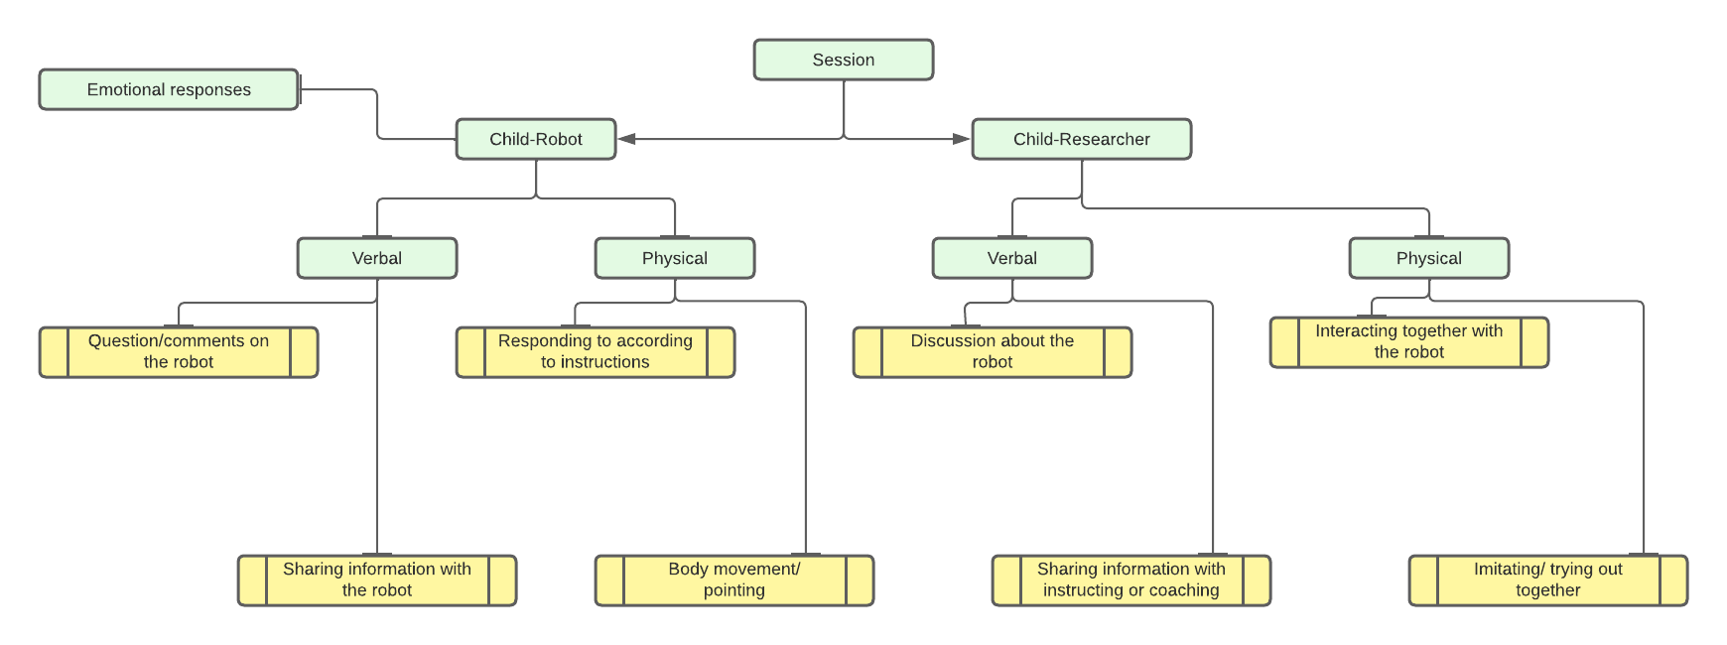
Figure 5.4: Framework with description.
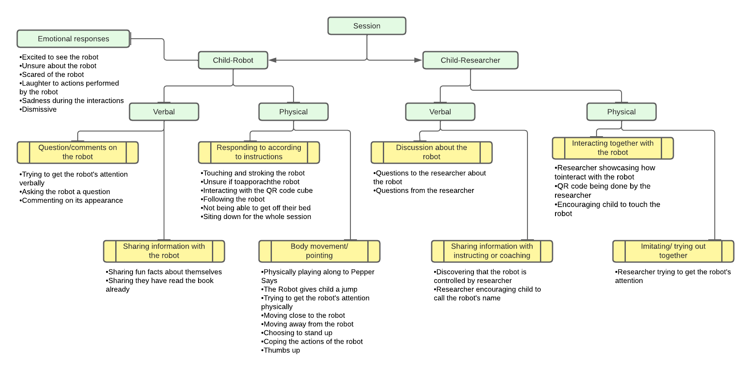
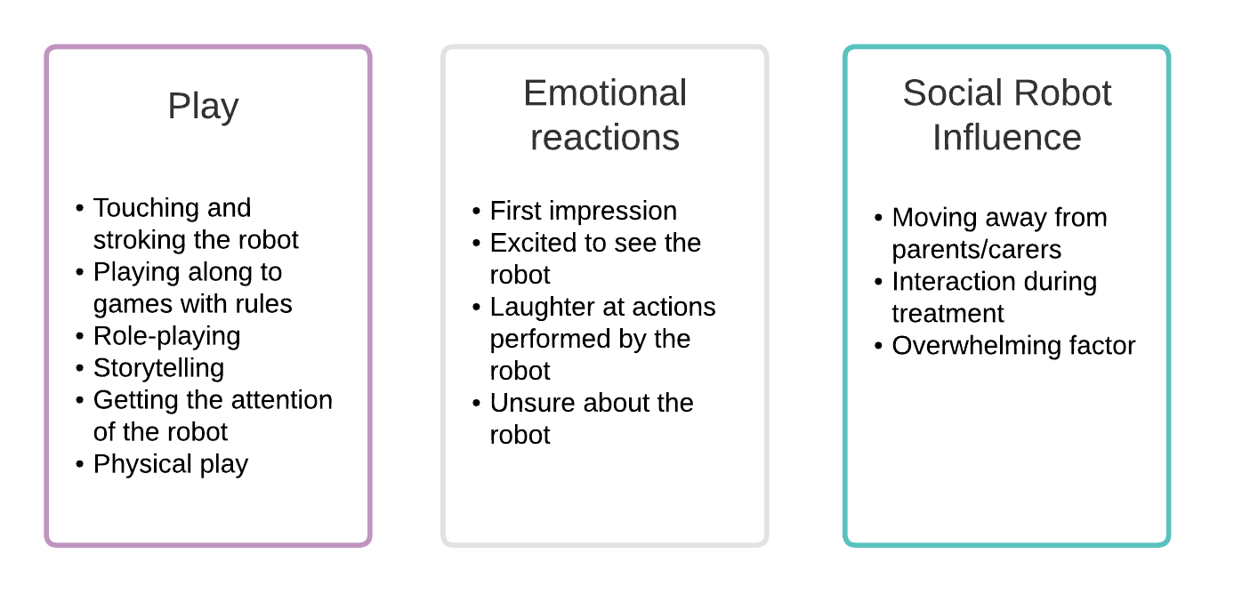
Figure 5.5: Codes with description from the observation
The decision to exclude standard Human-Robot Interaction (HRI) frameworks or evaluation questionnaires in this study was made due to the uniqueness of the study focus, which was not sufficiently addressed by existing HRI frameworks or questionnaires. Additionally, the specific criteria under investigation, such as play, hospital settings, and anxiety, were not comprehensively covered by conventional HRI frameworks.

5.3 Results

All participants were scheduled for a medical appointment or were already admitted to the hospital. Thirty-two participants were approached and recruited between the ages of 5 to 12 (M = 8.75, SD = 2.032). Eight from each setting were selected, with 18 males and 14 females in total (see Table 5.4). An equal number of paediatric patients were either assigned to interact with Pepper or MiRo. Pepper interacted with ten male and six female participants, and MiRo had eight males and eight females interact with it. See Table 5.5 for participants' characteristics for more information about the participants.

Table 5.4: Statistic for the ages of participants
 | No. of participants | The ages of the participants range | Mean | SD
Male | 18 | 6-12 | 9.33 | 2.058
Female | 14 | 5-11 | 8 | 1.797

Table 5.5: Participant's characteristics
Participant No. | Age | Gender | Setting | Reason for visit | Social robot | Seen or interacted with a social robot before
01 | 11 | F | Medical Day Care | Clinical Trial | Miro | No
02 | 9 | M | Medical Day Care | Inflex Infusion | Pepper | No
03 | 8 | F | Medical Day Care | Research | Miro | No
04 | 9 | M | Medical Day Care | Treatment | Pepper | Yes
05 | 10 | M | Medical Day Care | Research | Pepper | No
06 | 7 | F | Haematology and oncology unit | Unable to gather information | Miro | No
07 | 8 | F | Haematology and oncology unit | Chemo | Pepper | No
08 | 6 | F | Haematology and oncology unit | Chemo | Pepper | No
09 | 9 | F | Haematology and oncology unit | Iron/Blood Trans | Pepper | No
10 | 6 | M | Haematology and oncology unit | Clinic | Pepper | No
11 | 7 | M | Medical Day Care | Osteogenesis imperfect treat | Miro | No
12 | 6 | F | Medical Day Care | IV treatment | Miro | No
13 | 10 | F | Medical Day Care | Blood test | Pepper | No
14 | 6 | M | Ward 3 | Unable to gather information | Pepper | No
15 | 9 | M | Haematology and oncology unit | Chemotherapy | Miro | No
16 | 9 | M | Haematology and oncology unit | Chemotherapy | Miro | No
17 | 10 | M | Ward 3 | Unable to gather information | Pepper | No
18 | 8 | F | Ward 3 | Metabolic | Pepper | No
19 | 11 | M | Ward 3 | Chest infection | Pepper | No
20 | 12 | M | Theatre admission unit | Surgery | Pepper | No
21 | 11 | M | Theatre admission unit |  | Pepper | No
22 | 5 | F | Ward 3 | Check (wards) | Miro | No
23 | 7 | M | Ward 3 | Unwell | Miro | No
24 | 7 | F | Ward 3 | IV antibiotics | Miro | No
25 | 10 | F | Haematology and oncology unit | Immunotherapy | Miro | No
26 | 10 | F | Haematology and oncology unit | Chemotherapy | Miro | No
27 | 12 | M | Theatre admission unit | Operation | Pepper | No
28 | 12 | M | Theatre admission unit | Operation | Miro | No
29 | 8 | M | Theatre admission unit | Operation | Miro | Yes
30 | 12 | M | Theatre admission unit | Surgery | Miro | No
31 | 8 | M | Theatre admission unit | Camera | Miro | No
32 | 7 | F | Theatre admission unit | Procedure | Pepper | No

    - Types of play

      - Tactile play
Touching and stroking the social robots occurred very frequently. Participants displayed tactile play throughout the study, making it a fundamental form of play found in this study. For example, Participant 3 (female, age 8) spent 12 minutes on the floor with MiRo between her legs, rubbing its body and interacting with it. She stroked MiRo several times around his ears (see Figure 5.6). Participant 22 (female, age 5) started slightly unsure about MiRo, but 8 minutes later, she asked if she could hold MiRo on her bed. For the next 12 minutes, she had MiRo on her bed and continued to hug and comment on its appearance (see Figure 5.7). Participant 6 (female, age 7) also asked for MiRo to sit on her bed while she stroked its body and head, and Participant 11 (female, age 7) did the same for two-thirds of the session. Two participants mentioned, in their questionnaire, that they liked the fact they could stroke the social robot. Participant 15 (male, age 9) "I liked how it could spin. When you stroked it, it wiggled its tail".
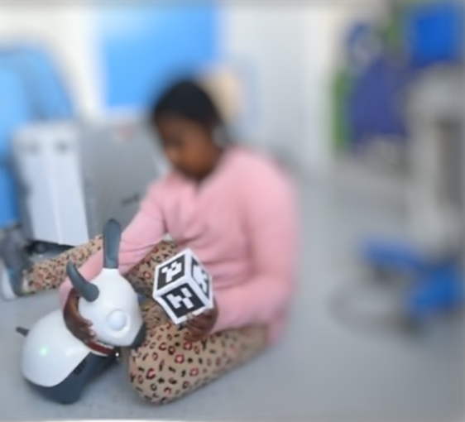
Figure 5.6: Participant 3 is sitting on the floor with MiRo stroking its head.

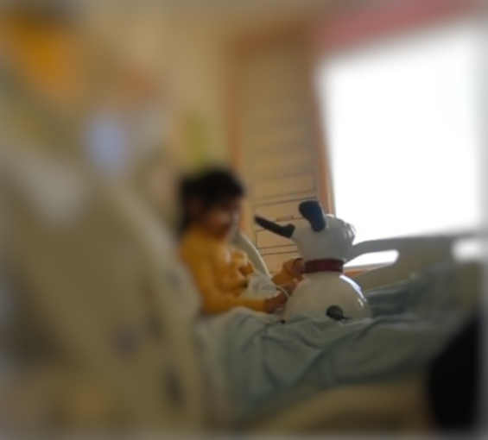
Figure 5.7: Participant 22 is sitting on the bed with MiRo beside her.

When it came to Pepper, some participants still found a way to interact with it through touch. Participant 2 (male, age 9) quickly touched Pepper's hands just after Pepper said hello. Participant 17 (male, age 10) took a picture with Pepper beside him. Participant 14 (male, age 6) was fascinated by Pepper's screen and touched it a few times.

      - Playing along to games with rules
Both robots had a feature that allowed the participant to take part in a game with rules. MiRo had a MiRoCube, which initiated specific movements. Pepper was programmed to play Pepper Says, a game in which all or one player imitates only the activities and commands of Pepper that are preceded by the words "Pepper says". Half of the participants that interacted with Pepper participated in 'Pepper Says' by either standing up to take part or sitting on their chairs. Mostly all the participants took part with MiRoCube. Participant 14 (male, age 6) was in a wheelchair. He managed to imitate Pepper using his arms, lifting it up and down. He smiled when Pepper made sounds and gestures, and at points of the interactions touched Pepper’s fingertips. He followed the instructions well and requested for some of the actions to be repeated (see figure 5.8). Participant 8 (female, age 6) started the session with Pepper nervously and decided to sit on her father's lap instead of her own chair. Once the game started, the participant got down from her father's lap and moved closer to Pepper. She took part in the game and asked for the game to be played again twice, with her trying to get the actions right each time (see figure 5.9). In figure 5.9, she is off her father's lap and in front of Pepper. Participants 15 (male, age 9) and 11 (male, age 7) worked hard to play with the MiRoCube. They moved across the floor rapidly, moving the cube in different directions and getting excited when MiRo followed the instructions through MiRoCube. Participant 25 (female, age 10), at the start of the session, was seated on a chair, but after 5 minutes of interacting with MiRo with the MiRoCube, she got down onto the ground to play with it more. In Figure 9, she is laughing while interacting with it and strokes its body, showing MiRo the cube. She stays on the floor for 10 minutes and then brings MiRo onto her lap for more stroking and play. 87% of the participants marked in their questionnaire that they liked playing games with the robot.
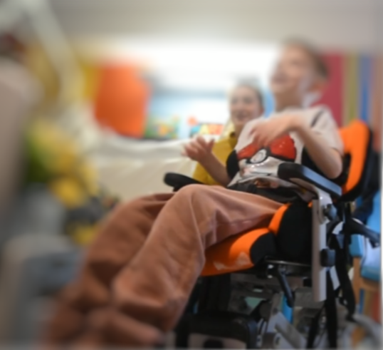
Figure 5.8: Participant 14 is sitting in his wheelchair and taking part in Pepper Says

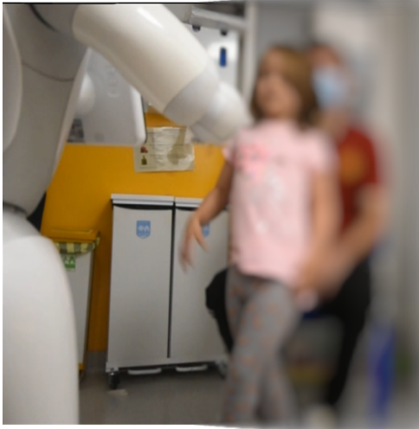
Figure 5.9: Participant 8 is standing up to take part in Pepper Says

      - Role-playing
Many of the young participants, eight years old and below, referred to MiRo as a pet. One child, participant 24 (female, age 7), created a narrative where she was the mother of MiRo and Miro was her dog. She would say to MiRo, "Listen to your mother", or "Do not be rude to your mother". MiRo would sometimes come towards her, and she would respond to it with, "I've stroked you enough times". Whenever MiRo performed an action due to the MiRoCube, the participant would say, "Good girl", and praise it. However, if MiRo went in a different direction or did something she didn't want it to do, she would say, "Listen to me" or "That's not your mother. I am". This participant expressed her affection for MiRo multiple times and gave it lots of hugs and attention. Her speech towards MiRo was loud and clear, which resulted in MiRo following her along the room accurately. Another participant, participant 18 (female, age 8), interacted with Pepper by calling its name multiple times, clapping her hands during Pepper's dancing routine, and then proceeded to tell Pepper what to do; "Do the gorilla", "clap your hands Pepper", and "high five Pepper". When the medical staff came into the room, she introduced Pepper to them and included Pepper in the conversation. Then, when Pepper turned around, facing away from her, she performed multiple actions to try to get Pepper's attention back on her. She also wrote in her questionnaire that playing was what she liked the most about interacting with Pepper. 87% (n=27) of the participant agreed positively with the statement on the questionnaire regarding playing with a social robot (see figure 5.10).
Figure 5.10: A graph representing the response from the paediatric questionnaire about their experience: Did you like playing games with the robot?

      - Storytime
A feature that only Pepper had was the ability to read a book to the participants and, at the same time, display the text and act out animations. Participant 5 (male, age 10) was shown the book and enjoyed listening to and watching the animation and asked for the book to be read out again once it finished. Participant 7 (female, age 8) wrote in their questionnaire that the story was the thing she liked most about the robot.

      - Physical play
Both social robots required the participant to interact physically with them, especially when attracting the robot's attention. Participant 5 (male, age 10) danced with Pepper, moving his arms from side to side with the music that Pepper played. When Pepper pretended to play the saxophone, participant 5 moved his body along with the rhythm. Playing along with the 'Pepper Says' game also requires physical movement, and participants 2 (male, age 9), 13 (female, age 10), and 17 (male, age 10) showed this by getting up from their seats and moving to the instructions with eagerness. Participant 32 (female, age 7) wrote in her questionnaire that the music and dancing was her favourite part of the interaction. Some participants would put their hands before MiRo's face to encourage the robot to look at them. Others would wiggle around and make noise. Participants 15 (male, age 9), 16 (male, age 9), and 31 (male, age 8) all got down to the floor and moved around, trying to get MiRo's attention by waving their arms or moving up and down, and sliding from side to side to get MiRoCube working effectively. These participants took part in physical play, using a lot of energy to interact with the social robot in a physical form. 87% (n=27) of the participants responded positively, agreeing to have fun while playing with the social robot. Please see figure 5.11 for the results of this question.

Figure 5.11: A graph representing the response from the paediatric questionnaire about their experience: How much fun did you have playing with the robot?

    - Emotional reaction

      - First impression
Many of the participants' initial reactions to the social robots were positive. Some stood up straight away and moved towards the robot. Others maintained a distance but looked with enthusiasm towards the robots. Participant 5 (male, age 10) was so excited about seeing Pepper that his mother encouraged him multiple times to calm down and wait (see figure 5.12). Participant 2 (male, age 9) stood in front of Pepper after being introduced to it by the researcher. He explored Pepper's features for a few minutes and eagerly waited to see what Pepper could do (see figure 5.13). Normally MiRo was turned on by the researcher, but three participants, without a prompt from the researcher, switched on MiRo after a few minutes of being introduced to it. Participant 11 (male, age 7) was very excited to see MiRo and came straight to the robot and started touching and stroking it. He had many questions, which included wondering how MiRo work. The questions were directed to the researcher. The participant's mother mentioned that this was the most extended period her son had stayed in the room without walking out or playing with the remote control for the electronically adjustable bed. The participant waved his hands back and forth to get MiRo's attention, attempted to pick it up, and appeared to be enjoying engaging with the robot by smiling at the robot during the interactions and asking questions. Participants 11 (male, age 7), 18 (female, age 8) and 24 (female, age 7) switched on MiRo before the session. 90% (n=28) of the participants shared that playing with the robot made them feel happy. See figure 5.14 for the responses.
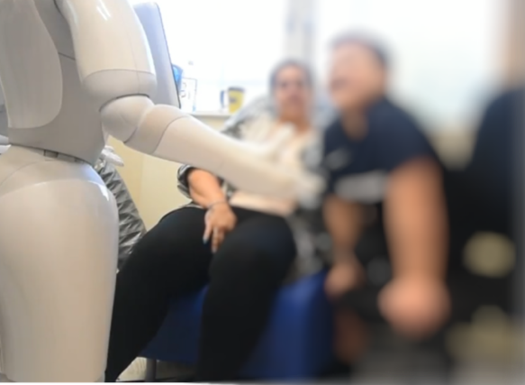
Figure 5.12: Participant 5 is sitting on the chair while they watch Pepper read a book.

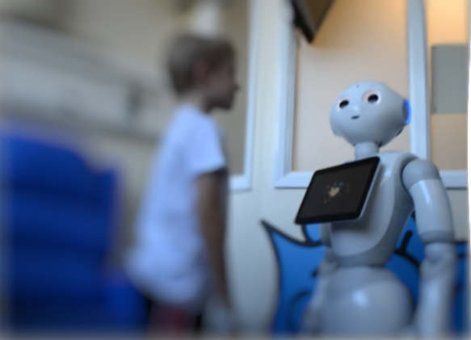
Figure 5.13: Participant 2 is standing face to face with Pepper.

Figure 5.14: A graph representing the response from the paediatric questionnaire about their experience: How did you feel playing with the robot?

      - Unsure about the robot
Although most participants reacted positively to the social robots, a few were unsure whether or how to interact with them. Participant 7 (female, age 8) was disengaged when interacting with Pepper. She seemed sad and withdrawn. Her parents had volunteered her to interact with Pepper, hoping it would cheer her up after receiving bad news. Participant 6 (female, age 7) was still determining whether she wanted to interact with MiRo. She appeared afraid of MiRo at some points of the interaction. In addition, Miro made sudden movements which caused her to jump several times. After 10 minutes into the session, she got off her bed and onto the ground and attempted to stroke MiRo but seemed cautious. In her questionnaire, she wrote that the thing she didn't like about her interaction with MiRo was that it came close to her feet. The body language of Participant 27 (Male, age 12) indicated a lack of interest in the robot. His face rested on his hands for most of the interactions; however, in his questionnaire, he noted that the robot would make a good buddy, and when asked what he thought, he had a positive reaction. Participant 4 (male, age 9) has autism spectrum disorder. The session started with him agreeing to participate in the research, but getting Pepper set up took roughly 5-7 minutes. During that time, the participant began to lose interest. When Pepper started reading out the book, the participant turned their back towards the robot and refused to look at Pepper. Instead, he played with his own hand-held games console. When asked if he would like to see Pepper dance, he said no, so it was agreed to stop the study there. The participant did not want to engage with the robot at all.6% (n=2) of participants put down that the robot scared them. See Figure 5.15 for the results from that question regarding if the robot felt scary to the participant or not.
Figure 5.15: A graph representing the response from the paediatric questionnaire about their experience: did the robot scare you?

      - Laughter
For many participants, laughter was present. Many enjoyed listening and watching Pepper pretend to play the saxophone. Participants either danced along or wiggled in the chairs and nodded their heads with the rhythm. Participant 20 (male, age 12), who was reserved at first, broke into laughter when Pepper started playing the saxophone. He also took part in the 'Pepper Says' game and reacted with excitement. MiRo also made a few participants laugh, especially when it spun around, following the MiRoCube instructions. Participant 26 (female, age 10) laughed several times at MiRo regarding its actions and movements. Whenever MiRo would spin or move around the room, the participant laughed and continued to interact with MiRo. 87% of the participants responded to the questionnaire that they had fun playing with the social robot.

    - Social Robot Influence

      - Moving away from parents/carers
A few participants started the session by sitting on their parent's lap or very close by. Participant 8 (female, age 6) sat on her father's lap for most of the interaction and did not come close to the robot, but after 6 minutes, she decided to get down and move closer to the robot. Participant 30 (male, age 12) started sitting extremely close to his mother. Initially, this participant looked very nervous at the start of the session. After three minutes of stroking MiRo, he moved onto the floor for better interaction. From the questionnaire, the participant could see the robot acting as a tool that helps and supports them in relaxing, 61% (n=19) answered yes (mean age = 8.68; range = 6) and 49% (n=13) answered unsure (mean age = 8.54, range = 7). to the robot playing this kind of role, see figure 5.16.
Figure 5.16: A graph representing the response from the paediatric questionnaire about their experience: do you think the robot can help you relax?

      - Interaction during treatment
Some of the participants interacted with a social robot during their treatment. For example, participant 12 (female, age 6) decided to stroke and play with MiRo on her bed while the nurse changed her IV fluid. Her attention was not on the treatment but on her interaction with MiRo. She seemed happy, calm, and engaged with the social robot. Another Participant, participant 18 (female, age 8), engaged happily with Pepper as her nurse tended to her medical needs. She had her face towards Pepper and did not verbally engage with the nurse while the nurse removed and changed her dressings. Participant 13 (female, age 10) initially was inhaling Entonox anaesthetic (also known as gas and air) when the session with Pepper began. Within seconds she decided that she did not need it anymore and removed the mask covering her mouth. She was highly engrossed with Pepper for the remaining time of her treatment, and once treatment was finished, she stood up and got involved with the 'Pepper Says' game. Figure 5.17 shows a graph with the responses regarding participants' feedback on the role social robot could have in the hospital.
Figure 5.17: A graph presenting the response from the paediatric questionnaire about their experience: Social robots in the hospital.

In another case, participant 16 (male, age 9) interacted with MiRo. During the session, the father said to his son that he had not been tapping his leg for the last 15 minutes since they had been interacting with MiRo. The father later explained that tapping his leg is typically behaviour that normally indicates when his son is anxious. The participant spent the whole session engaged with MiRo and had many questions for the researcher about the features and appearances. When it came to introducing the participants to the social robot, the approach varied depending on the setting and the family. 47% of participants saw the social robot before they were seen by a hospital professional regarding their visit or stay. 44% of the participants had the chance to interact during their treatment, a day visit or an overnight stay. The remaining 9% interacted with the social robots after their treatment (see figure 5.18).
Figure 5.18: A graph representing when the participants interacted with a social robot during their journey through the hospital.

      - Overwhelming factor
Participant 1 (female, age 11) withdrew from the study after three minutes of interacting with MiRo. MiRo was introduced to her while she was receiving treatment. There was BL (the researcher), her father, and a nurse in the room. In addition, there were multiple machines making noises. At first, she was unsure about interacting with MiRo but was prompted by her father to engage. She started off by stroking MiRo's body, touching its ears, and feeling MiRo's 'tail'. After two minutes of doing this, she looked at her father and started crying. All the adults in the room asked her if everything was overwhelming, which she then agreed with.

    - Social robot features
In the children's questionnaire, which was administered after the interaction, they were asked to write down things they liked about the robot and what they did not like about the robot. When it came to MiRo, participants enjoyed playing with it, its appearance and the functionality and movement of the social robot. However, some of these categories also came up in the dislike section. The sudden movement or action of MiRo was mentioned as something they didn't like, as well as it not following instructions and the limited amount of functionality. When it came to Pepper, participants responded that they liked the entertainment factor and the functionality of Pepper, as well as the appearance. However, more participants mentioned the appearance of Pepper in the dislike section, mentioning its voice, hands, and the appearance of its face. Figure 5.19 shows the comments clustered together.
Figure 5.19: The responses from the questionnaire regarding likes and dislikes
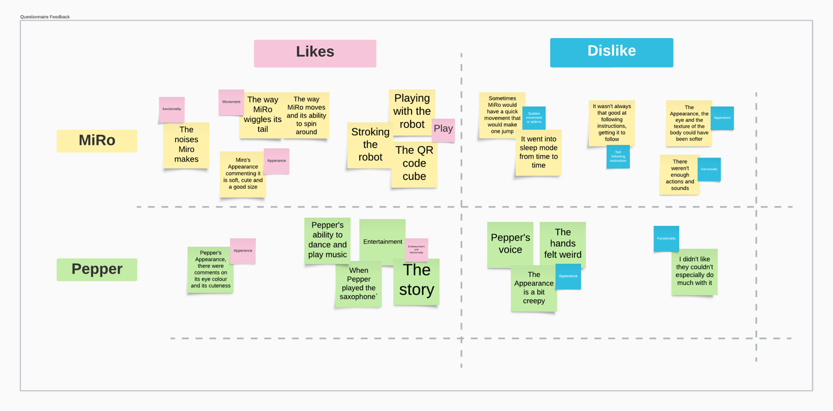
  - Discussion

The hospital environment can cause a considerable number of negative emotions among paediatric patients. Reducing anxiety in paediatric patients is beneficial, and social robots have characteristics that can support this goal (Jeong et al., 2015; Littler et al., 2021). The study demonstrated that children value play. Play is a fundamental activity for development in children and a way of communicating and belonging (Van den Heuvel et al., 2017). The United Nations Convention on the Rights of the Child (UNCRC) set in their agreement, in article 31, "A child has the right to rest and leisure, to engage in play and recreational activities appropriate to the child's age and to participate freely in cultural life and the arts." play is recognised as a child's right ('The United Nations Convention on the Rights of the Child', 1989).
Many of the participants displayed a desire for tactile play. Participants who interacted with MiRo enjoyed stroking the robot; it was apparent they enjoyed seeing MiRo's response to their touch and stroke. Some spent up to 15 minutes stroking MiRo, and others invited MiRo into their space, onto their beds or laps. Two participants commented on the feel of Pepper's hand being weird, as well as the texture of MiRo's body not being soft enough. Physical touch is a critical form and fundamental way children choose to communicate with others. Tactile play and behaviours help understand the world and build confidence, which starts from the moment a child is born (Robins and Dautenhahn, 2014). Tactile play is inclusive, offering every child a way to play and interact no matter their physical differences (Harkness and Bundy, 2001; Van den Heuvel et al., 2017). Social robots like MiRo promote inclusiveness (van den Heuvel et al., 2022).
The other forms of play during the study were games with rules, role-playing, listening to a story and physical play. Play is a human right for every child and can come in different forms. Therefore, when designing and developing social robots to reduce anxiety and distress in a hospital environment, it is crucial to consider the types of play that would be favoured among paediatric patients. There is a clear preference for tactile play, and participants also displayed a preference for games with rules. Games with rules, such as 'Pepper Says', were enjoyed by all ages. The older participants showed an evident openness to try the 'Pepper Says' game. Initially, at the start of the research, there was some doubt about whether the older participants would participate in the game section of the session. However, this assumption was quickly disproven. Most of the older children tried the games and enjoyed the interaction. Games with rules are one of the only plays we all take into adulthood. Therefore, it is useful to encourage children to engage in games with rules. It teaches children to understand rules, learn about objectives, and at the same time, challenge themselves in a fun manner (Baranowski et al., 2016).
Pepper allowed the participant to interact in a wide variety of ways, including the ability to watch and listen to Pepper read a book. Pepper offered a game that required the participant to participate in music and dances, which they could join in. Even though Pepper does not encourage tactile play, unlike Miro, participants who interacted with Pepper still found a way to connect and socially interact with it. One participant introduced Pepper to the healthcare professional who walked into her room, acknowledging that Pepper is a legitimate character that deserves a part in conversations with other humans. Whereas Miro offers an animal-like experience, which involves the participant caring for it as a pet more than a person, MiRo promotes tactile behaviours. One participant showed that she felt the need to stroke MiRo every time it approached her by saying, "I have stroked you already". The child projected intention onto the robot, demonstrating the success of the social interaction between the participant and Miro. Others called MiRo needy and commented on how much stroking it required. This was interesting as MiRo does not once ask to be petted, as it is a non-speaking social robot, making only animal-like sounds. MiRo is easy to carry and can be brought onto beds, laps, and chairs, making it a more portable social robot than Pepper. Both social robots encouraged interaction, and paediatric patients engaged with the social robots by waving their arms, calling their names, and having short conversations with them, demonstrating that the children valued the robots' attention.
The emotional reactions to the social robots were mainly positive. Participants were primarily happy to take part and interact with the robots. There were smiles and laughter when turning on the robots and questions about what the robot could do, as well as the appearance of the social robot. There was a novelty factor present with the robots, as 94% (n=30) of the participant had never seen or heard about social robots. The novelty factor has the potential to diminish over time. Early longer-term research has shown that people lose interest towards robots and change their attitudes after a period (Leite, Martinho and Paiva, 2013). As the aims of this study only required introducing the social robot to the participant once, it was not possible to know if these positive emotional reactions would diminish or change over time. Findings from a longer-term study suggested that children continued to engage with the social robot after the first meeting. Fernaeus et al. (2010) conducted a study introducing Pleo, a mini dinosaur social robot, into six families' homes for 2 to 10 months. They found that children still expressed an interest towards the social robot displaying affection but also some frustration due to the expectation of the toy not acting as a real pet (Fernaeus et al., 2010; Leite, Martinho and Paiva, 2013).
There were a few participants (n=4) that were unsure when it came to the initial interaction. However, most slowly became more comfortable interacting with the social robots. One participant found the experience overwhelming. It is essential to understand that introducing a social robot in a busy and noisy environment can unintentionally be overwhelming. Participant 1 demonstrated how quickly a social robot in a small room with healthcare professionals, a parent, a researcher, machines, and wires could cause distress. Participant 7 also displayed sadness towards the social robot. However, this was more of a withdrawn approach. She did not interact with Pepper at all, verbally or physically. She sat on her chair and watched Pepper without reacting to any of the movements or performances that Pepper displayed. This individual had attended the oncology department, and she had received some bad news that morning. Her face expressed sadness while she sat on her chair and watched Pepper perform. When introducing social robots, it is important to be mindful that some children are experiencing stressful situations. They are often experiencing new emotions, new environments, and new people. If social robots are not carefully considered in a healthcare setting before being implemented, they could quickly become another anxiety-provoking factor in a hospital environment. For this reason, we would recommend further research into identifying and describing ethical issues associated with any use of social robots in hospital settings. This research would aim to limit potentially negative impacts of social robot interventions. This work should consider incorporating prior guidance and recommendations such as the BS 8611 ‘Robots and robotic devices: Guide to the ethical design and application of robots and robotic systems’ (The British Standards Institution, 2016).
Social robots offer children good companionship, entertainment, and distraction in a healthcare setting (Dawe et al., 2019). In the questionnaire given to participants at the end of the interaction, 94% (n=29) of participants reported positively (yes) to the social robot making a good hospital buddy. In addition, 90% (n=28) stated that playing with the robot made them happy, and 61% (n=19) responded positively to the question, "Do you think the robot can help you relax?" 39% (n=12) stated that they were unsure if the robot could do such a thing.
The results indicate that companionship and entertainment are key factors when interacting with a social robot. Designing a suitable social robot to engage with children in a stressful hospital environment requires featuring elements children will respond to positively. Other studies have provided similar evidence to support the potential of social robots as a tool to promote positive emotions and decrease negative behaviours and feelings towards hospital and healthcare interventions (Beran et al., 2015b; Dawe et al., 2018; Littler et al., 2021). Ensuring that social robots have companionate and entertainment factors is crucial, as well as the play element for them to act as a buddy and distraction. An area that wasn’t considered in this study were factors that might have influenced the responses of the participants such as weather, cultural, and/or socioeconomic background. These types of information were not originally considered for this study however this could be a useful area to explore in future research.

  - Conclusion

The results highlight that different types of play occur between paediatric patients and social robots. Tactile play, games with rules, and role play are popular forms of play for children visiting the hospital. Both social robots succeeded in being social robots but in different ways. There is significant potential for social robots to help to alleviate anxiety and distress in the hospital environment. However, there is a need for further research into their effectiveness and to explore what interventions work best for certain patients in specific situations. It is also important to ensure co-design with children, parents, and healthcare professionals in the design of new social robots and their interactive features.

Authors' Contributions
Brenda Littler: Conceptualization, Methodology, Software, Formal Analysis, Investigation, Data Curation, Writing – Original Draft, Visualization, Project Administration
Luc de Witte: Conceptualization, Methodology, Writing – Review & Editing, Visualization, Supervision
Paul Dimitri: Conceptualization, Methodology, Resources, Writing – Review & Editing, Visualization, Supervision
Christine Smith: Conceptualization, Methodology, Writing – Review & Editing, Visualization, Supervision
Steven Ariss: Writing – Review & Editing, Visualization, Supervision

BL developed the protocol, conducted the research, analysed the data, and wrote the initial manuscript. LdW, CS, PD, and SA advised on either the protocol or analysis and reviewed the manuscript drafts. All authors contributed to the draft and approved the final manuscript.

Acknowledgements
We thank all authors for their contributions. BL is a PhD student at the University of Sheffield, with the Centre for Assistive Technology and Connected Healthcare (C.A.T.C.H), the School of Health and Related. LdW, PD, CS, SA have been providing supervision support to BL which has involved proof reading.

Funding sources
This research did not receive any specific grant from funding agencies in the public, commercial, or not-for-profit sectors.

5.6 References

Athanassiadou, E. et al. (2008) 'An Evaluation of the Effectiveness of Psychological Preparation of Children for Minor Surgery by Puppet Play and Brief Mother Counseling - ProQuest', Psychotherapy and Psychosomatics, 78(1), pp. 62–63. Available at: https://www.proquest.com/docview/235472238?parentSessionId=ECle8CqdjY88ipOK5q26zqyVJ9azoD6Xwcs%2FjmWpQTU%3D&pq-origsite=primo&accountid=13828 (Accessed: 17 January 2023).

Baranowski, T. et al. (2016) 'Games for Health for Children - Current Status and Needed Research', Games for Health Journal, 5(1), pp. 1–12. Available at: https://doi.org/10.1089/g4h.2015.0026.

Beraldo, G. et al. (2019) 'A preliminary investigation of using humanoid social robots as non-pharmacological techniques with children', In 2019 IEEE International Conference on Advanced Robotics and its Social Impacts (ARSO), pp. 393–400. Available at: https://doi.org/10.1109/ARSO46408.2019.8948760.

Beran, T.N. et al. (2015a) 'Humanoid robotics in health care: An exploration of children's and parents' emotional reactions', Journal of Health Psychology, 20(7), pp. 984–989. Available at: https://doi.org/10.1177/1359105313504794.

Birnie, K.A. et al. (2014) 'Systematic Review and Meta-Analysis of Distraction and Hypnosis for Needle-Related Pain and Distress in Children and Adolescents', Journal of pediatric psychology , 39(8), pp. 783–808. Available at: https://doi.org/10.1093/jpepsy/jsu029.
BS8611, B. (2016). Robots and robotic devices, guide to the ethical design and application of robots and robotic systems. British Standards Institute.
Campbell, S. et al. (2020) 'Purposive sampling: complex or simple? Research case examples', Journal of Research in Nursing, 25(8), pp. 652–661. Available at: https://doi.org/10.1177/1744987120927206/FORMAT/EPUB.

Cheung, H., Li, W. and Lopez, V. (2006) 'ISSUES AND INNOVATIONS IN NURSING PRACTICE Assessing children's emotional responses to surgery: a multidimensional approach', Journal of advanced nursing , 53(5), pp. 543–550. Available at: https://doi.org/10.1111/j.1365-2648.2006.03756.x.

Cheung, H., Li, W. and Lopez, V. (2018) 'Effectiveness and Appropriateness of Therapeutic Play Intervention in Preparing Children for Surgery: A Randomized Controlled Trial Study Smoking cessation trial View project Alternative tobacco product View project', Journal for Specialists in Pediatric Nursing, 13(2), pp. 63–73. Available at: https://doi.org/10.1111/j.1744-6155.2008.00138.x.

Chow, C.H.T. et al. (2016) 'Systematic Review: Audio-visual Interventions for Reducing Preoperative Anxiety in Children Undergoing Elective Surgery', Journal of Pediatric Psychology, 41(2), pp. 182–203. Available at: https://doi.org/10.1093/jpepsy/jsv094.

Dawe, J. et al. (2018) 'Can social robots help children in healthcare contexts? A scoping review', BMJ Paediatrics Open, 0, p. 371. Available at: https://doi.org/10.1136/bmjpo-2018-000371.
Dawe, J. et al. (2019) 'Original article: Can social robots help children in healthcare contexts? A scoping review', BMJ Paediatrics Open, 3(1). Available at: https://doi.org/10.1136/BMJPO-2018-000371.

Demore, M. and Cohen, L.L. (2005) 'Distraction for Pediatric Immunization Pain: A Critical Review Same-day injections relate to subsequent needle fear 5 years later View project Distraction for Pediatric Immunization Pain: A Critical Review 1', Article in Journal of Clinical Psychology in Medical Settings, 12(4). Available at: https://doi.org/10.1007/s10880-005-7813-1.

Fernaeus, Y. et al. (2010) 'How do you Play with a robotic Toy Animal? A long-term study of Pleo', in Proceedings of the 9th International Conference on Interaction Design and Children. ACM, pp. 39–48.

Harkness, L. and Bundy, A.C. (2001) 'The test of playfulness and children with physical disabilities', Occupational Therapy Journal of Research, 21(2), pp. 73–89. Available at: https://doi.org/10.1177/153944920102100203.

Heigham, J. and Croker, R.A. (2006) Qualitative Research in Applied Linguistics: A Practical Introduction.

Jeong, S. et al. (2015) 'A Social Robot to Mitigate Stress, Anxiety, and Pain in Hospital Pediatric Care', In Proceedings of the Tenth Annual ACM/IEEE International Conference on Human-Robot Interaction Extended Abstracts, pp. 103–104. Available at: https://doi.org/10.1145/2701973.2702028.

Kain, Z.N. et al. (1996) 'Preoperative Anxiety in Children: Predictors and Outcomes', Archives of Pediatrics & Adolescent Medicine, 150(12), pp. 1238–1245. Available at: https://doi.org/10.1001/ARCHPEDI.1996.02170370016002.

Kujala, S., Kauppinen, M. and Rekola, S. (2001) 'Bridging the Gap between User Needs and User Requirements', in Proceedings of the Panhellenic Conference with International Participation in Human-Computer Interaction, pp. 45–50.

Leite, I., Martinho, C. and Paiva, A. (2013) 'Social Robots for Long-Term Interaction: A Survey', International Journal of Social Robotics, 5(2), pp. 291–308. Available at: https://doi.org/10.1007/s12369-013-0178-y.

Li, H.C. and Lam, H.Y. (2003) 'Paediatric day surgery: impact on Hong Kong Chinese children and their parents', Journal of clinical nursing, 12(6), pp. 882–887. Available at: https://doi.org/10.1046/j.1365-2702.2003.00805.x.

Littler, B.K.M. et al. (2021) 'Reducing negative emotions in children using social robots: Systematic review', Archives of Disease in Childhood. BMJ Publishing Group, pp. 1095–1101. Available at: https://doi.org/10.1136/archdischild-2020-320721.

Luyten, T. et al. (2017) 'Disability and Rehabilitation: Assistive Technology How nursing home residents with dementia respond to the interactive art installation "VENSTER": a pilot study How nursing home residents with dementia respond to the interactive art installation "VENSTER": a pilot study', Assistive Technology, 13(1), pp. 87–94. Available at: https://doi.org/10.1080/17483107.2017.1290701.

Mccann, M.E. and Kain, Z.N. (2021) 'The Management of Preoperative Anxiety in Children: An Update', Anesthesia & Analgesia, 93(1), pp. 98–105.
McClurkin, S.L. and Smith, C.D. (2016) 'The Duration of Self-Selected Music Needed to Reduce Preoperative Anxiety', Journal of PeriAnesthesia Nursing, 31(3), pp. 196–208. Available at: https://doi.org/10.1016/J.JOPAN.2014.05.017.

Moerman, C.J., van der Heide, L. and Heerink, M. (2019) 'Social robots to support children's well-being under medical treatment: A systematic state-of-the-art review', Journal of Child Health Care, 23(4), pp. 596–612. Available at: https://doi.org/10.1177/1367493518803031.

Neaum, S. (2016) 'Observing and assessing children's learning and development', in, pp. 139–141. Available at: https://study.sagepub.com/sites/default/files/Neaum%2C%20S.%20%282016%29%20Observing%20and%20Assessing%20Children%27s%20Learning%20and%20Development.%20London%2C%20Sage._.pdf (Accessed: 17 February 2023).

Nelson Kirsten, Adamek Mary and Kleiber Charmaine (2017) 'Relaxation training and postoperative music therapy for adolescents undergoing spinal fusion surgery.' Pain Management Nursing, 18(1), pp. 16–23.

Okita, S.Y. (2013) 'Self-Other's Perspective Taking: The Use of Therapeutic Robot Companions as Social Agents for Reducing Pain and Anxiety in Pediatric Patients', Cyberpsychology, Behavior, and Social Networking, 16(6). Available at: https://doi.org/10.1089/cyber.2012.0513.

Robins, B. and Dautenhahn, K. (2014) 'Tactile Interactions with a Humanoid Robot: Novel Play Scenario Implementations with Children with Autism', International Journal of Social Robotics, 6(3), pp. 397–415. Available at: https://doi.org/10.1007/s12369-014-0228-0.

Saunders, B. et al. (2018) 'Saturation in qualitative research: exploring its conceptualisation and operationalisation', Qual Quant, 52, pp. 1893–1907. Available at: https://doi.org/10.1007/s11135-017-0574-8.

Shuman, J. et al. (2016) 'The Arts in Psychotherapy Group music therapy impacts mood states of adolescents in a psychiatric hospital setting', The Arts in Psychotherapy, 49, pp. 50–56. Available at: https://doi.org/10.1016/j.aip.2016.05.014.

Thabet, A.M. and Mona, M. (2017) 'The Relationship between PTSD, Anxiety, and Depression in Palestinian Children with Cancer and Mental Health of Mothers', INTERNATIONAL JOURNAL OF CANCER BIOLOGY AND CLINICAL ONCOLOGY [Preprint]. Available at: http://www.moh.gov.ps/.

'The United Nations Convention on the Rights of the Child' (no date). https://www.unicef.org.uk/what-we-do/un-convention-child-rights/

Van den Heuvel, R.J.F. et al. (2017) 'Robots supporting play for children with physical disabilities: exploring the potential of IROMEC', Technology and Disability , 29(3), pp. 109–120.

Van den Heuvel, R. et al. (2022) 'The potential of robotics for the development and wellbeing of children with disabilities as we see it', Technology and Disability, 34(1), pp. 25–33. Available at: https://doi.org/10.3233/TAD-210346.

Chapter 6

Parents' views of the use of Social Robots in a Hospital Environment

This paper present findings from the questionnaires given to parent/carers of paediatric patients involved in Chapter 5 observational study from a Children’s Hospital in England. This chapter plans to be submitted for publication.
Abstract

Children who visit the hospital for medical appointments undergo a range of negative emotions. These emotions range from tears, withdrawal, and negative behaviours. Managing these emotions and behaviours during a hospital visit is essential. Social robots have the potential to play a role in reducing negative emotions and behaviours. This study introduced two social robots, MiRo and Pepper, into a Children's hospital in England. Both social robots interacted and played with paediatric patients for up to 20 minutes. Parents or guardians were also in the room and had the opportunity to witness the interaction and play between their child and the social robot. Before the child interacted with a social robot, the parent or guardian filled in a questionnaire, and another questionnaire was given after the interaction. The study aimed to examine parents' and guardians' opinions of the social robot, the play's impact on their child, and the potential use of a social robot to reduce anxiety, negative emotions, and behaviours in paediatric patients. The study recruited 32 children patients aged 5 to 12 and 32 Parents and guardians. Most of the parents and guardians shared that the social robots had a positive impact on their children. There was a clear agreement regarding the positive impact social robot could have on paediatric patients within a hospital environment.
Keywords: Children, play, social robot, anxiety

  - Introduction

Children who visit the hospital present a range of negative emotions, and often these emotions and behaviours are driven by anxiety and distress (Lerwick, 2016). Anxiety is among the most common negative responses when children visit an unfamiliar environment and this is multiplied with the experience of undergoing medical procedures. Anxiety has also been known to cause harm to children's physiological and psychological health (Li et al., 2016a). These emotional behaviours and reactions have delayed essential treatments and recoveries (Lerwick, 2016). Distraction and play have been successful methods for minimising anxiety in children visiting the hospital. Distraction redirects children's attention away from stressful situations, which could be pain, the hospital environment, or the experience (Beran et al., 2015). Some evidence has shown that using visual incentives such as cartoons and music has successfully diverted children's attention and reduced children's anxiety (Cohen, 2002; Cohen et al., 1997). Despite evidence supporting cartoons and music, there is also evidence that children require more of a multis ensory approach involving visual, auditory, and tactile senses of play (Beran et al., 2015).
Playing is vital in children's development and alleviates anxiety and distress in children visiting the hospital (Li et al., 2016b). Social robots are increasingly being designed for and introduced into healthcare sectors. They provide children with an opportunity to play and interact in a multisensory manner (Dawe et al., 2019). Graaf et al. (2015) conducted a longitudinal study which explored the perspective of social robots and discovered eight social features that users share as the most prominent features for a robot to function as a social robot. For example, (1) for a social robot to have a two-way interaction, the robot to respond to humans socially, (2) be able to display thoughts and feelings; (3) be socially aware of the environment; (4) provide social support; (5) displaying some autonomy. In addition, (6) provides a sense of cosiness, (7) similarity to oneself and (8) mutual respect (De Graaf et al., 2015; Henschel et al., 2021).
This study aimed to gain parents' opinions on the role of social robots in reducing children's anxiety during hospital appointments. MiRo and Pepper were introduced to paediatric patients from a Children's hospital in England. This paper presents the parent's views and perspectives on the potential use of social robots in a hospital, as well as the reaction to the social robots' impact on their children.

  - Materials and Methods

    - Participants
Thirty-two parents/guardians were recruited to take part in the research. They all had children who were being seen by a healthcare professional at the Sheffield Children's Hospital and who took part in study as well. Parents and guardians completed pre-intervention and post-intervention questionnaires regarding their child's interaction with a social robot and the impact on their child’s emotions. Responses regarding participants' perspectives on social robots as a tool in the hospital environment were collected through the questionnaires. This study took place between September 2021 and January 2022. Participation was voluntary, and the study was approved by the NHS Health Research Authority Ethics Review Board (Manchester, REC ref: 20/NW/0242) in June 2020. The inclusion criteria were parents/guardians with children aged 5 to 12, who were being seen by a health professional from the hospital and who understood English well enough to complete the questionnaire. Table 6.1 below shows the list of parents/guardians involved in the study, alongside their role to their child, the child’s age, reason for visit, and whether it was the child’s first hospital visit.

Table 6.1: Details about the parents and guardians and their child

Participant no. | Parent/guardian role to the child | Child’s gender (age) | Reason for child’s visit  (department) | Child’s first time to the hospital
1 | Father | Female  (11) | Clinical Trial  (Medical day care unit) | No
2 | Mother | Male  (9) | Inflex Infusion  (Medical day care unit) | No
3 | Aunty | Female  (8) | Research  (Medical day care unit) | No
4 | Grandmother | Male  (9) | Treatment  (Medical day care unit) | No
5 | Mother | Male  (10) | Research  (Medical day care unit) | No
6 | Mother | Female  (7) | Unable to gather information  (Ward) | Yes
7 | Father | Female  (8) | Chemotherapy  (Oncology and haematology unit) | No
8 | Father | Female  (6) | Chemotherapy  (Oncology and haematology unit) | No
9 | Father | Female  (9) | Iron/Blood Transfusion  (Oncology and haematology unit) | No
10 | Mother | Male  (6) | Clinic  (Oncology and haematology unit) | No
11 | Mother | Male  (7) | Osteogenesis imperfect treatment  (Medical day care unit) | No
12 | Mother | Female  (6) | I.V. treatment  (Medical day care unit) | No
13 | Father | Female  (10) | Blood test  (Medical day care unit) | No
14 | Mother | Male  (6) | Unable to gather information  (Ward) | Yes
15 | Mother | Male  (9) | Chemotherapy  (Oncology and haematology unit) | Yes
16 | Father | Male  (9) | Chemotherapy  (Oncology and haematology unit) | No
17 | Mother | Male (10) | Unable to gather information  (Ward) | No
18 | Father | Female (8) | Metabolic  (Ward) | No
19 | Father | Male (11) | Chest inflection  (Ward) | No
20 | Mother | Male (12) | Surgery  (Theatre admission unit) | No
21 | Mother | Male (11) | Unable to gather information  (Theatre admission unit) | No
22 | Father | Female (5) | Check  (Ward) | No
23 | Mother | Male (7) | Acute illness  (Ward) | Yes
24 | Mother | Female (7) | IV antibiotics  (Ward) | No
25 | Mother | Female (10) | Immunotherapy  (Oncology and haematology unit) | No
26 | Mother | Female (10) | Chemotherapy  (Oncology and haematology unit) | No
27 | Mother | Male (12) | Operation  (Theatre admission unit) | No
28 | Mother | Male (12) | Operation  (Theatre admission unit) | No
29 | Father | Male (8) | Operation  (Theatre admission unit) | No
30 | Mother | Male (12) | Surgery  (Theatre admission unit) | No
31 | Mother | Male (8) | Camera  (Theatre admission unit) | No
32 | Mother | Female (7) | Procedure  (Theatre admission unit) | No

    - Questionnaire design
The questionnaires were developed to gain insight into the perceptions and views of the impact social robots could have on children visiting the hospital. BL designed the questionnaire based on a systematic review conducted by Littler et al. (2021). The systematic review explored studies that introduced social robots into hospitals to act as a distraction and reduce anxiety and distress in visiting children. The questionnaires underwent initial review by other authors before being submitted to the NHS Ethics Review Panel, and subsequent revisions were made accordingly. Parents/guardians were given a five-point Likert scale questionnaire that assessed their views and opinions before and after their child’s interaction with the social robots. The scales ranged “Strongly Agree” to “Strongly Disagree”. Both questionnaires had six questions and had three sections: their child's feeling about going to the hospital (2 items), the interaction between the social robots and children (1 item), and parents' view on social robots in a hospital environment (3 items).

    - Procedure
Children were recruited in four different hospital settings: (1) theatre admission unit, (2) medical day care unit, (3) oncology and haematology unit, and (4) a mixed internal medicine clinical ward. These settings regularly have patients who experience anxiety and distress. Visits to these settings were carried out by researchers BL and PD, with support by medical staff. In the beginning, a healthcare professional approached them to inquire about their interest in participating in the study, both for themselves and their child. A study information sheet was provided to help inform their decision. Parents or guardians were informed about the aims and goals of the research, why they were chosen, and any potential risks. Once consent was given, the parent/guardian and their child were introduced to the researcher BL and a social robot. This allowed for the study to be explained further and for questions to be asked. They were given up to 1 hour to consider their involvement in the study. Once consent was given, a pre-intervention questionnaire was given to the parents asking them about their child's emotional state before they attended the hospital and their views on social robots. The children were then introduced to the social robot and allowed to play with it for up to 20 minutes. The parents were then asked to complete the post-intervention questionnaire to capture their opinions now that they had witnessed a social robot in action. Table 6.2 describes the setting for each hospital setting used for the study.

Table 6.2: The layout of each of the department involved in the study

Setting | Description of settings
Theatre Admission Unit | In the Theatre Admission Unit, the research involved two distinct settings:  Type 1: Participants were situated in an open space with chairs that allowed them to sit and stand freely. The seating arrangement included dividers on either side, providing a semi-private space. Parents or guardians sat beside their child, with the social robot positioned in front of them. The researcher occupied the space on the opposite side of the social robot.  Type 2: Participants were accommodated in bays, featuring curtains for privacy. Within these bays, participants had beds that offered flexibility for sitting or reclining, depending on their ability. The social robot's placement varied, sometimes positioned in front or on the side, contingent on the participant's condition. Researchers adjusted their positions, accordingly, accommodating the diverse conditions of the participants in these bays.
Oncology and Haematology Unit | In the Oncology and Haematology Unit, the research setting was uniform, featuring a single type of arrangement. A dedicated room was allocated for the study, where participants entered to engage with the social robot. Within the room, participants and their accompanying parent or guardian occupied one side, while the social robot was positioned in the middle. On the opposite side of the room, the researcher facilitated the study, maintaining a structured setup that allowed for systematic observation and interaction between the participant, social robot, and researcher.
Medical Day Care | In the Medical Day Care Unit, the research settings were categorised into two types:  Type 1: Sessions in this department occurred in enclosed spaces, primarily rooms. One variation of the room featured a bed, providing participants the flexibility to either sit or move around based on their ability during interactions with the social robot. The researcher positioned themselves opposite the children and the social robot, adjusting their location as needed to facilitate the engagement effectively.  Type 2: Another room configuration included a chair instead of a bed. In this setup, participants and their parent or guardian occupied one side, while the researcher positioned themselves on the opposite side, with the social robot positioned in the middle. This arrangement allowed for structured interactions, and the researcher adapted their position to optimize the research process based on the participants' needs and conditions.
A mixed internal medicine clinical ward (Ward 3) | The ward comprised two distinct settings for the research:  Type 1: Participants in this setting were situated in bays with privacy curtains. Within these bays, participants had beds that allowed for sitting or reclining based on their comfort and ability. The placement of the social robot varied, with adjustments made according to the participant's condition—positioned either in front or on the side. Researchers adeptly adapted their positions to accommodate the diverse conditions of participants in these bays.  Type 2: The alternative setup featured a bed for participants, offering flexibility for sitting or moving during interactions with the social robot. In this configuration, researchers positioned themselves opposite the children and the social robot, adjusting as necessary to facilitate effective engagement. This setup allowed for a tailored approach that considered the varying abilities and needs of participants in Ward 3.

    - Intervention
The two social robots that the paediatric patients interacted with were Pepper and MiRo. Pepper is a self-standing social robot that is able to move it body, including arms and head (Figure 6.1). It can recognise faces and engage in limited conversation. The social robot was programmed by the researcher to perform four scenarios. The four scenarios were storytelling, movement, game, and choice of activity. During the intervention, the researcher oversaw the order of scenarios; however, the child was given an opportunity at the end to choose which scenarios they would like to see again.
MiRo was the second social robot used in the study. MiRo is an animal-like robot (Figure 6.2). It generates animal-like sounds and has sensory and motor ability. MiRo is an autonomous robot, which means it can perceive and react to its environment. There is no programming required for MiRo, it was used in its factory setting mode. MiRo can move and respond to sounds. MiRo has a tail that wags side to side and droops up and down, ears that move left and right, eyelids that open and shut, and six RGB illumination LEDs that shine through the white body shell.

Figure 6.1: Pepper the robot standing outside of the hospital waiting room.
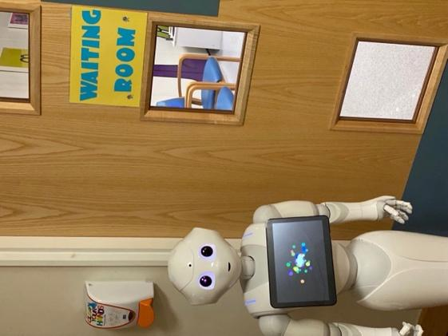

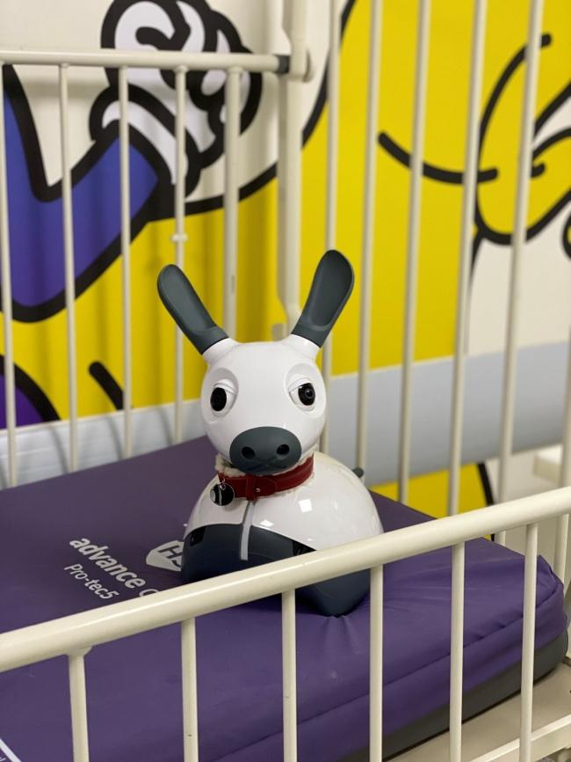
Figure 6.2: MiRo the robot sitting down on an empty hospital bed.

6.2.5 Data analyses
Once all the questionnaires were collected, the data was entered into Microsoft Excel for analysis. The data was organised in a structured format with participant numbers and their responses on the Likert scale. To further analyse the data, the responses were converted to numbers. One represented strongly disagree, two represented disagree, three represented neutral, four represented agree, and five represented strongly agree. Once the data was numbered, the next step involved analysis using SPSS statical software (SPSS premium version 28). Descriptive statistics techniques were used to summarise and describe the findings, and these included mean and standard deviation.

6.3 Results
Thirty-two parents and children gave informed consent, and thirty-one parents completed both questionnaires. One child withdrew from the study, so their parent did not complete the second questionnaire. Twenty-one female parents (65%) and eleven male parents (34%) participated.
Table 6.2: Results from the questionnaires
Pre- intervention questionnaire | My child was worried about coming to the hospital | My child felt anxious about seeing the doctor | My child will not enjoy interacting with a robot | Robots will make a good tool in the hospital | My child may treat the robot as a buddy | The robot will not help with my child’s anxiety
Strongly agree | 16%  (n=5) | 13%  (n=4) | 13%  (n=4) | 31%  (n=10) | 22%  (n=7) | 3%  (n=1)
Agree | 28%  (n=9) | 28%  (n=9) | 3%  (n=1) | 56%  (n=18) | 44%  (n=14) | 13%  (n=4)
Neutral | 16%  (n=5) | 22%  (n=7) | 9%  (n=3) | 6%  (n=2) | 28%  (n=9) | 28%  (n=9)
Disagree | 22%  (n=7) | 22%  (n=7) | 38%  (n=12) | 6%  (n=2) | 6%  (n=2) | 25%  (n=8)
Strongly disagree | 19%  (n=6) | 16%  (n=5) | 38%  (n=12) | 0%  (n=0) | 0%  (n=0) | 31%  (n=10)
Mean | 3.00 | 3.00 | 2.16 | 4.13 | 3.81 | 2.31
Std. Deviation | 1.391 | 1.295 | 1.322 | .793 | .859 | 1.148
Post- intervention questionnaire | My child seems less worried after the interaction | My child felt less anxious after the interaction | My child did not enjoy interacting with the robot | Robots will make a good tool in the hospital | I can see robots acting as a buddy for children visiting the hospital | Robots are not a suitable intervention for anxious children visiting the hospital
Strongly agree | 19%  (n=6) | 29%  (n=9) | 0%  (n=0) | 65%  (n=20) | 58%  (n=18) | 13%  (n=4)
Agree | 42%  (n=13) | 35%  (n=11) | 6%  (n=2) | 29%  (n=9) | 32% (n=10) | 0%  (n=0)
Neutral | 26%  (n=8) | 26%  (n=8) | 3%  (n=1) | 6%  (n=2) | 10%  (n=3) | 10%  (n=3)
Disagree | 3%  (n=1) | 3%  (n=1) | 35%  (n=11) | 0%  (n=0) | 0%  (n=9) | 29%  (n=9)
Strongly disagree | 10%  (n=3) | 6%  (n=2) | 55%  (n=17) | 0%  (n=0) | 0%  (n=0) | 48%  (n=15)
Mean | 3.58 | 3.77 | 1.61 | 4.58 | 4.48 | 2.00
Std. Deviation | 1.148 | 1.117 | .844 | .620 | .677 | 1.342

    - Children's feelings about attending hospital.
Results showed that 44% (n=14) of parents/guardians agreed that their child was worried about coming into the hospital (see figure 6.3), and 41% (n=13) of parents/guardians agreed that their child felt anxious about seeing a doctor. These results indicate that many children are worried about attending the hospital. Interestingly, 13 of the parents/guardians disagreed with the statements regarding their child being worried about attending the hospital. Among those, 12 had children who were not attending the hospital for the first time. Following the interaction with a social robot, 61% (n=19) of parents/guardians shared that their children seemed less worried (see figure 6.3), and 64% (n=20) seemed less anxious (see figure 6.4). From the parents'/guardians' perspective, a decrease in their child's worries and a reduction in anxiety levels occurred after interacting with a social robot. Three parents/guardians disagreed with the interaction reducing anxiety.

Figure 6.3: The results from parents’ perspective on their child’s wordiness to attend the hospital (Pre: n=32;)

Figure 6.4: The results from the questionnaire post the interaction with a social robot, relating to the anxiousness of their child after the interaction (Post: n=31)

    - The interaction between the social robots and children
Initially, 76% (n=24) of parents/guardians felt their child would enjoy playing with the social robot. In contrast, a smaller number of 16% (n=5) considered that their child would not enjoy interacting with the social robot. However, after the interaction, this changed. Most of the parents/guardians 90% (n=28) reported that their child enjoyed interacting with the social robot (see figure 6.5). Only two parents/guardians thought their child did not enjoy interacting with a robot. One of the parents/guardians, who put down their child did not enjoy the interaction, was a participant who did not engage at all with the social robot, and at one point in the session, turned their back on Pepper, the humanoid robot.
When it came to the matter of the social robot making a good tool, before the interaction, 87% (n=28) of parents/guardians agreed that it would be a good tool to have in the hospital, but after the interaction, the agreement increased to 94% (n=29). Initially, two parents/guardians disagreed with the statement that social robots are a good tool in a hospital environment. However, this changed after the interaction, with no participants who disagreed with the statement.
Figure 6.5: The results from the questionnaire post the interaction with a social robot, relating to the enjoyment of the children from the parents’ perspective.

Figure 6.6: the results from the questionnaire pre and post the interaction with a social robot, relating to the social robot being a good tool at a hospital.

    - Parent's view on social robots in a hospital environment.
Prior to the interaction with the robot, 65% (n=21) of parents/guardians felt they could see their child treating the social robot as a ‘buddy’ in the hospital setting. After the interaction with the social robot, this increased to 90% (n=28). The results displayed a shift in parents’/guardians’ perceptions regarding the social robot acting as a potential buddy for their children. In addition, no parents/guardians disagreed with the idea of social robots acting as a ‘buddy’ for children visiting the hospital after the interaction.
Before the interaction, 16% (n=5) of parents/guardians believed that the social robot would not effectively reduce anxiety in their children while visiting the hospital, with 56% (n=18) disagreeing with this proposition and signifying their disagreement in the social robot reducing their anxiety. Following the interaction, parents/guardians were asked whether a social robot was an unsuitable intervention to help with anxiety 13% (n=4) agreed. However, 77% (n=24) of parents disagreed with the statement, indicating that most respondents viewed social robots as a suitable intervention for anxious children visiting the hospital. Of the four parents/guardians that agreed with the statement relating to not being a suitable intervention, one had a child who had no physical engagement with the social robot throughout the interaction, she sat still while Pepper preformed his acts. Therefore, the father agreed that he could not see robots as a suitable tool for reducing anxiety in children while visiting the hospital.

  - Discussion
The use of social robots is increasing, and its promising role in reducing anxiety in paediatric patients is causing research interest (Dawe et al., 2019). This study explored the impact and the effect social robots had on children while visiting the hospital by investigating the perspectives of parents/guardians. Parents' and guardians' opinions are vital when introducing a new concept. In 2020 when the COVID-19 vaccination was released, research was done on the acceptability of a future COVID-19 vaccination for children by conducting a survey and interviews with parents and guardians. Bell et al. (2002) felt it was crucial to explore the acceptability from a parent's and guardian's point of view as it would fall on their responsibility to vaccinate their child or not. Their research findings highlighted the early stage of research to understand factors that may affect acceptance, which is essential. Factors relating to trust and transparency were vital areas parents and guardians felt was significant and would encourage them to either engage with it or not (Bell et al., 2020).
When it comes to social robots, many parents have yet to encounter social robots, making it important to gain insight into their opinions on the potential impact it can have on their child and their well-being from the beginning. Parents/guardians are legally responsible for giving consent to any research or medical treatment due to the child's age and level of understanding. Therefore, for this study parents/guardians gave consent on their child’s behalf.
Consistent with previous studies involving social robots and children self-managing diabetes, our study found parents responded positively and openly to the idea. Parents reported that their children displayed enjoyment during their interaction with the social robot. Our findings further supported that the interaction with the social robots positively impacted the emotions and behaviour of the paediatric patients involved. Suggesting that the presence of a social robot influenced the children's emotional state and well-being, as well as reducing a level of worriedness and anxiety. A number of parents change their mind about the impact social robots have on their child’s emotions. Parents/guardians who had initially reported that their child was worried or anxious about visiting the hospital and seeing the doctor reported a change in those feelings after games and interaction had occurred with Pepper or MiRo. While most of the parents saw a change and the results demonstrated that social robots could have a soothing and calming effect, a portion of children did not have any anxious feelings about attending the hospital, mainly if they had visited the hospital previously.
These findings corroborate the existing body of research regarding anxiety and hospital experiences. It highlights the need to mitigate negative emotions and find interventions and tools to affect paediatric patients positively. In a scoping review by Dawe et al. 2018, after reviewing seventy-three papers, the authors concluded that social robots hold significant potential to help children in a healthcare context (Dawe et al., 2019). Three years later, a systematic review was carried out by Littler et al. 2021. The authors from the systematic review reviewed studies that used social robots to reducing anxiety and distress and found that social robots had a potential of reducing negative emotions (Littler et al., 2021). This research has yielded similar findings and has demonstrated that social robots have the potential to reduce anxiety.
Regarding the interaction between the child and the social robot, parents reported that children enjoyed interacting and could see a social robot acting as a 'buddy' for their child. Regarding the concept of a buddy; studies have found that participants can sometimes compare a social robot to a friend or refer to the social robot as a buddy. In a study by Hung et al. 2021, in which a baby seal social robot interacted with ten patients with dementia, one of the main themes in their interviews, focus groups and video ethnographic was that the robot was seen as a buddy. Their study found that many patients took little time to accept and bond with PARO and that words like "it is like a buddy" were said frequently (Hung et al., 2021). Our study aligns with these previous research findings as it demonstrates that social robots can act as a companion and support children during their visit through the parent/guardian perception.
While 94% of parents or guardians acknowledged that children derived enjoyment from their interactions with the social robot, almost as many (90%), expressed agreement that social robots serve as beneficial companions for paediatric patients. The conviction regarding the efficacy of alleviating anxiety in paediatric patients stood at a slightly lower rate of 77%.These results show that while social robots substantially impact children's enjoyment and potential as a companion, there is still doubt about their effectiveness in reducing anxiety from the parents'/guardians' perceptive. This study also emphasises the potential of social robots being used to engage and create an enjoyable experience in the hospital environment for paediatric patients.
The exploration of parents' perceptions indicated that their views changed as they observed their children engaging with the robot. Initially, a subset of parents held reservations about the potential enjoyment their children might derive from the interactions. However, this scepticism was markedly transformed upon direct observation. Witnessing their children's positive experiences with the social robot served as a catalyst for a shift in parental perspectives. Parents, who may have initially doubted the efficacy or appeal of the social robot, were not only convinced of its positive impact but also began viewing it as a valuable and enjoyable intervention tool for their children. This shift in perception illuminates the crucial role of first-hand observation in shaping parental attitudes, underscoring the tangible influence of real-time interactions on parental understanding and endorsement of social robots as beneficial companions for paediatric patients.

  - Conclusion
In summary, this investigation has shed light on the prevalent issue of anxiety among paediatric patients, with each child exhibiting unique responses depending on their circumstances. Our findings strongly indicate that the companionship of social robots, mostly has a discernibly positive impact on the emotional well-being and behaviour of children, as reported by their parents or guardians. This study underscores the potential of social robots to act as amiable companions, providing valuable support to children during their hospital visits, as perceived through the perspectives of their caregivers. While our results offer promising insights, further research is essential to comprehensively understand the ways in which social robots can effectively assist children in managing negative emotions across various hospital environments and age groups. This study serves as a catalyst, paving the way for additional research on the role of robots in paediatric care, with the prospect of enhancing the hospital experience for young patients, making their visits more comforting.
Authors' Contributions
Brenda Littler: Conceptualization, Methodology, Software, Formal Analysis, Investigation, Data Curation, Writing – Original Draft, Visualization, Project Administration
Luc de Witte: Conceptualization, Methodology, Writing – Review & Editing, Visualization, Supervision
Paul Dimitri: Conceptualization, Methodology, Resources, Writing – Review & Editing, Visualization, Supervision
Christine Smith: Conceptualization, Methodology, Writing – Review & Editing, Visualization, Supervision
Steven Ariss: Writing – Review & Editing, Visualization, Supervision

6.6 References

Bell, S., Clarke, R., Mounier-Jack, S., Walker, J. L., & Paterson, P. (2020). Parents’ and guardians’ views on the acceptability of a future COVID-19 vaccine: A multi-methods study in England. Vaccine, 38(49), 7789. https://doi.org/10.1016/J.VACCINE.2020.10.027

Beran, T. N., Ramirez-Serrano, A., Vanderkooi, O. G., & Kuhn, S. (2015). Humanoid robotics in health care: An exploration of children’s and parents’ emotional reactions. Journal of Health Psychology, 20(7), 984–989. https://doi.org/10.1177/1359105313504794/FORMAT/EPUB

Cohen, L. L. (2002). Reducing Infant Immunization Distress Through Distraction. Health Psychology , 21(2), 207–211. https://oce-ovid-com.sheffield.idm.oclc.org/article/00003615-200203000-00012/PDF

Cohen, L. L., Blount, R. L., & Panopoulos, G. (1997). Nurse Coaching and Cartoon Distraction: An Effective and Practical Intervention to Reduce Child, Parent, and Nurse Distress During Immunizations 1. In Journal of Pediatric Psychology (Vol. 22, Issue 3). https://academic.oup.com/jpepsy/article/22/3/355/917453

Dawe, J., Sutherland, C., Barco, A., & Broadbent, E. (2019). Can social robots help children in healthcare contexts? A scoping review. In BMJ Paediatrics Open (Vol. 3, Issue 1). BMJ Publishing Group. https://doi.org/10.1136/bmjpo-2018-000371

De Graaf, M. M. A., Ben Allouch, S., & Van Dijk, J. A. G. M. (2015). What makes robots social?: A user’s perspective on characteristics for social human-robot interaction. Lecture Notes in Computer Science (Including Subseries Lecture Notes in Artificial Intelligence and Lecture Notes in Bioinformatics), 9388 LNCS, 184–193. https://doi.org/10.1007/978-3-319-25554-5_19

Henschel, A., Laban, G., & Cross, E. S. (2021). What Makes a Robot Social? A Review of Social Robots from Science Fiction to a Home or Hospital Near You. Cognitive Robotics , 9–19. https://doi.org/10.1007/s43154-020-00035-0/Published

Hung, L., Gregorio, M., Mann, J., Wallsworth, C., Horne, N., Berndt, A., Liu, C., Woldum, E., Au-Yeung, A., & Chaudhury, H. (2021). Exploring the perceptions of people with dementia about the social robot PARO in a hospital setting. Dementia, 20(2), 485–504. https://doi.org/10.1177/1471301219894141

Lemaignan, S., Newbutt, N., Rice, L., & Daly, J. (2022). “It’s Important to Think of Pepper as a Teaching Aid or Resource External to the Classroom”: A Social Robot in a School for Autistic Children. International Journal of Social Robotics. https://doi.org/10.1007/s12369-022-00928-4

Lerwick, J. L. (2016). Minimizing pediatric healthcare-induced anxiety and trauma. World Journal of Clinical Pediatrics, 5(2), 143–150. https://doi.org/10.5409/wjcp.v5.i2.143

Li, W. H. C., Chung, J. O. K., Ho, K. Y., & Kwok, B. M. C. (2016). Play interventions to reduce anxiety and negative emotions in hospitalized children. BMC Pediatrics, 16(1). https://doi.org/10.1186/s12887-016-0570-5

Littler, B. K. M., Alessa, T., Dimitri, P., Smith, C., & De Witte, L. (2021). Reducing negative emotions in children using social robots: Systematic review. In Archives of Disease in Childhood (Vol. 106, Issue 11, pp. 1095–1101). BMJ Publishing Group. https://doi.org/10.1136/archdischild-2020-320721

Chapter 7

The acceptance of social robots in a hospital environment: experiences and perceptions of healthcare professionals

This paper presents findings from the interviews conducted with healthcare professionals from a Children's Hospital in England.
Abstract
Managing negative emotions in paediatric patients is a challenge well-known to healthcare professionals. With numerous responsibilities, one crucial role involves developing strategies to reduce these negative emotions in paediatric patients, particularly in addressing emotional challenges during hospital visits. Thus, obtaining insight from healthcare professionals regarding their perspectives on social robots, their sentiment towards these robots, and how they could seamlessly integrate into the hospital environment is invaluable. This study conducted semi-structured interviews with eight healthcare professionals at a children's hospital in England, aiming to comprehend their opinions and views on the introduction of social robots as intervention tools to reduce anxiety and distress among paediatric patients.

Health professionals expressed a favourable opinion on the idea of using social robots to support paediatric patients dealing with anxiety during their hospital visits. They highlighted the potential benefits, especially in departments involving needles and intensive procedures. While the overall feedback was positive, concerns were raised regarding attachments and physical space required for the social robot. The findings suggest that social robots have the potential to serve as a valuable tool for reducing anxiety in paediatric patients. However, the next consideration revolves around the logistics of integrating social robots into a hospital setting and further consideration and exploration of any ethical concerns.

7.1 Introduction
Visiting the hospital can be a stressful experience for many paediatric patients (Moerman, van der Heide and Heerink, 2019). Children attend the hospital for various reasons, spanning from hourly clinics to a several weeks of hospitalisation. These visits, set in unfamiliar environments with numerous strangers asking questions, can evoke negative emotions and behaviours (Lerwick, 2016; Moerman, van der Heide and Heerink, 2019). Studies indicate that anxiety has led to treatment delays, prolonged recovery periods, and low patient satisfaction (Caumo et al., 2000; Kerimoglu et al., 2013). Minimising and managing anxiety in paediatric patients are crucial, with potential benefits for healthcare, the hospital experience, and the overall child healthcare sector (Caumo et al., 2000; Lerwick JL., 2016). Distraction techniques employed over the decades, such as music, storytelling, hospital tours, and audio-visual interventions, have reduced anxiety and distress, enhancing well-being in paediatric patients (Beran et al., 2015; Wolfe et al., 2016).
While these traditional distraction techniques have proven effective, recent studies indicate the need for multisensory methods, combining auditory and visual elements with tactile senses, to divert children’s attention away from pain (Melamed and Siegel, 1975; Beran et al., 2015; Chow et al., 2016; McClurkin and Smith, 2016). This suggests a necessity for more engaging forms of distractions to reduce anxiety in paediatric patients, and social robots emerge as a potential solution, offering a novel way for children to engage in activities. Social robots have demonstrated significant promise as anxiety-prevention intervention (Kerimoglu et al., 2013; Beran et al., 2015; Dawe et al., 2019a; Littler, Alessa, Dimitri, Smith and De Witte, 2021). Autonomous, interactive, and multifactional, these technologies that interact with human through movement and gestures (Beran et al., 2015; Littler, Alessa, Dimitri, Smith and de Witte, 2021; van Bindsbergen et al., 2022a).
The field of social robots is expanding, with various types being designed and tested in the healthcare sector (De Graaf, Ben Allouch and Van Dijk, 2015; Jibb et al., 2018). Studies have explored the benefits of social robots interacting with children facing mental health issues, physical health conditions, autism, and disability (Dawe et al., 2019b). Such interactions have proven valuable and promising, particularly in reducing negative emotions and behaviours (Littler, Alessa, Dimitri, Smith and De Witte, 2021). Crossman et al. (2018) investigated the influence of social robots on the moods, anxiety, and arousal of children ages 6 and 9 . Children encouraged to touch, play, and talk to the social robot showed increased positive moods (Crossman, Kazdin and Kitt, 2018). Another study observed children receiving annual flu vaccinations and their emotional response to a social robot’s distraction during the visit. Children appeared happier, smiled more, and talked about the robot more than the needle (Beran et al., 2015). These studies underscore the positive impact social robots can have on paediatric patients.
Considering the growing potential of social robots as an intervention to support and minimise anxiety in paediatric patients, gaining insight from healthcare professionals becomes essential. Health professionals play a pivotal role in paediatric care, and the introduction of social robots in hospital environments may influence their work (van Bindsbergen et al., 2022b). This study aims to gather healthcare professionals’ perspectives on social robots as a tool to reduce anxiety and distress in paediatric patients. Understanding healthcare professionals' views about social robots is crucial for designing and implementing practical social robots in a hospital environment (van Bindsbergen et al., 2022b).

  - Materials and methods

    - Participants and design
This paper employs a qualitative methodology involving semi-structured interviews to investigate healthcare professionals' perceptions of social robots in a hospital environment. Semi-structured interviews, as outlined by DeJonckheere and Vaughn (2019), facilitate the exploration of personal experiences, beliefs, and perceptions (DeJonckheere and Vaughn, 2019). They provide. By allowing key informants to speak freely, researchers gain an valuable insights into the hospital environment from the healthcare professional perspective (Niebauer, 2020). Open-ended and precise questions were crafted to elicit detailed responses, steering clear of leading language and jargon (Dejonckheere and Vaughn, 2019). The interview guide drew inspiration from a prior systematic review (Littler et al., 2021), that delved into studies introducing social robots into hospital settings. A convenience sampling strategy, a non-probability approach (Sedgwick, 2013), was chosen to recruit participants. This strategy not only addressed the research question and study purpose effectively but allowed for in-depth and meaningful conversations with the relevant individuals.
    - Participants
Healthcare professionals employed at a children's hospital in England were recruited for semi-structured interview. These health professionals represented various departments, including the hospital's clinical research facility, emergency department, haematology and oncology, eye department, and paediatric intensive care. They were selected to provide a broad spectrum of clinical experience, considering the high prevalence of anxious children aged 5 to 12 that visiting these departments daily. Inclusion criteria encompassed healthcare professionals working with children aged 5 to 12, spoke and understood English, and had limited knowledge of social robots. The study received approval from the NHS Ethics Committee board in June 2020 (Manchester, REC ref: 20/NW/0242).

    - Procedure
Each healthcare professional received information sheets and given 48 hours to decide on participation. After obtaining consent, interviews were scheduled with researcher BL at a mutually convenient time and location, either online or face-to-face, accommodating participants' work schedules and commitments. Interviews, lasting between 30 to 60 minutes, were recorded using a password-protected device. Verbatim transcriptions of the audio data were conducted, and pseudonymously identification, using only the participant numbers, was implemented. Thematic analysis of the transcripts was performed using NVivo (version 12), a computer-assisted qualitative data analysis software. BL initiated the first coding stage, reading the transcripts line by line.

    - Data Analysis
In this study, the choice of employing Framework Analysis for thematic analysis was informed by its systematic and transparent approach, allowing for a rigorous exploration of healthcare professionals' perceptions regarding the integration of social robots in a hospital environment. Framework Analysis is particularly suited for organising and managing data systematically, providing a structured framework for coding and categorising data. This aligns with the study's aim to gain in-depth insights and identify recurring themes in the qualitative data (Ritchie and Lewis, 2003; Braun and Clarke, 2006; Gale et al., 2013; Kiger and Varpio, 2020). The study was interested in exploring similarities and differences in the data and focusing on relationships in order to draw conclusions that are both descriptive and explanatory around the main themes (e.g. Gale et al., 2013). The data analysis strategy, developed during the planning stage, employed thematic analysis due to its flexibility in handling qualitative data. The five themed categories, developed included:
1. Background: Describing children's responses to hospital attendance and current interventions for anxiety management.
2. Experience of Social Robots in a Hospital Environment: Participant's view on social robots, their ideal placements, and potential challenges.
3. Impact on Children: Exploring healthcare professionals’ expectations regarding children’s responses and reactions to social robots.
4. Application of the Social Robot: Investigating any concerns of features that healthcare professionals foresee regarding the use of social robots.
5. Influence on the Environment: Assessing the impact of the environment on utilising social robots.
Transcribed notes were coded into these predetermined categories, with ongoing analysis allowing for the refinement, merging, or modification of themes as necessary. After BL coded 10 transcripts, BL met with SA to agree on the set of codes, once there was an agreement the codes were then applied to the remaining transcripts.
  - Results

7.3.1 Participant characteristics
Eight healthcare professionals were intentionally selected to participate in this qualitative study, aiming to provide comprehensive insights and detailed descriptions within the scope of practical constraints such as resource limitations, logistical considerations, and the objective of achieving data saturation, in accordance with established qualitative research methodologies. The decision on the sample size was not strictly predetermined at the outset but was rather guided by the principle of data saturation, where additional participants cease to provide substantially new information or insights, indicating that theoretical saturation has been achieved.
To determine when data saturation was attained, constant comparative analysis was employed throughout data collection and analysis. This involved systematically comparing new data with previously collected data to identify recurring themes, patterns, and discrepancies. As data collection progressed, emerging themes were continually evaluated, and the depth of understanding was assessed. When no new themes or insights emerged from subsequent interviews and the existing data reached a point of redundancy, data saturation was deemed to have been achieved.All the healthcare professionals were female and worked at the Sheffield Children's Hospital. All eight participants worked with the clinical research facility at some point in their careers. Each worked in different areas, two had witnessed paediatric patients interacting with a social robot called Pepper in the past, and the others had seen either Pepper or MiRo around the hospital due to research studies (see table 7.1).

Table 7.1: Participant characteristics
Table 7.1: Participant characteristics

Participant ID | Profession | Areas of work | Interview conducted | Previous experience with social robots (W: witness; S=seen) | Which Social Robot?
HP1 | Nurse | Clinical research facility (CRF) | Face to face | W | Pepper
HP2 | Nurse | Ophthalmology, emergency department, and CRF | Face to face | W | Pepper
HP3 | Nurse | Haematology and oncology | Online | S | Pepper  Miro
HP4 | Research officer | The Palestine study in the CRF | Face to face | S | Pepper  Miro
HP5 | Nurse | Allergy, medical-surgical and CRF | Face to Face | S | Pepper  Miro
HP6 | Nurse | Eye department, outpatients, and CRF | Face to face | S | Pepper  Miro
HP7 | Nurse | Haematology and oncology, and trauma | Face to face | S | Pepper  Miro
HP8 | Nurse | Paediatric intensive care and general wards | Online | S | Pepper  Miro

7.3.2 Background
Based on insights gathered from interviews with healthcare professional, this section explores the background of children’s responses to hospital attendance and the current interventions employed for anxiety management.
Healthcare professionals noted that anxiety is frequently observed among children visiting their hospital departments.
"We do see a lot of anxiety, you know, quite high anxiety levels, especially as the children get older and more aware of what's going on" (HP3).
There was a mention that children undergoing invasive procedures had an increased likelihood of experiencing anxiety.
"The thought of then having needles and invasive treatments, and also all the equipment, and everything that's going on in that room is quite full on for them. So yeah, we do see children with anxiety" (HP4).
Three healthcare professionals reported that injections were a common anxiety-provoking procedure for all ages. They shared that older children often exhibited silent anxious behaviours, reflecting their heightened awareness, while the younger ones tended to express their anxiety more overtly.
"They just, you know, act out or, you know, just a lot of crying and, you know, that sort of temper tantrum type behaviour, because they don't really understand what's going on" (HP3).
Another prevalent factor was anxiety experiences by the parents and carers of the child. It was said that children often take cues from their parents, seeking reassurance from them. Three healthcare professionals expressed that when a child’s parent or carer is worried or exhibits anxious behaviours, the child tends to mirror that behaviour.
"Anxiety often doesn't just come on its own. It comes from other external. It's often how the parents act, and children will take their cues from the parents" (HP2).
"I'd say, probably the anxiety was more with the parents than the children" (HP3).
The healthcare professionals reported that anxiety had widespread adverse effects on children during their hospital visits.
"Having uncontrolled anxiety in a child can be devastating, and life-changing, if it then causes them to disengage" (HP6).
To alleviate anxiety, current interventions involve the inclusion of playworkers, play specialists and therapists.
"If we're doing a procedure where we feel a child's really anxious, then we quite often will work with the play therapists would come in, and they would work with the child" (HP3).
Nevertheless, according to one healthcare professional, these intervention such as playworkers are underused. Additionally, another healthcare professional expressed that certain hospital departments could derive greater benefits from utilisation of a play specialist.
"We could use the play specialist quite a lot more for kids that have anxiety issues with injection. But we barely ever use it" (HP7).
Reasons cited for not engaging a play specialist range from being too busy to establish contact to potential scepticism about the effectiveness of their work.
"You've got loads of other things. It's more work to get these people involved", "thinking honesty, its disbelief in the use of them slight disbelief, and maybe even laziness because you just want to get your job done" (HP7).
Additional interventions discussed included arts and crafts, the provision of toys, and pre-procedure visits to the hospital. Learning disability nurses were also identified as crucial support for children dealing with needle phobia and autism.
We ended up getting the learning disability lead nurse involved. And she just came in and suggested a few things. Really simple things like, let's just have an appointment, where we just make this a really wonderful experience. So, we did that (HP4).

We've had one occasion where we have used a learning disabilities nurse who actually also helps children cope with difficult procedures (HP7).
7.3.3 Experience of social robots in a hospital environment
Healthcare professionals conveyed their perspectives on the introduction of social robots into the hospital setting, and shared first-hand experience of observing patients interact with a social robot.
Healthcare professionals expressed support for the introducing social robots into a hospital environment.
"I think it's a brilliant idea. It's really, really good. Yeah, I'm surprised it's not done before. And especially like the kids with specific learning problems" (HP1).
Healthcare professionals recounted two instances where they observed their patients interacting with social robots. The first involved a 10-year-old boy who frequently visited the hospital regularly and typically had difficulty remaining still during appointments.
"When I saw the little boy a few weeks ago. He is 10. I think. I'm not sure whether he's got any learning difficulties, such as ADHD. But I've not seen him sit still for very long. But what was really lovely was when the robot read a story to him, and he sat still, and he was really engaged. Yes, the most engaged I have seen him really, that was really good" (HP1).
Another healthcare professional recounted an experience involving a 10-year-old girl who had been attending the hospital for over a year, typically on monthly visits with two-week stays. The girl’s parents exhibited anxiety,, and the healthcare professional noted that this anxiety seemed to impact the child. As a measure to reduce the girl’s anxiety levels, the hospital permitted her to use Entonox.
"Her parents are very anxious. And that sort of gets projected onto her. Often, it's sort of multiple cannulas to put in to get this infusion going in. She does get very, very worried about it. So, we use the Entonox, and that helps her with the procedure of putting the cannula in or if it's just a blood draw (HP2).
The healthcare professional detailed the patient’s reaction upon seeing social robot, Pepper, being introduced into the room for interaction.
"Her eyes lit up when she saw the robot. And she was interacting, even though she sat in the chair and was fairly immobile because I had her arm, and we were taking blood. But actually, she didn't need to use the Entonox because she was so distracted. She was so transfixed by the robot. It was monumental, really, for her. It's absolutely massive that she didn't need that. So, they actually didn't need to use interlocks. So, it was amazing." (HP2)."
Two health professionals highlighted features they appreciated in a specific social robot named MiRo. They noted its ability to engage children through tactile interactions, acting as a distraction with its animal-like characteristics. These aspects were identified as advantages of utilising social robots as intervention tools.
"It just allows them to sort of, yeah, be to be themselves in a way, you know, sort of touchy-feely, so that's really nice" (HP2).
"I guess it's sort of like a distraction as well. Yeah, something that stops the child focusing entirely and sort of exemplifying in their head" (HP6)

7.3.4 Impact on children
Healthcare professionals expressed their views on the potential impact of social robots on children visiting the hospital, highlighting the importance of proactive measures to improve anxiety levels in patients, and emphasising ongoing efforts to explore innovative solutions.
When questioned about their expectations regarding how patients and children visiting the hospital would respond to social robots, the healthcare professionals provided a positive response. Two professionals elaborated on the reactions their patients exhibited when introduced to a social robot.
"I think it has been really positive. Especially the Boy, I actually saw doing it. It was really good" (HP1).
"Yeah, I think one little girl was very early on in her diagnosis. And her mum thought it would be a good thing to see [the robot] because it would just take away some of the Anxiety because she was sitting around waiting for the first slot of treatment. And so, she was really anxious about everything. And I think they just thought it would work as a good distraction for her" (HP3).

Health professionals proposed strategies for utilising social robots to reduce children's anxiety levels. One suggestion involved pre-programming for returning patients, tailoring the robots’ interactions based on their child’s preferences. They emphasised that anxiety often stems from anticipation of hospital visits and the uncertainty of medical procedures, leading to anxious behaviours in patients.
"Because I think a lot of the time is because children know that you're going to be doing something, and they've already worked themselves up" (HP5).
Another professional referred to social robots as a distraction tool, highlighting their potential to divert attention away from anxiety inducing situations:
"You're giving them another focus. Mind off whatever they're having a blood test or taking their mind off it for a bit, then totally focusing and totally engaging. And when you're in the moment, you haven't got time to be anxious because you're in the moment interacting with a robot that's already watching that" (HP1).
Another professional discussed the increasing number of children with autism and emphasised that the hospital doesn’t always serve as a calming environment for them. They suggested that awareness of encountering a social robot, capable of providing a more positive experience , could potentially contribute alleviating in siuch children.
"If they knew that there was this robot, sure that that would help to get them to the hospital and to have a better experience" (HP4).
Several respondents mentioned the importance of taking proactive measures and consistently seeking ways to improve the anxiety levels in their patients. Additionally, there was widespread support for the use of distraction techniques.
"Children don't always show Anxiety in the same way as we do. And they don't always tell you. And I think anything that's going to interact and distract children is always a good thing. And I think distraction, in general, is very good. And that's why we play with them so much is to take their mind off of what we're doing, if it's something that they're, you know, not always keen on" (HP5).

7.3.5 Application of the social robots
Healthcare professionals expressed both enthusiasm and reservations regarding the application of social robots in a hospital setting. They articulated concerns about potential challenges and shed light on the implementation of social robots in healthcare environments,
When questioned about potential worries or concerns regarding the utilisation of social robots in a hospital setting. One professional expressed apprehension about the possibility of children forming attachments to the social robot, while another raised concerns specifically regarding children with autism.
"One thing it could become like a toy, and they want to interact too much" (HP1).
"So, children, you know, on any part of the autistic spectrum, you know, that it may be too much for them, their noise, maybe too much the movement, maybe too much. That sensory might just be a sensory overload for them" (HP2).
Another concern raised was the appearance and size of the social robot. All the healthcare professionals were familiar with the visual aspect and dimensions of Pepper, which was used for a hospital study in their departments. Two professionals, who had seen Pepper in action, specifically mentioned their observations.
"I think it might be a bit scary. You know when it first wakes up" (HP1),
"They could be scary for some children and very younger children. I think its sudden movements are a little bit scary" (HR2).
Certain healthcare professionals remarked on the potential for random, sudden movements that social robots could exhibit.
"You might have a child who might suddenly be surprised by it, it might do something that they don't expect. So, for some children, or it might suddenly make a noise, but it just depends on it" (HP4).
Another area of concern raised by healthcare professionals was related to technical support. They were cognisant, with some having first-hand experience, of social robots encountering technical issues during previous research studies.
"I think that there would need to be somebody like, ready, available. Like to, to, let's say, come in, fix it, or, you know, provide a provided input if, if, let's say that the robot doesn't work quite right" (HP8).

Finally, concerns were raised about the storage space for the social robots, potential wear and tear of the technology, and the practicality of handling the robots in terms of their size.
"At the moment, with space and things like that, it could be an issue" (HP5).
"Most of the time, you've got issues, perhaps with space" (HP7).
"I'd imagine wear and tear on the robot would be" (HP6).

7.3.6 Implementation suggestions in hospital
The interviews delved into areas where healthcare professionals anticipated a positive impact from the social robot. Suggestions were made for impact from the social robot in hospital departments such as the emergency department, inpatient areas, and the play team. A consistent theme emerged, reflecting a shared desire among professionals for more diverse forms of play and interaction to be available, especially for children facing extended stays in the hospital.
"We've got patients who were isolated for long periods of time, you know, so they're away from any, you know, pets at home, they're away from them, they're away from family members" (HP3).
"I think it's good for long-term patients who've been in for a long time as well because it's something that they will benefit from because they, you know, they're in for a long time and start getting anxious about those things, especially when there are restrictions on visitors" (HP5).
Some mentioned children waiting to be seen, noting that certain departments have extended waiting periods, further heightening the anxiety levels of the children.
"Because when you're waiting, and you're just looking at the screen waiting to be called, you're anxious" (HP2).
"a huge amount of time in between the patient appointments for a child, a lot of time to get worked up and really quite worried about what's coming. They knew that there was this robot, sure that that would help to get them to the hospital and to have a better experience" (HP4)."
A healthcare professional proposed the idea of integrating a social robot with the play team, highlighting their regular interactions anxious children.
"I think a place where it is quite useful is playing team. They get bleeped to see particularly anxious patients than they would usually go and spend time with that patient before they have something done" (HP5).
Other suggested places within the hospital setting include:
"I'm thinking maybe like outpatient departments, specific like dedicated area onwards, inpatient wards where, you know, I would expect a playroom, where maybe, the robot could be placed and patient that has a single room, maybe can go and, spend time with" (HP8).
Regarding the optimal timing for introducing a social robot during a child's hospital journey, healthcare professionals provided a mixed response – whether it be before or after their interaction with a healthcare professional or simply as an item available for use in the hospital.
"Kind of both. So, they get to have an interaction, they have that, and then they get to play again" (HP5).
"I think it's actually a nice thing to just have around, you know, and the kids know that they're there. And they know that they're going to go to a hospital, and there's going to be all this funny stuff" (HP7)
The finial topic addressed with the healthcare professionals was whether they perceived the social robot as a potential negative influence or obstruction to hospital work. All eight healthcare professionals unanimously disagreed with the notion that social robots could impede hospital staff.
"I can't think of how it would, you know" (HP7).
"Nothing comes to my mind to say, oh, no" (HP8).

  - Discussion

Healthcare professionals perceived anxiety as a prevalent emotion among children visiting the hospital. The abrupt shift from their familiar surroundings to often distressing environment, coupled with illness and potentially unpleasant medical procedures, frequently induces fear, worry, and anxiety in paediatric patients (Moerman, van der Heide and Heerink, 2019). Healthcare professionals noted varied manifestations of anxiety in paediatric patients, with young children expressing it more overtly, while older patients sometimes exhibit less visible signs, aligning with previous research findings (Arts et al., 1994).
Injections were singled out as common anxiety-provoking procedures, prompting extensive research into fear reduction methods, including investigations into the placebo effect in children (Goodenough et al., 1997). Parental anxiety emerged as another focal point, with professionals underscoring its potential influence on a child's emotional state. Research aligns with this perspective, emphasising the need to address excessive parental anxiety for the well-being of paediatric patients (Shirley et al., 1998).
The introduction of social robots during medical procedures and hospital visits was discussed as a potential tool to alleviate pain and reduce anxiety in children. Distraction, a proven anxiety-prevention method, has historically included play materials, showing positive responses in children undergoing medical interventions (Moerman, van der Heide and Heerink, 2019)(Brewer et al., 2006). The consensus among healthcare professionals in this study strongly supports the integration of social robots as an intervention tool, despite acknowledging the underutilisation of current methods such as playworkers and therapists in the hospital environment.
The complexity of the hospital setting, with diverse departments catering to different needs, prompted healthcare professionals to identify specific areas where social robots could prove beneficial. The emergency department, inpatient wards (especially for isolated children), and areas involving high needle usage were highlighted. These suggestions align with research indicating elevated anxiety in children undergoing clinical visits, acute care, and invasive procedures, potentially causing emotional trauma and affecting physical and personality growth.
Features that would enhance the effectiveness of social robots were discussed, including tailoring them to individual patients, utilising animal-like forms, and addressing the unique needs of children with autism. While two professionals saw potential benefits for children with autism, concerns were raised about sensory overload. Worries about children forming attachments to the social robot were also acknowledged. However, issues regarding attachment could potentially be addressed through the reassurance that children understand their hospital experience is temporary. These are important ethical considerations, regarding potential psychological harm to particularly vulnerable children, which have been highlighted by this study and demand closer scrutiny in future research. Other things to consider is that social robot various when it comes to the access, availability and cost. These effects comparisons to other techniques need to be made case by case.
This research possesses several strengths that enhance the robustness and significance of its findings. The inclusion of healthcare professionals from diverse departments within a children's hospital ensures a richness of perspectives, resulting in qualitative data containing varied insights. The use of semi-structured interviews as a data collection method allowed for in-depth exploration of healthcare professionals' perceptions, providing detailed and nuanced responses, whilst offering a framework to enable thorough comparison and combination of findings. Methodological transparency was maintained through the adoption of Framework Analysis, which is a systematic approach that adds consistency and rigor to the thematic analysis process. The study is set within the context of previous and current research on social robots in hospital settings and the relevance to paediatric care. The work therefore builds on prior knowledge, advances understanding in this field and sets out clear directions for future development in terms of practice and research.
However, certain weaknesses warrant consideration. The study's focus on healthcare professionals from a single children's hospital in England may limit the generalizability of findings to broader healthcare contexts. Further studies in different settings are recommended to establish whether there are other important contextual features to consider. Additionally, the small sample size of eight participants could raise concerns about the representativeness of perspectives within the larger population of healthcare professionals. While efforts were made to gather high quality data, potential biases including socially desirable bias regarding interview or survey responses from participants might have influenced the findings. The retrospective nature of some elements of the study design relied on self-reported perceptions, which may introduce difficulties with the accuracy of recall. However, the use of observation and video data to record extended sequences of interaction minimises these potential weaknesses in the study as a whole, through the triangulation of observational and reported data. Despite these potential limitations, a key strength of the study is that it combines an exploration of the benefits of social robots with valuable insights into the feasibility and implications of incorporating them into paediatric healthcare settings.

  - Conclusion and recommendations

In conclusion, our discussions with healthcare professionals highlight the pervasive issue of paediatric anxiety in hospital settings. The consensus among professionals supports and accepts the use of social robots as innovative tools to reduce anxiety, particularly in strategic areas like the emergency department and inpatient wards. While recognising the potential benefits, concerns about sensory overload and ethical considerations indicate the need for further investigation and an evidence-informed approach in design and implementation. The study's limitations, such as a homogeneous participant group and a single-hospital focus, underscore the need for future research with diverse representation.
Overall, this exploration points to the promising role of social robots in enhancing patient-centreded care for paediatric anxiety in hospitals. Social robots have the potential to be programmed or chosen to provide additional benefits, such as educational, behavioural, or psychological interventions. They therefore have the capacity to provide wider benefits than traditional distraction techniques. They could also prove to be more engaging than other approaches to anxiety reduction. However, care must be taken to ensure that the possibilities of psychological harm are minimised, through carefully matching interventions with specific patients and ensuring that attachment problems are not experienced. A key recommendation is therefore for further research to investigate these issues.

Authors' Contributions

Brenda Littler: Conceptualisation, Methodology, Software, Formal Analysis, Investigation, Data Curation, Writing – Original Draft, Visualization, Project Administration
Luc de Witte: Conceptualisation, Methodology, Writing – Review & Editing, Visualization, Supervision
Paul Dimitri: Conceptualisation, Methodology, Resources, Writing – Review & Editing, Visualization, Supervision
Christine Smith: Conceptualisation, Methodology, Supervision
Steven Ariss: Writing – Review & Editing, Visualization, Supervision

7.6 References

Arts, S.E. et al. (1994) Age-Related Response to Lidocaine-Prilocaine (EMLA) Emulsion and Effect of Music Distraction on the Pain of Intravenous Cannulation, PEDIATRICS. Available at: http://publications.aap.org/pediatrics/article-pdf/93/5/797/985280/797.pdf.

Beran, T.N. et al. (2015) ‘Humanoid robotics in health care: An exploration of children’s and parents’ emotional reactions’, Journal of Health Psychology, 20(7), pp. 984–989. Available at: https://doi.org/10.1177/1359105313504794/FORMAT/EPUB.

van Bindsbergen, K.L.A. et al. (2022a) ‘Social robots in pediatric oncology: opinions of health care providers’, Journal of Psychosocial Oncology Research & Practice, 4(2), p. e073. Available at: https://doi.org/10.1097/or9.0000000000000073.

van Bindsbergen, K.L.A. et al. (2022b) ‘Social robots in pediatric oncology: opinions of health care providers’, Journal of Psychosocial Oncology Research & Practice, 4(2), p. e073. Available at: https://doi.org/10.1097/or9.0000000000000073.

Braun, V. and Clarke, V. (2006) ‘Using thematic analysis in psychology’, Qualitative Research in Psychology, 3(2), pp. 77–101. Available at: https://doi.org/10.1191/1478088706qp063oa.

Brewer, S. et al. (2006) ‘Pediatric Anxiety: Child Life Intervention in Day Surgery’, Journal of Pediatric Nursing , 21(1), pp. 13–22. Available at: https://doi.org/10.1016/j.pedn.2005.06.004.

Caumo, W. et al. (2000) ‘Risk factors for postoperative anxiety in children’, Acta Anaesthesiologica Scandinavica, 44(7), pp. 782–789. Available at: https://doi.org/10.1034/J.1399-6576.2000.440703.X.

Chow, C.H.T. et al. (2016) ‘Systematic Review: Audiovisual Interventions for Reducing Preoperative Anxiety in Children Undergoing Elective Surgery’, Journal of Pediatric Psychology, 41(2), pp. 182–203. Available at: https://doi.org/10.1093/jpepsy/jsv094.

Crossman, M.K., Kazdin, A.E. and Kitt, E.R. (2018) ‘The influence of a socially assistive robot on mood, anxiety, and arousal in children’, Professional Psychology: Research and Practice, 49(1), pp. 48–56. Available at: https://doi.org/10.1037/PRO0000177.

Dawe, J. et al. (2019a) ‘Can social robots help children in healthcare contexts? A scoping review’, BMJ Paediatrics Open, 3(1), p. e000371. Available at: https://doi.org/10.1136/BMJPO-2018-000371.

Dawe, J. et al. (2019b) ‘Original article: Can social robots help children in healthcare contexts? A scoping review’, BMJ Paediatrics Open, 3(1). Available at: https://doi.org/10.1136/BMJPO-2018-000371.

DeJonckheere, M. and Vaughn, L.M. (2019) ‘Semistructured interviewing in primary care research: a balance of relationship and rigour’, Family Medicine and Community Health, 7(2), p. 57. Available at: https://doi.org/10.1136/FMCH-2018-000057.

Dejonckheere, M. and Vaughn, L.M. (2019) ‘Semistructured interviewing in primary care research: a balance of relationship and rigour’, Fam Med Com Health, 7, p. 57. Available at: https://doi.org/10.1136/fmch-2018-000057.

Goodenough, B. et al. (1997) An investigation of the placebo effect and age-related factors in the report of needle pain from venipuncture in children.

De Graaf, M.M.A., Ben Allouch, S. and Van Dijk, J.A.G.M. (2015) ‘What makes robots social?: A user’s perspective on characteristics for social human-robot interaction’, Lecture Notes in Computer Science (including subseries Lecture Notes in Artificial Intelligence and Lecture Notes in Bioinformatics), 9388 LNCS, pp. 184–193. Available at: https://doi.org/10.1007/978-3-319-25554-5_19/COVER.

Jibb, L.A. et al. (2018) ‘Using the MEDiPORT humanoid robot to reduce procedural pain and distress in children with cancer: A pilot randomized controlled trial’, Pediatric Blood and Cancer, 65(9). Available at: https://doi.org/10.1002/pbc.27242.

Kerimoglu, B. et al. (2013) ‘Anesthesia induction using video glasses as a distraction tool for the management of preoperative anxiety in children’, Anesthesia and Analgesia, 117(6), pp. 1373–1379. Available at: https://doi.org/10.1213/ANE.0B013E3182A8C18F.

Kiger, M.E. and Varpio, L. (2020) ‘Medical Teacher Thematic analysis of qualitative data: AMEE Guide No. 131 Thematic analysis of qualitative data: AMEE Guide No. 131’, Medical teacher, pp. 42–48. Available at: https://doi.org/10.1080/0142159X.2020.1755030.

Lerwick JL. (2016) ‘Minimizing pediatric healthcare-induced anxiety and trauma’, World Journal of Clinical Pediatrics, 5(2), pp. 143–150. Available at: https://doi.org/10.5409/wjcp.v5.i2.143.

Littler, B.K.M. et al. (2021a) ‘Reducing negative emotions in children using social robots: Systematic review’, Archives of Disease in Childhood, 106(11), pp. 1095–1101. Available at: https://doi.org/10.1136/ARCHDISCHILD-2020-320721.

Littler, B.K.M. et al. (2021b) ‘Reducing negative emotions in children using social robots: Systematic review’, Archives of Disease in Childhood. BMJ Publishing Group, pp. 1095–1101. Available at: https://doi.org/10.1136/archdischild-2020-320721.

McClurkin, S.L. and Smith, C.D. (2016) ‘The Duration of Self-Selected Music Needed to Reduce Preoperative Anxiety’, Journal of Perianesthesia Nursing, 31(3), pp. 196–208. Available at: https://doi.org/10.1016/j.jopan.2014.05.017.

Melamed, B.G. and Siegel, L.J. (1975) Reduction of Anxiety in Children Facing Hospitalization and Surgery by Use of Filmed Modeling, Journal ol Consulting and Clinical Psychology.

Moerman, C.J., van der Heide, L. and Heerink, M. (2019) ‘Social robots to support children’s well-being under medical treatment: A systematic state-of-the-art review’, Journal of Child Health Care, 23(4), pp. 596–612. Available at: https://doi.org/10.1177/1367493518803031/FORMAT/EPUB.

Niebauer, A. (2020) ‘The Epistemological and Methodological Foundations of Qualitative Research’. Available at: https://www.researchgate.net/publication/339750453 (Accessed: 24 January 2023).

Sedgwick, P.M. (2013) ‘BMJ Statistics Endgames View project Biologics for Rheumatoid arthritis pain View project’, 66, p. 409. Available at: https://doi.org/10.1136/bmj.f6304.

Shirley, P.J. et al. (1998) ‘Parental anxiety before elective surgery in children A British perspective’, Anaesthesia, 53, pp. 956–959. Available at: https://doi.org/10.1046/j.1365-2044.1998.00533.x.

Wolfe, I. et al. (2016) ‘Child Health Systems in the United Kingdom (England)’, Journal of Pediatrics, 177, pp. S217–S242. Available at: https://doi.org/10.1016/j.jpeds.2016.04.058.

Chapter 8

General Discussion

This chapter presents the overall results of the study and a reflection on the main findings. The strengths and weaknesses of this research are considered, and recommendations are made for future implications of social robots in hospital environments and further research. This is followed by the overall conclusion to the thesis.

8.1 Study Summary

The primary aims of this research were to observe how paediatric patients respond and play with social robots, to examine the feasibility of using social robots within the clinical setting, and to gather opinions and insight into the effectiveness of social robots in mitigating anxiety of paediatric patients. Despite there being a growing interest in the use of social robots in the healthcare sector (van Bindsbergen et al., 2022), there is no evidence in the literature regarding the types of play that occurs with social robots in a busy, noisy, and stressful environment, and application of social robot in a hospital setting (Dawe et al., 2019). There is a lack of insight from patients, parents, and healthcare professionals when it comes to their opinion of social robots and their potential to reduce negative emotions.
This research started with a literature review (Chapter 2), an overview of previously published work on anxiety among paediatric patients, as well as interventions used in the past to reduce anxiety, pain, and distress. There is also an introduction to the use of social robots as a tool to improve well-being amongst different groups. The findings of this review revealed that anxiety among paediatric patients is common and can have a detrimental effect on paediatric patients’ treatment and recovery and that there is a potential that social robots could be an excellent tool to support the mitigating of negative emotions. I then went on to do a systematic review which focused on the reduction of negative emotions, anxiety, and distress, among paediatric patients by using social robots (chapter 3). Ten published papers were identified during this review which had introduced one or two social robots into a hospital with the desire to reduce anxiety or distress. This review highlighted the potential impact that social robots could have on reducing anxiety or distress in paediatrics. However, it exposed that more detailed and high-quality research was required within this field to gain further understanding. At the same time, no information was found on the ways patients interacted with the social robots (Littler et al., 2021).
Based on the findings from the reviews and conversations with the Sheffield Children’s Hospital staff, a mixed-methods exploration of feasibility, acceptability, and utility was then conducted. Thirty-two paediatric patients aged 5 to 12 were observed while interacting and playing with a social robot, either Pepper or MiRo. Study participants were given a questionnaire to gather their feedback regarding the interaction. Alongside the observation, parents/carers had two questionnaires to fill in, one before the interaction and the second one after the interaction. Lastly, semi-structured interviews were conducted with eight healthcare professionals to gain insight into anxiety in the hospital and how they view social robots as a potential tool for reducing anxiety and distress.

  - Main findings

Based on the results of previous research, social robots have a promising potential ability to support children who are visiting the hospital, as well as a possibility of reducing anxiety and distress in those same children. The data found in this research provide convincing evidence that social robots offer children a chance to play in an otherwise stressful environment and benefit their mental state. Furthermore, there is a clear desire from the children, parents, and healthcare professionals for more social robot interaction in hospital environments. There is also a longing for more fun and pleasant experiences at the hospital according to the healthjcare professionals. The social robots used in the study had a range of functions, but there is still a need for improvement in the design and functionalities. This section offers a summary of the main findings.
    - Feasibility: How do paediatric patients play with social robots?
Play is an essential activity for children, present in all stages of development, and it has a therapeutic value, especially for children in stressful situations, like hospitalisation (Gabriela Bertozzo Francischinelli et al., 2012). Touch and physical play are common types of play when it comes to children communicating and forming relationships. It allows them to express themselves and give or ask for support (Robins & Dautenhahn, 2014). Our research findings identified that paediatric patients performed these same behaviours (touch and physical play) during their interaction with the social robots. Paediatric patients would sit on the floor or bed and have MiRo next to them or on their lap, all while stroking and playing with its soft, rubber ears. Participants also provided feedback on the appearance of the robots, specifically regarding their physical attributes such as the texture of their bodies, mentioning concerns about them feeling either too hard or having soft ears.This feedback indicated that children place importance on the material of things and the ability to use their touch sense during play. When it came to physical play, this was highlighted during the games section of the interactions. MiRo required paediatric patients to move around with the QR code cube, and they encouraged MiRo to follow them by walking around and stomping. Pepper had paediatric patients joining in with Pepper Says, which encouraged body and arm movements.
Playing through touch, also known as tactile play, occurred several times among the different ages of paediatric patients. Participant 22, a five-year-old girl on the ward, initially showed signs of nervousness but approximately eight minutes into the session, she asked if she could hold MiRo. MiRo was placed on her bed, and she stroked him for the remainder of the session. Similarly, participant 25, a ten-year-old girl, was very excited to interact with MiRo and get involved in stroking and playing with MiRo. Near the end of the session, she lifted MiRo, placed it on her lap, and continued to stroke it with a smile. Both interactions exemplify how tactile play facilitates engagement, provides companionship, and promotes emotional well-being. MiRo proved to be a useful tool in facilitating forms of play that are essential in the development of every child. The desire to interact through tactile play starts in infancy, and studies have shown the benefits of touch in infancy, toddlers, and childhood. It has a positive influence over a long period and supports children's expression of emotions (Cascio et al., 2019). MiRo would respond to stroking by wiggling its tail or getting closer to the participants. These responses made participants stroke MiRo more and laugh at the types of movements performed by MiRo. On the other hand, Pepper didn't encourage tactile behaviour to the same extent. Still, some paediatric patients were fascinated by the physical construction of Pepper and, therefore, would touch its hands and feel the hard shell of Pepper's body.
MiRo allowed children to interact in this way more than Pepper due to the nature of its design, construction and programming. The other forms of play that were also popular with participants were games with rules and role-playing. For example, Pepper was programmed to play Pepper Says. Again, participants responded well to the game. There was an initial fear that older children would not interact with this game, but that was proven wrong when some of the older participants stood up to participate. A sense of curiosity was displayed among the participants as Pepper told participants to "nod your head". Many of the participants responded to Pepper and took part happily. There was an element of fun and cheerfulness among the participants as they took part in the game, showcasing that playing a game is still important in a stressful environment. Children value partaking in games, and incorporating play during a hospital stay provides better quality care and eases the psychological burden (Li et al., 2016).
Regarding role-playing, there was a strong narrative between the paediatric patient and the social robot. One paediatric patient referred to herself as MiRo's mother several times during the interaction. The participant used anthropomorphism towards MiRo when responding to some of MiRo's reactions and behaviour, for example, by saying, "I've stoked you enough", or "Listen to your mother". She had created this world, and MiRo clearly played the role of a social robot by eliciting these behaviours. It allowed the paediatric patient to engage socially with MiRo and allowed real play between the two. Another paediatric patient introduced Pepper to hospital staff that walked in during the interactions. This particular person saw Pepper as significant enough as a social actor in the setting to deserve an introduction. Even though the relationship title was never defined, they treated Pepper as a buddy, including it in conversation. Both social robots showed they could encourage play among paediatric patients undergoing stressful situations. Both, in their different ways, supported various types of plays and gave paediatric patients a space to express themselves, and acted in their roles as social robots.
In response to the inquiry regarding paediatric patients' interactions with social robots, insights gleaned from parental questionnaires revealed a predominantly positive outlook. A substantial majority of parents reported that their children derived enjoyment from engaging with the social robots, indicating a high level of receptivity and enthusiasm among paediatric patients towards this novel form of interaction (90%). Moreover, parents overwhelmingly expressed the perception of the social robot serving as a companion or "buddy" for their child during hospital visits (90%), highlighting its potential role in providing emotional support and companionship in the healthcare setting. These findings underscore the significant impact of social robots in enhancing paediatric patients' experiences, fostering positive engagement, and potentially mitigating feelings of isolation or distress commonly associated with hospitalisation.

    - Acceptability: Will social robots be accepted in a hospital environment?
In the study, parents agreed on the idea of social robots as a tool in the hospital to reduce anxiety in children visiting the hospital. From the parent's questionnaire, there is clear support for social robots, which increased after they saw the impact the social robots had on their children. The results demonstrate that paediatric patients did became more relaxed after the interaction between themselves and the social robot from the parents or guardians' perspective. Parents saw the benefit of the social robots and felt these were something their child or children would enjoy. In a similar study, an observational preliminary by Beraldo et al. (2019), they examined the potential use of social robots with paediatric patients. In their study Pepper was also used, and Sanbot Elf. When it came to the robot therapy section of the questionnaire, most parents believed that the social robots helped the child ‘enough’ (35.71%) and ‘much’ (39.29%), including that their child had a positive experience with the social robots (Beraldo et al., 2019).

Parents play an important role in managing their child’s anxiety levels and negative emotions. From our questionnaires, parents and guardians seem to have a favourable view of social robots, and it is clear that they expect it to be something that can only benefit the children rather than bring them harm. Parents from Okita's 2013 study also saw how having parents present during the interaction with the robot had an impact on their children's emotional state. Patients who engaged with a baby seal robot, with a parent in the room showed a greater reduction in negative emotional anxiety than patients who engaged with the robot alone. (Okita, 2013). Healthcare professionals also said that social robots would make an excellent addition to the hospital. They felt it was a new and fun way to engage with children who visit the hospital.
Health professionals widely endorse and embrace the utilization of social robots as innovative instruments for anxiety reduction, especially in critical zones such as emergency departments and inpatient wards. Although acknowledging their potential benefits, apprehensions regarding sensory overload and ethical implications highlight the necessity for thorough investigation and an evidence-based approach in both design and implementation. Both parents and healthcare professionals see an advantage of having social robots in a hospital environment and believe these interactions can reduce anxiety and distress.
The participants' reception of the social robots was overwhelmingly positive. They demonstrated eagerness to engage with and interact with the robots, expressing happiness and enthusiasm throughout the process. Smiles and laughter were evident as they activated the robots, accompanied by inquiries about their capabilities and appearance. The interactions served as a clear source of entertainment for the participants, highlighting their acceptance and enjoyment of the social robots' presence.
8.2.3 Utility: what are the benefits of having a social robot in the hospital?
During the observation, a few participants interacted with a social robot whist their treatments were taking place. There was a 10-year-old girl who was using a form of gas and air to reduce her pain and anxiety but decided to stop using it to pay attention to Pepper. Pepper could act as a distraction for her while the nurse was seeing her. At that moment, Pepper was distracting her from the treatment and her anxiety. In another case, MiRo was brought to the participant's bed for it to be stroked while the participant had intra-venous (IV) fluid changed, or blood was taken. MiRo acted as a comforting object. Participants were not fixed on what was going on medically but focused on their interaction with MiRo.
Anxiety and distress are displayed in different ways, and social robots have the potential to support the reduction of these displays of negative emotions. In the study, we see the social robots, making children who didn’t seem happy initially start laughing, or children who are afraid of the setting leave their parents to come closer towards the social robot and explore their features. Evidence from this study supports the assumption that social robots can create a fun atmosphere for children visiting the hospital. MiRo and Pepper offered participants a new way to play but using methods and types of play that were familiar to them. Both social robots gave each participant a unique experience and showed that anxiety and distress could be managed with social robots.
In addition to providing distraction from potentially distressing environmental elements, social-robot interactions have the potential for broader therapeutic or educational benefits. These interactions can assist children in processing their experiences and circumstances, as well as preparing them for clinical procedures. The level of engagement and interaction facilitated by social robots was a notable finding of this study. It underscored the effectiveness of social robots compared to other interventions such as video intervention, mobile phone applications, and music therapy.
When considering the benefits of integrating social robots into hospital environments, insights drawn from parental responses underscore their perceived suitability as interventions for addressing anxiety among paediatric patients. A notable majority of parents, constituting 77%, expressed confidence in the efficacy of social robots as suitable interventions for alleviating anxiety in children during hospital visits. This finding highlights the potential of social robots to serve as valuable tools in the healthcare setting, offering a supportive and comforting presence for paediatric patients navigating the stressors associated with hospitalisation. By providing a reassuring and engaging interaction experience, social robots may contribute to the overall well-being and emotional resilience of paediatric patients, ultimately enhancing their hospital experiences and promoting positive health outcomes.
Health professionals suggested strategies to utilize social robots in mitigating children's anxiety levels. One proposed approach involved pre-programming for returning patients, customizing the robots' interactions according to each child's preferences. They highlighted that anxiety often arises from anticipation of hospital visits and the uncertainty surrounding medical procedures, and shared their belief that social robots can fill those gaps and benefit thei patients.
    - Humanoid vs Animal-like: Which social robot is better in a hospital environment?
In this study, Pepper, a humanoid social robot standing at 4 feet tall, was utilized as a primary research instrument. Despite its substantial size and weight, which posed logistical challenges in transportation within the hospital environment, Pepper's versatility and functionalities rendered it an effective tool for engaging participants. Programmed with various capabilities, Pepper engaged in activities such as playing games, performing dances, and reading aloud to participants, eliciting laughter and amusement from them. Notably, Pepper's interactive nature encouraged playful behaviour among participants, as evidenced by instances such as sticking out one's tongue towards the robot. Moreover, Pepper facilitated physical engagement by prompting participants to move around and partake in activities like "Pepper says." The aesthetic appeal of Pepper, particularly its eyes, was positively received by participants, as indicated by survey responses. During observation sessions, children were drawn to Pepper and exhibited curiosity by actively exploring its features and functions. If Pepper were introduced into a hospital setting, several things would need to be considered; the storage space, which is something the hospital already struggles with, and the skill set to programme the robot. Pepper requires someone to programme it to act. In the study, the interactions were also facilitated. To replicate this, the human resource implications would also need consideration. However, a longitudinal study could assess the extent to which facilitation is needed after the initial introduction to the robot. There were some suggestions about tailoring the interaction to patients, but Pepper would need someone with knowledge of how it worked to do such a task.
MiRo, an animal-like robot, elicited varied perceptions among participants, with many likening its appearance to that of a dog with rabbit-like ears, while one participant drew a comparison to a kangaroo. Despite its intentional design to embody multiple animal characteristics, most participants consistently referred to MiRo as a dog or puppy. Offering a unique mode of interaction, MiRo operates autonomously, enabling independent movement. During observational sessions, MiRo demonstrated responsiveness to touch by wagging its tail and changing colours when stroked. Compact and lightweight, MiRo proved convenient for transportation and storage within the hospital setting. Its simplicity, devoid of complex programming requirements, was noted, although its limited features were acknowledged. Participants expressed comfort and familiarity with MiRo, often inviting it onto their beds or laps for interaction. The act of stroking MiRo served as a calming exercise for participants, contributing to a sense of ease in an otherwise stressful environment. Overall, MiRo emerged as an effective social robot, fostering smiles and inducing calmness among paediatric patients in the hospital setting.
Pepper presents significant advantages owing to its versatility and the inclusion of entertainment and educational functionalities, enhancing its potential benefits. Introducing a novel form of play, Pepper effectively captures attention. On the other hand, MiRo's compact size confers a practical advantage, particularly in hospital environments where space constraints are a crucial consideration. Moreover, MiRo's user-friendliness renders it easier to operate, reducing the time required for training others in utilizing social robots for patient interactions. Despite Pepper's extensive array of entertainment and educational features, its larger size poses challenges, making it cumbersome to manoeuvre in confined spaces within hospitals. Considering the diverse layouts of hospital settings, limited play areas in some facilities further compound the suitability of larger robots like Pepper for certain environments.
*

8.3 Study strength and limitation

All 32 sessions were conducted by a sole researcher who assumed multiple roles including researcher, programmer, note-taker, and facilitator. With a background spanning 15 years working with children aged 5 to 18, the researcher's characteristics may have influenced the behaviors of both the child and parent, as well as their reactions towards the social robots. Notably, both parents and children demonstrated a level of trust towards the researcher and the robot, confident in the researcher's execution of safe and ethical research practices and in the robot's benign nature as an intervention. While the involvement of a single researcher could potentially impact the intervention, the absence of a comparative framework makes this difficult to ascertain. To address this, detailed descriptions of the intervention and contextual features have been provided in this thesis, facilitating replication by others and allowing for comparison of findings.
The observational study investigated the interactions of a relatively small sample size of 32 paediatric patients. Whilst, at the time being considered a suitably varied population for this study and although providing valuable insights, the limited sample size could raise concerns regarding the generalisability of the findings. Furthermore, the brief duration of the sessions with the social robots, lasting up to 20 minutes, might have curtailed a comprehensive understanding of how the interactions between paediatric patients and the robots could have evolved over a longer time or multiple visits. It is essential to recognize that the parents, guardians, and healthcare professionals who participated in this study might not fully represent the diverse population within the hospital setting. Particularly, the exclusion of male healthcare professionals could affect the generalisability of the experiences and perceptions of the professional participants.
A potential source of bias that merits consideration is self-report bias. The responses from parents, guardians, and healthcare professionals may have been influenced by social desirability, potentially affecting the accuracy of their accounts. The recruitment of healthcare professionals through convenience sampling introduces a potential source of bias, raising concerns about the representativeness of the findings in the wider population. In future studies using randomised sampling or purposive sampling could reduce the risk of bias and allow healthcare professionals to have an equal chance of being selected for research. As well as, conducting the interview with healthcare professionals from different hospitals, future studies could explore contextual issues that were not explored in this study which could have effect on the intervention or outcomes.
The questionnaire-based approach for parents and guardians focused predominantly on the perceptions of the presence of social robots. The questionnaire provided useful insight, but future research could focus on more open ending question to give greater depth of insight. Including some open-ended questionnaires would allow for qualitative feedback and piloting the questionnaire to a small group of participants could have helped with identifying with any issues with the questionnaire.
The research showcases several notable strengths, bolstering its credibility and pioneering status within the field. One key strength lies in its adoption of a diverse methodological approach, which encompasses observational studies, interviews, and questionnaires. By employing this mixed-methods strategy, the study gains comprehensive insights into the dynamics of interaction between children and social robots, while also capturing the perspectives of various stakeholders, including parents, children, and healthcare professionals.
Furthermore, the research benefits from its wide coverage across four distinct hospital settings. This extensive scope ensures the inclusion of diverse populations of children with varying clinical conditions, ranging from those confined to beds to those with greater mobility. Such inclusivity enriches the study's findings by offering a nuanced understanding of how different environmental contexts may influence children's interactions with social robots.
The study also demonstrates age diversity among its participants, spanning from 5 to 12 years old. By encompassing a broad spectrum of developmental stages, the research provides valuable insights into how children across different age groups engage with social robots. Additionally, the inclusion of two distinct types of robots – animal-like and humanoid – allows for comparative analysis, shedding light on how different robot designs may impact children's responses and engagement levels.
Finally, the research is ground-breaking in nature, marking the first endeavour of its kind to explore the interaction between children and different types of social robots within hospital environments. This pioneering aspect underscores the study's significance and potential to advance understanding in both research and practical application domains. In summary, the research's strengths lie in its comprehensive methodology, diverse participant demographics, utilization of varied robot types, and its ground-breaking contribution to a relatively unexplored area of inquiry.

Recommendations
- In this study, paediatric patients engaged primarily with social robots through tactile and physical play. As a result, it is recommended that social robots be equipped with elements that foster tactile interaction and are designed with materials that offer a pleasant tactile experience for children. To also create social robots with materials that provide an enjoyable tactile experience for children, such as soft skin, smooth body surfaces, and visually appealing exteriors. Involving tactile attributes in the design would make children feel more comfortable and increase engagement with social robots. Moreover, the design of social robots should also incorporate features that promote physical play, including structured games with rules and opportunities for movement.

- Based on the observations and feedback obtained from paediatric patients and their parents or guardians, it was evident that the interactions with social robots have the potential to reduce negative emotions, particularly anxiety. The paediatric patients expressed feelings of relaxation, while the parents or guardians acknowledged the potential of social robots as a tool to reduce anxiety. Given these encouraging findings, there is a compelling need for further in-depth research to explore and investigate the anxiety-reducing capabilities of social robots. Conducting a larger-scale experimental study could contribute significantly to the body of knowledge in this domain.

- Among the two social robots investigated, MiRo emerged as the most user-friendly and effortless to navigate within the hospital setting and therefore potentially a more sustainable intervention that Pepper. Paediatric patients received MiRo well. MiRo was often asked to be put on beds, chairs, or laps. However, it is essential to note that paediatric patients only had a single encounter with MiRo during the study. A longitudinal study is recommended to gain deeper insights into the implications and applications of MiRo in healthcare. Further study, ideally conducted within one of the four settings used in this research, preferably the wards as paediatric are normally in that setting for longer period than the other three, will offer valuable insights into the sustained utilisation and experiences of paediatric patients with MiRo.

- Through the research, healthcare professionals were able to shed light on aspects within the hospital environment. Parents were able to share their thoughts and opinion via their questionnaire, and children were able to play and interact with the social robot while being observed. Co-design focus group would be an effective method to explore and understand the requirements and preferences for the use of social robots in the healthcare settings including all groups (healthcare professionals, parents, and children).

- Previous research has highlighted a prevalence of negative emotions among younger children during their hospital stays, and this was supported by the health professionals interviewed, who emphasised that younger children tend to express their feelings more vocally than older children. This present research focused on investigating children aged 5 to 12; however, there was not a focus on comparing the younger subgroup (ages 5-8) to the older subgroup (ages 9-12). To better understand potential age-related differences and the effectiveness of social robots as anxiety-reducing tools, further research is required. This would shed light on the varying responses and experiences with social robots among different age groups, facilitating a more nuanced and informed approach to implementing these robots in healthcare settings.

- Given the current state of development, caution is advised regarding the integration of social robots into hospital settings. Collaborative efforts involving social robot designers, healthcare staff, parents, and children are necessary to address existing challenges and refine the technology for paediatric healthcare environments. To advance towards safe and effective integration, comprehensive research initiatives are needed to understand requirements and opportunities.

  - Conclusion
In this thesis, the study found that paediatric patients primarily engaged with social robots through tactile and physical play. The feedback received from paediatric patients and their parents and guardians emphasised the positive impact of these interactions in mitigating negative emotions, particularly anxiety. However, these encouraging findings also highlight the need for further comprehensive research to explore and understand social robots' anxiety-reducing potential fully. Conducting a large-scale longitudinal study is recommended. Such a study would allow for a more extensive examination of the implications and applications of social robots in healthcare, especially within the context of extended hospital stays. The insights gained from this thesis serve as a significant advancement in the field, providing a deeper understanding and empirical evidence regarding social robots' efficacy and potential effects as an anxiety-reducing tool in paediatric care.

8.6 References

Beraldo, G., Menegatti, E., Tommasi, D. V., Mancin, R., & Benini, F. (2019). A preliminary investigation of using humanoid social robots as non-pharmacological techniques with children. 393–400.

Cascio, C. J., Moore, D., & McGlone, F. (2019). Social touch and human development. Developmental Cognitive Neuroscience, 35, 5–11. https://doi.org/10.1016/j.dcn.2018.04.009

Dawe, J., Sutherland, C., Barco, A., & Broadbent, E. (2019). Can social robots help children in healthcare contexts? A scoping review. In BMJ Paediatrics Open (Vol. 3, Issue 1). BMJ Publishing Group. https://doi.org/10.1136/bmjpo-2018-000371

Gabriela Bertozzo Francischinelli, A., de Amorim Almeida, F., Mitiko Suzuki Okada Fernandes, D., & Paul Enferm, A. (2012). Routine use of therapeutic play in the care of hospitalized children: nurses’ perceptions* (Vol. 25, Issue 1).

Li, W. H. C., Chung, J. O. K., Ho, K. Y., & Kwok, B. M. C. (2016). Play interventions to reduce anxiety and negative emotions in hospitalized children. BMC Pediatrics, 16(1). https://doi.org/10.1186/s12887-016-0570-5

Littler, B. K. M., Alessa, T., Dimitri, P., Smith, C., & De Witte, L. (2021). Reducing negative emotions in children using social robots: Systematic review. Archives of Disease in Childhood, 106(11), 1095–1101. https://doi.org/10.1136/ARCHDISCHILD-2020-320721

Mitchinson, B., & Prescott, T. J. (2016). MIRO: A robot “Mammal” with a biomimetic brain-based control system. Lecture Notes in Computer Science (Including Subseries Lecture Notes in Artificial Intelligence and Lecture Notes in Bioinformatics), 9793, 179–191. https://doi.org/10.1007/978-3-319-42417-0_17

Okita, S. Y. (2013). Self-other’s perspective taking: The use of therapeutic robot companions as social agents for reducing pain and anxiety in pediatric patients. Cyberpsychology, Behavior, and Social Networking, 16(6), 436–441. https://doi.org/10.1089/cyber.2012.0513

Robins, B., & Dautenhahn, K. (2014). Tactile Interactions with a Humanoid Robot: Novel Play Scenario Implementations with Children with Autism. International Journal of Social Robotics, 6(3), 397–415. https://doi.org/10.1007/s12369-014-0228-0

Søraa, R. A., Nyvoll, P. S., Grønvik, K. B., & Serrano, J. A. (2021). Children’s perceptions of social robots: a study of the robots Pepper, AV1 and Tessa at Norwegian research fairs. AI and Society, 36(1), 205–216. https://doi.org/10.1007/s00146-020-00998-w

van Bindsbergen, K. L. A., van Gorp, M., Thomassen, B. W., Merks, J. H. M., & Grootenhuis, M. A. (2022). Social robots in pediatric oncology: opinions of health care providers. Journal of Psychosocial Oncology Research & Practice, 4(2), e073. https://doi.org/10.1097/or9.0000000000000073

Appendices

Appendix 1 – Search strategy

Systematic Review Searching Strategies
Electronic Database:

Undertaking a scoping review will identify exiting studies related to the review.
- MEDLine
- PubMed
- PsycINFO
- IEEE Xplore
- Web of Science
- Google Scholar

Grey Literature Database:
- Open Grey
- ClinicalTrials.gov
- Bielefeld Academic Search Engine (BASE)
- WorldWideScience.org

Key terms
Anxiety  Anxiety disorder  Separation anxiety  Fear  Anxiousness  Worry  Depression  Distress | Children  Child  Paediatric  Infant  Infancy  Human  Young  Child | Hospital  Clinic  Medical institution  Hospital room  Children’s hospital  Emergency  Treatment  Healthcare | Social Robots  Humanoid  Robotics  Android  Humanoid Robot

Search Strategy
The first step will be reviewing the titles of the articles from the literature search as well as data cleaning, removing any duplications. After screening the titles, the second stage will be reviewing the abstract of those studies that were not excluded from the first stage. The third stage will be reading the full text of the articles and then eliminating studies that are not relevant based on the full text, as well as documenting why they do not meet inclusion criteria.

Medline Search Strategy
- (Anxiety or (anxiety disorder or anxiety separation or fear or anxiousness or worry or depression or distress)).mp.
- (Children or (paediatric or infant* or kid* or child or young)).mp.
- (Hospital or (clinic or treatment or healthcare or medical institution or hospital* or children's hospital)).mp.
- (Social Robots or (humanoid or android or humanoid robot or robotics)).mp.
- 1 AND 2
- 1 AND 3
- 1 AND 4
- 2 AND 3
- 2 AND 4
- 3 AND 4
- 1 AND 2 AND 3
- 1 AND 2 AND 4
- 2 AND 3 AND 4
- 1 AND 2 AND 3 AND 4
- 12 OR 13 OR 14

[mp=title, abstract, original title, name of substance word, subject heading word, floating sub-heading word, keyword heading word, organism supplementary concept word, protocol supplementary concept word, rare disease supplementary concept word, unique identifier, synonyms]

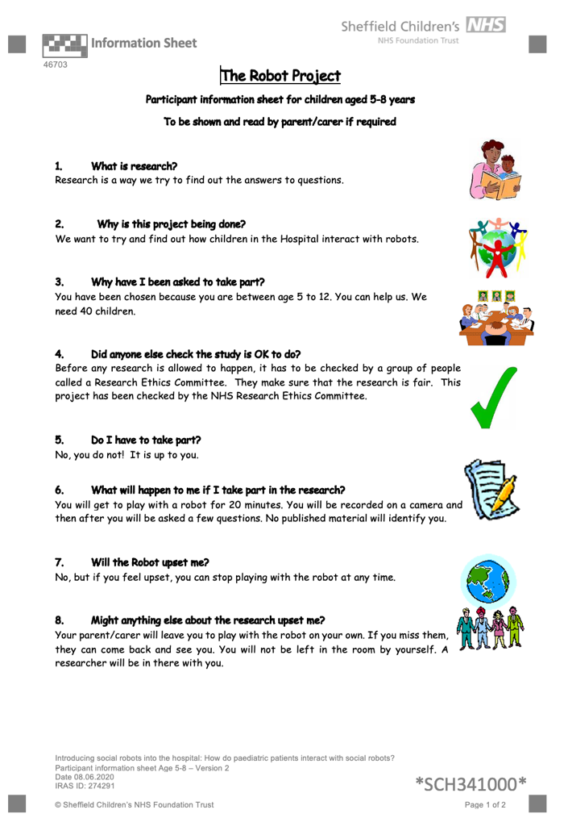
Appendix 2 – Information sheet for participant aged 5 to 8 years old.
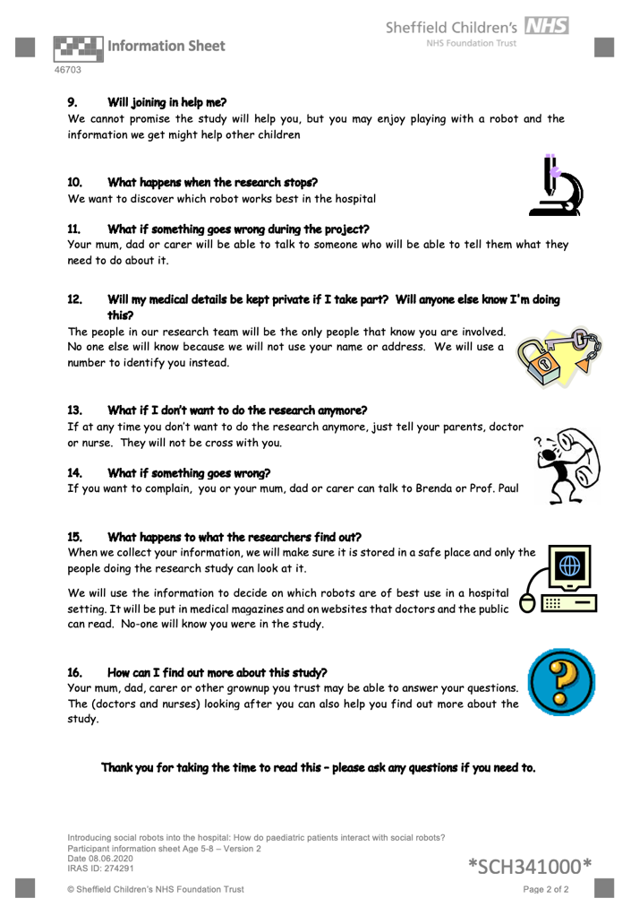

Appendix 2 - Information sheet for participant aged 9 to 12 years old.
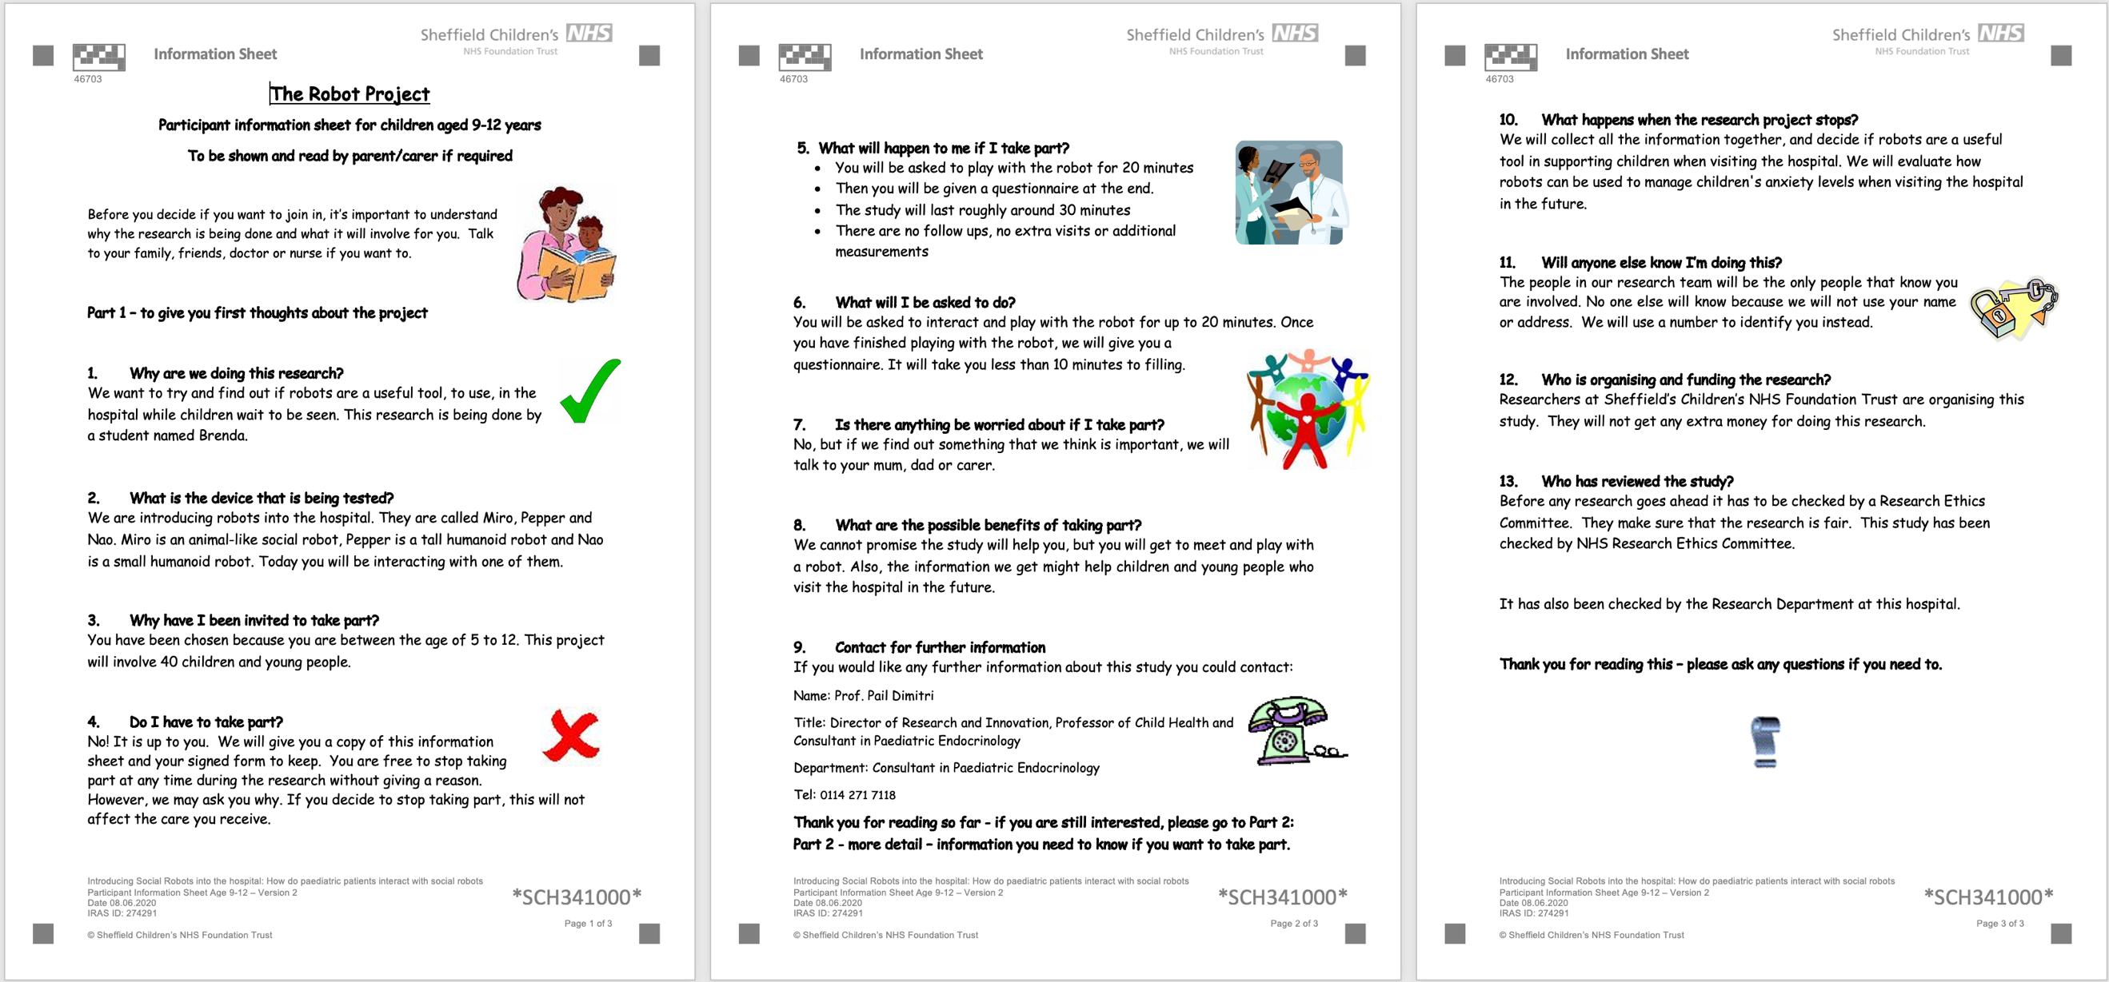

Appendix 3 – Consent form for paediatric patients
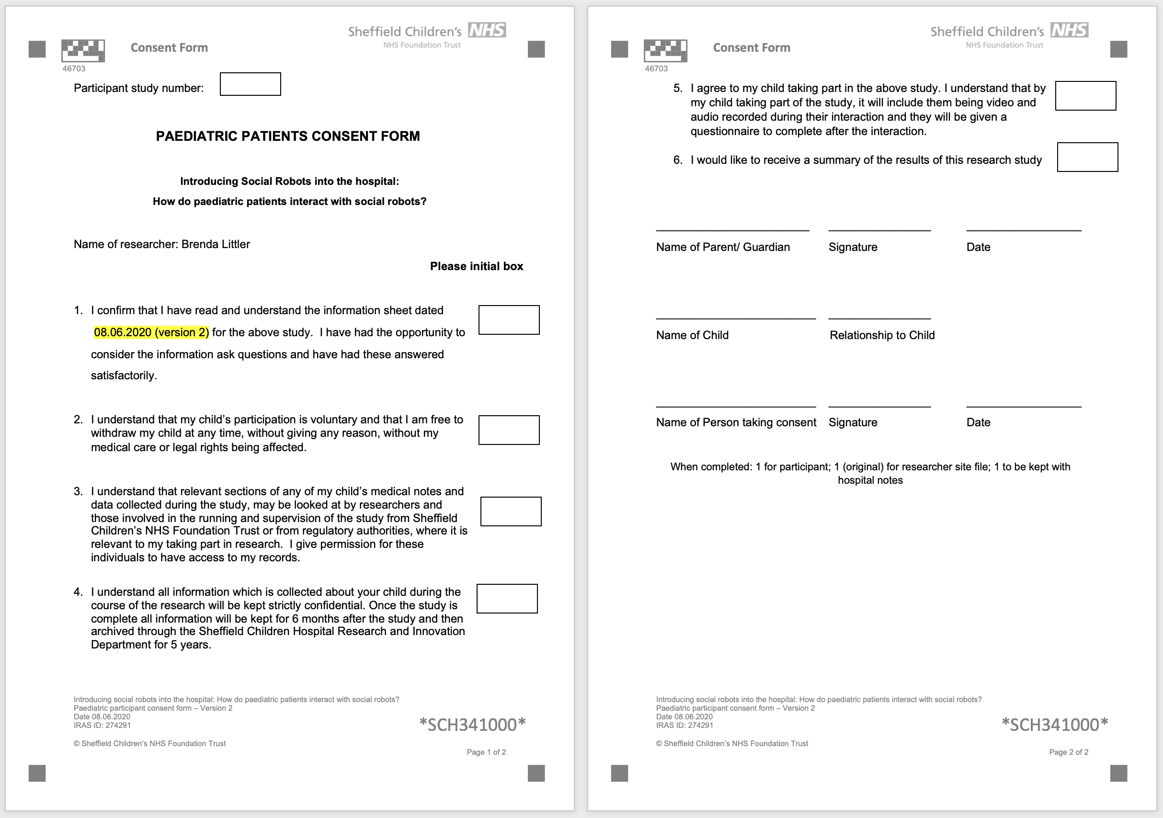

Appendix 4 – Information sheet for parents and guardians of paediatric patients

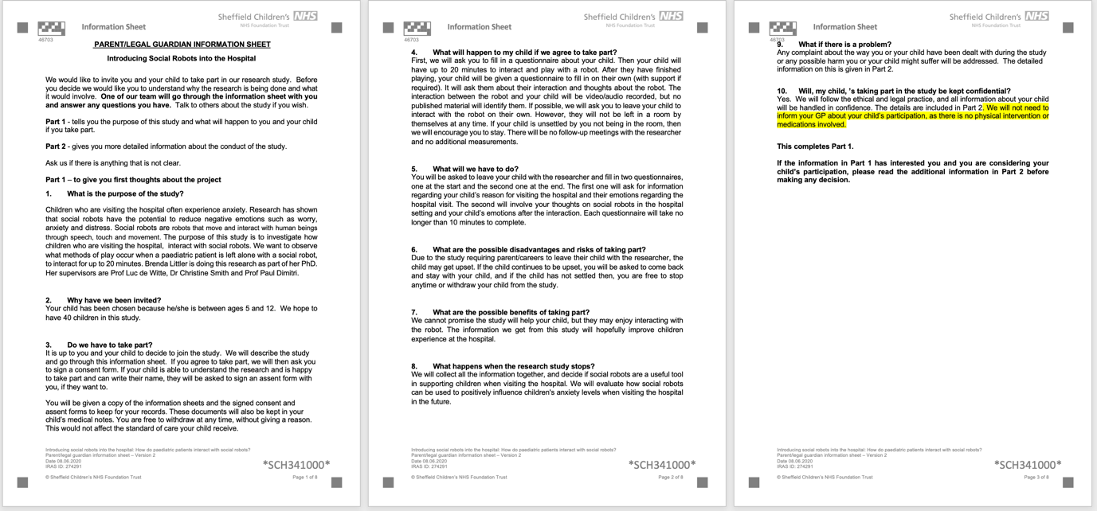

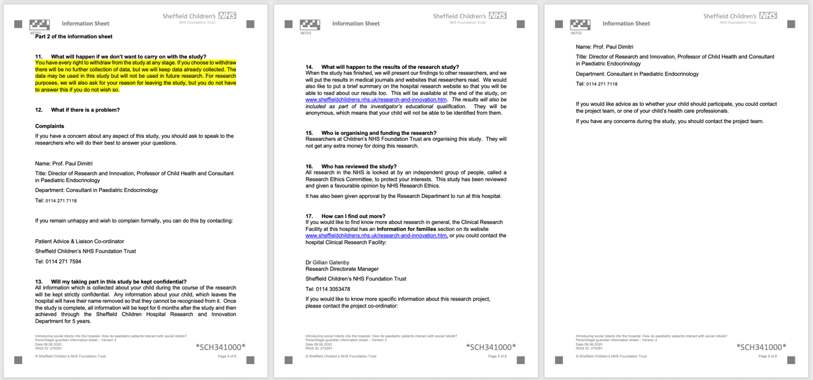
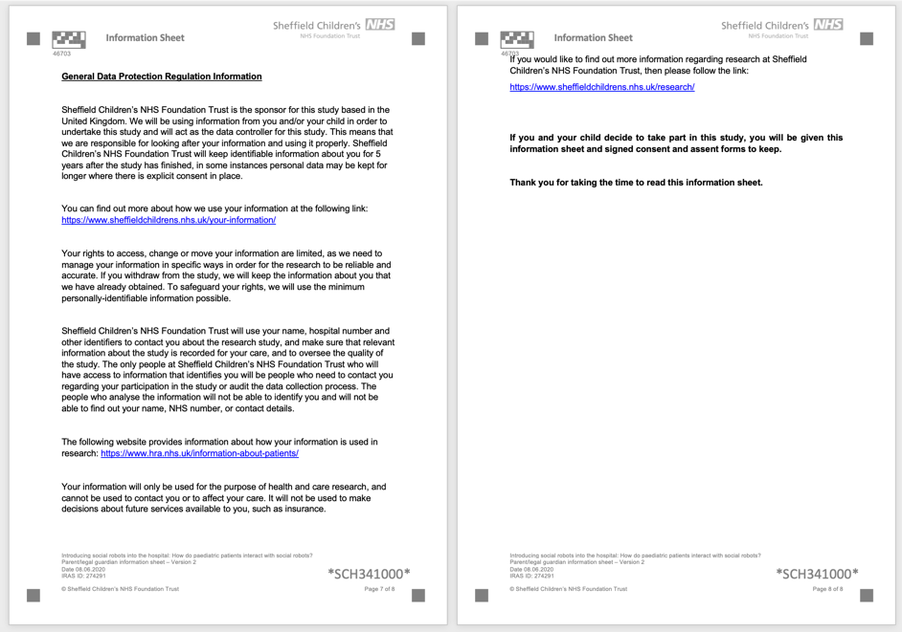

Appendix 5 – Parents and guardians consent form



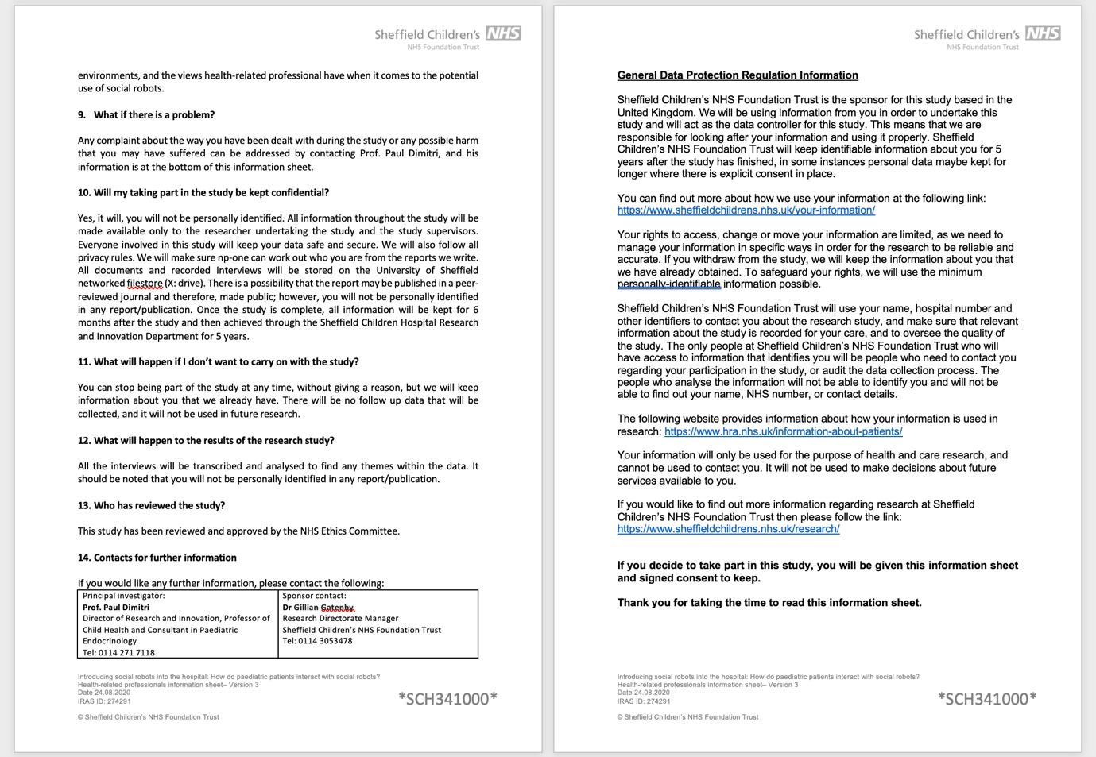
Appendix 6 – Information sheet for healthcare professionals
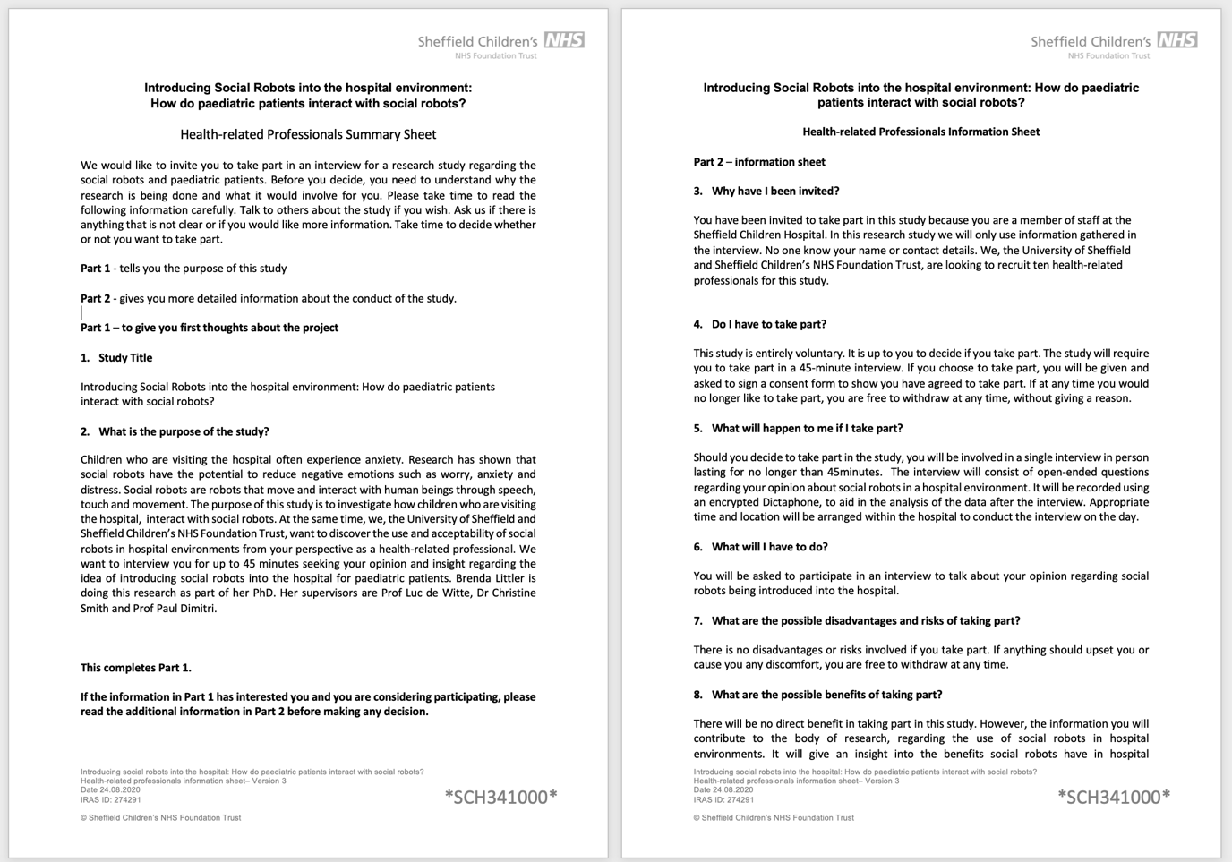

Appendix 7 – Healthcare professional consent form



Appendix 8 – Parents and guardians questionnaire before the interaction
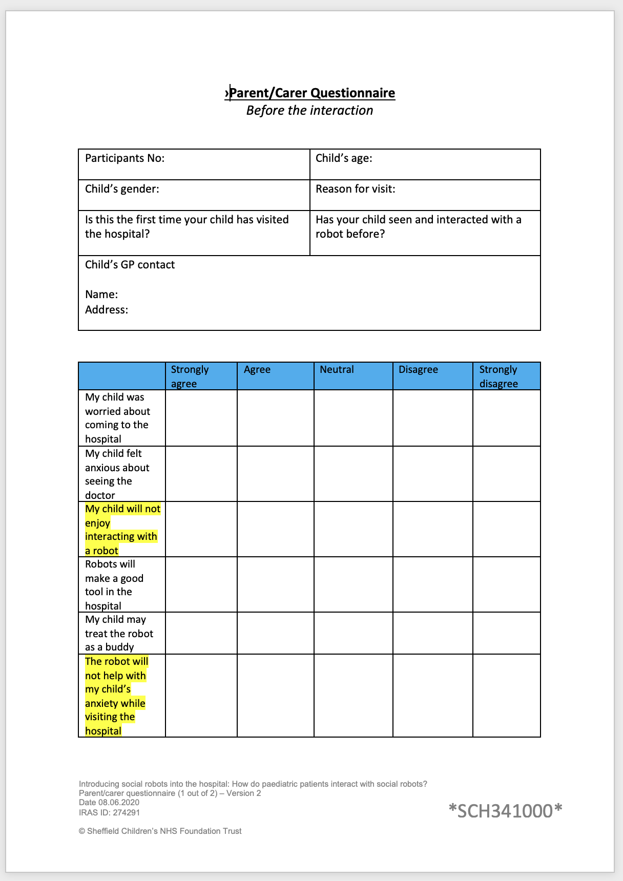

Appendix 9 – Paediatric patients’ questionnaire after the interaction
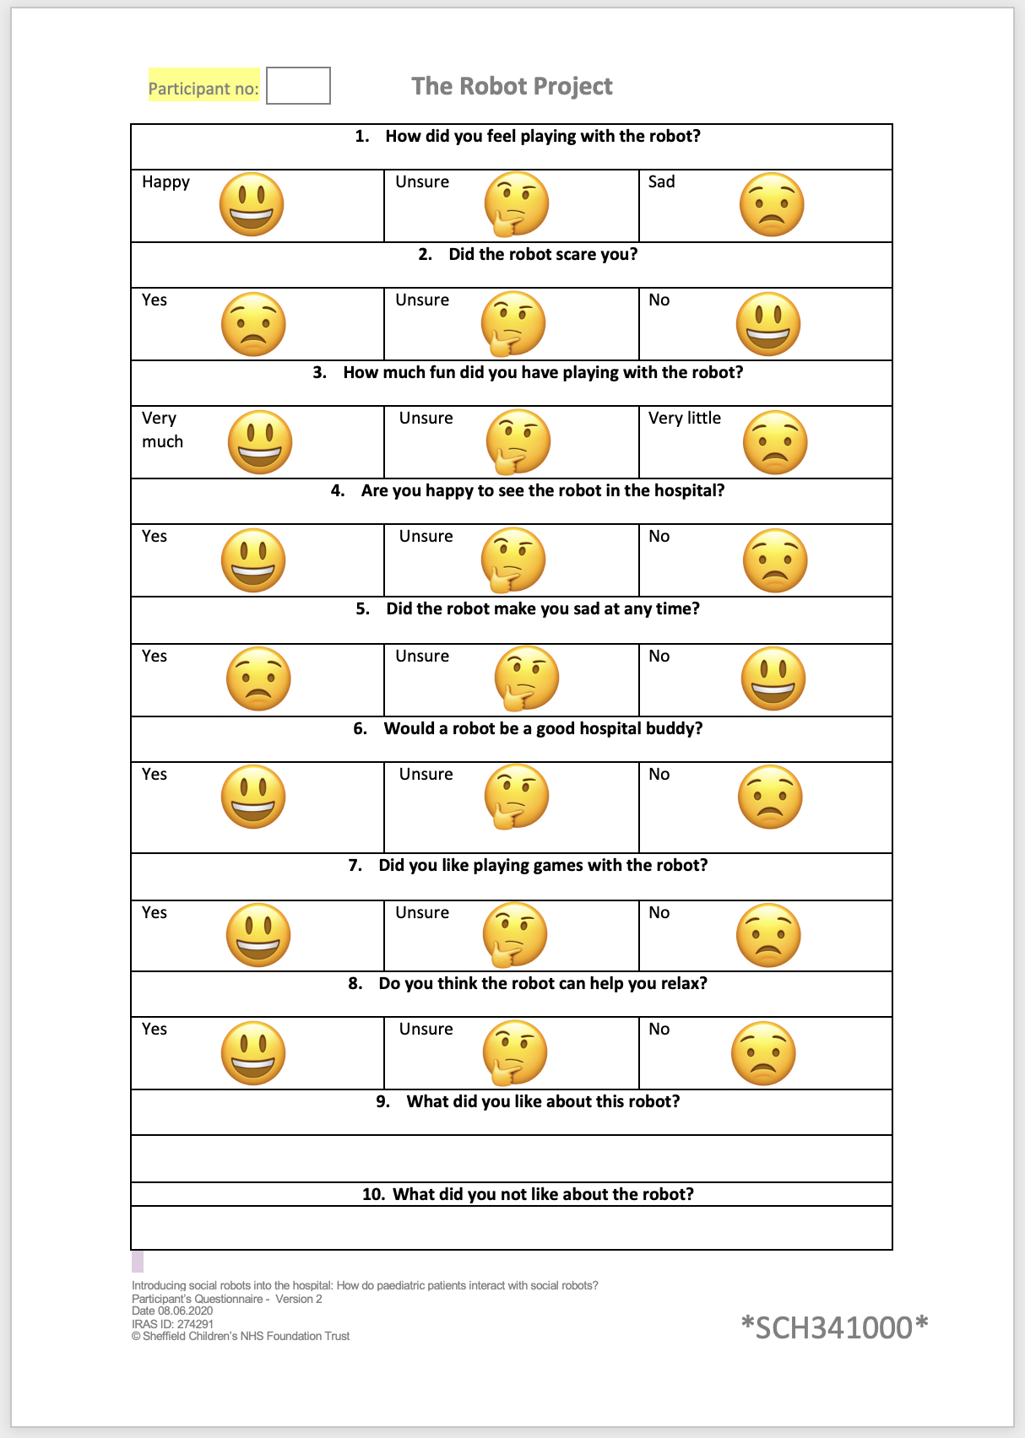

Appendix 10 – Parents and guardians questionnaire after the interaction
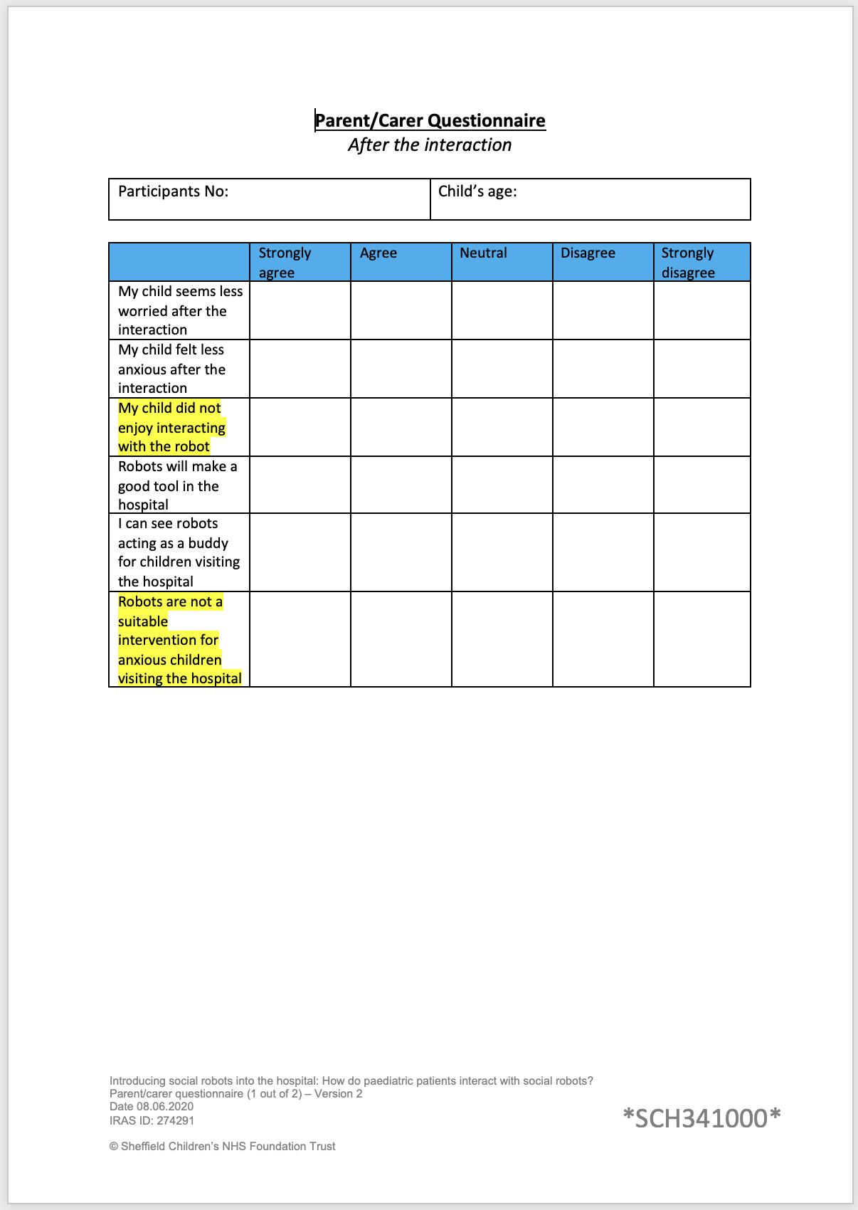

Appendix 11 – Healthcare professional interview topic guide

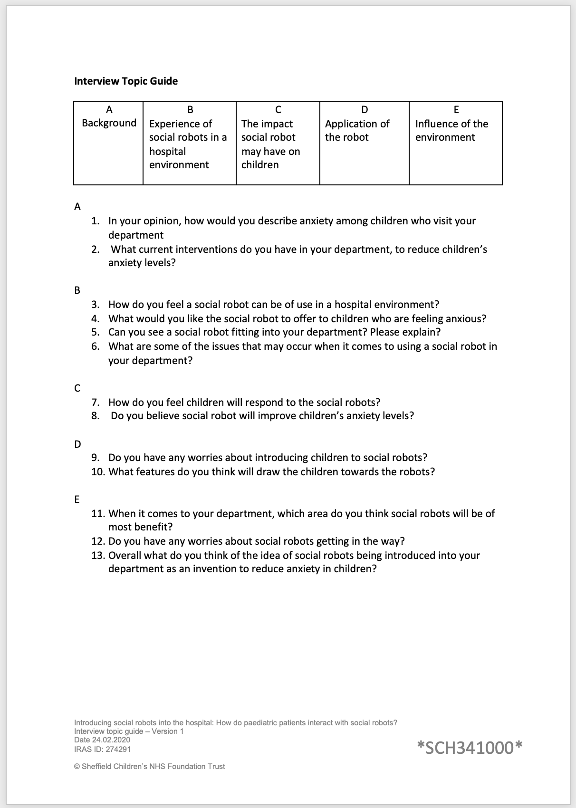

Appendix 12 – First page of the HRA and Health and Care Research Wales approval letter
