

Natural history of kidney disease based on smoking and glycaemic status: a conceptual framework for updating the current diabetes prevention programme (DPP) model.

Submission for the qualification - Doctor of Medicine (MD)
Name of the candidate – Debasish Kar
Registration Number – 190296340
Word count – Abstract 540, Main text - 24448; Figures – 19; Tables – 11; References - 315
Original submission date – 12th May 2023
Revision submission date – 23rd January 2024
Table of Contents

Acknowledgements 10
Statement of contributions 11
Declaration of conflict of interest 11
Abbreviations 13
Definition 15
Abstract 16
Background 16
Methods 16
Results 16
Conclusion 17
Chapter 1: introduction 18
1.1 Background 18
1.2 Prediabetes: a high-risk phase for T2DM and vascular complications 21
1.3 Insulin resistance: a unifying thread for smoking, obesity, T2DM & DKD 24
1.4. Natural history of kidney disease in prediabetes & T2DM 25
1.5 Metabolic effect of smoking and its cessation: a confusing relationship 29
1.6. Effect of smoking on the renovascular haemodynamic pathway 30
1.7 Is the glucocentric approach fit for the emerging challenges of vascular complications? 32
1.8. The NHS Diabetes Prevention Programme: what is the problem under consideration? 35
1.9 Literature review: The impact of smoking cessation is a poorly researched area for DPP. 38
1.10. Incorporating smoking cessation in DPP: a conceptual model 39
1.11 Aim and objectives of this doctoral thesis 43
Chapter 2: Association of smoking and cardiometabolic parameters with albuminuria in people with type 2 diabetes mellitus: a systematic review and meta-analysis 44
Statement of contribution 44
2.1 Introduction 44
2.2 Materials and methods 46
Data analysis 49
2.3 Results 54
2.4 Discussion 64
2.5 Conclusion 70
2.6 Chapter summary and research in the context of the overall goal of the thesis 71
Chapter 3: Predictors and determinants of albuminuria in people with prediabetes and diabetes based on smoking status: a cross-sectional study using the UK Biobank data. 72
Statement of contribution 72
3.1 Introduction 72
3.2 Methods 76
Study cohort and design 76
Selection process and data collection 77
Exposure and covariates 77
Outcome variables 79
Statistical analysis 79
3.3 Results 80
Descriptive analysis 80
Prevalence of albuminuria depending on smoking and diabetes status. 83
Predictors and determinants of albuminuria at the stage of prediabetes and diabetes 84
Relationship between smoking status and cardiorenal risk factors with albuminuria 88
3.4. Discussion 89
3.5 Potential for further research 95
3.7 – Chapter summary and research in the context of the overall thesis 96
Chapter 4 – Relationship of cardiorenal risk factors with Albuminuria based on age, smoking, glycaemic status and BMI: a retrospective cohort study of the UK Biobank data 97
Statement of contributions 97
4.1 Introduction 97
4.2 - Methods 99
Study cohort and design 99
Selection process and data collection 99
Exposure and covariates 100
Outcome variables 101
Statistical analyses 103
Ethics and software used for analyses 104
4.3 Results 104
Subset analyses on ex-smokers 110
4.4 Discussion 112
4.5 Strengths and limitations 115
4.6 Chapter summary and how these fit in with the overall thesis objectives 115
Chapter-5: Discussion 116
5.1 Summary of the findings and how it fits in with current evidence 116
5.2 Smoking, BMI, and vascular risk: an ‘obesity paradox.’ 118
5.3. Challenges in post-cessation weight gain: one size does not fit all 119
5.4 Implications for screening people with prediabetes for albuminuria in the NHS DPP 122
5.5 Implications for public health policy and clinical outcomes 123
5.6 How this thesis contributes to the conceptual framework 124
5.7 Strengths and limitations 126
5.8 Further research needed 127
5.9 Conclusion and Future Perspective 128
References 129
Supplementary materials (Chapter 1) 147
Search results – PubMed 147
Search results – Medline 147
Supplementary materials (Chapter 2) 148
PROSPERO registration 148
Search strategy 151
Table 1 – Cardiometabolic profiles of 13 studies with HbA1c data 152
Random effect meta-analysis 152
Funnel plot exploring publication bias 154
Summary 154
Mixed effect metaregression model with duration of T2DM 163
Supplementary table 2 – Relationship of duration of T2DM and the odds ratio of albuminuria. Statistical significance is indicated by italic font and asterisk (*) 165
Supplementary materials (Chapter 3) 166
Ethics application 166
Ethics approval 169
UK Biobank Material Transfer Agreement 170
Table 1: Relationship between DM status and albuminuria 173
Table 2: Relationship between smoking status and albuminuria 173
Table 3: Group statistics for mean value of cardiorenal risk factors based on DM status 173
Table 4: Statistical significance testing for cardiorenal risk factors based on DM status 174
Table 5: Group statistics for mean value of cardiorenal risk factors based on albuminuria status 175
Table 6: Townsend deprivation scale (-6.26 - least deprived, 11.00 - most deprived) 175
Distribution of variables 176
Figure 1: Non-parametric distribution of Townsend deprivation index in UKB dataset 176
Figure 2: Non-parametric distribution of age in UKB participants 176
Figure 3: Distribution of BMI – parametric distribution 177
Figure 4: Scatter plot showing distribution of HbA1c and UAC 178
Figure 5: Spearman correlation analysis of cardiorenal risk factors 178
Table 7: Logistic regression analysis of risk factors for albuminuria in people with prediabetes 179
Table 8: Logistic regression analysis of risk factors for albuminuria in people with diabetes 180
Table 9: Risk of albuminuria in smokers and ex-smokers when adjusted for age, anti-hypertensive and cholesterol lowering drugs in people with prediabetes 181
Table 10: Risk of albuminuria in smokers and ex-smokers when adjusted for anti-hypertensive and cholesterol lowering drugs in people with diabetes 181
Supplementary materials (Chapter 4) 182
Table 1: Descriptive statistics – participants who had UAC value in the second visit. 182
Table 2: One-Sample Kolmogorov Smirnov test 183
Table 3: Descriptive statistics of ex-smokers 183
Statistical analyses progression, glycaemic and smoking status. 184
Table 4: Descriptive crosstab – smoking and diabetes status. 184
Table 5: Progression and smoking status 184
Table 6: Progression and diabetes status 185
Table 7: Pearson’s correlation 186
Table 8: Missing data analyses 187
Table 9: Analyses of people with no change between the two visits 188
Table 10: Logistic regression (Model 1) – Predictors of progression: visit 1 and visit 2. 189
Table 11: Logistic regression [Model 2(a)] – Predictors of progression in ex-smokers: with waist circumference and the duration of smoking 189
Table 12: Logistic regression [Model 2(b)] - Predictors of progression in ex-smokers: with BMI and the duration of smoking 190
Table 13: Logistic regression [Model 2(c)] - Predictors of progression in ex-smokers: without BMI & waist circumference and the duration of smoking 190
Table 14: Logistic regression [Model 3(a)] - Predictors of progression in ex-smokers: with waist circumference and the duration of abstinence 191
Table 15: Logistic regression [Model 3(b)] - Predictors of progression in ex-smokers: with BMI and the duration of abstinence 191
Table 16: Logistic regression [Model 3(c)] - Predictors of progression in ex-smokers: without BMI and waist circumference and the duration of abstinence 192

List of figures
Figure 1: Natural history of disease progression. 25
Figure 2: Structure of a nephron and the process of urine production [69] 26
Figure 3: Structural and functional changes in kidneys various stages of DN 28
Figure 4: Structural damage to glycocalyx initiates albuminuria in DKD 31
Figure 5: Development and construction of a model 41
Figure 6: Relationship between smoking and albuminuria 43
Figure 7: Conceptual framework for incorporating smoking cessation with the NHS DPP 44
Figure 8: PRISMA flow chart 48
Figure 9: Relationship between smoking and albuminuria 56
Figure 10: A radial plot of random effect meta-analysis 57
Figure 11: Funnel plot to demonstrate publication bias 57
Figure 12: Predicted Odds Ratio (OR) of albuminuria in smokers 65
Figure 13: Prevalence of albuminuria based on smoking status 85
(Aya El-Wazir, a PhD student, and a co-author of the published paper, prepared this figure) 85
Figure 14: Risk of albuminuria in ex-smokers and current smokers 91
Figure 15: Flowchart of selection of study participants 104
Figure 16: Count of people with albuminuria on the second visit 109
Figure 17: Count of people with albuminuria on the second visit. 110
Figure 18: Predictors of progression and regression of albuminuria based on years of smoking. 112
Figure 19: Predictors of progression and regression of albuminuria based on years of abstinence. 113

List of tables

Table 1: Baseline characteristics of study participants 52
Table 2: Cardiometabolic parameters associated with albuminuria. 59
Table 2: Cardiometabolic parameters associated with albuminuria. 59
Table 3: Relationship between cardiometabolic risk factors and albuminuria before adjusting for smoking status 61
Table 4: Meta-regression showing the relationship of cardiometabolic risk factors and albuminuria after adjusting for smoking status on the heterogeneity. 63
Table 5: Meta-regression analysis showing the relationship between the risk of albuminuria in smokers with the duration of T2DM 65
Table 6 (a): Baseline characteristics (numerical value) of subgroup who had UAC value (n= 152,896) 84
Table 6 (b): Baseline characteristics (categorical variable) of the study participants with UAC value available (n=152896) 85
Table 7 (a): Descriptive statistics of the prevalence of albuminuria based on smoking status in people with pre-diabetes 87
Table 7 (b): Descriptive statistics of the prevalence of albuminuria based on smoking status in people with diabetes 87
Table 8: Logistic regression model with adjusted estimates of odds ratio and corresponding 95% confidence intervals for albuminuria at the stage of prediabetes 88
Table 9: Logistic regression model with adjusted estimates of odds ratio and corresponding 95% confidence intervals for albuminuria at the stage of diabetes 90
Table 10: Baseline characteristics of numerical variables of participants with UAC value in the second visit 109
Table 11: Model 1 – Factors predicting the progression of albuminuria (n=2493). 112

Acknowledgements
This thesis is based on my clinical work for the last 30 years. It is an ambitious project at the age of 57! My patients always intrigued me by presenting with problems which are not always amenable to medications. As a primary and secondary care clinician, I feel we can do better to prevent vascular complications by demystifying our advice on living a healthy life. I am grateful to all my patients who have allowed me to be inquisitive and question the current practice, which led to this thesis. Likewise, the encouragement and support I received from my colleagues, both in clinical and academic fields, drive all my enthusiasm and endless energy. I can’t name them all, but I must acknowledge a few who have given their time in their extremely busy work schedules.
I am grateful to Professor Kamlesh Khunti, Leicester Diabetes Centre, University of Leicester, for being inspirational in my journey through academia. Without his active encouragement, I would not have even explored my research capabilities. The work on smoking and its cessation is a brainchild of Kamlesh, and I am indebted to him for introducing me to an important public health issue. I would also like to express my sincere gratitude to Professor Melanie Davies, Director of Leicester Diabetes Centre, Professor Amanda Adler, Director of the Diabetes Trial Unit, University of Oxford and Professor Simon de Lusignan, Director of Clinical Informatics and Health Outcomes Research Group, University of Oxford, for their mentorship support. I am immensely fortunate that I received mentorship from some of the world’s best researchers in this field.
Despite all my passion and enthusiasm, I could not have come to this stage without any funding if Professor Elizabeth Goyder did not support me. Liddy played an instrumental role and convinced me that age is just a number. She has supported me in every step of the way, and I am indebted to her. Professor Andrew Lee, Professor Mark Strong and Professor Jim Chilcott also helped me in various stages of the research. I am particularly grateful to Andrew, who helped me to understand the importance of remaining focused, as I can easily be carried away. This is because, in general practice, we try to accommodate as many problems as possible in a 10-minute consultation! I would also like to express my gratitude to Dr Claire Gillies, Dr Cameron Razieh, and Dr Samuel Seidu of Leicester Diabetes Centre, Dr Mintu Nath of the University of Aberdeen, Dr Dan Pollard, and Dr Chloe Thomas, of the University of Sheffield School for Health, and Related Research (ScHARR), for their contribution to my thesis.
Finally, I sincerely thank my wife, Reba and two children, Debajyoti and Oindrila. Debajyoti helped me when I got stuck with Excel, and Oindrila has proofread my manuscripts several times. Reba put up with me all the way when I pursued my professional and academic career simultaneously, with very little time left for the family. I am very fortunate that I have got a wife like Reba!

Statement of contributions
This thesis's 2nd, 3rd and 4th chapters are already published in peer-reviewed journals. All the work is solely mine, although the co-authors contributed by giving their feedback and comments. In addition, I received statistical support from my collaborative network at the Universities of Sheffield, Leicester, Oxford, and Aberdeen. Some graphical illustrations used in this thesis are from Google images and are appropriately referenced.

Declaration of conflict of interest
I declare that I am a specialist member of the Quality Standard Advisory Committee (QSAC) of the National Institute for Health and Care Excellence (NICE) and have contributed to the guideline development in type 2 diabetes. Although I was eligible for remuneration for the work, I opted not to receive one. I was also privy to the committee meetings and discussions on managing complications of type 2 diabetes, including kidney disease.
I am employed as a clinical researcher at the Clinical Informatics and Health Outcomes Research Group, University of Oxford and have been involved in several studies on diabetes and cardiometabolic disease. In my role at Oxford University, I work closely with a team of researchers and contribute to their work in a clinical capacity. I also curate and quality-check variables for the Oxford Royal College of General Practitioners’ Digital Informatics Hub (ORCHID). In addition, I regularly review the clinical trials of novel pharmacotherapy, new technology and new diabetes research and discuss them with the research and clinical team.
I worked as the education lead for the White Rose Faculty and as the International Medical Adviser for the RCGP and received remuneration. I analyse the Royal College of General Practitioners’ (RCGP) Research and Surveillance Centre’s (RSC) weekly virology and serology samples and report to the practices and the UKHSA. The UKHSA and AstraZeneca fund my job at the University of Oxford. I am also on the advisory panel of Novo Nordisk and Eli Lily, two leading pharma companies that manufacture medications for diabetes.
I have an honorary senior clinical lecturer contract with the School of Health and Related Research, University of Sheffield. I have undertaken clinical reviews of several evidence synthesis papers and received an honorarium. I have also received an honorarium from the RCGP for running education sessions and received research funding from the NIHR Clinical Research Network (East Midlands) and the Clinical Leadership Applied Health Research and Care (CLAHRC), East Midlands.
As a GP appraiser of the NHS England, I have access to the confidential records of over 50 General practitioners’ audits, clinical governance, personal development plans, CQC reports and GMC records. As an invited author, I have written a review paper for the Lancet Diabetes and Endocrinology on diabetic peripheral neuropathy. In addition, I have peer-reviewed articles for international publishers such as Elsevier, the American Journal of Preventative Medicine, BMJ, PLOS, BMC, DOVE, and Springer Nature.

Abbreviations
American diabetes association ADA
Albumin creatine ratio ACR
Angiotensin-converting enzyme inhibitor ACEI
Angiotensin receptor blocker ARB
Action to Control Cardiovascular Disease in Diabetes ACCORD
Body mass index BMI
Basement membrane BM
Chronic kidney disease CKD
Cardiovascular disease CVD
Type 1 diabetes mellitus T1DM
Type 2 diabetes mellitus T2DM
Diabetes prevention programme DPP
Diabetic peripheral neuropathy DPN
Diastolic blood pressure DBP
Estimated glomerular filtration rate eGFR
European Association of Study of Diabetes EASD
End-stage renal disease ESRD
Fasting plasma glucose FPG
Glomerular endothelial cells GEC
Glycosylated haemoglobin HbA1c
Glucose tolerance test GTT
Glucagon-like peptide 1 GLP-1
Health technology assessment HTA
High-density lipoprotein HDL
Incremental cost-effectiveness ratio ICER
International diabetes federation IDF
Insulin resistance IR
Impaired glucose regulation IGR
Impaired fasting glycaemia IFG
Impaired glucose tolerance IGT
Index of multiple deprivations IMD
Late autoimmune diabetes of the adults LADA
Low-density lipoprotein LDL
Major adverse cardiovascular event MACE
Maturity onset diabetes of the young MODY
National Health Service NHS
Non-communicable disease NCD
Office for National Statistics ONS
Podocyte POD
Peripheral vascular disease PVD
Quality-adjusted life years QALY
Renin Angiotensin Aldosterone System RAAS
Reactive oxygen species ROS
Renal Replacement Therapy RRT
Semaglutide treatment effect in people with obesity STEP
Systolic blood pressure SBP
Total cholesterol TC
UK Biobank UKB
United Kingdom Prospective Diabetes Study UKPDS
Urinary albumin excretion (24-hour urine sample) UAE
Urinary albumin concentration (spot sample) UAC
Very low-density lipoprotein VLDL
World Health Organization WHO

Definition
Normoalbuminuria – UAC value in a spot sample of urine <30 µmol/g of creatinine
Microalbuminuria – UAC value in a spot sample of urine >30 - <300 µmol/g of creatinine
Macroalbuminuria – UAC value in a spot sample of urine >300 µmol/g of creatinine
Smoker – Active smoker for 12 months or longer
Non-smoker – Never smoked
Ex-smokers – Smoked for 12 months or longer and then stopped and abstinent for >12 months
Type 2 diabetes mellitus – Diagnosed by a healthcare professionals
BMI – Calculated as weight (kg) ÷ height (m²)
Overweight – >25 to <30 kg/m²
Obese – >30 kg/m²

Abstract

Background
Although smoking is associated with vascular complications before and after the onset of diabetes, smoking cessation is not a core component of the NHS Diabetes Prevention Programme (DPP). Without smoking cessation, the existing model of DPP may not reduce the risk of vascular complications in smokers, including chronic kidney disease (CKD). This thesis uses albuminuria as a surrogate marker to examine the relationship between smoking status and CKD.

Methods
Meta-analyses and meta-regression were conducted to elucidate the relationship between smoking status and albuminuria (defined as >20 mg/l in spot urine sample). A total of 30 studies were identified for inclusion in the narrative synthesis, and 13 were included in the meta-analysis. A cross-sectional study (n=502,490) explored the prevalence of albuminuria in people with prediabetes and diabetes. A logistic regression model examined the predictors and determinants of albuminuria based on smoking and glycaemic status. Further analyses were conducted on a longitudinal cohort (n= 20,346) to explore the factors associated with the progression and regression of albuminuria. Results are expressed in odds ratios and 95% CIs.

Results
After analysing 13 studies (n=21476), using study-level data, a random effect meta-analysis showed that, compared with non-smokers, the odds of albuminuria in current smokers with T2DM was 2.13 (1.32-3.45) compared to non-smokers (defined as those who never smoked) with T2DM. However, individual study odds ratios varied from 0.75 to 1.45. Factors that influenced the between-study variation included duration of T2DM, mean age of the study participants and pack-years smoked.
The cross-sectional study (n=502,490) showed that the prevalence of albuminuria in smokers with prediabetes and diabetes was approximately 35% and 50%, respectively. After adjusting for confounding variables, variable significantly associated with albuminuria in people with prediabetes were sex 1.42 (1.28-1.58), (males vs females); HbA1c (per mmol/mol) 1.06 (1.02-1.10), hypertension (yes vs no) 1.57 (1.40-1.75), IHD (yes vs no) 1.41 (1.20-1.65), smoking (smokers vs non-smokers) 1.21 (1.05-1.39).
The odds of albuminuria in ex-smokers with T2DM compared to non-smokers (never smokers) with T2DM was 1.07 (0.96-1.19)
The longitudinal cohort study (n=6505) showed that after a median follow-up of 51 months, each year of ageing and each mmol/mol rise in HbA1c increased the odds of progression of albuminuria by 20% and 3%, respectively. Changes in BMI, SBP, Creatinine, Cholesterol and smoking status had no statistically significant impact on the progression.

Conclusion
Current smokers with T2DM and prediabetes are at an increased odds of albuminuria compared to nonsmokers (excluding ex-smokers) with T2DM and prediabetes. An increase in HbA1c was associated with an increase in odds but changes in BMI were not. This suggests that smoking status and glycaemic control are the most important risk factors for current smokers; however more research is needed on the implications for HbA1c and weight control after smoking cessation.

Chapter 1: introduction

Background
Globally, over the last 20 years, due to improved anti-glycaemic pharmacotherapy, better management of hypertension and dyslipidaemia, and reduction in tobacco consumption, cardiovascular mortality and morbidity in people with T2DM have improved substantially [1]. In contrast, the incidence of CKD and the associated mortality and morbidity did not show comparable progress, suggesting that management of hyperglycaemia, hypertension, dyslipidaemia, and quitting smoking may not be as effective in preventing CKD as CVD. In 2020, the WHO global report on tobacco consumption showed that there were 1.3 billion people who used tobacco worldwide, compared to 1.32 billion in 2015. The report also showed that in 2020, 22.3% of the global population used tobacco; approximately 38 million were children aged 13 to 15 years [2].
CKD is a strong risk factor for ESRD, CVD and stroke. Between 1990 and 2017, global mortality attributable to CKD rose by 73% in men and 83% in women [3]. In 2017, approximately 1.2 million people died worldwide from CKD; up to 50% had prediabetes or diabetes [4]. While most older adults with T2DM and CKD die of CVD before developing ESRD, younger people are at a higher risk of progression to ESRD requiring RRT, which currently costs the NHS £7.5 billion a year. Therefore, an evidence-based, cost-effective and individually tailored intensive multifactorial vascular risk reduction strategy may be valuable in preventing the rising surge of CKD.
One of the key determinants of CKD in people with prediabetes and T2DM is insulin resistance [5]. Insulin resistance is independently associated with CKD, which may progress to ESRD [6]. Compared to the general population, people with insulin resistance have a 5 to 13-fold increased risk of CKD and ESRD [7, 8]. Therefore, factors that cause insulin resistance should be targeted to prevent the surge of people developing ESRD. Smoking and obesity are potent predisposing factors for insulin resistance [9].
Albuminuria is one of the earliest signs of CKD before and after the onset of T2DM [10]. Emerging evidence indicates that the incidence of albuminuria is common in people even at the stage of prediabetes, suggesting that hyperglycaemia may not be the sole determinant of CKD in people with metabolic syndrome [11]. A recent cross-sectional study of the Clinical Practice Research Datalink (CPRD) showed that compared to people with normoglycaemia, those with an HbA1c in the prediabetes range were at a 14% higher risk of developing CKD [12]. Likewise, a longitudinal cohort study showed that after a median follow-up of 8.7 years, compared to people with normoglycaemia, those with an HbA1c at the prediabetes range had a 39% higher risk of CKD [13]. Evidence strongly suggests that those who present with CKD at the onset of T2DM might have developed it at the stage of prediabetes [14]. Despite albuminuria being a sensitive and reliable marker for CKD and CVD [15], the NHS screening programme does not screen people for albuminuria.
One of the leading causes for poor clinical outcomes in people with CKD is late presentation [16]. In the UK, 1.8 million people have been diagnosed, and another 1 million have undiagnosed CKD; approximately 50% might also have either diagnosed and undiagnosed T2DM or prediabetes [17]. As CKD has a long, quiescent subclinical stage, without proactive screening, it may not be detected at a stage when it is reversible.
Currently, the bulk of spending for CKD is on managing complications rather than preventing them. In 2009-10, out of £1.4 billion spent on CKD, only 5% was spent on diagnosis and prevention, while 95% was spent on RRT, renal transplant and managing other complications of CKD [18]. Evidence suggests that detecting CKD at the stages of albuminuria and prediabetes may allow early intervention and prevent the rising surge of CKD and its complications [19]. Because of the adverse impact of CKD on health inequality [20], premature mortality [21], and morbidity [22], preventing CKD is a significant public health priority. As people are now undergoing screening for the DPP, it may be an opportune moment to screen them for CKD and optimise the investment remit.
T2DM is the culmination of a cascade of metabolic deregulation mediated by insulin resistance, preceded by a long quiescent phase of IFG, IGT and prediabetes. Irrespective of progression to T2DM, all these phases are risk factors for vascular complications, including CKD [23]. Therefore, the aim of the DPP should not only be halting the movement of the HbA1c from prediabetes to diabetes range but also to detect vascular complications early in the disease trajectory and manage them appropriately. Smoking and obesity exacerbate insulin resistance predisposing to T2DM and are independently associated with CKD, ESRD and CVD [24-26]. Smoking cessation and obesity management are integral to vascular risk reduction strategy. They are also recommended by the joint position statement of the EASD and ADA for people with prediabetes [27]. Despite overwhelming evidence that CKD may begin at the stage of prediabetes, and smokers are at a higher risk, none of the current DPP models worldwide use smoking cessation as an intervention and albuminuria as an outcome in their models.
CKD is one of the most expensive but preventable complications of diabetes [18]. In addition to the monetary cost of managing people with CKD, quality-of-life years are lost when people rely on dialysis [28]. The health-related quality outcome prediction model suggests that by 2025, the economic burden of CKD in people with diabetes will be £11.4 billion [29]. In 2008, the mean annual cost of hospital-based haemodialysis per person in the UK was approximately £35000 [30]. The expense is predicted to rise in the coming years as younger people are now developing ESRD and rely on RRT for longer [31]. In the USA, in 2008, the monthly cost associated with managing CKD was $1250, which increased to $ 3,000 if diabetes and heart failure also co-existed [32].
However, early diagnosis and multifactorial intervention can improve the disease outcome. The United States Renal Data System annual report 2019 showed that after implementing the national CKD screening programme, compared to 2018, there was a 25% reduction in the percentage of patients who needed RRT due to ESRD. There was a 13% reduction in the adjusted rate of all-cause hospitalisation in people with haemodialysis [33]. Therefore, with proactive screening and multifactorial intervention at an appropriate stage of disease trajectory may prevent the progression of CKD and reduce the need for hospitalisation for RRT and transplantation [34, 35].

Prediabetes: a high-risk phase for T2DM and vascular complications
Prediabetes is a precarious phase in metabolic deregulation comprising several heterogeneous states of deranged glucose homeostasis, characterised by IFG, IGT or elevated HbA1c. Approximately 25% of people with prediabetes will progress to overt T2DM in 3-5 years, and up to 70% will develop T2DM in their lifetime [36, 37]. Progression from prediabetes to diabetes depends on factors that influence the degree of insulin resistance. For example, for those who undertake regular exercise, do not gain further weight, and do not smoke, the risk of progression to T2DM might be expected to be slower compared to obese smokers with a sedentary lifestyle unless they have a genetic predisposition. Although each of the above stages of prediabetes may have a different etiopathology, their progression rates to T2DM range from 35 to 45 per 1000 person-years [38, 39].
The relationship between progression of prediabetes and vascular complications is not linear. Vascular complications can begin and progress at any stage of metabolic syndrome, not only after the onset of T2DM. Glycaemic value in prediabetes is an independent risk factor for CKD and CVD [40, 41]. In a recent prospective cohort study of people with prediabetes (n=46,911), after a median follow-up of 11 years, 13.8% (n=6,476) developed CVD, CKD, or heart failure. Only 12% (n=802) progressed from prediabetes to T2DM [42]. Therefore, keeping the HbA1c below the diabetes range may not be sufficient to protect people with prediabetes from developing adverse micro- and macrovascular complications.
Currently, there is no global consensus on the optimal definition of prediabetes. The WHO defined prediabetes on FPG, and the ADA defined it based on FPG, 2-hour postprandial glucose (2hPG) and HbA1c [43]. On the contrary, the International Expert Committee (IEC) defined prediabetes as an HbA1c of 6.0 – 6.4% (42-47 mmol/L) [44]. In the UK, the IEC definition is used to diagnose prediabetes. A recent cohort study reported the risk of developing T2DM within five years using different definitions of prediabetes. Out of a total of 76513 study participants with WHO defined [45] prediabetes (based on FPG) 10.73% (n=8208) developed T2DM over a median follow-up of 11.1 years (range 4.9 to 21.7 years). Pooled hazards ratio (HR) of T2DM using the WHO definition (FPG) was 5.54 (95% CI 4.31 to 7.12), the ADA definition (HbA1c) was 7.81 (95% CI 4.32 to 14.14), and based on the IEC definition (HbA1c) was 8.36 (95% CI 4.88 to 14.33) [45].
The global burden of prediabetes is increasing [46]. Due to the variation in the definition in different parts of the world, it is difficult to estimate the precise global prevalence of prediabetes. However, the IDF estimate suggests that in 2019, the global prevalence of IGT was 7.5% (374 million), which is projected to rise to 8% (454 million) in 2030 and to 8.6% (548 million) by 2045 [47]. In the UK, one in three adults has prediabetes [48]. Between 2009 and 2018, in the UK, although the incidence rate of new clinical diagnoses of T2DM recorded in primary care decreased by a third from its peak in 2013-14, the incidence rate of prediabetes tripled [49]. A similar trend is reported in the USA and globally, particularly among young adolescents [41, 46, 50]. A sedentary lifestyle and high-calorie diet are implicated in the global rise of prediabetes.
Compared to people with normoglycaemia, those with an HbA1c at prediabetes range are at an increased risk of micro- and macrovascular complications and all-cause mortality. A recent meta-analysis of 53 prospective studies with 1.6 million participants, with a median follow-up of 9.5 years, reported that compared with people with an HbA1c in the normoglycemic range, those with an HbA1c in the prediabetes range were at a 25% increased risk of composite cardiovascular disease [51]. Similarly, the Australian Diabetes, Obesity, and Lifestyle Study (AusDiab) reported that compared to those with normoglycaemia, people with prediabetes had a 2.5-fold increased risk of CVD [52]. Similar risks for CVD, CKD and mortality in prediabetes were reported in several other studies, including the Whitehall II study in the UK [13, 53, 54].

Insulin resistance: a unifying thread for smoking, obesity, T2DM & DKD
The unifying thread that connects smoking, obesity, T2DM and CKD is insulin resistance. An individual progresses from normoglycaemia to various stages of impaired glucose regulation before developing T2DM (Figure 1). Regardless of progression to T2DM, the individual remains susceptible to micro- and macrovascular complications due to insulin resistance [55].
At the beginning of metabolic syndrome, normoglycaemia is maintained at the cost of increasing demand on the insulin-secreting β cells of the pancreas [56]. Obesity and smoking contribute to insulin resistance and further increase demand for insulin [9, 57]. This phase is characterised by hyperinsulinemia, a toxic environment for vascular endothelium and is strongly associated with albuminuria, an early marker of CKD [6, 58]. During this phase, to meet the increased demand for insulin, the pancreatic Islets of Langerhans undergo rapid hyperplasia followed by apoptosis [59]. When 40-50% of the functioning Islets of Langerhans β cells have undergone apoptosis, persistent hyperglycaemia marks the onset of T2DM [60] (Figure 1). Irrespective of whether the glycaemic status moves from one stage to the other, insulin resistance remains an independent predictor for micro- and macrovascular complications [61] and mortality [62].

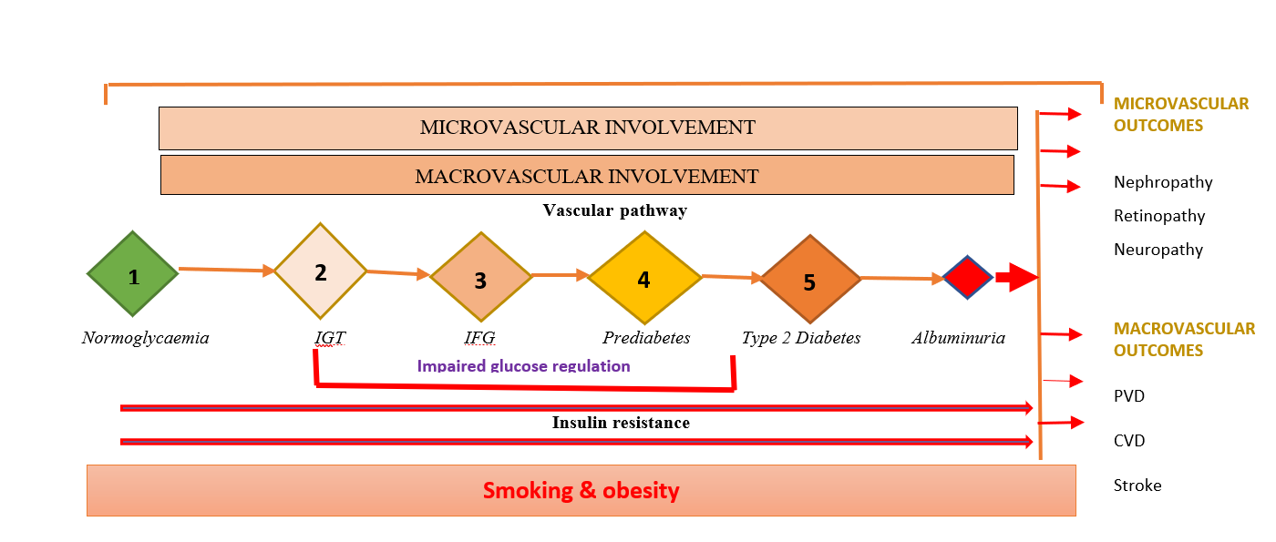
Figure 1: Natural history of disease progression.
Insulin resistance is also linked with dyslipidaemia and hypertension, which interferes with the intrarenal haemodynamic pathway and contributes to albuminuria and CKD [63, 64]. Characteristics of insulin resistance-induced dyslipidaemia are increased levels of triglyceride, low levels of High-Density Lipoprotein (HDL), and changes in the composition of the Low-Density Lipoprotein (LDL) [64]. Atherogenic dyslipidaemia and metabolic perturbations associated with insulin resistance are predisposing factors for CVD and CKD [65, 66]. Concurrently, insulin resistance contributes to renovascular hypertension, which is a predisposing factor for albuminuria, CVD, and ESRD [63, 67].

1.4. Natural history of kidney disease in prediabetes & T2DM
Nephrons are the structural and functional unit of kidneys. Approximately 1 million nephrons in each kidney produce about 1.5 litres of urine in 24 hours by filtering 200 litres of blood [68]. It filters the waste products, maintains the fluid, electrolyte, and acid-base balance, and controls blood pressure. Each nephron comprises an afferent arteriole, through which blood enters a tuft of capillaries called the glomerulus. In the glomerulus, the hydrostatic pressure filters the fluid, electrolytes, and other waste products into Bowman’s capsule, called glomerular filtrate. After filtration, the remaining blood returns to circulation through the efferent arteriole. Through the tubular pathway of nephrons, the glomerular filtrate becomes urine after a series of reabsorptions and secretions (Figure 2).

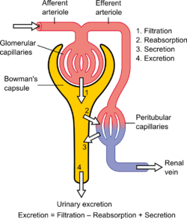

Figure 2: Structure of a nephron and the process of urine production [69]

The glomerular endothelial cells (GEC) are crucial for the filtration function of the nephron. Under normal circumstances, the GEC does not allow albumin, glucose, or blood cells to escape into the glomerular filtrate. However, if the GEC is damaged, albumin starts appearing in the urine (albuminuria), an early marker of vascular damage and renal injury [70]. The appearance of albumin in the urine indicates renovascular disease and other micro-and macrovascular endothelial dysfunction. Hypertension, obesity, smoking, hyperglycaemia, and dyslipidaemia are the leading causes of GEC damage [71-73].
Several structural and functional changes occur in the kidneys during different stages of metabolic deregulatory disease trajectory, from normoglycaemia to T2DM (Figure 1). The earliest change in the renal structure in prediabetes and early T2DM is renal hypertrophy caused by raised intraglomerular pressure. During this phase, the eGFR increases by 20-50%, but the urinary ACR remains <30 mg/g, and the blood pressure is within the normal range. Based on the progression of metabolic deregulation and other cardiorenal risk factors, this phase may last 0 to 5 years. After the stage of renal hypertrophy, incipient nephropathy begins when the eGFR returns to normal, and the blood pressure starts rising [74]. This phase is characterised by microalbuminuria [75] when the urinary ACR value increases above 30 mg/g [76]. If untreated, this phase progresses to overt nephropathy, the eGFR starts dropping, and the urinary ACR level creeps up >300 mg/g. When the eGFR drops, it represents irreversible damage to the glomerular filtration function [77]. This phase is characterised by systemic hypertension, as the renal pathway for blood pressure regulation becomes dysfunctional [78], and the urinary ACR level reaches >300 mg/g. Unless the precipitating factors such as smoking, obesity, hyperglycaemia, dyslipidaemia, and blood pressure are managed appropriately, this phase may progress to ESRD, when the patient will need RRT or renal transplant to survive. (Figure 3).
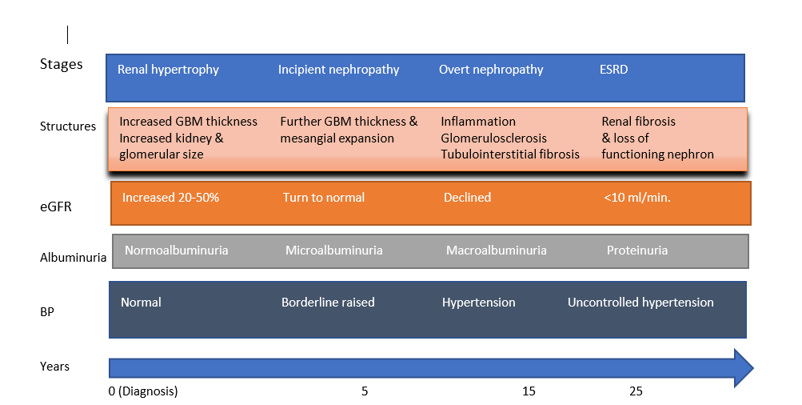
Figure 3: Structural and functional changes in kidneys various stages of DN

If CKD can be diagnosed at the stage of microalbuminuria, it can be potentially reversible by multifactorial intervention [34, 79]. However, piecemeal management of individual risk factors such as hyperglycaemia and hypertension may be counterproductive [80, 81]. A stratified analysis of the Action to Control Cardiovascular Risk in Diabetes (ACCORD) study indicated that intensive glycaemic management and multifactorial intervention at an early stage of disease trajectory can prevent CKD in people with T2DM [82]. Likewise, in the STENO-2 study, a multifactorial intervention including smoking cessation, active weight management, and control of hypertension and hyperglycaemia at the microalbuminuria stage prevented CKD progression and improved life expectancy 21 years after the intervention [83]. In contrast, aggressive glucose and blood pressure control at a later stage of the disease trajectory of CKD can predispose to frequent glycaemic oscillation [84] and orthostatic hypotension [85] due to poor renal clearance of hypoglycaemic and antihypertensive drugs. Therefore, aggressive glycaemic and hypertension management in established CKD can enhance the progression of albuminuria and increase the risk of cardiovascular mortality [82, 86, 87]. Thus, multifactorial intervention, including smoking cessation, should be achieved at the stage of microalbuminuria before the eGFR starts dropping.

1.5 Metabolic effect of smoking and its cessation: a confusing relationship
The relationship between smoking and its cessation on cardiorenal risk factors is confusing and is not fully understood. While smoking is a risk factor for prediabetes and its progression to T2DM [88, 89], so is its cessation [90]. Moreover, the impact of smoking cessation is disparate in people with and without T2DM, the precise cause of which is unknown. Smoking cessation reverses insulin resistance to the level of non-smokers within three years in people without T2DM [91]. On the contrary, in smokers with T2DM, it may take up to 10 years, depending on the pack-years smoked and the scale of post-cessation weight gain [92, 93]. In addition, in people without T2DM, if the post-cessation weight gain is not managed appropriately, it can precipitate incident T2DM [94, 95].
A recent systematic review with over 5 million participants reported that compared to non-smokers, active smokers were at a 37% increased risk of developing T2DM [96]. The study also found a dose-dependent relationship between smoking and the risk of incident T2DM. Compared to non-smokers, light smokers (<10 cigarettes/day) were at 21%, moderate smokers (10-20 cigarettes/day) were at 34%, and heavy smokers (>20 cigarettes/day) were at 57% higher risk of incident T2DM. Therefore, it is intuitive that smoking cessation would reduce the risk. Paradoxically, research evidence suggests that quitters who gain ≥2 kg in body weight have a 2.25-fold increased risk of T2DM [97]. Furthermore, multiple studies have shown that based on the scale of post-cessation weight gain, the risk of incident T2DM increases in recent quitters [98, 99].
Concurrently, the duration of abstinence is also a key determinant of the risk of T2DM after smoking cessation. A recent systematic review reported that, compared with non-smokers, quitters were at 54%, 18% and 11% higher risk of incident T2DM within five years, 5-9 years and >10 years, respectively [100]. In obese quitters, it may take up to 12 years for the risk of incident T2DM to decline to the level of non-smokers [101]. However, the risk can be reduced substantially if the post-cessation weight gain is managed appropriately, and smokers remain abstinent for >10 years [102].

1.6. Effect of smoking on the renovascular haemodynamic pathway
Smoking is particularly harmful to renovascular endothelial integrity and intrarenal haemodynamic circulation. It causes raised intraglomerular pressure by interfering with the Renin-Angiotensin-Aldosterone System (RAAS) [103], damaging the filtration functionality of the glomerular endothelial bondage [104], and exposing endothelium to oxidative stress and Reactive Oxygen Species (ROS) by destroying the glycocalyx [105].
One of the crucial components of vascular endothelial protection in blood vessels such as the glomerulus is the glycocalyx. It is a thin microscopic layer of glycoprotein which lines the inner surface of the vascular endothelium and prevents exposure of endothelium to the circulating plasma protein such as albumin and small dense atherogenic LDL and VLDL [106]. Smoking and ROS generated from insulin resistance damage the glycocalyx. Intact glycocalyx repels the adhesion of albumin to the glomerular endothelial cells. However, when the glycocalyx is damaged, albumin attaches itself to the endothelial surface, with the help of VLDL, and then leaks out through the damaged endothelial barrier, causing microalbuminuria [107]. It is a sensitive and reliable marker for renovascular and cardiovascular disease [108]. Any factors that exacerbate insulin resistance, such as hypertension, hyperglycaemia, obesity, and smoking, can damage the glycocalyx [105] and cause a faster progression of albuminuria to ESRD (Figure 4).

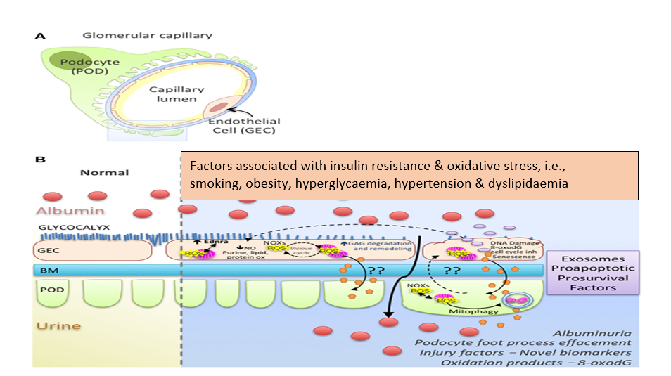
Figure 4: Structural damage to glycocalyx initiates albuminuria in DKD
(Adapted from Daehn et al., 2018) [69]
The most effective management for albuminuria in people with insulin resistance, hypertension and albuminuria is the inhibition of RAAS by Angiotensin-Converting Enzymes Inhibitors (ACEI) or Angiotensin Receptor Blockers (ARB) [109]. However, neither ACEI nor ARB can confer their therapeutic benefit in smokers due to excessive pulmonary conversion of Angiotensin I to Angiotensin II [103]. Furthermore, managing hypertension with beta-blockers is also ineffective in smokers due to the excitatory action of nicotine on the sympathetic-adrenergic pathway [110]. Therefore, smoking cessation is a renoprotective intervention at any stage of metabolic syndrome, but it must be achieved at the stage of microalbuminuria before the eGFR starts dropping.

1.7 Is the glucocentric approach fit for the emerging challenges of vascular complications?
Existing DPP models assume that keeping the HbA1c below the diabetes range will prevent vascular complications. However, the current epidemiology of ESRD, CVD and other vascular complications suggests that it may not be the case. The glucocentric approach of global diabetes prevention models is derived from the findings of the United Kingdom Prospective Diabetes Study (UKPDS). It is one of the largest RCTs in people with T2DM and has been widely used in diabetes management guidelines worldwide. The RCT showed that reducing HbA1c by 1% could reduce the risk of albuminuria by 33% [111]. Out of the 5097 study participants of UKPDS RCT phase, 92.7% (n=4727) had normoalbuminuria (UAC <30 µmol/g), 6.5% (n=333) had microalbuminuria (UAC 30-300 µmol/g) and 0.7% (n=37) had macroalbuminuria (n=37) had macroalbuminuria (>300 µmol/g). In the cohort phase, after a median follow-up of 10.4 years, a further 867 participants developed microalbuminuria and 264 macroalbuminuria.
However, the epidemiology of T2DM and DKD has changed a lot since the UKPDS. Due to the increasing prevalence of T2DM worldwide, the number of people requiring RRT due to T2DM has increased [112]. CKD is a multifactorial disease; therefore, screening people with insulin resistance may allow early detection and multifactorial intervention at an early stage of disease trajectory when it is amenable to reversal. In people with established T2DM despite following guidelines recommended by the NICE and high achievement in the QOF for glucose and blood pressure control, the 24th Renal Registry Report showed that in 2020, 7,323 new people registered for RRT, which is identical to the year before. Approximately 30% of them had diabetic nephropathy. The report suspects that the number of people who met the criteria for RRT could be significantly higher as many people declined to have RRT during the COVID-19 pandemic. The proportion of people who needed RRT due to diabetes increased from 24.1% in 2011 to 30.5% in 2020 [113]. The STENO-2 study demonstrated that if diabetic nephropathy can be detected at the stage of microalbuminuria and a multifactorial intervention is implemented, the progression of CKD can be halted [79]. More recent work in people with CKD showed that treatment with SGLT-2 inhibitors can prevent the progression of CKD without diabetes [114]. In the UK, the NICE recommends SGLT-2 inhibtors in people with CKD even without diabetes [115]. Therefore, screening people for microalbuminuria at the stage of prediabetes may be an opportunity to prevent rising numbers of people with CKD.
In contrast to the UKPDS, T2DM is no longer an exclusive disease of middle-aged and older people. The mean age of newly diagnosed study participants with T2DM in the UKPDS was 51 years [116]. However, since the UKPDS, the mean age of people with T2DM has declined. In the UK, between 2007 and 2015, the incidence of T2DM in children aged 17 years or younger increased from 0.53 to 0.72 per 100,000 person-years [117]. Likewise, the incidence of prediabetes is also rising in young and adolescents [50], and an increasing number of them are presenting with established vascular complications such as CKD [118]. The severity and progression of CKD in younger people with prediabetes and T2DM are faster than the study participants of the UKPDS [119]. Unlike the age when UKPDS study participants who needed RRT was ≥65 years, in 2020, for those who needed RRT due to diabetes, 31% were between the ages of 45 and 54, and 40% were between the ages of 55 and 64 years [113]. The cost of managing the ESRD is also higher in younger people as they are likely to need RRT for a longer period. Additionally, if younger people with T2DM are smokers and need RRT, they are at a higher risk of CVD and mortality [120, 121].
The UKPDS was the first randomised controlled trial that demonstrated the relationship between hyperglycaemia in T2DM and micro- and macrovascular complications [122]. This was also the first study that showed that glycaemic control in newly diagnosed people with T2DM can reduce the risk of vascular complications [123]. The UKPDS follow-up cohort analysis showed that ten years after the onset of T2DM, the prevalence of microalbuminuria was 24.9% and the annual rate of progression of microalbuminuria to macroalbuminuria was 2.8%, and from macroalbuminuria to elevated creatinine (≥ 175 µmol/L) was 2.3% [124]. In the UKPDS cohort of 5,097 study participants of newly diagnosed people with T2DM, only 14 needed RRT during the median follow-up of 10.4 years. [124]. Further analyses of the UKPDS participants cohort 12 years after the study began showed that more intensive glycaemic control can reduce the risk of microalbuminuria or clinical grade proteinuria by 33% [125].
However, the prevalence and natural history of CKD have changed significantly since when the UKPDS participants were recruited. The Diabetes UK report 2019 suggests that almost a third of people at the onset of T2DM might have already developed one or more microvascular complications, such as CKD [126]. An increasing number of people present with ESRD, with an HbA1c in diabetes or prediabetes ranges [127]. The risk is particularly high in obese smokers [128]. Thus, the lesson from the UKPDS needs to be revisited.

1.8. The NHS Diabetes Prevention Programme: what is the problem under consideration?
Diabetes UK estimates that around 2 million people in the UK have prediabetes and are at a higher risk of developing T2DM [129], and a third of them may present with an established microvascular complication such as CKD [126]. The Healthier You NHS Diabetes Prevention Programme identifies people at a higher risk of developing T2DM and offers them a nine-month-long behavioural intervention. It is provided face-to-face or as a digital service. After being referred, people are free to choose between the two. Those who prefer a face-to-face behavioural intervention receive personalised coaching on weight-management, healthy eating, and structured exercise. Likewise, those signed up for digital services receive similar support using technologies and apps that monitor exercise levels, give access to health coaching and online peer support, setting and monitor goals electronically. In 2022, commissioned by NHS England, the University of Manchester analysed the data of those who completed nine months of the DPP structured intervention programme and reported that it reduced the incidence of T2DM by 37% [130].
Before rolling out the NHS DPP, NHS England commissioned the Sheffield School for Health and Related Research (ScHARR) to develop a cost-benefit model. The model showed that keeping the HbA1c at the prediabetes range (6.2% to 6.4%, 42 – 47 mmol/mol), each £1 investment would return £1.28 over 20 years. For every 100,000 DPP interventions, there will be a net gain of 3552 QALYs [131]. The modelling was based on the programme lasting for five years, from 2016 to 2021, with a gradual roll-out over three years to offer the intervention to 100,000 people per year by the end of the third year [132]. The intervention cost for the first three years was estimated to be £8,350,000, and the ongoing cost for supporting this programme beyond the first three years was estimated to be £1,300,000 per year [133].
ScHARR modellers used several scenarios and vascular outcomes to develop the cost-benefit model, including improved HbA1c, weight loss, blood pressure and lipid profiles. It also used outcomes such as QALYs, delayed cases of T2DM, cardiovascular disease and impact on health inequality [131, 134]. However, in the model, as opposed to a vascular outcome such as UAC, all the risk factors, such as HbA1c, blood pressure, BMI, etc., were used, and a speculative estimate of cardiovascular disease 20 years later was made. Despite ESRD being one of the most expensive and avoidable complications of T2DM, no specific renal outcome was incorporated into the modelling. The model input restricted the age between 40 and 74 years [133], based on the UKPDS modelling [135]. In the UKPDS model, although active smoking accounted for an increased risk of ESRD, the impact of smoking cessation was not factored in [136].

Based on the UKPDS, the current DPP model assumes that in people with prediabetes, keeping the HbA1c value below the diabetes range may reduce the risk of vascular complications, including CKD [137]. However, there is no evidence to confirm or refute this assumption. In contrast to the UKPDS RCT study participants, where the prevalence of microalbuminuria was 24.9%, the Diabetes UK estimate in 2014 suggests that the prevalence of microalbuminuria has risen to 33% at the onset of T2DM [138]. The prevalence of microalbuminuria could be as high as 15.5% at the stage of prediabetes [139]. Therefore, intensified glycaemic control after the diagnosis of T2DM may not be enough to reverse CKD in people who have developed microalbuminuria at the stage of prediabetes. Thus, diabetes prevention programmes should be more inclusive to address multiple risk factors to prevent vascular complications rather than only keeping HbA1c below the diabetes range.
Despite overwhelming evidence that smoking is an independent risk factor for incident T2DM, micro- and macrovascular complications, and ESRD, smoking cessation was not incorporated into any DPP model. It is well-known that post-cessation weight gain and a rise in HbA1c are significant barriers to successful quitting [140]. However, not including smoking cessation intervention and not offsetting the benefit of weight loss and a reduction in HbA1c seems to be a missed opportunity and suboptimal use of the investment in DPP.

Due to the current budget constraints, smoking cessation is a neglected area which may exacerbate the renal burden of prediabetes and T2DM. Unlike other public health services such as the NHS health check programme and sexual health services, the local authorities are no longer mandated to commission smoking cessation services or interventions. Between 2013-2014 and 2017- 2018, the budget for smoking cessation decreased by 34%, from £129.6m to £85.2m. Nationally, 33% of the local authorities have cut their funding for smoking cessation by 50% or more since 2013-2014 [141]. Without supported smoking cessation interventions, keeping smokers’ HbA1c below the diabetes range may not halt the surge of ESRD and expensive therapy such as RRT or renal transplant. By adding smoking cessation intervention in the current NHS DPP, the investment can be recycled, post-cessation weight-gain can be minimised, the number of successful quitting can be increased, and the risk of vascular complications, including CKD, can be reduced.

1.9 Literature review: The impact of smoking cessation is a poorly researched area for DPP.
The evidence of structured exercise and lifestyle intervention in preventing T2DM is well-researched but does not include smoking cessation. Some leading studies are the Finnish Diabetes Prevention Study [142] and the American Diabetes Prevention Programme [143]. A systematic review and network meta-analysis of 30 studies showed that compared to standard lifestyle advice, all kinds of interventions could reduce the risk of progression of people with prediabetes to T2DM [144]. However, no study in the meta-analysis included smoking cessation in the structured lifestyle intervention.
For this thesis, I conducted a comprehensive search on PubMed and Medline on 17th January 2022. The search revealed that a total of 604 studies examined the impact of structured lifestyle interventions to prevent the progression of HbA1c from prediabetes to diabetes range. Several systematic reviews confirmed the efficacy of lifestyle intervention i.e., structured exercise, dietary intervention and increasing physical activities in preventing the onset of T2DM [145, 146]. However, despite smoking is a strong risk factor for progression of prediabetes to T2DM, none of the included studies in the review had smoking cessation intervention. The reason for not including smoking cessation intervention in RCTs was unethical. Moreover, smoking cessation intervention could cause weight gain which could predispose to incident T2DM [100].

A hand search of references from the reviewed literature found smoking cessation intervention in people with prediabetes in one study. In this shared decision-making-based non-randomised controlled trial, smokers with prediabetes joined the Fight Tobacco, Stay Fit (FTT2) programme or received usual care. In the 16-week FTT2 programme, out of 596 smokers with prediabetes, 33% (n=199) consented to receive smoking cessation intervention alongside individualised coaching. The rest of the cohort (n=397) received their healthcare professionals' usual care and smoking cessation advice. After a mean follow-up of 1316 days, 36.8% (n=217) of the study participants developed T2DM, and 11.5% (n=68) regressed to normoglycaemia. In the intention-to-treat analysis (n=589), participants who were on the intervention arm had a reduced risk of developing T2DM (HR 0.58; 95% CI 0.40 – 0.84) and a high probability of regression to normoglycaemia (HR 1.91; 95% CI 1.04 – 3.53) [147]. Therefore, incorporating smoking cessation in the NHS DPP programme may prevent or delay T2DM. Simultaneously, it can opportunistically be used to help smokers with prediabetes to quit and remain abstinent.

1.10. Incorporating smoking cessation in DPP: a conceptual model
Conceptual modelling is a methodological framework to enable HTA modellers to develop the health economic model. It is the abstraction of complexities of a clinical problem at an appropriate level of simplification [148]. It is the first stage of any HTA modelling project, which guides the subsequent stages of model development. Good Research Practices in Modelling Task Force made up of representatives from the International Society for Pharmacoeconomics and Outcomes Research (ISPOR) and the Board of the Society for Medical Decision Making (BSMDM) suggested that before developing the HTA model, it is prudent to develop a conceptual model [149]. They also recommended that the conceptual model be divided into three steps. Firstly, conceptualise the clinical problem and, secondly, conceptualise the model that matches the attributes and characteristics of a particular modelling type to address the clinical problem [150]. In the third step, the framework of the conceptual model is used to develop the HTA model (Figure 5).
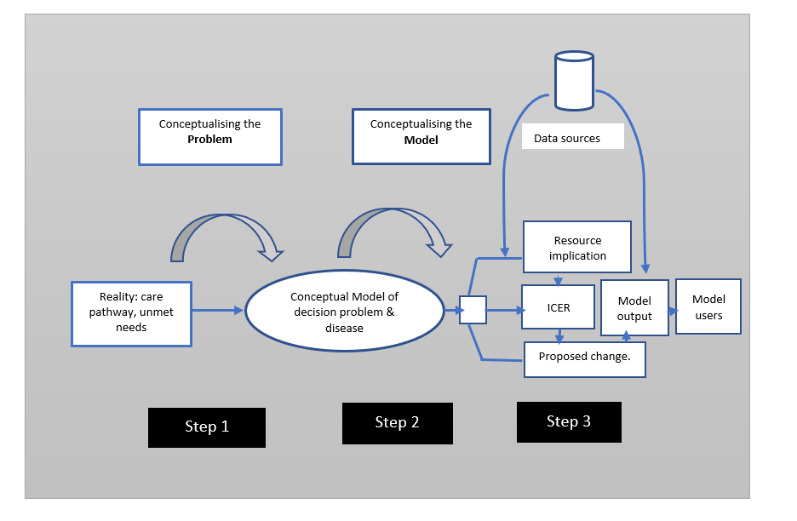
Figure 5: Development and construction of a model
(Based on Roberts et al., 2012) [150]

This conceptual model will explore the intricacies of the relationship between smoking, its cessation and albuminuria. The relationship between smoking, its cessation and BMI with kidney disease has not been established. The most recent estimation of the risk factors progression equations, the UKPDS outcomes model 2 (UKPDS 90), published in 2021, showed that active smokers have a 39% higher risk, and people with BMI above 25 kg/m² have an 18% higher risk of developing albuminuria [135]. However, it could not factor in whether smoking cessation could reverse the risk and, if so, how many years of abstinence are required for the risk to decline to the level of non-smokers. Although the model suggested a link between increased BMI and albuminuria, it did not specify whether the post-cessation increase in BMI would increase the risk of albuminuria. Moreover, this model could not evaluate how smoking affects the incidence and progression of albuminuria in people with prediabetes.
Smoking can predispose people with prediabetes to develop T2DM and albuminuria without developing T2DM. Hypertension and dyslipidaemia can pre-exist with prediabetes or T2DM, and they are independent risk factors for people with prediabetes and T2DM to develop albuminuria [151, 152]. Smoking can cause or worsen pre-existing hypertension [153] and dyslipidaemia [154] and can be a precursor for albuminuria. Smoking cessation, on the other hand, can reduce blood pressure [155] and dyslipidaemia [156]. Therefore, persuading smokers to quit and remain abstinent can reduce the risk of albuminuria and the progression from prediabetes to T2DM.

Increased risk

Hypertension & dyslipidaemia
Smoking

Prediabetes

Albuminuria
T2DM

Figure 6: Relationship between smoking and albuminuria

One of the major criticisms of the current DPP model is not incorporating smoking cessation intervention in the structured lifestyle intervention. One of the possibilities for this omission could be the uncertainty of how smoking cessation and post-cessation weight gain will impact the HbA1c. However, DPP models should aim to reduce the risk of overall vascular complications, including CKD, rather than just seeking to prevent the movement of the HbA1c from prediabetes to diabetes range. If the DPP structured lifestyle interventions are efficacious in helping people lose weight and reduce HbA1c, offering them smoking cessation intervention at the same time can be a pluralistic approach to maximise the NHS investment in DPP.
In this proposed framework, firstly, I suggest screening smokers with prediabetes for albuminuria. Secondly, the NHS DPP is redesigned to incorporate smoking cessation in the core intervention strategy. Alongside the lifestyle intervention of existing DPP, additional medications for reducing nicotine addiction and weight management with GLP-1 analogue should be carefully considered after an HTA cost and benefit analysis (Figure 7).

Benefits
- Progression of albuminuria
- Cost saving on RRT & transplant
- Other vascular complications
Outcome
Overt nephropathy

Cost of adding
- NRT
- GLP-1 analogues
- BMI
- HbA1C
- Rate of successful quitting

Intervention

NHS DPP with smoking cessation

Cost of adding
- Urinary ACR
- Smoking status
Smokers with prediabetes and albuminuria
Screening

Figure 7: Conceptual framework for incorporating smoking cessation with the NHS DPP

1.11 Aim and objectives of this doctoral thesis
This doctoral thesis aims to develop a conceptual model of the natural history of CKD. The objectives are to contribute to and simplify understanding of how smoking and its cessation affect the risk of albuminuria at various stages of the glycaemic spectrum. Based on this conceptual model, the potential value of a non-randomised controlled trial incorporating smoking cessation as a core component of DPP to inform a cost-benefit model could be assessed.

Chapter 2: Association of smoking and cardiometabolic parameters with albuminuria in people with type 2 diabetes mellitus: a systematic review and meta-analysis
https://doi.org/10.1007/s00592-019-01293-x

Statement of contribution
This chapter is already published in a peer-reviewed journal. I (DK) was responsible for conceptualising and designing the study. I also applied for funding, selected the review team, wrote the protocol, and published it in PROSPERO. I conducted the search, selected studies using the inclusion and exclusion criteria, and undertook and extracted data from the published literature. An independent researcher (CG) searched independently using the agreed inclusion and exclusion criteria and undertook quality assurance using the same tool. A third reviewer (SS) resolved any disagreement between CG and DK. I conducted the meta-analysis using Cochrane Collaboration Review Manager version 5. I received guidance from the statistician (MN), who prepared Figure 11. I drafted the manuscript, and all the co-authors contributed to it. I was responsible for publication, data handling and responding to peer-reviewers’ comments. The publication cost was paid by a grant received from the East Midland CLAHRC. Figure 11 is prepared by the statistician MN using the software R.

2.1 Introduction
This chapter aims to explore the relationship between smoking and albuminuria in people who have progressed from impaired glucose regulation (IGR) (stage 2,3,4) to T2DM (stage 5) (Figure 1).
Smokers with T2DM are disproportionately affected by kidney disease [157], cardiovascular disease [158] and premature mortality [159]. A recent systematic review of over 1 million people revealed that smokers with T2DM were approximately 50% more likely to die prematurely than non-smokers [160]. However, the precise underlying cause for this heightened cardiovascular mortality remains unexplored. Smoking exacerbates insulin resistance and adversely affects some cardiometabolic risk factors in T2DM, including HbA1c, HDL-cholesterol and arterial blood pressure [161]. Surprisingly, however, smoking cessation does not appear to confer any substantial cardiovascular risk reduction for up to 10 years in people with diabetes, compared to 3 years in people without [91]. Indeed, the World Health Organization (WHO) Multinational Study of Vascular Disease in Diabetes (MSVDD) demonstrated that the risk of cardiovascular mortality in people with diabetes remains up to 50% higher in recent quitters (1-9 years) compared to non-smokers [162]. This incongruous relationship between smoking cessation and mortality suggests that some additional risk factors may contribute to a higher cardiovascular risk in recent quitters, which might not be reversed by short-term abstinence from smoking.
Albuminuria is an early indicator of both micro and macrovascular involvement in diabetes [163, 164], and the progression of albuminuria is a reliable marker for the extent of vascular perturbation [165]. Aggressive management of traditional risk factors such as reducing renovascular disease, glucose, blood pressure, and lipid profile has not shown consistent benefitparticularly when proteinuria is already established [166]. On the other hand, multifactorial interventions, including smoking cessation at an early stage of the disease trajectory, have shown promising potential for the reversal of microalbuminuria and improved cardiovascular outcomes [167]. However, conventional risk stratification scores derived from the HbA1c, blood pressure, and lipid profile, without smoking status and BMI, may underestimate the influence of lifestyle factors such as obesity and smoking on albuminuria during this crucial stage of the disease trajectory. With a global surge of younger people developing metabolic syndrome and T2DM, it is pivotal to explore how best they can be protected from albuminuria which not only heralds incipient diabetic nephropathy but also poses a higher risk for premature cardiovascular complications. The aim of this systematic review and meta-analysis is to elucidate how smoking impacts upon the prevalence of albuminuria and how this relationship is influenced by cardiovascular risk factors such as age, male sex, duration of diabetes, HbA1c, blood pressure, lipid profile and BMI.

2.2 Materials and methods
Search strategy and selection criteria
I conducted a comprehensive search on Medline and Embase electronic databases for this systematic review and meta-analysis from their inception to May 2018. The keywords used for the searches were: “type 2 diabetes”, “smoking”, “microalbuminuria”, “macroalbuminuria”, or “albuminuria” or “proteinuria” in the title, abstract and keywords; the result was then combined using the Boolean operator “AND”. Additionally, I searched the references of the included studies to identify further suitable studies for inclusion. I followed the Preferred Reporting Items for Systematic Reviews and Meta-analysis Protocol (PRISMA-P) 2015 guidelines [168] (Figure 8). I published the protocol in the International Prospective Register for Systematic Reviews (PROSPERO) database (CRD 42018090637). The full search strategy is in the supplementary material.

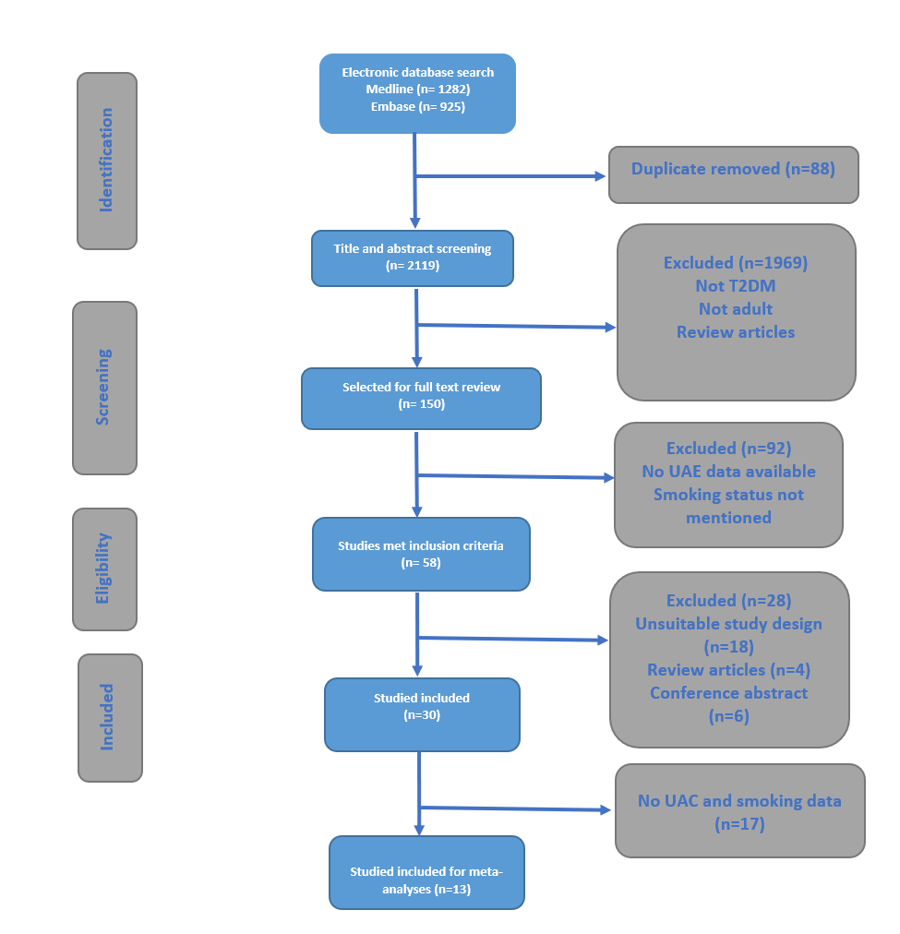
Figure 8: PRISMA flow chart

The inclusion criteria were studies reporting UAE in adults (≥18 years) with T2DM. T2DM was defined as a condition affecting people’s blood sugar levels, which was then diagnosed by healthcare professionals and treated with diet, lifestyle interventions, oral medication, or injectable therapy. People with T1DM, steroid-induced diabetes, diabetes insipidus, and LADA were excluded, but MODY was included. Smokers were defined as self-reported cigarette smokers for at least a year after being diagnosed with T2DM. For this study, albuminuria was defined as urinary albumin creatinine ratio (ACR) >20 mg/gm or >2.5 mg/mmol in males or >3.5 mg/mmol in females following the KDIGO - Kidney Disease Improving Global Outcome guidelines [169] . Total Cholesterol and HDL were converted to mmol/l if they were reported in mg/dl (mg/dl = ÷38.67 mmol/l) and TG (mg/dl = ÷88.57). HbA1c was expressed in both the IFCC unit (mmol/mol) and the DCCT unit (%). Blood pressure was expressed in mm of Hg, and BMI was expressed as kg/m².
Studies in the English language or translated into the English language were accepted for inclusion. Observational prospective and cross-sectional studies were included in this review. Two investigators independently screened the articles using the inclusion and exclusion criteria. Consensus or consulting with a third investigator resolved any disagreement between the two investigators. Studies were selected by reviewing the titles and abstracts on electronic database search. Additionally, hand searches were carried out from the references of included studies.

Data analysis
Data extraction was conducted using a predesigned data extraction template - study name, year of publication, country of study, study design, number of participants, mean age, smoking status of the participants, and presence or absence of albuminuria (Table 1).

Table 1: Baseline characteristics of study participants  Author | Study Design | Country | Mean Age  (years) | Sex  (% male) | Number of participants (n) | Smoking status (n) |  |  | Albuminuria (n) |  |  | Mean duration of DM | Mean  HbA1c | Mean SBP
 |  |  |  |  |  | S | NS | Q | Yes | No |  | (years) | mmol/mol (%) | (mm of Hg)
Chuahirun et al, 2002 [170]Chuahirun et al, 2002 | Prospective | USA | 45 | 55 | 33 | 13 | 20 | NS | NS | NS |  | NS | 92 (10.6) | NS
Chuahirun et al, 2003 [171]Chuahirun et al, 2003 | Prospective | USA | 45 | 54 | 84 | 31 | 53 | NS | 46 | 38 |  | 5 | 95 (10.8) | 115
Chuahirun et al, 2004 [172]Chuahirun et al, 2004 [172] | Prospective | USA | 49 | 50 | 157 | 69 | 88 | NS | 112 | 45 |  | 5 | 54 (7.06) | 132
Ikeda et al, 1996 [173]Ikeda et al, 1996 | Cross-sectional | Japan | 62 | 100 | 142 | 81 | 40 | 21 | 58 | 84 |  | NS | 62 (7.8) | 137
Tseng et al, 2010 [174]Tseng et al, 2010 | Prospective | Taiwan | 58 | 55 | 519 | 199 | 320 | NS | 240 | 279 |  | 10 | 64 (8.0) | 132
Voulgari et al, 2011 [175]Voulgari et al, 2011 | Prospective | Greece | 56 | 50 | 193 | 73 | NS | 120 | 193 | NS |  | NS | 61 (7.75) | 143
Phistkul et al, 2008 [176]Phistkul et al, 2008 | Prospective | USA | 47 | 52 | 91 | 39 | 52 | NS | 91 | NS |  | 4 | 59 (7.53) | 145
Hsu et al, 2010 [177]Hsu et al, 2010 | Prospective | Taiwan | 54 | 100 | 509 | 191 | 243 | 75 | 314 | 195 |  | 4 | 66 (8.2) | 129
Baggio et al, 2002 [178]// 02Baggio et al, 2002 [178]// 02 | Cross-sectional | Italy | 58 | 73 | 96 | 48 | 48 | NS | 96 | NS |  | 11 | 65 (8.1) | NS
Cederholm et al, 2005 [71]Cederholm et al, 2005 | Cross-sectional | Sweden | 67 | 59 | 31037 | 4532 | 26505 | NS | 4811 | 26,226 |  | 8 | 51 (6.85) | 147
Savage et al, 1995 [179]Savage et al, 1995 | Cross-sectional | USA | 58 | 61 | 931 | 264 | 230 | 439 | 402 | 531 |  | 9 | 103 (11.6) | NS
Okhuma et al, 2016 [180]Okhuma et al, 2016 | Cross-sectional | Japan | 65 | 100 | 2770 | 760 | 559 | 1451 | NS | NS |  | 19 | 57 (7.40) | 130
Author | Study design | Country | Mean age (years) | Sex (% male) | Number of participants  (n) | Smoking status (n) |  |  | Albuminuria |  |  | Mean duration of DM (years) | Mean HbA1c  mmol/mol (%) | Mean SBP  (mm of Hg)
 |  |  |  |  |  | S | NS | Q | Yes |  | No | Mean duration of DM (years) | Mean HbA1c  mmol/mol (%) | Mean SBP  (mm of Hg)
Prashanth et al, 2010 [181]Prashanth et al, 2010 | Cross-sectional | Oman | NS | 51 | 447 | 85 | 362 | NS | 163 | 284 |  | 10 | 70 (8.55) | NS
Corradi et al, 1993 [182]  Corradi et al, 1993 | Cross-sectional | Italy | NS | 100 | 90 | 44 | 46 | NS | 46 | 44 |  | NS | 60 (7.65) | 162
Anan et al, 2007 [183]Anan et al, 2007 [183] | Cross-sectional | Japan | 45 | 18 | 55 | 20 | 35 | NS | NS | NS |  | 5 | 60 (7.65) | 129
Yoem et al, 2016 [184]Yoem et al, 2016 [184] | Cross-sectional | Korea | 63 | 100 | 629 | 314 | 90 | 225 | 455 | 174 |  | 9 | 58 (7.44) | 126
Forsblom et al, 1998 [185]Forsblom et al, 1998 [185] | Prospective*  (follow-up data) | Finland | 58 | 61 | 108 | 36 | 54 | NS | 31 | 59 |  | 9 | 95 (10.8) | 152
Tomlinson et al, 2006 [186]Tomlinson et al, 2006 [186] | Cross-sectional | China | 53 | 100 | 496 | 196 | 300 | NS | NS | NS |  | 3 | 63 (7.94) | 133
Kanauchi et al, 1998 [187]Kanauchi et al, 1998 [187] | Cross-sectional | Japan | 65 | 46 | 155 | 44 | 111 | NS | 78 | 77 |  | 13 | 56 (7.3) | NS
Gambaro et al, 2001 [188]Gambaro et al, 2001 [188] | Prospective | Italy | 65 | 55 | 273 | 72 | 134 | 67 | 107 | 203 |  | 13 | 75 (9.0) | NS
West et al, 1980 [189]West et al, 1980 [189] | Cross-sectional | USA | NS | NS | 973 | 323 | 421 | 229 | 416 | 557 |  | 7 | NS | 137
Klein et al, 1993 [190]Klein et al, 1993 [190] | Cross-sectional | USA | NS | NS | 376 | 53 | 200 | 123 | 58 | 318 |  | NS | NS | NS
Bruno et al, 1996 [191]Bruno et al, 1996 [191] | Cross-sectional | Italy | 69 | 43 | 1521 | NS | NS | NS | 756 | 765 |  | 11 | 64 (8.05) | NS
Bruno et al, 2003  [192] | Prospective | Italy | 68 | 38 | 1103 | 149 | 708 | 222 | 426 | 677 |  | 10 | 65 (8.1) | 154
Bentata et al, 2016 [193]Bentata et al, 2016 [193] | Prospective | Morocco | 65 | NS | 671 | 81 | 590 | NS | 520 | 151 |  | 8 | 68 (8.4) | NS
Author | Study design | Country | Mean age (years) | Sex (% male) | Number of participants  (n) | Smoking status (n) | Albuminuria | Mean duration of DM (years) | Mean HbA1c  mmol/mol (%) | Mean SBP  (mm of Hg) |  | Author | Study design | Country
Gerstein et al, 2000 [194]Gerstein et al, 2000 [194] | Cross-sectional | Canada | 65 | 63 | 3503 | 538 | N/A | 1777 | 1128 | 2375 |  | 11 | 58 (7.46) | 142
Kohler et al, 2000 [195]Kohler et al, 2000 [195] | Cross-sectional | USA | 51 | 32 | 1044 | NS | NS | NS | 244 | 760 |  | 0.3 | 76 (9.1) | NS
Nilsson et al, 2004 [196]Nilsson et al, 2004 [196] | Cross-sectional | Sweden | 65 | 54 | 40648 | 4512 | 36136 | NS | 5578 | 35070 |  | 8 | 48 (6.55) | 144
Parving et al, 2006  [197] | Cross-sectional | Denmark | 61 | 50 | 24151 | NS | NS | NS | NS | NS |  | 8 | 58 (7.5) | NS
Pijls et al, 2001 [16]Pijls et al, 2001 [16] | Cross-sectional | Netherlands | 64 | 49 | 335 | NS | NS | NS | NS | NS |  | 6 | NS | 143

Study-level data were also compiled for HbA1c, TC, HDL-cholesterol, triglyceride, BMI, SBP and DBP. Continuous data were expressed as mean ± SD (standard deviation). For cross-sectional studies, prevalence data and prospective studies, baseline data were extracted. In prospective studies, if albuminuria was absent at the baseline but was present at follow-up, then the follow-up data were obtained by extracting data from all studies at one-time points, allowing both cross-sectional and cohort studies to be combined in the meta-analyses. The study team used the Newcastle Ottawa Tool to assess the quality of the included studies [198]. A random effect meta-analysis was conducted to assess the odds of having albuminuria between smokers and non-smokers. Further random effects meta-analysis models were fitted to compare participants with and without albuminuria for other known cardiometabolic risk factors. Older age, male sex, hypertension, dyslipidaemia, obesity, and hyperglycaemia are known cardiometabolic risk factors for vascular complications in people with T2DM. Therefore, they were chosen to elucidate the relationship with albuminuria. Meta-regression analyses were also carried out to explore the relationship between smoking and albuminuria. To investigate the influence of the duration of diabetes on the risk of albuminuria further, we used the mixed effect meta-regression model, to predict the odds ratio and corresponding 95% confidence intervals of albuminuria, among smokers compared to non-smokers, for the duration of T2DM ranging from 4 to 20 years.
The heterogeneity between studies was assessed using the I² statistic, which represents the total proportion of study variation that is due to heterogeneity rather than sampling error or by chance [199]. Publication bias among studies was assessed by visual inspection of the funnel plot and Egger’s test. The type 1 error to determine the level of statistical significance was set at p=0.05. All statistical analyses were carried out using the metafor package (version 2.0.0) in the R statistical software environment and Cochrane Collaboration Review Manager version 5.
2.3 Results
A total of 2207 studies were identified by electronic database searches. After removing the duplicates, 2119 articles were screened for eligibility; 150 were accepted for abstract review, and 58 were included for full-text review. Overall, 30 studies (twenty cross-sectional and ten prospective observational) with a total of 113,140 people with T2DM were included. Studies used the Albumin Creatinine Ratio (ACR) value to define albuminuria. The mean age of the study participants was 58 years, and 51% of them were male. Amongst the study participants, 11% were smokers, 60% were non-smokers, and 4% were quitters. Smoking status was unavailable for 25% of the study participants. The prevalence of albuminuria in the included studies was 14%. The mean duration of T2DM was eight years; the mean HbA1c was 63 mmol/ mol (7.9%), and the mean SBP was 125 mm of Hg. Narrative synthesis of all the studies showed a positive relationship between male sex, HbA1c, systolic and diastolic blood pressure, BMI, triglyceride, and the duration of T2DM. There was a negative correlation between HDL and albuminuria.
The outcomes from the random effects meta-analysis of 13 studies (Table 2) on 4,313 smokers and 15,743 non-smokers showed that the pooled odds ratio of albuminuria in smokers, compared to non-smokers, was 2.13 (95% CI 1.32–3.45; p=0.002; I² 94.71; Figure 9), indicating a statistically significant increased risk of albuminuria in smokers. However, the I² was high, suggesting considerable heterogeneity between the studies.

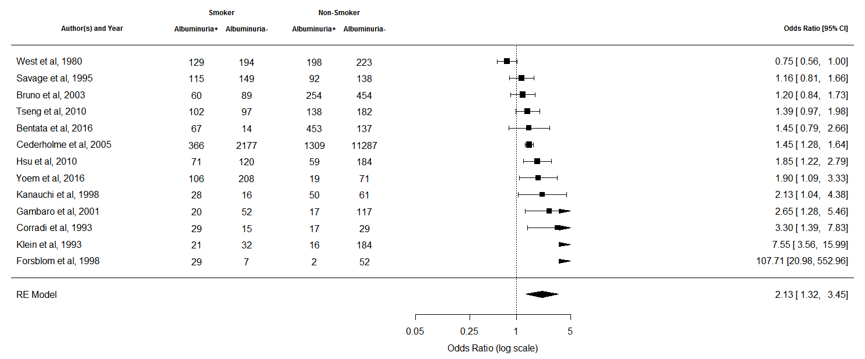
I² = 94.73 (90.66 – 98.99)
Figure 9: Relationship between smoking and albuminuria

Except for one study, the radial plot demonstrated that the differences in outcomes between smokers and non-smokers were consistent for most studies, suggesting that other factors were unlikely to contribute to the variation in the risk of albuminuria (Figure 10).

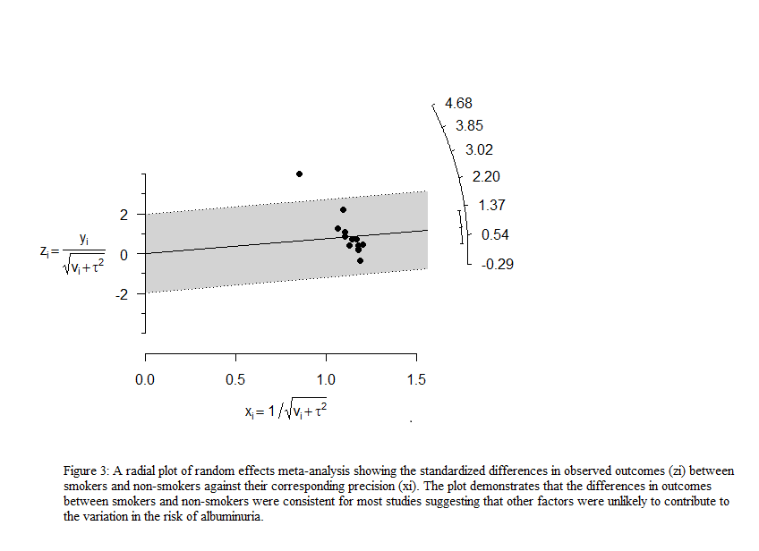
Figure 10: A radial plot of random effect meta-analysis

The plot shows the standardized differences in observed outcomes (zi) between smokers against their corresponding precision (xi).
The visual exploration of the funnel plot showed slight asymmetry, suggesting possible publication bias (Figure 11). However, outcomes from Egger’s test showed the evidence was not statistically significant (p=0.063). (Supplementary material)
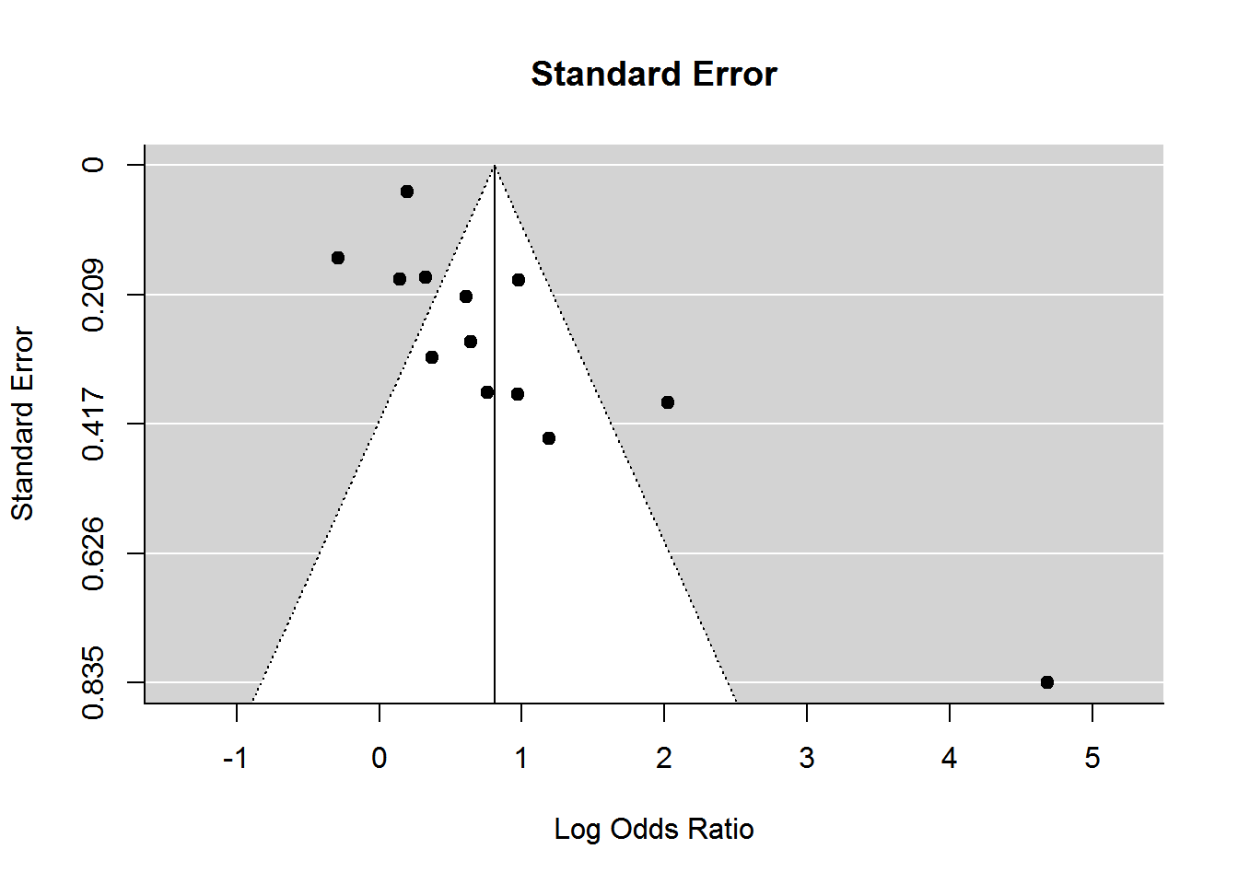
Figure 11: Funnel plot to demonstrate publication bias

ID | Author | Year | Design | Country | Male (%) | Participants  (n) | Age | SBP | DBP | HbA1c | DM duration | HDL | BMI | TG | TC | Alb+ve Smoker | Alb-ve  Smoker | Alb+ve non-smoker | Alb-ve non-smoker
S03 | Bentata | 2016 | Prospective | Morocco | NS | 671 | 65.00 | NS | NS | 8.3 | 8.5 | NS | 27.56 | 1.53 | NS | 67 | 14 | 453 | 137
S05 | Bruno | 2003 | Prospective | Italy | 38 | 1103 | 67.50 | 154.26 | 87.50 | 8.03 | 10.30 | 1.44 | 27.55 | NS | 5.81 | 60 | 89 | 254 | 454
S06 | Cederholme | 2005 | Cross-sectional | Sweden | 59 | 15139 | 66.56 | 143.82 | 78.37 | 6.61 | 8.61 | NS | 28.82 | 1.86 | 5.17 | 366 | 2177 | 1309 | 11287
S10 | Corradi | 1993 | Cross-sectional | Italy | 100 | 90 | NS | 161.71 | 101.76 | 7.65 | NS | NS | NS | NS | NS | 29 | 15 | 17 | 29
S11 | Forsblom | 1998 | Prospective | Finland | 61 | 108 | 66.00 | 156.69 | 86.31 | 11.65 | 17.95 | 1.25 | 28.14 | NS | 5.92 | 29 | 7 | 2 | 52
S12 | Gambaro | 2001 | Prospective | Italy | 55 | 273 | 65.00 | NS | NS | 9.00 | 13.00 | NS | 27.95 | 1.88 | 6.09 | 20 | 52 | 17 | 117
S14 | Hsu | 2010 | Prospective | Taiwan | 100 | 509 | 54.70 | 128.96 | 81.38 | 8.13 | 4.90 | NS | 25.76 | 2.06 | 4.91 | 71 | 120 | 59 | 184
S16 | Kanauchi | 1998 | Cross-sectional | Japan | 46 | 155 | 65.00 | NS | NS | 7.26 | 13.50 | NS | 22.96 | NS | NS | 28 | 16 | 50 | 61
S17 | Klein | 1993 | Cross-sectional | USA | NS | 376 | NS | NS | NS | NS | NS | NS | NS | NS | NS | 21 | 32 | 16 | 184
S26 | Savage | 1995 | Cross-sectional | USA | 61 | 931 | 58.28 | 146.52 | 91.29 | 11.64 | 9.00 | NS | 30.50 | 3.26 | 5.70 | 115 | 149 | 92 | 138
S28 | Tseng | 2010 | Prospective | Taiwan | 55.3 | 519 | 58.43 | 132.34 | 82.87 | 7.98 | 9.75 | 1.24 | 24.88 | NS | 5.38 | 102 | 97 | 138 | 182
S30 | West | 1980 | Prospective | USA | NS | 973 | NS | NS | NS | NS | 6.85 | NS | NS | NS | NS | 129 | 194 | 198 | 223
S31 | Yoem | 2016 | Cross-sectional | Korea | 10D0 | 629 | 62.51 | 126.09 | NS | NS | 9.12 | NS | 24.30 | NS | NS | 106 | 208 | 19 | 71
Table 2: Cardiometabolic parameters associated with albuminuria.
Further meta-analyses demonstrated that cardiometabolic factors associated with albuminuria were: age 1.24 [(95% CI 0.84–1.64, p <0.001); I² 33%], male sex 1.39 [(95% CI 1.16–1.67; p = 0.003); I² = 77%], SBP 6.03 [(95% CI 4.10–7.97, p < 0.001); I² = 88%], DBP 1.85 (95% CI 1.08–2.62, p < 0.001); I² = 67%], duration of T2DM 1.78 [(95% CI 1.32–2.23, p < 0.001); I² = 61%], BMI 0.40 [(95% CI 0.00–0.80, p = 0.05); I² = 77%], total cholesterol 0.06 [(95% CI − 0.05 to 0.17; p = 0.31); I² = 65%], HDL − 0.01 [(95% CI − 0.04 to 0.02; p = 0.47); I² = 0%] triglyceride 0.22 [(95% CI 0.12–0.33; p < 0.001); I²= 41%], and HbA1c 0.63 (95% CI 0.45–0.81; p < 0.001); I² = 77%]. (table 3). Meta-analyses before adjusting for smoking status showed that age, male sex, SBP, DBP, duration of T2DM, HbA1c and triglyceride are statistically significantly associated with albuminuria. On the other hand, BMI, total cholesterol, and HDL had no statistically significant relationship with albuminuria. The heterogeneity of the studies included in the meta-analyses was high, suggesting that other factors not included in the analyses might have contributed to the observed relationship.
Before adjusting for smoking status, meta-analyses showed that there was a statistically significant relationship between albuminuria and age per year 1.24 (95% CI 0.84 – 1.64), male vs female sex 1.39 (95% CI 1.16 – 1.67), SBP (per mm of Hg) 6.03 (4.10 – 7.97), DBP (per mm of Hg) 1.85 (95% CI 1.08 – 2.62), HbA1c (per mmol/mol) 0.63 (95% CI 0.45 – 0.81), duration of T2DM (per year) 1.32 – 2.23 (95% CI 2.23), and Triglyceride (per mmol/L) 0.22 (95% CI 0.12 – 0.33). Total cholesterol, and HDL cholesterol did not have any statistically significant impact on the risk of albuminuria. (Table 3) (Supplementary material 3).

Table 3: Relationship between cardiometabolic risk factors and albuminuria before adjusting for smoking status

Variables | Odds ratio (OR)/ mean difference (MD) | 95% CI | p-value for the odds of albuminuria | I² for heterogeneity
Age | 1.24 (MD) | 0.84 – 1.64 | <0.001 | 33%
Male sex | 1.39 (OR) | 1.16 – 1.67 | 0.003 | 77%
SBP | 6.03 (MD) | 4.10 – 7.97 | <0.001 | 88%
DBP | 1.85 (MD) | 1.08 – 2.62 | <0.001 | 67%
HbA1c | 0.63 (MD) | 0.45 – 0.81 | <0.001 | 77%
Duration of T2DM | 1.78 (MD) | 1.32 – 2.23 | <0.001 | 61%
Total cholesterol | 0.06 (MD) | -0.05 – 0.17 | 0.31 | 65%
HDL cholesterol | -0.01 (MD) | -0.04 – 0.02 | 0.47 | 0%
Triglyceride | 0.22 (MD) | 0.12 – 0.33 | <0.001 | 41%
BMI | 0.40 (MD) | -0.00 – 0.80 | 0.05 | 77%

Meta-regression analyses were conducted after adjusting for smoking status with all the above potential confounding variables to elucidate which factors could significantly reduce the heterogeneity. Fitting the duration of diabetes with smoking status reduced the heterogeneity to a statistically significant level (p=0.001). We also observed that the inclusion of the duration of diabetes as a moderator variable reduced the residual heterogeneity, although there was still evidence of residual heterogeneity (Q-statistic = 10.09, p = 0.002); the estimate of residual heterogeneity (τ²) reduced from 0.69 (95% CI 0.38-3.84) based on the random effect meta-analysis model to 0.23 (95% CI 0.10-2.13) based on the mixed effect meta-regression model (Table 4). Therefore, the duration of diabetes as a moderator variable accounted for almost 60% of the heterogeneity.

Table 4: Meta-regression showing the relationship of cardiometabolic risk factors and albuminuria after adjusting for smoking status on the heterogeneity.

Variables | Overall effect size (z) | Heterogeneity | p-value for heterogeneity
Age | 0.75 (-0.084 – 0.18) | 0.70 (0.33 – 6.44) | 0.46
Male sex | 0.27 (-0.02 – 0.0.03) | 0.79 (0.36 – 6.81) | 0.78
SBP | 1.09 (-0.29 – 0.101) | 1.26 (0.44 – 10.22) | 0.27
DBP | 0.26 (-0.13 – 0.17) | 2.05 (0.66 – 18.43) | 0.79
HbA1c | 1.43 (0.1 – 0.65) | 0.76 (0.30 – 4.94) | 0.15
Duration of T2DM* | 3.18 (0.07 – 0.31) | 0.23 (0.10 – 2.13) | 0.001
Total cholesterol | 0.92 (-1.36 – 3.75) | 1.74 (0.56 – 15.78) | 0.35
HDL cholesterol | -0.50 (-47.78 – 28.83) | 9.93(1.66 – 100) | 0.61
Triglyceride | -1.14 (-0.51 – 0.14) | 0.01 (0-1.28) | 0.25
BMI | 2.48 (0.15 – 1.30) | 0.74 (0.36 – 6.86) | 0.93

*Statistically significant relationship
The statistically significant residual heterogeneity suggested that other moderators not investigated in this study might be important. The duration of T2DM was positively associated with albuminuria: each year increase in the duration of T2DM was associated with an increased log of odds of albuminuria on an average by 0.19 units (95% CI: 0.07–0.31), or it increased the odds approximately by 21% (Figure 11). After nine years of diabetes, the odds of albuminuria in smokers were approximately 50% higher 1.53 (95% CI 1.10–2.43) compared to non-smokers. The odds ratio rose further to almost three times at a 12-year duration 2.74 (95% CI 1.74-4.30), and almost six times after a 16-year 5.94 (95% CI 2.58–15.05). (Table 5)

Table 5: Meta-regression analysis showing the relationship between the risk of albuminuria in smokers with the duration of T2DM

Duration of T2DM (Years) | Odds ratio (OR) | 95% CI (lower limit) | 95% CI (upper limit) | p-value
8.00 | 1.26 | 0.87 | 1.82 | 0.21
9.00 | 1.53 | 1.10 | 2.13 | 0.01*
10.00 | 1.86 | 1.33 | 2.60 | <0.001*
11.00 | 2.26 | 1.54 | 3.29 | <0.001*
12.00 | 2.74 | 1.74 | 4.30 | <0.001*
13.00 | 3.32 | 1.94 | 5.70 | <0.001*
14.00 | 4.03 | 2.13 | 7.64 | <0.001*
15.00 | 4.89 | 2.32 | 10.30 | <0.001*
16.00 | 5.94 | 2.58 | 15.05 | <0.001*

(bold, italic and asterisk denote statistical significance)

The risk of albuminuria rises by almost 3-times after a diabetes duration of 12 years 2.74 [(95% CI 1.74 to 4.30), p <0.001] and by almost 6-times after 16 years 5.94 (95% CI 2.58 to 15.05), p <0.001] (Figure 12).
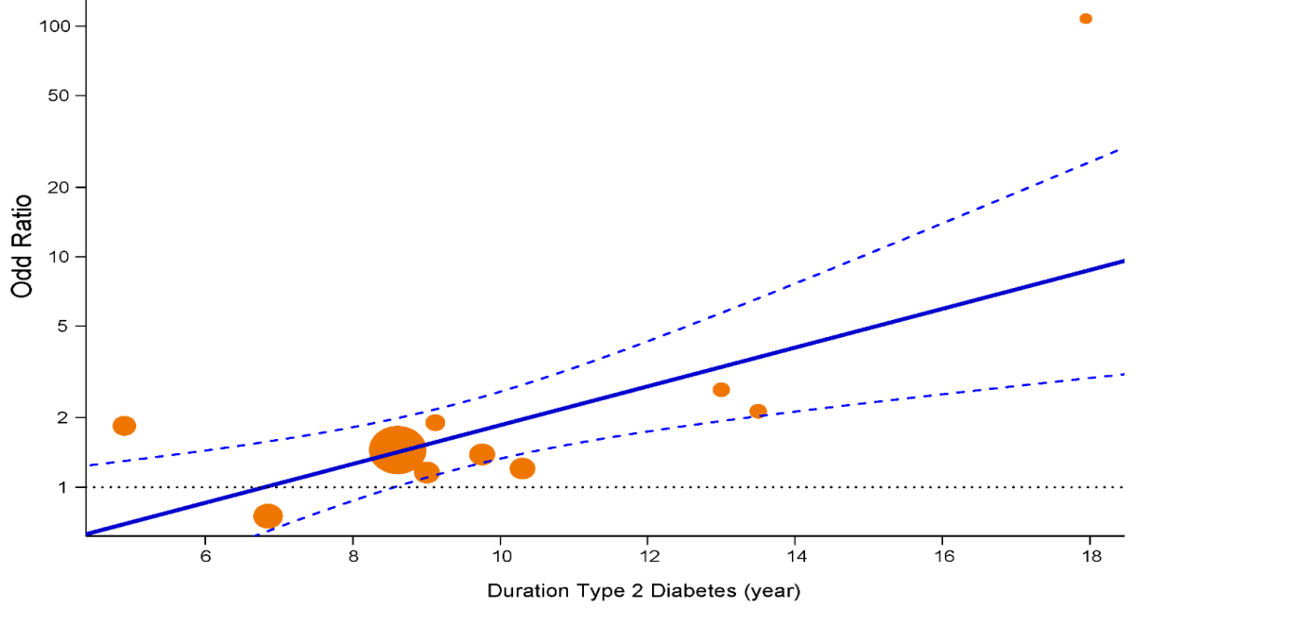
Figure 12: Predicted Odds Ratio (OR) of albuminuria in smokers
(This graph was prepared by Dr Mintu Nath, Senior Lecturer in Medical Statistics, University of Aberdeen and a co-author of the published paper. The solid line shows the predicted mean, and the dashed line shows the corresponding 95% confidence interval. The OR below the horizontal dotted line is not statistically significant (p>0.05). The plot also shows the observed OR of individual studies (points) where the point sizes are proportional to the inverse of the corresponding standard errors.)

2.4 Discussion
This systematic review summarises the relationship between smoking and albuminuria in people with T2DM and whether this relationship is influenced by other confounding variables such as age, sex, the duration of T2DM, HbA1c, BMI, HDL and total cholesterol, systolic and diastolic blood pressure. The meta-analysis suggests that smoking strongly predicts albuminuria in people with T2DM. Conversely, the meta-regression concedes that apart from the duration of T2DM, none of the above confounding variables has any statistically significant influence on albuminuria when adjusted for smoking status. A linear relationship exists between smoking and the duration of T2DM with albuminuria. Smokers with T2DM have a 21% increased annual risk of albuminuria compared to non-smokers. Therefore, smoking cessation at an early stage of the disease trajectory is likely to be one of the most effective intervention strategies to prevent the development of albuminuria in smokers with T2DM.
This is the first systematic review and meta-analysis exploring the relationship between smoking and albuminuria and how other cardiometabolic parameters influence this relationship. Although multiple studies have shown smoking augments the risk of albuminuria in people with T1DM [200, 201], its role in T2DM remains undetermined. T2DM, as opposed to T1DM, is one of the components of metabolic syndrome. In addition to hyperglycaemia, it is often accompanied by obesity, hypertension, and dyslipidaemia [202]. All these risk factors are closely associated with albuminuria [203]; therefore, the relationship between smoking and albuminuria is much more intricate in T2DM compared to T1DM. Previous studies have shown that smokers have a higher urinary albumin excretion rate, which might have been independent of glycaemic effects [204]. Meta-analyses in this systematic review concluded that there is a close association between smoking and albuminuria in people with T2DM. Meta-regression, on the other hand, taking into consideration all the above confounding variables, concluded that the duration of diabetes is the most important predictor of albuminuria in smokers with T2DM.
Early detection of albuminuria at the stage of microalbuminuria, and multifactorial intervention including smoking cessation is advocated in all major global guidelines, including the EASD and the ADA [205]. This recommendation is based on the observation that once the daily urinary albumin excretion rate reaches the level of proteinuria (urinary albumin excretion >300 mg/day), no interventions appear to be effective in reversing it [206, 207]. Addressing other anthropometric and metabolic risk factors, including hip-waist ratio, BMI, HbA1c, blood pressure, and lipid profiles, remain at the centre of this intervention strategy. For glycaemic management, the choice of drugs seems to be a determinant factor of albuminuria. Insulin sensitizers have shown better efficacy in halting the prevalence and progression of albuminuria compared to insulin and its secretagogues. In the BARI-2D trial, the researchers have shown that insulin and its secretagogues are more likely to cause an increased prevalence of albuminuria and coronary artery disease compared to insulin-sensitizing drugs [208]. However, it will be interesting to know if this outcome is influenced by the choice of drugs influences this outcome or if people on insulin had poorer glycaemic control.
Irrespective of hypertension, treatment with angiotensin-converting enzyme inhibitors (ACEI) or Angiotensin Receptor Blockers (ARB) has shown promising prospects of halting the prevalence and progression of albuminuria [109]. However, studies have shown that this reno-protective effect of ACEI and ARBs can be revoked in smokers [170], suggesting that renin-angiotensin axis blockade is less effective in preventing the progression of albuminuria in smokers. Raised triglyceride and raised total and LDL-cholesterol, with low HDL-cholesterol, are the hallmarks of dyslipidaemia in T2DM [209], but in smokers, the predominant abnormality in lipid profile seems to be lower HDL-cholesterol [89]. Smoking downregulates the hepatic and endothelial lipoprotein lipase activities [210] and tampers with the reverse cholesterol transport pathway [211]. Consequently, they have lower HDL-cholesterol compared to their non-smoker counterparts. Smoking cessation, on the other hand, improves lipid profile, particularly HDL-cholesterol, despite moderate weight gain [212, 213], halting the progression of albuminuria [214]. Conversely, isolated and piecemeal management of glucose, blood pressure and lipid profile did not show consistent efficacy in preventing the prevalence or progression of albuminuria in smokers with diabetes [167, 215]. These observations suggest an independent relationship between smoking and albuminuria mediated by a constellation of underlying pathophysiological processes of metabolic syndrome and insulin resistance.
Several mechanisms have been proposed to explain albuminuria in smokers with T2DM. They include increased blood pressure and altered intrarenal haemodynamic, such as activation of the sympathetic-adrenergic pathway, the renin-angiotensin-aldosterone axis and the endothelin system [216-218]. In addition, smoking directly causes tubulointerstitial disease [26] and causes neuro-endocrine disruption, vascular endothelial damage and metabolic deregulations, which adversely affect the renal structure and function [178, 204, 219]. Therefore, addressing hyperglycaemia, hypertension and dyslipidaemia without smoking cessation may not halt the prevalence and progression of albuminuria in smokers with diabetes.
Nicotine and other toxic metabolites in cigarettes appear to be handled differently in people with and without diabetes [220]. Nicotine infusion acutely increases insulin resistance in people with T2DM but not in people without [221]. Although smokers have lower BMI than non-smokers, they have more visceral adiposity and lower insulin sensitivity [222]. Smoking cessation, on the other hand, despite causing moderate weight gain, is associated with the reversal of visceral adiposity and an improvement in insulin sensitivity [213]. However, this reversal takes longer in people with T2DM than in those without [91, 223]. Therefore, short-term abstinence may not yield any meaningful benefit in smokers with T2DM.
The Heart Outcomes Prevention Evaluation (HOPE) study examined the factors influencing the prevalence and progression of albuminuria in people with and without diabetes. This study demonstrated that smoking, hypertension, older age, abdominal adiposity, vascular disease and left ventricular hypertrophy were significantly associated with albuminuria in people with and without diabetes. However, in people with diabetes, the most significant determinants of albuminuria were the duration of diabetes, HbA1c and the use of insulin. People with diabetes were 1.16 times more likely to develop albuminuria after a diabetes duration of 10.4 years (irrespective of their HbA1c), the risk of albuminuria increased by 8% for each 0.9% increase in the HbA1c, and the people with albuminuria were 1.3 times more likely to be on insulin compared to people who had normoalbuminuria. Sex, dyslipidaemia, creatinine, and BMI were not independently associated with albuminuria after adjustment of other factors [194]. Considering all this evidence, this systematic review emphasises that to manage the prevalence and the progression of albuminuria in T2DM effectively, the most effective strategy would be a multifactorial intervention where smoking cessation is one of the key component.
The findings of this systematic review have significant clinical implications. The WHO estimates that by 2030, a staggering number of 366 million people will suffer from T2DM worldwide. Amongst them, 60 million will be between 20 and 44 years, and 180 million will be between 45 and 64 years [224]. Young smokers with T2DM are at a higher risk of albuminuria as they will live longer with the condition. This study showed that the risk of albuminuria was similar in smokers and non-smokers up to around 8.5 years of T2DM duration, and then the risk increased approximately by 20% annually.
Albuminuria marks the onset of microvascular complications often associated with retinopathy, neuropathy and macrovascular involvement [225]. Several studies have shown a rapid rise in the prevalence of albuminuria and cardiovascular complications in younger patients with T2DM, compared to T1DM, despite having similar glycaemic control [119, 226]. Poor lifestyle choices, including smoking, have been attributed to this disparate response of glycaemic control in T2DM, as opposed to T1DM. Therefore, this study emphasises that smokers, particularly younger ones, should be encouraged to quit soon after diagnosis and be persuaded to remain abstinent.
One of the strengths of this study is that it included all the major studies available on the electronic databases from their inception and included 30 studies with 113,400 participants. The quality of the papers was determined by the Newcastle Ottawa scale, which is a validated tool, and the review process followed the PRISMA protocol [168], which is considered to be the gold standard. Publication bias was addressed by conducting an appropriate sensitivity test, which did not show any significant bias. On the other hand, the weaknesses of the study were that it was based mainly on cross-sectional or the baseline data of prospective studies, and therefore, no temporal relationship between smoking and albuminuria can be confirmed. Secondly, most of the included studies used self-reported smoking behaviour, which might not be accurate. There was also considerable heterogeneity in the included studies, so the findings may not be generalisable. Although between-study heterogeneity was investigated, meta-regression models lacked statistical power to assess associations between the effect size and study-level covariates.

2.5 Conclusion
Albuminuria is one of the earliest biochemically measurable risk factors in T2DM, which heralds incipient micro and macrovascular complications. It is a substantial milestone in the trajectory of disease progression and is independently associated with cardiovascular and all-cause mortality. This study reiterates that smoking is a strong predictor of albuminuria; the longer the duration of T2DM, the higher the risk. With a rapidly changing global prevalence of T2DM with an anticipated surge of younger people with T2DM [227], and approximately 70% of them already having complications [228], it is important to raise awareness about the effect of smoking and the duration of T2DM on albuminuria, and its impact on cardiovascular mortality. Future research should be focused on elucidating the relationship between smoking cessation and the progression of albuminuria in people with T2DM, particularly the length of abstinence required to reverse the risk of albuminuria.

2.6 Chapter summary and research in the context of the overall goal of the thesis
This systematic review and meta-analysis showed that compared with non-smokers (defined as never smokers and excluding ex-smokers), smokers with T2DM, at stage 5 of the metabolic deregulatory trajectory (Figure 1), have a 2-fold increased risk of albuminuria. When adjusted for confounding cardiorenal risk factors of age, male sex, HbA1c, HDL, total cholesterol, triglyceride, duration of T2DM, SBP and DBP, and BMI, none but the duration of T2DM had a statistically significant relationship with albuminuria. The longer the smokers continue to smoke after the onset of T2DM, the higher the risk of albuminuria.

Chapter 3: Predictors and determinants of albuminuria in people with prediabetes and diabetes based on smoking status: a cross-sectional study using the UK Biobank data.

https://doi.org/10.1016/j.eclinm.2022.101544

Statement of contribution
This chapter is already published in a peer-reviewed journal. I (DK) conceptualised the study, wrote the protocol, applied for data access and ethics approval, extracted data from UK Biobank, undertook the analyses and wrote the manuscript. I consulted a researcher at Leicester Diabetes Centre (CR) and received help from a fellow PhD candidate (AE) in data cleaning, statistical analyses, and data interpretation. She has also prepared figure 12 using the statistical software R. Following the journal’s publication policy, two independent statisticians (MJ and MN) reviewed the statistical analyses. All the co-authors commented on the manuscript. I received feedback from my supervisors (LG and AL). I was responsible for data handling and the decision to publish. The University of Sheffield paid the publication cost. AE prepared Figure 1, and MN calculated confidence intervals for Figure 13, Tables 7 (a) and 7 (b).

3.1 Introduction
The systematic review and meta-analysis in the previous chapter showed that smoking is an independent risk factor for albuminuria in people with diabetes (stage 5, figure 1). In this chapter, the relationship between albuminuria and cardiorenal risk factors in current and ex-smokers with prediabetes and diabetes will be explored using a cross-sectional study design (stages 4 & 5, figure 1).
Albuminuria is a sensitive marker for both micro and macrovascular complications at all stages of metabolic deregulation, including prediabetes [229]. It indicates leakage of an abnormal concentration of albumin in the urine. In the disease trajectory of metabolic syndrome, prediabetes and albuminuria are important hallmarks of disease progression [230]. In the UK, prediabetes is defined as a state of intermediate hyperglycaemia when an individual’s HbA1c exceeds the normal range but remains below the threshold for the diagnosis of diabetes [231]. Due to the lack of consensus about the definition of prediabetes, it is difficult to estimate its global prevalence. However, the International Diabetes Federation (IDF) estimates that the global prevalence of impaired glucose tolerance was 7.5% (374 million) in 2019 and is projected to rise to 8% (454 million) by 2030 and to 8.6% (548 million) by 2045 [47].

Although approximately 25% of people with prediabetes are likely to progress to overt diabetes in 3-5 years [36], the risk of vascular complications is considerably higher in all of them, irrespective of whether or not they progress to diabetes. For example, a recent Spanish observational study, Progression of Early Subclinical Atherosclerosis (PESA), showed that compared to those with normoglycaemia, the risk of multi-territorial subclinical atherosclerosis in people with prediabetes was almost 2.5-fold [OR 2.47 (95% CI 1.62-3.76)]. In the PESA study, prediabetes was defined by the ADA definition (HbA1c 5.7% to 6.4%) and the NICE definition (HbA1c 6.0 to 6.4%). Incremental risk analyses were conducted on the study participants, putting them under two categories, i.e., HbA1c ≤5.2% and ≥5.7%, estimating the cumulative risk of extensive subclinical atherosclerosis (SA) using the HbA1c groups. As the HbA1c level rises within the prediabetes categories, the risk of SA increases. The independent determinants of this heightened risk in this group were hypertension, dyslipidaemia and smoking [232]. Likewise, a recent prospective study on people with prediabetes (n=46,911) showed that after a median follow-up of 11 years, 13.8% (n=6,476) developed atherosclerotic cardiovascular disease, chronic kidney disease or heart failure [42]. Amongst those who suffered the above adverse vascular outcomes, only 12.4% (n=802) had progressed from prediabetes to diabetes [42]. These observations suggest that halting the progression of HbA1c from the prediabetes to diabetes range, as recommended by the existing diabetes prevention guidelines worldwide, may not by itself halt the rising surge of people developing vascular complications at the stage of prediabetes. Therefore, taking a holistic view and adopting a multifactorial approach is important. Lifestyle intervention in people with prediabetes should include smoking cessation and proactive weight management to reduce the risk of developing T2DM and vascular complications [233, 234].
Albuminuria is associated not only with nephropathy but also with retinopathy, neuropathy, stroke, peripheral vascular disease, and cardiovascular disease [235, 236]. Therefore, it may be a reliable composite outcome measure for all the vascular complications associated with prediabetes and diabetes. Although multiple studies have explored the link between smoking and albuminuria in diabetes [237, 238], there is a lack of evidence in people with prediabetes. Due to the rapid rise in the number of people with prediabetes developing vascular complications, screening high-risk people, such as smokers with prediabetes, for albuminuria may prevent late diagnosis and irreversible vascular damage.
It may be an opportune moment for smokers to quit when they are diagnosed with prediabetes and are being referred for structured lifestyle intervention such as DPP. Due to the increased risk of vascular complications in smokers, guidelines worldwide prioritise smoking cessation at any stage of metabolic deregulation, including prediabetes [239]. However, quitting smoking has complex metabolic and psychological sequelae, and smokers need strong motivation and willpower to remain abstinent long-term. Evidence suggests after the onset of prediabetes and metabolic syndrome, smokers may be more willing to quit. A recent Korean cohort study showed that the quitting attempts in people with newly diagnosed metabolic syndrome such as prediabetes were 84% more than those without metabolic syndrome [240]. However, to help them remain abstinent long-term, a package of lifestyle and motivational support is needed, as they are likely to resume smoking due to nicotine withdrawal symptoms and anxiety due to a reduction in the euphoric hormone cortisol [241, 242].
A smoker makes an average of 16 attempts before successfully quitting [243]. One of the major barriers to successfully quitting and remaining abstinent long-term is post-cessation weight gain [244, 245]. Multiple studies have shown that post-cessation weight gain can precipitate the transition from prediabetes to diabetes [99, 246]. Similarly, in people with diabetes, smoking cessation is associated with a transient rise of HbA1c [247]. Even following smoking cessation, compared to non-smokers, the risk of major adverse cardiovascular events and mortality remains significantly elevated in people with diabetes for up to 10 years [162]. It is unknown how long it takes for cardiorenal risk in people with prediabetes to decline to the level of non-smokers. Therefore, two important determinants of the benefit of smoking cessation in people with prediabetes and diabetes are managing post-cessation weight gain and continued abstinence. In current diabetes prevention programmes, these two important factors are not adequately addressed [99, 246].
In addition to structured exercise and dietary intervention in diabetes prevention programmes [248], pharmacotherapy has shown promise in facilitating weight loss and reversing prediabetes. A recent double-blind, randomised control trial (n=2254) showed that when people with prediabetes were treated with Liraglutide, 66% of the intervention group, compared to 36% in the placebo group, reverted to normoglycaemia. From baseline, the Liraglutide group lost an average of 6.5 kg in body weight, compared to 2 kg in the placebo group [249]. Likewise, in the STEP-2 study, in week 68, participants in the once-weekly Semaglutide group lost an average of 15.3 kg of body weight from baseline, compared to 2.6 kg in the placebo group [250]. Based on this evidence, in the UK, the National Institute for Health and Care Excellence (NICE) approved Liraglutide for treating people with prediabetes to manage their weight and prevent progression to diabetes [251].
This study aims to explore the relationship between cardiorenal risk factors (such as age, sex, BMI, and blood pressure) and albuminuria in people with prediabetes and diabetes. In addition,

a subgroup analysis will analyse the relationship between albuminuria and smoking status. 3.2 Methods

Study cohort and design
This retrospective cross-sectional study uses the UK Biobank (UKB) data, containing genomic and phenotyping data of 502,490 individuals from the United Kingdom [252]. The data used for this study were collected from screening visits of study participants between March 01, 2006, and December 31, 2010. The data were reported in adherence to the STROBE reporting guidelines [253]. Out of 9.2 million invited individuals aged 40-69 years, living within 25 miles of 22 recruitment centres in England, Wales, and Scotland, approximately 5.5% (n=502,490) consented to participate. UK Biobank received ethics approval from the Northwest Multi-centre Research Ethics Committee (MREC). It has also received approval from the National Information Governance Board for Health & Social Care (NIGB). For this study, ethics approval was also granted by the Research Ethics Committee, Sheffield School of Health and Related Research, University of Sheffield (Application No 038586, 09/03/2021). For this cross-sectional study, those who consented to have their urine samples measured for UAC were eligible to be included, and those who did not consent were excluded. The study is reported following the STROBE reporting guidelines for cross-sectional studies [254].

Selection process and data collection
At enrolment, each participant completed a lifestyle questionnaire with their socio-demographic details, and medical history including diabetes status, and if they were receiving treatment for hypertension, stroke, and ischaemic heart disease (IHD). At the recruitment centres, qualified research nurses verified all the information and undertook a physical assessment, including anthropometric measurements and vital signs. They also collected blood and urine samples from the participants who agreed to provide their samples for laboratory analysis. Blood samples were analysed for HbA1c (VARIANT II Turbo, Bio-Rad), total and high-density lipoprotein cholesterol (HDL) (AU5400, Beckman Coulter, Brea, California), and urinary albumin concentration (AU5400, Beckman, Coulter) [255].

Exposure and covariates
The population of interest for this study was people who responded to the question about whether they have diabetes in the questionnaire. Those participants who answered “don’t know” or “prefer not to answer” were classed as missing. Prediabetes was defined as no self-reported diabetes, and HbA1c between 6% to 6.4% (42−47 mmol/L), and not on any antidiabetic medication. The exact number of people with type 1 and type 2 diabetes could not be identified from the questionnaire. However, the current epidemiological data suggests that at the population level, 90% of people with diabetes have type 2 diabetes, and therefore, this study assumes that it is representative of people with type 2 diabetes. Participants who had an HbA1c in the prediabetes range but were on glucose-lowering medication were classed as having diabetes. The exposure of interest was smoking (defined by a self-reported questionnaire as current, former, and non-smokers). For deprivation, the Townsend Deprivation Index was used, which was a composite measure of socioeconomic deprivation derived from employment, household crowding, and ownership of a house and car. UKB assigned it based on the postcodes of participants’ residences. The Townsend Deprivation Index was used to divide the study participants into quintiles where a negative score on the scale suggested less deprived, and a positive score was more deprived. BMI was expressed in kg/m² and banded as underweight <19 kg/m², normal weight 20 – 25 kg/m², overweight >25 kg/m² but <30 kg/m², and obese ≥30 kg/m².
People who gave their urine samples on the first visit to UAC were included in the exploratory analyses. A spot sample of urine collected at the time of first attendance was used to measure the UAC value. The UK Biobank did not present albumin creatinine ratio (ACR) data as a variable. Therefore, for this study, we used UAC to measure albuminuria. We did not distinguish between microalbuminuria and macroalbuminuria. Following the Kidney Disease Improving Global Outcomes (KDIGO), we defined a UAC value of 20 mg/l or above in the urine spot sample as albuminuria and reading less than 20 mg/l as no albuminuria [256].

Outcome variables
The study's primary outcome measure was urinary albumin concentration (UAC). The spot sample of urine collected at baseline from the study participants was analysed for UAC. The UK Biobank did not present albumin creatinine ratio (ACR) data as a variable. Therefore, for this study, we used UAC as the measure for albuminuria. We did not distinguish between microalbuminuria and macroalbuminuria.

Statistical analysis
For descriptive statistics, categorical variables were expressed in frequency and percentage, whilst continuous variables were expressed in mean and standard deviation (SD) or median and range, depending on the distribution of data. The statistical significance was set at <0.05. Missing data were excluded from statistical analyses. No allowance was made for multiple significance testing.
Participants who did not have UAC value recorded were excluded. For the exploratory analyses, smoking and its cessation were treated as explanatory variables, and albuminuria as the outcome variable; older age, male sex, hypertension, obesity, and deprivation were effect modifiers in the causal pathway. Stroke and IHD were response variables (macrovascular outcomes) closely linked with albuminuria (microvascular outcome) and were at the end of the causal pathway. In the exploratory analysis, a bivariate correlation analysis was conducted to explore the relationship between the above cardiorenal risk factors (i.e., age, sex, obesity, etc.) and albuminuria. As the distribution of the data was non-parametric, a Spearman’s ranked bivariate correlation analysis was conducted on continuous variables to explore the relationship between cardiometabolic factors, i.e., age, HbA1c, BMI, HDL, TC, SBP, DBP and UAC at the stage of prediabetes and diabetes. (Supplementary material 3, Figure 5) A multivariate logistic regression model was used to explore the relationship of the above cardiometabolic parameters with albuminuria based on smoking status at the stage of prediabetes and diabetes.(Supplementary material 3, Tables 7 & 8) As the UAC values were missing from almost 70% of the study participants, further analysis was carried out based on age and gender to determine whether the missing values were random. All data analyses were conducted using software of IBM SPSS statistics version 26 and R version 1.4

3.3 Results

Descriptive analysis
The original UKB dataset had a total of 502,490 individuals who signed up to take part in biomedical research. For this cross-sectional study we only included those participants who had UAC data.
UAC data were available for 30.4% (n=152,896); 77.4% (n=118,286) had no albuminuria, and 23.5% (n=34,610) had albuminuria. Their mean age was 57 years; 48.4% (n=74043) were female, 51.6% (n=78,853) male; 75.7% (n=115807) had normoalbuminuria, 24.3% (n=37089) had albuminuria; 51.9% (n=79300) were non-smokers, 35.3% (n=53900) were ex-smokers, and 12.2% (18675) were current smokers. 26.2% (n=40144) had a normal BMI (BMI <25 kg/m², 40.7% (n=62297) were overweight (BMI 25-30kg/m² ) and 32.4% (n=49581) were obese (BMI >30 kg/m² ). [Tables 6(a) and 6(b)]

Table 6 (a): Baseline characteristics (numerical value) of subgroup who had UAC value (n= 152,896)
Variables | Mean | Standard deviation (SD) | Minimum | Maximum | Number (n)
Age (years) | 57.78 | 8.14 | 40 | 72 | 152896
BMI  (kg/m²) | 28.45 | 5.27 | 12.12 | 74.68 | 152176
Waist circumference (cm) | 93.69 | 14.34 | 20 | 182 | 152531
SBP (mm of Hg) | 143.70 | 20.87 | 70 | 268 | 142452
DBP (mm of Hg) | 84.19 | 11.38 | 35 | 148 | 142455
Cholesterol (mmol/mol) | 5.63 | 1.19 | 1 | 14 | 143615
HbA1c (mmol/mol) | 37.47 | 8.61 | 15 | 296 | 142614
HDL (mmol/l) | 1.39 | 0.38 | 0 | 4 | 131790
LDL (mmol/l) | 3.53 | 0.90 | 0 | 10 | 143290

Table 6 (b): Baseline characteristics (categorical variable) of the study participants with UAC value available (n=152896)

Variables |  | Percent | Number (n)
Sex | Female | 48.4% | 74043
Sex | Male | 51.6% | 78853
Albuminuria  (µmol/g) | Normoalbuminuria (<30) | 75.7% | 115807
Albuminuria  (µmol/g) | Albuminuria (>30) | 24.3% | 37089
Smoking status | Non-smoker | 51.9% | 79300
Smoking status | Ex-smoker | 35.3% | 53990
Smoking status | Smoker | 12.2% | 18675
BMI (kg/m²) | Normal (<25) | 26.2% | 40144
BMI (kg/m²) | Overweight (25-30) | 40.7% | 62297
BMI (kg/m²) | Obese (>30) | 32.4% | 49581
Deprivation  (Townsend Deprivation Index) | Most deprived quintiles | 43.5% | 66455
Deprivation  (Townsend Deprivation Index) | Medium deprived quintiles | 19.3% | 29572
Deprivation  (Townsend Deprivation Index) | Least deprived quintiles | 37% | 56659

The missing values were further investigated to ensure that they were missing at random. 56.5% of participants who had their UAC values missing were aged <60 years, and 43.5% were ≥60 years. Of those who had their UAC data, 50.4% were aged <60 years, and 49.6% were ≥ 60 years. Similarly, of people who did not have their UAC data, 57% were female, and 43% were male. By contrast, of those who had their UAC data, 48.4% were female, and 51.6% were male. Therefore, there was no systematic bias, and the missing values were confirmed to be at random.

Prevalence of albuminuria depending on smoking and diabetes status.
Irrespective of smoking status, the prevalence of albuminuria in people with prediabetes and diabetes was 32.3% and 45.2%, respectively. However, based on smoking status, the prevalence of albuminuria in current, ex and non-smokers with prediabetes was 35% (95% CI 32 - 37%), 33% (95% CI 32 - 35%), 30% (95% CI 29 - 32%) respectively. Similarly, in those with diabetes, the prevalence of albuminuria in current, ex, and non-smokers were 50% (95% CI 47% - 52%), 47% (95% CI 45% - 48%), and 42% (95% CI 40% - 44%) respectively [Figure 12, Table 7 (a) & 7 (b)].

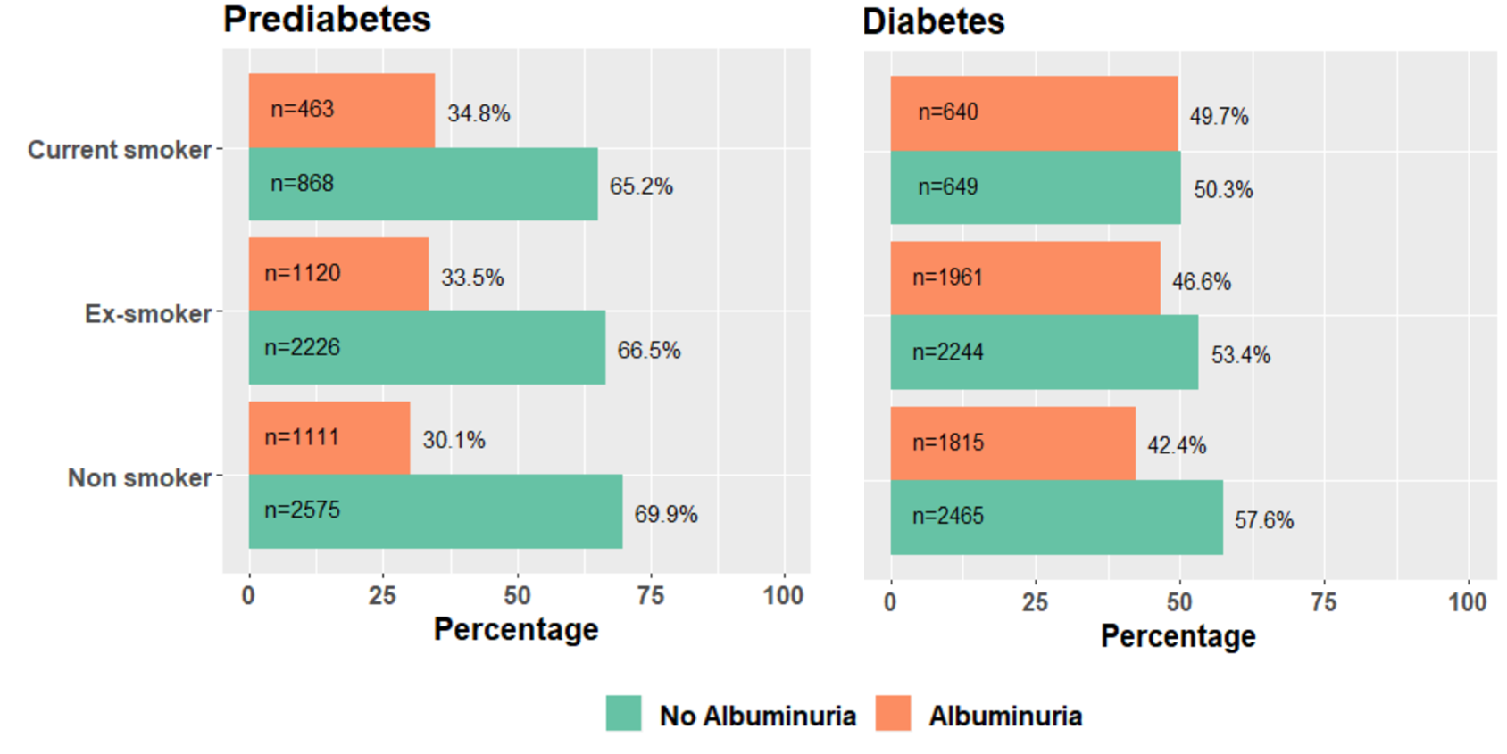
Figure 13: Prevalence of albuminuria based on smoking status

(Aya El-Wazir, a PhD student, and a co-author of the published paper, prepared this figure)

Table 7 (a): Descriptive statistics of the prevalence of albuminuria based on smoking status in people with pre-diabetes

Pre-diabetes | n (number) | N (Total) | P (Percentage) | Lower level of CI | Upper level of CI
Current smoker | 463 | 1331 | 35% | 32% | 37%
Ex-smoker | 1120 | 3346 | 33% | 32% | 35%
Non-smoker | 1111 | 3686 | 30% | 29% | 32%

Table 7 (b): Descriptive statistics of the prevalence of albuminuria based on smoking status in people with diabetes

Diabetes | n (number) | N (Total) | P (Percentage) | Lower level of CI | Upper level of CI
Current smoker | 640 | 1289 | 50% | 47% | 52%
Ex-smoker | 1961 | 4205 | 47% | 45% | 48%
Non-smoker | 1815 | 4280 | 42% | 40% | 44%

Tables 7 (a) and 7 (b) were prepared by Dr Mintu Nath, Senior Lecturer in Medical Statistics, University of Aberdeen (a co-author of the published paper)

Predictors and determinants of albuminuria at the stage of prediabetes and diabetes
We report the estimated odds of albuminuria in people with prediabetes and diabetes based on cardiorenal risk factors such as age, sex, hypertension, HbA1c, cholesterol, deprivation, and BMI.
In people with prediabetes, compared with non-smokers, the adjusted odds ratio of albuminuria in current smokers was 1.21 (95% CI 1.05 − 1.39, p=0.009), and in ex-smokers was 1.07 (95% CI 0.96 − 1.19, p=0.240). Other cardiorenal factors associated with albuminuria were - male sex 1.42 (95% CI 1.28 − 1.58, p <0.0001), stroke 1.71 (95% CI 1.30 – 2.25, p<0.0001), IHD 1.41 (95% CI 1.20 – 1.65, p<0.0001), HbA1c 1.06 (95% CI 1.02 – 1.10, p<0.0001) and hypertension 1.57 (95% CI 1.40 – 1.75, p<0.0001). Age, cholesterol, deprivation, and BMI did not show any statistically significant relationship with albuminuria at the stage of prediabetes. (Table 8). The association between IHD and stroke with albuminuria in people with T2DM has been reported in multiple other studies [257, 258] which suggests that micro- and macrovascular complications are continuum rather than two distinct process [259]. This is the first study to show such relationship in people with prediabetes.
Table 8: Logistic regression model with adjusted estimates of odds ratio and corresponding 95% confidence intervals for albuminuria at the stage of prediabetes

Cardiorenal risk factors | Odds ratio  (95% CI) | p-value | Effect size (S.E)
Current smokers vs non-smokers | 1.21 (1.05 – 1.39) | 0.009 | 0.191 (0.072)
Ex-smokers vs non-smokers | 1.07 (0.96 – 1.19) | 0.240 | 0.065 (0.055)
Age | 0.99 (0.99 – 1.00) | 0.536 | -0.003 (0.004)
Male sex | 1.42 (1.28 – 1.58) | <0.001 | 0.353 (0.052)
Most deprived vs least deprived  quintile | 1.05 (0.90 – 1.22) | 0.566 | 0.045 (0.078)
HbA1c | 1.06 (1.02 – 1.10) | 0.001 | 0.058 (0.017)
Cholesterol | 1.00 (0.96 – 1.05) | 0.838 | 0.004 (0.021)
Overweight vs normal weight | 0.64 (0.38 – 1.07) | 0.091 | -0.444(0.263)
Obese vs normal weight | 0.84 (0.50 – 1.40) | 0.500 | -0.176 (0.262)
Stroke | 1.71 (1.30 – 2.25) | <0.001 | 0.536 (0.140)
Ischaemic heart disease | 1.41 (1.20 – 1.65) | <0.001 | 0.343 (0.082)
Hypertension | 1.57 (1.40 – 1.75) | <0.001 | 0.450 (0.056)

In people with diabetes, the odds of albuminuria in current smokers were 1.26 (95% CI 1.10 – 1.44, p<0.0001), and in ex-smokers, 1.09 (95% CI 0.99 – 1.19, p=0.08). Other cardiorenal risk factors associated with albuminuria in people with diabetes were - male sex 1.52 (95% CI 1.38 – 1.67, p<0.0001), stroke 1.96 (95% CI 1.52 - 2.52, p<0.0001), ischaemic heart disease 1.79 (95% CI 1.57 - 2.04, p<0.0001), cholesterol 1.06 (95% CI 1.03 – 1.10, p<0.0001), HbA1c 1.014 (95% CI 1.011 – 1.018, p<0.0001) and hypertension 1.55 (95% CI 1.40 - 1.71, p<0.0001). No statistically significant relationship existed between age and BMI with albuminuria in people with diabetes (Table 9).

Table 9: Logistic regression model with adjusted estimates of odds ratio and corresponding 95% confidence intervals for albuminuria at the stage of diabetes

Cardiorenal risk factors | Odds ratio (95% CI) | p-value | Effect size (S.E)
Current smokers vs non-smokers | 1.26 (1.10 – 1.44) | 0.001 | 0.242 (0.066)
Ex-smokers vs non-smokers | 1.09 (0.99 – 1.19) | 0.080 | 0.084 (0.046)
Age | 1.00 (0.99 – 1.01) | 0.536 | 0.002 (0.003)
Male sex | 1.52 (1.38 – 1.67) | <0.001 | 0.419 (0.048)
Most deprived vs least deprived  quintile | 1.35 (1.18 – 1.55) | <0.001 | 0.302 (0.071)
HbA1c | 1.01 (1.01 – 1.02) | <0.001 | 0.014 (0.002)
Cholesterol | 1.06 (1.03 – 1.10) | 0.001 | 0.062 (0.019)
Overweight vs normal weight | 0.65 (0.30 – 1.41) | 0.276 | -0.435 (0.399)
Obese vs normal weight | 0.83 (0.38 – 1.82) | 0.647 | -0.182 (0.398)
Stroke | 1.96 (1.52 – 2.52) | <0.001 | 0.672 (0.128)
Ischaemic heart disease | 1.79 (1.57 – 2.04) | <0.001 | 0.582 (0.068)
Hypertension | 1.55 (1.40 – 1.71) | <0.001 | 0.438 (0.051)

While in prediabetes group, deprivation was not statistically significant determinant of albuminuria, in the diabetes group, after adjusting for smoking status and other cardiorenal risk factors, those in the most deprived quintile, compared with those in the least deprived quintiles, were 35% more likely to have albuminuria.
In the analyses, all assumptions of binary logistic regression were tested and confirmed as met, including the presence of a binary dependent variable, independence of observations, absence of correlations between independent variables and absence of significant outliers in numeric independent variables. In addition, all continuous independent variables included in the model were linearly related to the log of odds.

Relationship between smoking status and cardiorenal risk factors with albuminuria
In ex-smokers, the odds of albuminuria in the male sex, systolic and diastolic blood pressure, cholesterol, HbA1c, waist circumference and the most deprived quintiles were 1.146 (95% CI 1.090 – 1.206, p<0.001), 1.009 (95% CI 1.008 – 1.011, p<0.001), 1.005 (95% CI 1.002 – 1.007, p<0.001), 0.914 (95% CI 0.896 – 0.931, p<0.001), 1.026 (95% CI 1.023 – 1.028, p<0.001), 1.012 (95% CI 1.010 – 1.013, p<0.001), and 1.189 (95% CI 1.110 – 1.273, p<0.001), respectively [Figure 14 (A)]

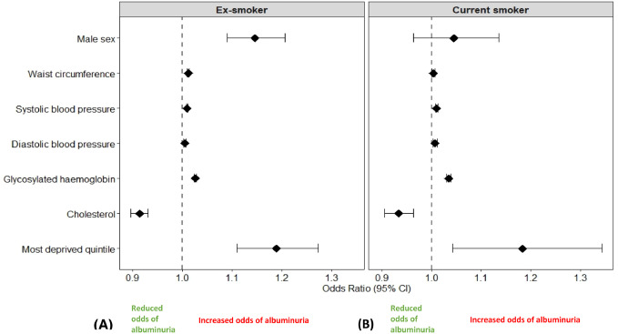

Figure 14: Risk of albuminuria in ex-smokers and current smokers

In current smokers, the cardiorenal risk factors associated with increased odds of albuminuria were SBP 10.10 (95% CI 1.008 – 1.013, p<0.001), DBP 1.007 (95% CI 1.003 – 1.012, p=0.001), cholesterol 0.934 (95% CI 0.905 – 0.964, p<0.001), HbA1c 1035 (95% CI 1.030 – 1.039, p<0.001), waist circumference 1.004 (95% CI 1.001 – 1.007, p=0.004), and deprivation 1.183 (95% CI 1.042 – 1.343, p=0.010). In current smokers, there was no evidence of an association between the male sex and albuminuria 1.045 (95% CI 0.963 – 1.135, p=0.292) [Figure 14 (B)]

3.4. Discussion
This cross-sectional study demonstrated that smoking is a significant risk factor for albuminuria in both people with prediabetes and diabetes. This finding is in keeping with the current evidence [128, 260]. This study showed that irrespective of diabetes status, male ex-smokers are at a higher risk of albuminuria than current smokers. One of the key determinants of the risk of albuminuria after quitting is post-cessation weight gain, indicated by waist circumference. This study suggests that waist circumference may better predict albuminuria than BMI. Deprivation is an independent predictor for albuminuria in both ex- and current smokers. Systolic and diastolic blood pressure and HbA1c are positively associated with albuminuria in both ex- and current smokers, suggesting that these risk factors should be addressed in both groups. Counterintuitively, however, this study showed that total cholesterol was negatively associated with albuminuria in both current and ex-smokers.
In people with prediabetes, each unit increase in HbA1c was associated with 6% increased odds of albuminuria, compared with 1% in those with diabetes, suggesting that controlling HbA1c may be more important in people with prediabetes than diabetes. Hypertension, IHD and stroke are independently associated with albuminuria in both groups. In people with diabetes, each unit increase of cholesterol was associated with 6% increased odds of albuminuria. In contrast, there was no statistically significant association between total cholesterol and albuminuria in those with prediabetes. Similarly, there was no evidence that BMI was associated with albuminuria in either group. Compared with the least deprived quintiles, the most deprived quintiles of people in the diabetes group had higher odds of albuminuria than those in the prediabetes group. Compared with non-smokers, despite lower BMI, smokers have larger waist circumference [220, 261], an independent risk factor for insulin resistance [262], and albuminuria [263]. After smoking cessation, quitters may have an increased waist circumference and BMI. Therefore, two important determinants of reducing the risk of albuminuria are the active management of post-cessation weight gain and remaining abstinent long-term [264, 265]. This is the first study to show that greater waist circumference may also be associated with a higher risk of albuminuria in ex-smokers.
In people with diabetes, previous studies have shown that the progression of nephropathy can be ameliorated in those who gave up compared to those who continued smoking [176]. However, the impact of smoking and its cessation on albuminuria in people with prediabetes is not fully understood. Anecdotal evidence suggests that the duration of abstinence and post-cessation weight gains could be the two determinant factors of albuminuria in ex-smokers [264, 266]. This study supports the risk of ex-smokers for albuminuria based on waist circumference. Still, a longitudinal study will be needed to estimate the length of abstinence needed to bring the risk down to the level of non-smokers. Current Diabetes Prevention Programmes worldwide assume that in people with prediabetes, keeping the HbA1c under the diabetes range will be sufficient to keep the vascular risk under control. However, the findings of this cross-sectional study suggest that it may be a piecemeal approach, particularly for smokers and ex-smokers with prediabetes, who are at a higher risk of albuminuria.
Microalbuminuria is an important milestone in the disease trajectory of metabolic syndrome. If the renal disease can be detected at the stage of microalbuminuria and multifactorial intervention is initiated at an early stage of disease trajectory, it can improve the renal outcome and reduce the risk of all-cause and cardiovascular mortality [83]. Smoking cessation, active weight management, glycemic control and hypertension management are the key components of the multifactorial intervention.
However, the above multifactorial intervention approach can only reverse renal impairment if implemented at the microalbuminuria stage. When microalbuminuria progresses to proteinuria, and a drop in eGFR occurs in overt nephropathy (Figure 3), the renal dysfunction is irreversible, although RAAS inhibition can slow the progression [170].
Hypertension management in smokers and ex-smokers with prediabetes and diabetes can be challenging and needs careful monitoring. Although RAAS inhibitors have dual effects of lowering blood pressure and preventing albuminuria, their effectiveness is diminished in smokers due to enhanced pulmonary conversion of angiotensinogen to angiotensin II, which has a potent vasoconstrictor property [103]. Similarly, beta-blocker's effectiveness in treating hypertension in smokers is counteracted by the direct excitatory effect of nicotine on the sympathetic adrenergic pathway [267]. Therefore, effective blood pressure control may be difficult to achieve without smoking cessation.
In contrast to the current understanding [268], this study found that cholesterol was inversely associated with albuminuria in both ex-smokers and current smokers. The precise cause for this observation is unclear. One of the explanations could be that due to the higher socio-economic status and education level, the UKB population may have a healthier diet, which increases the level of HDL-cholesterol than triglycerides and LDL cholesterol. Previous studies have shown that higher HDL concentration can reduce the risk [269], while high LDL [270] and triglyceride [271] can increase the risk of albuminuria.
The findings of this study are important for public health policy. The risk of albuminuria is higher in smokers and ex-smokers with prediabetes compared to non-smokers. Current diabetes prevention models, without smoking cessation intervention and without screening for vascular complications such as albuminuria, may lead to a late presentation, with established microvascular and macrovascular complications when they are not amenable to reversal. Smokers with prediabetes and diabetes should be supported not only to quit smoking but also to remain abstinent. Short-term quitting may not give any meaningful risk reduction benefit.
The main strengths of this study are its sample size and novel stratified analysis. This is the first study to demonstrate the risk of albuminuria in smokers and ex-smokers with prediabetes. It identifies the gaps in the current diabetes prevention models and how the weight loss gained from the structured lifestyle intervention can be used opportunistically to encourage smokers to quit and remain abstinent. It also demonstrates that a holistic, multifactorial approach is needed to reduce the risk of albuminuria in people with prediabetes rather than just keeping the HbA1c below the diabetes range.
However, several limitations associated with the dataset make interpreting the findings less generalizable. Instead of ACR, we used the available UAC data, albeit it was only for 30% of the study participants. We do not hold data about the other 70% of the UK Biobank population. We compared the characteristics of people with and without UAC value and did not elucidate any significant selection bias. Moreover, majority of the UK Biobank cohort are from white ethnicity and are from higher socioeconomic status which is a limitation of this study [252]. To confirm the findings of this study, a nationally representative real-world data analysis would be required.
We did not differentiate micro and macroalbuminuria and, therefore, cannot comment on how the cardiorenal risk factors influence the outcomes in current and ex-smokers. From the questionnaire, it was not possible to be precise about the numbers of type 1 and type 2 people with diabetes, which is one of the major weaknesses of this study. We recognize that a single measure of albuminuria does not enable us to assess variability, a risk factor in type 1 and type 2 diabetes [272, 273].
The age of the study participants was limited to 40-69 years. People from the Black, Asian, and Minority Ethnicities (BAME) were not well-represented, with 94% of the study participants being White. We also note that the prevalence of smoking was lower in the UKB population than the national average, possibly reflecting selection bias related to the participants’ higher socioeconomic status [252]. The smoking data were derived from the questionnaire; no biochemical confirmation was sought. This is a less reliable method of determining smoking status than a biochemical affirmation by measuring the urinary excretion of nicotine metabolites.
In the UK Biobank, smoking prevalence was 10.5%, while the Office for National Statistics data showed that in 2021, the national prevalence of smoking was 13.3% [274]. Therefore, the analyses of this study may not reflect the true impact of smoking on albuminuria.
Moreover, the number of male participants was more than the number of female participants, and the variation in the prevalence of albuminuria may be by chance or due to the gender disparity already known. Stroke and IHD are macrovascular complications, and higher odds of albuminuria in this group of people suggest macrovascular and microvascular complications are interlinked, and one increases the risk of the other. However, people who have suffered macrovascular complications such as IHD and stroke are likely to have pre-existing vascular risk factors predisposing to those complications. Due to the ramification of cardiometabolic risk factors such as hypertension, dyslipidaemia, and co-existing vascular complications, it may not be appropriate to attribute smoking as a singular risk factor for albuminuria. The interaction between multiple risk factors and smoking is more important than merely smoking and its cessation.
The study's cross-sectional design could not elucidate how long the quitters need to remain abstinent for their risk to decline to the level of non-smokers. The UKB study participants were less likely to be socioeconomically deprived, obese and smokers than the general population. They were less likely to drink alcohol daily, had fewer self-reported physical and/or mental health conditions, and were more likely to be older [275]. The cross-sectional study design is a limitation as it cannot establish causation. However, it serves the purpose of hypothesis generation and helps inform the design of future prospective studies.
In this study, deprivation was independently associated with increased risk of albuminuria in both current and ex-smokers. However, the data from the Office for National Statistics (ONS) in the UK showed that smoking prevalence is four times higher in the most deprived neighbourhoods compared with the least deprived [276], suggesting that there may be an overlapping relationship between smoking, socioeconomic status, and albuminuria. Further research is needed to explore the relationship between smoking and deprivation with albuminuria.

3.5 Potential for further research
In this study, we demonstrated that ex-smokers had a lower risk of albuminuria than non-smokers in both people with prediabetes and diabetes, but it did not reach the level of statistical significance. It is not clear whether other factors, such as length of abstinence and post-cessation BMI, may influence the risk. A longitudinal cohort study with adequate abstinence period is needed to answer this question. Likewise, further research is required to explore whether the reason for quitters not to have a statistically significant reduction in the risk of albuminuria is post-cessation weight gain.
Similarly, the effectiveness of GLP-1 analogues (i.e., Liraglutide, Semaglutide) in managing post-cessation weight gain needs to be explored. A randomized controlled trial is needed to investigate the efficacy of GLP-1 analogue to prevent weight gain in ex-smokers and facilitate long-term abstinence. A longitudinal study is required to elucidate how long the ex-smokers need to remain abstinent to get their risk decline to the level of non-smokers.

3.7 – Chapter summary and research in the context of the overall thesis
This chapter showed that smokers are at a higher risk of albuminuria at the stages of prediabetes and diabetes (Stage 4 and 5, Figure 1). This study also highlighted that the risk of albuminuria in ex-smokers may not decline to the level of non-smokers. In the next chapter, in a longitudinal cohort study, I will explore what factors are associated with the progression and regression of albuminuria in ex-smokers.

Chapter 4 – Relationship of cardiorenal risk factors with Albuminuria based on age, smoking, glycaemic status and BMI: a retrospective cohort study of the UK Biobank data

https://doi.org/10.1136/bmjph-2023-000172

Statement of contributions
This chapter is published in BMJ Public Health and is available following the above link. My work included the conceptualisation, choosing the study design, selecting suitable data to answer the study questions, data collection and cleaning, statistical analyses, data interpretation and writing up. I received support in statistical analyses from a fellow PhD student (Aya El Wazir), who contributed to preparing the forest plots. Dr Mintu Nath, a statistician from the University of Aberdeen checked the statistical analyses and designed tables 7 (a) and 7 (b). All the other co-authors contributed by reading the manuscript and giving their feedback.

4.1 Introduction
The cross-sectional study in the previous chapter showed that smoking is an independent risk factor for albuminuria at the stage of prediabetes and diabetes (stages 4 & 5; Figure 1). However, after smoking cessation, compared to non-smokers, the risk did not decline to a statistically significant level in ex-smokers. This observation suggests that other cardiorenal risk factors may have an influence on the prevalence and progression of albuminuria after smoking cessation. Therefore, this chapter conducted a longitudinal cohort study on the UK Biobank data to explore the cardiorenal risk factors associated with the progression of albuminuria in ex-smokers.
Smoking and obesity are the leading preventable causes of mortality and morbidity worldwide. On average, the life expectancy of overweight smokers is 13 years lower than normal-weight non-smokers [277]. People with cardiometabolic diseases are particularly at risk [278, 279]. To reduce the burden of complications arising from tobacco consumption in people with NCD, the WHO set a target to reduce tobacco consumption from baseline in 2010 by 30% in its member countries by 2025 [280]. Due to raised awareness and public health intervention, the fourth WHO global tobacco trends report published in 2022, showed that tobacco consumption in adults had decreased considerably in its member countries. However, the report also highlighted that 38 million children aged 13 to 15 still smoke tobacco worldwide [281]. Concurrently, due to rapid urbanisation in third-world countries and cheaper availability of high-calorie food in developed countries, childhood obesity is rising globally, increasing mortality and morbidity risk [282, 283]. Smoking and obesity are interlinked risk factors associated with micro- and macrovascular complications [72, 284, 285]. Therefore, the WHO has set a target of reducing childhood smoking to zero and tackling childhood obesity as its significant public health priority [282, 286].
Smoking increases the risk of T2DM and albuminuria in people with cardiometabolic disease [287], and its cessation ameliorates the risk [288]. Compared to non-smokers and ex-smokers, smokers have a lower BMI [220] but heightened propensity to insulin resistance and hyperinsulinemia [289], which increases the risk of albuminuria [6]. The risk is particularly high in young and adolescent obese smokers [9]. Smoking cessation, on the other hand, improves insulin sensitivity [92] but paradoxically increases the risk of T2DM [98, 100]. In people with T2DM, smoking cessation is associated with worsening glycaemic control [247]. The impact of post-cessation weight gain on the renovascular outcome is also conflicting. Some studies reported that micro- and macrovascular risk could be reduced after smoking cessation, if post-cessation weight gain can be prevented [290-292]. In contrast, some other studies contradicted this observation and suggested that those who had post-cessation weight gain had a lower risk of MACE and mortality than those who lost weight [293]. Therefore, the anxiety of further weight gain, risk of developing T2DM, worsening of glycaemic control and unknown impact on vascular outcomes are the major deterrents for obese smokers to quit [294]. Although public health guidelines are unambiguous about the harm of smoking and the benefits of smoking cessation, they are less clear about the cardiometabolic consequences of smoking cessation and how to manage them.
In this study, using UAC data in the first and second visits of the UK Biobank study participants, we aim to explore the relationship between cardiorenal risk factors and smoking status with change in albuminuria between study visits.

4.2 - Methods

Study cohort and design
We conducted a retrospective cohort study using a subset of the UK Biobank data. It is a large dataset containing the genomic and phenotyping data of 502,490 individuals from the United Kingdom [252]. The age range of study participants on the first visit was 40 to 70 years, and on the second visit was 44 to 76 years. The initial visit was between 13 March 2006 and 01 October 2010, and the follow-up was between 08 August 2012 and 07 June 2013. Of 502,490 participants, 30% (n=152,864) provided urine samples on the first visit, and from 20,346 participants, 32% (n=6,505) provided urine samples on the second visit. The data field description in the UK Biobank was “Microalbumin in urine”.

Selection process and data collection
UK Biobank conducted the follow-up visits (n=20,346) by asking the participants to complete a questionnaire, undergo physical examinations, and provide blood, urine, and saliva samples. Data for age, sex, the age at which they started and stopped smoking, the number of years they smoked, and when diabetes and hypertension were diagnosed were obtained from the questionnaire. Duration of smoking was calculated by subtracting the age they started smoking from the age they stopped smoking; duration of abstinence was calculated by subtracting the current age on the second visit and the age they stopped smoking. All the data were verified by the lead author (DK) and another study team member (AE). The data were reported using the Strengthening the Reporting of Observational Study (STROBE) reporting guidelines for retrospective studies [254].

Exposure and covariates
The population of interest was those who had UAC values on both the first and the second visit. The population was divided into progressor, regressor and unchanged groups based on an increase, decrease or no change in the UAC values between the visits. Smokers were classed as active smokers at the second visit, non-smokers were those who never smoked, and ex-smokers were those participants who smoked in the past but had given up at the time of the second visit and were abstinent for at least a year. Covariates were age, sex, BMI, waist circumference, age at which hypertension and/or diabetes diagnosed, age when started and stopped smoking, serum creatinine, HbA1c, blood pressure and cholesterol at the time-point of the second visit. BMI was expressed in kg/m²; SBP and DBP in mm of Hg; cholesterol, HDL, and LDL in mmol/l; and HbA1c in mmol/mol and %. This study did not include smoking e-cigarettes or consuming tobacco in any other form except smoking cigarettes.

Outcome variables
The study's primary outcome was a change in the UAC values between the first and second visits. The secondary outcomes were changes in the HbA1c, blood pressure, serum creatinine, total cholesterol, HDL, LDL, and BMI between the two visits.
UAC value available in both first and second visit (n=2805)
Included
Progressor (n=1506)
Regressor (n=987)
Eligible participants for the cohort study (n=502408)
Excluded – no change in UAC value (n=312)
Excluded – UAC value not available in the first visit (n=3700)
Excluded – UAC value not available on the second visit (n=495903)
UAC value available in second visit (n=6505) (August 08, 2012 – June 17, 2013)
Excluded – participants withdrawn consent (n=82) before the analysis began
(April 1, 2022)
People who consented to take part in the UK Biobank studies at enrolment (n=502,490) (March 1, 2006, to December 31, 2010)

Figure 15: Flowchart of selection of study participants

Statistical analyses
Participants who did not have their UAC value on both the first and second visits and those who did not have any change in the UAC were classed as missing values. As this study focuses on exploring the relationship between cardiorenal risk factors and change in the UAC value over the two time periods, missing values were excluded from the analyses. However, a separate analysis was conducted on missing values to examine if they were distributed randomly.

A descriptive analysis was carried out to summarise the cardiorenal characteristics of the study participants. The normality of the distribution of continuous variables was assessed using the Kolmogorov-Smirnov test with pairwise exclusion (supplementary material). A chi-squared test was conducted to explore the significance of cardiorenal risk factors based on the progression of UAC values between the first and the second visit, smoking, and glycaemic status.

Three separate logistic regression models were fitted using different cardiometabolic parameters. The outcome variables for all three models were ‘progressor’ and ‘regressor’, determined by the change in the UAC values between the first and the second visits. Model 1, in a retrospective cohort design, included 2493 participants who had a change of >1 mg/l in their UAC value between the two visits. This method was adopted to understand how a rise and fall of UAC values in visit one and visit two were associated with the cardiorenal risk factors of age, blood pressure, creatinine, cholesterol, HbA1c and smoking status. A rise or fall in UAC value of 1 mg/l may not be clinically significant, but due to the lack of power of the available data, we took this approach and acknowledged it as a limitation of the study.

Further logistic regression was conducted on ex-smokers’ subsets using a cross-sectional design during the second visit. Explanatory variables in subset analyses were in model 2(a), the duration of smoking and waist circumference; in model 2(b), the duration of smoking and BMI; and in model 2(c), the duration of smoking without BMI and waist circumference. Similarly, the explanatory variables in model 3(a) were - the duration of abstinence and waist circumference; in model 3(b), the duration of abstinence and BMI; and in model 3(c), the duration of abstinence without BMI and waist circumference.

Ethics and software used for analyses
UK Biobank received ethics approval from the Northwest Multi-centre Research Ethics Committee (MREC) and from the National Information Governance Board for Health & Social Care (NIGB). For this study, a separate ethics approval was obtained from the University of Sheffield Research Ethics Committee (Application Number 038586, 09/03/2021). All the analyses were carried out using IBM SPSS version 28.0.1.1 and R version 4.2.2.

4.3 Results
After excluding 82 participants who withdrew their consent, 502,408 participants were screened for eligibility. Based on the UAC value in the second visit, 6505 participants were selected as the study population for descriptive analysis, and their baseline characteristics are summarised in Table 9. Amongst the included participants, 46% (n=2999) were female, and 54% (n=3506) were male. Based on the HbA1c values in the second visit, 61% (n=3954) had normoglycaemia, 5% (n=318) had HbA1c in the pre-diabetes range, and 4% (n=288) had it in the diabetes range. 30% (n=1945) had no HbA1c value at the second visit. Out of 6505 participants who had UAC values on the second visit, 43% (n=2805) also had corresponding values on the first visit. Of them, 23% (n=1506) were progressors, 15% (n=987) were regressors, and 5% (n=312) did not have any change. People who did not have UAC values in both the first and the second visits and those whose UAC value was unchanged were classed as missing values. Analyses of the missing values showed that they were distributed randomly, and there was no systematic bias. (Supplementary materials 4; Table 8).
The Kolmogorov- Smirnov tests for Normality showed the distribution of numerical variables was non-parametric. (Supplementary materials 4; Table 2) On the second visit, the median age of study participants was 64 years, the median age of starting smoking in ex-smokers was 17 years, the median age of stopping smoking was 37 years, the median length of smoking before quitting was 20 years, the median age of diabetes diagnosis was 55 years, and the median BMI was 27 kg/m² (Table 9).

Table 10: Baseline characteristics of numerical variables of participants with UAC value in the second visit

Variables | Mean | Standard deviation (SD) | Minimum | Maximum
Age (years) | 64.53 | 6.83 | 44 | 76
Waist circumference (cm) | 97.31 | 13.51 | 60 | 164
SBP (mm of Hg) | 141 | 10.05 | 88 | 253
DBP (mm of Hg) | 83.45 | 10.16 | 55 | 119
BMI (kg/m²) | 28.73 | 4.97 | 17.10 | 58.88
Cholesterol (mmol/l) | 5.40 | 1.22 | 2.00 | 11.00
Creatinine (µmol/dl) | 78.78 | 19.47 | 40 | 381
HbA1c (mmol/mol) | 38.17 | 7.64 | 19 | 105
HDL (mmol/l) | 1.41 | 0.39 | 0.00 | 4.00
LDL (mmol/l) | 3.35 | 0.90 | 1.00 | 7.00

A chi-squared test was conducted based on progression, smoking, and glycaemic status. While diabetes status at the second visit (pre-diabetes and diabetes) was statistically significantly associated with the progression of UAC value, smoking status was not. (Supplementary materials 4; Tables 5 & 6) A Spearman’s ranked correlation analysis showed evidence of a statistically significant relationship between UAC value in the second visit with age, SBP and DBP, waist circumference, BMI, total cholesterol, serum creatinine, HbA1c, HDL and LDL, duration of smoking of current and ex-smokers. (Supplementary materials 4; Table 7).

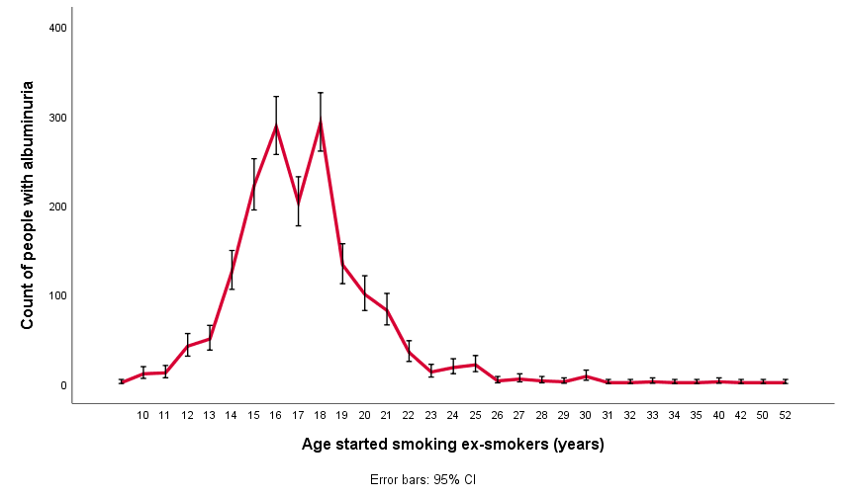

Figure 16: Count of people with albuminuria on the second visit

The number of ex-smokers whose UAC value increased in the second visit was plotted against the age when they started and stopped smoking. The plot showed that the prevalence of albuminuria was higher among those ex-smokers, who started smoking between the ages of 13 and 18 (Figure 16), and in those who stopped smoking between the ages of 15 and 35 (Figure 17).

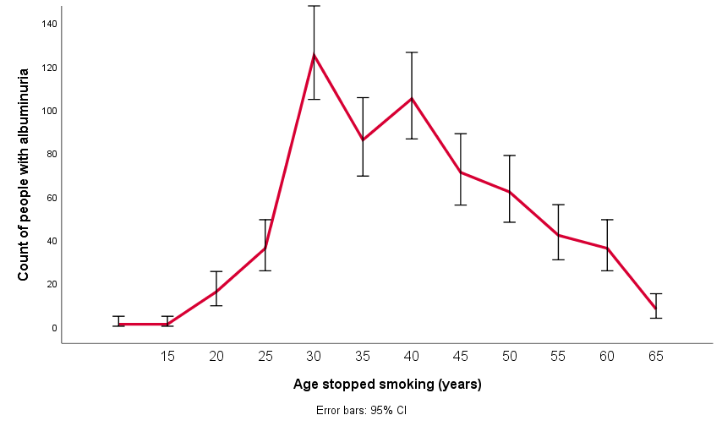

Figure 17: Count of people with albuminuria on the second visit.
Table 11: Model 1 – Factors predicting the progression of albuminuria (n=2493).

Variables | Odds ratio | p-value | 95% CI | Effect size (SE)
Male vs female | 1.22 | 0.14 | 0.94 to 1.58 | 0.20 (0.13)
Age (visit 2 – visit 1) (years) | 1.20* | <0.01 | 1.06 to 1.36 | 0.18 (0.06)
BMI (visit 2 – visit 1) (kg/m²) | 1.03 | 0.48 | 0.95 to 1.10 | 0.03 (0.04)
SBP (visit 2 – visit 1) (mm of Hg) | 1.00 | 0.88 | 0.99 to 1.01 | 0.001(0.007)
HbA1c (visit 2 – visit 1) (mmol/mol) | 1.03* | 0.02 | 1.00 to 1.05 | 0.03 (0.01)
Creatinine (visit 2 – visit 1) (µmol/l) | 0.99 | 0.15 | 0.98 to 1.00 | -0.008 (0.006)
HDL (visit 2 – visit 1) (mmol/l) | 0.53 | 0.05 | 0.28 to 1.01 | -0.64 (0.33)
Total cholesterol (visit 2 – visit 1) (mmol/l) | 1.08 | 0.21 | 0.95 to 1.23 | 0.08 (0.06)
Ex-smoker vs non-smoker (visit 2) | 1.22 | 0.50 | 0.69 to 2.15 | 0.20 (0.29)
Current smoker vs non-smoker (visit 2) | 0.72 | 0.52 | 0.26 to 1.97 | -0.33 (0.51)

(*Statistically significant)

Subset analyses on ex-smokers
From 2805 people with the UAC values available on both the first and the second visits, ex-smokers who had information on their current smoking status and the date of starting and stopping smoking were selected. 18.97% (n=532) had the above data. Amongst them, 35.3% (n=188) were female, and 64.7% (n=344) were male. The mean age was 63.39 ± 6.94 years, the mean duration of smoking before quitting was 21.33 ± 11.33 years, the mean age of starting smoking was 17.18 ± 3.34 years, the mean age of stopping smoking was 38.51 ± 11.14 years, and the mean duration of abstinence was 24.88 ± 11.69 years.
In model 2(a), the duration of smoking was fitted with age, sex, waist circumference, cholesterol, DBP, and change in HbA1c between the first and second visit. None but the duration of smoking before quitting was statistically significantly associated with the progression of albuminuria (Figure 18). (Supplementary materials 4; Table 11)
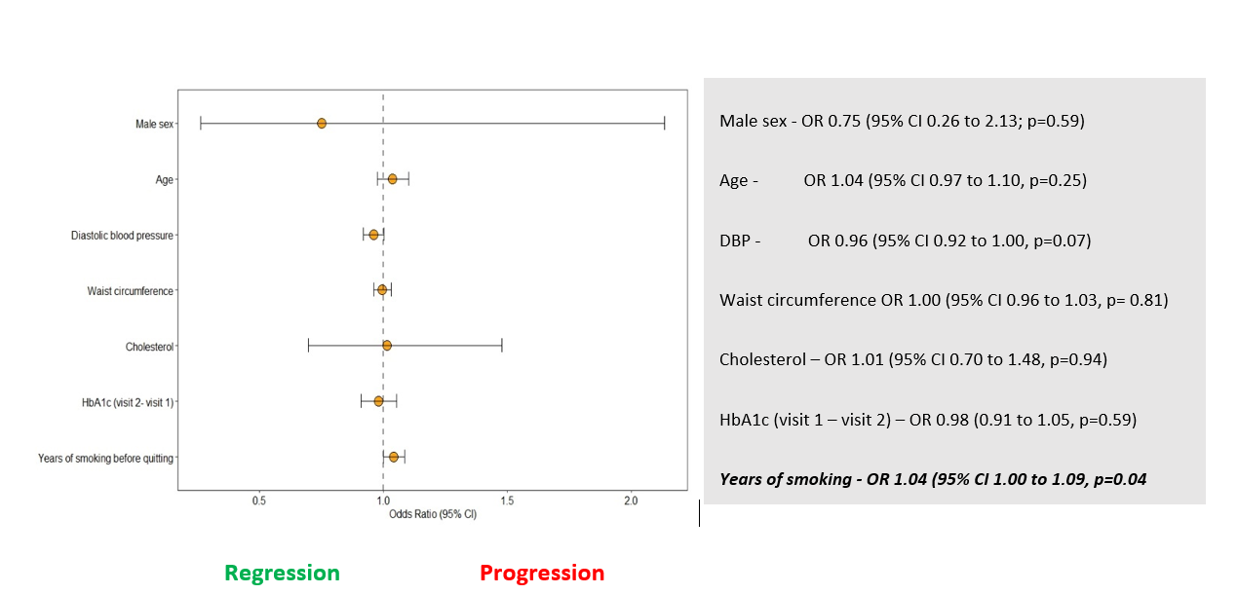
Figure 18: Predictors of progression and regression of albuminuria based on years of smoking.

However, in model 2(b), when BMI replaced waist circumference, none of the above cardiorenal risk factors had any statistically significant relationship with the progression of albuminuria. Finally, in model 2(c), when both BMI and waist circumference were removed from the model, duration of smoking remained a statistically significant predictor of albuminuria in ex-smokers, suggesting that the duration of smoking before quitting is an independent determinant of the progression of albuminuria. (Supplementary materials 4; Tables 12 & 13).
In model 3 (a), the duration of abstinence was fitted with age, sex, DBP, cholesterol, waist circumference, and the change in HbA1c between the first and the second visit. Apart from the age in the second visit and the duration of abstinence, no other confounding variables had any statistically significant relationship with the progression or regression of albuminuria (Figure 19). (Supplementary materials 4; Table 14)
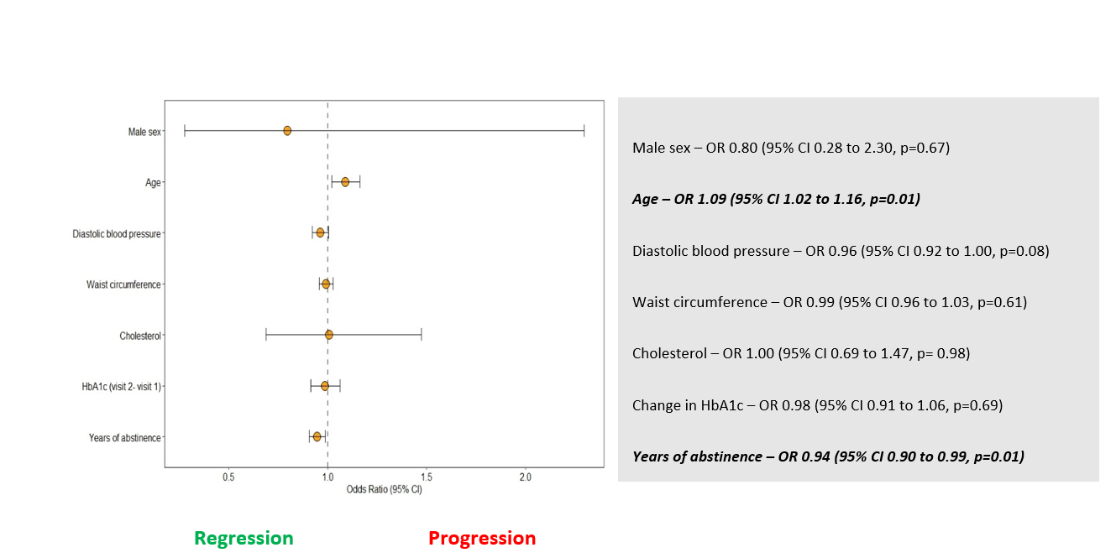

Figure 19: Predictors of progression and regression of albuminuria based on years of abstinence.

In model 3 (b), waist circumference was replaced with BMI; in 3 (c), neither BMI nor waist circumference was used. Age remained a statistically significant predictor of progression in both models, and the duration of abstinence remained a statistically significant determinant of regression, suggesting that the younger the smokers quit and the longer they remain abstinent, the more the likelihood of regression of albuminuria, irrespective of change in BMI and waist circumference. (Supplementary materials 4: Tables 15 & 16).

4.4 Discussion
This study showed that with a mean duration of 51.70 ± 10.95 months between the first and second visits, ageing and change in HbA1c were the only statistically significant predictors of the progression of albuminuria. Each year of ageing increased the odds of progression by 20%, and each unit of HbA1c increased the odds by 3%. Between the two visits, changes in BMI, SBP, cholesterol, creatinine and HDL had no statistically significant association with the progression of albuminuria, suggesting that short-term changes in those risk factors may not significantly impact the progression. At the time-point of the second visit, the number of people with albuminuria was significantly higher in ex-smokers who started smoking between the ages of 13 and 19, and stopped smoking between the ages of 25 and 35. After adjusting for confounding variables, each year of smoking before quitting increased the odds of progression by 4%, each year of ageing increased the odds by 9%, and each year of abstinence reduced the odds by 6%. Waist circumference and BMI had no statistically significant association with the progression of albuminuria unless they caused a rise in HbA1c.
The finding of this study that HbA1c is an independent predictor of albuminuria is supported by previous studies [166, 295]. Similarly, the relationship between ageing and the progression of albuminuria shown in this study is in keeping with current evidence [296, 297]. This is the first study to indicate that preventing children from taking up the habit of smoking at an early age, quitting smoking before the age of 25, and remaining abstinent long-term may reduce the risk of albuminuria. There are significant public health implications for these findings.
The epidemiology of renovascular complications has changed over the last 20 years, and therefore, current practice and policy need to be carefully evaluated. Existing global diabetes management guidelines and prevention of complication models are heavily dependent on the United Kingdom Prospective Diabetes Study (UKPDS) [135, 298, 299]. In the UKPDS study participants, the prevalence of albuminuria ten years after the diagnosis of T2DM was approximately 24.9% [124], which is no longer the case. Diabetes UK 2019 report showed that a third of people had already developed a microvascular complication at the onset of T2DM [126]. Despite adhering to the NICE guidelines set from the UKPDS model and high attainment score in the Quality Outcome Framework (QOF) for HbA1c and blood pressure, the Renal Registry UK Report 2022 suggests that the number of new people registered for RRT in 2020 was 7,323, which was comparable to previous years. The report indicates that the number of those who met the RRT criteria could be higher as many people refused to have RRT during the coronavirus pandemic. The proportion of people requiring RRT due to diabetes had increased from 24.1% in 2011 to 30.5% in 2020. Amongst those who needed RRT due to diabetes, 31% were between the ages of 45-54, and 40% were between the ages of 55-64 years [300].
In contrast to the UKPDS study participants, where the mean age of diagnosis of T2DM was 51 years, T2DM is no longer an exclusive disease of older and middle-aged people. Between 2007 and 2015, in the UK, the incidence of T2DM in people aged 17 years or less increased from 0.53 to 0.72 cases per 100,000 person-years [117]. Vascular complications such as albuminuria can develop at any stage of metabolic deregulation, even at the stage of pre-diabetes. In our recent cross-sectional study, we demonstrated that almost 35% of smokers with pre-diabetes had already developed albuminuria [301]. A recent cohort study reported that between 2009 and 2018, in the UK, the incidence rate of T2DM declined by a third, compared to its peak in 2013-2014, but the incidence of pre-diabetes had tripled [49]. In 2022, one in three adults in the UK had pre-diabetes [48].
Young obese smokers are a particular risk category for renovascular disease. In this study, we have shown that smoking and a rise in HbA1c can increase the risk of albuminuria. During puberty, there is a physiological decline in insulin sensitivity by almost 50% due to the action of Growth Hormone (GH) [302]. To compensate, pancreatic β-cell must increase their insulin secretion by 50% [303], but in smokers, this compensatory pathway becomes dysfunctional. Nicotine and other toxic chemicals in cigarettes cause premature apoptosis of functioning β-cell of the Islets of Langerhans [304]. Therefore, lifestyle intervention and pharmacotherapy should be offered to retain functioning β-cell. GLP-1 analogues such as Liraglutide and Semaglutide have shown promising results in reducing HbA1c, losing weight and preventing premature apoptosis of the β-cell [250, 305].
After stopping smoking, remaining abstinent is challenging. An average smoker makes approximately 16 attempts before successfully quitting [243]. This study has shown that each year of abstinence reduced the risk of progression of albuminuria by 6%. However, multiple studies have shown that the relapse rate is significantly higher in those quitters who gained weight beyond three months after quitting [306, 307]. Therefore, a weight management programme and careful monitoring of glycaemic control should be offered as a package in the smoking cessation programme.

4.5 Strengths and limitations
This is the first study to explore the impact of smoking cessation on the progression of albuminuria. Therefore, it can be a valuable reference for public health policymakers. However, there are several weaknesses in the study. Smoking status was determined from the questionnaire and was not verified. Similarly, the age of starting and stopping smoking was also patient-reported and could not be verified. For urinary albumin, the UKB data field “microalbumin in urine” was used as the parameter for progression and regression, although the gold standard is the ACR. Diabetes status, serum creatinine, and cholesterol levels could not be verified as not all the study participants on the second visit gave their blood samples. Of 6505 eligible participants, 2805 had their UAC values in the first and second visits. The missing values were analysed separately and did not show any systematic bias based on age, sex, smoking, and glycaemic status.

4.6 Chapter summary and how these fit in with the overall thesis objectives
The findings of this chapter suggest that the risk of progression of albuminuria in ex-smokers is dependent on the age when they stopped smoking, the duration of smoking before quitting and the duration of abstinence. Irrespective of short-term weight gain after smoking cessation, smoking cessation should reduce the risk of micro- and macrovascular complications. (Figure 1)

Chapter-5: Discussion

5.1 Summary of the findings and how it fits in with current evidence
This doctoral thesis developed a conceptual model of kidney disease to be incorporated with the NHS DPP. Chapter 1 showed the natural history of CKD based on smoking and glycaemic status and explained how a conceptual model can guide the development of HTA. In Chapter 2, the systematic review and meta-analysis showed that the risk of albuminuria in smokers with T2DM was more than double compared to non-smokers. Before adjusting for smoking status, the univariate meta-analysis showed that male sex, SBP, DBP, HbA1c, duration of T2DM, triglyceride and BMI were statistically significantly associated with albuminuria. There was significant heterogeneity between the studies. However, after adjusting for the smoking status, none but the duration of T2DM brought the heterogeneity down to a statistically significant level. Each year of the duration of T2DM increased the log of odds of albuminuria by 0.19 units or increased the odds approximately by 21%. 9 years after the onset of T2DM, compared to non-smokers, the odds of albuminuria in smokers were about 50% higher. The odds increased to almost three times after 12 years and nearly six times after 16 years.
In Chapter 3, in the cross-sectional study, the logistic regression analyses focused on identifying the predictors and determinants of albuminuria at the stage of prediabetes and diabetes in smokers and ex-smokers. The cross-sectional study showed that approximately 33.5% and 46.6% of ex-smokers had already developed albuminuria at the stage of prediabetes and diabetes, respectively. Amongst current smokers, the prevalence of albuminuria was 34.8% and 49.7% in people with prediabetes and diabetes, respectively. In the adjusted logistic regression model, active smoking increased the odds of albuminuria in people with prediabetes and diabetes by 21% and 26%, respectively. Waist circumference, SBP and DBP, HbA1c and deprivation increased the risk of albuminuria in both current and ex-smokers. Each unit increase in HbA1c increased the odds of albuminuria identically in current and ex-smokers. Additionally, in ex-smokers, SBP, DBP, waist circumference and deprivation were the predictors and determinants of albuminuria.
In Chapter 4, the longitudinal study showed a close relationship between the age of starting and stopping smoking and albuminuria. Ex-smokers who started smoking between the ages of 13 and 19 and quit smoking between the ages of 25 and 35 had the highest prevalence of albuminuria. Between the first and second visits of UK Biobank study participants, change in the UAC values had a statistically significant relationship with a change in HbA1c and age. However, a change in SBP, BMI, creatinine, HDL, and TC had no statistically significant relationship to the change in the UAC values. Likewise, the gender and the smoking status at the second visit did not have any statistically significant association with a change in the UAC value between the two visits.
At the time point of the second visit, in ex-smokers, age, duration of smoking before quitting and the duration of abstinence were the significant predictors of the progression and regression of albuminuria. In ex-smokers, each year of ageing increased the odds of albuminuria by 9%, and each year of smoking before quitting increased the odds of albuminuria by 4%, whilst each year of abstinence reduced the odds by 6%. Waist circumference, DBP, cholesterol, gender, and BMI had no statistically significant relationship with albuminuria. Therefore, smokers should be encouraged to stop smoking and remain abstinent long-term. These goals are in keeping with the conceptual model (Figure 7).

The conceptual model assumes prediabetes is a high-risk phase in metabolic deregulation and vascular complications such as albuminuria. Due to the close relationship between albuminuria and other micro- and macrovascular complications, detecting CKD at the stage of albuminuria and offering smoking cessation and weight management intervention to prevent a rise in HbA1c in a package, may reduce the risk of ESRD and other vascular complications. This thesis also provides further evidence that suggests smoking cessation at the stage of prediabetes may reduce the risk of progression of albuminuria.
Previous public health studies have shown that the risk of vascular disease and mortality may increase in recent quitters, but the reason for this observation was unclear. The WHO Multinational Study on Vascular Disease in Diabetes (MSVDD) showed that compared to non-smokers, the risk of mortality and adverse vascular events was higher for ex-smokers for up to 10 years after smoking cessation [162].
This thesis showed that smoking may be independently associated with albuminuria. Compared to non-smokers, ex-smokers still had a higher risk of albuminuria but a lower risk than current smokers. Childhood smoking is associated with increased odds of developing albuminuria. Post-cessation weight gain was not associated with increased risk of albuminuria and therefore, quitters should be encouraged to remain abstinent despite post-cessation weight gain.

5.2 Smoking, BMI, and vascular risk: an ‘obesity paradox.’
Despite the multiple health hazards of smoking, smokers have a lower BMI than non-smokers. Smokers weigh approximately 4.5 to 5 kg less than non-smokers [308]. Lower BMI in smokers is mediated by the direct effect of nicotine on the nicotinic cholinergic receptors of the brain, which reduces the appetite [309], increases energy expenditure due to the impact of nicotine on adipose tissue [310], on sympathomimetic effects as an anti-obesity drug [311], and by increasing basal metabolic rate [312]. Smoking increases energy expenditure by approximately 200 kcal per 24 hour [313]. Assuming no change in the calorie uptake, this equates to about 10 kg weight loss in a year. After smoking cessation, quitters are prone to regain the weight which was lost when they were smoking.
Despite lower BMI, smokers have high insulin resistance [314], which predisposes them to T2DM and vascular complications [315]. Nicotine and other toxic chemicals in smoking cause direct damage to the glomerular endothelium and are a precursor for ESRD [157, 218]. Previous studies have shown that despite a lower BMI, smokers have a higher risk of non-alcoholic fatty liver disease (NAFLD) [316] and visceral adiposity [222], associated with incident T2DM [317] and nephropathy [318]. The risk of vascular complications and nephropathy is particularly high in smokers who start smoking at a younger age and develop T2DM [204, 319, 320], a finding supported by this analysis of the UK Biobank cohort.

5.3. Challenges in post-cessation weight gain: one size does not fit all
After smoking cessation, the physiological response is to regain the lost weight during smoking, which is approximately 4 to 5 kg within 6 to 12 months [321]. During this phase, the risk of incident T2DM remains high [322]. Post-cessation weight gain is a significant barrier to successful quitting and is a leading cause for the resumption of smoking after a brief period of abstinence [245].
In smoking cessation programmes, physiological response to quitting should be pre-empted, and appropriate weight management intervention incorporated to help people quit and remain abstinent long-term. This excess weight may take up to 10 years to lose [321, 323]. However, managing post-cessation weight gain can be challenging and may need to be individually tailored.
Several studies have investigated the effectiveness of various interventions to prevent post-cessation weight gain [323, 324]. A combination of behavioural therapy and pharmacological intervention showed the most efficacy [307]. Several medications, including bupropion, nicotine-replacement therapy (NRT), fluoxetine and varenicline, have been investigated for their effectiveness in preventing post-cessation weight gain and smoking relapse rate. All the above medications delayed the weight gain rather than prevented it. On discontinuing the drug, the weight gain was identical to what would have been if they had not had those medications [321], predisposing to a relapse. However, combination of behavioural intervention and pharmacotherapy can double the successful quitting rate [325].
In 2008, the WHO launched a six-component behavioural intervention strategy called MPOWER to reduce tobacco consumption worldwide. The components of the MPOWER include - Monitoring tobacco use and prevention policies; Protecting people from tobacco use; Offering help to quit tobacco use; Warning about the dangers of tobacco, Enforcing bans on tobacco advertising, promotion and sponsorship; and Raising taxes on tobacco [326]. Combining the MPOWER strategy for behavioural interventions and adding pharmacotherapy can substantially increase the success rate of quitting.
Recent studies have also shown promising prospects of glucagon-like peptide one analogue (GLP-1), which can simultaneously prevent post-cessation weight gain and a rise in HbA1c, which this thesis showed are associated with the progression of albuminuria in ex-smokers. For example, in the STEP-4 study, people who received Semaglutide 2.4 mg weekly could achieve a weight loss of 17.4% compared to the baseline and had a reduction in waist circumference, SBP and HbA1c [327]. Similar efficacy was demonstrated with another GLP-1 analogue, Liraglutide [249]. In 2022, the NICE approved the use of GLP-1 analogue for weight management in people with prediabetes [328]. But none of these medications is tried to prevent post-cessation weight gain.
An average smoker makes between 16 to 30 attempts before successfully quitting [243]. One of the leading causes for so many unsuccessful attempts before quitting is post-cessation weight gain [294, 329, 330] . Motivations and engagement with smoking cessation services are also variable. A recent pilot study showed that after adjusting for age, sex, ethnicity, education level, the level of nicotine dependence, BMI and concern about weight gain, attendance at the first scheduled smoking cessation programme increased from 71.6% to 88.1% when a weight management programme, compared to without any weight management plan incorporated in the intervention strategy. Furthermore, the study reported that the six-month abstinence rate between groups with and without proactive weight management was 21.4% and 10.1%, respectively [331].
In the 4th Chapter of this thesis, the UKB cohort study showed that in ex-smokers, the key determinant of regression of albuminuria was the length of abstinence. As post-cessation weight gain is a physiological sequela, smoking cessation services should be offered in a package to facilitate long-term abstinence and ensure optimal utilisation of resources. Without concurrent weight management intervention, smokers may not remain abstinent, and a rise in HbA1c due to post-cessation weight gain may increase the risk of progression of albuminuria. Previous studies have shown that total and long-term abstinence is required for the vascular risk reduction benefit. Reducing the number of cigarettes may not reduce the risk of vascular complications [332]. Likewise, stopping and starting smoking repeatedly can be counterproductive and may paradoxically increase the risk of adverse vascular events [333]. On the other hand, if weight management is incorporated into smoking cessation services, it reduces the risk of T2DM [147] and increases successful quit rate [331] and long-term abstinence [334].

5.4 Implications for screening people with prediabetes for albuminuria in the NHS DPP
T2DM and CKD have a long, quiescent subclinical phase (Figures 1 and 3). Insulin resistance is one of the significant determinants of both. Although HbA1c, blood pressure and cholesterol are part of routine primary screening and widely in use in vascular risk outcomes modelling, such as the QRisk [335] and the Framingham Risk Assessment tool [336], the efficacy of albuminuria in vascular risk screening is underutilized. This is a cheap and reliable vascular risk marker which can be potentially incorporated into the NHS Health Check programme and can play a pivotal role in reducing the risk of people developing CKD and other micro- and macrovascular complications.
This study showed that smokers with prediabetes and T2DM are at a higher risk of developing albuminuria than the general population. Under the QOF, primary care is incentivised financially to measure the ACR when diagnosed with T2DM [337]. However, there is no requirement for the primary care service to check for ACR in people with prediabetes before the referral to the NHS DPP. In addition, this thesis showed that a third of smokers with prediabetes may have already developed albuminuria. Therefore, not screening them for albuminuria at the same time and not offering them smoking cessation intervention may be a suboptimal use of resources allocated for the NHS DPP.
.

5.5 Implications for public health policy and clinical outcomes
The meta-regression analysis in Chapter 2 showed that if smokers with T2DM quit within seven years of the onset of T2DM, the risk can be minimised to the level of non-smokers. The cross-sectional study in Chapter 3 showed that at the stage of prediabetes and diabetes, male sex, HbA1c, stroke, hypertension, IHD, and smoking are associated with a higher risk of albuminuria. Age and BMI were not statistically significantly associated with albuminuria in people with prediabetes or diabetes. Deprivation and cholesterol were not statistically related to the risk of albuminuria in people with prediabetes. However, they were associated with a higher prevalence of albuminuria among people with diabetes (Tables 8 and 9). Chapter 4, in a cohort study design with a 51-month follow-up, each year of ageing increased the odds of albuminuria by 20%, and each mmol/mol rise in HbA1c increased the odds by 3%. A subset analysis of the UK Biobank cohort, who had UAC available in both first and second visits, showed that most of them started smoking between the ages of 13 and 18 years and quit between 25 and 35 years. The association between smoking and albuminuria at the stage of prediabetes can raise awareness of public health policymakers to consider incorporating smoking cessation in the structured behavioural intervention in DPP.

Although the WHO Global Tobacco Report 2021 highlighted that 38 million children aged ≤15 smoke cigarettes [2], there is no concerted effort to discourage children and adolescents from smoking. Tobacco advertisements targeting young adolescents should be prohibited. Younger smokers willing to give up should be supported, particularly people with pre-existing mental health problems in managing nicotine withdrawal symptoms and post-cessation weight gain. Antipsychotic drugs are well known for weight gain, and smoking cessation can exacerbate [338].
People with mental health conditions are more likely to smoke and need help to quit and remain abstinent [339]. As nicotine works as a euphoric agent, its cessation may exacerbate anxiety, depression, and other mental health issues, which is a major contributor for people with mental health conditions to resume smoking [140, 340]. Moreover, remaining abstinent long-term is challenging for people with mental health conditions, and they may resort to smoking after quitting if they gain weight and develop T2DM.
Nicotine is an active psychotropic agent, and multiple drugs have been tried to reduce the craving. A recent study examined the quitting and relapse rate of nicotine replacement therapy (NRT), varenicline and bupropion. The quitting rates for NRT, varenicline and bupropion were 52.8%, 32.5% and 23%, respectively. The relapse rates, defined as resuming smoking after abstaining for three months or longer, for NRT, varenicline and bupropion were 5.6%, 22.9% and 32%, respectively [341]. The complexities of smoking cessation are not adequately addressed in current smoking cessation services. A recent study reported that 73% of smokers would like to quit, 22% try, and less than 5% succeed [342]. However, the success rate can be significantly increased if smokers are supported by a structured lifestyle and pharmacological interventions [343].

5.6 How this thesis contributes to the conceptual framework
This thesis contributes to step 1 and step 2 of the conceptual model (Figure 5). In step 1, in conceptualising the problem, this thesis highlighted the relationship between smoking and albuminuria across the glycaemic spectrum. Step 2 shows how screening smokers with prediabetes for albuminuria can detect early CKD and how incorporating smoking cessation in the NHS DPP can use the existing resources in an attempt to prevent nephropathy and ESRD.
The UK National Screening Committee has specified the following key criteria for the introduction of a screening programme to be considered:
- Condition – Must be an important health problem
- Test – Screening tests must be simple, safe, and effective in detecting the identified health problem.
- Intervention – There must be an intervention to prevent the health problem detected by the screening.
- Screening programme – There must be good evidence to support that the screening programme will be acceptable to the population and can be safely undertaken.
Screening for albuminuria in the diabetes prevention programme to identify those at risk of CKD could potentially meet these criteria, but more evidence would be needed that detection of albuminuria leads to risk reduction through effective risk factor management.
Although this study did not investigate the effect of GLP-1 analogue for preventing post-cessation weight gain, but a rise in HbA1c can increase the risk of progression of albuminuria. Therefore, in the HTA modelling, the cost and benefit of adding GLP-analogue to control weight gain and HbA1c could potentially be used for public health policy (Figure 7). Before implementing the concept in practice, randomised controlled trial will be needed to demonstrate the efficacy of incorporating smoking cessation intervention in the NHS DPP compared to standard smoking cessation advice.

5.7 Strengths and limitations
This thesis contributed to the current understanding by elucidating smokers' risk of developing albuminuria, an early and reliable marker for micro- and macrovascular complications. The main strengths of the studies included are novel stratified analyses using a large, reliable dataset. The findings show that the benefit of smoking cessation on renovascular outcomes depends on the number of years smoked, and the number of years of abstinence is a new finding. However, the studies have several limitations. The smoking data was obtained from the questionnaire and was not verified, which may have introduced bias. The UK Biobank cohort did not have sufficient data on different ethnic groups, so the results cannot be generalised. There is a selection bias in the UKB dataset where volunteers gave their data, which is skewed to more educated and people from higher socioeconomic classes. The prevalence of smoking and obesity in the UKB cohort is significantly lower than the ONS data, and therefore, the findings are not representative of the UK general population.
Although the thesis was intended to explore the relationship between the progression and regression of albuminuria based on smoking, glycaemic status and BMI, there were data limitations. Improvement in vascular risk profile after smoking cessation is crucially dependent upon the total length and intensity of tobacco exposure (pack-years), length of abstinence, and cardiometabolic profiles following smoking cessation. There was insufficient data in the UK Biobank cohort to draw a meaningful inference of smoking cessation on the progression of albuminuria. The data was dominated by white male volunteers from relatively affluent middle-class backgrounds with significantly lower smoking prevalence than the national prevalence. A representative sample of data using real-world evidence will be needed to estimate the association between smoking status and the progression of albuminuria.
Despite the limitations, this study is an important addition to the current evidence of how smoking can increase the risk of nephropathy. Furthermore, the health economic modeller can use the conceptual model developed in this thesis to develop a cost-benefit tool for incorporating the proposed changes in the current DPP.
This study added to previous evidence by suggesting that if the HbA1c is well controlled, post-cessation weight gain may not have a deleterious effect on vascular outcomes, including albuminuria.

5.8 Further research needed
Weight gain is almost inevitable after smoking cessation. The impact of post-cessation weight gain on HbA1c and vascular complications needs further research. While some studies found that after smoking cessation, HbA1c rises, which is not dependent on post-cessation weight gain, multiple other studies suggest that a rise in HbA1c after smoking cessation is mediated by post-cessation weight gain. Similarly, the research evidence of the impact of weight gain on vascular outcomes after smoking cessation is contradictory. Some studies showed that if post-cessation weight gain can be prevented, the risk of micro- and macrovascular complications can be reduced. In contrast, some studies have shown that smoking cessation reduces the risk of micro- and macrovascular complications despite post-cessation weight gain. Paradoxically, a meta-analysis found that those quitters who gain weight after smoking cessation had a 26% risk-reduction of macrovascular complications, compared to 14% in those who lost weight. A consistent message should be conveyed to convince smokers to quit and remain abstinent, and future studies should address the inconsistencies.

5.9 Conclusion and Future Perspective
As the risk of developing albuminuria is higher in childhood smokers, encouraging them to stop smoking at an early stage of the disease trajectory may be able to reduce the rising tide of people with diabetes developing ESRD. Although the post-cessation weight gain is not directly associated with the progression of albuminuria, if it causes a rise of HbA1c, it is a powerful predictor for the progression of albuminuria. Therefore, future research should focus on estimating the cost-effectiveness of incorporating screening smokers with prediabetes for albuminuria and combining the existing lifestyle intervention with NRT and weight reduction medication such as GLP-1 analogue as well as treatments to prevent the progression of renal disease.

References
1. Longato, E., et al., Better cardiovascular outcomes of type 2 diabetic patients treated with GLP-1 receptor agonists versus DPP-4 inhibitors in clinical practice. Cardiovascular Diabetology, 2020. 19(1): p. 74.
2. The World Health Organization. WHO report on the global tobacco epidemic 2021:addressing new and emerging products. 2021, July 27; Available from: https://www.who.int/publications/i/item/9789240032095.
3. Thomas, B., The Global Burden of Diabetic Kidney Disease: Time Trends and Gender Gaps. Current Diabetes Reports, 2019. 19(4): p. 1-7.
4. Bikbov, B., et al., Global, regional, and national burden of chronic kidney disease, 1990–2017: a systematic analysis for the Global Burden of Disease Study 2017. The Lancet, 2020. 395(10225): p. 709-733.
5. Samuel, V.T. and G.I. Shulman, Integrating Mechanisms for Insulin Resistance: Common Threads and Missing Links. Cell, 2012. 148(5): p. 852-871.
6. Yudkin, J.S., Hyperinsulinaemia, insulin resistance, microalbuminuria and the risk of coronary heart disease. Annals of medicine, 1996. 28(5): p. 433-438.
7. Brancati, F.L., et al., Risk of end-stage renal disease in diabetes mellitus: a prospective cohort study of men screened for MRFIT. Multiple Risk Factor Intervention Trial. Jama, 1997. 278(23): p. 2069-74.
8. Icks, A., et al., Incidence of renal replacement therapy (RRT) in the diabetic compared with the non-diabetic population in a German region, 2002-08. Nephrol Dial Transplant, 2011. 26(1): p. 264-9.
9. Juneja, A., et al., Insulin Resistance in Young Obese Subjects and Its Relation to Smoking (A Pilot Study). Indian Journal of Clinical Biochemistry, 2017. 32(1): p. 99-102.
10. Meisinger, C., et al., Albuminuria, cardiovascular risk factors and disease management in subjects with type 2 diabetes: a cross sectional study. BMC Health Services Research, 2008. 8: p. 226.
11. Sheng, C.-S., et al., Microalbuminuria in relation to the metabolic syndrome and its components in a Chinese population. Diabetology & metabolic syndrome, 2011. 3(1): p. 6.
12. Palladino, R., et al., Association between pre-diabetes and microvascular and macrovascular disease in newly diagnosed type 2 diabetes. BMJ Open Diabetes Research and Care, 2020. 8(1): p. e001061.
13. Kim, G.S., et al., Association between prediabetes (defined by HbA1 C , fasting plasma glucose, and impaired glucose tolerance) and the development of chronic kidney disease: A 9-year prospective cohort study. BMC Nephrology, 2019. 20(1): p. <xocs:firstpage xmlns:xocs=""/>.
14. Echouffo‐Tcheugui, J.B., et al., Association between prediabetes and risk of chronic kidney disease: a systematic review and meta‐ analysis. 2016. p. 1615-1624.
15. Yerram, P., et al., Chronic kidney disease and cardiovascular risk. 2007. 1: p. 178-184.
16. Pijls, L.T., et al., Determinants of albuminuria in people with Type 2 diabetes mellitus. Diabetes Research & Clinical Practice, 2001. 52(2): p. 133-143.
17. UK Renal Registry Report (https://www.renalreg.org/wp-content/uploads/2019/05/21st_UKRR_Annual_Report.pdf). 2019.
18. Kerr, M., et al., Estimating the financial cost of chronic kidney disease to the NHS in England. Nephrology Dialysis Transplantation, 2012. 27(suppl_3): p. iii73-iii80.
19. McKenna, K. and C. Thompson, Microalbuminuria: a marker to increased renal and cardiovascular risk in diabetes mellitus. Scottish medical journal, 1997. 42(4): p. 99-104.
20. Hsu, C.-C., et al., Poverty increases type 2 diabetes incidence and inequality of care despite universal health coverage. Diabetes care, 2012. 35(11): p. 2286-2292.
21. Thompson, S., et al., Cause of Death in Patients with Reduced Kidney Function. Journal of the American Society of Nephrology, 2015. 26(10): p. 2504.
22. Hillege, H.L., et al., Microalbuminuria is common, also in a nondiabetic, nonhypertensive population, and an independent indicator of cardiovascular risk factors and cardiovascular morbidity. Journal of internal medicine, 2001. 249(6): p. 519-526.
23. Hermans, M.P., C. Dumont, and M. Buysschaert, Clinical, biophysical and biochemical variables from African-heritage subjects with type 2 diabetes. Acta Clinica Belgica, 2002. 57(3): p. 134-141.
24. Orth, S.R., Effects of smoking on systemic and intrarenal hemodynamics: influence on renal function. Journal of the American Society of Nephrology, 2004. 15(Suppl 1): p. 58.
25. Ishizaka, N., et al., Association between obesity and chronic kidney disease in Japanese: differences in gender and hypertensive status? Hypertension Research - Clinical & Experimental, 2007. 30(11): p. 1059-1064.
26. Orth, S.R., Cigarette smoking: an important renal risk factor - far beyond carcinogenesis. Tobacco Induced Diseases, 2002. 1(2): p. 137-155.
27. Rydén, L., et al., ESC Guidelines on diabetes, pre-diabetes, and cardiovascular diseases developed in collaboration with the EASD. European heart journal, 2013. 34(39): p. 3035.
28. Hakeem Ismael, N. and A. Omer Rashid, Health-Related Quality of Life in End-Stage Renal Disease Patients and Healthy Individuals. Galen Medical Journal, 2020. 9: p. e1987.
29. Nguyen, N.T.Q., et al., Chronic kidney disease, health-related quality of life and their associated economic burden among a nationally representative sample of community dwelling adults in England. PLoS One, 2018. 13(11): p. e0207960.
30. Baboolal, K., et al., The cost of renal dialysis in a UK setting—a multicentre study. Nephrology Dialysis Transplantation, 2008. 23(6): p. 1982-1989.
31. Martínez-Castelao, A., et al., The Concept and the Epidemiology of Diabetic Nephropathy Have Changed in Recent Years, in J Clin Med. 2015. p. 1207-16.
32. Collins, A.J., et al., United States Renal Data System 2008 Annual Data Report. Am J Kidney Dis, 2009. 53(1 Suppl): p. S1-374.
33. Johansen, K.L., et al., US Renal Data System 2021 Annual Data Report: Epidemiology of Kidney Disease in the United States. American Journal of Kidney Diseases, 2022. 79(4): p. A8-A12.
34. Makino, H., Y. Nakamura, and J. Wada, Remission and regression of diabetic nephropathy. Hypertension Research - Clinical & Experimental, 2003. 26(7): p. 515-519.
35. Gæde, P., et al., Intensified multifactorial intervention in patients with type 2 diabetes mellitus and microalbuminuria: the Steno type 2 randomised study. The Lancet, 1999. 353(9153): p. 617-622.
36. Tabák, A.G., et al., Prediabetes: a high-risk state for diabetes development. The Lancet, 2012. 379(9833): p. 2279-2290.
37. Souza, C.F.d., et al., Prediabetes: diagnosis, evaluation of chronic complications, and treatment. Arquivos Brasileiros de Endocrinologia e Metabologia, 2012. 56(5): p. 275-284.
38. Færch, K., et al., Pathophysiology and aetiology of impaired fasting glycaemia and impaired glucose tolerance: does it matter for prevention and treatment of type 2 diabetes? Diabetologia, 2009. 52(9): p. 1714-1723.
39. Morris, D.H., et al., Progression rates from HbA1c 6.0–6.4% and other prediabetes definitions to type 2 diabetes: a meta-analysis. Diabetologia, 2013. 56(7): p. 1489-1493.
40. Cai, X., et al., Association between prediabetes and risk of all cause mortality and cardiovascular disease: updated meta-analysis. BMJ, 2020: p. m2297.
41. Plantinga, L.C., et al., Prevalence of Chronic Kidney Disease in US Adults with Undiagnosed Diabetes or Prediabetes. Clinical Journal of the American Society of Nephrology, 2010. 5(4): p. 673-682.
42. Honigberg, M.C., et al., Cardiovascular and Kidney Outcomes Across the Glycemic Spectrum. Journal of the American College of Cardiology, 2021. 78(5): p. 453-464.
43. 2. Classification and Diagnosis of Diabetes: Standards of Medical Care in Diabetes-2022. Diabetes Care, 2022. 45(Suppl 1): p. S17-s38.
44. International Expert Committee report on the role of the A1C assay in the diagnosis of diabetes. Diabetes Care, 2009. 32(7): p. 1327-34.
45. Lee, C.M.Y., et al., Comparing different definitions of prediabetes with subsequent risk of diabetes: an individual participant data meta-analysis involving 76 513 individuals and 8208 cases of incident diabetes. BMJ Open Diabetes Research & Care, 2019. 7(1): p. e000794.
46. Hostalek, U., Global epidemiology of prediabetes - present and future perspectives. Clinical Diabetes and Endocrinology, 2019. 5(1).
47. Saeedi, P., et al., Global and regional diabetes prevalence estimates for 2019 and projections for 2030 and 2045: Results from the International Diabetes Federation Diabetes Atlas, 9. Diabetes Res Clin Pract, 2019. 157: p. 107843.
48. Wise, J., A third of adults in England have "prediabetes," study says. BMJ, 2014. 348(jun09 18): p. g3791-g3791.
49. Pal, K., et al., Time trends in the incidence of clinically diagnosed type 2 diabetes and pre-diabetes in the UK 2009–2018: a retrospective cohort study. BMJ Open Diabetes Research & Care, 2021. 9(1): p. e001989.
50. Andes, L.J., et al., Prevalence of Prediabetes Among Adolescents and Young Adults in the United States, 2005-2016. JAMA Pediatrics, 2020. 174(2): p. e194498.
51. Huang, Y., et al., Association between prediabetes and risk of cardiovascular disease and all cause mortality: systematic review and meta-analysis. Bmj, 2016. 355.
52. Barr, E.L.M., et al., Risk of Cardiovascular and All-Cause Mortality in Individuals With Diabetes Mellitus, Impaired Fasting Glucose, and Impaired Glucose Tolerance. Circulation, 2007. 116(2): p. 151-157.
53. Vistisen, D., et al., Risk of Cardiovascular Disease and Death in Individuals With Prediabetes Defined by Different Criteria: The Whitehall II Study. Diabetes Care, 2018. 41(4): p. 899-906.
54. Collaboration, T.E.R.F., Diabetes mellitus, fasting blood glucose concentration, and risk of vascular disease: a collaborative meta-analysis of 102 prospective studies. The Lancet, 2010. 375(9733): p. 2215-2222.
55. Chuang, S.-M., et al., Risk factors in metabolic syndrome predict the progression of diabetic nephropathy in patients with type 2 diabetes. Diabetes Res Clin Pract, 2019. 153: p. 6-13.
56. King, G.L., The role of hyperglycaemia and hyperinsulinaemia in causing vascular dysfunction in diabetes. Annals of medicine, 1996. 28(5): p. 427-432.
57. Artese, A., B.A. Stamford, and R.J. Moffatt, Cigarette Smoking: An Accessory to the Development of Insulin Resistance. American journal of lifestyle medicine, 2019. 13(6): p. 602-605.
58. Schmidt, A.M. and D.M. Stern, Hyperinsulinemia and Vascular Dysfunction: The Role of Nuclear Factor-κB, Yet Again. Circulation Research, 2000. 87(9): p. 722-724.
59. Rojas, J., et al., Pancreatic Beta Cell Death: Novel Potential Mechanisms in Diabetes Therapy. Journal of Diabetes Research, 2018. 2018: p. 1-19.
60. Leibowitz, G., N. Kaiser, and E. Cerasi, β-Cell failure in type 2 diabetes. Journal of Diabetes Investigation, 2011. 2(2): p. 82-91.
61. Karrowni, W., et al., Insulin Resistance Is Associated With Significant Clinical Atherosclerosis in Nondiabetic Patients With Acute Myocardial Infarction. Arteriosclerosis, Thrombosis, and Vascular Biology, 2013. 33(9): p. 2245-2251.
62. Cheong, H.S., et al., Glycaemic status, insulin resistance, and risk of infection-related mortality: a cohort study. European Journal of Endocrinology, 2023. 188(2).
63. Groop, L., et al., Insulin resistance, hypertension and microalbuminuria in patients with type 2 (non-insulin-dependent) diabetes mellitus. Diabetologia, 1993. 36(7): p. 642-647.
64. Howard, B.V., Insulin resistance and lipid metabolism. Am J Cardiol, 1999. 84(1a): p. 28j-32j.
65. Schrauben, S.J., et al., Insulin resistance and chronic kidney disease progression, cardiovascular events, and death: findings from the chronic renal insufficiency cohort study. BMC Nephrology, 2019. 20(1).
66. Spoto, B., A. Pisano, and C. Zoccali, Insulin resistance in chronic kidney disease: a systematic review. American Journal of Physiology-Renal Physiology, 2016. 311(6): p. F1087-F1108.
67. Spangler, J.G. and J.C. Konen, Hypertension, hyperlipidemia, and abdominal obesity and the development of microalbuminuria in patients with non-insulin-dependent diabetes mellitus. 1996. 9: p. 1-6.
68. Bertram, J.F., et al., Human nephron number: implications for health and disease. Pediatric Nephrology, 2011. 26(9): p. 1529-1533.
69. Daehn, I.S., Glomerular endothelial cell stress and cross-talk with podocytes in early diabetic kidney disease. Frontiers in Medicine, 2018. 5: p. 76.
70. Schmidt, S., A. Ismail, and E. Ritz, Diabetic glomerulopathy: pathogenesis and management. Saudi Journal of Kidney Diseases & Transplantation, 2000. 11(3): p. 405-413.
71. Cederholm, J., et al., Microalbuminuria and risk factors in type 1 and type 2 diabetic patients. Diabetes Research and Clinical Practice, 2005. 67(3): p. 258-266.
72. Barbato, A., et al., Increased Microalbuminuria Risk in Male Cigarette Smokers: Results from the "Olivetti Heart Study" after 8 Years Follow-Up. Kidney & blood pressure research, 2019. 44(1): p. 33-42.
73. Giordano Imbroll, M., et al., Predictors and generation of risk equations for albuminuria progression in type 2 diabetes. Clinical Nephrology. 88(1): p. 33-39.
74. Ismail, N., et al., Renal disease and hypertension in non-insulin-dependent diabetes mellitus. Kidney international, 1999. 55(1): p. 1-28.
75. Ritz, E., Diabetic nephropathy. Saudi Journal of Kidney Diseases & Transplantation, 2006. 17(4): p. 481-490.
76. Toto, R.D., Microalbuminuria: Definition, Detection, and Clinical Significance. The Journal of Clinical Hypertension, 2004. 6(s11): p. 2-7.
77. Badve, S.V., et al., Glomerular filtration rate decline as a surrogate end point in kidney disease progression trials. Nephrology Dialysis Transplantation, 2015. 31(9): p. 1425-1436.
78. Cases Amenos, A., M. Goicoechea Diezhandino, and F. de Alvaro Moreno, [Arterial hypertension and dyslipidemia in patients with chronic kidney disease (CKD). Anti-platelet aggregation. Goal oriented treatment]. Nefrologia, 2008. 28(Suppl 3): p. 39-48.
79. Gaede, P.H., et al., [Intensified multifactorial intervention in patients with type 2 diabetes mellitus and microalbuminuria: the Steno-2 study]. Ugeskrift for Laeger. 161(30): p. 4277-85.
80. Duckworth, W., et al., Glucose control and vascular complications in veterans with type 2 diabetes. New England journal of medicine, 2009. 360(2): p. 129-139.
81. Action to Control Cardiovascular Risk in Diabetes Study, G., Effects of intensive glucose lowering in type 2 diabetes. N Engl j Med, 2008. 2008(358): p. 2545-2559.
82. Ismail-Beigi, F., et al., Effect of intensive treatment of hyperglycaemia on microvascular outcomes in type 2 diabetes: an analysis of the ACCORD randomised trial. The Lancet, 2010. 376(9739): p. 419-430.
83. Gæde, P., et al., Years of life gained by multifactorial intervention in patients with type 2 diabetes mellitus and microalbuminuria: 21 years follow-up on the Steno- 2 randomised trial. Diabetologia, 2016. 59(11): p. 2298.
84. Candido, R., Which patients should be evaluated for blood glucose variability? 2013: Oxford. p. 9-12.
85. Robertson, D., The pathophysiology and diagnosis of orthostatic hypotension. Clinical Autonomic Research, 2008. 18(Suppl 1): p. 2-7.
86. Skrha, J., J. Soupal, and M. Prázný, Glucose variability, HbA1c and microvascular complications. Reviews in Endocrine & Metabolic Disorders, 2016. 17(1): p. 103-110.
87. Jin, S.M., et al., Association between the extent of urinary albumin excretion and glycaemic variability indices measured by continuous glucose monitoring. Diabetic Medicine, 2015. 32(2): p. 274-279.
88. Sun, K., J. Liu, and G. Ning, Active Smoking and Risk of Metabolic Syndrome: A Meta-Analysis of Prospective Studies. PLoS ONE, 2012. 7(10): p. e47791.
89. Berlin, I., Smoking-induced metabolic disorders: a review. Diabetes & metabolism, 2008. 34(4 Pt 1): p. 307-314.
90. Luo, J., Smoking Cessation, Weight Gain, and Risk of Type 2 Diabetes Mellitus Among Postmenopausal Women. Archives of Internal Medicine, 2012. 172(5): p. 438.
91. Clair, C., et al., Association of Smoking Cessation and Weight Change With Cardiovascular Disease Among Adults With and Without Diabetes. JAMA, 2013. 309(10): p. 1014-1021.
92. Eliasson, B., et al., Smoking cessation improves insulin sensitivity in healthy middle-aged men. European journal of clinical investigation, 1997. 27(5): p. 450.
93. Ohkuma, T., et al., Dose-and time-dependent association of smoking and its cessation with glycemic control and insulin resistance in male patients with type 2 diabetes mellitus: the Fukuoka Diabetes Registry. PloS one, 2015. 10(3): p. e0122023.
94. Kamaura, M., et al., Weight gain and risk of impaired fasting glucose after smoking cessation. Journal of Epidemiology, 2011. 21(6): p. 431-439.
95. Sahle, B.W., et al., Weight Gain After Smoking Cessation and Risk of Major Chronic Diseases and Mortality. JAMA network open, 2021. 4(4): p. e217044-e217044.
96. Pan, A., et al., Relation of Smoking with Total Mortality and Cardiovascular Events Among Patients with Diabetes: A Meta-Analysis and Systematic Review. Circulation, 2015. 132(19): p. 1795-804.
97. Wu, L., et al., Smoking Cessation, Weight Gain, and Risk for Type 2 Diabetes: A Prospective Study. Int J Public Health, 2022. 67: p. 1604654.
98. Akter, S., et al., Smoking, smoking cessation, and the risk of type 2 diabetes among Japanese adults: Japan Epidemiology Collaboration on Occupational Health Study. PLoS One, 2015. 10(7): p. e0132166.
99. Hu, Y., et al., Smoking Cessation, Weight Change, Type 2 Diabetes, and Mortality. The New England Journal of Medicine, 2018. 379(7): p. 623-632.
100. Pan, A., et al., Relation of active, passive, and quitting smoking with incident type 2 diabetes: a systematic review and meta-analysis. The Lancet Diabetes & Endocrinology, 2015. 3(12): p. 958-967.
101. Pham, N.M., et al., Non-linear association between smoking cessation and incident type 2 diabetes. The Lancet Diabetes & Endocrinology, 2015. 3(12): p. 932.
102. Kos, K., Cardiometabolic Morbidity and Mortality with Smoking Cessation, Review of Recommendations for People with Diabetes and Obesity. Curr Diab Rep, 2020. 20(12): p. 82-82.
103. Oakes, J.M., et al., Nicotine and the renin-angiotensin system. American Journal of Physiology-Regulatory, Integrative and Comparative Physiology, 2018. 315(5): p. R895-R906.
104. Delgado, G.E., et al., The Renin-Angiotensin-Aldosterone System in Smokers and Non-Smokers of the Ludwigshafen Risk and Cardiovascular Health (LURIC) Study. Adv Exp Med Biol, 2016. 935: p. 75-82.
105. Triantafyllidi, H., et al., REDUCED ENDOTHELIAL GLYCOCALYX IS ASSOCIATED WITH HYPERTENSION BURDEN ONLY IN MALE SMOKERS WITH FIRST DIAGNOSED AND NEVER TREATED STAGE I AND II ESSENTIAL HYPERTENSION. Journal of Hypertension, 2022. 40(Suppl 1): p. e125.
106. Salmon, A., et al., Loss of the Endothelial Glycocalyx Links Albuminuria and Vascular Dysfunction. J. Am. Soc. Nephrol., 2012. 23(8): p. 1339-1350.
107. Salmon, A.H. and S.C. Satchell, Endothelial glycocalyx dysfunction in disease: albuminuria and increased microvascular permeability. 2012: Chichester, UK. p. 562-574.
108. Donnelly, R., J.M. Yeung, and G. Manning, Microalbuminuria: a common, independent cardiovascular risk factor, especially but not exclusively in type 2 diabetes. 2003. 21: p. 7.
109. Boger, C.A., et al., Effect of ACE and AT-2 inhibitors on mortality and progression to microalbuminuria in a nested case-control study of diabetic nephropathy in diabetes mellitus type 2: results from the GENDIAN study. International Journal of Clinical Pharmacology & Therapeutics, 2006. 44(8): p. 364-374.
110. Trap-Jensen, J., et al., Cardiovascular and adrenergic effects of cigarette smoking during immediate non-selective and selective beta adrenoceptor blockade in humans. Eur J Clin Invest, 1979. 9(3): p. 181-3.
111. Glycemic control with diet, sulfonylurea, metformin, or insulin in patients with type 2 diabetes mellitus: progressive requirement for multiple therapies (UKPDS 49). UK Prospective Diabetes Study (UKPDS) Group. 2017.
112. Koye, D.N., et al., The Global Epidemiology of Diabetes and Kidney Disease. Adv Chronic Kidney Dis, 2018. 25(2): p. 121-132.
113. 24th Renal Registry Report. 2022 March 19, 2023]; Available from: https://ukkidney.org/audit-research/annual-report/24th-annual-report-data-31122020.
114. Podestà, M.A., et al., SGLT2 Inhibitors in Diabetic and Non-Diabetic Chronic Kidney Disease. Biomedicines, 2023. 11(2).
115. NICE recommend dapagliflozin for people with chronic kidney disease. 2021 11 January 2024]; Available from: https://www.nice.org.uk/news/article/nice-recommend-dapagliflozin-for-people-with-chronic-kidney-disease#:~:text=It%20is%20the%20first%20SGLT2,technology%20appraisal%20process%20for%20CKD.&text=In%20draft%20guidance%20published%20today,disease%20(CKD)%20in%20adults.
116. Turner, R.C., et al., UK PROSPECTIVE DIABETES STUDY (UKPDS) .8. STUDY DESIGN, PROGRESS AND PERFORMANCE. Diabetologia, 1991. 34(12): p. 877-890.
117. Candler, T., et al., Continuing rise of type 2 diabetes incidence in children and young people in the UK. Diabetic Medicine, 2018. 35(6): p. 737-744.
118. Dart, A.B., et al., Earlier onset of complications in youth with type 2 diabetes. Diabetes care, 2014. 37(2): p. 436-443.
119. Group, T.S., Rapid rise in hypertension and nephropathy in youth with type 2 diabetes: the TODAY clinical trial. Diabetes Care, 2013. 36(6): p. 1735-1741.
120. Liebman, S.E., et al., Smoking in Dialysis Patients: A Systematic Review and Meta-analysis of Mortality and Cardiovascular Morbidity. American Journal of Kidney Diseases, 2011. 58(2): p. 257-265.
121. Tapolyai, M., et al., Dialysis patients who smoke are more hypertensive, more fluid overloaded and take more antihypertensive medications than nonsmokers. Renal Failure, 2020. 42(1): p. 413-418.
122. Stratton, I.M., et al., Association of glycaemia with macrovascular and microvascular complications of type 2 diabetes (UKPDS 35): prospective observational study. Bmj, 2000. 321(7258): p. 405-412.
123. Intensive blood-glucose control with sulphonylureas or insulin compared with conventional treatment and risk of complications in patients with type 2 diabetes (UKPDS 33). UK Prospective Diabetes Study (UKPDS) Group. Lancet, 1998. 352(9131): p. 837.
124. Adler, A.I., et al., Development and progression of nephropathy in type 2 diabetes: the United Kingdom Prospective Diabetes Study (UKPDS 64). Kidney international, 2003. 63(1): p. 225-232.
125. Bilous, R., Microvascular disease: what does the UKPDS tell us about diabetic nephropathy? Diabetic medicine, 2008. 25: p. 25-29.
126. Diabetes UK Report - https://www.diabetes.org.uk/professionals/position-statements-reports/statistics. 2019.
127. Kim, S.M., et al., Association of early-onset diabetes, prediabetes and early glycaemic recovery with the risk of all-cause and cardiovascular mortality. Diabetologia, 2020: p. 1-10.
128. Ioakeimidis, N., et al., Combined effect of cigarette smoking and prediabetes on structural and functional changes of large arteries. European Heart Journal, 2020. 41(Supplement_2).
129. England, N. Healthier You NHS Diabetes Prevention Programme. 2019 [cited 2023 May 1, 2023]; Available from: https://www.england.nhs.uk/diabetes/diabetes-prevention/.
130. The University of Manchester, U. NHS Prevention Programme Cuts Chances of Type 2 Diabetes for Thousands. 2022 [cited 2023 March 18, 2023]; Available from: https://www.manchester.ac.uk/discover/news/nhs-prevention-programme-cuts-chances-of-type-2-diabetes-for-thousands/.
131. Thomas, C., et al., Assessing the potential return on investment of the proposed UK NHS diabetes prevention programme in different population subgroups: an economic evaluation. BMJ open, 2017. 7(8): p. e014953.
132. England, N., NHS England » NHS Diabetes Prevention Programme (NHS DPP). 2017.
133. NHS Diabetes Prevention Programme Return on Investment Tool. 2016 03/11/2020]; Available from: https://dpp-roi-tool.shef.ac.uk/.
134. Chatterton, H., et al., Risk identification and interventions to prevent type 2 diabetes in adults at high risk: summary of NICE guidance. BMJ : British Medical Journal, 2012. 345: p. e4624.
135. Leal, J., et al., Estimating risk factor progression equations for the UKPDS Outcomes Model 2 (UKPDS 90). Diabetic Medicine, 2021. 38(10).
136. Hayes, A.J., et al., UKPDS Outcomes Model 2: a new version of a model to simulate lifetime health outcomes of patients with type 2 diabetes mellitus using data from the 30 year United Kingdom Prospective Diabetes Study: UKPDS 82. Diabetologia, 2013. 56(9): p. 1925-1933.
137. Boye, K.S., et al., The Association Between Sustained HbA1c Control and Long-Term Complications Among Individuals with Type 2 Diabetes: A Retrospective Study. Adv Ther, 2022. 39(5): p. 2208-2221.
138. UK, D. Diabetes UK annual report 2014. 8th of March 2021]; Available from: https://www.diabetes.org.uk/resources-s3/2017-11/diabetes%20uk%20cost%20of%20diabetes%20report.pdf.
139. Bahar, A., et al., Correlation between prediabetes conditions and microalbuminuria. Nephrourol Mon, 2013. 5(2): p. 741-4.
140. Nerín, I., et al., [Weight gain and anxiety levels in recent ex-smokers]. Arch Bronconeumol, 2007. 43(1): p. 9-15.
141. PAGEB. Smoking Cessation Services in England: the widening divide between investment and ambiion across England. 2019 March 18, 2023]; Available from: https://www.pagb.co.uk/content/uploads/2020/01/20190625-Smoking-cessation-spend-outcomes-v2-0.pdf.
142. Lindstrom, J., et al., The Finnish Diabetes Prevention Study (DPS): Lifestyle intervention and 3-year results on diet and physical activity. Diabetes Care, 2003. 26(12): p. 3230-3236.
143. The Diabetes Prevention Program (DPP). Diabetes Care, 2002. 25(12): p. 2165-2171.
144. Herrington, W., et al., Body-mass index and risk of advanced chronic kidney disease: Prospective analyses from a primary care cohort of 1.4 million adults in England. PLoS One, 2017. 12(3): p. e0173515.
145. Retnakaran, M., L.V. Viana, and C.K. Kramer, Lifestyle intervention for the prevention of type 2 diabetes in women with prior gestational diabetes: A systematic review and meta-analysis. Diabetes, Obesity and Metabolism, 2023. 25(5): p. 1196-1202.
146. Aziz, Z., et al., A systematic review of real-world diabetes prevention programs: learnings from the last 15 years. Implement Sci, 2015. 10: p. 172.
147. Chiang, C.-H., et al., Incorporating Post-Cessation Weight-Control Coaching into Smoking Cessation Therapy to Reduce Type 2 Diabetes Risk. Nutrients, 2021. 13(10): p. 3360.
148. Squires, H., et al., A Framework for Developing the Structure of Public Health Economic Models. Value in Health, 2016. 19(5): p. 588-601.
149. Caro, J.J., et al., Modeling Good Research Practices—Overview. Medical Decision Making, 2012. 32(5): p. 667-677.
150. Roberts, M., et al., Conceptualizing a Model. Medical Decision Making, 2012. 32(5): p. 678-689.
151. Sahib, A.K., S.K. Sahu, and K. Reddy, Prediabetes and hypertension. Journal of the Indian Medical Association, 2007. 105(1): p. 25-28.
152. Al Amri, T., et al., &lt;p>The Association Between Prediabetes and Dyslipidemia Among Attendants of Primary Care Health Centers in Jeddah, Saudi Arabia&lt;/p&gt. Diabetes, Metabolic Syndrome and Obesity: Targets and Therapy, 2019. Volume 12: p. 2735-2743.
153. Rhee, M., et al., Acute Effects of Cigarette Smoking on Arterial Stiffness and Blood Pressure in Male Smokers With Hypertension. American Journal of Hypertension, 2007. 20(6): p. 637-641.
154. Gepner, A.D., et al., Effects of smoking and smoking cessation on lipids and lipoproteins: Outcomes from a randomized clinical trial. American Heart Journal, 2011. 161(1): p. 145-151.
155. Lee, D.-H., et al., Effects of smoking cessation on changes in blood pressure and incidence of hypertension: a 4-year follow-up study. Hypertension, 2001. 37(2): p. 194-198.
156. Rabkin, S.W., Effect of cigarette smoking cessation on risk factors for coronary atherosclerosis. A control clinical trial. Atherosclerosis, 1984. 53(2): p. 173.
157. Orth, S.R., Smoking--a renal risk factor. Nephron, 2000. 86(1): p. 12-26.
158. Orth, S.R. and S.I. Hallan, Smoking: a risk factor for progression of chronic kidney disease and for cardiovascular morbidity and mortality in renal patients—absence of evidence or evidence of absence? Clinical Journal of the American Society of Nephrology, 2008. 3(1): p. 226-236.
159. Katanoda, K. and H. Yako-Suketomo, Mortality attributable to tobacco by selected countries based on the WHO Global Report. Jpn J Clin Oncol, 2012. 42(6): p. 561-2.
160. Pan, A., et al., Relation of Smoking With Total Mortality and Cardiovascular Events Among Patients With Diabetes Mellitus: A Meta-Analysis and Systematic Review. Circulation, 2015. 132(19): p. 1795-1804.
161. Kar, D., et al., Relationship of cardiometabolic parameters in non-smokers, current smokers, and quitters in diabetes: a systematic review and meta-analysis. Cardiovascular Diabetology, 2016. 15.
162. Chaturvedi, N., L. Stevens, and J.H. Fuller, Which features of smoking determine mortality risk in former cigarette smokers with diabetes? The World Health Organization Multinational Study Group. Diabetes care, 1997. 20(8): p. 1266-1272.
163. Eijkelkamp, W.B., et al., Renal function and risk for cardiovascular events in type 2 diabetic patients with hypertension: the RENAAL and LIFE studies. 2007. 25: p. 876.
164. Lee, E.T., et al., Prediction of coronary heart disease in a population with high prevalence of diabetes and albuminuria: the Strong Heart Study. Circulation, 2006. 113(25): p. 2897-2905.
165. Singh, D.K., et al., The relationship of albuminuria and vascular calcification in type 2 diabetes. 2009. 58.
166. Di Landro, D., et al., The effect of metabolic control on development and progression of diabetic nephropathy. Nephrology Dialysis Transplantation, 1998. 13(Suppl 8): p. 35-43.
167. Ascic-Buturovic, B., M. Kacila, and M. Kulic, Effects of aggressive approach to the multiple risk factors for diabetic nephro-pathy on proteinuria reduction in diabetes type 2 patients. Bosnian Journal of Basic Medical Sciences, 2009. 9(1): p. 44-48.
168. Shamseer, L., et al., Preferred reporting items for systematic review and meta-analysis protocols (prisma-p) 2015: Elaboration and explanation. BMJ (Online), 2015. 349(jan02 1): p. <xocs:firstpage xmlns:xocs=""/>.
169. Miller, W., et al., Current Issues in Measurement and Reporting of Urinary Albumin Excretion. Clinical Chemistry, 2009. 55(1): p. 24-38.
170. Chuahirun, T. and D.E. Wesson, Cigarette smoking predicts faster progression of type 2 established diabetic nephropathy despite ACE inhibition. American Journal of Kidney Diseases, 2002. 39(2): p. 376-382.
171. Chuahirun, T., et al., Cigarette smoking and increased urine albumin excretion are interrelated predictors of nephropathy progression in type 2 diabetes. 2003. 41: p. 13-21.
172. Chuahirun, T., et al., Cigarette smoking exacerbates and its cessation ameliorates renal injury in type 2 diabetes. American Journal of the Medical Sciences, 2004. 327(2): p. 57-67.
173. Ikeda, Y., et al., Effect of smoking on the prevalence of albuminuria in Japanese men with non-insulin-dependent diabetes mellitus. Diabetes Research and Clinical Practice, 1997. 36(1): p. 57-61.
174. Tseng, C.H., C.P. Tseng, and C.K. Chong, Joint effects of hypertension, smoking, dyslipidemia and obesity and angiotensin-converting enzyme DD genotype on albuminuria in Taiwanese patients with type 2 diabetes mellitus. 2010. 43: p. 629-634.
175. Voulgari, C., N. Katsilambros, and N. Tentolouris, Smoking cessation predicts amelioration of microalbuminuria in newly diagnosed type 2 diabetes mellitus: a 1-year prospective study. 2011. 60: p. 1456-1464.
176. Phisitkul, K., et al., Continued smoking exacerbates but cessation ameliorates progression of early type 2 diabetic nephropathy. 2008. 335: p. 284-291.
177. Hsu, C.C., et al., Cigarette smoking and proteinuria in Taiwanese men with Type 2 diabetes mellitus. Diabetic Medicine, 2010. 27(3): p. 295-302.
178. Baggio, B., et al., Effects of cigarette smoking on glomerular structure and function in type 2 diabetic patients. Journal of the American Society of Nephrology, 2002. 13(11): p. 2730-2736.
179. Savage, S., et al., Clinical factors associated with urinary albumin excretion in type II diabetes. 1995. 25: p. 836-844.
180. Ohkuma, T., et al., Effects of smoking and its cessation on creatinine- and cystatin C-based estimated glomerular filtration rates and albuminuria in male patients with type 2 diabetes mellitus: the Fukuoka Diabetes Registry. Hypertension research : official journal of the Japanese Society of Hypertension, 2016. 39(10): p. 744-751.
181. Prashanth, P., et al., Prevalence and risk factors for albuminuria among type 2 diabetes mellitus patients: A Middle- East perspective. Diabetes Research and Clinical Practice, 2010. 88(3): p. e24-e27.
182. Corradi, L., et al., Association between smoking and micro-albuminuria in hypertensive patients with type 2 diabetes mellitus. Journal of Hypertension, 1993. 11.
183. Anan, F., et al., Smoking is associated with urinary albumin excretion: an evaluation of premenopausal patients with type 2 diabetes mellitus. Metabolism: Clinical and Experimental, 2007. 56(2): p. 179-184.
184. Hyungseon, Y., et al., The Association Between Smoking Tobacco After a Diagnosis of Diabetes and the Prevalence of Diabetic Nephropathy in the Korean Male Population. Journal of Preventive Medicine and Public Health, 2016. 49(2): p. 108-117.
185. Forsblom, C.M., et al., Predictors of progression from normoalbuminuria to microalbuminuria in NIDDM. Diabetes Care, 1998. 21(11): p. 1932-1938.
186. Thomas, G.N., et al., Association of Smoking with Increasing Vascular Involvement in Type 2 Diabetic Chinese Patients. Exp Clin Endocrinol Diabetes, 2006. 114(06): p. 301-305.
187. Kanauchi, M., et al., Smoking habit and progression of diabetic nephropathy. Journal of Nara Medical Association, 1998. 49(2): p. 85-89.
188. Gambaro, G., et al., Cigarette smoking is a risk factor for nephropathy and its progression in type 2 diabetes mellitus. Diabetes, Nutrition & Metabolism - Clinical & Experimental, 2001. 14(6): p. 337-342.
189. West, K.M., L.S. Erdreich, and J.A. Stober, Absence of a relationship between smoking and diabetic microangiopathy. Diabetes care, 1980. 3(2): p. 250-252.
190. Klein, R., B.E. Klein, and S.E. Moss, Incidence of gross proteinuria in older- onset diabetes. A population- based perspective. Diabetes, 1993. 42(3): p. 381.
191. Bruno, G., et al., Prevalence and risk factors for micro- and macroalbuminuria in an Italian population-based cohort of NIDDM subjects. Diabetes care, 1996. 19(1): p. 43-47.
192. Bruno, G., et al., Progression to overt nephropathy in type 2 diabetes: the Casale Monferrato Study. Diabetes care, 2003. 26(7): p. 2150-2155.
193. Bentata, Y., et al., Does smoking increase the risk of progression of nephropathy and/or cardiovascular disease in type 2 diabetic patients with albuminuria and those without albuminuria? American Journal of Cardiovascular Disease, 2016. 6(2): p. 66-69.
194. Gerstein, H.C., et al., Prevalence and determinants of microalbuminuria in high-risk diabetic and nondiabetic patients in the Heart Outcomes Prevention Evaluation Study. The HOPE Study Investigators. Diabetes care, 2000. 23(Suppl 2): p. 35.
195. Kohler, K.A., et al., Risk factors for microalbuminuria in black americans with newly diagnosed type 2 diabetes. American Journal of Kidney Diseases, 2000. 36(5): p. 903-913.
196. Nilsson, P., et al., Smoking is associated with increased HbA 1c values and microalbuminuria in patients with diabetes — data from the National Diabetes Register in Sweden. Diabetes and Metabolism, 2004. 30(3): p. 261-268.
197. Parving, H.H., et al., Prevalence and risk factors for microalbuminuria in a referred cohort of type II diabetic patients: a global perspective. Kidney international, 2006. 69(11): p. 2057-2063.
198. Stang, A., Critical evaluation of the Newcastle-Ottawa scale for the assessment of the quality of nonrandomized studies in meta-analyses. European journal of epidemiology, 2010. 25(9): p. 603-605.
199. Higgins, J.P.T. and S.G. Thompson, Quantifying heterogeneity in a meta‐ analysis. Statistics in Medicine, 2002. 21(11): p. 1539-1558.
200. Chase, H.P., et al., Cigarette smoking increases the risk of albuminuria among subjects with type I diabetes. JAMA, 1991. 265(5): p. 614-617.
201. Amin, R., et al., Risk of microalbuminuria and progression to macroalbuminuria in a cohort with childhood onset type 1 diabetes: prospective observational study. BMJ, 2008. 336(7646): p. 697-701.
202. Abuaisha, B., et al., Relationship of elevated urinary albumin excretion to components of the metabolic syndrome in non-insulin-dependent diabetes mellitus. Diabetes Research & Clinical Practice, 1998. 39(2): p. 93-99.
203. Temimovic, R. and S. Rasic, Impact of obesity and smoking on the values of albuminuria and proteinuria in high risk patients and its impact on development of early chronic kidney disease in outpatients in Bosnia and Herzegovina. 2015. 30: p. iii489.
204. Christiansen, J.S., Cigarette smoking and prevalence of microangiopathy in juvenile- onset insulin- dependent diabetes mellitus. Diabetes care, 1978. 1(3): p. 146.
205. Inzucchi, S.E., et al., Management of Hyperglycemia in Type 2 Diabetes, 2015: A Patient-Centered Approach: Update to a Position Statement of the American Diabetes Association and the European Association for the Study of Diabetes. 2015.
206. Boger, C.A., et al., Effect of ACE and AT-2 inhibitors on mortality and progression to microalbuminuria in a nested case-control study of diabetic nephropathy in diabetes mellitus type 2: results from the GENDIAN study. 2006. 44: p. 364-374.
207. Yamashita, T., et al., Renal insufficiency without albuminuria is associated with peripheral artery atherosclerosis and lipid metabolism disorders in patients with type 2 diabetes. Journal of Atherosclerosis & Thrombosis, 2013. 20(11): p. 790-797.
208. Wall, B.M., et al., High prevalence and diversity of kidney dysfunction in patients with type 2 diabetes mellitus and coronary artery disease: The BARI 2D baseline data. 2010. 339: p. 401-410.
209. de Boer, I.H., et al., Lipoprotein abnormalities associated with mild impairment of kidney function in the multi-ethnic study of atherosclerosis. Clinical Journal of The American Society of Nephrology: CJASN, 2008. 3(1): p. 125-132.
210. Freeman, D.J., et al., The effect of smoking on post-heparin lipoprotein and hepatic lipase, cholesteryl ester transfer protein and lecithin:cholesterol acyl transferase activities in human plasma. European journal of clinical investigation, 1998. 28(7): p. 584.
211. Zong, C., et al., Cigarette smoke exposure impairs reverse cholesterol transport which can be minimized by treatment of hydrogen- saturated saline. Lipids in health and disease, 2015. 14(1): p. 159-159.
212. Campbell, S.C., R.J. Moffatt, and B.A. Stamford, Smoking and smoking cessation—The relationship between cardiovascular disease and lipoprotein metabolism: A review. Atherosclerosis, 2008. 201(2): p. 225-235.
213. Ferrara, C.M., et al., Weight gain and adipose tissue metabolism after smoking cessation in women. International journal of obesity, 2001. 25(9): p. 1322-1326.
214. Zoppini, G., et al., Higher HDL cholesterol levels are associated with a lower incidence of chronic kidney disease in patients with type 2 diabetes. 2009. 19: p. 580-586.
215. Sawicki, P.T., et al., Effects of smoking on blood pressure and proteinuria in patients with diabetic nephropathy. Journal of internal medicine, 1996. 239(4): p. 345-352.
216. Orth, S.R., Effects of smoking on systemic and intrarenal hemodynamics: influence on renal function. 2004. 15 Suppl 1: p. 58.
217. Ritz, E., H. Ogata, and S.R. Orth, Smoking: a factor promoting onset and progression of diabetic nephropathy. Diabetes & metabolism, 2000. 26(Suppl 4): p. 54-63.
218. Orth, S.R., et al., Effects of smoking on renal function in patients with type 1 and type 2 diabetes mellitus. Nephrology Dialysis Transplantation, 2005. 20(11): p. 2414-2419.
219. Agarwal, R., Smoking, oxidative stress and inflammation: impact on resting energy expenditure in diabetic nephropathy. BMC Nephrology, 2005. 6: p. 13.
220. Canoy, D., et al., Cigarette Smoking and Fat Distribution in 21,828 British Men and Women: A Population-based Study. Obesity, 2005. 13(8): p. 1466-1475.
221. Axelsson, T., et al., Nicotine infusion acutely impairs insulin sensitivity in type 2 diabetic patients but not in healthy subjects. Journal of internal medicine, 2001. 249(6): p. 539-544.
222. Kim, J.H., et al., Cigarette Smoking Increases Abdominal and Visceral Obesity but Not Overall Fatness: An Observational Study. PLoS ONE, 2012. 7(9): p. e45815.
223. Clair, C., et al., EFFECTS OF SMOKING CESSATION AND WEIGHT CHANGE ON CARDIOVASCULAR DISEASE AMONG PEOPLE WITH AND WITHOUT DIABETES. J. Gen. Intern. Med., 2011. 26: p. S12-S14.
224. Organization, W.H., Global report on diabetes. 2016.
225. Herrera, R., et al., Albuminuria as a marker of kidney and cardio-cerebral vascular damage. Isle of Youth Study (ISYS), Cuba. MEDICC review, 2010. 12(4): p. 20-26.
226. Constantino, M., et al., Long Term Complications and Mortality in Youth Onset Diabetes: Type 2 Diabetes is More Lethal than Type 1. Diabetes, 2012. 61(s1): p. A88-A88.
227. Whiting, D.R., et al., IDF diabetes atlas: global estimates of the prevalence of diabetes for 2011 and 2030. Diabetes research and clinical practice, 2011. 94(3): p. 311-321.
228. Dabelea, D., et al., Association of Type 1 Diabetes vs Type 2 Diabetes Diagnosed During Childhood and Adolescence With Complications During Teenage Years and Young Adulthood. JAMA, 2017. 317(8): p. 825-835.
229. Deckert, T., et al., Microalbuminuria. Implications for micro- and macrovascular disease. Diabetes care, 1992. 15(9): p. 1181-1191.
230. Brannick, B., A. Wynn, and S. Dagogo-Jack, Prediabetes as a toxic environment for the initiation of microvascular and macrovascular complications. Experimental biology and medicine, 2016. 241(12): p. 1323-1331.
231. Bansal, N., Prediabetes diagnosis and treatment: A review. World journal of diabetes, 2015. 6(2): p. 296.
232. Rossello, X., et al., Glycated Hemoglobin and Subclinical Atherosclerosis in People Without Diabetes. Journal of the American College of Cardiology., 2021. 77(22): p. 2777-2791.
233. Park, M.-B., J.-K. Choi, and C.-K. Kang, Smoking cessation is related to change in metabolic syndrome onset: A rural cohort study. Tobacco Induced Diseases, 2020. 18(March).
234. Kolovou, G.D., V. Kolovou, and S. Mavrogeni, Cigarette smoking/cessation and metabolic syndrome. Clinical Lipidology, 2016. 11(1): p. 6-14.
235. Savage, S., et al., Urinary albumin excretion as a predictor of diabetic retinopathy, neuropathy, and cardiovascular disease in NIDDM. Diabetes care, 1996. 19(11): p. 1243-1248.
236. Mohammedi, K., et al., Microvascular and Macrovascular Disease and Risk for Major Peripheral Arterial Disease in Patients With Type 2 Diabetes. Diabetes Care, 2016. 39(10): p. 1796-1803.
237. Xu, H., J. Suo, and J. Lian, Cigarette smoking and risk of albuminuria in patients with type 2 diabetes: a systematic review and meta- analysis of observational studies. International Urology and Nephrology, 2018. 50(5): p. 911-922.
238. Harmer, J.A., et al., Cigarette smoking and albuminuria are associated with impaired arterial smooth muscle function in patients with type 2 diabetes mellitus: a FIELD substudy. Diabetes research and clinical practice, 2014. 106(2): p. 328-336.
239. David, L., 2019 ESC Guidelines on diabetes, pre-diabetes, and cardiovascular diseases developed in collaboration with the EASD. European heart journal, 2020. 41(2): p. 255-323.
240. Lee, S., et al., Smoking, Smoking Cessation, and Progression of Chronic Kidney Disease: Results From KNOW-CKD Study. Nicotine Tob Res, 2021. 23(1): p. 92-98.
241. Wong, J.A., et al., Cortisol levels decrease after acute tobacco abstinence in regular smokers. Human Psychopharmacology: Clinical and Experimental, 2014. 29(2): p. 152-162.
242. Edwards, A.C. and K.S. Kendler, Nicotine withdrawal-induced negative affect is a function of nicotine dependence and not liability to depression or anxiety. Nicotine & Tobacco Research, 2011. 13(8): p. 677-685.
243. Chaiton, M., et al., Estimating the number of quit attempts it takes to quit smoking successfully in a longitudinal cohort of smokers. BMJ Open, 2016. 6(6): p. e011045.
244. Villanti, A.C., et al., Reasons to quit and barriers to quitting smoking in US young adults. Fam Pract, 2016. 33(2): p. 133-9.
245. Germeroth, L.J. and M.D. Levine, Postcessation weight gain concern as a barrier to smoking cessation: Assessment considerations and future directions. Addictive behaviors, 2018. 76: p. 250-257.
246. Pan, A., et al., Relation of active, passive, and quitting smoking with incident type 2 diabetes: a systematic review and meta-analysis. The Lancet Diabetes & Endocrinology.
247. Lycett, D., et al., The association between smoking cessation and glycaemic control in patients with type 2 diabetes: a THIN database cohort study. The Lancet Diabetes & Endocrinology, 2015. 3(6): p. 423-430.
248. Valabhji, J., et al., Early outcomes from the English National health service diabetes prevention programme. Diabetes Care, 2020. 43(1): p. 152-160.
249. Le Roux, C.W., et al., 3 years of liraglutide versus placebo for type 2 diabetes risk reduction and weight management in individuals with prediabetes: a randomised, double-blind trial. The Lancet, 2017. 389(10077): p. 1399-1409.
250. Wilding, J.P.H., et al., Once-Weekly Semaglutide in Adults with Overweight or Obesity. New England Journal of Medicine, 2021. 384(11): p. 989-1002.
251. Excellence, N.I.f.C.a.C. NICE recommends new treatment option for adults with obesity and non-diabetic hyperglycaemia who have a high risk of cardiovascular disease. 2020; Available from: https://www.nice.org.uk/news/article/nice-recommends-new-treatment-option-for-adults-with-obesity-and-non-diabetic-hyperglycaemia-who-have-a-high-risk-of-cardiovascular-disease.
252. Bycroft, C., et al., The UK Biobank resource with deep phenotyping and genomic data. Nature, 2018. 562(7726): p. 203-209.
253. Moher, D., et al., CONSORT 2010 Explanation and Elaboration: updated guidelines for reporting parallel group randomised trials. BMJ, 2010. 340(mar23 1): p. c869-c869.
254. Von Elm, E., et al., The Strengthening the Reporting of Observational Studies in Epidemiology ( STROBE) statement: guidelines for reporting observational studies. Lancet (London, England), 2007. 370(9596): p. 1453.
255. Elliott, P., T.C. Peakman, and o.b.o.U. Biobank, The UK Biobank sample handling and storage protocol for the collection, processing and archiving of human blood and urine. International Journal of Epidemiology, 2008. 37(2): p. 234-244.
256. Levey, A.S., et al., Definition and classification of chronic kidney disease: a position statement from Kidney Disease: Improving Global Outcomes (KDIGO). Kidney international, 2005. 67(6): p. 2089-2100.
257. Chronic Kidney Disease Prognosis, C., Association of estimated glomerular filtration rate and albuminuria with all-cause and cardiovascular mortality in general population cohorts: a collaborative meta-analysis. The Lancet, 2010. 375(9731): p. 2073-2081.
258. Ovbiagele, B., Microalbuminuria: Risk factor and potential therapeutic target for stroke? 2008. 271: p. 21-28.
259. Chawla, A., R. Chawla, and S. Jaggi, Microvasular and macrovascular complications in diabetes mellitus: Distinct or continuum? Indian Journal of Endocrinology and Metabolism, 2016. 20(4): p. 546-551.
260. Kar, D., et al., Association of smoking and cardiometabolic parameters with albuminuria in people with type 2 diabetes mellitus: a systematic review and meta-analysis. 2019, Springer Nature B.V.: Heidelberg. p. 1-12.
261. Kim, J.H., et al., Cigarette smoking increases abdominal and visceral obesity but not overall fatness: an observational study. PloS one, 2012. 7(9): p. e45815-e45815.
262. Lee, S., et al., Waist circumference is an independent predictor of insulin resistance in black and white youths. J Pediatr, 2006. 148(2): p. 188-194.
263. Bonnet, F., et al., Waist circumference and the metabolic syndrome predict the development of elevated albuminuria in non-diabetic subjects: the DESIR Study. Journal of hypertension, 2006. 24(6): p. 1157-1163.
264. Pisinger, C. and T. Jorgensen, Waist circumference and weight following smoking cessation in a general population. Preventive medicine., 2007. 44(4): p. 290-295.
265. Duncan, M.S., et al., Association of Smoking Cessation With Subsequent Risk of Cardiovascular Disease. JAMA, 2019. 322(7): p. 642.
266. Campagna, D., et al., Smoking and diabetes: dangerous liaisons and confusing relationships. Diabetology & Metabolic Syndrome, 2019. 11(1).
267. Trap-Jensen J Fau - Carlsen, J.E., et al., Cardiovascular and adrenergic effects of cigarette smoking during immediate non-selective and selective beta adrenoceptor blockade in humans. (0014-2972 (Print)).
268. Kar, D., et al., Relationship of cardiometabolic parameters in non- smokers, current smokers, and quitters in diabetes: a systematic review and meta-analysis. 2016.
269. Molitch, M.E., D. Rupp, and M. Carnethon, Higher Levels of HDL Cholesterol Are Associated With a Decreased Likelihood of Albuminuria in Patients With Long-Standing Type 1 Diabetes. Diabetes Care, 2006. 29(1): p. 78-82.
270. Shankar, A., et al., The relationship between albuminuria and hypercholesterolemia. J Nephrol, 2004. 17(5): p. 658-665.
271. Wang, Y.-X., et al., Elevated triglycerides rather than other lipid parameters are associated with increased urinary albumin to creatinine ratio in the general population of China: a report from the REACTION study. Cardiovascular Diabetology, 2019. 18(1).
272. Ceriello, A., et al., Variability in HbA1c, blood pressure, lipid parameters and serum uric acid, and risk of development of chronic kidney disease in type 2 diabetes. Diabetes Obes Metab, 2017. 19(11): p. 1570-1578.
273. Rotbain Curovic, V., et al., Visit‐to‐visit variability of clinical risk markers in relation to long‐term complications in type 1 diabetes. Diabet Med, 2021. 38(5): p. e14459-n/a.
274. Adult smoking habits in the UK:2021. 2022 September 21,2023]; Available from: https://www.ons.gov.uk/peoplepopulationandcommunity/healthandsocialcare/healthandlifeexpectancies/bulletins/adultsmokinghabitsingreatbritain/2021.
275. Fry, A., et al., Comparison of Sociodemographic and Health-Related Characteristics of UK Biobank Participants With Those of the General Population. American Journal of Epidemiology, 2017. 186(9): p. 1026-1034.
276. Office for National Statistics - Likelihood of smoking four times higher in England's most deprived areas than least deprived. 2021; Available from: https://www.ons.gov.uk/peoplepopulationandcommunity/healthandsocialcare/drugusealcoholandsmoking/articles/likelihoodofsmokingfourtimeshigherinenglandsmostdeprivedareasthanleastdeprived/2018-03-14.
277. Peeters, A., et al., Obesity in adulthood and its consequences for life expectancy: A life-table analysis. Ann Intern Med, 2003. 138(1): p. 24-32.
278. de Boer, I.H., et al., Central obesity, incident microalbuminuria, and change in creatinine clearance in the epidemiology of diabetes interventions and complications study. 2007. 18: p. 235-243.
279. Afghahi, H., et al., Risk factors for the development of albuminuria and renal impairment in type 2 diabetesthe Swedish National Diabetes Register (NDR). 2011. 26: p. 1236-1243.
280. Organization, T.W.H. Non communicable disease and mental Health Target 5: Reduce Tobacco Use. 29 December 2020]; Available from: https://www.who.int/nmh/ncd-tools/target5/en/.
281. The World Health Organization. Tobacco use falling: WHO urges countries to invest in helping more people to quit tobacco. 2021 [cited 2022 November, 12, 2022]; Available from: https://www.who.int/news/item/16-11-2021-tobacco-use-falling-who-urges-countries-to-invest-in-helping-more-people-to-quit-tobacco.
282. Wang, Y. and H. Lim, The global childhood obesity epidemic and the association between socio-economic status and childhood obesity. 2012, Taylor & Francis.
283. Ogden, C.L., et al., Differences in Obesity Prevalence by Demographics and Urbanization in US Children and Adolescents, 2013-2016. JAMA, 2018. 319(23): p. 2410-2418.
284. Lu, J.L., et al., Association of age and BMI with kidney function and mortality: A cohort study. 2015. 3: p. 704-714.
285. van Valkengoed, I.G.M., et al., Ethnic differences in the association between waist-to-height ratio and albumin-creatinine ratio: the observational SUNSET study. BMC Nephrology, 2012. 13: p. 26.
286. Swinburn, B. and S. Vandevijvere, WHO report on ending childhood obesity echoes earlier recommendations. Public Health Nutrition, 2016. 19(1): p. 1-2.
287. Pietri, P., et al., Smoking accelerates albumin excretion in hypertensive patients with metabolic syndrome. Journal of Hypertension, 2016. 34.
288. Hieshima, K., et al., Smoking cessation ameliorates microalbuminuria with reduction of blood pressure and pulse rate in patients with already diagnosed diabetes mellitus. Journal of clinical medicine research, 2018. 10(6): p. 478.
289. Foy, C.G., et al., Smoking and incidence of diabetes among U.S. adults: findings from the Insulin Resistance Atherosclerosis Study. Diabetes care, 2005. 28(10): p. 2501-2507.
290. Liu, G., et al., Smoking cessation and weight change in relation to cardiovascular disease incidence and mortality in people with type 2 diabetes: a population-based cohort study. The Lancet Diabetes & Endocrinology, 2020. 8(2): p. 125-133.
291. Ji, Y., Z. Wang, and Z. Li, Smoking cessation, weight change, and risk of cardiovascular disease. JAMA - Journal of the American Medical Association, 2013. 310(3): p. 322.
292. Vijayaraghavan, M., Smoking cessation is beneficial for all smokers despite potential for weight gain. Journal of Clinical Outcomes Management, 2013. 20(10): p. 444-446.
293. Wang, X., et al., Smoking Cessation, Weight Gain, Cardiovascular Risk, and All-Cause Mortality: A Meta-analysis. Nicotine & Tobacco Research, 2021. 23(12): p. 1987-1994.
294. Germeroth, L.J. and M.D. Levine, Postcessation weight gain concern as a barrier to smoking cessation: Assessment considerations and future directions. Addict Behav, 2018. 76: p. 250-257.
295. Lian, H., et al., The Risk Threshold for Hemoglobin A1c Associated With Albuminuria: A Population-Based Study in China. Front Endocrinol (Lausanne), 2021. 12: p. 673976.
296. Ohno, T., et al., Effect of age on the development or progression of albuminuria in non-insulin-dependent diabetes mellitus (NIDDM) without hypertension. Diabetes Res, 1993. 22(3): p. 115-21.
297. Chen, F., et al., Albuminuria: Prevalence, associated risk factors and relationship with cardiovascular disease. Journal of Diabetes Investigation, 2014. 5(4): p. 464-471.
298. Slieker, R.C., et al., Performance of prediction models for nephropathy in people with type 2 diabetes: systematic review and external validation study. BMJ, 2021: p. n2134.
299. Dorajoo, S.R., et al., HbA1c variability in type 2 diabetes is associated with the occurrence of new-onset albuminuria within three years. Diabetes Research and Clinical Practice, 2017. 128: p. 32-39.
300. UK, R.r., 24th Annual Report. 2020.
301. Kar, D., et al., Predictors and determinants of albuminuria in people with prediabetes and diabetes based on smoking status : a cross-sectional study using the UK Biobank data. 2022.
302. Hannon, T.S., J. Janosky, and S.A. Arslanian, Longitudinal study of physiologic insulin resistance and metabolic changes of puberty. Pediatric research, 2006. 60(6): p. 759-763.
303. Hannon, T.S. and S.A. Arslanian, The changing face of diabetes in youth: lessons learned from studies of type 2 diabetes. Annals of the New York Academy of Sciences, 2015. 1353(1): p. 113-137.
304. Tong, X., et al., Cigarette smoke exposure impairs β-cell function through activation of oxidative stress and ceramide accumulation. Mol Metab, 2020. 37: p. 100975.
305. Davies, M.J., et al., Efficacy of Liraglutide for Weight Loss Among Patients With Type 2 Diabetes. JAMA, 2015. 314(7): p. 687.
306. Nørregaard, J., P. Tønnesen, and L. Petersen, Predictors and reasons for relapse in smoking cessation with nicotine and placebo patches. Prev Med, 1993. 22(2): p. 261-71.
307. Hartmann-Boyce, J., et al., Interventions for preventing weight gain after smoking cessation. Cochrane Database of Systematic Reviews, 2021. 2021(10).
308. Klesges, R.C., et al., Smoking, body weight, and their effects on smoking behavior: a comprehensive review of the literature. Psychol Bull, 1989. 106(2): p. 204-30.
309. Wannamethee, S.G., et al., Smoking as a modifiable risk factor for type 2 diabetes in middle-aged men. Diabetes care, 2001. 24(9): p. 1590-1595.
310. Andersson, K. and P. Arner, Systemic nicotine stimulates human adipose tissue lipolysis through local cholinergic and catecholaminergic receptors. International Journal of Obesity, 2001. 25(8): p. 1225-1232.
311. Moheimani, R.S., et al., Sympathomimetic Effects of Acute E‐Cigarette Use: Role of Nicotine and Non‐Nicotine Constituents. Journal of the American Heart Association, 2017. 6(9).
312. Metsios, G.S., et al., Cigarette smoking significantly increases basal metabolic rate in patients with rheumatoid arthritis. Annals of the Rheumatic Diseases, 2008. 67(1): p. 70-73.
313. Hellerstein, M.K., et al., Effects of cigarette smoking and its cessation on lipid metabolism and energy expenditure in heavy smokers. The Journal of clinical investigation, 1994. 93(1): p. 265-272.
314. Facchini, F.S., et al., Insulin resistance and cigarette smoking. Lancet, 1992. 339(8802): p. 1128-1130.
315. Eliasson, B., et al., The insulin resistance syndrome in smokers is related to smoking habits. Arteriosclerosis and Thrombosis : A Journal of Vascular Biology / American Heart Association, 1994. 14(12): p. 1946.
316. Akhavan Rezayat, A., et al., Association between smoking and non-alcoholic fatty liver disease: A systematic review and meta-analysis. SAGE Open Medicine, 2018. 6: p. 205031211774522.
317. Willi, C., et al., Active smoking and the risk of type 2 diabetes: a systematic review and meta-analysis. JAMA, 2007. 298(22): p. 2654-2664.
318. Sawicki, P.T., et al., Smoking is associated with progression of diabetic nephropathy. Diabetes care, 1994. 17(2): p. 126-131.
319. Association, T.A.H. Smokers, espicaially those who start young, face higher risk of early death from heart disease. 2020 November 13, 2022]; Available from: https://www.heart.org/en/news/2020/10/28/smokers-especially-those-who-start-young-face-higher-risk-of-early-death-from-heart-disease.
320. Lloyd, A., et al., Pronounced increase in risk of acute ST-segment elevation myocardial infarction in younger smokers. Heart, 2017. 103(8): p. 586-591.
321. Audrain-Mcgovern, J. and N.L. Benowitz, Cigarette Smoking, Nicotine, and Body Weight. Clinical Pharmacology & Therapeutics, 2011. 90(1): p. 164-168.
322. Yeh, H.-C., Smoking, Smoking Cessation, and Risk for Type 2 Diabetes Mellitus. Annals of Internal Medicine, 2010. 152(1): p. 10.
323. Williamson, D.F., et al., Smoking Cessation and Severity of Weight Gain in a National Cohort. New England Journal of Medicine, 1991. 324(11): p. 739-745.
324. Hudmon, K.S., et al., Eating Orientation, Postcessation Weight Gain, and Continued Abstinence Among Female Smokers Receiving an Unsolicited Smoking Cessation Intervention. Health Psychol, 1999. 18(1): p. 29-36.
325. Stead, L.F., et al., Combined pharmacotherapy and behavioural interventions for smoking cessation. Cochrane database of systematic reviews, 2016(3).
326. Tobacco, W.H.O. WHO report on the Global Tobacco Epidemic, 2008: MPOWER package. 2008 March 20, 2023]; Available from: https://apps.who.int/iris/handle/10665/43818.
327. Rubino, D., et al., Effect of Continued Weekly Subcutaneous Semaglutide vs Placebo on Weight Loss Maintenance in Adults With Overweight or Obesity: The STEP 4 Randomized Clinical Trial. Jama, 2021. 325(14): p. 1414-1425.
328. NICE approves new treatment for obese adults with non-diabetic hyperglycaemia. October 2020; Available from: https://www.nice.org.uk/guidance/ta203/documents/diabetes-liraglutide-final-appraisal-determination3.
329. Mukhopadhyay, S. and J. Wendel, Is post-smoking-cessation weight-gain a significant trigger for relapse? Applied Economics, 2011. 43(24): p. 3449-3457.
330. Zhou, X., et al., Attempts to quit smoking and relapse: factors associated with success or failure from the ATTEMPT cohort study. Addictive behaviors, 2009. 34(4): p. 365-373.
331. Love, S.J., et al., Offer of a weight management program to overweight and obese weight-concerned smokers improves tobacco dependence treatment outcomes. Am J Addict, 2011. 20(1): p. 1-8.
332. Jeong, S.-M., et al., Smoking cessation, but not reduction, reduces cardiovascular disease incidence. European Heart Journal, 2021. 42(40): p. 4141-4153.
333. Johnson, H.M., et al., Effects of smoking and smoking cessation on endothelial function: 1-year outcomes from a randomized clinical trial. J Am Coll Cardiol, 2010. 55(18): p. 1988-95.
334. Farley, A.C., et al., Interventions for preventing weight gain after smoking cessation. Cochrane Database Syst Rev, 2012. 1: p. Cd006219.
335. Hippisley-Cox, J., et al., Derivation and validation of QRISK, a new cardiovascular disease risk score for the United Kingdom: prospective open cohort study. Bmj, 2007. 335(7611): p. 136.
336. Berry, J.D., et al., Framingham risk score and prediction of coronary heart disease death in young men. American heart journal, 2007. 154(1): p. 80-86.
337. NICE, N.I.f.H.a.C.E. Quality outcome framework. 2012 April 03, 2023]; Available from: https://www.nice.org.uk/standards-and-indicators/qofindicators/the-percentage-of-patients-with-diabetes-who-have-a-record-of-an-albumin-creatinine-ratio-acr-test-in-the-preceding-15-months.
338. Barton, B.B., et al., Update on weight-gain caused by antipsychotics: a systematic review and meta-analysis. Expert Opin Drug Saf, 2020. 19(3): p. 295-314.
339. Campion, J., et al., Smoking by people with mental illness and benefits of smoke-free mental health services. Advances in Psychiatric Treatment, 2008. 14(3): p. 217-228.
340. Taylor, G., et al., Change in mental health after smoking cessation: systematic review and meta-analysis. BMJ, 2014. 348(feb13 1): p. g1151-g1151.
341. Yilmazel Ucar, E., et al., Effectiveness of pharmacologic therapies on smoking cessation success: three years results of a smoking cessation clinic. Multidisciplinary Respiratory Medicine, 2014. 9(1): p. 9.
342. Etter, J.-F., T.V. Perneger, and A. Ronchi, Distributions of Smokers by Stage: International Comparison and Association with Smoking Prevalence. Preventive Medicine, 1997. 26(4): p. 580-585.
343. Joly, B., et al., Success rates in smoking cessation: Psychological preparation plays a critical role and interacts with other factors such as psychoactive substances. PLOS ONE, 2017. 12(10): p. e0184800.

Supplementary materials (Chapter 1)

Search results – PubMed

Search results – Medline

Supplementary materials (Chapter 2)

PROSPERO registration

Search strategy

Table 1 – Cardiometabolic profiles of 13 studies with HbA1c data

Random effect meta-analysis

- Model – Random effect meta-analysis model without moderator

Meta-analysis regression was conducted accounting for important moderator variables recorded in these studies. First, a random effect model was fitted to assess the risk of developing Albuminuria for the smoker and non-smoker groups.

Abbreviations
- Alb+ve – Albuminuria positive
- Alb-ve – Albuminuria negative
- NS – not specified
- CI – confidence interval
- LB – Lower boundary
- UB – upper boundary
- Parameters

- tau^2: Estimated amount of residual heterogeneity
- tau: square root of estimated tau^2 value
- I^2: residual heterogeneity / unaccounted variability
- H^2: unaccounted variability / sampling variability
- R^2: amount of heterogeneity accounted for
- QE: Statistic to test for Residual Heterogeneity
- QM: Statistic to test Moderators

- Model outputs
Total number of studies 13 (Supplementary table 1)
Parameters | Estimate | ci.lb | ci.ub
Tau^2 | 0.6851 | 0.3783 | 3.8372
Tau | 0.8277 | 0.6150 | 1.9589
I^2(%) | 94.7179 | 90.6594 | 98.9946
H^2 | 18.5801 | 10.7060 | 99.4634

QE = 76.59636; p-value = 1.832091e-11
 | estimate | se | z-val | p-val | ci.lb | ci.ub
intrcept | 0.7569 | 0.2462 | 3.0741 | 0.0021 | 0.2743 | 1.2395
- Test for funnel plot asymmetry
Regression Test for Funnel Plot Asymmetry
Model: weighted regression with multiplicative dispersion
predictor: standard error
test for funnel plot asymmetry: t = 2.0677, df = 11, p = 0.0630

Funnel plot exploring publication bias

Summary

We fitted different mixed effect meta-regression models to assess if the residual heterogeneity is influenced by different moderator variables.
The following sections include the model outcomes from the Random Effect Meta-Regression model without Moderator and Mixed Effect Meta-Regression models with different Moderators.
The results from the meta-regression output suggest that the risk of Albuminuria positive in the smoker is significantly higher; the risk if almost 2.2 times higher in the smoker group compared with the non-smoker group.
The moderator variables explored were - age, male sex, SBP, DBP, HbA1c, duration of T2DM, HDL, BMI, triglyceride and total cholesterol.
The results did not suggest that the risk of albuminuria was associated with any of the above moderator variables except the duration of type 2 diabetes when the model was adjusted for smoking status. For the variable of the duration of T2DM, each year increase in duration of T2DM increased the likelihood of albuminuria by 1.2 times (95% confidence interval: 1.09, 1.38).

We carried out meta-analyses to explore the relationship between cardiometabolic parameters. For continuous data, random effect model with inverse variance was used. The outcome measure was expressed in mean difference with 95% confidence interval. For dichotomous data, the data was analysed using random effect, and Mantel-Haenszel method and the outcome was expressed in odds ratio with 95% confidence interval. For continuous data, an inverse variance and random effects model was fitted.

Age and albuminuria

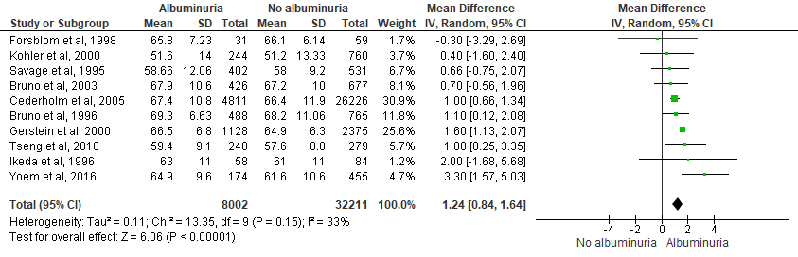

Male sex and albuminuria

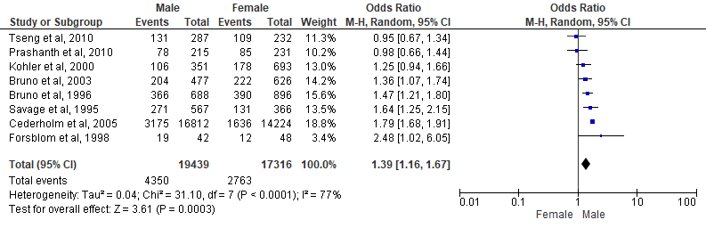

Systolic blood pressure (SBP) and albuminuria
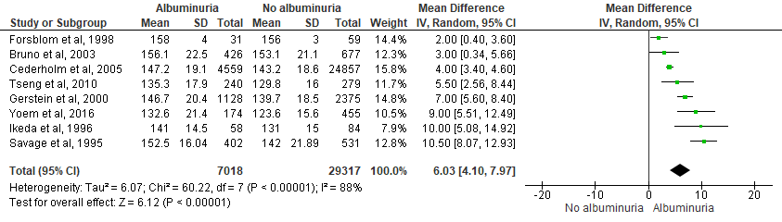

Diastolic blood pressure (DBP) and albuminuria

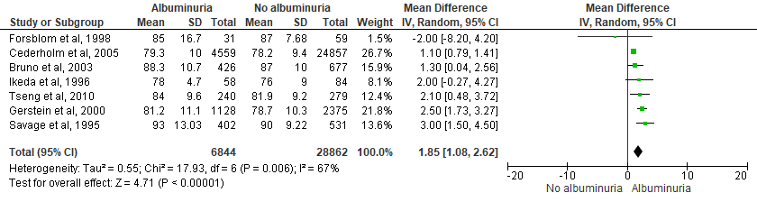

Glycosylated haemoglobin (HbA1c) and albuminuria

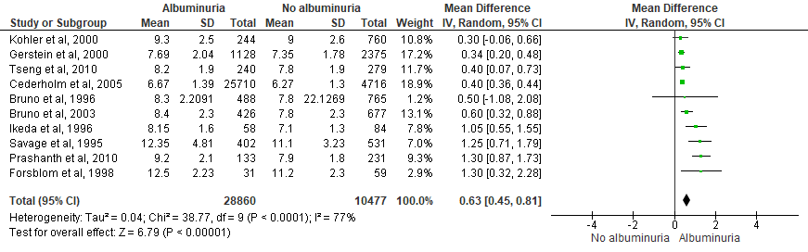

Body mass index (BMI) and albuminuria
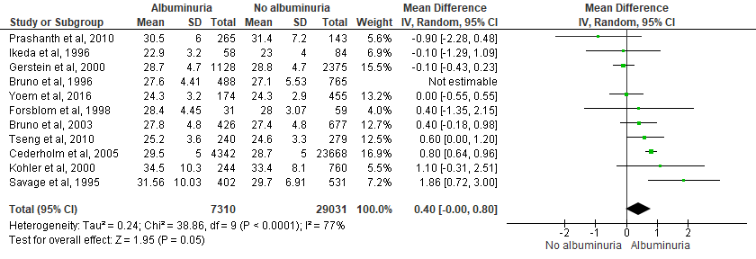

Total cholesterol (TC) and albuminuria

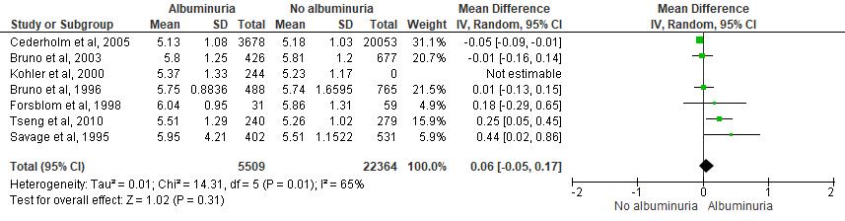

Triglyceride and albuminuria
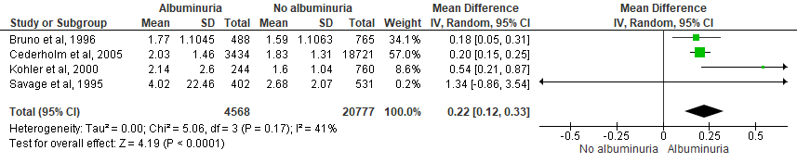

High-density lipoprotein (HDL) cholesterol and albuminuria

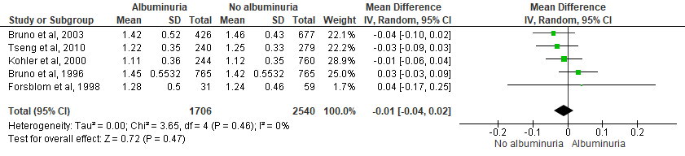

Duration of type 2 diabetes mellitus and albuminuria

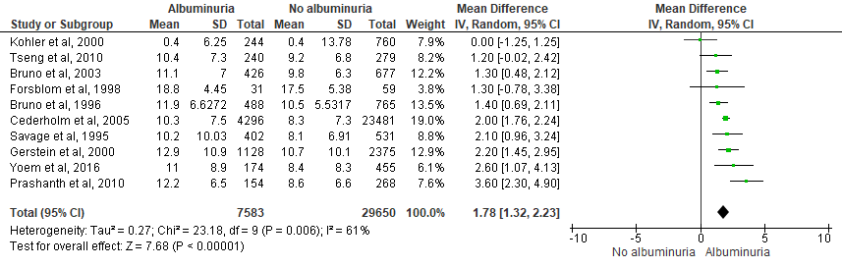

We adjusted for different moderator variables using a mixed effects model to assess if the estimated residual heterogeneity could be explained due to the study-level moderator variables. The moderator variables explored were - Age, male sex, SBP, DBP, HbA1c, DM duration, HDL, BMI, Triglyceride (TG) and Total Cholesterol (TC). The numeric moderator variables were fitted as a deviation from the mean of the variable from all studies.

Moderator – Age (Number of studies – 10)

 | estimate | ci.lb | ci.ub
tau^2 | 0.6993 | 0.3300 | 6.4420
tau | 0.8362 | 0.5744 | 2.5381
I^2 (%) | 93.6658 | 87.4658 | 99.2713
H^2 | 15.7873 | 7.9792 | 137.2281
R^2 = NA;
QE = 34.9842; p-val = 2.691618e-05;
QM = 0.526; p-val = 0.4682846
 | estimate | Se | z-val | p-val | ci.lb | ci.ub
intercept | 0.5582 | 0.3575 | 1.5612 | 0.1185 | -0.1425 | 1.2589
I (Age – 59.47) | 0.0493 | 0.0679 | 0.7253 | 0.4683 | -0.0839 | 0.1824

Moderator - Male sex (Number of studies 10)

 | estimate | ci.lb | ci.ub
tau^2 | 0.7758 | 0.3567 | 6.8107
tau | 0.8808 | 0.5973 | 2.6097
I^2 (%) | 95.2294 | 90.1755 | 99.4326
H^2 | 20.9617 | 10.1786 | 176.2466
R^2 = 0
QE = 34.2245; p-val = 3.699244e-05;
QM = 0.0751; p-val = 0.7839817 | estimate | Se | z-val | p-val | ci.lb | ci.ub
intercept | 0.7865 | 0.3066 | 2.5652 | 0.0103 | 0.1856 | 1.3875
I (Male % 61.86) | 0.0036 | 0.0132 | 0.2741 | 0.7840 | -0.0223 | 0.0295

Moderator - Systolic blood pressure (Number of studies 8)

 | estimate | ci.lb | ci.ub
tau^2 | 1.2586 | 0.4446 | 10.2214
tau | 1.1219 | 0.668 | 1.1971
I^2 (%) | 97.4547 | 93.1156 | 99.6794
H^2 | 39.2886 | 14.5256 | 311.9598
R^2 = 0
QE = 34.7441; p-val = 4.830463e-06;
QM = 1.1909; p-val = 0.2751531
 | estimate | Se | z-val | p-val | ci.lb | ci.ub
intercept | 0.7578 | 0.4233 | 1.7900 | 0.0735 | -0.072 | 1.5875
I (SBP – 140.44) | 0.0364 | 0.0334 | 1.0913 | 0.2752 | -0.029 | 0.1018

Moderator – Diastolic blood pressure (number of studies 7)

 | estimate | ci.lb | ci.ub
tau^2 | 2.0546 | 0.6624 | 18.4331
tau | 1.4334 | 0.8139 | 4.2934
I^2 (%) | 98.0164 | 94.0937 | 99.7749
H^2 | 50.4131 | 16.9310 | 444.3127
R^2= 0
QE = 33.9478; p-val = 2.438684e-06;
QM = 0.0694; p-val = 0.7922743
 | estimate | Se | z-val | p-val | ci.lb | ci.ub
intercept | 0.8983 | 0.5822 | 1.5430 | 0.1228 | -0.2427 | 2.0393
I (DBP – 84.81) | 0.0205 | 0.0778 | 0.2634 | 0.7923 | -0.1320 | 0.1729
Moderator – HbA1c (Number of studies 10)

 | estimate | ci.lb | ci.ub
tau^2 | 0.7566 | 0.3002 | 4.9428
tau | 0.8698 | 0.5479 | 2.2232
I^2 (%) | 93.4733 | 85.0365 | 98.9425
H^2 | 15.3217 | 6.6829 | 94.5592
R^2 = 0;
QE = 37.4922; p-val = 9.341225e-06;
QM = 2.059; p-val = 0.1513115
 | estimate | Se | z-val | p-val | ci.lb | ci.ub
intercept | 0.7275 | 0.2967 | 2.4523 | 0.0142 | 0.1461 | 1.3090
I (HbA1c – 8.32) | 0.2732 | 0.1904 | 1.4349 | 0.1513 | -0.1000 | 0.6463

Moderator – Duration of diabetes (Number of studies 11)
 | estimate | ci.lb | ci.ub
tau^2 | 0.2307 | 0.1042 | 2.1258
tau | 0.4803 | 0.3228 | 1.4580
I^2 (%) | 87.4863 | 75.9518 | 98.4718
H^2 | 7.9913 | 4.1583 | 65.4347
R^2 = 50.4529
QE = 41.298; p-val 4.414324e-06
QM = 10.0856; p-val = 0.001494315
 | estimate | Se | z-val | p-val | ci.lb | ci.ub
intercept | 0.4161 | 0.1689 | 2.4637 | 0.0138 | 0.0851 | 0.7472
I (DurT2DM- 8.95) | 0.1937 | 0.0610 | 3.1758 | 0.0015 | 0.0741 | 0.3132

Moderator – HDL cholesterol (Number of studies 3)

 | estimate | ci.lb | ci.ub
tau^2 | 9.9315 | 1.6624 | 100.0000
tau | 3.1514 | 1.2893 | 10.0000
I^2 (%) | 96.1972 | 80.8954 | 99.6089
H^2 | 26.2967 | 5.2343 | 255.7107
R^2 = 0
QE = 26.2967; p-val = 2.927947e-07
QM = 0.254; p-val = 0.6142553
 | estimate | Se | z-val | p-val | ci.lb | ci.ub
intercept | 0.5221 | 2.9266 | 0.1784 | 0.8584 | -5.2140 | 6.2581
I (HDL – 1.43) | -9.7731 | 19.3907 | -0.5040 | 0.6143 | -47.7781 | 28.2320

Moderator – BMI (Number of studies 10)

 | estimate | ci.lb | ci.ub
tau^2 | 0.7363 | 0.3551 | 6.8630
tau | 0.8581 | 0.5959 | 2.6197
I^2 (%) | 94.5055 | 89.2410 | 99.3801
H^2 | 18.2002 | 9.2945 | 161.3141
R^2 = NA
QE = 32.8593; p-val = 6.529003e-05
QM = 0.0076; p-val = 0.9304357
 | estimate | Se | z-val | p-val | ci.lb | ci.ub
intercept | 0.7256 | 0.2918 | 2.4865 | 0.0129 | 0.1537 | 1.2975
I (BMI 27.12) | 0.0114 | 0.1310 | 0.0873 | 0.9304 | -0.2453 | 0.2681

Moderator – Triglyceride (TG) (Number of studies 5)

 | estimate | ci.lb | ci.ub
tau^2 | 0.0118 | 0 | 1.2811
tau | 0.1088 | 0 | 1.1319
I^2 (%) | 22.2732 | 0 | 96.8735
H^2 | 1.2866 | 1 | 31.9849
R^2 = 0
QE = 4.0654; p-val = 0.2544869
QM = 1.2989; p-val = 0.254408
 | estimate | Se | z-val | p-val | ci.lb | ci.ub
intercept | 0.4269 | 0.0949 | 4.4982 | 0.0000 | 0.2409 | 0.613
I (TG - 1.98) | -0.1889 | 0.1658 | -1.1397 | 0.2544 | -0.5139 | 0.136

Moderator - Total cholesterol (TC) (Number of studies 7)

 | estimate | ci.lb | ci.ub
tau^2 | 1.7422 | 0.5573 | 15.7757
tau | 1.3199 | 0.7465 | 3.9719
I^2 (%) | 97.9967 | 93.9926 | 99.7747
H^2 | 49.9169 | 16.6461 | 443.9377
R^2 = 0
QE 331513; p-val = 3.511879e-06
QM = 0.8426; p-val = 0.3586602
 | estimate | Se | z-val | p-val | ci.lb | ci.ub
intercept | 0.9060 | 0.5156 | 1.7571 | 0.0789 | -0.1046 | 1.9166
I (TC – 5.56) | 1.1961 | 1.3031 | 0.9179 | 0.3857 | -1.3579 | 3.7501

Mixed effect metaregression model with duration of T2DM

Mean duration of T2DM across all studies: 10.14
Mixed-Effects Model (k = 11; tau^2 estimator: REML)
logLik deviance AIC BIC AICc
-9.6032 19.2064 25.2064 25.7981 30.0064

tau^2 (estimated amount of residual heterogeneity): 0.2307 (SE = 0.1389)
tau (square root of estimated tau^2 value): 0.4803
I^2 (residual heterogeneity / unaccounted variability): 87.49%
H^2 (unaccounted variability / sampling variability): 7.99
R^2 (amount of heterogeneity accounted for): 50.45%

Test for Residual Heterogeneity:
QE (df = 9) = 41.2980, p-val < .0001
Test of Moderators (coefficient(s) 2):
QM (df = 1) = 10.0856, p-val = 0.0015

Model Results:
estimate se zval pval ci.lb ci.ub
intrcpt 0.6457 0.1725 3.7423 0.0002 0.3075 0.9839 ***
mods 0.1937 0.0610 3.1758 0.0015 0.0741 0.3132 **

---
Signif. codes: 0 '***' 0.001 '**' 0.01 '*' 0.05 '.' 0.1 ' ' 1

Supplementary table 2 – Relationship of duration of T2DM and the odds ratio of albuminuria. Statistical significance is indicated by italic font and asterisk (*)

Duration of T2DM | Odds ratio (OR) | 95% CI (lower limit) | 95% CI (upper limit) | p-value
4.00 | 0.58 | 0.28 | 1.20 | 0.14
5.00 | 0.71 | 0.38 | 1.31 | 0.26
6.00 | 0.86 | 0.51 | 1.44 | 0.55
7.00 | 1.04 | 0.67 | 1.61 | 0.86
8.00 | 1.26 | 0.87 | 1.82 | 0.21
9.00 | 1.53 | 1.10 | 2.13 | 0.01*
10.00 | 1.86 | 1.33 | 2.60 | <0.001*
11.00 | 2.26 | 1.54 | 3.29 | <0.001*
12.00 | 2.74 | 1.74 | 4.30 | <0.001*
13.00 | 3.32 | 1.94 | 5.70 | <0.001*
14.00 | 4.03 | 2.13 | 7.64 | <0.001*
15.00 | 4.89 | 2.32 | 10.30 | <0.001*
16.00 | 5.94 | 2.58 | 15.05 | <0.001*

Supplementary materials (Chapter 3)

Ethics application
Application 038586 Self-declaration
Section A: Applicant details
Date application started:
Tue 2 March 2021 at 08:57
First name:
Debasish
Last name:
Kar
Email:
dkar1@sheffield.ac.uk
Programme name:
N/A
Module name:
N/A
Last updated:
02/03/2021
Department:
School of Health and Related Research
Applying as:
Postgraduate research
Research project title:
Predictors and determinants of microalbuminuria at the stage of prediabetes and diabetes depending on smoking status: a cross sectional analysis of UK Biobank data
Similar applications:
None
Section B: Basic information
Supervisor
Name Email
Elizabeth Goyder e.goyder@sheffield.ac.uk
Proposed project duration
Proposed start date:
Tue 2 March 2021
Proposed end date:
Sat 2 March 2024
Section C: Summary of research
1. Aims & Objectives:
a) What factors predict incident albuminuria in people with newly diagnosed type 2 diabetes mellitus and pre-diabetes
depedning on their smoking status?
Smoking is a strong risk factor for diabetic kidney disease (DKD). Diabetes UK estimates that up to one-third of newly
diagnosed people with T2DM, will have already developed a microvascular complication. One of the determinants of
which 3rd of this group will develop the complications are smokers with other adverse cardiometabolic risk factors.
Microlbuminuria is an easily measurable biomarker not only for DKD but also for other macro and microvascular
complications. The aim of this study is to explore the relationship between smoking and albuminuria.
2. Methodology
For this study, data will be collected from the UK Biobank from 2010 to 2015. Study participants with an HbA1c reading
6% (42 mmol/mol) or above will be included. Out of them with a diagnosis of Type 1 DM will be excluded. The age range
for inclusion will be between 44 to 64. Data on the sex, ethnicity, deprivation score (Townsend score), smoking status,
current medications, height, weight, BMI and waist circumference will be extracted. Biochemical profiles for HbA1c, Lipid
profile, Blood Pressure, and urinary Albumin Creatinine ratio will be obtained.
For descriptive statistical analysis, the data will be used to assess central distribution and variance to calculate the
mean, median, p-value and 95% confidence interval. A visual inspection of the histogram for distribution and a scatter
plot for correlation will be used. Missing data will be excluded from the analysis.
Bivariate correlation will be carried out to explore the relationship between albuminuria and smoking. Appropriate
statistical test either Pearson or Spearman correlation will be used depending upon the distribution of the data. A 3-step
multiple regression analysis will be carried out to explore how the relationship between the dependent variable
(albuminuria) and smoking changes when adjusted for the other confounding variables. Initially, a model analysis will be
carried out to check if the model is suitable to assess Null hypothesis. Then an analysis of variance (ANOVA) test will be
carried out to check within sample and between sample variance, and finally a multiple regression analysis will be
conducted to determine beta-coefficients and Student's t-test to determine p-value and 95% confidence interval. The
result will show how smoking is related to albuminuria at various stages of metabolic syndromes, particularly before and
after the formal diagnosis of T2DM.
Section F: Supporting documentation
All versions
Additional Documentation
Document 1088252 (Version 1)
Material Transfer Agreement
External Documentation
- not entered -
Section G: Declaration
Signed by:
Debasish Kar, MSc, FRCP, FRCGP
Date signed:
Tue 2 March 2021 at 09:06
Offical notes
- not entered –

Ethics approval



UK Biobank Material Transfer Agreement

Title - Predictors and determinants of albuminuria in pre-diabetes and newly diagnosed Type 2 diabetes depending on smoking status and cardiometabolic profiles

Defining your data
What data will you collect or create during the project?
How will the data be collected or created, and over what time period?
What formats will your digital data be in?
Approximately how much digital data will be generated during the project?
Are you using pre-existing datasets?
Give details if possible, including conditions of use.
Responses
Data on the age, sex, ethnicity, deprivation index, smoking status, glycosylated haemoglobin (HbA1c), lipid, blood pressure, urinary albumin creatinine ratio, BMI, waist circumference, medication list and the duration of T2DM. Data from the UK Biobank from 2010 to 2015 Data will be collected in excel spreadsheet and stored in CSV format Approximately 10,000 subjects The contact between the UK Biobank and I allows to make derivatives and any other analyses required for my research Yes, pre-existing data set. The condition for use is it can only be used for the research related to the MD.

Looking after your data How will you make data easier to understand and use? (e.g. creating a README file)
Where will you store digital and physical data during the project?
How will you name and organise your data files?
How will you ensure data is backed up? (e.g. using University research data storage)
How often will you check your backup files? (e.g. on backup, at set intervals)
Will you use extra security precautions for any of your digital or physical data?(e.g. for sensitive and/or personal data)
By creating a README file Personal PC and the University PC - encrytion for raw data is not necessary as long as the standard security and password protection are in place By version number and date (YYYY-MM-DD)
Using University research data storage. On back up and once a month Patient identifiable data will not be accessible to me or any other member of the study team under the UK Biobank access policy Archiving your data What data will be archived (stored on a long-term basis) at the end of the project? How long will the data be stored for? (e.g., standard TUoS retention period of 10 years)
Where will the archive be stored? (e.g. subject-specific repository, ORDA)
Who will archive the data? (e.g. you, your supervisor)
If you plan to use storage other than a repository, who will be responsible for the data?
Responses
Only the research findings and the data used to conduct the research will be stored Standard TUoS retention period of 10 years Subject specific repository but if it is not available it will be archived in ORDA I will archive the data Not applicable Sharing your data Created using DMPonline. Last modified 24 August 2020 1 of 2
How will you make your data available outside the research group after the project? (e.g. through data repository, access on request via data availability statement)
Will you make all of your data available, or are there reasons you can’t do this? (e.g. personal data, commercial or legal restrictions, very large datasets)
How might you make more of your data available? (e.g. anonymisation, participant consent, analysed data only) What licence might you attach to your data to say how it can be reused and shared?
Through data repository, creative common CC - By license (https://creativecommons.org/licenses/by/4.0/).
Responses
I will be allowed to use the UK Biobank data for a set period of time. The raw data will be available from the UK Biobank and will be accessible on application Analysed data only. License issued by the UK Biobank
Implementing your plan
Who is responsible for making sure the plan is followed? (e.g. you, your supervisor)
How often will the plan be reviewed and updated? (e.g. if the project changes, yearly)
What actions have you identified from the rest of this plan? (e.g., selecting a repository, requesting University research data storage)
Responses
I will be responsible. However my supervisors will also be responsible to follow the plan Yearly or if the project changes Requesting University Research data storage

Table 1: Relationship between DM status and albuminuria
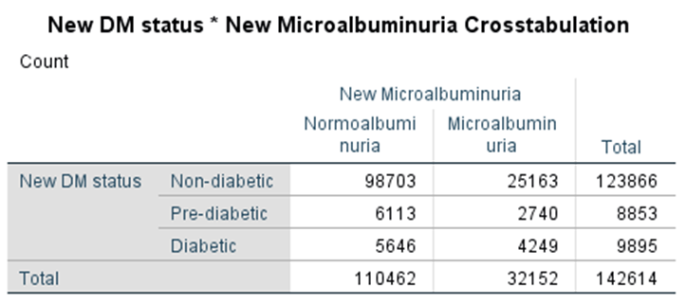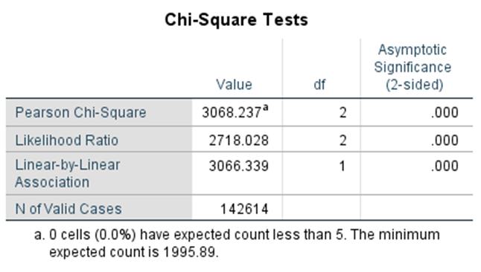

Table 2: Relationship between smoking status and albuminuria
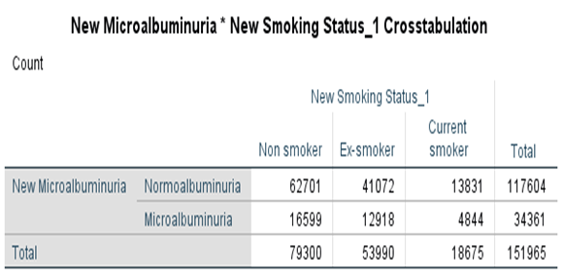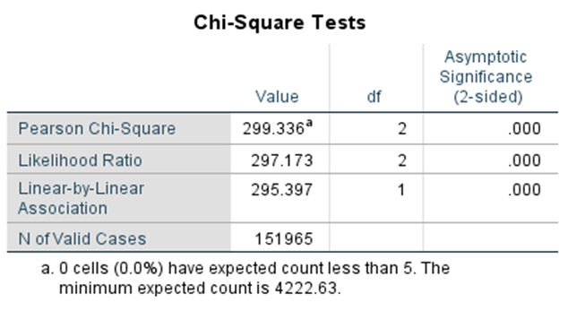

Table 3: Group statistics for mean value of cardiorenal risk factors based on DM status
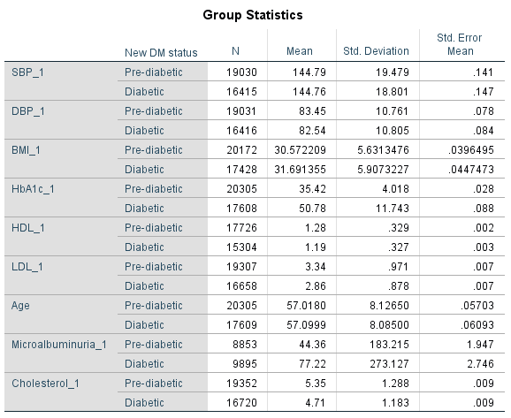

Table 4: Statistical significance testing for cardiorenal risk factors based on DM status
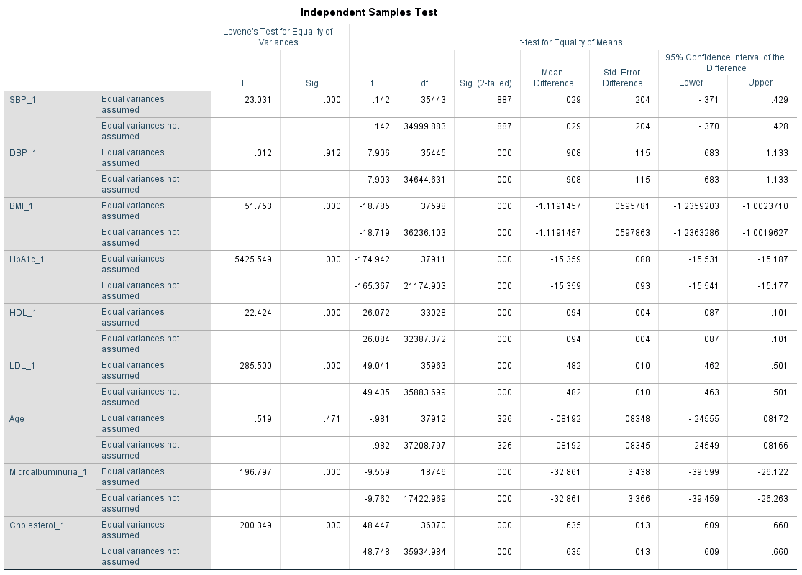

Table 5: Group statistics for mean value of cardiorenal risk factors based on albuminuria status
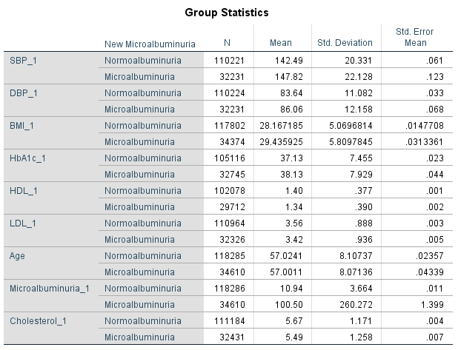

Table 6: Townsend deprivation scale (-6.26 - least deprived, 11.00 - most deprived)

Statistics
Townsend deprivation index at recruitment
N | Valid | 501866
N | Missing | 625
Median |  | -2.135390
Mode |  | -4.697450
Minimum |  | -6.258260
Maximum |  | 11.001300
Percentiles | 20 | -3.933260
Percentiles | 25 | -3.639820
Percentiles | 40 | -2.764870
Percentiles | 50 | -2.135390
Percentiles | 60 | -1.295780
Percentiles | 75 | .550175
Percentiles | 80 | 1.349956

Distribution of variables

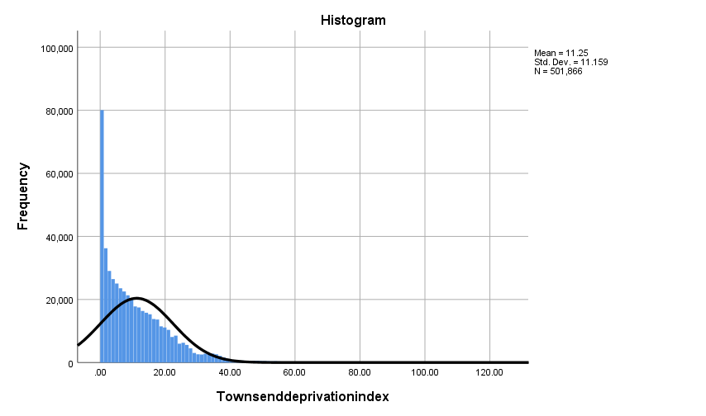

Figure 1: Non-parametric distribution of Townsend deprivation index in UKB dataset

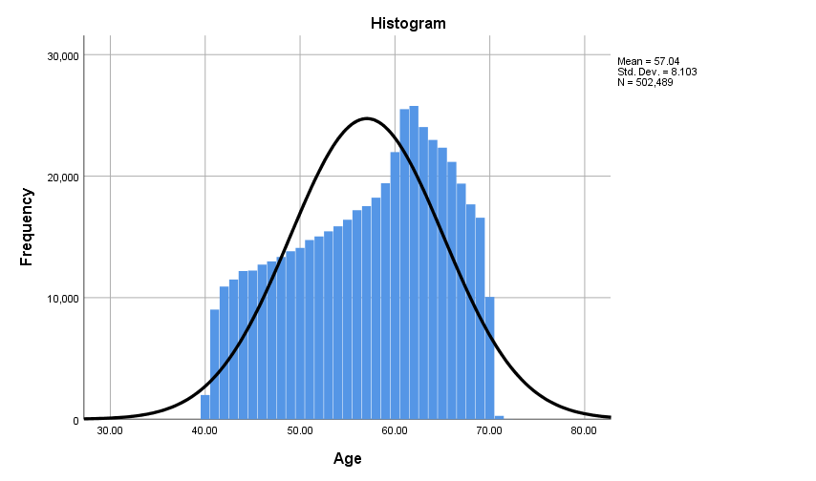

Figure 2: Non-parametric distribution of age in UKB participants

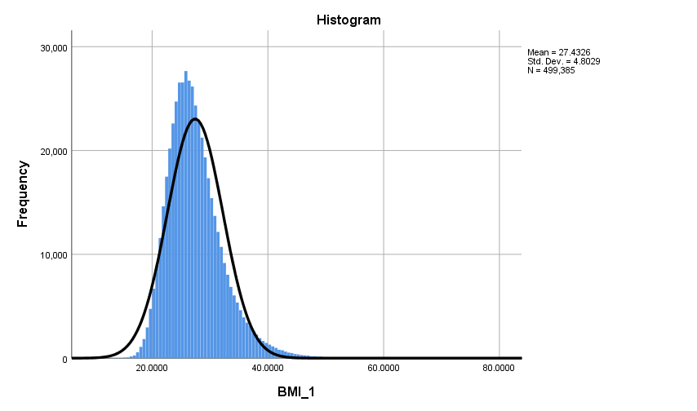

Figure 3: Distribution of BMI – parametric distribution

Figure 4: Scatter plot showing distribution of HbA1c and UAC

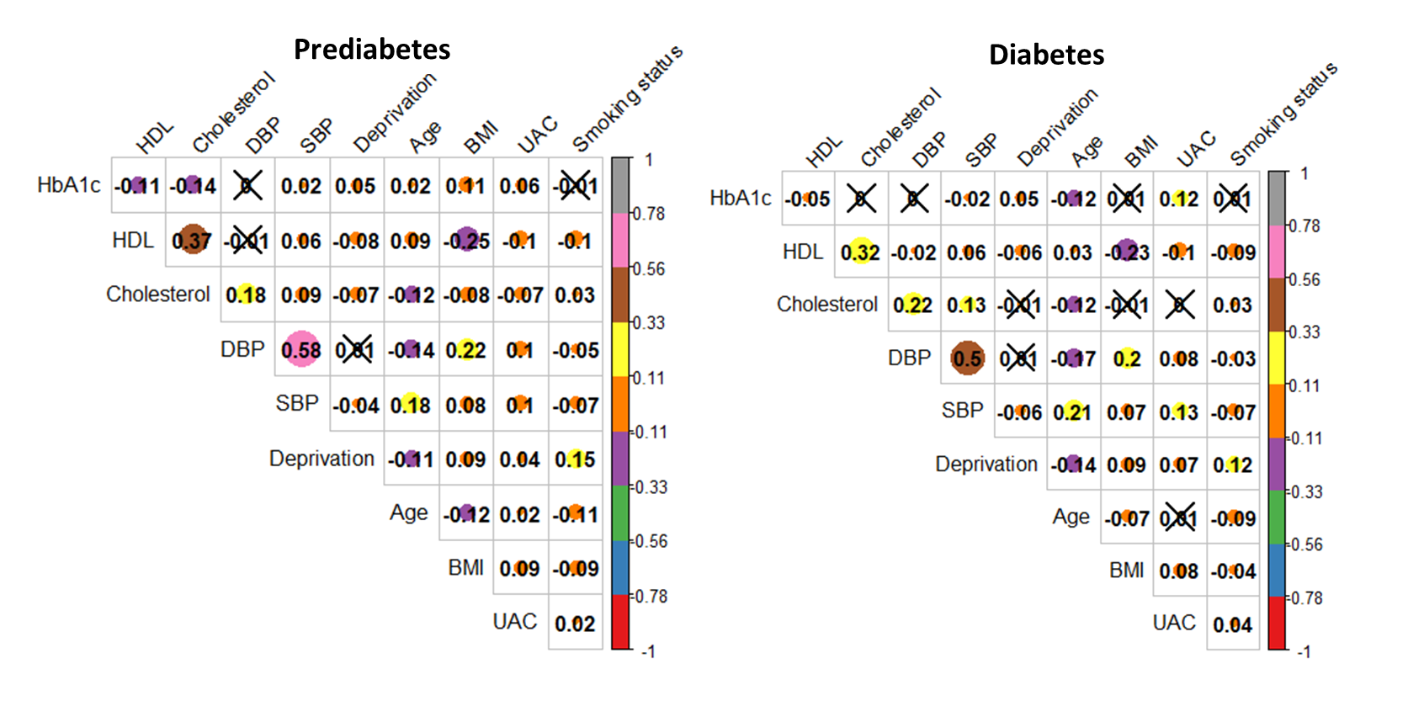

Figure 5: Spearman correlation analysis of cardiorenal risk factors

Table 7: Logistic regression analysis of risk factors for albuminuria in people with prediabetes
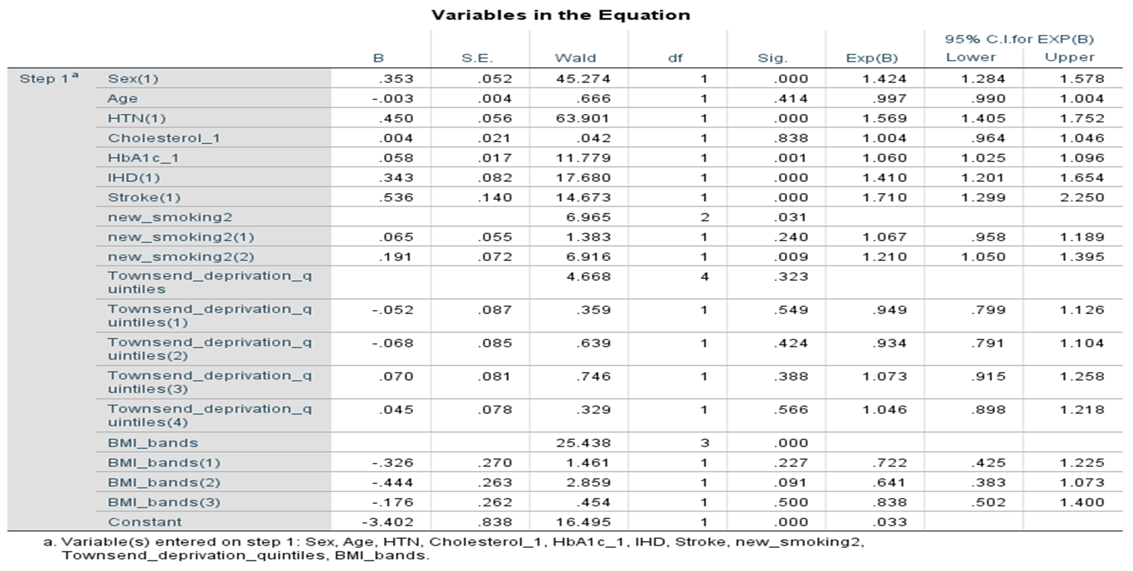

Table 8: Logistic regression analysis of risk factors for albuminuria in people with diabetes
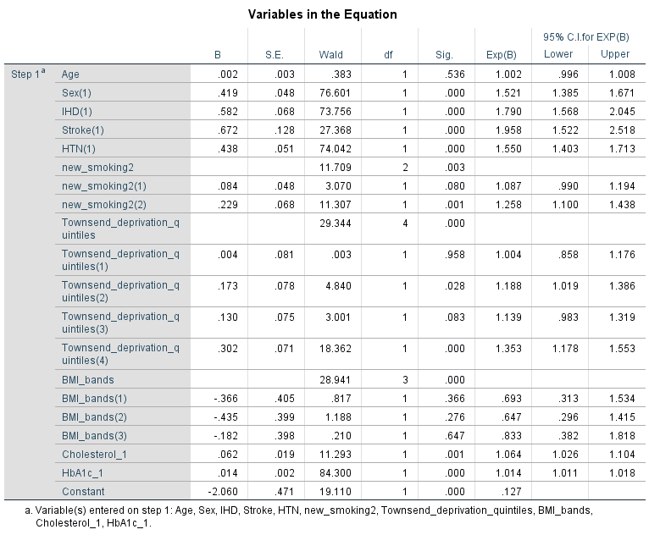

Table 9: Risk of albuminuria in smokers and ex-smokers when adjusted for age, anti-hypertensive and cholesterol lowering drugs in people with prediabetes
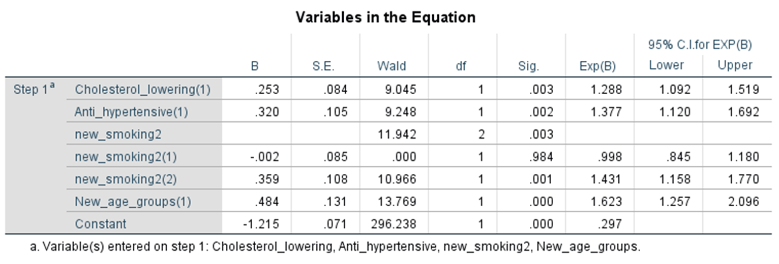

Table 10: Risk of albuminuria in smokers and ex-smokers when adjusted for anti-hypertensive and cholesterol lowering drugs in people with diabetes
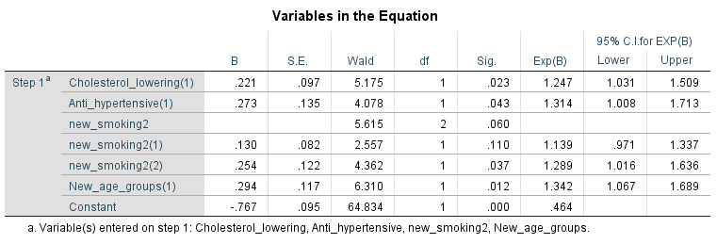

Supplementary materials (Chapter 4)

Table 1: Descriptive statistics – participants who had UAC value in the second visit.

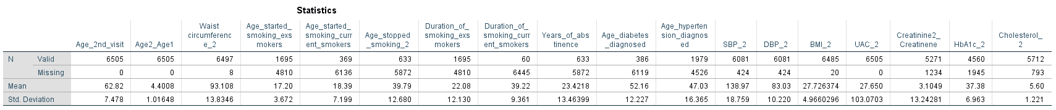

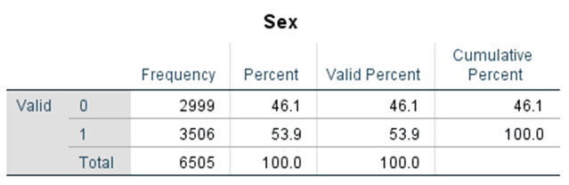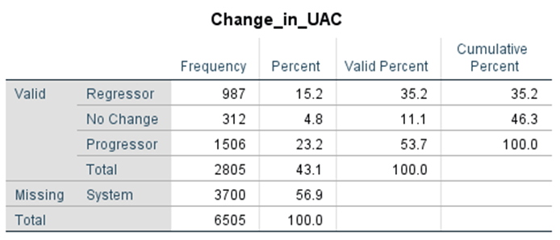

Table 2: One-Sample Kolmogorov Smirnov test
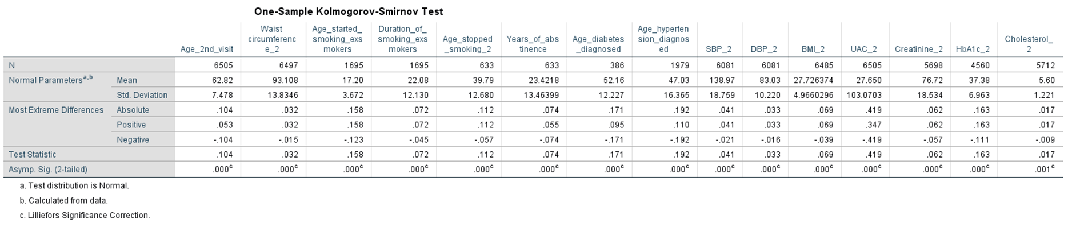

Table 3: Descriptive statistics of ex-smokers
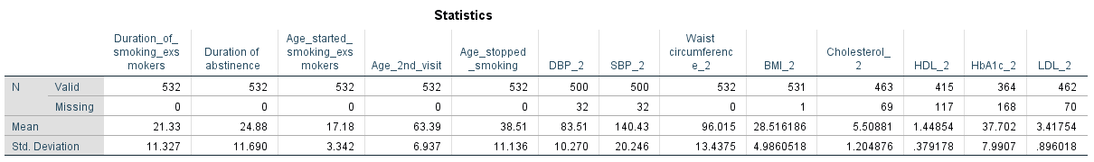
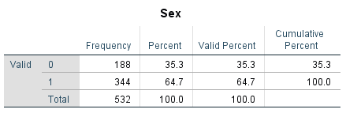

Statistical analyses progression, glycaemic and smoking status.

Table 4: Descriptive crosstab – smoking and diabetes status.

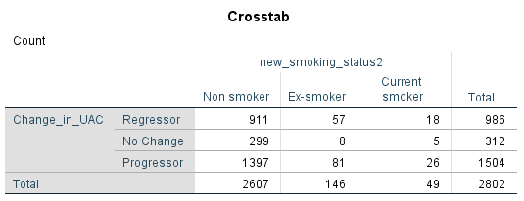

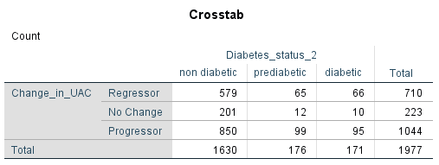

Table 5: Progression and smoking status
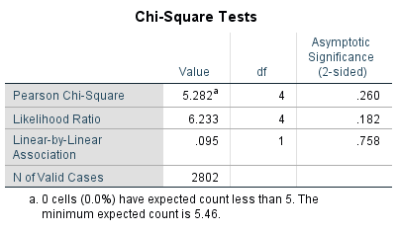

Table 6: Progression and diabetes status
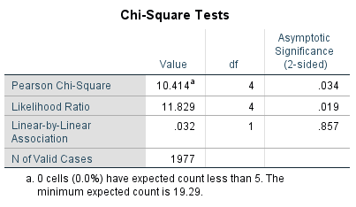

Table 7: Pearson’s correlation
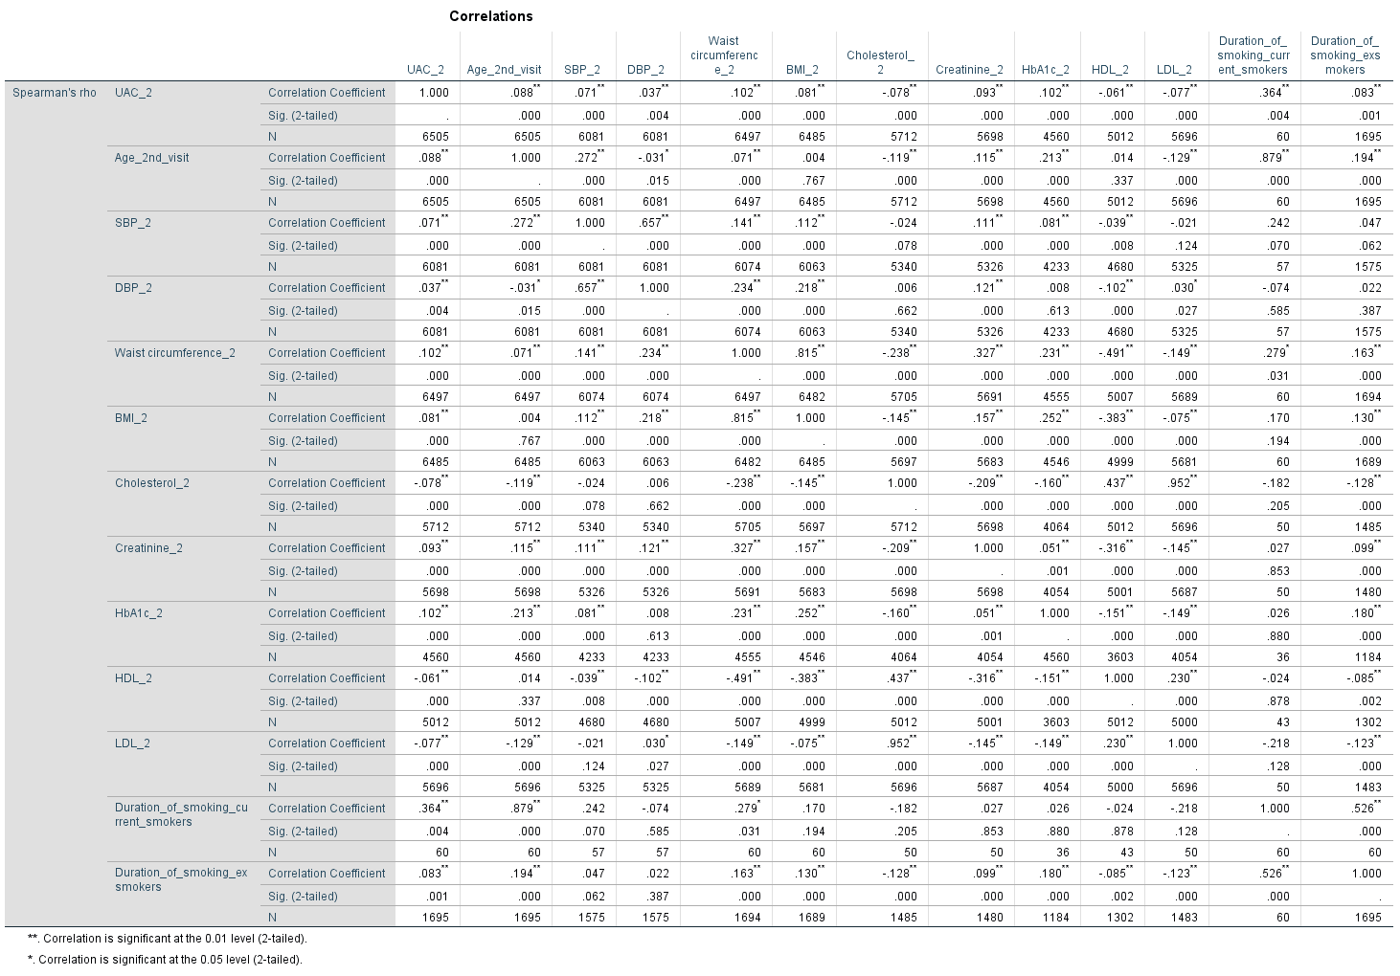

Table 8: Missing data analyses
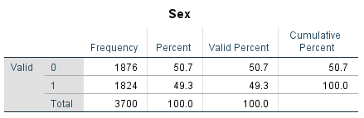

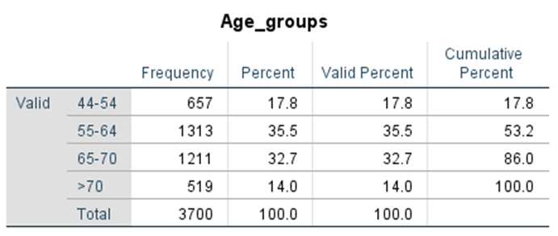

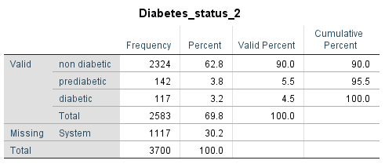

Table 9: Analyses of people with no change between the two visits
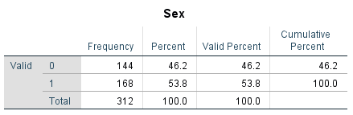

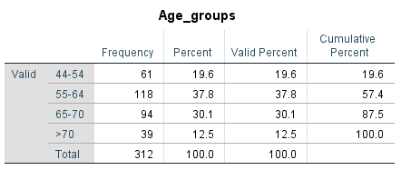

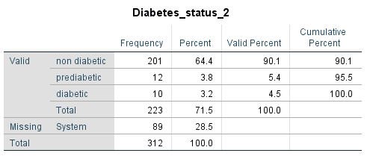
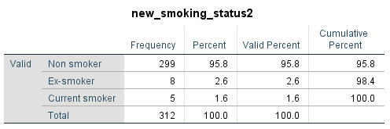

Table 10: Logistic regression (Model 1) – Predictors of progression: visit 1 and visit 2.
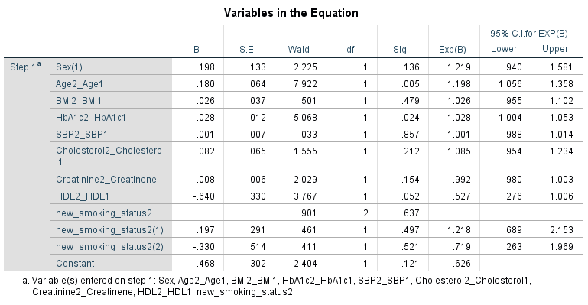

Table 11: Logistic regression [Model 2(a)] – Predictors of progression in ex-smokers: with waist circumference and the duration of smoking

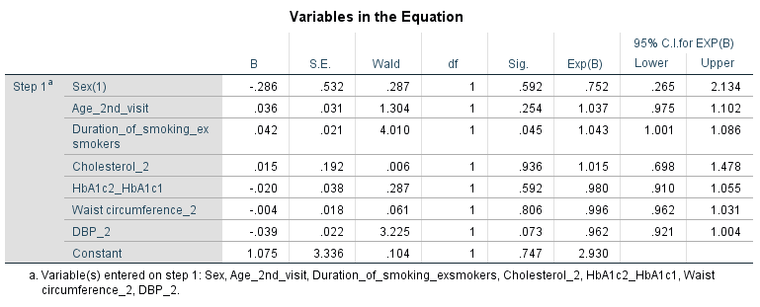

Table 12: Logistic regression [Model 2(b)] - Predictors of progression in ex-smokers: with BMI and the duration of smoking

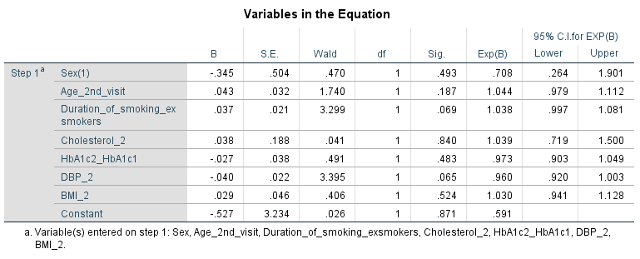

Table 13: Logistic regression [Model 2(c)] - Predictors of progression in ex-smokers: without BMI & waist circumference and the duration of smoking
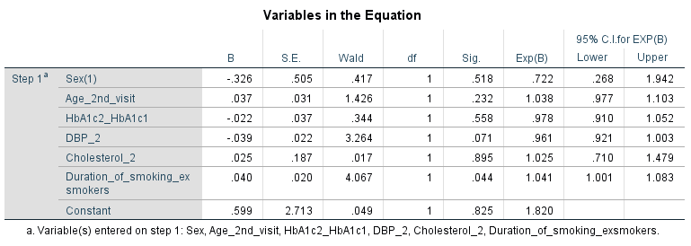

Table 14: Logistic regression [Model 3(a)] - Predictors of progression in ex-smokers: with waist circumference and the duration of abstinence
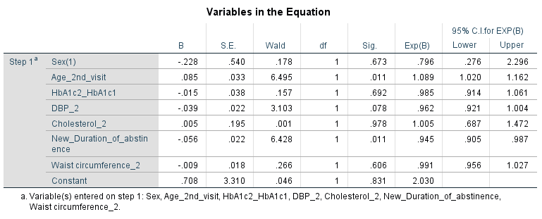

Table 15: Logistic regression [Model 3(b)] - Predictors of progression in ex-smokers: with BMI and the duration of abstinence

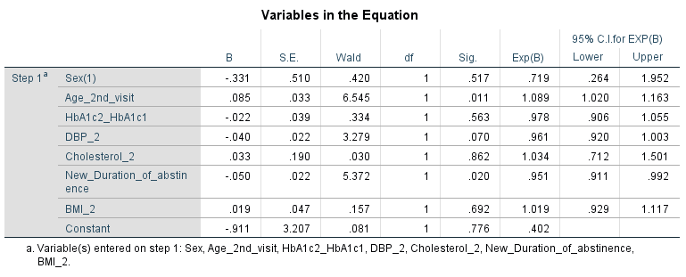

Table 16: Logistic regression [Model 3(c)] - Predictors of progression in ex-smokers: without BMI and waist circumference and the duration of abstinence

