

Antibodies to Infliximab in patients with Inflammatory Bowel Disease: Clinical and Molecular Targets

By:
Gloria Shwe Zin Tun

A thesis submitted in partial fulfilment of the requirements for the degree of
Doctor of Philosophy

Co-supervised by:
Professor Alan J Lobo
Dr Bernard Corfe
Dr Munitta Muthana

The University of Sheffield
Faculty of Medicine
Department of Oncology and Metabolism
Academic Unit of Gastroenterology

Submission Date 7 July 2023

Table of contents
Table of contents 2
List of Figures 5
List of tables 8
List of abbreviations used 10
Abstract 12
Acknowledgements 13
Chapter 1: Introduction 14
1.1 Inflammatory bowel disease 14
1.1.1 Epidemiology 14
1.1.2 Aetiology 15
1.1.3 Clinical features 16
1.1.4 Treatment 18
1.1.5 Role of tumour necrosis factor-α (TNFα) in IBD 20
1.1.6 Infliximab 23
1.1.7 Side effects of infliximab 28
1.1.8 Biosimilars 30
1.2 Monoclonal antibodies 35
1.2.1 Immunoglobulins 35
1.2.2 Epitopes 37
1.2.3 Monoclonal antibodies as biotherapeutic agents 38
1.3 Clinical implications of antibodies to infliximab (ATI) 40
1.3.1 Measurement of ATI 40
1.3.2 Development of ATI 43
1.3.3 The association between ATI and infliximab trough levels 44
1.3.4 The association between ATI and clinical response 46
1.3.5 The association between ATI and infusion reactions 48
1.4 Characterisation of ATI 49
1.4.1 Neutralising and non-neutralising ATI 49
1.4.2 Functional epitope mapping using phage display 50
1.4.3 B cell epitopes on infliximab 56
1.5: Aims 58
Chapter 2: High prevalence of antibodies to infliximab and their relation to clinical outcomes in inflammatory bowel disease patients 60
2.1 Introduction 60
2.2 Materials and Methods 61
2.2.1 Patient population 61
2.2.2 Clinical assessment 61
2.2.3 Therapeutic drug monitoring (TDM) 62
2.2.4 Ethical approval 63
2.2.5 Statistical analyses 64
2.3 Results 64
2.3.1 Patient cohort 64
2.3.2 Prevalence of immunogenicity in patients with IBD 66
2.3.3 Temporal development of ATI and risk-factors for ATI development 67
2.3.4 Chronological relation of ATI to infliximab levels 68
2.3.5 TDM at first maintenance dose (Week 14) 69
2.3.6 The association between ATI and clinical outcomes 70
2.3.6 Association of ATI levels with loss of clinical remission 72
2.4 Discussion 74
Chapter 3: The effect of infliximab dose escalation in inflammatory bowel disease patients with antibodies to infliximab 77
3.1 Introduction 77
3.2 Materials and Methods 78
3.2.1 Patient population 78
3.2.2 Clinical assessment 79
3.2.3 Therapeutic Drug Monitoring (TDM) 79
3.2.4 Ethical approval 80
3.2.5 Statistical analyses 80
3.3 Results 81
3.3.1 Patients 81
3.3.2 The effect of DE on trough infliximab levels 84
3.3.3 The effect of infliximab dose escalation on ATI levels 86
3.3.4 The effect of infliximab dose escalation on clinical outcomes 88
3.3.5 Comparison of the different methods of dose escalation 90
3.4 Discussion 94
Chapter 4: Generation of an infliximab Fab gene fragment phage display library 97
4.1 Introduction 97
4.2 Materials and Methods 99
4.2.1 Polymerase Chain Reaction (PCR) amplification of infliximab Fab gene 99
4.2.2 DNA purification of infliximab light and Fab heavy chain 101
4.2.3 Production of infliximab Fab gene fragments 101
4.2.4 Preparation of phagemid vector 102
4.2.5 Construction of infliximab Fab gene fragment library 106
4.2.6 Analysis of phage clones 107
4.2.7 Summary of the generation of the infliximab Fab GFL 108
4.3 Results 109
4.3.1 Production of infliximab Fab gene fragments 109
4.3.2 Construction of infliximab Fab gene fragment library 110
4.3.3 DNA sequencing 111
4.4 Discussion 113
Chapter 5: The identification of infliximab linear epitopes using an novel gene fragment phage display library 115
5.1 Introduction 115
5.2 Method 116
5.2.1 Patients 116
5.2.2 Clinical assessment 118
5.2.3 TDM 118
5.2.4 Blood samples for epitope mapping 118
5.2.5 Study cohort 118
5.2.6 Construction of infliximab designer full gene fragment phage display library 120
5.2.7 Serological selection of infliximab phage display libraries 120
5.2.8 Analysis of Clones 122
5.2.9 Monoclonal phage ELISA 122
5.3 Results 123
5.3.1 NGS of infliximab designer full gene fragment phage display library 123
5.3.2 Mapping of infliximab epitopes 123
5.3.3 Monoclonal phage ELISA 126
5.3.4 Comparison to the literature 128
5.4 Discussion 130
Chapter 6: The identification of infliximab conformational epitopes using a random peptide phage display library 134
6.1 Introduction 134
6.2 Method 135
6.2.1 Patients 135
6.2.2 Clinical assessment 135
6.2.3 TDM 135
6.2.4 Blood samples for epitope mapping 135
6.2.5 Study cohort 136
6.2.6 Random peptide phage display library 136
6.2.7 Selection of the RPL using in solution method with Protein A Dynabeads 136
6.2.8 Analysis of selected phage clones 140
6.2.9 Monoclonal phage ELISA 140
6.3 Results 142
6.3.1 Selection of random peptide phage display library 142
6.3.2 Epitope mapping of selected peptides 144
6.3.3 Phage ELISA 147
6.4 Discussion 150
Chapter 7: Summary, final Discussion and future directions 153
Bibliography 158
Appendix 1: Publications and presentations 171
Appendix 2: Patient information leaflet 175
Appendix 3: Consent form 178

List of Figures
Figure 1. Anatomical involvement in inflammatory bowel disease. 17
Figure 2. “Step up” approach to treament of inflammatory bowel disease. 18
Figure 3. Signalling pathways of tumour necrosis factor (TNF) receptors 1 and 2. 22
Figure 4. Mechanism of action of infliximab. 24
Figure 5. Structure of a monomeric immunoglobulin 35
Figure 6. Linear and conformational epitopes. 36
Figure 7. Diagrammatic representation of infliximab total anti-drug antibodies sandwich ELISA IDKmonitor, a commonly used commercial ELISA ¹¹⁷. 41
Figure 8. The filamentous bacteriophage. 51
Figure 9. Overview of phage and phagemid infection of bacterial cells. 52
Figure 10. Diagrammatic representation of serological selection of a phage display library. 54
Figure 11. Workflow for the PhD. 58
Figure 12. Summary of patient cohorts included in this study. 64
Figure 13. Time to development of antibodies to infliximab during infliximab treatment. 66
Figure 14. Chronology between antibodies to infliximab and infliximab trough levels. 68
Figure 15. The effect of antibodies to infliximab on time to loss of clinical remission. 70
Figure 16. Receiver operator curve analysis of antibodies to infliximab threshold of 2.5 mg/L to a) loss of clinical remission ≤ 8 weeks and b) loss of clinical remission ≤ 6 months by IBD subtype: Crohn’s disease and ulcerative colitis. 72
Figure 17. Summary of IBD cohort receiving infliximab dose escalation. 81
Figure 18. Median trough drug levels (error bars indicate the 25th-75th percentiles of the trough drug levels) following infliximab dose escalation in patients a) with ATI >10 AU/mL at baseline and b) with ATI ≤ 10 AU/mL at baseline. 84
Figure 19. Median antibodies to infliximab levels (error bars indicate the 25th-75th percentiles) following dose escalation in patients with positive antibodies (>10 AU/mL). 86
Figure 20. Sankey diagram to illustrate clinical outcomes of patients receiving infliximab dose escalation at week 24 based on initial ATI and clinical status. 88
Figure 21. Time in clinical remission following different methods of infliximab dose escalation. 92
Figure 22. Diagrammatic representation of a pNIBS-1 phagemid vector. 103
Figure 23. Gel electrophoresis of pNIBS-1 phagemid vector after SmaI digestion. 104
Figure 24. Diagrammatic summary of the generation on the infliximab Fab GFL. 107
Figure 25. Gel electrophoresis to confirm PCR amplification of infliximab light chain (LC) and Fab heavy chain (HC) with DNA digestion using sonication at different time stops (0-7 m). 108
Figure 26. Colony PCR of 20 clones from the large-scale infliximab fab gene fragment library. 110
Figure 27. All peptide sequences selected from round 3 of infliximab whole gene fragment library showing enrichment of three peptides mapped to complementarity determining regions of infliximab. 123
Figure 28. Model of infliximab Fab fragment bound to tumour necrosis factor-α with mapped peptides. 124
Figure 29. Monoclonal phage ELISA demonstrating similar reactivity of individual patients’ ATI positive sera against selected peptides: heavy chain peptide 1, light chain peptide 1, light chain peptide 2 and an unselected control peptide. 126
Figure 30. Selected candidate peptides compared to peptides previously selected in the literature. 128
Figure 31. Diagrammatic summary of the selection of the 12-mer random peptide phage library (RPL) using pooled ATI positive sera and protein A magnetic beads. 136
Figure 32. Model of infliximab Fab fragment bound to tumour necrosis factor-α with mapped predicted peptides selected from the random peptide library. 145
Figure 33. Monoclonal phage ELISA demonstrating similar reactivity of pooled ATI positive sera against the three selected peptides and the unselected control peptide from the random peptide library. 147

List of tables
Table 1. Infliximab biosimilars licensed for use in the European Union ^{71,98,99,101,102}. 40
Table 2. Baseline demographics of study cohort (n=214). 69
Table 3. Relationship between antibodies to infliximab status and infliximab trough levels at first maintenance dose (n=50). 73
Table 4. Outcomes of patients with positive antibodies to infliximab and loss of clinical remission n=49. 75
Table 5. Demographic details of patient cohort receiving infliximab dose escalation. 87
Table 6. Comparison of infliximab trough level following different methods of dose escalation in patients with inflammatory bowel disease 96
Table 7. Domain specific primers used for separate PCR amplification of infliximab light and infliximab Fab heavy chain. 105
Table 8. Sonication conditions assessed in digestion of infliximab light chain and heavy chain Fab. 106
Table 9. Transformation results following different ligation conditions: 1) dephosphorylated digested pNIBS1 vector (D pNIBS1), 2) dephosphorylated digested pNIBS1 vector (D pNIBS1) and SrfI restriction enzyme using different vector: insert ratios. 114
Table 10. DNA sequencing of randomly selected colonies from infliximab Fab gene fragment library. 116
Table 11. Definition of the clinical phenotypes of patients’ sera used for selection of B cell epitopes. 124
Table 12. Clinical details of antibody to infliximab positive IBD patients used for pooled serological selection. 125
Table 13. Binding affinity of Protein A for human immunoglobulins ¹⁹⁹. 146
Table 14. Selection of random peptide phage display library using ATI positive pooled sera, blank selection with no sera and normal AB sera. 150
Table 15. Composition and position of predicted epitopes on infliximab Fab from the selectively enriched and non-selectively enriched peptides from the random peptide phage display library using Pepitope: Pepsurf Server. 152

List of abbreviations used
ADA | Anti-drug antibodies
ATI | Antibodies to infliximab
CD | Crohn’s disease
CDR | Complementarity determining regions
C-Myc | C-terminal
DE | Dose escalation
ELISA | Enzyme linked immunosorbent assay
Fab | Antigen binding fragment
Fb | Constant fragment
Fc | Crystalline fragment
FcRn | Neonatal Fc Receptor
Fv | Variable fragment
GFL | Gene fragment library
HA | Hemagglutinin
HRP | Horseradish peroxidase
IBD | Inflammatory bowel disease
Ig | Immunoglobulin
IL | Interleukin
IPTG  MHC | Isopropyl β-D-1-thiogalactopyranoside  Major histocompatibility complex
NGS | Next generation sequencing
LB | Lysogeny broth
LOR | Loss of response
NIBSC | National institute for biological standards and controls
NPV | Negative predictive value
OR | Odds ratio
POD | Peroxidase
PBS  PPV | Phosphate buffered saline  Positive predictive value
ROC | Receiver operating curve
RCT | Randomised controlled trial
RPL | Random peptide library
TMB | Tetramethylbenzidine
TNFα | Tumour necrosis factor-α
UC | Ulcerative colitis
VH | Variable heavy
VL | Variable light

Abstract
Infliximab was the first biological therapy to be approved for use in inflammatory bowel disease (IBD). Similar to other biological therapies, secondary loss of response to infliximab occurs in up to 50% of patients at 1 year follow up. In the case of infliximab, antibodies to infliximab (ATI) are likely to contribute towards secondary loss of response. This PhD thesis aims to identify the associated clinical outcomes of ATI, assess a strategy of infliximab dose escalation (DE) and to identify epitopes on infliximab using phage display.

In a retrospective review of 214 patients, ATI were detected in 64% of patients during the first year of infliximab treatment. They were significantly associated with loss of clinical response, reduced infliximab levels and adverse drug reactions. Assessment of infliximab DE in 92 patients with subtherapeutic drug levels, showed it was effective at significantly increasing infliximab levels in those with and without ATI. DE was also associated with a high rate of clinical remission at 6 months. Pooled sera from eight patients with positive ATI and differing clinical outcomes was used for biopanning of two phage display libraries. Three distinct linear epitopes were heavily enriched from a novel whole gene fragment library (GFL), all mapped to complementarity determining regions of infliximab. Using a random peptide library (RPL), three different peptides were enriched. Using Pepsurf, a mimotope prediction programme, three conformational epitopes were predicted using the enriched peptides. One of the predicted epitopes from the RPL overlapped with a linear epitope selected from the GFL.

In increasing our understanding of immunogenicity to infliximab, this may lead to an identification of an epitope associated with loss of response, a biomarker, and will help aid treatment decisions when ATI are detected.

Acknowledgements
I would not have been able to complete my PhD fellowship without the support and guidance of my supervisors Professor Alan Lobo, Professor Bernard Corfe and Dr Munitta Muthana. As experts in their fields, their knowledge and encouragement has been invaluable. In addition, I am deeply grateful to Dr Simon Hufton, Head of Antibodies at the National Institute for Biological Standards and Control. His incredible knowledge of phage display and his time and training of me has been crucial in this research. Within the Biotherapeutics department, I also want to thank Dr Martin Orecchia, Dr Tiziano Gaiotto, Mr Walter Ramage and Ms Chris Ball for their support. The immunology department at Sheffield Teaching Hospitals has also helped me, in particular, Dr Graeme Wild and Ms Kirsty Swallow. To the IBD team at Sheffield Teaching Hospital, you have helped me with my research and helped shape me into the clinician I am today.

Lastly, I want to thank all of my family. My parents, who have always put their children first and my husband, Chris, who has the ability to make me laugh even on the tough days- thank you.

Chapter 1: Introduction

1.1 Inflammatory bowel disease

1.1.1 Epidemiology
Inflammatory bowel disease (IBD) is an encompassing term for Crohn’s disease (CD), ulcerative colitis (UC) and, in 5-15% of affected individuals, an unspecified subtype: IBD-unclassified ¹. IBD is a chronic inflammatory condition affecting the gut with extra-intestinal features. IBD has a relapsing remitting course, but with varying severity between individuals and currently there is no cure.

IBD has an estimated incidence of 15-30 per 100 000/year and a prevalence of 150-300 per 100 000 ². There is variation in incidence occurs across age, ethnicities and countries, with the highest rates in temperate zones with UC more common than CD ^{2,3}. Within Europe, the estimated incidence of UC is 8–14 per 100 000/year with a prevalence of 120–200 per 100 000 and the incidence of CD is 6–15 per 100 000/year with a prevalence of 50–200 per 100 000 ⁴.

1.1.2 Aetiology
The exact aetiology of IBD remains unknown but is likely to be due to a complex interplay between genetic susceptibility, dysbiosis of gut microbiota, altered immunological response and environmental triggers.

Subsequently, over 300 genetic mutations have been identified to be associated with IBD ^{5–8}. Genetic predisposition is mainly polygenic though monogenic mutations are associated with early onset IBD ⁷. NOD2 was the first gene described in association with IBD ⁵. NOD2 mutations lead to dysregulation of host–microbe interactions in the ileum leading to inflammation ⁵. Meta-analysis has shown a 17 -fold increase risk in NOD2 homozygotes and 2-fold increase risk in heterozygotes of developing ileal CD ⁹. There are genetic mutations associated with the development of IBD, IBD sub-type, genes that are associated with a particular disease phenotype, early onset disease, disease severity, alterations in the immune system or how the body handles bacteria ^{5–7,10}. In clinical practice, genetic markers are not routinely assessed. A positive family history in first and second degree relatives is a risk factor and the former confers a ten-fold relative risk of developing the same disease compared to the general population ¹¹.

Dysbiosis, an imbalance and a restriction in major groups of gut bacteria, is a consistent finding in IBD ^{12,13}. The altered gut microbiome interacts with the immune system leading to upregulation of inflammatory T cell, downregulation of regulatory T cells, and effects on humoral immunity ^{12,13} . Although microbial pathogens such as adherent-invasive E coli have been suggested to cause IBD with an initial infection, no specific pathogen has been consistently implicated in IBD ^{12,14}.

Smoking is a risk-factor for CD but is protective against the development of UC. In established CD, smoking worsens the severity of the disease, increase the likelihood of surgery with a 2 fold risk of post-operative recurrence ^{15,16}.

1.1.3 Clinical features
In IBD there is chronic relapsing remitting inflammation of the gut with systemic features. In UC the mucosal inflammation almost always involves the rectum (proctitis) and continuously extends proximally to only affect the colon whereas CD can affect any part of the gastro-intestinal tract, but has a predilection for the terminal ileum and right colon ¹⁷ (Figure 1). Macroscopically there is patchy transmural inflammation and aphthous ulceration can progress to deep linear ulceration. Non caseating granulomas- a collection of epitheloid histiocytes – are a histological characteristic of CD ¹⁸.

Both UC and CD commonly present with chronic diarrhoea ^{19,20}. The presence of blood is reported by 90% of people with UC, whereas in CD it is reported in less than half ^{19,20}. Abdominal pain, weight loss, fatigue and fever are other common symptoms. Extra-intestinal manifestations such as arthropathy, cutaneous and ocular involvement, hepatobiliary conditions occur in both UC and CD and can be related to luminal inflammation ¹⁷.

Perianal disease is commonly associated with CD. It can present with perianal skin tags, fissures, abscesses and fistulae, and the latter can be difficult to treat and debilitating for the patient ¹⁷.

The diagnosis of IBD is based on a combination of clinical features and investigations including imaging and endoscopy findings. Histology remains the gold standard for diagnosis but may not always be available or can be non-specific.

- b) 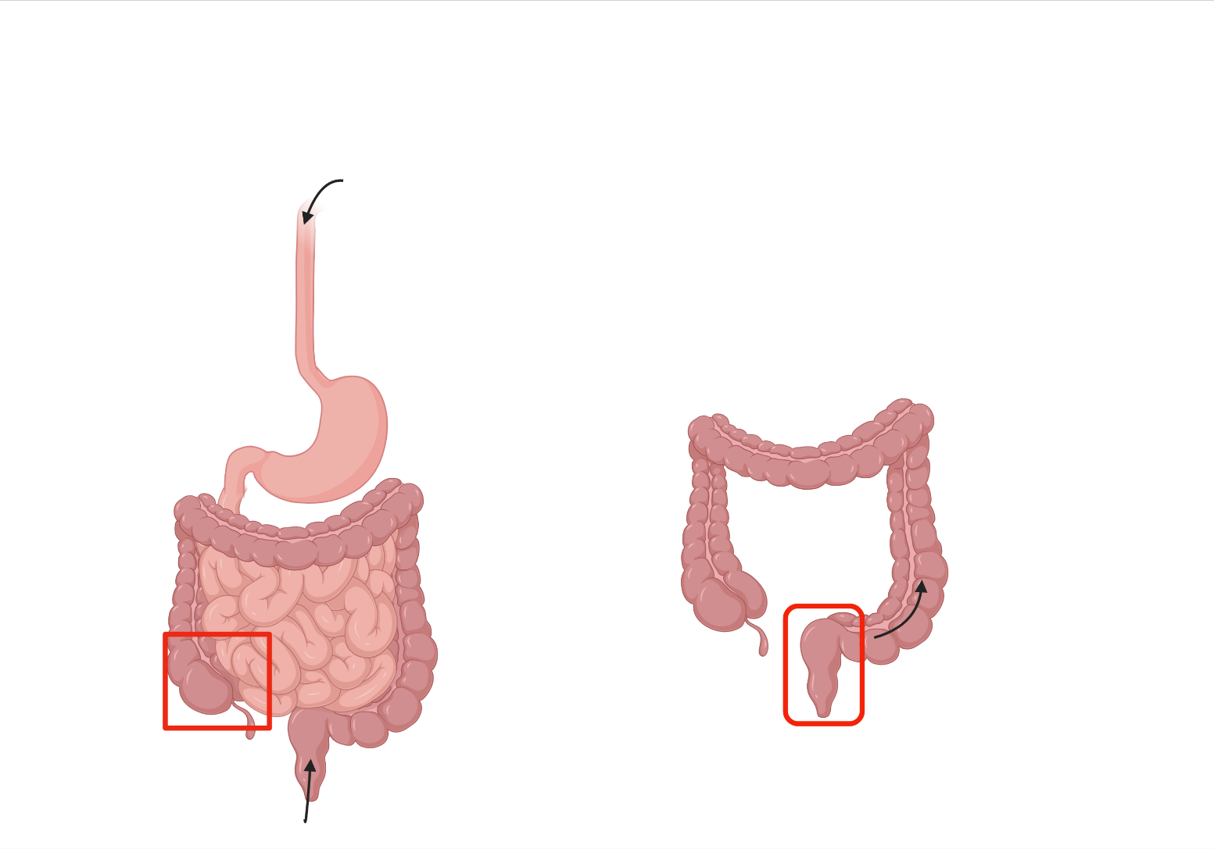
Figure 1. Anatomical involvement in inflammatory bowel disease.
a) Crohn’s disease can affect anywhere from the mouth to the anus, though it most commonly affects the terminal ileum and right side of the large bowel as shown in the red square b) ulcerative colitis nearly always affects the rectum and extends continuously proximally to affect the large bowel.

1.1.4 Treatment
The type of IBD, clinical severity, extent of disease and presence of complications dictates the management, as shown in Figure 2. Medical treatments are used to induce- treat the “flare” and are continued long-term to maintain remission. Corticosteroids are used to induce remission, immunomodulators such as thiopurines and methotrexate to maintain remission and topical and oral aminosalicylates to induce and maintain remission in UC. In the last 20 years, monoclonal antibodies and more recently small molecules targeting specific inflammatory pathways in IBD, have become licensed for the treatment of IBD. Anti-tumour necrosis factor-α (TNFα) agents: infliximab, adalimumab, golimumab, certolizumab (though the latter is not licensed for use in the United Kingdom), anti-α4β7 integrin: vedolizumab, anti-interleukin-12 and 23: ustekinumab and Janus kinase inhibitors: tofacitinib (only in UC) have become licensed ^{19–25}. Figure 2 shows a “step-up” approach, utilising ‘stronger’ medications as the disease becomes more severe. Nutrition is an important adjunct at all stages of treatment and surgery remains an important option for medically refractory acute severe disease, or for relapsing disease, fibrotic strictures, fistulating or complicated CD ^{19,20}.

Nutritional support
Surgery

Figure 2. “Step up” approach to treament of inflammatory bowel disease.
Treatments are used to induce- treat the “flare” and are continued long-term to maintain remission. A “step-up” approach: going up the pyramid, utilises stronger medications as the disease becomes more severe. Nutrition and surgery are important adjuncts in all stages of treatment, and the latter is essential in refractory acute severe disease, or for relapsing disease, fibrotic strictures, fistulating or complicated CD.

The management of IBD has greatly changed over the last few decades due to the availability of monoclonal antibodies and small molecules. There is an increased understanding of disease phenotype and progression and a change in approach to more personalised care. Treatment has shifted from a “step-up” to a “top-down” strategy in selected cases, using ‘stronger’ medications- particularly those associated with higher chance of mucosal healing- earlier in the disease to prevent progression and complications and treat-to-target- pre-defining targets with close monitoring and adjusting treatments to achieve the target has led to closer monitoring. This proactive approach has led to better patient outcomes. However, challenges remain and one of the biggest is the loss of response to monoclonal antibodies. Primary non-response (lack of improvement with induction therapy) occurs in 20-30% of patients ^{26,27} and secondary loss of response (loss of response after initial improvement) occurs in up to 23-46 % of patients at 12 months follow-up for anti-TNF agents ^{28–30}. Similar rates of secondary loss of response, around 30%, are reported in IBD patients treated with vedolizumab and ustekinumab ^{31,32} Loss of response may occur due to an aggressive disease phenotype, disease complications such as strictures or fistulae, drug pharmacokinetics: low drug levels and or positive anti-drug antibodies, or a combination of these factors ^{10,33,34}. This means that despite the advancements in the management of IBD over the last few decades, patients can still be left with ongoing disease activity, poor quality of life with no treatment options. By increasing our understanding of reasons for loss of response, such as the anti-drug antibodies, this will help aid treatment decisions when immunogenicity is detected and may help in the future development of less immunogenic monoclonal antibodies.

1.1.5 Role of tumour necrosis factor-α (TNFα) in IBD
Tumour necrosis factor-α (TNFα), is a pro-inflammatory cytokine and plays a key role in a multiple complex signalling pathways ³⁵. It is produced by monocytes and macrophages, but also to a lesser quantity by other inflammatory cells ³⁵. TNFα exists as membrane bound and a soluble form. Transmembrane TNFα, a polypeptide of 233 amino acid residues (26 kDa) is cleaved by TNFα-converting enzyme (TACE) to soluble TNFα, a polypeptide of 157 amino acid residues (17 kDa) ^{36–38}. Transmembrane TNFα functions as a ligand and a receptor. Two transmembrane TNF receptor exists: TNF receptor 1, which is expressed in all tissues and TNF receptor 2, which is mainly expressed in immune cells ³⁵. Both soluble and transmembrane TNFα bind to TNF receptor 1, whereas transmembrane TNFα’s primary target is TNF receptor 2 ³⁵. Both receptors can be cleaved to form soluble TNF receptors ³⁸.

TNFα is involved in homeostasis, autoimmunity, inflammation and cellular biology (Figure 3). It regulates the pro-inflammatory cytokine cascade, initiates and maintains inflammation, but also has a role in its resolution ^{39,40}. It induces proliferation, differentiation, and apoptosis of macrophages. Activation of both TNF receptor 1 and 2 can induce cellular survival ³⁵. The inclusion of a death domain at TNF receptor 1 exerts cellular apoptosis or necrosis, dependant on the physiological conditions, via signalling complexes ³⁵. TNFα also affects atherosclerosis and bone remodelling ^{40–43}. In IBD, its ability to induce inflammatory cytokines, attract inflammatory cells to areas of inflammation, tissue degeneration and regeneration, coagulation cascade and its involvement in granuloma formation are important ^{44,45}.

Faecal TNFα has been shown to be increased in experimental animal models of colitis, in children with both UC and CD and in the colonic mucosa of patients with CD ^{46–50}. Studies have shown that TNF correlates with disease activity in IBD, with higher serum levels being noted in CD over UC ⁵¹. Inhibition of TNF leads to a reduction in numbers of inflammatory cells in colonic and ileal biopsies of patients with CD, mucosal healing and disease remission ^{27,52–54}. In disease, TNFα is associated with uncontrolled inflammation, however, its role in other physiological functions should be considered when using anti-TNF agents. In addition, the existence of patients with primary non-response to infliximab suggest variation and complexity of inflammatory pathways in IBD ^{26,27,55}.

.

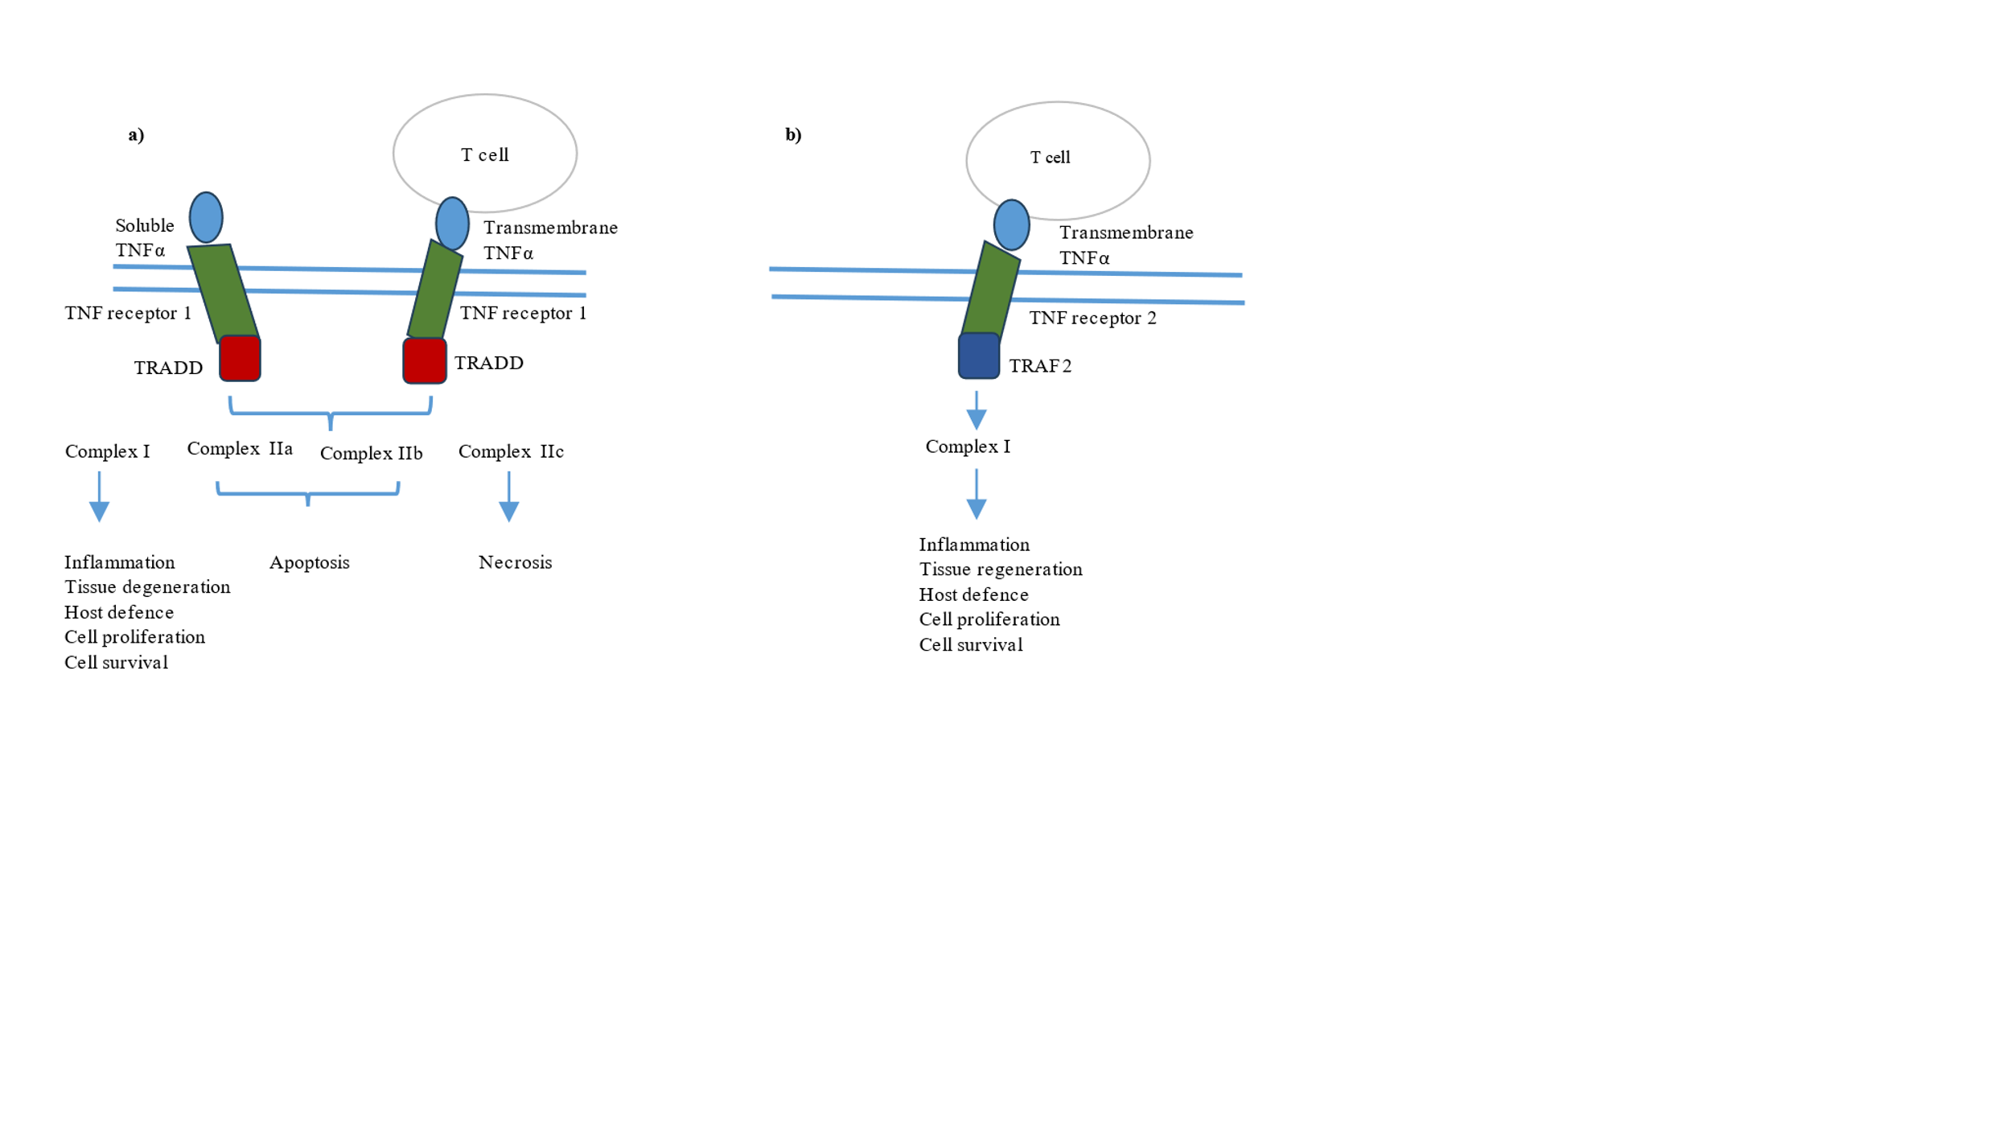
Figure 3. Signalling pathways of tumour necrosis factor (TNF) receptors 1 and 2.
a | TNF receptor 1 is activated by soluble and transmembrane TNFα and contains a death domain that recruits the adaptor protein TNF receptor 1-associated death domain (TRADD). Activation of TNF receptor 1 leads to complex I, which induces inflammation, tissue degeneration, cell survival and proliferation, and the immune defence against pathogens. The formation of the complexes IIa and IIb results in apoptosis, whereas complex IIc induces necrosis and inflammation.
b | TNF receptor 2 is activated primarily by transmembrane TNFα. TNF receptor 2 recruits TNFR-associated factor 2 (TRAF2), triggering the formation of complex I, which primarily mediates homeostasis including tissue regeneration, cell proliferation and cell survival. However, this pathway can also initiate inflammation and host defence against pathogens.
(TNFα: tumour necrosis factor-α)

1.1.6 Infliximab
Infliximab was the first biological therapy to be approved for the treatment of IBD in 1998 ⁵⁶. It is effective at inducing and mainlining remission in UC and CD and remains the only monoclonal antibody licensed for the treatment of acute severe UC ²².

Structure
Infliximab is a chimeric monoclonal IgG1 antibody to soluble and transmembrane TNFα. It is composed of murine derived amino acids (∼ 30% ) at the variable Fab region grafted onto an antibody composed of human derived amino acids (∼ 70%) ⁵⁷.

Mechanism of action
Infliximab’s efficacy is complex and is shown in Figure 4. It binds to both soluble and transmembrane TNFα preventing them from exerting their effects via TNF receptors 1 and 2 ^{37,45,58}. By binding to transmembrane TNFα, it also induces reverse signalling leading to T-cell apoptosis by interrupting anti-apoptosis signals ⁵⁹. Infliximab reduces permeability of the intestinal epithelium, allowing improved barrier function ³⁶. It improves wound healing by increasing intestinal fibroblasts motility and inducing M2 wound healing macrophages via Fc receptor-mediated action ^{36,59,60}.

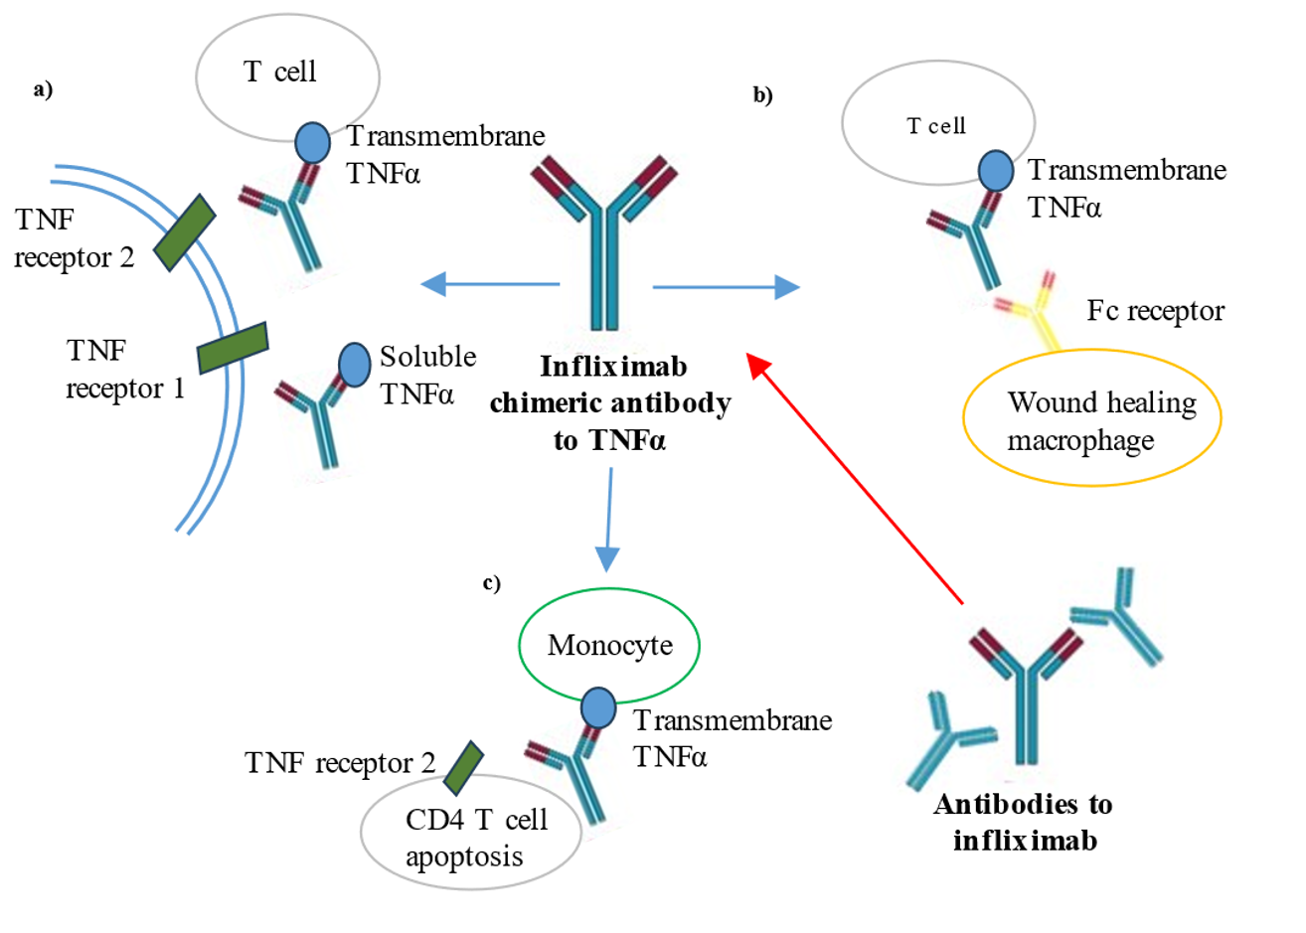
Figure 4. Mechanism of action of infliximab.
a) Prevention of TNF receptors 1 and 2 mediated signalling pathways: binding of infliximab to soluble and transmembrane TNFα.
b) Fc receptor-mediated action: the Fc region of infliximab bound to transmembrane TNFα on activated T cells is recognised by Fc receptors on monocytes. This triggers their differentiation into wound-healing macrophages.
c) T cell apoptosis: binding of infliximab to transmembrane TNFα on monocytes interrupt anti-apoptosis signals via TNF receptor 2 on CD4 T cells via reverse signalling.
The development of antibodies to infliximab may affect infliximab’s efficacy as it interacts with its ability to bind to soluble and transmembrane TNFα and the Fc receptor and due to increased clearance of the drug via immune complex formation.
(Fc: crystalline fragment, TNFα: tumour necrosis factor-α)

Pharmacokinetics
Monoclonal antibodies as large molecules are not readily absorbed from the gastrointestinal tract and are administered intravenously or subcutaneously ⁶¹. A study in 108 CD patients showed that response at 4 weeks after a single infusion of infliximab of 5 mg/kg was higher at 81% compared to patients who were administered 10 or 20 mg/kg (50% and 64% respectively) ⁶². A pharmacokinetic study in 25 CD patients illustrated that after a single intravenous administration of 5 mg/kg, infliximab is largely distributed in the vascular compartment and has a half-life of 10 days with detectable levels at 8 to 12 week post infusion ⁶³. Intravenous administration means 100% bioavailability. Due to its large size as a monoclonal antibody, infliximab is distributed in the bloodstream and extracellular space and cleared by catabolism ⁶¹. Infliximab’s clearance is increased by a higher body weight, immune complex formation from anti-drug antibodies and high inflammatory state demonstrated by an increased CRP, reduced albumin concentration and an increased TNF load ⁶¹. Catabolism is also affected by infliximab’s interaction with the neonatal Fc receptor (FcRn) and genetic mutations in the FcRn gene affect infliximab concentration ⁶⁴. FcRn binds to the Fc fragment of immunoglobulins, internalises them within endosomes and protects them from proteolysis, recirculating them back into the plasma ⁶⁵.

Clinical efficacy
Landmark large RCTs have shown infliximab’s efficacy in inducing and maintaining clinical response and remission in IBD ^{27,53,55,66}. In ACCENT 1, 58% of 573 patients with moderate-severe CD responded to an initial 5 mg/kg intravenous infusion of infliximab ⁵³. After randomisation of the responders to placebo or infliximab for 54 weeks, at week 30, 21% of those receiving placebo were in remission, compared to 39% receiving 5 mg/kg and 45% receiving 10 mg/kg (p=0.003 and p=0·0002 respectively)⁵³. In ACT 1 and 2, 728 patients with moderate to severe UC were randomised to placebo or infliximab 5 mg/kg or 10 mg/kg and showed significant superiority of both infliximab regimes at week 8 for induction of clinical response, rates of >60% compared to rates of around 30% for placebo²⁷. This significant difference in clinical response was maintained at week 30 and at week 54. In the latter, nearly 50% of those receiving infliximab regimes were in clinical remission compared to 20% of those receiving placebo (P<0.001)²⁷.

Infliximab remains the only biological therapy licensed for use in acute severe UC ⁶⁷.
This life-threatening medical emergency carries a 1% mortality rate and a high risk of colectomy during the acute admission and on follow-up ^{68,69}. Intravenous corticosteroids are administered as initial therapy but around a one-third of patients will fail to respond ^{69–71}. A meta-analysis showed infliximab had a number needed to treat of four for moderate to severe UC and real world experience showed two-thirds of patients avoided colectomy, and more than 50% were in glucocorticosteroid-free remission on follow-up ^{70,71}.

The efficacy of infliximab has also been assessed and shown in fistulating CD, a difficult patient cohort with limited evidence from RCTs. At week 10, following infliximab induction therapy, 195 of 306 CD patients with abdominal or perianal fistulas, showed response ⁵⁵. Responders were randomised to infliximab 5mg/kg or placebo every 8 weeks and the time to loss of response was significantly longer for patients who received infliximab compared to placebo and at week 54, nearly 40% of those receiving infliximab had a complete absence of draining fistulas, compared to 19% in the placebo group (P=0.009) ⁵⁵.

RCTs in both UC and CD has shown that infliximab used in combination with azathioprine significantly increases rates of corticosteroid free remission and mucosal healing when compared to infliximab or azathioprine monotherapy ^{54,66}. Although no significant difference was noted in rates of infection or serious infections between the three treatment arms, risks and benefits of using combination immunosuppression have to be considered for each patient.

The strong evidence base for infliximab’s efficacy in IBD has led to infliximab being commonly administered as an intravenous infusion of 5mg/kg at 0, 2 and 6 weeks for induction and then continued 8 weekly as maintenance, with the option of dose escalation to 10 mg/kg +/- a reduction in interval to every 4 weeks ²³.

1.1.7 Side effects of infliximab
Side effects with infliximab therapy include but are not limited to allergic reactions, infections, acute and latent immune-mediated reactions, development of anti-drug antibodies, autoimmune-like reactions, liver derangement, gastro-intestinal symptoms, pancytopenia, malignancy and worsening of heart failure ⁷².

Infection
Infection is an important side effect and seen consistently in the literature and clinical practice. In the landmark RCTs there was no significant difference in rates of infection/serious infections between infliximab treated and placebo groups ^{27,53,55}. However in the CD cohort, at least one dose of infliximab had been administered in the placebo group due to the study design, limiting the analysis ^{27,53,55}. A meta-analysis in CD showed the rate of infection was not higher in infliximab treated patients compared to placebo but was limited by the study design of the RCTs as discussed above ⁷³, More recently, the TREAT registry, a large prospective cohort study in CD: 3440 infliximab-treated, 2833 other-treatments-only assessed the long-term safety of infliximab, with median duration of follow-up exceeding 6 years ⁷⁴. Serious infection rates were significantly higher for infliximab-treated compared to other treatments only patients: 2.15 compared 0.86/100 patient years (relative risk of 2.46, 95% CI 1.8–3.4) ⁷⁴. Prior to commencing all monoclonal antibodies, acute and latent infections such as HIV, hepatitis B and C and tuberculosis must be investigated for and either fully treated or controlled¹⁷. Reactivation of tuberculosis is a concern and an increase in tuberculosis infections, in particular, atypical presentations with extrapulmonary or disseminated disease has been noted following the introduction of anti-TNF therapy⁷⁵. Screening for tuberculosis prior to commencing anti-TNF therapy is commonly accepted. Ongoing vigilance is required as active tuberculosis can still develop despite a negative screen during infliximab treatment of IBD and 44 cases were reported in a large multi-centre retrospective study⁷⁶.

Immune mediated side-effects
Immune mediated side-effects of biological agents can be considered as target-related e.g. suppression of TNFα and the effect of this on the immune system or agent-related e.g. the response of the immune system to the presence of the actual drug infliximab ⁷⁷. Allergic reactions, acute infusion reactions: occurring within 1-2 hours of the infusion and delayed/late infusion reactions-occurring > 24 hours post infusion are considered to be agent related. Infusion reactions have a complex aetiology and may be IgE mediated, or related to the formation of ATI and immune complex formation ^{77,78}. Infusion reactions will be discussed further in section 1.3.5. Features of autoimmunity are considered to be target-related and formation of auto-antibodies, lupus-like syndrome, demyelinating disease, neuropathy are associated with infliximab therapy.^{27,53,74,77}. Infection can also be considered as a target-related side effect as the TNF antagonism leads to immunosuppression.
Malignancies
Malignancies have been noted during infliximab treatment, though large cohort studies have not shown a significant increased risk of cancer with infliximab treatment compared to other treatments ^{74,79}. However, a limitation with assessing malignancy in studies is duration of follow up. Commonly reported malignancies included breast, lung, prostate, colonic and malignant melanoma ⁷⁴. Lymphoproliferative disorders are associated with immunosuppressive treatments in IBD, though less consistently with infliximab monotherapy compared to combination therapy with thiopurines ^{74,80,81}. 62 cases of a rare but aggressive lymphoma, hepatosplenic T cell lymphoma, was noted on interrogation of the Food and Drug Administration Adverse Event Reporting System in 2020 of IBD patients receiving biologics ⁸². Almost all had thiopurine exposure, but 3 cases occurred with infliximab monotherapy ⁸².

1.1.8 Biosimilars
A biosimilar is defined by the World Health Organization (WHO) as “a biotherapeutic product that is similar in terms of quality, safety and efficacy to an already licensed reference biotherapeutic drug” ⁸³. CT-P13 (Inflectra® Hospira, UK and Remsima® Celltrion Inc., Korea ) and SB2 (Flixabi® Samsung Bioepis, UK) are biosimiliars of originator infliximab, Remicade® (Janssen Biotech Inc., USA) with identical amino acid sequences to the originator ^{84,85}. Infliximab biosimilars approved for use in IBD by the EMA are listed in Table 1.

In depth physicochemical characterisation of Remsima® indicates identical primary and higher-order structures compared with the originator drug ⁸⁴. Physicochemical assessment of primary and higher-order structures of SB2 to originator infliximab also indicates it is highly similar ^{86,87}. However, SB2 showed a lower proportion of basic charge variants with the absence of two basic charge variants caused by more extensive C-terminal lysine clipping of SB2 ⁸⁶. Batch to batch analysis showed no significant effect on TNF-α binding nor TNF-α neutralization despite this difference ⁸⁷. Cross-reactivity of ADA between Remicade® and biosimilars have been shown. Sera from 69 IBD patients with antibodies to Remicade®, all recognised and cross reacted with Remsima® with correlation on ELISAs between titres of antibodies to Remsima® and titres of antibodies to Remicade® ⁸⁸. Sera from ATI positive patients treated with originator infliximab, CT-P13 or originator to CTP13 switched patients showed ATI positivity using CT-P13 or SB3 bridging assays with 100% overall agreement between assays and no significant difference in ATI levels ⁸⁹.

Prior to their marketing authorisation, large RCTs in rheumatoid arthritis and ankylosing spondylitis patients showed similar pharmacokinetics, comparable efficacy and safety of CT-P13 and SB2 to Remicade® ^{90–92}. NOR-SWITCH, a landmark, multi-centre, randomised, double-blind study in 2017 evaluated the safety and efficacy of switching from Remicade® to Remsima® in patients with rheumatoid arthritis, spondyloarthritis, psoriatic arthritis, psoriasis and IBD over 52 weeks. Subgroup analysis of the 204 IBD patients showed no difference in efficacy, trough serum levels, ATI nor adverse events ⁹³. A systematic review identified 24 studies evaluating the switch between Remicade® and CT-P13 in 1326 IBD patients and showed no difference in disease control nor adverse events before and after switching ⁹⁴. Limitations noted by the investigators of the systematic review was that all but one study was retrospective, the low sample size of the individual studies, that follow-up ≤1 year in all studies and response was assessed clinically instead of harder end points such as endoscopically. A later RCT to assess non-inferiority enrolled 308 patients with active Crohn’s disease naïve to biologics to 4 arms: CT-P13 then CT-P13, CT-P13 then infliximab, infliximab then infliximab, or infliximab then CT-P13, with switching at week 30 ⁹⁵. There was no significant difference in rates of clinical response following induction at week 6, similar sustained steroid-free remission rates between groups after switching and similar rates of adverse reactions before and after switching ⁹⁵. Once again response was assessed clinically with improvement in CDAI scores. The rates of ADA appeared similar prior to switching and at week 54 (rates of 33%-55%), but no statistical analysis was performed ⁹⁵. There are no RCTs in IBD comparing SB2 to originator infliximab. A RCT in moderate to severe rheumatoid arthritis (n=584) compared SB2’s efficacy, safety, immunogenicity, and PK to originator infliximab over 54 weeks and showed no significance difference in response rates at week 30 and 54 ⁹². At 54 weeks, patients in the SB2 arm continued treatment and patients in the originator drug arm were re-randomised to SB2 or continued the originator drug with similar response rates of 64-69% at week 78 in all three arms ⁹⁶. Rates of adverse events and ADA formation was also similar in the initial part of the study and following switching ^{92,96}. Real life prospective studies in IBD have subsequently indicated that following a switch from originator infliximab to SB2, clinical response is maintained in clinically stable patients ^{97,98}.

CT-P13 and SB2 received European marketing authorisation in 2013 and 2016 for all of the same licensing indications as Remicade® ^{99,100}. As biosimilars they have the same amino acid sequence as the originator drug and studies have suggested comparable efficacy, side effects profile and immunogenicity. However, in IBD, data especially from RCTs have been extrapolated from assessment of their use in other medical conditions. Other limitations of their assessment in IBD include that most studies contain a small number of patients (n< 100), follow-up is mostly < 1 year, assessment of efficacy relies on clinical assessment and switch to biosimilar often occurs in stable disease with only 1 RCT comparing CT-P13 and infliximab use from induction ⁹⁵. The lack of long-term follow-up is especially a concern in terms of adverse events as these effects may require assessment of a large number of patients over many years. Regarding immunogenicity, although there is a high similarity for higher-order structures between originator and biosimilar infliximab, small changes in structure have been noted. In addition, we have yet to understand the full impact of post-translational changes: enzymatic modifications that occur after translation, between administering originator and biosimilar drugs ¹⁰¹. There is also a significant paucity of data for switch between biosimilars indicating a cautious approach regarding recurrent switching. Ultimately, the potential risks of using biosimilars must be weighed against the lower cost associated with them and the opportunity they offer for increase access to life-changing medications.

 | Originator | Biosimilars
 | Infliximab | Infliximab | CT-P13 | CT-P13 | SB2
Brand name | Remicade | Zessly | Remsima | Inflectra | Flixabi
Manufacturing process | SP2/0 host cell line (mouse myeloma-derived) | SP2/0 host cell line (mouse myeloma-derived) | SP2/0 host cell line (mouse myeloma-derived) | SP2/0 host cell line (mouse myeloma-derived) | CHO host cell (Chinese hamster ovary derived)
Approval date | FDA: August 1998  EMA: August 1999 | EMA: May 2018 | EMA: September 2013 | EMA: September 2013  FDA: April 2016 | EMA: May 2016
Indications | AS, CD, PsA, Ps, RA, UC | AS, CD, PsA, Ps, RA, UC | AS, CD, PsA, Ps, RA, UC | AS, CD, PsA, Ps, RA, UC | AS, CD, PsA, Ps, RA, UC
Cost | £419.62  (1 x 100 mg vial) | £377.66  (1 x 100 mg vial) | £377.66  (1 x 100 mg vial) | £377.66  (1 x 100 mg vial) | £377  (1 x 100 mg vial)

Table 1. Infliximab biosimilars licensed for use in the European Union ^{72,99,100,102,103}.
AS: ankylosing spondylitis, CD: Crohn’s disease, PsA: Psoriatic arthropathy, PS: psoriasis, RA: rheumatoid arthritis, UC: ulcerative colitis.

1.2 Monoclonal antibodies

1.2.1 Immunoglobulins
There are 5 main classes of immunoglobulins: IgG, IgA, IgD, IgM and IgE, and each class share identical heavy chain constant domains ⁶⁵. Monomeric immunoglobulin structure: IgG, IgA, IgD and IgE, consist of two identical heavy and two identical light chains as shown in Figure 5. IgA and IgM can exist in multimeric forms ⁶⁵. The heavy and light chains form two antigen binding fragments (Fab) and one crystalline fragment (Fc), which via Fc receptors on cell surfaces activate the cellular immune system ^{37,65}. Within the variable Fab region of each light (V_{L}) and heavy chain (V_{H}) are 3 hypervariable regions: complementarity determining regions (CDR 1, 2 and 3) which are held within sequences of limited variability: framework regions ¹⁰⁴.

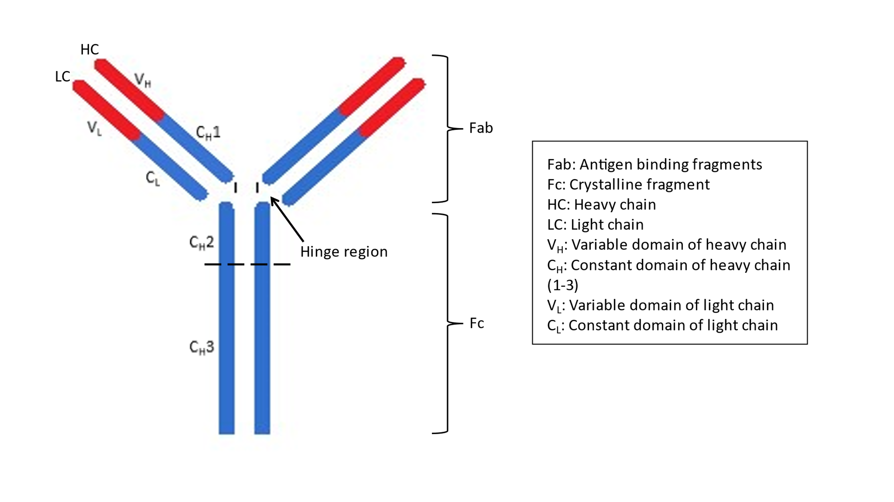
Figure 5. Structure of a monomeric immunoglobulin
Monomeric immunoglobulins: IgG, IgA, IgD and IgE consists of two identical heavy and two identical light chains linked by disulphide bonds. The heavy and light chains form two antigen binding fragments (Fab) and 1 crystalline fragment (Fc). Within the variable Fab region of each light (V_{L}) and each heavy chain (V_{H}) are three hypervariable regions: complementarity determining regions (CDR 1, 2 and 3). The CDRs determine antibody specificity and the 6 CDRs from each Fab form a paratope: the antigen binding site.

1.2.2 Epitopes
The six CDRs of a variable Fab constitutes the paratope: the region on the antibody that determines specificity and binds to the B cell epitope on the antigen ^{65,104}. B cell epitopes can be linear: continuous short sequences of amino acids, or conformational: discontinuous or continuous sequences of amino acids which as a three-dimensional structure interacts with the paratope ¹⁰⁵ (Figure 6).

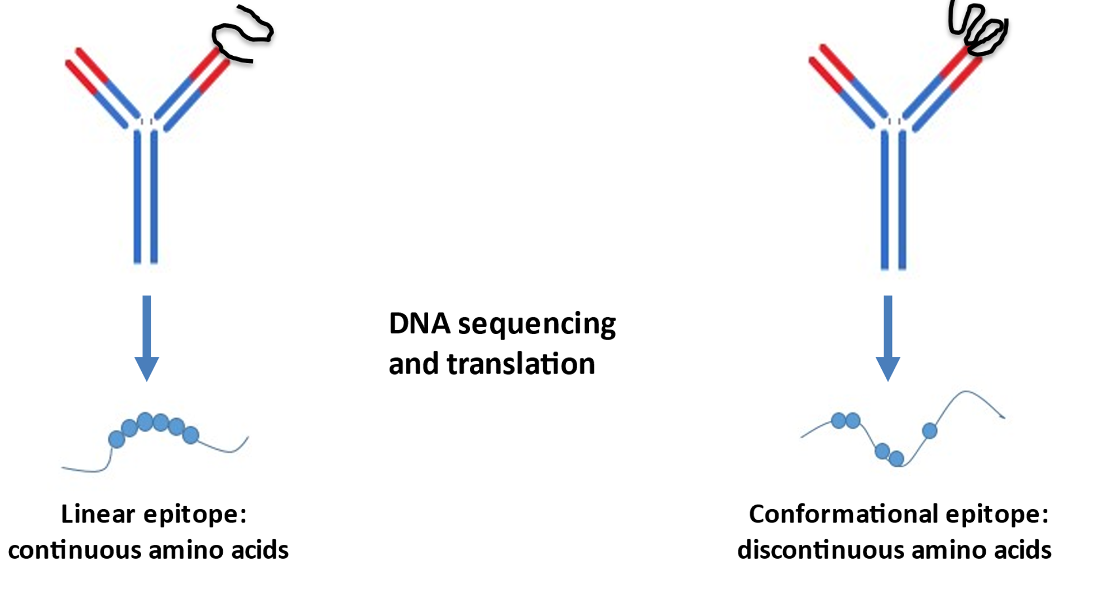
Figure 6. Linear and conformational epitopes.
Linear epitopes are peptides on an antigen which consist of a continuous amino acid sequence. Conformational epitopes consist of discontinuous amino acids which are only brought into proximity by the 3D folding of the tertiary peptide structure of the antigen.

Specificity, the ability of the antibody to differentiate between different antigenic variants and bind only to a intended antigen, and affinity, the strength of the binding between an antibody and its antigen is key to immune recognition ^{65,106}. The initial antibody-antigen interaction is often weak and occurs between the antigen and IgM on naïve B cells (B cells which have not encountered their specific antigen before) ¹⁰⁶. Following this interaction, affinity maturation occurs. This process involves hypermutations in the DNA coding of the CDRs to select those B cells that produce antibodies that bind at higher affinities, further competitive selection of these B cells from T cell independent activation, leading to high affinity IgG secreting plasma B cells ^{106,107}. Antigen specificity is retained despite the switch in isotype from the initial IgM or IgD in the primary immune response to IgG, as isotype switching is determined by the constant region and therefore the Fab region is unaffected maintaining recognition of the same B cell epitopes ^{106,108}.

1.2.3 Monoclonal antibodies as biotherapeutic agents
In 1975, Köhler and Milstein, in one of the greatest scientific breakthroughs, produced the first synthetic monoclonal antibodies. They formed hybridoma cells from fusion of an immortal myeloma cell with a mouse spleen cell from an immunised donor, which secreted the antibody of interest ¹⁰⁹. As monoclonal antibodies are produced by a clonal population of plasma B cell, they are identical, with the same variable domains ¹¹⁰. Monoclonal antibodies’ specificity and affinity to an antigen of interest have made them effective biotherapeutics and has allow targeted therapy to specific cellular pathways and cellular targets.

Immunogenicity can occur to monoclonal antibodies. A robust immune response is often associated with the immune response to monoclonal antibodies. The presence of IgG anti-drug antibodies indicates T cell dependant B cell activation may be the underlying mechanism ¹⁰⁷. However, the exact mechanism remains unknown, and it may be that both T cell dependant and T cell independent pathways are involved. T cell independent activation can occur via exposure to products of bacterial degradation, display of antigen on viruses or viruses-like-particles and protein aggregates which have the ability to cross link B cell receptors, inducing B cell signals required for activation ^{107,111} .

Factors that affect immunogenicity can be viewed in terms of relating to 1) product, 2) patient, or 3) method of administration. Product related factors such as the origin of the biotherapeutics as those from animal sources ie “foreign” are more immunogenic than human derived products, protein modification ie the presence of a unique or unusual amino acid sequences in a humanised protein, impurities such leachates from the container or the effect of their presence on the drug such as aggregation, increases the likelihood of immunogenicity ^{101,107,112,113}. Patient related factors include immunosuppression state (reduce risk of immunogenicity if immunosuppressed), genetic deficiency with administration of the replacement therapeutic protein leading to immune recognition of those proteins as “foreign” and allelic variations that increase or reduce the risk of immunogenicity ^{101,114}. Short-term therapy compared to long-term treatment, continuous vs intermittent administration and a higher concentration of drug compared to a lower concentration are associated with a lower risk of immunogenicity ¹⁰¹. Route of administration via the skin is also associated with increased immunogenicity as the skin is the largest barrier to pathogens and has the immune system in close proximity ¹¹⁵.

Biotherapeutics have changed the management of infective, immunological, and oncological conditions and their scope will only increase further. Understanding and assessing their potential for immunogenicity is essential to their optimal use and should be considered during the drug development with a focus on development of standardised assays for detection of clinically relevant immunogenicity.

1.3 Clinical implications of antibodies to infliximab (ATI)

1.3.1 Measurement of ATI
Worldwide, different methods are used to assess antibodies to infliximab. Common screening assays include radio-immunoassay, fluid phase mobility shift assays and ELISAs ¹¹⁶. There are limitations in current measurements of ATI. Comparative studies of assays highlight their differing sensitivities in detection of ATI. A study assessing an in-house ELISA, an in-house radioimmunoassay and a commercially available ELISA did suggest a good correlation between the three assays in detection of ATI, however the in-house ELISA had lower sensitivity and did not detect ATI in 8/46 positive samples (all with low levels of ATI) ¹¹⁶.

Sandwich and bridging ELISAs are commonly used to detect ATI due to availability of commercial kits ¹¹⁷. Initial ELISAs were “drug sensitive” as the ATI could be bound by the drug giving a false negative result ^{118–120}. In its drug tolerant form, steps such as acid dissociation or wash out, firstly dissociates the immune complexes and then remove infliximab, increasing the accuracy in ATI detection ^{117,121}. False positives are also a concern with ELISAs as the presence of other immunoglobulins in the sera may lead to aggregation, cross-linking and non-specific binding. Bridging ELISAs reduce the risk of non-specific binding compared to simple sandwich ELISAs but are unable to detect monovalent IgG4 ¹²². A study of three ELISAs showed one commercial bridging assay could not detect 29% of ATI positive samples in the presence of infliximab or if the ATI consisted of a high concentration of IgG4 ^{123,124}. Mobility shift assays incorporates acid-dissociation of immune complexes and detects ATI using a fluorescently labelled drug in a liquid phase. The detection is via high-performance liquid chromatography which allows separation by size of particles, distinguishing antibody-bound labelled drug from free labelled drug ^{122,125}. Mobility shift assays are less affected by non-specific binding, are drug tolerant, but are more complex and expensive due to fluorescent labelling ¹²⁵. In addition, a limitation with routinely used assays for ADA detection is their inability to differentiate whether the antibodies are neutralising or not.

The diagnosis of a “positive threshold for ATI” varies between assays as no reference standards are available. Heterogenous units of measurement between assays makes comparisons and generalisation of results difficult. IDKmonitor® Infliximab total ADA (Immundiagnostik AG, Bensheim, Germany) is a commonly used commercial ELISA, also used by our centre. It is drug tolerant and includes immune complex dissociation allowing ATI to be detected in the presence of the drug. The free ATI bind to labelled infliximab: peroxidase conjugate infliximab and biotinylated infliximab, which binds via biotin to the streptavidin coated microtiter plate and is detected via the peroxidase conjugate which leads to a colour change when TMB substrate is added (Figure 7) ¹¹⁷. The positive threshold of >10 AU/mL was established by diluting a highly positive ATI sample until no further linear dilution was possible. Using this cut-off, subsequent testing of sera from infliximab-naive patients were confirmed to be negative for ATI in 97.5% of patients ¹¹⁷. This positive threshold was assessed in a much large cohort of 500 healthy volunteers and a slightly lower threshold of 9 AU/mL was determined for ATI positivity ¹²⁶. A limitation with this validation study was that the cohort was healthy, young, mainly Caucasian students, which may limit generalisation to other ethnicities or ages, but it highlights the importance of validating these thresholds in local populations.

Despite the limitations discussed above, therapeutic drug monitoring is a useful clinical tool in guiding treatment decisions in those on infliximab and has been incorporated into guidelines ¹⁷. They allow some guidance in expensive treatments of a complex medical condition.

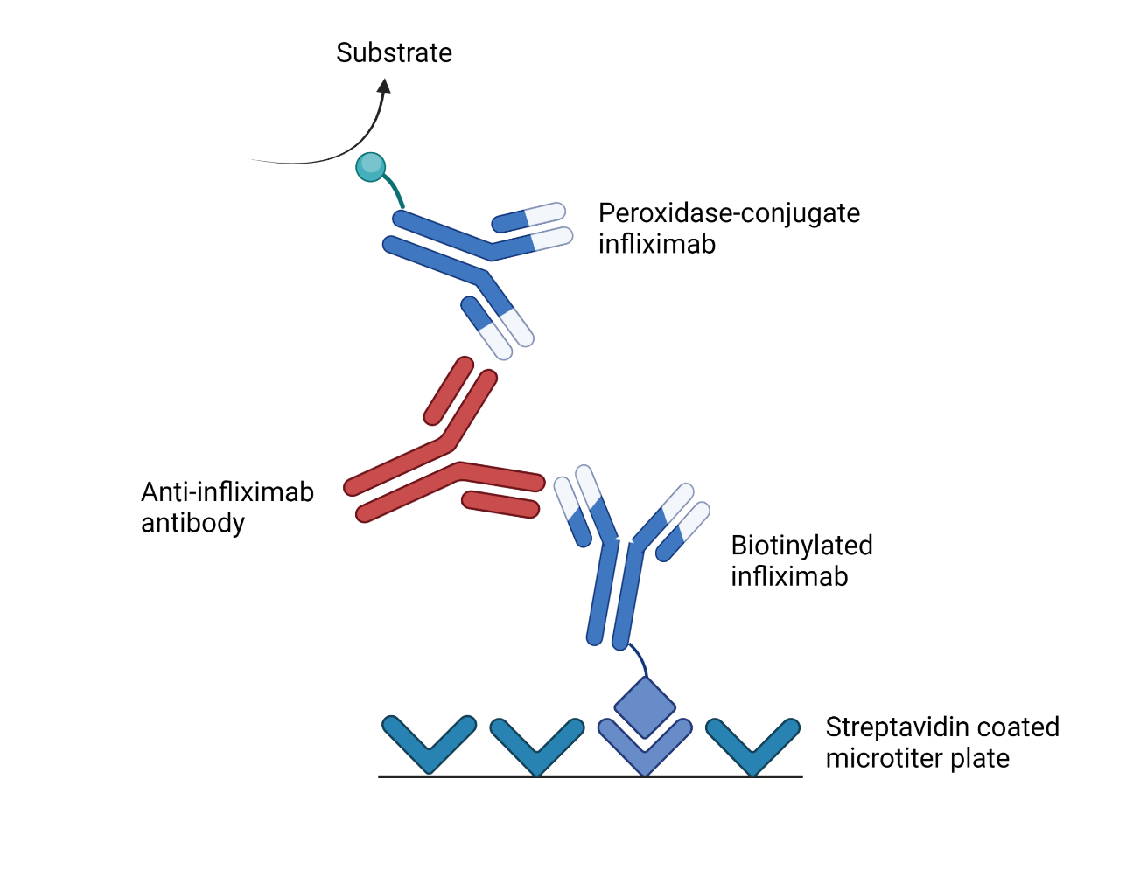
Figure 7. Diagrammatic representation of infliximab total anti-drug antibodies sandwich ELISA IDKmonitor, a commonly used commercial ELISA ¹¹⁷.
This drug tolerant ELISA allows free ATI to bind to labelled infliximab: peroxidase conjugate infliximab and biotinylated infliximab. The immune complex binds via biotin to the streptavidin coated microtiter plate and is detected via the peroxidase conjugate which leads to a colour change when TMB substrate is added.

1.3.2 Development of ATI
Expression of certain HLA alleles are associated with the development of immunogenicity to biotherapeutics. 76 ATI positive IBD patients were shown to express HLA DRB1*03 significantly more than 116 controls (13% compared to 4%; p=0.002) independent of disease type, use of a loading dose or concomitant immunosuppression ¹²⁷. HLA DRB1*03 is also associated with antibodies to interferon beta therapy in multiple sclerosis and the development of systemic lupus erythematosus ¹²⁷ indicating its importance in autoimmunity and immunogenicity to medications. A prospective study in over 1000 CD patients identified a different HLA allele, HLA-DQA1*05 with an increased risk of developing antibodies to both infliximab and adalimumab ¹²⁸. Risk of immunogenicity was higher for infliximab compared to adalimumab and in those receiving monotherapy (no concomitant immunomodulators) with the highest incidence of 91% at 1 year for those receiving infliximab monotherapy ¹²⁸.

Concomitant immunosuppression with thiopurines and methotrexate appears to significantly reduces the formation of ATI in both CD and UC patients, 0.9-43% vs 14.6-75% ^{54,66,118,129,130}.

Comparisons between studies also suggested that immunogenicity may differ between UC compared to CD as ATI occurred in 6-41% of UC patients compared to 6-20% of CD patients ^{27,53,130,131} but there are no direct comparison studies. Episodic therapy appears to be associated with higher rates of immunogenicity. 125 CD patients, all on concomitant immunosuppressants were administered episodic infliximab infusions on loss of clinical response and ATI positivity was 61% after the fifth infusion ¹¹⁸. Another study in CD over 72 weeks showed that 30% of those that received infliximab infusions on loss of response had ATI compared to 8% in those receiving regular infliximab (P < 0.0001), with the episodic group having higher rates of concomitant immunosuppression ¹³². However, a prospective study of 125 IBD patients showed that the 14 patients who had previously received infliximab did not develop ATI more readily than those who had not been previously exposed to infliximab ¹²⁹. But the latter study is limited by the small numbers in the previous infliximab therapy group with no information on concomitant immunosuppression, nor when or how long the previous infliximab treatment was. Although some may categorise restarting infliximab in those who had received previous infliximab therapy as episodic treatment, this is very different to receiving multiple unscheduled infusions over a few years and this difference would be reflected in drug pharmacokinetics, and therefore, immunogenicity. All three studies used drug sensitive assays, which means they may have underestimated the rates of ATI formation.

Comparisons between studies to assess risk-factors for ATI remain difficult as different assays are used. ATI are also measured at different points of time with positivity on any assessment often taken as a positive ATI status. This is relevant as ATI may be transient or develop at different time points of treatment. In the above mentioned prospective observational study of 125 IBD patients receiving scheduled therapy, infliximab and ATI levels were measured before each infusion and results indicated that 90% of ATI occurred within 12 months and 26% of patients developed transient antibodies: ATI that disappeared within 2 consecutive infusions and had little clinical impact ¹²⁹. These points therefore should be considered when assessing risk factors for clinically relevant immunogenicity.

1.3.3 The association between ATI and infliximab trough levels
Early studies suggested that infliximab trough levels of >3 µg/mL were associated with better clinical outcomes in IBD: clinical response, clinical remission and endoscopic improvement ^{53,119,121,131,133,134}. A target therapeutic window of 3–7 μg/mL was suggested by the TAXIT study in 2015, a randomised control trial in over 200 IBD patients ¹²⁰. Patients on maintenance infliximab therapy were evaluated on whether drug concentration guided dosing based on TDM at each infusion plus assessment of clinical features and CRP was superior to clinically based dosing using clinical features and CRP alone, for maintaining remission in IBD. The results indicated that optimising infliximab to 3–7 μg/mL was cost-effective as it was associated with increased remission rates in CD, and it allowed those with supratherapeutic drug levels to have their drug regime altered ¹²⁰. More recently, studies have suggested that therapeutic drug targets may vary for different clinical situations with higher levels for perianal disease ^{135,136} . Debate also remains whether TDM should be assessed reactively or proactively, but the importance of assessing trough drug levels and ATI during infliximab treatment has been recognised and is incorporated into national guidelines ¹⁷.

Previous studies have suggested ATI are associated with lower levels of infliximab. A prospective study in 93 IBD patients suggested that trough infliximab levels were significantly lower at week 22 in patients with positive ATI (0.05 µg/ml vs 4.24 µg/ml; p < 0.001) ¹³⁷. However, number of patients were limited as only 9 patients had sustained positive ATI (ATI was consistently positive), likely due to the use of a drug sensitive assay and how often ATI were measured in the study. Another study in 100 UC patients found that undetectable levels of infliximab were associated with ATI positivity: 44/66 patients with undetectable levels were ATI positive ¹³¹. However, 42 patients with detectable infliximab levels were antibody inconclusive due to the assay being drug sensitive limiting their conclusion as those patients may also be antibody positive. More convincingly, a large cohort study of over 300 stable CD patients who had received at least 5 consecutive infusions of infliximab found that ATI positive patients were less likely to have therapeutic infliximab levels compared to those who were ATI negative: respectively 17.5% vs. 77.3% at visit 1 and 13.8% vs. 75.6% at visit 3 (8 weeks later); P < 0.001 for both comparisons ¹³⁸. Using a homogenous mobility shift assay with a pre-analytical acid dissociation to allow detection of ATI in the presence of infliximab, an observational study assessed 1487 trough serum samples from 483 CD patients on maintenance infliximab who had previously participated in four previous studies. Samples that were positive for ATI had a significantly lower likelihood of having detectable infliximab compared with ATI-negative samples (OR 0.041; 95% CI 0.030-0.056; p<0.001). These studies suggest an association between ATI and low infliximab trough levels but are limited by the use of drug sensitive assays and timing of TDM (often performed just once or twice), both underestimating the prevalence of ATI positive patients, and therefore making true correlation to infliximab trough levels difficult.

1.3.4 The association between ATI and clinical response
Different treatment targets exist in IBD. Clinical targets are often determined by clinician assessment or with the use of disease activity scores of which, multiple scoring systems exist. Commonly used scoring systems are the Harvey Bradshaw Index and Crohn’s Disease Activity Index for CD and Mayo score and Simple Clinical Colitis Activity Index for UC ^{139–142}. Clinical response is usually accepted as an improvement in symptoms or a defined improvement for the specific score. Loss of response would be an increase in symptoms attributable to IBD +/- a defined increase for the specific score. For clinical remission, the score must be below a defined threshold and rising above this threshold would indicate loss of clinical remission. The variety of scores, differing definitions of response and remission and dependence on an individual clinician’s assessment leads to heterogeneity and bias. Clinical targets have now often been surpassed in research by harder end points of endoscopic remission, mucosal healing and histological remission. However, even with these latter targets, which are more objective, there continues to be lack of consensus regarding their definitions ¹⁷. In addition, these harder end points can be difficult to justify in terms of routine clinical practice due to cost-benefit but also patient acceptance in terms of invasive procedures. Clinical assessment, which despite its limitations remains pivotal with endoscopic and histological assessment as important adjuncts based on individualised care.

Two meta-analyses have assessed the association between ATI and clinical outcomes. The earlier meta-analysis by Lee et al concluded that although patients with ATI were less likely to be in clinical remission, this was not statistically significant ¹⁴³. In the later meta-analysis by Nanda et al, patients who were positive for ATI were 3.2 times more likely to lose response than those without ATI (P < 0.0001) ¹⁴⁴. However, on sub-group analysis of IBD sub-type, this significance was only maintained in CD patients and not for UC patients ¹⁴⁴. Both meta-analyses included a similar number of studies of which 6 were the same, though 4 studies included in the earlier meta-analysis was not included in the later one. The differing conclusions are likely to be affected by their clinical outcome of interest: clinical remission for Lee at el vs loss of response for Nanda et al. Neither analysis stringently defined their outcome in their methodology, likely to not limit study inclusion. Heterogeneity existed in the studies included in both analyses regarding assessment of ATI and loss of response and remission, with clinical assessment based on clinician assessment or clinical scores, which are susceptible to bias and limitations discussed above, but also reflective of real life practice.

More recent observational studies not included in the meta-analysis have also assessed the impact of ATI on clinical outcomes and shown that lower levels of ATI are an independent predictor of remission and that the presence of sustained ATI is an independent predictor of loss of response ^{121,137} with time to loss of response significantly longer in patients with no ATI compared to those with low or high antibodies ¹²⁹. These later studies used drug tolerant assays.

1.3.5 The association between ATI and infusion reactions
Infusion reactions can be defined as 1) acute or immediate, occurring during the infusion or within 1-2 hours of completion or 2) delayed or late, occurring more than 24 hours post infusion reported. Acute reactions are more common than delayed reactions, 5-23% compared to 1-3% in a systematic review ⁷⁸. Reported symptoms with an acute infusion reaction include rash, pruritus, wheezing, flushing, shortness of breath, chest discomfort, hypertension, myalgia, nausea, urticaria, headache and anaphylaxis ^{78,145}. Delayed reactions are often reported 1-3 weeks after the infusion and include rash, fever, malaise, polyarthralgia and jaw pain ^{78,145}. The risk of infusion reactions appears to be increased with episodic regimens, administration of infliximab after a prolonged drug-free interval, and in those with high ATI titres and reduced in those receiving concomitant immunosuppression ^{78,145}.

Meta-analyses have shown that IBD patients with ATI have a significantly higher risk of infusion reactions ^{143,145} though this may be limited to acute (more than 2 fold increased risk) and severe infusion reactions (nearly 6 fold increased risk) compared to delayed infusion reactions ¹⁴⁵.

Different aetiologies have been suggested for immediate infusion reactions including complement activation from infliximab-ATI complexes and IgE mediated reactions⁷⁸. Delayed reactions may occur from deposition of ATI-infliximab complexes in organs, joints and blood vessels generating local and systemic inflammatory responses ⁷⁸. ATI positivity may not be predictive for delayed infusion reaction, as additional factors such as the size of the immune complexes may be important. Small infliximab-ATI complexes may remain in circulation and not trigger inflammation and large complexes more readily cleared, whereas intermediate-sized complexes could lead to deposition and complement activation ⁷⁸.

1.4 Characterisation of ATI

1.4.1 Neutralising and non-neutralising ATI
Using a competition ELISA, a study in juvenile arthritis patients showed ATI positive serum from 9 patients prevented binding of an infliximab Fab fragment to immobilised TNF, indicating a neutralising effect ¹⁴⁶. In the comparison groups of serum from patients with no ATI and a control group of healthy donors there was no inhibition of infliximab Fab from binding to the immobilised TNF ¹⁴⁶. Although this study suggests the presence of neutralising antibodies, it did not exclude the presence of other types of ATI, which would bind simultaneously with the neutralising antibodies.

Van Schie et al used a different TNF competition assay in which ADA were bound by protein A Sepharose and a signal was generated on binding of radiolabelled drug Fab fragments ³³. Using sera positive for ADA to different TNFα antagonists, increasing amounts of TNFα were added to assess competitive inhibition. In the humanised TNFα antagonists: adalimumab, golimumab and certolizumab, >97% of the ADA response was neutralising and binding between ADA and the drug was suppressed on addition of TNFα ³³. For infliximab, two distinct ADA phenotypes were suggested as binding in 2/3 of sera was fully suppressed with an increase in TNFα concentration. However, in a 1/3, ATI continued to bind to infliximab even at the highest concentration of TNFα, suggesting simultaneous binding of infliximab to TNFα and ATI ³³. Modification of the competition assay with use of polyclonal mouse IgG, which would target the murine component of infliximab, did not reduce binding of ATI to infliximab leading to the authors to conclude that the ADA may target humanised epitopes unique to infliximab ³³.

Despite small numbers of sera and no information on patients’ clinical outcomes these studies suggest that different types of ATI exist and that they may be neutralising and non-neutralising.

1.4.2 Functional epitope mapping using phage display
Epitopes can be mapped 1) structurally, which identifies all amino acids in contact with the paratope but with no information regarding regions involved in the binding interaction, or 2) functionally, the identification of amino acids which are involved in the binding interaction to the paratope ^{105,147}.

In 1985, George P Smith illustrated that a gene fragment of interest could be fused to gene encoding for a viral coat protein of the filamentous bacteriophage ¹⁴⁸. This new method allowed genotype and phenotype to be linked, as the phage contained the DNA fragment on the inside and displayed the peptide of interest on the outside.

Bacteriophage
Bacteriophages or phages are viruses that infects and replicate within bacteria. The filamentous phage (Figure 8) infects gram negative bacteria and replicates without host cell lysis ¹⁴⁹. Due to its flexible genome, which allows large inserts of DNA sequences, its stability in high temperatures and acidity, it is a commonly used vector for phage display.

Phage and phagemid display libraries
Both phage and phagemid are used as vectors for phage display technology. The phagemid is a plasmid with a filamentous phage and plasmid origin of replication ¹⁵⁰. Whereas phage is the complete virion and can infect and produce daughter virion particles, a phagemid is non-infectious. It requires transformation into the bacterial cell and co-infection with a helper phage for production of virion particles (Figure 9). Other basic components of a phagemid vector are a gene for a phage coat protein so a gene fragment of interest can be fused to it, selective markers ie antibiotic resistance genes, restriction enzyme sites, an intergenic region, promoter peptide affecting expression of the fused product, signal peptide and often molecular tags such as HIS and C-myc for selection and screening ^{150,151}. Phagemids are more efficient in transformation- the insertion of foreign DNA into bacteria, they produce high diversity libraries with display of monovalent fusion products, eliminating avidity ^{150,151}.

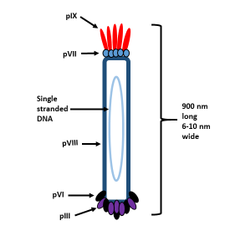
Circular genome of single stranded DNA is wrapped inside several thousand copies of a major coat pVIII. Phage genome encodes for 11 proteins: structural coat proteins (pIII, pVI, pVII, pVIII and pIX), assembly and export proteins (pI, pIV and pXI) and proteins for replication (pII, pV and pX) ¹⁵². There are 5 copies each of minor coat proteins: pIII, pVI (at the head for cell binding), pVII and pIX (at the tail for phage assembly) ¹⁴⁹.

Figure 8. The filamentous bacteriophage.

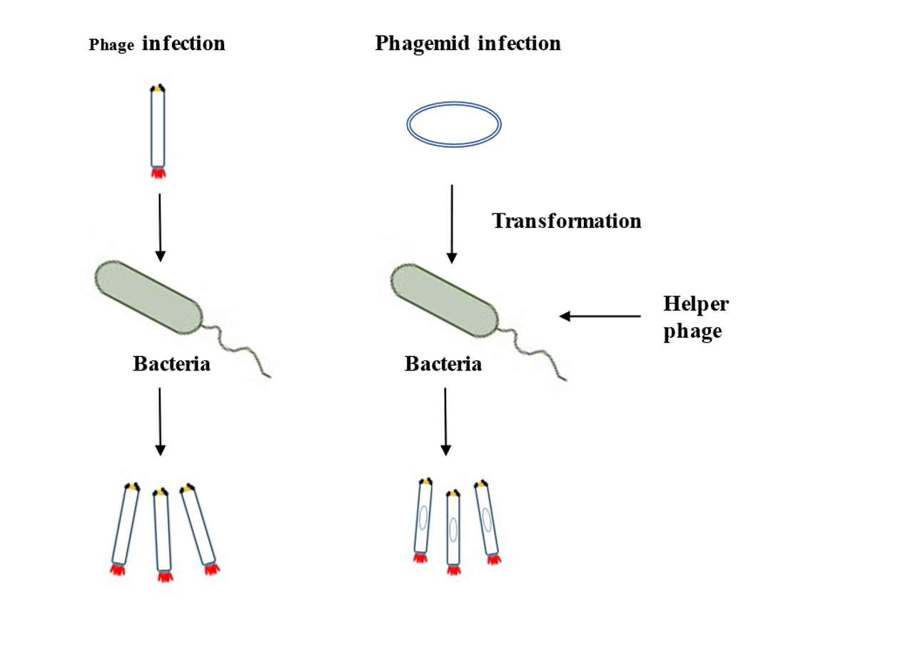
Figure 9. Overview of phage and phagemid infection of bacterial cells.
Phage, the complete virion, can infect bacterial cells and use the host cytoplasm for replication and assembly of new virion particles. A phagemid is a plasmid, which contains a gene for a phage coat protein e.g. pIII but it requires transformation into the bacterial cell and co-infection with a helper phage to supply additional phage genes for production of virion particles.

Affinity selection of phage display libraries
Phage display libraries often encompass millions of different phage variants. They allows screening with a known antigen or antibody to identify biomarkers, select high affinity antibodies for production of monoclonal antibodies and for functional epitope mapping^{105,153–155}. Affinity selection or biopanning involves incubation of the phage library with a known protein to allow binding of specific phage variants, washing to remove non-binding phage and elution to identify selected phage variants (Figure 10) ^{105,154,156,157}. Repeated cycles of amplification (growth of the selected phage variants), re-selection and elution aim to reduce non-specific binding and enrich selection of desired clones ^{105,154}.

Random peptide and gene fragment libraries
Phage display libraries can be considered in terms of random peptide libraries (RPL) and gene fragment libraries (GFL) ^{97,172}. RPL are large diverse libraries of unique random peptide sequences made from synthetic oligonucleotides. They can be used for identifying a wide range of protein-protein interactions including the identification of mimotopes - peptide sequences that mimic conformational epitopes ^{105,153,158}. A GFL contain phage with different DNA fragments of an individual gene and therefore is much smaller but specific for a particular selection ^{105,154}.

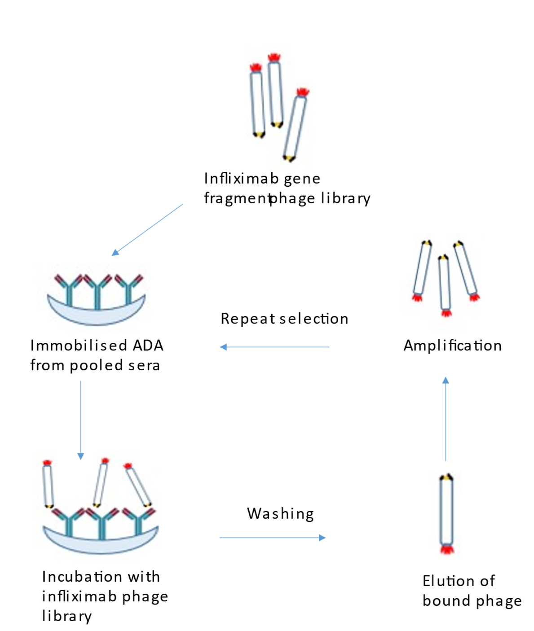
Figure 10. Diagrammatic representation of serological selection of a phage display library.
Incubation with a captured antigen/antibody allows binding of specific phage variants with displayed fusion products. Non-bound or non-specific binding phage are removed with multiple washes and bound phage are eluted. Cycles of amplification of bound phage variants, re-selection and elution are repeated 2-3 times to reduce non-specific binding.

1.4.3 B cell epitopes on infliximab
An early study was unable to select linear epitopes on infliximab by using pooled ATI positive sera from 9 patients on 3 immunoassays using 15-mer peptides of the variable regions of infliximab ¹⁴⁶. However the pooled ATI did demonstrate binding to immobilised native infliximab Fab fragment and to a much lesser extent the denatured form indicating the epitopes may be conformational ¹⁴⁶. Another study was more successful in delineating B cell epitopes on infliximab ¹⁵⁹. Six linear epitopes were identified by comparing the sera of 20 infliximab treated patients to 15 controls using a peptide microarray ¹⁵⁹. Four epitopes were located in the variable region and two were in the constant region ¹⁵⁹. Interestingly, in the infliximab treated group, different patients’ sera varied in their ability to bind to the different epitopes, indicating that different ATI may exist in different patients.

A more recent study used phage display to compare epitopes selected using sera from IBD patients with antibodies to originator and biosimilar infliximab ¹⁶⁰. Individual sera from 14 CT-P13 and 10 Remicade treated patients with ATI was used to select a phage display library of randomly generated infliximab full gene fragments ¹⁶⁰. 13 large antigenic regions, which altogether, spanned most of the infliximab protein sequence were enriched: 10 from the variable region and 3 from the constant region. Using a phage ELISA, these consensus peptides were tested against further sera from CT-P13 and Remicade treated IBD patients with antibodies. Not all sera bound to all epitopes but similar rates of reactivity were seen in the two treatment groups for each peptide leading to the authors to suggest that antibodies to originator and biosimilar infliximab are against the same epitopes ¹⁶⁰.

These studies offer new insight into immunogenicity to infliximab but are limited by the lack of associated clinical information, such as the clinical state of the patients involved ^{159,160}. In the latter study, the selected peptides also almost span the entire infliximab sequence. These factors limit the clinical significance of the epitopes identified and distinct immunogenic areas are hard to define.

The finding of different epitopes on infliximab could support the hypothesis of different phenotypes of ATI. Potentially any ATI could lead to immune complex formation, which may lead to reduce drug levels due to increased clearance of the immune complexes or immune complex deposition ⁷⁸. Immune complex deposition in organs, joints and blood vessels with complement activation and local and systemic inflammatory responses have been suggested in the pathogenesis of delayed infusion reaction ⁷⁸. Antibodies against the CDRs of infliximab could directly prevent the drug from binding to soluble and transmembrane TNFα and therefore prevent the inhibition of TNF receptor 1 and 2 mediated signalling pathways, leading to loss of response. Antibodies against epitopes on the Fc fragment of infliximab would affect Fc mediated actions and its ability to bind to the neonatal Fc receptor (FcRn). This receptor binds to the Fc fragment of immunoglobulins and protects them from degradation, recirculating them back into the plasma ⁶⁵. However, if the Fc fragment is bound to by ATI, this may prevent binding by the FcRn, leading to increased clearance of infliximab and reduced drug levels.

1.5: Aims

The overall aim of this PhD thesis is to understand antibody formation to infliximab on a clinical and immunological level. The specific aims were to-
- Assess immunogenicity to infliximab in patients with IBD using a drug tolerant assay.
- Identify factors associated with the development of ATI.
- Assess the association between ATI and clinical outcomes.
- Assess the effect of infliximab dose escalation in IBD patients with ATI.
- Define linear and conformational B cell epitopes on infliximab with the use of phage display.
Figure 11 shows the workflow of this PhD thesis. Initial clinical work focused on a retrospective review of 214 people with IBD with prospective follow-up of a cohort of patients who received dose escalation. From this work, patients with positive ATI were selected and consented to have sera stored. Pooled sera from patients with positive ATI and different clinical outcomes was used for serological selection of two phage display libraries to identify linear and conformational epitopes.

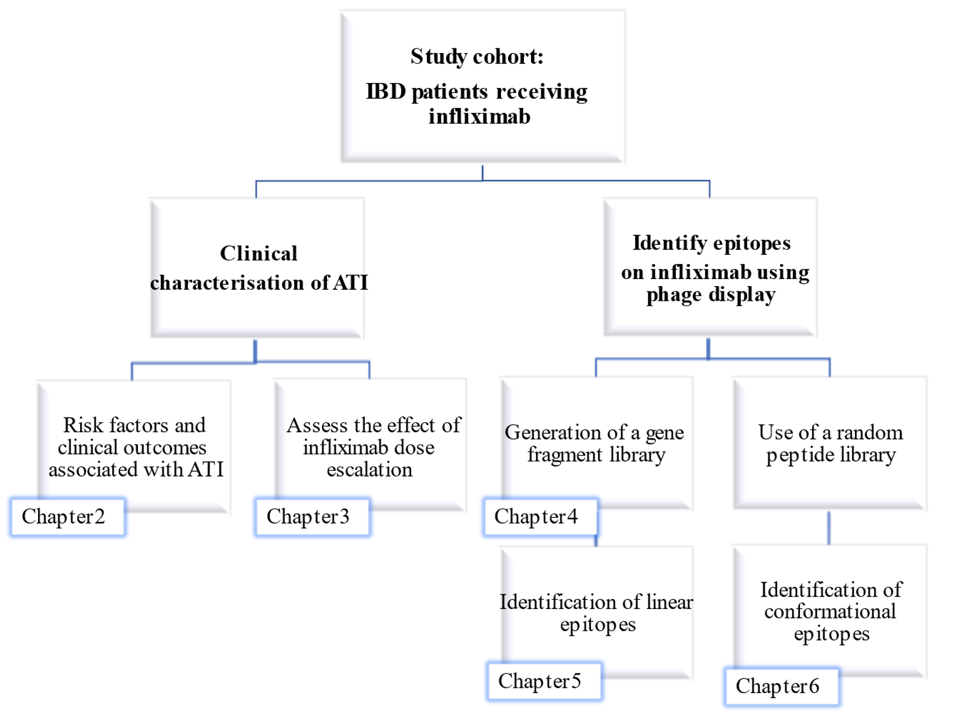
Figure 11. Workflow for the PhD.

Chapter 2: High prevalence of antibodies to infliximab and their relation to clinical outcomes in inflammatory bowel disease patients

This chapter has been published:
Tun, GSZ, Downey, R, Robinson, K, et al. High prevalence of antibodies to infliximab and their relation to clinical outcomes in inflammatory bowel disease patients. GastroHep.
2019; 1: 214– 222. https://doi.org/10.1002/ygh2.363.

Introduction
Infliximab, a chimeric, monoclonal IgG1 antibody to tumour necrosis factor‐α, is used to induce and maintain remission in inflammatory bowel disease. A target therapeutic window of 3‐7 mg/L has been suggested based on the association of response and remission with these levels ^{119,120}.

Antibodies to infliximab (ATI) can complicate treatment with infliximab and are associated with reduced drug levels, loss of response and infusion reactions though the association with the latter two outcomes is not consistent ^{121,131,143,144}. There is also considerable variation in the reported prevalence of ATI—between 10% and 74% ¹⁴³. This may reflect the differing dosing regimens, different rates of concomitant immunosuppression, genetic predisposition, use of different assays and the timing of ATI measurement ^{118–120,128,129}. In addition, the threshold for ATI positivity varies. It is determined by the assay used and may refer to the presence of ATI above a specified threshold or the presence of any detectable ATI ^{116,161,162}. Clarifying a clinically important threshold for positive ATI and the inconsistency of the association between ATI and clinical outcomes can create difficulties in the management of IBD patients with ATI.

This study aims to describe the risk factors for the development of ATI, their clinical implications and to clarify the association between ATI and clinical remission using a drug‐tolerant assay in a retrospective cohort of IBD patients at a large tertiary centre.

2.2 Materials and Methods

2.2.1 Patient population
From May 2016, patients receiving infliximab for IBD of Sheffield Teaching Hospitals IBD service underwent TDM comprising measurement of trough infliximab and ATI levels, prior to each infusion after the first. Infliximab was administered during induction as 5 mg/kg at 0, 2 and 6 weeks and continued every 8 weeks at 5 mg/kg for maintenance therapy.
Patients receive intravenous hydrocortisone 200 mg prior to each infliximab infusion.
During this period, all patients receiving infliximab were transferred to the biosimilar, CT-P13 (Remsima ®, Celltrion, South Korea), from the originator drug, Remicade (Janssen Biotech Inc, United States).

2.2.2 Clinical assessment
Clinical assessment using validated clinical scores: Harvey Bradshaw Index (HBI) ¹⁴⁰ for Crohn's disease and Simple Colitis Activity Index (SCAI) ¹⁴¹ for ulcerative colitis (UC) were documented at each infusion attendance. Additional patient contact including clinic review from clinical records were also taken into consideration e.g. in assessing for clinical response or relapse. Full blood count, urea and electrolytes, liver function tests, C‐reactive protein (CRP) and erythrocyte sedimentation rate (ESR) were measured at each infusion.

Remission was defined clinically and biochemically for CD as HBI ≤ 4 plus a C‐reactive protein ≤5 mg/L and defined clinically in UC as SCAI ≤ 4. Treatment failure was defined as ongoing or worsening of symptoms attributable to IBD, requiring alteration in treatment. Loss of clinical remission was defined in CD as HBI > 4 and/or raised CRP and in UC as SCAI > 4 or worsening of symptoms attributed to the IBD requiring an alteration in treatment. Patients with perianal disease were not included for ROC analysis of remission and loss of clinical remission as the clinical scores used are limited in their assessment of relapse of perianal disease. Patients were considered to have been exposed to immunosuppression if they had received thiopurines or methotrexate at any time during follow‐up.

2.2.3 Therapeutic drug monitoring (TDM)
At least 1 mL of whole blood was obtained using venesection in a serum separating tube. Serum was separated following centrifugation. 35 µL of the serum was used for TDM.

Trough infliximab levels
Briefly, IDKmonitor® Infliximab drug level ELISA (Immundiagnostik AG, Bensheim, Germany) detects free infliximab using a monoclonal anti-infliximab antibody ¹⁶³. Further incubation with peroxidase-labelled antibody with tetramethylbenzidine (TMB) as a substrate produced colour change directly proportional to the concentration of free infliximab in the sample. Trough infliximab levels were defined as undetectable if < 0.8 mg/L, subtherapeutic if 0.8-2.9 mg/L, therapeutic if 3-7 mg/L and supratherapeutic if >7 mg/L ¹²⁰.

Antibodies to infliximab
ATI was assessed using a drug tolerant assay, IDKmonitor® Infliximab total ADA (Immundiagnostik AG, Bensheim, Germany) ¹¹⁷. This total anti-drug antibody double bridging ELISA incorporates an immune complex dissociation step between ATI and Infliximab, allowing ATI to be assessed in the presence of the drug ¹¹⁷. Following complex dissociation, the ATI are free to bind to labelled infliximab: peroxidase conjugate infliximab and biotinylated infliximab ¹¹⁷. This ATI-labelled infliximab complex binds via biotin to the streptavidin coated microtiter plate and is detected via the peroxidase conjugate which leads to a colour change when TMB is added. Individual ATI readings were calculated: patient sample optical density X 10 / optical density of control (10 AU/mL). The cut-off control was established by diluting a sample, which was highly positive for ATI until no further linear dilution was possible. Using this cut-off, subsequent testing of sera from infliximab-naive patients confirmed 97.5% of patients to be negative for ATI. This was further confirmed by repeating this assessment in a local population as part of the laboratory accreditation. Positive ATI that resolved within two consecutive infusions were defined as transient.

2.2.4 Ethical approval
Ethical approval was granted by Sheffield Research Ethics Committee and the Health Research Authority (IRAS project ID 213480, 2016, STH reference 19459). Service improvement registration number 7520.

2.2.5 Statistical analyses
Shapiro-Wilk was used to assess normality of distribution for infliximab and ATI levels.
A binary logistic model was used to assess for factors associated with immunogenicity to infliximab. Fisher's exact test and chi square analysis were used to compare the rates of antibody positivity in patients at first maintenance dose of infliximab in regard to immunosuppressants use and previous infliximab exposure. It was also used to compare rates of treatment failure in those with positive and negative ATI at first maintenance dose and rates of infusion reaction in all infusions based on ATI status. Kaplan‐Meier analysis with Tarone‐Ware test was used to compare the effect of ATI status on cumulative survival free of loss of clinical remission. Receiver operator curve (ROC) analysis was used to determine sensitivity and specificity of ATI and infliximab levels to clinical remission. Microsoft Excel, GraphPad Prism and IBM SPSS statistics software were used for statistical analyses. 95% confidence intervals with p value $≤$ 0.05 were deemed statistically significant.

2.3 Results

2.3.1 Patient cohort
Between May 2016 and April 2017, 218 patients attended for infliximab infusions. Clinical data and TDM were available for 214 patients :136 with CD, 75 with UC and 3 IBD-unclassified. 61 patients were followed up from induction therapy (induction doses 1-3 onwards) and 153 patients during maintenance therapy (from or after dose 4). Summary of the patient cohorts included in this study is shown in Figure 12. 1107 TDM values with corresponding clinical data were available. 55 patients only had one TDM reading available, and infliximab was subsequently stopped due to loss of response (n=30), infusion reactions (n=2) and elective withdrawal for patients in clinical remission (n=23).
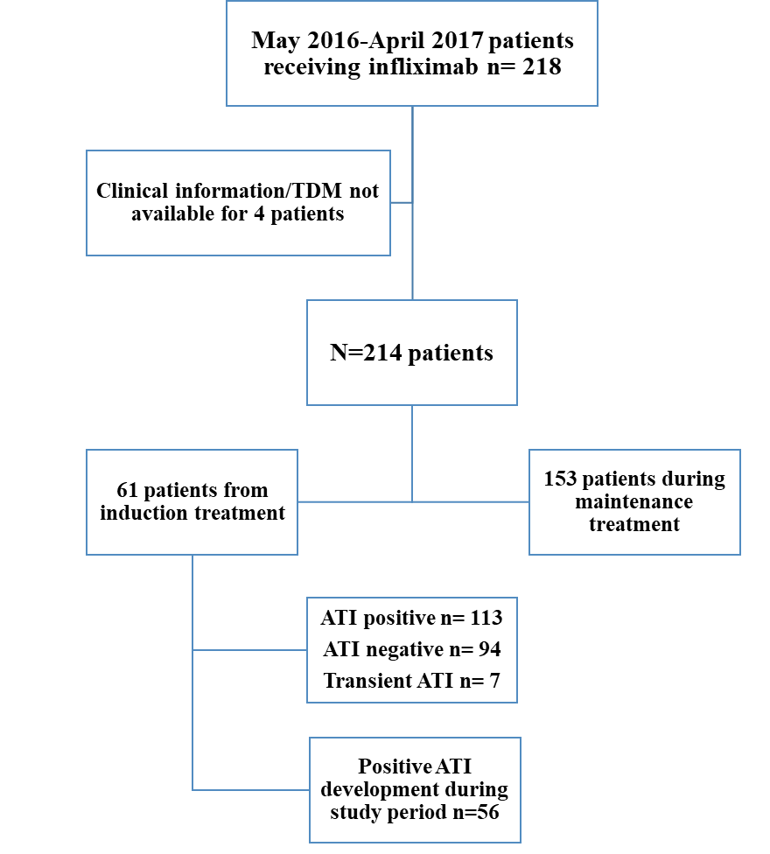
Figure 12. Summary of patient cohorts included in this study.

2.3.2 Prevalence of immunogenicity in patients with IBD
Over the study period 113/214 (53%) patients had positive ATI, 94/214 (44%) had negative ATI and 7/214 (3%) had transient ATI. Baseline demographics are shown in Table 2. 61/96 (64%) had positive ATI within 54 weeks of infliximab treatment. At 48-54 weeks of treatment, 17/33 (51%) had positive ATI.

Variable | Antibodies to infliximab status
Variable | Positive n=113 | Negative n=94 | Transient n=7
Male (%) | 68 (60) | 45 (48) | 4 (57)
Median age in years (range) | 36 (17-82) | 40 (17-82) | 49 (24-77)
Current smokers (%) | 14 (12) | 18 (19) | 0
IBD type (%):  Crohn’s disease  Ulcerative colitis  IBD-unclassified | 71 (63)  40 (35)  2 (2) | 61 (65)  32 (34)  1 (1) | 4 (57)  3 (43)  0
Concomitant immunosuppression (%):  Thiopurines  Methotrexate | 53 (47)  46  7 | 62 (66)  50  12 | 4 (57)  3  1

Table 2. Baseline demographics of study cohort (n=214).

2.3.3 Temporal development of ATI and risk-factors for ATI development
56 patients became ATI positive during the study period (Figure 13). Median time to ATI positivity was 38 weeks of infliximab treatment (range 2-310): 27 (48.2%) developed positive ATI within 6 months of treatment, 17 (30.4%) between 6-12 months and 12 (21.2%) beyond 12 months of treatment. Concomitant immunosuppression significantly protected against ATI development within the first 6 months of infliximab treatment. In the 12 patients who developed ATI beyond 12 months, 7 (58 %) were on immunosuppression and none had it stopped prior to developing ATI.

Figure 13. Time to development of antibodies to infliximab during infliximab treatment.
56 patients become ATI positive during the study period of May 2016-April 2017. Concomitant immunosuppression significantly protected against ATI development within the first 6 months of infliximab treatment.
(IS immunosuppression)

119/214 patients received concomitant immunosuppression (azathioprine n=84, mercaptopurine n=15 and methotrexate n=20). Both thiopurines and methotrexate were negatively associated with ATI positivity during follow-up: OR for thiopurines of 0.48 (95% CI: 0.253-0.912, p=0.02), and, for methotrexate, OR of 0.36 (95% CI: 0.134-0.965 p=0.04). A longer interval between infusions was significantly associated with ATI positivity (OR of 1.17 (95% CI: 1.095-1.259) for each added week, p=<0.01). Gender, smoking, body mass index or sub-type of IBD did not show a significant association to ATI positivity.

2.3.4 Chronological relation of ATI to infliximab levels
56 patients developed positive ATI during the study period. This was preceded by subtherapeutic drug levels in 32/56 (57%).17 (30%) developed subtherapeutic drug levels at the same TDM measurement as positive ATI and in 5 (9%), positive ATI preceded subtherapeutic drug levels (Figure 14). 2 patients had therapeutic drug levels at the same time as positive ATI- both had infliximab stopped within 8 weeks of TDM due to LOR.

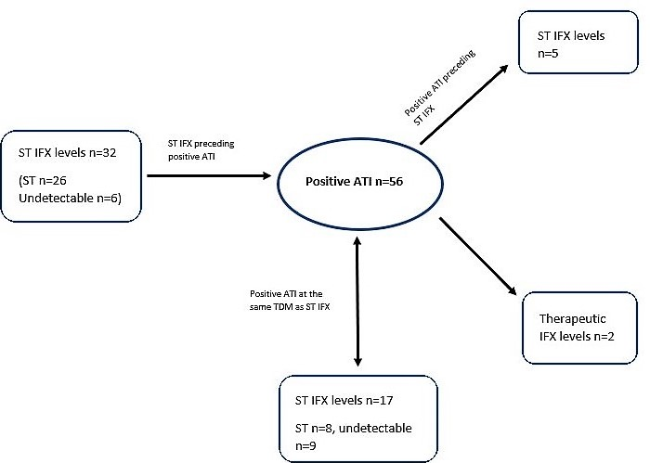

Figure 14. Chronology between antibodies to infliximab and infliximab trough levels.
56 patients developed positive ATI during the study period. Positive ATI was preceded by subtherapeutic drug levels in 32/56 (57%), 17/56 (30%) developed subtherapeutic drug levels at the same TDM measurement as positive ATI, and in 5/56 (9%) positive ATI preceded subtherapeutic drug levels. 2 patients had therapeutic drug levels at the same time as positive ATI- both had infliximab stopped within 8 weeks due to loss of response.
(ATI antibodies to infliximab, IFX infliximab, ST subtherapeutic)

2.3.5 TDM at first maintenance dose (Week 14)
TDM from dose 4, the first maintenance dose at week 14, was available for 50 patients (25 CD, 24 UC and 1 IBD-Unclassified) and is shown in Table 3. At week 14, 14/50 (28%) were positive for ATI. There was no significant difference in use of concomitant immunosuppression. However, those who had received previous infliximab were significantly more likely to have developed positive ATI at week 14 (5/14 compared to 1/36; OR 19.4, 95% CI: 2.01-187.94, p<0.01). Median infliximab trough level was significantly lower in those with positive ATI compared to those who were negative (0.9 mg/L v 1.7 mg/L; p=0.02). Of those with positive ATI, 10/14 (71%) were treatment failures by the second maintenance dose at 22 weeks (1 primary non-responder and 9 loss of response), compared to 10/36 (28%) in those with negative ATI (p<0.01).

Antibodies to infliximab status | Infliximab trough level (mg/L)
Antibodies to infliximab status | Undetectable  (<0.8) | Sub-therapeutic (0.8-2.9) | Therapeutic (3-7) | Supra-therapeutic (> 7) | Total
Positive | 6 | 8 | 0 | 0 | 14
Negative | 7 | 20 | 8 | 1 | 36
Total | 13 | 28 | 8 | 1 | 50

Table 3. Relationship between antibodies to infliximab status and infliximab trough levels at first maintenance dose n=50.
Therapeutic drug monitoring data from dose 4, the first maintenance dose at week 14.

2.3.6 The association between ATI and clinical outcomes
Excluding 34 patients with perianal disease, 164 patients (68 UC and 96 CD) on maintenance infliximab had corresponding data to categorise clinical remission and loss of remission. Patients were significantly more likely to lose clinical remission from time of first ATI positivity, or from first TDM if positive at first assessment, compared to those with negative ATI (p= 0.04) (Figure 15). Within 6 months follow up, patients with positive ATI had an OR of 4 (95% CI: 1.862-8.595) for losing clinical remission compared to those with negative ATI. The median infliximab trough concentration of those with positive ATI during IFX maintenance therapy was significantly lower at 1.3 mg/L compared to 2.0 mg/L in those with negative ATI (p<0.01).
Figure 15. The effect of antibodies to infliximab on time to loss of clinical remission.
164 patients on maintenance infliximab had corresponding data to categorise clinical remission and loss of remission. Patients with positive ATI were significantly more likely to lose clinical remission compared to those with negative ATI (p= 0.04).
(ATI: antibodies to infliximab)

Infusion reactions occurred significantly more in those with positive ATI (5/330 infusions) compared to those negative for ATI (1/777 infusions) (p<0.01). In the 5 ATI positive patients, median ATI level was 204 mg/L (range 11-614); 3 developed immediate reactions (all were receiving concomitant immunosuppression) and 2 were delayed (neither were receiving concomitant immunosuppression). 2/5 patients had received previous infliximab and one of these patients developed the only infusion reaction during induction therapy (dose 2). The patient with negative ATI was not receiving concomitant immunosuppression and developed a delayed infusion reaction.

2.3.6 Association of ATI levels with loss of clinical remission
723 ATI and infliximab levels from 162 IBD (90 CD, 72 UC) patients during maintenance therapy had corresponding data on clinical remission. Patients with data only during induction therapy and 37 patients with perianal disease were excluded. On ROC analysis, area under the curve indicated that ATI levels and not infliximab levels were associated with loss of remission as the latter had an AUC of 0.40 and 0.38 respectively for loss of remission within 8 weeks and 6 months.

An ATI level of 2.5 mg/L had a sensitivity of 0.78 and a specificity of 0.63 (AUC 0.63, p <0.001, 95% CI: 0.583-0.669) for loss of clinical remission within 8 weeks and a sensitivity of 0.76 and a specificity of 0.60 (AUC 0.62, p< 0.001, 95% CI: 0.574-0.669) for loss of clinical remission within 6 months. ROC by subtype of IBD is shown in Figure 16.
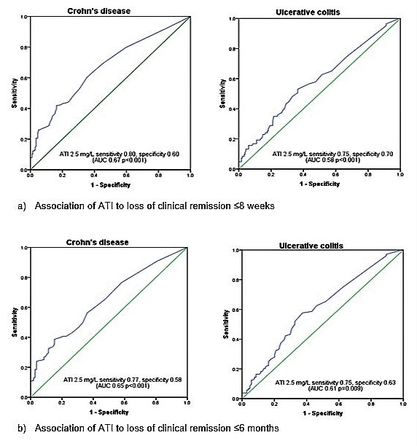
Figure 16. Receiver operator curve analysis of antibodies to infliximab threshold of 2.5 mg/L to a) loss of clinical remission ≤ 8 weeks and b) loss of clinical remission ≤ 6 months by IBD subtype: Crohn’s disease and ulcerative colitis.
(ATI: antibodies to infliximab)

2.4 Discussion

This study has described a substantial experience from a tertiary centre with key messages for clinical practice.

The main limitation of our study was that patients were at different points of infliximab treatment. In addition, 55 patients only had one TDM reading available, making it difficult to clarify if these patients had sustained or transient ATI. In reviewing the development of ATI, this was limited to the 56 patients who developed ATI during the study period. An additional limitation was that remission was defined clinically and biochemically and not endoscopically or histologically.

ATI were common, 60% of IBD patients receiving infliximab therapy were found to be ATI positive at any time during a 1-year study period. This is a much higher prevalence than reported rates of 3-22% in large randomised control trials of TDM ^{120,164} and 26-28% reported at week 54 in a large prospective observational study of CD patients using the same commercial assay for TDM ¹⁶⁵. Similar rates of immunosuppression was used in our cohort as in the prospective study. In contrast to our study, ATI were not assessed at every infusion and therefore ATI positivity may have been underestimated. Our cohort also included patients with UC, whereas the study of Kennedy et al included only those with CD.

By the time of the first maintenance dose, nearly a third of patients had developed positive ATI – associated with lower trough drug levels and a higher risk of rapid treatment failure by the second maintenance dose. A lower infliximab trough level and positive ATI post-induction have been associated with loss of response at long term follow ^{134,166}. However, our study indicates that treatment failure occurs rapidly in this group with early ATI formation and therefore TDM following induction therapy may be helpful in identifying such patients - who require prompt treatment alteration, especially in those who have received previous infliximab.

Median infliximab levels in both ATI positive and negative patients were subtherapeutic. This is in marked contrast to the lower rate of subtherapeutic levels seen in 30% in the TAXIT study ¹²⁰. Yet our findings are consistent with other real-world data. A prospective study - using the same assay as our centre - showed median subtherapeutic infliximab trough level of 0.9 ug/mL in 138 CD patients ¹⁶⁷. Another study reported that 52% of their IBD cohort had subtherapeutic drug levels ¹⁶⁸, using a lower threshold of < 2 µg/mL as subtherapeutic. Assays can vary in their detection of infliximab levels ¹⁶⁹ but this disparity should improve with the introduction of an international standard ¹⁷⁰.

We have also described here the late development of ATI. The risk of antibody development seems to be present throughout treatment with infliximab but is highest in the first 12 months of treatment as nearly 80% of patients developed ATI during this period. This agrees with previous findings that ATI most commonly occur within the first year of treatment ¹²⁹. However, 21% patients did develop ATI beyond 12 months of treatment, and in one patient, ATI developed at 77 months. The protective effect of thiopurines and methotrexate in ATI formation has been established ^{55,118,130,171,172}. Our study confirms that the benefit is seen in routine clinical practice with an OR for developing antibodies for thiopurines of 0.48 and 0.36 for methotrexate and suggests that concomitant immunosuppression may only be protective against ATI formation in the first 6 months of infliximab treatment. Beyond 6 months of infliximab treatment, the protective effect of concomitant immunosuppression on the development of immunogenicity is less clear. Two recent studies have shown that withdrawal of concomitant immunosuppression at beyond 6 months of combination therapy is not associated with an increased risk of relapse compared to continuation of combination therapy, though ATI were detected more frequently after immunosuppression withdrawal ^{173,174}.

In our cohort, using a drug tolerant assay, ATI were significantly associated with infusion reactions, a reduction in IFX levels and loss of clinical remission. 2 meta-analyses assessed ATI and their association to clinical outcomes ^{143,144}. Lee et al concluded that ATI was not associated with clinical remission ¹⁴³ and Nanda et al concluded that patients who were positive for ATI were 3.2 times more likely to lose response than those without ATI ¹⁴⁴. Observational studies not included in the meta-analysis have also shown that lower levels of ATI are an independent predictor of remission and the presence of sustained ATI is an independent predictor of loss of response ^{137,175}.

In conclusion, secondary LOR remains a significant problem in treating IBD. During infliximab treatment, a mechanism is the formation of ATI. Our study with serial TDM with a drug tolerant assay, shows a high prevalence of immunogenicity and subtherapeutic drug levels in IBD patients treated with infliximab, despite the use of a scheduled treatment regime and premedication with intravenous hydrocortisone. ATI are associated with clinically important outcomes: reduced infliximab levels, loss of clinical remission and infusion reactions.

Chapter 3: The effect of infliximab dose escalation in inflammatory bowel disease patients with antibodies to infliximab

This chapter has been published:
Tun GSZ, Robinson K, Marshall L, et al. The effect of infliximab dose escalation in inflammatory bowel disease patients with antibodies to infliximab. Eur J Gastroenterol Hepatol. 2022 Mar 1;34(3):295-301.

Introduction
Reported rates of secondary loss of response to infliximab vary depending on the definition but can be up to 50% at 12 months follow up ^{28,70}. This may occur due to an aggressive disease phenotype, disease complications such as strictures or fistulae, drug pharmacokinetics, or a combination of these factors ^{10,33,34}. Low circulating drug levels may occur due to ‘consumption’ in the inflammatory process, loss through the colon, FcR gene polymorphisms or immunologically mediated through the formation of anti-drug antibodies, which can increase the drug clearance ^{64,176–178}.

The availability of assays to measure drug levels and antidrug antibodies has enabled both proactive and reactive approaches to dosing regimens ^{161,164,179}. Infliximab dose escalation (DE) can be used as a treatment strategy either to proactively optimise drug levels or reactively when loss of response occurs. DE can be achieved by shortening the dose interval, giving a higher dose or a combination of both of these ^{164,179}. Although infliximab DE is included in guidelines ^{17,22}, formal long-term evaluation of a strategy of DE is limited, especially in the context of ATI status.

The aim of this retrospective study was to assess the effect of infliximab DE in IBD patients on drug level, ATI status and clinical response.

3.2 Materials and Methods

3.2.1 Patient population
All patients undergoing infliximab DE between April 2016 and August 2019 were included. Therapeutic drug monitoring consisting of trough infliximab and ATI levels were measured at each infliximab infusion following the initial infusion, in all patients receiving infliximab, from May 2016 at a large tertiary referral centre.

Infliximab was administered during induction as 5 mg/kg at 0, 2 and 6 weeks and continued every 8 weeks for maintenance therapy. DE comprised of:
1) Interval shortening: reduction in dose interval between maintenance infusions to less than 8 weeks,
2) Dose doubling: increase of infliximab to 10 mg/kg,
3) Combined dose escalation: combination of both interval shortening and dose doubling at each infusion or
4) Variable dose escalation: the use of interval shortening or dose doubling at different infusions.
Patients were included at specified time points if infliximab levels were available +/-1 week from that time point. Patients were dose-escalated both proactively whilst in clinical remission with subtherapeutic drug levels and reactively for loss of response.

3.2.2 Clinical assessment
Harvey Bradshaw Index (HBI) ¹⁴⁰ for Crohn’s disease and Simple Colitis Activity Index (SCAI) ¹⁴¹ for ulcerative colitis were documented at each infusion attendance. Additional patient contact including clinic review was also included in clinical assessment. Full blood count, urea and electrolytes, liver function tests, C-reactive protein (CRP) and erythrocyte sedimentation rate (ESR) were measured at each infusion.

Remission was defined clinically and biochemically for CD as HBI ≤4 plus a C-reactive protein (CRP) ≤ 5 mg/L and defined clinically in UC as SCAI ≤4. Loss of clinical remission was defined in CD as HBI >4 and/or raised CRP and in UC as SCAI >4 or worsening of symptoms attributed to the IBD requiring an alteration in treatment. ATI positive, following DE, were deemed to become sustained ATI negative (ATI ≤10 mg/L) if the ATI level remained negative for the duration of DE.

3.2.3 Therapeutic Drug Monitoring (TDM)
As outlined in Chapter 3, trough infliximab levels were assessed using IDKmonitor® Infliximab drug level ELISA (Immundiagnostik AG, Bensheim, Germany) ¹⁶³. Trough infliximab levels which were defined as undetectable if < 0.8 mg/L, subtherapeutic if 0.8-2.9 mg/L, therapeutic if 3-7 mg/L and supratherapeutic if >7 mg/L ¹²⁰. ATI was assessed using a drug tolerant assay, IDKmonitor® Infliximab total ADA (Immundiagnostik AG, Bensheim, Germany) ¹¹⁷, this is discussed in further detail in Chapter 3.

3.2.4 Ethical approval
Ethical approval was granted by Sheffield Research Ethics Committee and the Health Research Authority (IRAS project ID 213480, 2016, STH reference 19459). Treatment was part of routine clinical care. Service improvement registration number 7520.

3.2.5 Statistical analyses
Shapiro–Wilk was used to assess normality of distribution for infliximab and ATI levels.
Wilcoxon signed rank test with correction for multiple comparisons was used to assess paired infliximab and ATI levels pre-infliximab dose escalation to levels post dose-escalation as data was non-parametric. Receiver operated curve was used to assess the association between ATI
levels pre-DE and subsequent ATI negativity post-DE. Kruskal–Wallis with pair-wise analysis and correction for multiple comparisons was used to compare the efficacy of the different methods of DE on infliximab levels and Kaplan–Meier with Tarone–Ware test for the different methods of DE’s effect on clinical remission.

Microsoft Excel, GraphPad Prism and IBM SPSS statistics software were used for statistical analyses. 95% confidence intervals with P value ≤0.05 were deemed statistically
significant. Benjamini–Hochberg and Bonferroni correction was used to control for multiple comparisons false discovery rate.

3.3 Results

3.3.1 Patients
464 IBD patients were treated with infliximab between 2016 to 2019. 92 people (20%) underwent infliximab dose escalation. Summary of the patient cohort receiving dose escalation is shown in Figure 17.

51/92 were male; 50 had CD; median age was 33 (16-81) and 63 were receiving concomitant immunosuppression (Table 6). Infliximab was the first biologic for 70/92 patients. Of the 22 patients with prior biologic exposure, 13 had previously been treated with infliximab, 6 with adalimumab, 1 with vedolizumab, 1 with adalimumab and vedolizumab and 1 with infliximab, adalimumab, vedolizumab and ustekinumab. 54 had negative or transient ATI (median ATI levels 4 mg/L, range 1-9) and 38 had positive ATI (median ATI levels 31 mg/L, range 10-223). 59 patients were dose escalated for LOR (17 with positive ATI and 42 with negative ATI) and 33 proactively to optimise therapeutic drug monitoring levels. 87 people received DE for a median of 44 weeks (range 4-176). 5 stopped infliximab after a single further dose: 2 for LOR and 3 due to infusion reaction (IR).

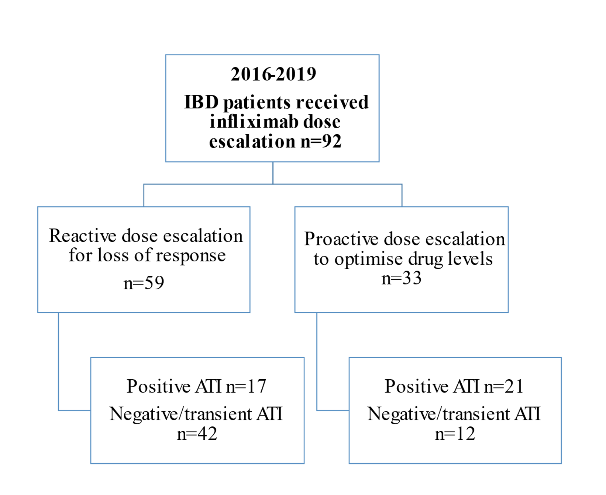
Figure 17. Summary of IBD cohort receiving infliximab dose escalation.
(ATI: antibodies to infliximab)

Variables | ATI > 10 AU/mL  (n=38) | ATI ≤ 10 AU/mL or transient (n=54) | P value
Male, number (%) | 21 (55) | 30 (56) | NS
Median age (range) | 34 (17-81) | 31 (16-71) | NS
Crohn’s disease, number (%) | 20 (53) | 30 (56) | NS
Previous infliximab, number (%) | 6 (16) | 8 (15) | NS
Reason for dose escalation, number (%):  Loss of response  Therapeutic drug monitoring | 17 (45)  21 (55) | 42 (78)  12 (22) | <0.01  <0.01
Immunosuppression,  number (%):  Thiopurines  Methotrexate | 22 (58)  16 (42)  6 (16) | 41 (76)  36 (67)  5 (9) | NS
Type of dose escalation,  Number (%)  Interval shortening  Dose doubling  Combined dose escalation  Variable dose escalation | 9 (24)  16 (42)  6 (16)  7 (18) | 11 (20)  16 (30)  11 (20)  16 (30) | NS  NS  NS  NS

Table 5. Demographic details of patient cohort receiving infliximab dose escalation.
(ATI: antibodies to infliximab, NS: non-significant)

3.3.2 The effect of DE on trough infliximab levels
Infliximab levels after DE were compared to paired pre-DE values in 87 patients who had more than 1 DE dose. DE significantly increased trough drug levels at subsequent follow-up to week 48 across the cohort. At baseline, median infliximab levels were 1.4mg/L and 0.9 mg/L respectively for patients with negative/transient ATI and positive ATI and these increased to 3.2 mg/L respectively at week 24, p <0.001;<0.001 (corrected for multiple comparisons) (Figure 18).

- b)
Figure 18. Median trough drug levels (error bars indicate the 25th-75th percentiles of the trough drug levels) following infliximab dose escalation in patients a) with ATI >10 AU/mL at baseline and b) with ATI ≤ 10 AU/mL at baseline.
At baseline, week 0, median infliximab levels were 1.4mg/L and 0.9 mg/L respectively for patients with negative/transient ATI and positive ATI. DE significantly increased trough drug levels at subsequent follow-up to week 48 for both cohorts. Patients remaining at each timepoint are shown at each stage.
*Indicates infliximab levels at this time point were significantly increased compared to baseline with correction for multiple comparisons (p <0.05)
(ATI: antibodies to infliximab)

3.3.3 The effect of infliximab dose escalation on ATI levels
ATI levels after DE were available for 35/38 (92.1%) patients with positive ATI. 21/35 (60%) ATI positive patients had a fall in ATI to below the positive threshold (ATI ≤10 AU/mL) at any point following DE. However, this was only sustained in 13 (22.9%) patients (median follow up 58 weeks, range 21-104). There was no significant difference in ATI levels before dose escalation between those who subsequently became ATI negative (n=13 median ATI 23 AU/mL, range 12-103) compared to those who remained ATI positive (n=22 median ATI 37 AU/mL, range 10-223). Figure 19 shows that median ATI levels in those with ATI > 10 AU/mL decreased after DE (corrected for multiple comparisons). ATI levels pre-DE in those with positive ATI poorly predicted subsequent ATI negativity after infliximab DE with an area under the curve of 0.56 (p=0.6, 95% CI 0.36-0.76).

Figure 19. Median antibodies to infliximab levels (error bars indicate the 25th-75th percentiles) following dose escalation in patients with positive antibodies (>10 AU/mL).
*Indicates antibodies to infliximab levels at weeks 16, 24, 40 and 48 of infliximab dose escalation were significantly decreased compared to baseline with correction for multiple comparisons (p<0.05)
(ATI: antibodies to infliximab)

3.3.4 The effect of infliximab dose escalation on clinical outcomes
33/92 (36%; 21 ATI positive and 12 ATI negative) patients were in clinical remission prior to DE. Following DE - at week 24 - 62/92 (67%) patients were in clinical remission (Figure 18). Of these 42/59 (71%) were recaptured following loss of response (11 ATI positive and 31 ATI negative or transient) and 20/33 (60%) were maintained in remission (11 ATI positive and 9 ATI negative or transient). Duration of clinical remission was numerically shorter in ATI positive patients (median 24 weeks, range 0-88) than in those with transient or negative ATI (median 36 weeks, range 0-126, p=0.06).

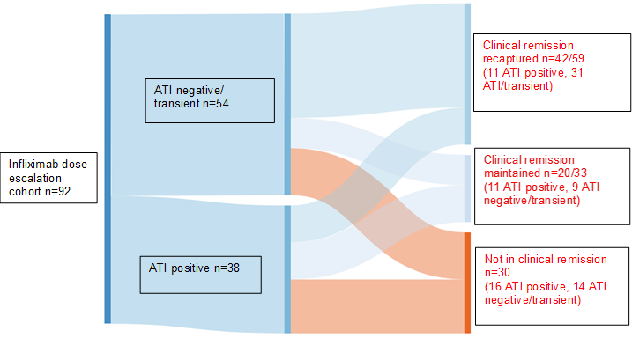
Figure 20. Sankey diagram to illustrate clinical outcomes of patients receiving infliximab dose escalation at week 24 based on initial ATI and clinical status.
33/92 (36%); 21 ATI positive and 12 ATI negative/transient patients were in clinical remission prior to dose escalation. Following dose escalation - at week 24 - 62/92 (67%) patients were in clinical remission: 21 ATI positive patients, 40 ATI negative or transient patients. Of the 62 in clinical remission at week 24, 42/59 patients were recaptured following loss of response and 20/33 were maintained in remission. Of those not in clinical remission, 16 were ATI positive and 14 were ATI negative or transient.
(ATI: antibodies to infliximab)

3.3.5 Comparison of the different methods of dose escalation
The different methods of DE were assessed for their effect on infliximab trough levels and clinical response. There was a significant difference in infliximab trough levels at week 24, those who received dose doubling to 10 mg/kg (median drug level of 2.5 mg/L, range 0.8-7.5) had lower drug levels compared to those who received combined dose escalation (median drug level of 5 mg/L, range 2.7-16.7). This same difference was mirrored in the ATI negative cohort but not in the ATI positive cohort (Table 6). There was a significant difference in duration of clinical remission between those receiving variable dose escalation and combined dose escalation with a decrease in time to loss of remission in the latter method (Figure 21). These results assessing the different methods of DE are significantly limited by the small number of patients in each group.

Type of infliximab dose escalation | Median infliximab trough levels
Type of infliximab dose escalation | Entire cohort (n=92) | ATI >10 AU/mL (n=38) | ATI ≤10 AU/mL or transient ATI (n=54)
Week 0  Interval shortening  Dose doubling  Variable DE  Combined DE  P value | 1.3  0.9  1.7  0.8  0.05 | 1.3  0.8  0.8  0.8  0.33 | 1.3  1.2  1.8  0.8  0.16
Week 4-8  Interval shortening  Dose doubling  Variable DE  Combined DE  P value | 3.7  2.1  2.7  2.3  0.28 | 2.6  3.1  1.7  2.0  0.77 | 3.8  2  2.7  3.5  0.17
Week 16  Interval shortening  Dose doubling  Variable DE  Combined DE  P value | 5.3  2.1  4.5  4.6  0.11 | 2.3  2.7  2.7  No values  0.92 | 7.2  1.9  6.1  4.6  0.05
Week 24  Interval shortening  Dose doubling  Variable DE  Combined DE  P value | 3.2  2.5*  2.8  5*  0.02* | 3.1  2.5  5.3  4.6  0.70 | 3.2  2.4*  2.7  5*  0.02*
Week 32  Interval shortening  Dose doubling  Variable DE  Combined DE  P value | 2.3  2.7  3.6  6.8  0.26 | 2.4  3.6  3.5  8.8  0.40 | 2.2  2.2  3.6  4.7  0.22
Week 40  Interval shortening  Dose doubling  Variable DE  Combined DE  P value | 3.6  3.1  2.5  1.2  0.65 | 3.7  4.7  3.9  No values  0.94 | 3.4  2.3  2.5  1.2  0.64
Week 48  Interval shortening  Dose doubling  Variable DE  Combined DE  P value | 3.2  2.5  2.3  5.2  0.61 | 4.3  4.5  4.6  9.4  0.45 | 3.1  2.6  2.2  4.3  0.70

Table 6. Comparison of infliximab trough level following different methods of dose escalation in patients with inflammatory bowel disease
P values are generated from comparing the infliximab trough levels at each time point from using the different methods of dose escalation: 1) Interval shortening: reduction in dose interval between maintenance infusions to less than 8 weeks, 2) Dose doubling: increase of infliximab to 10 mg/kg, 3) combined dose escalation: both interval shortening and dose doubling at each infusion and 4) variable dose escalation: the use of interval shortening or dose doubling at different infusions.
*Significant difference in infliximab trough level is noted at week 24 between dose doubling and combined dose escalation (p= 0.01) on pairwise analysis and correction for multiple comparisons.
(DE: dose escalation)

Figure 21. Time in clinical remission following different methods of infliximab dose escalation.
*Significant difference in duration of clinical remission between those receiving variable dose escalation and combined dose escalation with a decrease in time to loss of remission in the latter method despite correction for multiple comparisons p=0.01.

3.4 Discussion
Secondary loss of response to biological therapies remains a significant problem in the treatment of IBD. The role of DE for secondary loss of response to infliximab is not clear in people with ATI ^{161,179–181}. In particular, there remains a lack of long-term data with therapeutic drug monitoring following DE. This report describes the experience of infliximab DE in a large tertiary centre. Both proactive and reactive dose escalation was assessed, as both methods are used in clinical practice. DE was effective in significantly increasing trough drug levels to therapeutic levels in those with positive and negative ATI, reduced ATI in those above the threshold of 10 mg/L and maintained or recaptured remission in nearly 70% at 6 months post DE.

A limitation of the study was that both proactive and reactive dose escalation was assessed. Both methods are used in clinical practice, however, different drug pharmacokinetics may be present in these two groups affecting their response to DE. The effect of DE was not assessed separately based on whether proactive or reactive DE due the reduction in number of patients in the sub-groups. In addition, although patients were closely monitored and had a clinical review and CRP at every infusion, a limitation is that remission was not defined endoscopically or with routine faecal calprotectin assessment.

The best way to dose escalate in clinical practice remains unclear. In this study, assessment of the different methods of DE on drug levels and remission are limited by the small numbers in each group. In addition, selection bias will affect our results as it is very likely that the most aggressive method of DE: combined dose escalation using both interval shortening and dose doubling, would be used in those with very low drug levels and/or loss of response. Ultimately a randomised control trial assessing the different types of DE would aid in clarifying the most cost-effective method of infliximab DE.

In our cohort, following DE, all patients had TDM, CRP and clinical severity scores assessed at every infliximab infusion. Patients received pre-medication with intravenous hydrocortisone prior to each infliximab infusion, which may have reduced immunogenicity rates. A total anti-drug antibody assay was used as the aim was to identify all patients with ATI. At baseline, prior to DE, all patients had individual ATI levels assessed and 38/92 were above our assay’s threshold for ATI positivity (>10 AU/mL). In our cohort, infliximab DE was associated with an increase in drug levels up to week 48 compared to baseline in both those with positive and negative ATI. Previous studies have suggested that DE may not be effective in those with “high” ATI: above 481 ng/mL or 9 mcg/ml ^{179,180}. However, the use of different anti-drug assays in the literature creates difficulty in determining a clinically relevant threshold of ATI, which is generalisable. In our cohort, despite significant levels of ATI in the ATI positive group (median 32 mg/L, range 10-223) infliximab DE did lead to a significant increase in trough drug levels. It would have been of interest to review whether “grouping” patients into ATI levels affected their response to dose escalation. However, the number of patients in the ATI positive group limited this. Interestingly, infliximab levels post DE were higher for the ATI positive group. There was no significant difference in the different methods of DE used between the ATI positive and negative groups. However, significantly more ATI negative patients received DE for loss of response. The increased inflammation and circulating TNFα may have led to increased drug consumption, explaining the lower drug level in this group. More people were reactively dose escalated in in the ATI negative group as the combination of LOR and high ATI levels may have led to alternative management decisions such as switching to a different biologic as per clinical guidelines ¹⁷.

Our study shows that total ATI levels can reduce following DE. There was no significant difference in baseline ATI levels between those who became ATI negative and those who remained positive after DE. ATI levels in the former group ranged greatly - from 12-103 AU/mL. The lack of association between baseline ATI level in predicting ATI negativity following DE may be due to the small numbers but also suggests other factors may be more important. HLA genotype is associated with the development and persistence of anti-drug antibodies to TNF agents ¹²⁸. It is therefore also possible that these individuals will also respond less favourably to DE. There is also evidence that different types of antibodies to infliximab may be generated ^{33,159} and it may be that the different antibodies respond differently to DE.

Chapter 4: Generation of an infliximab Fab gene fragment phage display library

4.1 Introduction

Infliximab is composed of ∼ 30% murine derived amino acids at the variable Fab region with the rest of the antibody derived from human amino acids ⁵⁷. Its efficacy at inducing and maintaining remission for both UC and CD has been shown in large landmark RCTs and in clinical practice since it was licensed for use in IBD ^{27,53,55,66}. In addition, infliximab remains the only biological therapy licensed for use in acute severe UC, a life threatening medical emergency and it is an effective treatment for fistulating CD, a difficult to treat complication of CD ^{55,67}.

Infliximab biosimilars, CT-P13 (Inflectra® Hospira, UK and Remsima® Celltrion Inc., Korea) and SB2 (Flixabi® Samsung Bioepis, UK) received European marketing authorisation in 2013 and 2016 for all of the same licensing indications as originator infliximab, Remicade® (Janssen Biotech Inc., USA) ^{99,100}. Biosimilars are discussed in detail in section x. In summary, as infliximab biosimilars, both CT-P13 and SB2 have identical amino acid sequences to the licensed originator drug and studies have suggested comparable quality, efficacy, safety and immunogenicity ^{86,87,90–93,182}. The data is more robust for CT-P13- as the earlier biosimilar, including a systematic review of 24 studies and a RCT, which compared CT-P13 and originator infliximab use from induction, specifically in patients with IBD ^{94,95}. Despite the promising evidence of infliximab biosimilars, caveats remain regarding their use in IBD. Although high similarity is indicated between the primary and higher-order structures of CTP13 and SB2 to originator infliximab ^{86,87,182}, small differences in basic charge variants are present in SB2 ⁸⁶. Our knowledge on post-translational changes: enzymatic modifications that occur after translation, between administering originator and biosimilar drugs is also limited and should be taken into consideration in noting their structural similarities from studies ¹⁰¹. Limitations from clinical studies are that most are retrospective, data is extrapolated from their use in other conditions and that follow-up ≤1 year in all studies. The latter may impact on the observation of adverse outcomes, including immunogenicity, as this may require a large number of patients over many years.

As described in Chapter 2, ATI are common and are associated with differing clinical outcomes: loss of clinical remission, a reduction in infliximab drug levels and infusion reactions. It may be that the antigenic region/regions of infliximab are in the Fab fragment as this contains the murine and variable regions of the therapeutic monoclonal antibody. In addition, binding of antibodies to the CDRs, would prevent infliximab from binding to soluble and transmembrane TNFα. This would explain the association of ATI with loss of clinical remission.

Phage display allows screening with a known antigen or antibody to identify biomarkers, select high affinity antibodies for production of monoclonal antibodies and functional epitope mapping^{105,153–155}. Affinity selection or biopanning involves incubation of the phage library with a known protein to allow binding of specific phage variants, washing to remove non-binding phage and elution to identify selected phage variants. Repeated cycles of amplification (growth of the selected phage variants), re-selection and elution aim to reduce non-specific binding and enrich selection of desired clones ^{105,154}.

Phage display libraries can be considered in terms of random peptide libraries (RPL) and gene fragment libraries (GFL) ^{97,172}. RPL are large diverse libraries of unique random peptide sequences made from synthetic oligonucleotides. They can be used for identifying a wide range of protein-protein interactions including the identification of mimotopes - peptide sequences that mimic conformational epitopes ^{105,153,158}. A GFL contain phage with different DNA fragments of an individual gene and therefore is much smaller but specific for a particular selection ^{105,154}.

Generation of an infliximab GFL will provide the basis to identify linear epitopes on infliximab. The aim of this work was to generate a gene fragment phage display library of the infliximab Fab. In doing so, I will undertake a strategy to clone sonication generated gene fragments of the infliximab Fab into a pIII phagemid vector, assessing optimal conditions for ligation.

4.2 Materials and Methods

4.2.1 Polymerase Chain Reaction (PCR) amplification of infliximab Fab gene
Separate PCR amplification of infliximab light chain in pIDT smart vector and infliximab Fab heavy chain in pIDT smart vector (Integrated DNA Technologies, Leuven, Belgium) was performed using domain specific primers (Table 7) with Phusion Flash High-Fidelity PCR Master Mix (ThermoFisher Scientific, Massachusetts, United States) and Expand High Fidelity PCR System (Merck, Darmstadt, Germany). Using Phusion, 14 PCR reactions of 50 µL samples: 19 µL of H20, Phusion mix 25 µL, 2.5µL of forward primer, 2.5 µL of reverse primer and 1 µL (2 ng) of infliximab DNA using annealing temperatures of 61.2°c for heavy chain primers and 60.2°C for light chain primers to obtain 197 ug of PCR products. Using High-Fidelity, 14 PCR reactions of 50 µL: 1 uL of dNTP, 1 µL forward primer, 1 µL of reverse primer, 1 µL (2 ng) of infliximab DNA, 5 µL of PCR buffer, 0.75 µL of enzyme mix and the rest of the volume made up with water to obtain 150 µg of PCR products.

Primers | Primer sequence
Infliximab light chain Forward (5’ to 3’) | GATATTTTGTTGACTCAATCTCCAGCT
Infliximab light chain Reverse (5’ to 3’) | ACATTCACCTCTATTAAAAGATTTAGT
Infliximab heavy chain Fab Forward (5’ to 3) | GAAGTTAAATTGGAAGAATCTGGTGGT
Infliximab heavy chain Fab Reverse (5’ to 3’) | TGGTTCAACTTTTTTATCAACTTTAGT

Table 7. Domain specific primers used for separate PCR amplification of infliximab light and infliximab Fab heavy chain.

4.2.2 DNA purification of infliximab light and Fab heavy chain
After PCR amplification of the infliximab light and Fab heavy chain, the DNA products were combined and purified using the QIAquick PCR purification kit (Qiagen, Hilden, Germany) as per manufacturing instructions. Briefly, 10 reactions of 25 µL of PCR products were added to 125 µL of buffer PB and mixed. The samples were added to a QIAquick column in a 2 ml collection tube and centrifuged for 30-60 seconds. Flow through was discarded and the QIAquick column washed using Buffer PE, centrifuged for 30-60 seconds and the flow through discarded again. QIAquick column was centrifuged for a further minute to remove residual buffer. The QIAquick column was placed in a clean 1.5 mL microcentrifuge tube, 50 µL of elution buffer was applied to the membrane, left to stand for 1 minute and then centrifuged. 50 µg of infliximab DNA was eluted.

4.2.3 Production of infliximab Fab gene fragments
Using sonication (MSE Soniprep 150, London, United Kingdom), different conditions were assessed to determine optimum conditions for digestion of the infliximab light chain and heavy chain Fab. Sonication was undertaken using different amplitudes of 5 µM or 10 µM, DNA concentration of 1 or 2 µg in 100 µL of nuclease free H20, sonication time of 0-13 minutes with varying time stops using cycles of 1 minute of sonication with 30 seconds or 1 minute of cooling with ice were assessed. Conditions assessed are shown in table 8.

Conditions | Variables
Time period of sonication | 1 minute intervals from 1-13 minutes
Time stops | 30 second or 1 minute of cooling with ice between sonication
Amplitudes | 5 µM or 10 µM
DNA concentration | 1 or 2 µg in 100 µL of nuclease free H20

Table 8. Sonication conditions assessed in digestion of infliximab light chain and heavy chain Fab.

Post sonication, infliximab DNA fragments were converted from 5´or 3´overhangs to compatible blunt-ended 5´phosphorylated DNA using Quick Blunting™ Kit (New England BioLabs, Massachusetts, United States). 3.2 µg DNA was combined with 2.5 µL of blunting buffer, 2.5 µL of dNTP mix, 1 µL of blunt enzyme mix and incubated at room temperature for 30 minutes and then at 70°c for 10 minutes to inactive the enzymes (New England BioLabs, Massachusetts, United States). The blunt-ended DNA fragments were then purified using the QIAquick PCR purification kit (Qiagen, Hilden, Germany), as described above in 5.2.2.

4.2.4 Preparation of phagemid vector
PIII phagemid vector pNIBS1 was designed and constructed in-house at National Institute of Biological Standards and Control (Figure 22) ¹⁸³. 4 µg of pNIBS1 was digested with 2 µL (40 units) of SmaI (New England BioLabs, Massachusetts, United States) in an overall volume of 50 µL including Cutsmart buffer and water. Four reactions were incubated for 1 hour at 25°c.
Gel electrophoresis confirmed a linearised vector post blunt-end SmaI digestion (Figure 23). Phagemid DNA was purified using Monarch plasmid miniprep kit (New England BioLabs, Massachusetts, United States). DNA was diluted at a ratio of 1:5 with binding buffer, sample loaded onto column in a collection tube and centrifuged for 1 minute. Flow through discarded and 200 µL of wash buffer added and centrifuged twice. The column was transferred to a clean collection tube and centrifuged again. 15 µL of elution buffer was added to the column and left to stand for 1 minute and then centrifuged. 9 µg of phagemid DNA was eluted. Phagemid DNA was dephosphorylated using Antarctic Phosphatase (New England BioLabs, Massachusetts, United States), a heat labile phosphatase. 1 pmol of DNA ends (calculated based on the size of the vector using https://nebiocalculator.neb.com/#!/dsdnaends) was combined with 5 µl (2 units) of Antarctic Phosphatase, reaction buffer and ultrapure H20 to an overall volume of 20 µL for 30 minutes at 37°C and then heat deactivated for 2 minutes at 80°C.

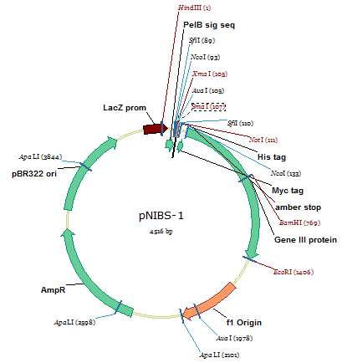
Figure 22. Diagrammatic representation of a pNIBS-1 phagemid vector.
The pNIBS-1 phagemid vector comprises of 4516 base pairs. Important components of the phagemid vector includes: pBR322 origin of replication for a plasmid, f1 origin of replication for the filamentous phage, genetic markers (AmpR: ampicillin resistance gene and LacZ: gene for β-galactosidase, which allows bacterial cells to transport and metabolise lactose), PelB signal sequence (which directs the peptide of interest to secretory pathways), phage coat protein (GeneIII) for fusion of the gene fragment of interest, intergenic region, molecular tags (HIS, cMyc) and the amber stop codon TAG. Additional annotations are the recognised sites of restriction enzymes.
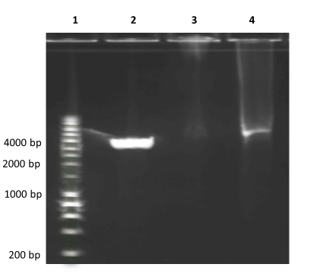
Figure 23. Gel electrophoresis of pNIBS-1 phagemid vector after SmaI digestion.
Lane 1 is 1 kb Bioline DNA ladder, lane 2 shows SmaI digested linearized pNIBS-1 vector of
4516 base pairs and lane 4 the same vector pre-SmaI digestion.
(bp: base pairs)

4.2.5 Construction of infliximab Fab gene fragment library
Test ligations assessed different condition for efficient ligation using 1) dephosphorylated digested vector 2) dephosphorylated digested vector and SrfI restriction enzyme and 3) different vector:insert ratios. Using 20 µL volumes, the digested vector was combined with infliximab fragments, T4 buffer, T4 ligase (New England BioLabs, Ipswich, Massachusetts, United States) +/- SrfI (Agilent Technologies, California, United States). A control of digested dephosphorylated vector only with no infliximab fragments was used to assess for self-ligation. The ligation reagents were incubated for 16 hours at 16 °c and deactivated by further incubation at 10 minutes at 65°C. The ligated reactions were purified (Monarch PCR and DNA clean up kit; New England BioLabs, Massachusetts, United States). Each ligation product was eluted in 6 µL buffer.

Transformation of Escherichia. coli (E. coli)
The products of the ligation reactions were transformed into TG1 E. coli (Agilent Technologies, California, United States) using electroporation of 1700 volts. After electroporation, the cells were immediately regenerated in 950 µL of S.O.C. medium (Super Optimal broth with Catabolite repression: a nutrient rich bacterial culture medium) and incubated for 1 hour at 37°C with shaking 225-250 rpm. The transformed E. coli were plated onto 2 x YT (Yeast Extract Tryptone) carbenicillin containing agar plates overnight at 37°C.

Production of large-scale phage display library
After identifying optimal ligation conditions, the reaction was repeated in 10 x 20 µL volumes to produce a large-scale library.

4.2.6 Analysis of phage clones
PCR and colony PCR were used in assessing optimal ligation conditions and in screening and
sequencing of the large-scale library. For PCR, QIAprep Spin Miniprep kit (Qiagen, Hilden,
Germany) was used for DNA extraction. For colony PCR, individual colonies were picked
with a sterile pipette. For both, template DNA was combined with 0.5 µL of 10 µM forward primer, 0.5 µL of 10 µM reverse primer, 2.5 µL of 10 x ThermoPol reaction buffer, Taq DNA Polymerase (New England BioLabs, Massachusetts, United States) and nuclease free water made up to 25 µL volume. 30 cycles of PCR were completed. Amplification of the vector: pNIBS1 without a foreign insert resulted in 181 base pairs. Using gel electrophoresis, clones producing fragments greater than 181 base pairs were considered as recombinants. DNA sequencing of individual colonies from the large-scale library was assessed using pairwise sequence alignment on Vector NTI (ThermoFisher Scientific Massachusetts, United States).

4.2.7 Summary of the generation of the infliximab Fab GFL
Figure 24 summarises the methodology used in the generation of the infliximab Fab GFL

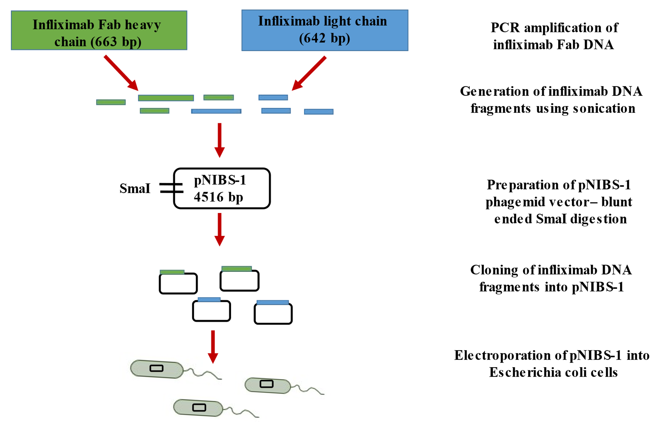

Figure 24. Diagrammatic summary of the generation on the infliximab Fab GFL.
Using domain specific primers, PCR amplification of the infliximab Fab heavy chain and light chain was performed. After DNA purification, the infliximab genes were fragmented using sonication with different conditions to identify optimal fragmentation. PIII phagemid vector pNIBS1 was prepared with blunt-end SmaI digestion and then purified. The infliximab Fab fragments were cloned into the phagemid vector after assessment of different conditions for efficient ligation using 1) dephosphorylated digested vector 2) dephosphorylated digested vector and SrfI restriction enzyme and 3) different vector:insert ratios. The ligation reactions were transformed into Escherichia coli cells using electroporation of 1700 volts.

4.3 Results

4.3.1 Production of infliximab Fab gene fragments
PCR amplification of the infliximab fab heavy chain and light chain were confirmed on gel electrophoresis (Figure 23). Sonication of the PCR products at 5 µM amplitude, 200 µl volumes (1µg DNA in 100 µL of nuclease free H2O) for 6 minutes and above led to full digestion and produced DNA fragments up to 400 base pairs (~up to 130 amino acid length peptides) (Figure 25).
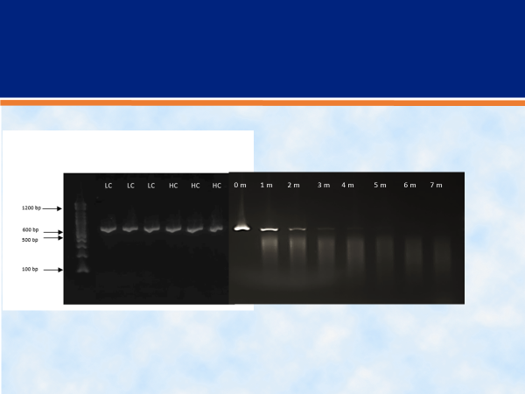

Figure 25. Gel electrophoresis to confirm PCR amplification of infliximab light chain (LC) and Fab heavy chain (HC) with DNA digestion using sonication at different time stops (0-7 m).
Infliximab fab heavy chain is 663 base pairs and infliximab light chain 642 base pairs. Post PCR, DNA was combined. Column 0 m - 7 m (0-7 minutes) confirm DNA digestion using sonication at different time stops.
(LC: light chain, HC: heavy chain fab, bp: base pairs, m: minutes)

4.3.2 Construction of infliximab Fab gene fragment library
Dephosphorylated vector and SrfI restriction enzyme with vector:insert ratio of 1:3 was the most effective at transformation (Table 9). This reaction was repeated in 10 x 20 µL volumes to transform TG1 cells by electroporation to obtain a library of 2.9 x 10⁵. Amplification of the vector only pNIBS1 without a foreign insert was 181 base pairs. Using gel electrophoresis, clones producing DNA fragments greater than 181 base pairs were considered as recombinants. Colony PCR of 20 colonies showed 15/20 (75%) had an insert (Figure 26). On colony PCR, insert size ranged from ~100-400 base pairs.

Number of colonies | D pNIBS1 V:I ratio 1:3 | D pNIBS1 V:I ratio 1:5 | D pNIBS1 V:I ratio 1:20 | D pNIBS1  + SrfI  V:I ratio 1:3 | D pNIBS1 + SrfI  V:I ratio 1:5 | D pNIBS1 + SrfI  V:I ratio 1:20 | D pNIBS1 vector only
Neat | Blank | 60 | Blank | >1000 | >1000 | >1000 | ~1000
-1 | Blank | 7 | Blank | 312 | 320 | 208 | 130
-2 | Blank | Blank | Blank | 54 | 32 | 32 | 10

Table 9. Transformation results following different ligation conditions: 1) dephosphorylated digested pNIBS1 vector (D pNIBS1), 2) dephosphorylated digested pNIBS1 vector (D pNIBS1) and SrfI restriction enzyme using different vector: insert ratios.
Highlighted column indicates that dephosphorylated vector and SrfI restriction enzyme with vector:insert ratio of 1:3 was the most effective at transformation.
(D pNIBS1: dephosphorylated pNIBS1 vector, V:I: vector: insert)

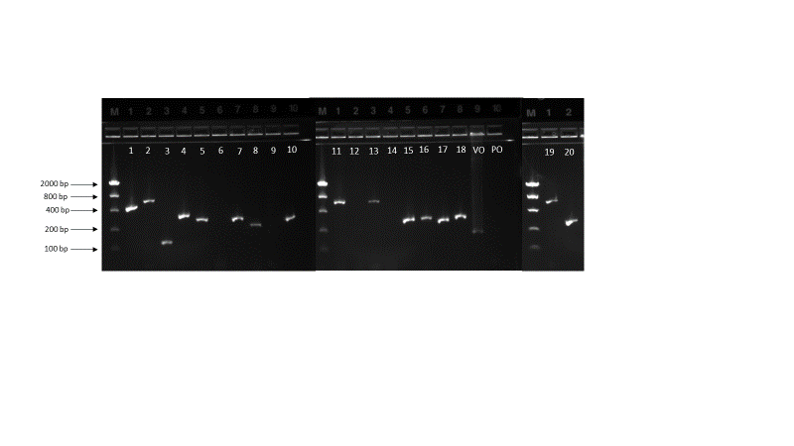

Figure 26. Colony PCR of 20 clones from the large-scale infliximab fab gene fragment library.
Amplification of the vector pNIBS1 without a foreign insert is 181 base pairs as shown by VO (vector only) column on the gel electrophoresis. 15/20 (75 %) of the selected colonies have an insert, with insert size ranging from ~100-400 base pairs after taking into consideration vector size.
(VO: vector only, PO: primers only)

4.3.3 DNA sequencing
Colonies selected for colony PCR were DNA sequenced. Of 12 sequenced, 3 sequences aligned to infliximab light chain nucleotides sequence and 5 to infliximab heavy chain nucleotide sequence (Table 10). There was no insert present on one of the sequences. 3 inserts (sequence 9-11) did not illustrate an exact match to infliximab heavy or light chain but did show a close partial match to infliximab heavy chain nucleotide sequences. None of the sequences were in frame which is not unexpected with the number of colonies sequenced. The median nucleotide sequence was 110 nucleotides (range 52-275), median amino acid sequence was 37 residues (range 17-92).

Colony sequenced | Infliximab chain aligned to | Position on nucleotide sequence
1 | Light chain | 547-643
2 | Heavy chain | 326-460
3 | Light chain | 527-642
4 | Light chain | 3-116
5 | Heavy chain | 612-664
6 | Heavy chain | 389-664
7 | Heavy chain | 3-110
8 | Heavy chain | 577-664
9 | Heavy chain (partial match of sequence) | 175-334
10 | Heavy chain (partial match of sequence) | 148-260
11 | Heavy chain (partial match of sequence) | 100-286

Table 10. DNA sequencing of randomly selected colonies from infliximab Fab gene fragment library.
Of the 12 colonies sequenced, three sequences aligned to infliximab light chain and five to infliximab heavy chain nucleotide sequence (Table 10). Sequences 9-11 did not illustrate an exact match to infliximab heavy or light chain but did show a close partial match to infliximab heavy chain nucleotide sequence. The median nucleotide sequence was 110 nucleotides (range 52-275), median amino acid sequence was 37 residues (range 17-92).

4.4 Discussion
Phage display is a systematic method due to the repeated cycles of biopanning with washing, elution and amplification. Its ability to identify protein-protein and high affinity antigen-antibody interactions lends itself to functional epitope mapping- the identification of amino acids involved in the binding interaction between an epitope and paratope. However, it has rarely been used to identify epitopes to anti-drug antibodies ¹⁶⁰.

My phage display library was designed to focus on the Fab fragment of infliximab, which, as the variable murine region, was thought to contain the antigenic region or regions to which ATI form. The size of the library was 2.9 x 10 ⁵ clones: a large library in relation to the size of the genome of interest: infliximab Fab genome, which is 1305 base pairs. Colony PCR of 20 colonies showed 15/20 (75%) had an insert when compared to vector only DNA. This is an adequate insert ratio, as considering 1) the size of the infliximab Fab genome, 2) the length of the infliximab fragments, and 3) the overall size of the library, the genome will still be represented 1000 fold. By using a theoretical formula: Clarke and Carbon equation, 4000 clones are needed to ensure representation of the genome of interest ^{184,185}. Of the 12 random colonies, from which DNA was sequenced, eight showed exact alignment of the whole insert to either infliximab light or Fab heavy chain. For the three inserts which showed a partial match to infliximab Fab heavy chain, this would suggest that sonication generated some very short fragments, and that during ligation, multiple gene fragments may have been inserted into the phagemid vector.

In this chapter, I have described how I generated an infliximab Fab gene fragment phage display library. I have described a strategy to assess optimal conditions to clone sonication generated gene fragments of the infliximab Fab into a pIII phagemid vector. I have utilised Antarctic Phosphatase, a heat labile phosphatase that can be deactivated with high temperature and SrfI restriction enzyme to reduce self-ligation. The generated infliximab Fab gene GFL was to be used to identify linear B cell epitopes to which ATI form and bind to. However, a novel infliximab full GFL with cloned overlapping in-frame fragments of the whole infliximab peptide was developed. Due to all DNA fragments being in-frame, this would increase the likelihood of linear epitope selection and this, therefore, this was used.

Chapter 5: The identification of infliximab linear epitopes using an novel gene fragment phage display library

5.1 Introduction
This thesis has demonstrated that anti-drug antibodies during infliximab treatment are associated with reduced drug levels, loss of clinical remission and increased risk of infusion reactions. In addition, some patients with anti-drug antibodies appear to remain clinically stable with trough drug levels that remain within a therapeutic range. Anti-drug antibodies detected in commercial assays are therefore associated with differing clinical outcomes. The association of differing clinical outcomes with ATI could be potentially explained by the presence of ATI that bind to different epitopes: different phenotypes of ATI.

Phage display allows the identification of protein-protein interactions including functional epitope mapping. By using an infliximab GFL, a phage display library comprising thousands of phage variants containing DNA fragments of the infliximab gene and displaying the corresponding infliximab peptides, we can identify linear epitopes on infliximab using sera from patients with ATI.

In chapter 5, I presented my methodology for producing an infliximab Fab GFL. The Fab region was focused upon as it contains murine amino acids and was deemed to be the most antigenic region. However, after consideration, I wanted to utilise an infliximab whole GFL as the different clinical phenotypes seen with ATI could suggest epitopes outside of the Fab region. Therefore, a novel infliximab whole GFL with produced using synthesised overlapping in-frame infliximab gene fragments. Due to all the DNA fragments being in-frame, this would ensure all the phage variants in the library displayed infliximab peptides and increase the likelihood of successful of linear epitope selection.

The aim of this study was to use an infliximab gene fragment phage display library to identify linear epitopes in IBD patients treated with infliximab. Patients with ATI with different clinical outcomes would be included to identify clinically relevant linear epitopes.

5.2 Method

5.2.1 Patients
From May 2016, patients receiving infliximab for IBD of Sheffield Teaching Hospitals IBD service underwent therapeutic drug monitoring (TDM) comprising measurement of trough infliximab and ATI levels, prior to each infusion after the first. Infliximab was administered during induction as 5 mg/kg at 0, 2 and 6 weeks and continued every 8 weeks at 5 mg/kg for maintenance therapy. During this period, all patients receiving infliximab have been transferred onto the biosimilar, CT-P13 (Remsima ®, Celltrion, South Korea), from the originator drug, Remicade (Janssen Biotech Inc, United States).

IBD patients receiving infliximab were identified using the biologic database of IBD patients (a database of all IBD patients receiving biologics). Patients who were ATI positive were identified as possible candidates for storage of sera for selection of B cell epitopes on infliximab. An information leaflet and consent forms (Appendix 2 and 3) were sent to the patients at least 24 hours before enrolment. At their attendance for the infliximab infusion, the research was explained by the researcher, and questions answered before written consent was gained. Three copies of the consent form were completed: one for the patient to keep, one for the patient’s notes and one to be kept on file by for possible inspection by the regulatory authorities.

Patients were prospectively followed up and carefully clinically phenotyped based on TDM and clinical assessment into the clinical outcomes of subtherapeutic infliximab levels, therapeutic/supratherapeutic infliximab levels, loss of response and adverse drug reaction (Table 11).

Clinical phenotype of antibody positive patients | Definition
Reduced therapeutic drug levels | Below target therapeutic levels (< 3 mg/L)¹⁶¹
Therapeutic/supratherapeutic drug levels | Within and above therapeutic levels (≥ 3 mg/L)¹⁶¹
Loss of response | Previous clinical response, but now loss of response with consideration of change in medication (including reduction in dose interval or increase in infliximab dose)
Adverse reaction | Immediate: during or within 1 hour of completing infusion requiring slowing or cessation of infusion e.g. rash, wheezing, anaphylaxis.  Reported serum sickness type reaction e.g. arthralgia, jaw pain, fever.

Table 11. Definition of the clinical phenotypes of patients’ sera used for selection of B cell epitopes.

5.2.2 Clinical assessment
This is discussed in 2.2.2.

5.2.3 TDM
This is discussed in 2.2.3.

5.2.4 Blood samples for epitope mapping
After informed consent, at least 1 mL of whole blood was collected from patients prior to their infliximab infusion. Serum was separated following centrifugation. 35 µL of the serum was used for TDM and the remaining sample was stored for epitope mapping at 20-40°c.

5.2.5 Study cohort
Sera from eight antibody positive IBD patients with different clinical outcomes were pooled for selection. The clinical details of the 8 patients are shown in Table 12. Sera was chosen from patients with different clinical outcomes as the aim was to identify epitopes associated with different clinical outcomes in IBD patients.

Patient | IBD sub-type | Concomitant immunosuppression | Infliximab dose number | ADA level (mg/L) | Infliximab level (mg/L) | Clinical phenotype
1 | Crohn’s disease | None | 110 | 17 | 4.6 | In response with therapeutic infliximab levels
2 | Crohn’s disease | Azathioprine | 6 | 167 | <0.8 | Loss of response
3 | Ulcerative colitis | Mercaptopurine | 5 | 124 | 0.9 | Loss of response
4 | Ulcerative colitis | None | 5 | 142 | 0.8 | Loss of response
5 | Crohn’s disease | Azathioprine | 6 | >600 | <0.8 | Adverse drug reaction
6 | Ulcerative colitis | Azathioprine | 17 | 177 | 0.8 | In response with subtherapeutic infliximab levels
7 | Crohn’s disease | Azathioprine | 18 | 156 | 0.9 | In response with subtherapeutic infliximab levels
8 | Ulcerative colitis | None | 5 | 93 | 1.7 | In response with subtherapeutic infliximab levels

Table 12. Clinical details of antibody to infliximab positive IBD patients used for pooled serological selection.

5.2.6 Construction of infliximab designer full gene fragment phage display library
~400 infliximab in-frame gene fragments (38 amino acid length infliximab peptides plus primer) with overlapping amino acids were generated (Twist Bioscience, California, United States) to produce a sliding window of in-frame gene fragments that moved along the infliximab sequence. The DNA was amplified using PCR and modified to allow in-frame sequencing with gene III on the phagemid vector and purified.

Post modifications, next generation sequencing (NGS) was performed in-house at NIBSC. NGS allows parallel sequencing of up to millions of small fragments of DNA ^{186,187}. These individual sequences can then be mapped onto the reference genome of interest using bioinformatic tools ^{186,187}. Infliximab designer full GFL phagemid DNA was extracted from E. coli cultures to obtain template DNA for NGS. PCR of the DNA was performed, the resulting PCR products purified, multiplexed and ran on the Illumina MiSeq (Illumina, San Diego, United States) according to the manufacturer’s protocol.

PIII phagemid vector pNIBS1 ¹⁸³ (designed and constructed in house at National Institute of Biological Standards and Control) was digested with SmaI (New England BioLabs, Massachusetts, United States),) and purified. The infliximab fragments were ligated into pNIBS1. The ligation mixture was used to transform E. coli TG1 cells (Agilent Technologies, California, United States) by electroporation to obtain two libraries of > 10⁶, which were combined.

5.2.7 Serological selection of infliximab phage display libraries
Sera from the 8 antibody positive patients as shown in Table 12 were pooled for biopanning of the infliximab designer full gene fragment phage display library.
10 µL of phage library stock was used for each round of selection. The library was packaged using Hyperphage as the helper phage^{188,189}. Hyperphage has a deletion in the pIII gene ensuring there is no wild type pIII gene for competition with the phagemid pIII. Therefore, the latter with its fused gene fragment of interest will be used in phage assembly allowing the pIII-antibody product to be displayed on all phage particles ¹⁸⁸. The phage library was harvested after polyethylene glycol (PEG) precipitation. The input phage was pre-blocked with 2% marvel in phosphate buffered saline (PBS).

For selection of the infliximab GFL 8 µL of pooled sera: 1 µL from each antibody positive patient in 100 µL of PBS was applied to the wells of Nunc polystyrene 96-well microtitre plates (Nunc, Roskilde, Denmark). For the blank selection, only PBS was used. Plates were incubated overnight at 4ºc to allow antibody binding before washing x 3 with PBS then blocked with 2% marvel in PBS-Tween. After washing, the pre-blocked input phage was added and incubated for 1.5 hour with agitation at room temperature and then 0.5 hour standing to allow binding of antibodies to displayed peptides. The wells were washed for sequentially increasing times from round 1 to 3 with PBS-Tween to remove unbound phage. Bound phage was eluted with Triethylamine for 10 minutes and then rebalanced with 1M Tris hydrochloride pH 7.5.

A negative selection was added in rounds 2 and 3: the pre-blocked input phage was incubated with normal sera prior to incubation with the pooled ATI positive sera.

The input phage and selected phage libraries were titrated onto 2 x YT Carbenicillin Glucose ocplates and incubated overnight at 30°c. The selected phage mix was also plated and incubated overnight at 30°c, to be scraped and made into glycerol stocks for the next round of selection.

5.2.8 Analysis of Clones
Colony PCR was performed on rounds 2 and 3 of the infliximab antibody positive selection.
For colony PCR, individual colonies were picked with a sterile pipette. Template DNA was combined with 0.5 µL of 10 µM forward primer, 0.5 µL of 10 µM reverse primer, 2.5 µL of 10x ThermoPol reaction buffer, Taq DNA Polymerase (New England BioLabs, Massachusetts, United States) and nuclease free H2O made up to 25 µL volume. 30 cycles of PCR were completed. Agarose gel electrophoresis was used to confirm the presence of infliximab gene fragment inserts in the selected phagemid clones. After confirmation of inserts, DNA was extracted and purified (QIAamp DNA Blood Midi Kit, Qiagen) from 122 phagemid clones: 24 clones from the input library, 24 clones from round 1, 24 clones from round 2 and 48 clones from round 3. Insert DNA from 122 phagemid clones underwent Sanger sequencing (DBS genomics, Durham University, UK) and the amino acid sequences were compared with the full-length infliximab peptide using pairwise sequence alignment on Vector NTI (ThermoFisher Scientific Massachusetts, United States).

5.2.9 Monoclonal phage ELISA
Selected infliximab peptides and a control peptide (which was not enriched on patient serum, amino acid sequence TVPSSS) was PEG purified. The phage was filtered using a 0.2 µm filter to give a final stock of 200 µl which was then diluted to 2 mls in PBS. 100ul each phage stock was coated onto wells and incubated overnight at 4°C. Wells were washed, blocked with 200 µL of 2% Marvel-PBS for 1-2 hours, and then washed with PBS-Tween and PBS. Individual patient serum (serum 1 – 8) was diluted 1:100 in PBS and incubated with phage for 2 hours at room temperature with agitation. All sera were tested in duplicates. Wells were washed three times with PBS-Tween and PBS. Antibody binding was detected by incubating with HRP-conjugated anti-human Fc IgG diluted 1:40 000 in 2% Marvel-PBS-Tween for an hour with agitation. Wells were washed 5 times. ELISA plate was developed and read at 450 nm.

5.3 Results

5.3.1 NGS of infliximab designer full gene fragment phage display library
A total of 23,383 gene sequences from the input library were analysed. There was complete coverage of infliximab heavy and light chain genes. There were gene fragments of different sizes and all fragments were in correct orientation so have the potential to be displayed on the surface of phage. Infliximab peptides of 20-30 amino acid length were represented more than 100 times.

5.3.2 Mapping of infliximab epitopes
Insert DNA from 122 phagemid clones: 24 clones from the input library, 24 clones from round 1, 24 clones from round 2 and 48 clones from round 3 were DNA sequenced. The corresponding amino acid sequences were aligned with the full-length infliximab peptide. Sequencing showed that the input library had diverse peptides sequences with subsequent enrichment of 3 candidate peptides from round 1 to round 3 (Figure 27). The 3 candidate peptides: GFL heavy chain peptide 1 (amino acid residue 25-36), GFL light chain peptide 2 (amino acid residue 30-37) and GFL light chain peptide 3 (amino acid residue 55-64) were localised to the infliximab Fab fragment (Figure 28). All three selected peptides overlapped with the complementary determining regions (CDR).

Figure 27. All peptide sequences selected from round 3 of infliximab whole gene fragment library showing enrichment of three peptides mapped to complementarity determining regions of infliximab.
Three peptides identified as shown: GFL heavy chain peptide 1 overlapping heavy chain CDR 1, GFL light chain peptide 2 overlapping light chain CDR 1 and GFL light chain peptide 3 overlapping light chain CDR 2. The amino acids that are part of the CDRs are highlighted in red on the sequences.
(CDR: complementarity determining regions)
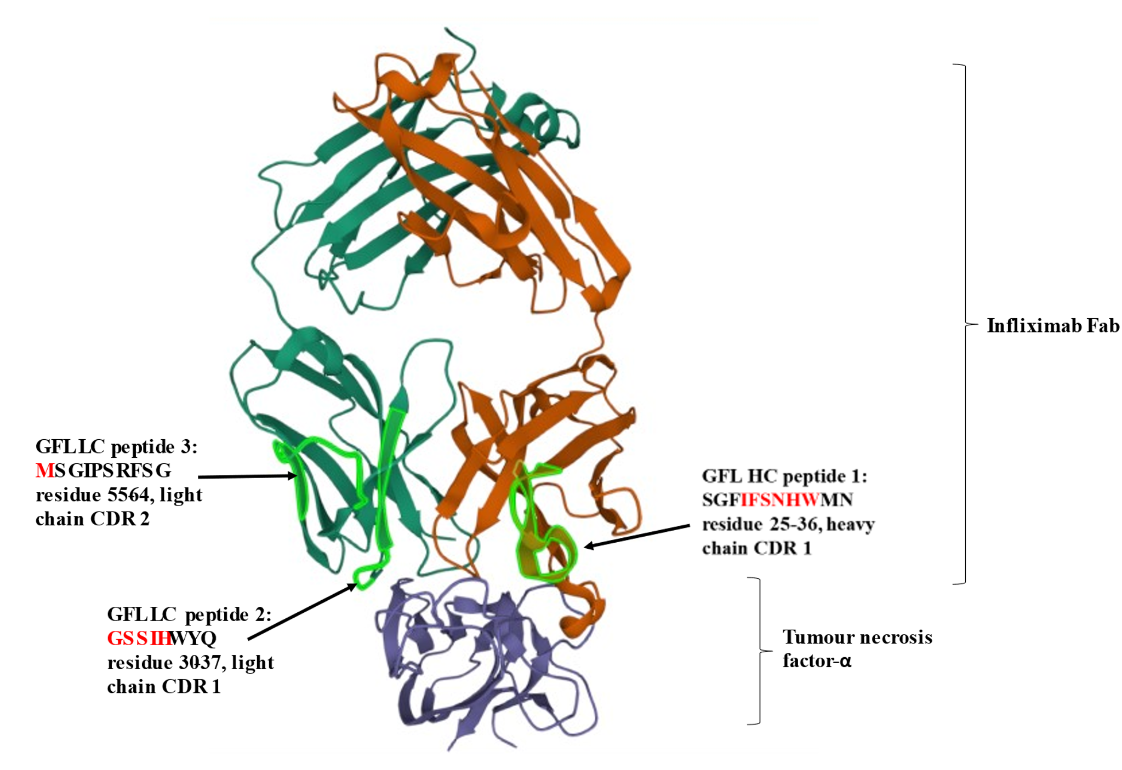
Figure 28. Model of infliximab Fab fragment bound to tumour necrosis factor-α with mapped peptides.
Infliximab Fab heavy chain in red and infliximab light chain in dark green are bound to tumour necrosis factor-α (purple). The three mapped epitopes are highlighted in light green on the infliximab Fab. The amino acids that are part of the complementary determining region are highlighted in red on the epitope sequences.
(GFL: gene fragment library, HC: heavy chain, LC: light chain)
Images created using Mol* PDB ID 4G3Y

5.3.3 Monoclonal phage ELISA
Figure 29 shows reactivity of the individual patients’ sera against the candidate peptides but also to the control phage. There was minimal background binding to the ELISA plate. Serum 5, 6 and 7 had the highest absorbance values and these patients did have high ATI levels (> 600, 177 and 156 AU/mL) with undetectable/very low drug levels. As reactivity to the control phage was demonstrated, individual serum was purified using IgG purification using protein A HP SpinTrap Column (ThermoFisher Scientific, Massachusetts, United States). A repeat monoclonal phage ELISA incorporating pre-adsorption of the individual purified IgG with E. coli extract showed ongoing reactivity to selected phage clones as well as control phage clones.

Figure 29. Monoclonal phage ELISA demonstrating similar reactivity of individual patients’ ATI positive sera against selected peptides: heavy chain peptide 1, light chain peptide 1, light chain peptide 2 and an unselected control peptide.
(IFX: infliximab)

5.3.4 Comparison to the literature
The three selected candidate peptides: heavy chain 1, light chain 1 and light chain 2 overlap with previously identified infliximab epitopes, as shown in Figure 30. Heavy chain peptide 1 and light chain peptide 1 correlate closely to two of the peptides identified by Homann et al: IFX 1 on the heavy chain (selected by 60% by their analysed sera) and IFX 3 on the light chain (selected by 85% by their analysed sera) ¹⁵⁹. Goncalves et al, using phage display demonstrated immunoreactivity to most of the Fab heavy chain and nearly half of the infliximab light chain. The regions that contained the candidate peptides were noted to be some of the most immunogenic areas by Goncalves et al and their selected VL peptide: amino acid residue 17-63 contained both selected light chain peptides 1 and 2 and was selected 86% and 79% of patients with antibodies to Remicade and CT-P13 respectively ¹⁶⁰.

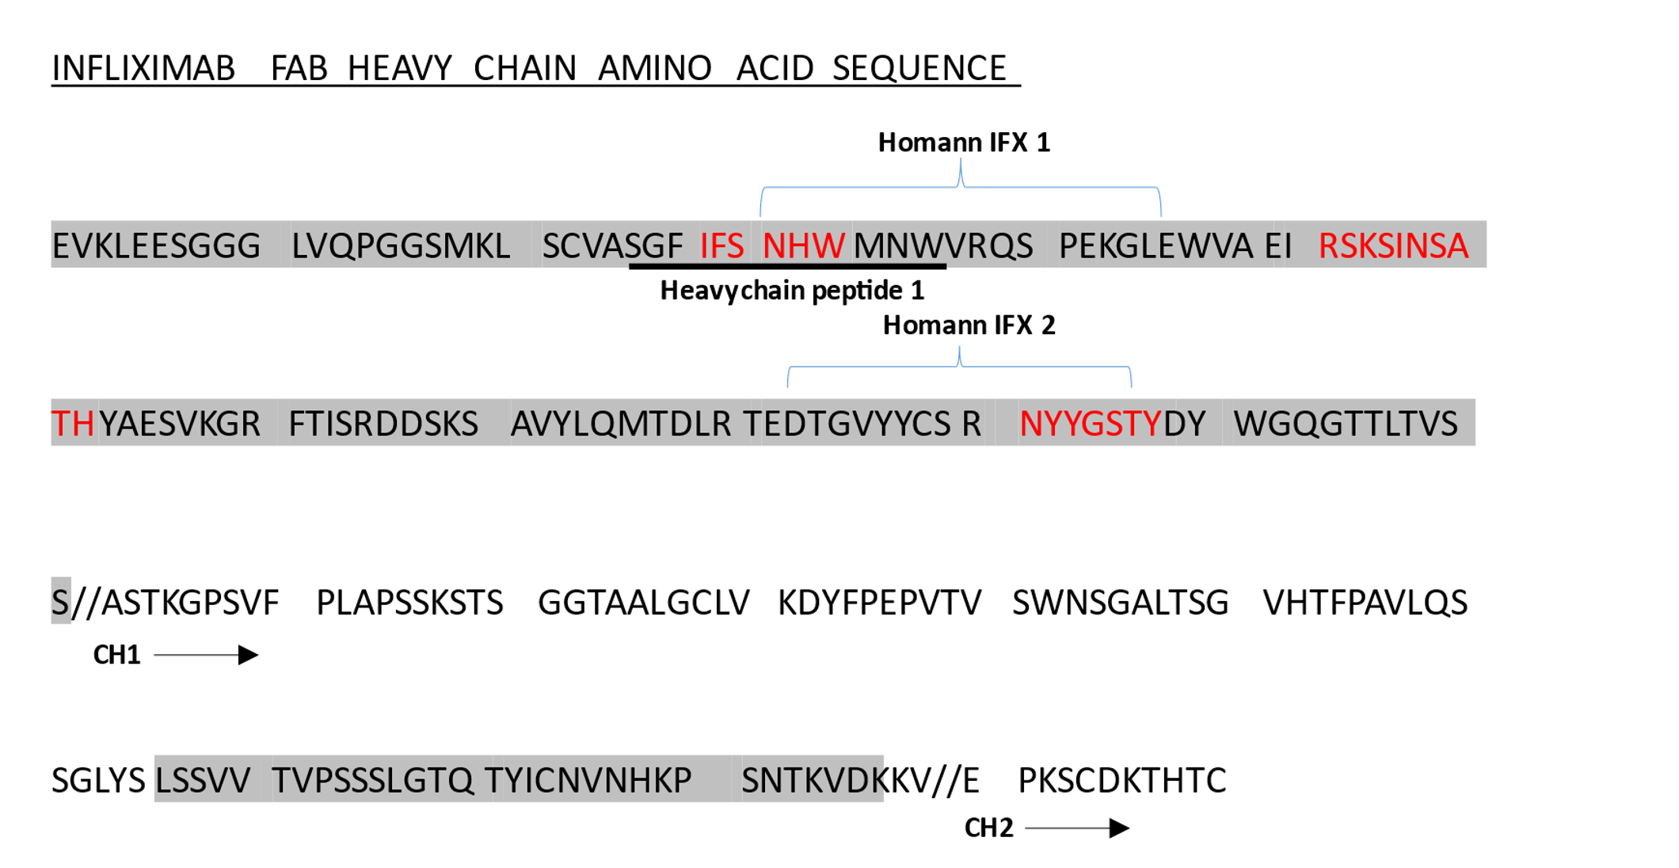

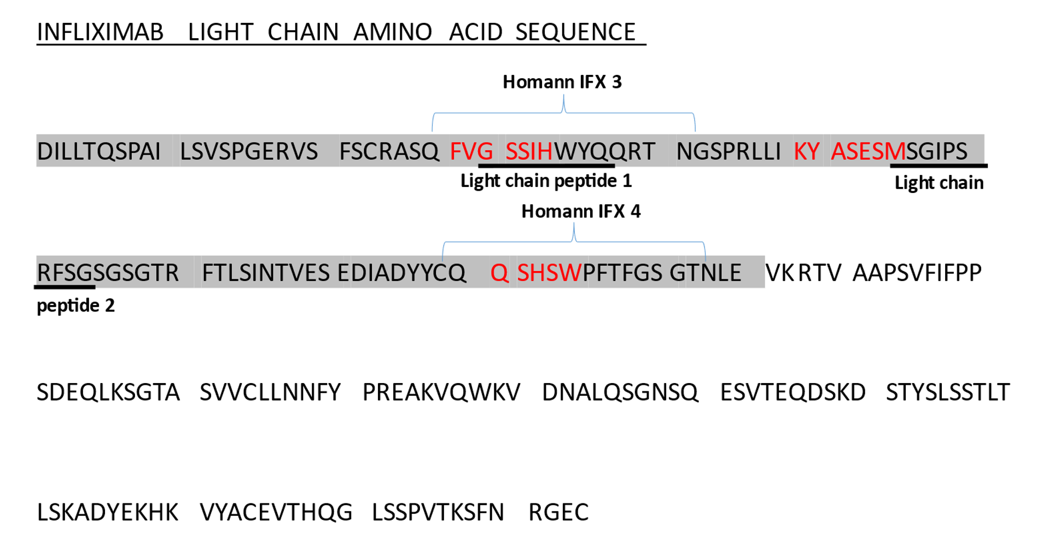

Figure 6.4. Comparison of selected candidate peptides from this work to
Figure 30. Selected candidate peptides compared to peptides previously selected in the literature.

Infliximab Fab heavy chain and light chain with complementary determining regions (CDR) in red are annotated with candidate peptides: heavy chain peptide 1, light chain peptide 2 and light chain peptide 3. Immunogenic regions selected by Goncalves et al are highlighted in grey and peptides selected by Homann et al are in captions.

5.4 Discussion
Using an infliximab gene fragment phage display library with pooled sera from patients with ATI and different clinical outcomes, we have identified three distinct candidate peptides. The patients used for serological selection were prospectively followed up and carefully clinically phenotyped using clinical assessment and TDM. Pooled sera from patients with different clinical outcomes were used to ensure different ATI were included and to allow clinically important epitopes to be identified. To aid epitopes selection, a new method for designing a phage display library was utilised to ensure there was in-frame coverage of the whole infliximab peptide. In-frame gene fragments coding for overlapping amino acid sequences of the infliximab peptide was generated and cloned into phage. Two large libraries were created and combined. NGS confirmed coverage of the entire infliximab peptide sequence, with peptide sequences of 20-30 amino acid length, which were represented more than 100 times.

Phagemid libraries such as ours, utilises a plasmid with both a plasmid origin of replication and a filamentous phage origin of replication with a pIII phage coat protein gene. Additional phage genes are needed for phagemids to produce virion particles following transformation into bacterial cells. This is supplied by co-infection of the bacterial cell with a helper phage. However, traditional helper phage contain a pIII gene, leading to competition with the phagemid pIII gene, which is modified with the gene fragment of interest, therefore not all phage display the peptide of interest. Hyperphage have a deletion in the pIII gene ensuring the phagemid pIII gene is used in phage assembly allowing the pIII-peptide product to be displayed on all phage particles ¹⁸⁸.

The candidate peptides showed selective enrichment especially heavy chain peptide 1, which was heavily enriched. The selected peptides overlap with previously suggested epitopes, but have identified distinct areas as previous epitopes span a large region of the infliximab peptide. There was close correlation to two peptides which were previously selected by Homann et al using a peptide array, which included heavy chain CDR 1 and light chain CDR 1 ¹⁵⁹. The two previous studies assessing epitopes on infliximab also selected peptides on the Fc fragment of infliximab ^{159,160}. This was surprising as the IgG1 Fc fragment of infliximab is human and there should be immune tolerance to it, however immune tolerance can be compromised in autoimmune conditions such as IBD. Using pooled sera of IBD patients with different clinical outcomes against a phage library which covered the entire infliximab sequence, the peptides selected in our study were localised to the Fab fragment. In addition, all our peptides overlapped with CDRs: heavy chain peptide 1 fully included heavy chain CDR 1, light chain peptide 1 and 2 overlapped with the light chain CDR 1 and 2. This is of potential clinical and mechanistic importance as the CDRs determine antigen-antibody specificity and binding of ATI to these areas on infliximab would prevent infliximab from binding to TNFα, and therefore, be a potential factor in secondary loss of response to infliximab.

Using individual patient’s serum from the pooled serological selection of the infliximab gene fragment library, specificity to the selected peptides have not demonstrated in initial monoclonal phage ELISAs. Individual sera have shown reactivity to control phage as well the selected phage clones in the ELISAs. This may be due to non-specific binding of the sera to phage proteins, bacterial or culture media contaminants during the ELISA. IgG purification has been undertaken to isolate IgG, which would include ATI. However, cross-reactivity of the individual sera to control as well as selected phage clones continues. Reactivity of sera to bacterial antigens such as lipopolysaccharides is recognised due to common exposure to these antigens¹⁹⁰. This could lead to recognition of the sera to all phage clones as E. coli are used to produce the phage and despite phage purification, bacterial antigens can continue to be present. To control for this, pre-adsorption of the sera with of E. coli extract has been incorporated into the ELISA, but further adjustments in terms of the protocol are needed ¹⁹⁰. PEG purification, a commonly used method of phage preparation was used to precipitate and purify the phage for the serological selection and the monoclonal phage ELISAs ¹⁹¹. Other methods of phage purification exist and include density-based methods using cesium chloride with high speed centrifugation, isolectric based precipitation, spermidine based precipitation and chromatography based methods ¹⁹¹. Cesium chloride-based purification provides highly pure phage. However, its use is limited by the ultracentrifugation force required, which cannot be achieved by most centrifuges and can have a destructive effect on the phage itself, leading to low yield ¹⁹¹. We aim to further optimise the current ELISA with use of the E. coli extract.

An alternative method of assessing specificity of the ATI positive sera to the selected phage clones and the enriched peptides would be to incorporate NGS. NGS has been integrated into phage display as it gives the ability to interrogate the entire sequence diversity after selection. It is able to assess up to approximately 10,000-fold more sequences than Sanger sequencing ^{192–196}. It is also able to provide this at a comparatively low cost and shorter time frame than Sanger sequencing ¹⁹⁶. Using NGS, we could fully assess the diversity of the library after each round of biopanning, to ensure that has been no selection bias from DNA sequencing of the selected colonies. The infliximab full GFL could also be reselected using individual ATI positive serum that was pooled for biopanning. Subsequent NGS of each individual selection could be assessed for enrichment of the selected phage clones.

Due to the use of pooled sera from patients with a range of clinical outcomes and the small and distinct nature of the peptides selected, which were heavily enriched and include infliximab CDRs, we would suggest these are clinically important epitopes on infliximab. Further work on the monoclonal ELISA and NGS would aid in confirming the specificity of the ATI positive sera to the peptides selected. These epitopes could then be further screened in the future against a large selection of patients’ sera to identify whether specific epitopes are associated with specific clinical outcomes.

Chapter 6: The identification of infliximab conformational epitopes using a random peptide phage display library

6.1 Introduction
Differing adverse clinical outcomes seen in IBD patients with ATI could be partly explained by the presence of different ATI binding to different epitopes on the infliximab molecule. Chapter 6 has focused on the selection of linear epitopes from an infliximab whole GFL, with selective enrichment of three distinct peptides which include CDRs. However, the majority, ~ 90% of B cell epitopes on native antigens are conformational ¹⁹⁷. It is possible that epitopes on therapeutic monoclonal antibodies, such as infliximab, are also conformational ¹⁴⁶.

The discontinuous nature of conformational epitopes has made their identification challenging as alignment of the epitope onto the antigen is difficult as structural knowledge of the whole antigen and the antibody-antigen interaction is required. Current identification is based on assessment of solvent exposed residues (amino acids on the surface of the antigen), amino acid composition and statistics, spatial information of the antigen (the 3D structure of the antigen), data of the antigen-antibody interaction and mimotope based methods ¹⁹⁷. The latter method uses random peptide libraries, large diverse commercial phage display libraries of peptides which can be screened to identify protein-protein interactions ^{105,158,198,199}. Although the library does not display peptide sequences derived from the antigen of interest, in our case, infliximab. It displays potential “mimotopes”: artificial peptides that mimic B cell conformational epitope on infliximab that elicit the immune response ²⁰⁰. RPL have successfully been used for identification of disease specific antigen mimics, development of peptide-mediated drug delivery systems such as vaccine development and for B-cell and T-cell epitope mapping ²⁰¹. After cycles of biopanning using a known antibody, the peptides from the selected phage variants are sequenced and mimotopes can be predicted using the known 3D protein structure of the antigen via bioinformatic programmes, which include MIMOX, PEPITOPE, EPISEARCH, MIMOPRO, and PEPMAPPER ²⁰⁰. Different algorithms are used by the different programmes to align the selected peptides onto the known antigen.

The aim of this study was to use a random peptide phage display library to identify conformational epitopes on infliximab. Pooled ATI positive sera from patients with different clinical outcomes was used to identify clinically relevant epitopes.

6.2 Method

6.2.1 Patients
This is discussed in 5.2.1.

6.2.2 Clinical assessment
This is discussed in 2.2.2.

6.2.3 TDM
This is discussed in 2.2.3.

6.2.4 Blood samples for epitope mapping
This is discussed in 5.2.4.

6.2.5 Study cohort
This is discussed in 5.2.5. Sera from the same eight antibody positive IBD patients with different clinical outcomes were pooled for selection. The clinical details of the eight patients are shown in Table 12 in chapter 6. Sera was chosen from patients with different clinical outcomes as the aim was to identify epitopes associated with different clinical outcomes in IBD patients with ATI.

6.2.6 Random peptide phage display library
Ph.D.-12™ Phage Display Peptide Library (New England BioLabs, Massachusetts, United States) displays unique random 12-mer peptides fused to the pIII gene of M13 phage. M13KE as a phage vector, which allows all 5 copies of the pIII coat protein to display the fused peptide. Approximately 10⁹ random unique peptide sequences are in a library, which allows identification of mimitopes.

6.2.7 Selection of the RPL using in solution method with Protein A Dynabeads
Four rounds of selection of the RPL were performed using an in-solution method. Pooled sera was incubated with phage, with subsequent capture of the immunoglobulins and therefore bound phage using Dynabeads™ protein A magnetic beads (Thermo Fisher Scientific, Massachusetts, United States). The method is summarised diagrammatically in Figure 31. Dynabeads™ are uniform, 2.8µm supermagnetic beads covalently coupled with recombinant Protein A on their surface. Protein A is derived from the cell wall of the bacteria Staphylococcus aureus and has a high affinity for the Fc segment of most human IgG as shown in Table 13 ²⁰².

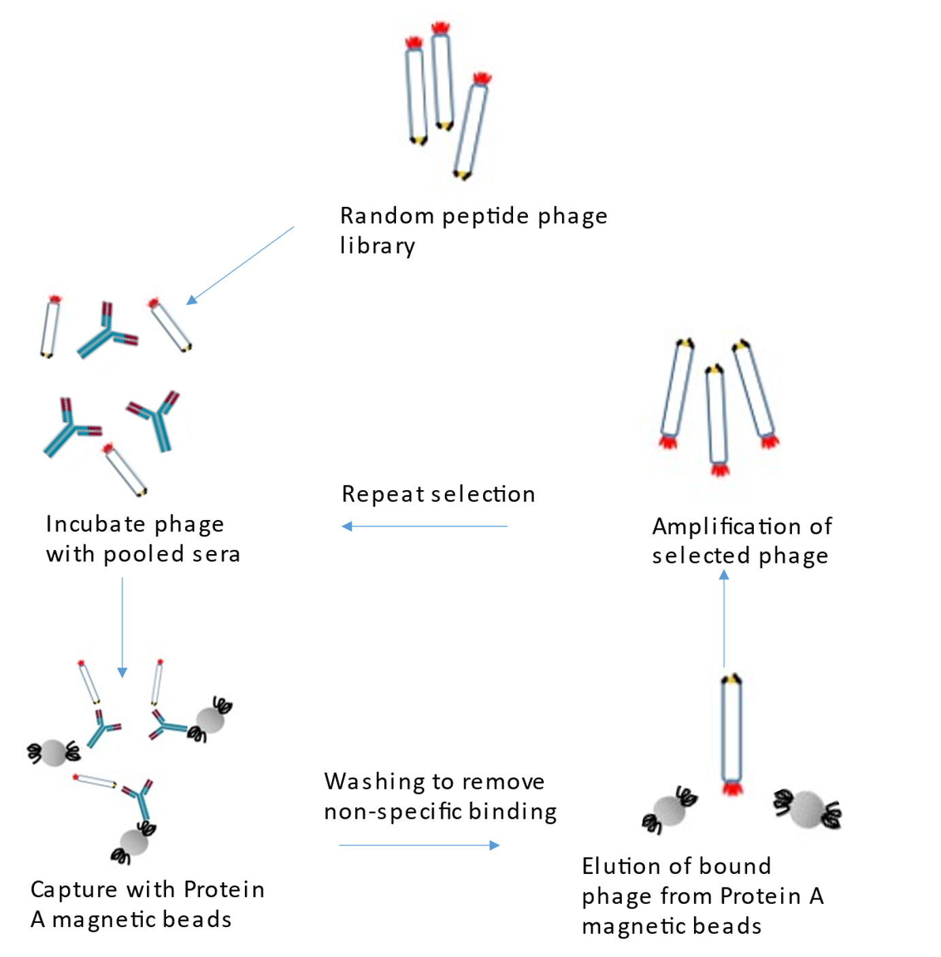

Figure 31. Diagrammatic summary of the selection of the 12-mer random peptide phage library (RPL) using pooled ATI positive sera and protein A magnetic beads.
Four rounds of selection of the RPL were performed using an in-solution method: pooled ATI positive sera was incubated with the phage library, with subsequent capture of ATI and therefore bound phage using Dynabeads™ protein A magnetic beads (Thermo Fisher Scientific, Massachusetts, United States). Washing of the magnetic beads to remove non-specific binding, followed by elution of bound phage. Amplification and growth of selected phage for subsequent re-selection with ATI positive sera. Control selections using normal AB sera and blank with no sera were also undertaken.

Species | Immunoglobulin subclass | Binding affinity of Protein A
Human | IgA | Variable
 | IgD | Weak
 | IgE | Weak
 | IgG1 | Strong
 | IgG2 | Strong
 | IgG3 | Weak
 | IgG4 | Strong
 | IgM | Variable

Table 13. Binding affinity of Protein A for human immunoglobulins ²⁰².

In round 1 of biopanning, 10µL of the random peptide phage library stock, a 100-fold representation of the library (1 x 10^11) was used. Subsequent rounds of biopanning used 10 µL of the previous selected library, confirmed by input phage titre. 16 µL of pooled ATI positive sera (2 µL from each ATI positive patient) and control selections using no sera (blank) and normal AB sera was used.

Phage and sera were incubated in microfuge tubes in PBS-tween solution of 200µL. In round 1 of selection of the RPL, the tween solution concentration was 0.1%, sera and phage were incubated for 50 minutes, then incubated with protein A magnetic beads as per the manufacturer’s protocol. Protein A magnetic beads were then washed using PBS-tween. remove non-specific binding, followed by elution of bound phage using Elution Buffer (Thermo Fisher Scientific, Massachusetts, United States). The input phage and selected phage libraries were titrated onto Lysogeny Broth/Isopropyl β-D-1-thiogalactopyranoside/Xgal (LB/IPTG/Xgal) plates and incubated overnight at 37°c. The selected phage mix was also plated onto LB/IPTG/Xgal plates and incubated overnight at 37°c, to be scraped and made into glycerol stocks for the next round of selection. Amplification for subsequent rounds of selection use E. coli strain ER2738 culture.

To increase specificity- binding of ATI for phage displaying high affinity mimotopes, in subsequent rounds of selection:
- The tween concentration of the solution for phage and sera incubation and washes was raised from 0.1% to 0.5%
- Number of washes of the protein A magnetic beads were increased from 3 to 10 times.
- For round 3 and 4, the incubation time for phage and pooled sera was reduced to 30 minutes. A negative selection was added at round 2 to remove non-specific binding of phage to protein A. An additional 50 μL of washed, blocked magnetic beads was prepared for each selection tube and incubated with diluted phage library in 200 μL of PBST prior to incubation of the phage library with sera. The beads were then captured (along with any non-specific bound phage) and the supernatant transferred to a fresh microfuge tube to incubate with pooled sera and subsequently recapture using more washed, blocked beads.

6.2.8 Analysis of selected phage clones
Seventy plaques were picked from titration plates using sterile pipettes. 10 plaques from the unselected RPL, 10 plaques each from round 3 of pooled ATI sera, normal and blank selections and 10 plaques each from round 4 of pooled ATI sera, normal and blank selections were picked and added to LB broth with overnight culture of ER2738. The selected phage clones were amplified and single strand phage DNA extracted using alcohol precipitation as per protocol ²⁰³. DNA from 70 phage plaques underwent Sanger sequencing (DBS genomics, Durham University, UK) and translated into amino acid sequences using Vector NTI (ThermoFisher Scientific Massachusetts, United States).

.

6.2.9 Monoclonal phage ELISA
The aim of the monoclonal phage ELISA was to illustrate specificity: that ATI positive sera would bind to the selectively enriched phage clones and not the control phage.

The three selected peptides and a control peptide (which was not enriched on patient serum, amino acid sequence YSLWEPDFPPPV) was PEG purified. The phage was filtered using a 0.2 µm filter to give a final stock of 200 µl which was then diluted to 2 mls in PBS.

Initially a direct ELISA was performed using pooled sera coated onto wells with subsequent incubation of monoclonal phage clones. 50µL of pooled sera 1/50 in PBS were coated onto wells and incubated overnight at 4°C. Wells were washed, blocked with 200 µL of 2% Marvel-PBS for 1-2 hours, and then washed with PBS-Tween and PBS. Different concentrations of phage (^12, ^9, ^6, ^3, crude phage of 100 µL were incubated with sera for 2 hours at room temperature with agitation. All sera were tested in duplicates. Wells were washed three times with PBS-Tween and PBS. Antibody binding was detected by incubating with anti-m13 HRP in 2% Marvel-PBS-Tween for an hour with agitation. Wells were washed 5 times. ELISA plate was developed and read at 405 nm.

Following the direct ELISA, additional conditions were modified:
- sandwich ELISA using a capture antibody of rabbit anti-human IgG coated onto wells. Phage and sera mix were incubated to replicate the conditions of the phage library selection (in-solution selection) and then added to the wells to allow binding to the rabbit anti-human IgG with detection using anti-m13 HRP secondary antibody.
- variations in number of washes after incubation of phage and sera.
- varying dilutions of anti-m13 HRP secondary antibody (1:100, 1:500, 1:1000, 1:3000, 1:5000)
- using pooled sera (1:50, 1:100, 1:1000) and individual sera at different concentrations (1:50, 1:100 and 1: 1000).
- acid dissociated sera to increase the likelihood of unbound ATI from drug. Pooled and individual sera was incubated with glycine buffer pH 2.5 for 30 minutes to dissociate the ATI-infliximab immune complexes. Neutralisation was with Tris-HCL pH 8 and the sera used immediately after for the monoclonal phage ELISA as immune complexes would reform with time.
- Individual serum was purified using IgG purification using protein A HP SpinTrap Column as per protocol (ThermoFisher Scientific, Massachusetts, United States).

6.3 Results

6.3.1 Selection of random peptide phage display library
After four rounds of selection, the ratio of the output phage titer to the input phage titer in the ATI selection was 100-fold more than the blank selection (Table 14) reflecting the enrichment of specific phage clones.

Round | ATI positive selection |  |  | Blank selection |  |  | Normal selection
 | Input PFU/mL | Output  PFU/mL | Ratio O/I | Input PFU/mL | Output  PFU/mL | Ratio O/I | Input PFU/mL | Output  PFU/mL | Ratio O/I
1 | 5.3 x 10^¹³ | 6 x 10⁷ | 1.13 x 10⁻⁶ | 5.3 x 10¹³ | 6 x 10⁷ | 1.13 x 10⁻⁶ | 5.3 x 10¹³ | 7 x 10⁷ | 1.13 x 10⁻⁶
2 | 1.8x10^¹³ | 6 x 10⁶ | 3.33 x 10⁻⁷ | 4.5 x 10¹³ | 5 x 10⁶ | 1.11 x 10⁻⁷ | 2 x 10¹³ | 8 x 10⁶ | 4 x 10⁻⁷
3 | 6 x 10^¹³ | 5 x 10⁷ | 8.33 x 10⁻⁷ | 2 x 10¹³ | 3 x 10⁵ | 1.5 x 10⁻⁸ | 2.7 x 10¹³ | 1.3 x 10⁷ | 4.81 x 10⁻⁷
4 | 2.7 x 10^¹³ | 2 x 10⁷ | 7.41 x 10⁻⁷ | 9 x 10¹³ | 1 x 10⁵ | 1.11 x 10⁻⁹ | 3 x 10¹³ | 2 x 10⁷ | 6.67 x 10⁻⁷

Table 14. Selection of random peptide phage display library using ATI positive pooled sera, blank selection with no sera and normal AB sera.
Enrichment of phage clones in the ATI positive selection in comparison to the blank selection is suggested by the higher plaque forming units (PFU) output:input ratio in the former selection.
(PFU: Plaque forming units; ratio O/I: ratio output:input)

6.3.2 Epitope mapping of selected peptides
Single stranded phage DNA was isolated from 70 selected plaques. 3 peptides show selective enrichment- selected more than once only in the ATI positive selection: amino acid sequences were: YNKETPQTGFRA (isolated from three plaques from round 4 of ATI positive selection), FHGPSKISSGES (isolated from two plaques from round 3 of ATI positive selection) and SVALNVKRAPVT (isolated from two plaques from round 4 of ATI positive selection).

There was no alignment of the enriched peptides to the full-length infliximab peptide using pairwise sequence alignment with Vector NTI and no match using protein and nucleotide blast.

Using Pepitope: Pepsurf server (http://pepitope.tau.ac.il/), a mimotope prediction programme using the inputs of the selected peptides and the known infliximab Fab 3D protein structure: protein databank ID 4G3Y (https://www.rcsb.org/structure), conformational epitopes were predicted (Table 15).

There is overlap between amino acids in light chain peptide 1 selected from the RPL with light chain peptide 3 selected from the infliximab whole gene fragment library (Table 15). Conformational epitopes predicted using the selectively enriched peptides were compared to three peptides selected using blank and normal AB sera: YSLWEPDFPPPV was isolated from 17 phage plaques, TLQLVYTKSPTP was isolated from 2 plaques and SYPSNALSLHKY also isolated from 2 plaques. Cluster scores for the selectively enriched peptides were higher compared to those that were not enriched using ATI positive sera. Figure 32 shows the predicted epitopes from the three selected peptides mapped onto infliximab Fab.

Selectively enriched peptides
Name | Selected amino acid sequence | Predicted conformational epitope | Cluster score
Light chain peptide 1 | SVALNVKRAPVT | S14L V13L S12L L11L N103L A84L R39L R45L G57L P59L I58L S60L | 21.47
Heavy chain peptide 2 | YNKETPQTGFRA | Y201H N162H N204H N206H T212H P126H K124H T123H S122H F153H A121H | 17.67
Heavy chain peptide 3 | FHGPSKISSGES | L45H E46H G44H P41H S40H Q39H V95H T115H T114H G113H E6H S21H | 21.56
Non-selectively enriched peptides
Name | Selected amino acid sequence | Predicted conformational epitope | Cluster score
Peptide 1 | YSLWEPDFPPPV | P119L P120L D122L L125L  K126L Y186L | 6.42
Peptide 2 | TLQLVYTKSPTP | P126H S127H F129H K150H G160L V176H L177H T178L S184H  T212H | 9.44
Peptide 3 | SYPSNALSLHKY | N138L N162H A165H L166H  S168H V170H H171H S195H  T200H Y201H | 9.44

Table 15. Composition and position of predicted epitopes on infliximab Fab from the selectively enriched and non-selectively enriched peptides from the random peptide phage display library using Pepitope: Pepsurf Server.

The selected peptides’ amino acid sequences with the corresponding predicted epitopes: the amino acid, the number denoting the position on the infliximab light (L) or heavy (H) chain are shown. The four amino acids in red for light chain peptide 1 overlap with light chain peptide 3 selected from the infliximab whole gene fragment library. The cluster scores for the selectively enriched peptides are higher than the peptides selected on normal AB serum and blank selections.

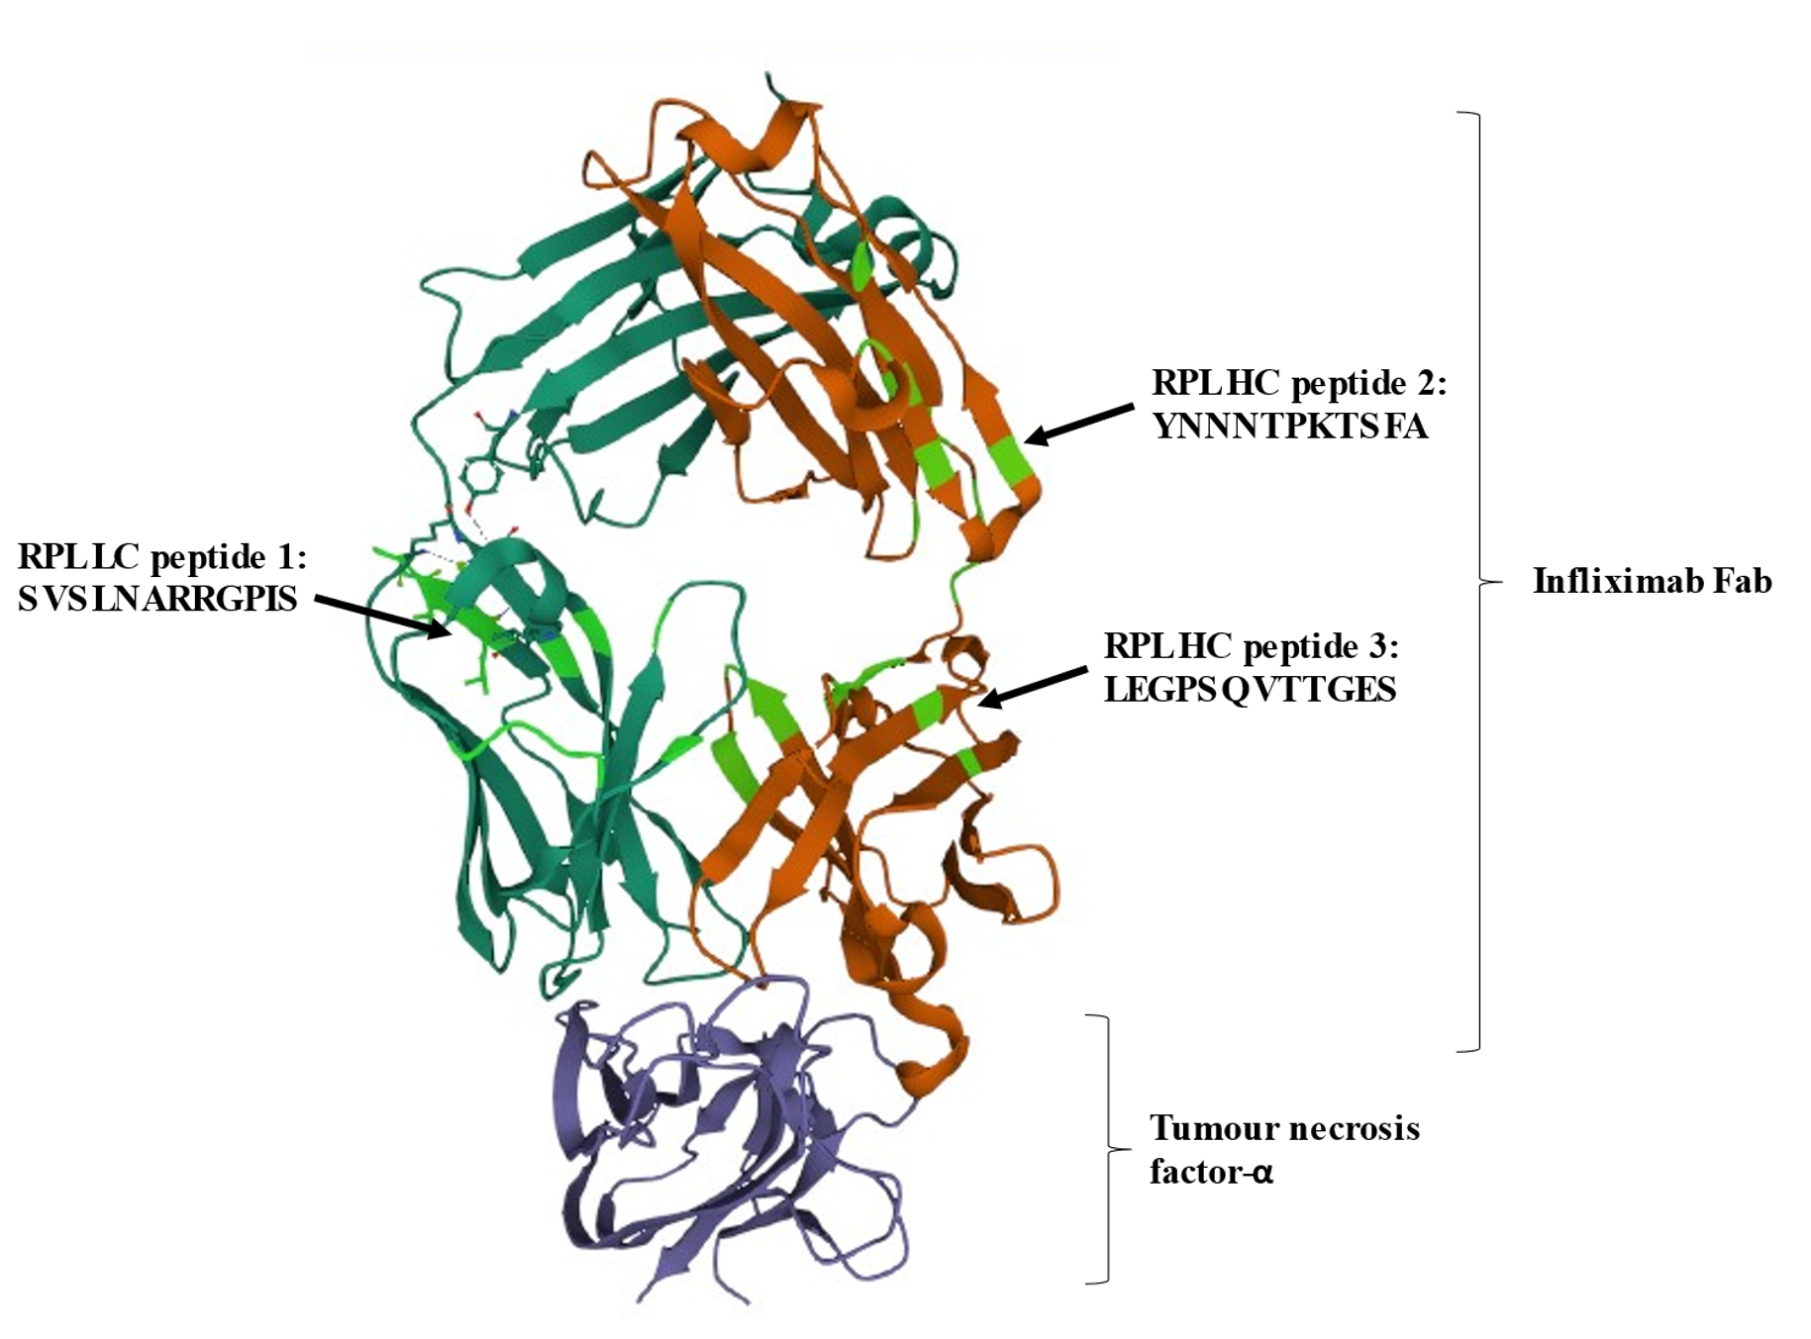
Figure 32. Model of infliximab Fab fragment bound to tumour necrosis factor-α with mapped predicted peptides selected from the random peptide library.
Infliximab Fab heavy chain in red and infliximab light chain in dark green are bound to tumour necrosis factor-α (purple). The three mapped epitopes are highlighted in light green on the infliximab Fab.
(RPL: random peptide library, HC: heavy chain, LC: light chain)
Images created using Mol* PDB ID 4G3Y

6.3.3 Phage ELISA
Initial direct ELISAs used pooled ATI positive sera coated onto wells with incubation of monoclonal phage. Detection used secondary anti-M13 HRP. These showed reactivity of the pooled ATI positive sera for the three selected monoclonal phage but also the unselected control phage (Figure 33). There was minimal background binding to the ELISA plate. As reactivity to the control phage was demonstrated on initial ELISAs, additional conditions were adjusted. A sandwich ELISA using a capture antibody of rabbit anti-human IgG coated onto wells, with subsequent incubation of phage and sera in solution was used to replicate the conditions of the phage library selection. Detection used secondary anti-M13 HRP. Both ATI positive pooled and individual sera was used for the sandwich ELISA. Continued reactivity of the ATI positive sera for the unselected control phage was demonstrated (Figure 34). Despite further modifications in the ELISA conditions, specificity of the ATI positive sera for the selectively enriched phage variants could not be demonstrated.

Figure 33. Monoclonal phage ELISA demonstrating similar reactivity of pooled ATI positive sera against the three selected peptides and the unselected control peptide from the random peptide library.
A direct ELISA used pooled ATI positive sera at a concentration of 1/50 coated onto the wells. Sera was incubated with the selectively enriched monoclonal phage variants of LC peptide 1, HC peptide 2, HC peptide 3 as well as an unselected control phage at a titre of 10^12. Detection using secondary antibody anti-m13 HRP.
(ATI: antibodies to infliximab, HC: heavy chain, LC: light chain, RPL: random peptide library)

Figure 34. Monoclonal phage ELISA demonstrating similar reactivity of individual ATI positive patient sera against the three selected peptides and an unselected control peptide from the random peptide library.
A sandwich ELISA with capture antibody of rabbit anti-human IgG coated onto wells assessed reactivity of individual ATI positive sera: serum 1-8 at a concentration of 1/100 against monoclonal phage variants: LC peptide 1, HC peptide 2, HC peptide 3 and an unselected control phage, at a titre of 10^12. Detection using secondary antibody of anti-m13 HRP.
(ATI: antibodies to infliximab, HC: heavy chain, LC: light chain, RPL: random peptide library)

6.4 Discussion
RPL are large commercial phage display libraries. They have been increasingly used in the last 20 years to identify protein-protein interactions. They allow identification of “mimotopes”: artificial peptides that mimic B cell conformational epitopes that elicits the immune response with the use of mimotope prediction programmes ^{158,198–201}. Using pooled sera from IBD patients with positive ATI and different clinical outcomes, three peptides were selectively enriched from a RPL. These peptides were not enriched in the control selections of normal AB serum and blank. There was no alignment of the selected peptides to the full-length infliximab peptide using pairwise sequence alignment and no match using protein and nucleotide blast, indicating they were not linear epitopes. Using Pepsurf, a mimotope prediction programme, three conformational epitopes were predicted.

Mimotope prediction programmes use different algorithms with the inputs of 1) the affinity selected peptides from random peptide libraries, and 2) the known 3D antigen structure to predict conformational epitopes. The Pepitope web server (http://pepitope.tau.ac.il/) has been used in the literature since 2007 to identify allergens, toxins, viruses and receptors via mimotope selection ^{156,204–208}. It uses two algorithms: PepSurf and Mapitope. My research has utilised the Pepsurf algorithm which uses the selected peptide to search for “paths” of neighbouring residues on the surface of the antigen 3-D structure that has a high similarity to the input peptide sequence ²⁰⁹. These neighbouring residues/clusters are then assessed with internal scores including cluster scores, where the higher the score, the more significant the alignment in predicting an epitope ²⁰⁹. Studies have tried to assess the accuracy of the different mimotope prediction programmes in predicting epitopes. However, a key limitation is that there is no “gold standard” to assess the quality of the performance of the different tools and our knowledge on the molecular nature of an antigen–antibody interaction and the key component within that interaction is limited. There continues to be limitations with all B cell epitope prediction tools including those using mimotopes. Therefore, although these bioinformatic tools have their limitations, they give insight into an area of immunology that is complex. Using Pepsurf, three conformational epitopes were predicted on the infliximab Fab and the cluster scores for the selectively enriched peptides were higher than the peptides selected on normal AB and blank selections. One of the predicted epitopes: RPL light chain peptide 1 overlapped with a linear epitope selected from the GFL: Light chain peptide 3 linear epitope.

Different measures were considered and implemented in the selection of the RPL to reduce the risk of non-specific binding phage. Dynabeads™ protein A magnetic beads (Thermo Fisher Scientific, Massachusetts, United States) were used as protein A have high affinity for the Fc fragment of most human IgG immunoglobulins, in particular, IgG1, IgG2, IgG4 ²⁰². Studies have shown that ATI are predominantly IgG with the majority being IgG1 (36–65%) and IgG4 (20–55%) ¹⁴⁶. As the magnetic beads are coated in protein A they would therefore bind to IgG, including ATI IgG. This would then allow capture of the bound phage selected by the ATI allowing amplification and identification of selected phage variants. As well as the ATI positive selection, two other selections were used so that selective enrichment of the peptides could be assessed. A “blank” selection using no sera: just microfuge tubes containing PBS solution and a “normal” selection using AB sera from healthy volunteers was used to assess for non-specific binding to plastic tubes and other components of sera. Four selection cycles with increasing washes and increasing tween (a detergent) concentration post incubation of phage and sera, was used to also reduce non-specific binding of phage. The incubation time was decreased in later selection cycles to identify high affinity binders between phage and ATI. To control for non-specific binding to protein A, a negative selection was added at round 2. The diluted random peptide phage library was incubated with protein A magnetic beads, prior to incubation with sera. The beads were then captured, along with any bound phage to protein A. The supernatant containing the rest of the phage library was then transferred to a fresh microfuge tube to incubate with pooled sera. The aim with these conditions was to ensure that the selectively enriched peptides were epitopes on infliximab.

To confirm specificity of the ATI positive sera for the selected phage, we proceeded with monoclonal phage ELISAs of the selected peptides. A systematic approach using pooled ATI positive sera, then individual sera, purified sera, acid dissociated sera (to optimise free anti-drug antibodies), direct and sandwich ELISA were undertaken. However, despite these measures, similar reactivity between the selected and control phage clones were demonstrated. Due to the repetitive nature of selection in phage display, protein-protein interactions with a broad range of affinities can be identified including those at a subnanomolar to 1 millimolar affinity ²¹⁰. These lower affinity binders identified on phage display may then not be demonstrated as a positive signal on ELISA. Further work on the ELISA is required including pre-adsorption of the sera with E. coli extract ¹⁹⁰ and a peptide ELISA, where the predicted epitopes are synthesised as peptides, removing phage as a non-specific binder.

In conclusion, pooled ATI positive sera was used to select a RPL, using carefully considered conditions. Three peptides were selectively enriched only on the ATI positive selection in comparison to the control selections using normal AB sera and no sera. Using a mimitope prediction tool: Pepsurf, the selected peptides were used to predict conformational epitopes on the infliximab molecule. There was overlap with a linear epitope selected from GFL, indicating the regions predicted on infliximab are immunologically important.

Chapter 7: Summary, final Discussion and future directions

IBD is a lifelong relapsing-remitting inflammatory condition with limited- though expanding - treatment options. Infliximab, a TNFα antagonist is a key drug for inducing and maintaining remission in IBD ^{27,53–55},. Similar to other biological therapies in IBD, secondary loss of response occurs in up to 50% of patients at 1 year follow up ^{28,29} - but there may be a number of causes for this. Understanding the reasons for this loss of response is important for optimising patient care. In the case of infliximab, ATI are likely to contribute to secondary loss of response in some of these patients and to other adverse effects including infusion reactions.

The overall aim of this PhD thesis was to add to the understanding of antibody formation to infliximab on a clinical and immunological level: to identify risk factors for the development of ATI, confirm the associated clinical outcomes using a drug tolerant antibody assay and to use phage display to identify linear and conformational epitopes on infliximab. The overall workflow is therefore described in Figure 11.

Initial clinical work focused on a retrospective review of 214 IBD patients. Patients had TDM and a clinical assessment at every infliximab infusion to address inconsistencies in the literature regarding the association of ATI to clinical outcomes ^{33,146},¹⁵⁹. Using a drug tolerant antibody assay, ATI were shown to be prevalent and significantly associated with poor clinical outcomes of loss of clinical remission, reduced infliximab drug levels and adverse drug reactions. In our cohort, ATI development was most likely in the first 12 months of treatment, as nearly 80% of patients developed ATI during this period. Our study confirmed previous findings that concomitant immunosuppression with thiopurines and methotrexate was protective against ATI development ^{55,118,130,171,172}, but suggests that this protective effect may only be present in the first 6 months. Therefore, beyond 6 months of infliximab treatment, the risks of ongoing combination therapy should be considered.

As ATI are so prevalent, it is important to assess the effectiveness of treatment strategies in this cohort. Although the patient can be switched to a different treatment, due to the chronic nature of IBD and the finite number of medications, optimising the current medication is essential. We therefore reviewed the effectiveness of infliximab DE in a cohort of patients with subtherapeutic drug levels, with and without ATI. Infliximab DE is discussed in national guidelines as a treatment strategy ^{17,22}. However, evaluation of DE, especially as a long-term plan based on ATI status remains limited. Our work describes the experience of infliximab DE in a large tertiary centre, in 92 patients over a median of 44 weeks. Infliximab DE led to a significant increase in trough drug levels in those with positive ATI and was associated with a high rate of clinical remission at 6 months. The results indicate that DE should be considered in all those with subtherapeutic levels.

Although patients were closely monitored and had a clinical review and CRP at every infusion, limitations of the clinical studies were that faecal calprotectin or endoscopy were not routinely performed to guide clinical assessment. However, this is reflective of real-life patient care as treatment was guided by clinical review.

Having described the clinical impact of ATI in a large clinical cohort, I went on to investigate the molecular determinants of the immunogenicity on the infliximab molecule. This comprised of using a phage display to examine for linear and conformational epitopes. From my clinical work where I had carefully followed up and phenotyped IBD patients, I pooled sera from eight patients with positive ATI and different clinical outcomes. Pooled sera and two different phage display libraries were used to optimise selection of clinically relevant epitopes.

My skillset and knowledge were highlighted in generation of an infliximab Fab GFL. I employed different strategies to optimise conditions for cloning infliximab Fab gene fragments into a phagemid vector. This library was to be used for serological selection of linear epitopes; however, we then developed a novel infliximab full GFL with cloned overlapping in-frame fragments of the whole infliximab peptide. NGS confirmed coverage of the entire infliximab peptide sequence, therefore this was used for linear epitope selection. In addition, hyperphage as helper phage was used ^{188,189}. These two methods ensured all phage variants in the library displayed infliximab peptides to significantly increase the likelihood of epitope selection. Three peptides were heavily enriched in the ATI positive selection and all overlapped with CDRs: GFL heavy chain peptide 1 fully included heavy chain CDR 1, GFL light chain peptide 2 and GFL light chain peptide 3 overlapped with the light chain CDR 1 and 2. Two studies have previously identified linear epitopes on infliximab ^{159,160}. However, these studies were limited by the lack of clinical information on the patients’ whose sera was used ^{159,160}. In the later study using phage display, the epitopes identified were large and spanned most of the infliximab protein sequence, making it difficult to identify specific antigenic areas ¹⁶⁰.

Using the same pooled sera, a large diverse RPL was screened to identify “mimotopes”: artificial peptides that mimic B cell conformational epitopes that elicits the immune response ^{158,198–201}. These commercial phage display libraries have been successfully used to identify B-cell and T-cell epitopes, but have not been previously used for identifying conformational epitopes to ADA ^{105,158,198,199}. Screening of the library was performed using carefully considered conditions to reduce the risk of non-specific binding. Three peptides were selectively enriched from the RPL in the ATI positive selection, and these were not present in the control selections. Using the Pepsurf algorithm, a mimotope prediction tool, three conformational epitopes were predicted. One of the predicted epitopes: RPL light chain peptide 1 overlapped with a selected linear epitope: GFL light chain peptide 3.

Initial monoclonal phage ELISAs using the selected phage clones from the GFL and the RPL have not demonstrated specificity on ATI positive sera. A systematic approach was taken, including altering the number of washes, adjusting the concentration of secondary antibody, IgG purification of the sera and acid dissociation of the sera. The ongoing reactivity may be due to non-specific binding of the sera to phage proteins, bacterial or culture media contaminants during the ELISA¹⁹⁰. To address this, pre-adsorption with of E. coli extract has been incorporated into the ELISA, but further optimisation is required ¹⁹⁰.

Due to the use of pooled ATI positive sera from patients with a range of clinical outcomes and the distinct nature of the peptides selected, which were heavily enriched and include infliximab CDRs, we would suggest these are clinically important epitopes on infliximab. The overlap between epitopes identified from the whole GFL and the RPL would further suggest these regions are immunologically important.
Future directions

Further work on the ELISA of the enriched peptides from the GFL and the PRL is needed to confirm specificity of the ATI positive sera to the selected peptides. An alternative method of assessing specificity of the ATI positive sera to the enriched peptides would be to incorporate NGS. The infliximab whole GFL and the RPL could be reselected using individual ATI positive serum that was pooled for biopanning. Subsequent NGS of each individual selection would assess for enrichment of the selected phage variants. Due to the difficulties with the phage ELISA, a peptide ELISA of synthesised selected peptides would also be an option to combat non-specific binding to phage.

After the development of an ELISA, the enriched peptides would be screened against a large selection of ATI positive IBD patients’ sera with different clinical outcomes. This would be to identify whether specific epitopes relate to specific clinical outcomes. In doing so, we may be able to clinically phenotype the epitopes, which could help understand why a range of clinical outcomes are seen in IBD patients with ATI ie the epitopes overlapping CDR may be associated with loss of response and those in other regions may be associated with reduced drug levels or adverse drug reactions. In identifying an epitope associated with loss of response to infliximab, this could then be used as a biomarker. Infliximab remains a highly effective treatment for patients with IBD. The onset of infliximab biosimilars means it has also become a cost-effective option compared to other monoclonal antibodies licensed for IBD. As ATI are common during infliximab treatment, identifying a biomarker associated with loss of response to infliximab would aid in guiding and individualising treatment decisions when ATI are encountered.

Bibliography

1. Price, A. B. Overlap in the spectrum of non-specific inflammatory bowel disease--’colitis indeterminate’. J. Clin. Pathol. 31, 567–577 (1978).
2. Carter, M. J., Lobo, A. J., Travis, S. P. L. & IBD Section, B. S. of G. Guidelines for the management of inflammatory bowel disease in adults. Gut 53 Suppl 5, V1-16 (2004).
3. Molodecky, N. A. et al. Increasing Incidence and Prevalence of the Inflammatory Bowel Diseases With Time, Based on Systematic Review. Gastroenterology 142, 46-54.e42 (2012).
4. Cosnes, J., Gower–Rousseau, C., Seksik, P. & Cortot, A. Epidemiology and Natural History of Inflammatory Bowel Diseases. Gastroenterology 140, 1785-1794.e4 (2011).
5. Ogura, Y. et al. A frameshift mutation in NOD2 associated with susceptibility to Crohn’s disease. Nature 411, 603–606 (2001).
6. de Lange, K. M. et al. Genome-wide association study implicates immune activation of multiple integrin genes in inflammatory bowel disease. Nat. Genet. 49, 256–261 (2017).
7. Kelsen, J. R., Russo, P. & Sullivan, K. E. Early-Onset Inflammatory Bowel Disease. Immunol. Allergy Clin. North Am. 39, 63–79 (2019).
8. Liu, Z. et al. Genetic architecture of the inflammatory bowel diseases across East Asian and European ancestries. Nat. Genet. 55, 796–806 (2023).
9. Economou, M., Trikalinos, T. A., Loizou, K. T., Tsianos, E. V. & Ioannidis, J. P. A. Differential Effects of NOD2 Variants on Crohn’s Disease Risk and Phenotype in Diverse Populations: A Metaanalysis. Am. J. Gastroenterol. 99, 2393–2404 (2004).
10. Biasci, D. et al. A blood-based prognostic biomarker in IBD. Gut 68, 1386–1395 (2019).
11. Orholm, M. et al. Familial Occurrence of Inflammatory Bowel Disease. N. Engl. J. Med. 324, 84–88 (1991).
12. Sartor, R. B. & Mazmanian, S. K. Intestinal Microbes in Inflammatory Bowel Diseases. Am. J. Gastroenterol. Suppl. 1, 15–21 (2012).
13. Zheng, D., Liwinski, T. & Elinav, E. Interaction between microbiota and immunity in health and disease. Cell Res. 30, 492–506 (2020).
14. Sasaki, M. & Klapproth, J.-M. A. The Role of Bacteria in the Pathogenesis of Ulcerative Colitis. J. Signal Transduct. 2012, 1–6 (2012).
15. Cottone, M. et al. Smoking habits and recurrence in Crohn’s disease. Gastroenterology 106, 643–648 (1994).
16. Thomas, G. A. O. Role of smoking in inflammatory bowel disease: implications for therapy. Postgrad. Med. J. 76, 273–279 (2000).
17. Lamb, C. A. et al. British Society of Gastroenterology consensus guidelines on the management of inflammatory bowel disease in adults. Gut 68, s1–s106 (2019).
18. Feakins, R. M. Inflammatory bowel disease biopsies: updated British Society of Gastroenterology reporting guidelines. J. Clin. Pathol. 66, 1005–1026 (2013).
19. National Institute for Health and Care Excellence. Crohn’s disease: management (Nice Guidelines). 1–34 (2012).
20. National Institute for Health and Care Excellence. Ulcerative colitis: management (CG166). (2013).
21. National Institute for Health and Care Excellence. Vedolizumab for treating moderately to severely active Crohn’s disease after prior therapy [TA352]. (2015).
22. National Institute for Health and Care Excellence. Infliximab and adalimumab for the treatment of Crohn ’ s disease [TA187]. 1–44 (2013).
23. National Institute for Health and Care Excellence. Infliximab, adalimumab and golimumab for treating moderately to severely active ulcerative colitis after the failure of conventional therapy [TA329]. (2015).
24. Feagan, B. G. et al. Ustekinumab as Induction and Maintenance Therapy for Crohn’s Disease. N. Engl. J. Med. 375, 1946–1960 (2016).
25. National Institute for Health and Care Excellence. Tofacitinib for moderately to severely active ulcerative colitis. Technology appraisal guidance [TA547]. (2018).
26. Sprakes, M. B., Ford, A. C., Warren, L., Greer, D. & Hamlin, J. Efficacy, tolerability, and predictors of response to infliximab therapy for Crohn’s disease: A large single centre experience. J. Crohn’s Colitis 6, 143–153 (2012).
27. Rutgeerts, P. et al. Infliximab for Induction and Maintenance Therapy for Ulcerative Colitis. N. Engl. J. Med. 353, 2462–2476 (2005).
28. Ben-Horin, S. & Chowers, Y. Review article: loss of response to anti-TNF treatments in Crohn’s disease. Aliment. Pharmacol. Ther. 33, 987–995 (2011).
29. Rostholder, E., Ahmed, A., Cheifetz, A. S. & Moss, A. C. Outcomes after escalation of infliximab therapy in ambulatory patients with moderately active ulcerative colitis. Aliment. Pharmacol. Ther. 35, 562–567 (2012).
30. Roda, G., Jharap, B., Neeraj, N. & Colombel, J.-F. Loss of Response to Anti-TNFs: Definition, Epidemiology, and Management. Clin. Transl. Gastroenterol. 7, e135 (2016).
31. Ma, C. et al. Long-term Maintenance of Clinical, Endoscopic, and Radiographic Response to Ustekinumab in Moderate-to-Severe Crohnʼs Disease. Inflamm. Bowel Dis. 23, 833–839 (2017).
32. Shmidt, E. et al. Predictors and Management of Loss of Response to Vedolizumab in Inflammatory Bowel Disease. Inflamm. Bowel Dis. 24, 2461–2467 (2018).
33. van Schie, K. A. et al. The antibody response against human and chimeric anti-TNF therapeutic antibodies primarily targets the TNF binding region. Ann. Rheum. Dis. 74, 311–314 (2015).
34. Dreesen, E. et al. Monitoring a Combination of Calprotectin and Infliximab Identifies Patients With Mucosal Healing of Crohn’s Disease. Clin. Gastroenterol. Hepatol. 18, 637-646.e11 (2020).
35. Holbrook, J., Lara-Reyna, S., Jarosz-Griffiths, H. & McDermott, M. F. Tumour necrosis factor signalling in health and disease. F1000Research 8, 111 (2019).
36. Danese, S. Mechanisms of action of infliximab in inflammatory bowel disease: an anti-inflammatory multitasker. Dig. Liver Dis. 40, S225–S228 (2008).
37. Mauser, J. & Hyams, J. Infliximab: A novel chimeric monoclonal antibody for the treatment of Crohn’s disease. Clin. Ther. 21, 932–942 (1999).
38. Pennica, D. et al. Human tumour necrosis factor: precursor structure, expression and homology to lymphotoxin. Nature 312, 724–729 (1984).
39. Michlewska, S., Dransfield, I., Megson, I. L. & Rossi, A. G. Macrophage phagocytosis of apoptotic neutrophils is critically regulated by the opposing actions of pro‐inflammatory and anti‐inflammatory agents: key role for TNF‐α. FASEB J. 23, 844–854 (2009).
40. Parameswaran, N. & Patial, S. Tumor necrosis factor-α signaling in macrophages. Crit. Rev. Eukaryot. Gene Expr. 20, 87–103 (2010).
41. Tipping, P. G. & Hancock, W. W. Production of tumor necrosis factor and interleukin-1 by macrophages from human atheromatous plaques. Am. J. Pathol. 142, 1721–8 (1993).
42. Ross, R. Atherosclerosis — An Inflammatory Disease. N. Engl. J. Med. 340, 115–126 (1999).
43. Feng, X. Regulatory roles and molecular signaling of TNF family members in osteoclasts. Gene 350, 1–13 (2005).
44. Kalliolias, G. D. & Ivashkiv, L. B. TNF biology, pathogenic mechanisms and emerging therapeutic strategies. Nat. Rev. Rheumatol. 12, 49–62 (2015).
45. Knight, D. M. et al. Construction and initial characterization of a mouse-human chimeric anti-TNF antibody. Mol. Immunol. 30, 1443–1453 (1993).
46. Neurath, M. F. et al. Predominant pathogenic role of tumor necrosis factor in experimental colitis in mice. Eur J Immunol 27, 1743–1750 (1997).
47. Neilly PJD, Campbell GR, A. N. & Al., E. Faecal and systemic tumour necrosis factor in experimental inflammatory bowel disease. Surg Res Commun 18, 11–17 (1995).
48. Braegger, C. P., Nicholls, S., Murch, S. H., Stephens, S. & MacDonald, T. T. Tumour necrosis factor alpha in stool as a marker of intestinal inflammation. Lancet 339, 89–91 (1992).
49. Beil, W. J., Weller, P. F., Peppercorn, M. A., Galli, S. J. & Dvorak, A. M. Ultrastructural immunogold localization of subcellular sites of TNF-alpha in colonic Crohn’s disease. J. Leukoc. Biol. 58, 284–298 (1995).
50. Reimund, J. M. et al. Increased production of tumour necrosis factor-alpha interleukin-1 beta, and interleukin-6 by morphologically normal intestinal biopsies from patients with Crohn’s disease. Gut 39, 684–689 (1996).
51. Komatsu, M. et al. Tumor necrosis factor-?? in serum of patients with inflammatory bowel disease as measured by a highly sensitive immuno-PCR. Clin. Chem. 47, 1297–1301 (2001).
52. Song, S., Yang, L., Trepicchio, W. L. & Wyant, T. Understanding the Supersensitive Anti-Drug Antibody Assay: Unexpected High Anti-Drug Antibody Incidence and Its Clinical Relevance. J. Immunol. Res. 2016, (2016).
53. Hanauer, S. B. et al. Maintenance infliximab for Crohn’s disease: The ACCENT I randomised trial. Lancet 359, 1541–1549 (2002).
54. Panaccione, R. et al. Combination Therapy With Infliximab and Azathioprine Is Superior to Monotherapy With Either Agent in Ulcerative Colitis. Gastroenterology 146, 392-400.e3 (2014).
55. Sands, B. E. et al. Infliximab Maintenance Therapy for Fistulizing Crohn’s Disease. N. Engl. J. Med. 350, 876–885 (2004).
56. Kornbluth, A. Infliximab Approved for Use in Crohnʼs Disease: A Report on the FDA GI Advisory Committee Conference. Inflamm. Bowel Dis. 4, 328–329 (1998).
57. Lourdes Ruiz-Rebollo, M. et al. Crohn’s disease presenting as pyloric stenosis. Rev. Esp. Enfermedades Dig. 103, 211–212 (2011).
58. Scallon B, Cai A, Solowski N, et al. Binding and Functional Comparisons of Two Types of Tumor Necrosis Factor Antagonists. J. Pharmacol. Exp. Ther. 301, 418–426 (2002).
59. Levin, A. D., Wildenberg, M. E. & van den Brink, G. R. Mechanism of Action of Anti-TNF Therapy in Inflammatory Bowel Disease. J. Crohn’s Colitis 10, 989–997 (2016).
60. Tracey, D., Klareskog, L., Sasso, E. H., Salfeld, J. G. & Tak, P. P. Tumor necrosis factor antagonist mechanisms of action: A comprehensive review. Pharmacol. Ther. 117, 244–279 (2008).
61. Hemperly, A. & Vande Casteele, N. Clinical Pharmacokinetics and Pharmacodynamics of Infliximab in the Treatment of Inflammatory Bowel Disease. Clin. Pharmacokinet. 57, 929–942 (2018).
62. Targan, S. R. et al. A Short-Term Study of Chimeric Monoclonal Antibody cA2 to Tumor Necrosis Factor α for Crohn’s Disease. N. Engl. J. Med. 337, 1029–1036 (1997).
63. Wagner C, Mace K, DeWoody K, et al. Infliximab treatment benefits correlate with pharmacodynamic parameters in Crohn’s disease patients. in Presented at World Congress of Gastroenterology Meeting. Vienna, Austria. Abstract 1252. (1998).
64. Billiet, T. et al. A Genetic Variation in the Neonatal Fc-Receptor Affects Anti-TNF Drug Concentrations in Inflammatory Bowel Disease. Am. J. Gastroenterol. 111, 1438–1445 (2016).
65. Schroeder, H. W. & Cavacini, L. Structure and function of immunoglobulins. J. Allergy Clin. Immunol. 125, S41–S52 (2010).
66. Colombel, J. F. et al. Infliximab, Azathioprine, or Combination Therapy for Crohn’s Disease. N. Engl. J. Med. 362, 1383–1395 (2010).
67. National Institute for Health and Care Excellence. Infliximab for acute exacerbations of ulcerative colitis Technology appraisal guidance [TA163]. 1–28 (2008).
68. Dong, C., Metzger, M., Holsbø, E., Perduca, V. & Carbonnel, F. Systematic review with meta-analysis: mortality in acute severe ulcerative colitis. Aliment. Pharmacol. Ther. 51, 8–33 (2020).
69. Carbonnel et al. Predictive factors of outcome of intensive intravenous treatment for attacks of ulcerative colitis. Aliment. Pharmacol. Ther. 14, 273–279 (2000).
70. Ford, A. C. et al. Efficacy of Biological Therapies in Inflammatory Bowel Disease: Systematic Review and Meta-Analysis. Am. J. Gastroenterol. 106, 644–659 (2011).
71. Halpin, S. J. Efficacy of infliximab in acute severe ulcerative colitis: A single-centre experience. World J. Gastroenterol. 19, 1091 (2013).
72. Committee., J. F. British National Formulary (online) London: Infliximab. Available at: https://bnf.nice.org.uk/drug/infliximab.html#indicationsAndDoses. (Accessed: 23rd March 2021)
73. Singh, S., Fumery, M., Sandborn, W. J. & Murad, M. H. Systematic review and network meta-analysis: first- and second-line biologic therapies for moderate-severe Crohn’s disease. Aliment. Pharmacol. Ther. 48, 394–409 (2018).
74. Lichtenstein, G. R. et al. Infliximab for Crohn’s Disease: More Than 13 Years of Real-world Experience. Inflamm. Bowel Dis. 24, 490–501 (2018).
75. Keane, J. et al. Tuberculosis Associated with Infliximab, a Tumor Necrosis Factor α–Neutralizing Agent. N. Engl. J. Med. 345, 1098–1104 (2001).
76. Abitbol, Y. et al. Negative Screening Does Not Rule Out the Risk of Tuberculosis in Patients with Inflammatory Bowel Disease Undergoing Anti-TNF Treatment: A Descriptive Study on the GETAID Cohort. J. Crohn’s Colitis 10, 1179–1185 (2016).
77. Lee, S. J. & Kavanaugh, A. Adverse reactions to biologic agents: Focus on autoimmune disease therapies. J. Allergy Clin. Immunol. 116, 900–905 (2005).
78. Lichtenstein, L. et al. Infliximab-Related Infusion Reactions: Systematic Review. J. Crohn’s Colitis 9, 806–815 (2015).
79. Andersen, N. N. et al. Association Between Tumor Necrosis Factor-α Antagonists and Risk of Cancer in Patients With Inflammatory Bowel Disease. JAMA 311, 2406 (2014).
80. Beaugerie, L. et al. Lymphoproliferative disorders in patients receiving thiopurines for inflammatory bowel disease: a prospective observational cohort study. Lancet 374, 1617–1625 (2009).
81. Subramaniam, K., D’Rozario, J. & Pavli, P. Lymphoma and other lymphoproliferative disorders in inflammatory bowel disease: A review. J. Gastroenterol. Hepatol. 28, 24–30 (2013).
82. Shah, E. D. et al. Systematic review: hepatosplenic T-cell lymphoma on biologic therapy for inflammatory bowel disease, including data from the Food and Drug Administration Adverse Event Reporting System. Aliment. Pharmacol. Ther. 51, 527–533 (2020).
83. World Health Organization. Guidelines on Evaluation of Similar Biotherapeutic Products (SBPs). WHO Tech. Rep. Ser. 34 (2009).
84. Jung, S. K. et al. Physicochemical characterization of Remsima®. MAbs 6, 1163–1177 (2014).
85. Shin, D., Kim, Y., Kim, Y. S., Körnicke, T. & Fuhr, R. A Randomized, Phase I Pharmacokinetic Study Comparing SB2 and Infliximab Reference Product (Remicade®) in Healthy Subjects. BioDrugs 29, 381–388 (2015).
86. Beyer, B., Walch, N., Jungbauer, A. & Lingg, N. How Similar Is Biosimilar? A Comparison of Infliximab Therapeutics in Regard to Charge Variant Profile and Antigen Binding Affinity. Biotechnol. J. 14, 1800340 (2019).
87. Ebbers, H. C. et al. Batch-to-Batch Consistency of SB4 and SB2, Etanercept and Infliximab Biosimilars. BioDrugs 34, 225–233 (2020).
88. Ben-Horin, S. et al. Cross-immunogenicity: antibodies to infliximab in Remicade-treated patients with IBD similarly recognise the biosimilar Remsima. Gut 65, 1132–1138 (2016).
89. Fiorino, G. et al. Full Interchangeability in Regard to Immunogenicity Between the Infliximab Reference Biologic and Biosimilars CT-P13 and SB2 in Inflammatory Bowel Disease. Inflamm. Bowel Dis. 24, 601–606 (2018).
90. Yoo, D. H. et al. A randomised, double-blind, parallel-group study to demonstrate equivalence in efficacy and safety of CT-P13 compared with innovator infliximab when coadministered with methotrexate in patients with active rheumatoid arthritis: the PLANETRA study. Ann. Rheum. Dis. 72, 1613–1620 (2013).
91. Park, W. et al. A randomised, double-blind, multicentre, parallel-group, prospective study comparing the pharmacokinetics, safety, and efficacy of CT-P13 and innovator infliximab in patients with ankylosing spondylitis: the PLANETAS study. Ann. Rheum. Dis. 72, 1605–1612 (2013).
92. Choe, J.-Y. et al. A randomised, double-blind, phase III study comparing SB2, an infliximab biosimilar, to the infliximab reference product Remicade in patients with moderate to severe rheumatoid arthritis despite methotrexate therapy. Ann. Rheum. Dis. 76, 58–64 (2017).
93. Joergensen, K. K. et al. Biosimilar Infliximab (CT-P13) is not Inferior to Originator Infliximab: Explorative IBD Subgroup-Analyses in Crohn’s Disease and Ulcerative Colitis from the Nor-Switch Trial. Gastroenterology 152, S65–S66 (2017).
94. Gisbert, J. P. & Chaparro, M. Switching from an originator anti-TNF to a biosimilar in patients with inflammatory bowel disease: Can it be recommended? A systematic review. Gastroenterol. Hepatol. 41, 389–405 (2018).
95. Ye, B. D. et al. Efficacy and safety of biosimilar CT-P13 compared with originator infliximab in patients with active Crohn’s disease: an international, randomised, double-blind, phase 3 non-inferiority study. Lancet 393, 1699–1707 (2019).
96. Smolen, J. S. et al. Comparing biosimilar SB2 with reference infliximab after 54 weeks of a double-blind trial: clinical, structural and safety results. Rheumatology 56, 1771–1779 (2017).
97. Fischer, S. et al. Long-term effectiveness, safety and immunogenicity of the biosimilar SB2 in inflammatory bowel disease patients after switching from originator infliximab. Therap. Adv. Gastroenterol. 14, 175628482098280 (2021).
98. Massimi, D. et al. Switching from Infliximab Originator to SB2 Biosimilar in Inflammatory Bowel Diseases: A Multicentric Prospective Real-Life Study. Therap. Adv. Gastroenterol. 14, 175628482110233 (2021).
99. European Medicines Agency. Assessment Report: REMSIMA. 1–105 (2013).
100. European Medicines Agency. EPAR Summary for the public Flixabi infliximab. 44, (2016).
101. Kuriakose, A., Chirmule, N. & Nair, P. Immunogenicity of Biotherapeutics: Causes and Association with Posttranslational Modifications. J. Immunol. Res. 2016, 1–18 (2016).
102. European Medicines Agency. Remicade scientific discussion. 1–30 (2005).
103. Gimeno-Gracia, M., Gargallo-Puyuelo, C. J. & Gomollón, F. Bioequivalence studies with anti-TNF biosimilars. Expert Opin. Biol. Ther. 19, 1031–1043 (2019).
104. Sela-Culang, I., Kunik, V. & Ofran, Y. The Structural Basis of Antibody-Antigen Recognition. Front. Immunol. 4, 1–13 (2013).
105. Wang, L.-F. & Yu, M. Epitope Identification and Discovery Using Phage Display Libraries: Applications in Vaccine Development and Diagnostics. Curr. Drug Targets 5, 1–15 (2004).
106. Frank SA. Immunology and Evolution of Infectious Disease. Princeton (NJ): Princeton University Press; 2002. Chapter 4, Specificity and Cross-Reactivity. (2002).
107. De Groot, A. S. & Scott, D. W. Immunogenicity of protein therapeutics. Trends Immunol. 28, 482–490 (2007).
108. Janeway CA Jr, Travers P, Walport M, et al. B-cell activation by armed helper T cells. in Immunobiology: The Immune System in Health and Disease. 5th edition. (ed. Garland Science) (2001).
109. Köhler, G. & Milstein, C. Continuous cultures of fused cells secreting antibody of predefined specificity. Nature 256, 495–7 (1975).
110. Rich RR, Fleisher TA, Shearer WT, Schroeder H, F. A. and W. C. Clinical Immunology, 4th Edition. (Saunders, 2012).
111. Baker, M., Reynolds, H. M., Lumicisi, B. & Bryson, C. J. Immunogenicity of protein therapeutics: The key causes, consequences and challenges. Self. Nonself. 1, 314–322 (2010).
112. Boven, K. et al. The increased incidence of pure red cell aplasia with an Eprex formulation in uncoated rubber stopper syringes. Kidney Int. 67, 2346–2353 (2005).
113. Wadhwa, M., Knezevic, I., Kang, H.-N. & Thorpe, R. Immunogenicity assessment of biotherapeutic products: An overview of assays and their utility. Biologicals 43, 298–306 (2015).
114. ASTERMARK, J. Basic aspects of inhibitors to factors VIII and IX and the influence of non-genetic risk factors. Haemophilia 12, 8–14 (2006).
115. Singh, S. K. Impact of Product-Related Factors on Immunogenicity of Biotherapeutics. J. Pharm. Sci. 100, 354–387 (2011).
116. Vande Casteele, N. et al. Detection of infliximab levels and anti-infliximab antibodies: a comparison of three different assays. Aliment. Pharmacol. Ther. 36, 765–771 (2012).
117. Immunodiagnostik AG. IDK monitor Infliximab total ADA ELISA. (2015).
118. Baert, F. et al. Influence of Immunogenicity on the Long-Term Efficacy of Infliximab in Crohn’s Disease. N. Engl. J. Med. 348, 601–608 (2003).
119. Cornillie, F. et al. Postinduction serum infliximab trough level and decrease of C-reactive protein level are associated with durable sustained response to infliximab: a retrospective analysis of the ACCENT I trial. Gut 63, 1721–1727 (2014).
120. Vande Casteele, N. et al. Trough Concentrations of Infliximab Guide Dosing for Patients With Inflammatory Bowel Disease. Gastroenterology 148, 1320-1329.e3 (2015).
121. Vande Casteele, N. et al. The relationship between infliximab concentrations, antibodies to infliximab and disease activity in Crohn’s disease. Gut 64, 1539–1545 (2015).
122. Lázár-Molnár, E. & Delgado, J. C. Immunogenicity Assessment of Tumor Necrosis Factor Antagonists in the Clinical Laboratory. Clin. Chem. 62, 1186–1198 (2016).
123. Davies, A. M. & Sutton, B. J. Human IgG4: a structural perspective. Immunol. Rev. 268, 139–159 (2015).
124. Afonso, J. et al. Detection of anti-infliximab antibodies is impacted by antibody titer, infliximab level and IgG4 antibodies: a systematic comparison of three different assays. Therap. Adv. Gastroenterol. 9, 781–794 (2016).
125. Wang, S.-L. et al. Development and validation of a homogeneous mobility shift assay for the measurement of infliximab and antibodies-to-infliximab levels in patient serum. J. Immunol. Methods 382, 177–188 (2012).
126. Rachel Nice1| Neil Chanchlani2, 3| Harry Green3| Claire Bewshea3|Tariq Ahmad2, 3| James R. Goodhand2, 3| Timothy J. McDonald1|Mandy H. Perry1| Nicholas A. Kennedy. Validating the positivity thresholds of drug-tolerant anti-infliximab and anti-adalimumab antibody assays. Aliment Pharmacol Ther. 2021;53128–137 doi:10.1111/apt.16135
127. Billiet, T. et al. Mo1745 The Development of Antibodies to Infliximab in Inflammatory Bowel Disease Is Influenced by HLA-DRB1. Gastroenterology 148, S-700-S-701 (2015).
128. Sazonovs, A. et al. HLA-DQA1*05 Carriage Associated With Development of Anti-Drug Antibodies to Infliximab and Adalimumab in Patients With Crohn’s Disease. Gastroenterology 158, 189–199 (2020).
129. Ungar, B. et al. The temporal evolution of antidrug antibodies in patients with inflammatory bowel disease treated with infliximab. Gut 63, 1258–1264 (2014).
130. Feagan, B. G. et al. Methotrexate in Combination With Infliximab Is No More Effective Than Infliximab Alone in Patients With Crohn’s Disease. Gastroenterology 146, 681-688.e1 (2014).
131. Seow, C. H. et al. Trough serum infliximab: a predictive factor of clinical outcome for infliximab treatment in acute ulcerative colitis. Gut 59, 49–54 (2010).
132. Hanauer, S. B. et al. Incidence and importance of antibody responses to infliximab after maintenance or episodic treatment in Crohn’s disease. Clin. Gastroenterol. Hepatol. 2, 542–553 (2004).
133. Adedokun, O. J. et al. Association Between Serum Concentration of Infliximab and Efficacy in Adult Patients With Ulcerative Colitis. Gastroenterology 147, 1296-1307.e5 (2014).
134. Bortlik, M. et al. Infliximab trough levels may predict sustained response to infliximab in patients with Crohn’s disease. J. Crohn’s Colitis 7, 736–743 (2013).
135. GU, B. et al. P586 Higher infliximab and adalimumab trough levels are associated with fistula healing in patients with fistulising perianal Crohn’s disease. J. Crohn’s Colitis 14, S490–S491 (2020).
136. Yarur, A. J. et al. Higher infliximab trough levels are associated with perianal fistula healing in patients with Crohn’s disease. Aliment. Pharmacol. Ther. 45, 933–940 (2017).
137. Roblin, X. et al. Combination of C-reactive Protein, Infliximab Trough Levels, and Stable but Not Transient Antibodies to Infliximab Are Associated With Loss of Response to Infliximab in Inflammatory Bowel Disease. J. Crohn’s Colitis 9, 525–531 (2015).
138. Levesque, B. G. et al. A prospective cohort study to determine the relationship between serum infliximab concentration and efficacy in patients with luminal Crohn’s disease. Aliment. Pharmacol. Ther. 39, 1126–1135 (2014).
139. Schroeder, K. W., Tremaine, W. J. & Ilstrup, D. M. Coated Oral 5-Aminosalicylic Acid Therapy for Mildly to Moderately Active Ulcerative Colitis. N. Engl. J. Med. 317, 1625–1629 (1987).
140. Harvey, R. F. & Bradshaw, J. M. A SIMPLE INDEX OF CROHN’S-DISEASE ACTIVITY. Lancet 315, 514 (1980).
141. Walmsley, R. S., Ayres, R. C. S., Pounder, R. E. & Allan, R. N. A simple clinical colitis activity index. Gut 43, 29–32 (1998).
142. Best, W. R., Becktel, J. M., Singleton, J. W. & Kern, F. Development of a Crohn’s disease activity index. National Cooperative Crohn’s Disease Study. Gastroenterology 70, 439–44 (1976).
143. Lee, L. Y. W., Sanderson, J. D. & Irving, P. M. Anti-infliximab antibodies in inflammatory bowel disease. Eur. J. Gastroenterol. Hepatol. 24, 1078–1085 (2012).
144. Nanda, K. S., Cheifetz, A. S. & Moss, A. C. Impact of Antibodies to Infliximab on Clinical Outcomes and Serum Infliximab Levels in Patients With Inflammatory Bowel Disease (IBD): A Meta-Analysis. Am. J. Gastroenterol. 108, 40–47 (2013).
145. O’Meara, S., Nanda, K. S. & Moss, A. C. Antibodies to Infliximab and Risk of Infusion Reactions in Patients With Inflammatory Bowel Disease. Inflamm. Bowel Dis. 20, 1–6 (2014).
146. Kosmač, M. et al. Exploring the Binding Sites of Anti-Infliximab Antibodies in Pediatric Patients With Rheumatic Diseases Treated With Infliximab. Pediatr. Res. 69, 243–248 (2011).
147. Van Regenmortel, M. H. V. Structural and functional approaches to the study of protein antigenicity. Immunol. Today 10, 266–272 (1989).
148. Smith, G. Filamentous fusion phage: novel expression vectors that display cloned antigens on the virion surface. Science (80-. ). 228, 1315–1317 (1985).
149. Rasched, I. & Oberer, E. Ff coliphages: structural and functional relationships. Microbiol. Rev. 50, 401–27 (1986).
150. Qi, H., Lu, H., Qiu, H.-J., Petrenko, V. & Liu, A. Phagemid Vectors for Phage Display: Properties, Characteristics and Construction. J. Mol. Biol. 417, 129–143 (2012).
151. O’Connell, D., Becerril, B., Roy-Burman, A., Daws, M. & Marks, J. D. Phage versus Phagemid Libraries for Generation of Human Monoclonal Antibodies. J. Mol. Biol. 321, 49–56 (2002).
152. Webster, R. Biology of the filamentous bacteriophage. in Phage Display of Peptides and Proteins: A Laboratory Manual. (eds. Kay, B. K., Winter, J. & McCafferty, J.) 4–5 (Academic Press, 1996).
153. Bazan, J., Całkosiński, I. & Gamian, A. Phage display—A powerful technique for immunotherapy. Hum. Vaccin. Immunother. 8, 1817–1828 (2012).
154. Kay, B. K. & Hoess, R. H. Principle and applications of phage display. in Phage Display of Peptides and Proteins: A Laboratory Manual. 22–24
155. Sheehan, J. & Marasco, W. A. Phage and Yeast Display. Microbiol. Spectr. 3, 1–12 (2015).
156. Alves, P. T., Fujimura, P. T., Morais, L. D. da S. & Goulart, L. R. Revisiting the CD14: Epitope mapping by Phage Display. Immunobiology 219, 822–829 (2014).
157. Kurup, S. et al. Characterization of Anti-heparan Sulfate Phage Display Antibodies AO4B08 and HS4E4. J. Biol. Chem. 282, 21032–21042 (2007).
158. Salles, B. C. S. et al. Leishmania infantum mimotopes and a phage–ELISA assay as tools for a sensitive and specific serodiagnosis of human visceral leishmaniasis. Diagn. Microbiol. Infect. Dis. 87, 219–225 (2017).
159. Homann, A., Röckendorf, N., Kromminga, A., Frey, A. & Jappe, U. B cell epitopes on infliximab identified by oligopeptide microarray with unprocessed patient sera. J. Transl. Med. 13, 339 (2015).
160. Goncalves, J. et al. Antigenic response to CT-P13 and infliximab originator in inflammatory bowel disease patients shows similar epitope recognition. Aliment. Pharmacol. Ther. 48, 507–522 (2018).
161. Van Stappen, T. et al. Clinical relevance of detecting anti-infliximab antibodies with a drug-tolerant assay: post hoc analysis of the TAXIT trial. Gut 67, 818–826 (2018).
162. Kim, J. S., Kim, S. H., Kwon, B. & Hong, S. Comparison of immunogenicity test methods used in clinical studies of infliximab and its biosimilar (CT-P13). Expert Rev. Clin. Immunol. 11, 33–41 (2015).
163. Immunodiagnostik AG. IDK monitor Infliximab drug level ELISA. (2015).
164. D’Haens, G. et al. Increasing Infliximab Dose Based on Symptoms, Biomarkers, and Serum Drug Concentrations Does Not Increase Clinical, Endoscopic, and Corticosteroid-Free Remission in Patients With Active Luminal Crohn’s Disease. Gastroenterology 154, 1343-1351.e1 (2018).
165. Kennedy, N. A. et al. OP031 Clinical effectiveness, safety and immunogenicity of anti-TNF therapy in Crohn’s disease: 12-month data from the PANTS study. J. Crohn’s Colitis 12, S021–S021 (2018).
166. Bodini, G. et al. Infliximab trough levels and persistent vs transient antibodies measured early after induction predict long-term clinical remission in patients with inflammatory bowel disease. Dig. Liver Dis. 50, 452–456 (2018).
167. Oh, E. H. et al. Clinical correlations of infliximab trough levels and antibodies to infliximab in South Korean patients with Crohn’s disease. World J. Gastroenterol. 23, 1489 (2017).
168. Lobaton, T. et al. P367 The availability of infliximab trough levels in IBD patients on maintenance therapy deeply impacts therapeutic decision-making. J. Crohn’s Colitis 11, S265–S265 (2017).
169. Perry, M. H. & McDonald, T. J. Method Comparison Between ELISAs Suggests Therapeutic Ranges for Infliximab Should Be Assay-Specific. J. Appl. Lab. Med. 3, 515–517 (2018).
170. Metcalfe, C. et al. The first World Health Organization International Standard for infliximab products: A step towards maintaining harmonized biological activity. MAbs 11, 13–25 (2019).
171. Miele, E., Markowitz, J. E., Mamula, P. & Baldassano, R. N. Human Antichimeric Antibody in Children and Young Adults with Inflammatory Bowel Disease Receiving Infliximab. J. Pediatr. Gastroenterol. Nutr. 38, 502–508 (2004).
172. Vermeire, S. et al. Effectiveness of concomitant immunosuppressive therapy in suppressing the formation of antibodies to infliximab in Crohn’s disease. Gut 56, 1226–1231 (2007).
173. Mahmoud, R. et al. Immunomodulator Withdrawal From Anti-TNF Therapy Is Not Associated With Loss of Response in Inflammatory Bowel Disease. Clin. Gastroenterol. Hepatol. 20, 2577-2587.e6 (2022).
174. Louis, E. et al. Withdrawal of infliximab or concomitant immunosuppressant therapy in patients with Crohn’s disease on combination therapy (SPARE): a multicentre, open-label, randomised controlled trial. Lancet Gastroenterol. Hepatol. 8, 215–227 (2023).
175. Dreesen, E. et al. OP25 Targeting endoscopic outcomes through combined pharmacokinetic and pharmacodynamic monitoring of infliximab therapy in patients with Crohn’s disease. J. Crohn’s Colitis 13, S016–S018 (2019).
176. Avila-Pedretti, G. et al. Variation at FCGR2A and Functionally Related Genes Is Associated with the Response to Anti-TNF Therapy in Rheumatoid Arthritis. PLoS One 10, e0122088 (2015).
177. Tutuncu, Z. et al. Fcγ receptor type IIIA polymorphisms influence treatment outcomes in patients with inflammatory arthritis treated with tumor necrosis factor α-blocking agents. Arthritis Rheum. 52, 2693–2696 (2005).
178. Maser, E. A., Villela, R., Silverberg, M. S. & Greenberg, G. R. Association of Trough Serum Infliximab to Clinical Outcome After Scheduled Maintenance Treatment for Crohn’s Disease. Clin. Gastroenterol. Hepatol. 4, 1248–1254 (2006).
179. Dreesen, E. et al. Anti-infliximab antibody concentrations can guide treatment intensification in patients with Crohn’s disease who lose clinical response. Aliment. Pharmacol. Ther. 47, 346–355 (2018).
180. Yanai, H. et al. Levels of Drug and Antidrug Antibodies Are Associated With Outcome of Interventions After Loss of Response to Infliximab or Adalimumab. Clin. Gastroenterol. Hepatol. 13, 522-530.e2 (2015).
181. Papamichael, K. et al. Appropriate Therapeutic Drug Monitoring of Biologic Agents for Patients With Inflammatory Bowel Diseases. Clin. Gastroenterol. Hepatol. 17, 1655-1668.e3 (2019).
182. Jung, S. K. et al. Physicochemical characterization of Remsima®. MAbs 6, 1163–1177 (2014).
183. Hufton, S. E. et al. The Breadth of Cross Sub-Type Neutralisation Activity of a Single Domain Antibody to Influenza Hemagglutinin Can Be Increased by Antibody Valency. PLoS One 9, e103294 (2014).
184. Gardner, C. O., Eskridge, K. M., Zhang, H. T. & Weeks, D. P. Estimating the Probability That a Genomic Library Contains a Specific DNA Sequence. J. Agric. Biol. Environ. Stat. 4, 1 (1999).
185. Pirez-ortin JE, Li Del Olmo M, Matallana E, T. V. Making Your Own Gene Library. Biochem. Educ. 25, 237–241 (1997).
186. Behjati, S. & Tarpey, P. S. What is next generation sequencing? Arch. Dis. Child. - Educ. Pract. Ed. 98, 236–238 (2013).
187. Gullapalli, R. R., Desai, K. V., Santana-Santos, L., Kant, J. A. & Becich, M. J. Next generation sequencing in clinical medicine: Challenges and lessons for pathology and biomedical informatics. J. Pathol. Inform. 3, 40 (2012).
188. Breitling, F., Broders, O., Helmsing, S., Hust, M. & Dübel, S. Improving Phage Display Throughput by Using Hyperphage, Miniaturized Titration and pVIII (g8p) ELISA. in Antibody Engineering 197–206 (Springer Berlin Heidelberg, 2010). doi:10.1007/978-3-642-01144-3_14
189. Ramli, S. R. et al. Discovery of Leptospira spp. seroreactive peptides using ORFeome phage display. PLoS Negl. Trop. Dis. 13, e0007131 (2019).
190. Woo, M.-K. et al. Optimization of phage-immobilized ELISA for autoantibody profiling in human sera. Biotechnol. Lett. 33, 655–661 (2011).
191. Luong, T., Salabarria, A.-C., Edwards, R. A. & Roach, D. R. Standardized bacteriophage purification for personalized phage therapy. Nat. Protoc. 15, 2867–2890 (2020).
192. Yang, W. et al. Next-generation sequencing enables the discovery of more diverse positive clones from a phage-displayed antibody library. Exp. Mol. Med. 49, e308–e308 (2017).
193. Braun, R. et al. Application of Next Generation Sequencing (NGS) in Phage Displayed Peptide Selection to Support the Identification of Arsenic-Binding Motifs. Viruses 12, 1360 (2020).
194. Dias-Neto, E. et al. Next-Generation Phage Display: Integrating and Comparing Available Molecular Tools to Enable Cost-Effective High-Throughput Analysis. PLoS One 4, e8338 (2009).
195. Turner, K. B. et al. Next-Generation Sequencing of a Single Domain Antibody Repertoire Reveals Quality of Phage Display Selected Candidates. PLoS One 11, e0149393 (2016).
196. Rouet, R., Jackson, K. J. L., Langley, D. B. & Christ, D. Next-Generation Sequencing of Antibody Display Repertoires. Front. Immunol. 9, (2018).
197. Ferdous, S., Kelm, S., Baker, T. S., Shi, J. & Martin, A. C. R. B-cell epitopes: Discontinuity and conformational analysis. Mol. Immunol. 114, 643–650 (2019).
198. Liu, I. et al. Disease‐Specific B Cell Epitopes for Serum Antibodies from Patients with Severe Acute Respiratory Syndrome (SARS) and Serologic Detection of SARS Antibodies by Epitope‐Based Peptide Antigens. J. Infect. Dis. 190, 797–809 (2004).
199. He, B. et al. Epitope Mapping of Metuximab on CD147 Using Phage Display and Molecular Docking. Comput. Math. Methods Med. 2013, 1–6 (2013).
200. Sanchez-Trincado, J. L., Gomez-Perosanz, M. & Reche, P. A. Fundamentals and Methods for T- and B-Cell Epitope Prediction. J. Immunol. Res. 2017, 1–14 (2017).
201. Freund, N. T., Enshell‐Seijffers, D. & Gershoni, J. M. Phage Display Selection, Analysis, and Prediction of B Cell Epitopes. Curr. Protoc. Immunol. 86, Unit 9.8 (2009).
202. Yang, L., Biswas, M. E. & Chen, P. Study of Binding between Protein A and Immunoglobulin G Using a Surface Tension Probe. Biophys. J. 84, 509–522 (2003).
203. Midoro-Horiuti, T. & Goldblum, R. M. Epitope Mapping with Random Phage Display Library. in 477–484 (2014). doi:10.1007/978-1-62703-992-5_28
204. Mayrose, I. et al. Pepitope: epitope mapping from affinity-selected peptides. Bioinformatics 23, 3244–3246 (2007).
205. Li, X. et al. Identification of IgE and IgG epitopes on native Bos d 4 allergen specific to allergic children. Food Funct. 7, 2996–3005 (2016).
206. Hartmann, C. et al. Peptide mimotopes recognized by antibodies cetuximab and matuzumab induce a functionally equivalent anti-EGFR immune response. Oncogene 29, 4517–4527 (2010).
207. Tang, C.-T. et al. An Epitope-Substituted DNA Vaccine Improves Safety and Immunogenicity against Dengue Virus Type 2. PLoS Negl. Trop. Dis. 9, e0003903 (2015).
208. Chikaev, A. N. et al. Selection of Peptide Mimics of HIV-1 Epitope Recognized by Neutralizing Antibody VRC01. PLoS One 10, e0120847 (2015).
209. Mayrose, I. et al. Epitope mapping using combinatorial phage-display libraries: a graph-based algorithm. Nucleic Acids Res. 35, 69–78 (2007).
210. Vaughan, T. J. et al. Human Antibodies with Sub-nanomolar Affinities Isolated from a Large Non-immunized Phage Display Library. Nat. Biotechnol. 14, 309–314 (1996).

Appendix 1: Publications and presentations

Presentations directly relating to this work:
Tun G, Downey R, Robinson K et al. P1040 Outcomes of patients in remission with inflammatory bowel disease with undetectable infliximab trough levels and positive antibodies to infliximab. UEG Journal abstract issue 2017; A528.
Poster presentation at United European Gastroenterology conference 2017.

Tun GS, Marshall L, Thompson L, et al. OWE-01 The effect of infliximab dose escalation in inflammatory bowel disease patients with antibodies to infliximab. Gut 2019;68:A61-A62.
Platform presentation at British Society of Gastroenterology Conference 2019.

Zin Tun GS, Orecchia M, Wild G, et al. P211 Identification of linear and conformational epitopes on the infliximab molecule. Gut 2022;71:A144.
Poster presentation at British Society of Gastroenterology Conference 2022.

Tun, Gloria S., Martin A. Orecchia, et al. EP1296: Selection of phage display designer whole gene fragment library and random peptide library to identify linear and conformational epitopes on a biosimilar infliximab molecule. Gastroenterology 162, no. 7 (2022): S-1091.
Poster presentation at Digestive Diseases Week conference 2022

Presentations not directly related to work:
Hadjinicolaou A, Beg S, Tun G, et al. PTH-121 Referral pathway and age influence the likelihood of biopsy to exclude eosinophilic oesophagitis in dysphagia
Gut 2018;67:A149.

Beg S, Hadjinicolaou A, Tun G, et al. PTH-125 Variation in the investigation and diagnosis of eosinophilic oesophagitisin daily clinical practice
Gut 2018;67:A151

Tai D, Tun GS, Jalal M, et al. PTH-060 An assessment of quality of, and factors affecting, oesophagogastroduodenoscopy (OGD)
Gut 2018;67:A41-A42.

Tai D, Jalal M, Tun G, et al. PTU-121 The value of endoscopic biopsies in routine upper gastrointestinal endoscopy. Gut 68, no. Suppl 2 (2019): A55.

Publications directly relating to this work:
Tun, GSZ, Downey, R, Robinson, K, et al. High prevalence of antibodies to infliximab and their relation to clinical outcomes in inflammatory bowel disease patients. GastroHep. 2019; 1: 214– 222. https://doi.org/10.1002/ygh2.363

Tun, GSZ.ª; Robinson, K; Marshall, L; et al. The effect of infliximab dose escalation in inflammatory bowel disease patients with antibodies to infliximab. European Journal of Gastroenterology & Hepatology 34(3):p 295-301, March 2022. | DOI: 10.1097/MEG.0000000000002289

Publications not directly related to this work:
Tun GS, Harris A, Lobo AJ. Ulcerative colitis: management in adults, children and young people - concise guidance . Clin Med (Lond). 2017 Oct;17(5):429-433. doi: 10.7861/clinmedicine.17-5-429.

Tun GS, Cripps S, Lobo AJ. Crohn's disease: management in adults, children and young people - concise guidance . Clin Med (Lond). 2018 Jun;18(3):231-236. doi: 10.7861/clinmedicine.18-3-231.

Tun GSZ, Raza M, Hale MF, Lobo AJ. Polymerase chain reaction for detection of mucosal cytomegalovirus infection in patients with acute ulcerative colitis. Ann Gastroenterol. 2019 Jan-Feb;32(1):81-87. doi: 10.20524/aog.2018.0318.

Zin Tun GS, Gleeson D, Al-Joudeh A, Dube A. Immune-mediated hepatitis with the Moderna vaccine, no longer a coincidence but confirmed. J Hepatol. 2022 Mar;76(3):747-749. doi: 10.1016/j.jhep.2021.09.031. Epub 2021 Oct 5. PMID: 34619252; PMCID: PMC8491984.

Raju SA, Ching H, G Tun, et al. Does reverse mentoring work in the NHS: a feasibility study of clinicians in practice. BMJ Open 2022; 12:e062361. Doi: 10.1136/bmjopen-2022-062361

Appendix 2: Patient information leaflet

ANTIBODY RESPONSES TO INFLIXIMAB TREATMENT IN PATIENTS WITH INFLAMMATORY BOWEL DISEASE (ULCERATIVE COLITIS AND CROHN’S DISEASE)

PATIENT INFORMATION SHEET

You are being invited to take part in a research study. Before you decide it is important for you to understand why the research is being done and what it will involve.

Please take time to read the following information carefully and discuss it with friends, relatives and your GP if you wish. Ask us if there is anything that is not clear or if you would like more information. Take time to decide whether or not you wish to take part.

Consumers for Ethics in Research (CERES) publish a leaflet entitled ‘Medical Research and You’. This leaflet gives more information about medical research and looks at some questions you may want to ask. A copy may be obtained from CERES, PO Box 1365, London N16 0BW.

What is the purpose of the study?

You have been approached because you are about to start – or have already started treatment – with a medication called infliximab. This drug has had a significant benefit in the treatment of patients with inflammatory bowel disease, but its benefit is sometimes limited by the body producing antibodies against it, which may prevent it from working as well, or lead to reactions to the drug. There is little information about the different types of antibodies that the body can produce and the significance of these different types. We hope that identifying these types of antibody will help to identify patients where we can adjust the treatment more effectively and perhaps design new drugs which cause fewer antibodies. It is also a way of monitoring antibodies against the new biosimilar forms of infliximab.

This is a collaborative study between the IBD team in Sheffield and the National Institute for Biological Standards and Controls in London.

What will be involved if we agree to take part in the study?

When you attend for each of your infliximab infusions, we would like to take additional samples of blood, which will be used to measure the different types of antibodies using special laboratory techniques at the National Institute for Biological Standards and Controls in London. Some of the blood would therefore need to be transported there. The laboratory there has all the appropriate accreditation for this form of research. We would take up to an additional 50ml (5 tubes) of blood. Blood samples will be taken at baseline, week 2, week 6 then every 8 weeks for two years. This coincides with your standard hospital appointments. Over the course of full participation (2 years) this would mean a total of up to an additional 700ml of blood samples would be taken. If you showed very high levels of antibody to infliximab in the blood, we might also approach you again, at a later date, to ask for a further sample of blood – as it is these antibodies that we are particularly keen to study. Samples of blood and cells isolated may be stored for future assessment using these techniques.

Are there any risks to taking part?

We don’t think that there is any risk over and above the risks from the blood samples you have taken at the time of the infusion anyway. The amount of blood taken would not carry a significant risk.

When will the samples be taken?

These would be taken at the same time as the samples that we usually take when you attend for you infliximab infusion. No additional needle or cannula would be needed.

Do I have to take part in the study?

NO. You are free to refuse to join the study and may withdraw at any time. You will receive the same quality of care at the hospital whether you join the study or not.

What other information will be collected in the study?

In addition, and with your agreement, a member of the research team will record details of your condition, your current and previous medication and any reactions to the drug, so that we can relate the presence of antibodies to your overall condition.

Will there be effects on my treatment?

No, your participation in the study is not connected to your treatment in any way.

Will the information obtained in the study be confidential?

Anything identified in the study will be recorded in confidence. No names will be mentioned in any reports of the study and care will be taken so that individuals cannot be identified from details in reports of the results of the study.

Will anyone else be told about my participation in the study?

No. No one will be informed of your participation in the study

What if I wish to complain about the way in which this study has been conducted?

If you have any cause to complain about any aspect of the way in which you have been approached or treated during the course of this study, the normal National Health Service complaints mechanisms are available to you and are not compromised in any way because you have taken part in a research study.

If you have any complaints or concerns please contact the Principal Investigator: Professor Alan Lobo, Gastroenterology Unit, Royal Hallamshire Hospital, Sheffield.

Otherwise you can use the normal hospital complaints procedure and contact the following person: (name and address of appropriate Trust officer).

Appendix 3: Consent form

