

Planning Border Controls at UK Airports: Quantitative studies into operational decisions and their impact on passengers.

Ben Gardner

Submitted in accordance with the requirements for the degree
of Doctor of Philosophy in Data Analytics & Society

The University of Sheffield
Sheffield Methods Institute

May 2023

Acknowledgements
This thesis has only been possible due to the extensive support, feedback, and advice of my academic supervisors at the University of Sheffield. These are Gwilym Pryce, Aneta Piekut and Mauricio Alvarez. I am also extremely grateful for the support and contribution of Phillip Dixon at the UK Home Office, as well as others in the Border Analysis unit.
Abstract
This thesis contains three new research projects in the field of airport border control. Utilising unique access to the UK Home Office and Border Force, these studies combine current and historic data of airport border control scenarios with advanced quantitative methods to provide novel analysis of passenger delays and their costs. This analysis is framed in terms of the significant rise in global air passenger numbers in recent decades and the major technological, operational and information changes that have occurred in response. The overall aim has been to consider areas where these new forms of airport border controls may continue to be operating in ways that result in suboptimal outcomes for passengers; in terms of both average wait times and the frequency of ‘unacceptably’ long delays. Whilst there is a vast literature exploring this field in terms of the theoretical impact of new systems of border control, there are few that explore the objectives of operational decisions or provide empirical evidence to evaluate their underlying logic. I attempt to rectify this by exploring three specific elements of the border system, using UK airports as a case study.
The first project considers the impact that the stochasticity of flight arrival times has on the risks that long wait times will occur at non-automated border controls. Whilst authorities receive prior information on the number of flights, passengers, and passenger type, it cannot predict exactly what time those flights will arrive. Using stochastic Discrete Event Simulation (DES) of a UK airport terminal, we identify the wide range of border delays that occur from this single variable and suggest the staffing decisions that would be necessary to ameliorate this risk.
My second project explores the costs of variances in border processing times by nationality. Using the results of observational research at various UK ports, I establish the average times that different nationalities spend at staffed desks. These are then included in an updated version of our DES model to show the link between processing rates and border delays. Further analysis illustrates the savings that could be achieved from ‘levelling down’ processing times for nationalities facing the highest challenge to their border.
The final project switches to analysing newer automated border controls (eGates). Using results from a stated preference survey, I challenge existing valuations of travel time suggested for passengers in these systems and provide new insight into how the full arrival process needs to be considered when costing delays. DES modelling of multiple UK airports is then used to provide examples of how both time and operational costs vary as the level of eGate provision changes. I conclude from these results that the passenger time costs of an undersupply of gates will often significantly exceed the redundant operational costs of an oversupply.

Contents
Section I: Introduction 10
1 Research Overview and Context 11
1.1 Research rationale 11
1.2 Research Aims and Objectives 12
1.3 Scoping Statement 13
1.4 Thesis Overview 14
2 Background 15
2.1 Overview 15
2.2 The Airport Border Control Process 15
2.3 Increases in Pressures on Border Controls 17
2.4 The Problem with Border Queues 18
2.5 Developments in Border Control 19
2.6 Current Issues 21
2.7 Summary 21
3 Data and Methodology 22
3.1 Home Office Collaboration 22
3.2 Key Data 22
3.3 Methodology 23
3.4 Summary 26
Section I References 27
Section II: Included Research Studies 30
4 Flight Arrival Delays and Queueing Risks at the Airport Border: A study using Discrete-Event simulation 31
4.1 Introduction 31
4.2 Existing Literature 34
4.3 Data and Methodology 40
4.4 Results 49
4.5 Discussion 57
4.6 Conclusion 59
4.7 Appendix A. Record of Ethical Approval 60
4.8 Appendix B. Model Requirements 61
4.9 Appendix C. Supplementary Model Material 63
4.10 Appendix D. Convergence Analysis 64
4.11 Appendix E. Model Validation 65
4.12 Chapter 4 References 67
5 Variations in Border Mobility and their Costs: A study of passenger processing at UK airport borders 72
5.1 Introduction 72
5.2 Literature Review 75
5.3 Methodology and Data 82
5.4 Results 88
5.5 Discussion 98
5.6 Conclusion 100
5.7 Appendix A: Automated Border Systems Access (UK) 102
5.8 Appendix B: Nationalities with the Highest Processing rates 102
5.9 Appendix C: Simulation Validations 103
5.10 Appendix D: Variable Processing Rate Model 104
5.11 Chapter 5 References 105
6 Costing Airport Border Choices: Assessing the optimal level of automated border control for UK airports 109
6.1 Introduction 109
6.2 Literature Review 113
6.3 Methodology 119
6.4 Results 125
6.5 Discussion 135
6.6 Conclusion 138
6.7 Appendix A - Ethical Approval 139
6.8 Appendix B – Stated Preference Survey 139
6.9 Appendix C - eGate Operation Cost Details. 140
6.10 Appendix D - Breakdown of Flight Experience from Stated Preference Survey 141
6.11 Appendix E: Additional Choice Modelling Results 142
6.12 Chapter 6 References 145
Section III: 148
Discussions & Conclusion 148
7 Discussion 149
7.1 Overview 149
7.2 Aims and Methods Review 149
7.3 Key Findings 150
7.4 Implications Outside Border Control 153
7.5 Further Research 154
8 Conclusion 156
Section III References 159

List of Tables
Table 1. Research Objectives 12
Table 2. Scoping Statement for Thesis Projects 13
Table 3. Growth in Total Arrivals at UK Ports 2012-2018 (millions) 17
Table 4. Developments in Airport Border Control by category 19
Table 5. Service Levels at UK Borders 2010-20 20
Table 6. Main Data Sources 22
Table 7. DES Model variations 24
Table 8. Flight Data Example 41
Table 9. Passenger Data Example (Non-EEA Queue) 41
Table 10. Example of Flight Arrival Scenario Creation 44
Table 11. Model Verification Test 45
Table 12. Best and Worst Queue Time Performances for High-Volume Day 56
Table 13. Model Assumptions 61
Table 14. Types of PCP Queues 62
Table 15. Scenarios Violating Feasible Landing Requirements 62
Table 16. Files used for DES/MCA 63
Table 17. Border Force Data Description 65
Table 18. Correlation (PMCC) test for model and actual predictions 65
Table 19. Comparison of Predicted Average Wait Times for High Volume Day 66
Table 20. Regional UK Visa Requirements (August 2023) 78
Table 21. Valuations of Passenger Time ($ per hour, 2016 prices) for Air Travel Components 81
Table 22. MLR Model of open non-EEA border desks based on passenger flows 86
Table 23. Non-EEA Passenger Group Processing Time Summary Statistics (Seconds) 89
Table 24. Processing Time Statistics Breakdown 89
Table 25. Top 4 Non-EEA nationality border processing times (> 1% of 2017 arrivals) 91
Table 26. Comparison of simulation wait times and measurements taken by Border Force 91
Table 27. Simulation Wait Times by Nationality Cohort (minutes unless stated) 92
Table 28. Comparison of Wait Time Statistics for Specified Simulations (minutes) 94
Table 29. Wait time reductions achieved in high-rate smoothed simulation (from baseline) 95
Table 30. Valuations of Annual Time Savings from High-Rate Processing Smoothing 97
Table 31. Nationalities with Access to ePassport Gate Systems during Winter 2019/20 103
Table 32. Nationalities with the Highest Observed Processing Rates in 2019 Study 103
Table 33. Comparison of Simulated Wait Time to Measured Results by Port (Winter 2019) 104
Table 34. Selected Valuation of Travel Time Multipliers Against Baseline Values 116
Table 35. Selected Valuations of Travel Times (Converted to 2021 UK Prices) 117
Table 36. Share of respondents that had checked-in baggage on last leisure flight 126
Table 37. Compensation Acceptance Rates for Passport Control Scenarios 128
Table 38. Logit Regression models for Accepting Compensation 129
Table 39. Selected Simulation Results for Terminal A 132
Table 40. Selected Simulation Results for Terminal B 132
Table 41. Leisure VTTs use for Passenger Time in Borer Control 133
Table 42. Comparison of Costing Methodology (Terminal A) 134
Table 43. Cost Benefit Analysis of Different UK SLA Targets for Simulation Period 135
Table 44. Illustrative Example of Annual eGate Operational Costs 141
Table 45. Share of Age Group by Last Leisure Flight (n=1,367) 142
Table 46. Share of Age Group by Frequency of Leisure Air Travel (n=1,367) 142
Table 47. Share of Age Group by Frequency of Business Air Travel 142
Table 48. Multilinear Regression of Passenger Dissatisfaction with Air Travel 143

List of Figures
Figure 1. Thesis Format Overview 14
Figure 2. Simplified Example of Air Travel Stages (UK Arrivals) 15
Figure 3. An example of Border Control at a UK Airport 16
Figure 4. Flow Diagram of Core Airport Border Control Simulation Model 24
Figure 5. Simplified Arrival Stages for UK Airports 40
Figure 6. Comparison of Model and Actual Passenger Flow over the Operational Period 46
Figure 7. Validation using Terminal Average Servicing Rate (High Volume Day) 46
Figure 8. Validation using Day Average Desk Service Rate (high volume day) 47
Figure 9. Distribution of Flight Delays for Target Airport for 2019 (extreme values removed) 49
Figure 10. Distribution of Simulated Flight Delays for MCA Scenarios (extreme values removed) 49
Figure 11. Individual Flight Arrival Ranges by total non-EEA passengers for a Low-Volume Day 50
Figure 12. Individual Flight Arrival Time Ranges by non-EEA totals for High-Volume day 50
Figure 13. Average Passenger Wait Times (Mins) Across all Scenarios 51
Figure 14. Comparison of MCA Average and Scheduled arrival Wait Times by Passenger Volume 52
Figure 15. Comparison of Wait Time Predictions by Open Desks throughout the operational period for the high volume scenario. 52
Figure 16. Comparison of Risk that 95th percentile wait time exceeds 45 minute target 53
Figure 17. 95th Percentile Wait Time Distributions for Low-Volume Scenarios 54
Figure 18. 95th Percentile Wait Time Distributions for High Volume Scenarios 54
Figure 19. 95th Percentile Queue Times for Scheduled Arrival Pattern (high volume) 55
Figure 20. Probability that Maximum Wait Time will Exceed Stated Target (High Volume Day) 55
Figure 21. Comparison of Passenger Arrival Flow During Simulated Time Period 56
Figure 22. Average Wait Times Convergence for High Volume Day (10 desks) 64
Figure 23. Wait Times Variance Convergence for High Volume Day (10 Desks) 64
Figure 24. Comparison of Predicted Wait Time Distributions for High Volume Day 66
Figure 25. Research Method Process Flow 74
Figure 26. Example of Actual vs Predicted Open Border Desks 87
Figure 27. Average processing times and share of total non-EEA Nationalities travelling through UK border control during the port study period 90
Figure 28. Distribution of Passenger Wait times by Nationality (cut off at 30 minutes) 93
Figure 29. Reductions in Total Passenger Wait times from High-rate Smoothing 94
Figure 30. Comparison of smoothing methods on Wait Time Reductions 96
Figure 31. Comparison of smoothing methods on Average Wait Time Reductions 96
Figure 32. Comparison of non-EEA Passenger Totals (> 100k arrivals) 104
Figure 33. Diagram of VPR Simulation Model 105
Figure 34. Simplified Example of Arrival Passenger Stages (UK Arrivals) 112
Figure 35. Example of Survey Choice Option 122
Figure 36. Dissatisfaction with Waiting in Air Travel Elements (1 lowest - 7 highest) 127
Figure 37. “Where would you rather spend additional waiting time?” 128
Figure 38. Probability Density Function for Compensation Acceptance (Passport) 130
Figure 39. Comparison of VTT for Air Passenger Arrival Stages 131
Figure 40. Impact on Border Control Wait Times from increasing Operational Capacity 132
Figure 41. Marginal Cost and Benefit from the ‘nth’ operational eGate at Terminal A 133
Figure 42. Relationship between level and acceptance of compensation 143
Figure 43. Relationship between respondent age and acceptance of compensation 144
Figure 44. Relationship between respondents’ income and acceptance of compensation 144
Figure 45. Compensation acceptance rate by passport queue dissatisfaction score 145

List of Terms and Abbreviations
API | Advanced Passenger Information
Arrival Gate | Location in an airport terminal where an arriving flight disembarks passengers.
DfT | Department for Transport
DES | Discrete-Event Simulation
Desk | Control desk where passengers are processed a border officer or equivalent
EEA | European Economic Area
eGate | ePassport Border Control Gate where passengers are processed automatically
MCA | Monte Carlo Analysis
PCP | Principal Control Point
RoW | Rest of World (non-domestic/EEA passenger queues)
SLA | Service Level Agreement
SP | Stated Preference (Survey)
Terminal | Airport area in which outbound and inbound flights take place.
VTT | Valuation of Travel Time
WTA | Willingness to Accept
WTP | Willingness to Pay

List of Notation
Chapter 4 |  | Chapter 6
$$\underline{W}$$ | Average passenger wait time | Vt | Total value of passenger time
$$S_{i}$$ | Scenario | Tt | Total time lost by passengers
$$W_{j}$$ | Passenger | VTT | Valuation of Travel Time
$$n$$ | Total number of passengers | Pl | Share of leisure passengers
P | Traffic intensity | Pb | Share of business passengers
$${σ_{u}}^{2}$$ | Coefficient of the variation of the inter-arrival times. | VVT_l | VTT rate for leisure
$${σ_{v}}^{2}$$ | Coefficient of the variation of the inter-service times. | VTT_b | VTT rate for business
t | Mean service time | Tv | Total time with value
 |  | Pnbg | Share of passengers with no checked-in luggage
 |  | Pbg | Share of passengers with checked in luggage
 |  | Tt_ bg | Total time at border (discounted by baggage reclaim time)

Section I: Introduction

Research Overview and Context

Research rationale
A British national arrives back into Heathrow from holiday. Still in shorts and t-shirt, they disembark their flight and continue through the pre-set terminal maze into the border control area. They are directed to a queue leading to the multiple banks of ePassport gates and, after a short wait, enter a machine that scans both their digital passports and biometric features. The gates open and they head through to the next stage of their journey home. They feel lucky as the last time they came they had queued for 20 minutes, and had recently read news stories of 2 hour delays. Whilst entering border control they had noticed the much longer queues for passengers ineligible to use the automated gates system. Where Border Force Officers continue to manually interview and assess passengers to determine their eligibility to enter the UK. They wonder if that’s where those long delays are happening.

The above hypothetical individual is likely unaware of the extent of the revolution that has taken place in airport border controls in recent decades. The objectives, planning and operations of which has become a topic of increased debate and analysis (Gilmore, 2012; Leese, 2016; Sontowski, 2018). A process that historically involved border staff reacting to arriving passengers has morphed into a proactive system of pre-travel activities (Møhl, 2018), biometric technologies (Lisle & Bourne, 2019) and automated decision making via the use of global databases (Hall, 2017). One in which travellers find themselves having to navigate challenges to their border mobility, based on both their personal characteristics and nationality (Scheel, 2018).

The thesis presented here includes three new quantitative studies (Chapters 4, 5 and 6) which attempt to better understand how these systems impact the risk of passenger delays, and how authorities might respond to such risks. The modern challenge to border control authorities has been the rapid increase in workload over recent decades, a consequence of both the quadrupling of air passengers between 1993 and 2019 and a heightened demand for ‘secure borders’ due to perceived threats from terrorism and irregular migration (see Chapter 2). I view this problem through what Leese (2006) describes as the ‘Security/Facilitation Nexus’. Nation states have multiple incentives to allow and encourage the free flow of ‘desirable’ travellers across their borders with minimal delays. However, they simultaneously have a competing pressure to deny access and deter passengers deemed a ‘threat’ to the existing population. The practical implication of this conflict is the requirements of border control authorities to process air passengers in a secure manner, whilst maintaining queues and wait times to ‘acceptable’ levels.

Broadly speaking, this research is concerned with the assumptions that authorities make when planning border control operations and the (uneven) impact that these assumptions can have on different groups of passengers. Working in collaboration with the UK Home Office, these studies utilise access to systems and personnel directly involved in the management of border control at UK airports during the period 2018-2020. I use computer simulation to offer insight into how the forecasting of passenger flows and corresponding optimisation of staffing levels affects queuing risks (Chapter 4). I explore how variations in processing rates among nationalities leads to inequalities in border mobilities and puts pressure on border control authorities (Chapter 5). I also conduct primary research into how passenger delays should be costed by authorities, and make suggestions for how operational decisions can be taken that achieve both targets and reductions in overall costs (Chapter 6).

Research Aims and Objectives
Aims:
- To better understand key elements of queueing risks in airport border systems and how these can be managed by authorities.
- To explore the extent that variations in passenger processing at the border impacts overall queueing times.
- To create a robust methodology for the costing of the time lost by air passengers in delays in order to demonstrate the expected trade-offs involved with operational decisions.

To achieve these, I propose nine additional objectives:

Table 1. Research Objectives
Objective | Chapter
Demonstrate the extent that variations in flight arrival times impact expected queueing times. | 4
Provide evidence of how stochastic forecasting can help mitigate the risks of long passenger delays. | 4
Explore the variations in border processing times by nationality. | 5
Show how processing variations impact passenger delays. | 5
Demonstrate the wait time savings that could be achieved from a reduction in processing time for ‘high-burden’ nationalities. | 5
Improve understanding of passenger preferences in border control compared to other air travel stages. | 6
Provide Valuations of Travel Time (VTT) for airport border control and contrast these to generic travel VTTs. | 6
Determine the impact that Baggage Reclaim has on calculations of the cost of border delays. | 6
Demonstrate how total passenger costs can be compared to operational costs for differing levels of border processing capacity. | 6

Whilst the study engages with the literatures of both the Air Travel Management and Borders disciplines, the main focus of this research was not on either methodological or theoretical elements, but on real world applications. I have aimed to utilise unique access to a wide array of real data, people and locations to further understanding of the practical processes that impact the lives of hundreds of millions of people each year. I believe this provides advantages beyond research which only discusses impact from a theoretical viewpoint (Lisle & Bourne, 2019) or simulation studies conducted with limited data (Pitchforth et al, 2015). Whilst the nature of this collaboration project means that I focus on UK-centric examples of airport border control, I argue that many key findings can be broadly generalised to the operational decisions of other nations.

Scoping Statement
Table 2 provides an overview of the research conducted in Chapters 4, 5 and 6. This includes the main aim of each project, as well as the element that are not included.
Table 2. Scoping Statement for Thesis Projects
Chp | Projects | Overview | Elements Included | Element Excluded
4 | Flight Arrival Delays and Queueing Risks | Analysis of the extent that variations in flight arrivals times creates risks that UK Border Force will miss its wait time performance targets | Passengers using non-EEA border desks in UK airports.  Flight arrival stochasticity  Variations in total passengers per day  Different flight arrival schedules | All other passengers  Dynamic arrival gate allocation.  Impact of delays on other behaviour (walking/processing speed etc).  Stochastic processing times.
5 | Variations in Border Mobility and their Costs | Analysis of how UK border processing times vary by nationality and the impact this has on wait times for both these groups and all passengers. | Passengers using non-EEA border desks at UK airports.  Nationalities included in Home Office Port study Winter 2019/20  Processing time variations by nationality. | All other passengers stochasticity.  All other nationalities.  All other forms of process variation.
6 | Costing Airport Border Choices | Creating a robust methodology for valuing time spent queuing for UK automated passport gates and using this to assess the impact of increasing and decreasing ‘eGate’ capacity. | UK residents using automated passport gates at UK airports.  Valuation of Travel Time for border control, baggage reclaim and train journey home. | All other passengers.  Other variations in valuations of travel time.  Valuation for Children.

Thesis Overview
My thesis follows a ‘Three-Paper’ model where the main research contributions are presented as three separate papers, bookended by a series of chapters covering introductory material at the start (Section I) and concluding chapter at the end (Section III). A schematic overview of this is provided in Figure 1. Chapter 2 includes a background for the topic, including relevant terminology and a short summary of the general literature concerning recent developments in airport border control. Chapter 3 provides a brief overview of the general methodology and data sources used as part of the study. Section II contains Chapters 4, 5 and 6, which provide complete versions of our three research papers. Section III contains our overall discussion and conclusion chapters. 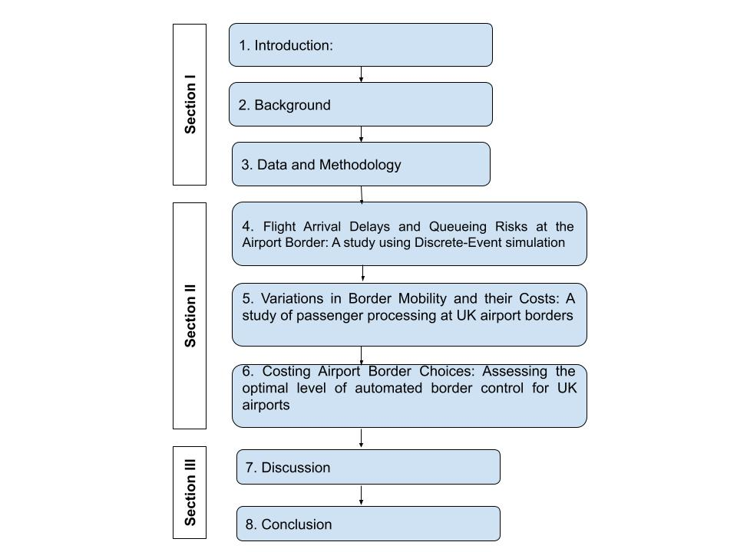
Figure 1. Thesis Format Overview

Background

Overview
The purpose of this section is to provide background information and literature for the research projects presented in Section II. I start by briefly describing the border control process at airports, and the relationship with other stages of the arrival process. I then provide summaries of the workload problems faced by modern border authorities, the desires to avoid delays at the border and the solutions that have been enacted to achieve this. I end by suggesting gaps in the existing understanding of these problems.

The Airport Border Control Process
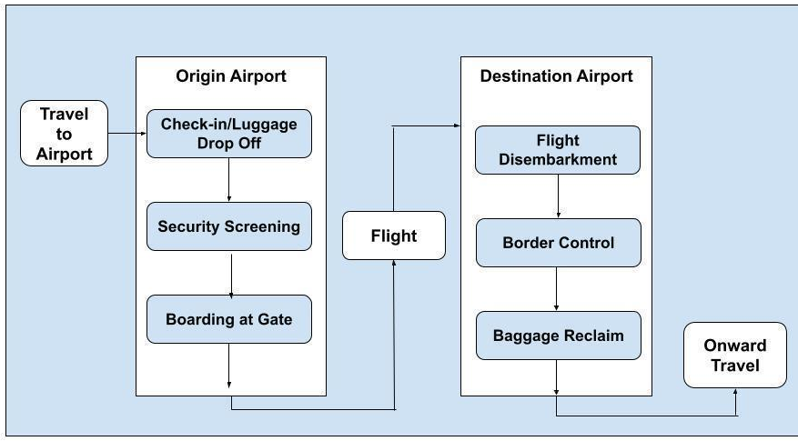
Figure 2. Simplified Example of Air Travel Stages (UK Arrivals)
Air passengers arriving into a country via an international flight are required to submit themselves for assessment by border control before entering a national territory. Figure 2 illustrates how this process is integrated into the UK arrivals passenger flow, with other nations following similar setups. Passengers will disembark a flight at their arrival gate and then travel to the main border control areas. At this point they will be directed into the correct control queue dependent on their relevant characteristics. The main determinants typically being:
- Nationality
- Age/travelling with children
- Disability status
- Eligible to use fast-track/registered traveller services.

The exact process that is undertaken by border control will depend on the nation. However, they typically involve identification checks, validation of their legal right to enter the country, cross-check of criminal/security threat databases and (in some cases) an assessment of the perceived risks of granting them entry. The complexity of these checks will depend on the nature of the individual(s) that present themselves at the border. From the simplest case of a domestic citizen returning from holiday, to the far more complex cases involving issues such as multiple travel documents, language barriers, irregular migration risks and child trafficking (see Chapter 5). How border control authorities are organised to respond in each case, and how long passengers spend in such systems, are driven by a nation’s overall strategy and policies. As illustrated in Figure 3, many of these areas will be set up to handle long queues when flows of passengers exceed the system’s ability to handle them.
Once passengers have cleared the border, they then move to Baggage Reclaim, where checked-in luggage can be picked up. If the hold luggage from the associated flight has not yet arrived at the area, passengers with bags will have to wait until they are available. A key element of this process is that delays at border control will only impact passengers (in terms of total time) if the wait time is more than what they would have otherwise had to wait for their bags (see Chapter 6).
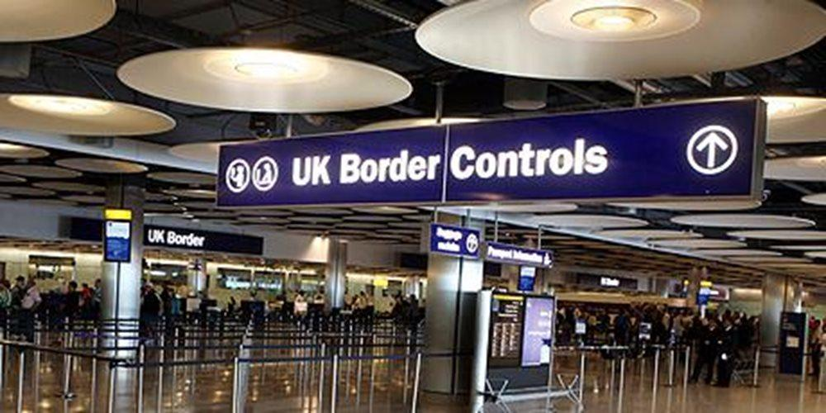
Figure 3. An example of Border Control at a UK Airport

UK Border Force Operations
The responsible authority for airport border control in the UK is Border Force. Each airport terminal has a separate ‘Principal Control Point’ (PCP), which include automated ‘eGates’ (where one officer can monitor up to 10 gates at a time) and the desks where passengers are processed face-to-face by an officer.
Eligibility to use eGates has varied over recent years. However, common passenger groups including domestic (British) and European Economic Area (EEA) nationals over the age of 12. All passengers 12 and under (and those travelling with them) must use a manual border control desk to enter the UK. However, there are separate desks for British/EEA nationalities and ‘Rest of World’ passengers (who will require the types of checks and assessments described above). There are also additional desks set up for specific types of travellers, including those with disabilities and ‘Fast Track’ for passengers that have paid to avoid queues.
A set number of Border Force Officers will be assigned to shifts in each PCP dependent on forecast of arriving passenger flows and staff availability. Note the latter is restricted by the total number of officers available for assignment, determined by the size of the officer pool and contractual obligations. Officers can be deployed in a flexible way throughout a shift, potentially moving between different types of desks or performing other duties. However, the total number of officers available will ultimately determine the maximum number of desks that can be opened. Hence, we can consider that the ability to provide operational capacity at UK borders is a result of multiple decisions taken at different timeframes. From the highest level: Total number of Border Force Officers need nationally each year, to the lowest: Total number of officers required for a particular PCP desk area for a 15-minute block.

Increases in Pressures on Border Controls
Accelerating trends in globalisation and the rapid rise of low-cost airlines have both been cited as responsible for significant increase in air passenger traffic from the 1980s onward (Akgüç et al, 2018, Balliauw & Onghena, 2020). More people holidayed abroad, more international business travel took place as international flights became affordable, increases in global migration expanded travel links with family and friends. The growth of international students attending Western universities resulted in millions of young people making multiple trips to and from home each year. Overall, the figures are stark: between 1993 and 2019, global air travellers quadrupled, from 1.1 to 4.6 billion annually (worldbank, 2022). Even in 2020, as air transport faced significant restrictions due to the Covid-19 pandemic, 1.81 billion individual air passenger journeys took place, more than any year before 2004.

UK Trends
The UK has seen trends similar to those described above. Table 3 show how over six years, UK Border Control was required to process 36 million additional passengers per annum. Added to this, the number of non-EEA Nationals increased by much higher rate than either British or EEA passengers. The typical ‘burden’ to UK border control is larger for the former (see Chapters 4 & 5), resulting in a multiplier effect of workload compared to just the passenger number rise. Several societal factors could be linked to this increase, such as:
- Total migration into the UK increased from less than 400k in 1998 to over 800k in 2018, and 1.2 million in 2022 (Sturge, 2023).
- The number of UK residents born outside of the country increased from 4.6 million in 2001 to 10.0 million in 2021. The number born outside of the EU doubled from 3.2 million to 6.4 million in the same period (Roskams, 2022)
- Total foreign students in UK higher education facilities increased from 231k in 2001 (HESA, 2023) to 680k in 2023 (Gent, 2023)
Table 3. Growth in Total Arrivals at UK Ports 2012-2018 (millions)
 | 2012 | 2018 | % Increase
British Citizens | 63.2 | 81.7 | 29%
Non-EEA Nationals | 12.9 | 20.4 | 58%
Other EEA and Swiss Nationals | 30.6 | 40.8 | 33%
Total Passenger arrivals | 106.7 | 142.9 | 34%
Source: GOV.UK. 2020
During this same period of rapid passenger growth, border authorities are also considered to have faced increased pressures on the quality of their work. An obvious factor is the 9/11 attacks in New York, which led to a notable rise in concerns over preventing entry to those deemed a threat to national security (Tholen, 2010). However, it is also claimed that rises in global migration and those seeking refugee status has resulted in increased public concern over the threats of ‘weak borders’ in terms of perceived increased competition for jobs, housing and government services (Bosworth, 2008; Leese, 2016). The exact nature and impact of these changes are highly debatable, and I have included some of this discussion in Chapter 5. I highlight them here to clarify the limited ability that authorities have had during this period to relax border controls in the face of rising passenger numbers.

The Problem with Border Queues
In a fixed border system, the logical consequence of higher workload would be longer queues and waiting times for arriving air passengers. This issue was analogous to the general challenges facing the air travel industry during this period; where significant research was conducted into how customer satisfaction levels could be maintained as demand/capacity ratios deteriorated (Balliauw & Onghena, 2020). Border control has been cited by the industry as a ‘weak link’ in these efforts (Aoa.org.uk, 2018) and pressure clearly exists from the business side to avoid long delays. However, nation states also view costs from long border wait times in various non-commercial terms.

Lost Passenger Time and Valuations of Travel Time
An obvious major cost is to the air passengers themselves who lose time from waiting in queues. For a high-volume nation such as the UK, with millions of air passenger arrivals each week, even small average delays can multiply into hundreds of thousands of passenger days lost (see Chapter 6). The valuation of this lost time is explored in the Valuation of Travel Time literature, which aims to provide a robust monetary valuation of passenger delays in transportation projects (see Jara-Diaz, 2007). These theories are primarily based on the concept that there is a monetary amount that an individual would be willing to pay (or accept) to reduce the time spent travelling/waiting.
A key element of VTT theories is that the average willingness to pay to avoid travel time is stated to increase along with the overall undesirability of the travel element (Jara-Diaz, 2007). Variables which impact desirability include positive elements, such as whether a traveller can perform enjoyable activities during the travel time (such as listening to music), as well as negative elements, such as stress caused by unpredictable or uncomfortable travelling conditions or unwanted environmental factors such as noise or crowds.
VTT research typically uses either stated or real preference survey techniques to obtain rates for various travel scenarios (Bateman et al., 2002). Rates can be calculated and applied in a way that does not consider the specific form of travel (see Batley et al., 2019). An example of this are the UK Department for Transport suggestions that national projects should value traveller time at £5.97 an hour for leisure trips and £55.46 for business (2021 prices) (Home Office, 2021), regardless of the nature of mode of transportation. However, these generic VTT rates can also be seen as less preferable to using rates that apply specifically to the travel scenario being costed; especially where there are factors which may result in an above average undesirability of travelling in the scenario.
Research into the nature of air travel and border control suggest factors why passenger may value time spent in these processes higher than in other forms of travel:
- The typical passenger journey through an airport is unappealing, involving flows of people broken down into multiple stages. All of these involve extensive monitoring and control from authorities and strict time deadlines (Kellerman, 2008)
- Queuing for border control involves standing in congested spaces with minimal opportunities to perform alternative tasks. Where individuals have limited privacy from either other passengers or the surveillance systems surrounding them (Wattanacharoensil et al., 2016).
- Specific to non-automated travellers, people excluded from automated border control gates are not only stuck in less desirable, often longer manual processes, but it also creates an obvious and visible gap between their experiences and those of automated passengers (Wattanacharoensil et al., 2016). Alexander et al. (2012) explore the issue of ‘multilevel queuing systems’ (where individuals are sorted into slower and faster queues) and conclude that perceived social injustices have a considerable effect on customer satisfaction levels.

Studies into air travel VTTs (Abrantes & Wardman, 2011; Landau et al., 2016) have confirmed that rates are significantly higher than other forms of travel. These issues are explored in more detail in Chapters 5 and 6.

Other Costs
In addition to the above, the costs of border delays are argued to include reduced levels of tourism/business travel into cities/nations with higher wait times, (Farrell, 2016). From a political standpoint, border control delays (as well as a perceived lack of control) are claimed to have high public visibility (Gilmore, 2012), and national governments risk general reputational damage when the press highlights individual cases of long wait times (see BBC, 2018). Finally, most national governments are signatures to international treaties on air travel, which commit them to prevent unnecessary delays to passengers, especially in the administration of the laws relating to immigration (Abeyratne’s, 2014, p78).
Border authorities themselves acknowledge the importance of managing border delays through the use of either public or private performance targets. An example of this is the UK’s ‘Service Level Agreement’ (SLA) target that 95% of passengers should face wait times within ‘acceptable’ levels; 25 minutes for domestic and EEA travellers and 45 minutes for all others (Home Office, 2022).

Developments in Border Control
Having illustrated both the risk and undesirability of passenger delays at airport borders, I move on to the common solutions pursued by border authorities. The simplest approach would have arguably been to just expand border processing capacity in line with increasing demands. However, we can consider the significant cost associated with handling a fourfold increase in passengers, as well as the practical problems that authorities may face such as a lack of physical space, or facilities for additional staff. Whilst capacity expansion was an initial solution (Költzsch, 2006), authorities have focused on other methods to reduce the time and cost needed to process individuals. I broadly summarise these under three category headings (“Exporting the Border”, “Border Control Digitisation”, “Forecasting and Optimisation”) shown in Table 4.

Table 4. Developments in Airport Border Control by category
Topic | Description | Examples (Studies)
Exporting the Border | Activities that would have previously been performed at the border have been moved to earlier stages of the passenger journey (including even pre-travel) | - Advanced Passenger Information (Vine, 2013)  - Passenger checks by airlines and airports (Møhl, 2018)  - Visas (Mau et al, 2015)
Border Control Digitalisation | The manual identification of travellers against travel documents has been gradually replaced by use of biometric technologies and validation against extensive data sources. | - Electronic Passports (Abeyratne, 2013)  - Automated Border Gates (Oostveen et al, 2014)  - Real-time database checks. (Lisle & Bourne, 2019)
Forecasting and Optimisation | The increased use of forecasting and other analytical tools has improved the planning of operational strategies that achieve performance targets whilst minimising costs. | - Staffing Optimisation (Mason et al, 1998)  - Capacity Modelling

The changes above can be broadly summarised as an attempt to reduce the average amount of work that has to be performed by Border Control staff when processing flows of arriving passengers. Passengers who are clearly ineligible to enter a nation find their journey cut short before they step onto a plane. Passengers who clearly are eligible for entry are processed simultaneously by banks of automated gates. Remaining passengers are left to queue for manual processing at staffed desks, the required number of which can be forecasted in advance using modelling techniques. Many of these process changes have received extensive research and been judged broadly successful in enabling authorities in achieving ‘acceptable’ levels of delays whilst controlling costs (Sontowski, 2018). Home Office statistics for 2010 to 2020 (Table 5) show that an average of 98% of monitored passengers were processed at UK border control within the agreed targets (Home Office, 2022).
Table 5. Service Levels at UK Borders 2010-20
 | % of passengers with wait times less than SLA Target
2010 | 98.4%
2011 | 97.6%
2012 | 98.5%
2013 | 99.6%
2014 | 99.5%
2015 | 99.1%
2016 | 97.7%
2017 | 97.4%
2018 | 96.0%
2019 | 97.5%
2020 | 97.4%

Current Issues
Nevertheless, gaps remain in the evidence base relating to the performance of border authorities and key aspects of their processes. Whilst 2% seems a low ‘failure’ rate for the UK, this would have still accounted for almost 3 million passengers in 2018. Beyond this overall figure, we can highlight the potential for variations in passenger experiences. The key split is between automated and non-automated passengers, with the latter typically facing longer delays at the border. As previously stated, this difference is codified in the UK SLA targets themselves, with non-EEA (non-automated) passengers having to wait 80% longer than EEA passengers before being in breach of agreed standards (GOV.UK, 2022). There is some evidence that even these laxer targets are being missed more often (Hegarty, 2021).
One possible explanation for this is the difference in importance of advanced planning of border staff levels for automated and non-automated passenger clearance. Whilst multiple banks of ePassport gates can be opened by a small number of staff, each additional border desk requires an additional member of staff. Hence, it is much more difficult to expand non-automated processing capacity at short notice. Whilst studies into areas that we categorised above as Exporting the Border and Border Control Digitalisation are extensive, much less focus has been placed on how authorities forecast and optimise staffing levels. I attempt to rectify this in Chapter 4, specifically by investigating how the variations in flight arrival times may be a central cause of risk within the planning process and how ‘bad arrival patterns’ can be translated into longer passenger delays. In Chapter 5 I focus on another element in non-automated delay, passenger processing times. Whilst there is considerable qualitative research in the varied ‘experiences’ of travellers crossing borders, there has been no prior statistical analysis into variations in processing times and the impact these have on delays.
Finally, I highlight some deficiencies in the costing of border delays. For authorities to make valid cost-benefit or other forms of analysis of border control options, it’s necessary to understand the costs resulting from the longer wait times that may occur in each scenario. Some studies have attempted to do this in terms of generic border delays (see Roberts et al, 2014b, Aussilloux and Le Hir, 2016), and one US study focuses specifically on airport delays, suggesting an annual figure to the USA of $1.3 Billion (Roberts et al, 2014a). However, none of these fully consider how lost passenger time should be accurately calculated for border control situations. This is a complex topic, which I explore and attempt to answer in Chapter 6.

Summary
The issue of passenger clearance at airport borders has risen in salience as passenger numbers have burgeoned while governments have taken greater concern over the benefits and costs of different types of travellers crossing their borders. Authorities have met this challenge by introducing significant technological and process changes that have not only fundamentally changed the passenger experience but introduced a clearer divide between those that are allowed to use automated systems and those not. Whilst overall there is evidence to suggest that these have been a success, further analysis calls into question the extent of this success for non-automated passengers. In addition to this, there are few studies that have robustly asked exactly how we should cost the time lost by passengers at the airport border, which leaves us to question the accuracy of cost-benefit analysis by authorities.

Data and Methodology
This chapter provides a high-level understanding of the data and methodology used in this thesis, as well as highlighting the links between the three studies. I focus on quantitative methodologies, combining both primary and secondary data sources with computer simulation to understand how decisions taken by border control authorities impact passengers.

Note on Terminology
To clarify, throughout this thesis I will be using the terms ‘desks’ and ’eGates’ when referring to the areas where passengers are processed by border control.
‘Desks’ are the areas in the PCP where a Border Force (or equivalent) staff member will directly process a passenger through a combination of ID/document checks and interviews.
‘eGates’ are automated border control gates (also referred to as ePassport Gates in the UK) where passengers are processed by a combination of biometric technologies.
Note that airports also have ‘departure gates’ (where passengers wait before boarding a flight) and ‘arrival gates’ (where flights land and passengers disembark). These are entirely different to the ‘gates’ referenced above and will be referenced using their full name where appropriate.

Home Office Collaboration
As previously stated, the on-going cooperation of the UK Home Office and Border Force have enabled this research to take advantage of a wide range of access to data and systems used in UK border control. This offers us a unique opportunity to conduct studies that attempt to accurately model the real-world people flows at UK borders. It also allowed continuous validation and feedback with relevant Home Office/Border Control staff to ensure that our understanding of processes and data was correct and that our outcomes conformed to the expectations of subject matter experts. However, this relationship also comes with strict confidentiality requirements which restricts what I can make publicly available. This includes the nature of the data sources and the exact assumptions made in the modelling. Nevertheless, I confirm that the findings presented here are my own, and that any redactions do not change the nature of the conclusions made in the various studies.

Key Data
Table 6 provides an overview of the key data sources used throughout my studies.
Table 6. Main Data Sources
Name / Source | Description | Main Data Fields | Chpts
UK Flight Arrivals  UK Home Office Internal System | Data for all flights arriving into UK airports. Taken from national systems used by airports and various government authorities.  Various terminals and data periods used for research. | - Flight Origin/Destination  - Arrival times (expected & actual)  - Gate Walk Time  - Total Passengers onboard  - Passenger breakdowns by expected gate used. | 4, 5, 6
UK Terminal Queues & Arrivals  UK Home Office Internal System | Time series data on the flow of passengers at UK airport border control areas. Used by Border Force in live dashboards to monitor border wait times.  Various terminals and data periods used for research. | - Total passengers arriving in each type of border queue  - Number of gates/desks available for use.  - Estimated wait time.  - Available staff | 4, 5
Border Force Queue Reports  UK Home Office | Statistics on passenger wait times at UK airport terminals, broken down by month. | Not provided | 4, 5
UK Port Research  UK Home Office | Data from observational research conducted at UK border controls between November 2019 and February 2020. | - Passenger Nationality  - Group Size  - Time required to process group | 5
Survey data of UK Air Passengers  Primary Research | Results from a Stated Preference Study of UK nations into their preferences regarding air travel and border control queues. Conducted in July 2022 by authors | - Attitudinal data on travel journey elements.  - Results from choice experiments  - Frequency of hold luggage use. | 6

Methodology
My research is primarily composed of a series of computer simulations, combined with quantitative studies of passenger behaviour and preferences.

Discrete-event Simulation
My main technique for modelling border control flows is Discrete-event Simulation (DES). DES involves the recreation of a real system in computer code in a model that allows it to evolve over a countable number of points in time (Phillips, 2009). Chapter 4 provides an in-depth discussion of the comparative merits of simulation modelling (DES in particular) when analysing queueing problems in airports. The advantages can be summarised as follows:
- Computer simulation is better suited to dealing with the non-standard nature of air passenger arrival distribution rates (Manataki et al, 2010),
- It is better at capturing the general complexity of airport systems with multiple interacting elements (Wu & Mengersen, 2013),
- It provides a more accessible tool for the general researcher as well as situations where non-technical air travel industry/border control stakeholders would react better to empirical evidence than to mathematically derived insights (Worthington, 2009, p60).

A different DES model is used for each of our three research papers. However, they are all an amended version of the core Python model represented in Figure 4. The key data inputs are UK Flight Arrivals and Queues and Arrivals data specified in Table 6. The relevant data range is taken for the terminal and dates of interest in each case. Figures for internal calculations were either provided by Home Office/Border Force staff or deduced from other data sources (precise details are provided in each chapter).
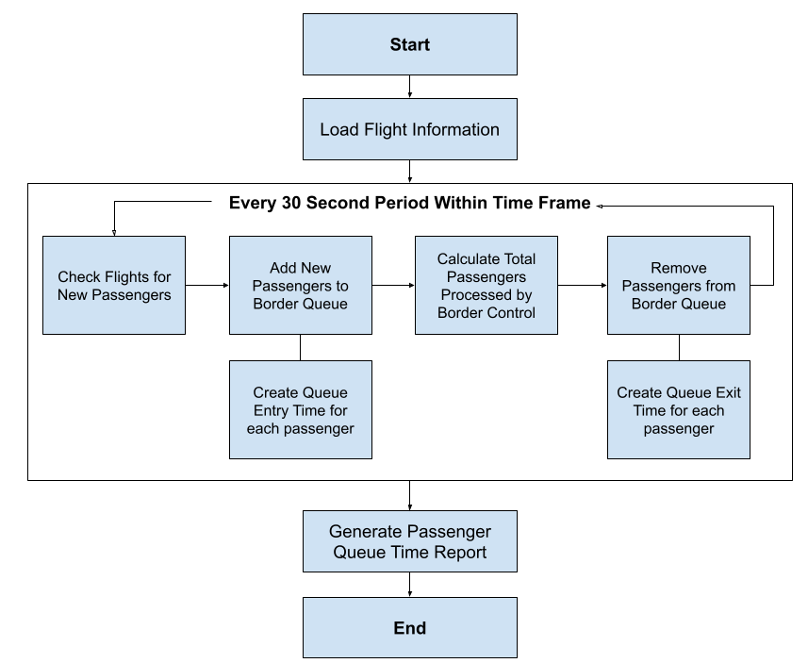
Figure 4. Flow Diagram of Core Airport Border Control Simulation Model
The final model output is a list of all passengers arriving into the terminal during the period with a queue entry and exit time. From this information a variety of wait-time statistics can be produced. An overview of the three different models is provided in Table 7. Whilst Models B and C use deterministic (scheduled) arrival times to provide a single set of statistics for each scenario, Model A uses variable arrival times to produce a probabilistic range of possible wait times. And whilst Models A and C assume that all passengers take the same amount of time to be processed at the border, in Model B these times are dependent on nationality (though still deterministic).
Table 7. DES Model variations
Model | Chapter | Arrival Times | Processing Times | Passenger Type
A | 4 | Stochastic | Uniform | Non-Automated
B | 5 | Deterministic | Variable by nationality | Non-Automated
C | 6 | Deterministic | Uniform | Automated

Focusing on Subcomponents
I discuss throughout Chapters 4-6 why the decision was made to focus on different areas of the system for each project, including references to applicable literature. Law (2014, pp2249-250) provides some general arguments for focusing on specific elements of the system you are modelling.
- It reduces the overall complexity, making it easier to develop, manage and maintain.
- It allows more resources/time to be focused on the element that is being explored, allowing potentially a more accurate representation of the systems behaviour in the simulation and the results of interest.
- Leaving out other non-essential elements makes it easier to verify/validate the model and deal with bugs/issues. The fewer ‘moving parts’ the easier it is to identify and fix problems.
Conversely, this approach also has some downsides for typical research projects. The main one is arguably having too limited scope, with important real-world interactions being ignored by the model. It is possible to miss important insight that would otherwise emerge from the impact of different components acting on the system simultaneously. I acknowledge the risks that this approach may lead to results that diverge from the actual airport border control environment being simplified in our project. I include consideration of this in my results.

Creating unique models
As described above, the DES models were built from the base up in Python specifically for this project. This contrasts with a more typical approach of building the model using existing simulation software (see Lang et al., 2021 for a discussion of this topic). This is to some extent a reflection of the realities of the researchers’ options when the project started during the Covid19 pandemic; the Home Office was unable to provide access or training to these software options. The confidentiality of Home Office data also meant that unverified cloud-based solutions or any other solution that didn’t already exist in their own environment would have been deemed unacceptable. However, I can also highlight some potential benefits from this approach suggested by Law (2014, p27):
- Customisation: Building the tool from scratch allowed the researcher to recreate the real-world system being modelled with the precise levels desired/required. There was no need to use approximations that might be necessary with existing software packages.
- Flexibility: Similarly, I had full control over the scenarios being modelled and was able to include/exclude elements and make granular level changes to timeframes and other interactions at the code level. Any inadequacies in the results could be rectified and simulation rerun based on this trial and error method.
- Optimisation: All the simulations involved considerable amounts of processing time. Building the tool from scratch meant that work could be done to optimise the code and remove all unnecessary elements.
- Analyst Skill Development: Building the tool from scratch, along with the algorithms and stochastic elements, provided me with valuable learning experiences where I gained increased understanding and confidence in my methods. Having a full understanding of how my results were generated was useful element in their interpretation.
Nevertheless, I can also specify some negative elements of this approach. The most obvious one is the considerable additional time and effort required to build, verify, run, and analyse the results from a code built tool. The key advantage of using existing software is that you are not ‘reinventing the wheel’ and can take advantage of existing, rigorously tested modelling techniques to run simulations in a much more efficient way. This approach would have arguably allowed me to include more complexity in my modelling techniques, as well as include more data and wider target frames for my scenarios. This is particularly applicable to issues of stochasticity that I discuss in Chapter 4 (Section 4.2.4). In addition, existing software would include more features such as in-built visualisation that may have improved or increased outputs in some areas. I discuss this issue further in my various results sections.

Observational Study at UK Ports
The Home Office conducted a series of observational studies at UK ports between November 2019 and March 2020. The key purpose of the studies was to obtain statistics on the times taken to process passengers (individuals and groups) at border control. This included timing breakdowns for individual elements of the border control process, as well as traveller data, including nationality and group size. The data shared with the researcher includes values for 1,980 passengers at 5 airport terminals.
I assisted in one of the terminal studies, allowing myself to become familiar with the data collection methodology and environment in which it was collected. An analysis of this data is included for the research project in Chapter 5.

Stated Preference Survey of UK Air Passengers
A Stated Preference Survey of 1,357 UK residents was conducted with assistance from the Home Office in March 2023. The survey was designed and distributed using online tools and answered by individuals who had signed up to complete surveys for a fee. The key element of the survey was a series of choice experiments designed to obtain the Valuation of Travel Time for passengers in three different stages of the arrival passenger journey (including border control). The survey also contained attitudinal and other questions used to increase understanding of preferences related to air travel and technical elements of the arrival process. Full details and results are presented in the project in Chapter 6.

Summary
My core methodological approach is based on developing models that allow us to predict how different operational decisions made by border control authorities impact passengers. Access to the real world data for these processes has allowed me to create and validate these with a high-level of accuracy. My primary research has enabled me to challenge some of the assumptions used in Home Office planning and offer alternative methods for calculating optima levels of passenger delays.

Section I References
Abeyratne, R. (2013). The ePassport—new technology to counter security threats. Journal of Transportation Safety and Security, 6 (1), pp.27–42.
Abeyratne, R. (2014). The Facilitation Connection. In: Abeyratne, R. (Ed). Regulation of Air Transport: The Slumbering Sentinels. Cham: Springer International Publishing. pp.77–83.
Akgüç, M., Beblav\`y, M. and Simonelli, F. (2018). Low-Cost Airlines Bringing the EU closer together. CEPF Research Report, May 15. Avilable from: https://www. ceps. eu …. [Online]. Available at: https://www.ceps.eu/wp-content/uploads/2018/03/05152018%20Felice%20Simonelli%20Low-Cost%20Airlines_Makguc_MBeblavy_CEPS.pdf.
AOA. (2018). TOWARDS A SMOOTH AND IMPROVED BORDER. [Online]. Available at: https://www.aoa.org.uk/wp-content/uploads/2018/07/A-smooth-and-improved-Border.pdf [Accessed 3 September 2019].
Aussilloux, V. and Le Hir, B. (2016). The economic cost of rolling back Schengen. Analytical Note, 39. [Online]. Available at: http://www.mondialisations.org/medias/pdf/consequenceabandonschengenen.pdf.
Balliauw, M. and Onghena, E. (2020). Expanding airport capacity of cities under uncertainty: Strategies to mitigate congestion. Journal of Air Transport Management, 84, p.101791.
Bateman, I. et al. (2002). Economic Valuation with Stated Preference Techniques: A Manual. Edward Elgar.

BBC News. (2018). Heathrow passport queues more than two hours. [online] Available at: https://www.bbc.co.uk/news/uk-45165222 [Accessed 4 Mar. 2020].
Batley, R. et al. (2019). New appraisal values of travel time saving and reliability in Great Britain. Transportation, 46 (3), pp.583–621.

Bosworth, M. (2008). Border Control and the Limits of the Sovereign State. Social & legal studies, 17 (2), pp.199–215.
Farrell, S. (2016). How airports can fly to self-service biometrics. Biometric Technology Today, 2016 (1), pp.5–7.
Gent (2023) International Student Statistics in UK 2023, Study in UK. Available at: https://www.studying-in-uk.org/international-student-statistics-in-uk/#:~:text=Top%20Countries%20of%20Origin%20of,outside%20of%20the%20European%20Union. (Accessed: 05 August 2023).
Gilmore, M. (2012). Securing Borders for the Olympic Games. The RUSI Journal, 157 (2), pp.26–31.
GOV.UK. (2020). How many people come to the UK each year including visitors. GOV.UK, May 2020. [online]. Available at: https://www.gov.uk/government/statistics/immigration-statistics-year-ending-march-2020/how-many-people-come-to-the-uk-each-year-including-visitors
GOV.UK. (2022). Statistics relating to passenger arrivals in the United Kingdom since the COVID-19 outbreak, May 2022. [online] Available at: <https://www.gov.uk/government/statistics/statistics-relating-to-passenger-arrivals-since-the-covid-19-outbreak-may-2022/statistics-relating-to-passenger-arrivals-in-the-united-kingdom-since-the-covid-19-outbreak-may-2022> [Accessed 23 September 2022].
Hall, A. (2017). Decisions at the data border: Discretion, discernment and security. Security Dialogue, 48 (6), pp.488–504.
HESA (2023) Introduction - students 2000/01 (2023) HESA. Available at: https://www.hesa.ac.uk/data-and-analysis/publications/students-2000-01/introduction#:~:text=Table%20B-,Students%20from%20countries%20other%20than%20the%20UK%20numbered%20230%2C870%20and,predominant%20among%20part%2Dtime%20students. (Accessed: 05 August 2023).
Hegarty, E. (2021) (COR0238) - committees.parliament.uk. Available at: https://committees.parliament.uk/writtenevidence/22523/pdf/ (Accessed: December 23, 2022).
Home Office. (2021). BF Passenger Waiting Times Methodology. Unpublished internal document.

Home Office (2022) Border Force Transparency Data: Q4 2021, GOV.UK. GOV.UK. Available at: https://www.gov.uk/government/publications/border-force-transparency-data-q4-2021 (Accessed: December 23, 2022).
Jara-Díaz, S. (2007). Travel Demand and Value of Time. In: Transport Economic Theory. 39. Emerald Group Publishing Limited. p.88. [Accessed 14 June 2021].
Költzsch, G. (2006). Biometric technologies in passenger clearance. Aviation, 10 (4), pp.18–24.
Landau, S. et al. (2016). Measuring air carrier passengers’ values of time by trip component. Transportation research record, 2569 (1), pp.24–31.
Lang, S. et al. (2021). Open-source discrete-event simulation software for applications in production and logistics: An alternative to commercial tools? Procedia computer science, 180, pp.978–987.
Leese, M. (2016). Exploring the security/facilitation nexus: Foucault at the ‘Smart’border. Global Society, 30 (3), pp.412–429.
Lisle, D. and Bourne, M. (2019). The many lives of border automation: Turbulence, coordination and care. Social studies of science, 49 (5), pp.682–706.
Manataki, I. E. and Zografos, K. G. (2010). Assessing airport terminal performance using a system dynamics model. Journal of Air Transport Management, 16 (2), pp.86–93.
Mason, A. J., Ryan, D. M. and Panton, D. M. (1998). Integrated Simulation, Heuristic and Optimisation Approaches to Staff Scheduling. Operations research, 46 (2), pp.161–175.
Mau, S. et al. (2015). The Global Mobility Divide: How Visa Policies Have Evolved over Time. Journal of ethnic and migration studies, 41 (8), pp.1192–1213.
Møhl, P. (2018). Border control and blurred responsibilities at the airport. Security Blurs, the Politics of Plural Security Provision, pp.118–135.
Oostveen, A.-M. et al. (2014). Automated Border Control: A Comparative Usability Study at Two European Airports. [Online]. Available at: doi:10.2139/ssrn.2432461 [Accessed 13 October 2018].
Phillips, C. (2007). A Review of High Performance Simulation Tools and Modeling Concepts. pp.29–47.
Roberts, B. et al. (2014a). Impact of Passport Inspection Wait Time on International Air Travel to and From the US. Analysis of Primary Inspection Wait Time at US Ports of Entry, p.53.
Roberts, B. et al. (2014b). The impact on the US economy of changes in wait times at ports of entry. Transport Policy, 35, pp.162–175.
Roskams, M. (2022) International Migration, England and Wales: Census 2021, International migration, England and Wales - Office for National Statistics. Available at: https://www.ons.gov.uk/peoplepopulationandcommunity/populationandmigration/internationalmigration/bulletins/internationalmigrationenglandandwales/census2021#:~:text=Out%20of%20the%2059.6%20million,were%20born%20outside%20the%20UK. (Accessed: 05 August 2023).
Scheel, S. (2018). Real fake? Appropriating mobility via Schengen visa in the context of biometric border controls. Journal of ethnic and migration studies, 44 (16), pp.2747–2763.
Sontowski, S. (2018). Speed, timing and duration: contested temporalities, techno-political controversies and the emergence of the EU’s smart border. Journal of ethnic and migration studies, 44 (16), pp.2730–2746.
Sturge, G. (2023) Migration Statistics - House of Commons Library. Available at: https://commonslibrary.parliament.uk/research-briefings/sn06077/ (Accessed: 05 August 2023).
Tholen, B. (2010). The changing border: developments and risks in border control management of Western countries. International Review of Administrative Sciences, 76 (2), pp.259–278.
Vine, J. (2013). ‘Exporting the border’? An inspection of e-Borders. assets.publishing.service.gov.uk. [Online]. Available at: https://assets.publishing.service.gov.uk/government/uploads/system/uploads/attachment_data/file/546849/An-Inspection-of-eborders_Oct_2013.pdf.
worldbank.org (2022) Air Transport, passengers carried, Data. World Bank. Available at: https://data.worldbank.org/indicator/IS.AIR.PSGR (Accessed: October 24, 2022).
Worthington, D. (2009). Reflections on queue modelling from the last 50 years. The Journal of the Operational Research Society, 60 (sup1), pp.S83–S92.
Wu, P. P.-Y. and Mengersen, K. (2013). A review of models and model usage scenarios for an airport complex system. Transportation Research Part A: Policy and Practice, 47, pp.124–140.

Section II: Included Research Studies

Flight Arrival Delays and Queueing Risks at the Airport Border: A study using Discrete-Event simulation

Abstract
This study explores the extent to which delays in the arrival times of flights impact the ability of border authorities to meet wait time performance targets. Using data provided by the Home Office and Border Force for a large UK airport terminal for 2019, I undertake Discrete-Event Simulation (DES) to demonstrate the expected queuing times given variations in flight arrivals. These are explored given varying levels of passenger numbers and border operational capacity. My results are compared to deterministic model results, based on the scheduled flight arrival times. Distributions of queuing times are presented and used to calculate the probability that Border Force will miss its Service Level Agreement performance targets given any specific flight arrival schedule. I conclude that flight arrival delays can have a non-neutral effect on queuing times on average, meaning that modelling based on scheduled arrival times may provide inaccurate predictions. I also demonstrate that these methods are a useful way of exploring queuing risks from flight delays alone, and that such results could be used to further both the aims of border control organisations and the interests of non-EEA passengers.

Introduction

Predicting Border Queues
As set out in Section I, border authorities have spent recent decades dealing with substantial increases in demands at airport borders. Various innovations have been implemented, all with the aim of limiting the frequency and length of passenger delays, whilst maintaining ‘acceptable’ levels of security. Many of these have been explored in existing Borders and Air Transport literature (see Chapter 2), with particular attention paid to technological developments such as Automated Border Controls and process changes such as pre-travel passenger vetting. Analysis suggests that these have been broadly successful in both reducing demands at the border and increasing processing capacity (Sontowski, 2018). However, less attention has been paid to the third category of solution established in Chapter 2, the role of forecasting and optimisation.
Border authorities conduct forecasting of future passenger numbers in order to plan the operational capacity needed to maintain queuing times within targets. This is done on both a short term (how many desks/gates we will need open at a specific airport terminal next Tuesday) and long term (how many will we need available in total a year from now) basis. Here, I can highlight a key difference in the importance of short/long term forecasting between groups:
Automated Gates: If passenger flows into automated queues are higher than expected, authorities can potentially respond by opening more gates. Purchased in banks of 5, opening available gates simply involves turning them on and potentially adding an additional Border Officer to supervise once a specific threshold has been reached.
Non automated (Staffed desks): If passenger flows into staffed desks are higher than expected, authorities can also respond by opening additional control desks. However, each desk requires an additional border officer to operate. Thus, the number of desks that can be opened is limited by the total officers that have been rostered to work in that particular shift.
Hence, we can consider that whilst maintaining automated queues within targets is dependent on long-term predictions of how many gates should be installed/maintained at a terminal (see Chapter 6 for more details), maintaining non-automated queuing times is more dependent on short term forecasts of required staffing levels. Too few officers available on a particular day is more likely to risk non-automated queues times escalating than automated.

UK Border Force
An example of this kind of forecasting are the in-house tools used by Border Force, the UK authority responsible for border control. These recommend how many desks/gates are required based on the scheduled arrival times and passenger breakdowns of each flight (Home Office, 2017). At the time of this study (2019), passengers ineligible for ‘ePassport gates’ primarily composed of non-EEA nationalities (GOV.UK, 2020), totalling 15.2 million arrivals in 2015/16. Border Force tools provide a recommended number of desks that should be made available for each 15 minute section of the day at each airport terminal. These results inform Border Force when making advanced staffing decisions. The primary target of this analysis are the national Service Level Agreement (SLA) levels that, on 95% of occasions, non-EEA passengers wait not more than 45 minutes (House of Commons Home Affairs Committee, 2012).
Official statistics for monitoring of this SLA target do not provide breakdowns between EEA and non-EEA arrivals. However, they do show multiple quarters in which the overall 95% target rate is only just met (GOV.UK, 2022). We can consider that 5% of non-EEA arrivals in 2018 would have totalled over a million passengers (see Chapter 2, Section 2.3 for figures). A number that will grow along with total passenger numbers. A question arises, given the stated concerns with delays and use of demand forecasting tools, why aren’t all passengers processed within stated wait time targets?
One avenue of exploration is the type of modelling used. Deterministic models, such as Border Force’s in-house tools, provide predictions and suggestions based on expected values of the systems they are modelling. Where these systems contain random (stochastic) elements, average values are typically used to generate expected predictions for the system. A typical airport border control process will contain numerous stochastic elements, with two key variables being the arrival time of flights and the processing times of passengers at desks. Focusing on the former, deterministic models will typically set a flight to arrive at its scheduled arrival time. However, in practice, flights will be delayed or brought forward depending on numerous factors. These arrival times determine the flow of passengers into the border control process, and the subsequent number of desks needed to keep wait times within targets.
We can consider a key problem with an approach based on such scheduled arrival times: Assume that such a model suggested that a minimum of 10 desks would need to be open for at least some part of the day to maintain queues within target. Border control may have some understanding that changing arrival patterns may in fact result in the need for more than 10 desks to be open at once. Hence, a heuristic decision is taken in advance on how many staff to allocate to that shift. A decision which must balance the need to have enough staff to cover ‘bad’ arrival patterns with the desire to minimise idle staff time that may arise due to ‘good’ patterns. Deterministic tools will provide a baseline for that decision but cannot inform organisations of the range or likelihood of minimum desk numbers, given the stochastic nature of flight arrivals. Beyond this, it’s possible that flight delays have an overall non-neutral impact on expected passenger flows for a given schedule; meaning that models that treat arrival times as deterministic may predict higher or lower minimum desk numbers than what is needed on average.

Project Aim
In this paper, I present a solution to this problem: Specifically, how flight delay variation can be considered when deciding on staffing-levels in border control scenarios. Working in conjunction with the UK Home Office, I use data for a major UK airport terminal from 2019 to perform Discrete-Event Simulation (DES) using variable arrival patterns. This is completed for three separate days representing different passenger volumes and uses a range of fixed values for open desks to generate a probabilistic spread of queuing times. These results are then used to assess the probability that SLA targets would be met for a specific day given a set maximum staffing level. They are also used to indicate the difference between average predictions from stochastic modelling and deterministic models using scheduled arrival times.
The aim of this study is to demonstrate to border control organisations both the methodology and desirability of stochastic analysis of flight arrivals when considering performance target risk. I am not attempting to determine optimal staffing levels in terms of passenger-staff trade off or suggest what levels of risk border control authorities should accept. Rather, the aim is to enable authorities to better calculate and communicate risk among themselves and other stakeholders, especially when in negotiations for resources. Wu & Mengersen (2013) highlight that the causes of long queues and problems affecting air passenger flows are often not obvious due to the complexity of interactions and interdependencies within the airport system. Hence, focusing on one specific stochastic variable allows us to consider its impact in isolation. Flight delays in themselves are considered to cause negative economic impacts for passengers, airlines and airports (Sternberg et al., 2017). Hence, knock-on delays at border control might have a cumulative effect.
The key research questions for this study can be summarised as:
(1) How do variations in flight arrival times impact the risk that border control queuing time targets will be missed?
(2) How do results from stochastic modelling methods of border control queuing problems contrast with deterministic solutions?

Ethics
This project has received ethical approval from the University of Sheffield Research Ethics Committee on the basis that it does not include any primary data collection or use personal data (Appendix A).

Paper Layout
The next section sets out the literature concerning the related areas of border control, airport operation and queue modelling. I then explain the data used in the research and the modelling/MCA methods utilised. I then present the results of our analysis, including a discussion of their meaning to our research questions. The last section concludes our research and specifies the limitations.

Existing Literature
This review will set out the existing literature concerning both general approaches to researching queuing problems as well those specific to the air travel industry and border control. I discuss arguments over deterministic vs stochastic modelling and the relative benefits. I finish by considering research into elements of passenger flows at airport border control and how this impacts the study.

Queuing Theory
The wide literature into queuing studies can be broadly split between those using queuing theory and simulation methods (see Worthington, 2009).
Queuing theory is concerned with providing analytical solutions for problems that focus on system aspects such as the arrival rate, the processing rate and queue discipline (Medhi, 2002). The standard notation used in queuing theory is in the format of A/B/c/K, where A denotes the arrival distribution into the queue, B the processing distribution/service time, c the number of servers and K the capacity of the queue. For example, M/M/m refers to a Poisson distribution for arrival and processing and variable servers. G/G/m is used to describe a ‘general’ queue where the distribution and service time can have any given distribution and there are variable number of servers. The core usefulness of queueing theory is that specific A/B/c/K queue types will have standard analytical formulas for calculating statistics for the queue based on standard inputs. For example, the mean wait and queue length can be calculated from using the mean and variance of the arrival time, the mean and variation of service time and the number of servers (Medhi, 2002).
These solutions have advanced in recent decades to include increasingly complex arrival and service rate distribution types; including multiple server behaviour, queue networks (where a service system is made up of multiple queue types) and time-dependent service systems (Worthington 2009). There are numerous examples of applications of this method to airport service-related problems. Regattieri et al.’s (2010) study of wait times at airport security screening applies multiple M/M/m models to different time-periods at Marconi International Airport to calculate the expected queue time distributions. Stolletz (2011) uses queuing theory to conduct a study of passenger flows at airport check-in. Both studies report that analytical solutions are statistically significant when validated against real data. Though, Stolletz mentions significant challenges when taking account of the time-dependent arrival of passengers, given the specific nature of air travel processes, including batch arrival, heterogeneous passenger groups and heterogeneous flight operators.

General Insight and Kingsman’s Approximation
Queuing theory can provide insight even where the arrival and rates of queues have non-specifical distributions, such as in the G/G/m model. Whilst these cannot produce exact results, approximations created by Marchal (1976) and Kraemer and Langenbach-Belz (1976) have proven popular.
A useful understanding of elements of these systems can be found Kingsman’s approximation of mean waiting time in the G/G/1 queue (1) (see Medhi, 2002, Chapter 8.1 for full details).
$E\left(W\right)≈\left(\frac{p}{1-p}\right)\left(\frac{({σ_{u}}^{2}+{σ_{v}}^{2})}{2}\right)t$ (1)
Where:
E(W) is the expected wait time.
P the traffic intensity or utilization of the system, calculated as the ratio of the mean arrival rate to the mean service rate.
${σ_{u}}^{2}$ is the coefficient of variation of the inter-arrival times.
${σ_{v}}^{2}$ is the coefficient of variation of the inter-service times.
t is the mean average service time.
This formula can be interpreted as mean wait times in these queues being a combination of three different factors.
- Utilization – The percentage of time that servers spend processing.
- Variability – The combination of the variation of the arrival times into the system and the variation of the processing rate.
- Service Time – The average time taken to process passengers.
A key insight here is that if the variability of either the arrival rate or processing rate of passengers increases, or the average service time, then so should the expected wait time.

Simulation
However, the literate also cites issues when applying analytical methods to complex, real-world queuing problems. Van Dijk (2002) summarises these concerns as follows:
‘The perception seems to have grown that queuing analysis is too detailed and too mathematically complex to allow for a direct practical application, other than for technical or industrial purposes. This perception seems to be strengthened by queuing theoreticians and their publications that mainly highlight the mathematical and technical issues rather than general insights. (Van Dijk, 2002, p1)’
Worthington (2009) agrees that, although complex queue systems can theoretically be transformed into mathematical solutions (Ingolfsson et al., 2007 provides a good example), often these are too advanced for use by the typical analyst. Even in complex solutions, queuing theory is required to make simplifying assumptions about numerous aspects of the service. Although this is an aspect of almost all queuing models, analytical solutions can particularly struggle to capture stochastic, time-dependent elements that do not conform to established distribution patterns. This chapter addresses these difficulties by selecting a method that is best able to capture the specific stochasticity of flight arrival times, as explained in more details below.
Angerhofer & Angelides’ (2000) exploration of the System Dynamics literature shows that from as early as 1960s, arguments were being put forward that the most effective way of solving complex problems is through use of computer-aided design tools to simulate real-world situation. This can require a considerable amount of data for the processes being modelled, however, Worthington (2009) argues that this can be a strength in practical situations where managers might react better to empirical evidence than to mathematically derived insights (p60). In addition, once a system is modelled and validated, simulation provides stakeholders the potential to examine almost any aspect of the process (Norton, 2011). One form of simulation, Discrete-Event Simulation (DES), involves the modelling of a system in computer codes as it evolves over a countable number of points in time (Phillips, 2009) and is a particularly common method for modelling service provision in airports.
Mason et al.’s (1998) review of customs control at Auckland Airport uses deterministic DES modelling methods that consider multiple passenger types to calculate optimal staffing levels. The authors argue that their methods highlight the enthusiasm for computer-based decision tools in the management process and its outputs were able to demonstrate a commitment to efficiency and optimisation. Something which, Mason et al. claim, has allowed them to avoid privatisation. These findings offer support for arguments from Worthington (2009) and others that stakeholders value computer simulation driven analysis. A specific limitation highlighted by Mason et al., was their model’s inability to consider flight arrival delay; confirming that this is an area that would benefit from further exploration.
Guizzi et al. (2009) provide another example of air passenger modelling using Arena software to perform DES at Naples International Airport. They model the flow of passengers from arrival to boarding, with the objective of ascertaining the number of open check-in and security desks that minimises the combined airport/passenger cost. They argue that a benefit of DES is that it allows:
‘..the detection of any critical issues that could arise in the real flow management taking into account some key factors such as the traffic passenger volume and the type of the passengers themselves. (P429).’
The authors state that the most problematic phase of the study involved data acquisition given the variability in flows by day of the week and time of day. And although the arrival of passengers is modelled in a stochastic manner, the results are only presented in terms of averages and the min/max range. This does allow easier validation of results for real life case study, but without an indication of the probabilistic range of the results, it means that stakeholders are unable to judge the risk that actual costs will deviate from expected. A strength of the approach followed in this chapter is that access to real-world data from Home Office/Border Force systems allows us to consider risks assessments that are based on a wide time range, rather than just a few days of observational research.

Stochastic Modelling and Variable Distribution
Petersen (2000) explores the general benefits of stochastic modelling in their review of food-chain contaminants and exposure risk. The author explains that use of fixed values for variable elements can lead to results in model outcomes that fail to consider the probabilistic range of inputs. Petersen argues that when using numerous variables, there is a risk of a multiplication effect if actual rates deviate from expected ones in a similar direction. That this can result in real-world outcomes varying considerably from simulated ones, even if the deviation in each variable is only slight. Also, if the modelling is primarily concerned with worst-case scenario testing, this requires setting variable rates at their extreme values, without any consideration of the likelihood of this outcome.
Simulation modelling techniques often provide the opportunity to incorporate actual distributions for input variables rather than relying on standard statistical models. Kelton et al. (2007) argues that although these models may be useful for random variable generation, it is likely that real-world variable distributions may not conform to any of the available standard distributions. In which case simulations will inevitably deviate from actual outcomes. Manataki et al. (2010) highlight this as a specific problem for using queuing theory with airport modelling,
‘Previous work reveals that existing analytical models generally present limitations, since they use specific distributions (or combinations of distributions) for their variables, or simplifications of many assumptions, failing thus to capture the complexity, variability and stochasticity of airport terminal operations and flows. (p2)’
Kelton et al. (2007) argue that the process of fitting and validating statistical distributions may be overly time consuming with numerous variables. Instead, they suggest a preferable method of using acquired data to generate specific probability distributions for required variables. The authors also raise the issue of variable independence, whether the random elements of a system are truly separate from each other or whether there are interactions between them. Clearly, if the latter is the case, it would be invalid to model each variable from an independent probability distribution. With regards to our study, research by Marin et al. (2007) of airport security screening times found that, as visible queues increased, the time taken by staff to complete individual scans decreased. They claim this to reflect ‘Parkinson’s law’, where servers will take more time on a task if they perceive there to be less time-pressure to complete it. However, the study showed that this applied only to relatively simple tasks that staff believed could be ‘sped up’ without an impact on security; it is questionable whether this would be applicable to the duties of border control.

Model Complexity and Monte Carlo Analysis
These discussions feed into a wider consideration of the complexity of the system that can be modelled in Discrete Event Simulation and how stochastic elements can be implemented. Common simulation software products will typically incorporate some element random variate generation (see Law, 2014). This involves the repetition of experiments with variable inputs to generate a sample of results that, after sufficient iterations, closely represents the variability of the real-world system it is modelling (Kroese et al., 2014). A common use of MCA is optimisation, where models are run multiple times to ascertain the values need to achieve the ‘best’ possible outcome. Kroese et al. argue that MCA methods are a popular way of analysing probabilistic outcomes due to their relative ease, efficiency, their insight into randomness and a growing literature of mathematical and statistical work underpinning their theoretical justification. Arunraj & Saptarshi (2013) state that Monte Carlo methods are the most common form of risk assessment due to their ability to ‘combine multiple probability density functions in risk to quantify uncertainty or variability in a probabilistic framework’ (p244).
However, the analyst also must consider model complexity. These include elements such as:
- Number of entities being modelled.
- Number of events taking place.
- Event dependencies.
- The time horizon of the simulation project.
- How often events are interacting with each other concurrently.
- The complexity of these interactions.
- The required level of accuracy and granularity.
As Law (2019) highlights, each additional complexity has the possibility of increasing the computing resources and time needed to conduct the simulation. The more complex the system, the more difficulties there will be in introducing stochastic techniques that attempt to capture the full range of possibility inputs/outputs from all elements of the system. Hence, careful considerations must be made concerning the level of complexity that is being captured in the simulation and what areas of randomness are important to model. From the perspective of airport border control, we can consider that the number of entities (passengers) can be extremely high and that our analysis would be interested in understanding queuing time risks throughout the operational period, at even the 15 minute level. Whilst the queuing system may not be that complicated (see Section 4.3), there are possible interaction effects between elements such as flight delay, arrival gate allocation, walk times and border officer processing times, as well as stochasticity within them.
Nevertheless, simulation methods using MCA is common in general queuing analysis (see Asmussen, 1990; Abdalla, A. & Buckley, 2009; Krose et al., 2014) and have been applied to numerous air transport Management problems. These include forecasting changing air passenger numbers (Scarpel, 2013), regional airport capacity planning (Irvine et al., 2015), passenger check-in queues (Ma, 2011), airport security queuing (Li, 2017; Xu et al., 2018) and risk assessment (Mueller, 2014), flight boarding (Steffan, 2008), ground movement of aircraft (Pitfield et al., 1998), flight departures (Carr et al., 2002) and air traffic risk management (Stroeve et al., 2009). These methods as seen as particularly useful for risk management cases as decision-makers can be presented with graphical representations of results that clearly show the range of all possible outcomes along with the probability that each outcome will occur (Bihani, 2014). This motivates my decision to include MCA as a key element of my simulation methodology for this study.

Flight Delays, Passenger Arrival and Border Control
Nikoue et al. (2015) present research into various methods used to track the movement of passenger arrivals at Sydney International airport. The study includes details on:
- the number of flights arriving in a specific time period,
- the number and types of passengers on each flight,
- the walk times from flight gates to border control.
With regards to flight arrivals, Nikoue et al.’s study highlighted significant differences between scheduled and actual arrivals during the surveyed days, with some evidence to suggest a lognormal distribution of delays. Tošić (1992) suggests, however, in their review of air passenger movements, that flight arrival delays are unlikely to be fully independent due to common influencing factors (e.g. local weather conditions or an incident at the airport). They continue that combined with ‘rigid’ flight schedules and arrival variance not growing with traffic volume, this makes the use of distributions such as Poisson less useful. Abdel-Aty et al. (2007) adds to this by suggesting that flight delay distributions may vary according to seasonal, weekly and daily factors.
Neither Nikoue et al. (2015) nor Tošić (1992) attempt to link arrival rates to border control queues. Brunetta et al. (1999) study, does include an inspection of passport service rates and performance for Milan’s Malpensa airport given expected passenger flows. It concludes that flow models can be used to ascertain when lower levels of performance would be expected for different parts of the day. However, these results are just one part of a much more comprehensive terminal analysis (simple landside aggregate model), and as such are limited in scope. The authors conclude that the passport control analysis would benefit from a more complex simulation of flight delay. Wu & Mengersen (2015) have provided additional analysis into the links between passenger flows and border control performances, but only as a limited consideration in a wider study. Hee and Zeph (1998) simulate passenger arrivals at Singapore Changi Airport using different flight arrival schedules. However, they focus on passenger volumes and capacity constraints rather than queuing times. Also, results are presented as summary statistics rather than probabilistic ranges.
McGonegal et al. (2014) offers a more direct example of how border control processes impact queue wait-times for passengers. Their study focuses on how US Customs and Border Protection allocate resources to reduce variations in average and maximum wait times for non-US air passengers for different times of the day. The research was framed by concerns that Customs and Border Protection had insufficient staffing to meet rising passenger numbers and that the staffing it did have was used inefficiently. The authors used metrics on the patterns of non-US resident arrivals, the number of control booths open and queue waiting times to assess these claims for different US airports. Among the key findings were:

- In some cases, Customs and Border Protection lacks the flexibility to adjust staffing (measured by available booths) adequately in response to changes in volumes of arriving passengers. Resulting in large spikes in queuing times (p49).
- Different airport terminals had different wait time distributions (though this could be explained by varying levels of non-US passengers).
- Wait times in the morning period were longer than others, even when accounting for higher passenger volumes.
- There was almost no correlation between periods with high levels of passengers and those with long wait times.

The authors claim that this lack of correlation suggests that US border control is generally successful in allocating staffing to handle larger passenger numbers, and that long queuing times are caused by other, unknown factors. We should be careful in accepting this analysis at face value, given that the research uses 1-hour time blocks aggregated over a year (meaning that fine analysis of the impact of specific passenger flows is not possible). Our research offers an opportunity to explore the link between flows and waiting times in more detail.

Summary
Analytical solution-based models have been shown to be an efficient method of providing answers to complex queuing problems, including in airport related scenarios. However, the advanced mathematics inherent in these methods have been considered a limitation for researchers and stakeholders who do not possess sufficient technical skills to understand them. Simulation methods, such as DES, have been suggested as more accessible alternatives. Such analysis may take more time and resources to achieve similar results; however, it also facilitates the exploration and interrogation of each system element by those from a wide range of backgrounds. Additionally, simulation allows the use of bespoke variable distributions and the kinds of complex system behaviour typically seen at airports. Informed by this insight, our research combines access to a wide range of real-world data with simulation and Monte Carlo techniques that allows us to best understand the stochastic nature of airport border control. These data and methods are explained fully in the following section.

Data and Methodology

Problem
Non-EEA queue times are measured from the moment that an individual enters the queue at the Principal Control Point (PCP) to the time that a border control desk becomes free for use. Variations in queuing times will depend on the flow of passengers into the queue and the rate at which desks can process them (an overview of this flow is provided in Figure 5 below).
The flow is dependent on the total volume of passengers, flight arrival times and the time taken to walk to the PCP. The overall processing rate is determined by multiple factors. However, I focus solely on the number of available staffed non-EEA desks (hereinafter referred to as operational capacity).
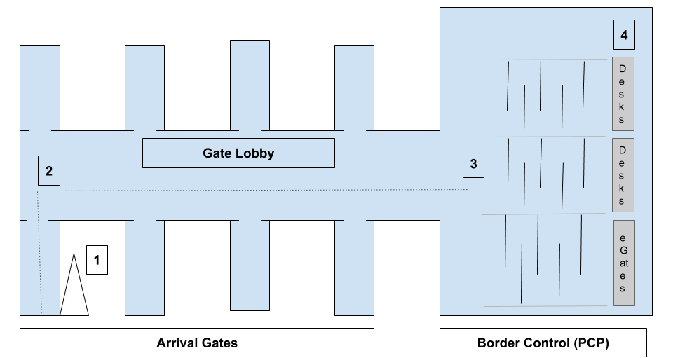
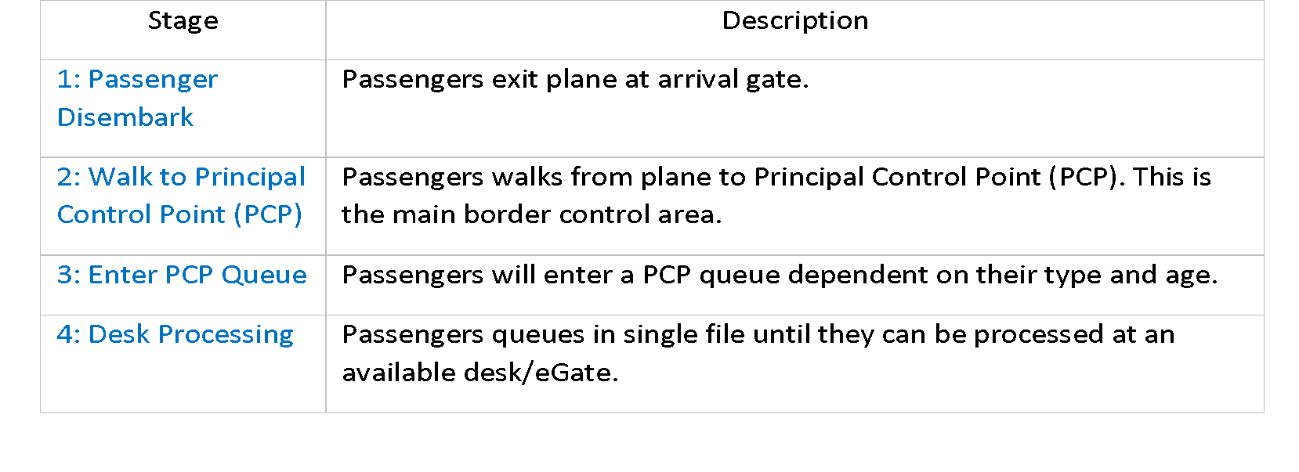
Figure 5. Simplified Arrival Stages for UK Airports

Case Study
This study focuses on a major UK airport terminal. It uses data from June to December 2019, following a major operational change which reduced the use of non-EEA desks overall (Gardner, 2019). The main data source is the Home Office’s in-house tool discussed earlier. This is confidential data that the researcher was granted access to as part of an ongoing collaboration. The tool is used ‘on the ground’ for managing border staff resources and passenger queues; hence data accuracy can be assumed to be high. Nevertheless, due to the nature of the data structure, exports can result in some missing values.
Table 8 shows a synthetic example of data taken from this tool. Scheduled and actual arrival times are used to calculate the arrival delay for each flight. Missing values can appear in the export for actual arrival time, in which case these flights are ignored from our delay analysis. The total for this is not stated due to confidentiality, but I am confident that it does not impact the ability to generate an accurate distribution. The status indicates flights which have been cancelled, as well as dummy data entered for testing purposes. Both are also filtered out.
Table 8. Flight Data Example
IATA | Scheduled Date | Scheduled Time | Act Arrival | Landing Gate | Status
ABC123 | 01/07/2019 | 05:30 | 05:45 | /200 | Landed
DEF456 | 01/07/2019 | 06:15 | 05:55 | /250 | Landed

Table 9 indicates some of the Advanced Passenger Information (API) available in this data. This includes the total passengers onboard and the number that are expected to enter the PCP (the rest transfer to a connecting flight). Passenger totals are also broken down by the type of PCP queue they are expected to use (see Appendix B), supplied from API data collected by the airlines. Only non-EEA queue data is shown in the example. The data export can contain missing values for the API data and in these cases the flight’s historical data is used; or if this is also not available, the terminal average. The use of this historic/terminal data would clearly have an impact on the accuracy of queuing time predictions, depending on how much these diverge from actual values. However, given that this research explores the specific impact of flight variations and desk capacity on queue times, as long as the same non-EEA passenger totals are used for each scenario day, my analysis will not be significantly impacted by whether totals are 100% accurate.
‘Est PCP’ shows the time that passengers are expected to start arriving in the PCP given the actual landing time. This is a function of the time taken for the first passengers to disembark and the average walk time from the gate to PCP.
Table 9. Passenger Data Example (Non-EEA Queue)
IATA | Scheduled Date | Total Pax | PCP Pax | API Non-EEA | Historical Non-EEA | Terminal Average Non-EEA | Est PCP
ABC123 | 01/07/2019 | 250 | 190 | 50 | 40 | 30 | 05:58
DEF456 | 01/07/2019 | 400 | 350 | 40 | 60 | 50 | 06:24

Scenarios: Passenger volumes & Operation capacity
Three days in 2019 were chosen that closely represent the first, second and third quartiles of non-EEA passenger totals for the airport terminal for the studied period. These are labelled in the results as Low, Medium, and High- volume days respectively. These days were selected to consider the extent that the insight gained from the analysis of results depend on the total number of passengers flowing into the system during the operational period. Specifically, what levels of additional operational capacity would be required in each case to reduce the risk of missing SLA totals to either zero, or a negligible amount. However, selecting three separate days also enables us to consider more generally how differences in scheduled arrival patterns impact results. No specific measurements other than passenger volumes were used in this decision.
Only modelling three days could be considered a limitation in our ability to validate that our findings are applicable to the general UK border control scenario. There would arguably be value in including a wider choice of scheduled arrival patterns to demonstrate the extent that our insight needs to consider the original schedule. To an extent, this choice reflects a practical limitation on the part of the researcher in terms of time and resources to conduct these simulations. However, it also does reflect the scope of previous airport simulation projects highlighted in Section 4.2.2, where it is typical that only a small number of days are chosen for analysis. I will return to this point in my discussion.
As discussed earlier, Border Force opens and closes non-EEA desks throughout the day based on suggestions made by their tools to maintain an efficient balance of queue times and staffing levels. However, as this research is specifically concerned with the links between desk capacity and border control targets, the system will be modelled to have a fixed number of desks open for the entire operational period. Similar to methods used by Guizzi et al. (2009), this will indicate the extent that a specific staffing level would be sufficient to avoid SLA breaches, regardless of arrival pattern of flights. This does mean that predicted queue times in the results are unlikely to conform to real-world scenarios. However, they will represent an accurate assessment of queue times when the system is at its highest capacity, where the number of open desks would increase up toward operational limits as expected queue times rise.

Home Office data indicates the range of non-EEA desks that are open in the terminal for the high-volume day. From initial results, it was decided to use a range of 6-15 fixed open desks for all volumes as this appeared to capture a wide range of results whilst allowing analysis and visualisation to not become overly complex.
The combined effect of the above meant that it was necessary to explore 30 separate passenger volume-operational capacity scenarios (3 volumes multiplied by 10 different totals of open desks).

UKBF SLA Target
As highlighted earlier, UK Border Force has an SLA target that non-EEA passengers should have border queue wait times of less than 45 minutes in at least 95% of queue measurements. This research aims to measure the probability that this target is meet for each volume-capacity combination explained above. This could be explored in multiple ways; however, I focus on two approaches:
- The probability that at least 5% of non-EEA passengers in any one day will have a wait time of over 45 minutes.
- The probability that the maximum wait time for a passenger in any 15 minute block is longer than 45 minutes.
The first of these provides a straight-forward measure of Border Force’s SLA. The second allows a more in-depth analysis of what times during the day that queue times are likely to breach the SLA. In addition to this, the calculation of average wait times across all scenarios will allow us to consider the extent that stochastic modelling differs from deterministic methods using only expected landing time.

Model Requirements
One method of researching the problem described in the previous section would be to build a full recreation of the flight arrival and border control process at our target airport terminal. This would include elements such as a realistic gate allocation for delayed flights, stochastic passenger disembarkation and walk times to the PCP, group behaviour, stochastic border control processing. However, as discussed in Section 4.2.4, it is often not cost effective to include the full complexity of the system being modelled. Rather, more limited models can still be valid if they are able to provide insight into the issue being investigated. As we are studying flight delays as a specific example of stochastic modelling, I argue that modelling a simplified version of the border control system would be better suited to demonstrate the range of performances that would occur in each ‘artificial’ scenario. Beyond a reduction in the time and resources needed to design the model, additional advantages to this approach include:
1. The ability to assess the issue of flight delay in isolation from other stochastic elements. This is something that the literature has highlighted as difficult when studying real world airport systems.
2. The provision of a generic example which could be expanded and adapted in the future to model specific airport terminal systems.
The simplified version of the system we have decided to model is explained in Appendix B.

Model Selection
The chosen model is built in Python, with some elements in R, and was developed from a much more basic DES model created by the researcher during an internship at the Home Office in 2019 to forecast queue times at ePassport gates (Gardner, 2019). The earlier model was validated against results from Border Force simulation tools and displayed an acceptable level of accuracy. This new model uses a similar form of fixed-increment time progression, where time is broken up into small time slices and the system state is updated according to the set of events/activities happening in the time slice (Phillips, 2007). For every 30 second interval of a specific period, the following tasks are performed in order:
- A check is made on the number of passengers on landed flights that are yet to disembark.
- A set number of passengers from these flights are added into the PCP system.
- The share of these passengers that use the non-EEA queues is calculated and they are entered into the queue.
- The passengers in the existing queue who have been processed by non-EEA desks in that time interval are identified and removed from the queue.
During this process, passengers are created as an agent class in Python (see Macal & North, 2005) and their queue entry and exit times are saved as attributes. In line with DES practice, the system is only simulated when there are events taking place in the time slice. Supplementary model material can be found in Appendix C.
This simulation required the following system process rates:
- The average rate at which passengers disembark from a flight.
- The average walk times from a flight arrival gate to the PCP.
- The average time taken for a non-EEA passenger to be processed at a border control desk.
These values are provided from the results of Home Office field research over multiple years. This is clearly an advantage for our research as it avoids the data acquisition issues involved with airport operations highlighted by Guizzi et al. (2009, see literature section). Though their confidential nature means we are unable to provide the values or details of data collection (see appendix B for full assumptions).

Monte Carlo Analysis (MCA)
MCA is used to capture the impact of flight delay on non-EEA queue times for a specific flight schedule and open number of desks. To create the scenarios for our DES model, a large sample of flight delay data is generated for our case study airport for 2019. This is then randomly sampled to apply a separate delay for each flight to create a new ‘simulated arrival time’. Table 10 gives an example of this process. This method follows earlier discussions on the benefits of using bespoke distributions for variables rather than standard statistical models such as the log-normal distribution (Kelton, 2017). Note, however, that the analysis treats delays as independent, which has already been highlighted as a questionable assumption (Tosic, 1992). I recognise this as a limitation of my model.
Table 10. Example of Flight Arrival Scenario Creation
IATA | Scenario | Scheduled Arrival | Randomly Sampled Delay | Simulated Arrival
ABC123 | 1 | 01/07/2019 05:30 | 00:10 | 01/07/2019 05:40
DEF456 | 1 | 01/07/2019 06:20 | -00:30 | 01/07/2019 05:50
GHI789 | 1 | 01/07/2019 08:15 | 01:22 | 01/07/2019 09:37
ABC123 | 2 | 01/07/2019 05:30 | -00:15 | 01/07/2019 05:15
DEF456 | 2 | 01/07/2019 06:20 | -00:05 | 01/07/2019 06:15
GHI789 | 2 | 01/07/2019 08:15 | 00:00 | 01/07/2019 08:15

‘Cancelled’ Flights
One issue with this method is that the simulated arrival time could potentially fall outside the 24 hour period of my analysis. In these cases, the flight is deemed to have been ‘cancelled’ and its passengers are not considered in the model. I note that a potential limitation of this approach is that the simulation does not include the possibility that flights could be delayed from the previous day and moved into our analysis period. Hence, by removing flight but not including additional ones there is a risk that we underestimate the average total workload that Border Force faces. However, analysis of the generated scenario data indicates that an extremely low number of flights are ‘cancelled’ (<0.02%), hence, we would not expect this to have any significant impact on our results.

Total Scenarios
The necessary number of scenarios runs needed for each combination was obtained by monitoring the change in mean and variance of the target variable with the addition of each extra iteration. The values for both will converge once the suitable number of iterations has been reached (Bukaçi et al., 2016). Initial exploration to test the model involved simulations with 100 and then 250 scenarios and convergence analysis suggested that little additional value was being added beyond 200 scenarios. A small number of these iterations were removed for each day due to violation of feasible landing requirements (see Appendix C). Additional convergence analysis with 500 scenarios confirmed the earlier analysis (see Appendix D).

Verification and Validation
Before beginning the simulation, I perform tests to verify that the model is performing as expected and validation to test the extent that my results conform to the real world system being modelled.
Verification involved using a sample of the data (the first 25 flights for our high-volume day) to perform manual modelling of passenger wait times in Excel using our system parameters and logic. The total number of passengers and their combined queue wait times are then compared to wait time results produced by our simulation model. Table 11 shows the result of this, including a less than 0.01% difference in total wait time (the difference is likely due to rounding errors).
Table 11. Model Verification Test
Method | Number of Passengers | Total Wait Time (mins)
Excel Simulation | 1029 | 11,361
Model Simulation | 1029 | 11,362.5
Match | 100% | 99.99%

Several steps of model validation were conducted following suggestions by Sargent (2010). My initial validation check was to ensure that our system assumptions (including rates described in Section 4.3.5) were correct. This was achieved by creation of an assumptions document (see appendix C) that was sent to subject matter experts at the Home Office to check. This raised some discussion about valid desk processing rates, and a different rate was provided using the most recent data for the terminal being modelled, rather than a general rate for all ports. Other rates were approved as valid according to their prior research and experience.
Following this, I used historic Home Office data on flights to perform validation against a sample of the model output. To match the operational circumstances of the day, flight arrival times were set to their actual landing times and the number of desks were set to the actual desks for each 15-minute slot for 9 hours of the high-volume day (referred to as ‘operational period’). Full details of this data and process can be found in Appendix E.
My first check was to see if passenger flow rates into the PCP were being correctly modelled. Figure 6 below indicates a very high degree of accuracy at the 15-minute level, which is confirmed by a test showing 0.98 correlation.
Figure 6. Comparison of Model and Actual Passenger Flow over the Operational Period
The second check was to compare model predicted wait times with Border Force data. Figure 7 shows that although the model closely predicts wait times in the first half of the period, it fails to accurately reflect the falls in the second half. Overall, there is a correlation of 0.78 between the datasets. This is not necessarily an issue though. As Sargent (2010) states, validity tests do not need to prove that the model is fully accurate, merely that it is accurate for the element of the system that is being tested. As we are concerned with the impact of variations in flight arrival time, as long as our model can accurately simulate the flows of passengers and deduce wait time statistics in a consistent way, we will both be able to determine the broad effect of flight delays and demonstrate the value of these methods as an measurement of performance risk.
Figure 7. Validation using Terminal Average Servicing Rate (High Volume Day)
To explore further, the model was amended to use the average desk processing rate recorded for just the high-volume day, rather than the terminal average. The comparison of these results with the actual wait times are shown in Figure 8. We see that predictions from our high-volume day model are now closely matching the actual results, with a correlation of 0.94. Hence, we can be confident that the model is accurately predicting wait times when values for non-flight arrival stochastic elements are known. In addition to this, sensitivity analysis was performed to assess the impact of different desk service times on our model predictions. Results are shown in Appendix E. They suggest that even if average rates used in the model are lower/higher than actual rates, the insight would not be significantly impacted.
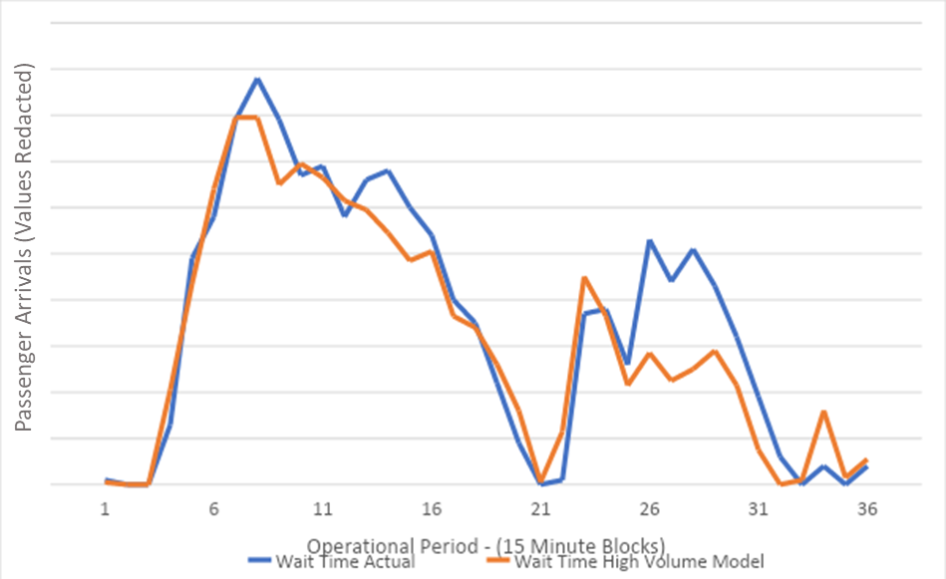
Figure 8. Validation using Day Average Desk Service Rate (high volume day)

Data Analysis
The initial output of the simulation model will be individual datasets for each combination of passenger-volume and open number of desks (e.g. high-volume day, 9 desks open). These will contain the non-EEA queue entry and exit time for each passenger modelled. These will be analysed using the R software package to calculate the summary statistics.

Average Wait Times: Stochastic vs Deterministic
Average wait times will be calculated for each volume-capacity combination using the full MCA results (~250 flight arrival scenarios each). If:
S₁ . . . S_{i}: Scenario datasets for a fixed combination
S₁W_{1 . . . . .} S_{i}W_{j}: Individual passenger wait times in each scenario,
Then the average wait time for all passengers E(W) across all scenarios can be represented as:
$E(W)= \sum{\frac{S_{i}W_{j}}{n}}$ (2)
Where n is the total number of passengers.
This will provide a general overview of the performance of border control in each case. $\underline{W}$ will also be compared against the average wait times for just the scheduled arrival time to give an indication of how predictions vary when flight delay is included. This will be performed for both the daily averages and for within day fluctuations in queuing times.

Performance Target Breach
My key focus is the risk that flight arrival delays will result in border queues that exceed Border Force’s SLA target. To assess this, the metrics presented will ascertain for each combination:
A. The overall probability that more than 5% of passengers will have wait times longer than 45 minutes.
B. The probability that in any 15 minute window, at least one passenger has a wait time above 45 minutes.
To measure A I use the 95th percentile queue wait time for each MCA scenario. I can then calculate:
P(sf) = Nsf / Ns (3)
Where:
P(sf): The probability that the 95th percentile exceeds 45 minutes for a single volume-capacity combination.
Ns: The number of scenarios used for a specific volume-capacity combination
Nsf : The number of scenarios in Ns where the 95th percentile exceeds 45 minutes.
The second will be measured in a similar way:
P(15f) = N15f / Ns (4)
Where:
N15f : The number of scenarios in Ns where a specific 15 minute block has a maximum wait time above 45 minutes.
P(15f): The probability that the 45 minute target will be exceeded in a specific 15 minute block for a single volume-capacity combination, where:

Results
I start by exploring the flight arrival delay distributions used in our modelling and the resulting arrival schedules. I then provide analysis of MCA average queue wait times and comparison with scheduled arrival predictions. The following section focuses on our main concern—analysis of risk of performance target breaches for both a daily and within day basis. The final section briefly considers the link between arrival schedule patterns and risk

Flight Arrival Delay
Figure 9 shows the distribution of flight delays for the target airport for 2019. These are generated from 46,755 separate flights, with a small number of extreme values removed. We can see that this takes the form of a slightly right-skewed normal distribution, with a median value of minus 11 minutes and mean value of minus 4 minutes; meaning that, on average, flights arrive ahead of schedule. Figure 10 shows the almost identical distributions of flight delays in our low, medium and high passenger scenarios, and how these conform to the overall patterns for 2019.
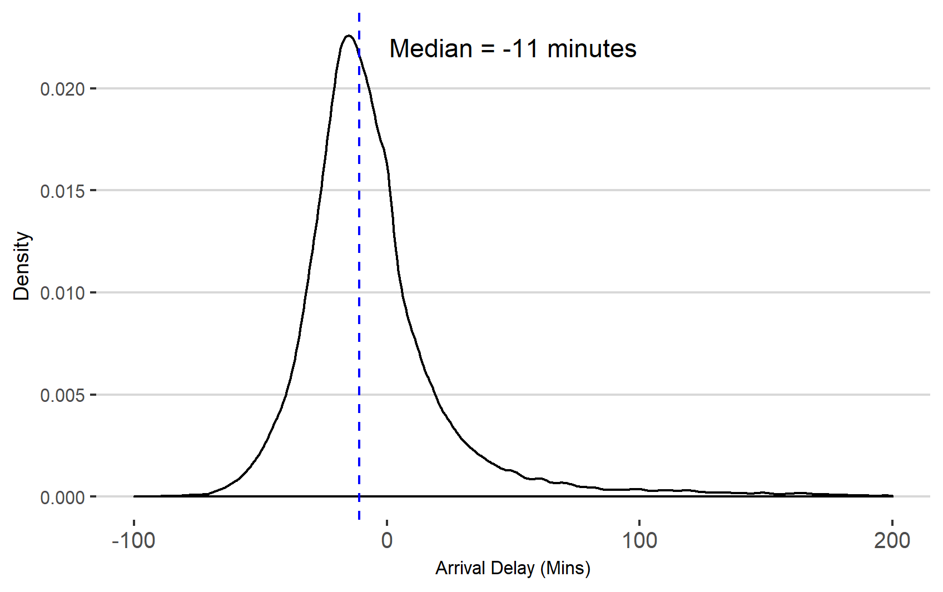
Figure 9. Distribution of Flight Delays for Target Airport for 2019 (extreme values removed)

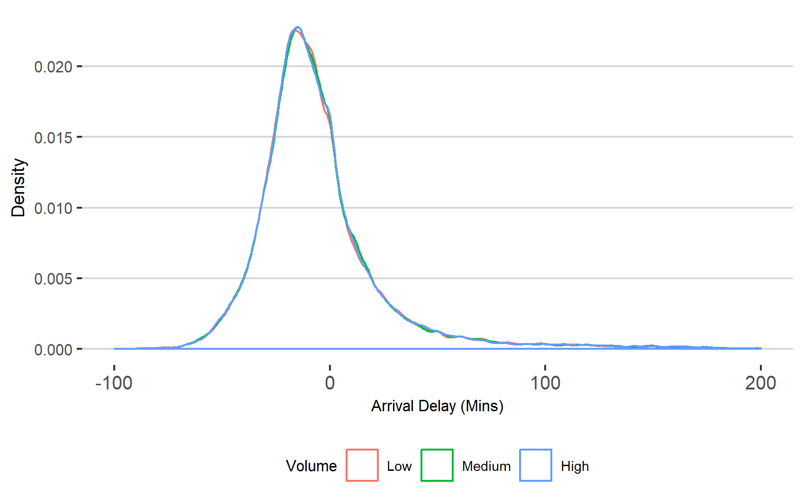
Figure 10. Distribution of Simulated Flight Delays for MCA Scenarios (extreme values removed)

Arrival Patterns
Figures 11-12 illustrate the range of flight arrivals for the low and high volumes days for all MCA scenarios. Each line indicates a separate flight, with the x-axis showing the range of arrival times over all scenarios and the y-axis showing the total number of non-EEA passengers onboard. In both schedules, most flights have less than 25 non-EEA passengers on board. However, the high-volume day is clearly distinguished by having multiple flights with more than 150 passengers.
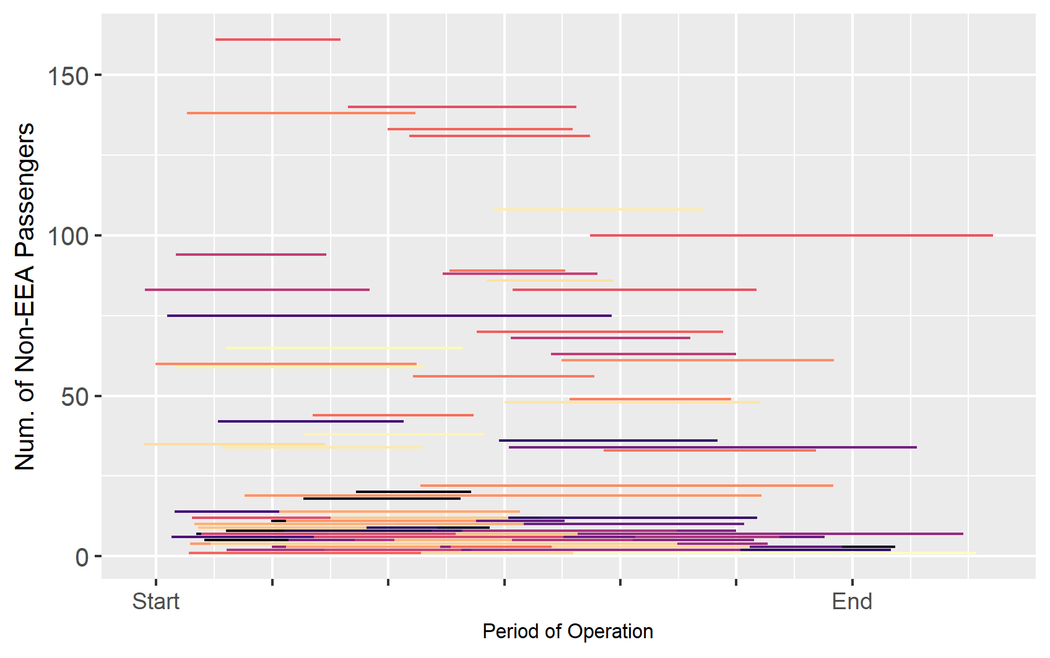
Figure 11. Individual Flight Arrival Ranges by total non-EEA passengers for a Low-Volume Day
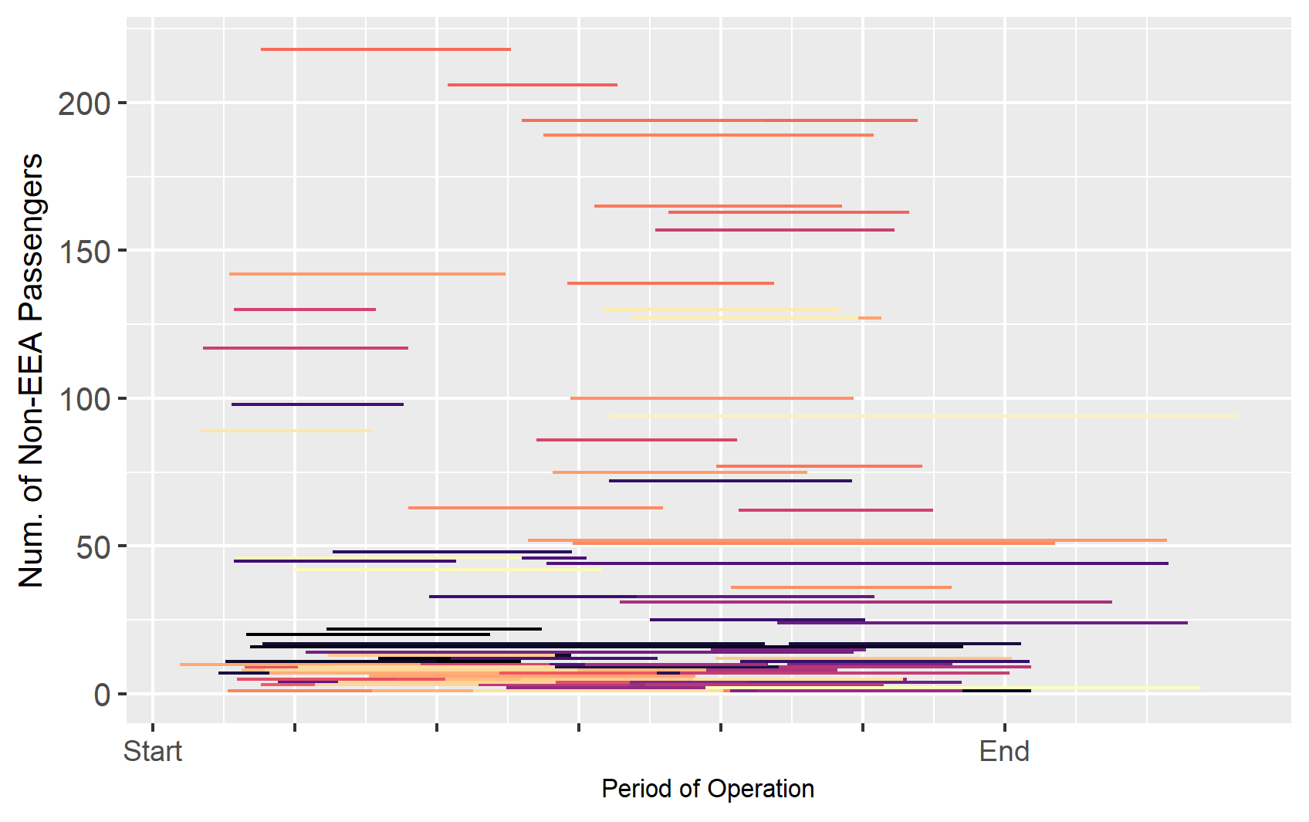
Figure 12. Individual Flight Arrival Time Ranges by non-EEA totals for High-Volume day

Overall comparisons between passenger volumes

Average Wait Times
An overview of predicted average non-EEA queue wait times for the three scenario days is shown in Figure 13. This indicates the mean wait time for MCA flight landing schedules for each volume-capacity combination. At lower operational capacity, we see a significant difference in queue wait times for the three non-EEA passenger volumes. For 6 desks operational, average wait times are almost an hour for the high-volume days but less than 10 minutes for the low-volume. For the medium and high-volume days, we notice that average queue wait times decrease at a diminishing rate as total operational desks increase. At the lower levels, we see the sensitivity in queue times; having 8 desks open rather than 7 reduces average wait times by 44% for the high-volume day and 39% for the medium.
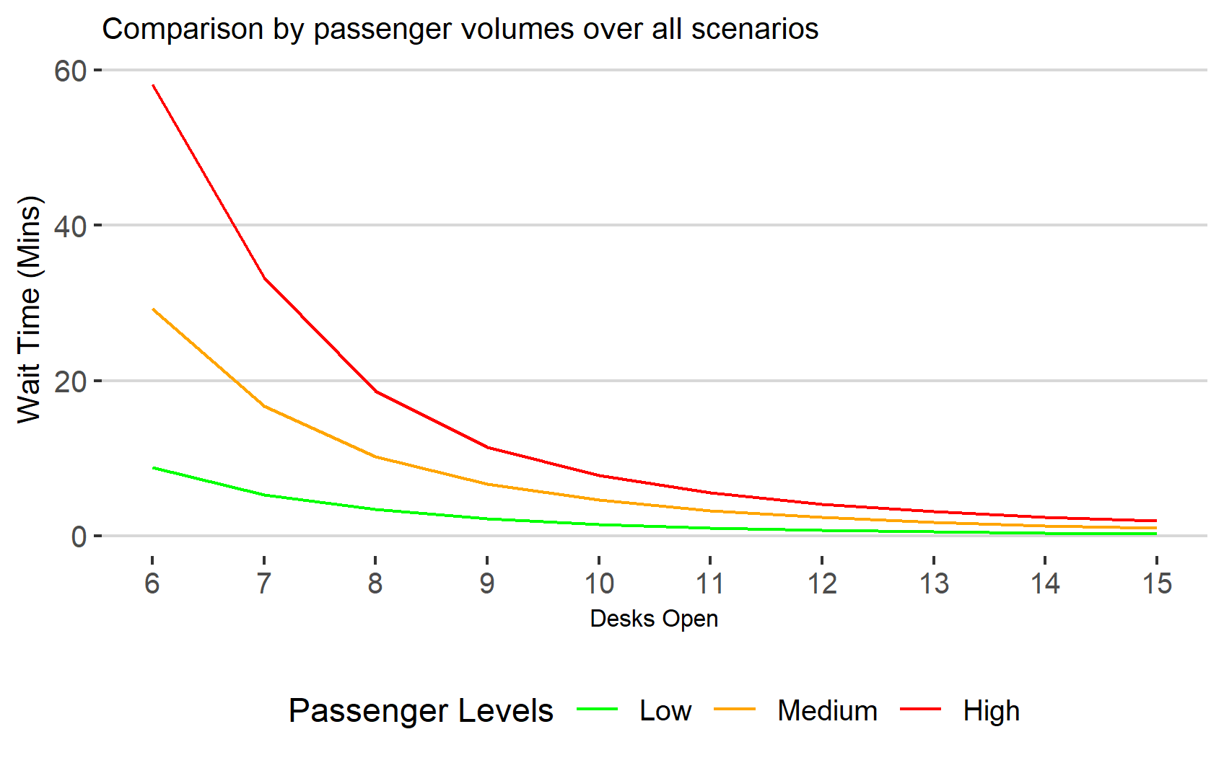
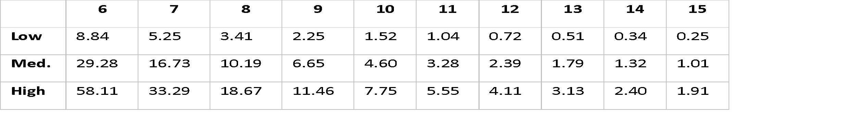
Figure 13. Average Passenger Wait Times (Mins) Across all Scenarios
Average vs Scheduled
Figure 14 shows these differences in minutes between our MCA average and the scheduled predicted queue wait times for each of our 30 volume-capacity combinations. The bars indicate whether the combined wait time for all flight arrival scenarios is lower or higher than the wait time for just the scheduled arrival. Overall, the results are mixed. For our low and medium passenger volume days, there was minimal difference between the MCA average predictions and scheduled arrival projections. However, our high-volume day has a clearer, consistent difference, predicting higher average wait times for all totals of open desks than the scheduled arrival projections.
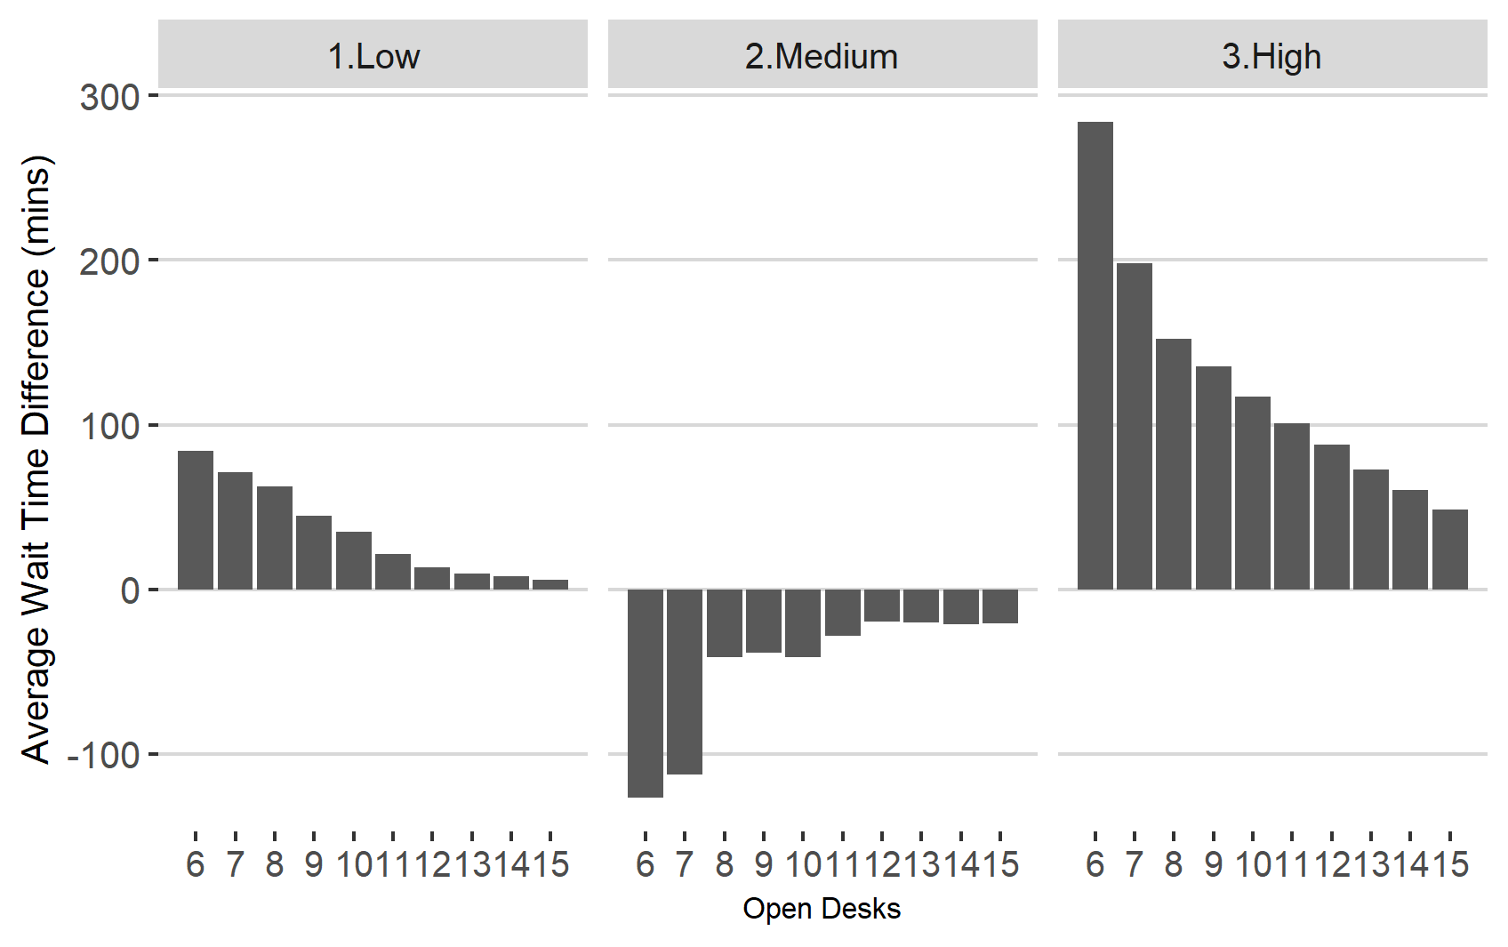
Figure 14. Comparison of MCA Average and Scheduled arrival Wait Times by Passenger Volume
Figure 15 provides some additional insight into this result, showing the predicted average queue wait times throughout the day for the high-volume day for 4 different open desk scenarios. The lines indicate the mean wait time for passengers who exit the queuing system at each 15-minute interval, with the gaps between them showing the difference between our expected average and scheduled predictions. Overall, the patterns of wait times are similar, however there are clear differences at different points of the day of each number of open desks. The main issue with 6 desk open pattern is that queues are expected to last for longer than the scheduled prediction, whilst for 10 and 12 desks average wait times are lower in the early part of the period but higher in the mid-late. Regardless of the specifics, this analysis is valuable in showing how deterministic modelling of the form explained earlier may systematically under or overestimate queuing times for different parts of a day, and that the specific nature of the inaccuracies will change with differing levels of operational capacity.
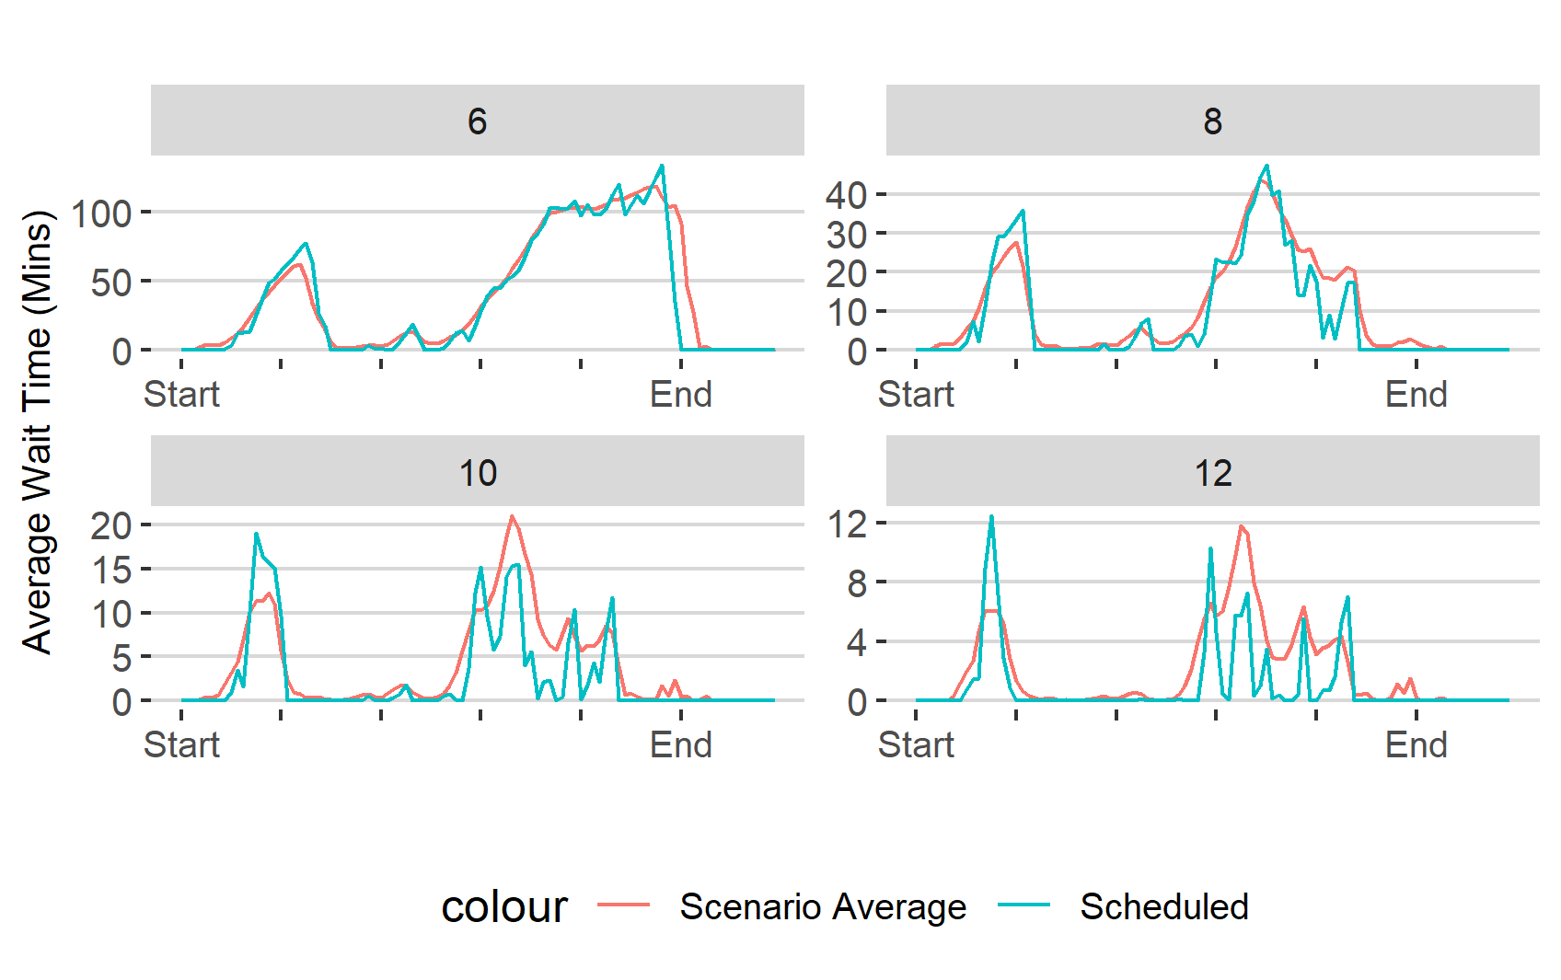
Figure 15. Comparison of Wait Time Predictions by Open Desks throughout the operational period for the high volume scenario.

Performance Target Risk Analysis
The main metric of this study is the risk that Border Force’s SLA target would be breached in a specific scenario. Figure 16 shows the full results of the simulations as a probability that each volume-capacity combination will result in a 95th percentile queue wait-time of more than 45 minutes. This is calculated using the method described in Section 4.3.8.
We see that even at our lowest number of open desks modelled, that the low-volume day would only have a 6% chance of an SLA breach, however our medium and high-volume days are predicted to breach with 100% certainty. Once we reach 11 or more desks open, the risk of SLA breach falls to zero for all three passenger numbers. These results show the sensitivity of operational capacity to meeting targets; increasing the total number of desks from 7 to 8 reduces the likelihood of breach in our medium day from almost 2 in 3 to just over 1 in 10. There is a similar reduction in likelihood when moving from 8 to 9 desks for the high-volume.
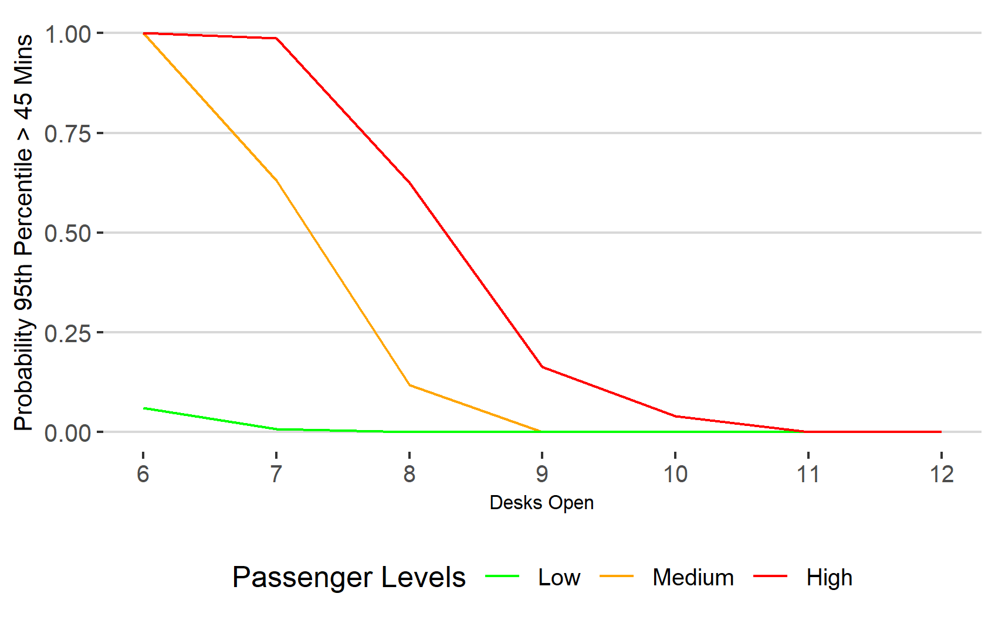
 | 6 | 7 | 8 | 9 | 10 | 11 | 12
Low | 0.06 | 0.01 | 0.00 | 0.00 | 0.00 | 0.00 | 0.00
Med. | 1.00 | 0.63 | 0.12 | 0.00 | 0.00 | 0.00 | 0.00
High | 1.00 | 0.99 | 0.62 | 0.16 | 0.04 | 0.00 | 0.00
Figure 16. Comparison of Risk that 95th percentile wait time exceeds 45 minute target

Low-Volume Day
The above results suggest that despite prediction for relatively small average wait times for the low volume day, there remains some possibility that Border Forces SLA target would be missed at lower operational capacity. Figure 17 expands on this by showing the distribution of the 95th percentile wait times for all scenarios.
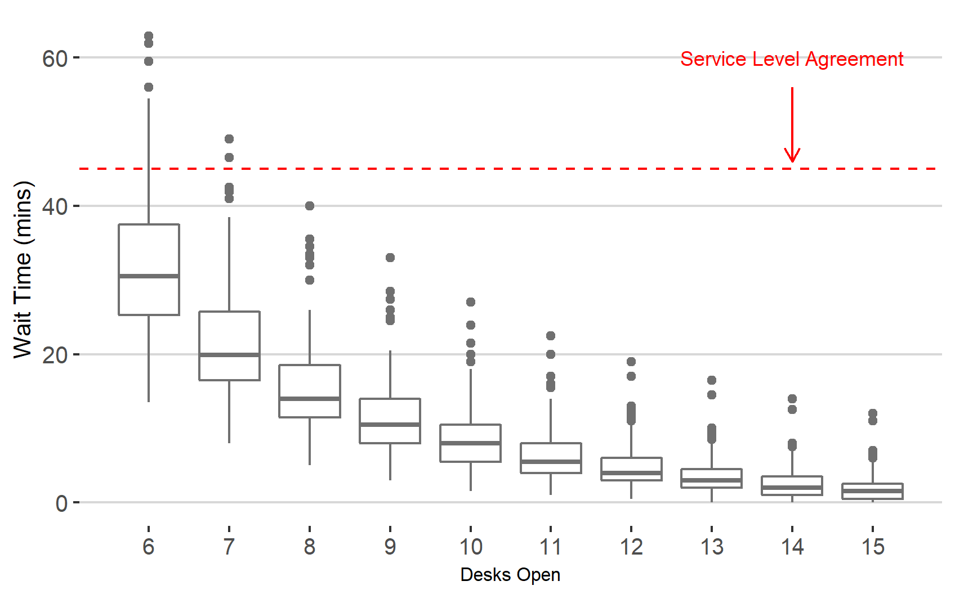
Figure 17. 95th Percentile Wait Time Distributions for Low-Volume Scenarios
Here we see why the risk of breaching SLA is comparatively low for the low-volume day. With 6 desks operational, the average 95th percentile wait time across all 247 valid landing scenarios is 31.6 minutes, with our 45-minute performance target being missed in only 15 of them. Moving to 7 desks operational reduces the average 95th percentile to just over 21 minutes and results in only 2 out of 247 landing scenarios failing our SLA. These results do indicate the range and distribution of possible 95th percentile wait times at the lower operational capacity levels

High-Volume
Figure 18 shows the same analysis for the high-volume day. This confirms that the average (median) 95th percentile wait time will exceed the performance target at 8 open desks (49.7 minutes) but drop below at 9 (35.3 minutes). However, the figure also shows more clearly the number of scenarios that exceed SLA with 9 desks (41), as well as the difference in range of upper queue wait times for the lower operational capacity values.
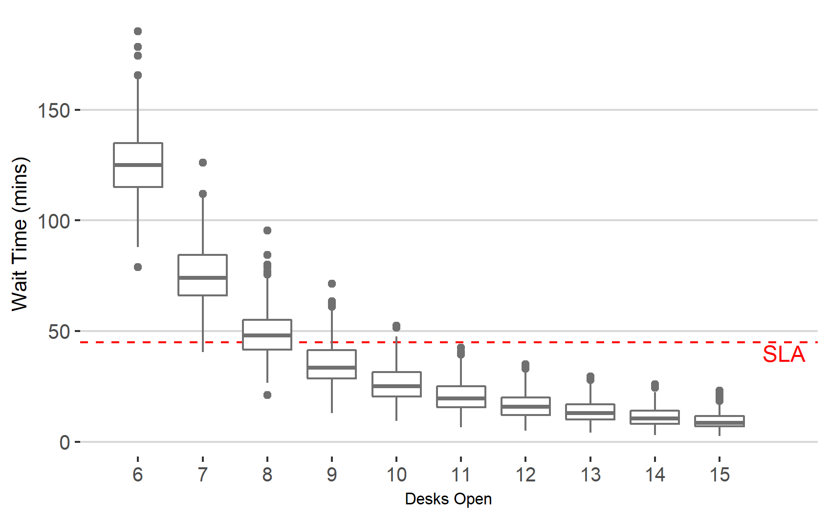
Figure 18. 95th Percentile Wait Time Distributions for High Volume Scenarios

Returning to a comparison of stochastic and deterministic modelling, Figure 19 shows the 95th percentile wait time by operational capacity for just the scheduled arrival pattern of the high-volume day. The results suggest that an operational capacity of 8 desks would be required to just avoid breaching SLA targets (the 95th percentile would be 43 minutes). However, this contrasts with the stochastic flight delay modelling above which shows that even on average, the SLA would be missed with 8 desks and that 9 still leaves a 16.4% risk of breach.
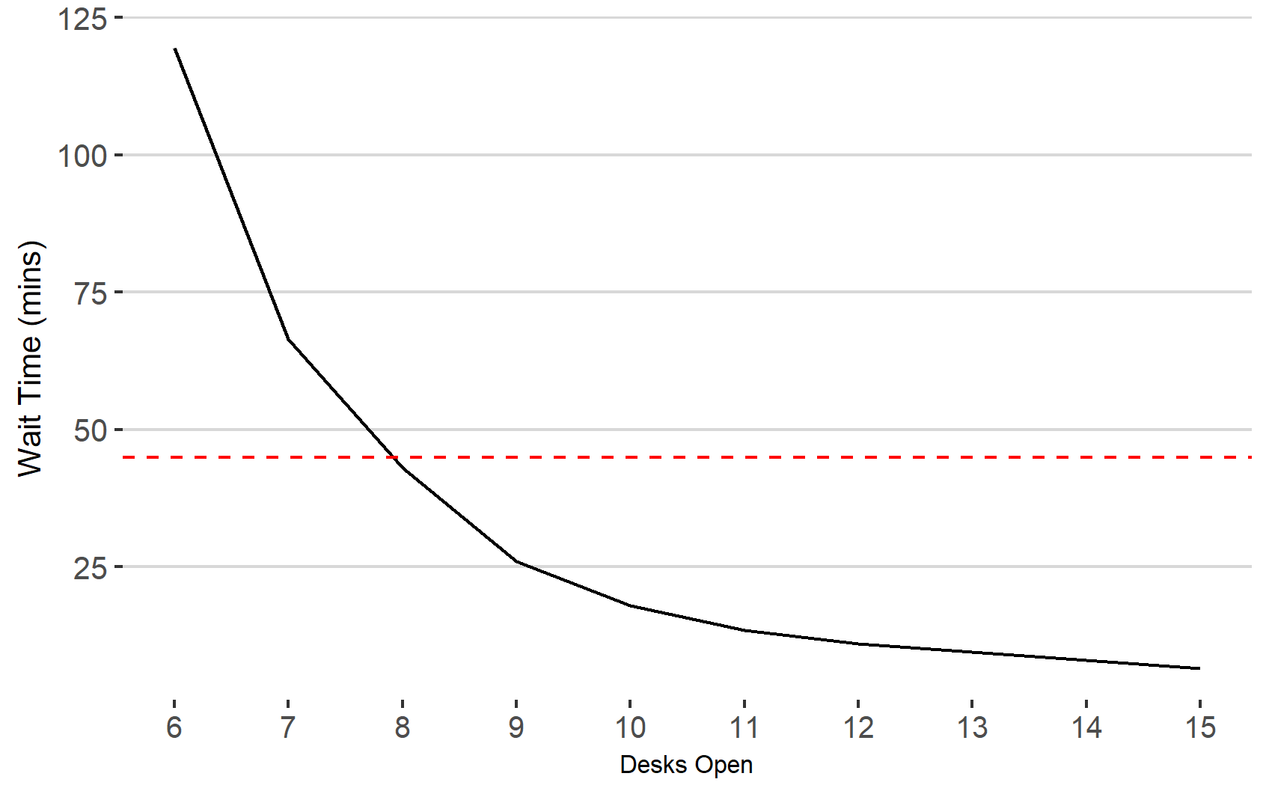
Figure 19. 95th Percentile Queue Times for Scheduled Arrival Pattern (high volume)

Time of Day (High-volume)
This risk of unacceptably long queue times can be interrogated in more detail when we explore the maximum passenger wait time in each 15-minute block for each scenario (see Section 4.3.8). Figure 20 shows the results for the 45-minute target (and a higher 90-minute threshold) for 6-9 desks open for the high-volume day.
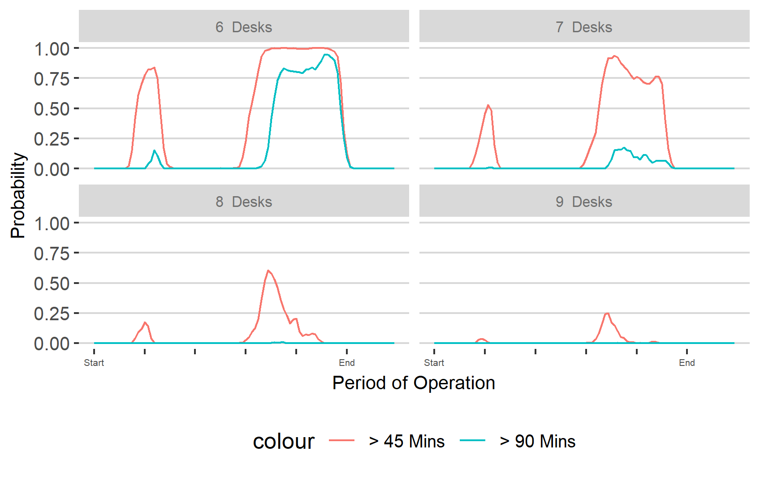
Figure 20. Probability that Maximum Wait Time will Exceed Stated Target (High Volume Day)

With 8 desks open there is an over 60% chance that the performance target will be breached at the mid-late period of our analysis, and a smaller (17.6%) chance of breach in earlier periods. The graph shows further how the risk of both a 45 minute and 90 minute queuing time breach increases rapidly as operational capacity is reduced. With 8 desks, the probability of a wait time above 45 minutes only rises above 50% for 1 hour of the day; with 7 desks this happens for 4.5 hours and for 6 desks the risk remains above 50% for almost 11 hours.

Additional Analysis: Arrival Schedule vs Performance Target
The results above have illustrated the range in potential queue wait times due to variations in flight arrival schedules. This section briefly explores possible links between arrival patterns and the breaches in our performance target. Focusing on the high passenger volume day, Table 12 shows the scenarios with the highest and lowest 95th percentile wait time when 8 desks are open.
Table 12. Best and Worst Queue Time Performances for High-Volume Day
 | Scenario # | 95th Percentile Wait Time
Worst Case | 76 | 95.5 Minutes
Best Case | 62 | 21 Minutes

Figure 21 shows a comparison of these arrival scenarios. The bars indicate the total number of passengers that arrive into the airport during each hour of the day. As shown, the main difference between the passenger flows in the two scenarios are that whilst there is a steady arrival between the middle and mid-late period in the best case, there are two peaks of 600+ passengers close to each other in the worst. This suggests, as we might logically expect, that high 95th percentile times come from narrow periods of high passenger volume. This conforms to the general queue theory insight (Section 4.2.1) that increasing the variability of arrival times into the system increases average queuing times.
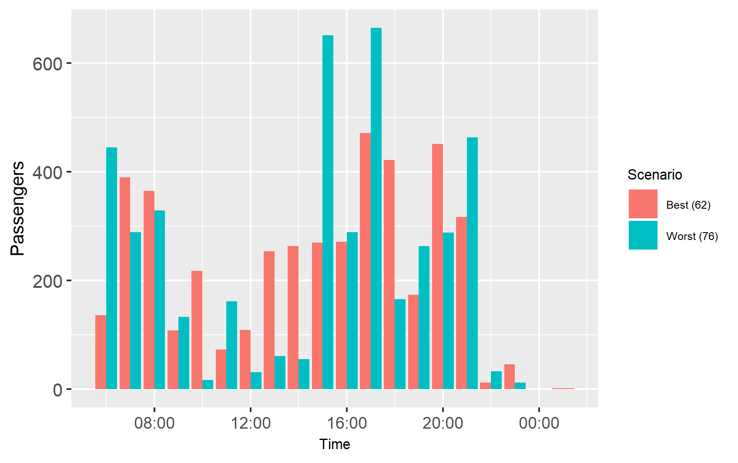
Figure 21. Comparison of Passenger Arrival Flow During Simulated Time Period

Discussion

Nature of Flight Delay
The exploration of the generated flight arrival schedules indicates the wide variation in possible passenger flow for each day. Most flights have a small number of non-EEA passengers on board. However, in both the low and high volume days there are flights with over 100 non-EEA passengers. My results illustrate how these flights could either land hours apart, or simultaneously, demonstrating the risk that large numbers of non-EEA passengers will arrive in border control in a short space of time, even where scheduled flight arrival times are separated by a considerable gap. The brief analysis of flight arrival schedules suggest that this form of arrival congestion is important in determining whether or not a passenger flow scenario will lead to incidents of long queuing times.

Impact of Flight Variations
Beyond this intuitive conclusion, my results demonstrate how the inclusion of arrival delay leads to queuing time predictions that differ from those based on scheduled arrival patterns. I stated at the start of the study that these forms of deterministic modelling solutions provide estimates for queuing times based on average scenarios. If the scheduled flight arrival pattern represented the ‘average’ scenario then we might expect the average of stochastic modelling results to approach scheduled results given a large enough sample size. However, my analysis shows that scheduled arrival predictions for at least one of our (high-volume) days were lower than the average of our scenarios for all operational capacities. When breaking down average wait times by 15-minute periods, we were able to identify exactly what times of the day we would expect to under-estimate by deterministic modelling.
The importance of these results to both border control organisations and other related air travel industry stakeholders is that they highlight how modelling using only scheduled arrival patterns may lead to queue time predictions that are less accurate than stochastic modelling; and resourcing decisions that may systematically under/over staff border control. For example, modelling results for the high-volume day using the scheduled arrival pattern suggested that Border Force’s SLA target would be met with 8 desks functioning all day. However, when flight arrival variation is included in the model our results suggest that, on average, the SLA would be breached at this operational capacity. The 15-minute comparison then clarified that this added risk would come towards the end of the operational period, suggesting that 8 desks would on average be less successful in bringing down queue times from their mid-late peak than in the scheduled arrival pattern.

Measurement of Risk
I argue that the results of my simulations show the value of the method in judging queuing risks with regards to Border Force’s SLA. The distribution of the scenario simulation provides both the frequency that the 45-minute target is missed, as well the probabilistic range of queuing times. For example, in the low-volume day the median 95th percentile wait time was well within the SLA. However, within those 247 scenarios, the metric ranged between less than 20 minutes and over an hour, with 6% over the 45-minute target. Even at this low figure, Border Force would expect to have approximately 22 days a year of SLA breach if operating at the same level of risk.
For the medium and high-volume days, my results suggest that the risk of SLA breach was highly sensitive to the number of open desks, with the opening/closure of an additional desk resulting in significant changes to the likelihood of breach. The modelling also suggested that in all three volume scenarios, one extra desk was needed to reduce the risk from very low to zero. This highlights some of the issues I described at the start of the study concerning heuristic decision-making based on deterministic models. Historic experience may suggest that a certain ‘buffer’ of additional staff will be sufficient to eliminate the risk of SLA breaches. However just because a breach has not occurred in the past at a certain level doesn’t mean that the risk is zero. This argument could be difficult to explain to external stakeholders when requesting additional staffing resources, especially if there have been multiple instances of staff idle time during flight arrival patterns that resulted in lower than expected queue-times. In contrast, by using stochastic modelling of the type I have demonstrated in this study, border control authorities could potentially provide statistical evidence of the frequency of operational overcapacity that would be necessary to reduce the risk of unacceptable queue length to below the target threshold. Given the requirements to not only meet SLAs, but also the desire to avoid public incidents of long wait times, authorities could include additional statistics of the risk of even longer queues in these discussions.
Further to this, our study highlights the extent of impact on expected queueing times from flight arrival delays alone. When presented with preliminary results from this study, Home Office staff expressed strong interest in the ability to quantify the range of performance outcomes from this single variable. Given the complexity of queuing systems at airports and the nature of passenger arrivals, it can be almost impossible to demonstrate what aspects lead to delays (Wu & Mengersen, 2014). The work in this study supports border control agencies in arguments that queue variations are heavily impacted by factors outside of their control. As Mason (1998) suggests, this finding could be useful when arguing that poor performance results are a consequence of insufficient resource allocation to deal with the inherent risk, rather than organisational deficiencies.

Limitations
As previously clarified, the modelling techniques used here involve simplifications of real-world scenario. However, even with these simplifications, the model validation demonstrated that it was able to estimate queue wait times to a highly accurate degree if it was provided with the desk opening pattern and average passenger processing times for the specific day. Hence, we have confidence that the risk predictions based on maximum staffing levels would be accurate over a full daily operating period.
However, I acknowledge that this model could not be used to ascertain specific patterns of staffing within-day to maintain queue times within SLA targets. This would be a useful function if, for example, staffing decisions were made at finer level than a day (such as 4-hour shifts). To achieve this, the desk opening logic used by the border control organisation would need to be captured (either directly from their own management tools or from research into their operation practices) and then applied to the simulation model.
It's also important to consider issues arising from focusing on one subcomponent and my decision to build the model from scratch (see Section 3.31). For the former, my simulation includes limited complexity in the modelling of flight arrival delay distribution, something that the literature has suggested is not uniform or independent. Flight arrival patterns are also determined by complex air traffic control/airport decisions that are only partially recreated here. Also, I acknowledge that I have not considered any interaction effects between delays and other aspects of the border control system, such as whether passengers walk quicker when arriving on delayed flights, or whether border control staff process passengers at a faster rate when they know their flight has been delayed, or when queue times are long. These limitations represent worthwhile areas of future research. In addition, building a bespoke model reduced the time I had to perform additional scenario testing. As previous acknowledged, the ability to only simulate three days does limit my ability to provide insight into how the exact nature of scheduled arrival patterns impacts the extent that we would expect deterministic simulation to inaccurate predict expected queuing times.

Conclusion
This study has considered how delays in flight arrival times can impact the expected queuing times of air passengers at airport border controls. Overall, I have shown that there may be non-neutral impacts on wait times. My study illustrated that for at least one day, the average effect of delay was to increase the risk of breaching SLA targets. The importance of this result is that it suggests that deterministic solutions that rely on only the scheduled arrival patterns may have an inbuilt inaccuracy. Beyond this, I have demonstrated how the probabilistic spread of results from the model provides a more accurate and comprehensive understanding of the level of risk of long queues compared to deterministic solutions.
This study benefited from the use of real data and processing rates provided by the Home Office which are not publicly available. However, I clarify that to accurately predict real-world scenarios a more sophisticated model that considers dynamic closing and opening of desks and other stochastic elements such as walk times and (most importantly) variations in passenger processing rates, would be required. Rather, I argue that the results can be used to consider the general sensitivity between operational capacity and the risk of poor performance levels, as well as the ‘surplus’ number of desks that need to be operational before risk falls to within a required level.
If the number of passengers travelling through airports continues to increase over the long-term, border control organisations essentially have three choices: (i) Increase the level of resources available to process them, (ii) accept longer queues or (iii) design new methods and systems to allow more efficient handling of passengers. Recent decades have seen a combination of all three in various border systems, though the trend has been focused mainly on the third of these, efficiency. However, these new risk-based approaches have been shown to have an uneven impact on those attempting to gain border mobility, with those excluded from automated systems facing the highest risk of poor experiences at the border. If these differences are maintained, then the results and methods described here will at least allow border control organisations to better forecast incidents of long queuing times and give them the option of making decisions that would likely reduce them.

Appendix A. Record of Ethical Approval
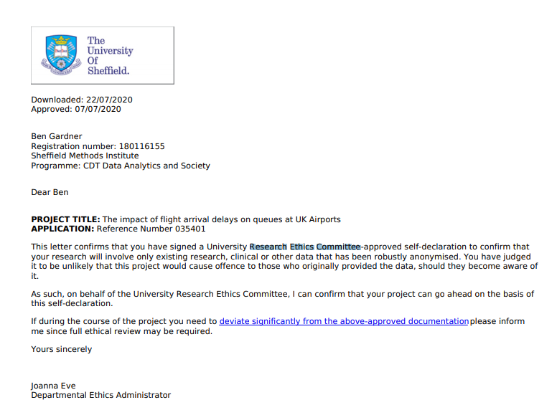

Appendix B. Model Requirements

Table 13. Model Assumptions
Model Aspect | Assumption
Flight Arrival Times | Flights will arrive at a terminal gate in a stochastic manner. Their scheduled arrival time is amended by the random application of a delay time taken from a distribution of flight delays at the same airport terminal for 2019.
Flight Arrival Patterns | Airport and gate capacity restrict the number of flights that can land in a given time window. Our model has the following criteria taken from analysis of 2019 data:  - No more than 8 flights can arrive within X* minutes.  - No more than 12 flights arrive within double X* minutes.  This is a more simplified version of how congested flight arrivals would be handled by the relevant air traffic control authorities. However, we argue that it is sufficient for this project. Table 15 below indicates the generated arrival pattern scenarios that were rejected from our MCA analysis due to violation of either criteria 1 or 2 above.
Gate Arrivals | Flights will always land at their originally assigned gates.
Aircraft disembarkment rates | Passengers will disembark a landed flight at a fixed rate of Y* per 30 seconds.
Walk Times | Passengers will walk to the PCP at a fixed rate according to the gate they landed at.
Queuing Behaviour | Non-EEA passengers will immediately enter the non-EEA queue. Queuing time is only recorded if they are not able to proceed forward due to someone waiting in front of them. Passengers will not leave the queue until they are ready to be processed in a FIFO manner.
Groups | All passengers are modelled as individuals and group or family behaviour is not considered.
Desk Processing Times | All individuals are processed at fixed rate of Z* seconds. After which the next passenger in the queue will be start their processing.
Number of Open Desks | There is a fixed number of non-EEA desks open for the entire period, which is constantly processing passengers at the same rate, without break.
*Note: Figures redacted due to confidentiality requirements.

Table 14. Types of PCP Queues
Queue Type | Eligibility | Notes
Flight Arrivals | EEA citizens and national from B5JSSK countries, over the age of 12. | Automated gates using biometrics.  Adults with children must go to staffed-desks.
Referral Desk | Any eligible passenger who is refused entry by the egate. | Not technically a separate queue as it feeds off the epassport gate.
EEA Desks | All EEA citizens | Mainly for families with children.
ROW Desks | All non-EEA citizens
Fast-Track | Anyone with fast track access
Accessibility | Disabled travellers

Table 15. Scenarios Violating Feasible Landing Requirements
Passenger Volume Day | Scenarios with >8 Flights in fixed window | Scenarios with >12 Flights in double fixed window | Total Scenarios Remaining
Low | #5, #52, #55, | None | 247
Medium | #64, #116, #122, | #116, #143 | 245
High | None | None | 250

Appendix C. Supplementary Model Material
The original data files, Python and R code for our modelling cannot be made publicly available as they contain information deemed confidential by the Home Office. However, amended versions have been made available with randomised data and some alterations of coded values. Pseudocode for the MCA scenario generation and the Python DES model have also been created with amended values. Details are provided in Table 16. Files can be found at the Github repository below.
https://github.com/bdgardner1/Flight_Delay_Analysis
Table 16. Files used for DES/MCA
File Name | File Type | Description
1_FlightAnalysis_MCScenarios | R | Generates distribution of flight delays for terminal and then applies them to required schedule date to generate scenarios.
2_feasible_landing | Python | Interrogates scenarios to establish whether they confirm to established feasible landing criteria
3_DES_Main | Python | Main DES model for scenario simulation
4_DES_AgentFramework | Python | Agentframework for DES model
5_SumStats_Processing | R | Creates summary statistics from DES output
6_Individual_Analysis | R | Explores full data output
7_SumStat_Exploration | R | Explores summary statistics
8_Convergence_Analysis | R | Check changes in wait time average and variances
APT_2019 | Excel | Randomised flight data for terminal for 2019
PsCode_FlightAnalysis_MCScenarios | Text | Pseudocode for file 1
PsCode_DES_Main | Text | Pseudocode for file 3
PsCode_DES_AgentFramework | Text | Pseudocode for file 4

Appendix D. Convergence Analysis
Figures 22 and 23 show the change in total wait time average and variance as additional scenarios are run for one of our volume-capacity combinations. They indicate that results would not be expected to change significantly beyond 250 scenarios.
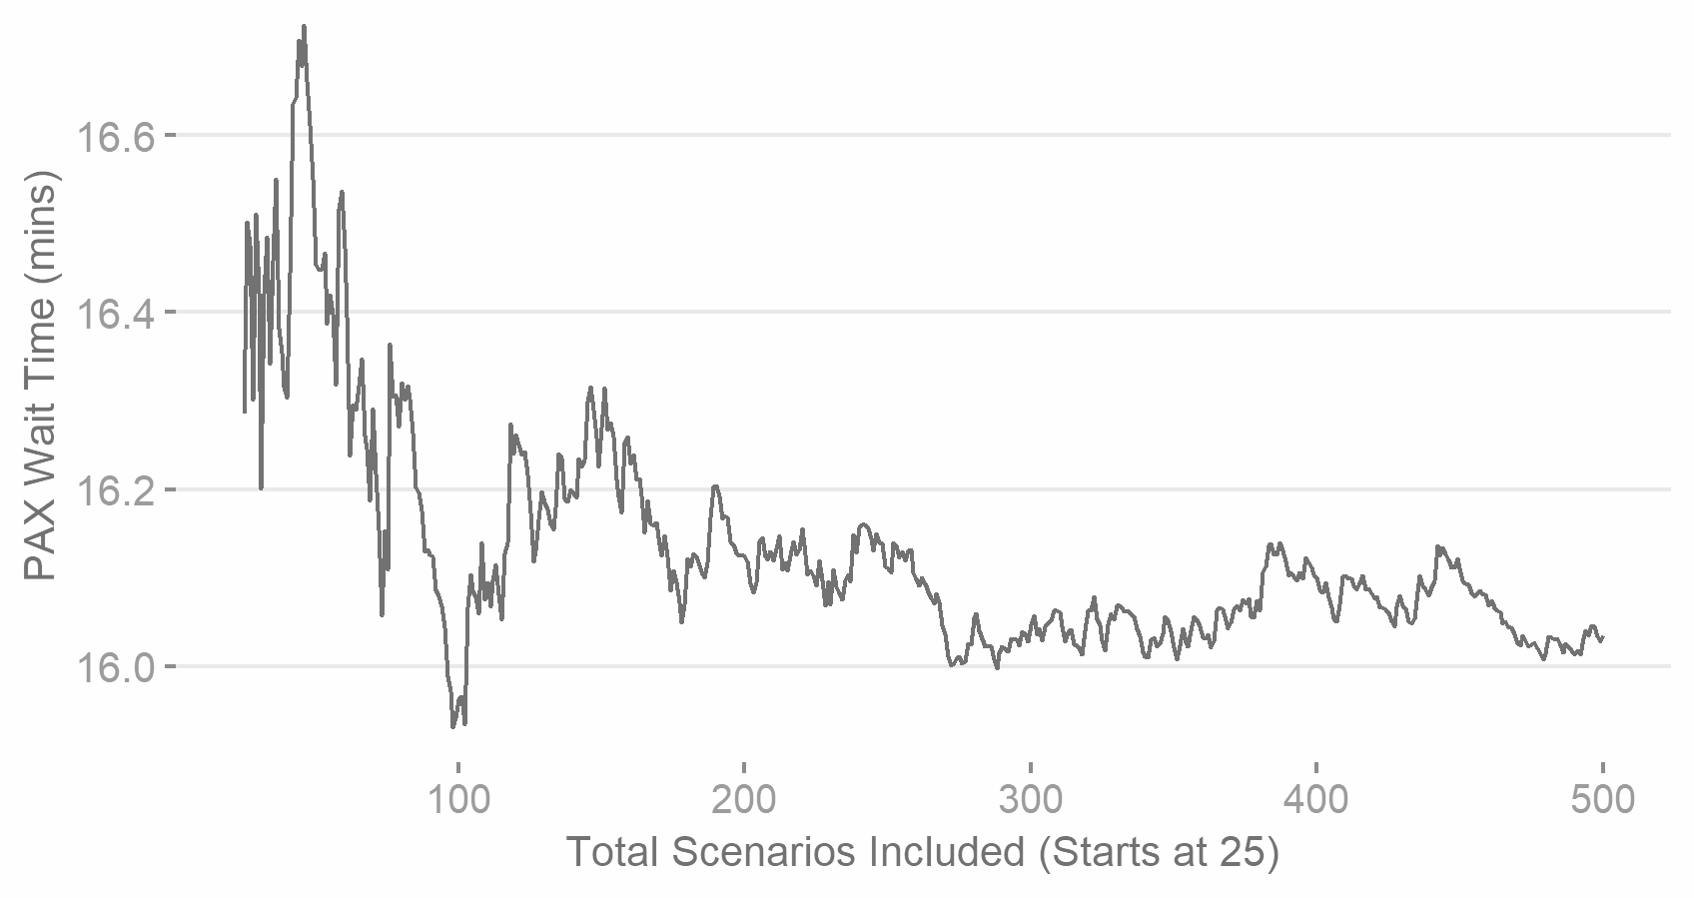
Figure 22. Average Wait Times Convergence for High Volume Day (10 desks)
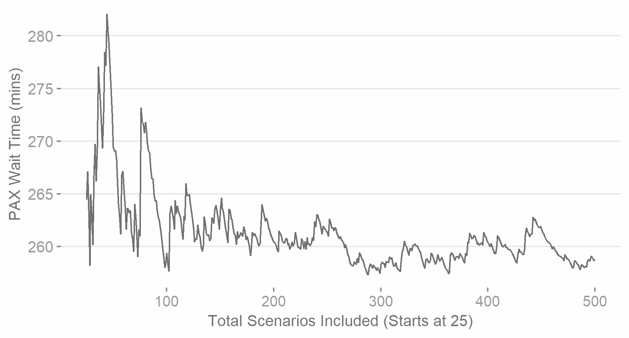
Figure 23. Wait Times Variance Convergence for High Volume Day (10 Desks)

Appendix E. Model Validation

Historic Data Test
This test was performed by taking Border Force data (see Table 17) for 9 hours of our high-volume day in 2019 and comparing it to results from our model using the actual flight landing times and operational desk pattern. Our model was amended to have the same number of desks open as indicated in the Border Force data. However, as this data is only accurate to a 15 minute window, this does represent some deviation from the actual operational capacity. For example, desks may have been opened or closed immediately after the start of the block, whilst our model will use the fixed number for the entire 15 minute period. The method of actual wait time recorded could be replicated in our model results by manually selecting either the first passenger to enter the queue at the start of the 15 minute period or, the last passenger to enter before it. There is the possibility that Border Force data was recorded in an inconsistent/inaccurate way, however we accept this as a risk in our analysis.
Table 17. Border Force Data Description
Variable | Explanation
Flight Arrival Time | The time the flight arrived at the terminal gate on that day.
Actual Passengers | The total number of non-EEA passengers that entered into the PCP in each 15 minute period during the day.
Actual Wait Time | At the start of each 15 minute period (i.e. 09:00, 09:15, 09:30), the last passenger in the non-EEA queue is identified and then timed to ascertain how long it takes them to access a staffed desk.
Actual Desks | The total number of non-EEA desks that were operational at the start of each 15 minute block.

Table 18 shows the full results of the correlation tests for our standard and ‘high volume’ day results against Border Force data.
Table 18. Correlation (PMCC) test for model and actual predictions
 | Standard Model | High Volume Model
Correlation | 0.78 | 0.94
95% Confidence interval | 0.61 – 0.88 | 0.89 – 0.97
T | 7.28 | 16.55
p-value | <0.001 | <0.001

Sensitivity Analysis
Analysis was performed to compare the queuing time distribution produced by our model using a variation of desk servicing times. This was for our high volume passenger day, using a fixed number of open desks (10 and 11). Table 19 and Figure 24 indicates the difference in distributions (actual values redacted due to confidentiality).
Table 19. Comparison of Predicted Average Wait Times for High Volume Day
Average Passenger Service Time | Mean Wait Time: 10 Desks (mins) | Mean Wait Time: 11 Desks (mins) | Decrease from to 10 to 11 open desks
X | 21.8 | 17.2 | 21.1%
X + 10 seconds | 31.8 | 24.7 | 22.3%
X + 20 Seconds | 45.4 | 34.5 | 24.0%

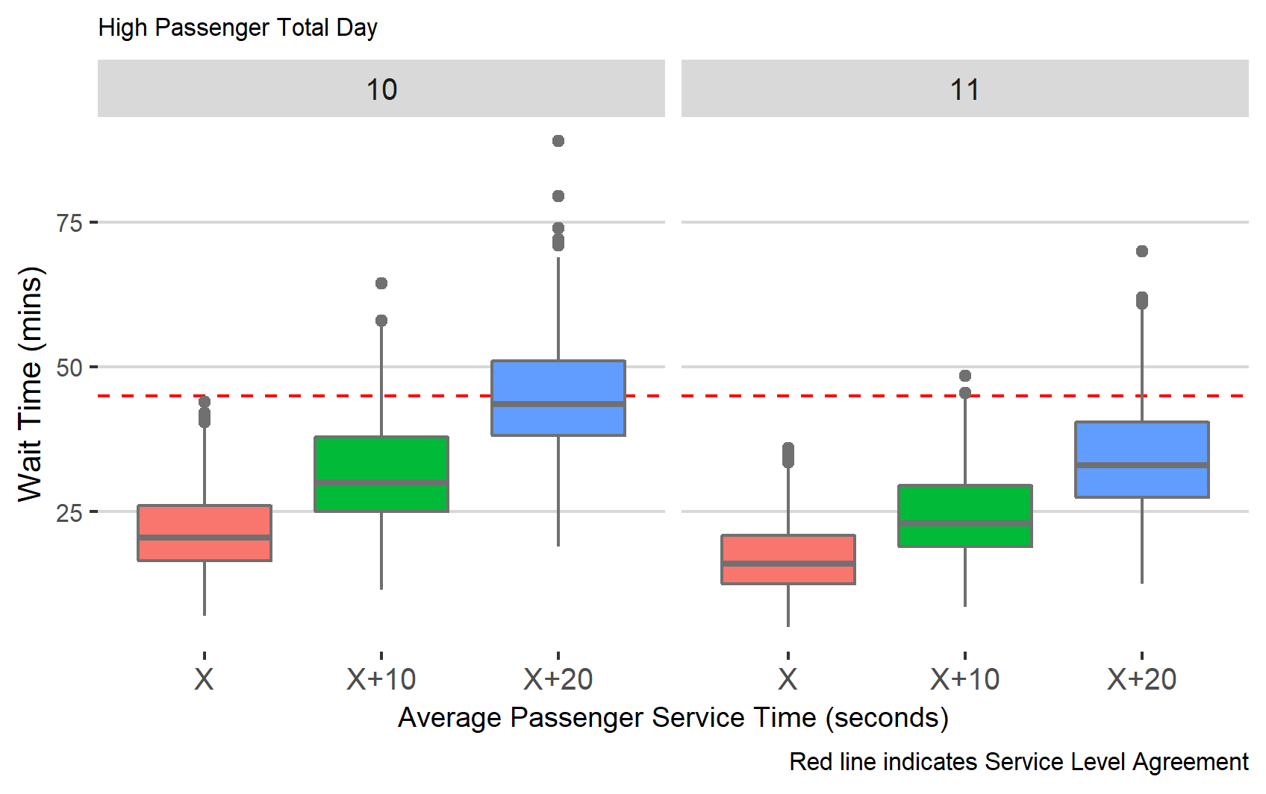
Figure 24. Comparison of Predicted Wait Time Distributions for High Volume Day

Chapter 4 References
Abdalla, A. and Buckley, J. J. (2009). Monte Carlo methods in fuzzy queuing theory. Soft Computing, 13 (11), pp.1027–1033.
Angerhofer, B. J. and Angelides, M. C. (2000). System Dynamics Modelling in Supply Chain Management: Research Review. In: Proceedings of the 32Nd Conference on Winter Simulation. WSC ’00. 2000. San Diego, CA, USA: Society for Computer Simulation International. pp.342–351.
Aoa.org.uk (2018). TOWARDS A SMOOTH AND IMPROVED BORDER. [Online]. Available at: https://www.aoa.org.uk/wp-content/uploads/2018/07/A-smooth-and-improved-Border.pdf. [Accessed: 3 September 2019].
Arunraj, N. S., Mandal, S. and Maiti, J. (2013). Modeling uncertainty in risk assessment: an integrated approach with fuzzy set theory and Monte Carlo simulation. Accident; analysis and prevention, 55, pp.242–255.
Asmussen, S. (1990). Exponential families and regression in the Monte Carlo study of queues and random walks. Annals of statistics. [Online]. Available at: https://www.jstor.org/stable/2241892.
Balliauw, M. and Onghena, E. (2020). Expanding airport capacity of cities under uncertainty: Strategies to mitigate congestion. Journal of Air Transport Management, 84, p.101791.
Batley, R. et al. (2019). New appraisal values of travel time saving and reliability in Great Britain. Transportation, 46 (3), pp.583–621.
Benedicto, M. I. et al. (2018). A DECISION SUPPORT TOOL FOR PORT PLANNING BASED ON MONTE CARLO SIMULATION. In: 2018 Winter Simulation Conference (WSC). December 2018. ieeexplore.ieee.org. pp.2885–2896.
Bezerra, G. C. L. and Gomes, C. F. (2020). Antecedents and consequences of passenger satisfaction with the airport. Journal of Air Transport Management, 83, p.101766.
Bihani, A. (2014). A New Approach to Monte Carlo Simulation of Operations. Laser, 20, pp.0–20.
Brunetta, L., Righi, L. and Andreatta, G. (1999). An operations research model for the evaluation of an airport terminal: SLAM (simple landside aggregate model). Journal of Air Transport Management, 5 (3), pp.161–175.
Bukaçi, E. et al. (2016). Number of iterations needed in monte carlo simulation using reliability analysis for tunnel supports. International journal of engineering research and applications, 6 (6), pp.60–64.
Callahan, B. G. (1996). Commemoration of the 50th anniversary of Monte Carlo. Human and Ecological Risk Assessment: An International Journal, 2 (4), pp.627–627.
Carr, F. et al. (2002). Modeling and control of airport queueing dynamics under severe flow restrictions. In: Proceedings of the 2002 American Control Conference (IEEE Cat. No.CH37301). 2. May 2002. ieeexplore.ieee.org. pp.1314–1319 vol.2.
Chambers, C. and Kouvelis, P. (2006). Modeling and Managing the Percentage of Satisfied Customers in Hidden and Revealed Waiting Line Systems. International Journal of Operations & Production Management, 15 (1), pp.103–116.
Chawdhry, P. K. (2009). Risk Modeling and Simulation of Airport Passenger Departures Process. In: Winter Simulation Conference. WSC ’09. 2009. Austin, Texas: Winter Simulation Conference. pp.2820–2831.
Chib, S. and Greenberg, E. (1996). Markov Chain Monte Carlo Simulation Methods in Econometrics. Econometric Theory, 12 (3), pp.409–431. [Accessed 3 February 2020].
Cole, W., 2020. Chaos At Heathrow As Travellers Are Forced To Pack Into Huge Queues. [online] Mail Online. Available at: <https://www.dailymail.co.uk/news/article-8583599/Chaos-Heathrow-hundreds-travellers-forced-pack-huge-queues.html> [Accessed 4 August 2020].
Culhane, M. (2014). Survey of Technologies for the Airport Border of the Future. NATIONAL RESEARCH COUNCIL OF CANADA OTTAWA (ONTARIO) OTTAWA Canada. http://www.dtic.mil/docs/citations/AD1016982.
de Lange, R., Samoilovich, I. and van der Rhee, B. (2013). Virtual queuing at airport security lanes. European journal of operational research, 225 (1), pp.153–165.
Dorton, S. L. (2011). Analysis of airport security screening checkpoints using queuing networks and discrete event simulation: a theoretical and empirical approach. [Online]. Available at: http://commons.erau.edu/cgi/viewcontent.cgi?article=1046&context=edt.
Dorton, S. L. and Liu, D. (2016). Effects of Baggage Volume and Alarm Rate on Airport Security Screening Checkpoint Efficiency using Queuing Networks and Discrete Event Simulation. Human Factors and Ergonomics in Manufacturing & Service Industries, 26 (1), pp.95–109.
Doubilet, P. et al. (1985). Probabilistic sensitivity analysis using Monte Carlo simulation. A practical approach. Medical decision making: an international journal of the Society for Medical Decision Making, 5 (2), pp.157–177.
Ersahin Tolga, McCabe Brenda and Doyle Mark. (2003). Monte Carlo Simulation Analysis at Lester B Pearson International Airport Development Project. Construction Research Congress, pp.1–8.
Gardner, B. (2019). Modelling ePassport Gate Queues at UK airports. Unpublished. Available at: https://drive.google.com/file/d/1zsOhjQ9b1e-22Laa5-FfupGkhBSQNvNV/view?usp=sharing
GOV.UK. (2016). Immigration statistics April to June 2016 [online] Available at: https://www.gov.uk/government/publications/immigration-statistics-april-to-june-2016/passenger-arrivals-and-visitors
GOV.UK. (2019). Border Force. [online] Available at: https://www.gov.uk/government/organisations/border-force [Accessed 27 Aug. 2019].
GOV.UK. (2020). Entering The UK. [online] Available at: <https://www.gov.uk/uk-border-control/at-border-control> [Accessed 4 August 2020].
GOV.UK. (2022). Border Force transparency data: Q2 2022, September 2022. [online] Available at: <https://www.gov.uk/government/publications/border-force-transparency-data-q2-2022> [Accessed 23 September 2022].
Guizzi, G., Murino, T. and Romano, E. (2009). A discrete event simulation to model passenger flow in the airport terminal. Mathematical methods and applied computing, 2, pp.427–434.
Hee King Jim and Zeph Yun Chang. (1998). An airport passenger terminal simulator: A planning and design tool. Simulation Practice and Theory, 6 (4), pp.387–396.
Home Office. (2017). The “Shadow DRT”: a flexible toolkit for queue and workforce modelling. Methodology & QA report. Unpublished.
House of Commons Home Affairs Committee (2012). The work of the Border Force: Government Response to the Committee's Sixth Report of Session 2012–13. London: The Stationery Office Limited.
Ingolfsson, A. et al. (2007). A Survey and Experimental Comparison of Service-Level-Approximation Methods for Nonstationary M(t)/M/s(t) Queueing Systems with Exhaustive Discipline. INFORMS journal on computing, 19 (2), pp.201–214.
Irvine, D., Budd, L. C. S. and Pitfield, D. E. (2015). A Monte-Carlo approach to estimating the effects of selected airport capacity options in London. Journal of Air Transport Management, 42, pp.1–9.
Jacquillat, A. (2012). A queuing model of airport congestion and policy implications at JFK and EWR. Massachusetts Institute of Technology. [Online]. Available at: https://dspace.mit.edu/handle/1721.1/72652?show=full [Accessed 2 April 2020].
Kelton, W. D. (2007). Representing and Generating Uncertainty Effectively. In: Proceedings of the 39th Conference on Winter Simulation: 40 Years! The Best is Yet to Come. WSC ’07. 2007. Piscataway, NJ, USA: IEEE Press. pp.38–42.
Költzsch, G. (2006). Biometric technologies in passenger clearance. Aviation, 10 (4), pp.18–24.
Kraemer, W. and Langenbach-Belz, M. (1976) Approximate formulae for the delay in the queueing system GI/G/1. In Proceedings of the 8th International Telegraphic Congress, volume 2(3), page 235/1 235/8, Melbourne, Australia
Kroese, D. P. et al. (2014). Why the Monte Carlo method is so important today. Wiley interdisciplinary reviews. Computational statistics, 6 (6), pp.386–392.
Larson, R. C., Larson, B. M. and Katz, K. L. (1991). Prescription for waiting--in line blues: Entertain, enlighten and engage. Sloan management review, 32 (2), pp.44–55.
Law, A. M. (2014). Simulation Modeling and Analysis. McGraw-Hill Education.
Leese, M. (2016). Exploring the Security/Facilitation Nexus: Foucault at the ‘Smart’ Border. Global Society, 30 (3), pp.412–429.
Lin, Z. et al. (2019). Airport Taxi Decision-Making Strategy Based on Queuing Theory and Computer Simulation. In: 2019 4th International Conference on Mechanical, Control and Computer Engineering (ICMCCE). October 2019. ieeexplore.ieee.org. pp.813–8134.
Lovell, D. J. et al. (2013). A diffusion approximation to a single airport queue. Transportation Research Part C: Emerging Technologies, 33, pp.227–237.
Ma, N. L., Cheong, M. L. F. and Choy, J. (2011). Data Analysis and Monte Carlo Simulation of Airport Check-In Process. [Online]. Available at: https://ink.library.smu.edu.sg/sis_research/1496/ [Accessed 6 March 2020].
Manataki, I. E. and Zografos, K. G. (2010). Assessing airport terminal performance using a system dynamics model. Journal of Air Transport Management, 16 (2), pp.86–93.
Marin, C. V. et al. (2007). Human Factors Contributes to Queuing Theory: Parkinson’s Law and Security Screening. Proceedings of the Human Factors and Ergonomics Society... Annual Meeting Human Factors and Ergonomics Society. Meeting, 51 (10), pp.602–606.
Marchal, W. G. (1976). An Approximate Formula for Waiting Time in Single Server Queues. A I I E Transactions, 8 (4), pp.473–474.
Mason, A. J., Ryan, D. M. and Panton, D. M. (1998). Integrated Simulation, Heuristic and Optimisation Approaches to Staff Scheduling. Operations research, 46 (2), pp.161–175.
Medhi, J. (2002). Stochastic Models in Queueing Theory. Elsevier.
Naess, A., Leira, B. J. and Batsevych, O. (2009). System reliability analysis by enhanced Monte Carlo simulation. Structural Safety, 31 (5), pp.349–355.
Nikoue, H. et al. (2015). Passenger Flow Predictions at Sydney International Airport: A Data-Driven Queuing Approach. arXiv [cs.OH]. arXiv [Online]. Available at: http://arxiv.org/abs/1508.04839.
Papadopoulos, C. E. and Yeung, H. (2001). Uncertainty estimation and Monte Carlo simulation method. Flow Measurement and Instrumentation, 12 (4), pp.291–298.
Petersen, B. J. (2000). Probabilistic modelling: theory and practice. Food additives and contaminants, 17 (7), pp.591–599.
Phillips, C. (2007). A Review of High Performance Simulation Tools and Modeling Concepts. Pp.29–47.
Pitfield, D. E., Brooke, A. S. and Jerrard, E. A. (1998). A Monte-Carlo simulation of potentially conflicting ground movements at a new international airport. Journal of Air Transport Management, 4 (1), pp.3–9.
Raychaudhuri, S. (2008). Introduction to Monte Carlo simulation. In: 2008 Winter Simulation Conference. December 2008. ieeexplore.ieee.org. pp.91–100.
Regattieri, A. et al. (2010). Designing production and service systems using queuing theory: principles and application to an airport passenger security screening system. International Journal of Services and Operations Management, 6 (2), pp.206–225.
Scarpel, R. A. (2013). Forecasting air passengers at São Paulo International Airport using a mixture of local experts model. Journal of Air Transport Management, 26, pp.35–39.
Sembakutti, D., Kumral, M. and Sasmito, A. P. (2017). Analysing equipment allocation through queuing theory and Monte-Carlo simulations in surface mining operations. International Journal of Mining and Mineral Processing Engineering, 8 (1), pp.56–69.
Setti, J. R. and Hutchinson, B. G. (1994). Passenger-terminal simulation model. Journal of transportation engineering / American Society of Civil Engineers, 120 (4), pp.517–535.
Shanmugasundaram, S. and Banumathi, P. (2017a). A Comparitive Study on M/M/1 and M/M/C Queueing Models Using Monte Carlo Simulation. Global Journal of Pure and Applied Mathematics, 13 (11), pp.7843–7853.
Shanmugasundaram, S. and Banumathi, P. (2017b). Survey on Multi-Channel Queueing Model in Southern Railways Using Monte Carlo Simulation. International journal of pure and applied mathematics: IJPAM, 117 (11), pp.211–219.
Sobol, I. M. (2018). A primer for the Monte Carlo method. CRC press.
Steffen, J. H. (2008). Optimal boarding method for airline passengers. Journal of Air Transport Management, 14 (3), pp.146–150.
Sternberg, A. et al. (2017). A Review on Flight Delay Prediction. arXiv [cs.CY]. arXiv [Online]. Available at: http://arxiv.org/abs/1703.06118.
Stolletz, R. (2011). Analysis of passenger queues at airport terminals. Research in Transportation Business & Management, 1 (1), pp.144–149.
Stroeve, S. H., Blom, H. A. P. and (Bert) Bakker, G. J. (2009). Systemic accident risk assessment in air traffic by Monte Carlo simulation. Safety science, 47 (2), pp.238–249.
Tavakoli, S., Mousavi, A. and Komashie, A. (2008). A Generic Framework for Real-time Discrete Event Simulation (DES) Modelling. In: Proceedings of the 40th Conference on Winter Simulation. WSC ’08. 2008. Miami, Florida: Winter Simulation Conference. pp.1931–1938.
Tošić, V. (1992). A review of airport passenger terminal operations analysis and modelling. Transportation Research Part A: Policy and Practice, 26 (1), pp.3–26.
Van Dijk, N. M. (2002). To pool or not to pool?‘ The benefits of combining queuing and simulation’. In: Proceedings of the Winter Simulation Conference. 2. 2002. IEEE. pp.1469–1472.
Worthington, D. (2009). Reflections on queue modelling from the last 50 years. The Journal of the Operational Research Society, 60 (sup1), pp.S83–S92.
Wu, P. P.-Y. and Mengersen, K. (2013). A review of models and model usage scenarios for an airport complex system. Transportation Research Part A: Policy and Practice, 47, pp.124–140.
Wu, P. P.-Y., Pitchforth, J. and Mengersen, K. (2014). A Hybrid Queue-based Bayesian Network framework for passenger facilitation modelling. Transportation Research Part C: Emerging Technologies, 46, pp.247–260.
Xu, X. et al. (2018). Sustainable Queuing-Network Design for Airport Security Based on the Monte Carlo Method. Sustainability: Science Practice and Policy, 10 (2), p.1. [Accessed 3 February 2020].
Zukerman, M. (2013). Introduction to Queueing Theory and Stochastic Teletraffic Models. arXiv [math.PR]. arXiv [Online]. Available at: http://arxiv.org/abs/1307.2968v21.

Variations in Border Mobility and their Costs: A study of passenger processing at UK airport borders

Abstract
This project presents the results of new research exploring the costs associated with high processing times for specific nationalities at airport border control. Utilising access to UK Home Office/Border Force data and processes, I explore variations across nationalities in the total time spent by non-EEA (outside the European Economic Area) passengers in border control systems. This includes a combination of observational research during the winter of 2019/2020 and Discrete-Event Simulation of queuing scenarios to estimate wait times. I focus on nationality groups that spend the longest time at border control desks and suggest the savings that could be achieved through a ‘levelling down’ of their processing times. My experiments predict that by reducing the processing time for four high-rate groups to the mean non-EEA level, UK border control could save 6,057 days of traveller time per year. Using results from existing Valuation of Travel Time literature, we suggest a value of these savings of between £3-6m. The targeted nationality groups would be expected to see average queuing time reductions of between 30-50%, resulting in £0.5-1.2m in time savings per group.

Introduction

Queues at the staffed border
Chapters 2 & 4 discussed how air passengers excluded from automated border control systems face additional risks of border delays. For the UK, this cohort is composed mainly of non-British passport holders from the outside of the European Economic Area (henceforth referred to as ‘non-EEA’), accounting for over 20 million arrivals in 2017/18 (Gov.uk, 2019). Passenger delays can be presented as a negative economic impact in multiple ways: The travellers themselves face a cost in terms of the time they lose waiting in control systems (Landau et al., 2016). The air travel industry cites costs in terms of lower customer satisfaction (AOA.org.uk, 2018). Nations are also considered to lose out economically from both the leisure and business travellers discouraged from travelling into airports known for long border control processing times (Farrell, 2016). Altogether, the pressure to avoid these delays and facilitate the free flow of ‘desirable’ individuals at border controls is viewed as an important economic target of the modern nation state (Leese, 2016).
A key determinant of wait time for a non-automated individual is the speed at which Border Officers process the passengers ahead of them in the queue. The typical border assessment involves practical checks, such as confirmation of identity, valid travel documentation and searches against national security checklists. However, they can also involve questioning the individual on their economic situation, intentions whilst in the UK and other ties to their country of origin to determine the risk they pose of irregular migration (in terms of over-staying). Passengers are only granted access to the UK once they have been able to convince staff that they do not pose an ‘unacceptable’ risk (Sontowski, 2018). Existing studies suggest that the time taken for such activities will vary depending on the nature of the passengers, but that commonalities among nationality groups are likely to lead to lower or higher average processing times (see Mau et al., 2015, Scheel, 2017). Flights from certain origins are known within Border Force to be ‘problematic’, with passengers tending to take longer to process than average. We can consider that nationalities with significantly longer average processing time would, in a fixed system, increase wait times; not just for themselves but all passengers in the queue at that time.

Researching the border
Despite the stated importance of reducing border control times and the known additional burdens that non-automated cohorts face, there is a lack of existing research into these border mobility variations. Whilst research into other areas of the air passenger journey (check-in, security, flight boarding) is extensive, and the introduction of automated border control technologies have been evaluated by several studies (see Chapter 2), the experience of passengers at manual staffed desks has received minimal interest. We can speculate that this may be because of difficulties that researchers experience in gaining access to confidential processes run by government authorities. Or that researchers have been drawn to new technologies and the potential for significant overall improvements that they offer. Either way, this has resulted in a dearth of information into the groups that face the highest delays at border control.
An appreciation and understanding of the nature of manual border process variations would be useful in any assessment of improvement to border control processes. Cost-benefit analysis of projects requires an estimation of both the extent and the valuation of reductions in passenger queuing times (see Chapter 6). Previous studies have considered wide-ranging analysis of the economic benefits arising from general reductions in border delays. However, few (if any) have considered the impact of processing variations within traveller groups on overall wait times.

Research Aims
This project seeks to address these deficiencies through a direct exploration of variations across nationalities in border processing times at staffed desks in the UK. This is achieved through a unique collaboration project with the UK Home Office that has granted the researcher wide access to both existing data and the areas and personnel required to explore this topic. I intend to expand knowledge in this area by answering three key research questions:
- To what extent do processing times vary by nationality at staffed UK border desks?
- How do processing time variations impact wait times?
- What are the additional costs from passengers who face the longest processing times?

An exploration of processing variations by nationality will allow border control in the UK and potentially other similar countries to understand the extent that operational decisions have resulted in differences in border experiences at non-automated desks. Analysis of the impact of these variations in terms of wait times would also make clear to authorities the total time lost from higher processing times, and the overall time savings that could be made from changes. Finally, providing monetary values for these wait times validated against the established literature will allow authorities to evaluate the total benefit of time reduction projects. This mainly focuses on the arrival country authorities, however, could also be of benefit to origin countries deciding on whether to undertake projects that would improve the mobility of their citizens at foreign borders.

Methods
Figure 25 provides an overview of the three stages to my research.
- Processing times for staffed desks are explored using data from the port studies conducted by the Home Office at multiple UK airport terminals. Summary statistics from the data are produced to demonstrate the extent of processing time variations among non-EEA passengers, as well as the overall time-burden placed on UK border control by different nationality groups.
- The results from stage 1 are used in a Discrete-event Simulation (DES) to predict expected non-EEA passenger wait times at UK Border Control. The model is then run again to predict the change in wait times that would occur from reducing average processing times for four ‘high-rate’ nationality groups.
- These figures are extrapolated to total non-EEA passenger numbers at all UK airports using historic Home Office statistics to provide a national overview. A brief review of Value of Travel Time literature is conducted to ascertain what monetary values would be appropriate to assign for our wait time figures.
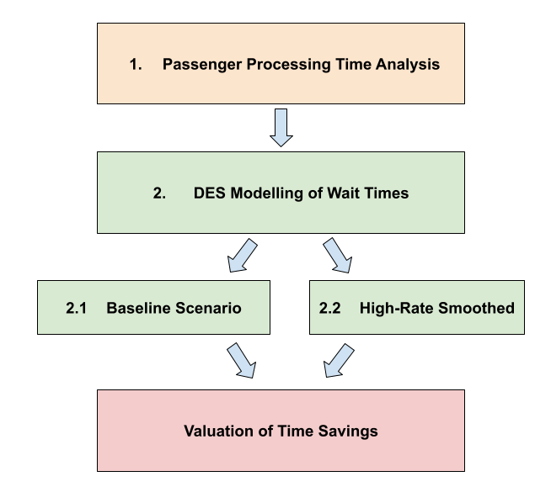
Figure 25. Research Method Process Flow

Ethical Approval
Ethical approval for the project was received from the University of Sheffield’s Research Ethics Committee on the basis that it does not include personal data. A copy of this can be found in Appendix A.

Paper Layout
The following section will review literature concerning the nature of modern border control, arguments for how these can lead to variations in processing times by nationality and how border delays have been researched and cost previously. The next section will explain my methodology and data sources in detail. The results section will show the variations in processing and wait times for passengers and the expected savings that could be achieved through targeting high-rate nationalities. I then discuss the implications of these results to my research questions and provide a conclusion.

Literature Review
This section sets out how our study fits within the existing literature concerning border mobility and valuing the cost of delays. I start by providing a theoretical background for why passengers face varying experiences at the modern border. I then move onto examples of how border control delays have been studied in the past, including how results of these influence choices on how to explore nationality variations. I conclude with a review of literature into valuations of travel time and the applicability of existing studies to our research scenario.

Objectives of Border Control
Border control policy can be briefly summarised as the principles and mechanisms by which individuals are either denied or granted access to enter a country. As international travel rose significantly in the 21st Century (Balliauw & Onghena, 2020), nation states faced the challenge of facilitating the flow of ‘desirable’ travellers through their borders whilst simultaneously restricting access to those deemed a ‘threat’. Tholen (2010) suggests that principles of border access rest on obligations to both those at home and abroad. That nation states need to assess the economic benefit that can be received from foreign travellers and the desire to provide help to vulnerable individuals entering the country. However, this is balanced against a necessity to protect domestic citizens from any risk to public order or safety that could be caused by undesirable travellers, or even protecting the shared culture or religion of existing citizens. Tholen (2010) argues that public concerns over safety and terrorism since 9/11 have led to an intensification of border concerns by Western nations.
Other studies into the topic (Bosworth, 2008; Leese, 2016; Sontowski, 2018) share these themes but concentrate more clearly on economic concerns. States are keen to attract tourists, businesspeople, and those with in-demand labour skills, whilst simultaneously deterring those viewed as an economic threat to the domestic population. The latter tends to be viewed in terms of irregular migration, however additional issues such as health tourism (Schweitzer, 2019) also appear in the narrative. Bosworth (2008) questions whether forms of border control are ‘theatre’ to appease public concerns and deter potential economic migrations. Leese talks of certain border control methods ‘enacting an economic sorting mechanism in the name of security’ (2016, p.415), though also states that the entanglement of security and economy can occur in a way that neither are ‘cancelled out’. The objectives and motivations behind border policy are important to the extent that they frame the assessment process that passengers undertake at border desks. If the major concern is placed on economic issues, then passengers from low income and financially unstable nations may face tougher probing than others. If border control methods are designed to assuage public concerns, then we might expect longer processing times for nationalities from areas considered ‘dangerous’ in UK national dialogue.
The ideas above assume that national governments are free to make decisions based on internal preferences. From the perspective of airport border control, many have pointed out how both the intervention of the air travel industry and global commitments towards international air travel may influence these actions. Abeyratne’s (2014) assessment of air travel industry regulation describes how border control objectives are framed by global commitments made by national governments and regulators to facilitate air travel. The author highlights Annex 9 of the 2006 Convention of International Civil Aviation where states guarantee to take:
“....all practicable measures, through the issuance of special regulation or otherwise . . . . .to prevent unnecessary delays to passengers, especially in the administration of the laws relating to immigration, quarantine, customs and clearance.” (p.78)

This includes ‘maximum requirements’ that should be imposed in the way of paperwork, restrictions or freedom of movement and a commitment to conduct cost-benefit analysis of measures aimed at enhancing air travel connectivity. Abeyratne clarifies that states retain autonomy to decide exactly what forms of border control are required to meet its security objectives; however, these global commitments clearly place restrictions on actions. Wattanacharoensil et al. (2016) argue that in recent years the air travel industry has placed significant emphasis on improving passenger satisfaction with their airport experience. This involves attempting to reduce not only delays, but also the level of anxiety and potential of mistreatment by staff at each stage of the air travel journey. The authors state that automation has been pursued by the industry as a key tactic for achieving these objectives, placing ‘control’ of the travel process in the passengers’ hands, and removing the potential for ‘undesirable’ human interactions. It would seem likely that border authorities who operate in airport environments would be influenced by desires to maintain satisfaction levels and promote automation; especially when the industry is publicly highlighting border control as a ‘weak link’ in their strategies (AOA.org.uk, 2018).

Border Mobility Variations
The pressures described above have led to the development of specific border control processes that have placed uneven burdens on passenger groups. The most obvious of these is automation through selective availability of automated border control gates to different passenger cohorts. Less visible are the efforts made to ‘export the border’, where passengers and various stakeholders have been co-opted into extensive systems of preapproval checks long before they arrive at airport border controls (Tholen, 2010). Mau et al. (2015) explore one aspect of this, visa waiver schemes, explaining how nationalities included in such arrangements face fewer bureaucratic barriers when travelling. Network analysis conducted by the authors shows that both the number and density (how many countries had waivers with each other) increased between 1969 and 2010. However, this increase was uneven, with democratic states in the global north achieving significant greater success in extending mobility rights for their citizens compared to those in the South. The removal of the visa inspection element of the border control process is cited by Pitchforth et al. (2015) as one explanation for nationality variations in passenger processing.

With regards to the UK, there is a lack of existing research into how visa arrangements with other nations have changed over time. Talking with Home Office contacts, visa policy is considered a sensitive topic where limited information is made publicly available. However, combining the available list of visa nations (Gov.uk, 2023) with a list of 199 internationally recognised sovereign states and dependent territories, I can provide a regional breakdown as of August 2023 (Table 20). Of these 199 nations/territories, 114 (57%) require their nationals to have a visa to visit the UK. Africa and Asia account for 91 of these, whilst Europe and North America account for only 17 in total.

Table 20. Regional UK Visa Requirements (August 2023)
Region | % of nationalities where a visa is required for UK entry
Africa | 94%
Asia | 78%
Europe | 22%
North America | 30%
Oceania | 14%
South America | 33%
Grand Total | 57%

Even with these preapproval processes, passengers excluded from automated systems still must spend time convincing border staff of the legitimacy of their travel. Scheel (2017) highlights the issue of documentation as a key element in variations by nationality group. The author argues that in many cases, especially for poorer people in less developed countries, it is not possible to obtain the documents necessary to prove economic ties to origin countries, making it more difficult to convince border staff of their lack of threat of irregular migration. Passengers from countries with a reputation for fake documents may also experience greater border scrutiny. In addition to this, Scheel considers more personal elements, such as the extent that an individual ‘looks and sounds’ like a ‘legitimate’ traveller (i.e. someone not attempting to migrate through irregular methods). Scheel (2017) argues that there are certain groups of travellers who are almost certain to be refused entry, and that only by adapting their profile to those of ‘bona fide’ travellers can migrants more successfully navigate border control processes. This is an extensive topic that I won’t attempt to cover here, except to point out that these profiles are likely to vary along with nationality. Cote-Boucher (2017) explores the impact that border staff themselves have on processing variations via interviews with Canadian officers on the US-Canadian land border. It highlights how attitudes to security are shaped by not only political and bureaucratic requirements, but the organisational culture and habits of those fulfilling the tasks. There is claimed to be a generational divide in attitudes of officers, with the newer staff taking a more aggressive approach to security threats, or as one officer states ‘wanting to catch bad guys’ (p.154).

Whilst the studies described above provide suggestions for variations in border control experiences by nationality, they do not provide any empirical evidence to support these claims. A report commissioned by the UK Home Office (Woodfield et al., 2007), did analyse decisions taken by immigration officers with regards to denying immediate entry to non-EEA passengers. This study was undertaken through a combination of observational research and in-depth interviews with Immigration Officers at two major UK airports during 2005. It found that Officers decisions to stop passengers was triggered mainly by:
- Their financial and domestic circumstances.
- The economic strength and ‘risk’ of their country of origin.
- Forged or otherwise suspicious documents.
- The travel and immigration history of the passenger.
- The fit between the individual’s circumstances and what might be considered ‘normal’
- The passenger’s behaviour/dress/appearance and general demeanour.

This study did not look directly at processing or wait times; though it’s reasonable to assume that individuals more likely to be stopped by staff will have faced longer interviews before that decision. Whilst this research is relatively dated, and it’s not known if stopping reasons would match current day practices, we can see some correlation between them and the nationality-based factors I’ve previously suggested (economic strength of origin country, reliability of documentation).

Border Control Processing Studies
With regards to methodology of researching queueing systems in an airport environment, I provided a discussion of queuing theory vs computer simulation methods in Chapter 4. I highlight arguments that computer simulations have a general advantage with air travel studies, due to:
- Being better suited to dealing with the non-standard nature of passenger arrival distribution rates (Manataki et al., 2010).
- Better capturing the general complexity of airport systems with multiple interacting elements (Wu & Mengersen, 2013).
- Providing a more accessible tool for the general researcher as well as situations where non-technical air travel industry/border control stakeholders would react better to empirical evidence than to mathematically derived insights (Worthington, 2009, p.60).

I note that many of these studies cite difficulties with access to data in the airport environment as a hindrance to research possibilities (see Guizzi et al., 2009; Regattieri et al., 2010; Pitchforth et al., 2015). This highlights the value of my relationship with the UK Home Office and Border Force when researching the topic.

There are a small number of analytical studies that have successfully established evidence for differences in border control processing rates and general impacts on queuing times. Pitchforth et al. (2015) analyses the total time that arrival passengers spend at Brisbane airport and tests for significance with variables such as nationality, airline, age, sex, and additional flight details (such as arrival gate landed at). Their results demonstrate that nationality is an important variable in determining overall processing time, even when controlling for other aspects such as congestion in the airport and other passenger characteristics. The authors suggest differences in group size and visa requirements are factors for nationality variations. However, I note that this research considers the entire arrival process (flight disembarkment, walks from gates, time spent in duty-free shopping before border control etc) rather than focusing on the border control element in isolation. In addition, the research only uses data from one day at one airport terminal, limiting the range and quantities of nationalities that can be analysed.

McGonegal et al. (2014) analytical exploration of wait times for non-US arrival air passengers is focused solely on border control and uses data from numerous ports and dates. It analyses wait time statistics, alongside passenger numbers and the number of open inspection booths, to assess the operational efficiency of US Customs and Border Protection. The researchers claim in their findings that most of the variations seen in waiting times are not due to decisions made by US Customs and Border Protection, such as staffing levels and control desks made available for different flows of passengers. Rather, they state that other, unexplored factors, must be responsible for these fluctuations. We can consider differences in both passenger type and typical group types as possible candidates.

Unfortunately, there are few examples that research the specific element of airport border control processing, and almost no recent ones where computer simulation is utilised. Mason et al.’s (1998) review of customs control at Auckland Airport uses Discrete Event Simulation modelling methods to consider multiple passenger types to calculate optimal staffing levels. The authors argue that their methods highlight the enthusiasm for computer-based decision tools in the management process (conforming with point 3 above) and its outputs were able to demonstrate a commitment to efficiency and optimisation. Other examples include Hee and Zeph (1998) and Brunetta et al. (1999), which both attempt to simulate various aspects of airport performance given flow rates of arriving passengers. Both conclude that such methods have value in predicting elements such as capacity constraints and time spent in customs processes. However, none of these studies specifically looks at variations in passenger processing rates.

The Costs of Border Delays
Finally, we consider the appropriate methodology for costing of these types of border delays. There are three key areas of cost highlighted in the existing literature:
- The impact of lower leisure and business travel to an area in terms of reduced tourism spending and trade.
- The impact to specific industries, such as lower air passenger numbers or the additional costs to road freight from delays.
- The value of the time spent by passengers in border control processes.

A detailed discussion of this topic can be found in Chapter 6. To summarise, whilst there are clear merits in establishing the potential costs in points 1 & 2, these are complicated areas to analyse for air travel due to the difficulty in estimating the impact of border delays on demand (see Roberts et al., 2014a). Any attempt to do so would arguably require resources outside the scope of this research project. Additionally, focusing on these creates a risk of reducing attention to point 3, the value of passenger time. This is an area where we can provide robust estimations of the impact of changes to border control practices. I argue that research projects such as Aussilloux and Le Hir (2016) and Roberts et al. (2014a/2014b), that have attempted a broader review of border costs, have resulted in relatively simplistic forms of wait time analysis, which may be of a more limited use to border authorities.

If we are to focus exclusively on the cost of lost passenger time, then we need to consider robust methods for valuing delays. The Valuation of Travel Time is a concept that I, again, explore in considerably more detail in Chapter 6, including new primary research. For the purposes of this study, it is sufficient to consider a summary of existing research and suggest the most appropriate methodologies to our study.

Valuation of Travel Time (VTT)
An introduction to VTT concepts is provided in Chapter 2, Section 2.2.1. To briefly recap, individuals are stated to lose utility from spending time travelling rather than on other more desirable activities and hence there is a monetary amount that they would be willing to pay to reduce their travel time. The average willingness to pay is stated to increase along with the undesirability of the travel element. A key example of valuation of travel time research for the UK is Batley et al. (2019) which forms the basis of the UK Department for Transport suggestion (Home Office, 2021) that national projects should value traveller time at £5.97 an hour for leisure trips and £55.46 for business (2021 prices), regardless of the nature of mode of transportation.

However, these generic VTT rates can also be seen as less preferable to using rates that apply specifically to the travel scenario being costed; especially where there are factors which may result in an above average undesirability of travelling in the scenario. Studies into air-travel and queuing have confirmed higher average VTT rates than other forms of travel. Abrantes & Wardman (2011) meta-analysis of VTT databases from multiple European studies shows that air passengers have VTTs 81% higher than other forms of transport and that wait time VTTs have a multiplier of 1.7 compared to non-wait elements of travel. Landau et al. (2016), explores air travel in more detail, ascertaining VTT valuations for multiple stages of the typical air journey (Table 21).

Table 21. Valuations of Passenger Time ($ per hour, 2016 prices) for Air Travel Components
 | WTP ($) by Purpose
Component | Business | Leisure
Airport Time Components Choice Experiments
Ground access time | 18.60 | 16.95
Terminal access time | 33.85 | 26.01
Check-in and security time | 57.19 | 28.45
Time to reach the gate area | 20.48 | 17.62
Flight Itinerary Choice Experiments
Flight Time | 51.01 | 34.91
Expected flight delay | 286.32 | 123.30
Taken from Landau et al., 2016, p30

Summary
Nation states have faced multiple, conflicting aims when designing and implementing airport border controls. Existing research suggests that the outcomes have resulted in uneven burdens on passenger groups. That longer processing times will occur when individuals are from nations considered a ‘higher risk’, have less trustworthy documentation, or simply don’t fit a preconceived notion of ‘reliable traveller’. So far there has been limited empirical research to validate these theories, and none that considers the specific costs of additional waiting times resulting from variations in border mobility. In the following section, I set out the data and methods used in this study to address these shortcomings.

Methodology and Data
My research case study involves analysing arrival passenger flows at UK airport borders during Winter 2019/20. At the time of the research (2021), this was the last period before the Covid-19 outbreak impacted air travel. The main aims of these methods are to establish differences in processing times between nationality groups, how these variations impact expected waiting times at border control and the savings that could be achieved if ‘high-rate’ nationality groups had their processing times lowered.

Average Processing Rates
Border processing rate analysis is obtained from data collected in a series of port studies undertaken by the UK Home Office. This was completed at five of the busiest airport terminals in the UK, with the researcher assisting directly in the Manchester study. The research entailed the recording the of the following information for each individual/group that approached a border control desk:
- Nationality
- Size of the group (typically where families approach a desk together)
- Number of children
- Time taken to process (either allowed entry to the UK or sent for further investigation).

This was completed for all types of border control desks, however, only non-EEA passengers using standard, staffed desks are included in this analysis. Note that at the time of the study there were three cohorts of non-EEA passengers using such desks:
- Visa National: Passengers who required a border interview and a visa to enter the UK
- Non-Visa Nationals: Passengers who required a border interview but not a visa.
- B5JSSK: Passengers from seven non-EEA countries who required neither a border interview nor a visa; however, still had to use manual desks if their group contained a child under 13 years of age.

The final cleaned version of the data was provided in Excel format and analysed using R. The main area of interest is the average (mean) passenger processing time by nationality, focusing specifically on nationalities that have both a high processing time and large number of passengers arriving in the UK. I also explore additional statistics related to processing times and group sizes to provide additional insight.

I acknowledge some potential issues with the use of this data. With regards to general problems with secondary data (see Arber, 2001, p.279), I note that the port study was conducted without the specific objectives of this research in mind. Hence, any vagueness in methods will potentially limit confidence in the validity and reliability of results. However, a more randomised data collection exercise, in line with this study’s aims, was impractical within the time and resource available. Also, my involvement in one of the airport data collection exercises and continued regular contact with researchers has allowed me to reduce misunderstanding of the data. However, I acknowledge some validity issues may persist.

Discrete Event Simulation Modelling of Wait Times

Model Requirements and Selection
The next stage of the study involves ascertaining the impact of high processing rates on border control wait times. Achieving this requires the simulation of both the existing border control situation and a hypothetical scenario where processing times have been reduced for certain nationalities. This method must also allow us to break down wait time results by nationality to show the specific savings to nationality groups, as well as overall savings. Law (2019) argues that simulation should focus on the main element being explored and simplify other areas to reduce the complexity and workload required for the modelling. As the main concern is focusing on the impact of processing variations, we can simplify other aspects of the airport border control system such as flight arrival times, passenger disembarking, walk times to gates or queuing behaviour. Practically, this means using deterministic average rates instead of modelling their full stochastic nature.
The model designed for this study is based on the core simulation model explained in Chapter 3.3. To summarise:
- The model simulates the arrival and processing of air passengers at a specific airport border control area using historic Home Office data. This includes actual flight arrival times, passenger data, flight disembarkment rates, walk times and average processing rates.
- The model uses fixed-increment time progression, where time is broken up into small time slices and the system state is updated according to the set of events/activities happening in the time slice (Phillips, 2007). The ‘time slice’ used for the model is 30 seconds.
- A fixed number of desks are set to be open for use by non-EEA passengers for the entire period.
- Passengers are created as agents with their queue entry and exit times saved as attributes. The results of the simulation are a passenger list with calculated wait times based on these attributes.

Variable Processing Rate Model
The new model replaces the fixed processes element with a variable one. Instead of a set number of desks being open, desk totals change throughout the operational period depending on passenger flows. In addition, the uniform passenger processing rate is replaced with a specific rate dependent on the flight of the individual. Both elements are explained in further detail below. Passenger attributes are updated to include a nationality to allow analysis of predicted wait times using this variable. Additional information can be found in Appendix D.

Simulation Criteria
The simulation covers a similar period to the port research by modelling all passenger flight arrival for eight UK airport terminals from 1 November 2019 to 31 January 2020. Flight arrival data is taken from Home Office systems that record various details for each flight arriving at UK airports, including the number of passengers onboard by cohort and the time that they reached the border control area. Results will contain predicted wait times for over 1.7 million of the estimated 3.2 million non-EEA passengers that arrived at UK border control desks in the period (Gov.uk, 2019). Two simulation scenarios are run to demonstrate the time savings that could be achieved through a reduction in processing times:
- Baseline Scenario: This uses the processing rates established in our port analysis to predict wait times given the realities of border control in the 2019/20 period.
- High-Rate Smoothed Scenario: This predicts wait times in a situation where Border Force has been able to reduce the average processing times for four ‘high-rate’ nationalities to the overall mean for non-EEA passengers. All other processing times remain as in the baseline scenario.
In addition to the above, alternative methods for reducing processing times are also simulated to demonstrate the effectiveness of the High-Rate smoothing method.
Simulating such a large percentage of actual arrivals, as opposed to the selective case study approach such as Pitchforth et al. (2015), allows us to have increased confidence that wait time predictions reflect the variations in flight/passenger arrival at UK airports. It may be the case for a single airport schedule that flights from certain locations arrive during more congested periods than others, even over a long period. Hence, by including multiple airports it allows us to even out some of these scheduling variations. The breadth of the simulation also makes it more likely that we have large enough sample sizes at the nationality level to have significant results, allowing stronger predictions of how much time each nationality group would save. I acknowledge that by concentrating on the largest/busiest terminals it’s possible that our results would not generalise to smaller-sized UK airports. However, in 2019 the 41 smaller UK airports outside of our sample frame accounted for less than 12% of arrivals from non-EU origins (Caa.co.uk, 2023).

Estimating Nationality Shares
The first key data issue faced was that flight passenger details provided by the Home Office contains the split by the type of desks they are expected to use (eGate/EEA/non-EEA), however, not the nationality of the passenger. To simulate the differences in processing rates by nationality we need to estimate the nationality breakdown of passengers on flights. To achieve this, I made the following assumptions based on samples of historic data provided by the Home Office and Border Force:
- If the origin flight came from a ‘non-hub’ airport (one not typically used for flight transfers) I assume that 80% of its non-EEA passengers will have the same nationality as the country of origin and the remaining 20% will be a mixture of other nationalities.
- The ‘other’ nationalities on a flight will be assumed to have an average processing rate equal to the mean value for all non-EEA nationalities.
- If the flight came from a ‘hub’ airport, then I assume the split between origin and ‘other’ nationality is 50/50.
- This is amended for Qatar and UAE airports to include the fact that certain non-EEA nationalities are more likely to be transiting from these airports.
- This is also amended for ‘B5JSSK’ origins to account for the fact that a lower share of nationalities from these countries will use non-automated queues.
A further simplification is made by using these breakdowns and processing rate results to assign an average processing rate for all passengers on the flight, rather than having specific rates for each passenger.
Example: A flight originating from Nation 1 airport will be assumed to have 80% of its non-EEA passengers as Nationality 1. The remaining 20% are classed as ‘Other’. Hence, the average processing time for a non-EEA passenger on the flight will be calculated as:
(0.8 × Nationality 1 Processing Time) + (0.2 × non-EEA Mean Processing Time)

I acknowledge the limitations of this method in its ability to reflect meaningful real-world groupings of nationalities. Whilst I can perform some basic validation by comparing the extent to which the grouping of nationalities in our results corresponds to published data on UK arrivals (gov.uk, 2019), there is insufficient data to validate the grouping at a flight level. This is an obvious limitation in the ability to model real world scenarios. However, it represents the best approach available and still has value in terms of understanding the general impact of high processing times for specific nationalities on wait times.

Predicting Open Desk Patterns
The second challenge is establishing realistic patterns of open desks for the simulation. The total number of desks available to non-EEA passengers will determine the rate at which arriving groups of passengers are processed, and hence their waiting-times. The Home Office maintains historical data on open desks patterns; however, this is only done comprehensively for a very small number of terminals. Hence, to model additional terminals, I needed to find a solution to generate realistic desk opening patterns for those without historic data. The method chosen for this was multilinear regression analysis. Details of the model can be found in Table 22 below. As shown, the model estimates how many non-EEA desks will be open based on the total number of passengers that have arrived into the queue in the past 90 minutes, as well as the flow of passengers in each prior 15 minute slot. The model has a R-Squared value of 0.48, suggesting a reasonable level of predictive ability.
Table 22. MLR Model of open non-EEA border desks based on passenger flows
 | Estimate | Standard Error
(Intercept) | 2.47*** | 0.036
PassengerTotal_90mins | 0.050*** | 0.0005
0_15Mins | 0.017*** | 0.0005
15_30Mins | 0.014*** | 0.0005
30_45Mins | 0.016*** | 0.0005
45_60Mins | 0.015*** | 0.0005
60_75Mins | 0.014*** | 0.0005
75_90Mins | 0.015*** | 0.0005
R-Squared | 0.48
*** Significant at 0.1% level
The results from this model are then used to predict the number of non-EEA border desks that were open at each terminal during the simulated period based on the available data of passenger flows. This process does create an issue. Discussions with Home Office and Border Force staff, along with the research in Chapter 4, suggests that long wait times are at least partially due to the inability of Border Force to open the required number of desks due to operational restrictions. The use of a MLR formula to predict open desks does not include these restrictions. An example of this is shown in Figure 26, a snapshot of our simulation, showing the predicted and actual desk open patterns for a terminal for a single day. Overall, we see that our predictions broadly follow the actual desks that were recorded as open throughout the period. However, we see a short period in the late morning where we are modelling a much higher number of open desks than were open. Then a longer period after midday where recorded open desks well below our predictions. Both situations would result in longer actual wait times than simulated.
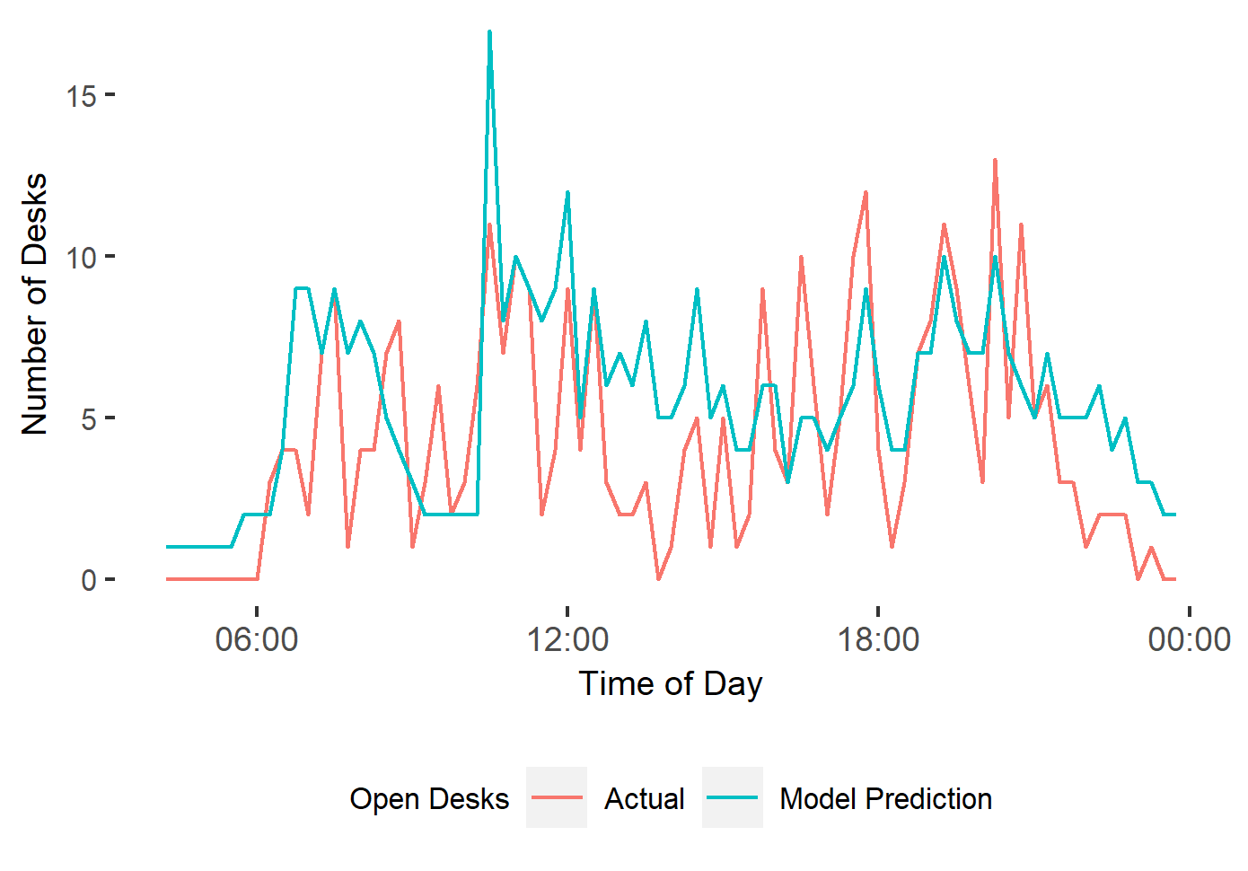
Figure 26. Example of Actual vs Predicted Open Border Desks
I attempt to compensate for this by adding into the simulation random fluctuations in desk availability. In each 30 second period there is a small chance that an ‘event’ will occur that reduces the number of open desks between 2 to 6 for between 10 to 75 minutes. Unfortunately, the data and discussions that contributed towards this addition cannot be disclosed due to the confidential nature of the process. Whilst this clearly will not match the actual patterns of desk ‘shortages’ in terminals during the period, it should introduce enough variance to capture a similar level of excess waiting time. We can validate this against actual patterns of long wait times recorded for the terminals using Border Force data.

Verification and Validation
The base model was extensively verified and validated as part of our study presented in Chapter 4. To ensure that amendments to the model operated as expected, I used Excel and a small sample of flight data to recreate the simulation's intended stages. The results from this test matched my model outputs for the sample group exactly. To validate that results were a close approximation of the real border control system, I also compared simulation results to passenger wait time summary statistics collected by Border Force for the same period. Full details of this are shown in Section 5.4.2.

Valuation of Costs

Valuation Method
The literature review highlighted key issues when costing airport border delays; specifically, the difficulties when attempting to ascertain the external costs in terms of reduced tourism/business travel to either the air travel industry or wider economy (whether local or national). Hence, individual valuations of travel time are typically used as a more clearly definable measurement of cost.

I need to clarify a potential issue with this when discussing non-domestic travellers, such as non-EEA passengers at UK airports. It has been argued in the VTT literature that there is an ethical concern when benefits of a project accrue to individuals outside of the groups that pay for them (Borjesson and Eliasson, 2019). In terms of our case-study, we would assume that it would be British taxpayers that would fund processing time improvement projects, yet the travel times savings achieved are for non-British citizens. In addition to this, I raise a methodological concern of whether it makes sense to use preference surveys of higher-income, Western citizens to establish VTTs for all non-EEA nationalities, regardless of incomes (see Rizzi and Steimetz, 2014).

Both concerns can be partially addressed by suggesting that VTTs are used as a proxy for the economic benefits that accrue to the UK from lower border queues. However, a more satisfying answer comes from highlighting the UK’s commitments to international air travel agreements, as discussed in Section 5.2.1. We can consider its efforts to minimise border wait times for non-EEA travellers as a quid pro quo for other nations taking similar measures to reduce border times for British citizens in their systems. Hence, I argue that the use of British, or similar income-level survey results to assign costs for non-EEA passengers is both logical and justifiable in terms of reciprocal benefits to the UK.

Final Costs
Once average wait times have been established for each nationality, the total expected wait time for these groups can be extrapolated from Home Office statistics showing the total number of foreign travellers arriving into the UK in 2017 (Gov.uk, 2019). This is the last year for which statistics are publicly available for both nationality and business/leisure splits. Where I have been unable to generate average wait times for a nationality (due to them not being present in our simulation scenarios), the mean average will be used. Figures will be rounded to an appropriate level of significance to maintain nationality anonymity. This will be done for the baseline and levelled-down scenarios to demonstrate the total time savings that would be achieved for all non-EEA passengers coming into UK borders over a 12-month period from our suggested processing time reductions.

To convert these time savings into monetary value, I use two different sets of VTT rates suggested in our literature review (both using 2021 prices). The first are the generic DfT rates described in Section 5.2.5. The Home Office is familiar with these figures and hence it makes sense to provide valuations using them. The second set is taken from Landau et al.’s (2016) study. I use their discovered VTT rates for check-in and security; £23.80 for Leisure and £31.11 for Business. I argue that these are the most relevant existing VTT rates for airport border control. The two sets will provide a comparison between costs generated using generic and travel scenario specific VTT rates.

Results

Passenger Processing Times
Border processing times were recorded for 1,980 passengers using Non-EEA desks at five UK airport terminals. Passengers were either processed individually or in groups (such as families). Depending on nationality, passengers required either an interview and visa (Visa), just an interview (Non-Visa) or neither (B5JSSK).

Passenger Statistics of interest:
- The average group size was 1.47.
- 2/3rds of passengers came from nations requiring a visa to enter the UK
- 69% of observations were of an unaccompanied adult being processed. These made up 47% of all passengers included in the study.
- 8.2% of recorded passengers were children.
- B5JSSK groups were more likely to have children (17% compared to 8% overall).

Tables 23 and 24 provide summary statistics for processing times. They show that the average time taken for an unaccompanied adult to be processed at a Non-EEA border desk was 104 seconds. Average processing times were higher for visa passengers compared to non-visa nationals, and considerably lower for B5JSSK passengers. Per passenger processing times drop as the size of the group increases, with groups containing children having a lower average processing rate for all types.

Table 23. Non-EEA Passenger Group Processing Time Summary Statistics (Seconds)
 | Mean | Min | Q1 | Median | Q3 | 95th Per | Max
All  Single Adults | 123.9  104.4 | 10.0  10.0 | 55.8  49.0 | 86.5  72.0 | 141.0  110.0 | 316.2  272.0 | 1,550.0  1,448.0

Table 24. Processing Time Statistics Breakdown
Passenger Type | # Group Observations  [Inc .Children] | # Passengers Included  [Children] | Mean Per Passenger Processing Time (seconds)  [Groups inc. Children]
Cohort  Visa  Non-Visa  B5JSSK | 1,363 [86]  385 [33]  232 [39] | 1,930 [128]  659 [57]  328 [54] | 91.6 [66.2]  83.7 [52.1]  38.2 [31.7]
Group Size  1  2  3  4  5+ | 1,383 [7]  387 [34]  122 [60]  60 [41]  28 [16] | 1,383 [7]  774 [34]  366 [70]  240 [81]  154 [47] | 104.3 [96.6]  74.3 [61.5]  59.9 [53.9]  54.3 [52.2]  50.3 [52.1]
All | 1,980 [158] | 2,917 [239] | 83.81 [54.7]

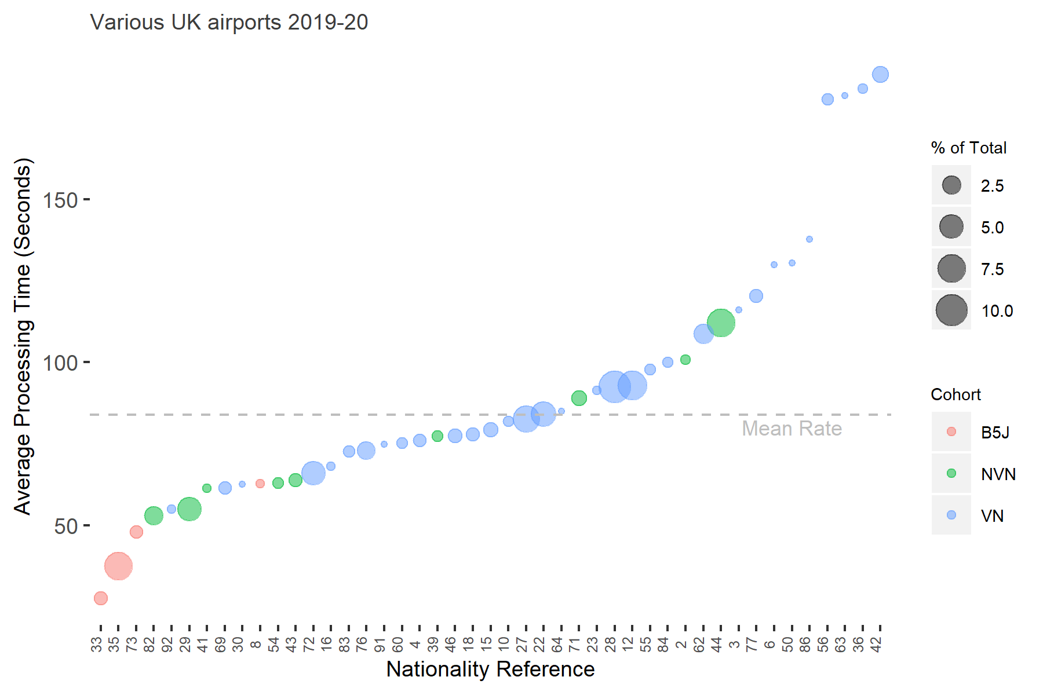
Figure 27. Average processing times and share of total non-EEA Nationalities travelling through UK border control during the port study period

Average processing times by nationality are shown in Figure 27. Reference numbers have been used instead of the nationality names due to the confidentiality of this data. For example, we can see that passengers with the nationality corresponding to references #73 took on average just under 50 seconds to be processed during the study. However, passengers with nationality reference #55 took approximately 100 seconds on average to clear UK borders. The size of the circles shows the percentage share that each nationality had of all observations, providing a rough indication of the workload that each group represented to Border Force during the study period. The dashed line indicates the mean processing time for all passengers.

High-Rate Nationalities
Table 25 shows details for the four nationalities with the highest average processing rates who accounted for at least 1% of non-EEA passenger arrivals into the UK in 2017 (Gov.uk, 2019). These are chosen as the ‘high-rate’ nationalities for simulation analysis. A fuller version of the table can be found in Appendix B.

Table 25. Top 4 Non-EEA nationality border processing times (> 1% of 2017 arrivals)
Nationality Reference | % of non-EEA observations in study | Average Group Size | % of Passengers Children | Mean Passenger Processing Time (seconds)
#42 | 1.9 | 1.2 | 8.9 | 188.4
#77 | 1.1 | 1.3 | 12.9 | 120.3
#44 | 8.4 | 1.7 | 3.7 | 112.2
#62 | 3.6 | 1.5 | 19.0 | 108.8

DES Wait Time Simulation Results

Baseline Summary Statistic Comparison
A ‘baseline’ simulation of border controls at 8 UK terminals was run as described in Section 5.3.2. Nationality process rates were set to the averages for each nationality group as shown in Figure 27. The mean value of 83.81 seconds was used for all cases where we were unable to apply nationality specific rates.

Table 26 compares summary statistics of wait times from this simulation to measurements recorded by Border Force during the same period. Overall, we see a close match between the model’s predictions and Border Force’s figures. As well as the stated statistics, the simulated maximum wait time matched Border Force’s recorded maximum to within 0.7%. However, port level results (see Appendix C) suggest that at a finer level the model is less successful, with only three ports out of eight having predictions within 2 minutes of the recorded total. As explained in the methodology section, this is not surprising given our inability to accurately recreate the exact operational levels in each port for the period. I would argue, however, that our model represents a good approximation of the actual wait times faced by the target passenger groups.

Table 26. Comparison of simulation wait times and measurements taken by Border Force
Wait Time Statistics | Baseline Simulation | UK Border Force Measurements
Mean (minutes) | 6.91 | 7.33
Median (minutes) | 2.5 | 1
95th Percentile (minutes) | 30 | Not Available
Wait Time > 45 Mins | 2% | 3%
# Observations / Ports | 1,745,394 / 8 | 86,751 / 26

Nationality Level
Validation was undertaken to ensure that the distribution of nationalities in the simulation results was realistic to the UK border scenario. This was done by comparing the percentage of each nationality group in the results with official figures for arrivals into the UK in 2017 (see Appendix C). Overall, we see a reasonable match for most nationalities, with only one group being notably underrepresented. The explanation for this discrepancy cannot be elaborated on due to confidentiality; I accept this as a limitation of the model.

Results
The first level of nationality-level wait time analysis was at the ‘cohort’ level (Table 27). As we might expect, the B5J nations, with significantly lower processing times, have lower wait times in the simulation. However, we can also see that Non-Visa Nationals have higher wait times than Visa Nationals, despite slightly lower processing times. A similar, but less pronounced trend is seen with extreme wait times, with B5JSSK and Visa Nationals having a lower 95th percentile wait time and percentage missing the 45 minute target, but Visa Nationals having a higher maximum wait time.

Table 27. Simulation Wait Times by Nationality Cohort (minutes unless stated)
Cohort | Mean Wait Time | Median Wait Time | 95th Percentile Wait Time | Max Wait Time | Wait Time > 45 Mins
B5JSSK | 5.64 | 0.5 | 28.5 | 82 | 1.2%
Non-Visa National | 8.72 | 4.5 | 34.5 | 93.5 | 2.4%
Visa National | 8.31 | 4 | 32.5 | 130 | 1.8%

Figure 28 shows the full distribution of wait times for nationality groups with at least 5,000 observations in our model (0.3%). A fuller explanation is provided below the graph. Comparing Figures 27 and 28 shows that two nationalities with significantly higher average processing times have considerably higher average passenger wait times. Also, the nationality with the lowest processing time has the lowest wait time. Beyond this, general trends are hard to distinguish.

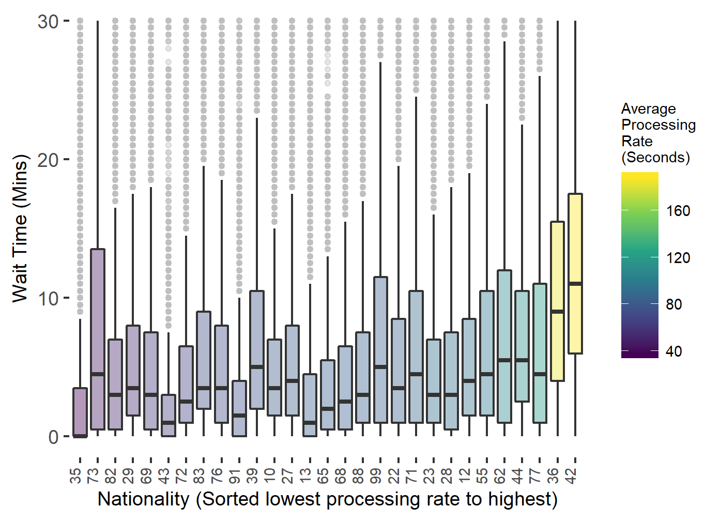
Figure 28. Distribution of Passenger Wait times by Nationality (cut off at 30 minutes)
Note: This shows the range of border wait times experienced by passengers of different nationalities in the baseline simulation model. The colour indicates the average processing time that each nationality faces at border control. These results show that median wait times for most nationalities fall within a range of approximately 2-5 minutes.

Smoothed Scenarios

High-Rate Reduction
Based on results in the sections above; nationality groups #42, #44, #62 and #77 were selected for the ‘high-rate smoothing’ scenario. Their average processing rates were set to the overall average and the simulation was run again. Overall, this scenario contained just over 1,014 fewer hours (2.47%) of total passenger processing time than the baseline.

Table 28 shows a comparison of summary statistics for the two simulations. The headline change is a reduction of 0.68 minutes (9.8%) in passenger mean wait time. For the approximately 1.7 million passengers included in the simulation, this would factor out to 19,781 hours of saved time over the 8 terminals for the 3-month period. Regarding extreme wait times, we see an 8.3% reduction in the 95th percentile wait time and a 20% decrease in passengers waiting longer than the 45 minute target.

Table 28. Comparison of Wait Time Statistics for Specified Simulations (minutes)
Simulation | Mean  Wait Time | Median  Wait Time | 95th Percentile  Wait Time | Wait Time > 45 Mins
Baseline | 6.91 | 2.5 | 30 | 1.53%
High-rate Smoothed | 6.23 | 2.5 | 27.5 | 1.21%

Nationality Level Changes
Figure 29 shows a comparison of total wait times by nationality group in each of the two simulations. The difference between the baseline and high-rate smoothed scenarios (shown in blue) indicates the wait time saved from the levelling down of processing times. We see time-savings for most nationality groups. However, as expected, the four high-rate nationalities whose processing times have been reduced in the smoothed scenario experience the greatest benefit.
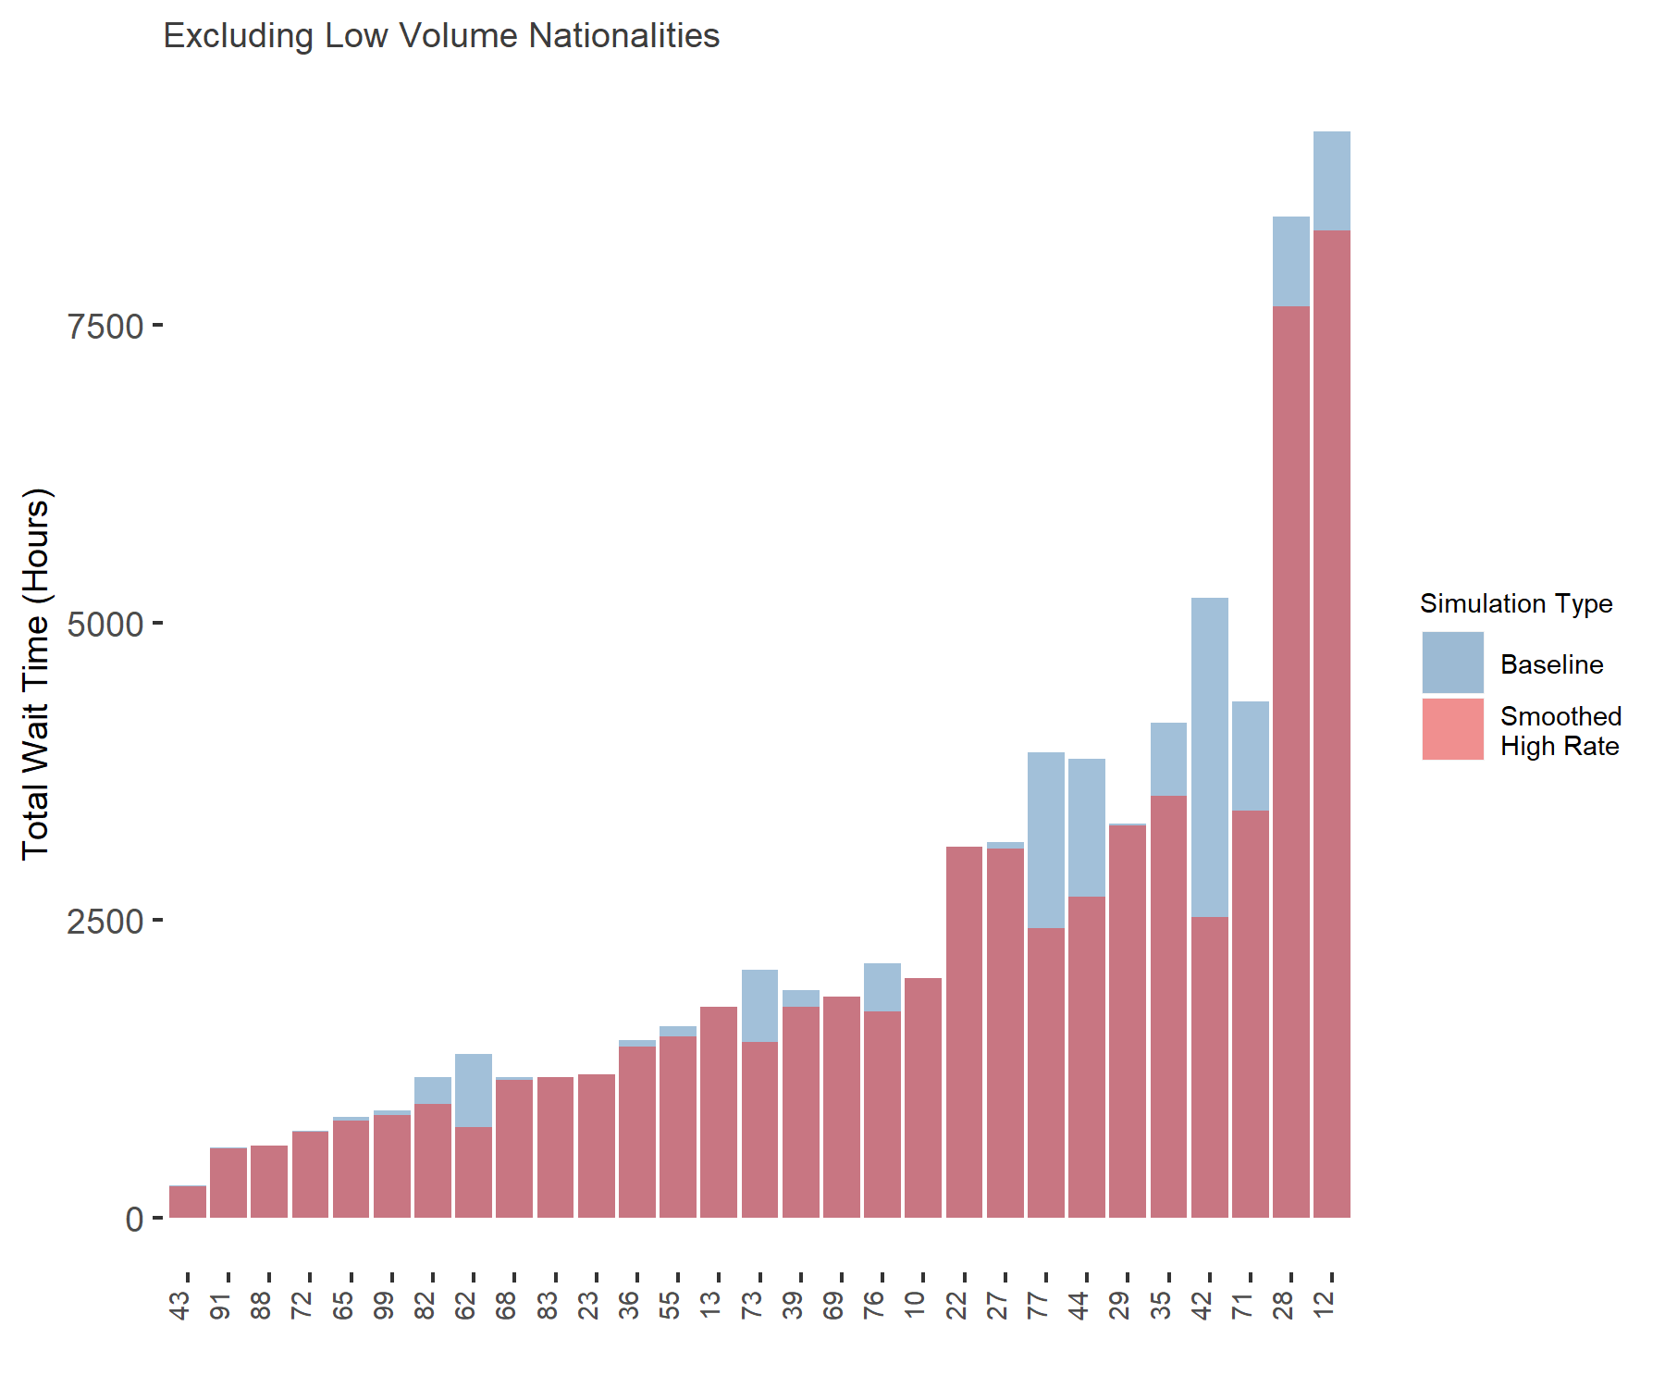
Figure 29. Reductions in Total Passenger Wait times from High-rate Smoothing
Table 29 shows a more detailed breakdown of the high-rate nationalities. We see a multiplier effect of processing time reduction on mean wait times, between 5 and 10 for each group. From Border Force’s operational perspective, I highlight the large falls in wait times above the 45 minute target, with an overall reduction of 65%.

Table 29. Wait time reductions achieved in high-rate smoothed simulation (from baseline)
 | Nationality Reference
Statistic [Mins (% change)] | #44 | #42 | #62 | #77
Mean Processing Time | -1.74 (-55.5%) | -0.47 (-25.3%) | -0.42 (-23.0%) | -0.61 (-30.0%)
Mean Wait Time | -8.4 (-51.5%) | -3.2 (-30.2%) | -4.3 (-44.6%) | -4.2 (-38.5%)
Median Wait Time | -7.5 (-60.0%) | -2.5 (-41.7%) | -4.0 (-61.5%) | -2.5 (-45.5%)
95th Percentile Wait Time | -18.5 (-41.6%) | -8.0 (-20.3%) | -10.0 (-32.2%) | -11.5 (-29.9%)
Performance Target
Wait Times > 45 Mins % | -3.6 (-75.8%) | -1.8 (-55.3%) | -0.7 (-79.9%) | 1.7 (-58.0%)

High-Rate Smoothing Effectiveness
To explore the specific effectiveness of focusing on high-rate nationalities, we ran two additional scenarios.

Uniform Smoothing: A uniform reduction of 2.47% was applied to all non-EEA passenger processing times.
High-Total Smoothing: The two nationalities responsible for the highest total workload (#12 and #26) had their processing times reduced by 28.5%.

In both scenarios, the percentage reductions were selected to achieve the same 1,014 hours of processing time reduction as in our high-rate method. Figure 30 shows a comparison of the wait time savings achieved in each scenario. As shown, our high-rate smoothing method achieved the highest decreases in all three wait time metrics, with the uniform method performing least-well. Overall, our high-rate method saved an additional 3,807 hours of passenger wait time compared to the high-total method and 8,417 hours over the uniform method.

Figure 31 shows how average passenger wait times grouped by nationality vary across these 3 smoothing scenarios (as well as the original baseline simulation). Levelling down the border processing times for four ‘high rate’ nationalities achieved proportionally greater reductions in overall passenger wait times than other methods which involved the same total reduction in processing times.

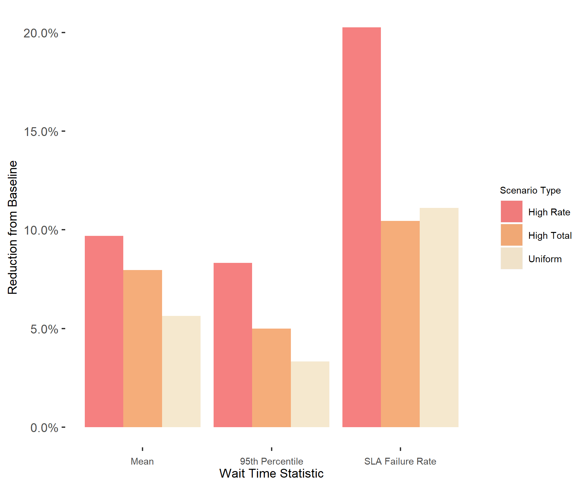
Figure 30. Comparison of smoothing methods on Wait Time Reductions

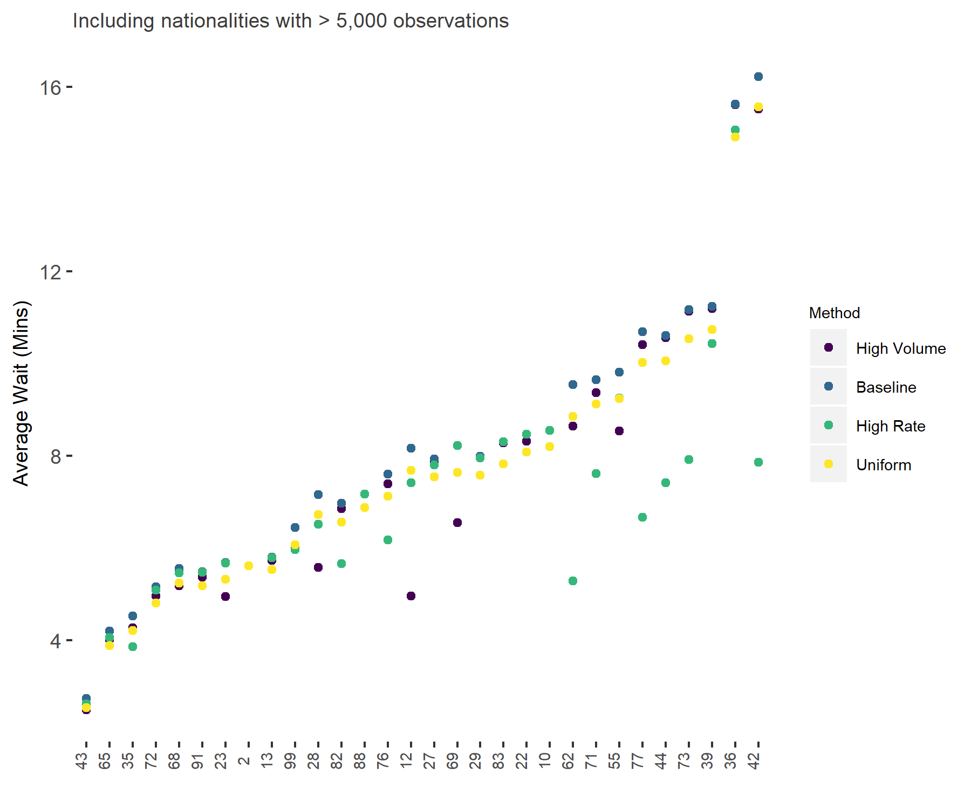
Figure 31. Comparison of smoothing methods on Average Wait Time Reductions

Total Passenger Time and Cost Savings
Having established the average time savings for air passengers from various nationality groups, we can apply these to typical traveller numbers to suggest the expected time and monetary savings from our high-rate smoothing. Table 30 shows a breakdown of these costs when we use 2017 UK arrivals data as a basis. Total passenger time savings include both processing and wait times. The table shows the breakdown for nationalities who would be expected to save at least £100,000 a year (Landau valuation) as well as the total saving for all non-EEA nationalities. The latter is estimated at £6.3m a year using Landau’ valuations and £3.0m using DfT recommendations. As expected, our four high-rate nationalities (highlighted in red) are included in the top 5 largest beneficiaries.

Table 30. Valuations of Annual Time Savings from High-Rate Processing Smoothing
Nationality Group Reference | Total UK Arrivals 2017 (showing to nearest 50k) | Average Passenger Time Saving (mins) | Landau VTT Total (shown to nearest £50k) | DfT VTT Total (shown to nearest £50k)
#42 | 300,000 | 10.1 | £1,200,000 | £500,000
#44 | 450,000 | 3.7 | £700,000 | £300,000
#77 | 300,000 | 4.8 | £600,000 | £350,000
#73 | 400,000 | 3.2 | £550,000 | £200,000
#62 | 250,000 | 4.7 | £500,000 | £250,000
#35 | 1,700,000 | 0.7 | £450,000 | £200,000
#12 | 1,400,000 | 0.7 | £400,000 | £200,000
#28 | 1,400,000 | 0.7 | £400,000 | 250,000
#71 | 300,000 | 2.1 | £300,000 | £100,000
#82 | 400,000 | 1.3 | £200,000 | £100,000
#87 | 200,000 | 2.4 | £200,000 | £150,000
#76 | 250,000 | 1.3 | £150,000 | £50,000
Total Non-EEA | 12,826,905 |  | £6,317,968 | £2,969,656
High-rate nationalities highlighted

Discussion

Passenger Processing Variations
Analysis of the port data confirms our assumptions that non-EEA passenger groups face a wide variation in processing times at UK border control. Whilst the mean average time for a group was just over 2 minutes, we see a minimum time of 10 seconds and maximum of over 25 minutes. The summary statistics suggest that at least some of this difference is simply due to the average number of individuals in each group and whether children are included. Discussions with Border Force staff during the observational research stage suggested that they can, on average, save time processing family or friend groups together as risk assessment can be performed collectively. However, the requirements for individual identification and document checks limits time savings. I also confirmed that the inclusion of children lowers the average time needed to process a group, with staff explaining that they might not require separate documentation and will not usually pose an individual risk to the UK (though, some checks may be necessary to safeguard against trafficking).

When we looked at nationality variations, it was clear that differences in average group sizes and frequency of child passengers play a part in the range of per-passenger processing rates. Of the 12 nationalities with the highest rate, 10 had below average group sizes and half of them had no children at all in the study. This is an important observation as it asks to what extent nationality variations are simply a result of group characteristics, rather than differences in how passengers are treated at the border. We can inspect this question by limiting our results to groups containing only unaccompanied adults. Here, we still see significant variations in processing times at a nationality level. For example: lone adults from nationality group #42 have an average processing rate of 226 seconds, compared to 151 seconds for nationality #62, 69 seconds for those from nationality #71 and 36 seconds for nationality #35. Clearly group characteristics are only an element in average variations.

Average Passenger Times
Returning to our full passenger analysis, I note that the B5JSSK cohort had substantially lower processing times. This is expected given that they were not required to undergo border interviews during this period. We also see evidence that passengers who do not require visas are processed quicker than those that do; validating suggestions in the literature that visa requirements add an additional time burden at the border. However, I highlight that the overall average difference of 8 seconds (approximately 10% of the mean processing time) is not particularly large. Much greater variation is shown within these cohorts, with average processing times varying between 53-189 seconds, dependent on nationality. I note an issue with low observation numbers for certain nationalities (less than 10 in some cases), though as our research focuses on the larger groups this is less of an issue. Of these, nationality group #42 faced the most challenges at the UK border, with these citizens taking a minute longer on average than the next ‘high-rate’ nationality. Overall, our results show clear evidence of the divergences in processing rates that passengers faced based on nationality.

Passenger Wait Time Variations and Valuations
Our baseline simulation results demonstrate how a small number of nationalities make up a large share of passengers being handled at the border. Citizens from three nationalities account for 30% of individuals in our model with an assigned nationality and 26% of the total passenger queuing time. Our wait time distribution graph shows that whilst our two highest rate nationalities have the highest average wait times, beyond this the relationship is less clear. For example, we note that B5JSSK nationality #73 has an average wait time almost triple that of #35, despite having only a slightly higher average processing time. A SLR model between wait times and processing times does show a significant relationship, but this only explains 24% of wait time variation, and only 8.6% if we remove our two highest rate nationalities from the model. What this suggests to us is that whilst extreme high processing rates seem to have a negative impact on passenger wait times, outside of this category, other factors in our model (such as airport congestion) are more important in determining wait times for individual nationality groups.

Our experiment does validate the need to focus on these high-rate nationalities when making processing time reductions. By lowering the average processing rate for four nationalities we were able to reduce total waiting times for all passengers by 9.8%. For every minute of processing time removed from the model we achieved a 19 minute reduction in waiting time. This kind of ratio is expected given the compounding nature of wait times in queues; though our validation against other smoothing techniques suggests that targeting high-rate nationalities is a particularly effective method, especially when reducing extreme wait times. This latter element is important when operational targets are focused on reducing the frequency of queuing times above a certain threshold, rather than being concerned about overall wait times. With regards to Border Force’s 45 minute SLA target, our high-rate method was almost twice as effective than alternatives.

I highlight here that these results broadly confirm the behaviour that queuing theory suggests would occur in this situation (see Chapter 4.2.1 for a full discussion of this). In all three of our reduction scenarios, we see that reducing the average service time (border processing time), decreases the average passenger wait time. However, when focusing on methods that reduce the inter-service variability (the variation in passenger processing times) we see a bigger reduction than in methods that don’t. This reflects the impact of the variability element of Kingman’s approximation.

Realities of Processing Time Reductions
We should note that this analysis does not consider the practicalities or costs of achieving processing time reductions. It’s likely that the resources needed to achieve these will vary depending on the nationality group and their existing processing rate; with the marginal cost of time reductions increasing. Hence, even though our method is shown to be the most efficient of those investigated, it might not be the most cost-effective. This would especially be the case if process changes for a specific nationality group have a fixed cost, regardless of the number of passengers that arrive in the country from that group. In which case, we would logically expect a focus on high-volume passengers to have a larger overall effect than our focus on high-rate nationalities. This would need additional research into the area to ascertain.

Nevertheless, we should also consider that this research specifically stems from a concern over the cost of border mobility variations that have arisen in previous decades because of exclusions from automated border systems. If we were to then focus on groups of non-automated passengers that are the easiest/cheapest to achieve time savings this risks simply creating or reinforcing variations within this group. Figure 30 indicated the success that our high-rate method had at tackling extremes in average wait times: In our baseline scenario nine nationality groups have an average wait time above 10 minutes, compared to six in both our high volume and uniform scenarios and only four in our high rate reduction. The breakdowns for our high-rate nationalities clearly show the substantial time savings for these groups from lower processing times. However, other nationalities (who presumably tend to be in the same border queues as them) also see large falls. For example, nationality #73 passengers experience a 3.2 minute (29%) reduction in average wait time, despite their processing times not changing.

Cost Savings
The impact of processing time reductions is seen clearest in our cost estimates. Lowering average time for our four high-rate nationalities is predicted to save just over £3m worth of passenger time per year (using Landau calculations) to those four groups. However, this accounts for less than half of the total savings to all non-EEA passenger groups. Within these, four nationality groups are predicted to achieve savings of between £400k and £500k each per year. This suggests to us that whilst focusing on high-rate nationalities could be a moral imperative to tackle extremes in border variations, the actual benefits of such a scheme would be wide-reaching.

Whilst I have no direct data upon which to compare these cost savings with the specific costs of process changes, we can use published Border Force costs (Gov.uk, 2021) as an illustrative guide. They show that an average £2.80 was spent for each passenger it processed at the UK border in 2017 (2020 prices). Unfortunately, this statistic is not broken down between automated gates and manual desks, hence, we must be careful when applying it to our scenario. However, we can note that using Landau valuations, our high-rate reduction would be predicted to save approximately £0.50 of wait time per non-EEA passenger that used a Border Force desk in 2017: 17.6% of the £2.80 per passenger cost to UK Border Force. Using the lower DfT rates, savings are calculated at 27p per passenger, 9.6% of total cost.

Conclusion
The objective of this study has been to explore the costs of variations in border mobility with regards to nationality and airport border control. By analysing differences in processing times for passengers that use staffed desks and applying them in discrete event simulation, I have been able to demonstrate the total times lost from border control staff taking longer to process specific nationality groups. After identifying four ‘high-rate’ nationalities in the data, DES modelling was used to estimate the total border wait times that could be saved if their processing times were reduced to the overall non-EEA level. Overall, we achieved a 9.8% reduction in the time that all passengers spend queuing, and an over 50% reduction for our highest rate nationality. After viewing the literature of valuation of travel time and applying it to our specific scenario of border control, I suggested that the total cost of this lost time could be valued at over £6m a year for non-EEA passengers, or 17.6% of the cost of processing this cohort according to average for all passenger assessed by UK Border Force for the same period.

The value in this specific research is in the ability to study the actual outcomes for different nationalities at border control in a detail that has not been undertaken publicly before. The access to observational research at the port, significant Border Force and airport data for the same period and the individuals that manage the process, both on the ground and at the UK Home Office, have allowed me to build analysis and modelling that reflect the real-world system with a high degree of accuracy. This is apparent from the accuracy at which the model matches measurements taken by Border Force for the period being model. I would argue that this provides us with confidence when recommending to similar border control authorities the value of concentrating on higher processing time nationalities when attempting to improve passenger experiences.

Further to this, the experiences of passengers continuing to use staffed desks is one that has been relatively under-researched compared to the large volume of studies into new technologies and data systems that have been introduced to handle the vast increase in air passenger numbers. Whilst this focus may achieve the high-level aims of air travel industry stakeholders to reduce overall passenger wait times and maintain customer satisfaction, it risks furthering a divide between those that benefit from the digitalisation of border control and those who don’t. The research presented here aims to directly respond to this issue by highlighting passenger groups that are not easy to process, whose ‘risk profile’ creates a separate risk of poor experiences at the border. By presenting the cost of their lack of border mobility I aim to allow decision makers to better consider these groups in their planning.

Limitations
I highlight again the limitations of methods for estimating nationality breakdowns and typical desk opening patterns in UK border control. Whilst these methods present a reasonable approximation of the border control systems being modelled, additional data in this area would increase the quality of research. I also accept that the costing of lost time is relatively simplistic and does not consider the consequences of reductions in border delays on the overall air passenger journey. This general issue is tackled in Chapter 6. This study also does not consider the variation in processing times within nationality groups and how this may impact wait times (see Section 3.2.1 for general discussions on our approach).

Arguably though, the clearest limitation in the study is the lack of consideration of the non-wait time elements of reducing border processing. As discussed in the literature review, a possible trade-off of lower processing times would be a reduction in border security and an increase in flow of ‘undesirable individuals into the UK. It may be the case that nationalities with the highest processing times have the highest risk-profiles, and hence reducing their times may come with additional consequences. Whilst this analysis was never within the scope of this project, I highlight that without them it is not possible to make informed decisions concerning possible border control reforms.

Appendix A: Automated Border Systems Access (UK)
Table 31. Nationalities with Access to ePassport Gate Systems during Winter 2019/20
Country | Cohort | Country | Cohort | Country | Cohort
Australia | B5JSSK | Hungary | EU | Portugal | EU
Austria | EU | Iceland | EEA | Romania | EU
Belgium | EU | Ireland | EU | Singapore | B5JSSK
Bulgaria | EU | Italy | EU | Slovakia | EU
Canada | B5JSSK | Japan | B5JSSK | Slovenia | EU
Croatia | EU | Latvia | EU | South Korea | B5JSSK
Republic of Cyprus | EU | Liechtenstein | EEA | Spain | EU
Czech Republic | EU | Lithuania | EU | Sweden | EU
Denmark | EU | Luxembourg | EU | Switzerland | EEA
Estonia | EU | Malta | EU | UK | Domestic
Finland | EU | Netherlands | EU | USA | B5JSSK
France | EU | New Zealand | B5JSSK
Germany | EU | Norway | EEA
Greece | EU | Poland | EU

Appendix B: Nationalities with the Highest Processing rates
Table 32. Nationalities with the Highest Observed Processing Rates in 2019 Study
Nationality Reference | Average Group Size | % of Passengers Children | Mean Passenger Processing Time (seconds)
#42 | 1.2 | 8.9 | 188.4
#36 | 1.2 | 0.0 | 184.1
#63 | 1.0 | 0.0 | 182.0
#56 | 1.5 | 9.1 | 180.9
#86 | 1.2 | 0.0 | 137.7
#50 | 1.4 | 0.0 | 130.6
#6 | 1.0 | 0.0 | 130.0
#77 | 1.3 | 12.9 | 120.3
#3 | 1.0 | 0.0 | 116.1
#44 | 1.7 | 3.7 | 112.2
#62 | 1.5 | 19.0 | 108.8
#2 | 1.3 | 7.7 | 100.1

Appendix C: Simulation Validations
Table 33. Comparison of Simulated Wait Time to Measured Results by Port (Winter 2019)
Port | Share of Non-EEA Passengers in Study | Average Wait time  (nearest minute)
Port | Share of Non-EEA Passengers in Study | Baseline Simulation | BF Measurement
Port 1 | 8.2% | 7 | 8
Port 2 | 10.3% | 8 | 8
Port 3 | 16.2% | 10 | 6
Port 4 | 17.4% | 6 | 10
Port 5 | 21.9% | 2 | 7
Port 6 | 12.2% | 5 | 7
Port 7 | 5.2% | 11 | 6
Port 8 | 8.6% | 2 | 5
‘BF Measurements’ are actual passenger wait times measured by Border Force at multiple ports during November 2019 to January 2020. This data is contained within internal, unpublished Home Office reports.
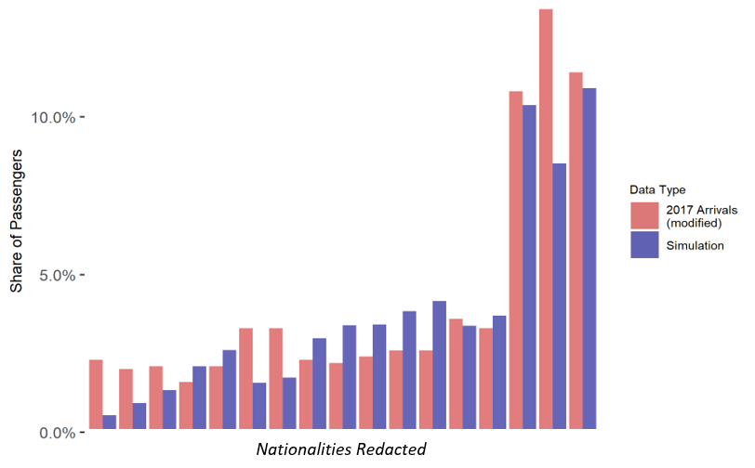
Figure 32. Comparison of non-EEA Passenger Totals (> 100k arrivals)
Note: 2017 arrivals are taken from government statistics (GOV.UK, 2019) and are modified to account for the fact that only 30% of B5JSSK nationalities would be expected to use staffed desks during the period.

Appendix D: Variable Processing Rate Model
Redacted Python code for our Variable Processing Rate (VPR) Model can be found in the below GitHub repository:
https://github.com/bdgardner1/Flight_Delay_Analysis
Data files used for this study cannot be provided in any format due to confidentially requirements from the Home Office.
A processes diagram for the model is shown in Figure 33.
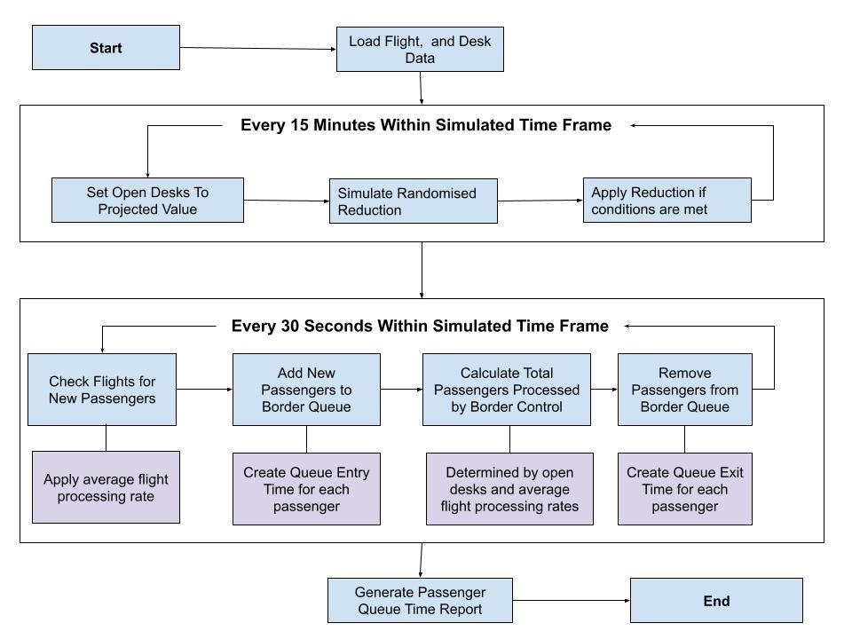
Figure 33. Diagram of VPR Simulation Model

Chapter 5 References

Abeyratne, R. (2014). The Facilitation Connection. In: Abeyratne, R. (Ed). Regulation of Air Transport: The Slumbering Sentinels. Cham: Springer International Publishing. pp.77–83.
Abrantes, P. A. L. and Wardman, M. R. (2011). Meta-analysis of UK values of travel time: An update. Transportation Research Part A: Policy and Practice, 45 (1), pp.1–17.
Alexander, M. et al.. (2012). Priority queues: Where social justice and equity collide. Tourism Management, 33 (4), pp.875–884.
AOA. (2018). TOWARDS A SMOOTH AND IMPROVED BORDER. Available at: https://www.aoa.org.uk/wp-content/uploads/2018/07/A-smooth-and-improved-Border.pdf. [Accessed: 3 September 2019].
Arber, S. (2001). SECONDARY ANALYSIS OF SURVEY DATA 16. Researching social life, p.269.
Aussilloux, V. and Le Hir, B. (2016). The economic cost of rolling back Schengen. Analytical Note, 39. [Online]. Available at: http://www.mondialisations.org/medias/pdf/consequenceabandonschengenen.pdf.
Balliauw, M. and Onghena, E. (2020). Expanding airport capacity of cities under uncertainty: Strategies to mitigate congestion. Journal of Air Transport Management, 84, p.101791.
Batley, R. et al.. (2019). New appraisal values of travel time saving and reliability in Great Britain. Transportation, 46 (3), pp.583–621.
Börjesson, M. and Eliasson, J. (2019). Should values of time be differentiated? Transport Reviews, 39 (3), pp.357–375.
Bosworth, M. (2008). Border Control and the Limits of the Sovereign State. Social & legal studies, 17 (2), pp.199–215.
Brunetta, L., Righi, L. and Andreatta, G. (1999). An operations research model for the evaluation of an airport terminal: SLAM (simple landside aggregate model). Journal of Air Transport Management, 5 (3), pp.161–175.

Caa.co.uk. (2023). Annual airport data 2019. [Online]. Available at: https://www.caa.co.uk/data-and-analysis/uk-aviation-market/airports/uk-airport-data/uk-airport-data-2019/annual-2019/ [Accessed 16 January 2023].
Côté-Boucher, K. (2018). Of ‘old’ and ‘new’ ways: Generations, border control and the temporality of security. Theoretical Criminology, 22 (2), pp.149–168.
Farrell, S. (2016). How airports can fly to self-service biometrics. Biometric Technology Today, 2016 (1), pp.5–7.

GOV.UK. (2015) Values of travel time savings and reliability: Final reports, GOV.UK. GOV.UK. Available at: https://www.gov.uk/government/publications/values-of-travel-time-savings-and-reliability-final-reports (Accessed: November 17, 2022).

Gov.uk. (2019). How many people come to the UK each year (including visitors)? [Online]. Available at: https://www.gov.uk/government/statistics/immigration-statistics-year-ending-june-2019/how-many-people-come-to-the-uk-each-year-including-visitors [Accessed 21 December 2021b].

Gov.uk. (2021). Border Force transparency data: February 2021. [Online]. Available at: https://www.gov.uk/government/publications/border-force-transparency-data-february-2021 [Accessed 21 December 2021a].

Gov.uk (2023) Immigration rules, Immigration Rules - Immigration Rules Appendix Visitor: Visa national list - Guidance - GOV.UK. Available at: https://www.gov.uk/guidance/immigration-rules/immigration-rules-appendix-visitor-visa-national-list (Accessed: 12 August 2023).
Guizzi, G., Murino, T. and Romano, E. (2009). A discrete event simulation to model passenger flow in the airport terminal. Mathematical methods and applied computing, 2, pp.427–434.
Hee King Jim and Zeph Yun Chang. (1998). An airport passenger terminal simulator: A planning and design tool. Simulation Practice and Theory, 6 (4), pp.387–396.
Hess, S. and Adler, T. (2011). An analysis of trends in air travel behaviour using four related SP datasets collected between 2000 and 2005. Journal of Air Transport Management, 17 (4), pp.244–248.
Jara-Díaz, S. (2007). Travel Demand and Value of Time. In: Transport Economic Theory. 39. Emerald Group Publishing Limited. p.88. [Accessed 14 June 2021].
Jiang, H. and Zhang, Y. (2016). An assessment of passenger experience at Melbourne Airport. Journal of Air Transport Management, 54, pp.88–92. [Accessed 6 August 2021].
Kellerman, A. (2008). International Airports: Passengers in an Environment of ‘Authorities’. Mobilities, 3 (1), pp.161–178.
Landau, S. et al.. (2016). Measuring air carrier passengers’ values of time by trip component. Transportation research record, 2569 (1), pp.24–31.
Law, A. M. (2019). How to Build Valid and Credible Simulation Models. In: 2019 Winter Simulation Conference (WSC). December 2019. pp.1402–1414.
Leese, M. (2016). Exploring the security/facilitation nexus: Foucault at the ‘Smart’border. Global Society, 30 (3), pp.412–429.
Manataki, I. E. and Zografos, K. G. (2010). Assessing airport terminal performance using a system dynamics model. Journal of Air Transport Management, 16 (2), pp.86–93.
Mason, A. J., Ryan, D. M. and Panton, D. M. (1998). Integrated Simulation, Heuristic and Optimisation Approaches to Staff Scheduling. Operations research, 46 (2), pp.161–175.
Mau, S. et al.. (2015). The Global Mobility Divide: How Visa Policies Have Evolved over Time. Journal of ethnic and migration studies, 41 (8), pp.1192–1213.
McGonegal, S., Beggs, T. and Roberts, B. (2014). Management of the Passport Inspection Process at US International Airports. Analysis of Primary Inspection Wait Time at US Ports of Entry, p.42.
National Audit Office. (2012). The UK Border Agency and Border Force: Progress in cutting costs and improving performance. [Online]. Available at: https://www.nao.org.uk/wp-content/uploads/2012/07/1213467.pdf.
Phillips, C. (2007). A Review of High Performance Simulation Tools and Modeling Concepts. pp.29–47.
Pitchforth, J. et al.. (2015). Processing passengers efficiently: An analysis of airport processing times for international passengers. Journal of Air Transport Management, 49, pp.35–45.
Regattieri, A. et al.. (2010). Designing production and service systems using queuing theory: principles and application to an airport passenger security screening system. International Journal of Services and Operations Management, 6 (2), pp.206–225.
Rizzi, L. I. and Steimetz, S. S. C. (2014). On using standard values of time in project appraisal: Income equity vs. preference equity. Documento de Trabajo, Departamento de Ingeniería de Transporte y Logística, Pontificia universidad Católica de Chile. [Online]. Available at: https://www.sjsu.edu.akadns.net/economics/docs/steimeitz.pdf.
Roberts, B. et al.. (2014a). Impact of Passport Inspection Wait Time on International Air Travel to and From the US. Analysis of Primary Inspection Wait Time at US Ports of Entry, p.53.
Roberts, B. et al.. (2014b). The impact on the US economy of changes in wait times at ports of entry. Transport Policy, 35, pp.162–175.
Scheel, S. (2018). Real fake? Appropriating mobility via Schengen visa in the context of biometric border controls. Journal of ethnic and migration studies, 44 (16), pp.2747–2763.

Schweitzer, R. (2019). Health Care Versus Border Care: Justification and Hypocrisy in the Multilevel Negotiation of Irregular Migrants’ Access to Fundamental Rights and Services. Journal of immigrant & refugee studies, 17 (1), pp.61–76.
Shires, J. D. and de Jong, G. C. (2009). An international meta-analysis of values of travel time savings. Evaluation and program planning, 32 (4), pp.315–325.
Sontowski, S. (2018). Speed, timing and duration: contested temporalities, techno-political controversies and the emergence of the EU’s smart border. Journal of ethnic and migration studies, 44 (16), pp.2730–2746.
Tholen, B. (2010). The changing border: developments and risks in border control management of Western countries. International Review of Administrative Sciences, 76 (2), pp.259–278.
Wattanacharoensil, W., Schuckert, M. and Graham, A. (2016). An Airport Experience Framework from a Tourism Perspective. Transport Reviews, 36 (3), pp.318–340.
Woodfield, K. et al.. (2007). Exploring the decision making of Immigration Officers: a research study examining non-EEA passenger stops and refusals at UK ports. Home Office Online Report, 1 (07). [Online]. Available at: https://www.researchgate.net/profile/Kandy_Woodfield/publication/237289219_Exploring_the_decision_making_of_Immigration_Officers_a_research_study_examining_non-EEA_passenger_stops_and_refusals_at_UK_ports/links/55aa354308aea99467233534/Exploring-the-decision-making-of-Immigration-Officers-a-research-study-examining-non-EEA-passenger-stops-and-refusals-at-UK-ports.pdf.
Worthington, D. (2009). Reflections on queue modelling from the last 50 years. The Journal of the Operational Research Society, 60 (sup1), pp.S83–S92.
Wu, P. P.-Y. and Mengersen, K. (2013). A review of models and model usage scenarios for an airport complex system. Transportation Research Part A: Policy and Practice, 47, pp.124–140.

Costing Airport Border Choices: Assessing the optimal level of automated border control for UK airports

Abstract
This multi-stage research project provides insight into the costing of passenger delays at airport border control. Working in collaboration with the UK Home Office, I focus on individuals using automated border gates (‘eGates’) at UK airports. The first stage provides the results of a stated preference survey of air travel and border control, including specific Valuation of Travel Time (VTT) estimates for border delays. My overall findings suggest a clear aversion to wait times in the airport arrival stages, with VTT rates ranging between £38-41 per hour, higher than those found in most other transportation methods. The second stage uses Discrete-Event Simulation of ePassport gate systems to demonstrate how changes in eGate capacity would impact the total cost of delays. This includes an analysis of baggage reclaim and the extent that reducing wait times at the border simply increases delays in this area. This result, combined with high VTTs and the elasticity of waiting times to operational capacity at lower levels, suggest that an ‘undersupply’ of eGate capacity has the potential to cause high overall costs, even when average waits are still relatively low compared to non-automated border controls.

Introduction

Automated Border Controls
Previous studies (Chapters 4 & 5) considered the importance of forecasting when planning border control operations. They illustrated how the staff intensive nature of manual desk processing means that detailed forecasts, based on up-to-date flight data, are vital for ensuring that ‘optimal’ levels of border officers are available each day at each terminal (Chapter 4). Conversely, the operational planning of automated systems is less dependent on this type of daily forecasting. Automated Border Controls operate in banks of multiple gates, simultaneously clearing passengers using biometric scans and electronic documents. Whilst they require staff to operate, this is at a far lower ratio than the 1:1 needed for manual desks. Hence, the number of gates available to arriving passengers is mainly dependent on decisions taken months/years in advance on how many banks to install. Whilst additional staff can be (theoretically) drawn from a wide pool of possible candidates (Syal, 2023), it’s clearly not possible to move banks of gates from terminal to terminal at similar short notice.

Automated gate systems were introduced to increase processing capacities at lower costs to manual processes (see Chapter 2). UK border policy acknowledges the relative efficiency of these systems by setting waiting time performance targets 80% higher for nationalities excluded from them (Gov.uk, 2021). Nevertheless, we can still consider that passengers will face queues to use such systems whenever the arrival rate into them is higher than their processing rate (determined by available gates). Whilst Border Force does not provide official statistics specifically on automated usage, the Home Office has indicated to the researcher that approximately half of UK arrivals will use an ‘eGate’. At the most recent peak of air traffic (August 2019), this would account for approximately five million passengers a month (GOV.UK, 2022a). We can consider that with such a high volume of passengers, even small wait times would multiply into significant overall figures.

Cost Benefit Analysis
A question emerges of what criteria should authorities such as Border Force use when considering the trade-offs between varying levels of gate capacity? A common approach to these types of problems is to undertake cost-benefit analysis of different policy options and to choose the one that results in the lowest net cost (Feldman & Serranorence, 2005). Overall operational costs for Border Force include the amount that Border Force spends purchasing and operating eGates. The costs of border delays are arguably harder to define and could be extended into numerous areas (see Section 5.2.4). Even if we focus only on the value of time lost by passengers in border delays, we are still presented with challenges in terms of costing. I highlight two key issues:

Problems 1: Valuations of Time at the Border
The first issue relates to valuing these specific forms of delays. The UK Department for Transport (DfT) provides suggestions that a rate of £5.97 per hour for leisure travel and £55.46 per hour for business (2021 prices) be used in policy decisions which require a costing of passenger time (Home Office, 2021a). The methodologies for these specific Valuations of Travel Time (VTT) are not provided publicly, however. Previous DfT figures have been based on extensive research into multiple forms of UK travel (see Batley et al., 2019). Whilst the use of such generalised rates is a reasonable approach in many situations, their use becomes problematic if there are reasons to believe that VTT rates in a particular scenario would deviate significantly from these figures. VTT theories are clear that valuations are dependent on the specific undesirability of the travel activity being performed (Jara-Diaz, 2007). Existing research strongly suggests that both air travel and waiting in queues particularly have much higher VTTs than other forms of travel (see Section 5.2.5).

VTT studies have taken place into some of the stages of air travel (Landau et al., 2016). However, there is currently no robust published research into valuations for arrival processes, including border control. Whilst it could be argued that a general flight VTT valuation would be an acceptable figure to use, there are elements that may result in actual VTTs for arrival stages being higher still. For example,
- Arrival stages of the air travel journey take place after passengers have already spent multiple hours travelling, hence they may be less willing to accept delays.
- Border control delays are more likely to extend the overall travel time, whereas check-in and security delays likely won’t.
- Border control may be considered a more ‘stressful’ environment where individuals may face concerns about being ‘stopped’ at the border, or that delays may impact onward travel plans.
These factors lead us to hypothesise that the actual value that individuals would pay/accept to avoid queuing in border control systems would be higher than the DfT’s suggested rate, and that cost-benefit analysis undertaken using this rate would underestimate the total value of passenger time.

Problem 2: Baggage Reclaim
The second problem in performing accurate cost-benefit analysis involves a technical issue with how border control delays interact with other arrival stages. After disembarking from a flight, passengers will walk, or be otherwise transported to the border control area (Figure 34). However, after passing through these checks they will then arrive in the baggage reclaim area where they will need to pick up any hold luggage. It will take a certain amount of time for luggage to be transported from the plane to the reclaim area, and if passengers make this journey quicker than their bags, they will face a wait time before being able to continue. Hence, if passengers have baggage to reclaim it’s possible that speeding up the border control process will simply increase the amount of wait-time they have in baggage reclaim. In such a scenario, we would have to consider the increase/reduction in baggage wait times that would occur for each operational option and how the net benefit would need to be adjusted.

This issue has been briefly considered in previous research (Roberts et al., 2014b) and Home Office/Border Force stakeholders have informed the researcher that this is a known factor when evaluating the value of reductions in border wait times. However, it has not been explored to the extent that it could be fully included in any cost-benefit analysis of border control scenarios.
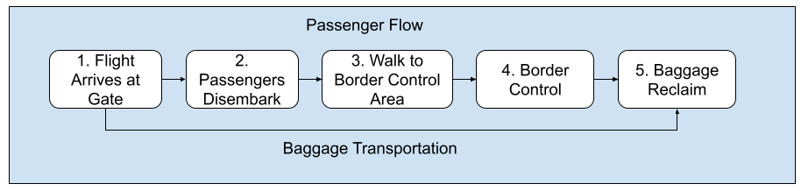
Figure 34. Simplified Example of Arrival Passenger Stages (UK Arrivals)

Research Aims
The overall aim of this research project is to tackle both issues to provide a more robust method of estimating the cost of automated border gate delays at airports. My key questions can be summarised as:
- How do passengers value their time in border control processes, compared to other stages of airport travel and other transportation methods in general?
- How do changes in gate operational capacity impact the total cost of lost passenger time, when factors such as appropriate VTT and overall impact on the air passenger journey are considered?

An answer to the first of these questions would allow us to consider the extent that border control scenarios for arriving passengers represent an undesirable activity compared to other forms of travel (and stages of air travel). This would help to resolve a gap in VTT literature for not only this specific case, but also provide additional information on how queuing/wait times in transportation systems should be valued. The specific values themselves will also allow a wide range of stakeholder decision-making to consider the valuation of passenger time more accurately in their analysis. An answer to the second would allow a more robust valuation of net passenger savings/costs that authorities would expect to see from changes to automated gate provision. Such analysis would also be useful when deciding overall performance level targets.

Case Study
The case study for this research will be UK residents arriving into UK airports. The methodology involves three key steps:
- Data for VTTs/preferences are obtained using an online stated preference survey of 1,367 UK residents. Respondents were asked for their experience of air travel, as well as general attitudes towards air travel delays. They were given a series of choice modelling experiments concerning wait times and compensation payments for border control, baggage reclaim and another arrival stage used for validation. VTTs for these three travel stages are then obtained using methodology suggested in the literature.
- Using the findings from this survey, along with other publicly available data, I propose a robust way of calculating the total cost of lost passenger time in border delays. This calculation effectively answers the following questions:
- What values should be used for both leisure and business travellers when calculating the cost of lost time in different passenger arrival stages?
- What ratio of leisure/business travellers would we expect to see in these stages?
- What proportion of passengers would have to wait in baggage reclaim after passing through border control?
- What ‘discount’ would need to be applied to the value of time saved at border control for passengers who now have longer waits in baggage reclaim?

- Finally, results from simulation modelling of UK airport border control scenarios are used to provide an example of the expected ratios between time savings and operational costs. This is achieved through collaboration with the UK Home Office/Border Force to provide real world data and transaction rates for two UK airport terminals. Results demonstrate the net value that would be achieved from making additional eGates available to passengers, as well as how each operational level links back to UK Border Force’s SLA targets.

Ethical Approval
Full ethical approval for the project was received from the University of Sheffield’s Research Ethics Committee (Appendix A). This was provided after demonstrating that I had considered the ethical implications of my Stated Preference survey, including appropriate compensation for respondents’ time, whether the subject was likely to cause harm and whether the results could be used in way detrimental to respondents. Overall, it was agreed that the project had a low likelihood of raising ethical concerns. Additional ethical issues are discussed in Section 6.3.

Paper Layout
The following section will review literature concerning valuations of travel time, related theories, and how these would be expected to apply to my border control scenario. The next section will provide a detailed explanation of my stated preference survey methodology and how this is used to calculate valuations of time. I also set out the simulation model used in the study. I will then show a breakdown of relevant results from my survey, including VTTs, as well as their application to my simulation scenario results. These are discussed further in the final sections, linking back to my research questions and the literature.

Literature Review
This section will explore the arguments in the relevant literature exploring border delays and specifically the value of passenger wait-times. I start by briefly reviewing ideas into how public projects should be evaluated and consider the strengths and weaknesses of existing border delay studies. I then focus on Valuation of Travel Time (VTT) as a general concept, before analysing arguments for how air travel and border control scenarios may impact VTT rates. I will establish the gaps in this literature relevant to my key questions and explain how my research will aim to challenge and expand upon this existing knowledge.

Public Policy Evaluation
Boadway et al. (2006) summarises cost-benefit analysis as the process of ranking policy options from an economic point of view, taking account of both the benefits of the policy and its costs. The literature suggests multiple theoretical approaches and concepts related to such analysis (Feldman and Serrano, 2005). These explore how policy decisions can be evaluated to determine the overall level of economic welfare generated; and how this compares to the status-quo or other choices. The aim is to establish an outcome that leads to the highest, or ‘optimal’ level of welfare. However, such decisions are likely to result in winners and losers. From an ethical or even practical viewpoint it will often be necessary to redistribute gains between the groups. If such an exchange leads everyone in an improved position, i.e., the ‘winners’ can pay the losers enough to fully compensate them and still have additional resources left over, then the change is said to have achieved the Kaldor Criterion (Just et al., 2008).

With regards to border control scenarios, winners and losers can be widely defined and multiple methods are suggested for transferring gains. Roberts et al. (2014a) uses empirical evidence from a study at a US border crossing in 2012 to develop a theoretical model to simulate the effect of changing staffing levels at all US border points. This enables them to evaluate the economic benefit from a theoretical increase in border processing capacity. Their study includes the value of time of those waiting in inspection queues as beneficiaries, however, also consider other sectors such as tourism and freight cost. They conclude that an increase in staffing at all points by one would increase US GDP by approximately $65m, or $640,000 per additional staff member. They don’t provide a cost for that additional staffing, though, the extent of the savings strongly suggests a net positive to the nation. However, the methodology also highlights issues with such a wide ranging approach. For one, the research relies on the use of simple regression techniques to estimate relationships between staffing and wait times, something the authors acknowledge as a limitation due to the unlikeness of a linear relationship. In addition, they have to make a number of simplifying assumptions when considering wider economic consequences.

Aussilloux and Le Hir (2016) face similar issues when reviewing proposed changes to Schengen agreements in Europe in the light of significant increases in migration resulting from international crises. The authors claim that prior restrictions to Schengen travel arrangements, as part of visa control, had already reduced tourism into the area by 21%, and that new delays would further deter the 24% of non-European visitors who stay in EU countries for only 1-2 nights. Focusing on France specifically, they calculate the cost of lost tourism revenue from a 5% decrease in same-day visitors and 2.5% decrease in overnight visitors at €498m. In addition, they suggest a €253.2m a year cost in lost time to French residents commuting to other EU countries. However, the authors struggle to provide clear details on how these figures were reached, especially with regards to commuting times.

Whilst I do not suggest that these holistic approaches lack a value when evaluating border control changes, I highlight that stakeholders may view these generalised figures as less robust than those focused on directly measurable outcomes from policy changes. Specifically, the time spent by air passengers in border queues is something that can be projected with higher degrees of certainty. Roberts et al. (2014b) attempt this themselves in a separate report that considers the cost of wait times as US airport customs controls. Results from the study show a 52% increase in total wait times for foreign-residents between 2010 and 2013 and a monetary cost of this lost time for 2012 to be as high as $1.3bn. The authors acknowledge limitations of their wait time calculations and recommend that a more extensive analysis of processing and wait times would add value to their research. They specifically highlight baggage reclaim as a mitigating factor when calculating the value of time saved; though do not provide any detail for how this discount is performed.

Value of Travel Time Theory
General concepts of Valuation of Travel Time have already been discussed in Chapter 2 and some specific air travel related rates were suggested in Chapter 5. This section intends to provide a more detailed discussion of the theoretical and practical issues involved. As Boadway et al.’s (2006) discussion of cost-benefit analysis highlights, a common issue occurs when there are no real world economic markets in which valuations can be estimated. The authors suggest one approach of using the average wage-rate of the individuals in the relevant system to estimate the value of lost time. However, Jara-Diaz’s (2007) review of VTT theory explains that these methods are considered to be too simplistic for most cases and are only really relevant when applied to situations where work and travel time are interchangeable. For this research, we would need to consider how the nature of air travel, and border control specifically, would be expected to impact the general utility of passengers and their VTTs.

Batley et al.’s (2019) provides a wide exploration of how VTTs have been calculated by the UK Department of Transportation for use in project evaluations. These were developed using willingness-to-pay (WTP) methods for a range of transportation types for both business and non-business (leisure) travellers. The authors suggest that employers will typically value the time of their employees more than they would value their own time. Hence, valuations for business travel will be higher than non-business. They state that the income of the individual is important to valuation but choose not to include variations in VTT by income. They do, though, highlight variations by method and length of travel. This latter element is briefly discussed by Jara-Diaz (2007), that longer journeys will result in less leisure time in a specific period, and hence individuals will value additional leisure time more highly. This appears to be confirmed by Batley et al.'s study, with longer journeys having a higher VTT. The research concludes that the average business VTT should be set at between £25 to £28 (2014 prices) for business travel and between £5-7 for non-business. Air travel is not included in this analysis.

Batley et al. (2019) suggest further reasons for why VTTs will vary within the same method of transportation. For example, they suggest that the overall baseline VTT for a travel activity would need to be approximately doubled when people are required to stand in crowded areas. These types of multipliers are also suggested in other studies, for example Abrantes & Wardman (2011), Roberts et al.(2014a) and Román et al. (2014). See Table 34 below for details.

Table 34. Selected Valuation of Travel Time Multipliers Against Baseline Values
Study | Target Population | Type of Activity | Multiplier
Abrantes & Wardman (2011) | UK | Walking  Waiting  Being Searched  Travelling in congested area | 1.65  1.70  1.38  1.54
Roberts et al.(2014a) | USA | Waiting in queue (in car) | 1.47
Román et al. (2014) | Spain | Waiting on a train (compared to travelling) | 2.47 - 3.78
Batley et al.(2019) | UK | Standing on a busy train | Leisure - 2.17  Business - 2.03

The undesirability of air travel and border control
Research into the nature of air travel suggests reasons why passengers would be willing to pay more to avoid time spent in these than other travel scenarios. Kellerman’s (2008) account of the relationship between air passengers and ‘authority’ highlights how individuals are constantly watched and assessed for security threats at multiple stages of their journey, and that this involves a system of human flows, characterised by strict timings. Whilst travellers in a city are likely to have some flexibility in arrival times to each stage, missed deadlines for an air traveller can mean significant delays and additional costs to their journey. From the perspective of border control, we can consider how delays in queues can result in either missed flight connections or missing onward travel connections such as airport trains/buses. Whilst this is arguably an issue of reliability rather than total time (see Batley et al., 2019), the longer average queues are the more they are likely to vary. Hence, we would expect passengers to value reducing time in border queues more than they would in less time dependent travel activities.

Kellerman’s (2008) description of airports as ‘cold’ spaces in which individuals find themselves both alone and in the middle of people flows also raises the issue of how undesirable waiting in border queues are compared to other travel activities. Whilst there is some scope for passengers to check mobile phones or listen to music whilst in border queues, it will also typically be an environment where individuals have limited privacy from either other passengers or the surveillance systems surrounding them.

Jiang and Zhang (2016) assessment of passenger experience at Melbourne Airport seems to confirm that border control is viewed more negatively than other aspects of the air travel journey. The study surveyed 715 passengers at the airport in 2014 to judge their satisfaction with 30 different elements of air travel: asking for both their prior expectation of service and actual experience. The findings showed that ‘immigration’ control was ranked 24th lowest for actual satisfaction and was 2nd last in terms of the gap between expectation and reality. The authors do not explore specifically why immigration/border controls are rated relatively low, though they do raise internet connections as being important to how undesirable an individual may find certain elements of a passenger journey. Wattanacharoensil et al. (2016) suggests that whilst airports work closely with third parties, such as border authorities, to improve passenger experiences, that there are fewer commercial incentives for government authorities to focus on these over the security and general queue time concerns discussed earlier.

Air travel/Border Control VTT
There have been limited empirical studies that aim to directly judge the value of time for passengers at airport border control. Selected valuations for general air travel studies are summarised in Table 35. Hess & Adler (2011) provides an overview of four studies into US air travel that use Stated Preference surveys to determine willingness to pay. They add additional corroboration of the higher VTTs for business travels (valued at $88 per hour compared to $31 for leisure). Air travel is included in a meta-analysis of VTT databases from multiple European studies by Abrantes & Wardman (2011). The authors argue that this form of study provides greater confidence in the range of values that should be used in specific situations, as well as being useful when attempting to challenge established conventions. Only 11 of the studies directly consider air travel, however they do state that air passengers have VTTs 81% higher than other forms of transport. I note that these figures, as well as other studies into air and rail travel, are higher than the general travel valuations suggested by the DfT.

Table 35. Selected Valuations of Travel Times (Converted to 2021 UK Prices)
Source | Sampled Population/Size | Type of Travel | Leisure | Business
UK Department for Transport recommendations | UK  Unknown size | ALL | £5.97 | £55.46
Batley et al. (2019) | UK  Leisure n = 3,337  Business n = 2,231 | All  Car  Rail | £5.86 | £20.87  £18.86  £31.61
US Department of Transport valuations | USA  Unknown size | Air & High-Speed Rail | £28.61 | £52.31
Hess & Adler (2011) | USA  Leisure n = 16,095  Business n = 4,792 | Air (Flight Time) | £24.63 | £62.65
Abrantes & Wardman (2011) | UK  Meta analysis of 226 separate studies | Rail | £5.50 - £16.49  (depending on distance)
Román et al. (2014) | Spain  n = 1,274 | High-Speed Rail | Leisure  £7.19 - £11.36 (when travelling)  £21.69 - £30.42 (when waiting)

As discussed in Chapter 5, Landau et al. (2016) explores air travel in more detail by measuring the value of each component of the air passenger journey. The authors highlight the US Federal Aviation Administration’s guidance that air travel should be valued at $60 for business travel and $43 for leisure (2016 prices). However, they argue that variations in the desirability of individual air travel components will also lead to variations in their VTTs, based on many of the factors already discussed (environment, physical exertion, ability to perform alternative activities, stress, unreliability). A series of preference surveys are used to ascertain these individual valuations (see Chapter 5, Table 21).

Unfortunately, border control is not included in this analysis. The authors suggest that VTT values would be similar to the time spent in check-in and security. However, I have already raised objections to this viewpoint in Section 6.1.2. Nevertheless, results do indicate that both business and leisure travellers value this component of the journey higher than others, though interestingly not by a particularly large amount. The most notable difference is with ‘Gate time’, which is valued at only 55% of the value of check-in/security time for business travellers and 62% for leisure. The authors explain this difference using the typical arguments of the literature that the former queues have unpredictable lengths, have minimal opportunity for alternative tasks, and are much less physically comfortable than sitting in situations such as gate wait time.

I note that these values are lower than valuations for flight time itself ($51), which is rather confusing as one might consider this to be a more desirable activity than waiting in security queues. It is possible that this is impacted by psychological anxiety caused by fear of flying and the potential for in-flight mechanical or weather issues (Wattanacharoensil et al., 2016) but this is speculation. The study also breaks down these valuations by the household income, confirming our earlier assumption that those with higher incomes will have higher VTTs. Here I see a significantly larger difference between flight and non-flight time valuations for those with the highest incomes (~ $60) compared to those with the lowest (~$5). Landau also raises an important question of how the value of children’s time should be considered, something not really discussed in earlier studies, though fails to provide an answer.

Use of Income in VTTs
Income is a major determinant of an individual’s VTT. Hence, it might seem logical to consider differences in average incomes when valuing time among different groups. Whilst UK residents make up the majority of eGate users, other nationalities are eligible to use these systems. Hence, it is necessary to consider whether varying national incomes should impact the VTT I recommend for use. Shires and de Jong (2009) discuss the issue as part of another meta-analysis of international VTT studies. Their results show a significant relationship between valuations and a country’s GDP per capita. They also find that countries outside Europe have a lower VTT even when controlled for GDP. The authors argue that whilst these relationships exist, there is no theoretical justification for assuming proportionality between the VTTs and the wage rate of a country. This would suggest that GDP/ income adjustments made in studies such as Roberts et al. (2014a) are inappropriate.

Rizzi and Steimetz (2014) explore more directly the desirability of using income equity vs preferences equity for calculations of VTT in transportation appraisals. They highlight that many national project appraisers use standard rates of VTT that do not consider either income or preferences. They state that this is not only an issue of equity, but one of pragmatism due to the difficulty of mapping heterogeneity of incomes to target populations. This would certainly be the case for arrivals into UK airports. Gossling and Humpe’s (2020) exploration of global aviation trends suggests that ascertaining average incomes for different nationality groups would be a challenge. Their study suggests that whilst 100% of people in high-income countries can afford to travel by air in any given year, that these figures fall to 35% for upper-middle income, 7.5% for lower-middle and just 1.6% for low income countries. Given these variations, it’s highly unlikely that differences in average incomes of air travellers will vary by the same proportion as GDP per capita values for their origin countries.

Summary
Whilst existing research into the impact of border delays is limited, especially in the field of air travel, we can clearly see that the value of passenger time makes up a core component. In fact, there is a risk that if this issue is not focused on sufficiently that the validity of such calculations can come into question. This is especially true when researchers do not consider the specific ways in which air travel and border control impact the willingness of individuals to pay to avoid delays. In addition, there are no existing research projects that fully consider how border control delays impact other aspects of the arrival process or offer advice on how this should be included when costing delays. I will set out in the following section how the methods and data for this research aims to resolve some of these gaps.

Methodology

Introduction
This section provides an overview of the multi-step methodology used for this study. I focus on the choice and implementation of my stated preference survey of UK residents. The primary purpose of this survey is to establish VTT valuations for three separate arrival stages, as well as other attitudinal and behavioural data necessary for my research. I then provide details on the methodology for calculating VTT values and how these are used (along with other data) to determine the total value of lost passenger time at border controls. Lastly, I combine these calculations along with simulation results of UK border control scenarios to provide illustrative examples of how the costs of border delays increase or decrease as operational capacity changes.

Stated Preference Survey
The two main approaches to gathering data for VTT studies are revealed preference (RP) methods and stated preference (SP) surveys (Bateman et al., 2002). RP studies use data on the actual choices made by individuals in real world markets and are typically considered to be the optimal way of estimating willingness to pay (WTP) (Merkert & Beck, 2017). However, there will often be situations where the market being investigated either does not exist, or there is insufficient information available to establish robust RP estimates of VTTs. This is the case with my UK border control case study; air passengers are not offered the option to pay to avoid border control queues or accept compensation in exchange for longer wait times, hence no ‘real world’ data exists. Instead, I establish VTT valuations by using SP survey methodology where individuals are presented with hypothetical scenarios. Specifically, I created a series of choice experiments in which passengers were asked to pick between options that involved varying levels of wait time and compensation.

I considered potential issues with the use of stated preference methods suggested in the literature (Bateman et al., 2002). These include:

- Cognitive Difficulties: Participants may find it challenging to properly ‘imagine’ the scenario being presented and correctly predict their response in a real-world situation.
- Trust: Respondents may not trust the scenario being presented to them. They may either believe that they wouldn’t actually pay/receive the amount suggested, or that their monetary contribution would not impact the service they receive.
- Protest / Ideological: Respondents may provide answers to a hypothetical scenario based on non-monetary motivations.

Applying the above to border control: I can consider that as air travel is relatively infrequent for many individuals (Kim, 2016), that many may struggle to accurately ‘place themselves’ in such scenarios and accurately state their true willingness to pay. This is a particular issue given that UK residents have never paid to avoid border control queues and may respond in a hostile manner to even a hypothetical suggestion that they should do so.

I mitigate this issue by describing multiple details of each scenario, including visual stimuli. In addition, I decided to use choice modelling methodology (which asks the respondent to select between set options) rather than contingent valuation (which asks the individual to specify a value themselves). Whilst only focusing on two variables (delay and compensation) would typically make contingent valuation an appropriate choice, Bateman et al. (2002) argues that choice modelling is preferable in cases where individuals are not used to paying/accepting compensation for a service.

These problems are also a factor in my decision to adopt a Willing to Accept (WTA) methodology. UK air passengers are accustomed to the concept that they would receive compensation in the circumstances that their flights are delayed (Drake, 2020). Hence, I argue that offering compensation in exchange for a longer border wait would be a more intuitive choice than one in which they are asked to pay to avoid them. WTA approaches do, however, have some drawbacks; primarily that the psychological preference towards loss avoidance means that individuals will typically state a higher WTA than they would WTP for the same change in commodity/service (Johnston et al., 2017). However, I can consider this in my analysis and use validation against existing studies

With regards to the issue of trust, I highlight to participants the exact method of receiving compensation and state that queuing times presented are guaranteed. I also use validation questions to check respondents' understanding, trust and cases of ‘protest/ideology’ response (Bateman et al., 2002). For the latter, I will focus on whether individuals are protesting either the existence of queues at border control, or the concept of receiving compensation for their acceptance.

Survey Design
The full survey design can be found in Appendix B. Individual sections included:

Air Travel Experience: Questions used to ascertain an individual’s experience of air travel to compare against attitudinal/choice responses. This also includes a question of hold luggage to estimate the frequency that a passenger will need to use Baggage Reclaim.

Air Travel Delay Attitudinal: Used to inspect the attitude of the individual to delays in different aspects of the air travel journey. These are used to validate and explore variations in individual VTT.

Choice Experiments: Respondents are asked to choose between an option with no delay and one with a specific delay and compensation amount. An example is shown in Figure 35 below. These are used to calculate VTTs for Border Control, Baggage Reclaim and a Train journey home.

Whilst the passenger valuation of time of train journey away from the airport is not directly relevant to my research aim, I include this element as a validation for my experimental design. As Bateman et al. (2002) highlights, one of the key issues of SP survey methodology is the difficulty of obtaining ‘real’ results to validate findings where there are no actual markets. This issue is compounded by the general acceptance that survey design choices impact the VTTs obtained from them (Ojeda-Cabral et al., 2018). Including train journeys allows us to validate these results against the RP evidence that exists on train travel VTT. This will provide some indication of the general accuracy of my survey design.

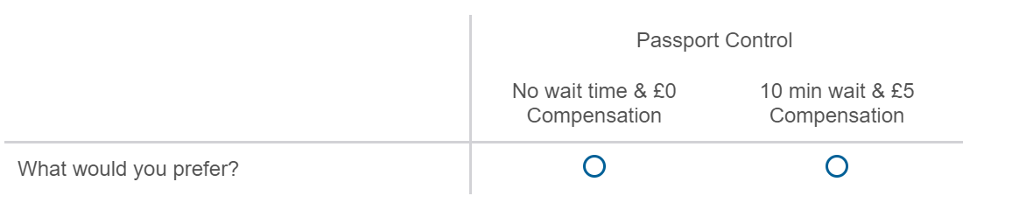
Figure 35. Example of Survey Choice Option

Validation Questions: These are used to determine whether passengers trust the scenarios being presented to them and are answering based on monetary motivations rather than ideological/protest ones.

Conducting the Survey
The target population for this research was all adults residing in the UK. Whilst non-domestic individuals use eGates, I restricted my research UK residents to mirror existing studies that seek to establish VTT that are relevant to UK national projects (Batley et al., 2019). Further to this, I limit my research to only leisure travellers as VTT studies into business travel involve separate methodology since they typically do not pay for their own travel (Markert & Beck, 2017). In addition, as highlighted in Section 6.2.4, existing DfT valuations of business travel conform much closer to valuations suggested in the wider literature than their leisure valuations.

The survey was built using the Qualtrics tool and was piloted with the assistance of approximately 60 Home Office employees. The survey was amended following feedback from this group and launched via the Prolific website. This tool is specifically designed to provide respondents for academic online research and has over 50,000 UK residents signed up to complete surveys for small sums of money. Prolific is able to achieve a representative sample based on the UK census breakdown of age, gender and ethnicity and 1,357 respondents were gathered on this basis. Prolific was chosen for primarily practical reasons as I had a short-time window in which to complete this phase of the research and the tool provided fast access to a wide range of respondents. Whilst some concerns have been raised with the potential for population bias with paid-for-completion tools (Mason & Suri, 2012), previous studies suggest that Prolific can provide results which accurately reflect target populations (Palan & Schitter, 2018). With regards to potential ethical issues, Prolific specifically states that it monitors and handles many of these concerns (Palan & Schitter, 2018), and my respondents were paid an average amount above the UK national living wage for completing the survey.

Calculation of VTT
The standard methodology for VVT calculation when using choice modelling is the generation of a random utility model appropriate to the preference distribution of the respondent set. Extensive explanation of the theory of this methodology and justifications of different approaches can be found in a range of previous literature (see Fowkes & Wardman, 1988; Hensher, 2001; Johnston et al., 2017 for examples). I provide a brief explanation of the relevant elements below (adapted from Bateman et al., 2002).

Choice experiments assume that the utility that an individual would derive from an option will depend on the attributes provided and the cost. An indirect utility function can be assigned to an individual that will approximate their preferences with regards to this choice. This will never be fully accurate though, hence a random element needs to be added to account for variations. This entails the creation of a random utility model that can predict individual preferences based on set variables.

The choice of random utility model is dependent on the functional form of the model and the probability distribution of random elements. By far the most common options selected for this in VTT calculations are a linear model that combines costs and attributes and a Gumbel distribution, resulting in modelling of probability similar to the logistic distribution. Whilst various logit models can be chosen, depending on the population and preferences displayed, the most used for VTT analysis are the multinomial and mixed logit models. These models approximate the preference choices of survey respondents by estimating the likelihood that they will choose a particular option given the various attributes and cost.

When such models are used, the marginal willingness to pay for any change in an attribute can simply be calculated by comparing the cost and attribute coefficients. Hence, VTTs can be calculated as:
VTT = - $\frac{Bt}{β}$ (5)

where β is the coefficient on cost and, Bt is the coefficient of the Time attribute. In WTA examples, ‘compensation’ can simply be treated as a negative cost.

I have chosen to use the simplest Multinomial Logit Model (MNL) for the random utility model for my three arrival scenarios. For each of the border, baggage reclaim and train journey elements, I will generate a MNL model using the delay time and compensation attributes of choice experiment, as well as demographic and various experience/attitudinal results from my survey. This follows standard methodological design of similar VTT studies into air travel (Landau et al., 2016). Though, I acknowledge concerns raised by Johnston et al. (2017), that a lack of endogeneity between choice decisions supporting question results can cause issues when using the results from the later in modelling. I follow their advice to place these questions before the choice experiment.

Valuing Lost Passenger Time
The simplest method for calculating the total value of passenger time (Vt) in any travel scenario can be presented as (6):
Vt = Tt* VTT (6)
Where:
Tt = Total time lost by passengers
VTT = Applicable valuation of travel time rate

As discussed in Section 6.2.4, it is often necessary to differentiate between leisure and business travellers as different VTT rates will apply to each. Hence,
Vt = Tt*Pl*VTT_l + Tt*Pb*VTT_b (7)
Where:
Pl = Share of passengers that are leisure travellers
VTT_l = VTT rate for leisure travellers
Pb = Share of passengers that are business travellers
VTT_b = VTT rate for business travellers

As explained in Section 6.1.2, to accurately assess the overall costs of border control delay we have to also take in account their impact on baggage reclaim waiting times. To achieve this, I start with the following assumptions:
- Passengers value time in border control and baggage reclaim equally (though, this will be challenged by my survey results).
- If a passenger doesn’t have checked-in baggage then the full value of their lost time needs to be considered.
- If a passenger does have checked-in baggage, then their value of time lost at the border needs to be discounted by the time they would have otherwise spent in baggage reclaim.

Hence, the total time that for valuing (Tv) can be represented as:
Tv = Tt*Pnbg + Tt_bg*Pbg (8)
Where:
Pnbg = Share of passengers that have no checked in baggage
Pbg = Share of passengers that have checked in baggage
Tt_ bg = Total time at border, discounted by the time otherwise spent in baggage reclaim

The final calculation can hence be represented as:

Vt = Tv*Pl*VTT_l +Tv*Pb*VTT_b (9)

Simulation Design
Case studies for border time savings are generated using Discrete-Event Simulation and data provided by the Home Office for two UK airport terminals. The model selected for this process was a slightly amended version of the model used for my study in Chapter 4. The only changes made were:
- The processing time was altered to match the average processing rates for eGate established from prior Home Office research (unpublished).
- Rather than using variable arrival times for flights, only the actual, historic arrival times were used (changing the model from stochastic to fully deterministic).
The justification for this model choice is the same as the arguments made for its use in Chapter 4.3. Some basic Excel verification was undertaken to ensure the model was simulating the terminal as expected.

I use two different cases studies for my simulations:

- A large UK airport terminal (Terminal A) for an unspecified period in summer 2019 (~90,000 passengers)
- A medium sized terminal (Terminal B) for an unspecified period in autumn 2019 (~35,000 passengers).

This is done to allow a comparison in results between a ‘busy’ terminal and ‘quiet’ terminal. I note that calculations are done for ALL passengers eligible to use eGates during those periods, not just UK nationals. For each of the above, the simulation is run multiple times, using a different number of open eGates to establish the expected wait times in each case.

Model Limitations
The above represent a simplification of the UK eGate border control scenario as, in practice, some passengers eligible to use automated systems may be directed towards staffed desks instead. The researcher is aware that this tactic is used when eGates are at capacity and Border Force has resources available to open additional desks. This additional complexity has not been included. However, from a wait time perspective, opening additional desks is not fundamentally different to
opening additional eGates.

Cost Benefit Analysis
The final part of analysis involves applying the cost of lost time methodology to the results of my simulation scenarios to present a cost-benefit analysis of varying levels of eGate operational capacity. This analysis will take the form of a performance matrix which will show the estimated value of the time that passengers would spend in border control processes as well as illustrative examples of the operational costs incurred.

Illustrative example in this case means that the figures provided are intended as a general indication of the scale of operational costs in a generic terminal setup compared to the value of passenger time. The reasons for this generalisation are due to both the challenges in accurately costing specific eGate operational decisions (see Appendix C for more details) and confidentiality requirements of the Home Office/Border Force. Combined with the fact that I do not provide the timeframe for my case studies, I wish to reiterate that these figures do not provide a meaningful understanding of operational costs of UK eGates outside of this specific research project.

I will also include a ‘baggage reclaim discounted’ value for total lost time to factor in the issue discussed above. This is calculated by assuming that if a passenger faced no wait at border control, they would have to wait 15 minutes in baggage reclaim. Hence the first 15 minutes of border delay for a passenger with check-in luggage will not be counted towards any cost valuation of lost time. I highlight that this specific discount is based only on discussions with Home Office stakeholders as the baggage transportation process is controlled by the airlines and airports and no public data is made available.

Results

Stated Preference Survey
An original, smaller version of the survey was conducted in June 2022. Following analysis and concerns over sample size and representation, a larger survey was run in March 2023. The survey received a total of 1,364 respondents, seven of which were removed after failing basic data quality checks. The sample size provides us with a 95% confidence that the below result match our population with a $±$3% margin of error

Flight Experience

A full breakdown for our air travel experience results can be found in Appendix D. Some findings of note include:
- 59% of respondents had flown for leisure in the past 12 months.
- 8% had not flown in the previous 10 years.
- 64% flew at least once a year.
- 79% of people had a checked-in bag on their previous leisure flight.

Table 36 shows a fuller breakdown of results concerning the frequency that individuals travel with checked-in baggage.

Table 36. Share of respondents that had checked-in baggage on last leisure flight
Age | Male | Female
18-24 | 71% | 69%
25-34 | 71% | 79%
35-49 | 80% | 84%
50-65 | 79% | 81%
65+ | 84% | 78%
All (n = 1,336) | 77% | 80%
Excluding ‘Can’t Remember’

Attitudes Towards Air Travel Delays
Figure 36 presents the results of attitudinal questions for different stages of the air travel journey (referred to hence as ‘dissatisfaction score’). Note that the term ‘passport control’ is used instead of ‘border control’ as it was felt that this was easier for the respondents to understand.

The highest level of dissatisfaction was with waiting for baggage reclaim (3.79), slightly above passport control (3.77) and security checks (3.62). Though, the error bars suggest to us that this is a non-significant difference at the population level. Though, we do see significantly lower stated dislike with waiting at the airport gate and the arrival call, and between check-in queuing time and passport/baggage reclaim. I tested for relationships between overall mean dissatisfaction levels and respondent characteristics (full results shown in Appendix E). These indicated that age and annual salary have a small positive affect on dissatisfaction scoring.

Bars indicate $±$3% margin of error

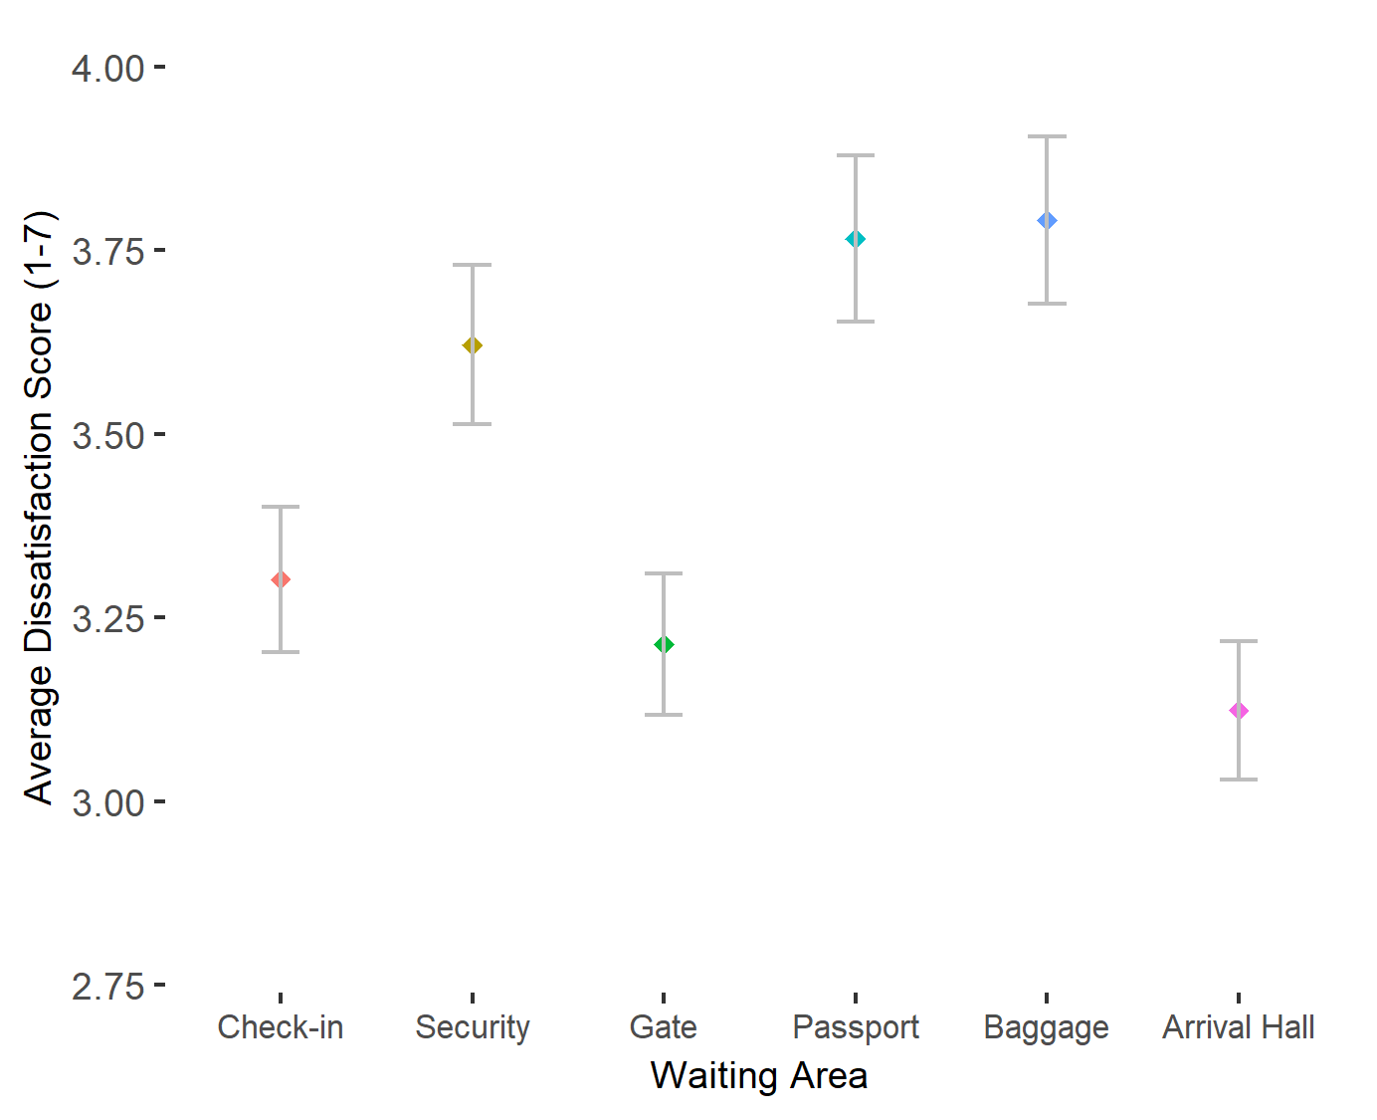
Figure 36. Dissatisfaction with Waiting in Air Travel Elements (1 lowest - 7 highest)
These attitudes were explored further by questioning respondents to whether they would prefer a fixed delay to their journey to occur in passport control compared to another stage (Figure 37)
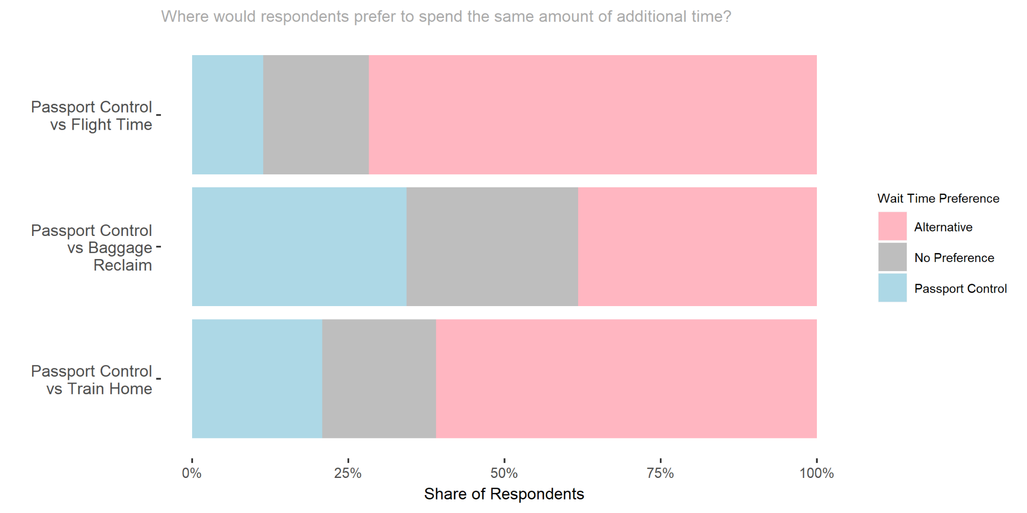
Figure 37. “Where would you rather spend additional waiting time?”

Valuations of Travel Time
Before starting VTT calculations, I made preliminary data validity checks (see Section 6.3.2). Five respondents indicated that they didn’t understand the scenarios. 52 stated that they didn’t trust the offer being made. As a cautionary step, all were removed from my sample before VTT analysis. Regarding motivations validation, 355 respondents (26%) selected at least one protest motivation as a reason for their choices. However, all but four of these also selected a non-protest reason (monetary or personal attitudes to waiting). These four were also removed, meaning that (given some overlap) 59 respondents were removed in total, leaving a sample size of 1,298.

Passport Control: Background Analysis
I first tested the relationship between the compensation amount (£ per hour) offered in each of the 12 choice experiments and the likelihood that the individual would accept them. The strong positive correlation (0.96) confirms that, overall, individuals were behaving according to theories of utility maximisation. Table 37 shows the overall acceptance rates for different groups. Males, people under 45, those on lower incomes and those with higher dissatisfaction scores with passport delays are all more likely to accept the offer of compensation in any given scenario. Additional analysis suggests a general negative correlation of age and income with acceptance rate (see Appendix E for this and previous analysis).

Table 37. Compensation Acceptance Rates for Passport Control Scenarios
Breakdown |  | Acceptance Rate
Gender | Female | 30.1%
Gender | Male | 35.1%
Age | 18-45 | 40.1%
Age | 45+ | 25.0%
Income  (per year) | <£30,000 | 33.7%
Income  (per year) | >=£30,000 | 30.8%
Passport Wait Time Dissatisfaction Score | 3 or lower | 33.9%
Passport Wait Time Dissatisfaction Score | 4 or higher | 31.6%
Overall |  | 32.6%

Logistic regression modelling and VTT calculations
Table 38 shows my Logistic regression models with ‘accepts compensation’ as the dependent binary variable. Comparison with the null model shows a large reduction in AIC, suggesting that Model 1 is explaining a meaningful amount of variation in respondents' decision to accept compensation. Additional validation was done to test the predictive ability of the model. When applied to a 20% subsection of my data, Model 1 had a 76% accuracy rate when predicting outcomes in the remaining 80%.

My model confirms that the likelihood of accepting compensation is negatively correlated with both annual income and the age of the respondent. As expected, those who express lower dissatisfaction levels with passport control wait times are also more likely to accept compensation. The gender split suggested above is also confirmed as statistically significant, men are more likely to accept compensation, even when accounting for other variables.

Table 38. Logit Regression models for Accepting Compensation
 | Null Model |  | Model 1
 | Coefficient | Standard Error | Coefficient | Standard Error
Intercept | -0.73*** | 0.025 | 1.17*** | 0.12
WaitTime_Mins |  |  | -0.10*** | 0.004
Compensation |  |  | 0.15*** | 0.005
GenderMale |  |  | 0.35*** | 0.058
Income (per £10,000) |  |  | -0.056*** | 0.001
Age |  |  | -0.036*** | 0.002
PassportOpinion_LowDissat |  |  | 0.13* | 0.059
AIC | 9257 |  | 7459
VTT_WaitTime_Mins |  |  | 39.76
**Significant at <0.01% level *Significant at <5% level

From the model, we can derive a probability density function that a median income/aged male would accept a 30 minute Passport queue wait time given the amount of compensation offered (Figure 38). At around £20 per 30 mins (so £40 per hour) there is an equal chance that the respondent would either reject or accept the offer. At £45 (£90 per hour) there is now a 97.5% chance that they would accept.

Dividing the Time and Compensation coefficients, I arrive at an overall WTA of £39.76 per hour for Passport queues. Further analysis was done on demographic subgroups (age/income/gender) and calculated figures showed the expected variations (higher for women, older groups, and higher income). However, the small sample sizes for this analysis meant that I could not confirm any statistically significant difference.

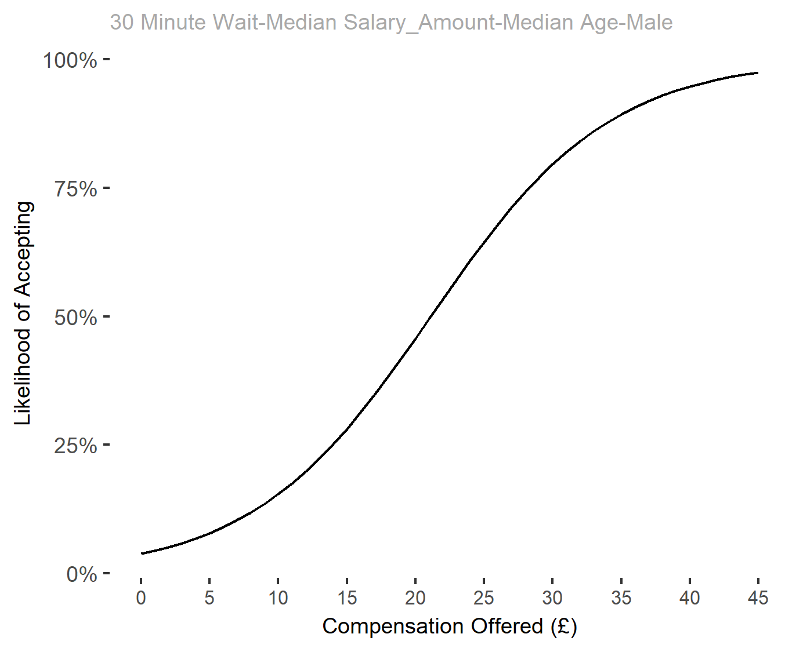
Figure 38. Probability Density Function for Compensation Acceptance (Passport)

VTT Comparison with Baggage and Train Travel
Similar methods were used to analyse respondent choice data for the baggage handling and train journey scenarios. The general inferences were the same as for Passport Control, and the same variables were statistically significant in my logistic regression models for both.

Figure 39 shows the comparison of VTT calculations for all three journey stages. Error bars indicate the range that we have a 95% confidence level that actual VTTs fall within. Correlating with both my dissatisfaction and queue preference analysis, we see that passengers value time waiting in baggage reclaim similar to passport control. We do (as we would expect from the literature) see a lower VTT for train travel.

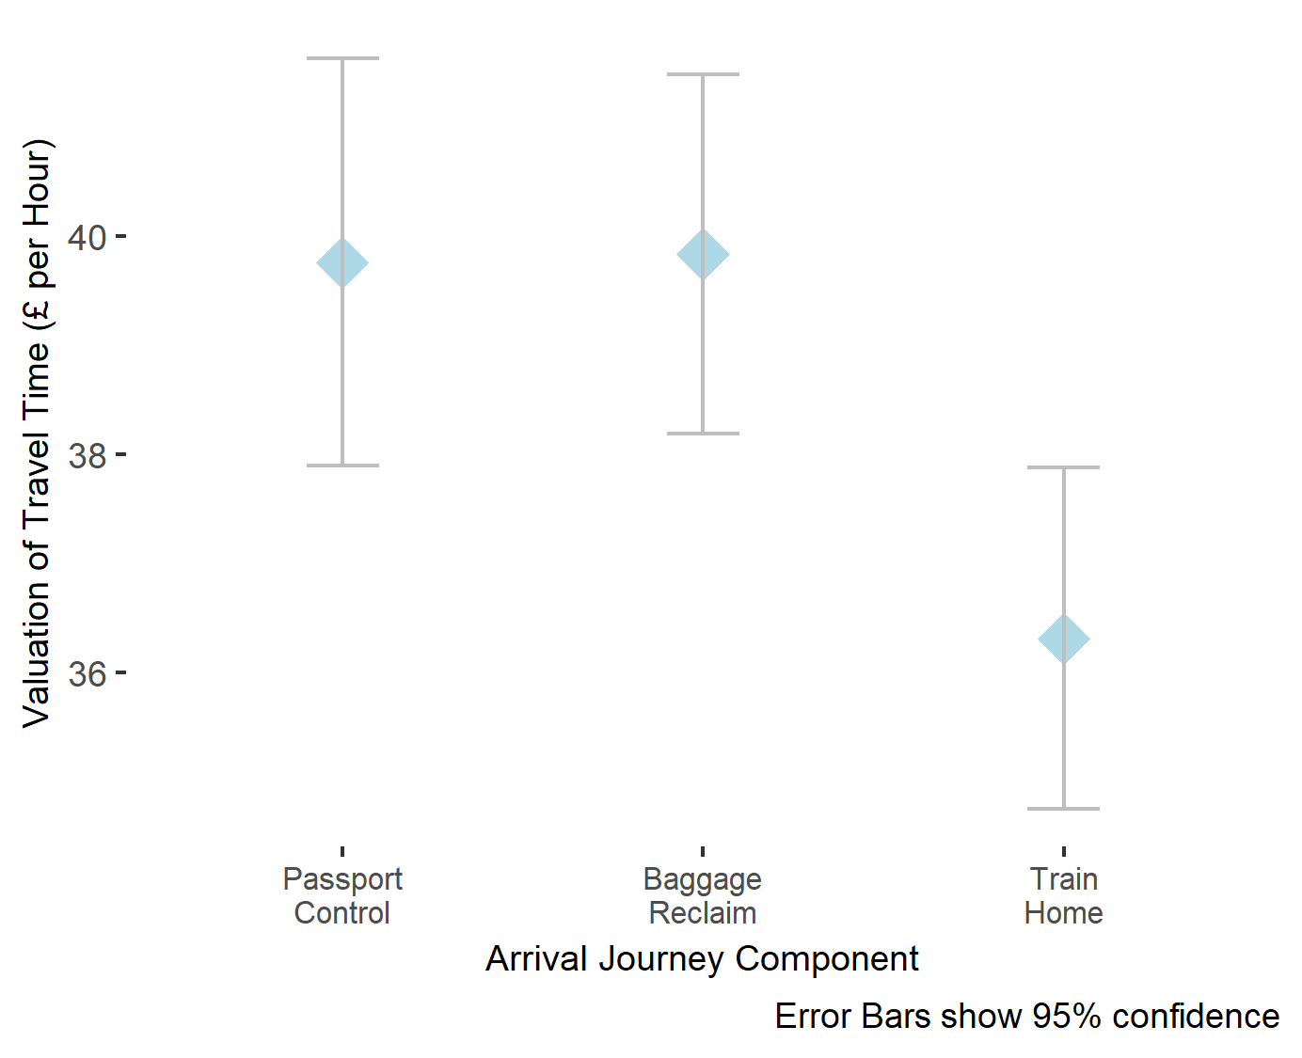
 | Passport Control | Baggage Reclaim | Train Home
VTT (£/hr) | £39.76 | £39.84 | £36.32
95% CI | [37.90, 41.63] | [38.20, 41.48] | [34.76, 37.88]
Figure 39. Comparison of VTT for Air Passenger Arrival Stages

Passenger Simulation
Figure 40 shows the results of simulations for the higher (A) and lower (B) passenger volume airport terminals. These use arrivals data for an undisclosed period in 2019 and a separate simulation is run for each total number of available eGates. Note that the linearity suggested in eGate provision is shown only for the comparative impact on wait times. The bank nature of eGates, authorities (such as Border Force) would be unlikely to make such granular decisions on how many gates to operate.

Correlating with previous studies into staffed desks (see Chapter 4), we see ‘L curve’ distributions for both terminals, with average wait times falling sharply up to an elbow point, after which the addition of extra operations eGates results in much smaller improvements. Tables 39-40 provides some more detailed findings for selected simulation results for the two terminals. For each operational eGates total I show the overall wait time, as well as totals above 15 minutes (to provide an indication of the impact of baggage reclaim wait times). The overall figures suggest that hundreds of hours of passenger time are being saved for each additional operational eGate, even once we have breached the ‘elbow points’ where average wait times diminish at a slower rate. Time savings are obviously lower when we start discounting expected baggage reclaim time, though even these wait times see reduction in the multiple hundreds of hours when operational capacity is initially increased.

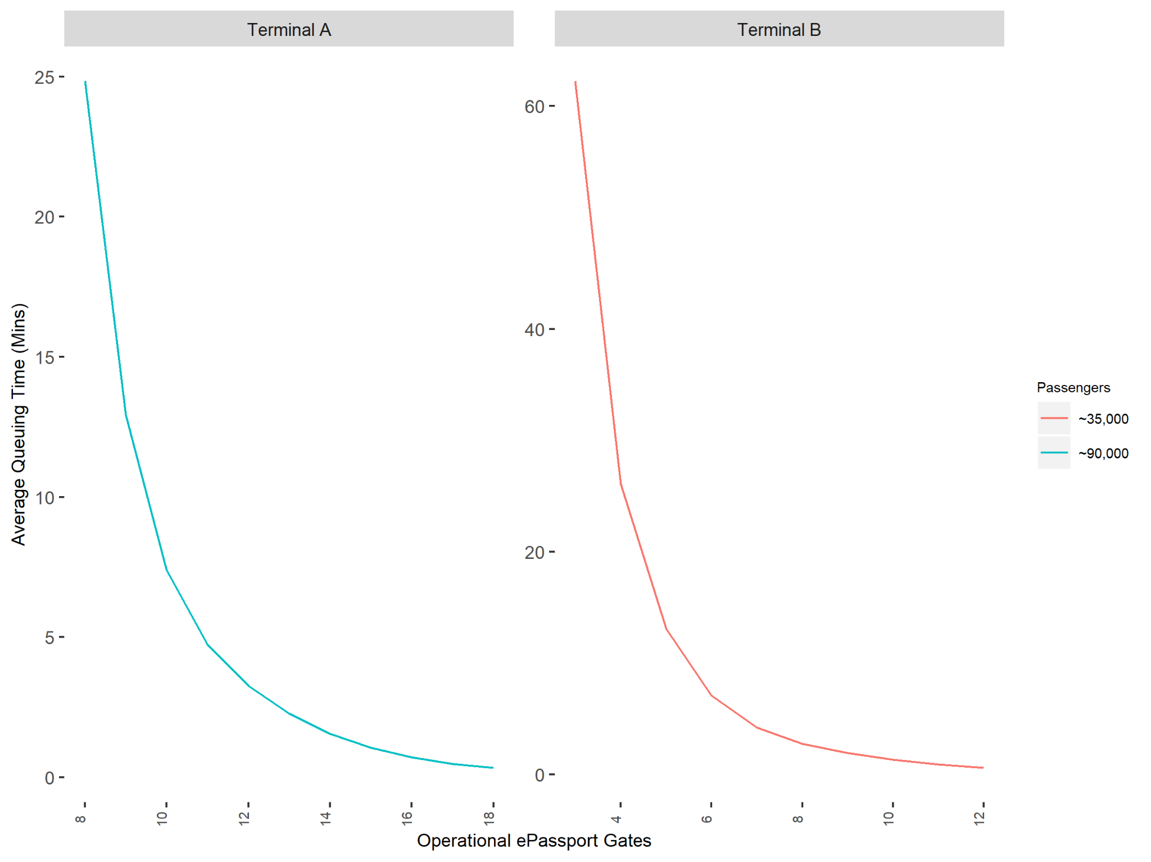
Figure 40. Impact on Border Control Wait Times from increasing Operational Capacity

Table 39. Selected Simulation Results for Terminal A
 | Total Wait Time (Hours)
Operational Gates | All | Over 15 Minutes
10 | 11,315 | 4,158
11 | 7,271 | 2,110
12 | 4,991 | 970
13 | 3,478 | 280
14 | 2,387 | 76

Table 40. Selected Simulation Results for Terminal B
 | Total Wait Time (Hours)
Operational Gates | All | Over 15 Minutes
6 | 4,309 | 1,457
7 | 2,561 | 544
8 | 1,690 | 238
9 | 1,173 | 100
10 | 817 | 20

Cost Savings
I can now provide an estimated value of total wait times using the calculations described in Section 6.3.3. I set the share of passengers with checked-in luggage at 79% (see Table 41) and the leisure/business split at 83%/17% (gov.uk, 2019). Calculations use the leisure VTT rate from my survey results, as well as others for comparison (see Table 33). For business VTT, I used the DfT suggested value of £55.46.

Table 41. Leisure VTTs use for Passenger Time in Borer Control
VTT | Description | Valuation (per Hour)
SP 2023 | Value derived from the conducted SP Survey | £39.76
Landau | Value suggested by Landau et al., 2016 | £23.80
DfT | General rate suggested by UK Department for Transport | £5.97

Figure 41 shows the value of passenger time that would be saved from each additional eGate being made operational in our Terminal A scenario. A separate value is shown for each of the leisure VTT rates shown in Table 41, indicating how the estimated value of saved passenger time would change depending on the methodology used. For example, we can see that opening a 14th eGate would achieve a saving of between approximately £5,000 and £16,000, depending on whether we accept the DfT valuation or use the new SP survey rate. An illustrative marginal cost of £1,500 per gate is also shown (see Section 6.3.5) to provide an indication of whether opening the additional gate would have a net positive or negative outcome.
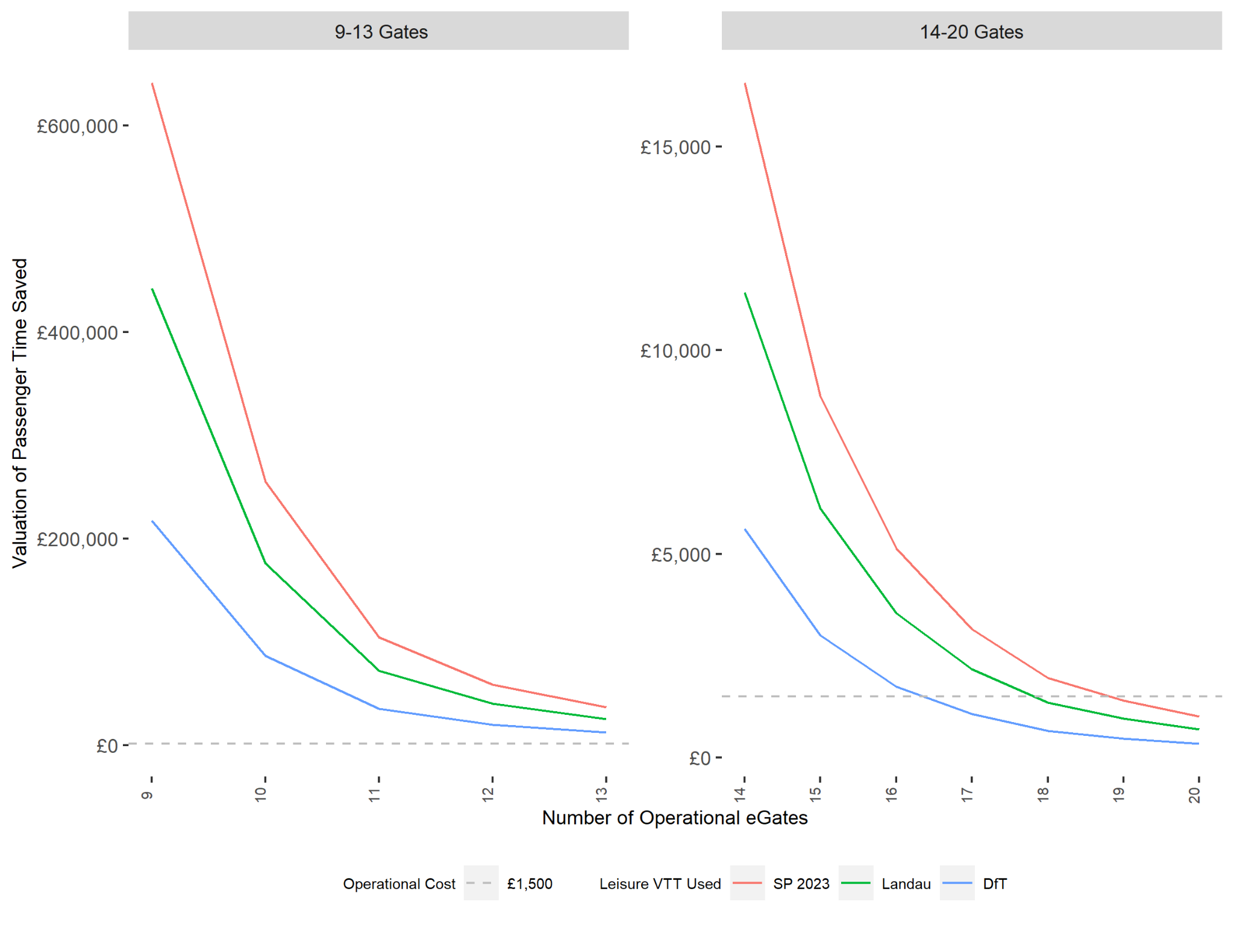
Figure 41. Marginal Cost and Benefit from the ‘nth’ operational eGate at Terminal A

Baggage Reclaim Discount
Table 42 illustrates the impact to valuations of lost time when we consider the impact of additional baggage reclaim time. Both sets of values are calculated using the SP 2023 VTT rate. We can see that including baggage reclaim results in a significant reduction in the benefits achieved from opening additional eGate. However, the impact is determined by the extent of average wait times, with longer waits having a lower percentage discount.

Table 42. Comparison of Costing Methodology (Terminal A)
eGates Operational | Average Wait | Total Value of Lost Time Using SP 2023 VTT (nearest £100)
eGates Operational | Average Wait | Excluding Baggage Reclaim Discount | Including Baggage Reclaim Discount | % Reduction
10 | 7.4 mins | £480,100 | £240,200 | 50%
12 | 3.3 mins | £211,800 | £77,000 | 64%
14 | 1.6 mins | £101,300 | £23,800 | 77%

Performance Targets
Table 43 provides an example of the changes in costs that would occur from changes in hypothetical performance targets. Here I use the historic Border Force Service Level Agreements that wait times should not exceed a set value in more than 5% of cases. I present the results using the VTT from my SP survey, as well as DfT VTT, and compare these to the illustrative costs. We see that for Terminal A, the expected value of time savings is always higher than the estimated cost regardless of the VTT used. The same is true for my quieter Terminal B when using my survey VTT. However, the benefits are less clear when using DfT.

Table 43. Cost Benefit Analysis of Different UK SLA Targets for Simulation Period
 |  |  | Valuation of Time Saved using specified VTT and Baggage Reclaim ‘discount’ (nearest £100) |  | Operational Costs
Terminal | 95th Percentile Target Change | Average Wait Time Change | SP 2023 | DfT | Total eGates change | Illustrative Additional Cost*
A | 25 min to 15 min | 3.3 min to 2.3 min | £36,600 | £12,400 | +1 | £1,500
A | 15 min to 10 min | 2.3 min to 1.1 min | £25,300 | £8,600 | +2 | £3,000
A | 10 min to 5 min | 1.6 min to 0.7 min | £5,100 | £1,700 | +1 | £1,500
B | 25 min to 15 min | 4.2 min to 2.8 min | £18,000 | £6,100 | +1 | £1,500
B | 15 min to 10 min | 2.8 min to 1.3 min | £15,000 | £5,100 | +2 | £3,000
B | 10 min to 5 min | 1.3 min to 0.6 min | £3,600 | £1,600 | +2 | £3,000

Discussion

Flight Experience
A potential issue for this project was the extent that the Covid19 pandemic had reduced exposure to both air travel and ‘status quo’ border control scenarios among the British public. A lack of recent experience may diminish the ability of respondents to accurately place themselves in air travel scenarios and correctly predict their attitudes and preferences to delays. My survey results showed that 59% of respondents had flown for leisure in the previous 12 months. However, 34% had not flown since 2019, indicating the gap created by the pandemic. Whilst the infrequent nature of air travel for most individuals (only 17% reported flying more than twice a year) always makes recent experience a general issue, running the survey at this specific point does raise some validity issues that may require future confirmation. Approximately 4 in 5 passengers indicated in the survey that they had travelled with a check-in baggage on their last leisure flight. This is comparable to results (85%) reported for US passengers in 2017 (Burgueño Salas, 2021), and provides us with a good estimate of the likelihood that UK arrivals will need to collect luggage in baggage reclaim.

Air Travel Opinions
The attitudinal data shows confirmation of expectations surrounding traveller preferences to different types of delays. The two areas where individuals show the lowest levels of dissatisfaction (flight gate and arrival hall) are also those where they have the most opportunity to sit down in a comfortable environment and perform other tasks. However, I also note that the highest dissatisfaction score is for baggage reclaim, an area where individuals have some similar opportunities. In fact, this score is not significantly different from the queuing activities (security and passport control) that the literature would suggest as being the least desirable forms of waiting.

This result is shown again in the ‘delay’ preference where there is an almost equal split between those that would rather spend time in border control queues compared to baggage reclaim. Though, the number that state a preference here is still significantly larger than those with no preference, suggesting a split within the population rather than a general apathy towards the choice. The other results for this section are closer to what we would expect from a comfort/alternative task view of delay preference, that having a longer flight or train ride journey is preferred to queuing at the border. Though, the former does seem to conflict with results from Landau et al. (2016) that suggest that individuals would be more willing to reduce flight time compared to other forms of delay. Overall, I can state that preferences appear to be more complex than a simple application of existing VTT theory.

Wait time preferences
This analysis is broadly confirmed in my VTT results. There is no clear difference between UK passenger valuation of time for border control compared to baggage reclaim. Though, we can confirm a higher VTT than train journeys home at the 95% confidence level. The conclusion of this is that if there is a direct transference of border wait times to baggage wait times then this should be considered to have had a zero net benefit. There is no value in saving time waiting to use eGates if a passenger then spends all that time in baggage reclaim. My MNL modelling also indicated a positive relationship between age and VTT, which is what we would expect given attitudinal results. However, interestingly, men were more likely to accept offers of compensation for the same wait time (hence, having a lower VTT on average than women). This contrasts with my attitudinal data results that show men clearly expressing strong dissatisfaction with both passport and baggage reclaim delays. I offer this analysis without comment and suggest it as an area for future research.

Beyond this though, my main finding is that respondents valued time in these processes significantly higher than not only general leisure values suggested by the DfT, but also applicable VTT values found in the general transport literature. To be frank this is somewhat of a concern with regards to the validity of my findings. My value for border control (£39.76) is considerably higher than the value Landau et al. (2016) found for security screening in US airports (£23.80). However, I can make the following clarifications:
- As discussed previously, there is considerable debate whether security screening for departing passengers is an appropriate comparison to border control processes for arriving passengers. One reduces potentially leisure time in the departure lounge whilst the other potentially increases the total journey time.
- I have highlighted claims that Willingness to Accept methodologies may produce results higher than the Willingness to Pay methods more typically used in the literature.
- The literature does make clear that VTTs are highly context dependent, and that both waiting and standing in congested areas have high multiplier effects on ‘baseline’ VTT values for a particular form of transport.

As stated in the Section 6.3.2, I choose to also inspect VTTs for train journeys home in order to provide a result that can be directly compared to existing RP and SP studies. The comparison to values explored in the Section 6.2 suggest that the VTT range (£34.76 - £37.88) is notably higher than the general range for leisure train journeys. Though, we must consider the contextual nature of my specific scenario: That it is presented as the final stage of a (much longer) air travel journey, rather than in isolation, and that individuals are accepting a value to avoid a delay in that journey. Román et al.'s (2014) study into intercity travel between Madrid and Barcelona suggest that there is a 2.6-3.7 times multiplier between the VTT of rail travel times and delays, the latter of which they suggest could be as high as £30.42 (2021 prices). With hindsight, ascertaining a VTT for a transport scenario that could be more easily compared to the established literature would have been more beneficial as a validation here.

Overall, whilst I do express some caution with these figures, I can state with some confidence that UK nationals do value time spent in airport border control queues significantly higher than general leisure valuation suggested by the DfT, and that the ‘true’ figure is much more likely to be within the ranges established by existing literature concerning flight control and queueing in general.

Simulation
From the above, I can suggest the below expected impact on cost-benefit analysis for UK border control:
- Calculations performed using DfT suggested values are likely to considerably underestimate the actual value of passenger time lost in UK border control processes.
- Calculations that do not consider that increased baggage reclaim wait time from reductions in border delays will likely overestimate the overall net benefit.

The results from my simulation scenarios provide examples of how the above factors may impact analysis. Using the survey VTT values, we end up with estimated total savings valued at more than three times higher than when using the DfT VTT. However, my valuations that included baggage wait times also produced total values 50% - 75% lower than those that don’t. Hence, the net impact of the inclusion of these aspects will depend on the average wait times of the system being modelled/analysed; with higher wait time systems likely to underestimate the value of total wait saved and lower wait time systems overestimate. These conclusions would obviously be impacted by any change in my assumptions about business passenger share and the average time it would take for baggage to be available after arriving at border control.

The results highlight the key difficulties when setting performance targets for border control; the main issue being the sensitivity between the number of open eGates and expected passenger delays. My results repeat previous analysis showing how, at certain levels, changes in operational gates will lead to a considerably greater rate of change in average and total wait times. In one scenario a 13% reduction in available eGates more than doubled the average wait times faced by passengers and increased total wait time by approximately 1,500 hours for the period. Even using DfT VTT valuations, results consistently show how the opening of just one additional gate can result in saving tens of thousands. Applying my survey generated VTT increases this into the hundreds of thousands.

In terms of applicable performance targets: In my specific scenarios, the UK’s 2019 wait time target of 25 minutes would be a sub-optimal strategy. Moving from 25 to 15 minutes clearly reduced overall costs using both my SP and DfT valuations, for Terminal A there was even a clear benefit from moving from 15 to 10 minutes. Though, whether reductions in SLA target below this level would have a net benefit are dependent on the VTT used. A potential alternative method of targeting average wait times would also appear to be problematic given the fine margins and different multipliers depending on total passenger numbers. I highlight though that this analysis is based on simplistic assumptions of eGate costs and operational choices which may not represent the reality on the ground for Border Force operations. Hence, I do not state here what an optimal wait time target for the UK should be.

With regards to general operational strategy, my simulation results suggest that there are much greater risks associated with an undersupply of eGates compared to an oversupply. The volume of passengers going through airport terminals, even in my ‘quiet’ examples, ensures that delays are quickly compounded and can escalate exponentially with fewer than required eGates. Whereas, the costs of owning, maintaining and operating eGates, whilst still significant, increases in a much more linear fashion. For example, my analysis using the DfT VTT suggests 16 gates would be the optimal average number of gates to have open for Terminal A. Having three fewer gates operational is estimated to have an additional passenger time cost of between £11,500 to £31,000 (depending on VTT used), whereas my illustrative cost for having three additional gates operational is £4,500. Reducing available gates below these figures quickly results in costs over £100k.

Conclusion
Automated Border Controls, such as the UK’s eGates, have been widely seen as a key solution to the facilitation problem of modern border control. However, their relative efficiency also risks a complacent attitude over their performance levels, especially if (as in the UK) official targets are focused on wait times longer than those typically seen at automated border control gates. This attitude could be compounded by practical difficulties in conducting cost-benefit analysis of these systems, such as valuing passenger time and understanding how passport control fits into the overall arrival process. The aim of this project has been to explore elements that allow a more robust calculation of passenger delay costs, as well as a demonstration of the extent of costs that could occur when eGates are ‘undersupplied’.

My first key finding is that passengers appear to have a clear aversion to airport border control queues compared to other forms of travel. Hence, the value they place on avoiding them is significantly higher than a generalised VTT for all forms of leisure travel. This result suggests that the cost-benefit analysis conducted using generalised VTT rates, such as the DfT’s suggestion, risks underestimating the actual cost of lost passenger time at airport borders. And that the use of higher rates suggested by this research, and other existing literature exploring air travel and delays specifically, would result in more optimal levels of eGate provision.

The second finding is that claims that reductions in border delays would have minimal benefit due to increased baggage wait times are inaccurate. Whilst results from both my survey and simulation confirm that a discount does need to be applied to benefits of border control improvements, significant savings remained in all but the lowest wait-time scenarios. Whilst this result is based on simplifying assumptions made concerning the baggage reclaim process, I would argue that only the scale of benefits would be impacted by the discovery of alternative data in this area.

These results, combined with my simulation findings suggest a final point. In my scenarios, an ‘undersupply’ of eGates lead to much higher total costs than an oversupply, in some cases by a factor of 10. The elasticity of wait times to eGate provision means that total delays escalate exponentially as available gates are reduced, increasing costs at a non-linear rate as more of the wait time now exceeds the ‘baggage reclaim’ discount. When we consider that eGates are typically installed in banks of five (see Appendix C), this analysis would suggest that a decision to install one ‘too many’ banks would be preferable to installing one ‘too few’.

Limitations
I have acknowledged that my SP survey is a simplification of more extensive methods used in the valuation of travel time field. In addition, this research does not consider other practicalities or potential costs, such as whether existing infrastructure at airport border control would support numbers of eGates beyond a certain level. Finally, I point out that my final conclusion is only strictly applicable to situations where it is not possible to use staffed desks to process passengers to reduce automated queues. In which case additional studies would need to be performed into the relative efficiencies of either having higher gate capacity compared to additional staffing costs.

Appendix A - Ethical Approval

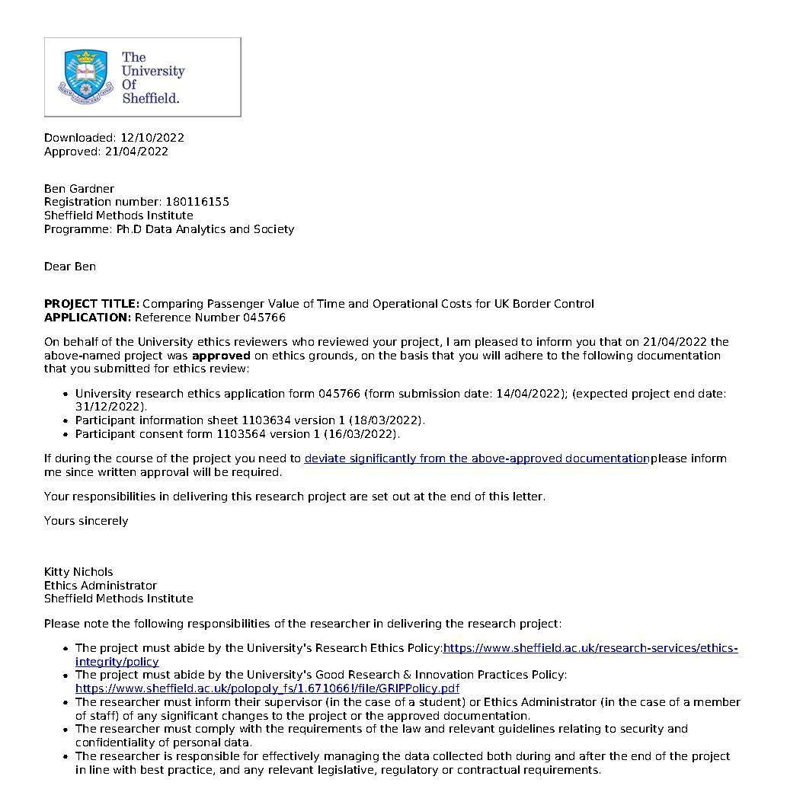

Appendix B – Stated Preference Survey

Files relating to my Stated Preference Survey can be found in the following github repository:

https://github.com/bdgardner1/AirTravel_StatedPref

Appendix C - eGate Operation Cost Details.
UK airport eGates have the following features:
- Purchased in banks of five, with a five year lifetime.
- Machines require annual maintenance, with a cost and gate downtime.
- One Border Force Officer is necessary for every 10 that are operational.

Note: The below uses synthetic figures to provide an illustrative example of the variation in costs of operating different levels of eGates at UK airports. They are not the actual costs.

Hypothetical Assumptions for a Bank of 5 eGates:
- Annualised purchase and maintenance cost - £170,000
- Annualised Border Force Salary Cost to operate - £164,250 (up to 2 banks in total)
- 20 % maintenance downtime (average of 4 operational at any one time)

Hence, the annual cost of having four eGate available all year round would be approximately £334k. This works out to an average cost of about £84k per eGate. However, consider that there is no reduction in cost to having 1-3 eGates operational as I still need to purchase a bank of 5. If I purchase two banks in order to operate 5 eGates, there is then no additional operational cost to having between 6 and 8 open all year. Operating more than 10 machines simultaneously would require both purchasing/maintaining another bank of eGates, as well as doubling the number of Border Force people hours/salary costs. Based on these synthetic assumptions, the costs of operating different levels of eGates would be as shown Table 44.

Table 44. Illustrative Example of Annual eGate Operational Costs
Total eGates | Marginal Cost of nth eGate | Average Cost | Total  eGates | Marginal Cost of nth eGate | Average Cost
1 | £334,250 | £334,250 | 9 | £170,000 | £74,917
2 | £0 | £167,125 | 10 | £0 | £67,425
3 | £0 | £111,417 | 11 | £164,250 | £76,227
4 | £0 | £83,563 | 12 | £0 | £69,875
5 | £170,000 | £100,850 | 13 | £170,000 | £77,577
6 | £0 | £84,042 | 14 | £0 | £72,036
7 | £0 | £72,036 | 15 | £0 | £67,233
8 | £0 | £63,031 | 16 | £0 | £63,031

Appendix D - Breakdown of Flight Experience from Stated Preference Survey
Table 45. Share of Age Group by Last Leisure Flight (n=1,367)
 | Year of Last Leisure Flight
 | 2023 | 2022 | 2021-2020 | 2019-18 | Prior to 2018
18-45 | 20% | 49% | 5% | 15% | 11%
46+ | 15% | 38% | 6% | 21% | 20%
ALL | 18% | 44% | 6% | 18% | 14%

Table 46. Share of Age Group by Frequency of Leisure Air Travel (n=1,367)
 | Average number of leisure travel flights per year
Age | Less than once | 1 or 2 times | 3 to 5 times | More than 5
18-45 | 35% | 47% | 17% | 2%
46+ | 38% | 47% | 13% | 1%
ALL | 36% | 47% | 15% | 2%

Table 47. Share of Age Group by Frequency of Business Air Travel
 | Average number of business travel flights per year (n=1,367)
Age | Never | Less than once | 1 or 2 times | 3 or more
18-45 | 75% | 14% | 7% | 4%
46+ | 79% | 13% | 5% | 3%

Appendix E: Additional Choice Modelling Results
Table 48. Multilinear Regression of Passenger Dissatisfaction with Air Travel
 | Model 1
 | Estimate | Standard Error
Intercept | 3.1* | 0.13
GenderMale | 0.002 | 0.07
Age | 0.003 | 0.002
Income | 04.28E-06* | 01.92E-06
LastFlightDay | 1.58E-05 | 1.82E-05
Freq_Air | 0.121* | 0.049
*Significant at 5% level
‘LastFlightDay’ indicates total days since survey and past leisure flight. ‘Freq_Air’ reflects a combination of frequency of leisure and business flight responses.

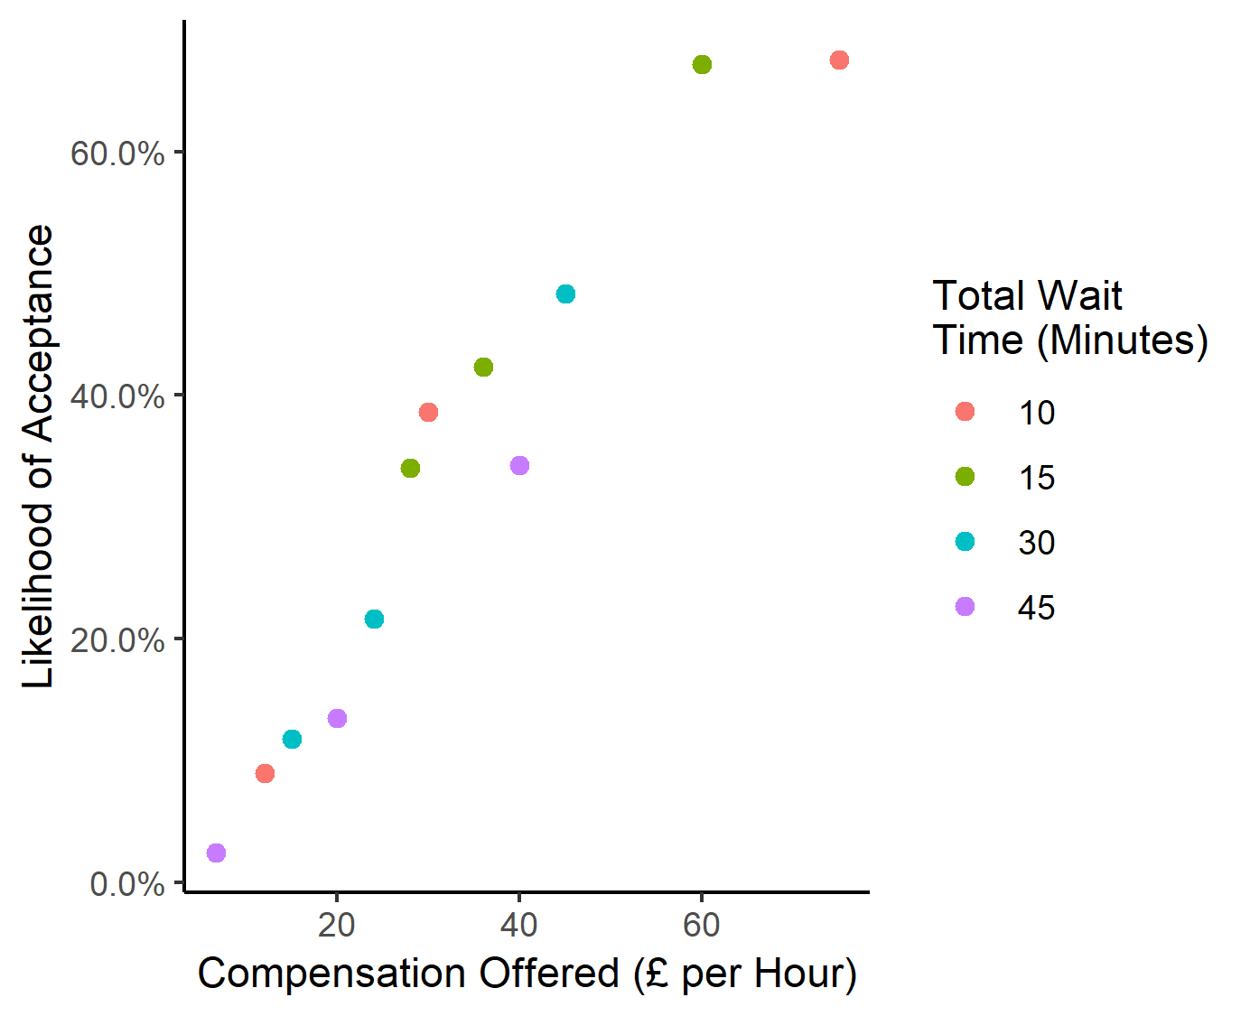
Figure 42. Relationship between level and acceptance of compensation

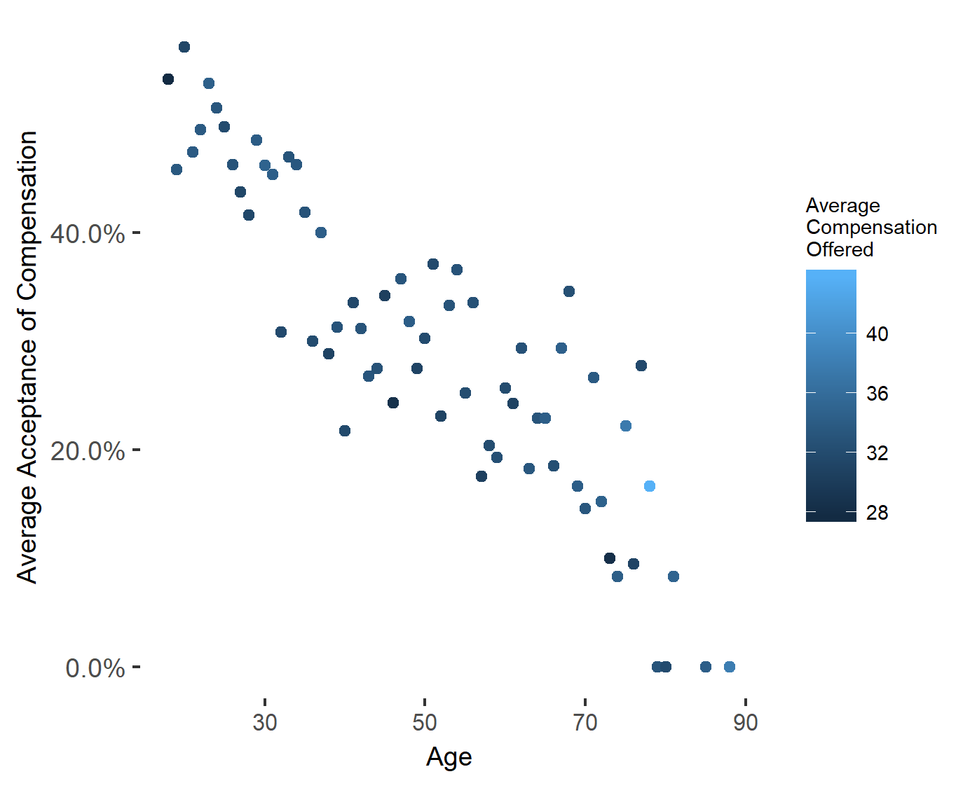
Figure 43. Relationship between respondent age and acceptance of compensation

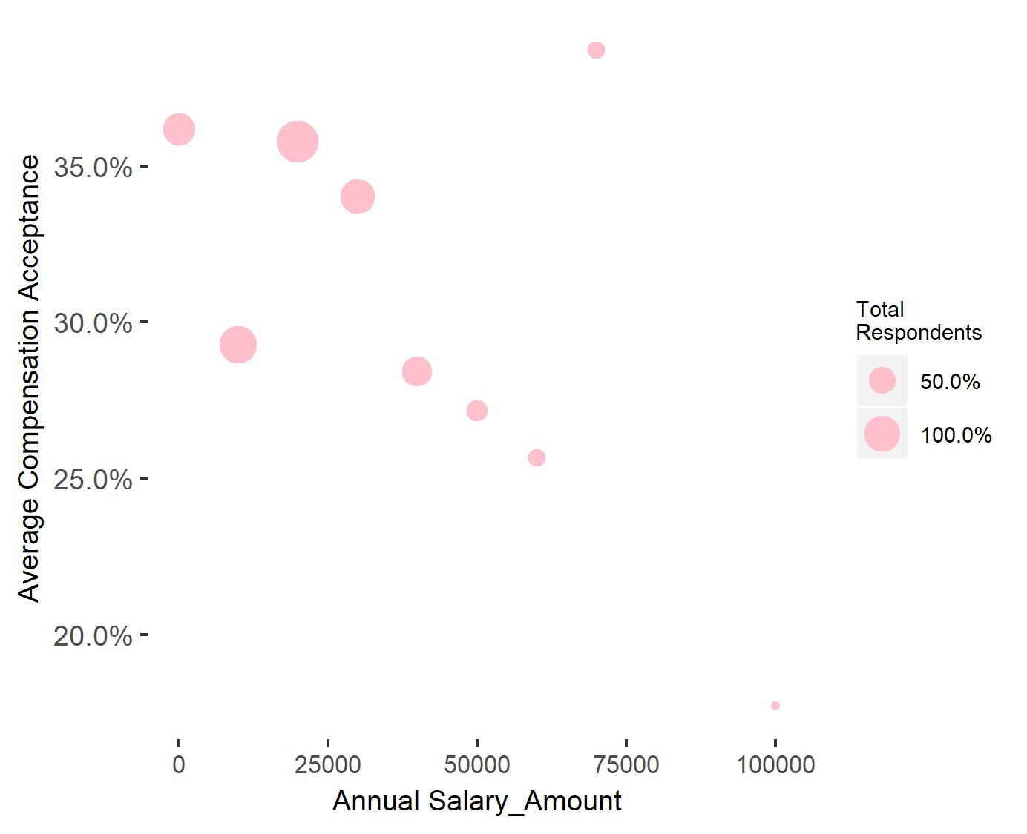
Figure 44. Relationship between respondents’ income and acceptance of compensation

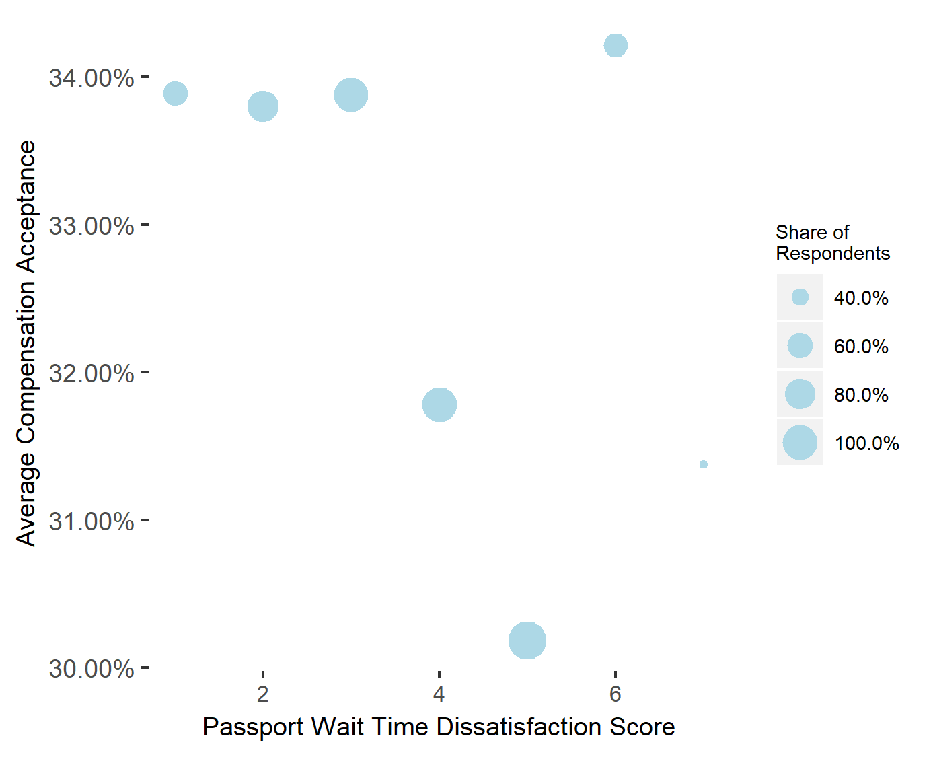
Figure 45. Compensation acceptance rate by passport queue dissatisfaction score

Chapter 6 References

Abrantes, P. A. L. and Wardman, M. R. (2011). Meta-analysis of UK values of travel time: An update. Transportation Research Part A: Policy and Practice, 45 (1), pp.1–17.

Alexander, M. et al. (2012). Priority queues: Where social justice and equity collide. Tourism Management, 33 (4), pp.875–884.

Aussilloux, V. and Le Hir, B. (2016). The economic cost of rolling back Schengen. Analytical Note, 39. [Online]. Available at: http://www.mondialisations.org/medias/pdf/consequenceabandonschengenen.pdf.

Bateman, I. et al. (2002). Economic Valuation with Stated Preference Techniques: A Manual. Edward Elgar.

Batley, R. et al. (2019). New appraisal values of travel time saving and reliability in Great Britain. Transportation, 46 (3), pp.583–621.

Boadway, R. and Others. (2006). Principles of cost-benefit analysis. Public Policy Review, 2 (1), pp.1–44.

Burgueño Salas, E., 2021. Air travel in the U.S. - pieces of luggage usually checked by trip purpose 2017 | Statista. [online] Statista. Available at: <https://www.statista.com/statistics/863006/air-travel-us-pieces-of-luggage-usually-checked/> [Accessed 6 September 2022].

Drake, S. (2020). Delays, cancellations and compensation: Why are air passengers still finding it difficult to enforce their EU rights under Regulation 261/2004? Maastricht journal of European and comparative law, 27 (2), pp.230–249.

Feldman, A. M. and Serrano, R. (2005). Welfare Economics and Social Choice Theory. 2nd ed. Springer.

Fowkes, T. and Wardman, M. (1988). The Design of Stated Preference Travel Choice Experiments: With Special Reference to Interpersonal Taste Variations. Journal of Transport Economics and Policy, 22 (1), pp.27–44.
Gössling, S. and Humpe, A. (2020). The global scale, distribution and growth of aviation: Implications for climate change. Global environmental change: human and policy dimensions, 65, p.102194. [Accessed 6 August 2021].

Gov.uk. (2019). How many people come to the UK each year (including visitors)? [Online]. Available at: https://www.gov.uk/government/statistics/immigration-statistics-year-ending-june-2019/how-many-people-come-to-the-uk-each-year-including-visitors [Accessed 21 December 2021b].

GOV.UK. 2021. Guide to faster travel through the UK border. [online] Available at: <https://www.gov.uk/government/publications/coming-to-the-uk/faster-travel-through-the-uk-border> [Accessed 27 August 2022].

GOV.UK. (2022). Statistics relating to passenger arrivals in the United Kingdom since the COVID-19 outbreak, May 2022. [online] Available at: <https://www.gov.uk/government/statistics/statistics-relating-to-passenger-arrivals-since-the-covid-19-outbreak-may-2022/statistics-relating-to-passenger-arrivals-in-the-united-kingdom-since-the-covid-19-outbreak-may-2022> [Accessed 23 September 2022].

Hensher, D. A. (2001). Measurement of the Valuation of Travel Time Savings. Journal of Transport Economics and Policy (JTEP), 35 (1), pp.71–98.

Hess, S. and Adler, T. (2011). An analysis of trends in air travel behaviour using four related SP datasets collected between 2000 and 2005. Journal of Air Transport Management, 17 (4), pp.244–248.

Home Office. (2021). BF Passenger Waiting Times Methodology. Unpublished internal document.

Jara-Díaz, S. (2007). Travel Demand and Value of Time. In: Transport Economic Theory. 39. Emerald Group Publishing Limited. p.88. [Accessed 14 June 2021].

Jiang, H. and Zhang, Y. (2016). An assessment of passenger experience at Melbourne Airport. Journal of Air Transport Management, 54, pp.88–92. [Accessed 6 August 2021].

Johnston, R. J. et al. (2017). Contemporary Guidance for Stated Preference Studies. Journal of the Association of Environmental and Resource Economists, 4 (2), pp.319–405.

Just, R., Hueth, D. L. and Schmitz, A. (2008). Applied Welfare Economics. Edward Elgar Publishing. [Accessed 18 April 2022].

Kellerman, A. (2008). International Airports: Passengers in an Environment of ‘Authorities’. Mobilities, 3 (1), pp.161–178.

Kim, S., 2016. Nearly a quarter of Britons have never flown on a plane or visited a beach, new survey says. [online] The Telegraph. Available at: <https://www.telegraph.co.uk/travel/news/a-quarter-of-britons-have-never-been-on-a-plane-visited-a-beach-or-european-capital/#:~:text=Twenty%2Dtwo%20percent%20of,beach%2C%20according%20to%20new%20research.> [Accessed 29 August 2022].

Landau, S. et al. (2016). Measuring Air Carrier Passengers’ Values of Time by Trip Component. Transportation research record, 2569 (1), pp.24–31.

Mason, W. and Suri, S. (2012). Conducting behavioral research on Amazon’s Mechanical Turk. Behavior research methods, 44 (1), pp.1–23.

Merkert, R. and Beck, M. (2017). Value of travel time savings and willingness to pay for regional aviation. Transportation Research Part A: Policy and Practice, 96, pp.29–42.

Ojeda-Cabral, M., Hess, S. and Batley, R. (2018). Understanding valuation of travel time changes: are preferences different under different stated choice design settings? Transportation, 45 (1), pp.1–21.

Palan, S. and Schitter, C. (2018). Prolific.ac—A subject pool for online experiments. Journal of Behavioral and Experimental Finance, 17, pp.22–27.

Rizzi, L. I. and Steimetz, S. S. C. (2014). On using standard values of time in project appraisal: Income equity vs. preference equity. Documento de Trabajo, Departamento de Ingeniería de Transporte y Logística, Pontificia universidad Católica de Chile. [Online]. Available at: https://www.sjsu.edu.akadns.net/economics/docs/steimeitz.pdf.

Roberts, B., Baschnagel, C. and Beggs, T. (2014a). Impact of Passport Inspection Wait Time on International Air Travel to and From the US. Analysis of Primary Inspection Wait Time at US Ports of Entry, p.53.

Roberts, B. et al. (2014b). The impact on the US economy of changes in wait times at ports of entry. Transport Policy, 35, pp.162–175.

Román, C. et al. (2014). Valuation of travel time savings for intercity travel: The Madrid-Barcelona corridor. Transport Policy, 36, pp.105–117.

Syal, R. (2023) Border force strike: Cover staff report getting just two days' training, The Guardian. Guardian News and Media. Available at: https://www.theguardian.com/uk-news/2023/feb/01/border-force-strike-covering-staff-report-receiving-just-two-days-training (Accessed: February 9, 2023).

Shires, J. D. and de Jong, G. C. (2009). An international meta-analysis of values of travel time savings. Evaluation and program planning, 32 (4), pp.315–325.

Transportation.gov. (2021) Revised Departmental Guidance on Valuation of Travel Time in Economic Analysis. [Online]. Available at: https://www.transportation.gov/office-policy/transportation-policy/revised-departmental-guidance-valuation-travel-time-economic [Accessed 21 December 2021c].

Wattanacharoensil, W., Schuckert, M. and Graham, A. (2016). An Airport Experience Framework from a Tourism Perspective. Transport Reviews, 36 (3), pp.318–340.

Section III:
Discussions & Conclusion

Discussion

Overview
This chapter summarises the overall research project. I briefly review the aims and methods before analysing the key findings of the research (including recommendations for stakeholders). I then suggest future research projects that could either tackle limitations in my projects or explore additional areas that our findings suggest would be of value. I end by providing an overall conclusion for the thesis.

Aims and Methods Review
The key research aims set out in Chapter 1 were as follows:
- To better understand key elements of queueing risks in airport border systems and how these can be managed by authorities.
- To explore the extent to which variations in passenger experiences at the border affect overall queueing times.
- To create a robust methodology for the costing of the time lost by air passengers in delays to demonstrate the expected trade-offs of operational decisions.

The common motivation behind these aims was a desire to explore why modern border control systems may continue to provide poor experiences for passengers. This can be broken down into analysis that considers the optimality of the entire system, and analysis that focuses on the unequal burdens placed on different sets of passengers. A broader aim of the study was to provide evidence that would allow us to consider the extent to which delays are due to justifiable operational decisions made by authorities, and the extent to which they are due to a lack of knowledge/understanding of the systems they are managing.

My overall methodological approach was based on a combination of quantitative methods such as computer simulation and choice modelling and unique access to real world border control processes (Chapter 2). My objective here was to review some of the examples of border control forecasting and suggest amendments, rather than propose radically new methodological approaches. The purpose of simplified simulation models of terminals was to provide general insights into border control scenarios that, whilst using real data, were not attempts to fully recreate the entire system.

The nature of this collaborative research project with the Home Office meant that the three studies presented were not planned simultaneously as a comprehensive analysis of a singular aspect of modern airport border control. Rather, they represent a form of iterative research, with Chapter 5 emerging from ideas and findings of Chapter 4, and Chapter 6 from elements of both 4 and 5. However, the latter studies were also heavily impacted by external factors that effected the environments researched and the nature of support from my partners. Primarily the COVID-19 pandemic (2020-), but also the wars in Afghanistan (Summer 2021) and invasion of Ukraine (war 2014-, and escalation in 2022) and ‘small boats’ migrant crisis (2021-). Global air travel was significantly reduced from March 2020, all the way until early 2022 (World Bank, 2022), and the processes at the border changed regularly to account for new Covid19 requirements (Davies, 2022). This combination of crises also meant that senior Home Office/Border Force management had less time available to support or review my activities, meaning that I was limited in the level of new primary research that could be carried out at airports or with staff during this time (see Section 7.4.4 below).

Key Findings
The four key findings of the research projects presented in Chapters 4-6 are detailed below.

Key Finding 1: Flight arrival times result in a significant variance to border control delays. Forecasts which do not consider this stochastic element are liable to produce staffing suggestions that fail to meet passenger delay goals.

My first project (Chapter 4) was driven by a focus on the specific risks that exist in non-automated systems of passenger processing. I discussed briefly how this burden falls primarily on nationalities too ‘risky’ to be allowed through border controls without additional checks by staff. This project views the problem with border control wait times in terms of 'excessively’ long delays faced by these groups, matching the focus of Border Force’s SLA performance targets.

My flight delay analysis (Chapter 4) suggests that a wide range of wait time outcomes can be expected when you operate a fixed level of operational capacity (open desks). If available staff levels are based on static forecasts that assume that flights will arrive on schedule, then a probability will remain each day that excessive queue times targets are breached. The scenarios in Chapter 4 (Section 4.2) demonstrated that arrival patterns could lead to performance targets being missed more than half of the time, and excess wait times more than double those allowed. Given the minimalist nature of my simulation techniques, these results would also be applicable to when studying terminals where arriving passengers first flow into some other kind of queuing system rather than border control (such transport). Or even other simple queuing system that shared similar batch arrival distributions to arriving flights.

We must be careful when translating this finding into a real-world border control scenario where staffing may be more flexible than assumed above. It may be possible that officers could be taken from other duties to support ‘bad arrival patterns’. However, the results provide new and unique evidence of the inherent risks that exist within the airport border control system, and an explanation for why a certain level of staffing redundancy would be needed to avoid it. Whether the cost of additional staffing is warranted is ultimately a policy/political decision. However, the types of results presented here would arguably be useful in negotiations within government when considering the resources necessary to achieve external targets.

Recommendations:

- Border authorities should include the stochastic nature of flight delay in their forecasts when determining optimal staffing levels for non-automated passengers processing.
- The outputs of such analysis provide clear and compelling evidence when negotiating with stakeholders for the resources required to reduce/eliminate the risk of excessive passenger delays.

Key Finding 2: Border processing times vary significantly by nationality, which likely results in certain nationalities facing higher average delay times than others. Significant saving could be achieved by ‘levelling down’ nationalities with the highest processing times.

The extent that processing time variations are a problem in themselves is debatable. For a system that is monitored in terms of 25/45 minutes delays (see Chapter 2), the 1-2 minute variations seen in Chapter 5 might not be of high concern in themselves. However, the issue arises from the cumulative nature of delays created by the specific nature of airport border control scenarios. Nationality groups literally arrive in plane loads, additional processing times multiply quickly. A small difference in processing times for large numbers of travellers results in significant differences in overall delays. Our highest processing rate nationality had simulated border wait times 135% higher than average and were more than three times as likely to face wait times over the SLA target of 45 minutes (Chapter 5, Section 4).

It’s not surprising that if in the simulation we ‘level down’ the processing times of those with the lowest border mobility that queue times reduce. However, the extent and nature of the reductions is notable: nineteen minutes of total passenger wait time is saved for every one minute of average processing times reduced. There was a 20% drop in passengers waiting longer than performance targets. And there were even large reductions in wait times for nationalities whose processing times remained the same. Applying applicable Valuation of Travel Time (VTT) rates to these time reductions suggest passenger savings worth over £6m a year. The specific nature of nationality arrival into airport border controls does create some difficulties in applying these insights into other fields. However, we can consider that systems that involves batch arrivals of customers/items where processing time depends on the origin are likely to face similar issues.

It should be stated that Border Force are aware that passengers from some origins take longer to clear than others (known internally as ‘sticky’ flights). Hence, staffing levels may be determined heuristically from the known ‘stickiness’ of arrivals to avoid the longer delays suggested by my modelling. It could be the case that this flexible approach to staffing is a preferable solution to attempts to reduce time officers spend evaluating specific passenger groups. But a key element is the extent that decisions are based on logical appraisals of risk to national security, rather than the prejudices suggested in the literature. Authorities are incentivised to consider whether there are opportunities to reduce processing times that do not increase border security risks.

Recommendations:

- Authorities should be clear in their reasoning for variations in passenger processing times and take measures to eliminate factors that cause unnecessary delays.
- There are both ethical and practical reasons for focusing on nationalities who face the longest processing times. Authorities should consider how times can be levelled down for these groups in a way that maintains necessary levels of border security.

Key Finding 3: Time spent by passengers in automated border control processes should be valued higher than generic valuation of travel time estimates.

When studying automated border controls, my focus shifted from infrequent incidents of long delays to considering the overall level of delays for all passengers (Chapter 6, Section 6.1). This meant considering not just what operational decisions are necessary to reach an externally established performance target, but directly assessing the optimality of border choices in terms of cost benefit analysis. My key finding here is concerned with how individuals value their own time in these systems and an analysis of the suitability of using generic VTT rates in such cases.

My results confirm with existing research that air travel has higher levels of VTT rates than other forms of travel (Chapter 6, Section 6.6). However, the survey also suggests the general dislike passengers have of waiting in crowded air travel stages; especially arrival stages where travellers are coming towards the end of their journey. The specific values I established for border control and baggage reclaim VTTs are substantially higher than not only other forms of travel, but also existing generic valuations of air travel. I repeat caution that my choice-modelling experiments involve elements that may result in elevated VTT values (Chapter 6, Section 6.2). However, the results provide evidence that actual VTT rates for this area clearly exceed the generic leisure valuations suggested for use in UK travel scenarios (~£6).

Recommendations:

- Analysis concerning border controls should utilise valuations of travel time specific to airport scenarios.

Key Finding 4: In my simulations, the undersupply of automated border control gates regularly leads to higher ‘excess’ costs than an oversupply. Even when discounting for reduction in value that the baggage reclaim element introduces.

This finding concerns the specific risks when making decisions over the level of automated border control gates to install in a terminal. An important element of this was refuting the claim that potential delays in subsequent arrival stages (specifically baggage reclaim) would largely eliminate the value of reducing wait times at the automated border. Our simulation results clarified that even in situations of low average delay, incidents of longer delays and frequency of passengers travelling without checked bags would still result in overall time savings. The value of these are significantly increased when you use the new VTTs discussed in Key Finding 3. However, even when using existing generic valuations, it was clear that the costs of lost time escalate rapidly when the number of eGates falls.

The importance of this finding can be clarified by considering how the benefits of overall delay reductions may be viewed differently to incidents of particularly long delays. Newspapers don’t typically write stories about economically inefficient eGate systems, they do write stories about 2-hour long queues at Border Control desks (Chapter 2, Section 2.2). The insight from this study should lead authorities to carefully consider the more visible costs compared to the hidden.

Recommendations:

- Border authorities should consider using methodologies similar to those demonstrated in our study when attempting to accurately value the cost-benefit of different levels of eGates.
- In situations where there is uncertainty over the optimal levels of eGates to install, authorities should err towards installing more rather than less.

Implications Outside Border Control
My findings up to this point have focused exclusively on the target frame of border controls within airports. However, we can briefly consider some implications that expand beyond this specific area:

General Airport Management for Arriving Passengers
As discussed in Chapter 2 and elsewhere, the UK airport border control set up involves passengers moving directly from the arrival gate to the border control area, and then onto other stages once they have been processed. However, other nations do have different arrangements of arrival stages, with passengers potentially entering non-border control stages first (see Pitchforth et al, 2015). Hence, our insight from Key Finding 1 could be more broadly applied to that of airport management. For passengers to complete the flows from arrival gates to other areas, the airport will need to ensure sufficient capacity for transportation such as buses, trains, and other mechanisms. The risk of high numbers of passengers arriving simultaneously due to ‘bad’ flight arrival patterns have the potential to cause long delays if existing facilities have capacity issues similar to border control. Understanding the worst case scenarios and the expected frequency of these events would allow airport management to better consider capacity levels and other solutions to this problem. This can be expanded further to stages beyond border control (such as arrival lounges and onward transportation connections), that would similarly be impacted by high volumes of passengers entering them in a short space of time.

Batch Arrivals and High Demand Individuals
Whilst the specific results discussed in Key Finding 2 are valid only to the airport border control scenario, there is a general insight that can be considered beyond this. I would argue that the extent that the ‘high burden’ nationalities increased both overall waiting times and the delays of others in the same queuing periods demonstrates a general importance of avoiding these situations. We can consider other queuing systems where certain group types with high processing demands may enter in quick succession. Whilst the exact benefit will depend on the system, my research does suggest that reducing these specific time demands would be a preferable tactic over other queue reduction options. This also conform to some of the basic queuing theory concepts discussed back in Chapter 4 (Section 4.2.1).

Use of Specific VTTs in Air Transportation Projects
The literature reviews in Chapters 5 and 6 that argues that air travel is a specifically undesirable form of travel and that passengers would be willing to pay higher amounts to avoid delays. Whilst my SP survey was focused primarily on airport border control, I would argue that it provides additional evidence that air travel specific VTTs should be used for evaluation of air travel transportation projects. Existing publicly available DfT valuations and analysis does not suggest that this is currently taking place, though the researcher acknowledges that they may be unaware of internal processes that do.

Further Research
The above overview suggests areas where limitations in my research have resulted in gaps in the ability to answer my research questions. It also raises additional research questions that were not originally consider. This section will briefly summarise areas where additional studies would provide improved answers and increased knowledge of the topic overall. I will not repeat basic elements that have already been covered in previous chapters.

Impact of Flight Delay
The methods I used for modelling flight delay in Chapter 4 and their impact on the border control scenario were a simplification. The assumption that delays are independent is very likely to be incorrect and, in practice, airport authorities will manage the arrival patterns of flights to match gate availability (something only partially included in our modelling). I argued that this level of simulation detail is not necessary to demonstrate the impact of flight delays on risks of long-waiting times. However, there would be value in establishing this before attempting to apply this methodology to any real world forecasting. Similarly, variable desk opening patterns would need to be included in such analysis to determine optimal staffing patterns over multiple shifts. This will naturally be a more efficient process in determining how many staff should be rostered to a terminal.

Passenger Processing Times
I suggested in Chapter 4 that flight arrival times and passenger processing rates are the main variable elements of the border control system. However, I only provided stochastic analysis of the former. It may appear an obvious oversight to not have investigated the extent that variations in passenger processing time result in border delay variability. To provide full transparency, this analysis was included in the exploration stages of my second project. A prototype model was built that incorporated a simplified version of processing rate stochasticity and Monte Carlos Analysis was conducted for a single case study. However, the early results suggested that there was no significant variation in expected queuing times, after which I decided to abandon this analysis and focus on other areas. With more time and resources, it would have been preferable to include a full, robust analysis of this topic in the study to provide an authoritative answer for stakeholders.

Valuing Automated Border Delays
As clarified in Chapter 6, the choice modelling experiments of my stated preference survey (Chapter 6, Section 6.2) were limited by the resources available. The aim was to provide a general indication of how passengers value time in border control processes and contrasts this with generic VTT study values. If authorities or other stakeholders wished to replicate the cost-benefit analysis methods used in this study to evaluate real world operational capacity, there would be clear value in increasing the number of respondents and improving some of the validation to generate more robust VTTs for this specific area. This could also expand to consider the preferences of non-UK resident groups that use eGates, to determine whether their VTTs vary significantly enough to warrant inclusion in analysis. With regards to ‘baggage reclaim discounts’, I repeat that additional primary research is needed to fully understand this element before an authority could simulate accurate results for their specific terminal. I have no data either way to support whether variations in airline/airport processes in this area would make our simplifying assumptions more or less accurate on an individual basis. I general, my research suggests that organisations should be careful when using generic valuations of travel time for leisure that do not consider the specific nature of the travel activity. Whilst these may represent a realistic compromise for projects where specific valuations do not exist, and it is not possible to conduct/tender additional research, organisation should consider modifying generic values using existing multipliers.

Additional Areas
A key theme of this thesis has been the ways in which the decisions taken by authorities concerning national groups impacts their border mobility. A natural avenue for future research would be an exploration of the rationale of this decision-making process. The major divide is clearly with nationalities excluded from automated border controls. There would be significant value in providing an understanding on what basis this decision is made, evaluating whether the results conform to the stated objective and whether the objectives can be justified according to concepts such as cost-benefit analysis and other moral considerations.

Within the non-automated cohort, I was only able to provide a summary of the existing literature into ideas concerning why processing times may vary between nationalities (Chapter 5, Section 5.2). None of this has been directly validated by exploring the working practices of border officers and their interactions with passengers. A potential study could include a background into the training and monitoring of staff, interviews into how they view their roles and responsibilities and observational research into how this plays out in practice. The purpose of such a study would be to both understand the organisational reasoning for some nationality groups taking longer times to process, and whether the actions of staff follow these reasons or are influenced by other factors.

Finally, there would be value in replicating these studies with data from other nations to test the applicability of our findings to non-UK border controls. There are general insights within all three chapters which are built on elements of border control systems that are common in many nations. All nations face flight arrival delays, all will likely have some variability of passenger processing time and all will have to make cost benefit calculations based on the VTT of their passengers and the cost of implementing border capacity (both staffing and machines). However, without future research it is unknown the extent that these elements vary and how this might impact the overall conclusions.

Conclusion

The Scale of the Problem
The air travel industry and the authorities set up to manage it have faced an almost permanent revolution in recent decades. Budget airlines and rising incomes have made air travel more affordable, and an interconnected world has provided more reasons to fly. In 1993, two air journeys took place for every ten people alive globally. By 2019 that was up to six (World Bank, 2022). This has only been made possible by technological advancements that have driven process improvements throughout the industry. As the likes of Tholen (2010) and Sontowski (2018) have noted, border control is no exception. Chapter 4 provided insight into the importance of advanced forecasting and staffing optimisation at ports. Chapter 5’s study of passenger processing rates illustrates how vital it has been to ‘export’ elements of the border assessment to earlier stages of the journey to reduce the time passengers spend with officers. Both the existing literature and my own simulations in Chapter 6 highlight the importance of the mass processing capability of automated border controls. Overall, the changes made by border authorities have been viewed by many as a broad success. For example, when arrivals into the UK increased by 40 million (40%) during 2012-2018, Border Force’s ability to meet its queue time SLAs never fell below 95%. (GOV.UK, 2022).

The reader may consider at this point to what extent the issues we have explored throughout this thesis matter in comparison to these wider successes. Is this just a case of ‘tidying up’ a few remaining leftover problems from the major overhaul undertaken in the border control environment? Throughout our studies we have considered the UK Border Force’s ability to achieve its SLA targets that focus on limiting ‘unacceptable’ queue lengths to a small minority of passengers. We could reasonably ask whether this is a legitimate national concern, or one of avoiding politically embarrassing news stories, as suggested by Gilmore (2012)? The SLA target is itself a binary judgement of a continuous situation - Is someone waiting 44 minutes ‘acceptable’ whilst someone waiting 46 minutes not? In addition, this thesis only views public concerns of border control in terms of wait times and not the many additional economic and security concerns raised over ‘weak’ borders suggested in the literature (see Bosworth, 2008).

Ultimately, I would argue that this thesis is important for a few fundamental reasons, the understanding of which have been clarified and expanded upon as part of this study:
- Air passenger numbers are so huge that small differences at an individual level multiple exponentially at the system level.
- Travellers value the time they spend delayed in air travel higher than other modes of transport, and have a particular aversion to waiting in arrival stages such as border control.
- The costs of implementing additional border processing capacity can often be at a lower scale than the total value savings achieved when you combine [1] and [2].
- The nature of modern border control creates clear risks of uneven experiences based on nationality.

Delays and Costs
Over 140 million people arrived into the UK in 2018 (Chapter 2, Table 3). The volume of passengers and desire by air travel industry stakeholders to improve passenger experiences is mirrored by the extensive research that has taken place into almost every aspect of the air travel journey (see Chapter 4, Section 4.2). Compared to these, the flow of passengers into and out of border controls is a relatively under-researched area. Yet the costs from potential inefficiencies are clear. Even a system that avoids longer queuing times for 95% of UK arrivals would have left 7 million facing these delays in 2018. If average delays increased by just 1 minute, that would result in 2.3 million hours of additional travel time. Applying the VTT rate established in Chapter 6, the cost of this could be estimated at £91m, 26% of the total amount spent on UK border control in 2017/18 (Home Office, 2022). And this only considers costs in terms of passenger time, ignoring the other potential external costs of deterring tourists and business travellers that I explored in Chapters 5 & 6.

In addition to the scale of costs, there are the usual public policy concerns of the most ethical and efficient choices when it comes to assigning those costs to different groups (see Feldman and Serrano, 2005). Should the passengers themselves bear the burden as users of the system or should the state fully cover the cost given that border controls are a perceived public good (Bosworth, 2008)? Or, if we are convinced that lower border delays result in increased demand for air travel then we might look to the industry to cover the costs; with the potential consequences of blurring the lines between state security and airport operations as suggested by Møhl (2018). This thesis hasn’t attempted to answer this; rather it has focused on whether it’s more efficient to compensate/charge passengers for the value of their time than it is to spend money on additional operational costs to reduce delays. The precise answer is dependent on the costs faced by border authorities (of which I only provided minimal guidance) and the methodology for costing delays. Though, even with assumptions that exaggerate the former and minimise the latter, I have ended up with results in all three studies where reducing delays is typically preferable.
However, even this cost-benefit analysis approach ignores another key issue, the divisions created in passenger experience by the ‘revolutions’ in border control. Previous studies (Pitchforth et al, 2015), as well as official UK targets highlight longer expected delays for non-automated passengers. Nationality variations in border mobility have been suggested by multiple studies (Chapter 5, Section 5.2) and the Home Office’s own reports suggest this (Woodfield et al, 2007). My research in Chapter 5 is the first to clearly confirm it, whilst also making the case for the benefits that could be achieved from ‘levelling down’ processing times. Reducing the level of scrutiny that those with the lowest mobility face had quantifiable savings, not just for those individual groups themselves, but all passengers and stakeholders in the system. I am not advocating an outcome here; it might be that the overall savings from reducing processing times for these groups could allow authorities to reduce the number of active staff. This means that total waiting times remain the same but there is more equity among nationality groups (an arguably desirable objective in itself). However, given our insight into the cost of delays vs cost of operational capacity suggested above, it’s likely that accepting the lower wait times would be the optimal solution.

Final Considerations
I wish to clarify here that whilst based on real data, our findings are in no way a full explanation for the delays at airport border controls. I am not suggesting that incidents of long queues are due to deliberate decisions to employ fewer officers than ‘optimal’; staffing decisions and terminal operational circumstances are a consequence of multiple, complex factors. Queues can emerge from random situations entirely unexplored by our work and the level of staff that can be assigned to a border control area may not be within an authority’s full discretion. It may also be the case that there are solutions for reducing border delays that are cheaper than paying additional staff. These caveats apply to automated border controls as well, where decisions on how many banks to install are not a simplistic calculation of passenger waiting times as could be taken from my studies.

Rather, this research project highlights the imperative of paying careful attention to specific outcomes when planning border control operations. My findings suggest that authorities need to consider how undesirable passengers find waiting in each of the arrival stages of the air travel process. I have emphasised the need to look beyond static performance targets that may still leave large numbers with a poor experience, and to ensure that the visible, direct costs of operational capacity are not allowed to unduly outweigh the hidden costs to passengers. Finally, there is a need to be aware of the uneven impact that border control processes can have on different passenger groups and to act where possible to narrow them. Whilst changes in the air travel industry have lowered price barriers to global travel, we should not be complacent about addressing the remaining hurdles.

Section III References
Bosworth, M. (2008). Border Control and the Limits of the Sovereign State. Social & legal studies, 17 (2), pp.199–215.
Davies, G. (2022) Managing cross-border travel during the COVID-19 pandemic. National Audit Office. Available at: https://www.nao.org.uk/wp-content/uploads/2022/04/Managing-cross-border-travel-during-the-COVID-19-pandemic.pdf (Accessed: April 4, 2023).
Feldman, A. M. and Serrano, R. (2005). Welfare Economics and Social Choice Theory. 2nd ed. Springer.
Gilmore, M. (2012). Securing Borders for the Olympic Games. The RUSI Journal, 157 (2), pp.26–31.
Home Office. (2022) Border Force Transparency Data: Q1 2022, GOV.UK. GOV.UK. Available at: https://www.gov.uk/government/publications/border-force-transparency-data-q1-2022 (Accessed: March 9, 2023).
Møhl, P. (2018). Border control and blurred responsibilities at the airport. Security Blurs, the Politics of Plural Security Provision, pp.118–135.
Pitchforth, J. et al. (2015). Processing passengers efficiently: An analysis of airport processing times for international passengers. Journal of Air Transport Management, 49, pp.35–45.
Woodfield, K. et al. (2007). Exploring the decision making of Immigration Officers: a research study examining non-EEA passenger stops and refusals at UK ports. Home Office Online Report, 1 (07). [Online]. Available at: https://www.researchgate.net/profile/Kandy_Woodfield/publication/237289219_Exploring_the_decision_making_of_Immigration_Officers_a_research_study_examining_non-EEA_passenger_stops_and_refusals_at_UK_ports/links/55aa354308aea99467233534/Exploring-the-decision-making-of-Immigration-Officers-a-research-study-examining-non-EEA-passenger-stops-and-refusals-at-UK-ports.pdf.
worldbank.org (2022) Air Transport, passengers carried, Data. World Bank. Available at: https://data.worldbank.org/indicator/IS.AIR.PSGR (Accessed: October 24, 2022).

25 minutes for UK and EEA passport holders and 45 minutes for all others.
Established from discussions with Home Office/Border Force staff during this period.
We should note that this is a simplification as staffed desks are also used to reduce queue times for these passengers if automated systems are at capacity.
Some non-EEA nationalities were approved to use ePassport gates in 2019, however this policy was reversed during the COVID19 outbreak.
Actual figures are not presented due to confidentiality.
This previous model was deterministic, only able to consider one flight arrival pattern and open number of gates/desks.
X axis values for this figure and others have been removed due to confidentiality.
Australia, Canada, Japan, New Zealand, Singapore, South Korea, United States
Whilst the UK left the EEA, along with the EU, on 31 January 2020, we use the term ‘non-EEA’ in place of ‘non-domestic, non-EEA’ for brevity. A list of these nations can be found in Appendix A.
eGate access was provided to seven non-EEA nationalities in spring 2019 (see Section 5.3 and Appendix A). However, this access was removed during the covid-19 pandemic and only partially reinstated.
Discussion with Border Analysis Unit staff member in 2020
Note that this represents a simplification of the UK’s visa policy and that not all citizens of a ‘visa nation’ will require one for entry in all circumstances.
London Heathrow terminals 3 and 4, Manchester, Stansted and Edinburgh
Excludes fast track and ‘medical’ desks used by those with disabilities or other medical conditions.
Note that due to confidentiality reasons discussed in Chapter 3, the raw data for this study cannot be provided.
London Heathrow (All), Gatwick (All), Manchester T1 and Stansted.
Based on 2018 figures. Border force stopped tracking non-EEA arrival totals in early 2019.
The researcher is aware that some border control funding comes from the air industry itself.
Taken from internal, unpublished Home Office Statistics
These figures are amended to B5JSSK countries to reflect that only 30% of passengers would be expected to use manual desks
Based on discussions with UK Border Force stakeholders in 2019/20
Though it may be possible to open additional desks to handle overflows of automated passengers (see Section 6.3.2)
Home Office, 2021
Transportation.gov, 2016
There does exist a ‘FastTrack’ service that individuals can pay to use dedicated desks at some UK airport’s border control. However, this is aimed at non-UK nationals who use staffed desks, rather than eGates, and would not provide sufficient range of data to establish VTTs (gov.uk, 2021)
Gumbel Distribution represents the distribution of extreme values either maximum or minimum of samples used in various distributions. It is used to model distribution of peak levels.

