New An artcil

Exploring the Lived Expereince and Spiritual Lives of Parents of Children with Disabilities in Oman

Nuha Al Shaaili

A thesis submitted in partial fulfilment of the requirements for the degree of
Doctor of Philosophy

The University of Sheffield
School of Health and Related Research
March 2023
Declaration:

I, the author, confirm that the Thesis is my own work. I am aware of the University’s Guidance on the use of unfair means (www.sheffield.ac.uk/ssid/unfair-means). This work has not been previously presented for an award at this, or any other, university.

Acknowledgments
I would like to begin this thesis by thanking my supervisors Dr Elizabeth Croot and Dr Sarah Drabble for their support, patience, invaluable feedback and for sharing their knowledge and experiences with me. I would like to thank them for their compassion, kindness and for making my PhD an excellent experience. My heartfelt appreciation and thanks extend to Professor Andrew Lee and Dr Aamir Al-Toubi for the guidance, wise-words and helpful advice. I am lucky to have had supervisors who were not only knowledgeable in their areas but also generous and detailed in their feedback.
This study was made possible by a scholarship from the National Postgraduate Scholarship Program, Ministry of Higher Education, Oman. I would like to thank them for their support and for funding me to undertake this research. Opinions and views expressed in this thesis are solely my own and do not express the views of the Ministry of Higher Education.
A huge thank you to all the parents who participated in this research, without whom this thesis would not be possible, I hope I have done your perspective, insights and thoughts justice.
I would like to thank everyone who encouraged and supported me. I owe my deepest gratitude to my mother Raiya, for her support and unwavering belief in me and my father Issa who inspired me to read and think critically. To my partner and best friend, Mohammed, thank you so much for being my anchor and for supporting and reassuring me through all life’s difficult stuff. I am forever grateful for your belief in my ability to prepare this thesis, even when I was not so sure myself. To my children, Yousuf, Ola and Wael, thank you for filling the house with joy and helpfully distracting me from this thesis when it was needed.

Abstract
Background: In Oman, spiritual beliefs play an important role in society, however, there is limited understanding of how spirituality influences the lived experience of parents who care for children with disability. Parents of children with disability, like all parents, experience joyful and challenging aspects of parenting. However, raising a child with disability is generally associated with increased care-giving demands and parental stress. The parents’ spiritualty may impact their beliefs, behaviours and feelings and therefore may influence the way that parents respond to these demands.
Aim: To explore the meaning and experience of spirituality amongst parents of children with disability in Oman.
Methods: A qualitative study using in-depth interviews (n=11) and photovoice. Eleven parents of children with disability engaged in the photo-taking task and captured photographs that represented their spirituality. Interpretive phenomenological analysis was used to analyse the interview transcripts and the participants’ photographs.
Findings: A comprehensive description of participants’ spirituality embedded within their lived experience was constructed from the data and three group themes related to their spirituality were identified: Understanding disability through a spiritual lens; managing tensions at the intersection of spirituality and disability; and drawing on spirituality to overcome challenges in accessing and using services. The parents outlined their spirituality as an overarching perspective that goes beyond religious affiliation. Their spirituality appeared to foster hope, optimism, determination, and positive meaning-making and thereby, operated as a coping mechanism. However, spiritual experiences also gave rise to spiritual and emotional struggles.
Conclusions: This study sheds light on the influence of spirituality on the lived experiences of parents of children with disability in Oman. The findings highlight the existing joys, challenges and fears emerging from the parenting experience and may pave the way to transfer findings into opportunities to improve service provision in the social and healthcare sectors.

Table of Contents
Acknowledgments ii
Abstract iii
List of Figures vii
List of Tables xi
Abbreviations xii
List of Definitions xiii
Chapter 1: Introduction 1
1.1 Background to this Research 1
1.2 Research Context 6
1.3 Justification for the Research 14
1.4 Outline of the Document 15
Chapter 2: Literature Review 17
2.1 Introduction 17
2.2 Review Purpose 17
2.3 Review Type 17
2.4 Conceptualising Spirituality 20
2.5 Parents of Children with Disability 32
2.6 The Omani Context 42
2.7 The Conceptual Framework 53
2.8 Summary 57
Chapter 3: Methodology 58
3.1 Introduction 58
3.2 Research Process 58
3.3 Consideration of Methodologies 65
3.4 Rationale for Selecting Interpretive Phenomenological Analysis 67
3.5 Interpretive Phenomenological Analysis 68
3.6 Interpretive Phenomenological Analysis’s Limitations 75
3.7 Application of IPA’s Research Principles 77
3.8 Quality and Validity 78
3.9 Positionality and Reflexivity 80
3.10 Summary 82
Chapter 4: Research Methods 83
4.1 Introduction 83
4.2 Photovoice Method 84
4.3 Sampling Approach 85
4.4 Research Procedures 91
4.5 Analysis Process 109
4.6 Ethical Considerations 118
4.7 Summary 123
Chapter 5: Introducing the Parents 126
5.1 Introduction 126
5.2 Descriptive Data 126
5.3 Participants’ Vignettes 127
5.4 Summary 152
Chapter 6: Group Experiential Theme 1: Understanding Disability Through a Spiritual Lens 153
6.1 Introduction 153
6.2 Overview of the Group Experiential Themes 153
6.3 Group Experiential Theme 1: Managing the Tension at the Intersection of Spirituality and Disability 156
6.4 Sub-Theme 1: ‘The Sick Child’: Concepts, Beliefs, and Attitudes Towards Disability 157
6.5 Sub-Theme 2: ‘My Child Is Unique’: Parents’ Spiritual Perceptions of Their Child with Disability 171
6.6 Group Experiential Theme One Discussion 182
6.7 Summary 193
Chapter 7: Group Experiential Theme 2: Managing tensions at the Intersection of Spirituality and Disability 195
7.1 Introduction 195
7.2 Sub-theme 1: ‘Why God, Why Did You Give Me This Child?’: Reconciling Religious Beliefs with the Child’s Disability 195
7.3 Sub-theme 2: ‘I trust God’: Prayers of faith 202
7.4 Group Experiential Theme Two Discussion 212
7.5 Summary 219
Chapter 8: Group Experiential Theme 3: Drawing on Spirituality to Overcome Challenges in Accessing and Using Services 221
8.1 Introduction 221
8.2 Sub-theme 1: ‘It is not easy’: Navigating the System 221
8.3 Sub-theme 2: ‘No Matter How Challenging Life is, We Must Face it and Overcome the Challenges’: Building A Spiritual Foundation to Overcome Challenges 231
8.4 Sub-theme 3: Spiritual and Personal Growth 248
8.5 Group Experiential Theme Three Discussion 254
8.6 Summary 268
Chapter 9: Discussion 269
9.1 Introduction 269
9.2 Key Findings 269
9.3 Expanding the Conceptual Framework 276
9.4 Study Strengths and Limitations 278
9.5 Implications for Practice 281
9.6 Directions for Future Research 284
9.7 Conclusion 285
References 288
Appendices 322
Appendix A: Search Strategy 322
Appendix B: Recruitment Advertisement 323
Appendix C: Consent Form 324
Appendix D: Information Sheet 325
Appendix E: Photography Subject Consent Form 329
Appendix F: Photograph General Release Form 330
Appendix G: Interview Guide 331
Appendix H: Poland’s Instructions for Transcribers (2001) 338
Appendix I: Reflection on Al-Muthabira’s Interview 339
Appendix J: Personal Profile Sample 340
Appendix K: Searching for Connections Across Experiential Statements 358
Appendix L: Developing Group Experiential Themes 359
Appendix M: Table of Group Experiential Themes-Sample 360
Appendix N: Ethical Approval 362

List of Figures
Figure 1. The Canadian Model of Occupational Performance and Engagement (Adapted from Towsend & Polatajko, 2007) 2
Figure 2. Ministry of Health Hospitals and Health Centres (2000-2018). 8
Figure 3. A Continuum of Overlapping Approaches (Adapted from Nind, 2014). 10
Figure 4. Factors that Influence Parents’ Experience. 39
Figure 5. Distribution of Omanis with disability by cause. 44
Figure 6. Distribution of Omanis with disability by cause 44
Figure 7. The conceptual framework. 53
Figure 8. IPA's theoretical underpinnings. 67
Figure 9. Research procedures. 88
Figure 10. Connectedness. 124
Figure 11. Trust in God. 124
Figure 12. Happiness 124
Figure 13. Entrust yourself in God. 126
Figure 14. Stop lying, hating and envying. 126
Figure 15. Every person should reach their goal. 126
Figure 16. Hope and optimism. 128
Figure 17. Peace and calmness. 128
Figure 18. Challenge. 128
Figure 19. Life is beautiful. 131
Figure 20. Life's challenges. 131
Figure 21. Take steady steps to navigate your life. 131
Figure 22. Sweets. 132
Figure 23. Siblings love. 133
Figure 24. Sunrise. 133
Figure 25. Luck. 136
Figure 26. The leaf. 136
Figure 27. Belief in science. 136
Figure 28. At the end of the journey. 137
Figure 29. Hardship will fade. 137
Figure 30. The fruit of determination. 137
Figure 31. Welcome life. 140
Figure 32. Brother. 140
Figure 33. Oman is my identity. 140
Figure 34. Managing time. 143
Figure 35. My hobby. 143
Figure 36. Appreciation. 143
Figure 37. My daughter. 144
Figure 38. The water's journey. 144
Figure 39. Underneath moon light. 144
Figure 40. The sea. 147
Figure 41. Homeland. 147
Figure 42. Oman. 147
Figure 43. The leaf: the only leaf that looks different from the other normal leaves in the lemon tree. 166
Figure 44. Happiness: The peak of my happiness is my children’s happiness. 168
Figure 45. My daughter: Keep your loved ones smiling as much as you can. 169
Figure 46. Love: siblings helping one another. 171
Figure 47. Brother: take my hand for you are my support. 172
Figure 48. Stop lying, hating and envying. Stop calling us Mongolian. Stop negativity. 173
Figure 49. Oman is my identity and I'm proud of its traditions. 175
Figure 50. Trust in God: My hopes, my wishes and my desires begin here. 196
Figure 51. Entrust yourself in God and trust Him in everything and know that everything from God is Good. 200
Figure 52.The sea: The sea is like life with all its ups and downs. 202
Figure 53.Life is beautiful: No matter how challenging life is, we must face it and overcome the challenges and obstacles. 226
Figure 54. Hardship will fade: no matter what challenges and difficulties a person encounters, they will definitely vanish, and he/she will reach their goals 228
Figure 55. Hope and optimism: A person should work hard in life. 229
Figure 56. Every person should reach their goal, whether the goal is big or small, even if the goal was the highest mountains. 231
Figure 57. Life’s challenges: the challenges I face to take my child to therapy. 232
Figure 58. At the end of the journey: navigating surging waves to reach the shore is a proud achievement. Just like the journey of parents of children with special needs 234
Figure 59. Peace and Calmness: A person’s inner-self should be calm and accepting... always calm, so he/she can concentrate to be able to think about tomorrow. 235
Figure 60. The water's journey: a trip with friends away from the city and pressures. 237
Figure 61. Connectedness: My family’s connectedness gives me strength 238
Figure 62. Sweets: It tastes good to my children. 239
Figure 63. My hobby: the image shows my hobby of making desserts, which is an enjoyable and relaxing activity for me in my free time. 240
Figure 64. Managing time: a strong desire to manage my time and organise my daily tasks according to priority and try not to waste time. 244
Figure 65. Distribution of MOH Rehabilitation Professionals by Governorate 250
Figure 66. Spirituality of Omani parents of children with disabilities (derived from the literature review findings). 269
Figure 67. The spirituality of Omani parents of children with disabilities (derived from the study findings). 270
Figure 68. Project stages 318

List of Tables

Table 1. Advisory Group Meeting 12
Table 2. Disability Questions in Oman's Census (1993, 2003 and 2010). 45
Table 3. Epistemology, theoretical perspectives, methodology and methods (Adapted from Crotty, 1998). 59
Table 4. Present study design. 60
Table 5. Interview guide. 100
Table 6. Analysis steps (adapted from Smith et al., 2009). 110
Table 7. Analysis steps (adapted from Smith et al., 2022) 114
Table 8. Parents' characteristics. 127
Table 9. Presentation of Group Experiential Themes. 154
Table 10. Prevalence of Sub-themes across participants 156

Abbreviations
Abbreviation |  | Explanation
 | ASD |  | Autism Spectrum Disorder
 | CDD |  | Children with Developmental Disability
 | CWD |  | Children with Disability
 | DD |  | Developmental Disability
 | MoH |  | Ministry of Health
 | MoSD |  | Ministry of Social Development
 | NIHR |  | National Institute for Health Research
 | PCWD |  | Parents of children with Disability
 | PPI |  | Public and Patient Involvement
 | UN |  | United Nations
 | WHO |  | World Health Organisation

List of Definitions
Consanguineous Marriages A formally recognised union among two family members who are related as cousins (Hamamy, 2011).
Religion Includes beliefs, rituals and practices linked to the ‘sacred’, which relates to the mystical, supernatural, ultimate truth or God. Typically, religions include rules about moral conduct to guide a social group and hold beliefs about the ‘afterlife’ (Koenig, 2001).
Spirituality The capacity of the individual to choose the relative importance of the physical, social, emotional, religious and intellectual stimuli that impacts him or her and are thus involved in a continuous process of meaning making (Morgan, 2002).
Supernatural beliefs Beliefs in things that do not exist according to scientific knowledge, however these beliefs appear real to believers (Jong, 2013).
Supernaturalism A belief in an otherworldly reality or realm, it is commonly associated with religious beliefs and practices (Encyclopaedia Britannica, 2017). Characterised as a supernatural agency that intervenes in the course of natural laws (Oxford Dictionaries, 2020).
Theism A belief of existence of a God or Gods (Oxford Dictionary, 2020)
Transcendence A state of existence beyond the limits of physical experiences (Vocabulary, 2020). Transcendence is often used to describe a spiritual state. If a person has trouble abandoning material needs, reaching transcendence would be difficult (Vocabulary, 2020)

Introduction
This chapter sets the scene for this thesis and is divided into four sections. The first section will outline my personal experiences and interests which have shaped my positionality as a researcher, and interest in researching the spirituality of parents of children with disability. Within this chapter, I also describe the research background and context and the terminology I use in this project. I close this chapter by providing an outline of the thesis.

Background to this Research
I trained as an occupational therapist in Auckland, New Zealand (2008–2012). In 2013, I started working as an occupational therapist at the Royal Hospital in Oman, where the majority of my clients were children with developmental disabilities (CDD). I was struck by people’s negative perceptions of developmental disabilities, particularly amongst the parents of children with disability (PCWD). It is also important to note that this thesis includes stories of disability stigma and child abuse which may evoke emotional responses.
During my work as an occupational therapist, many of my clients, including children, had visible scars resulting from wasm, which is a method of traditional medicine in which parts of the body are cauterised using a hot metal rod. For example, I met Nadia (synonym) a 3-year-old girl who had multiple disabilities. It was Nadia’s first visit to therapy, and she communicated using sounds and gestures. Her parents were both present throughout the session. As I worked with Nadia, I noticed that she seemed in pain, as her eyes were tightened, and she was groaning. I asked her mother if she was unwell, but her mother explained that she was fine. I attempted to be gentle and proceeded to check Nadia’s back as she had poor posture. I asked for consent to remove Nadia’s shirt and was surprised to see multiple (more than 10) wasms in her back. The wounds looked inflamed, and I understood that while I was examining her (not realising that she has multiple wounds in her back) I had caused her pain. The experience was overwhelming, and I had to pause the session to seek help from my supervisor. The parents were counselled regarding the use of wasm. However, Nadia was never brought to therapy again. This incident made a deep impression on me. It made me realise that some parents and medical professionals approach health and disability from different perspectives, and that we must understand the parents’ perspective to deliver quality care and help parents and their children access services.
Consequently, I found practising the occupational therapy frameworks that I had learned in New Zealand challenging, if not impossible. For example, my occupational therapy undergraduate course was based on the Canadian Model of Occupational Performance and Engagement (CMOP-E) (Polatajko, Townsend and Craik, 2007) ( Figure 1).
Figure 1. The Canadian Model of Occupational Performance and Engagement (Adapted from Towsend & Polatajko, 2007)
The CMOP-E includes three main components: occupation, environment, and person. The inner part represents the ‘person’, and its centre is the person’s spirituality as it is shaped and expressed through occupations. Spirituality in this model does not refer directly to religion; rather, it represents the person’s worldview and essence of self (Polatajko, Townsend and Craik, 2007). The model nevertheless acknowledges that some individuals may express their spirituality through religion. Learning about this model was my first encounter with the term spirituality. I became intrigued and wanted to learn more about it. I understood spirituality as a concept that includes religious beliefs but also includes non-theistic thought: spirituality as a part of being human.
My interaction with Nadia and other children with developmental disabilities in Oman led me to think about how the different components of the Omani culture influence the parents’ choices and therefore affect my role as an occupational therapist. Exploring the parents’ understanding of disability, as well as their beliefs, can help adapt treatment plans to their understanding. Upon reflection, I realised that the parents’ perceptions and attitudes towards disability and their parenting roles, and the health choices and healthcare services they choose to access, may be shaped by social and cultural factors, and spirituality appeared to be central within the conservative Omani culture. The CMOP-E model emphasises the importance of integrating spirituality into occupational therapy practice. However, to achieve this, spirituality must first be explored thoroughly to enable a systematic and ethical approach to spiritual care. Looking at the academic literature, while I found numerous international studies that described the lives of PCWD, little was known about the experiences of Arab or Omani parents (Alakhzami and Huang, 2020). I believe that researching the area of spirituality in Oman could pave the way to a more effective approach to delivering services for children with disabilities (CWDs) and their parents.
As an occupational therapist working with parents of children with disability, I recognised that it is important for healthcare professionals to understand parents’ spirituality as part of their worldview, and to understand how parents make sense of their experiences and how their worldview affects their choices regarding health care and the forms of treatment they seek for their children. Religion is a key part of Omani culture, but I was keen to understand spirituality in a broader sense and to learn more about how it impacts, and is impacted by, parents’ experience of caring for children with disability in Oman.
It is my personal experience with Omani parents of children with developmental disabilities and my reflection and interest in spirituality that brought me to this inquiry. I was born and raised in Muscat, Oman in a predominantly Muslim family. Muscat, the capital of Oman, exhibits a wealth of diversity in native language, cultural and ethnic groups (Al-Azri, 2013). My mother was born and raised in Zanzibar, Tanzania and my father was born and raised in Busaiteen, Bahrain. Therefore, I grew up in a house that adopted various cultural customs, traditions and languages/dialects. Generally, in Oman, arranged marriage is common to ensure that family members marry from within similar socio-cultural backgrounds, and therefore my parents’ marriage was uncommon as my parents come from different backgrounds. This reflects that my parents come from relatively open-minded families, and hence my upbringing involved engaging in activities and discussions that do not occur within the majority of Omani families. For example, while the use of musical instruments was encouraged within my family, listening to songs and valuing arts have been frowned upon, if not banned, in many Omani families, especially from the 1970s to the beginning of the 2000s (Al-Azri, 2013). I am aware that my upbringing and life experiences may be different to many people in Oman, and I noted this after I started my job as an occupational therapist, that I had to be aware and mindful that, for example, some parents find recommending music therapy for their children offensive.
My cultural background played a role in my interest to study overseas to experience a new culture. My spiritual journey began at the age of 17 when I moved to New Zealand to pursue higher education. This was my first encounter with people of different faiths, and I became interested in discovering my own spirituality as the beliefs I ‘inherited’ were challenged. I visited churches, attended bible classes and studied world religions. In 2017, I moved to Ireland to complete a master’s degree in older person rehabilitation and developed a stronger sense of identity as my thoughts and beliefs became more consolidated.

Research Context
This section provides a brief overview about the PhD journey and the Omani context. This section also details the involvement of parents in this research and terminology and voice use.

The PhD Journey
I started my PhD course in September 2019. I moved to Sheffield with my two children, who settled in school/nursery. I began the course aiming to explore the spirituality of adults with learning disabilities in Sheffield; therefore, my literature review focused initially on this topic. In December 2019, I had my third child and took parental leave (leave of absence) for 50 days, after which I resumed the course and focused on writing my literature review. Unfortunately, at the end of March 2020, the COVID-19 pandemic began, and because I had caregiving responsibilities for my three children, I had to relocate to Oman to be supported by my husband and family. After relocating to Oman, I changed the study population to Omani parents of children with disability, as recruiting Omani parents seemed more practical than conducting online interviews due to the COVID-19 restrictions. However, this adjustment was not purely pragmatic as in my initial PhD proposal I had sought to explore the spirituality of Omani parents, in line with my previous professional experience. Therefore, while this process was stressful and limited the time I had to work on the literature review, my personal and professional interest in interviewing Omani parents motivated me to continue.
The lockdown period was challenging as I had to work from home and care for my children. Nevertheless, I was fortunate to get support from my husband and extended family. However, in August 2020, a month before my confirmation review, I experienced a life-threatening cardiac condition that required emergency surgery. The first three months after the surgery I experienced physical, mental and cognitive issues, though these improved with time. Facing a health condition impacted my PhD journey in many ways. While I recovered mentally and cognitively after a couple of months, my physical limitations persisted. Working on this project was luckily not physically demanding, therefore I was able to fully engage with the demands of the course. I also found that working on this project helped with my mental well-being. When I physically was unable to do the activities I wanted to do, working on this research helped me feel productive and gave me a sense of being my usual self.

Oman
This study was conducted in Muscat, the capital city of the Sultanate of Oman. Oman is located in the south-eastern coast of the Arabian Peninsula with Saudi Arabia, the United Arab Emirates and Yemen as neighbours. According to Oman’s National Centre for Statistics and Information (NCSI) (NCSI Portal, 2022), Oman’s total population in 2022 was 4,908,789. The official religion of Oman is Islam (Al-Azri, 2013). Oman is considered a developing, high-income country (World Bank, 2023).
In the last few decades, Oman has undergone rapid change. Oman’s GDP per capita has increased steadily since the discovery of oil in 1964 and the beginning of exports in 1967 (Al-Azri, 2013). The country is heavily dependent on gas and oil resources, which generate 68% to 85%, respectively, of government revenue. The acceleration of development in Oman is dependent on oil prices (Al-Azri, 2013). In 1970, Sultan Qaboos initiated a comprehensive socioeconomic development programme, called the Omani Renaissance which, since its commencement, has achieved some of the highest-ever recorded growth in the history of human development (Harrison, 2002).
Like the economy, the healthcare system in Oman experienced rapid growth. While in 1970, the only medical care in Oman was offered through a missionary station in Mutrah, in Muscat, today there are nearly 71 hospitals and 190 health centres (Figure 2).
Figure 2. Ministry of Health Hospitals and Health Centres (2000-2018).
The healthcare system in Oman, similar to other developing countries’ health systems, is geared towards the eradication of infectious disease and the improvement of primary care (Al-Adawi et al., 2012; Alakhzami and Huang, 2020). This has led to reduced morbidity and mortality rates and increased life expectancy (The Ministry of Health (MOH), 2014). However, improvements in services for people with disabilities have lagged considerably (Alakhzami & Huang, 2020). The MOH is currently working on a vision for 2050 to address the demand for improved quality care and deal with the increasing cost of health services (MOH, 2014).
Considering the significant improvement in Oman’s healthcare system, health professionals and researchers have begun to raise the significance of improving rehabilitative and supportive services to improve the quality of life of people with disabilities (Al-Adawi et al., 2012; Alakhzami and Huang, 2020). The Ministry of Higher Education (Oman) is funding my course as part of a postgraduate program that aims to qualify nationals in various fields including rehabilitation and disability. I received funding for the ‘PhD in disability studies’ course, therefore, I take a disability studies perspective in this project even though my professional experience is within occupational therapy practice. As I planned this study, I felt it was important to engage the parents of children with disability. The next section details the parents’ involvement.

Involvement of Parents of Children with Developmental Disability
A dynamic partnership between researchers and members of the public/patients is referred to as patient and public involvement (PPI) (National Institute for Health Research, (NIHR), 2017). PPI is valuable, as researchers and clinicians may lack personal or immediate experience with illness, disease or, as in this project, the experience of raising a CWD. Therefore, PPI can provide insights into what it is like to care for a CWD and help make the research more relevant to the needs of parents and their children. A growing body of literature shows that PPI in research is essential for strengthening the relevance, impact and quality of research projects (NIHR, 2017). Researchers can actively involve patients and the public in any or all stages of the research process, including the prioritisation of studies, study design, data collection and the analysis and dissemination of findings (NIHR, 2017), with positive outcomes reported during all stages of the study process. Because doctoral students have found the early initiation of PPI beneficial (Tomlinson et al., 2019) and as it is recommended by the NIHR (2017), I decided to incorporate an advisory group at an early stage of the project to ensure that the research goals were in line with the parents’ needs and to ensure that researching spirituality using the proposed methods (‎Chapter 4)was acceptable within Omani culture. This research was led by me with some sharing from the parents (Figure 3). I decided to take the lead for this project as it is a PhD project, so I must meet the deadlines and have limited resources which restricted the extent to which I could share control of the project with the parents. In this study, mothers of children with developmental disability actively contributed to the research as advisers.
The advisory group is comprised of Omani mothers of children with developmental disability who volunteered to share their insights and expertise to inform and develop this research. An invitation was sent to an existing online support group for mothers of children with disabilities, and five mothers expressed their interest to participate. The group met ten times during the project. The initial meetings were conducted online due to COVID-19 social restrictions, and even after the restrictions were eased, the advisory group members preferred online meetings. Only the 9th meeting was held in person, in a public area in which food and refreshments were provided. An 11th face-to-face meeting is scheduled to discuss data dissemination with the group. Table 1 details the advisory group meetings, the meetings’ agendas and advisory group contributions.
Figure 3. A Continuum of Overlapping Approaches (Adapted from Nind, 2014).
Date | Agenda | Advisory Group input
10th May 2020 | - Introduction to the project  - Aim of PPI  - Research proposal  - Use of Photovoice  - Language use | - The use of photovoice would be acceptable within Omani culture. However, participants would probably prefer to use their personal phones rather than disposable cameras to capture photographs.  - Exploring spirituality would be acceptable.  - The use of special needs rather than disability is preferable.
8th July 2020 | - Number of photovoice sessions  - Mode of session | - Keep the number of sessions to a minimum because the research participants would find it challenging to attend multiple sessions.  - Conduct the photovoice sessions while the participant’s child is undergoing therapy to make it easier for the parents to attend.
9th August 2020 | - Literature review themes discussion | - Emphasised the lack of services and elaborated on the challenges the parents face in accessing available services.
11th January 2021 | - Recruitment strategy  - Incentives  - Feedback on advertisement | - Emphasised the importance of the researcher being available in the department in which the advertisement is placed to answer any questions that potential participants may have.  - The use of an incentive and a gift voucher was recommended.
17th March 2021 | - The interview guide: feedback and pilot | - Help with the language/ wording of the questions in Arabic.  - Received feedback about individual questions.
10th November 2021 | - Data collection update  - Asked about why it is hard to recruit parents of older children | - Clarified that parents of older children are less likely to take their children to therapy (or outside the house in general) due to inaccessible buildings and lack of equipment.
30th January 2022 | - Final data collection update | - The advisory group was informed about the progress and the number of interviews conducted.
28th February 2022 | - Shared and discussed the first draft of the findings | - The mothers discussed the findings and highlighted the importance of the analysis related to stigma and lack of services.
9th May 2022 | - Themes and sub-themes  - Summary of findings | - The mothers discussed the themes/ content  - The mothers also wanted to share their personal experiences of both stigma (especially from extended family members) and challenges related to service availability.
21st February 2023 | - Shared final themes and a brief discussion | - The mothers expressed approval of the final themes.
Table 1. Advisory Group Meeting
The advisory group input is embedded within the main text of the thesis. As I engaged the parents, I realised that it is important to pay attention to voice and language use. The next section discusses these topics in detail.

Terminology and Voice Use
While working as an occupational therapist in Oman, I realised that the language I used to describe disability played an important role in how the parents interacted with me during therapy sessions. In my experience many parents disliked the use of the word ‘disability’ in general and preferred the use of ‘special needs’ or ‘ehtiyajaat khassa’ in Arabic. Some parents I interacted with as an occupational therapist also spoke positively about neighbouring countries’ endeavours in changing the language used to address people with disability; for example, The United Arab Emirates officially uses the phrase ‘people with determination’ to address people with disability. Some parents also chose not to seek services for their children, mainly because they need to apply for a ‘disability card’ from the Ministry of Social Services and they did not want the ‘label’ of disability for their children. This reflects a deeply rooted disability stigma in Oman.
The language I used in this thesis was influenced by multiple factors. First, English is my second language, therefore writing the thesis was daunting, particularly at the early stages of the PhD. I found some aspects of writing to be challenging, for example, to deliver a point I want to make, I used long sentences as I did not have the vocabulary I needed to express myself in a precise manner. However, I felt more confident after receiving feedback from my supervisors. I generally write in the third person as this was how I was instructed during my bachelor’s and master’s degrees. However, as I developed as a researcher during the PhD, and with my supervisors’ feedback, I revisited my writing style and explored the use of first-person pronouns in academic writing. I found that first-person pronouns not only better align with the methodology of this research (Chapter 3) but also reflect a sense of responsibility for reporting the aims, process and findings of the project. Nevertheless, I have been hesitant to use first-person pronouns at times because I found it to ignore the contributions of my supervisors, the participants and the PPI. Therefore, I have attempted to use first-person language throughout this project while acknowledging the role of my supervisors, the participants and the PPI group. Furthermore, I conducted the interviews in Arabic and translated the transcripts before conducting the analysis. Therefore, I had to be continuously mindful of my writing style. This is discussed in detail in section 4.4.3.4.
Literature on disability makes use of both ‘person-first’ terminology (for example people with disabilities) as well as ‘identity-first’ language (for example disabled people). Person-first terminology places the person first and the disability second, therefore seeks to emphasise the personhood of the individual (Shakespeare, 2013). Person-first language was proposed by social psychologist Beatrice A. Wright, who used the social model to challenge language that dehumanises people with disability (Dunn, 2015). Wright argued that person-first language preserves people with disabilities’ humanity while emphasising their individuality (Dunn, 2015).
However, critics of person-first terminology criticise the phrase ‘people with disabilities’ because it implies that it is possible to distinguish the experience of being disabled from the individual’s identity (Shakespeare, 2013). Disability-first language stems from a newer model: the minority or diversity model which portrays disability as a neutral, or positive natural characteristic (Dunn, 2015). This model suggests that similar to other demographic characteristics such as skin colour, race or sexual orientation, disability ought to be valued or celebrated as part of one’s identity (Andrews et al., 2013). Therefore, some people with disability, who view disability as an integral part of their identity and culture, find person-first language offensive (Dunn, 2015). In light of these contrasting debates, and in an attempt to respect the parents’ perspectives, I consulted the advisory group, in May 2020 to help decide the preferred language. The parents recommended using ‘special needs’ to refer to disability, following the commonly used terminology in Oman. However, in November 2021, The Sultan of Oman issued a royal decree (Oman Observer, 2021) stating that in all governmental and legal documents the term ‘people with disability’ should be used instead of ‘special needs’ or ‘disabled’. Since then, Omani people appear to have become more accepting of the person-first language, which was confirmed by the mothers in the advisory group. Therefore, I have used person-first terminology throughout this document.

Justification for the Research
The aim of this research is to explore parents’ conceptualisations of spirituality and their spiritual beliefs, and how these shape their views and lived experiences of raising a child with disability in Oman and will shed light on the joys and challenges the parents’ experience. Existing research conducted in Oman with health professionals (Al Busaidy and Borthwick, 2012) and caregivers of people with acquired brain injury (Al-Adawi et al., 2012) has shown that spiritual beliefs played an important role in understanding disability and influences caregivers’ access to health services. Also, in her doctoral project, Bloushi (2019) conducted grounded theory research to explain the experience of being a mother of a child with cerebral palsy in Oman. Al-Boushi found that ‘patience’, derived from the mothers’ religious and cultural beliefs, helped them in assuming their parenting role and aided in shaping a positive parenting experience. However, Bloushi did not explore other aspects of the mothers’ spirituality and how it may have related to their experience.
The knowledge gained from this study will be beneficial in many ways. First, providers must understand the parents’ experiences, as well as cultural aspects, such as spirituality, in order to address disparities in service provision to Omani children with disabilities and their families, which may lead to increased service access and use. Second, exploring the parents’ spiritual responses to disability may also aid in the development of interventions that are tailored to the Omani culture and improve the well-being of parents and children. Finally, the findings may provide opportunities to improve the education and competencies of health professionals as spirituality can be integrated into client care.

Outline of the Document
The thesis is organised into the following chapters:
Chapter 2 Literature Review: This chapter summarises the literature relevant to my research. The literature includes research about conceptualising spirituality, parents of children with special needs, and the Omani context. The literature is analysed to create a conceptual framework and to understand the gaps in the literature and how this project may help to fill one or more of these gaps.
Chapter 3 Methodology: This chapter describes the methodological orientation and justification of the methodology of choice − interpretive phenomenological analysis (IPA).
Chapter 4 Methods: The research methods section provides an account of the particularities of how the research was undertaken. The chapter begins with an introduction and includes a section on patient-public engagement. The sampling strategy and recruitment process are detailed, and the processes of data collection (photovoice and in-depth interviews) and analysis are described.
Chapter 5 Introducing the Parents: This chapter provides an overview the findings of this study. The participants' characteristics are outlined, and a vignette of each participant is given. After describing the vignettes, an overview of the group experiential themes, emerging from cross-case analysis, is detailed.
Chapter 6 Group Experiential Theme 1: Understanding disability through a spiritual lens: This chapter describes the parents’ perceptions and beliefs regarding their children’s disability. The chapter concludes with a discussion section in which the relevant academic literature is considered
Chapter 7 Group Experiential Theme 2: Managing tensions at the intersection of spirituality and disability: This group experiential theme captures the parents’ religious sense-making processes regarding their child’s disability. The chapter includes a discussion of the relevant literature.
Chapter 8 Group Experiential Theme 3: Drawing on spirituality to overcome challenges in accessing and using services: This chapter captures how the parents’ spirituality related to their journey in accessing and using services to provide care for their children. The chapter ends with a discussion of the related literature.
Chapter 9 Discussion: The final chapter highlights the key messages from this research and provides a discussion of the findings in relation to the conceptual framework. Next, the strengths and limitations of this project are discussed by critiquing my work. After that, I discuss the implications of the findings for practice, given the new insights generated from the study, and outline recommendations for future research.

Literature Review

Introduction
Chapter two begins with a brief overview of the methodology of the literature review. The chapter offers an overview of the current literature conceptualising spirituality, the lived experience parents of children with disability, and the Omani context. This chapter concludes with a conceptual framework that informs this study.

Review Purpose
The aim of this literature review is to facilitate understanding of the abovementioned topics and aid in formulating the research questions, methodology and interview guide through a traditional or narrative literature review methodology. This narrative review summarises and critiques the prevalent knowledge, identifies gaps in the literature, and broadens understanding of the lived experience of parents of children with disability and their spirituality.

Review Type
I chose to do a narrative review because narrative reviews are more suitable for researchers whose research methodology is based on interpretive methodology, as the purpose of their review is to generate understanding about the topic rather than accumulate knowledge (for example, through systematic reviews) Bryman (2016). Narrative reviews offer a ‘snapshot’ of existing knowledge, while systematic reviews aim to capture and monitor emerging knowledge (Booth, Sutton and Papaioannou, 2016). This literature review was not regularly updated throughout the project period, rather, as the research progressed, the interviews and analysis took me into unanticipated and new territory and the literature relating to this is explored in the discussion sections (pages 176, 205 and 246). Literature reviews, as part of the discussion section, serve to explain, justify and contextualise the research findings.
Narrative literature reviews aid in the development of conceptual and theoretical frameworks (Ravitch and Riggan, 2017). This literature review was intended to identify a conceptual framework. To this end, I identified and took into consideration the various definitions proposed in the literature. Furthermore, this literature review also considered the key themes that have emerged from previous research investigating the lived experience of parents of children with disability, presenting the findings through a thematic approach. Since parents’ experiences vary according to the context in which they are embedded, I explored relevant literature on the Omani context to gain an in-depth understanding of Omanis experience with disability and to explore the available support services. This knowledge aided in formulating the research questions and creating the interview guide.

Review Methods
To ensure that I identified the main literature on the above-mentioned topics, I followed Aveyard's (2008) search strategy guidelines. First, I specified the three main areas of literature that I would approach to avoid getting side-tracked when searching: conceptualising spirituality, parenting children with disability, and the Omani context. Next, I set the inclusion and exclusion criteria. The literature search was limited to English and Arabic; however, almost all included literature comes from English research, mainly due to the lack of Arabic research literature. Also, because I wanted to explore the term ‘spirituality’ as a broad concept, I excluded studies that focus mainly on sub-components of spirituality, such as those that focus primarily on religious beliefs or specific value systems and do not acknowledge spirituality as a broad concept. This is in line with the definition of spirituality in the Canadian Model of Occupational Performance and Engagement (CMOP-E) as spirituality in this model represents the person’s worldview and essence of self and does not refer directly to religion (Polatajko, Townsend and Craik, 2007).
The inclusion criteria focused mainly on subject areas, including the concept of spirituality, the experiences of parents of children with disability, and studies relevant to the Omani context concerning disability and services available for parents of children with disability. After that, I explored the different methodological approaches that are important for my review and found that while the majority of the existing literature is qualitative, for example using interviews, some quantitative literature was also relevant. Therefore, I aimed to include both types of methodology. Next, I established the search strategy, and a list of keywords was created to identify the literature (Appendix A).
The following databases were searched for relevant studies: Cochrane Library, CINHAL, PsycInfo, PubMed, Scopus and Web of Science. The search also incorporated the University of Sheffield online library, and the Oman Ministry of Health online library, books, websites and online search engines. Further studies were identified by examining the reference lists included in some research articles. The literature review covers research conducted globally but focused where possible on the Middle East, Arab and Muslim countries, and Oman. However, as noted in the introduction, there is scant literature on spirituality and health in the Arab region, particularly in Oman.
The review starts by considering definitions of spirituality and distinguishing between spirituality and religion. It goes on to discuss the theoretical and empirical definitions of spirituality, concluding with a description of the way that spirituality is conceptualised in the present study. The next section of the review considers the literature related to the lived experiences of parents of children with disability, focusing on different aspects that may shape the parents’ experience. This section concludes with a description of a model of the factors that influence the parents’ experience. The last section of this review provides an overview of the Omani context as may relate to the Omani parents’ experience of raising a child with disability.

Conceptualising Spirituality
In the past 30 years, interest in spirituality has increased and a number of researchers have attempted to study, theorise and define the concept (e. g., Zinnbauer, Pargament and Scott, 1999; Hill et al., 2000; Van Niekerk, 2018). Despite decades of research, defining spirituality has proven to be difficult (Hill et al., 2000; Van Niekerk, 2018). This is partly because we live in an intercultural, multi-faith world and partly because the existing literature lacks uniformity about what encompasses spirituality. Some scholars argue that one of the major hindrances in defining the concept is its relationship with religion (Van Niekerk, 2018). Therefore, the lack of agreement on the meaning of spirituality originates from the question of ambiguity between the terms ‘religion’ and ‘spirituality’ (Hill et al., 2000). In this section I discuss ideological and empirical definitions of spirituality before discussing the role of spirituality in the lives of parents of children with disability.

Ideological Definitions
The differentiation between religion and spirituality was initially driven by the escalation of secularism in the 1950s (Hill et al., 2000), and consequently, spirituality became separated from religion. Spiritualty is generally viewed in a positive light, as researchers associate it with the inner experience of the transcendent, an experience of feeling connected to the world (Ammerman, 2015), whereas religion with its formal structure relates to rituals and theory, excluding personal experiences. The polarisation of the two concepts is evident in the literature (e.g. Zinnbauer et al., 1997, 2016; Hill et al., 2000). Tanyi (2002) described religion as a fixed entity expressed by a definable system, such as doctrine, theological rituals and denominations. By contrast, spirituality has been used to define a personal, internal experience that gives meaning to life (Sodhi and Manju, 2013). A trend towards spirituality and away from organised religion emerged in the 1960s, and scholars speculated that a ‘spiritual revolution’ has been evolving in Western societies (Zinnbauer et al., 1997). Indicators of this trend include a rising percentage of people who identify as ‘spiritual but not religious’ (Ammerman, 2015) and expression of spirituality through practices like yoga and meditation (Hill et al., 2000; Palmisano, 2010). The explanations included in this paragraph, developed out of the scholarly interpretations of social scientists, rather than from lay people’s personal articulations, therefore the next paragraphs will examine research regarding how spirituality is perceived by individuals.

Empirical Definitions
Researchers have attempted to understand the meanings of spirituality and religion by examining the ways in which spiritual and religious believers define the terms (Mattis, 2000; Steensland, Wang and Schmidt, 2018). The literature indicates that spirituality and religiosity are highly individualistic and dynamic, and the conceptualisation of these terms may differ between people of different sociodemographic backgrounds and may also change over time. Therefore, in this section, I will explore differences between conceptualisations of spirituality in research completed in several countries.
In one of the first empirical studies examining spirituality and religiosity, Zinnbauer et al. (1997) examined the definitions of religion and spirituality among members of the public with a non-probability sample (N=346). The sample comprised 11 groups from two American states (Ohio and Pennsylvania). The sample included nursing home residents and students at a state university. Participants were requested to write their own understanding of religion and spirituality, and the results were analysed and grouped into conceptual and definitional categories. The most common definitions for spirituality were the experience of connectedness with a higher power or nature and personal beliefs such as in God or values (51%). Religiousness was found to be associated with a person’s level of devotion to the ritual teachings of religious institutions, doctrines and beliefs. This study argues that while spirituality and religiousness are interrelating concepts, they do have distinct meanings. One limitation of the study is that it did not indicate the ages of the participants, which may have affected their definitions of the terms as age and gender are most correlated with levels of spirituality (Steenland et al., 2018).
Mattis (2000) explored African American women’s definitions of spirituality and religion and the ways in which these women distinguish the two concepts through two qualitative studies. Study 1 included an analysis of the women’s written accounts of their own definitions of spirituality and religion. In Study 2, a sub-group of the Study 1 participants were interviewed in-depth to discuss the ways in which participants differentiated between spirituality and religion. In Study 1, African American Women (N=128) were recruited from a university with a mean age of 31.9 years. Participants were asked ‘What does the term spirituality/religion mean for you?’ and a majority (53%) defined spirituality as a belief and/or a connection to a superior power. Furthermore, 24% of Mattis’ (2000) respondents conceptualised spirituality as faith in the transcendent. Of the 128 participants in Study 1, 75 were willing to participate in in-depth interviews. A total of 21 interviewees were sampled to match the demographic characteristics of the participants in Study 1 (the mean age of the participants was 30.1 years). Participants were asked to identify how they differentiated between spirituality and religiousness and the three themes that emerged demonstrated that even though spirituality and religion were linked, they were defined as individual constructs. The first theme was that religious values and practices act as a channel to achieve spirituality. Second, religiosity was seen by the interviewees as one way to achieve spirituality. Third, participants argued that religiousness is a personal set of beliefs and practices related to a higher power, whereas spirituality refers to the expression of personal values. These findings are consistent with those of Zinnbauer et al. (1997). However, an important limitation of this study is that the participants, a sample of university students, reported a higher level of educational attainment than the larger African American women in society, which limits the generalisability of the results as education and income may impact levels of spirituality (Zinnbauer et al., 1997).
In a recent nationally representative survey conducted in the US, Steenland et al. (2018) examined the meaning of spirituality amongst the American population. The study investigated the elements that shaped participants’ perceptions of spirituality and examined the social factors that influenced individuals’ views on the topic. A probability sample of 1,038 adults aged 18 years and older were included in the study. The analysis focused on the responses to the question: ‘In a sentence or two, please describe what the term spirituality means to you.’ Deductive and inductive approaches were used to code the responses, which showed that consistent with the abovementioned studies (Zinnbauer et al., 1997; Mattis, 2000), American spirituality is also mainly oriented toward theism and supernaturalism; 41% of the responses referenced God and 21% contained a reference to a higher being. An additional 13% referenced supernaturalism or transcendence and only 9% explicitly described spirituality in nontheistic terms. Furthermore, the researchers concluded that younger participants were significantly more likely to hold nontheistic spiritual views. Evidence also showed that women were more likely to be religious and spiritual than men (Hodge and McGrew, 2006; Steensland et al., 2018) and older adults, unlike younger adults, viewed spirituality as an essential aspect of their lives (Steenland et al., 2018). This research included a representative sample size and so the results can be generalised to the American public, however the results may not be generalisable to people in other countries. The literature shows a lack of longitudinal studies; therefore, it is unknown if the beliefs of younger people who hold nontheistic views change as they get older.
A review of the literature shows a relative lack of research in the field of spirituality and religiousness in Europe (Palmisano, 2010; Berghuijs, Bakker and Pieper, 2013). A first attempt to draw a distinction between religion and spirituality in Italy took place in 2006 with the Italian Religion and Spirituality Project. Palmisano (2010) analysed the data gathered from the project, which surveyed 3,160 individuals aged between 16 and 74 years old. This study showed that interest in spirituality among Italians had grown in the past 20 years, as many described themselves as ‘spiritual, but not religious. 69% of the participants described themselves as religious and 72% believed they led a spiritual life. In regard to gender, a notable difference emerged when participants were asked if they viewed themselves as religious or spiritual, where 56% of women defined themselves as both religious and spiritual, compared to only 7% of men. This study showed that Italians viewed the two concepts as distinct. Similarly, Berghuijs et al. (2013) attempted to explore spirituality in a secularised country, the Netherlands, through a large representative random sample (N=4402) of individuals aged 16 and over. The majority of descriptions of spirituality in this study were expressed in terms of feelings and ideas. Also, 54% of the descriptions were within the cognitive or intellectual domain, which pertains to philosophy of life, the human mind, beliefs about God and transcendent reality. After cognitive descriptions, references to individual and personal experiences were the most common. In contrast to the results of the studies conducted in the US, people in the Netherlands and Italy expressed spirituality as a separate entity from religion.
In Arabic literature, an extensive body of literature discuss Islamic beliefs and practices (Al-Aoufi, Al-Zyoud and Shahminan, 2012; Ghaly, 2010), however, the term spirituality is commonly used to describe the supernatural, specifically sorcery or black magic (Salman, 2019). I found only one piece of research directly addressing spirituality and disability in Oman, where Emam and Al-Lawati (2014) conducted a mixed-method study examining spirituality and personal commitment and their relationship with stress, focused on support staff working with children with disability in Oman. While Emam and Al-Lawati (2014) defined spirituality in relation to personal values, such as patience, religion and benevolence, they emphasised that spirituality in religious countries, like Oman, is mainly oriented toward theism. 142 support staff completed a survey that examined spiritual experiences, personal commitments, and stress. This was followed by focus groups in which spirituality was discussed. The quantitative data showed that personal commitment and spiritual experiences can determine work stress for support workers. The focus group findings showed that spirituality was mainly attributed to Islamic beliefs, culture, and practices. Also, concepts like Karma emerged as participants believed that working with children with disability (doing good) could bring well-being and happiness to them and their families. Support staff explained that spirituality provided them with a sense purpose as they believed that working with children with disability is a reward from God that gives meaning to their lives.
While some authors have argued that religiosity and spirituality are ambiguous concepts (e.g. Zinnbauer et al., 1997; Tanyi, 2000), others have advocated that the two concepts are unequivocal (e.g. Steenland et al, 2018). In addition, some authors have proposed that spirituality encompasses religiosity (Zinnbauer et al., 1997; Mattis, 2000; Ammerman et al., 2015). However, empirical evidence based on research with participants shows that the definitions of spirituality are diverse because people vary in how they respond to, and experience spirituality. The majority of the abovementioned studies suggest that spirituality and religion overlap. Additionally, unlike in secular countries such as the Netherlands where spirituality is described by reflecting on nature and well-being (Berhjuijs et al., 2013), spirituality in religious countries, like Oman, is mainly oriented toward theism (Emam et al., 2014). These studies suggest that people’s country of origin/ culture, age and gender may influence how they define their spirituality. Thus, this thesis aims to explore the meaning of spirituality for Omani parents of children with disability, paying attention to spirituality as culturally specific, unique, dynamic and personal. The next section explores the spirituality of parents of children with disability.

The Role of Spirituality in the Experiences of Parents of Children with Disabilities
Salkas et al. (2016) suggested that the parents’ perceptions of their child’s disability are intertwined with their spiritual beliefs. Parents may draw on their spiritual beliefs in diverse ways to cope with and make sense of their child’s disability (Pandya, 2018). However, the existing literature offers few studies that aim to understand what spirituality means to PCWD and how spirituality affects their experiences. Existing studies indicate that spirituality may help to give meaning to disability (Salkas et al., 2016), influence mental health (Ivtzan et al., 2013) or provide a system of positive and negative support (Speraw, 2006). This section will include studies that explore the role of spirituality in the parents’ experience and its relationship with mental health. As mentioned earlier, this literature review includes articles that use spirituality as an all-encompassing term that incorporates organised religious beliefs as well as secular beliefs and practices.
Spirituality can be essential in the process of parents establishing the meaning of the disability experienced by their child (Speraw, 2006). The outcomes of using spirituality as a framework for understanding the reasons behind the child’s disability vary considerably, from intense positive experiences of transformative growth and change (Salkas et al., 2016) to despair (Ekas, Whitman and Shivers, 2009). In many cultures, spirituality plays a key role in interpreting illness and disability. In their research with 34 Latino mothers of children with ASD, residing in the US, Salkas et al. (2016) found that, in general, the mothers’ positive understanding of their child’s disability was mediated through spiritual beliefs. In their thematic analysis of in-depth interviews, the researchers showed that almost all mothers viewed having a child with autism as a sign from God. The first theme was that the child is a positive sign from God. The majority of the mothers believed that their child is a blessing, a gift from God and that the child is part of God’s plan. One parent suggested that the child could be a punishment or a test from God.
Researchers have also suggested that raising a CWD can encourage parents to reflect on their priorities and values in an attempt to adapt a view of their child’s disability that gives meaning and makes sense to them (Scorgie and Sobsey, 2000). Over time, some parents can develop a wide range of personal qualities, such as patience, compassion, tolerance and love, and their perceptions of their child, themselves and the world can change (Scorgie and Sobsey, 2000). As the parent’s values, spiritual beliefs and perceptions change, the meaning of the disability of their child may change too. However, there is a lack of longitudinal studies that have focused on the spirituality of parents and their views concerning their child. Exploring parents’ spiritual values and beliefs and the meanings attributed to the disability over time may yield interesting results.
The general conclusions from Salkas et al. (2016) support the view that spiritual beliefs and practices are important to the PCWD and can provide meaning behind the child’s disability and comfort to the parents. However, spirituality may also have negative effects (Gallagher et al., 2014). The findings also showed that the way in which spirituality influences parents’ experiences is dependent on the country in which the research is conducted and the parents’ cultural background, due to differences in the parents’ cultural beliefs as well as the services available to the parents and children.
The majority of studies included in this section originate from the US. I was unable to find any Arabic literature that specifically studies the topic of spirituality, as a wider concept. This is likely due to the lack of research in the Arab world, specifically research that relates to spirituality. A few studies have highlighted the role of Islam in the lived experience of Arab mothers (Bloushi, 2019; Nazzal and Al-Rawajfah, 2018). Bloushi (2019) aimed to develop a theory explaining parenting a child with cerebral palsy in Oman. Al-Bloushi interviewed 23 Omani mothers, finding that their Islamic beliefs had a significant influence on their parenting experiences. Al-Bloushi explained that the patience derived from the mothers’ religious beliefs helped them to accept their children’s disability and aided them in caring for them despite having limited access to support services. Additionally, Nazzal et al. (2018) explored the experience of Jordanian mothers of children with disability and found that these mothers viewed the child’s disability as a test from God. This resonates with findings conducted with Muslim parents of children with disability who live in the UK who ascribed spiritual causes to the child’s disability (Croot et al., 2012). Interestingly, the research conducted in Arab countries examines the lived experience of mothers of children with disability rather than fathers (Nazzal and Al-Rawajfah, 2018; Bloushi, 2019), perhaps due to the belief that caregiving is primarily the mother’s role. To expand on this, this research aimed to explore the experience of both mothers and fathers of children with disability. Also, to the best of my knowledge, there is no existing research that explores the meaning of spirituality of Omani parents. Due to the paucity of available literature in the area and the difference in the measures used, it is difficult to draw definitive conclusions. Therefore, there is a gap in knowledge about the role of spirituality in the experience of Arab parents caring for a child with disability.

Spirituality and Parents’ Mental health
Several studies have focused on the spirituality of parents of children with disability and their mental health. Caregivers’ mental health affects the treatment of CWD (Resch et al., 2010) and spirituality may be a foundational aspect of the parent’s belief system with direct effects on their mental health (Pandya, 2018). Some studies have explored the relationship between spirituality, resilience and coping (Ekas, Whitman and Shivers, 2009; Samta P. Pandya, 2018). A few of these studies have reported negative association between spirituality and parental well-being (Ekas et al., 2008; Gallagher et al., 2014).
Pandya (2018) suggests that spiritualty is a critical source of well-being for PCWD. Pandya examined the effect of spirituality and spiritual training on the resilience of parents caring for children with autistic spectrum disorders (ASD) by examining pre-and post-test scores of the parents on the Sense of Coherence Scale, the Parenting and Family Adjustment Scale and the Resilience Scale. This cross-country research included 1,687 parents from India, China, Japan, Singapore, Egypt, South Africa, Saudi Arabia, France, Germany, Sweden, Italy, the UK, the US, Canada and Australia to ensure a diverse population with various spiritual backgrounds. The majority (73%) were classified as middle class, while 27% belonged to the high-income class according to the per capita income of their countries. The parents had undergone spiritual lessons, which were formulated by several spiritual leaders and covered ideas of unconditional love and forgiveness; attaining a sense of peace, equity and unity; practising meditation and mindfulness; and channelling negative emotions such as grief, anger and self-pity into positive feelings. Volunteers from spiritual organisations administered the sessions with groups of parents and pre-and post-test scores were taken for all participants. Four rounds of lessons were conducted, the first two were compulsory and the remaining were elective. The results showed that parents who belonged to the middle class achieved higher scores, in the sense of coherence and resilience scales, compared to their elite class counterparts. The author suggested that middle-class parents may have greater family cohesion and an innate resilience due to class-contained traditional values that elite families lack. However, future research is needed to understand how socioeconomic levels relate to parents’ spirituality.
Additionally, the results showed that parents who attended more sessions and/or self-practised were more likely to have better resilience. The researchers also found that participants from the US and European countries had higher post-test resilience and sense of coherence scores compared to participants from Asian and African countries. This could be because Christian participants scored higher than parents who belonged to other faiths, or because the content of the intervention may have been better suited to people from Western cultures. Future research could examine cross-cultural differences in spirituality and the resilience of PCWD.
The results of research examining the relationships between spirituality, resilience and positive emotions suggest that spirituality may be related to an increase in positive emotions and resilience (Peterson, Park and Seligman, 2006; Womble, Labbé and Cochran, 2013). In an attempt to explore the mediating role of resilience in the relationship between subjective well-being and spirituality, Dey, Amponsah and Wiafe-Akenteng (2019) conducted a quantitative study with 107 Ghanaian parents raising CWD. The Satisfaction with Life Scale (SWLS) and Brief Resilience Scale were used to measure emotions and mood state along with the Brief Multidimensional Measure of Religiousness and Spirituality. The results showed that parents with higher levels of spirituality were more satisfied with life, and that resilience is a potential mechanism through which spirituality influences parental subjective well-being. The findings from this study are consistent with Pandya’s (2018) findings that parents with greater spirituality seem to be more resilient. Replicating this study in other countries may yield interesting results. Further, including qualitative data could add to understanding of how resilience mediates the relationship between spirituality and subjective well-being.
Ekas, Whitman and Shivers (2009) conducted a quantitative study to examine the relationship between maternal spirituality and socioemotional functioning with 119 American mothers of children with disability. Spirituality was measured using the 28-item brief multidimensional spirituality-religiousness measure, which contains various subscales to measure religious beliefs, religious activities, and spirituality. Numerous quantitative scales were used to measure socioemotional functioning. The results showed that religious beliefs and spirituality were associated with positive maternal outcomes, while religious activities were related to negative outcomes. Specifically, greater involvement in religious activities was associated with increased parenting stress, depression and parenting affect.
In line with these findings, Gallagher et al. (2015) examined the associations between spirituality, social support, and depression in 32 parents of children with developmental disabilities in Ireland, who participated in the Hospital Anxiety and Depression Scale, the Belief and Values Scale and the Support Functions Scale. Parents who reported lower levels of social support had greater spirituality. Also, parents who had stronger spiritual beliefs reported more depressive symptoms. These findings are contrary to the consensus in the literature where spirituality is associated with improved mental health and well-being for these parents (Dey et al., 2019; Pandya, 2018). Because the quantitative study was cross-sectional, the authors could not determine causality; therefore, they undertook a qualitative study with five parents to gain greater insights. The parents were from Christian and Muslim religious backgrounds. The findings from the in-depth interviews showed that the parents held contradictory views. While the parents felt that their beliefs supported them and relieved stress during difficult times, they felt frustrated when their prayers went unanswered, and they became frustrated with God. Parents used spirituality as a way of enduring their situation as they believed in a rewarding afterlife. The quantitative findings from Ekas et al. (2008) who found that involvement in religious activities was associated with increased mental health issues, contrasts with previous studies (Dey et al., 2019; Pandya, 2017) and may reflect that mothers are more likely to be involved in religious activities in times of stress in an attempt to cope. The difficulties associated with accessing religious services may also induce stress, as many religious institutions do not offer accessible services for CWD (Carter and Boehm, 2019). The next section explores the literature that examines the experience of parenting a child with disability.

Parents of Children with Disability
In this section, I consider the key themes that have emerged from studies investigating the lived experience of parenting a child with disability. I identified four themes. First, disability beyond the medical model, Second, the challenges experienced by parents. Third, health and social services provision and access to information. Last, unequal parenting where the different experiences of mothers and fathers are discussed.

Disability Beyond the Medical Model
Lalvani and Polvere (2013) argue that research on families of children with disabilities reflects a direct application of the medical model of disability, a paradigm that perceives disability as a biological deficit that creates tragedy and sorrow. This body of literature tends to treat the child with a disability as a ‘pathological entity’, assuming an unavoidable, causal relationship between raising a CWD and family function, such as marital issues and disturbed family relationships (Lalvani and Polvere, 2013). This approach has resulted in the production of biased research, which assumes that the source of the mental distress experienced by the parents emerges from their children’s impairment and fails to consider how socioeconomic or environmental factors add to familial stress and further negative feelings. Lalvani and Polvere (2013) have argued that the views of families of CWD are not represented in research based on the medical model, as their lived experience cannot be reduced to numerical analysis of negative findings (see also Ritzema and Sladeczek, 2011).
Scholars continue to adopt the medical model to understand families’ responses to raising a child with a disability (Resch et al., 2010). These findings are interpreted through a medical viewpoint and healthcare workers continue to assume that the lives of PCWD are typified by burdens and struggles to overcome never-ending obstacles (Lalvani and Polvere, 2013). These beliefs about CWD have led to research intended to assist parents to ‘cope’ with their difficult realities (for example, Ludlow, Skelly and Rohleder, 2012; Estes et al., 2013). Traditional research approaches that consider parents’ reactions to their children’s disabilities fail to recognise the influence of socio-cultural beliefs and values on the implications of raising a CWD. These approaches do not evaluate the means by which parents make sense of the child’s disability or assess the impact of experiences of social stigma. Furthermore, traditional research approaches rarely consider the positive outcomes of raising a child with a disability (Lalvani and Polvere, 2013).
In this study, disability is conceptualised and perceived using aspects of critical disability studies (CDS) which aims to reframe mainstream notions of people with disability by rejecting the charity model, which views people with disability as victims who should adjust to the world around them (Gillies, 2014). While the boundaries between the social model and CDS are blurred (Gillies, 2014), CDS offers a ‘critical’ perspective of how disability is understood, by considering the political, economic, and social structure. In this study, I view disability from a wide perspective taking into account more critical approaches to disability. Furthermore, I will consider how spirituality operates and influences parents’ responses to their child’s disability within the economic, social and cultural dynamics of Oman, and include both the positive and negative outcomes of raising a child with disability in Oman.

Challenges
Research has identified a number of challenges including stress, financial barriers, isolation and stigma, lack of services and unequal parenting.

Stress and Psychological Distress.
A key theme identified from the literature is psychological distress experienced by PCWD. Researchers have examined the stressors that arise from raising a child with autistic spectrum disorders (ASD) as these parents are more likely to experience higher stress levels than parents of children with other DDs, which may be due to the complexity of symptoms that characterise ASDs (Estes et al., 2013). Lessenberry and Rehfeldt (2004) emphasised that these parents have high levels of stress, which results in less effective parenting skills. A quantitative study conducted in the US by Estes et al. (2013) evaluated parenting-related stress in 96 mothers of children with ASD, developmental delay without ASD (DD) and typical development (TYP). Parents were allocated to one of three groups based on their child’s diagnosis: ASD (46), DD (25) or TYP (25). The parents completed the Questionnaire on Resources and Stress (QRS) to measure their stress levels. QRS is widely used and has high validity and reliability (Honey, Hastings and McConachie, 2005). The results showed that parenting-related stress levels were higher for mothers of children with ASD than for mothers in the DD and TYP groups. The researchers in this study attributed increased parenting-related stress to problem behaviour demonstrated by the child and recommended early autism intervention to improve parent-related stress in caregivers.
Ludlow, Skelly and Rohleder (2012) interviewed 14 mothers and 6 fathers with a total of 14 children diagnosed with ASD in the UK to explore the challenges they face and their coping strategies. The ages of children ranged from 4 to 14 years, with two children of adult age. The majority of the parents (12) highlighted the emotional impact of having a child with ASD. Four mothers reported having struggled with depression. Another theme that emerged from the study was the lack of support parents received. The parents described their caring responsibilities as time-consuming and exhausting with few breaks. They explained that finding trained and experienced child-minders was difficult and that the grandparents' lack of understanding of autism worked as a barrier, as some grandparents refused to look after the child and offer respite to the parents due to lack of understanding of the child’s condition.
Both of these studies indicate that stress is more related to the severity of problematic behaviour than to disability per se. While this literature has made valuable contributions, for example, by highlighting the association between maternal well-being and the child’s behaviour, it has failed to examine the broader impact of the socioeconomic context within which families function.

Financial Barriers
Many studies have reported that having a CWD results in additional financial costs, with the total cost of raising a CWD estimated to be three times higher than raising a typically developing child (Ludlow, Skelly and Rohleder, 2012; Montes and Halterman, 2008; Pickard and Ingersoll, 2016). Also, a 2008 study estimated a loss of 14% of household income in US households with a child with developmental disability (Montes and Halterman, 2008). In developed countries, welfare benefits generally compensate for some disability-related costs; however, some studies explain that the financial effect is exaggerated by the gap that exists between the costs of caring of a child with a disability and the benefits received (Pickard and Ingersoll, 2016). As a result, living standards in households with a child with a disability are often lower than the general population (Montes and Halterman, 2008). For instance, parents may live in inaccessible houses due to a lack of accessible public housing (Pickard & Ingersoll, 2016).
In developing countries, the lack of a well-developed social welfare system results in even greater financial hardship (Masulani-Mwale et al., 2016). The lack of equipment provided for the child with a disability can result in social exclusion; for example, lacking a wheelchair prevents the family from going out or caregivers may experience poor physical health due to handling the child with a disability without assistive equipment (Masulani-Mwale et al., 2016). As widely discussed, two main factors contribute to these financial issues in developing countries. First, as caring responsibilities increase, the likelihood of employment decreases, particularly for mothers as they are usually the main caregivers (Ejiri and Matsuzawa, 2019). Second, the cost of meeting the child’s needs is high; for example, special equipment, transportation and rehabilitation (Montes and Halterman, 2008).
Researchers have examined the association between parents’ well-being and their socioeconomic status to determine whether the decreased well-being and increased psychological distress could be attributed to poorer socioeconomic circumstances. Emerson et al. (2006) explored socioeconomic characteristics and maternal well-being in a nationally representative sample of 6,954 British mothers with children under the age of 17 with DD. The results showed that mothers with children with DD recorded lower levels of self-esteem, self-efficacy and happiness in comparison to mothers who did not have a CWD. However, controlling for differences in socioeconomic position, household composition and maternal characteristics accounted completely for the between-group differences in happiness levels. These findings show that a statistically significant percentage of the poorer level of well-being among mothers of CWD in the UK may be attributed to their relatively low socioeconomic position. Olsson and Hwang (2008) conducted a similar study in Sweden and produced similar results. In conclusion, overlooking the socioeconomic position of the family is likely to emphasise a pathological orientation in which children with disability are assumed to be a ‘burden’ and a cause of familial concern (Emerson et al., 2006).

Isolation and Stigma
Ludlow et al. (2011) and Baumgardner (2019) have explored how PCWD face social isolation, identifying several factors such as losing friends and contacts and missing out on events. This can be because it is difficult to find a childminder with experience of caring for a child with a disability, meaning the parents are unable to leave their child to participate in social activities (Ludlow et al., 2011). For a family with a child with a disability, even a simple outing such as a trip to the playground may be challenging because for example, travel arrangements can be difficult, particularly if the child uses assistive equipment (Baumgardner, 2019), the layout of playgrounds may not be adapted for a child with disabilities, and other children, and sometimes adults, may stare at, tease or bully the child. Factors such as these may deter the family from going out or participating in activities, which in turn limits the social interaction of the parents with other parents (Baumgardner, 2019). Some people may also show an inclination to distance themselves from people who look different and therefore may limit or cut social ties with families with a CWD (Baumgardner, 2019).
Research exploring the lived experience of parents of children with disability in Arab countries shows that parents frequently experience stigma (Crabtree, 2007; Nahal et al., 2017). Crabtree (2007) interviewed 15 Arab parents of children with disability, residing in the United Arab Emirates, which neighbours Oman, to explore perceptions of caring for children with developmental disabilities. The findings highlight that mothers were the primary caregivers and disability stigma appeared to play a significant role in the parents’ experience. Crabtree (2007) found that some fathers of children with disability felt socially stigmatised, as a child with disability is thought to be a misfortune to the family. This led some fathers to marry other women (through polygamous marriage), as mothers are generally blamed for having a child with disability. Similarly, Nahal et al. (2017) interviewed 20 Palestinian mothers to examine their experiences of raising a child with spina bifida and found that these mothers were blamed for their child’s disability. This was associated with feelings of guilt and regret, with some mothers wishing for their children to die or feeling that their children were unwanted. This current research aims to explore the parents’ experience in caring for their child, including their perceptions of disability and their experiences of disability stigma.

Health and Social Services Provision and Access to Information
Previous studies have shown that adequate support services and access to relevant information are not only crucial for the child’s health but also to the well-being of the parents (Masulani-Mwale et al., 2016). Parents need a holistic package of social and healthcare services, such as diagnostic and rehabilitative services, welfare benefits, an inclusive educational system and adaptive equipment, which give the parents the support they need to meet their child’s needs and maintain a good quality of life (Resch et al., 2010). Tracey et al. (2018) examined how parents acquired information to improve their understanding of their child’s disability, through a focus group study involving 56 parents. The parents discussed the importance of face-to-face communication and valued information from other parents and from professionals who knew their child. Tracey et al. (2018) suggested that parents need extensive support from the moment of the child’s diagnosis. Therefore, support needs to be a holistic package of social and healthcare services, such as diagnostic and rehabilitative services, welfare benefits, an inclusive educational system and adaptive equipment, delivered face to face by professionals and peers and from the moment of the child’s diagnosis.
Researchers have also recommended early intervention as parents of preschool CWD seem to experience high levels of stress, which improve by the time a child starts school and become similar of those parents raising a typically developing child (Ritzema and Sladeczek, 2011). This could be due to the respite parents receive when a child starts school (Ludlow et al., 2011). Also, research has shown that the parents’ socioeconomic status influences access to information, so parents with higher income are more likely to be able to access services (Pickard and Ingersoll, 2016). Pickard and Ingersoll (2016) found that high socioeconomic status families reported a need for ‘higher quality service’, probably reflecting increased awareness of best practice standards, whereas lower socioeconomic parents reported various structural barriers that hinder access to services. Little has previously been written about the experience of Omani parents of children with disability in accessing services, therefore this research aims to explore the parents’ experience in an attempt to highlight if anything can be done to improve these services.

Unequal Parenting
Despite political and ideological shifts since the 1970s to improve equality between women and men in the sharing of caregiving roles, the care of children rests mainly with mothers in many countries across the world (United Nations, 2010). Research shows that maternal well-being has direct effects on the well-being of the children (Ejiri and Matsuzawa, 2019). Furthermore, research shows that mothers with CWD show higher levels of stress, depression, and anxiety than mothers raising a typically developing child (Ritzema and Sladeczek, 2011). Interestingly, mothers of CWD are reported to experience more psychological distress than fathers (Ludlow et al., 2011). Ludlow et al. (2011) explains that this could be because mothers spend more time with the children and, therefore, do not engage in other activities such as leisure. Kilic et al. (2013) showed that mothers who did not receive education about their child’s disability typically experienced lower levels of marital adjustment and reported more marital problems than mothers of typically developing children. Additionally, mothers with CWD expressed more financial hardship than fathers (Olsson and Hwang, 2008). This could be due to the mothers being responsible for buying household items, therefore being conscious of budget issues, or mothers being unemployed and therefore having limited funds (Ejiri and Matsuzawa, 2019). Even though mothers seem to be affected to a greater extent, fathers can play a significant role in the well-being of the mother and the child, making the inclusion of the fathers in research important (Olsson and Hwang, 2008).
In the context of the patriarchal Omani culture, gender roles are clearly defined. Mothers are generally expected to be the main carers of children, while fathers are expected to be breadwinners. Therefore, in this study, I adopt a feminist perspective as I believe that gender is socially constructed. Feminism is described as the belief in the economic, social and political equality of the genders—it is a movement to end sexism (Pedwell, 2010). In Oman, similar to many Middle Eastern countries, religious conservatism, tradition and patriarchy have led women to struggle for equality. Feminism is generally frowned upon in these areas as it is seen as a movement of moral degeneracy among the public. Sadly, many Omani men and women hold the belief that they are not equal, and that society should refrain from providing equal rights and opportunities. Oman ranks 128 out of 153 countries in the gender gap index (World Economic Forum, 2014). Men are generally seen as superior to women, especially in matters that involve the ‘mind’, as men are seen as more intellectually capable. I strived to encourage mothers in this project to share their experiences and value their thoughts. The importance of their involvement will be highlighted throughout the thesis. I was also mindful of the parents’ perceptions of raising a daughter with disability as opposed to a son with disability.
Summary
This section considered the literature related to the lived experiences of parents of children with disability, focusing on different aspects that shape the parents’ experience. The literature has highlighted that parents of children with disability experience social isolation and stigma (Crabtree, 2007; Nahal et al., 2017).The literature also explained how service provision and the availability of resources play a central role in the lives of parents of children with disability (Pickard and Ingersoll, 2016; Masulani-Mwale et al., 2016). The literature also shows that both parental characteristics (for example, gender and socioeconomic status) and child characteristics (for example, type and severity of disability) influence the parents’ experience (Estes et al., 2013; Ludlow, Skelly and Rohleder, 2012). Figure 4 summarises my understanding of the factors that influence the parents’ experience of raising a child with disability from section ‎2.5 (positively and negatively).
Figure 4. Factors that Influence Parents’ Experience.
These findings helped in formulating the conceptional framework and the research objectives and questions (section 2.7).

The Omani Context
This section provides an overview of Oman. The culture, prevalence of disability, health and social services and perceptions about disability. The limited existing literature around disability in Oman is incorporated.

The Omani Culture
Culture is the ideas, behaviours and customs shared by a group of individuals or society (Matsumoto, 2001). Omani identities evolved mainly from three cultures: Arab, tribal, and Islamic. Oman’s culture is deeply rooted in traditional Middle Eastern and Islamic values (Al-Azri, 2013). Scholars tend to divide Omani culture into two main regions: the interior of Oman and Muscat, the capital. According to Jones and Ridout (2012), two types of cultural identity have formed the society, history and economy of the country. The first identity, which pertains to the interior of Oman, is conservative, traditional and tribal, and has been greatly influenced by the Ibadi doctrine of Islam. Western standards view Ibadi Muslim social norms as conservative; however, these social customs are significantly less strict than those of other sects (Al-Azri, 2013). The second identity, which is predominantly found in Muscat and the coastal areas of the country, is embodied in trade and business, hence the culture has a more modern and open identity. According to the 2010 census, 55% of the population inhabits the coastal areas of Muscat (Al-Dagheishi, 2011).
Another cultural dimension derives from the various backgrounds of Omanis. After 1970, when Sultan Qaboos took the throne, Omanis, who were spread across neighbouring counties and former colonies in East Africa, were asked to return to the country as the ‘renaissance’ began. The majority of these people relocated to Muscat (Al-Azri, 2013). The largest group are African-Omanis (socially referred to as Zanzibaris). The second group, which speaks Khoja, is al-Lawati. who might have ‘originated from Sind, which is today part of Pakistan’ (Al-Azri, 2013). The third group is Dhofaris who reside in the southern region of Oman, Dhofar, which is culturally diverse and consists of several tribes that speak non-Arabic languages such as Mehri. In the North, tribes such as the Shiuh are found in Musandam who speak Shihi. The contemporary Omani government promotes equality among these groups. However, due to the tribal system and the identification of cultural backgrounds through the tribe’s name, a degree of discrimination between tribes still exists (Al-Azri, 2013).
Due to the conservative nature of Omani society, several dominant cultural values, beliefs and behaviours exist among all Omanis. Failure to adhere to social and cultural norms can have negative consequences as an Omani who does not follow the norms is generally considered an outcast (Al-Azri, 2013). For example, all Omanis are expected to wear traditional garments, the dishdasha (ankle length robe) for men and the abaya (a cloak) for women. Alternative clothing is generally unaccepted and frowned upon. Omani women and men greet by shaking hands and kisses. However, Omanis of the opposite gender do not generally touch, except for close family members. Gender segregation is observed in the workplace, at public events and sometimes even in people’s homes. Families play a central role in shaping the lives of Omanis, therefore it not unusual for Omani males to live with their parents even after marriage. Also, similar to other Arab and Islamic traditions, there is a great emphasis on the use of the right hand to greet, eat and write, and the use of the left hand is generally unacceptable. This has many implications for people with disabilities as they are expected to follow these customs regardless of the limitations caused by their disability.

Prevalence of Disability in Oman
Oman is experiencing an acceleration in the development of non-communicable diseases (NCDs), including heart disease, diabetes, hypertension, stroke, congenital disorders, depression and hearing and vision disorders, which are associated with moderate to high levels of disability. The acceleration of NCDs is related to risky behaviours, including tobacco use, poor diet and physical inactivity (Al-Bahlani and Mabry, 2014). Currently, Oman relies on the population census to generate data on disability, with the 1993 census being Oman’s first experience in collecting this type of data. The census included two questions on ‘type of handicap’ and ‘reason for handicap’. The results showed that 1.9% of the population recorded some form of disability. The following census (2003) recorded 2.3%, while the most recent census in 2020 found that the number of people with disabilities accounted for 3.4% of the population (National Centre for Statistics and Information (NSCI, 2020)).
Although the 2010 census documented a rise in the number of people with disability, it is speculated that the rise in numbers does not reflect an increase in the prevalence of disability (Zidjaly, 2007), rather it is due to a change in the adopted definition of disability and the questions used in the survey (Table 1). The change in disability definition resulted in variation in disability prevalence. Some Omani scholars argue that some Omanis do not disclose the presence of a person with a disability in the census due to social stigma (Zidjaly, 2007). This is supported by the fact that current official estimates of the numbers of people with disabilities in Oman were below what is predicted by international standards. In 2020, according to national statistics (NSCI, 2020), prevalence of Omani people with disability was 1.55 percent, which is significantly lower than the World Health Organization’s (WHO) estimate of 15% (WHO, 2013). This could be due to under-diagnosis, lack of understanding of invisible disabilities, and the lack of precise national statistics. This may have a negative influence on the distribution and availability of services tailored to people with disability in Oman. Also, health professionals in Oman do not have a standardised protocol for disability diagnosis (Alakhzami and Huang, 2020). Therefore, the documented numbers may not reflect the real numbers which may be considerably higher.

1993 Census Questionnaire | 2003 Census Questionnaire | 2010 Census Questionnaire
Type of handicap  - Blind  - Lost one eye  - Lost one or two hands  - Lost one of two legs  - Deaf/Dumb  - Mentally handicapped  - Paralysed | Area of difficulties  - Seeing  - Hearing  - Speaking  - Hearing and speaking, learning  - Inability to control behaviour  - Moving from one place to another  - Body moving  - gripping and holding things  - Personal care | The main type of difficulties/ disability the person is suffering from?  - Seeing, even if wearing glasses  - Hearing, even if wearing earphone  - Walking or climbing up steps  - Remembering or concentrating  - Taking care of him/herself  - Communicating in normal language  - Movement of the upper part of the body
Cause of handicap  - Since birth  - Illness  - Car accident  - Work accident  - others | Frequency of difficulties  - Always  - Sometimes | The level of this difficulty/ disability?  - Some difficulty  - Enormous difficulty  - Cannot do at all
 | Period since the start of difficulty  - Less than 6 months  - 6months or more | The main reason for this difficulty/ disability  - Since birth  - Car accident  - Work injury  - Old age  - other
Reason for disability
- Since birth
- Disease
- Traffic accident
- Work injury
- Elderly
- Other reason
Table 2. Disability Questions in Oman's Census (1993, 2003 and 2010).
The 2020 census (Figure 5), which utilised data from the Ministry of Health and Ministry of Social Development showed that 57% of disabilities in Oman are caused by congenital abnormalities. Congenital abnormalities are also the principal cause of death for infants in Oman.
Figure 5. Distribution of Omanis with disability by cause.
Figure 6. Distribution of Omanis with disability by cause
The high rate of congenital anomalies in Oman is believed to be driven by cultural factors. For example, due to the tribal system, approximately 50% of marriages in Oman are consanguineous, of which almost half have first-degree consanguinity (Ministry of Health(MOH), 2014). In 2008, the National Reproductive Health Survey found that 58% of the participants believed that consanguineous marriage was good, even though 74% of the participants were aware that consanguineous marriages are a major risk for congenital anomalies (MOH, 2014).
In 2011, a cross-sectional descriptive study was conducted by Al-Farsi et al. to explore the prevalence of autistic spectrum disorders (ASD) in Oman. This study was the first of its kind in Oman as there were no other existing studies that assessed the prevalence of ASD in Oman (Al-Farsi, 2011). The study included children with a formal diagnosis of autism (ages 0–14) by accessing data from hospitals across the country. Al-Farsi and colleagues found the estimated prevalence to be 1.4 per 10,000, as only 113 children were diagnosed with autism in the entire country, compared to international prevalence, which is estimated to be 1 per 160 (WHO, 2019). The researchers explained that the recorded number is considerably smaller than the real number as many children affected by ASD are not diagnosed (Al-Farsi, 2011). Recently, Al-Mamri et al. (2019) followed the same research design to revisit the number of children diagnosed with autism. They found a 15-fold increase from Al-Farsi’s (2011) estimations, with an estimated prevalence of 20.35 per 10,000. The significant increase in numbers reflects Oman’s efforts over the past years to diagnose, treat and raise awareness of developmental disabilities (MOH, 2014).

Healthcare and Social Services
Despite Oman’s growing infrastructure, the systems supporting people with disabilities remain basic (Bloushi, 2019; Alakhzami and Huang, 2020). Generally, services for people with disabilities and their families are inadequate in Oman (Alakhzami & Huang, 2020). As a result, the family caring for a person or child with a disability must take the lead and work as advocates (Al-Farsi, 2011). The main providers of supportive services for people with disabilities in Oman are the Ministry of Health (MOH) and the Ministry of Social Development (MoSD). This section provides an overview of the services provided by the two ministries.
The MOH provides limited rehabilitative services for people with disability. The services consist mostly of physiotherapists (PT) and occupational therapists (OT), speech and language therapists (SLP) and orthotics and prosthetics (OR). The number of physiotherapists is relatively high due to the availability of physiotherapy courses in Oman. OTs, SLPs and ORs are either Omanis trained overseas or non-Omani residents. The therapists are unevenly distributed in hospitals across the country. The majority of therapists work in Muscat, which results in a lack of rehabilitation services in other parts of Oman (Al-Farsi, 2011, Alakhzami & Huang, 2020). Due to the small number of therapists and the high numbers of clients, sessions are generally far apart, and rehabilitation goals are difficult to achieve. This may lead to the dissatisfaction with health services noted by Omani PCWD (Bloushi, 2019; Al-Farsi, 2011). Family-centred services and community rehabilitation are not available for CWD.
The MoSD is the main provider of services for people with disabilities and their families in Oman. A range of services are provided for CWD and their parents, including ‘social security’, which is a monthly salary of 80 OMR (approximately 160 GBP) provided for low-income families with CWD. Assistive equipment is provided for low-income families, while car parking permits and rehabilitation services are provided for all families regardless of income. Accessing these services requires a ‘disabled card’, which is an official document that verifies the disability. Due to the social stigma associated with disability in Oman, some parents refuse to apply for the card as they feel like they are ‘labelling’ their child and, therefore, they are unable to access the services. Due to the austerity measures adopted by the government since 2014, the MoSD has experienced cuts in funding that have negatively affected services. For example, processing applications for assistive equipment may take up to two years (Personal communication, 2020). The MoSD does not provide any family-centred programmes or respite care for PCWD (MoSD, 2020).
In general, service provision for people with disabilities in Oman and their caregivers is limited and under-developed (Alakhzami & Huang, 2020). The unequal distribution of services is evident as the majority of services are in the capital city, Muscat. Further, the governmental-funded services are overwhelmed. The lack of service provision in Oman results in parents resorting to medical tourism, to neighbouring countries, to seek diagnostic and rehabilitation services (Kutty, 2017). Furthermore, it may impact the experience of parents as it adds to issues such as the misunderstanding of disability and leads to further isolation of people with disabilities. Therefore, this study aims to explore the parents’ experience in an attempt to highlight how the lack of services affects their experiences.

Views on Health and Disability in Oman
Health and disability are cultural notions, in that culture shapes how people perceive, and manage health, disability and illness (Matsumoto, 2001). Attitudes towards disability are formed by cultural values, educational backgrounds and religious beliefs (Matsumoto, 2001). Therefore, similar to cultural values, perceptions of disability are dynamic. Currently, in conservative Omani society, diseases, disability and stress are generally attributed to supernatural beliefs, for example, the evil eye. (Al-Adawi, 2012; Busaidy & Borthwick, 2012).
Individuals with disabilities are one of the most marginalised groups (Economic and Social Commission for Western Asisa (ESCWA), 2017) and, because of physically and socially inaccessible environments, people with disabilities are often not visible in public life (ESCWA, 2017). This section discusses the few available studies that examine the perceptions of Omani people with disabilities and their caregivers.

Perceptions of Omanis with Disabilities
Due to societal and environmental restrictions in the Arab region, examining the perceptions of people with disabilities is challenging (Busaidy & Borthwick, 2012). In a unique essay, a researcher from Sultan Qaboos University, Muscat shared a ‘visual narrative’ of a man with a disability in Oman (Zidjaly, 2007). A 36-year-old Omani man called Yahya, who became quadriplegic after a car accident in 1988, shared his story using Microsoft PowerPoint. Yahya started recording his story in 2000 and kept it ‘a secret’ from his family until 2005. Yahya’s narrative expressed the struggles that people with disabilities face. His family are conservative Muslims, which affected the way they addressed his disability. First, he wanted to go out; however, his family were unable to take him due to people’s stares and the challenges of the physical environment because he used a wheelchair and venues were inaccessible because they lacked ramps. Second, Yahya hired a female assistant, but his mother insisted on firing her because she believed it was inappropriate for a woman to carry out intimate personal duties for a man who was not her husband due to strict gender segregation social rules. Yahya felt uncomfortable with male assistants, so he decided to leave his family’s house and live with one of his sisters and a female assistant. He had difficulty finding accessible accommodation and finally settled in an apartment on the first floor in a building without an elevator. Therefore, he had to be carried by family members to get in and out of the building. Third, Yahya felt he was ‘half the man he used to be’ and, he was forbidden from talking about his sexual desires because his family believed he was no longer competent to get married and marriage, according to Islamic teachings, is the only way a person can obtain a sexual partner. Fourth, Yahya developed suicidal thoughts. When he shared his depression and suicidal thoughts with some family members, he was told that these thoughts are against God’s will and that he should not discuss them. To cope, Yahya used PowerPoint to express himself. On many occasions, Yahya expressed that he wanted to die, not because of his disability, but because of ‘the unforgiving society that views him as an object that should be forgotten’ (Zidjaly, 2007, pg. 94). He explained that his future as an individual with disability in Oman is ambiguous. In the end, seven years after the accident, Yahya confronted his family. This was a turning point in his experience; he felt empowered and started to see himself as strong and capable. He concluded that he would entrust himself to God, return to live with his family and move forward by having faith that life is worth living. Al-Zidjali explained that Yahya’s spirituality and faith had grown over the years and expressing himself helped him cope with his situation.
Since 2005, the society and environment in Oman has experienced minimal changes. Yahya, as a young Omani male was able to leave his parents’ house and live with his sister and had the opportunity to document his narrative, however, this opportunity is unlikely to exist for a female Omani with a similar experience due to gender inequality.
In 2017, Näslund conducted an exploratory study on the interference of disability, gender and information and communication technologies. Näslund conducted semi-structured interviews to explore the family background, interests, views on disability, gender, technology, and education of two Omani women: Noor, a woman with a disability (in her early 50s) and Ramia (mid-30s), who has a brother and a sister with a disability. Both women worked with people with disabilities in Oman. Both participants were educated, full-time employees. Noora completed her education in a Western country and returned to Oman to work. She explained that she enjoys going to the beach, malls, and cafes but the physical environment hindered her participation in these activities. Noor explained that people in the Omani society are unaware of the experiences of people with disabilities and, therefore, they are not fully accepted and integrated. Ramia believed that road accidents and consanguineous marriages were the main cause of disabilities in Oman. She explained that Omanis regard disability as a curse from God, and so they feel embarrassed by the disability and so many CWD are kept at home. Both women explained that the experience of disability differs between genders in Oman. Ramia explained that it is more challenging for a woman with a disability to find a partner, compared to a man with a disability, because in Omani culture a man wants a woman who can clean, cook, and care for the children. Both women explained that the geographical area in which a person of disability lives in Oman would greatly influence his or her quality of life. They believed that people with disabilities who live in Muscat, the capital city, can access more services whereas people with disabilities and their families living in the interior face more challenges. Näslund (2017) explained that in extreme cases, people with disabilities in Oman are restrained and locked inside their house. Näslund (2017) encouraged scholars to explore the topic of disability in Oman as the existing literature is limited.

Perceptions of Family Members
This section describes research that explored disability perceptions of caregivers of people with disability in Oman. Al-Adawi et al. (2012) conducted the first study to examine the perception of the caregivers of a person with a disability in Oman, specifically concerning disabilities acquired following a traumatic brain injury (TBI). They interviewed six caregivers from two families of clients with TBI to gain insights into the beliefs related to the experiences of family carers within a rural Omani community.
Three themes were identified. First, causal attributions and cultural beliefs. The participants’ beliefs centred around spirit infestations, as they believed that a spell was cast on the victim rather than the TBI being the cause of the disabilities. The caregivers’ believed that even though the injuries seemed ‘naturally’ caused, they were the result of jealousy of the alleged success of the people who experienced the TBI. The participants sought traditional healing practices and rituals.
The second theme identified was attributions and coping. Participants did not view the person with TBI as ‘ill’, rather they believed that the person was possessed or affected by supernatural events such as evil eyes. The author explained that this belief is a way of coping for the family members, as this way of thinking forms the focus for the projection of hostile feelings that resulted from the experience.
The third theme they identified was coping and health. In this theme, the authors argued that due to the lack of appropriate interventions, particularly rehabilitation services for people with TBI, caregivers used traditional beliefs as a coping strategy. The authors explained that adequate interventions could lessen the impact of a disability and provide a venue for caregivers to be informed about the manifestation of the TBI. This study is important because opposing views of disability between health professionals and laypeople are likely to work as a barrier to mutual understanding of treatment and prognostic indicators such as participation in rehabilitation. This study is congruent with the findings of similar studies assessing the perceptions of caregivers from developing countries about disability, where people believed that disabilities were a result of cultural or spiritual causes rather than biomedical, or a combination of the two (Croot et al., 2012; Matt, 2014). For example, Matt (2014), conducted a qualitative study to examine the perceptions of disability among caregivers of CWD in Nicaragua and found similar results. Caregivers cited beliefs of traditional, superstitious, and religious causes of disability and reported limited access to medical care and rehabilitation services. As the participants from Al-Adawi’s study originated from a rural community in Oman, it would be interesting to compare their perceptions with those of Omanis living in coastal areas. I aimed to include participants from rural and coastal areas.
In conclusion, while limited, the literature about the experience of people with disabilities and their caregivers in Oman shows that their experience is complicated by several cultural and structural barriers. People with disability and their caregivers experience stigma due to the negative social attributions to disability. For example, disability is seen as a curse and illness, and these perceptions lead to social isolation. Furthermore, there is an evident lack of supportive and rehabilitation services, with an inequitable distribution of the services that do exist. The literature also shows that some caregivers seek traditional and religious healers to manage disability which could be due to difficulty accessing modern health services or due to religious and cultural beliefs.

The Conceptual Framework
Conceptualisation is the process of clarifying and defining concepts, which makes reaching a degree of understanding and consensus achievable (Adom et al., 2018). In this section, I follow Ravitch and Riggan’s (2017) approach to defining and creating a conceptual framework. According to Ravitch and Riggan, a conceptual framework is developed using the literature review findings and models and theories related to the topic. The conceptual framework served as a guide throughout the process of refining my understanding of spirituality, as well as specifying the questions that guide this research. This section summarises the literature review findings, details the conceptual framework and provides an argument about why the aim of this study is significant.
The literature review did not provide a consensus on a definition of spirituality. The findings from section 2.4 indicate that spirituality is personal and may encompass many meanings (Renu, 2013). The literature also shows that a person’s spirituality comprises several factors, including thoughts or cognition (Berghuijs, Bakker and Pieper, 2013), emotions (Peterson, Park and Seligman, 2006; Womble, Labbé and Cochran, 2013), and religious beliefs and practices (Palmisano, 2010; Berghuijs et al., 2013). The literature review also showed that a person’s age (Steenland, 2018), gender (Palmisano, 2010), culture (Zinnbauer et al., 1997) and life experiences (Pandya, 2018) may influence their spirituality.
Parents’ experiences of caring for their children with disability is dependent on many factors. The literature showed that parents often experience psychological distress and negative emotions (Estes et al., 2013), financial barriers (Ludlow et al., 2011) and social isolation and stigma (Baumgardner ,2019). These challenges exist due to gaps in services (Masulani-Mwale et al., 2016) as well as a lack of financial and social support (Tracey et al., 2018). The parents’ experiences are linked to their context, which includes the availability and accessibility of support services; the parents’ characteristics, such as income (Pickard et al., 2015), gender (Ludlow et al., 2011), and spirituality (Pandya, 2016); and the child’s disability (Lessenberry and Rehfeldt, 2004). The literature that examines the association between the spirituality and mental health of parents of children with disability seems to offer mixed findings. Dey et al., (2019) and Pandya (2018) found that spirituality may be a critical source of well-being, while Gallagher et al. (2014) and Ekas et al. (2009) found that spirituality may also be associated with negative mental health outcomes.
This conceptual framework also consists of the ideas and commitments that inform and guide the study. The literature review findings led me to adopt aspects of critical disability theory and feminism. The following diagram (Figure 7) illustrates my conceptual framework for understanding the spirituality of parents of children with disability in Oman.
Figure 7. The conceptual framework.

Parents’ spirituality is linked to the context in which they live, their personal characteristics (gender and age), their child’s characteristics (type of disability and severity), as well as the parents’ thoughts, emotions, and religious beliefs and practices. These factors may be considered part of the parents’ spirituality but may exist separately. The conceptual map highlights that spirituality cannot be divorced from the parents’ lived experiences. The different components of the conceptual framework influence each other, and their meaning, importance and prominence may differ from a parent to another.

Conceptual Framework and Research Aim
Generating conceptualisations of spirituality is complex because spirituality is multidimensional and is expressed in unique ways across cultures, genders, and ages (Steensland, Wang and Schmidt, no date; Palmisano, 2010). However, it is important because spirituality is linked to mental health (Ludlow, Skelly and Rohleder, 2012; Gallagher et al., 2014; Samta P. Pandya, 2018), plays an important role in understanding disability (Al-Adawi et al., 2012; Croot et al., 2012; Matt, 2014), and influences caregivers’ access to health services (Al Busaidy and Borthwick, 2012; Al-Adawi et al., 2012). There is a significant gap in the literature examining the spirituality of Arab parents of children with disability in general and Omani parents specifically. To the best of my knowledge, there are no studies that explore perspectives related to the spirituality of parents of children with disability in Oman. Therefore, the current study aims to address gaps in the existing literature by developing an understanding of the spirituality of Omani parents of children with disability as relates to their lived experiences and taking into consideration the social, cultural, and institutional context. The research is guided by the following questions:
- How do PCWD in Oman conceptualise and express their spirituality?
- How do parents experience raising a child with a disability in Oman?
- What are the positive/negative experiences/aspects of raising a child with a disability?
- How does the parents’ spirituality influence their experiences of raising a child with a disability?
- Does spirituality play a role in the way Omani parents conceptualise their child’s disability?
- How can the findings inform family-centered care/ interventions?

Summary
This chapter has reviewed the literature on conceptualising spirituality, the lived experience of parents of children with disability, and the Omani context. The aim of this chapter was to facilitate understanding of the above-mentioned topics and offer a snapshot of existing knowledge. The literature review aided in the development of a conceptual framework that facilitated understanding of the spirituality of parents who care for a child with disability in Oman. The conceptual framework guided the creation of the research questions and showed the importance of undertaking this study. The next chapter explains how the research questions, shaped by the conceptual framework, led to the chosen research design and methods.

Methodology

Introduction
The choice of methodology in research needs to reflect the nature of the study. In this thesis, a focus on parents’ spiritual lives and their experiences of raising a child with a disability is not amenable to a positivist or quantitative approach. Positivist methodology requires quantification, or the reduction of lived experiences and spirituality to a measurable form. As discussed in Chapter 2, spirituality is an abstract concept (Greenstreet, 2017). As such, a qualitative research approach that emphasises the richness of data, rather than its quantity or measurability, is a more appropriate choice. In this chapter, I start by introducing the research process, including the underpinning epistemological stance and ontological position. I will then introduce the chosen methodology, the rational of selecting the chosen approach and the limitations and consideration of other approaches. Later, the procedures that were followed in relation to quality and validity will be outlined. Lastly, I discuss the importance of adopting a reflexive approach within qualitative research and explore how I endeavour to do this.

Research Process
Crotty (1998) suggests that research terminology such as epistemologies, theoretical perspectives, methodologies, and methods signify different hierarchical levels of decision making throughout the research process. In creating an appropriate research design, the researcher’s view of the epistemology has a strong relationship with the theoretical stance of the researcher and the methods used (Crotty, 1998). In this section, I followed Crotty’s steps in designing a research structure (Table 2).

Epistemology | Theoretical Perspective | Methodology | Methods
- Objectivism  - Constructivism  - Subjectivism | - Positivism  - Interpretivism  - Phenomenology  - Symbolic interactionism  - Naturalistic inquiry  - Hermeneutics  - Feminism  - Critical inquiry  - Postmodernism etc. | - Ethnography  - Phenomenological research  - Survey research  - Experimental research  - Heuristic Inquiry  - Grounded theory  - Feminist Research  - Action Research etc. | - Sampling  - Focus group  - Case study  - Visual ethnography  - Narrative  - Statistical analysis  - Theme identification  - Conversation analysis etc.
Table 3. Epistemology, theoretical perspectives, methodology and methods (Adapted from Crotty, 1998).

Step One: Research Questions
To initiate any study process, Crotty (1998) states that research purpose and questions must be identified. The aim of this study is to explore the meaning and experiences of spirituality among parents of children with disability in Oman. Based on my review of the literature and the conceptual framework, I identified the following research questions:
- How do PCWD in Oman conceptualise and express their spirituality?
- How do parents experience raising a child with a disability in Oman?
- What are the positive/negative experiences/aspects of raising a child with a disability?
- How does the parents’ spirituality influence their experiences of raising a child with a disability?
- Does spirituality play a role in the way Omani parents conceptualise their child’s disability?
- How can the findings inform family-centered care/ interventions?
The aim and questions lead to the following research objectives:
- To review the literature relating to conceptualisation of spiritualty, the spirituality of parents of children with disability and the lived experience of raising a child with disability.
- To explore the parents’ personal meanings and understandings of spirituality.
- To investigate the parents’ perspectives and experiences of raising a child with disability.
- To involve the parents throughout the study process.
- To integrate and interpret the findings, and to explore their possible implications in clinical practice and future research in this area.
- To document this process in a manner that is easily shared with policy makers and the community.
Research questions must be situated in an epistemology, followed by a theoretical perspective, then a choice of method (Table 3). This process helps to create a transparent research design (Gray, 2022). A transparent research design allows the study to be reproduced and/or critiqued.

Epistemology | Theoretical Perspective | Methodology | Methods
- Constructivism | - Interpretivism  - Phenomenology  - Hermeneutics | - Interpretive Phenomenological Analysis | - In-depth Interviews  - Photovoice
Table 4. Present study design.

Step Two: Exploring Epistemology
Epistemology is the science or theory of the grounds of knowledge (Crotty, 1998). Gray (2022) suggests that identifying the epistemological perspective is important as it clarifies issues of research design, including the overarching structure of the research, and allows the researcher to build a knowledge base that enables them to choose a suitable design. According to Crotty (1998), there are three epistemological bases of knowledge: objectivism, subjectivism and constructivism.
Objectivism posits that meaning and truth reside in objects independent of consciousness (Crotty, 1998). Objectivists affirm that knowledge is discovered and that a rigorous process of scientific inquiry can obtain the truth about the one reality (Park, Konge and Artino, 2020). This epistemology is closely aligned with a positivist approach mainly used in quantitative research (Park et al., 2020), in which a researcher tests a hypothesis, for example, using randomised controlled trials. By contrast, subjectivism suggests that meanings and knowledge are developed through interpretation, and an object exists only if a subject ascribes meaning to it (Crotty, 2008). Subjectivism affirms that reality is what people perceive and while subjects construct meanings, this is done from a collective unconsciousness, for example, from dreams (Gray, 2022). Therefore, subjectivists believe that people can have a different understanding of knowledge (Gray, 2022). Postmodernism is a theoretical perspective closely linked to subjectivism (Crotty, 1998), postmodernist believe that no one narrative or ideology can be considered appropriate, therefore, research is conducted to characterise the fragmentation and ambiguity of the world. Objectivism does not reject subjectivity; rather, it studies people’s subjective views such as their values, attitudes and beliefs objectively (Park et al., 2020). The third epistemological viewpoint, constructionism, argues that reality is constructed rather than discovered (Given, 2012). More specifically, constructionism discards the objectivist view of human knowledge and affirms that meaning and truth are formed by the person’s interactions with the world (Given, 2012). The core assumption of the constructivist perspective is that realities are constructed by individuals and are influenced by multiple social and cultural factors that results in shared constructions (Guba and Lincoln, 1989); because reality is socially constructed, there is no one single reality, therefore there is no one single truth (Howell, 2016).
As the aim of this study is to explore and understand parents’ experiences, rather than objectively test a hypothesis about spirituality or raising a child with a disability, constructionism is the most appropriate epistemology for the outlined research questions. Moreover, I am interested in what, how and when parents of children with disability (PCWD) experience and apply spirituality within their lived experiences. The idea that meanings and knowledge are constructed by the parents, who may have varying views and experiences that are all true, seems to be a natural fit. Furthermore, because little is known about the spirituality and lived experiences of parents raising a child with a disability in Oman, the aim of this study is to explore and understand their experiences. Therefore, this study is best approached from a paradigm that acknowledges that multiple constructed realities exist rather than one objective truth.
Constructivist axioms include holistic, multiple realities and a recognition that these understandings lead to more questions than answers; thus, in constructivist research, causality and prediction are unlikely outcomes—rather, different levels of understanding can be achieved (Guba and Lincoln, 1989). This means that the research project may involve limited possibilities regarding generalisation, as only context-bound hypotheses may be made. This project, like other qualitative research, does not aim for generalisability. Rather, it aims to provide a rich, contextualised understanding of spirituality as perceived by Omani PCWD. This constructivist enquiry embraces subjectivity and the inclusion and acceptance of values and bias (Guba and Lincoln, 1985).

Step Three: Theoretical Perspectives
Gray (2022) explains that positivism and several elements of interpretivism are the most influential theoretical perspectives in terms of the number of studies they are used in. Below, I discuss why an interpretive approach is the most relevant for this study.
From the 1930s to the 1960s, positivism was the dominant theoretical perspective in social science (Gray, 2022). In essence, positivism argues that social worlds exist externally to the researchers and that scientific observation can measure the properties of these social worlds. Crotty (1998) explains that the results of research that adopts a positivist stance tend to present quantifiable/ measurable research as ‘objectively’ as possible. This theoretical perspective contradicts my epistemological stance as the aim of this study is not to objectively measure spirituality and lived experiences but rather to explore the parents’ subjective understandings.
Interpretive research is concerned with philosophical, phenomenological, empirical, and experiential ways of understanding social reality (Howell, 2016). It is viewed as a practice, framework and a set of paradigms embedded in multiple theoretical frameworks and approaches, ranging from phenomenology to feminist theory (Given, 2008; Howell, 2016). The terms constructivism and interpretivism are used interchangeably by some scholars as they hold similar ontological and epistemological stances, and both attempt to understand society and culture through lived experiences (Howell, 2016). Interpretive research has been used extensively across the human and social sciences, particularly in sociology, cultural studies, anthropology, and social work (Howell, 2016).
The notion of Verstehen, or understanding (first argued by Max Weber), is central to the interpretive framework (Howell, 2016). Since Weber, social scientists and philosophers have emphasised the inseparability of understanding from interpretation (Given, 2008). As research is generally guided by the researcher’s aspiration to understand (and therefore interpret) phenomena, all social research can be considered interpretive to a certain extent (Gray, 2022). The main purpose of this research focuses on understanding parents’ spirituality and lived experiences; therefore, an interpretive perspective is well-suited.
Over several decades, many approaches have emerged from the interpretive perspective such as symbolic interactionism, naturalistic inquiry, phenomenology, and hermeneutics (Gray, 2022). Symbolic interactionism examines how people negotiate and construct meanings and identities in their daily interactions (Gary, 2022). Naturalistic inquiry endeavours to understand the social world, in which the researcher observes and interprets the experience and behaviours of people in cultural or societal contexts. Phenomenology (section 3.5.1) emphasizes study of experience (Smith et al., 2009). I chose a phenomenological approach because it is used to explore and understand social reality, based on people’s experiences of that reality (Given, 2008).
Hermeneutics, which means the study of interpretation, has historical roots in biblical interpretations and was later developed into an influential school of thought in applied social sciences (Given, 2008). According to Gadamer (cited in Howell, 2016), our being and doing are intimately connected. Hermeneutics is based in Kant’s belief that there is no access to an uninterpreted or a-theoretical world of knowledge; rather, the mind actively makes sense of the world based on existing conceptual and theoretical frameworks (Howell, 2016). Later, Schleiermacher theorised that hermeneutics is needed when attempting to interpret complex, ambiguous texts in which understanding is not immediately clear (cited in Howell, 2016).
Philosophers such as Dilthey, Emilio Hirsch, Jr. and Donald Hirsch, Jr. were interested in developing a methodological approach to hermeneutics. In the approach of these ‘conservative’ theorists, preconceptions are identified and controlled (bracketed) to obtain the ‘true’ meaning of a story, which is perceived as the authors’ intent. This is similar to the phenomenological point of view. However, Heidegger challenged these conservative hermeneutic thoughts and explained that a critical and reflective process would allow the author and the reader to create a more empowering interpretation (Lincoln and Denzin, 2003). Later, Gadamer extended Heidegger’s work and placed a greater emphasis on uncovering the ‘prejudices’ of both the object and the subject and, rather than judging these prejudices, they become an integral part of the study (Lincoln and Denzin, 2003). According to Gadamer, the social science researcher must knowingly engage with his or her own biases in a continual reflective process (Lincoln and Denzin, 2003). Similarly, I believe that my preconceptions, beliefs and experience of both spirituality and parenting a child with a disability will play an integral role in interpreting the research findings.
In my research, I adopted a phenomenological and hermeneutic approach as I believe that my preconceptions, beliefs, and experience about both spirituality and parents of children with a disability will play an integral role in interpreting the research findings.

Step Four: Exploring Methodology
Having reflected on the aim and epistemological foundation of this research and my position concerning the subject area, I decided to adopt interpretive phenomenological analysis (IPA) as a methodological approach. In this section, I begin by discussing the methodologies I considered and rejected and the rationale for selecting interpretive phenomenological analysis. I then discuss the IPA’s theoretical underpinnings.

Consideration of Methodologies
In qualitative research, several methodologies exist. After establishing the research aim and questions and reflecting on my epistemological and theoretical perspective, I initially considered three methodologies: phenomenology, hermeneutics and grounded theory. Further exploration led to the consideration of IPA, which I eventually adopted for this study. In this section, I discuss my process of selecting a methodological approach.
The initial aim of this research was to explore parents’ spirituality and lived experiences of caring for a child with a disability. I initially considered a phenomenological approach, as it is appropriate for studying participants’ experiences. However, the current literature on phenomenology relies heavily on Husserl’s main ideas of exploring the essence of the phenomena and bracketing the researcher’s preconceptions. This did not align with my own belief that I need to continuously reflect on my own spirituality and preconceptions. Moreover, Husserl’s approach aims to describe the phenomena (descriptive phenomenology), whereas I aimed to understand parents’ spirituality. This led me to explore Heidegger’s ideas on hermeneutics.
Hermeneutics, which focuses on the interpretation of phenomena, has been used as a research methodology in health and social science research. The hermeneutic approach places a great emphasis on the interpretation of language and the context, including culture (Smith and Nizza, 2022). While the literature supports the influences of culture on spiritual beliefs and practices, other multiple factors should be considered. For example, due to time constraints, focusing on language and culture may limit the interpretation of the parents’ lived experiences. Furthermore, while the hermeneutic circle is prescribed for data analysis, no specific guidelines exist for this process; rather, different theorists have proposed an analytic process that emphasises their own interests (Tomkins and Eatough, 2018). While aspects of the hermeneutic approach pertain to this project, I was looking for a more structured approach that acknowledges the lived experience of the participants.
Grounded theory is useful in developing an explanatory theoretical account of a phenomenon (Smith et al., 2009). Grounded theory was originally developed in the 1960s by Glaser and Strauss (1997) to offer qualitative researchers a systematic fieldwork and analysis guide. The approach often required sampling on a larger scale to create a theory about a specific social phenomenon. While using a grounded theory approach to explore the lived experience of parents would have contributed to existing knowledge, creating theory is not compatible with the aim of this study, which was to explore the lived experiences and spirituality of individual parents in comparison with other parents within the sample. Therefore, the framework of IPA, which includes aspects of phenomenology and hermeneutics, best suited the aim of this research.

Rationale for Selecting Interpretive Phenomenological Analysis
Having reflected on my epistemological and theoretical perspective, I chose IPA as a suitable methodology for this study for many reasons. For instance, the exploratory nature of the research aim and questions align with the exploratory nature of IPA, which helps in gaining insight into the lived experiences of participants (Smith et al., 2009). The flexibility offered by IPA also allows the researcher to creatively approach data collection to optimise opportunities to reveal interesting data (Miller, Chan and Farmer, 2018).
I found the interpretive approach of IPA appealing, as I did not seek to merely describe the spirituality of parents, but rather to obtain a deep interpretation of how parents make sense of their lived experiences. Furthermore, the idiographic nature (section 3.5.3) of IPA attracted my attention. The individual consideration of participants’ accounts aligns with the individualistic nature of spirituality; therefore, such an approach may elicit a more detailed, unique account of spirituality for each participant.
IPA is a relatively new methodology devised in the mid-1990s within psychological research (Smith, 1996). In recent years, IPA has been adopted in various disciplines in the health, human, and social sciences (Brocki and Wearden, 2006). It has gained popularity within healthcare, education and arts research, predominantly exploring the lived experience (Brocki and Wearden, 2006; Papaloukas, Quincey and Williamson, 2017; Boden, Larkin and Iyer, 2019). Additionally, before deciding on a methodology, I was interested in using visual methods for data collection. The flexibility offered by IPA allowed me to collect and analyse arts-based and visual mediums, including photovoice (Miller, Chan and Farmer, 2018). Because I initially planned to explore the spirituality of people with intellectual disability in the UK, and visual methods appeared to be a suitable approach to collect data, I was still keen to use arts-based methods despite my research changing to explore the parents’ spirituality when I had to move back to Oman.
Lastly, the analysis process seemed daunting as a novice researcher. So, I needed a comprehensive guide that I could follow. Smith et al. (2009) offered a detailed but flexible guideline for data analysis (section 4.4.4). Also, the reflective, reiterative approach allowed for a dynamic process through which I could simultaneously improve my skills and immerse myself deeper into the data.

Interpretive Phenomenological Analysis
IPA is committed to the exploration of personal experiences and how people make sense and ascribe meanings to those experiences. Smith et al. (2009) explained that people often reflect on the significance of what they experience in their lives, and researchers aim to engage with these reflections through IPA. In this research, I investigated how parents make sense of their spirituality within their lived experience of raising a child with a disability. IPA researchers aim to understand participants’ perspectives as deeply as possible. However, Smith et al. (2009) emphasised that although the understandings accessed in interviews are meaningful, they should not be held as ‘the truth’ because the findings originate from the participants’ position at the time of the interview and this position may change.
IPA is a form of qualitative thematic analysis (TA) (Love, Vetere and Davis, 2020). However, there are some divergences between IPA (Smith, Flowers and Micheal, 2022) and TA (Braun and Clarke, 2022). TA is a method of generating, analysing and interpreting themes within qualitative data (Braun and Clarke, 2022). Unlike IPA, TA offers a tool or technique, unbounded by theoretical assumptions, rather than a theoretically informed framework or methodology (Love et al., 2020). While TA can be about the subjective lived experience, similar to IPA, it can also be used to explore other topics. In contrast the focus of IPA is always on the lived experiences and this focus influences all aspects of data collection and analysis including the research questions, the topic guide and the themes generated. Furthermore, IPA has a commitment to ideography, which emphasises that an understanding of the lived experience of each participant comes before cross-case analysis, while it is possible to do this TA, it is common to consider all cases as one data set from the start of the analysis (Braun and Clarke, 2022). Thus, the final report from an IPA study focuses on individual cases and may look significantly different from the final report from a TA study.
The foundations of IPA are based on three major theoretical underpinnings: phenomenology, hermeneutics and ideography (Figure 8). Smith et al. (2009) argued that it is essential to explore these to fully comprehend the aims and objectives of IPA and effectively use them to understand participants’ experiences. In the following section, I discuss the theoretical background of IPA and how it influenced my thesis development.
Figure 8. IPA's theoretical underpinnings.

Phenomenology
Phenomenology is the philosophical and scientific study of experience (Smith et al., 2009). Despite differences in interests and emphasis among phenomenologists, phenomenological approaches share the specific interest of the lived experience. Phenomenologists are also concerned with meaning and how people may come to understand their experiences of the world (Langdridge, 2007). Within the phenomenological framework two variants of phenomenology have developed: transcendental phenomenology, established by Husserl, and existential phenomenology, developed by later thinkers (Smith et al., 2009). This section considers the work of four major contributors to phenomenology: Husserl, Heidegger, Marleau-Ponty and Sartre.
Husserl (1859–1938) is often described as the grandfather of the modern phenomenological approach (Langdridge, 2007). For Husserl, phenomenology attempts to provide an account of how the world appears to someone from their subjective experience of it. In other words, for Husserl, phenomenology means reflecting on one’s experience to gain some sense of its underlying essence (Langdridge, 2007). This involves stepping outside of our experience, or our natural attitude as Husserl names it, to be able to examine the experience. Our natural attitude refers to our beliefs about an experience and recognising they are just a personal kind of belief. Therefore, adopting a phenomenological attitude requires a reflexive shift in focus from objects of the world to an inward focus towards our beliefs and thoughts about those objects (Smith, 2009).
The phenomenological attitude requires bracketing, which involves suspending our natural attitude. This act of bracketing is also called ephocé, which allows us to focus on the ongoing activity of consciousness in which our experience of reality is constituted. This method, which Husserl proposed is continuous through a sequence of ‘reductions’, is a process initiated with epoché in which each reduction offers a new way of thinking and a different perspective. A series of reductions is required to lead the inquirer away from the distraction of their own beliefs and back towards seeing the experience from another’s perspective. The ability to truly bracket off one’s preconceptions is discussed widely within phenomenology (Langdridge, 2007; Smith et al., 2009). Transcendental phenomenologists follow Husserl and believe achieving epoché is possible with a series of reductions. However, existential phenomenologists argue that although an inquirer may attempt to achieve epoché, a person can never truly bracket off all preconceptions (Langdridge, 2007).
Heidegger (1889–1976), a former student and assistant of Husserl, integrated the existential and hermeneutic emphasis within the phenomenological approach. Heidegger’s work is also mentioned in the hermeneutics section 3.5.2. In his book, Being and Time, Heidegger discussed Dasein (being-in-the-world), which is always in relation to the context (‘person-in-context’), and the phenomenological concept of intersubjectivity, which refers to overlapping and united engagement with the world (Smith et al., 2009). The concept of intersubjectivity describes our relatedness to one another and the world. Heidegger critiqued Husserl’s work and argued that we are an inseparable part of the world we exist in; therefore, bracketing off one’s preconceptions is not possible, but rather the historical and cultural contexts of our being and existing must be described and interpreted (Langdridge, 2007). Heidegger’s philosophy invites IPA researchers to embark on studying the lived experience while considering the participants’ culture, language, and gender. Heidegger also developed and encouraged interpretation through a hermeneutic lens (section 3.5.2)
Merleau-Ponty adopted an existential-phenomenological approach. In his book Phenomenology of Perception (1945), he introduced his idea of ‘self’ as embodied subjectivity. Subjectivity refers to ‘something that has being’, and Merleau-Ponty believed that the physical body is not merely an object in the world but a means to communicate with the world and hence an important part of the subjective self (Langdridge, 2007). Merleau-Ponty argued that no separation exists between the mind and body; rather, they are connected. He explained that the body adapts to the intended meanings of the mind, thus giving itself a form of embodied consciousness (Moya, 2014). Merleau-Ponty’s ideas of embodiment and subjectivity explain that each person’s experiences are unique because they belong to their own embodied perspective of the world (Moya, 2014). In IPA research, this signifies that people’s lived experience is an important aspect of understanding one’s perspective. This might be evoked when people use emotion words or embodied language, therefore IPA researchers must attend closely to these meanings in analysis (Smith and Nizza, 2022).
Sartre, Heidegger and Merleau-Ponty assumed and extended existential phenomenology. Although Sartre concurred with the Husserlian approach of continuous reflection in the study of essence, he saw no justification for phenomenological reduction (Smith et al., 2009). Sartre emphasised the developmental aspect of people. In his view, human nature is more about growing, changing and becoming than existing. He stressed that we are, as individuals, always becoming ourselves. Sartre also linked the idea of becoming in terms of connecting with others: the presence of relationships, or lack of, influences our becoming (Tuffour, 2017). Sartre’s phenomenological work provided IPA researchers with a comprehensive framework for the analysis of human experience that includes the context of inter- and intrapersonal relationships (Smith et al., 2009).

Hermeneutics
According to Gadamer, our being and doing are intimately connected (cited in Howell, 2016). Hermeneutics is based in Kant’s belief that there is no access to an uninterpreted or a-theoretical world of knowledge; rather, the mind actively makes sense of the world based on existing conceptual and theoretical frameworks (Howell, 2016). Later, Schleiermacher theorised that hermeneutics is needed when attempting to interpret complex, ambiguous texts in which understanding is not immediately clear (cited in Howell, 2016).
Through hermeneutic principles of the hermeneutic circle and double hermeneutic, IPA researchers engage in close interpretation of the participants’ accounts. The hermeneutic principles are detailed below:

Hermeneutic Principles
- At a broad level, the hermeneutical research process is known as the ‘hermeneutic circle’, which generally refers to the inter-relationship between the parts and the whole. Phenomena are considered parts constituting a larger whole, and an understanding of the parts depends on preconceptions about the whole (Cohen et al., 2000). In hermeneutic analysis, the ‘text’, representing an individual participant, is ‘read’ to gain a general understanding of the data in its entirety. This global understanding is later used as a base for a closer examination of the other ‘texts’. Thus, the closer determination of the meaning of separate ‘texts’ may result in changing originally anticipated meanings of the totality and influence the meaning of the separate ‘texts’ in turn.
- The hermeneutic circle involves a process of questioning, reflecting, uncovering meaning and further questioning (Cohen et al., 2000), moving forwards and backwards. This offers a multi-level analysis of the phenomenon: from the descriptive to phenomenological level, conveying an empathetic understanding of the experience; and a investigative, critical analysis based on investigator’s deeper interpretative work (Cohen et al., 2000). The circle moves back and forth and there is no definitive endpoint. Therefore, whereas traditional epistemologies ideally seek to identify universal laws that describe the basic mechanism of human functioning, hermeneutics seeks to keep the discussion open and maintain inquiry (Cohen et al., 2000).
- Double hermeneutics, as described by Cohen et al. (2000), was used as two interpretations were considered in the analysis stage: first, the participants’ interpretations of their experience (through the photovoice and interview data); then my interpretation of the participants’ experiences.

Ideography
IPA’s third major theoretical underpinning is ideography. Ideography is a commitment to understanding a particular thing by providing a detailed analysis of the investigated phenomena (Smith et al., 2009). This prescribes great care of individual cases, presenting nuanced and detailed within-case analysis, respecting each case in its own right before exploring convergences and divergences in cross-case analysis (Tuffour, 2017). Some IPA studies express their commitment to ideography by using single case studies (Smith et al., 2009; Alase, 2017) to demonstrate the uniqueness of the experience. Exploring single case studies does not inevitably shun generalisations, instead, it offers a different method of determining those generalisations since single cases can be drawn together for a detailed analysis (Alase, 2017). The central concern of the idiographic approach is with documenting the existence of specific patterns of life experiences rather than measuring incidence. IPA research does not aim to produce generalisable research but focuses on the potential theoretical transferability of findings from one context or group to another (Smith et al., 2009). Therefore, the analysis of cases should be rich and transparent to enable readers to evaluate the transferability of the findings to persons in similar contexts (Smith et al., 2009).

Interpretive Phenomenological Analysis’s Limitations
IPA has been critiqued as being riddled with theoretical ambiguities (Tuffour, 2017); however, recent literature has disputed these arguments and clarified IPA’s position (Smith, 2018) . Here, I discuss four major practical and theoretical limitations of IPA.
First, since its initiation, IPA has been concerned with cognition because IPA examines how a person creates meaning or makes sense of their experiences. The theoretical underpinnings of IPA suggest that sense-making is a core human action and researchers, through data collection, try to understand participants’ perspective of an experience. Langdridge (2007) argued that cognition is not compatible with phenomenological psychology as this is not concerned with understanding what is going on inside the research participants heads, instead it focuses on how participants experience things and the way in which this appears. However, Smith et al. (2009) explained that cognition is conceptualised differently in IPA and mainstream psychology, where the latter is focused on cognition as a process and IPA focuses on understanding meaning, thoughts and feelings. In IPA, cognition pertains to a reflective domain that includes multiple layers of reflection by both the researcher and the participant, which helps reveal meaning.
Secondly, Kung (1969) argued that IPA, like many phenomenological methodologies, does not acknowledge the role of language as a tool for analysis . However, even though IPA’s main focus is gaining insight into the participant experience, the experience is always expressed using language, which is later analysed by the researcher to reveal the participants’ understanding of their experience and the researcher’s analysis of the same experience. Analysing language (e.g. in discourse analysis) does not necessarily offer an understanding of the participant’s lived experience, which is the main aim of IPA. However, IPA involves conducting a detailed linguistic analysis to help understand the affective and cognitive state of the participant and to inform how the participant is making meaning from their experience (Smith et al., 2021). In this study, I used interviews which I conducted in Arabic. The Arabic transcripts were translated to English (section 4.4.3.4) and a detailed linguistic analysis aided in revealing the parents’ perceptions of disability.
Another criticism pertains to whether IPA captures the participants’ opinions and understanding of the phenomena rather than the phenomena itself (Tuffour, 2017). Smith (2018) argued, that similar to phenomenological research, a key part of IPA is to examine an individual’s reflections. Tomkins and Eatough (2018) argued that to capture the essence of the experience, both the researcher and the participant should have sufficient communication skills. As an experienced occupational therapist, I had some skills in communicating with parents of disabled children but as a novice researcher, I was worried that my interview skills needed improvement. Therefore, I took extra precautions. I developed and piloted the interview guide with the advisory group (more detail about this process is given in section 4.4.3.2) to ensure that the language I used was appropriate. After the interviews, I reflected on my performance with my supervisors, and I felt that my skills and my confidence improved over time. I also engaged in continuous reflection throughout the research process.
Lastly, Van Maanen explained that while IPA is inspired by phenomenology, it fails to provide valuable phenomenological insights and thus should be labelled as psychological research (as cited in Zahavi, 2019). However, Smith (2018) argued that good research can be both psychological and phenomenological and this is demonstrated in multiple research designs. Smith et al. (2009) explained that researchers from any discipline may successfully use IPA even if they are not trained psychologists. For example, occupational therapists can use IPA to conduct a systematic examination of the lived experience while also finding answers to psychological questions (Smith et al, 2022).
In conclusion, IPA has a solid theoretical and philosophical foundation; however, these limitations show that to conduct good IPA research, the researcher should follow several additional steps. First, extensive knowledge of the foundations of IPA is required. Second, continuous reflection should be undertaken on the process of the research to identify areas of improvement. Third, the researcher should seek support from supervisors and colleagues to explore personal assumptions.

Application of IPA’s Research Principles
Husserl emphasised the significance of engaging in continuous reflexive thinking when studying the lived experience. I have adopted some strategies for reflection throughout the research process (section 3.9). However, like existential phenomenologists, I do not believe that I am capable of bracketing all my preconceptions, experiences and beliefs; however, I began reflecting upon my background and preconceptions at an early stage of the project and I continued to reflect throughout the data collection and analysis stages. The process of continuous reflection helped me gain insight into my preconceptions and limitations and engage more extensively with the data.
Smith et al. (2009) explained that, in IPA research, the researcher’s experiences, thoughts and feelings are not a source of bias but an integral component for making sense of the experiences of participants. To commit to the idiographic orientation, I analysed each case in detail before moving to the next case, after which I drew the cases together to connect the findings and establish patterns
In IPA, the aim of the data collection procedures is to collect detailed experiences, thoughts and feelings from the participants and semi-structured, one-to-one, using a flexible interview guide is the preferred data collection method (Smith et al., 2022) .Also, in line with the methodology used by other IPA researchers to analyse visual data (Andrews, 2020), I incorporated the photovoice images and data within the verbal data in the interview. I have attempted to prioritise the participants’ experience and expressions relayed through the photovoice data rather than the explanations I had about the images.

Quality and Validity
Attempts to develop quality assessments in qualitative research stemmed from the rising dissatisfaction with qualitative methodologies being assessed according to the criteria of traditional quantitative research (e.g. inter-rater reliability and representative samples) (Yardley, 2017). Qualitative researchers affirm the importance of validity and quality; however, they assert that the evaluation of qualitative research ought to be consistent and compatible with its diverse nature (Langdridge, 2007). Therefore, several approaches for assessing the quality of qualitative research have been developed. I chose to follow Yardley’s (2017) guidelines because they offer an accessible way of assessing qualitative research using four principles: sensitivity to context, commitment and rigour, transparency and coherence, and impact and importance. Below, I discuss each principle as it relates to this research.

Sensitivity to Context
According to Yardley (2017), the context in qualitative research includes many facets. Sensitivity to context can be established by the understanding of the topic, which includes an awareness of previous research relating to the topic and the qualitative methodology of choice. At the early stages of this project, I completed a literature review (Chapter 2). Also, my choice of IPA as a methodology enabled sensitivity to context because it offers close engagement with the participants as manifested in its idiographic approach.
Yardley argued that culture, language and social interactions are central to the meaning of all phenomena; therefore, sensitivity to context is also alluded to through an awareness of the sociocultural setting of the study. Conducting the study in my home country, Oman, exploring the literature about Omani culture and reflecting on my culture and beliefs helped me develop and solidify my understanding of the sociocultural background of the study.
Lastly, Yardley explained that managing the balance of power in the research process is central to sensitivity to context. She explained that ensuring sensitivity to participant involvement is central, as participants have been widely viewed as ‘subjects’. In this study, parents of children with disability were contributed to this research in all stages of the research as advisers.

Commitment and Rigour
According to Yardley (2017), commitment refers to prolonged engagement with the topic, including interacting with the topic before commencing the research. Concerning this project, I have been working as an occupational therapist with children with disabilities and their parents since 2013; therefore, I have been exposed to aspects of their lives as their therapist. I have also been committed to learning about IPA and applying its approaches. I engaged in multiple online learning activities, including workshops, lectures and an IPA online group. Furthermore, during the analysis stage, I engaged in close analytic reading of the parents’ quotes to commit to the interpretive and ideographic depths required by IPA. By doing this I was able to reveal the way each participant was making sense of their parenting experience. I also attended to convergence and divergences to illustrate similarities and differences between the parents’ experiences.
The second aspect of this principle is rigour, which refers to the thoroughness of the research process. This depends on the quality of collected data and analysis. In this research, data were collected using semi-structured interviews and photovoice. Conducting a good interview is a demonstration of rigour (Smith et al., 2022). The continuous reflection of interviewing skills along with my supervisor’s feedback helped me to complete the data collection stage thoroughly. Lastly, IPA emphasises deeper levels of interpretation of the data using the hermeneutic cycle, which may add to the rigour of data analysis (Alase, 2017).

Impact and Importance
The usefulness and impact of the research comprise the final principle in Yardley’s guideline. She explained that conducting thorough research is not sufficient if the research does not influence the actions or beliefs of others. Therefore, she argues that the usefulness of research ought to be judged by the application and the aims for which it was planned. I aspired to conduct useful research that would ultimately influence the way we interact with and approach parents of children with disabilities in Oman.

Coherence and Transparency
Coherence is often judged by the reader in the finished article or write-up (Smith et al., 2009). It concerns the coherence of the argument, whether the themes connect logically and whether contradictions are analysed appropriately (Yardley, 2000). I attended to these issues by an iterative approach to analysis and drafting and re-drafting my findings to reach a deeper more coherent level of analysis.
Transparency can be assured by describing all aspects of the data collection process, the coding and analysis stage by presenting quotes from the transcripts. Transparency is also mirrored in the researcher’s reflexivity, which means reflecting on one’s assumptions and actions throughout the research process. This was done throughout the research process. Also, the next section details a reflexive account of my positionality.

Positionality and Reflexivity
In qualitative research, the status of the insider and outsider is an important concept. Insiders are considered to be part of the community within which the study is being conducted, while outsiders are considered outside the group being researched (Hellawell, 2006). Hellawell (2006) suggests that a balance between estrangement and involvement is beneficial for research. Empathy and familiarity, along with a sense of distancing, provide the ideal position for the researcher to engage with the participants (Hellawell, 2006).
I base my position on my background, my spirituality and my self-identity, and I take an in-between stance as I see myself as an insider in some respects and an outsider in other aspects. I am an insider because I am an Omani woman, a mother and an occupational therapist who has knowledge and experience in working with CWD. I am, however, an outsider as I never experienced raising a child with a disability and, unlike many Omanis, I am less conservative.
When the researcher is viewed as an insider, participants are usually more confident in the researcher’s ability to represent their stories (Berger, 2015). However, several limitations may arise. First, due to my experience in working with PCWD, I worried that the research questions and interview may be structured based on my experiences and perspectives rather than being flexible and attentive to the participants’ concerns (Dwyer and Buckle, 2018). Therefore, I attempted to avoid this by completing a literature review and seeking help from my supervisors and the advisory group. Additionally, as an insider, I was conscious that parents may not express themselves fully as they may expect me to already know their answer (Berger, 2015). Therefore, I encouraged participants to fully articulate their thoughts by using several interviewing techniques (section 4.4.3.5). In being an outsider, I approached the study participants as experts (Dwyer and Buckle, 2018). I was open to the fact that their experiences and opinions may differ. I also engaged in continuous reflection as my position slid between facets of ‘insiderness’ and ‘outsiderness’, as the project evolved, and my own experiences changed (Berger, 2015).
Reflexivity relates to the researcher’s awareness of the perspectives, experiences, and values that they bring to qualitative research (Dwyer and Buckle, 2018). My life journey has formulated my worldview and therefore plays a role in shaping the conceptual and theoretical frameworks of this project. In qualitative research, the researcher’s ‘subjectivity and positionality’ may influence interactions with the study participants, the emotional experience of the researcher and participants, and the interpretive lens they use (Dwyer and Buckle, 2018). Reflecting on my positionality and stating it clearly gives me and the reader a better understanding of the direction of my thoughts and the insights I draw, and consequently may clarify some aspects of the research approach. Reflexivity explains the process by which researchers are aware of, and reflective about, the ways that their subject choice and methodology might influence the knowledge produced in a study (Hellawell, 2006). I kept a reflexive dairy and maintained continuous discussions with my supervisors and the advisory group. During this project, I continuously reflected on the project steps and shared my reflections within the different chapters, to document my views and the changes that occurred in my perspectives and thinking process over time. Extracts from my diary are included in reflective boxes to offer an insight into these reflections, however, a reflective commentary is also included at key points within the main text. This may strengthen the reader’s confidence in the research and enable the reader to assess how my positioning influences the research findings and to identify potential weakness and strengths that my position may have on this project (Dwyer and Buckle, 2018).

Summary
This chapter has addressed the philosophical underpinnings of the study, introduced IPA as the chosen methodology, and discussed its theoretical principles. This chapter has also highlighted the steps I took to ensure quality and discussed my positionality. The next chapter discusses the study setting, data collection methods, and data analysis.
Reflective Box:
Writing this thesis was challenging at times as I reflected on my identity as an Omani occupational therapist and as a researcher. Hyland (2002) highlighted that academic writing, like other forms of communication, reflects identity as it not only conveys information but also provides a representation of the writer. As I began this project, my occupational therapist identity appeared to shape how I thought, the language I used and the literature I read; however, as the project progressed, I began to adopt discourses and practices that were new to me. For example, while occupational therapy works well with both the medical and social models of disability, my previous experiences lay mainly with the medical model. This research, by contrast, followed a social constructivist perspective; therefore, I had to reconcile the vastly different models of thinking, and with these, changes in ways of thinking, I felt that there was an identity shift to being a researcher as well as an occupational therapist. While this identity shift was obvious to me, expressing this in the language I used was challenging at times as English is my second language. I often felt more comfortable using terminology I was accustomed to using, based on the medical model. For example, using ‘suffer from an impairment’ to describe a person with disability. Nevertheless, as I progressed and read literature and with the support of my supervisors, I became more aware of the language I use and attempted to use language better aligned with the research design, methodology and my new way of thinking.

Research Methods

Introduction
This chapter focuses on describing the research methods. I explored the parents’ spirituality and their experience of caring for their children through photography (visual data) and interviews (verbal data). The chapter consists of the following sections: Photovoice method, sampling approach, research procedures and the analysis process.

Photovoice Method
In addition to semi-structured / in-depth interviews I also conducted photovoice. Photovoice, previously named photo-novella, is a visual method based on participant-generated photography. It was initially conceptualised by Wang and Burris (1997) in women’s health research in Yunnan, China as a health promotion strategy. In photovoice projects, the participants actively contribute to all phases. Photovoice involves the participants being introduced to the method and trained before photographs are taken (Wang and Burris, 1997). After the photographs have been taken, the participants engage in an interview to discuss the photos with the researcher. Finally, the participants collectively choose the photos they want to share with the community (Wang and Burris, 1997).
The photovoice method is underpinned by three main principles (Wang and Burris, 1997). The first is feminism, Wang and Burris worked from the relational perspective that females should not be ‘objects’ of research, but rather active participants. This echoes the participatory approach (nothing for us without us) (Liebenberg, 2018). Photovoice, akin to the feminist approach, values knowledge grounded in experience. It attempts to provide opportunities in which groups can gain power and lead to positive social change. The second principle is the critical pedagogy of Paulo Freire. He sought justice and an egalitarian power shift in education processes using photos, thus acknowledging participants and researchers as equals. Finally, like documentary photography, photovoice utilises images to report social phenomena (Booth and Booth, 2003). However, it differs from documentary photography in that it allows those who experience powerlessness to document their dominant social reality using photographs (Glaw et al., 2017). Wang and Burris (1997) argued that by actively engaging in the documentation of their reality, participants can be promotors of change in their communities and reach policymakers. Nonetheless, Newman et al. (2009) explained that the use of photovoice with participants still yields positive outcomes, even if policymakers are not directly reached. Further, Glaw et al. (2017) noted that the photovoice method is a flexible tool that has been adapted by researchers to fit diverse contexts, participant characteristics and research interests. Currently, there are several examples of studies using photovoice (e.g. Booth and Booth, 2003; Cluley, 2017; Glaw et al., 2017). Etymologically, photovoice encompasses visual and verbal communication, which allows participants to communicate their realties visually. People in Oman, especially women, are not accustomed to expressing their opinions (Al-Azri, 2013). Therefore, I hoped that the use of photos as medium would help participants to express their thoughts and perceptions in a relaxed manner.

Sampling Approach
Robinson (2014) created a four-point sampling approach to guide researchers in the sampling process. In this section, I will use Robinson’s guidelines to outline the sampling process.

A Sample Universe
The first step is to define a sample universe by specifying inclusion and exclusion criteria. This study focused on the experience of Omani parents raising a child with a developmental disability. Initially, I excluded spouses due to privacy issues. However, after several spouses expressed interest, I contacted the ethics committee and adjusted the inclusion criteria to include spouses. The inclusion criteria were:
- Mothers and fathers of children aged between 0 and 18 years who had a diagnosis of developmental delay or a diagnosis of any genetic disorder that causes developmental delay (for example Down’s Syndrome). In accordance with Omani law, children were defined as individuals under age 18 (Ministry of Social Development, 2014).
- Omanis may speak numerous languages; therefore, the mother/ father had to be able to speak either Arabic or English. This requirement reflected the fact that I speak both Arabic and English.
- The mother/father had to own and be able to operate a smartphone to take pictures and access videos if online platforms were used for the workshops and interview (section 4.4). This decision was made based on the advisory group’s advice; unlike cameras, smartphones are widely used in Oman and owned by 95% of adults (NCSI, 2020).
The exclusion criteria eliminated the following:
- Mothers/fathers who were not Omani because the study explored the spirituality of Omani parents (regardless of birthplace).
- Mothers/fathers who had a child with an acquired disability, such as traumatic brain injury or cancer-related disability. The cause of the child’s disability might influence the parents’ spiritual beliefs and experiences (Ludlow et al., 2011), therefore, parents with children who are born with disability may hold spiritual beliefs that differ from parents of a child with an acquired disability.

Homogeneity and Heterogeneity in the Sample
Greater specificity in the inclusion and exclusion criteria used to define a sample universe creates a more homogeneous sample universe (Robinson, 2014). Homogeneity is determined through various parameters, such as geographical, demographic, psychological, physical or life history. Conversely, heterogeneity is achieved when participants with different characteristics are included in the sample. The rationale for recruiting a heterogeneous sample is that any similarities found across a diverse group of participants are more likely to be a widely generalisable finding than a commonality found in a homogenous sample (Robinson, 2014). According to Smith et al. (2013), a homogenous sample works best with IPA’s philosophical foundation and analytical process. The aim of IPA is not to recruit a heterogenous sample or to generalise findings; rather, IPA aims to examine in detail convergences and divergences (Smith et al., 2021). Thus, I sought a homogenous sample. According to Smith et al. (2022), findings are bounded by the sample studied, but an extension can be considered through theoretical generalisability, where the reader can assess the findings in relation to their personal and professional experiences. I believe that this approach enabled me to capture a detailed encounter of my respondents’ experiences of caring for children with disability in Oman, as well as their spirituality.

Sample Size
The second step involves determining the sample size by considering epistemological and practical concerns. In this project, the verbal and visual data were analysed using IPA. Due to IPA’s idiographic nature, small sample sizes are recommended as they facilitate in-depth analysis of individual experiences (Smith et al., 2013). This technique helped me to achieve an adequate understanding of the participants’ spirituality and lived experiences. Sample size depends on the completeness and depth of the collected data, and interviews stop when theoretical saturation of information is achieved. Morse (2015) explained that we saturate characteristics within categories that emerge as important in the analysis stage. I analysed the data after each interview. As I developed group experiential themes (GETs), I produced a table of GETs that illustrate shared experiences and qualities while also demonstrating the unique ways in which different parents reflected on their experiences (section 4.5.2.4). This enabled me to develop cross-case generalities while giving parents within the sample a distinct identity, rather than considering them an anonymous part of a larger whole (Robinson, 2014). As I become more knowledgeable about the topic, I found that my understanding of the phenomenon became stronger and more consistent, and I began to identify generalities. Morse (2015) identifies this as ‘indices of saturation’, which was achieved by the 11 interviews. The sample size is also in line with Smith et al.’s (2022) recommendation for PhD students that 10 participants is the optimal number.

Sampling Strategy
According to Robinson (2014), selecting a sampling strategy involves choosing between random, convenience and purposive sampling strategies. In this project, it was essential for participants to have had the experience of raising a child with a disability to be able to provide meaningful data. Hence, I employed purposive sampling to recruit parents of children with a diagnosis of developmental disability. According to Gentles et al., (2015), purposive sampling is based on recruiting information-rich cases to learn in-depth information about issues central to the aim of the inquiry. Reflecting Smith et al.’s (2009) suggestion that a homogeneous sample works best with IPA’s philosophical foundation and analytical process, this study incorporated a homogeneous sample of Omani parents with a child having a developmental disability. In this case, the homogeneity was based on the parents’ nationality and shared life experience of raising a child with a disability in Oman.

Sample Recruitment
According to Robinson (2014), recruitment includes making decisions regarding ways to disseminate the research idea to potential participants and incentivising. Volunteer sampling, a form of purposeful sampling, is commonly used when the researcher must rely on participants who are willing to provide data (Jupp, 2006). For this study, volunteer participants were sought by placing advertisements (Appendix B) in the waiting areas of the rehabilitation department at the Royal Hospital. I opted for volunteer sampling due to the nature of the data collection method selected. Photovoice methodology requires participants to attend a workshop, complete a photo-taking task and take part in an interview. Participants who must commit to multiple research phases are more likely to do so if they are genuinely willing to participate. Thus, volunteer samples increase the types of potential participants, broadening the potential range of experience (Morse, 1991).
The advertisement was placed in the female/ male waiting areas, the corridor and rehabilitation rooms of the rehabilitation department. The rehabilitation therapists referred the parents to the advertisement. Potential participants were advised to contact the researcher using the research phone number if they were willing to participate, and I explained the project to interested parents. During this stage, I waited at the rehabilitation department to provide a detailed, in-person information to potential parents. Within the first month, 15 parents expressed interest in participating. Subsequently, four parents dropped out due to personal issues.
Parents whose children had frequent appointments in the department showed interest in participation, raising the issue of self-selection bias. Nevertheless, self-selection bias is unavoidable in interview-based research because voluntary participation is central to ethical practice (Smith et al., 2013). Moreover, mothers were more likely to show interest, leading to female bias. This outcome could be due to cultural reasons as women might feel comfortable participating when the researcher is also female; alternatively, females are recognised as having a higher tendency towards self-disclosure than males (Robinson, 2014). To mitigate this, I encouraged couples to take-part in the study.
According to Robinson (2014), incentives should be planned prior to sourcing the sample. As recommended by the PPI group, each participant received a gift in the form of a voucher worth 5 Rials (approximately 10 pounds) as a token of appreciation for their time and effort. The participants were informed about this incentive after they consented to participate in the project to ensure that parents were primarily consenting because they wished to take part and not because of the gift offered. As a PhD student funded by the Ministry of Higher Education in Oman, I received a project allowance that was used for participant gifts.
Reflective Box
During the recruitment phase, I noticed that I could only find parents with children below the age of five. To explore this further, I consulted rehabilitation staff at the Royal Hospital, who explained that children above five years old rarely attend rehabilitation services. I was struck by this as I had never thought about it during my work experience. I contacted staff in other Ministry of Health hospitals who also confirmed that children above five rarely attend rehabilitation services. I then contacted the Ministry of Social Development to explore the possibility of recruiting parents of children with disability through their facilities; however, they also confirmed that older children seldom attend their services. I was advised to contact the Down’s Syndrome Association (DSA), as they might have older children attending their special education sessions. While the DSA serves a limited number of older children, only one mother – Al-Shumookh, whose child was 15 – agreed to participate. To explore the lack of older children in rehabilitation services, I met with the PPI group. The mothers in the PPI group explained a number of reasons why older children are more likely stay at home and are not taken out: they shared stories of parents who stop taking their children to rehabilitation services when the disability persists as the children grow (maybe as their hopes regarding the child’s independence drop) , while other parents find it difficult to transport the child due to structural barriers (such as inaccessible buildings or a lack of transport). The mothers in the PPI group explained that they worried about their own children because as their children grow, it would be more challenging to take them out if they do not have the needed equipment or are faced with inaccessible transport and buildings.

Research Procedures
This section includes a description of the research procedures. This process is displayed in Figure 9. I collected data between February 2021 and December 2021.

Figure 9. Research procedures.

Phase 1: Training Workshop
The training workshop included an introductory session, ethics of photography session and the photovoice assignment session (discussed below). Each session lasted 30–45 minutes. Consent forms were handed out before the sessions (Appendix C). An information sheet (Appendix D) (hard copy) was distributed. The aim of this workshop was to equip the parents with knowledge, skills, and confidence to take their own photographs and to answer any questions about the project.
Initially, I planned to conduct group-based workshops for up to eight parents. However, as I began recruiting participants, two issues emerged. First, parents who expressed an interest in participating explained that they would like the workshops and the interviews ‘as soon as possible’ as they might no longer be available after two or more weeks. This response might reflect cultural concerns, as meeting times for people in the Gulf Arab region are treated flexibly, unlike ‘Western-style’ meetings. Therefore, setting a precise date and time for a workshop did not seem acceptable. Second, some potential participants explained that they refused to participate because the workshop would be in a group setting, causing them to worry that others would gossip about them having a child with a disability, which may signify the level of stigma the parents feared or experienced. A potential participant said, ‘we are Omanis, we do not like to work in groups’. This reflected their preference for individual meetings Therefore, participants who wanted to take part in the study were asked whether they preferred an individual workshop or a group-based workshop. All participants (11) opted for individual, face-to-face meetings. The workshop content is outlined below:
Introductory session: The first sessions aimed to make the parents feel comfortable with the project’s purpose, plan and methods. The objective of the research and the photovoice method was discussed. Also, participants were introduced to reflection and encouraged to reflect throughout the project.
Ethics sessions: Participants were advised on the issues of power, responsibility and ethics of photography, such as the process of obtaining consent before taking photographs of people who could be identified (including children). The Photography Subject Consent form (Appendix E: Photography Subject Consent Form) and the Photograph General Release form (Appendix F: Photograph General Release Form) were introduced.
Photovoice assignment session: This session provided an overview of basic photography, the photo-taking assignment and the topics to be covered in the interview. The photovoice assignment involved taking photos that represent a specific topic (Wang and Burris, 1997); in this study, spirituality was the focus. Participants were asked to take pictures that reflected their spirituality. In photovoice research, participants are generally provided with a disposable camera, which can generally take up to 27 images, and they are given an appropriate timeframe, usually two weeks (Plunkett, Leipert and Ray, 2013). In line with other photovoice projects (Plunkett et al., 2013; Glaw et al., 2017), participants were requested to take 5 to 15 images within two weeks, then choose three photographs they felt comfortable to share and discuss in the interviews. Setting a limit for the number of photographs may have encouraged deeper reflection from participants before selecting the photographs (Plunkett et al., 2013).
At the end of this session, participants chose their preferred date and time for the interview.

Phase 2: Photo-taking Task
As advised by the PPI group, parents had the choice to use a disposable camera or their smartphones to take photographs and share them using private messages sent to an encrypted phone used only for this study. All participants opted to use their own smartphones. Participants were encouraged to communicate, reflect and share with the researcher throughout the photo-taking assignment, which provided additional information or insights and assisted participants in providing information as it occurred to them (Plunkett et al., 2012). I recorded this data in a Word document. Participants were contacted via telephone to discuss and encourage progress in the photo-taking assignment, with interviews scheduled two to four weeks after the photovoice assignment.

Phase 3: Semi-structured Interviews
The photovoice method was modified from the recommended group discussions (Wang and Burris, 1997) to individual face-to-face interviews. This is due to potential participants expressing a strong preference for individual interviews. This is also in keeping with the Arab culture of ‘saving face’ and avoiding public shame, where people avoid sharing personal information due to the fear of being pitied or judged (Marsella, 2010). In addition, as I reflected on IPA’s methodology, I found that individual face-to-face interviews is more aligned with the idiographic element of IPA as it allows an in-depth exploration of the participants’ experiences and helps in illuminating convergences and divergences within the data.
I conducted ten interviews in a meeting room at the Royal Hospital where I worked and one interview at the Down’s Syndrome Association in Muscat, Oman. The interviews ranged from 35 to 70 minutes. This section outlines the interview setting and the interview guide.

Interview Setting.
The interview setting refers to the physical space in which the interview is conducted and the social context in which the exchange of information between the participant and the researcher takes place (Gagnon, Jacob and McCabe, 2015). Several qualitative researchers emphasise that an interview is a social event, a conversation between partners and an integral part of constructing individual subjectivity (Gubrium et al., 2012), encompassing the exchange of perceptions on a shared topic between people who embark on a conversational journey (Kvale, 2007).
The construction of reality is anchored in the cultural, political, structural, social and historical contexts in which it exists; and the interview is part of the practices of constructing and understanding this reality (Gubrium et al., 2012). Therefore, the various decisions made by the researcher and the participants throughout the interview play a significant role in the construction of the reality being examined and subsequently the analysis of the data (Gagnon et al., 2015; Gubrium et al., 2012). Hence, the interactions between the participant and the researcher are situated in a context that affects how the interview is negotiated and experienced (Gagnon et al., 2015). Therefore, the setting of the interview can become a significant component of the research process in its own right. The purpose of this section is to engage in a critical reflection regarding the interview location.
It became clear at the onset of data collection that the interview setting was going to play an essential role in the potential participants’ willingness to participate and in shaping their responses. Due to social restrictions imposed by the COVID-19 pandemic, the interview location options were limited to online meetings and face-to-face meetings in public areas, for example, cafés, restaurants or hospitals. Since the participants were attendees of rehabilitation sessions in the Royal Hospital, participants were given the choice to either meet at the hospital or online via Zoom. Ten participants chose to meet face-to-face at the hospital and one participant, who was recruited through the Down’s Syndrome association, chose to meet at the association. The introductory session and the interviews were conducted in a quiet, private room. I closed the room’s door during the interview and placed a low table between myself and the participant to place the recorder and the photos on. I also maintained social distancing and COVID-19 prevention measures, such as wearing a mask.
The determination of the interview location should be carefully considered as the interview is an active process, central to the creation of knowledge (Gagnon et al., 2015). The interview location may affect the participants’ identity, emotions, perceptions and may influence the interaction of hierarchies of power between the participant and the researcher (Gubrium et al., 2012). Elwood and Martin (2000) argue that the ideal location for an interview does not exist; rather, each study location offers a myriad of advantages and challenges. If I was not restricted by the COVID-19 pandemic, I would have offered to let the participants choose their preferred location.
Reflective Box
During the data collection phase, social distancing restrictions were imposed as a result of the COVID-19 pandemic. This included the obligation to wear a face mask. I often use facial expressions to build rapport with people I interact it, and I was conscious that wearing a face mask would conceal my facial expressions. This made me anxious as I wanted to make the participants comfortable during the interviews and show them that I was interested in their experiences. However, as I reflected on my performance, I noticed during the interviews that I exaggerated non-verbal communication that does not involve my face, for example, to communicate agreement and interest I nodded my head. However, I realised that nodding too fast could also communicate disinterest. Therefore, I dedicated time to improve my non-verbal communication skills and I attempted to be mindful of my tone of voice, eye contact, and posture, as well as reflecting continuously on my verbal communication skills. Some mothers became emotional during the interviews; while I could tell that they were upset because of their tone, it was hard to note their facial expressions until some of them began crying.

Interview Guide
The interviews were semi-structured using a topic guide. Transparency around the development of an interview guide facilities the assessment of the quality of the research (Wengraf, 2001). In this section, I discuss how I developed and reviewed my interview guide. According to Morris (2015), the interview guide is a flexible, adaptable tool. The interview guide was dynamic and progressed throughout the project.
The first version of the interview guide consisted of two parts. The first part included a discussion about the participants' photographs. The questions were adapted from the PHOTO technique described by Wang and Burris (1997). The second part of the interview guide was developed using the findings from the literature review, IPA principles and the advisory group recommendations. The table in (Appendix G) details corresponding interview questions and associated follow-up and prompt questions. As a novice researcher, I used the interview guide to remind me of the topics and questions that I intended to discuss during the interviews. The predetermined wording in the guide was used when I found myself unable to articulate a question in the moment. This helped with my confidence.
After conducting the first interview with the first version of the interview guide (Appendix G), I presented the transcript to my supervisors and reflected on the interview guide and my interviewing skills. Upon reflection and feedback from my supervisors, I made changes to the order and wording of the questions and prompts. The first version began with the photovoice questions. Initially, I wanted to start the interview with the photovoice questions as an ice breaker and to build rapport. However, after the initial interview, I realised some important information did not emerge until later in the interview. Hence, for the second version of the guide, I reviewed possible question sequencing techniques and decided to re-order the questions. I explored using a funnel structure; meaning the interviews followed a deductive approach by starting with general open-ended questions then narrowing the possible responses (Wengraf, 2001). Another technique is the pyramid structure, which follows an inductive approach. In this approach, the interviews start with very detailed questions after which the researcher expands the topic (Wengraf, 2001).
After piloting the interview guide with the advisory group members, I decided to adopt a hybrid of the funnel and pyramid structures of question order. Therefore, the second version started with open-ended, simple-to-answer questions, such as ‘Tell me about your family’ and then moved on to more reflective questions that included the photovoice section and gradually progressed to sensitive topics that pertained to the participants’ lived experience and spirituality.
The interview questions for both drafts were initially written in English and were later translated to Arabic and shared with the advisory group for feedback and tested with two members to check for clarity, flow and accuracy of the translation. A few changes were made to the translated questions (mainly related to equivalence of constructs).
Similar to all qualitative research, interviewing is iterative, as data collection and analysis occur concurrently (Morris, 2015). Hence, additional changes were made as the study progressed as a number of prompts were added as presented in the final version of the interview guide (Table 4). The interviews were audio-recorded and subsequently transcribed into text. Identifiable information was removed, and pseudonyms (chosen by the participants) were used in the transcripts.
Questions | Probes
Part one: Introduction and lived experience
Can you tell me about your family? | Can you tell me about your core family? How many members?  Can you tell me about your extended family?  What is the relationship like between your family and yourself/your child?
Tell me about (child’s name)? | Can you tell me about the child’s birth?  Can you tell me about the child’s diagnosis  Did anything change for you when your child received a diagnosis?  How did you feel when you first found out the diagnosis of your child?
Describe a typical day in your life? | Can you tell me about your daily routine?  What do you enjoy/look forward to in your day? What are things you find difficult?
Tell me what it has been like for you to care for (child’s name)? | What makes caring for (child’s name) easier?  What makes is difficult?
You described some good things and challenging things about raising (child’s name). I would like to ask you more questions about the good things about this experience. Tell me more about the ______ (item identified by the parent). | Tell me more about the best thing about ______ (experience identified by the parent).
You described some good things and challenging things about raising (child’s name). I would like to ask you more questions about the challenging things about this experience. Tell me more about the ______ (item identified by the parent) | What is it about ------- that you find challenging? Then - What makes it a challenge?
What do you see in the future for yourself and your child? | As a parent, what do you hope for (child’s name) future?
If I know nothing about parenting a child with disability, what would you want me to know? | What experiences and advice would you share?
what do you believe is the cause of your (child’s name) disability? | Why did this happen to your child?  Why did that happen to this child (if they have more than one child)?  What do people around you believe is the cause of the child’s disability?
Is there anything else you want to share?
Part Two: photovoice
Describe your photo | Point at objects to prompt discussion
What is happening in this picture? | Who, where and when did you take this picture?
Why did you take a picture of this? | Why is this______ (point to an item in the picture) important to you?
What does this picture tell us about your spirituality? | How is this spiritual for you?
Would you like to add anything?
Part Three: spirituality and the lived experience
Describe what the word spirituality means to you? | Spirituality means different things to different people; can you tell me what does it mean to you?  How does spirituality affect your day to day life?
Can you describe your spiritual beliefs? | How do these spiritual beliefs affect your thoughts? Actions?  What spiritual activities do you engage in?  Do you engage in any social activities that you identify as spiritual?
When you are sad or distressed, is there anything or anyone else who helps you feel better? | Who or What helps you when you feel afraid or need special help?  Are there any special people or special activities that make you feel positive?
Sometimes parents of children with special needs seek spiritual healing, is that something that you’ve thought about? | What spiritual healing activities did you engage in?  In what ways do you think these practices may help with (child’s name) condition?
Introduce this question first, then ask:  Is there anything that you have mentioned/ expressed that may provide opportunities for service providers to improve the lives of PCWD? | How can we incorporate this ____ (meaning discussed) into care?
Is there anything else that you would like to share with me? | Do you have any questions?
Table 5. Interview guide.

Transcription of Interviews
Transcription encompasses observing the data closely by repeated, careful listening and watching (Morris, 2018). Many scholars consider it the first step in data analysis (Baily, 2008). A researcher’s familiarity with their data and attention to what was said can lead to realisations and ideas that will emerge during analysis (Bailey, 2008; Morris, 2015). According to Morris (2018), it is also helpful for the interviewer to personally transcribe the interview, as this will allow them to assess their interviewing technique and reflect on it. Therefore, I decided to personally transcribe the interviews to help me immerse myself in the data.
Decisions about transcription technique and level are influenced by the research objectives and the overarching methodological assumptions; therefore, numerous techniques can be used to transcribe data (Baily, 2018). The use of a transcription system helps in standardising the transcription process among all interviews and encourages consistency in the way transcription is handled and, therefore, facilitates the analysis process (Poland, 2001). For IPA research, the level of transcription is at the semantic level, which means the transcriber includes all spoken sounds, including stutters, false starts, pauses and laughs. However, for IPA, a transcriber does not need the more detailed transcription of prosodic features of speech, such as rhythm and stress – this level of analysis is commonly needed for conversation analysis research (Oliver, Serovich and Mason, 2005). Thus, the focus of IPA is on the meaning contained in the transcript, rather than the analysis of speech (Oliver et al., 2005). For this study, I used Poland’s (2001) instructions for transcribers because the level of detail it offers concurred with the level of interpretation required for IPA analysis (Appendix H).
IPA research suggests that verbatim transcription of interviews is essential to preserve data integrity and aid in data analysis (Smith and Osborn, 2015). Therefore, the interviews were recorded and transcribed verbatim. The transcripts were revised multiple times to ensure accuracy; this was aided by examining the notes I took during the interview. Normally, in IPA research, the whole interview is transcribed, including the interviewer’s questions (Smith and Osborn, 2015). The interviews were transcribed manually after each interview.

Translation of interview transcripts
Regmi, Naidoo and Pilkington, (2010) described translation as a process of converting ideas expressed from one language to another. I opted to personally translate the interviews for two reasons. First, I share a similar cultural background with the participants and speak Arabic as a first language; therefore, I have some understanding of the cultural and social meaning of narratives and metaphors that may contribute to the validity of translations (Squires, 2008; Regmi, Naidoo and Pilkington, 2010). Second, hiring a professional translator is not only costly but can also compromise the translation quality if they do not receive sufficient training about the research purpose and methodology (Regmi et al., 2010). However, translation was time consuming and intensive.
I translated each interview in its entirety after transcribing it rather than translating important sections only, as this may hinder the analysis of data (Reqmi et al., 2008). I used Brislin's (1970) model of translation, which suggests allocating at least two bilingual people to translate the qualitative texts because native speakers do not always have the skills to accurately translate, therefore quality checks of the transcripts by the local Omani supervisor proved essential.
I first translated the text from Arabic to English. This is called forward-translation (Brislin, 1970). Another bilingual person (my local supervisor) revised the translated text and randomly selected sections to translate back into Arabic – this is called back-translation. Then, both versions were compared to check for accuracy and emerging discrepancies were negotiated between the two of us. For example, the first participant used the word “Khalas” in Arabic which literally translates to “that is it”. However, it can mean various things depending on the context, for example it can mean ‘enough’ or be used to signal the end of the conversation. The local supervisor recommended avoiding the use of ‘that is it’ and translated the meaning he felt the person speaking had aimed to achieve when using the word “Khalas”. For example: my translation “I mean I just see their smile and that is it” was changed to “seeing their smile is enough for me”. The translation process helped me to further immerse myself in the data by giving detailed attention to the language and meanings used by participants, which also facilitated the analysis process.
During translation, I encountered difficulties with finding a literal translation for some words. Regmi et al. (2010) explained that translating all communication in cross-cultural translation is impossible. Therefore, in the analysis section, I needed to offer interpretations of certain Arabic terms that I was unable to find a literal translation of, to ensure that I captured the intended meaning.

Reflexivity and Interview skills
Focusing on myself as an interviewer helped me identify the values and assumptions that subconsciously embodied the interviews. In this section, I identify several issues that arose upon my reflection of the first interview and discussion with my supervisors who read the transcripts and provided feedback on the interview technique. Kvale (2007) explained that interviewing is a craft and mastering it is a process that comes with practical skills and continuous personal judgment derived from experience. Novice researchers lack experience; therefore, continuous reflections are useful to improve the quality of subsequent interviews.
I handled some parts of the interview well; on many occasions, I used open-ended, clear questions, and I used the hermeneutic interviewing principles (Vandermause and Fleming, 2011). However, in this section, I will focus on the mistakes I made before and during the interview, as I found my supervisor’s insightful feedback and my reflection to be helpful to my development as a novice qualitative researcher.
Before the interview
I entered the interview with a set of assumptions and expectations of what I would discuss with my participant. Prior to the interview, I revised my interview technique and was fixated on practising it during the interview. However, I failed to reflect on my previous role as an occupational therapist and my current role as a researcher. This led to me resuming my occupational therapy role, as I treated the interviewee as a client rather than a research participant. For example, by asking the participant about her child’s activities. After the first interview, I reflected on my role as a researcher, the way I asked questions, and on how the participants might respond to me as they knew my clinical background.
During the interview
Follow-up responses
I found formulating effective follow-up questions of the participant’s account to be more challenging than I anticipated. For example, in Excerpt 1.1, I responded to the participant’s comment with a conversational convention that is very common in Oman, saying ‘Thank God’ instead of exploring the topic further. Upon reflection, I should have asked the participant to tell me more about the hope she gains from other family members.
Excerpt 1.1:
P: … the child is always sick. I mean the father is around and the girl is fine and healthy, thank God, so they give me hope.
I: Thank God.
According to Roulston (2014), difficulty asking follow-up questions is common among inexperienced researchers. The art of asking second questions requires active listening (Given, 2008) and on-the-spot, flexible follow-up of the interviewee’s answers (Kavle, 2013). Active listening helps the interviewer to attend purposefully to the interviewee, with the goal of hearing and interpreting the interviewee’s verbal and nonverbal communication (Given, 2008). Active listening encompasses the use of verbal and non-verbal communication strategies. Verbal active listening strategies include reflecting, interpreting, summarizing and checking perceptions (Given, 2008). Nonverbal strategies foster and maintain rapport. These strategies include orienting the body and focusing the face on the interviewee, maintain an open posture and stay relaxed. These strategies demonstrate that the interviewer is actively processing the interviewee’s responses. As a health professional, I have implemented active listening strategies to facilitate therapeutic communication, however, implementing active listening strategies as a researcher proved to be challenging for me in the first interview as I did not feel confident enough, hence, to start with I found it challenging to both remember the interview questions and actively listen to the participant’s responses.
Suggesting Possible Answers
Throughout the interview, I attempted to paraphrase or summarise the interviewee’s responses to assess the accuracy of my understanding. Despite my best intentions not to lead the participant, I suggested an answer for my participant while trying to clarify the interviewee’s statement as shown in Excerpt 1.2.
Excerpt 1.2:
I: what is the most important thing for you?
P: My children come first.
I: Your children first … If I ask you what is your goal in life? Would you say it is your children?
In hindsight, I should have asked the participant ‘why do your children come first?’
Asking Multiple Questions
On one occasion, I asked the interviewee multiple questions. I was aware that I should ask one question at a time. However, when the participant did not give an in-depth answer to my question, instead of probing the participant to answer, I reacted by asking multiple questions (Excerpt 1.3), So, I failed to pause to allow the participant time to answer.
Excerpt 1.3:
I: So, if you could tell me about your experience since his birth and then about the present and then about your hopes for the future.
While silence and pauses may feel uncomfortable in interviews, they are an essential active listening strategy (Given, 2008). When used appropriately, silence can communicate interest, empathy and respect (Given, 2008). Silence also appeared to give the participants time to formulate an answer to difficult questions about things they might not have thought about before. I felt that as the interviews progressed, I became more comfortable to use silence and listen actively.
Non-specific Questions
In the photovoice part of the interview, I asked a question regarding improving services for the parents. For me, the question made sense because I had read about the aims of photovoice in creating positive changes in services. However, this was not clear for the participant. A non-specific question from the interviewer caused the participant to offer multiple answers in an attempt to find an appropriate response (Roulston, 2014). Reflecting on this, I decided to include an introduction to the question to clarify it.
Excerpt 1.4:
I: Is there anything that you have mentioned/ expressed that may provide opportunities for service providers to improve the lives of parents of children with disability?
Reflecting on my supervisors’ feedback and the interview process enabled me to identify areas of improvement in my interview skills and recognise how these pitfalls affected my ability to collect in-depth data. Importantly, early reflection provided an opportunity to improve my skills for the next interviews.
As the interviews continued, I successfully avoided some of the mistakes I had made in the first interview. First, I used probing to follow-up through operationalising questions, such as, ‘How did you feel at that time?’ ‘How did you feel when they told you that he has Down’s syndrome?’ ‘Why did you cry? Can you tell me more?’ These questions helped me get more specific descriptions of relevant events. I also avoided suggesting possible answers and asking multiple questions.
After revising the first interview guide and receiving detailed feedback from my supervisors, I also made some of the questions clearer. For example, I asked, ‘Can you describe a typical day in your life?’ instead of asking, ‘Tell me about raising your child’. I also decided to set aside time after each interview to write a reflection about what I learned from the interview (for example, Appendix I: Reflection on Al-Muthabira’s Interview). Kvale (2014) explained that immediate impressions of the interaction recorded in the form of notes may afford a valuable context for the analysis of the transcript. I also reflected on the importance of reflecting my own cultural beliefs to be able to resume my role as a researcher.
Reflective Box
During the data collection phase, I visited the house of Omani people who were known to my family. In Oman, it is customary for women and men to sit in separate rooms; however, during our visit to this family’s house, I was informed that a young man, a family member, with Down’s syndrome would like to enter the women’s room and introduce himself. The young man, Salim (pseudonym) entered the room, he was very cheerful, introduced himself and then left the room. His family, who know my background as an occupational therapist, told me proudly how Salim is a full-time employee who enjoys meeting new people and loved socialising. I was delighted to see him. Later that day, the host decided to show us around her house. While showing us the different rooms in the house, she unlocked a bedroom, inside which was a woman, Yamama, whom the host introduced as: ‘this is my sick daughter’. When the door opened, Yamama appeared surprised, staring at everyone’s face, sitting at the edge of her bed, in an almost empty room. I asked why she was surprised and was told that she is not used to seeing people as she is always locked inside her room. She is allowed to go outdoors once a day for one hour with the housekeeper (who also showers and feeds her). However, she does not interact with anyone else. I was told that she is now either 35 or 36 years old and that she has been locked up since she was a child. Yamama was a typically developing child, until she had (what I understood to be) meningitis when she was five years old and developed a cognitive disability. I was told that Yamama was a quiet, calm woman. I felt very emotional when I saw her and asked her mother if she could come with us and sit with the other women. Her mother agreed. Nevertheless, I could tell that it was very stressful for her because the other women were staring at Yamama. However, Yamama appeared happy and started exploring the room, walking close to people. After a few minutes, her mother took her back to her room and locked the door. I also asked Yamama’s mother if she would consider getting Yamama to go to rehabilitation or therapy, but her mother explained that when Yamama was a child she attended rehabilitation and never ‘benefited’. She explained: ‘I look after her, I keep her clean’. The mother’s response reminded me of the participants’ responses as they also emphasised that they love their children and they ‘keep them clean’.
This incident made me very emotional. I was initially very happy to see Salim, a young man with Down’s syndrome, who appeared to be fully integrated and accepted by his family, but then I saw Yamama, his sister, whose freedom was taken away. This made me wonder if Yamama was born a boy, would he also be locked up? The incident also made me worry about the future of the babies and toddlers whose parents take them to rehabilitation; will the parents give up hope after the children grow and the disabilities stay, and then isolate their children? During data collection, I did not interview any parent of a girl above 9, so I was unable to explore such parents’ experiences. The intersection of disability and gender made me more aware of inequalities women with disability face. Further research ought to explore the gendered differences in the challenges and perceptions of children and adults with disability.

Phase 4: Data Analysis
In studies that include phenomenological data and the photovoice method, researchers have used diverse data analysis methods. For example, Capous-Desyllas and Bromfield, (2018) used arts-based methods to analyse photovoice data by creating a collage to represent the data. Other researchers have used a similar approach to photovoice analysis, which include four steps: the meaning of the photograph from the participant’s perspective, the meaning of the photograph from the researcher’s lens, cross-photo comparison and theme development, and the theorising stage in which links are made between themes (Oliffe et al., 2008; Tsang, 2020). In this study, I avoided using arts-based methods as I lack basic artistic skills and used IPA to analyse the verbal and visual data. Papaloukas, Quincey and Williamson, (2017) argue that IPA is suitable in analysing visual and verbal data as it shares hermeneutic and phenomenological origins with photovoice methodology. In the next section, I discuss the analysis steps.

Analysis Process
Data analysis in IPA is an iterative, inductive process (Smith et al., 2009). This process aims to aid in developing an understanding of the participants’ perspectives with an idiographic focus. Therefore, my analysis started with a focus on the individual level and moved to a more shared understanding as it progressed from a descriptive understanding to an interpretive one (Reid et al., 2005). The analysis route was not a linear one; rather, it was a cyclical process that involved continuous reflection on my perceptions and abilities, and collaboration with my supervisors.
While no specific prescribed approach to data analysis in IPA research exists, I have adapted the steps suggested by Smith et al. (2009) (Table 5) to conduct the individual analysis. After conducting the individual analysis, I created a ‘profile’ for each participant to provide an overview of their lived experience of raising a child/children with disability and their spiritual beliefs (example, Appendix J). I have also included vignettes in Chapter 5 Before I approached the group-level analysis, Smith et al. published a refined, comprehensive IPA analysis guide (Table 6). While the latest analysis process is similar to the previous guide, it introduced a minor change in terminology. The first guide (Smith et al., 2009) recommends ‘developing emergent themes’ for individual participants, whereas the latest guide calls for identifying ‘experiential statements’ (Smith et al, 2022). Experiential statements relate directly to the participants’ experiences, or the experience of making sense of their life events, therefore, they are more specific than developing themes. When I used the old version of IPA analysis (Smith et al., 2009) I found developing themes a challenging process and created broad themes during the analysis of individual cases for example: ‘Religious practices’ and ‘challenges’. Therefore, I decided to use the new guide to re-analyse the transcripts and complete the group-level analysis. Re-doing the analysis was a time-consuming process; however, creating experiential statements provided me with deep and insightful interactions with the data and generated a more in-depth understanding of the participants’ experiences. In the next section I will refer to the previous IPA analysis steps as the first stage of analysis and the updated IPA analysis as the second stage of analysis.
In the first stage of analysis, I used NVivo 12 (2020); however, I decided to conduct the second stage of analysis both manually and using Microsoft Word as I felt that NVivo did not fully support the analysis process. Nevertheless, I found that NVivo offered good data management and visual mapping facilities that supported the first stage of analysis.

The First Stage of Analysis
The steps of stage one analysis were adapted from Smith et al. (2009) (Table 5).
Step One | Reading and re-reading
Step Two | Initial noting
Step Three | Developing emergent themes
Step Four | Searching for connections across emerging themes
Table 6. Analysis steps (adapted from Smith et al., 2009).

Step One: Reading and re-reading
This process started with a close reading of the transcript multiple times so that I could immerse myself in the data, and each reading provided new insights. The translation and transcription stages helped me recall the atmosphere of the interview and immerse myself in the data. While transcribing the interviews, I reflected on my feelings during the interview and used the notes I made at the time of the interview to generate personal reflexive notes. According to Smith et al. (2009), this may aid in temporarily bracketing off some perceptions. For example, when I interviewed Shaikha (synonym), a mother of a child with a developmental disability, I noted, ‘Shaikha comes from a big, well-known tribe’. Because I knew that she comes from a ‘big, well-known tribe’, therefore, I assumed that she receives the support she needs from the extended family, and I unintentionally did not focus on the support aspect in the first round of reading. My perceptions of Shaikha were influenced by how I perceived her tribe had affected her lived experience. Bracketing these preconceptions and re-reading the transcript helped me to see things in the transcript that I had overlooked in the first round of reading. While I do not believe that all preconceptions can be bracketed, acknowledging my preconceptions, and understanding how they might influence my understanding allowed me to be more open to the data.

Step Two: Initial noting
In this step, the aim is to explore the content and language used within the transcript. Smith et al. (2009) highlighted that the analyst notes everything of interest. I merged this step with step one, as I started writing notes as I began reading. This step helps unveil ways by which the participant discusses, understands, and thinks about their lived experience and spirituality (Alase, 2017). There are many ways in which notes can be added. However, I found Smith et al.’s (2009) process useful. Smith et al. recommended producing a comprehensive set of descriptive, linguistic, and conceptual comments on the transcript. I discuss examples of the three types of comments in the following section.
Descriptive: These comments summarise what the participant has discussed and include understandings of things that are important to the participant and accepting the participants’ understandings without challenging it.
Transcript | Descriptive comment
P: I feel better when the children’s father is present. He makes it easier for me. | Her husband’s support gives her relief.
Linguistic: These comments reflect the specific use of language, including the use of pronouns, repetitions and pauses among other aspects of language.
Transcript | Linguistic comment
P: I mean my family, MY FAMILY. I mean, I am not talking about strangers, I mean they know that my child has issues, so every time they see him, they get surprised. | Repetition and emphasis on ‘my family’. She feels that her own family does not understand. It seems that she expects that at least her own family should not judge her child.
Conceptual: This type of comment focuses on moving towards a more conceptual understanding of specific topics/concerns. These comments are more interpretive and often include personal reflection, as the analyst will inevitably draw on their own experiential knowledge or pre-understanding.
Transcript | Conceptual comment
Participant: This girl, God gave us as a gift, so we have to give her special care … unlike the others ... So, thank God we accepted. | child with disability is (God given)- assigning a divine cause to the child’s disability

I completed this stage manually using a hard copy of the transcript. I used the left-hand margin to annotate the comments and the right-hand margin for the following step. Although this stage was time-consuming, it helped me to get a sense of the participants’ overall experiences.

Step Three: Developing Emergent Themes
This step involved working with exploratory comments to map connections and patterns and create themes. This included aspects of the hermeneutic cycle, during which I fragmented the original whole transcript to re-organise the data and created a new whole at the end of analysis in the write-up (Smith et al., 2009). This was initially done manually, then transferred to NVivo. I coded the interviews into themes and sub-themes, NVivo enabled me to see the codes at a glance and match the quotes to each code. Examples of initial emergent themes are ‘the meaning of spirituality’ and ‘raising a child with a disability’. The initial themes were broad. Therefore, I felt encouraged to use the revised version of the Smith et al. (2022) guide because I believed that using the new guidelines would enable me to develop a deeper understanding of the data, therefore creating more grounded interpretations

Step Four: Searching for Connections Across Emerging Themes
After establishing a list of emergent themes, connecting the themes involved listing the themes and looking for links between them. This can be done through the development of charts or maps. I used the maps function in NVivo to link themes by creating a map of the codes and themes. To look for patterns across themes, I used abstraction (Smith et al., 2022), which involved matching similar concepts and developing a ‘super-ordinate’ theme. After organising the themes, I found developing super-ordinate themes challenging, as I struggled to develop concise names that also encompassed meaning. I found using contextualisation to look at the data immensely helpful. Contextualisation is a way of looking at links between themes in terms of temporal moments (Smith et al., 2022). For example, within the interviews, the parents talked about the pregnancy, the moment of diagnosis, the disclosure to family members etc. This helped me look at the data from a different perspective and made organising the themes easier. After this step, I created a ‘profile’ for each participant that lists all the themes supported by quotes (Appendix J: Personal Profile Sample). I shared the profile with my supervisors and received feedback. This step helped identify potent themes and included relabelling themes. According to Smith et al. (2022), this step may help to elevate the analysis to a more theoretical level, as the analyst may identify super-ordinate themes that relate to higher concepts.
At this point, my supervisors reviewed the themes and the quotes to verify the clarity of sub- and super-ordinate themes in terms of whether relevant quotes were coded appropriately and provide feedback on the process.

The Second Stage of Analysis
The purpose of the second stage of analysis was to use the updated IPA guidelines proposed by Smith et al. (2022) as detailed in Table 6.
Step One | Reading and re-reading
Step Two | Exploratory noting
Step Three | Constructing experiential statements
Step Four | Searching for connections across experiential statements
Step Five | Naming the personal Experiential themes (PETs)
Step Six | Continuing the individual analysis of other cases
Step Seven | Working with personal experiential to develop Group Experiential themes (GETs)
Table 7. Analysis steps (adapted from Smith et al., 2022)

Step One: Reading and Re-reading
As I re-read the transcripts in the second round of analysis, I developed new insights. Upon reflection, I realised that in the first round of reading, due to my implicit assumptions about the parents’ lived experiences, I focused on specific aspects such as parenting challenges and ignored more subtle, but significant accounts, such as aspects related to the meaning of disability. The second round of analysis allowed me to effectively engage with all the participants’ worldviews, not only participants whose responses resonated with my presumptions. Furthermore, I started re-reading the transcripts for the second round of analysis after creating profiles for each participant, and re-reading the transcripts helped me to identify similarities and differences between the participants’ experiences and supported the next step as my comments on the transcript became more comprehensive.

Step Two: Exploratory Noting
To create comments, I followed the same process in the second step as in stage one. I felt more confident during the second stage of analysis and was able to create in-depth descriptive, linguistic, and conceptual comments without actively distinguishing between them. After reflecting on Step Two during the first stage of analysis, I realised that I did not follow a robust visual analysis process. Therefore, I decided to analyse the photovoice section separately in the second stage in order to produce a more comprehensive set of comments for the photographs. This enabled me to engage with the photographs and incorporate my voice and the participants’ voices in the development of the experiential statements, which consist of different layers of perspectives.

Step Three: Constructing Experiential Statements
After creating a comprehensive set of comments on the left-hand side margin, I began to write experiential statements on the right side. In my initial attempt to formulate experiential statements, I produced open phrases of closed categories (for example, ‘siblings’ relationship’). However, after creating experiential themes for the first participant, my supervisors provided feedback on the wording of the experiential statements. Rewriting the statements after receiving feedback helped me to construct more meaningful experiential statements (for example, ‘A strong bond exists between siblings’). In comparison to the themes, I created in the first stage of analysis, I found that writing experiential statements provided more in-depth meaning and insight into the participants’ experiences.

Step Four: Searching for Connections Across Experiential Statements
After I created experiential themes for the whole interview (photovoice and lived experience) sections, I followed the recommendation of Smith et al. (2022) and created two lists of experiential statements (one for the photovoice section and another for the lived experience), printed, and cut out each statement, then placed the statements randomly on a large work surface. This enabled me to move the statements around in an attempt to group them. To group the statements, I first reviewed my research questions to focus my attention, and then read the statements one by one and grouped them by shifting the connected statements around to answer the questions (Appendix K). I initially clustered the photovoice section separately from the lived experience section but merged them in the next step because they were closely related. This helped me to see how different aspects of spirituality become prioritised or diminished in the participant’s overall accounts. After conducting this step manually, I transferred the data into a Word document.

Step Five: Naming the Personal Experiential Themes (PETs)
After clustering the statements into meaningful groups, I created a table of clusters named as personal experiential themes (PETs), and created sub-themes for each PET. For each theme, I listed personal experiential statements with their supporting quotes. At this point, my supervisors reviewed the themes and the quotes to verify the clarity of the personal experiential statements, in terms of whether relevant quotes were coded coherently, and provided feedback on the process.

Step Six: Continuing the Individual analysis of other cases
I repeated steps 1–5 for each participant. I followed the same process systematically while making efforts to do justice to the individuality of each participant's lived experience to honour the idiographic focus of IPA. I found that while some experiences occurred in multiple cases, there were unique aspects to each parent’s experience.

Step Seven: Working with PETs to Develop Group Experiential Themes (GETs)
This step involved looking across individual cases to find commonalities and divergences between them. I colour coded all participants’ PETs and sub-themes in order to identify which PET belonged to which participant. I then printed out the themes, cut them and laid them on a large surface (Appendix L). I explored the material carefully to identify similarities and differences. In some instances, I had to go back to the individual experiential statements to support specific themes or regroup them. In keeping with the inductive and idiographic nature of IPA, the wording and the structure of the PETs and sub-themes differed between participants, which made the process time consuming.
After comparing the PETs and sub-themes, I created a table of group experiential themes (GETs) (Appendix M). The table indicates how each participant’s PETs contributed to the GETs and details similarities and differences in participants’ accounts of their lived experiences.
Reflective Box:
When designing this study, I had considered including ‘member checking’, which would entail taking the analysis back to the parents to get their feedback. However, after much thought, I decided that this might not complement this PhD project. This is because I was concerned that being a novice researcher and wanting to foreground the participants’ experience, I would find it challenging to negotiate the participants’ diverging views and to meet the objectives of this study. However, to check the trustworthiness of the results, I shared and discussed the initial themes with the PPI group.

Ethical Considerations
This section summarises my reflections on the ethical issues related to conducting a research project about spirituality with parents of children with disabilities in Oman.

Ethical approval
Ethical approval was obtained from the Research Ethical Committee of the Ministry of Health, Oman (Appendix N). After approval, an alternative ethics application was submitted to the School of Health and Related Research (ScHARR) Ethics Committee at the University of Sheffield. Participant recruitment begun once the approval was granted.

Informed Consent
Parents who were interested in being involved in the project were provided with an information pack that included information about the study and consent forms. To facilitate understanding, simple Arabic language, pictures, repetition of information and bullet points were used. Informed consent was an ongoing process; before each meeting, participants were asked if they wanted to continue being involved and were reminded that it is their choice to be part of the project and that they could stop their involvement at any time. Participants completed three types of written consent forms:
- A research consent form.
2- Photography Subject Consent: completed if the participant decided to take a photograph of a person.
3- Photograph General Release form: to give permission to use the photographs for display and publication.

Confidentiality and Anonymity
Anonymity was guaranteed to all participants. The identities of the participants are protected in written outputs by the use of pseudonyms. Aspects of the parents’ and children’s identities and characteristics have been altered to reduce the risk of their anonymity being compromised. The data was protected in accordance with the University of Sheffield’s regulations and guidelines. All interviewees agreed to have their interviews recorded. Recordings were saved on an encrypted voice recorder and transferred to the university’s secure computer network for transcription.

The Ethics of Photovoice
Photovoice as a research method is considered to be an ethical research approach (Schwartz, Harris and Comer, 2018). I followed the clear guidelines offered by Wang and Burris (1997) from the initial stages of the project, offering potential participants a full and clear explanation of the study, ensuring written consent by the participants, and discussing issues of anonymity and ethics of photography before the photo-taking task. This approach ensured that potential participants are fully aware of what could happen to the data.
Wiles et al. (2012) argued that visual types of data raise ethical issues in relation to identifiable photographs of participants, which may be observed in studies that adopt visual data methodologies. Therefore, Schwartz et al. (2018) recommend adjusting photographs to maintain confidentiality. In this study, participants were informed that any photographs that include faces would be pixelated to maintain anonymity. Additionally, issues of authenticity, related to asking whether the story being told is reflective of the participants’ experiences, have been raised (Schwartz et al., 2018). For this study, participants chose titles and captions and discussed their photographs during the interview to ensure that the photographs told the story as intended. Also, I discussed the findings with the PPI group to check if the overall findings appeared similar to and reflective of parents’ experiences of having a child with a development disability.

Ensuring the Participants’ and Researcher’s Well-being
The interviews were conducted in a culturally sensitive manner and parents’ views and meanings were thoroughly respected. Sałkowska (2018) suggests that some ethical issues may arise when interviewing PCWD as children with disabilities and their parents form an inaccessible and vulnerable group. The vulnerability stems mostly from the stigmatisation that pertains particularly to the parents of CWD, who may be stigmatised only due to their child being disabled (Sałkowska, 2018) and fall victim to various stereotypes and prejudices. Moreover, mothers of CWD are usually the main carer and often find it challenging to go out, preventing mothers from engaging in many activities. The exclusion of these mothers from the community makes it challenging for scholars to reach them. This leads to additional stigma and results in a lack of important information about these mothers’ experiences. To include these mothers, I offered to conduct the interviews using an online platform to help those who are unable to attend face-to-face sessions.
Because the research was conducted with a vulnerable social group, careful considerations were taken during all study phases. First, I considered the relevance of the topic for respondents as suggested by Sałkowska (2018). I started the PPI group in May 2019 and discussed the relevance of spirituality with the mothers. They expressed their interest but emphasised that their experiences with raising their children should also be explored, hence the research questions were tailored to suit the respondents.
Second, during the recruitment phase, I was aware that parents may be reluctant to participate given the perceived emotional impact. Price and Nicoll (2013) recommend careful preparation of information leaflets for parents, thus I used simple language and avoided using jargon. Additionally, during the recruitment phase, I was present at the department to offer detailed verbal information. I sought to demonstrate an understanding of the parents’ experiences by showing cultural awareness and sharing aspects of my experiences working with children with disability and their parents. During the data collection phase, some sensitive and personal stories were difficult to hear. Interviews required planning, concentration and flexibility and I found interviewing was tiring work. To manage the challenges of this phase, I reflected on my interpersonal interviewing skills (section ‎4.4.3.5), focused my attention on verbal and non-verbal communication, and followed a non-judgemental approach while demonstrating respect, empathy and interest. Price and Nicoll (2013) further emphasise the importance of implementing appropriate strategies in ending the interview. Thus, after the interviews, I spent time summarising the content so that participants could reflect on what they had told me, provided an opportunity for questions, and shared information about further support when appropriate. Participants were also invited to contact me with any questions or concerns that arose after the interview.
A great deal of literature has assessed how best to keep research participants safe, valued and not exploited (Price and Nicoll; 2013; Sałkowska (2018). Less guidance, however, has been discussed as to how to best support qualitative researchers who research sensitive topics (Silverio et al., 2022).
There is a growing recognition that undertaking qualitative research poses several challenges for researchers (Dickson-Swift et al., 2007; Silverio et al., 2022; Thunberg, 2022), such as managing emotions (Silverio et al., 2022), developing rapport with participants and maintaining boundaries (Thunburg, 2020). Many of these difficulties are compounded when researching sensitive or difficult topics. In light of this, researchers working on sensitive topics need to be mindful of the impact of research on both themselves and the participants (Dickson-Swift et al., 2007). Researchers need to be aware of the potential issues that might be raised for them as they undertake the research. I found that researching the topic of disability in Oman was emotionally laden; however, my work experience with Omani parents of children with disability aided in formulating and anticipating potential discussions that emerged during the data collection. Nevertheless, I found that the stories parents shared during the data collection phase were more sensitive than the stories that I am used to parents sharing during occupational therapy sessions.
Silverio et al. (2022) argued that researchers may hear opinions they do not agree with and observe or hear about actions that seem incomprehensible when listening to people who are describing experiences of struggling. In this research, the participants’ stories and the experiences of people with disability in Oman included sensitive and traumatic events, such as stories of sexual abuse, physical abuse, and people with disability being locked away. These stories left me with feelings of sadness, anger and frustration. I managed these feelings using a reflective diary, I also had monthly supervisory meetings, which provided an opportunity to talk about what I had heard and felt and ensured that I was well supported in my work. The supervisory meetings allowed me to engage in open conversations about the challenges I faced during data collection, including discussing sensitive stories and the associated feelings. In addition, I was helped by feeling equipped to meaningfully signpost parents to sources of support where available and knowing that I was checking in with participants during the interviews, and acting with integrity, sincerity and kindness towards them.
Silverio et al. (2022) argued that listening to traumatic accounts when interacting with research on sensitive topics can induce a similar response to direct trauma exposure, particularly if an element of a narrative holds a personal salience to the researcher. These responses may induce acute distress or may cause sensitivity. Therefore, it is essential to ensure that the whole research team and readers are aware of the research content (Silverio et al., 2022). While the research team was continuously involved in the research process, a warning of sensitive content has been included in section ‎1.1 for the readers of this thesis.
My experience of working with parents of children with disability in Oman taught me essential communication skills, to always treat the parents with respect and kindness and ensure that they felt safe and comfortable, but also to establish clear boundaries. These skills aided in performing the interviews and building rapport with the participants. My experiences also taught me to be prepared to handle emotional reactions from both the parents and me. In my view, it is important to show the parents that their emotions are accepted, for example by being prepared with a pack of tissues and offering them if needed.

Summary
This chapter outlined the research methods in use for this study. I discussed the photovoice method, the use of semi-structured interviews, the sampling strategy and the study process. 11 interviews were conducted to collect verbal and visual data, which were analysed using interpretive phenomenological analysis. I discussed the analysis process and the ethics procedures relevant to this study. The following chapters present the findings of this research.
Reflective Box
I am aware that my life experiences have influenced how I view and understand the spirituality of the parents involved in this study. I aimed to embrace my own spirituality and my experience and reflect on them during the data collection and analysis stages. During the process of this research, and before I began conducting interviews to collect data, I was faced with a sudden life-threatening condition which led me to reflect on my own spirituality. While the medical condition weakened my physical body, it enriched my soul.
During the initial shock, I felt a deep sense of love and connection to other people, which made me feel very peaceful, positive and safe, despite being in a critical condition. I believe that these feelings were a result of the care and love I received from my family, friends, and the medical team. For me, these feelings were spiritual. However, as I recovered, I felt that what happened to me was ‘unfair’ and feelings of resentment and anger began to grow. I aimed these feelings towards ‘whoever or whatever was responsible for this’. I found these feelings interesting as I consider myself a humanist, and I thought that I had always used logic and science to make sense of my experiences. However, during that time I questioned why this happened to me and how unfair it was to my family and loved ones as I saw how this experience influenced them. I may have felt relief in blaming a ‘higher power’ for these feelings. After some time, and as I gained a better understanding of the medical condition and its causes, these feelings began to disappear. Nevertheless, I found that this experience changed me as a person. I believe that I had become more empathetic as I developed a deeper sense of connection with people, which extended to the people I met during that time, including the parents who participated in this study.
I realise that people’s reactions to experiences and their spirituality differ, and everyone’s feelings and perceptions should be respected and acknowledged. I am aware that my previous understanding of spirituality and my life experiences have influenced how I collected, selected, and interpreted data. I understood that being preoccupied with my own experience and emotions could skew the findings, so I continuously reflected on my experience and spirituality to prompt self-awareness and foreground the participants’ voices and experiences. I believe that reflecting on my spirituality contributed to this research as I became more aware of how spirituality is personal and dynamic and may be intertwined with one’s life experiences.
I also realised that I initially made assumptions about my own spirituality and worldview, believing that these may be different from the majority of Omanis. However, I found that even though my life experience led me to different ways of thinking, I still held similar beliefs to the participants.

Introducing the Parents

Introduction
This chapter introduces the parents who shared their spirituality as part of the study. The chapter begins by outlining the parents’ characteristics. I then present a detailed description of individual cases using vignettes. The vignettes are intended to give an in-depth account of the parents’ experience.

Descriptive Data
I share only limited demographic details of the 11 parents (8 mothers and 3 fathers) who took part in order to maintain their confidentiality. Parents were asked to choose pseudonyms. To support anonymity, the table below (Table 7) does not specify the child’s diagnosis; however, all participants had at least one child with a developmental disability. I include the number of typically developing children for each family as parents who had older children received significant help from them in caring for their child. All fathers who participated in this study did so with their spouses. I was unable to recruit more fathers, even though spouses were encouraged to participate. I also attempted to recruit parents with children above 7 years old; however, this proved to be challenging as only very few children above 7 years old attend therapy sessions.
Parent characteristics |  |  |  |  | Child’s characteristics
Pseudonym | Age | Marital status | Employment status | Number of children | Pseudonym |  | Gender |  | Age | Lives in
Shaikha | 30-45 | Married | Homemaker | 2 | Adam |  | M |  | 0-2 | Muscat
Al-Muthabira | 45-60 | Married | Self-employed | 4+ | Mahboob |  | F |  | 6-8 | Muscat
Latifa | 30-45 | Married | Employed | 2 | Noor |  | F |  | 3-5 | Muscat
Al-Fajer | 30-45 | Married | Employed | 3 | Al-Amal |  | M |  | 3-5 | Al-Batinah
Zumuruda | 30-45 | Married | Homemaker
Khalid | 30-45 | Married | Employed | 1  1 | Mazin |  | M |  | 0-2 | Muscat/ Al-Sharqiya
Amani | 30-45 | Married | Employed
Al-Shumookh | 45-60 | Married | Employed | 4 | Al-Amal Al-Mutajadid |  | M |  | 14+ | Al-Batinah
Sada | 30-45 | Married | Employed | 2 | Hadeel | Rateel | F | F | 6-8  3-5 | Muscat/ Al-Batinah
Abdullah | 30-45 | Married | Employed
Samia | 30-45 | Married | Homemaker | 4 | Amal |  | F |  | 508 | Muscat
*Shaded boxes represent ‘couples’
Table 8. Parents' characteristics.

Participants’ Vignettes
In keeping with the ideographic nature of IPA, I begin by introducing the parents. These short biographies bring to light some contextual factors and provide insight into how these factors influenced the analysis of the interviews. Parents who participated in this study with their spouses are presented jointly. The vignettes include the three photographs the parents shared to discuss their spirituality. The parents and their children’s pseudonyms are detailed. Interestingly, Al-Fajer, Zumuruda, Al-Shumookh and Samia chose the pseudonym Al-Amal for their children, which is the Arabic word for hope.

Shaikha
Shaikha is a young mother of two living children and one deceased child. Her first child is a typically developing 6-year-old girl. After her first child, she gave birth to a child with an undiagnosed genetic disorder. Unfortunately, her second child, a boy, passed away due to multiple health issues caused by the genetic disorder. She later gave birth to her third child, Adam. Adam has an undiagnosed genetic disorder that resulted in a global developmental delay. Adam is almost 2 years old, and he receives ongoing rehabilitation sessions. Although Shaikha completed her undergraduate education, due to caregiving commitments, she is a stay-at-home mother and not seeking a job. Shaikha explained that she is married to a supportive man, who works in a different city; therefore, he is not always present. Additionally, Shaikha has a large, extended family, including uncles and aunts. Shaikha mentioned that she feels connected to her whole family but particularly to her mother and sisters. Although Shaikha talked about the perceived support she receives from her uncles and aunts, she still experiences significant stress and social isolation. Shaikha described being a parent of a child with disability as a ‘harsh experience’ as she reflected on the challenges of caring for Adam. Shaikha explained her trust in God, which she said is manifested by her connection with God, gives her strength and hope. According to Shaikha, personal religious activities include reading the Quran, praying and seeking religious healing.
When sharing the photovoice images, Shikha explained that family connectedness is part of her spirituality. To illustrate this, she shared a picture of her nuclear family members’ hands stacked together (Figure 10). Furthermore, Shaikha talked about her trust in the path God had planned for her. The image below (Figure 11) shows a prayer mat and the Quran. For Shaikha, this picture signifies her trust in God and her confidence that everything that comes from God is a blessing, including the ‘good’ and ‘bad’ things in her life. The third picture shows Shaikha’s children smiling (Figure 12). Shaikha explained that her children’s happiness is her happiness, and she sees it as a reward for being a mother and having a family.
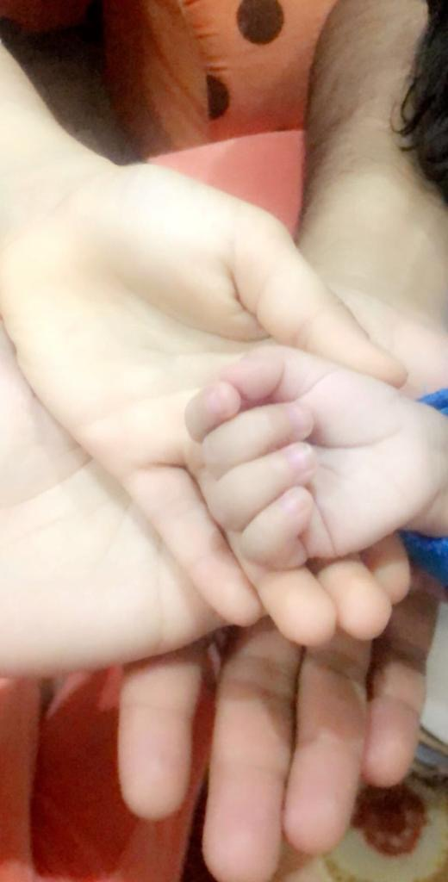
Figure 10. Connectedness.
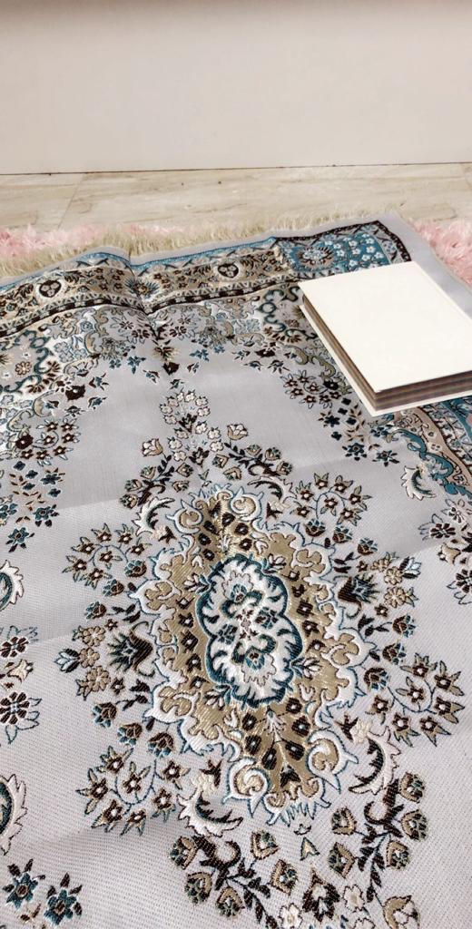  Figure 11. Trust in God. | 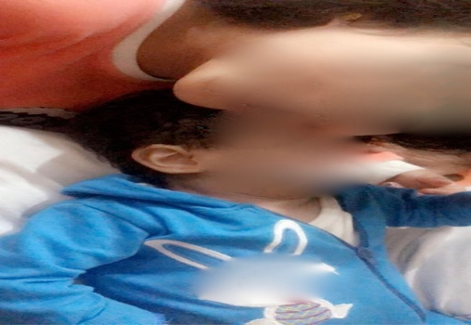  Figure 12. Happiness

Al-Muthabira
Al-Muthabira is a mother of seven. Her oldest child, Fatma, is 27 years old and her youngest, Mahboob, is 6. Mahboob has Down’s syndrome. Al-Muthabira and her husband were excited about the pregnancy, but they decided not to tell their children until the signs started to show. Al-Muthabira lives with her husband, children and a full-time housemaid. Her husband works flexible hours. Al-Muthabira shared her story starting with Mahboob’s birth, providing a detailed description of events, and mentioning numerous characters. Her story was inevitably also that of her family, with Mahboob at the centre of it as a joint responsibility. As she told her story, different voices of sadness, fear, gratitude and love unfolded.
Al-Muthabira felt that her spirituality influences many aspects of her life. Her religious beliefs play an integral role in how she sees her spirituality. She believed that God has plans for her and that his choices are always good: “Whatever God decides is good, because I trust His choices”. This trust has led her to ask God for help, especially when she needs to make important decisions: “I ask him for help”. Al-Muthabira found relief in her religious practices, especially in asking God for help. She frequently repeated the Al-Istikharah prayer (Figure 13), which is recited to ask God for help when facing a decision. Al-Muthabira’s relationships with other people are also spiritual; she believes that her connections with them are very valuable. She finds that being loving and positive by having ‘purity of heart’ can bring people together. To express this, during the interview, Al-Muthabira shared an image that was taken by Mahboob’s sister (Figure 14). Al-Muthabira explained that the picture symbolises stopping negative things, such as bullying, lying and hate. The third image reflected ‘reaching a goal’. The image she chose was of her brother at the top of the highest mountain in Oman, Jabal Shams. She explained that this picture shows a man gazing at the clouds and feeling satisfied after reaching his goal (Figure 15).
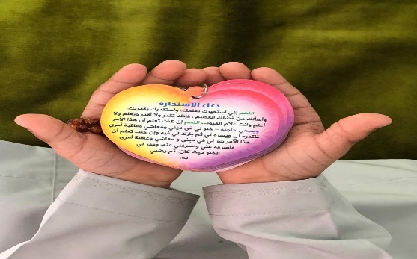
Figure 13. Entrust yourself in God.
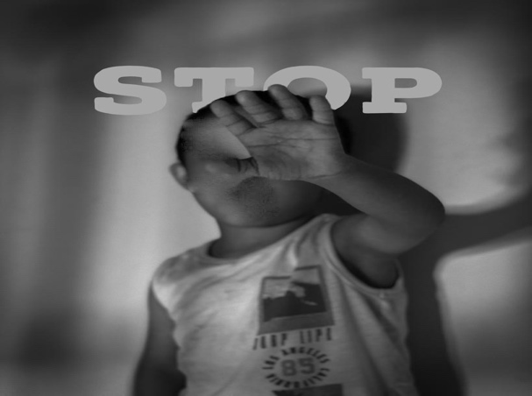  Figure 14. Stop lying, hating and envying. | 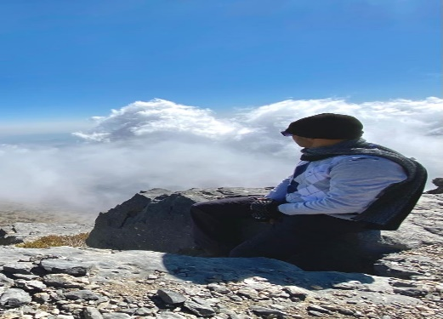  Figure 15. Every person should reach their goal.

Latifa
Latifa is a mother of four children: a 12-year-old boy; 6-year-old twins, Al-Noor, who is a child with developmental delay and Yamman, a typically developing boy; as well as an 8-month-old girl. Latifa works full time and lives with her husband and is a full-time caregiver for Al-Noor. She lives near her parents’ house and receives emotional and practical support from her husband, her parents and her five siblings. Latifa tells a non-linear but clear and succinct story, narrated calmly. She mentions numerous characters throughout the story whom she rarely names. Latifa has agency in the telling; she is self-aware and confident.
Latifa chose the pseudonym Al-Noor for her child, which means ‘the light’ in Arabic. This could reflect Latifa’s perception about Al-Noor being an angel and bringing light into their lives, as light is associated with angels. Latifa’s spiritual beliefs around Al-Noor’s disability are expressed as a sense of responsibility of caring for Al-Noor. Latifa views herself as a strong-minded mother. Latifa is determined to help Al-Noor achieve independence in the activities of daily living (ADLs), ‘my goal in life that my girl would at least reach a level of independence I am satisfied with’. She centres her goal on positive spiritual values rather than negative considerations. Figure 16 depicts stairs in an old fort. Latifa took this picture when she was on a trip to Nizwa, Oman, as she felt that it represents her journey with Al-Noor. The top of the stairs reflects the ultimate goal of Al-Noor’s independence, and the steps reflect the tasks Latifa needs to accomplish to achieve the goal: ‘I feel like in my situation with Al-Noor I need to take one step at a time so we can help her’ Additionally, for Latifa, the feeling of inner peace is very important as it helps her gather the strength to concentrate on her goals and achieve them: ‘a person should be calm to be able to concentrate and all.’ For Latifa, anger is the opposite of feeling peaceful and it prevents her from staying focused on her goals and leads to her failure to achieve them. Latifa used Figure 17 to express the importance of inner peace as a spiritual value. depicts the natural scenery of a beach and clouds. Latifa took the picture because she felt peaceful there: ‘A nice place... I felt this place gives you inner peace and calmness’, which reminded her of Al-Noor because she also makes her feel peaceful’. Being in nature, the mother had an opportunity to connect with herself, feel inner peace and calm and reflect on her goals: ‘calmness and peace help you do things.’ Lastly, Latifa acknowledged that her goals could not be achieved without the help of others: ‘it is not easy… you have to go through obstacles and all, so you need to be patient and cooperate with others to reach your goals’ To demonstrate this, she shared a picture of an incomplete puzzle (Figure 18). She explained that the puzzle represents the obstacles she faces; the colours represent her values of optimism, determination, hope and patience; and, just like life, this puzzle looks beautiful, but it is not void of challenges and hardship, and these cannot be overcome without receiving help from others.
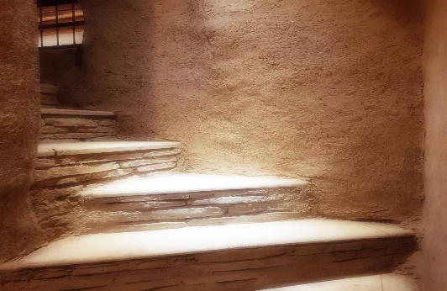
Figure 16. Hope and optimism.
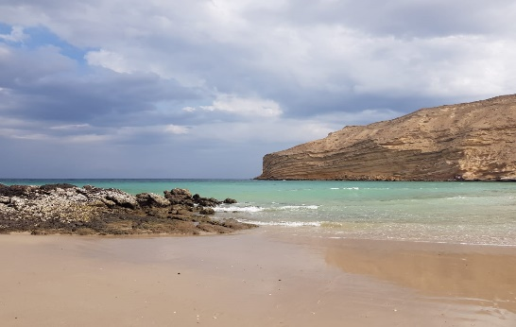  Figure 17. Peace and calmness. | 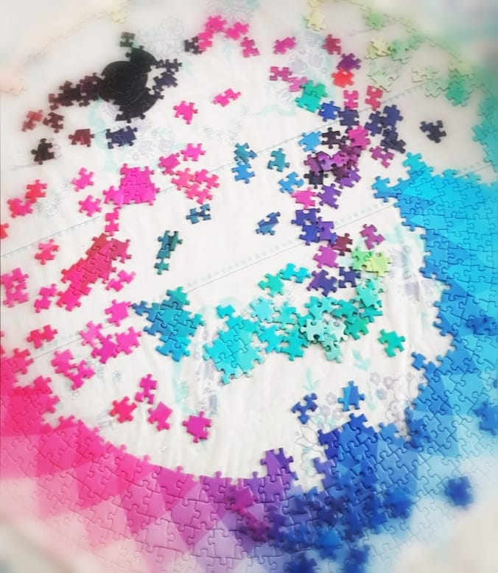  Figure 18. Challenge.

Zumuruda and Al-Fajer
I was contacted by Al-Amal’s mother, Zumuruda, who indicated that she and Al-Amal’s father, Al-Fajer, wished to share their experiences and participate in the study. The interview was conducted in the rehabilitation department while Al-Amal attended rehabilitation sessions. The interviews were conducted separately but Zumuruda attended Al-Fajer’s interview, as she did not seem comfortable for her husband to be interviewed by me without her presence, most likely due to the gender segregation norms in Oman. Nevertheless, Al-Fajer and Zumuruda were friendly and expressive during the interviews and told their stories in detail. They chose the name Al-Amal for their son, which means ‘hope’ in Arabic.
The family lives in a mountainous rural area located two and a half hours away from the capital city, Muscat. They have three children: Al-Amal, the youngest, a 3-year-old boy with developmental disabilities; Shaima, a typically developing 10-year-old girl; and Ahmed, the eldest, a typically developing 13-year-old old boy. They are unable to receive direct support from their extended families, who live 30 minutes away. Due to the location of the house, transportation and accessing services is time-consuming and costly and Zumuruda stated ‘our financial status is not very good’. Therefore, Al-Fajer sets a strict monthly budget for the family.
The parents mentioned Ahmed and Shaima frequently during the interviews as they share a strong bond with them. Ahmed and Shaima currently attend school classes online due to the COVID-19 pandemic. They also play a significant role in caring for Al-Amal, as older siblings in Arab countries are expected to look after their younger siblings (Cicirelli, 1994).
The parents explained that Al-Amal underwent medical, traditional, and spiritual healing. The traditional healing used was wasm, in which an extremely hot rod is used to burn specific areas of skin in the body. The parents explained that the wasm was not their idea, but they were pressurised by family members: ‘It was the society around us, for example, his grandmother, his grandfather, her aunties from both sides, and they all said it would be good and they said: ‘if it doesn’t benefit him, it won’t harm him.’ Zumuruda also sought spiritual healing and Al-fajer supported her ‘Al-Ruqyah Al-Sharia is permitted’. Al-Ruqyah Al-Sharia is reciting specific verses of the Quran to protect from the evil eye and jinns, or spirits.
Zumuruda and Al-Fajer’s spiritual values and beliefs differ slightly. Al-Fajer has a strong belief that life is beautiful despite its struggles and challenges. To express this belief, Al-Fajer shared a picture taken by him that shows a divided falaj (an Omani irrigation system) in the middle of a green farm area (Figure 19). Al-Fajer carefully took the picture from a low angle because he wanted to illustrate that, at the beginning of the path, the falaj is not branched because life is straightforward in the beginning, and the area is green to reflect beauty and optimism, which he says represents the beginning of life. However, life gets more complicated as a person grows, and the falaj becomes branched. Additionally, Al-Fajer believes that there is beauty in every challenge, which is one of his key spiritual values. To illustrate this, he took a picture of cactus trees surrounded by flowers. For Al-Fajer the cactus trees reflect the challenges he faces, and the flowers represent the positive outcomes he gains from these challenges (Figure 20) Also, Al-Fajer finds that arranging transportation is challenging and requires a lot of planning. The family own one car and the parents take their son, Al-Amal, to rehabilitation in Muscat four day per week. The father expressed an immense sense of responsibility, as the car is the only way to take his son to rehabilitation. Al-Fajer expressed this planning process as a spiritual belief. To illustrate this, Al-Fajer shared a picture of a pomegranate tree planted outside his house (Figure 21). He took the picture while Al-Amal was with him. The flowers in the pomegranate tree remind Al-Fajer of the steps he needs to take to keep the vehicle working: ‘I told you that the flowers are organised… I mean, for example, the car needs service every five or six thousand kilometres… umm, petrol is needed to move from a place to another’. In the picture, Al-Fajer inserted an Arabic text meaning ‘glory be to God, thank God’. When asked about it, he explained that the text was added to protect the pomegranate tree from the evil eye and envy − he said that many of his trees suddenly died, which he believes is a result of an evil eye, common belief within the Omani society.

Figure 19. Life is beautiful.
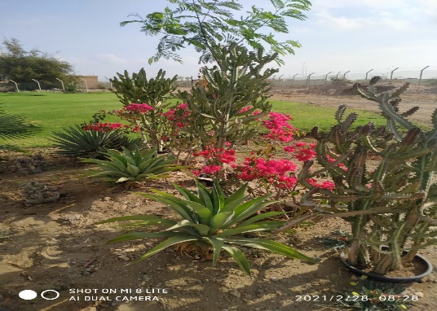  Figure 20. Life's challenges. | 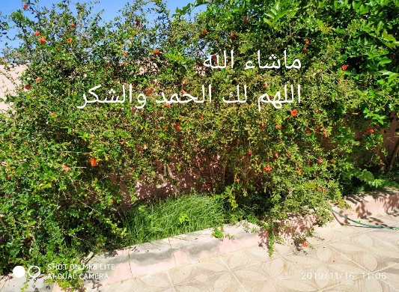  Figure 21. Take steady steps to navigate your life.
Zumuruda’s role as a mother appeared to be children-centred. She has a strong belief that her role as a mother is to satisfy her children’s needs and wants. The spiritual values Zumurada shared were embedded within her role as a mother. Zumuruda shared a picture of homemade dumplings and explained that her husband and children love the dish (Figure 22). Preparing the dish and seeing her family enjoy it gives her positive emotions: ‘I feel happy because my children ask me for it’. Also, Zumuruda appreciates the love and connection with her family, and she feels that love forms a part of her spirituality. To share this, she took a picture of her children watching videos together. She also inserted flower icons because her children love to pick flowers to gift her (Figure 23). She explained that she enjoys watching her children spending time together: ‘I like the connectedness between them’.
Zumuruda daily routine is busy. Four days per week, Al-Fajer, Zumuruda and Al-Amal leave their house before sunrise to reach Muscat and attend the rehabilitation sessions. On their way to Muscat, Zumuruda took a picture of the sunrise (Figure 24). At that time, while heading to a rehabilitation session, Zumuruda felt a sense of spirituality. Watching the sunrise makes Zumuruda feels curious about the day. She feels that while she does not have control over what the day will bring, her trust in God awakens feelings of hope and optimism: ‘A new day tells us that we must be ready, God Almighty plans things for us in secret and we will not know unless these plans happen on that particular day.’
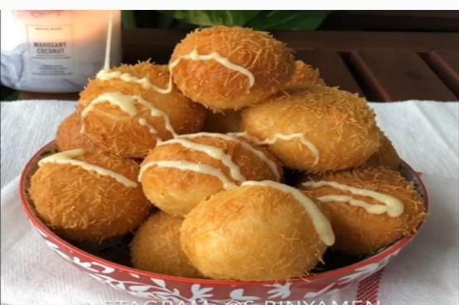
Figure 22. Sweets.
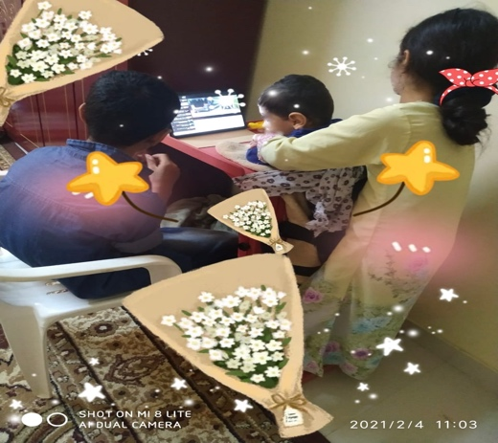  Figure 23. Siblings love. | 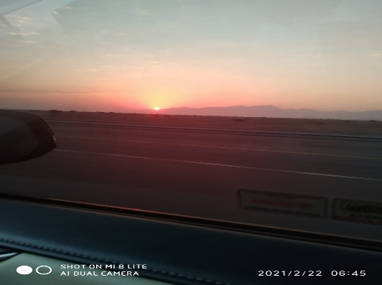  Figure 24. Sunrise.

Khalid and Amani
Mazin’s parents, Khalid and Amani, both expressed interest in participating in the study. Both worked full-time. They take turns in attending Mazin’s rehabilitation appointments. Hence, the introductory session and the interviews were conducted in the rehabilitation department on different days and separately. Khalid’s interview was conducted first, during which he was friendly but seemed uncomfortable; his answers were short, and he needed a lot of prompting, though as the interview progressed, he become more open and interactive. Amani, on the other hand, arrived 30 minutes late for her interview and wanted to get the interview done. She was very open and expressive but rushed to answer the questions towards the middle of the interview as she wanted to go back to her work.
Mazin’s parents live in Muscat near their extended family’s houses. Khalid and Amani, are first cousins, a common occurrence as more than half (52%) of marriages are consanguineous in Oman (Islam, 2012). The parents live together with Mazin and a full-time nanny/housekeeper who helps in caring for Mazin. Every weekday morning, the parents take Mazin and the nanny to Mazin’s grandparents’ house. They return home late in the afternoon, though Amani has on-call shifts on some days. Usually, they have lunch at the grandparents’ house then return to their home in the evening. They both like nature and enjoy the outdoors when they have free time.
Mazin was born when Amani was 29 weeks pregnant. After his birth, Amani was discharged and stayed at her parents’ house for around a month and a half. In Omani culture, it is customary for a woman to stay home, usually with their mother, for six weeks postpartum. Mazin was admitted to the neonatal intensive care unit (NICU) due to low birth weight and health issues. Both parents found this time exceptionally challenging, and Amani described being ‘depressed’ and even said. ‘I wished he dies… I did not want this child’. Amani and Khalid could not share the disability diagnosis with their families – Mazin explained, ‘they won’t get it, they won’t understand’ –so he told his family that Mazin has medical issues: ‘I mean they know he has electrolyte imbalance’. Amani on the other hand could not tell her parents because ‘my parents worry a lot about health-related issues’ and so she did not want to worry them and preferred to not share the news for the first couple of months. Khalid and Amani had to support each other: ‘we told ourselves that it’s okay because there are medications to manage [child’s health issues]… I mean it’s a chronic disease but it’s better than other diseases’. The parents also expressed a strong belief in ‘science’ and emphasised that they only seek medical therapy for Mazin as they do not believe in traditional or spiritual healing. Both Amani and Khalid viewed spirituality positively, however, they shared different values and beliefs.
Khalid shared a picture he took while hunting in the mountains. The picture contains many rocks and a rabbit (Figure 25). Khalid enjoys hunting and often takes pictures of his trips and quarries. He explained that this picture represents life and that behind each rock there is a situation or event that a person may come across, ‘just like when a person is climbing a mountain and they come across multiple different situations’. For Khalid, the rabbit in the image represents luck because rabbits are difficult to find and hunt. Khalid feels that when a person is faced with a difficult situation, he must seek to ‘bring himself luck’ by being opportunistic. He gives an example of attending Mazin’s rehabilitation sessions: ‘I mean I do not have to be with him at the hospital, but I leave work and come… I mean I come to see him and check his improvement’. Also, Khalid shared a picture he took of a lemon leaf (Figure 26). He noticed its unique shape and liked it: ‘it has a unique appearance, special appearance when you compare it to other leaves’. He believes that people would generally label this leaf as ‘different’ or ‘sick’ and wonder ‘why isn’t it like the other leaves?’ Khalid emphasised that being ‘different’ is not necessarily a bad thing because with the leaf ‘it looks unique... like a heart and its colour is also different… and it looks like this naturally with no cutting’. For Ali, Mazin is just like the leaf ‘unique’ and ‘special’ and this a spiritual reflection for Khalid. Lastly, Khalid shared a picture that he took while visiting a hotel. The hotel is located in Al-Jabal Al-Akhdar, a high mountain in Oman. The picture was taken by the edge of a cliff (Figure 27). Khalid was amazed by the hotel; as he reflected on its location, his belief in the power of humans and science heightened: ‘this shows that no matter how cruel nature is, humans can adapt and survive in any habitat… even in a high mountain’. His reflections on the process of constructing the hotel in a tricky location led him to relate it to his son’s condition. He referred to the cruelty of nature, which is reflected by the high, rocky mountain – in Khalid’s life, the cruelty of nature is reflected in the health issues that his son Mazin has. In the picture, human advancement and science enabled the building of the hotel and in Khalid’s life, he is hoping that science will find a cure for his child: ‘humans can build the most luxurious hotels on top of mountains and if a disease is complex and difficult, then science may bring a cure in the future. I mean I believe in science’.

Figure 25. Luck.
  Figure 26. The leaf. | 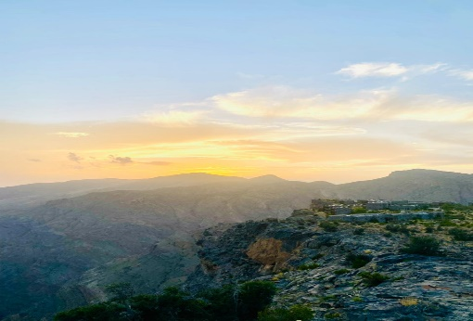  Figure 27. Belief in science.
Amani shared a picture she took while visiting Sur, a coastal city in Oman, which shows a small fishing boat on the shore (Figure 28). Amani felt that this picture is meaningful because it represents making an effort to achieve a specific goal: ‘if you work on something, you will reach your goals eventually, just like the boat sails for a long time to reach the shore’. She believes that when people are dedicated to a goal and when they are determined, they eventually achieve what they aim for: ‘I felt that the picture reflects that people should work with determination and at the end their goals will be reached’. The second image Amani shared was taken when she visited Jordan, in a fort overlooking the city (Figure 29). For Amani, this picture reflects hope and optimism. In the picture, the castle walls look dusty and dull, but the scene of the city is bright and beautiful. Amani feels that this picture reflects her reality, she found looking after Ahmed challenging in the first few months of his life, however, she now enjoys her time with him, so she believes that ‘there is always a bright side’ and ‘if you go through difficulties, things will get better eventually’. Lastly, Amani shared a picture of a man sitting on the top of a sandy hill with his footprint trail visible (Figure 30). The footprints fascinated Amani as she compared them to a person’s impact in life. She reflected on people’s purpose in life, which for her is making a positive impact on the world: ‘if someone does a certain act or something, his impact remains’.
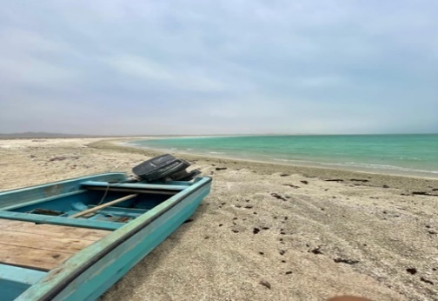
Figure 28. At the end of the journey.
  Figure 29. Hardship will fade. | 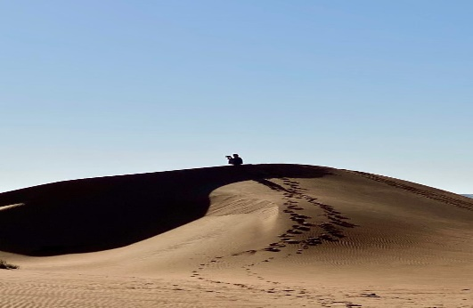  Figure 30. The fruit of determination.

Al-Shumookh
Al-Shumookh expressed interest in participating in the research through the Omani Down’s Syndrome Association (ODSA). I interviewed Al-Shumookh at the ODSA while her son, Al-Amal, had his scheduled special education session. Al-Shumookh did not wear a face mask during the interview, which made it easier for me to see her facial expressions. Al-Shumookh chose the pseudonym ‘Al-Amal Al-Mutajadid’ for her son, which means ‘the renewed hope’ in Arabic. In this section, I refer to Al-Amal Al-Mutjadid as Al-Amal ‘the hope’.
The family lives in a coastal town located two hours away from the capital city, Muscat. The mother, Al-Shumook, is a full-time teacher, and the father, Saleh, is a recent retiree. Together they have five children: Fahad, a 29-year-old man who recently married; Lama, a 26-year-old woman who works full time and lives with her parents; Samia, a 19-years-old woman; Al-Amal, a 15-year-old boy with Down’s Syndrome; and Hamed, a 6-year-old boy. The parents, the four youngest children, and a live-in housekeeper live together. Al-Shumookh explained that her husband is a very caring father and that he and Al-Amal are ‘very attached’. The family lives near their extended families.
During the interview, Al-Shumookh shared stories about her experience and about Al-Amal and Hamed (Al-Amal’s youngest brother). She explained that the older three children are ‘considered old now’ and they are busy with their own lives. Also, Al-Shumookh expressed worries about her child’s future, particularly his education. Al-Shumookh also spoke about how her son Al-Amal experienced stigma because of his disability.
Al-Shumookh explained that after the introductory session, she began to think about her spirituality. She read about it, however, she felt that the topic was ‘abstract’. Nevertheless, she feels that spirituality is about ‘the values the parents want to instil in their children’. Therefore, she took pictures that reflect these values. Al-Shumookh’s first picture shows Al-Amal at the beach (Figure 31). Al-Amal loves the beach, and his father ‘takes him to the beach every day’. Al-Amal is facing the sea and his arms are spread out. The mother explains: ‘I mean he is looking at the beach and saying: “welcome to life” and the sea is extended so it is as though he says: “life is forthcoming”’. For Al-Shumookh, this picture portrays hope. She believes that Al-Amal looks forward to a bright future. The second picture Al-Shumookh shared is a picture of Al-Amal and Hamed, posing (Figure 32). The picture was taken by Al-Shumookh when Cyclone Shaheen hit Oman in October 2021. In the picture, Hamed is standing behind Al-Amal while holding Al-Amal’s shoulders. Al-Shumookh likes this picture because she believes that the way Hamed is standing and holding Al-Amal signifies Hamed’s support: ‘as if he is saying to him, “I’m here Al-Amal, and as long as I’m here, you are safe”. Al-Shumookh teaches Hamed to care for Al-Amal: ‘I try to prepare Hamed to support Al-Amal and at the same time... implement values of care and concern for his siblings’. The last picture depicts Al-Amal sitting outdoors in a chair and sipping coffee (Figure 33). The picture was taken when Al-Amal, Hamed, Saleh, and some male family members went on a three-day camping trip in Al-Ashkhara, a coastal fishing town. The mother loves this picture because ‘it has authenticity… it has some Omani values’. The values Al-Shumookh refers to are the cultural norms specific to men in Oman. Al-Shumookh explained that Al-Amal is sitting ‘confidently’ and holding the coffee cup just like ‘other men’. She continued to explain that some people say, ‘people with Down’s don’t know, they don’t understand… they don’t know Omani values and heritage’. She believes, however, that Al-Amal proves people wrong as she believes that his behaviour in this picture reflects his knowledge of Omani values and traditions.
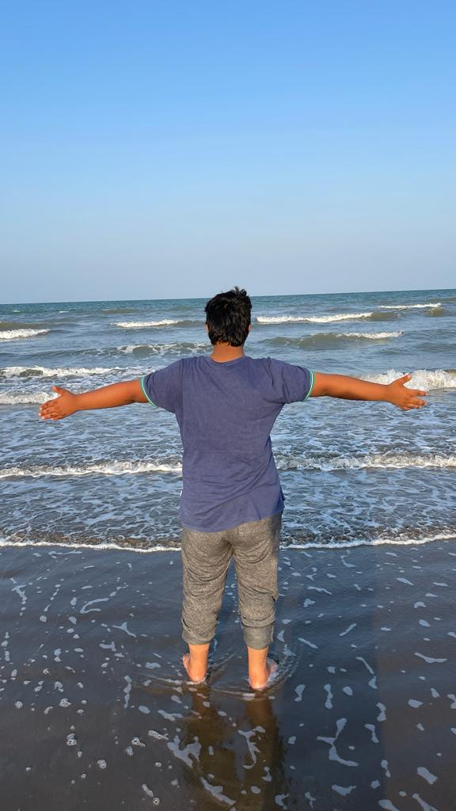
Figure 31. Welcome life.
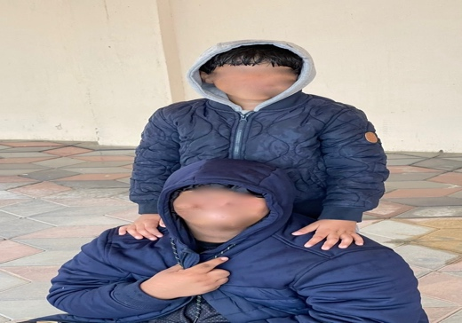  Figure 32. Brother. | 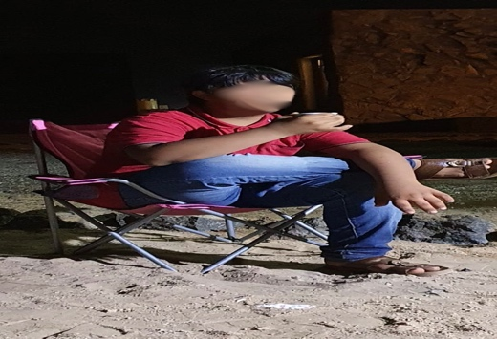  Figure 33. Oman is my identity.

Abdullah and Sada
Hadeel and Rateel’s parents, Abdullah and Sada Al-Sabah, both expressed interest in participating in the study. The parents chose common names as pseudonyms for the daughters (Hadeel and Rateel). Similarly, the father chose a common name (Abdullah) as a pseudonym, while the mother chose Sada Al-Sabah, which translates to ‘the morning echo’. In this document, the mother is referred to as Sada. Both parents work full-time, Abdullah as a government employee and Sada as a medical professional. The parents have two children with developmental delay, Hadeel and Rateel. A joint introductory session followed by separate interviews were conducted. Sada’s interview was conducted first, during which she was emotional but open to sharing her story. At the beginning of the interview, Sada sobbed repeatedly, but she became cheerful as she started sharing her photovoice pictures. In his interview, Abdullah was friendly, but his answers were short, and he still preferred to keep his answers short even when he was prompted. For example, when prompted he said ‘I talked a lot about this picture’ even though he did not elaborate in the discussion. Abdullah became more comfortable, and his answers were longer towards the end of the interview.
Abdullah and Sada are first cousins, a common occurrence as more than half (52%) of marriages are consanguineous in Oman (Islam, 2012). Abdullah and Sada have two children: Hadeel, an eight-year-old girl and Rateel, a six-year-old girl. Both girls have developmental disabilities. Abdullah and Sada live in Muscat near their extended families’ houses. The location of their house was intentional to enable them to receive practical support from their families when needed: ‘We tried to find accommodation near our families… Because of our situation’. After having Hadeel, the parents employed a live-in nanny/housekeeper. The nanny helps in caring for both girls as well as doing household chores. Sada has chronic neck and shoulder pain, which prevents her from carrying her girls, hence she is very appreciative of the nanny’s help: ‘she is my right hand’. The parents also receive considerable practical and emotional support from their extended families, which enables them to work full-time.
Abdullah and Sada explained that many people had approached them to suggest possible alternative therapy. He believes that giving advice about natural remedies is common in Oman, as shared an Omani saying: ‘Omanis say “wrap your finger and they will prescribe a thousand remedies”’. He continued to explain that people suggested ‘Wasm... and some say burn some frankincense’. However, Abdullah said that he never sought these kinds of remedies. However, the parents sought traditional healing that included ‘natural things… honey to strengthen the body’ and spiritual healing that involved reading the Quran.
Abdullah and Sada share various religious and non-religious aspects of their spirituality. When asked about the meaning of spirituality, Sada replied, ‘for me… I mean it can be related to a person’s “self”’. She believes that spirituality can ‘help you mentally’. Sada shared a picture of a notebook (Figure 34). Sada explained that the notebook was a gift from her colleague. She took the photo while she was sitting in her backyard and shared it with her colleague, thanking her for the notebook. Sada clarified that her friend gave her the notebook after a discussion they had on an earlier day. The discussion was about Sada’s willingness to develop herself: ‘I try to change myself always… I try to become a better person’ Her friend recommended that Sada write her goals in a notebook to help her remember them, so she gave her a notebook as a gift. Sada wants to set goals to become ‘a better mother’ and ‘exercise’, and she would like to do these activities to ‘look after myself’. For Sada, self-development is spiritual because she believes that by ‘improving’ herself, she can make her day more meaningful, for herself and her family.
The second picture Sada shared was a picture of homemade shot-glass desserts (Figure 35). Sada prepared the dessert for some guests and took a picture and shared it with her colleagues. Sada is very passionate about making desserts: ‘I really like to make desserts and cookies and cake… I love working on these’. She believes that this is spiritual as it is one of the things that helps her ‘mentally’. Making desserts also provides Sada with an opportunity to be creative, which she particularly enjoys: ‘I like to do new things… I feel something inside… I can’t explain it to you but I like how it feels’-
Lastly, Sada shared a picture of a flower (Figure 36). Sada works in a laboratory, and, during the pandemic, the workload increased while the number of staff was limited. The flower was an initiative from a flower shop to thank frontline healthcare professionals. Sada’s explained that since the start of the pandemic, her job became ‘stressful’ due to increased workload and restrictions to going on leave, leading her to experience ‘mental and physical difficulties’. However, this flower made Sada feel appreciated and cared about. She believes that being cared about is spiritual because it made her ‘happy and proud’.
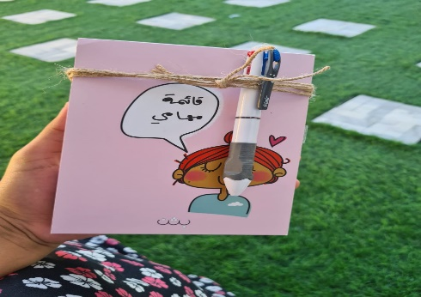
Figure 34. Managing time.
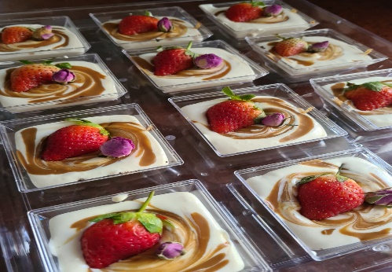  Figure 35. My hobby. | 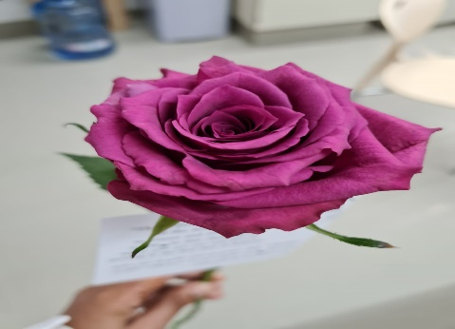  Figure 36. Appreciation.
For Abdullah, spirituality means ‘the things that make you feel better’. Abdullah shared pictures that reflect this meaning. The first picture Abdullah wanted to share was one of Hadeel (Figure 37). The picture shows Hadeel smiling and playing, which Abdullah took on a family visit to the beach. When asked to talk about the picture, Abdullah explained, ‘Hadeel is my daughter… every father loves his daughter’. Abdullah wanted to take a picture of Hadeel because she seemed to enjoy playing: ‘she was happy and laughing’. For Abdullah, spending time with family is spiritual. The second picture Abdullah shared is a picture of a valley (Figure 38). Abdullah took this picture when he was on a trip to Al-Rustaq with other male family members. He finds natural scenery ‘calming and beautiful’. He explained that he also enjoyed the ‘company’. Abdullah believes that going out is a spiritual activity as it helped him ‘relax’ and feel ‘calm’, especially because he spent time ‘outside the house… away from all the pressures’. The third picture Abdullah shared is a picture of the moon (Figure 39), which he took outside his house. Abdullah explained that he particularly enjoys taking pictures of the moon. Abdullah and his brothers often take pictures of different scenes and share them. For Abdullah, observing the moon is a ‘relaxing’ activity: ‘it’s relaxing… you sit under the moonlight’. Hence, he perceives it as a spiritual act.
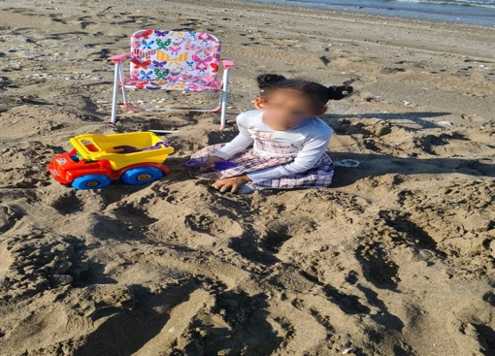
Figure 37. My daughter.
  Figure 38. The water's journey. |   Figure 39. Underneath moon light.

Samia
Samia expressed her interest in participating in the study to her daughter’s physiotherapist. When I contacted Samia to inform her about the research, she was attentive but quiet. We completed the introductory session while Amal, Samia’s daughter, was undertaking a physiotherapy session. During the session, Samia asked a few questions about the photo-taking task and used gestures frequently to demonstrate understanding of the session’s content, for example, by shaking her head. The interview was scheduled on the same day as Amal’s subsequent physiotherapy appointment. Throughout the interview, Samia provided brief answers to the interview questions. She was very emotional (cried) when talking about Amal’s birth and infancy and explained that she preferred not to talk about this period as she found it challenging. Samia seemed comfortable when talking about the pictures she took as she laughed and was eager to share several photographs of her family. However, her answers remained short. Interestingly, her choice of pseudonym for her child was the same as Al-Fajer, Zumuruda and Al-Shumookh; Amal is the Arabic word for hope.
Samia is the mother of four children: an eight-year-old girl, Amal; a six-year-old girl, Janna; a five/six-year-old girl, Leena, and a one-and-a-half-year-old boy. When asked about the children’s ages, Samia seemed uncertain about them. For example, when asked about Janna, Samia replied, ‘she is 4 or 5’, while on a different occasion Samia said, ‘Janna is 5’. Amal has a developmental disability while the other children are typically developing. Samia is a stay-at-home mother, and her husband is a full-time shift work employee. They live together with the children and a live-in housekeeper, near their extended families.
As mentioned earlier, Samia was a quiet participant who preferred not to dwell on the emotional part of her lived experience, particularly the early years of Amal’s life. Samia also expressed that she, and the housekeeper are the main caregivers of the children as her husband has shift work and is not actively involved in caring for them. Unlike other parents, Samia explained that Amal’s caregiving needs are challenging, but only as much as the other children’s needs: ‘I feel like the challenges are just like the challenges with other children… it’s the same’.
Samia reflected on her spirituality and seemed comfortable sharing the photographs she chose. Samia believes that ‘spirituality is something about your consciousness’. She considers reflecting on one’s life a spiritual act: ‘I mean, when you sit alone and think about the things you do’. The three photographs Samia shared were natural scenes: ‘I love nature’. She finds spending time in nature helps her tap into her consciousness. During the interview, Samia was eager to show me additional photographs of family members to provide me with a holistic idea about her experiences. Samia shared a picture depicting the beach and an unclear seabird on the seawater (Figure 40). Samia took the picture when she was visiting the beach one afternoon with her children and her brother and his family. The children played together at the beach and the two families stayed to watch the sunset. For Samia, this picture is spiritual because it connects her to God: ‘it helps reflect on God’s creation… to reflect on night and day… because it was sunset time and I felt spiritual’. Samia’s second picture was taken during her recent visit to Turkey. Samia and her family visited Turkey for medical tourism purposes as the family sought rehabilitation for Amal. The family also visited some tourist attractions, and the picture was taken while the family was in a cable car in a tourist area in Turkey. Figure 41 shows the cable car’s steel wire rope in the middle with some cable cars and trees on either side. Samia enjoyed the experience with her husband and four children, as well as the ‘beauty of the place’. She found the experience spiritual because when she spends time in a similar place she enjoys ‘contemplating on nature’. Samia’s third picture shows a floating walkway on the sea. The walkway is connected to a building and mountains can be seen on the horizon (Figure 42). The picture was taken by Samia’s sister, but Samia loved it and obtained consent to use the image. Samia described the picture as ‘it’s a house and the mountains and the sea… all in harmony’. Samia liked the ‘harmony between the mountains and the sea’

Figure 40. The sea.
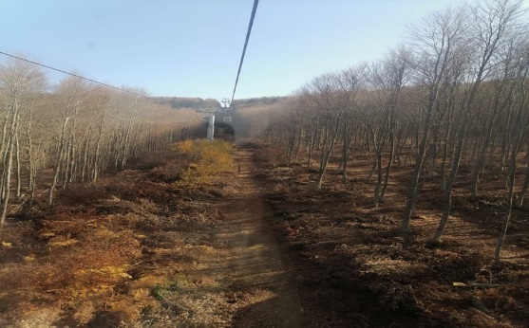  Figure 41. Homeland. | 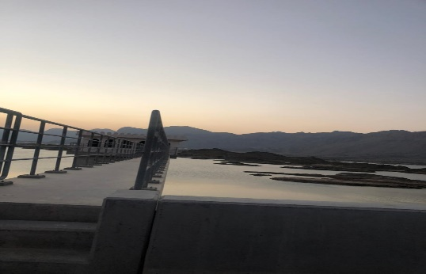  Figure 42. Oman.

Summary
This chapter detailed the individual case analysis using vignettes and included the photovoice photographs that represent the parents’ spirituality. The next three chapters discuss the group experiential themes, highlighting patterns across individual cases. The next chapter begins with Group Experiential Theme 1: understanding disability through a spiritual lens.

Group Experiential Theme 1: Understanding Disability Through a Spiritual Lens

Introduction
This chapter details Group Experiential Theme (GET) 1: understanding disability through a spiritual lens. This chapter begins with an overview of the group experiential themes (GETs) identified from the across-case analysis. Next, GET 1 will be outlined. The chapter concludes with a discussion section in which the relevant academic literature relating to GET 1 is considered.

Overview of the Group Experiential Themes
This section provides a summary of the themes identified across all participant transcripts. Three group experiential themes (GETs) emerged from the analysis, encapsulating the experiences of all 11 parents: Understanding disability through a spiritual lens; managing tensions at the intersection of spirituality and disability; and drawing on spirituality to overcome challenges in accessing and using services.
The findings were derived from two sources of data: photographs (visual data) and interviews (verbal data). The first sub-theme in each GET is primarily experiential and closely grounded in the data, drawing directly on the parents’ experiences of caring for a child with disability, and illustrated using verbal data. The second sub-theme in each GET consists mainly of the photovoice findings, supported by verbal data. The sub-themes shed light on the participants’ spirituality as demonstrated by the photographs they took of things that represent their spirituality. Therefore, the second sub-themes explore the relationship between the spiritual aspects of the parents’ experiences that relate directly to their parenting. Table 8 presents the GETs and associated sub-themes.
Group Experiential  Theme | Sub-themes
Understanding Disability through a Spiritual Lens | - ‘The Sick Child’: Concepts, Beliefs, and Attitudes Towards Disability  - ‘My Child Is Unique’: Parents’ Spiritual Perceptions of Their Child with Disability
Managing the Tension at the Intersection of Spirituality and Disability | - ‘Why God, Why Did You Give Me This Child?’: Reconciling Religious Beliefs with the Child’s Disability  - ‘I trust God’: Connecting with God
Drawing on spirituality to Overcome Challenges in Accessing and Using Services | - ‘It is Not Easy’: Navigating the System  - ‘No Matter How Challenging Life is, We Must Face it and Overcome the Challenges’: Building A Spiritual Foundation to Overcome Challenges  - Personal and Spiritual Growth
Table 9. Presentation of Group Experiential Themes.

Table 9 provides a visual presentation of the prevalence of sub-themes across participants. The table shows that the sub-themes are relevant to at least half the participants. Although themes were separated during the analysis process, many of them are related, and this is apparent throughout the narrative account.

Group experiential theme | Sub-theme | Shaikha | Al-Muthabira | Latifa | Al-Fajer | Zumuruda | Khalid | Amani | Al-Shumookh | Sada | Abdullah | Samia
Perceptions of Disability | ‘The Sick Child’: Concepts, Beliefs, and Attitudes Towards Disability | x | x | x | x | x | x | x | x | x | x | x
Perceptions of Disability | ‘My Child Is Unique’: Parents’ Spiritual Perceptions of Their Child with Disability | x | x | x | x | x |  |  | x
Managing the Intersection of Religious Beliefs and Disability | ‘Why God, Why Did You Give Me This Child?’: Reconciling Religious Beliefs With the Child’s Disability | x | x | x | x | x | x | x | x | x
 | ‘I trust God’: Connecting with God | x | x | x | x | x | x | x | x | x | x | x
Accessing and Using Services | ‘It is not easy’: Navigating the System | x | x | x | x | x | x | x | x | x | x | x
Accessing and Using Services | ‘No matter how challenging life is, we must face it and overcome the challenges’: building a spiritual foundation to overcome challenges | x | x | x | x | x | x | x | x | x | x
Accessing and Using Services | Personal and spiritual growth | x | x | x |  | x |  | x | x |  | x | x
Table 10. Prevalence of Sub-themes across participants
The GETs are presented and discussed in turn. I have aimed to sample the quotes proportionally across participants so that individual experiences can be illuminated. Extracts from at least half of the participants who related to each sub-theme are included to support the claims made (Smith and Nizza, 2022). Throughout the narrative, I have aimed to capture convergences and divergences, therefore highlighting both shared and distinct experiences while also exploring both the depth and the breadth of experiences.

Group Experiential Theme 1: Managing the Tension at the Intersection of Spirituality and Disability
Group Experiential Theme (GET) 1 describes the parents’ perceptions and beliefs regarding their children’s disability. GET 1 is underpinned by two sub-themes: ‘The sick child’: concepts, beliefs, and attitudes towards disability, which details perceptions about disability and their intersection with the parents’ experiences of social stigmatisation, and ‘My child is unique’: Parents’ spiritual perceptions of their child with disability, which encompasses the parents’ spiritual values pertaining to the social context of the parents’ and their children's lives. The first sub-theme includes the parents’ descriptions of their lived experiences using the verbal data from the interviews, whereas the second sub-theme presents the photovoice findings that pertain to the parents’ perceptions of their children.

Sub-Theme 1: ‘The Sick Child’: Concepts, Beliefs, and Attitudes Towards Disability
This sub-theme describes the parents’ worldviews regarding their children’s disabilities by exploring the concepts they use to refer to their child’s disability. The majority of parents (10) referred to the concept of ‘normal’ or tabiei to understand and describe their child’s disability, with disability viewed as a deviation from normal/typical development. This sub-theme explores four ways in which parents described disability: disability as the difference between ‘normal’ and ‘abnormal’, disability as the difference between ‘sick’ and ‘healthy’, disability as misfortune, and the rejection of difference. The sub-theme also explores how neglect versus cleanliness was linked to acceptance of disability and how these perceptions of disability shaped the parents’ hopes, worries and expectations for the future. This sub-theme also describes how parents believed other people’s views of disability from cultural perceptions of disability in Oman influenced their social responses to the parents and children with developmental disability in terms of experiencing stigma or compassion.
Parents expressed that their children’s disability is what makes their child ‘different’ or ghayr from typically developing children when they addressed delays in developmental milestones. Parents also spoke about what they perceive to be the children’s differences concerning additional caregiving needs in comparison to their typically developing children. Additionally, parents referred to their child with disability as mareedh, which is most closely translated as sick, referring to disability as a medical disease that needs to be fixed. Latifa explained that Al-Noor’s ‘difference’ was noticeable early on:
We noticed that Al-Noor was different since she was born. I mean, she is different from other children... So, I mean, thank God, when we noticed that she was different, we did not just sit and do nothing, we took her everywhere. (Latifa)
Latifa referred to her daughter’s ‘difference’ in relation to the developmental delay that differentiates her from typically developing children, the identification of which accelerated their efforts to access therapy. Latifa continued to highlight the differences she perceives when she compared Al-Noor with her typically developing twin brother:
We noticed that Al-Noor showed slowed development in every milestone… I tell you when she was born even her eyes wouldn’t open… I mean for a month or so her eyes… I mean she was slow… did not open her eyes… similarly… I mean smiling… her smile was not like other kids… I mean even when you compare her to her twin brother, I mean he responded more and understands. (Latifa)
Here, Latifa engaged in social comparison as she noticed that Al-Noor was not as interactive or physically active as her twin brother. Al-Noor’s perceived difference lies in the delayed achievement of milestones when compared to typically developing children. Like Latifa, Shaikha highlighted her child’s ‘difference’ from typically developing children. She found the parenting experience ‘different’ because her son – Adam, a child with global developmental delay – needs close supervision and had intense caregiving demands:
I mean it is different from having a normal child… I mean you have to hold him… you must hold the toy… he does not have the strength to hold it by himself. (Latifa)
Shaikha used the word ‘different’ to describe the parenting experience of caring for a child with disability, which implies that being the ‘same’ or caring for a typically developing child is more usual/normal. Shaikha gave an example of the perceived difference: ‘he does not have the strength to hold it [the toy] by himself’. This may pertain to the muscle weakness that prevents Adam from achieving expected milestones, or it may indicate a sense of loss, as seeing her child holding a toy is perhaps perceived by Shaikha as a fundamental experience of parenting.
When Shaikha introduced her children through a photograph she shared, she explained:
This child [pointing at the typically developing daughter] there is nothing wrong with her and this child [pointing at Adam] is sick. (Shaikha)
Shaikha described Adam as ‘sick’ or mareedh, a word in Arabic that serves several meanings: disease, deviation or deficiency. These meanings were reflected in the participant’s discourses. The word ‘sick’ was used to refer to the child’s disability, in contrast to using ‘healthy’ to describe her normally developing daughter. The term indicates that disability needs to be ‘cured’.
Similarly, Al-Fajer, the father of a child with global developmental delay, spoke about the time the family learned about his son’s disability: ‘We realised that Al-Amal is sick and has hypotonic nerves’. Al-Fajer referred to the medical cause of his son’s disability by emphasising the medical explanation but shows a lack of accurate understanding of the cause of Al-Amal’s disability. Nevertheless, his understanding of Al-Amal’s disability seemed to encourage him to seek rehabilitation. It is important to note that it is common among Omanis to refer to hypotonia, decreased muscle tone, as ‘hypotonic nerves’, usually in reference to the medical care needed to treat it.
The parents’ binary normal/abnormal understanding of disability extends to shaping their hopes and worries for the future. Being normal equates to living a ‘normal’ life in the future, therefore, Khalid who has a child with developmental disabilities caused by a genetic disease, hopes for a cure:
I want him to live a normal life… I mean to go back to… I mean they told us that there is no cure but with the advancement of knowledge or something God willing, they will find a cure. (Khalid)
Khalid wishes for his son, Mazin to live an ordinary life. In the original Arabic transcript, the phrase Khalid used is yaeish tabiei, which can be translated as ordinary or common life. This normality construction depends on the dual meaning of the word, something that is both normal and frequent. When asked to explain what he meant by normal, Khalid elaborated:
Movement…that he walks and interacts because his age is advanced but his development is comparable to a 7 months old normal child… Amani’s nephew is the same age…they were born a week apart and he already started to walk and talk. (Khalid)
For Khalid, the construction of normality entails being physically and cognitively able, as this is common/normal, the opposite of having developmental delay. Mazin is compared to a typically developing family member from a physical development aspect. Khalid continued to explain: ‘we see that he is normal now… but we do not know maybe in the future’. Khalid may be perceiving Mazin as ‘normal now’ because he is still a young toddler, and his physical disability is not prominent. Nevertheless, in the future, his physical disability may become obvious, and Mazin will no longer be viewed as ‘normal’.
Al-Shumookh, whose son Al-Amal has Down Syndrome (DS), worries about his feelings when he becomes aware of his ‘difference’, as she is concerned about how his limited abilities will affect his social interactions with typically developing children: ‘How will he feel because he is different from his siblings and his cousins… he will see that he is different… he won’t be able to do things… you get it?’
In contrast to these participants, the experiences Samia shared were completely devoid of terms such as ‘abnormal’ or ‘sick’. Instead, she emphasised that her daughter’s disability does not make her ‘different’ from other children nor does it impose any additional caregiving challenges, even though her 8-year-old child needs assistance with all activities of daily living: ‘the challenges are just like the challenges with other children… it’s the same’. However, during the interview, questions related to her child’s disability brought up difficult feelings as Samia cried heavily and was unable to share a detailed account of her lived experience and avoided discussing any challenges related to her daughter’s disability. She explained that she found talking about her daughter’s disability difficult:
I: Can you talk about it?
Samia: (crying) It’s difficult.
This account suggests that Samia was distressed and sad/ heartbroken. Shaikha echoed this as she appeared to feel sorry for people with DS she had met, describing them as ‘two poor people with Down’s Syndrome’.
Viewing disability as a misfortune was reflected in Sada’s account, as her aunts attempted to support her emotionally because she is a mother of two children with developmental delay. However, they made her feel sad and frustrated instead. Sada explained that her aunts can be ‘overly sympathetic’:
They say: ‘oh poor thing, she has two girls like this’… I mean I accept my situation and I continue to live… I do not live in sadness so why do you take me back to sadness? Or sometimes they say ‘poor thing’ in front of a group of people… I mean sometimes an aunt would say ‘may God ease it for you’ and I feel it’s okay to say it to me in person and when it’s only us but when they say it in a group of people it makes me feel weak… I mean it’s uncomfortable. (Sada)
Praying for her child in front of other people and calling her ‘poor thing’ or asking God to make caring for her children easier, made Sada feel sad and uncomfortable as she was pitied in front of others. Being pitied in front of others also brought difficult feelings for Latifa as she felt ‘weak’, this may indicate that she felt humiliated or experienced a sense of inferiority. Sada highlighted the presence of others, maybe indicating that her aunt’s sympathy would have been viewed positively if it was expressed privately. She explained that while she had overcome the sadness she initially felt when the girls were diagnosed, her aunts’ prayers and explicit sympathy frustrate her and remind her of the ‘sadness’ she previously experienced. The aunts’ view of disability indicates that people with disability and their parents deserve to be pitied.
Participants spoke about how other parents of children with disability in Oman approach their children with disability. They explained that they found some children with disability within the Omani society to be neglected by their parents, as they appear not cared for or not dressed well, emphasising their ‘difference’ from typically developing children who are better looked after. Al-Muthabira explained that before having Mahboob, children with Down Syndrome, including the neighbour’s child, also scared her due to their appearance:
Frankly, when I used to see a child with Down’s I used to get scared sometimes. I mean they do not dress them well… because they have special needs, they do not care about their clothes, their hair or their body, so we feel that they are different. (Al-Muthabira)
Al-Muthabira said that some children with Down Syndrome are neglected by their parents, which results in people viewing them negatively. Therefore, she pays additional attention to her son’s appearance and receives compliments, even from medical health professionals:
Doctors everywhere say that Mahboob is well-presented. He looks stylish and all… even the doctor at the health centre says: ‘You are different, glory be to God… some parents do not care about their children and they look messy… you give him confidence, dress him nicely, brush his hair… the child becomes confident. (Al-Muthabira)
Health professionals appear to confirm Al-Muthabira’s perception about parents neglecting their children with disability, with Al-Muthabira described as ‘different’ to other children with disabilities. It also appeared that health professionals attributed Al-Amal’s self-confidence to the care Al-Muthabira provided to him. Al-Muthabita was asked to elaborate on how his appearance helps with his confidence:
When he gets dressed, he goes and checks himself out in the mirror and all… yeah even at the optometry clinic they even sometimes… that lady says (imitating) ‘I like his outfit I must take a picture’ (laughs). (Al-Muthabira)
Al-Muthabira seemed to be satisfied with how caring for Al-Amal makes him happy, as she was enthusiastic when she talked about his reaction after getting dressed. Zumuruda also explained that she had met other parents of children with disability who neglect their children, linking it to ‘acceptance’ of the child’s disability:
I mean I know children who are like Al-Amal but they are not accepted… I mean they do not care about them as I care about Al-Amal… I see that their children are always dirty, I mean they do not care about the child’s food and all. I can’t think of a single day where I left Al-Amal dirty, I mean I change his outfits regularly… myself, the father and Shaima. (Zumuruda)
Here, Zumuruda explained that, unlike families who do not embrace and accept their child, she and the other family members make efforts to ensure that Al-Amal is cared for, prioritising his cleanness and appearance, indicating that keeping a child with disability clean and well-presented is a sign of parental acceptance of the child’s disability. Like Al-Muthbiara, who was described by healthcare professionals as ‘different from other parents of children with disability’ because she cared about her child, Zumuruda also compared herself favourably to other parents: ‘They do not care about them as I care about Al-Amal’.
Participants spoke about their perceptions of other people’s beliefs about disability and how these perceptions influence how they engage with others and with their children. Al-Fajer suggested that negative perceptions about disability held by people in society are deeply ingrained:
Some people show contempt towards people with disability and neither I nor others or others can change it. These people exist whether we like it or not so I worry that people might look at him like this… I mean I worry that he will feel less of a person when an ignorant person looks at him like this or when a person who does not accept this group of people sees him… if a person looks at him with contempt, how will he feel? His disability is out of his control, he was put in this situation. Me as a father, or a guardian, I tried my best to help him become a normal person, so nobody criticises him. (Al-Fajer)
Al-Fajer’s repetition of ‘others’ seems to signify that peoples’ negative perceptions are difficult to alter. He appeared to worry about his son’s feelings if he faces stigma from people in society. While Al-Fajer believes that some people view people with disability as less than human, he seemed to believe that this is unfair because ‘disability is out of his control’. Al-Fajer believes that these negative perceptions are unlikely to change, therefore, he made it his responsibility as a father to help his child integrate into society to protect him. This must be a great responsibility to hold as Al-Fajer believed that he has to do his best to help Al-Amal ‘become normal’. However, if Al-Fajer does not see his child achieve developmental milestones, or if the child’s disability becomes more prominent, this might be emotionally challenging for Al-Fajer.
The participants went on to describe examples of their interactions with extended family members. Al-Shumookh and Al-Fajer appeared pleased that their child was treated like other typically developing children when describing their extended family members’ interactions with their child:
I mean they do not treat him, for example, they do not alienate him or see him as a special case, you get me? I mean, they treat him like they treat their own children. I mean, they treat him in a normal way. (Al-Shumookh)
I mean they are realistic... they greet him like they greet a normal child. For example, my dad says, ‘bring him to me so to say hello to him’… my mother is the same and my brothers… my young brothers play with... I mean they do not make him feel that he is different. (Al-Fajer)
Both Al-Shumookh and Al-Fajer appeared content that their extended families interact with their children with disability as they would with typically developing children in the family, and do not appear to stigmatise their children because of their disability because they are perceived as ‘different’. They seem to have low expectations for how their close family members respond to their child and appreciate that these expectations were exceeded. They seem to appreciate seeing their child being treated and greeted like typically developing children, rather than being ignored or treated negatively: ‘they do not make him feel that he is different’ and ‘they treat him like they treat their own children’. Al-Fajer explained that his family is waqiea, ‘realistic’ or ‘pragmatic’, maybe indicating that his extended family set realistic expectations of what his son can and cannot do, therefore grounding their interactions with the child on their ‘realistic’ expectations.
Interestingly, in different parts of their interviews, Al-Shumookh, who like Al-Fajer praised her extended family’s interaction with her child, mentioned experiencing stigma from some extended family members. Al-Shumookh used to take her son Al-Amal to all family gatherings until she learned that some extended family members locked him outside their house: ‘to be honest recently… they kicked him outside the house, and they locked him out’. When asked about her feelings, she responded:
What did I feel? Of course, it was painful… I mean you know this is my child… and they are not strangers… if they were strangers, I’d make an excuse for them… I mean this is their child, you get me? What would I feel? Happy? I felt sad… I felt angry… I felt oppressed. (Al-Shumookh)
This encounter is full of negative feelings. Al-Shumookh seemed disappointed that her son was treated negatively, especially because family members initiated this behaviour, leading her to feel a combination of anger, sadness, pain and oppression. However, Al-Shummokh decided not to confront her family members because she ‘didn’t want to make it big’, perhaps worrying that confrontation would cause family conflicts and negatively influence the family ties that are highly regarded in a collectivist society like that of Oman. Instead, Al-Shumookh decided to limit her son’s interaction with them: ‘now I try not to let him visit them as much as I can’. These sentiments were echoed across accounts, where parents viewed stigmatisation as a barrier to social participation.
Shaikha shared similar experiences when interacting with extended family members as she felt judged and pressured when they commented on Adam’s lack of physical development. Shaikha found that the social restrictions due to the COVID-19 pandemic protected her from being asked questions. She worried about the easing of social distancing restrictions because she will now have to face these questions again:
Even before corona, I actually could not go out, because people ask. People keep staring at him I mean [mimicking people]: ‘Oh we saw this child a couple of months ago and he is still the same’... society puts a lot of pressure. I even worry when corona ends, what will happen to me? Because they have not seen him for months. So now, he will be 2 years old, they will see him, and he will be just the same. (Shaikha)
Here, Shaikha expressed a fear of being judged as she worried about future social interactions and the judgements people might make about her child’s restricted growth. Shaikha appeared to be overwhelmed by the judgements people make about her child and her as the mother of a child with disability: ‘society puts a lot of pressure’. This pressures her to see the child gain developmental milestones, which in Adam’s case is challenging due to his global developmental delay. Later in the interview, Shaikha explained that she does not take Adam to social gatherings, which could be an attempt to avoid the ‘pressure’ she anticipates. She also does not trust anyone else to care for him; therefore, she does not engage in social activities:
I mean I did not know if I could cope, so it was very stressful… I mean people go to weddings, birthdays… umm, I know that these things are silly but when a person is deprived of all of them… (Shaikha)
Here, Shaikha dismissed the importance and value of social interactions describing social events as ‘silly’, even though she seemed willing to participate in these activities as she compared herself to others who attend them. However, dismissing the value of social engagement did not make the experience easier as she still experiences stress and finds it challenging to cope with being a full-time carer while not having an opportunity to engage in social events. She felt as though she was ‘deprived’, or mahrooma, of participation. The word mahroom in Arabic translates to deprived, disadvantaged, forbidden and destitute. It appears that Shaikha finds social interaction as something essential to her well-being, but that the opportunity to participate and engage was taken away from her due to perceived ‘societal pressures’.
Lika Al-Muthabira, Amani explained that she seldom goes out with Mazin. Therefore, she said that they never encounter any negative social interactions:
When I am home it’s easy but if I go out, it gets difficult… at the beginning, this was preventing me from going out because I felt like home is the best place for him… but I started to feel that I was being unfair because he does not go out and does not see new things… so I try to take him out now but I still find feeding him difficult, I mean I can’t feed him outside home. (Amani)
Amani believes that ‘home is the best place’ for Mazin. It appeared as though the home is Amani’s comfort zone, where she can care for Mazin and perhaps protect herself from external pressures. However, Amani seemed to feel guilty, describing herself as ‘being unfair’ as Adam was restricted to the home environment. But Amani found caring for him outside the house challenging, especially when feeding him. When asked about why it is difficult to feed him outside the home, she explained that he gags and vomits when he eats due to swallowing issues, so she worries about what other people might think: ‘I feel… if I was in a restaurant in front of others, they would think it’s weird… they would say “what’s wrong with her”’. Amani’s fear of embarrassment and stigmatising views lead her to consider home as a haven.
The parents described their experiences with healthcare providers who seemed to hold negative perceptions of disability. For example, Latifa and Sada experienced negative interactions with rehabilitation professionals and believed that their attitudes are a result of negative attitudes towards disability, Sada explained: ‘some therapists hesitate when they see these children’. Latifa also explained:
In some places for example, in this area REHABILITATION, not everyone… I mean even the therapists who work do not want to work… It happened to me once… the therapist just let the time pass and did not explain anything to us… so I feel that you need to sit with parents and educate them… tell them. (Latifa)
Latifa mentioned the word ‘rehabilitation’ loudly and appeared to be frustrated because healthcare professionals, who are aware of disability and ought to support the parents and educate them, seem to be unwilling to work with children with disability, adding to the vicious cycle of negative perceptions.
In contrast to this experience, Latifa also experienced positive social interactions. For example, she talked about a positive relationship between a teacher and her daughter:
Sometimes when people know about her condition they show compassion and all… at the nursery she was in… one of the teachers was very attached to Al-Noor… she said that she loves her more than her own daughter… so you feel that some people accept her and others… glory be to God. (Latifa)
Al-Noor’s teacher expressed love and compassion towards her as she told Latifa that she loved Al-Noor ‘more than her own daughter’. It is clear from this extract that Latifa values this positive interaction as she praises God; however, Latifa also experienced other encounters that left her feeling disappointed.
This sub-theme set out to explore disability perceptions held by parents of children with disability and other people within the community with whom they have close contact. The participants used terms like abnormal, different or sick, reflective of wider social narratives surrounding disability. The participants, however, did not seem to feel their perspectives towards their children were negative. The participants described difference and sickness as it related to their children’s vulnerability as well as their hopes, dreams, fear and desires for them. The participants’ accounts suggested that some people within their social circles, sometimes even close family, held negative views about disability, resulting in negative interactions and stigma, even from some healthcare professionals. Some parents experienced psychological difficulties and considered several strategies for managing the negative interactions they faced, for example, avoiding social interaction. Nevertheless, this engendered feelings of isolation and exclusion for some participants. Only one parent (Latifa) shared a positive account and some parents made efforts to present their children positively to society by keeping them clean and well-presented, manifesting acceptance of the children’s disability.
Reflective Box
Through supervision and re-reading the transcripts, I noted that I did not think deeply about the language the parents used to describe their children. When the parents referred to their child with disability as ‘sick’, I initially took it for granted. Later, my supervisors enquired about the use of ‘sick’ and I realised that I have become accustomed to hearing people with disability being called sick and therefore did not question it. This is due to me being an insider and I consider this to be linked to my inexperience as a researcher, as I did not always consider the words the participants used and the associated meanings. This also led me to reflect on my own perceptions of disability, which were mainly based on the medical model, and the words I use to refer to and describe disability.

Sub-Theme 2: ‘My Child Is Unique’: Parents’ Spiritual Perceptions of Their Child with Disability
The parents shared seven photovoice photographs that illustrate their spiritual understandings of their children’s disability and their children’s place in the social context. The photographs revealed aspects of the parents’ experiences and emotions that did not emerge in the verbal description of events. The photographs also elicited a narrative change as parents spoke about their personal, spiritual understandings of disability, which somewhat challenged or rejected the traditional perspectives mentioned in sub-theme 1. The parents spoke about how their spiritual perceptions of their children transcend the socially perceived ‘differences’ imposed by their disability. Also, the parents talked about their spiritual beliefs concerning their social interactions and their children’s place in the world.

The parents shared photovoice pictures to illuminate how their personal spiritual beliefs transcend their perceptions about disability and go above and beyond societal descriptions. The parents’ personal spiritual values and beliefs reflect how they see their children. To share his spiritual belief, Khalid shared a photo he took of a heart-shaped lemon leaf (Figure 43).
Figure 43. The leaf: the only leaf that looks different from the other normal leaves in the lemon tree.
When asked to describe this picture, Khalid explained:
This is a lemon leaf that fell off from a lemon tree and is different from the rest of the leaves… we judge it and say it’s sick or different… why isn’t it like the other leaves? But it has a unique appearance, a more beautiful and special appearance when you compare it to other leaves… for me, this leaf is like Mazin. I mean Mazin is the only child in the family that has this genetic disease and he has a cousin who is normal, but I have Mazin and for me, he is like this leaf... different but something substantial to me… and it looks like this naturally with no cutting. (Khalid)
Khalid used this picture as a visual metaphor for his son Mazin. Khalid believes that people would generally label this leaf as ‘different’ due to its unusual appearance, indicating that Khalid believes that societal views encourage viewing disability as an unwanted ‘difference’. He explained ‘we judge it’, implying that he also holds similar perceptions; however, as Khalid spoke about his spiritual beliefs while describing the photograph, he expressed this ‘difference’ in positive ways, as ‘unique’, ‘beautiful’ and ‘special’ or mumayaz. This had a positive influence on their father-son relationship as Khalid described Mazin as ‘different but something substantial to me’, emphasising that Mazin’s disability does not lead to emotional distance – with Khalid using the word jawhari, to describe Mazin’s position to him. Jawhari means substantial, essential and intrinsic, indicating that Mazin holds a central place in Khalid’s life. Khalid also engaged in social comparison as he compared Mazin to his typically developing nephew, whom he described as normal just like the ‘normal leaves’.
Other parents, like Al-Fajer and Al-Shumookh, also engaged in social comparison and talked about the uniqueness of their children compared to other children with disability. For example, Al-Fajer believes that his son, Al-Amal, unlike other children with disability, is special: ‘my son has many positive things... he is not like other children who cry when you put them somewhere’. Likewise, Al-Shumookh compared her son favourably to other children with Down Syndrome: ‘even his speech is good when you compare him to other children like him’.
Like Khalid, Shaikha also spoke about her perceptions of her child as she shared a photograph of her children smiling (Figure 44).
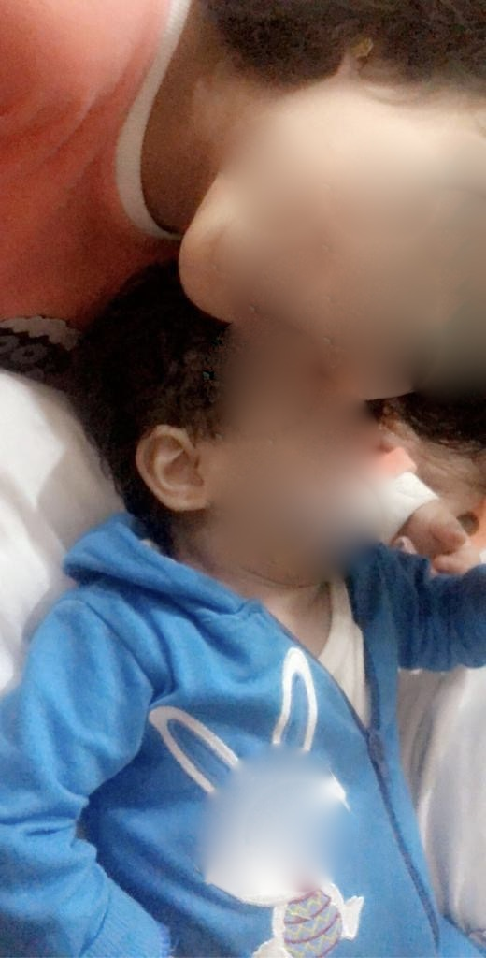
Figure 44. Happiness: The peak of my happiness is my children’s happiness.
The picture includes her typically developing daughter leaning towards her brother, Adam, who has developmental delay:
I mean, as a mother it does not differ for me. I mean, I just see their smile and its enough for me. I mean, it does not differ for me that this child is sick, and this one is not. When they laugh, they are the same, and they are my children. (Shaikha)
Like Khalid, Shaikha also shared her views of her son and how this influences her relationship with him. Shaikha emphasised that Adam’s disability does not mean his happiness or laughter is less valuable than that of his sister; instead, Shaikha values and enjoys both children’s happiness equally as she can see past her son’s disability and enjoy his presence as her son rather than as a ‘sick’ child who needs additional care. Shaikha affirmed a sense that both children belong to her: ‘they are my children’, confirming that she perceives them similarly. For Shaikha, when she sees both her children happy, everything else seems insignificant: ‘I just see their smile and that’s it’. When asked about how this experience reflects her spirituality, Shaikha replied: ‘family, tranquillity, serenity. I mean it is the fruit of motherhood, of creating a family’. Knowing that her children are happy brings her peacefulness and calmness.
Abdullah also shared a photo of his daughter Hadeel (Figure 45). The image, which Abdullah took on a family visit to the beach, shows Hadeel smiling and playing.
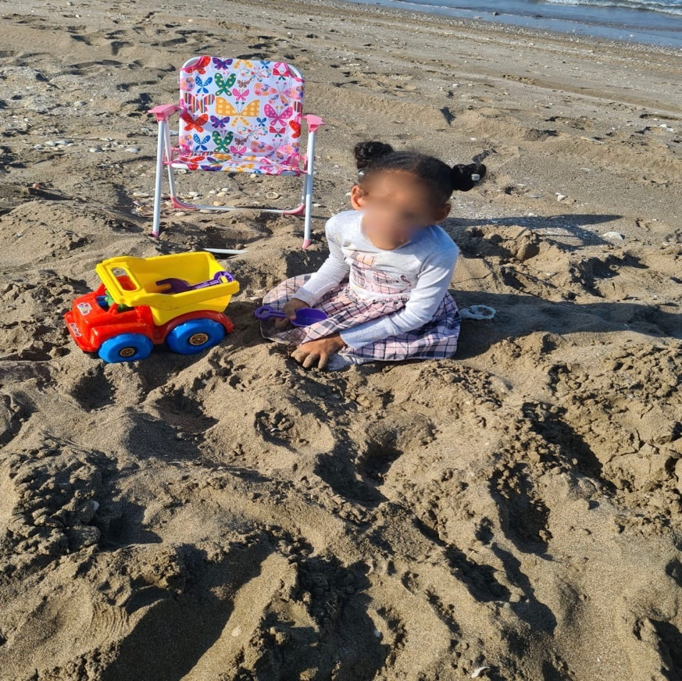
Figure 45. My daughter: Keep your loved ones smiling as much as you can.
When asked to talk about the picture, Abdullah expressed his love for his daughter, albeit indirectly:
Hadeel is my daughter… every father loves his daughter, but this one… we went to the beach a couple of days ago and we were playing… it’s both play and exercise… physiotherapy I mean and play… we buried her legs in the sand and we got her to exercise… we stayed there for almost an hour and she was laughing. (Abdullah)
Abdullah conveyed a powerful expression of emotion as he explained ‘every father loves his daughter, but this one’, maybe indicating that it is usual for every father to love his daughter. However, ‘but this one’ may suggest that his love for his daughter is special, or that the moment he took the picture was special to him – it is more meaningful than the regular love a father has for his daughter. For Abdullah, making his loved ones, like his daughter, happy is a meaningful spiritual experience. The caption Abdullah chose for this picture demonstrates an important value for Abdullah as he strives to make the people he loves, like Hadeel, content and pleased. While talking about this photograph during the interview, Abdullah was smiling and appeared content. He explained that ‘going out with family and going outside home’ as in this picture represent his spirituality. As with Shaikha emphasising family time as an experience that enabled her to reflect on her spirituality, it appeared that Abdullah perceives going out with his family to be a spiritual experience because it made his daughter happy.
While Khalid, Shaikha and Abdullah shared photographs and reflections about their children’s importance in the family and what their relationships with their children bring them, they also used the photographs as representations of their spirituality shared through photovoice, other parents spoke about their spiritual values concerning their children’s relationship with their siblings. Zumuruda and Al-Shumookh both described how much they enjoy seeing their typically developing children help and support their siblings with disability. Zumuruda appreciates the relationship her children developed, in which her older typically developing children help their brother, Al-Amal. To share this, she took a picture of her children watching videos together. She also inserted flower icons beside her children (Figure 46).
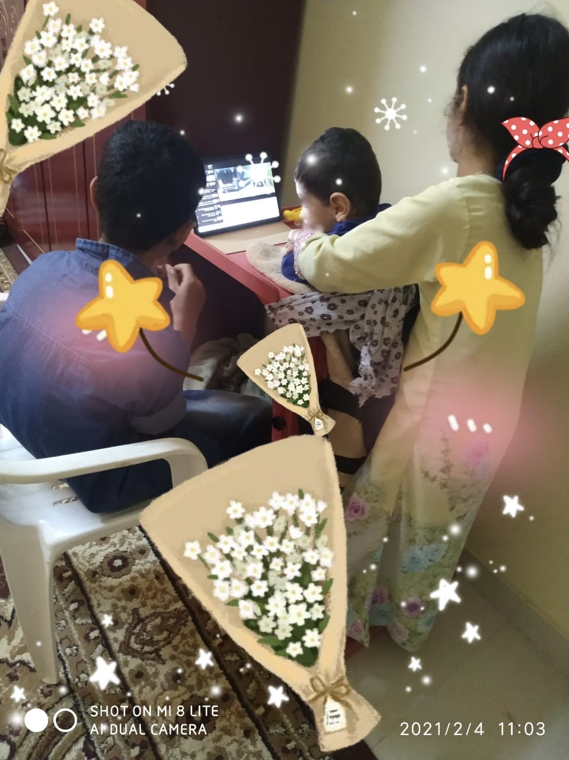
Figure 46. Love: siblings helping one another.
When asked to describe how this picture is spiritual, Zumuruda explained:
I: what does this picture tell us about your spirituality?
Zumuruda: Brotherhood first and the love amongst them… I love this picture because I lived in a loving environment… I mean we are connected and loving… I want my kids to grow up loving, the way I grew up with my brothers and sisters.
Zumuruda explained that Al-Amal’s siblings are always eager to spend time with him and care for him and that she enjoys watching her children support and love each other. For Zumuruda, the relationship between the children is an outcome of love, which she sees as a spiritual bond.
Similarly, Al-Shumookh shared a picture that shows her sons, Al-Amal and Hamed, posing (Figure 47). The photo was taken by Al-Shumookh when Cyclone Shaheen hit Oman in October 2021. In the picture, Hamed, a 6-year-old typically developing child, is standing behind Al-Amal while holding his brother’s shoulders.

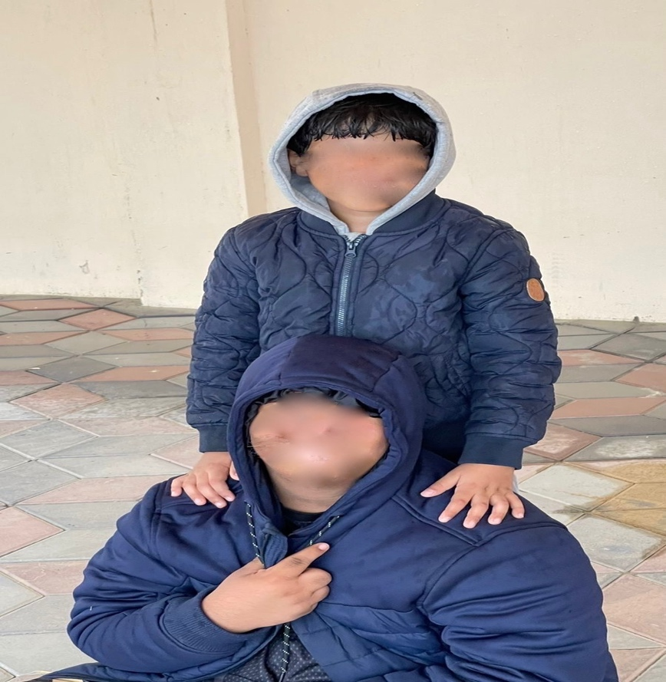
Figure 47. Brother: take my hand for you are my support.
Al-Shumookh likes this picture because she believes that the way Hamed is standing and holding Al-Amal signifies his support:
I chose it because I consider Hamed as a supportive brother for Al-Amal Al-Mutajadid… I see in Hamed an extension of myself and their father… I mean after us… this is what I hope… that Hamed will look after Al-Amal Al-Mutajadid… I mean see the picture (pointing at the picture)... Hamed is standing behind Al-Amal Al-Mutajadid and is holding his shoulder as if he is saying to him ‘I’m here Al-Amal Al-Mutajadid, and as long as I’m here, you are safe’. (Al-Shumookh)
Al-Shumookh described her youngest typically developing son Hamed as an ‘extension’ of the parents. She said that ‘after us’, or baadna, Hamed is Al-Amal’s ‘support’. ‘After us’ can either indicate designating Hamed as a caregiver after the parents pass away, or that he holds the second rank in the caregiving role. When asked why she chose this photograph to represent her spirituality, Al-Shumookh explained: ‘I believe that maybe God gave me Hamed after Al-Amal, so he supports and helps Al-Amal… to be close to him and for Al-Amal to find someone to care for him’. Al-Shumookh appeared to believe that Hamed’s role was determined by God, which places significant responsibilities on him.
Al-Muthabira and Al-Shumookh’s spiritual reflections encompass wider society’s view of people with disability. To illustrate this, Al-Muthabira shared a picture that was taken by Mahboob’s sister (Figure 48).
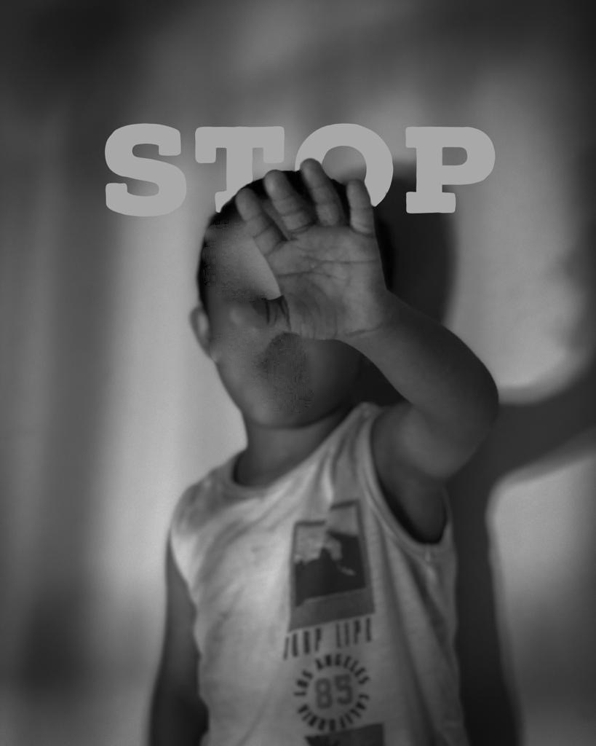
Figure 48. Stop lying, hating and envying. Stop calling us Mongolian. Stop negativity.
According to Al-Muthabira, the black and white picture shows Mahboob looking uncomfortable and trying to stop his sister from taking the picture. Later, his sister wrote the word ‘stop’ above him to send a message the picture reflected Mahboob saying ‘Stop lying, hating and envying. Stop calling us Mongolian. Stop negativity’. Al-Muthabira wanted to share this picture as she believes that ‘love’ can eradicate stigma and bullying. However, when asked if Mahboob had any experiences with stigma, Al-Muthabira replied:
He was never bullied and everywhere we go people love him. I talk in general that people say this or that about their children, but this picture does not represent me, it represents all people. (Al-Muthabira)
While Al-Muthabira denied facing any stigmatising views, in other parts of the interview, she expressed experiencing stigmatising views from extended family members, therefore, she found Figure 48 relevant to express her spiritual value of ‘purity of the heart’. When asked to expand, Al-Muthabira explained:
Spirituality is purity of the heart... It brings people closer… makes you closer to people… Even if a person is sad and has negative perceptions about you and you get closer to that person with love and all… (Al-Muthabira)
It appeared that Al-Muthabira found stigma and negativity to separate people while spirituality through ‘purity of the heart’ brings people together. Choosing a photograph of Al-Amal to demonstrate this perhaps reflects her hopes of his integration with others in society. Similarly, Al-Shumookh shared a picture that shows Al-Amal sitting outdoors in a chair and sipping coffee (Figure 49). The picture was taken when Al-Amal, his typically developing brother, their father, and some male family members went on a three-day camping trip in Al-Ashkhara, a coastal fishing town.
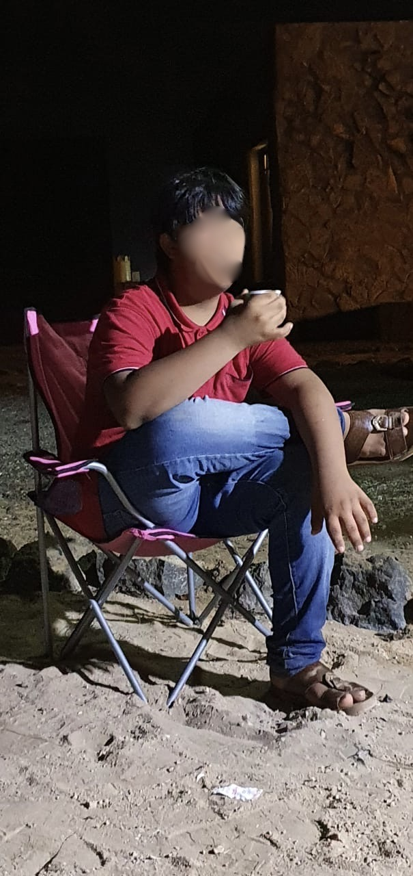
Figure 49. Oman is my identity and I'm proud of its traditions.
The mother loves this picture because ‘it has authenticity… it has some Omani values’. When asked about how this photograph represented her spirituality, Al-Shumookh explained:
I love for Al-Amal to be like his siblings… just like I instil certain values in them, I do the same with him… for example, the coffee, sitting confidently… you know how they say, ‘you are a man, when you sit, sit properly, don’t wiggle’ (Al-Shumookh)
Al-Shumookh appeared to be proud that her son was sitting in a culturally acceptable way. In Oman, when the phrase ‘you are a man’ is used, it usually refers to the traditionally accepted way of sitting where men are expected to sit still. By contrast, it is acceptable for women to move around while sitting, therefore when Al-Shumookh said ‘you are a man’ she was referring to the traditionally accepted way of sitting, as a man rather than a child. Al-Shumookh views the cultural values she encourages her son to follow as part of her spirituality, which relates to the belief that adhering to societal norms and cultural values can enable Al-Amal to integrate and be part of the larger Omani society despite his disability. She continued to explain that the way Al-Amal can assimilate Omani values challenges people’s negative perceptions of people with Down Syndrome:
Some people say: ‘these people with Down’s don’t know, they don’t understand… they don’t know Omani values and heritage’ but this picture shows that this isn’t true… I mean see the way he is sitting, can you see how confident he is? (Al-Shumookh)
The participants shared their spiritual perceptions of their children. In this sub-theme, the parents shared several diverse perceptions; however, these perceptions were largely related to their children’s social lives. The parents highlighted their children’s uniqueness and shared emotions of love, meaningfulness and happiness. The parents appeared to see beyond their child’s disability and emphasised their similarities to other children and shared hopes of integrating their children into society. The parents’ spirituality seemed to be embedded in the parenting experience, as their spiritual perceptions shaped their relationship with their children. The parents’ spiritual perceptions also influenced how they see their children with disability’s relationships with their siblings and wider society. The spiritual perceptions parents shared appear to be positive, meaningful and hopeful.

Group Experiential Theme 1: Summary
The accounts in sub-theme one suggests that Omani parents of children with disabilities engage in discourses of sickness, abnormality and grief when describing their child’s disability, as reflected by the wider social narratives surrounding disability. Their perceptions of disability influence the ways that parents engage in their parenting activities, shaping their ideas around acceptance and how they want to present their child to the wider community. Within their social circle, the parents experienced both positive and negative social encounters. However, the negative encounters seemed to be more prominent. Parents and their children experienced judgement and stigma not only from the public but also sometimes from extended family members, leading to intense negative feelings. As a result, some participants chose to limit their social interactions to protect their own, and their children’s, mental health.
The parents assimilated personal perceptions about their child’s disability from their spiritual beliefs, which they relayed through their photovoice pictures detailed in sub-theme 2. These values seemed to be different from and more positive than wider societal perceptions about disability. While parents described children with disability as ‘different’ and ‘sick’, the parents’ spiritual beliefs helped them see beyond their child’s disability. The photographs reflected their love for their children and their hopes for their development and social relationships with their siblings and others.

Group Experiential Theme One Discussion
The accounts in Group Experiential Theme (GET) 1 suggest that Omani parents of children with disabilities exist at a crossroads of discourses –negative discourses of sickness, abnormality, and misfortune which reflect difference to typically developing children, versus spiritual and more reflective discourses of love and inclusion emphasising sameness and celebrating uniqueness. This section aims to discuss the findings of GET1 and to place them within the context of the broader literature.

Ableism, Stigma and Social Isolation
Smith et al. (2022) argue that while IPA’s aim is to understand the participant experience, this understanding is inevitably always embroiled with culture and language. Heidegger describes language as ‘the house of being,’ arguing that language shapes, limits, and enables our interpretation of experience (Williams, 2017). In GET 1, parents referred to their children with disability as ‘different,’ ‘sick’ and ‘abnormal’ while describing children developing typically as ‘normal’ and ‘healthy.’ Kress (1989) explained that language consists of taken-for-granted assumptions and logics which provide the foundation for thinking about and understanding the world. These constructions of ‘abnormal,’ ‘different’ and ‘sick’ produce understandings of disability as inherently negative, atypical and problematic (Reynolds, 2017; Mosleh and Gibson, 2022). In reviewing the literature, no study was found that specifically examined parents’ understandings, perceptions, and attitudes towards disability in Oman. However, in accordance with the findings of the present study, studies examining maternal perceptions of caregiving of disabled children in other Arab countries also showed that study participants used similar language, specifically that of ‘normal/abnormal’ and ‘sickness’, to describe their disabled children (Crabtree, 2007; Nahal et al., 2017; Madi, Mandy and Aranda, 2019). These deficit-based descriptions of disability resonate with the medical model, which presents disability as a biological impairment that needs to be ‘fixed’ (Goodley, 2017). These reductive understandings fail to acknowledge and appreciate the many ways in which children with disability develop and flourish.
While Smith and colleagues (2022) have argued that IPA analysis has a strong connection with discourse analysis through shared interests with how context is intertwined in the experiences of participants, IPA studies, such as this study, provide an experiential account of participants’ involvement in the context. Discourses may be uncovered from understanding the way in which participants interact and experience them, but the main focus is on participants’ experiences. By contrast, discourse analysis offers a critical analysis of contextual structure and thus touches on the resources available to the participant to make sense of their experience. Several scholars and researchers have offered a critical analysis of contextual structure and thus touched on the resources available to people with disability and their caregivers (Goodley, 2017; Mosleh and Gibson, 2022). While a few studies have explored the perceptions of disability among Arab parents of children with disability (Crabtree, 2007; Nahal et al., 2017; Madi, Mandy and Aranda, 2019), there is an evident lack of Arabic literature examining contextual structures. Therefore, future research could use discourse analysis to study the language that parents of disabled children use (within their social contexts) in an Arabic setting, as well as explore their perspectives and understandings about disability.
In contrast to the other parents in this study, only one participant, Samia, emphasised that her daughter, Amal, ‘is just like other children.’ However, Samia, became emotional during the interview and explained that she is unable to talk about Amal’s disability, which suggests she may be struggling to accept her daughter’s disability. Other parents also reported how other people appeared to feel ‘sorry’ for disabled people, describing them as ‘poor people.’ These findings resonate with perceptions of disability as a tragedy, a hardship and a disadvantage. Reynolds (2017) argues that disability is widely viewed as a phenomenon that brings about pain and suffering—experiences to be avoided. The language the parents used and their feelings towards disability reflect an ableist viewpoint. The majority of literature on ableism is housed in disability studies, a discipline that examines disability as a social, cultural and political phenomenon (Goodley, 2017). Ableism is generally described as representing an attitude that differentiates disability through an assessment which equates able-bodiedness with normalcy (Campbell, 2009). Whilst several definitions of ableism exist (Bogart and Dunn, 2019), the main component of an ableist viewpoint is a belief that disability, irrespective of ‘type,’ is inherently negative and should be cured. Disability studies scholar Fiona Kumari Campell’s definition draws attention to its dehumanising role:
A network of beliefs, processes and practices that produces a particular kind of self and body (the corporeal standard) that is projected as the perfect, species-typical and therefore essential and fully human. Disability then, is cast as a diminished state of being human. (Campbell, 2001, p. 44).
A similar term, disablism, which is defined by Miller, Parker and Gillinson (2004) as discriminatory or abusive behaviour arising from the belief that people with disability are inferior to others. Ableism and disablism are sometimes used interchangeably, however I chose the term ableism over disablism because the term became increasingly more popular in the recent years (Bogart and Dunn, 2019).
The parents in this study appeared to believe that wider society holds negative views of disabled people. Al-Fajer described this as ‘contempt’ towards disabled people, worrying that his son might one day experience this contempt. Slater and Chapman (2015), have argued that society’s ableist views can have negative consequences on disabled people and their families, perhaps as a consequence of pursuing ‘normality’ (Mosleh and Gibson, 2022). Parents in this study also sought ‘normalcy’ for their children: Al-Fajer, for example, aimed to help his child ‘become normal,’ whilst Khalid wished for his son to ‘live a normal life.’ This is notably similar to Crabtree's (2007) findings where a participant hoped that her son would feel ‘normal like other men’. These understandings risk pressuring parents to pursue goals and hopes that reflect dominant ableist assumptions and understandings regarding expected ways of being, and when these goals are not met, this can lead to negative mental health outcome for the parents (Broberg, 2011).
In this study, the way in which children were looked after and dressed was linked to disability. For example, Al-Muthabira and Zumuruda noted that other parents of disabled children neglect their children by not providing basic care, such as keeping them clean, and emphasized that this accentuated the children’s ‘difference’. This was strongly conveyed in interviews with Zumuruda and Al-Shumookh, who, along with other members of their nuclear family, made extra efforts to dress their children nicely and keep them clean. This finding is consistent with that of McKeever and Miller (2004), who found that Canadian mothers of children with disability took great efforts to dress their children fashionably or in new clothes in order to deemphasize their disability. In this study, it appeared that some parents colluded with an ableist agenda and attempted to make their children appear less disabled or less ‘different’ maybe to protect themselves and their children from stigma.
The phenomenon of ableism fits into the larger body of literature on stigma. The findings from this study are consistent with prior studies that have noted that parents of children with disability in the Arab region frequently experienced stigma (Crabtree, 2007; Alaee et al., 2015; Nahal et al., 2017; Emam, Al-Hendawi and Ali, 2021). However, the issue of disability stigma in Oman has attracted very little attention from the scholarly community. For example, Bloushi (2019), who explored the experiences of mothers of children with Cerebral Palsy in Oman, explained that mothers did not report experiences of stigma or social isolation. Bloushi suggested that this could be due to Omani society’s heightened awareness of disability which may encourage acceptance of children with disabilities. However, Bloushi also explained that mothers who participated in her study may have felt uncomfortable about sharing experiences of stigma.
Unlike Bloushi’s (2019) findings, this study found that stigma took many forms. First, parents experienced differential treatment from people in public, as well as from extended family members describing examples of pity and excessive sympathy. One compelling finding is that negative interactions appeared to be prominent within the participants’ extended families; this has also been reported by other studies of Arab mothers of children with disability (Madi et al. (2019), Lamba et al. (2022)). Similar to parents in this study, the research found that mothers experienced pity, sympathy and stigma more prominently from extended family members than the general public. These attitudes were disliked by the parents in this study and caused them emotional distress, leading some parents to avoid social interactions, or causing them social anxiety. Shaikha, for instance, found relief in the social restrictions imposed by COVID, which limited her social interactions; as a result, she was less likely to experience pity. Broomhead (2019) also found that societal attitudes of pity are emotionally challenging to parents. This may be due to pity being a form of distress at the misfortune of another (Clore, 1998), reinforcing the idea that having a child with disability is a misfortune. Nario-Redmond, Kemerling and Silverman (2019) argued that pity reflects a benevolent side of ableism, this form of ableism views people with disability as vulnerable and weak which reinforces an unequal power dynamic.
While extended family members in this study exhibited pity for the parents, some extended family members were violent towards children with disability. For example, Al-Shumookh’s son, Al-Amal, who has Down’s Syndrome; was ‘kicked out of the house’ by his extended family and not allowed to play with other children. Goodley and Runswick‐Cole (2011) examined the multi-faced nature of violence experienced by children with disability in the United Kingdom. The findings showed an inclination for violence against children with disability rooted in the relationships, institutions and cultural acts. The authors explained that there is a need to reform and deconstruct the cultural norms that legitimise violence against people of disability (Goodley and Runswick‐Cole. 2011). Interestingly, all of the parents in this study who experienced stigma from extended family members decided not to confront them. When asked why Al-Shumookh did not confront her extended family, she replied that she ‘did not want to make [the issue] big.’ This could be due to the fact that Oman has a strong extended family culture (Al-Barwani and Albeely, 2007). The extended family generally provides help and support (Al Busaidy and Borthwick, 2012). This could be due to socio-cultural norms common in collectivist cultures that prioritises maintaining a reputation of a good group member by avoiding conflict (Gelfand et al., 2012). In light of the lack of formal support services (GET 3), parents may have chosen to cope with the emotional distress without confronting their extended family members, worrying that this would negatively influence their relationship with extended family and potentially limit the help they received.
Neely-Barnes et al. (2010) found that when parents of disabled children are confronted with stigma and exclusion, they may adopt strategies that are empowering for themselves and their families, such as advocating for their children; yet they may also choose disempowering strategies, including ignoring negative interactions from extended family members, which maintains the status quo of an ableist society. Unlike the strategies used by parents in previous studies (Riley et al., 1998; Thomas, 2021), perhaps the most striking finding in this study is that parents used disempowering strategies aimed at mitigating stigma, rather than advocating on behalf of their child to create a more accommodating society; in particular avoiding social interactions to protect themselves and their children. Earnshaw, Quinn and Park (2012) explained that being the target of stigma or discrimination can become internalised and privately endorsed over time, and this contributes to what they call ‘anticipated stigma,’ in which people expect continued stigmatisation by others, so they avoid social situations in which stigma or discrimination may occur.
Social isolation, that may result from avoiding stigma, has been linked to psychological distress and negative health outcomes (Alaee et al., 2015). A quantitative study by Emam et al. (2021) showed that Omani parents of disabled children experienced high levels of parenting stress, which correlated negatively with life satisfaction; the authors argued that disability stigma and social isolation contribute to the high parenting stress Omani parents experience, suggesting that stigma and social isolation could create dissatisfaction with life. Further work is needed to explore the relationship between parents and their disabled children, as well as their perception of broader societal understandings of disability and how these attitudes may contribute to overall understandings of how ableism manifests in Arab societies. Also, given that our study methodology was not able to capture the complexity of the relationship between the parents’ attitudes towards disability and their parenting behaviour, further research is needed to describe this relationship by taking into account the wider sociocultural and political contexts.
Reflective Box
This research rests on a topic to which I felt very connected due to my personal experiences as an occupational therapist. I found the research process enjoyable in several ways; this research journey has provided me with personal insights, particularly during the analysis and write-up process as I attempted to make sense of the parents’ experiences. I was struck by the notion of ableism and how strongly ableism emerged in the themes. I reflected on my own ableist beliefs and how these influenced my identity as an occupational therapist. Upon reflection, I realised that as the years passed, the biomedical model of disability had become more ingrained in me, as I held an impairment-focused approach trying to identify my clients’ physical, cognitive or mental ‘dysfunctions’. I had become accustomed to seeing disability as a ‘problem’ requiring intervention. I realised that I engaged in benevolent ableism as I sometimes overly praised parents of children with disability, intending to encourage them as I did not realise that this stems from my assumptions that they are ‘vulnerable’ or somehow weak due to the limited availability of support services and the stigma they face. While for me, ableism was demonstrated unconsciously, reflecting made me more aware of my perceptions about disability and I can now see the different ways in which disability can be embraced and celebrated.
Pursuing this project and delving into the concept of ableism by exploring the challenges the parents face helped me consider the context, systems and environments that influence occupations, namely the occupation of parenting. For example, I previously struggled to understand Omani parents’ use of traditional medicine, particularly the more invasive practices. However, I now understand that parents face huge societal pressures and stigma combined with a lack of services and support. While using invasive non-medical treatments still appears problematic to me, I understand and acknowledge the challenges the parents face.
Reflecting on ableism and reading about it also led me to reflect on other issues, such as women’s and minority rights and children’s rights. For example, I realised that as an occupational therapist, I could have shown more respect to my clients who were children as I tended to ask their parents about their daily routines and abilities and tailor the intervention accordingly, without always considering the child’s wants or needs. I plan to engage the children and care about what is meaningful to them rather than what their parents expect them to do. I believe that this paternalistic act stems from my cultural background, in which respect should be aimed towards adults and mercy towards children. Also, in terms of the intersection of disability and gender, how women with disability are more likely to face ablism consolidated my feminist perspective and made me reflect on the need for research aimed at exploring the intersection of disability, gender and race in Oman.

Spirituality and Coping
One of the aims of this study was to explore whether spirituality plays a role in the way parents of disabled children conceptualise their child’s disability. In the analysis of GET 1, a reader might notice a contrast between the discourse in sub-theme 1 (Concepts, beliefs, and attitudes towards disability) and sub-theme 2 (Parents’ spiritual perceptions of their child with disability). Interestingly, when parents shared their photovoice photographs, discourses about disability appeared to change. In sub-theme 1, the discourses that parents used to describe their child’s disability reflected the negative dominant cultural narratives around disability, whereas when parents shared photographs that reflected their spiritual beliefs, they voiced more positives perspectives of their experience of parenting a child with disability. A possible explanation for this might be that individuals can hold dual attitudes in which they maintain differing evaluations of the same phenomena (Wilson, Lindsey and Schooler, 2000). These different evaluations may indicate the presence of both implicit attitudes—which involve automatic, non-conscious evaluations—and explicit attitudes based on conscious, controlled evaluations. In this study, the parents appeared to hold ableist implicit attitudes (negative attitudes) towards disability driven by the wider socio-cultural narrative, as well as a positive explicit attitude driven by their spiritual values and beliefs. Since attitudes influence behaviour (Dunn, 2015), future research ought to explore how parents’ attitudes towards disability affect their parenting.
Consistent with the literature (for example, Lloyd and Hastings, 2008; Ferrer, Vilaseca and Guàrdia Olmos, 2017; Thomas, 2021), this research found that parents identified their disabled children in positive terms when talking about their parenting experience; for example by sharing positive perceptions of love, compassion, and a sense of connection to their children. Ferrer et al. (2016) argued that the presence of positive perceptions among parents of disabled children appears to generate a closer parent-child relationship, thus offering a stronger foundation for child development. Research has shown that parents’ positive perceptions of caring for a disabled child could help families cope with the stress of parenting (Lloyd and Hastings, 2008), as these positive perceptions buffer emotional impact, promote family wellbeing (Kayfitz, Gragg and Robert Orr, 2010) and improve adaptation to disability (Ferrer et al., 2016).
In order to draw conclusions about the nature of the positive perceptions shared by parents of disabled children, Hastings et al. (2002) argued that parents do not merely identify positive aspects of having a child with disability, but the positives they describe are examples of adaptive coping mechanisms via which they engage in positive reframing—a component of meaning-focused coping or meaning making (cognitive coping) (Hastings et al., 2002; Beighton and Wills, 2019). Positive reframing or positive reappraisal may help a person experiencing stress to reframe a situation in order to view it in a more positive light, which may be especially important in helping people sustain efforts (including caregiving) long term (Folkman and Moskowitz, 2000). In quantitative studies, positive reappraisal was found to be a significant independent predictor of positive perceptions for mothers of disabled children (Hastings et al., 2002). In addition, Beighton et al. (2017) conducted a qualitative study to explore the nature of positive perceptions of parents of children with intellectual disabilities and concluded that these positive aspects are largely based on meaning-focused coping.
However, some researchers have argued that positive perceptions are not merely coping mechanisms but should also be viewed as outcomes of a transformational life-learning process (McConnell et al., 2015). It is important to note that parents in this research had to deliver their parenting role amidst strong social discourses that devalue and dehumanize disabled children, resulting in emotional distress. The literature shows that perceived caregiver stigma experienced by parents of disabled children can cause psychological distress and depressive symptoms (Cantwell, Muldoon and Gallagher, 2015). Since stigma causes distress to parents, spiritual beliefs similar to those expressed in this study could help parents reappraise their perceptions of their child’s disability and construct a positive image of their child.
The results from this study further support the idea that parents of children with disability use positive reframing techniques to cope with caregiving stressors (Beighton et al., 2017; Hastings et al., 2002; Twoy, Connolly and Novak, 2007). The literature also shows that positive reframing associated with spiritual beliefs and activities can play an integral role in reshaping the appraisal of perceptions, which resulted in improved mental health outcomes in several populations, including among women living with HIV/ AIDS (McIntosh and Rosselli, 2012), cancer patients (Carrion et al., 2017), people with rheumatoid arthritis (Bartlett et al., 2003) and older adults (Cowlishaw et al., 2013). So far, however, very little research has directly investigated spiritual beliefs and positive reframing techniques among parents of disabled children. Salkas et al. (2016) found that parents of disabled children used their spirituality to reframe their perceptions about their child’s disability, yet this reframing was largely denoted to religious beliefs rather than a more encompassing definition of spirituality including non-religious positive perceptions, such as love and compassion towards the disabled child.
Additionally, no previous study has investigated the mechanisms by which positive spiritual perceptions correlate with improved mental health among parents of disabled children. In a systematic review of the literature examining positive aspects of parenting children with developmental disabilities, Beighton et al. (2019) found that the positive aspects are largely related to the parents’ intrapersonal orientation, including positive perceptions (such as love for their child and happiness brought by the child). The present study shows that parents considered positive perceptions to be spiritual aspects or values. It is possible, then, that the parents’ spiritual beliefs allowed them to reframe their perceptions about disability. Therefore, it can be argued that in this study, parents’ spiritual beliefs fostered positive perceptions about the child’s disability. Future studies are needed to examine the connection between positive reappraisal and spirituality among parents of disabled children, as well as their effect on well-being.

Summary
In this GET, parents used non-religious language to express their spiritual beliefs that related to their perceptions of their child, as well as their relationship to their child. Parents shared beliefs about love, compassion, and a sense of connection to their children. The majority of parents suggested that these positive perceptions differed from wider society’s perceptions towards disabled children, highlighting that these spiritual perceptions were personal and unique to the parents. These findings resonate with the conceptual framework (section 2.7), reflecting that spiritual beliefs are personal and unique to individuals and are influenced by their life experiences and/or religious beliefs. Further research should be undertaken to investigate how social, political and cultural influences impact on the spiritual beliefs of parents of disabled children and how this affects parental wellbeing.

Group Experiential Theme 2: Managing tensions at the Intersection of Spirituality and Disability

Introduction
This group experiential theme captures the parents’ religious sense-making processes regarding their child’s disability. Parents wove religious understandings of their children’s disabilities into their accounts. The parents’ religious beliefs and the meanings they assigned to their child’s disability influenced their perceptions of their parenting roles. This Group Experiential Theme (GET) consists of two sub-themes: ‘Why God, why did you give me this child?’: Reconciling religious beliefs with the child’s disability, which details the religious meaning-making process of the child’s disability and the transition experienced by some participants from viewing the child as a punishment from God to seeing the child as a divine gift; and ‘I trust God’: Prayers of faith, which details the religious practices participants engaged in to maintain their trust in God and seek his help.

Sub-theme 1: ‘Why God, Why Did You Give Me This Child?’: Reconciling Religious Beliefs with the Child’s Disability
This sub-theme captures how the parents’ made sense of having a child or children with developmental disabilities within the concept of a benevolent God. Parents wove religious understandings of their children’s disabilities into their accounts, and the religious meanings they assigned to their child’s disability influenced the parents’ lived experience. Almost all participants (10) described having a child with a disability as part of God’s plan for them, however this plan was manifested in different ways as a test or challenge, a gift, or a punishment. This sub-theme explores how parents accepted, or struggled to accept, God’s plan, their processes of reconciling their religious beliefs with the child’s disability, and how this shaped their perceptions of their parenting role.
Sada and Shaikha spoke about having a child with a disability being part of God’s plan for them. Nevertheless, accepting God’s will seemed to be challenging:
I mean, God gave me this thing, so I should not think about what will happen… what is destined to happen will happen… whether I like it or not… so its best that I accept what God gives me and carry on with my life. If I do not accept it, my life will be lost because of this. (Sada)
Sada believes that destiny granted by an all-powerful God cannot be altered, therefore embracing the negative events, such as the challenges associated with caring for a child with disability, by submitting to God’s will, is her only valid option. This indicates a lack of choice, for if she fails to accept God’s plan, she will go astray, as failure to submit may suggest a challenge to her trust in God and her faith, causing her life to be ‘lost’. While losing life can be used to refer to death, in the Islamic faith, losing one’s life results from straying from God’s path, which some Muslims believe leads to depression and failure to achieve one’s goals. Therefore, Sada may be referring to losing a joyful life, which is devoid of sadness granted when a believer accepts God’s will and submits to his plan.
Shaikha, who lost a child with a disability prior to having Adam, reiterated Sada’s account as she expanded on the loss of self/identity she experienced when she had her first child with a disability:
I feel the closer you are to God, the more faith you have that this is your life, and you have to be responsible. I mean we are in this life as a choice… you either endure it or lose yourself. I mean, you lose… especially I mean that I have been through… I mean an experience, my son who passed away, it was emotionally exhausting, and I regret it a lot because I cried a lot… I mean, more than now, (laughter) because it was shocking. I mean, I did not know if I could cope, so it was very stressful. (Shaikha)
Shaikha associated the sense of loss of self with the grief and sadness that she experienced when she had her first child with disability. For her, experiencing stress and emotional turmoil is a sign of losing oneself, for which she blames herself as she believes that a lack of faith and acceptance of God’s will result in her being distant from God. While Shaikha spoke about a vulnerable time of her life, she laughed, even though she did not find the topic amusing, which may indicate feelings of embarrassment as she strove to maintain an image of not showing vulnerability to others: ‘they always say that I am patient and that I am strong’.
Believing in God’s plan provided the parents with a way of making sense of their child’s disability and how they should feel based on their religious beliefs; for example, having a child with disability is part of ‘God’s plan’, thus, feelings of grief or pain should be eliminated, because showing feelings of resentment can be seen as lack of faith or trust in God’s will. Al-Shumookh provides us with an example here:
He has Down’s… I accept it… at the beginning I was sad… I was not sad because I do not accept God’s will… I accept it… but how will he feel because he is different from his siblings and his cousins… he will see that he is different… he won’t be able to do things… you get it? (Al-Shumookh)
Here, Al-Shumookh was keen to let me know that her negative feelings were not sadness towards God due to lack of acceptance of his will, but rather due to her worries that her son may experience negative feelings due to his disability when he becomes aware of his ‘differences’ and compares himself to other typically developing family members in the future. Al-Shumookh might have worried about being judged as lacking faith, thus she explicitly highlighted ‘I was not sad because I do not accept God’s will… I accept it’. Al-Shumookh detached her feelings of sadness and worry about her child and from her belief in accepting God’s will.
Similarly, Amani expressed worry that being sad or depressed might conflict with strong faith:
My friend, the one I told you about. I used to ask her, ‘would it be fine if I cry or would it mean that I am not satisfied with what God gave me?’ She used to tell me that it’s okay and that these are just feelings. (Amani)
After learning about her son’s disability, Amani was sad but felt guilty for expressing her feelings and tried not to cry. Therefore, she sought support from her friend who reassured her by reinforcing Al-Shumookh’s idea that feelings and beliefs are separate from what?
None of the parents explicitly mentioned that they were unwilling to express negative emotions because it would appear that they were unhappy with God, however, it is implicit within the parent’s accounts. These accounts showed that the participants’ religious beliefs are a fundamental aspect of their self-identity. Their sense of self is challenged when incongruence between their religious beliefs, ‘belief in God’s plan’, and actions, ‘emotional distress’, occurs. Parents attempted to reconcile their religious beliefs and the child’s disability and ascribed distinct religious meanings to the purpose of the child in their lives. The religious meanings the parents assigned influence their interactions with their children.
Having children with disabilities was also interpreted as a test of faith from God and a way of assessing the parents’ strength of belief. Latifa spoke about the child’s disability being a test of faith to assess her patience:
I felt like this is a message from God, to test your patience, your ability to be patient… when He [God] gives a child like this, you feel it is a test from God. I mean, she is not like other children. She needs more care. I mean, this girl, God gave us as a gift, so we have to give her special care… I mean, a person must accept it and know that everything from God is good… it is a gift from God; you don’t know what’s God’s plan. (Latifa)
Latifa conveyed seemingly contrasting beliefs about Al-Noor, describing her as a ‘test’ and a ‘gift’ from God. Al-Noor is a ‘test’ because she requires extensive caregiving. However, Al-Noor is also perceived as a ‘gift’, which may be due to the Islamic belief that challenges are given by God as an opportunity for the believer to demonstrate their faith. Latifa demonstrates her faith by giving Al-Noor ‘special care’. It is apparent here that Latifa conveyed a sense of struggle, as she seems to suggest that some of God’s plans must be accepted, even if its they are difficult to accept. Nevertheless, total submission and acceptance of his plans are imperative. Latifa’s use of the word ‘must’ suggests that accepting God’s plans does not come readily, but people make sense of God’s offering and ‘must’ ultimately accept them to pass the ‘test’.
Al-Fajer echoed Latifa’s beliefs in describing his son’s disability as a ‘test’ from God; however, in contrast to being a test of patience, for Al-Fajer, it is a test of integrating the child within society:
When God loves his slave, He afflicts him with tests and hardship, so the slave always remembers Him. God gave me this challenge to see how I present this child to society as a normal person or as a person who is accepted by society... I believe that this is all from God and that these are challenges for me and that, God willing society will accept him and that I can do my best. I mean doing my best for this child is from of God. (Al-Fajer)
Al-Fajer referred to himself as God’s slave, the expression of the master-slave relationship may be a product of prevailing religious discourse but could also be understood as communicating an understanding of complete submission and obedience to God and accepting God’s offering even when it is challenging. Al-Fajer views his son, Al-Amal, as an expression of God’s love, who was given by God as a test, and God will hold Al-Fajer accountable for how well he treats the child and helps him to be socially included. Al-Fajer conveyed a deep sense of responsibility stemming from this belief. Al-Fajer feels obliged to do what he perceives as best for Al-Amal by helping his son become as independent as possible so that society would ‘accept’ him and treat him with respect.
Amani and Al-Shumookh’s understandings of their children’s existence were in very different terms to Latifa and Al- Fajer. Amani, a full-time health professional and the mother of Adam, a child with physical developmental delay, reflected on her experience and stated:
In the beginning, I thought that this was afflicted on me by God. I worked as a doctor for a couple of years… I mean, I stay late to make sure that everyone is treated. Why are you [God] punishing me now? But this was the first month of taking Adam out of NICU… I stopped thinking that way after that. (Amani)
Amani found caring for Adam a particularly challenging experience as he required intensive care, while she did not receive sufficient support and information. During that time, she questioned whether her son’s disability was a punishment for sin or wrongdoing at her workplace. This puzzled her, as she believed that she was trying her best to help people by staying late and putting effort into caring for others (a sign of goodness), but instead of being rewarded, she was faced with a challenging experience of caring for Adam. This was initially perceived as a ‘punishment’ due to the caregiving challenges she faced, maybe indicating a belief that ‘good’ should be rewarded with good. Amani seemed to be feeling disappointed with God and questioned Him repeatedly: ‘why did God choose me? Why me? God why me? Why did you choose me?’ She believes that having a child with disability was ‘afflicted by God’ causing her distress, when she may have expected to be rewarded for her goodness.
This view was similar to that of Al-Shumookh, who initially believed that having a child with Down Syndrome was a punishment from God:
In the beginning, I thought that I did something bad and God is punishing me by giving me this child. But afterwards, I started to think as we Omanis say ‘the pen is lifted off them’… this made me believe that this affliction from God is good for me. (Al-Shumookh)
Like Amani, Al-Shumookh initially perceived a child with disability as an ‘affliction’ from God. While an affliction may be a God-given life event that can cause pain and grief, which appeared to be what Al-Shumookh felt as she believed that a child with disability is a punishment from God. As time passed and as she reflected on her religious beliefs, she began to view the child as an ‘affliction’ from God, but nevertheless, an ‘affliction’ that was perceived positively. To explain why having a child with disability is ‘good’ for her, Al-Shumookh quoted the sayings of the Prophet Muhammed, a hadith, ‘The pen is lifted’. This hadith is used for people who are not ‘judged’ by God and resonates with the Islamic belief that people with intellectual disabilities are pure of sins and are not judged by God. Having a child with no sins can be a ‘good thing’, as in Islam, caring for a child with no sins can be a gateway to heaven for the parents. Al-Shumookh suggested that God grants an affliction (child’s disability) for a subsequent greater good (heaven).
Almost all participants described how having a child with disability is predestined by God. The participants’ discourses suggest that having a child with a disability can produce challenging emotions that, due to religious beliefs, people consider should be eliminated, as they may reflect a lack of faith in God’s will. Therefore, parents had to reconcile these conflicting views to resolve their experienced spiritual conflict. Parents reconcile these beliefs by assigning spiritual meanings to the child’s disability, moving towards acceptance or passing the test God had set which could lead to heaven, detaching emotion from faith or attributing negative emotions to other things. None of the parents sought professional help to manage their feelings; rather, negative feelings and depression are perceived as personal responsibility, managed exclusively by the parents.

Sub-theme 2: ‘I trust God’: Prayers of faith
Connecting with God through religious practices was expressed as a spiritual activity that demonstrated the parents’ trust in God. As Sada explained, ‘worshipping… I believe is spiritual’. The parents’ trust in God and their connection with Him seemed to elicit positive feelings. All participants (11) shared instances of partaking in religious activities, the most common being obligatory prayer, reading the Quran, Dua (prayer of supplication), and God’s remembrance prayers. The choice of religious practices was influenced by their beliefs about the nature of God. This sub-theme outlines the religious practices the parents engaged in and how these practices influenced their parenting experiences.
Some parents perceived prayers as a source of strength, guidance and hope. Some parents also sought to heal their child’s disability through prayers. For example, Shaikha chose a picture of a prayer mat and the Quran to resemble her trust in God (Figure 50).
Figure 50. Trust in God: My hopes, my wishes and my desires begin here.
Muslims must pray (salat) five times per day. Muslims use a prayer mat and often read the Quran during each prayer:
This is a praying mat and the Quran. This means trust in Allah. This means that Allah, glory be to Him, just like he gave you, I mean, difficulties in life, he also gave you good things. So, you have to accept. I mean this is my life. I mean that Allah, glory be to Him, made this path for me and I have to be confident that this is a blessing for me, whether it’s good or bad... as Muslims, we have to be satisfied with what Allah, glory be to Him, gave us. That is it, I mean we must have complete satisfaction that this is good… yeah, glory be to Allah. (Shaikha)
There are several points of interest to be noted in the above extract. This extract implies that Shaikha accepts Adam as a blessing due to her Islamic beliefs; however, her trust in God seems to be difficult to enact as she said ‘you have to accept’ or lazm atqabal and ‘I have to be confident’ or lazm athiq. The word lazm translates to have to, necessary and prerequisite. It is necessary to accept Adam and trust God as accepting God’s will is required for all Muslims, therefore having ‘complete satisfaction’ is an obligation rather than a feeling that comes readily. Therefore, Shaikha needs to constantly connect with God to maintain and express her satisfaction with his will:
I mean in my vulnerable time or when I feel stronger I take my strength from there (looking at the picture)...I have to thank God always and remind myself that Allah, glory be to Him, put us in this life, and I mean I am sure that this is good for me and for my children. (Shaikha)
Similarly, Sada implied that God is immanent/ present as he was perceived to be actively involved in their lives. Sada talked about how prayer elicits positive feelings, a sense of being loved and taken care of by a divine power who alleviates her fears:
You feel that someone cares about you and hears you… someone… I mean, all the fears you have, He will take your fears and worries and will make things easier for you. So you do not worry and submit… submit yourself and do not think… because someone bigger than me will look after me. (Sada)
Sada expressed a strong belief that God is loving and intimate. She also spoke about submission to God, which appeared to mean submitting her life to God’s control and authority and trusting him. Sada appeared to believe that worshipping God and trusting his will results in positive emotional outcomes. Therefore, when she struggled with accepting her second child’s disability, she decided to play a recording of the Quran:
I always played the Quran near Rateel while she was asleep, but deep inside, I felt trapped in depression. I still felt, why is this happening to her? I would Google the reasons behind it. I mean, why does she have this? Why my girls? [mother crying]. (Sada)
Here, while Sada felt ‘trapped in depression’, feeling unable to escape her emotional anguish, she resorted to God. However, her questions about her child’s disability were not answered, and she struggled to overcome these feelings. Nonetheless, in another part of the interview, Sada, like Shaikha, linked trusting God to accepting her daughter’s disabilities: ‘I started to accept my girls’ conditions… and I submitted myself to God’. Sada also spoke about her relationship with God, seeming to maintain a close relationship with God as she found that complaining to God helped to resolve negative feelings:
Some topics I can only complain about to God and can’t tell to anyone. Some things I talk to my husband about, and some other things I do not... I take these things back to God, and I don’t feel that sadness lingers. (Sada)
Sada explained that she felt comfortable sharing her problems with God that she does not share these even with close people like her husband. Similarly, Shaikha also finds resorting to God, instead of close people, more comforting. However, she does this because she wants to maintain the perceived image of a strong parent in front of others, even her spouse. By contrast, Shaikha finds it acceptable to be vulnerable when communicating with God:
I mean, just me and God… I mean, I can make Dua. I can complain. I can express all the psychological stressors, away from the children’s father and the children... I mean, I feel that this is vulnerability… when I feel tired and such. (Shaikha)
Sada and Shaikha’s encounters with God suggest that God is perceived as non-judgemental and accepting. They can raise complaints with Him, unlike with other friends or relatives. These views contrast with those of Amani and Al-Shumookh, who were unable to express their sadness, worrying that it could mean dissatisfaction with God’s plans. This indicates that parents hold distinct views about the nature of the same God that they worship. Furthermore, while Abdullah did not expand on his experience with prayer, he explained that for him: ‘the most comforting worshipping way is prayer’.
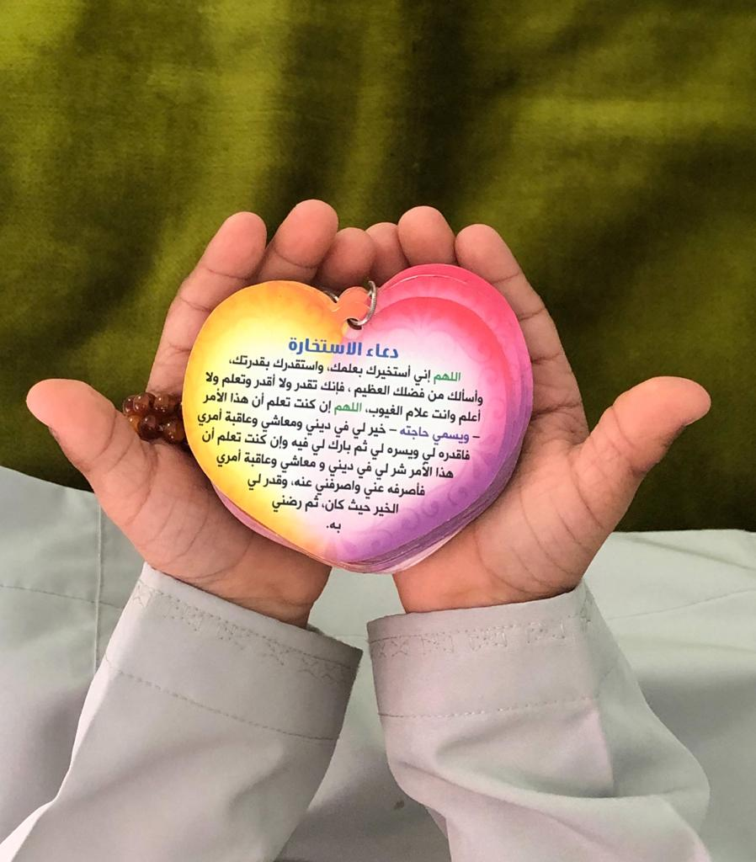
Al-Muthabira and Al-Shumookh also expressed their trust in God. However, unlike Shaikha and Sada, who focused on submitting to God, Al-Muthabira and Al-Shumookh demonstrated their trust in God by asking him for help and guidance. Al-Muthabira frequently repeated the Al-Istikharah Dua, an Islamic prayer recited to ask God for help when facing a decision. Figure 51 shows the Arabic text of the Al-Istikharah Dua resting on Mahboob’s hands.
Figure 51. Entrust yourself in God and trust Him in everything and know that everything from God is Good.
To describe this picture, Al-Muthabira explained:
Asking God for help is a must... sometimes I do not read the exact Dua text but I make Dua and ask God for help in everything in everything... whatever God chooses is good. ... because I trust God’s choices and I ask him for help… God glory be to him, he will plan what is needed for Mahboob. (Al-Muthabira)
Al-Muthabira explained that this prayer means a lot to her because it reflects her trust in God and helps her stay confident in His plans. This trust helps her to believe that all of God’s choices are ‘good’. Al-Muthabira believes that God can help people in ‘everything’, the repeated use of the word everything implies a strong belief in God’s power to help her in every aspect. Al-Muthabira prays the Istikharah dua before any important life event or when she is distressed or unsure about something, including her son’s medical care. She stated that she used the prayer before giving consent for her son’s medical procedure (a laparoscopy): ‘I said the most important thing for me is to ask God for help. I signed the papers and everything and asked God for help’. The procedure was successful without any adverse effects. Asking God for help gives Al-Muthabira a sense of hope as, after asking him for help, she expects ‘good things’ to happen.
Similarly, Al-Shumookh believes that God provides help and guidance. However, Al-Shumookh believes that this could be done through the common religious activity of reading the Quran rather than Dua – particularly the Al-Baqarah surah (a chapter in the Quran) – can positively impact people’s lives. Some Muslims believe this chapter is blessed; thus, wishes may be granted to the readers of this chapter. Consequently, Al-Shumookh trusts that God helps her and grants her wishes if she reads this chapter. To express this, she shared her daughter’s story as the family went to apply for a university place, and she waited for them in the car:
I sat and read the Al-Baqarah surah with the intention that God eases her application process. I expected them to decline her application, but when my husband came, he said that they accepted her. (Al-Shumookh)
Al-Shumookh demonstrated a strong sense of belief that led her to expect an event she perceived as surprising, which indicates a belief that God can grant people unexpected blessings when they seek his help. Al-Shumookh explained that she deeply believes in reading the surah because ‘this happened more than once’. This contrasts with Khalid’s perception that God’s destiny is unchanged and does not accommodate people’s wishes: ‘when God destines something to happen, it happens’.

In contrast to the majority of participants who connect with God through religious practices, Samia connects with God through reflecting on nature (Figure 52).
Figure 52.The sea: The sea is like life with all its ups and downs.
Samia believes that God created the world:
This picture… because it helps reflect on God’s creation… to reflect on night and day… because it was sunset time, and I felt spiritual. (Samia)
Samia shared this picture to reflect her spiritual beliefs about feeling God’s presence through nature. In particular, the sunset held a spiritual meaning. When asked about how nature is spiritual to her, she replied: ‘I love nature’. However, the caption Samia provided for her picture indicates that she reflects on her life when she spends time in nature: ‘The sea is like life, with all its ups and downs’.
All parents expressed beliefs that disability is controlled by God. Unsurprisingly, the majority, nine parents, sought religious healing, preferring to seek therapy from religious healers to cure their children’s disabilities and other health-related conditions. Religious healing is commonly sought from religious people who are often referred to as ‘sheikhs’. At the time of the interview, Abdullah was actively seeking religious healing for his daughters with disability. For Abdullah, it is essential to seek ‘therapy’ from a ‘trusted person’:
Healing with the Quran… I mean as Muslims it is a belief… but as I said, you should not go to anyone… I mean if you are seeking healing with the Quran do not go to any person... healing with the Quran is needed. (Abdullah)
Abdullah views Quranic healing as part of his Islamic belief, emphasising its importance to him ‘it is a need’. However, before seeking religious healing, Abdullah emphasised the importance of seeking healing from a trusted healer. Similarly, Zumuruda sought healing from an ‘Imam’ while performing pilgrimage in Mecca. Her husband, Al-Fajer, who did not join her due to work commitments, supported her: ‘Al-Ruqyah Al-Sharia is permitted’. In Islam, Al-Ruqyah is a recitation of particular verses of the Quran that is used to protect from sickness, an evil eye, and magic. The purpose of the healing was to cure Al-Amal’s disability:
I also sought Al-Ruqiya when I went to A-Umrah with Al-Amal... the Imam came and took my father and Al-Amal and they left… they also took some oil, I brought the oil with me… he took the oil and prayed on it by reciting the Ruqiya and he also brought us Zamzam water which he also recited Al-Ruqiya on, the water was for us to shower Al-Amal and give him to drink. (Zumuruda)
While Abdullah and Zumuruda were personally motivated to seek religious healing. Samia and Sada seemed to be encouraged by other people’s advice of seeking religious healing. Following the advice of others, Samia sought religious healing when her daughter Amal had night terrors:
We tried healing with Quran once… they told us that its best for Amal to be treated with Quran… to get someone to read Quran over her... we tried once… she used to shout when she is asleep… she sleeps a little then wakes up and shouts… so we said we’d better treat her with Quran so the shouting stops… but thank God… after being treated with the Quran, the shouting stopped. (Samia)
Samia was happy with the outcome of the treatment as she believes that God had stopped her daughter’s night terrors, and therefore praised Him. Similarly, Sada explained that strangers repeatedly approached her and recommended that she seek Quranic healing for her daughter instead of medical care, as they believed that the girl’s disability may have been caused by someone casting an ‘evil eye’, which only Quranic healing can cure:
Even people who are not related to me, they tell me that this disease should not be treated in the hospital. It means that it’s evil eyes (Hasad) or something… it means to go get treated with Quran. (Sada)
It appeared that Sada was influenced by people’s advice, as Sada and her husband, Abdullah, were both actively seeking religious healing at the time of the interview. In contrast, many other participants strongly opposed this idea. None of the participants referred to witchcraft as a cause for their child’s disability; hence none of them sought witchcraft to heal their child. Al-Shumookh addressed black magic healers when asked about alternative healing but explained, ‘I don’t believe in it’. Shaikha emphasised that she only performed healing methods prescribed by the Islamic sheikhs and did not seek black magic healing: ‘I used to read the Quran and drink holy water, but I never did anything like Hirz [an Islamic amulet used to protect from the evil eye] or anything like that’.
Parents demonstrated their trust in God through religious practices. Participants maintained their relationship with God through obligatory prayer, Dua, and religious healing, but not black magic or non-religious practices except one who reflected in nature. They believed that this type of communication gave them comfort and provided them with a sense of guidance. Participants who sought healing and protection through Quranic and Islamic healing practices believed that religious healing yielded positive physical and mental outcomes.

Group Experiential Theme 2: Summary
The findings in this theme suggest that the parents believed in a divine meaning for their children’s existence, seeing it as part of God’s plan (Al-Qadr). Participants’ trust in God’s plans heightened their sense of responsibility towards their children with disability as they began a quest to ‘help’ their children gain independence. Although the parents’ faith generally ignited a positive sense of ‘acceptance’ of the child’s disability, some participants seemed to go through emotional turmoil as they appeared to fear that expressions of sadness could be a sign of dissatisfaction with God’s will. This led them to repress their emotions and experience guilt when they expressed them, although some were able to separate these feelings from their beliefs or attribute their negative feelings to other things in order to reconcile their belief of a benevolent God with their child’s disability.
The parents demonstrated their trust in God through religious practices, including prayer, Dua, and seeking religious healing for their children. The majority of parents demonstrated a personal relationship with God as they sought comfort by communicating with God through prayers, except for one who reflected in nature. The participants’ relationships with God allowed them to share their worries and concerns without being judged by others. Some parents asked God to guide them to make the right choices for their children through Dua. Also, the majority of parents believed that God has agency over their child’s disability, so they actively sought various forms of religious healing.

Group Experiential Theme Two Discussion
The findings in Group Experiential Theme (GET) 2 suggest that the parents believed in a divine meaning for their children’s existence, seeing it as part of God’s plan. Although the parents’ faith generally ignited a positive sense of ‘acceptance’ of the child’s disability, some participants seemed to go through emotional turmoil, appearing to fear that expressions of sadness could be a sign of dissatisfaction with God’s will. Nonetheless, the majority demonstrated their trust in God through religious practices, including prayer, Dua, and seeking religious healing for their children. This section aims to discuss the findings of GET 2 and place them within the context of the broader literature.

Religious Meaning-Making
In this sub-theme, the parents shared their religious beliefs pertaining to the child’s disability. Religion is a central meaning-making system for many people; however, this centrality varies significantly from individual to individual (Pargament, 1997). In this research, conducted in a devoutly Muslim country, religion appeared to be central to the participants.

Having a child with disability is part of God’s plan
The majority of parents believed that having a child with disability was part of ‘God’s plan’ for them. This is consistent with the Islamic belief of qadr, which is the fate or destiny stated in the Muslim holy book, the Quran. Based on the belief in qadr, having a child with disability is an act of God and part of the individual’s destiny. In Islamic teachings, believing in qadr is an extension of believing in God and His divine wisdom (Al-Aoufi, Al-Zyoud and Shahminan, 2012). The parents in this research spoke about accepting their caregiving roles because the child was ‘God-given’. This has been documented in other research with Muslim parents of children with disability (Bryant et al., 2011; Nur Saadah, Siti Hajar and Islam, 2014).

Disability in Islam
Some scholars have argued that disability, as a generic term, is not found in Islamic texts. However, Islamic teachings and principles derived chiefly from the Quran and Sunnah (a record of the prophet Mohammed’s sayings and actions) refer to people with disability as ‘disadvantaged’, ‘sick’, ‘different’, ‘weak-minded’ and ‘deficient’ (Ghaly, 2010; Black, 2013) but also devoid of sin (Ghaly, 2010). Furthermore, various references in Islamic texts suggest that evil-doers, unbelievers, and even beasts appear to have physical disabilities. For example, Islamic enemies are repeatedly portrayed with physical disfigurements (Turmusani, 2001). Well-known Muslim scholars such as Ibn Tamima categorise disability as ‘evil’ (Ghaly, 2010). Such negative portrayals might have also influenced the negative societal perceptions of disability discussed in GET 1, such as parents describing their children as ‘sick’. However, Islamic teachings also encourage believers to treat people with disability with mercy, and Muslim believers are required to dedicate charity or Zakat to people with disability. Since religious beliefs may include the cultural and moral values of society (Pargament, 1997), the pity that parents and people within society felt towards people with disability, which is discussed in the GET 1 discussion, may be linked to their religious beliefs. Although pity or mercy for people with disability is linked to benevolent ableism (Nario‐Redmond, Kemerling and Silverman, 2019). Further research is needed to explore the relationship between religious beliefs and benevolent ableism within a Muslim/Omani context.

Questioning God: Islamic Theodicy
The majority of parents appeared to engage in a religious meaning-making process of trying to make sense of why God gave them a child with disability or in other words, why an all-knowing, merciful God caused them to suffer. The parents in this research expressed a belief that the child with disability was sent from God as a test of faith, a gift or an infliction. Research shows that these understandings are common among Muslim parents of children with disability (Jegatheesan, Miller and Fowler, 2010; Bryant et al., 2011). Similarly, Bloushi (2019) who explored Omani mothers’ experiences of raising a child with cerebral palsy, found that Islamic beliefs played an integral positive role in making sense of the child’s disability. This supports the findings from this study, that Islamic explanations and teachings play a significant role in how Omani parents understand disability.
These explanations can be explored in the light of Islamic theodicy, which means vindication of God and examines why a good God allows the manifestation of evil (Ghaly, 2019). The majority of Omanis follow the Ibadi Muslim faith, but there are Sunni and Shia Muslims as well. Although research is lacking on theodicy within these Islamic sects, parents in this research appeared to follow a pro-theodicy approach as they tried to explain or justify the existence of disability, viewing it as pain or suffering in a way that would not harm God’s justice and wisdom (Ghaly, 2010). Like followers of the pro-theodicy approach, parents believed that there was a wise purpose or Hikam behind having a child with disability. Some parents, such as Amani, questioned whether God sent them the child as a way to punish them for a sin they committed or as an infliction. This could originate from the writings of some Muslim scholars, such as Ibn Tamiyaa and Ibn-Qayyim, who regarded people’s sins as the main cause of suffering, pain and disease (Ghaly, 2010). This is supported by some Quranic verses, such as: “whatever misfortune happens to you is because of the things your hands have brought, but for many, He grants forgiveness”. In this verse, misfortune is interpreted as illness, punishment or any other form of infliction, and “the things that your hands have wrought” as a person’s sins and misdeeds (Ghaly, 2010). However, even as a form of punishment or infliction, disabilities in some Islamic views serve a beneficent function (Masotta, 2020): they may have a purifying role by purging the sinner of their sins and bringing the person closer to God. Therefore, having a child with disability, which was seen by some parents in this research as an infliction and punishment, can be a sign of God’s benevolence rather than His wrath. This is also reflected in the Hadith to which Al-Fajer referred: ‘When God loves his servant, He will visit him with afflictions’. This Hadith is also related to the topic of servitude, characterised by Muslims as a deep awareness of powerlessness without God. According to Masotta (2020), servitude includes viewing disabilities as a source of reward. This is reflected by the Islamic belief of lutf or divine assistance (Ghaly, 2010), where believers can profit from fulfilling the obligations of the task God has sent them. For example, children’s disability and illness serve as an example of divine assistance for the parents. This explains the variation in the religious meaning the parents attributed to their child’s disability. Some parents viewed it as a gift or blessing, whereas others viewed it as punishment. However, all the meanings attributed to the child ultimately signified God’s benevolence or lutf. Although these beliefs are rejected by other sects of Islam, such as Sufis, who follow an anti-theodicy approach (Masotta, 2020), they appear to be prominent for these Omani parents. Notably, despite the dominance of Islamic culture in Arab countries, variations in religious beliefs exist. These variations mean that disability is dealt with and understood differently depending on individual religious beliefs.

Spiritual or Religious Struggle
As part of the meaning-making process, some parents, such as Al-Shumokoh and Amani, appeared to experience religious or spiritual (r/s) struggles because they found assigning spiritual meaning to the child’s existence challenging. These struggles arise when some aspects of r/s practice, belief or experience become a source of tension or internal conflict (Exline, 2013). Although different forms of spiritual struggles exist, parents in this study appeared to have experienced divine struggles, conflict centred on beliefs about God and the parents’ relationship with God (Exline, 2013). As Amani asked, ‘Why God, why did you give me this child?’, a conflict focused on the concept of theodicy.

Emotional Distress
Parents also spoke about emotional suppression and felt guilty when they expressed sadness related to religious struggles. Exline (2013) describes these as moral struggles. Abu‐Raiya et al. (2015) explained that Muslims may be unwilling to divulge certain types of r/s struggle, which are deemed unacceptable, mainly because Islamic theology strongly discourages negative feelings (such as anger and disappointment) towards God. Therefore, as can be seen in this study, Muslims may suppress these feelings or be unwilling to discuss them (Abu-Raiya et al., 2015). Furthermore, the Quran strictly warns against people who practice Ilhad which means ‘deviating from the right path’. In this context, it is used to refer to individuals who deny the positive connotations of God, so for many Muslims, negative attributions to God may seem morally and socially unacceptable. Hence, parents may have been restricted in what they could share during the interviews because they did not want to appear angry towards God.
Other forms of religious struggle include demonic struggles, which involve concerns about evil spirits. Interestingly, although beliefs about the evil eye are prominent in Oman and other Muslim societies, and some research shows that Muslims attribute having a disability (Al-Aoufi et al., 2012) or a child’s disability to the evil eye (Qamar, 2016; Mohamed Madi, Mandy and Aranda, 2019), none of the parents in this study related the child’s disability to this. However, parents in this study talked about the evil eye. For example, in Figure 21 shared by Al-Fajer, he inserted a Qur’anic verse in the image, which he explained was ‘to protect the tree from the evil eye’ as he believes that some of the trees in his farm had died due to it. Also, Sada explained that people had advised her to seek religious and traditional healing to cure her child’s disability, as they believe that it is caused by the evil eye. While almost all parents sought traditional and religious healing, none of them shared experiences with traditional healing targeted specifically at casting the evil eye, even though belief in the evil eye and traditional medicine to cast the evil eye are common in Oman (Weber, 2011). This could be because parents in this study may have not believed in the evil eye as a cause for their child’s disability, or parents may have been unwilling to share such ‘unscientific’ opinions during interviews conducted in a hospital setting by a health professional.
While some parents appeared to experience spiritual struggle in this study, they also expressed being emotionally distressed, which in Amani’s account negatively influenced her relationship with her child with disability. Evidence shows that r/s struggles are linked with emotional distress and poor physical health (Exline, 2013; Abu‐Raiya et al., 2015; Stauner, Exline and Pargament, 2016; Bockrath et al., 2021), including depression and anxiety (McConnell et al., 2006). Although participants appeared emotional while talking about their emotional or religious struggles, this research did not explore religious struggles and their influence on wellbeing. Future studies ought to explore how aspects of r/s struggle such as emotional suppression influences parents’ wellbeing.

Religious Coping
Pargament, Koenig and Perez (2000) argued that because religion serves as the basis for the beliefs of many individuals, religious meaning-making often plays a crucial role in the coping process. Park (2005) argued that religious meaning-making helps individuals restore beliefs that the world is fair, controllable and safe and that a benevolent God perhaps exists. Park (2005) argued that individuals can make religious reappraisals when faced with life stressors, including benevolent religious reappraisals – for example, in this research, the child with disability was seen/perceived by some parents as the will of a loving, purposeful God. Religious coping, characterised by making use of r/s beliefs and practices to understand and deal with stressful situations (Pargament, Falb, Ano and Wachholtz, 2013), includes seeking God’s help directly through religious practices.
Three types of religious coping exist. First, collaborative coping includes working together with God during conflict to resolve the problem (Pargament, Koenig and Perez, 2000). This was reflected in Al-Muthabira’s experience as she explained that she asks God for guidance when asked to give consent for her son’s medical care. Second, active religious surrender is where a believer initiates efforts to solve the problem and relies on God for help (Pargament et al., 2000). This is in contrast to collaborative coping, where the person and deity do not work together; rather, the believer assumes responsibility for part of the situation and leaves the rest up to God (Pargament et al., 2000). This idea was reflected in Sada account: ‘I do my best and the rest is in God’s hands’. Third, passive religious deferral, in which the believer assumes little responsibility, expecting God to resolve the situation (Pargament et al., 2000). In this research, parents appeared to use more collaborative and active religious surrender coping rather than passive religious deferral because they used prayer, Dua and religious healing but also made substantial efforts to take their child to therapy.
Collaborative and active religious surrender both have positive associations with wellbeing (Wilt et al., 2019; Pargament et al., 2000). Parents in this study were recruited from rehabilitation departments. This might explain why none used passive religious deferral. Given the participants’ efforts to get their children into therapy, it is likely that those using passive religious surrender would not have made the active effort needed to secure a place in therapy. Further research ought to explore the different kinds of coping and their influence on accessing rehabilitation.
Research has shown that religious beliefs impact people’s physical and mental health (McConnell et al., 2006; Stauner, Exline and Pargament, 2016). For example, religious involvement has been associated with meaning in life (Park, 2005). Research conducted with Christian participants experiencing spiritual struggle shows that religious participation reduces spiritual struggle among followers of that faith. However, Abu-Raiya et al. (2015) found no association between religious participation and religious struggle among Muslims. This could be because the majority of Islamic practices are habitual practices that are regularly performed, such as mandatory prayers and fasting. However, in this study, participants spoke about Dua, which is a voluntary prayer where participants ask God for help and guidance. The majority of parents in this study found this kind of prayer particularly helpful. More research is warranted to explore which religious practices yield more positive psychological outcomes for parents who follow a certain faith.

Summary
On one hand, the literature, supported by findings from this research, shows that religion might be related to high levels of distress, especially when individuals feel a sense of spiritual struggle. On the other hand, it suggests that religion might facilitate positive reappraisals, which in turn might decrease long-term distress. Park et al. (2005) argued that the impact of religion on adjustment to stressful events may be contingent on the time since the event because it may have negative consequences at the initial stages of coping, when individuals are struggling to understand the challenging events that seem to contradict their religious beliefs about how doing or being good should save them from suffering. The findings of this study support this. Amani and Al-Shumookh used the word ‘initially’ to discuss the distress they felt when they first learned about their child’s diagnosis. They also attributed their child’s disability to a punishment from God. However, these parents appeared to reappraise their religious beliefs and, like the majority of other parents, assigned more positive religious meanings that reflected their belief in a benevolent God. The parents’ reappraisal may be based on both their experience of being a parent and the joys and struggles parenting brings, and their religious beliefs.

Group Experiential Theme 3: Drawing on Spirituality to Overcome Challenges in Accessing and Using Services

Introduction
This Group Experiential Theme (GET) captures the parents’ experiences and challenges of accessing and using services to provide care for their children and the way parents drew on aspects of their spirituality to help them overcome these challenges. There are three sub-themes. Sub-theme 1: ‘It is not easy’: Navigating the system details parents’ experiences in accessing and using available services and how these services affected not only their parenting experience, but also how they perceived their children’s disabilities. The spiritual values the parents shared through the photographs are discussed in sub-theme 2: ‘No matter how challenging life is, we must face it and overcome the challenges: ‘building a spiritual foundation to overcome challenges. The parents’ accounts described how they felt they had developed a strong foundation that helped them cope with the challenges they faced. Sub-theme 3, ‘My perception changed’: personal and spiritual growth, looks at parents’ accounts of the personal growth that they presented as a result of overcoming challenges related to parenting a child with disability.

Sub-theme 1: ‘It is not easy’: Navigating the System
In the interview, parents were asked about the positive and challenging aspects of raising a child with disability. All parents (11) presented overwhelmingly negative experiences related to the access and utilisation of health, social and educational services. These difficulties appeared to stem from parents’ expectations of what the system would offer being challenged, and their needs not being met because services were either unavailable to them or the services that were available were hard for them to access. This section describes the parents’ experiences of and perspectives on existing services, and how these shaped their parenting experiences and future worries.
The parents shared stories about their interactions with the healthcare system. Zumurda and her husband Al-Fajer spoke about their experience with postnatal care after having their child Al-Amal, who has global developmental delay. They recalled their experience with great disappointment as they believed that the care Zumuruda and Al-Amal received was compromised. Speaking of the birth experience, Zumurda said:
The birth was easy, glory be to God, when I reached the delivery suite, it took around 10 to 20 minutes to deliver (laugh) yeah thank God, so the challenges are that they did not let me stay there to know about Al-Amal’s check-up… six hours only and they said that if I want to stay, I have to sleep in the corridor, can you imagine? We left the hospital thinking that there is nothing wrong with him, we thought he was assessed in the delivery suite, I did not know that he was not checked at all… even the umbilical cord was not checked… the hearing test was done when he was 4 months old… I mean we were shocked because he was supposed to be tested in the delivery suite. (Zumurda)
Zumuruda appeared disappointed with the healthcare service, and they exacerbated the issue by advising Zumurda to sleep in the corridor, which is unviable for a woman in Oman due to the strict cultural norms of gender segregation that dictate privacy for women, which Zumurda described as ‘inappropriate’. Also, the parents subsequently realised that routine medical checks were not conducted for Al-Amal before his discharge, as a doctor confirmed later ‘When the doctor checked the red card, he was surprised because the [antenatal] tests were not done’. Zumuruda appeared to view care they received as negligent. Her husband Al-Fajer was also disappointed with the care they received and their negative experience with the healthcare system led him to lose trust in the medical care. Al-Fajer’s distrust of the health system, combined with stories he heard from other people about the care received in the same institution, appears to have shaped his beliefs about the causes of Al-Amal’s disability; Al-Fajer appeared to be convinced that Al-Amal’s disability was caused by a ‘medical error’.
Other parents expressed dissatisfaction concerning the way they learned about the diagnoses of their children. Al-Shumookh and Amani both expressed feeling shocked and saddened about the way their children’s diagnoses were disclosed. Al-Shumookh, who needed a caesarean section to give birth, did not know about her son’s diagnosis as the prenatal scans did not show anomalies:
During birth, I did not know… nobody told me but after giving birth… I always need a caesarean… all five of them… so when I was sedated I did not know what was going on… the doctor left the delivery suite and gave the father the baby and said (imitating a foreign accent): (take your child, he is Down’s)… my husband was shocked… I was fully sedated and did not know… and after I woke up... I started looking for… there is no baby in the crib and I asked my mother: (where is the baby) and my mother was crying and did not answer me… I asked: ‘Where is my husband?’ They said he went out… how did this happen, he is not used to leaving me… I called him and he did not answer at first… later on he answered and I swore that he would tell me and I accept it and he did not want to tell me… then I insisted to see the baby. (Al-Shumookh)
While giving birth through caesarean section was familiar to Al-Shumookh, not finding her baby and her husband when she was awake was not. Al-Shumookh appeared to be accustomed to receiving support from her husband after giving birth, therefore, not seeing him beside her made her feel confused: ‘he is not used to leaving me’. Al-Shumookh’s husband was battling feelings of shock at the same time as he was not prepared to welcome a baby with Down’s Syndrome (DS), nor was he counselled. Al-Shumookh’s mother could not support her either as she appeared overwhelmed. Al-Shumookh was unable to receive support from anyone and her baby was not around, which induced feelings of panic and the emotional impact was readily apparent and Al-Shumookh explained ‘I was sad… I cried’. Also, during the interviews Al-Shumookh emphasised the importance of emotional support and the importance of disclosing the diagnosis professionally: ‘breaking the news to the parents or the family is very important’.
Unlike Al-Shumookh, Amani, who works as a health professional, learned about her son’s diagnosis during prenatal scans. However, Amani also felt that the healthcare professionals were unkind towards her, and she was not approached with empathy. Amani explained:
I mean the doctor was excited when she guessed that it’s [child’s diagnosis]... even when she did the scans, she used to say (imitating): ‘this is the mother of [child’s diagnosis]’. So, I used to tell her: ‘It’s not confirmed, why are you saying that?’ Later on, she called me and said: ‘It’s Bartter’s, just like I said’. I know that it’s good that she reached a diagnosis, but sometimes… as a mother it’s different… it’s challenging… I felt really sad at that time, even though I knew there was a possibility of being diagnosed with Bartter… but when you hear and know that it’s confirmed… it’s difficult. (Amani)
In the above extract, Amani stated ‘as a mother’, highlighting her relationship with her child and separating this relationship from her role as a medical professional. As a medical professional, Amani understood the doctor’s excitement about finding a diagnosis; however, as an expecting mother, realising that her child had a genetic disorder that would cause him health complications and disability meant the experience was laden with emotional distress.
After learning about their children’s developmental disability, the parents approached different services to get the support/care for their children that they needed. In Oman, specialised healthcare is provided through several tertiary hospitals spread across the capital city, Muscat. The majority of parents (10) Parents had to go to several different services to try to get their child seen as soon as possible because the services had long waiting lists and long travel times for those who lived outside Muscat. For example, Al-Fajer and Zumuruda travel to Muscat (240 kilometres) four days per week to access services, which caused a financial burden:
I talk here about the financial aspect. Of course, when you take your son to physiotherapy sessions, you need a budget… for petrol, to fix the car if any damage occurs… for example, other things like the tires, oil or service… as a father, I have to think about these things, because this is the only way I can move my son from one place to another to seek treatment. But this vehicle needs petrol, tyres, oil and service difficulties like the speed radar or God forbids, accidents… air-conditioning, I think about all these. (Al-Fajer)
Al-Fajer found arranging transportation challenging as it required a lot of planning. The family own one car and the parents frequently take Al-Fajer to rehabilitation in Muscat. The father expressed an immense sense of responsibility, as the car is the only way to take his son to rehabilitation. He worried that if the car was broken, the family would have no means of access to these vital services; he had allocated a separate budget for the car expenses as this was so important. Zumuruda, Al-Fajer’s wife explained: ‘our financial status is not very good’, which may explain Al-Fajer’s worries about their car as the only means of transporting his son to receive therapy. Al-Fajer also asserted a traditional masculine identity based on the belief that, as a man, it is his duty to manage the finances to provide security for his family.
Al-Shumookh also lives outside Muscat. However, unlike Al-Fajer and Zumuruda, her child Al-Amal Al-Mutajadid was unable to receive early intervention because ‘it was difficult to bring him to Muscat. . . we did not have any services in Al-Batinah... we did not get any physiotherapy… until he became 10’. Al-Shumookh continued to explain that in recent years, early intervention services became available, primarily in Muscat: ‘I say that children now are lucky, because they get therapy… but you see, for us, in other governates, our children are very oppressed, unlike Muscat’. Here, Al-Shumookh highlighted an improvement in the availability of services in Muscat. Nevertheless, the unequal distribution of services seems to provoke in her a sense of injustice.
Unlike Al-Fajer and Al-Shumookh, Samia, who lives in Muscat, found accessing several services manageable as the services were located in Muscat:
We did physiotherapy there for a while… but I didn’t just take her to therapy there… I take her to the police hospital, and I registered her at the army hospital and Khoula hospital. (Samia)
Samia was also supported financially by her extended family to take her daughter overseas to get rehabilitation: ‘we took her to Thailand four times and in the fifth time we went to Turkey’.
The Ministry of Social Development offers services including rehabilitation and equipment provision for children with disability. Parents talked about how assisting the child with activities of daily living (ADLs) can be physically challenging. Zumuruda and Samia spoke about challenges with ADLs and how assistive equipment could help Zumrurda, who finds showering Al-Amal physically challenging:
I hoped to get a chair and I found one but it was very expensive… the chair is 200 rials and our financial status is not very good... the chair might help me in feeding and showering him. When I shower him, someone must hold him and the other washes him... I searched a lot… I went to this pharmacy… what is it called… Ibn Sina to try to find these things and I found them but they are expensive. (Zumuruda)
Zumuruda expressed a sense of dissatisfaction that she was unable to afford an assistive chair and could not access formal support to receive one because Al-Amal was deemed ineligible: ‘they give some people but they did not give me one... they said because he can’t sit upright yet’.
Samia, on the other hand, had to help her daughter with feeding until she found an assistive feeding table:
She could not eat independently… I used to feed her… and one day I saw an advertisement for a table that can help her eat independently, so I bought it for her and now she eats on her own. (Samia)
Samia was able to afford the assistive table that enabled her daughter to eat independently. This extract alludes to issues of dependence and independence (for both child and parent) as well as triumph – Samia identified, for herself, something she can do, does it herself, and it works. Samia independently effected a real change in her situation because she could afford the table. As a result, her daughter now has her own independence. When compared to Zumuruda’s extracts, it shows inequality in being able to access the resources needed. This inequality in equipment provision was summarised by Latifa:
Some children need equipment and they [formal services] do not provide them… I mean if the parents can’t purchase this equipment, where will the child get them from? No equipment, no services, so we need to focus on these. (Latifa)
In addition to equipment, there were also issues in provision for nursery and school. Latifa described how she struggled to find a nursery place for her child:
I contacted many nurseries and they do not welcome children with special needs... I mean these children should be at least integrated with other children… we do not have this here, not only in regards to schools but in everything. (Latifa)
Latifa struggled to find a nursery that would accept Al-Noor due to her disability. Latifa seemed to believe that children with disability are neglected or discriminated against in several institutions and expressed frustration with the lack of dedicated services for children with disability. Latifa summed up the parents’ experiences with rehabilitation services and went on to express frustration concerning the lack of education and schooling opportunities.
Other parents echoed Latifa’s views and expressed their worries about their children’s education. Al-Fajer and Al-Muthabira were both concerned about accessing inclusive government schools because they did not believe that government schools could cater to the needs of their children. Al-Fajer believed that his son, who has severe cognitive delay, might not receive support to keep up with the other children in a government school:
I assume that his intellectual disability will make him slow but in a government school, they put him with others… I mean his brain does not respond like a normal child. For example, you need to repeat the information 10 or 11 times, to help him understand. So, in a government school, he will be a loser. But this is not his challenge, it is mine. I have to enrol him in private schools. (Al-Fajer)
However, some parents found accessing private education a challenge. Al-Fajer demonstrated a sense of frustration about how inclusive public schools are as he worried that his son would miss out on education and be considered a ‘loser’, therefore, he set himself a goal to enrol Al-Amal in private schools as he believes that private schools may provide a more suitable education because some private schools in Oman offer special education services.
Similarly, Al-Muthabira, whose son is 6 years old and not enrolled in school yet, had heard about the experiences of other mothers of children with Down Syndrome and explained:
Every mother wants to see her child read and write but the situation in Oman… you take the child to a government school, as we heard from other mothers, that education is not inclusive. I mean the child regresses and has to be taken back to a private school. If we talk about private schools, they are expensive, 3,000 rials a month or more… this is the future… it is true that every mother wants her child to read and all but for me, I say if my child cannot read or write, there are other skills. We can help him improve his other skills. (Al-Muthabira)
Al-Muthabira’s main concern about Mahboob’s future is his education. She explained that government-funded schools are not equipped to include children with DS, and private schools are expensive. Al-Muthabira conveyed a sense of hopelessness when she talked about what she perceived to face when enrolling Mahboob in school: ‘this is his future’. Al-Muthabira managed the limitations on her ability to give her child the future she wants by focusing on Mahboob’s other abilities, such as ‘swimming and football’, instead of focusing on his academic skills. Despite limiting her expectations about Mahboob’s academic achievements, Al-Muthabira maintains a sense of hope about his broader achievements: ‘I will see what he is capable of doing. I mean, if he does not do well academically, he will definitely do well in something else’.
Al-Shumookh, who comes from an educational background, talked about her son Al-Amal’s (15 years old) schooling extensively, validating Al-Fajer and Al-Muthabira’s fears. She explained that she initially enrolled Al-Amal in a government school to complete Cycle 1 (Years 1-4 in the United Kingdom’s (UK) school system). Her experience with Cycle 1 school was very positive as she explained that Al-Amal ‘did really well and was awarded’ for his achievements. However, when Al-Amal was supposed to start Cycle 2 (Year 5–10 in the UK school system), in which children in all government schools study in an exclusively male school, the parents had worries about ‘moral issues’, because Al-Amal was only 9 years old and there were ‘older children’ at the same class. Al-Shumookh explained: ‘We worry about sexual assaults because it happens even with normal children, so what would happen to them’. Therefore, Al-Shumookh decided to enrol Al-Amal in a nearby private school that has a special class for children with disabilities. Al-Amal did well in this school and successfully completed Year 5 and 6.
In contrast to Al-Fajer, Al-Muthabira and Al-Shumookh, Samia was less proactive in seeking education for their children: ‘someone told me that Amal has to go to school… I said thank God… someone thought about her schooling… this happened recently’. Samia, who pushed for her daughter’s rehabilitation and takes her to multiple rehabilitation centres within Oman and overseas, was happy that ‘someone’ at the rehabilitation centre mentioned that Amal is ready to go to school, and she is now waiting to hear back from the school. This may suggest that for Samia, Al-Amal’s physical abilities may be perceived as more important than her education or this could signify that Samia has little hope for Al-Amal’s education.
One participant summarised the challenges that parents of children with disability encounter, Latifa stated:
The hospitals and the rehabilitation centres are difficult… I mean I am not saying that we do not have any but if you compare what we have to other countries. I mean these children need more care, so their lives do not get wasted. I mean their future… we have limited places and like for example… us… we say thank God because we can take her to private hospitals or something. For example, she received speech therapy sessions in a private clinic but what about people who can’t afford it? Some people suffer… they do not even have information, I mean there is not enough care. I mean here, if a parent has a child with special needs, then it is as though their life has come to an end. They need to look after them. (Latifa)
Latifa appeared to show compassion to other parents of children with disability who cannot afford private services because government services do not cover their children’s needs. Latifa attributed the lack of services to a lack of caring for children with disability, believing that the children’s lives will be lived in vain or ‘wasted’ due to the lack of care. Latifa appeared to indicate that having a child with disability in Oman evokes great emotional distress and perhaps a sense of losing control, comparable to losing one’s life: ‘it is as though their life has come to an end’.
This sub-theme detailed the parents’ experiences in accessing rehabilitation and educational services to support their children with disability. The parents faced several challenges, including mistrust in the health care system, barriers to accessing specialised services, and worries about the children’s futures due to inefficient educational opportunities. These challenges caused several emotional impacts such as hopelessness, sadness and frustration. Even though the parents faced many challenges, they made a significant effort to utilise available services.

Sub-theme 2: ‘No Matter How Challenging Life is, We Must Face it and Overcome the Challenges’: Building A Spiritual Foundation to Overcome Challenges
In light of the difficulties that the parents faced in accessing and utilising services for their children with disability (Sub-theme 1: ‘It is not easy’: Navigating the System), the parents’ goal of supporting their children proved to be challenging. Hence, the parents required a solid foundation to help them remain strong to cope with the challenges. In this study, the parents were requested to take pictures that represent their spirituality. The parents dedicated the majority of photovoice pictures (15) to the spiritual beliefs that helped them to overcome such challenges. This sub-theme details the parents’ spiritual beliefs that helped them cope with the challenges and the spiritual activities they engaged in that helped them to maintain their mental health and well-being.

Parents believed that their actions or ‘life choices’ could influence the outcome of their lives and the outcome of their child’s disability. To express his spiritual belief about life, Al-Fajer shared a picture taken by him that showed a divided falaj (an Omani irrigation system) in the middle of a green farm area (Figure 53).
Figure 53.Life is beautiful: No matter how challenging life is, we must face it and overcome the challenges and obstacles.
For Al-Fajer, this picture represented life:
I saw it as life… as the life we live in now… we are people walking in the path [pointing at the falaj] but which path do you choose… which path and what obstacles will you face and what challenges will you come across? I wanted to show all the angles, because if you see here, close by… life is beautiful… when we are first born… we do not have any responsibilities… they fall on our fathers or society and later on, as you go further, the image becomes smaller and more branched… you as a person how do you choose your path. (Al-Fajer)
The falaj is a visual metaphor for Al-Fajer’s perception of life. For Al-Fajer, living life seemed to be like walking a path. As people walk through the path, they face challenges. While these challenges seem inevitable, Al-Fajer expressed a sense of control as people can ‘choose’ the path they want. Al-Fajer carefully took the picture from a low angle because he wanted to illustrate that, at the beginning of the path, the falaj is not branched, reflecting a straightforward, easy life for new-borns and children. Al-Fajer particularly mentioned that responsibility falls on ‘fathers’, this could be because he spoke intensively about his ‘financial responsibilities’ which he believed is the sole responsibility of ‘fathers’. The area is green, reflecting beauty and optimism. Al-Fajer continued to explain that the branches of the falaj reflect challenges in life, and as people grow older, life becomes more challenging, and one has to make choices:
No matter how challenging life is, how you see it… is it a good life… and so on… do you like to be a person who challenges the obstacles you come across… to always be optimistic because as you can see the picture is all green… do you get me? Life is green. I mean, life is beautiful no matter what challenges you face… they stay for some time and then they go away… if you can overcome the challenge or can’t, everything gets solved with time. (Al-Fajer)
In this extract, Al-Fajer spoke about his approach to life’s obstacles. He seemed to view these obstacles as challenges that need to be faced with optimism rather than overwhelming difficulties that cannot be overcome. The beauty perceived in this picture by Al-Fajer reflects that ‘life is beautiful’. Al-Fajer changed his discourse as he shifted his perception from taking control to perceiving that the passage of time will resolve challenges and embracing a more passive and hopeful view. This may reflect Al-Fajer’s positive stance on life or might relate to having to ultimately submitted to God’s will, as he talked about his belief in ‘destined fates’ which is consistent with the belief in God’s plan or the Islamic Belief of Qadr.

Amani echoed Al-Fajer’s view that challenges will pass, to illustrate this spiritual belief, Amani shared a picture of a fort overlooking the city (Figure 54).
Figure 54. Hardship will fade: no matter what challenges and difficulties a person encounters, they will definitely vanish, and he/she will reach their goals
For Amani, this picture reflects hope and optimism:
My idea is, if you see this side, you would see a rocky and sandy area but if you see the other side, it is green, there are trees and blue sky and all… I feel that no matter how difficult life is, things will get better. (Amani)
In the picture, the castle walls look dusty and dull, but the scene of the city is bright and beautiful. Amani felt that this picture reflects her reality. She explained that looking after Ahmed was challenging in the first few months of his life, which is reflected by the ‘rocky and sandy area’. However, Amani’s relationship with her son improved as he grew, and this is reflected by the green area in the picture. In the caption, Amani shared her belief that life difficulties ‘fade’ and related this to achieving goals of accessing care for her child. Amani’s perception that there are two sides to life appeared to help her remain hopeful when she experienced hardship and challenges.
Reflective Box
Al-Fajer’s and Amani’s optimism were reflected in the photograph through the green grass. Al-Fajer’s choice of photograph may be influenced by the geographic location of Oman and the fact that most of the country is covered in desert, therefore, green spaces and water resources such as falajs are highly regarded by Omanis. Amani, like Al-Fajer, represented her positive outlook through green spaces.
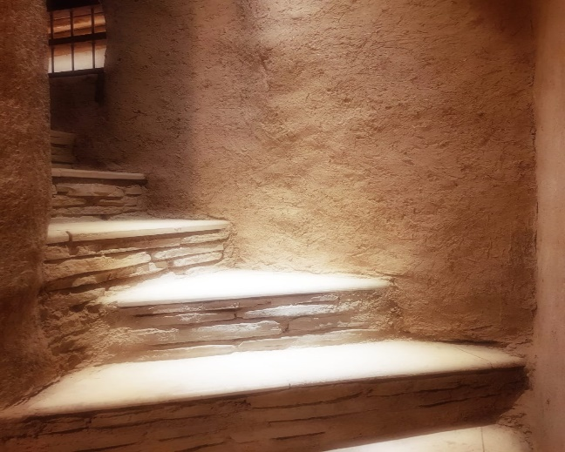
Similarly, Latifa and Al-Muthabira believed that their spiritual values helped them achieve their goals. However, unlike Al-Fajer and Amani, their discourses focused on personal goal-setting and hard work and their intersection with God’s will. Latifa shared a picture (Figure 55) of stairs in an old fort, which represents her core spiritual values of optimism and hope.
Figure 55. Hope and optimism: A person should work hard in life.
Latifa took this picture when she was on a trip to Nizwa, Oman, as she felt that it represents her journey with Al-Noor:
When a person wants to reach something, they need to take things one step at a time… you can never reach goals without working on them… I mean first, you have to set a goal… so my goal in life is that my girl would at least reach a level of independence that I am satisfied with, and the rest is on God. But I want to know that I never just left her and I did everything I could and the rest is on God… a person cannot change anything in this world… if God wants something to happen, it will happen but the most important thing that a person does not lose hope… you try your best… like steps… first this and then will get to what we want. (Latifa)
The picture of the stairs is used as a metaphor. The top of the stairs reflects the ultimate goal of Al-Noor’s independence, and the steps reflect the tasks Latifa needs to accomplish to achieve the goal: ‘I feel like in my situation with Al-Noor I need to take one step at a time so we can help her’. Latifa spoke about the spiritual beliefs that helped her achieve her goal of helping her child gain independence. While Latifa emphasised the importance of setting goals and working systematically to achieve them, she also highlighted her perception that God’s will is not amendable, maybe implying a tension between her personal goals and God’s plan. To reconcile these, she focused her parental behaviour on doing her ‘best’ as a mother to help her child gain independence, i.e., to fulfil her role as a mother of a child with disability by working hard to care for her. In this extract, Latifa draws her beliefs about the link between her beliefs about free will and destiny or God’s plans.
Al-Muthabira reiterated Latifa’s account. For the photo-taking task, Al-Muthabira chose a picture that reflected reaching a goal (Figure 56).
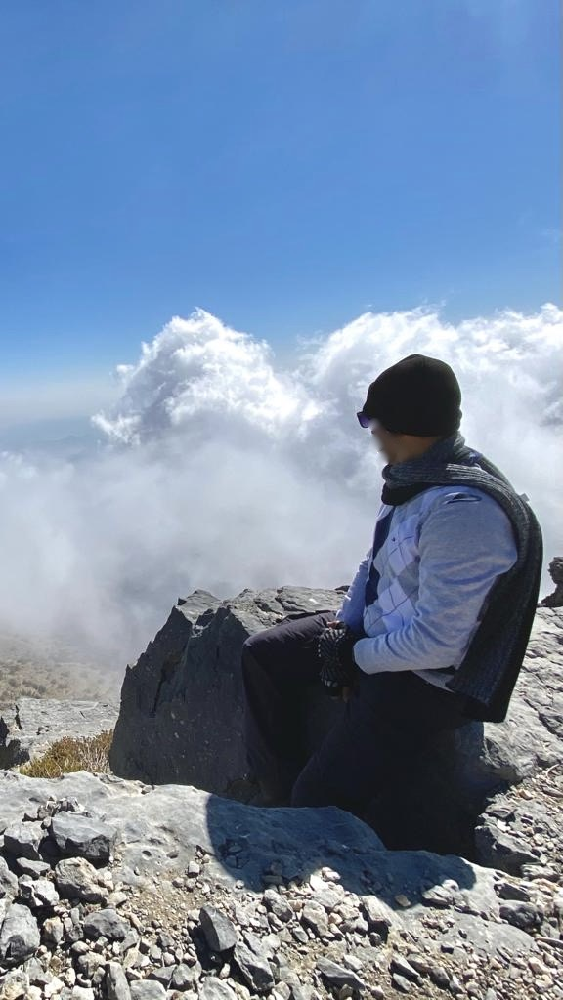
Figure 56. Every person should reach their goal, whether the goal is big or small, even if the goal was the highest mountains.
The photo she chose is of her brother at the top of the highest mountain in Oman, Jabal Shams. She explained that this picture shows a man gazing at the clouds feeling satisfied after reaching his goal. To express her spiritual beliefs, Al-Muthabira explained:
This picture is like I say, when a person seeks success and wants to reach his goal, he has to do his best. I mean look at where he reached in this picture… the top of the mountain… high up… so there is nothing difficult I mean… as long as a person has a goal… something he wants to get… just be sure that God will give you the reasons to success and all, no matter what your goal is… I mean while he climbs, he might fall or something… I mean his trust in God and his certainty in God that I will take the risk and reach. (Al-Muthabira)
Al-Muthabira expressed a strong sense of determination: ‘there is nothing difficult’. Like Latifa, Al-Muthabira found engaging her religious beliefs with goal-setting crucial to her. For Al-Muthabira, when a person’s goal is in line with their religious beliefs and when a person trusts God, He helps them to achieve their goals. Both participants expressed their reliance on God while also highlighting a sense of personal choice in goal-setting.
Reflective Box
To convey her values, Al-Muthabira used a photograph of her brother, rather than a photograph of herself hiking. This may be due to cultural and religious barriers, including restrictions around clothing and gender stereotypes, that limit Omani women’s engagement in sport activities. This is similar to other Arab women, whose engagement in sports is restricted due to cultural restrains (Aljayyousi et al., 2019). However, it seemed that Al-Muthabira found this photograph particularly expressive of her spiritual belief of being determined to achieve goals.
Interestingly some parents shared positive psychological outcomes to hard work, other than achieving their main goal, such as personal gains or positive feelings that stemmed from overcoming challenges related to caring for a child with disability.
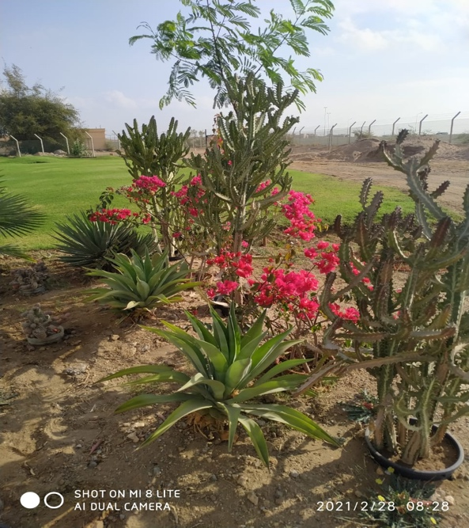
Al-Fajer talked about the beauty in every challenge, which is one of his key spiritual values. To illustrate this, he took a photo of cactus trees surrounded by flowers (Figure 57).
Figure 57. Life’s challenges: the challenges I face to take my child to therapy.
For Al-Fajer the cactus trees reflect the challenges he faces, and the flowers represent the positive outcomes he gains from these challenges:
The cactus tree, for me, reflects the difficulties I face, and the flowers of course are the joy of facing the challenge. The beauty of facing the challenge and the pleasure of learning from it. Of course, no matter what circumstances you are in, you have to get out of it with some benefit or experience and this is what the flowers represent to me. (Al-Fajer)
Al-Fajer appeared optimistic and explained that he finds joy, beauty and pleasure of learning in overcoming challenges, seeing his son improve, and feeling that he is fulfilling his role as a father. When Al-Fajer spoke about the challenges he faced, he explained:
I mean these circumstances you have to face… you are trapped in the corner… like the health issues that happened to my son… I have to face them… I do not want them but some challenges you have to face and overcome. (Al-Fajer)
Feeling ‘trapped’ indicates a lack of freedom or power to change his situation, demonstrating the heavy load that Al-Fajer must feel. He feels he has no choice but to ‘face and overcome’ these challenges. Al-Fajer tried to manage the feeling of being ‘trapped’ with his positive spiritual outlook that he described as hope in overcoming the challenges:
I: Can you tell me about the spiritual aspects that this picture reflects?
Al-Fajer: That there is hope in all difficulties.
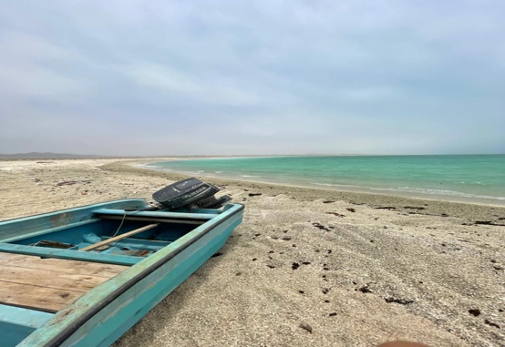
Amani and Sada spoke about personal gains from achieving their goals. Amani shared a picture she took while visiting Sur, a coastal city in Oman, which shows a small fishing boat on the shore (Figure 58).
Figure 58. At the end of the journey: navigating surging waves to reach the shore is a proud achievement. Just like the journey of parents of children with special needs
Amani explained:
This picture… I mean it’s like the boat reached the shore, so this picture is the same… I mean, if you work on something, you will reach your goals eventually… just like the boat sails for a long time to reach the shore… you too will reach what you want. (Amani)
The picture represented working hard to achieve a specific goal. Amani believes that when people are determined and dedicated to a goal, they eventually achieve what they aim for. Amani’s caption showed that Amani used the picture as a visual metaphor that reminded her of the experience of parents of children with disability: The challenges of parenting a child with a disability is represented as navigating surging waves, something that requires effort to overcome in order to reach the shore but results in pride at accomplishing this. The boat in the picture represents her belief that it is possible to overcome the obstacles and reach the shore although the effort required may be considerable and take a long time. Amani considered achieving goals to be a ‘proud achievement’, the feeling of pride either stems from social praise associated with the ‘achievement’ of caring for a child with disability or could stem from an internal feeling of self-respect. Amani explained that the spiritual aspect reflected in this photograph is that ‘people should work with determination and in the end, their goals will be reached’.

Parents also spoke about the spiritual activities they engage in and the positive psychological outcomes that result from engaging in these activities. It appeared that activities were perceived as spiritual because of the way that engaging in the activity helped them feel. For example, to express their spirituality, Latifa and Abdullah spoke about the activities they participate in that improve their mental well-being. Latifa used Figure 18, which depicts the natural scenery of a beach and clouds, to express the importance of inner peace as a spiritual value (Figure 59).
Figure 59. Peace and Calmness: A person’s inner-self should be calm and accepting... always calm, so he/she can concentrate to be able to think about tomorrow.
Latifa took the picture because she experiences a sense of peace:
There is the sea and clouds. A nice place… I felt this place gives you inner peace and calmness. Of course, I felt that it is like with Al-Noor… when I see her I feel calm and peaceful, like she is an angel, glory be to God… she is not guilty of anything so we try to help her… so this picture gives you peace and calmness so this is how I felt… the beach gives you inner peace and calmness. (Latifa)
Latifa enjoyed the scenery as it reminded her of Al-Noor. Both the beach and Al-Noor give Latifa the same feelings of inner peace and calmness. She also believes that Al-Noor is similar to an angel, she is angelic because she has no guilt or sin, but a disability was bestowed upon her and she needs assistance. Latifa continued to talk about the photograph:
I felt calmness and inner peace. I mean, a person should be calm to be able to concentrate and all… I mean I can focus more on what I am doing… unlike when I am angry and all… I can’t focus and can’t do anything… so calmness and peace help you do things… be able to help. (Latifa)
For Latifa, the feeling of inner peace is very important as it helps her to gather the strength to concentrate on her goals and achieve them. For her, anger is the opposite of feeling peaceful and it prevents her from staying focused on her goals, leading to her failure to achieve them. Being in nature, Latifa had an opportunity to connect with herself, feel inner peace and calm, and reflect on her goals. Latifa explained that these positive emotions enable her to ‘be able to help’ maybe referring to helping Al-Noor. Therefore, Latifa’s spirituality appears to be an important element as it provides her with positive emotions that fuel her desire to carry on with her goals and achieve her life’s purpose of helping Al-Noor.

Finding inner peace helps Latifa clear her mind. Similarly, Abdullah enjoys natural scenery and feels relieved after spending time in nature. Abdullah shared a picture of a valley (Figure 60), which he took when he was on a trip to Al-Rustaq with other male family members.
Figure 60. The water's journey: a trip with friends away from the city and pressures.
Abdullah explained:
The valley and the sound of water… I mean this is spiritual… to go to a place like this… with water and open space… this was an outing with family members… I was out with my brother-in-law and other guys… the scenery is beautiful and it’s a valley… I enjoyed the place and the company as well… this is an outing… outside the house… away from all the pressures and all… I just relaxed. (Abdullah)
Abdullah explained that spending time in nature, in a place he perceived as ‘beautiful’, is a spiritual activity. Abdullah enjoys the collective experience of being in nature with people he likes to spend time with and indicated that taking a break from his usual responsibilities as a father helps him to ‘relax’.
Shaikha also spoke about the spiritual activities she engages in with others, namely, her immediate family, explaining that family connectedness is part of her spirituality. To illustrate this, she shared a picture of her nuclear family members’ hands stacked together (Figure 61).
Figure 61. Connectedness: My family’s connectedness gives me strength
For Shaikha, the closeness of her family and her husband’s support helps her cope with difficulties:
I mean for me this picture represents connectedness or strength, for example, this is my strength. For example, when we are together then this is strength for me, this is what gives me the energy to withstand… for example, going to the hospital and coming back and the child is always sick I mean the father is around and the girl is fine and healthy, thank God, so they give me hope. (Shaikha)
Shaikha believes that her family is her ‘strength’, the togetherness and sense of connection give her ‘energy to withstand’. Using the word ‘withstand’ or at’hammall holds several meanings including endure, resist, and hold on. These meanings reflect how challenging she finds the experience of caring for Adam as though she has to withstand this experience and survive. Shaikha gave an example of taking her child to the hospital, which she finds challenging due to Adam getting sick frequently and the issue of needing to visit multiple hospitals to receive specialised care. However, receiving support from her husband and seeing her other child growing without needing additional support like Adam gives her a sense of hope and ‘energy to withstand’. While Al-Fajer did not share a photograph to demonstrate this, he also talked about how connecting with family by spending time with them is ‘considered spiritual’. Al-Fajer explained: ‘it creates love and intimacy, we hear each other, we laugh together this is spiritual’.

While Shaikha and Al-Fajer described their relationship with their family as spiritual, Zumuruda and Latifa believe that doing things for others is a spiritual activity as they shared stories assigning spiritual meanings to preparing food for other people. Zumuruda shared a picture of homemade dumplings and explained that her husband and children love the dish (Figure 62).
Figure 62. Sweets: It tastes good to my children.
Preparing the dish and seeing her family enjoy it give her positive emotions:
I feel happy because my children ask me for it and I also feel happy because they come to me when they want something… they do not go to others… I mean my sense of duty lets me do the things that they ask for… my duty is to satisfy their needs… they can’t ask anyone else… for example, they can’t go ask their aunties. (Zumuruda)
For Zumuruda, this picture is spiritual not only because the dish brings happiness to the family, but also because she feels that it is her ‘duty’ to meet her children’s needs. Doing her duty for her family gives her a sense of satisfaction and brings her happiness. Zumuruda’s sense of duty may relate to her perception of her purpose in life: ‘my duty is to satisfy their needs’.
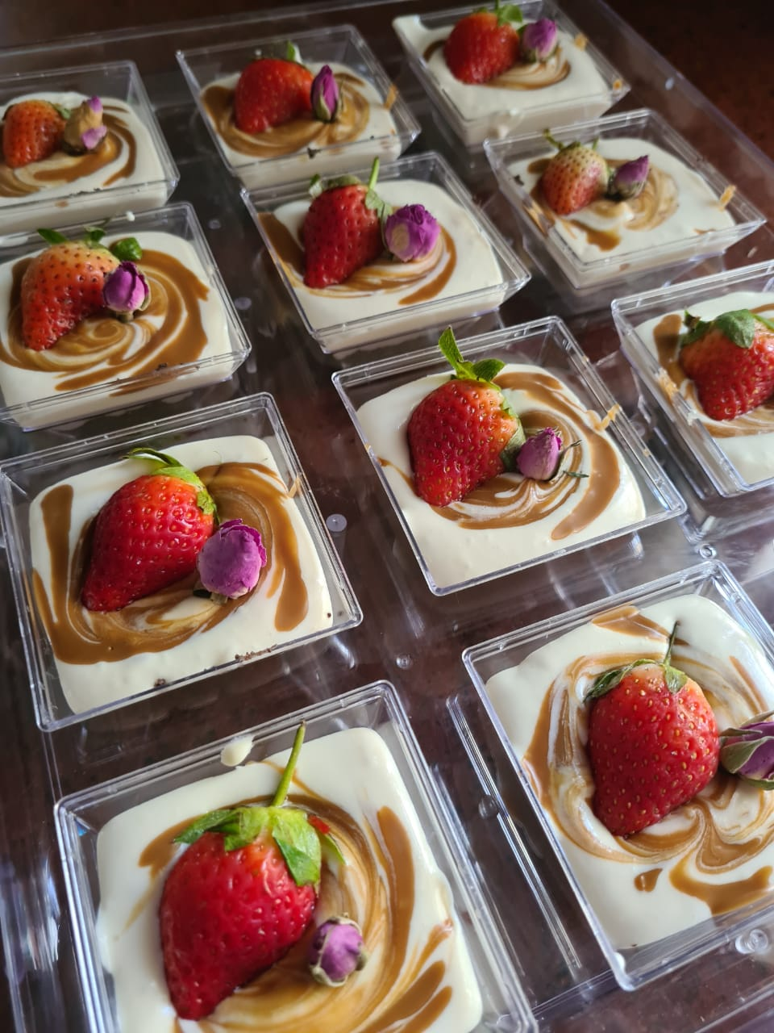
While Zumuruda prepares desserts for her family as part of her duty, Sada prepares desserts because she enjoys it as a hobby. Sada shared a picture of homemade shot-glass desserts (Figure 63).
Figure 63. My hobby: the image shows my hobby of making desserts, which is an enjoyable and relaxing activity for me in my free time.
Sada prepared the dessert for some guests and took a picture and shared it with her colleagues:
I really like to make desserts and cookies and cake… I love working on these… and this picture was taken after my brother’s wedding… or maybe my sister’s wedding…they married around the same time…and I had visitors coming and I took this picture to show my work-mates the dessert I made…but I chose this picture because I really love making dessert. (Sada)
Sada appeared to be proud of her cooking skills as she shared the picture with her colleagues and expressed strong positive feelings towards making desserts. When asked how making desserts relates to her spirituality, she explained:
Like I said, I really enjoy making desserts, it makes me feel calm and when I make desserts… I mean I do not enjoy eating desserts a lot but when I make something delicious that others like… I really like the feeling. (Sada)
Sada clarified that while desserts are not very appealing to her, the process of preparing desserts helps her mentally. She also enjoys preparing desserts for others to enjoy. For Sada and Zumuruda, preparing food gives them personal satisfaction and creates a sense of connection with others.
The parents’ description of their spirituality appeared to be influenced by the lived experience of being parents of a child with disability. Spiritual beliefs gave participants a sense of agency – helped them mentally and pushed them to overcome the challenges imposed by institutional barriers. The parents also attempted to cope with their experiences through engaging in activities that resulted in positive psychological outcomes. Their spiritual beliefs seemed to provide a way with which the parents could overcome challenges and experiences they faced through caring for a child with disability in Oman.

Sub-theme 3: Spiritual and Personal Growth
The majority of participants (10) gave accounts of personal and spiritual growth, describing it as an outcome of the challenging process of caring for a child with disability. However, the parents grew and transformed in different ways, which are discussed below.
Parents noted transformation in different ways such as reprioritising what they perceived as important in their lives. For example, while reflecting on her experience as a parent and having a child with disability, Shaikha explained:
I realised the meaning of health. The meaning of seeing your child grow older. I mean, when my daughter was the only child, she learned and whatnot; I focused on so many external things. We neglect basic things like health, that he grows, that she can walk, she can eat, she has cognitive abilities, she talks. I mean, many children do not talk but have something like, for example, autism, and they have this or that… I mean, I became aware of these things. (Shaikha)
Here, Shaikha described becoming more attuned to the good things that surrounded her after she had Adam. Adam has marked global developmental delay; therefore, he requires a significant amount of time to meet developmental milestones. As a result, Shaikha developed a deeper awareness of health and children’s development. Upon reflection, she found that she took her typically developing daughter’s milestones for granted even though it was a valuable thing. She also found that she developed awareness of other disabilities and perceives this positively.
As with Shaikha’s experience, Al-Fajer noticed changes in himself after having a child with disability:
Before having Al-Amal, I was not compassionate with people who are like Al-Amal. I mean when I used to see a child with disability, I would say thank God or may God heal him or thank God who spared us from what this child has, but my perspective changed when I had Al-Amal. I now can feel how a father of a disabled child feels when somebody looks at his son. A father would think does this person accept my child or not? I mean from the way a person is looking at the child. I now see deep things I never expected to see. (Al-Fajer)
Like Shaikha, Al-Fajer became more enlightened and aware of developmental disabilities. This awareness resulted in a perspective shift. Al-Fajer believes that he ‘grew’ spiritually after having Al-Amal and became more sympathetic towards people with disabilities and their parents. In the past, he used to feel thankful to God that neither he nor his family members had a disability. However, his perspective has now changed, and he is conscious of how a child’s father might feel if he heard what he used to say or stared at the child. Al-Fajer considers the change he has experienced to be unexpected and deep.
Similarly, Al-Shumookh also noticed positive changes in her personality:
I get angry… I know my flaws… I mean, I boil from the inside… and sometimes with Al-Amal Al-Mutajadid, I experience some circumstances but I control it. I mean, I am now more able to control my anger… I began to say: ‘Why would I express my anger if it is useless?’ I mean expressing my anger can worsen things so I try to control it. (Al-Shumookh)
Al-Shumookh’s son, a teenager with Down Syndrome, sometimes displays challenging behaviour, but she believes that managing his behaviour has improved her self-control. Al-Shumookh described an intense feeling of anger expressed as immense internal heat: ‘I boil from the inside’. This feeling results in what she perceives as negative behaviour: ‘sometimes I shout at him’. However, due to Al-Amal’s limited recognition of her anger, she realised that anger was not the best way to discipline him, therefore, she found that she became more capable of controlling her anger, although it is sometimes difficult.
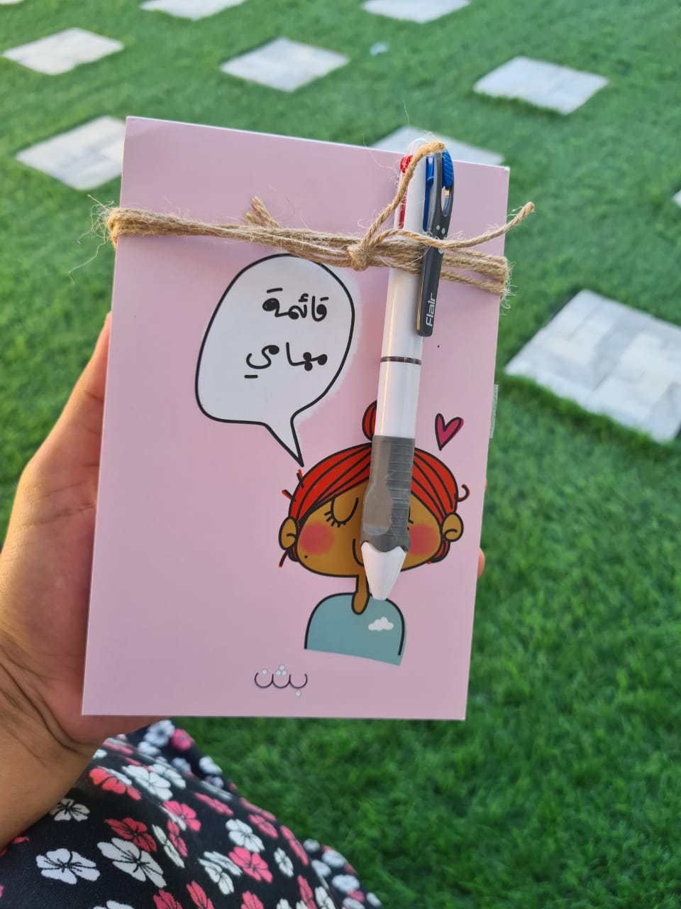
Unlike Al-Shumookh, who found that self-improvement was a product of caring for her child, Sada actively sought self-improvement and growth to become a ‘better’ parent and described it as a spiritual value illustrated through Figure 64.
Figure 64. Managing time: a strong desire to manage my time and organise my daily tasks according to priority and try not to waste time.
Sada explained:
A close colleague of mine and I were discussing… I mean my friend… and I told her that I try to change myself always… I become to become a better person… we were just sitting and laughing… I mean I try to change myself… my habits whether health habits or… I mean every night before I sleep, I think to myself that tomorrow I will be a better person, I will exercise and I will eat healthy food… I will change my relationship with my girls… look after them more… I mean change myself… I told her: ‘but when I wake up, I forget about it all’ (laughs). (Sada)
Sada clarified that her friend gave her the notebook as a gift after a discussion they had at an earlier time. The Arabic qayimat mahamy can be seen on the notebook, which translates as ‘my to-do list’. Sada’s talked about her willingness to develop herself. Sada’s account implies that she finds self-development spiritual because she believes that by ‘improving’ herself, she can become a better parent as this improvement can make her day more meaningful for herself and her family.
Parents also felt that having a child with disability strengthened their faith. Al-Shumookh and Amani found that having children with disabilities strengthened their relationship with God as their faith grew. Al-Shumookh explained:
This [having a child with a disability] helps you become more resilient. It gives you faith in God and, as they say, ‘good lies in evil’ (a proverb)… I mean, we might perceive something as being challenging and an affliction from God, and we think that it’s bad… I mean, God puts his slave in situations, and He knows that this person can endure it. (Al-Shumookh)
She also used the proverb ‘good lies in evil’ or alkhayr yakmun fi alshar, which is used in Arabic when someone experiences a challenging situation to encourage the person to be patient, as ‘good’ may emerge from a challenging experience if one demonstrates patience. The ‘evil’ in this extract seems to refer to Al-Shumookh’s initial perception that her son’s disability was a challenging affliction from God and the ‘good’ is that she found herself growing as she became more resilient and maintained her faith through the process of caring for her child. Al-Shumookh also believed that God knows what people can handle and gives them challenging life events according to their resilience, indicating that God gave her a child with Down Syndrome because God knew she is able to care for him.
On the other hand, Amani’s growth in faith resulted from her spiritual reflections: ‘thoughts I derive from my meditations and these thoughts change my perspective about things… I mean when you are not spiritual, your perspective is different’. Amani gave the following example:
Sometimes when I used to go through a difficult time, I used to say: ‘oh God, why is it so difficult’… now I feel that yes there are difficulties but things improve… so I started to think that this experience will teach me something… I feel that God gave me things to learn, be patient and get stronger to face things in the future… so these challenges do not upset me like they used to. (Amani)
Amani’s description of her experience of growth illustrates a temporal dimension as she initially felt that the challenges of caring for a child with disability were overwhelming. However, upon reflection, a positive understanding developed, and Amani found that having a child with disability provided her with a greater sense of personal strength. Thus, she became more resilient and confident in the face of life’s challenges. Amani denotes this change of perspective on her spirituality as she believes that God purposefully gave her a child with a disability to help her grow.
In contrast to the majority of participants, who identified personal or spiritual growth, Samia was unable to recognise any growth. Throughout the interview, Samia provided brief answers to the interview questions. She was very emotional when talking about Amal’s birth and infancy and explained that she preferred not to talk about this period as she found it difficult. Furthermore, Samia dismissed the challenges related to caring for her child:
I: If I ask about the challenges, can you tell me about them?
Samia: I feel like the challenges are just like the challenges with other children… it’s the same.
While all other participants seemed to have reflected on the difficulties and resultant personal growth, Samia avoided engaging with them. It appeared from other respondents, however, that recognising challenges may have provided opportunities for growth.

Group Experiential Theme 3: Summary
Parents of children with disability in Oman face multiple challenges related to caring for a child with disability. The parents in this study felt overwhelmed or emotional as a result of the challenges they came across through their experience with accessing services to provide care for their children. However, the parents did not seem to focus on discussing specific caregiving tasks related to the child’s behaviour or the severity of the child’s disability. Rather, they elaborated on issues that pertained to service provision and how these services affected not only their parenting experiences but also how they perceived their child’s disability.
The photovoice findings, as demonstrated in sub-theme two, showed that the parents’ perceived values of determination and optimism as spiritual values essential to aiding them in overcoming challenges and achieving their hopes for their children’s development. The parents’ accounts confirmed that the experience of caring for a child with disability is challenging due to institutional barriers, however, the parents seemed to rely on a solid foundation of spiritual values and engaged in spiritual activities that helped them maintain their well-being and maintain their parenting role.
Sub-theme 3 detailed the parents’ experiences of spiritual growth that seemed to directly result from the challenges they experienced while caring for their children with disabilities. Most parents described growth and transformation in different ways such as in faith, personal attributes, the ability to control their emotions and improved relationships.

Group Experiential Theme Three Discussion
The findings in Group Experiential Theme (GET) 3 detailed the parents’ experiences in accessing health and education services to support their children. Sub-theme 1 showed that parents faced several challenges related to service availability and accessibility. Sub-theme 2 detailed the challenges parents faced and how these influenced their spiritual values and beliefs. Sub-theme 3 discussed the parents’ personal and spiritual growth, which also appears to be an outcome of the challenging process of accessing care for their children. In this section, I aim to contextualise the findings by providing background information about the current services that support children with disability and their parents. I will also discuss the findings in relation to the wider literature.

Experiences of Accessing Services
The parents in GET 3 elaborated the challenges they faced while seeking health, educational and social services for their children. In this section I will detail the parents’ experiences and provide background information in relation to the availability of existing services.

Health services: Inequitable Distribution of Health Services
The literature review (Chapter 2:) highlighted that parents of children with disability face a higher cost of living due to the additional expenses of providing specialist care. This was reflected in the participants’ accounts, in which parents identified accessing services for their children as a major challenge. These challenges include difficulty in accessing services due to cost and distance. For example, Al-Fajer, Zumuruda and Al-Shumookh, who live outside Muscat, had to travel for hours to access services for their children. This caused delays in accessing early intervention for their children; for example, Al-Shumookh’s son, Al-Amal, began accessing services when he was 10 years old. The absence of transportation support for families with a child with disability and the high cost of transport may affect accessibility (Mkabile and Swartz, 2020).
In this study, parents appeared emotional when discussing the challenges they faced in accessing services. Some parents expressed a sense of unfairness, whereas others expressed distress and sadness. Marquis, McGrail and Hayes (2020) found that parents of children with disabilities who live further from health and rehabilitation services are more likely to have depression than parents who live closer. The findings from this study align with other research that shows that parents of children with disability experience high levels of stress due to a lack of accessible supportive services, among other reasons (Barlow, Powell and Gilchrist, 2006; Sloper and Beresford, 2006).
Health services in Oman have improved significantly in the past 40 years, which has led to reduced morbidity and mortality rates, and increased life expectancy (MoH, 2014). However, improvements in services for people with disabilities have lagged considerably (Alakhzami and Huang, 2020; Al-Adawi et al., 2012). For example, while primary health care services are provided in both urban and rural areas, the majority of rehabilitation or specialised services are currently located in Muscat. Figure 65 shows the geographic distribution of rehabilitation staff working in Ministry of Health (MoH) facilities in 2021. While a limited number of therapists exist, physiotherapists (PTs) appear to be more widespread. This is likely because physiotherapy is the only rehabilitation sub-speciality taught in higher education in Oman, while occupational therapists (OTs), speech and language therapists (SLTs) and others are either non-Omanis or Omanis who trained overseas. The numbers of OTs and SLTs are expected to increase as the specialisms will be taught in higher education in Oman from 2023.
Figure 65. Distribution of MOH Rehabilitation Professionals by Governorate
Participants in this study were recruited from rehabilitation centres, meaning that all parents in this study had access to such services. Some of the above-mentioned challenges might have prevented other parents from accessing services for the children, and future research should study the lived experience of parents who do not or are not able to attend specialised services in Oman.

Disclosure of Child’s Diagnosis
Parents spoke about their experiences concerning the disclosure of disability diagnoses for their children. Research has suggested that a diagnosis of disability can be challenging for parents, as it could be associated with a feeling of loss (Goff et al. 2013; Wright, 2008). Parents in this study were not only upset and emotional because of the diagnosis but because of the way the diagnosis was disclosed. Parents in this study felt that healthcare professionals lacked compassion and did not provide sufficient information regarding their children’s disabilities. Likewise, Goff et al. (2013) found that parents of children with Down’s syndrome in the United States identified negative experiences with medical professionals during the diagnosis process (including a lack of compassion and perpetuation of negative stereotypes of people with disability), which had negative consequences for their adjustment to their child’s diagnosis. Furthermore, Prezant and Marshak (2006) found that parents of children with disability reported that they wanted healthcare professionals to provide information, show compassion, and collaborate and communicate with them about their child’s disability. Disclosure of a disability diagnosis can be challenging for health professionals; nevertheless, delivering the diagnosis in a sensitive, caring and confident manner is important for the parents’ experience in accepting and adjusting to the diagnosis (Dent and Carey, 2006; Goff et al., 2013). In this study, Al-Muthabira, Al-Shumookh, Al-Fajer, Zumuruda, Sada, and Amani shared negative experiences related to the disclosure of diagnosis for their children. For example, Amani, who felt depressed in the postpartum period was referred to by health professionals as ‘mother of [Child’s diagnosis]’. Also, Al-Muthabira, the mother of Mahboob, a child with Down’s syndrome who is an active member in an informal support group of mothers of children with Down’s Syndrome shared some thoughts the mothers discussed when they met:
Breaking the news in a good way is something we lack... we hope that in the future they will have a better way, they will have a psychologist or something who can explain to the mother in a nice way… believe me, they will love the syndrome… because all of us… after we live with the child we regret the frustration we felt when we were first told about it. (Al-Muthabira)
Offering a positive view of disability when sharing the diagnosis improves the experience of parents (Dent et al., 2005) and can potentially oppose ableist attitudes. Unfortunately, support and counselling services are not yet widely available in the Omani health system. An established protocol for the healthcare team to relay such information with a positive approach may help determine the parents’ reaction to the event (Wright, 2008). Additionally, since one-third of disabilities are caused by congenital anomalies (Ministry of Health(MOH), 2014), healthcare professionals should acknowledge that parents may have varying degrees of self-blame, particularly if the disability resulted from genetic transference, and offer support when needed (Wright, 2008). This was evident in Khalid and Amani’s account; they are married cousins and their child has a genetic disorder, and Khalid said ‘we felt guilty’ after they became aware of the child’s diagnosis.

Educational Services for Children with Disability: Parents Experiences and Concerns
This section gives a brief review of the available educational services for children with disability in Oman to provide background information to the challenges the parents shared in GET 3 Next, the parents’ concerns and worries about the child’s education will be discussed in relation to the wider literature.

Educational Services for Children with Disability
The school education system in Oman consists of basic and post-basic education. The basic education system extends from Grades 1-10 and is divided into two cycles: Cycle One consists of four years (Year 1-4 in the UK school system) and Cycle Two consists of six years (Grades 5-10 in the UK school system). Cycle One classrooms are for girls and boys with full female staff, whereas Cycle Two classes are single-gender with single-gender staff. The post-basic education includes Grades 11 and 12, which are similarly single-gender. Free education is offered to all Omani children through government schools. In this study 10 out of 11 parents expressed concerns about their children’s education.
Due to the limited availability of information regarding the school system and education services for children with disability, I visited the Ministry of Education and met staff working in the provision of education for children with disability, who also wished to remain anonymous. According to one staff member, education for children with disability is offered through dedicated special education schools and inclusive government schools. The three special education schools are the School of Intellectual Education (for students with cognitive disabilities), Oman bin Al-Khattab School for the Blind (for children with visual disabilities), and Al-Amal School for the Deaf (for children with hearing disabilities). Children with physical disabilities are integrated into mainstream schools.
According to one staff member, inclusive classes are available in the majority of government schools. Each inclusive school dedicates one class for children with intellectual disabilities; for example, Cycle 1 schools dedicate one class for children in Grades 1-4 and provide special education. Children who enrol in inclusive schools can be referred through Al-Wafa centres or by parental self-referral. Education for children with intellectual disabilities is offered up to Grade 9, and only students with visual disabilities can continue beyond Grade 9. In general, children with intellectual disabilities tend to stay home after Grade 9. In this study, Al-Shumookh appeared to be stressed about her son staying home as he is 15 years old and not eligible for further education due to his disability.

Experiences and Concerns about Education
For Omani parents in this study, their child’s education appeared to be a central worry. Although these results differ from the results of some studies conducted in Korea (Kim et al., 2016) and the United States (Marsack-Topolewski and Graves, 2020), they are consistent with studies exploring parents’ experiences in Africa (Oti-Boadi, 2017; Mkabile et al., 2021) and China (Yang et al., 2016). According to Mkabile et al. (2021) this could be due to the lack of coherent educational services for children with disability in these countries.
Despite significant efforts by the Ministry of Education to provide quality education for children with disability, a lack of specialised teaching and support staff remains an obstacle (Mohamed Emam, 2016; Al Hosni, 2017). Therefore, unsurprisingly, in 2021, 58% of people with disability in Oman were illiterate. A possible explanation for the parents’ concerns about their children’s education is that a lot of emphasis has been placed on education since the rule of His Majesty Sultan Qaboos. Another possible explanation could be the fact that data collection for this study was conducted while some pandemic restrictions were imposed, which may have exacerbated parents’ stress about their children’s education due to the closure of rehabilitation and special education facilities in Oman. This is supported by Abdelfattah et al. (2021), who explored sources of stress for parents of children with disability in several Arab countries (including Oman) during the pandemic, finding that the closure of special education centres caused immense stress.
Another concern raised by parents in this study was sexual abuse in schools. Al-Shumookh, who is the parent of a boy with Down syndrome was concerned about enrolling her child in a Cycle 2 single-sex school as she worried about ‘sexual abuse’. According to Alshekaili et al. (2020), the Ministry of Social Development reported 73 cases of child sexual abuse in 2018; however, data on sexual abuse is not widely available in Oman, therefore while rumours about sexual abuse in schools exist, there is no concrete evidence to explore this issue. In addition, while sexual abuse targeting men is unacceptable among Omanis, sexual abuse towards women is believed to bring shame not only to the woman, but also to the family, therefore, families tend to show ‘extra’ efforts to protect women from being abused and this might include isolating them. For example, not letting girls with disability go to public places. This may contribute to the fact that in Oman women with disability have a higher rate of illiteracy (United Nations Human Rights (UNHR, 2017)), because they do not attend school. This may be related to worries about sexual abuse in schools. Further research can be undertaken to investigate the prevalence of sexual abuse in school and issues related to gender inequity in accessing education.

Lack of Support Services
Parents also spoke about the lack of services, support and information for parents of children with disability and recommended establishing these services. The parents suggested establishing formal support groups as none are currently available. Support services and educational programmes can have positive effects on parents’ mental health (Bourke-Taylor et al., 2022). For example, Barlow, Powell and Gilchrist (2006) conducted a training and support programme to equip parents of children with disability with a simple massage skill for their children, which they found had positive effects on parents’ psychological well-being. Similarly, Bourke-Tavlor et al. (2022) examined the psychological outcomes for mothers who attended a programme that empowered and educated mothers of children with disability to improve health behaviours, finding that mothers who took part in the programme experienced reduced depressive and anxiety symptoms and improved quality of life compared to those who did not. Also, Dent and Carey (2006) explained that support groups that include more experienced parents of children with disability can help those with a newly diagnosed child accept the child’s disability.
Sloper and Beresford (2006) argued that a robust benefit system can help reduce stress for parents. Due to the lack of availability of information regarding services provided by the Ministry of Social Development (MoSD), I visited the ministry to understand more about the available services for children with disability and their parents and was asked to keep the identity of the member of staff I spoke with anonymous, therefore a pseudonym (Safia) will be used to refer to the staff member. The MoSD aims to improve the quality of services for people with disability. These services include social security (provision of cash allowance) for low-income families, rehabilitation services through Al-Wafa centres, and vocational training for children with disability aged 16 and above. Nevertheless, there were some services and benefits for children with disability and their parents that were not yet placed within a coherent system due to a lack of resources (for example, a lack of therapists). Safia explained that while there are currently 32 Al-Wafa centres across Oman, not all provide these services, and some are better equipped than others. Furthermore, for a child with disability to access these services, a disability card must be issued. According to Safia, many parents of children with disability refuse to register their children into the system due to disability stigma and not wanting their children to be called ‘disabled’.
In 2021, the number of people in Oman with a disability was 42,304 (NCSI, 2021). The number of boys/men registered with a disability (61%) is significantly higher than the number of girls/women (39%). This discrepancy has not been yet explored but could relate to gender inequity. Furthermore, while the staff member emphasised the implementation of recent policies and practices, there was no clear evidence or documentation of this, as Ismail and Hussein (2019) found in their exploration of the services provided by the MoSD to older adults.

Spirituality and Hope and Optimism
In sub-theme 2, parents shared values of hope, optimism, determination, inner-peace and happiness related to caring for their children with disability. Spirituality is related to purpose and meaning in life (Hill et al., 2000; Ivtzan et al., 2013), and the purpose in life the parents focused on while sharing their photographs was caring for their child with disability, ‘helping’ the child gain independence and benefit from the available health and educational services. In this section, I focus on the values of hope, optimism and determination, as the majority of participants alluded to these values. Furthermore, when parents in this study were asked to choose a pseudonym for their children, four chose the name Amal (hope) or Al-Amal (the hope), which may signify the importance of hope in their lives (concerning caring for their child with disability) or be related to the research topic of ‘spirituality’, as parents talked about hope when talking about spirituality in the photovoice interviews.

Hope
The majority of parents (8) alluded to hope in relation to overcoming challenges and achieving goals. This can be linked to Snyder’s theory of hope (Snyder et al., 1991), in which hopeful thinking consists of the beliefs that one can find routes or pathways to desired goals and that one can assemble the motivation to use those routes. A fundamental tenet of Snyder’s theory of hope is that much of human behaviour is goal-directed; therefore, goal thoughts are considered the foundation on which hope theory is built (Snyder et al., 1991). Goals can be conscious or unconscious. Parents in the current study appeared to talk about conscious goals of caring for their child; however, these goals may have been unconscious until the parents reflected on their spirituality, as one mother explained ‘Reflecting on my spirituality really helped me see things in a positive way’.
The theory of hope explains how people find routes or pathways to their goals. In his 2001 paper, Synder discussed two kinds of goals, those that fill a profound void in a person’s life and those that people have to build on an already satisfactory life. In this research, parents faced significant challenges to provide care for their child, so their goals and hopes appeared to be constructed to help them cope with these challenges or according to Snyder (2001), to fill a significant void in their lives. However, parents who raise their children with disability in a context where services are accessible and available, or parents who receive satisfactory support, may construct different goals and hopes. Therefore, the parents’ hope may be shaped and constrained by the context in which they live.
Parents also spoke about how the pursuit of their goals brought a sense of satisfaction and fulfilment. For example, Amani explained that the journey of parents of children with disability gives a sense of ‘proud achievement’, whilst Al-Fajer chose a photograph (Figure 20) that shows flowers used metaphorically to reflect the ‘beauty of facing challenges’. In accordance with findings in this study, research has shown that the spirituality of parents of children with disability enhances and maintains hope, and thus can be used as a coping mechanism (Kausar, Jevne and Sobsey, 2003).

Optimism
The majority of the participants’ photovoice explanations about spirituality focused on optimism. This indicates that the parents’ optimistic worldview reflects their spirituality. Scheier and Carver's (1985) theory of optimism suggests that optimistic people expect good things to happen to them, which influences their approach to the world, helps them to cope with stressors, and affects the way they confront problems. Optimism is associated with a lower risk for psychopathology; for example, O’Connor and Cassidy (2007) found that optimism is inversely related to hopelessness, which is a risk factor for depressive disorders.
Scientific definitions of optimism, like hope share the underlying perspective that all human behaviour reflects the pursuit of goals (Krafft, Guse and Maree, 2020). This links with the findings from this study, as parents linked their optimism to the challenges they face to help their children. For example, Al-Fajer, who spoke about the challenges he faces to help take his child to therapy, explained: ‘to be always optimistic because as you can see the picture is all green… do you get me? Life is green… I mean, life is beautiful no matter what challenges you face’.
While Synder’s (2002) theory of hope and Scheier and Carver’s (1985) theory of optimism share the underlying perspective of goal pursuit, the theories diverge in the roles they assign to personal agency (Gallagher and Lopez, 2009). According to hope theory, a hopeful person identifies strategies to achieve their goals. For example, in this study, Latifa said: ‘the most important thing is that a person does not lose hope… you try your best… like steps… first this and then will get to what we want’. In optimism theory, personal agency is not emphasised. This can be seen by Al-Fajer’s quote, ‘everything gets solved with time’.
The difference between the two theories is the importance placed on personal agency in pursuing goals. Individuals who believe that the outcome primarily depends on their own actions demonstrate an internal locus of control, whilst an external locus of control is reflected in situations where individuals believe that the outcome primarily depends on external circumstances or the behaviours of other, for example, God’s will. Gallagher and Lopez (2009) argued that perceived or actual control moderates the impact that hope or optimism have in any given situation and optimal mental health outcomes result from the presence of both hope and optimism as they both help in coping with stressors. Research also shows that higher levels of internal locus of control are associated with lower levels of depression (Khumalo and Plattner, 2019). Future research could explore the link between Omani parents’ goal-setting and behaviours in relation to their child and access to services for their children. Moreover, in light of the varied spiritual beliefs (religious and non-religious) that parents shared in this study, exploring how these beliefs influence parents’ locus of control may yield interesting results.
Karaca et al. (2019) explained that values such as hope, and optimism originate from subjective experiences both within and outside religious customs and beliefs. In this research, the parents spoke about hope and optimism in relation to their experience in accessing services for their children. While the parents did not refer to their religious beliefs, their hope and optimism may originate from their Islamic beliefs. Hill et al. (2000) explained that a person’s spirituality may be influenced by mainstream culture, as a person’s spiritual beliefs must be justified in the face of other cultural beliefs and practices. If a specific belief is at odds with wider cultural views, the larger culture or society may use these beliefs to reject the person. Taking into account that the Omani culture is collectivist, meaning it is important for individuals to comply with a strict cultural norm, the parents in this study may have shared beliefs of hope, optimism, and determination because these beliefs are widely accepted and encouraged in Omani culture. Nevertheless, there may have held back other values or beliefs that they felt uncomfortable sharing. This is consistent with the conceptual framework, which indicates that culture shapes individuals’ values and beliefs (section 2.7).
Furthermore, this study examined the spirituality of Omani parents who experienced significant challenges in accessing services and yet demonstrated values of hope and optimism through their spiritual beliefs. Future research could also explore the spirituality of Omani parents who experience similar challenges but without access to services for their children, as well as the spirituality of Omani parents who are able to access high-quality services (for example, parents who travel overseas to access therapy).

Determination and Self-efficacy
The parents acknowledged the challenges associated with caring for a child with disability (section 8.2) but also spoke about ‘hard work’, ‘determination’ and goals that they set to ‘overcome’ these challenges. Parents in this research explained that they would persist in efforts to achieve the goals they set for their children. For example, Amani explained that ‘if you work on something, you will reach your goals eventually’. Determination and setting goals to overcome challenges reflects self-efficacy; the perceived ability to do what is necessary to accomplish one’s goals (Bandura, 1997). For parents of children with disability, self-efficacy has been found to facilitate coping with caregiving challenges (Whiting et al., 2019).
In this research, some parents talked about how spirituality was linked to aspects of self-efficacy such as determination, hard work and goal setting to overcome challenges. This is consistent with the literature, that showed that spirituality is linked to self-efficacy (Adegbola, 2011; Rakhshanderou, Safari-Moradabadi and Ghaffari, 2021); however, there is a lack of research that details how the two concepts are linked, which could be due to a lack of consistency in definitions and measures of spirituality.

Personal and Spiritual Growth
In sub-theme 3, parents shared highly positive personal changes as a result of caring for a child with disability. One of the most substantial changes parents reported was the way they perceived their values, attitudes and their religious beliefs and experiences. While parents were not asked about ‘growth’ directly, they perceived growth as a positive outcome resulting from understanding and coping with their parental role. Parents shared changes in perspectives; for example, Al-Fajer became more compassionate towards children with disability and their parents: ‘I now see deep things I never expected to see’, whereas Al-Shmookh developed more self-control: ‘I am now more able to control my anger’. These findings are consistent with previous research, in which parents of children with disabilities developed insights into their selves and their lives (Scorgie and Sobsey, 2000; Waizbard-Bartov, Yehonatan-Schori and Golan, 2019). Several parents reported growth in religious terms; for example: ‘I feel that God gave me things to learn, be patient and get stronger’
This section has detailed how the values of hope and optimism that derive from the parents’ spirituality may provide a resource that protects or promotes better mental health. The results extend the literature that has considered spirituality as a positive resource in the following ways: The parents spoke about pursuing goals related to helping their child access available services, and they referred to belief in hope and optimism as strategies to achieve these goals. The parents also spoke about how aspects of self-efficacy, such as determination and hard work, aid in overcoming the challenges imposed by difficulties in accessing and using services. The parents in this research described their hope, optimism, and determination as part of their spirituality.

Summary
GET 3 detailed the parents’ experience in accessing and using the limited available services for their children. The parents’ accounts reflected difficulties accessing services, negative experiences using services, and worries about their children’s future, specifically their education. The parents shared photographs that represent aspects of their spirituality including hope, optimism, and determination. Parents also shared accounts of personal and spiritual growth, explaining that they developed more self-awareness and self-control and that their faith has grown as a result of their parenting experiences. The next chapter offers a discussion of the key findings, the strengths and limitations of the study, and implications for practice.

Discussion

Introduction
In line with the objectives outlined in (section 3.2.1), I reviewed the literature to establish a conceptual framework for understanding the spirituality of parents of children with disability. I explored the spirituality of 11 parents using in-depth interviews and the photovoice method and created vignettes exploring individual experiences. I went on to use IPA to conduct a cross-case analysis and identified three group experiential themes: Understanding disability through a spiritual lens; managing tensions at the intersection of spirituality and disability; and drawing on spirituality to overcome challenges in accessing and using services. I then discussed these in light of relevant literature. This section summarises the key findings, reviews the conceptual framework, highlights the implications for practice, and notes the study’s strengths, limitations and directions for future research.

Key Findings

The lived experience of Omani Parents of Children with Disability
This study has been one of the first attempts to thoroughly examine the lived experience of parents of children with disability in Oman. Omani parents of children with disability deliver their parenting role amid strong social discourses that devalue and dehumanise people with disability, leading to many challenges in caring for their children. The findings clearly indicate that parents faced social stigma from wider society as well as their extended families. As a result, some participants chose to limit their social interactions to protect their, and their children’s, mental health. These findings add to the limited body of literature that explores disability stigma within Omani society (Zidjaly, 2007; Al-Adawi et al., 2012; Näslund, 2017).
In her doctoral project, Bloushi (2019) conducted grounded theory-based research to understand the experience of mothering a child with cerebral palsy in Oman and found that ‘patience’, derived from the mothers’ religious and cultural beliefs, helped them in assuming their parenting role and aided in shaping a positive parenting experience. In line with the present study, Bloushi (2019) found that mothers struggled with a lack of services; however, the mothers in Bloushi’s study did not share experiences of stigma or social isolation, unlike the parents in this study, for whom stigma appeared to be a prominent experience. Bloushi explained that while this finding may indicate Omani society’s acceptance of people with disability, it could also indicate that the mothers in her project were unwilling to share such negative experiences.
The findings of the present study shed light on the experiences of stigma experienced by parents of children with disability. The impact of this on parents is supported by several academic and media reports that highlight how people with disability in Oman face significant stigmatising views, with some suggesting that people with disability may be ‘hidden’ by their families (Alshahri, 2013; Madi et al., 2019). The findings of the present study appear to be the first to document experiences of social stigma among Omani parents of children with disability. These findings have significant implications for the understanding of how and why children with disability may be ‘hidden’ and why parents behave and act as they do in seeking social support. To improve the lives of people with disability and their caregivers, these findings highlight the need for further research on how to change societal views, improve access to services, and improve the quality of available services.
This study has also shown that parents of children with disability in Oman experience a range of difficulties in accessing appropriate and adequate health, social and educational services. This complements findings from earlier studies conducted in Oman that show how caregivers struggle to access services for children with disability (Al-Adawi et al., 2012; Alakhzami and Huang, 2020). Parents in this study elaborated on the specific structural challenges they faced (for example, inadequate communication with health professionals and fear of accessing educational services for their children) and spoke about the emotional distress caused by difficulties accessing services. These findings provide additional evidence for policymakers that despite significant and ongoing efforts to improve service accessibility and availability for people with disability and their caregivers, which are welcomed, current services do not yet meet all service user needs.
Oman Vision 2040 aims to create a well-developed social welfare system that supports people with disability and their caregivers (United Nations, 2019). This will require efforts to better understand the financial needs of families with children with disabilities. Additionally, making information about services, programme implementation, and policies available online and through other outlets may improve service accessibility. In light of Oman Vision 2040, and based on the results of this study, I suggest that the Ministry of Social Development could further enhance resources and support to assist families of children with disability. Furthermore, because disability stigma poses a challenge to the provision and uptake of services, efforts to change societal views through, for example, media representation of people with disabilities or disability inclusion and educational programmes, could help to facilitate parents registering their children for a disability card which would enable them to access services currently available. Furthermore, the effectiveness of these programs could be assessed by measuring the number of disability cards registered before and after commencing these initiatives and collecting the views of parents of children with disabilities.

Religious Meaning-making
The parents in this study engaged in a process of religious meaning-making as they assigned religious meanings to their child’s disability. This process illuminates the role of spirituality in conceptualising and understanding disability. This study adds to the growing body of research indicating that Muslim parents of children with disability assign divine meanings to their child’s disability and use religious practices such as religious healing to cope with caregiving challenges (Al-Adawi et al., 2012; Croot et al., 2012; Matt, 2014). Moreover, some parents in this study highlighted the spiritual struggle that came from making sense of their child’s disability in relation to Islamic theodicy, which is a philosophical attempt to explain why God allows evil. While spiritual struggles among believers of the Islamic faith has been discussed previously (Abu-Raiya et al., 2015), such struggles among Muslim Omani parents of children with disability and their influence on religious meaning-making have not been explored. To the best of my knowledge this is the first study to identify a link between experiencing spiritual struggle and emotional suppression among Omani parents of children with disability. Parents reported feeling ‘guilty’ when they expressed sadness related to spiritual struggles, and some avoided seeking formal or informal help as they were worried that it might indicate anger towards God. These findings are important in furthering our understanding of how religious meaning-making can have both positive and negative influences on the mental health of parents of children with disability.

Ableism
The issue of ableism was rooted within the discussions with my participants and filtered through each group experiential theme. Ableism appears to manifest prominently in the lived experiences of these parents, within social discourses, as part of the religious meaning-making process, and demonstrated by the lack of support services for those who are not able. Ableist social discourses caused emotional distress for the parents, which led to some parents isolating themselves within society.
Ableism also appeared to be intertwined with the parents’ religious beliefs. Islamic teachings encourage believers to treat people with disability with mercy, and Muslim believers are required to dedicate charity to people with disability. Some parents expressed feeling merciful/ pity towards people with disability, engaging in benevolent ableism (Nario‐Redmond, Kemerling and Silverman, 2019). Also, research has found that some Islamic beliefs may contribute to negative attitudes towards disability (Ghaly, 2010; Black, 2013), ableist beliefs within Islam have not been explored, so these findings provide important insights into the role of Islam in feeding into ableist thinking. Moreover, ableist attitudes are not limited to social discourses and behaviours, they extend to institutions and services (such as healthcare, social services, and education) as part of wider disability discrimination. However, this discourse has not extended to the Arab world. To the best of my knowledge, there is no research that explores how ableism operates in the Arab world; and currently there is not even a translation for the word ableism in Arabic therefore this research has presented important new insights into this topic. Further research is needed to explore the relationship between religious beliefs and benevolent ableism within a Muslim/Omani context.

Omani Parents’ Spirituality
The parents in this study used the photographs they shared to express their spirituality. Their conceptualisations of spirituality included positive perceptions of parenting a child with disability, sharing beliefs about love, compassion, and a sense of connection to their children. When talking about their lived experiences, the terms parents used to describe their child’s disability reflected the negative dominant cultural narratives about disability in Oman, whereas when sharing their spiritual perceptions, parents shared expressions that included love and happiness. While the parents may have found their spirituality helped them to reframe their perceptions about disability, expressing their spirituality through photovoice allowed the parents to talk about their feelings for their child rather than their experiences. These findings are important because the existing literature that examines the role of spirituality in positive reframing focuses predominantly on religious beliefs (Salkas et al., 2016) rather than encompassing a wider notion of spirituality, including the non-religious spiritual perceptions the parents in this study embraced. This study suggests that positive reframing associated with spiritual beliefs, specifically non-religious beliefs, can play an integral role in reshaping disability perceptions.
The parents’ spirituality was also reflected in their descriptions of their purpose in life as ‘helping’ their children benefit from the available services and integrate into society. To ‘overcome challenges’ imposed by issues related to services provision and accessibility, parents talked about the importance of hope, optimism and determination, aspects of spirituality conveyed through their photovoice images. The majority of the parents explained how hope, optimism and determination or self-efficacy helped them to overcome the challenges of parenting a child with disability and achieve the goals they set for their children. The parents’ spirituality appeared to influence their approach to the world and help them manage the stressors related to service access.
This study has expanded understanding of the spirituality of parents of children with disability and how the parents’ spirituality is enacted in their parental role (affecting their behaviour) in terms of seeking rehabilitation services. Furthermore, while hope, optimism and self-efficacy have been explored in previous studies concerning parents of children with disability (Harty, Engel and Hohlfeld, 2018; Kozachuk, Wheeler and Carr, 2022), these aspects have not been explored thoroughly as part of spirituality. The findings from this study can be used to help understand how the spirituality of parents of children with disability can support positive thinking and parental well-being.

Disability studies and Spirituality
A growing body of evidence affirms the positive contributions of spirituality to well-being and quality of life for people with chronic illness (Bartlett et al., 2003; Riley et al., 1998; Saadah et al., 2014). However, the intersectionality of disability and spirituality is an under-researched topic. The majority of existing studies that explore spirituality and disability look at the religious dimension of spirituality (Bryant et al., 2011; Nario‐Redmond, Kemerling and Silverman, 2019; Salkas et al., 2016), rather than encompassing a wider definition of spirituality. The limited existing literature on religion and disability stems mainly from Christian theology and ethics (Imhoff, 2017; Park, 2005; Stauner, Exline and Pargament, 2016), with scarce references to broader religious studies in disability literature.
Imhoff (2017) suggests that exploring religious beliefs is beneficial for disability studies as religious beliefs are an integral part of meaning-making for people with disability. To date, only a limited number of studies examining Islamic theology and disability exist (Al-Aoufi et al., 2012; Ghaly, 2010). However, few studies discuss people’s religious beliefs as opposed to Islamic theology (Abu-Raiya et al., 2015; Turmusani, 2001). This study adds to the existing literature by examining the role of spirituality in its widest sense and incorporating the religious beliefs of people living in an Islamic country and their intersection with disability. It shows that parents in this study did not dismiss theology as irrelevant to understanding their child’s disability, nevertheless, the parents also shared non-religious beliefs that pertain to their connection with themselves, their child with disability and wider society.
Imhoff (2017) argues that exploring religious beliefs and their intersection with disability could bring new insights to disability studies methodologies. Following Imhoff’s suggestion that religious beliefs are an integral part of meaning-making for people with disability, the parents in this study attempted to reconcile their religious beliefs and the child’s disability, as they appeared to ascribe distinct religious meanings to the purpose of the child in their lives. The religious meanings that the parents assigned influenced their interactions with their children.

Expanding the Conceptual Framework
The conceptual framework should be responsive to the data, which often requires additions or modifications to this framework (Ravitch and Riggan, 2017). In this section, I use the research findings to revise and strengthen the conceptual framework (Figure 66) discussed in section 2.7.
Figure 66. Spirituality of Omani parents of children with disabilities (derived from the literature review findings).
Before this study little was known about the experiences of Omani parents of children with disability, and this is the first study to explore how spirituality is part of that experience. One of the key findings to emerge from this study is that the parents’ spirituality appeared to be linked to the context in which they are embedded and their experiences as parents of children with disability. This is in line with the conceptual framework (Figure 66) derived from the literature review.
While the parents’ spirituality appeared dynamic and personal, some commonalities in spiritual expressions emerged from the interpretive analysis. Figure 67 provides a modified version of the conceptual framework that represents the findings from this study.
Figure 67. The spirituality of Omani parents of children with disabilities (derived from the study findings).

The present study shows that parents face multiple barriers in raising a child with disability in Oman. For example, negative societal attitudes towards disability and lack of services. Viewing their situation through a spiritual lens appeared to help them to manage these difficulties, through processes including such as benevolent religious appraisals, positive reframing of disability, optimism, and self-efficacy. These enabled parents to deliver their parental role despite facing stigma, discrimination, and a lack of services. The conceptual framework has raised the importance of context in shaping spiritual beliefs. By providing a conceptual model, this work offers a novel understanding of how Omani parents express their spirituality.
This study has extended the conceptual framework by exploring in detail how spirituality as an entity is expressed by parents of children with disability and also how the environments affect this manifestation. Spirituality appeared to be a central aspect to the parents’ experience and exert a string influence over how they perceived their children and the efforts they decided to pursue to achieve the goals they set for themselves and their children.

Study Strengths and Limitations
In this section, I consider the research design and how the methods were implemented. The limitations of IPA as an approach were considered and discussed in section ‎3.6. Here, I extend that discussion and critique the study design to list several potential strengths and limitations that appear pertinent to this study.

Strengths:
- This study provides an in-depth exploration of this under-researched area generating new knowledge about the experience of Omani parents of children with disability. The study included a small number of fathers in addition to mothers, to the best of my knowledge, this is the first study to explore the experiences of Omani fathers of children with disability
- As an occupational therapist, I was able to communicate effectively with the parents who disclosed new information about the stigma they faced.
- In this study, combining photographs and semi-structured interviews using IPA supported the development of a nuanced understanding of the parents’ experience. The photographs offered a richer insight than using verbal data alone as the photographs facilitated discussion and added additional layers of meaning, enabling the parents to access more deeply held beliefs and emotions. Additionally, I have carried out a detailed analysis overseen by my supervisors and with a contribution of experts in IPA (through online IPA support groups).
- The use of photographs appeared to create a different level of connection as several parents were keen to share more photographs or videos during and after the interview. It appeared that the photographs also helped in building rapport with the participants. I was also able to carry out the interviews in Arabic, which I believe enabled stronger rapport with the parents than would have been possible for a non-native speaker.

Limitations:
- Parents in this study were recruited from rehabilitation centres, meaning that they all had access to such services. Some of the challenges mentioned in GET 3 might have prevented some parents from accessing services for their children, and future research should study the lived experience of parents who do not or are not able to attend specialised services in Oman.
- During recruitment, I found it challenging to recruit fathers as they appeared uncomfortable being interviewed by me. This is probably due to gender segregation rules within Omani culture (Gallagher, Long and Phillips, 2020). Therefore, the lower number of fathers interviewed in this study is also a limitation to consider.
- The majority of parents recruited in this study had pre-school children with disability as it proved to be difficult to recruit parents of school aged children. When the PPI group was consulted regarding this difficulty, they explained that parents of school-aged children with disability often give up on rehabilitation services, therefore, if the child has mild physical disability, the child may be attending school, however, they explained that some children with cognitive disabilities or more complex disabilities are ‘kept home’ as services do not accommodate their needs. Although I attempted to recruit older children, this was only partially successful as I managed to recruit only 1 parent of an older child.
- Aspects of the Omani culture influenced the way I could implement the photovoice aspect of the research. Photovoice projects are commonly completed as a group activity; however, during recruitment, for the training workshop, the parents appeared to feel uncomfortable about engaging in group discussions. For example, a potential participant refused to take part in the study when I explained that the introductory training session would be conducted in a group, explaining that ‘we Omanis do not work in groups’. Therefore, this was modified to one-to-one sessions with the parents (section ‎4.4.3). While this may be considered a limitation, I found that the one-to-one interactions with the parents helped in building rapport, which I believe helped participants feel more comfortable during the interviews and also contributed to the idiographic focus of IPA.

Implications for Practice
The evidence from this present research has practical implications for healthcare professionals and service providers for parents of children with disability. The study provides valuable findings on the challenges that parents of children with disability face and how spirituality can help them to cope with these challenges. These findings can be disseminated through seminars and workshops and subsequently used by service providers. This section suggests potential practical implications.

Spirituality in Healthcare
There is growing recognition regarding the integration of spirituality and spiritual care in rehabilitation in general (Jones et al., 2022) and in occupational therapy specifically (Mthembu, Wegner and Roman, 2018). This study adds to the existing body of knowledge as it sheds light on the spirituality of parents of children with disability and how it influences their lived experience.
Firstly, for healthcare professionals working with parents of children with disabilities, gaining an understanding of parent’s spirituality can offer important insights when assessing the child or offering interventions for these parents. the period of rehabilitation may be a pivotal time for parents of children with disability to adjust to the diagnosis (Jones et al., 2022). The findings of the current study show that spirituality helped parents in the meaning-making process and facilitated positive reappraisals of the child’s disability. Parents of newly diagnosed children have many years of meaning-making ahead of them. Therefore, training for health professionals on delivering disability diagnosis, compassionate care, offering information and ongoing support to parents and extended family can help the parents in the meaning-making process.
Second, it may also be helpful for healthcare professionals to assess and identify where parents lie along the continuum of hope and optimism. Health professionals could ask basic questions regarding how parents cope with the demands of parenting and identify the parents’ coping strategies. Having this information would help the professionals address any concerns, build on the resilience that is already present, or identify levels of distress that may require them to refer the parents for psychotherapy services if available.
Third, the findings from this study also suggest that some parents experience spiritual struggle as the religious meaning-making process can be challenging, which can cause psychological distress. For example, parents in this study reported feeling ‘guilty’ when they expressed sadness related to religious struggles, therefore, some parents avoided seeking formal or informal help when they felt distressed worrying that it might indicate anger towards God. Therefore, it might be helpful to train health professionals in ways to respond to parents who have these views/ feelings and also to engage with religious leaders to develop support to parents around their religious views and attributions on disability in general as well as on having a child with disability, the role of the ‘evil eye’, and beliefs around spiritual healing.
Fourth, the findings from this study show that parents are raising their children in a society that holds strong ableist views. The parents felt that these views were also reflected in their interactions with healthcare professionals; therefore, there is a need for training packages to be developed to equip healthcare professionals to recognise and challenge ableist views. For example, by discussing and exploring ableism, the social model of disability, disability history and culture, and health disparities. This would enable them to view disability through a holistic lens rather than relying solely on the medical model.
Lastly, from an occupational therapy perspective, parents in this study appeared to have experienced social isolation. Therefore, there is a need to liaise with parents of children with disability to determine how social support could be provided in a way that is accessible and acceptable to them. Occupational therapists are well placed to help parents locate and access support services to facilitate their engagement in social/ leisure activities.

Resources and Services for Parents of Children with Disability
Several recommendations for service providers are suggested below:
First, parents in this study appeared to lack essential information about available services for children with disabilities. There appears to be a need to create a child and family-centred pathway to provide holistic, coherent care for children with disabilities and their parents. This pathway could be developed in partnership with families, in an integrated way with cooperation across health, education and social services in order to improve accessibility for parents and to ensure that all parents have access to support and information.
Second, the findings from this study can be used to create and structure culturally sensitive support groups that integrate the parents’ spirituality. The present study indicated the possible benefits of encouraging more experienced parents of children with disability to communicate their experiences to parents with a child that is newly diagnosed with disability. Experienced parents may share spiritual values that promote coping, and this knowledge may be helpful to other parents. This would also hopefully foster a more positive appraisal of disability and increase feelings of inclusion from being part of a wider group.
Third, providers of social and educational services for children with disability could think about how to include parents of children with disability in order to assess how current services are operating and to focus on improving the quality of these services. For example, addressing the parents’ concerns in relation to issuing a disability card. In this study, mothers of children with disability in the advisory group provided significant knowledge by sharing their opinions and perspectives, which helped significantly in the production of this study.
Lastly, measuring the impact of improvements to service provision and making data about current services available to the public can aid in monitoring and supporting improvements in services.

Directions for Future Research
As stated in the discussion section, it would be constructive for future research to build on this study by measuring the relationship between various spiritual beliefs discussed in this research and psychological well-being among parents of children with disabilities to contribute further to the exploration of the spirituality of parents of children with disability to better inform clinical practice. The following are recommendations for future research:
- The findings from this study showed that parents appeared to hold ableist implicit attitudes (negative attitudes) towards disability driven by the wider socio-cultural narrative, as well as a positive explicit attitude driven by their spiritual values and beliefs. This study did not examine how these attitudes influence the parental role, therefore, future research ought to explore how Omani parents’ attitudes towards disability affect their parenting.
- This study aimed to further understandings of spirituality and revealed that the parents’ spirituality includes aspects of positive thinking (hope, optimism and self-efficacy), however, this study did not examine the link between spirituality and mental health, therefore exploring the link between parents’ mental well-being and its link with spirituality may yield interesting results.
- Lastly, the majority of parents recruited in this study had pre-school children with disability, therefore there is a need to explore spirituality and experiences of parenting older children with disability. Also, a further direction for future research would be conducting a longitudinal study of the parents. This would have provided a richer insight into the participants’ spirituality and its dynamic nature and may yield more information in terms of the parent-child relationship.

Conclusion
The research presented in this thesis has explored the spirituality of Omani parents of children with disability. Using photovoice and in-depth interviews, 11 parents shared their experience of caring for their children and used photographs to express and share their spirituality. The verbal and visual data were analysed using interpretive phenomenological analysis. The findings show that Omani parents of children with disability face significant challenges. Many of these challenges arise from the context in which they live, including inefficient services, a lack of appropriate formal support services, and disability stigma. However, the parents in this study expressed their spirituality as a positive resource and related it to their perceptions of disability; religious beliefs and practices; and hope, optimism, and determination in accessing services for their children. While this thesis identified aspects of the parents’ experience, it was also significant that the parents actively reflected on their understanding of spirituality and how their experience of caring for a child with disability relates to their spirituality.
This study adds to the emerging literature concerning spirituality and disability. Further research may explore how spirituality influences perceptions of disability. I have suggested a number of recommendations based on the findings of this research that may help to improve the current services for children with disability and their parents in line with Oman Vision 2040. Additionally, health professionals can draw insight from this study to reflect on their relationship with and understanding of their clients with disability and their parents, and how they can better support them.
Reflective Box
Before I engaged with this research study, my interaction with Omani parents of children with disability was mainly driven by my role as an occupational therapist. Beginning this study, I was acutely aware of how my presumptions and preconceptions were informed by this background. This reflective piece aims to demonstrate how conducting this research with the parents moved me towards new ways of thinking.
During the research process, I found that some aspects of my positionality remained fixed, for example, my nationality and gender. I found that other aspects were more fluid and subjective, such as my spirituality and views about parents of children with disability and about disability itself.
I came to this research with the worldview of an occupational therapist who worked with children with developmental disabilities and their parents. I began this research because I was keen to understand the parents’ spirituality, mainly because I was focused on the child’s well-being and the care their parents chose to seek. However, as I began the process, the parents’ experiences become the main focus, as I realised that the parents’ experiences are equally important.
By exploring the experience of parents of children with disability, I have attempted to understand the parents’ own perspective or ‘stand in the shoes’ of the parents. From sharing their experience, I have learned the challenges they need to overcome to deliver their parenting role. I have enjoyed listening to the parents talk about their love for their children and the bond they have. I was also saddened and angered, at times, by the challenges the parents face due to a lack of resources. I am now more understanding of the parents’ experiences and the choices they make when they choose which services or therapies to access.
By exploring the parents’ experiences, I had to explore societal views and discourses of disability, discourses that I had previously unintentionally absorbed. I became able to view it from a wider perspective, as my perspective had previously been based on the medical model. I believe that this new perspective influenced how I have seen and interpreted the data. The themes would likely be different if they were based on the medical model, for example if I viewed disability as a ‘problem that needs to be fixed’. I was also touched by the parents’ experiences of disability stigma. For instance, on one occasion, Shaikha spoke about her experience with the stigma she faced from extended family members. She was emotional during this stage and repeated the fact that she would expect stigma from strangers but not family members. This was reiterated by other parents, and I could see how it was emotionally challenging. I have also learned that stigma can be internalised and that it does not only involve people but extends beyond the social system. The knowledge I gained from interacting with the parents has undeniably changed me, not only as a researcher and occupational therapist but as a person. This experience provided me with a level of understanding and openness to people’s differences and experiences.
I have aimed to give a trustworthy account of the parents’ experience, foregrounding their sensemaking rather than my own and continuously reflecting on my preconceptions and how these changed throughout the research process. By sharing the parents’ experiences, I am hopeful that the findings from this research will help improve the situation for future parents of children with disability and add to the existing literature about parenting a child with disability within Oman and other Arab countries.

References
Abdelfattah, F. et al. (2021) ‘Exploring feelings of worry and sources of stress during covid-19 pandemic among parents of children with disability: A sample from arab countries’, Education sciences. BASEL: BASEL: Mdpi, 11(5), p. 216. doi: 10.3390/educsci11050216.
Abu-Raiya, H. et al. (2015) ‘Prevalence, Predictors, and Implications of Religious/Spiritual Struggles Among Muslims’, Journal for the Scientific Study of Religion, 54(4), pp. 631–648. doi: 10.1111/jssr.12230.
Abu‐Raiya, H. et al. (2015) ‘Prevalence, Predictors, and Implications of Religious/Spiritual Struggles Among Muslims’, Journal for the scientific study of religion. HOBOKEN: HOBOKEN: Wiley Subscription Services, Inc, 54(4), pp. 631–648. doi: 10.1111/jssr.12230.
Adegbola, M. (2011) ‘Spirituality, Self-Efficacy, and Quality of Life among Adults with Sickle Cell Disease.’, Southern online journal of nursing research, 11(1), pp. 1–16. Available at: http://www.ncbi.nlm.nih.gov/pubmed/21769284%0Ahttp://www.pubmedcentral.nih.gov/articlerender.fcgi?artid=PMC3137798.
Al-Adawi, S. et al. (2012) ‘Families coping with disability due to brain injury in Oman: Attribution to belief in spirit infestation and Ensorcellment’, SAGE Open, 2(3), pp. 1–8. doi: 10.1177/2158244012457400.
Al-Aoufi, H., Al-Zyoud, N. and Shahminan, N. (2012) ‘Islam and the cultural conceptualisation of disability’, International Journal of Adolescence and Youth. Routledge, 17(4), pp. 205–219. doi: 10.1080/02673843.2011.649565.
Al-Azri, K. M. (2013) Social and gender inequality in Oman: the power of religious and political tradition. London: Routledge.
Al-Bahlani, S. and Mabry, R. (2014) ‘Preventing non-communicable disease in Oman, a legislative review’, Health Promotion International, 29, pp. i83–i91. doi: 10.1093/heapro/dau041.
Al-Barwani, T. A. and Albeely, T. S. (2007) ‘The Omani Family: Strengths and Challenges’, Marriage & family review. New York: New York: Taylor & Francis Group, 41(1–2), pp. 119–142. doi: 10.1300/J002v41n01_07.
Al-Farsi, Y. M. et al. (2011) ‘Brief report: Prevalence of autistic spectrum disorders in the Sultanate of Oman’, Journal of Autism and Developmental Disorders, 41(6), pp. 821–825. doi: 10.1007/s10803-010-1094-8.
Al-Mamri, W. et al. (2019) ‘Revisiting the prevalence of autism spectrum disorder among omani children a multicentre study’, Sultan Qaboos University Medical Journal, 19(4), pp. e305–e309. doi: 10.18295/squmj.2019.19.04.005.
Alaee, N. et al. (2015) ‘Psychosocial Challenges for Parents of Children with Cerebral Palsy: A Qualitative Study’, Journal of child and family studies. New York: New York: Springer US, 24(7), pp. 2147–2154. doi: 10.1007/s10826-014-0016-3.
Alakhzami, M. and Huang, A. (2020) ‘Individuals with Autism Spectrum Disorders and Developmental Disorders in Oman: An Overview of Current Status’, Journal of Autism and Developmental Disorders. Springer US, (0123456789). doi: 10.1007/s10803-019-04360-y.
Alase, A. (2017) ‘The Interpretative Phenomenological Analysis (IPA): A Guide to a Good Qualitative Research Approach’, International Journal of Education and Literacy Studies, 5(2), p. 9. doi: 10.7575/aiac.ijels.v.5n.2p.9.
Alshekaili, M. et al. (2020) ‘Characteristic and psychosocial consequences of sexually abused children referred to a tertiary care facility in Oman: Sentinel study’, Heliyon. OXFORD: OXFORD: Elsevier Ltd, 6(1), pp. e03150–e03150. doi: 10.1016/j.heliyon.2019.e03150.
Ammerman, N. T. (no date) Spiritual But Not Religious? Beyond Binary Choices in the Study of Religion.
Andrews, E. E. et al. (2013) ‘Providing culturally competent supervision to trainees with disabilities: In rehabilitation settings’, Rehabilitation Psychology, 58(3), pp. 233–244. doi: 10.1037/a0033338.
Aveyard, H. (2008) Doing a literature review in health and social care [electronic resource] : a practical guide. Edited by O. University. Maidenhead: Maidenhead : McGraw-Hill Open University Press, 2008.
Bailey, J. (2008) ‘First steps in qualitative data analysis: transcribing’, Fam Pract. OXFORD: OXFORD: Oxford University Press, 25(2), pp. 127–131. doi: 10.1093/fampra/cmn003.
Barlow, J., Powell, L. and Gilchrist, M. (2006) ‘The influence of the training and support programme on the self-efficacy and psychological well-being of parents of children with disabilities: A controlled trial’, Complement Ther Clin Pract. England: England: Elsevier Ltd, 12(1), pp. 55–63. doi: 10.1016/j.ctcp.2005.02.005.
Bartlett, S. J. et al. (2003) ‘Spirituality, well‐being, and quality of life in people with rheumatoid arthritis’, Arthritis Rheum. Hoboken: Hoboken: Wiley Subscription Services, Inc., A Wiley Company, 49(6), pp. 778–783. doi: 10.1002/art.11456.
Baumgardner, D. J. (2019) ‘Social Isolation Among Families Caring for Children With Disabilities’, Journal of Patient-Centered Research and Reviews, 6(4), pp. 229–232. doi: 10.17294/2330-0698.1726.
Beighton, C. and Wills, J. (2019) ‘How parents describe the positive aspects of parenting their child who has intellectual disabilities: A systematic review and narrative synthesis’, J Appl Res Intellect Disabil. HOBOKEN: HOBOKEN: Wiley, 32(5), pp. 1255–1279. doi: 10.1111/jar.12617.
Berger, R. (2015) ‘Now I see it, now I don’t: researcher’s position and reflexivity in qualitative research’, Qualitative Research, 15(2), pp. 219–234. doi: 10.1177/1468794112468475.
Berghuijs, J., Bakker, C. and Pieper, J. (2013) ‘Conceptions of spirituality among the dutch population’, Archive for the Psychology of Religion, 35(3), pp. 369–397. doi: 10.1163/15736121-12341272.
Black, K. (2013) ‘Disability in Judaism, Christianity, and Islam’, Anglican and Episcopal History. Austin: Austin: Historical Society of the Episcopal Church, pp. 97–99.
Bloushi, S. H. Al (2019) ‘THE EXPERIENCES OF OMANI MOTHERS CARING FOR CHILDREN WITH CEREBRAL PALSY (CP): A GROUNDED THEORY STUDY Division of Nursing, Midwifery and Social Work’.
Bockrath, M. F. et al. (2021) ‘Religious and Spiritual Struggles and Their Links to Psychological Adjustment: A Meta-Analysis of Longitudinal Studies’, Psychology of religion and spirituality. WASHINGTON: WASHINGTON: Educational Publishing Foundation-American Psychological Assoc, 14(3), pp. 283–299. doi: 10.1037/rel0000400.
Boden, Z., Larkin, M. and Iyer, M. (2019) ‘Picturing ourselves in the world: Drawings, interpretative phenomenological analysis and the relational mapping interview’, Qualitative research in psychology. ABINGDON: ABINGDON: Routledge, 16(2), pp. 218–236. doi: 10.1080/14780887.2018.1540679.
Bogart, K. R. and Dunn, D. S. (2019) ‘Ableism Special Issue Introduction’, Journal of Social Issues, 75(3), pp. 650–664. doi: 10.1111/josi.12354.
Booth, A., Sutton, A. and Papaioannou, D. (2016) Systematic approaches to a successful literature review. Second edi. Edited by A. Sutton and D. Papaioannou. Los Angeles: Los Angeles : SAGE, 2016.
Booth, T. and Booth, W. (2003) ‘In the frame: Photo voice and mothers with learning difficulties’, Disability and Society, 18(4), pp. 431–442. doi: 10.1080/0968759032000080986.
Bourke-Taylor, H. M. et al. (2022) ‘Mental Health and Health Behaviour Changes for Mothers of Children with a Disability: Effectiveness of a Health and Wellbeing Workshop’, J Autism Dev Disord. New York: New York: Springer US, 52(2), pp. 508–521. doi: 10.1007/s10803-021-04956-3.
Braun, V. and Clarke, V. (2022) Thematic analysis : a practical guide. Edited by V. Clarke. Los Angeles: Los Angeles : SAGE, 2022.
Brislin, R. W. (1970) ‘Back-translation for cross-cultural research.’, Journal of Cross-Cultural Psychology. US: Sage Publications, pp. 185–216. doi: 10.1177/135910457000100301.
Broberg, M. (2011) ‘Expectations of and reactions to disability and normality experienced by parents of children with intellectual disability in Sweden’, Child: Care, Health and Development, 37(3), pp. 410–417. doi: 10.1111/j.1365-2214.2010.01198.x.
Brocki, J. M. and Wearden, A. J. (2006) ‘A critical evaluation of the use of interpretative phenomenological analysis (IPA) in health psychology’, Psychology and Health, 21(1), pp. 87–108. doi: 10.1080/14768320500230185.
Broomhead, K. E. (2019) ‘The influence of the nature of children’s disabilities on societal reactions experienced by their parents’, Journal of Research in Special Educational Needs, 19(2), pp. 126–134. doi: 10.1111/1471-3802.12435.
Bryant, L. D. et al. (2011) ‘“All is done by Allah”. Understandings of Down syndrome and prenatal testing in Pakistan’, Soc Sci Med. OXFORD: OXFORD: Elsevier Ltd, 72(8), pp. 1393–1399. doi: 10.1016/j.socscimed.2011.02.036.
Bryman, A. (2016) Social research methods. Fifth edit. Oxford, United Kingdom: Oxford, United Kingdom : Oxford University Press, 2016.
Al Busaidy, N. S. M. and Borthwick, A. (2012) ‘Occupational Therapy in Oman: The Impact of Cultural Dissonance’, Occupational Therapy International, 19(3), pp. 154–164. doi: 10.1002/oti.1332.
Campbell, F. K. (2009) Contours of Ableism [electronic resource] : the production of disability and abledness. Basingstoke: Basingstoke : Palgrave Macmillan, 2009.
Cantwell, J., Muldoon, O. and Gallagher, S. (2015) ‘The influence of self-esteem and social support on the relationship between stigma and depressive symptomology in parents caring for children with intellectual disabilities’, Journal of Intellectual Disability Research. Cantwell,. HOBOKEN: HOBOKEN: Blackwell Publishing Ltd, 59(10), pp. 948–957. doi: 10.1111/jir.12205.
Capous-Desyllas, M. and Bromfield, N. F. (2018) ‘Using an arts-informed eclectic approach to photovoice data analysis’, International Journal of Qualitative Methods, 17(1), pp. 1–14. doi: 10.1177/1609406917752189.
Carrion, I. V et al. (2017) ‘“I Told Myself to Stay Positive” Perceptions of Coping Among Latinos With a Cancer Diagnosis Living in the United States’, Am J Hosp Palliat Care. Los Angeles, CA: Los Angeles, CA: SAGE Publications, 34(3), pp. 233–240. doi: 10.1177/1049909115625955.
Carter, E. W. and Boehm, T. L. (2019) ‘Religious and Spiritual Expressions of Young People with Intellectual and Developmental Disabilities’, Research and Practice for Persons with Severe Disabilities. SAGE Publications Inc., 44(1), pp. 37–52. doi: 10.1177/1540796919828082.
Cicirelli, V. G. (1994) ‘Sibling relationships in cross-cultural perspective’, Journal of marriage and family. MINNEAPOLIS: MINNEAPOLIS: National Council on Family Relations, 56(1), pp. 7–20. doi: 10.2307/352697.
Cluley, V. (2017) ‘Using photovoice to include people with profound and multiple learning disabilities in inclusive research’, British Journal of Learning Disabilities, pp. 39–46. doi: 10.1111/bld.12174.
‘Cohen’ (no date).
Corbin Dwyer, S. and Buckle, J. L. (2018) ‘Reflection/Commentary on a Past Article: “The Space Between: On Being an Insider-Outsider in Qualitative Research”: http://journals.sagepub.com/doi/full/10.1177/160940690900800105’, International Journal of Qualitative Methods, 17(1), pp. 1–2. doi: 10.1177/1609406918788176.
COWLISHAW, S. et al. (2013) ‘Older adults’ spirituality and life satisfaction: a longitudinal test of social support and sense of coherence as mediating mechanisms’, Ageing and Society. Cambridge, UK: Cambridge, UK: Cambridge University Press, 33(7), pp. 1243–1262. doi: 10.1017/S0144686X12000633.
Crabtree, S. A. (2007) ‘Maternal Perceptions of Care-Giving of Children with Developmental Disabilities in the United Arab Emirates’, Journal of applied research in intellectual disabilities. Accepted f. Oxford, UK: Oxford, UK: Blackwell Publishing Ltd, 20(3), pp. 247–255. doi: 10.1111/j.1468-3148.2006.00327.x.
Croot, E. et al. (2012) ‘Coping strategies used by Pakistani parents living in the United Kingdom and caring for a severely disabled child’, Disability and Rehabilitation, 34(18), pp. 1540–1549. doi: 10.3109/09638288.2011.650310.
Crotty, M. (1998) The foundations of social research : meaning and perspective in the research process. London : London .
Dent, K. M. and Carey, J. C. (2006) ‘Breaking difficult news in a newborn setting: Down syndrome as a paradigm’, Am. J. Med. Genet. Hoboken: Hoboken: Wiley Subscription Services, Inc., A Wiley Company, 142C(3), pp. 173–179. doi: 10.1002/ajmg.c.30100.
Dey, N. E. Y., Amponsah, B. and Wiafe-Akenteng, C. B. (2019) ‘Spirituality and subjective well-being of Ghanaian parents of children with special needs: The mediating role of resilience’, Journal of Health Psychology. doi: 10.1177/1359105319873956.
Dickson-Swift, V. et al. (2007) ‘Doing sensitive research: What challenges do qualitative researchers face?’, Qualitative Research, 7(3), pp. 327–353. doi: 10.1177/1468794107078515.
Dunn, D. (2015) The social psychology of disability. Oxford, [England] : Oxford, England .
Earnshaw, V. A., Quinn, D. M. and Park, C. L. (2012) ‘Anticipated stigma and quality of life among people living with chronic illnesses’, Chronic Illness, 8(2), pp. 79–88. doi: 10.1177/1742395311429393.
Ejiri, K. and Matsuzawa, A. (2019) ‘Factors associated with employment of mothers caring for children with intellectual disabilities’, International Journal of Developmental Disabilities. Taylor & Francis, 65(4), pp. 239–247. doi: 10.1080/20473869.2017.1407862.
Ekas, N. V., Whitman, T. L. and Shivers, C. (2009) ‘Religiosity, spirituality, and socioemotional functioning in mothers of 1children with autism spectrum disorder’, Journal of Autism and Developmental Disorders, 39(5), pp. 706–719. doi: 10.1007/s10803-008-0673-4.
Elwood, S. A. and Martin, D. G. (2000) ‘“Placing” Interviews: Location and Scales of Power in Qualitative Research’, The Professional geographer. Boston, USA and Oxford, UK: Boston, USA and Oxford, UK: Taylor & Francis Group, 52(4), pp. 649–657. doi: 10.1111/0033-0124.00253.
Emam, M. and Al-Lawati, S. (2014) ‘Spiritual experiences, personal commitment: Relationship with work stress among support staff for children with disabilities in Oman’, Journal of Disability and Religion, 18(4), pp. 340–360. doi: 10.1080/23312521.2014.966439.
Emam, M. M., Al-Hendawi, M. and Gaafar Ali, D. (2021) ‘Parenting stress and life satisfaction in families of children with disabilities: the mediating effect of social support in three Arab speaking countries’, Journal of family studies. ABINGDON: ABINGDON: Routledge, ahead-of-p(ahead-of-print), pp. 1–19. doi: 10.1080/13229400.2021.1893791.
Emerson, E. et al. (2006) ‘Socio-economic position, household composition, health status and indicators of the well-being of mothers of children with and without intellectual disabilities’, Journal of Intellectual Disability Research, 50(12), pp. 862–873. doi: 10.1111/j.1365-2788.2006.00900.x.
ESCWA (2022) Social Inclusion and Disability. Available at: https://archive.unescwa.org/our-work/social-inclusion-and-disability (Accessed: 16 December 2022).
Estes, A. et al. (2013) ‘Parenting-related stress and psychological distress in mothers of toddlers with autism spectrum disorders’, Brain and Development. The Japanese Society of Child Neurology, 35(2), pp. 133–138. doi: 10.1016/j.braindev.2012.10.004.
Exline, J. J. (2013) ‘Religious and spiritual struggles’, in APA handbook of psychology, religion, and spirituality (Vol. 1): Context, theory, and research. American Psychological Association, pp. 459–475.
Ferrer, F., Vilaseca, R. and Guàrdia Olmos, J. (2017) ‘Positive perceptions and perceived control in families with children with intellectual disabilities: relationship to family quality of life’, Quality & quantity. Dordrecht: Dordrecht: Springer Netherlands, 51(2), pp. 903–918. doi: 10.1007/s11135-016-0318-1.
Folkman, S. and Moskowitz, J. T. (2000) ‘Stress, Positive Emotion, and Coping’, Curr Dir Psychol Sci. Los Angeles, CA: Los Angeles, CA: Blackwell Publishers, 9(4), pp. 115–118. doi: 10.1111/1467-8721.00073.
Gagnon, M., Jacob, J. D. and McCabe, J. (2015) ‘Locating the qualitative interview: reflecting on space and place in nursing research’, Journal of research in nursing. London, England: London, England: SAGE Publications, 20(3), pp. 203–215. doi: 10.1177/1744987114536571.
Gallagher, M. W., Long, L. J. and Phillips, C. A. (2020) ‘Hope, optimism, self‐efficacy, and posttraumatic stress disorder: A meta‐analytic review of the protective effects of positive expectancies’, J Clin Psychol. HOBOKEN: HOBOKEN: Wiley, 76(3), pp. 329–355. doi: 10.1002/jclp.22882.
Gallagher, M. W. and Lopez, S. J. (2009) ‘Positive expectancies and mental health: Identifying the unique contributions of hope and optimism’, The journal of positive psychology. ABINGDON: ABINGDON: Routledge, 4(6), pp. 548–556. doi: 10.1080/17439760903157166.
Gallagher, S. et al. (2014) ‘The Association Between Spirituality and Depression in Parents Caring for Children with Developmental Disabilities: Social Support and/or Last Resort’, Journal of Religion and Health, 54(1), pp. 358–370. doi: 10.1007/s10943-014-9839-x.
Gelfand, M. et al. (2012) ‘The cultural contagion of conflict’, Phil. Trans. R. Soc. B. LONDON: LONDON: The Royal Society, 367(1589), pp. 692–703. doi: 10.1098/rstb.2011.0304.
Gentles, S. J. et al. (2015) ‘Sampling in qualitative research: Insights from an overview of the methods literature’, Qualitative report. FORT LAUDERDALE-DAVIE: FORT LAUDERDALE-DAVIE: Nova Southeastern Univ, 20(11), pp. 1772–1789. doi: 10.46743/2160-3715/2015.2373.
Ghaly, M. (2010) Islam and disability : perspectives in theology and jurisprudence. London : London .
Gillies, J. (2014) ‘Critical Disability Theory BT - Encyclopedia of Quality of Life and Well-Being Research’, in Michalos, A. C. (ed.). Dordrecht: Springer Netherlands, pp. 1348–1350. doi: 10.1007/978-94-007-0753-5_619.
Given, L. (2012) ‘Thematic Coding and Analysis’, The SAGE Encyclopedia of Qualitative Research Methods. doi: 10.4135/9781412963909.n451.
Glaw, X. et al. (2017) ‘Visual Methodologies in Qualitative Research: Autophotography and Photo Elicitation Applied to Mental Health Research’, International Journal of Qualitative Methods. SAGE Publications Inc., 16(1). doi: 10.1177/1609406917748215.
Goff, B. S. N. et al. (2013) ‘Receiving the initial down syndrome Diagnosis: A comparison of prenatal and postnatal parent group experiences’, Intellect Dev Disabil. WASHINGTON: WASHINGTON: Amer Assoc Intellectual Developmental Disabilities, 51(6), pp. 446–457. doi: 10.1352/1934-9556-51.6.446.
Goodley, D. (2017) Disability studies : an interdisciplinary introduction. Second edi. London: London : SAGE, 2017.
Goodley, D. and Runswick‐Cole, K. (2011) ‘The violence of disablism’, Sociol Health Illn. Oxford, UK: Oxford, UK: Blackwell Publishing Ltd, 33(4), pp. 602–617. doi: 10.1111/j.1467-9566.2010.01302.x.
Gray, D. E. (David E. (2022) Doing research in the real world. Fifth edit. Los Angeles: Los Angeles : SAGE, 2022.
Guba, E. G. and Lincoln, Y. S. (1989) Fourth generation evaluation. Edited by Y. S. Lincoln. Newbury Park, Calif.: Newbury Park, Calif. : Sage Publications, 1989.
Gubrium, J. F. et al. (2012) The SAGE handbook of interview research : the complexity of the craft. 2nd ed., Handbook of interview research. 2nd ed. Edited by J. F. Gubrium et al. Thousand Oaks, California: Thousand Oaks, California : SAGE Publications, 2012.
Harrison, D. (2002) ‘The Statesman’s Yearbook: The Politics, Cultures and Economies of the World 2002’, Reference Reviews. Harlow: Harlow: Emerald Group Publishing Limited, 16(1), pp. 10–11. doi: 10.1108/rr.2002.16.1.10.6.
Harty, M., Engel, M. E. and Hohlfeld, A. S. J. (2018) ‘Parents of children with disabilities : a systematic review of parenting interventions and self-efficacy’, Afr. j. disabil. (Online). Pretoria: Pretoria: AOSIS, 7(1), pp. 1–12. doi: 10.4102/ajod.v7i0.437.
Hastings, R. P. et al. (2002) ‘Factors Related to Positive Perceptions in Mothers of Children with Intellectual Disabilities’, Journal of applied research in intellectual disabilities. Paper acce. Oxford, UK: Oxford, UK: Blackwell Science, Ltd, 15(3), pp. 269–275. doi: 10.1046/j.1468-3148.2002.00104.x.
Hellawell, D. (2006) ‘Inside-out: Analysis of the insider-outsider concept as a heuristic device to develop reflexivity in students doing qualitative research’, Teaching in Higher Education, 11(4), pp. 483–494. doi: 10.1080/13562510600874292.
Hill, P. C. et al. (2000) ‘Conceptualizing religion and spirituality: Points of commonality, points of departure’, Journal for the Theory of Social Behaviour, 30(1), pp. 51–77. doi: 10.1111/1468-5914.00119.
Hill, P. C. et al. (no date) Conceptualizing Religion and Spirituality 51 Conceptualizing Religion and Spirituality: Points of Commonality, Points of Departure, Journal for the Theory of Social Behaviour.
HM Sultan Haitham issues two Royal Decrees - Oman Observer (no date). Available at: https://www.omanobserver.om/article/5173/Main/hm-sultan-haitham-issues-two-royal-decrees (Accessed: 30 January 2023).
Hodge, D. R. and McGrew, C. C. (2006) ‘Spirituality, religion, and the interrelationship: A nationally representative study’, Journal of Social Work Education, 42(3), pp. 637–654. doi: 10.5175/JSWE.2006.200500517.
Home - NCSI PORTAL (no date). Available at: https://www.ncsi.gov.om/Pages/NCSI.aspx (Accessed: 12 December 2022).
Honey, E., Hastings, R. P. and McConachie, H. (2005) ‘Use of the Questionnaire on Resources and Stress (QRS-F) with parents of young children with autism’, Autism, 9(3), pp. 246–255. doi: 10.1177/1362361305053256.
Al Hosni, T. (2017) Responding to pupil differences in Oman: A study of two primary schools — Research Explorer The University of Manchester, PhD thesis, The University of Manchester. Available at: https://research.manchester.ac.uk/en/studentTheses/responding-to-pupil-differences-in-oman-a-study-of-two-primary-sc (Accessed: 17 December 2022).
Howell, K. E. (2016) An introduction to the philosophy of methodology. Los Angeles: Los Angeles : SAGE, 2016.
Hyland, k (2002) ‘Options of identity in academic writing’, ELT Journal, 56(4), pp. 351–358.
Imhoff, S. (2017) ‘Why disability studies needs to take religion seriously’, Religions, 8(9). doi: 10.3390/rel8090186.
Islam, M. M. (2012) ‘The practice of consanguineous marriage in Oman: Prevalence, trends and determinants’, Journal of Biosocial Science, 44(5), pp. 571–594. doi: 10.1017/S0021932012000016.
Ismail, M. and Hussein, S. (2019) ‘Population aging and long-term care policies in the Gulf region: a case study of Oman’, Journal of Aging & Social Policy. Routledge, 31(4), pp. 338–357. doi: 10.1080/08959420.2018.1485392.
Ivtzan, I. et al. (2013) ‘Linking Religion and Spirituality with Psychological Well-being: Examining Self-actualisation, Meaning in Life, and Personal Growth Initiative’, Journal of Religion and Health, 52(3), pp. 915–929. doi: 10.1007/s10943-011-9540-2.
Jegatheesan, B., Miller, P. J. and Fowler, S. A. (2010) ‘Autism From a Religious Perspective: A Study of Parental Beliefs in South Asian Muslim Immigrant Families’, Focus on Autism and Other Developmental Disabilities. SAGE Publications Inc, 25(2), pp. 98–109. doi: 10.1177/1088357610361344.
Jones, J. and Ridout, N. (2012) Oman, Culture and Diplomacy. Edinburgh University Press. Available at: http://www.jstor.org/stable/10.3366/j.ctv2f4vnck.
Jones, K. F. et al. (2022) ‘“Spirituality is everybody’s business”: an exploration of the impact of spiritual care training upon the perceptions and practice of rehabilitation professionals’, Disabil Rehabil. ABINGDON: ABINGDON: Taylor & Francis, 44(8), pp. 1409–1418. doi: 10.1080/09638288.2020.1820586.
Jupp, V. (2006) The SAGE dictionary of social research methods [electronic resource], Dictionary of social research methods. Edited by V. Jupp and S. Publications. London: London : SAGE, 2006.
Kausar, S., Jevne, R. F. and Sobsey, D. (2003) ‘Hope in families of children with developmental disabilities’, Journal on Developmental Disabilities, 10(1), pp. 35–46. Available at: http://gateway.library.qut.edu.au/login?url=http://search.ebscohost.com/login.aspx?direct=true&db=psyh&AN=2004-13077-004&site=ehost-live&scope=site%5Cnkausar@mnstate.edu.
Kayfitz, A. D., Gragg, M. N. and Robert Orr, R. (2010) ‘Positive Experiences of Mothers and Fathers of Children with Autism’, Journal of applied research in intellectual disabilities. Accepted f. Oxford, UK: Oxford, UK: Blackwell Publishing Ltd, 23(4), pp. 337–343. doi: 10.1111/j.1468-3148.2009.00539.x.
Khumalo, T. and Plattner, I. E. (2019) ‘The relationship between locus of control and depression: A cross-sectional survey with university students in Botswana’, South African Journal of Psychiatry, 25, pp. 1–6. doi: 10.4102/sajpsychiatry.v25i0.1221.
Kilic, D. et al. (2013) ‘Psychosocial Problems and Marital Adjustments of Families Caring for a Child with Intellectual Disability’, Sexuality and Disability, 31(3), pp. 287–296. doi: 10.1007/s11195-013-9308-6.
Kim, J. H. et al. (2016) ‘Measuring the Virtues and Character Traits of Rehabilitation Clients: The Adapted Inventory of Virtues and Strengths’, Journal of Occupational Rehabilitation. Springer New York LLC, 26(1), pp. 32–44. doi: 10.1007/s10926-015-9619-9.
Kozachuk, L. A., Wheeler, N. J. and Carr, S. (2022) ‘The Psychometric Properties of the Family Relationship Hope Scale with Parents and Caregivers of Children with Autism Spectrum Disorder’, The Family Journal. Los Angeles, CA: Los Angeles, CA: SAGE Publications, 30(4), pp. 644–651. doi: 10.1177/10664807221104108.
Krafft, A. M., Guse, T. and Maree, D. (2020) ‘Distinguishing Perceived Hope and Dispositional Optimism: Theoretical Foundations and Empirical Findings beyond Future Expectancies and Cognition’, Journal of well-being assessment. Cham: Cham: Springer International Publishing, 4(3), pp. 217–243. doi: 10.1007/s41543-020-00030-4.
Kress, G. R. (1989) Linguistic processes in sociocultural practice. 2nd ed. Oxford: Oxford : Oxford University Press, 1989.
KUNG, G. (1969) ‘The Role of Language in Phenomenological Analysis’, American philosophical quarterly (Oxford). BOWLING GREEN: BOWLING GREEN: Basil Blackwell, 6(4), pp. 330–334.
‘Kutty’ (no date).
Kvale, S. (2007) Doing interviews [electronic resource]. Los Angeles, [Calif.] : Los Angeles, Calif. .
Lalvani, P. and Polvere, L. (2013) ‘Historical perspectives on studying families of children with disabilities: A case for critical research’, Disability studies quarterly, 33(3). doi: 10.18061/dsq.v33i3.3209.
Lamba, N. et al. (2022) ‘Exploring challenges and support structures of mothers with children with Autism Spectrum Disorder in the United Arab Emirates’, Research in Developmental Disabilities. Elsevier Ltd, 120(October 2021), p. 104138. doi: 10.1016/j.ridd.2021.104138.
Langdridge, D. (2007) Phenomenological psychology [electronic resource] : theory, research and method. Harlow: Harlow : Prentice Hall, 2007.
Lessenberry, B. M. and Rehfeldt, R. A. (2004) ‘Evaluating stress levels of parents of children with disabilities’, Exceptional Children, 70(2), pp. 231–244. doi: 10.1177/001440290407000207.
Liebenberg, L. (2018) ‘Thinking Critically About Photovoice: Achieving Empowerment and Social Change’, International journal of qualitative methods. Los Angeles, CA: Los Angeles, CA: SAGE Publications, 17(1), p. 160940691875763. doi: 10.1177/1609406918757631.
Lincoln, Y. S. and Denzin, N. K. (2003) The landscape of qualitative research : theories and issues. 2nd ed. Edited by Y. S. Lincoln and N. K. Denzin. Thousand Oaks, CA. : Thousand Oaks, CA. .
Lloyd, T. and Hastings, R. P. (2008) ‘Psychological variables as correlates of adjustment in mothers of children with intellectual disabilities: cross-sectional and longitudinal relationships’, J Intellect Disabil Res. Accepted 2. Oxford, UK: Oxford, UK: Blackwell Publishing Ltd, 52(1), pp. 37–48. doi: 10.1111/j.1365-2788.2007.00974.x.
Love, B., Vetere, A. and Davis, P. (2020) ‘Should Interpretative Phenomenological Analysis (IPA) be Used With Focus Groups? Navigating the Bumpy Road of “Iterative Loops,” Idiographic Journeys, and “Phenomenological Bridges”’, International Journal of Qualitative Methods, 19, pp. 1–17. doi: 10.1177/1609406920921600.
Ludlow, A., Skelly, C. and Rohleder, P. (2012) ‘Challenges faced by parents of children diagnosed with autism spectrum disorder’, Journal of Health Psychology, 17(5), pp. 702–711. doi: 10.1177/1359105311422955.
Marquis, S. M., McGrail, K. and Hayes, M. (2020) ‘Mental health of parents of children with a developmental disability in British Columbia, Canada’, J Epidemiol Community Health. LONDON: LONDON: Bmj Publishing Group, 74(2), pp. 173–178. doi: 10.1136/jech-2018-211698.
Marsack-Topolewski, C. N. and Graves, J. M. (2020) ‘“I worry about his future!” Challenges to future planning for adult children with ASD’, Journal of Family Social Work. Routledge, 23(1), pp. 71–85. doi: 10.1080/10522158.2019.1578714.
Marsella, A. (2010) Ethnocultural perspectives on disasters and trauma: Foundations, issues and applications. New York: Springer New York LLC.
Masotta, K. (2020) ‘Disability in Islam: a Sufi perspective’, Journal of disability & religion. Philadelphia: Philadelphia: Routledge, 25(1), pp. 68–81. doi: 10.1080/23312521.2020.1867029.
Masulani-Mwale, C. et al. (2016) ‘Parenting children with intellectual disabilities in Malawi: the impact that reaches beyond coping?’, Child: Care, Health and Development, 42(6), pp. 871–880. doi: 10.1111/cch.12368.
Matsumoto, D. R. (2001) The handbook of culture & psychology [electronic resource]. Edited by D. R. Matsumoto. New York: New York : Oxford University Press, 2001.
Matt, S. B. (2014) ‘Perceptions of disability among parents of children with disabilities in Nicaragua: Implications for future opportunities and health care access’, Disability studies quarterly. The Ohio State University Libraries, 34(4). doi: 10.18061/dsq.v34i4.3863.
Mattis, J. S. (2000) ‘African American Women–s Definitions of Spirituality and Religiosity’, Journal of Black Psychology, 26(1), pp. 101–122. doi: 10.1177/0095798400026001006.
McConnell, D. et al. (2015) ‘Benefit-finding or finding benefits? The positive impact of having a disabled child’, Disability & society. ABINGDON: ABINGDON: Routledge, 30(1), pp. 29–45. doi: 10.1080/09687599.2014.984803.
McConnell, K. M. et al. (2006) ‘Examining the links between spiritual struggles and symptoms of psychopathology in a national sample’, J. Clin. Psychol. Hoboken: Hoboken: Wiley Subscription Services, Inc., A Wiley Company, 62(12), pp. 1469–1484. doi: 10.1002/jclp.20325.
McIntosh, R. C. and Rosselli, M. (2012) ‘Stress and Coping in Women Living with HIV: A Meta-Analytic Review’, AIDS Behav. Boston: Boston: Springer US, 16(8), pp. 2144–2159. doi: 10.1007/s10461-012-0166-5.
McKeever, P. and Miller, K.-L. (2004) ‘Mothering children who have disabilities: a Bourdieusian interpretation of maternal practices’, Soc Sci Med. OXFORD: OXFORD: Elsevier Ltd, 59(6), pp. 1177–1191. doi: 10.1016/j.socscimed.2003.12.023.
Miller, R. M., Chan, C. D. and Farmer, L. B. (2018) ‘Interpretative Phenomenological Analysis: A Contemporary Qualitative Approach’, Counselor Education and Supervision, 57(4), pp. 240–254. doi: 10.1002/ceas.12114.
Mkabile, S. et al. (2021) ‘African families’ and caregivers’ experiences of raising a child with intellectual disability: A narrative synthesis of qualitative studies’, African journal of disability. CAPE TOWN: CAPE TOWN: Aosis, 10, pp. e1–e10. doi: 10.4102/ajod.v10i0.827.
Mkabile, S. and Swartz, L. (2020) ‘“I Waited for It until Forever”: Community Barriers to Accessing Intellectual Disability Services for Children and Their Families in Cape Town, South Africa’, Int J Environ Res Public Health. BASEL: BASEL: Mdpi, 17(22), pp. 1–13. doi: 10.3390/ijerph17228504.
MOH (2014) ‘Ministry of Health (Health Vision 2050)’.
Mohamed Emam, M. (2016) ‘Management of inclusive education in Oman: A framework for Action’, Support for Learning, 31(4), pp. 296–312. doi: 10.1111/1467-9604.12139.
Mohamed Madi, S., Mandy, A. and Aranda, K. (2019) ‘The Perception of Disability Among Mothers Living With a Child With Cerebral Palsy in Saudi Arabia’, Glob Qual Nurs Res. Los Angeles, CA: Los Angeles, CA: SAGE Publications, 6, pp. 2333393619844096–2333393619844096. doi: 10.1177/2333393619844096.
Montes, G. and S.Halterman, J. (2008) ‘Association of childhood autism spectrum disorders and loss of family income’, Pediatrics, 121(4). doi: 10.1542/peds.2007-1594.
Morris, A. (2015) A practical introduction to in-depth interviewing. London: London : SAGE Publications Ltd, 2015.
Morse, J. M. (1991) Qualitative nursing research : a contemporary dialogue. Rev. ed. Edited by J. M. Morse. Thousand Oaks, California: Thousand Oaks, California : SAGE Publications, 1991.
Morse, J. M. (2015) ‘Data were saturated...’, Qualitative Health Research. SAGE Publications Inc., 25(5), pp. 587–588. doi: 10.1177/1049732315576699.
Mosleh, D. and Gibson, B. E. (2022) ‘Abnormal-Becoming-Normal: Conceptualizations of Childhood Disability in Children’s Rehabilitation Textbooks’, Scandinavian journal of disability research : SJDR. STOCKHOLM: STOCKHOLM: Stockholm Univ Press, 24(1), pp. 122–135. doi: 10.16993/sjdr.877.
Moya, P. (2014) ‘Habit and embodiment in Merleau-Ponty’, Frontiers in Human Neuroscience, 8(JULY), pp. 1–3. doi: 10.3389/fnhum.2014.00542.
Mthembu, T. G., Wegner, L. and Roman, N. V (2018) ‘Guidelines to Integrate Spirituality and Spiritual Care in Occupational Therapy Education: A Modified Delphi Study’, Occupational therapy in mental health. ABINGDON: ABINGDON: Taylor & Francis, 34(2), pp. 181–201. doi: 10.1080/0164212X.2017.1362367.
Nahal, M. S. H. et al. (2017) ‘From Feeling Broken to Looking Beyond Broken: Palestinian Mothers’ Experiences of Having a Child With Spina Bifida’, J Fam Nurs. Los Angeles, CA: Los Angeles, CA: SAGE Publications, 23(2), pp. 226–251. doi: 10.1177/1074840717697436.
Nario-Redmond, M. R., Kemerling, A. A. and Silverman, A. (2019) ‘Hostile, Benevolent, and Ambivalent Ableism: Contemporary Manifestations’, Journal of Social Issues, 75(3), pp. 726–756. doi: 10.1111/josi.12337.
Nario‐Redmond, M. R., Kemerling, A. A. and Silverman, A. (2019) ‘Hostile, Benevolent, and Ambivalent Ableism: Contemporary Manifestations’, Journal of social issues. HOBOKEN: HOBOKEN: Wiley, 75(3), pp. 726–756. doi: 10.1111/josi.12337.
Näslund, R. (2017) ‘Situated knowledges claims about the interferences of disability, gender, and information communication technologies’, Gender, Technology and Development. Informa UK Limited, trading as Taylor & Francis Group, 21(1–2), pp. 31–45. doi: 10.1080/09718524.2017.1385316.
National Institute for Health Research (no date) ‘Patient and public involvement in health and social care research: A handbook for researchers’.
Nazzal, M. S. and AL-Rawajfah, O. M. (2018) ‘Lived experiences of Jordanian mothers caring for a child with disability’, Disability and Rehabilitation, 40(23), pp. 2723–2733. doi: 10.1080/09638288.2017.1354233.
Neely-Barnes, S. L. et al. (2010) ‘“It’s our job”: Qualitative study of family responses to ableism’, Intellect Dev Disabil. WASHINGTON: WASHINGTON: Amer Assoc Intellectual Developmental Disabilities, 48(4), pp. 245–258. doi: 10.1352/1934-9556-48.4.245.
Van Niekerk, B. (2018) ‘Religion and spirituality: What are the fundamental differences?’, HTS Teologiese Studies / Theological Studies. AOSIS (pty) Ltd, 74(3). doi: 10.4102/hts.v74i3.4933.
Nur Saadah, M. A., Siti Hajar, A. B. and Islam, M. R. (2014) ‘Coping Strategies Among Mothers of Chronically Ill Children: A Case Study in Malaysia’, Journal of Social Service Research, 40(2), pp. 160–177. doi: 10.1080/01488376.2013.866613.
O’Connor, R. C. and Cassidy, C. (2007) ‘Predicting hopelessness: The interaction between optimism/pessimism and specific future expectancies’, Cognition and Emotion. Routledge, 21(3), pp. 596–613. doi: 10.1080/02699930600813422.
Oliffe, J. L. et al. (2008) ‘Analyzing participant produced photographs from an ethnographic study of fatherhood and smoking’, Research in Nursing and Health, 31(5), pp. 529–539. doi: 10.1002/nur.20269.
Oliver, D. G., Serovich, J. M. and Mason, T. L. (2005) ‘Constraints and Opportunities with Interview Transcription: Towards Reflection in Qualitative Research’, Social Forces. CARY: CARY: The University of North Carolina Press, 84(2), pp. 1273–1289. doi: 10.1353/sof.2006.0023.
Olsson, M. B. and Hwang, C. P. (2008) ‘Socioeconomic and psychological variables as risk and protective factors for parental well-being in families of children with intellectual disabilities’, Journal of Intellectual Disability Research, 52(12), pp. 1102–1113. doi: 10.1111/j.1365-2788.2008.01081.x.
Oti-Boadi, M. (2017) ‘Exploring the Lived Experiences of Mothers of Children With Intellectual Disability in Ghana’, SAGE open. Los Angeles, CA: Los Angeles, CA: SAGE Publications, 7(4), p. 215824401774557. doi: 10.1177/2158244017745578.
Palmisano, S. (2010) ‘Spirituality and Catholicism: The Italian experience’, Journal of Contemporary Religion, 25(2), pp. 221–241. doi: 10.1080/13537901003750910.
Pandya, Samta P (2018) ‘Spirituality to build resilience in primary caregiver parents of children with autism spectrum disorders: a cross-country experiment’, International Journal of Developmental Disabilities. Taylor & Francis, 64(1), pp. 53–64. doi: 10.1080/20473869.2016.1222722.
Pandya, Samta P. (2018) ‘Spirituality to build resilience in primary caregiver parents of children with autism spectrum disorders: a cross-country experiment’, International Journal of Developmental Disabilities. Taylor & Francis, 64(1), pp. 53–64. doi: 10.1080/20473869.2016.1222722.
Papaloukas, P., Quincey, K. and Williamson, I. R. (2017) ‘Venturing into the visual voice: combining photos and interviews in phenomenological inquiry around marginalisation and chronic illness’, Qualitative Research in Psychology. Routledge, 14(4), pp. 415–441. doi: 10.1080/14780887.2017.1329364.
Pargament, K. I., Falb, M. D., Ano, G. G., & Wachholtz, A. B. (2013) ‘The religious dimension of coping: Advances in theory, research, and practice’, in Handbook of the psychology of religion and spirituality. 2nd edn. The Guilford Press, pp. 560–579.
Pargament, K. I. (Kenneth I. (1997) The psychology of religion and coping : theory, research, practice. New York, New York : New York, New York .
Pargament, K. I., Koenig, H. G. and Perez, L. M. (2000) ‘The many methods of religious coping: Development and initial validation of the RCOPE’, J. Clin. Psychol. New York: New York: John Wiley & Sons, Inc, 56(4), pp. 519–543. doi: 10.1002/(SICI)1097-4679(200004)56:4<519::AID-JCLP6>3.0.CO.
Park, C. L. (2005) ‘Religion as a Meaning-Making Framework in Coping with Life Stress’, Journal of social issues. 350 Main Street , Malden , MA 02148 , USA , and PO Box 1354, Garsington Rd , Oxford OX4 2DQ , UK: 350 Main Street , Malden , MA 02148 , USA , and PO Box 1354, Garsington Rd , Oxford OX4 2DQ , UK: Blackwell Publishing, 61(4), pp. 707–729. doi: 10.1111/j.1540-4560.2005.00428.x.
Park, Y. S., Konge, L. and Artino, A. R. (2020) ‘The Positivism Paradigm of Research’, Acad Med. PHILADELPHIA: PHILADELPHIA: by the Association of American Medical Colleges, 95(5), pp. 690–694. doi: 10.1097/ACM.0000000000003093.
Pedwell, C. (2010) ‘Feminism, Culture and Embodied Practice: The rhetorics of comparison’, Feminism, Culture and Embodied Practice: The Rhetorics of Comparison, pp. 1–172. doi: 10.4324/9780203877531.
Peterson, C., Park, N. and Seligman, M. E. P. (2006) ‘Greater strengths of character and recovery from illness’, Journal of Positive Psychology, 1(1), pp. 17–26. doi: 10.1080/17439760500372739.
Pickard, K. E. and Ingersoll, B. R. (2016) ‘Quality versus quantity: The role of socioeconomic status on parent-reported service knowledge, service use, unmet service needs, and barriers to service use’, Autism, 20(1), pp. 106–115. doi: 10.1177/1362361315569745.
Plunkett, R., Leipert, B. D. and Ray, S. L. (2013) ‘Unspoken phenomena: using the photovoice method to enrich phenomenological inquiry: Unspoken phenomena’, Nursing inquiry, 20(2), pp. 156–164. doi: 10.1111/j.1440-1800.2012.00594.x.
Poland, B. D. (2001) ‘Handbook of Interview Research’. SAGE Publications, Inc. doi: 10.4135/9781412973588.
Polatajko, H. ., Townsend, E. A. and Craik, J. (2007) ‘Canadian Model of Occupational Performance and Engagement (CMOP-E)’, in Townsend, E. A. and Polatajko, H. J. (eds) Enabling Occupation II: Advancing an Occupational Therapy Vision of Health, Well-being, & Justice through Occupation. Ottawa, ON: CAOT Publications ACE, pp. 22–36.
Porter, S. L. (2013) ‘Just Spirituality: How Faith Practices Fuel Social Action’, Journal of spiritual formation and soul care. Sage Publications Ltd. (UK), 6(2), p. 339.
Prezant, F. P. and Marshak, L. (2006) ‘Helpful actions seen through the eyes of parents of children with disabilities’, Disability & Society. Routledge, 21(1), pp. 31–45. doi: 10.1080/09687590500373767.
Qamar, A. H. (2016) ‘Belief in the Evil Eye and Early Childcare in Rural Punjab, Pakistan’, Asian Ethnology. NAGOYA: NAGOYA: Nanzan Institute for Religion and Culture, 75(2), pp. 397–418.
Rakhshanderou, S., Safari-Moradabadi, A. and Ghaffari, M. (2021) ‘Structural Equation Modeling of the Spirituality and Self-efficacy Among College Students’, J Relig Health. New York: New York: Springer US, 60(1), pp. 488–499. doi: 10.1007/s10943-020-00984-y.
Ravitch, S. M. and Riggan, M. (2017) Reason & rigor : how conceptual frameworks guide research. Second edi, Reason and rigor. Second edi. Edited by M. Riggan. Los Angeles: Los Angeles : SAGE, 2017.
Regmi, K., Naidoo, J. and Pilkington, P. (2010) ‘Understanding the Processes of Translation and Transliteration in Qualitative Research’, International journal of qualitative methods. Los Angeles, CA: Los Angeles, CA: SAGE Publications, 9(1), pp. 16–26. doi: 10.1177/160940691000900103.
Resch, J. A. et al. (2010) ‘Giving parents a voice: A qualitative study of the challenges experienced by parents of children with disabilities’, Rehabilitation Psychology, 55(2), pp. 139–150. doi: 10.1037/a0019473.
Reynolds, J. M. (2017) ‘“I’d rather be dead than disabled”-the ableist conflation and the meanings of disability’, The review of communication. Routledge, 17(3), pp. 149–163. doi: 10.1080/15358593.2017.1331255.
Riley, B. B. et al. (1998) Types of Spiritual Well-Being Among Persons With Chronic Illness: Their Relation to Various Forms of Quality of Life, Arch Phys Med Rehabil.
Ritzema, A. M. and Sladeczek, I. E. (2011) ‘Stress in parents of children with developmental disabilities over time’, Journal on Developmental Disabilities, 17(2), pp. 21–34. Available at: http://www.oadd.org/docs/41010_JoDD_17-2_21-34_Ritzema__Sladeczek.pdf%5Cnhttps://www.researchgate.net/publication/47666242_Stress_in_parents_of_children_with_developmental_disabilities_over_time.
Robinson, O. C. (2014) ‘Sampling in Interview-Based Qualitative Research: A Theoretical and Practical Guide’, Qualitative research in psychology. ABINGDON: ABINGDON: Routledge, 11(1), pp. 25–41. doi: 10.1080/14780887.2013.801543.
Roulston, K. (no date) ‘The Pedagogy of Interviewing’, in The SAGE Handbook of Interview Research: The Complexity of the Craft. 2nd edn. Los Angeles: SAGE Publications Inc.
Sałkowska, M. (2018) ‘Carrying Out Research Among Persons with Disabilities and their Relatives – Selected Ethical Issues’, Zoon Politikon, Special Is, pp. 200–217. doi: 10.4467/2543408xzop.18.010.10066.
Scheier, M. F. and Carver, C. S. (1985) ‘Optimism, coping, and health: assessment and implications of generalized outcome expectancies’, Health Psychol. WASHINGTON: WASHINGTON: Amer Psychological Assoc, 4(3), pp. 219–247. doi: 10.1037/0278-6133.4.3.219.
Schwartz, M., Harris, H. and Comer, D. R. (2018) Visual ethics. First edit. Edited by M. Schwartz, H. Harris, and D. R. Comer. Bingley: Bingley : Emerald Publishing, 2018.
Scorgie, K. and Sobsey, D. (2000) ‘Transformational outcomes associated with parenting children who have disabilities.’, Mental Retardation. US: American Assn on Mental Retardation, pp. 195–206. doi: 10.1352/0047-6765(2000)038<0195:TOAWPC>2.0.CO;2.
Self-efficacy : the exercise of control (1997). New York: New York : W.H. Freeman, 1997.
Shakespeare, T. (2013) Disability rights and wrongs revisited. Second edi. London: London : Routledge, 2013.
Silverio, S. A. et al. (2022) ‘Sensitive, Challenging, and Difficult Topics: Experiences and Practical Considerations for Qualitative Researchers’, International Journal of Qualitative Methods, 21. doi: 10.1177/16094069221124739.
Slater, J. and Chapman, E. L. (no date) ‘Normalcy, Intersectionality and Ableism : teaching about and around “inclusion” to future educators Normalcy, Intersectionality and Ableism: Teaching about and around “inclusion” to future educators’. Available at: http://shura.shu.ac.uk/13408/ (Accessed: 31 January 2023).
Sloper, T. and Beresford, B. (2006) ‘Families with disabled children’, BMJ. Internatio. England: England: British Medical Journal Publishing Group, 333(7575), pp. 928–929. doi: 10.1136/bmj.39017.633310.BE.
Smith, J. A. (1996) ‘Beyond the divide between cognition and discourse: Using interpretative phenomenological analysis in health psychology’, Psychology & Health. Routledge, 11(2), pp. 261–271. doi: 10.1080/08870449608400256.
Smith, J. A. et al. (2009) Interpretative phenomenological analysis : theory, method and research. Edited by P. Flowers, M. H. Larkin, and M. Larkin. Los Angeles: Los Angeles : SAGE, 2009.
Smith, J. A. (2018) ‘“Yes It Is Phenomenological”: A Reply to Max Van Manen’s Critique of Interpretative Phenomenological Analysis’, Qualitative Health Research. SAGE Publications Inc, 28(12), pp. 1955–1958. doi: 10.1177/1049732318799577.
Smith, J. A. and Nizza, I. E. (2022) Essentials of Interpretative Phenomenological Analysis. WASHINGTON: American Psychological Association.
Smith, J., Flowers, P. and Micheal, L. (2022) Interpretative Phenomenlogical Analysis: Theory, Method and Research. 2nd Editio. London: SAGE Publications Inc.
Smith, M. and Osborn, M. (2015) ‘Interpretative phenomenological analysis’, in Qualitative psychology. A practical guide to research methods. London, England: SAGE Publications Inc.
Snyder, C. R. et al. (1991) ‘The will and the ways: Development and validation of an individual-differences measure of hope.’, Journal of Personality and Social Psychology. US: American Psychological Association, pp. 570–585. doi: 10.1037/0022-3514.60.4.570.
Sodhi, R. and Manju (2013) ‘The role of religion/spirituality in mental and physical health’, Indian journal of health and wellbeing. Hisar: Hisar: Indian Association of Health, Research and Welfare, 4(3), p. 556.
Speraw, S. (2006) ‘Spiritual experiences of parents and caregivers who have children with disabilities or special needs’, Issues in Mental Health Nursing, 27(2), pp. 213–230. doi: 10.1080/01612840500436974.
Squires, A. (2008) ‘Language barriers and qualitative nursing research: methodological considerations’, Int Nurs Rev. Oxford, UK: Oxford, UK: Blackwell Publishing Ltd, 55(3), pp. 265–273. doi: 10.1111/j.1466-7657.2008.00652.x.
Stauner, N., Exline, J. J. and Pargament, K. I. (2016) ‘Religious and Spiritual Struggles as Concerns for Health and Well-Being’, Horizonte (Belo Horizonte, Brazil). BELO HORIZONTE: BELO HORIZONTE: Editora Puc Minas, 14(41), pp. 48–75. doi: 10.5752/P.2175-5841.2016v14n41p48.
Steensland, B., Wang, X. and Schmidt, L. C. (2018) ‘Spirituality: What Does it Mean and to Whom?’, Journal for the Scientific Study of Religion, 57(3), pp. 450–472. doi: 10.1111/jssr.12534.
Steensland, B., Wang, X. and Schmidt, L. C. (no date) Spirituality: What Does it Mean and to Whom?
Susan Newman et al. (2009) ‘Gathering the Evidence: Photovoice as a Tool for Disability Advocacy’, Progress in Community Health Partnerships: Research, Education, and Action. Johns Hopkins University Press, 3(2), pp. 139–144. doi: 10.1353/cpr.0.0074.
Tanyi, R. A. (2002) ‘Towards clarification of the meaning of spirituality’, Journal of Advanced Nursing, 39(5), pp. 500–509. doi: 10.1046/j.1365-2648.2002.02315.x.
Thomas, G. M. (2021) ‘Dis-mantling stigma: Parenting disabled children in an age of “neoliberal-ableism”’, The Sociological review (Keele). London, England: London, England: SAGE Publications, 69(2), pp. 451–467. doi: 10.1177/0038026120963481.
Thunberg, S. (2022) ‘Safeguarding personal integrity while collecting sensitive data using narrative interviews–a research note’, International Journal of Social Research Methodology, 25(5), pp. 711–715. doi: 10.1080/13645579.2021.1915981.
Tomkins, L. and Eatough, V. (2018) ‘The SAGE Handbook of Qualitative Business and Management Research Methods: History and Traditions’. 55 City Road: SAGE Publications Ltd. doi: 10.4135/9781526430212.
Tomlinson, J. et al. (2019) ‘Patient and public involvement in designing and conducting doctoral research: The whys and the hows’, Research Involvement and Engagement. Research Involvement and Engagement, 5(1), pp. 1–12. doi: 10.1186/s40900-019-0155-1.
Tracey, D. et al. (2018) ‘How do parents acquire information to support their child with a disability and navigate individualised funding schemes?’, Journal of Research in Special Educational Needs, 18(1), pp. 25–35. doi: 10.1111/1471-3802.12390.
TSANG, K. K. (2020) ‘Photovoice Data Analysis: Critical Approach, Phenomenological Approach, and Beyond’, Beijing International Review of Education, 2(1), pp. 136–152. doi: 10.1163/25902539-00201009.
Tuffour, I. (2017) ‘A Critical Overview of Interpretative Phenomenological Analysis: A Contemporary Qualitative Research Approach’, Journal of Healthcare Communications, 02(04), pp. 1–5. doi: 10.4172/2472-1654.100093.
Turmusani, M. (2001) ‘Disabled Women in Islam: Middle Eastern Perspective’, Journal of religion, disability & health. Taylor & Francis Group, 5(2–3), pp. 73–85. doi: 10.1300/J095v05n02_06.
Twoy, R., Connolly, P. M. and Novak, J. M. (2007) ‘Coping strategies used by parents of children with autism’, J Am Acad Nurse Pract. Received: Malden, USA: Malden, USA: Blackwell Publishing Inc, 19(5), pp. 251–260. doi: 10.1111/j.1745-7599.2007.00222.x.
United, N. (2017) Committee on the Elimination of Discrimination against Women considers the report of Oman.
United Nations (2010) The fourth domain for gender equality, decision-making and power, Achieving Gender Equality, Women’s Empowerment and Strengthening Development Cooperation.
United Nations (2019) ‘OHCHR | Committee on the Rights of Persons with disabilities considers the Report of Oman’. Available at: https://www.ohchr.org/en/NewsEvents/Pages/DisplayNews.aspx?NewsID=22684&LangID=E.
Vandermause, R. K. and Fleming, S. E. (2011) ‘Philosophical Hermeneutic Interviewing’, International journal of qualitative methods. Los Angeles, CA: Los Angeles, CA: SAGE Publications, 10(4), pp. 367–377. doi: 10.1177/160940691101000405.
Waizbard-Bartov, E., Yehonatan-Schori, M. and Golan, O. (2019) ‘Personal Growth Experiences of Parents to Children with Autism Spectrum Disorder’, J Autism Dev Disord. New York: New York: Springer US, 49(4), pp. 1330–1341. doi: 10.1007/s10803-018-3784-6.
Wang, C. and Burris, M. A. (1997) ‘Photovoice: Concept, Methodology, and Use for Participatory Needs Assessment’, Health Educ Behav. Thousand Oaks, CA: Thousand Oaks, CA: Sage Publications, Inc, 24(3), pp. 369–387. doi: 10.1177/109019819702400309.
Weber, A. S. (2011) ‘FOLK MEDICINE IN OMAN’, International journal of arts & sciences. Cumberland: Cumberland: International Journal of Arts and Sciences LLC, 4(23), p. 237.
Wengraf, T. (2001) Qualitative research interviewing : biographic narrative and semi-structured methods. London : London .
Whiting, M. et al. (2019) ‘Enhancing resilience and self-efficacy in the parents of children with disabilities and complex health needs’, Primary health care research & development. CAMBRIDGE: CAMBRIDGE: Cambridge Univ Press, 20, pp. e33–e33. doi: 10.1017/S1463423619000112.
Wiles, R. et al. (2012) ‘Anonymisation and visual images: issues of respect, “voice” and protection’, International journal of social research methodology. ABINGDON: ABINGDON: Routledge, 15(1), pp. 41–53. doi: 10.1080/13645579.2011.564423.
Williams, D. (2017) Language and being : Heidegger’s linguistics. New York]: New York : Bloomsbury Academic, 2017.
Wilson, T. D., Lindsey, S. and Schooler, T. Y. (2000) ‘A Model of Dual Attitudes’, Psychological review. WASHINGTON: WASHINGTON: American Psychological Association, 107(1), pp. 101–126. doi: 10.1037/0033-295X.107.1.101.
Wilt, J. A. et al. (2019) ‘Partnering With God: Religious Coping and Perceptions of Divine Intervention Predict Spiritual Transformation in Response to Religious−Spiritual Struggle’, Psychology of religion and spirituality. WASHINGTON: WASHINGTON: Educational Publishing Foundation, 11(3), pp. 278–290. doi: 10.1037/rel0000221.
Womble, M. N., Labbé, E. E. and Cochran, C. R. (2013) ‘Spirituality and personality: Understanding their relationship to health resilience’, Psychological Reports, 112(3), pp. 706–715. doi: 10.2466/02.07.PR0.112.3.706-715.
World Bank (no date) Data for Oman, High income | Data. Available at: https://data.worldbank.org/?locations=OM-XD (Accessed: 30 January 2023).
World Economic Forum (2014) The Global Gender Gap Report 2014: Global Rankings.
World Report 2021: Oman | Human Rights Watch (no date). Available at: https://www.hrw.org/world-report/2021/country-chapters/oman (Accessed: 15 December 2022).
Wright, J. A. (2008) ‘Prenatal and Postnatal Diagnosis of Infant Disability: Breaking the News to Mothers’, J Perinat Educ. NEW YORK: NEW YORK: Lamaze International, 17(3), pp. 27–32. doi: 10.1624/105812408X324543.
Yardley, L. (2017) ‘Demonstrating the validity of qualitative research’, The journal of positive psychology. ABINGDON: ABINGDON: Routledge, 12(3), pp. 295–296. doi: 10.1080/17439760.2016.1262624.
Zidjaly, N. al (2007) ‘Alleviating disability through Microsoft PowerPoint: The story of one quadriplegic man in Oman’, Visual Communication, 6(1), pp. 73–98. doi: 10.1177/1470357207071466.
Zinnbauer, B. J. et al. (1997) Religion and Spirituality: Unfuzzying the Fuzzy, Source: Journal for the Scientific Study of Religion.
Zinnbauer, B. J. et al. (2016) ‘Religion and Spirituality : Unfuzzying the Fuzzy Published by : Wiley on behalf of Society for the Scientific Study of Religion Stable URL : http://www.jstor.org/stable/1387689 Religion and Spirituality : Unfuzzying the Fuzzy’, 36(4), pp. 549–564. doi: 10.2307/1387689.
Zinnbauer, B. J., Pargament, K. I. and Scott, A. B. (1999) The Emerging Meanings of Religiousness and Spirituality: Problems and Prospects, Journal of Personality.

Appendices

Appendix A: Search Strategy
Search keywords used to identify the literature
On the meaning of spirituality | On the parents’ experience | Oman related
Spirituality | Parents | Oman
Concept | Caregivers | Omani
Definition | Experience | Omani culture
Meaning | Child with disability | Ministry of Health
 | Child with special needs | Ministry of social services
 | Disabled child | Arab
 | Developmental disability | Al-Wafa centres
Search strategy
- Boolean operators (AND, OR, and NOT) were used. For Example, spirituality [title] AND (concept OR definition)
- Truncations were used. For example, I used (*) for singular/plural; noun/adjective forms of the search terms were considered. Also, abbreviations and acronyms were considered.
- The search strategy evolved as I searched for literature. As I refined the search terms when I found different or new terminology and language.
- Backward citation searching was also used as I looked at the reference list locate cited references
- Searches by author were also conducted.
Search Example
- (Spiritual*) AND parents AND (child* with disabil* OR child* with special needs OR child* with developmental disabil*)
- spirituality [title] AND (concept OR definition)

Appendix B: Recruitment Advertisement
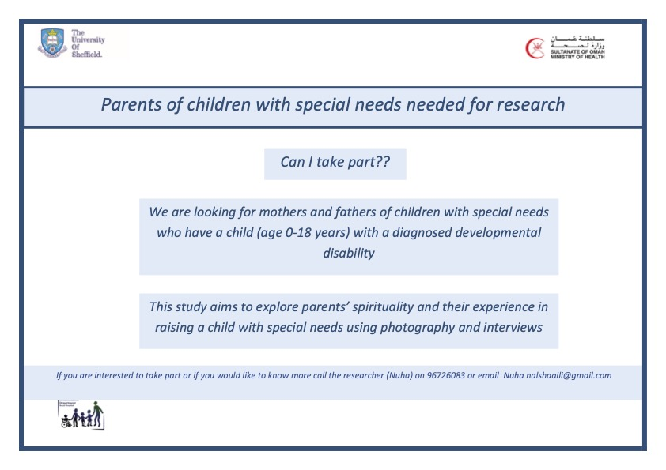

Appendix C: Consent Form

Appendix D: Information Sheet
Participant Information Sheet
Exploring the Spiritual Lives of Parents of Children with Special Needs in Oman: A Photovoice Study
Invitation
You ae invited to take part in a research project that explores the lives of parents of children with special needs in Oman. Before you decide whether or not to participate, it is important for you to understand the aim of this research and what it will involve. Please take time to read the following information carefully and discuss it with others if you wish. Contact us if you have any questions or if you need additional information. Take time to decide whether or not you wish to take part.
What is the purpose of this research?
The aim of this project is to learn more about the lived experience and spirituality of parents of children with special needs in Oman. The results of this research will be used by the primary investigator to obtain a doctoral research degree. This research is being conducted by the University of Sheffield, United Kingdom in collaboration with the Ministry of Health, Oman. The research is sponsored by the Ministry of Higher Education, Oman.
Why have I been invited?
Parents of children with developmental disability will take part in this project. You have been invited to participate because you are a parent of a child with special needs. This project will include 10 –15 parents.
Do I have to take part?
Taking part is voluntary and you may withdraw from the project at any time. If this occurs, you can decide between destroying your contributions to the research or releasing them. Your decision to take part or not to take part, will not affect your routine care or your relationship with professional staff at the Ministry of Health. You are free to withdraw from the project at any stage, just use the contact details below to inform us.
What will happen to me if I decide to take part?
Taking part in this project will involve your commitment to participate in 3 stages (illustrated in Figure 1).
Stage 1: The first meeting will be a 90 minutes workshop. The workshop will provide an overview of the project, principles of photography and instructions about the phot-taking task. You may choose to attend the workshop at the Royal Hospital meeting room or online (Zoom). If you decide to attend the workshop at the Royal Hospital, you can complete the consent forms during the meeting. If you choose to attend the meeting via Zoom, the consent forms will be sent to you (by mail or email).
Stage 2: Photo-taking task: A two to four weeks period in which you capture photographs that represent your spirituality using your mobile phone or a digital camera. The researcher will contact you during this time to answer any questions and check for progress. If a participant is unable to use their own mobile phone to take the pictures, a digital camera will be delivered to the participant. Participants will take 5-15 photographs then choose 3 photographs that they feel represent their spirituality the most and email them to the researcher or bring them (saved in their devices) for the interviews.
Stage 3: Individual interviews: The interview will run for around an hour and will encompass sharing the photographs you took with the researcher followed by further questions about spirituality and your experience as a parent of a child with special needs. The conversation will be recorded. The recording will allow the researcher to remember exactly what you say during the interview. You will be contacted before the interview to arrange a suitable date, time and venue (Royal hospital or online). The researcher will answer any questions you may have and review the consent form you sent prior to attending the workshop.
2
3
1
Figure 68. Project stages
Research setting
Due to the coronavirus pandemic, social distancing measures will be taken into account. The researcher and participants will be required to wear a face mask and keep a safe distance of around 2 meters. The research procedures will primarily be conducted face-to-face in a meeting room at the Royal Hospital in Muscat, Oman, though participants will be offered the option of participating via online platforms.
Will my taking part in the study be kept confidential?
Any information obtained in this project that can identify you will remain strictly confidential and will only be accessible to members of the research team. The confidentiality of the information will be assured by assigning a pseudonym (fictious name) to each participant. The researcher will make sure that your name or any information that might disclose your identity will not be on the transcript. The transcript will be shared with the research team only. The electronic copy of your transcript will be saved on a password protected device or computer. During the optional group meeting, all participants will be requested to respect confidentiality of the group and do not share any other participant’s responses outside of the group. However, we cannot guarantee your privacy or confidentiality because there is always the possibility that another member of the group could share what was said. A conference paper and publications and exhibition and possible media release will occur at the end of this study, but no individuals will be identified in published material.
The information you share will be anonymised. However, if you disclose information that indicates danger of harm to yourself or another person, the researchers will need to talk to someone about this and follow the necessary procedures.
What will happen to my data?
If you decide to take part, your interview will be recorded. The researcher will listen to the interview and write out the conversation word for word (transcribing). Later, the transcript will be translated to English. The images and the transcripts will be analysed to find out the key themes. The recording, images and transcript will be saved on encrypted computer and in a password protected file. The audio recording will be destroyed after the primary investigator’s course is complete and interview transcripts will be stored in the University of Sheffield data depository.
Are there any possible risks or disadvantages from taking part?
Apart from time involved in Stage 1, Stage 2 and Stage 3 of the study, we do not foresee any risks to you in participating in this study. For some parents, talking about their spirituality or experiences may be emotional. If you do get uncomfortable or upset, we may pause the interview until you are ready to continue, or you can withdraw at any time.
Are there any benefits of taking part in this research?
Whilst there are no direct benefits for those parents participating in the project, it is hoped that this project will help in communicating the parents’ needs to the Ministry of Health, Ministry of Social Development and the wider community. However, no actual changes can be guaranteed.
Are there any costs or compensation for taking part?
There are no costs associated with participating in this project, nor will you be paid. However, at the end of the interview, you will receive a 5 rials shopping voucher to say thank you for participating. If you have an online interview, we will post the voucher for you after the interview.
Who is organising this study?
Sheffield will act as the Data Controller for this study. This means that the University of Sheffield is responsible for looking after your information and using it properly. This project has been ethically approved via the Ministry of Health’s Ethics Review Procedure. If you have any ethical concerns about the project or questions about your rights as a participant, please contact us.
What if there is a problem?
If you wish to complain, or have any concerns about any aspect of the way you have been approached or treated during the course of this study, you should contact the academic supervisors: Dr. Elizabeth Croot at l.croot@sheffield.ac.uk or Dr. Sarah Drabble at s.j.drabble@sheffield.ac.uk.
Contacts for more information
Name: Nuha Issa Alshaaili, PhD student.
Telephone: 96726083
Email: nalshaaili1@sheffiled.ac.uk

Name: Dr. Aamir Al-Toubi
Telephone: 24588844
Email: aamir.altoubi@moh.gov.om
This information sheet is for you to keep.
Thank you for your time.

Appendix E: Photography Subject Consent Form
Photography Subject Consent Form

I, [name of photography subject], give permission for [research participant], who is working on Exploring the spiritual lives of parents of children with special needs in Oman: A photovoice study, to take a picture of me/ my child. By signing my name below, I understand that this photograph may be used in research, public display and for educational awareness purposes.
Signed: _________________________ Date: ___________________________
If subject is a minor:
Parental Consent: ________________________ Date: ___________________________

Appendix F: Photograph General Release Form
Photograph General Release Form
I, [name of participant] give permission to the researchers [name of researcher] on the ‘Exploring the spiritual lives of parents of children with special needs in Oman: A photovoice study’ project to use the photographs I share for educational, awareness and research purposes.
Signature: ______________________________
Date: _______________________________

Appendix G: Interview Guide
Version 1: (First interview- Shaikha)
Questions | Probes
Part One
Describe your photo | Point at objects to prompt discussion
What is happening in this picture? | Who, where and when did you take this picture?
Why did you take a picture of this? | Why is this______ (point to an item in the picture) important to you?
What does this picture tell us about your spirituality? | How is this spiritual for you?
Is there anything that you have mentioned/ expressed that may provide opportunities for service providers to improve the lives of PCWD? | How can we incorporate this ____ (meaning discussed) into care?
Part Two

I would like to get to know about you experience in raising (Child’s name) | I’d like to know about your experience since the (child’s name) was born  Past:  - Can you tell me about the child’s birth, infancy and diagnosis  Present:  - I'd like to know about your daily routine.  - Let’s start when you first wake up in the morning  - What happens next  Future:  - what are your hopes and fears about your experience with (child’s name) in the future?  - What are the good things about this experience?  - What do you enjoy most?  - What makes this experience challenging?  If I know nothing about parenting a child with disability, what would you want me to know?
You described some good things and challenging things about raising (child’s name). I would like to ask you more questions about the good things about this experience. Tell me more about the ______ (item identified by the parent). | Tell me more about the best thing about ______ (experience identified by the parent).
You described some good things and challenging things about raising (child’s name). I would like to ask you more questions about the challenging things about this experience. Tell me more about the ______ (item identified by the parent) | Tell me what makes _____ (mention experience) challenging.
Who are the things, places or people to whom you feel connected? | When you are feeling _______ (insert the words the parent used above), who, where or what makes you feel better?  When ______ (mention the negative experience), what to do/did you do to feel better?
When you are sad or distressed, is there anything or anyone else who helps you feel better? | Who or What helps you when you feel afraid or need special help?  Are there any special people or special?  activities that make you feel positive?
Describe for me the things that are most important to you? | What things do you want to be sure to do daily?  What gives your life meaning and purpose?  What do you think is your purpose in life?  What/ who are the people, things you look forward to when you wake up in the morning?
Describe what the word spirituality means to you? | Spirituality means different things to different people; can you tell me what does it mean to you?  Sometimes parents of children with special needs feel that their spirituality helps them when they are feeling ____ or facing ____ (use feelings or challenges used by the parent). Do you have a similar experience?  Do you feel that the meaning of spirituality changed as you became a parent of (Child’s name)
Can you describe your spiritual beliefs? | What spiritual activities do you engage in?  Do you engage in any social activities that you identify as spiritual?
How do you attribute spirituality to having (child’s name)? | In what ways does your spiritual beliefs influence your perception of (child’s name) condition?  What do you think about spiritual explanations for (child’s name) condition?
Can you share any experiences you have with spiritual healing? | What spiritual healing activities did you engage in?  In what ways do you think these practices may help with (child’s name) condition?
Is there anything else that you would like to share with me? | Do you have any questions?

Version 2: (used for interview 2- Al-Muthabira)

Questions | Probes
Part one: Introduction and lived experience
Can you tell me about your family? | Can you tell me about your core family? How many members?  Can you tell me about your extended family?  what is the relationship like between your family and yourself/your child?
Tell me about (child’s name)? | Can you tell me about the child’s birth?  Can you tell me about the child’s diagnosis  did anything change for you when your child received a diagnosis?  How did you feel when you first found out the diagnosis of your child?
Describe a typical day in your life? | Can you tell me about your daily routine?  what do you enjoy/look forward to in your day? What are things you find difficult?
Tell me what it has been like for you to care for (child’s name)? | What makes caring for (child’s name) easier?  What makes is difficult?
You described some good things and challenging things about raising (child’s name). I would like to ask you more questions about the good things about this experience. Tell me more about the ______ (item identified by the parent). | Tell me more about the best thing about ______ (experience identified by the parent).
You described some good things and challenging things about raising (child’s name). I would like to ask you more questions about the challenging things about this experience. Tell me more about the ______ (item identified by the parent) | what is it about ------- that you find challenging? Then - What makes it challenge?
What do you see in the future for yourself and your child’s? | As a parent, what do you hope for (child’s name) future?
If I know nothing about parenting a child with disability, what would you want me to know? | what experiences and advices would you share?
what do you believe is the cause of your (child’s name) disability? | why did this happen to your child?  Why did that happen to this child (if they have more than one child)?  What do people around you believe is the cause of the child’s disability?
Is there anything else you want to share?
Part Two: photovoice
Describe your photo | Point at objects to prompt discussion
What is happening in this picture? | Who, where and when did you take this picture?
Why did you take a picture of this? | Why is this______ (point to an item in the picture) important to you?
What does this picture tell us about your spirituality? | How is this spiritual for you?
Would you like to add anything?
Part Three: spirituality and lived experience

Describe what the word spirituality means to you? | Spirituality means different things to different people; can you tell me what does it mean to you?  How does spirituality affect your day to day life?
Can you describe your spiritual beliefs? | How do these spiritual beliefs affect your thoughts? Actions?  What spiritual activities do you engage in?  Do you engage in any social activities that you identify as spiritual?
When you are sad or distressed, is there anything or anyone else who helps you feel better? | Who or What helps you when you feel afraid or need special help?  Are there any special people or special?  activities that make you feel positive?
Sometimes parents of children with special needs seek spiritual healing, is that something that you’ve thought about? | What spiritual healing activities did you engage in?  In what ways do you think these practices may help with (child’s name) condition?
Introduce this question first, then ask:  Is there anything that you have mentioned/ expressed that may provide opportunities for service providers to improve the lives of PCWD? | How can we incorporate this ____ (meaning discussed) into care?
Is there anything else that you would like to share with me? | Do you have any questions?

Appendix H: Poland’s Instructions for Transcribers).

Appendix H: Poland’s Instructions for Transcribers (2001)
Symbol | Explanation
(…) | Short pauses, the length of which depends on the amount of time lapsed. For example, two dots for less than a second, three dots for more than a second).
(word) | Actions are indicated in parentheses
(-) | Hyphens indicate when someone’s speech is broken off midsentence
(overlapping) | (overlapping) is indicates overlapping speech
[word?] | Square brackets and question mark indicate unclear words
WORD | Caps denote strong emphasis
(mimicking voice) | Indicates that the interview is parodying what someone else said

Appendix I: Reflection on Al-Muthabira’s Interview
Al-Muthabira expressed her interest by contacting me after she found the research advertisement. She preferred to attend the introductory session in a group setting. During the introductory session, she was markedly pleasant and sociable. Two other mothers knew her from a support group for mothers of children with Down’s syndrome. The other mothers showed obvious respect to her by asking her to talk on their behalf at times. This could be because she was more senior (older) than the rest of the mothers. During the introductory session, she said that she felt that she understood the aim of the session but that she might contact me for clarification. She also mentioned that her daughter is a photographer and that she will ask her to take the pictures. We discussed ethical issues and she seems to have understood.
Al-Muthabira sent me the pictures and captions before the interview. On the day of the interview, she told me that the pictures were taken by her daughter. I felt a bit worried as I was not sure if I would have to exclude them due to ethical issues. However, after thinking about it, we decided to commence the interview. Before starting, I noticed that Al-Muthabira was concerned as she said, ‘I hope I can help you with what you need’. This made me aware of the power imbalance and therefore spent some time explaining that we are exploring the parents' experiences and that there is no right or wrong. During the interview, when asked about her spirituality, she said ‘I do not know if my answer is right or not’, so my explanation did not fully alleviate her concerns.
During the interview, as Al-Muthabira elaborated on her thoughts and experiences, she sometimes provided details about unrelated topics, for example, her brother's ordeal with cancer, which distracted me as I thought that the interview might not contain enough valuable information about her experience raising her son, Mahboob. The interview eventually lasted for 97 minutes and Al-Muthabira continued to talk for a while after the audio recorder had been turned off because she wanted to share more information. Upon reflection, I wish I had kept the recorder turned on, but we agreed to turn it off after the last question.
Al-Muthabira was very pleased after the interview. I thought that we built a good relationship during the introductory session and the interview. She explained that she enjoyed sharing her experiences and praised my communication skills. I left feeling happy about my communication skills but worried that the interview might lack important information. However, my worries were alleviated after transcription as the interview was rich in detail.

Appendix J: Personal Profile Sample
Al-Shumookh’s Personal Profile: ‘We Believe That the Future Is Better’
Al-Shumookh expressed interest in participating in the research through the Omani Down Syndrome Association (ODSA). I met Al-Shumookh at the ODSA while her son, Al-Amal, had his scheduled special education session. Al-Shumookh’s husband dropped off Al-Shumookh and their two children at the ODSA and waited for them in the car. During our first meeting, I conducted the introductory session and Al-Shumookh seemed very enthusiastic about the research. She began sharing her experiences and the introductory session was very interactive, lasting about an hour. To conduct the main interview, we met again at the ODSA, however, the family were 20 minutes late for their appointment and Al-Shumookh wanted to pray before conducting the interview. During the interview, which lasted around 1 hour and 19 minutes, Al-Shumookh provided detailed accounts of her experience. However, Al-Shumookh's sons interrupted the session multiple times to ask her to end the interview and we were also interrupted by the ODSA building caretaker as he wanted to close the building. Al-Shumookh did not wear a face mask during the interview, which made it easier for me to see her facial expressions. Al-Shumookh chose the pseudonym ‘Al-Amal Al-Mutajadid’ for her son, which means ‘the renewed hope’ in Arabic. In this section, I refer to Al-Amal Al-Mutjadid as Al-Amal ‘the hope’.
The family lives in a coastal town located two hours away from the capital city, Muscat. The mother, Al-Shumook, is a full-time teacher, and the father, Saleh, is a recent retiree. Together they have five children: Fahad, a 29-year-old man who recently married; Lama, a 26-year-old woman who works full time and lives with her parents; Samia, a 19-years-old woman; Al-Amal, a 15-year-old boy with Down Syndrome; and Hamed, a 6-year-old boy. The parents, the four youngest children, and a live-in housekeeper live together. Al-Shumookh explained that her husband is a very caring father and that he and Al-Amal are ‘very attached’. The family lives near their extended families.
Al-Shumookh shared the story of her pregnancy and the birth of Al-Amal thoroughly. She remembers that she had complications during the first months of her pregnancy. Al-Shumookh sought medical advice from a public hospital and was told ‘there is no heartbeat, we have to remove it’. However, after consulting doctors in two private hospitals, she was assured that the baby was fine. Al-Shumookh perceives Al-Amal’s birth memory as a distressing experience for herself and her husband as the medical team and her family members initially avoided telling Al-Shumookh her son’s diagnosis.
Al-Shumookh and Saleh have a large extended family and they visit both sides of the family every week: ‘we are strongly connected’. Al-Shumookh believes that Al-Amal is ‘loved a lot’ by his extended family. She believes that they love him because they ask about him when he is not present: ‘where is Al-Amal, why did you not bring him?’ Al-Shumookh also believes that they ‘accept him’. For her, their acceptance is demonstrated by his inclusion in play with other children: ‘they do not blame him or accuse him of hitting their children’. She also values the way he is treated by his extended family: ‘I mean they treat him like their own children, I mean they treat him in a normal way’.
While the majority of the extended family welcomes Al-Amal and ‘they do not alienate him or see him as a special case’, there are some ‘exceptions’. Al-Shumookh explained that some family members accuse Al-Amal of misbehaving and ‘they kick him outside the house, and they lock him out’. This disheartens Al-Shumookh: ‘it was painful… I felt sad… I felt angry… I felt oppressed’. However, Al-Shumookh could not discuss this with the concerned family members, to avoid ‘making it big and all’, and decided to forgive them as she believes that God holds people accountable for their actions: ‘I excused them and as you know… all people are accounted for what they do’.
During the interview, Al-Shumookh shared stories about her experience and about Al-Amal and Hamed (Al-Amal’s youngest brother). She explained that the older three children are ‘considered old now’ and they are busy with their own lives. She often talked about her husband, Al-Amal, and Hamed. Here, I briefly outline Al-Shumookh’s impressions of her husband (Saleh), Al-Amal, and Hamed.
Al-Amal’s Father, Saleh: ‘My Husband Is Very Understanding… He Stood Beside Me... He Helped Me Stay Patient’.
Al-Shumookh mentioned Saleh throughout the interview. Saleh retired recently and stays at home with Al-Amal in the morning. She explained that her husband has been supportive: ‘he helps me care for Al-Amal and he also helps me mentally’. Saleh has a strong relationship with Al-Amal: ‘they are both very attached to each other’. Saleh makes efforts to make Al-Amal happy; for example, before attending the ODSA session, Saleh went to a shop and bought toys for Al-Amal and Hamed to play with on the way to the ODSA. Additionally, because ‘Al-Amal loves the beach’, his father takes him and Hamed almost daily. Saleh also enjoys taking Al-Amal and Hamed out – they sometimes go on camping trips with their uncles (a males-only trip).
Al-Amal: ‘People Praise Him and Say That He Is Unlike Other Children With Down’s’
Al-Amal is a 15-year-old boy with Down Syndrome. During the interview, the ODSA therapist brought Al-Amal to Al-Shumookh when his session ended. He was very quiet and showed his mother the paperwork he completed, she praised him and asked him to go and wait with his brother, Hamed. The mother explained that Al-Amal is a quiet child. In the first few years of his life, he had some health issues and was frequently admitted to the hospital; however, these issues are now resolved. She also explained that in the first nine years of his life, he did not receive any formal therapy sessions to help him achieve developmental milestones because these services were not available. Nevertheless, Al-Shumookh and the rest of the family tried to help by teaching him: ‘you know at home, we repeated the words for him’. Al-Amal is now fully independent in self-care activities. When Al-Amal reached his teenage years, he started to develop some behavioural issues. Al-Amal refuses to go to school as they had to change his previous school and, in the new school, ‘he keeps leaving the class’. This disappoints Al-Shumookh as she strongly believes that Al-Amal has the ability to learn. She also believes that some of Al-Amal’s abilities are more advanced than his peers: ‘his speech is good when you compare him to other children like him’.
Hamed
Hamed is the youngest child in the family, a typically developing boy who attends school. During the session, he entered the room multiple times to ask Al-Shumookh to end the interview. Al-Shumookh asked him to look after Al-Amal and wait for her. At home, Hamad enjoys playing with Al-Amal: ‘they fight a bit and all… they use the swing… they fall’. In her discussion, it seemed that Al-Shumookh puts a lot of responsibility on Hamed as she hopes that ‘Hamed will look after Al-Amal’. Al-Shumookh believes that Hamed was ‘God-given’ to help her look after Al-Amal.
The mother explained that she is ‘an angry person’ and ‘she boils from the inside’ when the children misbehave. She finds that she can control her anger, but she sometimes finds it difficult to manage: ‘sometimes I shout at him’. She believes that shouting at Al-Amal is wrong, but she does not know how to manage it. During the interview, when Hamed interrupted, Al-Shumookh appeared to get angry, her facial expressions showed her anger, and she asked him to leave in a loud voice.
Al-Shumookh’s Lived Experience
In this section, I describe Al-Shumookh’s experience in raising Al- Amal, the challenges she faced, and her positive experiences.
Al-Amal’s Pregnancy and Birth
Al-Shumookh shared the story of her pregnancy and the birth of Al-Amal. When she was two months pregnant, she experienced bleeding and sought advice from the public hospital. The doctor told her, ‘the baby is broken, there is no heartbeat and we have to remove it, so I will give you an appointment to clean it up’. Al-Shumookh was overwhelmed and decided to seek a second opinion at a private clinic, where the doctor said, ‘everything is normal’. Al-Shumookh was reassured but also went to see another doctor in a different private clinic and the doctor confirmed that the foetus’ heartbeat was detectable. Al-Shumookh told the doctor at the private clinic about her experience with the public hospital and the doctor replied, ‘you are the third person who said the same thing to me’. So, Al-Shumook did the remaining routine follow-up appointments privately and the remainder of the pregnancy went smoothly.
With all five children, Al-Shumookh needed a caesarean section surgery to give birth. She explained that with her first three children, she would find the baby next to her when the sedation wore off and she woke up. However, with Al-Amal, she became alert and did not see the baby next to her: ‘there was no baby in the crib’, instead she saw her mother who was weeping. Al-Shumookh’s mother did not answer her and continued to weep, and her husband was not present ‘I called him, and he did not answer at first… later on he answered… he did not want to tell me’. Al-Shumookh was confused and scared: ‘I started crying’, and asked the nurses to bring the baby: ‘maybe the nurses felt sorry for me and brought him’. The nurses handed Al-Amal over to Al-Shumookh: ‘I noticed that he looked different… his face was big, he looked different… what is wrong with him?’ The nurses eventually told her that Al-Amal had Down Syndrome.
Response to Diagnosis
Al-Shumookh felt sad when she knew about Al-Amal’s diagnosis: ‘I was sad… I cried’. She also emphasised that her sadness was not wrath towards God, rather, it was an expression of empathy towards Al-Amal as her fears and sadness were geared towards Al-Amal’s feelings.
I was not sad because I do not accept God’s will… I accept it… but how will he feel because he is different from his siblings and his cousins… he will see that he is different… he won’t be able to do things.
Al-Shumookh explained that this time of her life was ‘challenging’. She was distressed and had many uncertainties; hence, she believed that the child’s diagnosis: ‘was an affliction from God’.
When they first gave me Al-Amal at the hospital, I remember that moment… a hundred things came to my mind… How will I teach him? When will he walk? What will he do?
Al-Shumookh believes that these fears and feelings, however, did not affect her relationship with Al-Amal. She further explained that she had heard of other women in the support group she attends who ‘do not want their babies’, but she never felt that way. She was worried about his feelings and his future, but she enjoyed looking after him. When she was discharged and went home, women visited her house to congratulate her on having the baby – which is a customary tradition in Oman – and she felt comfortable telling the visitors that Al-Amal has Down Syndrome: ‘I went home and everything was okay… women would come and visit and I told them that he has Down Syndrome’.
Al-Amal’s Infancy and Childhood
Al-Amal, like other children with Down Syndrome, experiences developmental delay. In the first few years, he had delayed motor and cognitive skills: ‘he couldn’t do anything’. The mother explained that there was a marked lack of supportive services and they had to help him reach developmental milestones: ‘we taught him to talk and to sit’. The family made efforts to teach him to talk: ‘you know at home, we repeated the words for him… this is a home… this is a car, and we bought him stories with pictures’. Al-Amal did not receive any formal therapy sessions until he reached 10 years old. The family attempted to access governmental services but were refused admission as the rehabilitation centre’s ‘list was full’.
Ahmed is now fully independent in self-care and he expresses himself; he often gets positive comments from people. When the mother reflects on Al-Amal's development she feels proud because she believes that it is the result of their dedication.
Now when I see him and I see that he started to talk and understand, and when people praise him and say that he is unlike other children with Down’s who are older than him but can’t talk… I consider this a positive thing… an achievement.
Despite therapy becoming available in recent years, Al-Shumookh feels that there is an inequitable distribution of services for children with disabilities who live outside the Muscat governorate.
I say that children now are lucky, because they get therapy… but you see, for us, in other governorates, our children are very oppressed, unlike Muscat… I mean if we were in Muscat, I would enrol him in a private school, I would have no issues.
Al-Shumookh’s Feelings and Worries
When Al-Amal was still at the pre-school age, Al-Shumookh worked as a teacher in a public school that welcomes children with Down Syndrome. As part of her duties, Al-Shumookh interacted with children with Down Syndrome. Every time she comes across children with Down Syndrome, Al-Shumookh becomes emotional:
When I see them, I cry… you get it? I mean I see them, and I cry… I see them and I see Al-Amal in them, and I could not handle it.
For her, seeing them was ‘very painful’ because she compares them to typically developing children: ‘I think to myself, “the normal students are doing well… they don’t need… and these poor children…look at them…”’
Al-Shumookh empathises with children with Down Syndrome because they need extra support to perform academically. These strong feelings left her ‘mentally drained’, however, while she had several fears and worries in her mind. In reality, raising Al-Amal at that stage was not physically challenging: ‘when he was younger, raising him was so easy and you know he did not move around much… you know some children with Down’s are very active’
Reflecting on her behaviour and feelings when observing children with Down Syndrome makes her feel guilty: ‘I say may God forgive me why am I like this?’ She blamed herself for her worries and fears because she believes that her reality was not as challenging as her fears: ‘sometimes I think that had I known that it will be like this, I would have behaved differently’. However, she now feels that raising Al-Amal is becoming more challenging as he grows.
Challenges
Al-Amal’s Schooling
Al-Shumookh elaborated on Al-Amal’s schooling. For her, educating Al-Amal and equipping him with skills is very important as she wants him to be independent.
I want him to face life after his father and I… I mean you know… God knows how long we will live but I want him to count on himself.
To better explain Al-Amal’s experience with schools, I briefly outline the Omani education system (OES). The OES consists of pre-school education, both public and private. Al-Amal did not attend any pre-school education. He started Grade 1 when he was six years old and attended a public school that offers an ‘integration of children with disabilities programme’. This programme offers a separate classroom for children with intellectual and hearing difficulties in public schools. Public school education includes Cycle 1 (Grades 1–4), in which male and female students are taught in the same classes but the staff are exclusively women. In each public school, one classroom is allocated for children with disabilities in Cycle 1. For Cycle 2 (Grades 5–10), male and female students are taught in separate schools and the staff are gender-matched with the students. Children with disabilities are also allocated one classroom in Cycle 2 schools and the classes include children in Grades 5–9. Children with disabilities follow a special programme rather than the standard curriculum, and they are educated up to Grade 9.
Al-Amal attended a public school and completed Cycle 1 successfully. Al-Shumookh was happy with his progress as he did well: ‘he excelled in the inclusive class… he was even given an award at the state level… and I still have the certificate’. Al-Shumookh believes that teachers allocated for the integrated education programme are not well-equipped or competent. Al-Shumookh believes that the teachers in the integrated education programme may not be interested in teaching children with disabilities, rather, they choose the specialism for personal reasons.

The teachers are not qualified… I mean when they first started inclusive learning they brought qualified teachers… I mean Egyptians, Jordanians, Tunisians… then they started… I am not undermining Omanis… I am Omani myself and I wish them the best but what happens is… these Omani teachers have other specialisms and are employed in other states and to get employment in their own states, they change their specialisms.
She also believes that the training the teachers receive is poor:
Like I said just two weeks of PowerPoint slides… theoretical things… if the teacher is interested and wants to explore the topic further… they give them training every now and then… I mean they did not study the subject, so how will these teachers deal with the students?
She further explained that she believes that these teachers do not possess good communication skills; for example, they shout at the students, which she believes may affect the students negatively: ‘I mean I noticed that children who have difficulties do not benefit, they actually get worse because of the way they treat them’.
In Cycle 1, Al-Amal was taught by female teachers and Al-Shumookh believes that the female teachers were somewhat competent: ‘the female teachers have the ability… I mean they try’. However, when Al-Amal successfully finished Cycle 1, he was supposed to start Cycle 2, in which children (Grades 5–10) study in an exclusively male school. The parents had worries about ‘moral issues’, in that Al-Amal was only nine and there were ‘older children’ at the school. Al-Shumookh explained:
We worry about sexual assaults because it happens even with normal children, so what would happen with them? I mean because of my background I know and I want to protect him… especially because he was only 9.
Therefore, Al-Shumookh decided to get Al-Amal enrolled in a nearby private school that has a special class for children with disabilities. Al-Amal did well at the school and completed Grade 5 and 6 successfully. Al-Amal started Grade 7 in 2019 and stopped attending school when the COVID-19 pandemic started. When the schools reopened in 2020, Al-Amal’s father was worried about him because ‘his immunity is not strong and he always has colds and allergies’, so he did not want him to go to school. Unfortunately, in the same year, the private school permanently closed as it went bankrupt due to the pandemic. Therefore, the parents had to take Al-Amal to a Cycle 2 public school.
The parents and Al-Amal had a negative experience. Al-Shumookh’s husband, Saleh, took Al-Amal to the Cycle 2 public school but Al-Amal did not like it and refused to stay in the class. Saleh told Al-Shumookh that the class looked ‘dull’ and the teacher did not make any effort to welcome Al-Amal; rather, the teacher ‘was just sitting and having coffee and didn’t even move’. The parents attempted to take Al-Amal to school, but he refused multiple times and now stays at home.
The mother is upset with the Cycle 2 public education system because she feels that the children are not always integrated or engaged with learning. She finds that the education the children with disabilities receive is heavily dependent on the school management and the available teachers:
Unfortunately, some teachers refuse these children… of course this depends on the school management… some teachers would accept these children but they would treat them just like they treat chairs… others would include them and give them marks, even though their work does not have credits.
Behavioural Issues
The mother explained that when Al-Amal reached his teenage years, he developed some behavioural issues. When Al-Amal was in the private school, the mother was able to consult a behavioural therapist who explained, ‘excuse him, because he is just like any other teenager’. The mother further explained, ‘a typical teenager won’t listen, so what would you expect of a child like this?’
- Going out
Al-Shumookh clarified that Al-Amal enjoys going out, especially to visit his extended family members. He likes to stay in their houses for a long time: ‘an hour or two are not enough for him’. She finds this embarrassing and upsetting because ‘they want to take their children to bed… we will have work in the morning… they want to teach their children’. Al-Amal’s behaviour makes her feel that she is a ‘burden’ on the other family members. She finds that Al-Amal also does not want to return home when they go out:
We would take him out to the mall, beach, desert and would stay there for a couple of hours but he would want to get into the car to leave… and when we get home, he does not want to enter… he runs to his aunt’s house.
She finds this behaviour ‘tiring’ for the entire family because they have to go out to try and bring him home: ‘I mean his father will take him there, then bring him back, then his brother will do the same, then his sister’.

Al-Amal also unlocks the door and leaves the house. Al-Shumookh recalls a day when she was at work and she started receiving calls from her friends and neighbours:
He leaves home and crosses a couple of roads and he reaches the shops there, and one of the neighbours was out to get her children from school and she saw him and called me.
Al-Shumookh feels supported by her neighbours and friends: ‘they were concerned about him and they care… they call me’. However, Al-Shumookh explains that sometimes people, especially strangers, react negatively to Al-Amal. For example, Al-Amal left home with his brother Hamed and they found some neighbours celebrating a birthday party. When Al-Amal tried to participate in the party, the mother of the birthday child kicked Al-Amal out: ‘when the mother saw him she said to him, “go out, go out, get out of the house”’.
- Pushing other children
Al-Amal is playful, he enjoys interacting and playing with others. However, sometimes he hurts other children while playing. For example: ‘he would push anyone standing in front of him… he laughs, it makes him happy… he thinks that he is playing’. So, in a family gathering on a farm, Al-Amal pushed his cousin into an empty swimming pool and his cousin fainted and was taken to the hospital. Al-Shumook experienced an overwhelming sense of blame: ‘I was worried that the girl might get a head injury’. Luckily, the cousin did not sustain any long-term injuries.
Relationship with Extended Family
Some of Al-Amal aunts have a strong bond with him; when Al-Amal misbehaves, Al-Shunookh tells his aunt to discipline him and she replies: ‘I do not want to scold him because he loves me, I do not want him to change the way he sees me, I want him to like me’. Al-Shumookh also believes that because Al-Amal has a strong bond with his aunt, ‘he can feel that she is coming’ to visit them, even when the visits are unexpected.
Spiritual Profile
Al-Shumookh explained that after the introductory session, she began to think about her spirituality. She read about it, however, she felt that the topic was ‘abstract’. Nevertheless, she feels that spirituality is about ‘the values the parents want to install in their children’. Therefore, she took pictures that reflect these values.
Picture One: Support
Al-Shumookh’s first picture shows her sons, Al-Amal and Hamed, posing (Figure 1). The picture was taken by Al-Shumookh when Cyclone Shaheen hit Oman in October 2021. In the picture, Hamed is standing behind Al-Amal while holding Al-Amal’s shoulders. Al-Shumookh likes this picture because she believes that the way Hamed is standing and holding Al-Amal signifies Hamed’s support: ‘as if he is saying to him, “I’m here Al-Amal, and as long as I’m here, you are safe”’.
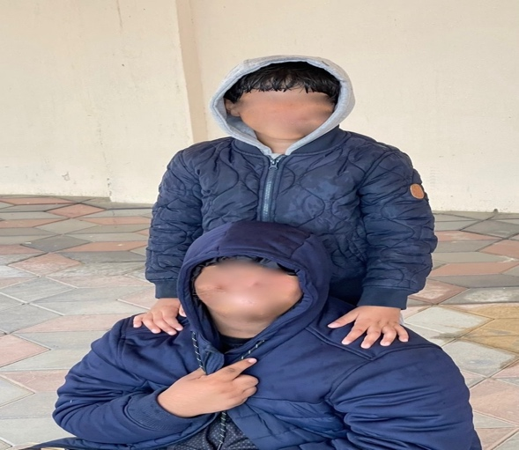
brotherhood: Take my hand for you are my support.
Al-Shumookh believes that Hamed was maybe given to her by God for a reason:

I believe that maybe God gave me Hamed after Al-Amal, so he supports and helps Al-Amal… to be close to him and for Al-Amal to find someone to care for him.
Due to her belief, Al-Shumookh teaches Hamed to care for Al-Amal: ‘I try to prepare Hamed to support Al-Amal and at the same time... implement values of care and concern for his siblings’. When Hamed asks her about Al-Amal’s learning difficulties, Al-Shumookh explains to Hamed that ‘Al-Amal has his own way of learning things’
Picture Two: Looking Forward
The second picture Al-Shumookh shared is a picture of Al-Amal at the beach (Figure 2). Al-Amal loves the beach, and his father ‘takes him to the beach every day’. Al-Amal is facing the sea and his arms are spread out. The mother explains:
I mean he is looking at the beach and saying “welcome to life” and the sea is extended so it is as though he says “life is forthcoming”… I mean he looks forward to life… a life better than what has passed.
Welcome life: I will leave a mark
For Al-Shumookh, this picture portrays hope. She believes that Al-Amal looks forward to a bright future. The mother feels that they are currently ‘going through a challenging time’ because Al-Amal is not going to school. She believes that his teachers ‘were supposed to take him in and contain him’. Al-Shumookh teared up when she talked about this topic; however, she concluded that ‘we still have hope and we believe that the future is better’.
Picture Three: Tradition and Culture
The last picture depicts Al-Amal sitting outdoors in a chair and sipping coffee (Figure 3). The picture was taken when Al-Amal, Hamed, Saleh, and some male family members went on a three-day camping trip in Al-Ashkhara, a coastal fishing town. The mother loves this picture because ‘it has authenticity… it has some Omani values’.
Oman is my identity and I'm proud of its traditions.
The values Al-Shumookh refers to are the cultural norms specific to men in Oman. Al-Shumookh explained that Al-Amal is sitting ‘confidently’ and holding the coffee cup just like ‘other men’. Al-Shumookh explains:

I love for Al-Amal to be like his siblings… just like I instil certain values in them, I do the same with him… for example, the coffee, sitting confidently… you know how they say, “you are a man, when you sit, sit properly, don’t wiggle”’.
She continued to explain that some people say, ‘people with Down’s don’t know, they don’t understand… they don’t know Omani values and heritage’. She believes, however, that Al-Amal proves people wrong as she believes that his behaviour in this picture reflects his knowledge of Omani values and traditions.
Spiritual Activities
Al-Shumookh prayed prior to starting the interview and explained that prayer time is very important to her husband; he was calling her around prayer time: ‘he is worried about the prayer’. The family seemed to structure their day around prayer time, for example, their days start with the Dawn prayer. When asked about the spiritual activities she performs, she mentioned reading the Quran, especially when she ‘feels upset’; daily adhkaar or Allah remembrance; and daily prayers. The family also keeps a copy of the Quran in each car they own.
She also believes that reading the Quran – especially Al-Baqarah (the cow) surah, a chapter in the Quran – can have positive effects on people’s lives. For example, it helps her ‘feel calm’. Also, she believes that a person’s hopes may be achieved if they read the surah. To illustrate this, she shared her daughter’s story as the family went to apply for a university place and she waited for them in the car:
I read the Al-Baqrah surah with the intention that God eases her application process… and the college was busy… and I finished reading the cow surah before they returned... and when they returned, I expected them to decline her application but when my husband came, he said that they accepted her.
Al-Shumookh believes that by reading Al-Baqarah surah, God helped the family and her daughter’s application was successful.
Other Activities
When Al-Shumookh is upset, she likes to ‘spend time alone and drink coffee’. She also enjoys talking to her sister, and spending time with her husband would sometimes help her feel better.
Traditional Healing
Al-Shumookh never tried any traditional healing: ‘this magic thing and all I don’t believe in it… people who are close to me know this’.
Recommendations
Al-Shumookh wanted to share some recommendations, but due to time constraints she only talked about disclosing the diagnosis of Down Syndrome. She explained that the doctor never informed her about the diagnosis and while she was sedated, the doctor gave the child to her husband and said: ‘take your child, he is Down’. Both parents felt saddened and shocked as nobody counselled them. She also feels that it is important to give parents hope: ‘not let the parents get depressed by telling them negative messages… that this child won’t walk, and I don’t know what not’. Lastly, she believes that parents should be taught about caring for the child: ‘what does the child need? Guide them you know…’ She believes that counselling should be done early, to help the parents cope: ‘at the beginning it's shocking… if you can overcome the shock, you will be able to overcome other things too’.

Appendix K: Searching for Connections Across Experiential Statements
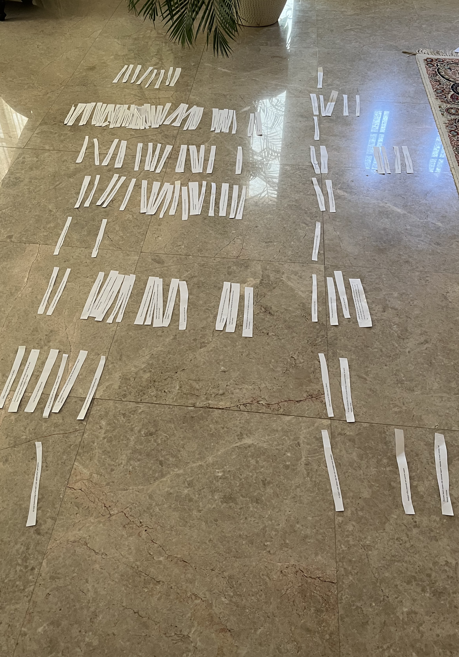

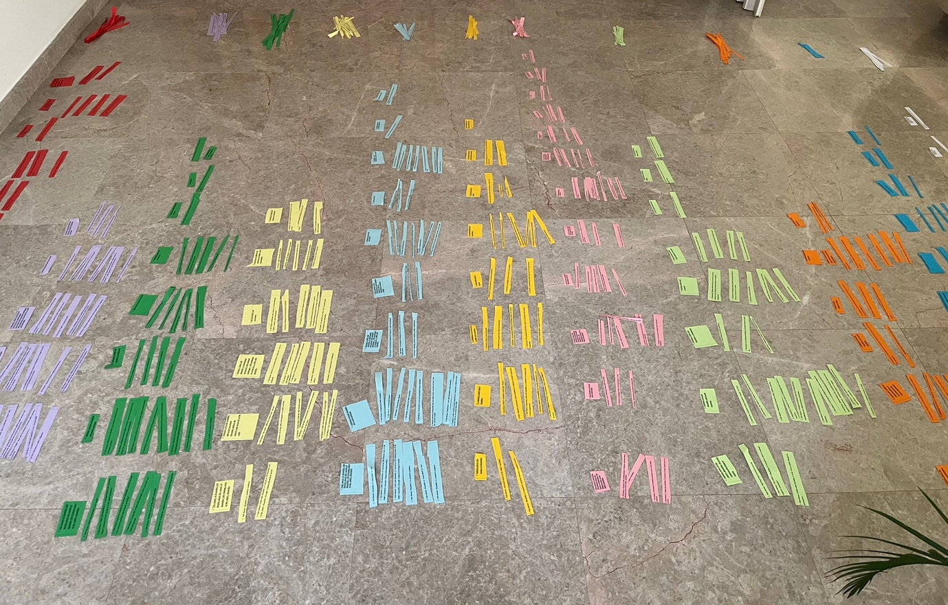
Appendix L: Developing Group Experiential Themes

Appendix M: Table of Group Experiential Themes-Sample
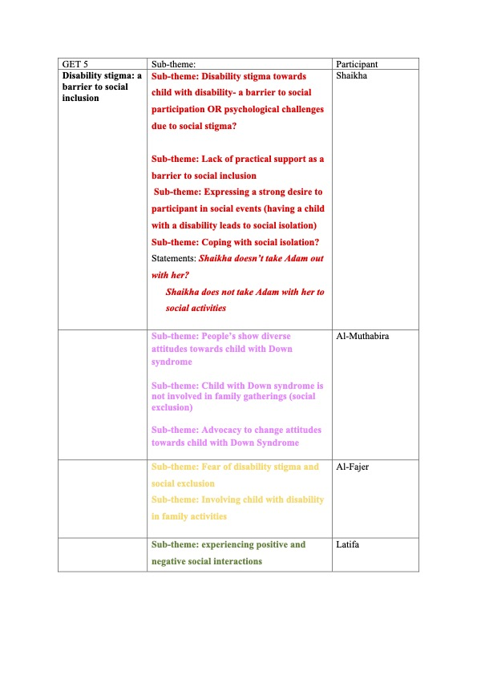
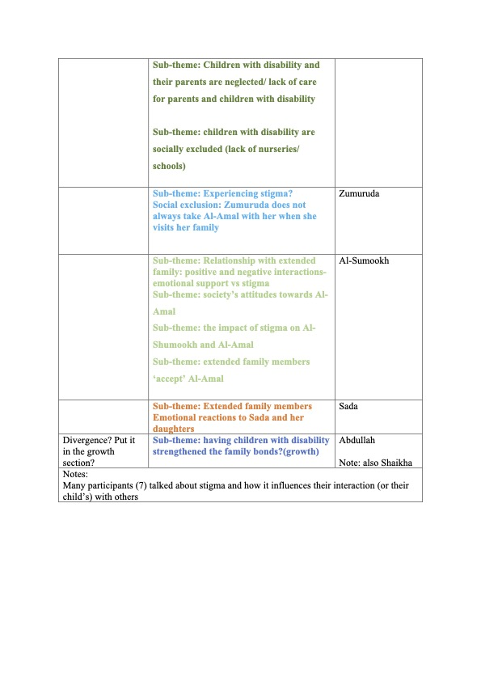

Appendix N: Ethical Approval

