Investigating the Relevance of Teaching General Communication Skills for Vocational Programmes in the Context of Polytechnic Level Education in Singapore.
Chao Jang Yuan
(UCard No: 002696433)
Word Count: 58,563
The University of Sheffield

Author Note
This dissertation was prepared in partial fulfilment of the requirements for the Doctor of Education (EDd) programme (Academic Year 2018/19), Language Learning & Teaching, with the University of Sheffield
Supervisor: Professor David Hyatt, School of Education

To all the dedicated lecturers, my colleagues, who never stop learning not because they are not good enough but because they never stop teaching.

Acknowledgements
Completing this dissertation would not have been possible without the guidance and encouragement from the Doctor in Education Programme tutors, especially Professor David Hyatt from the School of Education, Sheffield University. Thank you for your advice, patience and words of wisdom that pushed me beyond my perceived competencies.

I also want to thank the Polytechnic of my study, of which I am currently employed, for allowing me the space to be inquisitive and grow as an educator and researcher. My colleagues from both the Diploma in Early Childhood Development and the School, for your participation and support in my study that helped me confirm my beliefs on the importance of teaching language skills that are both contextualised and relevant for our students. Your involvement has humbled me and taught me invaluable lessons no academic literature can cover.

To my husband, Fabian, thank you for caring for our home (and me) while I had to tend to my studies; I am genuinely grateful. Last but never least, my daughter, Raeanne, thank you for being you. Our daily conversations helped me stay hungry and remain curious about the world around me and made me the teacher, mother, and woman I am today.

Table of Contents
Acknowledgements 2
Table of Contents 3
List of Tables 6
List of Figures 7
Abstract 8
Abbreviations 9
Chapter 1: Introduction 10
General Setting 10
Communication in the Workplace 10
Context of the Study 11
Aims and Objectives 16
Research Questions 17
Rationale 19
Structure of Dissertation 19
Professional Experience and Positionality 20
Scope 21
Definition of Key Terms used in this Study 22
Chapter 2: Review of Literature 26
How I reviewed Literature 26
Understanding Communication 28
Understanding Discourse 41
Workplace Discourse 46
General versus Specific Communication Skills 48
English for Specific Purposes 51
Why EOP/ESP? 53
Research and ESP 55
Identification of Language Skills in EOP Subjects 57
Examining Texts - Whole or Fragmented? 60
Genre in Linguistics 62
Genre in ESP 63
Genre-based Approach 64
Conceptual Framework 66
Chapter 3: Methodology 73
My Research Mind Map 73
Questioning Assumptions in this Study 75
The Ontological and Epistemological of my Approach to this Study 76
Participants 77
Interviews 79
Interview Questions 80
Questionnaire 83
Iterative categorization 87
Discourse analysis 91
Ethical Considerations 100
Chapter 4: Results 103
Brief Background of Preschool Practitioners 103
Brief Background of Preschool Teacher Trainees 106
Texts Written in the Preschool Environment – Practitioners & Teacher Trainees 107
Importance of Written Communication Skills in the Preschool Industry 112
Have Respondents Successfully Communicated in the Workplace? 114
Learning Communication Skills in an Authentic Work Environment 117
Context in Learning 120
Effectiveness of Fundamental Communication Subjects 123
Brief Background of Communication Lecturers 125
Move Counts and Analysis 129
Lexico-Grammatical Aspects of LPs 137
Chapter 5: Discussion 141
General Communication Skills in Vocational Programmes 141
Differences between Writing On-Campus vs. Workplace 145
Learning Communication where Communication happens 148
How should Preschool Teacher Trainees Learn to Write in Practice? 150
Learning how to Learn Genres 152
Lexico-grammatical Features of Genres 159
Chapter 6: Conclusion 164
Limitations of Study 165
Contributions of my Research to the Field 165
Implications and Recommendations 166
Future Directions 168
Final Thoughts 169
References 170
Appendix A 191
Appendix B 192
Appendix C 194

List of Tables
Table 1 | Overview of Generic Skills and Competencies | 59
Table 2 | Difference between a Text and a Corpus | 61
Table 3 | Hierarchy of Concepts | 85
Table 4 | BCU Approach – top-down corpus-based analyses of discourse organisation | 96
Table 5 | 3 Move Types of a Preschool Lesson Plan | 97
Table 6 | Moves of a Preschool Lesson Plan | 98
Table 7 | Profile and Pseudonyms of Preschool Practitioners who participated in the Interviews (n=10) | 105
Table 8 | Grades attained for Fundamental Communication Subjects (Preschool Teacher Trainees) | 106
Table 9 | Pseudonyms and Codes of Preschool Teacher Trainee Interview Participants | 107
Table 10 | Texts written by Preschool Practitioners and Teacher Trainees (Pre-identified list) | 109
Table 11 | Other texts written in Preschool Practice (“Others”) | 110
Table 12 | Ranking (1st) the importance of 6 identified Genres (N=43) | 112
Table 13 | Move counts of Practitioners and Trainees’ LPs | 131
Table 14 | Steps occurring in all LPs from both groups | 132
Table 15 | Additional Steps Found in Practitioners’ LPs | 135
Table 16 | Final Rhetorical Moves of Early Childhood LP | 137
Table 17 | Word Frequency of Practitioners and Trainees’ LPs | 138
Table 18 | Intended Purposes of Texts written in the Early Childhood Workplace | 142
Table 19 | Guiding Questions to Understand a Genre | 157

List of Figures
Figure 1 | Hall’s Encoding / Decoding Model | 35
Figure 2 | Communication defined in the Relevant Discourses | 38
Figure 3 | Registers, genres and disciplines in academic discourse | 42
Figure 4 | My Research Mind Map | 74
Figure 5 | Extracts of the Interview Conversation Deviating from the Question Asked | 81
Figure 6 | Example of a Ranking Question | 86
Figure 7 | Sorting of Coded File (right) Data to Analysis File (left) | 88
Figure 8 | Further Sorting of Data | 89
Figure 9 | Profile of Preschool Practitioners who Participated in the Questionnaire | 104
Figure 10 | Profile of Communication Lecturers | 125
Figure 11 | How Communication Lecturers Prepare for a Lesson | 126
Figure 12 | Methods in Teaching Communication Skills | 127
Figure 13 | Extracts of an Elaboration of Duration in an LP | 133
Figure 14 | Plots of the Article “the” and Determiner “a” in Practitioners and Trainees’ LPs (Sort to left) | 139
Figure 15 | Plots of the Conjunction “and” Within Procedures of LPs (Sort to left) | 140
Figure 16 | Plots of the Prepositions “to”, “of” and “in” Within LPs (Sort to left) | 140
Figure 17 | Example of Step 10 in Practitioner and Trainees’ LP | 146
Figure 18 | Example of Learning Areas described by Practitioners’ and Trainees’ LPs | 147
Figure 19 | Pentagonal Figure of the 5 Constitutive Aspects of a Genre | 156

Abstract
The launch of the Industry Transformation Programme (Ministry of Trade and Industry, n.d.) led to the start of the new initiative, SkillsFuture that sparked a series of changes in funding for training schemes, programmes in professional training and relooking at the role of technology and automation in the professional environment in Singapore. In response to this change, the institution of this study introduced a set of fundamental communication subjects which aims to prepare students to be effective communicators in the workplace. This research investigates issues the researcher identifies in the list of fundamental communication subjects and questions the need and possibilities of teaching general communication skills in vocational-based programmes. The method for this study includes semi-structured interviews, surveys, and discourse analysis of target texts. In addition, I evaluated the role of context in teaching written communication skills by examining the importance of and aspects in a specific genre existing within the early childhood education professional environment - teacher lesson plans. The findings confirmed the complexities of transferring general communication skills across dissimilar contexts and suggest that communication skills for the workplace should be taught within, if not close to, authentic environments. Recommendations included the introduction of varied contexts and genres existing in practice within the curriculum, possible collaborative efforts between language and learning experts with discipline-specific teachers and guiding learners on how to learn genres.

Abbreviations
CET | Continuing Education and Training
CEO | Chief Executive Officer
ECDA | Early Childhood Development Agency
ESP | English for Specific Purposes
EOP | English for Occupational Purposes
ITMS | Industry Transformation Maps
LP | Lesson Plan(s)
MOE | Ministry of Education
MOM | Ministry of Manpower
PET | Pre-employment Training
SPARKS | The Singapore Preschool Accreditation Framework
SSG | SkillsFuture Singapore

Chapter 1: Introduction

General Setting
Teaching communication skills is often part of the vocational curriculum because of the impact of effective communication on students' employability and ultimate career and academic success (Cornford, 2005). Successful communication in the workplace would require understanding the complexities of workplace discourse occurring in authentic environments. Parkinson et al. (2018) assert that the differences in communication between trades and fields go beyond technical vocabulary because differences can also be found in rhetorical moves and structures. Much evidence within the functional linguistics literature supports the importance of literacy teaching to be situated within authentic environments (Butler, 2009), which will be discussed in greater detail in this study. I examined and raised questions, which will be discussed in subsequent chapters of this dissertation, about the teaching approaches of communication skills within a Polytechnic in Singapore where vocational programmes appeared to be created based on the assumption of an automatic transfer of generic communication skills across trades and fields, and that students' learning is situated mainly in the classroom. My observation of the current practices of the institution of this study prompted me to review those practices and offers a deliberation on the approaches to teaching workplace communication skills in vocational education within a Polytechnic in Singapore.

Communication in the Workplace
Many studies in applied linguistics on workplace and professional communication are predominantly in the academic sector and concentrate primarily on text and writing (Nissi et al., 2021). According to Nissi et al. (2021), these studies were often influenced by classical text analysis and corpus linguistic works from Swales (Swales, 1990), Bhatia (Bhatia, 1997), Mauranen (Pöckl, 1996) and Hyland (1998). However, over the last decades, workplace and professional contexts have attracted more interest within applied linguistics, focusing on language learning in education settings, including workplaces and directing attention to the development of learners. Though its definition drew quite a debate (Dudley-Evans & St John, 1988), an aspect of language use that has existed for quite a long time and is extensively studied was the area of English for Specific Purposes (ESP), that began in the 1960s (Johns, 2012). Many studies in English for Occupational Purposes, a variant of ESP (Flowerdew, 1990), placed a great deal of attention on improving the communication skills of the workforce, with the primary aim to improve business performances, such as improvements in communication between customers and service providers. On an aggregated level, policymakers often focus on improving workplace learning to better organisational performance and national economic success (Fuller et al., 2004). The question of the efficacy of approaches, curriculum and location of study seems to be explored quite widely by various researchers such as Koester (2012), Stefani and Horlacher (2018) and Parkinson et al. (2018). One area of this was comparing differences in writing in the classroom versus authentic environments.
An example can be drawn from the study by Parkinson et al. (2018), where they found differences in rhetorical moves and word count between the writing of trainees on campus and apprentices in actual work sites. More details of their study and definition of what makes a move will be discussed in Chapter 2, Literature Review and Chapter 3, Methodology of this dissertation. Studies related to the location of communication skills training can also be found in the healthcare sector, with some examining how training can be integrated into everyday clinical practice, which they call "context-bound communication skills training" rather than the traditional off-site workshop approach (Rollnick et al., 2002). Most studies on workplace communication skills were targeted to specific professions or fields and identified genres, with few addressing workplace communication skills from a wider perspective. This study examines workplace communication skills from a broad perspective by reviewing common communication subjects identified to address generic skills in workplace communication across professions and fields in the context of vocational education in a Singapore Polytechnic. With the purpose to provide a context for this study, I will offer a background to the context in which this research is located.

Context of the Study
Impact of SkillsFuture
In 2016, the Singapore government announced allocating SGD$ 4.5 billion for the Industry Transformation Programme (Ministry of Trade and Industry, n.d.). According to the media release (Ministry of Trade and Industry, 2016), the Industry Transformation Maps (ITM) communicate plans in the form of infographics, articulate restructuring efforts, and establish deeper partnerships with the government for each of the 23 identified industries in Singapore. In addition, each ITM spells out future trends and needs that translate into initiatives, aiming to systematically integrate productivity improvement, skills development, innovation, and internationalisation.
ITM prompted many other initiatives that affected both the professional industries and the educational institutions in Singapore. The Polytechnics, being fundamentally vocational-based, where the design and delivery of programmes directly impact the nation's labour market, were inevitably impacted by this transformation. The national initiative that was launched concurrently, called the SkillsFuture (Ministry of Manpower [MOM], n.d.-b), steered the Polytechnics to increase involvement and contribution in the Continuing Education and Training (CET) ecosystem (MOM, n.d.-a; Chong, 2015, p.26) for working adults. The launch included a series of skills-upgrading programmes and the disbursement of training credits of SGD$500 per Singapore resident. These initiatives targeted Singaporeans of all age groups - from school-going students to experienced workers (Chong, 2015). This movement also propelled a series of changes in various sectors and vocational institutions in terms of skills, jobs and learning (Teng, 2018). The intent behind this national movement was motivated by an identified urgent need to cultivate and relentlessly renew "deep skills" (Chong, 2015, p.10) that the government deemed vital for the future of Singapore's economy. As reported, this movement aimed to "drive Singapore's next phase of development towards an advanced economy and inclusive society" (SkillsFuture, n.d.-a, lines 4-5). As explained by then Deputy Prime Minister and Finance, currently the Senior Minister of State, Tharman Shanmugaratnam, the initiative was to emphasise the importance of a "meritocracy of skills" and not the "hierarchy of grades earned early in life" (Chong, 2015, p.12-13). The Polytechnics in Singapore are naturally part of this initiative since running vocational-based programmes is their official core business, and the goal of all Polytechnics is to prepare students for the workforce. Since the Polytechnics in Singapore play a crucial role in this change, it is helpful to understand the purpose and role of the Polytechnics within the Singapore education system to provide clarity on how they are involved and positioned in the SkillsFuture initiative.
The Role of the Polytechnics in the Singapore Education System
The Singapore education system is highly centralised, with the Ministry of Education (MOE) being the governing body for funding, syllabi directions, national assessments, teacher and school principals' credentialing, hiring and evaluation (Ministry of Education [MOE], n.d.-a). The compulsory education track in Singapore typically consists of six years of primary school and four to five years of secondary education. After that, most students proceed to postsecondary education either in institutes of technical education, junior colleges, centralised institutes or alternative qualifications from arts college (MOE, n.d.-b). The English Language is the working language in Singapore (the development of the English Language as Singapore English will be described in Chapter 2 under the section Why EOP/ESP?), and all major courses are taught in English. By the time a student reaches the Polytechnic level in his/her educational journey, he/she will have completed 10 years of compulsory education in English at the primary and secondary levels. Most local students entering the Polytechnic institutions would have sat for the English Language examination at the GCE 'o' level or the 'n' level.
Five Polytechnics in Singapore belong to the "Institute of technical education" category. Polytechnics are responsible for providing diploma programmes for pre-employment training (PET) for postsecondary graduates and continuing education and training (CET) for working adults (MOE, n.d.-b). All Polytechnics in Singapore are statutory boards which means they are government-related agencies with their own recruitment and human resource management practices and are considered legally distinct employers from the Singapore Civil Service (Public Service Division, n.d., p.6-8). In essence, the MOE is still the governing body for curriculum approval, but the Polytechnic's management has more autonomy in the operations of the institution compared to the Singapore Civil Service that are considered government ministries directly linked to the government of the country.
Governance and Regulation of the Early Childhood Education in Singapore
The Early Childhood Development Agency (Early Childhood Development Agency [ECDA], 2023) is the regulatory and developmental agency for the early childhood sector in Singapore. It is jointly overseen by the MOE and the Ministry of Social and Family Development (MSF) and is hosted under the MSF. ECDA oversees the development of children below seven in kindergartens and childcare centres. The agency's primary functions include:
  - Regulating early childhood programmes.
  - Facilitating the training and professional development of early childhood professionals.
  - Providing subsidies and grants to keep quality preschool programmes affordable.
  - Overseeing the provision of early intervention services for children with developmental needs.
  - Conducting public education and outreach.
  - Uplifting the image and professionalism of the early childhood sector through partnerships and programmes.
According to ECDA, its main aim is to serve children, early childhood professionals, parents, families, the broader community of caregivers, and childcare centre and kindergarten operators. There are mainly three different types of preschool education offered in Singapore, the Anchor Operated Scheme (AOP), Partner Operated Scheme (POP) and privately operated schools. AOP and POP are supported by ECDA with fee caps and are subjected to quality requirements set by ECDA and MSF. On the other hand, privately operated schools have more autonomy in their curriculum, practice and pricing of programmes. This study examines practitioners from all three types of preschools in Singapore.
SkillsFuture Singapore and the Polytechnics
The SkillsFuture Singapore (SSG) is a statutory board under the MOE, was formed in 2016, and was entrusted to manage activities and programmes implemented from the SkillsFuture initiative (MOM, n.d.-b). This statutory board was tasked to work closely with the Polytechnics and the industries to ensure graduates' skills meet the requirements necessary to achieve the initiative's objectives in terms of employability and competitiveness (MOM, n.d.-b). Since the Polytechnics are vocationally motivated, it is logical to be part of the SkillsFuture initiative as the graduates will ultimately impact Singapore's workforce and economy. The SkillsFuture initiative prompted many changes in the organisation of departments and the curriculum of diploma programmes within the Polytechnic studied in this research, which will be described in the following sections.
Common Fundamental Communication Subjects
The SkillsFuture initiative prompted the implementation of a suite of common communication subjects identified as fundamental skills graduates would need to possess to be successful in the workplace. At the exploratory stage of this research, I had a chance to speak to a member of staff at the institution of this study, who was part of a high-level committee within the Polytechnic to conceptualise the overall structure and directions of the fundamental communication subjects I am examining in this study. Our conversation was conducted at the stage of submitting my research proposal for the doctoral programme with the University when I needed to ascertain the possibility of obtaining sufficient data to conduct this study. I discovered some information from our conversation about the origins of the fundamental communication subjects examined in this study. Before launching those fundamental communication skills subjects, a high-level committee was formed to identify fundamental skills to be taught to all students within the institution, and they were decided based on the following.
- A comprehensive scan of local and overseas literature for the desired attributes of the "new economy" (Glossary of statistical terms, 2004).
- Deliberations and recommendations from representatives of each faculty involved in the high-level committee (Applied Science, Business, Design, Information Technology, Engineering and Humanities & Social Sciences), assuming that representatives would sufficiently reflect the needs of each represented industry/sector.
- The Principal and CEO of the institution.
- Reference to the MOE's general direction about essential life skills to inculcate in Polytechnic students.
The main aim of those fundamental subjects was to "better equip… students with the core skills and attributes that will help them to succeed in the workforce of the future" (Institution's staff communication, July 2017). This aim will reoccur throughout this dissertation because it spells out the motivation behind those fundamental communication subjects, which is the focus in the examination of the teaching of these subjects.
Changes made to the teaching of Communication Subjects
Prior to this change, each of the six schools (Applied Science, Business, Design, Engineering, Information Technology and Humanities & Social Sciences) within the institution had a team of communication lecturers who were responsible for the teaching of communication skills, contextualised to the school's identified communication needs for their students (e.g., Engineering communication lecturers teaching technical English). In response to the SkillsFuture movement and recommendations of the institution's high-level committee, there followed the involuntary transfer of communication lecturers from the respective schools into a single department, aiming to centralise and manage common communication and life skills subjects for the entire institution. There were also other changes, such as the reorganisation of working departments and amendments to curriculum and diploma courses. After that, the newly set-up department was tasked to design the content. The list of fundamental subjects included communication and general life skills. Three fundamental subjects were directly related to communication, namely:
  - Communication and information literacy (focuses on critical evaluation of information sources and communicating of found sources)
  - Communication skills in persuasion
  - Communication in the workplace
The Polytechnic's management assumed the communication skills identified to be general skills required in students' eventual workplaces. More details of the identification and curriculum planning process will be described under the section Identification of language skills in EOP subjects in Chapter 2 of this dissertation.
Doubts about the approaches to teaching those fundamental communication subjects spurred this study. I questioned the usefulness of those subjects when I was told by students I have taught, especially the students from the early childhood diploma, on several occasions via different conversations, that the skills they learnt appeared useful and "business-like" but were insufficient to equip them to be effective communicators in their eventual workplace. Their comments prompted doubts if our fundamental communication subjects sufficiently supported all our students, particularly in the context of this study - trainee teachers in early childhood education - to be effective communicators in their workplace. In the process of questioning, I began to search for answers, which led me to dig deeper.

Aims and Objectives
The aim of the fundamental communication subjects was to focus on teaching general communication skills, which are expected to be transferable to specific contexts, dependent on the ultimate discipline/occupation of learners. This approach was problematic because those fundamental communication subjects did not address specific skills related to the professional environment the learners would ultimately participate in. If the main aim of those fundamental communication subjects was to "better equip… students with the core skills and attributes that will help them to succeed in the workforce of the future" (Staff Communication, July 2017), those fundamental communication subjects should focus on pre-vocational and vocational language. According to Basturkmen (2005), vocational languages refer to the modes and styles of communication of "members of those communities" (p.3) in specific real work situations. Therefore, learners should learn the genres used and forms of communication deemed typical in those target discourse communities (Hyland, 2002a). However, reflecting on the content of the fundamental communication subjects of this study, I questioned the relevance of those general communication skills in the respective industries and sectors of our graduates would ultimately be a part of. Hence, the purpose of this study is to examine workplace discourses and genres, starting with a specific professional environment, with the aim to answer the question of whether to focus on skills that are general and "wide-angled" or focused and "narrow-angled" (Basturkmen, 2003, p.48).
Reviewing the literature on language acquisition led me to examine the area of English for Specific Purposes (Johns & Dudley-Evans, 1991) and genre-based learning and teaching (Hyland, 2002b). The guiding principles of English for Specific Purposes were often regarded as practical and functional by nature (Belcher, 2006). Regarding genre-based teaching, it focuses on actual "communicative events" (Saville-Troike, 1982, as cited in Swales, 1990, p.39). Both concepts were identified as relevant in my investigation of workplace discourse. More details of the rationale for my choice of theories will be further explained in Chapter 2 of this dissertation.
Based on the issues raised, I investigated the assumptions in teaching those fundamental communication subjects. In addition, I want to explore if it would be valuable to offer an expansion to the list of fundamental communication subjects or if they need to be replaced. To confirm this, I approached this topic in the following ways:
- Investigate communication skills required within a specific professional environment. In order to investigate if those fundamental subjects need to be specific or remain generic, I will need to obtain students', communication lecturers' and practitioners' feedback on communication skills crucial to being effective communicators within a chosen professional environment.
- I would also identify a commonly written genre in a chosen professional environment, collect authentic text and analyse the moves present in those texts (Hyon, 2018). My analysis will compare the frequency of motivations, structure and possibly language features and forms within the genre and context of the identified field between writing by on-campus trainees and practitioners. Doing so should provide me with clear indications of the core and optional moves in the chosen genre.

Research Questions
The aim of this study is for the findings to inform curriculum that could either result in recommendations for a review or the inclusion of new communication subjects. I will start by examining one professional environment – early childhood education. Though examining only one professional environment cannot make my recommendations conclusive to many, it is essential to note that the recommendations from this study are not intended to be conclusive but iterative. Perhaps my findings could indicate that more similar research with other industries would be needed to confirm the applicability of my conclusion. To guide my investigation, I will be addressing the following research questions in the context of early childhood education:
Q1. | Should general communication skills be taught in vocational programmes?
Q2. | Are there differences between writing for an on-campus training versus writing in actual workplace environments?
Q3. | What lexico-grammatical features of the identified genre should be taught? Why and how?

In summary, I would like to know if there are general communication skills, how communication skills should be taught, and what we should teach. I am focusing on writing skills because it is a crucial skill that impacts academic and professional success (Göpferich & Neumann, 2016). I have decided to examine lesson plans for preschool classroom teaching that were indicated based on the survey I conducted in this study, with both practitioners and teacher trainees, to be the most commonly written text in the early childhood professional environment. Lesson plans are a form of procedural text, important in many contexts in teachers' personal and professional lives (Martin & Rose, 2008). Farkas (1999) clearly explains procedural discourse describes "system states and actions that change system states" (p.42), and the "interplay of actions and states takes place everywhere as human beings conduct their affairs" (p.43). Lesson plans reveal systems of communication events and contexts of communication in an authentic preschool professional environment. Another reason for deciding to examine lesson plans is because of no access to preschool centres during the period of data collection that would allow me to perform observations and face-to-face interviews. My study was conducted during phase 3 of covid-19 heightened alert measures where many organisations were functioning at the default arrangement of working from home, and preschools only allowed external visitors of those who were deemed as "necessary to the support of the centre operations and those performing necessary functions such as licensing and parent accompanying newly enrolled children" (Ministry of Social and Family Development, 2021, point 3). Much of my lesson plan corpus was gathered from practitioners in the field of dealing with development and education within the early childhood professional environment – colleagues from the Diploma in Early Childhood Development and practitioners in preschools in Singapore.

Rationale
In the last two years, topics surrounding how the pandemic has changed how we work and live have occurred commonly in many public discussions. Topics range from the dramatic disruptions at work, how we communicate with our connections, how we view time, and how we go about our daily lives. One common topic discussed quite extensively was the fact that our lives and how we work were permanently changed (Lobdell, 2021), which led to the re-definition of what “normal” means today (Living normally, 2021). Another impact of the pandemic is the aspect of communication. The pandemic brought about new vocabulary additions and changes in how we communicate (Bhattacharya, 2021). For example, the word “vax” (i.e., “vaccine”), which was previously not often occurring in our speech, was designated by Oxford Languages as the word of 2021 (Word of the Year, 2021). In addition, fewer face-to-face meetings led organisations to explore alternatives for communication, such as more written communication, remote online meetings, and fresh nuances and etiquettes that increase layers and meanings in how we speak (Bhattacharya, 2021). Bhattacharya (2021) also raised the fact that “compassion and empathy have never mattered more in our lifetimes” (line 27) and that prior to the pandemic, asking someone about their health state was never a common communication topic. Even when we know someone who lost a loved one to the virus, the familiar words of condolences that we use, such as “sincere condolences” (line 42), appear clichéd these days, knowing the horrific consequences of the pandemic. I think these undeniable changes in how we communicate force us to relearn how to write and speak; redefine what is appropriate in communication. This study provides a timely opportunity to relook at how we should communicate in the workplace, reviewing our training curriculum and ensuring it is relevant to authentic workplace environments of today.

Structure of Dissertation
This dissertation will first provide a summary of the literature examined in this study, aiming to critically analyse theories and approaches relating to workplace discourse, English for Specific Purposes (ESP) and English for Occupational purposes (EOP), genre analysis, teaching, and how these inform and help to contextualise my study. I will also describe how the institution of this study created the ESP subjects' content and curriculum and the recent developments in EOP from the socio-economical perspective. The recent developments in EOP could and do they inform the current practices of the institution of my study. I will then explain how the institution of my study identifies skills needed to teach those fundamental communication subjects, examining what appears to be a non-systematic process of content creation and the misalignment in EOP principles and skills identified in those EOP subjects. In subsequent chapters, I will discuss the importance of context in learning how to communicate in the workplace. Methods and methodology of this study will be addressed in Chapter 3, in which I will be discussing the assumptions, ontological and epistemological, of my approach to this study, and my research mind map. I will end this dissertation with a report of my results and an in-depth analysis and discussion of my findings, referring to related literature. Finally, I will conclude with my final thoughts about my study, which will include a consideration of limitations and recommendations for policy and practice.

Professional Experience and Positionality
My professional experience includes teaching English language and music at the secondary and primary level with the Ministry of Education, Singapore, for six years. Driven by my love for the arts and understanding of the transformative power of education, I left the Ministry to join the National Arts Council as an Arts Education Manager in the Arts Education division, taking charge of over 1000 local artists and multi-media art practitioners in Singapore. My passion led me to teach writing and communication subjects at the Polytechnic of this study, to prepare students for the workforce. My work as a lecturer at the Polytechnic included curriculum design, teaching, and review of fundamental communication subjects. Additionally, I was the ICT representative for the school, promoting good practices in learning through various e-platforms and developing online modules, including two popular mobile micro-learning modules and a fully online module on academic writing. I was also involved in a research project investigating the use of AI technology as a personalized chatbot for engaging in home-based learning. Throughout my teaching career, my positionality as an educator was developed based on the belief that teachers should possess the grit to remain committed to their chosen pursuit, of which my chosen pursuit is to remain passionate in my craft as an educator. In the face of changes within the education arena and our world, it is important to constantly question and possibly redefine our position in our classrooms, be agile in our methods, but always keep to the fundamental motivation of our roles as educators in the lives of our learners. I also believe that impacting the lives of our learners goes beyond the physical classroom. Since January 2023, this belief led me to transit to a new position that enabled me to utilize my knowledge in qualitative research gained during my post-graduate studies and my experience teaching writing and communication skills to make valuable contributions to the Polytechnic's strategic and developmental efforts, bridging theory and practice to create innovative and impactful solutions for the education sector.

Scope
The purpose of this section is to provide a summary of the scope of this study. More details about this study's focus, constraints and limitations will be provided in Chapter 3: Methodology and Chapter 5.
This study investigates existing approaches to teaching communication skills in a vocational institution in Singapore, which is also the organisation of my current employment at the time of data collection and writing. It aims to seek responses from three different groups of participants in the identified field: teacher trainees, practitioners and lecturers of communication skills subjects. While there were past cohorts who have taken the fundamental communication subjects, views were sought only from the graduating cohort of 2021, of which my data collection was conducted. Furthermore, at the point of data collection and writing of this dissertation, the fundamental communication subjects were in the midst of reviewing content by various development teams. Therefore, this study excludes examining the new subject content and subsequent cohorts' responses, which would possess an entirely different context that will be irrelevant to this study.

While it is ideal to cover all sectors and fields, the scope of the study is limited to the early childhood sector as the word count of this dissertation only allows space to examine one professional environment in depth. Based on statistics for 2021, the early childhood sector comprises more than 2000 kindergartens, childcare centres and infant care centres (Early Childhood Development Agency, 2022), and more than 16000 early childhood educators in Singapore (SkillsFuture, 2016). While recognising the high number of possible participants in the professional environment, the number of practitioners participating in the interviews and questionnaires is limited to willing participants of 10 practitioners and 10 trainees for interviews and 50 trainees and 43 practitioners for the questionnaires. The teacher trainees were recruited from the organisation of this study, and the practitioners were recruited from immediate contacts of colleagues, LinkedIn invitations, and my personal connections. The rationale for the number of participants was mainly due to the challenges in obtaining participation during the recruitment period that lasted for 5 months. Though this might affect the applicability of the findings. However, as the early childhood centres are regulated by the Early Childhood Development Agency, practices are broadly consistent. Though the practices in private schools may differ to a more considerable extent, there are many similarities in their practices directed by the fundamentals of early childhood education. Further details will be discussed in Chapter 3, Methodology section of this dissertation.

Definition of Key Terms used in this Study
This section serves to clarify the terms used to reduce misunderstandings of terminology that possess multiple meanings in different professional and academic contexts.
Fundamental communication subjects: | A list of mandatory subjects on communication-related content that students in the institution of this study must complete to graduate with a diploma.
Authentic Texts: | Authentic texts are non-pedagogical materials meant to assist learners in enhancing their communication and cultural competencies. The term authentic was coined as a reaction to textbooks' “off-the-rack” patterns. Authentic materials (realia) can be described as anything created for native language speakers; we can use them for teaching. However, due to shifting language boundaries, it is now generally known as materials that comprise ideas, words, phrases, and expressions that are heard and read in real-life settings (Ciornei & Dina, 2015, p.275). Part of the analysis in this study includes performing a move analysis on one of the most commonly existing authentic texts, lesson plans, within the early childhood education professional environment.
Context: | This refers to all relevant workplace activities, including work embedded within associated tasks, processes, and those already competent (Fuller et al., 2004). This study supports teaching communication subjects within students’ eventual work contexts.
Corpus / Corpora: | A corpus is a collection of written or spoken text typically stored in a computer database. A body may, for example, be relatively small, with only 50,000 words of text or very large, with millions of words (McCarthy, 2004, p.1). The collection of texts in a corpus is “selected and ordered according to a set of explicit criteria, including representativeness, balance and sampling” (Halliday, 2009, p.129). The plural of the corpus is corpora. De Haan (cited in Leitner, 1992/2011) addressed the reliability of samples with a lower word counts. He claims that samples of 20000 words have shown on the whole sufficient to yield “statistically reliable on frequency and distribution, but even they are sometimes too small, especially when complex interactions are studied, simply because the number of observations yielded is too small.” (p.3). He added that “the suitability of the sample depends on the specific study that is undertaken and that there is no such thing as the best or optimum, sample size as such” (p.3). This study analyses a corpus of lesson plans of about 22000 words created by practitioners and trainees in the early childhood professional environment from different schools within Singapore.
Discourse Communities: | According to Swales (1990), in a general discourse community, members generally share  - a broadly agreed set of common public goals,  - mechanisms for intercommunication,  - participatory mechanisms primarily to provide information and feedback,  - discoursal expectations that have developed and continue to develop.  Genre is "a class of communicative events, the members of which share a set of communicative purposes" (Swales, 1990, p.58). The term discourse communities in this study refer to the communities existing within the eventual workplaces students/graduates would ultimately be part of.
Genre: | Systemic Functional Linguistic views language as a context-dependent, meaning-making resource (Martin, 2009) and defines genre as "a staged, goal-oriented, purposeful activity in which speakers engage as members of our culture" (Martin, 1984, p. 25). Paltridge (2017) describes genre as "communicative events" (p.31). These communicative events usually share similar features such as spoken, written, existing conventional ways and separate or a set of functions and purposes. Paltridge (2017) claims that genres can change over time due to changes in underlying values and responses to technological transformation. Genres can also be affected by the relationship between the communicator and the audience and social and cultural contexts. Genres "vary in terms of their typicality" (p.31 & 32), and a text may be "typical" or less of a genre but can still serve as an example of the same genre.
Genre for Workplace Communication: | According to Chan (2021), language for workplace communication is often described in terms of text types, communicative events, communicative tasks, or workplace genres. It usually includes emails, letters, reports, socialising, meetings, etc. This study discovered from interviews and surveys with practitioners on several workplace genres for the early childhood education professional environment - Letters to parents, observation records of children, proposed plans for centre events/itineraries for excursions, photographs - write captions to describe the children's activities in the picture and incident/accident reports (If any). The lesson plans were identified to be the most-commonly written genre in the field.
Industry: | In this study, the use of the word industry refers to a specific group that operates within similar business spheres (sectors) (Langager, 2020, "Industry vs Sector"). This study examined workplace genres within the early childhood education industry. This term is used based on the understanding that the early childhood sector includes aspects beyond education-related activities, e.g., childcare and welfare and family child-support industries. "Industry" in this dissertation is used interchangeably with the term "professional environment" though recognised as problematic from the academic perspective, is prevalent in the discourse of the Singapore economic and professional narrative.
Workplace Discourse: | According to Koester (2012), workplace discourse refers broadly to institutional, professional and business discourse. This study uses the term "workplace genres" to cover all the genres people use for work-related discourses.

The problematisation of the current state of the approach to teaching general communication skills in this study led to the review of much literature, which will be discussed in the following chapter.

Chapter 2: Review of Literature
The purpose of this chapter is to describe the literature reviewed and discuss how it informs and supports this study. The reading of literature started with the aim to understand how humans communicate through the review of classical pragmatics, with the hope that understanding how it was acquired would ultimately provide clues on how to teach it. The reading of classical pragmatics unravelled the importance of context that determined how a message was understood, which led to examining the context of this study – workplace communication. Subsequently, literature relating to workplace communication brought about the realisation of the common motivation of communication, especially in the workplace context, to be highly functional. This discovery directed me to examine the literature relating to Systemic Functional Linguistics. After that, literature about Systemic Functional Linguistics informed the focus of the analysis of my data, to focus on the motivation behind the written word rather than on the micro-analysis of lexical features. Concurrently, my literature review explored the rhetorical genre theory and English for Specific Purposes.

How I reviewed Literature
Jesson et al. (2011) highlighted the importance of the literature review in all research work. Similarly, Tranfield et al. (2003), who evaluated the process of a systematic review of literature in the medical sciences, emphasised the significance of the literature review because the objective of “conducting a literature review is usually to assess the existing intellectual territory and to specify a research question to develop the existing knowledge further” (p.208). Though that claim was made in the context of medical sciences, equally important in educational studies, expanding existing knowledge is crucial with the ever-changing profile of learners and the learning environment over time (Chong et al., 2015). Broadly, there are two primary forms of literature review: traditional and systematic (Jesson et al., 2011). A traditional literature review is an approach that critically searches for literature without a specified structure and method and is often biased in selecting materials.
In contrast, a systematic review works through existing academic writings critically in an “ordered or methodical way” via “six essential stages of methodology” (Jesson et al., 2011, p. 12). Jesson et al. (2011) claim that the systematic review approaches literature more exhaustively than the traditional approach. Tranfield et al. (2003) also supported the use of a systematic literature review as it is a “key tool, used to manage the diversity of knowledge for a specific academic inquiry” (p.208).
Though being thorough is the preferred option, actual research projects often depend on time, budget and human resources. If I were to apply strictly the systematic approach to review literature, as described by Jesson et al. (2011), the process would need an extended length of time and might require more than one researcher. My investigation started with my "current state of knowledge" (Bell & Waters, 2014, p. 107) and a concurrent literature search. Keeping to the aims of my study as stated above, I would categorise my literature review process as one that is semi-structured and focused on frameworks and approaches that are observed to be applicable in my context. The approach I am taking is consistent with Oliver (2012), who asserted that the process of researching a topic is often "fairly narrow and focused" (p.9). This process would make it challenging for a reader to understand how the research subject is linked to other related areas. Hence, a literature review aims to "demonstrate this" (Oliver, 2012, p.9) connection with other related areas. The aims of my literature review are also consistent with what Oliver (2012) described that a literature review should cover previous research in identified themes, emphasise leading research studies by exploring key academic arguments, summarise new and developing knowledge in an area, identify gaps in our understanding of a subject and explore trends in literature (p.10-19). More importantly, my literature review also aims to situate my study within the identified field by highlighting how it will likely connect with existing studies and inform my research.
The process of my literature search started with preliminary readings of themes and subjects that intrigued me. It was like window shopping, with some focus in mind. Concurrently, conversations with my university tutors and colleagues provided leads for my search and advanced topics I could explore. Once I identified a body of literature, I delved deeper, after which I worked backwards to identify a focus for my research topic and aims. Though this may inevitably inject a certain amount of subjectivity in the selection of literature, Google Scholar and Sheffield University's Library system would surface other works and frameworks that might be related to my interest, which would expand my search too. Those prompts and suggestions were helpful as they prompted me to dig deeper. During this process, I questioned my choice of research aims and topic every time I dug deeper and wider within the body of literature. The process took about a year before I settled on my research focus.
How I performed my literature search was also influenced by Bramer et al. (2017), who concluded in a study that supported a combination of databases would determine if a search would reach a "maximum recall" (p.7). Though their study identified and proposed a combination of specific types of databases of fields not related to my research, their study prompted me to expand my access to different databases to make my search as comprehensive as possible. Hence, I ensured I performed searches from the different databases and search services from Sheffield University Library, the National Institute of Education Library services, Google Scholar and the library services in the organisation of my current employment. Other literature sources were obtained from the Regional Language Centre (RELC) journals to ensure I also captured works of local writers in the field of my investigation. My choice of literature depended on whether the source is peer-reviewed, how often the source was cited and the writer's authority. Prolific writers in the field of my choice will hold the highest priority for my search, followed by writers who are peer-reviewed and relevant to my research topic.

Understanding Communication
This study questioned the current approach to teaching communication skills and queried if there is an alternative way to acquire communication skills in the workplace. In my quest to locate answers, my literature search started with the question, what is communication? Communication is an almost ubiquitous behaviour of humanity, yet it does not occur naturally and is so complex, challenging and needs to be learnt. If we view communication simply, the utterer plays the central role of a message, but often, what is expressed may not be perceived according to the intent of the utterance. Therefore, meanings cannot be derived from what the utterer says alone. Misunderstandings occur when messages interpreted are contrary to or deviate from the original intent of the utterance. Dummett (1993), when examining language and truth, said, "to put a speaker of, say, English in a position to interpret some other natural language, a system of translation is unquestionably the most efﬁcient means" (p.130). The act of translation is more than replacing word for word in a different language. It requires a translator to identify phrases or utterances that "means the same as" (Dummett, 1993, p.130). I observed that the process of translation and interpretation occurs in the process of communication of common languages between people too. Miscommunication occurs when the interpretation breaks down; when that happens, sharing information, feelings, ideas and even doing things with speech would be broken. Hence, understanding communication goes beyond what a speaker says because the meaning of the utterances of a speaker is beyond the words themselves, contains intent, is context-dependent, and can potentially be argued by classical pragmatics to have the capabilities of doing things or performing an act (Austin, 1975). Before one can even figure out how to better teach communication skills, it is fundamental to start understanding how humans use language to communicate, prevent miscommunication and ultimately successfully do things with it. By understanding how successful communication happens, one can know what to teach in learning how to communicate successfully.
The following sections of this chapter will examine topics that have influenced this study's direction and activities. Since, in this study, I needed to understand how humans use communication to do things successfully, I decided to examine how researchers understand utterances, specifically the study of pragmatics. According to Korta and Perry (2008), utterances are "intentional acts of speaking, writing or signing, usually for the purpose of communication, and usually in service of further goals, such as developing a plan, persuading someone to do something, teaching, learning, passing the time, or whatever" (p.347). In addition, the study of pragmatics is "the study of utterances as ways of doing things" (p.347). Furthermore, according to Mizrahi (2015) in her book about writing for professional purposes, the "purpose for writing in the professional world falls into three basic categories: informing, persuading, or requesting" (p.4). Hence, since professional communication is usually prompted by doing something, it seems logical to start with examining pragmatics. I started with classical pragmatics, the foundation of much research in today's understanding of communication. Literature relating to discourse that examines utterances occurring in communication and the importance of specificity in successful communication will also be discussed. In the following sections of this chapter, I will attempt to describe three central values that motivate this study, and they are:
- The communication model does not describe a one-way process
- Successful communication in the workplace goes beyond interpersonal communication
- The importance of context in the acquisition of communication skills
Beyond Words
Austin (1975) started his lecture that he delivered in 1955 with the point about statements though being grammatically correct were regarded as "nonsense" (lecture I, para.1). The word "nonsense" that Austin used does not mean the everyday use of the word that refers to incoherent gibberish of words, but a lack of sense in the context of sense and reference. Many utterances may appear like statements but are often
not intended at all or only intended in part; to record or impart specific information about the facts: for example, 'ethical propositions' are perhaps intended, solely or partly, to evince emotion or to prescribe conduct or to influence it in unique ways. (Austin, 1975, Lecture I, para 1)
Hence, we should not understand how we communicate solely on what we say alone. The implication of context and intentions complicates the comprehension of our utterances. Austin (1975) asserts that speech depends not only on the literal meaning of words but also on what one aims to do with them and the institutional and social framework in which the speech occurs. He argued against the assumption of some philosophers who regard a statement as only describing some state of affairs or fact that is either true or false. He posits that not all sentences are used in making statements, as some state questions, exclamations, express commands, wishes or concessions.
Austin (1975) added that not all true or false statements are descriptions. Hence, due to this, he prefers not to use the term "description" but "constative" (para.4). He also distinguished utterances that are known as "performatives" or "performatories", that "indicates that the issuing of the utterance is the performing of an action – it is not normally thought of as just saying something" (para.10). He gave an example of the utterance "I do" where "in saying these words we are doing something, namely marrying." (Lecture II, para.3). Similarly, terms from the national-directed preschool learning dispositions set by the Ministry of Education in Singapore, such as Praise: sense of wonder and curiosity (Nurturing Early Learners, n.d.), occur in many early childhood lesson plans collected in this study and indicates a performative too. This term signals an instruction to the teacher who reads the lesson plan to imbue a questioning mind and curiosity when performing a step in the lesson plan procedure. Performatives or performatories cannot be true or false but "felicitous" or "infelicitous", "depending on whether they are performed correctly, completely, and sincerely in accord with some antecedent set of conventions" (Searle, 1968, p.405–406). However, some performatives, such as warnings, can be assessed as true or false, and constatives can be assessed as felicitous or infelicitous too, such as "All John's children are asleep" would be infelicitous if John has no children (Searle, 1968, p. 406). Austin replaced the constative-performative distinction with the distinction between locutionary and illocutionary acts (p.406). A locutionary act is a speech act and refers to the "sense and reference" of an utterance while uttering a sentence with a certain force would be to perform an illocutionary act (p.406). The term "reference" refers to meaning (Searle, 1968, p. 411). Austin asserts that a locutionary act would generally perform an illocutionary act and, by doing so, would usually perform a perlocutionary act by "achieving some effect on the actions, thoughts, and so forth," of his hearer" (cited in Cohen, 1970, p.545).
Searle (1968) questioned Austin's distinction between locutionary and illocutionary acts, and one of the reasons was the fact that they are too general to be considered "mutually exclusive classes of acts" (p.407). He posits that if the "force" is part of the meaning of a locutionary act, one cannot say that a locutionary act with force is performing a particular illocutionary act. Instead, he asserts that "where the meaning uniquely determines a particular force, there are not two different acts but two different labels for the same act" (p.407). Specifically, on the topic of performatives, Searle (1989) asserts that "some illocutionary acts can be performed by uttering a sentence containing an expression that names the type of speech act, as in, for example, 'I order you to leave the room" (p.536), where such an utterance would be considered "explicit performatives" to Austin. He added that though every utterance is a "performance", only a very restricted class are "performatives" (p.536). Fundamentally, he questioned the "class of sentences whose meaning is such that we can perform the action named by the verb" (p.538) just by simply uttering it. Searle (1968) concluded that making a statement is just as much as performing an act.
Searle (1975) went on to list twelve dimensions of variation in which illocutionary acts differ, and they are as follows:
- Differences in the point (or purpose) of the (type of) act.
- Differences in the direction of fit between words and the world.
- Differences in expressed psychological states.
- Differences in the force or strength with which the illocutionary point is presented.
- Differences in the status or position of the speaker and hearer as these bear on the illocutionary force of the utterance.
- Differences in the way the utterance relates to the interests of the speaker and the hearer.
- Differences in relations to the rest of the discourse.
- Differences in propositional content that are determined by illocutionary-force indicating devices. (e.g. report vs. a prediction)
- Differences between those acts that must always be speech acts, and those that can be, but need not be performed as speech acts.
- Differences between those acts that require extra-linguistic institutions for their performance and those that do not.
- Differences between those acts where the corresponding illocutionary verb has a performative use and those where it does not.
- Differences in the style of performance of the illocutionary act. (p.345-350)

Searle (1975) proposes what he regards as the “basic categories of illocutionary acts” and they are:
Representatives: | 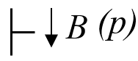 | The point or purpose of the members of the representative class is to commit the speaker to something’s being the case, to the truth of the expressed proposition. e.g., “It’s snowing”
Directives: | 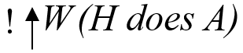 | The speaker attempts to get the listener to behave in a way so as to fulfil what is represented by the propositional content. e.g., “Shut the door!”
Commissives: |  | Those illocutionary acts whose point is to commit the speaker (in varying degrees) to some future course of action. e.g., “I’ll complete the task by next Monday.”
Expressives: | 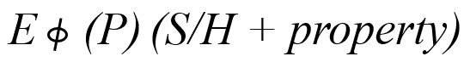 | The illocutionary point is to express the psychological state specified in the sincerity condition about a state of affairs specified in the propositional content. e.g., “I’m glad it’s sunny today!”
Declarations: | 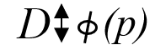 | Included in the class of performatives, the speaker performs an action just representing herself as performing an action. “I declare war!” (p.354-360)
Symbols adapted from Searle (1975)
Reflecting on this study, based on Searle’s alternative taxonomy, the speech in lesson plans appear to belong under the category of Directives in the written form. Though much of the lesson plans were written in a “modest attempt” (i.e., suggest to do so) (p.355), Searle (1975) considers these as directives where the propositional content denotes the hearer (reader) will do some future action.
Theory of Implicatures
Grice (1991) emphasized the connection between what a speaker says and its intended meaning, and often what a speaker intends to communicate is beyond the words a speaker uses in his/her speech. Grice’s theory distinguished between a speaker’s utterances and what he/she “implicates” (p.31) in his/her speech. Grice uses “implicatures” (p.25) to refer to intent communicated but not said in a speech. An example is taken from Grice (1991):
A: Smith doesn’t seem to have a girlfriend these days
B: He has been paying a lot of visits to New York lately. (p.32)
In the above conversation, B implicates that Smith has, or may have, a girlfriend in New York. Grice (1991) described that the above conversation was successfully communicated due to common knowledge between the speaker and the hearer. It was commonly understood between A and B that Smith spending more time in New York meant the possibility of Smith having a girlfriend, which Grice calls the “Cooperative Principle” (p.26). To Grice, some implicatures are conventional and rely on the conventional meaning of words, while others are “essentially connected with certain general features of discourse”, and these are known as “conversational implicatures” (p.26). Grice listed 4 distinguish “maxims” (p.26) that would attribute to successful communication with the Cooperative Principle:
- Quantity: Make your contribution as informative as is required (for current purposes of the exchange). Do not make your contribution more informative than is required.
- Quality: Try to make your contribution one that is true (Supermaxim) Do not say what you believe to be false. Do not say that for which you lack adequate evidence (Submaxims)
- Relation: Be relevant
- Manner: Be perspicuous (Supermaxim). Submaxims: Avoid obscurity of expression. Avoid ambiguity. Be brief (avoid unnecessary prolixity). Be orderly. The speaker must make it clear what contribution he/she is making and to execute his/her performance with reasonable dispatch. (p.26-28)

Violation of the above maxims will affect conversational implicatures. Grice (1991) also stated features of conversational implicatures:
Nondetachability: “The implicature is nondetachable insofar as it is not possible to find another way of saying the same thing (or approximately the same thing) which simply lacks the implicature. This feature is not necessary if “what is said has been said, and it is also subject to the limitations that there may no alternative way of saying what is said, or no way other than one which will introduce peculiarities of manner, such as by being artificial of long-winded” (p.43).
Cancelability: “…a putative conversational implicature that p is explicitly cancelable if, to the form of words the utterance of which putatively implicates that p, it is admissible to add but not p, or I do not mean to imply that p, and it is contextually cancelable if one can find situations in which the utterance of the form of words would simply not carry the implicature” (p.44).
Calculability: A conversational implicature must be able to be worked out; otherwise, even though it can be intuitively grasped, until the intuition can be replaced by an argument, the implicature (if there is at all) will not be considered a conversational implicature. (p.49)
Reflecting on this classical pragmatic theory by Grice in my study, there appears to be evidence of a strong Cooperative Principle in crafting lesson plans within the early childhood professional environment. As described earlier, the terms occurring in lesson plans examined in this study were from the national-directed set of learning dispositions by the Ministry of Education (MOE) in Singapore. These terms are derived from a set of learning dispositions in the form of a framework called Nurturing Early Learners (NEL) Framework (Nurturing Early Learners, n.d.), which is considered what Grice would term “common knowledge” within the public preschools in Singapore. A learning disposition quoted earlier, such as “Praise: Sense of wonder and curiosity”, that occurs in preschool lesson plans of both practitioners and trainees, would not be understood by an outsider of the field when reading the plan because the reader is not aware of the “common knowledge” within the early childhood community. Hence, judging the calculability of the implicature of the learning dispositions indicated in those lesson plans would technically be relevant only within the early childhood professional environment.
Linear vs. Circuit Communication Model
This study does not subscribe to the conventional communication model but regards Hall’s circuit of communication as a preferred model. The conventional mass communication model posits a linear structure of the encoding and decoding process. Carey then described the conventional model of communication from a transmission view in 1975 (as cited in McQuail, 2013, p.10), defined by terms such as “imparting”, “sending”, “transmitting”, Or “giving information to others” (Carey, 2008, p. 41). Carey (2008) later included his view on communication with the “ritual” view that likened it to “attending a mass” and that “a situation in which nothing new is learned but in which a particular view of the world is portrayed and confirmed” (p.46).
Hall challenged the conventional linear model of communication and stated the following argument for this.
- Meaning is not simply fixed or determined by the sender;
- The message is never transparent; and
- The audience is not a passive recipient of meaning. (cited in Procter, 2004:59)
Figure 1
Hall’s Encoding / Decoding Model. (Adapted from Hall, 1973, p.4)
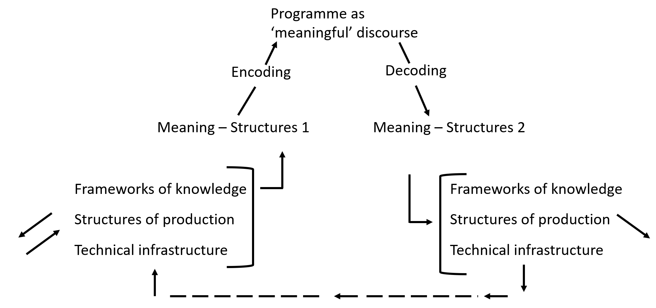
Procter (2004) supported Hall's argument against the linear model of communication by citing an example of a documentary on asylum seekers that aims to give a sympathetic documentary of their plight would not guarantee that its audience will regard them sympathetically. The linear model assumes that meanings are as indicated in the words spoken and that the meaning is perceived the same in all situations. The linear model failed to recognise that conversation is a collaborative motion and that the meaning of utterances is context-determined. Hall (1973) further argued against the linear structure of communication by stating that the "codes of encoding and decoding may not be perfectly symmetrical" (p.4). Language does not reflect the actual message encoded and decoded but constructs or "distorts" it, which Hall (1973) equates to "misunderstandings" due to a case of "a-symmetry" between the sender and receiver (p.4). Hall's (1973) alternative communication model suggests a circuit instead of the traditional linear form where the sender is the producer, and the receiver is the consumer, dispelling the notion of a passive process and an end of a communication process as implied by the term "receiver". Hall's circuit of encoding and decoding is depicted in Figure 1.
Hall's circuit of encoding and decoding reminds me of the feature of feedback observed in many preschool practitioners' lesson plans. Hall's model of communication is highly relevant to this study. Many responses from participants revealed the complex structure of encoding and decoding lesson ideas in the early childhood setting. Strictly speaking, a lesson plan appears innocently to be one-directional to inform the reader of instructions or procedures of a lesson. However, many parts of a lesson plan contain messages not explicitly stated in words. In addition, the decoding stage has messages that need interpretation, such as procedures that allow the teacher (the reader) to adapt and not follow strictly in the specified order as noted in a lesson plan. The feature of feedback also allows a conversation between the creator of the lesson plans and the assessor of the plans. In this instance, the teacher's supervisor is the reader and the assessor of the plans. The circuit exists in those lesson plans for a functional reason, that is, for formative learning and development of teachers in the preschool.
General Observations about the definition of Communication Skills in the Workplace
According to Hargie (2006), competencies required in most professions involve successfully using three main sets of skills. They are cognitive and technical skills, and the one of interest in this study, communication skills. Based on a review of the literature, communication skills are often functional by nature and primarily for professional purposes that cover strategies to attain successful interpersonal communication in the workplace (Hargie, 2006, p.2). According to Hargie (2006), much attention on communication skills was highly associated with attaining successful interpersonal communication skills in the workplace and focused on the importance for “neophytes to become competent communicators” (p.2). Coffelt and Smith (2020) discovered in their study that employers’ perspectives about the meaning of “communication skills” shows a “preference for interpersonal skills” (p.365). Much emphasis is given to such skills and their impact on personal effectiveness and success within a professional setting. I have similar observations, as seen in the titles of books written within the professional context on communication skills. They were often referring to knowledge regarding successful interpersonal communication. Examples such as
- Keith Ferrazzi’s Never eat alone highlights the importance of relationship building,
- Arianna Huffington’s On Becoming Fearless focuses on how to speak the truth successfully within the workplace, and
- Dale Carnegie’s best-selling book, How to Win Friends and Influence People, addresses methods of forging interpersonal relationships and the power of those relationships.
Even in Hargie’s (2006), The Handbook of Communication Skills, his notion of “communication skills” essentially refers to non-verbal interpersonal communication skills and posits that the benefits and impact of effective interpersonal skills give one a competitive advantage over both academic and professional achievements. It is difficult to deny the importance of interpersonal communication skills. However, it is also true that the realm of the workplace encompasses communication that can occur in various contexts and forms. Contexts for communication can range from pitching a business deal or expressing a scientific idea with presentation skills to writing instructions for a procedure or to describing a sensitive situation for a case report. In that case, if successful communication skills are crucial for success in the workplace, attention must be given to the different areas, contexts and types of communication that will affect success beyond interpersonal communication skills.
Understanding Communication where Communication happens
Based on a review of literature, communication was defined by German sociologist Niklas Luhmann, often regarded as a "theorist of society", whose overall approach to the social world is the "conceptualisation of the social domain as constituted exclusively of verbal and non-verbal communication" (Cooren & Seidl, 2020, p.480). Luhmann (1992) defines communication as not an action but a "social operation" that is unavoidable and will take place when any social situation arises (p.252). He further defined communication as an "emergent reality, a state of affairs sui generis" and emerges through a mandatory fusion of "information, selection of the utterance of this information, and a selective understanding or misunderstanding of this utterance and its information" (p.252). He asserts that the utterer of the information needs not to assume that the information is "self-understood but requires a separate decision" (p.252) and that if these are not dealt with separately, the information would merely be regarded as perceptions. Based on Luhmann's definition, communication skills would be crucial in ensuring the communicator and receiver make the right communication "decisions". Therefore, knowing how to make good communication "decisions" is essential for teaching communication. The findings of this study hope to inform and suggest approaches for this purpose; to help students make accurate and successful communication "decisions" so that information communicated would be understood according to the intended meaning and not left to the listener's perception of the message. Ensuring students know how to make accurate communication "decisions" we can then help them succeed in the workplace. It is useful to note the existence of miscommunications during the process of communication, and consistent with Schegloff's (1991) central conception of conversation analysis, the only way to know if the message has been understood (as intended by the message sent) would be from how information is displayed in the next turn of talk (Luhmann, 1992).
Figure 2
Communication defined in the Relevant Discourses. (Adapted from Schmidt, 2003, p.129)
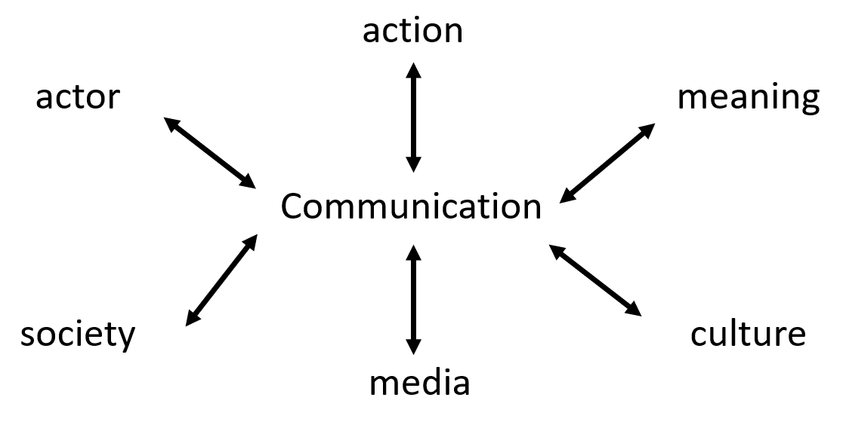
Hence, communication happens from all the "decisions" made between the utterer and the receiver. However, such decisions cannot be made in the absence of communication. Schmidt (2003), as highlighted by Luhmann too, posits that the term "communication" can only be "defined in or through communication”. Schmidt explains, as indicated in Figure 2, that just as descriptions of cultures can only be made possible within the "framework of cultures of description and also for conceptualisations of media which can be made only in the media or indeed for descriptions of action which require actions of description" (p.130), communication can only be described within the communication itself.
These definitions, when applied in the context of this study, inform the content and curriculum design of communication subjects. Skills identified to be taught should prepare students to function successfully within various discourse situations and to make accurate communication decisions. More importantly, it is logical to situate the learning of communication within experiences of communication in actual contexts. If communication can only be defined in or through communication (Luhmann, 1992), it makes sense to understand communication from where it would eventually occur. Ultimately, one aspect congruent in all literature, professionally and academically, is that effective communication is crucial to succeeding in many areas of a person's life. Essentially, "all human experience is ultimately social" and involves both "contact and communication" (Dewey, 1938, p.38). Therefore, learning to communicate involves participating within authentic social contexts where communication ultimately happens.
Systemic Functional Linguistics (SFL)
This study examines the properties of language structures derived from human activities and attributes within the workplace context. Based on this, with reflections from my literature review, it seems appropriate to position it under systemic functional linguistics because systemic functional linguistics does not regard language in isolation but examines language within the context of where it exists. Halliday (2009) describes systemic functional linguistics as falling within the definition of a “general linguistic theory”, where it is a general theory that describes features of specific languages. He asserts that languages need to be examined where they are “located and understood in their context within the totality of the language” so as “to be established as comparable in any significant sense” (p.59). Furthermore, Halliday (2009) posits that investigating a language goes beyond examining the language itself. An investigation needs to examine “sociological foundations of human relationship and interaction” (p.59) and, in order to have a meaningful comparison of languages, the investigation must not only focus on grammatical features passively but also “identify the system within which these features are located” (p.59). Similar to systemic functional linguistics, this study aims to identify and understand authentic texts existing within actual workplace environments and hopes to describe the language used in identified texts commonly written by early childhood teachers within the workplace. Hence, this section describes how this study is placed within the functional linguistics framework by reviewing related literature.
According to Butler (2009), the most fundamental principle of functional linguistics is the following. Language is, first and foremost, a means of communication between human beings in social and cognitive contexts (p.3). Based on this principle, Butler (2009) raised two claims, which are:
- Language is not self-contained or autonomous from external (cognitive and sociocultural) factors but shaped by them.
- Syntax is not self-contained or autonomous from meaning. (p.3)
These basic principles are not entirely constant across different functional theories as
  - Functional approaches do not treat language as a fixed monolithic entity but recognise that it shows great flexibility in response to communicational demands.
  - The communicational emphasis is sometimes translated into an interest in the use of attested linguistic data, often in combination with data from intuition.
  - Functional theories tend to recognise the importance of studying phenomena at the discourse level, rather than limiting themselves to the sentence domain.
  - Many functionalist theories have a typological orientation.
  - Functionalists take a basically constructivist rather than a nativist approach to language acquisition. (Butler, 2009, p.4)
Halliday (2009) regards infant speech as a protolanguage that is made up of simple signs with “just one cycle of token and value”, while adult-like language is “stratified: that is, it embodies cycles of realisation” (p.62). He explains that it is a cycle that extends to the relation between language and its context of operation. The cycles of realisation include semantics lexico-grammar phonology phonetics. He asserts that adult language is organised “meta-functionally”, which has the following process:
Having evolved simultaneously as the means of making sense of our experience (construing “reality”) and of getting along with each other (enacting our social relationships), language manages these as complementary modes of meaning (ideational, interpersonal) – along with a third functional component (the textual) which maps these on to each other and on to the context in which meanings are being exchanged. (p.63)
Contrary to functionalists' aims and assumptions of languages, Chomskyan linguistics has a consistent position of a genetic endowment in language acquisition. In addition, Chomsky's levels of criteria of adequacy regard the object of linguistics description as a set of grammatical sentences in a language and that "native speaker intuition" would provide evidence for the explanatory adequacy of a theory (Butler, 2009, p.4). If we accept Chomsky's view, language will have "no direct genetic or neurological link with social grouping or social manipulation" (Chilton, 2003, p.17). Language would be regarded as how Chilton (2003) described Chomsky's position: "free-standing ability, not predictable from human social behaviour, uninfluenced by it" (p.17). Logically, this seems incorrect, as communication exists within social settings, and the social environment can influence how we communicate. Hence it seems to make more sense to accept the functional linguistics' belief of a "theory of choice", which means "in more ways than one", and focus on the description of languages rather than theory (Webster, 2009, p.1). The approach and content of lesson plans written in different early childhood schools were highly determined by the school's culture and practice. Determining the best lesson plans written is a complex exercise. Comparing lesson plans between schools would be meaningless because different parts of each plan serve a specific function identified by the environment and context determined by the school. Functionalism in linguistics is concerned with "how language is or can be used in context" (González et al., 2014, p.2). This belief will impact how one would approach linguistics databases too.
Contrary to what Chomsky would label as "performance" (Butler, 2009, p.4), where data should not be a basis for the description and theorising of a language, Functionalists, who possess a broader perspective towards linguistics databases for a description of a language would include language used by speakers and writers under specific conditions. The practicality of functional linguistics was also highlighted by Halliday (2009), who characterised systemic functional linguistics as a "problem-oriented theory" that asks "questions of practical action" where "the questions it sets out to answer are questions faced by people who are not linguists but are engaged in" (p.61) using the language. This study's underlying value firmly believes that a language learner's social environment plays a pivotal role in the acquisition and determines the ultimate production of a language. Based on this belief, this research aims to describe the language used in the context of the writing of the most commonly written text, as claimed by participants of this study, practitioners and trainees, within the context of each early childhood environment they represent.

Understanding Discourse
This study examines discourse occurring within the workplace, so it would be helpful first to examine what discourse means in this study because there are varied ways to approach the study of discourse. Different researchers approach the study of discourse in varied ways too. For example, Bhatia (2004) discussed discourse based on the register, genre and discipline. He explained the interrelationship between these three aspects in a diagram (Figure 3), particularly in academic discourse.

Figure 3
Registers, genres and disciplines in academic discourse. (Adapted from Bhatia, 2004, p.31)
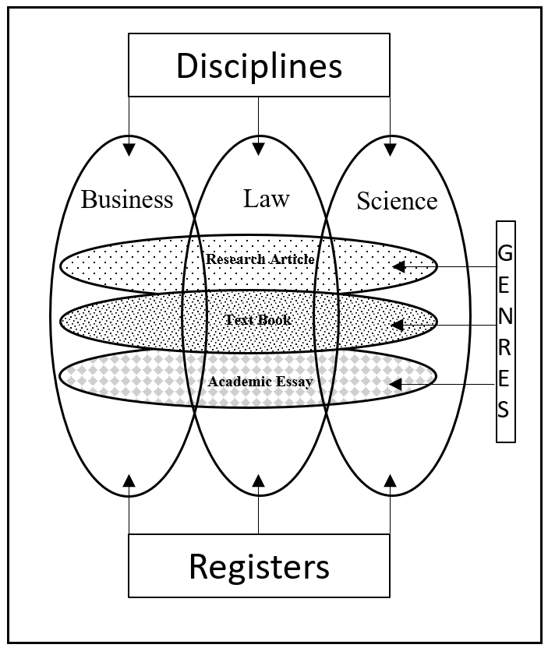
Bhatia (2004) claimed that register is often closely related to discipline, but he posits that these two are different. Figure 3 shows that discipline represents content, while register represents "the language associated with it" (p.31). Then, Bhatia understood discourse sufficiently to distinguish register from discipline within academic discourses. However, this diagram cannot be applied to the workplace discourse, where different disciplines and registers are found within a single communicative genre. For example, reflecting on a lesson plan collected for this study contains the business discipline and register for human resource purposes. The teacher who wrote the lesson plan included justifications for actions described in the plan for appraisal purposes. However, within the same lesson plan, the procedure section of the document can contain the science discipline with an explanation of scientific information (e.g., how plants grow). It would be challenging to categorise those lesson plans under a specific discipline. Hence, discourse in this instance cannot be categorised, unlike academic discourse, where the demarcation of disciplines is quite clear. Bhatia (2017) later expanded his definition of a discourse and highlighted the bearing of context in discourse analysis, and raised the critical value of "recognising conventions constraining how the member of a (that) community negotiate meaning in their specialised contexts of language use" (p.4), especially in professional genres. In pursuit of determining the right approach to examine the discourse in my study, I started with locating other definitions of discourse to provide leads that could help me determine my definition based on the context of this study. Mills (2004) claimed that discourse occurs like common knowledge but is often undefined in multiple disciplines such as critical theory, sociology, linguistics, philosophy, social psychology and others. Doing what Mills did in her book, I started my search by locating the definition of discourse from several online dictionaries and, notably, relating to the context of my study, and three dictionaries gave definitions from the linguistics perspective:
[uncountable] (linguistics) The use of language in speech and writing in order to produce meaning; language that is studied, usually in order to see how the different parts of a text are connected. (Oxford Learner's Dictionary, n.d. -a)
In linguistics, discourse is natural spoken or written language in context, especially when complete texts are being considered. (Collins, n.d.)
The language used in particular types of speech or writing. (Longman, n.d. -a)
In all three dictionaries, discourse's definition revolves around language use in natural contexts. However, Longman (n.d.) and Collins focus on the language itself, while the Oxford Learner's Dictionary (n.d.) stresses the use of language. It is easy to categorise genres strictly by discipline and register of a communicative event without referring to the discourse context. However, social settings and environments often determine the discourse context. Bhatia (2017) suggests that professional communication is best understood "on the basis of communicative behaviour" that was performed to "achieve specific disciplinary and professional objectives rather than just on the basis of disciplinary theories" (p.7). Gee (2014) asserts that humans talk and act not as individuals but as members of various social and cultural groups. Cultural groups include professions like teachers, carpenters, academic disciplines and interest-driven groups. These groups have distinctive ways with words associated with distinctive identities and activities. Gee asserts that there are many ways to describe these groups, such as "communities of practice, speech communities", and "discourse communities" (p.182). He termed such social groups with the term "Discourse" with a capital "D" because he posits that such groups will continue through time that exists with distinctive ways of speaking/listening, acting, valuing and interacting even before we existed. Gee (2014) believes that language was "inherited" (p.181) from others and not invented. However, we innovate within the conventions, give new situated meanings to works, and identify new ways to say things, but "these innovations must be shared with others in order to be understood and to survive" (Gee, 2014, p.182).
Gee (2014) posits that social groups not only use languages but also "distinctive ways of acting, interacting with others, believing, valuing, dressing, and using various sorts of objects and tools in various sorts of distinctive environments" (p.182). He gave the example of a basketball player who cannot claim to be one just by talking about it but "walk the talk and do that with basketball on a basketball court in front of other people" (p.182). Similarly, early childhood teachers use commonly understood terms like "DAP" ("12 Teacher terms," n.d.) to describe "developmentally appropriate practice" activities conducted in a classroom, and this acronym occurs in lesson plans collected for this study. Several acronyms were used in the interviews conducted in this study, and I had to seek clarifications to understand what the participants meant. Terms such as "NEL framework", "SPARK" (The Singapo​re Preschool Accreditation Framework), "EYDF" (Early Years Developmental Framework), "PTC" (Parents Meet), "EC" (Early Childhood), "Comm Book" (communication book with parents) and "Little Lives App" (a Preschool Management System) are commonly used in professional documents and verbal conversations within the early childhood work environment. Some participants even used nouns as adjectives, such as "… that's not EC…" to mean an approach not commonly found in early childhood practice. Hence, this reiterated Austin's assertion that meanings exist beyond words or language. Similarly, Gee (2014) posits the following, which this study acknowledges.
The whole point of taking about Discourses is to focus on the fact that when people mean things to each other, there is always more than language at stake. To mean anything to someone else (or even to myself) I have to communicate who I am (in the sense of what socially-situated identity am I taking on here and now). I also have to communicate what I am doing in terms of what socially-situated activity I am seeking to carry out, since Discourses (being and doing kinds of people) exist in part to allow people to carry out certain distinctive activities (e.g., arresting people for a policeman, taking communion for a Catholic, getting an “A” for a good student). Language is not enough for this. We have to get our minds and deeds “right,” as well. (Gee, 2014, p.183)
Hence, discourses are beyond words and language itself. Through discourses, we add meaning to the world around us, and through it, we can understand the world in which we reside. Social practices are crucial in helping us understand the world, which is essentially Foucault’s ideology of discourse. According to Hall (1992), Foucault’s discourse “does not consist of one statement, but several statements working together to form a …‘discursive formation’… the statements fit together because any one statement implies a relation to all the others…discourse is about the production of knowledge through language” (p.291). However, Hall (1992) added that “since all social practices entail meaning, all practices have a discursive aspect. Hence, discourse enters into and influences all social practices” (p.291). Foucault’s theory of discourse bears the following essential points:
- A discourse can be produced by many individuals in different institutional settings (like families, prisons, hospitals and asylums) …every discourse construct positions from which alone it makes sense. Anyone deploying a discourse must position themselves as if they were the subject of the discourse.
- Discourses are not closed systems. A discourse draws on elements in other discourses, binding them into its own network of meanings.
- The statements within a discursive formation need not all be the same. But relationships and differences between them must be regular and systematic, not random… of which Foucault calls ‘a system of dispersion’. (Hall, 1992, p.292)
Foucault asserts that discourse defines, allows, and limits social practices and values and has "real consequences and effects" (Hall, 1992, p.295). Discourse influences and changes how we locate ourselves in concepts and ideas carried by discourses, affecting our identities. One example related to the participants in this study would be that the professionalism of early childhood teachers (PECT) in Singapore society is reflected in societal views towards the qualifications of preschool teachers in the past. School Directors' idea of professionalism at the preschool level was reported to be equivalent to "years of teaching experience" (Tzuo et al., 2015, p.118). Parents perceived the idea of professional development for teachers as less critical for teachers in the early childhood professional environment, and perceptions of the early childhood teachers drew from the "old-time view of comprehending it as a form of childcare such as by a nanny" (Tzuo et al., 2015, p.117). They constructed the subject (i.e., early childhood teachers) as a lesser educator compared to other levels of educators, reducing the importance of well-trained educators to teach at this level. Collectively and over time, this resulted in an under-evaluation of the early childhood practitioners that influenced their compensation too. A change started when discourse emerged at both academic and national levels, prompting interventions in training and compensations of early childhood educators today.
Text and Discourse
This study seeks to describe the discourse existing within early childhood education by examining authentic texts within the early childhood professional environment. The investigation will raise the question of whether authentic texts can be regarded as representative of discourse in a context. Hence this section hopes to address this.
Researchers such as Mills (2004) cited examples of definitions that broadly define discourse by describing what it is not. She cited definitions that compare discourse with history (or story), language system and text (p. 4 & 5). Mills (2004) cited Hawthorn, who claims that text is written, discourse is spoken, and that text is non-interactive while discourse is. Hawthorn's definition of discourse is shared amongst some scholars who view a text as "written language" while discourse is "spoken language" (Trosborg, 1997, p.4). However, others regard texts to occur in both written and spoken. If the definition of discourse is what Hawthorn claims, I question the categorisation of communication through a genre such as love letters. Technically, love letters are written and used in interactions. They will probably not exist if there is no expected response. Hence, an interaction exists in the writing of such letters. However, it also seems technically suitable to accept a differentiation between text and discourse through Trosborg's (1997) citation of Virtanen (1990), who asserts that:
A text may be viewed as structure and/or it may be regarded as a process. In line with these two approaches, text has often been used of a static concept - the product of a process - while discourse has been used to refer to a dynamic notion - the process of text production and text comprehension (p. 453).
However, Trosborg (1997) explains that separating text from discourse in definitions would also seem to be misplacing the definitions because both may be regarded to be different but are highly related, and both provide "complementary perspectives on language" (p.4). Hence, a strict demarcation between text and discourse is now considered "arbitrary" (Trosborg, 1997, p.4). With the text being inseparable from discourse, viewing them as separate entities seems incorrect. Instead, I regard texts as reflecting discourse existing in a context. This study looks into authentic texts written in the workplace and assumes that they have a close relationship with and provides a description of the examined workplace discourse.

Workplace Discourse
I set out to identify principles and conclusions in the spoken and written interactions that might occur in actual workplaces, and my search resulted in the following. I started looking into the term workplace discourse and what revolves around it. Koester (2012) listed the various terms describing interactions occurring in the workplace and claimed that workplace discourse and institutional discourse are usually broader terms and often task-related, while business discourse and professional discourse appear to be more specific (p.5). Determining workplace discourse as an umbrella term encompassing task-related and context-determined discourses seems logical. However, it seems challenging to put all tasks and skills required in respective discourses, though similar in nature, under the broad categorisation of workplace discourse. For example, Stefani and Horlacher (2018), in their study of interactions between two different contexts of service providers, such as retail assistants, found that "mundane talk" or "small talk" (p.222) and even "relational skills" (p.242) via talk are mandatory competencies of good service providers. However, it would be rather challenging to regard "mundane talk" as a necessary form of conversation and skills in other occupations, such as IT helpdesk personnel. Though both would technically belong in the service industry, the context and activities contain differences that impact the type of "talk" and communication skills needed to be successful in their jobs. The eventual professional discourse is specified to different industries, and any attempts to generalise them seem problematic. Applying the importance of context in the instruction of professional discourse, Parkinson et al. (2018) assert this stand of situating literacy teaching in content instructions, and this was demonstrated through their study that supports the effectiveness of situated learning. They explained that the technical vocabulary would be the apparent difference in communication between trades and fields. However, they argued that acquiring a language of a trade cannot stop at learning technical vocabulary. The structure of meanings in a conversation and how they were created are as specific as the vocabulary of a field or trade. Their study focused on learning occupational discourse among learners in vocational education for trainee carpenters. They observed the importance of noting that the actual work context contains specific rhetorical moves, structures and vocabulary. Swales (1990) developed the study of genres to describe segments of academic articles functionally. These segments are called moves. In his approach, the identification of moves aims to functionally describe and explain the rhetorical function of specific segments plotted within articles, particularly academic articles, to support non-native speakers of English to learn the rhetorical segments of a genre and ultimately learn how to write them. According to Biber, Connor and Upton (2007), a move "refers to a section of a text that performs a specific communicative function. Each move not only has its own purpose but also contributes to the overall communicative purposes of the genre" (p.23). An example of moves can be seen in 6 rhetorical moves Bremner and Ban Phung (2015) identified in the Summary sections of LinkedIn profiles written by 50 résumé writers who came from a widely recognised résumé/career coaching conference for self-promotion in the context of the LinkedIn environment. These rhetorical moves are what Bremner and Ban Phung (2015) would believe in serving as exemplary models of self-presentation in the context of LinkedIn, as the résumé writers were considered experts in the field of career and employment communications.
- Establishing credentials
- Identifying client needs
- Detailing service
- Indicating the value of service
- Identifying the target market
- Personal branding (p.372)
The above rhetorical moves showed the intent of each portion of the Summary section on a LinkedIn profile. The moves described above showed the intent of each step in a successful Summary section. Parkinson et al. (2018) found differences even in sentence length and depth in moves between apprentices and on-campus trainees. They also discovered a difference in the knowledge of genres between novices and more experienced trainees. Their findings reflect the importance of situating communication skills learning within practice.
Similarly, in the context of my study, in preschool teacher preparation, Darling-Hammond (2010) asserts the importance of high-quality classroom-based experiences that typify the notion of "practice in practice" in order to teach trainee teachers to "teach powerfully" (p.42), as they are linked to higher efficacy in teachers' retention and overall effectiveness. These studies inform the investigation of my query on the relevance of content situated in actual context in teaching communication skills, which I will be discussing in further detail under the section Conceptual Framework. This discovery made me ponder why the institution of my study decided to generalise communication skills across six different faculties. Differences can be found even within industries represented by each faculty/diploma, so generalising communication skills seems illogical even at this point of this discussion. The idea of specificity led me to explore approaches and theories that emphasise the importance of context in learning how to communicate in actual places of practice. In the following section, I will explain the theories and why I anchor this study on the fundamentals of English for Specific Purposes (ESP).

General versus Specific Communication Skills
As explained earlier in this dissertation, my research was prompted by questions about the approach to teaching the current list of fundamental communication skills within the institution of my study. One of which was whether teaching communication skills should focus on specific contexts existing within the eventual workplace or if we should be identifying broad communication skills that can be generalised to all connections regardless of field, setting and industry. Coffelt et al. (2019) asked similar questions and studied 22 managers from more than eight fields of work, such as journalism, engineering, business and education. They identified three primary "exemplary skills" and "unacceptable skills" to inform communication instructors when deciding topics to emphasise in a course. The exemplary skills listed are relatability, documentation and audience awareness/adaptation, while unacceptable skills were identified as verbal aggression, deception and defensive communication behaviours. Reading the results, the initial reaction I had was to halt in the direction where I was heading in my research and that I might be wrong to hypothesise that communication skills should be taught in specific contexts and that communication skills can be generalised and would be sufficient in preparing our students to function effectively in the workplace. However, upon reading the study by Coffelt et al. (2019), I gathered that employers. although they view written communication as "universal communication norms", have views about written communication in line with genre theorists' perspectives of the fact that writing "is best taught with the activity in mind" (p.431). They reported that employers frequently stated written communication skills in terms of "specific document types, which they understood to be situated within specific contexts of use" (p.431). Despite this, Coffelt et al. (2019) suggest genre theorists should consider if some aspects of communication skills could be consistent across genres, as many workplace supervisors usually understand communication skills to be universal. Their study found few gaps between employers and instructors but rather gaps in "matching appropriate courses with students" and the perceived gap between employers and instructors was due to students' application of the transfer of communication skills from courses to employment situations (p.434). Coffelt et al. (2019) still recognise a need to be specific in context and "align with industry" (p.434). Coffelt et al. (2019) reasoning makes sense because what is an "exemplary skill" for audience awareness and adaptation for a sales representative versus those of a marketing executive, though both function within the sales industry, would differ quite extensively. Similarly, within the education industry, many preschool language teachers would need to write weekly lesson plans, while a language teacher at the Polytechnic level, like myself, need not write weekly lesson plans. Even if Polytechnic lecturers were to write weekly lesson plans, parts of lesson plans from both groups would differ quite vastly too. The weekly lesson plans at the Polytechnic level are usually brief compared to those written for an early childhood lesson. It is prevalent for Polytechnic lecturers to adapt lessons and include supplementary materials in our plans. Materials for a lesson plan are usually not listed in the Polytechnic's lesson plans and, even if they are, are merely suggested. Hence, there are differences in the approach to lesson plans, even within the education sector. This phenomenon indicates the importance of recognising specificity in professional communication.
Similarly, in the assessment of communication skills, also demonstrating the importance of specificity, is the study by Grande et al. (2022), who observed a need to inject more "military flavour" (p.73) in the oral proficiency interview for Joint Terminal Attack Controllers' NATO English proficiency test. More than good English-speaking skills, their findings support using "correct terminology and phraseology" (p.74) to determine performance in the target language use situation. Pushing my argument further, the following section presents two vignettes of actual workplace miscommunication to illustrate the importance of context and the notion of specificity in teaching communication skills in the workplace. The vignettes highlight that there can be dire consequences if one lacks consideration for not using specific terminologies and approaches required in communicating in the workplace.
When “running out of fuel” is not important
The crash of an Avianca jetliner in January 1990 was a result of a miscommunication in the workplace. On the day of the tragic accident, the co-pilot did not use specific emergency terms, which led to the cockpit crew failing to understand the situation's urgency and not allowing the plane to land immediately (Malnic, 1990). Instead, the co-pilot used "non-standard terms" such as "need priority" and "running out of fuel", which can be considered to be a critical situation if one were to look at it from a day-to-day conversation. However, these phrases in the aviation context do not necessarily trigger an emergency protocol. Nevertheless, this miscommunication led to an unfortunate event and showed the importance of specificity in workplace communication.
Repeat Back Communication could have avoided a Tragedy
Four-year-old MacKenzie Briant’s life changed just because her doctors miscommunicated. Mackenzie was born with a heart defect in 2004 and survived a heart transplant. Although she had to be protected from germs due to the immune-suppressing drugs, she was a cheerful child who accepted constant measures of sanitising her hands with “an independent spirit and a special way” by dubbing the hand sanitiser “handitizer” (Ostrom, 2013, line 30-32). In November 2008, MacKenzie caught a cold and her mother, being extremely careful, brought her to a paediatrician, but she was found to have no serious problems. However, two days later, the congestion in her nose did not clear up, so her mother called the Seattle Children’s Hospital and consulted a cardiology fellow, Dr Cory Noel. Since MacKenzie was a heart-transplant patient, Dr Noel contacted the transplant cardiologist, Dr Yuk Law, who had been the doctor following MacKenzie’s case. Dr Law told Dr Noel that MacKenzie should not use the Afrin nasal spray, but Dr Noel did not repeat his instructions back and included the Afrin nasal spray in the list of drugs MacKenzie was allowed to use. This error led MacKenzie to stop breathing. The situation was “hysterical”, with several unsuccessful attempts to resuscitate her for a few minutes, which led to significant brain damage. MacKenzie was hospitalised for two months and needed nursing care to turn her, massage to keep her body from twisting and stiffening, and cognitive therapy to help her body develop as much as possible. Reflecting on what happened, if Dr MacKenzie had repeated what was communicated back to Dr Law, he could have confirmed the contents of the instructions and avoided this error.
These real-life situations demonstrated the importance of being specific in our knowledge of effectively communicating in the workplace. These stories led me to examine the theories behind English for Specific Purposes, which I will discuss in the following sections.

English for Specific Purposes
According to Johns (2012), the discourse on understanding English for Specific Purposes (ESP) began in the 1960s. Judging from the extensive research on ESP 30 years after its first mention, one would expect the ESP community to understand what ESP means clearly. However, it appears that the development of the knowledge of ESP evolved in ways that were unexpected and alarmingly slow (Dudley-Evans & St. John, 1988). Despite that, one aspect researchers and educators appear to agree about unanimously would be the practicality and specificity of ESP, which can be understood from words used by Belcher (2006) such as "needs-based, pragmatic, efficient, cost-effective, and functional" (p.134). Similarly, Hutchinson and Waters (1987) explained the guiding principle for ESP through the notion, "Tell me what you need English for, and I will tell you the English that you need" (p.8), showing the highly functional nature of ESP. Specificity is indeed crucial for ESP. The letter "S" in the acronym "ESP" refers to "specific", which shows language identified with explicit "spheres of professional and institutional communication in English" (Williams, 2014, p.1). Though ESP refers to language skills of explicit settings in which the language should and will function, and hence is highly dependent on context, a few general attributes would characterise ESP. When one discusses the meaning of ESP, many will refer to Johns and Dudley-Evans (1991), who recognised ESP between four absolute and two variable attributes (p. 298):
Absolute characteristics:
ESP consists of English language teaching which is:
- designed to meet specified needs of the learner;
- related in content (i.e., in its themes and topics) to particular disciplines, occupations and activities;
- centred on the language appropriate to those activities in syntax, lexis, discourse, semantics, etc., and analysis of this discourse;
- in contrast with “General English”.

Variable characteristics:
ESP may be, but is not necessarily:
- restricted as to the language skills to be learned (e.g., reading only);
- not taught according to any pre-ordained methodology.
Claims: the claims for ESP are
- being focused on the learner’s need, wastes no time;
- is relevant to the learner;
- is successful in imparting learning;
- is more cost-effective than “General English”

Based on the variable and absolute descriptions of ESP, as stated by Johns and Dudley-Evans (1991), the notion of "specific" is still consistent in each descriptor. ESP's focus is fundamentally on the learner's needs and contextually specified discourse structures with "language appropriate to activities relating to syntax, lexis and discourse" (p.298). Similarly, for the assessments of ESP, Douglas (2001) emphasised the importance of empirical analysis and analysing of the Target Language Use (TLU) of ESP in order to determine content (i.e., language situations), method and assessments criteria for Language for Specific Purposes (LSP) (p.173). The emphasis on "specific" and "target", referring to the specified context of the language, indicated definitive language discourse structures existing in the context of the intended use. However, the general internet skills emphasised by those fundamental subjects of my study do not target context within the learner's eventual work environment and the intended use. They are too generic and hence will and can never fulfil the organisation's primary objective, which is to be successful in the workplace. These problems raise the question of what skill or communication situations and contexts we should include in our teaching materials. Hence, these fuelled my investigation and prompted me to look into the topic of this dissertation, to identify specifics of communication skills we should focus on in our common fundamental communication subjects.

Driven by a need
An observation from the literature on ESP was that much research was conducted in the second language environment. Johns (2012) confirmed my observation when she stated that one of the issues in ESP research is the fact that much of the literature about ESP was "considerable[ly] localised" (p.5) and often published in another language. One reason could be the level of need for research in this area. In addition, ESP is taught mainly to second language speakers who would need to use the English Language for a specific vocational purpose which would and often affect the success of businesses.
Referring to Lockwood's (2012) investigation on ESP training for operators of off-shore call centres in India and Manila, such businesses' decisions were due to significant savings and the competitive advantages which accrue to companies who chose to relocate such support services. Hence, using locals for the workforce of those call centres brought about an urgent need to neutralise accents and eradicate grammatical interference mistakes for those call centres to function in their optimal form. From the business perspective, the high stakes spur a need for improving outcomes and effectiveness in learning ESP. Furthermore, ESP's outcomes have always focused on the practical aspects of learning and teaching English because much of its impact has a functional-related consequence (Dudley-Evans & St John, 1998). Similarly, even during the earlier days of research in ESP, the main objective for ESP subjects was to prepare learners to communicate effectively in the task prescribed to them in their studies or within a work situation (Dudley-Evans & St John, 1998). ESP's objective is highly functional by nature and matches the motivation of those fundamental communication subjects in this study. In the following sections, I will explain why it is appropriate to base my study on the concepts of ESP.

Why EOP/ESP?
This study is based on the theory of ESP, particularly English for Occupational Purposes (EOP), a variant of ESP (Flowerdew, 1990). Three reasons for choosing ESP to inform this study were linked to the motivations of those fundamental communication subjects of this study, and the objectives of all diploma courses offered by the institution of this investigation are as highly functional as EOP/ESP. First, the underlying motivation of all Polytechnic courses is vocationally based. The Polytechnic education in Singapore was created in 1954 following the end of WWII when the economy shifted away from trading post and entering industrialisation. During that time, technical education was urgently needed to meet the shortage of skilled workers in both the public and private sectors (Loo, n.d.). Though the Polytechnics in Singapore has undergone waves of changes in their influence and role in the economy, the fundamental motivation of most curriculum activities remains vocationally based. Second, the fundamental communication subjects aim to prepare students with communication skills they will use in the workplace. Those fundamental communication subjects aim to "better equip… students with the core skills and attributes that will help them to succeed in the workforce of the future" (Staff Communication, July 2017). Once again, this means that the ultimate skills we are trying to teach are contextualised in the workplace.
The final point is related to the fact that research in ESP is predominantly explored in the teaching and learning of the English Language for second language learners (ESL). The English Language is regarded as a working language in Singapore. However, many Singaporean speakers of English are often called Singlish. Singapore English is described as a
large corpus of naturally-occurring spontaneous speech of young, native speakers of Singapore English, … a vibrant, current, contemporary, colloquial Singapore English, spoken by the Singapore English speaker of today, that is, those young Singaporeans who grew up during a period where, for all their school-going years, they have had to be what has been referred to as “English-knowing bilinguals” (Pakir 1992), that is, they have had to be proﬁcient in English and their ‘mother tongue’. (Lim, 2004, p.1)
According to Lim (2004), following an introduction of "an elementary education in the three Rs [reading, 'riting and' rithmetic] in English" (p.3) under the second British governor of Singapore in 1834, by 1900, the English Language had been established as a language for socio-economic mobility where those who possess a greater proficiency would enjoy a much wider occupational range. By the 1950s, English became universal, and English-medium education was a norm. By the 1970s, the English Language was recognised as the primary working language in Singapore, the "de facto national language" used in commerce, business, legislation, science and technology and became the primary medium of instruction in schools and tertiary institutions, serving as the "lingua franca" for international communication and diplomacy (Lim, 2004, p.5). The English Language spoken by Singaporeans has gone through the process of "structural nativisation" (Schneider, 2007, p.71), which possesses a distinctive "phonology, syntax and lexicon, which shows a high degree of influence from other local languages such as Hokkien, Cantonese, Malay and Tamil (Platt, 1980, p.100-101). Although Singaporean English speakers have non-standard pronunciation compared to native speakers, more often spoken at the playgrounds (in casual settings) rather than the classrooms (Lim, 2004), our level of language competencies would not categorise us strictly as second-language speakers. This complex development of Singapore English would technically categorise Singaporeans as not falling within the group of native or non-native speakers of English. However, some may have differing views on applying this approach to English speakers in Singapore. Regardless of these differences in views of Singapore English, this study approaches the use of ESP from the perspective of English as "natural, neutral and beneficial" (Pennycook, 1994, p.11) and based on the position of language as a local practice (Pennycook, 2010), the labels of native or non-native, official or semi-official are irrelevant in determining if the concepts of ESP/EOP can be applied in this study. Pennycook (2010) argued that to look at language as a practice is to view language as an activity rather than a structure, as something we do rather than a system we draw on, as a material part of social and cultural life rather than an abstract entity (p.2). He explained that once we view language not as a system but as "doing" (p.2), many common assumptions about language will no longer hold. Otsuji and Pennycook (2010) examined a mixed Japanese/English code as a lingua franca. They argued to move away from "ascriptions of language and identity along conventional statist correlations among nations, language and ethnicity" (p.241). They promoted the idea of "metrolingualism", disregarding the idea of pluralism in English. Instead, it embraces the notion of a "mobile language use" (p.252) that is "constantly reconstructed in sensitivity to environmental factors" (p.251). Therefore, I will apply ESP/EOP in this study. The language used in the context of this study disregards the argument about whether or not English was used in the native sense. Instead, my investigation focuses on how it was used in the workplace.

Research and ESP
In earlier days, Dudley-Evans and St John (1998) attempted to define ESP by citing Hutchinson and Waters, who claimed that ESP is an approach that does not involve "a particular kind of language, teaching material or methodology" (p. 2). However, that definition appeared incomplete when Johns (2012) asserted that research in ESP extended beyond effective pedagogical practices with research on course design that includes teaching materials. Dudley-Evans and St John (1998) also recognised the fluid nature of the various types of ESP teaching. Johns (2012) claimed that ESP has generally been seen as a separate activity within English Language Teaching (ELT) and draws on research from various disciplines other than applied linguistics. Similarly, Bhatia (2008) drew examples from a range of professional contexts, particularly from business and international arbitration practice, and argued for a non-isolated way to analyse the professional genre for ESP. He posits an integration of "discursive and professional practices", emphasising "the function of inter-discursivity in critical genre analysis" for ESP (p.161). The ever-increasing complexity of ESP brought about multi-methods and multi-disciplinary in studying and understanding the teaching of ESP.
Much literature directs ESP practitioners to research for answers to improve outcomes. For example, Hyland and Shaw (2016), in their handbook on English for Academic Purposes (EAP), described this other form of ESP as one that must be grounded, not meant to read the research about ESP/EAP merely, but also actively involved in creating it. Furthermore, they assert the importance of understanding the genres to be taught and the students we work with and that research "feeds back into the design of curricula, courses, materials and tasks" (p. 3). However, reflecting on the process of conceptualising those EOP fundamental subjects of this study, there were no attempts to research relevant skills of students' eventual workplace contexts and no analysis of the needs of our learners and their target language situations.
I observed that research in ESP is constantly in search of new grounds. However, Parkinson et al. (2022) observed that contrary to the business case genre that has received much attention, not much research has been done on engineering student writing. Both engineering students and lecturers expressed concerns about engineering students' performance in engineering writing assignments. In my work, colleagues who teach engineering students raised similar concerns. I see many potential and untouched groups in areas that research in ESP can reach. Based on conversations with colleagues in my workplace, I observed that writing and communication in specific industries, such as early childhood education and the design industry, are predominantly untouched in Singapore. This study aims to contribute to the grounds yet to be uncovered, starting with the investigation of writing skills in Singapore's early childhood education industry. The emphasis of my study goes beyond examining pedagogical approaches to communicate effectively with children to improve teaching but also with partners in the professional environment of a preschool teacher.
Before I explain further problems existing within those fundamental subjects, in the following section, I will briefly describe the process of conceptualising and how the skills and approach needed for those EOP fundamental subjects were identified. Due to the sensitivity of this topic, my descriptions will be the abridged version of the actual occurrence of events. The descriptions will be based only on two sources. (1) A personal inquiry from a colleague during my pre-research investigation stage, who sits in the initial conceptualisation of all fundamental subjects in the institution. (2) My observation during part of two fundamental communication subjects' material creation task force.

Identification of Language Skills in EOP Subjects
I found it perplexing for the institution of my study to disregard conducting needs analysis and research in creating those fundamental subjects, given the strong link between ESP and improved outcomes that make research inseparable from its practice (Johns, 2012). A brief look at the details of the process of conceptualising those subjects, based on conversations with colleagues and my observation during my involvement in the later part of the process of the creation of those fundamental subjects, I realised that the process was hurried, decisions made were mostly intuitive and investigation of outcomes primarily operational. In the context of this study, "language" and "content" appear to be viewed like what Smit and Finker (2022) regard as containing "different curricular concerns as well as distinct areas of professional expertise and identity" and often "treated as subservient to content learning" (p.103). Below is a brief outline of the conceptualising process of those fundamental subjects.
Timeline | Activities
Dec 2016 – 9 Aug 2017 | - Instructions from the senior management of the organisation to set up a task force, looking at a review of our graduate profile in response to SkillFuture and Industry 4.0.  - Representatives from respective schools and selected individuals within the organisation were chosen (no criteria revealed), to be part of the taskforce.  - A scan was performed of local and overseas literature for the desired attributes for the new economy, informed the newly described graduated profile. The taskforce looked at overall structure of essential skills and attributes our students will need, with reference to a newly described graduate profile.  - During the period of conceptualisation, direct inputs from the Principal and CEO (PCEO) and reference to the Ministry of Education (MOE) general direction at the time about important life skills to inculcate in our students. Diploma-specific inputs were gathered from the school representatives, assuming all would know what is relevant in their respective industries.
July 2017 – Mar 2018 | - The taskforce informed all six Schools and diploma teams about the overall structure of the essential skills the organisation has decided and would like to emphasise in the revamped of common curriculum.  - Initial description of subjects was created and assigned to various schools and departments, subject-level working groups were created to work on the details of each subject.  - The following assessment structure was recommended for those communication subjects – Not more than 20% of group work and 80% for individual work.
Apr 2018 | - Launch of the first fundamental communication subject. The launch of the other two subjects took place in subsequent semesters.

After the launch of the first fundamental communication subject in April 2018, subsequent work for the subject revolves around operational issues. The subject team deliberated on whether students would hand in their assignments via the e-platform or hardcopy in class, the number of assessment topics we needed to churn out to populate the pool of topics, and why some students were not performing. There is nothing wrong with those subject-related and predominantly administrative activities. However, the team's work focused mainly on feedback relating to the operational aspects of the subject. The anecdotal feedback gathered from classes I taught said they needed help understanding the subject's relevance in their diplomas. For example, general Google search skills are not scientific, academic research skills, which many social sciences students would prefer to be learning. This feedback illuminates the importance of identifying specific communication and language needs, which will provide clues on specific genres that need to be expounded and directions in the curriculum and materials for the fundamental communication subjects.

Table 1
Overview of Generic Skills and Competencies (Adapted from SkillsFuture, n.d.-b).
GSC | GSC Description | Proficiency Levels
GSC | GSC Description | Basic | Intermediate | Advanced
Communication | Convey and exchange thoughts, ideas and information effectively through various mediums and approaches | Communicate information with others to respond to general inquiries and to obtain specific information | Articulate and discuss ideas and persuade others to achieve common outcomes | Negotiate with others to address issues and achieve mutual consensus
The aim of those fundamental communication subjects, as revealed through a conversation with a colleague who was involved as part of the task force during the initial process of the conceptualisation of those fundamental subjects, was spelt out by the organisation, is to "better equip… students with the core skills and attributes that will help them to succeed in the workforce of the future" (Staff Communication, July 2017). Accordingly, the task force researched various local and overseas sources to help them conceptualise and predispose the skills for those fundamental communication subjects. One of these informing the description of communication skills to focus on was the list of generic skills and specific competencies (GSCs) determined through the SkillsFuture initiative. Table 1 shows the "Communication" description according to proficiency levels.
The problem lies not only in the conflicting objective of equipping students with core skills and attributes for them to succeed in the future workforce; the problem also lies in the GSCs that inspired those fundamental subjects. Though the GSCs described communication skills, the definition of communication skills has varied meanings for specific industries and contexts. It is important to note that to help our students "succeed in the workforce of the future" would require a focused curriculum for targeted genres within a specific language situation in respective industries instead of the range of one-size-fits-all subjects. Similarly, our students need more than generic skills and competencies to be successful in their eventual workforce. For example, according to the GSCs, the basic level of proficiency for communication is when one can "communicate information with others to respond to general inquiries and to obtain specific information" (Table 1). However, the meaning of "responding to general inquiries and obtaining specific information" will differ between genres and contexts of industries such as the design industry compared to science-related industries. Beyond learning a language in context, many studies in the area of Content and Language Integrated Learning (CLIL) have shown the importance of paying attention to linguistic forms and "language-related episodes" (p.102) in subject-related content teaching (Smit & Finker, 2022). Language and content are inseparable. Hence, I reiterate my argument of a targeted curriculum that provides learners with situated language exposure, teaching them to communicate in that genre and context relevant to the professional environment, they will ultimately be functioning in to "succeed in the workforce of the future".
The importance of context in learning to communicate is the main emphasis of this study. Success in communicating in a professional environment would be completing the required actions and achieving goals with communication. Hence, if we were to teach communication skills, it should focus on successfully communicating within specified fields, our graduates would ultimately be functioning. Successful communication in the workplace would mean using appropriate approaches, specific terminologies and language acceptable within a professional community.

Examining Texts - Whole or Fragmented?
This section negotiates the difference between a corpus and a text, with the ultimate aim of supporting why I have chosen to focus on analysing moves existing within genres rather than the lexical level of a text. Initially, I thought differences between actual and in-training texts could be found at the lexical levels. This view led me to look at the corpus-level analysis. However, based on findings from interviews with participants of this study, I found that differences mainly were found between motivations behind texts written by members in actual work communities versus similar texts written during training. Hence, it seems logical to focus on examining moves within those texts.
To explain this decision's rationale, I would like to explicitly differentiate a text and a corpus. Tognini-Bonelli (2001) stated that one of the main differences between a corpus and a text is the extent of what can be interpreted as meaningful. She claims that a text can be interpreted as meaningful in both verbal and non-verbal actions within a specific context in which they occur and in the outcomes of an action. On the other hand, a corpus is meaningful because it can be "generalised to the language as a whole" (p. 3) with no specific link to a particular instance. Tognini-Bonelli (2001) described the differences in Table 2.

Table 2
Difference between a Text and a Corpus (Adapted from Tognini-Bonelli, 2001, p.3)
A TEXT | A CORPUS
read whole  read horizontally  read for content  read as a unique event  read as an individual act of will  instance of parole  coherent communicative event | read fragmented  read vertically  read for formal patterning  read for repeated events  read as a sample of social practice  gives insight into langue  not a coherent communicative event

A corpus-driven study can provide some generalisation to help identify structures and functions of "lexical bundles" (Jablonkai, 2010, p.254) that serve as building blocks for constructing spoken and written language skills. However, the applicability of such analysis does not directly address the desired outcome of preparing our students to be effective communicators. There are two reasons for this. First, learners of the fundamental communication subjects examined in my study would have completed at least ten years of language training: six years of English Language learning with a national examination and 4-5 years of the language curriculum at the GCE' O' or 'N' levels. Hence teaching linguistic structures of those identified texts would be irrelevant to them at the point of instruction of those communication subjects. The level of depth in written communication emphasised in learning with a corpus seems unnecessary for these learners as they are strictly not language learners, equivalent to ESL. The other reason would be that learners of those communication subjects of my study, bearing in mind the stage of instruction and the vocational aims of their courses, should focus on the broad structure of texts existing in situations and scenarios they are used. Hence, it seems more appropriate for the curriculum of those communication subjects to focus on examining rhetorical conventions that could reveal meanings as they are tightly linked to social practices (Reiff & Bawarshi, 2011, p.314). However, it is undeniable that learning via a corpus, depending on the choice of the learning activity and learners' competencies, and the introduction of the use of corpora via concordance software can be helpful to achieve the development of vocabulary and grammar skills. However, for this study, the focus of the corpus analysis will be on rhetorical moves existing within an identified genre that is most frequently written in the early childhood education professional environment – lesson plans. Though the analysis will also examine lexical structures of moves, the main focus will be on the "text" as a whole and reading for content (Tognini-Bonelli, 2001, p.3). The concordance software Antconc (Anthony, 2004) will be used to describe the main grammatical features of the texts collected.

Genre in Linguistics
This section addresses the literature reviewed regarding genre as a product of writing and study. Conventionally, the term "genre" was given limited and reluctant attention by many linguists due to the universal inclination to regard it from the literary sense as referring to the categories of art, music or literature (Swales, 1990). According to Swales (1990), genres are "communicative events which typically possess features of stability, name recognition and so on" (p.9). Parkinson et al. (2022) define genre "as a set of texts that aim to achieve a similar purpose and employ similar organisational and lexicogrammatical features" (p.15). SFL views language as a context-dependent, meaning-making resource (Martin, 2009) and defines genre as "a staged, goal-oriented, purposeful activity in which speakers engage as members of our culture" (Martin, 1984, p. 25). Hymes (cited in Swales, 1990) claims that genre often coincides with "speech events" and asserts that they should be separately analysed because determining the properties of texts such as a sermon can be entirely different from another that contains, for example, humorous effects (p.30). More importantly, Swales (1990) thought that genres should be regarded as "type(s) of communicative events" (Saville-Troike, 1982, as cited in Swales 1990, p. 39) and listed examples such as jokes, stories, lectures, greetings and conversations.
When analysing genres, they are often associated with the long-standing term "register". Typically, the register of language variation is analysed in relation to three aspects of sociolinguistics: field, tenor and mode. If one were to look at the "register" of a language situation, it is easy to regard it as a genre. However, Martin (1985) defines genre beyond the register. He defines it as one that is realised through registers and refers to "how things get done, when language is used to accomplish them" (p.250). He highlighted that it is essential to recognise the gaps between variables found due to cross-cultural situations to specify genres. Swales (1990) asserts the concept of genre as "indigestible" (p.41). He reasoned this phenomenon to the fact that by contrast, the concept of a register is well-established and central. At the same time, a genre is a "recent appendage" necessary as a result of "important studies of text structures" (p.41). Though the well-established concept of the register would never be disregarded, Swales (1990) asserts the importance of genre in linguistics and describes how the linguistics world regarded genres with the following.
"…unwillingness strengthened, on the one hand, by large-scale investment in analysis of language varieties (for lexicographic among other purposes) and underpinned, on the other, by relatively little interest in seeing how texts are perceived, categorised and used by members of a community". (p.42)
Despite the ambiguity and the avoidance of the importance of genre in the linguistic world, Swales (1990) posits that the study of genre contributes to the evolving study of linguistics that emphasises:
- Genre as types of goal-directed communicative events
- Genres as having schematic structures
- Genres as disassociated from registers or styles (p.42)
Rose (2021) asserts that genres weave together three dimensions of meaning: fields of activity, the tenor of social relations, and modes of meaning-making (spoken, written, visual, aural, and gestural). From a vocational training perspective, a genre-based approach is a more practical way to ensure competencies in communication, given the varied contexts existing in the workplace. Pondering the definition of genres by Martin, Swales and Halliday, different contexts would exist in different genres and vice versa. However, as long as written or spoken texts possess the same goal, the same lexico-grammatical features would be considered the same genre. It is like attempting to generalise texts and genres within varied contexts and discourse communities. Going back to the initial question regarding whether general skills subjects should be a teaching model, it seems literature has answered my question. At this juncture, I still need to be convinced that general communication skills, such as teaching general internet search skills, as cited earlier in this dissertation, taught in the current fundamental communication subjects, is an ideal approach. Instead, identifying features and traits of genres, existing as texts, that are common from either a "definitional approach" or the "family resemblance" approach to classify "members" within a category (genre) seems to be a more effective way in determining the content of instruction for communication skills subjects (Swales, 1990, p.49).
Researchers raised several issues in genre-based approaches, and the following section aims to address them.

Genre in ESP
Appealing to rhetorical genre theory, Miller (1984) argued that authentic writing occurs within genres bound to particular activities embedded within particular contexts and social structures. The concept of genre is central to ESP, and Hyon (2018) clearly articulated its characteristics. The word genre holds several meanings. However, in ESP, a genre is "a type of spoken or written text", recognising it as a "type, or category, because the various instances of it share similarities in purpose, content, form, and/or context" (p. 3). Different genres can occur within the same context, just like the example Hyon (2018) gave about a wedding invitation. It can be written based on specific linguistic tendencies, syntax, and word choice. These features can be similar or different across its "members" (p. 4) within the category/genre.
Genre is important to ESP because it describes the traits of texts in their "target contexts" (p. 4), which is the core mission of ESP – it prepares learners to use English in target contexts and situations in which they hope to study, work, and live. Genre shows learners of ESP categories they would see themselves needing to understand and use the English language. A practical reason for the use of genre was the fact that genre presents a "nice size" for language teaching (Paltridge, 2001, cited in Hyon, 2018, p. 4) while still "large" enough to include attention to elements like "organisation, vocabulary, grammar, audience, and purpose" (Hyon, 2018, p. 4). Using a genre approach to teaching ESP is highly practical as it allows for a certain level of generalisation in conceptualising content while addressing language skills our students would eventually need to be effective in specified communicative contexts. Though ESP favours teaching targeted language skills, it is not practical for any institution to conceptualise ESP subjects for multiple contexts, making it highly challenging to administer and monitor subjects.

Genre-based Approach
According to Hyon (2018), genre-based teaching "improves students' performance in specific genres as well as their general rhetorical awareness of how genres work" (p.101). The idea of "genre" in my study refers to what Imtihani (2010) described as the various functions and "disciplinary approach that highlights different functions" (p.90) and provides models with linguistics varieties within a community. Hyon cited several studies that showed genre-based teaching to be effective in improving students' writing as it gets students to analyse genre samples and discovers "forms and contexts" (p.78) of genres and make sense of the language features on their own in order for them to learn how to produce them. However, Paltridge (2012) raised the point on intercultural rhetorical differences that can make genres challenging to generalise because the "moves" (p.349) of the structures of a particular genre can differ in another culture or context. According to Coffelt, Grauman and Smith (2019), exemplary skills need to be contextualised and defined, and genres identified should also be regarded in this manner. The benefits of genre-based teaching add to its merits, and I decided it was worth exploring if this approach could be useful in the context of my study.
Genre-based approaches have their critics too. Derewianka (2003) raised some issues about the principles relevant to the educational context in genre theory. First, genre-based approaches emphasise the creation of meaning at the whole text level instead of distinct instances of language. Derewianka (2003) raised issues of this emphasis, especially in teaching English to foreign learners. She highlighted many teachers' perceptions that foreign language learners would face difficulties with the whole text and that it is necessary to start with mastering the "basics" (p.136). However, she pointed out that most theories today recommend "engagement with creating and comprehending meaning within the context of a text that promotes effective language learning" (p.136). Derewianka (2003) also talked about pedagogical issues surrounding the teaching of genres as "purposeful and staged activities" (p.138). In many instances, those stages of a genre became like items in a syllabus or textbook that would encourage students to focus on "following the recipe" rather than "focusing first on a text's social purpose" (p.139). Derewianka (2003) also noted the assumption that students can tackle subtypes of genres and that, due to this, only a small handful of genres were covered in the years of schooling. She raised an example that a student who is taught to write a recount of a personal experience is assumed to be able to write a historical recount too. I see similar assumptions even in the context of my study. By teaching students how to write a persuasive text of a proposed idea in one of the fundamental communication subjects of this study, there seems to be an assumption that students could apply similar persuasive writing skills in other contexts, e.g., writing a persuasive email to rally participation.
Derewianka (2003) suggested emphasising the flexibility and rhetorical nature of genres instead of introducing them with "formulaic and static rules or conventions" (p.139). She added that instead of just teaching "grammatical structures in context (e.g., the present tense in information reports)", she suggested helping students be aware of how "grammar is creating particular meaning relevant to the genre in question" (p.140). This study aims not to provide a formula for writing lesson plans but to determine possible moves (stages) for a lesson plan. As explained earlier in this chapter, this study seeks to describe the genre rather than creating a rule or formula for lesson plans. The fact that genres are highly dependent on the context of where they exist shows the fluidity of genres. It should always be "up for negotiation", and "the creation of a text is an ever-shifting, interactional process" (Drerwianka, 2003, p.141). Context and text are what Drerwianka (2003) would call "mutually determining" (p.141).
Regarding language in context, genre theory emphasised the notion of languages as a system of choices and noted that the cultural and situational context constrains these choices. However, Derewianka (2003) posits that such choices are also influenced by the "context of the immediate situation – in particular, 'what the text is about' (the field), 'who is interacting with whom' (the tenor), and 'what role language is playing' (the mode)" (p.140). She suggests that the "starting point" can show certain choices "are more probable than others", and choices can be made to "change the direction" (p.140). However, Derewianka (2003) raised the observation that "text types" are "taught unproblematically as 'forms' in a culture-free zone" (p.142). Genres are not uniform across cultures, just as lesson plans within the early childhood industry, though they exist within the same industry or sector, can contain differences in the moves of lesson plans. As observed in my findings, which I will be reporting in Chapter 5, the order of the moves varies between preschools. Each preschool represents a separate culture on its own and can influence the intentions, content and structure of the genre of lesson plans. Though some "choices" made in genres, as Derewianka (2003) explained, are indeed more probable than others, the challenge in the teaching of lesson plans would be to provide identified probable moves that serve as a comprehensive guide for trainee teachers as they learn how to craft a lesson plan. It seems crucial to highlight to teacher trainees the fluidity of genres and the importance of making appropriate choices if they choose to "change the direction" (p.140) of the text.

Conceptual Framework
Based on the literature review in this chapter, this section has presented the theoretical framework for this study. I reiterated the aim of this study: to investigate possible alternatives to teaching written communication skills to pre-vocational students to ultimately prepare them to be effective communicators in the workplace. The current approach to teaching generic skills across disciplines, assumed to help prepare them to be effective communicators, led me to question if there is a need and if it is even possible to identify common communication skills essential to all sectors and industries. With the expected outcomes so specific and contexts of practices so varied, it is challenging to locate commonalities in the communication skills needed. With this, the following statements frame this study's approaches, research questions and analysis.
- The importance of context in language learning and that learning must be situated within the practice (Parkinson et al., 2018).
- Communicative competencies should never be regarded as a static and uniform pool of knowledge, ready to be applied in any context (Hymes, 1972).
- The transfer and application of generic skills should not be assumed across varied contexts required in a workplace (Rounsaville et al., 2008; Coffelt et al., 2019).
In the following sections, I will explain the above statements related to my study in the order listed.
Learning Situated in Practice
Parkinson et al. (2018) demonstrated the benefits of apprenticeship and situated learning in trainees' learning of written workplace discourse (the Builders' Diary) for carpentry trainees in Polytechnics in New Zealand. Their study showed significant differences between the purposes and language use in recording information reflected in the Builders' Diaries of two groups of apprentices: trainees on campus and apprentices in actual work sites. They identified the differences by analysing the moves of the Builders' Diaries of both groups of apprentices. The researchers identified six moves and described the differences in writing using them. For example, for "Move 1: Setting the Context for Building Work", apprentices seem to produce this move more frequently, detailing hours spent on a particular job in order to claim remuneration for hours worked, weather conditions that interfere with work, and noting down the names of qualified builders for job references.
On the other hand, the on-campus trainees focused on the team nature of the building work. The researchers also found that apprentices in actual work sites would omit the use of first-personal pronouns or imperative/infinitive verbs when detailing evidence of completion of particular tasks indicated in "Move 4: Detailing Building Work" (Parkinson et al., 2018, p.303). In contrast, on-campus trainees would use complete sentences with past tense and personal pronouns. The researchers concluded that the on-campus trainees were not writing about something they had done before; they were writing to convince their tutors about something. In addition, the focus on recording for on-campus trainees seems to be documented for "future reference". In contrast, apprentices on actual work sites focused on detailed information based on professional requirements such as "hours, costs and billing" (p.310). Generally, counting from the two data sets, on-campus trainees and on-site apprentices wrote an almost similar number of words, with on-campus trainees writing 21 more words. However, the on-site apprentices produced 28% more moves, indicating that they were more concise in expressing their moves (p.307). This study showed apparent differences between writing similar texts in different contexts suggesting that learning should be situated. That learning writing for professional purposes should be contextualised was equally supported by Flowerdew & Wan (2010), who studied a corpus of current and authentic written auditors' reports and found that other than a good grasp of the English language, auditors need to "read social situations that indicate what kind of writing is appropriate" (p.90).
Similarly, Chan (2021) studied three informants who were fresh graduates from the same Bachelor of Arts degree programme in English studies at a University in Hong Kong with regard to their experiences in generalist positions who have to use English at work. Chan (2021) found that there were gaps in knowledge and skills in communication. The use of jargon, technical words, and contextualised language commonly spoken within communities of practice (CoPs) raised challenges in communication for fresh graduates. Chan (2021) highlighted that much "language socialisation" (p.6) was mainly acquired from learning through praxis. The informants also learnt "tacit practices of the department" (p.6), taught by members of the CoP. Learning through participation in a CoP acknowledges that we are social creatures and that our learning is and will always be a part of our surroundings (Wenger, 1998). Novices learn from what Wenger would label "experts" within a CoP. An "expert" in a CoP possesses more "power than a novice", and it derives from the ability to contribute to the knowledge of CoPs (Wenger et al., 2002, p.xxxv). Wenger et al. (2002) believe that, unlike experiences that are predominantly individual, knowledge is created socially and that "appreciating the collective nature of knowledge is especially important in an age when almost every field changes too much, too fast for individuals to master" (p.xv). Hence, learning by being part of the CoP could help novices gain up-to-date knowledge required to thrive in the field. These findings strongly suggest an emphasis on context in learning written communication and that communication skills learnt in a general classroom alone are insufficient.
Hymes’ Communicative Competencies
The second statement describes how we should approach the acquisition of language skills. Cazden (2011) articulated the theoretical comparison of Hymes' communicative competence and other theories of language competencies definitions, such as Chomsky's language acquisition. What was noteworthy between Chomsky's and Hymes' theories would be Chomsky's presumed uniformity, while Hymes advocates diversity. Chomsky regarded "knowledge of a language as an abstract system". On the contrary, Hymes sees such systems as "systemic potential", referring to a "resource pool" that may be accessible to individual language acquirers for use, but that is not always the case (Cazden, 2011, p.365). Hymes asserts the "fundamental difference between what is not said, because there is no occasion to say it, and what is not said, because one does not have a way to say it." (1972, p.24). Another aspect important in my study would be Cazden's (2011, p.366) brief discussion about "deficit" and "difference" and that they are not parallel to each other. More often than not, the term "difference" should not be assumed to negate the chances of the other, "deficit". To Cazden, "difference" is "a description of relationships among languages of discourse systems". On the other hand, "deficit" would most appropriately be used to refer to the knowledge of a system of an individual compared to others about the demands of a particular context. These works of literature highlight the importance of not assuming communicative competencies as a static pool of knowledge that an individual possesses and that the idea of knowing in terms of communicative competencies depends on a complex process of exchanges within discourses existing in different sets of social communities, individual preferences, confidence, and character. Therefore, I am more inclined to accept Hymes' concept of communication competencies instead of Chomsky's language acquisition theory. Logically, the communicative environment and languages in those environments contain traits far too varied to assume a universal grammar. Diversity in communicative environments should always be assumed. Hymes' theories also support my hypothesis of the vital role of actual contexts in language and communication - Hymes' notion of occasions for language use.
In addition, Cazden's notion reminded me that the learners of those fundamental subjects should not be assumed to possess communication skills deficits. This discovery emphasised the need to determine learners' state of knowledge, background, and experiences to make informed decisions in curriculum, content and syllabus. However, those skills taught in those fundamental communication subjects, intuitive by nature, appear to assume a deficit. Therefore, besides establishing a closer link between curriculum and eventual communication contexts, it is also essential to ascertain learners' "systemic potential" (Cazden, 2011, p.365), making teaching content functional by nature and highly relevant.
While holding on to my belief that knowledge of language competencies should not be regarded as specific knowledge pools, it is still quite humanly possible to create vast and comprehensive lists of skills and knowledge that could be termed and categorised according to identified competency levels. However, ongoing changes in occupations because of technological and social changes create additional complexities in identifying what goes into the list. From an educational institution's perspective, there is an additional major problem of classification to structure knowledge and make it manageable. Classification involves increasingly abstract and inclusive headings and terminology, with these used to 'manage' the information. Hence, one way to approach this is to identify communication skills needed to create genres successfully within eventual workplace discourse. Whichever approach and how knowledge is classified and managed, it is crucial to remember that categorised skills and knowledge should always be regarded as a dynamic pool and regularly reviewed.
Automatic Transfer of Communication Skills should never be Assumed
Arguments relating to the transfer of learning started way back during the 20th century, with topics such as claims of the impossibility of an identification of a valid approach to measure transfer, the role of motivation in the understanding of successful and unsuccessful transfer and even the identification of "sameness" between learning settings instead of differences (Baartman & Middleton, 2013, p.1). One area I found helpful in my literature search was Cornford’s (2005) highlighting of significant problems in policymakers' interpretation and understanding of generic skills in vocational education in Australia. He posits that policymakers' "conception of generic skill far outrun the realistic possibilities and need to be reined into achievable reality" (p.26) and that policies and related literature focusing upon generic skills are "overly optimistic" and present "unrealistic expectations" (p.28). He deplored the common argument that specific generic skills can be taught and transfer of learning can be achieved as advanced by policymakers who failed to realise that, for that to occur, careful planning would be needed in implementing such policies. In addition, it is crucial to involve employers, managers, trainers/teachers and curriculum developers and acknowledge the role of "learning processes and make implementation issues central" and ensure "effective processes and conditions for learning" (Cornford, 2005, p.26). He raised four main strands of related argument in his writing:
- using generic skills entails understanding the transfer of learning,
- transfer of learning is complex,
- there are different types of transfer, and transfer is only attainable in certain conditions,
- policymakers do not understand the above three points. (p. 27)
Cornford (2005) raised one aspect that I found equally evident in my study - the assumption of the definition of generic communication skills and its impact on employability and effectiveness in workplace discourses. This assumption regarded generic skills "as being skills applicable to different situations after initial teaching/learning and capable of slight adaptation to suit the varying needs of the new situation" (p.27) which are "seen as a convenient way of achieving the desired higher levels of productivity and national competitiveness" (p.28). In addition, the increase in recognition of the need for "lifelong learning" is "assumed to involve the employment of generic learning skills, with these skills rarely or never spelt out specifically in the lifelong learning literature" (p.29) and the acquisition of generic skills is regarded as essential for effectiveness in workplace productivity and employment. However, Cornford stressed that the development of generic skills innately includes the exchange of learning through adaptation and application of existing knowledge and skills to new and varied settings.
Pushing the argument of situated learning further and not assuming teaching generic skills would enhance students' competencies; it was beneficial to note the study by Bjurulf (2013), who studied the nature of transfer between school and work based on a three-year study in the LISA-project. It centred on teaching and learning at a vocational school and workplaces in Sweden. This study showed a common discrepancy between "syllabi and the teachers' actual teaching" as many teachers in vocational training possess a background and expectations as professionals in the field of training (p.43). It ruled out the approach to regard vocational training content as "an exact education" as it is impossible for schools to possess all the "steering systems in the world at the school" (p.45). The findings support the idea of preparation for future learning (PFL) (Bransford & Schwartz, 1999), posits the importance of "basic knowledge that can be used and adjusted in new situations" (p.45) and the knowledge to discern critical similarities and differences. Bjurulf also emphasised the notion of a "continuum", which meant that vocational education should occur "in parallel in both school and the workplace" and that the nature of transfer emerged when "working with theory and practice is a holistic view of knowledge" (p.46). This study led me to question why the institution of my study chose to include internship programmes for content learning of disciplines but failed to regard the importance and relevance of the role of the workplace in learning communication skills. The role of the actual work context is unanimously agreed upon amongst researchers as necessary in vocational learning. Hence, communication skills should surely pay attention to this aspect too.
Regarding the transfer of generic skills, Rounsaville et al. (2008) raised doubts about the transfer value of general writing skills instruction in a college-level first-year writing program. They investigated the various types of pre-attained genre knowledge that a group of college students would draw on when prompted with new academic writing contexts. They found that though the participants have a substantial range of genre knowledge (e.g., compare/contrast paper, social networking profile, analysis of academic essay(s), business letter), they have the tendency not to draw from their vast possession of discursive resources when encountering a new writing context in their studies. Furthermore, the researchers found that even if they used the genre knowledge they owned, many of those genres were "associated with the school". However, many of the new writing contexts were related to "non-school genres", which they possess and would have writing skills to tackle (p.106). Their findings suggest that it is beneficial to encourage students to reflect on their perception of an assignment's requirements. Examples of questions they could ask include what the assignment reminds them of and what prior resources they might be able to draw from or need for adaptation to complete the assignment. Rounsaville et al. (2008) assert that teachers should prompt students to reflect on how and why they perceive a particular assignment. This reflection is critical because perception requires "interpretation, and interpretations are learned" and this is an important "meta-cognitive step for students to critically examine, as a starting point, why and how they recognised the assignment in certain ways and not others" (p.108). By doing so, "teachers can help students intervene in meta-cognitive processes that may limit students' ability to utilise the wider range of resources they possess— those that can enable high road transfer" between prior knowledge gained from the previous educational stage to the present programme/training.
This study's conceptual and theoretical framework determines my choice of methods and the methodology of this study, which will be discussed in the next chapter.

Chapter 3: Methodology
This chapter will explain the methods and methodology adopted in this study. It describes the choice to use Neales’ iterative categorisation as a method for the qualitative analysis of this study. This decision was prompted from an aim to dispel the negative reputation of qualitative analysis as one that is intuitive, haphazard, based on memory with findings that has no audit trail back to the source. This motivated and influenced my choice of the method for analysis that led to the use of Neales’ iterative categorisation approach. This chapter will also explain the method in the analysis of lesson plans. The focus of the analysis is not on how English was used in the traditional sense but on observing motivations behind the writing of lesson plans and how they were used in the context of the professional environments of the early childhood education.
My Research Mind Map
In this study, I aim to examine the current suite of fundamental communication subjects and determine if an alternative approach can improve the teaching of communication skills to prepare students to be effective communicators in their eventual workplace. I adopted the approach Parkinson et al. (2018) utilised to compare novice writing and experienced practitioners’ writing to locate possible differences between writing in both environments. Furthermore, comparing texts written in both settings aims to identify gaps between curriculum and practice. I also seek to understand how participants of actual work environments (i.e., the early childhood education sector) acquire communication skills during their training and working life. Such findings can indicate the importance of situated learning in developing skills in written communication in the workplace. My investigative approach includes seeking views through administering questionnaires to three different groups of participants: Preschool practitioners, preschool teacher trainees and communication lecturers. In addition, interviews were conducted with two groups of participants: Preschool practitioners and preschool teacher trainees.
The research mind map is diagrammed in Figure 4. This investigation started with a curiosity that surfaced from examining organisation documents and reflecting on existing theories, which led to the search for literature. Existing literature was foundational in directing my investigation because it informed the data collection process, analysis and methods. The literature search for this study focused predominantly on pragmatics, workplace discourse, genre-based teaching, and ESP. These topics surfaced from investigations of the context of this study supported by the examination of organisation documents and pre-investigation queries with colleagues involved in the initial conceptualisation of the fundamental communication subjects studied in this research. This process was carried out to be closely aligned with the research questions developed. Examining the existing subject content and my literature search took place concurrently.
Figure 4
My Research Mind Map
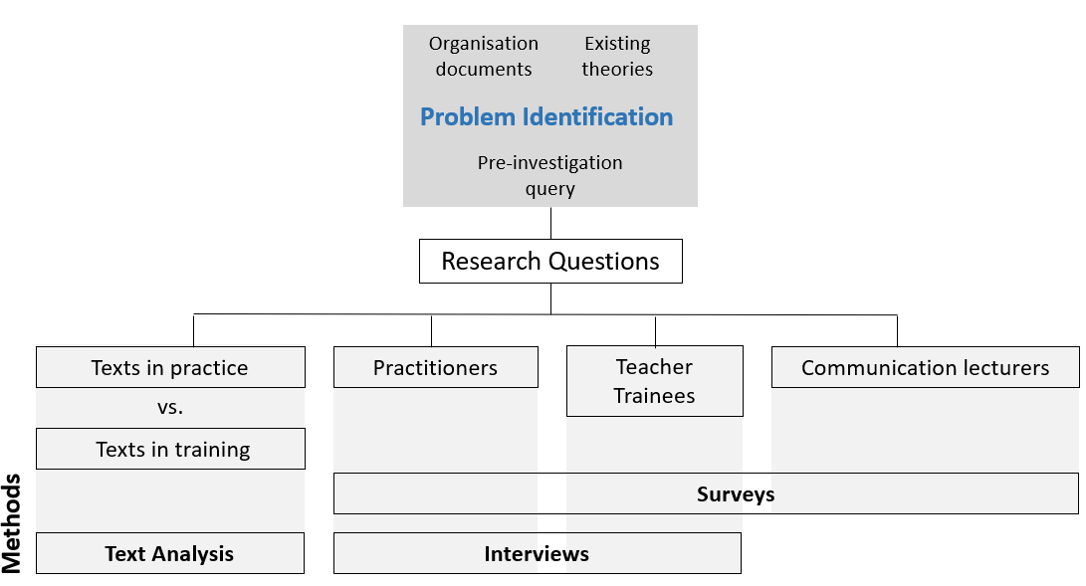
My investigation sought qualitative views and personal encounters in acquiring written communication skills within authentic workplace environments. Some questions surfaced during my pre-investigation query before the conceptualisation of research questions that directed my investigation activities and approaches:
Can communication skills be taught in the classroom?
What are the general communication skills?
These seemingly “raw” yet-to-be-defined questions led me to examine more deeply what has been found in literature and query the motivation and aim behind those fundamental communication subjects.
There were challenges during the literature review where I had more doubts than answers. Emerging topics from the initial investigations had to be further determined to locate answers, and the sub-categories of the topics were not entirely obvious. Initially, during my literature search, the terms “communication” and “skills” might not occur together. Even if they occur together, much literature was about interpersonal communication skills, such as the work of McKay et al. (2018), that deals with body language, influencing others and couple communication to improve relationships and personal effectiveness. The search process took a turn when I discovered multiple studies discussed in Chapter 2 that demonstrated the importance of context in the vocational learning of communication skills. To reiterate the studies described in Chapter 2 of this study, Stefani and Horlacher (2018), in their study of interactions between two different contexts of service providers, found differences in the understanding of “mundane talk”. Parkinson et al. (2018) found that the differences in communication between trades went beyond technical vocabulary and demonstrated the significant differences between the purposes and language used in recording information of carpentry trainees and apprentices. In the Asian context, Chan (2021) found gaps in knowledge and skills in communication and benefits in learning through participation in CoP that acknowledges learning to communicate as a social activity.
Similarly, Bremner (2012) highlighted the importance of socialisation and gaining “community membership” (p.12) between “newcomers and more experienced workers” (p.9) in learning work-related discourse in PR firms in Hong Kong, where the subject of the study showed changes in her journal writing from “outsider discourse” to “insider discourse” (p.19). Hence, I was curious if the idea of the context in learning to communicate is equally valid in teaching communication skills in my current situation. The studies listed above influenced the idea of starting with a sector or industry (i.e., Early Childhood Education) to support my view of situating communication skills learning within the context of authentic workplace discourse. Though focusing on a sector may not be ideal and will affect the applicability of my findings, I would regard my results to potentially justify the need to examine other sectors/industries in future research.
Questioning Assumptions in this Study
A researcher’s assumptions may seem like unknown obstacles in a research process, but I think they are equally crucial for any research to exist and proceed. For example, I assumed there was a better way to teach communication subjects. Hence, I began questioning the current state of matters, reading about the topics relating to my hypotheses, raising research questions and searching for answers. My assumptions pushed me to seek answers and desire change. Similarly, Leedy and Ormrod (2015) assert that “assumptions are so basic that, without them, the research problem itself could not exist” (p.62). They stated that an example of using pre-tests and post-tests to measure if one method of classroom instruction is superior to another. Proceeding with this way to measure assumes two things: The basic assumption that the “pre-tests and the post-tests measure knowledge of the subject matter in question” (p.62) and that the teacher in study teaches effectively, and the students are capable of learning the subject matter. Hence, without assumptions, any research project would be meaningless (Leedy & Ormrod, 2015).
Therefore, this section acknowledges my assumptions and positionality as a researcher that underlies my research effort. Not only do I acknowledge my assumptions, but it is equally vital in the research process to address them. I have two main assumptions, and I would like to address them. Though there are more than I acknowledge, but to keep my writing within the word count stipulated by the faculty, I will be focusing on two main assumptions that can potentially create biases in the analysis of my investigation. First, being a trained teacher, I am familiar with the writing of lesson plans. However, it would be essential to note that my beliefs about how a good lesson plan should be structured can interfere with analysing and understanding the genre and unknowingly create blind spots. The only way to ensure this does not happen is to remind myself to focus on the text itself rather than referring to my beliefs of how a successful lesson plan should be. The purpose of the analysis is not to judge the quality of the lesson plans but to look at the traits of authentic texts. Keeping strictly to this purpose is essential in ensuring my analysis is focused and accurate. Second, this research started from the primary assumption of possible problems existing within the context of this study, and this assumption can create biases in how I regard my methods and where I search for answers. Identifying problems is based on an assumption that “something else” is better — bearing in mind that, at the end of the day, my results might reveal “something else” wrong. In other words, my findings might support the teaching of general communication subjects and that learning situated within practice might not apply to learning communication subjects. It is crucial to acknowledge this assumption and accept the possibility that my findings might contradict my assumptions.

The Ontological and Epistemological of my Approach to this Study
This study has the view of an interpretivist who possesses the thought that human sciences are highly linked to "Verstehen (understanding)" (Max Weber 1864-1920, cited in Crotty, 1998, p.67). This research aims to "explore perspectives and shared meanings and to develop insights into situations" (Wellington, 2015. p.26). Therefore, my research inquiry looks into the perspectives of my participants in the context of learning to communicate in the early childhood education industry, aiming to discover their views that were "culturally derived and historically situated interpretations of the social life-world" (Crotty, 1998, p.67). This study also recognises that my researcher's values and beliefs will affect the observations of participants, and this "reality is a human construct" (Wellington, 2015. p.26). My research is not an end to understanding and does not assume its conclusions are "absolute certainty(ies)" (Wellington, 2015, p.27). Instead, the conclusions in this study serve as part of a continuous cycle to understand learning to communicate in the world in which we exist.
This study also assumes the learning philosophy of constructivism, which believes that humans construct their knowledge and that the experiences of the individual will determine that reality. I believe learning to communicate happens through social interactions and recognise Vygotsky's belief of the role of social environments in the process to "promote thinking, engagement with ideas and activities and serve to allow for intellectual growth, including the growth of knowledge and understanding" (Pritchard & Woollard, 2010, p.35).

Participants
There are three groups of participants in this study. The following paragraphs provide a background to the three groups of participants. Chapter 4 of this dissertation will describe more details about the participants.
Preschool Teacher Trainee
The first group are recent graduates with a Diploma in Early Childhood Studies. There is a total of 203 students who graduated in April 2021. This cohort has taken all three fundamental communication subjects during their studies. Before their graduation ceremony, two mass emails (Appendix A) were sent to all, seeking their participation in answering a questionnaire and for a group/single interview. The request to participate in interviews was sought via a final question in the questionnaire. A total of 50 graduates responded and participated in the questionnaire, and ten participated in the interview via Skype Web. At the point of data collection, the institution of my study was conducting graduation ceremonies for the 2021 cohort. Hence, prior to the mass email sent to all graduates, to ensure I get as many respondents as possible to participate in the questionnaire and interviews, I also requested participation via the WhatsApp group chats of students whom I taught before. They are also part of the graduating cohort I have access to via the personal messaging system on the professional social network platform, LinkedIn and one-to-one messaging on the WhatsApp chat platform. The final number of participants for the questionnaire and the interviews was coincidentally in whole numbers with no deliberate interventions to ensure that. Both communication channels were used solely to recruit participants and not for the research.
Preschool Practitioners
The other group of participants is practitioners currently working in the preschool industry. They include teachers, principals, teacher assistants, lecturers in vocational training programmes, regulations and development agency officers. Emails were sent to more than 30 preschools via the online ECDA data set available to the public, and none responded. The lack of responses led to a more personalised approach to seeking participation via the LinkedIn messaging system. I searched for LinkedIn members in the preschool field and sent a request to connect with a personalised message. Participation was also sought through the snowball sampling approach (Browne, 2005) through my contacts and referrals from colleagues and friends. A total of 43 responded and participated in the questionnaire, and ten responded to participate in an interview. Similarly, the final number of participants in the interviews for this group was coincidentally in whole numbers with no deliberate interventions to ensure that.
Communication Lecturers
The final group of participants is my colleagues from the department of my current employment. There were about 45 staff in the department at the point of investigation. This group of participants has a varied range of years of experience teaching communication skills. Messages to request participation were sent via the institutional persistent chat-based collaboration platform, Microsoft Teams. Views were sought only through a questionnaire from this group of participants. 26 responded and participated in the questionnaire. This questionnaire aimed to seek their views on the current fundamental communication subjects.
Process of Recruitment of Participants
I identified the list of preschools via ECDA’s webpage of existing centres in Singapore. The contact details of the preschools were searched online, and emails to request participation in this study were sent to about 150 centres with no responses. On reflection, the time of recruitment happened during phase 3 of covid-19 heightened alert measures where many preschools were preoccupied with ensuring centre practices were according to the health requirements set by the government, adapting lessons to the online mode and establishing close communication with caregivers that might have led to the lack of responses. Hence, I decided to identify potential participants via the professional social network platform LinkedIn. I searched participants of the platform who stated their professional backgrounds as “early childhood development”. I sent about 50 personal messages requesting their participation and obtained better results. My participants were also recruited via recommendations from colleagues, students and recruited participants. Communications were mainly via WhatsApp, and interviews were conducted using Skype web chat services. All interviewees participated in the questionnaires prior to the interviews.

Interviews
Semi-structured Interviews were conducted with two groups of participants I described earlier – Preschool practitioners and teacher trainees. This way of conducting interviews meant I created a set of “guide or checklist” questions but allow some “flexibility to decide the range and order of questions within a guide or framework” (Wellington, 2015, p. 141). Dearnley (2005) reflected on the use of semi-structured interviews in her doctoral study and described semi-structured interviews as one that “allows all participants to be asked the same questions within a flexible framework.” (p.22). According to Galletta and Cross (2013), semi-structured interviews require researchers to engage with participants in a way that allows them to respond to questions and know when not to interrupt. This method seeks to guide participants with open-ended questions, anticipate possible routes they may take in responding and ascertain the appropriateness of further queries. Galletta and Cross (2013) assert that it is vital to regard interviews as “unfolding” (p.76) participants’ narratives and to achieve reciprocity. Decisions made in interviews require researchers to be reflexive by revisiting decisions and reflecting on the consequences of decisions made during interviews (p.77). I found myself doing what Galletta and Cross (2013) described actively throughout the process of conducting interviews for my study. I conducted my interviews based on two orienting tasks recommended by Galletta and Cross (2013):
- Listen closely to the participant for points needing clarification and further generation of meaning.
- Locate and place on hold points in the interview to which you may return later for elaboration or invite the participant to reflect critically. (p.77)
These tasks guided all my interviews for this study, and I found them especially useful in keeping me focused on achieving my data collection aims.

Importance of Reciprocity in Interviews
I was especially drawn to Lather’s (1986) concept of reciprocity as a state where the researcher and the participant would “give and take, a mutual negotiation of meaning and power” (p.267). This concept is a crucial point to note, especially for some of the preschool teacher trainees for whom I was their fundamental communication subject tutor during their study at the institution of this research. The idea of negotiating power can be sensitive here and impede frank and honest responses and hence, the importance of directing the attention during the interview to the fact that they are trained preschool teachers. I am the researcher investigating their learning experiences, and I am no longer someone of authority who has an influence on their academic results and graduation status. Therefore, this negotiation of power should focus on mutual respect and expectations of honest responses. Doing so can be especially difficult in the standard Asian culturally accepted view of a teacher-student role that tends to continue even after the students stop being students. This view is also evident in a participant-researcher relationship where the power differentials are always present (Dodgson, 2019). Hence, Dodgson (2019) recommended using “participatory research methods, when conducted appropriately, minimise these power differences, as all who participate in the research are seen as equal partners in developing, creating, analysing, and disseminating research products” (p.221). An awareness of these differential power existing in an interview is essential when positioning my role and giving power to participants where appropriate are crucial in obtaining rich and authentic data in interviews. Interventions made to address issues relating to a possible lack of reciprocity will be explained in a subsequent section, Piloting of Interview Questions.

Interview Questions
A predetermined list of about 11 interview questions was created (see Appendix B). The main objective of the interviews was to seek their views on the learning and teaching of communication skills in the preschool setting and the reflection on their learning journey before becoming preschool practitioners. Hence, both groups have the same pool of questions, except for one (Appendix B, Question 11) that aims to understand preschool trainees’ learning experiences in the fundamental communication subjects examined in this study.

Figure 5
Extracts of the Interview Conversation Deviating from the Question Asked
Interviewer:  Trainee 1:  Interviewer:  Trainee 1: | So the modules that you have learnt? Did they help prepare you to do what your organisation wants you to do for these two documents?  I will say is different, like [Eliminated from script: Acronym of a module she has taken before in her training] did teach me on the evaluation of lesson plan. And like, you know, what are the questions that they usually ask? It's just that my organisation asked me, they asked me like, in a different way, you know. I feel like my organisation, they want to write like, in depth, like, okay, so for my evaluation, right, yes, this question. What, what can you do better for the next like, like, for the future? Like, what can we do better if you were to teach this lesson? So from what I first saw, when I see this question, I'll be like, Oh, if I were to conduct it in the future, what would I do differently? But for my organisation, what I heard from my teachers, is that Oh, for this question, right, how you answer it is that if you face a challenge in the lesson that you conducted, right, what did you do to like, sort of solve the issue? Or the problem, or the challenge that you faced?  So different? So the way they approach that question…  Yes! My organisation isn't asking me is what I will do in the future differently. But what they ask me is what I did to like, what was the challenges that I faced during lesson and what I did to like, solve the challenge? So it's different, you know?

As the nature of the interviews was semi-structured, some questions asked during each session were not scripted. For example, for question 7 (Appendix B), the conversation during one of the sessions started with describing if the bold terms (See Appendix B) highlighted in the example given were commonly indicated in authentic lesson plans in their employment. The extracted conversation attached below in Figure 5 showed a related topic from question 7. That question triggered the participant to share differences between what she was taught in her training and the expectations in the school of her employment upon graduation. The conversation moved slightly away from question 7, though still related to it. She started relating a noticeable difference in the understanding of evaluating a lesson plan between her and the preschool of her employment.
The flexible framework of semi-structured interviews allowed me to obtain rich data that I might not have achieved if I had adhered to a fixed set of questions. For example, the above conversation brought out some frustrations expressed by the participant about the differences between what she understood about the evaluation of lesson plans in school and the organisation of her employment. The participant's responses were valuable in my study as they revealed differences in the meanings of terms used in training and authentic working environments. It also showed the importance of context in learning to communicate in the workplace.
Piloting of Interview Questions
The question list was piloted separately to obtain feedback from each group to refine the questions. Conversations for the pilot were conducted via the chat platform WhatsApp, due to the Covid-19 pandemic restrictions, with two colleagues from the diploma in early childhood (under the role of "Practitioners"), one practitioner (Vice-Principal of a preschool) whom I connected through personal contacts, and 15 ex-students currently in the final year of the diploma programme (Preschool trainees). The questionnaire for communication lecturers was piloted with three communication lecturers to gather feedback. The preschool trainees' group raised issues such as the importance of managing fears of commenting on the communication subject programme of their training institution and that their responses will not have implication regarding chances for future employment. Three deliberate changes were made to the interview plan and questions to ensure all participants understood the interview's true intent:
- The question on their learning experiences for the fundamental communication subjects was shifted to the last on the list, hence not making it appear to be a top priority in the interview. The occurrence of this question at the start of the interview would reinforce the connection with the fundamental communication subjects they took during their course and possibly hinder honest responses.
- Interviews were conducted after their graduation ceremony in May 2021, which shifted their academic status from being a student of the institution to a graduate. This change was made to ensure that participants would approach the questionnaire without the burden of academic status with the institution of this study.
- During all interview sessions, participants were assured repeatedly that participation in this research has no impact on their studies or assessment within the institution or their graduate status and reminded to read the information sheet provided.
Feedback was also sought from three practitioners who influenced the review of my questions, such as question 10 (See Appendix B.-included in parenthesis) with the inclusion of the question - Were you taught communication skills while training as a preschool teacher? Participants in the pilot explained that separate communication skills modules were not commonly included in training programmes for most early childhood educators. Instead, they were often infused within other modules, usually not the main focus in programmes. In addition, I observed that many participants were generally very accommodating in wanting the best for my research and tended to "give me what I want" in their responses. Being aware of possible differential of power existing in the interviews, especially with the trainees' group, I made conscious attempts to encourage reciprocity with my participants. I assured my participants and highlighted the importance of their honest views about their communication learning experiences. I also found myself slipping into casual comments and small talk at various points of the interviews to ease their nerves. The interviews were carried out at separate timings, one-to-one or in groups of no more than 3, via Skype Web, with each session lasting between 40 minutes to one hour and 30 minutes. Interview responses were transcribed into a standard word processing package using an artificial intelligence-powered transcription software otter.ai. Transcriptions were not shown to participants for reading or checking unless requested. This option was verbally informed to all interview participants at the start of the interviews. No participants requested to read or check the transcriptions. During the transcription process, clarifications were made by sharing transcriptions with 1 participant to clarify the accuracy of the transcription resulting from the software's inability to capture non-standard pronunciation.

Questionnaire
According to De Vaus et al. (2014), questionnaires are characterised by an organised or deliberate arrangement of information and call a variable by "case data grid" (p.3). De Vaus et al. meant a collection of data of the same variables or characteristics from two or more cases that led to a data grid. Data collected from questionnaires are often systematic by nature and seem very neat and structured, ready to be analysed using statistical and quantitative techniques. However, such structured analysis is not self-explanatory as analysing questionnaires' responses for a research project depends on the "logic of analysis that distinguishes survey research" (De Vaus et al., 2014, p.7). De Vaus et al. (2014) assert that questionnaires conducted in a natural context usually do not conform to textbook models. Consistent with De Vaus et al. (2014), the questionnaires I conducted for my study are shaped according to my experience and personality and the "politics" (p.7) of my study and my participants. In the following section, I will explain the concept behind generating my questions and the guidelines I adhere to when creating my questionnaires.
There were three sets of questionnaires, of which each set was directed to three groups of participants: Communication Skills Lecturers, Preschool Practitioners and Preschool Teacher Trainees. All questionnaires were implemented via the free online survey administration software, Google Forms. Questions for my questionnaires were derived from my research question, where I was guided by the objective of my study and abstract concepts to the empirical world of specific and concrete data (Punch, 2003, p.33). I found Punch's (2003) description of the process of conceptualisation of questions helpful in guiding me to craft my questionnaires. Using Punch's example of a hierarchy of concepts, Table 3 shows an example of my thought process and concepts that describes how I derived the questions in my questionnaires. The questionnaires were crafted based on the following guidelines:
- All questionnaires contain a clear statement, research topic and questionnaire objectives with the information sheet attached.
- Consent was sought using compulsory Google Form questions, which meant failing to complete them would not allow participants to proceed with the questionnaire.
- The researcher's contact details were provided to allow participants to retract their responses by emailing their intent at any point of the study, which was indicated in the information sheet.
- All questions (other than those belonging to the providing consent to proceed with the survey) are optional, giving participants a choice not to respond.
- Open-ended questions aim to collect richer and more varied views from participants.
- The questionnaires should take at most 15 to 20 minutes to complete.
Invitations to participate in the survey were sent via various means, including email, messaging applications on the professional social network platform LinkedIn, the mobile chat platform WhatsApp, and the institutional persistent chat-based collaboration platform, Microsoft Teams.
Table 3
Hierarchy of Concepts (Adapted from Punch, 2003)
General | Research area | Efficacy of generalised communication skills
 | Research topic | To investigate if generalised written communication skills would prepare students for the workplace.
 | Objectives | Identify writing skills needed in the workplace.
 | General research question | What are the writing skills needed in the workplace? What are the authentic texts existing in the workplace?
 | Specific research questions | Are there differences between writing for an on-campus training vs. writing for actual workplace environments (i.e., preschool industry)?
Specific | Data collection questions | What type of written texts are/were you required to write in your job as a preschool practitioner? How frequently written in a typical working environment for a preschool teacher? Please RANK ALL of the following list of texts according to the most-frequently written in a typical working environment for a preschool teacher. 1 being the most frequently written and 6 being the least frequently written. Some texts can have similar rankings. Recalling how you learn to write texts (lesson plans, letters to parents, observation records of children...etc.) in your field of work. Please describe what you did to improve the way you write those texts. [Example: Learn from YouTube tutorials, learn from your mentor/colleagues, your training as a preschool teacher...etc]
Values of Rankings in Questions
The questionnaires used in this study contain ranking-type questions to seek participants' views on a "frequency-of-behaviour" (Punch, 2003, p.57). The options were coded using numbers, but those numbers are not scaled and do not indicate levels of degree or quantity. Instead, the extreme ends of each range of numbers indicated a category and the categories were explained to respondents. Figure 6 shows an example of a ranking question in this study. A pre-determined list of genres was identified using informal conversations with peers who are existing preschool practitioners. This decision was a deliberate move to ensure apparent distinctions and identification of commonly known genres in the field. I did contemplate using an open-ended question. However, based on separate conversations with existing preschool practitioners, I realised there is a certain level of consistency in the genres in Singapore preschools. Hence, I used a ranking question listing pre-determined genres instead to provide ease of responding. It was also a deliberate move to avoid putting a value on each number because sorting the genres according to the "most-frequently written" is clear enough to identify each genre's importance. In addition, putting a fixed value for each number might make it difficult for respondents with answers that might fall between values because the perception of "frequently written" can mean various degrees for different preschools and participants.
Figure 6
Example of a Ranking Question
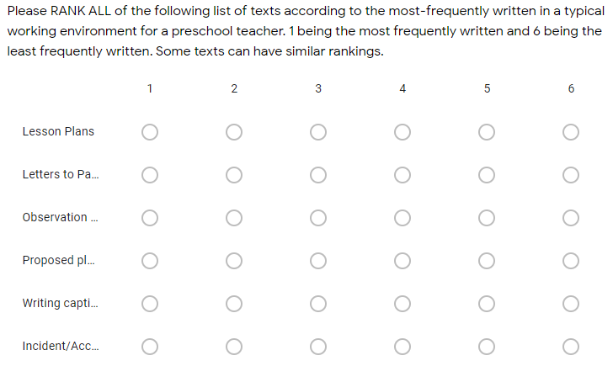
The questionnaires were piloted via the chat platform WhatsApp with personal contacts from all three groups of participants and were made available for responses for two months. Not all questionnaire participants proceeded to participate in the interview for this study. The invitation to an interview was the last question of each questionnaire for preschool practitioners and teacher trainees only because the broader aim of the interviews was to obtain an in-depth account of their learning experiences in written communication in the preschool professional environment.

Iterative categorization
Qualitative data analysis seems to have a reputation for lacking in standardisation and being a "highly personal activity" that relies mainly on intuition, "creativity", and "inspiration" (Neale, 2016, p.1097). Neale highlighted the features of qualitative research as one that is "highly dependent on the "research aim(s), nature and amount of data collected, time and resources available, and analytical skills, epistemological position and interests and the researcher" (p.1097). Neale (2016) explained that there are no rigid rules and specific separation between data collection and analysis, and consistent with Morgan and Nica (2020), initial intuitions and preliminary interpretations might be utilised to guide, modify, or amend further data collection. This analysis method led me to search for a more structured and transparent way to sort and analyse data, aiming to increase legitimacy and rigour in analysing my findings. That was how I discovered iterative categorisation (IC). The following paragraph will provide some background on the IC and the process.
IC is a systematic and transparent technique for analysing qualitative data and originated from a study of non-fatal overdose by Joanne Neale in 2016. Neale (2016) recommends starting with deductive codes and that inductive codes can derive from topics that surfaced in the data. IC cautions against elaborate and unstructured coding trees and favours simple coding frames. The data sets can be coded using qualitative computer packages, which help create matrices that help reduce data and display. The researcher has to move up and down the matrices when writing findings, and IC helps bridge the gap, hence "demystifying the 'black box' of analysis without requiring the matrix function" (Neale, 2016, p. 1100). Generally, IC has "its roots in pragmatism", and researchers are encouraged to "select, adapt or develop aspects of the process according to what works best to improve understanding within any given study" (Neale, 2016, p.1098). However, IC assumes the following: (i) the study for which the data being analysed has clear aims and objectives (Or an appropriate research question), and (ii) any interview or observation guides used for data generation were informed by both aims/objectives and the relevant literature.
In the following paragraphs, I will explain how Neales's IC was applied in my analytical process, using my survey responses as examples. In this study, IC was used for both the transcriptions of all interviews and open-ended responses to the questionnaires.
Preparing for analysis: The raw data, not summarised, was exported from the online artificial intelligence-powered transcription software otter.ai into a standard word processing package, Microsoft Word. Data from each exported code was labelled and saved as individual coding files. Neale (2016) highlighted that the data would have already been sorted in broad codes, but the length of the coding files would reflect the fact that data still possess valuable contextual material. It would be ideal to create an electronic coding file for every study code, to be analysed sequentially.
Figure 7
Sorting of Coded File (Right) Data to Analysis File (Left)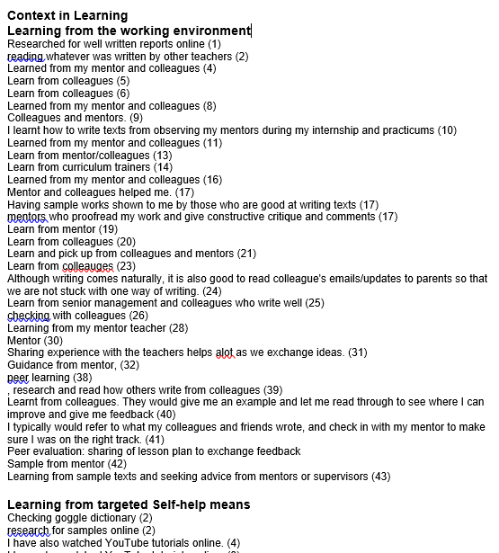(Left)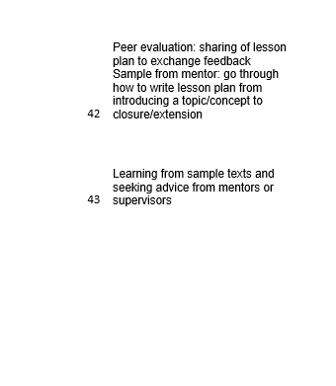 (Right)
Descriptive analyses: The exported coding file was duplicated, with the duplicate file renamed as an analysis file. Taking an example from my study, when analysing the Importance of Context in Learning, responses for the open-ended survey question were extracted and coded under the broad code "Importance of context". I used the coded file for reference and created a duplicated file named "Importance of context analysis". Each coded file will be read from top to bottom, spontaneously noting topics and themes and identifying connections within the data. I did an initial line-by-line analysis, summarised the data according to the themes in the analysis file and deleted the data once they have been sorted. For my study, I initially sorted the manually coded file (Code: Context in learning) on my right into further themes (Figure 7) on the left of my monitor. I did not summarise at this stage because the survey responses were straightforward and short. The numbers in the brackets in Figure 7 were pre-labelled numbers assigned to each response. Numbering responses allowed me to track the source of the data. Once the data has been sorted, the coded file would look quite empty, after which I repeated the process by summarising the data in the analysis file and constructed new headings (Figure 8).
Figure 8
Further Sorting of Data
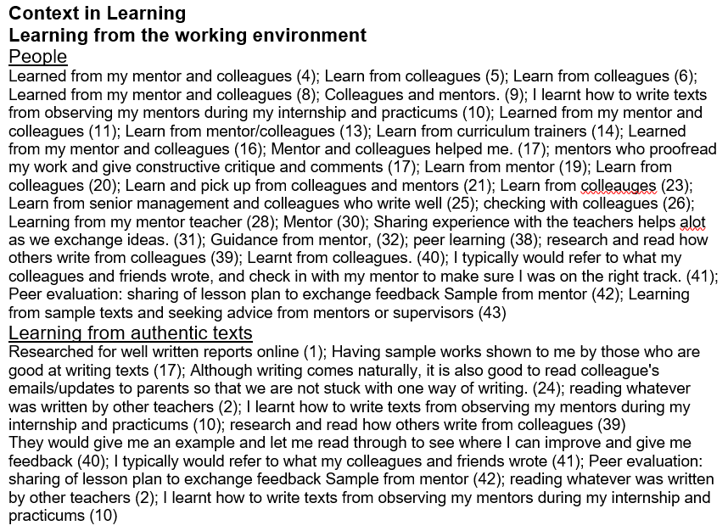
Interpretive analyses
This step of analysis seeks to uncover patterns, connections, ideas, and explanations in the data and determine if the findings support or contradict previously published literature, theories, policies, or practices (Neale, 2016, p.1103). This stage of the analysis does not assume to cover all aspects and disciplines implied by the data because, naturally, the researcher would interpret the data based on his/her training and area of interest. Citing an example from Neale (2016), a sociologist would explore findings relating to 'social' rather than 'psychological' theory (p. 1103). However, it is crucial to ensure that analysis should move beyond being descriptive of the data so that findings are transferable to other contexts.
Neale (2016, p.1103) suggested reading and re-reading the analysis file and considering the following:
- Which points or issues or themes recur within (and potentially across) the analyses ﬁles;
- whether and, if so, how these points or issues or themes can be categorised into higher order concepts, constructs or typologies beyond those already identiﬁed in the earlier descriptive stage, and
- the extent to which points or issues or themes apply to pre-identiﬁed subsets of the data/study participants.
The researcher should test other speculative hunches and theories. This stage is when the researcher synthesises and makes sense of what was sorted and labelled and back-checks the characteristics of the participants that made the point in question, using the source document at the coding stage. All findings and interpretations should be reported and written in a way that maps back to the codes, aims and objectives and research question(s) of a project with a "clear forward and backwards trajectory from the study starting point to its conclusion" (p.1104).
A Final note on IC
I chose the described adapted IC approach in my data analysis for two main reasons. First, this approach allows me to document an audit trail of how I arrived at my findings and provides a clear route back to the raw data that could confirm/disconfirm my evidence. Second, it forces a researcher to leave no data behind with a systematic approach to reducing data that allows a complete reflection of the responses from the raw data. Though Neale’s IC was performed using the MS Word application, I found that to be challenging to track the source of specific findings and decided to use the Excel application instead. The Excel application has a sorting function that allows me to determine where I got the source, making it much easier to track. As explained earlier, I applied this method in both the analysis of the transcripts of my interviews and the open-ended questions of all questionnaires, which will be reported in Chapter 4: Results section. The following sections of this chapter will explain how I analysed lesson plans (LP) collected from practitioners and trainees.

Discourse analysis
Approaches to Discourse Analysis
The meaning of discourse relating to discourse analysis differs amongst scholars in different fields given the accelerated evolvement of discourse analysis in which models for understanding and methods for analysing extended beyond the world of linguistics, such as to social psychology and artificial intelligence (Schiffrin et al., 2003). Though definitions are plenty from different sources, Schiffrin et al. (2003) grouped these definitions into three main categories:
- Anything beyond the sentence
- Language use
- A broader range of social practice includes non-linguistic and nonspecific instances of language. (p.1)
The study of (2) focuses on traditional linguistic constructs – phrase and clause structures and addresses problems relating to the structural variant with similar meanings in languages. Studying linguistic structures beyond the sentence (indicated in point 1) directs attention to the larger object of study, examining how texts are constructed and organised systematically. For (3), the discourse in this aspect focuses on specific communicative events and general characteristics of discourse communities, relating issues such as power and gender. Definition (3) is more aligned with Foucault's conception of Discourse (Hall, 1992), where language has implications on social practices and values. As explained in Chapter 2, this study recognises the importance of how discourse can define and limit social values and practices, particularly in how Singapore society views the professionalism of preschool teachers. However, this study will focus on (1) and (2) identifying linguistic features of texts and discourse of one specific genre, lesson plans, within the discourse community of early childhood educators. It aims to investigate the practices of a specific genre, particularly to describe it with the hopes of informing curriculum and teaching approaches. The aims of this study do not address the “power” and “gender” as described in Foucault’s conception of Discourse. Hence, I will analyse both lesson plans of in-training teachers and practitioners in real workplace contexts. After this, the analysis results for both groups will be compared. It would be ideal to examine the communicative events within authentic environments in person, but as explained earlier in Chapter 1, since there were restrictions to in-person meetings during the analysis and data collection period due to the Covid-19 pandemic that prevented me from performing observations on site.
Move Analysis
The move analysis falls under the broad category of a genre-based analysis and has reference to Swales' genre theory (Swales, 1990). The original intent of developing this text analytical scheme was to aid advanced second-language students in improving academic reading and writing of research articles in English (Swales, 1990; Moreno & Swales, 2018). This method of analysing texts was then applied by many, not only in academic texts but also professional and general genres. Moreno and Swales (2018) explained that the main aim of the move analysis was to identify linguistic features that characterise the various rhetorical moves. As discussed in Chapter 2 under the section Genre in Linguistics, the term "genre" often coincides with "speech events" (p.30) and in the analysis of this study, a speech event is a communication event of a single lesson sitting. From the Systemic Functional Linguistics perspective, language is a context-dependent, meaning-making resource (Martin, 2009), and genre is defined as "a staged, goal-oriented, purposeful activity in which speakers engage as members of our culture" (Martin, 1984, p. 25). Also discussed in Chapter 2, Workplace Discourse, moves are rhetorical segments of an article that describes the communicative functions that make up the overall communicative objective of an article (Swales, 1990). Each communication event contains "moves", and Biber et al. (2007) posit that "each move has a local purpose, but also contributes to the overall rhetorical purpose of the text" (p.32). Moreno and Swales (2018) further explained five points to describe a move.
- A rhetorical construct, the linguistic realisation of which could be as short as a clause and as long as a paragraph (and/or sometimes repeated in cycles).
- How a move functions will depend on "one or more specific functions, or steps".
- Though the move boundaries (i.e., text items indicating the start of a move and transition from one move to another) can be challenging to identify, strategies such as a "bottom-up search for lexical or syntactic signals and a top-down close reading of the text for topic breaks of shifts in content" could overcome this.
- Morena and Swales (2018) indicated the importance of the role of "specialist disciplinary experts" who have "stronger intuitions regarding the typical rhetorical structure and language use" in the genre.
- Lastly, they posit a place for "additional analysts (or raters)" who could support the findings of the primary investigator. (p.41)
In this study, besides analysing exemplary and authentic texts in the preschool professional environment, each pre-determined move was identified by examining current preschool lesson plans and consultations with practitioners who are what Moreno and Swales (2018) referred to as the "specialist disciplinary expert” (p.41). Practitioners' perspectives are crucial in confirming structures and rhetorical moves of a genre, as discourse communities are influential in determining conventions in a genre because:
"…the purposes of the genre are recognised by the expert members of the discourse community, less so by the novice members, and probably not by the non-members. These purposes shape the rationale, and the rationale helps develop the constraining conventions." (Biber et al., 2007, p.36)
This aspect also confirms the importance of context in learning to communicate. Learning should be situated in practice, and learners should engage with members of discourse communities to be members of those communities.
Corpus Collection
Based on the survey findings of this study, the writing of lesson plans was a key written text produced in the early childhood sector. The corpus collection of this study consists of lesson plans collected from two groups of participants: Lesson plans in practicum assignments of final year diploma students that were graded A (=/>80%) and lesson plans of practitioners in preschools. The final year diploma students' lesson plans described lessons they carried out during their practicum. Diploma programmes in the institution of this study aim to offer industry-relevant training, ensuring students are vocationally ready for the workplace. Therefore, selecting lesson plans graded as part of the internship programme would reflect what the training programme deems as 'industry-ready' lesson plans. Hence this would establish a clear comparison between authentic texts in the workplace and exemplary lesson plans of trainees written in training, which are considered industry-ready. Similar to the aims of Parkinson et al. (2018), where the researchers compared essential writings of carpentry trainees and apprentices, this study compares lesson plans from both groups to locate possible gaps between authentic texts and texts written in training. These gaps signify probable interventions required to help bridge the gap between curriculum training and practice.
During the collection of preschool lesson plans for this study, the question of what makes a complete corpus came to mind. Sinclair (1991) defines a corpus as "a collection of naturally occurring language text, chosen to characterise a state or variety of a language" (p.171). Crystal (2008) defines a corpus as a "collection of linguistic data, either written texts or a transcription of recorded speech, which can be used as a starting point of linguistic description or as a means of verifying hypotheses about a language (corpus linguistics)" (p.117). McEnery et al. (2006) define a corpus as "a collection of (1) machine-readable (2) authentic texts (including transcription of spoken data) which are (3) sampled to be (4) representative of a particular language or language variety" (p.5). Based on these definitions, I regarded a corpus as a plan of a completed communication event (i.e., a single-sitting lesson of 30-45 minutes). The top 20 of the practicum assessment, with final grades ranging from 83.1% to 88.3%, were selected from the cohort to represent exemplary lesson plans written by teacher trainees. For this assessment, each trainee has written plans for ten separate lessons, of which one lesson plan was randomly picked for my analysis. I collected 20 lesson plans written by practitioners from a mix of anchor-operated, partner-operated, private preschools and a freelance preschool physical educator.
The challenge at the point of the collection was access to authentic lesson plans, commonly regarded as restricted documents for teaching staff working in preschools. More access to authentic lesson plans would have helped gain a more extensive collection. Hence, I decided to keep to a small corpus of 20 individual corpora of completed lessons from both groups for my analysis. The set of 20 authentic lesson plans was the personal collection of practitioners from my contacts. The criteria I set in what should be accepted as "authentic" would be lesson plans those preschool practitioners and teacher trainees have used in a classroom. These lesson plans from preschool practitioners were individually and personally volunteered to be part of my analysis. All participants were fully aware of how I would handle those lesson plans. The number "20" was decided based on the status of available lesson plans collected from practitioners and hence that impacted the cut-off point of the top 20 teacher trainees' pool. Though the small corpus would affect the applicability of the findings, the results of my analysis serve as preliminary research that can indicate possible future research for larger corpora.
The concordance freeware, AntConc (4.0.11) was used to generate the word and keyword frequency, cluster and lexical bundles, and move analysis was performed using the Biber Connor Upton approach (Biber et al., 2007), which will be described in the following sections.
Bridging the Function-Form Gap
According to Moreno and Swales (2018), the move analysis is typically done manually on small corpora. Some consider it a shortcoming because more detailed quantitative studies are needed. In addition, the lack of annotation at the step level made available to external researchers adds to the shortcomings of move analysis. However, a couple of corpus-based studies have tried to bridge this "function-form gap" (p.42) by introducing indirect methods such as examining the functions of frequently occurring lexical bundles and word clusters using computer software or performing multi-dimensional analysis. Nevertheless, the main drawback of these approaches failed to "distinguish between the most salient linguistic terms, or patterns, helping readers to interpret a given step and those that simply occur in that function." (Morena & Swales, 2018, p.42).
Furthermore, more than counting selected words and the frequency of lexical bundles are required to understand the moves of a text because some words not selected in the count might signify the same logical function. Hence, the manual analysis, though arduous it may seem, of sorting and identifying categories and patterns is needed to supplement the analysis of authentic texts. The following section describes the approach this study adopted in analysing moves in the corpora of preschool lesson plans.
Biber Connor Upton (BCU) Approach
In search of methods to do a move analysis, I found many published analyses provided the concluded moves in various genres. However, concerning the methods, they were often vague in descriptions. Upton and Cohen (2009) observed this too. They drew themes from the seven-step corpus-based approach to discourse analysis by Biber et al. (2007). They described the process as doing a move analysis and called it the Biber Connor Upton Approach (BCU). They describe the steps through the analysis of the birthmothers' letters. The summary of the steps is described in Table 4. In the following paragraphs, I will describe how I apply BCU to the analysis of preschool practitioners' and teacher trainees' lesson plans.

Table 4
BCU Approach – top-down corpus-based analyses of discourse organisation (Adapted from Upton & Cohen, 2009, p.589)
Required step in the analysis |  | Realisation in this approach
1.  2.  3.  4.  5.  6.  7. | Communicative / functional categories  Segmentation  Classification  Linguistic analysis of each unit  Linguistic description of discourse categories  Text structure  Discourse organisational tendencies | Develop the analytical framework: determine set of possible functional types of discourse units, that is, the major communicative functions that discourse units can serve in corpus  Segment each text into discourse units (applying the analytical framework from Step 1)  Identify the functional type of each discourse unit in each text of the corpus (applying the analytical framework from Step 1)  Analyse the lexical/grammatical characteristics of each discourse unit in each text of the corpus  Describe the typical linguistic characteristics of each functional category, based on analysis of all discourse units of a particular functional type in the corpus  Analyse complete texts as sequences of discourse units shifting among the different functional types  Describe the general patterns of discourse organisation across all texts in the corpus

Step 1: Communicative / Functional Strategies - This step states to identify the analytical framework for analysis by determining the communicative and functional categories via a two-part process.
1a) Determine Rhetorical Purpose of the genre
1b) Determine Rhetorical Function of each text segment in its local context
This stage of analysis aims to identify a "stretch of discourse of a particular type – that is, that serves a particular communicative function" (Upton & Cohen, 2009, p.589). Applying this step to preschool practitioners' lesson plans (LP), I had the initial idea of the overall rhetorical purpose to provide instructions for a relief teacher to follow if the teacher-in-charge is away on leave of absence. However, based on responses in the interviews conducted in this study, other reasons cited during interview sessions for writing LPs in the field are for appraisal and supervision purposes. Hence, it was decided that the overall rhetorical purpose of the genre is to describe how a teacher conducts a lesson for documentation, appraisal and reference for relief/replacement teachers. In order to identify specific move types, I had to read all 20 lesson plans and identify the distinction between what makes a unique move type. I identified three broad segments within the document – Top, middle and bottom with the rhetorical function of each segment explained in Table 5.

Table 5
3 Move Types of a Preschool Lesson Plan
Move Type 1: Introducing the information about the lesson
This move type serves the function of informing the reader of details of the lesson's target audience and the lesson plan itself. The information allows the reader to rationalise the purpose and reasons behind the activities conducted in the lesson.
Move Type 2: Describing the procedure of the lesson
This move type describes the procedure and details of the teaching activities carried out in the lesson. It reveals the how, what and why of activities conducted in the lesson.

Move Type 3: Evaluating the outcomes of the lesson
This move type provides an observational reflection and evaluation of the outcomes of the lesson, generally for the teacher’s professional development. The documentation of this segment aims to provide a replacement teacher with a reference for follow-up lessons and/or the supervisor for mentoring and appraisal purposes.

The move types in Table 5 reflect how lesson plans are "typically realised" (Upton & Cohen, 2009, p.594). I had to read all 20 lesson plans and reflected on them multiple times to determine the move types. During this process, "common functional and/or semantic themes represented by the various text segments", especially those that are "in relative proximity to each other or often occur in approximately the same location", can belong in the same segment (p.591). During this process of my analysis, the difficulty lies not in identifying the move types but in determining the overall function of the genre. Nevertheless, the move types were easy to identify because lesson plan descriptions were logically and commonly sequenced.
Steps 2 & 3: Segmentation and Classification - This step aims to determine the moves of texts by move types via the following steps:
- Segment the full set of texts into moves
- Classify each move-by-move type
According to Upton and Cohen (2009), before segmenting texts in a corpus into moves and classifying them into move types (i.e., steps 2 and 3 of the BCU Approach), a pilot coding is required, ideally by two coders for an inter-rater reliability check. By pilot coding, the coder would be "seeking to understand the functional-semantic purposes of text segments" (p.594). Therefore, I performed a pilot coding on all texts and sought lecturers of the early childhood diploma in the organisation of my employment for verification and confirmation of my coding. For the pilot, I collected and sorted the moves identified into the move types, and the items classified to belong to each type were indicated as steps in Table 6.

Table 6
Moves of a Preschool Lesson Plan
Move Type 1: Introducing the information about the lesson
State semester/term of the year of instruction
State level of instruction
State duration of lesson
State the topic/theme
State date of instruction
Describe the learning area(s) to be accomplished in the lesson
Move Type 2: Describing the procedure of the lesson
Describe the objectives of the lesson
Describe the learning disposition/areas for children
Describe the materials/tools/applications required for the lesson
Describe the procedures and activities
Describe how to close a lesson.
Describe the follow-up activities for the lesson
Move Type 3: Evaluating the outcomes of the lesson
Describe the personal evaluation of the lesson's design, instructional practices and theoretical structure.
Describe the outcomes of the lesson by recounting children's responses and actions during the lesson.
The supervisor responds to the reflections of the teacher who carried out the lesson.

Upton and Cohen (2009) claim that some move structures could be quite complex, especially genres that are "dynamic and persuasion-oriented" that may contain "obligatory, typical and optional move elements" and that moves may not be occurring in a fixed manner (p.594). The challenge I had when analysing the lesson plans was the difficulty in determining the segments occurring in Move Type 3 because some lesson plans do not contain the "evaluation" segment that should typically occur in Move Type 3, as indicated in Table 6. Though the evaluation segment occurred in most of my corpora, there was a corpus that did not follow the assumed conventions and was written in a separate document. Furthermore, the motive behind evaluating a lesson varies from preschool, which adds to the challenge of deciding that segment. Another challenge was the order of the steps within each Move type. At this stage of my analysis, I can only conclude broad positions of the moves (i.e., Top, Middle and Bottom). The detailed moves in Table 6 were generally the typical order to realise each Move type. At this stage, I had to decide whether a move within each Move type should be included at all, but the order of the moves will be decided in steps 6 and 7 of the BCU Approach.
Steps 4 & 5: Linguistic Analysis of each Unit and Linguistic Description of Discourse Categories - The aim of the BCU Approach is not only to segment texts into "well-defined discourse units" but also to describe the linguistic characteristics of each discourse unit (Upton & Cohen, 2009, p.596). Though move types were defined in functional terms, they are also realised through "linguistic features, including word choice, phrase types and grammatical features (e.g., tense, aspect, voice)" (p.596).
The fourth and fifth steps of the BCU Approach are completed through two strategies:
- Conduct linguistic analysis of move features
- Describe move types in terms of the linguistic features of the moves. (p.596)

Steps 6 & 7: Text Structure and Discourse Organisational Tendencies - Once each move's relative location and type was identified, specific observations of how moves were used within the genre can be made (Upton & Cohen, 2009, p.598). Observations on how frequently different moves tend to occur in the corpus and "typical position" in the lesson plans "in relationship to each other and their mean length in terms of words" were observed (p.598). The two strategies to accomplish these two steps are:
- Analyse the move structure of each text in terms of move types.
- Describe the corpus of texts in terms of typical and alternate move structures.
I performed steps 6 and 7 of the analysis of the lesson plans collected. From my analysis, I will summarise the total and average counts of move types and steps occurring within the corpus. Doing so will reveal steps that are considered relatively optional when compared with another. Conversely, moves that occur more frequently within the corpus were regarded as more necessary than others. The results of all steps in my analysis will be reported in Chapter 4 of this dissertation.

Ethical Considerations
Considerations of Participants’ and Organisation’s Perspectives
Those fundamental subjects to be examined in my study possess a political and economic motivation in response to the national initiative, SkillsFuture (Chong, 2015) and Industry 4.0 (Temasek, 2017). The launch was directives from the country's Ministry of Education, and the conceptualisation process has direct inputs from the Principal and CEO of the institution. Due to the strong link to national objectives, I had to obtain interim approval from my department before submitting my research proposal. Hence, I have sought interim approval from my school's director and department head to embark on this research. At that stage of my study, I was granted in-principle approval for the following:
- Access course documents related to the subjects (excluding meeting notes, emails, approval papers – official documents on a need-to-know basis);
- Access slides that were shared with Schools on the subjects;
- An approval to interview colleagues in my department and students of the subject, using all ethically cleared structured and semi-structured interviews with Sheffield University.
- Providing each participant with an information sheet and a consent form approved by Sheffield University (A screen print of the approval letter, consent form and information sheet are attached as Appendix C.)
Various sub-groups within my department officially own the fundamental communication subjects. My investigation may be perceived as disapproving and critiquing the institutional aims and lecturers' teaching methods and materials. Many of the staff working on those subjects are senior lecturers with more than ten years in the institution. Based on my experiences, I anticipated that some would experience discomfort in allowing someone outside the team to examine their work. Efforts were made to ensure that willing participants were aware of the motivations behind my study – to confirm the relevance of the conceptualisation of those subjects and not their teaching methods and practices. Invitations for participation were sent via the organisation's subscribed persistent chat-based collaboration platform, Microsoft Teams, via a simple message explaining the aims and objectives of my study with attached information sheets and consent forms. Only one communication lecturer objected to participating in the study, citing discomfort in commenting on an ongoing programme. Likewise, similar ethical considerations were made for the other groups of participants - recent graduates and practitioners in the field of early childhood education, for all survey invitations and additionally by ensuring their identities were kept anonymous during interviews.
Questioning my Position as an Insider-Researcher
The researcher who examines his or her organisation is termed an "insider-researcher" and could offer a "unique perspective because of their knowledge of the culture, history and people involved" (Smyth & Holian, 1999, cited in Dearnley, 2005, p.20). Despite that, Dearnley (2005) and many researchers also recognise an insider-researcher's potential biases and a loss of objectivity. Recognising my role as a staff member in the department where I was still actively fulfilling teaching and assessing roles for the fundamental communication subjects examined in this study, I must reflect on the ethical implications of conducting research in this position. Dearnley (2005) emphasised the importance of the insider-researcher being reflexive. Berger (2015) describes the common definition of "reflexivity" of researchers as a process of continuous internal dialogue and critical self-assessment of the researcher's position and the active recognition and explicit acknowledgement of how this position can influence the research process and outcome.
Researchers need to increasingly focus on self-knowledge and sensitivity; better understand the role of the self in the creation of knowledge; carefully self-monitor the impact of their biases, beliefs, and personal experiences on their research; and maintain the balance between the personal and the universal. (p.220)
With this in mind, I had to be committed to transparency of the research process, holding on to the value of being open and ensuring I give a voice to the participants in my study. In addition to this transparency, I also tried to take notes of immediate observations of the survey's findings, interviews, and conversations relating to the study in a physical notebook to help me document my observations truthfully and accurately rather than letting my interpretations and values cloud my observations. Writing in a hardcopy notebook is a faster and more efficient method to keep records clear and separate from digital documents, as the study contains many data sets, from texts to interview recordings to questionnaire responses. In addition, doing so made me pay more attention to what had been said and observations of participants' reactions on a topic, and it served to remind me of my role as a researcher in this study, not staff of the department.

Use of Free Telecommunication Applications for Interviews
The data collection of this study happened about a year after the first human cases of the coronavirus disease in 2019. During this period, the nation underwent a heightened alert phase of restrictions on social interactions in public places and home visits. The nationwide restrictions led to the exploration of using a free telecommunication application for conducting interviews. After exploring several applications, I decided to use Skype because it allows video calls without registration and recordings are saved for 30 days. Furthermore, participants were encouraged to switch off their video streaming, which serves to anonymise participants' identities. The application also allows participants to create nicknames hence safeguarding further their identities. Finally, all data sets reported in this dissertation will be pseudonymised to prevent the identification of any individuals.
These methods and approaches were used in collecting and analysing the data for this study, which will be reported in the following chapter.

Chapter 4: Results
As explained in Chapter 3 Methodology, there were three groups of participants in this study – Preschool Practitioners, Preschool Teacher Trainees, and Communication Lecturers. This chapter will report the results starting with the first two groups of participants – Preschool Practitioners and Preschool Teacher Trainees. I will provide a brief background about these two groups of participants and then describe the findings from the questionnaires and interviews. After that, the results of the questionnaire for the final group of participants - Communication Lecturers - will be reported. The report's structure for all groups will focus on themes identified from the study. Finally, the chapter will report results from the move counts, analysis performed, and a brief lexico-grammatical description of the corpus of lesson plans (LP) collected from both preschool practitioners and teacher trainees. I noted in Chapter 3, Methodology, the definition of what makes a move, and how I applied the Biber Connor Upton (BCU) Approach in my analysis of the most frequently written text, the preschool lesson plan (LP). I analysed two sets of data – lesson plans from teacher trainees who wrote and used them in lessons conducted during their internship period and lesson plans written by preschool practitioners. As described in that chapter, a move has a local purpose that contributes to the overall meaning of a text. Therefore, counting the frequency of occurrence of each move in a corpus can indicate their significance in the rhetorical purpose of the genre examined. After reporting the findings of this study, Chapter 5 offers a discussion and analysis of these results in light of relevant research literature.

Brief Background of Preschool Practitioners
The questionnaire and the interviews aimed to investigate practitioners' communication experiences in authentic settings and understand how they acquire relevant communication skills required to be effective in the early childhood industry.
Questionnaires
Out of those who responded to the questionnaire (n=43), there were 17 preschool teachers, 11 lecturers of preschool training programmes, seven senior teachers, three vice-principals, and one principal. The remaining four questionnaire participants (9.3%) indicated "Other roles not listed here" and included:
- an enrichment teacher
- ECDA officer (Early Childhood Development Agency. A regulatory and development agency for the early childhood sector in Singapore),
- a practicum student with a university, and
- a lead teacher.
More than half of the respondents (51.2%) have over ten years of preschool teaching experience, while the rest have ten or less experience in the field. Most respondents work for private kindergartens (66.7%), and 18.2% work in anchor-operated kindergartens.
Figure 9
Profile of Preschool Practitioners who Participated in the Questionnaire (n=43)
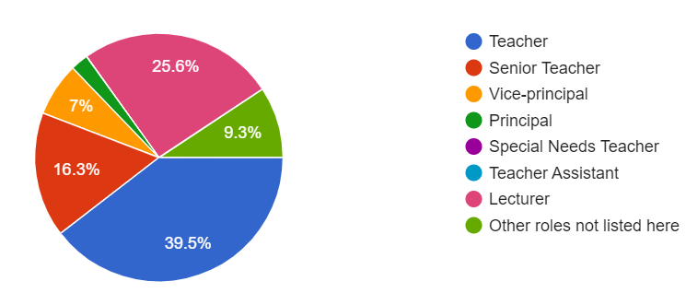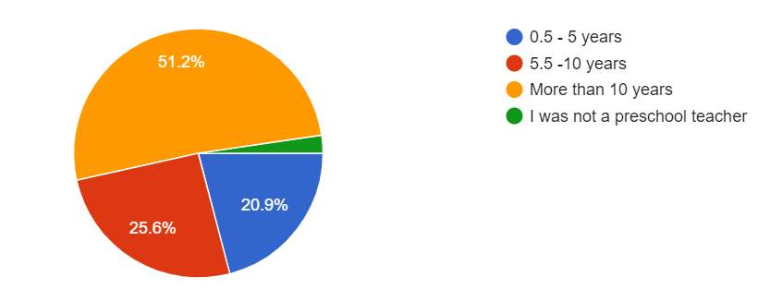

Figure 9 presents a summary of the preschool practitioners' profiles. The local preschools' governing body, ECDA, differentiates preschools in terms of whether it is licensed by the ECDA or registered with the ECDA for Private Education (CPE). According to one preschool practitioner participant (Jenny), there is a further differentiation of ECDA-licensed centres (Anchor-operated and Partner-operated) in terms of funding, approval, and curriculum (Early Childhood Development Agency, 2021-a). Based on responses from the interviews, I have come to understand that private kindergartens have more autonomy in decisions for curriculum and pedagogical approaches adopted by the centre (Early Childhood Development Agency, 2021-b).

Interviews
Table 7
Profile and Pseudonyms of Preschool Practitioners who participated in the Interviews (n=10)
Pseudonym (code) | Profession | Years in the Industry
Danielle (DA1) | Teacher Partner (Private School) | 8
Fanny (FA2) | Senior teacher (Anchor-Operated) | 9
Felicia (FE3) | Teacher Trainer | 15
Jenny (JE4) | Vice-Principal (Anchor-Operated) | 7
Kim (KI5) | Teacher Trainer | 33
Kylie (KY6) | Teacher Trainer | 15
Maggie (MA7) | Teacher Trainer | 18
Penny (PE8) | Senior Teacher | 13
Sherry (SH9) | Teacher | 5
Tom (TO10) | Sport Enrichment Preschool Teacher | 7

From the total number of preschool practitioners who responded to the questionnaire (n=43), ten volunteered to participate in the interview for this study. As described earlier in Chapter 3, participants were recruited from personal contacts, referrals from colleagues and friends, and via the LinkedIn messaging system. Therefore, the final number of participants who agreed and attended the interview was coincidentally a whole number with no deliberate interventions to ensure that. At the point of the interview process, the ten interviewees consisted of the following:
- a preschool teacher who is also an undergraduate in an early childhood degree programme,
- a vice-principal,
- two senior teachers,
- four teacher trainers,
- a sports enrichment preschool teacher, and
- a teacher assistant in a private school.
The years of experience in this group of interview participants range between 5 to 33 years. Table 7 summarises the pseudonyms (with codes), professions, and years of experience of the preschool practitioner participants' interview group. For conciseness, the assigned codes, which serve as abbreviations for the pseudonyms, were used for references of three or more participants in the report.

Brief Background of Preschool Teacher Trainees
Questionnaires
Table 8
Grades attained for Fundamental Communication Subjects (Preschool Teacher Trainees)
Subject/Grade | A | B+ | B | C+ | C | D+ | D | Single Attempt | Two Attempts
Communication and information literacy | 2  (4%) | 12 (24%) | 18 (36%) | 9  (18%) | 7  (14%) | 2  (4%) | - | 49  (98%) | 1  (2%)
Communication skills in persuasion | 3 (5%) | 14 (28%) | 23 (46%) | 8 (16%) | 2 (4%) | - | - | 50  (100%) | -
Communication in the workplace | 2 (4%) | 14 (28%) | 25 (50%) | 4 (8%) | 5 (10%) | - | - | 50  (100%) | -

There was a total of 203 graduates in the year of my investigation. I sent two email invitations to participate in my study to all in the graduating cohort, and 50 graduates responded to my request for participation in the questionnaire. The questionnaire aimed to understand their learning experiences during the 6-month Student Internship Programme (SIP), particularly the learning to communicate via writing, and their views towards the relevance of the three fundamental communication subjects examined in this study. This group has completed different durations of internship placements at various points of their three-year diploma course, and the questionnaire of this study aimed to enquire about their overall internship experiences and did not specify a particular internship assignment. Similar to the practitioner group for interviews, the final number of preschool teacher trainee respondents for the questionnaire was also coincidentally a whole number with no interventions to ensure that. Table 8 summarizes the grades attained by questionnaire respondents for all three fundamental communication subjects. Chapter 1, the Introduction of this dissertation, provided a brief explanation of each fundamental communication subject examined in this study, aiming to provide a clearer understanding of the skills and content students were exposed to.
Interviews
Table 9
Pseudonyms and Codes of Preschool Teacher Trainee Interview Participants
No. | Pseudonyms | Codes
1 | Elly | E3
2 | Esther | E4
3 | Hannah | H1
4 | John | J1
5 | Mary | M2
6 | Sarah | S4
7 | Sharon | S1
8 | Sheena | S2
9 | Susan | S3
10 | Tim | T3

Referring to Table 8, most participants scored either a B+ or a B grade in a single attempt. Only two of the 50 graduates who participated in the questionnaire agreed to participate in an interview. The remaining participants were recruited through personal contacts of students in the cohort whom I have taught. The final number of preschool teacher trainees who participated in the interviews was ten. The whole number was also unintentional, with no deliberate interventions to ensure that. Table 9 lists the pseudonyms with their corresponding codes. Like the preschool practitioners’ group, the assigned codes will be used for references of three or more participants in the report that serve as abbreviations for conciseness.

Texts Written in the Preschool Environment – Practitioners & Teacher Trainees
The study uses a checkbox question that allows respondents to provide multiple responses to investigate the type of texts participants write in the preschool practice for both participant groups. The question to address this listed six pre-identified types of texts. As explained earlier in this dissertation, this was determined from pre-questionnaire interviews with preschool practitioners from my immediate contacts during the pilot stage. Participants from both groups were asked to select any of the six pre-identified texts they have written in the workplace. To surface texts that participants have written in the field but were not listed in the pre-identified list, I included the additional option to supplement the list of pre-identified texts under the category of "others" in the questionnaire. Based on the results, the writing of lesson plans was the text most respondents from both participant groups indicated to be required to write in the preschool practice. Table 10 lists the ranking of the responses based on the most to the least selected for both groups. Referring to Table 10, genres such as observation records of children, writing captions for photographs, and incident/accident reports have the same rank, with 92.7% of preschool practitioners who selected this as a text they have written in the field. As explained earlier in this dissertation, though many anchor-operated centres provide prescribed LPs, it was observed that many centres still require teachers to adapt prescribed LPs to the learning level, preferences, and abilities of the respective classes they teach. Though this would mean not writing LPs from scratch, teachers must still change parts of the prescribed plans and contextualise them for their children's learning. To do this would require writing skills too and, for some as will be reported next, verbal skills also.
Based on interview responses from all participants from the preschool practitioner and the teacher trainee groups, the types of writing to reflect any changes made to the prescribed LPs included scribbles of amendments subsequent to copies of the prescribed plans, verbally sharing their adaptation with the teaching team during weekly/bi-weekly meetings, to rewriting an abridged version of the prescribed LPs to be submitted to the supervisors. Fundamentally, most preschool teachers would still be required to do some writing relating to LPs. Similar to the question in the practitioners' questionnaire, the checkbox question also used the option that allows more than one response in the preschool teacher trainees' questionnaire. The question was phrased differently to contextualise it for the preschool teacher trainees: What type of written texts were you required to write during your 6-month internship? This question also listed the pre-identified list of 6 types of texts as options. Like the preschool practitioners’ questionnaire, preschool teacher trainees were invited to provide texts (indicated as “others”) not listed in the questionnaire. Based on the responses, most of them stated that they were also required to write LPs during the Student Internship Programme (SIP).
Referring to Table 10, the most commonly written texts with 90% or more preschool practitioner respondents who indicated to have written in the field are:
- Lesson Plans
- Proposed Plans with Itinerary for centre events/excursions
- Incident / Accident Reports and
- Texts relating to the compilation of the children's portfolio to be presented to their parents.
The texts for the collection of the children’s portfolio consist of Observation Records of Children and Writing Captions for Photographs. Though 92.7% of practitioners indicated they had written Incident / Accident Reports, not many preschool teacher trainees had the chance to write such texts. When queried during the interview, all participants explained that preschools viewed such reports as highly important in a teacher’s job and these required accuracy in reporting incidents. However, this task would not usually be delegated to trainees to complete because trainees are assumed to possess insufficient experience to perform well in such writing assignments. It is important to note that though both groups indicated LPs as the most frequently written text, the LPs trainees have written were mainly to fulfil the requirements of their vocational training. Like the practitioner group, the preschool teacher trainees were also asked to list any other texts they wrote (under Others), which I will report on next.
Table 10
Texts written by Preschool Practitioners and Teacher Trainees (Pre-identified list)
Trainees (n=50) |  | Practitioners (n=43)
Genre | % Selected | Genre | % Selected
Lesson Plans | 96 | Lesson Plans | 97.6
Proposed Plans with Itinerary for centre events / excursions | 90 | Observation Records of Children | 92.7
Observation Records of Children | 88 | Writing Captions for Photographs | 92.7
Letters to Parents | 78 | Incident / Accident Reports | 92.7
Writing Captions for Photographs | 48 | Proposed Plans with Itinerary for centre events / excursions | 90.2
Others | 36 | Letters to Parents | 87.8
Incident / Accident Reports | 12 | Others | 46.3

Other Texts Written in the Preschool Practice
The iterative categorisation approach (IC) was used to analyse responses to all open-ended questions in the questionnaires from both participant groups for texts falling under the "Others" category. The analysis identified six different purposes of writing: Administrative texts for learners' academic advancement, meetings and training, events and projects, communication, general administration, and teaching. Table 11 lists texts identified under "Others" by both groups. Some genres may seem to be serving similar purposes as the initial six genres listed in previous questions, e.g., "Observation records of children" (Table 10) have a similar purpose to "Progress reports" (Table 11) as do "Letters to Parents" (Table 10) with "Emails to parents" (Table 11, under the category "Communication"). However, when clarified during interviews, it was observed that the terms used to describe those texts, the approach, structure, frequency of observation, and progress reports of children vary from school. In addition, some genres are part of the writing required for a larger document. One example is the "Observation Records of Children", which are usually related to "Writing Captions for Photographs". Based on interview responses, there are two main reasons for writing these texts in the example - for documentation of children's works to be displayed in class and for yearly/half-yearly progress reports and portfolios for parents to understand their children's learning progress. Texts occurring in Table 10, "Observation Records of Children" and "Writing Captions for Photographs", and those falling under the purpose of "teaching" in Table 11, namely "Documentation for children", "Portfolio" and "Progress reports", are all to create a child's portfolio. Yearly/half-yearly reports for parents compiled from observations and documentation were usually in a physical folder or communicated via digital applications that would reflect the child in action and recount what went on in class during a specified period.
Table 11
Other texts written in Preschool Practice (“Others”)
Purpose | Practitioners | Trainees
Learners’ academic advancement | - Child’s recommendation letter to primary school.  - Testimonials
Meetings & Trainings | - Meeting Minutes  - Reflection Papers from sharing and training courses  - Evaluation forms for pre and post meeting/training  - Monthly meeting minutes
Events and projects | - Valedictorians  - Media scripts  - Application for Innovation Grant  - Training materials | Field trip planning
Communication | - Communication with community partners, colleagues, and others for collaboration efforts via mail  - Newsletters  - Emails to vendors, colleagues, Headquarters, parents | - Survey for parents  - Email proposition & queries  - Newsletters  - Questionnaire for mentors
General administration | - Investigations  - Monthly updates | Receipt & Acknowledgement for extra-curriculum payment
Teaching | - Weekly Activity Plans  - Documentation for children  - Portfolio  - Progress reports | - Theme Boards  - Take-home kits
Vocational Training |  | - Major Project writing  - Reflective logs  - Taking Leave of absence  - Written report to analyse selected child’s development  - Child study report

Referring to Table 11, much of the preschool teacher trainees' writing during their student internship programme focused on fulfilling their vocational course requirements. Many were tasked to write texts required for teaching, and some were needed to communicate by writing official letters to parents. When queried during interviews, all preschool teacher trainee participants, except for Tim, said that much of the text written to parents was usually drafted and sent to their respective mentors for vetting and approval before sending them to parents. It was observed that no participants interviewed in this study were tasked to write minutes of staff meetings and letters for the children's academic advancement, such as recommendation letters for primary school and testimonials.
A Ranking of the 6 Pre-identified Genres Existing in Practice – Preschool Practitioners
As noted earlier, six pre-identified texts were determined before the launch of the questionnaires. Current preschool educators who participated in the pilot stage of the questionnaire identified these six text types as standard texts written within the industry. Out of the six text types, practitioners were asked about their perceived importance of those text types. The participants were allowed to indicate more than one genre in the same rank to capture possible genres in the field that hold equal importance. The practitioners ranked "Lesson Plans" as the most importantly written text in practice, with 60.5% of the participants ranking them first. None of the practitioners ranked "Proposed Plans with Itinerary for centre events/excursions" in the first place. The "Observation Records of Children" and "Letters to Parents" ranked second, with 27.9% of the preschool practitioner participants ranking it first. Table 12 lists a summary of the genres and the percentages of participants who ranked them first.

Table 12
Ranking (1st) the importance of 6 identified Genres (n=43)
Genre | % Perceived to be the most important (ranked first)
Lesson Plans | 60.5
Observation Records of Children | 27.9
Letters to Parents | 27.9
Writing Captions for Photographs | 20.9
Incident / Accident Reports | 9.3

The question to ask preschool practitioners to rank the order of importance for the 6 "most frequently written texts" in the early childhood professional environment was posed only to the practitioners. The reason for doing so was to capture their perceptions about the importance of each of the pre-listed six genres, which may differ from actual practice due to various job allocations, centre dynamics, and structure. This question was excluded from the questionnaire for preschool teacher trainees because interns have limited experience and only partial access to information and activities in their assigned centres. Hence, this may limit their exposure to authentic texts within the professional environment and impact their responses.

Importance of Written Communication Skills in the Preschool Industry
Preschool Practitioners
Based on Preschool Practitioners' questionnaire responses regarding the importance of written communication skills, 72.1% (n=31) of the respondents viewed written communication skills as essential skills to master. In comparison, 27.9% (n=12) selected the option "To some extent", and none chose "Not at all". The respondents who chose "To some extent" were asked to rank the importance of communication skills from 1-6, with 1 being least important and 6 being most important. Ten responded from this group (n=12); four ranked it as level 4 and 5, respectively, and two ranked it as 6. No qualitative feedback was requested further for this group as the questionnaire would have required participants to spend more time than that was projected and communicated to participants at the beginning of the questionnaire. The time allocated for the questionnaire was determined at the pilot stage, where participants in the pilot thought that a questionnaire which requires more than 15 minutes was asking too much from preschool practitioners who usually have a hectic schedule.
29 Respondents (72.1% n=31) who viewed written communication skills as an essential skill to master provided five main reasons – For communication with stakeholders, regular administrative work requirements, maintaining the professional profile of an educator, positive model for children, and documentation. The purpose of communication with stakeholders, namely parents, caregivers, government agencies, and the community, seem to occur most frequently in fourteen independent responses. One response noted that communication with parents is usually done via the written form as face-to-face interactions with parents are often not possible and are a rare occurrence in their work. Another reason that stood out with seven independent responses was documentation. These comments explained the importance of making ideas "black and white" and that the written document can "protect you or cause somebody to use it against you (specific to communication with parents)". It appears from the responses that written communication was regarded as a tool to safeguard teachers from accusations relating to any mishandling of class situations and misconduct as a teacher and to avoid possible liability connected to disciplinary consequences or misunderstandings between the parent and teacher. Occurring in six independent responses was writing for the professional profile of an educator. The responses showed that the preschool practitioners regarded presenting a professional front to parents and stakeholders with high importance. Lastly, there were three independent responses for the two reasons listed - regular administrative work requirements and a positive model for children. Respondents in this group thought that written communication skills were fundamental in being effective in day-to-day work requirements and that teachers must be exemplary models for the children they teach.
Teacher Trainees
The teacher trainees' questionnaire did not include the question on the importance of communication skills in the preschool industry. This decision was based on the assumption that teacher trainees would have an inaccurate view of this question due to limited access to authentic communication-related tasks assigned to them during their 6-month internship. Instead of asking whether they think communication skills are essential in the field, the following question was asked: If you are allowed to choose, what written communication skills do you think are necessary for you to be successful as a preschool educator? This question hopes to enquire how and in what way communication skills are essential by locating specific communication skills required in authentic work environments during their internship. 41 participants responded to this question, and my analysis surfaced two main themes. First, out of the 41 responses, 27 separate respondents stated specific contexts of communication events required in the early childhood workplace. No particular communication events were highlighted, but descriptions of how writing should be were provided. For example, they are writing convincing "parents' letters", documents that can be "easily understood by members of the public", "proposals for field trips/event plans", writing to "convey observations and thoughts about a child", and writing clearer LPs to obtain "more constructive feedback". The other theme that stood out, which appeared in 23 different responses from this group, is the importance of the effective use of language to perform writing and speaking tasks required in specific communication events. The traits that were raised to describe effective writing were "clarity", which occurred in 9 different responses, "concise" in 5 distinct responses, and "convincing" or "persuade" in 3 individual responses. Six responses mainly describe the impact of effective communication skills, such as "Workplace communication is important as to communicate with your colleagues and to promote camaraderie within the centre. This will allow teachers to help each other in the centre."

Have Respondents Successfully Communicated in the Workplace?
Preschool Practitioners
Ten participants from the preschool practitioner group in the interviews answered whether they successfully communicated in the workplace. The systematic sorting and analysis using the IC approach explained in Chapter 3 Methodology was also used to analyse the preschool practitioner group responses to this question. Based on the findings, it was observed that successful communication in the early childhood industry meant effectively communicating with two main groups of people – parents and colleagues. Four participants (KI5, KY6, SH9 and TO10) thought being successful in communication meant communicating effectively with parents. They credited their success due to the appropriate timing of communication, prompt reports of the children, a "clean-cut" style, being firm but with tact, and being able to talk about difficult topics such as reporting an incident with a child in school. However, one participant, Tom, who is a sports enrichment teacher and has worked with different preschools, described his observation of a lack of honesty when preschools communicate with parents. His reason for this observation was a commonly observed "animosity" between parents and teachers that led to a guarded communication style.
"…unfortunately, I've seen this happen quite a lot of times where the efforts to communicate to the parents often not, they're not genuine, and they're not well thought out. The teachers often think of the parents really, almost as enemies. There's a certain animosity between teachers and parents in a lot of places I have worked at. And unfortunately, that also translates into their communication style. They try and withhold as much information as possible because they think the parents are going to try and dig, you know, they will try to make it as vague as possible. But this ends up being quite irritating for the parents because they're like, why you are being so vague?"
Though face-to-face verbal communication is rare, all interview respondents thought communication in the preschool industry is often more effective when spoken rather than written. Kim, Jenny and Maggie emphasised the importance of giving parents a call regarding an incident that happened to their child even after the details were provided in writing. If communication is required in writing, all participants said using appropriate vocabulary, tone, and phrasing is vital to portray professionalism. Regarding the writing of LPs, these need to be precise enough for the reader, often the relief teacher, to carry out the lesson on behalf of the teacher who might be absent from work. It also needs to fulfil the requirements of SPARKS evaluation. All participants also thought effective interpersonal communication with workmates would be required to succeed in the field. Felicia credits success to a "mixture between a person's (teacher's) character, her values and beliefs". Lastly, one participant, Fanny, raised the importance of more experienced preschool practitioners, with more than 10 years in the field, to learn to relate with the younger generation with the changes in the profile of preschool teachers today.

Teacher Trainees
There were 48 questionnaire responses to the question that sought to know if teacher trainees thought they were successful in writing texts in their work during the internship period. 77.1% (n=37) of teacher trainees who participated in the questionnaire perceived themselves to have been successful in communicating in writing within the field, and 22.9% (n=11) indicated "Maybe". Of the 77.1% of teacher trainees who stated that they successfully communicated via texts written in their work, 36 responded with explanations. Based on an analysis of their responses, they concluded their positive performance was for two main reasons: Successful completion of tasks relating to the communication event and positive feedback from internship mentors, host teachers, centre leader/principal and parents. On the other hand, 11 responded with an explanation from the group who indicated "Maybe". One of the reasons for choosing "Maybe" was based on self-assessment of their writing that led to the successful completion of tasks. Another reason was that they were not given any feedback on their writing and hence they could not conclude about their success. Some relate success in their writing to attaining a "good grade" for an assessment relating to their internship. However, those who provided this as their reason did not indicate a specific grade they attained.
A similar question about what it means to be successful in communication within the field was posed to the ten interviewees from the teacher trainee group. The IC approach was also used to analyse responses from all 10 participants from this group. The analysis observed four main themes. The process of identifying themes and performing my analysis is explained in Chapter 3, Methodology of this dissertation. They are (1) effective online communication, (2) communicating difficult topics with parents, (3) the ability to complete tasks within the workplace environment, and (4) appropriate personality and experience. Participants provided an elaboration for each theme. For theme (1), given the covid-19 pandemic situation, success in communication focuses on effective communication with children via online means and engaging with children to participate in activities in online lessons. One participant, Sharon, claimed that it is more difficult to understand children in an online environment than face-to-face. For theme (2), successful communication also meant communicating effectively in meetings, parent-teacher conferences and with other teachers. One participant, Esther, observed that success in communication with parents happens when you forge close bonds and relationships. Having close bonds with parents makes it easier to communicate difficult topics, such as explaining a mishap truthfully to parents regarding what happened to their child. She observed how her mentor communicated with parents about an accident that happened to a child in school. She thought that her mentor focused on reporting the consequence of the accident without allocating fault on anyone. She added that her mentor merely said the happenings as they were and was concise and "to the point". Esther credited the success of this communication event to the mentor's close bond with the parents. Other instances of success in communication were raised, such as being able to convince a child to perform a task (e.g., eating vegetables during mealtimes). All participants explained the importance of determining the timing of communicating a message to parents to have positive outcomes, such as the timely submission of parental consent forms for a swimming event. For theme (3), three participants (E3, S3 & T3) cited examples such as:
- Authentic requests for covering duties due to personal emergencies,
- Determining if a child with medical conditions such as "lazy eye" should remove his eye patch, and
- Allaying the fears and suspicion of a parent who saw a change in his child's behaviour.
For theme (4), one participant, Sharon, opined that success in communication is a combination of personality and experience. No participants from this group credit their success in communication to the fundamental communication subjects they took during their course.

Learning Communication Skills in an Authentic Work Environment
Preschool Practitioners
In one of the questions in the questionnaire, preschool practitioners had to recount how they learned to write genres existing in the field. None of the participants credited their learning to their vocational training. The IC approach was also used to analyse 40 responses to this question. From the responses, learning appears to occur in three distinctive areas: The workplace, self-help platforms such as Google or YouTube videos and past experiences. A total of 36 independent responses indicated learning within the workplace environment, 14 different answers indicated learning from targeted self-help means, and one response credited learning from past experiences in the workplace. There was an emphasis on learning from the participants in the community in which they are functioning - mentors and colleagues. Activities such as peer evaluation, sharing authentic texts and seeking advice from mentors and supervisors were also evident in the responses. Learning within the workplace also included modelling authentic texts shared by community participants, and self-help videos (YouTube tutorials) were also evident.
All preschool practitioner participants in the interview thought what vocational training could offer was limited, and effective communication skills must be learnt from authentic environments. One participant, Kylie, believed that a novice teacher would make mistakes in communication because the novice teacher is not familiar with the school's culture and given time, they will "learn along the way". Another participant, Jenny, explained that communicating with parents in the field is acquired through learnt experiences and the active application of knowledge gained from her training. She recalled a communication event where she successfully explained an incident to the parents of a child who suffered injuries. She recalled that she knew the child's parents were medical doctors. Hence, she decided to use medical jargon\ she learnt from a "health management" module during her undergraduate course in her written explanation to portray professionalism and confidence as a preschool educator. She expressed that successful communication with parents can be attained with experience.
“It's usually about a parent partnership, in a sense, where what are the things you can engage parents in by maybe having some home learning key or whatever, but they don't teach you like, you know, being tactful with your words. Like, I think these are things that are very important, which they (novices) don't know. My undergrad, yeah, even for my undergrad, they don't do it. So, it's really on the job after you, you know, you're kind of like "bleed" from the complaints, then you learn from it.”
Though vocational training, such as the preschool diploma course that the teacher trainees in this study have completed, does contain modules addressing communicating with parents, all preschool practitioner participants felt they needed more. No preschool practitioners credited successful communication with parents solely to their training but to the possession of communication styles that are clear and detailed and to have strong interpersonal relationships with parents and workmates. However, all preschool practitioner participants in the interview agreed that the initial knowledge from their training provided an excellent start to learning to communicate in the field. Still, much jargon and many nuances used explicitly in the field are culturally specific and cannot be taught in the classrooms but will have to be learnt in authentic environments. To participants like Felicia, there are limitations in learning via scripted role plays. Felicia opined that much knowledge on successful communication could only be discovered on the job, where one must be "adaptable and flexible". Another participant, Maggie, explained that her experiences communicating with different parents as a teacher helped her anticipate potential issues when managing parents as a school principal later in her career. Two participants, Jenny and Tom, used terms like "trial by fire" and "bleed" to describe learning to communicate in the field. Their choice of words indicated what appears like a necessary pain a preschool teacher must go through to learn how to communicate in the field.
All participants thought "general communication skills" could be taught, but applying such general skills requires deliberate effort. Although, as described earlier, all of the participants thought learning to communicate in the field has to happen in authentic environments, three interview participants (JE4, TO10 and MA7) also cited the effectiveness of the use of role-playing and scenario-based approaches to teach trainees how to communicate in the early childhood industry. In addition, Maggie suggested learning communication skills through observation using a mentoring approach, providing samples of exemplary writing, listing vocabulary and terms in the field for writing LPs and debating the decisions made for communication scenarios and peer learning. One participant, Penny, opined that learning generic communication skills is possible by using scenarios to help contextualise the early childhood setting. Another participant, Danielle, thought scenarios should not be confined to the local school context and should encompass scenarios from different categories of preschools in Singapore, for example, from the international schools. She claims this would provide a broader view of the industry in Singapore and possible growth opportunities.
“…if I was teaching this course, and I'm prepared in my mind, I'm preparing them for teaching in local schools. My scenarios would be very specific to local schools, and like what I said, there's no alternative, like, scenarios from international schools. So, then I don't see that they are given opportunities for growth, if they keep giving the same scenarios over and over again, that is only relevant to the local preschool setting.”
Another reason for learning communication skills situated in practice was the different communication skills and vocabulary required in various roles within the practice. One participant, Kim, described this quite clearly.
“… if I compare like if I remember, when I first started work, I will not have a lot of these vocabulary terms like developmentally appropriate using your sensory approach right. So, that comes from my education, right, in my training in early childhood, but in the early years, you know, I think very simply because my role doesn’t require me to sell the program, I only need to like communicate with parents like what and how their children are doing, how was your day like or how the child responds to an activity …But comparing to the role of like a VP (Vice-Principle) or principal, because I need to influence and convince the parent or actually at the later part, when I become more experienced or when I have to also convince or like influence them on the approach right, and how the children are learning along the way, the vocabulary for it will need to come in.”
Generally, participants agreed that learning in authentic environments is crucial to acquire skills to communicate in the field successfully and that initial training contextualised to the industry can serve as an introduction.
Though the importance of learning in authentic environments resonated in participants' responses in the practitioners' group, one participant, Sherry, recalled her experiences during her training and described a problem with this approach. She said that the openness of a preschool's culture would determine if an intern could experience meaningful learning in authentic environments. She explained that not all preschools allow interns to interact or be part of the communication process with parents, citing reasons for lack of qualification.
“…So, whenever we're out for practicum, we don't really have the opportunity to interact with parents, and when we don't have the opportunity to interact, we don't have the chance to learn from our mistakes, or, to even make mistakes in the first place. And then so like, you know, when we are isolated, and then suddenly we graduate, and suddenly, when we're like, oh, okay, then now that you're a schoolteacher, and you can talk to the parents. And we were like, how do we do that? Yeah, so I think like the practicum thing is, is like a social stigma that you're not certified enough, or you're not qualified enough to talk to parents, plus, you're just an intern.”
Sherry expressed the importance of the openness of a preschool school to allow interns to learn, observe and experience authentic communication environments.
Teacher Trainees
Based on the analysis of the interview responses, one teacher trainee participant, Hannah, regarded learning in the classroom as obtaining a "manual" and going to authentic environments would provide opportunities to "see how it works". She explained that classroom training provides the initial "basic knowledge" and ideas about the authentic environment. Similarly, another participant, Mary, said that formal training provides a "gauge" of what to expect in the field but is insufficient in preparing one to handle specific communication contexts. Authentic environments also allow for communication practice. One participant, Sharon, said that being shy by nature, the opportunities to communicate with colleagues helped her overcome her hesitation in expressing her thoughts and feelings in a work environment.
Another significant theme observed for this question was learning through observation. All participants expressed the importance of gaining experience from watching how a more experienced teacher communicates. One example of learning from observation was Mary recounting her experiences when she recalled learning how to communicate with a child with speech impairment by observing how her mentor did it. She recalled a situation when her mentor, whom she highly regarded, was patient in understanding the child's needs and had an effective communication system with the child.

Context in Learning
Preschool Practitioners
Based on interview responses from preschool practitioners, many participants emphasised the importance of context in learning to communicate in the field. Four participants (DA1, FE3, KI5 and SH9) explained that general communication strategies could not address the differences due to the differences in practices and approaches within the industry and between different preschools. One participant, Danielle, explained the importance of learning "from communication to communication" and that this is "just how you learn, you have to experience it".
“Like they tell you, I mean, I feel they tell you the tips. But after you graduate, you don't necessarily remember all the tips. Like you only retain information if you're constantly doing it and facing the situation. I'm sure you agree with me.”
She also recalled her experiences transiting from a local preschool to an international school and observed a significant difference in the curriculum and language use within the industry.
“…two years ago, when I did the shift from local to preschool, they were talking in a completely different language from me, like curriculum-wise. Right. So, and in that school setting, that's all they talk about curriculum, like, how are you going to improve the curriculum? What are the needs of the children? You know, all these things, we're always talking about?”
All participants also explained the different expectations of and many scenarios with parents that general communication skills subjects cannot address. One participant, Felicia, explained the importance of flexibility when communicating with the different demands of parents.
“Perhaps because I think parents' expectations are quite different. You still need to practice some flexibility and then also learn from experience. I will say this because some parents will be more demanding than the rest. Yeah, so you still need to react according to the situation on the spot itself.”
When shown excerpts from LPs written by trainees with terms relating to the NEL framework, all participants could identify each disposition and explain how a teacher should respond to the dispositions highlighted in the LPs. Their responses showed a certain level of consistency in the writing of LPs. Despite the common jargon used in the writing of LPs, differences in the writing style and approach to the writing of LPs were observed too. Some participants said they were required to write weekly LPs from scratch, while others were required to write an abridged version of the prescribed LPs. Some preschools allow teachers to scribble amendments and adaptations on copies of the prescribed LPs for submission to supervisors. One of the participants, Danielle, explained a unique way a teacher she assisted documented lessons through an Excel spreadsheet structured like a timetable. Fundamentally, communication in the early childhood professional environment was observed to be contextually determined, and different schools have significantly different cultures and approaches to the same thing.

Teacher Trainees
Based on the analysis of participants' responses via the iterative categorisation approach (IC), all participants expressed that they did not have the chance to apply the skills learnt from the fundamental communication subject that teaches persuasion. One participant, Sharon, felt that the writing skills taught in that subject are more "formal". When clarified what the word meant, it refers to a more stylistic and deliberate way of writing. In contrast, in early childhood practice, much of the writing needs to be highly functional and more casual by nature, straightforward and "easy to understand". To illustrate this, one participant, Esther, said that the writing to explain portfolio pictures of a child's learning has to be written in a way parents will understand. Therefore, preschool teachers have to convert EC-related terms to words parents can comprehend to explain the learning that took place for the child effectively.
All participants explained that the expectation of the same writing task differs between preschools. One noticeable difference is in the writing of LPs. It was observed in the interviews and through a move analysis of the sample texts collected for this study that some moves were commonly observed in all LPs collected. However, the standard requirements of an LP contain variations in expectations between schools. The variations include the number of specific steps to be incorporated in each move of an LP, with some schools requiring more than others. The analysis observed similar moves in anchor-operated and partner-operated schools where the understanding of outcomes of preschool education was regulated by the national body ECDA. More about the move analysis of the collected LPs will be reported in this chapter's Move Counts and Analysis section. As explained earlier, though the Ministry of Education spelt out the learning dispositions meant for all local preschools in Singapore to apply, they were observed not in all but some sample LPs from anchor-operated and partner-operated schools. This inconsistency shows the differences in the perception of the importance of the learning dispositions though they are traits spelt out by the governing body for local early childhood education.
The preschool teacher trainee participants observed a gap in learning to write LPs due to differences in the practices and approaches of schools. Generally, their training taught them to write an LP from start to finish, with objectives indicated in detail throughout the procedure. However, in authentic environments, they were often required to write abridged or modified versions of prescribed LPs. However, all participants felt this discrepancy between training and practice would not be problematic as most MOE-based schools would provide prescribed LPs. The abridged version they were required to write was merely brief steps detailing what they would do in class and their reflections about the outcomes of the lesson. One example of this practice was observed in Sarah's recount, where she explained that the school she was attached to treated LPs as a guide and allowed her to be spontaneous with amendments to plans. Amendments to the prescribed plan will be reflected in the evaluation portion of the weekly submitted abridged plan. However, two participants, Susan and Elly, explained that this differs from their experiences in anchor-operated schools, where they were provided with themes and topics for the week(s), and teachers were to plan the lessons accordingly from scratch. Some participants raised problems even in the prescribed LPs given by the school as these did not include the national-curriculum objectives, and the teacher had to determine which aspect of the prescribed LP would fulfil the national-curriculum objectives of the lesson. Those objectives must be indicated in their LPs for submission when a teacher is observed by their supervisor for appraisal purposes. One participant, Tim, also said that though the teachers in the school created a plan, changes would be made after a face-to-face discussion, and those changes were often not documented.
Lastly, the idea of "a lesson" can differ from school to school as it can mean a day, a 30 minute lesson or even a week or two of teaching content. Some LPs have a mix-and-match approach where the reader must select parts they would like to teach for the day from specific sections of a weekly or monthly plan.

Effectiveness of Fundamental Communication Subjects
One of the objectives of the teacher trainee questionnaire was to investigate what teacher trainees think about the effectiveness of the fundamental communication subjects in preparing them to write texts required in the industry. Out of the total number of participants in this questionnaire (n=50), 48 responded to the question about the usefulness of the fundamental communication subjects. 20.8% (n=10) selected a "No", while 14.6% (n=7) indicated a "Yes", and the majority of the participants (64.6%, n=31) indicated "Yes, but not entirely".
Questionnaire participants who said "Yes" (14.6%, n=7) explained that those fundamental communication subjects taught them the basics of citation and referencing according to the APA Style, which is useful in helping them to tackle assignments in their course. Other cited reasons indicated the perceived usefulness of "general skills" they might "need in the working world". However, three respondents indicated a direct application of communication skills learnt from the fundamental communication subjects. One respondent, in particular, stated the direct applicability of letter writing (workplace communication subject) and persuasive skills (persuasive communication subject) in writing letters to parents. This participant also cited an example of how persuasive skills learnt from the fundamental subjects helped "…to 'persuade' parents to participate in school events or even in Take-Home Kits, to benefit both parents and their child". However, at the other end of the spectrum of responses, participants who responded with a "No" (20.8%, n=10) explained that those fundamental communication subjects have little relevance to their industry. Out of this group of responses, four respondents expressed that they did not recall what they have learnt from those subjects and they have no use in their work.
Of the 31 (64.6%) responses to "Yes, not entirely", 28 explained their choice. Amongst the list of explanations provided, 13 independent responses were related to the fact that these fundamental communication subjects were irrelevant to their work in the early childhood setting. Among these individual responses, one indicated that "they will definitely be useful in future". In contrast, the other responses in this group expressed the point that the skills they learnt from those fundamental communication subjects were either "not very useful" or "quite generic", and some indicated that they "cannot specifically recall what was taught". Six independent responses credit their writing skills in the workplace to what they learnt from "other subjects" in their course and "prior knowledge from secondary school". However, six responses from this group indicated an improvement in language and writing, specifically in writing more concisely, objectively and appropriately. All six respondents stated the need for context in learning to communicate in the early childhood workplace.
All teacher trainee interview participants needed help remembering the details of information literacy skills in the fundamental communication subject. However, two participants revealed valuable skills learnt from the workplace communication skills subject. One of the two participants, Elly, said that the subject helped her learn to write respectfully in emails, which is required in her work now. She also claims that the subject helped her in writing minutes for meetings held in the workplace. The other participant, Tim, said that the workplace communication subject helped him understand boundaries and informed him about the limits of an official meeting. Generally, both participants who found the workplace communication subject useful also said that communication skills learnt in this subject serve as an introduction only. However, one other participant, Esther, pointed out that though the skills learnt were generally helpful, the simulated meeting scenario in one of the assessments for the fundamental communication module was far from actual situations and was "awkward". Generally, all who recalled the skills they learnt from the fundamental communication subjects found differences in the target audience and the environment compared to authentic environments.

Brief Background of Communication Lecturers
There were about 45 lecturers in the department at the point of data collection, of whom 26 participated in the questionnaire. As described in Chapter 3, participation was requested individually via the institutional persistent chat-based collaboration platform, Microsoft Teams. The reason for doing so was that not all lecturers within the centre teach subjects directly related to the three communication skills subjects examined in this study. The centre is responsible for teaching "life skills" subjects; hence, not all subjects specifically address communication skills. A request was sent to 34 lecturers, and 26 responded to the call. When asked for the number of years they have taught communication / communication-related subjects, out of this group of participants (n=26), 76.9% (n=20) had taught for more than ten years, 19.2% (n=5) have 4-10 years, 3.8% (n=1) indicated 1-3 years. Figure 10 summarises the years of experience of this group of respondents. Other than the subjects examined in this study, this group has experience in teaching subjects relating to the following areas in communication: Oral presentations, organisation, scientific communication, interpersonal communication, cross-cultural, engineering business, design, academic writing, marketing and principles in corporate communications. The main aim of this questionnaire was to determine views on approaches to teaching communication skills subjects. No interviews were conducted for this group as the questionnaire would be sufficient to obtain the information I need for this group.
Figure 10
Profile of Communication Lecturers
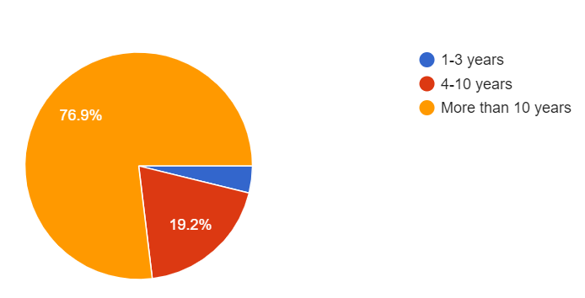

Planning of lessons
Six options listed in Figure 11 were provided to elicit responses to understand how communication lecturers prepare for a lesson. According to the responses to this question, most lecturers prefer to follow the LP provided and go according to "feel" and intuition in preparing a lesson.
Performing IC in the analysis of participants' responses on "other approaches/activities not listed here", the following themes were observed. First, participants significantly differentiated their teaching approaches to suit their teaching style and students' profile. Their teaching was performed via three main methods, from past experiences and some by conducting diagnostic tests and discussing needs with students. Areas from past experiences that aid in identifying teaching approaches were common difficulties and challenges, lesson outcomes and training. Participants also discuss teaching strategies with colleagues and search for e-platforms, tools and audio-visual materials to increase student engagement.

Figure 11
How Communication Lecturers Prepare for a Lesson
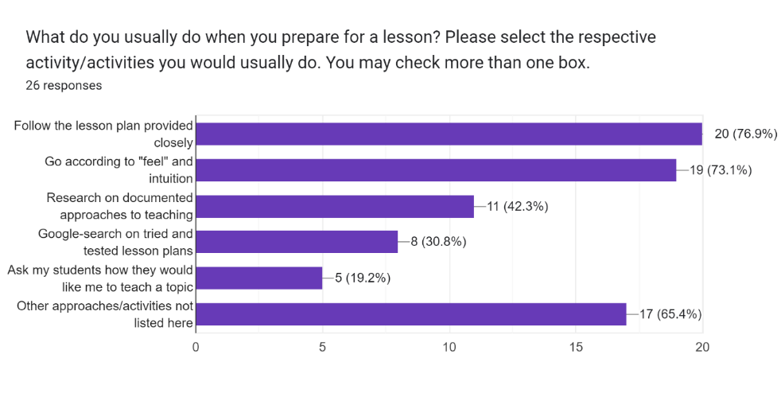

Approaches to the Teaching of Communication Skills Subjects
Respondents' views were asked to describe their teaching methods. Most respondents (76.9%, n=20) chose the option "Based on needs analysis of my students". Figure 12 shows all the responses to this question. Generally, the notion of teaching based on "feel" is evident in 2 questions of this questionnaire- questions 16 and 18. Question 16 sought to enquire about participants' methods in preparing a lesson, while question 18 sought to enquire about participants' perceptions of their methods in teaching communication skills subjects. 17 participants for question 18 chose "based on ad hoc observation of my students" to describe their teaching method, and 19 participants for question 16 chose "go according to 'feel' and intuition" to describe how they plan a lesson.

There were two responses for the option "Description not listed here" in question 18, and they were "Adaptation from colleagues' ideas regarding the delivery of a certain lesson" and "Peer observation". It was observed that participants in this group viewed learning from members within the department as a viable approach in determining how to teach communication skills subjects. One way to learn was to consult colleagues when encountering problems in teaching. Other than learning from peers, most would analyse the situation with reference to observations of students and search from documented research to solve problems in teaching.

Figure 12
Methods in Teaching Communication Skills
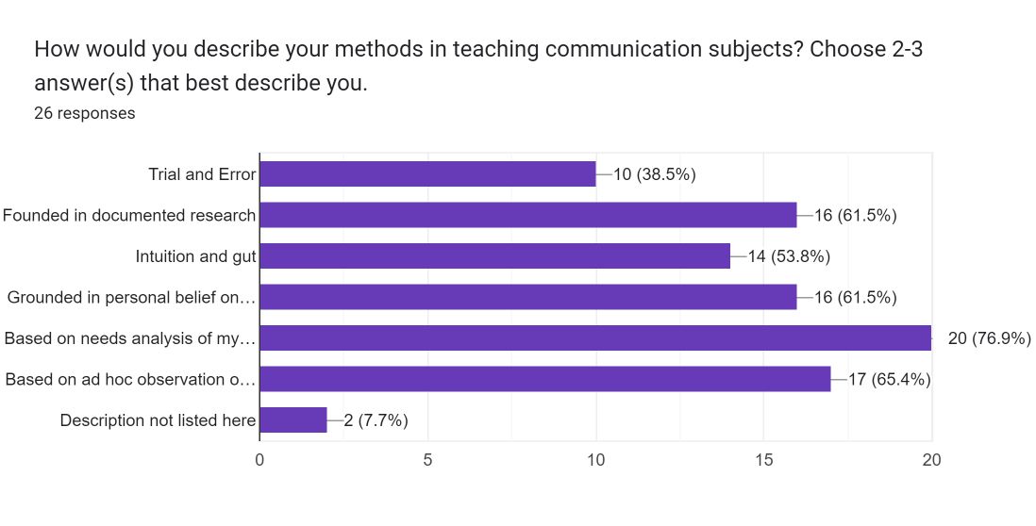

Views on Fundamental Communication Subjects
Participants in this group were asked if they thought the fundamental communication subjects were sufficient to prepare students to be effective communicators in the workplace. 26 participants responded, 65.4% (n=17) said no, while 34.6% (n=9) said yes. Based on an analysis of the responses, one aspect that stood out from the responses is that those fundamental communication subjects serve their purpose of providing basic communication skills. However, to achieve more customised and in-depth learning, job training, and further education - CET (Continuing Education and Training) would be necessary. Six independent responses indicated that the fundamental communication subjects lacked context and focused on "one type of audience – those in higher positions than they are". This group of participants thought that the fundamental communication subjects were designed for "university-bound" students, which does not help prepare students for the workforce. They stressed the importance of providing "significant real-world problems with a real-world connection for them to solve and tackle". One of the participants suggested staggering the communication subjects within the 3-year diploma programme and not within the first year of their course. This comment might suggest reviewing the curriculum and progression of students within their studies.
The objective of questions 22 – 25 aims to locate the views of communication lecturers on possible communication skills they think are missing in the three fundamental communication subjects examined in this study. The aspects of communication skills (written, oral, visual & electronic) listed in all four questions were informed by a literature search on types of communication skills identified by researchers, in particular from the study by Coffelt et al. (2019) where they obtained views from employers on the meaning of communication skills.
The responses from this group of participants significantly expressed a lack of teaching grammar and language use in all aspects of communication for the fundamental communication subjects.19 individual responses indicated that writing skills should be explicitly taught in communication subjects. Some areas in grammar that participants thought would need attention are discourse markers, summary skills, sentence and paragraph structure, crafting of headings and sub-headings, conciseness and writing for digital media. Some highlighted a need for fundamental communication subjects to address students' lack of audience awareness when presenting in oral presentations. 12 independent responses also emphasised verbal presentation skills such as pronunciation, not reading off presentation slides, being persuasive, overcoming stage fright, and being self-aware as a presenter. One expressed that "the need to teach slides design is outdated, given that there are now free online design resources such as 'Designer' in PowerPoint online".
Some responses indicated the need for more context in teaching fundamental communication subjects. Those subjects were mostly pitched at "a high level of formality which may not be so appropriate in some professions/work situations". One highlighted that "certain aspects of report writing should be related to students' technical area and discipline. In this way, students will see greater relevance in what they are doing". These responses are consistent with teacher trainees' views on the fundamental communication subjects, where they felt that much of what they learnt from those subjects were too "business-like" for the early childhood industry. Two teacher trainee participants, John and Sheena, described their experiences communicating in the early childhood environment as casual and "informal", and John even highlighted the occasional use of expletives amongst the teachers, though not in front of the children.
Other aspects of communication skills were also emphasised in the participants' responses. There was a significant emphasis on teaching conversational skills such as creating small talk in a business setting, sustaining a conversation, and creating conversations through visuals and self-introduction in a business situation. Much emphasis on developing good visuals was also highlighted in the participants' responses, with some raising the need to be trained in this area to better their teaching. Much focus on digital communication was placed on writing, video recording and creating a podcast for social media platforms, professional websites, and blogs.

Move Counts and Analysis
General Observations
As noted in Chapter 3, the Biber Connor Upton (BCU) Approach was applied in my analysis of the moves in the lesson plans (LP) collected from both preschool practitioners and teacher trainees. The final number of LPs in my data set was ultimately determined by the availability of preschool practitioners' LPs. 21 sets of LPs were collected, but 20 were used in my move count and analysis. The reason for not using the 21st set was because that set contains several LPs for a school term, and the practitioner did not respond to a further query on which parts to extract to be counted as an LP for 1 lesson, which is a communication event as determined in this study. Hence, I did not include that set in my analysis.
After the moves were pre-determined via a pilot coding, as explained in Chapter 3, each step/move was counted for all 20 LPs from each group. In reporting my move counts and analysis in this section, I will use the term "practitioners" to refer to the preschool practitioners' group and "trainees" to the preschool teacher trainees. Generally, the occurrence of steps performed by the trainees was more consistent than the practitioners' group, as the LPs were created for assessment purposes within their course. The assessment allowed the trainees to use the LP template or structure of the preschools they were attached to during their practicum, but none from the data set deviated from the template specified by the course. Table 13 describes the percentage of occurrence, the total number of words and the average number of words written for each step from both data sets. The results of the move count for this study are contrary to the results of Parkinson et al. (2018), where trainee carpenters who were primarily situated on campus in vocational training wrote significantly more words than apprentices who were situated in practice. In this study, counting the total number of words written for all move types and steps, the practitioners wrote 12347 words while the trainees wrote 10923 words. Based on the total move count, the practitioners also wrote more words than the trainees for more than half of the 15 steps identified from the pilot coding. This difference is observed in the total and the average number of words for steps 1, 3, 4, 6, 7, 8, 9, 10, 11 and 14. The trainees wrote more words for steps 5 and 13. For step 2, practitioners and trainees have the same average number of words written though the total number of words for the trainee is more. Trainees' responses to steps in the moves relied on their assessment requirements. However, there is no response for step 15 for both practitioners and trainees, as this portion of the LPs was not shared. However, prompts for this purpose can be seen in the practitioners' LPs but were left unfilled. This part of the LP requires the writer (practitioners) to reflect on what happened in class. The assigned supervisor will read it and provide comments or evaluations for appraisal purposes. The sensitive nature of this portion might be why participants were uncomfortable revealing this for the study. On the other hand, the trainees' sets were assignments provided by the institution, and the data sets were unassessed copies of the LPs. Hence this portion was also left empty. Generally, more than half of practitioners responded to steps 1-11, while more than half of the trainees responded to steps 2-7, 9-11 and 13. These observations informed the ultimate steps to be included in an early childhood LP which will be discussed at the end of this section.

It is important to note that no responses were required for step 8 in Move Type 2 (Describe the learning disposition/areas for children) from trainees as, when queried, the lecturer from the course explained that the course perceives this portion of the LP to be an unimportant aspect in the field. However, practitioners have contrary responses. Many practitioners' LPs were structured in a form-like manner, and this step was one of the fields in the LPs that are structured this way. From the data set, 13 practitioners (65%) have responses for this step with 1045 words and an average of 80 words per LP. This observation raised the question of the importance of this step which will be discussed in Chapter 5.
Table 13
Move counts of Practitioners and Trainees’ LPs
Rhetorical Moves from Pilot Coding | Practitioners (n=20) |  |  | Trainees (n=20)
Move Type 1: Introducing the information about the lesson | Step Taken (%) | Total word count | Ave. word count | Step Taken (%) | Total word count | Ave. word count
1. State semester/term of the year of instruction | 55 (n=11) | 43 | 4 | 0 | 0 | 0
2. State level of instruction | 75 (n=15) | 57 | 4 | 100 | 84 | 4
3. State duration of lesson | 60 (n=12) | 147 | 12 | 100 | 41 | 2
4. State the topic/theme | 100 | 155 | 8 | 100 | 74 | 4
5. State date of instruction | 60 (n=12) | 49 | 4 | 95 (n=19) | 58 | 3
6. Describe the learning area(s) to be accomplished in the lesson | 100 | 477 | 24 | 100 | 155 | 8
Move Type 2: Describing the procedure of the lesson
7. Describe the objectives of the lesson | 100 | 1244 | 62 | 100 | 954 | 48
8. Describe the learning disposition/areas for children | 65 (n=13) | 1045 | 80 | 0 | 0 | 0
9. Describe the materials/tools/applications required for the lesson | 100 | 791 | 40 | 100 | 716 | 36
10. Describe the procedures and activities | 100 | 6342 | 317 | 100 | 5605 | 71
11. Describe how to close a lesson | 75 (n=15) | 1057 | 70 | 100 | 1022 | 51
12. Describe the follow-up activities for the lesson | 10 (n=2) | 43 | 22 | 10 (n=2) | 71 | 36
Move Type 3: Evaluating the outcomes of the lesson
13. Describe personal evaluation of the design, instructional practices and theoretical structure of the lesson | 15 (n=3) | 514 | 171 | 95 (n=19) | 2143 | 113
14. Describe the outcomes of the lesson by recounting children’s responses and actions during the lesson | 35 (n=7) | 383 | 55 | 0 | 0 | 0
15. Supervisor respond to the reflections of the teacher who carried out the lesson | 0 | 0 | 0 | 0 | 0 | 0

The steps listed in Table 14 were performed by both groups, with the highest total and the average number of words written for step 10 (Describe the procedures and activities). The steps in Table 14 were ordered according to the total and the average number of words, from the most to the least. Both groups showed a similar order based on the total and the average number of words.

Table 14
Steps occurring in all LPs from both groups
 | Practitioners (n=20) |  | Trainees (n=20)
Steps | Total word count | Ave. word count | Total word count | Ave. word count
10. Describe the procedures and activities | 6342 | 317 | 5605 | 71
7. Describe the objectives of the lesson | 1244 | 62 | 954 | 48
9. Describe the materials/tools/applications required for the lesson | 791 | 40 | 716 | 36
6. Describe the learning area(s) to be accomplished in the lesson | 477 | 24 | 155 | 8
4. State the topic/theme | 155 | 8 | 74 | 4

It is crucial to note that the steps ranked in Table 14 have possible implications for their importance in an LP, except for step 4 (State the topic/theme). Due to the nature of this step, the practitioners' set has an average of 8 words, and the teacher trainees' set has an average of 4 words. Based on the total number of words and occurrences, practitioners focus on steps 10 (Describe the procedures and activities) and 7 (Describe the objectives of the lesson). In contrast, trainees focus more significantly on step 10 (Describe the procedures and activities) and step 13 (Describe personal evaluation of the design, instructional practices and theoretical structure of the lesson). The significance of this finding will also be discussed in Chapter 5.
Move Type 1: Introducing the information of the lesson
The steps in Move Type 1 focus on providing information about the lesson. As described earlier, many practitioners' LPs were observed to be written in a form-like structure with fixed fields to fill for this move type. Prompts of the forms were not counted in the word count, and only the writer's response in the form was included. It was also observed that the "duration" of the lesson varies significantly in meaning for practitioners' LPs. Some LPs were written for 30 to 45 minute lessons, while others were written for a month's lesson. Under such a circumstance, via a consultation with the practitioner who provided the LP, I extracted parts of a single-sitting LP to be part of my count and analysis.
The following were observed in Move Type 1. Trainees entirely omitted step 1, while 11 (55%) practitioners' LPs responded to this step. Both groups responded to step 6 (Describe the learning area(s) to be accomplished in the lesson), but practitioners wrote more than trainees with an average word count of 24. Practitioners' LPs contain more details in describing the learning areas to be accomplished in the lesson when compared with trainees' LPs. Generally, the practitioners provided more information for Step 3 (State duration of lesson) and 6. Upon closer examination, eight practitioners' LP had more than the average 4 word count for step 3, and four practitioners had more than the average 24 word count for step 6. All LPs in the group of eight practitioners with more than a 4 word count for Step 3 provided a specific time allocation for each part of their lesson. One in particular, that went beyond the specific allocation of time, with a word count of 46 provided more explanation of what each allocated timing was meant to achieve. Figure 13 shows an example of how this practitioner wrote this step.
Figure 13
Extracts of an Elaboration of Duration in an LP
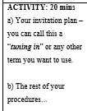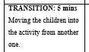

Move Type 2: Describing the procedure of the lesson
This LP was the most detailed in the data set, and I sought an explanation for why it was written this way. The practitioner explained that the LP she provided was part of her collection, where she had to write an LP for a lesson observation submission to her work supervisor for appraisal purposes. It was understood from interviews and consultation with the practitioner who provided this LP that such an elaborate LP is usually written only for appraisal purposes.
The steps in Move Type 2 focus on describing the procedure and details of the lesson, providing the reader with clarity about how they could carry out the lesson. There are several observations for this move type. Generally, practitioners wrote significantly more words for 5 of the six steps in this move type. As stated above, Step 10 (Describe the procedures and activities) has the highest number of words for both groups amongst all the move types. Though both groups responded to steps 7, 9 and 10, as stated in Table 14, practitioners wrote more words than trainees for all three steps. Both groups have the same number of occurrences (n=2) for step 12 (Describe the follow-up activities for the lesson), and this is not mandatory for LPs in both groups.
Move Type 3: Evaluating the outcomes of the lesson
The steps in Move Type 3 focus on evaluating the outcomes of a lesson and provide channels for reflective conversations with a preschool teacher's peers and supervisors. This move type was observed to have the least number of occurrences in the data sets. Trainees appeared to emphasise step 13 (Describe personal evaluation of the design, instructional practices and theoretical structure of the lesson), while only three practitioners responded. For step 14 (Describe the outcomes of the lesson by recounting children's responses and actions during the lesson), the word count and occurrences of trainees' LPs were regarded as zero. However, reflections on the outcomes of the lesson were written in step 13 instead as part of their evaluation of the design of the lesson. Some trainees separated the outcomes of their lesson from personal evaluations with sub-headings within their writing, while others wrote it as part of their general evaluation of the lesson. Hence, I decided to leave this out of the count as it would be difficult to decipher which portion belongs to the respective steps. However, it can be concluded that both steps 13 and 14 occurred in both groups of data sets.
Steps not Observed during Pilot Coding
There were additional steps and other details not observed during the pilot coding stage but occurring in both trainees' and practitioners' data sets. However, and as noted earlier, responses for the trainees' LPs were generally similar, with some worded a little differently. The only significant difference can be seen in step 4 (State the topic/theme), where the topic and theme of the lesson described were stated separately in the LPs of 9 trainees, appearing as two separate steps. In contrast, the other LPs stated the topic and theme in a single step, as identified in the pilot coding. On the other hand, the practitioners showed more deviance from the steps identified from the pilot coding. Six additional steps within the practitioners' set were outside the move types identified during the pilot coding. They are "Provocation", "Teacher's note of developmental target group", "Differentiation", "The Planning Process", "Evidence of learning", and "Parental Involvement". Table 15 provides an example of each additional step extracted from the LPs.
Table 15
Additional Steps Found in Practitioners’ LPs
Additional Steps | Examples
Provocation | Provocation:  Post questions to children to regarding biography and realistic fiction (e.g., what do you think it means?)  Read the title of the term’s book to the children - “Me… Jane”, and post questions to children (e.g., what do you think the book is about?)  Link the children’s varied responses to perspective, that each child has different thinking/ideas.
Teacher’s note of developmental target group | Teacher’s Note: The 5- and 6-year-olds are the most physically adept of all the classes. They follow complex storylines very well, and often are most engaged during the storytelling portion. Don’t be afraid to spend a little bit longer on the storytelling, in order to draw the children in more. At this age, children are also very talkative and opinionated. Practice patience and understanding when dealing with this group of children, but also don’t be afraid to be ﬁrm and decisive and allow them to deal with some measure of disappointment. Verbal cues and positive feedback are very important, as well as focusing and pointing out both positive examples as well as areas of improvement. These children will also tend to be more self-conscious, so be aware not just of the things you say, but the tone with which you say it. Also be aware of any incidents of bullying/mocking that may take place in class and use the opportunity to deal with it.
Differentiation | Differentiation:  Above average learners  Identify other words that start with letter A  Learners who need more help  Draw circles along the lines of the letter so that they know where to place the alien picture card.
The Planning Process | 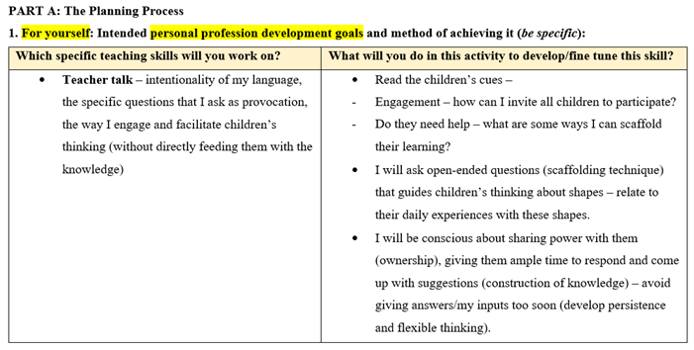
Evidence of Learning | 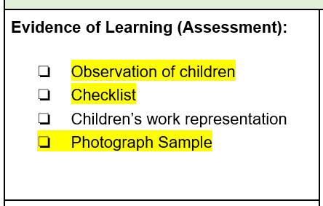
Parental Involvement | Parental Involvement:  Invite parents to take their children to the park during the weekends. The children will draw what they had seen or done at the park and share it with their peers in the following week.

All the additional steps appear to provide more details for the reader on how to approach and carry out the lesson described in the plan except "The Planning Process". This portion was found in the same LP highlighted earlier that provided elaboration of duration for step 3 (State duration of lesson). This LP was written for appraisal purposes, which explains the additional information required beyond instructing and describing the lesson to be carried out. These extra steps have implications for teaching LP writing, which will be discussed in Chapter 5.
Final Coding and the Order of Moves of a Preschool LP
Based on the analysis of both groups of LPs, the order of the steps is consistent with the pilot-coded steps except step 8 (Describe the learning disposition/areas for children). This step was not addressed at step 8 but occurred in 9 (n=13) practitioners' LPs at the stage of Move Type 1. Hence, considering this point and the move counts and occurrences within both data sets, the final order of moves with 13 steps is provided in Table 16.
Though Step 15 Supervisor respond to the reflections of the teacher who carried out the lesson (now known as "Step 13" in Table 16), was not observed in both groups, as explained earlier, the fact that it exists in practitioners' LPs showed its importance and should be included for teaching purposes. Therefore, the final moves for an LP will omit two steps from the list: steps 12 and 13. Step 12 (Describe the follow-up activities for the lesson) was removed as it only occurs in 2 LPs for each group. Step 13 (Describe personal evaluation of the design, instructional practices and theoretical structure of the lesson) was also removed as this step is only required for appraisal purposes and optional for daily LPs. Since the consideration of the final steps is based on the LPs that preschool teachers frequently write, steps relating to LPs written for appraisal purposes that are not commonly written in the field will not be considered.
Table 16
Final Rhetorical Moves of Early Childhood LP
Move Type 1: Introducing the information of lesson
1. State semester/term of the year of instruction
2. State level of instruction
3. State duration of lesson
4. State the topic/theme
5. State date of instruction
6. Describe the learning area(s) to be accomplished in the lesson
7. Describe the learning disposition/areas for children
Move Type 2: Describing the procedure of the lesson
8. Describe the objectives of the lesson
9. Describe the materials/tools/applications required for the lesson
10. Describe the procedures and activities
11. Describe how to close a lesson
Move Type 3: Evaluating the outcomes of the lesson
12. Describe the outcomes of the lesson by recounting children’s responses and actions during the lesson
13. Supervisor respond to the reflections of the teacher who carried out the lesson

Lexico-Grammatical Aspects of LPs
LPs from both groups were converted into plain text and processed using the concordance tool AntConc (version 4.1.2) and Table 17 displays the results of the first ten frequency of both groups. Though the emphasis of this study is not on the lexico-grammatical aspects of the LPs, it was included to provide some possible suggestions on lexico-grammatical patterns and possible grammatical aspects that trainees need to note when learning to write an LP.
The word frequency list in the top 7 counts in both data sets is consistent. The words often used in LPs relate to describe the procedure, and connecting words were used to help readers make sense of the process of the lesson. For example, the verb "be" and the modal verb "will" naturally occur in LPs since this procedural text involves action and activity. It is a common belief that the words listed in Table 17 would have a high frequency in many different corpora, but their occurrence in this corpus has grammatical aspects that are worth noting in the learning to write LPs. Three main grammatical elements were observed to be important in a preschool LP.
Table 17
Word Frequency of Practitioners and Trainees’ LPs
Practitioners | Trainees
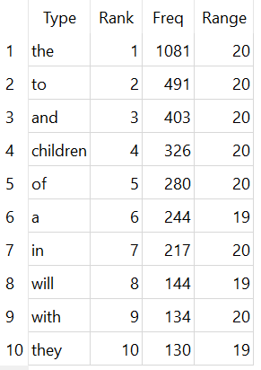 | 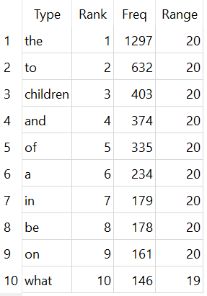

First, the article "the" is the most frequently written word in both data sets. Based on AntConc's plot of the location within the data sets of the articles, it was used predominantly to indicate the specific parties and objects highly involved and related to the lesson described. In this case, "children" is the main object of the LPs' procedures. The determiner "a" is also used for the same function in the LPs. Examples are extracted in Figure 14.
The article "the" helps to indicate to the reader the object specifically related to the lesson and the parties (i.e., children and teacher) directly involved in the lesson. This grammatical aspect is an essential element in the writing of preschool LPs as it will affect clarity in communicating the procedures of lessons to substitute teachers in the event of absences of a regular teacher-in-charge. Another grammatical element is the determiner "a", which seems to occur primarily within Move Type 3 - the evaluation of the LPs. The language used in the evaluation of the lesson design appears to indicate objectivity in assessing the effectiveness of the LPs with the help of the article "a" to separate the LPs from the author.
Figure 14
Plots of the Article “the” and Determiner “a” in Practitioners and Trainees’ LPs (Sort to left)
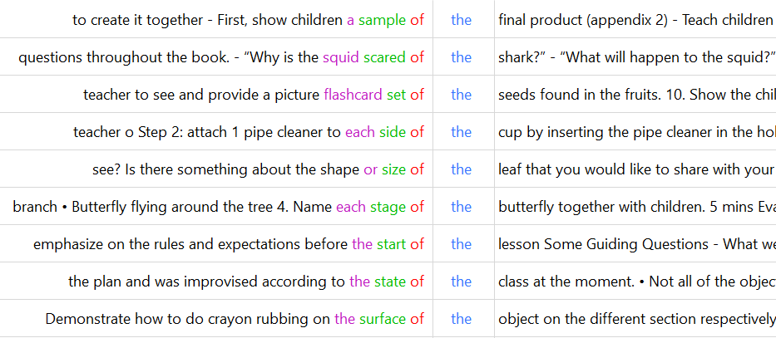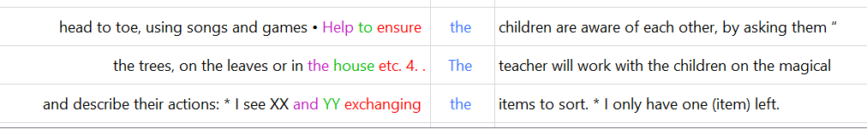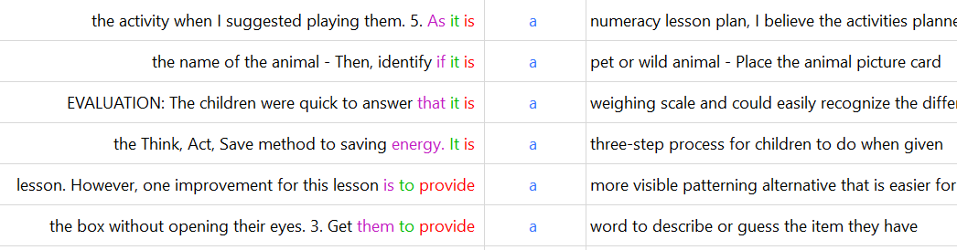

Second, the conjunction "and" was plotted to occur mostly within procedures and lesson evaluation. This connecting conjunction "and" serves as an essential connector of parts of instructions and speech, especially within the procedure of the LPs. Figure 15 shows examples of the conjunction "and" occurrences within procedures.

Figure 15
Plots of the Conjunction “and” Within Procedures of LPs (Sort to left)
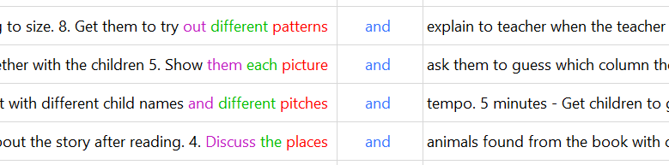

Figure 16
Plots of the Prepositions “to”, “of” and “in” Within LPs (Sort to left)
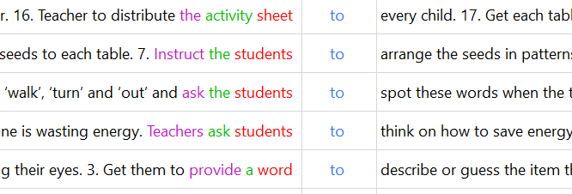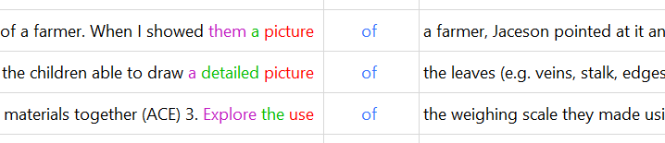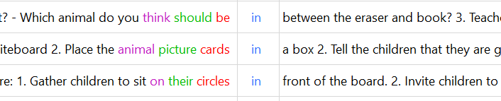

Lastly, prepositions are highly important in communicating a procedure. The concordance tool surfaced the prepositions "to", "of", and "in", frequently occurring in both practitioners' and trainees' LPs. In the data sets, these prepositions were used to direct attention to an object and express the relationship between a part of a whole and directions of a location, item or condition. Extracts of examples of the use of prepositions in the data sets are shown in figure 16. These observations of the grammatical aspects of both data sets inform the teaching of writing LPs. In addition, these observations and move counts, including findings from the interview and questionnaires, raised several pertinent points that inform the learning and approach of communication subjects for vocational training in early childhood education, which will be discussed in the following chapter.

Chapter 5: Discussion
This chapter discusses observations that surfaced from the findings described in Chapter 4. The findings revealed varied purposes of the genre of lesson plans, which could impact the relevance of teaching general communication skills and the location of learning. This chapter will start with raising four critical observations from the analysis of lesson plans written by teacher trainees and practitioners in the field. Next, implications from the observations will be discussed, and recommendations to address three main areas in teaching communication skills will be proposed.

General Communication Skills in Vocational Programmes
Diverse Genres and their Intended Purposes
Six general intended purposes of texts were observed from the findings of this study. These categorisations and genres were gathered and determined from two main questions from the questionnaires, the six predetermined lists of texts and the interview responses reported in Chapter 4. Table 18 summarises the possible genres and lists the categorisation of broad intentions for genres written in the early childhood workplace. Though not comprehensive, the three fundamental communication subjects examined in this study potentially cover some writing skills needed in the varied genres and purposes listed in Table 18. For example, persuasive skills in writing letters to parents and the content about communication in the workplace cover minute writing too. However, responses from the findings of this study showed that the direct relevance of language and writing skills to specific genres is necessary for the application of skills to be made possible. As reported in Chapter 4, participants expressed that applying such generic skills is often forgotten with many preschool teachers' hectic work schedules.
Furthermore, the existence of various purposes and genres in the field, as listed in Table 18, challenges trainees to determine specific communication skills for application. Hence, learning to write genres bridges this gap, allowing a more immediate and natural application of skills. Looking at how diverse the nature of genres is, it seems more appropriate to teach specific skills relating to genres existing in the field rather than to assume the application of generic communication skills that are often incidental and forgotten.

Table 18
Intended Purposes of Texts written in the Early Childhood Workplace
Intended Purpose | Possible Genres
Learners’ academic advancement | - Recommendation letters  - Testimonials
Meetings & Trainings | - Meeting Minutes  - Reflection Papers from sharing and training courses  - Evaluation forms for pre and post meeting/training
Events and projects | - Valedictorians’ speeches  - Media scripts  - Application for funding  - Training materials  - Proposed Plans with an Itinerary for centre events / excursions*
Communication | - Emails to colleagues, community partners, parents and Headquarters  - Communication notebooks for parents  - Letters to parents*  - Newsletter on school’s events/activities/programmes to parents  - E-portal for parents
General administration | - Incidents / accidents reports  - Monthly updates for staff  - Documentation for claims and payments
Teaching | - Lesson plans*  - Observation Records of Children*  - Writing captions for photographs  - Progress reports  - Theme Boards  - Take-home kits
*Texts written by more than 50% of trainees during the internship period
On a related note, obtaining a list of texts in the field is a good starting point in determining the curriculum content for communication subjects. However, more than referring to the list alone is needed to inform the teaching of communication skills. Furthermore, varied genres existing in a single industry raise the question of which genre to focus on in teaching communication skills. The intended purposes of a specific genre, such as writing lesson plans (LPs), are also highly varied in the field. These were observed in the collection of LPs where the purpose of lesson plans written in a school was found to serve two primary purposes - communication for appraisal purposes between a work supervisor and a teacher and for the communication of suggested plans for a classroom lesson. These genres written for these two purposes, though both labelled as LPs with similar linguistic modes, are entirely different in purpose and focus. Differences between LPs can be observed in the steps in the LP sample written for appraisal purposes, which contains a detailed description of the plan, rationale, reflection, and the learners' profile.
Contrary to that LP, the other LPs focus on the objectives and procedures of a preschool lesson. The different purposes also determined the word count of the LPs, with plans for appraisal purposes containing a higher word count when compared with plans prepared solely to conduct a lesson alone. Hence, this shows that more than referring solely to the list of genres is needed to inform the curriculum.
Pushing the point further on the diverse nature of genres in the workplace that can potentially affect the relevance of generic communication skills, the responses from the interviews support the importance of context in language learning and that learning must be situated within the practice (Parkinson et al., 2018). The "context and conditions of work have become more transient and unpredictable due to global changes" (Nissi et al., 2021, p.1), and the approach to different genres will have to adjust accordingly. This phenomenon was also observed in this study, where preschool teacher trainees raised the challenges of communicating with parents and children in the online environment due to an increase in the use of online platforms during school closures because of the covid-19 pandemic. With varied approaches to the same task or the writing of the same genre in our "super-diverse world where social and technological innovations play a key role, value creation is not only seen to lie in the effective management and distribution of information, but in its collaborative and inventive cultivation" (Nissi et al., 2021, p.1-2). It seems how we manage and communicate information is highly dependent on our environment and even the "attitudes" and "disposition" (Hager, 2002, p.3) of the communicators towards a communication event. For example, as reported in Chapter 4, one participant described how her mentor managed communication with her in writing LPs through a collaborative spreadsheet using the Microsoft Excel programme. The supervisor thought this would be a more efficient way to monitor and indicate lesson plans with their hectic schedules. According to the participant, communication between her and her supervisor happens within the Excel spreadsheet. This approach to writing LPs would change how we determine the moves in an LP, including the order and plot of the steps of each move. The varied approaches towards the genre of LPs implied, at this point, the importance of situating the learning to communicate in the workplace and that should not be confined to the classroom alone. Though the limited exposure to authentic texts due to different cultures in schools affects preschool teacher trainees' learning, isolating their learning in the classroom will prevent trainees from even observing the creation of genres in authentic environments.
Furthermore, the content and steps in a specific genre are highly varied and determined by each school's culture and values. In this aspect, if the learning to communicate and write LPs were confined in the classroom, the preschool teacher trainees would not be able to learn genres of their eventual preschool workplace. Therefore, exposing preschool teacher trainees to different versions of the authentic environment is essential. Lastly, situating learning in authentic environments would encourage the development of self-directed learning that requires professional competencies not achieved solely via classroom-based education but as competencies that require a higher level of skills that has to be cultivated and sustained throughout one's professional life (Boyer et al., 2014).
However, based on the findings, even if the learning of preschool trainees is situated in authentic environments, limited exposure to authentic texts can hinder learning to communicate within the field. Based on findings reported in Chapter 4 and the list of genres and their intended purposes in Table 18, the preschool teacher trainees were exposed to merely three main purposes in the field – Events and projects, communication, and teaching. Based on the interview responses presented in Chapter 4, preschool teacher trainees were not allowed to be part of writing texts that require detailed and accurate writing and are deemed highly important in the workplace. Withholding exposure to authentic and frequently written texts will ultimately limit the views of genres in the field and deprive preschool teacher trainees of practice in writing genres in authentic work environments. With limited exposure to authentic texts, trainees cannot obtain what Parkinson et al. (2018) would call a "fuller membership in the community" (p.311) and start writing and communicating in "occupation-specific ways" that is crucial in "taking on an identity" within the community of the early childhood practice. This restriction will limit preschool teacher trainees' valuable experiences in writing for contexts existing in the field and may hinder their future success in communicating in the workplace. Exposure to authentic genres existing in the field is crucial because it was observed in this study, as well as in Parkinson et al. (2018), that the objectives of a writing task will change according to the environment in which it was written. The following section will describe comparative observations and analysis of the move count of the lesson plans written by both preschool practitioners and teacher trainees.

Differences between Writing On-Campus vs. Workplace
Texts written by Practitioners and Trainees
It was clear from the findings that lesson plans (LP) are the most frequently written genre and are considered essential for practitioners and trainees. However, there are four main observations between trainees' and practitioners' writing. Firstly, the total word count of the LPs of both groups was contrary to Parkinson et al. (2018), who found that on-campus carpenter trainees wrote more than apprentice carpenters. My findings revealed a different definition of what it means to write for functional purposes. The apprentice carpenters' dairy entries had to be functional by nature and hence, more economical in the number of words. In fact, my results showed the opposite of what Parkinson et al. (2018) found, where on-campus trainees wrote less than practitioners in the field. Practitioners wrote 1424 more words with the trainees describing the steps only while the practitioner provided elaborations and examples. When queried, the practitioner said the examples and elaborations are important to help a replacement teacher understand what to do if a teacher is absent. The step that has the highest word count for both groups is Step 10 (Describe the procedure and activities). From an examination of LPs from both groups, the higher total word count from the practitioners' group was due to two reasons.
- The elaboration of the practitioners' procedures of the lesson, with explanations on what the user of the LPs could do to address learning goals in Step 10.
- One practitioner's LP created for appraisal purposes has a significantly higher word count than all LPs collected from both groups.
Figure 17 shows an example of the procedure portion plotted in Step 10 of the LPs from both groups that would illustrate observation (1). The practitioner in this example has a total word count of 714 and 375 for Step 10, while the trainee has a total of 536 and 317 for Step 10. Figure 17 showed how the practitioner provided examples and suggested specific actions on what to do for the suggested steps in the lesson procedure (see point 2 in the practitioner's example), while the trainee merely stated the steps of the lesson procedure. Based on this observation, an elaboration is necessary to ensure the user of the instructions knows how to conduct the lesson according to the plan. For observation (2), as explained in Chapter 4, an LP stood out in terms of word count and elaboration due to a different motivation of the LP - for appraisal purposes. This LP has a total word count of 3802, with 1358 words for step 10. This LP has the highest total and word count for step 10, amongst all LPs collected for both groups. This difference in intentions of the LP is revealed significantly even in the word count.
Figure 17
Example of Step 10 in Practitioners’ and Trainees’ LP
Practitioner | Trainee
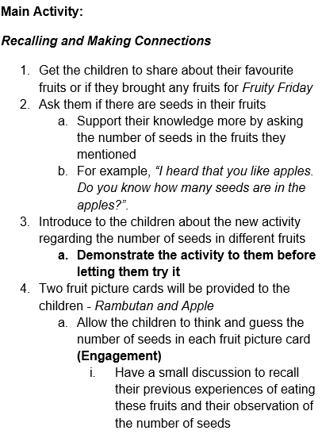 | 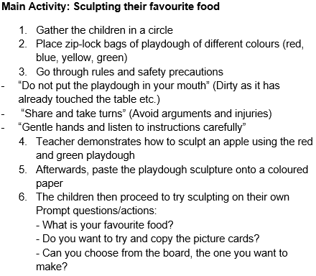

Secondly, practitioners' LPs focused on elaborating on the learning areas of a lesson, often incorporating them within the description of objectives and even the learning disposition section. By contrast, trainees' LPs focused on describing the personal evaluation of the design and theoretical structure of the plan. Figure 18 shows the difference in the approach to writing learning areas for practitioners and trainees. It was observed that no responses were required for Step 8 (Describe the learning disposition/areas for children) for the teacher trainee group, as when queried, the teacher trainers explained that this step is unimportant in writing LPs. However, this step occurs in more than 50% (n=13) of the practitioners' LPs. The fact that this step occurs in the practitioners' LPs shows its importance in the field. Specifying the children's learning dispositions and areas helps the LP reader understand how to perform the steps in the lesson procedure. This difference showed the intent of writing LPs for each group of participants. The writing performed by the trainees was for assessment purposes. Hence, the emphasis of the task and the motivation of the writing of LPs focused on evaluating the design of a lesson. On the contrary, the practitioners' LPs focused on the objectives, including learning areas and evaluating the outcomes of a lesson. This difference is consistent with what Freedman and Adam (1996) described in workplace settings where the "collaborative engagement in tasks" focuses on outcomes (p.423) while the classroom setting is predominantly epistemic and knowledge-oriented (Dias et al., 1999), and I will discuss this further in the later section of this chapter.
Figure 18
Example of Learning Areas described by Practitioners’ and Trainees’ LPs
Practitioner | Trainee
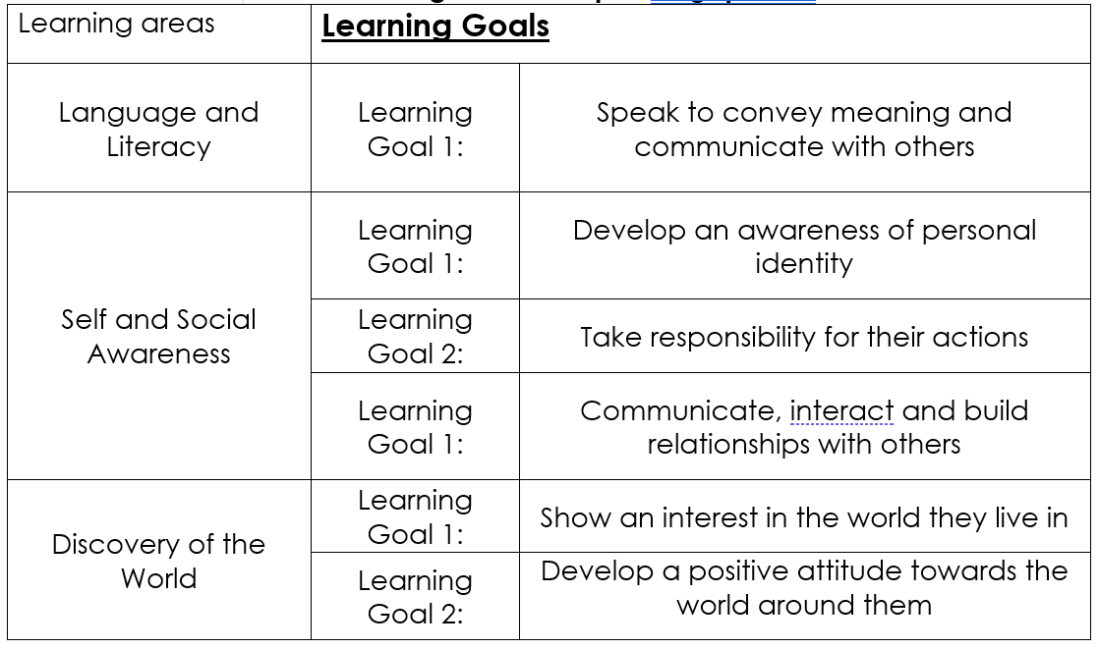 | 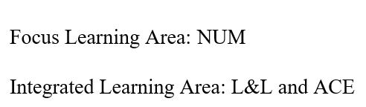

Thirdly, the lesson duration indicated in the LPs varies significantly in the meaning of the practitioners' LPs. The difference in the meaning implicates the definition of a "communication event" that would signify when the turn of communication starts and ends. For example, one set from the practitioner group showed a pick-and-mix kind of LP for a month, with the need for insider knowledge as to which to "pick" and how to "mix" to form a plan for a single-sitting preschool lesson. The duration for the trainees' LPs was consistent in structure as their course requirements specified it.
Finally, a significant number of additional steps found in the practitioners' LPs, as stated in Chapter 4, Table 15, showed, once again, the varied nature of genres existing in the field. These additional steps were found in 7 separate practitioners' LPs. These additional steps deviated from the standard version of LP, and the only way for trainees to be exposed to such non-standard genres is to situate learning in practice.

Learning Communication where Communication happens
As explained earlier in this chapter, attempts to apply general communication skills did not happen because the application of such generic skills was often forgotten due to hectic schedules in the preschool workplace. The findings also showed that learning to communicate happens not in formal training but within the workplace community. Practitioners in the questionnaire opined that preschool teacher trainees should be exposed to authentic texts during the internship and "made to write texts that (real) teachers write". Practitioners' responses showed that they learnt how to communicate via three main areas – the workplace, self-help videos and guides obtained online, and past experiences. Many preschool practitioners also explained the importance of learning from the community through modelling authentic texts shared by participants of the community in learning how to write effectively. All preschool practitioners felt that vocational training has limitations and did not credit their success in communication solely to their training before joining the industry. Two participants used words such as "trial by fire" and "bleed" to describe the learning journey to communicate in the field and suggested that this painful process is necessary. Regarding the teacher trainee group, many raised specific communication events unique to the early childhood industry to describe communication skills that they perceive as crucial for success in the workplace. In addition, many teacher trainees regarded their vocational training as an introduction, functioning as a "manual", and thought going into the field would allow them to see how things work in authentic settings. Participants also raised the effectiveness of learning through observation, especially by observing more experienced practitioners. Hence, the specificity in participants' responses indicates contrary views on teaching generic communication skills.
Hence, both groups' responses support the notion that communicative competencies should never be regarded as a static and uniform pool of knowledge, ready to be applied in any context (Hymes, 1972). As reported, many teacher trainees could not recall what they had learnt in the fundamental communication subjects, and the application of skills would depend on the nature of the task, state of mind and the act of applying those communication skills. Participants in this study confirmed that applying general communication skills does not occur naturally and requires a deliberate application. The teacher trainees said they had no chance to apply any skills learnt from the fundamental communication subjects and found the writing style taught in those subjects too "formal" for the field. Even if there were attempts at application, they were purely incidental.
The communication event and context determine the content and style of communication. This is especially so when different communication skills would be needed for different roles within the industry at different stages of a preschool teacher's career. One example from a preschool practitioner claimed that her vocabulary and manner of speech when communicating with parents had to change when she moved from being a class teacher to a leadership position within the school.
Furthermore, the transfer and application of generic skills should not be assumed across varied contexts required in a workplace (Rounsaville et al., 2008; Coffelt et al., 2019) as the expectations of the same type of text vary from schools. As observed by practitioners and teacher trainees, differences can also be found in learning to write LPs, where actual practices and approaches differ from training. One example is that an abridged version of an LP, often required in authentic environments, differs from writing an LP from scratch in training. In other instances, some participants needed to verbally explain their abridged LP to their colleagues. Hence, different communication skills would also be required to perform that. Fundamentally, the use of communication skills is a complex process. Therefore, determining an approach to teach communication skills is equally complex and should not be treated like a "unidimensional ability" (Hora et al., 2019, p.2223), as many vocational education policymakers and curriculum creators view it. This perspective led many to designate specific skills and subjects assumed to be useful in the workplace. There were discussions of skills as overly reductionist, treating complex human competencies simplistically (Urciuoli, 2008). Hora et al. (2019) described how views of communication skills "is a classic case of this reductive turn, where a complex and multimodal activity that involves nuances of language, rhetoric, cultural norms, and situations is frequently distilled down to a single term – communication (p.2223)". Hence, it does not make sense to teach general communication skills because the context itself should determine the content. . If general communication skills should not be taught exclusively, the question to address next would be how preschool teachers should learn to write in the field, which will be discussed next.

How should Preschool Teacher Trainees Learn to Write in Practice?
Freedman and Adam (1996) differentiated the processes of novices learning to write in the workplace from the processes of students learning new genres in their university courses. They found that students in the university courses were guided through the use of “collaborative performance” (p.405). This process is when the instructor modelled the performance, presenting different case studies and drawing points on what is essential by presenting information in particular ways; students were “inducted into ways of thinking, that is, the ways of construing and interpreting phenomena, valued in the discipline” (p.405). They found the setting up of a rich “discursive context” that serves as a way to get students to echo or what Freedman and Adam (1996) call “ventriloquating” social language and speech genres (p.405). They also found that the interns went through the same learning process, similar to the university settings. However, they discovered that the difference between learning to write professionally in simulated and authentic environments is the
“nature of the interactive co-participation and collaboration between mentor and learner, the improvisatory nature of the task, the task’s authenticity and ecological validity within a larger context (the institution and indeed society as a whole), and the varied and shifting roles played by mentor and learner.” (p.409-410)
Similar to observations by Freedman and Adam (1996), this study showed that the most important difference between the writing of preschool practitioners and trainees is the “goal of the writing task” (p.410). Relating to what was discussed earlier about the purposes of the genres, all writing performed by the preschool teacher trainees was predominantly to fulfil the requirements of their vocational training. Equally identical to the findings by Freedman and Adam (1996), the goal of the writing of the LPs for preschool teacher trainees was for learning and “demonstrating of (their) learning” (p.411), while writing performed in authentic environments mainly focuses on “material or discursive outcomes” (p.410). They also found that the learning goals of writing tasks performed in authentic workplace environments were often unclear .
Our own research in the workplace and that of others have repeatedly shown that one consequence of this difference in writing goals is that it is often unclear to newcomers that they must learn, let alone what and how they must learn, and from whom they can learn. (p.411)
The relationship between the instructor and the learner is clearly defined in a classroom setting. However, novices must learn to discern their roles in an authentic workplace environment. They must determine whom they can learn from because authentic environments are not so structured, and often “tasks cannot be so simplified” (Freedman & Adam, 1996, p.414). On the contrary, a course has a structured curriculum that is often designed and unfolds sequentially. Freedman and Adam (1996) suggested that mentors in the workplace should possess “skill, subtlety, tact, and imagination” (p.412). Mentors should see learning opportunities and allow novices to be involved in tasks that can potentially add value to their learning. However, they noted that not many mentors met the challenge. This is true even in this study, when preschool teacher trainees were not allowed to be involved in writing tasks deemed important and with high stakes. Based on the findings, it appears that the trainees were given writing tasks that are less commonly written in the field. Comparing the top 4 genres written by both groups (practitioners and trainees), as ranked in Table 10 of Chapter 4, it appears that fewer than 50% of trainees were allowed to write two of the top four genres (=/more than 92.7%) written by preschool practitioners, which are “Writing captions for photographs” (48%) and creating “Incident/accident reports” (12%). From an examination of the genres ranked in Table 10, it seems that trainees were tasked to write genres that are not as frequently written by practitioners in the field (Indicated by less than 92.7% of practitioners), with 90% of trainees having written “Proposed plans with an itinerary for centre events/excursions” and 78% to have written, “Letters to parents”. Preschools seemed cautious in allowing trainees to be part of writing tasks involving handling parents and children. Though writing letters to parents technically involves communicating with parents, based on interview responses, this task is generally perceived to hold a lower stake in the field.
Furthermore, trainees were often tasked to draft letters based on specified templates provided by the schools. Principals or senior teachers will vet their writing before sending it to parents. Hence, this task is highly supervised. Based on the interview responses, the willingness to allow trainees to be part of crucial writing tasks would depend on the culture and practices of a preschool. Furthermore, the multiple roles of the mentor complicate the learning process of a preschool teacher trainee. A mentor is not only in charge of the trainee’s learning, but he/she is also a staff of the school, which comes with other responsibilities unrelated to the teacher trainee’s learning. Often the mentor shares the same goals of producing the best work possible, making the “newcomer and old-timer” on the “same side” (Freedman & Adam, 1996, p.416). This complicating mentor-intern relationship makes learning in an authentic environment challenging, complex and often incidental. Hence, it makes better sense not to determine an exhaustive list of what genres and skills we should teach in communication skills subjects. Instead, we should teach students the skill to perform and engage in the process of learning, using the genres existing in the field by learning how to learn genres.

Learning how to Learn Genres
I concur with Freedman and Adam (1996) that it is neither valuable nor possible to choose only one way of learning to communicate in the field. It would be more beneficial to weigh the implications and advantages of each form of learning before deciding what methods and approaches we should adopt. In this section, I propose teaching communication writing skills by learning the different aspects of understanding genres. I propose approaching the teaching of writing for communication skills using three ways.
- Introduce varied authentic contexts
- Compare genres written in varied environments
- Learn how to learn a genre.
These approaches aim to inform the teaching of communication skills across disciplines, using the industry highlighted in this study to illustrate the approaches, the early childhood education. All three ways approach the learning to communicate from both the process and the product of a communication event. Before I explain the three ways, it is essential to note that all three acknowledge two clear conclusions from the findings of this study that are consistent with related literature. Firstly, learning to communicate in the workplace must be taught in collaboration with the field. Situating learning in authentic environments is crucial to successfully communicating in the communities of practices our learners will ultimately be part of. If on-campus training alone is sufficient, the participants in this study would be crediting success in communication with the training they received. However, the findings showed that none of the participants credits their success in communication solely to their vocational training. More often than not, learning starts all over again when a graduate moves into actual workplace settings. Based on the participants’ responses, with the diverse cultures and values of different preschools, novices in the field had to re-learn how to write genres they were taught in their course, such as writing LPs. This process can cause anxiety and feelings of disjuncture, not because it involves a greater intellectual challenge but a need to locate a new way to learn (Freedman & Adam, 1996). Though the process of learning to create the genre has similarities between authentic environments and course settings, the varied forms of genres would require learners of a genre to be flexible and, as discussed earlier in Chapter 2, not to approach the learning of genres as a set of “formulaic and static rules or conventions” (Derewianka, 2003, p.139). Learners should be aware of the fluidity of the rhetorical moves and lexico-grammatical traits of genres in different contexts.
Secondly, it is crucial to remain flexible in the timing and duration of implementing the approaches within a vocational programme. These proposed ways recognise the importance of the workplace in informing what and how we should teach communication writing skills. Communication skills should never be regarded as a unidimensional ability, nor should the learning of communication skills. As observed in this study, learning to communicate is not necessarily a structured process; these approaches should be regarded organically, and adjustments should be made to fit the industry and course requirements.
Introduce Varied Authentic Contexts
The first approach is based on suggestions from the participants in this study. The participants in this study opined that a good mix of genre-related roleplays and case studies help introduce some possible contexts in the field to learners. The genre-related roleplays, and case studies serve as an introduction to varied contexts existing in the field. One teacher trainee participant from the teacher trainee group used the analogy of a manual to describe her formal training. However, the relevance of scenarios in roleplays and case studies is crucial in ensuring they are authentic and current. Hence, the teacher trainees should be encouraged to reflect on their experiences in the field and contribute to the scenarios of roleplays and case studies from their internship experiences. The teacher trainees should be encouraged to reflect on positive and negative genre-related experiences. Activities in response to those authentic scenarios could be active reflections, explorations of solutions, and proposing different ways to articulate or rewrite plans of lessons according to the scenarios. Examples of scenarios teacher trainees could share would be different ways to write an LP for a numeracy topic or different approaches to writing LPs, such as the example provided earlier about using a collaborative Excel spreadsheet to communicate plans for lessons of the week. By doing so, this would serve as an introduction to authentic classroom communication contexts. It could be regarded as more than a manual for trainees and provide rich and authentic recounts of contexts existing in the workplace.
Compare Genres Written in Varied Environments
Though the introduction in the form of roleplays and case studies might help to introduce diverse contexts existing in authentic environments and establish some connections between the curriculum and practice, this attempt is insufficient to ensure what Freedman and Adam call a "necessary divergence between the two learning settings" (p.424). As discussed earlier, the goals of the writing tasks in a course setting and authentic environments differentiate these two environments. Situating the writing task in a classroom setting will change the goal and motive of the task. The goal of writing in a course setting is predominantly epistemic, which is knowledge-oriented, while the goal in the workplace is instrumental and practical (Dias et al., 1999). The classroom setting favours performance, "with the attendant implications of display and attention", while the workplace "privileges participation – collaborative engagement in tasks whose outcomes take centre stage and where the learning is often tacit and implicit" (Freedman & Adam, 1996, p.423). Hence, the challenge is to meet the requirements of these two settings successfully. Besides reflecting on the genre-related encounters in the workplace, the preschool teacher trainees could be introduced to the genre approach in learning to write the most frequently written genres, such as the lesson plan (LP). Genres known to exist in the field should also be taught in training. Genre teaching could be implemented as part of the curriculum for communication subjects for preschool teacher trainees before each internship period. The teaching of commonly written genres introduces preschool teacher trainees to the predetermined moves of genres. In the context of this study, the introduction of moves of an LP should be accompanied by encouragement to bring lesson plans teacher trainees worked on or have access to during their internship placements into the classroom. The genre approach to teaching can start by comparing genres created in the classroom with samples of authentic LPs preschool trainees encountered in the workplace during their internship placements, highlighting differences in moves, steps and lexicon-grammatical features, and raising critical discussions. This approach could help fill the gaps between curriculum and authentic texts in the workplace to describe the moves of actual genres written in authentic environments.
However, this idea is not without challenges. Exposure to various authentic texts will only be possible if the relationship between the vocational training school and industry partners is closely established. Unfortunately, this is not always possible. In the context of this study, the lesson plans of a preschool are considered the intellectual property of the school, and there is an inherent fear of sharing with an outsider that might lead to sharing these lesson plans with competitors in the field. As explained in the collection of LPs for this study, obtaining authentic LPs existing in the preschool workplace was challenging for similar reasons. However, this connection is necessary to bridge the gap between what was taught in the classroom and what was authentically written in the workplace, or inconsistencies in understanding authentic genres will exist. Relying solely on these two approaches to the teaching of writing for the workplace is insufficient as the success of these two approaches relies on the openness of learners and attaching organisations of internships to share authentic genre-related encounters and genres. Hence, there is a need for an approach that is not dependent on the variability of access to authentic genres to be brought into the classroom and shifts the focus of the learning to the cognitive mechanisms in engaging in the writing process of genres. The final approach I am proposing would be to facilitate the meta-cognition activity by engaging our learners in deciphering "not just (the) personal characteristics of the writer but on the genre, situation, and social activity system within which the writing is taking place and which support the writing in various ways" (Bazerman, 2009, p.286), by learning how to learn a genre.
Learn how to Learn a Genre
In order to help learners understand a genre, there is a need to describe the aspects of that genre. Fundamentally, learners need to understand and ultimately learn how to create a genre independently. This goal led me to search for a model or an overall aspect of a genre which would inform my guiding questions and that has the potential to perform like a tool in supporting and prompting learners to learn authentic genres existing in the workplace. Ongstad (2021) attempted to identify the main components of genres through the discussions and debates of Miller (1984), Bakhtin (1986) and Freadman (1987), that "may constitute a possible general, multimodal, semiotic communication genre concept" (p.86). Figure 19 depicts Ongstad's (2021) pentagonal figure, which summarises the four levels of a genre suggested in inquiries he examined: the sign, utterance, genre and lifeworld.

Figure 19
Pentagonal Figure of the 5 Constitutive Aspects of a Genre (Adapted from Ongstad, 2021, p.102)
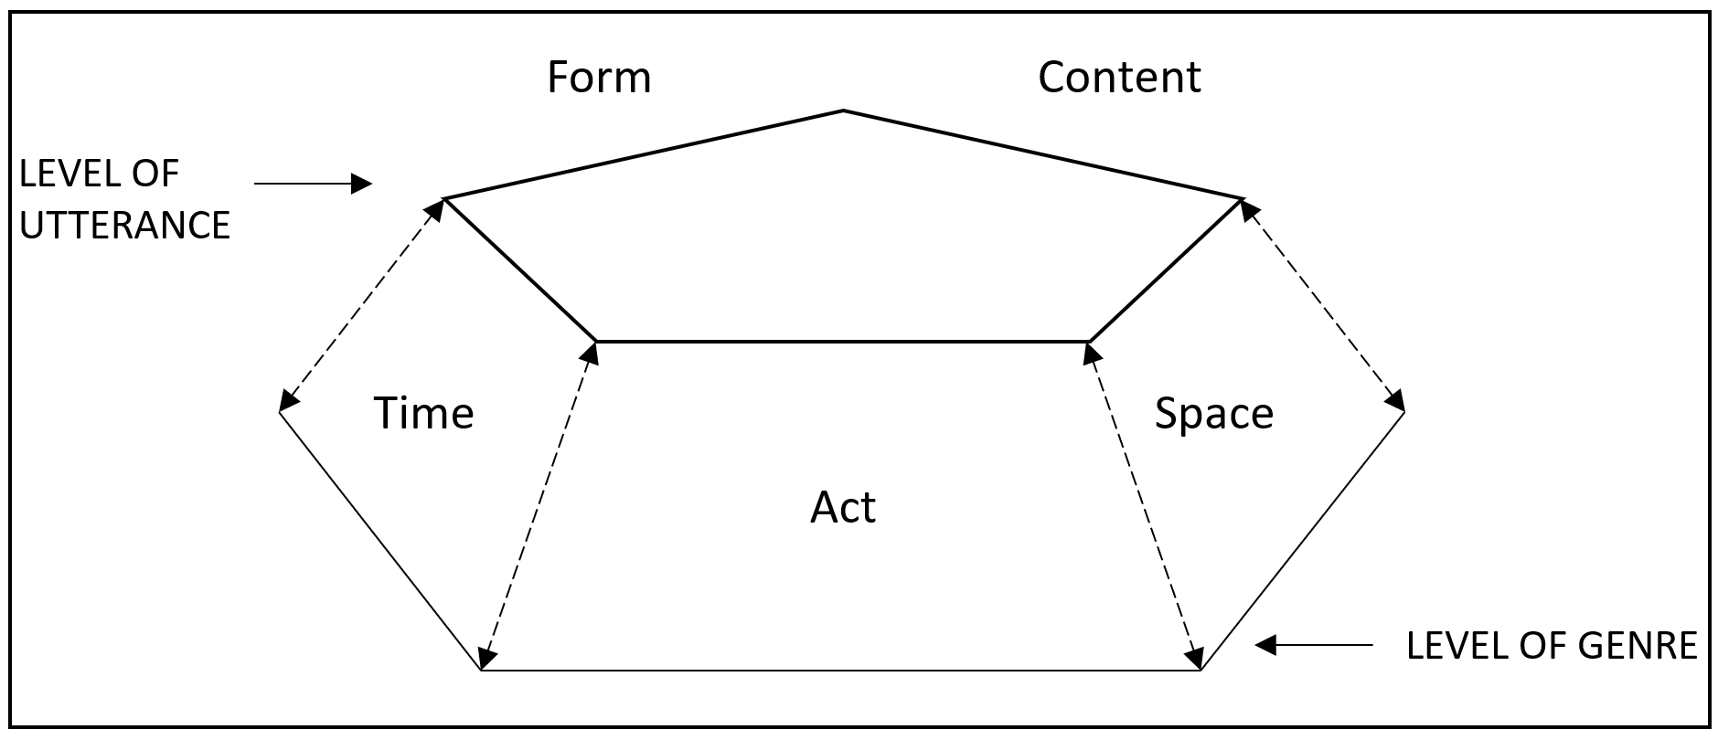
The aim of conceptualising a framework was to "move communicators' (included analysts') attention from genre or from utterance (text) as such to dynamics between them" (Ongstad, 2021, p.103). He recognised the challenges of applying the framework. He accepted the critical fact that it would never solve all the problems in understanding genres but "creates new challenges forcing analysts to validate more specifically and more broadly: any work with or study of genres needs to balance descriptions of the structural form of simple utterances to the risky business of catching complex genres as 'wholes'" (p.103). This framework provides a preliminary insight into the overall parts of a genre, but Ongstad (2021) did not describe each aspect which brings challenges in applying them. Hence, what I did was to try to understand each aspect based on definitions in the study of linguistics, particularly in pragmatics, as discussed in Chapter 2 of this dissertation. In addition, with reference to the Biber Connor Upton (BCU) approach to analysing moves, I propose a set of guiding questions to help learners understand genres existing in authentic environments. The proposed guide applying Ongstad's pentagonal figure is preliminary and would require refinement and further development.
Nonetheless, this application could contribute to the learning of genres in the field of rhetorical genre studies. Table 19 shows a possible application of the guiding questions in the context of examining the genre of a lesson plan by a preschool teacher trainee. It would be ideal to introduce this set of guiding questions as part of a subject or domain knowledge curriculum. The point of application should be determined with close consultation and collaboration with experts in respective domain knowledge and should ideally be introduced with facilitations from the "experts" (Coffelt et al., 2019) of respective vocations and disciplines who had experiences creating and assessing the genres being examined. This guide should be used to facilitate discussions, putting students through the process of understanding a genre through questioning. This approach assumes that students will have access to authentic genres that will serve as samples for their analysis.
The timing to introduce this set of guiding questions is crucial in ensuring the relevance of this approach. Ideally, the learners' responses will be the moves of the genre they were trying to understand within authentic workplace environments. The guide starts with determining the genre's form, space, time and act, inspired by the aspects in Ongstad's pentagonal figure, through the questions under the section "Examine the overall rhetorical purpose, function and context". The second part of the guide examines the content of the genre itself, inspired by the move analysis steps described in the BCU approach in this dissertation. The questions will not use technical words in linguistics, but the choice of words in the guiding questions serves to help direct users of the guide to look at specific aspects of the genre being examined. The students should be encouraged to test their analysis by using it to create more versions of the same genre and comparing the steps identified in the genre being examined with other similar genres (e.g., Lesson plans written for appraisal purposes) written within the same environment.
Table 19
Guiding Questions to Understand a Genre
Questions to Ask | Possible Application
Examine the overall rhetorical purpose, function and context.
What is the function of the text?  - Is it a plan?  - Is it used to adapt to the audience?  - Is it used to express a motive?  - Is it used to respond to a situation?  - Is it used to persuade?  - Is it used to address a contingent issue? | A set of instructions for a lesson observation on the topic “Farm Animals”. The observation will be conducted by my supervisor, for appraisal purposes. Points of observation will be based on the competencies of a preschool teacher specified by the supervisor and the school:  - encourage positive behaviours in learning  - demonstrate creativity in presenting lesson content  - demonstrate the ability to manage a class of children
When will it be presented?  How often will it be presented? | Once a year on a specified date of observation
What is the mode? (Written, spoken, illustrated) | Written
Where will it be presented?  Who are my audiences? | Submission of the plan in a printed word document to my supervisor
Examine the content.
Step 1: How many segments with distinctive functions are there in the content?  Step 2: What are the functions of each segment in the content? Describe them  Step 3: Plot the occurrence of each segment (function) in the content. (E.g., Top, middle or bottom) | There are 3 main segments in the content.  1) Introduce the information of the lesson (top)  The function of this segment is to inform the reader of details of the target audience of the lesson and of the lesson plan itself. The information allows the reader to rationalise the purpose and reasons behind the activities conducted in the lesson.  2) Describing the procedure of the lesson (middle)  The function of this segment is to describe the procedure and details of the teaching activities carried out in the lesson. It reveals the how, what and why of activities conducted in the lesson.  3) Evaluate the outcomes of the lesson (bottom)  The function of this segment is to provide an observational reflection and evaluation of the outcomes of the lesson, generally for the teacher’s professional development. The documentation of this segment aims to provide a replacement teacher with a reference for follow-up lessons and/or the supervisor for mentoring and appraisal purposes.
Step 3: Determine the steps of each segment of the content. Plot the occurrence of each step | 1) Introducing the information of the lesson (top)  - State semester/term of the year of instruction  - State level of instruction  - State the duration of the lesson  - State the topic/theme  - State date of instruction  - Describe the learning area(s) to be accomplished in the lesson  - Describe the materials/tools/applications required for the lesson  2) Describing the procedure of the lesson (middle)  - Describe the objectives of the lesson  - Describe the learning disposition/areas for children  - Describe the procedures and activities  - Describe how to close a lesson.  - Describe the follow-up activities for the lesson  3) Evaluating the outcomes of the lesson (bottom)  - Describe the outcomes of the lesson by recounting children’s responses and actions during the lesson.  - Provide reflections of the teacher who carried out the lesson for the supervisor’s review.

This guide addresses the issue of varied genres in authentic workplaces that make determining what genre to teach literally impossible. However, as reported in the findings of this research, more than the default approach to teaching general communication skills are needed to prepare students to communicate successfully in their eventual working environment. Since it is impossible to cover all genres existing in practice, this guide approaches the teaching of genres from the perspective of teaching students to fish rather than giving them the "fish" to help learners understand any genres they will encounter and ultimately learn to create them. This approach to understanding genres is a crucial implication of the findings and serves as a start to bridging the gap between curriculum and practice.

Lexico-grammatical Features of Genres
Though the lexico-grammatical features of genres were not the main aim of this study, whether to teach grammar explicitly or implicitly in vocational communication subjects has been considered. This aspect of a genre should always be addressed because lexico-grammatical features of a genre can affect the realisation of that genres and determine how effective a created genre is in a communication event. Whether to teach grammar explicitly or implicitly has also been a dispute and a topic of debate amongst language teachers and researchers (Burgess & Etherington, 2002). The location and form of grammar instructions in language acquisition have been discussed and researched for at least 40 years (Ellis, 2001). The subjects of discussion concerning this area are 1) the degree of explicitness such teaching and learning should display and 2) the relationship of grammar-focused learning to learning activities with other foci (Burgess & Etherington, 2002, p.433). Some approaches that attracted many discussions in the teaching of grammar include "Focus on Form" (FonF) (Long, 1991) and "Focus on FormS" (FonFs) (Ellis, 2001). The FonF approach focuses on linguistic elements such as a specific form's function within a communicative activity.
According to Laufer (2006), Long (2001) identified FonF as "incidental" arising only when a learner needs it and hence grammatical forms should not be explicitly introduced. This stand was amended to include "planned FonF designed to elicit specific linguistic forms during a communicative activity" and "a range of techniques, from implicit (e.g., recasts, input enhancement) to more explicit (e.g., an indication that an error has been made, or stating a rule" (Laufer, 2006, p.150). Ellis (2001) opined that the main difference between FonF and FonFs is how learners view themselves and the language they are learning. FonF focuses on teaching the linguistic structures of a language or communicative event sequentially according to the syllabus. Hence, learners view themselves as users of a language regarded as a communication tool. In a FonFs approach, on the other hand, learners view themselves as learners of a language, and the language is "the object of study" (Laufer, 2006, p.150). Loewen (2005) explains that the FonF approach draws learners to focus on linguistic elements that arise incidentally or in pre-planned lessons on communication events and their meaning. The FonFs approach teaches linguistic items separately, in isolation. These separate approaches to language learning are highly related to teaching grammar and vocabulary (Laufer, 2006).
Thus far, based on a review of literature relating to discussions and debates between FonF and FonFs, conclusions appear to be more supportive of the FonF approach, with more criticisms on FonFs to be, as Laufer (2006) described it; "old fashioned, synthetic, unnecessary, and generally ineffective" (p.151). In a recent study by Ebbels et al. (2022) focused on the effects of direct intervention from a speech and language therapist (SLT) teaching course-specific vocabulary versus in-course teaching on bespoke vocabulary measure for adults with language disorders. Their results showed "a stable baseline" (p.1335), with apparent progress witnessed in words targeted in both SLT sessions and lessons. Generally, all tasks yielded improvements with intervention, with a higher performance on verbs and definition recognition tasks but lower on production tasks (p.1335). Though this study focused on learners with language learning disorders, it reveals a possible benefit of implicit intervention and teaching vocabulary.
The findings of lexico-grammatical features of LPs may not be ground-breaking but important. However, the role of authored texts, especially over electronic media such as texting, has increased significantly over the years in the life of youth. Hafner (2009) claims that texting has made its way into the lives of youth today, and physicians and psychologists have reported effects of texting, such as anxiety, distraction in school, failing grades, repetitive stress injury and sleep deprivation. According to Crystal (2008), though there were arguments about the ill effects of texting on literacy, such fears were greatly exaggerated. On the contrary, Crystal suggested that there has been increasing evidence that texting helps literacy. Crystal (2008) opined that texting is “no different from other innovative forms of written expression that have emerged” (p.158) and suggested including a variety of texts in school curricula to support the development of a stronger sense of appropriate use of expression and writing. Though Crystal’s rationale makes some sense, but from my observation of teaching writing and communication skills for the last 10 years, I have noticed a change in students’ writing, with some influences from texting such as the inclusion of the contracted forms “imho” for “In my humble opinion” and “dats” for “that is” in formal writing. Such influences, though from a statistical perspective would be considered few and sporadic, there are merits to place appropriate focus on lexico-grammatical features in the teaching of genres. The awareness of a genre's grammatical structure would bring a learner to their attention of subsequent genres they might encounter in their professional lives.
Lastly, reflecting on the interview responses of my study, all participants expressed the importance of using appropriate vocabulary to portray a professional front. One participant, Kim, raised the necessary changes in vocabulary and expression in English for different roles in the field, such as a classroom teacher versus a vice-principal of a school. Another participant also expressed the usefulness of lists of discipline-related vocabulary for teacher trainees. Hence, if grammar and vocabulary are essential in communicating in specific disciplines, the question would be how they should be taught, which will be discussed next.
A study by Moraitis et al. (2012) was a collaborative project between discipline-specific teachers in community services (CS) and teachers with language and learning expertise (LL) to provide explicit instruction about distinctive language features of disciplinary knowledge. In that study, the CS teachers accepted that they were not experts in language and learning development, and the LL teachers recognised that they were not specialists in the CS discipline. This approach can be applied to the context of this study, where it is a common narrative among the language and learning lecturers (Communication Skills Lecturers) in my department. Moraitis et al. (2012) raised the phenomenon that, generally, discipline-specific teachers are often unaware that "student understanding of such knowledge (discipline) is both accomplished and demonstrated primarily through complex forms of writing" (p.60). Learners were often known to face difficulties in meeting vocational courses' complex reading and writing demands. The difficulties include writing skills essential to be part of specific discipline professional communities and grasping disciplinary knowledge through reading and writing within their training. To address the unresolved "connection between the conceptual and the linguistic demands", (Moraitis et al., 2012, p.59) call for collaboration between language and learning with discipline-specific teachers. According to Moraitis et al. (2012), this collaboration model draws on the concepts of critical literacy (Lankshear, 1997) and the metaphor of a discourse community. They explained how the collaborative project "initiated" sociology students into the "sociological imagination" (p.62) by "drawing on sociological concepts, to question situations or established courses of action that might seem natural, taken for granted, routine or beyond question, and then place these situations in comparative cultural contexts" (p.62). By doing so, sociology theories could be introduced to students to learn to "access sociology as a resource to re-imagine and respond creatively and effectively to issues as community service workers" with sociology as a "collaborative unit to the communication unit, therefore constituted the 'knowledge' that students learn" (p.62). An example of a student's writing showed how their pedagogy brought a student from writing a personal reflection to an exposition of a sociology theory. The students were instructed to reflect on a personal experience, such as "write about your experiences of change within your family", and Moraitis et al. (2012) cited a first draft of writing from a student named Mia.
Those challenges changed my life in a negative way. I started to neglect myself and focus on other things of my life and all my attention was focused on my family. (p.62)
Mia was subsequently introduced to a series of reading activities and instructed to link her reflections with concepts in sociology in a second draft.
“The physical and emotional changes that come with raising children may have a negative effect on women's role in the family. ... child raising is time-consuming, so that her former interests and hobbies are no longer a means to express herself.” (p.62)
This change was brought about by the fact that
"…in the new world of knowledge, she (Mia) was entering, she needed to learn the 'grammar' of that new knowledge. Essentially therefore, rather than originating from notions of a student language deficit, our pedagogy is grounded in the idea that students move into an emerging identity that has more to do with seeing themselves as part of a new discourse community rather than as people struggling with the lexical underpinnings of communication." (p.63)
This approach is consistent with one of the rudimentary beliefs of my study - that students should never be assumed to possess a deficit (Cazden, 2011). The collaborative model between language and learning teachers and discipline-specific teachers suggested by Moraitis et al. (2012) connects discipline-specific concepts with the language demands to acquire them. Based on responses from participants, grammar and vocabulary should be introduced explicitly and implicitly. Participants of this study raised the usefulness of an explicit provision of lists of vocabulary used in early childhood practice in teacher training programmes. The "language" vocational learners must learn is "high-level language” and learning such languages should never be isolated from "participation in a discipline and that the language teacher could not be substituted for the discipline teachers" (Moraitis et al., 2012, p.59) Hence, this supports the importance of including participants of the authentic workplace environments in the communication learning process in vocational training. The FonF approach could realise the explicitness of teaching grammar and vocabulary, and collaborative methods suggested by Moraitis et al. (2012) could be explored to initiate vocational training students into fuller membership and identity of their professional communities.
The preceding chapters have explored and discussed the importance of context in learning to communicate in the workplace. The communication skills required in an individual's work life will change and are highly dependent on the context and motivations existing within specific practices, revealing the importance of situating students' learning within the eventual professional working environments. The findings brought about implications and contributions from this research project, which will be discussed in the closing chapter.

Chapter 6: Conclusion
The findings confirmed the complexities of the transfer of general communications skills across dissimilar contexts. The preschool teacher trainees needed help remembering what they had learned from the fundamental communication subjects they took during their vocational programme. Even if they remembered, they said that the application of general communication skills must be deliberate. It was often incidental or did not happen due to the preschool teachers' hectic schedules. Moreover, the diverse genres in the preschool workplace make it impossible to determine specific writing skills to teach. Hence these are not able to inform the curriculum for communication subjects and activities in vocational training programmes.
Furthermore, preschool practitioners and teacher trainees only partially credit their successful communication moments to their training. Instead, they said they owed their success to learning from their mentors, colleagues and external means outside their formal training. It appears novice preschool teachers had to learn all over again the genres and identify who and where to obtain information to help them master the writing of the genres existing in the field. Learning is continuous throughout a preschool teacher's career, with changes in the roles within professional discourse communities, such as from a classroom teacher to a vice-principal. For these reasons, teaching general communication skills cannot help prepare vocational learners to be successful communicators in their workplace.
Regarding the writing performed in the classrooms and authentic environments, differences were found between the word count, moves and steps of the LPs written by both the preschool practitioners and the teacher trainees. The differences showed that the writing goals of genres would change according to where the writing task is situated. The LPs written by the teacher trainees were to demonstrate their learning and fulfil their vocational training requirements. In contrast, the LPs' goals written by the field practitioners were instrumental and practical. This difference also indicated a gap in the focus of teaching writing in vocational programmes, and I suggest that it will be necessary to bridge this gap.
Furthermore, there is a need to determine an approach to teaching communication skills to connect the conceptual demands of vocational courses with equally essential but often ignored linguistic skills for learning and demonstrating conceptual theories in specific disciplines. The varied nature of genres and the contexts in which they are located makes the common fundamental communication subjects examined in this study irrelevant. This study demonstrated the importance of situating the learning to write for professional purposes within the disciplines in which communication happens because separating them would make any academic interventions or efforts futile.

Limitations of Study
There are three main limitations identified in this study. First, the limited access to authentic lesson plans implicates the applicability of the moves identified from the move analysis in this study. This restricted access to genres can extend to other industries and fields too, where corporations, especially for-profit ones, would likewise have similar regard to genres in the field. The guarded nature of preschools extends to the second limitation of this study, alongside other factors such as the hectic schedules of preschool practitioners and the timing of the collection of data, my access to more interview participants was limited and hence affects the applicability of my findings. As explained in Chapter 1, during the process of data collection, Singapore was in phase 3 of the covid-19 heightened alert and many organisations, including preschools, were functioning at the default arrangement of working from home with only visitors allowed in the school’s premises with reasons identified as necessary for the support of the preschool. This restriction limited my access to the authentic environments this study sought to examine. Lastly, as explained in Chapter 1, it would have been ideal to cover all sectors and fields, but the scope and word count specified for this dissertation, and the extent of work and time required, did not allow space to examine more than one industry in depth.
Furthermore, as doing so would be time-consuming, it would require more than one researcher. However, the underlying premise of my argument is that if the common fundamental communication subjects are deemed "common" and "fundamental", they should address the communication needs of all industries and disciplines they were created for within the institution examined in this study. Hence, if they are irrelevant to the early childhood industry, they should not be considered "common" and "fundamental" communication skills.

Contributions of my Research to the Field
This study seeks to contribute to the research of language competencies for professional purposes in the context of vocational education curricula in Singapore. It aims to suggest a review of the approaches to teaching communication skills, to contributes to the impact of research in curriculum and practice, which currently needs to be looked at, and to highlight how communication skills should be regarded in the context of preparing learners for the workplace. As observed in the context of this study and many institutes of higher learning in Singapore, the default approach towards teaching communication skills is commonly addressed in isolation from disciplines (Smit & Finker, 2022). Furthermore, equally evident in the context of this study, many materials and content creation in ESP subjects were largely impromptu, relying on an intuitive feel in decisions relating to the identification of skills that are likely to "work" (Kuzborska, 2011, p.2). Hence, this study aims to inform the curriculum about the importance of situating learning in the workplace and provide a suggested tool, as proposed in the earlier section, to teach learners how to learn a genre. The application of Ongstad's pentagonal figure in the proposed guide explained in Chapter 5, though it is still at a preliminary stage, has the potential to contribute to the understanding of genres in the field of rhetorical genre studies. The findings aim to contribute critical perspectives to literacies studies in vocational education, highlighting the complexities of acquiring communication skills and dispelling the myth and the common belief that communication skills are a unidimensional ability. In addition, contrary to the findings by Parkinson et al. (2018), the word count of the LPs written by on-campus trainees was less than practitioners in the field. This finding proposed rethinking the common view that writing for functional purposes should typically use fewer words.
This research project has methodological contributions too. The use of Neale's IC method to analyse interview and survey responses using the Excel application brought about a refinement to the method, strengthening the audit trail back to the source by making it more systematic.

Implications and Recommendations
The recommendations proposed in this study suggested regarding the study of genres follow Halliday's theory of functional grammar (Halliday & Matthiessen, 2004), that is, to approach language in its "entirety" (p.19) through understanding aspects of language that contribute to the entire system of a genre. The three proposed ideas, outlined in the previous chapter, could be implemented at the discipline level, where communication lecturers could work on different collaborative projects to incorporate language learning activities within discipline-specific subjects. If the recommendations from this study are accepted, they potentially imply a change in the approach to teaching communication skills, specifically in writing skills. The recommendations could also prompt a review of the scope of communication lecturers' work in the organisation examined in this study. To make the communication skills curriculum relevant to vocational learners, communication lecturers and discipline-specific lecturers should collaborate closely in various projects to determine types of language activities relevant to specific disciplines and plot the timing of language activities during a vocational course. In other words, language activities should be inserted at critical junctures within discipline-specific subjects, providing "common language affordances" (Moraitis et al., 2012, p.60) when a learner needs to 1) use linguistic skills to learn concepts of specific disciplines and 2) demonstrate conceptual ideas of a discipline using linguistic skills. Such collaborations will encourage the learning of not only the knowledge required in respective disciplines but also the language vocational learners need to be successfully initiated into the discipline-specific "imagination" in order to provide the means for students to view the discipline as a "resource for application" (Moraitis et al., 2012, p.62), and ultimately assume the identities of the professional communities of their eventual workplace.
How realistic are the recommendations?
Realistically, the first two recommendations (1. Introduce varied authentic contexts and 2. Compare genres written in varied environments) can be easily implemented. Though they required learners to contribute authentic texts they had access to and were exposed to, many activities can be conducted within the classroom. Regarding recommendation 3, Learn to learn genres, this approach requires cross-disciplinary collaboration between language teachers and domain experts. Implementing cross-disciplinary collaboration is coincidentally possible as the institution of this study advocates such forms of working across all departments and schools. However, this recommendation can also face resistance, especially from my understanding of the profile of communication lecturers who might not be too receptive to changes. However, based on an observation of recent changes in the developments of the Singapore education scene, the Singapore government is redefining the longstanding internalisation of the abuse of the term meritocracy (Chew, 2023). Thus, hopes for a change, such as recommendation 3, is not too unrealistic compared to the redefinition of the narrative about learning and achievement as it is a radical change in the context of the Singapore society. The government's attempt to redefine meritocracy and learning can alter how educators in the country view their role in the teaching and learning of today's learners, pushing them to embrace change and not be complacent.

Future Directions
The recommendations are at the proposal stage and need to be trialled and refined. The proposed guiding questions were created based on the literature examined, and conclusions from the findings surfaced in this study. It would be good to pilot those guiding questions in various disciplines to ensure their applicability across different contexts. There might be a need to create various versions of the guiding questions due to the diversity of possible characteristics of genres existing in respective disciplines. Hence, this can only be determined by trialling this proposed set of guiding questions in as many disciplines and contexts as possible. The trial of those guiding questions should also be complemented by teaching communication lecturers how to use the tool to facilitate lessons on how to learn a genre. This is a critical process to ensure better applicability of the findings of this study and expand the investigation of existing authentic genres to more fields beyond the early childhood industry.
The investigations should not only seek to enquire about the list of genres existing in respective industries but also to determine the differences between curriculum and practice. The findings of this study showed a higher word count in the preschool practitioners' LPs compared to the teacher trainees' LPs. This difference is contrary to the higher word count found in on-campus trainee carpenters' writing versus in-practice apprentices, as examined by Parkinson et al. (2018). Findings from Parkinson et al. (2018) and my study confirm the difference in the word count and moves between writing situated in vocational programmes and practice. This finding confirms the teaching of genres to be situated in authentic contexts. However, my study, which obtained a higher word count for practitioners, prompted further questions on the implications and significance of the number of words written in genres when situated in practice and on campus. Parkinson et al. (2018) posit that though it is essential to teach the moves of a genre, it is equally important for learners of the genre to know how to realise them. The difference in the word count and moves can implicate the realisation of a genre (Halliday, 2009, p.62). Awareness of the differences can inform the curriculum of language used in realising genres. Hence, it raises the need to investigate the differences in word count and moves of genres in other industries, such as the design brief in the design discipline and laboratory reports in the applied science discipline. This investigation is necessary to ensure the relevance of communication-related curricula in vocational education.

Final Thoughts
This investigation was prompted by doubts about the existing approaches to teaching communication skills with the launch of the fundamental communication subjects examined in this study. This investigation showed the importance of specificity in teaching communication and language skills for professional purposes. Though participants in this study see merits in learning general communication skills, the findings also showed that communication skills, specifically related to their field of practice, cannot be intuitively determined and should be informed by authentic communication contexts. The learning of communication skills for the workplace should be connected to authentic environments located in the workplace. The role of language and learning teachers in providing language affordances in learning specific disciplines is crucial in ensuring vocational learners are initiated to use the language of and communicate as members in their respective professional communities of practice. Language learning for professional purposes should never be isolated from disciplines because any efforts to understand professional communication should be discovered within the contexts where professional communication happens. Only then can we genuinely say that efforts to teach communication skills in vocational training programmes will "better equip… students with the core skills and attributes that will help them succeed in the workforce of the future" (Staff Communication, July 2017).

References
12 Teacher terms demystified. (n.d.). National Association for the Education of Young Children. https://www.naeyc.org/our-work/families/12-teacher-terms-demystified
Austen. I. (2006). The comma that costs 1 million dollars (Canadian). The New York Times. https://www.nytimes.com/2006/10/25/business/worldbusiness/25comma.html
Austin, J. L. (1975). How to do things with words: The William James lectures delivered at Harvard University in 1955. (Lectures I, II) 10.1093/acprof:oso/9780198245537.003.0002
Baartman, L. K. J., & Middleton, H. (2013). Transfer, transitions and transformations of learning (1st ed. 2013.). Sense Publishers
Basturkmen, H. (2005). Ideas and options in English for specific purposes. Taylor & Francis Group. RELC journal, 34(1), 48-63. 10.1177/003368820303400104
Basturkmen, H. (2003). Specificity and ESP Course Design. RELC Journal, 34(1), 48–63. https://doi.org/10.1177/003368820303400104
Bazerman, C., Bonini, A., & Figueiredo, D. de C. (2009). Genre in a changing world. The WAC Clearinghouse: Parlor Press.
Berger, R. (2015). Now I see it, now I don’t: Researcher’s position and reflexivity in qualitative research. Qualitative Research, 15(2), 219-234. 10.1177/1468794112468475
Belcher, D. (2006). English for specific purposes: Teaching to perceived needs and imagined futures in worlds of work study, and everyday life. Tesol Quarterly, 40(1), 133-156.
Bell, J., and Waters, S. (2014) Doing your research project: A guide for first-time researchers in education, health and social science (6th ed.). McGraw-Hill Education.
Bhattacharya, S. (2021, June 24). View: Covid-19 has changed the way we communicate. The Economics Times. https://economictimes.indiatimes.com/opinion/et-commentary/view-covid-19-has-changed-the-way-we-communicate/articleshow/84711008.cms
Bhatia, V. K. (2017). Critical genre analysis: Investigating interdiscursive performance in professional practice. Routledge.
Bhatia, V. K. (2008). Genre analysis, ESP and professional practice. English for Specific Purposes, 27, 161-174. doi:10.1016/j.esp.2007.07.005
Bhatia, V. K. (2004). Worlds of written discourse: A genre-based view. (1st ed.). Bloomsbury Publishing Plc.
Bhatia, V. K. (1997). Introduction: Genre Analysis and World Englishes. World Englishes, 16(3), 313–319. https://doi.org/10.1111/1467-971X.00066
Biber, D., Connor, Ulla, & Upton, Thomas A. (2007). Discourse on the move: Using corpus analysis to describe discourse structure. John Benjamins Pub. Co.
Bjurulf, V. (2013). Transfer as an iterative process between school and work. In L. K. J. Baartman, & H. Middleton (Eds.), Transfer, transitions and transformations of learning (1st ed. 2013.). SensePublishers
Boyer, S. L., Edmondson, D. R., Artis, A. B., & Fleming, D. (2014). Self-Directed Learning. Journal of Marketing Education, 36(1), 20–32. https://doi.org/10.1177/0273475313494010
Bramer, W. M., Rethlefsen, M. L., Kleijnen, J., & Franco, O. H. (2017). Optimal database combinations for literature searches in systematic reviews: A prospective exploratory study. Systematic Reviews, 6(1), 245–245. https://doi.org/10.1186/s13643-017-0644-y
Bremner, S., & Ban Phung. (2015). Learning from the experts: An analysis of résumé writers' self-presentation on LinkedIn. IEEE Transactions on Professional Communication, 58(4), 367–380. https://doi.org/10.1109/TPC.2016.2519319
Bremner, S. (2012). Socialization and the acquisition of professional discourse: A case study in the PR industry. Written Communication, 29(1), 7–32. 10.1177/0741088311424866
Browne, K. (2005). Snowball sampling: using social networks to research non-heterosexual women. International Journal of Social Research Methodology, 8(1), 47–60. https://doi.org/10.1080/1364557032000081663
Burgess, J., & Etherington, S. (2002). Focus on grammatical form: Explicit or implicit? System, 30(4), 433-458. https://doi.org/info:doi/
Butler, C. (2009). Criteria of adequacy in functional linguistics. Folia Linguistica 43(1), 1-66. https://doi-org.sheffield.idm.oclc.org/10.1515/FLIN.2009.001
Carey, J., & Adam, G. S. (2008). Communication as culture, Revised Edition : Essays on Media and Society. (2nd ed.). Taylor & Francis Group.
Cazden, C. B. (2011). Dell Hymes's Construct of "Communicative Competence" Anthropology & Education Quarterly, 42(4), 364–369. https://doi.org/10.1111/j.1548-1492.2011.01144.x
Chan, C. S. (2021). University graduates’ transition into the workplace: How they learn to use English for work and cope with language-related challenges. System, 100, 102530. https://doi.org/10.1016/j.system.2021.102530
Chew Hui Min. (2023, April 17). Singapore concept of meritocracy too narrow, need to refresh mindset on schools and grades: DPM Wong. Channel News Asia. https://www.channelnewsasia.com/singapore/new-social-compact-key-shifts-education-meritocracy-seniors-lawrence-wong-3422931
Chilton, P. (2003). Analysing political discourse: Theory and practice. Taylor & Francis Group. https://ebookcentral.proquest.com/lib/sheffield/detail.action?docID=200368
Chong Zi Liang. (2015, February 23). Singapore Budget 2015: Every Singaporean above 25 to get $500 for a start under SkillsFuture. The Straits Times. https://www.straitstimes.com
Chong, S., Loh, W. M., & Babu, M. (2015). The millennial learner: A new generation of adult learners in higher education. Advances in Scholarship of Teaching and Learning, 2(2). https://tlc.suss.edu.sg/research/AdvSoTL-3/pdf/chong_loh_babu.pdf
Ciornei, S. I., & Dina, T. A. (2015). Authentic texts in teaching English. Procedia – Social and Behavioral Sciences, Romania, 180, 274-279. 10.1016/j.sbspro.2015.02.116
Coffelt, T. A., & Smith, F. L. M. (2020). Exemplary and Unacceptable Workplace Communication Skills. Business and Professional Communication Quarterly, 83(4), 365–384. https://doi.org/10.1177/2329490620946425
Coffelt, T. A., Grauman, D., & Smith, F. L. M. (2019). Employers’ perspectives on workplace communication skills: The meaning of communication skills. Business and Professional Communication Quarterly, 82(4), 418-439. 10.1177/2329490619851119
Cohen, L. (1970). Searle's theory of speech acts. The Philosophical Review, 79(4), 545–557. https://doi.org/10.2307/2184294
Collins. (n.d.). Discourse. Retrieved April 28, 2022, from https://www.collinsdictionary.com/dictionary/english/discourse
Cooren, F., & Seidl, D. (2020). Niklas Luhmann’s Radical Communication Approach and Its Implications for Research on Organizational Communication. The Academy of Management Review, 45(2), 479–497. https://doi.org/10.5465/amr.2018.0176
Cornford, I. (2005). Challenging current policies and policy makers' thinking on generic skills. Journal of Vocational Education & Training, 57(1), 25–45. https://doi.org/10.1080/13636820500200273
Crotty, M. (1998). The foundations of social research: Meaning and perspective in the research process. Sage Publications.
Crystal, D. (2008). A dictionary of linguistics and phonetics (6th ed.). Blackwell.
Crystal, D. (2008). Txtng [electronic resource]: the Gr8 Db8. Oxford University Press.
Darling-Hammond, L. (2010). Teacher Education and the American future. Journal of Teacher Education, 61(1-2), 35–47. https://doi.org/10.1177/0022487109348024
Darling-Hammond, L. (2006). Constructing 21st century teacher education. Journal of Teacher Education, 57(3), 300-314. 10.1177/0022487105285962
De Vaus, D. A., Kidd, S., & Shaw, D. (2014). Surveys in social research (Sixth edition.). Routledge
Dearnley, C. (2005). A reflection on the use of semi-structured interviews. Nurse Researcher, 13(1), 19–28. https://doi.org/10.7748/nr2005.07.13.1.19.c5997
Derewianka, B. (2003). Trends and issues in genre-based approaches. RELC Journal, 34(2), 133-154. https://doi.org/10.1177/003368820303400202
Dewey, J. (1938). Experience and education. Macmillan.
Dias, P., Freedman, A., & Medway, P. (1999). Worlds apart: Acting and writing in academic and workplace contexts. Taylor & Francis Group.
Dodgson, J. E. (2019). Reflexivity in Qualitative Research. Journal of Human Lactation, 35(2), 220–222. https://doi.org/10.1177/0890334419830990
Douglas, D. (2001). Language for Specific Purposes assessment criteria: Where do they come from? Language Testing, 18(2), 171-185. 10.1177/026553220101800204
Dudley-Evans, T., & St John, M. J. (1998). Developments in English for specific purposes: A multi-disciplinary approach. Cambridge University Press.
Dummett, M. (1993). The seas of language [electronic resource]. Clarendon.
Early Childhood Development Agency. (2023). Who we are. https://www.ecda.gov.sg/who-we-are
Early Childhood Development Agency. (2022). Statistics & Reports: Statistics on ECDE services. https://www.ecda.gov.sg/Operators/Pages/Statistics-n-Reports.aspx
Early Childhood Development Agency. (2021-a). Parent: Choose a child care centre (Anchor Operator Scheme & Partner Operator Scheme). https://www.ecda.gov.sg/parents/Pages/Default.aspx
Early Childhood Development Agency. (2021-b). Parent: Overview of PSE. https://www.ecda.gov.sg/parents/Pages/Default.aspx
Ebbels, S. H., Bannister, L., Holland, B., & Campbell, L. (2022). Effectiveness of intervention focused on vocational course vocabulary in post‐16 students with (developmental) language disorder. International Journal of Language & Communication Disorders, 57(6), 1334–1353. https://doi.org/10.1111/1460-6984.12758
Ellis, R. (2001). Introduction: Investigating Form-Focused Instruction. Language Learning, 51(s1), 1–46. https://doi.org/10.1111/j.1467-1770.2001.tb00013.x
Farkas. (1999). The Logical and Rhetorical Construction of Procedural Discourse. Technical Communication (Washington), 46(1), 42–54.
Flowerdew, J. (1990). English for specific purposes – A selective review of the literature. ELT Journal, 44(4), 326-337. https://academic.oup.com/eltj
Flowerdew, J., & Wan, A. (2010). The linguistic and the contextual in applied genre analysis: The case of the company audit report. English for Specific Purposes, 29(2), 78–93. https://doi.org/10.1016/j.esp.2009.07.001
Freedman, A., & Adam, C. (1996). Learning to Write Professionally. Journal of Business and Technical Communication, 10(4), 395–427. https://doi.org/10.1177/1050651996010004001
Fuller, A., & Munro, A., & Rainbird, H. (2004). Workplace learning in context. Routledge.
Galletta, A., & Cross, William E. (2013). Mastering the Semi-Structured Interview and Beyond : From Research Design to Analysis and Publication. New York University Press.
Gee, J. P. (2014). How to do discourse analysis: A toolkit (Second edition.). Routledge.
Glossary of statistical terms: New economy (2004). https://stats.oecd.org/glossary/detail.asp?ID=6267
González. M. Á. G., Ibáñez. F. J. R. M., Gonzálvez-García. F., & Downing, A. (2014). Functional Perspective on Language and Discourse : Applications and implications. John Benjamins Publishing Company.
Göpferich, S., & Neumann, I. (2016), Developing and assessing academic and professional writing skills – An Introduction (pp. 7-13). Forum Angewandte Linguistik. https://www.peterlang.com/view/9783653960488/Fm01.xhtml#ch1
Grande, B., Leishman, C. D., & Skilleå, G. K. (2022). “I can’t come to the words”: Effects of including military flavour when testing the oral proficiency of Norwegian joint terminal attack controllers. English for Specific Purposes, 68, 73-86. https://doi.org/10.1016/j.esp.2022.07.001
Grice, H. P., & American Council of Learned Societies. (1991). Studies in the way of words [electronic resource] (1st Harvard University Press pbk. ed.). Harvard University Press.
Hafner, K. (2009). Texting May Be Taking a Toll. The New York Times.
Hager, P., Holland, S. & Beckett, D. (2002). Enhancing the learning and employability of graduates: The role of generic skills. Retrieved from the Business/Higher Education Round Table website: http://www.bhert.com/publications/position-s/B-HERTPositionPaper09.pdf
Hall, S. (1992). The West and the Rest: Discourse and Power. In Hall, S., & Gieben, B. (Eds.). Formations of modernity (pp. 276-330). Cambridge: Polity Press.
Hall, S., & University of Birmingham. Centre for Contemporary Cultural Studies. (1973). Encoding and decoding in the television discourse: paper for the Council of Europe Colloquy on "Training in the Critical Reading of Television language". Birmingham University.
Halliday, M. A. K. (2009). Methods – techniques – problems. In M. A. K. Halliday, & J. J. Webster (Eds.), Bloomsbury companion to Systemic Functional Linguistics (1st ed., pp. 1-11). Bloomsbury Publishing Plc.
Halliday, M. A. K., & Matthiessen, C. M. I. (2004). An introduction to functional grammar. Routledge.
Hargie, O. (2006). The handbook of communication skills (3rd ed.). Routledge.
Hora, M. T., Smolarek, B. B., Martin, K. N., & Scrivener, L. (2019). Exploring the Situated and Cultural Aspects of Communication in the Professions: Implications for Teaching, Student Employability, and Equity in Higher Education. American Educational Research Journal, 56(6), 2221–2261. https://doi.org/10.3102/0002831219840333
Hutchinson, T., & Waters, A. (1987). English for specific purposes: A learning-centered approach. Cambridge University Press.
Hyland, K. (2002a). Specificity revisited: How far should we go now? English for Specific Purposes. 21, 385-395. https://doi.org/10.1016/S0889-4906(01)00028-X
Hyland, K. (2002b). 6. Genre: Language, context, and literacy. Annual Review of Applied Linguistics, 22, 113–135. https://doi.org/10.1017/S0267190502000065
Hyland, K., & Shaw, P. (2016). The Routledge handbook of English for academic purposes (Routledge handbooks in applied linguistics). Routledge.
Hyland, K. (1998). Hedging in Scientific Research Articles. John Benjamins Publishing Company.
Hymes, D (1971) On communicative competence in J. B. Pride and J. Holmes (eds) (1972) Sociolinguistics. Penguin.
Hyon, S. (2018). Introducing genre and English for specific purposes. Routledge.
Imtihani, N. (2010). Genre Analysis in the frame of systemic functional linguistics. Humaniora, 22(1), 86-93. https://media.neliti.com/media/publications/11856-ID-genre-analysis-in-the-frame-of-systemic-functional-linguistics.pdf
Jablonkai, R. (2010). English in the context of European integration: A corpus-driven analysis of lexical bundles in English EU documents. English for Specific Purposes, 29(4), 253-267. https://doi.org/10.1016/j.esp.2010.04.006
Jesson, J. K., Matheson, L., and Lacey, F. M. (2011) Doing your literature review: Traditional and systematic techniques. Sage Publication Ltd.
Johns, A. M. (2012). The history of English for specific purposes research. In B. Paltridge & S. Starfield (Eds.), Genre and English for specific purposes (pp. 5-30). John Wiley and Sons.
Johns, A., & Dudley-Evans, T. (1991). English for Specific Purposes: International in Scope, Specific in Purpose. TESOL Quarterly, 25(2), 297-314. 10.2307/3587465
Koester, A. (2012). Workplace discourse. Bloomsbury Publishing Plc. https://www.bloomsbury.com/us/
Korta, K., & Perry, J. (2008). The pragmatic circle. Synthese, 165(3), 347-357. https://doi.org/10.1007/s11229-007-9188-3
Kuzborska, I. (2011). Teachers’ decision-making processes when designing EAP reading materials in a Lithuanian university setting. Journal of English for Academic Purposes, xxx, 1-15. 10.1016/j.jeap.2011.07.003
Langager, C. (2020, August 07). Industry vs. Sector: What’s the difference? Investopedia. https://www.investopedia.com/ask/answers/05/industrysector.asp
Lankshear, C. (1997). Changing literacies. Open University Press.
Lather, P. (1986). Research as praxis. Harvard Educational Review, 56(3), 257-278. https://doi.org/10.17763/haer.56.3.bj2h231877069482
Laufer, B. (2006). Comparing Focus on Form and Focus on FormS in Second-Language Vocabulary Learning. Canadian Modern Language Review, 63(1), 149–166. https://doi.org/10.1353/cml.2006.0047
Anthony, L. (2004). AntConc: A learner and classroom friendly, multi-platform corpus analysis toolkit. An Interactive Workshop on Language e-Learning, 7-13. https://www.laurenceanthony.net/research/iwlel_2004_anthony_antconc.pdf
Leedy, P. D., & Ormrod, J. E. (2015). Practical research [electronic resource] : planning and design. (Eleventh edition. / Paul D. Leedy and Jeanne Ellis Ormrod.; Global edition.). Pearson.
Leitner, G. (1992). New directions in English language corpora [electronic resource]: methodology, results, software developments (Reprint 2011.). Mouton de Gruyter.
Lim, L. (2004). Singapore English: A grammatical description. (1st ed.). John Benjamins Publishing Company.
Living normally, with Covid-19: Task force ministers on how S'pore is drawing road map for new normal. (2021, June 24). The Straits Times. https://www.straitstimes.com/opinion/living-normally-with-covid-19
Lobdell, R. (2021, March 9). One year later: 15 ways life has changed since the onset of the COVID pandemic. Fortune. https://fortune.com/2021/03/09/covid-pandemic-how-life-has-changed-coronavirus-one-year-later-march-2020/
Lockwood, J. (2012). Developing an English for specific purpose curriculum for Asian call centres: How theory can inform practice. English for Specific Purposes, 31, 14-24. 10.1016/j.esp.2011.05.002
Loewen, S. (2005). Incidental focus on form and second language learning. Studies in Second Language Acquisition, 27(3), 361-386. doi:10.1017/S0272263105050163
Long, M. H. (1991). Focus on Form: A design feature in language teaching methodology. In K. de. Bot, R. B. Ginsberg, & C. Kramsch (Eds.), Foreign Language Research in Cross-Cultural Perspective. (1st ed.). John Benjamins Publishing Company.
Longman. (n.d. -a). Discourse. Retrieved April 28, 2022, from https://www.ldoceonline.com/dictionary/discourse
Loo, J. (n.d.). Singapore Polytechnic. Singapore Infopedia. https://eresources.nlb.gov.sg/infopedia/articles/SIP_2019-04-15_102439.html
Luhmann, N. (1992). What is Communication? Communication Theory, 2(3), 251–259. https://doi.org/10.1111/j.1468-2885.1992.tb00042.x
Malnic, E. (1990). Avianca pilot disputes need to use specific emergency terms. Los Angeles Times. https://www.latimes.com/archives/la-xpm-1990-06-22-mn-109-story.html
Martin, J. R. (2009). Genre and language learning: A social semiotic perspective. Linguistics and Education, 20(1), 10–21. https://doi.org/10.1016/j.linged.2009.01.003
Martin, J. R. (1985). Process and text: Two aspects of human semiosis. Systemic perspectives on discourse, 1(15), 248-274. Ablex Pub. Corp.
Martin, J. R. (1984). Language, register and genre. In F. Christie (Ed.), Children Writing: Reader (pp. 21-29). Deakin University Press.
Martin, J. R., & Rose, D. (2008). Genre relations: Mapping Culture. Equinox Pub. https://www.equinoxpub.com/home/genre-relations-mapping-culture-jr-martin-david-rose/
McCarthy, M. (2004). Touchstone: From corpus to course book. Cambridge University Press. http://www.cambridge.org
McEnery, T., Xiao, R., Tono, Y. (2006). Corpus-Based Language Studies: An Advanced Resource Book. Routledge, Taylor & Francis Group
McKay, M., Davis, M., & Fanning, P. (2018). Messages : The Communications Skills Book. (4th ed.). New Harbinger Publications.
McQuail, D. (2013). The media audience: A brief biography – Stages of growth or paradigm change? The Communication Review, 16(1-2), 9-20. https://doi.org/10.1080/10714421.2013.757170
Miller, C. R. (1984). Genre as social action. Quarterly Journal of Speech, 70(2), 151-167. 10.1080/00335638409383686
Mills, S. (2004). Discourse. Taylor & Francis Group.
Ministry of Education. (n.d. -a). About MOE: Our organisation structure. https://www.moe.gov.sg/about-us/organisation-structure
Ministry of Education. (n.d.-b). Post-secondary education: Pursuing pathways that fit your interests, abilities and aspirations. [PDF document] https://www.moe.gov.sg/-/media/files/post-secondary/post-secondary-school-booklet-2021.pdf?la=en&hash=398E972A115C7B31311A8D75EAC3748924D6FD3C
Ministry of Manpower. (n.d.-a). Refreshed continuing education and training (CET) Masterplan. https://www.mom.gov.sg/employment-practices/skills-training-and-development/refreshed-cet-masterplan
Ministry of Manpower. (n.d.-b). New statutory boards to sharpen focus on skills and employment. [Press release]. https://www.mom.gov.sg/newsroom/press-releases/2016/0112-new-statutory-boards-to-sharpen-focus-on-skills-and-employment
Ministry of Social and Family Development. (2021, 5 May). Updated safe management measures in preschools and early intervention centres to minimise transmission. https://www.msf.gov.sg/media-room/Pages/Updated-Safe-Management-Measures-in-Preschools-and-Early-Intervention-Centres-to-Minimise-Transmission.aspx
Ministry of Trade and Industry. (n.d.). Industry Transformation Maps - Overview. https://www.mti.gov.sg/ITMs/Overview
Ministry of Trade and Industry. (2016). Industry Transformation Maps [media release]. https://www.mti.gov.sg/-/media/MTI/ITM/General/Industry-Transformation-Maps_v13.pdf
Mizrahi, J. (2015). Writing for the workplace : Business communication for professionals (First edition.). Business Expert Press.
Moraitis, P., Carr, A., & Daddow, A. (2012). Developing and sustaining new pedagogies: A case for embedding language, literacy and academic skills in vocational education curriculum. International Journal of Training Research, 10(1), 58–72. https://doi.org/10.5172/ijtr.2012.10.1.58
Moreno, A. I., & Swales, J. M. (2018). Strengthening move analysis methodology towards bridging the function-form gap. English for Specific Purposes, 50, 40-63. https://doi.org/10.1016/j.esp.2017.11.006

Morgan, D. L., & Nica, A. (2020). Iterative thematic inquiry: A new method for analyzing qualitative data. International Journal of Qualitative Methods, 19, 160940692095511. https://doi.org/10.1177/1609406920955118
Neale, J. (2016). Iterative categorization (IC): a systematic technique for analysing qualitative data. Addiction (Abingdon, England), 111(6), 1096–1106. https://doi.org/10.1111/add.13314
Nissi, R., Blåsjö, M., & Jonsson, C. (2021). Workplace communication in flux: From discrete languages, text genres and conversations to complex communicative situations. Applied Linguistics Review. https://doi.org/10.1515/applirev-2021-0052
Nurturing Early Learners. (n.d.). Teaching and learning. https://www.nel.moe.edu.sg/teaching-and-learning/learning-dispositions/perseverance
Oliver, P. (2012). Succeeding with your literature review: A handbook for students. McGraw-Hill Open University Press.
Ongstad, S. V. (2021). Genre constituents in “Reflections on genre as social action” – in the light of 1980s’ genre research? Discourse and Writing/Rédactologie, 31(1), 86–108. https://doi.org/10.31468/dwr.857
Ostrom, C. M. (2013). UW must pay family $15M for error that left daughter disabled. The Seattle Times. https://www.seattletimes.com/seattle-news/uw-must-pay-family-15m-for-error-that-left-daughter-disabled/
Otsuji, Emi; Pennycook, A. (2010). Metrolingualism: Language in the city. Routledge
Oxford Learner’s Dictionary. (n.d. -a). Discourse. Retrieved April 28, 2022, from https://www.oxfordlearnersdictionaries.com/definition/english/discourse_1?q=discourse
Paltridge, B. (2017). The discourse of peer review: Reviewing submissions to academic journals (1st Ed. 2017.). Palgrave Macmillan UK. https://doi.org/10.1057/978-1-137-48736-0
Paltridge, B. (2012). Genre and English for Specific Purposes. In B. Paltridge & S. Starfield (Eds.), The handbook of English for specific purposes (Chapter 18, pp. 347-366). 10.1002/9781118339855.ch18
Parkinson, J., Watterson, C., & Whitty, L. (2022). Constructing arguments in engineering student case studies. English for Specific Purposes, 68, 14-30. https://doi.org/10.1016/j.esp.2022.05.002
Parkinson, J., Mackay, J., & Demecheleer, M. (2018). Situated learning in acquisition of a workplace genre. Vocations and Learning, 11, 289-315. 10.1007/s12186-017-9191-x
Pennycook, A. (2010). Language as a local practice. (1st ed.). Taylor & Francis Group.
Pennycook, A. (1994). The cultural politics of English as an international language. Routledge.
Platt, J. T. (1980). Varieties and functions of English in Singapore and Malaysia. English World-Wide, 1(1), 97–121. https://doi.org/10.1075/eww.1.1.08pla
Pöckl, W. (1996). Cultural differences in academic rhetoric: a textlinguistic study [Review of Cultural differences in academic rhetoric: a textlinguistic study]. Multilingua, 15(2), 220–221.
Pritchard, Alan, & Woollard, John. (2010). Psychology for the classroom: constructivism and social learning. Routledge.
Procter, J. (2004). Stuart Hall. Taylor & Francis Group
Public Service Devision. (n.d.). Frequently asked questions. https://www.ifaq.gov.sg/PSD/apps/fcd_faqmain.aspx?qst=hRhkP9BzcBKnt75r%2Bl1bopmAANxUYJsZ1XtCavhh%2Bg8uifs%2FSSJBsG%2F2RHXVN6h2hkMNZZuwoe%2BhHSB6HH1irDq0OEDDvtDNDb7VkugzZ4susqYLgHjPSrdP2ZF16Cy0txUiBGwHBwpeYJER2TzO1B3CtQzqBx%2Bs#FAQ_34345
Punch, K. (2003). Survey research: The basics. SAGE.
Reiff, M. J., & Bawarshi, A. (2011). Tracing discursive resources: How students use prior genre knowledge to negotiate new writing contexts in first-year composition. Written Communication, 28(3), 312–337. https://doi.org/10.1177/0741088311410183
Rollnick, S., Kinnersley, P., & Butler, C. (2002). Context-bound communication skills training: Development of a new method. Medical Education, 36(4), 377-383. https://doi.org/10.1046/j.1365-2923.2002.01174.x
Rose, D. (2021). Reading metaphor: Symbolising, connoting and abducing meanings. Linguistics and Education, 64, 100932. https://doi.org/10.1016/j.linged.2021.100932
Rounsaville, A., Goldberg, R., & Bawarshi, A. (2008). From incomes to outcomes: FYW students’ prior genre knowledge, meta-cognition, and the question of transfer. WPA: Writing Program Administration, 32, 97-112. Retrieved from http://www.wpacouncil.org/archives/32n1/32n1rounsaville-goldberg-bawarshi.pdf
Schegloff, E. A. (1991). Conversation analysis and socially shared cognition. In L. B. Resnick, J. M. Levine, & S. D. Teasley (Eds.), Perspectives on socially shared cognition (pp. 150–171). American Psychological Association. https://doi.org/10.1037/10096-007
Schiffrin, D., Tannen, D., & Hamilton, H. E. (2003). The Handbook of Discourse Analysis. (1st ed.). John Wiley & Sons, Incorporated.
Schmidt, S. J. (2003). Histories and discourses: An integrated approach to communication science. In C. B. Grant (Ed.). Rethinking communicative interaction: An interdisciplinary programme (Vol.116). John Benjamins Publishing Company.
Schneider, E. W. (2007). Postcolonial English: Varieties around the world. Cambridge University Press.
Searle, J. R. (1989). How performatives work. Linguistics and Philosophy, 12(5), 535–558. http://www.jstor.org/stable/25001359
Searle, J. R. (1975). A taxonomy of illocutionary acts. In K. Gunderson (Ed.), Language, Mind and Knowledge (pp.344-369). University of Minnesota Press.
Searle, J. R. (1968). Austin on locutionary and illocutionary Acts. The Philosophical Review, 77(4), 405–424. https://doi.org/10.2307/2183008
Sinclair, J. (1991). Corpus, concordance, collocation. Oxford University Press.
SkillsFuture. (n.d.-a). About SkillsFuture. https://www.skillsfuture.gov.sg/AboutSkillsFuture
SkillsFuture. (n.d.-b). Overview of generic skills and competencies. file:///C:/Users/jangyuan/Downloads/SF%20GSC.PDF
SkillsFuture. (2016). Early Childhood Care and Education: Facts and Figures. https://www.myskillsfuture.gov.sg/content/student/en/secondary/world-of-work/industry-landscape/industry-detail.Early-Childhood-Care-and-Education-11394.html#:~:text=As%20of%20May%202016%2C%20there,next%20two%20to%20three%20years.&text=There%20are%203%20career%20tracks%20covering%2013%20occupations%20in%20the%20ECCE%20industry.
Smit, U., & Finker, T. (2022). Topicalizing language in CLIL teaching at technical colleges: A micro-level analysis of language-related episodes (LREs). English for Specific Purposes, 68, 102-115. https://doi.org/10.1016/j.esp.2022.07.004
Stefani, E. D., & Horlacher, A. (2018). Mundane talk at work: Multiactivity in interactions between professionals and their clientele. Discourse Studies, 20(2), 221-245. https://doi.org/10.1177/1461445617734935
Swales, J. M. (1990). Genre analysis: English in academic and research settings. In M. H. Long & J. C. Richards (Series Ed.). The Cambridge applied linguistics series. Cambridge University Press.
Temasek. (2017). Industry 4.0: Tomorrow’s manufacturing starts today. https://www.temasek.com.sg/en/index
Teng, A. (2018, July 2). SkillsFuture, four years on. The Straits Times. https://www.straitstimes.com
Tognini-Bonelli, E. (2001). Corpus linguistics at work. John Benjamins Publishing Company.
Tranfield, D., Denyer, D., & Smart, P. (2003). Towards a Methodology for Developing Evidence-Informed Management Knowledge by Means of Systematic Review. British Journal of Management, 14(3), 207–222. https://doi.org/10.1111/1467-8551.00375
Trosborg, A. (1997). Text typology and translation. John Benjamins Publishing Company.
Tzuo, Per-Wen., Yong, F. L., Tan, L. S., & Liang, Jyh-Chong. (2015). Teachers’ versus parents’ perceptions of professionalism of early childhood teachers: A mixed-methods study. Australasian journal of Early Childhood, 40(1), 117-126. https://doi.org/10.1177/183693911504000214
Upton, T. A., & Cohen, M. A. (2009). An approach to corpus-based discourse analysis: The move analysis as example. Discourse Studies, 11(5), 585–605. https://doi.org/10.1177/1461445609341006
Urciuoli, B. (2008). Skills and selves in the new workplace. American Ethnologist, 35(2), 211–228. https://doi.org/10.1111/j.1548-1425.2008.00031.x
Webster, J. J. (2009). An introduction to continuum companion to Systemic Functional Linguistics. In M. A. K. Halliday (Ed), Bloomsbury companion to Systemic Functional Linguistics (1st ed., pp. 1-11). Bloomsbury Publishing Plc.
Wellington, J. (2015) Educational research: Contemporary issues and practical approaches (2nd ed.). Bloomsbury Academic.
Wenger, E. (1998) Communities of practice: Learning, Meaning and Identity. Cambridge University Press.
Wenger, E., McDermott, R., and Snyder, W. M. (2002) A guide to managing knowledge: Cultivating communities of practice. Harvard Business School Press.
Williams, C. (2014). The future of ESP studies: Building on success, exploring new paths, avoiding pitfalls. ASp [Online], 66. http://journals.openedition.org/asp/4616
Word of the year 2021: Vax. (2021). Oxford Languages. Retrieved April 20, 2022, from https://languages.oup.com/word-of-the-year/2021/

Appendix A
Email to Graduates seeking participation
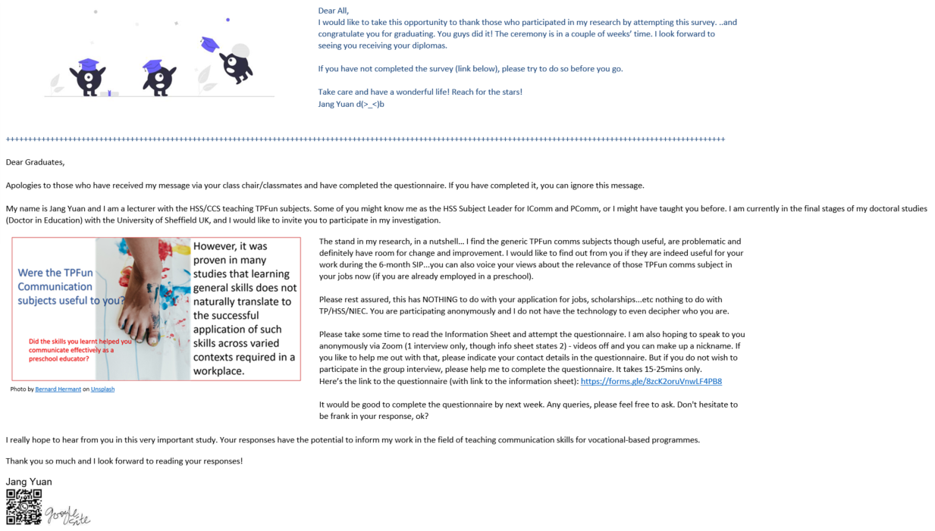

Appendix B
Interview Script
Thank you for being here! As you know, my name is Jang Yuan. The purpose of this interview is to understand your communication experiences and opinions on what it means to be an effective communicator within the preschool environment. Please note that this interview is audio-recorded. For my analysis, the recording will be transcribed using an online paid transcribing platform, otter.ai. Since it is an audio recording, please feel free to stop the video streaming. How I deal with findings was stated in the information sheet given to you earlier. This session should end before 8.30pm or earlier. Thank you.
- Tell me briefly about a positive experience/instance/event where you successfully communicated in the early childhood sector. Either when you witnessed someone in your field of work communicating successfully or in a situation where you communicated successfully.
- Is he/she successful in the field? Why a fellow colleague/staff is successful?
- I have looked at some exemplary texts offered by an organization and my survey responses. The following questions I am about to ask will relate to them.
- Based on anecdotal comments from my preschool contacts, lesson plans appear to be prescribed nowadays. Teachers hardly write them anymore. However, according to the survey I launched that you have completed, lesson plans top the chart for the “most frequently written” text in the preschool. Why do you think this is so?
- The following are some of the most essential features of a well-written lesson plan [SLIDE1]:
- The evaluation of a lesson plan
- Freedom for autonomy and encouragement of child initiation
- Knowledge on child development
- What do you understand from these responses about the lesson plan? Is that consistent with all contexts within the preschool sector?
- With regards to [SLIDE2] “Writing captions for photographs”, according to a response, “the learning which has taken place and not the description of the photo” is an important aspect of such texts? Why would it be critical to reflect that in captions of photographs? Would you elaborate on the purpose of such texts? Is that consistent with all contexts?

Appendix B

- [SLIDE 3] The following are extracts from exemplary assignments from an institution that trains preschool teachers.
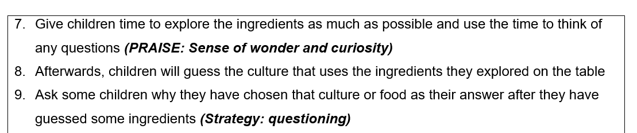
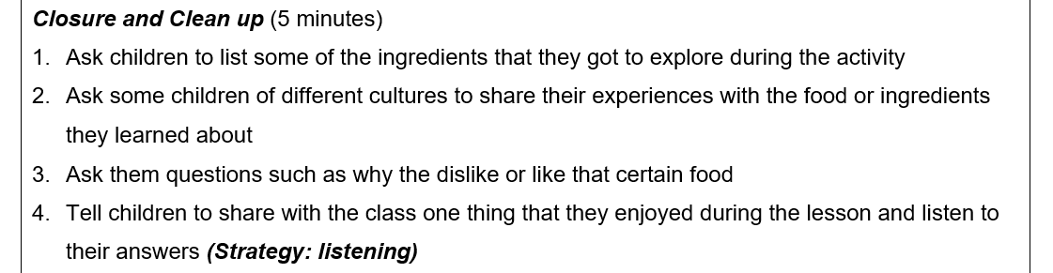

- Referring to examples 1 & 2, taken from a student’s lesson plan assignment, what do “(Praise: sense of wonder and curiosity)” and “(Strategy: listening)” mean?
- Is this commonly expressed in lesson plans in the field?
- How crucial is this aspect in a lesson plan? [Note to self: This question elicits responses to confirm the existence of semiotic resources in the exemplary texts and the importance of context in communicating in the early childhood sector.]
- I observed that many respondents to my survey learned to communicate on the job.
- Should effective communication in English (for preschool) be taught explicitly?
- Can we teach those communication skills in schools and/or vocational training programmes like those offered in the Polytechnics? (For Practitioners only: Were you taught communication skills while training as a preschool teacher?)
- Reflective question (for trainees): What did you learn from those fundamental subjects you took in your course? Were they helpful in your work now? Did you apply what you have learnt from those subjects?

Appendix C
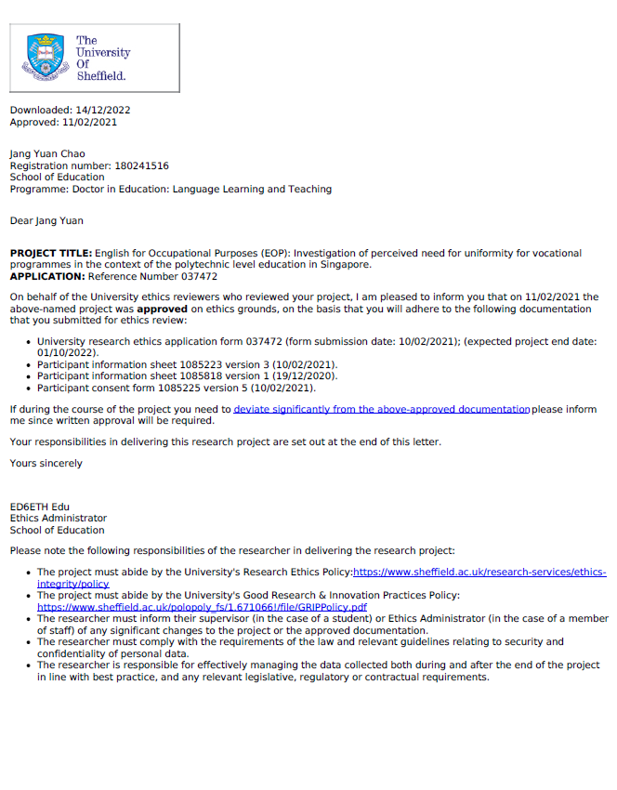

Appendix C
Consent form for questionnaire
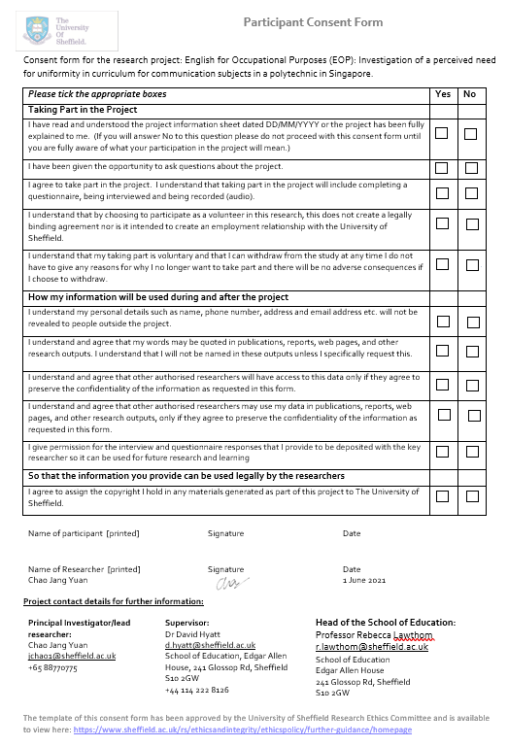
Appendix C
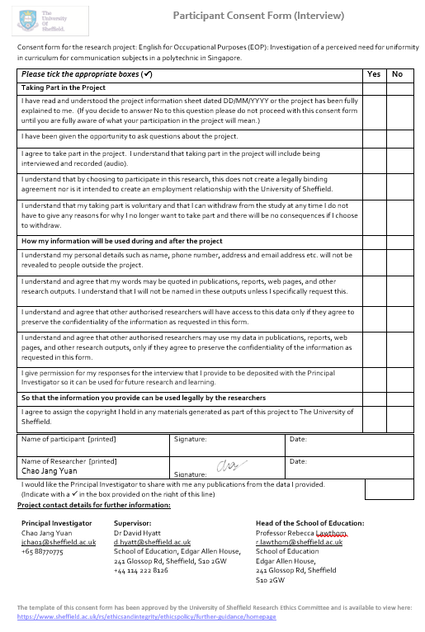
Appendix C
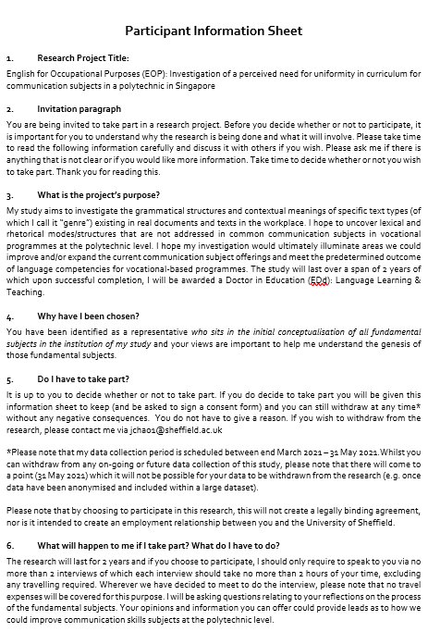

Appendix C

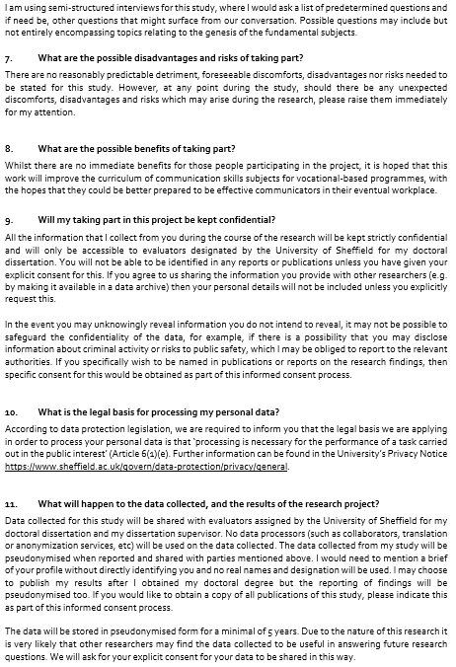

Appendix C

