Thesis in submission for the degree of Doctor of Philosophy

Defect Chemistry and Dissolution Behaviour of Doped Nuclear Fuels



Hannah Smith

Immobilisation Science Laboratory

Department of Material Science and Engineering

University of Sheffield

May 2022

For My Nan – I carry your pride with me, always

Abstract
Doped nuclear fuels, developed to improve safety and efficiency of standard UO₂, are widely used in nuclear energy generation and continue to be developed for future, so-called accident tolerant or advanced doped, fuels. Small amounts of additive are doped into UO₂ which, when fabricated under appropriate conditions, results in a larger grained microstructure, responsible for enhanced fuel performance. However, key understanding of the fundamental crystal chemistry of these materials, as well as the long-term durability in comparison to standard UO₂ fuel, is lacking. A thorough understanding of both is required, firstly to aid further implementation of doped UO₂ as nuclear fuel and, secondly, to ensure that the durability behaviour is well recognised and quantified for the purposes of developing radioactive waste management strategies.
Advanced high-flux, high-spectral purity X-ray absorption spectroscopy (XAS), corroborated by X-ray diffraction (XRD), Raman spectroscopy and high energy resolved fluorescence detection-XAS was used to directly evidence the crystal chemistry of both Cr- and Mn- doped UO₂. Results confirm incorporation via substitution of Cr²⁺/Mn²⁺ dopant on the U⁴⁺ lattice site and concurrent formation of U⁵⁺ and O_{v} defects. Further analysis of sintered material highlighted that, for Cr-doped UO₂, a degree of complexity is introduced to the system, evidenced by the mixed oxidation state (Cr²⁺/Cr³⁺), when sintered under reducing conditions. For Mn-doped UO_{2,} no change in the local chemistry is observed upon sintering.
The effects of Cr²⁺/Cr³⁺ mixed oxidation state on dissolution behaviour was assessed in long-term dissolution experiments in a simplified simulant bicarbonate ground water solution. In comparison to un-doped UO₂, a systematic decrease in the initial dissolution of rate of U as a function of increasing Cr content at 25 °C and 40 °C suggests that Cr improves the durability of UO₂, hypothesised to be the result of galvanic coupling of Cr²⁺ with U⁶⁺. It was shown that at 60 °C, the bicarbonate solution-driven oxidative dissolution is dominant and no effect of Cr content is observed. Once dissolution is hindered by the thermodynamic processes that govern the solubility of U, the dissolution rate is suppressed due to solution saturation with respect to U and the eventual formation of secondary U-phases. In this regime, there is no change in the dissolution rate with Cr content. Highlighting the importance of microstructure in UO₂ dissolution, a decrease in dissolution rate with increase grain size was also observed.
In addition to in-depth understanding of Cr-doped UO₂ defect chemistry and dissolution behaviour, this work presents an initial synthesis and fabrication route for Mn-doped UO₂ and a basis for understanding grain growth and ultimately the full potential of Mn-doped UO₂ as a future nuclear fuel.

Acknowledgements
“Whatever that work is that you find worth doing. Do it, and find some people to love who'll do it with you” - Leslie Knope
Completing a PhD was something I had never imagined was possible, I feel extremely lucky to have had this opportunity, and to have had the support of so many amazing people. I wish I had space for you all but I would like to thank here those who made this achievement a reality!
Firstly, my supervisor, Professor Claire Corkhill. I simply cannot begin to express how grateful I am for the opportunity you have given me. It has been inspiring to share in your ideas and a privilege to learn all that I have from you. Thank you for your constant support, your commitment and encouragement every step of the way. Secondly, Dr Pam Dugdale, I can categorically say I would not be here today without you. I will never forget the day you said to me ‘Hannah, you like smashing things up? How about Material Science!’ – Thank you for inspiring me! Thank you to Professor Neil Hyatt for inviting me to play a small part in a fantastic research group and to Dr Martin Stennett for your time and patience with me in the Lab! Also to Dr Sarah Pepper - in the last few months you have taught me so much and helped to get me over the finish line, so thank you!
I’d also like to thank the DisCO project for funding part of my research and for the opportunity to travel and be a part of the wider scientific community. Also, its members for their brilliant insights on all things Cr-doped UO₂.
To my executive team of postdocs who taught me to use a spatula properly, dilute acid safely, to convert ppm to ppb and importantly, when to just call it a day and go to the pub! – You have all been FAB! I’m especially grateful to Dr Théo Cordara, Dr Ritesh Mohun, Dr Clémence Gausse, Dr Colleen Mann and Dr Luke Townsend; I will not forget the hours of time spent sharing your knowledge with me, the patience, encouragement and kindness you have all shown me! Your support has made a big impact on me as a scientist and a person - thank you! Also, to Dr Adam Fisher; thank you for taking me under you wing as your masters student and helping me settle into PhD life!
To my day ones: Dr. James Mansfield – thank you for the word searches and for being my partner in crime; Dr Rita Vasconcellos – thank you for the laughs and the snacks; Dr Antonia Yorkshire and Dr Sebastian Lawson – Jegerbomb?. And finally, to the entire ISL group; you are all amazing people and have made the last few years an absolute pleasure!!
To my family: My dad – thank you for teaching me to work hard and to think outside the box; My mum – thank you for encouraging me to chase my dreams and to never give up; and to My Hollie – thank you for showing me I can do anything I want to do! And My Grandad – thank you for letting me make potions in the sink, the mess paid off!
To Emily May Alexis O’Donovan and ‘The girls’: your unconditional friendship has been a constant, thank you for always listening to me moaning on and for being my biggest supporters! Also, thank you to the Unicorns for weekly bursts of energy, laughs and love!
And, of course, My Dan (Dr Daniel Austin woo!). You have been my absolute rock. Thank you for your patience, for persevering with me through every wobble and for helping me make this work the best it could be. You, and Poppy, have been my reason to get up and keep going and I feel so incredibly lucky to be finishing with you both by my side.
Now, in the words of Prof Corkhill, “Let’s go do some good science…”
Presentations
The author has presented the research in the thesis at the following conferences and workshops:
- Early Career Researchers Conference: Pathways to net zero energy – online presentation (July 2021)
- Uranium Science Conference – online presentation (July 2021)
- RWM RSO Seminar: Reducing the uncertainty in spent nuclear fuel disposal – online presentation (April 2021)
- MRS Spring Meeting – online presentation (December 2020)
- Spent Fuel Workshop – in-person presentation, Ghent (Nov 2019)
- Disco Project Annual Meetings – in-person presentation, Cologne (May 2019), online (Oct 2020 and Oct 2021)

Contents

1. Introduction 1

2. Literature review 5
2.1 Advanced doped UO₂ fuels 5
2.2 Synthesis of Cr-doped UO₂ materials 7
2.3 Fabrication of large grained UO₂ 9
2.4 Cr-doped UO₂ crystallography 11
2.4.1. UO₂ crystal structure 11
2.4.2. Observations in Cr-doped UO₂ crystal lattice 12
2.4.3. Assessment of the defect structure in Cr-doped UO₂ 13
2.4.4. Lower Cr valence 15
2.4.5. Investigation of the formal valence of Cr in UO₂ 17
2.5 Cr-doped UO₂: Investigations of final microstructure of Cr 21
2.5.1. Precipitate characterisation 24
2.5.2. Evaporative loss 26
2.6 Spent UO₂ fuel (post reactor operation behaviour) 27
2.7 Investigations of Cr-doped UO₂ on matrix dissolution behaviour 28
2.7.1. Dissolution behaviour in Gd-doped UO₂ 31
2.8 Microstructural effects on UO₂ dissolution behaviour 33
2.9 Summary 35

3. Experimental procedures 37
3.1 Doped sample synthesis and fabrication 37
3.1.1. Nitrate synthesis 37
3.1.2. Pellet fabrication 37
3.2 Complete digest methodology 38
3.3 Thermogravimetric analysis 39
3.4 Density measurements 40
3.5 X-Ray Diffraction 40
3.6 X-ray Absorption Spectroscopy 42
3.6.1. Transmission measurements 43
3.6.2. Fluorescence measurements 44
3.6.3. X-ray Absorption Near Edge Spectroscopy 45
3.6.4. Extended X-ray Absorption Fine Structure 45
3.6.5. XAS experimental details and data processing 47
3.7 Raman Spectroscopy 50
3.8 Scanning Electron Microscopy 51
3.9 Electron Probe Micro Analysis 52
3.10 Dissolution Experiment Methodology 54
3.11 Inductively Coupled Plasma-Mass Spectroscopy 55
3.11.1. Dissolution data analysis 56

4. Cr²⁺ solid solution in UO₂ evidenced by advanced spectroscopy 59

5. Oxidative dissolution of Cr-doped UO₂ fuel 81

6. Defect chemistry of Mn-doped UO₂ 109

7. Summary and conclusions 135
7.1 Conclusion on doped UO₂ crystal chemistry (Chapters 4 and 6) 135
7.2 Conclusions on Cr- doped UO₂ durability (Chapter 5) 136
7.3 Future work 137

8. References (Chapters 1-3) 139

Introduction

Several advanced, doped UO₂ fuels have been developed over recent years. Although proven to confer improved fuel efficiency during reactor operations, doped UO₂ fuels differ from standard UO₂ fuel in terms of their microstructure and chemistry. The major focus of this Thesis is large-grained Cr-doped UO₂, which has been adopted for use in Light Water Reactors (LWR) in Europe. Other elements can be doped into UO₂ fuels, for example, Gd as a neutron poison, while novel dopants including Mn, explored in this Thesis, have been proposed as alternative to Cr in large-grained UO₂.
Fission reactions that occur during reactor operation result in the formation of radioactive, heat-producing fission products and minor actinides in the fuel. These add significant complexity to the final form, chemistry and microstructure of the fuel post-reactor operation, which is known as spent nuclear fuel (SNF). Upon removal from a nuclear reactor, the SNF is stored in cooling ponds allowing decay of shorter-lived radionuclides and removal of heat, after which a period of dry storage may also be employed.
In considering the long-term management of SNF, over the 100,000+ years it will take for the radioactivity of the fuel to return to safe levels, many countries have chosen a policy of deep geological disposal, a multi-barrier concept consisting of a number of barriers to radionuclide release, which is the ultimate goal of such a disposal facility. During the final disposal in a geological facility, SNF will eventually be exposed to ground waters and changing redox environment, depending on the waste containment materials and host rock permeability. Understanding the dissolution kinetics and mechanisms of these materials upon exposure to storage and disposal conditions is an essential requirement for developing the safety case for disposal of SNF in a geological disposal facility and is dependent on the chemistry and microstructure of the doped UO₂ fuel. However, little is understood about the chemistry and dissolution behaviour of doped UO₂ in comparison to plain UO₂ fuel. This was the topic of interest to the wider European Euratom project, DISCO, to which this Thesis contributes.
The fundamental crystal chemistry of doped UO₂ is intrinsically linked to its durability, as set out in this Thesis. This is also thought to be true for Cr-doped UO₂; however, the actual structure and chemistry of this fuel, although currently deployed in operational nuclear power plants, is debated in the literature. In the absence of extensive experimental studies of Cr-doped UO₂ in storage and disposal conditions, there remains significant uncertainty in Cr-doped UO₂ behaviour, post-reactor operation. The implications of such uncertainty mean that evidence of long-term durability, required to implement safe long-term storage and disposal, is lacking. This Thesis focuses on understanding the chemistry and microstructure of Cr-doped UO₂ materials and the subsequent effects on long-term durability, in comparison to standard UO₂ fuels. Additionally, Mn-doped UO₂ is explored as a promising alternative doped fuel.
This Thesis is presented in an alternative format, i.e., in the format of scientific papers prepared for publication. Each Chapter, described below, details an investigation of the chemistry and dissolution behaviour of doped UO₂ fuel, as follows:
Chapter 2 is a highly focused review of the available literature on Cr-doped UO_{2,} the primary material subject of the Thesis. It describes the synthesis and fabrication of commercially-used large grained Cr-doped UO₂ fuels and discusses the implication of Cr-doping on the crystal structure as well as the final microstructure. Discussion of the current understanding of Cr-doped UO₂ durability in comparison to undoped and other trivalent-doped UO₂ material is also included. One of the major findings of this review is that the current understanding of Cr incorporation into the UO₂ structure, and the influence of Cr on spent nuclear fuel storage and disposal, is lacking clarity and consistency. As such, materials and methods, described in Chapter 3, were developed to provide unambiguous evidence regarding Cr-doped UO₂ fuel chemistry and durability.
Chapter 4 presents a novel analysis of the Cr₂O₃-UO₂ solid solution, and uses high-flux, high-spectral purity X-ray absorption spectroscopy to provide definitive evidence of the speciation of Cr and U within Cr-doped UO₂. At the time of writing, this chapter has been submitted for publication, and is under review, in the Journal of Materials Chemistry A:
Cr²⁺ solid solution in UO₂ evidenced by advanced spectroscopy. H. Smith, L. T. Townsend, R. Mohun, T. Cordara, M. C. Stennett, J. F. W. Mosselmans, K. Kvashnina, C. L. Corkhill
Author contributions: HS – material synthesis, all data collection, analysis of results; LTT – provided analysis support with EXAFS analysis and editing; RM – provided analysis support with Raman spectroscopy and editing; TC – provided support with material synthesis and data collection; MCS – provided support with XAS data collection and XANES and EXAFS analysis; JFWM – operation of I20 scanning beamline and editing; KK – operation of BM20 beamline, data collection and editing; and CLC – acquired funding, provided supervision and support in data collection, analysis and editing.

Building on the knowledge acquired through the chemical analysis of Cr-doped UO₂, Chapter 5 explores the influence of Cr on the dissolution kinetics and mechanisms of UO_{2,} as a function of Cr concentration and microstructure. It reports the results of up to three years of dissolution experiments, performed under oxic conditions in a simplified groundwater, and draws conclusions regarding the difference in dissolution behaviour between UO₂ and Cr-doped UO₂. This Chapter has been prepared as a publication for submission in the journal Applied Materials and Interfaces as follows:

Oxidative dissolution of Cr-doped UO₂ fuel. H. Smith, T. Cordara, C. Gausse, S. Pepper, C. L. Corkhill.
Author contributions: HS – all experimental work and all analysis; TC – support with experimental set-up and sampling; CG and SP – support with aqueous analysis; CLC – acquired funding, provided supervision and support in data collection, analysis and editing.

Having successfully resolved the crystal chemistry and dissolution behaviour of Cr-doped UO₂, attention was turned to the development of novel trivalent element doped UO₂. This was an attempt to understand whether different dopants could confer the same beneficial properties as Cr, i.e., with respect to the microstructure, but without changes in dopant valence upon heat treatment, as has been observed for Cr. Chapter 6 describes the synthesis and characterisation of Mn-doped UO₂, which has been prepared as a publication for submission to Inorganic Chemistry:

Defect chemistry of Mn-doped UO₂. H. Smith, L. Townsend, M. C. Stennett, R. Mohun, F. Mosselmans, K. Kvashnina and C. L. Corkhill.
Author contributions: HS – material synthesis, all data collection, analysis of results; LTT – provided analysis support with EXAFS analysis and editing; MCS – provided support with XAS data collection; RM – provided analysis support with Raman spectroscopy and editing; JFWM – operation of I20 scanning beamline and editing; KK – operation of BM20 beamline, data collection and editing; and CLC – acquired funding, provided supervision and support in data collection, analysis and editing.

Finally, Chapter 7 brings together the findings of each chapter in the context of real spent nuclear fuel storage and disposal. It highlights further research that should be performed in the future with regards to understanding the long-term behaviour of doped UO₂ fuels in storage and disposal environments, including potential new dopants to investigate.

Literature review

Advanced doped UO₂ fuels
A drive to increase the in-reactor performance of uranium dioxide (UO₂) nuclear fuels has led to the development of so-called advanced nuclear fuels. These fuels exhibit enhanced burn up capabilities, and therefore efficiency, as well as improved accident tolerance due to alterations in the ceramic microstructure. A common cause of failure in ceramic UO₂ fuel is cracking due to the thermal gradient experienced during operation (Fig. 2.1a) and swelling of pellets due to the build-up of fission products, transuranic elements and activation elements within the UO₂ matrix (Fig. 2.1b).

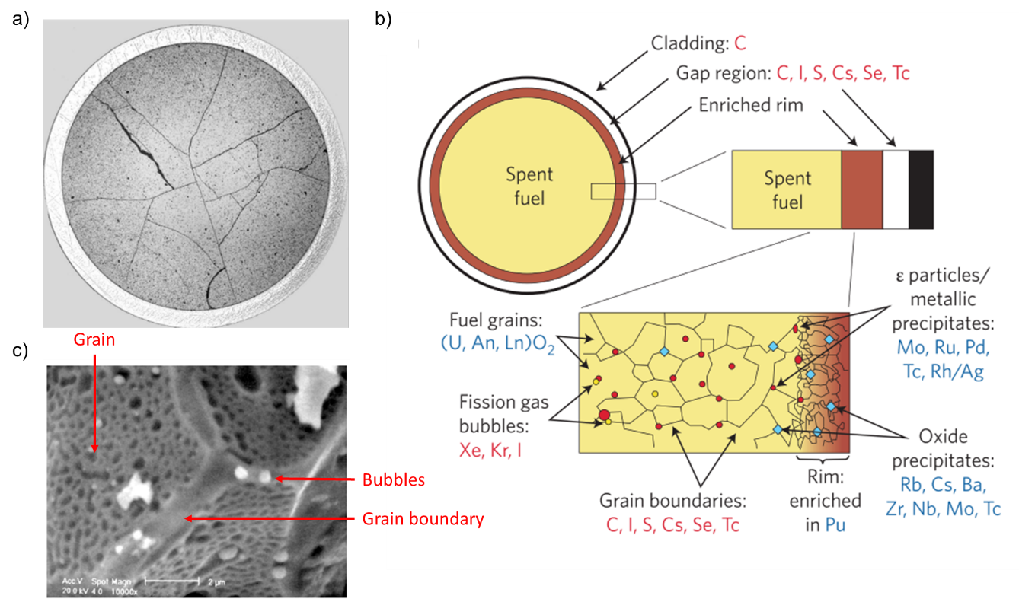
Figure 2.1. Spent UO₂ fuel microstructure. a Cracking caused by temperature gradients experienced in reactor operation [1]; b schematic distribution of fission products including Actinides (An) and Lanthanides (Ln) within the UO₂ matrix [2]; and SEM images of c metallic particles and b fission gas bubbles at grain boundaries in irradiated fuel [1].

A typical spent fuel pellet will contain ~4 at.% of fission products in the final composition, present in one of four main classifications: gases, e.g. Xe, Kr and I; metallic particles, e.g. ɛ particles, Tc, Rh and Mo; oxide precipitates, e.g. Cs, Ba and Zr and; solid solutions of elements in the UO₂ structure such as Sr, Zr and Nb [2]. The migration, particularly of the gaseous fission products, toward the grain boundaries (Fig. 2.1c) facilitates the release of volatile gases and the expansion of the fuel geometry. When a critical level of swelling is reached, fuel will begin to interact with the cladding material, exhorting localised stress and causing the cladding to crack (Fig. 2.2a-c) [1]. This swelling effect is limited by the maximum burn-up of fuel and, as such, advanced fuels were developed with the aim of increasing the grain size of UO₂ which, in turn, increases the migration path for fission products to reach grain boundaries. Larger grained UO₂ can therefore be subjected to increased burn-ups (or dwell time) in the reactor. While altering sintering conditions (time, temperature and atmosphere) can modify the UO₂ microstructure [3], the addition of small amounts of sintering aids has proven the most cost effective fuel fabrication method, with Cr₂O₃ doped UO₂ fuels being used in light water reactors for more than 20 years [4].

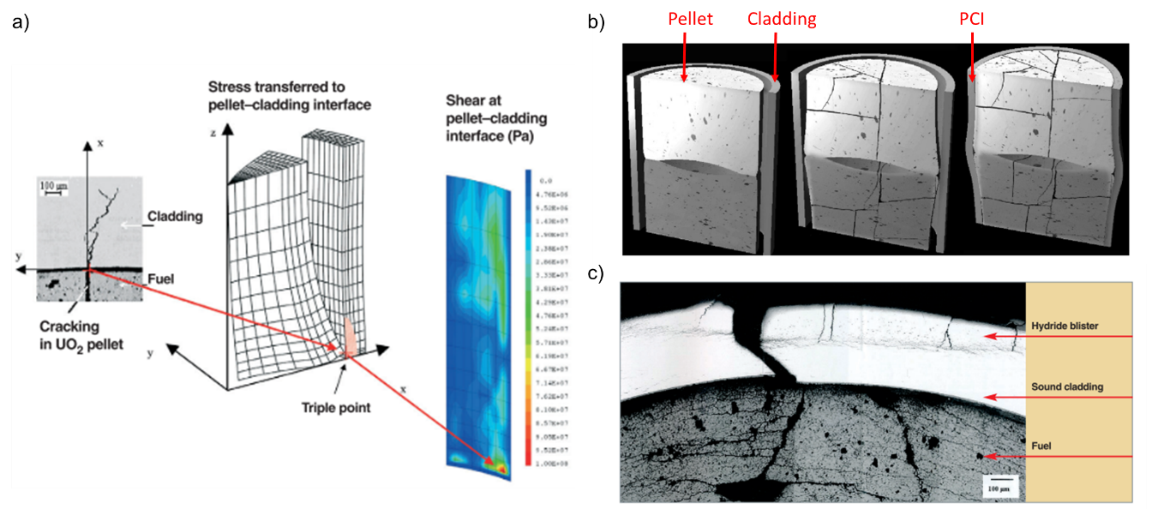
Figure 2.2. Fuel failure in UO₂ . a schematic diagram showing localised stress due to pellet cladding interaction (PCI) [1]; b evolution of pellet swelling effect on cladding causing deformation [1]; and c pellet cladding facture [1].

While a number of additives have been researched and reviewed for their in-reactor, performance [5], the most recent interest is in Mn-doped UO₂ as alternatives [6], Cr₂O₃ doped UO₂ is the topic of most interest, and contention, in the literature. A number of studies have aimed to understand the synthesis and fabrication processes that result in increased grain growth and the fundamental incorporation of Cr in the UO₂ crystal structure. A limited number of recent studies, originating from the European Euratom DISCO project [7], have explored the oxidation and dissolution behaviour of Cr-doped UO₂, relevant to post reactor operation. This literature review will present the findings of these studies and highlight the ambiguity that has arisen from the investigation of Cr-doped UO₂.

Synthesis of Cr-doped UO₂ materials
Cr-doped UO₂ is commercially fabricated for use in light water reactors. Developed in France by AREVA NP, where they are termed accident tolerant fuels [8], and in Sweden by Westinghouse, where they are alternatively known as ADOPT (Advanced Doped Pellet Technology) fuels [4]. Fabrication involves dry mixing and sintering of UO₂ powder with Cr₂O₃ oxide powder and, in the latter case, small amounts of Al₂O₃ (added to limit the parasitic neutron absorbing effect of Cr). In some cases, a small amount of Zn-sterate is also added as a binding agent [8, 9]. The combination Cr₂O₃ as a sintering aid, in addition to the sintering conditions (discussed in Section 2.5) results in enhanced grain size of Cr-doped UO₂, reported to reach 40 - 70 μm in comparison to undoped UO₂ at ~10 μm [4,10, 11] (Fig. 2.3).

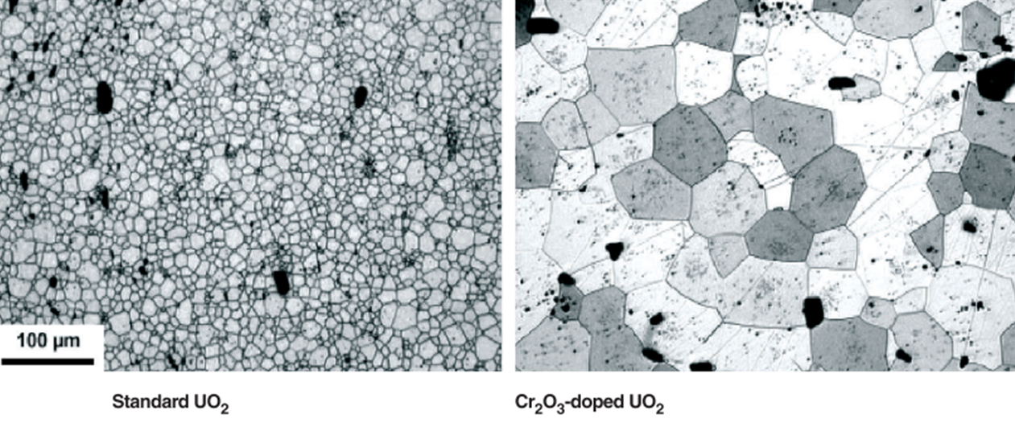
Figure 2.3. Microstructure comparison between undoped (standard) UO₂ and large grained, Cr₂O₃ doped UO₂ [1].

Due to the commercial sensitivity surrounding industrially-fabricated Cr-UO₂ fuel, numerous methods have been applied within non-industrial research contexts to replicate these materials. Success has been reported using a dry mixing method for some studies [11, 12, 13, 14], although this method is considered less effective for laboratory scale Cr-doping, due to the smaller amounts of powder increasing the uncertainty in dopant concentration and homogeneity of Cr distribution in the sample. Alternative synthesis routes have been developed utilising wet chemical methods [15, 16] to produce a mixed U-Cr oxide powder, where U and Cr in solution (typically as nitrates) are either co-precipitated using ammonia solution, or UO₂ powder is wet-coated with aqueous Cr nitrate and then dried. A comparative study of the co-precipitation and wet-coating chemical methods reported an increase in dopant homogeneity in comparison to dry mixing as well as reproducibility of ceramic material properties, such as large grain size and increased density, observed in commercially fabricated samples [15].
Successful Cr-doping of UO₂ was reported during the development of a novel sol-gel method, where Cr and U in solution with hexamethylenetetramine (HMTA)/urea was mixed cold and subject to gelation via a heated gelation column [16, 17]. The resultant gelled feed stock materials were dissolved in 5 mL of 5 M HNO₃ and solutions analysed by inductively coupled plasma mass spectrometry (ICP-MS) to assess the achieved concentrations of Cr in the synthesised material. The results showed that the target concentration was met, within error for each attempted Cr concentration, confirming the success of the sol gel method. Mn-doped UO₂ was also synthesised by both wet-coating and sol-gel methods, where success in achieving the targeted dopant concentration for both was observed.
The application of heat is required to convert synthesised precursor material into the final desired product in a calcination step. Cr-doped UO₂ synthesised by co-precipitation results in a yellow precursor, U₃O₈, that is converted to UO₂ by heating under a reducing atmosphere, typically 4-5%H_{2(g)}: 96-95% N_{2(g)}. Calcination is also employed to control the stoichiometry of dry mixed powders or dried powders from wet coating/sol gel synthesis, where exposure to air during preparation results in hyper-stoichiometric UO_{2+x} requiring reduction to UO₂ [18]. Structural transformation to stoichiometric UO₂ is confirmed by X-ray diffraction (XRD). Complete transformation of precursor material to UO₂ was reported for calcination temperatures >600 °C after 5 hours in a reducing 4% H₂–96% Ar_{(g)} atmosphere [15].

Fabrication of large grained UO₂
Following a standard homogenisation step, the final microstructure of pellet samples is governed by a sintering step where the application of pressure and temperature convert calcined powders into consolidated, dense pellets. For Cr-doped UO₂, control of the atmosphere during sintering also plays a role in production of large-grained fuel pellets.
Typically, Cr-doped UO₂ is fabricated by applying pressure to consolidate powder into a green body prior to heat treatment in traditional Cold Press and Sinter (CPS) methods, while alternative Hot Isostatic Pressing (HIP) and Spark Plasma Sintering (SPS) have been explored for doped UO₂. HIP applies high temperature and pressure simultaneously to consolidate samples, resulting in higher density ceramic materials as observed in comparison of undoped UO₂ and Cr-doped UO₂ prepared by CPS (~90% densification) and HIP (~97% densification) [19]. SPS, performed on Gd₂O₃- [20] and CsI- [21] doped UO₂, uses a pulse current to apply quick heating/cooling rates, under pressure, leading to densification under reduced sintering temperatures and times. Whilst both alternative methods offer improvements in the commercial fabrication of doped UO₂, there is no indication that either significantly affect the final large-grained microstructure of Cr-doped UO₂. Therefore, neither have been used in subsequent studies.
The initial application of pressure to UO₂ powder forces loose particles together, reducing the void space in between resulting in the formation of a green body pellet. Strong bonds begin to form between particles and, upon the application of high temperature atoms, driven by surface energy reduction, diffuse facilitating the formation of grain boundaries and pores (Fig. 2.4a). Continued reduction of pore channels and the subsequent increase in density during the intermediate stage of sintering results in rounding of pores and formation of a granular microstructure (Fig. 2.4a).
During the final stages of sintering, porosity closure is mostly complete and the migration of remnant pores and grain boundaries facilitates grain growth. Alternatively, congregation of larger pores, remnant from inadequate shrinkage in the intermediate stage, can act to pin grain boundaries and hinder grain growth. As such, densification is important to achieving a final large-grained microstructure.
The presence of additives, such as Cr, in UO₂ can influence the sintering process in two ways (Fig. 2.4b) [22]. Firstly, by precipitating at the grain boundaries, rapid grain growth in the intermediate stage is inhibited and adequate pore shrinkage is allowed. The subsequent dissolution of Cr into the UO₂ lattice as a solid solution or the formation of a eutectic liquid phase under the applied sintering atmosphere, results in grain enhancement during the final stages.

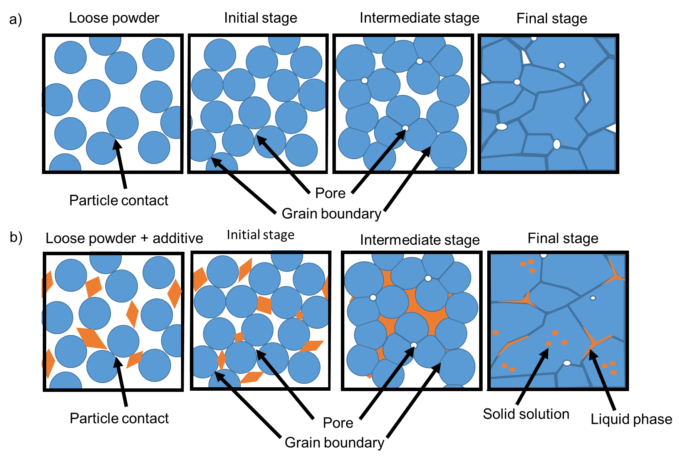
Figure 2.4. Microstructural evolution of the sintering process. a conventional sintering; and b in the presence of additives.

Additionally, the sintering temperature and time profile is important to achieving the desired microstructure; both are optimised in UO₂ fabrication to allow for sufficient densification and grain growth. Studies focused on underpinning the grain growth mechanism of Cr-doped UO₂ as a function of Cr content, sintering atmosphere and temperature are also discussed below (Section 2.5).

Cr-doped UO₂ crystallography
Incorporation of Cr into the crystal structure of UO₂ will influence the diffusion of atoms and therefore grain growth during sintering. In undoped UO_{2,} the presence of uranium vacancies (Uv) allows for the migration of U atoms through the lattice structure and therefore a clear understanding of how Cr may alter the lattice structure of UO₂ is required.

UO₂ crystal structure
The fluorite (space group Fm-3m) crystal structure of UO₂ comprises of a cubic array of U⁴⁺ cations with O²⁻ anions occupying tetrahedral sites (Fig. 2.5a). Via transfer of electrons, UO₂ readily oxidises whereby U⁴⁺ loses an electron to form U⁵⁺. Oxidation can occur either by sufficient diffusion of atmospheric oxygen into the lattice, incomplete reduction during fabrication, or via the presence of metallic particles formed during reactor operation [2][23].

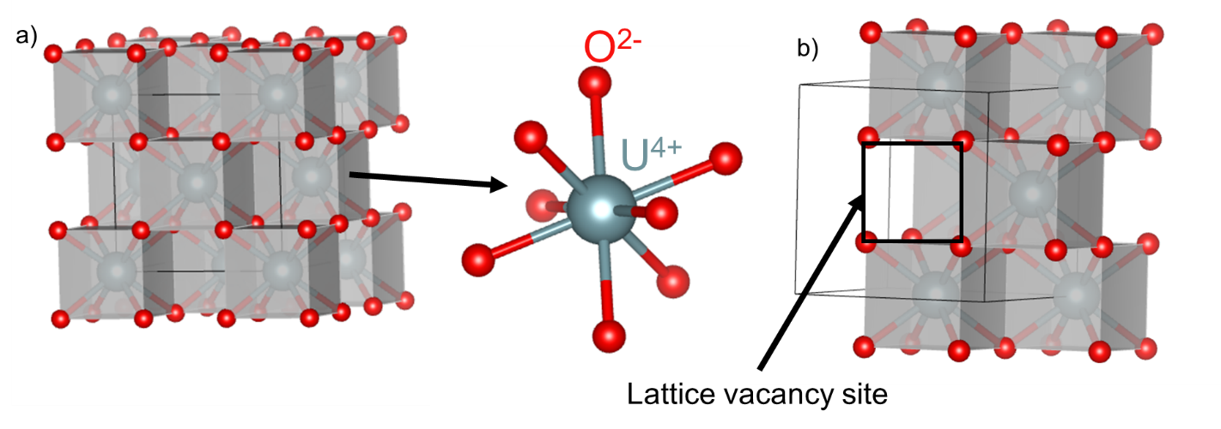
Figure 2.5. The UO₂ crystal structure [24]. a the cubic array of U⁴⁺ and tetrahedral O²⁻ ions; and b lattice vacancy site.

Oxidation, involving the incorporation of oxygen interstitial defects (O_{i}), is possible because of lattice vacancy sites in the structure of UO₂ (Fig. 2.5b) in which O_{i} can easily be accommodated and form hyper-stoichiometric UO_{2+x} without alteration of the cubic lattice structure [25]. The formation of ordered defect structures comprising of O_{i} and oxygen vacancy defects (O_{v}) in UO_{2+x} allows for a maximum hyperstoiciometry of x=0.24. The incorporation of additional oxygen, beyond x=0.24, results in formation of a secondary phase, U₄O₉ [26]. The ability of UO₂ to accommodate a high concentration of defects before altering its chemical structure means that fission products and radiation damage defects are more readily incorporated; hence, UO₂ is widely used as nuclear fuel.
Lattice distortions, which occur in UO₂ due to oxidation, can be measured by XRD by a shift in the peak position to different degrees of 2θ, representative of lattice expansion and contraction. Raman spectroscopy analysis can also be used, where the vibration band observed at a Raman shift of ~630 cm⁻¹ is attributed to UO₂ anion sub-lattice distortions. The behaviour of defect structures in UO₂ is well established [26][24], and can be utilised when beginning to understand and explain the incorporation of Cr into the UO₂ lattice.

Observations in Cr-doped UO₂ crystal lattice
While X-ray diffraction patterns of Cr-doped UO₂ materials show the fluorite structure of UO_{2,} lattice distortion is observed by a consistent decrease in evaluated lattice parameter reported, regardless of sintering conditions [11, 13, 14]. The lattice contraction is consistent with Vegard’s law, where the lattice parameter of a solid solution varies linearly with composition. This suggests a substitution incorporation mechanism of Cr³⁺ on the U⁴⁺ lattice site, which is widely assumed in the literature.
Substitution is considered possible because of cation size; U⁴⁺ has an ionic radius of 1.00 Å and Cr³⁺ an ionic radius of 0.62 Å. Therefore, Cr³⁺ can be accommodated on the U⁴⁺ site with a subsequent decrease in the volume (lattice parameter) of the crystal lattice. As well as size, charge state must also be considered. Substitution of Cr³⁺ into the U⁴⁺ lattice site would result in a net negative charge, requiring charge balance via positive defect formation. Positive defects include formation of U⁵⁺ by oxidation of U⁴⁺, or the formation of O_{v} (formal charge 2+). Both charge balance mechanisms are possible and evidence for both in the incorporation and subsequent grain growth of Cr-doped UO₂ has been presented (see Chapter 4).
Cr³⁺ substitution in the UO₂ lattice was first theorised based on paramagnetic resonance measurements of Cr³⁺ doped CaF₂, which shares the Fm-3m crystal structure of UO_{2,} to explain the lattice parameter decrease with dopant concentration [18]. However, the authors highlight the difference in ionic charge between Ca²⁺ and U⁴⁺ anions, when considering the substitution of a Cr³⁺ cation. According to the Hume-Rothery relationship for metal solid solution formation via substitution, ionic solubility is greater when the dopant ion (Cr³⁺) has a larger valence than the lattice anion (U⁴⁺), which, true for CaF₂, is not the case in the Cr-doped UO₂ system. Furthermore, large distortion in the lattice parameter, much larger than those observed experimentally would be expected.
It was hypothesised that, that Cr³⁺ enters into the vacant interstitial site of the UO₂ lattice, which, owing to a net positive charge of the Cr³⁺ interstitial defect, would require formation of negative lattice defects such as O_{i} and U_{v}. An increase in the concentration of U_{v} is linked to the increased diffusion of U atoms and, thus, increased grain growth. Subsequent to O_{i} formation, oxidation of U⁴⁺ to U⁵⁺ would occur and, as the ionic radii of U⁵⁺ is smaller (0.84 Å) than U⁴⁺ (1.00 Å), could also explain the lattice parameter decrease [18]. It is suggested that, although introducing an interstitial atom would cause the lattice to expand, the decrease in lattice size due to U⁵⁺ would outweigh any increase due to interstitials, resulting in a net decrease in lattice parameter. Furthermore, the magnitude of this decrease would be less extreme than the lattice distortions predicted in a Cr³⁺ substitution mechanism.

Assessment of the defect structure in Cr-doped UO₂
Atomic scale simulations were used to determine the energy required in formation of point defects (O_{i}, O_{v}, U_{v}, Cr interstitials, U⁵⁺ and U³⁺) and possible defect clusters in the UO₂ lattice by comparing lattice parameters, measured by XRD, to empirical interatomic potential calculations [13]. Estimations of the formation and binding energies of point defects were used to derive the relative solution energy and, therefore, the most stable lattice sites for Cr in UO₂. The most negative relative solution energies indicate the most stable defect configurations. Energy minimisation favoured Cr³⁺ substitution on the U⁴⁺ site, resulting in a lattice parameter contraction, supported by the experimental lattice parameter observations. Cr interstitial incorporation was dismissed in this study due to the high-energy requirements and lattice expansion associated with the formation of U³⁺ (ionic radii 1.025 Å), considered to be required for charge balance of this type of point defect; the formation U_{v} or O_{i} were not discussed.
Further atomic simulations considered defect energies based on the assumption that Cr incorporates via substitution with the concurrent formation of either O_{v} defects or Cr³⁺ interstitials; both Cr lattice substitution and Cr interstitials are incorporated in the latter scenario [27]. It was suggested that since both scenarios form defects of opposite charge from the net negative charge of Cr³⁺ substitution on the U⁴⁺ site, a clustering effect would be observed in favour of energy minimisation in the system. The lowest energy cluster was found to be O_{v} with the substituted Cr³⁺, which led the authors to conclude that Cr will more likely substitute via O_{v} formation than by any other mechanism.
Defect concentrations in Cr-doped UO₂ in comparison to undoped UO₂ have also been assessed by Raman spectroscopy [14]. A pure UO₂ Raman spectrum (Fig. 2.6a) has two identifiable features, the Raman active T_{2g} mode peak at ~445 cm⁻¹, present due to oxygen vibrations around the U⁴⁺ cation, and the 2LO crystal field transition peak at ~1150 cm⁻¹, which is characteristic of the quasi-perfect fluorite structure. An additional feature, the LO phonon band at ~570 cm⁻¹ has been linked to lattice distortion due to defect formation in UO_{2+x} [25].
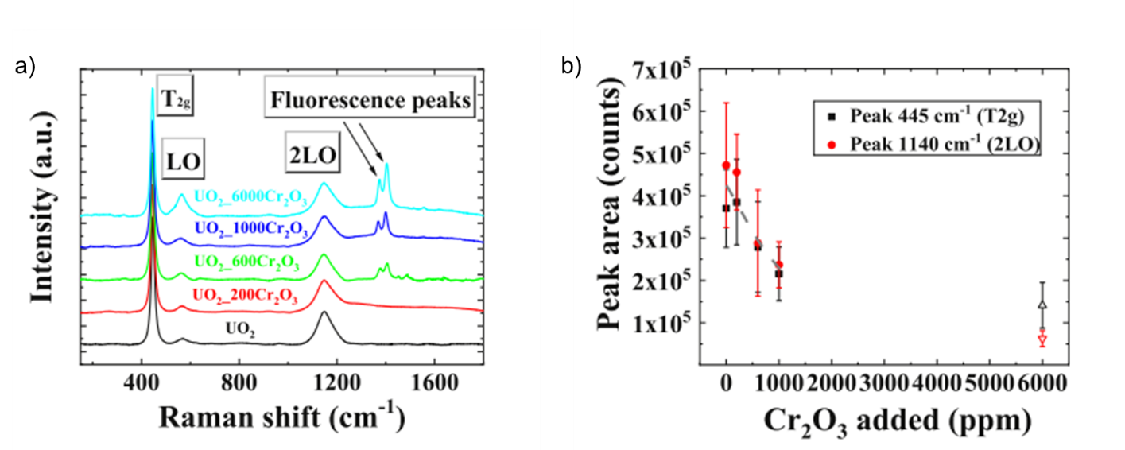
Figure 2.6. Raman spectra for Cr-doped UO₂ as a function of Cr content. a the T_{2g}, LO and 2LO bands as well as fluorescence peaks associated to Cr₂O₃ [14]; and b the peak area of the T_{2g} and 2LO bands [14].

The absolute area ratio of the T_{2g} and 2LO bands (Fig. 2.6b) are observed to decrease as a function of dopant concentration in Cr-doped UO₂ sintered at 1645 °C for 4 hours under a reducing atmosphere (4.7 % H₂ - N_{2(g)}). This result suggests that introduction of Cr causes deviation from the fluorite structure [23]. An additional doublet peak at 1380 cm⁻¹ and 1410 cm⁻¹, associated with Cr₂O₃ fluorescence, was also identified in samples with Cr added above 600 ppm (Fig. 2.6a), supporting the presence of segregated phases and un-reacted Cr₂O₃ above the solubility limit. Furthermore, profile analysis of the LO band, which increased with increasing Cr content, showed a contribution at 545 cm⁻¹ in addition to the peak at 570 cm⁻¹. This peak at 545 cm⁻¹ was not observed in pure UO₂ and was attributed to the formation of O_{v} in the lattice, based on previous studies of other trivalent element dopants (such as Gd, Dy, Nd and La [30, 31, 32]). It was noted that this peak at 545 cm⁻¹ was only observed above 600 ppm Cr containing samples; however, the significance of this observation is not discussed and could be due to limitations in the analysis of measuring small quantities of defects.

Lower Cr valence
A combination of DFT calculated defect energies, and empirically calculated vibrational entropies, were used to predict defect concentrations as a function of temperature in doped UO₂ [28]. By relaxing the constraint on Cr valence, it was found that a Cr¹⁺ interstitial defect would be energetically favourable at temperatures experienced during sintering (~1700°C). This is possible due to the natural ability of Cr to access lower valence states, as opposed to Al doping where the energy required to reduce Al³⁺ to lower valence makes interstitial substitution energetically un-favourable. In corroboration with previous simulations [13, 27], at lower temperatures, Cr³⁺ substitution at the U lattice site was the dominant defect, suggesting that, upon cooling, Cr is quenched in solution and transitions to Cr³⁺ or, as observed experimentally, Cr₂O₃ precipitates are present due to the low solubility of Cr in the UO₂ matrix at lower sintering temperatures.
It was shown by simulation of defect concentrations that, as the concentration of Cr¹⁺ interstitial defects became the dominant positive defect in the UO₂ lattice, the concentration of all negatively charged defects also increased. An increase in U_{v} concentration at higher temperatures was observed. It was suggested that the observed grain growth in Cr-doped UO₂ below the Cr solubility limit (i.e. in the absence of growth via liquid phase sintering) [11] is facilitated by U_{v} diffusion.
The same relationship was observed in Mn and V dopants whereby Mn¹⁺/V¹⁺ interstitial defects were predicted to be dominant at lower temperatures, indicating that the solubility of both elements is higher in UO₂ than Cr¹⁺ [28]. In fact, the concentration of U_{v} was up to five times larger for Mn-doped UO₂, suggesting these materials will exhibit larger grain growth than Cr-doped UO₂. Such work has led to early stage development of Mn-doped UO₂ fuels [6].
The Cr interstitial mechanism, via U_{v} formation, is further supported by measurements of the diffusion coefficient measured for ¹³³Xe release in irradiated Cr-doped UO₂ [29]. Post-irradiation, at conditions equivalent to 4 MWd/tU, samples were heated, stepwise, from 1100 °C – 1600 °C under a He + 2% H_{2(g)} atmosphere and the ¹³³Xe concentration of the gas constantly measured using an ionization chamber; the final ¹³³Xe content was measured by complete digestion of the sample in nitric acid. The ¹³³Xe diffusion coefficient of Cr-doped UO₂ was three time larger than in undoped UO_{2.} Electron Probe Microanalysis (EPMA) was used to estimate the concentration of dissolved Cr in UO₂ compared to the known defect concentration in stoichiometric UO₂. Frenkel and Schottky defect equilibria equations were then used to establish that the U_{v} concentration increased with introduction of Cr interstitials.
Atomic simulations were carried out to consider a number of possible defect structures of Cr²⁺ in UO₂ (Fig. 2.7) [35]. The most thermodynamically stable structure of Cr²⁺ in UO₂ was found to be 1 Cr²⁺ substitution defect with the formation of 1 O_{v} defect (Fig. 2.7a and b), which was in accordance with the maximum Cr solubility observed in experiments, and also the smaller than anticipated lattice contraction.

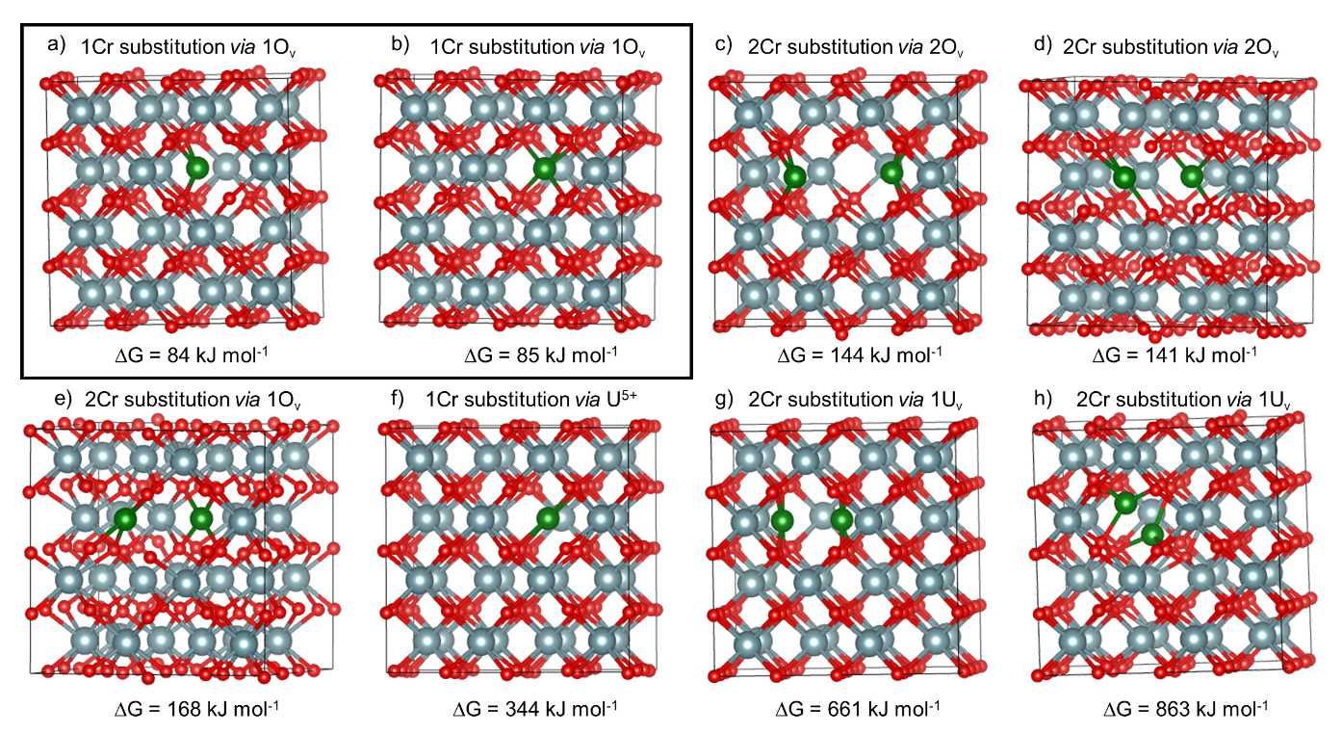
Figure 2.7. The proposed lattice structure of Cr in UO₂ assessed incorporation [35]. a and b were the most thermodynamically stable structures (Cr²⁺ substitution on U⁴⁺ site via O_{v} formation).

Investigation of the formal valence of Cr in UO₂
Determination of the formal valence of Cr in UO₂ is integral to understanding the incorporation mechanisms and has been assessed experimentally by Cr K-edge X-ray absorption spectroscopy [12, 33, 34]
The Cr³⁺ valence state of 0.108 wt.% Cr-doped UO₂, sintered in presence of O₂ in H₂ to induced large grains, [12] was deduced from the Cr K-edge X-ray Absorption Near Edge Spectroscopy (XANES) spectra in comparison to known standards (Cr₂O₃, FeCr₂O₄ and CaCrO₄). Although the authors discussed a clear difference in the local environment between the sample and standards measured, two small pre-edge features observed in Cr³⁺₂O₃ and FeCr³⁺₂O₄ were used to confirm the Cr³⁺ valence (Fig. 2.8). It appears, however, that only one of the pre-edge features mentioned can be observed in the Cr-doped UO₂ sample. It is claimed that the Cr³⁺ oxidation state was maintained regardless of the sintering conditions; however, only one sample representative of one set of sintering conditions was analysed. This claim is based on the assumption that Cr is fully dissolved in UO₂ matrix when the EPMA measurements suggest only 92% of Cr is present as a solid solution and, as such, XANES analysis ignores the possibility of signal from any precipitates in the sample.
Microprobe XAS spectroscopy was carried out on commercially fabricated Cr-doped UO₂ with a measured Cr content of 0.07 ± 0.01 wt. %, present in the UO₂ matrix as well as in Cr precipitates [33]. Although not displayed, the edge positions of Cr-doped UO₂ were reported to be similar to the Cr₂O₃ standard, and so a Cr³⁺ oxidation state was assumed for Extended X-ray Absorption Fine Structure (EXAFS) modelling of the local structure; structural information was derived using a modified UO₂ structure where Cr was substituted on the U lattice site. The authors note that this structure did not model the sample data exactly, which is explained to be due to distortion in the local atomic arrangement of Cr. Distortion was evidenced by a reduction in Cr-O coordination number and bond length, where the coordination was 6-fold and a Cr-O scattering distance of 2.02 ± 0.02 Å, in comparison to undoped UO₂ with a U coordination of 8-fold and U-O bond length of 2.36 ± 0.02 Å. Again, there were some assumptions in the experimental approach, which cannot be ignored; for example, the assumption that the XAS signal measured is representative of Cr dissolved in UO₂ matrix, despite the presence of precipitates in the sample.
A pre-edge peak in the XANES analysis, present at 5996 eV, was identified (Fig. 2.9) [33] and postulated to be a symmetry forbidden 1s to 4s transition of Cr²⁺; however, further evidence of the Cr²⁺ valence state could not be resolved from this analysis. The incorporation of Cr in UO₂ as the Cr²⁺ valence state can be considered to be feasible given that the ionic radius of Cr²⁺ (0.73 Å) is more similar in size to U⁴⁺ (1.00 Å) than Cr³⁺ (0.63 Å), meaning that Cr²⁺ substitution could be more favourable.

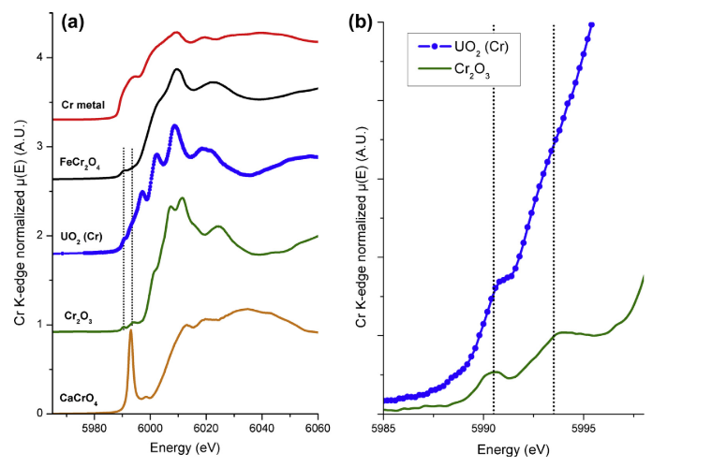
Figure 2.8. Initial Cr-K edge XANES analysis in 0.108 wt.% Cr-doped UO₂ sintered under H₂ with controlled H₂O content [12]. a comparison to known standards; and b deduction of Cr³⁺ valence based on peak position alignment to Cr₂O₃ standard.

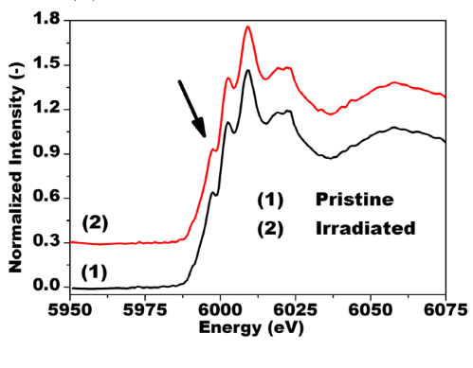
Figure 2.9. The Cr K-edge XANES analysis of commercially fabricated 0.07 wt.% Cr-doped UO₂ [33]. The pre-edge feature at 5996 eV is indicated by the arrow.

The same pre-edge feature was identified in Cr K-edge XANES of Cr-doped UO₂ sintered at 1700 °C for 4 hours (atmosphere not stated) [34]. Due to the presence of this peak, in addition to the white line position corresponding to Cr³⁺, it was postulated that both Cr²⁺ and Cr³⁺ valence states were present. A disordered local environment of the Cr²⁺ was suggested, which was attributed to an amorphous Cr²⁺O phase; however, no modelled EXAFS data was provided to evidence this. The Cr-doped samples were annealed at 1700 °C for 10 hours (atmosphere not stated) and the EXAFS region features discussed. A second contribution, present after the first Cr-O shell, was observed and attributed to Cr-Cr bonding of metallic Cr. Regardless of valence state identification, this result highlights that a possible mixture of Cr local environments, after sintering, exists.
Re-evaluation of XANES spectral features acquired in [12], using an additional Cr²⁺ standard (enstatite, Mg_{0.9}Cr_{0.1}SO₃), found that the feature at 5996 eV assigned previously in connection to Cr²⁺ was present in both the Cr²⁺ standard and the Cr-doped UO₂ [35]. Analysis of the pre-edge feature positions was performed to discriminate between Cr^{2+/3+} oxidation states. A shift in the centroid position of the second peak (at 5992.97 eV for Cr-doped sample) was closer to the Cr²⁺ standard (enstatite) centroid position than the Cr³⁺ (C₂O₃) (Fig. 2.10a) This result was also in accordance with literature values for pre-edge centroid positions measured for other Cr valence states (Fig. 2.10b).

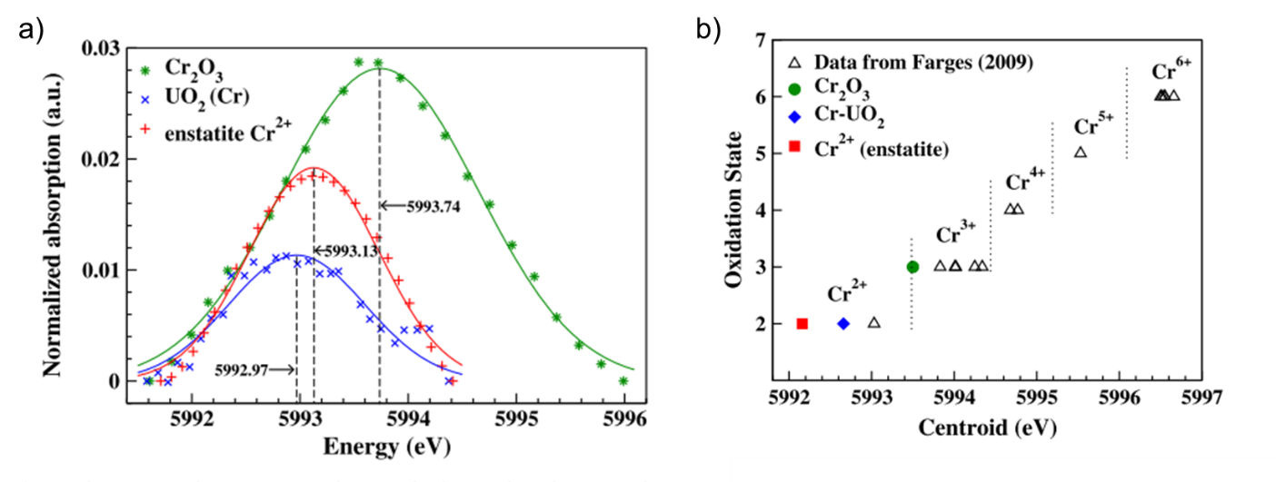
Figure 2.10. Re-analysis [35] of the Cr-K edge XANES of presented in Fig. 8 [12]. a the pre edge centroid position in comparison to Cr²⁺ (enstatite) and Cr³⁺ (Cr₂O₃) standards; and b comparison of centroid passion to known literature values of Cr valence states.

While the incorporation mechanism of Cr in the UO₂ has not met with agreement in the literature, it is clear that Cr will affect the defect structure and that a degree of disorder would be expected in the local environments. However, the exact crystal lattice formation of Cr-doped UO₂ cannot be drawn from the current literature. While the substitution of Cr onto the U lattice site (and subsequent formation O_{v} and of U⁵⁺) is the most common assumption of incorporation, the mechanism has not been linked to grain growth. The possibility of Cr interstitials (and subsequent formation of U_{v}) is suggested as being responsible for increased diffusion of U atoms leading to large grained UO₂, when the solid solution of Cr in UO₂ is concerned. Both mechanisms are possible; however, careful consideration of the lattice structure is required to unpick exactly the nature of Cr in the UO₂ lattice.

Cr-doped UO₂: Investigations of final microstructure of Cr
Regardless of the incorporation mechanism, the sintering conditions will play a large role in determining the final microstructure of Cr-doped UO₂. A number of studies have focussed on understanding the microstructural evolution as a function of sintering atmosphere and temperature as well as Cr content.
Scanning electron microscopy (SEM) is typically used to follow microstructural changes in Cr-doped UO₂ as a function of sintering conditions. A systematic study of the influence of applied pressure, temperature, oxygen potential of sintering atmosphere and concentration of dopant was employed to determine the influencing factors on grain growth [11]. Cr-doped UO₂ was sintered in H_{2(g)} atmosphere with added H₂O at 0.05 vol. %, 1 vol. % and 5 vol. % to adjust the atmospheric oxygen potential (Fig.2.11a (1), (2) and (3), respectively). The intermediate, H₂ + 1 vol. % atmosphere was determined as the optimal atmosphere for enhanced grain growth, showing a significant increase in grain size to ~80 μm at a dopant concentration of ~2400 μg(Cr₂O₃)/ g (UO₂) (Fig. 2.11a and b, (2)) as opposed to a maximum at ~20 μm in the other atmospheres (Fig 2.11a and b, (1) (3)).
An interesting grain growth profile as a function of Cr₂O₃ content was observed in samples sintered in a H₂ + 1 vol. % atmosphere as a function of temperature; 1525 °C, 1625 °C and 1700 °C (Fig. 2.11c) [11]. A first maximum in grain size was observed for all temperatures at ~0.07 wt. % Cr₂O₃ after which samples sintered at 1525 °C decreased in grain size with increased Cr₂O_{3.} This occurs due to precipitation, presumably of Cr₂O₃, at the grain boundaries causing a pinning effect, hindering diffusion of U and grain growth. It is clear that at higher temperatures of 1625 °C and 1700 °C (Fig. 2.11c) this reduction in grain growth is delayed, owing to the greater solubility of Cr at higher temperatures. A second maximum in grain size was observed at ~0.25 wt.% Cr₂O₃ suggesting that, even above the solubility limit, Cr further enhances grain growth. It was proposed that a eutectic phase exists whereby Cr present at grain boundaries becomes a liquid phase at higher temperatures, promoting the diffusion of U. Energy dispersive X-ray analysis (EDX), while not presented in the publication, was said to confirm that Cr and O were present in an agglomerated grain boundary phase, with a composition close to Cr₂O₃. The liquid nature of this phase was deduced by the rounded appearance in SEM images (Fig. 2.11d). While the results of these studies conclude that the two most prominent influencing factors on Cr-doped UO₂ grain growth are oxygen potential and temperature, the conclusions regarding Cr solubility were based on microstructural observations alone. Furthermore, no explanation for the first initial increase in grain size at ~0.07 wt % Cr, below the proposed solubility limit, is offered.

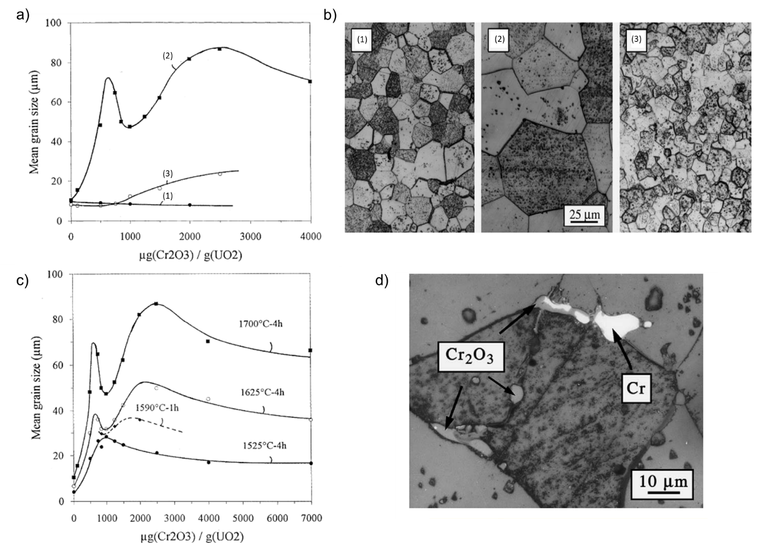
Figure 2.11. Grain growth in Cr-doped UO₂ sintered as a function of Cr content [11]. a-b for different oxygen contents in the sintering atmosphere where (1) is 0.05 vol. %, (2) is 1 vol. % and (3) is 5 vol. % and c sintering temperature; d SEM image identifying the metallic Cr liquid phase (lighter and rounded) and potentially undissolved Cr₂O_{3.}

The effects of the liquid phase on grain growth were further confirmed by combined SEM and EPMA analysis of Cr-doped UO₂ sintered under increasing temperature (1655 to 1744 °C) and oxygen content in the atmosphere (-386.5 to -437.0 kJ.mol⁻¹) [12]. A 7 times increase in grain size for samples sintered within the range of conditions attributed to CrO_{(l)} phase formation (Fig. 2.12) was observed, which increased with extended sintering time, although no experimental data is shown for these observations. Thermodynamic analysis showed that at constant temperature, the solubility of Cr in UO₂ varies with oxygen potential [12] in agreement with the previous observation [11] and suggesting that the success of Cr incorporation in the solid solution of UO₂ is highly dependent on sintering atmosphere.

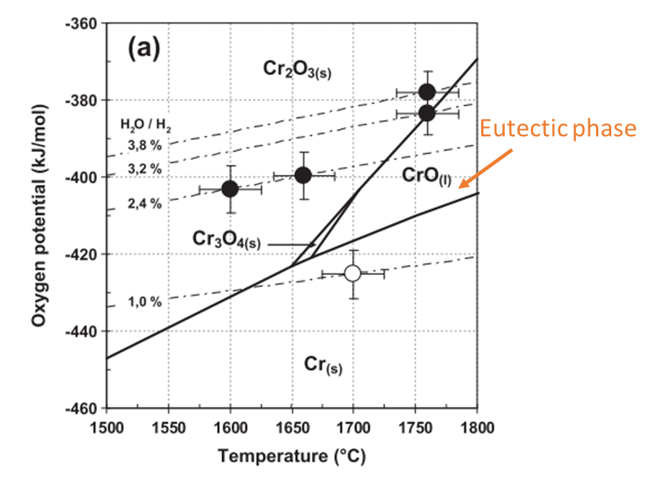
Figure 2.12. The phase formations as a function of oxygen potential and temperature of the U-Cr-O system [12]. Black dots represent data obtained by EPMA [18] and white dots by microstructural observations [11].

Precipitate characterisation
Direct measurement of Cr content by EPMA was used to understand Cr solubility in more detail and to give a more accurate estimation of solubility limit [18]. Line scans of 80 data points across the diameter of sintered pellets were used to identify concentrations of Cr, U and O in a range of Cr-doped UO₂ sintered between 1600°C and 1760 °C with oxygen potentials -370 kJ/mol O₂ to -390 kJ/mol O_{2.} Peaks in the Cr content were attributed to Cr-containing precipitates. The measured concentration of Cr indicated a stoichiometry close to Cr₂O₃, with the exception of samples sintered at -390 kJ/mol O₂ where a ‘CrO’ composition was observed. This suggests reduction of Cr₂O₃ to CrO under these conditions. It was postulated that the slow kinetics of Cr dissolution in the UO₂ matrix during sintering results in the presence of undissolved Cr₂O₃ at grain boundaries, which is reduced under a -390 kJ/mol O₂ atmosphere, in accordance with the liquid phase formation.
EMPA characterisation was also carried out on commercially fabricated pellets (i.e. undeclared sintering parameters) with increasing Cr content, where spot mode and surface mapping analysis was used to observe Cr precipitates in more detail [13]. Precipitates were evidenced for all Cr concentrations as peaks in Cr concentration in the line scans (Fig. 2.13a) and, in the higher doped samples, by Cr intensity maps (Fig. 2.13b) where an average precipitate size of 1 μm was observed, the frequency of which increased with added Cr.

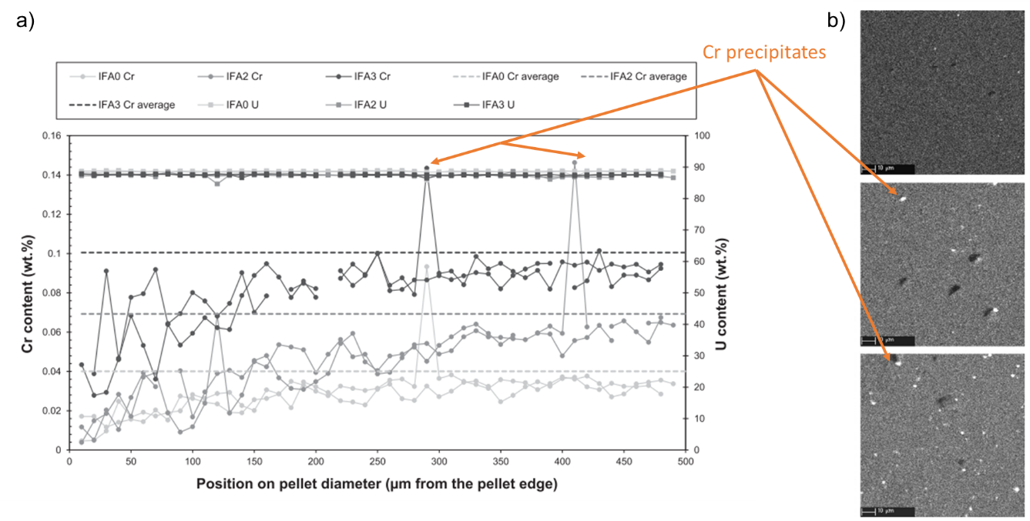
Figure 2.13. EPMA analysis of commercially fabricated Cr-doped UO₂ [13]. a line scans across the pellet diameter where peaks are Cr precipitates; and b elemental mapping where bright spots are Cr precipitates.

Microfocused X-ray diffraction (μ-XRD) and absorption spectroscopy (μ-XAS) was carried out to analyse, specifically, the composition of precipitates in commercially fabricated, unirradiated, Cr-doped UO₂ fuel [36]. The composition of all precipitates was first measured by EPMA, and determined to be stoichiometrically close to Cr₂O₃. This was confirmed by evaluation of the unit cell measurements by μ-XRD analysis of the precipitates. Detailed μ-XANES spectral analysis was not discussed by the authors; however, fitting of the EXAFS region using structural data from the Cr₂O₃ standard showed that, although there were distortions in the modelled precipitate local structure, there was a good agreement with the general features of Cr₂O_{3.}

Evaporative loss
Evaporative loss of Cr during sintering was reported in chemical analysis of samples sintered above 1700 °C in a reducing Ar-4%H₂ atmosphere, upon post-sintering acid digest and ICP-MS [16] or ICP-AES [29] determination of Cr concentration. A significant loss of Cr was observed from all concentrations prior to sintering. However, SEM imaging of sintered pellets showed that this loss did not affect grain growth, with large grains of 50 - 80 μm observed. Cr content losses were also measured by EPMA, where an initial Cr content of 0.065 wt.% decreased to 0.012 wt.% Cr measured in the matrix of sintered samples [13]. Such losses are attributed to Cr₂O₃ volatilisation from undissolved Cr in the matrix of dry synthesised and wet coated Cr-doped UO₂, whereby the nature of the synthesis envelopes UO₂ grains by Cr. The evaporative loss effect in co-precipitated Cr-doped UO₂, is not reported.
The volatilisation of Cr₂O₃ powder at high temperatures (up to 1700 °C) and under various oxygen potentials (10⁻²⁰ to 10⁻¹¹ atm) was evaluated by thermogravimetric (TGA) and differential thermal (DTA) analysis [37]. The observations were compared to the behaviour of Cr-doped UO₂ when heated from room temperature to 1700 °C in a 1.47 % CO₂ atmosphere. The volatilisation process of Cr-doped pellets was described thusly; first Cr solubilises in UO₂ at around 1200 °C and continues to dissolve with increased temperature, then at 1480 °C, with open porosity, there is dissociation of excess Cr (i.e. Cr not yet solubilised) plus volatilisation of gaseous Cr from Cr-doped UO₂ particles. As a liquid phase forms, evidenced by an exothermic peak in the TG-DTA at 1660 °C associated with the crystallisation of the liquid phase upon cooling, sintering is enhanced and porosity closed. Then, volatilisation of gaseous Cr from the Cr-doped UO₂ matrix will occur. This analysis suggests that volatilisation of Cr in Cr-doped UO₂ should be expected, regardless of synthesis technique and highlights that above 1200 °C, only a fraction of Cr will enter the UO₂ matrix.
The above studies have characterised the microstructure of existing Cr-doped UO₂ and discussed its possible evolution with sintering conditions. It is apparent that variation in the final microstructure is dependent on temperature, oxygen potential as well as the initial Cr content as evidenced by the U-Cr-O phase diagram (Fig. 2.12). When Cr is present above the solubility limit (i.e. not in solid solution with UO₂), the sintering atmosphere is by far the most important factor for the formation of large grained UO₂ due to the formation of a eutectic liquid phase, although, the effect of Cr in the UO₂ matrix upon grain growth have also been highlighted.
Therefore, to understand the grain growth mechanisms involved, further elucidation of the crystallographic nature of Cr-doped UO₂ are required. The impact of understanding the crystal and defect structure would not only allow improved understanding of the grain growth mechanism but also support prediction and understanding of post-reactor operation behaviours of Cr-doped UO₂, discussed below.

Spent UO₂ fuel (post reactor operation behaviour)
The behaviour of advanced fuels post-reactor operation, i.e., spent nuclear fuel, under long-term storage and disposal conditions, is of interest for the safe containment of radioactive wastes. As is extensively understood, the formation of radioactive fission products upon reactor operation will transform spent nuclear fuel into a highly radioactive material, requiring safe containment from the public and the environment.
The treatment of spent nuclear fuel is varied depending on individual government policies. For example, as of January 2022, spent fuel in France is reprocessed [38], allowing efficient reuse of the fissile content of fuel material and reduction in volume of the radioactive waste inventory by immobilisation conditioning (i.e., vitrification to glass or in ceramic matrix). Otherwise, for example in the UK, Sweden, Finland etc., spent nuclear fuel is safely stored, depending on the material requirements, in cooling ponds and in dry casks until a reprocessing route or final disposal option is available. Final disposal is, for many countries, considered to be deposition into an engineered geological disposal facility in which the spent fuel can be safely secured and release of radionuclides to the biosphere prevented. Despite the complicated final form of spent nuclear fuel, in terms of both chemistry and microstructure (discussed in section 2.1), the long-term retention of radionuclides in UO₂-based fuels (such as advanced doped UO₂) is dependent on the durability of the UO₂ matrix. Matrix durability is dependent on the extent of: 1) the oxidation from U⁴⁺O₂ to U⁶⁺O₂²⁺ species and; 2) the subsequent dissolution of U⁶⁺O₂²⁺ species when in contact with ground water [1]. Current understanding of the implications of Cr-doping on UO₂ matrix durability is limited; however, given the alterations to UO₂ chemistry and microstructure described in Sections 2.4 and 2.5, it cannot be assumed to behave identically to undoped UO₂ fuel. This is described in the subsequent Sections of this Chapter.

Investigations of Cr-doped UO₂ on matrix dissolution behaviour
Oxidation of UO₂ is facilitated by the availability of O_{v} sites to accommodate O_{i}, which then diffuse through the lattice. Previous discussion of the lattice defect formation in Cr-doped UO₂ (Section 2.4) suggests that upon doping with Cr there is potential to increase the concentration of O_{v} defects through Cr substitution, potentially resulting in enhanced oxidation and dissolution of Cr-doped UO₂. However, of the limited published data on Cr-doped UO₂ dissolution, increased dissolution has not been observed.
Dissolution experiments conducted in bicarbonate solution (pH 9) and cementitious water (pH 13.5), representative of a conceptual Belgian disposal environment, showed that after 180 days of dissolution, that the U dissolution rate was decreased in samples doped with Cr in comparison to undoped UO₂ [39]. It was suggested that the presence of Cr acts to prevent oxidation or the subsequent release of U⁶⁺. However, no further evidence for either is presented.
The effects of alpha radiation in Cr-doped and undoped UO₂ was investigated through doping material with an alpha radiation emitter, ²³⁸Pu, which simulated fuel composition after 10,000 years of geological disposal [39] (Fig. 2.14). Dissolution experiments were performed under H_{2(g)} (pO2 below 10 ppm and pCO2 below the detection limits). Radiolytic oxidation of the UO₂ matrix and subsequent dissolution of U is expected to be supressed in a reducing H₂ environment. However, an increase in U concentration in solution was initially observed for both undoped and Cr-doped UO₂. This result suggests that firstly, the U dissolution was not suppressed due to dissolved H_{2(g)} and secondly, Cr has no effect when compared to undoped UO₂. In both experiments (with and without Pu-doping) the dissolution rate of Cr-doped UO₂ stabilised with time, implying that increased durability occurs in the later stages of dissolution due to the presence of Cr. Enhanced catalytic properties of the UO₂ surface due to the presence of Cr, and the formation of secondary phases on the surface, were postulated as possible explanations for this result, but no evidence for either was presented.

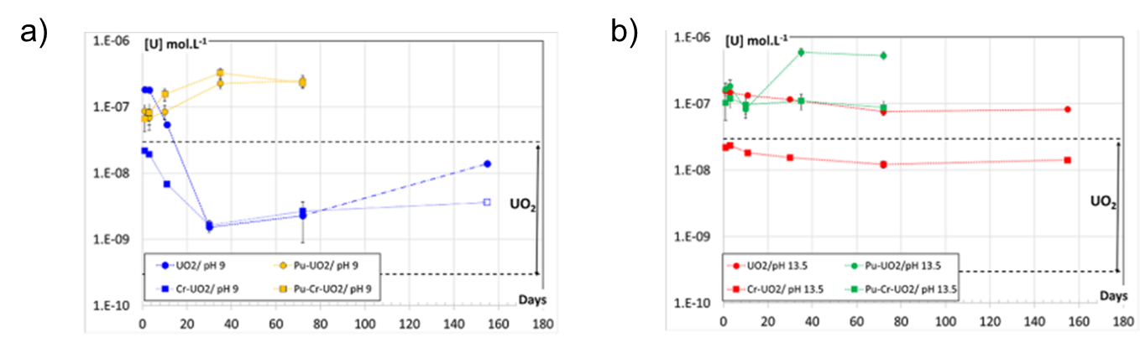
Figure 2.14. U concentration in solution after 180 days of dissolution in anoxic conditions at 20-25 °C [39]. a dissolution at pH 9; and b at pH 13.5 where in both cased the U concentration in solution is decreased compared to the undoped UO_{2.} The stabilisation of Cr-doped UO₂ dissolution with time is also observed with and without Pu-dopant. For both graphs, the dashed black lines indicate the U⁴⁺ solubility range.

A similar decrease in the dissolution rate of U, in comparison to undoped UO₂, was also observed for commercially fabricated Cr-doped UO₂. Pellets of this material were dissolved in bicarbonate solution (10 mM HCO₃⁻) with the addition of radiolytic oxidant (0.1M H₂O₂) to simulate the effects of water radiolysis [40]. The solutions were purged with N₂ to remove oxygen from the system ensuring isolation of H₂O₂ oxidising effects. No significant difference in the rate of H₂O₂ consumption was observed, however; a slight decrease in the dissolution rate of U in Cr-doped UO₂ occurred. The kinetic dissolution yield (the ratio of U dissolution rate to H₂O₂ consumption) was used to compare undoped and Cr-doped UO₂, which omits the possible surface area effects of the different samples. A reduction in dissolution yield of 3% in the Cr-doped UO₂ was observed, but was not considered significant enough to draw definitive conclusions on the effect of Cr on dissolution behaviour. Similarly, minimal difference in U dissolution was observed for reactor-irradiated samples of Cr-doped (ADOPT) and undoped UO₂ dissolved in bicarbonate solution (10 mM NaCl + 2 mM NaHCO₃) in air when the cumulative release fraction (sum of release fractions over a certain cumulative time) (Fig. 2.15).
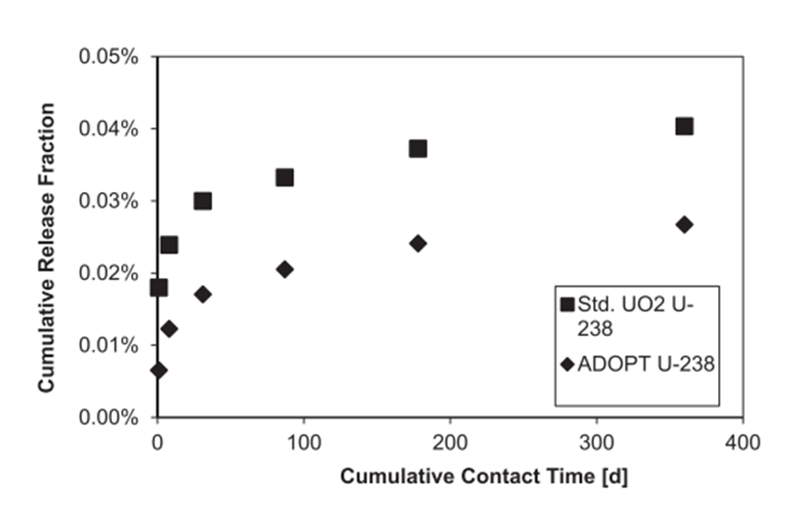
Figure 2.15. Cumulative release fraction of ²³⁸U as a function of solution contact period [40]. A marginal decrease in ²³⁸U release was observed in Cr-doped (ADOPT) pellet samples compared to undoped UO₂ (std. UO₂).

An evaluation of fission product release into aqueous solution from irradiated Cr-doped UO₂ was given [40]. An increase in the release rate of low solubility fission products (i.e. fission products not in solid solution with UO₂) when compared to undoped UO₂ was attributed to further reduction in the matrix solubility of fission products due to less available lattice sites (O_{v}) in Cr-doped UO₂. This suggests a reduction in durability in relation to low solubility fission products, which is potentially problematic for long-lived radionuclides such as ⁹⁹Tc (half-life ~2 x10⁵ y) and ¹⁰⁰Mo (half-life ~1 x10¹⁹ y).
The predicted effects of grain size on the release of gaseous fission products (¹³⁷Cs) was observed [40]. At irradiation temperatures, Cs_{(g)} migrates through the lattice structure of UO₂ and eventually, is released through the grain boundaries. Upon cooling Cs will form as a precipitate, susceptible to dissolution upon interaction with ground water. It was shown that in larger grained Cr-doped UO₂, less Cs was released from the matrix in comparison to undoped UO₂ where due to the increased diffusion pathway in larger grains.
These limited initial investigations into Cr-doped UO₂ oxidation and dissolution behaviour suggest a slightly increased durability of the UO₂ matrix with the inclusion of Cr. It is clear, however, that further experimental data is required to supporting this, including an understanding the chemical and microstructural effects on dissolution behaviour.

Dissolution behaviour in Gd-doped UO₂
In the absence of further study of the Cr-doping effect on UO₂ oxidation and dissolution behaviour, observations can be drawn from dissolution studies of doped UO₂ containing other trivalent elements, of which the most prominently studied is Gd-doped UO₂.
The electrochemical reactivity of UO₂ doped with 6.0 wt% Gd was measured by cyclic voltammetry experiments between -1.2 V and ≤ 0.4 V at a scan rate of 10mV.s⁻¹, in a 0.1 mol.L⁻¹ NaCl + 0.1 mol.L⁻¹ NaOH solution at pH 7 [41]. When compared to un-doped UO₂, the electronegativity of doped UO₂ was shown to decrease and oxidation was suppressed. Raman analysis was conducted on samples to identify any structural deviances in the doped samples, in particular, the lattice distortions observed due to defect formation. The intensity of both T_{2g} and 2LO bands decreased in doped UO₂, suggesting deviation from the fluorite structure with the presence of dopant, as observed in non-dissolved Cr-doped UO₂ [14]. The reduced reactivity in Gd-doped UO₂ when compared to UO₂ was attributed to Gd-O_{v} cluster formation, which would reduce the available O_{v} sites for oxidation of the UO₂ matrix.
Potentiostatic polarization experiments were used to understand the influence of Gd doping on the oxidation and dissolution mechanisms in UO₂ [30]. The Gd-doped UO₂ showed a lower current at low potentials consistent with the loss in reactivity associated with UO₂ oxidation to UO_{2+x}. Stabilisation of current at the steady-state potential (0.2V) indicated the onset formation of UO₂²⁺ soluble species. These results suggest the dissolution mechanism in Gd-doped UO₂ is consistent with the undoped UO₂. When steady state currents as a function of Gd content (0.01 – 0.1 mol.%) were assessed, there was no observable influence of Gd on the first stage oxidation of UO₂. The second stage, representing dissolution of soluble U species, showed that, at low Gd contents, reactivity (i.e. dissolution of UO₂) was increased, while at higher Gd contents it decreased. At lower Gd contents (<0.05 wt. % Gd) the formation of O_{v} was attributed to oxidation and dissolution increased, while at higher dopant contents, lattice contraction or Gd-O_{v} cluster formation could be responsible for the decreased reactivity. Overall, however, no major influence of Gd on UO₂ reactivity was reported, owing to a competition between these two opposite effects.
Assessment of the dissolution behaviour in Gd-doped UO₂ (0-8 wt.% Gd) dissolved in bicarbonate solution (10⁻² mol. dm⁻³ NaHCO₃) under the influence of radiolytic oxidant (H₂O₂) confirmed that the U dissolution is reduced with increased Gd content (Fig. 2.16) [42]. The concentration of U in solution of the 8 wt.% Gd doped sample (Gd80) was reduced to ~10⁻⁶ from ~10⁻⁴ in undoped UO₂ (Gd00). Similar increased durability in the initial dissolution of Gd-doped UO₂ powder (0-4 wt.% Gd) dissolved in continuously flowing bicarbonate solution (pH 7 - 8.5) [43]. Temperature (25-75°C) and oxygen content in the solution (3.0 – 8.7 ppm O₂) were varied and in all cases the dissolution rate of U decreased with increased Gd content.

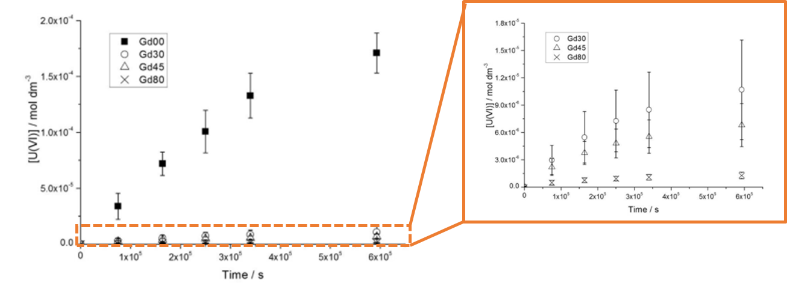
Figure 2.16. Concentration of dissolved U in Gd doped UO₂ as a function of Gd content [42]. The U concentration for the lowest doped samples are enlarged.

These results are in accordance with the matrix stabilisation via cluster formation theory made by electrochemical studies [30, 31]; however, there is no direct evidence for Gd-O_{v} cluster formation in the available literature to confirm this theory.
Similarities in the defect structure of Gd-doped UO₂ can be drawn with that of Cr-doped UO₂; therefore, studies of the oxidation processes and reactivity of Gd-doped UO₂ have given insight into possible dissolution mechanisms of Cr-doped UO_{2.} These understandings should be used to direct future studies of Cr-doped system.

Microstructural effects on UO₂ dissolution behaviour
As discussed previously, one of the primary differences between UO₂ and Cr-UO₂ is an increased grain size, in addition to the presence of precipitates. As such, the microstructure of Cr-doped UO₂ is already significantly different from undoped UO₂, even before the complexity of spent nuclear fuel microstructure is considered. The effects of even these simple microstructural changes on dissolution behaviour must also be considered in the long-term durability of Cr-doped UO₂ fuels.
Surface features, such as grain boundaries and surface facets have been shown to influence the chemical dissolution rates of analogue UO₂ materials, CeO₂ and ThO₂ (Fig. 2.17) [45]. Assessment of the surface features of CeO₂ by SEM, vertical scanning interferometry (VSI) and atomic force microscopy (AFM) was carried out in conjunction with dissolution experiments to map the surface changes as a function of dissolution. Leaching experiments were performed at room temperature, 90 °C and 150 °C in concentrated nitric acid solutions (0.01 – 15 M HNO₃). Preferential dissolution of grain boundaries in the initial stages of dissolution, as well as increased dissolution of high misorientation grain boundaries, highlighted the significant effect of surface features on dissolution rate. It was hypothesised that the presence of O_{v} defects, increasing with increased misorientation angle, at grain boundaries creates high-energy reactive surface sites for dissolution to initiate.
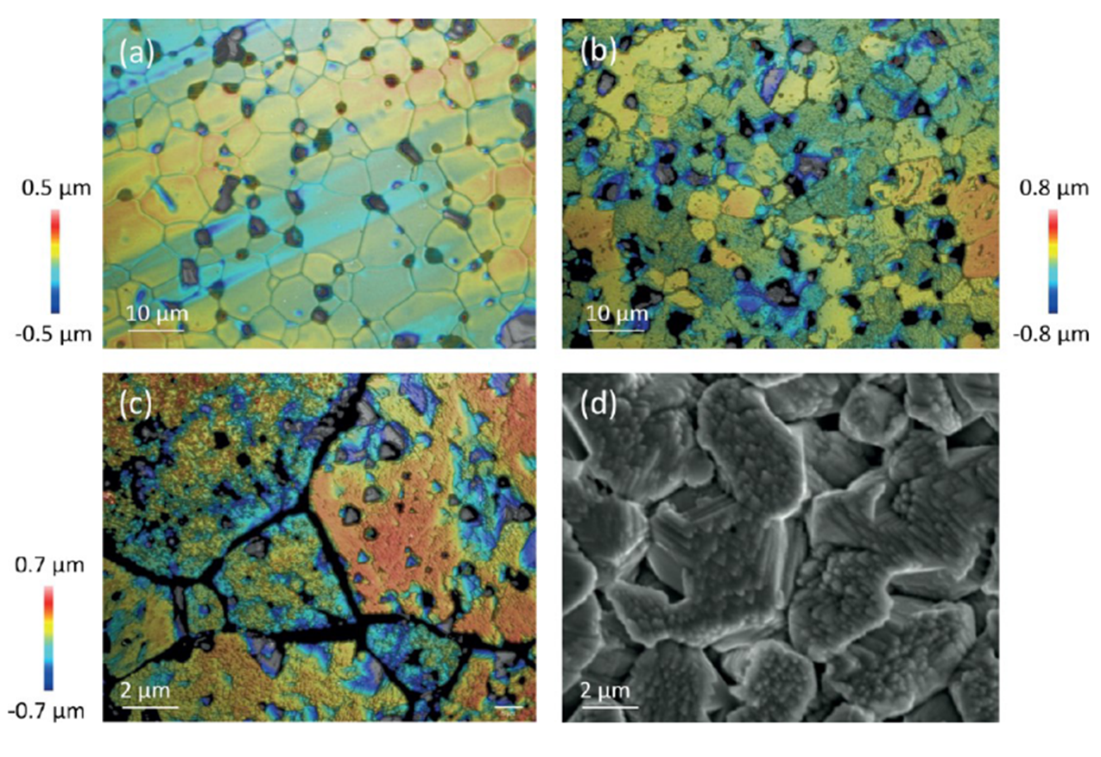
Figure 2.17. Vertical scanning interferometry (a-c) and SEM image (d) following the dissolution of CeO₂ surface over 21 days in 0.01 M HNO₃ at 150 °C [45]. The preferential dissolution at grain boundaries is most prominent in d where there is significant material loss from the grain boundary area.

Additionally, the study of CeO₂ dissolution as a function of non-stoichiometry (CeO_{2-x}) when dissolved in 0.01 M HNO₃ at 90 °C showed that as the O_{v} content was increased the dissolution rate of Ce increased by up to 15 times (Fig. 2.18) [46]. This behaviour was attributed to changes in lattice volume and strain, due to O_{v} concentration, leading to grain boundary decohesion and subsequent degradation.
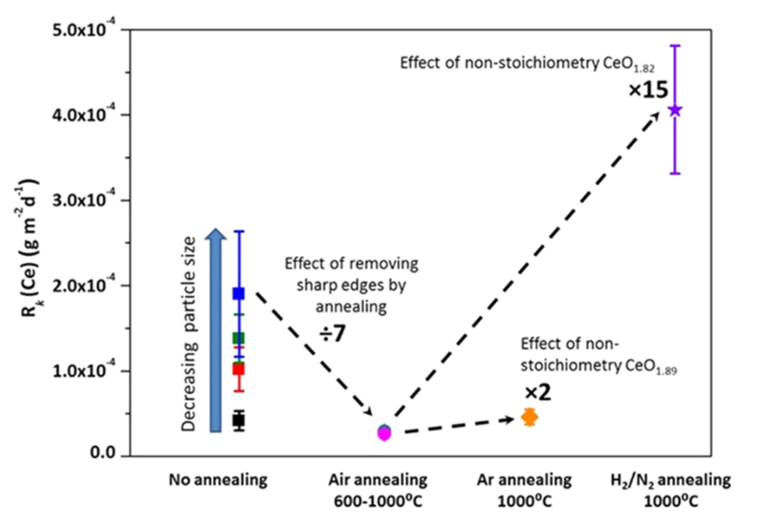
Figure 2.18. The normalised dissolution rate of Ce from CeO₂ oxide materials as a function of particle size and annealing atmosphere, which governs the O_{v} content [46]. Dissolution rate is increased when particle size is decreased. The rate increased with increase O_{v} content (CeO₂ (no annealing) to CeO_{1.82} (H₂/N₂ annealing)).
These studies show, although in conditions not representative of geological disposal, the microstructural effects of UO₂ such as grain boundaries, surface features can significantly influence the dissolution behaviour. It is important then, to assess the relationship between UO₂ microstructure and the dissolution behaviour; most critically the effect of Cr on the defect formation and grain boundary concentration.

Summary
The review of the current understanding of Cr-doped UO₂, the most prominently researched advanced doped nuclear fuel, has identified three main areas of interest. Firstly, the influence of Cr on UO₂ grain growth has been assessed by microstructural characterisation, whereby Cr is identified as existing in a solid solution, dissolved in the UO₂ matrix, and as insoluble precipitates. The advanced understanding of sintering conditions effects on the final microstructure have also been discussed, although the effects of the sintering atmosphere on Cr and U valence are not yet fully understood.
Analysis of the incorporation mechanism of the Cr dopant into the UO₂ lattice structure, by X-ray diffraction and absorption spectroscopy, as well as Raman spectroscopy, has recognised the possible defect structure and crystal lattice arrangement due to dopants however, it is clear more studies are required to resolve the precise coordination environment of Cr in Cr-doped UO₂.
Finally, there is limited understanding of the dissolution behaviour of Cr-doped UO₂, which is vital to ensuring safe post-reactor storage and disposal. Comparisons have been made between Cr-doped UO₂ and the dissolution of other UO₂ systems, which should be considered in further study of the long-term durability of in Cr-doped UO₂.

Experimental procedures

Doped sample synthesis and fabrication
Three synthesis methods were investigated in the initial stages of research, a dry mixing route and two wet precipitation routes, of which the nitrate precipitation method was chosen as the optimal synthesis method for doped UO₂. The primary reason for this is the difficulty in obtaining the desired Cr content for dry mixing (due to weighing small amounts of powder for laboratory-sized batches). Moreover, preparation of material by an oxalate wet-precipitation produced poorly densified material. Further investigation of the optimal pH for synthesis of Mn-doped UO₂ was also carried out. As such, this Section describes only the optimised synthesis and fabrication method for doped UO₂ samples and should be assumed to be the fabrication method of all samples discussed, unless stated otherwise.

Nitrate synthesis
Uranium nitrate hexahydrate (UO₂(NO₃)₂6H₂O, The British Drug House (BDH). B.D.H Laboratory Chemicals Division, >98%, 0.3 mol.L⁻¹) was mixed with either chromium (III) nitrate nonahydrate (Cr(NO₃)₃9H₂O, Sigma Aldrich, 99.99%, 1.6 mol.L⁻¹) or manganese (III) nitrate (Mn(NO₃)₃4H₂O, Sigma Aldrich, 99.99%, 1.6 mol.L⁻¹) measured to give the desired concentration of dopant (Fig. 3.1a). Concentrated ammonium hydroxide was added dropwise until pH 8-10 for Cr-doping [47] and pH 10 for Mn-doping, determined via systematic investigation (detailed in Chapter 6). A yellow precipitate formed which was vacuum filtered, washed in ultra-high quality (UHQ, 18 MΩ.cm) water and dried for 24 hours at 90 °C (Fig. 3.1b). This was subsequently calcined at 750 °C in a reducing 5% H_{2(g)}: 95% N_{2(g)} atmosphere for 4 hours to convert the yellow powder to black UO₂ (Fig. 3.1c), confirmed by X-ray diffraction of the oxide powder as described in section 3.5.

Pellet fabrication
Homogenisation of doped-UO₂ powders was carried out via milling using a Fritsch Pulverisette 23 Mini-Mill at 35 Hz for 15 minutes (Fig. 3.1d). A 6 mm, stainless steel die was used to uniaxially press green pellets at 2.5 tonnes (Fig. 3.1e), which were then sintered in a reducing 5% H_{2(g)}: 95% N_{2(g)} atmosphere for 8 hours at 1700°C to obtain dense pellets (Fig. 3.1f). Sintering of doped UO₂ under a fully reducing atmosphere does not result in an increased grain size; in fact, the increase in grain size is dependent upon the oxygen potential of the sintering atmosphere, optimal at −420 kJ/mol O₂ [11, 15] (discussed in Chapter 2). Attempts to achieve this oxygen potential were unsuccessful in this research; however, to obtain a variation in grain size, sintering temperatures of 1400 °C, 1500 °C, 1600 °C and 1700 °C were also used.
The surfaces of sintered pellet samples were ground using SiC paper and polished to 1 μm using successively finer grades of diamond suspension. Pellets were thermally etched at 80-90% of the sintering temperature in 5% H_{2(g)}: 95% N_{2(g)} to reveal the grain boundaries.

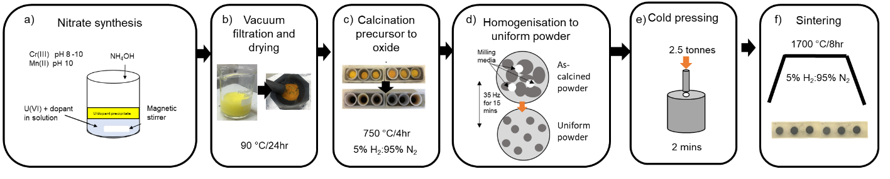
Figure 3.1. Nitrate synthesis methodology for fabrication of doped UO₂. a schematic of nitrate synthesis for Cr- and Mn- doped UO₂; b solution recovered from vacuum filtration and recovery of yellow precipitate; c colour change during calcination of precursor to UO₂; d schematic diagram of powder homogenisation via ball milling; e compaction of green pellets; and f sintering to form dense pellets.

Complete digest methodology
The actual concentration of dopant in each doped UO₂ sample was determined by a complete dissolution (digest) analysis (Fig. 3.2). Powder samples were dissolved in triplicate using 5 mL of 2M HNO₃ at 90 °C and continuously stirred until all solid was dissolved (24 – 48 hours). Precursor precipitates, calcined material and sintered pellets were powdered by a mortar and pestle, then ~ 20 mg weighed out to 2dp. The expected concentration of element (C_{exp} (i), g.L⁻¹) in solution was calculated by Equation (1) using the sample mass (m, g), the fraction of element (i) in sample (f (i)) solution and the volume of solution (V, L).
$C_{exp} \left(i\right)=\left(\frac{m}{V}\right)×f(i)$ (1)

C_{exp} (i) was used to determine the factor of dilution, appropriate to measure the concentration of dopant via ICP-MS (described in section 3.2). Dilution factors of both 10 and 100 were performed and the concentration of both solutions used to give an average concentration of element for each dissolved sample. Further averaging of the triplicates of each concentration was used to report the final average concentration of element.

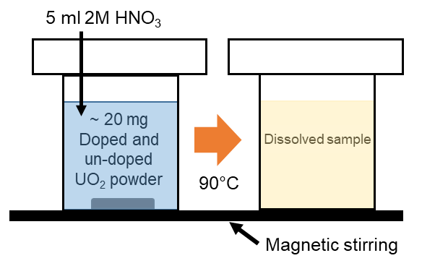
Figure 3.2. Schematic of complete dissolution (total digest) experimental setup.

Thermogravimetric analysis
Thermogravimetric analysis (TGA) was used during development of the sample fabrication method to measure the change in the mass of the pre-cursor, as it is continuously heated and converted to oxide powder. The changes in mass observed correspond to chemical reactions occurring in the sample conversion and can be used to determine the appropriate temperature for the initial heat treatment (calcination). A Netzsch TG 449 F3 Jupiter was used with a 64-channel QMS 403 D Aeolos mass spectrometer for off-gas analysis.

Density measurements
The density (ρ, g m⁻³) of a given material can be described by Equation (2), where m and V represent the mass (g) and volume (m³) of a sample, respectively. Experimentally, the density of thermally etched samples was determined in two ways: 1) the geometric density (ρ_{G}) was calculated using an average of 10 measurements of mass, height and diameter; and 2) the Archimedean density (ρ_{A}) was measured by the mass change due to displacement of liquid using a Mettler Toledo analytical balance. The theoretical density (ρ_{th}) was calculated using the molecular weight and unit cell volume. The ratio of measured density to the theoretical density was used to calculate the densification rate.

$ρ= \frac{m}{V}$ (2)

X-Ray Diffraction
X-ray diffraction (XRD) is a non-destructive technique used to determine the crystal structure of materials. XRD was used primarily during the fabrication of pellet samples to confirm the complete reduction of precursor to oxide power and the absence of oxidation on the surface of pellet samples. It was also used to determine the nature of secondary phases formed after dissolution. The atomic structure of doped UO₂ was also investigated through powder XRD where the effect of preferential crystal orientation of the sample is removed, giving a higher quality measurement.
In XRD measurements, incident X-rays are generated via a cathode ray tube, where a filament is heated to produce electrons that are accelerated towards a target material, most commonly copper, with an applied voltage. Electrons with sufficient energy will dislodge inner shell electrons of the target material and, in its place, an outer shell electron will move into the hole created, emitting excess energy in the form of an X-ray. In the case of a copper target material, there are two electron shell transitions that occur, 2p 1s, referred to as Kα, and 3p 1s, known as Kβ. Copper Kα has a wavelength of 1.5405 Å, which is a result of Kα transition being a doublet of Kα1 and Kα2, each with wavelengths 1.54051 Å and 1.54433 Å, respectively [48].
X-rays emitted from the target material are filtered by a monochromator and directed at the sample, which is placed at an exact geometry between the X-ray source and the detector such that Bragg’s law (Equation (3)) is satisfied and constructive interference occurs. When the incident X-ray, of known wavelength (λ), is directed at an angle (θ) towards the sample. The resulting diffracted X-rays will have an angle equal to that of the incident beam (θ) (Fig. 3.3). These are characteristic to a crystal of inter-planar spacing (d). A detector is located at angle 2θ from the incident beam and collects the intensity of diffracted X-rays.

$nλ=2dsinθ$ (3)

A Bruker D2 Phaser diffractometer with a Cu Kα source and Ni foil Kβ filter was used for pellet samples. Measurements were taken from 10° to 100° 2θ with a step size of 0.02° and a step time of 2 seconds. A PANalytical Xpert3 diffractometer, in reflection mode with a 45 keV/40 mA generator was used for powder diffraction on finely ground samples homogenously mixed with 20-30 wt. % LaB₆, used as an internal standard. The step size was 0.013° between 5° and 100° 2θ with a step time of 40 seconds, and a fixed slit size of 0.5 was used. Obtained XRD patterns were corrected using WinXPow software and Le Bail refinements used in Topas software to determine the lattice parameters.

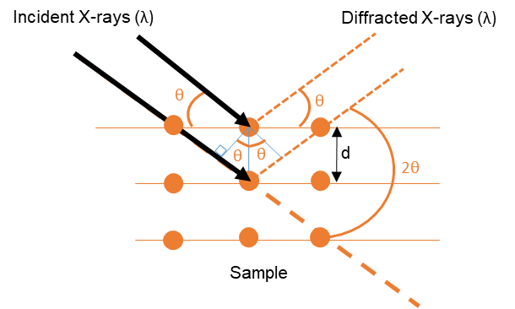
Figure 3.3. Schematic diagram of the geometry of incident and reflected X-ray’s on a sample surface according the Bragg’s Law.

X-ray Absorption Spectroscopy
X-ray absorption spectroscopy (XAS) was performed at various synchrotron radiation facilities, and used as complimentary analysis to lab-based techniques (XRD and Raman spectroscopy) to explore the local structure and oxidation states of elements in doped and undoped UO₂ samples.
Synchrotron radiation is emitted when charged particles (electrons or positrons) are accelerated to relativistic speeds using a magnetic field (Fig. 3.4). The main storage ring is supplied by a charge particle source, which heats a cathode to sufficient energy for electrons to leave the material. Electrons are accelerated from ~ 0.1 GeV to 3 GeV through a booster ring, controlled by a magnetic field of up to 0.8 Tesla. The spectrum of energy produced by the beamline ranges from microwaves to hard X-rays and as such, often termed a ‘light source’. As electrons travel around the storage ring, energy is lost and so a radiofrequency cavity is employed to maintain a fixed energy level. The beamline is channelled and directed towards an experimental station where specific wavelengths of light are selected and focussed in the optics hutch, before interaction with samples in the experimental hutch, overseen by beamline scientist in the control cabin.

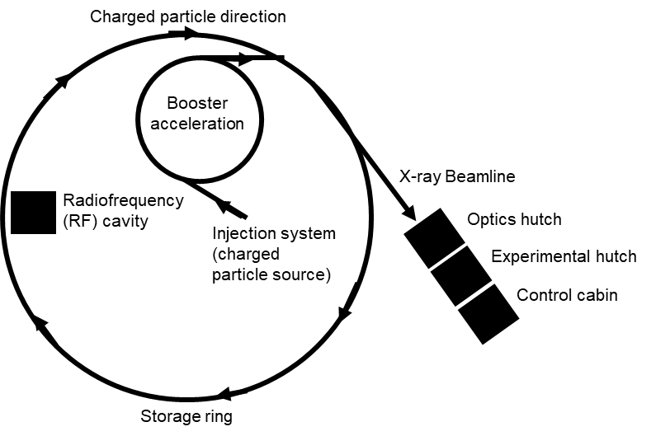
Figure 3.4. Schematic of a typical synchrotron facility adapted from interactive ‘Bird’s eye view’ of the Diamond Light Source Facility [49].
XAS measurements use wavelengths between 0.01 – 10 nm to probe the interatomic structure of molecules as well as identify characteristic features, specific to the electronic configuration of elements. Electrons of an atom occupy electron shells, otherwise known as energy states, labelled K, L and M, from inner to outer (Fig. 3.5). Electrons of the inner most shell have a strong electron binding energy holding them to the atom, while outer shell elections, termed valence electrons, are more easily lost. The number of electrons in each shell is distinct where K, L and M shells (Fig. 3.5a) are configured into subshells (Fig. 3.5b) each with a unique energy level required to excite or remove electrons.

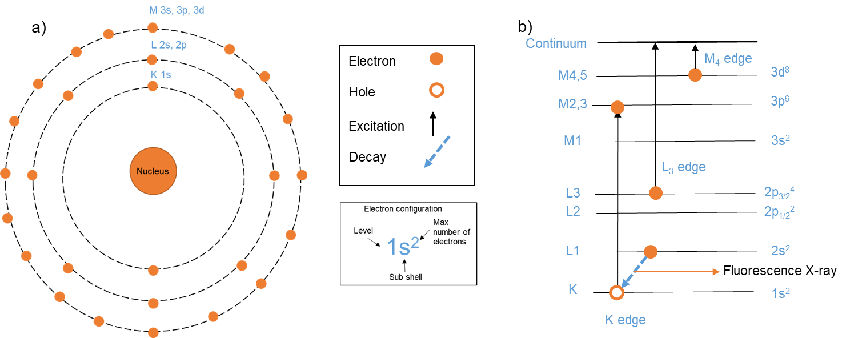
Figure 3.5. Physical processes involved in X-ray absorption spectroscopy. a Electron Shells of an atom, K, L and M with the maximum number of electrons in each shell; b electron shell transitions of the K, L₃ and M₄ edge where an example of Fluorescence X-ray emission is shown.

Transmission measurements
The excitation of electrons between shells occurs at specific energy values, unique to the electron transitions of a specific atom. When the incident energy is equal to that of the transition energy, X-rays are absorbed by the atom and excitation occurs (Fig. 3.5b). In a transmission measurement, the intensity of incident electrons is measured before and after interaction with the sample by ion chambers (Fig. 3.6a). According the Bouguer’s Law (Equation (4)) the incident intensity (I₀) can be related to the absorbed intensity (I_{t}) by the linear absorption coefficient (μ (E)). The absorption coefficient is a measure of the absorbed X-rays in a given thickness (t) of material and is dependent on sample density (ρ). The denser or thicker a sample, the more atoms per unit thickness, the more X-rays are absorbed. As such, the sample thickness must be optimised such that a sufficient number of X-rays are transmitted. The intensity of X-rays is also measured for a reference material at reference ion chamber (I_{ref}).

$I_{t}=I_{0}e^{μ(E)t}$ (4)

Fluorescence measurements
Absorption of X-rays, leading to excitation of a shell electron to a higher energy level, will leave an empty space or hole. This hole is filled by an outer shell electron, which will decay to the lower energy level by a release in energy, as a fluorescence X-ray (Fig. 3.5b). As in transmission measurements, the intensity is measured before interaction with the sample (I₀) however the intensity of emitted fluorescence X-rays (I_{f}) are measured directly (Fig. 3.6b). As fluorescence X-rays are emitted isotopically, an energy-discriminating detector, capable of selecting specific energies of fluorescence X-rays, is set at 45 degrees from the sample surface in order to collect a maximum number of emitted X-rays. The absorption coefficient is then determined via Equation (5).
$μ (E)∝\frac{I_{f}}{I_{0}}$ (4)

Fluorescence measurements are used when the sample thickness cannot be optimised, or for dilute samples where absorption via transmission measurement is negligible. This is applicable to measurements of the Cr K-edge and Mn K-edge for Cr and Mn dopants in the UO₂ where the concentration is low and the UO₂ matrix is highly absorbing.
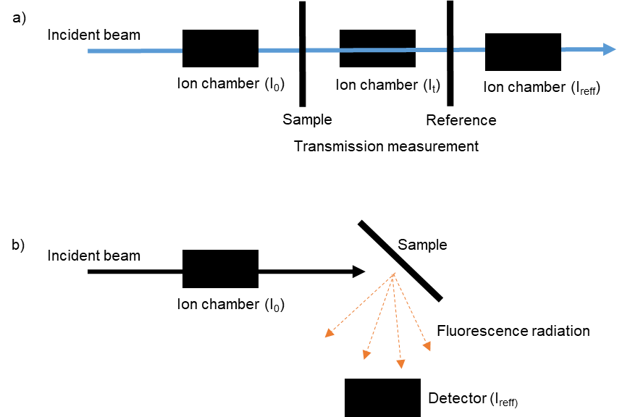
Figure 3.6. Schematic of experimental setup XAS measurements. a Transmission mode; and b Fluorescence mode.

X-ray Absorption Near Edge Spectroscopy
As the incident energy approaches that of the absorption energy for a specific transition, the linear absorption coefficient will have a sharp rise, known as the absorption edge of an XAS spectrum (Fig. 3.7a). The edge and surrounding features are analysed in X-ray Absorption Near Edge Spectroscopy (XANES) where comparison of the absorption edge features of known edge transitions in standard materials can be used to identify oxidation states of samples. In reality, this edge occurs across a 10-20 eV range of the electron transition energy, so when using edge position as a fingerprint indication of specific elements, it is important to define the exact edge transition energy as E₀.

Extended X-ray Absorption Fine Structure
At incident energies above the edge transition, oscillations in the absorption coefficient are observed known as the extended X-ray absorption fine structure (EXAFS) (Fig. 3.7a). These oscillations correspond to interactions of ejected electrons with neighbouring atoms. That is, when the energy of the incident X-ray is sufficient to eject an electron completely from the atom as a photoelectron, it will travel and interact with surrounding atoms (Fig. 3.7b). The photoelectron can be scattered by a number of surrounding atoms before returning to the original absorbing atom, giving rise to observed oscillations in absorption coefficient. Interaction with surrounding atoms creates constructive and deconstructive wave interactions corresponding to maxima and minima of the EXAFS oscillations, respectively.
Information about the local structure of the absorbing atom can then be determined via the EXAFS equation (Fig. 3.8). Since scattering paths are described in waves, the incident X-ray energy (E, eV) is converted to a wavenumber, (k, Å⁻¹) and EXAFS oscillations are described as a function of wavenumber (χ(k), Å^{-1/2/3}). Note the units of χ(k) are dependent on a weighting factor employed to account for loss of amplitude as k increases. Scattering properties of neighbouring atoms are known values, which can be simulated using the FEFF software [50]. The EXAFS equation can be used to determine the number of neighbouring atoms (N_{j}), the distance between them (R_{j,} Å) and the level of disorder associated with variation in the mean squared path length (σj). Further discussion of EXAFS data processing is discussed in the context of the experiments conducted in the present research below.

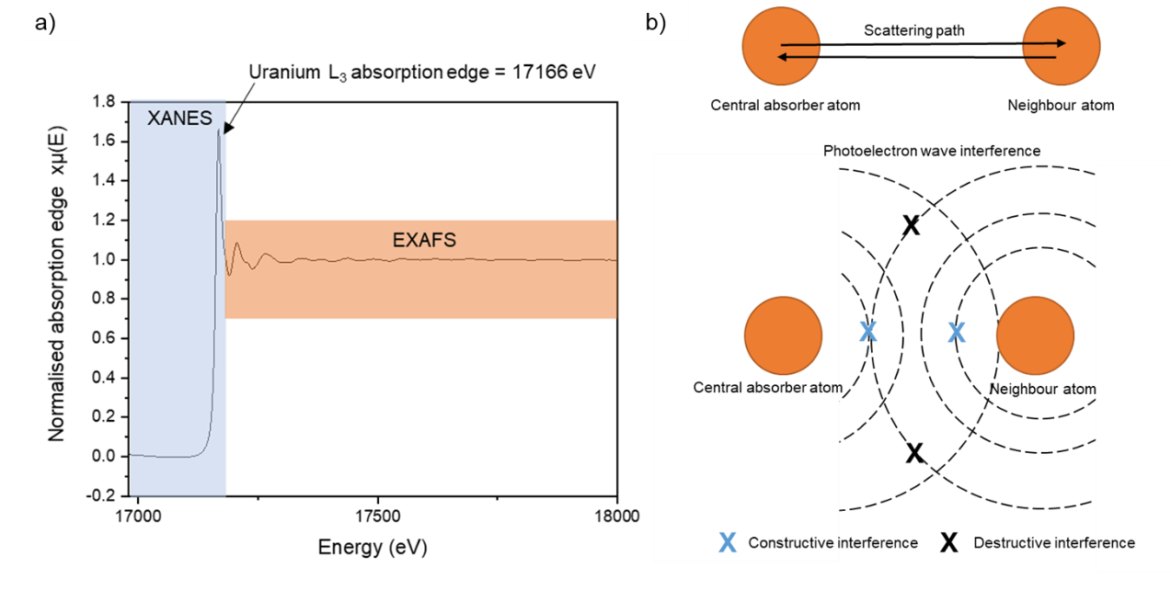
Figure 3.7. XAS data interpretation. a an example X-ray absorption spectra for the U L₃ Edge (17166 eV) showing the XANES and EXAFS regions; b schematic showing the scattering paths of electron waves that give rise to EXAFS oscillations and the associated interference of photoelectrons.

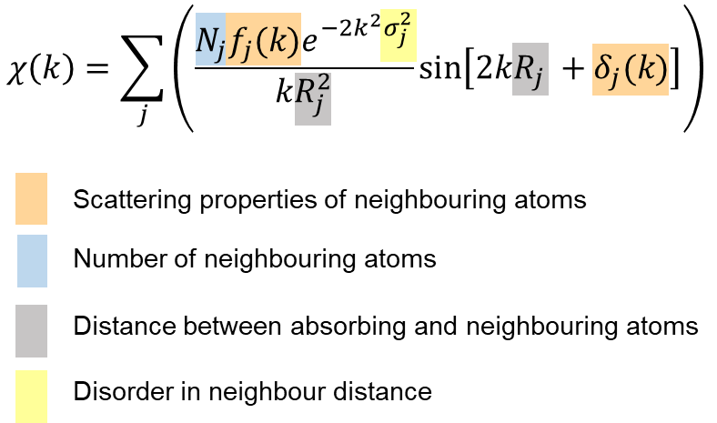
Figure 3.8. Annotated EXAFs equation as described above.

XAS experimental details and data processing
The B18 and I20- scanning beamlines at the Diamond Light source (DLS), Oxford, UK and BM20 beamline at the European Synchrotron (ESRF) [51] were used in this research. The details of each measurement including the measurement type and analysis are outlined in Table 1 and specific beamline experimental set up and data treatment discussed below. All experiments were carried out at room temperature on both sintered pellets and calcined powder material. The as-sintered surface of pellets was measured directly and calcined powders were mixed with poly-ethylene glycol (PEG) and pressed into 6 mm pellets for analysis. Standards of known U, Cr and Mn valence state and coordination were measured.
Initial treatment of all raw data was carried out using the Athena software [52]. A standardised element foil for each element was measured simultaneously with each sample and used as a reference to which E₀ positions of each sample was aligned. A cubic spline background subtraction and normalisation procedure [50] was carried out on all aligned data before multiple scans were merged.
High-energy resolution fluorescence detection X-ray absorption near edge spectroscopy (HERFD XANES), at the U M₄-edge, was carried out at the BM20 beamline using an X-ray emission spectrometer [53]. Measurements at the U M₄ edge probe the excitation of 3d_{3/2} shell electrons to the 5f electron shell, where edge transitions are indicative of different valence states of U and can be used to determine valence states in mixed oxide materials [54]. Pre-processed merged data was plotted in comparison to UO₂ (U⁴⁺) and CrUO₄ (U⁵⁺) standards and a principal component analysis was carried out using the Iterative Target Transformation Factor Analysis (ITFA) software [55] to reconstruct the data. Components were attributed to an oxidation state using the standard spectra and iterative target transformation factor analysis used to indicate an approximate fraction of each oxidation state present in each sample.

Table 1. Experimental measurement details for each element analysed by XAS presented in this research.
Element | Edge | Transition energy (eV) | Electron transition | Synchrotron facility | Measurement type | Analysis range
U | M₄ | 3728 | 3d_{3/2} -5f | BM20 (ESRF) | Fluorescence | XANES
Cr | K | 5989 | 1s – 3p | B18 and I20 (DLS) | Fluorescence | XANES and EXAFS
Mn | K | 6539 | 1s – 3p | I20 DLS | Fluorescence | XANES and EXAFS

Initial measurements of the Cr K-edge XAS were collected at B18 beamline using a Si (111) monochromator and beam size of 500 x 500 μm. Due to the low concentration of dopant present in each sample, the resolution of the acquired fluorescence and transmission data was sub-optimal and information regarding the Cr K-edge EXAFS was un-resolvable.
Further experiments were conducted at the Cr K-edge and Mn-K edge using the wiggler-sourced I20-scanning beamline. A Si (111) four-bounce crystal monochromator was used, which results in a high flux and energy resolution allowing measurement of lower concentrations of sample. A beam size of 400 x 300 µm was used and a 64-element Ge detector with Xspress4 signal processing. Multiple scans were taken to improve data quality with energy steps of 5 eV (5889 - 5985 eV), 0.2 eV (5985 - 6010 eV) with a time step of 1 s step⁻¹ and 0.04 Å⁻¹ (6010 - 6700 eV) with a time step of 1 - 6 s step⁻¹ in this region. Following pre-processing, the XANES region of both Cr and Mn K-edge data was compared to known standards.
Using the Artemis software, the EXAFS region data (eV) was converted to wavenumber, k (Å⁻¹). The Fourier Transform of this data could then be plotted allowing scattering path contributions in the EXAFS oscillations to be more clearly observed. Data from possible scattering paths, generated by CIF files using the FEFF algorithm, can be used to model the Fourier transform using the EXAFS equation (Fig. 3.8). A combination of possible scattering paths from the central absorber (Cr or Mn) to surrounding atoms (U and or O) were iterated to find the model of best fit to the sample structures.
The data range of k (Å⁻¹) and radial distance r (Å) can be selected to include only certain information. For example the radial distance can be such that only the first scattering path (e.g Cr to O) is included in the model. By gradually extending the r range to include more paths, a model of the local structure can be systematically built. The k-range was selected based on quality of data. The amplitude reduction factor (S₀²), which accounts for intrinsic losses in the EXAFS spectrum, was also optimised. The degeneracy or number of neighbouring atoms (N), fitted bond length/scattering path (R)(Å), shift from Cr/Mn K-edge position (5.989 keV/6.539 keV) (∆E₀) and the Debye-Waller factor, which accounts for disorder in neighbour distance (σ²) were allowed to refine until a model of best fit was achieved. The bond valence sum (BVS) was used to indicate the valence in the central absorbing atom by a summation of bond distances in a coordination shell, which is equal to the formal oxidation state of the cation absorber [56].
The R-factor was used to measure the agreement between modelled fits and acquired sample data and a further statistical F-test was applied to each fitted path where the result (α) indicated the confidence of adding the path to improve the fit (>67 % gives a confidence of 1σ, >95 % gives a confidence of 2σ) [57].

Raman Spectroscopy
Raman spectroscopy utilises the interaction of light with chemical bonds of a material to identify and understand the chemical structure. When high intensity incident light (laser), of fixed wavelength (λ_{L}), hits a molecule (Fig. 3.9a), electrons will be excited between energy levels, as discussed in Section 3.6. If the excited electron returns to its original energy state, Rayleigh scattering is observed as no change in energy occurs and photons maintain the same wavelength (λ_{Ray} = λ_{L}). If energy is absorbed and the electron returns to a higher state (Stokes. λ_{Ram} > λ_{L} ), or if energy is lost and the electron returns to a lower state (Anti- Stokes, λ_{Ram} < λ_{L}) Raman scattering is observed. Holographic filters are used to attenuate the Rayleigh scattered light to allow for maximum intensity of Raman scattered light which is then directed to a diffraction grating to optimise the signal response detected by the CCD camera (Fig 3.9b).
Raman scattering causes a change in the frequency of the incident light which is detected after interaction with the sample. The Raman shift (∆ṽ, cm⁻¹) is related to wavelength by Equation (5) where λ₀ and λ₁ represent the incident and Raman shifted wavelength respectively. The intensity of the Raman shift is unique to specific vibrations of chemical bonds and can be used to identify the chemical structure of a sample.

$∆\tilde{ν}=\left(\frac{1}{λ_{0}}-\frac{1}{λ_{1}}\right)$ (5)

Raman analysis was performed using a Renishaw inVia Reflex confocal spectrometer equipped with a Leica DM2500 microscope. A 514 nm green argon laser was used with 1800 lines.mm⁻¹ grating to acquire a spectral acquisition between 200 and 750 cm⁻¹. Vibrational modes present in each sample were identified and a Lorentz peak fitting method used to determine intensity of each peak.

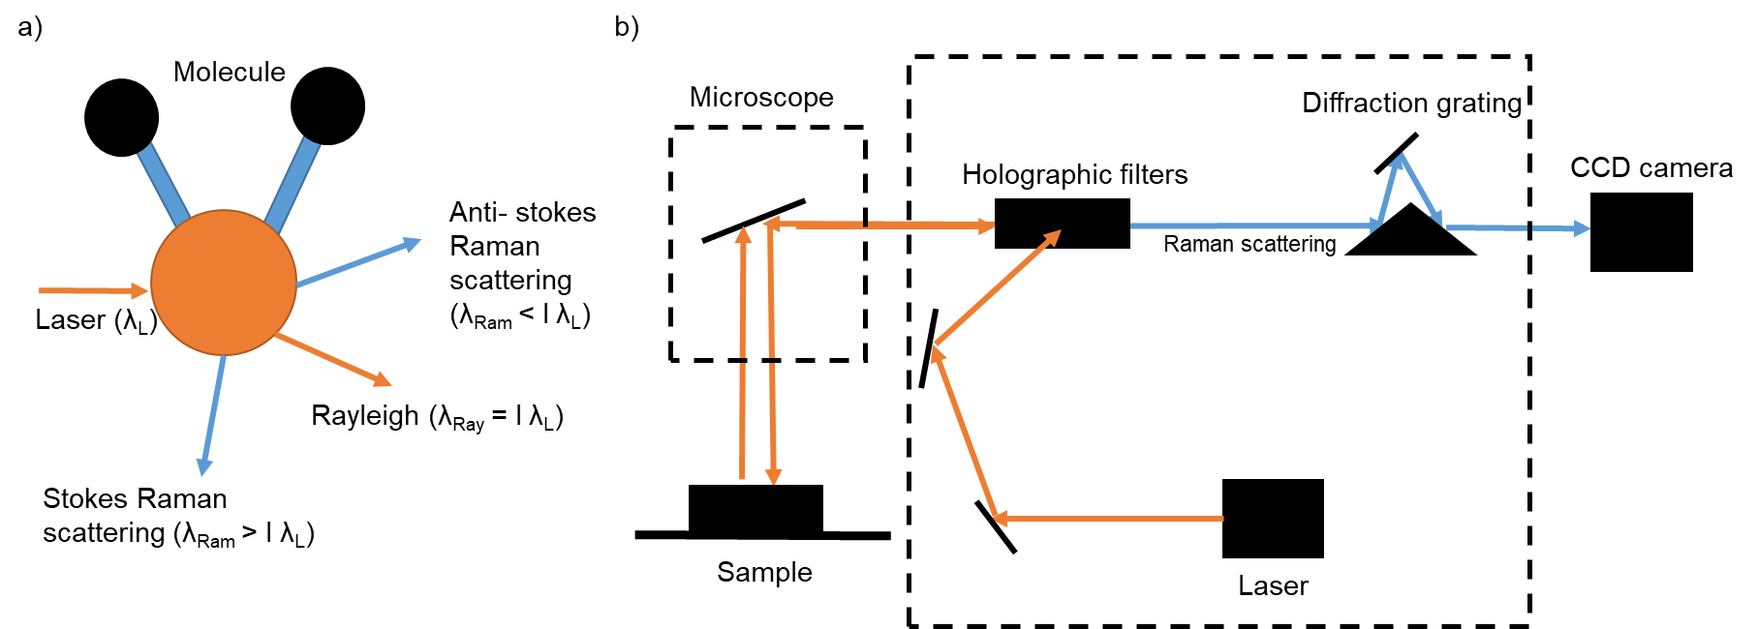
Figure 3.9. Raman spectroscopy. a interaction of light with molecules to produce Rayleigh and Raman scattered light; and b Schematic of the light path and the Raman experimental set up.

Scanning Electron Microscopy
Scanning electron microscopy (SEM) was used to image the surface of samples and to facilitate measurement of grain size. This was coupled with energy dispersive X-ray spectroscopy (EDS) for qualitative elemental analysis of samples. SEM utilises a focused beam of high-energy electrons, directed at a sample surface, to retrieve signals generated by electron-sample interactions (Fig. 3.10a). Such signals are detected and used to construct an image of the sample morphology. Topographical information is returned via secondary electron (SE) imaging, which occurs due to inelastic scattering of low energy, incident electrons (Fig. 3.10b). High-energy electrons will penetrate via elastic interaction whereby the coulombic force of the nuclei forces the electron to travel away from the sample, creating backscattered electrons (BSE). The intensity of BSE is dependent on the size of the atom; heavier atoms have a larger coulombic force and therefore the intensity is larger and such elements appear brighter.
Electrons of sufficient energy will facilitate the removal of a secondary electron from its orbital, which leaves a hole into which electrons from a higher energy level can drop into releasing energy in the form of an X-ray. Such X-rays are characteristic of each element and can be acquired to determine sample composition in EDS.
A Hitachi TM3030 scanning electron microscope was utilised in this research to obtain secondary electron images. Thermally etched samples were imaged at 500x magnification, across 5 points of each pellet surface, to represent the entire sample, and the Image J software used to obtain the average grain size of ~ 500 grains. Pellets removed from dissolution experiments were imaged in the same way and the Bruker Quantax 70 software was used to record EDS maps and spectra.
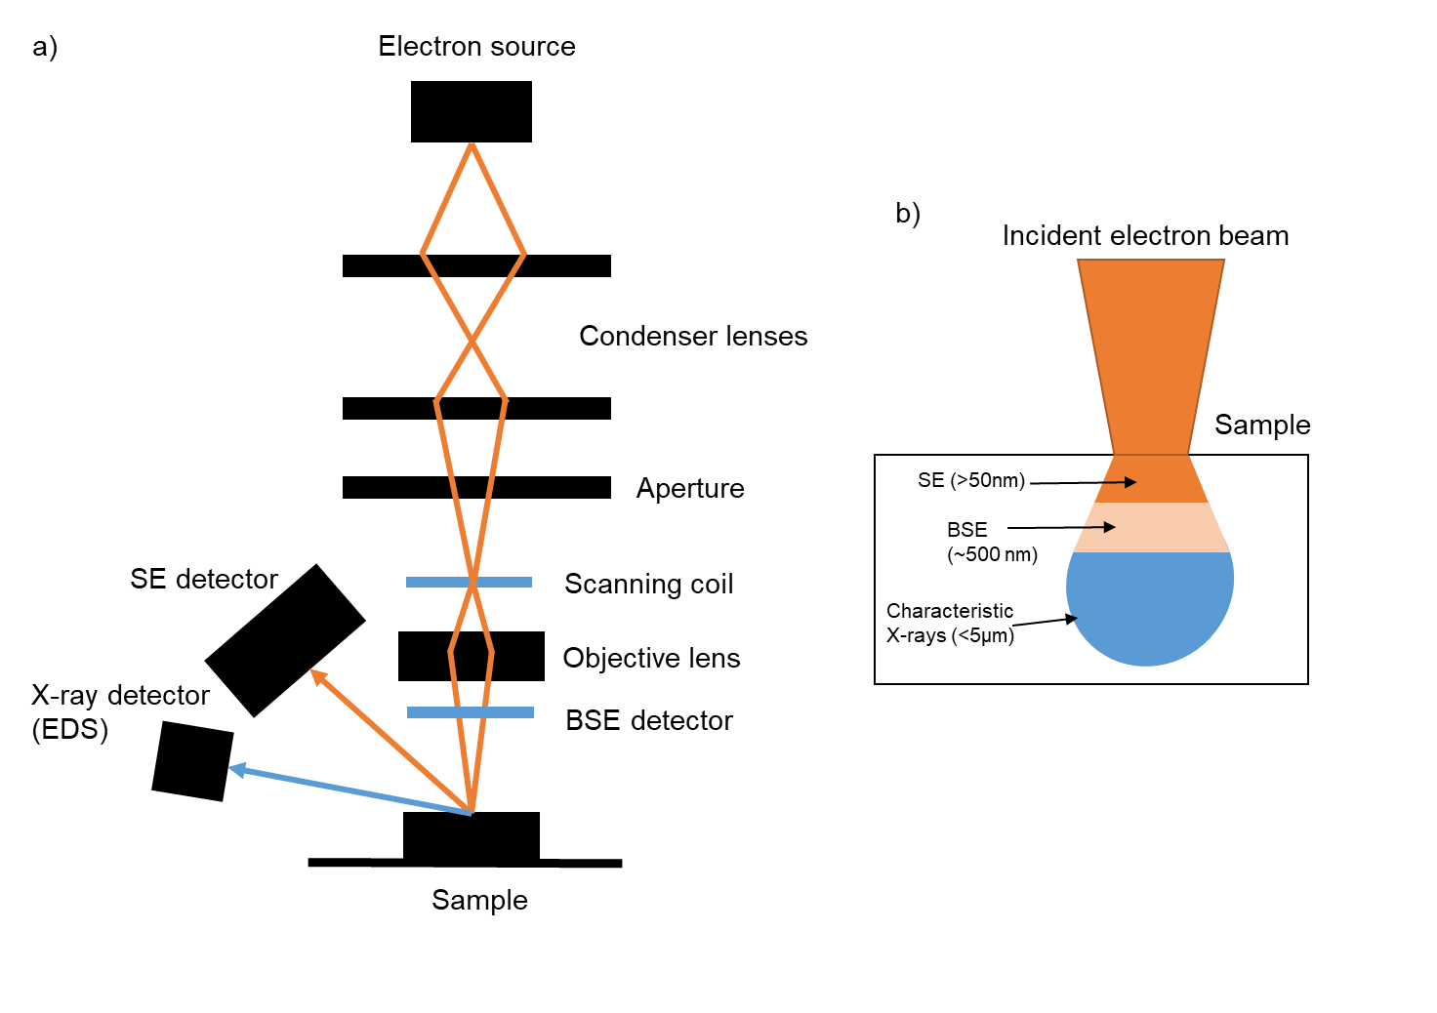
Figure 3. 10. Scanning electron microscopy. a Schematic of an SEM instrument set up; and b The electron penetration depths and the resultant emitted electron or X-ray.

Electron Probe Micro Analysis
Direct measurement of elements, especially those in small quantities, can be determined via electron probe microanalysis (EPMA), which is both a qualitative and quantitative method of element analysis of a sample surface. EPMA uses a focused electron beam (energy 5 – 30 keV) to bombard the surface of a sample with sufficient energy to remove an electron from the inner shell of the nucleus, creating a hole which a higher-level electron fills, emitting a characteristic X-ray. The wavelength of this X-ray is equivalent to the energy difference between the lower and higher electron shells and, since this energy difference is unique for each element, is used to identify composition of the surface. Emitted X-rays can be detected via EDS (as described in Section 3.8), which collects all the emitted X-rays from a sample, or by wavelength dispersive X-ray spectroscopy (WDS), which utilises an analysing crystal to select specific wavelengths. As such, WDS is a much higher precision measurement of a specific element in the sample. WDS utilises Bragg diffraction, whereby an X-ray of wavelength (λ) interacts with an analysing crystal with known atomic spacing (d), at an angle (θ) with the diffracting X-rays emitted at the same angle (θ) (See Section 3.5). The WDS detector is placed at the correct angle (θ) to collect X-rays diffracted from a crystal of the same element that is being measured (Fig. 3.11). EPMA can also detect secondary electrons emitted from the sample and produce images of the surface. The incident beam can be moved across the surface to build up an elemental map or take spot concentrations across a number of positions.
A Cameca SX100 micro analyser with a 15 keV accelerating voltage, 160 nA beam current and a beam diameter of 1 μm was used, calibrated prior to measurement with standards of FeCr₂O₄ and UO₂ at the EPMA facility, School of Geosciences, University of Edinburgh, UK. Elemental composition was analysed by WDS using crystals of PET and LPET to measure U Mα and Cr Kα signals. Measurements were taken at 15 points across the pellet surface and an average wt. % of Cr at each point calculated to represent the wt. % Cr in the UO₂ matrix. Elemental (Cr) maps of 100 x 100 μm across the pellet surface were also taken. MATLAB software was used to process images and adjust the threshold, allowing any areas of high Cr concentration to be observed and back scattered electron images were overlaid with Cr elemental maps to highlight location of Cr.

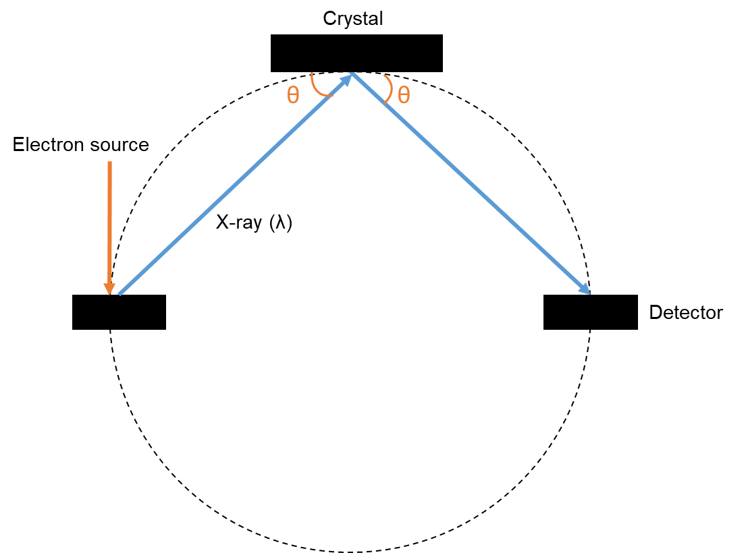
Figure 3.11. Schematic sample/detector set up in wavelength dispersive X-ray Spectroscopy.

Dissolution Experiment Methodology
All sintered pellet samples used in dissolution experiments were thermally etched and pre-characterised by SEM, XRD and VSI, with both the geometric and experimental density determined. Post dissolution, samples were allowed to air dry and were characterised again using SEM, XRD and VSI.
Duplicate samples, of a range of dopant concentrations, were placed in PTFE baskets and submerged into PTFE vessels containing a total volume of 50 mL of the chosen solution (Fig. 3.13). A simulant groundwater (1 mM NaHCO₃ + 19 mM NaCl in ultra-high quality H₂O) [58] was used to allow direct comparison with previous assessments of UO₂ and spent nuclear fuel durability in long-term dissolution experiments. The pH of the solution and the mass of each sample vessel was recorded and placed, alongside two blanks (i.e. solution only, no sample), into ovens held at either 25 °C, 40 °C or 60 °C; an error of ± 2 °C on the oven temperature was recorded via temperature logging throughout the experiment. Periodically, each vessel was gently agitated by hand and an aliquot removed for analysis by ICP-MS (detailed in Section 3.12). The same volume of fresh solution was replaced to maintain the surface area to volume ratio of tests.
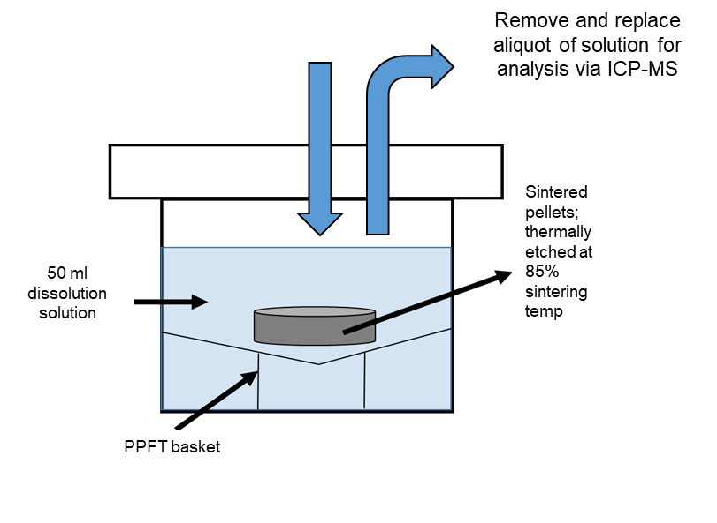
Figure 3.13. Schematic of long-term dissolution experimental setup.

Inductively Coupled Plasma-Mass Spectroscopy
The concentration of elements released from the UO₂ samples to the solution was measured using inductively coupled plasma mass spectroscopy (ICP-MS). ICP-MS is an analytical technique that allows simultaneous measurement of multiple elements and can detect trace level concentrations in aqueous solution. A single quadrupole ICP-MS (Fig. 3.14) pumps liquid samples and nebulises them into a fine aerosol using an Argon gas supply. Fine droplets are separated from larger ones by the spray chamber and introduced to the high temperature argon plasma via a quartz torch where the liquid is ionised. Positively charged ions and electrons in the plasma interact with the atomised sample and elements present are converted to ions by the removal of electrons. Elemental ions are extracted through a set of lenses known as the RAPID lens set up, which focus the ion beam into a quadrupole mass analyser where individual ions are separated based on the mass/charge ratio and measured using a mass detector. A pulse of electrons given off by the ion beam is measured and the intensity of this pulse is compared to a set of standards of known concentration to determine the element concentration in the sample.
It is possible to experience interference from ions generated in the argon plasma that overlap in mass/charge ratio to the elements measured. This can be controlled by selecting to measure elements with no interference or by using kinetic energy discrimination mode (KED). KED mode employs a collision cell, Qcell, to attenuate interference based on the size of the ion. Larger ions will collide more frequently with the cell gas resulting in lower energy ions. An energy barrier is then set for ions leaving the collision cell restricting the larger, slower ions. The quadrupole mass analyser can scan at a rate >5000 atomic mass units per second [59] allowing the ICP-MS to scan many different elements over a short time period.
A ThermoFisher single quadrupole ICP-MS iCAP RQ was used in this research, coupled with a PrepFAST 4DX auto-sampler. Both standard (STD, without QCell) and KED modes were used to measure elemental concentration. The limit of detection for elements measured in this work (U, Cr and Mn) was determined to be ~0.5 ppt.

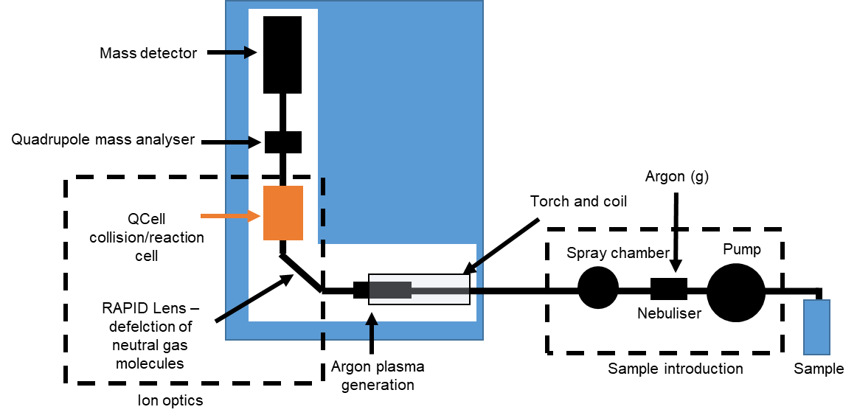
Figure 3.14. Schematic ICP-MS instrument set up.

Dissolution data analysis
The concentration (C (i), mg.L-1) of element (i) in solution was measured and, after deduction of the blank measurement, used with the sample volume (V, L) to determine the mass of element in solution (m (i)(t), mg) at each specific time point (t, days) via Equation (6).

` $m\left(i\right)=C\left(i\right)×V$ (6)

As the solution was not replenished, elemental dissolution was cumulative over the entire experiment (i.e., each aliquot sample will have an elemental concentration equal to concentration at the current time point plus the element concentration of the sample before it). To demine the mass of pellet lost at each time point (m_{loss} (i)(t), mg) the mass of element in solution in the experiment vessel (m_{pot} (i)(t), mg) is added to the mass of element in solution for the previous aliquot sample (m (i)(t-1), mg). The original pellet mass (m_{initial}, mg) and mass fraction (f (i)) of element in sample is used to give the mass of pellet remailing (m_{remaining} (i)(t), mg). Figure 3.15 shows schematically this methodology.

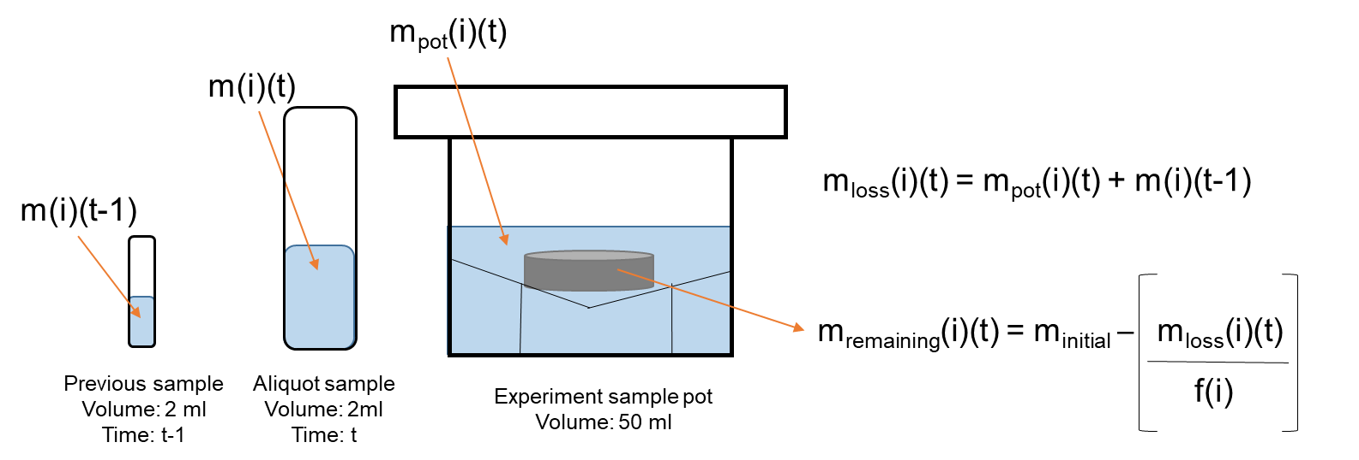
Figure 3.15. Schematic diagram showing the conversion from mass of element in solution to the elemental mass loss and mass of pellet remaining at each time point.

The normalised mass loss N_{L}(U) (g.m⁻²) was calculated from Equation 7 using the specific geometric surface area (S_{SA,} m².g⁻¹) of each sample, while the normalised rate of U dissolution (R_{L}(U), g.m⁻².d⁻¹ ) was determined via the gradient of N_{L}(U) over time.

$N_{L\left(i\right)}=\frac{m_{loss} (i)(t)}{f\left(i\right) × S_{ }× m(i)(t-1)}$ (7)

The dependence of the dissolution rate on temperature was assessed by determination of the activation energy (E_{a}) according to the Arrhenius law, Equation (8), where R_{L}(U) was taken in the initial regime of dissolution as well as when the effects of solution saturation were observed in the steady state of dissolution (as described in Chapter 5). The gradient of ln(R_{L}(U)), for the intended regime, over the reciprocal absolute temperature was taken to determine the E_{a} (kJ mol⁻¹) for each concentration of Cr-doped UO₂.

$R_{L}\left(U\right)= e^{{-E_{a}}/{RT}}$ (8)

Cr²⁺ solid solution in UO₂ evidenced by advanced spectroscopy

The following was prepared for publication in the Journal of Materials Chemistry A and is currently under review.

Cr²⁺ solid solution in UO₂ evidenced by advanced spectroscopy

H. Smithª, L. T. Townsendª, R. Mohunª, T. Cordaraª, M. C. Stennettª, J. F. W. Mosselmans,^{b} K. Kvashnina,^{c,d}, C. L. Corkhill^{a*}

ª NucleUS Immobilisation Science Laboratory, Department of Materials Science and Engineering, The University of Sheffield, UK
^{b} Diamond Light Source, Harwell Science and Innovation Campus, Didcot, UK
^{c} Helmholtz-Zentrum Dresden-Rossendorf (HZDR), Institute of Resource Ecology, PO Box 510119, 01314, Dresden
^{d} The Rossendorf Beamline at ESRF – The European Synchrotron, CS40220, 38043 Grenoble Cedex 9, France

*Corresponding Author: c.corkhill@sheffield.ac.uk

Abstract
Advanced Cr-doped UO₂ fuels are essential for driving safe and efficient generation of nuclear energy. Although widely deployed, little is known about their fundamental chemistry, which is a critical gap for development of new fuel materials and radioactive waste management strategies. Utilising an original approach, we directly evidence the chemistry of Cr⁽³⁺⁾₂O₃–doped U⁽⁴⁺⁾O₂. Advanced high-flux, high-spectral purity X-ray absorption spectroscopy (XAS), corroborated by diffraction and high energy resolved fluorescence detection-XAS, is used to establish that Cr²⁺ directly substitutes for U⁴⁺, accompanied by U⁵⁺ and oxygen vacancy charge compensation. Extension of the analysis to heat-treated simulant nuclear fuel reveals a mixed Cr^{2+/3+} oxidation state, with Cr in more than one physical form, explaining the substantial discrepancies that exist in the literature. Successful demonstration of this analytical advance, and the scientific underpinning it provides, opens opportunities for an expansion in the range of dopants utilised in advanced UO₂ fuels.

Introduction
Chromium (Cr) is an important additive used in uranium dioxide (UO₂) fuel fabrication. The doping of Cr, added as Cr⁽³⁺⁾₂O₃, into UO₂ fuels leads to enhanced grain growth, realising beneficial properties of higher fission gas retention and reduced swelling during reactor operations. During the subsequent long-term storage and disposal of such fuels post-fission, the dissolution behaviour in aqueous media, a two-stage mechanism dependent upon the oxidation of U⁽⁴⁺⁾O₂ to more soluble U⁽⁶⁺⁾O₂²⁺, will be integral to safety over millions of years¹⁻². Since doping of the UO₂ lattice with aliovalent species will alter the valence state of U and, consequently, the local defect structure of UO₂, e.g. forming U^{(4+/5+)}O_{2+x}, an understanding of the influence of Cr on the UO₂ lattice is required to support safety assessments for disposal. While the role of Cr on practical aspects such as fuel performance³⁻⁷ and grain growth mechanisms⁸⁻¹³ is generally understood, agreement on the mechanism of Cr incorporation into the UO₂ structure and its consequent impacts on U chemistry has proven elusive^{14-20, 21}. One reason for this is the prior focus on materials that have been sintered to mimic nuclear fuel production, on which a number of factors, such as pressure, temperature and atmosphere will influence the O diffusion kinetics in the material and, therefore, the final valence, distribution and coordination of U and Cr in the UO₂ structure. Since these sintered systems are highly complex, the lattice structures between studies tend to be incomparable due to the varying sintering conditions used.

A number of possible incorporation mechanisms and associated speciation of Cr within UO₂ have been proposed, implicating Cr³⁺ or Cr²⁺, and in one case, Cr¹⁺. A substitution mechanism is proposed, evidenced by a reduction in the lattice parameter of UO₂ upon doping, attributed to substitution of smaller Cr^{2+/3+} (ionic radii of 0.73 Å and 0.62 Å, respectively²²) on the larger U⁴⁺ (ionic radius 1.00 Å²²) site. This mechanism requires charge compensation via positive defect formation; for example, U⁵⁺ species and/or oxygen vacancy (O_{v}) defects are expected to develop, causing further lattice distortion. Comparison of Cr K-edge X-ray Absorption Spectra (XAS), in particular, the X-ray Absorption Near Edge (XANES) spectral region of sintered Cr-doped UO₂ pellets with a range of Cr standards, has previously provided tentative evidence for the Cr³⁺ valence state^{20, 23}. More recent ab initio atomistic simulations, based on qualitative assessment of XANES data, argue the plausibility of Cr²⁺ speciation²¹, with substitution onto the U⁴⁺ site and concurrent formation of one O_{v}, determined to be the most thermodynamically favourable configuration. Alternately, in density functional theory and empirical potential descriptions, where the valence state of Cr was not restrained to the trivalent state, modelling of defect concentrations in Cr-doped UO₂ at high temperature has predicted Cr¹⁺ interstitial defects would be the dominant species⁸.

To gain definitive experimental evaluation of the Cr incorporation mechanism, quantitative information relating to the lattice interatomic distances and near-neighbour coordination, through the use of Extended X-ray Absorption Fine Structure (EXAFS) region of XAS data is required. The only reported EXAFS fitting of Cr-doped UO_{2,} carried out on commercially available sintered nuclear fuel pellets, gave evidence that Cr is incorporated as Cr³⁺ in 6-fold coordination²³. The feasibility of Cr²⁺ valence and the presence of undissolved Cr⁽²⁺⁾O phases in the pellet was discussed, but not verified. This preliminary work reported a significant change in Cr-O bond length (2.02 ± 0.02 Å) when compared to the U-O distance (2.36 ± 0.02 Å) in UO₂, which was attributed to disruption in both the cation-cation and cation-anion lattices due to the presence of Cr. The authors noted that, owing to the low concentration of Cr in a heavily absorbing U-rich matrix, the data quality was not sufficient to obtain reliable evidence for the Cr speciation and local environment.

In the current study, a high-flux, high spectral-purity beamline was utilised to fully resolve the XAS Cr K-edge, including both XANES and EXAFS regions, thus making it possible to fully resolve the local structure and valence state of Cr in UO₂. Additionally, high-energy resolution fluorescence detection (HERFD) XANES data were acquired at the U M₄-edge to evidence the oxidation state of U^{24,25}, complemented by Raman spectroscopy analysis of the Cr-doped UO₂ oxygen defect chemistry. Importantly, our study avoids the ambiguity induced in interpretation of sintered UO₂ by focusing on simple heat treated (i.e., calcined, not sintered) materials. We thus develop an experimentally-evidenced, fundamental understanding of the mechanism of Cr₂O₃ incorporation within UO₂ oxide powder. This understanding is further applied to Cr-doped UO₂ sintered in a reducing atmosphere, where the unavoidable complexity introduced into the system, and the associated challenge in assigning incorporation mechanisms, is demonstrated.

Experimental
Sample preparation
A suite of Cr-doped UO₂ samples was prepared via a wet synthesis method using uranium (VI) nitrate hexahydrate in solution (0.3 mol L⁻¹) and chromium (III) nitrate nonahydrate in solution (1.6 mol L⁻¹) (Cr(NO₃)₃9H₂O 99.99 %, Sigma Aldrich). Concentrated ammonium hydroxide solution (5 mol L⁻¹) was added at room temperature while stirring until a pH of 8-10 was reached, and a yellow precipitate was observed. Successful co-precipitation of U and Cr was confirmed by analysis of the supernatants by ICP-OES (ThermoFisher iCAP Duo6300), where 99.9 % precipitation for both U and Cr was achieved. Following vacuum filtration, precipitates were washed in deionised water and dried overnight at 90 °C to eliminate any remaining hydroxide. Thermal treatment at 750 °C for 4 hours under a reducing (5% H_{2(g)}: 95% N_{2(g)}) atmosphere allowed conversion of the precursor to oxide, confirmed by powder x-ray diffraction analysis (employing a LaB₆ standard), which showed the fluorite crystal structure in all of the pure and Cr-doped UO₂ samples. Homogeneity and powder reactivity were optimised by milling at 35 Hz for 15 min. A stainless steel die was then used to uniaxially press 6 mm green pellets, at 500 MPa, before sintering in a reducing atmosphere (5% H_{2(g)}: 95% N_{2(g)}) at 1700 ˚C for 8 hours to obtain the final sintered pellets.

The concentration of Cr in the doped UO₂ was verified by complete digestion in concentrated nitric acid. Approximately 20 mg of calcined material was dissolved in 2M HNO₃ (ultrapure) and each vessel was magnetically stirred at 90 °C to accelerate the dissolution. An aliquot was analysed for the Cr concentration using inductively coupled plasma mass spectroscopy (ICP-MS, ThermoFisher iCAP RQ). Triplicate samples were measured to obtain an average Cr concentration for each sample. This method was repeated for sintered pellet samples, which were crushed to a powder using a pestle and mortar before being dissolved.

Raman spectroscopy
The crystal structure of calcined and sintered Cr-doped UO₂ was analysed by Raman spectroscopy using a Renishaw inVia Reflex confocal spectrometer equipped with a Leica DM2500 microscope. Pressed green pellets of calcined powders and sintered samples polished to 1 μm using diamond suspension were measured using a 514.5 nm green argon laser with 1800 lines mm⁻¹ grating to acquire a spectral acquisition between 200 and 800 cm⁻¹. An average of 10-point measurements across the surface of each sample, avoiding grain boundaries, was taken to confirm their reproducibility and the homogeneity of the composition. Information from the Raman spectra was extracted using Lorentz function fitting where the intensity ratios of the triplet defect peaks (U1, U2 & U3) relative to the main UO₂ T_{2g} band (445 cm⁻¹) was carried out. These defect peaks correspond to O_{v} (U1) (~ 527 cm⁻¹), LO mode (U2) (~574 cm⁻¹) and O_{i} (U3) (~634 cm⁻¹)³¹.

X-ray absorption spectroscopy
XAS measurements were performed, at room temperature, on both calcined powder and sintered Cr-doped UO₂ at several beamline facilities. Fluorescence mode was employed at beamline I20-scanning at DLS to measure the Cr K-edge (5.989 keV) using a 64-element Ge detector with Xspress4 signal processing. The beam size was 400 x 300 µm (FWHM). The wiggler-sourced I20 beamline utilises a Si (111) four-bounce crystal monochromator, which results in high flux and excellent energy resolution. As such, I20-scanning is uniquely suited to determine the local structure of Cr-doped UO₂, especially where Cr was in low concentration in the heavily absorbing UO₂ matrix. Multiple scans were taken to improve data quality with energy steps of 5 eV (5889-5985 eV), 0.2 eV (5985-6010 eV) with a time step of 1 s step⁻¹ and 0.04 Å⁻¹ (6010-6700 eV) with a time step of 1-6 s step⁻¹ in this regions. High-energy resolution fluorescence detection X-ray absorption near edge spectroscopy (HERFD XANES), at the U M₄-edge (3.728 keV), was carried out at the BM20 beamline at the European Synchrotron (ESRF)³², France, with a help of X-ray emission spectrometer³³. Surfaces of as-sintered pellets were measured, while calcined powders were mixed with poly-ethylene glycol (PEG) and pressed into 6 mm pellets for analysis. Standards of known U and/or Cr valence state and coordination, including UO₂, CrUO₄, Cr₂O₃ and Cr Foil were also measured.

A standardised element foil was measured simultaneously with Cr-doped UO₂ samples and used as a reference to which the E₀ (Edge transition energy) positions of all raw data was aligned. A cubic spline background subtraction and normalisation procedure³⁴ was carried out on all aligned data before multiple scans were merged using Athena³⁵. The EXAFS region, measured in eV, was then converted to wavenumber, k, with units of Å⁻¹. The Fourier Transform of this data was then fit using models generated from applying possible scattering paths of the central absorber (Cr) to surrounding atoms (O and U). Scattering paths were generated from appropriate structural Crystallographic Information File (CIF) files, using the FEFF 6 algorithm³⁶ in Artemis. A number of parameters; range of k (Å⁻¹) and radial distance r (Å), and the amplitude reduction factor (S₀²) were optimised for the data and the following parameters allowed to refine; degeneracy (N), fitted bond length (R)(Å), shift from Cr K-edge position (5.989 keV) (∆E₀) and the Debye-Waller factor (σ²). The F-test was applied to each fitted path, the result (α) indicated the confidence of adding the path to improve the fit (>67 % gives a confidence of 1σ, >95 % gives a confidence of 2σ)³⁷. The bond valence sum (bvs) returns a summation of bond distances in a coordination shell, which is equal to the formal oxidation state of the cation absorber³⁸. The bond valence of Cr-O coordination was calculated for both calcined and sintered material and used to determine the proportion of Cr²⁺/Cr³⁺ in the sintered material.
Despite efforts during collection of Cr K-edge data, reduced resolution of the XANES region at the lowest Cr concentrations resulted in inconsistency in the background removal and normalisation, most prominently in the 300 ppm sample for both oxide powder and sintered samples (Fig. 2c and e, Extended Data Fig. 4). Nevertheless, the same features were observed for all materials and, as such, only the samples with the highest dopant concentrations were utilised for Cr K-edge EXAFS analysis.
Principal component analysis was carried out on U M₄-edge data (Raw data was pre-processed in Athena as described above) as part of the Iterative Target Transformation Factor Analysis³⁹ to calculate the relative concentration of each component of the absorption spectra; UO₂ and CrUO₄ standards were used.

X-ray diffraction
Powder XRD (p-XRD) characterisation was performed using a PANalytical Xpert3 diffractometer in reflection mode with a 45 keV/40 mA generator. To avoid oxidation, the calcined oxide samples were measured immediately post heat treatment (i.e. within 10 minutes of removal from the furnace). Similarly, sintered samples were crushed using a pestle and mortar upon removal from the furnace, within a controlled inert atmosphere (N_{2(g)}), and immediately measured. Data were collected between 5° and 100° 2θ with a step size of 0.013° and a step time of 40 seconds, a fixed slit size of 0.5 was used. An internal standard of LaB₆ (20-30 wt. %) was used for data alignment, and p-XRD patterns corrected in the WinXPow software. Le Bail refinements were carried out in the Topas software, allowing accurate determination of the lattice parameter as a function of Cr content in UO₂.

Electron probe microanalysis
Sintered pellets were ground using SiC paper, polished to 1 μm using diamond suspension and measured at the EPMA facility, School of Geosciences, University of Edinburgh, UK. A Cameca SX100 micro analyser with a 15 keV accelerating voltage, 160 nA beam current and a beam diameter of 1 μm was used with standards of FeCr₂O₄ and UO₂. Elemental composition was analysed by wavelength dispersive X-ray analysis using crystals of PET (polyethylene terephthalate) and LPET (amorphous polyethylene terephthalate) to measure U Mα and Cr Kα signals. Measurements were taken at 15 points across the pellet surface and an average wt % Cr within the UO₂ matrix calculated as well as maps of 100 x 100 μm. MATLAB software was used to process images and adjust the threshold, allowing any areas of high Cr concentration to be observed. Back scattered electron images were overlaid with EPMA Cr elemental maps to highlight location of Cr.

Results & Discussion

Cr-speciation in UO₂ calcined powder
Confirmation of successful Cr-doping of UO₂ powder upon calcination was given by ICP-MS analysis (Fig. 1a). All oxide powders were shown to contain the intended concentration of Cr when fully digested (in the range 300 to 2400 ppm).

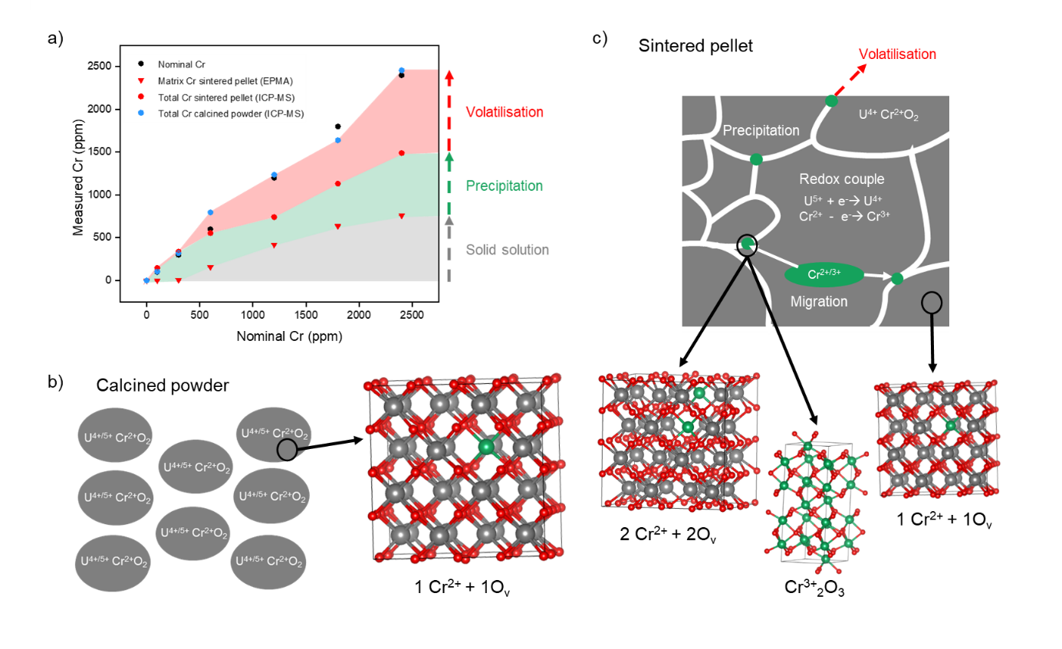
Fig. 1. Cr content and incorporation in UO₂. a The measured Cr content of Cr-doped UO₂ calcined powder and sintered pellets. Total Cr content measured by ICP-MS following acid digest and matrix content of sintered samples measured by EPMA, excluding grain boundary precipitates; b schematic representation and associated crystal structure of particles of calcined Cr-doped UO₂ ²² and; c schematic representation and crystal structures of the sintered matrix of Cr-doped UO₂ ^{21,26}, highlighting distribution of Cr in precipitates (green) at grain boundaries (white). In the crystal structures, grey atoms represent U, green atoms represent Cr and red represent O.

The Cr K-edge EXAFS fitting of the samples was successfully performed using a structure derived from ab initio atomistic models of Cr-doped UO₂, in which Cr²⁺ substitutes onto the U⁴⁺ cation site via the formation of O_{v} for charge balance, denoted by (1Cr²⁺ + 1O_{v}) ²² (Fig. 1b). The EXAFS model (Fig. 2a, b) indicates that the first O nearest neighbour environment is split, with 4 O atoms at a distance of 2.00 ± 0.01 Å, and 3 O atoms at 2.95 ± 0.02 Å, giving a total coordination of 7. Since this is less than the expected coordination of 8, it implies that one O_{v} is situated in the Cr coordination environment. Confirmation of Cr²⁺ speciation is given by the bond valence sum (BVS)²⁷ of 2.05. The second shell Cr-U environment was successfully fitted by the model, with 4 U atoms at a scattering distance of 3.58 ± 0.04 Å and 2 U atoms at 3.85 ± 0.06 Å. These latter Cr-U distances are in good agreement with U-U distances of UO₂ (3.83 Å²³) while the presence of shorter Cr-U distances can be attributed to distortion of U atoms adjacent to the O_{v}. Detailed fit results are displayed in Table 1. These data support the hypothesis of Sun et al. ²¹ who found that the most thermodynamically favourable structural arrangement of Cr in UO₂, through ab initio calculations, is a pair of associated Cr²⁺ and O_{v}, i.e. 1Cr²⁺ + 1O_{v}.

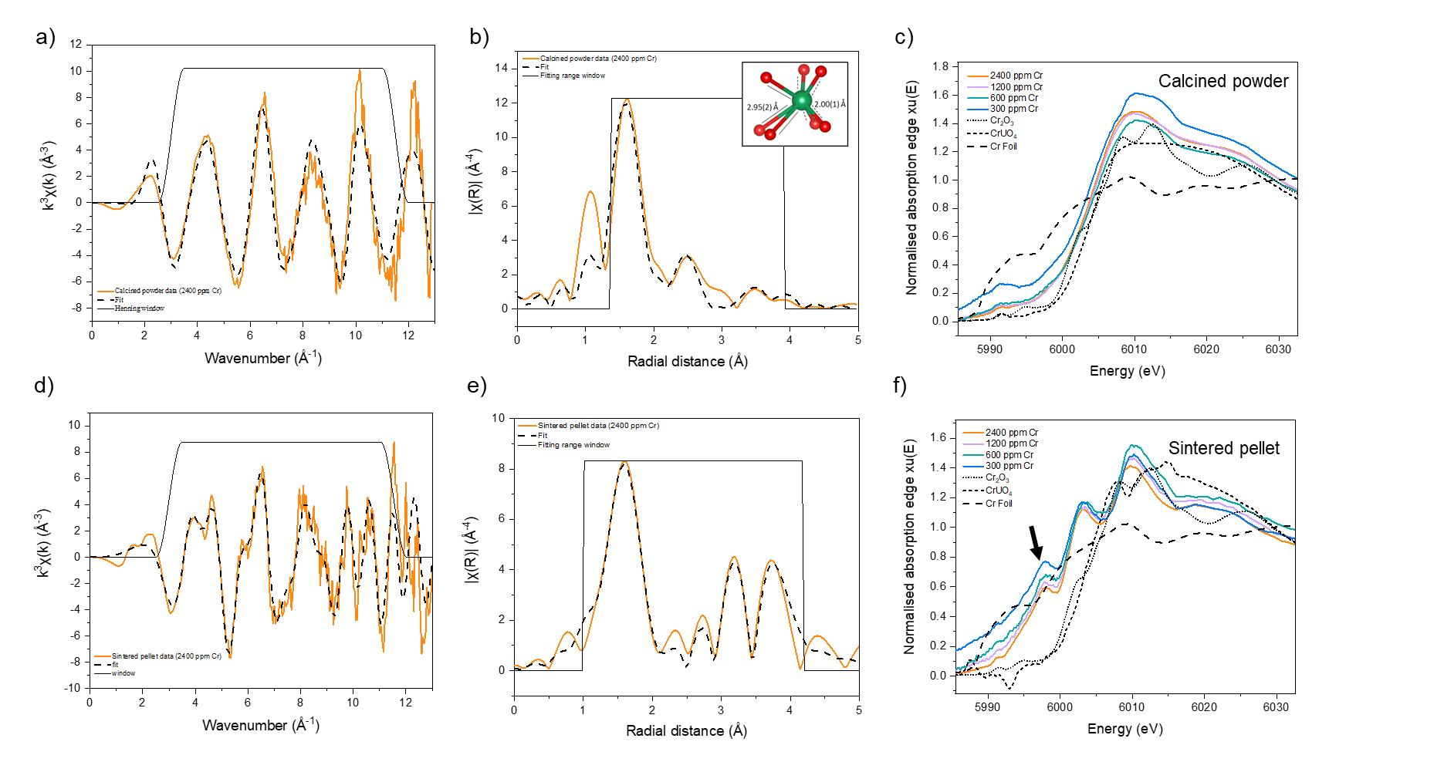

Fig. 2. Crystal structure and local coordination analysis of Cr in Cr-doped UO₂ determined by EXAFS and XANES analysis. k³-weighted Cr K-edge spectra, EXAFS model fits and Cr K-edge XANES spectra of Cr-doped UO₂ in comparison to known standards (Cr₂O₃, CrUO₄ and Cr⁰ foil) respectively, for a-c calcined powders; and d-f sintered pellets where the arrow indicates the white line position of the Cr K Edge.

The substitution mechanism via vacancy formation is further supported by an increase in the O_{v} (U1) defects observed with increasing Cr dopant concentration, according to Raman measurements (Fig. 3a). This is in good agreement with HERFD XANES data acquired at the U M₄-edge (Fig. 3b, Extended Data Fig. 1), which showed, though principal component analysis of the data series, that only two components were required to accurately reconstruct each of the samples in the series. These were attributed to U⁵⁺ and U⁴⁺ oxidation states using the standards CrU⁵⁺O₄ and U⁴⁺O₂. Whilst the higher energy component matches well with the U⁵⁺ standard, U⁴⁺ shows some differences when compared to the UO₂ standard. This is likely due to the distortion around the U⁴⁺ coordination environment upon doping of UO₂ with Cr, possibly due to vacancy formation. Iterative target transformation factor analysis was used to indicate the approximate fraction of U⁴⁺ and U⁵⁺ in each of the oxide powder (Fig. 3c), with results indicating ~ 30% U⁵⁺ (and therefore ~ 70 % U⁴⁺) for all samples, irrespective of Cr content. This corroborates the hypothesis that charge balance for Cr²⁺ within Cr-doped UO₂ is provided by both O_{v} and U⁵⁺ defect formation, according to Equation (1).

$y{Cr}^{2+ }+U^{4+ }O_{2 }→\left({\left(U_{1-x}^{4+}U_{x}^{5+}\right)}_{1-y}{Cr}_{y}^{2+}\right)O_{2-\frac{y}{2}}$ (1)

Analysis of the UO₂ T_{2g} Raman band at 445 cm⁻¹, and other peaks relevant to defect structures in the matrix (Fig. 3a and Extended data, Figs 2a and b), revealed a slight increase in the oxygen interstitial (O_{i}) (U3) concentration with increasing Cr dopant concentration. Given that the concentrations of Cr in the calcined material exceed the generally agreed solubility limit of Cr in UO₂ (reported to be in the range of 700 – 1200 ppm^{3, 6, 9, 11, 15)}, it can be assumed that any excess Cr is present as positive interstitial defects⁸. In this case, negative O_{i} defects would be required as a charge balance mechanism. Since the O_{i} defect concentration broadly increases with increasing Cr content, this seems to be a plausible explanation. However, it is also possible that such defects arise from slight oxidation of the sample during analysis.

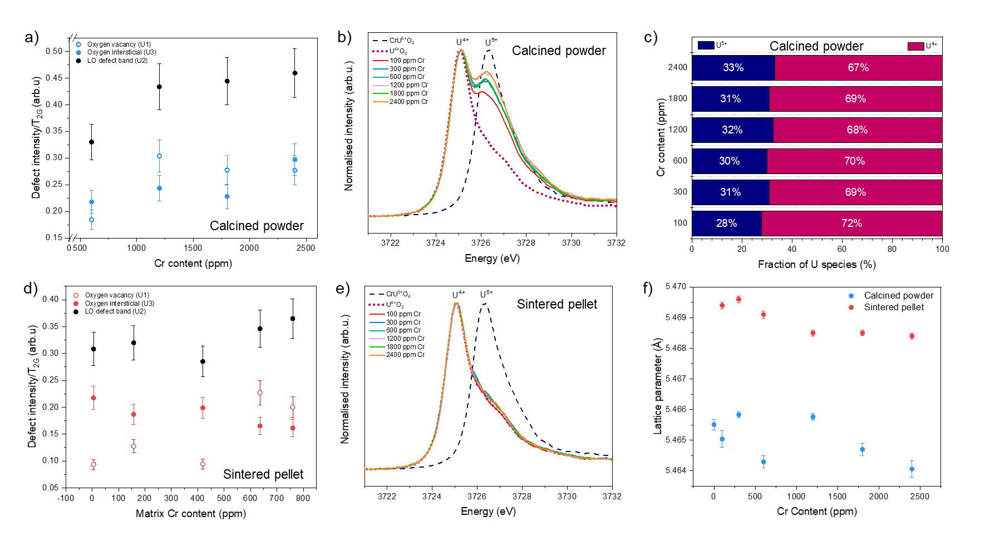

Fig. 3. Raman Spectroscopy, U M₄-edge HERFD XANES and p-XRD analysis of Cr-doped UO₂ materials. a Oxygen defect content realised by deconvolution of Raman spectra of calcined material; b U M₄-edge HERFD XANES of calcined material; c quantification of the U^{4+/5+} ratio in calcined powder determined from fitting of U M₄-edge HERFD XANES data in b; d oxygen defect content of sintered material realised by deconvolution of Raman spectra; e U M₄-edge HERFD XANES of sintered material; and f lattice parameter values for calcined powder and sintered material, as determined by p-XRD.

Cr-speciation in sintered UO₂ pellets
The complexity induced during sintering (analogous to nuclear fuel synthesis) was investigated using calcined Cr-doped UO₂ powders pressed into pellets and heat-treated at 1700 °C under a reducing 5% H_{2(g)}: 95% N_{2(g)} atmosphere. Loss of Cr, expected due to high temperature volatilisation,^{28, 29} is observed through a reduction in the Cr concentration when compared with calcined powder (Fig. 1a). In contrast to the homogenous Cr incorporation in calcined powders, significant heterogeneity in the distribution of Cr in the sintered pellets was observed (Extended data, Fig. 3). This is exemplified by the precipitation of Cr within grain boundaries, which has previously been observed for Cr-doped UO₂ sintered under a range of conditions.^{6, 9, 11-12, 15, 20}

Retention of a portion of Cr within the UO₂ matrix upon sintering is evidenced by a reduction in the lattice parameter with increasing Cr-dopant matrix concentration, as measured by powder X-ray diffraction (p-XRD, Fig. 3f). The absolute values of lattice parameter between the sintered and calcined oxide material are different, with the latter being lower than the former by ~0.004 Å. This is most likely due to the loss of some Cr²⁺ in the lattice due to volatilisation. Alternatively, the lattice parameter decrease could result from the reduction of Cr²⁺ to Cr⁰ (ionic radius 2.00 Å) in the reducing sintering atmosphere or, conversely, possible oxidation of pellets after sintering. Both alternative explanations are excluded on the basis of experimental data obtained: the absence of U⁵⁺ and U⁶⁺ in the HERFD-XANES data for the sintered material (Fig. 3e) and a lower O_{i} concentration than in the calcined materials (Fig. 3d), precludes enhanced oxidation. Moreover, analysis of the XAS data effectively excludes the presence of Cr⁰ within the EXAFS model (see below).

In accordance with the highly reducing sintering conditions, the white line position (E₀) of the Cr K-edge (6,001 eV, Fig. 2f) is shifted to lower energy than that of the Cr³⁺ standards (E₀ = 6,007 eV) and the calcined Cr²⁺UO₂ material (E₀ = 6,005 eV), and towards that of the Cr⁰ standard (E₀ = 5,989 eV). The presence of Cr²⁺, rather than Cr⁰, in the sintered material is confirmed by the occurrence of the pre-edge feature at 5,996 eV, which originates from the forbidden 1s 4s transition of Cr²⁺ ³⁰. This transition becomes allowed for Cr²⁺ only when multiple Cr²⁺ environments are present, which induces s to p orbital mixing. The lower the symmetry of the Cr²⁺ environments, the more that such hybridisation can occur; consequently, it is proposed that multiple, low-symmetry Cr²⁺ environments exist for the sintered material. That this transition is not observed as strongly in the equivalent calcined Cr²⁺-containing UO₂ XANES spectra (Fig. 2c), is likely to be a consequence of the single Cr²⁺ coordination and high symmetry environment of those materials.

In comparison with the calcined material, fitting of the EXAFS data acquired from the sintered sample was challenging. Several unsuccessful models were explored, including those based on the structure of Cr⁽³⁺⁾U⁽⁵⁺⁾O₄, and others including Cr-Cr backscatters, to be expected if Cr⁰ were present. All produced unsatisfactory fits, both quantitatively and qualitatively. The best fit was achieved by utilising the 1Cr⁽²⁺⁾+1O_{v} structure²¹ in addition to a second Cr²⁺ environment of 2Cr⁽²⁺⁾+ 2O_{v} and also a Cr³⁺ environment, of Cr⁽³⁺⁾₂O₃ (Fig. 2e and Table 1; structures shown in Fig 1c). The mixed Cr²⁺/Cr³⁺ oxidation state is confirmed by the resultant BVS, which gives an average Cr oxidation state of 2.35. The EXAFS fit was used to estimate that the sintered Cr-UO₂ contains ~65% Cr²⁺ and ~35% Cr³⁺. The presence of Cr³⁺ in such a reducing environment can be explained by the existence of U⁵⁺ species in the calcined precursor material, but none in the sintered material (Fig. 3b and d). We hypothesise that Cr³⁺ originates from the reduction of U⁵⁺ to U⁴⁺ during sintering and the associated redox couple with Cr²⁺/Cr³⁺.

The aforementioned best fit model contained: 4.5 O atoms at a distance of 2.00 ± 0.01 Å; 1.5 O atoms at 2.44 ± 0.02 Å; 1 U atom at 3.34 ± 0.05 Å; 3 U atoms at 3.40 ± 0.07 Å; and 2 more U atoms at 3.91 ± 0.02 Å, indicating that a complex mixture of different Cr environments likely exists. Previous work has experienced limited success in obtaining and analysing XAS data (both XANES and EXAFS^{20, 21, 23}) on systems similar to this sintered sample. As such, this proposed model, generated using high flux, low-noise scanning EXAFS, provides insight to a possible structure for sintered Cr-doped UO₂. Given the complexity of the sample, including the likely multiple Cr oxidation states and coordination environments, further study of sintered materials developed under carefully controlled conditions should be performed, using this original analytical approach, to systematically evaluate the effect of sintering on the structure of Cr-UO₂ materials.

Table 1. Fitting parameters and results for 2400 ppm Cr-doped UO₂ oxide powder and sintered pellet samples. (S₀²) is the amplitude reduction factor, (∆E₀) the shift from Cr K-edge position (5.989 keV), (N) the degeneracy, (R_{eff}) (Å) the reference bond length, (R) (Å) the fitted bond length, (σ²) the Debye-Waller factor and (α) F-test factor.
 | UO₂ + 2400 ppm Cr (Calcined oxide powder) | UO₂ + 2400 ppm Cr (Sintered pellet)
S₀² | 0.90 | 0.90
∆E_{o} | -0.80(2) | -6.0(15)
N (Cr-O1) | 4 | 4.5
R_{eff} (Cr-O1) | 2.10* | 2.10*^
R(Cr-O1) | 2.00(1) | 2.00(1)
σ² (O1) | 0.001(1) | 0.005(1)
α (%) | 100.0 | 100.0
N (Cr-O2) | 3 | 1.5
R_{eff} (Cr-O2) | 2.94* | 2 .17’
R(Cr-O2) | 2.95(2) | 2.44(2)
σ² (O2) | 0.004(3) | 0.002(2)
α (%) | 99.6 | 100.0
N (Cr-U1) | 4 | 3
R_{eff} (Cr-U1) | 3.49* | 3.49*^
R(Cr-U1) | 3.58(4) | 3.40(7)
σ² (U1) | 0.017(6) | 0.014(8)
α (%) | 85.7 | 100.0
N (Cr-U2) | 2 | 1
R_{eff} (Cr-U2) | 3.81* | 3.40*
R(Cr-U2) | 3.85(6) | 3.34(5)
σ² (U2) | 0.01(7) | 0.004(3)
α (%) | 79.1 | 100.0
N (Cr-U3) | - | 2
R_{eff} (Cr-U3) | - | 3.81*^
R(Cr-U3) | - | 3.91(2)
σ² (U3) | - | 0.001(1)
α (%) | - | 100.0
R-factor | 0.019 | 0.013
Bond valence sum (O1) | 1.94 | 2.14
Bond valence sum (O2) | 0.11 | 0.22
Bond valence sum (total) | 2.05 | 2.35
Structures used to inform path fitting *1Cr+1O_{v},’ 2Cr+2O_{v,} ^ Cr₂O_{3.}

Considering these data, the following mechanism of Cr incorporation in sintered UO₂ is proposed (Fig. 1c): Cr²⁺, already dissolved in the UO₂ lattice (substituted onto U⁴⁺ sites and associated with O_{v}) in the calcined starting material, is retained within the matrix upon sintering. For any given material where the proposed solubility limit of Cr is exceeded (> 700 – 1200 ppm Cr in UO₂ ^{3, 6, 9, 11, 15}), Cr is likely present in interstitial sites⁸ and is, thus, unbound and easily mobilised during sintering. This portion of Cr diffuses towards the grain boundaries allowing precipitation or volatilisation to occur. While it is not possible to confirm the oxidation state of this mobile fraction of Cr, it is likely that this reflects a combination of Cr²⁺, which was determined to exist in more than one environment, and some Cr³⁺, which was necessary to model the EXAFS data. The presence of Cr³⁺ is in agreement with µ-XANES analysis of an industrially-synthesised Cr-doped UO₂ pellet¹⁹, which confirmed that precipitates of Cr comprised of Cr³⁺.

Conclusions

In summary, this work provides direct experimental evidence that, prior to high temperature heat treatment, the fundamental lattice structure of Cr-doped UO₂ incorporates Cr²⁺ substituted on a U⁴⁺ site, charge balanced by the formation of both U⁵⁺ and O_{v} defects. The latter defects appear to remain upon sintering in a reducing atmosphere, while U⁵⁺ is reduced, promoting the oxidation of Cr²⁺ to Cr³⁺, although the main Cr oxidation state in these materials remains Cr²⁺. The difficulty in realising the full local structure of aliovalent doped-UO₂ materials, particular after the application of high temperature heat treatment, is highlighted. Such complexity can be, at least in part, resolved using high resolution spectroscopy techniques, which can be used to scientifically underpin the development of novel advanced doped uranium nuclear fuels.

Acknowledgements

This work was funded by the European Commission Horizon 2020 Research and Training Programme, DISCO, of the European Atomic Energy Community (EURATOM), under grant agreement number 755443. We also wish to acknowledge funding from the UK Engineering and Physical Science Research Council (EPSRC) under grant numbers EP/N017374/1 and EP/S020659/1. This research utilised the HADES/MIDAS facility at the University of Sheffield established with financial support from EPSRC and BEIS, under grant EP/T011424/1⁴⁰, and also the PLEIADES National Nuclear User Facility, established with funding from EPSRC under grant number EP/V035215/1 and the Henry Royce Institute for Advanced Materials ICP-MS facility, under grant numbers EP/P02470X/1 and EP/P025285/1. We acknowledge Diamond Light Source for time on B18 and I20-scanning under proposal numbers SP20872, SP24074 and SP28515, with thanks to Giannantonio Cibin and Stephen Parry. We acknowledge the European Synchrotron Radiation Facility for provision of synchrotron radiation facilities (under proposal number MA-4821) and we would like to thank Tatiana Poliakova, Anastasiia Smirnova and Jurij Galanzew for assistance in using the Rossendorf beamline (ROBL, BM20) remotely during the pandemic. We would like to thank Chris Hayward at the University of Edinburgh and Max Cole at the University of Sheffield for assistance with EPMA analysis, Clémence Gausse for support with ICP-MS analysis and Piotr Kowalski at FZ Juelich for invaluable input to the EXAFS modelling. Finally, we wish to acknowledge all of the members of the DISCO project for fruitful discussions about really tricky nuclear fuel chemistry.

Author contributions

Hannah Smith – data collection, formal analysis, original draft preparation.
Luke Townsend – formal analysis, original draft preparation, reviewing and editing.
Ritesh Mohun – data collection, formal analysis, original draft preparation, reviewing and editing.
Theo Cordara – data collection, formal analysis.
Martin Stennett - data collection, formal analysis.
Kristina Kvashnina – data collection, formal analysis, reviewing and editing.
Fred Mosselmans – data collection, reviewing and editing.
Claire Corkhill – funding acquisition, supervision, data collection, formal analysis, reviewing and editing.

References
1 R. C. Ewing, Nat. Mater., 2015, 14, 252–257.
2 NDA, Geological Disposal: Package evaluation status report, 2010.
3 J. Arborelius, K. Backman, L. Hallstadius, M. LimbÄCk, J. Nilsson, B. Rebensdorff, G. Zhou, K. Kitano, R. LÖfstrÖm and G. RÖnnberg, J. Nucl. Sci. Technol., 2006, 43, 967–976.
4 A. Massih, Swedish Radiat. Saf. Auth., 2014, 74, 1-71.
5 J. C. Killeen, J. Nucl. Mater., 1980, 88, 177–184.
6 S. Kashibe and K. Une, J. Nucl. Mater., 1998, 254, 234–242.
7 K. Une, I. Tanabe, J. Nucl. Mater., 1987, 150, 93–99.
8 M. W. D. Cooper, C. R. Stanek and D. A. Andersson, Acta Mater., 2018, 150, 403–413.
9 L. Bourgeois, P. Dehaudt, C. Lemaignan and A. Hammou, J. Nucl. Mater., 2001, 297, 313–326.
10 J. H. Yang, K. S. Kim, I. H. Nam, J. S. Oh, D. J. Kim, Y. W. Rhee and J. H. Kim, J. Nucl. Mater., 2012, 429, 25–33.
11 A. Milena-Pérez, L. J. Bonales, N. Rodríguez-Villagra, S. Fernández, V. G. Baonza and J. Cobos, J. Nucl. Mater., 2021, 543, 152–181.
12 C. M. Silva, R. D. Hunt and K. S. Holliday, J. Nucl. Mater., 2021, 553, 153053.
13 C. Mieszczynski, G. Kuri, C. Degueldre, M. Martin, J. Bertsch, C. N. Borca, D. Grolimund, C. Delafoy and E. Simoni, J. Nucl. Mater., 2014, 444, 274–282.
14 A. Leenaers, L. De Tollenaere, C. Delafoy and S. Van den Berghe, J. Nucl. Mater., 2003, 317, 62–68.
15 T. Cardinaels, K. Govers, B. Vos, S. Van Den Berghe, M. Verwerft, L. De Tollenaere, G. Maier and C. Delafoy, J. Nucl. Mater., 2012, 424, 252–260.
16 S. C. Middleburgh, D. C. Parfitt, R. W. Grimes, B. Dorado, M. Bertolus, P. R. Blair, L. Hallstadius and K. Backman, J. Nucl. Mater., 2012, 420, 258–261.
17 E. Curti and D. A. Kulik, J. Nucl. Mater., 2020, 534, 152140.
18 Z. Guo, R. Ngayam-Happy, M. Krack and A. Pautz, J. Nucl. Mater., 2017, 488, 160–172.
19 G. Kuri, C. Mieszczynski, M. Martin, J. Bertsch, C. N. Borca and C. Delafoy, J. Nucl. Mater., 2014, 449, 158–167.
20 C. Riglet-Martial, P. Martin, D. Testemale, C. Sabathier-Devals, G. Carlot, P. Matheron, X. Iltis, U. Pasquet, C. Valot, C. Delafoy and R. Largenton, J. Nucl. Mater., 2014, 447, 63–72.
21 M. Sun, J. Stackhouse and P. M. Kowalski, Commun. Mater., 2020, 1, 1–8.
22 R. D. Shannon, Acta Crystallogr. Sect. A, 1976, A32, 751–767.
23 C. Mieszczynski, G. Kuri, J. Bertsch, M. Martin, C. N. Borca, C. Delafoy and E. Simoni, J. Phys. Condens. Matter., 2014, 26, 355009.
24 K. O. Kvashnina, S. M. Butorin, P. Martin and P. Glatzel, Phys. Rev. Lett., 2013, 111, 253002–1.
25 K. O. Kvashnina, S. M. Butorin and S. M. Butorin, ChemComm., 2022, 58, 317-472.
26 G. Guimbretière, L. Desgranges, A. Canizarès, G. Carlot, R. Caraballo, C. Jégou, F. Duval, N. Raimboux, M. R. Ammar and P. Simon, Appl. Phys. Lett., 2012, 100, 251914.
27 A. C. Scheinost, J. Claussner, J. Exner, M. Feig, S. Findeisen, C. Hennig, K. O. Kvashnina, D. Naudet, D. Prieur, A. Rossberg, M. Schmidt, C. Qiu, C. Cohen, E. Dettona, V. Dyadkin and T. Stumpf, J. Synchrotron Radiat., 2021, 28, 333–349.
28 K. O. Kvashnina and A. C. Scheinost, J. Synchrotron Radiat., 2016, 23, 836–841.
29 M. Newville, J. Synchrotron Radiat., 2001, 8, 322–324.
30 B. Ravel and M. Newville, J. Synchrotron Radiat., 2005, 12, 537–541.
31 A. Ankudinov and B. Ravel, Phys. Rev. B - Condens. Matter Mater. Phys., 1998, 58, 7565–7576.
32 L. Downward, C. H. Booth, W. W. Lukens and F. Bridges, AIP Conf. Proc., 2007, 882, 129–131.
33 D. A. Brown, I. D., Acta Crystallogr. Sect. B, 1985, 41, 244–247.
34 A. Rossberg, K. U. Ulrich, S. Weiss, S. Tsushima, T. Hiemstra and A. C. Scheinost, Environ. Sci. Technol., 2009, 43, 1400–1406.
35 A. Kantor, I. Kantor, M. Merlini, K. Glazyrin, C. Prescher, M. Hanfland and L. Dubrovinsky, Am. Mineral., 2012, 97, 1764–1770.
36 I. D. Brown, Chem. Rev., 2009, 109, 6858–6919.
37 V. Peres, L. Favergeon, M. Andrieu, J. C. Palussire, J. Balland, C. Delafoy and M. Pijolat, J. Nucl. Mater., 2012, 423, 93–101.
38 S. C. Finkeldei, R. D. Hunt, J. O. Kiggans C. A. Hobbs, B. D Eckhard, J. W. McMurray, K.A Terrani, A. T. Nelson, ORNA., 2019, 1, 1-14
39 S. R. Sutton, K. W. Jones, B. Gordon, M. L. Rivers, S. Bajt and J. V. Smith, Geochim. Cosmochim. Acta, 1993, 57, 461–468.
40 N. C. Hyatt, C. L. Corkhill, M. C. Stennett, R. J. Hand, L. J. Gardner and C. L. Thorpe, IOP Conf. Ser. Mater. Sci. Eng., 2020, 818, 012022.

Extended data

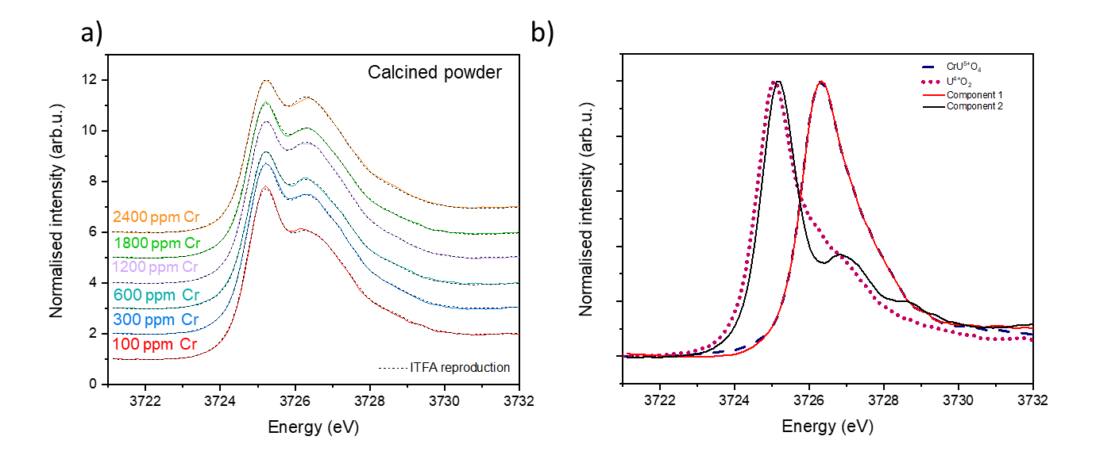

Extended Figure 1. HERFD XANES U M₄ edge spectroscopy analysis of calcined material. a ITFA reproductions of Cr-doped UO₂ calcined powder using only two components. Coloured lines are the original data and black dotted lines are the reproduced spectra by ITFA and; b Comparison between the components produced during the PCA analysis using (CrU⁵⁺O₄) and U⁴⁺O₂ standards.

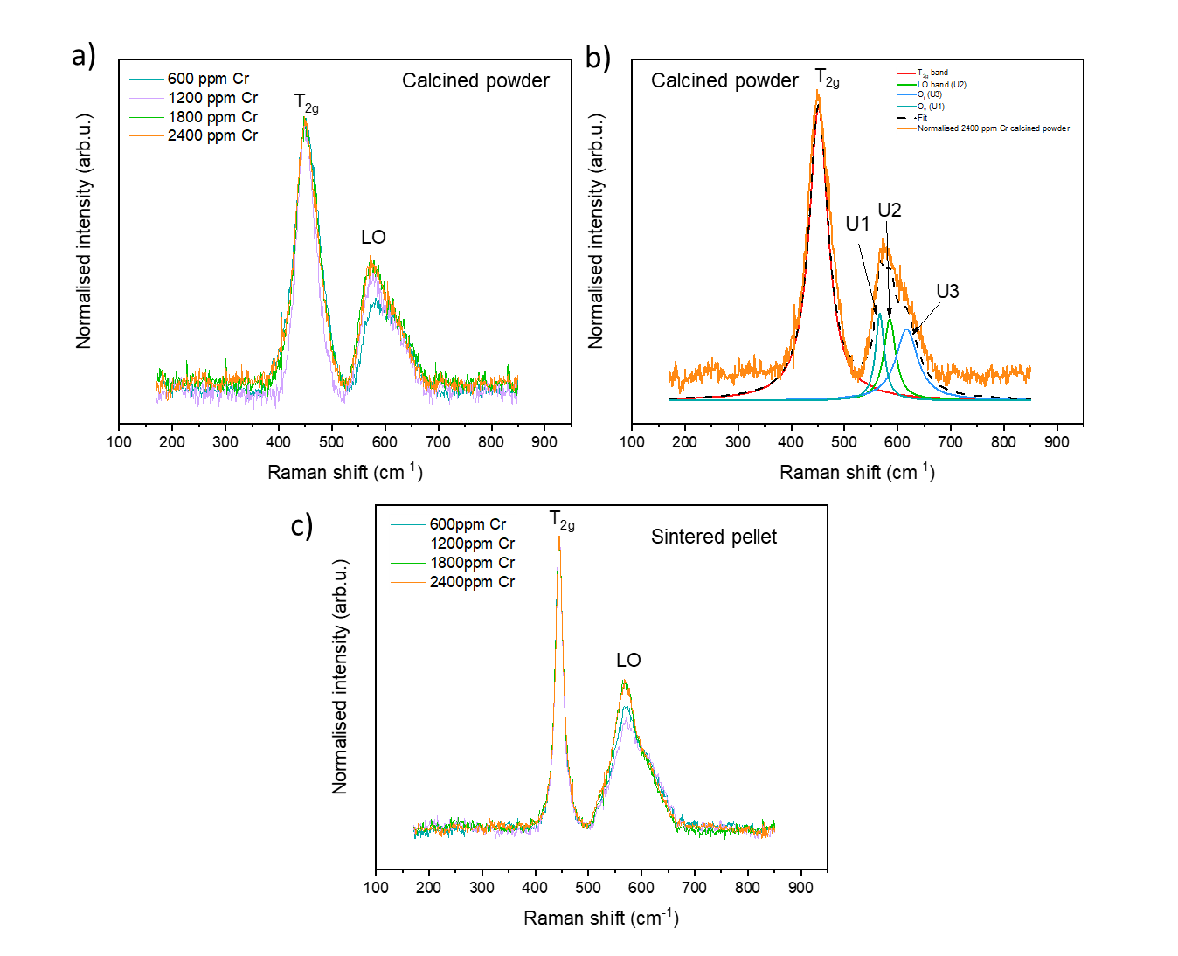
Extended Figure 2. Raman spectra for Cr-doped UO₂ calcined and sintered material. a Calcined powder Raman spectrum as a function of Cr content; b deconvolution of 2400 ppm Cr-doped calcined powder; c sintered pellet Raman spectra.

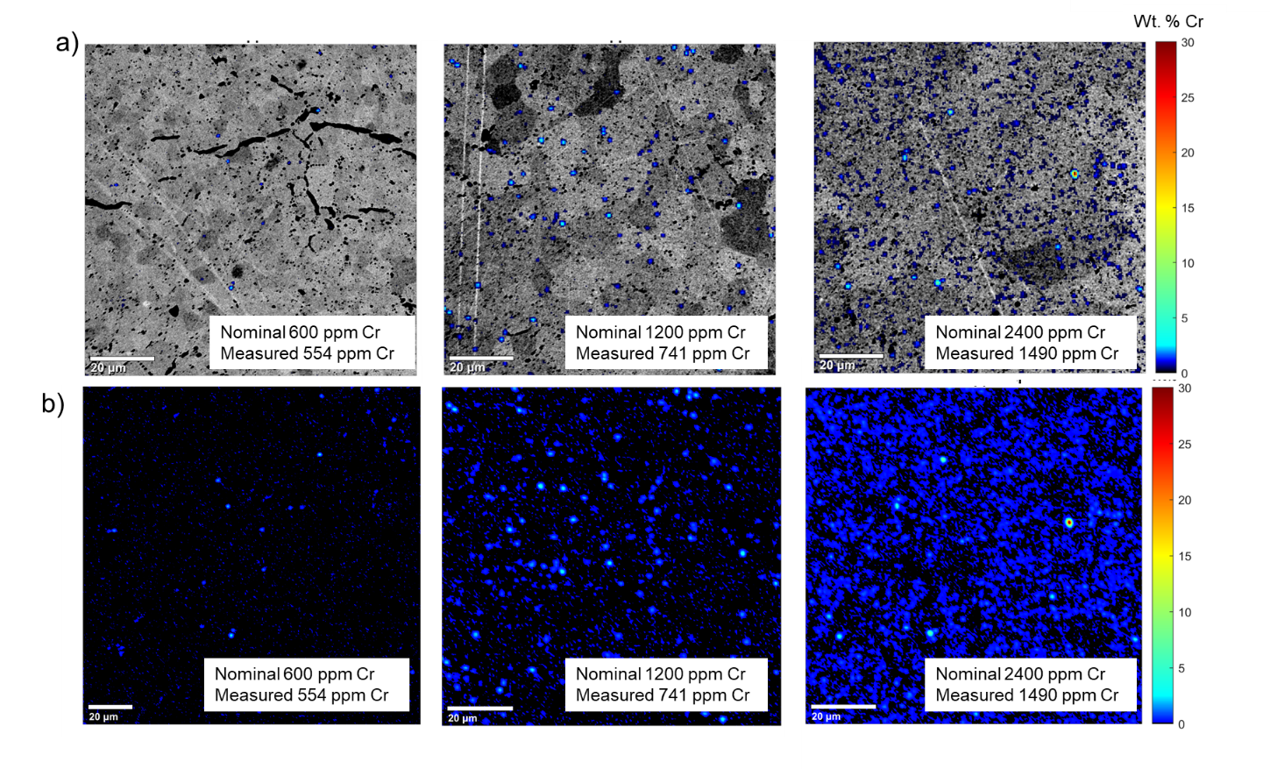
Extended Figure 3. Distribution of Cr in Cr-doped UO₂ sintered pellets measured by EPMA. a SEM micrographs overlaid with Cr elemental distribution maps showing distribution of Cr as precipitates at grain boundaries and within the UO₂ matrix; b Cr elemental distribution maps.

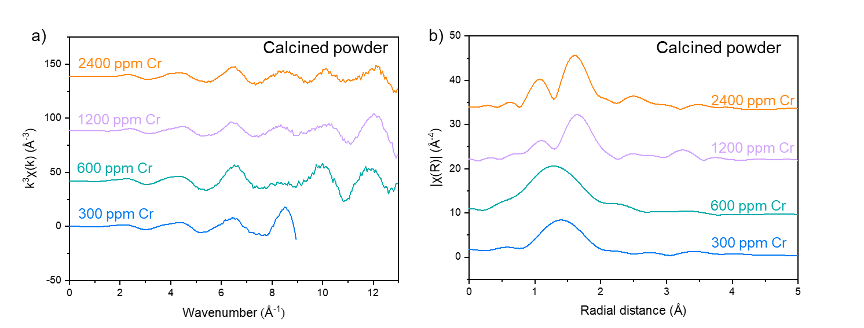

Extended Figure 4. Comparison of Cr K-edge data of Cr-doped UO₂ calcined powder (300 – 2400 ppm Cr). a k³-weighted Cr K-edge spectra (K-space) and; b the Fourier transform (R- space).

Oxidative dissolution of Cr-doped UO₂ fuel

The following was prepared for publication in the journal, Applied Materials and Interfaces.

Oxidative dissolution of Cr-doped UO₂ fuel

H. Smithª, T.Cordaraª, C. Gausseª, S. Pepperª, Claire L. Corkhillª

ªNucleUS Immobilisation Science Laboratory, Department of Materials Science and Engineering, The University of Sheffield, UK

Abstract

The long-term durability of advanced Cr-doped UO₂ is of interest when considering how such materials compare to the well-known behaviours of undoped UO₂ under geological disposal conditions. This study is focussed on the effects of Cr present in the UO₂ matrix as Cr²⁺ and as Cr³⁺ containing precipitates on the dissolution behaviour and is conducted in simulated groundwater solution at 25 °C, 40 °C and 60 °C in air. The normalised mass loss, dissolution rate and activation energy were determined as a function of Cr content allowing insight into the mechanisms and kinetics of Cr-doped UO₂ dissolution. At 25 °C and 40 °C, U dissolution rates in Cr-doped UO₂ were systematically lower than undoped UO₂, suggesting a link between Cr content and durability, postulated to be the result galvanic coupling whereby Cr²⁺ in the UO₂ matrix is preferentially oxidised over U species at the surface. Cr³⁺ is not thought to play a role in this process. However, at 60 °C, the effect of bicarbonate solution-driven oxidative dissolution was greater than at the other temperatures, effectively negating the galvanic effect of Cr²⁺ on the dissolution rate. With continued dissolution, saturation of U in solution was observed and, at this stage of dissolution, there was no apparent effect of Cr on the dissolution rate of U. Characterisation of the surface, post-dissolution, identified secondary U-phase precipitation, which acts to hinder UO₂ surface dissolution, especially at higher temperatures. Assessment of microstructural effects on the dissolution rates suggested that an increased grain size also reduces the dissolution rate of U. This work shows that Cr-doped UO₂ is possibly more durable than undoped UO₂ owing to both Cr content and increased grain size. Further work is required to determine which of these two factors is the most important in terms of the long-term durability of doped nuclear fuel.

Introduction

Adaptation of the microstructure of uranium dioxide (UO₂) nuclear fuel has been achieved through doping with additives such as chromium dioxide (Cr₂O₃). The addition of Cr₂O₃ to the UO₂ matrix results in an enlarged grain size when compared to standard UO_{2.} Such alteration in grain size has been proven beneficial to in-reactor performance, for example, fuel swelling and pellet cladding interactions are reduced, allowing for longer dwell times and general improvement in fuel efficiency [1, 2, 3, 4]. The current option for management of spent fuel is direct disposal in an engineered geological disposal facility (GDF). This will consist of a multi-barrier containment system, designed for the retention of radionuclides and mitigation of radioactive material reaching the biosphere. While engineered to promote minimal degradation of the waste, there is expected to be a point in time at which ground water will reach spent fuel and facilitate corrosion processes. The behaviour of UO₂ in this environment has been well established through many years of research of dissolution under anoxic, reducing and oxic conditions [5]. For the latter, dissolution rates are quoted to range from between 1 and 7 mg m⁻² d⁻¹, with the highest rates obtained in the presence of carbonate ions [6]. However, the development and use of Cr₂O₃ doped fuels requires deeper investigation into the effects of dopants on dissolution processes on spent Cr-doped fuel.
Although complex in final composition and microstructure post-fission, dissolution of the UO₂ matrix is understood to be the rate-determining step of spent fuel dissolution, which proceeds via the oxidation of U⁴⁺O₂ to soluble U⁶⁺O₂²⁺ species. This mechanism is governed by the availability of oxygen to diffuse through the lattice, enhanced by the presence of oxygen vacancies (O_{v}) [7]. It has been shown, in Chapter 4, that doping of UO₂ by Cr results in the substitution of Cr²⁺ onto U⁴⁺ sites in the lattice, with the concurrent formation of O_{v}; this defect species can potentially promote an increase in the oxidation and dissolution of doped UO₂. Conversely, recent studies focused on Cr-doped UO₂ dissolution behaviour suggest that the presence of Cr decreases the dissolution rate of U when dissolved under anoxic conditions in cementitious water (pH 13.5) and bicarbonate water (pH 9). The Cr-doped UO₂ dissolution rates were the lowest in cementitious solutions, so it was suggested that at a high pH, Cr either causes the surface of UO₂ to be more resistant to oxidation or prevents the release of U⁶⁺ species [8]. A slower U dissolution rate compared to undoped UO₂ was also reported for the dissolution of commercially fabricated Cr/Al-doped UO₂ under oxidative conditions (H₂O₂), although it was stated that the difference was more likely due to surface area exposure rather than Cr dopant content [9].
A similar reduction in U dissolution rate was observed for studies involving Gd³⁺-doped UO₂ dissolved in bicarbonate solution (pH 7- 8.5) using the single pass flow through method (SPFT) [10]. At room temperature, the dissolution rate of U decreased by an order of magnitude in doped samples, while a drop of almost two orders of magnitude was observed at 50 °C and 75°C, thought to confirm a “matrix stabilisation effect” of Gd in UO₂. The authors postulate that stabilisation is conferred by a decrease in the degree of UO₂ oxidation (U⁴⁺O₂ to U^{4+/5+}₄O₉) due to the substitution of U⁴⁺ cations for Gd³⁺ [11]. It should be noted, however, that SPFT experiments omit the effects of solution saturation and precipitation on dissolution behaviour and, therefore, do not provide a complete perspective.
Microstructural features, such as grain boundaries, have also been linked to changes in the dissolution behaviour of UO₂ and spent fuel analogue materials, CeO₂ and ThO₂ [12]. Assessment of surface features and their transformation during dissolution found that grain boundaries significantly enhanced dissolution rates. It was hypothesised that concentration of O_{v} defects at grain boundaries creates high-energy reactive surface sites for dissolution to initiate. This suggests that a decrease in the quantity of grain boundaries, which is associated with a larger grain size – observed in Cr-doped UO₂ – could reduce the number of energetically reactive sites and, thus, reduce dissolution rates.
In this study, semi-static oxic dissolution experiments in a simplified bicarbonate groundwater solution were conducted to investigate the dissolution behaviour of Cr-doped UO₂ in relation to dopant concentration and subsequent microstructure. A range of Cr-dopant concentrations, above and below the solubility limit of Cr in UO₂, were investigated to observe systematic changes in dissolution with Cr content, as a function of temperature. These samples were prepared such that there was a fixed grain size, to enable isolation of the chemical effects of Cr on the dissolution rate. Different sintering temperatures were then used to observe the effects grain size on the dissolution of Cr-doped UO₂, at a fixed temperature.

Experimental methods

Sample preparation
A wet chemical, nitrate precipitation method was used to synthesise both Cr-doped and undoped UO₂ samples. Nominal concentrations of Cr dopant were chosen, above and below the proposed solubility limit of Cr in UO₂ (700-1200 ppm [3, 13, 14, 15, 16]). Uranium (VI) nitrate hexahydrate in solution (UO₂(NO₃)₂·6H₂O, The British Drug House (BDH). B.D.H Laboratory Chemicals Division, >98%, 0.3 mol.L-1) was mixed with various amounts of chromium (III) nitrate nonahydrate in solution (Cr(NO₃)₃·9H₂O, Sigma Aldrich, 99.99%, 1.6 mol.L⁻¹) and precipitated at room temperature using concentrated ammonium hydroxide solution (NH₄OH, Sigma Aldrich, 28-30% NH₃ in H₂O 5 mol.L⁻¹). The pH was monitored and adjusted to pH 8 – 10 for the successful co-precipitation of U and Cr, confirmed by inductively coupled plasma optical emission spectroscopy (ICP-OES, ThermoFisher iCAP Duo6300) of the supernatants, where 99.9 % precipitation for each element was achieved. The yellow precipitate was washed in deionised water, vacuum filtered and dried overnight at 90 °C to eliminate any remaining hydroxide. The resultant precursor powder was converted to oxide via thermal treatment at 750 ˚C for 4 hours under a reducing (5% H_{2(g)}: 95% N_{2(g)}) atmosphere, followed by dry milling at 35 Hz for 15 minutes to increase homogeneity and powder reactivity. Pellets of 6 mm were uniaxially pressed at 2.5 tonnes using a stainless steel die and sintered for 8 hours in a reducing (5% H_{2(g)}: 95% N_{2(g)}) atmosphere. A range of sintering temperatures, of 1400 °C, 1500 °C, 1600 °C and 1700 °C, were used to control the microstructure. All surfaces were ground using SiC paper, polished to 1 μm using diamond suspension and thermally etched at ~85-90% sintering temperature to ensure an equal surface finish for all samples and to reveal the grain structure.

Sample characterisation
Confirmation of UO₂ single phase was carried out via X-ray diffraction (XRD) using a Bruker D2 Phaser diffractometer utilizing a Cu Kα source from 10° to 100° 2θ with a step size of 0.02° and a step time of 2 seconds. Geometric densities of sintered pellets were calculated using the average geometry, measured using calibrated digital callipers, and average mass, measured using a calibrated 5-point balance, to determine the geometric specific surface area of each pellet. Archimedes density was also determined for each sample prior to dissolution, presented as an average of 10 measurements on each sample. The microstructures of the Cr-doped UO₂ were characterised by Scanning Electron Microscopy (SEM) using a Hitachi TM3030 SEM operating with an accelerating voltage of 15 kV. Images were taken at 500x magnification across 5 points of each pellet and the average grain area of ~500 grains measured using ImageJ.

The Cr content within the sintered samples was assessed by a complete digest in concentrated nitric acid (2M HNO₃). Pellets were crushed using a pestle and mortar and ~ 20 mg of powder was dissolved in 5 mL HNO₃. The solutions were then measured for Cr concentration by inductively coupled plasma mass spectroscopy (ICP-MS, ThermoFisher iCAP RQ). Grain size and density were quantified as a function of both Cr content and sintering temperature.

Oxic dissolution experiments
Long-term durability experiments were conducted using thermally etched, sintered pellets in duplicate, which were submerged in 50 mL of simulant groundwater solution (19 mM NaCl + 1mM NaHCO₃ bicarbonate solution). No atmospheric control was applied throughout the experiment, which is important to note since the dissolution media was in equilibrium with CO₂ in the air. The pH was measured to be in the range of 7.8 - 8.8 (± 0.2 pH units) for all experiments at all times. Long-term dissolution was carried out at 25 °C, 40 °C and 60 °C on samples of increasing Cr content, sintered at 1700°C. Further experiments were carried out at 25 °C on a selection of Cr-concentrations sintered at 1400 °C, 1500 °C, 1600 °C and 1700 °C. Both experiments are discussed and compared to assess the influence of Cr content, temperature and microstructure on dissolution behaviour.

At specific time points, an aliquot of 2 mL of the dissolution medium was removed, filtered and diluted by a factor of 10 in 1% ultra-pure conc. HNO₃ for analysis by Inductively Coupled Plasma-Mass Spectroscopy (ICP-MS, ThermoFisher single quadrupole iCAP RQ) and fresh solution of the same volume replaced to maintain the surface area to volume (SA/V) ratio. Samples were taken at day 1, 3, 7, 14, 21 then weekly up to day 98 and then bi-weekly for the duration of each experiment, which varied depending on dissolution temperature. It should be noted that Covid-19-induced laboratory closures severely restricted the sampling points for several experiments, over a period of ~6 months. Each long-term experiment was terminated after a constant concentration of U, was measured, within error, for four consecutive time points.

The concentration of U (C(U), ng.L⁻¹) was converted to mass of element in solution for each time point (m(U)(t), mg) using the volume of sample (V, 2 mL) via Equation 1. Note that the concentration of Cr was below limits of detection (2.5 ng.L⁻¹ for KED and 28 ng.L⁻¹ for STD analysis modes) for the duration of all experiments and, therefore, could not be measured.

$m\left(U\right)(t)=C\left(U\right)×V$ (1)

$m_{remaining}\left(U\right)\left(t\right)=m_{initial}- \left[\frac{m_{loss}\left(U\right)(t)}{f(U)}\right]$ (2)

$N_{L}(U)=\frac{m_{loss} (U)(t)}{f\left(U\right) × {S_{SA}}_{ }× m(U)(t-1)}$ (3)

A cumulative mass loss over time (m_{loss}(U)(t), mg) of each sample, described in Chapter 3, and the initial pellet mass (m_{initial}, mg) was used to determine the percentage of mass remaining for each pellet via Equation 2, where f(U) is the mass fraction of U in each sample. The normalised mass loss N_{L}(U) (g.m⁻²) was calculated from Equation 3 using the specific geometric surface area (S_{SA,} m².g⁻¹) of each sample, while the normalised rate of U dissolution (R_{L}(U), g.m⁻².d⁻¹ ) was determined via the gradient of N_{L}(U) over time.

The dependence of the dissolution rate on temperature was assessed by determination of the activation energy (E_{a}) according to the Arrhenius law, Equation 4, where R_{L}(U) was taken in the initial regime of dissolution (R_{Li}, Table 1) as well as when the effects of solution saturation were observed in the steady state of dissolution (R_{Lss}, Table 1). The gradient of ln(R_{L}(U)), for the intended regime, over the reciprocal absolute temperature was taken to determine the E_{a} (kJ mol⁻¹) for each concentration of Cr-doped UO₂.

$R_{L}\left(U\right)= e^{{-E_{a}}/{RT}}$ (4)

Post-dissolution characterisation
The presence of secondary phases, post dissolution, was determined via SEM / EDX using a Hitachi TM3030 SEM and the elemental concentration measured using Bruker Quantax 70 software. XRD of the sample surface, post dissolution, was performed as described above, between 5° and 100° 2θ with a step size of 0.02° and a step time of 2 seconds. To improve diffraction pattern analysis, the precipitates were gently removed from the surfaces of pellets and analysed. XRD patterns were indexed using PDF SIEV+ software. Geochemical modelling using PHREEQC-3 and the LLNL database was used to identify potential species that reached saturation limits in the dissolution solution and could therefore, potentially be precipitated as secondary phases.

Results and Discussion

Cr-doped UO₂ pre dissolution characterisation
Previous work (Chapter 4) characterised the post-sintering microstructure of Cr-doped UO₂, prepared as described above and heat-treated at 1700 °C in a reducing 5% H_{2(g)}: 95% N_{2(g)} atmosphere. For all concentrations of Cr-doped UO_{2,} the sintered pellets presented a homogenous distribution of Cr²⁺ within the UO₂ matrix, which was associated with the presence of O_{v} defects, but no U⁵⁺ (due to the sintering conditions, see Chapter 4 for details). Above the solubility limit of Cr within UO₂ (700 – 1200 ppm) [13, 14, 15, 16, 17], precipitates of Cr were observed, hypothesised to be Cr³⁺₂O₃ (Chapter 4, [18]). The presence of precipitates in materials sintered at 1700 °C resulted in a slight reduction in grain size when compared to undoped UO₂ (Fig. 1a) due to the grain boundary pinning effect of precipitates, which inhibit diffusion and grain growth [19]. However, the grain size did not significantly vary with Cr content when sintered at 1700 °C.

The absence of large grains (>30 μm) [3], as observed in industrially synthesised Cr-doped UO₂, is a direct result of sintering in a fully reducing atmosphere; it is known that a controlled oxygen potential of the sintering atmosphere allows the grain growth mechanism in doped samples [14]. As such, to investigate the role of grain size, samples of Cr-doped UO₂ prepared in a reducing atmosphere were subject to heat treatment at different sintering temperatures, of 1400 °C, 1500 °C, 1600 °C and 1700 °C. A clear increase in grain size with increasing sintering temperature was observed (Fig. 1a). There was no reduction in grain size with increased Cr content in samples sintered at <1700 °C suggesting there is no grain boundary pinning effect, as observed in samples sintered at 1700 °C.

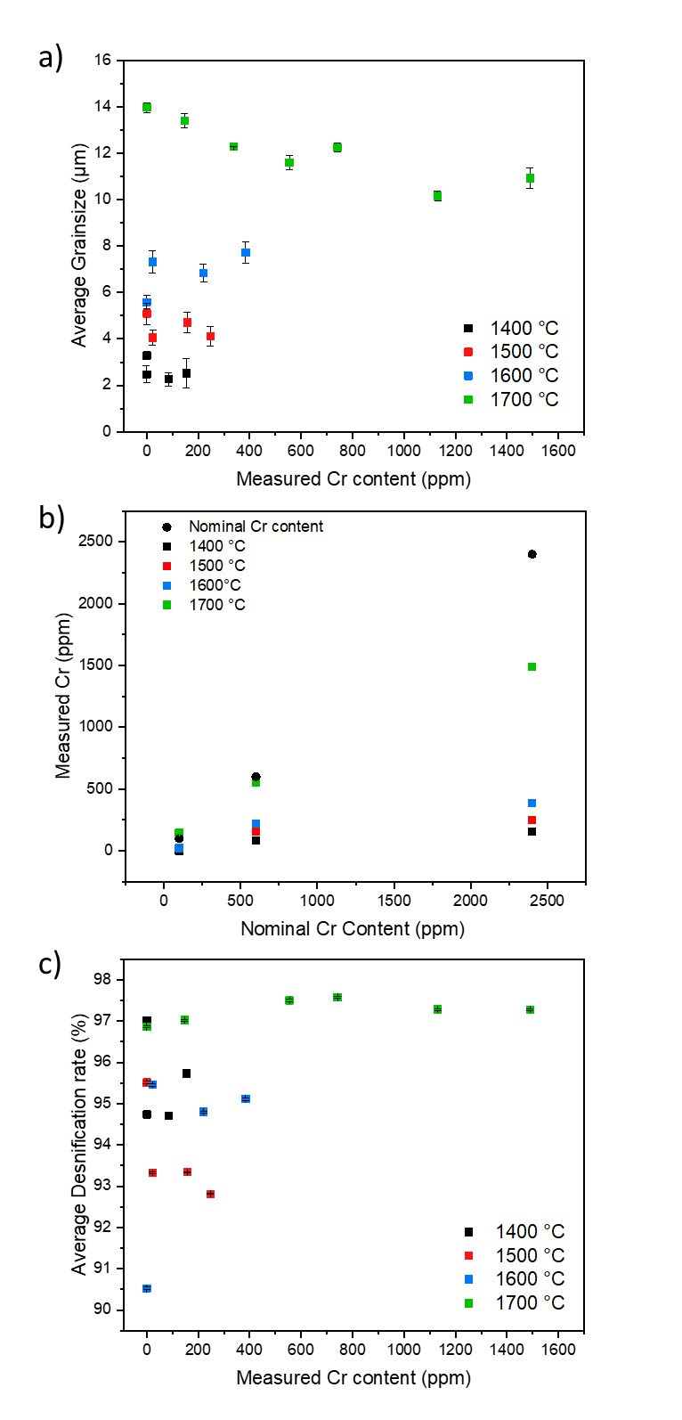
Fig. 1. Microstructural changes and measured Cr content in Cr-doped UO_{2.} a Grain size as a function of Cr content; b the measured Cr content of samples sintered at different temperatures (1400 -1700 °C); and c Archimedes density.
Complete digest of all sintered samples showed that the Cr content was below the expected, nominal, Cr concentration for all samples measured (Fig. 1b). A loss due to volatilisation is expected [20, 21], however, it is clear that Cr is better retained in samples sintered at 1700 °C where Cr-precipitates are observed. It is understood that the solubility of Cr increases with increasing temperature [14], therefore, at lower sintering temperatures, where less Cr is incorporated in the UO₂ lattice, a greater loss due to volatilisation is observed.

Greater volatilisation of Cr at the lower sintering temperatures is corroborated by the measured densification rate, determined via Archimedes density measurements (Fig. 1c). The densification rate was highest in samples sintered at 1700 °C (~98%), as expected [3], but only reached ~91-96% in samples sintered <1700 °C. As Cr incorporation into the lattice is attributed to increased densification of Cr-doped UO₂ [22], it follows that where there is less Cr in the lattice, at lower temperature, a reduced densification rate would be observed.

Dissolution behaviour as a function of temperature and Cr content
Pellets sintered at 1700 °C were used to study the effect of temperature and Cr content on the dissolution rate of U, independently from microstructure effects.

The normalised mass loss of U, N_{L}(U) (g.m⁻²), at 25 °C, 40 °C and 60 °C as a function of time (Fig. 2a-c) identified distinct regimes of normalised dissolution rate, R_{L}(U) (g.m⁻².d⁻¹). The common regimes for all temperatures are: R_{L,i} reflecting an initial dissolution rate where solution saturation effects are not observed (Fig. 2d-f); R_{L,t} showing a transitional stage of dissolution where the effects of solution saturation begin to take effect (Fig. 2g-i); and R_{L,ss} where the thermodynamic, solubility-related effects of elements in solution are observed (steady state) (Fig. 3a). For Cr-doped samples dissolved at 25 °C, an additional regime, R_{L,gb}, where normalised dissolution rate of U increases at later time points (Fig. 3b) was observed. Dissolution of UO₂ in acidic media has attributed this apparent increase in dissolution to an increase in surface area associated with the dissolution of grain boundaries [23, 24, 25, 26, 27]. Table 1 details the time period (days) of each regime for samples dissolved at each temperature, while Table 2 gives the absolute dissolution rate values (g.m⁻².d⁻¹ and mol.L⁻¹.d⁻¹).

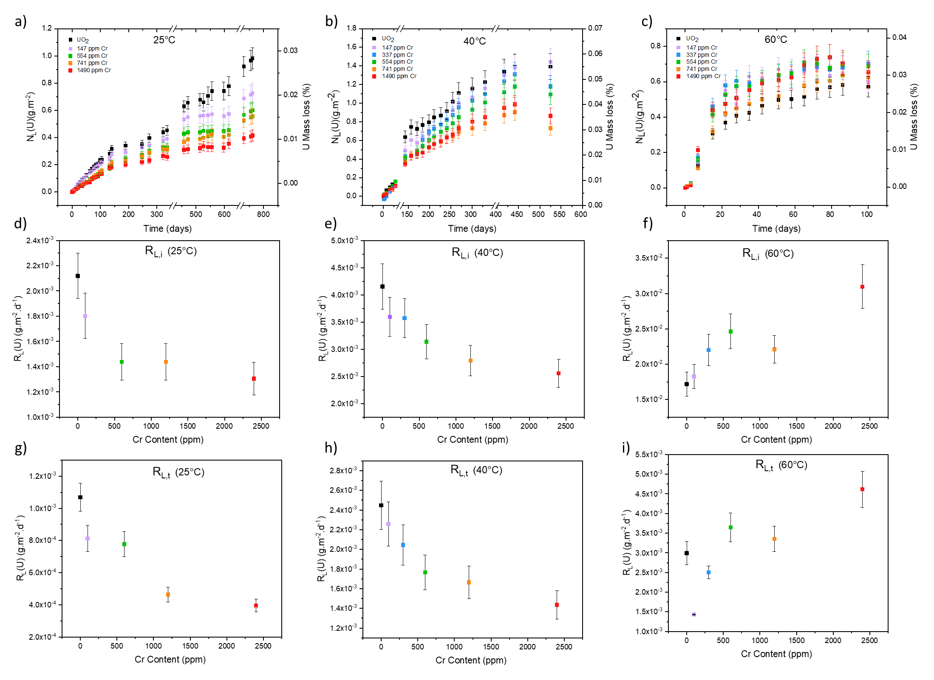
Fig. 2. Dissolution behaviour of Cr-doped UO₂ sintered at 1700 °C in reducing atmosphere after long-term dissolution in bicarbonate solution at 25 °C, 40 °C and 60 °C. a-c the normalised mass loss (N_{L}(U)); d-f the initial dissolution rate (R_{L,i} (U)); and g-i the transitional dissolution rate (R_{L,t} (U)).

Table 1. Time periods selected for the determination of the normalised dissolution rate regimes.
 |  | Time period (days)
Temperature (°C) | Rate regime | UO₂ | 147 ppm Cr | 337 ppm Cr | 554 ppm Cr | 741 ppm Cr | 1490 ppm Cr
25 | R_{L,i} | 0-133 | 0-133 | - | 0-105 | 0-133 | 0-140
25 | R_{L,t} | 140-761 | 140-457 | - | 133-457 | 140-514 | 189-471
25 | R_{L,ss} | - | 471-598 | - | 471-598 | 471-598 | 514-598
25 | R_{L,gb} | - | 616-761 | - | 616-761 | 616-761 | 616-761
40 | R_{L,i} | 0-183 | 0-210 | 0-254 | 0-268 | 0-156 | 0-330
40 | R_{L,t} | 198-441 | 226-525 | 268-441 | 300-441 | 170-441 | 416-441
40 | R_{L,ss} | 442-525 | 442-525 | 442-525 | 442-525 | 442-525 | 442-525
60 | R_{L,i} | 0-22 | 0-15 | 0-28 | 0-22 | 0-15 | 0-15
60 | R_{L,t} | 28-86 | 22-79 | 35-72 | 28-65 | 22-79 | 22-79
60 | R_{L,ss} | 100-226 | 86-226 | 79-226 | 72-226 | 86-226 | 86-226

Rate regime |  |  | 25 °C experiment |  |  | 40 °C experiment |  | 60 °C experiment
R_{L,i} |  |  |  | g.m⁻².d⁻¹ | mol.L⁻¹.d⁻¹ | g.m⁻².d⁻¹ | mol.L⁻¹.d⁻¹ | g.m⁻².d⁻¹ | mol.L⁻¹.d⁻¹
UO₂ |  |  | 2.12 ± 0.17 x 10⁻³ |  | 4.48 ± 0.50 x 10⁻⁹ | 4.15 ± 0.42 x 10⁻³ | 1.38 ± 0.14 x 10⁻⁸ | 1.71 ± 0.18 x 10⁻² | 6.18 ± 0.6 x 10⁻⁸
100 ppm Cr |  |  | 1.80 ± 0.18 x 10⁻³ |  | 5.10 ± 0.51 x 10⁻⁹ | 3.60 ± 0.36 x 10⁻³ | 1.03 ± 0.10 x 10⁻⁸ | 1.83 ± 0.18 x 10⁻² | 11.6 ± 1.16 x 10⁻⁸
300 ppm Cr |  |  | - |  | - | 3.60 ± 0.36 x 10⁻³ | 1.02 ± 0.10 x 10⁻⁸ | 2.20 ± 0.22 x 10⁻² | 6.94 ± 0.7 x 10⁻⁸
600 ppm Cr |  |  | 1.44 ± 0.14 x 10⁻³ |  | 4.35 ± 0.44 x 10⁻⁹ | 3.13 ± 0.31 x 10⁻³ | 0.88 ± 0.10 x 10⁻⁸ | 2.46 ± 0.25 x 10⁻² | 8.58 ± 0.86 x 10⁻⁸
1200 ppm Cr |  |  | 1.44 ± 0.14 x 10⁻³ |  | 3.76 ± 0.38 x 10⁻⁹ | 2.79 ± 0.28 x 10⁻³ | 0.88 ± 0.10 x 10⁻⁸ | 2.21 ± 0.20 x 10⁻² | 6.68 ± 0.70 x 10⁻⁸
2400 ppm Cr |  |  | 1.31± 0.13 x 10⁻³ |  | 3.77 ± 0.38 x 10⁻⁹ | 2.56 ± 0.26 x 10⁻³ | 1.00 ± 0.10 x 10⁻⁸ | 3.10 ± 0.31 x 10⁻² | 12.0 ± 1.20 x 10⁻⁸
R_{L,t} |  |  |  | g.m⁻².d⁻¹ | mol.L⁻¹.d⁻¹ | g.m⁻².d⁻¹ | mol.L⁻¹.d⁻¹ | g.m⁻².d⁻¹ | mol.L⁻¹.d⁻¹
UO₂ |  |  | 1.10 ± 0.09 x 10⁻³ |  | 1.65 ± 0.17 x 10⁻⁹ | 2.45 ± 0.24 x 10⁻³ | 0.51 ± 0.05 x 10⁻⁸ | 2.99 ± 0.30 x 10⁻³ | 0.34 ± 0.03 x 10⁻⁸
100 ppm Cr |  |  | 0.81 ± 0.08 x 10⁻³ |  | 2.55 ± 0.26 x 10⁻⁹ | 2.56 ± 0.23 x 10⁻³ | 0.39 ± 0.04 x 10⁻⁸ | 1.43 ± 0.14 x 10⁻³ | 0.14 ± 0.01 x 10⁻⁸
300 ppm Cr |  |  | - |  | - | 2.04 ± 0.20 x 10⁻³ | 0.48 ± 0.05 x 10⁻⁸ | 2.50 ± 0.25 x 10⁻³ | 0.12 ± 0.01 x 10⁻⁸
600 ppm Cr |  |  | 0.78 ± 0.08 x 10⁻³ |  | 2.42 ± 0.24 x 10⁻⁹ | 1.77 ± 0.18 x 10⁻³ | 0.41 ± 0.04 x 10⁻⁸ | 3.64 ± 0.36 x 10⁻³ | 0.33 ± 0.03 x 10⁻⁸
1200 ppm Cr |  |  | 0.46 ± 0.05 x 10⁻³ |  | 1.14 ± 0.10 x 10⁻⁹ | 1.66 ± 0.17 x 10⁻³ | 0.43 ± 0.0.4 x 10⁻⁸ | 3.36 ± 0.34 x 10⁻³ | 0.36 ± 0.04 x 10⁻⁸
2400 ppm Cr |  |  | 0.39 ± 0.04 x 10⁻³ |  | 0.94 ± 0.10 x 10⁻⁹ | 1.44 ± 0.14 x 10⁻³ | 0.36 ± 0.04 x 10⁻⁸ | 4.61 ± 0.46 x 10⁻³ | 0.74 ± 0.07 x 10⁻⁸
R_{L,ss} |  |  |  | g.m⁻².d⁻¹ | mol.L⁻¹.d⁻¹ | g.m⁻².d⁻¹ | mol.L⁻¹.d⁻¹ | g.m⁻².d⁻¹ | mol.L⁻¹.d⁻¹
UO₂ |  |  | - |  | - | 0.03 ± 0.01 x 10⁻³ | -0.21 ± 0.02 x 10⁻⁸ | -1.46 ± 0.15 x 10⁻³ | -0.63 ± 0.06 x 10⁻⁸
100 ppm Cr |  |  | 5.41 ± 0.53 x 10⁻⁵ |  | 1.01 ± 0.10 x 10⁻⁹ | 0.74 ± 0.07 x 10⁻³ | 0.04 ± 0.01 x 10⁻⁸ | -0.64 ± 0.06 x 10⁻³ | -0.36 ± 0.04 x 10⁻⁸
300 ppm Cr |  |  | - |  | - | -1.57 ± 0.16 x 10⁻³ | -0.48 ± 0.05 x 10⁻⁸ | -0.26 ± 0.03 x 10⁻³ | -0.25 ± 0.03 x 10⁻⁸
600 ppm Cr |  |  | 5.88 ± 0.58 x 10⁻⁵ |  | 0.62 ± 0.10 x 10⁻⁹ | -1.03 ± 0.10 x 10⁻³ | -1.11 ± 0.11 x 10⁻⁸ | -0.68 ± 0.07 x 10⁻³ | -0.45 ± 0.05 x 10⁻⁸
1200 ppm Cr |  |  | 2.25 ± 0.23 x 10⁻⁵ |  | 0.35 ± 0.04 x 10⁻⁹ | -2.07 ± 0.21 x 10⁻³ | -1.85 ± 0.20 x 10⁻⁸ | -0.18 ± 0.02 x 10⁻³ | -0.37 ± 0.04 x 10⁻⁸
2400 ppm Cr |  |  | 3.89 ± 0.40 x 10⁻⁵ |  | 0.16 ± 0.02 x 10⁻⁹ | -1.47 ± 0.15 x 10⁻³ | -3.01 ± 0.30 x 10⁻⁸ | -1.14 ± 0.11 x 10⁻³ | -0.58 ± 0.06 x 10⁻⁸
R_{L,gb} |  |  |  | g.m⁻².d⁻¹ | mol.L⁻¹.d⁻¹ | g.m⁻².d⁻¹ | mol.L⁻¹.d⁻¹ | g.m⁻².d⁻¹ | mol.L⁻¹.d⁻¹
UO₂ |  |  | - |  | - | - | - | - | -
100 ppm Cr |  |  | 1.05 ± 0.11 x 10⁻³ |  | 2.88 ± 0.30 x 10⁻⁹ | - | - | - | -
300 ppm Cr |  |  | - |  | - | - | - | - | -
600 ppm Cr |  |  | 1.02 ± 0.10 x 10⁻³ |  | 2.95 ± 0.30 x 10⁻⁹ | - | - | - | -
1200 ppm Cr |  |  | 0.95 ± 0.10 x 10⁻³ |  | 2.71 ± 0.30 x 10⁻⁹ | - | - | - | -
2400 ppm Cr |  |  | 0.42 ± 0.04 x 10⁻³ |  | 0.94 ± 0.10 x 10⁻⁹ | - | - | - | -
Table 2. Normalised dissolution rate of uranium (R_{L}(U)) for each regime
R_{L,i} (initial); R_{L,t} (transitional) R_{L,ss} (steady state); and R_{L,gb} (grain boundary effects)

25 °C experiment
The normalised dissolution rate of U is reduced as a function of Cr content in samples dissolved at 25 °C in both the R_{L,i} and R_{L,t} regimes (Fig. 2d and g). For example R_{L,i} = (2.12 ± 0.17) x 10⁻³ g.m⁻².d⁻¹ for undoped UO₂ and (1.31± 0.13) x 10⁻³ g.m⁻².d⁻¹ for 1490 ppm Cr-doped UO₂. The corresponding dissolution rates in the R_{L,t} regime are (1.10 ± 0.09) x 10⁻³ g.m⁻².d⁻¹ and (0.39 ± 0.04) x 10⁻³ g.m⁻².d⁻¹ for undoped and Cr-doped UO₂, respectively (Table 2). From these results, it is obvious that the presence of Cr in UO₂, in solid solution with the UO₂ matrix and / or present as precipitates at grain boundaries, significantly influences the dissolution behaviour of U.

Since UO₂ dissolution is dependent on the oxidation of U⁴⁺ to soluble U⁶⁺ species, especially under the oxic conditions of the present study, it is hypothesised that preferential oxidation of Cr²⁺ to Cr³⁺ allows U to maintain a reduced state according to the simplified form of the redox couples in Equations 5 and 6.

${2Cr}^{2+}+U^{6+}→2{Cr}^{3+}+ U^{4+}=0.75 V$ (5)
${2Cr}^{3+}+U^{6+}→2{Cr}^{6+}+ U^{4+}=-1.033 V$ (6)

Clearly, Cr³⁺ reduction of U⁶⁺ to U⁴⁺ is thermodynamically unfavourable (Equation 6), meaning that the presence of Cr²⁺ species in the UO₂ matrix is responsible for a decreased U dissolution rate. Increased Cr²⁺ content as a function of Cr-doping could explain why the galvanic coupling effect is most pronounced in higher doped samples.

During the latter stages of dissolution, in the solubility-controlled R_{L,ss} regime, a steady state was reached for Cr-doped UO₂ dissolved at 25 °C (Fig. 3a). Importantly, in this steady state regime, there appeared to be no significant difference in the normalised dissolution rate of U as a function of Cr content. However, the absence of steady state conditions for the un-doped UO₂ signifies an effect of Cr on the thermodynamics of U dissolution.

Since no Cr was measured in solution, it is assumed that sufficient Cr²⁺ remained in the doped UO₂ to promote the galvanic coupling effect; however, this process clearly no longer controlled the dissolution rate as for the R_{L,ss} and R_{L,gb} regimes (Fig. 3a and b, respectively). It is possible that, at later time points, the Cr²⁺ involved in this mechanism was fully oxidised and, therefore, had no further potential for galvanic coupling. Alternatively, it is likely that solution saturation of U hindered further dissolution. The measured molar concentration of U in these experiments was ~ 0.6 - 1.8 x 10⁻⁶ mol.L⁻¹ (Extended data, Fig.1), which is close to the solubility limit of U in bicarbonate solution [28, 29]. As such, the solution was clearly saturated with respect to U, therefore no further dissolution of U is possible. If this were the case, it could be said that U solubility effects have a stronger influence on Cr-doped UO₂ dissolution than the presence of Cr. It was not possible to identify any secondary phases precipitated at the surface of the 25 °C samples, even after 761 days of dissolution; therefore, the former explanation is tentatively favoured. The application of surface-sensitive spectroscopy techniques, capable of detecting Cr oxidation state in the highly electron-absorbing UO₂ matrix, is required to determine the final oxidation state of Cr within the dissolved samples to resolve this question.

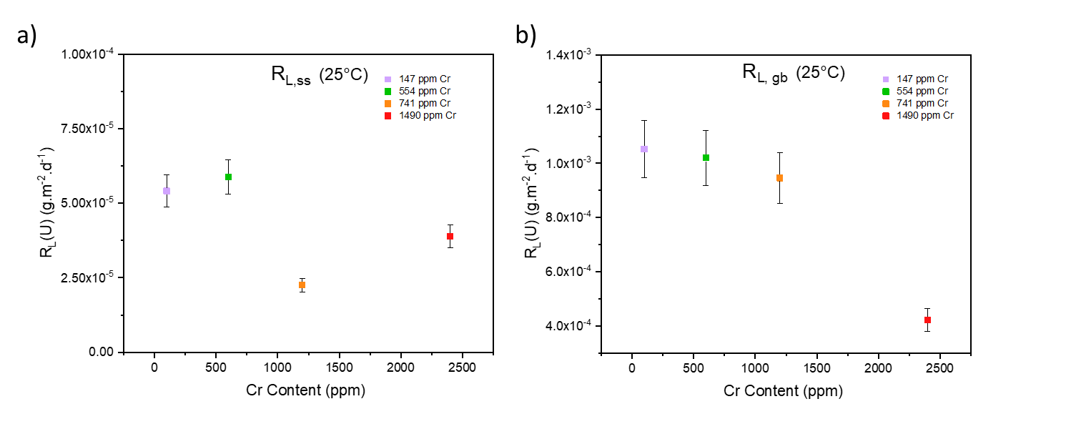
Fig. 3. Normalised dissolution rate of U in Cr-doped UO₂ sintered at 1700°C and dissolved at 25 °C in bicarbonate solution. a in the steady state regime (R_{L,ss}) and b when the effects of brain boundary dissolution are observed (R_{L, gb}).

Beyond 616 days of dissolution at 25 °C, the role of grain boundary dissolution increased the U dissolution rate from ~ 10⁻⁴ g.m⁻².d⁻¹ in the R_{L,ss} regime to ~10⁻³ g.m⁻².d⁻¹ in the R_{L,gb} regime (Fig. 3b, Table 2).

40 °C experiment
In agreement with the 25 °C experiment, the normalised dissolution rate of U in the R_{L,i} (Fig. 2e) regime decreased as function for Cr content, from (4.15 ± 0.42) x 10⁻³ g.m⁻².d⁻¹ to (2.56 ± 0.26) x 10⁻³ g.m⁻².d⁻¹ for undoped and the highest Cr-doped UO₂ sample, respectively. Similar behaviour was observed in the R_{L,t} regime (Fig. 2h), with rates of (2.45 ± 0.24) x 10⁻³ g.m⁻².d⁻¹ for undoped UO₂ and (1.44 ± 0.14) x 10⁻³ g.m⁻².d⁻¹ for the highest doped Cr-UO₂ sample. It is expected then that the galvanic coupling effect of Cr²⁺ in UO₂, as described for the 25 °C experiment, also occurs at 40 °C.

A steady state regime was reached in all samples after 442 days (Table 2 and Fig. 2b) where the R_{L,ss} dropped to (0.03 ± 0.01) x 10⁻³ g.m⁻².d⁻¹ for UO₂ and (0.74 ± 0.10) x 10⁻³ g.m⁻².d⁻¹ for 147 ppm Cr. The molarity values of U (3.7 x10⁻⁶ mol.L⁻¹ and 3.4 x10⁻⁶ mol.L⁻¹, respectively) are in accordance with solubility limits of U in bicarbonate solution [28, 29] meaning that the solution is saturated with respect to U. The absolute normalised dissolution rate of U values for the higher doped samples are negative, concurrent with the precipitation of uranium-bearing secondary phases, identified via SEM imaging of the post dissolution samples (Fig. 4).
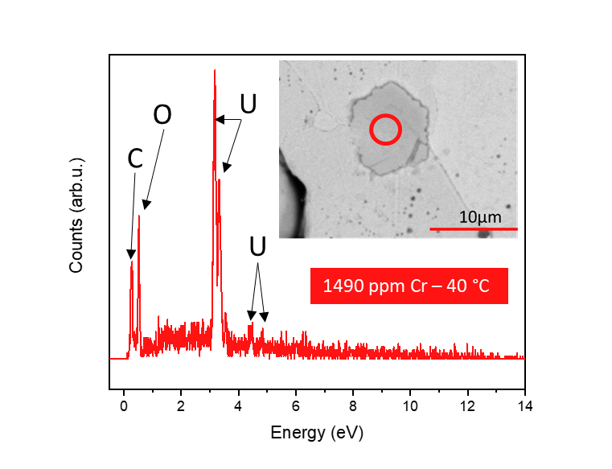
Fig. 4. EDX spot mapping of plate-like precipitate (SEM image insert) on the surface of 1490 ppm Cr-doped sample dissolved at 40°C in bicarbonate solution after 525 days of dissolution.

60 °C experiment
At 60°C, the undoped UO₂ exhibited a lower N_{L}(U) than the Cr-doped samples (Fig. 2c) and the reverse trend in normalised dissolution rate of U was found for R_{L,i} (Fig. 2f) and R_{L,t} (Fig.2i) when compared with 25 °C and 40 °C, i.e., the dissolution of U increased with increasing Cr content. It has previously been shown that bicarbonate-promoted dissolution of UO₂, where bicarbonate ligands bind to the initially oxidised UO₂ surface, is strongly dependent on temperature, with dissolution rates increasing in the range of 10 to 60 °C [30]. This is because the activation energy of UO₂ surface oxidation is greater than that of the surface attachment of the bicarbonate ligand [30]. Therefore, given the higher temperature of this particular experiment, we postulate that the role of bicarbonate in the dissolution process is more significant than the galvanic coupling effect of Cr.

Moreover, since the dissolution rate of U increases with Cr content, this implies that the activation energy of the Cr-doped UO₂ dissolution is higher than that of un-doped UO₂, and increases with increasing Cr content. This is confirmed by the apparent activation energy (E_{a}) determined for undoped and Cr-doped UO₂ at 25°C, 40 °C and 60 °C using the R_{L,i} dissolution rates (Fig. 5a). In agreement with published data for UO₂ dissolution in bicarbonate solution, the undoped UO₂ gave an E_{a} value of 49.40 ± 0.04 kJ.mol⁻¹, consistent with a dissolution mechanism that proceeds via surface-controlled reactions [30]. As the Cr content is increased, the activation energy significantly increased, reaching to (78.90 ± 0.01) kJ.mol⁻¹ for the highest doped Cr-UO₂ sample. This suggests that, in the initial stage of dissolution (i.e. without the effects of solution saturation), Cr enhances surface-controlled dissolution reactions – consistent with the hypothesised galvanic coupling effect – even in bicarbonate solutions.

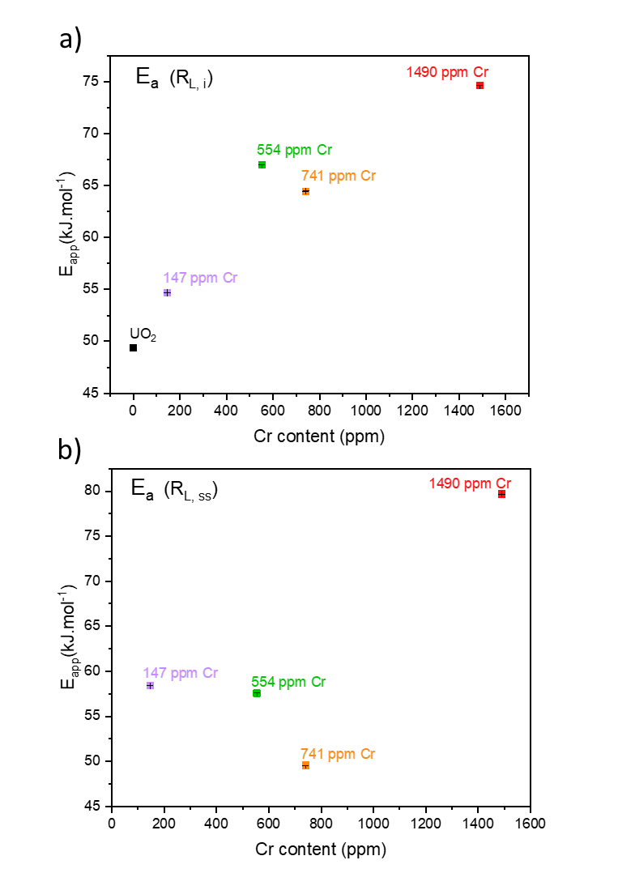

Fig. 5. Apparent activation energy of undoped and Cr-doped UO₂ determined at 25 °C, 40 °C and 60 °C. a taken during the initial dissolution rate regime (R_{L,i}); and b during the steady state regime (R_{L,ss}).

The steady state regime was reached after 100 days of dissolution at 60°C in the undoped UO₂ and after 79-86 days in the Cr-doped samples. The absolute normalised dissolution rate of U values were negative (Table 2), indicating the formation U-bearing secondary phases, which were more prominent in samples dissolved at 60 °C compared to the 40 °C experiment and, as such, identifiable by XRD (Fig. 6). XRD diffraction patterns were consist between duplicate samples hence, only one representative pattern is shown.
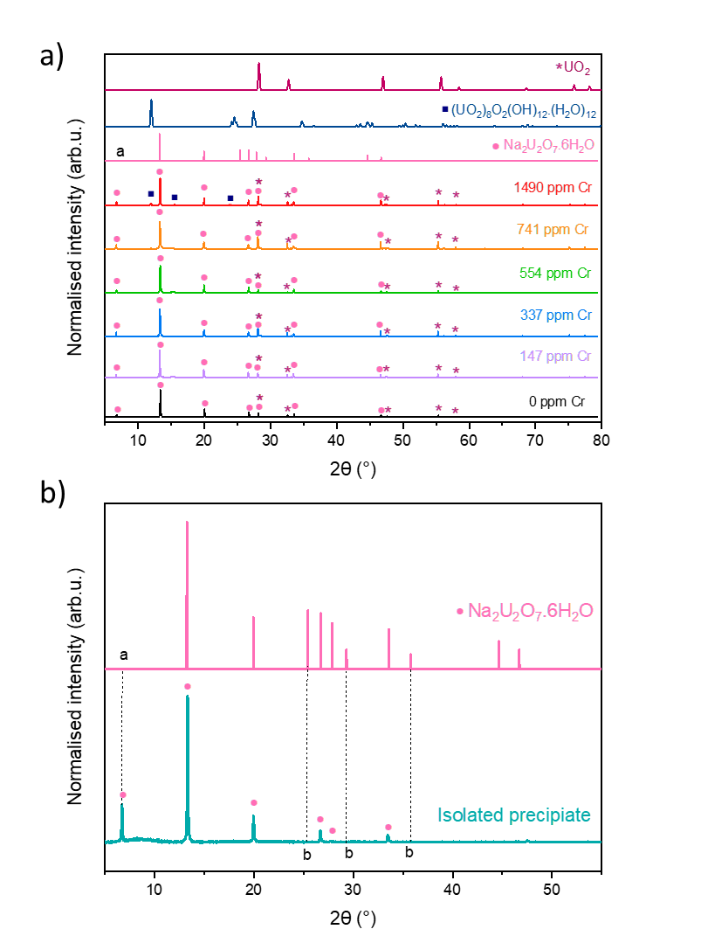
Fig. 6. XRD patterns of precipitated phases. a Cr-doped UO₂ sample surface dissolved at 60 °C in bicarbonate solution after 226 days of dissolution in comparison to UO₂ [31], ((UO₂)₈O₂(OH)₁₂(H₂O)₁₂) [32] and Na₂U₂O₇.6H₂O [33]; and b Isolated precipitate phase removed from the dissolved sample surface. Point a refers to unpublished peak at low 2θ, and point b absent reflections due to low powder concentration and possible preferred orientation.
Two distinct precipitate morphologies were identified: a plate-like phase (Fig. 7a and 8) present on all dissolved samples (doped and undoped UO₂) and an angular chip-shaped phase (Fig. 7b), visible only at the surface of the highest concentrations of Cr dopant. EDX spot-mapping of each precipitate confirmed that both precipitates consist of U, O and Na (Fig 7a and 8). A darker phase was also identified for some samples containing Na and Cl (Extended data, Fig. 2a; Point 1). This phase appeared not to contribute to the plate-like or chip-like morphologies in EDX elemental mapping (Extened data, Fig. 2b) and is likely remnant NaCl from solution.

XRD analysis of the plate-like phase matched with most of the reflections of the phase Na₂U₂O_{7·}6H₂O [33], which is in accordance with the EDX measured stoichiometry ratio of U/Na at 1:1 (Table 3, taken from the apparent thickest precipitate layer). An additional reflection at ~6.7 2θ (Fig. 6a and b; Point a), not previously published in literature due to angular range, corresponds to a d spacing of ~13.1 Å, which is in agreement with the structure of Na₂U₂O_{7·}6H₂O. Absent peaks at higher angles of 2θ (Fig. 6b; Points b) can be attributed to the low concentration of precipitate phase available for measurement and possible preferred orientation arising from the flat, plate-like morphology. Reflections consistent with schoepite ((UO₂)₈O₂(OH)_{12·}(H₂O)₁₂) [32] are also present in the highest doped, 1490 ppm Cr, samples (Fig. 6a).

Table 3. Qualitative EDX spot mapped measured atomic composition in precipitate phase. Due to EDX probe depth, measurements were taken only on sample deemed to be thicker than 1μm.
SEM image reference | Sample | Morphology | U (at. % ± 0.1) | O (at. % ± 0.1) | Na (at. % ± 0.1)
Fig.7a Point 1 | 554 ppm Cr | Plate | 20.7 | 64.3 | 15.0
Fig.7a Point 2 | 554 ppm Cr | Plate | 18.8 | 63.7 | 17.5
Fig.7a Point 3 | 554 ppm Cr | Plate | 17.3 | 67.4 | 15.3
Fig.7a Point 4* | 554 ppm Cr | Plate | 18.3 | 62.5 | 19.2
Fig.7a Point 5* | 554 ppm Cr | Plate | 18.4 | 65.6 | 18.1
Fig.7a Point 6* | 554 ppm Cr | Plate | 18.0 | 65.7 | 16.3
Fig.7a Point 7* | 554 ppm Cr | Plate | 17.3 | 67.4 | 15.3
Fig.7a Point 8* | 554 ppm Cr | Plate | 17.4 | 65.6 | 17.0
Fig.7a Point 9* | 554 ppm Cr | Plate | 15.2 | 67.0 | 17.8
Fig.7a Point 10* | 554 ppm Cr | Plate | 16.7 | 68.0 | 15.3
Average (at% ± 0.1) |  |  | 17.8 | 65.7 | 16.7
Ratio U/Na |  |  | 1.07
_{*not displayed in Fig.7a}
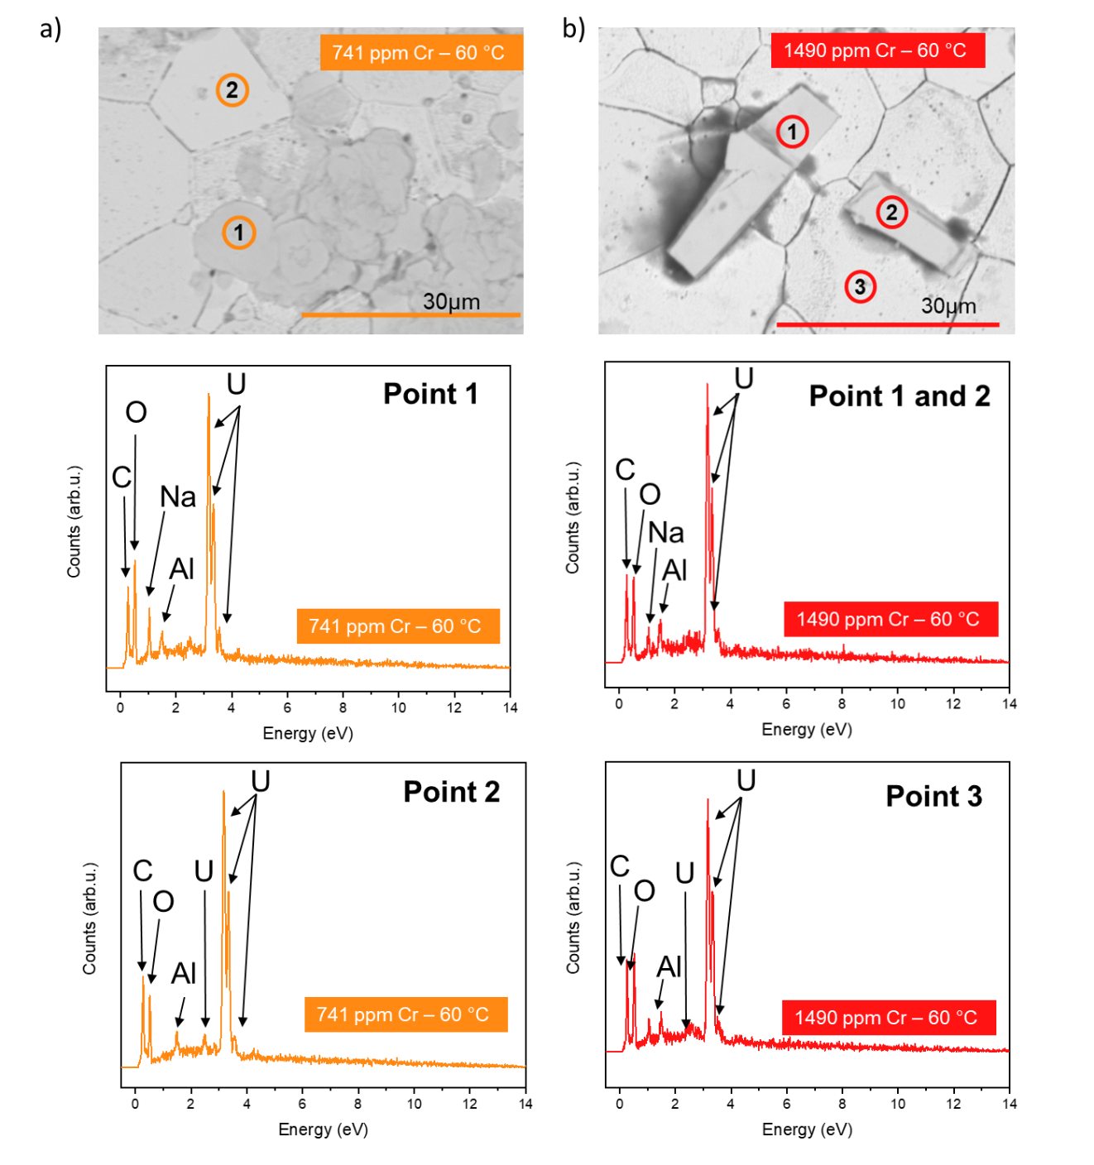
Fig. 7. SEM images and EDX spot mapping of precipitate phases observed in Cr-doped samples dissolved at 60°C in bicarbonate solution after 226 days of dissolution. a the 741 ppm Cr-doped sample showing the plate-like phase, identified as Na₂U₂O_{7·}6H₂O and b 1490 ppm Cr sample showing the chip-like phase, identified as schoepite ((UO₂)₈O₂(OH)_{12·}(H₂O)₁₂).

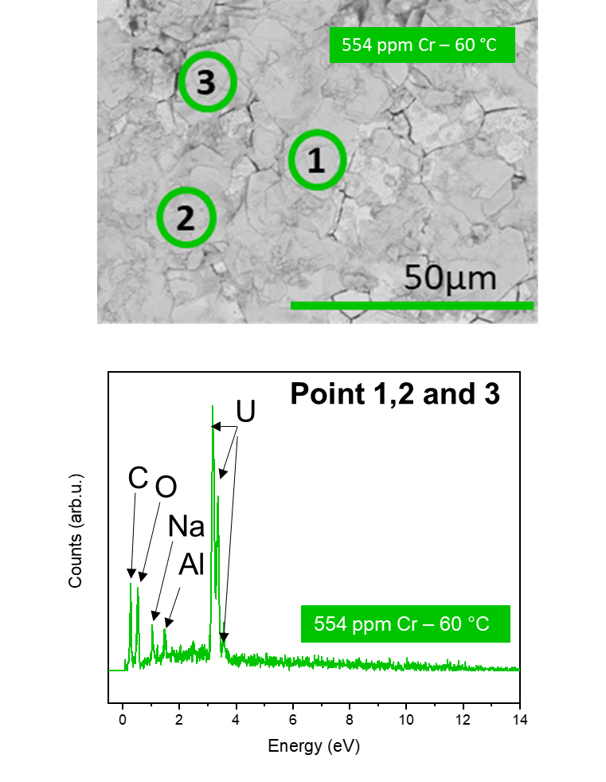
Fig. 8. Surface characterisation of 554 ppm Cr-doped sample surface dissolved at 60°C in bicarbonate solution after 226 days of dissolution. a EDX spot mapping and SEM image of plate like precipitate

The apparent activation energy in the R_{L,ss} regime (Fig. 5b), where the effects of solution saturation are considered, was shown to remain within the same range as the E_{a} for R_{L,i} regime (49.60 ± 0.01 to 79.70 ± 0.01 kJ.mol⁻¹), however the was no clear trend between E_{a} and Cr content. This supports the fact that at later stages of dissolution, when the solubility limit of U in bicarbonate solution has been reached, the effect of Cr is lost. Interestingly, the E_{a} remains unchanged for the highest doped Cr sample, which gave E_{a} of R_{L,i} = 74.63 ± 0.01 kJ.mol⁻¹ and R_{L,ss} = 79.68 ± 0.02 kJ.mol⁻¹. To fully understand the mechanistic behaviour, a wider range of Cr-doped UO₂ concentrations should be investigated.

Dissolution as a function of grain size
By altering the sintering temperature of Cr-doped UO₂, the grain size was controlled such that an increase from ~ 2 – 14 μm was observed with increased sintering temperature (Fig. 1a). However, as noted above, the different sintering temperatures influenced the concentration of Cr retained in the sintered material. As such, neither the Cr content (Fig. 1b), nor the density (Fig. 1c), were consistent between samples i.e., grain size was not the only variable during the study.

However, when the individual normalised dissolution rate of U from each sample is considered as a function of its average grain size (Fig. 9a), a reduction in R_{L}(U) in the larger grained samples is observed over 100 days of dissolution in simulant groundwater solution (1 mM NaHCO₃ + 19 mM NaCl) at 25 °C (assumed to be the R_{L,i} regime). By observation of the gradient in each set of samples sintered at different temperatures, it is clear as the sintering temperature is increased, the change in grain size has less of an effect on the normalised dissolution rate, most probably due to the level of densification reached. This result agrees with the hypothesis that a reduction in grain size, and therefore quantity of grain boundaries, results in fewer energetically reactive surface sites for initiation of dissolution [12].

When the Cr content measured for each sample is considered (Fig. 9b), there is a correlation between the grainsize and dissolution rate as a function of Cr content for samples sintered at 1700 °C (i.e. the R_{L} (U) decreases with increased Cr content and increased grain size). However, at lower sintering temperatures, and therefore smaller grain sizes, there is no relationship between dissolution rate and Cr content. This is most likely due to variability in density. Further study is required to investigate the change in grain size with constant Cr content to assess the effects of each in complete isolation.
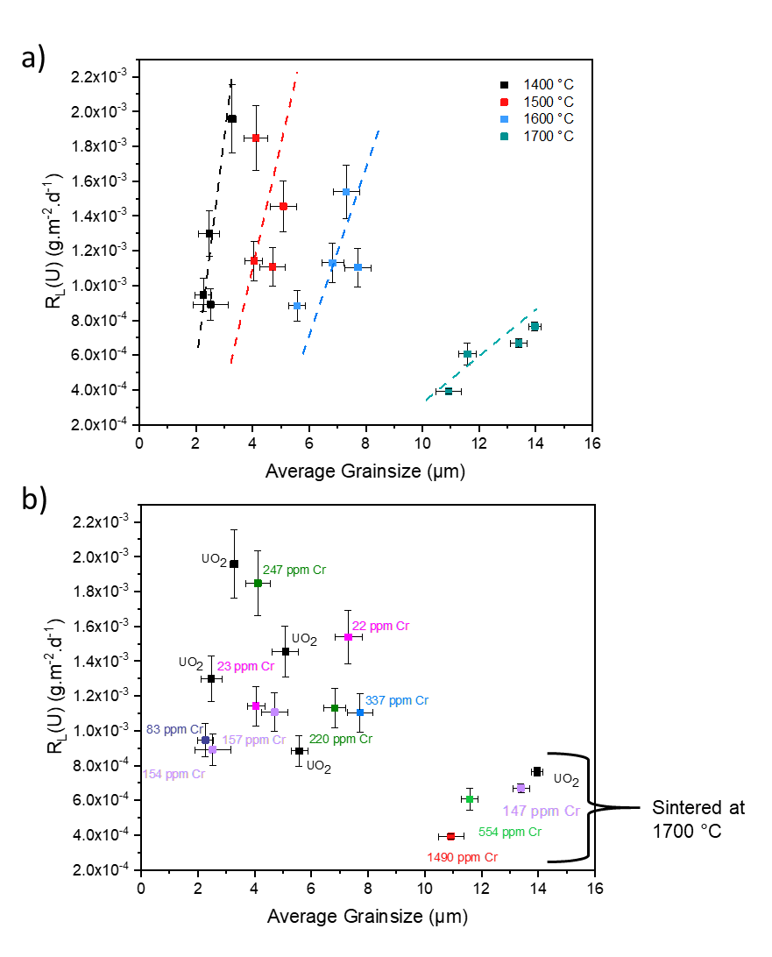
Fig. 9. The normalised dissolution rate (R_{L,i}) of Cr-doped UO₂ samples, with a range of grain sizes dissolved at 25°C in bicarbonate solution for 100 days. a showing the relationship between sintering temperature and b Cr content.

Conclusions
The dissolution behaviour of Cr-doped UO₂ was assessed in comparison to undoped UO₂ to establish any influence of dopant on long-term durability. Cr content is shown to improve the durability at 25°C and 40 °C, where the presence of Cr²⁺ in the matrix leads to a reduction in normalised mass loss of U in comparison with undoped UO₂. This is hypothesised to be the result of a galvanic coupling effect between Cr²⁺ and U, whereby Cr is preferentially oxidised. The galvanic effects of Cr are reduced with time by either complete oxidation of Cr²⁺ or solubility-limiting effects related to U secondary phase formation, and in the steady state dissolution regime, there is no impact of Cr concentration on the dissolution rate of U. Moreover, the galvanic effects of Cr are negated at higher temperature (60 °C) most likely due to enhanced oxidative dissolution of the surface at higher temperatures in bicarbonate solution.

By increasing the grain size of Cr-doped UO₂ it was indicated that the reduction in dissolution rate could be attributed to a reduction in grain boundaries (high-energy reactive sites for dissolution initiation). While the effects on dissolution behaviour observed in this study cannot be attributed to the grain size alone, there is clearly a relationship between microstructure and dissolution behaviour, requiring further investigation.

These results show that for conditions relevant to geological disposal, large-grained Cr-doped UO₂ will potentially have a higher durability than that of undoped UO₂, due to the presence of Cr, particularly in the initial phase of dissolution, and also the increased grain size induced in commercial pellets of Cr-doped UO₂. Further study of Cr-doped UO₂ with controlled dopant concentration and grain size is required to demine which of these two factors confers the greatest effect on durability.

References
1 J. Bruno and R. C. Ewing, Elements, 2006, 2, 343–349.
2 J.-L. Guillet and Y. Guerin, Nuclear fuels, 2009.
3 A. Massih, Swedish Radiat. Saf. Auth., 2014, 74, 1-71.
4 H. Assmann, W. Dörr and M. Peehs, J. Nucl. Mater., 1986, 140, 0–5.
5 D. Energy, Duke Energy Nuclear Information Centre, https://nuclear.duke-energy.com/2014/02/11/do-we-have-enough-nuclear-fuel, (accessed 2 July 2019).
6 D. W. Shoesmith, NWMO, 2007, 3, 1–60.
7 H. He and D. Shoesmith, Phys. Chem. Chem. Phys., 2010, 12, 8108–8117.
8 C. Cachoir, T. Mennecart and K. Lemmens, MRS Adv., 2021, 6, 84–89.
9 K. Nilsson, O. Roth and M. Jonsson, J. Nucl. Mater., 2017, 488, 123–128.
10 A. Casella, B. Hanson and W. Miller, J. Nucl. Mater., 2016, 476, 45–55.
11 J. Kim, Y.-K. Ha, S.-D. Park, K.-Y. Jee and W.-H. Kim, J. Nucl. Mater., 2001, 297, 327–331.
12 C. L. Corkhill, E. Myllykylä, D. J. Bailey, S. M. Thornber, J. Qi, P. Maldonado, M. C. Stennett, A. Hamilton and N. C. Hyatt, ACS Appl. Mater. Interfaces, 2014, 6, 12279–12289.
13 S. Kashibe and K. Une, J. Nucl. Mater., 1998, 254, 234–242.
14 L. Bourgeois, P. Dehaudt, C. Lemaignan and A. Hammou, J. Nucl. Mater., 2001, 297, 313–326.
15 A. Milena-Pérez, L. J. Bonales, N. Rodríguez-Villagra, S. Fernández, V. G. Baonza and J. Cobos, J. Nucl. Mater., 2021, 543, 152–181.
16 T. Cardinaels, K. Govers, B. Vos, S. Van Den Berghe, M. Verwerft, L. De Tollenaere, G. Maier and C. Delafoy, J. Nucl. Mater., 2012, 424, 252–260.
17 J. Arborelius, K. Backman, L. Hallstadius, M. Limbӓck, J. Nilsson, B. Rebensdorff, G. Zhou, K. Kitano, R. Lӧfstrӧm and G. Rӧnnberg, J. Nucl. Sci. Technol., 2006, 43, 967–976.
18 G. Kuri, C. Mieszczynski, M. Martin, J. Bertsch, C. N. Borca and C. Delafoy, J. Nucl. Mater., 2014, 449, 158–167.
19 C. Riglet-Martial, P. Martin, D. Testemale, C. Sabathier-Devals, G. Carlot, P. Matheron, X. Iltis, U. Pasquet, C. Valot, C. Delafoy and R. Largenton, J. Nucl. Mater., 2014, 447, 63–72.
20 S. C. Finkeldei, R. D. Hunt, J. O. Kiggans C. A. Hobbs, B. D Eckhard, J. W. McMurray, K.A Terrani, A. T. Nelson, ORNA., 2019, 1, 1-14
21 V. Peres, L. Favergeon, M. Andrieu, J. C. Palussière, J. Balland, C. Delafoy and M. Pijolat, J. Nucl. Mater., 2012, 423, 93–101.
22 B. Palanki, J. Nucl. Mater., 2021, 550, 152–160..
23 T. Cordara, S. Szenknect, L. Claparede, R. Podor, A. Mesbah, C. Lavalette and N. Dacheux, J. Nucl. Mater., 2017, 496, 251–264.
24 T. Cordara, S. Szenknect, R. Podor, V. Trillaud, L. Claparede, X. Le Goff, A. Mesbah, C. Lavalette and N. Dacheux, Hydrometallurgy, 2019, 188, 182–193.
25 P. Raison, M. Odorico, R. Podor, L. Claparede and N. Dacheux,Corrosion Sci. .2020, 176, 109–125.
26 R. Podor, X. Le Goff, T. Cordara, M. Odorico, J. Favrichon, L. Claparede, S. Szenknect and N. Dacheux, Mater. Charact., 2019, 150, 220–228.
27 S. Bertolotto, S. Szenknect, S. Lalleman, A. Magnaldo, P. Raison, M. Odorico, R. Podor, L. Claparede and N. Dacheux, Corros. Sci., 2020, 176, 109020.
28 L. Ahonen, Solubilities of uranium for HLA-99, 1998, 13, 1–60
29 K. Ollila, Solubility of unirradiated UO₂ fuel in aqueous solutions - Comparrison between experimental and calculated (EQ3/6) data, 1995, 14, 1–25.
30 J. De Pablo, I. gnasi Casas, J. avier Gimenez, M. Molera, M. Rovira, L. Duro and J. Bruno, 1999, 63, 3097–3103.
31 L. Desgranges, G. Baldinozzi, G. Rousseau, J. C. Nièpce and G. Calvarin, Inorg. Chem., 2009, 48, 7585–7592.
32 R. J. Finch, M. A. Cooper, F. C. Hawthorne and R. C. Ewing, Can. Mineral., 1996, 34, 1071–1088.
33 N. G. Chernorukov, O. V. Nipruk and E. L. Kostrova, Radiochemistry, 2016, 58, 124–127.

Acknowledgements

This work was funded by the European Commission Horizon 2020 Research and Training Programme, DISCO, of the European Atomic Energy Community (EURATOM), under grant agreement number 755443. We also wish to acknowledge funding from the UK Engineering and Physical Science Research Council (EPSRC) under grant numbers EP/N017374/1 and EP/S020659/1. This research utilised the HADES/MIDAS facility at the University of Sheffield established with financial support from EPSRC and BEIS, under grant EP/T011424/1⁴⁰, and also the PLEIADES National Nuclear User Facility, established with funding from EPSRC under grant number EP/V035215/1 and the Henry Royce Institute for Advanced Materials ICP-MS facility, under grant numbers EP/P02470X/1 and EP/P025285/1. We would like to thank Chris Dixon Wilkens at the University of Sheffield for support with XRD pattern indexing, Colleen Mann for support with ICP-MS analysis and all the members of the DISCO project for continued support and discussion.

Author contributions

Hannah Smith – data collection, formal analysis, original draft preparation.
Théo Cordara – sample preparation and experimental setup.
Clémence Gausse – data collection (ICPMS)
Sarah pepper – data collection (ICPOES)
Claire Corkhill – funding acquisition, supervision, data collection, formal analysis, reviewing and editing.
Extended data

Extended data Figure 1. The normalised mass loss of U N_{L}(U), in mol.L⁻¹, for 600 days of dissolution at 25 °C in bicarbonate solution

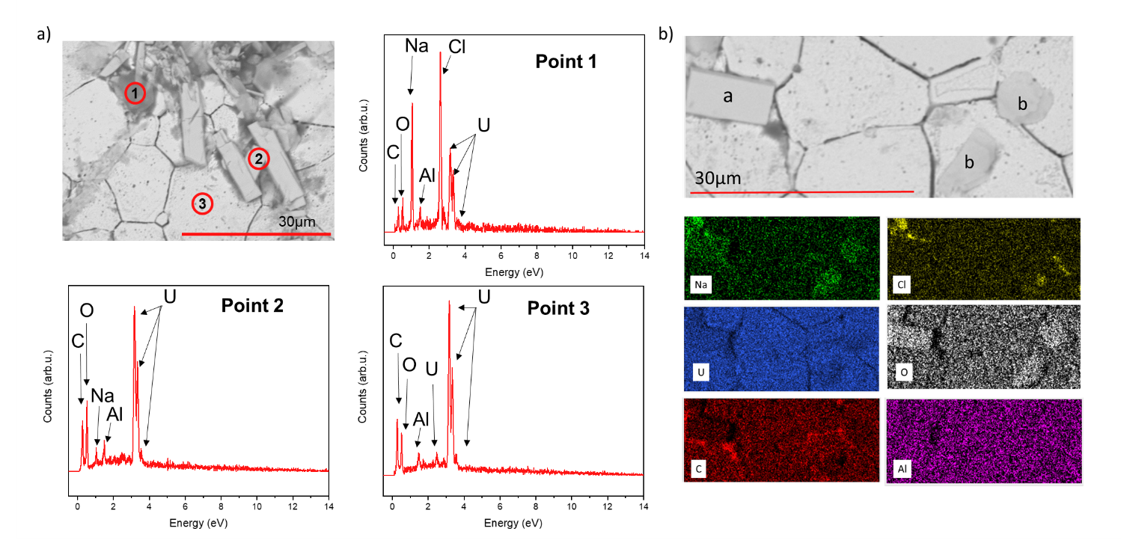
Extended data Figure 2. EDX analysis of 1490 ppm Cr-doped sampled surface dissolved at 60 °C in bicarbonate solution after 226 days of dissolution. a EDX spot maps; and b elemental mapping showing the chip-like phase identified as schoepite ((UO₂)₈O₂(OH)_{12·}(H₂O)₁₂) (Point a) and the plate-like phase identified as Na₂U₂O_{7·}6H₂O (Point b)

Defect chemistry of Mn-doped UO₂

The following was prepared for publication in the journal Inorganic Chemistry.

Defect chemistry of Mn-doped UO₂

H. Smithª, L. T. Townsendª, R. Mohunª, M. C. Stennettª, J. F. W. Mosselmans,^{b} K. Kvashnina,^{c,d}, C. L. Corkhill^{a*}

ª NucleUS Immobilisation Science Laboratory, Department of Materials Science and Engineering, The University of Sheffield, UK
^{b} Diamond Light Source, Harwell Science and Innovation Campus, Didcot, UK
^{c} Helmholtz-Zentrum Dresden-Rossendorf (HZDR), Institute of Resource Ecology, PO Box 510119, 01314, Dresden
^{d} The Rossendorf Beamline at ESRF – The European Synchrotron, CS40220, 38043 Grenoble Cedex 9, France

*Corresponding Author: c.corkhill@sheffield.ac.uk

Abstract
Mn-doped UO₂ is under consideration for use as an accident tolerant nuclear fuel. In this study, Mn-doped UO₂ was prepared via a wet co-precipitation method, which was refined to improve the yield of Mn precipitation in the synthesised material. To verify atomistic models of the Mn-doped UO₂ defect chemistry, advanced high-flux, high-spectral purity X-ray absorption spectroscopy (XAS) was performed and results were corroborated by X-ray diffraction and high-energy resolved fluorescence detection-XAS. It was established that Mn²⁺ directly substitutes for U⁴⁺ in the UO₂ lattice, accompanied by U⁵⁺ and oxygen vacancy (O_{v}) charge compensation. This work presents the first detailed study of the structure and crystal chemistry of Mn-doped UO_{2,} which shows potential advantages as a novel efficient advanced nuclear fuel.

Introduction
In so-called advanced nuclear fuels, it has been shown that by adding small amounts of Cr-dopant to the UO₂ matrix the grain size is increased, resulting in a longer pathway for fission gasses to migrate and escape the fuel matrix, thus reducing pellet swelling during reactor operations. Additionally, other favourable properties are promoted upon Cr-doping, including improved plasticity and reduced pellet-cladding interactions, all of which reduce the risk of fuel failure [1-5]. The introduction of Mn as a dopant in UO₂ fuels has been hypothesised to offer an improved alternative to already commercially available Cr-doped UO₂ [6]. As such, exploring Mn-doped UO₂ as an accident tolerant fuel is a key area of research interest.
Atomistic modelling of the Mn-doped UO₂ crystal lattice and defect formation during heat treatment suggested that grain growth is enhanced by the formation of U vacancy defects (U_{v}) which aid diffusion during the sintering process [7]. These defects are predicted to increase in concentration with the presence of dopants when compared to undoped UO₂. Through atomistic modelling, the U_{v} concentration was shown to be up to 5 times greater in Mn-doped UO₂ than Cr-doped UO_{2,} strongly suggesting that Mn-doped UO₂ should exhibit larger grains and, therefore, enhanced in-reactor properties with regards to fission gas migration. Experimental investigations of the synthesis of Mn-doped UO₂ via a sol-gel method found grain size enhancement of up to 80 μm in samples when compared to UO₂, with a measured Mn content of 490 ppm. In comparison, grains of ~ 50 μm were achieved in 350 ppm Cr-doped UO₂ when both were sintered at 1700 °C for 6 hours under a reducing Ar-4%H₂ atmosphere [8].
Grain size growth has also been postulated to be the result of the formation of a liquid phase in Mn-doped UO₂, where MnO powder was dry mixed with an additional dopant, Al₂O₃, to form a 1000 ppm Mn/Al-doped UO₂ [9]. When sintered at 1860 °C, which is above the melting temperature of MnO, a maximum grain size of ~50 μm was achieved, attributed to a MnO-Al₂O₃ binary liquid phase. The mechanism of grain growth in Mn-doped UO₂ is, therefore, unclear and further investigation into dopant concentration and solubility of Mn in the UO₂ lattice is required to optimise fuel fabrication routes.
Additionally, post-operation of a nuclear reactor, the safe storage and disposal of spent fuel is dependent on the long-term durability of the UO₂ matrix, most prominently when exposed to geological disposal conditions [10, 11]. Matrix oxidation converts the relatively insoluble U⁽⁴⁺⁾O₂ to relatively soluble U ⁽⁶⁺⁾O₂²⁺ and as such, under geological disposal conditions, may result in radionuclide release into groundwater. Therefore, any alteration to UO₂ that may result in oxidation will undoubtedly influence dissolution behaviour and so understanding how dopants affect these properties is crucial to ensuring safe disposal of radioactive waste. A thorough understanding of the crystal chemistry of Mn-doped UO₂ in comparison to undoped UO₂, including an investigation of defect formation, is required to fully underpin predictions of spent fuel dissolution behaviour over the geological disposal period (100,000+ years).
While dry-synthesis and sol-gel methods have been demonstrated for the synthesis of Mn-doped UO₂, this work improves upon these processes using an alternative wet chemical co-precipitation synthesis route. To aid a detailed study of the local structure of Mn in UO₂, the samples were sintered in a consistent reducing environment. Analysis of Mn-doped UO₂ prior to, and after, sintering were characterised by X-ray absorption spectroscopy, X-ray diffraction, and Raman spectroscopy. The effects of sintering in a reducing environment on the final microstructure and crystal chemistry is also discussed, completing the first in-depth experimental study of Mn-doped UO₂ crystal chemistry and providing a key foundation for future investigations and use of Mn-doped UO₂ as an advanced nuclear fuel.

Experimental
Sample preparation
A wet synthesis method was developed using uranium nitrate hexahydrate (UO₂(NO₃)₂ 6H₂O, The British Drug House (BDH). B.D.H Laboratory Chemicals Division, >98%, 0.3 mol.L⁻¹. This was mixed with manganese (II) nitrate tetrahydrate (Mn(NO₃)₃ 4H₂O, Sigma Aldrich, 99.99%, 1.6 mol.L⁻¹, in the proportion required to give the desired concentration of dopant. An initial synthesis study was performed (discussed below) in which a number of samples were assessed to determine the optimal pH and calcination temperature for fabrication of Mn-doped UO₂. The final fabrication route is shown in Figure 1 and is detailed as follows. Concentrated ammonium hydroxide, NH₄OH (5 mol.L⁻¹), was added until a pH of 10 was reached. The resultant precipitate was vacuum filtered, washed in ultra-high quality (18 MΩ.cm) water, and dried for 24 hours at 90 °C. Thermogravimetric analysis was carried out on precursor material using a Netzsch TG 449 F3 Jupiter instrument coupled with a 64-channel QMS 403 D Aeolos mass spectrometer. Samples were heated to 1000 °C at a rate of 10 °C.min⁻¹ under a constant Ar_{(g)} flow. Analysis of the mass loss over time determined that a calcination temperature of 750 °C for 4 hours under a reducing (5% H_{2(g)}: 95% N_{2(g)}) atmosphere was sufficient to convert the precursor material to oxide. Successful co-precipitation of Mn with U oxide was measured by inductively coupled plasma optical emission spectroscopy (ICP-OES) analysis of the supernatant, where >99.9% precipitation was observed for both U and Mn for samples precipitated at pH 10.
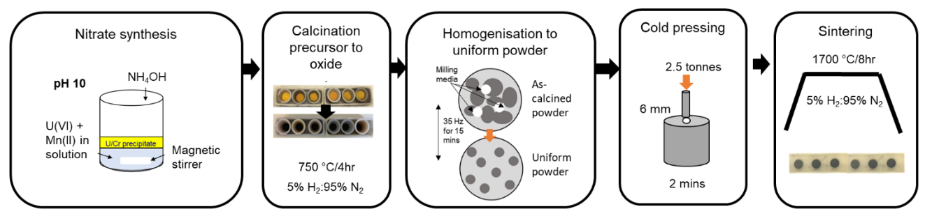
Fig. 1. Optimised synthesis and fabrication route for Mn- doped UO₂.

Homogenised oxide powders, prepared via milling at 35 Hz for 15 min, were uniaxially pressed at 2.5 tonnes into 6 mm thick green pellets and sintered at 1700 ˚C for 8 hours in a reducing atmosphere (5% H_{2(g)}: 95% N_{2(g)}). Complete digestion of precursor and calcined material, as well as sintered pellets (crushed to powder using a mortar and pestle), was carried out to assess the Mn content. In this method, 20 mg of sample was completely dissolved in 2M nitric acid (ultrapure HNO₃) at 90 °C with the aid of a magnetic stirrer and an aliquot was removed and analysed by ICP-OES for Mn and U concentration. Samples were dissolved in triplicate and an average measurement of Mn, with errors of 1 standard deviation, for each sample reported.

Scanning electron microscopy
Secondary electron images of thermally etched pellet sample surfaces were taken using a Hitachi TM3030 scanning electron microscope at an accelerating voltage of 15 kV. Samples were thermally etched at 80-90 % sintering temperature under a reducing atmosphere (5% H_{2(g)}: 95% N_{2(g)}) and the revealed grains imaged at 500x magnification. The Image J software was used to obtain the average grain size of ~ 500 grains in images taken from 5 different regions across the pellet surface.

X-ray diffraction
A PANalytical Xpert3 diffractometer was used in reflection mode with a 45 keV/40 mA generator to characterise powder samples by XRD (p-XRD). Data were collected between 5 ° and 100 ° 2θ with a step size of 0.013 ° and a step time of 40 seconds, a fixed slit size of 0.5 was used. LaB₆ (20-30 wt.%) was used as an internal standard for data alignment, corrected using the WinXPow software. Accurate determination of lattice parameters was carried out in the Topas software, using Le Bail refinements. To avoid oxidation, calcined powders were measured immediately post heat treatment (i.e. within 10 minutes of removal from the furnace) and sintered samples were crushed upon removal from the furnace, within a controlled inert atmosphere (N_{2(g)}), and immediately measured to avoid oxidation.

X-ray absorption spectroscopy
Mn K-edge (6.539 keV) and U M₄-edge (3.728 keV) X-ray Absorption Spectroscopy (XAS) measurements were performed, at room temperature, on both calcined powder and sintered Mn-doped UO₂. The I20-scanning beamline at the Diamond Light Source (DLS), UK, was used in fluorescence mode to measure the Mn K-edge using a 64-element Ge detector with Xspress4 signal processing and a beam size of 400 x 300 µm (FWHM). A high flux and excellent energy resolution is given by the wiggler-sourced I20-scanning beamline due to the use of a Si(111) four-bounce crystal monochromator, allowing the detection of low concentrations of Mn dopant in the heavily absorbing UO₂ matrix.

Multiple scans were taken across a number of energy ranges to improve data quality. Energy steps of 5 eV were taken from 6439-6535 eV, 0.2 eV from 6536-6560 eV with a time step of 1 s.step⁻¹ in the X-ray Absorption Near Edge Spectroscopy (XANES) region for all samples. In the Extended X-ray Absorption Fine Structure (EXAFS) region for calcined Mn-doped UO₂ samples, an energy step of 0.04 Å⁻¹ was taken from 6560–6980 eV with a time step of 1-6 s.step⁻¹. The spectral features in the sintered samples were identical to those of the calcined powers. A number of standards of known Mn valence state and coordination environment were measured including a range of Mn²⁺ standards: Mn²⁺O; (Mn²⁺, Fe)(Ta, Nb)₂O₆; Mn²⁺SiO₆; and Mn²⁺₂SiO₄.

The E₀ (white line, taken from the peak of the first derivative) positions of the raw data were aligned to the E₀ position of a standardised reference Mn foil that was measured simultaneously with Mn-doped UO₂ samples. A cubic spline background subtraction and normalisation procedure [12] was then carried out and multiple scans merged using the Athena software [13]. To isolate the pre-edge region for analysis, an arctangent function was applied across the 6535.0 – 6548.0 eV energy range to remove the photoelectric background absorption [14] and three Gaussian peak functions used to model the pre-edge features (Extended data, Fig. 1). The energy position and normalised height were refined using the non-linear least-square fitting SOLVER function in Excel and the pre-edge centroid position assigned by taking the intensity weight average of each Gaussian fit.

To create models of the local environment realised in the EXAFS region, absorption data (eV) was converted to wavenumber, k (Å⁻¹), and a Fourier Transform of the resulting k space was used for fitting. The possible scattering paths of the Mn central absorber atom to the surrounding atoms in the Mn-doped UO₂ local environment were generated using a FEFF6 algorithm [15] in Artemis [12] where a UO₂ CIF file [16] was modified to include Mn as the central absorbing atom at the first U lattice position. The range of k (Å⁻¹), r (Å), and the amplitude reduction factor (S₀²) were optimised for the data and the following parameters allowed to refine: degeneracy (N); fitted bond length (R) (Å); shift from Mn K-edge position (6.539 keV) (∆E₀) and; the Debye-Waller factor (σ²). The F-test was applied to each fitted path, the result (α) indicated the confidence of adding the path to improve the fit (>67 % gives a confidence of 1σ, >95 % gives a confidence of 2σ) [17]. The bond valence sum (bvs) was calculated for the Mn-O coordination environment, which is an evaluation of bond distances in a coordination shell that are equal to the formal oxidation state of the cation absorber [18].

High-energy resolution fluorescence detection X-ray absorption near edge spectroscopy (HERFD XANES) was carried out at the U M₄-edge using the BM20 beamline at the European Synchrotron (ESRF), France [19], with the use of an X-ray emission spectrometer [20]. Calcined powders were mixed with poly-ethylene glycol (PEG) and pressed into 6 mm pellets for analysis, while the as-sintered surfaces of pellets were measured. Raw U M₄-edge data was pre-processed in Athena, as discussed above, and a principal component analysis was used to determine the possible number of spectral components, followed by Iterative Target Transformation Factor Analysis (ITTFA) [21] to indicate the relative concentration of each component using U⁽⁴⁺⁾O₂ and CrU⁽⁵⁺⁾O₄ standards measured alongside Mn-doped UO₂ at the BM20 beamline.

Raman spectroscopy
Raman measurements were performed using a Renishaw inVia Reflex confocal spectrometer equipped with a Leica DM2500 microscope. Calcined Mn-doped UO₂ powders were pressed into pellets and then analysed using a 514.5 nm green argon laser with 1800 lines mm⁻¹ grating to acquire a spectral acquisition between 200 and 800 cm⁻¹. An average of 10 points across the compacted green pellet surface of each pellet was taken, to confirm their reproducibility and homogeneity of the composition across the sample. Lorentz function fitting was used to obtain information of peaks attributed to defects (U1, U2 and U3) in the UO₂ structure, relative to the main T_{2g} band of UO₂ at 445 cm⁻¹. In addition to the U2 LO phonon band at ~574 cm⁻¹, the U1 peak at ~ 527 cm⁻¹ attributed to Ov defects, and U3 peak at ~634 cm⁻¹ attributed to O_{i} defects, were identified [22].

Results & Discussion

Development of Mn-doped UO₂ synthesis and fabrication method
A nitrate co-precipitation method was developed to prepare Mn-doped UO₂ with an initial target concentration of 1200 ppm Mn. Concentrated NH₄OH was added in 0.1 mL instalments until a pH of 7, 9, 10 or 11 was reached. Analysis of the supernatants via ICP-OES indicated the success of co-precipitation for each pH, where ~ 99.00 ± 1.00 % U was precipitated for all pH values. The Mn precipitation varied, with 84.98 ± 0.01 %, 99.96 ± 0.03 %, 99.80 % ± 0.03 and 99.9 ± 0.6 % Mn precipitated for pH 7, 9, 10 and 11, respectively (Fig. 2a), indicating a pH ≥ 9 is required to fully precipitate Mn. Consideration of both the supernatant analysis and complete digest confirmed that optimal synthesis was observed at pH 10 and, as such, the remainder of the samples discussed herein were fabricated using material precipitated at pH 10.
An optimal calcination temperature was determined by Thermogravimetric analysis of the precipitated precursor material (Fig. 2b), where mass losses due to the removal of water (100 - 190 °C) [23], U/Mn and ammonia nitrate from synthesis (200 - 300 °C) [24, 25], and the decomposition of nitrate oxides formed during heating (300-525 °C) [25], occurred up to ~ 600 °C. The DTA curve shows endothermic peaks, A and C, relating to water loss and decomposition of nitrate oxides, respectively, and an exothermic peak, B, attributed to the formation nitrates during heating. A calcination temperature of 750 °C was selected and conversion from precursor material (identified as U₃(NH₃)₂O₉.4H₂O) to UO₂ after heat treatment for 4 hours under a reducing atmosphere (5% H_{2(g)}: 95% N_{2(g)}) was confirmed via p-XRD of the calcined powder (Fig. 2c).
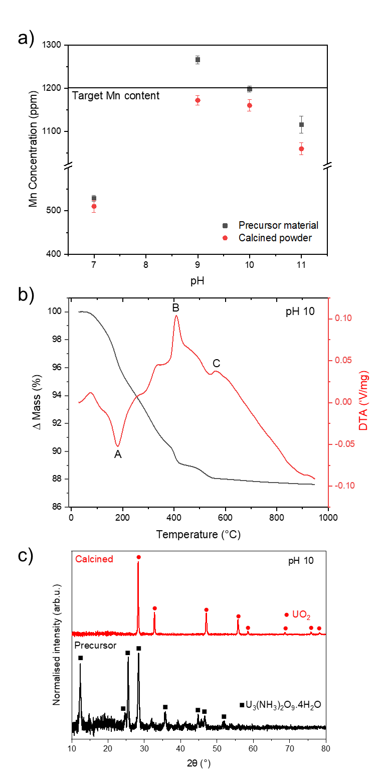
Fig. 2. Initial investigation of an optimal synthesis and fabrication route for Mn-doped UO_{2.} a Complete digest of target 1200 ppm Mn-doped UO₂ synthesised at pH 7, 9, 10 and 11; b Thermogravimetric analysis of precursor material synthesised at pH 10; c X-ray diffraction patterns of precursor and calcined material (pH10).

Crystal chemistry of Mn-doped UO₂
X-ray absorption near edge spectroscopy (XANES) analysis of Mn-doped UO₂ clearly showed a unique coordination environment when compared to standards of known speciation (Fig. 3a). Of the different Mn standards measured, the E₀ position (taken from the peak of the first derivative) of Mn-doped UO₂ (6551 ± 0.3 eV) is closest to that of the Mn²⁺ standards (6550 – 6552 ± 0.6 eV) (Table 1); however, spectrally each Mn²⁺ standard is clearly different to the samples, suggesting that Mn in UO₂ does not possess a local environment similar to the provided Mn standards.
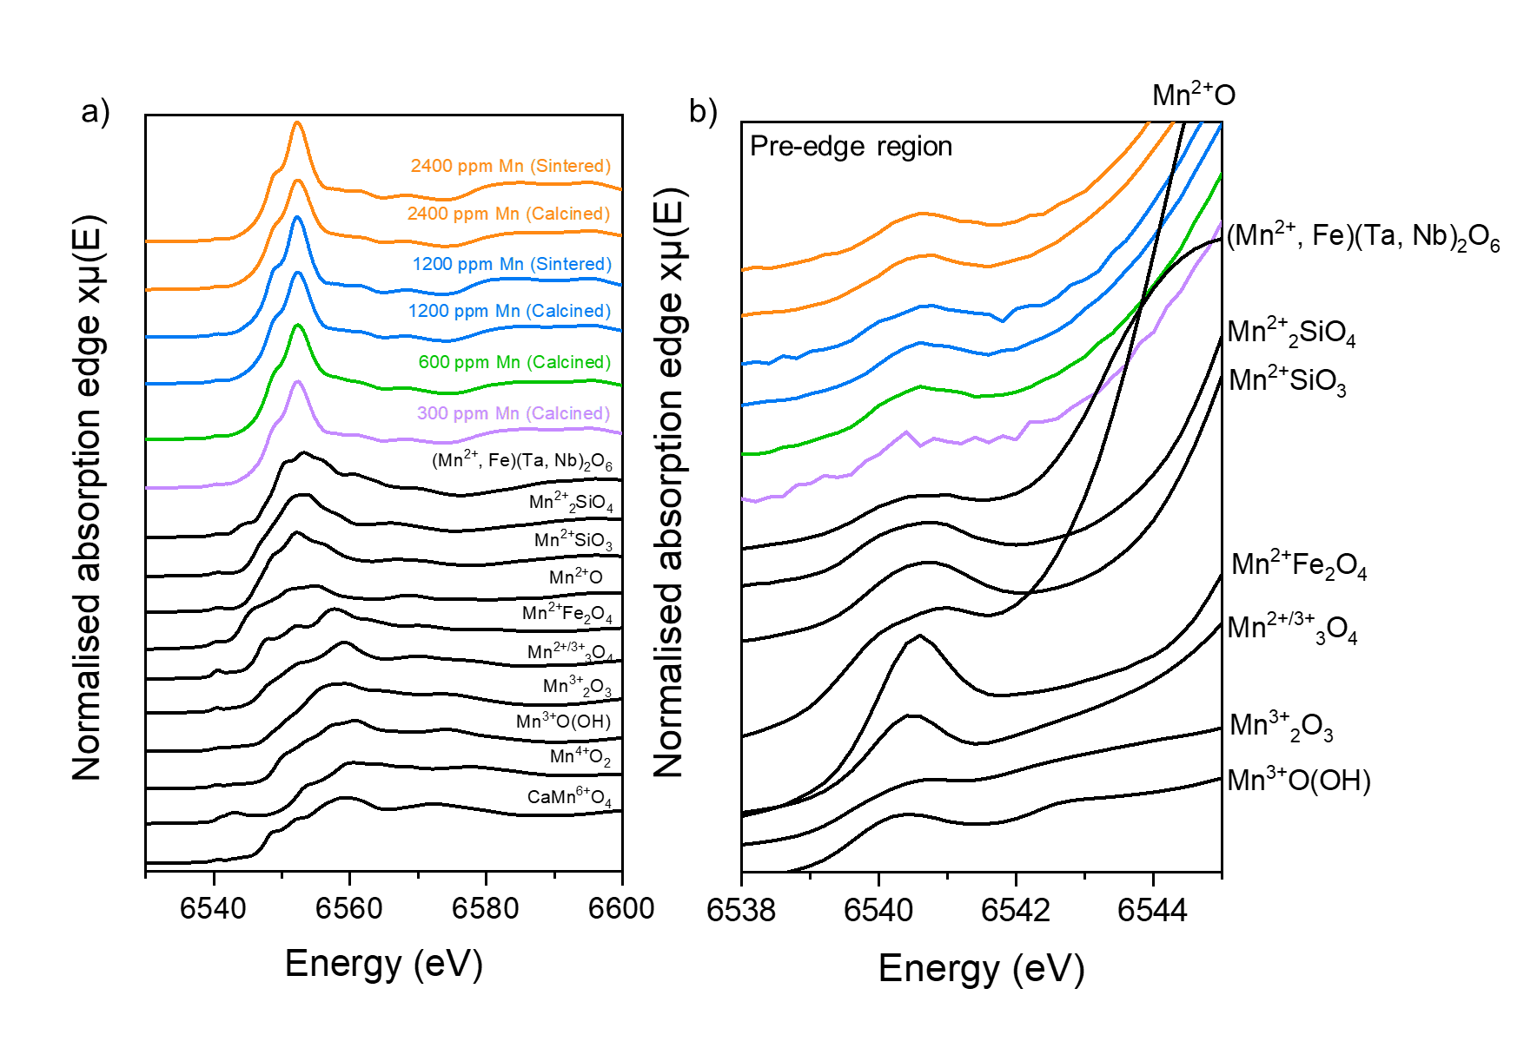Fig. 3. Mn K-edge XANES spectra of Mn-doped UO₂ compared to known standards. a complete spectra and b pre-edge region. Standards are depicted in black, with samples in colour.

Table 1. XANES analysis for Mn-doped UO₂ samples and Mn standards
Sample/Standard | Valence state | Mn environment | E₀ (white line) position (eV, ± 0.6) | Pre-edge centroid position  (eV, ± 0.6) | Pre-edge integrated area (±0.03)
300 ppm Mn (Calcined) |  |  | 6551.3 | 6540.4 | 0.0490
600 ppm Mn (Calcined) |  |  | 6551.1 | 6540.6 | 0.0994
1200 ppm Mn (Calcined) |  |  | 6551.2 | 6540.6 | 0.0716
1200 ppm Mn (Sintered) | 1.80ª | O_{h}^{b} | 6551.2 | 6540.5 | 0.0784
2400 ppm Mn (Calcined) |  |  | 6551.1 | 6540.6 | 0.0636
2400 ppm Mn (Sintered) | 1.88ª | O_{h}^{b} | 6551.3 | 6540.6 | 0.0717
(Mn,Fe)(Ta,Nb)₂O₆ | 2 | O_{h} | 6552.4 | 6540.3 | 0.0547
Mn₂SiO₄ | 2 | O_{h} | 6550.3 | 6540.8 | 0.1548
MnSiO₃ | 2 | O_{h}^{c} | 6551.0 | 6540.8 | 0.1860
MnO | 2 | O_{h} | 6550.6 | 6540.8 | 0.2845
MnFe₂O₄ | 2 | T_{d} | 6556.2 | 6541.1 | 0.4805
Mn₃O₄ | 2/3 | O_{h} /T_{d} | 6557.2 | 6541.1 | 0.1118
Mn₂O₃ | 3 | O_{h} | 6554.0 | 6541.4 | 0.2314
MnO(OH) | 3 | O_{h} | 6556.4 | 6541.2 | 0.1481
CaMn₂O₄ | 3 | O_{h} | 6555.2 | 6541.9 | 0.0100
MnO₂ | 4 | O_{h} | 6558.2 | 6542.0 | 0.5099
(O_{h}) is octahedral and (T_{d}) is tetrahedral local symmetry environment
ª calculated bond valence sum from EXAFS model (Table 2)
^{b} determined from EXAFS models (Table 2)
^{c} distorted [26]

Analysis of the pre-edge feature in the Mn K-edge XANES (Fig. 3b and Extended date Fig. 1) can be used to probe the local symmetry environment [26, 28]. This pre-edge feature arises from the forbidden 1s to 3d electronic transition and becomes more intense when there is stronger mixing of the d and p orbitals resulting from a lack of local symmetry in the Mn environment [27]. Here, the centroid position and integrated area of the pre-edge feature are similar for all Mn-doped UO₂ samples (6540.42 - 6540.64 eV and 0.0490 – 0.0994, respectively) (Fig. 3b and Table 1). These values are in accordance with values determined for standards that contain Mn²⁺ in an octahedral local symmetry environment (6540.36 - 6540.83 eV and 0.0547 - 0.2845 for the centroid position and integrated area, respectively). The values for Mn-doped UO₂ are also in agreement with literature values for (Mn²⁺,Fe)₃Al₂Si₃O₁₂ [28] (6.540.66 eV, 0.0745), which exhibits a cubic Mn local environment; however, the same study reports similar values for octahedrally-coordinated Mn²⁺O (6540.62 eV, 0.0745). This highlights that differentiation in the local symmetry of Mn²⁺ by pre-edge analysis is not simple and that additional EXAFS analysis is required to confirm the coordination environment.
Since there were no changes in the XANES spectral features with increasing Mn content, nor between calcined oxide powder and sintered samples, the 1200 ppm and 2400 ppm Mn-doped UO₂ calcined powder samples were selected as representative of the local structure of Mn in UO₂ (Figs. 3 and 4). Extended X-ray Absorption Fine Structure (EXAFS) fitting of the Mn K-edge, for both concentrations (Fig. 4 a-d, Table 2), were consistent and indicated that the first O nearest neighbour environment of Mn is split between 6 O atoms at 2.27 – 2.29 ± 0.01 Å and 2 O atoms at 2.55 – 2.57 ± 0.03 Å in an 8-fold coordination environment, consistent with direct substitution of Mn onto the U⁴⁺ site. Slight contraction in the first Mn-O distance, when compared to 2.36 ± 0.02 Å U-O distance, is expected due to the smaller cation size of Mn²⁺ (0.96 Å) compared to U⁴⁺ (1.00 Å). This contraction also creates a small amount of distortion in the local Mn environment, which is likely the reason for the first coordination shell splitting into two different O distances.
Substitution of Mn²⁺ on the U⁴⁺ lattice site is further supported by a decrease in the lattice parameter with increasing Mn content, consistent with Vegard’s Law (Fig. 5). Beyond the first coordination shell, a further 5 U atoms were fit at distance 3.78 ± 0.01 Å. This decreased coordination from the expected 12 U atoms at 3.85 ± 0.06 Å in crystalline UO₂ may be attributed to a combination of lattice distortion from Mn-doping and of the limited data range available (2 – 10.5 Å⁻¹). The combination of these two factors makes delineation of the distorted U-U backscatterers challenging; extension of the data range, not practically possible in this experiment due to the low Mn concentrations within a highly absorbing matrix, has previously been shown to resolve this issue [29]. The bond valence sum (BVS) was calculated and used to indicate the oxidation state. Values of 1.80 and 1.88 were calculated for the 1200 ppm and 2400 ppm Mn-doped UO₂ samples, respectively, supporting the presence of divalent Mn²⁺.

Table 2. Fitting parameters and results for 1200 ppm and 2400 ppm Mn-doped UO₂ oxide powders. (S₀²) is the amplitude reduction factor, (∆E₀) the shift from Mn K-edge position (5.989 keV), (N) the degeneracy, (R_{eff}) (Å) the reference bond length, (R) (Å) the fitted bond length, (σ²) the Debye-Waller factor and (α) F-test factor.
 | UO₂ + 1200 ppm Mn (Calcined oxide powder) | UO₂ + 2400 ppm Mn (Calcined oxide powder)
S₀² | 1.0 | 1.0
∆E_{o} | -0.8 (1) | -0.9(6)
N (Mn-O1) | 6 | 6
R_{eff} (Mn-O1) | 2.37 | 2.37
R(Mn-O1) | 2.29(1) | 2.27(1)
σ² (O1) | 0.016(1) | 0.018(1)
α (%) | 100.0 | 100.0
N (Mn-O2) | 2 | 2
R_{eff} (Mn-O2) | 2.37 | 2.37
R(Mn-O2) | 2.57(3) | 2.55(3)
σ² (O2) | 0.012(4) | 0.015(4)
α (%) | 100.0 | 100.0
N (Mn-U1) | 5 | 5
R_{eff} (Mn-U1) | 3.87 | 3.87
R(Mn-U1) | 3.78(1) | 3.78(1)
σ² (U1) | 0.011(1) | 0.013(1)
α (%) | 100.0 | 100.0
R-factor | 0.0098 | 0.0071
Bond valence sum (O1) | 1.56 | 1.62
Bond valence sum (O2) | 0.24 | 0.26
Bond valence sum (total) | 1.80 | 1.88
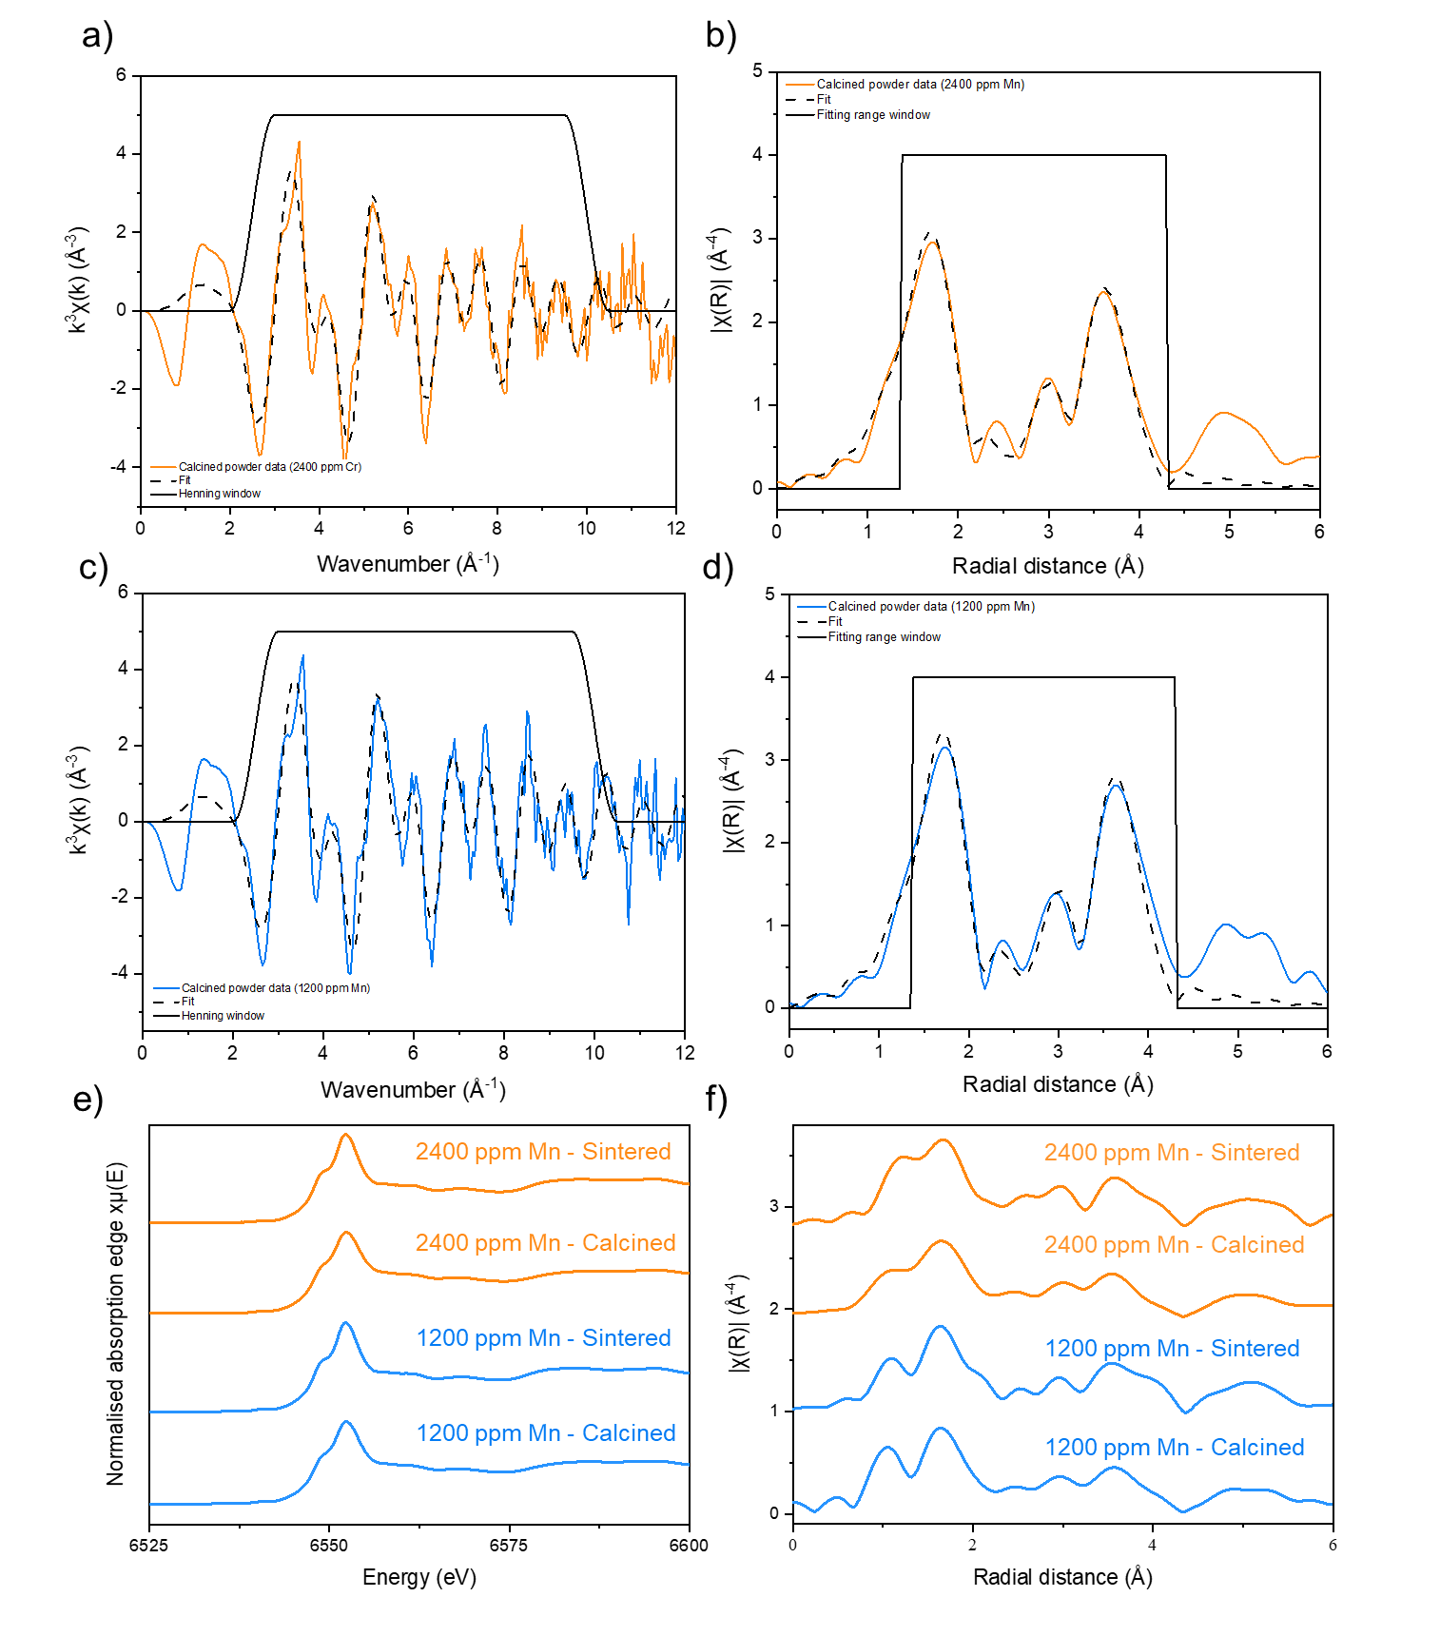
Fig. 4. Crystal structure and local coordination analysis of Mn in Mn-doped UO₂ determined by EXAFS and XANES analysis. k³-weighted Mn K-edge spectra and EXAFS model fits for a-b nominally doped 2400 ppm Mn calcined powder; and c-d nominally doped 1200 ppm Mn calcined powder; e Mn K-edge XANES and f the Fourier transformed spectra of Mn-doped UO₂ calcined powder and sintered pellets.
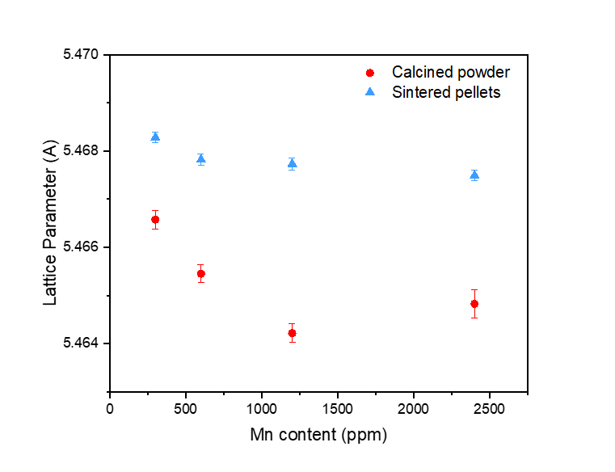
Fig. 5. Lattice parameter values for calcined powder and sintered material, as determined by p-XRD
A charge balance mechanism is required in the substitution of Mn²⁺ on the U⁴⁺ site, provided by the formation of positive defects, U⁵⁺ and/or oxygen vacancies (O_{v}). Experimental evidence for U⁵⁺ formation is given by HERFD XANES data acquired at the U M₄-edge (Fig. 6a and Extended data Fig. 2) which showed, through principal component analysis of the data series, that only two components were required to accurately reconstruct each of the samples in the series. These were attributed to U⁵⁺ (closely matching a standard of CrUO₄) and U⁴⁺ (UO₂) oxidation states. Iterative target transformation factor analysis was used to indicate the approximate fraction of U⁴⁺ and U⁵⁺ in each of the oxide powders (Fig. 6b), with results indicating ~21-26 ± 2 % U⁵⁺ present in Mn-doped UO₂ (and therefore ~74-79 ± 1 % U⁴⁺), confirming the formation of U⁵⁺ due to substitution of Mn²⁺ into the UO₂ lattice. There was an apparent slight increase in the intensity of the peak relating to U⁵⁺ in the highest doped Mn-UO₂ samples (Fig. 6a), which further supports the hypothesis of U⁵⁺ formation as a charge compensation mechanism, however, the values derived from the ITFA analysis were deemed to be the same, within error.
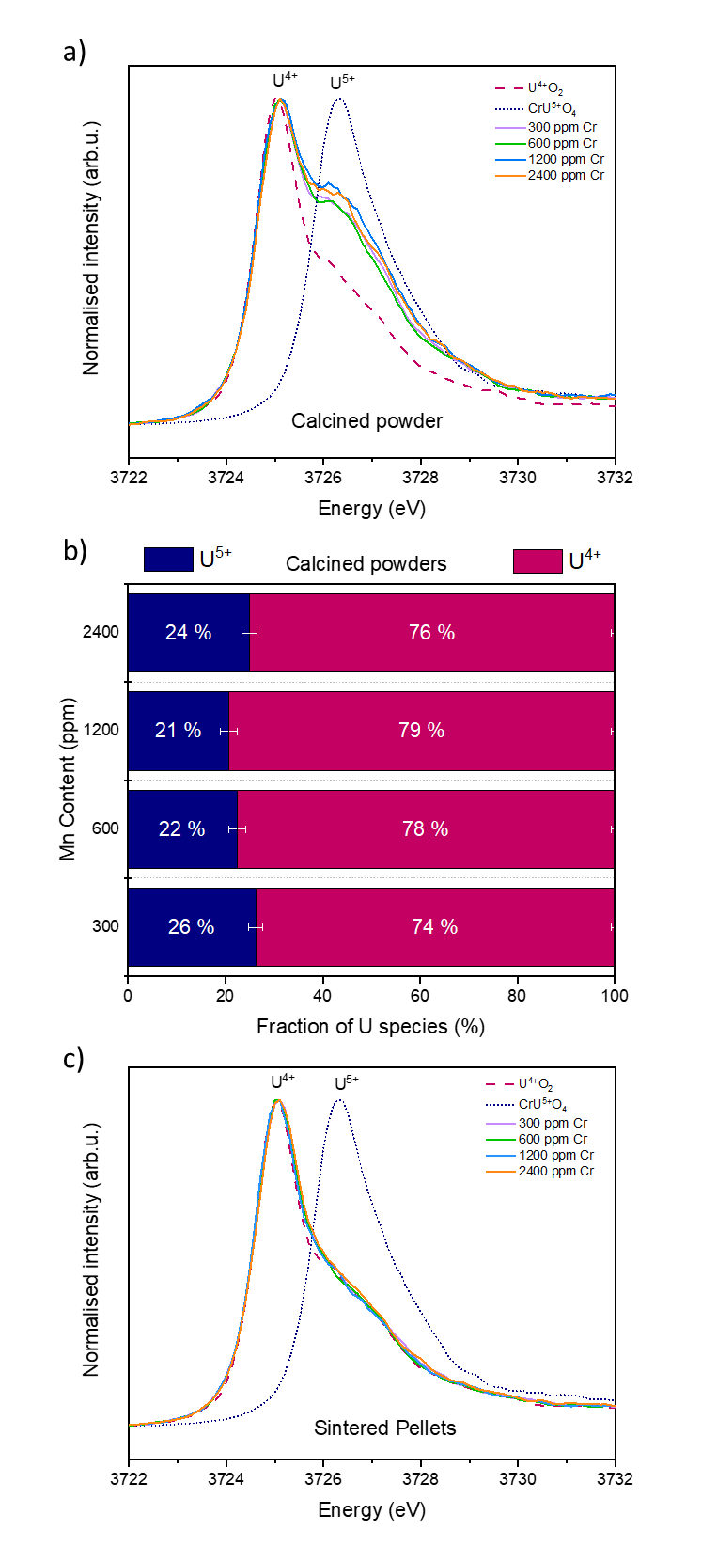

Fig. 6. U M₄-edge HERFD XANES of Mn-doped UO₂ materials. a calcined material; b quantification of the U^{4+/5+} ratio in calcined powder determined from fitting of U M₄-edge HERFD XANES data in a; and c sintered material.
The formation of O_{v} defects is observed through Raman spectroscopy in the analysis of the defect contributions (Fig. 7a). The main T_{2g} peak (~445 cm⁻¹) of UO₂ and the defect band (~500-700 cm⁻¹), indicative of lattice distortion due to defect formation, is present for all samples. The relative intensity of individual peak contributions of the defect bands, where U1 is attributed to O_{v}, U2 to the LO phonon mode and U3 indicating O_{i}, was compared to the relative intensity of the T_{2g} peak [22] (Fig. 7b). As the concentration of Mn is increased from 300 to 600 ppm, there is an increase in LO phonon peak (U2) and U1 peak, attributed to an increase in the O_{v} concentration (Fig. 7c). This confirms that O_{v} formation occurs as a charge balance mechanism for Mn doping in UO₂. As the concentration of Mn is increased beyond 600 ppm, a gradual decrease in the intensity of the defect band (U2) is observed where, seemingly, the concentration of O_{v} (U1) are reduced. Given that the lattice parameter continues to decrease with the increasing Mn content, a change in the incorporation mechanism is not expected. As such, it is postulated that this behaviour reflects the fact that at higher dopant concentrations, substitution via U⁵⁺ formation is favoured as the charge compensation mechanism.

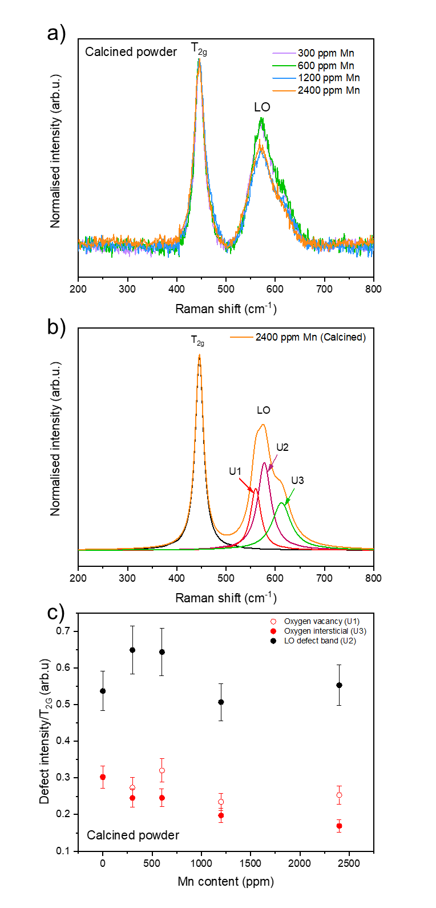
Fig. 7. Raman analysis of Mn-doped UO₂ calcined powders. a Raman spectra; b deconvolution of the 2400 ppm Mn-doped UO₂ spectra into U1, U2 and U3 peaks; and c defect content realised by the area ratio of the defect peak to the T_{2g} peak.
As noted previously, there were no significant changes in the crystal structure of sintered Mn-UO₂ when compared to the calcined oxide powders, indicated by consistency in spectral features Mn K-edge XANES (Fig. 3) and the Fourier Transform of the EXAFS region (Fig. 4e-f). The reduction in the lattice parameter, due to Mn²⁺ substitution on the U⁴⁺ site, is maintained; although, the absolute values of lattice parameter are 0.002 – 0.004 Å greater in the sintered samples than the calcined samples (Fig. 5). This could be the result of volatilisation of Mn during sintering (see below) and/or reduction of U⁵⁺ (0.84 Å) to U⁴⁺ (1.00 Å) imposed by the reducing high temperature environment, as observed by HERFD-XANES (Fig. 6c).

Influence of reducing sintering conditions on the microstructure of Mn-doped UO₂
When comparing the Mn concentrations of calcined oxide powders with those of materials sintered in a reducing (5% H_{2(g)}: 95% N_{2(g)}) environment, it is evident that significant volatilisation of Mn occurred (Fig. 8a) [8]. For UO₂ doped with 300 ppm Mn, the loss was ~30%, while for the remaining concentrations (600, 1200 and 2400 ppm), it was ~80%.
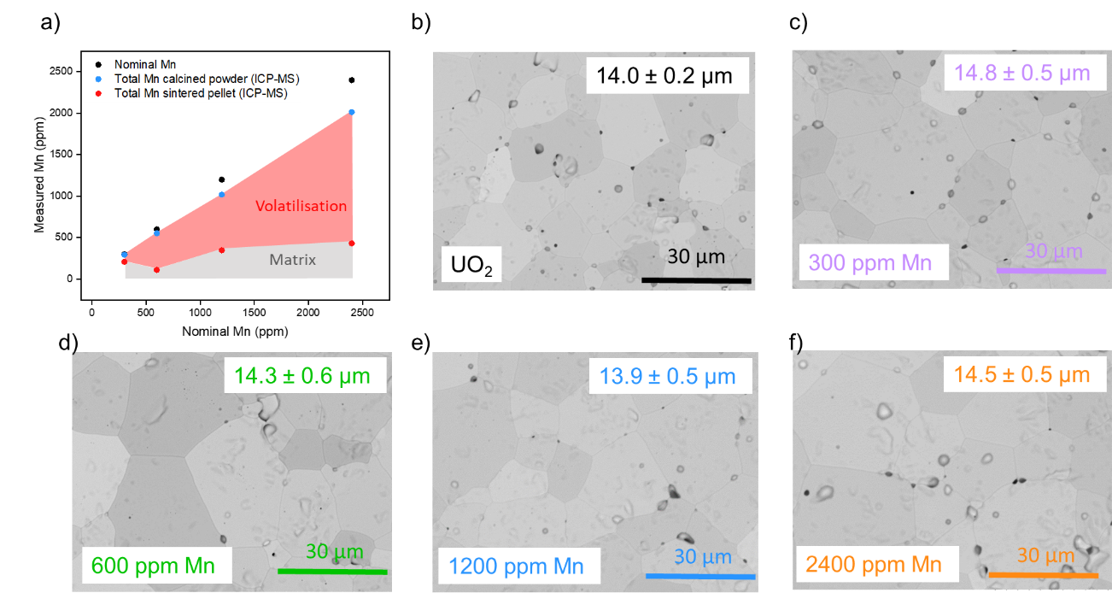
Fig. 8. Microstructural evolution of undoped and Mn-doped UO₂ sintered in a reducing environment. a the measured Mn content in Mn-doped UO₂ calcined powder and sintered pellets; and SEM images and average grain size of ~500 grains measured across the sample surface in b undoped UO₂ and b-e Mn-doped UO₂.
No significant influence on the grain size was observed when the average measurements of ~500 grains were considered in comparison to undoped UO₂ (Fig. 8b-e), however, there was a marginal increase with increasing dopant concentration. An average grain size of 13.9 – 14.8 ± 0.5 μm was recorded, in comparison with undoped UO₂, sintered under the same conditions, which had an average grain size of 14.0 ± 0.2 μm.
Studies of commercially available Cr-doped UO₂ have shown that the sintering atmosphere is the most important factor contributing to grain growth, with the addition of small quantities of oxygen in the sintering atmosphere thought to promote the formation of a ‘CrO’ eutectic phase. At sintering temperatures (>1675 °C), this phase is liquid and aids grain growth, evidenced as precipitates in Cr-doped UO₂ formed upon cooling [30-33]. The effects of a eutectic phase have been reported for Mn/Al doped UO₂ sintered in a H₂ atmosphere at 1860 °C, where a MnO/Al₂O₃ phase was observed by EDX mapping [10]. Conversely to Cr-doped UO₂, the addition of oxygen to the sintering atmosphere in Mn/Al doped UO₂ resulted in a smaller grain size, attributed to increased solubility of MnO in the UO₂ matrix.

However, in the present study under fully reducing conditions, much of the Mn²⁺ incorporated into the UO₂ was volatilised, and no precipitates were observed, which indicate that the solublity limit of Mn in UO₂ was not reached in this study and an equivalent MnO liquid phase was not likely formed. Moreover, the lower sintering temperature (1700 °C) would restrict the formation of any possible eutectic phase and, as such, no significant increase in the grain growth was observed. It has also been shown for Cr-doped UO₂ that, if the sintering atmosphere required for the eutectic phase formation is not met, the presence of precipitates at grain boundaries will have the opposite effect and grain growth will be hindered by pinning grain boundaries. This reasoning is excluded due to the absence of precipitates in the Mn-doped UO₂ samples.
Despite this, in contrast to undoped UO_{2,} individual grain sizes of up to 50 μm were observed for all Mn-doped UO₂ samples studied (Fig. 8b-e). This ‘localised’ grain growth has previously been reported for Mn-doped UO₂ prepared via sol-gel synthesis and sintered under reducing conditions (5% H_{2(g)}: 95% N_{2(g)}, 6hrs, 1700 °C) [8]. Such behaviour may be due to the increased diffusivity of U atoms predicted by atomistic models of the defect concentrations [6]. Further work to underpin the solubility limit of Mn in UO₂, and to develop an understanding of the influence of sintering conditions on Mn-UO₂, is required to fully elucidate the mechanism of grain size growth.

Conclusion
A uranyl nitrate precipitation synthesis method for successful co-precipitation of Mn-doped UO₂ has been established. Further detailed characterisation of the local structure and crystal chemistry of the calcined oxide material by high resolution XAS, supported by p-XRD and Raman spectroscopy has, for the first time, successfully resolved the incorporation mechanism of Mn in the UO₂ lattice structure. It has been shown that Mn²⁺ substitutes on the U⁴⁺ cation site resulting in the formation of both U⁵⁺ and O_{v} in a charge balance mechanism.
Upon sintering, Mn²⁺ was shown to be maintained in the UO₂ lattice, or lost due to volatilisation at high temperatures. Although the average grain size was not increased in comparison to undoped UO₂, some grains of up to ~50 μm formed, suggesting that large grained Mn-doped UO₂ synthesis is possible under the sintering conditions employed in this study. The absence of Mn-precipitates showed that the solubility limit of Mn in UO₂ was not reached and that it is unlikely that a liquid phase sintering effect occurred. Further refinement of sintering atmosphere and greater understanding of Mn solubility in UO₂ is required to further elucidate this behaviour.
These results have given insight into the crystallographic basis for interpretation of grain growth as well as oxidation and dissolution behaviours in Mn-doped UO₂ and support their development for future use as accident tolerant fuels.

References
1 J. Arborelius, K. Backman, L. Hallstadius, M. Limbӓck, J. Nilsson, B. Rebensdorff, G. Zhou, K. Kitano, R. Lӧfstrӧm and G. Rӧnnberg, J. Nucl. Sci. Technol., 2006, 43, 967–976.
2 A. Massih, Swedish Radiat. Saf. Auth., 2014, 74, 1-71.
3 J. C. Killeen, J. Nucl. Mater., 1980, 88, 177–184.
4 S. Kashibe and K. Une, J. Nucl. Mater., 1998, 254, 234–242.
5 K. Une, I. Tanabe, J. Nucl. Mater., 1987, 150, 93–99.
6 United States, 2020, 1.
7 M. W. D. Cooper, C. R. Stanek and D. A. Andersson, Acta Mater., 2018, 150, 403–413.
8 S. C. Finkeldei, R. D. Hunt, J. O. Kiggans C. A. Hobbs, B. D Eckhard, J. W. McMurray, K.A Terrani, A. T. Nelson, ORNA., 2019, 1, 1-14
9 K. W. Kang, J. H. Yang, J. H. Kim, Y. W. Rhee, D. J. Kim, K. S. Kim and K. W. Song, J. Nucl. Sci. Technol., 2010, 47, 304–307.
10 R. C. Ewing, Nat. Mater., 2015, 14, 252–257.
11 NDA, Geological Disposal: Package evaluation status report, 2010.
12 M. Newville, J. Synchrotron Radiat., 2001, 8, 322–324.
13 B. Ravel and M. Newville, J. Synchrotron Radiat., 2005, 12, 537–541.
14 G. A. Waychunas, American Minerologist, 1987, 72, 89–101.
15 A. Ankudinov and B. Ravel, Phys. Rev. B - Condens. Matter Mater. Phys., 1998, 58, 7565–7576.
16 R. W. G. Wyckoff, Interscience Publishers, 1963, 132, 239–444.
17 L. Downward, C. H. Booth, W. W. Lukens and F. Bridges, AIP Conf. Proc., 2007, 882, 129–131.
18 D. A. Brown, I. D., Acta Crystallogr. Sect. B, 1985, 41, 244–247.
19 A. C. Scheinost, J. Claussner, J. Exner, M. Feig, S. Findeisen, C. Hennig, K. O. Kvashnina, D. Naudet, D. Prieur, A. Rossberg, M. Schmidt, C. Qiu, C. Cohen, E. Dettona, V. Dyadkin and T. Stumpf, J. Synchrotron Radiat., 2021, 28, 333–349.
20 K. O. Kvashnina and A. C. Scheinost, J. Synchrotron Radiat., 2016, 23, 836–841.
21 A. Rossberg, K. U. Ulrich, S. Weiss, S. Tsushima, T. Hiemstra and A. C. Scheinost, Environ. Sci. Technol., 2009, 43, 1400–1406.
22 G. Guimbretière, L. Desgranges, A. Canizarès, G. Carlot, R. Caraballo, C. Jégou, F. Duval, N. Raimboux, M. R. Ammar and P. Simon, Appl. Phys. Lett., 2012, 100, 1–4.
23 J. Martinez, N. Clavier, T. Ducasse, A. Mesbah, F. Audubert, B. Corso, N. Vigier, N. Dacheux, J. Martinez, N. Clavier, T. Ducasse, A. Mesbah and F. Audubert, HAL, 2021, 35, 4535–4546.
24 T. J. W. De Bruijn, G. M. J. De Ruiter, W. A. De Jong and P. J. Van Den Berg, Thermochim. Acta, 1981, 45, 279–292.
25 K. V Rajagopalan, P. V Ravindran and T. P. Radhakrishnan, J. Therm. Ana, 1995, 44, 89–96.
26 F. Farges, Phys. Rev. 2005, 71, 1–14.
27 G. Dräger, T. Kirchner and S. Bocharov, Int. Union Crystallogr., 2001, 8, 398–400.
28 E. Chalmin, F. Farges and G. E. Brown, Contrib. to Mineral. Petrol., 2009, 157, 111–126.
29 T. A. Marshall, K. Morris, G. T. W. Law, F. R. Livens, J. F. W. Mosselmans, P. Bots and S. Shaw, Environ. Sci. Technol., 2014, 48, 3724–3731.
30 L. Bourgeois, P. Dehaudt, C. Lemaignan and A. Hammou, J. Nucl. Mater., 2001, 297, 313–326.
31 G. Kuri, C. Mieszczynski, M. Martin, J. Bertsch, C. N. Borca and C. Delafoy, J. Nucl. Mater., 2014, 449, 158–167.
32 A. Leenaers, L. De Tollenaere, C. Delafoy and S. Van den Berghe, J. Nucl. Mater., 2003, 317, 62–68.
33 T. Cardinaels, K. Govers, B. Vos, S. Van Den Berghe, M. Verwerft, L. De Tollenaere, G. Maier and C. Delafoy, J. Nucl. Mater., 2012, 424, 252–260.

Acknowledgements

This work was funded by the UK Engineering and Physical Science Research Council (EPSRC) under grant numbers EP/N017374/1, EP/S020659/1 and EP/L015390/1. This research utilised the HADES/MIDAS facility at the University of Sheffield established with financial support from EPSRC and BEIS, under grant EP/T011424/1, and also the PLEIADES National Nuclear User Facility, established with funding from EPSRC under grant number EP/V035215/1 and the Henry Royce Institute for Advanced Materials ICP-MS facility, under grant numbers EP/P02470X/1 and EP/P025285/1. We acknowledge Diamond Light Source for time on I20-scanning under proposal number SP28515. We acknowledge the European Synchrotron Radiation Facility for provision of synchrotron radiation facilities (under proposal number MA-4821) and we would like to thank Tatiana Poliakova, Anastasiia Smirnova and Jurij Galanzew for assistance in using the Rossendorf beamline (ROBL, BM20) remotely during the pandemic. The authors also wish acknowledge Sarah pepper, Daniel Austin and Daniel Bailey for help with the ICP-OES, XAS analysis and Thermogravimetric analysis, respectively.

Author contributions

Hannah Smith – data collection, formal analysis, original draft preparation.
Luke Townsend – formal analysis, original draft preparation, reviewing and editing.
Ritesh Mohun – data collection, formal analysis, original draft preparation, reviewing and editing.
Martin Stennett - data collection, formal analysis.
Kristina Kvashnina – data collection, formal analysis, reviewing and editing.
Fred Mosselmans – data collection, reviewing and editing.
Claire Corkhill – funding acquisition, supervision, data collection, formal analysis, reviewing and editing.

Extended data

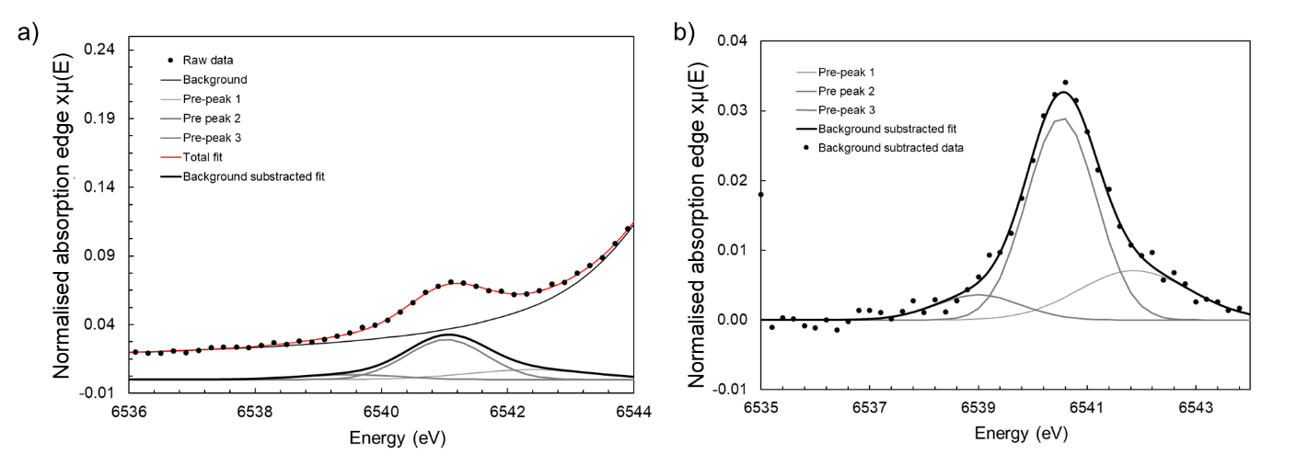
Extended Figure 1. Pre-edge fitting of Mn k-edge XANES of calcined material. a example pre-edge fit; and b Gaussian fitting of the isolated pre-edge feature of 2400 ppm Mn-doped calcined oxide powder.

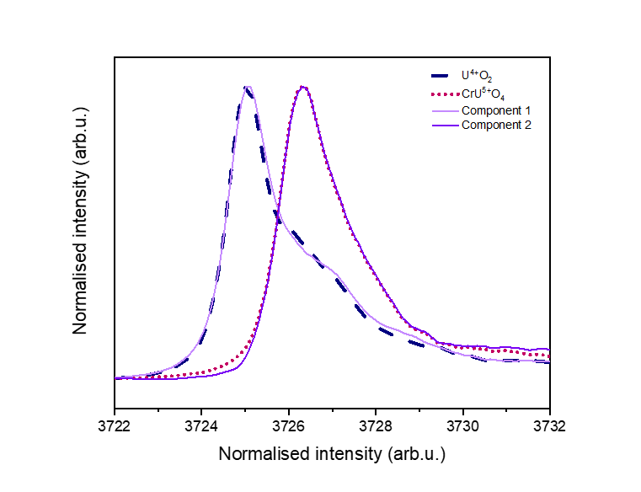
Extended Figure 2. HERFD XANES U M₄ edge spectroscopy analysis of calcined material. Comparison between the components produced during the ITFA analysis using CrU⁵⁺O₄ and U⁴⁺O₂ standards.

Summary and conclusions
The objective of this Thesis was to improve understanding of advanced, doped UO₂ materials and to explore the previously unknown behaviours surrounding the long-term durability in comparison to standard UO₂ fuel. As the most widely used advanced fuel, Cr-doped UO₂ was the main focus of this research, in addition to Mn-doped UO₂, which has been of interest to fuel manufacturers in recent years as a potential alternative to Cr-UO₂. The conclusions of this work can be divided into two subjects: the first centred on the crystal chemistry of doped UO₂ and; the second on the durability in conditions relevant to geological disposal.

Conclusion on doped UO₂ crystal chemistry (Chapters 4 and 6)
It has been shown that Cr incorporates into the UO₂ lattice structure via substitution mechanism where U⁴⁺ is replaced by Cr²⁺ and subsequent charge balance is achieved by formation of U⁵⁺ and O_{v}. In this work, a combination of high resolution spectroscopy techniques were shown to successfully resolve the fundamental crystal chemistry of the otherwise theoretical or simulated Cr-doped UO₂ material.
A key finding of this study was the importance of investigating the calcined oxide material, used to fabricate large grain UO₂, when assessing the crystal chemistry. A comparative study between Cr-doped UO₂ oxide powders and pellets sintered under a reducing atmosphere showed how heat treatment during fabrication alters the local crystal chemistry of Cr in the UO₂ lattice, resulting in a more complex system, which is difficult to interpret. This result showed that a fundamental understanding of the calcined powder is required to allow elucidation of the changes in crystal chemistry upon sintering in doped UO₂.
It was found that upon heat treatment at 1700 °C under a reducing atmosphere, the valence of Cr is altered such that a mixed Cr²⁺/Cr³⁺ oxidation state is observed. It should be noted that the Cr oxidation state of real Cr-doped nuclear fuel is unknown, and that the matrix Cr oxidation state of irradiated Cr-doped fuel has not been measured. These are key areas for future work, which the current Thesis strongly underpins. In contrast to Cr-doped UO₂, in Mn-doped UO₂, where similarly to Cr, Mn is initially substituted into the U⁴⁺ lattice site via O_{v} and U⁵⁺ defect formation, the Mn²⁺ oxidation state is maintained upon heat treatment and no alteration in the local coordination environment was observed.
Considering these results, it is hypothesised that Mn is more soluble than Cr in the UO₂ matrix at the dopant concentrations, and under the sintering conditions used in this research. As such, sintered Mn could be a more advantageous dopant owing to the fact less Mn would be required to produce large grained UO₂ and the resultant microstructure would be less complex. Further work to fully define the solubility limit of Mn in UO₂ would be beneficial to advance the potential use of this fuel.
The work presented in Chapters 4 and 6 of this Thesis have given insight into the crystallographic basis for interpretation of grain growth in Cr- and Mn-doped UO₂ as well as provided a successful route to fabrication of Mn-doped UO₂ in support of their development for future use as accident tolerant fuels.

Conclusions on Cr- doped UO₂ durability (Chapter 5)
The effects of Cr present in UO₂, both in the UO₂ matrix and as Cr₂O₃ precipitates in the grain boundaries, was assessed by long-term durability tests in oxic conditions, as a function of Cr content. Cr-doped UO₂ was dissolved in a simulant groundwater solution (19mM NaCl + 1mM NaHCO₃) at 25 °C, 40 °C and 60°C.
At lower temperatures, it was found that the presence of Cr seemingly improves the durability where the initial dissolution rate of U was reduced as a function of increased Cr content. From an electrochemical perspective, it was shown to be likely that the presence of Cr²⁺, and not Cr³⁺, promotes reduction of oxidised U at the surface of UO₂, leading to reduced U dissolution rate in Cr-doped UO₂. At higher temperatures however, no effect of Cr was observed due to the stronger effect of the bicarbonate solution-driven oxidative dissolution mechanism, which is known to be significantly enhanced at higher temperature.
The implications of these results for the initial dissolution behaviour of Cr-doped UO₂ in conditions relevant to geological disposal are dependent on the point in time at which ground water will reach the spent fuel. From these results, if the temperature has reached below 40 °C, it is possible that Cr-doped UO₂ will be more durable than standard UO₂. If groundwater were to reach spent fuel prior to this time, (i.e., when the fuel surface heated groundwater to higher temperatures than 40 °C) the dissolution behaviour is expected to proceed as expected for conventional UO₂ in bicarbonate solution.
Furthermore, for all temperatures investigated in this research, as dissolution proceeds, the rate of U dissolution is decreased due to the effects of solution saturation and the eventual formation of secondary U-phase precipitates. This concludes that Cr has no effect on dissolution behaviour in the latter stages of dissolution.
An interesting result observed in the 25 °C experiment was the apparent “resumption” in dissolution rate, attributed to the changing surface area associated with dissolution of the grain boundaries. The effect of microstructure was also assessed, showing that the dissolution rate was also decreased as a function of increasing grain size. It is suggested that a reduction in dissolution initiation sites (i.e. grain boundaries) with an increase in grain size is responsible for the reduced dissolution of U and that potentially, larger grained UO₂ would have improved durability over standard UO₂ material. It follows that the durability could be further enhanced in larger grained, commercially used UO₂, where grain sizes are ~80 μm. When the dissolution behaviour of Mn-doped UO₂ is considered, it is postulated that grain size, and grain boundary effects, will be the most prominent factor on the dissolution rate of U, due to possible higher solubility of Mn in the UO₂ matrix .

Future work
Considering the results of this Thesis, it is recommended that to understand fully the crystal chemistry of doped UO₂ materials, first the calcined oxide material should be analysed and the understanding applied to the final sintered material.
Additional analytical techniques such as neutron diffraction and transmission electron microscopy would be beneficial to supporting the presence of O_{i}/O_{v} defects and investigating the potential for a dopant interstitial incorporation mechanism.
The fabrication of Mn-doped UO₂ is strongly supported by this work, although further development of sintering conditions to produce large-grained Mn-doped UO₂ is required. In addition to a thorough understanding of Mn-doped UO₂ in-reactor performance in comparison to Cr-doped and standard UO₂ fuel, research into the long-term durability will be essential to developing waste management strategies. Unfortunately, this was not possible in the present Thesis due to laboratory closure restrictions imposed by the Covid-19 pandemic.
Furthermore, due to the differences observed in the crystal chemistry and microstructure of Mn-doped UO₂, compared to Cr-doped UO₂, dissolution studies replicating the conditions of this research would be of great interest to understanding the galvanic coupling effect and whether it is linked to precipitates or dopant present within the matrix. Micro-focus XAS techniques can also be utilised to measure the valence state of Cr in dissolved samples in order to establish the redox activity of Cr, and potentially Mn, in UO_{2.}
For already commercially used Cr-doped UO₂, a number of possible avenues for future work remain, particularly for unirradiated material. Extended dissolution experiments under the conditions studied, using advanced spectroscopy techniques (for example in-situ environmental scanning electron microscopy (E-SEM) or Vertical scanning interferometry (VSI)) as well as employing controlled sintering conditions to maintain Cr content with increasing grain size would allow a deeper understanding of the role of microstructure in Cr-doped UO₂ dissolution. Additionally, studies of the dissolution behaviour under alternative conditions (for example, anoxic dissolution conditions; in the presence of fission products and other effects of irradiation) are imperative to building a full understanding of Cr-doped UO₂ dissolution behaviour.

References (Chapters 1-3)

1 J.-L. Guillet and Y. Guerin, Nuclear fuels, 2009.
2 R. C. Ewing, Nat. Mater., 2015, 14, 252–257.
3 H. Assmann, W. Dörr and M. Peehs, J. Nucl. Mater., 1986, 140, 0–5.
4 J. Arborelius, K. Backman, L. Hallstadius, M. Limbӓck, J. Nilsson, B. Rebensdorff, G. Zhou, K. Kitano, R. Lӧfstrӧm and G. Rӧnnberg, J. Nucl. Sci. Technol., 2006, 43, 967–976.
5 A. Massih, Swedish Radiat. Saf. Auth., 2014, 74, 1-71.
6 United States, 2020, 1.
7 R. O. Evins, L.Z., Bosbach D, Duro, L., Farnan I, Metz V, DISCO Final Scientific Report, 2021.
8 AREVA, Incorporation of Chromia-Doped Fuel Properties in AREVA Approved Methods, 2016.
9 Z. Hiezl, D. I. Hambley, C. Padovani and W. E. Lee, J. Nucl. Mater., 2015, 456, 74–84.
10 C. M. Silva, R. D. Hunt and K. S. Holliday, J. Nucl. Mater., 2021, 553, 153–163.
11 L. Bourgeois, P. Dehaudt, C. Lemaignan and A. Hammou, J. Nucl. Mater., 2001, 297, 313–326.
12 C. Riglet-Martial, P. Martin, D. Testemale, C. Sabathier-Devals, G. Carlot, P. Matheron, X. Iltis, U. Pasquet, C. Valot, C. Delafoy and R. Largenton, J. Nucl. Mater., 2014, 447, 63–72.
13 T. Cardinaels, K. Govers, B. Vos, S. Van Den Berghe, M. Verwerft, L. De Tollenaere, G. Maier and C. Delafoy, J. Nucl. Mater., 2012, 424, 252–260.
14 A. Milena-Pérez, L. J. Bonales, N. Rodríguez-Villagra, S. Fernández, V. G. Baonza and J. Cobos, J. Nucl. Mater., 2021, 543, 152–181.
15 P. Kegler, M. Klinkenberg, F. Brandt, D. Bosbach, A. Bukaemskiy, G. L. Murphy and G. Deissmann, Modern Nuclear Fuels. Materials, 2021, 14, 61–80.
16 S. C. Finkeldei, R. D. Hunt, J. O. Kiggans C. A. Hobbs, B. D Eckhard, J. W. McMurray, K.A Terrani, A. T. Nelson, ORNA., 2019, 1, 1-14
17 R. D. Hunt and J. L. Collins, Radiochim. Acta, 2004, 92, 909–915.
18 A. Leenaers, L. De Tollenaere, C. Delafoy and S. Van den Berghe, J. Nucl. Mater., 2003, 317, 62–68.
19 T. Cordara, H. Smith, R. Mohun, L. J. Gardner, M. C. Stennett, N. C. Hyatt and C. L. Corkhill, MRS Adv., 2020, 62, 1–9.
20 E. K. Papynov, O. O. Shichalin, A. A. Belov, A. S. Portnyagin, I. Y. Buravlev, V. Y. Mayorov, A. E. Sukhorada, E. A. Gridasova, A. D. Nomerovskiy, V. O. Glavinskaya, I. G. Tananaev and V. I. Sergienko, Nucl. Eng. Technol., 2020, 55, 1–8.
21 T. Wangle, V. Tyrpekl, M. Cologna and J. Somers, J. Nucl. Mater., 2015, 466, 150–153.
22 B. Palanki, J. Nucl. Mater., 2021, 550, 152–160.
23 E. Curti and D. A. Kulik, J. Nucl. Mater., 2020, 534, 140–134.
24 L. Desgranges, G. Baldinozzi, G. Rousseau, J. C. Nièpce and G. Calvarin, Inorg. Chem., 2009, 48, 7585–7592.
25 H. He and D. Shoesmith, Phys. Chem. Chem. Phys., 2010, 12, 8108–8117.
26 J. M. Elorrieta, L. J. Bonales, N. Rodríguez-Villagra, V. G. Baonza and J. Cobos, Phys. Chem. Chem. Phys., 2016, 18, 28209–28216.
27 S. C. Middleburgh, D. C. Parfitt, R. W. Grimes, B. Dorado, M. Bertolus, P. R. Blair, L. Hallstadius and K. Backman, J. Nucl. Mater., 2012, 420, 258–261.
28 M. W. D. Cooper, C. R. Stanek and D. A. Andersson, Acta Mater., 2018, 150, 403–413.
29 S. Kashibe and K. Une, J. Nucl. Mater., 1998, 254, 234–242.
30 N. Liu, J. Kim, J. Lee, Y. Youn, J. Kim, J. Kim, J. J. Noël and D. W. Shoesmith, 2017, 247, 496–504.
31 M. Razdan and D. W. Shoesmith, J. Electrochem. Soc., 2014, 161, H105–H113.
32 T. A. Olds, S. E. Karcher, K. W. Kriegsman, X. Guo and J. S. McCloy, J. Nucl. Mater., 2020, 530, 151-169.
33 C. Mieszczynski, G. Kuri, J. Bertsch, M. Martin, C. N. Borca, C. Delafoy and E. Simoni, J. Phys. Condens. Matter., 2014, 26, 1–8.
34 C. P. Martin, H. Palancher, G. Carlot, P.Garcia, C.Riglet-Martial, ESRF, 2007, 1, 1–2.
35 M. Sun, J. Stackhouse and P. M. Kowalski, Commun. Mater., 2020, 1, 1–8.
36 G. Kuri, C. Mieszczynski, M. Martin, J. Bertsch, C. N. Borca and C. Delafoy, J. Nucl. Mater., 2014, 449, 158–167.
37 V. Peres, L. Favergeon, M. Andrieu, J. C. Palussire, J. Balland, C. Delafoy and M. Pijolat, J. Nucl. Mater., 2012, 423, 93–101.
38 IAEA, IAEA Nuclear Energy Series, 2022, vol. 14.
39 C. Cachoir, T. Mennecart and K. Lemmens, MRS Adv., 2021, 6, 84–89.
40 K. Nilsson, O. Roth and M. Jonsson, J. Nucl. Mater., 2017, 488, 123–128.
41 M. Razdan and D. W. Shoesmith, J. Electrochem. Soc., 2014, 161, H225–H234.
42 A. Barreiro Fidalgo and M. Jonsson, J. Nucl. Mater., 2019, 514, 216–223.
43 A. Casella, B. Hanson and W. Miller, J. Nucl. Mater., 2016, 476, 45–55.
44 M. C. Stennett, C. L. Corkhill, L. A. Marshall and N. C. Hyatt, J. Nucl. Mater., 2013, 432, 182–188.
45 C. L. Corkhill, E. Myllykyla, D. J. Bailey, S. M. Thornber, J. Qi, P. Maldonado, M. C. Stennett, A. Hamilton and N. C. Hyatt, ACS Appl. Mater. Interfaces 2014, 6, 12279–12289.
46 C. L. Corkhill, D. J. Bailey, F. Y. Tocino, M. C. Stennett, J. A. Miller, J. L. Provis, K. P. Travis and N. C. Hyatt, ACS Appl. Mater. Interfaces, 2016, 8, 10562–10571.
47 M. A. Baig, M. Mir, S. Murtaza and Z. I. Bhatti, J. Environ. Sci., 2003, 15, 417–422.
48 A. R. West, Basic solid state chemistry, 1999.
49 D. L. Source, Diamond, https://www.diamond.ac.uk/, (accessed 14 May 2022).
50 M. Newville, J. Synchrotron Radiat., 2001, 8, 322–324.
51 A. C. Scheinost, J. Claussner, J. Exner, M. Feig, S. Findeisen, C. Hennig, K. O. Kvashnina, D. Naudet, D. Prieur, A. Rossberg, M. Schmidt, C. Qiu, C. Cohen, E. Dettona, V. Dyadkin and T. Stumpf, J. Synchrotron Radiat., 2021, 28, 333–349.
52 B. Ravel and M. Newville, J. Synchrotron Radiat., 2005, 12, 537–541.
53 K. O. Kvashnina and A. C. Scheinost, J. Synchrotron Radiat., 2016, 23, 836–841.
54 K. O. Kvashnina, S. M. Butorin, P. Martin and P. Glatzel, Phys. Rev. Lett., 2013, 111, 253002–1.
55 A. Rossberg, K. U. Ulrich, S. Weiss, S. Tsushima, T. Hiemstra and A. C. Scheinost, Environ. Sci. Technol., 2009, 43, 1400–1406.
56 D. A. Brown, I. D., Acta Crystallogr. Sect. B, 1985, 41, 244–247.
57 L. Downward, C. H. Booth, W. W. Lukens and F. Bridges, AIP Conf. Proc., 2007, 882, 129–131.
58 B. Kienzler, V. Metz and A. Valls, Final scientific report - Fast/instant release of safety relevant radionuclides from spent nuclear fuel (FIRST-Nuclides), 2015.
59 P. Elmer, The 30-Minute Guide to ICP-MS, 2011.

Mischief managed.

