
Characterisation of Water Infrastructure using Impedance Spectroscopy
Shiyao Wang
Supervisors: Dr Andrew Nichols & Dr Jonathan Davidson

A thesis submitted in partial fulfilment of the requirements for the degree of
Doctor of Philosophy

The University of Sheffield
Department of Civil and Structural Engineering
Submission date: 07/11/2022

Acknowledgement
First and foremost, I would like to thank my supervisors Dr Andrew Nichols and Dr Jonathan Davidson for their support, guidance and encouragement throughout this study, especially during the pandemic. Dr Andrew Nichols has consistently provided advice and invaluable suggestions for my study. He offered me significant encouragement to persevere when I encountered difficulties while conducting the research. Dr Jonathan Davidson offered insight and knowledge of the subject matter and steered me through this research.
I would like to thank the numerous technicians in the Civil and Structural Engineering department, who provided supportive assistance and advice to the laboratory setup, most notably Paul Bentley, Mark Foster, and Martin Taylor.
I would like to thank my best friends in the department: Zhangjie, Peng, Xitong Sun, and Menglin Dai for the cherished time spent together in the department, and in social settings. My appreciation also goes out to my friends: Min Chen, Yi Yang, Zimeng Zhang, Eric Wong, Junping Li, and Wentao Zhang. It is their kind encouragement and help that have made my study and life in the UK a lovely time.
Finally, I would like to express my deepest gratitude to my family. My parents, Jianmin Wang and Xiaoning Wang, for their unwavering support and belief in me. Although I cannot be with them all the time, they give me all the love and support that make me pursue my dreams. My husband, Xiaoyu Ma, we have experienced all the ups and downs in the past few years, especially during the pandemic. I could not have undertaken this wonderful journey without your love and understanding.

Abstract
Sediment in urban drainage systems can lead to a reduction in flow capacity and potentially to surcharge and overflow, but the ability to monitor sedimentation is limited. This study aimed to develop conductance-based sensing systems to characterise the multiphase depths and hydraulic properties of sediments in sewer pipes.
Firstly, a novel sensor based on conductance measurement has been developed and tested under a laboratory environment and validated by a finite-element model. The relative conductance is measured between pairs of adjacent electrodes to provide a conductance profile along the sensor length. A piecewise linear relationship between conductance and electrode length was derived and the interface positions between sediment, water, and air can be determined from the profile. The results demonstrated that the root mean square error of the model and the measured interface level are within 1.4% and 2.6% of sensor’s measurement range of 172 mm depth. An error distribution of interface height shows that all anticipated errors are within the resolution of the electrode length increments. Furthermore, it was found that the conductivity of the measured medium is proportional to the gradient of the linear relationship of conductance and electrode length.
Secondly, a sensing system based on electrical impedance spectroscopy (EIS) has been developed as a method for characterising the grain size, porosity and hydraulic permeability of various sizes of glass beads and mixtures composed of sand or glass beads. The EIS involves applying an AC electrical signal to the sample and measuring the resulting voltage response, which is represented by the Bode plot and Nyquist plot. The Nyquist plot is fitted with the modified Randles circuit, a model that can be used to extract the electrical conductance of the test samples. The relationship between the electrical conductance and the hydraulic properties has been investigated, including a linear relationship between electrical conductance and grain size, and power law relationships between electrical conductance and porosity and permeability. Then a combined model is derived from the Kozeny-Carman equation, Archie’s Law and fitted parameters from this study, to predict the hydraulic permeabilities, which demonstrates a good agreement with the measured permeability. Considering the actual applications, the temperature dependence has been analysed so that temperature changes can be taken into account when interpreting the measured conductance. In addition, the relationship between the electrode spacing and measured electrical conductance is also characterised by the experiments and a recommendation has been proposed to help optimise the design of the sensor for future applications.
These findings demonstrate the feasibility of two valuable sensing systems for the accurate quantification of multiphase depths and hydraulic properties in sewer systems. The low-cost and real-time measurements can improve the understanding of the sedimentation process and optimise its monitoring in the water industry. Further work should validate the sensing systems with real sediment samples, and field tests would be desirable.

Journal Publication
Wang, S., Garcia, J. L. C., Davidson, J., & Nichols, A. (2020). Conductance-based interface detection for multiphase pipe flow. Sensors, 20(20). https://doi.org/10.3390/s20205854

Conference Publication
Wang, S., Nichols, A. and Davidson, J. (2022). An Electrical Impedance Spectroscopy Based Sensor For Sediment Hydraulic Permeability Estimation. Proceedings of the 39th IAHR World Congress. doi:10.3850/iahr-39wc2521711920221034.

Table of Content

Chapter 1. Introduction 16
1.1. Background 16
1.2. Aims and objectives 18
1.3. Thesis structure 19
Chapter 2. Literature review 21
2.1. Introduction 21
2.2. Sewer solids background 21
2.2.1. Solid types 21
2.2.2. Sediment porosity and permeability 24
2.2.3. Sedimentation transport process 26
2.2.4. Effect of sewer solids 27
2.3. Sensing system for sediment depth measurements 29
2.3.1. Acoustic based technology 29
2.3.2. Electrical based technology 29
2.4. Sediment electrical and hydraulic properties: relationships and measurement methods 32
2.5. Electrical impedance spectroscopy (EIS) 35
2.5.1. Theory 35
2.5.2. Bode plot, Nyquist plot, and equivalent electrical circuit model 36
2.5.3. EIS sensing system 47
2.5.4. Applications in porous media 49
2.6. Discussion 50
Chapter 3. Methodology 52
3.1. Introduction 52
3.2. Multiphase depth measurements 52
3.2.1. Sensor architecture 52
3.2.2. Theory 53
3.2.3. Parameters for Physical Experiments and Parallel Simulations 57
3.2.4. Experiment setup and sample material 58
3.2.5. FEA model 60
3.3. EIS technique and hydraulic properties measurements 62
3.3.1. Sensor structure and test materials 62
3.3.2. Measurement of hydraulic properties 66
3.3.3. EIS measurement 68
3.3.4. Data collection 71
3.4. Summary 72
Chapter 4. Conductance-based Interface Detection for Multiphase Pipe Flow 74
4.1. Introduction 74
4.2. Results and discussion 74
4.2.1. Depth measurement results 74
4.2.2. Sensor’s resolution analysis 77
4.3. Slope and electrical conductivity 78
4.4. Limitations 79
4.5. Summary 81
Chapter 5. Electrical impedance spectroscopy (EIS) method for characterising hydraulic properties 83
5.1. Introduction 83
5.2. Hydraulic Properties Results 83
5.3. Electrical Conductance (Parameters) Results 85
5.3.1. Bode plot 85
5.3.2. Nyquist plot 86
5.3.3. Equivalent Electrical Circuit Models 91
5.4. Electrical-Hydraulic relationship 94
5.4.1. The relationship between electrical conductance and glass beads diameters 95
5.4.2. The relationship between electrical conductance and hydraulic permeability 97
5.5. Effect of temperature 99
5.6. Effect of electrode spacing distance 104
5.7. Summary 106
Chapter 6. Electrical impedance spectroscopy method for sand and simulated sediment 107
6.1. Introduction 107
6.2. Hydraulic Properties Results 107
6.3. Electrical Conductance Results 111
6.3.1. Bode plot 111
6.3.2. Nyquist plot and equivalent circuit fitting 112
6.4. Electrical-Hydraulic Relationship 115
6.5. Effect of Electrode Spacing Distance 120
6.6. Discussion 123
6.7. Summary 124
Chapter 7. Conclusion and Future work 125
7.1. Summary of findings 125
7.2. Practical application considerations 126
7.3. Further work 129
7.3.1. Further experiment 129
7.3.2. Further analysis 130
7.3.3. Field validation 131
Reference 132
APPENDIX A - Combinatorial regression Matlab Code 148
APPENDIX B - Conductive sensor Microcontroller Electrical 156

List of Figures
Figure 1.1 A cross section picture of main drainage pipe, which was installed in 2013, sediment filled 2/3 of the pipe in 2020 (Ghane, 2022). 17
Figure 2.1 Diagrammatic illustration of the processes and occurrence of solids in sewers (Hvitved-Jacobsen & Ashley, 2002). 22
Figure 2.2 Sediment samples collected from storm sewer inlets near civil construction works (Almedeij, Ahmad and Alhumoud, 2010) 22
Figure 2.3 Size characteristics from USDA and ISSS standards (Ashley et al., 2004) 23
Figure 2.4 Schematic and picture of vertically distributed multi-anodes SMFC (Wang & Jiang, 2019) 31
Figure 2.5 Sketch of the experimental tank with locations of the electrodes (de Rooij et al., 1999) 31
Figure 2.6 Sinusoidal voltage excitation and current response 37
Figure 2.7 Bode plot and Nyquist plot of a paralleled RC circuit. 38
Figure 2.8 Nyquist plot of a resistance 40
Figure 2.9 Nyquist plot of a capacitor 40
Figure 2.10 Nyquist plot of an inductor 41
Figure 2.11 Nyquist plot of Warburg impedance (a) semi-infinite linear diffusion;(b) finite length Warburg (FLW) and finite space Warburg (FSW) (Lacery, 2016) 42
Figure 2.12 Nyquist plot of (a) constant phase element; (b) constant phase element parallel to a resistor(Lacery, 2016) 43
Figure 2.13 Nyquist plot of $R0R1C1$ circuit (Pine Research Instrumentation (2016)) 45
Figure 2.14 Nyquist plot of $R0R1C1R2C2$ circuit(Pine Research Instrumentation (2016)) 45
Figure 2.15 Conductive path models of concrete microstructure. a) Model from Macphee et al. (1997); b) Model from Song (2000). 46
Figure 2.16 Equivalent circuits of the conductive path. (a) Macphee et al. (1997); (b) Song (2000). 46
Figure 2.17(a)Nyquist plot of Randles circuit; (b) the corresponding Randles circuit.(Khan & Song, 2020) 47
Figure 2.18 Schematic illustrations of electrode configurations (a) two-electrode system; (b) three-electrode system; and (c) four-electrode system.(Metrohm Autolab,2019) 48
Figure 2.19 Circuit plots of porous media. (a) two-point measurement; (b) four-point measurement ( Wang et al., 2020) 50
Figure 2.20 Simulated impedance spectra for a synthetic packing of spherical particles with porosity linearly increasing (blue lines) or decreasing (red lines) from bottom to top. The top boundary can be either open (solid lines) or closed (dashed lines). The inset shows the distribution of relaxation times for the cases with open boundaries (Cooper et al., 2017) 51
Figure 3.1 (a) Schematic drawing of the conductive sensor; (b) 3D view of the arrangement of the sensor and media in a circular pipe. 54
Figure 3.2 Generic section of a typical configuration of pairs of probes. (b) Operating principal evolution from the parallel capacitor to flat capacitor. 55
Figure 3.3(a) cross-section view of the sensor attached to the pipe inner wall; (b) five-phase media along the sensor 56
Figure 3.4 Linear piecewise relationship between conductance and increasing length 56
Figure 3.5 Configuration of sensor and circular pipe used for the experiments: (a) the sensor; (b) the experiment configuration; (c) the sensor attached to the pipe’s inner wall. 59
Figure 3.6 Waveform change from 0-5 V square wave to ±1 V square wave 60
Figure 3.7 schematic diagrams of ADG1606 muxA and muxB 60
Figure 3.8 Meshed 3D model of the conductance sensor in COMSOL 62
Figure 3.9 Electric field vectors and electric potential distribution for one electrode pair of the sensor calculated by COMSOL Multiphysics: (a) 3D view of electric potential distribution for the model; (b) cross section electric field vectors and electric potential distribution of one electrode pair. 63
Figure 3.10 sensor’s structure and dimensions 63
Figure 3.11 Pictures of glass beads samples 64
Figure 3.12 Picture of test materials: sand mixtures and glass beads mixture 65
Figure 3.13 (a) grain size distribution of glass beads mixture; (b) probability density plot 66
Figure 3.14 HESKA stand mixer 66
Figure 3.15 Pictures of cylinder container and lid with press pad (a) empty cylinder container; (b) lid with press pad; (c) assembled cylinder container with glass beads sample. 68
Figure 3.16 Darcy test constant head facility with recirculating system 69
Figure 3.17 Fringing electric field for different electrode spacing distances. 70
Figure 3.18 EIS test instrument: oscilloscope, relays, and Arduino 71
Figure 3.19 (a) Schematic of the potential and current waveform, and phase shift; (b) EIS data measurement circuit 71
Figure 3.20 EIS data analysis and convert process. 72
Figure 3.21 EIS method for characterising hydraulic properties flow chat, (a) glass beads tests; (b) sand and simulated sediment test 73
Figure 3.22 static test temperature sensor arrangement 73
Figure 4.1 Test W2, S1, and SA1: (a) the fitting results of these three tests (blue line: COMSOL modelling results; red line: sensor’s measurement results); (b) the calculated depths demonstrated in the circle; (c) photograph of the setup in the experiment. 77
Figure 4.2 Model and sensor measured results with acceptance range. 78
Figure 4.3(a) Electrodes fully surround 3D model; (b) Model results with acceptance range 79
Figure 4.4 Sensor-measured results of partially emergent sediment scenario: (a) experiment setup picture; (b) plot of sensor’s output conductance vs. probe length; (c) plot results of water and sediment surface. 81
Figure 4.5(a) Five phase media along the sensor with non-planar interfaces; (b) Linear piecewise relationship between conductance and increasing length for non-planer interfaces scenario. 82
Figure 5.1 Comparison between the measured hydraulic permeability and Kozeny-Carman model 86
Figure 5.2 Bode plot for EIS test with different glass beads diameters, flow rates and electrode pairs 88
Figure 5.3 Nyquist plot for glass beads diameters from 3.0 mm to 5.0 mm, flow rates and electrode pairs 90
Figure 5.4 Nyquist plot for glass beads diameters from 0.5 mm to 2.5 mm, flow rates and electrode pairs 91
Figure 5.5 Nyquist plot comparison between ten sizes glass beads, measured with electrode No.1&2 91
Figure 5.6 Modified Randles equivalent electrical circuit 93
Figure 5.7 the Nyquist plot of CPE parallel to a resistor, the semi-circle is rotated (1-n)·90° clockwise and the centre of the semi-circle lies below the impedance real part axis (Z’ axis) 94
Figure 5.8 Equivalent circuit fitting results for electrode pair No.1&2 95
Figure 5.9 Linear relationships fitting between glass beads diameter and (a) solution conductance; (b) interface conductance; (c) interface CPE; and (d) diffusion CPE. 99
Figure 5.10 Power law relationship between interface conductance and hydraulic permeability 100
Figure 5.11 Equivalent electrical circuit fit for pure water test with electrode No.1&2 101
Figure 5.12 Comparison between measured permeability and model calculated permeability 101
Figure 5.13 Temperature tests facilities (a) Aquarium heater with 500W power (b) assemble the heater into the bottom water tank 102
Figure 5.14 Pure water and glass beads linear fit for temperature correction. Temperature range is from 21°C to 35°C with 1°C temperature interval 102
Figure 5.15 Coefficient $a$ and $b$ as a function of glass beads diameters 103
Figure 5.16 Comparison of the variation of coefficient b for different porosities 104
Figure 5.17 Electrical conductance and temperature relationship of 6 samples with a linear model fit 105
Figure 5.18 Linear relationships fitting between glass beads diameter and interface conductance for three different electrode pairs. 107
Figure 5.19 Electrical conductance versus spacing distance for 10 different glass beads sizes 107
Figure 5.20 a 2D distribution for 5mm and 1mm glass beads on the electrode pairs with 2mm spacing distance. 108
Figure 6.1 The relationships between (a) porosity and permeability; (b) average grain size and porosity; (c) average grain size and permeability with fitted lines/curves, equations and R². The red star in the plots represents the data of glass beads mixture. 112
Figure 6.2 Comparison between measured permeability and Kozeny-Carmen-calculated permeability. 113
Figure 6.3 EIS measurement Bode plot for six samples: (a) Impedance magnitude; (b) Impedance Phase plot. 114
Figure 6.4 Comparison of Nyquist plot with the change of mixtures 115
Figure 6.5 Equivalent electrical circuit model: Modified Randles Circuit 116
Figure 6.6 Comparison between EIS measured Nyquist plot and Modified Rundles circuit fitted Nyquist plot 117
Figure 6.7 The relationship between (a) average grain size and electrical conductance; (b) porosity and electrical conductance; (c) electrical conductance and permeability 120
Figure 6.8 Comparison between the measured permeability and model calculated permeability 121
Figure 6.9 Comparison of conductance versus average grain size between different electrode spacings. 124
Figure 0.1 162
Figure 0.2 EIS measurement Nyquist plot for six samples, each plot including three Nyquist plots with different electrode pairs. 163

List of Tables
Table 2.1 Five types of sediment and their properties for UK usage adapted from (Crabtree, 1989). 22
Table 2.2 particle size ranges and content ratio in different sewers and countries (Ashley et al., 2004) 24
Table 2.3 Outline of effects caused by sewer solids (Hvitved-Jacobsen & Ashley, 2002) 28
Table 2.4 The ranges of values proposed for empirical parameter and cementation exponent m in 33
Table 3.1 Summary of tests conducted related to the depths of water and sediment, and the rotation angle 57
Table 3.2 The electrical properties of materials used in FEA model 61
Table 4.1 Depth results summary of water only tests and water-sediment tests. 75
Table 4.2 Depth results summary of rotated sediment tests 75
Table 4.3 Model and sensor measured gradient. The actual conductivity is measured by electrical conductivity meter 79
Table 5.1 Measured hydraulic properties summary 83
Table 5.2 Standard deviation for repeated and reproduced tests 90
Table 5.3 Electrical element value summary of Modified Randle circuit 94
Table 5.4 Electrical conductance at 20°C and temperature coefficient for glass beads tests and pure water test 103
Table 6.1 Hydraulic properties summary 108
Table 6.2 The value of electrical circuits elements for six samples 115

List of Symbols
$A$ Cross section area ${mm}^{2}$
$C$ Capacitor -
$C_{F}$ Pore topology constant -
$D_{10}$ 10% of the particles are finer than this size mm
$D_{p}$ Particle diameter mm
$d$ Glass beads diameter mm
$E_{0}$ Amplitude of excitation voltage $V$
$E_{t}$ Excitation voltage signal $V$
$e$ Void ratio -
$F$ Formation factor $S/m$
$G$ Electrical conductance S
$g$ Gravity of the earth $m/s^{2}$
$h$ Depth of each phase mm
$Δh$ Hydraulic head difference mm
$I_{o}$ Amplitude of response current signal $A$
$I_{t}$ Alternating current signal $A$
$j$ Imaginary number -
$k$ Hydraulic permeability ${mm}^{2}$
$l$ Length of electrode mm
$m$ Cementation exponent -
$L$ Length of sample mm
$Q$ Total discharge ${mm}^{3}/s$
$Q_{d}$ Diffusion constant phase element $S∙s^{n}$
$Q_{i}$ Interface constant phase element $S∙s^{n}$
$R$ Resistor/resistance $Ω$
$R_{f}$ Reference resistor $Ω$
$R_{i}$ Interface resistance $Ω$
$R_{s}$ Solution resistance $Ω$
$S_{s}$ Specific surface area ${mm}^{2}$
$S_{w}$ Water saturation $S/m$
$t$ Thickness of electrode mm
$V_{total}$ Total volume $m^{3}$
$V_{void}$ Voids volume $m^{3}$
$w$ Width of electrode mm
$Y_{o}$ Admittance S
$Z$ Electrical impedance $Ω$
$Z^{'}$ Impedance real part $Ω$
$Z^{'}'$ Impedance imaginary part $Ω$
$Z_{0}$ Magnitude of impedance $Ω$
$v_{f}$ Kinematic fluid viscosity $m^{2}/s$
$Φ_{s}$ Sphericity -
$ε_{0}$ Electric constant $F/m$
$ρ_{bulk}$ Bulk density $kg/{mm}^{3}$
$ρ_{m}$ Mass density $kg/{mm}^{3}$
$ρ_{particle}$ Particle density $kg/{mm}^{3}$
$σ_{t}$ Total electrical conductivity $S/m$
$σ_{w}$ Solution electrical conductivity $S/m$
$δ$ Thickness of diffusion layer mm
$θ$ Sediment rotation angle degree
$σ$ Electrical conductivity $S/m$
$υ$ Kinematic viscosity $m^{2}/s$
$φ$ Phase shift rad
$ω$ Angular frequency rad/sec
$ϕ$ Porosity %

List of Abbreviations
EIS Electrical Impedance Spectroscopy
FEA Finite Element Analysis
USDA US Department of Agriculture
ISSS International Soil Science Society
CSO Combined Sewer Overflows
CPE Constant Phase Element

Introduction

Background
Combined sewer overflows (CSOs) and Sediment is important and inevitable components of the sewer system, which affect the quality and safety of water resources as well as the overall functioning of the sewer system. Monitoring the CSOs and investigating the properties of sediment is a continuing concern within the scientific and industrial communities. CSOs occur when a combined sewer system becomes overwhelmed with water during heavy rainfall or snowmelt (Regueiro-Picallo et al., 2020). When this happens, the excess water and untreated sewage are discharged directly into nearby waterways, leading to potential contamination and public health concerns. CSOs can be a major source of bacteria, viruses, and other pollutants in water bodies. Sediment is another important consideration for sewer systems because it can accumulate in pipes and cause blockages, reducing the system's efficiency and increasing the risk of backups and overflows. Sediment resuspension is also the main source of pollution in the wet weather, which can come from a variety of sources, including not only wastewater but also stormwater runoff, construction activities, and erosion.
Sewers function as collectors and transporters of wastewater and stormwater, but a significant proportion of sewer solids can settle and remain in sewer pipes, which can decrease the capacity of pipes as shown an example in Figure 1.1 and cause premature overflows, thereby causing an increase in maintenance and safety costs and bringing potential health and environment issues (Ashley et al., 2004). Monitoring sediment's physical properties, such as sediment depth, has a pivotal role in the industrial area to help avoid sewer pipe surcharges and optimise cleaning schedules. In the field of research, hydraulic properties, such as grain size, porosity and permeability, have been instrumental in the understanding of the sediment transport process (Kamann et al., 2007). Among them, sediment permeability is an important variable to understand sewer erosion, as it can determine how easily water can flow through the sediment. In sewer systems, sediment buildup can occur over time, leading to reduced flow capacity and increased flood risk. If the sediment is permeable, it can allow water to flow into the underlying soil, potentially causing subsidence or sinkhole formation. However, sediment permeability is still a relatively new variable which is being used in sewer sediment transport process.

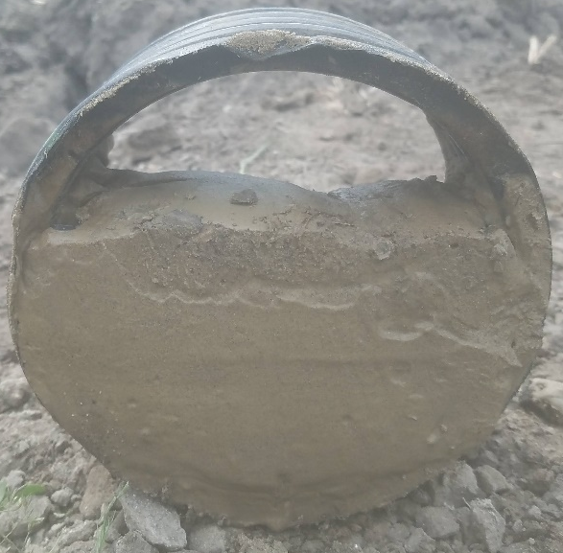
Figure 1.1 A cross section picture of main drainage pipe, which was installed in 2013, sediment filled 2/3 of the pipe in 2020 (Ghane, 2022).
For many years, acoustic-based techniques have dominated the field of sediment depth monitoring, which is advantaged in non-invasive, high accuracy, and wide coverage, however, the main challenges of this method are high cost and energy consumption and complicated manual operation during measurement (Thorne & Hanes, 2002, Bertrand-Krajewski, 2015, Lepot et al., 2017). In recent years, with the cost reduction, photogrammetric techniques and distributed temperature sensing (DTS) methods are more and more used in sewer sediment measurement. Imaging methods can provide high-resolution images of the sewer pipe interior, allowing for accurate identification of sediment accumulation and sediment erosion (Regueiro-Picallo et al., 2017, Noack et al., 2018, Bouratsis et al. (2013)). DTS is placed in the sewer pipe. Through analysing the temperature data to provide information on the location and thickness of sediment deposits in the sewer pipe (Regueiro-Picallo et al., 2022). The electrical conductance-based measurement is more and more applied in monitoring the sediment depth in the sewer system. The media in sewer pipes can be briefly divided into a solid phase (saturated granular media), a liquid phase and a gas phase, and arranged in order from bottom to top. The electrical conductivity between two adjacent media phases presents a significant difference. By measuring the change in electrical conductance at different depths, a new method can be developed for characterising the solid and liquid depth in sewer pipes. While some research has shown the feasibility of electrical conductance-based sensing systems in monitoring the sediment depth change, these methods have limitations in terms of high cost, complex operation, or limited measurement range, and no studies have been found to measure the multiphase depths simultaneously (Wang & Jiang, 2019, Li et al., 2005, Schlaberg et al., 2006).
The hydraulic property of sewer sediment is another major subject of interest within the field of the sediment transport process. Many empirical models do not adequately capture sediment transport processes due to a lack of information about the sediment's hydraulic properties. However, conventional measurement methods usually take a long time and are sometimes imprecise, especially since some methods are challenging to use in field tests. Recently, there has been an increasing interest in using the electrical impedance spectroscopy (EIS) technique to characterise porous media, however, apply the EIS technique into sewer sediment is still rare. The EIS technique can measure the impedance (consisting of a real part, imaginary part, magnitude and phase angle) by applying an alternating electrical field. For the saturated porous media, the solution, particle size, pore size, pore shape, and internal structure can act as various electrical elements, such as resistors, double layer capacitors, diffusion impedance, etc., which can be reflected in the frequency dependence of impedance. By studying the relationship between the value of electrical elements and hydraulic properties of porous media (including grain size, porosity and permeability), a new method may develop to characterise sewer sediments in-situ. Although extensive research has tried to present the relationship between the EIS data and hydraulic properties, the detailed relationship function for sediments has not been established, and the EIS measurements are hard to implement in field tests. On the other hand, the existing electrical-hydraulic empirical models have not been validated for applicability to the EIS data.
This study presents a novel application of electrical-based measurements in the monitoring of sediment depth and properties in sewer systems. The study first successfully measured multiphase depths using a single-frequency excitation sensor. The configuration of sensor is new, and it has the advantages in low-cost, long-term, and easy to operate method to measure the depth of solid and liquid phases without any calibration process. Then developed an electrochemical impedance spectroscopy (EIS) based measurement technique for the characterisation of sediment properties. The study involved measuring the impedance spectra of various materials with different grain sizes, porosities, and permeabilities, and deriving electrical-hydraulic models from the data. Additionally, the study advised the design of a sensor for real-world environmental applications, demonstrating the practicality and potential of the novel approach in sediment hydraulic properties measurements.

Aims and objectives
The primary aim of this thesis is to develop novel sediment sensing systems behind a new class of cost-efficient and robust devices to realise long-term and real-time monitoring of sediment depth, sediment properties, and water depths in sewer pipes. This study is accordingly divided into two related parts:
Aim 1: develop a sensing system for multiphase (sediment, water and air phases) depths characterisation based on electrical conductance measurement.
Aim 2: develop a sensing system for sediment hydraulic properties (grain sizes, porosity and hydraulic permeability) characterisation by using the EIS technique.
Objectives for Aim 1 are listed as follows:
- Develop the multi-electrode sediment sensor for pipe applications, based on Nichols (2004) design.
- Build the theoretical framework with electrical theory to establish a fundamental principle of the sensor for electrical conductance measurements of multiphase media.
- Build the finite element analysis (FEA) model for further verification of the theory.
- Establish a series of experiments to verify the feasibility of the sensor for multiphase depths measurement in the laboratory environment.
Objectives for Aim 2 are listed as follows:
- Develop a multi-electrode sediment sensor for the EIS test system to measure the frequency and impedance (real part, imaginary part, and phase angle)
- Analyse the Bode plot, Nyquist plot and develop an electrical equivalent circuit model.
- Develop the experimental setup and process to measure the hydraulic properties (porosity and hydraulic permeability) of various samples.
- Develop an empirical model based on experimental results and the existing literature, to describe the relationship between grain size, porosity, hydraulic permeability, and electrical conductance.
- Investigate the effects of temperature considering practical applications.
- Produce a summary of suggestions for optimisation of sensor design based on experimental results.

Thesis structure
The overall structure of this thesis takes the form of seven chapters. Chapter 1 briefly introduces the background of this research, and the aims and objectives that this study serves.
Chapter 2 contains a literature review, briefly introducing the background of sewer solids and their particle size range, porosity, and permeability. The existing sediment depth measurement methods are also presented. In addition, the fundamentals of the EIS technique are reported in the review, including electrical elements, equivalent circuit models for porous media, measurement electrode configurations and relevant applications.
Chapter 3 describes the methodology for multiphase depths and hydraulic property characterisation. For multiphase depth measurement, the design of the multi-electrode sensor is presented, and the theoretical analysis, experimental setup, and FEA model setup are presented. All the test facilities for the EIS and hydraulic property measurements are established in this chapter.
Chapter 4 compares the electrically measured and FEA modelled results of multiphase depths with the actual depths established in the laboratory. The sensor’s resolution is analysed based on the dimension of the sensor. The limitations of this sensor in practical applications are also discussed at the end of this chapter.
Chapter 5 and Chapter 6 follow a similar structure, which presents the EIS experimental results, including the Bode plot, Nyquist plot, each value of the electrical element in the equivalent circuit model, and the hydraulic property results, including grain size/mean grain size, porosity and hydraulic permeability. The relationships between electrical conductance and grain size, porosity, and hydraulic permeability are investigated, and an empirical model is derived. Considering that the design of the sensor may need to be optimised for different media in practical applications, the effects of electrode spacing distance are discussed in both chapters. The difference between chapters 5 and 6 is the test materials are different, which are one-size glass beads in chapter 5 and mixtures of sand and of glass beads in chapter 6. The effects of flow rate and temperature are also examined in chapter 5.
Chapter 7 discusses the main findings and problems encountered that can be drawn from the analysis and evaluation contained in Chapters 4, 5 and 6. On the basis of the research that has been conducted and presented, recommendations are made for practical applications and additional research.

Literature review

Introduction
This chapter presents a study of the relevant literature on sewage solids, depth measurement systems, electrical impedance spectroscopy (EIS), and correlations between electrical and hydraulic properties. Knowledge of sewage solids is essential for future study on sediment characterisation. The types, particle sizes, porosity, and permeability of sewer solids, as well as the sedimentation process in sewer functions, are briefly described in Section 2.2. The current state of sediment depth measurement and monitoring techniques, as well as their measurement principles, advantages, and disadvantages for research and industrial applications, are evaluated in Section 2.3. Section 2.4 provides a summary of the literature on the interaction between the electrical and hydraulic characteristics of saturated porous media. Finally, based on the topics covered by the study in this thesis, Section 2.5 evaluates the fundamental concept, data analysis procedure, measurement system, and applications of the electrical impedance spectroscopy technology.

Sewer solids background

Solid types
The problem of sediments in sewers has existed since Rome's first sewage system was built in the sixth century BC (Ashley et al., 2004). There are three types of sewer system, sanitary sewer system, storm sewer system and combined sewer system, they are playing important roles for collecting rainwater and wastewater. The combined sewers are most common in urban area to collect both domestic wastewater and rainwater, and consequently prevent the flooding and protecting public health and environment (Banasiak et al., 2005). Since the end of the 19th century, solids in sewers have been intensively studied as human society grows and changes (Celestini et al., 2007). Sewer solids are made up of both organic and inorganic components. According to Beg et al. (2001), autochthonous organic matter, nitrogen and phosphorus components typically accumulate in sediments within the long-term drainage of industrial wastewater and municipal sewage (Wang et al, 2019). Moreover, mixed minerals would be deposited in the sewer system as a result of soil erosion and rock weathering. Figure 2.1 illustrates how Hvitved-Jacobsen & Ashley (2002) demonstrated that there are three different processes in a sewer pipe (Figure 2.1(b)): (i) wastewater suspension process; (ii) sediment process; and (iii) biofilm process. From there, three main types of solids in sewers are illustrated in Figure 2.1(a): (i) suspended solids and colloids; (ii) sewer sediments; and (iii) biofilm. Figure 2.2 also demonstrates several example pictures of sediment solids. Additionally, Crabtree (1989) classified sewage solids into five categories based on an examination of the places, characteristics, and origins of the deposits found inside the sewerage system, as shown in Table 2.1.
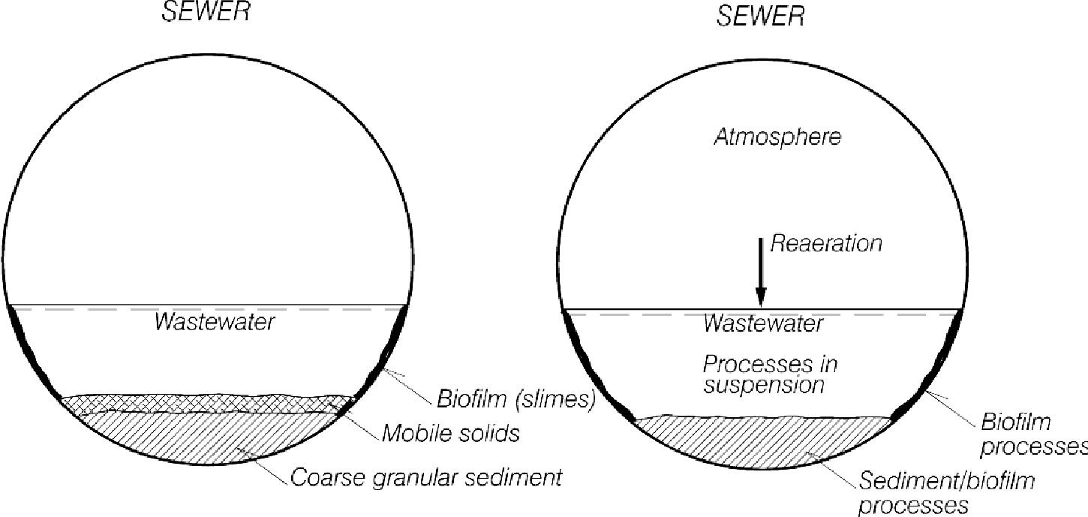
(b)
(a)
Figure 2.1 Diagrammatic illustration of the processes and occurrence of solids in sewers (Hvitved-Jacobsen & Ashley, 2002).
Figure 2.2 Sediment samples collected from storm sewer inlets near civil construction works (Almedeij, Ahmad and Alhumoud, 2010)
Table 2.1 Five types of sediment and their properties for UK usage adapted from (Crabtree, 1989).
Sediment type | Description/Where found | Wet bulk density ×10³kg/m³ | Percentage particle size (mm)  Minimum-mean-maximum |  |  | Percentage of total solids | Percentage of Organic content
Sediment type | Description/Where found | Wet bulk density ×10³kg/m³ | Gravel  (2.0-50.0mm) | Sand  (0.063-2.0mm) | Silt and clay  (<0.063mm) | Percentage of total solids | Percentage of Organic content
A | Coarse, loose, granular, predominantly mineral, material found in the inverts of pipes; | 1.72 | 3-33-90 | 3-61-87 | 1-6-30 | 73.4% | 7%
B | As type A but concreted by the addition of fat, bitumen, cement, etc. into a solid mass; | - | - | - | - | - | -
C | Mobile, fine grained deposits found in slack flow zones, either in isolation or above Type A material; | 1.17 | 0-0-0 | 5-55-71 | 29-45-73 | 27.0% | 50%
D | Organic pipe wall slimes and zoogloeal biofilms around the mean flow level; | 1.21 | 1-6-20 | 1-62-83 | 17-32-52 | 25.8% | 61%
E | Fine grained mineral and organic deposited found in storm sewage overflow (SSO) storage tanks; | 1.46 | 4-9-80 | 1-69-85 | 1-22-80 | 48.0% | 22%

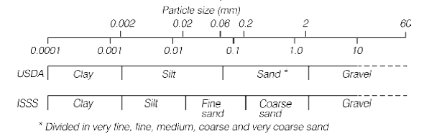
Figure 2.3 Size characteristics from USDA and ISSS standards (Ashley et al., 2004)
The US Department of Agriculture (USDA) categorised particle size into gravel, sand, silt, and clay as the basis for the classification system used in the Table 2.1. The International Soil Science Society (ISSS), whose division of particle size into gravel, coarse sand, fine sand, silt, and clay is depicted in Figure 2.3, is the other size characteristic standard. Solids in the sewer system come in a variety of sizes, from micron to centimetre. The main particle sizes vary for various types of solids. The majority of the suspended solids are fine particles (diameter less than 100 µm), which made up between 66% and 85% of the total mass, and medium particle diameters range from 25 µm to 44 µm (Chebbo et al., 1995; Chebbo & Bachoc, 1992). The particle size for sewer sediment solids is usually a mixture of Type A and Type C in Table 2.1. Ashley et al. (2004) also summarised the sediment particle size ranges of French (Bachoc, 1992; Chebbo et al., 1990), Belgium (Verbanck, 1990; Verbanck et al., 1994) and the UK (Ashley et al., 2004) sites as shown in Table 2.1. As can be seen, the majority of sediment solids have particles between 0.2 and 20 mm in size. The biofilm solids in sewers are usually in form of slime attached to the inner wall of the sewer pipe, which is hard to descript its particle size (Hvitved-Jacobsen, Thorne & Hanes, 2002). Biofilm consists of inorganic and organic compounds (protein, carbohydrates, and humic substance) (Jiang et al., 2010). Additionally, the biofilm is not evenly distributed on the inner wall and is often only a few millimetres thick, which can raise the friction factor and slow the flow velocity in sewer pipes (Gutierrez et al., 2016).
Table 2.2 particle size ranges and content ratio in different sewers and countries (Ashley et al., 2004)
Country | Sewer | % of each particle size range (mm)
Country | Sewer | <0.1 | 0.1-0.2 | 0.2-2 | 2-20 | >20
France | Man-entry ‘upstream’ sewers | 2 | 8-10 | 23-60 | 25-47 | 7-18
France | Trunk sewers | 4 | 5-10 | 38-55 | 25-45 | 8-10
France | Interceptor sewer | 4.5 | 35.5 |  | 60
Belgium | Interceptor sewer | 3 | 17 | 78 | 2 | NR
Belgium | All sewers in Brussels | 20 | 30 | 43 |  | 9
UK | Interceptor sewer | 1-20 | 1-21 | 32-80 | 65-20 | NR
UK | Trunk sewer | 1-8 | 1 | 18-41 | 41-50 | NR

Although most of studies have focused on the solids particles in sewer sediment, the physical, chemical and biological processes are also influence the properties of sewer sediment. Sewer sediment follows a cycle that is dry weather deposition and storm weather erosion and transport. It is a complex system that can significantly affect the performance of sewer networks. To improve the sewer management and reduce the negative impact, it is important to understanding not only the type of sediment solids but also the internal physical, chemical and biological processes.

Sediment porosity and permeability
Sediment solid types and their range in particle size were covered in Section 2.2.1. The porosity and hydraulic permeability of sediment are two factors that are frequently discussed in the present literature on sediment transport models. The terms porosity and hydraulic permeability, together with their associated empirical models and effect factors , will be reviewed in this section.
Sediment porosity ($ϕ)$ is defined as the ratio of voids volume ($V_{void}$) in samples divided by the total volume ($V_{total})$, and it can also be calculated by particle ($ρ_{particle}$) and bulk ($ρ_{bulk}$) density because directly measuring or observing voids volume is difficult. The formula for calculating porosity is represented as the following equation:
$ϕ=\frac{V_{void}}{V_{total}}=1-\frac{ρ_{particle}}{ρ_{bulk}}$ Eq. 2-1
As sediment is an accumulation process, and a mixture of various particles, the porosity for different sediments can be changed in a range from 40% to 90%. Campisano et al. (2019) tested various sediment samples and found the bulk density of sediment is in a range between 2220 and 2532 kg/m³, and porosity is in a range of 40% to 42%. Liu et al. (2015) collected their coarse sediment samples from a mature gravity sanitary sewer in Sydney; the sediment bulk density was 1370kg/m³ with 96.7% porosity. Anschutz et al. (2012) measured an open channel sediment porosity profile in depth, the porosity varies from 70% to 80% at depth of around 8.5 cm to 0 cm with a mean bulk density of 2650 kg/m³. Due to the varying porosity of different sediment samples, the transport model usually lacks the real porosity information leading to the inaccuracy of simulation.
Permeability is to be used to define the ability of porous media to transport fluid and is also reported as the conductivity of porous media. It is often assessed in a laboratory setting using a constant head, falling head, or constant flux facility and Darcy's law (Darcy, 1856).
$Darcy^{'}s law: Q=\frac{kAg}{υL}∆h$ Eq. 2-2
Where $Q$ is the total discharge with unit $\frac{m^{3}}{s}$, $k$ is hydraulic permeability with unit $m^{2}$, $A$ is the cross-section area in units $m^{2}$, $g$ is the gravity of the earth, $υ$ is the kinematic viscosity, $L$ is the length of the sample, and $Δh$ is the hydraulic head difference. The hydraulic performance of sediment in a circular pipe has been widely investigated, such as sediment roughness, hydraulic resistance to flow, however, the permeability of sediment is rarely applied in previous studies (Sterling & Knight, 2000). Sun et al. (2022) simulated the model to describe the backwater ratio in permeable blocked sediment. The permeability and porosity of sediment play an important role in their models to calculate the momentum loss of flow. The permeability also exhibits anisotropy, which means the permeability of porous media is different in different directions (Fisher, 2004). This led to the measurement of hydraulic permeability being difficult, especially for a field test. Permeability is highly related to other properties of porous media, such as particle types, particle size, porosity, pore shape, pore throat geometry and tortuosity (Wong et al., 1984). The permeability of porous media is usually calculated by a widely known empirical model – the Kozeny-Carman equation (Carman, 1997; Kozeny, 1927):
$Kozeny-Carman equation:k=Φ_{s}^{2}\frac{ϕ^{3}D_{p}^{2}}{180(1-{ϕ)}^{2}}$ Eq. 2-3
Where $Φ_{s}$ is sphericity (1 for perfect sphere), $ϕ$ is porosity, and $D_{p}$ is particle diameter. Taylor (1948) also developed an empirical relationship of sediment permeability correlated with specific surface area ($S_{s}$), void ratio ($e$), mass density ($ρ_{m}$),), and kinematic fluid viscosity ($v_{f}$) as shown in Eq. 2-4. Another two empirical relationships were found to describe the permeability of coarse-grained and fine-grained soils with grain size ($D_{10}$) and void ratio ($e$) are demonstrated in Eq. 2-5 and Eq. 2-6 respectively (Berilgen et al., 2006; Dolinar, 2009; Hazen, 2014; Mesri & Olson, 1971; Ren & Santamarina, 2018).
$k=\frac{C_{F}g}{v_{f}ρ_{m}^{2}}S_{s}^{-2}\frac{e^{3}}{1+e}; C_{F}≈0.2 \left(pore topology constant\right)$ Eq. 2-4
$Coarse-grained soil:k≈D_{10}^{2}$ Eq. 2-5
$Fine-grained soil:k=ae^{b}$ Eq. 2-6
Over the past few years, there has been an increasing focus on the impact of permeability on sewer erosion in various studies. Over the past few years, there has been an increasing focus on the impact of permeability on sewer erosion in various studies. Winterwerp (2012) also found that the turbulent stresses on a sediment or soil can also be written as a function of permeability. Mohr et al. (2018) conducted experiments on the erosion behaviour of fine-grained reconstituted marine sediments and found that permeability was the hydraulic parameter that exhibited a correlation with observed erosion trends resulting from variations in the bulk properties of the sediments. Based on the above findings, Mohr et al. (2021) conducted a new model to predict the erosion threshold shear stress for fine-grained sediments.
In addition to the factors presented in the previous equations, the properties of sediment in real environment can also be influence by the cohesive sediments, organic matter content and sediment aging. Fine particles and organic matter are likely to form cohesive sediment or biofilm adhered to the internal wall or on the top of sediment surface. The property can vary due to the biological and chemical reactions. On the one hand, the microbial and organic matters can form cohesion and fill up the internal pores, resulting in a compact sediment with lower porosity and permeability. As sediment ages, it can become more compacted and less permeable, which reduces its capability to store and transport water. The accumulation of organic matter within aging sediment can exacerbate these effects by further increasing its cohesion and reducing its porosity. On the other hand, the microbial biodegradation and organic matter decomposition can generate gasses to form internal pores and pore path to loosen the sediment. This can result in an increase of sediment porosity and permeability.

Sedimentation transport process
The sediment transport in sewers is still a complicated phenomenon, which is influenced by many variables, such as sewerage types, solids material, size, shape, hydraulic properties, and flow velocities (Celestini et al., 2007). According to Ashley et al. (2004), the transport procedure for various types of solids can be broken down into the following three phases:
- Suspended transport of middle and small-size particles, generally at the same rate or slightly slower than the flow rate;
- Dissolved phase transport of very small particles, at the same rate as the flow rate and completely diluted inflow;
- Bed and near-bed transport, are characterised by middle and large-size particles, which move under the effect of higher flow conditions.
Several studies also created empirical models to simulate the sewer transfer process, As an illustration, numerous studies separated the sediment transport process into build-up and wash-off processes and created a number of simulation models, including SWMM, Mike Urban, MUSIC, etc. (Gorgoglione et al., 2019; McKenzie & Young, 2013; Vaze & Chiew, 2002). Hydraulic modelling based on De saint Venant-Exner equations and the hydrodynamic characteristics of flow to numerically model the sediment deposit process in one-dimensional flow scenarios (Campisano et al., 2013). Song et al. (2018) applied the CFD model to predict sedimentation in two-phase flow in sewers. However, most of the models' results exist big uncertainties in the real scenario and it is not possible to eliminate them due to the lack of parameters of solids and flows (Ebtehaj et al., 2020). To better understand the sedimentation transport process, study into long-term sediment monitoring is required. Sediment hydraulic characteristics and physical information can be useful data for models.

Effect of sewer solids
Sediment deposition in sewers decreases the capacity of pipes and increases the risk of sewer overflows during high-flow events, while also influencing many physical, chemical and biological processes that can generate harmful gasses and corrode the inner pipe wall (Ashley, 2004; Bertrand-Krajewski, 2015; Jiang et al., 2015). Table 2.3 summarises the negative effects caused by sewer sediment (Hvitved-Jacobsen & Ashley, 2002). A large amount of sediment can reduce the capacity of sewer pipes and increase the risks and frequency of flooding. With the accumulation of sediment, the increasing hydraulic resistance will reduce the flow rate and solids' transporting capacity. Then the solids will further deposit and finally form a blockage in pipes. Biofilms and organic matters generate hydrogen sulfide and methane that cause security and public safety risks. If organic and inorganic solids escape from sewers, the environment, and human health will also be threatened. These problems can increase maintenance and safety costs and bring potential health and environmental issues. For example, in Nantes, 2500 tonnes of sediment deposits are removed from sewers annually because sewer sediment is seen as a primary factor in sewer overflows while increasing the risk of pipe damage (Riochet, 2008). Surveys such as that conducted by CIRIA (1987) have found that in the UK, there were more than 45% and 95% of sewer system surcharges in non-storm and storm periods respectively, and approximately £60 million was spent on sediment problems every year (Ashley et al., 2004). Hence, research into low-cost sediment monitoring is necessary to enable a real-time sediment management approach.
Table 2.3 Outline of effects caused by sewer solids (Hvitved-Jacobsen & Ashley, 2002)
Effect by sediment | Description of solids cause
Reduction in hydraulic capacity, increase in surcharging, flooding | Deposition of solids in inverts, permanent or semi-permanent
Blockage | Deposition in inverts, build-up on walls (progressive or sudden)
Premature operation of Combined sewer overflows (CSOs) | As above (downstream of CSO)
Enhanced pollutant washout from CSOs | All types of solids, and associated pollutants during wet weather
Gases, odours, explosions | Generated from biological degradation in bed deposits (hydrogen sulphide, methane and other odorous substances)
Sewer corrosion | As above, in most atmosphere
Pump impeller abrasion | Inorganic solids in flow (typically washed through system in wet weather)
Screen blockage and damage | Large solids (inorganic and organic)
Shock loads to treatment plants | Foul flushes and bed erosion, releasing both solids and associated pollutants
Rodents (rats) | Source of food (organic solids)
Health risks to sewer workers | Increased hazards, infections: gases (asphyxiation, toxicity), rodents (disease transmission)  Access and maintenance problems increased by solids presence.
Fat and grease deposits - can reduce capacity or get washed out in “lump” | Build up on sewer walls, particularly around ambient surface levels, can also develop into balls.

Sediment resuspension is a significant contributor to pollution within sewer systems, particularly during storm events, as the increased flow within combined sewer systems can cause sediment to become resuspended. Sediment accumulation is common in areas with low flow rates and under dry weather. Sediment within sewer systems can contain a variety of particles and pollutants. When resuspended, 80% of pollutants can be released into the sewer flow, which can result in increasing the risk of blockages downstream and pollutant the receiving water bodies (Banasiak et al., 2005). Additionally, the resuspended sediment can increase turbidity, which can affect the effectiveness of treatment process and performance of monitoring equipment and hinder the effective management of sewer systems. Therefore, it is imperative to thoroughly characterize the properties of sediment and implement regular cleaning procedures to mitigate the negative effects of sediment resuspension in sewer systems (Regueiro-Pocallo et al., 2020).

Sensing system for sediment depth measurements
Continuously monitoring sediment depth has practical significance as it can provide sediment depth information to improve the understanding of the sediment transport process in the research area and optimise the sediment cleansing schedules in the industrial area. The measurements of sediment depth in sewers have been attempted since the 1990s (Lepot et al., 2017; Lorenzen et al., 1992). Then several previous attempts have addressed the measurement of sediment and flow based on various principles. This section will introduce some existing sensing systems to measure the depth of sediments.

Acoustic based technology
Acoustic technology is one of the most common methods for measuring the morphology of sediment deposits in large-scale sewers. Thorne & Hanes (2002) reported that the acoustic measurement method usually emits a high frequency (around 0.5-5 MHz) pulsed sound wave from a height of one or two metres from the sediment bed. Then the sound wave will partially reflect by the suspended solids and be significantly reflected back by the sediment bed. Through the analysis of sound wave intensity and time history, a profile of flow suspended phase and sediment level can be calculated. Recently Bertrand-Krajewski (2015) developed a floating acoustic measurement device coupled to a laser meter to 180° scanning the sewer pipes. Lepot et al. (2017) also designed a 360° rotating sonar device consisting of sonar, motor and pitch and roll sensors to scan the sewer pipe cross-section profile and determine the water-sediment interface. Their sonar devices demonstrate firstly an accurate water-sediment interface (±1 cm precision for the Bertrand-Krajewski device, and less than 4% relative standard uncertainty for the Lepot et al device); secondly quick measurement within two seconds; thirdly the response signal demonstrated different for different types of sediment material (sand, gravels and stones) in a laboratory environment. However, when devices float on a liquid surface, calibration is necessary at the beginning of the measurement. Then the position of devices changes during measurement and hence reduces the accuracy. The measurement results can also be obstructed by low water levels and water waves. Finally, a series of acoustic measurement systems usually includes several component devices and need multiple operators to cooperate, which means high cost and energy consumption and complicated manual operation during measurement.

Electrical based technology
Electrical-based techniques are also widely used for multiphase measurements. Some sensing methods based on the sediment material’s electrical properties have been developed for the quantitative monitoring of coastal, fluvial, or sewer environments. Wang & Jiang (2019) placed vertically distributed multi-anode sediment microbial fuel cells (SMFC) in a water-sediment interface for real-time monitoring of the sediment height as shown in Figure 2.4. The array anodes span from below the water-sediment interface to above the interface, while a cathode is within the water phase as shown in Figure 2.4. The height of each anode is fixed during the setup. When an anode is below the water-sediment interface, all voltage would increase to 40mV, and otherwise, the voltage is 0. Each anode is paired sequentially with the cathode to determine which anodes are below the sediment interface. While the sensor configuration for the sewer system was not specified by the researchers, the anode is square-shaped with dimensions of ${6×6 cm}^{2}$ and the experiment container measures 34 cm in width and 23 cm in height (Wang & Jiang, 2019). This sensor is suitable for use in the environment contains microbes and organic matters, such as open channels, lake sediment, sewer pipes that have a diameter larger than 34 cm. However, the measurement range of the sediment height is limited (6 cm) and the water level cannot be determined. The other limitation of this method is that it is binary (40 mV or 0), which means that it can only detect which anodes are nearest to the sediment interface but cannot determine the actual interface height. Thus, the resolution of the sensor depends on anode spacing.
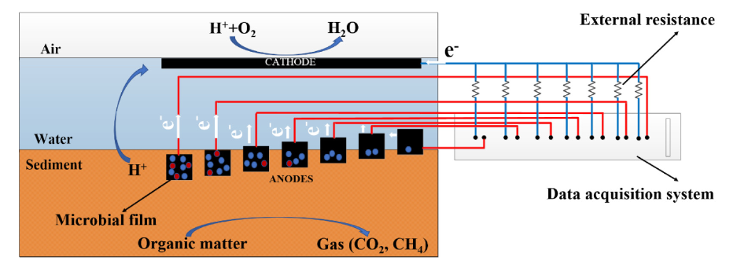
Figure 2.4 Schematic and picture of vertically distributed multi-anodes SMFC (Wang & Jiang, 2019)
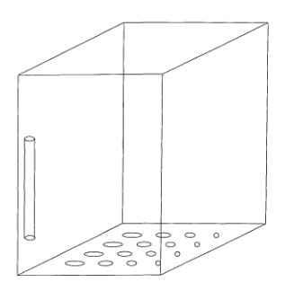
Reference electrode
Bottom electrodes
Figure 2.5 Sketch of the experimental tank with locations of the electrodes (de Rooij et al., 1999)
In addition to SMFC methods, Ridd (1992) proposed for coastal applications a thin rod with ring electrodes that can monitor the sedimentation process based on the difference in electrical conductivity of seawater and saturated sediment. The resolution of this sensor is limited to the electrode spacing. De Rooij et al. (1999) developed a device consisting of an array of electrodes on the base of the tank, connected via the filled water to a reference electrode located within the fluid as shown in Figure 2.5. Changes in the depth of sediment between the reference and bed electrodes caused a change in reference resistance. Although the result is accurate, the instrument required precise calibration for a given water depth and conductivity of the medium, and any fluctuation in either of these parameters would significantly affect the accuracy of the readings. Hence the application of this sensor in real environment is still limited. Jansen et al. (2005) developed and tested a mobile device that measured the resistivity of marine sediments and lake sediment, with the help of pressure sensors, could estimate the deposit depth; however, its complexity rendered it unsuitable for small-scale applications. Tollefsen & Hammer (1998) and Li et al. (2005) used capacitance to measure sediment concentrations in water and multiphase flows (water, gas, and oil), respectively. Although both studies reported high accuracy, the applications do not provide meaningful insights into sedimentation processes because the formulation at the heart of the sensing process relied on multiple parameters not easily measured in sewer flows, such as flow salt content and soil types. Besides, a calibration process is necessary for these methods because the performance is not fixed for different test materials.
Some methods also use electrical resistance tomography to develop a visual representation of sediment behaviour with sewers, Schlaberg et al. (2006) used a U-shaped sensor array to measure the concentration and deposition of suspended sediment based on the conductivity of the medium. Layers with different conductivity can be detected, but the sensitivity of the U-shaped sensor is not uniform, which leads to anomalies in the resulting tomographic image. During the experiment, the researchers placed the sensor inside a rectangular container. As the precision of the sensor increases in the future study, it has the potential to be implemented in an open channel of water and even be adapted to fit within a circular sewer pipes. Electrical capacitance tomography and electrical resistance tomography are used to detect interfaces in other relevant areas, such as gas-solid fluidised beds (Wang & Yang, 2020), measuring the particle concentration within moving suspensions (Schlaberg et al., 2006), and imaging the distribution of different conductive media (Deabes et al., 2019). However, tomography technology is relatively computationally expensive and sensitive to the setup, and also has high power requirements that can render it impractical for a remote field device (Goncharsky et al., 2016).
Although there are many studies have demonstrated the various methods to measure the sediment depth and water-sediment interface, low-cost and long-term techniques for in situ real-time management of sewer deposits remain limited.

Other methods
Sediment measurement is a critical aspect of monitoring sewer systems and identifying potential issues such as blockages and sediment accumulation. In addition to acoustic-based methods and electrical based methods, other approaches, such as the traditional manual measurement, imaging techniques and DTS, have also been used to measure sediment deposition in sewer systems.
The manual method for measuring sediment depth is usually estimated roughly using sediment level stave in a manhole or the selected sample points (Bertrand-krajewski & Gibello, 2018). While this method is relatively simple and cost-effective, it is also subject to high levels of variability due to differences in the operator's interpretation and measurement techniques. Furthermore, hand-rule measurements are limited to measuring the sediment thickness at discrete points, which can make it difficult to obtain a complete picture of sediment deposition along the length of the sewer pipe.
Imaging techniques, such as laser profilometry (Regueiro-Picallo et al., 2017) and photogrammetric methods (Noack et at., 2018) have also been used to measure sediment deposition in sewer pipes. Laser profilometry is a non-invasive technique that works by using a laser to scan the surface of the sewer pipe and generate a 3D profile of the sediment layer. Noack et al. (2018) used a photogrammetry method to measure the erosion rate of cohesive sediments, or cohesive/non-cohesive sediment mixtures according to the displacement of laser light points.
DTS is also a non-invasive monitoring technique that involves using fibre optic cables to measure temperature changes in the sewer pipe. Regueiro-Picallo et al. (2022) demonstrated the feasibility of monitoring sediment deposits through temperature measurements and heat transfer analysis by calibrating a 1D heat transfer model with experimental data. Rui et al. (2018) examined the heat transfer properties from a heat source to the surrounding sediment, which was used to estimate the thickness of the sediment overburden and can be applied to other materials.
In summary, hand-rule measurements, imaging techniques, and DTS have all been used to measure sediment deposition in sewer systems. While these techniques have their advantages, they also have limitations and may not be suitable for all monitoring scenarios. As such, it is important to carefully evaluate the advantages and limitations of each approach and select the most appropriate method for the specific monitoring application.

Sediment electrical and hydraulic properties: relationships and measurement methods
As introduced in Section 2.2, sediment properties, such as particle size, porosity, and permeability, also play important roles in simulating the sediment transport model, and help to prevent sewage surcharging and overflow. There are several traditional methods to measure sediment properties such as the pump test (Slater & Lesmes, 2002) or slug test (Butler, 2019). However, these conventional methods are time-consuming and costly, and most of them are not appropriate for field measurement. Electrical conductance is an important parameter that can enable an analysis of the structure and properties of porous media. Hence, electrical conductivity can be used to estimate the hydraulic properties of the sediment, as the sediment is usually submerged under wastewater and electrical conductance is highly correlated with water volume in a porous material. Furthermore, the electrical conductance of sediment can also help to investigate the pollutants from an environment monitoring perspective (Li et al., 2016). However, the studies for specific sewer sediment are still limited. This section will widely review existing relationship models between electrical conductance and grain size, porosity and permeability for porous media, such as glass beads, sediment, soil and rocks. The electrical conductance measurement method will also be evaluated.
Archie’s equation is the earliest known and most used empirical equation to describe the relationship between electrical conductivity ($σ_{t}$) and porosity ($ϕ$), which also defined the Formation Factor based on the physical properties of rock as shown in Eq. 2-8 (Archie, 1942).
$Archie^{'}s Law: σ_{t}=\frac{1}{a}σ_{w}ϕ^{m}S_{w}^{n}$ Eq. 2-7
$Formation factor: F=\frac{σ_{w}}{σ_{t}}=aϕ^{-m}$ Eq. 2-8
Where $σ_{t}$ and $σ_{w}$ are the electrical conductivity of the sample and solution respectively, $ϕ$ is porosity, $S_{w}$ is the water saturation, n is the saturation exponent, $a$ is the empirical constant and m is the cementation exponent, which is correlated to tortuosity. The value of coefficient $a$ and m are hard to be measured directly and vary for different test materials, which is usually derived from the experiment data as summarised in Table 2.4. It can be seen that for different test materials and test methods, the value of $a$ and m can be changed in a wide range, from 0.004 to 78.0 for coefficient $a$, and 0.39 to 5.67 for coefficient m (Cai et al., 2017).
Table 2.4 The ranges of values proposed for empirical parameter and cementation exponent m in
sandstones and carbonates (Cai et al., 2017).
Lithology | m | $$a$$ | References
Sandstone | 1.64-2.23 | 0.47-1.8 | (Hill & Milburn, 2003)
Sandstone | 1.3-2.15 | 0.62-1.65 | (Carothers, 1968)
Sandstone | 0.57-1.85 | 1.0-4.0 | (Porter & Carothers, 1971)
Sandstone | 1.2-2.21 | 0.48-4.31 | (Timur et al., 1972)
Sandstone | 0.02-5.67 | 0.004-17.7 | (Gómez-Rivero, 1977)
Carbonates | 1.64-2.10 | 0.73-2.3 | (Hill & Milburn, 2003)
Carbonates | 1.78-2.38 | 0.45-1.25 | (Carothers, 1968)
Carbonates | 0.39-2.63 | 0.33-78.0 | (Gómez-Rivero, 1977)
Carbonates | 1.7-2.3 | 0.35-0.8 | (Schön, 2011)

After Archie’s law, various studies have explored the relationships between electrical conductivity and porosity from theoretical analysis and numerical simulations. For example, the bound model assumes the total electrical conductivity is a weighted average of multiple conducting phases and their volume ratios (Guéguen & Palciauskas, 1994). The pore network model is a numerical simulation method to calculate the electric field distribution in pore space (Kirkby et al., 2016; Tsakiroglou & Fleury, 1999; Xiao et al., 2008). There are also lots of theoretical electrical conductivity transport models based on microscopic conservation laws. Theoretical models usually correlated with pore networks (Tang et al., 2015), tortuosity (Ghanbarian et al., 2013; Winsauer & Shearin, 1952), percolation theory (Ghanbarian et al., 2014), critical path analysis (Katz & Thompson, 1987) etc. Together these electrical and porosity models provide important insights into how porosity affects the electrical conductivity of porous media from geometrical and interfacial perspectives (Friedman, 2005). However, the major limitation of these electrical models is that they apply to a certain pore geometry of a certain porous media. It is still necessary to develop a more generic model, which includes more physical characteristics to describe in detail the relationship between electrical conductivity and porosity, and then it can be simplified for specific applications. (Ren & Santamarina, 2018).
A power law relationship between electrical conductivity ($σ)$ and hydraulic permeability ($k$) has been widely investigated as shown in Eq. 2-9:
$k=aσ^{b}$ Eq. 2-9
where a is the proportional constant and b is the exponent constant. Knight & Endres (2005) found that the relationship between $σ$ and $k$ depends on the mechanism of electrical conduction. In porous media, if the electrical conductivity depends largely on ionic conduction through the pore fluid, such as clay-free sand and silt (Huntley, 1986), the connectivity of the pore space is the main factor to influence the relationship of $σ$ and $k$. That means $σ$ is proportional to$k$. In contrast, if the electrical conductivity is primarily due to surface conditions in a system, the amount of surface area oppositely affects $σ$ and $k$. This means as surface area increases, for example, due to an increase in clay content, $σ$ will increase and $k$ will decrease (Kosinski & Kelly, 1981; Mawer et al., 2015). Although a direct or inverse power law relationship between $σ$and $k$ can be derived, a consistent model for the relationship between $σ$ and $k$ does not exist (Purvance & Andricevic, 2000). The range for coefficient b in Eq. 2-9 also varies for different materials. For clay-free porous media, the value of b is in a range from 1 to 5 (Walsh & Brace, 1984; Wong et al., 1984), and for material containing clay where surface conduction dominates the value of b can be decreased to -7 (Purvance & Andricevic, 2000). Revil (2002) derived a model to predict the hydraulic permeability with Formation Factor and grain size as shown in Eq. 2-10
$k=\frac{d^{2}}{aF^{3}}$ Eq. 2-10
Where $a=8$ for coarse granular material (Revil, 2002), and $a$ can increase to 24 for low permeable samples (Revil & Cathles, 1999). Revil’s model demonstrates a good agreement with Spangenberg et al. (1998)’s experiment data. As the Formation Factor used in Eq. 2-10 is calculated from the porosity ($F=\frac{σ_{w}}{σ_{t}}=aϕ^{-m})$, however, in real applications, the formation factor calculated by measuring the total electrical conductivity and the solution electrical conductivity will not be a reliable predictor of permeability in the model.
There are various approaches have been taken to measure the electrical conductivity of porous media. At the earliest, Archie (1942) used a DC method to derive the relationship between electrical conductivity and the physical properties of rocks. Börner et al. (1996) proposed a single-frequency AC method, also known as induced polarisation (IP), to predict $k$ of saturated clean sandstone and unconsolidated sediments. As for porous media, like sediment, the dominant electrical properties vary with the change in frequency. A frequency-domain performed induced polarisation, called spectral induced polarisation (SIP), has been widely studied and correlated with porous media characteristics, such as the average pore throat diameters (Kruschwitz et al., 2016), grain size distribution (Lesmes & Frye, 2001), permeability (Binley et al., 2005), porosity and specific internal surface (Kemna et al., 2012).

Electrical impedance spectroscopy (EIS)
EIS is a versatile technique to measure the electrical properties of a material under a defined frequency range (Mei et al., 2018) which is widely used to characterise the performance of electrical energy storage devices, such as fuel cells and electrochemical batteries. EIS is a sensitive method for examining interfacial phenomena and is therefore appropriate for studying the electrical properties of solid-liquid interfaces, electrode surface, and tested materials. The objective of EIS in sewer sediment properties measurement is to provide a non-invasive method for characterising the hydraulic properties of sewer sediment, such as grain size, porosity, and permeability. This section will provide an overview of the EIS technique's theory and the common methods to analyse EIS data (Afsarimanesh et al., 2019). The sensing system and applications of EIS in porous media will also be reviewed in this section.

Theory
In the EIS technique, the impedance of the test system is usually evaluated as a function of frequency and the current through the test system is measured by applying an AC excitation (Sun et al., 2022). If an AC excitation voltage signal ($E_{t}$) applied to the system, then the response signal is an alternating current signal ($I_{t}$) as shown in Figure 2.6, and the function of voltage and current can be written as:
$E_{t}=E_{0}\sin\left(ωt\right)$ Eq. 2-11
$I_{t}=I_{0}\sin\left(ωt+φ\right)$ Eq. 2-12
Where $E_{0}$ and $I_{0}$ are the amplitude of the excitation voltage signal and the amplitude of the response current signal respectively, $ω$ is the angular frequency and $φ$ is the phase shift. The electrical impedance ($Z$) is defined as a combination of resistance and reactivity in an AC circuit, which can be calculated by Ohm’s Law as below:
$Z=\frac{E_{t}}{I_{t}}=\frac{E_{0}\sin\left(ωt\right)}{I_{0}\sin\left(ωt+φ\right)}=Z_{0}\frac{\sin\left(ωt\right)}{\sin\left(ωt+φ\right)}$ Eq. 2-13
Where $Z_{0}$ is the magnitude of impedance. With Euler’s relationship, $e^{jφ}=cos\cos{φ}+φ$ (where $j=\sqrt{-1}$), the impedance can be expressed as a complex function in terms of $E_{t}$ and$I_{t}$ as shown below:
$Z\left(ω\right)=\frac{E_{t}}{E_{i}}=\frac{E_{0}e^{jωt}}{I_{0}e^{\left(jωt-φ\right)}}=Z_{0}\left(\cos{φ}+j\sin{φ}\right)$ Eq. 2-14
Then the impedance can be expressed as the real part and imaginary part as shown below:
$Real part: Z^{'}=Z_{0}\cos{φ}$ Eq. 2-15
${Imaginary part: Z}^{''}=Z_{0}\sin{φ}$ Eq. 2-16
The phase angle and magnitude of impedance can be expressed as
$Phase angle: φ=\frac{Z^{''}}{Z^{'}}$ Eq. 2-17
$\left|Z\right|=\sqrt{{\left(Z^{'}\right)}^{2}+{\left(Z^{''}\right)}^{2}}$ Eq. 2-18
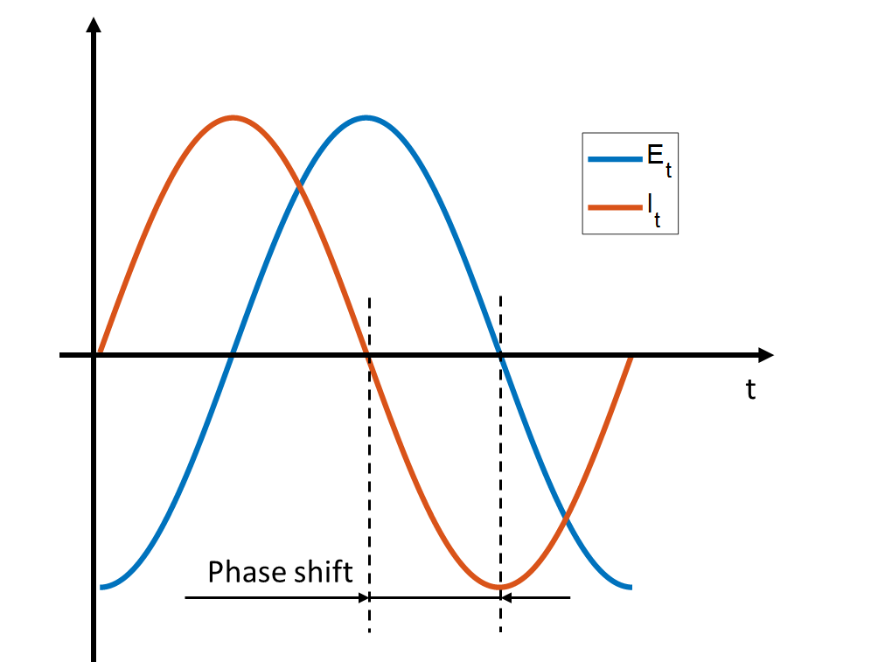
Figure 2.6 Sinusoidal voltage excitation and current response
As conducted by R. Wang et al. (2022), the advantages of applying the EIS approach in a porous medium were as follows:
- The EIS testing technology is simple and practical and can be applied to on-site tests, and the process is real-time and cost-effective, which can be used to monitor the change of inner structures.
- The dimensional effect related to sample size is eliminated by the EIS technique because it theoretically does not require sample geometry.
- For porous media, such as sediment, soil and cement, there is no need for sample preparation before tests.
- EIS is a non-destructive technique for test samples.

Bode plot, Nyquist plot, and equivalent electrical circuit model

Bode plot and Nyquist plot
A Bode plot displays the impedance magnitude and phase shift as a function of frequency on a logarithmic scale. Figure 2.7 demonstrates a typical Bode plot of a paralleled RC circuit. The changes in impedance and phase angle with frequency are demonstrated on Bode plot. A Bode plot includes information on the frequency, magnitude, real part, imaginary part, and phase shift of impedance. While a Bode plot is useful for analysing the behaviour of a single electrical component, it may not be as effective for monitoring changes in a dynamic system.
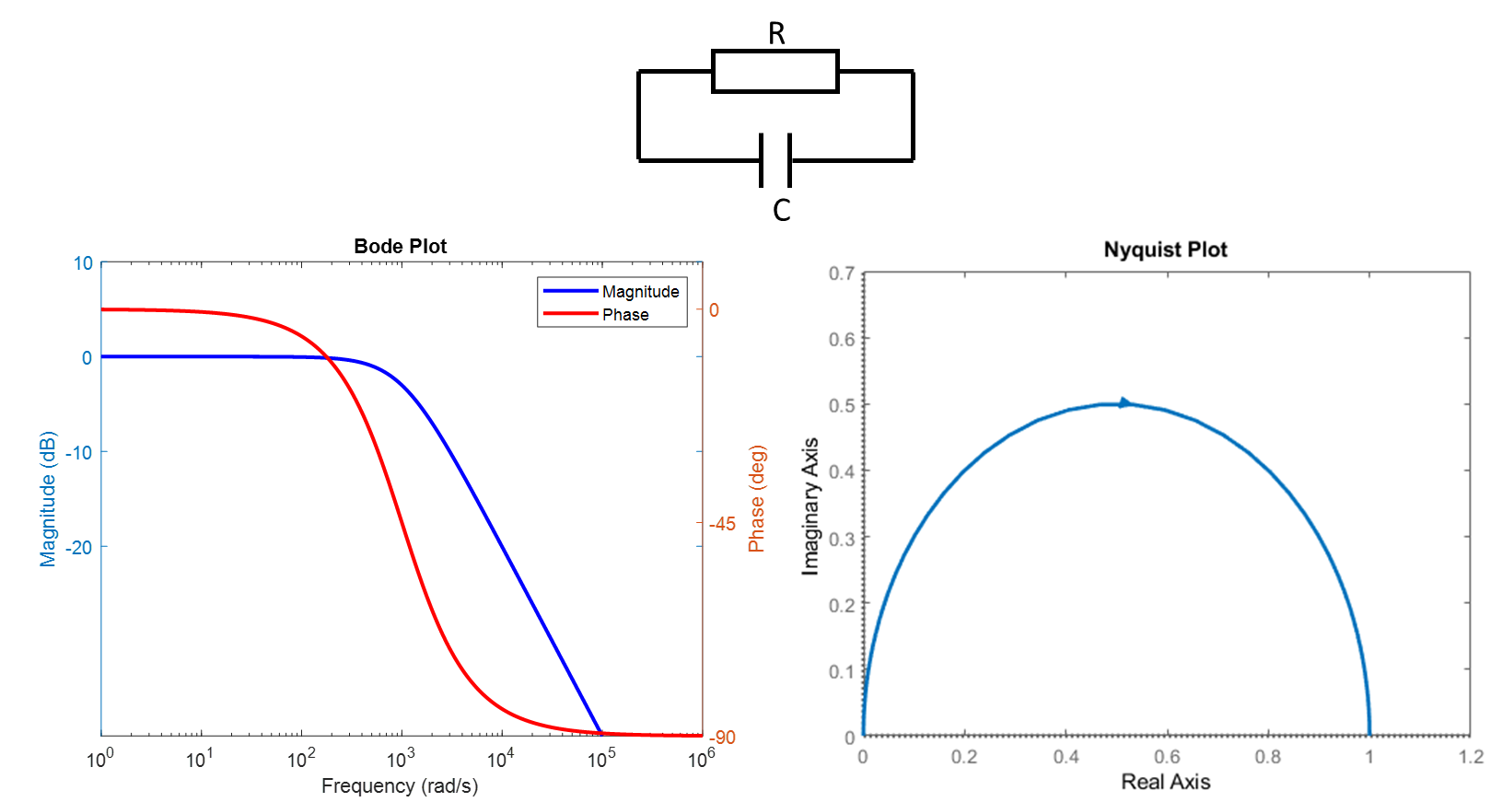
Figure 2.7 Bode plot and Nyquist plot of a paralleled RC circuit.
For a more informative measuring system, Nyquist plots are more popular. If the real part of the impedance is plotted on the X-axis and the imaginary part is plotted on the Y-axis over a wide frequency range, a Nyquist plot can be drawn. Figure 2.7 shows a typical Nyquist plot of a paralleled RC circuit. Each point on the Nyquist plot represents an impedance measured under a single frequency, but the actual frequency value is not shown in the Nyquist plot. However, the Nyquist plot is more practical in the analysis of EIS data because the characteristic shapes of impedance spectra can give researchers an estimation of the intrinsic electrical properties of the measuring system. Different combinations of electrical elements can demonstrate different shapes on Nyquist plot. Hence, the Nyquist plot is a preferred option to investigate the EIS data. If more frequency information is needed, it needs to be analysed in conjunction with the Bode plot.

Equivalent electrical circuit elements
As mentioned, the shape of a Nyquist plot implies the combination of circuit elements. It is common to analyse impedance spectra by fitting them to an equivalent circuit model, which consists of common electrical elements (resistors, capacitors, and inductors) and equivalent circuit elements (Warburg impedance, constant phase element) connected in series or parallel. There are some circuit elements based on the physical electrochemistry process, such as electrolyte resistance, double layer capacitance, charge transfer resistance, polarisation resistance and coating capacitance, which have been widely researched and directly used in the equivalent circuit model to describe relevant materials or systems.
- Resistors
A resistor is one of the simplest electrical circuit elements. The impedance for a resistor ($Z_{R})$ with resistance $R$ can be expressed as below:
$Z_{R}=R$ Eq. 2-19
$Z_{R}^{'}=R$ Eq. 2-20
$Z_{R}^{''}=0$ Eq. 2-21
$φ_{R}=0$ Eq. 2-22
Where $Z_{R}$ is the total impedance of a resistor, $Z_{R}^{'}$ and $Z_{R}^{''}$ are the real part and imaginary part of impedance respectively, $φ_{R}$ is the phase shift angle. As the imaginary part of impedance ($Z_{R}^{''}$) and phase angle of a resistor ($φ_{R}$) are equal to 0 for all frequencies, the Nyquist plot for a resistor is a simple point on $Z^{'}$ axis as shown in Figure 2.8.
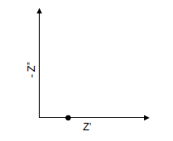
Figure 2.8 Nyquist plot of a resistance
- Capacitors
Capacitors are used to store electrical energy in the form of an electric field. Pure capacitors only have reactive impedance and zero resistance. The impedance for a capacitor $(Z_{C})$ with capacitance C can be expressed as below:
$Z_{C}=\frac{1}{jωC}$ Eq. 2-23
$Z_{C}^{'}=0$ Eq. 2-24
$Z_{C}^{''}=-\frac{1}{ωC}$ Eq. 2-25
$φ_{C}=-90°$ Eq. 2-26
Where $Z_{C}$ is the total impedance of a capacitor, $Z_{C}^{'}$ and $Z_{C}^{''}$ are the real part and imaginary part of impedance respectively, $φ_{C}$ is the phase shift angle. Capacitors are used to cause the current to lag the exciting voltage by -90 degrees. the impedance of capacitors is a series of vertically aligned points on the Nyquist plot; with the increase of frequency, the magnitude of capacitor impedance decreases as shown in Figure 2.9.
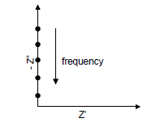
Figure 2.9 Nyquist plot of a capacitor
- Inductors
Similarly, inductors are used to temporarily store electrical energy in the form of a magnetic field, and they are used to lead the response current by 90 degrees. The impedance of an inductor ($Z_{L})$ with inductance L can be expressed as below:
$Z_{L}=jωL$ Eq. 2-27
$Z_{L}^{'}=0$ Eq. 2-28
$Z_{L}^{''}=ωL$ Eq. 2-29
$φ_{L}=90°$ Eq. 2-30
Where $Z_{L}$ is the total impedance of a capacitor, $Z_{L}^{'}$ and $Z_{L}^{''}$ are the real part and imaginary part of impedance respectively, $φ_{L}$ is the phase shift angle. The Nyquist plot for inductors is also a series of vertically aligned points, the difference is as frequency increases, the magnitude of inductor impedance increases as shown in Figure 2.10.
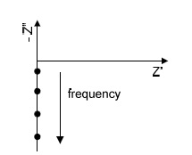
Figure 2.10 Nyquist plot of an inductor
- Diffusion and Warburg impedance
Diffusion phenomena commonly exist in electroactive materials and electrolytic solutions between the interface of solid electrodes and solutions (Freger, 2005; Huang, 2018). Warburg impedance is the equivalent circuit element to model the semi-infinite linear diffusion process, which means the diffusion in the solution diffused over a larger planar electrode in one direction. In a real diffusion process, it does not have enough time to reach a steady state, thus the Warburg impedance for semi-infinite linear diffusion is the most applied model in EIS analysis. The equation of Warburg impedance $(Z_{W})$ can be expressed as below:
$Z_{W}=σ_{W}(jω)^{-0.5}=σ_{W}ω^{-0.5}-{jσ}_{W}ω^{-0.5}=σ_{W}ω^{-0.5}(1-j)$ Eq. 2-31
Where $σ_{W}$ is the Warburg coefficient, with units of ${Ωs}^{-0.5}$, the equation of $σ_{W}$ are shown below:
$σ_{W}=\frac{RT}{n^{2}F^{2}A\sqrt{2}}\left(\frac{1}{c_{o}^{∞}\sqrt{D_{o}}}+\frac{1}{c_{R}^{∞}\sqrt{D_{R}}}\right)$ Eq. 2-32
Where $T$ is temperature, n is the number of electrons involved, $F$ is the Faradays constant, $A$ is the surface area of the electrode, $D_{o}$ and $D_{R}$ represent the diffusion coefficients of the oxidant and reductant respectively, and $c_{o}^{∞}$ and $c_{R}^{∞}$ are the bulk concentrations for the species oxidant and reductant respectively. The Nyquist plot of Warburg impedance for semi-infinite linear diffusion is a 45° line in the low-frequency region, as shown in Figure 2.11 (a).
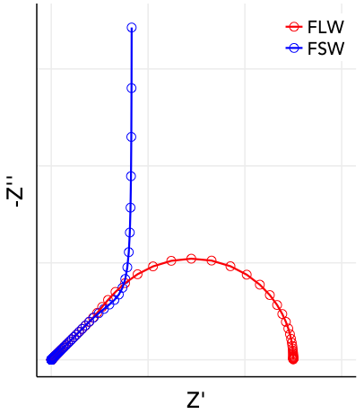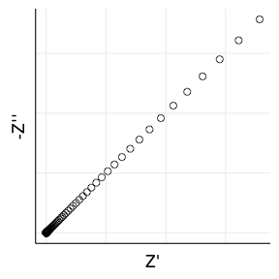

(a)
(a)
Figure 2.11 Nyquist plot of Warburg impedance (a) semi-infinite linear diffusion;(b) finite length Warburg (FLW) and finite space Warburg (FSW) (Lacery, 2016)
The other type of diffusion is finite diffusion, which means that the diffusion area is limited. It includes finite length Warburg (or short Warburg) and finite space Warburg (or open Warburg). The equations are expressed below:
$Z_{s}=σ_{W}ω^{-0.5}(1-j)×tanh⁡[δ(\frac{jω}{D})^{0.5}]$ Eq. 2-33
$Z_{o}=σ_{W}ω^{-0.5}(1-j)×coth⁡[δ(\frac{jω}{D})^{0.5} ]$ Eq. 2-34
Where $Z_{s}$ and $Z_{o}$ are impedance of short Warburg and open Warburg, $δ$ is the Nernst diffusion layer thickness and D is the average value of the diffusion coefficients of the diffusing species. The Nyquist plots of Warburg impedances for finite diffusion have been shown in Figure 2.11(b).
- Constant phase element (CPE)
In real experiments, an electric double layer can be generated when the electrode or solids contact with the solution (Yang et al., 2022). Due to the contamination and surface roughness at their interfaces, the electric double layer cannot be represented by an ideal capacitor. CPE is an equivalent circuit element to describe the complex impedance formed at the interface between electrode and electrolyte or solid/liquid interface. The impedance of CPE can be expressed as below:
$Z_{CPE}=\frac{1}{Q(jω)^{n}}$ Eq. 2-35
Where Q is a constant containing the electric double-layer capacitance with the unit of $S∙s^{n}$, and (-90×n)° is the constant phase. The value of n is in the range of 0 to 1. For n=1, the CPE represent a pure capacitance, and when n=0, the CPE is considered as a pure resistor. The Nyquist plot of CPE is a straight line with a phase of (-90×n)° as shown in Figure 2.12 (a). Figure 2.12 (b) is the Nyquist plot of CPE paralleled to a resistor.
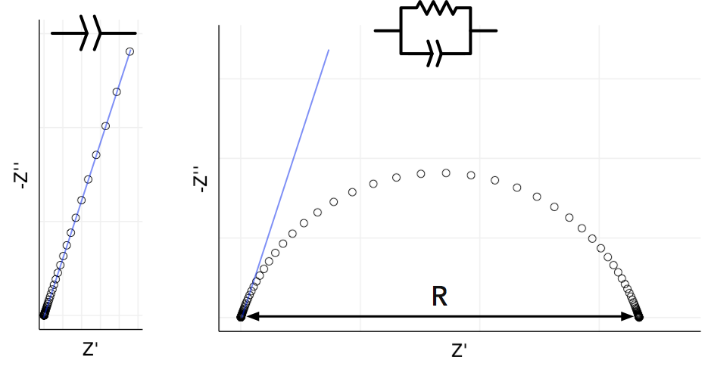
(a)
(b)
Figure 2.12 Nyquist plot of (a) constant phase element; (b) constant phase element parallel to a resistor(Lacery, 2016)
- Solution resistance and charge transfer resistance
As part of this study focuses on the EIS measurement of saturated porous media (sediments), the solution resistance and charge transfer resistance are introduced and discussed here. The solution resistance and charge transfer resistance are not simple resistors in test systems, which are generated due to the conducted solution and electrochemical reactions. The temperature, variety of ions, ionic quantity, and shape of the area where the current was transported all affect solution resistance, thus the impedance of solution resistance can be written as below:
$Z_{S}=R_{S}=ρ\frac{l}{A}$ Eq. 2-36
where $ρ$ is the solution resistivity, which is also equal to the reciprocal of solution conductivity, $l$ and $A$ are the length of current flow path and area carrying current respectively. The solution resistance is a common component in the equivalent electrical circuit of electrochemical cells. For the research on porous media, the solution resistance is also an important indicator of the pore ratio and water content of porous media (Li et al., 2016; Song, 2000).
Charge transfer resistance is generated due to the migration of ions or electrons between the solution and solids/electrodes interface resulting in a Faradic reaction. The equation of charge transfer resistance can be written as below:
$Z_{ct}=R_{ct}=\frac{RT}{nFi_{0}}$ Eq. 2-37
Where R is the gas constant, T is temperature, n is the number of electrons involved, F is the Faraday constant and $i_{0}$ is exchange current density. In a charge transform process, some ions or electrons could be accumulated on the surface of the solid and form a double-layer capacitor, hence in the equivalent electrical circuit of porous media, a charge transfer resistor is usually parallel to a double-layer capacitor.
It is hard to directly measure or calculate the solution resistance and charge transfer resistance in a system; it is usually through fitting impedance spectra by equivalent circuit models to determine the value of them and investigate the physical and electrical properties of the system.

Equivalent electrical circuit models for porous media
The equivalent electrical circuit model is the combination of circuit elements in various connection methods, which is used to interpret the electrical information in Nyquist plot. By fitting impedance spectra with the equivalent circuit, the value of each circuit component can be determined. Further information such as microstructure, particle size, pore size and water content, can be characterised from the correlated circuit components. It should be noted that the equivalent circuit model is based on the shape of Nyquist plot, hence the same Nyquist plot can be fitted to various equivalent circuits, even for the same equivalent circuit, the component in the circuit can also be given different physical meanings (Wang et al., 2022; Watson & Orazem, 2020).
Several equivalent circuits have been proposed to simulate the porous media. For example, the circuit consisting of a resistor series to a parallel RC circuit $R_{0}\left(R_{1}C_{1}\right)$, as shown in Figure 2.13 inner circuit, is commonly used to model the one-arc Nyquist plot. However, the meaning of each component in an equivalent circuit is contested. The meaning of $R_{0}$ can be an offset resistance (Song, 2000), a series sum of solid and liquid resistance (Gu et al., 1992), or a high frequency resistance (Hwang, 2012). Gu et al. (1995) also argue the value of $R_{0}$ is negatively proportional to the pore solution's concentration of ions and porosity. As for $R_{1}$ and $C_{1}$, they can be interpreted as the resistance and capacitance of bulk material (Christensen et al., 1994; Song, 2000; Wang et al, 2022) or the resistance and capacitance of solid-liquid interface (Gu et al., 1995; Hwang, 2012), which is also correlated to the pore structure (Ford et al., 1995).
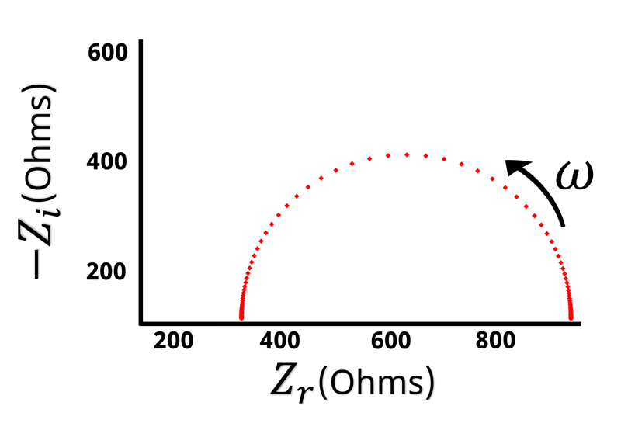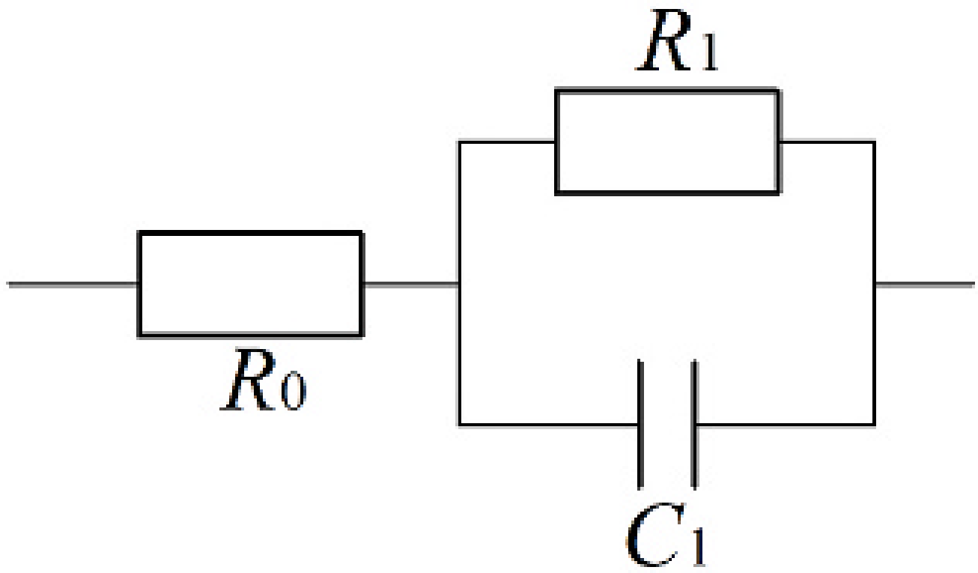
Figure 2.13 Nyquist plot of $R_{0}\left(R_{1}C_{1}\right)$ circuit (Pine Research Instrumentation (2016))
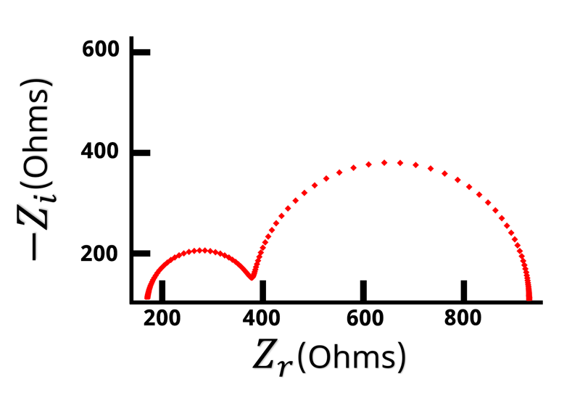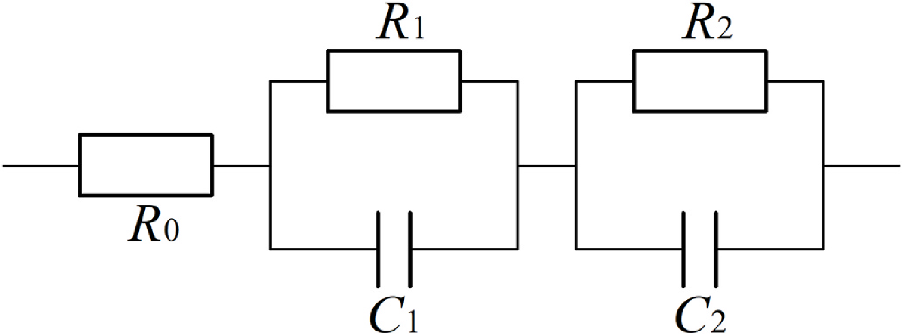
Figure 2.14 Nyquist plot of $R_{0}\left(R_{1}C_{1}\right)\left(R_{2}C_{2}\right)$ circuit(Pine Research Instrumentation (2016))
For Nyquist plots with two arcs, some researchers used a circuit of the series combination of two parallel RC models ($R_{0}\left(R_{1}C_{1}\right)\left(R_{2}C_{2}\right))$ to analyse the porous media as shown in Figure 2.14. Song (2000) thought that $\left(R_{1}C_{1}\right)$ and $\left(R_{2}C_{2}\right)$ are represent the responses of bulk and pore of porous media respectively, Li et al. (2016) defined $\left(R_{1}C_{1}\right)$ and $\left(R_{2}C_{2}\right)$ as the charge transfer resistance and capacitance on the anode and cathode respectively. Sometimes the arcs at high frequency were not observed due to the limitation of experimental instruments, however, some researchers found that one more RC circuit connected in series gives a better fit to their impedance spectra. Hence, the selection of an equivalent circuit model is not only dependent on the shape of the Nyquist plot but also based on the researchers' experience and understanding of the measurement system.
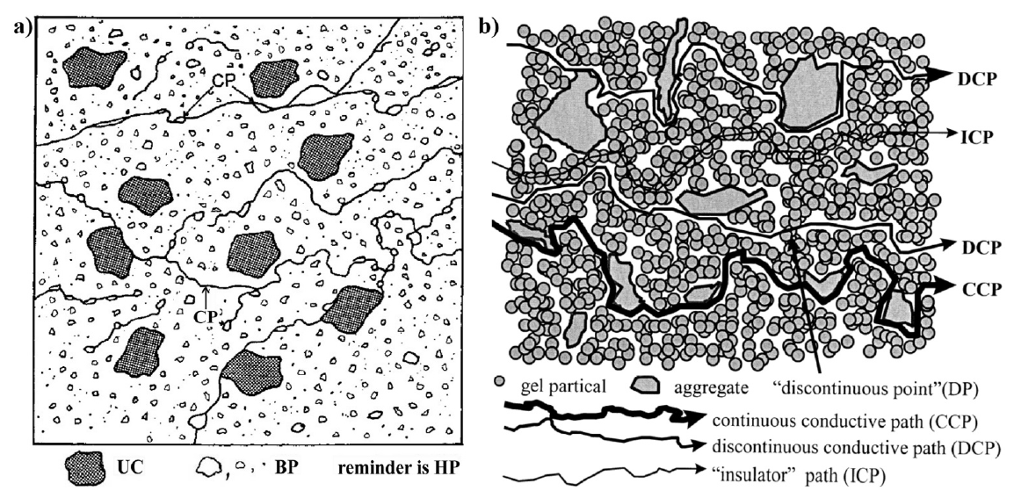
Figure 2.15 Conductive path models of concrete microstructure. a) Model from Macphee et al. (1997); b) Model from Song (2000).
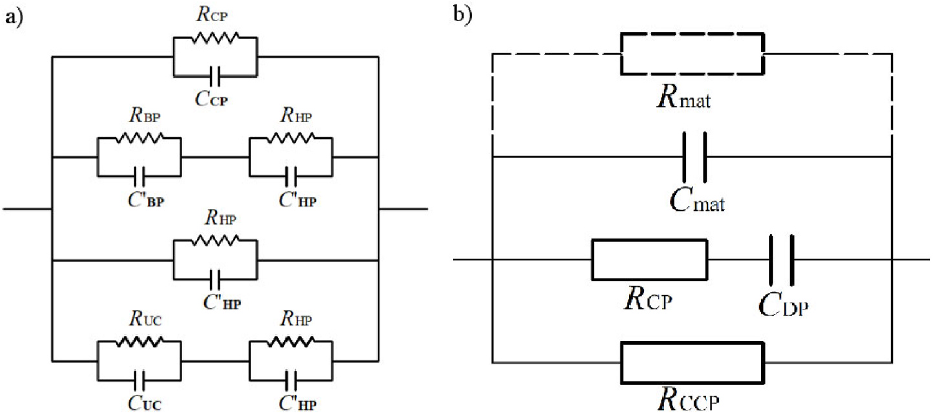
Figure 2.16 Equivalent circuits of the conductive path. (a) Macphee et al. (1997); (b) Song (2000).
Cormack et al. (1998), MacPhee et al. (1996), Macphee et al. (1997) and Song (2000) proposed equivalent circuits based on their understanding of the microstructure in porous media, called the conductive path model. Figure 2.15 (a) demonstrates Macphee et al. (1997)’s model of concrete consisting of four types of conductive paths: (i) CP: connected pore path filled with a solution; (ii) BP: disconnected pore path; (iii) hydration products in cementation process; (iv) insulated cement particles. The equivalent circuit based on four conductive paths is also exhibited in Figure 2.16 (a). It can be seen that Macphee et al. (1997)’s circuit contains many resistances and capacitances, making it difficult to determine and distinguish the value of each component from the Nyquist plots. Song (2000) simplified the microstructure of concrete and considered three conductive paths as shown in Figure 2.15 (b): (i) CCP: continue conductive path; (ii) DCP: discontinue conductive path; (iii) ICP: insulating path. Compared with Macphee et al. (1997)’s circuit, Song (2000)’s equivalent circuit eliminated the insignificant resistances and capacitances. He considered all the conductive paths and conductive points as pure resistors, and the discontinue point and insulators were represented as capacitors as shown in Figure 2.16 (b). In addition, Song (2000) also converted his circuit into $R_{0}\left(R_{1}C_{1}\right)$ and $R_{0}\left(R_{1}C_{1}\right) \left(R_{2}C_{2}\right)$ circuits and discussed the correspondence between $R_{0}$, $R_{1}$, $C_{1}$, $R_{2}$, $C_{2}$ and $R_{CP}$, $R_{CCP}$, $C_{DP}$, $C_{mat}$. However, their research remains narrow in focus dealing only with the electrical parameters of microstructures; physical parameters such as length of conductive path or geometry of conductive points, that can provide insight into how microstructure in the porous media influences the electrical parameter of EIS, were not involved.
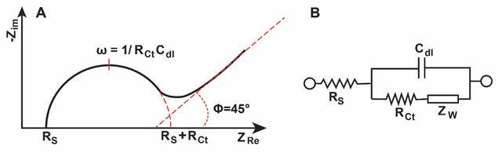
(a)
(b)
Figure 2.17(a)Nyquist plot of Randles circuit; (b) the corresponding Randles circuit.(Khan & Song, 2020)
In a real experiment, due to the limitations of experiment precision and dispersion phenomena in porous media, the Nyquist plot does not demonstrate one or two arcs. Randles-type equivalent circuit can be applied to simulate the Nyquist plot, consisting of an arc and a straight line as shown in Figure 2.17 (Dong et al., 2021; Randles, 1947; Watson & Orazem, 2020). The Randles circuit is composed of a resistor ($R_{s})$representing the solution resistance, $C_{dl}$ or ${CPE}_{dl}$ stands for the capacitor or constant phase element, which models the double layer capacitance, and a charge transfer resistance ($R_{ct})$ in parallel with a $Z_{W}$ or ${CPE}_{d}$ stands for the Warburg impedance or CPE corresponding to the diffusion phenomena. The $R_{ct}$ represents the electron transfer kinetics at the electrode-electrolyte interface, and the $Z_{W}$ or ${CPE}_{d}$ model the diffusion processes in the bulk of the electrolyte, which is used to simulate the angled straight line in the Nyquist plot. Randles circuits are widely used for a semi-infinite diffusion-controlled faradaic reaction to a planar electrode. (Kadan-Jamal et al., 2020) also used the Randles circuit to model the impedance spectra at low-frequency range (<10 MHz) where the impedance is dominated by solid/liquid interface. Husain et al. (2017) used Randles circuit to monitor the hydration behaviour of the cement paste. Except for the common circuit models mentioned above, some researchers also established their circuit models to describe the test system. For example, (Dong et al., 2021) developed a three-level equivalent circuit to fit three degrees of cementation for soil-rock mixtures.
In EIS, a small sinusoidal perturbation is applied to the system, and the resulting signal response is measured. The impedance of the system is then obtained by taking the ratio of the voltage and current responses. By varying the frequency of the perturbation, a frequency-dependent impedance spectrum can be obtained. This spectrum can be fitted to the Randles circuit, to extract information about the properties of the electrochemical system, such as the solution resistance, double layer capacitance, charge transfer resistance, and diffusion coefficient.

EIS sensing system
The sensing system to measure the electrical impedance can be divided into three types: two electrodes, three electrodes and four electrodes as shown in Figure 2.18.
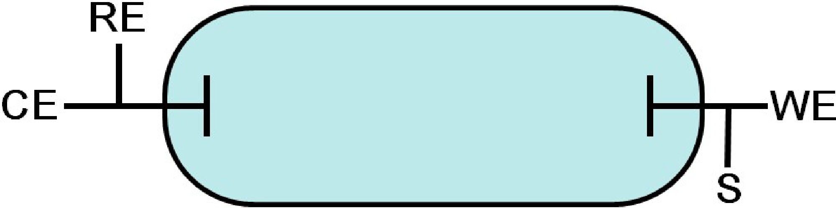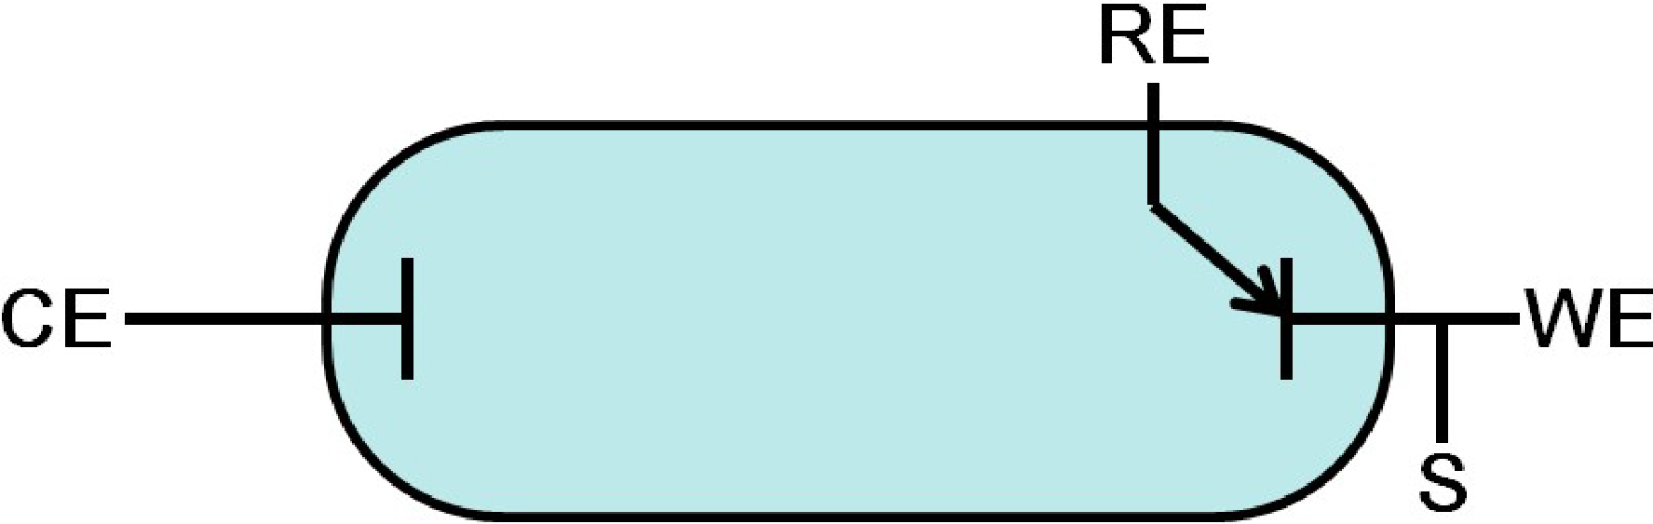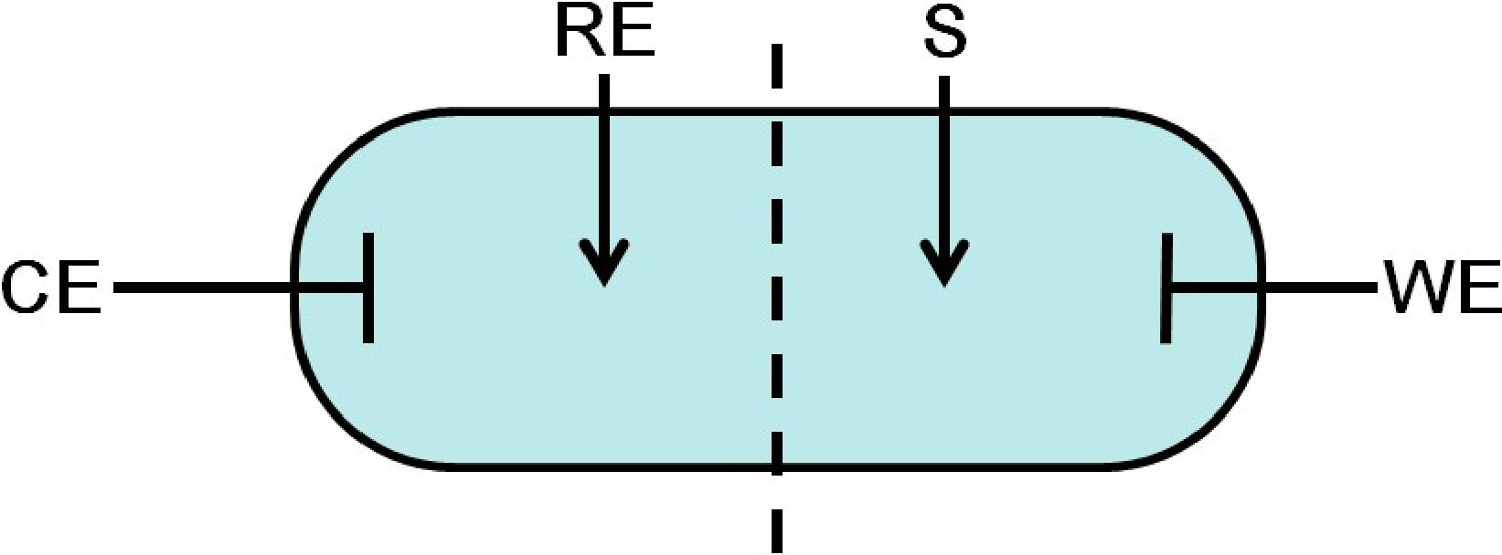
(a)
(b)
(c)
Figure 2.18 Schematic illustrations of electrode configurations (a) two-electrode system; (b) three-electrode system; and (c) four-electrode system.(Metrohm Autolab,2019)
- Two-electrode system
The two-electrode system is the simplest configuration, consisting of a working electrode (WE), and a counter electrode (CE) as shown in Figure 2.18 (a). When using a two-electrode system, a potential excitation is applied to two electrodes and a current response ($I$) is measured between them, hence the total impedance ($Z_{RE-S}$) between reference electrode lead (RE) and sense lead (S) can be measured, which also includes the contact impedance between electrodes and samples. The equation of impedance can be written as below:
$Z_{RE-S}=\frac{V_{WE}-V_{CE}}{I}$ Eq. 2-38
Where $V_{WE}$ and $V_{CE}$ are the voltages at the working electrode and count electrode. The two-electrode system has the advantage of being easy to set up, but the effect of interface impedance cannot be neglected.
- Three-electrode system
Three-electrode system is the most common configuration, which includes the third reference electrode (RE) close to the working electrode (WE) Figure 2.18 (b). After being given the excitation potential between WE and CE, the current can flow through the test system. The potential between WE and RE can be measured to investigate the specific reaction at the positive electrode, which is widely applied in the electrochemical experiment.
- Four-electrode system
Four-electrode systems are the most appropriate method to measure the impedance of the sample. As shown in Figure 2.18 (c), except for WE and CE, there are two electrodes (reference electrode (RE) and sensing electrodes (S)) placed in the test sample. After the current flow between WE and CE, the potential can be measured between RE and S to calculate the impedance and eliminate the effects of electrode/sample interface impedance.
For porous materials such as sediments, soils, rocks and concrete, researchers generally recommend using the two-electrode configuration (Ford et al., 1995; Hsieh et al., 1996, 1997; Xie et al., 1996) which have the advantages of (i) easily arranging (Wang et al., 2022); (ii) can provide reliable results for low conductivity samples (Xie et al., 1996); (iii) fewer influencing factors (only electrode/sample interface impedance) (Ford et al., 1995; Hsieh et al., 1997); (iv) the measurement results are easy to analyse. As three-electrode and four-electrode configurations measure the potential between RE and S, the influence of the voltage divider could be introduced and also the influence of instrument impedance and reference electrode needs to be considered. In addition, although more electrodes configuration can obtain more accurate results, the measurement and interpretation process is more complex, especially for a porous material, the microstructure model needs to be re-analysed (Grossi & Riccò, 2017). Figure 2.19 provides examples for two-electrode and four-electrode measurement circuits.
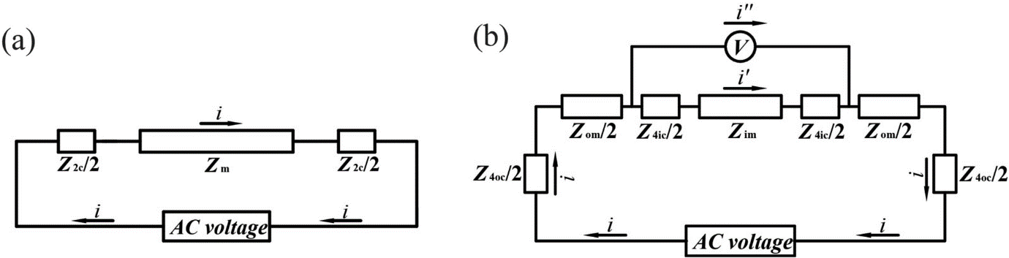
Figure 2.19 Circuit plots of porous media. (a) two-point measurement; (b) four-point measurement ( Wang et al., 2020)

Applications in porous media
EIS is a powerful and non-destructive approach that has been extensively used in the analysis of electrochemical, biological, and corrosion mechanism fields to expose the interface phenomena, charge transfer process, and internal structural characteristics of test samples. The electrical meaning of each component, as well as many electrical circuit models employed in porous media, have been introduced in the section above. Several researchers have looked at the application of EIS in porous media thus far, correlating the electrical parameters recorded with the physical and hydraulic characteristics.
Li et al. (2016) used the EIS technique to measure the electrical conductivity of soil with various water contents. An $R_{S}\left(R_{1}C_{1}\right)\left(R_{2}C_{2}\right)$ circuit model was applied in their study to fit the Nyquist plot, and $R_{S}$ represented the electrical resistance of soils. Then the electrical conductivity can be calculated from the geometry of the sample. A linear relationship between the water content and electrical conductivity was founded. Cooper et al. (2017) reported the effects of pore geometry on diffusion impedance (Warburg impedance), stating that the narrowing/broadening of pore cross-section could lead to the phase of diffusion line larger/smaller than 45° in the Nyquist plot (a Warburg impedance is represented as a phase of 45°). They also indicated that the decrease/increase in porosity of sphere packs with open/closed boundaries demonstrated different diffusion impedance, as shown in Figure 2.20. Dong et al. (2021) compared the real and imaginary part of impedance to the water content and soil-rock ratio. They found a negative power law relationship (with a negative exponent number) and a negative linear relationship, respectively. Raheem et al (2017) tried to use $R_{S}\left(R_{1}C_{1}\right)\left(R_{2}C_{2}\right)$ to model the treated and untreated ultra-soft clay soil and concluded that, with the increase of bentonite ratio in soil, the value of $R_{S}$ decreases. For lime/polymer-treated soil, $R_{S}$ decreases as the ratio of lime/polymer increases. These experiments conclusively show that there is a relationship between EIS electrical parameters and hydraulic characteristics, but they did not provide a precise relational expression.
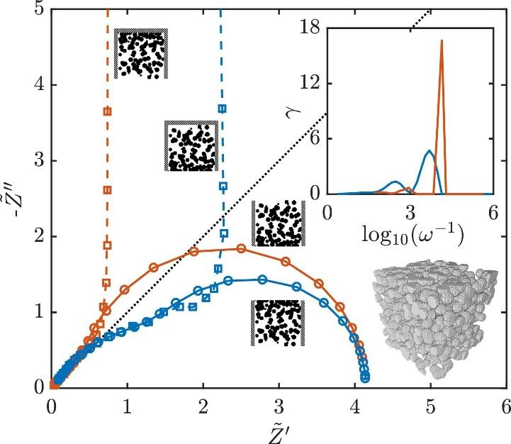
Figure 2.20 Simulated impedance spectra for a synthetic packing of spherical particles with porosity linearly increasing (blue lines) or decreasing (red lines) from bottom to top. The top boundary can be either open (solid lines) or closed (dashed lines). The inset shows the distribution of relaxation times for the cases with open boundaries (Cooper et al., 2017)

Discussion
This review has examined the existing literature and current theories regarding the types and properties, transport process and effects of sediment solids, the current sediment depth measurement methods based on the acoustic and electric principles, and the foundations and applications of the EIS technique.
Researchers have extensively investigated the particle range for each of the five major types of sediment identified by the literature study. Additionally, it was found that regional differences in the content and accumulation of the sediment, which is essential knowledge for sediment management. The measures of porosity and permeability are frequently used to analyse the transport of sediment. However, many transport models lack the necessary parameter since they are challenging to quantify in field tests, which causes the simulation results to be inaccurate. This chapter also provided a conclusion regarding the effects of sediment. In light of all of this information, it is important to keep an eye on the depth, porosity, and permeability of sediment in sewers in order to optimise transport modelling, manage sediment, and prevent sediment from having a detrimental impact.
The majority of systems employ an acoustic technique to identify the physical characteristics of the sewer network in order to determine depth. However, the acoustic approach is more appropriate for big-scale sewers and typically requires a large instrument, high expense, and complex operation. As electrical conductivity is highly associated with the void volume and water content of the studied system, methods based on it are being used more frequently in porous media. The available researches lack field testing and have range restrictions, and electrical conductivity-based sensing techniques are rarely employed for sewer monitoring. In conclusion, an investigation of the physical and hydraulic characteristics of sewage sediments can be made possible by an electrical conductivity-based sensing system, but finding a method for measurement that is inexpensive, real-time monitoring, and simple to use is important for sewer sediments.
The correlations between electrical conductivity and hydraulic characteristics are also significant to examine if a sensing system is based on electrical conductivity measurement. In this chapter, a number of theoretical and empirical models to describe the relationship between electrical conductivity and hydraulic properties have been summarised. These models provide the foundations for this study's investigation of the relationship between the characteristics of sediment and its inherent electrical conductivity (or conductance). The model based on the sensing system given in this study was built in the following chapters in addition to the existing relationships.
Numerous researchers have utilised the EIS approach to examine the electrical conductivities of porous media, which has inspired researchers to investigate the viability of the EIS methodology in sewer sediments. This chapter looked at the fundamental principle, common electrical element, selection of equivalent circuits, EIS measuring electrode configuration, and applications. According to the review of the literature, despite the fact that several studies use the EIS technique to study the straightforward relationship between electrical properties and hydraulic processes, no studies have been done using the EIS technique to study the porosity and permeability of sewer sediments and produce comprehensive models. The study can offer a complete research procedure for the use of the EIS technique for characterising the hydraulic properties of sediments, including the measurement of electrical parameters and the creation of electric-hydraulic models.

Methodology

Introduction
The previous literature has discussed the potential for conductance-based methods to characterise sediment depth and hydraulic properties. The overall theory and methodology of direct measurement and the EIS measurement of electrical conductance are covered in this chapter. For the two primary experiments in this study, this chapter is divided into two main sections. Section 3.2 describes the conductance based sensing system for multiphase depth measurements, which consist of fomular based theoretical analysis, finite-element analysis (FEA), experiment setup, and test materials. The objective is to demonstrate how to estimate depth in a circular pipe using a conductance sensor with various electrode lengths. The experimental setup and test materials for both the measurement of hydraulic properties and EIS data are covered in Section 3.3, which is aiming to investigate the application of the EIS technique in hydraulic properties measurements including grain size, porosity and hydraulic permeability.

Multiphase depth measurements

Sensor architecture
The structure of the sensor is based on a design by Nichols (2014), which can quantify the depths of water and sediment simultaneously. As shown in Figure 3.1, the sensor consists of 32 parallel tinned copper electrodes placed on an insulated polymer substrate. The electrodes decrease in length linearly from electrode 1 to electrode 32. In Figure 3.1 (a), L represents the length of the longest electrode, w is the width of each electrode, and 𝑑 and 𝑙 are the edge-to-edge distance between electrodes and the length difference between two adjacent electrodes, respectively. In this paper, because the sensor is considered to be applied in a circular sewer pipe that contains different heights of media, the substrate of the sensor is flexible so that it can be curved to match to the internal wall of a circular pipe section and the electrodes are exposed to the media on the inside of the pipe, as shown in Figure 3.1 (b).
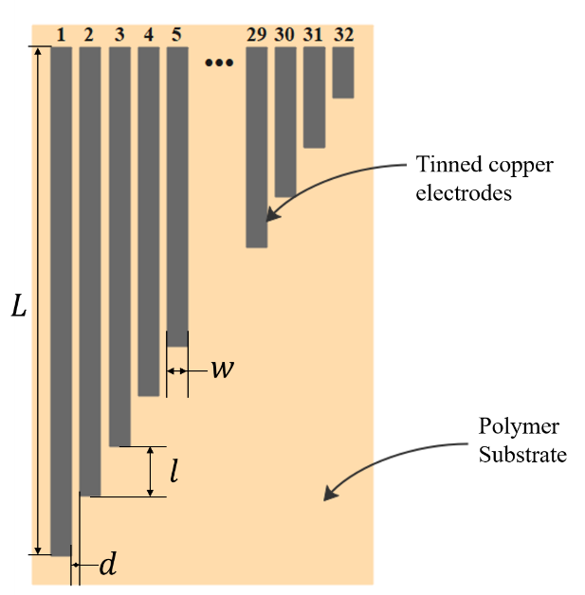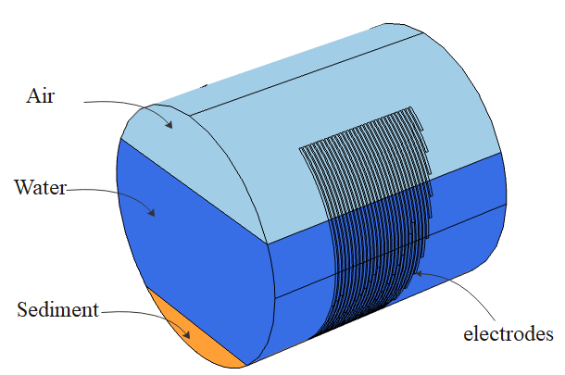
(a)
(b)
Figure 3.1 (a) Schematic drawing of the conductive sensor; (b) 3D view of the arrangement of the sensor and media in a circular pipe.

Theory
The theoretical principle behind the sensor is the relationship between the electric field generated between two electrodes and the environment surrounding those electrodes. Hence, it depends upon the inherent electrical properties of the local media, the sensor geometry, and the excitation method. As a first approximation, the media in a sewer pipe or open drainage channel can be divided into three phases: air, water, and saturated sediment. These three media have a significant difference in electrical conductivity. The conductivity of tap water is in the range of 50 to 80 mS/m (Chetpattananondh et al., 2014), while the air can be considered as an insulating material with negligible conductivity. Saturated sediment has a conductivity lower than that of water and the conductivity depends upon its porosity and permeability (Bai et al., 2013).
The sensor functions by determining the conductance between every two adjacent electrodes, i.e., electrode pairs. As shown in Figure 3.2, $E$ is the electric field generated by the electrodes. The recipient electrode connects to the earth, which leads to an electric charge movement, i.e., a current is generated between the electrodes. $I$ represents the current density in a 2D scenario. However, due to the thickness of the electrodes being much smaller than the width, each electrode pair can also be assumed to approximate to two parallel plate capacitors as shown in Figure 3.2 (b). An electrical fringing field is also generated between the anode and cathode, whereby the field extends into the measured medium for a short distance, from the top surface of the electrodes. Since the electrode shape does not change, this effect can be considered as a constant factor increasing the apparent conductivity of any medium. According to Ohm’s law, $I=GV$, when a fixed voltage $\left(V\right)$ is applied across two electrodes and the current $\left(I\right)$ between them is measured, the conductance $\left(G\right)$ is proportional to the current$\left(I\right)$. Conductance is proportional to the area of the conducting medium $\left(A\right)$ and has an inverse relation with the distance between the electrodes $\left(l\right).$For the proposed sensor, the area of the conducting media $\left(A\right)$ is equal to the product of the extension of the differential electrode’s length $\left(dL\right)$ and thickness $\left(t\right)$, which is perpendicular to the paper as shown in Figure 3.2 (a). In this study, it is difficult to measure the area $\left(A\right)$ due to the fringing field, but must be proportional to $dL$, which is known during the design process. Simultaneously, the medium is assumed to be homogeneous, i.e., the fringing electric field is uniform along the electrode. Hence, the conductance $\left(G\right)$ is still proportional to the conductivity $\left(σ\right)$ multiplied by the electrode’s length $\left(dL\right)$ as follows:
$G∝σ\frac{A}{l}=σ\frac{t×dL}{l}∝σdL$ Eq. 3-1
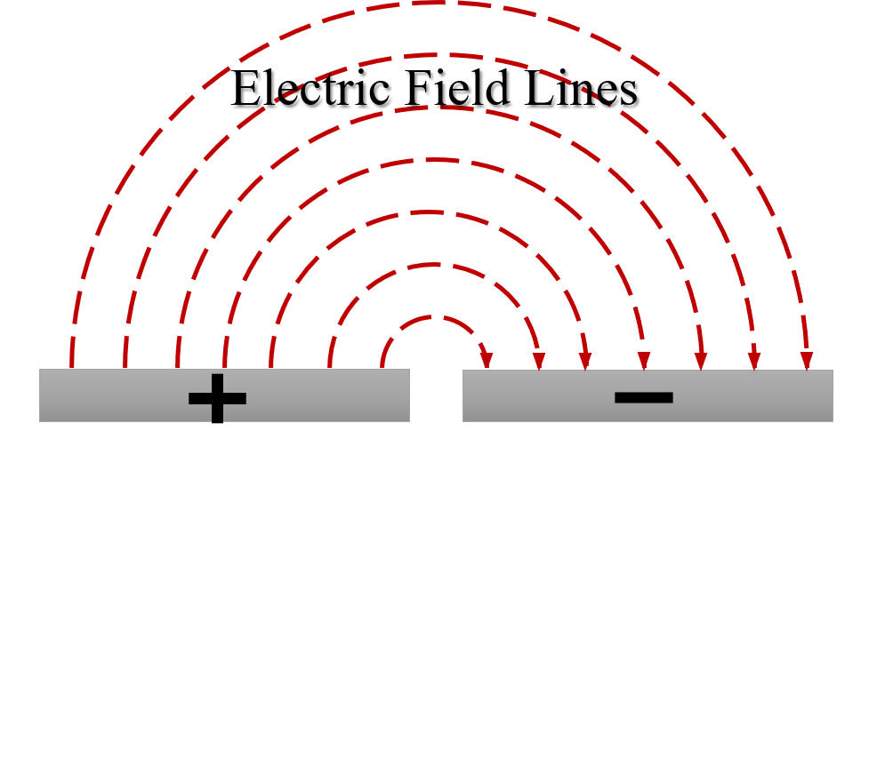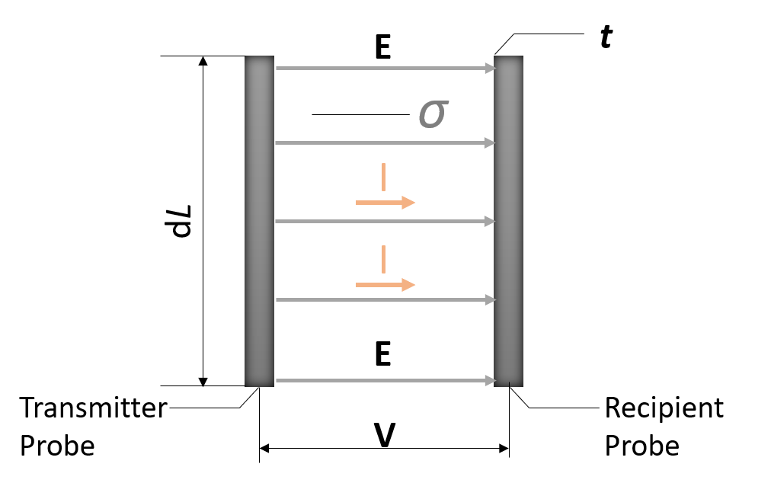
(a)
(b)
Figure 3.2 Generic section of a typical configuration of pairs of probes. (b) Operating principal evolution from the parallel capacitor to flat capacitor.
In this study, the application is considered in a sewer pipe containing three layers of media: sediment, water, and air. The media in the sewer pipe can be considered as five phases along the length of the electrode array, as the sensor runs down one sidewall and up to the opposite side as shown in Figure 3.3 (b). To simplify the analytical theory, the conductivity of each medium is considered fixed and homogeneous. Hence, the conductance of the sensor submerged in the five-phase media is expressed as:
$G∝σ_{a}L_{a1}+σ_{w}L_{w1}+σ_{s}L_{s}+σ_{a}L_{a2}+σ_{w}L_{w2}$ Eq. 3-2
where $σ_{a}$, $σ_{w}$, and$σ_{s}$ are the electric conductivity of air, water, and sediment;$L_{a1}$,$L_{w1}$, $L_{s}$, $L_{w2}$, and $L_{a2}$ are the electrode lengths in air 1, water 1, sediment, water 2, and air 2 as labelled in Figure 3.3. This is a piecewise equation as follows:
$G∝\left\{\begin{matrix}σ_{a1}L \\ σ_{a1}L_{a1}+σ_{w1}\left(L-L_{a1}\right) \\ σ_{a1}L_{a1}+σ_{w1}L_{w1}+σ_{s}\left(L-L_{a1}-L_{w1}\right) \\ σ_{a1}L_{a1}+σ_{w1}L_{w1}+σ_{s}L_{s}+σ_{w2}\left(L-L_{a1}-L_{w1}-L_{s}\right) \\ σ_{a1}L_{a1}+σ_{w1}L_{w1}+σ_{s}L_{s}+σ_{w2}L_{w2}+σ_{a2}\left(L-L_{a1}-L_{w1}-L_{s}-L_{a2}\right)\end{matrix} \begin{matrix}\left(L≤L_{a1}\right) \\ \left(L_{a1}<L≤L_{w1}+L_{a1}\right) \\ {(L}_{w1}+L_{a1}<L≤L_{w1}+L_{a1}+L_{s}) \\ {(L}_{w1}+L_{a1}+L_{s}<L≤L_{w1}+L_{a1}+L_{s}{+L}_{w2}) \\ {(L}_{w1}+L_{a1}+L_{s}+L_{w2}<L≤L_{w1}+L_{a1}+L_{s}{+L}_{w2}+L_{a2})\end{matrix}\right.$Eq. 3-3
which shows that the determined conductance $\left(G\right)$ and the electrode length $\left(dL\right)$ have a linear relationship for each sub-domain of Eq. 3-3 (i.e., for each medium), and the gradient of each line is proportional to the conductivity of the medium. The conductance is measured from each pair of adjacent electrodes. According to Eq. 3-3, the length and conductance of each electrode pair are plotted as shown in Figure 3.4. Lines 1, 2, 3, 4, and 5 correspond to air 1, water 1, sediment, water 2, and air 2 respectively, and points A, B, C, and D match the interfaces. The height of the water layer and the height of the sediment layer can thus be determined from the interface points A, B, C, and D.
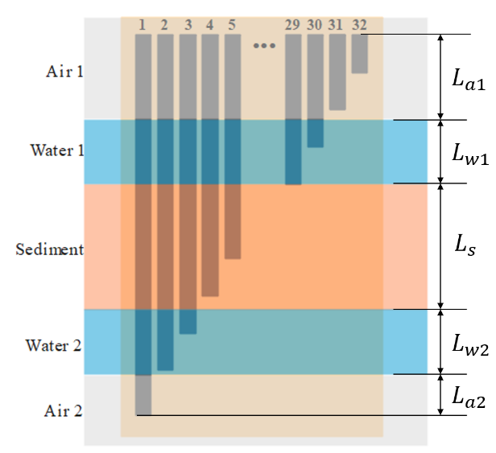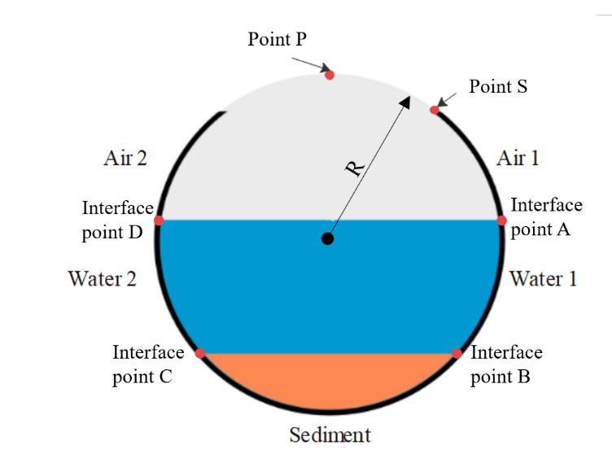
(b)
(a)
Figure 3.3(a) cross-section view of the sensor attached to the pipe inner wall; (b) five-phase media along the sensor
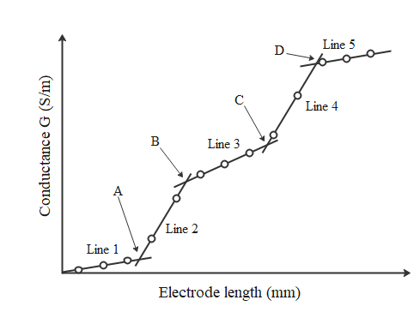
Figure 3.4 Linear piecewise relationship between conductance and increasing length
In this study, a MATLAB algorithm was developed based on Optimal Piecewise Linear Regression Analysis (OPLRA) and a Fuzzy Piecewise Linear Regression (FPLR) method to determine the best linear fitting equation as attached in Appendix A. The FPLR method builds upon the concepts of fuzzy sets to yield a possibility model, which instead of being a single segmented function describing the desired behaviour, actually yields a segmented region of possibility bounded from below and above by two optimal solutions determined by a Mixed Binary Integer Programming (Yu et al., 2001). The OPLRA method uses linear programming to find the set of segmented linear functions that yields the lowest absolute error in a piecewise linear regression (Yang et al., 2016). After collecting all 31 conductance results from 31 electrode pairs, the algorithm allocates them to several groups in order and performs linear regression to each group. The number of groups depends on the number of segments in the piecewise function. Because there is no prior information regarding the partitions and their probability, it is assumed that all possible partitions that could be obtained by distributing the number of points into the number of groups with the same probability. The linear regression is solved using a polynomial, i.e., least square fit. The algorithm performs linear regressions to all possible groups and calculates the standard deviations of the points in each segment. Finally, the group with the minimum average of standard deviations of all segments was selected.
The intersections of adjacent segments can be determined from the slope and intersect values of the regression lines. To prevent the procedure from forming degenerate groups, each group must contain at least two data points. The computed intersections should lie between the endpoint of the previous segment and the first point of the following segment.
To obtain the piecewise fitting line, the values of conductance associated with each pair of electrodes must be related to a specific length. Since the electrode lengths in a given electrode pair are different, each electrode pair is identified with the average length of the two electrodes.
Since the sensor is attached to the inner pipe wall, the positions of intersection points are on the circle’s circumference. The depth (h) of each phase can be determined using the following equation:
$h=R×\left(1+\cos\left(\frac{L+a}{R}\right)\right)$ Eq. 3-4
where $a$ is the arc length between the sensor’s starting point (point A in Figure 3.3 (a)) and the circle’s top point (point $P$ in Figure 3.3 (a)); $L$ is the position of the intersection point along the electrodes (i.e. the location of intersection point on the electrode length axis in Figure 3.4; and $R$ is the pipe radius. Because the sensor was manually fixed to the pipe surface, the distance length between points $A$ and $P$is known.
For an angled sediment layer, if the two intersect point depths $\left(h_{1},h_{2}\right)$ are determined by using (4), the mean sediment depth $\left(h\right)$ and rotation angle $(θ$) can be determined by using Eq. 3-5 and Eq. 3-6:
$θ=\arctan\left(\frac{\left|h_{1}-h_{2}\right|}{\sqrt{2Rh_{1}-h_{1}^{2}}+\sqrt{2Rh_{2}-h_{2}^{2}}}\right)$ Eq. 3-5
$h=R×\left(1-\cos\left(θ+\frac{R-h_{2}}{R}) \right)\right)$ Eq. 3-6
Because the length of each electrode is known from the design process, through determining the linear fitting equation of each sub-line in the piecewise equation, the position of the intersection points can be found. This process requires no calibration.

Parameters for Physical Experiments and Parallel Simulations
In multiphase depth measurements, both the experiment and FEA model are used to assess the feasibility and reliability of the sensor in a circular pipe, and the model is then extended to enable an in-depth quantification of minimum expected measurement error (under ideal conditions). In this experiment, the length of the longest electrode ($L$) of the sensor is 540 mm, and the length difference between two adjacent electrodes ($d$) is 15 mm. The width of each electrode ($w$) is 2 mm, and the separation between adjacent electrodes ($l$) is 0.54 mm. A transparent acrylic circular pipe with a 95 mm internal diameter ($R$) was used to represent a sewer pipe section. This is within the range of typical sewer pipe diameters in the UK (HM Government, 2017). The longest electrode was designed to cover around 90% of the pipe’s inner circumference and, thus, the sensor can measure a maximum depth of 172 mm in this case. This length was chosen to simplify the installation and leave space at the top of the pipe for access to set up the experimental conditions. In future embodiments, the sensor electrodes could span the entire circumference.
A range of different scenarios were examined with various depths of water and sediment. Table 3.1 shows the setup of each test, which was replicated in both the experiment and the corresponding finite-element-analysis (FEA) simulations. The tests included three kinds of scenarios for the pipe contents: (i) water and air; (ii) water, horizontal sediment and air; and (iii) water, angled sediment and air. Angled sediments were chosen because in practice the sediment surface is not always horizontal. It is worth noting that for different scenarios in the pipe, the number of linear segments would be changed in the piecewise plot. For example, if the pipe contains water and air, there would be 3 segments in the piecewise function.
Table 3.1 Summary of tests conducted related to the depths of water and sediment, and the rotation angle
Test Code | Water Depth (mm) | Sediment Depth (mm) | Rotation Angle (degrees) | Sediment depth/Pipe diameter
W1 | 134 | - | -
W2 | 95 | - | -
W3 | 47 | - | -
S1 | 133 | 23 | 0 | 0.24
S2 | 135 | 60 | 0 | 0.63
S3 | 133 | 90 | 0 | 0.95
S4 | 94 | 70 | 0 | 0.74
S5 | 94 | 40 | 0 | 0.42
S6 | 95 | 25 | 0 | 0.26
S7 | 48 | 25 | 0 | 0.26
S8 | 47 | 10 | 0 | 0.11
S9 | 48 | 5 | 0 | 0.05
SA1 | 137 | 56 | 15 | 0.59
SA2 | 95 | 13 | 28 | 0.14
SA3 | 47 | 23 | 8 | 0.24
SA4 | 85 | 75 | 38 | 0.79

Experiment setup and sample material
For the physical experiments, the sensor was fabricated using flexible PCB as shown in Figure 3.5 (a) and was attached to the inner surface of the transparent pipe section, matching the dimensions described in the previous section as shown in Figure 3.5 (b) and Figure 3.5 (c). The length between the sensor’s starting point and the pipe’s top point (i.e., the value of $a$ in Eq. 3-4) was 45 mm. The lab temperature was maintained at 20°C.
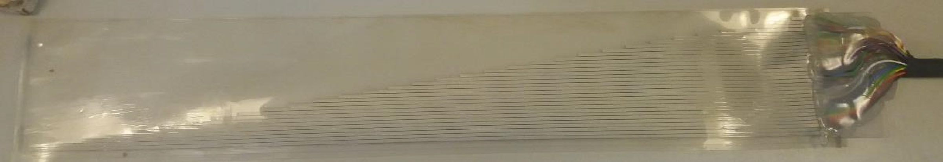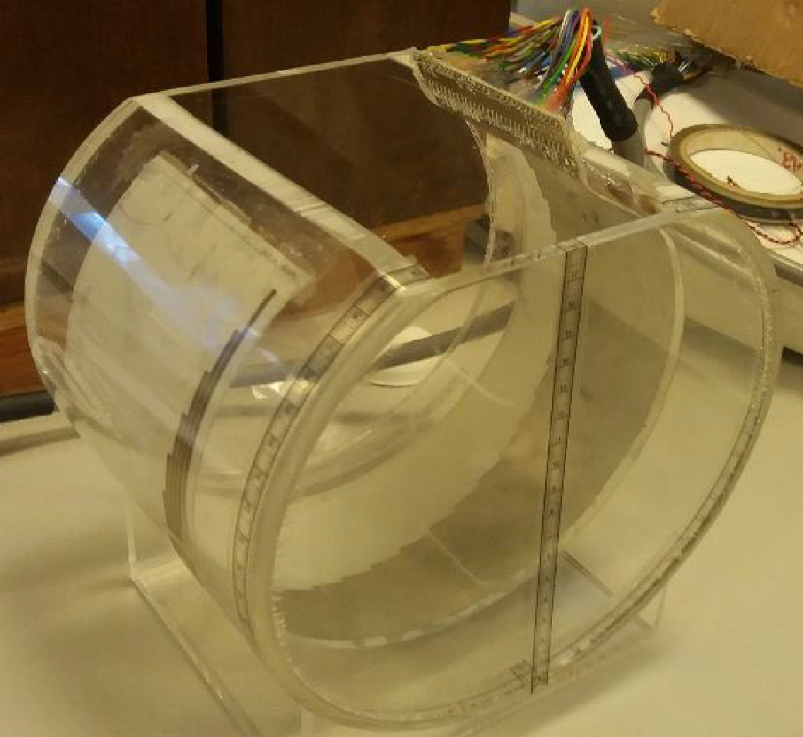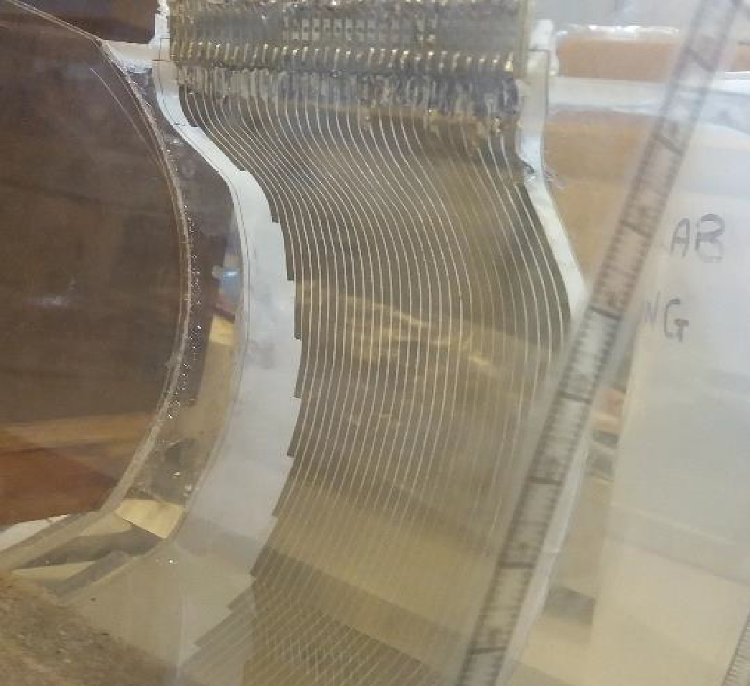
(a)
(c)
(b)
Figure 3.5 Configuration of sensor and circular pipe used for the experiments: (a) the sensor; (b) the experiment configuration; (c) the sensor attached to the pipe’s inner wall.
In the experiment, the sensor was excited by a bipolar square wave of 8 kHz frequency and 1 V peak amplitude. For this frequency, the corresponding phase angle is around zero, thus, the output signal could proportional to the sample conductivity (Pedro et al, 2008) This excitation signal was generated by a circuit comprising an oscillator (Analog Devices Inc. LTC1799 series standard clock oscillator) and amplifiers (Analog Devices AD8643 amplifier), which adjusted a 0-5 V square wave into ±1 V square wave as shown in Figure 3.6. The detailed circuit is attached in Appendix B.
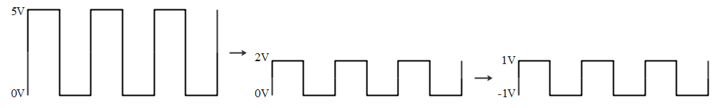
Figure 3.6 Waveform change from 0-5 V square wave to ±1 V square wave
In the measuring circuit, the excitation signal was sent through a multiplexer referred to here as muxA (Analog Devices ADG1606 multiplexer) to one of the electrodes numbered 1, 3, 5…29, 3, while a second multiplexer (muxB) was connected to one of the electrodes numbered 2, 4, 6…30, 32 as a receiver and connected to ground as shown in Figure 3.7. During the first data collection cycle, the measuring circuit recorded the output square wave from electrode pairs 1–2, 3–4, 5–6…31–32. Then, the second data collection cycle collected the output square wave from electrode pairs 3–2, 5–4, 7–6 up to 31–30. The measurement continually alternated between these two collection cycles. Through a series of inverter, rectifier, filter, and gain circuits, the mean of the absolute value of the current waveform was determined as shown in Appendix B. Ten cycles (1.25 ms) of the output wave were measured for each electrode pair. Collecting data from all 31 electrode pairs can be completed within 0.04 s, meaning that data are collected much faster than the time scale of hydraulic or morphological changes in sewer systems. Finally, the determined average value for each electrode pair was collected from the LabView program. In order to determine the depth of air, water and sediment phase, the value of each electrode pair are plotted with the corresponding electrode length as shown in Figure 3.4, and use the Matlab code in Appendex A to determine the interface position.
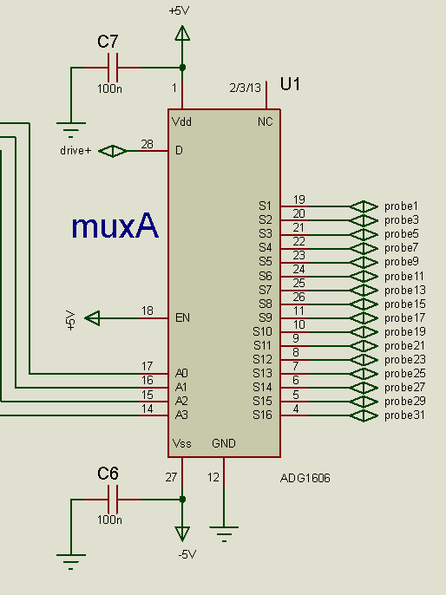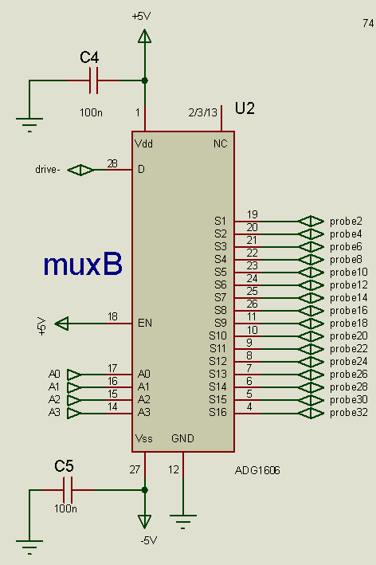
Figure 3.7 schematic diagrams of ADG1606 muxA and muxB
In the experiment, tap water and saturated sand were used to emulate the media in the sewer pipe. The sand size used in experimental testing was 1.18-2.36 mm (DB Group, n.d.). The conductivity of saturated sand is variable as it depends on the properties such as packing density, porosity, permeability, and tortuosity, so it was measured directly using a HANNA HI991300 waterproof pH (potential of hydrogen), EC (electrical conductivity), TDS (total dissolved solids), and temperature meter.
During the experimental test, the depths of water and sediment were set according to Table 3.1. For the experiments including sediment, water was added first up to the height equal to the required sediment depth; then, the sediment was poured into the pipe until it reached the expected sediment depth. The sediment was gently levelled by hand using a flat scraper to ensure it was level and at the right depth and was left submerged in the water for at least 30 minutes to ensure that the sediment was fully saturated. Finally, the remaining water was added up to the required water depth, being sure not to disturb the sediment.
It should be noted that the surface of the sediment could not be made perfectly flat. Since the principle of the sensor is to capture the changing points at the pipe perimeter, these points in particular were carefully adjusted to ensure that the sediment-water interface fell close to the points of the perimeter corresponding to the defined sediment depth, within an estimated error of ±1 mm.

FEA model
FEA can provide an accurate and effective analysis of the analytical theory and validation of experimental results. In the study, FEA was carried out using COMSOL Multiphysics software (COMSOL Inc., Burlington, CO, USA), which is a finite element analysis and solver software package for various physics and engineering applications, especially suited to coupled phenomena. For the electrical sediment sensor, the AC/DC module of COMSOL was chosen for the analysis, which simulated the sensor’s performance under an ideal environment with 20°C temperature and at 1 atmosphere pressure. In this model, COMSOL solves a current conservation equation based on Ohm’s law, used to compute electric field, current, and potential distributions in conducting media.
Figure 3.8 shows a meshed 3D finite element model of the sensor created by using COMSOL. The 3D model was consistent with the experimental setup and used the same geometry as the experimental sensor. The electrical conductivity and relative permittivity of the media used in the model have been summarised in Table 3.2, which were measured by the HANNA HI991300 EC meter and METER Group 5TE meter, respectively. In an electrode pair, the longer electrode served as the exciting electrode, which is supplied with a peak amplitude of 1 V, 8 kHz sine wave. The shorter electrode is a receiver for current measurement and is grounded. The model recorded the output from COMSOL one electrode pair after another, and the other electrodes were disconnected. After solving all 31 electrode pairs, the RMS value of the current wave was determined, then transferred to conductance according to Ohm’s Law and plotted. Once the conductance of each electrode pair was obtained, the data analysis method was the same as for the experiment tests described in Section 3.2.2.
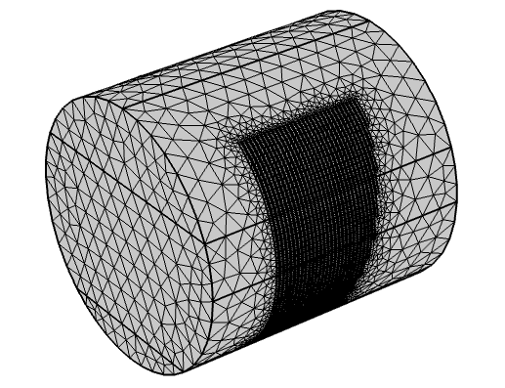
Figure 3.8 Meshed 3D model of the conductance sensor in COMSOL
Table 3.2 The electrical properties of materials used in FEA model
Material | Electrical conductivity(S/m) | Relative permittivity
Copper | 5.87$×{10}^{7}$ | -
Water | 0.0284 | 81
Saturated sand (sediment) | 0.0129 | 16
Air | 1$×{10}^{-20}$ | 1

Figure 3.9 shows the calculated electric potential and electric field distributions of one electrode pair. As can be seen, the electric field arrow is from the exciting electrode to receiving electrode and across the media above the electrodes, which also corresponds to the operating principle described in section 3.2.2.
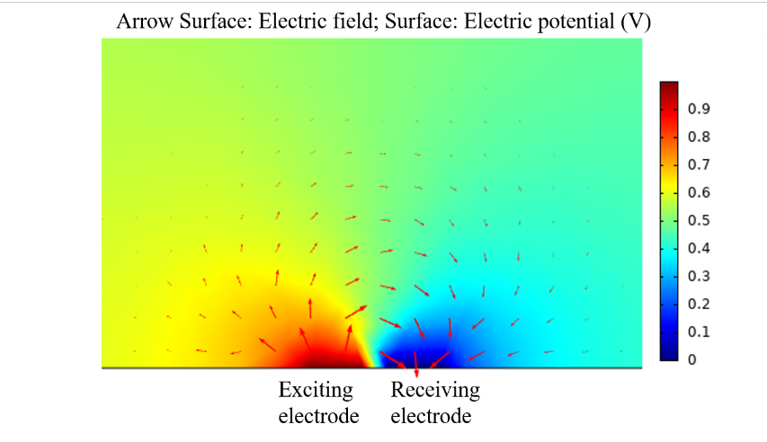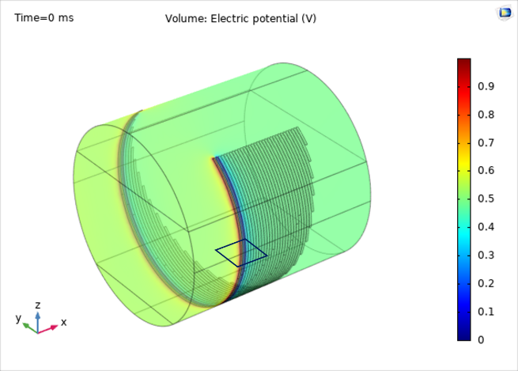
(a)
(b)
Figure 3.9 Electric field vectors and electric potential distribution for one electrode pair of the sensor calculated by COMSOL Multiphysics: (a) 3D view of electric potential distribution for the model; (b) cross section electric field vectors and electric potential distribution of one electrode pair.

EIS technique and hydraulic properties measurements

Sensor structure and test materials
The sensor used in the EIS test consisted of four parallel copper electrodes placed on a flexible insulated polymer substrate. The electrodes were 2mm in width and 276mm long with a 2mm spacing distance between two adjacent electrodes as shown in Figure 3.10. Like the sensor applied in the multiphase depth experiment test, the sensor was fabricated by the PCB technique, and the electrodes were treated with immersion gold to prevent corrosion. It should be noted that despite implementing anti-corrosion treatments, corrosion and abrasion of sensors are inevitably with frequent use and over time, especially the sensor in this test is exposed to a water environment and physical wear and tear from test materials. These issues can impact the accuracy of test results, hence it is important to keep the sensor dry and clean after testing. For prolonged use, it may be beneficial to utilise anti-corrosion materials in actual applications.
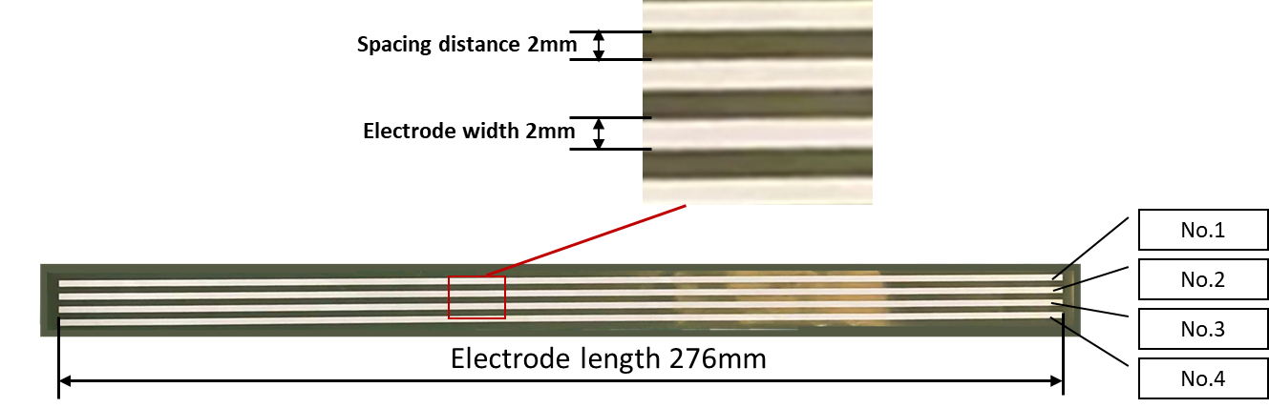
Figure 3.10 sensor’s structure and dimensions
Two different types of sample materials were adopted for the EIS test. The first experiment used 20°C tap water and ten different sizes of glass beads (from Glass Sphere, s.r.o Company) to create systems with various well-defined porous and hydraulic properties. Figure 3.11 shows pictures of ten different sizes of glass beads. Each test measures a homogeneous mixture of a single size of glass beads. The spherical samples can help to eliminate the influence of grain shape. All the samples were pre-washed with tap water before tests to remove possible impurities from the sample.
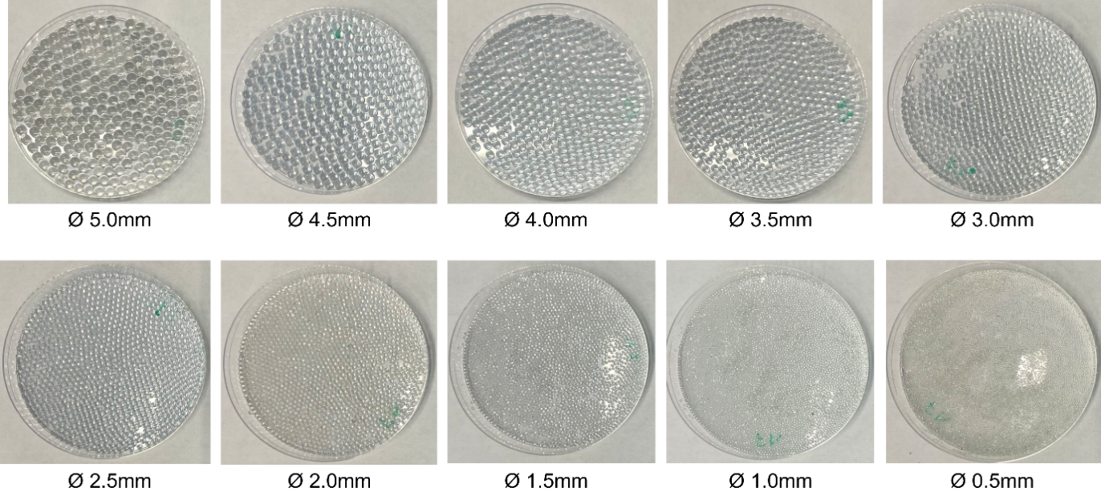
Figure 3.11 Pictures of glass beads samples
For the second experiment, two kinds of test materials were used: a mixture of sand with different volume proportions, and a mixture of glass beads. Figure 3.12 shows pictures of the test materials. The sand mixture consists of two different sizes: Fraction A in the size range of 1.18-2.36 mm and Fraction E in the 90-150 µm range. The compact bulk densities are 1620 kg/m³ and 1510 kg/m³ respectively (DB Group, n.d.). The volume ratios of Fraction A sand to Fraction E sand used in this study were: 100:0; 75:25; 50:50; 25:75; and 0:100. The proportion of different sized beads used in the glass beads mixture was based on the size distribution of solids from Marsalek (1984), which are compared in Figure 3.13 (a); the probability density plot is shown in Figure 3.13 (b).
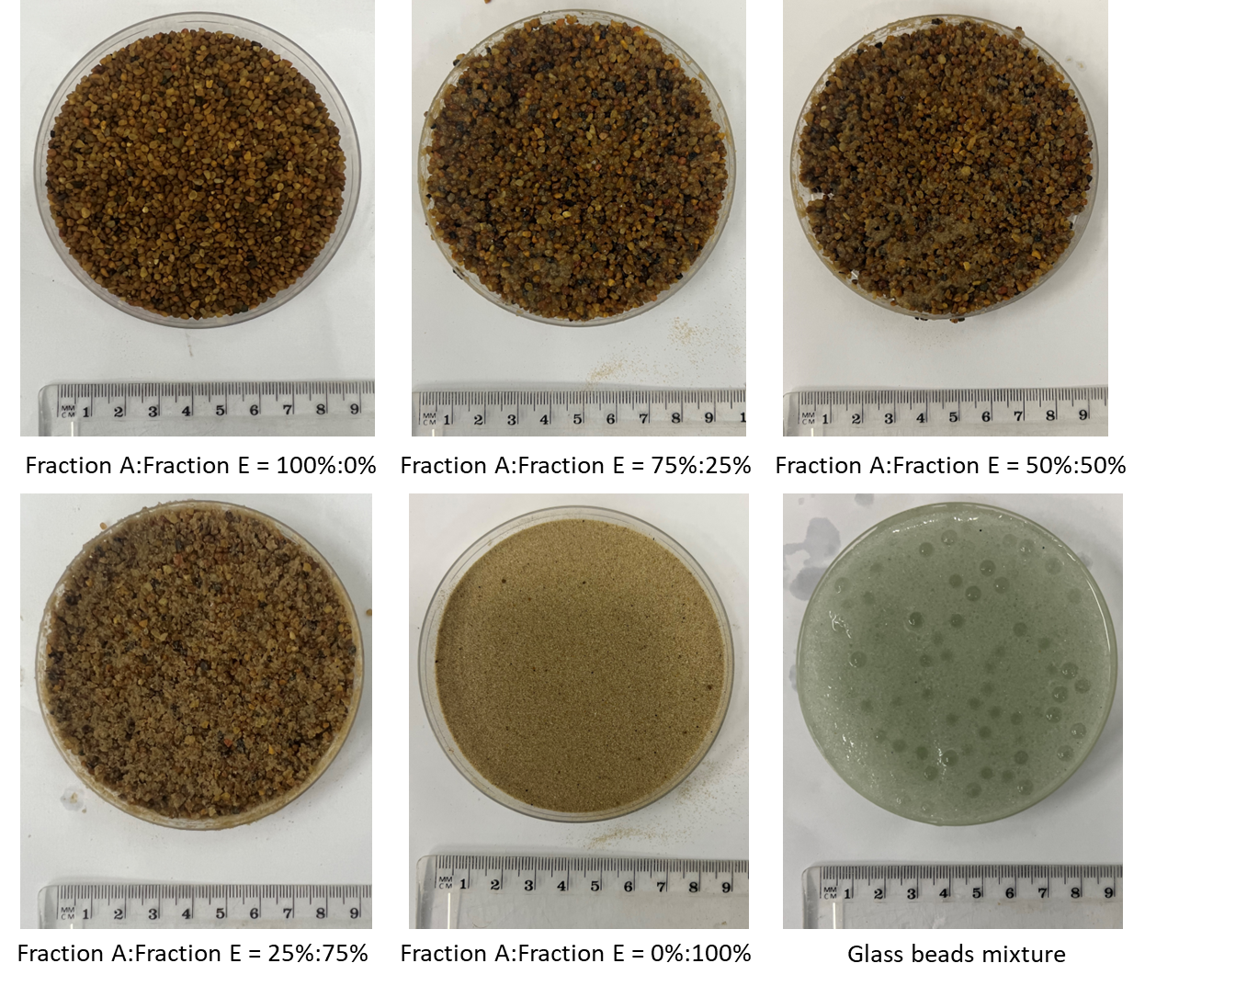
Figure 3.12 Picture of test materials: sand mixtures and glass beads mixture
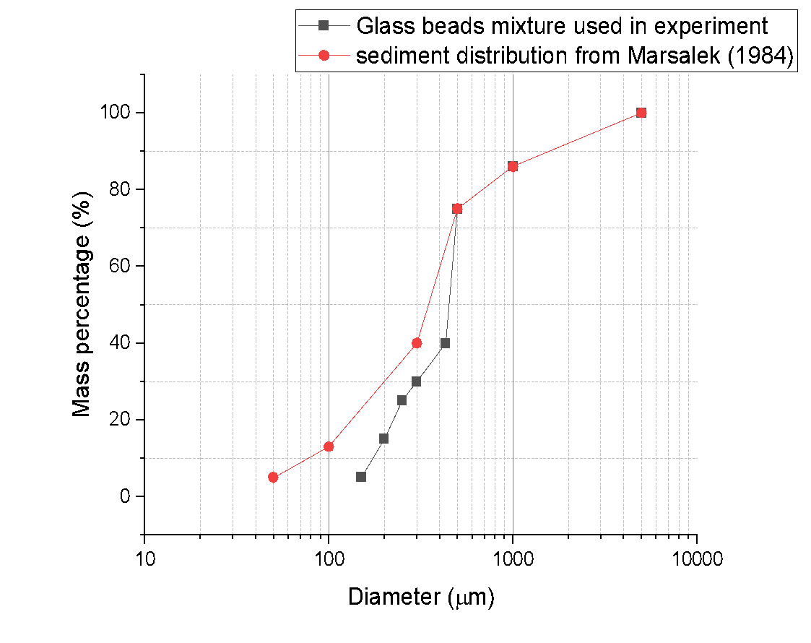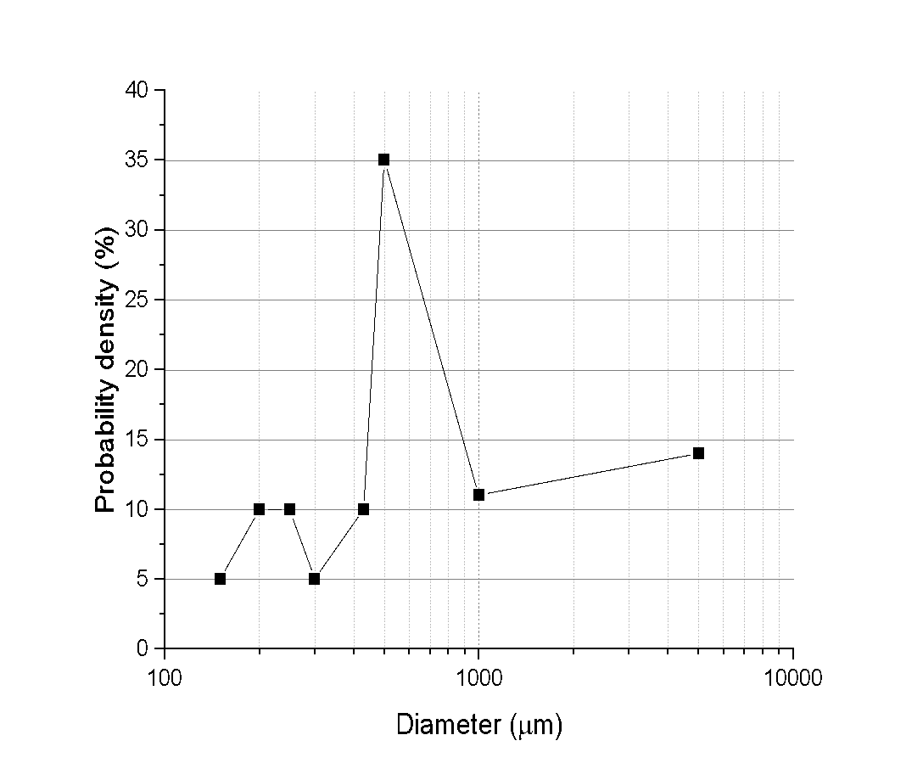
(b)
(a)
Figure 3.13 (a) grain size distribution of glass beads mixture; (b) probability density plot
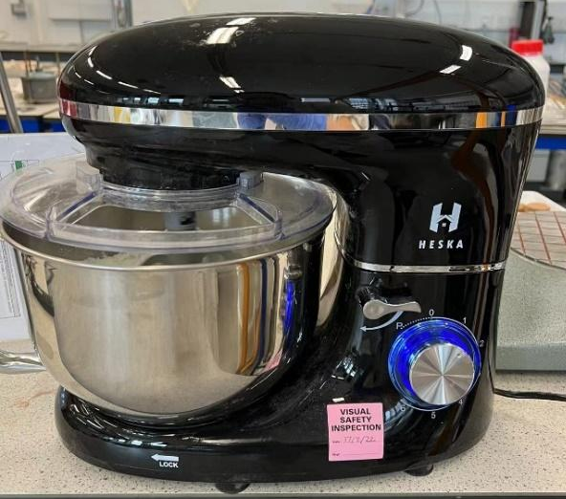
Figure 3.14 HESKA stand mixer
Before the testing, all materials were washed with tap water and air dried for 2 days. Each sample, which was around 1.5 L, was then homogeneously mixed for five minutes using a stand mixer as shown in Figure 3.14. Some experiments use a ribbon mixer to mix samples (Dias et al, 2004), due to the small amount of sample and the limitations of instrument in the lab, a stand mixer was selected in this experiment.

Measurement of hydraulic properties

Porosity
The porosity ($ϕ$) is defined as the ratio of pore volume ($V_{pore}$) to the bulk volume ($V_{bulk}$). In this study, the porosity of glass beads with various diameters was calculated using the saturation method. Figure 3.15 shows pictures of the cylinder container used in this test, the diameter of the cylinder is 88mm, and the height is 250mm. The air dried glass beads were poured into the dry and clean cylinder container, then the entire container was shaken up and down 10 times and side by side 10 times to settle the particles and confirm the height of the sample no longer decreases and remains constant. Bulk volume can be calculated by the height of samples ($H_{sample}$) and the radius of the cylinder container ($r_{c_{c}}$). The weight of 1L of tap water was measured at 20°C to calculate the density of water ($ρ_{water}$). The water was poured into the container until the water level was as close to the surface level of the glass beads as possible as shown in Figure 3.15 (c). With human measurement, the water level did not exceed the highest part of the glass beads by 1mm. Pore volume was calculated from the water density ($ρ_{water}$) and the weight of added water ($m_{water}$). The porosity of samples was measured before each test and then was calculated by the following equation:
Porosity: $ϕ=\frac{V_{pore}}{V_{bulk}}=\frac{\frac{m_{water}}{ρ_{water}}}{π{{r_{cc}}^{2}H}_{sample} }$ Eq. 3-7
To prevent changes in the packing of samples during subsequent tests, the glass beads were gently held in place by using the press pad on the lid as shown in Figure 3.15 (b). The porosity of samples was measured before each reproduced test.
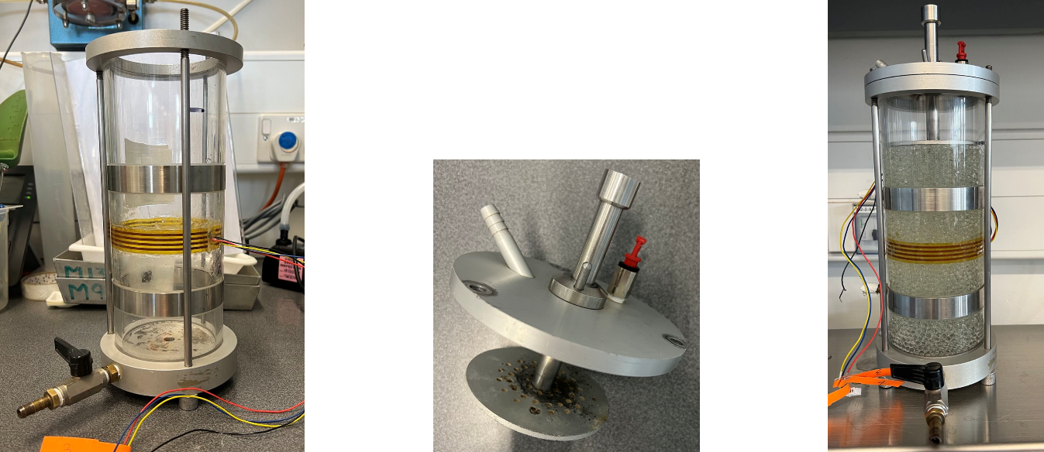
(a)
(c)
(b)
Figure 3.15 Pictures of cylinder container and lid with press pad (a) empty cylinder container; (b) lid with press pad; (c) assembled cylinder container with glass beads sample.

Hydraulic permeability
After the porosity measurement, the sample was sealed for the next hydraulic permeability measurement. It was measured by the constant head permeability test facility as shown in Figure 3.16. The facility is composed of an upper water reservoir, a bottom water tank, piezometers, and a cylinder container. The hydraulic permeability can be calculated by using Darcy’s law:
Hydraulic permeability: $k=\frac{Q/A}{∆ h/∆ L}×\frac{υ}{g}$ Eq. 3-8
where $A$ is the cross-section area of the cylinder container, $Δh$is the height difference on the piezometer tubes (head loss across the sample), $ΔL$ is the height of the sample, which is 110mm in this test, and $Q$ is the volumetric flow rate of liquid through the sample.
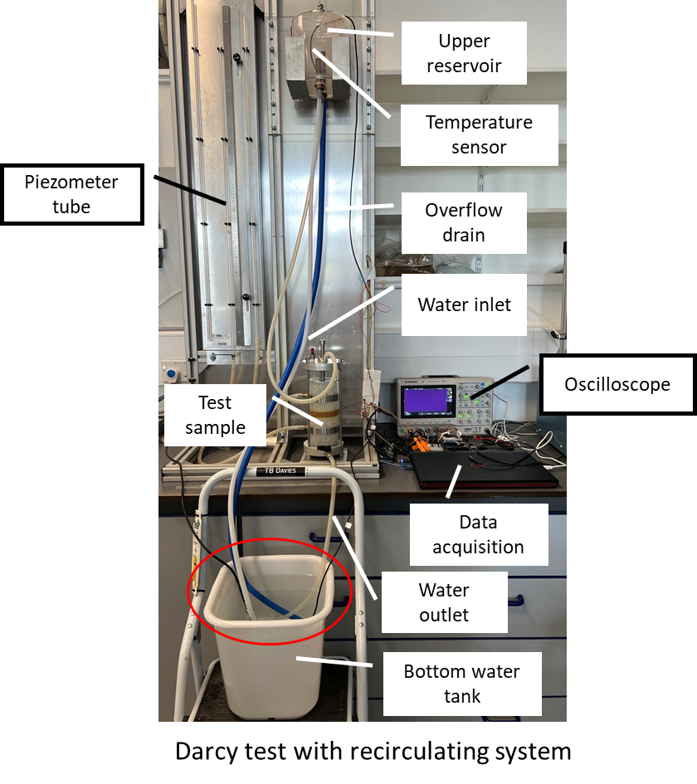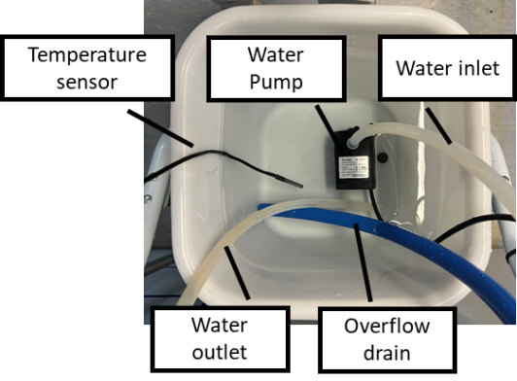
Figure 3.16 Darcy test constant head facility with recirculating system
In order to investigate the influence of water flow rate on measured impedance, the permeability tests for the ten different sizes of glass bead consisted of both dynamic tests and static tests. Dynamic tests involved water flowing through the sample from top to bottom with different flow rates (1 L/min, 0.6 L/min and 0.2 L/min). Considering the experimental setup for the dynamic test, the temperature of water in the tap can vary. Therefore, a recirculating system was designed to keep the water at room temperature i.e., 20±1°C. The recirculating system used a pump in the bottom water tank, which can pump the water up to the upper water reservoir as shown in Figure 3.16. Static electrical tests are with water-saturated samples but with no water flowing through the samples.
As for the sand and glass bead mixture tests, the existing facility cannot manage very fine sand mixtures flowing at 0.2 L/min since the maximum height of the constant head facility is 1.5 m, which cannot provide enough pressure. All samples were evaluated with water flowing through the samples from top to bottom without any control in the flow rate for each sample. The flow rate for 100% Fraction E is around 0.046 L/min, which is significantly lower than 0.2 L/min. The flow rate for other samples is in the range of 0.1 L/min to 1.5 L/min.

EIS measurement
The background of the EIS test has been described in section 2.5. In this experiment, the sensor was mounted to the centre depth of the cylinder container, as shown in Figure 3.15 (a), for simultaneous measurement of electrical and hydraulic properties. As a result, the sensor's substrate was curved to adhere to the inner wall of the cylinder container and provide electrode access to the measured samples from only one side as shown in Figure 3.17, and the other side was insulated by the substrate. For the EIS test, two electrodes were used at a time to measure the frequency-dependent impedance. A sinusoidal AC voltage with 2V peak amplitude and frequency range from ${10}^{1}$ Hz to ${10}^{7}$ Hz incrementing by a ratio of 10, was applied to the excitation electrode (electrode no.1 as labelled in Figure 3.10), and the other, as the sensing electrode, was connected to the ground individually in order to realise the measurement with different electrode spacing distances. All the other idle electrodes were not connected to the circuit. The selection of signal configuration for EIS testing depends on the specific research question being investigated. The current study employed a constant peak potential with varying frequency, which is useful for assessing media impedance. The frequency range was determined based on Keddam et al., (1997) research, which found that the key Nyquist Plot loops for a cement paste occur around ${10}^{7}$ Hz. Furthermore, preliminary testing indicated that a frequency range of ${10}^{1}$ Hz to ${10}^{7}$ Hz was sufficient for conducting EIS analysis with minimal time and power consumption.
Similar to the theory of multiphase depth measurements, when an AC excitation is applied to the electrodes, the electric field penetrates the sample materials from the excitation electrode to the sensing electrode (measured for three different pitch lengths), which contains impedance information of sample materials. The intensity of the output signal is influenced by the spacing distance between the excitation and sensing electrodes; thus, the output signal was recorded from three electrode pairs: Electrode No. 1&2, No. 1&3, and No. 1&4 as labelled in Figure 3.10. Figure 3.17 shows a simplified representation of the fringing electric field generated between electrode pairs. It can be seen that the longer pitch length causes penetration depth to increase but the field’s strength to decrease.
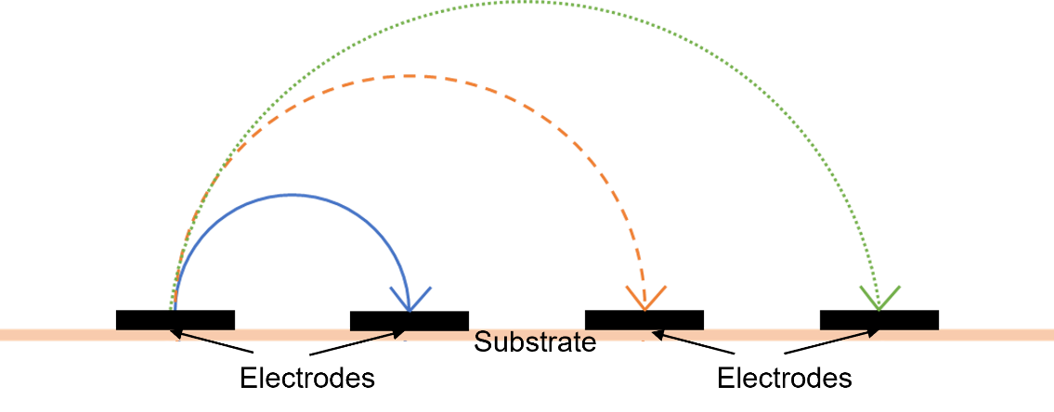
Figure 3.17 Fringing electric field for different electrode spacing distances.
This sensing electrode selection process was controlled by relays and Arduino as shown in Figure 3.18. An AC circuit with a series reference resistor ($R_{f}=1kΩ$) was used to measure the impedance between electrodes as shown in Figure 3.19(b). The signal was generated and recorded by an oscilloscope with a built-in wave generator (BK Precision 2567). The impedance can be calculated by Ohm’s law through derivation:
Total impedance: $Z=\frac{V_{2}}{I}=\frac{V_{2}}{(\frac{V_{1}-V_{2})}{R_{f}}}=R_{f}×\frac{V_{2}}{V_{1}-V_{2}}$ Eq. 3-9
where $V_{1}$ is the input voltage signal, and $V_{2}$ is the output voltage signal between two electrodes. $V_{1}$ and $V_{2}$ were the peak amplitudes in this study. The response current ($I$) can be calculated from the reference resistor ($R_{f}$).
In order to verify the stability of EIS measurements, each size of the glass bead was subjected to three repeatability tests, where the sample was kept in the container and the EIS measurement process repeated. Furthermore, there were three reproducibility tests, where the sample was poured out and refilled again before the EIS measurement was performed again.
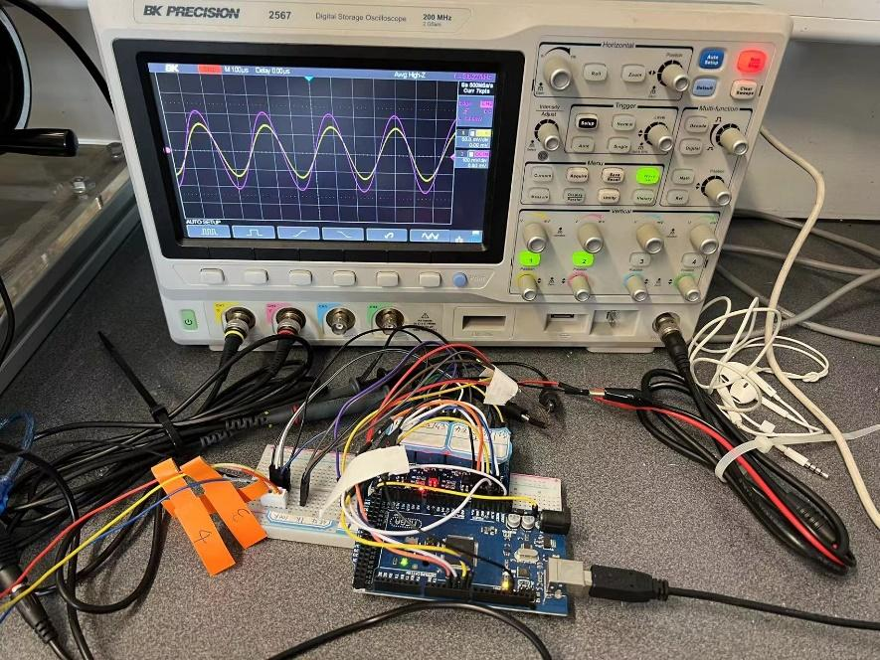
Figure 3.18 EIS test instrument: oscilloscope, relays, and Arduino
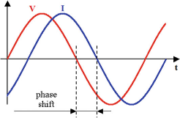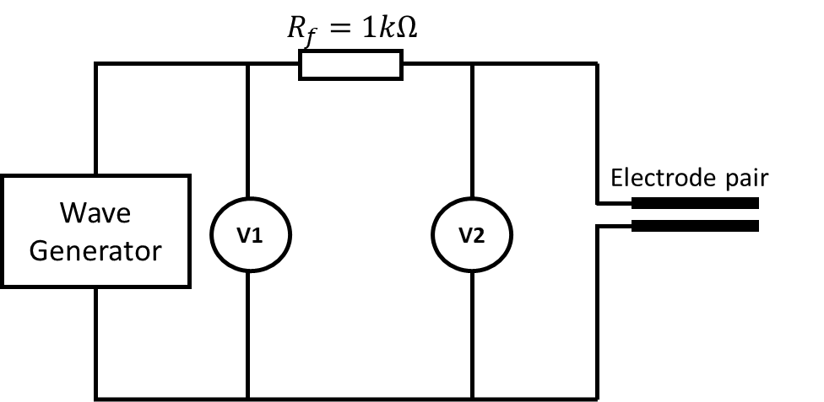
(a)
(b)
Figure 3.19 (a) Schematic of the potential and current waveform, and phase shift; (b) EIS data measurement circuit
Fitting an EIS instrument into a real sewer requires careful consideration of various factors, including the environment, installation methods, maintenance, and data transmission. Accessibility for installation, calibration and maintenance should be a concern when choosing a location. Additionally, replacing the traditional wave generator and oscilloscope with an EIS chip based on Analog devices can provide a more compact and efficient solution. Powering the instrument with a battery or connecting it to a main power source can further optimise its performance. Since the sediment in sewers changes slowly, the measurement period could be around one week or longer, and the data can be stored on a SD memory card or transmitted via Bluetooth or WIFI. It is crucial to consider the insulation of all electrical instruments in the moist sewer environment.

Data collection and analysis
The input and output sinusoidal wave signals were measured by the oscilloscope at each frequency and recorded by MATLAB with the Instrument Control Toolbox. Each measurement contained 3 cycles of the sinusoidal wave with 7 thousand data points. Then the data of the excitation signal and response signal were fitted by the sinusoidal function in MATLAB Curve Fitting Toolbox, which gave the value of peak amplitude of input and output voltage ($V_{1}$ and $V_{2}$), and the phase angle. Finally, the total impedance at each frequency can be determined with Eq. 3-9, and the real and imaginary impedance can be determined by phase angle.
Once the real and imaginary impedance values are calculated for each frequency, the Nyquist plot can be created by plotting the real impedance on the x-axis and the imaginary impedance on the y-axis. To accurately fit the Nyquist plot, it is important to choose an appropriate equivalent circuit composed of various electrical elements. In this study, the software ZSimpWin was utilized to determine the value of each electrical element in the equivalent circuit, based on the shape of the Nyquist plot. Figure 3.20 flow chart demonstrated the entire analysis process.
Figure 3.20 EIS data analysis and convert process.
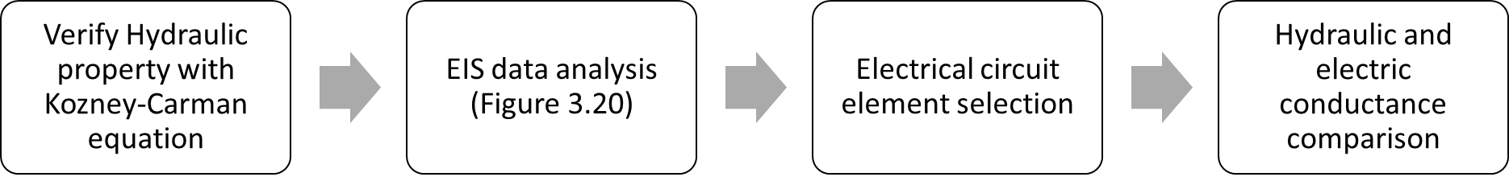
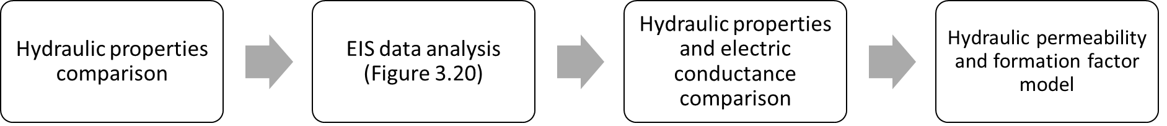
The EIS measurement aims to establish the electrical conductance of the media and subsequently establish a correlation between electrical conductance and hydraulic permeability. Therefore, in the EIS test using glass beads, it is essential to first validate the measured hydraulic properties using the well-established Kozeny-Carman equation, including glass beads size, porosity, and hydraulic permeability. It is also necessary to choose the appropriate electrical element that represents the electric conductance by comparing its value variation with the glass beads size. The relationship between electrical conductance and hydraulic permeability can be determined by leveraging Archie's Law, and this is described in Chapter 5. In the EIS test utilizing sand and simulated sediment, each pair of hydraulic properties is compared, and the relationship between electrical conductance and each hydraulic property is outlined. These relationships help fine-tune the model coefficients to suit the test material for this study, which described in Chapter 6. The entire analysis process is elucidated in Figure 3.21.
Figure 3.21 EIS method for characterising hydraulic properties flow chat, (a) glass beads tests; (b) sand and simulated sediment test
(a)
(b)
As mentioned before, the temperature is a significant influence when measuring electrical conductance. In the EIS test, the temperature of the water was also recorded during tests by using Arduino and DS18B20 temperature digital thermal probe sensors. For the dynamic test, because the cylinder container is sealed, two temperature sensors were used to measure the temperature of the upper water reservoir and bottom water tank as shown in Figure 3.16. For the static test, one temperature sensor was put into the cylinder container to measure the temperature of the water in the upper layer so that the packing structure of the lower sample would not be affected as shown in Figure 3.22.
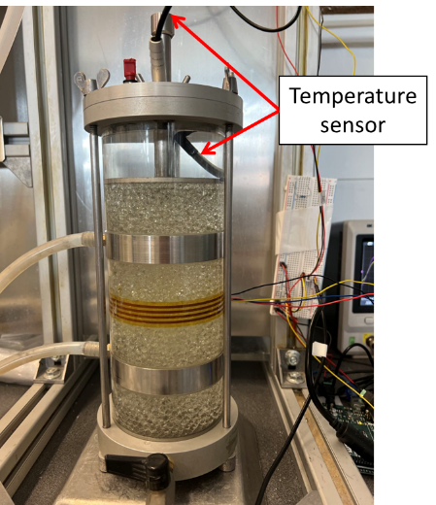
Figure 3.22 static test temperature sensor arrangement

Summary
This chapter describes the methodology for the multiphase depth measurement and the EIS tests for hydraulic property measurements. A novel sediment sensor has been designed and constructed to allow electrical conductance measurements of various sample materials in the laboratory environment.
The theoretical analysis, experimental setup, and FEA model setup for the multiphase depth measurement have been presented in this chapter. The novel sediment sensor with 32 varying-length electrodes was attached to a 95 mm inner diameter transparent vessel and tap water and 1.18-2.36 mm sand have been used to simulate the sewer pipe and saturated sediments in the experiment. An electrical conductance measurement circuit has been developed which is capable of collecting data from 31 electrode pairs within 0.04 seconds. The electrical properties of water and saturated sand were also characterised by electrical conductivity and relative permittivity meters as the input for the FEA model.
For the EIS tests, a four-electrode sediment sensor has been developed to measure the impedance spectra of samples, which is also designed to investigate the influence of electrode spacing distance in the EIS measurement. A measurement system has been devised, whereby an oscilloscope with a wave generator is used to generate and measure the excitation and response signals, an Arduino is directed at controlling the electrode connection, and the impedance information is recorded and analysed by MATLAB software. The temperature is a concern in the experiment; thus, a recirculating flow system and temperature recording system are proposed to maintain and monitor the temperature respectively. Ten sizes of glass beads, sand mixtures and glass bead mixtures have been used to generate different structures and hydraulic properties in samples, which can present different grain sizes, hydraulic permeabilities and porosities. The experimental setup for hydraulic property measurements is also included in this chapter.

Conductance-based Interface Detection for Multiphase Pipe Flow

Introduction
As described in Chapter 2, sediment deposition in sewers can decrease the capacity of pipes and increases the risk of sewer overflows. Low-cost and long-term sediment monitoring is necessary to understand the sedimentation process and enable real-time management approaches. In this chapter, an experimental and finite element analysis (FEA) model are presented for demonstrating a novel multi-electrode sensor based on electrical conductance measurements for monitoring the depths of sediment and water level in a sewer pipe. The experimental and FEA model measured depth results are demonstrated in section 4.2, and also compared with the real measured and set depth. The change of electrical conductance slope with different materials are analysed in section 4.3. Finally, Section 4.4 discusses the sensor’s measurement resolutions and limitations.

Results and discussion

Depth measurement results
Following the main aim of this study, to affix the sensor in a pipe environment and measure the depths of water and sediment, it is necessary to compare the depths obtained by the sensor and the model with the actual experiment and model setup. As mentioned in section 3.2.1, the sensor is attached to the inner wall of the pipe, thus only two interface points along the sensor can be detected for each interface. With mean depth defined as the average height of the left and right interface points, the results and error from the model and the sensor measurements have been compared with the actual depths in Table 4.1 and Table 4.2. Since the sand level is not horizontal in the rotated tests (test codes SA1, SA2, SA3), the depths of the left and right points of the sediment surface are used for validation. As mentioned in section 3.2.2, the intersection points of two adjacent lines on the conductance versus probe length plot represent the interface position between two different media in the pipe. Due to the sensor being attached to the pipe’s inner wall, the probe length corresponds to the perimeter position around the pipe. Once the sensor’s starting position is known, it is a geometric problem to transform the perimeter positions of intersection points into a vertical depth. Figure 4.1 demonstrates the fitting results, determined interface, and the experiment setup of three representative examples, a water only test (W2), a water and sediment test (S1), and a rotated sediment test (SA1). The interfaces are plotted in a circle to represent the setup scenarios.

Table 4.1 Depth results summary of water only tests and water-sediment tests.
Test Code | Water Depth (mm) |  |  |  |  | Sediment Depth (mm)
Test Code | Actual | COMSOL Modelling | Model Error | Sensor  Measured | Measured Error | Actual | COMSOL Modelling | Model Error | Sensor  Measured | Measured Error
W1 | 134 | 139.26 | 5 | 139.35 | 5 | - | - |  | -
W2 | 95 | 92.75 | 2 | 93.99 | 1 | - | - |  | -
W3 | 47 | 44.71 | 2 | 46.99 | <1 | - | - |  | -
S1 | 133 | 132.33 | <1 | 138.28 | 5 | 23 | 22.34 | <1 | 28.72 | 6
S2 | 135 | 130.97 | 4 | 141.07 | 6 | 60 | 59.83 | <1 | 55.31 | 5
S3 | 133 | 133.58 | <1 | 139.28 | 6 | 90 | 93.02 | 3 | 85.89 | 4
S4 | 94 | 92.67 | 1 | 99.90 | 6 | 70 | 68.73 | 1 | 75.92 | 6
S5 | 94 | 89.64 | 4 | 95.77 | 2 | 40 | 36.27 | 4 | 35.45 | 5
S6 | 95 | 89.56 | 5 | 93.91 | 1 | 25 | 23.05 | 2 | 17.37 | 8
S7 | 48 | 47.63 | <1 | 48.61 | <1 | 25 | 24.82 | <1 | 21.74 | 3
S8 | 47 | 45.96 | 1 | 47.24 | <1 | 10 | 8.72 | 1 | 5.99 | 4
S9 | 48 | 46.50 | 1 | 46.04 | 2 | 5 | 1.95 | 3 | 1.84 | 3
Table 4.2 Depth results summary of rotated sediment tests
Test Code | Water Depth (mm)
Test Code | Actual | COMSOL Modelling | Model Error | Sensor  Measured | Measured Error
SA1 | 137 | 136.04 | <1 | 138.59 | 2
SA2 | 95 | 93.91 | 1 | 93.63 | 1
SA3 | 47 | 46.64 | <1 | 46.55 | <1
Test Code | Sediment Depth(left) (mm)
Test Code | Actual | COMSOL Modelling | Model Error | Sensor  Measured | Measured Error
SA1 | 79 | 73.07 | 6 | 87.16 | 8
SA2 | 2 | 3.04 | 1 | 0.22 | 2
SA3 | 33 | 33.74 | <1 | 36.34 | 3
Test Code | Sediment Depth(right) (mm)
Test Code | Actual | COMSOL Modelling | Model Error | Sensor  Measured | Measured Error
SA1 | 35 | 33.15 | 2 | 27.35 | 7
SA2 | 31 | 28.67 | 2 | 13.81 | 17
SA3 | 15 | 13.80 | 1 | 15.19 | <1

Table 4.1 and Table 4.2 compare the calculated depths of model and sensor measurements with the actual set-up depth. The root-mean-square error from the model is 3 mm and 2 mm for water level and sediment level respectively, and the root mean square error of the sensor’s measurement is 2 mm and 5 mm for water depth and sediment depth, respectively. In other words, the root mean square error of model and experiment are within 1.4% and 2.6% of the sensor’s measurement range (i.e., the pipe diameter 190mm) and within 18% and 33% of the electrode tip spacing (15 mm). This shows that the water level measurements demonstrate a higher accuracy than sediment level measurements in the physical experiment and model. The sediment error is greater for the experiment with a bigger root mean square error, though this is likely attributable to the inevitable variability and uncertainty in actual sediment level, which is ±1mm at the pipe walls, as described in section 3.2.3, and the interface is also not perfectly planar.
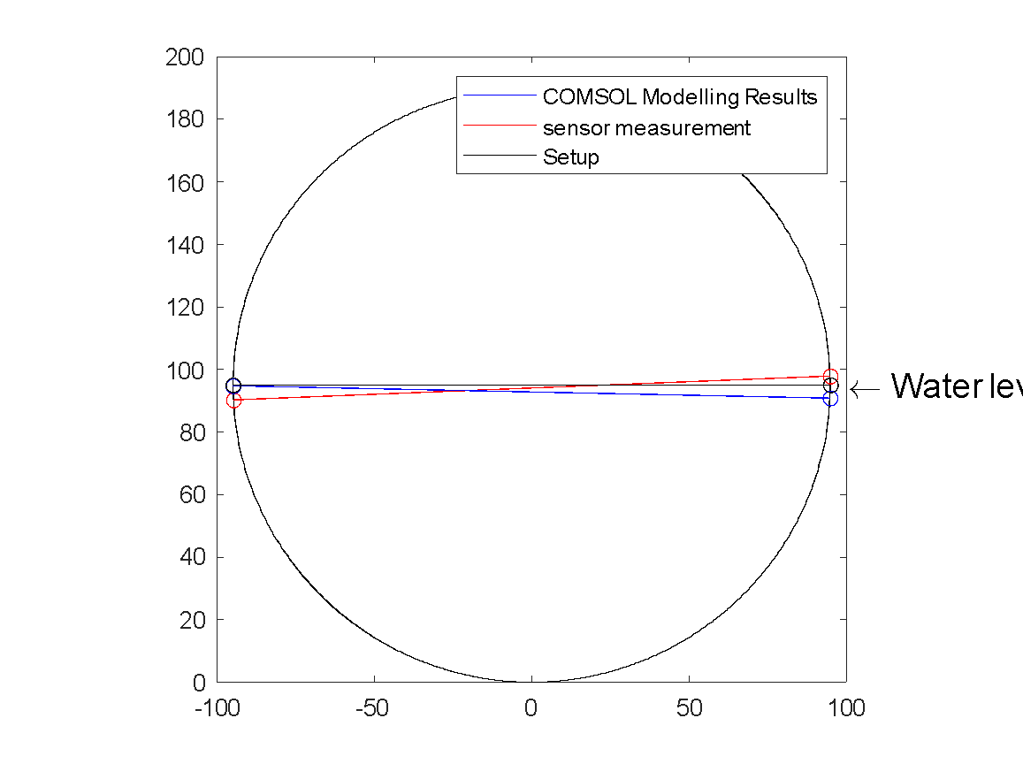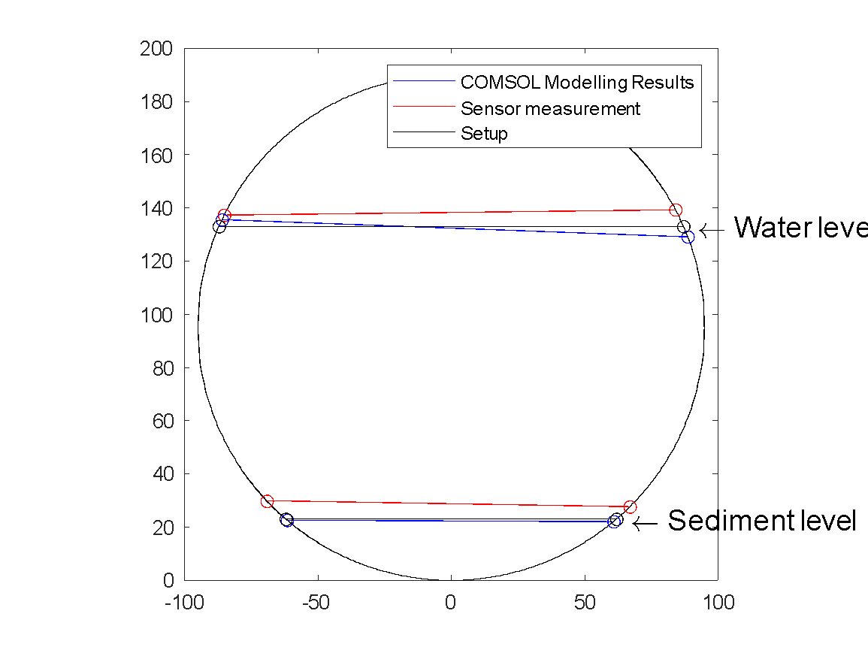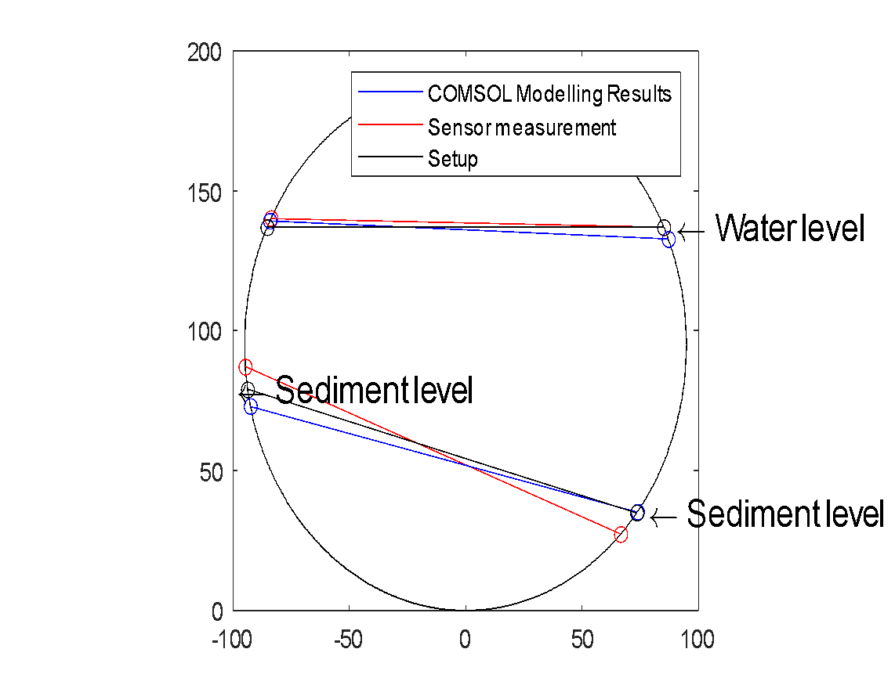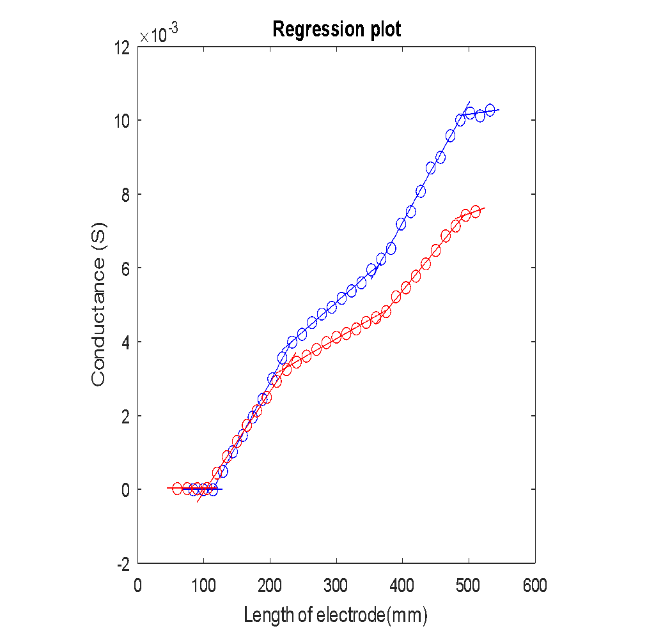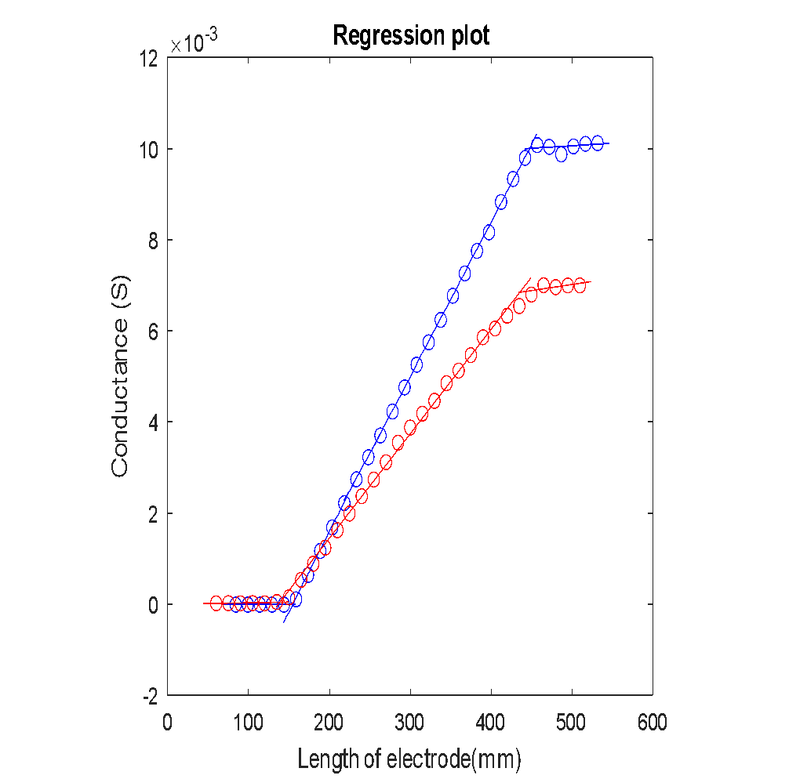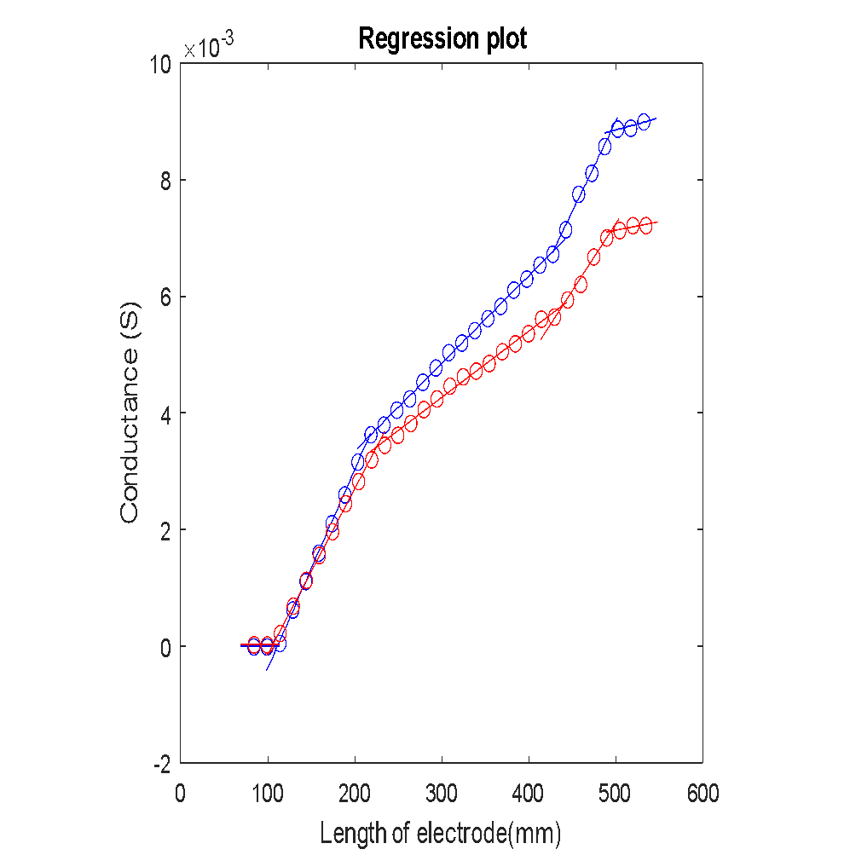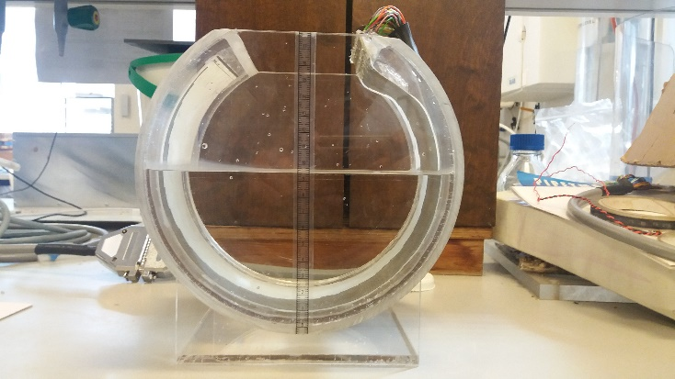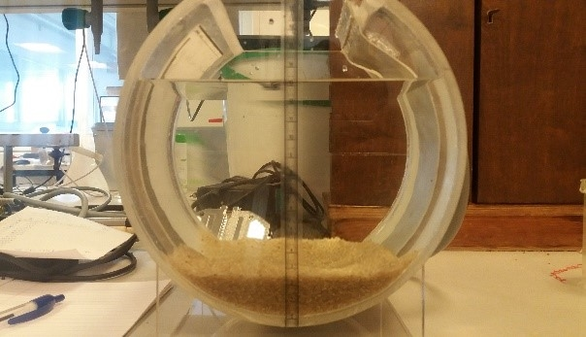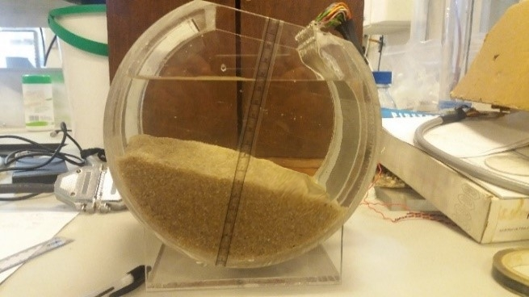
(a)
(b)
(c)
Figure 4.1 Test W2, S1, and SA1: (a) the fitting results of these three tests (blue line: COMSOL modelling results; red line: sensor’s measurement results); (b) the calculated depths demonstrated in the circle; (c) photograph of the setup in the experiment.
The error of the sensor can be influenced by the resolution of the sensor, namely the length of the stepwise increase of electrode length, which is 15 mm for this sensor. Thus, an error within the resolution of the sensor (±7.5 mm) may be considered acceptable i.e., the interface point on the circumference should be detected to the nearest electrode tip or better. Furthermore, as the sensor was installed within a circular pipe, this perimeter error translates to a smaller depth error near the crown and invert of the pipe (similar in principle to an inclined manometer). Hence, the acceptance range is the height difference between the two electrodes closest to the interface. Figure 4.2 shows a plot displaying the actual depth vs. the modelled and sensor-measured depth, and the red area is the acceptance range based on the sensor’s physical resolution. It was found that all the model results were within the sensor’s resolution area, and there were just four experimental results outside of the red area. The 1:1 reference line in the plot indicates the ideal response.
Figure 4.2 Model and sensor measured results with acceptance range.

Sensor’s resolution analysis
To gain a deeper understanding of the accuracy of the sensor, a circular pipe with a fully surrounding electrode array was modelled as shown in Figure 4.3 The model includes 40 electrodes with a 15 mm length difference between adjacent electrodes (the same resolution as used in the previous model and experiment). Figure 4.3 shows the actual depth versus the model calculated depth, and the red area represents the sensor’s resolution area. In the model, the level of water was increased from 5mm to 190 mm in 5 mm increments. Then the water was held at 190 mm and the level of sediment was increased from 5 to 190 mm in 5 mm increments. From the figure, most points are seen to be within the red acceptance area, with only 6 points outside the red area. The root-mean-square error of water depth and sediment depth are 2 mm and 3 mm, respectively. The error of water depth and sediment depth is 1.1% and 1.8% of the sensor’s measurement range, i.e., the diameter of the pipe. Meanwhile, the error of water depth and sediment is 13.4% and 22.5% of the electrode’s length difference, respectively. It was found that the root mean square error in sediment depth is higher than the error (1.37 mm) in water depth. This is because the electrical properties of sediment and water have a significantly smaller difference than that of air and water. This leads to the intersection being less pronounced, and thus, influences the classification of points by the multiple linear regression algorithm.
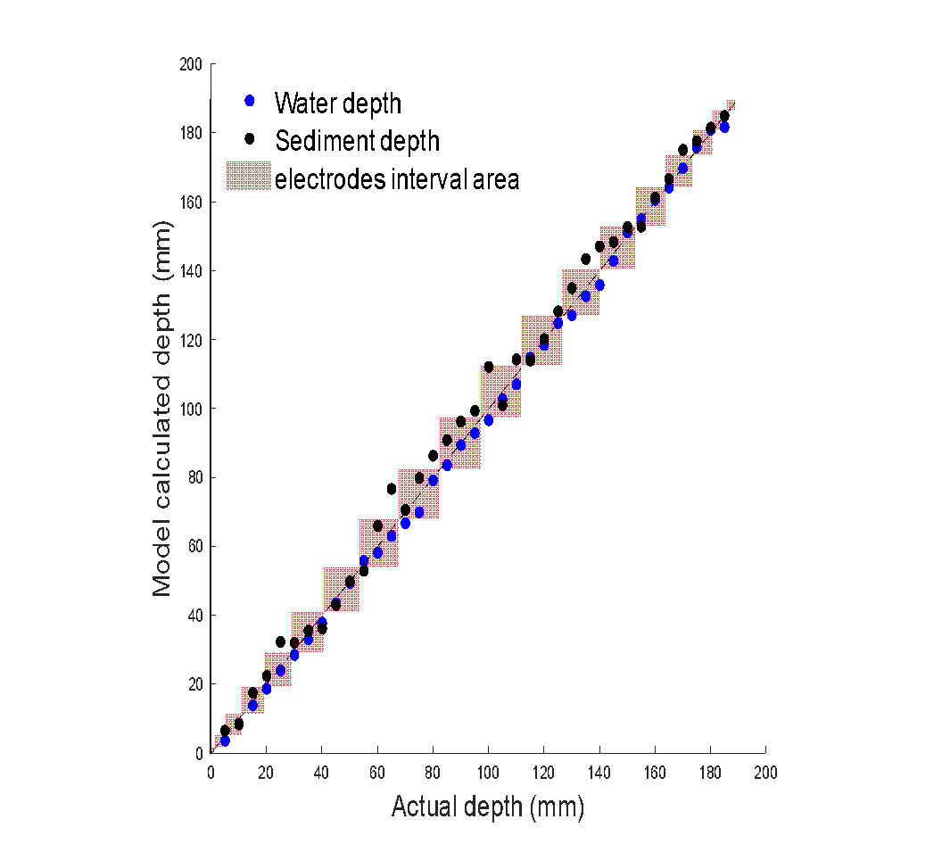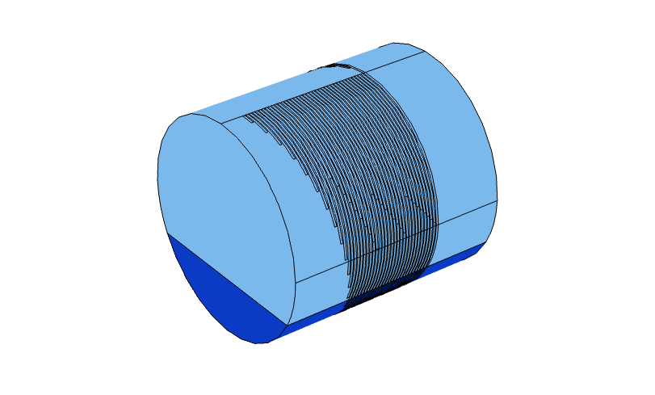
(a)
(b)
Figure 4.3(a) Electrodes fully surround 3D model; (b) Model results with acceptance range

Slope and electrical conductivity
According to the theoretical equations in 3.2.2, the electrical field crosses through the top surface of the electrode pairs, and thus the gradient of each segment referred to Figure 4.1 (a) is proportional to the electrical conductivity of the media. Table 4.3 summarises the mean gradients of each medium in the model and experiment, across all the scenarios describes in Table 3.1, and compares them with the measured conductivity values. It was found that the mean gradient of air is close to zero as expected, which is negligible. As for the model, the mean gradients for water and sediment are 17% and 15% larger than the meter measured water and sediment conductivities, respectively. The sensor measured mean gradients of water and sediment are 17% and 27% smaller than the EC meter measured water and sediment conductivities. As mentioned in section 3.2.2, due to the influence of the fringing electric field, the calculated conductivity is only expected to be proportional to the media conductivity. From the Table 4.3, the scaling factor has been calculated. The ratio of actual conductivity and model calculated conductivity in water and sediment are similar, which provides a good basis of the theoretical prediction. The ratio of actual conductivity and experiment calculated conductivity are slightly different for water and sediment, which can result from the non-uniform electrical properties of the media, especially for the saturated sand. From the piecewise plot in Figure 4.1, for media like water and saturated sediment, which have a difference in electrical conductivity, the sensor can demonstrate this difference in gradients. Hence, in addition to interface monitoring, this sensor can be put forward for monitoring changes in composition that affect conductivity, for example salinity of the medium, sediment compaction, or microbial activity.
Table 4.3 Model and sensor measured gradient. The actual conductivity is measured by electrical conductivity meter
 | Actual conductivity (µS/cm) | Model conductivity  (µS/cm) | Sensor measured conductivity  (µS/cm) | Actual: model | Actual: sensor measured
Air | 0 | 4 | 8 | - | -
Water | 280 | 330 | 230 | 1:1.18 | 1:0.82
Sediment | 130 | 150 | 95 | 1:1.15 | 1:0.73

Limitations
The sensor shows good performance in measuring the depth of two and three phases of media, but limitations must be considered for some specific practical scenarios. Figure 4.4 shows a scenario where the sediment is only partially immersed in the water; the remainder is above the water surface, which might be happened at pipe bends. In Figure 4.4 (c), the red line and black line represent the sensor measured interface and actual interface, respectively. It was found that the sensor can only detect three interface points: P1, P2, and P3 in Figure 4.4 (c). Because the electrical conductivity of non-immersed sediment was non-uniform (being drier further from the water), the interface between immersed sediment and non-immersed sediment was not clear, which caused the left point of the water surface to be difficult to detect. In addition, the demarcation point between sediment and air (P3) has a large error in this scenario, because the dry sediment had a similar conductivity to air. The water surface was assumed to be horizontal in Figure 4.4 (c), so that the one interface point for air-water is sufficient to draw the water level. Since the theory of the sensor is based on measuring the different conductivities of media, when two media have very similar conductivity or the media is heterogeneous, the sensor might not detect the interface accurately. Nonetheless, with intelligent interpretation of the data, useful information is still obtained; for example, water level, flow cross sectional area, and that there is emergent sediment, are all distinguishable characteristics.
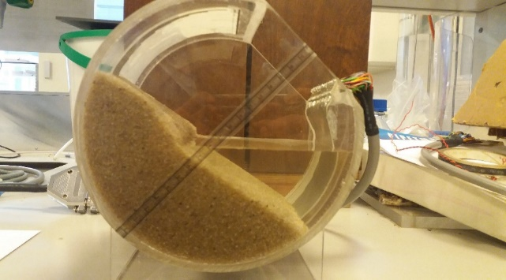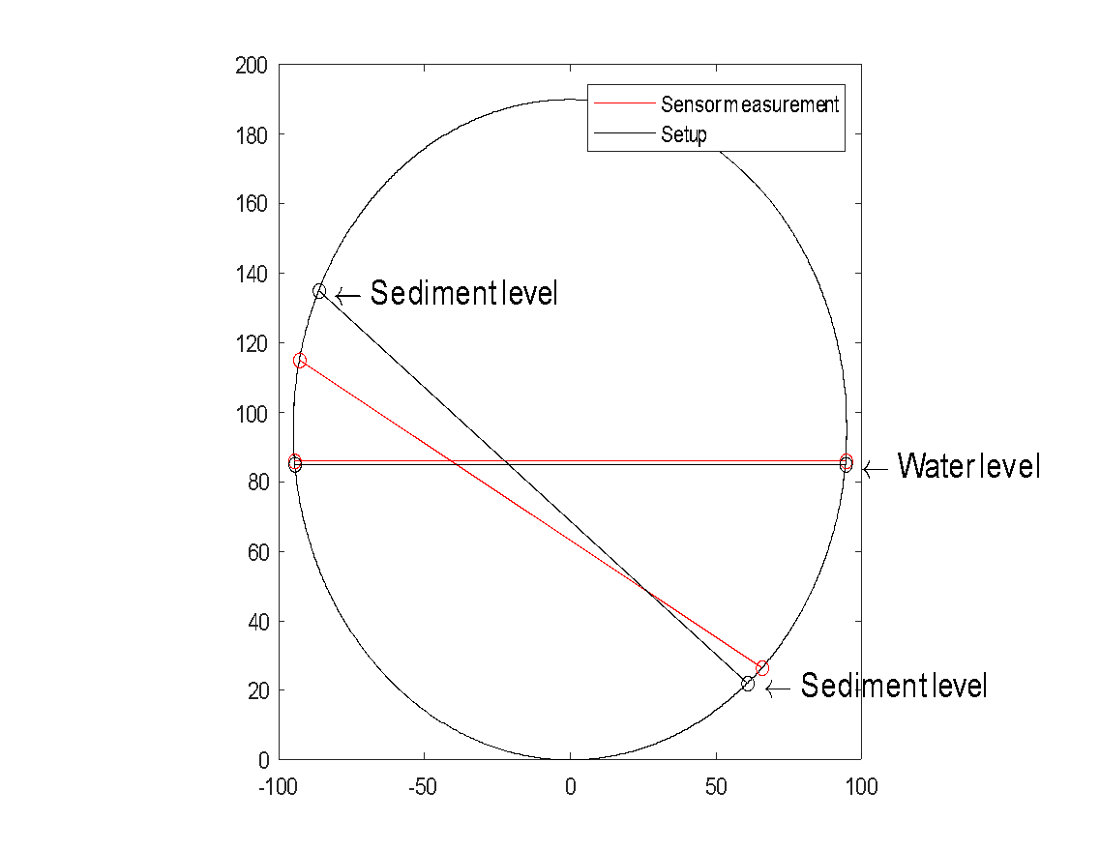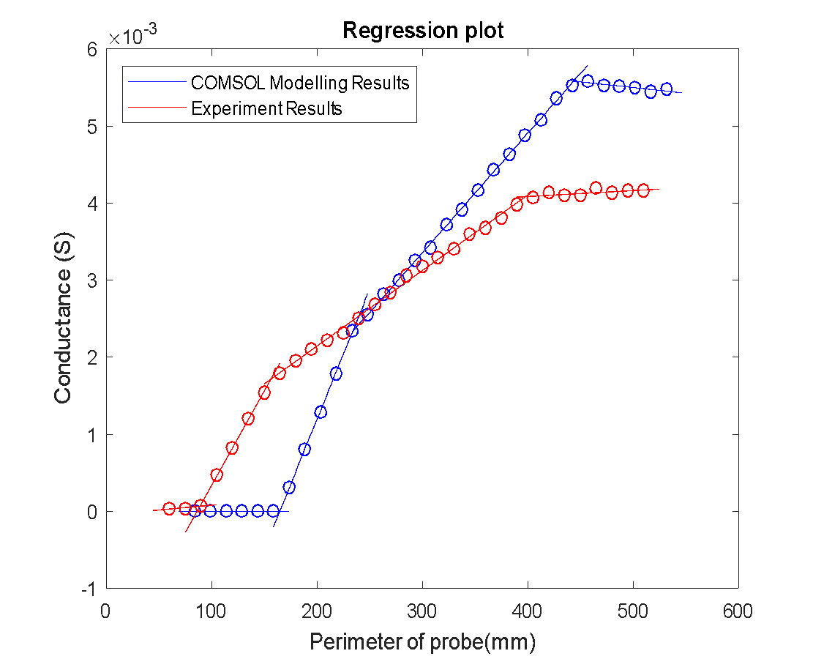
(a)
(b)

P1
P2
P3
(c)
Figure 4.4 Sensor-measured results of partially emergent sediment scenario: (a) experiment setup picture; (b) plot of sensor’s output conductance vs. probe length; (c) plot results of water and sediment surface.
In practical implementation under dynamic conditions, the levels of sediment and water may not be perfectly planar, as shown in Figure 4.5 (a). The non-uniform interfaces may lead to different interface levels at different positions across the electrode array; therefore, the measured conductance of each electrode pair could be bigger or smaller than what would be measured with flat interfaces, as shown in Figure 4.5 (b). This could influence the detection of interface heights; however, the linear regression process can help to eliminate some of this error. Furthermore, the PCB manufacturing technique can enable electrodes to be very thin and closely spaced, such that variability across the sensor is minimised. In addition, some interfaces (particularly the interface between air and water) may influence over time due to flow turbulence, which may affect the measurement results. In this study, the data collection from all electrodes can be completed within 0.04 s, meaning an effective sampling frequency of 25 Hz. This frequency could easily be increased for dynamic applications but, nonetheless, turbulent flow surfaces are known to be dominated by frequencies below 10 Hz (Gabreil et al., 2018; Horoshenkov et al., 2013, 2016; Nichols, 2015; Nichols et al., 2016; Nichols & Rubinato, 2016), so the temporal fluctuation can be accurately captured with the sensor in its current form. In the real application, the presence of organic matters in the sewer sediment cannot be ignored. Although the organic matters are non-conducting materiel, the chemical and biological reaction of organic matters can improve the capacity of water holding, nutrient, organic carbon and ions content in sediment, which can improve the electrical conductivity of sediment. The study utilized a sensor that detects the interface based on the difference in electrical conductance between water and sediment. Although the presence of organic matter can cause a slight increase in the electrical conductance of sediment, the difference in conductance between water and sediment remains greater. Therefore, the presence of organic matter is not expected to significantly impact the accuracy of the interface measurement.
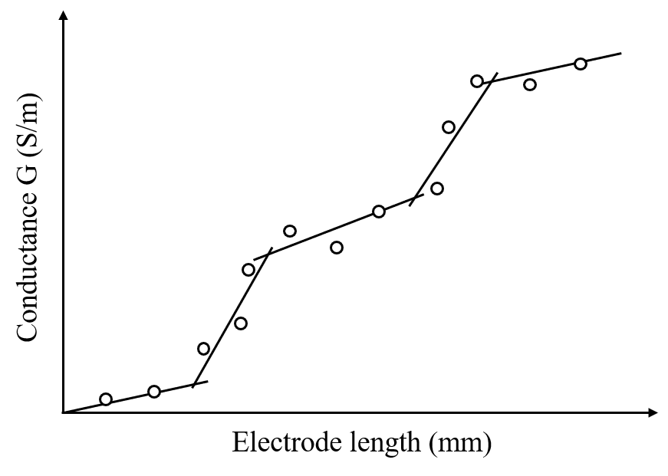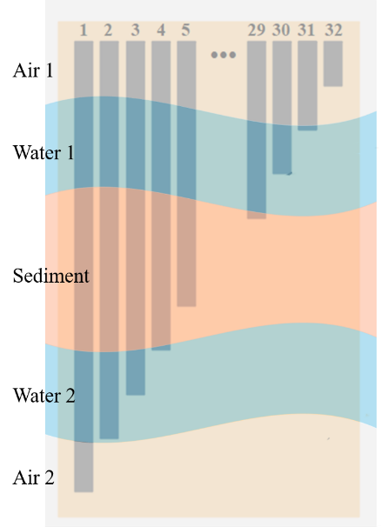
(a)
(b)
Figure 4.5(a) Five phase media along the sensor with non-planar interfaces; (b) Linear piecewise relationship between conductance and increasing length for non-planer interfaces scenario.
These limitations are relatively minor, especially given the simplicity of the sensor’s structure and application. The sensitivity of the sensor could be improved by optimising the design, for example, decreasing the electrode width, spacing and length difference. In addition, intelligent approaches such as machine learning could help to interpret ambiguous data objectively and autonomously.

Summary
In this study, a sensor based on conductance has been developed to simultaneously measure the depths of water and sediment in a circular pipe and provide instantaneous monitoring of the interface levels without any calibration process. A theoretical framework was developed and validated. A linear relationship between electrical conductance and electrode length has been observed, and the piecewise-linear relationship has been measured and modelled with multiphase media. Most of the results are within the maximum expected error based on the sensor’s resolution. The root-mean-square error of COMSOL modelling and sensor measured interface height is within 18% and 33% of the electrode length difference, which is also within 1.4% and 2.6% of sensor’s measurement range, respectively. Furthermore, the experimental and modelled results show that the slope of each sub-line, corresponding to different phases, is positively correlated with the electrical conductivity of the measured media and could be used to monitor changes in conductivity. The sensor is best suited to measuring multiphase flows with media that are homogeneous and have appreciably different conductivities. Some limitations have been identified, but these could be overcome by intelligent interpretation of the data, perhaps through a machine learning approach. Ultimately, this sensor provides a new opportunity for low-cost, minimally invasive, and minimally obstructive monitoring of multiphase flows in sewer pipes and other similar applications.

Electrical impedance spectroscopy (EIS) method for characterising hydraulic properties of single-sized glass beads

Introduction
The experiment reported in Chapter 4 validates the feasibility of the sediment conductance sensor to measure the heights of air, water, and sediment in sewer pipes. For a deep understanding of the properties of the sediment, this chapter will investigate the relationship between electrical conductance and hydraulic properties by using a four-electrode sensor based on EIS methods.
The purpose of this study is to explore the correlation between electrical and hydraulic properties. The experimental setup and procedures for measuring hydraulic properties and EIS has been firstly introduced in section 3.3. The hydraulic properties of 10 glass beads with varying sizes were tested, and the Kozeny-Carman model was employed to verify the results as outlined in section 5.2.
In section 5.3, the analysis of the Bode plot, Nyquist plot, equivalent electrical circuit and fitting process of impedance spectra are demonstrated. Subsequently, the outcomes of the EIS test were analysed, and an appropriate equivalent circuit was selected for further examination.
The relationship between electrical conductance, glass bead sizes, and hydraulic permeability is derived in section 5.4. The interface conductance was chosen as the parameter for studying the relationship between electrical and hydraulic properties by comparing the trends in glass bead size and four electrical elements. Furthermore, a model that relates hydraulic permeability to the formation factor was derived by introducing it as an additional parameter.
The impact of temperature and electrode spacing distance on the measurement of electrical conductance is discussed in sections 5.5 and 5.6, respectively. These findings provide a foundation for future research on the correlation between electrical and hydraulic properties.

Hydraulic Properties Results
Table 5.1 Measured hydraulic properties summary
Glass beads diameter  (mm) | Hydraulic permeability  (mm²) | Permeability Standard deviation  (mm²) | Porosity  (%) | Porosity standard deviation  (%)
5.0 | 1.48×10⁻² | 8.64×10⁻⁴ | 38.22 | 0.63
4.5 | 1.10×10⁻² | 7.75×10⁻⁴ | 38.18 | 1.10
4.0 | 7.06×10⁻³ | 5.14×10⁻⁴ | 38.27 | 0.69
3.5 | 5.53×10⁻³ | 6.73×10⁻⁴ | 37.35 | 1.14
3.0 | 4.45×10⁻³ | 3.54×10⁻⁴ | 37.62 | 0.45
2.5 | 4.10×10⁻³ | 3.60×10⁻⁴ | 37.71 | 0.66
2.0 | 3.39×10⁻³ | 1.42×10⁻⁴ | 37.65 | 0.59
1.5 | 1.72×10⁻³ | 1.18×10⁻⁴ | 37.53 | 1.56
1.0 | 1.15×10⁻³ | 3.62×10⁻⁵ | 37.21 | 0.78
0.5 | 3.19×10⁻⁴ | 2.01×10⁻⁵ | 36.43 | 0.53

The mean measured hydraulic permeability and porosity of each glass bead size have been listed with standard deviation uncertainty in Table 5.1. The hydraulic permeability is calculated by Darcy’s law, which shows an increase as the glass beads' diameter increases. As for the porosity, the measurement results are within the range of 36% to 39%, which agrees with the range of random sphere packing porosity (36%-44%) (Rose, 1993). Theoretically, for a sphere diameter larger than 100µm, the porosity of random packing of single-sized spheres should be independent of the sphere diameter (Glover, 2000). However, in this test, the porosity demonstrates a slight decrease as the diameter of glass beads decreases. It is possible that the variation is caused by the manufacture tolerance of the glass spheres and various arrangements of glass beads due to random packing. The range for 1.0mm and 0.5mm glass beads is 1.0-1.3mm and 0.43-0.57mm respectively, and for all other sizes, there is a ±0.1mm tolerance in diameter. In addition, As the glass sphere gets smaller, manufacturing errors lead to a reduction in sphericity. The different size mixture and deformation from a spherical shape will cause glass beads to fill each other’s pore space and lead to a porosity decrease (Dias et al., 2004).
After collecting all hydraulic parameters, it is necessary to confirm that the relationship between glass beads sizes and measured porosity and hydraulic permeability is valid. The Kozeny-Carman equation is a well-known model to relate the permeability to grain size and porosity, which can help to check the validity of measured hydraulic properties. For granular porous media with a uniform sphere, the Kozeny-Carman equation can be written as follows:
Hydraulic permeability: $k=\frac{d^{2}ϕ^{3}}{180(1-ϕ)^{2}}$ Eq. 5-1
Where $k$ is the hydraulic permeability, $d$ is sphere diameter and $ϕ$ is porosity.
Figure 5.1 Comparison between the measured hydraulic permeability and Kozeny-Carman model

Figure 5.1 demonstrates the comparison between the measured hydraulic permeability and the Kozeny-Carman model calculated permeability. It can be seen that the measured permeability for larger glass beads shows a lower value compared with the Kozeny-Carman model. The fitting process was carried out in OriginPro 2021 software, which is based on the power allometric equation with Levenberg–Marquardt literation algorithm. The fitting result shows a power law relationship with a 1.51 exponent, which is less than the exponent in the Kozeny-Carman model. Several factors may result in a biased permeability by using constant head facilities, which have been compiled by previous research. For the facility used in this study, because the outlet tube is directly connected to the porous sample from the bottom centre of the cylinder container and has a diameter of about one-fifth of the cylinder container diameter, it may only a fraction of the water connection path contributes to the final medium’s permeability (Koch et al., 2012; Revil & Cathles, 1999). In addition, highly permeable materials with a high flow rate may result in a non-laminar flow between pores and in the outlet tube i.e., turbulent flow, which allows water's internal frictional forces or interfacial drag force to dissipate energy and increase the resistance of tube walls (Nijp et al., 2017).

Electrical Conductance (Parameters) Results

Bode plot
The Bode plots, including magnitude and phase plots as shown in APPENDIX C, which shows the evolution of total impedance corresponding to the glass beads' diameter range from 5.0mm to 0.5mm with different flow rates (static test, 1L/min, 0.6L/min and 0.2L/min) and electrode spacing (electrode no. 1&2 (2mm), no. 1&3 (6mm), no.1&4 (10mm)). All curves of glass bead tests exhibited a similar shape and trend: the total impedance value decreased with the frequency increasing, a reasonably flat region within the frequency range of 10 kHz to 20 kHz and finally all the curves fall. The impedance curves demonstrate a slight decrease in the low-frequency area, which is likely because of the reducing impedance of contact resistance of the electrode (Raheem et al., 2017; Umezawa et al., 2021).
An example presented in Figure 5.2 compared the effects of glass bead size, electrode spacing distance, and flow rate on impedance changes. The results showed that increasing the diameter of the glass beads led to a decrease in total impedance, while increasing the electrode spacing distance resulted in an increase in total impedance. However, changes in flow rate did not have a significant effect on impedance change. Although the Bode plot provided insight into impedance changes with frequency and the impact of the three factors, it was challenging to extract specific resistance or capacitance values.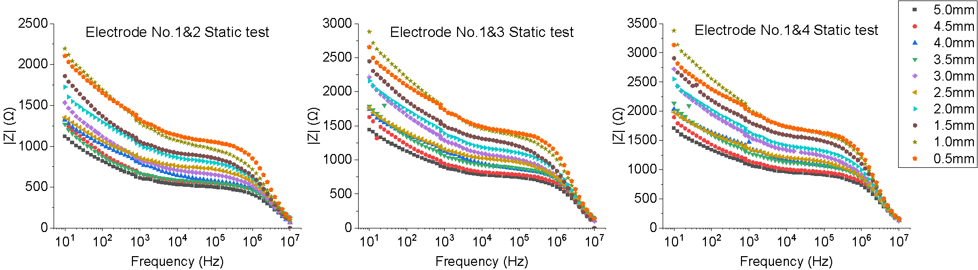
Glass beads diameter decrease
Figure 5.2 Bode plot for EIS test with different glass beads diameters, flow rates and electrode pairs

Nyquist plot
A Nyquist plot is the most common way to represent the EIS spectra, which plots a sample’s real impedance on the x-axis, the negative imaginary part on the y-axis, with the frequency decreasing from left to right on the curve. Averaged Nyquist plots of EIS measurement for each size of glass bead at different flow rates are shown in Figure 5.2 and Figure 5.3 with different electrode spacing. Each Nyquist plot compares the results measured with different flow rates, including the static test (0 L/min) and flow rates of 1 L/min, 0.6 L/min and 0.2 L/min. The shape of the Nyquist plot does not change significantly at these three flow rates. In this system, water, as the only conductor, dominated the impedance spectra measurement. Because the mobility of ions in water is about the speed of light, which is much larger than the flow rate, meanwhile, no other electrolytes were coming into the recirculating system, and the electrical properties of water were stable during the test. However, a slight variation in shape the Nyquist plot is still demonstrated between different flow rates, for example, the shapes of semi-circle in the Nyquist plots for glass beads diameter 4.5 mm. This could be due to the glass beads near the electrodes packing differently, which is tested again in the reproducibility tests below. It is also possible that, as the experiment progressed, the electrode surfaces became less smooth and therefore introduced a dispersion effect into the impedance spectra. In realistic sewer pipe applications, different sewer pipe dimensions can have different minimum flow rate design standards, which will not significantly influence the physical basis of the sensor as the electrical conductivity is independent of the flow rate.
In addition, a comparison of the Nyquist plots obtained at varying electrode spacing distances indicates that the width of the semicircle at high frequency expands with an increase in electrode spacing distance. The impact of electrode spacing distance will be explored in section 5.6.
Figure 5.4 compares the change of the Nyquist plot with the size of glass beads. In this experiment, three repeatability experiments and three reproducibility experiments were performed for the EIS test. The averaged Nyquist plot means plotting the averaged impedance real parts and imaginary parts of all repeats and reproduced tests at each frequency. From the figures, all tests demonstrate similar behaviour on the Nyquist plot, which is approximated by a straight line at an angle varying between 10° to 15° in the low-frequency range and a semicircle in the high-frequency range. In general, the semicircle correlates to the charge transfer and the straight line represents the diffusion area due to the charge accumulation at the electrode surface as introduced in section 2.5.2.2 (Mortadi et al., 2020). The increase in high frequency semicircle diameter is observed to correspond with a decrease in glass bead size, as depicted in Figure 5.5.
Each experiment's three repeatability and three reproducibility tests were averaged, and the standard deviations are listed in Table 5.2. In addition, measurements with long electrode spacing distances exhibited comparably high errors. This is because, in this experiment, the planer electrode pairs created the fringing electric field and penetrated through the samples. The penetration depth rises as the electrode spacing distance increases, while the field strength falls (Afsarimanesh et al., 2019). At the weak field strength area, the measurement noise can have a negligible impact, which was discussed in section 5.6. However, the maximum coefficient of variation of all tests is 5%, which is the percentage ratio of the standard deviation to the mean value, indicating that the experiment showed good reproducibility.
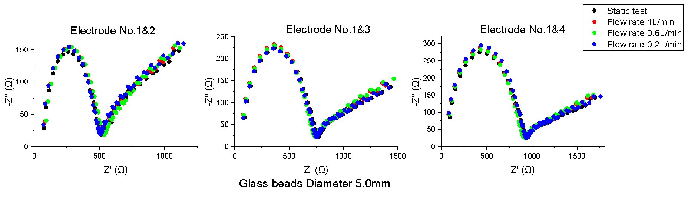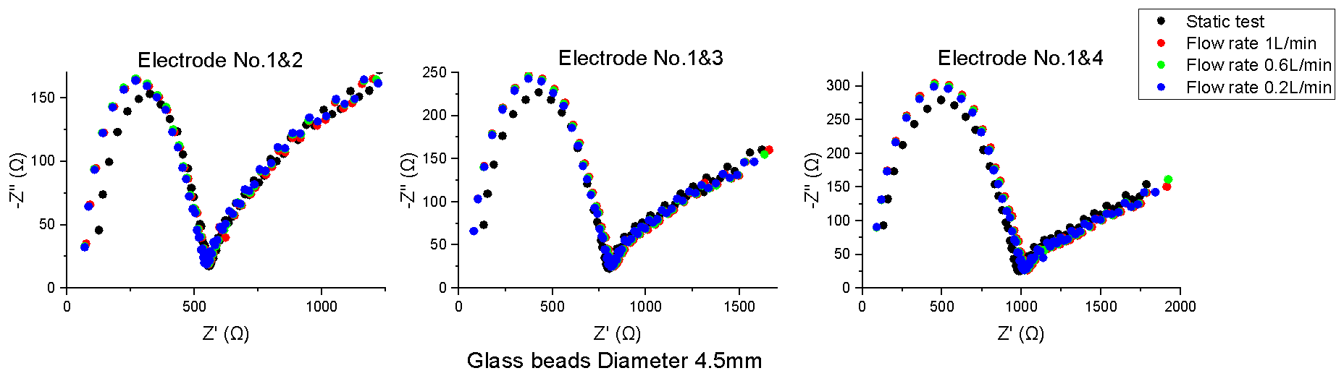
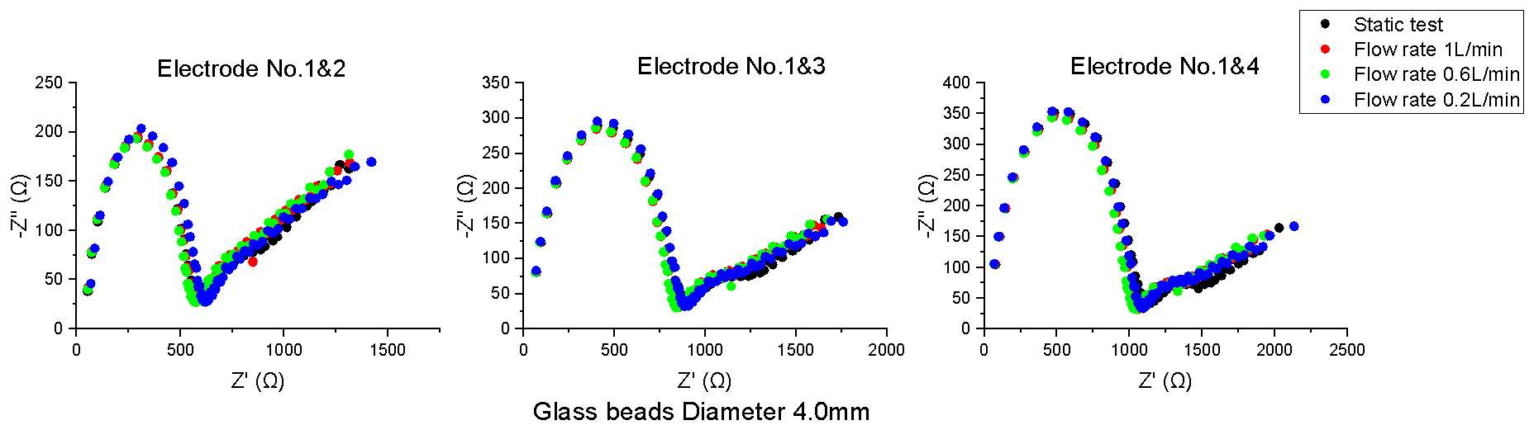
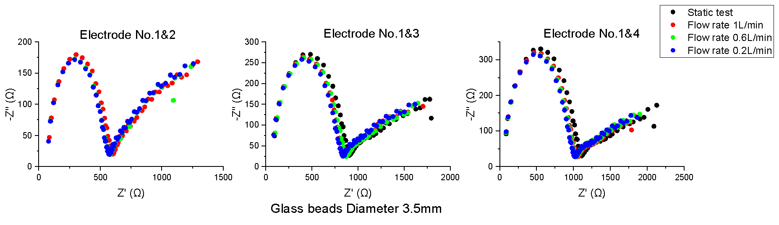
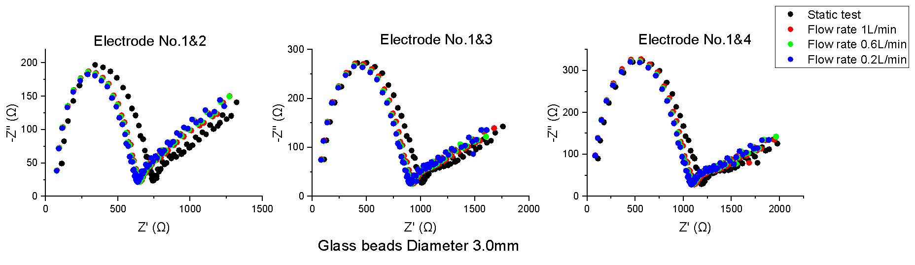
Figure 5.3 Nyquist plot for glass beads diameters from 3.0 mm to 5.0 mm, flow rates and electrode pairs
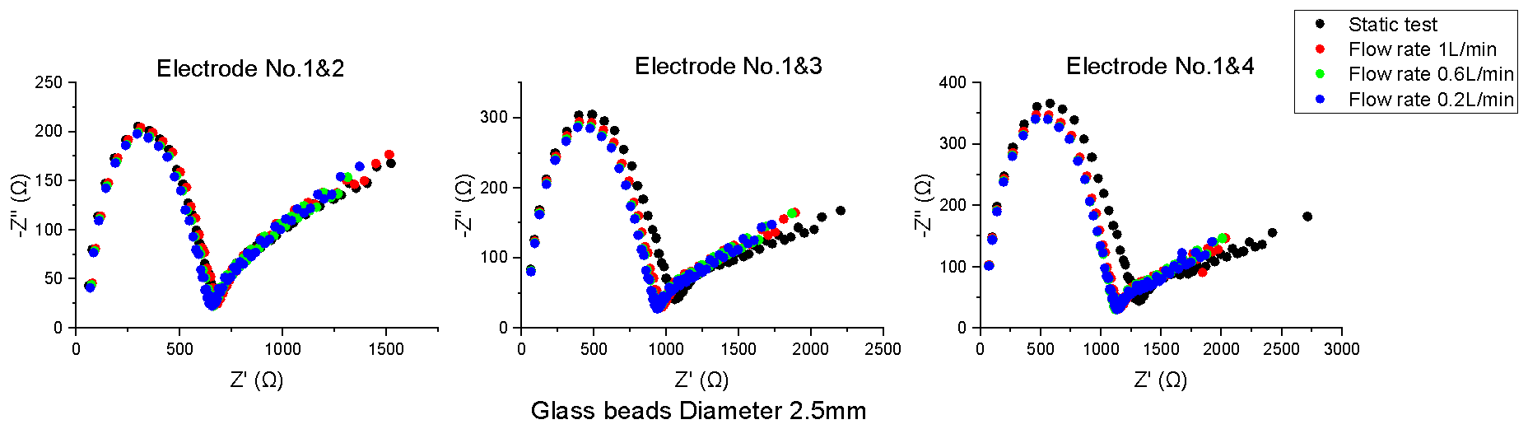
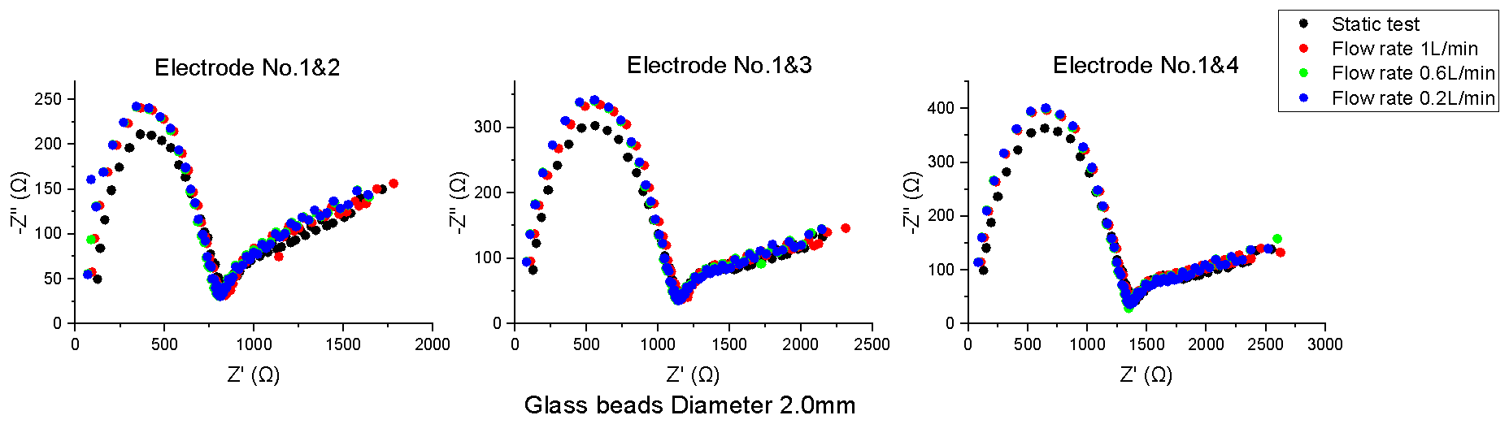
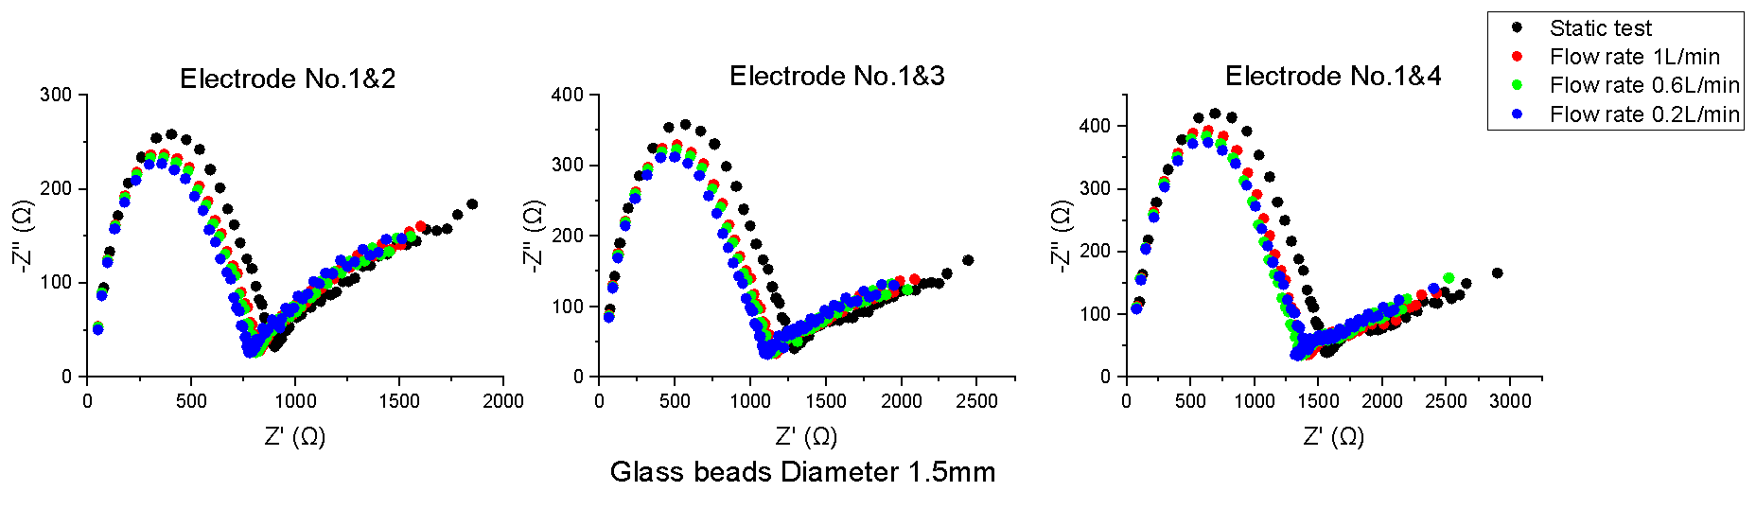
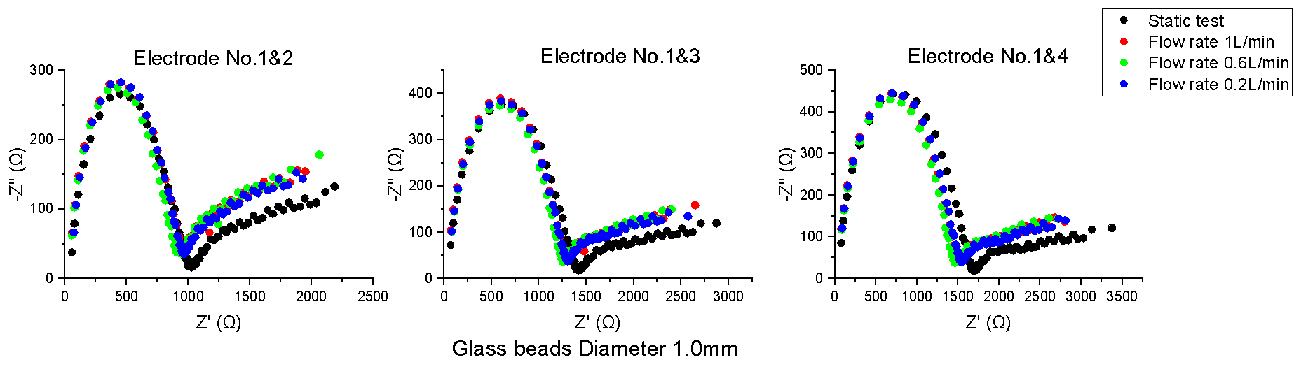
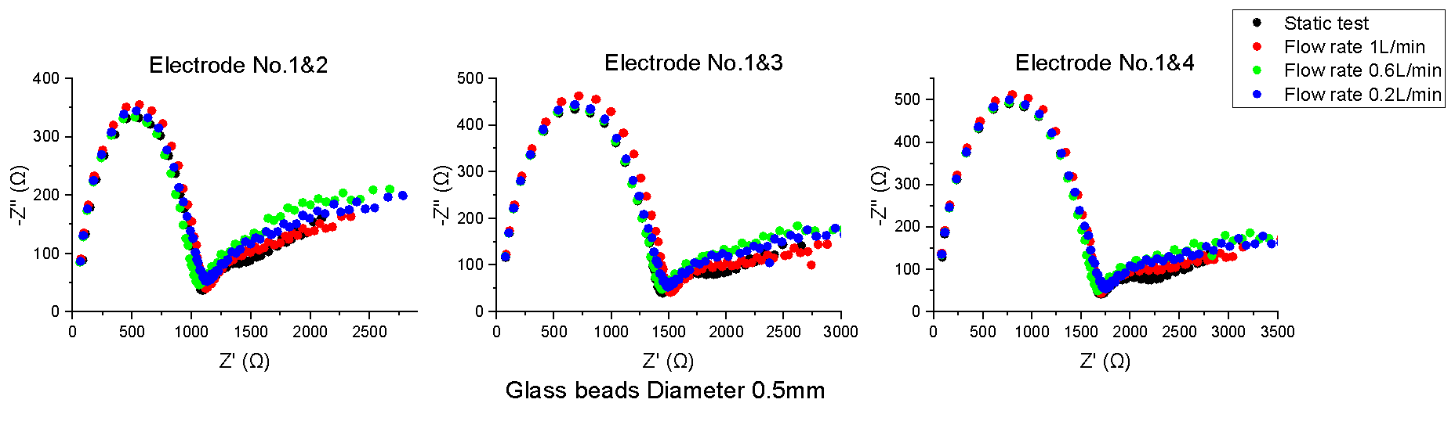
Figure 5.4 Nyquist plot for glass beads diameters from 0.5 mm to 2.5 mm, flow rates and electrode pairs
Figure 5.5 Nyquist plot comparison between ten sizes glass beads, measured with electrode No.1&2
Table 5.2 Standard deviation for repeated and reproduced tests
Glass beads diameter | Repeatability test
Glass beads diameter | Electrode No.1&2 |  | Electrode No.1&3 |  | Electrode No.1&4
Glass beads diameter | Real | Imag | Real | Imag | Real | Imag
5.0mm | 5.05% | 6.70% | 1.74% | 3.44% | 3.03% | 4.95%
4.5mm | 4.79% | 7.40% | 3.74% | 6.50% | 3.56% | 6.01%
4.0mm | 5.41% | 6.50% | 3.74% | 5.30% | 3.82% | 5.92%
3.5mm | 0.93% | 1.94% | 3.20% | 5.02% | 3.61% | 6.43%
3.0mm | 6.28% | 11.03% | 7.59% | 13.39% | 8.06% | 12.93%
2.5mm | 7.09% | 5.32% | 6.76% | 5.86% | 5.23% | 5.48%
2.0mm | 4.68% | 8.72% | 4.72% | 6.33% | 3.19% | 5.58%
1.5mm | 10.27% | 11.05% | 10.28% | 11.44% | 8.93% | 8.35%
1.0mm | 3.34% | 5.65% | 4.25% | 5.77% | 4.64% | 5.52%
0.5mm | 8.02% | 15.46% | 7.51% | 15.35% | 6.73% | 14.78%
Glass beads diameter | Reproducibility test
Glass beads diameter | Electrode No.1&2 |  | Electrode No.1&3 |  | Electrode No.1&4
Glass beads diameter | Real | Imag | Real | Imag | Real | Imag
5.0mm | 4.38% | 7.13% | 5.05% | 7.35% | 4.62% | 10.57%
4.5mm | 9.86% | 8.20% | 7.11% | 7.06% | 7.51% | 13.76%
4.0mm | 4.47% | 5.72% | 3.12% | 7.49% | 3.41% | 11.46%
3.5mm | 7.11% | 11.59% | 8.49% | 7.56% | 6.11% | 12.73%
3.0mm | 5.50% | 8.56% | 5.39% | 7.23% | 7.17% | 17.53%
2.5mm | 12.52% | 6.25% | 7.42% | 6.90% | 6.61% | 10.46%
2.0mm | 5.12% | 7.63% | 5.36% | 7.20% | 4.49% | 10.35%
1.5mm | 8.60% | 10.51% | 8.24% | 6.76% | 8.69% | 14.47%
1.0mm | 8.91% | 11.08% | 8.91% | 7.55% | 9.24% | 10.18%
0.5mm | 5.34% | 11.34% | 5.84% | 7.08% | 5.12% | 16.64%

Equivalent Electrical Circuit Models
To interpret the EIS data, fitting an equivalent electrical circuit model is an appropriate way to understand the data. Since different circuit elements, such as resistors, capacitors, inductors, and constant phase elements (CPE), have different relations to the real and imaginary parts of impedance, the data can be represented as a combination of these circuit elements in series and parallel, and the electrical information of the system can be modelled. However, it is possible to fit impedance spectra data to multiple different equivalent electrical circuits, which requires researchers to choose the most appropriate circuit according to the electrical mechanism of the material being studied.
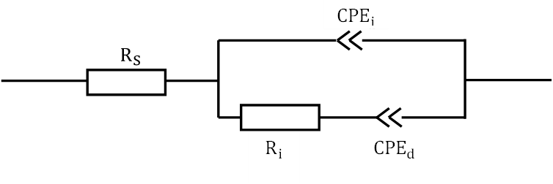
Figure 5.6 Modified Randles equivalent electrical circuit
The saturated glass beads system has similar characteristics to other porous media such as sand, rocks, concrete and soil with electrolytes in the pores. As reviewed in section 2.4, several researchers have proposed a number of equivalent electrical circuit models to simulate these porous systems. Song (2000) has proposed a theoretical equivalent model to describe the dielectric porous system regarding the microstructure. The total impedance can be described as a parallel combination of three types of pathways: (1) continuous conductive paths formed entirely by pore connections; (2) discontinuous conductive paths with the pore channels occluded by glass beads; (3) “insulator” conductive paths that are wholly connected by glass beads. Due to the limitations of frequency range (from 10 Hz to 10 MHz) and accuracy of measurement equipment, a modified Randles equivalent electrical circuit was proposed to fit measured impedance spectra data as shown in Figure 5.5, which consisted of a solution resistance ($R_{s}$) in series with a parallel interface constant phase element ($Q_{i}$) and resistance ($R_{i}$), and a diffusion constant phase element ($Q_{d}$) series to $R_{i}$. The following equation shows the circuit's overall impedance:
Total impedance: $Z_{total}=R_{s}+\frac{1}{\frac{1}{R_{i}+Q_{d}}+\frac{1}{Q_{i}}}=R_{s}+\frac{\left(R_{i}+\frac{1}{Q_{d}{\left(jω\right)}^{n_{d}}}\right)\frac{1}{{Q_{i}\left(jω\right)}^{n_{i}}}}{R_{i}+\frac{1}{Q_{d}{\left(jω\right)}^{n_{d}}}+\frac{1}{{Q_{i}\left(jω\right)}^{n_{i}}}}$ Eq. 5-2
$R_{s}$ represents an active electrolyte resistance, which is the total resistance of water-filled pores in both continuous and discontinuous paths near the electrode pairs. Paralleled $Q_{i}$ and $R_{i}$ demonstrate the double layer capacitor and resistor formed on the solid-liquid-solid interface and charge transfer resistance in the pores and pore paths within the sample. $Q_{i}$ replaced capacitor to compensate for dissociation of ions at the solid-liquid interface and the dispersion influence due to non-uniform surfaces (Sindhuja et al., 2016). In actual measurements, the “diffusion effect” and “dispersion effect” as mentioned in section 2.5.2.2 cannot be neglected and are also reflected in the Nyquist plot, i.e. infinite linear part in the low-frequency region and the centre of the semi-circle below the impedance real part axis as shown in Figure 5.6 the Nyquist plot of CPE parallel to a resistor, the semi-circle is rotated (1-n)·90° clockwise and the centre of the semi-circle lies below the impedance real part axis (Z’ axis). Therefore, ion transport or diffusion phenomena near the electrodes are appreciable in the low-frequency range which can be modelled as $Q_{d}$ series to $R_{i}$ (Kadan-Jamal et al., 2020; Sekar & Ramasamy, 2013).
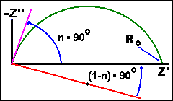
Figure 5.7 the Nyquist plot of CPE parallel to a resistor, the semi-circle is rotated (1-n)·90° clockwise and the centre of the semi-circle lies below the impedance real part axis (Z’ axis)
The fitted Randles circuit parameters are very useful in the field of EIS as they provide valuable information about the test media. Figure 5.7 shows the results of fitting the impedance spectra data with the modified model using the Zsimpwin software. The evaluated electrical parameters of each electrical circuit model are summarised in Table 5.3.
Figure 5.8 Equivalent circuit fitting results for electrode pair No.1&2
Table 5.3 Electrical element value summary of Modified Randle circuit
Glass beads diameter  (mm) | $R_{S}$ (Ω) | $Q_{i}$  $$\left(S∙\sec^{n}\right)$$ | $$n_{i}$$ | $R_{i}$ (Ω) | $$Q_{d}$$ | $$n_{d}$$
5.0mm | 55.32 | 1.10E-09 | 0.88 | 235 | 0.000859 | 0.13
4.5mm | 57.29 | 1.17E-09 | 0.88 | 239.2 | 0.000785 | 0.13
4.0mm | 40.49 | 1.25E-09 | 0.84 | 264 | 0.000789 | 0.11
3.5mm | 49.41 | 1.15E-09 | 0.84 | 303.8 | 0.000796 | 0.11
3.0mm | 47.11 | 1.30E-09 | 0.84 | 310.5 | 0.000788 | 0.11
2.5mm | 46.75 | 1.20E-09 | 0.83 | 335.2 | 0.000736 | 0.1
2.0mm | 47.49 | 1.15E-09 | 0.82 | 360.8 | 0.000799 | 0.09
1.5mm | 49.05 | 2.32E-09 | 0.8 | 387.6 | 5.84E-04 | 0.1
1.0mm | 40.02 | 2.69E-09 | 0.8 | 420.9 | 0.000505 | 0.1
0.5mm | 40.34 | 2.09E-09 | 0.83 | 439.6 | 0.00051 | 0.095

Electrical-Hydraulic relationship
This section will focus on the analysis of the relationship between glass beads size, hydraulic permeability and electrical properties. Because the porosity of glass beads does not vary significantly with sphere size, it will not be discussed in this chapter.
In section 5.3.3, the Randle circuit was used to fit the Nyquist plot and four electrical parameters have been derived. These parameters were then compared with the size of glass beads, and the parameter that showed the most significant changes was chosen in section 5.4.1. Section 5.4.2 involves comparing the chosen electrical parameter with hydraulic permeability by introducing the formation factor (F).
As reviewed in section 2.5.2.3, the electrical-hydraulic relationship in this study is best described using the equivalent circuit consisted of resistors and CPEs. Electrical conductivity is a parameter commonly used in electro-hydraulic models. However, from equation 3-1 the conductivity ($σ$) can be calculated from the conductance ($G$), cross-section area ($A$) and the length ($L$) of the conductor. In contrast to other electrical conductivity studies, it is difficult to measure the exact cross-section area of the sample as the cross-section area should be perpendicular to the electric field lines, for the fringing electric field in this study, this cross-section area is hard to be measured or calculated. Therefore, conductance analysis is carried out for the following sections rather than electrical conductivity. The electrical conductance of a saturated volume of glass beads is the reciprocal of resistance and can be calculated from:
Electrical conductivity: $σ=\frac{GL}{A}$ Eq. 5-3
Electrical conductance: $G=\frac{1}{R_{i}}$ Eq. 5-4
Since CPEs are the equivalent circuit model component to represent an imperfect capacitor for model fitting, which is difficult to translate to capacitance value in this circuit model, then only a simple comparison between CPE value (Q) and glass beads size will be presented in the following section.

The relationship between electrical conductance and glass beads diameters
The relationships between the four electrical parameters and the glass beads' diameters are shown in Figure 5.8. According to the figures, the linear fitting result between solution conductance and glass bead diameter (Figure 5.8 (a)) is not as good as the fitting results of interface conductance and glass bead diameter. With the glass beads’ diameter increase, the solution conductance deceases. The solution conductance was considered as the conductance of pores filled with solution near the electrode pairs. This trend can be caused by the fact that smaller glass beads will produce more continuous pore paths near the electrode pairs area, which can be considered as a series of parallel resistors and lead to a smaller total solution resistance, i.e., larger solution conductance. However, larger glass beads can produce larger pores and larger solution conductance, which counteracted the overall decrease in solution conductance to some extent and therefore the linear fitting results was not ideal, with smaller coefficient of determination (R²=0.42).
As the diameter of the glass beads increases, the value of interface conductance (Figure 5.8 (b)) rises linearly, which corresponds to the change in width of the first semicircle in the Nyquist diagram. Different to the solution conductance, the interface conductance was dominated by the pores and pore paths within the samples rather than limited to the electrode pair area, which means that larger glass beads contain larger pores and shorter and wider pore paths lead to larger conductance, thus, the positive linear relationship between interface conductance and glass beads diameter is significant. However, there are some outlier points shown on the Figure 5.8 (b) such as the data for 3.5 mm glass beads diameter, which can be caused by the random packing. Even though the glass beads have a regular shape and were packed with same way, the pores and pore paths were randomly distributed in samples, which lead to the deviation.
As for the $Q_{i}$ and $Q_{d}$, which are the double layer impedance formed on solid-liquid-solid interface, and diffusion impedance, the thickness of the produced double-layer capacitor and diffusion layer should decrease as the diameter of the glass beads decreases. The equations of the capacitance of diffusion element impedance are shown below:
Capacitance:$C=ε_{0}\frac{A}{d}$ Eq. 5-5
Diffusion element impedance: $Z=\frac{1}{Y_{o}}\tanh\left(\frac{δ}{\sqrt{D}}\sqrt{jω}\right)$ Eq. 5-6
where $ε_{0}$ is the electric constant, A is the area of double layer plates overlap, d is the separation distance of two plates, $Y_{o}$ is the admittance, $δ$ is the thickness of the diffusion layer, $D$ is the diffusion coefficient, j is the imaginary unit and $ω$ is the angular frequency. These two equations predict that as the diameter of the glass beads increases, the $Q_{i}$ should drop and $Q_{d}$ should grow. These trends are also seen in Figure 5.8 (c) and (d). However, the R² value for $Q_{i}$ and $Q_{d}$ are 0.62 and 0.75 repspectively, which are lower than the R² for interface conductance and glass beads diameter fitting result. According to Figure 5.8 (c), $Q_{i}$ for glass beads with a diameter of less than 2.0 mm is higher than the $Q_{i}$ value for glass beads with a diameter of more than 2.0 mm, which may be related to the electrode spacing distance. Because electrode no. 1 and electrode no. 2 are spaced apart by 2 mm, distributions of glass beads larger than 2.0 mm may not have been consistent along the electrode pair. However, because the CPE is the equivalent circuit component to represent an imperfect capacitor for model fitting, the value of the CPE is not the same as capacitance. It is also challenging to convert to a capacitance value in this electrical circuit as discussed in section 2.5.2.2.
According to these four fitting figures (Figure 5.8 (a), (b), (c), and (d)), the electrical parameter that is most appropriate for the following investigation about the electrical-hydraulic relationships is the interface conductance, which is the main factor influencing the width change to the Nyquist plot semicircle and also has the best linear fitting to glass bead diameters.

Figure 5.9 Linear relationships fitting between glass beads diameter and (a) solution conductance; (b) interface conductance; (c) interface CPE; and (d) diffusion CPE.

The relationship between electrical conductance and hydraulic permeability
In this study, one-sized glass beads provide a clean system: the porosity is similar, the grain size can be specified, and the regular spherical shape of glass beads controls the geometric influence. The diameter of the glass beads significantly affects the hydraulic permeability. The power-law relationship between permeability and electrical conductance is compatible with the empirical model summarised in the section 2.4 as seen in Figure 5.9. The fitted exponent value is 3.42, which is comparable to empirical models for a saturated clay-free environment with an exponent range of 1 to 5 (Walsh & Brace, 1984; Wong et al., 1984). The value of $R^{2}$ is 0.94 and the calculated mean squared error (MSE) is of hydraulic permeability is $2.3×{10}^{4}$, which provides an estimate of the error associated with the power law equation. The potential sources of error in the relationship between conductance and permeability could be due to the sample size and measurement error of electrical conductance and hydraulic permeability. The test conducted in this study consisted of only 10 data points. Increasing the sample size may reduce the impact of outliers and enhance the accuracy of the power law equation. In section 5.2, it was explained that the use of constant head facility and highly permeable test material may introduce measurement errors to the hydraulic permeability measurements. EIS measurements can also be affected by measurement error arising from external electronic equipment and electrical interference, which can lead to fluctuations in the measured impedance values and, consequently, affect the fitted electrical conductance.
Figure 5.10 Power law relationship between interface conductance and hydraulic permeability
Another way to investigate these data is to introduce the formation factor, which is the ratio of a sample’s total electrical conductivity to its fluid conductivity as given in Eq. 5-7. Eq. 5-8. This uses Archie's Law, and can also be used to describe the link between formation factor and porosity. In this equation, m is called the cementation factor, which is usually equal to 1.5 for spherical grains (Revil, 2002; Sen & Cohen, 1981), and $a$ is a constant correlated to the tortuosity factor and saturation.
Formation factor:$F=\frac{σ_{w}}{σ_{t}}=\frac{G_{w}}{G_{t}}$ Eq. 5-7
Archie’s Law: $F=aϕ^{-m}$ Eq. 5-8
Since it took the conductivity of the electrolyte into account, the formation factor is typically discovered in studies of the relationship between electrical conductivity and hydraulic properties. Since conductance is inversely related to conductivity in this study and cross section area is difficult to measure, conductance was substituted for conductivity in the Eq. 5-7. As illustrated in Figure 5.10, the fluid electrical conductance was also assessed using the EIS approach and obtained from the Nyquist plot and a modified Randles circuit. The electrical conductivity of the fitting is 0.0054 S. The following relationship between hydraulic permeability, formation factor, and grain size may be determined by combining Archie's Law and Kozeny-Carman equations:
$k=α\frac{d^{1.51}F^{3m}}{180(1-F^{m})^{2}}$ Eq. 5-9
The linear fitting result presented in Figure 5.1 is used to replace the exponent of d as 1.51. α is a constant that correlates to Archie's law's tortuosity factor. From the measured hydraulic permeability, the value of α can be calculated as 0.013, the equation may be rewritten as follows:
$k=\frac{d^{1.51}F^{3m}}{3.76×{10}^{-7}(1-F^{m})^{2}}$ Eq. 5-10
Figure 5.11 also demonstrates the comparison between the measured permeability and calculated permeability. In realistic applications, this sensor can be applied to predict the hydraulic permeability in a sewer pipe with the above equation, which will be verified in Chapter 6.
Figure 5.11 Equivalent electrical circuit fit for pure water test with electrode No.1&2
Figure 5.12 Comparison between measured permeability and model calculated permeability

Effect of temperature
Temperature has important influence during electrical conductance measurements. In field applications, the temperature of measured systems can be varied, thus temperature compensation is necessary. As illustrated in Figure 5.12, a heating tube was placed in the bottom water tank to heat the water from 21°C to 35°C for the temperature test in this study. A temperature sensor was used to track the temperature change throughout the measurement in the bottom and top water tanks. The electrical conductance was then determined using EIS methods and derived from the Nyquist plot and the modified Randles circuit. To confirm the impact of glass bead sizes, saturated samples of 5.0mm, 4.0mm, 3.0mm, 2.0mm, and 1.0mm glass beads were measured. A reference test with tap water was also conducted.
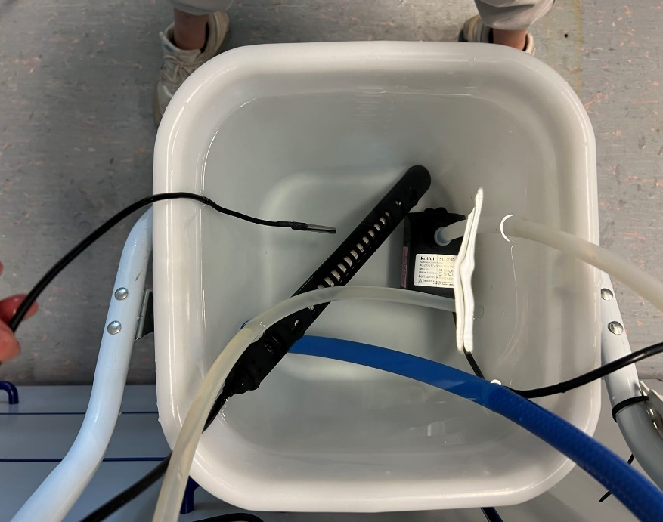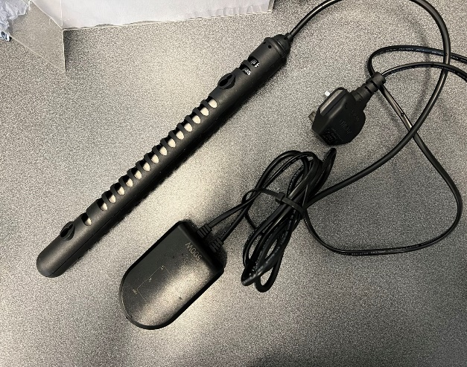
Figure 5.13 Temperature tests facilities (a) Aquarium heater with 500W power (b) assemble the heater into the bottom water tank
Figure 5.14 Pure water and glass beads linear fit for temperature correction. Temperature range is from 21°C to 35°C with 1°C temperature interval
The results of the linear fitting between the measured electrical conductivity and the temperature for experiments of tap water and five different sizes of glass beads are shown in Figure 5.13. The table next to the graphic includes a summary of the findings of the linear fitting. It is apparent that heating increased the electrical conductivity. The concentration and mobility of free ions in water can both rise with rising water temperature and, consequently, increase electrical conductivity. The slope and intercept values in the tap water test were the highest; the slope and intercept values appeared to decrease as the size of the glass beads decreased.
As shown in Figure 5.14, coefficient$a$ (intercept) and coefficient $b$ (slope) are expressed as functions of glass bead size using linear regressions. Coefficient $a$ shows a good linear connection with R² equal to 0.97. This relationship between the size of glass beads and interface conductivity resembles that shown in Figure 5.8 (b). However, the intercept value can be regarded as the electrical conductance at 0°C. Since ice doesn't contain any free mobile ions, which has a low electrical conductivity, then this linear relationship only within the range of measurement. The slope (coefficient b) fitting result is not as good as coefficient a. The electrical conductance change for a 1°C temperature change is the slope's value. As shown in Figure 5.15, it can be seen that the slope of the water test is much higher than the slope of the glass beads test. As a result, it is possible to assume that, in a system, the amount of water may primarily affect how the slope value changes. In addition, even though the amount of water in a system is similar due to the similar porosity, because the size, quantity, and pore paths of different-sized glass beads vary, the observed conductance varies with temperature.
Figure 5.15 Coefficient $a$ and $b$ as a function of glass beads diameters
Figure 5.16 Comparison of the variation of coefficient b for different porosities
Using the temperature coefficient of variation ($λ$), is another method of analysing the impact of temperature. This parameter is defined as the percentage change in electrical conductance for a given reference temperature for a 1°C temperature change (Barron & Ashton, 2013; Ramos et al., 2008). In this investigation, a reference temperature of 20°C was chosen. For saturated porous media, such as rocks and sediments, the electrical conductance mainly depends on the interface electrical conductance around the grain surface. Regarding porous media, the linear temperature conductance relationship is still valid (Hayashi, 2004; Hayley et al., 2007; Sen & Goode, 1992). Conductance measured at any temperature other than the reference temperature (20°C) can be converted to conductance at the reference temperature by the following equation:
Electrical conductance at 20°C: $G_{20℃}=\frac{G_{T}}{1+λ\left(T-20℃\right)}$ Eq. 5-11
Where $G_{T}$ and $G_{20℃}$ are the electrical conductance at T°C and 20°C respectively. The temperature for the glass bead and pure water testing was summarised in Table 5.4, and it was also compared to the porosity. The temperature coefficient for water is 2.13%/°C, which is very close to the standard temperature coefficient for water, which is around 2%/°C (Barron & Ashton, 2013). Hence, this kind of sensor seems to be sensitive to changes in temperature and can properly respond to measurements of electrical conductance. Regarding the glass beads test, the temperature coefficient is relatively dispersed in the range from 1.4%/°C to 2.05%/°C. Figure 5.16 fitted the average temperature coefficient for the six different samples based on (6.14), which is equal to 1.74%/°C. One explanation could account for this interesting phenomenon. Glass beads and water have different thermal conductivities, 0.62 W/mK and 1.09 W/mK, respectively. This will result in varying rates of heat transfer and, as a result, a non-uniform change in temperature inside the cylinder container. As the diameter of the glass beads increased, this influence grew more apparent. Even if the temperature of the top and bottom water tanks was checked during the test, the uneven distribution of temperature in the container can cause experiment errors.
Table 5.4 Electrical conductance at 20°C and temperature coefficient for glass beads tests and pure water test
Glass beads size  (mm) | Electrical conductance at 20°C (S) | Temperature coefficient (%/°C at 20°C)
water (0) | 0.00510 | 2.13
5 | 0.00426 | 1.40
4 | 0.00379 | 1.45
3 | 0.00312 | 1.62
2 | 0.00265 | 2.05
1 | 0.00238 | 1.76

Figure 5.17 Electrical conductance and temperature relationship of 6 samples with a linear model fit
In practical field applications, once the system temperature and temperature coefficient were known, the electrical conductance at 20°C could be calculated by using Eq. 5-11, and the hydraulic permeability could be derived from the above electrical-hydraulic model since it was based on the electrical conductance measured under 20°C.

Effect of electrode spacing distance
It is necessary to assess the impact of separation distance on the measurement of electrical conductance because as electrode spacing distance grows, the electrical field's penetration depth increases and the field weakens. In the test, glass beads ranging in size from 0.5 mm to 5 mm were used to assess the electrode conductance of electrodes no. 1&2, no. 1&3, and no. 1&4, where the separation distances are 2mm, 6mm, and 10mm, respectively.
The interface conductance against glass bead size and spacing distance curves are shown in Figure 5.17 and Figure 5.18, respectively. Three distinct spacing distances are shown in Figure 5.17 with a linear fluctuation, although the slopes are not the same. When the size of the glass beads changes, the electrical conductance measured at a 2 mm spacing distance will vary more because the sensitivity of the interface electrical conductance is higher at smaller spacing distances. The electrical conductance of glass beads larger than 3mm measured at a 2 mm spacing distance changes quite erratically, especially for glass beads between 4.5 mm and 5.0 mm. This is due to the uneven distribution of the large glass balls on the 2mm spacing distance as illustrated in Figure 5.19. For electrode no. 1&3, the diameters of all the beads are smaller than the spacing distance of 6 mm, which yields a better linear fitting result with a 0.98 R² value. The change in electrical conductance for various sizes of glass beads at a spacing distance of 10 mm is insignificant due to the weak electric field strength, and the linear fitting result is inferior with an R² value of 0.78.
Considering the results of these three spacing distances, comparing the spacing distances of 6 mm and 10 mm shows that the electrode sensitivity increases with decreasing spacing distance, and a higher sensitivity will demonstrate a better linear fit result. However, by comparing the 2mm and 6mm spacing distances, it can be seen that the smaller spacing distance is not always better. It is also necessary to comprehensively consider the relationship between the particle size of the measured sample and the spacing distance. From the 2mm spacing distance tests, glass beads larger than 3mm show inconsistent linear variation with glass spheres smaller than 3mm due to uneven distribution, while glass spheres smaller than 3mm show a good linear variation. Hence, for the consideration of practical applications, it is recommended that the electrode spacing should be approximately 1.5 times the particle size of the sample tested. The effects of the spacing distance will be further discussed in the next chapter, thereby, refining the recommendations on the design of the sensor.

Figure 5.18 Linear relationships fitting between glass beads diameter and interface conductance for three different electrode pairs.
Figure 5.19 Electrical conductance versus spacing distance for 10 different glass beads sizes
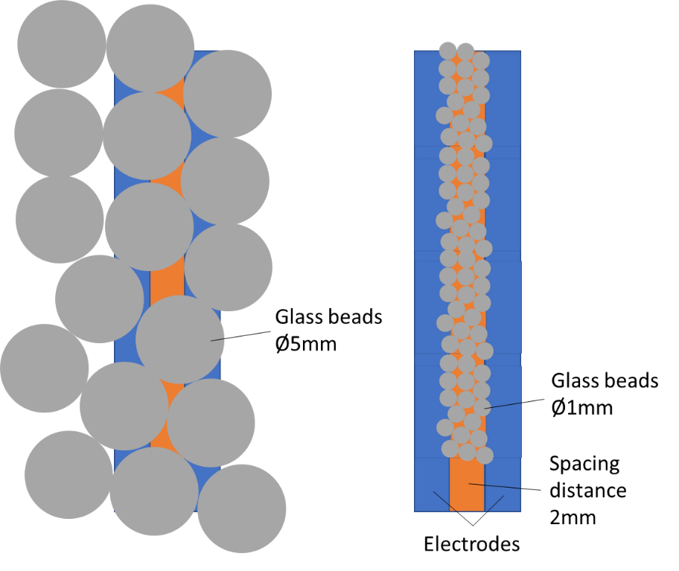
Figure 5.20 a 2D distribution for 5mm and 1mm glass beads on the electrode pairs with 2mm spacing distance.

Summary
The chapter has investigated the relationship between the electrical properties and hydraulic properties of saturated glass beads systems by using the novel sediment sensor based on the EIS method. Firstly, the measured hydraulic properties were verified by comparing them to the well known Kozeny-Carman model and showed a smaller exponent value. The possible reasons have been analysed, which may be due to the limitation of the experimental facility and the water’s internal frictional forces or interfacial drag force. Secondly, the effects of flow rate on the Bode plot and Nyquist plot have been presented. From the results, the flow rate ranged between 0.2 L/min and 1.0 L/min, which did not show a significant influence on the EIS measurement results. Thirdly, a linear and a power law relationship between interface electrical conductance and grain size and hydraulic permeability have been presented. In contrast to interface conductance, the other electrical components (solution conductance, interface impedance and diffusion impedance) showed a less significant relationship to grain size. In addition, a combined model of hydraulic permeability, grain size and formation factor was derived based on the Kozeny-Carman model and Archie’s law and will be refined in the next chapter. Then, the influence of temperature was discussed, and the average temperature compensation factor corresponding to 20°C has been founded, which is 1.74%/°C. Finally, by comparing the measurement results of 2 mm, 6mm and 10mm spacing distance, a design recommendation for the sensor’s spacing distance was proposed, that is, the electrode spacing distance should be 1.5 times the measured particle size. These findings in this chapter provide evidence that the EIS-based sensing system with two planar electrodes configuration is sensitive to monitoring the change of grain size and hydraulic permeability in a pipe.

Electrical impedance spectroscopy method for sand and simulated sediment

Introduction
The novel sediment sensor based on the EIS measurement method has been initially verified in the previous chapter by testing different sizes of glass beads. However, in practical applications, the shape of real sediment will not be a regular sphere and will not consist of a single-size particle. In this chapter, the EIS measurement method will be applied to more natural materials. The experimental results of a series of sand mixtures based on EIS measurements are investigated. Since sand mixed in different volume proportions can produce different porosities, the influence of porosity will be discussed which was not covered in the previous chapter. Meanwhile, the relationship between electrical properties and average grain size and hydraulic permeability is also analysed in this chapter for mixture samples. The measurement results of hydraulic properties are demonstrated in section 6.2, and the analysis of the Bode plot, Nyquist plot, equivalent electrical circuit and fitting process of impedance spectra are presented in section 6.3. In section 6.4, the relationships between electrical and hydraulic properties are analysed and the model proposed in Chapter 5 between hydraulic permeability, formation factor and grain size is verified with mixture samples. Moreover, the effects of electrode spacing distance are discussed in section 6.5, and section 6.6 discussed the actual application of proposed sensing system.

Hydraulic Properties Results
Table 6.1 summarises the porosities and hydraulic permeabilities of the 6 test samples and the test codes. The average grain size of the glass bead mixture is calculated by the Folk and Ward Formula as shown below (Folk & Ward, 1957):
$d=\frac{d_{16\%}+d_{50\%}+d_{84\%}}{3}$ Eq. 6-1
Where d is the average grain size of the glass beads mixture, and $d_{16\%}$, $d_{50\%}$, and $d_{84\%}$ are the particle diameter at 16%, 50% and 84% of the sample by weight. For the Mixture A and Mixture E samples, due to the manufacture tolerance, their grain size being in small ranges, the average grain sizes were chosen as the average value of the maximum size and minimum size in the ranges.
Because the sand mix samples only contained two different sizes, using the Folk and Walker Formula (which is designed for a broad distribution) will lead to unrepresentative estimates. Therefore, the average grain sizes of the sand mixtures were calculated by the weighted average value as shown in the following equation:
$d=αd_{A}+βd_{E}$ Eq. 6-2
Where $α$ and $β$ are the volume percentage ratio of sand Fraction A and sand Fraction E, and $d_{A}$ and $d_{E}$ are the average sizes of sand Fraction A and Fraction E.
Table 6.1 Hydraulic properties summary
Test code | Volume ratio | Average grain size  (mm) | Porosity (%) | Hydraulic permeability (mm²)
Mixture A | 100% Fraction A sand | 1.77 | 36.63 | 1.24×10⁻³
Mixture B | 75% Fraction A + 25% Fraction E | 1.36 | 34.44 | 3.23×10⁻⁴
Mixture C | 50% Fraction A + 50% Fraction E | 0.95 | 32.15 | 1.00×10⁻⁴
Mixture D | 25% Fraction A + 75% Fraction E | 0.53 | 28.54 | 1.66×10⁻⁵
Mixture E | 100% Fraction E sand | 0.12 | 25.55 | 3.90×10⁻⁶
Glass beads mixture | Glass beads mixture | 0.42 | 24.10 | 4.11×10⁻⁵

The relationships between porosity, permeability and average grain size are plotted in Figure 6.1, where the data of sand mixtures and the glass beads mixture are represented in black squares and red stars respectively. From Figure 6.1 (a), the relationship between porosity and permeability demonstrates a power-law relationship, which is also consistent with the general empirical model (Zheng et al., 2015). David et al. (1994) and Ghabezloo et al. (2009) surmised that the exponent was in the range of 1.1 to 25.4 for various geomaterials. The exponent value fitted in this study was 16.97, which is a large value in this range, thus a small change in porosity will lead to a big change in permeability. However, this power-law model can only give a simple relationship between porosity and permeability, because the porosity is dependent on the pore number and pore size, whereas the permeability is controlled by the throat size in the porous structure. None of these parameters is reflected in the power-law model.
The relationship between average grain size and porosity is plotted in Figure 6.1 (b). The fitting results of sand mixtures demonstrate a good linear relationship, with a 0.99 coefficient of determination ($R^{2}$) for sand samples. This indicates that this method of mixing two different sizes of sand in a certain ratio can generate samples with a proportional variation in porosity. One possible reason is that the two types of sand differ greatly in size (around 14 times). When they are mixed in a certain proportion, the finer sand gradually fills the pores between the coarse sand, thus, resulting in a proportional change in the overall porosity. The point for the glass bead mixture in Figure 6.1 (b) doesn’t follow the trend, and the blue dashed line in Figure 6.1 (b) demonstrates a good linear fit result ($R^{2}=0.91$) with six sample points. As the glass bead sample is a mixture of eight different sizes of glass spheres as introduced in section 3.3.1, the change of porosity did not conform to the pattern of sand mixtures.
In addition, glass mixture and sand are two different types of materials, and they demonstrate different properties when it comes to porosity and average particle size. The average particle size of glass mixture is 0.42mm, which falls between sand mixture D and E. However, the change of porosity did not conform to the pattern of sand mixtures, which is lower than Fraction E sand. Glass beads have a more rounded shape and a smoother surface compared to sand particles. Sand particles are usually angular and have a rough surface which allows them to form interlocks and create internal pore spaces. These effects lead to a higher porosity for sand mixtures. However, the pores in a glass beads mixture depend on the particle size and packing method. This results in a less predictable porosity-size relationship in glass beads mixture compared to sand.
The relationship between average grain size and permeability was also fitted by a power-law relationship as shown in Figure 6.1 (c). However, compared to the fit result in Section 5.2, the exponent in this test was significantly larger than the one-sized glass beads test as shown in Figure 6.1(c) blue dash line. Since the mixture samples consisted of various shapes and sizes of particles, the fine particles can fill the pores between larger particles and change the shape of the throat size. The permeability of mixture samples is hence smaller than the permeability calculated by the one-sized regular shaped glass beads fitted model. Therefore, for all samples, the average grain size and permeability are consistent with the power law relationship; however, the composition and shape of the material affect the parameters in the power law function.
Figure 6.1 The relationships between (a) porosity and permeability; (b) average grain size and porosity; (c) average grain size and permeability with fitted lines/curves, equations and R². The red star in the plots represents the data of glass beads mixture.
As indicated, a simple model to describe the relationship between each two of these three hydraulic properties is not sufficient. The Kozeny-Carman equation can be a better way to connect all hydraulic properties: porosity, permeability and average grain size. Figure 6.2 shows the comparison between measured permeability and Kozeny-Carman-calculated permeability. All six data points are distributed around the 1:1 reference line, and the measured permeability agrees with the Kozeny-Carman model with $2.34×{10}^{-10}$mean square error. This comparison shows that the hydraulic properties measured in the experiment are consistent with the empirical model, demonstrating the reliability of the experimental results.
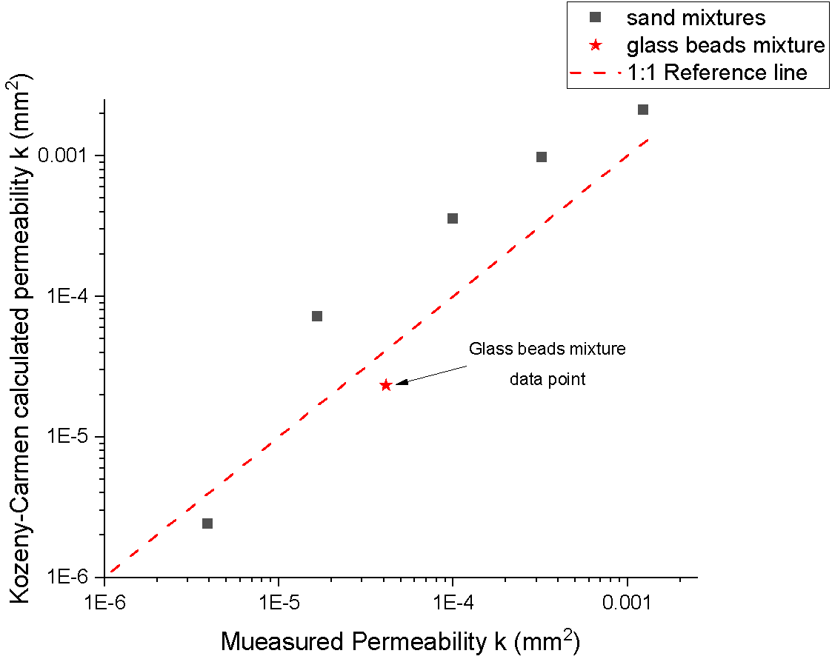
Figure 6.2 Comparison between measured permeability and Kozeny-Carmen-calculated permeability.

Electrical Conductance Results
Similar to Section 5.3, this section is aiming to show the EIS measurement results of sand mixtures and the glass bead mixture, which include Bode plots, Nyquist plots, the equivalent circuit model and the value of each element in it.

Bode plot
The Bode plot from different sand mixtures and the glass bead mixture are shown in Figure 6.3. This includes the impedance magnitude and phase change with frequency in the range from 10 Hz to 10 MHz. For sand mixtures at frequencies lower than 1 MHz, the impedance magnitudes increase with fine sand (Fraction E sand) volume ratio increase. For higher frequency (from 1 MHz to 10 MHz), the impedance magnitudes do not demonstrate a significant difference for the samples with different volume ratio. The impedance magnitude spectra of the glass bead mixture are similar to those of the sample Mixture D sand. From the hydraulic side, these two samples had similar average grain sizes (0.53mm for Mixture D; 0.42mm for glass beads mixture) and porosities (28.54% for Mixture D; 24.10% for glass beads mixture) which implies there is a relationship between hydraulic properties and electrical impedance.
(a)
(b)
Figure 6.3 EIS measurement Bode plot for six samples: (a) Impedance magnitude; (b) Impedance Phase plot.
Figure 6.3 (b) shows the phase angles for all six samples. It can be seen from the plots that the change in phase angle does not change significantly with the mixture sample changes, except at a high-frequency range (around 5 MHz to 10 MHz). In an electrical circuit, circuit components such as inductors and capacitors can induce a phase shift. In this case, double-layer capacitors may be formed at the interface between water and particles and between water and electrodes. However, the change of the capacitance is very small between samples, and the measurement precision of the instrument is not enough to detect minor variations, so the samples did not exhibit significant variations in phase angles.

Nyquist plot and equivalent circuit fitting
The Nyquist plot measured using different electrode pairs (electrode no.1&2, no.1&3, no.1&4 as labelled in Figure 3.10) with varying spacing distances is illustrated in Figure 6.4. For each plot, six Nyquist plots are shown corresponding to six mixture samples. The real and imaginary parts of impedance are correlated to the frequency in the range from 10 Hz to 10 MHz, where the frequency increases from right to left in the plot. Similar to the one-sized glass beads test, all the Nyquist plots show a similar shape, which can be divided into two sections: a depressed semicircle in a high-frequency range (around 12 kHz to 10 MHz) and a straight line with a clamp angle smaller than 45° to the real impedance axis in a low-frequency range (around 10 Hz to 12 kHz). For sand mixtures, with an increase in the volume ratio of fine sand (Fraction E sand), the width of the arc increases. It is also apparent that with the increase of electrode spacing distance, the width of the left arc increases.
Figure 6.4 Comparison of Nyquist plot with the change of mixtures
As the shape of the Nyquist plot in this test is similar to the shape of the one-sized glass beads test, the modified Randles circuit, shown in Figure 6.5, can be applied as a uniform model to derive the EIS results. The impedance of the modified Randles circuit can be expressed by the following equation, which has been given in section 5.3.3:
Total impedance: $Z_{total}=R_{s}+\frac{1}{\frac{1}{R_{i}+Q_{d}}+\frac{1}{Q_{i}}}=R_{s}+\frac{\left(R_{i}+\frac{1}{Q_{d}{\left(jω\right)}^{n_{d}}}\right)\frac{1}{{Q_{i}\left(jω\right)}^{n_{i}}}}{R_{i}+\frac{1}{Q_{d}{\left(jω\right)}^{n_{d}}}+\frac{1}{{Q_{i}\left(jω\right)}^{n_{i}}}}$ Eq. 6-3
Figure 6.5 Equivalent electrical circuit model: Modified Randles Circuit
Figure 6.6 shows the fitted Nyquist plot produced using the ZSimpWin software. Compared to the fitting results, the experiment data for some samples show smaller imaginary impedance in the frequency range of 100 kHz to 1 MHz. A possible reason is that due to the effect of electrode corrosion, the modified Randles circuits cannot accurately model the internal electrical characteristics of samples. As the experiment progressed, corrosion of the electrode surface occurred due to repeated filling samples, immersion in water, and scratching. Although the immersion gold process is used to prevent corrosion of the electrodes, corrosion is still inevitable for copper electrodes. The corrosion process can be simplified into the dissolution reaction and passivation reaction as shown below (Sun et al., 2022):
Dissolution reaction: $Cu→{Cu}^{2+}+2e^{-}$
Passivation reaction: $Cu+{OH}^{-}→\frac{1}{2}{Cu}_{2}O+\frac{1}{2}H_{2}O+e^{-}$
After dissolution reaction, ${Cu}^{2+}$ will be dissolved into the solution, and the passivation reaction will generate a passive film on the electrode surface, which might lead to a slight deformation of the Nyquist plot.
The fitted electrical parameters of the equivalent circuit are shown in Table 6.2. The solution resistance $R_{s}$ is smaller than the interface resistance $R_{i}$. Moreover, unlike the single glass bead samples in Chapter 5, the value of $R_{s}$ does not exhibit a linear decrease with increasing mean particle size in the case of sand mixtures. One possible reason is that smaller particles tend to settle at the bottom under the influence of the water flow, leading to a non-uniform particle distribution and pore structure around the electrode measurement area. On the other hand, the non-uniform particle distribution can affect the amount of ions dissolved in solution, which can further affect the$R_{s}$ value. As a result, a non-linear relationship between the $R_{s}$ and average particle size is observed. For the sand mixtures, an increase in the volume ratio of fine sand led to a significant increase in interface resistance, which was then applied to the further analysis.
Table 6.2 The value of electrical circuits elements for six samples
 | $R_{s}$ (Ω) | ${CPE}_{i}$ (S·s^{n}) | $$n_{i}$$ | $R_{i}$ (Ω) | ${CPE}_{d}$ (S·s^{n}) | $$n_{d}$$
Mixture A | 28.61 | $$6.32×{10}^{-9}$$ | 0.78 | 479.8 | $$7.58×{10}^{-4}$$ | 0.18
Mixture B | 37.45 | $$9.69×{10}^{-9}$$ | 0.75 | 566.3 | $$1.04×{10}^{-3}$$ | 0.15
Mixture C | 41.34 | $$9.45×{10}^{-9}$$ | 0.75 | 651.4 | $$1.02×{10}^{-3}$$ | 0.14
Mixture D | 28.02 | $$8.90×{10}^{-9}$$ | 0.75 | 812.8 | $$9.57×{10}^{-4}$$ | 0.15
Mixture E | 6.758 | $$5.98×{10}^{-9}$$ | 0.75 | 921.6 | $$7.53×{10}^{-4}$$ | 0.15
Glass beads mixture | 26.35 | $$8.50×{10}^{-9}$$ | 0.75 | 811.4 | $$7.80×{10}^{-4}$$ | 0.15
Figure 6.6 Comparison between EIS measured Nyquist plot and Modified Rundles circuit fitted Nyquist plot

Electrical-Hydraulic Relationship
Similar to section 5.4, this section is focused on the relationship between electrical conductance, average grain sizes, porosity and hydraulic permeability, which are calculated or measured from previous sections. In the mono-size glass beads experiment, the relationship between electrical conductance and porosity was not discussed as the porosity did not differ significantly between samples. This relationship will be presented in this section to complement the study of the electrical-hydraulic relationship. In addition, this section continues the study of combined models from section 5.4.2 to predict the hydraulic permeability.
Because there is no significant trend in other electrical parameters between the samples, the interface resistance has been selected for comparison with hydraulic properties. Similar to the relationships in Chapter 5, the interface electrical conductance ($G_{i}$), which is the reciprocal of the interface resistance, represents the electrical conductivity of the samples. $G_{i}$was compared with the average grain sizes, porosities and permeabilities as shown in Figure 6.7. Figure 6.7 (a) shows the linear relationship between the average grain size and the electrical conductance. From the fitted equation, the fitted slope ($6.10×{10}^{-4}$ S/mm) of this test is larger than the slope of the one-sized glass beads test ($4.84×{10}^{-4}$ S/mm). One of the possible reasons for the large fitted slope is that the method used here to find the average grain size underestimated the grain size of each sample. The other possible reason might be the measured electrical conductance was larger than the real electrical conductance due to the sample impure and surface conductance for finer sand. The sand used in this test is a natural material, when it was saturated with tap water, various impurities such as fine clay, salt and copper ions by electrode corrosion. On the other hand, fine clay could increase the particle surface area, and salt and copper ions would dissolve into the solvent causing an increase in interface conductance. For various sand mixtures, the content of fine clay and the amount of dissolution may vary, finer sand could have more clay content and dissolve more impurities into the electrolyte (Mawer et al., 2015). As a result, in addition to the effect of grain size, the increase in impurity content in samples also lead to an increase in electrical conductance, which ultimately caused the fitted slope of mixture samples to be greater than the one-size glass beads test.
From Figure 6.8 (b), the relationship between porosity and electrical conductance demonstrates a power-law relationship with the exponent value of 1.53. This value is called the cementation exponent in Archie’s Law as shown in Eq. 6-4. In Archie’s research, the cementation exponent was usually in the range of 1.8 to 2.0 for sandstone (Archie, 1942). Sen & Cohen (1981) demonstrated that the cementation factor is 1.5 for spherical particles. The exponent value measured in this test is within the range of 1.5 to 2.0.
Archie’s law: $σ_{t}=\frac{1}{a}σ_{w}ϕ^{m}S_{w}^{n}$ Eq. 6-4
Formation factor:$F=\frac{σ_{w}}{σ_{t}}=\frac{G_{w}}{G_{t}}$ Eq. 6-5
Where $σ_{t}$ and $σ_{w}$ are the electrical conductivity of total material and solution respectively, $a$ is tortuosity parameter, $ϕ$ is porosity, $m$ is cementation factor, $S_{w}$ is water saturation, (which is equal to 1 for the full saturated scenario), and $n$ is saturation factor.
Figure 6.7 (c) shows the power law relationship between permeability and electrical conductance, which is similar to the one-sized glass bead tests. The difference is the exponent value for the mixture samples test is 7.57. From the Chapter 2 literature review (section 2.4), most empirical models with exponent values are within the range of 1 to 5. The exponent value in this test is more than twice the exponent value of one sized glass beads (3.42). Figure 6.7 (c) also represents the power law fitted results by using a 3.42 exponent (green line). It can be seen that the difference between the two power-law functions can be due to the measured conductivity being larger or the measured hydraulic permeability being small. As explained above, impurities in the sand mixture samples can cause the electrical conductance to be higher than that measured with clean glass beads samples. The reason for the low measured hydraulic permeability may be due to potential non-uniform particle through the sample from top to bottom. If finer particles are able to move they will gradually move towards the bottom of the cylinder container. Nevertheless, this reasoning cannot explain the deviation of the Mixture A, Mixture E and glass beads mixture from the green fitted curve. Since hydraulic permeability is influenced by a series of elements, such as pore numbers, pore sizes, and pore path shape and size, directly using the power-law equation to describe the relationship between electrical conductance and hydraulic permeability may not be sufficient.
(a)
(b)
(c)
Figure 6.7 The relationship between (a) average grain size and electrical conductance; (b) porosity and electrical conductance; (c) electrical conductance and permeability
The relationship between permeability, formation factor, grain size and cementation factor has been derived from the one-sized glass beads test in section 5.4.2, the function is shown below:
$k=α\frac{d^{1.51}F^{3m}}{180(1-F^{m})^{2}}$ Eq. 6-6
where k is hydraulic permeability, $α$ is the parameter correlated to the tortuosity, d is grain size, F is the formation factor, and m is the cementation factor. The formation factor is the ratio of solution electrical conductance to total electrical conductance (Eq. 6-5). The cementation factor has been calculated from the relationship between porosity and electrical conductance, which is 1.53 in this test. Figure 6.8 compares the measured permeability and the permeability calculated with Eq. 6-6. The calculated value of $α$ for this test is 4.35. It can be seen that the measured permeability and calculated permeability were in good agreement (R²=0.99). However, the value of $α$ for the mixture test and one-sized glass bead tests are different. As $α$ is affected by the tortuosity of the test sample, the particle mixed with different sizes will influence the tortuosity to become larger or smaller (Sobieski & Lipiński, 2017). The flow may find a short way to reduce the tortuosity or bypass larger particles to increase path length and increase the tortuosity. Hence further investigation into the influence of tortuosity is needed to improve the accuracy of the model.
Overall, the model proposed in this study is a combination of Archie’s Law, Kozeny-Carman equation and experimentally fitted parameters, which can be used to describe the relationships between electrical conductance and multiple hydraulic properties (permeability, porosity and grain size). The measured permeability for the two sets of test materials presented in Chapters 5 and 6 showed good agreement with the model exhibiting high R² values. The parameter related to the tortuosity in the model still needs further research.
$$R^{2}=0.99$$
Figure 6.8 Comparison between the measured permeability and model calculated permeability

Effect of Electrode Spacing Distance
In this section 6.5, the effect of electrode spacing for the natural material and simulated sediment was discussed to improve the understanding of the design parameters of the sensor. Figure 6.9 demonstrates the relationships between electrical conductance and average grain size and spacing distance, which exhibit similar trends to the one-sized glass bead tests. The fitted slope and $R^{2}$ value of the mixture samples were larger than those of the one-sized glass bead tests for the three different electrode spacing distances. This can be contributed to the fact that the maximum average sand size is 1.77 mm which is less than the minimum spacing distance of 2 mm. This could also be due to the impurity of the sand mixture leading to more ions dissolving into the water, resulting in a higher solution conductance than the solution conductance of a one-size glass bead sample. The large slope indicates a greater variation in electrical conductance as grain size changes, which means that the sensor has higher sensitivity to the grain size change. From Figure 6.9 (a) , it can be seen that the slope between electrical conductance and the average grain size decreased as the electrode spacing distance increased, which means that the greater the spacing, the less obvious the change in conductivity with particle size. Hence, it can be conducted that the sensor’s sensitivity for grain size change decreased with the electrode spacing distance increase.
Figure 6.9 (b) compares the fitted slopes of mixture samples and one-size glass bead samples, which exhibit a consistent rate of change ($-5.26×{10}^{-5}$ S/${mm}^{2}$) with the spacing distance for the two sets of tests. It should be note that the ${mm}^{2}$in the unit means that the conductance varies per mm in grain size and per mm in spacing distance. If the fitted slope is considered to represent the sensitivity of the sensor, then it is clear from the Figure 6.9 (b) that the rate of change in sensitivity is only related to the spacing distance and not to the test material. However, the interception points with spacing distance axis are different for different tests; they are around 11 mm and 13.5 mm for the one-size glass bead test and mixture test respectively. This means that for a one-size glass bead, the conductance measured by the sensor does not change for a change in grain size at a spacing distance of 11 mm, which is the maximum electrode spacing distance for sensor’s design. For a sand mixture, this value is 13.5 mm. As mentioned above, this may be due to differences in the solution conductance. Since the sensitivity of the sensor decreases in the ratio of $5.26×{10}^{-5}$ S/${mm}^{2}$ with increasing spacing distance, the maximum electrode spacing for different samples can be calculated by a preliminary test. It means the sensitivity of a sample can first be measured at a typical spacing distance (for example 2 mm) and the maximum spacing distance applicable to that sample can be obtained from the rate of change in sensitivity ($5.26×{10}^{-5}$ S/${mm}^{2}$). The following equations can describe the calculation process:
$δ_{pt}=α-5.26×{10}^{-5}×w_{pt}$ Eq. 6-7
$w_{max}=\frac{α}{5.26×{10}^{-5}}=\frac{δ_{pt}+5.26×{10}^{-5}×w_{pt}}{5.26×{10}^{-5}}$ Eq. 6-8
Where $δ_{pt}$ is the measured sensitivity of sample corresponding to $w_{pt}$ spacing distance in a preliminary test, and $α$ is the intercept when spacing distance equal to zero, which can be calculated from the preliminary test. Then the maximum spacing distance $w_{max}$ can be calculated when sensitivity equal to zero by using Eq. 6-8
Both the one-size glass bead test (Chapter 5) and the mixtures test found that the smaller the electrode spacing distance, the higher the sensitivity of the sensor. Chapter 5 also has provided a recommendation for the design of the sensor, which is that the electrode spacing distance ($w$) should be larger or equal to 1.5 times the grain size ($d$) of the sample to be measured. From the mixture test, the maximum spacing distance is depending on the properties of the test material and can be obtained by a preliminary test. This determines the upper and lower limits of the electrode separation distance in the sensor design as shown below:
$1.5d≤w<\frac{δ_{pt}+5.26×{10}^{-5}×w_{pt}}{5.26×{10}^{-5}}$ Eq. 6-9
Overall, these findings suggests that in real applications, the electrode spacing distance should be within the range described in Eq. 6-9, and designers should select the smallest achievable spacing distance within that range based on practical manufacturing capabilities and costs.
(a)
(b)
(c)
Figure 6.9 Comparison of conductance versus average grain size between different electrode spacings.
Figure . Comparison of conductance versus average grain size between different electrode spacing

Discussion
In this experiment, the electrical conductance of test materials was measured from EIS methods, which demonstrated significant sensitivity to the change in average grain size, porosity, and permeability. The relationships between each of them were also found. However, it was also found that several parameters in the relationship were representative of different test materials. Further verification experiment is needed for real sediment. In the actual applications, this novel sediment sensor can be applied to understand how the sediment properties change in sewer pipes by monitoring the change of electrical conductance. For example, the sensor can be installed at regular intervals along the sewer pipe. If there is a very small electrical conductance anywhere, it may indicate a small porosity or permeability. The sewer pipe may be blocked here or may need to be cleaned. In addition, if porosity and permeability can be monitored, then the accumulation process and compaction of sediments can be investigated. In this experiment, the EIS spectra were measured with an oscilloscope, for the frequency range from 10 Hz to 10 MHz; the total measurement time is 10 minutes. Compared to the rate of change of hydraulic properties in the sewer, this method can realise real-time monitoring. Moreover, the sensor used for multiphase depths measurement (Chapter 4) has similar configurations to the sensor used in this experiment, the difference in sensor structure is that multiphase depths measurement uses a pair of electrodes with different lengths, while the sensor used in this experiment uses a pair of electrodes with the same length. Hence, it is possible to combine these two sensing systems together by applying the EIS technique to the multiphase depth sensor, then it can be used to measure multiphase levels and conduct EIS measurements. However, in this study, since the EIS was not used in this experiment to test the multiphase media, the combination needs to be verified by further experiments. Two sub-circuits to represent the water phases may need to be derived and connected in series based on the current modified Randles circuit.
On the other hand, this two-electrode configuration sensor based on EIS measurements can be used for further research to investigate how the hydraulic properties change with other electrical parameters, such as permittivity (Loewer et al., 2017). A better understanding of the internal structure of materials and their influence on electrical properties through analysis of EIS spectra and equivalent circuit models could result in a new form of sensing technology for water infrastructure. Finally, the sensor also has the advantage of being easy to manufacture and install, which is valuable to be applied in industry monitoring and sediment transport investigation.
When using EIS to test sand mixtures, it is also important to consider the potential effects of impurities on the accuracy and precision of the results. Impurities can have a range of effects on the electrode conductance of the sand mixture and sediment, including changes in conductivity, polarization, and interfacial impedance. This can make it difficult to accurately determine the hydraulic properties from the electrical conductance measurement, especially in some real environments that are aggressive or subject to electrode corrosion and abrasion by sediment transport. In addition, non-uniform particle size distribution (PSD) can lead to changes in the packing method and interparticle contacts, which can affect the electrical conductance results of the media. This can introduce errors to the determination of the grain size and the characterization of media hydraulic properties.
To mitigate the corrosion and abrasion effects from impurities on EIS measurement of sand mixture and sediment, it should be careful when select the electrode material. For the media with non-uniformly PSD, it is worth comparing the EIS measurement results with other methods before applying the sensor in real environment, such as sieving or sedimentation analysis, to ensure the accuracy, repeatability, and reproducibility.

Summary
This chapter followed the experimental approach from Chapter 5 to investigate the relationship between electrical conductance and hydraulic properties of sand mixtures and a glass bead mixture designed to simulate sewer sediment. A linear relationship between electrical conductance and average grain size, and a power relationship between electrical conductance, porosity and permeability have been found. A combined model of Archie’s Law, Kozeny Carmen equation and fitted parameters was verified to predict permeability. However, a tortuosity related parameter is representative of different materials, which needs to be analysed in future research. The effect of electrode spacing distance was discussed and provided recommendations for the design of sensors in practical applications. Finally, this chapter discusses how sensors of this kind can be used in industry.

Conclusion and Future work
In this thesis, the aim was to develop sensing systems to monitor the multiphase depths and sediment hydraulic properties in sewer pipes. The research was carried out in two main parts: the sensing system based on the electrical conductance measurement to determine the sediment and water depth in a circular pipe, and the sensing system based on the EIS measurement to investigate the electrical-hydraulic relationships for different sediment materials. This chapter summarises the main findings, recommended future work, and potential practical applications.

Summary of findings
For the measurement of the multiphase depths, a sensing system based on electrical conductance has been developed to simultaneously measure the depths of water and sediment in a circular pipe and provide instantaneous monitoring of the interface levels without any calibration process. Firstly, A theoretical framework was developed based on Ohm’s law, and then a COMSOL model and laboratory experiment were built to assess the accuracy of this sensing system. It was found that because the conductivity of sand, water and air is different, different media demonstrated linear relationships to electrode length with different gradients, which resulting in a piecewise line consisted of several "sub-lines" Most of the results are within the maximum expected error based on the sensor’s resolution. The root mean square error of COMSOL modelling and sensor-measured interface height are within 18% and 33% of the electrode length difference, which is also within 1.4% and 2.6% of the sensor’s measurement range respectively. Furthermore, the experimental and modelled results show that the slope of each sub-line is positively correlated with the electrical conductivity of the measured media, which can be further analysed to monitor the changes in the composition of sediment and wastewater.
The hydraulic properties characterisation includes two types of samples. The sensing system based on the EIS measurements has been developed to investigate the relationship between the electrical properties and hydraulic properties, and was first applied to ten sizes of saturated glass beads. The measured hydraulic properties were verified by comparing them to the well-known Kozeny-Carman model, which showed a smaller exponent value corresponding to grain sizes. The possible reasons have been analysed, which may be due to the limitation of the experimental facility and the water’s internal frictional forces or interfacial drag force. The Bode plot and Nyquist plot were measured from the EIS test, and the Nyquist plot was fitted with equivalent circuit to determine the electrical parameters of measured samples. The change in shape of the Bode and Nyquist plots with flow rate, grain size and hydraulic have been presented, which are the three main hydraulic parameters measured in this test. An equivalent circuit, modified Randles circuit, that represents the electrical behaviour of the system was designed by fitting the impedance spectra. From the results, the flow rate ranged between 0.2 L/min and 1.0 L/min, which did not show a significant influence on the EIS measurement results. A linear relationship between interface electrical conductance and grain size has been found, while a power law relationship between interface electrical conductance and hydraulic permeability has been presented. In contrast to interface conductance, the other electrical components (solution conductance, interface, and diffusion constant phase element) showed a less significant relationship to grain size. Additionally, the influence of temperature was discussed, and the average temperature coefficient corresponding to 20°C has been founded to help compare conductance at the same temperature, which is 1.74%/°C.
For the test with sand mixtures and a glass beads mixture, the samples created various average grain sizes, porosities and permeabilities, they are in a range from 0.12 mm to 1.77 mm, 24.10% to 36.63%, and 3.90×10⁻⁶ mm² to 1.24×10⁻³ mm², respectively. A linear relationship between electrical conductance and average grain sizes, and a power law relationship between electrical conductance, porosity and permeability have been founded. The relationships between electrical conductance and permeability were compared to the correlations from one-sized glass beads tests, which demonstrate a larger exponent value in the power law functions. The possible reason could be the impurities in the sand mixtures, and the movement of finer particles. However, since the permeability is influenced by a series of elements such as pore size, pore shape, pore path shape, a simple power-law relationship is hard to accurately predict hydraulic permeability in the actual practices. Then a combined model of electrical conductance, grain size, porosity and permeability was derived. The glass beads mixture used to represent the grain size distribution of real sediment demonstrated a good fitting result to the combined model.

Practical application considerations
The sensing systems presented in this thesis have the potential to provide a new opportunity for low-cost, long-term, minimally invasive and minimally obstructive monitoring of sewer sediment. The sensor is designed to be attached to the inner wall of the sewer pipe, which can be potentially applied to sewer systems, drainage systems for transport infrastructure, and other similar applications.
The multiphase depth sensing system takes advantage of low manufacturing costs and real-time monitoring. The present study established the feasibility of this sensing system for measuring multiphase flows with media that are homogeneous and have appreciably different conductivities, such as sediment and wastewater, wastewater and air, oil and water, etc. The resolution of the sensor has been discussed, in the practical implications, the resolution of the sensor can be adjusted by adjusting the electrode length difference as required. However, as the sensor derives the depths by measuring the two contact points of the interface on the sensor, the sensor has limitations in measuring the actual interface profile. Chapter 4 discussed two possible scenarios. For the sediment only partially immersed in water, the sensor can still give information about the water level, flow cross-sectional area, and emergent sediment level. The other scenario is that the sediment surface is not flat, which may lead to inaccurate measurement results. However, for the un-flat sediment surface in axial direction, the measurement accuracy can be increased by adjusting the sensor design, and through intelligent approaches such as machine learning to interpret ambiguous data.
The practical implication for the hydraulic properties measurement sensing system was discussed in Chapter 5 and Chapter 6. The feasibility of the sensing system and the accompanying combined model is verified, which can be applied to estimate the hydraulic permeability in sewer pipes by monitoring the change of electrical conductance. As recommended, the sensor can be mounted in sewer pipes at a regular distance to monitor the whole sewer system. It can also be placed to the positions where sediment properties are likely to accumulate, such as low-flow areas or bends in the pipe. When a very small electrical conductance occurs anywhere in the pipes with liquid, it can indicate a small porosity or permeability, thereby there may be a blockage, or the pipe may need to be cleaned.
In the experiment, EIS measurements were carried out using an oscilloscope and Matlab software. However, for practical applications, it is necessary to build an integrated device that is independent of hardware and software. The signal generator is a crucial component that produces a signal within the range of ±1V voltage and 10Hz to 10MHz frequency. Meeting the high-frequency requirement is challenging and may require significant costs and time investment to develop a suitable device. Among potential options, the PicoScope 5000 series is a viable alternative as it satisfies the frequency requirement and has a compact design. This device can be battery-powered and can also measure and record the output signal by using PicoLog data logging software. Alternatively, a wired or wireless data logger can be considered that can store data locally to an SD memory card or transmit it using Bluetooth or WIFI to a remote server for analysis. Developing an integrated equipment that combines EIS technology and can be effectively fitted to a sewer system is challenging. Some preliminary design ideas were presented, however, thorough investigations and testing of such a system will need to be conducted in the future.
Sediment properties can evolve over time due to a variety of factors, including changes in sediment source, deposition rate and flowrate, as well as the effects of contaminations and consolidation. Firstly, the average grain size of sediment can change over time due to the changes in sediment source, deposition rate and flowrate and direction, for example during the experiment in Chapter 6, with the direction of the flow, finer sand is more likely to be deposited on the bottom. Secondly, the composition of sediment can also change over time due to the changes in the source of sediment, as well as the effects of contaminations. Finally, over time, sediment can undergo consolidation due to compaction or cementation, which can result in changes in sediment porosity and permeability. By monitoring the change in electrical properties of sediment using EIS, it can give insights into the temporal evolution of sediment structure and composition.
The most important consideration in this study for practical applications is the electrode spacing distance of the sensor design. From the test, the design of the electrode spacing distance should be depending on the grain size of the measured materials. Too small an electrode spacing distance results in an uneven distribution of particles across the electrode pair, while a larger electrode spacing distance leads to a weaker electric field and less accurate sensors. According to the findings, the electrode spacing is recommended to be at least 1.5 times the size of the particles being measured. The maximum spacing distance is depending on the properties of the test material and can be obtained by a preliminary test. According to these findings, the electrode spacing distance in practical applications should fall within the range shown in Eq. 6–9, and designers should choose the minimum feasible spacing distance within this range in consideration of manufacturing costs and capabilities.
These two sensing systems, multiphase depths measurement and hydraulic properties measurement, can be combined to realise both measurements. For example, the total impedance at 8 kHz can be extracted for multiphase depth measurements by the same way described in Chapter 4, and the impedance spectra in frequency range from 10 Hz to 10 MHz can be used to conduct EIS measurement and then fitted with a new equivalent circuit model.
In addition to apply these two sensing systems to the sewer pipe, they can also be fitted to a gully pot, which is an important component connected to a sewer pipe to help collect wastewater and prevent blockages. The design of sensor should be optimised for use in the gully pot environment to withstand the corrosive and abrasive effects of wastewater and sediment transport. The multiphase depths measurement sensor can be vertically attached to the inner wall of the gully pot to monitor the depth of sediment and wastewater. The hydraulic properties measurement sensor should be horizontally attached to the inner wall along the circumference of the gully pot. The position of the sensor should be near the bottom to monitor the changes in sediment properties.
These two sensing systems could help to identify the overcharge and blockage issues in the sewer system. Furthermore, as the hydraulic properties measurement sensor is based on the EIS technique to collect the electrical information. It can also be placed in the middle of the gully pot to track the changes in the electrical properties of the wastewater. This can help to identify the environmental issues or the pollution, which can be further investigated in the next step.
Electrochemical Impedance Spectroscopy (EIS) is a powerful technique for monitoring and characterizing electrochemical processes. When applied to sewer systems, it can provide valuable information about the condition of the pipes and the effectiveness of any treatments or maintenance activities.

Further work
These findings from the present study provide the following insights for future investigations.

Further experiment
- For the multiphase depths’ measurement, the study should be repeated using real sediment samples for better verification of the proposed sensing system.
- For characterisation of hydraulic properties, the constant head facility could be improved to mitigate the influence of water internal friction force on hydraulic permeability measurements. Further experiments with the other sample materials, such as glass beads with wider range of diameter and actual sediment sample, could be carried out to optimise the experimental process and validate the combined model for hydraulic permeability prediction.. Firstly, although the repeatability of each experiment was checked three times, the internal structure of the sample may change each time. Hence, porous materials with fixed structures can be used to determine the stability of the sensor test results. Secondly, it is proposed that the other kinds of porous media and real sediment samples should be tested to further validate the combined model. Thirdly, the range of grain size, porosity and permeability tested in this study was still limited; further investigation and experimentation into a broader range of hydraulic properties is recommended to confirm the sensing system’s range of application.
- In the EIS test, the frequency range was between 10 Hz and 10 MHz; a larger range of frequencies can be attempted to generate a more complete Nyquist plot and produce a more precise equivalent circuit model.
- According to the discussion about the electrode spacing distance, a recommendation about the design of the sensor’s geometry has been provided. However, since the experiment only compared three different spacing distances (2mm, 6mm and 10mm), and the range of grain size is from 0.5 mm to 5 mm, the generalisability of the design recommendation is subject to certain limitations. Further research is required to determine how the electrode spacing distance affects the measurement accuracy based on the grain size. It is suggested to conduct more tests using single-size glass beads with various electrode spacing distances, such as 1 mm, 2 mm, 3 mm, 4 mm and 5 mm, and the grain size should in a range from 0.5 times to 3 times the electrode spacing distance. As the linear relationship between grain size and electrical conductance has been proved in this study and the other empirical models, by analysing the linear relationship between grain size and conductivity at each electrode spacing distance, it may be found that this linear relationship is not consistent or exhibits a discrete distribution when the grain size is larger than a certain range. From this, the maximum grain size that can be measured at the electrode spacing distance can be summarised. In other words, the smallest electrode spacing distance for a given grain size can be obtained.

Further analysis
- For the multiphase depth characterisation, further analysis needs to be done to fully understand the relationship between the electrical conductance and the slope of each sub-line. For example, by testing materials with different conductance to observe the change in slope, and then deduce the relationship between the two. This analysis can help to monitor the electrical conductance change in sediment and provide useful information about its components and pollutants from the environmental perspective.
- The research about hydraulic permeability prediction established a combined model to measure the hydraulic permeability from the grain size and porosity and electrical conductance, which is a model derived from Archie’s law, Kozeny-Carman equation and fitted parameters from the experiment. More information about the sample's internal structure, such as tortuosity, pore size, and pore shape, would help to establish a greater degree of accuracy on this empirical model to measure permeability, and these other properties could perhaps also be detected.
- The present EIS measurement analysed the shapes of the Bode plot, Nyquist plot, and the value of each electrical element in the modified Randles circuit. Further analysis of the other electrical parameters of EIS data, such as phase angle, relaxation frequency and induced polarisation, should be carried out to extend the understanding of how the change in hydraulic properties is reflected in the EIS data.
- The current EIS measurement uses a two-electrode configuration, as introduced in Chapter 2; three- and four-electrode configurations can eliminate impedance due to unsmooth electrode surfaces, which is suggested to improve the measurement accuracy and focus on the solution resistance and solid-liquid interface resistance.
- As described in section 6.6, multiphase depths and hydraulic properties measurements system systems can be combined to realise both measurements in one system by applying the EIS technique to the multiphase depth sensor. Further experiments are necessary to test this sensing system with multiphase and analysis the impedance spectra. A new equivalent circuit model may be developed based on the current modified Randles circuit, connected with two sub-circuits in series to represent the water phases. Depths information can be conducted by using the method in Chapter 4 and extracted impedance at 8 kHz. The electrical properties of the sediment and liquid phase can be calculated from the new equivalent circuit.
- In both tests, the sensor electrode was directly contacted with the test sample, and the corrosion phenomena on the metal surface would be raised with the use. The issue of electrode corrosion is an intriguing one which could be usefully explored in further research.

Field validation
- The tested multiphase media is stable in a circular pipe without any water flow, but this does not simulate the scenario in a real sewer pipe. Further research should test the multiphase media with a dynamic flow, and a field test should be conducted, which could usefully explore the performance of the sensing system in practical applications.
- For hydraulic properties characterisation, continued efforts are needed to make the EIS test more accessible to field tests. Follow-up field tests are also required to verify the feasibility of this sensing system in real practice.

Reference
Afsarimanesh, N., Mukhopadhyay, S. C., & Kruger, M. (2019). Planar interdigital sensors and electrochemical impedance spectroscopy. In Smart Sensors, Measurement and Instrumentation (Vol. 30). https://doi.org/10.1007/978-3-030-03706-2_3
Almedeij, J., Ahmad, E. and Alhumoud, J. (2010). Representative Particle Size of Sediment in Storm Sewer Inlets. American Journal of Environmental Sciences, 6(4), pp.316–323. doi:10.3844/ajessp.2010.316.323.
Anschutz, P., Ciutat, A., Lecroart, P., Gérino, M., & Boudou, A. (2012). Effects of Tubificid Worm Bioturbation on Freshwater Sediment Biogeochemistry. Aquatic Geochemistry, 18(6). https://doi.org/10.1007/s10498-012-9171-6
Archie, G. E., & others. (1942). The electrical resistivity log as an aid in determining some reservoir characteristics. Transactions of the AIME, 146(01).
Ashley, R. M., Bertrand-Krajewski, J.L., Hvitved-Jacobsen, T., & Verbanck, M. A. (2004). Solids in Sewers. Characteristics, effects and control of sewer solids and associated pollutants. Scientific and Technical Report No.14. In Water Science and Technology (Vol. 33, Issue 9).
Ashley, R.M. (2004). Solids in sewers: characteristics, effects and control of sewer solids and associated pollutants. IWA.
Bachoc, A. (1992). Location and general characteristics of sediment deposits into man-entry combined sewers. Water Science and Technology, 25(8). https://doi.org/10.2166/wst.1992.0178
Bai, W., Kong, L., & Guo, A. (2013). Effects of physical properties on electrical conductivity of compacted lateritic soil. Journal of Rock Mechanics and Geotechnical Engineering, 5(5), 406–411. https://doi.org/10.1016/j.jrmge.2013.07.003
Banasiak, R., Verhoeven, R., De Sutter, R., & Tait, S. (2005). The erosion behaviour of biologically active sewer sediment deposits: observations from a laboratory study. Water research, 39(20), 5221–5231. https://doi.org/10.1016/j.watres.2005.10.011
Barron, J. J., & Ashton, C. (2013). Conductivity Measurement - A Reagecon Technical Paper. A Practical Guide to Accurate Conductivity Measurements, 7(3).
Beg, M. U., Muzaini, S., Saeed, T., Jacob, P. G., Beg, K. R., Bahloul, M., Matrouk, K., Al-Obaid, T., & Kurian, A. (2001). Chemical Contamination and Toxicity of Sediment from a Coastal Area Receiving Industrial Effluents in Kuwait. Archives of Environmental Contamination and Toxicology, 41(3), 289–297. https://doi.org/10.1007/s002440010251
Berilgen, S. A., Berilgen, M. M., & Ozaydin, I. K. (2006). Compression and permeability relationships in high water content clays. Applied Clay Science, 31(3–4). https://doi.org/10.1016/j.clay.2005.08.002
Bertrand-Krajewski, J.L. (2015). A new technique to measure cross-section and longitudinal sediment profiles in sewers Flow Measurement View project OTHU-Field Observatory for Urban Water Management View project. https://www.researchgate.net/publication/228773115
Bertrand-Krajewski, J.-L., & Gibello, C. (2008). A new technique to measure cross-section and longitudinal sediment profiles in sewers. 11th International Conference on Urban Drainage.
Binley, A., Slater, L. D., Fukes, M., & Cassiani, G. (2005). Relationship between spectral induced polarization and hydraulic properties of saturated and unsaturated sandstone. Water Resources Research, 41(12). https://doi.org/10.1029/2005WR004202
Börner, F. D., Schopper, J. R., & Weller, A. (1996). Evaluation of transport and storage properties in the soil and groundwater zone from induced polarization measurements. Geophysical Prospecting, 44(4). https://doi.org/10.1111/j.1365-2478.1996.tb00167.x
Bouratsis, P., Diplas, P., Dancey, C. L., and Apsilidis, N. (2013), High-resolution 3-D monitoring of evolving sediment beds, Water Resour. Res., 49, doi:10.1002/wrcr.20110.
Butler, J. J. (2019). The Design, Performance, and Analysis of Slug Tests, 2nd Ed. In The Design, Performance, and Analysis of Slug Tests, 2nd Ed. https://doi.org/10.1201/9780367815509
Cai, J., Wei, W., Hu, X., & Wood, D. A. (2017). Electrical conductivity models in saturated porous media: A review. Earth-Science Reviews, 171, 419–433. https://doi.org/10.1016/J.EARSCIREV.2017.06.013
Campisano, A., Creaco, E., & Modica, C. (2013). Numerical modelling of sediment bed aggradation in open rectangular drainage channels. Urban Water Journal, 10(6). https://doi.org/10.1080/1573062X.2012.739627
Campisano, A., Modica, C., Creaco, E., & Shahsavari, G. (2019). A model for non-uniform sediment transport induced by flushing in sewer channels. Water Research, 163. https://doi.org/10.1016/j.watres.2019.114903
Carman, P. C. (1997). Fluid flow through granular beds. Process Safety and Environmental Protection: Transactions of the Institution of Chemical Engineers, Part B, 75(Suppl).
Carothers, J. E. (1968). A statistical study of the formation factor relation. Log. Anal., 9(5), 13–20.
Celestini, R., Silvagni, G., Spizzirri, M., & Volpi, F. (2007). Sediment transport in sewers. WIT Transactions on Ecology and the Environment, 103, 273–282. https://doi.org/10.2495/WRM070261
Chebbo, G., & Bachoc, A. (1992). Characterization of suspended solids in urban wet weather discharges. Water Science and Technology, 25(8). https://doi.org/10.2166/wst.1992.0191
Chebbo, G., Bachoc, A., Laplace, D., & le Guennec, B. (1995). The transfer of solids in combined sewer networks. Water Science and Technology, 31(7). https://doi.org/10.1016/0273-1223(95)00327-J
Chebbo, G., Musquere, P., Milisic, V., & Bachoc, A. (1990). Characterization of solids transferred into sewer trunks during wet weather.
Chetpattananondh, K., Tapoanoi, T., Phukpattaranont, P., & Jindapetch, N. (2014). A self-calibration water level measurement using an interdigital capacitive sensor. Sensors and Actuators A: Physical, 209, 175–182. https://doi.org/10.1016/J.SNA.2014.01.040
Christensen, B. J., Coverdale, T., Olson, R. A., Ford, S. J., Garboczi, E. J., Jennings, H. M., & Mason, T. O. (1994). Impedance Spectroscopy of Hydrating Cement‐Based Materials: Measurement, Interpretation, and Application. Journal of the American Ceramic Society, 77(11). https://doi.org/10.1111/j.1151-2916.1994.tb04507.x
CIRIA. (1987). Sediment Movement in Combined Sewerage and Storm-water Drainage Systems.
Cooper, S. J., Bertei, A., Finegan, D. P., & Brandon, N. P. (2017). Simulated impedance of diffusion in porous media. Electrochimica Acta, 251. https://doi.org/10.1016/j.electacta.2017.07.152
Cormack, S. L., Macphee, D. E., & Sinclair, D. C. (1998). An AC impedance spectroscopy study of hydrated cement pastes. Advances in Cement Research, 10(4). https://doi.org/10.1680/adcr.1998.10.4.151
Crabtree, R. W. (1989). Sediments in Sewers. Water and Environment Journal, 3(6), 569–578. https://doi.org/10.1111/j.1747-6593.1989.tb01437.x
Darcy, H. (1856). Les fontaines publiques de la ville de Dijon. Recherche.
David, C., Wong, T. F., Zhu, W., & Zhang, J. (1994). Laboratory measurement of compaction-induced permeability change in porous rocks: Implications for the generation and maintenance of pore pressure excess in the crust. Pure and Applied Geophysics PAGEOPH, 143(1–3). https://doi.org/10.1007/BF00874337
DB Group. (n.d.). https://dbgholdings.com/db-specialist-sands/. Retrieved August 30, 2022, from https://dbgholdings.com/db-specialist-sands/
De Rooij, F., Dalziel, S. B., & Linden, P. F. (1999). Electrical measurement of sediment layer thickness under suspension flows. In Experiments in Fluids (Vol. 26). Springer-Verlag.
Deabes, W., Sheta, A., Bouazza, K. E., & Abdelrahman, M. (2019). Application of electrical capacitance tomography for imaging conductive materials in industrial processes. Journal of Sensors, 2019. https://doi.org/10.1155/2019/4208349
Dias, R., Teixeira, J. A., Mota, M., & Yelshin, A. (2004). Preparation of controlled particulate mixtures with glass beads of different sizes. Separation and Purification Technology, 37(1). https://doi.org/10.1016/j.seppur.2003.07.001
Dolinar, B. (2009). Predicting the hydraulic conductivity of saturated clays using plasticity-value correlations. Applied Clay Science, 45(1–2). https://doi.org/10.1016/j.clay.2009.04.001
Dong, H., Zhu, X., Jiang, X., Chen, L., & Gao, Q. F. (2021). Structural characteristics of soil-rock mixtures based on electrochemical impedance spectroscopy. CATENA, 207, 105579. https://doi.org/10.1016/J.CATENA.2021.105579
Ebtehaj, I., Bonakdari, H., Safari, M. J. S., Gharabaghi, B., Zaji, A. H., Riahi Madavar, H., Sheikh Khozani, Z., Es-haghi, M. S., Shishegaran, A., & Danandeh Mehr, A. (2020). Combination of sensitivity and uncertainty analyses for sediment transport modeling in sewer pipes. International Journal of Sediment Research, 35(2). https://doi.org/10.1016/j.ijsrc.2019.08.005
Fisher, A. T. (2004). Sediment permeability, distribution, and influence on fluxes in oceanic basement. https://www.researchgate.net/publication/251801278
Folk, R. L., & Ward, W. C. (1957). Brazos River bar; a study in the significance of grain size parameters. Journal of Sedimentary Research, 27(1). https://doi.org/10.1306/74d70646-2b21-11d7-8648000102c1865d
Ford, S. J., Mason, T. O., Christensen, B. J., Coverdale, R. T., Jennings, H. M., & Garboczi, E. J. (1995). Electrode configurations and impedance spectra of cement pastes. Journal of Materials Science, 30(5). https://doi.org/10.1007/BF00356122
Freger, V. (2005). Diffusion impedance and equivalent circuit of a multilayer film. Electrochemistry Communications, 7(9). https://doi.org/10.1016/j.elecom.2005.06.020
Friedman, S. P. (2005). Soil properties influencing apparent electrical conductivity: A review. Computers and Electronics in Agriculture, 46(1-3 SPEC. ISS.). https://doi.org/10.1016/j.compag.2004.11.001
Gabreil, E., Tait, S. J., Shao, S., & Nichols, A. (2018). SPHysics simulation of laboratory shallow free surface turbulent flows over a rough bed. Journal of Hydraulic Research, 56(5). https://doi.org/10.1080/00221686.2017.1410732
Ghabezloo, S., Sulem, J., Guédon, S., & Martineau, F. (2009). Effective stress law for the permeability of a limestone. International Journal of Rock Mechanics and Mining Sciences, 46(2). https://doi.org/10.1016/j.ijrmms.2008.05.006
Ghanbarian, B., Hunt, A. G., Ewing, R. P., & Sahimi, M. (2013). Tortuosity in Porous Media: A Critical Review. Soil Science Society of America Journal, 77(5). https://doi.org/10.2136/sssaj2012.0435
Ghane, E. (2022). Why Do Subsurface Drainage Systems Underperform? [online] Michegen State university. Available at: https://www.canr.msu.edu/field_crops/uploads/files/E3451_Underperformance_Rev_0.pdf.
Glover, P. (2000). Petrophysics MSc Course Notes 2. Porosity: 2.1 Theory. Petrophysics MSc Course Notes.
Gómez-Rivero, O. (1977). Some considerations about the possible use of the parameters a and m as a formation evaluation tool through well logs. SPWLA 18th Annual Logging Symposium 1977.
Goncharsky, A. V., Romanov, S. Y., & Seryozhnikov, S. Y. (2016). Supercomputer technologies in tomographic imaging applications. Supercomputing Frontiers and Innovations, 3(1). https://doi.org/10.14529/jsfi160103
Gorgoglione, A., Bombardelli, F. A., Pitton, B. J. L., Oki, L. R., Haver, D. L., & Young, T. M. (2019). Uncertainty in the parameterization of sediment build-up and wash-off processes in the simulation of sediment transport in urban areas. Environmental Modelling and Software, 111. https://doi.org/10.1016/j.envsoft.2018.09.022
Grossi, M., & Riccò, B. (2017). Electrical impedance spectroscopy (EIS) for biological analysis and food characterization: A review. Journal of Sensors and Sensor Systems, 6(2). https://doi.org/10.5194/jsss-6-303-2017
Gu, P., Xie, P., & Beaudoin, J. J. (1995). Determination of silica-fume content in hardened concrete by AC impedance spectroscopy. Cement, Concrete and Aggregates, 17(1). https://doi.org/10.1520/cca10343j
Gu, P., Xie, P., Beaudoin, J. J., & Brousseau, R. (1992). A.C. impedance spectroscopy (I): A new equivalent circuit model for hydrated portland cement paste. Cement and Concrete Research, 22(5). https://doi.org/10.1016/0008-8846(92)90107-7
Guéguen, Y., & Palciauskas, V. (1994). Introduction to the Physics of Rocks. Princeton University Press.
Gutierrez, O., Jiang, G., Sharma, K., & Yuan, Z. (2016). Biofilm Development in Sewer Networks. In Aquatic Biofilms: Ecology, Water Quality and Wastewater Treatment. https://doi.org/10.21775/9781910190173.08
Hayashi, M. (2004). Temperature-electrical conductivity relation of water for environmental monitoring and geophysical data inversion. Environmental Monitoring and Assessment, 96(1–3). https://doi.org/10.1023/B:EMAS.0000031719.83065.68
Hayley, K., Bentley, L. R., Gharibi, M., & Nightingale, M. (2007). Low temperature dependence of electrical resistivity: Implications for near surface geophysical monitoring. Geophysical Research Letters, 34(18). https://doi.org/10.1029/2007GL031124
Hazen, A. (2014). XXIII. Some Physical Properties Of Sands And Gravels, With Special Reference To Their Use In Filtration. In State Sanitation Volume II. https://doi.org/10.4159/harvard.9780674600485.c25
Hill, H. J., & Milburn, J. D. (2003). Effect of clay and water salinity on electrochemical behaviour of reservoir rocks. SPE Reprint Series, 55. https://doi.org/10.2118/532-g
HM Government. (2017). Approved Document H Drainage and waste disposal (Part H). In The Building Regulations.
Horoshenkov, K. v., Nichols, A., Tait, S. J., & Maximov, G. A. (2013). The pattern of surface waves in a shallow free surface flow. Journal of Geophysical Research: Earth Surface, 118(3). https://doi.org/10.1002/jgrf.20117
Horoshenkov, K. v., van Renterghem, T., Nichols, A., & Krynkin, A. (2016). Finite difference time domain modelling of sound scattering by the dynamically rough surface of a turbulent open channel flow. Applied Acoustics, 110. https://doi.org/10.1016/j.apacoust.2016.03.009
Hsieh, G., Ford, S. J., Mason, T. O., & Pederson, L. R. (1996). Experimental limitations in impedance spectroscopy: Part I - Simulation of reference electrode artifacts in three-point measurements. Solid State Ionics, 91(3–4). https://doi.org/10.1016/S0167-2738(96)00481-X
Huang, J. (2018). Diffusion impedance of electroactive materials, electrolytic solutions and porous electrodes: Warburg impedance and beyond. Electrochimica Acta, 281. https://doi.org/10.1016/j.electacta.2018.05.136
Huntley, D. (1986). Relations Between Permeability and Electrical Resistivity in Granular Aquifers. Groundwater, 24(4). https://doi.org/10.1111/j.1745-6584.1986.tb01025.x
Husain, A., Kupwade-Patil, K., Al-Aibani, A. F., & Abdulsalam, M. F. (2017). In situ electrochemical impedance characterization of cement paste with volcanic ash to examine early stage of hydration. Construction and Building Materials, 133. https://doi.org/10.1016/j.conbuildmat.2016.12.054
Hvitved-Jacobsen, T, Vollertsen, J., Yongsiri, C., & Nielsen, a H. (2002). Sewer microbial processes , emissions and impacts. Sewers Process and Networks.
Hvitved-Jacobsen, T., & Ashley, R. (2002). Management of Sewer Sediments. In Wet-Weather Flow in the Urban Watershed. CRC Press. https://doi.org/10.1201/9781420012774.ch7
Hwang, J. H. (2012). Impedance spectroscopy analysis of hydration in ordinary portland cements involving chemical mechanical planarization slurry. Journal of the Korean Ceramic Society, 49(3). https://doi.org/10.4191/kcers.2012.49.3.260
Jansen, E., Blum, P., & Shipboard Scientific Party. (2005). Carbonates and bulk sediment geochemistry of ODP Hole 162-987D. PANGAEA. https://doi.org/10.1594/PANGAEA.252204
Jiang, G., Gutierrez, O., Sharma, K. R., & Yuan, Z. (2010). Effects of nitrite concentration and exposure time on sulfide and methane production in sewer systems. Water Research, 44(14), 4241–4251. https://doi.org/10.1016/J.WATRES.2010.05.030
Jiang, G., Sun, J., Sharma, K. R., & Yuan, Z. (2015). Corrosion and odor management in sewer systems. In Current Opinion in Biotechnology (Vol. 33). https://doi.org/10.1016/j.copbio.2015.03.007
Kadan-Jamal, K., Sophocleous, M., Jog, A., Desagani, D., Teig-Sussholz, O., Georgiou, J., Avni, A., & Shacham-Diamand, Y. (2020). Electrical Impedance Spectroscopy of plant cells in aqueous biological buffer solutions and their modelling using a unified electrical equivalent circuit over a wide frequency range: 4Hz to 20 GHz. Biosensors and Bioelectronics, 168. https://doi.org/10.1016/j.bios.2020.112485
Kamann, P. J., Ritzi, R. W., Dominic, D. F., & Conrad, C. M. (2007). Porosity and permeability in sediment mixtures. Ground Water, 45(4), 429–438. https://doi.org/10.1111/j.1745-6584.2007.00313.x
Katz, A. J., & Thompson, A. H. (1987). Prediction of rock electrical conductivity from mercury injection measurements. Journal of Geophysical Research, 92(B1). https://doi.org/10.1029/JB092iB01p00599
Keddam, M., Takenouti, H., Novoa, X. R., Andrade, C., & Alonso, C. (1997). Impedance measurements on cement paste. Cement and concrete research, 27(8), 1191-1201.
Kemna, A., Binley, A., Cassiani, G., Niederleithinger, E., Revil, A., Slater, L., Williams, K. H., Orozco, A. F., Haegel, F. H., Hördt, A., Kruschwitz, S., Leroux, V., Titov, K., & Zimmermann, E. (2012). An overview of the spectral induced polarization method for near-surface applications. Near Surface Geophysics, 10(6). https://doi.org/10.3997/1873-0604.2012027
Khan, N. I., & Song, E. (2020). Lab-on-a-chip systems for aptamer-based biosensing. Micromachines, 11(2). https://doi.org/10.3390/mi11020220
Kirkby, A., Heinson, G., & Krieger, L. (2016). Relating permeability and electrical resistivity in fractures using random resistor network models. Journal of Geophysical Research: Solid Earth, 121(3). https://doi.org/10.1002/2015JB012541
Knight, R. J., & Endres, A. L. (2005). 3. An Introduction to Rock Physics Principles for Near-Surface Geophysics. In Near-Surface Geophysics. https://doi.org/10.1190/1.9781560801719.ch3
Koch, K., Revil, A., & Holliger, K. (2012). Relating the permeability of quartz sands to their grain size and spectral induced polarization characteristics. Geophysical Journal International, 190(1). https://doi.org/10.1111/j.1365-246X.2012.05510.x
Kosinski, W. K., & Kelly, W. E. (1981). Geoelectric Soundings for Predicting Aquifer Properties. Groundwater, 19(2). https://doi.org/10.1111/j.1745-6584.1981.tb03455.x
Kozeny, J. (1927). Ueber kapillare Leitung des Wassers im Boden Sitzungsber Akad. Sitzungsber Akad. Wiss., 136(2a).
Kruschwitz, S., Prinz, C., & Zimathies, A. (2016). Study into the correlation of dominant pore throat size and SIP relaxation frequency. Journal of Applied Geophysics, 135. https://doi.org/10.1016/j.jappgeo.2016.07.007
Lacey, W. S. (2016). Impedance of a Warburg element. Retrieved May 10, 2023, from http://lacey.se/science/eis/diffusion-impedance/
Lepot, M., Pouzol, T., Aldea Borruel, X., Suner, D., & Bertrand-Krajewski, J. L. (2017). Measurement of sewer sediments with acoustic technology: from laboratory to field experiments. Urban Water Journal, 14(4), 369–377. https://doi.org/10.1080/1573062X.2016.1148181
Lesmes, D. P., & Frye, K. M. (2001). Influence of pore fluid chemistry on the complex conductivity and induced polarization responses of Berea sandstone. Journal of Geophysical Research: Solid Earth, 106(B3). https://doi.org/10.1029/2000jb900392
Li, X., Lei, T., Wang, W., Xu, Q., & Zhao, J. (2005). Capacitance sensors for measuring suspended sediment concentration. Catena, 60(3). https://doi.org/10.1016/j.catena.2005.01.001
Li, X., Wang, X., Zhao, Q., Zhang, Y., & Zhou, Q. (2016). In situ representation of soil/sediment conductivity using electrochemical impedance spectroscopy. Sensors (Switzerland), 16(5). https://doi.org/10.3390/s16050625
Liu, Y., Ni, B. J., Ganigué, R., Werner, U., Sharma, K. R., & Yuan, Z. (2015). Sulfide and methane production in sewer sediments. Water Research, 70. https://doi.org/10.1016/j.watres.2014.12.019
Loewer, M., Günther, T., Igel, J., Kruschwitz, S., Martin, T., & Wagner, N. (2017). Ultra-broad-band electrical spectroscopy of soils and sediments-a combined permittivity and conductivity model. Geophysical Journal International, 210(3). https://doi.org/10.1093/gji/ggx242
Lorenzen, A., Willms, M., & Dinkelacker, A. (1992). The Göttingen Boat. Water Science and Technology, 25(8), 57–62. https://doi.org/10.2166/wst.1992.0179
Macphee, D. E., Sinclair, D. C., & Cormack, S. L. (1997). Development of an equivalent circuit model for cement pastes from microstructural considerations. Journal of the American Ceramic Society, 80(11). https://doi.org/10.1111/j.1151-2916.1997.tb03206.x
MacPhee, D. E., Sinclair, D. C., & Stubbs, S. L. (1996). Electrical characterization of pore reduced cement by impedance spectroscopy. Journal of Materials Science Letters, 15(18). https://doi.org/10.1007/bf00278090
Marsalek, J. (1984). Caracterisation Du Ruissellement De Surface Issu D’une Zone Urbaine Commerciale. Sciences et Techniques de l’Eau, 17(2).
Mawer, C., Knight, R., & Kitanidis, P. K. (2015). Relating relative hydraulic and electrical conductivity in the unsaturated zone. Water Resources Research, 51(1). https://doi.org/10.1002/2014WR015658
McKenzie, E. R., & Young, T. M. (2013). A novel fractionation approach for water constituents-distribution of storm event metals. Environmental Sciences: Processes and Impacts, 15(5). https://doi.org/10.1039/c3em30612g
Mei, B. A., Munteshari, O., Lau, J., Dunn, B., & Pilon, L. (2018). Physical Interpretations of Nyquist Plots for EDLC Electrodes and Devices. Journal of Physical Chemistry C, 122(1), 194–206. https://doi.org/10.1021/acs.jpcc.7b10582
Mesri, G., & Olson, R. E. (1971). Mechanisms controlling the permeability of clays. Clays and Clay Minerals, 19(3). https://doi.org/10.1346/CCMN.1971.0190303
Mohr, H., Draper, S., White, D. J., & Cheng, L. (2021). The effect of permeability on the erosion threshold of fine-grained sediments. Coastal Engineering, 163, 103813. https://doi.org/https://doi.org/10.1016/j.coastaleng.2020.103813
Mohr, H., Draper, S., White, D. J., &#38; Cheng, L. (2018). The influence of permeability on the erosion rate of fine-grained marine sediments. Coastal Engineering, 140, 124–135. https://doi.org/10.1016/j.coastaleng.2018.04.013
Metrohm Autolab. (2019). Electrochemical Impedance Spectroscopy (EIS) Part 2 Experiment setup. Application Area: Fundamental. Retrieved from: http://www.metrohm.com/electrochemistry.
Mortadi, A., Elmelouky, A., Chahbi, M., Ghyati, N. el, Zaim, S., Cherkaoui, O., & el Moznine, R. (2020). Flocculation monitoring of wastewater by using impedance spectroscopy. Spectrochimica Acta - Part A: Molecular and Biomolecular Spectroscopy, 224. https://doi.org/10.1016/j.saa.2019.117437
Nichols, A (2014). Device and Method for Measuring the Depth of Media. PCT WO2014027208A2.
Nichols, A. (2015). Free surface dynamics in shallow turbulent flows. In Ph.D. thesis, University of Bradford, West Yorkshire, UK.
Nichols, A., & Rubinato, M. (2016). Remote sensing of environmental processes via low-cost 3D free-surface mapping. Proceedings of the 4th IAHR Europe Congress. 27–29 July 2016; pp. 186–192 ISBN 9781138029774.
Nichols, A., Tait, S. J., Horoshenkov, K. v., & Shepherd, S. J. (2016). A model of the free surface dynamics of shallow turbulent flows. Journal of Hydraulic Research, 54(5). https://doi.org/10.1080/00221686.2016.1176607
Nijp, J. J., Metselaar, K., Limpens, J., Gooren, H. P. A., & van der Zee, S. E.A.T.M. (2017). A modification of the constant-head permeameter to measure saturated hydraulic conductivity of highly permeable media. MethodsX, 4. https://doi.org/10.1016/j.mex.2017.02.002
Noack M, Schmid G, Beckers F, Haun S, Wieprecht S. PHOTOSED—PHOTOgrammetric Sediment Erosion Detection. Geosciences. 2018; 8(7):243. https://doi.org/10.3390/geosciences8070243
Okabe S., Ito T., & Satoh H. (2003). Sulfate-reducing bacterial community structure and their contribution to carbon mineralization in a wastewater biofilm growing under microaerophilic conditions. Appl Microbiol Biotechnol, 63(3):322-34. https://doi.org/10.1007/s00253-003-1395-3.
Pine Research Instrumentation. (2016). Electrochemical Impedance Spectroscopy (EIS) Basics. Retrieved from https://pineresearch.com/shop/kb/theory/eis-theory/eis-basics/
Porter, Christopher R., and James E. Carothers. (1970). Formation Factor-Porosity Relation Derived From Well Log Data. Paper presented at the SPWLA 11th Annual Logging Symposium, Los Angeles, California, US.
Purvance, D. T., & Andricevic, R. (2000). On the electrical-hydraulic conductivity correlation in aquifers. Water Resources Research, 36(10). https://doi.org/10.1029/2000WR900165
Raheem, A. M., Vipulanandan, C., & Joshaghani, M. S. (2017). Non-destructive experimental testing and modeling of electrical impedance behavior of untreated and treated ultra-soft clayey soils. Journal of Rock Mechanics and Geotechnical Engineering, 9(3). https://doi.org/10.1016/j.jrmge.2017.02.001
Ramos, P. M., Pereira, J. M. D., Ramos, H. M. G., & Ribeiro, A. L. (2008). A four-terminal water-quality-monitoring conductivity sensor. IEEE Transactions on Instrumentation and Measurement, 57(3). https://doi.org/10.1109/TIM.2007.911703
Randles, J. E. B. (1947). Kinetics of rapid electrode reactions. Faraday Discussions, 1. https://doi.org/10.1039/DF9470100011
Regueiro-Picallo, M., Suárez, J., Sañudo, E., Puertas, J., & Anta, J. (2020). New insights to study the accumulation and erosion processes of fine-grained organic sediments in combined sewer systems from a laboratory scale model. Science of The Total Environment, 716, 136923. https://doi.org/https://doi.org/10.1016/j.scitotenv.2020.136923
Regueiro-Picallo, M., Anta, J., Naves, A., & Reickermann, J. (2022). Monitoring_Sewer_Sediment_Deposits_with_Temperature_Sensors. The 39th IAHR World Congress. DOI: doi://10.3850/IAHR-39WC2521716X20221141
Regueiro-Picallo, M., Naves, A., Anta, J, Suárez, J., & Puertas, J. (2017). Monitoring accumulation sediment characteristics in full scale sewer physical model with urban wastewater. Water Sci Technol 76 (1): 115–123. doi: https://doi.org/10.2166/wst.2017.118
Ren, X. W., & Santamarina, J. C. (2018). The hydraulic conductivity of sediments: A pore size perspective. Engineering Geology, 233. https://doi.org/10.1016/j.enggeo.2017.11.022
Revil, A. (2002). The hydroelectric problem of porous rocks: Themodynamic approach and introduction of a percolation threshold. Geophysical Journal International, 151(3). https://doi.org/10.1046/j.1365-246X.2002.01815.x
Revil, A., & Cathles, L. M. (1999). Permeability of shaly sands. Water Resources Research, 35(3). https://doi.org/10.1029/98WR02700
Ridd, P. v. (1992). A sediment level sensor for erosion and siltation detection. Estuarine, Coastal and Shelf Science, 35(4). https://doi.org/10.1016/S0272-7714(05)80032-0
Riochet, B. (2008). Sedimentation in Large Combined Sewage Systems: Perspectives of an Operator / La Sédimentation dans les Réseaux Unitaires Visitables: le Point de Vue d’un Exploitant.
Rose, A. W. (1993). Porous media: Fluid transport and pore structure (2nd Ed.). Journal of Geochemical Exploration, 48(3). https://doi.org/10.1016/0375-6742(93)90016-f
Rui, Y., Hird, R., Yin, M. et al. Detecting changes in sediment overburden using distributed temperature sensing: an experimental and numerical study. Mar Geophys Res 40, 261–277 (2019). https://doi.org/10.1007/s11001-018-9365-4
Schlaberg, H. I., Baas, J. H., Wang, M., Best, J. L., Williams, R. A., & Peakall, J. (2006). Electrical Resistance Tomography for suspended sediment measurements in open channel flows using a novel sensor design. Particle and Particle Systems Characterization, 23(3–4). https://doi.org/10.1002/ppsc.200601062
Schön, J. (2011). Physical Properties of Rocks: A Workbook. In Vasa.
Sekar, N., & Ramasamy, R. P. (2013). Electrochemical impedance spectroscopy for microbial fuel cell characterization. In Journal of Microbial and Biochemical Technology (Vol. 5, Issue SPECIALISSUE.2). https://doi.org/10.4172/1948-5948.s6-004
Sun, F., Peng, X., Bai, X., Chen, Z., Xie, R., He, B. & Han, P. (2022) EIS analysis of the electrochemical characteristics of the metal–water interface under the effect of temperature. RSC Advances. 12 (27), 16979–16990. doi:10.1039/D2RA01634F.
Sen, P. N., & Cohen, M. H. (1981). A self-similar model for sedimentary rocks with application to the dielectric constant of fused glass beads. Geophysics, 46(5). https://doi.org/10.1190/1.1441215
Sen, P. N., & Goode, P. A. (1992). Influence of temperature on electrical conductivity on shaly sands. Geophysics, 57(1). https://doi.org/10.1190/1.1443191
Sindhuja, M., Kumar, N. S., Sudha, V., & Harinipriya, S. (2016). Equivalent circuit modeling of microbial fuel cells using impedance spectroscopy. Journal of Energy Storage, 7. https://doi.org/10.1016/j.est.2016.06.005
Slater, L., & Lesmes, D. P. (2002). Electrical-hydraulic relationships observed for unconsolidated sediments. Water Resources Research, 38(10). https://doi.org/10.1029/2001wr001075
Sobieski, W., & Lipiński, S. (2017). The analysis of the relations between porosity and tortuosity in granular beds. Technical Sciences, 1(20). https://doi.org/10.31648/ts.2912
Song, G. (2000). Equivalent circuit model for AC electrochemical impedance spectroscopy of concrete. Cement and Concrete Research, 30(11). https://doi.org/10.1016/S0008-8846(00)00400-2
Song, Y. H., Yun, R., Lee, E. H., & Lee, J. H. (2018). Predicting sedimentation in urban sewer conduits. Water (Switzerland), 10(4). https://doi.org/10.3390/w10040462
Spangenberg, E., Spangenberg, U., & Heindorf, C. (1998). An experimental study of transport properties of porous rock salt. Physics and Chemistry of the Earth, 23(3). https://doi.org/10.1016/S0079-1946(98)00039-1
Sterling, M., & Knight, D. W. (2000). Resistance and boundary shear in circular conduits with flat beds running part full. Proceedings of the Institution of Civil Engineers: Water and Maritime Engineering, 142(4). https://doi.org/10.1680/wame.2000.142.4.229
Sun, B., Tong, A., Yang, R., Chen, S., & Li, Z. (2022). Effect of blocked sediments on flow characteristics and associated backwater effect in drainage pipes. Water Science and Technology, 85(12), 3465–3478. https://doi.org/10.2166/wst.2022.181
Sun, F., Peng, X., Bai, X., Chen, Z., Xie, R., He, B., & Han, P. (2022). EIS analysis of the electrochemical characteristics of the metal–water interface under the effect of temperature. RSC Advances, 12(27), 16979–16990. https://doi.org/10.1039/D2RA01634F
Tang, Y. B., Li, M., Bernabé, Y., Tang, H. M., Li, X. F., Bai, X. Y., & Tao, Z. W. (2015). A new electrical formation factor model for bimodal carbonates: Numerical studies using dual-pore percolation network. Geophysical Journal International, 201(3). https://doi.org/10.1093/gji/ggv073
Taylor, D. W. (1948). Fundamentals of Soil Mechanics. Soil Science, 66(2). https://journals.lww.com/soilsci/Fulltext/1948/08000/Fundamentals_of_Soil_Mechanics.8.aspx
Thorne, P. D., & Hanes, D. M. (2002). A review of acoustic measurement of small-scale sediment processes. Continental Shelf Research, 22(4). https://doi.org/10.1016/S0278-4343(01)00101-7
Timur, A., Hempkins, W. B., & Worthington, A. E. (1972). Porosity and pressure dependence of formation resistivity factor for sandstones. In Trans CWLS 4th Formation Evaluation Symp (Vol. 30). Trans CWLS 4th Formation Evaluation Symp, 30.
Tollefsen, J., & Hammer, E. A. (1998). Capacitance sensor design for reducing errors in phase concentration measurements. Flow Measurement and Instrumentation, 9(1). https://doi.org/10.1016/S0955-5986(98)00006-5
Tsakiroglou, C. D., & Fleury, M. (1999). Pore network analysis of resistivity index for water-wet porous media. Transport in Porous Media, 35(1). https://doi.org/10.1023/A:1006586409963
Umezawa, R., Katsura, M., & Nakashima, S. (2021). Effect of Water Saturation on the Electrical Conductivity of Microporous Silica Glass. Transport in Porous Media, 138(1). https://doi.org/10.1007/s11242-021-01601-6
Vaze, J., & Chiew, F. H. S. (2002). Experimental study of pollutant accumulation on an urban road surface. Urban Water, 4(4). https://doi.org/10.1016/S1462-0758(02)00027-4
Verbanck, M. (1990). Sewer sediment and its relation with the quality characteristics of combined sewer flows. Water Science and Technology, 22(10–11). https://doi.org/10.2166/wst.1990.0311
Verbanck, M. A., Ashley, R. M., & Bachoc, A. (1994). International workshop on origin, occurrence and behaviour of sediments in sewer systems: Summary of conclusions. Water Research, 28(1). https://doi.org/10.1016/0043-1354(94)90133-3
Walsh, J. B., & Brace, W. F. (1984). The effect of pressure on porosity and the transport properties of rock. Journal of Geophysical Research, 89(B11). https://doi.org/10.1029/JB089iB11p09425
Wang, C., & Jiang, H. (2019). Real-time monitoring of sediment bulking through a multi-anode sediment microbial fuel cell as reliable biosensor. Science of the Total Environment, 697. https://doi.org/10.1016/j.scitotenv.2019.134009
Wang, H., & Yang, W. (2020). Application of electrical capacitance tomography in circulating fluidised beds – A review. In Applied Thermal Engineering (Vol. 176). https://doi.org/10.1016/j.applthermaleng.2020.115311
Wang, R., He, F., Chen, C., & Dai, L. (2020). Evaluation of electrode-sample contact impedance under different curing humidity conditions during measurement of AC impedance of cement-based materials. Scientific Reports, 10(1). https://doi.org/10.1038/s41598-020-74925-w
Wang, R., He, F., Shi, C., Zhang, D., Chen, C., & Dai, L. (2022). AC impedance spectroscopy of cement - based materials: measurement and interpretation. Cement and Concrete Composites, 131, 104591. https://doi.org/10.1016/J.CEMCONCOMP.2022.104591
Watson, W., & Orazem, M. E. (2020). EIS: Measurement Model Program. Can Be Found under Ecsarxiv.Org/Kze9x, {MA}2020-0(20).
Winsauer W. O., & Shearin, H. M. (1952). Resistivity of Brine-Saturated Sands in Relation to Pore Geometry. AAPG Bulletin, 36. https://doi.org/10.1306/3d9343f4-16b1-11d7-8645000102c1865d
Winterwerp, J. C., van Kesteren, W. G. M., van Prooijen, B., and Jacobs, W. (2012), A conceptual framework for shear flow–induced erosion of soft cohesive sediment beds, J. Geophys. Res., 117, C10020, doi:10.1029/2012JC008072.
Wong, P. Z., Koplik, J., & Tomanic, J. P. (1984). Conductivity and permeability of rocks. Physical Review B, 30(11). https://doi.org/10.1103/PhysRevB.30.6606
Xiao, Z., Yang, D., Yuan, Y., Yang, B., & Liu, X. (2008). Fractal pore network simulation on the drying of porous media. Drying Technology, 26(6). https://doi.org/10.1080/07373930802045981
Xie, P., Gu, P., & Beaudoin, J. J. (1996). Contact capacitance effect in measurement of a.c. impedance spectra for hydrating cement systems. Journal of Materials Science, 31(1). https://doi.org/10.1007/BF00355138
Yang, H. J., Han, D., Kim, J., Kim, Y. H., & Bae, J. H. (2022). Constant phase element affected by ion transport in nanoporous electrodes. Journal of Electroanalytical Chemistry, 922, 116766. https://doi.org/10.1016/J.JELECHEM.2022.116766
Yang, L., Liu, S., Tsoka, S., & Papageorgiou, L. G. (2016). Mathematical programming for piecewise linear regression analysis. Expert Systems with Applications, 44. https://doi.org/10.1016/j.eswa.2015.08.034
Yu, J. R., Tzeng, G. H., & Li, H. L. (2001). General fuzzy piecewise regression analysis with automatic change-point detection. Fuzzy Sets and Systems, 119(2). https://doi.org/10.1016/S0165-0114(98)00384-4
Zheng, J., Zheng, L., Liu, H. H., & Ju, Y. (2015). Relationships between permeability, porosity and effective stress for low-permeability sedimentary rock. International Journal of Rock Mechanics and Mining Sciences, 78. https://doi.org/10.1016/j.ijrmms.2015.04.025

APPENDIX A - Combinatorial regression Matlab Code
% This function finds the combinatorial Piecewise Linear Regression of a
% dataset, provided that the number of segments is known but the locations
% cannot be inferred with confidence.
% This function uses the principle of homoscedasticity as a basis to
% stablish the best fit in terms of likelihood. Therefore, in general, if
% the number of segments is G, and the dimension of the dataset is N
% (number of samples), then the program finds all the possible
% combinations of G segments that could be obtained from a total of N
% points. As it is a linear regression problem, a minimum of two points per
% segment is required to perform the regression.
function [Dist,alpha,betha,R_2,STDEV,BP,Final] = Combinatorial_PLinearRegression_V2(X,Yr)
% We start with a cluster of points representing N samples.
% Y = Remove_Outliers_LSR(X,Yr) % approximate values that are way off the trend line.
Y = Yr;
% Y is the set of dependent values with the outliers linearly approximated
% to within the cluster.
% To generate the number of possible distributions of N values forming G
% groups, and moreover knowing that a linear regression requires at least 2
% points, The Combinatory_Optimised() function is executed, which generates
% The number of combinations of N values in G groups, with the conditions
% that each group must have at least Ni number of points in each segment or
% group.
Ni = 2; Nf = length(X); G = 3; N = length(X); n = G;
Dist = Combinatory_Optimised(Ni,Nf,G,N);
% Dist is the matrix containing all the possible distribution of the N points
% of the sample into G groups, and each distribution is a row, thus it has
% 8 columns.
[dim,~] = size(Dist); % dim: number of distributions
% alpha: matrix that contains, for each distribution, the slope of the
% linear regression for each group. alpha(distribution,segment).
% betha: matrix that contains, for each distribution, the intersect of the
% linear regression for each group. betha(distribution,segment).
alpha = zeros(dim,n); betha = zeros(dim,n);
% R_2: matrix that contains, for each distribution, the value of the
% coefficient of determination of the linear regression for each group. R_2(distribution,segment)
% STDEV: matrix that contains, for each distribution, the value of the
% standard deviation of the linear regression for each group. STDEV(distribution, segment)
R_2 = zeros(dim,n); STDEV = zeros(dim,n);
% BP: matrix that contais, for each distribution, the values of the found
% changepoints, i.e. intersection of adjacent regression lines.
% BP(distribution, changepoint), naturally, changepoints = segments - 1
BP = zeros(dim,n-1);
% R_2_avg: column vector containing, for each distribution, the average of
% the coefficients of determination for the G segments in each distribution
% STDEV_avg: column vector containing, for each distribution, the average
% of the standard deviations for the G segments in each distribution.
R_2_avg = zeros(dim,1); STDEV_avg = zeros(dim,1);
% The matrix Interval is designed so that it stores in the first row the
% initial points of each of the G segments, and in the second row the
% final points of each of the G segments.
Interval = zeros(2,n);
% The following loop performs a least squares linear regression (thereby
% imposing homoscedasticity) on each segment G, for each distribution
% The relevant values of each regression are stored in corresponding
% entries in the matrices alpha(), betha(), R_2(), STDEV(); and computes
% the change-points as the intersection of the regression lines between
% adjacent segments.
for row = 1 : 1 : dim
Interval(1,1) = 1; Interval(2,1) = Dist(row,1);
for j = 2 : 1 : n
Interval(1,j) = local_sum(Dist(row,1:(j-1))) + 1;
Interval(2,j) = local_sum(Dist(row,1:j));
end
for j = 1 : 1 : n
[alpha(row,j),betha(row,j),R_2(row,j),STDEV(row,j)] = Least_Squares(X(Interval(1,j):Interval(2,j),1),Y(Interval(1,j):Interval(2,j),1));
end
for j = 1 : 1 : n - 1
BP(row,j) = (betha(row,j) - betha(row,j+1))/(alpha(row,j+1) - alpha(row,j));
end
end
% After all parameters calculated through the regression are stored for
% each distribution, in the corresponding matrices (i.e. alpha, betha, R_2,
% STDEV and BP), the average of the coefficient of determination R_2 and
% the average of the standard deviation STDEV, are calculated for all
% segments of each distribution. The averages are stored in the
% corresponding entry of the column vectors R_2_avg and STDEV_avg.
for i = 1 : 1 : dim
R_2_avg(i,1) = average(R_2(i,:));
STDEV_avg(i,1) = average(STDEV(i,:));
end
% From This line down, the condition X(Fj) <= BPj <= X(Ij+1) is imposed
% This conditions, in plain words, means that for all distributions, only
% those in which the all changepoints are within the interval formed by the end
% point and initial point of the previous and next segments are considered.
% To avoid the case in which this conditions is not found and thus a
% solution is no longer sought, a conditional is placed here, in which, if
% the referred condition related to change-points is true (i.e.
% interpolations within the referred interval were found) then it searches
% for the best fitting solution amongst those also complying with the
% referred condition. If, on the other hand, no change-points complying
% with the condition were found, the code seeks for a solution anyway.
% Either way, the final (optimal) solution will be the one yielding the
% minimum average standard deviation (min STDEV_avg)
% the column vector Bool serves as a flag indicator, which function is to
% indicate, obviously, which distributions comply with the condition
% imposed above.
Bool = ones(dim,1);
for row = 1 : 1 : dim
Interval(1,1) = 1; Interval(2,1) = Dist(row,1);
for j = 2 : 1 : n
Interval (1,j) = local_sum(Dist(row,1:(j-1))) + 1;
Interval (2,j) = local_sum(Dist(row,1:j));
end
for j = 1 : 1 : n - 1
if (BP(row,j) >= X(Interval(2,j))) && (BP(row,j) <= X(Interval(1,j+1)))
Bool(row,1) = Bool(row,1)*1;
else
Bool(row,1) = Bool(row,1)*0;
end
end
end
% The variable opt counts the number of distributions that comply with the
% condition stated above.
opt = local_sum(Bool);
if opt == 0
% this is the case in which no distributions complying with the mentioned
% criteria were found.
[~,index] = min(STDEV_avg);
Final = [Dist(index,:);alpha(index,:);betha(index,:);R_2(index,:);STDEV(index,:);0,BP(index,:)];
Interval(1,1) = 1; Interval(2,1) = Dist(index,1);
for j = 2 : 1 : n
Interval(1,j) = local_sum(Dist(index,1:(j-1))) + 1;
Interval(2,j) = local_sum(Dist(index,1:j));
end
figure(1);
plot (X,Y,'bo')
hold on
for j = 1 : 1 : n
a = alpha(index,j);
b = betha(index,j);
fplot(@(x) (a*(x))+b,[X(Interval(1,j),1)-15,X(Interval(2,j),1)+15],'k')
end
title('Combinatorial Regression')
xlabel('Independent Variable Xi (/)')
ylabel('Dependent Variable Yi (/)')
hold off
figure(2);
circle_plot(190,BP(index,:))
else
% this is the case in which there are indeed distributions where the
% interfaces are exactly in the space between adjacent segments.
OPBP = zeros(opt,n-1); OPDist = zeros(opt,n); OPR_2 = zeros(opt,n);
OPalpha = zeros(opt,n); OPbetha = zeros(opt,n); OPSTDEV = zeros(opt,n);
OPR_2_avg = zeros(opt,1); OPSTDEV_avg = zeros(opt,1); temp = 0;
for i = 1 : 1 : dim
if Bool(i,1) == 1
temp = temp + 1;
OPBP(temp,:) = BP(i,:); OPDist(temp,:) = Dist(i,:); OPR_2(temp,:) = R_2(i,:);
OPalpha(temp,:) = alpha(i,:); OPbetha(temp,:) = betha(i,:); OPSTDEV(temp,:) = STDEV(i,:);
OPR_2_avg(temp,1) = average(OPR_2(temp,:)); OPSTDEV_avg(temp,1) = average(OPSTDEV(temp,:));
end
end
[~,index] = min(OPSTDEV_avg);
Final = [OPDist(index,:);OPalpha(index,:);OPbetha(index,:);OPR_2(index,:);OPSTDEV(index,:);0,OPBP(index,:)];
Interval(1,1) = 1; Interval(2,1) = OPDist(index,1);
for j = 2 : 1 : n
Interval(1,j) = local_sum(OPDist(index,1:(j-1))) + 1;
Interval(2,j) = local_sum(OPDist(index,1:j));
end
% Plotting routine
figure(1);
plot (X,Y,'bo')
hold on
for j = 1 : 1 : n
a = OPalpha(index,j);
b = OPbetha(index,j);
fplot(@(x) (a*(x))+b,[X(Interval(1,j),1)-15,X(Interval(2,j),1)+15],'k')
end
title('Optimal Combinatorial Regression')
xlabel('Independent Variable Xi (/)')
ylabel('Dependent Variable Yi (/)')
hold off
figure(2);
circle_plot(190,OPBP(index,:))
end

% The function Combinatory_Optimised() finds the number of partitions
% (distributions) that could be obtained from N points in G segments (groups),
% considering that each segment must have at least Ni points. As the
% explanation could be not clear enough, it could be better understood by
% imagining the analogic situation of having N distinct objects and the
% task in hand is to find the total number of ways in which those N objects
% could be stored in G boxes, with the conditions that there should always
% be at least Ni objects on each box.
function Comb = Combinatory_Optimised(Ni,Nf,G,N)
total = (Nf - Ni + 1)^G;
ind = ones(1,G).*Ni;
count = 0;
for i = 1 : 1 : total
if local_sum(ind) == N, count = count + 1; end
ind(1,G) = ind(1,G) + 1;
for j = G : -1 : 2
if ind(1,j) > Nf
if ind(1,j - 1) > Nf
ind(1,j) = Ni;
else
ind(1,j - 1) = ind(1,j - 1) + 1;
ind(1,j) = Ni;
end
end
end
end
Comb = zeros(count,G);
ind = ones(1,G).*Ni;
count = 0;
for i = 1 : 1 : total
if local_sum(ind) == N
count = count + 1;
Comb(count,:) = ind;
end
ind(1,G) = ind(1,G) + 1;
for j = G : -1 : 2
if ind(1,j) > Nf
if ind(1,j - 1) > Nf
ind(1,j) = Ni;
else
ind(1,j - 1) = ind(1,j - 1) + 1;
ind(1,j) = Ni;
end
end
end
end

%this function returns the sum of all elements within a unidimensional
%array
function sum = local_sum(array)
dom = length(array);
sum = 0;
for i = 1 : 1 : dom
sum = sum + array(i);
end

% The function Least_Squares calculates a linear regression through the
% cluster of points X,Y input. The regression is solved using a degree-one
% polinomial, i.e. a least squares fit.
% alpha is the slope of the regression line
% betha is the intersect of the regression line
% R_2 is the coefficient of determination of the regression
% STDEV is the total standard deviation assuming the mean to be the
% regression value for each point of the sample.
function [alpha,betha,R_2,STDEV] = Least_Squares(X,Y)
[rX,cX] = size(X);
[rY,cY] = size(Y);
if (rX > 1 && rY > 1) && (cX == 1 && cY ==1)
n = length(X);
XY = X.*Y;
X2 = X.*X;
SX = local_sum(X);
SY = local_sum(Y);
SXY = local_sum(XY);
SX2 = local_sum(X2);
alpha = ((n*SXY) - (SX*SY))/((n*SX2) - (SX^2));
betha = ((SX*SXY) - (SX2*SY))/((SX^2) - (n*SX2));
Y_m = SY/n;
Y_R = zeros(n,1);
for i = 1 : 1 : n
Y_R(i,1) = (alpha*X(i,1)) + betha;
end
SSE = 0;
for i = 1 : 1 : n
SSE = SSE + ((Y(i,1) - Y_R(i,1))^2);
end
SSTO = 0;
for i = 1 : 1 : n
SSTO = SSTO + ((Y(i,1) - Y_m)^2);
end
if SSTO == 0
STDEV = sqrt(SSE/n);
R_2 = 1;
else
STDEV = sqrt(SSE/n);
R_2 = 1 - ((n*(STDEV^2))/SSTO);
end
else
disp('data set must have corresponding dimensions, and both must be column vectors')
end

function avg = average(array)
n = length(array);
s = 0;
for i = 1 : 1 : n
s = s + array(i);
end
avg = s/n;

function Y_S = Remove_Outliers_LSR(X,Y)
[alpha,betha,~,STDEV] = Least_Squares(X,Y);
n = length(X);
Y_R = zeros(n,1);
for i = 1 : 1 : n, Y_R(i,1) = (alpha*X(i,1)) + betha; end
LIM_STDEV = 2*STDEV;
Y_U = zeros(n,1);
Y_L = zeros(n,1);
Y_S = zeros(n,1);
for i = 1 : 1 : n
Y_U(i,1) = Y_R(i,1) + LIM_STDEV;
Y_L(i,1) = Y_R(i,1) - LIM_STDEV;
end
plot(X,Y,'ko',X,Y_U,'b',X,Y_L,'b');
if Y(1,1) > Y_U(1,1) || Y(1,1) < Y_L(1,1)
j = 1 + 1;
while Y(j,1) > Y_U(j,1) || Y(j,1) < Y_L(j,1)
j = j + 1;
end
yp = Y(1,1);
yf = Y(j,1);
xp = X(1,1);
xf = X(j,1);
Y_S(1,1) = (yf*(X(j,1) - xp)/(xf - xp)) + (yp*(xf - X(j,1))/(xf - xp));
Y(1,1) = Y_S(1,1);
end
if Y(n,1) > Y_U(n,1) || Y(n,1) < Y_L(n,1)
j = n - 1;
while Y(j,1) > Y_U(j,1) || Y(j,1) < Y_L(j,1)
j = j - 1;
end
yp = Y(j,1);
yf = Y(n,1);
xp = X(j,1);
xf = X(n,1);
Y_S(n,1) = (yf*(X(j,1) - xp)/(xf - xp)) + (yp*(xf - X(j,1))/(xf - xp));
Y(n,1) = Y_S(n,1);
end
for i = 2 : 1 : n - 1
if Y(i,1) > Y_U(i,1) || Y(i,1) < Y_L(i,1)
j = i - 1;
while (Y(j,1) > Y_U(j,1) || Y(j,1) < Y_L(j,1)) && j > 1
j = j - 1;
end
yp = Y(j,1);
xp = X(j,1);
j = i + 1;
while (Y(j,1) > Y_U(j,1) || Y(j,1) < Y_L(j,1)) && j < n
j = j + 1;
end
yf = Y(j,1);
xf = X(j,1);
Y_S(i,1) = (yf*(X(i,1) - xp)/(xf - xp)) + (yp*(xf - X(i,1))/(xf - xp));
else
Y_S(i,1) = Y(i,1);
end
end
plot(X,Y,'b')
hold on
plot(X,Y_S,'r',X,Y_L,'c',X,Y_U,'c')
title('Remove Outliers Graph')
xlabel('Independent Variable Xi (/)')
ylabel('Dependent Variable Yi (/)')
legend('Original Plot','Filtered plot','Lower Limit','Upper Limit')
hold off

function circle_plot(D,BP)
n = length(BP);
if mod(n,2) == 0
p = n/2;
else
p = (n - 1)/2;
end
X = zeros((D*2)+1,1); Yu = X; Yd = X;
for i = 1 : 1 : length(X)
X(i) = (-D/2) + (i-1)*(1/2);
Yu(i) = (D/2) + sqrt(((D^2)/4) - (X(i)^2));
Yd(i) = (D/2) - sqrt(((D^2)/4) - (X(i)^2));
end
Points = zeros(2*p,2);
for i = 1 : 1 : p
Points((2*i)-1,1) = (D/2)*cos((pi/2) - ((2*BP(i))/D));
Points((2*i)-1,2) = (D/2)*cos((pi/2) - ((2*BP(n-i+1))/D));
Points(2*i,1) = (D/2)*(1 + sin((pi/2) - ((2*BP(i))/D)));
Points(2*i,2) = (D/2)*(1 + sin((pi/2) - ((2*BP(n-i+1))/D)));
end
plot(X,Yu,'k',X,Yd,'k')
hold on
for i = 1 : 1 : p
plot(Points((2*i)-1,:),Points(2*i,:),'b')
text(Points((2*i)-1,1),Points(2*i,1),strcat('(P=',num2str(BP(i)),')'))
text(Points((2*i)-1,2),Points(2*i,2),strcat('(P=',num2str(BP(n-i+1)),')'))
end

APPENDIX B - Conductive sensor Microcontroller Electrical

APPENDIX C - Bode plot for EIS test with different glass beads diameters, flow rates and electrode pairs
Glass beads diameter decrease
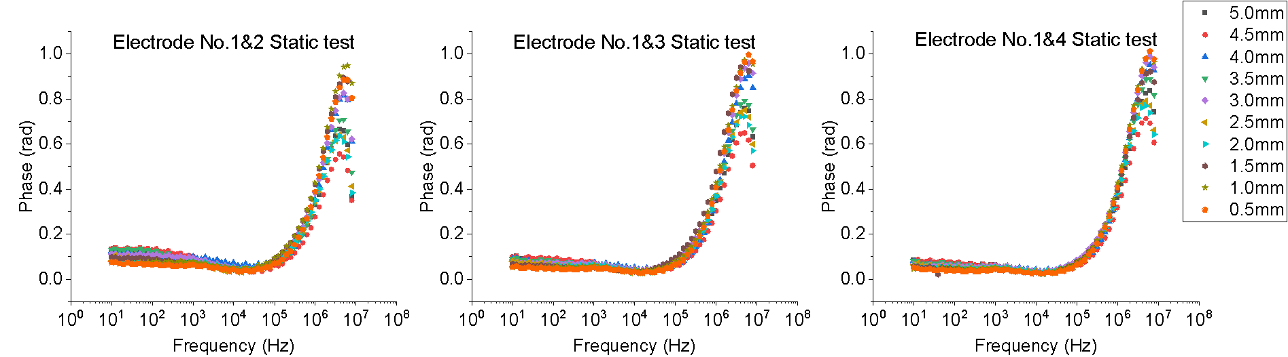
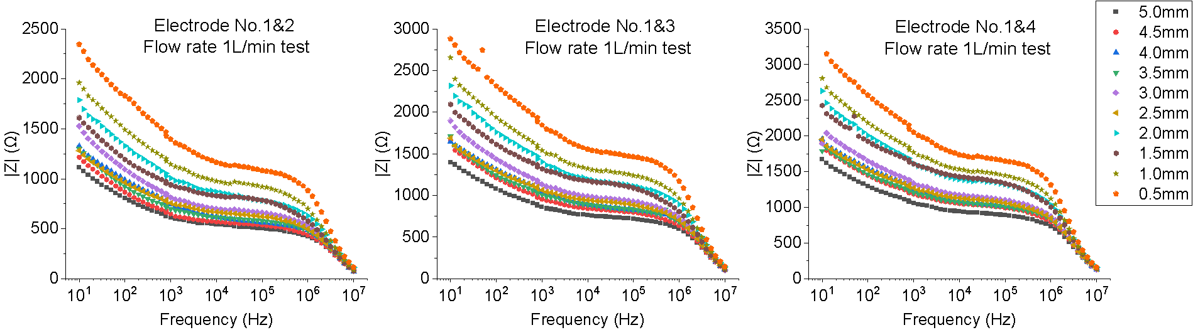
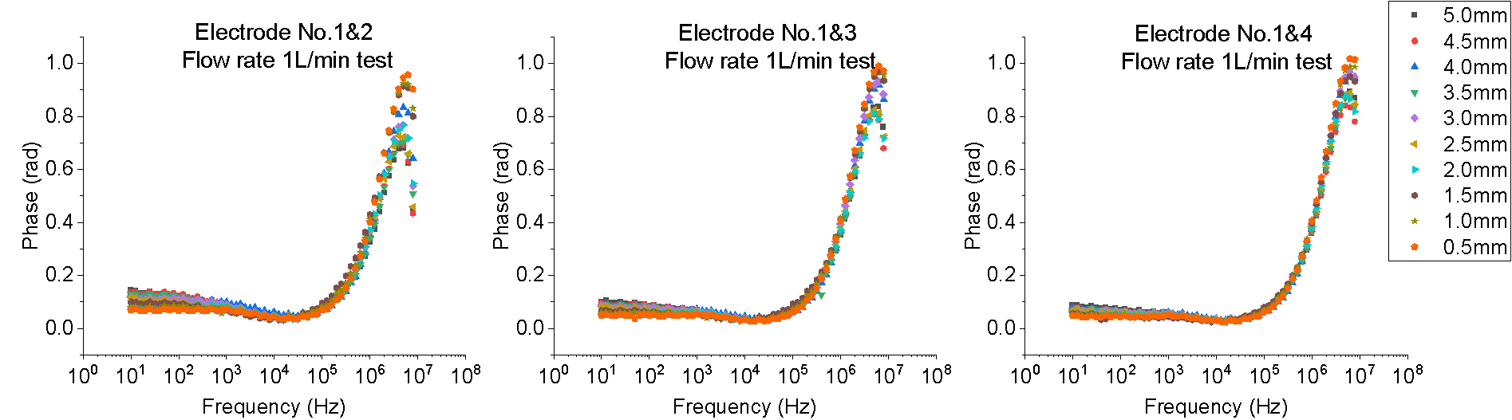
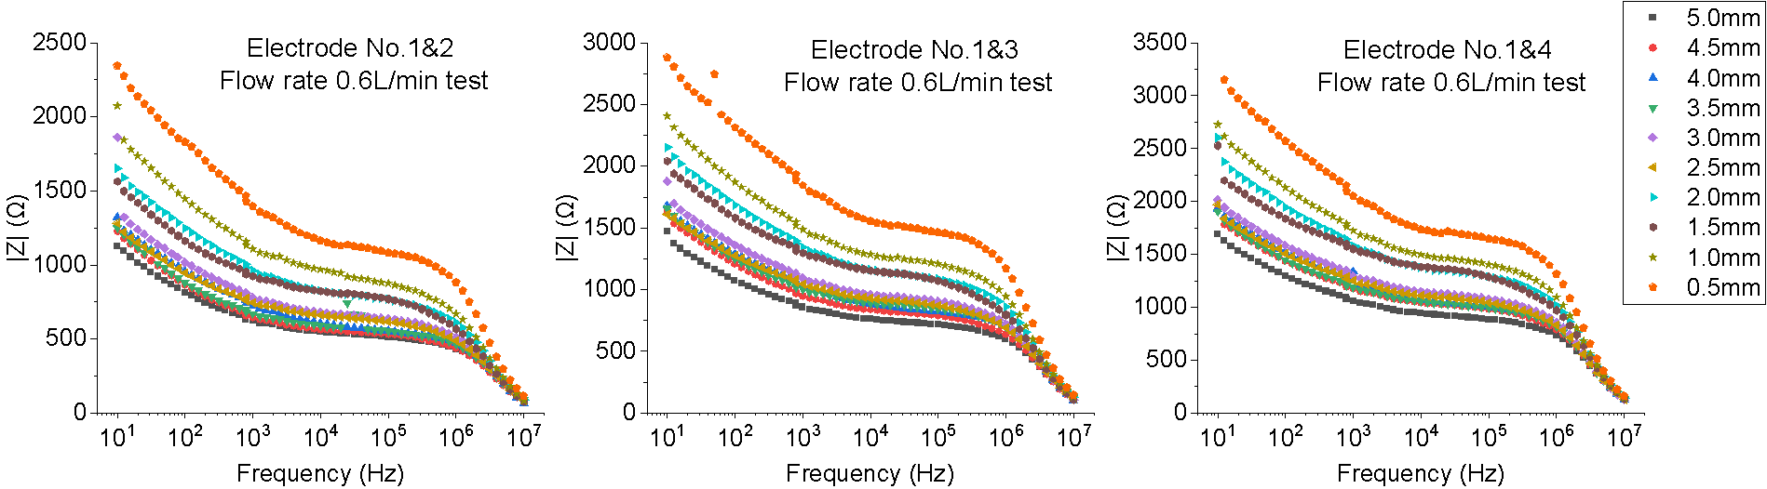
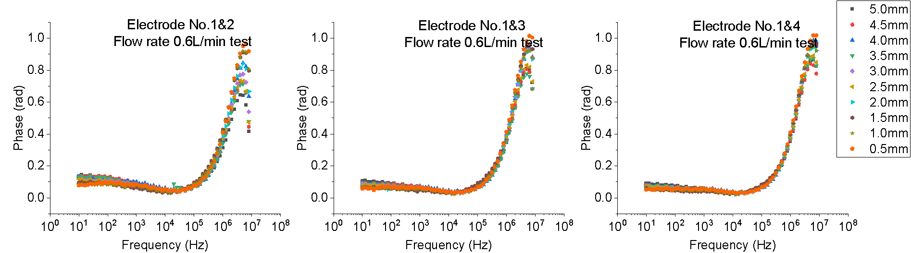
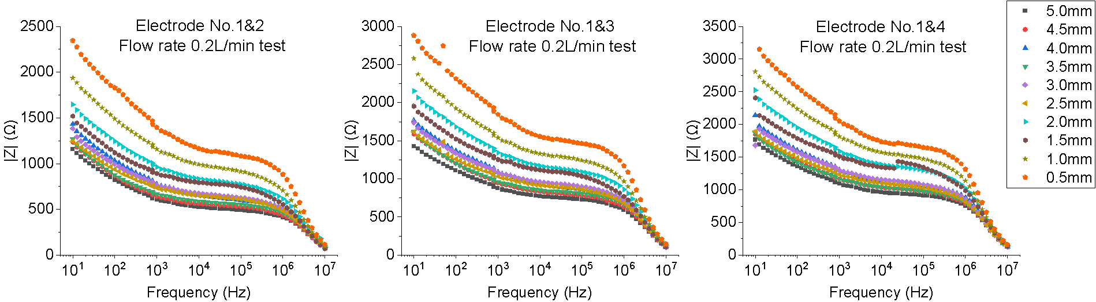
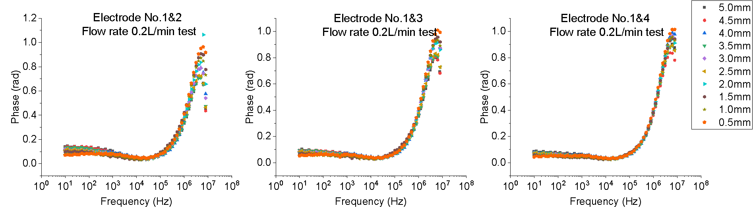
Figure 0.1

Figure 0.2 EIS measurement Nyquist plot for six samples, each plot including three Nyquist plots with different electrode pairs.

