
University of Sheffield
S.J. Watson
Identification of proteins involved in a Novel Mitotic DNA Damage Checkpoint
Doctor of Philosophy (PhD)
2023

Identification of proteins involved in a Novel Mitotic DNA Damage Checkpoint
Steven John Watson
Doctor of Philosophy (PhD)
Department of Oncology and Metabolism
March 2023

Declaration

I, the author, confirm that the Thesis is my own work. I am aware of the University’s Guidance on the Use of Unfair Means (www.sheffield.ac.uk/ssid/unfair-means). This work has not previously been presented for an award at this, or any other, university.

Acknowledgements

Firstly, I would like to thank my primary supervisor Dr Ruth Thompson for guidance throughout my Ph.D. Words cannot fully express my gratitude for the invaluable aid and expertise alongside unwavering support during a project that has been less than straightforward. Their enthusiasm, kindness and ever-available help have made this project possible and truly shaped the scientist I have become.
I would also like to express my thanks to my secondary supervisor Dr Helen Bryant whose invaluable support is deeply appreciated. I would also like to give specific thanks to Dr Ian Sudbery whose bioinformatics expertise and counsel made much of this project possible. Additionally, I would like to thank Dr Spencer Collis for all their advice.
I would like to also give credit to members of the Thompson lab for their assistance with this project; Dr Rachel Gatenby, Harry Porter, Priya Lata, Patricia Benavent-Bellver, Xin Lin, Alex Breitwieser and Afzaal Tufail. I am eternally grateful to have worked with such kind and brilliant individuals. Further thanks to excellent colleagues from the Collis and Bryant labs; Tim, Dan, Katie, Tom, Leona, Aurelie, Ola and Connor. I wish them nothing but the greatest of successes.
I would like to thank my mother, sister, and grandfather whose love, encouragement and support have made this PhD possible, even when the world has given us hard times to work through. Additionally, I want to dedicate this thesis to my grandmother who sadly is no longer here to see me complete my PhD.

Abstract

Cancer and healthy cells rely on conserved Deoxyribonucleic Acid (DNA) damage response (DDR) checkpoints to maintain genomic stability and reduce the chance of mutation. Cancer treatments predominantly function by inducing huge amounts of DNA damage to kill rapidly dividing cells. However, our DNA damage response can potentially lead to resistance to DNA damaging agents due to the total repair of damage induced. For this reason, it is vital that we have a full understanding of how our DNA damage response functions to exploit this for better cancer therapy. While interphase DDR checkpoints are well understood and categorised, mitotic-specific DDR checkpoints are poorly studied. Emerging evidence suggests crosstalk between the spindle assembly checkpoint (SAC) and DDR during mitosis. Despite global DDR downregulation in mitosis, local waves of key DDR component activation highlight the lack of complete DDR deactivation.
A delay in mitotic transit times following DNA damage induction from various agents, such as irradiation (IR), was detected during this project. This indicates the existence of a mitotic DNA damage checkpoint (MDDC), which could be a source of treatment resistance. This thesis aims to identify if X-ray repair cross-complementing 4 (XRCC4) plays a novel role in the MDDC. XRCC4 was highlighted in a preliminary Small interfering Ribonucleic acid (siRNA) DNA damage screen of potential proteins involved in the checkpoint. I observed a significant impact on cell fate, mitotic transit, and mitotic population upon XRCC4 depletion, indicating XRCC4 could play a role outside of Non-Homologous End-Joining (NHEJ). At the end of this project, the specific role of XRCC4 concerning the MDDC remained inconclusive but warrants further investigation.
The aims of this thesis shifted focus towards the analysis of the mitotic-specific transcriptome response to DNA damage, derived from genomic expression data analysed via RNA sequencing (RNAseq). We observed that whilst tools exist for cell-cycle analysis from RNAseq data, there was no reliable tool for the isolation of mitotic cells from the G2 population. Here I developed and validated Modified Seurat Mitotic Sort (MoSMiS), a tool to identify mitotic cells from single-cell RNA sequencing datasets based in the Spatial Reconstruction Of Single-Cell Gene Expression Data (Seurat) toolset. MoSMiS was then used to investigate the mitotic transcription responses to DNA damage and highlight MDDC-related genes of interest. MoSMiS was utilised to analyse published data sets to generate novel gene lists to guide future MDDC investigations.

Contents
Declaration 3
Acknowledgements 4
Abstract 5
Contents 7
Abbreviation List 11
Chapter 1 - Introduction 16
1. The Hallmarks of Cancer 17
1.1 DNA Damage Repair Pathways 19
1.1.1 Homologous Recombination 21
1.1.2 Non-homologous end-joining 22
1.1.3 Mechanism and Proteins of NHEJ 23
1.1.4 Detailed role of XRCC4 in NHEJ 26
1.2 The fundamentals of the Eukaryotic Cell Cycle and the SAC 27
1.2.1 Stages & checkpoints of the cell cycle 27
1.2.2 Stages of Mitosis 28
1.2.3 The Spindle assembly checkpoint in detail 30
1.2.4 SAC Proteins and role in the DDR 32
1.2.5 Interphase Damage Checkpoints and Mitosis 33
1.2.6 DNA Damage in Mitosis 34
1.2.7 Crosstalk between the DNA damage response in the mitotic spindle assembly checkpoint 35
1.2.8 Other Diseases Associated with Defective DNA Repair 37
1.3 Transcriptome through the Cell Cycle 38
1.3.1 Basics of transcription 38
1.3.2 Overview of the transcriptome profile 38
1.3.3 Transcription in response to DNA damage 40
1.3.4 Transcription in mitosis 40
1.4 Bioinformatics 41
1.4.1 RNA sequencing basics 41
1.4.2 Pipeline comparisons 42
1.4.3 Biological insight through cell phase assignment 45
1.5 Hypothesis and Aims 50
1.5.1 Thesis Hypothesis 50
1.5.2 Central Thesis Aims 50
Chapter 2 – Materials and Methods 51
2.1 Chapter Aims 52
2.2 XRCC4 Study 52
2.2.1 Antibodies 52
2.2.2 Human Cell Line Culture 53
2.2.3 Protein Expression Depletion via Reverse Transfection 53
2.2.4 Western Blotting 54
2.2.5 Validation of Deconvoluted siXRCC4 Depletion 56
2.2.6 Reduction in MAD2 at various time points of XRCC4 siRNA Depletion 57
2.2.7 Flow Cytometry 57
2.2.8 Co-Immunofluorescence Microscopy + Staining Controls 58
2.2.8.1 Anaphase Bridge Formation 58
2.2.8.2 BubR1 & Cenp B/ MAD2 / Bub3 Co-localisation 58
2.2.9 Live Cell Microscopy 59
2.2.10 Co-immunoprecipitation of NHEJ and SAC proteins 59
2.2.11 Cell Synchronization after XRCC4 Depletion 60
2.2.12 Quantitative Reverse transcription Polymerase Chain Reaction (qRTPCR) 61
2.3 Bulk RNA Sequencing - Data Set Generation 62
2.3.1 Irradiation treatment LD₅₀ of RT lab Hela Cells 62
2.3.2 5Gy Dose response of RT lab Hela Cells 62
2.3.3 RNA Extraction and storage 63
2.3.4 Cell phase FACSMelody isolation 64
2.3.5 Optimisation of RNA quality post FACSMelody isolation 65
2.3.6 Full Experimental Runs 67
2.4 Bulk RNA Seq – Differential Expression Processing 67
2.4.1 Internal RNA Quality Control 67
2.4.2 Novogene Bulk RNA Sequencing and Quality Control 67
2.4.3 Galaxy RNA sequence processing 67
2.4.4 Unaligned Read QC 67
2.4.5 Read Alignment 68
2.4.6 Aligned Read QC 69
2.4.7 Gene Quantification 71
2.4.8 Count Matrix Processing 71
2.5 Differential Expression Testing via DESeq2 72
2.5.1 PCA Analysis 72
2.5.2 Dispersion and Read Distribution testing 72
2.5.3 Differential Expression testing 72
2.5.4 MA Plot Generation 73
2.5.5 Volcano Plotting and Gene filtering 73
2.5.6 Gene List of Interest generation 73
2.5.7 Gene Ontologies 73
2.5.8 Threshold-free analysis 73
2.6 Seurat 74
2.6.1 Other Phase Analysis Testing – Peco & Cyclone 74
2.6.2 Default Seurat Function – Input from alt 74
2.6.3 Modification and Optimisation of Seurat 74
2.6.5 K Fold Testing 78
2.6.5 qRTPCR MoSMiS GOI validation 78
Chapter 3 – Investigation of a potential novel role for XRCC4 in a Mitotic DNA Damage Checkpoint 81
3.1 Introduction 82
3.2 Hypothesis 83
3.3 Aims 83
3.4 Objectives 83
3.5 Results 84
3.5.1 Validation of single siRNAs from the deconvoluted pool 84
3.5.2 Mitotic populations after Nocodazole and IR treatment post-XRCC4 siRNA depletion 85
3.5.3 Effects of XRCC4 siRNA depletion on mitotic cell progression and mitotic daughter cell fate 88
3.5.4 Effects of XRCC4 siRNA depletion on anaphase bridge formation 92
3.5.5 Effects of XRCC4 siRNA depletion on spindle assembly checkpoint proteins throughout mitosis 94
3.5.6 XRCC4 co-immunoprecipitation of spindle assembly checkpoint proteins after Nocodazole treatment 95
3.5.7. Nocodazole treatment post-siRNA depletion 96
3.5.8 Effect on MAD2 expression levels after XRCC4 siRNA depletion via qPCR 97
3.5.9 Off-target testing of XRCC4 depletion effects on MAD2 98
3.6 Discussion 100
3.6.1 siXRCC4 off-target effects and a potentially wider mitotic role for XRCC4 100
3.6.2 Protein interactions and XRCC4 104
3.7 Summary 106
Chapter 4 – The development of Modified Seurat Mitotic Sort (MoSMiS) 107
4.1 Introduction 108
4.2 Hypothesis 109
4.3 Aims 109
4.4 Objectives 109
4.5 Results 109
4.5.1 Irradiation treatment LD50 of RT lab Hela Cells 110
4.5.2 5Gy Dose Response of Hela Cells 111
4.5.3 Optimisation of RNA quality post FACSMelody isolation 113
4.5.4 Novogene quality control of RNA used in RNA sequencing 117
4.5.5 Quality assessment of unaligned RNA seq reads 119
4.5.6 RNA seq data library sizes 120
4.5.7 Quality assessment of aligned RNA seq reads 121
4.5.8 PCA analysis of generated count matrix 123
4.5.9 Gene distribution expression profiles of generated RNA seq data 125
4.5.10 Differentially expressed genes in the RNA seq data 127
4.5.11 Gene ontologues of differentially expressed gene lists. 135
4.5.12 In detail function of Seurat cell phase assignment optimisation 139
4.5.13 Modified Seurat Mitotic Sort pipeline testing. 141
4.5.14 Fourfold k-test Cross Validation 147
4.5.15 Quantitative RT PCR 152
4.6 Discussion 153
4.6.1 The need for MoSMiS 153
4.6.2 Other phase assignment systems available and their limits 154
4.6.3 Generating MoSMiS 155
4.6.4 Validation of MoSMiS 156
4.6.5 How MoSMiS can be applied and the next research steps. 158
Chapter 5 – Further validation and the application of MoSMiS 159
5.1 Introduction 160
5.2 Hypothesis and Aims 161
5.3 Sourcing datasets 162
5.4 Detail data sets and full phase assignment via MoSMiS 162
5.5 Analysis of mitotic gene expression levels in scRNA seq data sets in response to DNA damage 163
5.5.1 GSE81812 163
5.5.1.1 Combined Data Set Analysis 164
5.5.1.2 Threshold-free analysis 172
5.5.1.3 Enrichment profiles and gene of interest 183
5.5.2 GSE145700 191
5.6 Discussion 194
5.6.1 Datasets used and problems encountered. 195
5.6.2 Effects of treatment on mitotic biological processes. 196
5.6.3 Further experimental testing of MoSMiS and transcriptional gene expression 197
5.6.4 Potential targets for investigation and mapping of a mitotic DNA damage checkpoint derived from GSE81812 testing 198
5.6.4.1 PIDD1 199
5.6.4.2 MEIOC 200
5.6.4.3 SHLD3 201
5.6.4.4 Leading edge gene – E2F1 202
5.7 Conclusion 203
Chapter 6 – Discussion 205
6.1 Introduction 206
6.2 The potential importance of the MDDC in cancer treatment 207
6.3 Discovery of new treatment methodologies via the identification of novel targets 208
6.4 Potential for wider application of MoSMiS 209
6.5 Other use cases for MoSMiS 210
6.6 Investigating other biological questions using MoSMiS cell population isolation 211
6.7 Future Work on MoSMiS 212
Bibliography – Journals and Books 213
Bibliography – Websites 234
Bibliography – R Libraries 235
Appendices A – R Code 237
Appendices B – Differentially expressed genes used in Chapter 5 GO analysis. 289

Abbreviation List

293T | Human Embryonic Kidney 293 Cells
53BP1 | P53-Binding Protein 1
APC/C | E3 Ubiquitin Ligase Anaphase-Promoting Complex/Cyclosome
Artemis | Nuclear Protein That Is Involved In V(D)J Recombination And DNA Repair.
ATCC | The American Type Culture Collection
ATM | Ataxia telangiectasia mutated Serine/Threonine Kinase
ATR | Ataxia Telangiectasia And Rad3-Related Protein
BAM | Binary Alignment Map
BRCA1 | Breast Cancer Gene 1
BRCA2 | Breast Cancer Gene 2
BRCT | BReast CAncer gene 1 C Terminus Domain
BSA | Bovine Serum Albumin
Bub3 | Mitotic Checkpoint Protein Budding uninhibited by benzimidazoles 3
BubR1 | Mitotic Checkpoint Serine/Threonine-Protein Kinase Budding uninhibited by benzimidazoles 1 Beta
C.elegans | Caenorhabditis Elegans
CDK | Cyclin-Dependent Kinase
cDNA | Complementary Deoxyribonucleic acid
CenpB | Centromere Protein B
Chk | Checkpoint Kinase
c-NHEJ | Classical Non-Homologous End-Joining
CtIP | Retinoblastoma-Binding Protein 8, Also Known As RBBP8
Cyclone | Cell Cycle Phase Classification
DAPI | 4’6’ Diamidino-2-Phenylindole
dATP | Fluorescently Tested Adenine
dCTP | Fluorescently Tested Cytosine
DDR | DNA Damage Response
DESeq2 | Differential Gene Expression Analysis Of RNA-Seq Data R Toolkit
dGTP | Fluorescently Tested Guanine
DMEM | Dulbecco's Modified Eagle Medium
DNA | Deoxyribonucleic Acid
DNA Lig IV | DNA Ligase 4
DNA PKcs | DNA-Dependent Protein Kinase
dNTP | Reversible Terminator-Bound Deoxynucleotide Triphosphate
DSB | Double Strand Break
DTT | Dithiothreitol
dTTP | Fluorescently Tested Thymine
E2F | E2F Heterodimeric Transcription Factors
E2F1 | E2F Transcription Factor 1
ECL | Enhanced Chemiluminescence
EDTA | Ethylenediaminetetraacetic Acid
EGTA | Ethylene Glycol Tetraacetic Acid
FACS | Fluorescence Activated Cell Sorting
FANCI | Fanconi Anemia, Complementation Group I
FITC | Fluorescein Isothiocyanate
FUCCI | Fluorescent Ubiquitination-Based Cell Cycle Indicator
GFF | General Feature Format
GO | Gene Ontology
GOI | Gene Of Interest
GSE | Gene Set Enrichment
GSEA | Gene Set Enrichment Analysis
H2A | Histone H2A
HCl | Hydrogen Chloride
HeLa | Henrietta Lacks Human Cervical Cancer Cells
HISAT2 | Hierarchical Indexing For Spliced Alignment Of Transcripts 2
HR | Homologous Recombination
HRP | Horseradish Peroxidase
HTseq2 | High-Throughput Sequence Analysis 2
IR | Irradiation
Ku70 | Ku Heterodimer 70
Ku80 | Ku Heterodimer 80
KYSE-180 | Esophageal Squamous Cell Carcinoma From Middle Intra-Thoracic Esophagus Of A 53-Year-Old Man Prior To Treatment
Log | Logarithm
CPM | Cpm Log2 counts per million
Mad1 | Mitotic Arrest Deficient 1
MAD2 | Mitotic Arrest Deficient 2
MAD2L2 | Mitotic Arrest Deficient 2 Like 2, Also Known As REV7
MCC | Mitotic Checkpoint Complex
MCF7 | Michigan Cancer Foundation-7, Human Breast Cancer Cell
MDA-MB-231 | Epithelial, Human Breast Cancer Cell Line Of A 51-Year-Old Caucasian Female With A Metastatic Mammary Adenocarcinoma
MDC1 | Mediator Of DNA Damage Checkpoint 1
MDDC | Mitotic DNA Damage Checkpoint
Mec1 | Protein Kinase MEC1 (Saccharomyces Cerevisiae)
MEIOC | Meiosis Specific With Coiled-Coil Domain
miRNA | Micro-RNA
MoSMiS | Modified Seurat Mitotic Sort
Mre11 | Meiotic recombination 11 homolog 1
MRN | Protein Complex Consisting Of Mre11, Rad50 And Nbs1
mRNA | Messenger RNA
MYC | MYC Proto-Oncogene, Bhlh Transcription Factor
NaCl | Sodium Chloride
Nbs1 | Nijmegen breakage syndrome protein 1
ncRNA | Non-Coding RNA
NGS | Next Generation Sequencing
NHEJ | Non-Homologous End-Joining
Noc | Nocodazole
p53 | Tumor Protein P53, Cellular Tumor Antigen P53, Or Transformation-Related Protein 53
PBS | Phosphate-Buffered Saline
PCA | Principal Component Analysis
PCR | Polymerase Chain Reaction
Peco | Predicting Cell Cycle Progression R Package
PFA | Paraformaldehyde
pH3 | Phospho-Histone 3
PHRED | Phred (Phil's Read Editor)
PI | Propidium Iodide
PIDD1 | P53-Induced Death Domain Protein 1
Plk1 | Polo-Like Kinase 1
Pol λ | DNA Polymerase Lambda
Pol μ | DNA Polymerase Mu
P-TEFb | Positive Transcription Elongation Factor B
R | R Based Coding Language
Rad3 | Ataxia Telangiectasia And Rad3-Related Protein
Rad50 | RAD50 double strand break repair protein
Rad51 | DNA Repair Protein RAD51 Homolog 1
Rad53 | Serine/Threonine/Tyrosine Protein Kinase RAD53
RIN | RNA Integrity Number
RIPA | Radioimmunoprecipitation Assay Buffer
RNA | Ribonucleic Acid
RNA Seq or RNAseq | RNA sequencing
RNF168 | Ring Finger Protein 168
RNF8 | E3 Ubiquitin-Protein Ligase Ring Finger Protein 8
RPA | Replication Protein A
RT-PCR | Reverse transcription polymerase chain reaction
SAC | Spindle Assembly Checkpoint
SAM | Sequence Alignment Map
Scc1 | Double-Strand-Break Repair Protein Rad21 Homolog
SDS-PAGE | Sodium Dodecyl Sulfate–Polyacrylamide Gel Electrophoresis
Seurat | Name Of Spatial Reconstruction Of Single-Cell Gene Expression Data R Toolkit
SFM | Dulbecco's Modified Eagle Medium Serum-Free Media
Sgo1 | Shugoshin 1
SHLD3 | Shieldin Complex Subunit 3
scRNA Seq | Single Cell Ribonucleic Acid Sequencing
siRNA | Short Interfering RNA
snoRNPs | Small Nucleolar RNAs
snRNA | Small Nuclear RNA
SSB | Single Strand Break
ssDNA | Single Strand Deoxyribonucleic Acid
SYBR | SYBR Green I, Asymmetrical Cyanine Dye
TBS | Tris-Buffered Saline
Tel1 | Serine/Threonine-Protein Kinase TEL1
TIGR | The Institute For Genomic Research
TopBP1 | DNA Topoisomerase II Binding Protein 1
Tris | Tris(Hydroxymethyl)Aminomethane
tRNA | Transfer RNA
UV | Ultraviolet
XLF | Non-Homologous End-Joining Factor 1, XRCC4-Like Factor
XRCC4 | X-Ray Repair Cross Complementing 4
Ythdc2 | Yth N6-Methyladenosine Rna Binding Protein C2

Chapter 1 - Introduction

1. The Hallmarks of Cancer
It is important at the onset of this thesis to establish the specifics of cancer. Cancer in its most simple explanation is the aberrant uncontrollable development of cells that invade and destroy normal body tissue.
Cancer cells also share commonly observed characteristics and capabilities that provide insight into their underlying biology. In work published by Hanahan and Weinberg in 2000, they outlined 6 main hallmarks of these attributes:
- Sustaining Proliferative Signalling: Cancer cells can continuously undergo growth and division even when not receiving external signalling to do so. Cancer cells can produce these signals themselves or by disabling negative feedback signals.
- Evading Growth Suppressors: Following on from the previous attribute cancer cells can evade mechanisms limiting excessive cell growth and division. Doing so by inhibiting tumour suppressor genes and by not utilising contact-based growth inhibition.
- Resisting Apoptosis (Cell Death): Cancer cells develop mechanisms to loss the ability to undergo apoptosis, resulting in the survival and accumulation of aberrant cells.
- Enabling Replicative Immortality: Cancer cells can manipulate telomerase enzymes to enable indefinite division without initiating senescence.
- Inducing Angiogenesis: Tumours can stimulate angiogenesis, the formation of new blood vessels, to supply themselves with necessary nutrients and oxygen even at the detriment of surrounding tissue.
- Activating Invasion and Metastasis: Cancer cells can invade surrounding tissues and spread within the body, generating secondary tumour sites due to this proliferation (metastasis).
The above are the initial hallmarks that characterise most cancer cells (Hanahan & Weinberg, 2000). Further reports also introduced more emerging hallmarks of cancer in 2011 and again in 2022 (Hanahan & Weinberg, 2011 and Hanahan, 2022):
- Deregulating Cellular Energetics: Cancer cells can alter their energy metabolism to better aid in growth and survival even in the presence of oxygen-rich environments. Cancer cells often exhibit the Warburg effect utilising aerobic glycolysis and lactic fermentation to prevent normal aerobic respiration (Warburg, 1925).
- Avoiding Immune Destruction: Cancer can evade immune system detection and subsequent destruction via a loss of interleukin-33.
- Genome Instability and Mutation: Cancer cells commonly acquire and accumulate genetic instability and DNA mutations, this can lead to treatment-resistant phenotypes and cause more aggressive variations of a given cancer.
- Tumour Promoting Inflammation: Tumors can induce chronic inflammation in a given microenvironment to induce settings better suited for cancer replication and growth. Pathways designated to maintain tissue homeostasis are interrupted for the benefit of a given tumour.
- Unlocking Phenotypic Plasticity: Cancer cells are not limited by the same degree of set differentiation. Cancer cells can undergo molecular and phenotypical chances to facilitate and aid in tumour progression.
- Nonmutational Epigenetic Reprogramming: Cancer cells can undergo epigenetic reprogramming altering gene expression to be more favourable for function, proliferation and treatment resistance doing so via gene and histone modifications in addition to altering chromatin structure. This is completed can be completed without altering the underlying DNA structure.
- Polymorphic Microbiomes: Cancer cells may harbour regions of microorganisms, such as bacteria, that can have a protective or deleterious effect on cancer proliferation and development. The variation in microbial regions present within tumours can play a role in influencing cancer progression and treatment resistance.
- Senescent Cells: While traditionally regarded as a protective mechanism against cancerous cells senescence could have a role in the stimulation of tumor development. Senescent cells promote tumour phenotypes via senescence-associated secretory phenotypes (SASP).

1.1 DNA Damage Repair Pathways
Throughout an organism’s life cycle, its DNA is perpetually subject to a multitude of damaging events. If left unrepaired, the resulting DNA lesions could cause cell death or cancer. For this reason, our cells are equipped with a variety of safeguarding mechanisms for the identification and repair of DNA damage.
There are a variety of stimuli which can lead to DNA damage. Endogenous damage originates from within the cell through errors in DNA replication. Endogenous damage can also arise from oxidative damage where reactive oxygen species generated during metabolism subsequently induce cytotoxic lesions (Cannan & Pederson, 2016). Endogenous reactive chemicals such as aldehydes (Chung et al., 1996) and S‐adenosylmethionine (Holliday & Ho, 1998) can lead to DNA damage, as does chemical DNA instability resulting from DNA depurination and damage in DNA repair mechanisms (Nakamura et al., 2000).
Replication stress through insufficient nutrients, energy availability, nucleotides or key mitotic division proteins can lead to stalling of helicases and polymerases. Stalling occurs during DNA replication with cells unable to progress through the stages of mitosis. This replication stress can result in DNA replication forks collapsing into double-strand breaks. DNA is unwound to replicate two identical strands from the original that can collapse if regulatory proteins fail to stabilize DNA requiring DNA damage repair (Yeeles, Poli, Marians & Pasero, 2013).
Cells can also experience damage through external (exogenous) sources. Bulky DNA adducts can occur when DNA is bound to a carcinogenic chemical. Chemicals such as acetaldehyde, a component of tobacco smoke, increase the chances of cellular malignancy from improper mitotic division (Wei et al., 2020). Our DNA can also meet exogenous sources of damage such as ionizing radiation causing widespread base pair DNA damage in higher doses. Radiolysis of water in cells leads to free radicals that nick complementary DNA strands, in turn causing cytotoxic legions as the IR radiation degrades the phosphate backbone of the DNA (Ward, 1994).
DNA damage can be highly cytotoxic. Single-strand breaks (SSBs) are the most common lesions arising in cells. Double strand breaks (DSB) are less common but far more damaging. DSBs are the complete breakage of both strands of a DNA section. DSBs require different DNA damage repair (DDR) pathways to SSBs to ensure that the damage does not lead to mutation, or fixed inheritable DNA changes that can lead to diseases such as cancer.
DNA damage could deregulate systems of control in cells due to genetic damage, mutation, and conformational sequence changes. DDR systems must perform the vital task of repairing the genetic damage before it gives rise to cancerous cells (Zhu et al., 2002). The DNA damage repair pathways are varied in mechanism and biochemical components, but all are essential for the maintenance of genomic integrity. The variety of pathways provides a degree of redundancy should a more effective pathway fail.

1.1.1 Homologous Recombination
Homologous recombination (HR), as shown in Figure 1.1, is a pathway representing decades of research from a wide range of academic sources. A study by Szostak et al., 1983 represents the application of this pathway towards what would eventually be known as the Double-Strand Break Repair (DSBR) Pathway (Szostak et al., 1983).
HR DSBR is a genetic repair pathway where DSBs are processed and repaired using sister chromatids (which exist post-replication) as templates to repair the damaged strand, as shown in Figure 1.1. The broken DNA region is repaired with a high degree of efficiency and accuracy making HR the optimal DSB repair pathway.
5’ ends are resected by the MRN complex, a protein complex consisting of the proteins Meiotic recombination 11 homolog 1 (MRE11), RAD50 Double Strand Break Repair Protein (RAD50) double strand break repair protein (RAD50, and Nijmegen breakage syndrome protein 1 (Nbs1) (Figure 1.1.A). The MRN complex binds to the break site. The 5’ ends are cut to create Single Strand Deoxyribonucleic Acid (ssDNA 3’) overhangs (Figure 1.1.B). The MRN; a complex made up of Mre11, Rad50, and Nbs1, completes the resection using Retinoblastoma-Binding Protein 8, Also Known As RBBP8 (CtIP) (Figure 1.1.C).
Replication Protein A (RPA) which has a high affinity for ssDNA binds to the overhangs and recruits DNA Repair Protein RAD51 Homolog 1 (Rad51) which forms nucleoprotein filaments. The filaments detect homologous sequences in broken DNA regions. These proteins begin strand invasion where a displacement loop is formed allowing DNA polymerase to begin synthesizing DNA. This creates Holliday junctions (Li & Heyer, 2008), cross-shaped DNA structures that allow the exchange of genetic information between DNA duplexes. Synthesis then occurs to restore chromosomal information as shown in Figure 1.1.
The double-strand break repair pathway, or the synthesis-dependent strand annealing (SDSA) pathway repairs the DSB (Figure 1.1D) (Nassif et al., 1994).
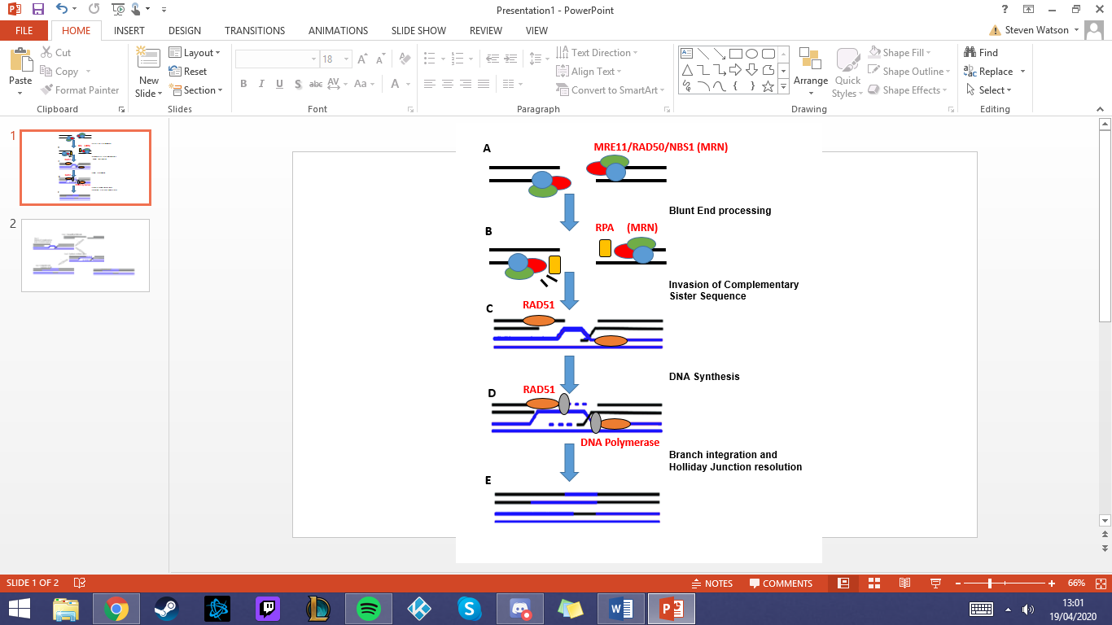Cells preferentially use homologous recombination repair (HR) as it is the optimal system for the repair of genetic damage when sister chromatids are present (Mao et al., 2008).
Figure 1.1. The complete repair of a DNA DSB using homologous recombination and a complementary DNA sequence. Homologous recombination response to double-strand breaks processes the affected region (A), creating overhangs in the 3’ regions of the complementary strands (B). The strands are then invaded by complementary sister chromatid sequences (C) before synthesis or the removed and broken region (D) before reintegration of the break site into two separate complementary DNA sequences (E). Image generated in Powerpoint.

1.1.2 Non-homologous end-joining
Alternate repair pathways are also required when the homologous sequence is unavailable to use as a template, such as in cells where DNA has not been replicated such as in the early S or G1 phase.
A separate series of repair pathways using non-homologous end-joining (NHEJ), was first coined in 1996 by Moore and Harber. NHEJ uses different DNA repair proteins to HR allowing for mechanistic flexibility, the redundant systems of damage repair in DNA are beneficial for an organism's survival (Moore & Haber, 1996).
There is a far higher rate of NHEJ in comparison to HR. The ratio of NHEJ to HR has been shown by Mao et al., 2008 to be approximately 6:1. NHEJ is a faster repair mechanism and is completed without slower utilisation of sister chromatids, however, NHEJ is more error-prone in its repair (Mao et al., 2008).
Mao et al., 2008 showed that NHEJ takes 0.5 hours compared to approximately 7 hours for the complete repair of a DSB by HR cells utilising each repair system based on its current condition. Cells choosing the slow, more environmentally dependent, HR allow for more accurate repair or error-prone NHEJ that can repair DSB far more quickly.
Work by Biehs et al., 2017 highlights further complexity of this well-established historic system. The study highlights that Mre11 endonuclease activity in the G1 phase of the cell cycle causes a DNA resection-limited dependent form of Classical NHEJ (Biehs et al., 2017). In addition, this slower variant of NHEJ appears to also be dependent on Artemis activity and binding. The study suggested this slow NHEJ may represent the repair of compacted chromatin (Biehs et al., 2017).

1.1.3 Mechanism and Proteins of NHEJ
The first step in the repair of DSB via NHEJ is the recognition and binding of the X-ray repair cross-complementing 5 and 6 (Ku70 and Ku80) heterodimer to broken regions (Figure 1.2.A). The Ku heterodimer is made of two distinct subunits Ku Heterodimer 70 (Ku70) and Ku Heterodimer 80 (Ku80), both of which are comprised of different protein sequences. Ku heterodimers function in tandem sharing the same structure with similar DNA binding domains forming the C-terminus protein scaffold (Figure 1.2.B). Further steps of NHEJ utilise the Ku70/Ku80 heterodimer in complex with DNA. The Ku70/Ku80 complex acts as the central platform for the nuclease, ligase and polymerase binding (John et al., 2001)
In the presence of DNA breakage, the Ku 70/80 complex undergoes conformational changes allowing the formation of complexes with other NHEJ proteins (Yaneva et al., 1997). The changing of the structure enables the recruitment of NHEJ proteins which indicates that Ku is an initial regulator of the NHEJ response (Yaneva et al., 1997). Nishizawa‐Yokoi et al., 2012 showed that suppression of the Ku heterodimer leads to decreased genetic transformations and increased homologous recombination (Nishizawa‐Yokoi et al., 2012).
The first protein recruited by the Ku complex is the DNA-dependent protein kinase catalytic subunit (DNA-PKcs) (Figure 1.2.B) a serine/threonine kinase in the phosphoinositide 3-kinases family. DNA-PKcs plays a crucial role in the repair of DSBs. The loss of DNA-PKcs results in hypersensitivity to IR in murine models and DSB breaks remaining unrepaired (Taccioli et al., 1998).
DNA-PKcs has been shown to act in a bridging manner at the DSB Kurimasa et al., 1999) recruiting and connecting other NHEJ proteins. The kinase activity causes a conformational change in DNA-PKcs and DNA at the DSB site. DNA-PKcs has been observed to be activated in mitotic cells' spindle assembly ensuring chromosomal stability by activation of the Checkpoint Kinase – Breast Cancer Gene 1 (Chk2-Brca1) pathway, which organises the mitotic spindle (Shang et al., 2014). In addition, DNA-PKcs phosphorylates the other components of NHEJ. The phosphorylation step enables dissociation from the DNA sequence of bound DNA-PKcs when NHEJ is complete, allowing the reuse of this complex (Spiley et al., 1995).
Polymerases and nucleases later in the NHEJ steps require blunt ends to function properly. The protein Artemis (Figure 1.2.B) cleans the DSB region. Artemis nicks 5’ overhangs via a 5’ endonuclease activity and removes the 3’ phosphoglycolate from 3’ overhangs. Resynthesis of missing or damaged nucleotides is performed by polymerase mu (Pol μ) and polymerase lambda (Pol λ) of the X polymerase family (Aoufouchi et al., 2000).
Both polymerases bind to the Ku:DNA-PKcs complex via their Brca1 C Terminus Domains (BRCT) (Figure 1.2.C). BRCT is an evolutionarily conserved domain in proteins involved in cell cycle checkpoints response to DNA damage i.e. DSB (Bork et al., 1997). Both polymerases have a degree of DNA template dependency. Pol λ, while having more flexibility in replication, is mainly template-dependent as it is tolerant of base-pair damage. In comparison, Pol μ is less flexible and can carry out both template-dependent synthesis and template-independent synthesis. Pol μ can catalyze DNA via its unique end-bridging activity allowing it to still synthesize a sequence even with incompatible blunt DNA ends. This synthesis, while error-prone, is made more accurate in the presence of Ku and X-ray cross-complementing protein 4 (XRCC4)/DNA Ligase IV (DNA Lig IV) complexes, this does not eradicate errors instead mitigating incidence rates (Ma et al., 2004).
After DNA binding at the DSB, Ku: DNA-PKcs forms a recruitment complex for the main factors of NHEJ. X-ray cross-complementing protein 4 (XRCC4), DNA Ligase IV (DNA Lig IV), and XRCC4-like factor (XLF also known as Cernunnos) are recruited in a stepwise fashion (DeFazio et al., 2002) (Figure 1.2.D).
XLF interacts with XRCC4 creating a series of filaments assisting in the bridging of DNA Lig IV to enable effective end-joining (Hammel et al., 2011). XLF also plays a role in the promotion of re-adenylating DNA Lig IV after ligation for further reuse of the complex, the adenylation process ensuring that DNA Lig IV unbinds from a now bridged DNA strand to enable its reuse in the repair process at another site (Riballo et al., 2009).
The most recently highlighted NHEJ factor is a Paralog of XRCC4 and XLF (PAXX), identified as a new component of the NHEJ framework by Ochi et al., 2015. PAXX’s crystal structure closely resembles that of XRCC4, the PAXX factor interacts directly with Ku heterodimers and is recruited to DNA damage sites (Ochi et al., 2015). PAXX functions in tandem with XRCC4 and XLF to mediate DSP repair. PAXX has been shown to promote Ku-dependant DNA ligation and in the assembly of NHEJ factors on damaged chromatin (Ochi et al., 2015). The PAXX Ku accumulation promotion to DSBs has been shown to work alongside XLF-based enhancement of DNA Lig IV recruitment, highlighting the distinct but complementary roles of both factors in NHEJ (Liu et al., 2017).
PAXX has been shown to function similarly to XLF bridge stabilisation, both factors can simultaneously bind to Ku heterodimers and act as structural bridges in their interaction with DNA-PK. The engagement of both proteins provides a complementary advantage in DNA end joining (Seif-El-Dahan et al., 2023).
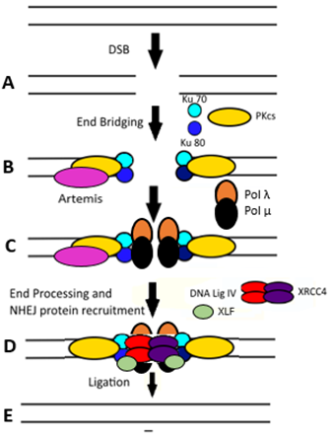
Figure 1.2. Stepwise repair of DSB in mammalian cells by NHEJ. In response to DNAdouble-strand breaks the region is stabilized by DNA PKcs and Artemis which bridge those broken ends and process them for subsequent ligation steps. The DNA PKcs/ Ku complex then starts to recruit downstream NHEJ Proteins. XRCC4 and XLF Artemis act as the framework between the processed blunt ends and the ligation action of DNA Lig IV, these proteins working in tandem to re-join to broken region together. Image generated in Powerpoint.

1.1.4 Detailed role of XRCC4 in NHEJ
XRCC4 plays a crucial role in NHEJ. The XRCC4-XLF complex when binding to Ku 70/80 acts as a scaffold stabilizing the broken region (Andres et al., 2012). In addition, XRCC4-XLF forms a strong complex with DNA Lig IV promoting ligation (Ahnesorg et al., 2006). XRCC4-XLF bridging appears to function independently of DNA Lig IV binding and activity (DeFazio et al., 2002).

As shown by Roy et al., 2015 DNA Lig IV stimulation by XRCC4 is intrinsic for XLF functionality in promoting cell survival after replication stress. This occurs alongside the variability in XRCC4/XLF complex requirement for DNA-PK autophosphorylation. Therefore, indicating variable levels of XRCC4 interaction during each stage of NHEJ. Loss of XRCC4 reduces the efficiency and precision of NHEJ (van Heemst et al., 2004). Studies analyzing the effect of knocking out XRCC4 in mice show a more error-prone NHEJ process takes place (Schulte-Uentrop et al., 2008). Decreased XRCC4 production leads to more extended DNA deletions and larger microhomologous regions, short complementary regions approximately 5-25 base pairs between two DNA strands (Schulte-Uentrop et al., 2008).
The role of XRCC4 in NHEJ is a dynamic one as both the bridging and recruitment require a degree of flexibility to account for the variance in DSBs. While XLF stimulates the binding of XRCC4-Lig IV to DNA (Ahnesorg et al., 2006), the ability to form sleeve-like filament constructs gives a mobile nature to the XRCC4-XLF complex. Not only does XRCC4 play a vital role in NHEJ but is also mechanistically flexible (Brouwer et al., 2016). The high affinity between XRCC4 and DNA Lig IV makes therapeutic drug screening affecting the complex difficult due to the protein-protein interaction. A study by Menchon et al., 2016 found an interface of DNA-Lig IV and XRCC4 binding allowed for a more detailed investigation of each compound within the NHEJ system (Menchon et al., 2016).

1.2 The fundamentals of the Eukaryotic Cell Cycle and the SAC

1.2.1 Stages & checkpoints of the cell cycle
The G1 (Gap 1) phase is the first growth phase of the cell cycle. During G1 a cell acquires the growth factors and nutrients alongside increasing organelle numbers.
In the S (Synthesis) phase, the cell undergoes DNA replication creating a complete copy of the DNA in the nucleus, doubling the DNA content of the cell.
G2 (Gap 2) is another growth phase where the cell prepares for mitosis via cell growth and protein synthesis. Cells during the M phase (Mitosis) undergoes cytokinesis, generating two daughter cells from a parent cell.
The driving force of the cell cycle is via the action of a series of cyclin proteins (Cyclin A, B, C, D, and E) which fluctuate in expression level throughout the cell cycle.
Cyclins act as regulators for the activation of Cyclin-dependent kinases (Cdk). As shown in Figure 1.3 Cdk 1, 2, 3 and 4 play direct roles in driving the forward cell cycle (Lau et al., 2021). DNA synthesis and replication occur in the synthesis phase (S phase). Each stage is monitored for errors by cellular checkpoints before undergoing mitosis (M phase).

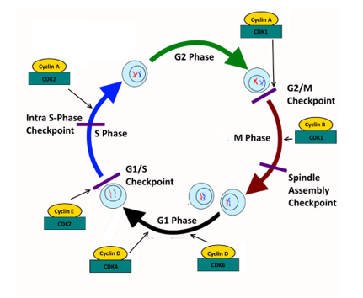
Figure 1.3. Cyclin level throughout the cell cycle determining the progression of mammalian cells through each phase. The cell undergoes growth in preparation for DNA synthesis driven by cyclin D and CDK4 and 6 pausing at the G1-S checkpoint to ensure the proper growth of the cell progressing before progressing through the checkpoint using Cyclin E and CDK2. Cellular synthesis in S phase is monitored for errors in DNA replication and DNA damage by the Intra S-phase checkpoint with S phase being driven by Cyclin A and CDK2. A secondary growth phase in G2 is driven forwards by Cyclin A and CDK1 and is monitored for errors in cell size and DNA replication by the G2/M checkpoint. The cell undergoes mitosis and creates identical daughter cells that reenter G1 phase being driven by Cyclin B and CDK1, mitosis is stopped at the spindle assembly checkpoint to check for proper chromosomal alignment before the cell is split in two (Tvegård et al., 2007. Maya-Mendoza, 2010. Stark & Taylor, 2004). Image generated in Powerpoint.

1.2.2 Stages of Mitosis
When a cell enters mitosis, the spindle assembly checkpoint (SAC) is activated. Proper microtubule attachment and chromosome tension are required to satisfy the SAC and allow the cells to progress to anaphase (Figure 1.4.C). Without this checkpoint, premature anaphase progression could potentially lead to errors in cell division. Improper cell division and the formation of anaphase bridges due to improper chromosome alignment can result in SAC failure. Failure of the SAC checkpoint can result in error-prone cellular division. One cause of anaphase bridges the fusion of telomeres resulting in improper separation of daughter cells, the aberrant daughter cells remaining attached via a connected DNA bridge (Hoffelder et al., 2004). Anaphase bridges can also form because of unresolved Holliday junction intermediates that lead to aberrant mitotic division in cells that have unresolved homologous recombination repair (Chan & West, 2018).
Following SAC satisfaction (Figure 1.4.C), the E3 Ubiquitin Ligase Anaphase-Promoting Complex/Cyclosome (APC/C) ubiquitinates and inhibits securin, a regulatory protein that inhibits separase. Separase is then free to break down the Cohesin molecules holding the two sister chromatids together (Uhlmann et al., 1999). This allows the tension from the microtubules to pull the condensed chromosomes to the opposite poles of the cell (Figure 1.4.C).
Upon entering telophase, the cell reassembles the nuclear envelope around each set of divided chromosomes (Figure 1.4.D). The nucleoli reappear while the chromosomes release their condensed state during which mitotic equipment such as the mitotic spindle and microtubules are dissembled (Kliuchnikov et al., 2022). The cell then undergoes cytokinesis, dividing into two daughter cells. The spindle apparatus partitions and transports the chromatids; contained within the nuclear envelope, into the cytoplasm of the new cell. A contractile ring of protein forms around the equatorial plate shrinking the cells' equator and pinching in the plasma membrane forming two discrete daughter cells (Figure 1.4.E) (Kliuchnikov et al., 2022).

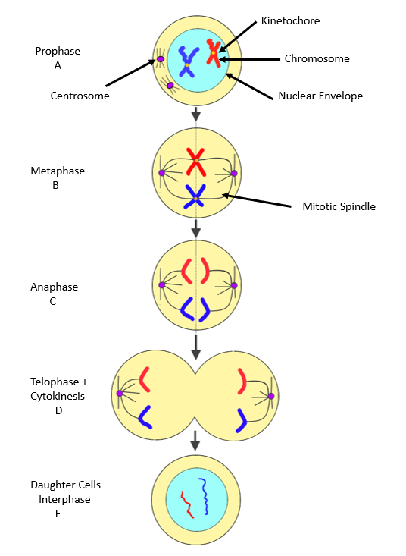
Figure 1.4. Visual representation of cells in the various stage of mitosis. One starting cellular division and leaving Interphase the cell enters Prophase wherein the nucleus begins to break down, the chromosomes condense and mitotic spindle forms (the above figure is simplified as there are 23 pairs of chromosomes), this leads into prometaphase where the nuclear envelope breaks down entirely and the fully condensed chromosomes attach to the spindle assembly. In Metaphase proper the chromosomes align to the metaphase plate and assuming there is proper spindle to chromosome binding the kinetochore microtubules pull the sister chromatids apart. Next in Telophase and Cytokinesis the chromosomes de-condense, the nuclear envelop reforms and nucleolus reappears before eventual complete separation into two daughter cells occur via an actin ring. Image generated in Powerpoint.

1.2.3 The Spindle assembly checkpoint in detail
To ensure accurate division of genetic material the sister chromatids must be broken apart. Separase, a protein that hydrolyses and degrades cohesin, must be released via the deregulation of its inhibitory counterpart securin (Hornig, Knowles, McDonald & Uhlmann, 2002). The release of separase occurs when cellular signalling indicates the proper binding of mitotic spindles to chromatids. Before anaphase, separase is kept inactive by securin ensuring that sister chromosomes remain bound together. A cell cannot enter anaphase until cohesion is broken and sister chromosomes split (Hornig, Knowles, McDonald & Uhlmann, 2002).
The SAC acts as a regulatory checkpoint ensuring kinetochore-microtubule attachments are properly made and equal tension from the two poles is detected before progression into anaphase (Skoufias et al., 2001). Kinetochores are specialised protein complexes that form on eukaryotic centrosomes. Kinetochores are vital for cell division as they provide the attachment point for spindle fibres that pull chromosomes apart during mitosis (Maiato et al., 2004).
The mitotic checkpoint complex (MCC) automatically forms at kinetochores during mitosis, restricting anaphase until proper microtubule attachment and equal tension are detected. The SAC is always active between metaphase and anaphase as the kinetochores continuously form during mitosis. The MCC is always assembled ensuring the checkpoint is continually functional (Hein & Nilsson, 2014).
The MCC is an inhibitory complex made up of Mitotic Checkpoint Protein BUB3 (Bub3), Mitotic Arrest Deficient 2 (MAD2), and Mitotic Checkpoint Serine/Threonine-Protein Kinase BUB1 Beta (BubR1). The MCC proteins act in tandem to bind to and deactivate CDC20 resulting in an inability to activate the APC/C (E3 ubiquitin ligase anaphase-promoting complex/cyclosome). The APC/C drives the cell forward into anaphase by degrading Cyclin B and securin via ubiquitination (Sudakin et al., 2001). The MCC complex requires sequential binding for proper formation and activity. For BubR1-Bub3 to bind to CDC20, MAD2 must bind first to CDC20 indicating MAD2 could be the initiating MCC factor (Fang et al., 1998).
Once all sister chromatids have properly aligned, the production of the MCC is stopped. A lack of MCC causes the release and activation of CDC20. The APC/C polyubiquitinates and leads to the proteolytic degradation of securin and cyclin B via the 26S proteasome (Sudakin et al., 2001). The degradation of securin releases the bound Separase, cleaving Double-Strand-Break Repair Protein Rad21 Homolog (Scc1, a kleisin subunit) of the Cohesion protein ring. The cleavage results in chromatid separation and the cells can enter telophase. Realignment of chromatids is completed by the destabilization and reattachment of microtubules to the kinetochore by Aurora-B (Kelly & Funabiki, 2009). Simultaneously cyclin B is degraded leading to the mitotic exit of the daughter cells (Murray et al., 1989).

1.2.4 SAC Proteins and role in the DDR
The DNA damage response (DDR) was initially thought to be non-functional during the mitotic cell phase due to the risk of telomere fusion (Orthwein et al., 2014). Studies indicate that DDR signalling is reduced during mitosis but not completely inactive and that full DDR activity is regained post-mitotic exit (Giunta et al., 2010).
A study by Kim and Burke, 2008 highlights that in yeast cells mitotic damage retained from interphase activates the SAC but is reliant on Ataxia telangiectasia mutated Serine/Threonine Kinase (ATM) and Ataxia Telangiectasia And Rad3-Related Protein (ATR) yeast homologs, Serine/Threonine-Protein Kinase TEL1 (Tel1), and Protein Kinase MEC1 in Saccharomyces Cerevisiae (Mec1) respectively. The study also demonstrates in yeast it is not SAC proteins alone that are assembled at unattached kinetochores for inhibition. But also that DDR proteins are key for mitotic regulation when unperturbed (Kim and Burke, 2008). ATM serine/threonine kinase (ATM) ataxia telangiectasia and Rad3-related protein (ATR) are key signalling proteins activating the DDR response to DSB.
The cross-talk between the SAC regulates DNA integrity and spindle attachment during metaphase respectively, their interlinked functionality ensures the stability, integrity and accurate creation of daughter cells.
Lawrence et al., 2015 highlights research in Caenorhabditis Elegans (C.elegans) germ cells that metaphasic defects in chromosomal alignment increase the enrichment of SAC and DDR components localized to chromatin. The same study also found stability of the metaphase plates is equally compromised in cells lacking SAC proteins Mitotic Arrest Deficient 1 (MAD1) and Mitotic Arrest Deficient 2 (MAD2), and cells lacking DDR kinase proteins ATR and Chk1 (Lawrence et al., 2015). These deficiencies both similarly affect the organism, indicating the proper function of SAC and DDR proteins are equally vital to cellular stability.
Palou et al., 2017 also show that the DDR proteins ATM and ATR block CDK activity in mitosis. These regulatory proteins also respond to DNA damage by stabilizing securin and phosphorylating key SAC proteins to ensure the initiation of DNA repair (Palou et al., 2017).
The connection of SAC and DDR pathways has led some to posit an interlinked system. Recent studies from our lab indicate that Superoxide Dismutase 1 (SOD1) mediates mitotic progression in response to DNA damage. SOD1-depleted cells showed increased damage to centromeres and bypassing mitotic delay post-genotoxic damage in a Rad52-dependant manner (Gatenby et al., 2022). SOD1-depleted cells also show deregulated mitotic DNA synthesis in tandem with Rad51.
An interlinked system could also function via ATM phosphorylating securin to induce mitotic arrest or ATR phosphorylating SAC components. A study by Dimitrova et al., 2008 highlighted this interlinked response. Activated SAC components, such as Bub1, localised to DSB interacting with P53-Binding Protein 1 (53BP1) and promoting NHEJ (Dimitrova et al., 2008).

The theoretical Mitotic DNA damage checkpoint could respond to both DNA damage and spindle defects during mitosis. It is also possible that the Mitotic DNA damage checkpoint is an entirely separate system from the SAC, sharing similar features or components but acting in an entirely different mechanistic manner.

1.2.5 Interphase Damage Checkpoints and Mitosis
Interphase has three checkpoints for cell progression. The G1/S restriction checkpoint utilises the E2F Heterodimeric Transcription Factors (E2F) in conjunction with G1/S and S phase cyclin/CDK complexes. This checkpoint ensures optimal conditions are present for cell cycle progression. The checkpoint establishes DNA integrity to either progress a cell into the S phase for DNA synthesis, stall the cell in G1 and signal for DNA repair or entirely remove the cell from cycling; into the G₀ phase (Venezia et al., 2004).
The intra-S checkpoint tightly regulates DNA synthesis during the S phase, arresting this synthesis in response to DNA damage to enable the repair of a cell before cell cycle progression resumes (Ren & Wu, 2004). The intra-S checkpoint plays an essential role in maintaining genomic integrity. The checkpoint is controlled by an ATR signalling responding to detected stalled replication (Tercero & Diffley, 2001). Stalled replication can originate from factors not solely related to DNA damage. The checkpoint allows cells to activate repair mechanisms at the stalled site and preventing further replication errors. ATR-mediated checkpoint signalling has been shown to activate upon Checkpoint Kinase 1 (Chk1) inhibition which effects replication fork speeds by inhibition of excess replication origin firing (Syljuåsen et al., 2005. Petermann et al., 2010). This in turn enabling cells to focus on completion of ongoing replication before new replication events are initiated.
The G2/M DNA damage checkpoint utilises cyclin/CDK complexes to ensure that cells do not enter mitosis before any accrued DNA damage has been repaired. The cyclin/ CDK complex is inhibited by Chk1 which is activated in response to DNA damage, preventing mitotic entry. Improper DNA replication is also checked and repaired before cell progression via the deactivation of Chk1 (Ree et al., 2006). Both checkpoints directly check for DNA damage and ensure DNA integrity before cell progression.
The mitotic spindle assembly checkpoint acts as a checkpoint of proper spindle alignment rather than explicitly checking DNA integrity. Daughter cells post-mitotic division can still retain DNA damage from parent cells.
Discovery and understanding of a Mitotic DNA damage checkpoint (MDDC) could give new insight into the DDR during mitosis, with the MDDC potentially functioning similarly to its interphase counterparts.

1.2.6 DNA Damage in Mitosis
Cells experiencing DSB during mitosis have been found to activate the Protein Complex Consisting Of Mre11, Rad50 And Nbs1 (MRN), DNA PKcs, ATM and Mediator Of DNA Damage Checkpoint 1 (MDC1) act similarly to their interphase counterparts (Benada et al., 2015). The traditional recruitment cascade would cause MDC1 to recruit E3 ligase RING-finger protein 8 (RNF8), in turn causing the ubiquitination of Histone H2A (H2A) and Histone H2AX (H2AX) aided by Ring Finger Protein 168 (RNF168) (Giunta et al., 2010, Benada et al., 2015). This ubiquitination would in interphase cells recruit 53BP1 and Breast Cancer Gene 1 (BRCA1) for NHEJ and HR processes, the recruitment triggered by the chromatin changes, but in mitosis this event is repressed (Giunta et al., 2010).
Giunta et al., 2010 show the signalling cascade for the DDR activated by DSB is reduced in mitosis (Giunta et al., 2010). The study showed that 53BP1 is not recruited during mitosis deregulating downstream checkpoint proteins. RNF8 and RNF168 were found to be recruited in late mitosis to the DNA damage site for the potential recruitment of 53BP1 (Giunta et al., 2010).
There is a diminished degree of DNA damage signalling in mitosis with full DDR activation upon mitotic exit and entry into G1 (Giunta et al., 2010). The study highlights that RNF8, RNF168 and 53BP1 associate with kinetochores but are excluded from DSB during early mitosis. The data suggest the induction of a DDR in mitosis is important because as stated “transient inactivation of ATM and DNA-PK renders mitotic cells hypersensitive to DSB-inducing agents”.
Studies such as Giunta et al., 2010 highlight that while the DDR is diminished in mitosis it is not entirely deactivated. The study highlights a marking of cells for repair during mitosis that are repaired outside of mitosis itself in G1 (Giunta et al., 2010).
DDR signalling varies across the cell cycle phases, the response in mitosis is still under-categorised. Orthwein et al., 2014 highlighted that both RNF8 and 53BP1 are phosphorylated by mitotic kinases to stop chromatin recruitment in the presence of DSB. The restoration of RNF8 and 53BP1 functionality at the break sites activates the DDR in mitosis (Orthwein et al., 2014). This accumulation is instead damaging rather beneficial leading to increased telomere fusion and anaphase bridge formation. The study concluded that DSB repair during mitosis could destabilize the genome to avoid telomere fusion.
The range of DDR inhibition serves different purposes from reducing error-prone division to enabling more accurate repair of cells post mitotic exit. Specifically, avoiding telomeric fusion via the stoppage of chromatin recruitment. This stoppage ensures cells do not continue to improperly complete harmful end joining of unrepaired or processed break sites.

1.2.7 Crosstalk between the DNA damage response in the mitotic spindle assembly checkpoint
Ma et al., 2018 show that RNF8 is a substrate of the APC/C complex and stabilizes the Ku heterodimer at DSB (Ma et al., 2018). The removal of the Ku heterodimer is mediated by the ubiquitination and subsequent degradation of the Ku80 subunit, this ubiquitination is completed by RNF8. The study highlighted that the APC/C determines the level of RNF8 and prevents premature degradation and turnover of Ku (Ma et al., 2018).
Work by Lukas et al., 2011 highlighted how DNA lesions from replication stress can be carried past the M phase. Lesions are carried into interphase when the affected DNA region is contained and protected in nuclear bodies marked with 53BP1, MDC1 and TopBP1 (Lukas et al., 2011). MDC1 foci were shown to recruit TopBP1 at mitotic DNA breaks. Filamentous structures are formed that tether the DNA breaks allowing the proper segregation of the DSB-containing chromosomes followed by repair in G1 (Leimbacher et al., 2019).
Royou, Gagou, Karess & Sullivan, 2010 show that BubR1 in conjunction with polo-like kinase 1 (Plk1) plays a role in G2/M transition and aids in the regulation of mitosis in Drosophila larvae (Royou, Gagou, Karess & Sullivan, 2010). Phosphorylation and inactivation of APC/C inhibitors have been shown to act similarly to NHEJ pathways, bridging DNA gaps and ensuring proper cellular division without telomere fusion. This operates in Drosophila larvae functionally similar to the tether structures highlighted in Leimbacher et al., 2019.
The study highlighted that MDC1 and BubR1 are shown to interact in mitosis (Eliezer et al., 2014), meaning the DNA tethers in Lukas et al., 2011 and Leimbacher et al., 2019 could be functionally the same.
Jessulat et al., 2015. showed that Bub1 and Bub2 support the process enabling mitotic exit. Bub1 and Bub2 are recruited to phosphorylated Serine/Threonine/Tyrosine Protein Kinase RAD53 (Rad53) (The human homolog being Chk2) or H2A accumulation sites in yeast. Bub1 then colocalizes the protein 53BP1 to DSB sites, promoting NHEJ repair (Jessulat et al., 2015) in yeast.
Yang et al, 2014 have shown that Serine 214 of MAD1 is phosphorylated by ATM. This phosphorylation was demonstrated to regulate the SAC by actively promoting the homodimerization of Mad1 and its heterodimerization with MAD2, vital parts of the MCC formation (Yang et al, 2014).
Eliezer et al., 2014 defined a novel role that DDR protein MDC1 plays in the SAC, MDC1 localized directly to the kinetochore in an ATM-dependent manner (Eliezer et al, 2014). ATM phosphorylates H2AX; a mitotic kinetochore histone, which is required for MDC1 localization. MDC1 plays a direct role in the localization of the inhibitory mitotic checkpoint complex proteins MAD2 and CDC20. Therefore, highlighting DDR proteins could be key to SAC integrity via MCC interactions (Eliezer et al, 2014).
Work by Guerrero et al., 2010 shows in cases of merotelic attachment subsequent daughter cells are malformed. Merotelic attachment is present when singular kinetochores are attached to microtubules originating from both poles. The lagging chromosomes lead to the improper separation of split daughter chromosomes causing malformations in the cell division and activating non-homologous end-joining (NHEJ) (Guerrero et al., 2010). In response, there is a limitation in the effectiveness of the SAC and suppression of anti-proliferative pathways. This link could indicate a potential interaction between the SAC and proper NHEJ functioning. A failure in either attachment monitoring, or the subsequent breakage repair is far more likely to produce carcinogenic cells.
A mitotic-specific DDR response has been shown to stabilise the kinetochore to microtubule attachments via Aurora-A and Plk1 kinases, resulting in chromosomal instabilities, when key DDR proteins are inhibited in mitosis these chromosomal segregation errors are not seen to the same extent (Bakhoum et al., 2014).
Mechanistic understanding of the interplay between the two signalling pathways must be understood as further evidenced by Bolanos-Garcia et al., 2012. They highlighted interaction and protein requirement hierarchies in both spatial and temporal arrangement of the DNA-PKcs/Ku70/Ku80 multiprotein complex in NHEJ, and the anaphase-promoting complex in the spindle assembly checkpoint is key for a complete picture of each system (Bolanos-Garcia et al., 2012).

1.2.8 Other Diseases Associated with Defective DNA Repair
Cancer while a prevalent example of disease derived from improper DNA repair is not the only example. Numerous other diseases can derive a root cause from aberrant DNA damage repair, the defective pathways can lead to many diseases with varied symptoms.
An example of such a disease is Bloom syndrome, often abbreviated as BS. The disease was first reported in Bloom, 1954 highlighted as a likely genetic syndrome (Bloom, 1954). A paternally and maternally linked mutation in the BLM gene unrepaired in offspring was found to be the gene root of this syndrome, a sequence with homology to RecQ double-strand break repair helicases (Ellis et al., 1995). Individuals with the syndrome could experience growth abnormalities, Ultraviolet (UV) skin sensitivity, an increased risk of infection and an elevated risk of cancer.
Another such disease is Ataxia–telangiectasia (A–T or Louis–Bar syndrome). The first published case report dates to 1941 describing a patient with cerebellar ataxia and cutaneous telangiectasia (Louis-Bar, 1941). The term ataxia-telangiectasia was proposed by Boder and Sedgwick in 1957 also observing similar presentation of the syndrome (Boder, Sedgwick, 1957). The syndrome, in addition to giving a predisposition to cancer, also presents as a range of neurodegenerative symptoms including telangiectasia and progressive ataxia, alongside choreoathetosis, eye apraxia, developmental, immune and respiratory issues (Boder, Sedgwick, 1963).
Work by Gatti et al., 1988 mapped the corresponding A-T gene to the corresponding chromosome 11q22-23 (Gatti et al., 1988). Further work determined that A-T was caused by mutations in the ATM serine/threonine kinase gene (ATM), a kinase key to the phosphorylation of vital DNA repair and cell cycle proteins (Savitsky et al., 1995).
Understanding the genetic route that causes DNA repair defective syndromes is integral to the development of potential therapeutic approaches. This is true both for cancer and across the spectrum of DNA repair-deficient diseases.

1.3 Transcriptome through the Cell Cycle
Proteins are the key to proper cellular processes and functional regulation. Eukaryotic DNA contains the blueprint for protein production within an organism, the process of proteins encoded is vital for proper cellular function. Transcription is the central biological process from which single-stranded ribonucleic acid (RNA) is produced from a Deoxyribonucleic acid (DNA) template. This RNA is then translated into protein (Ellis et al., 1995).

1.3.1 Basics of transcription
Transcription begins with the RNA polymerase and transcription factors binding to promoter DNA, transcription factors being key regulators of overall gene expression (Mitsis et al., 2020). The RNA polymerase breaks the bonds between the complementary DNA nucleotides by the removal of hydrogen bonds, complementary nucleotides are added to a strand of the now separated DNA to form the RNA strand. Polymerase forms an RNA backbone to create an RNA strand before post-transcriptional RNA processing is completed. The primary RNA transcript strand either remains in the nucleus or exits into the cytoplasm to begin translation into a protein (Andrecka et al., 2008).
The precursor messenger RNA (pre-mRNA) still contains noncoding intron regions most have these removed via RNA splicing. The correct translation of eukaryotic genes is completed via the linkage of exons (Zhao et al., 2016). The addition of a 5’ cap and 3' polyadenylated tail protects the Messenger RNA (mRNA) from degradation when moving from transcription sites to the ribosome (Jiang et al., 2016).

1.3.2 Overview of the transcriptome profile
The transcriptome is the total set of all RNA transcripts generated during the transcription process, including both the coding mRNA and non-coding RNAs (Zhang et al., 2019). While mRNA plays an obvious role in the process of gene expression, the non-coding RNA (ncRNA) also play a key role in the landscape of the transcriptome. ncRNA includes micro-RNA (miRNA) that plays a key role in post-transcriptional gene silencing through RNA interference (MacFarlane & Murphy, 2010).
Other ncRNAs include transfer RNA (tRNA) that transfers amino acids to the mRNA sequence during ribosomal gene translation (Sharp et al., 1985). Small nuclear RNA (snRNA) processes the pre-mRNA by the formation of a nucleus located in small nuclear ribonucleoproteins (Nagai et al., 2001). Small nucleolar RNAs (snoRNPs) are involved in nucleotide modification via sequence-specific small nucleolar ribonucleoproteins (Reichow et al., 2007). Piwi-interacting RNAs are involved in gametogenesis maintaining the stability of germline cells (Grimson et al., 2008).
The current approach for transcriptome study is via RNA sequencing (Wang et al., 2009). RNA sequencing (RNA seq) is a highly accurate cell-wide RNA analysis tool.
Single-cell RNA seq (scRNA seq) was developed to allow the tracking of experimental effects within individual cells. Analysis via scRNA seq is useful to answer specific biological questions while accounting for the effects of the cell cycle on transcription (Wang et al., 2009).
Poirion et al., 2016 highlight that as more studies move towards single-cell RNA sequencing analysis there is no best fit for processing tools (Poirion et al., 2016). The impact of data pre-processing, batch removal, gene alignment and normalization can alter the downstream analysis. Single-cell subpopulation detection and experimental response analysis require experimental and tool designs tailored to the experiment. A canon pipeline could provide key benchmarking data for bioinformatics tools and better data conformity.
More intricate transcriptome analyses such as the spatial mapping of the transcriptome, in tandem with the gene expression profile, are being developed. New tool suites need to be developed to analyse more complex data sets (McKellar et al., 2022).
Mapping of the human cancer transcriptome allows for new insights into the gene expression and pathology of the disease. Large-scale studies have categorised 17 distinct cancer transcriptomes across the human body in over 8000 patients (Uhlen et al, 2017). These studies bring brand new insight into key markers and potential oncological targets for study shared across patients.
The mapping of the cancer transcriptome allows for a more comprehensive view of a patient’s cancer and real-world clinical decisions. An RNA sequencing approach could allow for the determination of cancer classification on a molecular level. Patient RNA seq would allow the for charting personal genetic cancer risk factors and deriving individual specific treatment therapies.

1.3.3 Transcription in response to DNA damage
In Homo sapiens cell models, it has been established that DNA damage results in global repression of RNA synthesis acts primarily as a protective response. This protective response ensures that mutated or damaged genomic sequences do not propagate. Transcription repression allows cells to be repaired before further spread of cellular aberrations can be completed (Heine et al., 2008, Cannan & Pederson, 2016). Transcription is deregulated locally to double-strand DNA breaks, limiting the production of malformed RNA and allowing for repair of transcriptional machinery Heine et al., 2008, Cannan & Pederson, 2016).
Phosphorylation and ubiquitination of RNA polymerase II by the kinase Positive Transcription Elongation Factor B (P-TEFb) results in global repression of the transcriptional response in the presence of DNA damage across the cell cycle (Heine et al., 2008). While global repression of transcription is well categorised, transcriptionally active components are still utilised to maintain cell cycle progression. Global repression can be overcome to ensure the promotion of cell cycle phase exits via alternate systems via regulational waves of Tumor protein P53 (p53) and MYC Proto-Oncogene, Bhlh Transcription Factor (MYC) expression (Silva & Ideker, 2019).

1.3.4 Transcription in mitosis
Until recently, the consensus was that due to the highly condensed nature of chromatin in mitosis, there was complete repression of transcription in mitosis (Parsons & Spencer, 1997). The technical limitations of the time were unable to elucidate the far more complex transcription response of mitotic cells. More recent advances in RNA sequencing have been able to investigate this response more accurately.
Whilst there is global repression of transcription in response to DNA damage, mitotic cells refocus transcriptional responses to trigger waves of increased expression p53 expression and decreased MYC expression levels (Porter et al., 2017). MYC; proto-oncogenes that code for transcription factors, expression is mediated via p53 activity triggering waves of localised positively and negatively regulated genes. This process enabled localised gene activity, even in systems with net global transcription repression allowing for the repair of DNA damage, doing so in tandem with a transcription-coupled repair response where the RNA is used as the DNA template.
It is important when investigating the MDDC to differentiate between the general global mitotic repression of transcription set against the waves of increased transcription of localised key genes that allow for mitotic progression.
Transcription is maintained in a reduced capacity throughout the mitotic cell's internal phases with the wave of localised transcriptional expression changes increasing response levels towards the end of mitosis. The wave of transcription allows for the proper mitotic exit of cells (Palozola et al., 2017). There is also evidence of transcription occurring at both the centromeres during mitosis (Liu et al., 2015) and at other chromosome-fragile sites during mitosis (Macheret et al., 2020),

1.4 Bioinformatics
Biological data is constantly generated and published by an immense range of laboratories and private industries. The demand for analysis of these data sets is handled by bioinformatics and multidisciplinary fields of computational biology (Bayat, 2002). Bioinformatics has progressed vastly alongside the proliferation of computing capabilities. The field of study itself evolved from the first complete genome sequencing of Haemophilus influenza by The Institute for Genomic Research (TIGR) (Fleischmann et al., 1995). Developing the Human Genome Project sequencing the complete Homo Sapiens genome in 2003 (NHGRI, 2022).

1.4.1 RNA sequencing basics
Next Generation Sequencing (NGS) approaches such as Illumina, utilise parallel sequencing of short reads post-DNA fragmentation. The fragments undergo adaptor ligation and in-situ amplification adhered to the fragmented reads to be converted into the (Jones et al., 2015).
The short-read sequencing technologies process millions of fragment amplifications. Sequencing between longer DNA sequence fragment gaps is computationally reassembled (Hu et al., 2021). DNA fragmentation shears DNA into platform-specific fragments via physical, chemical, or enzymatic methods.
The smaller fragments generated contribute to high-quality sequencing data. End-repair is completed to ensure proper adaptor library ligation post fragmentation. Illumina systems remove 5′ phosphate and 3′ hydroxyl groups via blunt ending. Non-template deoxyadenosine monophosphate nucleotides are added to the 3' ends of DNA strands (Hu et al., 2021). Adaptors that are specific to the processed fragments are ligated to allow for fragment recognition by the sequencer using DNA fragments bound to the flow cells of the sequencing system.
Amplification uses size-selective enrichment within set ranges to remove contaminants for cleaner and more accurate sequencing (Gandhi et al., 2017). Generation of DNA libraries by clonal amplification is completed by bridge amplification Polymerase Chain Reaction (PCR) in Illumina flow cells.
Illumina sequences genes by the synthesis of fragments with attached fluorescently labelled reversible terminators (Goodwin et al., 2016). Reversible terminator-bound deoxynucleotide triphosphate (dNTP) is added to a bound fragment chain in the flow cell. The optical outputs from the incorporated fluorescently labelled nucleotides are activated if they correspond to the added dNTP. The fluorescence signals are imaged allowing fragment mapping.
Both the terminator and dye are removed to allow the next labelled dNTP to be added until all fluorescently tested adenine (dATP), cytosine (dCTP), guanine (dGTP), and thymine (dTTP) are tested. The fluorescence signals are imaged allowing fragment mapping.
This method of RNA sequencing gives raw fastq format sequencing information with inbuilt Phil’s Editor Phred (PHRED) scores, used to determine the level of base quality sequencing (Cock et al., 2009). This raw fastq format containing all read fragments creating the DNA library can be processed downstream and quality checked, the raw data can be used to gain differential expression genomic data.
Data is gathered post-isolation of total RNA from cells of interest and used in the construction of DNA libraries. These DNA libraries can be analysed to find differentially expressed genes of interest (Ji & Sadreyev, 2018).

1.4.2 Pipeline comparisons
After generating raw RNA sequencing (Figure 1.5 A) data the information must be pre-processed transforming the raw sequencing data into a count matrix of expressed genes (Figure 1.5 B). Once processing has been completed then differential expression (Figure 1.5C) and downstream analysis can occur.
Alignment mapping and gene coordinate assignment, as with most bioinformatics tools, have no standard optimal option. There are multiple tools and pipelines available for each tool and processing step used. The tool choice of any bioinformatician is based on experimental parameters best suiting the information being processed (Corchete et al., 2020).
As shown in Figure 1.5 B FastQC (Andrew, 2010) and Samtools (Li et al., 2009) were chosen to determine the quality of the unaligned and aligned reads respectively. Both tools return highly reliable scoring for a range of key parameters when testing the processing of RNA sequencing data. FastQC interprets the stored sequencing quality data present in the raw fastq format of the reads. FastQC allows for clear visualisation of mean quality score and per sequence quality score ensuring. Quality control at this step ensures data being processed will give reliable downstream outputs.
Similarly, Samtools returns the number of read maps, the errors in mapping and unmapped sequences. This tool gives a clear indication of the reliability of gene assignment from tested fragments. Accuracy in the count matrix is key to gaining biological insight from the RNA seq data set, giving conclusions that can dependably be reached.

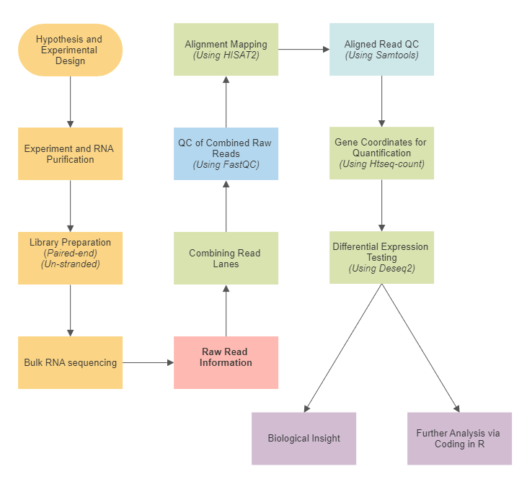
Figure 1.5 General RNA sequencing workflow and chosen tools. The overall workflow of the generation of biological insight from experimental design used within this study. Steps are highlighted with the tools used in brackets as required. Other workflows are available, but this is optimal for this studies requirements, ease of use and replication as needed. All analysis pre-processing will be completed in Galaxy.eu. Further downstream analysis will be completed using R coding in R.
A
B
C

Reads are mapped against the Human Dec 2013 (GRCh38/hg38) (hg38) reference genome using Hierarchical Indexing For Spliced Alignment Of Transcripts 2 (HISAT2) (Kim et al., 2019). HISAT2 is a splice-aware mapper that can align mRNA-originating reads crossing exon/intron boundaries. HISAT2 utilises and improves upon Bowtie (Langmead et al., 2009). HISAT2 can identify splice junctions between exons, using this information to align the read fragments to the chosen reference gene. When compared to its contemporary alignment tools such as STAR (Dobin et al., 2012), HISAT2 produced very small unmapped reads indicating a far more precise tool (Corchete et al., 2020).
To test differential expression of aligned RNA seq data counts across the must be generated for each feature. Counts are generated by the number of aligned RNA seq fragments that correspond to a specific gene. HTseq2 (Putri et al., 2022) creates a count matrix from the aligned reads outputted from HISAT2. HTseq2-count operates by calculating the number of reads in the aligned Binary Alignment Map (bam) file that maps to each gene. For each genomic feature (gene) a count matrix shows the number of reads mapped to said feature. HTseq22 shows a high correlation of gene expression values, fold changes in expression and related p values post differential expression indicating an accurate tool (Liu et al., 2022).
The next step was generating a mitotic and interphase-related gene list of interest. Differential expression was completed to find statistically relevant up and down-regulated genes from the bulk RNA seq data. Differential Gene Expression Analysis Of RNA-Seq Data R Toolkit (DESeq2) functions well with differential expression testing in negative binomially distributed data matrices (Love, Huber & Anders, 2014). When DESeq2 has been tested by other studies the tool showed highly accurate differential expressed gene analysis (Wang, Li, Nelson & Nabavi, 2019). The accuracy of the tool and its ability to handle negative binomially distributed data make it well-suited for this study.

1.4.3 Biological insight through cell phase assignment
A central aim of this study is to investigate the cell cycle using a generated mitotic and interphase differentially expressed gene of interest list. The cell cycle stage has been highlighted as a major factor in gene expression changes across cell phase populations (Keren et al., 2015. Sanchez & Golding, 2013). The development of tools to assign cell cycles for single-cell RNA sequencing data sets via computational analysis gives new insights into already interrogated experiments. Expanding the scope of a data set via reanalysis gives a board data pool to investigate the mitotic transcriptome.
Two main cell phase assignment tool types have been developed, discrete and continuous phase assignment. Both have the same central issue, an inability to isolate a G2 and M population instead of creating a grouped G2/M population. Discrete cell phase assignments such as via Cyclone (Scialdone et al., 2015) were tested before tool development, as shown in Figure 1.6 A. The default Cyclone function shows cells scoring as G1 or scoring as G2/M. When tested with a data set previously published, we were unable to attain differences in phase scoring that could separate G2 and M cells. Cyclone is emblematic of the problem as the G2/M default phase assignment was not M phase-specific. This lack of specificity made it unsuitable for mitotic cell population isolation. The Cyclone tool was not suitable for optimisation in the M phase assignment.
Continuous phase assignment tools such as Predicting Cell Cycle Progression R Package (Peco) (Hsiao et al., 2019) were also tested before tool development, as shown in Figure 1.6 B. Peco constructs a pseudo-timeline for continuous assignment along the cell cycle using a Fluorescent Ubiquitination-Based Cell Cycle Indicator (FUCCI) based pi cell phase assignment. Peco orders tested cells across a continuum of the cell phase landscape. The cyclic trend of a given gene is then estimated based on the FUCCI phase. The tool plotting per cell expression levels pi values are shown as black and white points. Peco then generates a normalised expression trend of that gene which can be overlayed across multiple tested genes, shown as blue dots. Peco is unable to identify a region in that pseudo-timeline corresponding specifically to mitosis.
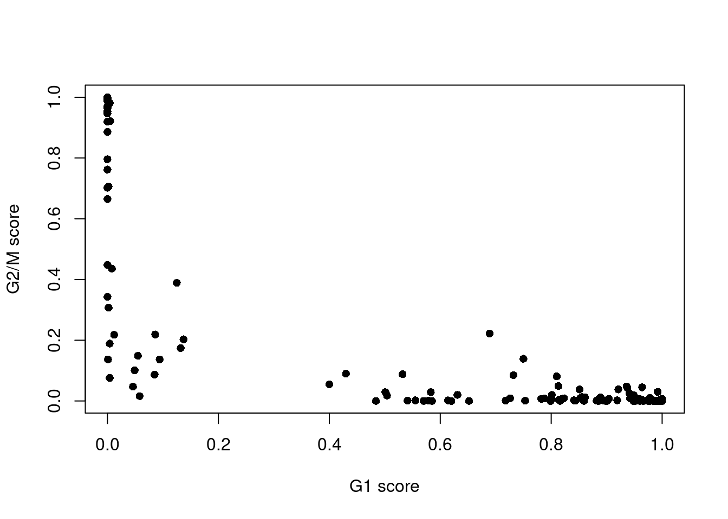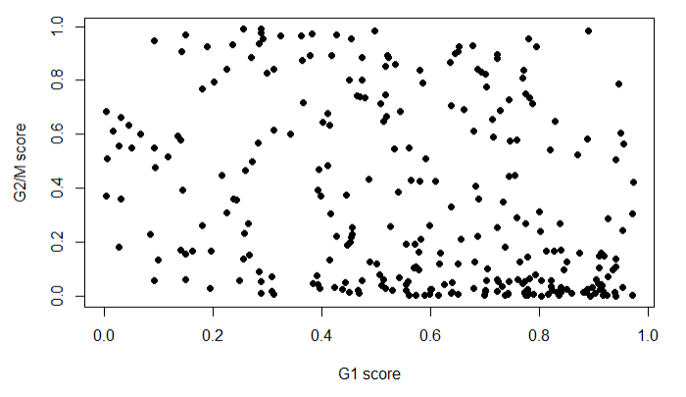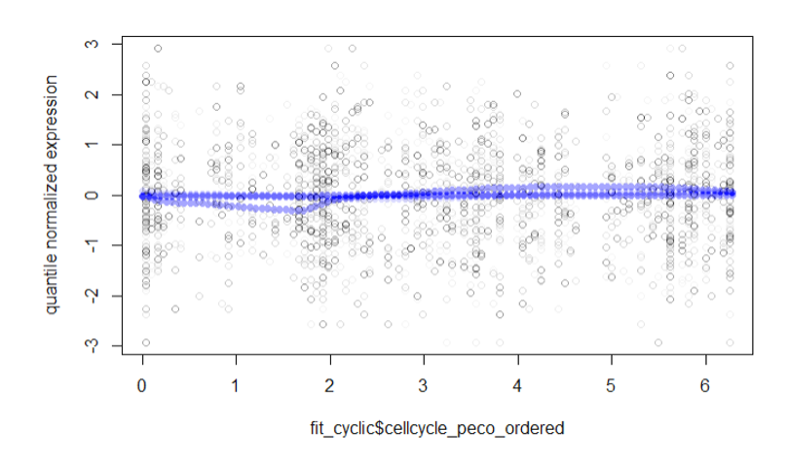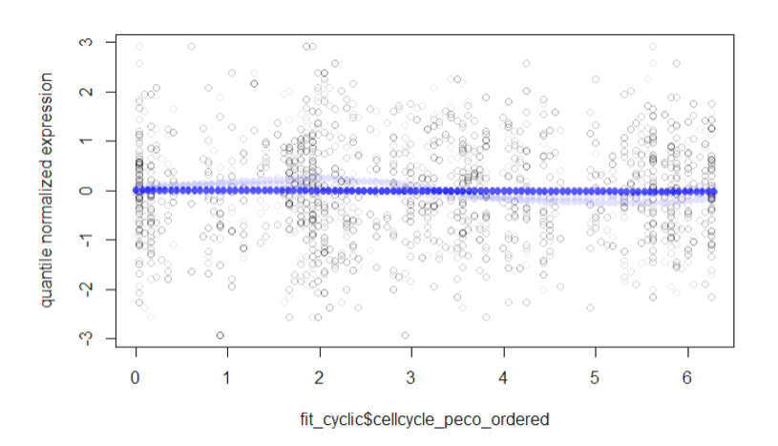
Cyclone Provided Data Set
External Input Data Set
A
B
Peco G2 Genes of Interest
Peco M Genes of Interest
Figure 1.6. Finding and optimising the phase sorting code base to analyse and detect mitotic cells using Peco and Cyclone. The major hurdle of generating a Mitotic sorting system is the preexisting software primarily sorts into G2/M rather than distinct phases it is therefore important to find a code base that is more efficient and adaptable. A) Initial testing of Cyclone immediately discounted it for the purposes of this experiment when using the External Input data of GSE129447 GSM3713084_HeLa_1_p9 it gave a fundamentally unusable spread of G1 and G2/M scoring genes. Testing and graphed using R, using Cyclone a subfunction of scran (https://bioconductor.org/packages/release/bioc/html/scran.html B) Unlike Cyclone the code base Peco accepts the external input data of GSE129447 GSM3713084_HeLa_1_p9. Peco uses a pi based continuous phase assignment approach as shown and used the shown FUCCI phases in gene cyclic trend estimation. Peco when tested to try and differentiate between the G2 and M phase genes of interest showed was no distinguishing peaks or throughs in the quantile normalised expressed or the cyclic fitted genes of interest values. Testing and graphed using R, using peco (http://www.bioconductor.org/packages/release/bioc/html/peco.html
When testing a range of G2 and M phase-specific genes the normalised expression line became smooth. This smoothing resulted in an inability to sufficiently differentiate points corresponding to G2 and M phase-aligned genes. The genes tested also had to match a list of 101 genes used as cell phase predictors in Peco, which they did not (Hsiao et al., 2019).
Testing of more computational analysis data tools for phase assignment led this study to investigate the discrete phase assignment tool Seurat (Butler et al., 2018). Seurat is an open-source toolkit for the analysis of scRNA-seq data, the Seurat functional phase assignment process is detailed further in sections 4.5.13 and 4.5.14.
The cell cycle prediction function of the Seurat tool will by default separate G1, S and G2/M cell populations as shown in Figure 1.7. The Principal Component Analysis (PCA) is highlighted in Figure 1.7.A and B represent a methodology to reduce complex data dimensionality for easier interpretation, data can be grouped by specific variables without losing data for analysis. PCA analysis in this case is used to group cells by phase.
However, it can use a supplied gene list instead of the default list to direct its cell cycle phase assignment. We reasoned that if supplied with a list of G2 and M-specific genes Seurat could be used to isolate M phase-specific single-cells. This isolation is due in part to the clear phase grouping via PCA plotting it uses in phase assignment.

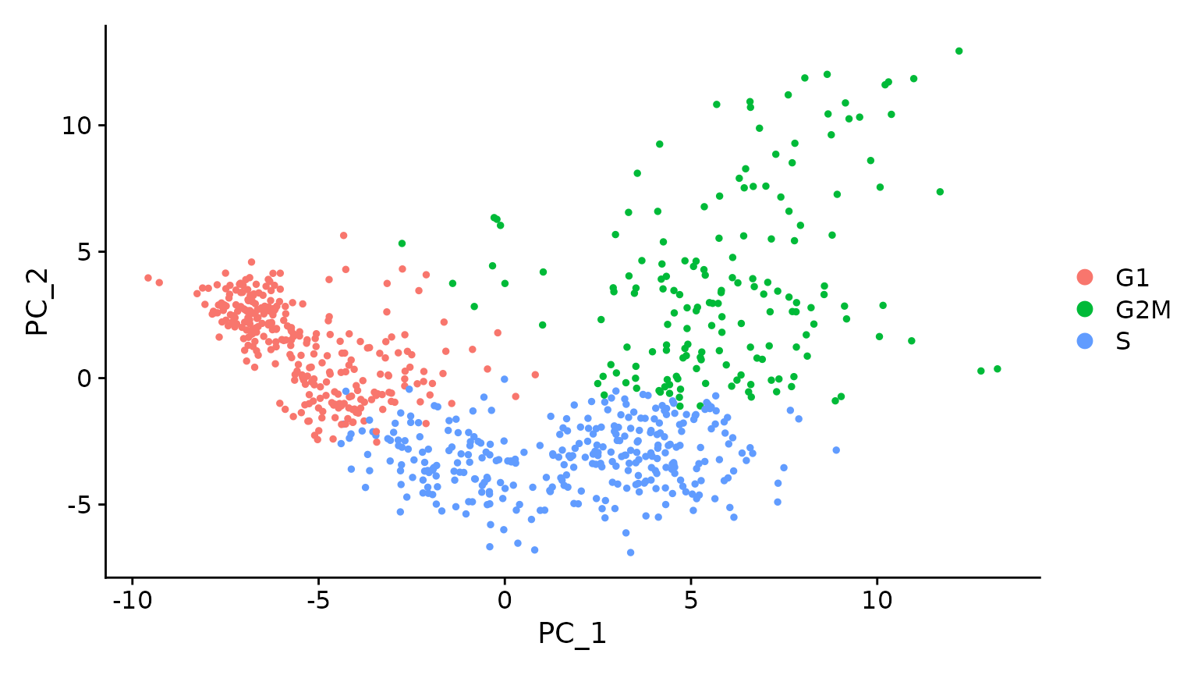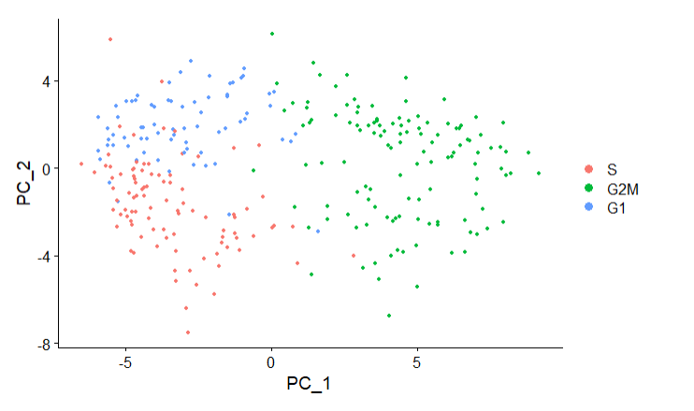
A
B
Figure 1.7 Finding and optimising a phase sorting code base to analyse and detect mitotic cells using Seurat. A) The PCA analysis and pie chart is provided as the default representation of the Seurat CellCycleScoring function. Limitations of the default Seurat code weighting all phases equally with a combined G2/M phase; rather than a distinct G2 and M phase, gives a good coding framework but needs optimisation for mitotic cell analyses. B) Unlike the other previously tested phase assignment R codes Seurat seems far more flexible, when using GSE129447 GSM3713084_HeLa_1_p9 rather than the provided input data the phases are still distinct and can be subset, filtered and recessed from this point into a distinct mitotic fraction with the right sorting methodology and a specific gene list. Testing and graphed using R, using Seurat (https://cran.r-project.org/web/packages/Seurat/index.html)

1.5 Hypothesis and Aims

1.5.1 Thesis Hypothesis
The first hypothesis of this thesis is that the MDDC is dependent on XRCC4, and the identification and investigation into interacting proteins from different repair or checkpoint pathways will elucidate the role of XRCC4 in the MDDC.
The second hypothesis of this thesis is that transcriptionally active mitotic specific genes can be used to isolate mitotic cells in single-cell RNA sequencing data.
The third hypothesis of this thesis is that isolated mitotic cells share transcriptionally active genes that respond specifically to DNA damage.

1.5.2 Central Thesis Aims
The main aims of this thesis are:
- Investigate if XRCC4 plays a role in novel mitotic DNA damage checkpoints outside its central role in the DNA damage response.
- Investigate the mitotic transcriptional response to DNA damage.
- Modify and optimise R-based tools to isolate and investigate mitotic population's single-cell RNA sequencing expression data in previously published tools.
- Validate the robustness and accuracy of any generated tools used to isolate mitotic cell subpopulations in single-cell RNA sequencing data already published.

Chapter 2 – Materials and Methods

2.1 Chapter Aims
• To accurately cite and source all materials used in the production of this thesis
• To effectively convey replicable methodologies used during this study

2.2 XRCC4 Study

2.2.1 Antibodies
Primary
Protein | Species | Manufacturer | Reference No | Dilution/Application
Beta Actin | Mouse | Abcam | ab8226 | WB (1:5000)
Beta Tubulin | Mouse | Abcam | ab6046 | WB (1:5000), IF (1:100)
Bub3 | Rabbit | Cell Signalling Technology | 30493 | WB (1:1000)
BubR1 | Mouse | Abcam | ab54894 | WB (1:1000), IF (1:500), IP
CDC20 | Rabbit | Abcam | ab26483 | WB (1:1000)
CenpB | Rabbit | Santa Cruz Biotechnology | sc-22788 | IF (1:500)
MAD2 | Rabbit | Abcam | ab70383 | WB (1:2000)
pH3 | Rabbit | EMD Millipore | O6-750 | FACs (1:200), Bulk RNA seq using FACs (1:100)
Rad51 | Rabbit | Abcam | ab63801 | IF (1:100)
Securin | Rabbit | Abcam | ab26273 | WB (1:1000)
XRCC4 | Mouse | Santa Cruz Biotechnology | sc-271087 | WB (1:1000), IF (1:100)
XRCC4 | Rabbit | Abcam | 15817.1.AP | WB (1:1000), IF (1:100)
Table 1. Antibodies used in Western blotting (WB), Immunofluorescence (IF), Immunoprecipitation (IP) and fluorescence-activated cell sorting (FACs) protocols are below.

Secondary
Protein |  | Manufacturer | Reference No | Dilution/Application
Alexa Fluor 488 Goat Anti-Mouse |  | Invitrogen | A11001 | FACs (1:200)
Alexa Fluor 594 Goat Anti-Rabbit |  | Invitrogen | A11012 | FACs (1:200)
Goat anti-Rabbit Fluorescein Isothiocyanate (FITC) |  | Abcam | ab6717 | FACs (1:500), Bulk RNA seq using FACs (1:200)
Goat Anti-Mouse Horseradish Peroxidase (HRP) |  | Invitrogen | A16078 | WB (1:5000)
Swine Anti-Rabbit HRP |  | Agilent - Dako | P0399 | WB (1:5000)
Table 1. Antibodies used in Western blotting (WB), Immunofluorescence (IF), Immunoprecipitation (IP) and fluorescence-activated cell sorting (FACs) protocols are below.

2.2.2 Human Cell Line Culture
Henrietta Lacks Human Cervical Cancer Cells (HeLa), Michigan Cancer Foundation-7, Human Breast Cancer Cell (MCF7) and Human Embryonic Kidney 293 Cells (293T) cell lines were cultured in Dulbecco's Modified Eagle Medium (DMEM) (Sigma-Aldrich, D6429) + 10% FCS (LSP, S-001A-BR) using 75cm² flasks (ThermoFisher Scientific, 156367). Cells were sourced from the American Type Culture Collection (ATCC). Cells were x2 washed with Phosphate-Buffered Saline (PBS), the PBS removed, and cells were detached from the growing environment with 0.5-2ml trypsin (Sigma-Aldrich, T3924). The cells were passaged into aseptic flasks or plated in 6 well Nunc Cell-Culture Treated Multidishes (ThermoFisher Scientific, 140675) under aseptic conditions in a tissue culture hood (Haier Biomedical, HR900-IIA2).
Cells were stored at -80C after gradual freezing in cryovials (Starstedt, 72.371), using a Mr Frosty (ThermoFisher Scientific) freezing container, in media containing DMEM + 10% FCS with 10% DMSO to prevent cellular decay when defrosted.

2.2.3 Protein Expression Depletion via Reverse Transfection
5 µL siRNA (20 µM stock) was incubated in 245 µL Dulbecco's Modified Eagle Medium serum-free media (SFM) (Sigma-Aldrich, D6429) for 5 min at room temperature. 3 µL Dharmafect 1 (Dharmacon, T-2001-03) was added to 247 µL SFM and incubated at room temperature for 5min. This concentration of siRNA and Dharmafect 1 is used in all siRNA treatments within this chapter.
The DF1 and siRNA + SFM DMEM were mixed in a 1:1 ratio and incubated for 20min. The mixture was added dropwise to a 6-well plate, cells were then trypsinized and resuspended in 2ml of 10 % FCS DMEM. 1.5x10⁵ cells were plated into each of 6 well plates to reach a total volume of 2 mL (50 nM total siRNA concentration). Cells were incubated for 24-72 hours as required.
siRNA sequences used:
• siControl (Eurofins, UAAUGUAUUGGAACGCA) a nonspecific control
• siBubR1 (Eurofins, CAGAUUUAGCACAUUUACUA)
• siXRCC4 si1 (Eurofins, AUAUGUUGGUGAACUGAGATT)
• siXRCC4 si4 (Eurofins, UCUUGGGACAGAACCUAAATT)
• siXRCC4 si5 (Eurofins, UGACCGAGAUCCAGUCUAU)
• siXRCC4 si6 (Eurofins, AACCCAGUAUACCCCAUU)
• siXRCC4 SmartPool (Dharmacon, made of pooled si1, si4, si5 and si6)
• SIXRCC4 3’ UTR (Eurofins, AAAUGAAUAGAAAACAUAGTC)
• siXLF (Dharmacon, pooled GGGCUACGCUGAUUCGAGA, GCAUGAGUCUGGCAUUACA, GCAACGUUACUUCAUAUGA, AUCGAUAGCCAAUGUGUAA)
• siMAD2 (Dharmacon, pooled GAAAGAUGGCAGUUUGAUA, UAAAUAAUGUGGUGGAACA, GAAAUCCGUUCAGUGAUCA, UUACUCGAGUGCAGAAAUA)
• siLig IV (Eurofins, CGACCUUUUAGACUCAAUUTT)

2.2.4 Western Blotting
Cells after incubation for 24-72; as required, were removed from the incubator and refrigerated for 15 min, cells were then trypsinized to remove the cells.
The cells were washed in PBS x2, resuspended in 100µL Radioimmunoprecipitation Assay Buffer (RIPA) Lysis Buffer; 1ml RIPA solution (10 mM Tris(Hydroxymethyl)Aminomethane (Tris), pH 7.4. 100 mM Sodium Chloride (NaCl). 1 mM Ethylenediaminetetraacetic Acid (EDTA). 1 mM Ethylene Glycol Tetraacetic Acid (EGTA). 1% Triton X-100. 10% glycerol. 0.1% SDS. 0.5% deoxycholate). Post resuspension in 1ml of PBS of a single Protease inhibitor (Roche, 04963159001) and Phosphatase inhibitor (Roche, 0490683700) tablet 100µL of each inhibitor solution was added. Cells were incubated for 15 min on ice and centrifuged in a microcentrifuge for 15 min at 18928 g, the supernatant was then collected.
Bradford Assay was completed to quantify protein levels using Bovine Serum Albumin (BSA) (ThermoFisher Scientific, BP1600-100) as a protein control. A standard curve of BSA concentrations was generated at 0 mg/ml, 0.02 mg/ml, 0.03 mg/ml, 0.04 mg/ml, 0.05 mg/ml, 0.06 mg/ml, 0.08 mg/ml and 0.1 mg/ml. Each standard curve concentration was plated at 40µl into a well of a 96 well (ThermoFisher Scientific, 167008) plate three times. Bio-Rad Protein Assay Dye Reagent (Bio-Rad, 5000006) was diluted 1:5 in water and 200µl was added to each well. The extracted protein present in the supernatant collected in the last step was diluted 1:40 in water 40µl was added to separate wells from the standard curve inputs, repeated three times before 200µl of the 1:5 Bio-rads solution was also added to these samples. The plate was run on a microplate reader at 520nm, and the standard curve of protein presence was calculated to derive the protein concentration of the extracted protein samples.
Lysates were made up to equal volume and concentration; 1:5 ratio in x5 Loading buffer (3ml 20% SDS, 3.75mL 1M Tris buffer at pH 6.8, 9 mg bromphenol blue, 1.16 gm Dithiothreitol (DTT), 4.5mL glycerol to the solution, final volume of 15ml with dH20). The lysates are placed in a heat block for 10 min at 70ºC. Lysates undergo heat treatment to denature the proteins present, this step aids protein progression through membranes during western blot transfer steps.
50-10μg of protein was added to precast Sodium Dodecyl Sulfate–Polyacrylamide Gel Electrophoresis (SDS-Page) Gels (Expedeon, NBT41212) in addition to 6µL Precision Plus Protein Dual Color Protein Standard. The western blot gel was run at 150V for 1-2 hours using a western blot cassette, and power pack and run in x1 NuPAGE MOPS Blue Running Buffer (Novox, NP0001). The gel was then transferred to nitrocellulose (Bio-Rad, 1620115) by wet transfer in Transfer Buffer (25 mM Tris. 190 mM glycine. 20% methanol made to 1L in dH20) for 2 hours at 94V at 2ºC.
Once transferred nonspecific binding was blocked by a 1-hour incubation in 5% Milk in 25 - 50ml of x1 Tris-Buffered Saline (TBS) (24 g Tris base, 88 g NaCl made to 1L in dH20 and 1 ml of Tween 20) and then removed. The required primary antibody was added to 5% Milk in TBS-T and incubated with the nitrocellulose membrane on a rocker overnight at a dilution of 1:1000. The primary antibody solution was then removed and washed five times by TBS-T. The membrane is then incubated for 1 hour with a secondary primary specific antibody in 5% Milk in TBS-T at a dilution of 1:5000. The secondary solution is removed, and the membrane is washed 5 x 5 minutes in TBS-T.
A peroxidase substrate for enhanced chemiluminescence (ECL) (ThermoFisher Scientific, 32106) was added for 1 min and the membrane developed using X-Ray film in a dark room.
A loading control of beta-actin (Abcam, ab8226) or beta-tubulin (Abcam, ab6046) was utilised. The above staining protocol was replicated with the exception that the required loading primary antibody was added to 5% Milk in TBS-T and incubated with the nitrocellulose membrane on a rocker overnight at a dilution of 1:5000.
The primary antibody solution was then removed and washed five times by TBS-T. The membrane is then incubated for 1 hour with a secondary primary specific antibody in 5% Milk in TBS-T at a dilution of 1:5000. The secondary solution is removed, and the membrane is washed 5 x 5 minutes in TBS-T.
A peroxidase substrate for enhanced chemiluminescence (ECL) (ThermoFisher Scientific, 32106) was added for 1 min and the membrane developed using X-Ray film in a dark room.

2.2.5 Validation of Deconvoluted siXRCC4 Depletion
The preliminary studies on XRCC4 used a SMARTpool siRNA (Dharmacon) in which 4 individual siRNA sequences are pooled together at lower concentrations to increase specificity and decrease the risk of off-target effects. Pooled siRNA was deconvoluted, the individual sequences were tested for depletion efficiency via Western Blotting after reverse transfection. XRCC4 siRNA 1, 4, 5 and 6 were transfected into HeLa cells for 72 hours as outlined in section 2.2.3. Cells were then harvested, western blotted and in tandem analyzed via flow cytometry to validate XRCC4 depletion.

2.2.6 Reduction in MAD2 at various time points of XRCC4 siRNA Depletion
2x10⁵ HeLa cells were reverse transfected with siXRCC4 si5 and siControl and then incubated for 24, 48 and 72 hours. The HeLa cells were harvested at each time point, lysates were analysed to determine the time of MAD2 expression loss after siXRCC4 depletion.

2.2.7 Flow Cytometry
Following incubation, Cells were washed with PBS and trypsinized. The collected cells were centrifuged for 3 mins (at 173 g). The supernatant was removed, and cells were PBS-washed and centrifuged twice more. The supernatant was removed, and 1 mL 70 % ethanol was added dropwise whilst vortexing. The cells were stored in a -20 freezer overnight.
On Day 2 cells were centrifuged for 3 mins at 173 g, the supernatant was removed, and cells were resuspended in PBS repeated x2.
Cells were resuspended in 0.5 mL Flow buffer 1 (500 mL PBS, 0.5 % BSA, 0.25 % Triton X), incubated on ice for 15 min and centrifuged for 3 mins at 173 g. The Phosphohistone H3 (pH3) primary antibody (Abcam, ab80612) at 1:200 in 100 μL flow buffer 1 was added to cells which were then incubated in the dark for 1h 30 mins.
0.5 mL Flow Buffer 2 (500 mL PBS, 0.25 % Triton X) is added after incubation. The cells are centrifuged for 3 mins at 173 g and washed with Flow Buffer twice more. A secondary Antibody conjugated to Fluorescein isothiocyanate (FITC) (Abcam, ab116639) at 1:500 in 100 μL Flow Buffer 2 is added to each sample. The cells are incubated for 30 min in the dark, 0.5ml PBS is then added and centrifuged for 3 mins at 173 g.
The supernatant is removed and 5 μL RNAseA stock with 400 μL of propidium iodide (PI) (ThermoFisher Scientific, P1304MP, 5 ug/μL) is incubated with each sample in the dark at -4 Celsius for at least 60 min. The cells were then analysed by Fluorescence Activated Cell Sorting (FACS) on the FACS Calibur (BD Biosciences) flow cytometer.
Three controls are used Control 1: Primary and FITC, Control 2: FITC and PI and Control 3: PI alone to ensure proper staining is present in cells and to accurately gate cells based on fluorescence levels.

2.2.8 Co-Immunofluorescence Microscopy + Staining Controls
Incubated cells were trypsinized and plated onto sterilized glass coverslips in 6 well plates at 1.5 x 105, cells were incubated for 48 hours and treated as required, and coverslips were processed at 72 hours.
Media was removed and slides were washed in PBS. 4% Paraformaldehyde (PFA) was added for 20 min (Sigma-Aldrich, 158127), removed and slides rewashed with PBS x2. Slides were then permeabilized in 0.5% Triton-X for 5 min, washed twice in PBS and blocked for 30 min in 1% BSA-PBS.
Slides were washed 3x5 min in PBS-T (0.2% Triton X) on a rocker, then removed and incubated in primary antibodies as needed (antibodies at 1:100 in 1% BSA-PBS) for 1.5 Hours in a humidified chamber.
Slides were washed 3x5 min in PBS-T (0.2% Triton X) (Sigma-Aldrich, 9002-93-1) on a rocker and incubated for a further 30 min in the dark inverted onto 150ul fluorescently active Secondary antibodies (1:200 in 3% BSA).
Slides were washed 2x5 min in PBS-T (0.2% Triton X) on a rocker then 1x5 min washed in PBS with 4’6’ diamidino-2-phenylindole (DAPI) (Sigma-Aldrich, D9542) at 1:1000 and mounted to glass microscope slides (Superfrost Plus – ThermoFisher Scientific) using mounting media (ThermoFisher Scientific, 9990407).

2.2.8.1 Anaphase Bridge Formation
Untreated and Nocodazole-treated (Noc) cells were used for slide production after siControl and siXRCC4 si5 depletion. DAPI (Sigma-Aldrich, D9542) was used to stain the cellular cytoplasm and images of n=50 cells were taken. The number of zero bridges, n=1 or n>1 anaphase bridges from fused telomeres were counted in n=3 experiments. The data was then averaged to determine the effect of decreasing XRCC4 presence on error-prone mitotic cell progression.

2.2.8.2 BubR1 & Cenp B/ MAD2 / Bub3 Co-localisation
The staining did not provide ideal conditions for determining foci localization. After testing multiple conditions 1 min permeabilization of slides in 100% Acetone (Sigma-Aldrich, 67-64-1) was used producing much cleaner results when viewed via fluorescence microscopy.
BubR1 was co-stained with Centromere Protein B (CenpB), MAD2, and Bub3, using fluorescently active 488 and 594 active secondary antibodies. A fluorescence microscope was used for imaging, and DAPI was used to stain the cellular cytoplasm. Untreated and 20μg/ml Nocodazole-treated cells were used for slide production after siControl and siXRCC4 si5 depletion.

2.2.9 Live Cell Microscopy
1x10⁵ HeLa cells were reverse transfected in each well of a 24-well plate (ThermoFisher Scientific, 142475) in 1ml of DMEM media using 1ul siRNA and 0.6uL of Dharmafect. The cells were incubated for 48 hours until treatment; either untreated as a control or 1:500 20μg/ml Nocodazole (Sigma-Aldrich, M1404). The plate was then immediately set up in a Leica AF6000 Time-Lapse microscope taking images every 5 min in ten positions in each well condition for a total of 16 hours.
The images were then fed into ImageJ; the file is a 16-hour frame-by-frame video of the cells in vivo, from there through visually counting the entry and exit of mitosis of n=50 cells were determined, and time spent in mitosis of each cell condition was also determined. The experiment was completed n=3 times in untreated cells.
Post-mitotic cell fate of treated cells was also tallied, n=50 cells were counted and cell fate was scored as a death in mitosis, slippage back into interphase from mitosis or normal mitotic progression. The experiment was repeated n=3 times.

2.2.10 Co-immunoprecipitation of NHEJ and SAC proteins
HeLa cells were plated at 2x10⁶ cells in 15 cm plates (2-4 per testing parameter) and incubated for 48 hours. The cells were either treated with 10Gy IR or 1:500 20μg/ml Nocazdole or left untreated as a control. The cells were incubated for a further 16 hours before harvest.
The media of each plate was collected, the cells scraped into 15ml tubes and the cells were centrifuged at 173 g for 3 mins. The cell pellets were washed in PBS after discarding the supernatant. Cells were transferred to a 2ml tube and resuspended in lysis buffer (1ml RIPA buffer, 100uL in PBS solution Protease and Phosphatase inhibitor). The cells were then incubated for 15 min on ice and centrifuged at 18928 g for 15 min. The supernatant was collected and quantified via Bradford Assay as outlined in section 2.2.4. The lysate's protein concentration levels were then standardized.
20ul of Dynabeads (Invitrogen, 100.04D) were incubated on the rotator at room temperature with 3 μg IP antibody in 200ul IP buffer (25 mM Tris-Hydrogen Chloride (HCl) pH 7.4, 150 mM NaCl, 1 mM EDTA, 1% NP-40 substitute and 5% glycerol) for 10 min. Mouse XRCC4 antibody (Santa Cruz Biotechnology, sc-271087) was used to avoid light chain interference with Rb XRCC4 blotting.
The antibody solution was removed and the beads were washed 3 times with PBS using a magnet block (Invitrogen, 123.21D) to separate magnetic beads and lysate. The lysates were standardised to equal concentrations in 1 ml lysis buffer. 50 μL of lysate was removed to be used as an input loading control. The remainder of the equal-concentration lysates were then incubated with the magnetic beads.
The beads were rotated for 10-30 mins, the lysate was then discarded using the magnetic block and beads were washed in IP Buffer x3 times. The beads were resuspended in 25 μL 1x Loading buffer (3ml 20% Sodium dodecyl sulfate, 3.75mL 1M Tris buffer at pH 6.8, 9 mg bromphenol blue, 1.16 gm Dithiothreitol, 4.5mL glycerol to the solution and made to a final volume of 15ml using deionised water. The loading buffer was then diluted 1:5 in lysis buffer) at 70°C for 10 mins then beads were removed via the magnet black, input lysates at 200μg in were made up to 60μL and heated at 70°C for 10 mins
Whole-cell lysates and IP lysates were then run on the same Western Blot gel to analyze protein coimmunoprecipitation with XRCC4. The blot was stained with antibodies for XRCC4, XLF, Lig IV, BubR1, Bub3, CDC20, MAD2 and Beta-actin as a loading control.

2.2.11 Cell Synchronization after XRCC4 Depletion
HeLa cells were plated at 1.5x10⁵ cells per well in a six-well plate and transfected with siXRCC4 si5, siBubR1, and siControl. After 48 hours incubation period the cells were treated with 1:500 20μg/ml Nocodazole and left for staggered time points 0, 4, 8 and 16-hour time points before harvesting.
The cells were then processed and ran via Western Blot, the blot was then probed with XRCC4, CDC20, MAD2, Bub3, BubR1, securin and beta-actin as a loading control. The experiment was repeated n=3 times to ensure the reliability of protein depletion on securin levels after 20μg/ml treatment nocodazole stalling analyzing the effects of XRCC4 and BubR1 on securin, DDR and SAC proteins when stalled in mitosis for variable lengths of time.

2.2.12 Quantitative Reverse transcription Polymerase Chain Reaction (qRTPCR)
HeLa cells were plated at 2x10⁵ cells per well in a six-well plate and transfected with siXRCC4 si5 and siControl. After a 72-hour incubation period, the cells were harvested and shredded using the Qiagen Cell Shredding Kit (Qiagen, 796454). RNA was then eluted using the RNeasy kit (Qiagen, 74104) and the RNA level was quantified via Nanodrop with an OD260/280 ratio of approximately 2.
A Reverse transcription reaction was set up using a ThermoFisher Scientific /Applied Biosystems High Capacity RNA to Complementary DNA (cDNA) kit (4387406). 10μL of buffer and 2 μL of the included enzyme were combined with 2μg of RNA, the samples were incubated in the PCR machine for 1 hour at 27ºC and 5 minutes at 95ºC.
A qPCR reaction was set up in triplicate using 10ul of MAD2 (Applied Biosystems, PN4453320), XRCC4 (Applied Biosystems, P4444892) and GAPDH (Applied Biosystems, 402869) control Taqman probes and using Taqman reaction (Taqman Universal PCR Master Mix # 4321018), a Taqman 384 well plate (ThermoScientific, AB1384) and 2ul of cDNA.
The 384 plates were covered and briefly centrifuged before being set up in the Reverse transcription polymerase chain reaction (RT-PCR) machine, and the software SDS 2.4 was used to run the sample. 6-Carboxyfluorescein (6-FAM) (ThermoScientific, C1360); a fluorescein dye active in the 495nm to 517nm range was chosen as the fluorescent stain with 40 cycle repeats and allowed to run for two hours. The housekeeping gene Glyceraldehyde 3-phosphate dehydrogenase (GAPDH) was selected to allow for the standardisation of XRCC4 and MAD2 expression levels post siXRCC4 depletion.

2.3 Bulk RNA Sequencing - Data Set Generation

2.3.1 Irradiation treatment LD₅₀ of RT lab Hela Cells
HeLa cell lines were used, and the cells cultured in Dulbecco's Modified Eagle Medium (DMEM) (Sigma-Aldrich, D6429) + 10% Foetal Bovine Serum (FBS) (LSP, S-001A-BR) using 25ml and 75ml flasks. Cells were x2 washed with PBS. The PBS is removed, and cells are detached from the growing environment with 0.5-2ml trypsin (Sigma-Aldrich, T3924). The cells were passaged into aseptic flasks (ThermoFisher Scientific, 140675) under aseptic conditions. Cells were then IR-treated at 0-10Gy using a closed cobalt-60 irradiation source. Cells were incubated for 0-96 hours and trypsinized in 24-hour intervals. Cells were determined to be alive or dead using a Trypan Blue Solution, 0.4% (ThermoFisher Scientific, 15250061) survival assay. Cells were suspended, pelleted and resuspended in PBS. Mixing in equal measure with Trypan Blue, the unstained (viable) and stained (nonviable) cells were counted separately in a haemocytometer. Cell survival was calculated against an untreated normalized data set.

2.3.2 5Gy Dose response of RT lab Hela Cells
HeLa cells were treated with 5Gy IR before being trypsinized at 0, 2, 4, 6, 8 and 16 post-IR treatment. Cells were similar to section 2.2.7 but with a more optimised staining protocol.
Cells after incubation had media removed and collected, washed with PBS and trypsinized. The collected media/cells were centrifuged for 3 mins (at 173 g), the supernatant was removed, and the cells were PBS washed and centrifuged twice more for 3 mins at 173 g. The supernatant was removed, and 1 mL 70 % ethanol was added dropwise whilst vortexing. The cells are stored in a -20 freezer for 30 min. The cells were then centrifuged for 3 mins at 173 g, the supernatant was removed, and cells were washed in PBS before pelleting and PBS removal.
Cells were resuspended in 0.5 mL Flow buffer 1 (500 mL PBS, 0.5 % BSA, 0.25 % Triton X), incubated on ice for 15 min and centrifuged for 3 mins at 173 g. Primary phosphorylated Histon H3 (Ser10) 1mg/ml antibody (Abcam, ab80612) was added at 1:100 dilution. Cells were then incubated in the dark for 60 mins. Post incubation 0.5 mL Flow Buffer 2 (500 mL PBS, 0.25 % Triton X) was added after incubation.
The cells were centrifuged for 3 mins at 173 g and washed with Flow Buffer 2 twice supernatant being removed each time. A secondary FITC 2mg/ml antibody (Abcam, ab116639) at 1:200 in 100 μL Flow Buffer 2 was added to each sample. The cells were incubated for 30 min in the dark, 0.5ml PBS was then added and centrifuged for 3 mins at 173 g.
The supernatant was removed, and 400 μL of PI (ThermoFisher Scientific, P1304MP, 5 ug/μL) was incubated with each sample in the dark at -4C for at least 30 min. The cells were then run on the relevant FACS flow cytometer. Each time point had its mitotic cell population content accessed via FlowJo software (BD Biosciences)

2.3.3 RNA Extraction and storage
Further steps require the isolation and extraction of cellular RNA content, this was attained via the Quick-DNA/RNA Miniprep (Zymo Research, D7001) consisting of:
- DNA/RNA Lysis Buffer D7001-1-50
- DNA/RNA Prep Buffer D7010-2-25
- DNA/RNA Wash Buffer D7010-3-12
- DNase/RNase-Free Water W1001-6
- Zymo-Spin IICG Columns C1006-50-G
- Zymo-Spin IICR Columns C1078-50 50
- Collection Tubes C1001-50

A minimum of 10000 cells were placed into PBS suspension, cells were centrifuged and pelleted at 1000g for 3 min. Cells were resuspended in 350µl DNA/RNA Lysis Buffer, sample was transferred to Zymo-Spin IICG Columns and centrifuged for 30 sec at 12000g, the flow through had 350µl of 100% Ethanol added and mixed well. The sample was transferred into a Zymo-Spin IICR Column 1 in a Collection Tube and centrifuged for 30 sec at 12000g. The flowthrough was discarded. 400µl DNA/RNA Prep Buffer was added to the column, centrifuged for 30 sec at 12000g and the flowthrough was discarded. 700µl DNA/RNA Prep Buffer was added to the column, centrifuged for 30 sec at 12000g and the flowthrough was discarded. 400µl DNA/RNA Wash Buffer was added to the column, centrifuged for 120 sec at 12000g and the flowthrough was discarded. RNA was eluted via 35µl of DNase/RNase-Free Water added to the column before spinning the column in a clean nuclease-free tube. The RNA content of the eluted was then quantified via a NanoDrop 2000 UV Visible Spectrophotometer (ThermoFisher Scientific, ND-2000).

2.3.4 Cell phase FACSMelody isolation
Cells were stained using the methodology outlined in section 2.3.2. Cells were inputted into the FACS Melody (BD Biosciences) in the University of Sheffield Medical School Flow Cytometry Core Facility. The FACS Melody allows for the specific gating of cell populations, in this case, those with strong ph3 staining indicating a likelihood of mitotic cell phase. The input HeLa cells were sorted into Zymo DNA/RNA Lysis Buffer as part of the RNA extraction kit outlined in 2.3.3. The untreated and +5Gy IR-treated cells were both sorted into interphase and mitotic populations giving:
- Untreated Interphase Cells
- Untreated Mitotic Cells
- +5Gy IR Treated Interphase Cells
- +5Gy IR Treated Mitotic Cell
To isolate the mitotic and interphase populations (Treated and untreated) for RNA extraction for resultant Bulk RNA seq analysis the workflow highlighted in Figure 4.3 was developed to ensure that resultant RNA extraction was phase and treatment-specific., the FACS Melody was used to sort cells based on gated populations as seen in step 3 and 4 of Figure 2.1.
The step-wise process involves the initial fixation, permeabilization and staining steps outlined in the link to methods, after the final step of suspension in PI and incubation the cells are filtered and inputted into the FACS Melody. After the outlined gating and cell sorting steps using the FACS Melody the cells are sorted into the RNA Extraction Buffer; derived from the Zymo RNA Extraction Kit stabilising RNA quality, for the stepwise extraction of the 4 outlined RNA extracts in the final step of Figure 2.1.
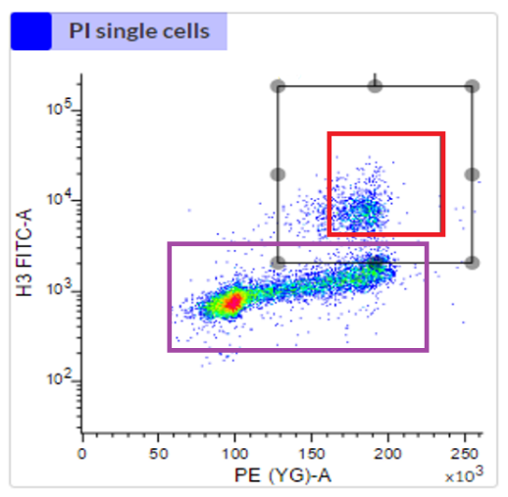
Figure 2.1 FACSMelody Sorting pipeline used for cell phase isolation. The above workflow uses the BD FACSMelody’s 488 nm Blue laser to gate for the bound phospohistone-3 fluorophore antibodies in conjunction with the 560 nm Yellow Green PE laser to gate for PI 535 nm to 617 nm range. This combination of lasers and cell excitation gating allows for the accurate separation of Interphase and Mitotic cells for phase and treatment separated RNA extraction.
Input Sample
Isolate Single Cells and Gate Alive Cells
FACSMelody Phase Gating
ph3/PI Sorting
Untreated Hela Cells
5Gy +IR Treated Hela Cells
Interphase UT Cells
Mitotic UT Cells
Interphase +IR Cells
Mitotic +IR Cells
Interphase
Mitotic
Cell Collection into Zymo RNA Extract First Buffer

2.3.5 Optimisation of RNA quality post FACSMelody isolation
Post RNA elution and quantification the RNA integrity number (RIN) Bioanalyzer (Agilent) service provided by the Sheffield Institute for Translational Neuroscience, the low stained, FACSMelody sorted and Zymo kit extracted RNA was below acceptable limits. RIN retention optimisation was completed by testing a wide range of parameters to try and increase RNA quality levels. PI/ph3-FITC staining was completed as outlined in section 2.3.2, and RNA extraction was completed as outlined in section 2.3.3 before RIN testing was completed
The parameters tested were:
Different fluorophore attachment impacts in cell samples.
- FITC ph3 attached(Abcam, ab116639)
- Alexa Fluor 594 Goat Anti-Rabbit ph3 attached (Invitrogen, A11012)
- 70% Ethanol Fixation Unstained
- Unstained Unfixed
The fixation method before permeabilised cell staining steps were tested in cell samples.
- 70% Ethanol Fixation
- 95% Ethanol Fixation
- 4% Paraformaldehyde Fixation
- 100% Methanol Fixation
- 70% Ethanol Fixation before 100% Methanol cell permeabilization
- 70% Ethanol Fixation no PI staining cell steps
- 70% Ethanol Fixation + 1M NaCl 1% Salt Buffer
- 4% Paraformaldehyde Fixation + 1M NaCl 1% Salt Buffer
An RNaseOUT Recombinant Ribonuclease Inhibitor (ThermoFisher Scientific, 10777019) was tested in isolated steps to investigate its RIN quality effect on samples prepared by section 2.3.2 and extracted via section 2.3.3. The inhibitor was tested in cell sample setups:
- Unstained Unfixed
- 70% Ethanol Fixation Unstained
- 70% Ethanol Fixation + RNase OUT added during fixation + 50k Cells collected
- 70% Ethanol Fixation + RNase OUT added during fixation + 100k Cells collected
- 70% Ethanol Fixation + RNase OUT added during fixation + 200k Cells collected
- 70% Ethanol Fixation + Testing Quick-DNA/RNA Miniprep (Zymo Research, D7001)
- 70% Ethanol Fixation + Testing RNeasy Mini Kit (Qiagen, 74104)
Final testing and optimisation steps of RNaseOUT usage were completed on cell samples:
- Unstained Unfixed
- 70% Ethanol Fixation No Inhibitor
- 70% Ethanol Fixation + RNase OUT added during staining steps
- 70% Ethanol Fixation + RNase OUT added during ph3-FITC staining step only
- 70% Ethanol Fixation + RNase OUT added during all staining and wash steps
- 70% Ethanol Fixation + RNase OUT added during ph3-FITC staining step only
- Unstained Unfixed but with RNase OUT in final RNA product

2.3.6 Full Experimental Runs
After optimisation was completed the 70% Ethanol Fixation + RNase OUT was added during all staining and wash steps was chosen and tested to give sufficient RIN scores for full generation of Untreated Interphase Cells, Untreated Mitotic Cells, +5Gy IR Treated Interphase Cells and +5Gy IR Treated Mitotic Cell RNA samples was created. The samples were completed in triplicate, further, repeats were generated per Novogene RNA sequencing needs.

2.4 Bulk RNA Seq – Differential Expression Processing

2.4.1 Internal RNA Quality Control
As previously highlighted the RNA quality level was processed via the quantification of RNA integrity number (RIN) Bioanalyzer (Agilent) service provided by the Sheffield Institute for Translational Neuroscience. RNA concentration was also quantified by the input of 1µL of RNA containing elution ran via a NanoDrop 2000 UV Visible Spectrophotometer (ThermoFisher Scientific, ND-2000).

2.4.2 Novogene Bulk RNA Sequencing and Quality Control
RNA samples were shipped to Novogene for Bulk RNA sequencing via a NovaSeq 6000 and processed via a next-generation sequencing technique (NGS). Data sets for raw RNA pair-ended sequencing data were returned for further pre-processing.

2.4.3 Galaxy RNA sequence processing
The raw forwards and reverse Bulk RNA sequencing data were uploaded to Galaxy Europe (https://usegalaxy.eu) for further processing steps via FileZilla FTP transfer. Paired data sets were grouped via the Concatenate Datasets function.

2.4.4 Unaligned Read QC
Initial quality control of unaligned read data sets was preformed via FastQ Quality Control -> FastQC Read Quality reports function providing UMI quality quantification (Fonseca, 2021) as shown in Figure 2.2.
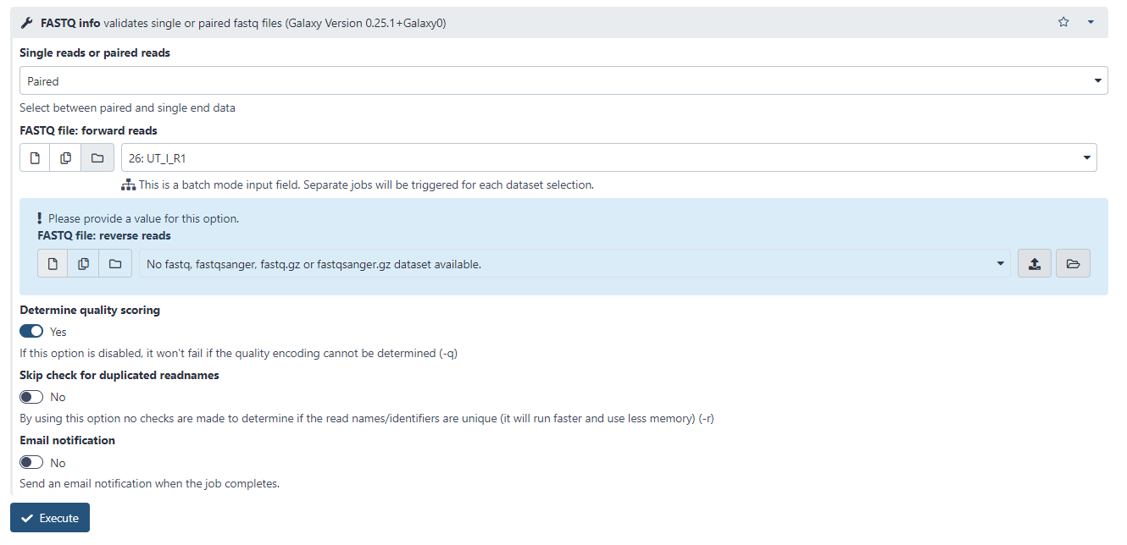
Figure 2.2 FastQC setup options present in Galaxy EU and used in the processing of derived unaligned bulk RNA sequencing data
FastQC data sets were then collated using MultiQC a quality control aggregation tool combining multiple reports into a singular output summary file (Ewels et al, 2016).

2.4.5 Read Alignment
Read alignment was completed via the Mapping -> HISAT2 (Kim, Langmead and Salzberg, 2015) function allowing the alignment of unstranded mRNA data that cross exon/intron boundaries to the Human Dec 2013 (GRCh38/hg38) (hg38) reference genome. HISAT2 is a splice-aware RNA sequencing read mapper based on Bowtie mapping. Results use a graphically represented whole genome index in tandem with a local region index to identify exon splice junctions for genomic mapping (Kim, Langmead and Salzberg, 2015). HISAT2 used default advanced settings and the setup can be seen in Figure 2.3.
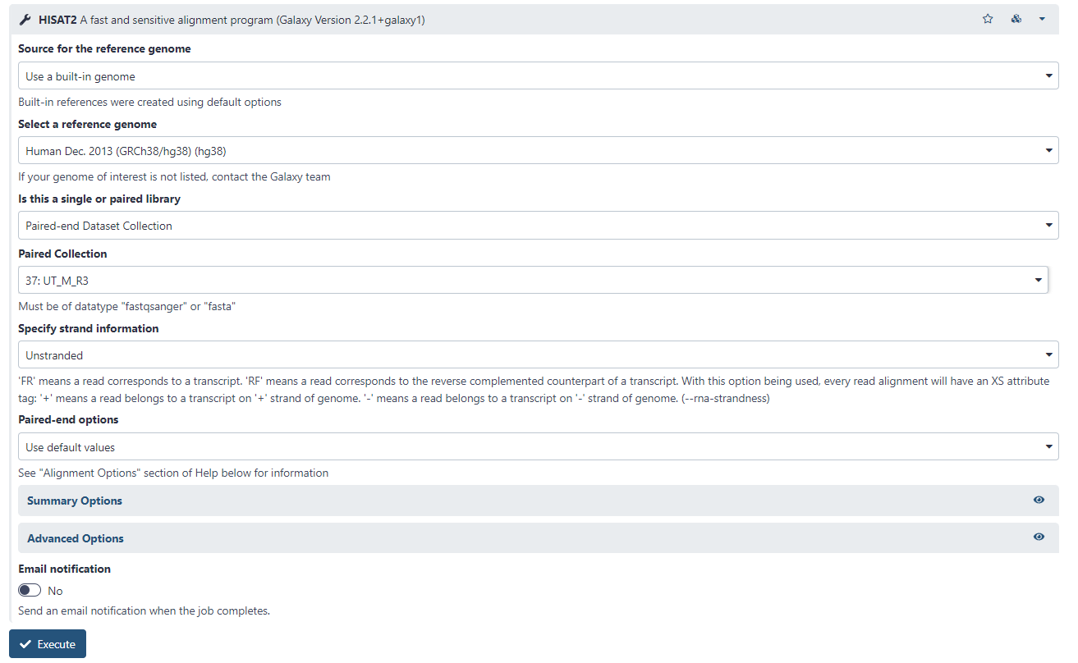
Figure 2.3 HISAT2 setup options present in Galaxy EU and used in the processing of derived unaligned bulk RNA sequencing data

2.4.6 Aligned Read QC
The Sequence Alignment Map/Binary Alignment Map (SAM/BAM) -> Samtools stats were used to check alignment quality in the output BAM files, analysing percentages of correctly mapped gene sequences to the reference human genome provided (Li et al, 2006). Samtools stats were then collated using MultiQC a quality control aggregation tool combining multiple reports into a singular output summary file (Ewels et al, 2016). The setup of Samtools stats is seen in Figure 2.4.

Figure 2.4 Samtools stats setup options present in Galaxy EU and used in the processing of derived aligned bulk RNA sequencing data BAM files

2.4.7 Gene Quantification
Gene transfer format coordinates from the hg38_ensembl93 were obtained containing the Ensembl gene id information derived from the University of California, Santa Cruz (UCSC) table browser data repository.
These gene coordinates were used with RNA Analysis > HTseq2-count and the aligned BAM files previously obtained. The HTseq2-count tool uses the overlapping features of the BAM alignment with the General Feature Format (GFF) coordinate file to calculate the number of reads mapping said feature. The features represent an interval range of positions on the assigned hg38 human chromosome. In the case of RNA sequencing data, the genes are considered as the union of its exons accounting for potential alternate genomic splicing (Anders, Pyl and Huber, 2014). The HTseq2-count setup is shown in Figure 2.5.
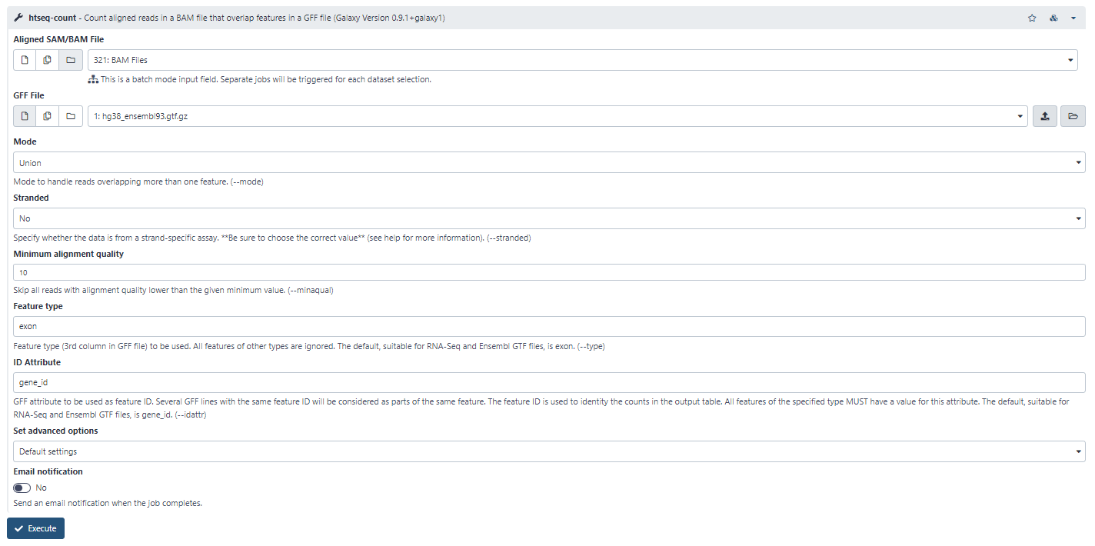
Figure 2.5 HTseq2-count setup options present in Galaxy EU and used in the processing of derived aligned bulk RNA sequencing data BAM files in tandem with hg38_ensembl93 gene coordinates.

2.4.8 Count Matrix Processing
The individual count matrix columns were then collated via Collection Operations -> Column Join on Collections. The count matrix was also fully annotated with Ensembl, cannon gene symbols and RefSeq IDs using Annotation -> annotateMyIDs. The CSV output files of the complete gene matrix were then downloaded from Galaxy EU.

2.5 Differential Expression Testing via DESeq2
Post-processing via the use of the Galaxy EU database a complete count matrix was downloaded. The data going forwards was processed via R-based coding using R Notebooks in RStudio (https://www.rstudio.com). All libraries and citations can be found in Bibliography -> R Code Libraries.

2.5.1 PCA Analysis
Principal Component Analysis (PCA) analysis of input data was completed using code generated and attached in appendix A.1. Experimental setup to ensure the replicate effect was regressed out and only cell cycle phase was completed by testing various differential expression experimental designs and using the phase, replicate and treatment variable ranges as seen in line 31-43.
The PCA analysis using the plotPCA function was completed using this range of experimental design plotPCA(vsd,intgroup=c("Treatment", "Phase")) being used to plot PCA used in further testing parameters. The data focuses on the phase effect, removing treatment and replicate effect for differential expression testing.

2.5.2 Dispersion and Read Distribution testing
Log2 counts per million (CPM) normalisation and visualisation were completed using code generated and attached in appendix A.1, lines 45-53. The gene distributions were checked post-CPM expression transformation and the normalised distributions were graphed against median logCPM.
Plotting of the per gene dispersion estimates using the plotDispEsts function was completed in appendix A.1, lines 76-78. Plotting raw count matrix data dispersion using the dispersion mean value against the mean of normalised counts allows for clear visualisation of a clear spread of the gene presence across the sample's gene expression levels.

2.5.3 Differential Expression testing
Differential gene expression analysis was completed for the target parameters of mitotic against interphase-related genes in the bulk RNA sequencing count matrix completed in appendix A.1, lines 79-90. Cut-off parameters using filter(padj<0.05) and arranging by Log2FoldChange were used to ensure accuracy in the analysis of statistically significant mitotic and interphase-related differentially expressed genes. Select genes were displayed using plotCounts() on lines 107-117.

2.5.4 MA Plot Generation
Initial plotting of differentially expressed genes was completed using the PlotMA function as seen in appendix A.1, lines 91-93. This generated an M (log ratio) and A (mean average) scatter plot of log2 fold changes versus the mean of normalized counts. Each dot represents a singular gene present, with blue dots representing differentially expressed genes under the preset padj<0.05 threshold.

2.5.5 Volcano Plotting and Gene filtering
To further ensure the validity of differentially expressed genes a further padj<0.001 and Log2Fold<0.6 filter cut-off to ensure that the gene list derived has the most phase relevance possible. Volcano plotting was completed using these parameters to gather a mitotic and interphase-related gene of interest list. Plotting was completed using code generated and attached in appendix A.2. Histogram plotting was also completed to ensure the proper distribution of gene expression levels.

2.5.6 Gene List of Interest generation
Once a gene list of interest was generated using section 2.5.5, volcano plotted differentially expressed genes that fell within the cut-off; outlined in section 2.5.3, were compared to ensure matching gene lists. Differentially upregulated genes present are those related to the mitotic gene phase, differentially downregulated genes present being those correlating to interphase-related genes.

2.5.7 Gene Ontologies
Gene Ontology (GO) tool GOrilla was used to determine the function gene ontologies of the mitotic and interphase-related gene lists of interest inputted against the complete gene list from the initial Galaxy EU generated count matrix (Eden, Navon, Steinfeld, Lipson & Yakhini, 2009).

2.5.8 Threshold-free analysis
Post differential expression testing as outlined in 2.5.3 the ranked gene list by Log2FoldChange had ontology and Reactome pathway enrichment/depletion analysed via GeneTrail (Gerstner et al., 2021) transcriptomics tool. Gene Set Enrichment Analysis (GSEA) was completed using a random walk Kolmogorov–Smirnov test. Confidence levels were calculated using a returned q-value from testing p-values across the entire data set and being adjusted by the Benjamini-Hochberg false discovery rate to give significance q-values to a minimum confidence level of 0.05

2.6 Seurat
To ensure consistent testing all cell phase assignment protocols were tested using the single-cell RNA sequencing count matrix derived from Gene Set Enrichment (GSE) Hu et al., 2019 (GSE129447) using the GSM3713084_HeLa_1_p9 data set.

2.6.1 Other Phase Analysis Testing – Peco & Cyclone
The cell phase assignment library Cyclone has testing preformed using code generated and attached in appendix A.3, it did not provide sufficient ability to subset out mitotic cells so was discounted as a method of cell cycle analysis. Peco was also tested using a cell cycle gene list generated by Macosko et al., 2015. Testing was completed using code generated and attached in appendix A.4, individual genes had Peco plots generated from lines 70-107 to determine if there was a capability to differentiate the pi-based cell cycle expression scores. Peco was unable to sufficiently generate points of differentiation between G2 and M phase-aligned genes.

2.6.2 Default Seurat Function – Input from alt
The default Seurat cell cycle scoring approach (Hao et al., 2021) is attached in appendix A.5, this baseline code will act as the basis from which modification and optimisation of mitotic and interphase cell separation will be completed. The default code was derived from the Cell-Cycle Scoring and Regression vignette (https://satijalab.org/seurat/articles/cell_cycle_vignette.html).

2.6.3 Modification and Optimisation of Seurat
The completed Modified Seurat Mitotic Sort can be found in appendix A.10. In which step by step, the libraries, working environment and count matrix are loaded to R.
Post-generation and investigation into the generated interphase and mitotic-related phase marker genes we then set about the application of said genes. The gene lists were used in a modified Seurat coding set to isolate a mitotic-specific fraction from the overall G2/M population the default Seurat cell phase prediction (Hao et al., 2021).
Seurat was used as its prediction methodology can be targeted towards other cell phase separation markers of interest. Seurat base phase sorting code either uses a default cc.gene list or an inputted gene list to determine phase separation features. While in this study we did not wish to alter the basic structure of Seurat CellCycleScoring. Thus in all relevant G2 and M separation steps the mitotic gene list of table 4.3 replaces the g2m.features function and the interphase gene list of table 4.3 replaces the s.features function, altering the target features but not the core Seurat function.
As shown in the workflow pipeline highlighted in Figure 2.6, we used an initial Seurat (Hao et al., 2021) sorting step. We kept default parameters besides using relative count normalisation rather than log2 normalisation as it fit better the two-stage approach. We then subsetting the G2/M assigned fraction before using a modified Seurat CellCycleScoring step (changes outlined in the previous section). This step separated the G2 and M phases cells from one another and removed unassigned cells from single-cell RNA sequencing data sets.
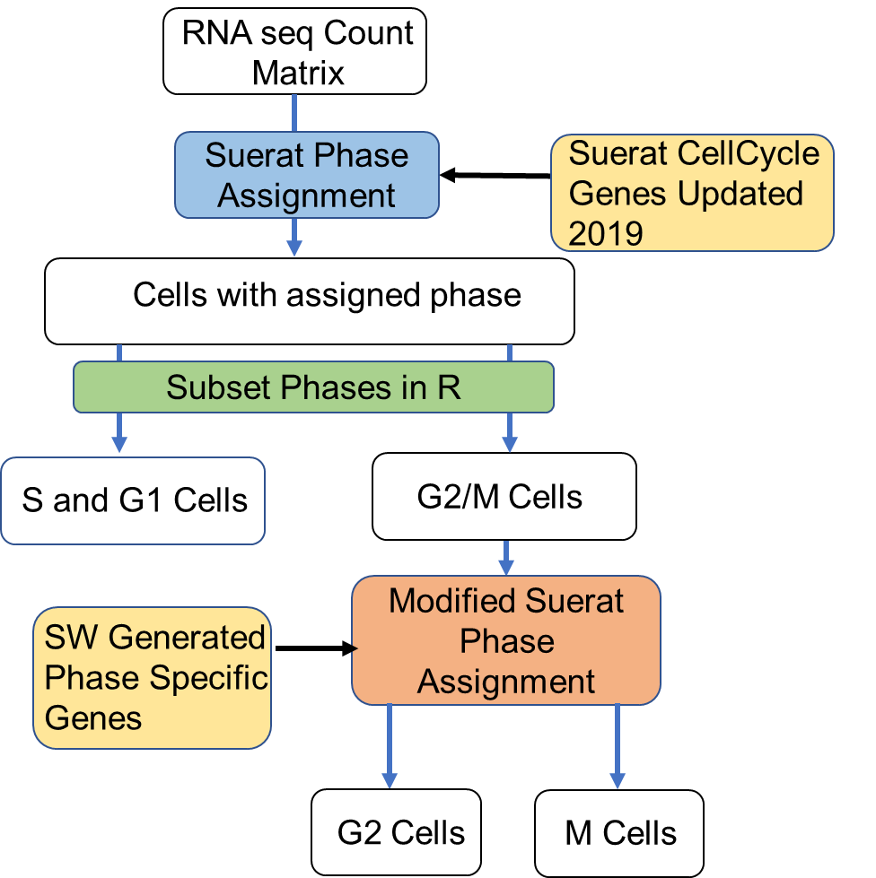
Figure 2.6 General overview of Modified Seurat Mitotic Sort pipeline. The derivation of a purely mitotic populations of cells from single cell RNA sequencing (scRNA seq) is currently not present in preestablished methods. The above pipeline is the broad outline that will be optimised. The Seurat Cell Cycle Sorting tools in conjunction with Seurat provided gene lists and lab generated M Phase gene lists will form the functional basis of this pipeline. This workflow will be used to generate a R coded set of functions to isolate the M phase population from any scRNA seq data set.
The step-by-step approach is as follows:
- Initial assignment of the number of columns present to optimise npcs numbers for later steps.
- Loads “S” and “G2/M” Gene markers in Ensembl format.
- Generate the Seurat object.
- Normalise the data via a relative count system with an appropriate scale factor.
- Find variable features based on the read in gene marker data – “S and G2/M”.
- Scale and centre the data set before running a principal component analysis using the variable “S” and “G2/M” input features.
- Plot the Heatmap for the PCA variables to ensure good points of variance visually.
- Assign cell phase based on “G2/M” and “S” phase variability scores.
- Cells not fitting in the “G2/M” and “S” are assigned to “G1”.
- Plot the highly expressed gene ridge plots, the visual plotting of the PCA and a PCA with proper phase grouping, the percentage of cells in each phase and an example snapshot of the cell phase matrix output.
- “G2/M” assigned cells were isolated, and “G1” and “S” assigned cells were saved in unique variables for later.
- “G2/M” data is formatted and cleaned to ensure that Seurat can be run again on this “G2/M” fraction.
- “G2/M” data is reintroduced to the second step modified Seurat pipeline.
- The derived interphase and mitotic gene of interest markers were inputted in Ensembl format – gene of interest markers being those derived via differential expression testing in section 2.5.7
- No G1 cells are present in this step having been already assigned. Seurat CellCycleScoring function's ability to assign G1 cells, therefore, is disabled via the generation of a modified CellCycleScoring function.
- Seurat only allows for the “G2/M” and “S” functions in the Cell Phase Scoring function. Thus, “G2/M” naming in functions and outputs is converted to “M” naming on scored genes. “S” naming in functions and outputs is converted to “G2” naming on scored genes.
- The generated edited function is dubbed CellCycleScoring_G1Disable
- Generate the “G2” and “M” specific Seurat objects.
- Log normalises the data with an appropriate scale factor.
- Find variable features based on the read in gene marker data – “G2” and “M” rather than “S” and “G2/M”
- Scale and centre the data set before running a principal component analysis using the variable “G2” and “M” features.
- Plot the Heatmap for the PCA variables to ensure good points of variance visually.
- Assign cell phase based on “G2” and “M” phase variability scores.
- Plot the highly expressed gene ridge plots, the visual plotting of the PCA and a PCA with proper phase grouping, the percentage of cells in each phase and an example snapshot of the cell phase matrix output.
- Properly named G2 and M-scored cells are re-joined with the initial count matrix to generate a complete G1, S, G2 and M-assigned count matrix.
- Final phase assignments are then graphically represented to ensure proper phase distribution and outputted in CSV format.
Before the complete 1.5 annotated version of the Modified Seurat Mitotic Sort (MoSMiS) multiple development steps were completed to optimise this code. MoSMiS 1.1 as seen in appendix A.6 only separated the “G2/M” population, not a unique “M” population. MoSMiS 1.2 as seen in appendix A.7 used a generic “G2” and “M” phase from Macosko et al., 2015 gene list of interest to assign “G2” and “M” phase post subsetting, the gene list gave improper phase assignment due to major overlap in phase-specific genes. MoSMiS 1.3 as seen in appendix A.8, first worked to optimise the code base removing write-in and out functions when isolating and cleaning the “G2/M” population increasing run efficiency. MoSMiS 1.3 did use lab-generated genes of interest when parsing out the “G2” and M population again giving improper phase reporting.
MoSMiS 1.4 as seen in appendix A.9 used the correct adjusted p-value cut-off scores for interphase and mitotic genes of interest, and tested multiple formats of gene input data before settling on Ensembl ENSG names used in MoSMiS 1.5. The code in MoSMiS 1.4 also altered the first “G2/M” and S normalisation steps to ensure relative counts were used so the data was not log normalised twice. MoSMiS 1.4 also added visual representations for cell phase percentages. MoSMiS 1.5 as previously mentioned and found in appendix A.10 was a complete optimisation of the coding structure, data input and output, graphing input and output and was fully annotated to ensure proper usage by others.

2.6.5 K Fold Testing
To test the validity of the gene lists further, a k-fold test was completed on the data set of interest. Datasets were inputted and code can be found in Appendix A.11 to convert them via rlog() or vst() functions to a usable log format. The data was then input to a code structure that replicated the MoSMiS 1.5 phase assignment sorting but removed 25% of either the interphase or mitotic generated gene list of interest as seen in appendix A.12.
This was completed 4 times for each 25% removed gene population of the interphase and mitotic lists, from the count matrix files generated the removed genes in each of the 4 tests (Interphase and Mitotic removal were tested separately) were then analysed for overall net expression of these removed genes in the interphase and mitotic bulk RNA sequencing runs.

2.6.5 qRTPCR MoSMiS GOI validation
Hela Cells were plated at 1.25x10⁶ for 24 hours on x12 10cm plates, after the growth period a mitotic enriched and non-cycling population were collected via mitotic shake-off and trypsinisation. RNA was extracted as outlined in section 2.3.3 before nano-dropping.
Equal nanograms of RNA present in the mitotic enriched and non-cycling population (minimum 400ng) were transformed to cDNA. A High-Capacity RNA-to-cDNA Kit (ThermoFisher Scientific, 4387406) was used to create a negative and positive RT reaction sample as shown in table 2
Component | Volume per Reaction
Component | Positive RT Reaction | Negative RT Reaction
2X RT Buffer Mix | 5µl | 5µl
20X RT Enzyme Mix | 0.5µl | 0µl
RNA sample | 4.5µl (or scaled) | 4.5µl (or scaled)
Nuclease-free H2O | Volume to make reaction 10 µl | Volume to make reaction 10 µl
Table 2. Setup protocol for the High-Capacity RNA-to-cDNA Kit
The samples in a Bio-Rad PTC-0200 DNA Engine thermal cycler underwent 60 minutes at 37ºC, 5 minutes at 95ºC and kept at 4ºC for complete cDNA transformation.
Post cDNA transformation the samples underwent real-time PCR analysis, the samples were plated in a MicroAmp Optical 384-Well Reaction Plate (ThermoFisher Scientific, 4309849) with SYBR Green I, Asymmetrical Cyanine Dye (SYBR Green) PCR Master Mix (ThermoFisher Scientific, 4309155) reactions being 5µl SYBR Green master mix, 0.5µl 10mM forward and reverse combined run specific primers (shown in table 3), 1µl of 1:10 diluted cDNA and 3.5µl H₂O per well.
Phase | Gene | Transcripts | Primer 1 Forward | Primer 1 Reverse
M | NEK2 | NM_002497.4 | ACTAGCAGAGGACAAACTGGC | AGGATGGAAGATTAAGAAGTTCTGG
M | KIF20A | NM_005733.3 | AAAACCAGCAGAACCGGTCA | CTCGGCCTGTGAAGAAACCT
M | CEP55 | NM_018131.5 | TGCCCGCTCTGATAACAGTC | TCTCTGAAATGGTCGCCAAGT
M | CCNB1 | NM_031966.4 | TGGATGCAGAAGATGGAGCTG | ACTGCTTGCTCTTCCTCAAGT
Housekeeping | 18S | NR_146152 | GTGGAGCGATTTGTCTGGTT | CGGACATCTAAGGGCATCAC
Housekeeping | HPRT1 | NM_000194.3 | CCTGGCGTCGTGATTAGTGA | CGAGCAAGACGTTCAGTCCT
Table 3. RT PCR Mitotic-related and housekeeping gene forward and reverse primers
Samples were run on a QuantStudio 7 Pro Real-Time PCR System, 96-well, 0.2 mL, desktop machine (ThermoFisher Scientific, A43183) for quantification and subsequent analysis of cq score and expression fold change calculation of the mitotic enrichment sample against the non-cycling baseline. Samples were programmed to run on QuantStudio 7 seen in Figure 2.7.

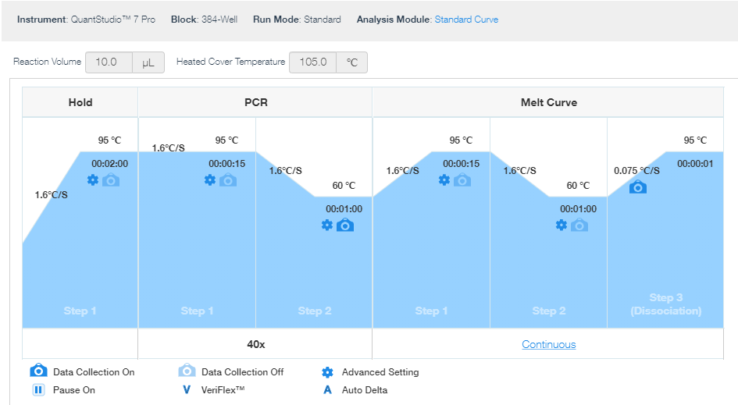
Figure 2.7 QuantStudio 7 Pro RT PCR standard curve analysis setup

Chapter 3 – Investigation of a potential novel role for XRCC4 in a Mitotic DNA Damage Checkpoint

3.1 Introduction
Mitosis is the division of cells and the continued replacement of lost or damaged cells. Therefore, numerous biological checks are in place during this vital step of proliferation. Errors during this cell cycle phase can have wide-reaching downstream effects promoting tumorigenesis, improper cell growth and the subsequent aberrant development of cancerous cells (Crasta et al., 2012).
Therefore, it is vital to understand mitosis as fully as possible and its response to DNA damage such as that from DNA double-strand breaks (DSB). A previously unexplored Mitotic DNA damage checkpoint (MDDC) has been posited by the Thompson Lab (Gatenby et al., 2022) and will be the focus of this chapter. This checkpoint is distinct from the more established cell cycle checkpoints that have been the focus of treatment development (Otto & Sicinski, 2017).
The MDDC potentially interacts with the spindle assembly checkpoint, a key checkpoint ensuring proper mitotic division via proper spindle attachment, which in turn has been shown to interact and cross-talk with the DNA damage non-homologous end-joining response (Lawrence et al., 2015. Dimitrova et al., 2008. Palou et al., 2017.).
Preliminary data from our lab has shown a direct impact on mitotic cell population and mitotic progression in cells lacking XRCC4 (Figure 3.1). The figure is a broad-spectrum DDR gene siRNA screen, investigating changes in mitotic population performed previously by the Thompson lab. This initial screen highlighted multiple significant decreases in untreated mitotic cell populations.
XRCC4 has an established role in bridging DNA to DNA ligase IV in NHEJ (Andres et al., 2012). Investigation of this protein aims to elucidate it playing a more complex role in mitotic progression and is potentially a contributing component of the MDCC. XRCC4 has previously been implicated in regulating genome instability during mitosis (Terasawa et al, 2014), showing it has more complexity of function than previously thought.
XRCC6; a gene that encodes Ku70, and DNA ligase IV-depleted cells also significantly impacted mitotic cell populations. The involvement of this protein in NHEJ makes them prime targets for subsequent studies once a thorough investigation of XRCC4 has been completed.
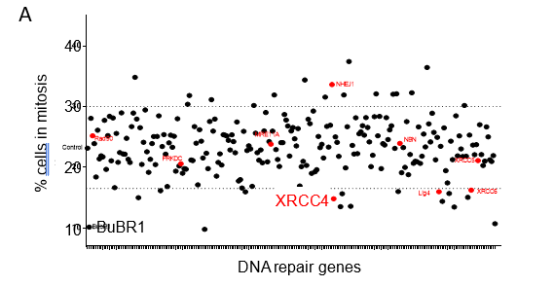
Figure 3.1 Previously completed broad spectrum DDR gene siRNA screen for changes in mitotic population performed by Thompson lab. The DDR screen highlighting the impact of XRCC4 depletion in mitosis. Cells were untreated but underwent a broad spectrum siRNA to analyse and highlight gene depletion which significantly impacted mitotic populations.
While the broad-spectrum siRNA screen depleted individual genes for analysis it is important to acknowledge that the impact of a mitotic cell population may not solely result from an impact on a MDDC. The decreased or increased mitotic populations could in theory be a consequence of cell cycle checkpoint activation outside of mitosis.

3.2 Hypothesis
The central hypothesis for this chapter is that the Non-homologous end-joining protein (NHEJ) XRCC4 plays a previously unknown role in a Mitotic DNA damage checkpoint. Furthermore, XRCC4 interacts with Spindle Assembly Checkpoint proteins to perform this uncategorised functional role.
In addition, depletion of XRCC4 results in faster, more error-prone mitotic transit resulting in a net negative impact in resultant daughter cell fates.

3.3 Aims
- Validate the role of XRCC4 in effective and efficient mitotic cell transit
- Uncover how XRCC4 affects mitotic DNA damage repair
- Investigate a link between XRCC4 and the SAC proteins

3.4 Objectives
- Investigate the effects of XRCC4 depletion on:
  - Mitotic cell population
  - Mitotic Transit and mitotic cell fate
  - A propensity for error in mitotic division
- Examine the interactions of XRCC4 with SAC proteins
- Explore the effects of XRCC4 depletion on SAC proteins

3.5 Results

3.5.1 Validation of single siRNAs from the deconvoluted pool
Phosphorylation of Serine 10 (Ser10) amino-terminal domain of histone H3 (pH3) is a clear hallmark of the the chromosome condensation present in mitosis. (Hendzel et al., 1997). Histone H3 (Ser10) is spatially and temporally phosphorylated by Mammalian Aurora kinases, beginning in early G2 phase in the pericentromeric heterochromatin of chromosome present. This phosphorylation spreading throughout all chromosome by metaphase during mitosis (Hendzel et al., 1997, Crosio et al., 2002). While viable for use as a mitotic phase marker the initiation of this phosphorylation could potentially be a confounding marker when isolating mitotic cells by pH3 staining values.
The preliminary data Figure 3.1 used a pool of siRNA targeting XRCC4 to assess the impact on mitotic populations in XRCC4-depleted cells. The first thing we did was therefore to deconvolute the pool and test the effects of each individual siRNA to deplete XRCC4 and decrease cells arrested in the M phase.
Si5 and Si6 show a demonstrable decrease in XRCC4 depletion using Western blotting as shown in Figure 3.2.A. The more attenuated response seen post-nocodazole treatment highlights the impact of the siRNA set tested in cells experiencing a source of DNA damage.
Si4 shows far less effective siRNA-derived XRCC4 depletion and a minimal demonstrable decrease in mitotic populations, sharing a weaker phenotype compared to the other siRNA tested in this experiment. Furthermore, the data shows that the siRNA used gives consistent XRCC4 siRNA depletion between experiments.
Figure 3.2.B shows the mitotic population in the absence of nocodazole treatment, there is minimal effect on mitotic populations in each siRNA tested, resulting in non-significant results.
A one-way ANOVA test was also completed using flow cytometry data. This test showed a significant degree of reduction in mitotic population between siControl and siXRCC4 Si1, Si5 and Si6 when treated with nocodazole, as shown in Figure 3.2.B. The same pattern of XRCC4 expression can be seen in the untreated cells but just to a far less extent. Nocodozole treatments will be used to make XRCC4 loss effects more easily measured in further experiments. Si5 and Si6 were selected from this data for use in further work.

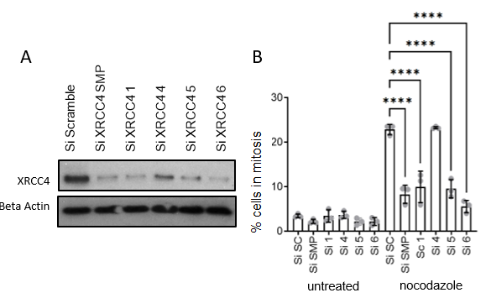
Figure 3.2 Deconvoluted XRCC4 siRNAs reduce both XRCC4 expression levels and mitotic population in treated samples, a weaker phenotype can be seen when testing si4. Depletion of XRCC4 reduces the percentage of cells in mitosis and + and - treatment with nocodazole was completed by Western Blot and FACs cell population analysis. A) Depletion of XRCC4 using siRNA in Hela cells. Cells were treated with control (scramble – Sc) siRNA and siRNA against XRCC4 (SMP – smartpool, deconvoluted si1-4) for 48 h. Lysates were then immunoblotted for XRCC4 (representative blot is shown) B) Detection of mitotic fraction by PI/pH3 staining. Hela cells were treated for 48 h with control or siRNA against XRCC4. Nocodazole (200ng/ml) was added 16 hours prior to harvesting to increase the mitotic fraction. Results are the average and the SD of n=3 experiments. Data analysed via Prism. 1 way ANOVA test performed compared to corresponding scrambled control ****= P ≤ 0.0001. All other comparisons were non-significant.
It is important to note here the observed mitotic population depletion responses could derive from other variables. XRCC4-depleted cells could potentially result in more cells becoming stuck in the G2 phase, alternatively, cells may be simply cycling more slowly in general in addition to having a shorter mitotic transit time due to said depletion.

3.5.2 Mitotic populations after Nocodazole and IR treatment post-XRCC4 siRNA depletion
To further determine the effects of XRCC4 siRNA depletion on the number of cells in mitosis multiple treatment methods were used. A dosage of 10Gy irradiation (IR) and 200ng/ml Nocodazole (Noc) where tested to compare the effects of XRCC4 siRNA depletion and the loss of SAC protein BubR1. Quantitative Real-Time Polymerase Chain Reaction (RT-qPCR) analysis would serve as an ideal positive control experiment to access if the siRNA utilised within this section depleted BubR1, XRCC4 and Lig IV to the same functional extent.
IR is used to activate the MDDC whereas Nocodazole treatment activates the SAC by poisoning microtubules. Binding protein DNA Ligase IV was also tested via flow cytometry but showed minimal effect on mitotic populations in IR-treated cells but does show a significant response in Nocodazole-treated cells.
As shown in Figure 3.3.A. the pattern of mitotic population is similar across all three treatment groups. siBubR1 treated cells show a drastically reduced mitotic population. siXRCC4 reduces the mitotic population further in IR-treated cells comparatively to siBubR1 but has a lesser effect in Nocodazole-treated cells. Cells treated with siLig IV show a significant reduction in mitotic population but to a comparatively lesser extent than XRCC4 and BubR1-depleted cells. The degree to which this depletion has also affected the functional capabilities of BubR1 and Lig IV compared to XRCC4 depletion remained unclear within this study.
Figure 3.3.B shows a representative image of the flow cytometry cell capture profile where the mitotic cells are gated in PI-high, pH3-high cell populations as shown in.
The reduction in mitotic population size post siRNA depletion and IR/Noc treatment can be found in Figure 3.3.C. This example visually highlights a loss of mitotic cells post siRNA and exogenous damage treatment. The siRNA response is consistent across the tested cells, although we did observe a high rate of apoptosis in nocodazole-treated cells.
The response of a mitotic population reduction in both exogenous damaging treatment types; when XRCC4 is depleted, indicates XRCC4 loss is important in both DNA damage repair and mitotic spindle assembly pathways.
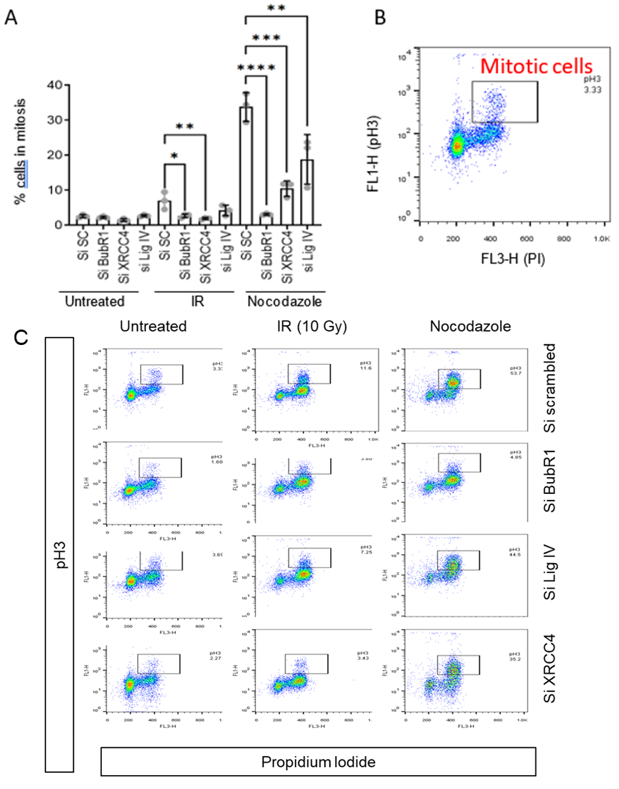
Figure 3.3 XRCC4 and BubR1-depleted cells show a net decrease in mitotic cell population when treated by IR or Nocodazole Depletion of XRCC4 reduces the percentage of cells in mitosis after treatment with radiation was tested via FACs calibur analysis of ph3 and PI straining strengths. A) Detection of mitotic fraction by PI/pH3 staining. Hela cells were treated for 48 h with control or siRNA against XRCC4 (si 5), BubR1 or Lig IV. Cells were then treated with 10 Gy IR or Nocodazole (200ng/ml). Results are the average and the SD of n=3 experiments. Data analysed via Prism. 1 way ANOVA test performed compared to corresponding scrambled control * = P ≤ 0.05, ** = P ≤ 0.01, *** = P ≤ 0.001, ****= P ≤ 0.0001. All other comparisons were non-significant. B) Representative dot blot showing gating for PI high, pH3 high population being mitotic cells. C) Representative dot blots from each condition indicated above.

3.5.3 Effects of XRCC4 siRNA depletion on mitotic cell progression and mitotic daughter cell fate
Flow cytometry while useful is just a snapshot of a population of mitotic cells at a singular time point. To validate that cells progress faster through mitosis after XRCC4 depletion time-lapse microscopy was utilised. Observation of siRNA depletion effects on live cells gives a greater overview of the cell cycle and mitotic transit time.
BubR1-depleted cells spent a significantly reduced time in mitosis, as shown in Figure 3.4.A. BubR1 depletion stops the formation of the mitotic checkpoint complex. Misalignment of mitotic spindles results in a failed SAC due to a lack of BubR1 allowing the nonregulated progression of cells through mitosis.

Figure 3.4.A also shows a similar mitotic transit time reduction in XRCC4-depleted, this could indicate a specific defect in a cell progression checkpoint. Other NHEJ proteins; namely XLF and Lig IV, also undergo siRNA depletion but show no significant effects on mitotic transit implying that the effect is XRCC4 specific.

To ensure that the effect was not cell line specific MCF7 and 293 cells were tested, again the same effect of both siXRCC4 si5 and si6 resulted in reduced mitotic transit time when compared to the control (Figure 3.4.B.)
Figure 3.4 XRCC4-depleted cells undergo faster mitotic transit times spending a lower average time in mitosis. Depletion of XRCC4 and key NHEJ proteins effect mitotic transit of cells analysed via live cell imaging. This experiment analysed only the siRNA impact on untreated cells and did not use IR or Nocodazole treatment.
A) Data derived from untreated HeLa cell protein siRNA depletion experiments, n= at least 131 cells across three biological repeats, cells counted entering and exiting mitosis giving time spent in mitosis. All data points available have been graphed. The data indicates significant reduction for time spent in mitosis for siBubR1 cells and both XRCC4 siRNA used when via a paired t test. siLig IV and siXLF had no signific effect
B) As in “A” but using MCF7 and 293 cell lines, n=3 biological with at least n=120 total data points shown for each cell line, the same effect of reduced time in mitosis is seen in both cell lines. Error bars represent standard deviation.
Data analysed via Prism. 1 way ANOVA test performed compared to corresponding control * = P ≤ 0.05, ** = P ≤ 0.01, *** = P ≤ 0.001, ****= P ≤ 0.0001. All other comparisons were non-significant.

A
B
HeLa
MCF7
293

The effects of XRCC4 and BubR1 siRNA-based depletion on mitotic cell fate are shown in Figure 3.5. Three distinct cell fates where categorised, namely, slippage, stalled or death. Mitotic slippage in this case are cells undergoing mitotic exit but bypassing the spindle assembly checkpoint. These slipped cells can enter interphase with aberrant DNA content or undergo error-prone mitotic division.

Cell stalling is the expected result after Nocodazole treatment due to the activation of the SAC stopping mitotic progression through the MCC. This effect therefore prevents CDC20 from activating the APC/C due to microtubule poisoning. The stalled cells eventually meet the same fate as apoptotic mitotic cells but at a far later time point.

Cells were classified under death if apoptosis was observed to differentiate them from cells classified as stalled that entered and did not exit mitosis in the observed live cell experiment.

HeLa, MCF and 293 cell fates where all tested post siRNA depletion as shown in. All three cell lines show an increase in cell slippage post-BubR1 and XRCC4 depletion. This response was observed across all three cell lines, indicating the response is not cell-line specific. Lig IV and XLF-depleted cells do not share this pattern of behaviour of increased cellular slippage, although XLF depletion does result in a significant reduction in cell slippage. Slippage as mentioned is a failure to progress through anaphase in mitosis causing the cells to drop back down into an interphase state with increased DNA content.

It was therefore important to isolate the information from the cell slippage data for statistical analysis as shown in Figure 3.5. Cell slippage supports the results of the mitotic time shown in figures 3.2 and 3.3, BubR1 and XRCC4-depleted cells have a higher likelihood of leaving mitosis early, returning to interphase with increased DNA levels. Slippage from mitosis into interphase, when treated with nocodazole, suggests a problem in the SAC of the analysed cells.
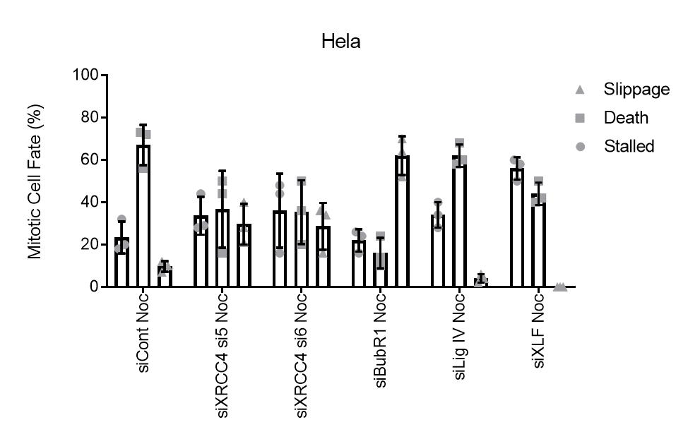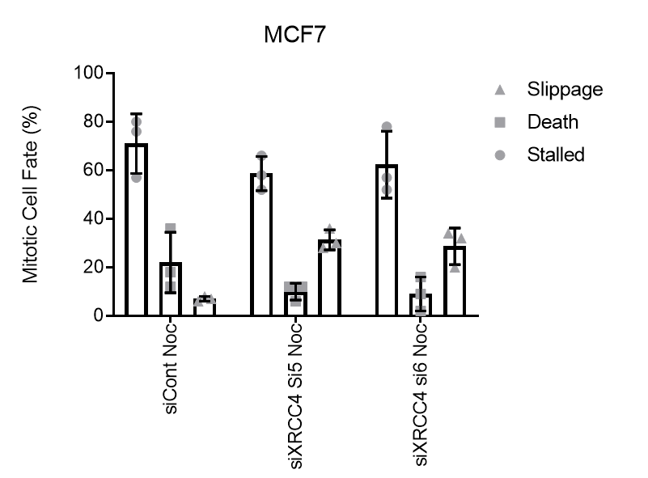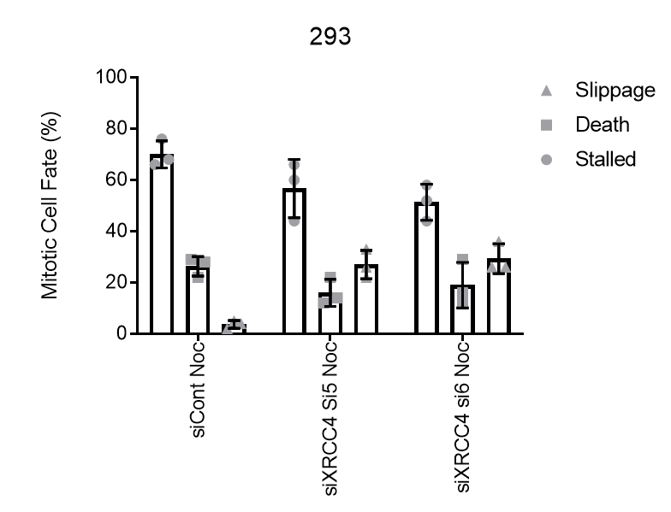
Figure 3.5 XRCC4 depletion leads to increased mitotic slippage. Data derived from live cell microscopy showing mitotic cell fate in n=3 Nocodazole (200ng/ml) treated HeLa cell protein siRNA depletion experiments. Cells counted per experiment were n=50 and graphed giving averages, the data shows a distinct increase in abnormal mitotic slippage in siBubR1 and to a less extent siXRCC4 si5 and si6, to ensure the effect seen was not cell line specific MCF7 and 293 cells were run under the same conditions, n=3 experiments with at least n=50 cells counted. Cells were imaged for 16 hours at minute intervals using a Leica Time Lapse microscope using white light. Cell phase was visually assessed and categorised as survival, stalled or apoptotic death.This process was repeated for each siRNA tested. Data analysed via Prism. 1 way ANOVA test performed compared to corresponding scrambled control * = P ≤ 0.05, ** = P ≤ 0.01, *** = P ≤ 0.001, ****= P ≤ 0.0001. Error bars represent standard deviation. All other comparisons were non-significant.

3.5.4 Effects of XRCC4 siRNA depletion on anaphase bridge formation
Terasawa et al, 2014 highlighted that a loss of XRCC4 via siRNA depletion leads to less DNA damage repair, therefore less anaphase bridge formation. The loss in anaphase bridge formation was attributed to a decrease in NHEJ efficiency when DSBs were introduced. Terasawa et al, 2014 used etoposide to induce said damage which prevents the relegation of DNA strands by being unable to relax coiled DNA. This treatment methodology caused resultant DNA damage rather than direct double-strand breaks such as those from IR treatment. This study was investigated as it was hypothesized that the lack of anaphase bridges may increase mitotic transit speeds, anaphase bridges delay division by binding chromosomes together.
Cells with XRCC4 siRNA depletion have an increased risk of error-prone division due to the increased DNA content and potential DNA damage. It is important to understand the effects of DNA loss on an easily identifiable marker of improper cellular division, in this case, anaphase bridges.

Figure 3.6 shows that when DNA damage is introduced to HeLa cells there is a distinct increase in anaphase bridge formations. Recent studies have indicated that ultrafine anaphase bridges can occur because of unresolved homologous recombination, these unresolved Holliday junction intermediates lead to aberrant mitotic cell division (Chan & West, 2018). One way in which anaphase bridges occur during said phase is due to telomeres fusing. This fusion is due to telomeres failing to separate into the respective daughter cells during mitosis causing potentially malignant cells due to the increased DNA content.
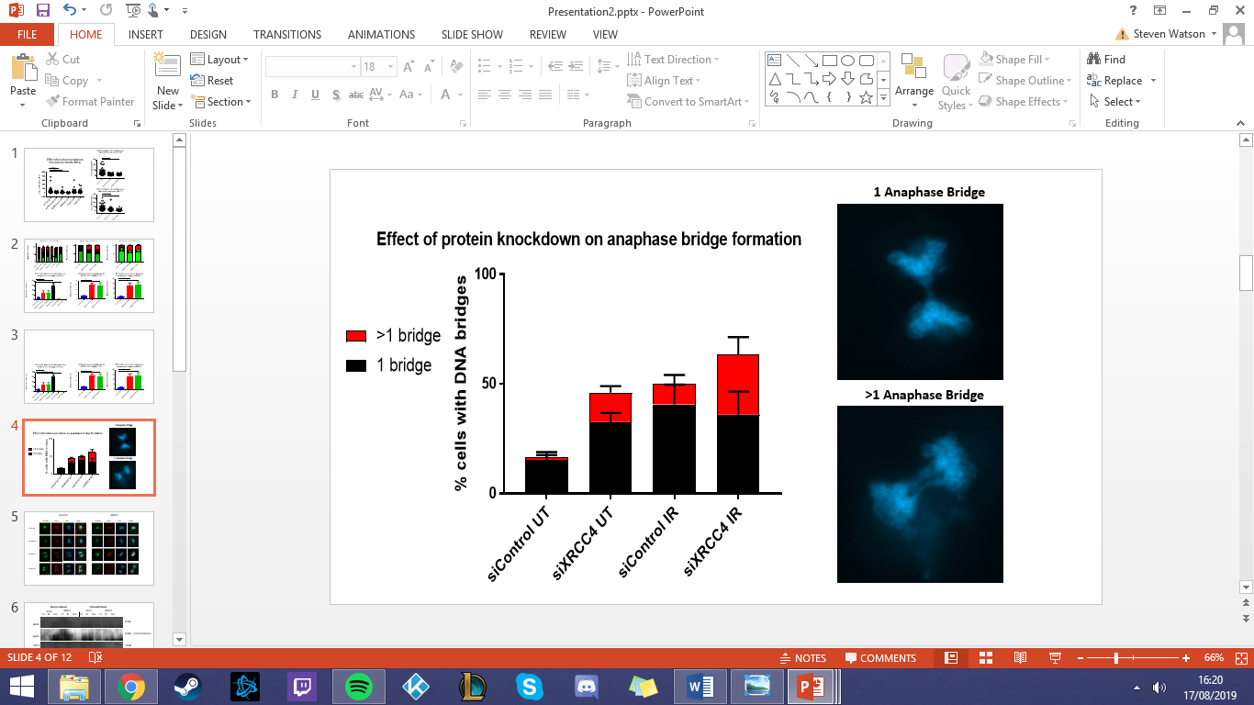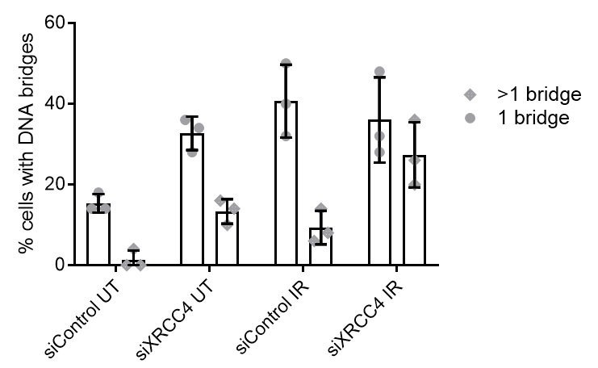
Figure 3.6 XRCC4-depleted cells experience higher levels of anaphase bridge formation in both untreated and +IR treated conditions. DAPI Stained Untreated and 10Gy IR treated HeLa cells after siControl and siXRCC4 si5 siRNA depletion were observed via coIF microscopy. n=50 cells were tallied showing anaphase bridges and the tallies separated into the number of complete bridges of 1 (Top) and >1 (Bottom); examples of each can be seen on the right. The experiment had n=3 repeats, 0 bridge formations were discarded, and a total was calculated. Error bars represent standard deviation. Data analysed via Prism. 1 way ANOVA test performed compared to corresponding scrambled control * = P ≤ 0.05, ** = P ≤ 0.01, *** = P ≤ 0.001, ****= P ≤ 0.0001. All other comparisons were non-significant.
A lack of XRCC4 expression results in a lack of a key component for DNA damage
repair. Without the XRCC4-Lig IV complex which bridges broken sections of DNA resultant ligation can improperly occur. XRCC4-depleted cells in untreated and IR-treated conditions both show a clear increase in >1 anaphase bridges formed.

The number of anaphase bridges formed acts as an indicator of the extent of the aberration in cell division. The excess DNA content because of more cells slipping from mitosis in XRCC4 knocked down cells could also contribute to the fusing of telomeres.

Cells going though mitosis with >4N DNA content could also contribute to this increase in anaphase bridge formation. This data is counter to that previously presented by Terasawa et al, 2014, showing an increase in bridge formation rather than decreasing.

3.5.5 Effects of XRCC4 siRNA depletion on spindle assembly checkpoint proteins throughout mitosis
Understanding the formation of anaphase bridges investigates only one net result of error-prone division. To understand the effects of siXRCC4 on the SAC it is important to understand what happens to the microtubules and chromatids during mitosis.
The impact of XRCC4 depletion on mitotic cell phases was analysed via coIF microscopy staining. Control siRNA and siXRCC4 treated cells where stained and captured to understand the relative impact of XRCC4 depletion, as shown in Figure 3.7.
Cells treated with siControl show proper progression through mitosis. Beta-tubulin staining highlights proper microtubule development and Cenp B shows the cell’s centromeres. We observed the normal formation of microtubules around the spindle apparatus, which in turn transitioned into compact chromosomes before attaching to the spindle along with the metaphase plate in the centre of the cell.
The centromeres and microtubules properly attach, the SAC progresses properly, and the sister cells are pulled to the cell’s poles. Clear ordered localization was observed with telophase splitting the cell into distinct daughter cells. Microtubules were shown to bind to the centrosome in anaphase, condensing in metaphase. There was also accurate alignment for daughter cell separation in anaphase and distinct separation occurring in telophase.
In XRCC4-depleted cells, the microtubules develop around the spindle apparatus with disordered binding to the centrosome. Unlike in the control cell, the microtubules align across the metaphase plate are entirely disorganised and remain unaligned within the cell. These depleted cells progressed into anaphase with disorganised chromosomes enabling a potential bypass of the key spindle assembly checkpoint and could result in cells with improper cellular division.

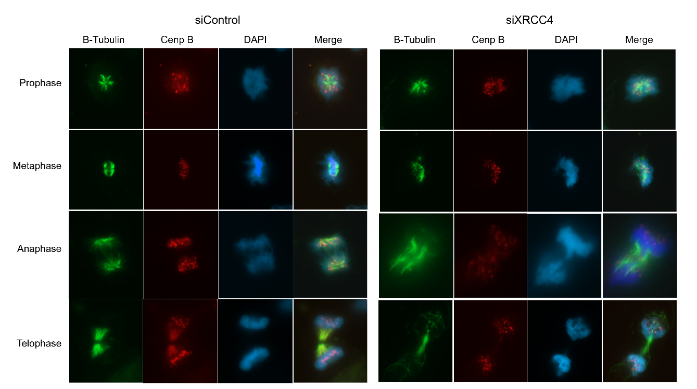
Figure 3.7 XRCC4-depleted HeLa cells experience errors in mitotic spindle assembly and division stages. CoIF staining of the spindle assembly checkpoint proteins was completed using beta-tubulin (B-Tub), Cenp B and DAPI straining. Green beta tubulin stain indicates microtubules. Red Cenp B is involved with centromere formation so localises to that region in the cells and blue DAPI stains for and represents the DNA within the cell. The failure for microtubule development and proper cell division due to siXRCC4 si5 is seen in comparison to the transfection control.
This data supports the hypothesis that a loss of XRCC4 fundamentally interferes with the SAC causing it to fail in regulating proper cellular division, thus directly leading to error-prone mitosis and an increase in anaphase bridge formation.

3.5.6 XRCC4 co-immunoprecipitation of spindle assembly checkpoint proteins after Nocodazole treatment
Understanding crosstalk is also important to characterize the interaction between specific SAC and NHEJ proteins. Systems within a cell often do not operate in isolation and elucidating a more robust process for the DRR in mitotic cells could be key to MDDC insights.
Co-immunoprecipitation (Co-IP) using an XRCC4 antibody as the probe was used to investigate any interactions with SAC proteins. Co-IP uses protein–protein interactions, in this case targeting XRCC4-specific antibodies, to indirectly capture other proteins bound to XRCC4.

As shown in Figure 3.8 we observed an interaction between XRCC4 and MAD2/BubR1, visible in the IP fraction of the Co-IP experiment. This result indicates a potentially previously unknown protein–protein interaction between XRCC4 and the SAC proteins MAD2 and BubR1.
Both the MAD2 and BubR1 pulled down by the XRCC4 probe show an increase in expression levels post nocodazole treatment, the pulldown protein intensity scaling with the XRCC4 probe signal. CDC20 was also tested but does not seem to interact with XRCC4 indicating that the potential interaction is with only some SAC proteins. 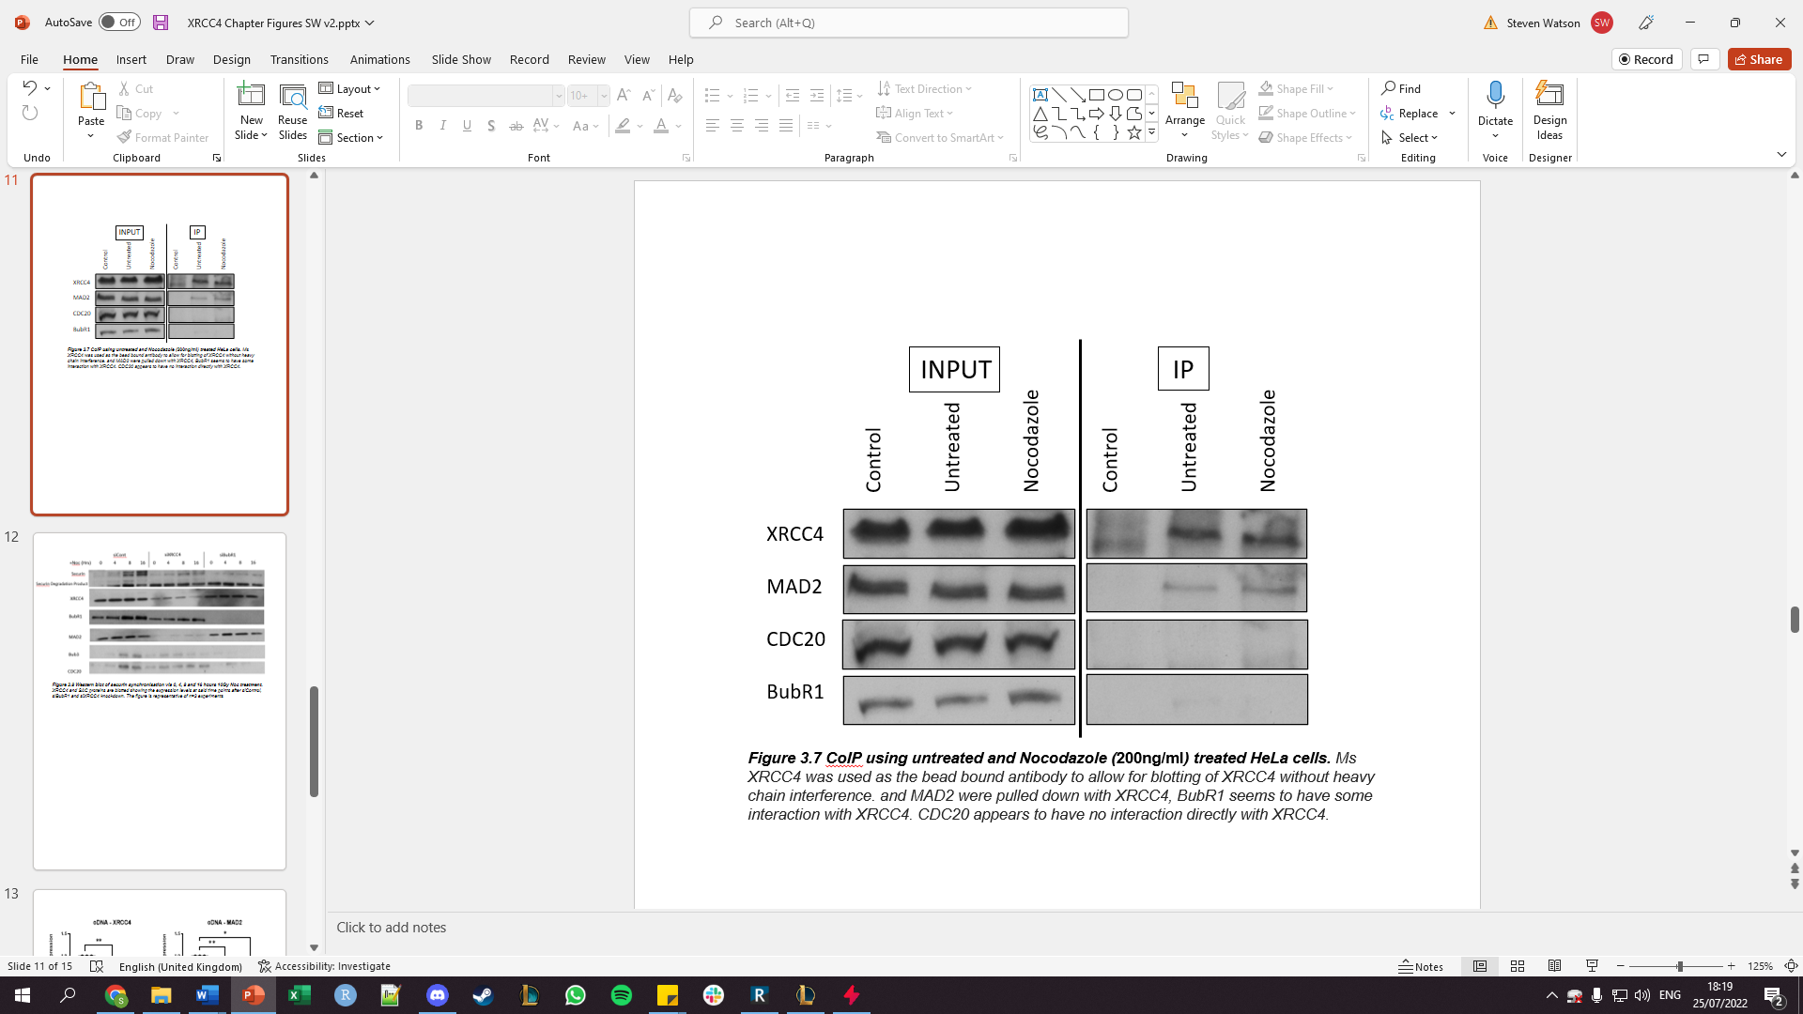
Figure 3.8 XRCC4 appears to directly interact and bind to MAD2. CoIP using untreated and Nocodazole (200ng/ml) treated HeLa cells. Ms XRCC4 was used as the bead bound antibody to allow for blotting of XRCC4 without heavy chain interference. and MAD2 were pulled down with XRCC4, BubR1 seems to have some interaction with XRCC4. CDC20 appears to have no interaction directly with XRCC4. Data was improperly controlled due to a lack of IgG staining, XRCC4 expression was used as the comparative control point.

3.5.7. Nocodazole treatment post-siRNA depletion
Securin levels increase in cells after extended exposure to nocodazole treatment conditions due to a lack of mitotic transit resultant from SAC stalling. Loss or depletion of key elements of the SAC, such as BubR1, results in a failure of the MCC formation and APC/C inhibition resulting in potential faster more error-prone mitotic transit. As shown in Figure 3.9 we did not observe increased securin levels across a range of time points post Nocodazole treatment in either BubR1 or XRCC4-depleted cells. This effect is a result of reduced mitotic stalling from Nocodazole treatment, cells bypassing the SAC and undergoing quicker more error-prone transit. Treatment with Nocodazole results in lower securin levels as it has less time to accumulate due to an increase in the same error-prone mitotic transit.
siBubR1 does not decrease the XRCC4 protein levels when compared to the control. siXRCC4 on the other hand decreases BubR1 expression, as shown in Figure 3.9. This could indicate that XRCC4 in some way regulates or alters BubR1 expression with the opposite being untrue.
The MAD2 expression levels appear to be directly decreased by XRCC4 siRNA depletion, as seen in Figure 3.9. Bub3 and CDC20 seem to be minimally affected by XRCC4 and BubR1 siRNA depletion. However, BubR1 does seem to reduce expression levels slightly, indicating that this interaction between XRCC4 and SAC proteins is not entirely specific to just MAD2. 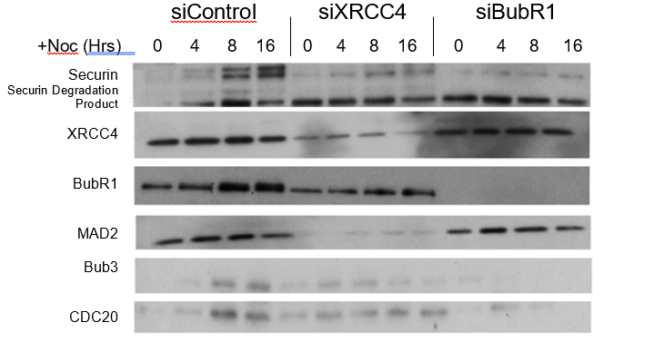
Figure 3.9 XRCC4-depleted cells appear to experience a loss in MAD2 protein expression levels. Western blot was completed post nocodazole mitotic arrest, cells extracted 0, 4, 8 and 16 hours post treatment. XRCC4 and SAC proteins are blotted showing the expression levels at said time points after siControl, siBubR1 and siXRCC4 siRNA depletion. The figure is representative of n=3 experiments

3.5.8 Effect on MAD2 expression levels after XRCC4 siRNA depletion via qPCR
MAD2 RNA levels in the absence of XRCC4 were analysed at the RNA level via qRT-PCR. Taqman controls and untransformed RNA that had not undergone PCR were also tested; not shown. This step was vital to ensure changes in expression levels are purely due to siRNA depletion rather than external factors or RNA contamination of samples.
Figure 3.10 indicates there is a significant decrease in MAD2 RNA levels after 72-hour treatment with siXRCC4 si5. In addition, siXRCC4 si6 shows a similar MAD2 depletion but to a far lesser extent. This data indicates that the siRNA depletion of XRCC4 affects both XRCC4 expression levels, as expected, but also impacts the relative expression levels of MAD2. Therefore, a potential link between XRCC4 depletion altering MAD2 expression levels could be present within mitotic cells.
Figure 3.10 Both siXRCC4 si5 and si6-depleted cells show a decreased expression of MAD2, although si5 appears to have a greater effect. Quantitative RT PCR was completed investigating XRCC4 and MAD2 RNA expression post siRNA depletion shown using siControl, siXRCC4 si5 and si6 treated cells. Taqman probe and untransformed RNA qPCR were ran to ensure the above is not an off-target effect from the siRNA used. Paired t tests were used to determine the significance of the data, GAPDH was used as the Taqman Probe control. Data is derived from n=3 repeats. Error bars represent standard deviation. Data analysed via Prism. 1 way ANOVA test performed compared to corresponding scrambled control * = P ≤ 0.05, ** = P ≤ 0.01. All other comparisons were non-significant.

3.5.9 Off-target testing of XRCC4 depletion effects on MAD2
XRCC4 siRNA si5 gave significant results when testing its effectiveness of interacting with expression MAD2 levels. To validate this effect as not being on si5 specific a siRNA targeted to the 3’ UTR was tested. A 3’ UTR siRNA was utilised to ensure that the region targeted in siRNA depletion did not cover the same base pair region targeted by siXRCC4 si5 or si6.
Testing was completed using this siRNA still targeting the same protein for depletion, retaining the depletion of XRCC4 expression, while mitigating potential off-target MAD2 effects coincidental to the regions targeted by si5 and si6. The siRNA targeted to the 3’ UTR does appear to have no impact on MAD2 expression levels indicating off-target effects of si5 and si6 as indicated in Figure 3.11.
Previous studies indicate there is some effect of XRCC4 depletion on the core mitotic function ensuring a reduction in error-prone mitotic division and transit (Lees-Miller, 2014. Terasawa et al., 2014). The same effect is also present in XRCC4 paralogues tested (Tang et al., 2022). Therefore, indicating while we see an obvious off-target effect of XRCC4 depletion this protein does play a more complex role in mitotic responses to DNA damage.
MAD2 may not interface with XRCC4 but further testing of this relationship between the NHEJ and SAC proteins is warranted, the relationship of XRCC4 with other systems present in a potential Mitotic DNA Damage Checkpoint cannot be discounted either. While we do see an off-target effect of the siRNA depletion utilised it does not explain the protein-protein interaction clearly shown in Figure 3.8 between XRCC4 and MAD2 or the screen previously completed by our lab in Figure 1.
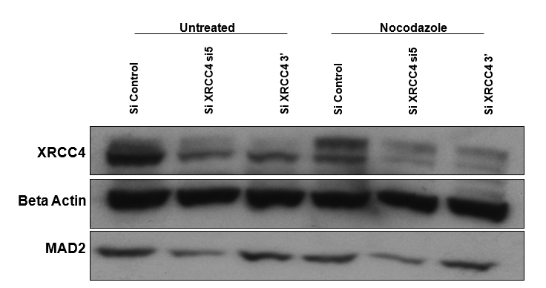
Figure 3.11 XRCC4-depleted cells appear to reduce MAD2 expression levels when utilising si5 but a 3’ UTR siRNA has minimal effects on MAD2 expression levels. Western Blot testing of 3’ UTR XRCC4 siRNA against deconvoluted siXRCC4 si5 and effects their respective effect on MAD2 in untreated and Nocodazole (200ng/ml) Hela cells was completed. Si5 shows a reduction of XRCC4 levels and MAD2 levels. 3’ UTR siRNA on the other hand reduces XRCC4 levels but has little to know effect on MAD2 levels. Therefore, indicating an off-target effect present in si5 XRCC4 siRNA changing MAD2 levels. This is not definitive evidence of an off-target effect, a XRCC4 depleted cell line tested for expression effected by treatment would give a more definitive answer.

3.6 Discussion

3.6.1 siXRCC4 off-target effects and a potentially wider mitotic role for XRCC4
In this chapter, we set out to uncover the mechanism by which cells exhibit slowed mitotic progression in response to DNA damage. We uncovered XRCC4 as being required for this arrest. However, we also discovered that treating cells with siRNA XRCC4 induced rapid mitotic progression under all conditions including following treatment with the spindle poison, Nocodazole.
Previous studies have implicated a role for XRCC4 in mitosis and showed reduced anaphase bridges in mitotic cells treated with siRNA to XRCC4 following etoposide treatment (Terasawa et al., 2014). Interestingly, we found the opposite effect, with the incidence of cells with one or more anaphase bridges increasing 3-fold following treatment with siXRCC4.
Unfortunately, our studies indicate that the utilised XRCC4 siRNAs have an off-target effect on MAD2 expression. Previous studies have shown that siRNA can potentially bind and repress off-target transcripts through potential partial complementary sequence binding. This binding alters expression levels of unintended targets responding to changes in siRNA treatment levels (Jackson & Linsley, 2010).
Further experimentation would also be valuable to ensure that the phenotype observed in XRCC4-depleted cells is due to siXRCC4, validating XRCC4 knockdown via positive control assays. A simple example would be further experimentation using comet repair assays, comparative levels of repair could be quantified in both untreated and XRCC4-depleted cells. Furthermore, analysis of the mitotic population and mitotic transit phenotype in generated XRCC4 deregulated cells could provide clearer results if the interaction with MAD2 was due to off-target siRNA effects or a result of XRCC4 depletion.
As shown in Figure 3.12 there appears to be negligible sequence homology between the siXRCC4 si5 and siXRCC4 3’ UTR and the sequence data for MAD2 utilising sequence alignment testing (VectorBuilder, 2023).
Figure 3.13 also shows the alignment of MAD2 and the siControl, thus highlighting what little sequence homology is detectable is negligible and an effect of comparing siRNA to larger gene sequences. Analysis of siXRCC4 si5 and siXRCC4 3’ UTR using NCBI BLAST only returned significant results for sequences matching XRCC4 (NCBI, 2023).
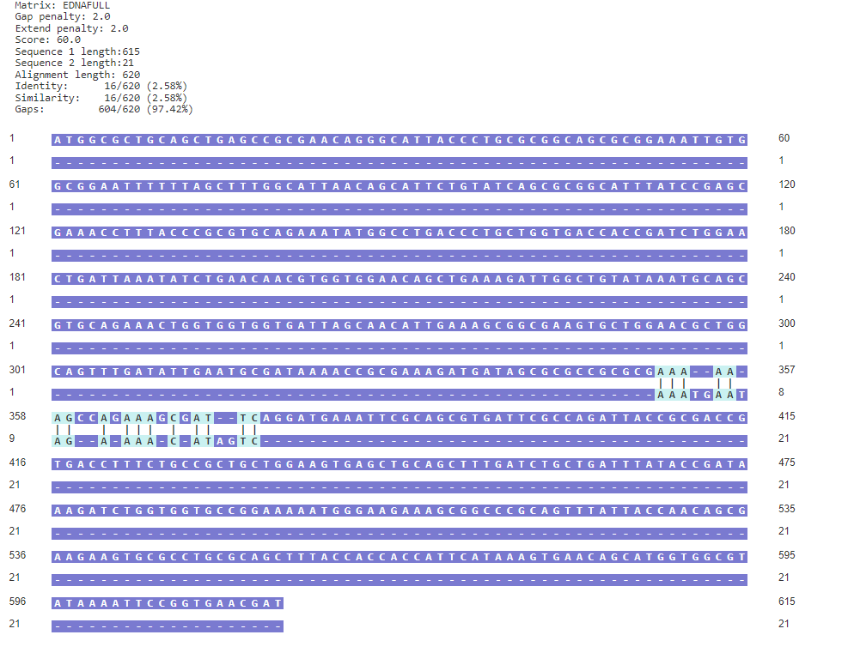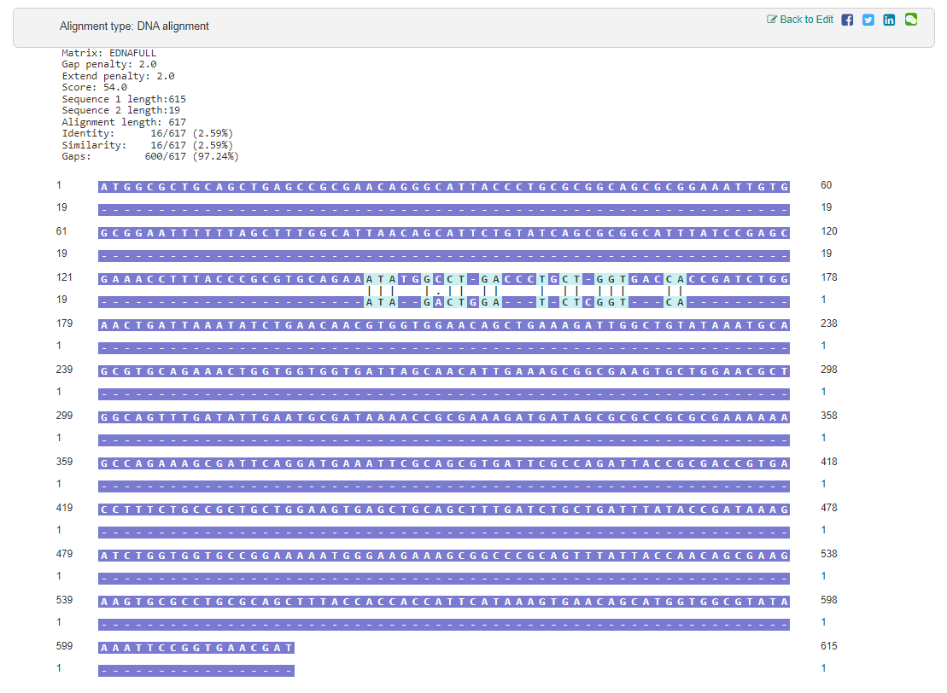
siXRCC4 si5
siXRCC4 3’ UTR
Figure 3.12 Minimal sequence homology is present between siXRCC4 si5 or a 3’UTR siRNA when compared to the MAD2 Human Homolog. Sequences of siXRCC4 si5 and siXRCC4 3’ UTR show similar levels of sequence homology to the siControl tested, indicating no significant sequence homology between the two siXRCC4 utilised and human homolog of MAD2. Data generated using https://en.vectorbuilder.com/tool/sequence-alignment.html. MAD2 human homolog sequence available at https://www.uniprot.org/uniprotkb/Q13257/entry#sequences.

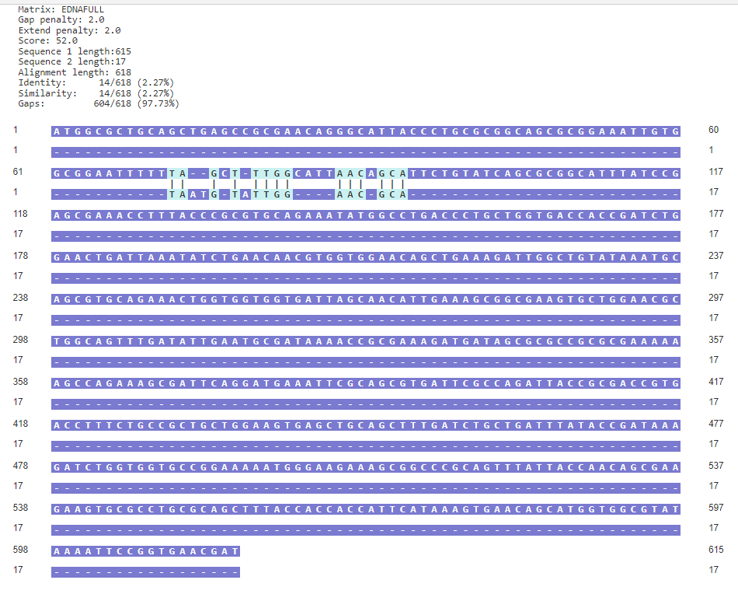
Figure 3.13 Minimal sequence homology is present between a siControl when compared to the MAD2 Human Homolog. Sequences siControl show no significant sequence homology between itself and human homolog of MAD2. Data generated using https://en.vectorbuilder.com/tool/sequence-alignment.html. MAD2 human homolog sequence available at https://www.uniprot.org/uniprotkb/Q13257/entry#sequences.
We do see a similar phenotypical response in the four-siRNA tested in the depletion of XRCC4. We observed an XRCC4 depletion response in the qPCR data utilising siMAD2 as seen in Figure 3.10.
However, when tested with the 3’ UTR targeting siXRCC4, as seen in Figure 3.11, XRCC4 was effectively depleted with minimal effect on MAD2. Other studies have highlighted MAD2 as a particularly sensitive off-target of siRNA depletion (Hübner et al., 2009).
Terasawa et al, 2014 induced anaphase bridge formations and observed that phase-specific phosphorylation of XRCC4 impacts genomic instability inducing mitotic NHEJ in HeLa S3 cells (Terasawa et al, 2014). Studies indicate a more complex role for XRCC4 than as the scaffold structure for NHEJ (Andres et al., 2012). Terasawa et al, 2014 arrested mitotic cells by treating them first with the spindle poison Nocodazole followed by 15-minute Etoposide to induce anaphase bridges.
Etoposide is a topoisomerase II enzyme which acts to stop the re-ligation of DNA strands causing DNA strands to break. Importantly the methodologies target different aspects of DNA damage. IR functions by directly on the DNA itself introducing cytotoxic DNA lesions via radiation damage. Etoposide induces DNA breaks by preventing the relegation of DNA strands by being unable to relax positive or negative super coils (Pommier, Leo, Zhang & Marchand, 2010).
Terasawa et al, 2014 highlight that during interphase DNA Lig IV and XRCC4 are localized to the nucleus. During mitosis, they found via CoIF microscopy that XRCC4 was not localized primarily to the chromatin-like DNA Lig IV but instead to the cytoplasm (Terasawa et al, 2014). The study also found that XRCC4 is phosphorylated during mitosis at the S326 site of XRCC4.
The phosphorylation defective XRCC4 mutant generated in their study showed more efficient mitotic double-strand break repair accompanied by an increase in anaphase bridge formation (Terasawa et al, 2014). The study focuses primarily on a singular phosphorylation site further study could encompass the mitotic DNA damage repair impacts of the other XRCC4 phosphorylation sites.

3.6.2 Protein interactions and XRCC4
It is possible, although unlikely, that the observed effect of MAD2 down-regulation following treatment with the XRCC4 is not due to off-target effects. There is evidence higher order-coordinated systems regulate expression levels of the individual proteins that make up complexes. Studies have shown coordinated regulation of multiprotein complexes, specifically bound interacting proteins, with a synchronised pattern regulation of mRNA production across all the bound proteins (Sprinzak, Cokus, Yeates, Eisenberg & Pellegrini, 2009).
XRCC4 may play a far more complicated role than the scope of this study, interacting with mitotic proteins beyond simple protein-protein interactions. One possible explanation for the response observed within this study is that XRCC4 plays a more significant role in the co-regulation of other key mitotic proteins.
One example of such regulation is the cap-binding protein complex associated with eIF2 and eIF3. eIF2 and eIF3 binding to the ribosomal small subunit complex (40s). This complex in turn initiates the process of translation in eukaryotes. Each factor is regulated in tandem even though the distinct protein subunits play a unique role. There is biological precedence for proteins that have been characterised not as transcription factors, when working as multiprotein complexes, to effect core biological functions at a transcriptomic level (Sonenberg & Hinnebusch, 2007).
A second example of how bound proteins are regulated as a singular complex is the Target Of Rapamycin Complex 1 (TOR complex 1). This complex is a conserved Phosphatidylinositol 3-kinase-related kinase (PIKK) that regulates cellular metabolism in response to the presence of useful nutrients and cellular stress. The complex is made up of TOR-associated proteins namely KOG1, TCO89, LST8, AVO1–3, and BIT61 each being bound and regulated together, again rather than as individual subunits (Wullschleger, Loewith & Hall, 2006).
Another possibility is a potential role for XRCC4 either as a transcription factor (TF) or as a TF regulator. TFs are proteins that control transcription rates from DNA to mRNA by way of DNA sequence-specific binding regulating gene expression (Lambert, 2018. Latchman, 1993). This does not appear to be the case regarding XRCC4, it does not contain key protein motifs for acting as a TF.
XRCC4 overall structure has been characterized via X-ray crystallography which did not detect zinc (zn) fingers (Junop, 2000). Zn fingers are a small but vital protein structural motif using the coordination of zinc ions to stabilize a structural fold. A lack of zn fingers and no distinct transcription factor sites characterized in XRCC4 make it highly unlikely to be a transcription factor itself (Gommans, Haisma & Rots, 2005).
Pieraccioli et al., 2015 linked a zinc finger factor ZNF281, involved in cellular stemness, with XRCC4 (Pieraccioli et al., 2015). The study showed that XRCC4 is transcriptionally activated by ZNF281 through a DNA binding dependant mechanism. The study also showed that this effect is one-directional as XRCC4 did not promote or alter ZNF281 activity. This data could provide a link potential mechanism for XRCC4 interacting with upstream TF, using conformation binding to ZNF281 to attach and utilise a zinc finger structure in the transcription regulation of SAC proteins (Pieraccioli et al., 2015).
Although our tested 3’ UTR siXRCC4 does show there is no direct link between XRCC4 regulating MAD2 expression. The coIP results seen in Figure 3.8 highlight there appears to be a direct protein level interaction between the two but due to the inconclusive data due to off-target effects of siXRCC4 si5 we cannot draw a definitive conclusion without further testing. Analysing the XRCC4 response in cells treated with siMAD2 or using a permanently depleted XRCC4 mutant cell could validate the responses to testing of this chapter.

3.7 Summary
In summary, we have inconclusive results in the interaction of XRCC4 and MAD2, the effects outside of the coIP of XRCC4/MAD2 show the result of off-target effects of the siRNA used in the depletion of XRCC4.

Chapter 4 – The development of Modified Seurat Mitotic Sort (MoSMiS)

4.1 Introduction
To uncover novel genes involved in the regulation of the mitotic DNA damage response, we decided to study the transcriptomic profile of mitotic cells following treatment. Helping map the mitotic transcriptome could lead to new avenues of study into the Mitotic DNA Damage Checkpoint. Expanding the overall scope of the investigation into cell cycle progression and mitosis was limited by currently available tools.
The central roadblock in mitotic single-cell RNA sequencing study; present in both discrete and continuous phase assignment software, was a prebuilt inability to differentiate between G2 and M phase-specific cells. The key difference between discrete and continuous phase assignments is highlighted in section 1.4.3. The currently available tools in their default format grouped cells as a singular G2/M cluster. This grouping made mitotic-specific grouping intrinsically difficult to process. Difficulty subsetting mitotic scRNA seq data to draw mitotic-specific conclusions presented clear limitations in current bioinformatics tools.
Therefore, the central focus of this study became the generation of bioinformatics tools which would be able to accurately separate M and G2 phases. The tool was designed to separate cells irrespective of cell type, treatment or inherent phase effect.
Seurat was developed by Hao et al., 2021 and presented a clear baseline from which mitotic-specific phase assignment could be derived (Hao et al., 2021). Seurat presented a directable code base able to be adapted to assign predictive user-directed cell phase information. Seurat has discrete phase assignment and is not reliant on FUCCI-stained data cells. Seurat was a prime choice for refinement and optimisation over other tools such as the cyclone, Peco or reCAT as covered in section 1.4.3.
This chapter highlights the generation and optimisation of mitotic gene markers. These markers are used to modify the Seurat coding structure. This modified code could then be used to isolate and analyse mitotic cells from previously published scRNA seq data sets.

4.2 Hypothesis
The central hypothesis of this chapter is that there are key genes specific to mitosis that can be used as functional markers for mitotic-specific single-cell RNA sequencing. These markers will be cross-compatible with bulk RNA sequencing and can be used to process and isolate the mitotic fraction of large-scale data sets.
This isolation of mitotic cells can then allow for the direct profiling of the mitotic transcription landscape enabling further mapping and understanding of the mitotic DNA damage checkpoint (MDDC).

4.3 Aims
There are three central aims to this chapter.
- Optimise a workflow protocol for the isolation and bulk RNA sequencing of RNA derived from purely mitotic and interphase cell populations.
- Use the pipeline developed in Aim 1 to generate a differentially expressed significant interphase and mitotic gene list.
- Apply that gene list in the optimisation of cell phase sorting software to single-cell RNA sequencing datasets so mitotic cell data can be accurately and efficiently identified for further transcriptomic study.

Objectives
To achieve these aims I will:
- Assess the sorting effectiveness of pre-existing R code to form a basis for a mitotic sorting function.
- Modify and optimise cell phase assignment software using key-generated differentially expressed mitotic and interphase genes of interest.
- Optimise a pipeline of cell sorting and bulk RNA sequencing to create said key gene list.
- Apply the optimised cell phase sorting software to single-cell RNA sequencing data sets to isolate a purely mitotic cell fraction.

4.5 Results
The initial testing of the Seurat cell cycle phase assignment highlighted a need to modify Seurat to isolate mitotic cells. The default gene list and published gene lists available for assigning a G2/M mixed population were unsuitable for the needs of this study.
Seurat required a novel gene of interest list to separate mitotic and interphase populations. During this study we performed bulk RNA seq to determine a gene list specific to mitotic cells, isolating highly expressed mitotic genes in phase-sorted cells.
We optimised cell sorting using propidium iodide for DNA content and phosphorylated histone H3 (Ser10) staining to isolate mitotic cell populations. RNA isolation and RNA sequencing analysis were used to generate gene expression lists specific to Interphase and Mitosis.
Such lists can be used for bioinformatics-based mitotic cell population isolation and transcriptomic study in wider single-cell RNA sequencing (seq) data sets.

4.5.1 Irradiation treatment LD50 of RT lab Hela Cells

To generate the dataset of bulk RNA sequencing data, we needed the cells to have sufficient levels of DNA damage to exhibit mitotic arrest without high programmed cell death (apoptosis) levels. Isolation and sequencing of RNA from 4 populations of cells separated by phase and IR treatment. The central focus of this study is the difference between interphase and mitotic cell populations.
Initial testing was completed to establish the median lethal dosage (LD50) in the irradiation (IR) exposure of Hela cells, this was tested using a trypan blue survival assay over a range of IR treatments analysed at 24-hour increments to determine a cell survival percentage. This survival percentage was then normalised and plotted as seen in Figure 4.1, from the plotted experimental data there was extensive cell death in 8Gy and above even at a 24-hour time point.
2Gy and 4Gy at the other end of the treatment spectrum also exhibited high levels of death even at a 24-hour time point. Significant levels of cell death were also observed at 8 hours post 8Gy treatment. 5Gy was selected moving forward.
This study initially focused on the impact of both treatment and phase. It was determined a more valuable model could be generated by accounting for and regressing out the impact of replicate or treatment effect. The eventual phase sorting system focusing the differences in gene expression due to mitosis versus interphase cells.
Both untreated and +IR data were processed but later differential expression testing via DESeq2 regressed out the impact of treatment so only phase-specific responses remain.
Figure 4.1 LD50 of Hela cells in response to IR Treatment. Survival of Hela cells treated and incubated over 96 hours and the survival ratio of cells at the above time points was calculated using a Trypan Blue assay under a light microscope at x20 magnification. The cells were subject to a range of IR treatment levels (0Gy to 10Gy). Data analysed via Prism. N=3.

4.5.2 5Gy Dose Response of Hela Cells
Dose-response was utilised to determine post-irradiation maximum levels of mitotic arrest with minimum levels of cell death. Cells were treated with 5Gy IR and harvested at various time points before assessment for the mitotic population. The impact on the mitotic cell population was analysed via flow cytometry. The cell cycle phase was identified using propidium iodide to identify DNA content and a phospho-histone H3 (f) antibody to mark cells with condensed chromatin.
As seen in Figure 4.2.A 2 hours post 5Gy treatment there was an observable decrease in the mitotic population likely due to cell cycle arrest at the interphase checkpoints. At 8 hours, the mitotic population level is back up to that of untreated cells and at the 16-hour post-treatment timepoint there is a clear increase in mitotic cells. As highlighted in Chapter 3.1, DNA damage of cycling cells causes a delay in mitosis.
Whilst the accumulation of cells in mitosis was most visible at 16 hours post-treatment, 8 hours post-treatment was chosen as there were sufficient cells in mitosis for analysis and lower levels of cell death were expected based on the data in Figure 4.1. Therefore, going forward the optimal timepoint for harvesting and cell phase isolation was 8 hours post 5Gy IR treatment and will be used in all further experiments. 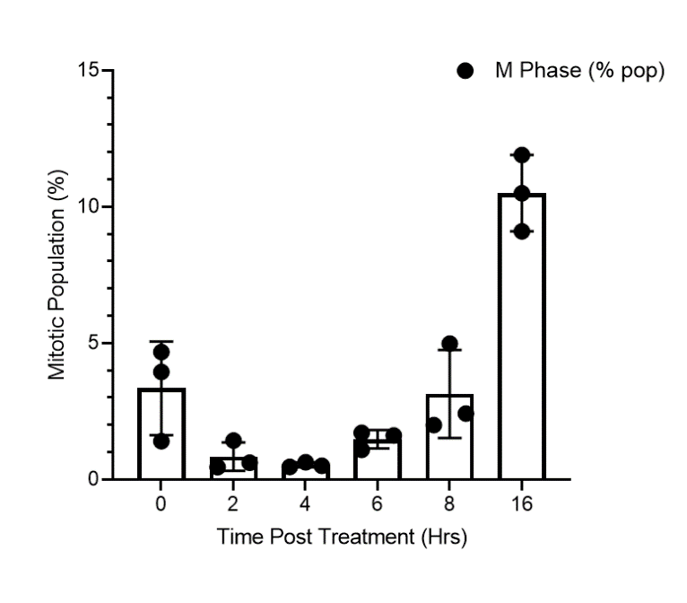
A
Propidium Iodide
pH3
0 Hrs Post IR 2 Hrs Post IR
4 Hrs Post IR 6 Hrs Post IR
8 Hrs Post IR 16 Hrs Post IR
B
Figure 4.2 Flow cytometry data of IR treatment (5Gy) over various time points. A) Analysis of 5Gy IR exposure was tested at different time points to determine its impact on mitotic populations. 8 Hours post treatment gives an ideal mitotic population size without the surge in apoptosis seem at post 16 hours. B) Representative flow cytometry data highlighting the mitotic population, 16 hours post IR there is an observable increase of cells in mitosis. Data analysed via Prism. N=3.
It is important to note as previously stated the scope of this project initially was to focus on both interphase and mitotic cells, in both IR-treated conditions and untreated conditions.

To generate a functional model the impact of treatment and replicate effect had to eventually be accounted for and regressed out to allow the development of a phase-specific transcriptome model. This treatment data remains in the generated input collected data. Future project stages could be able to analyse both treatment and phase impact to gain further bioinformatics insight into the mitotic transcriptome.

4.5.3 Optimisation of RNA quality post FACSMelody isolation
High-quality RNA is required for RNA sequencing on the RNA extracts (RNA Integrity Number (RIN) of >6 required by Novogene). The workflow from initial fixation and staining steps to the final PI staining before FACS Melody sorting was integral to optimise. Without these optimisation steps the low quality of the RNA present would prevent RNA-Seq analysis. All RNA quality scoring tests were completed using a Bioanalyzer (Agilent) at the Sheffield Institute for Translational Neuroscience.
A high RIN value ensured the RNA processed has not degraded and remains viable for analysis, multiple rounds of testing were completed as flow cytometry protocols and fluorophore tagging can negatively impact RNA quality.
Testing was completed to ensure an optimal sample was produced for the next stages of the project to analyse. Figure 4.3 represents the multiple rounds of RNA integrity testing with a RIN score returned after testing each protocol and staining setup outlined in the following paragraphs. Testing was completed using an Agilent Bioanalyzer that tests RNA and derives a quality score based on the stability. Purity and stability was tested analysing the effects of attached fluorophores, fixation methodology the impact of an RNase inhibitor.
The first phase of testing was to determine the fixing and staining protocol necessary for flow cytometric sorted and its impact on RIN. A measure of RNA with adhered FITC and 594 fluorophores had minimal spectral interference with the FACS Melody excitation lasers. As seen in Figure 4.3 A all samples had unusably low RIN scores except the unstained unfixed cells demonstrating that fixation and staining methods were negatively impacting the RNA. The unfixed cell has RNA extracted immediately after removal from incubation. All the samples in this stage were fixed using 70% ethanol.
The second step in optimisation was testing the cell fixation steps during the flow cytometry staining protocol. Modifying the fixation method to test ethanol, methanol and paraformaldehyde did not significantly impact RIN. The removal of PI staining, the introduction of a salt stabiliser in the fixation steps and permeabilising with methanol made a minimal impact on the RIN score as seen in Figure 4.3 B.
Further testing was completed to mitigate RNA degradation via the use of RNAseOUT Recombinant Ribonuclease Inhibitor (ThermoFisher,10777019). This inhibitor is a well-established potent non-competitive inhibitor of ribonucleases such as RNase A. As seen in Figure 4.3 C, once again, the only sample with an acceptable RIN score was the unstained and unfixed sample.
RNAseOUT was added step-wise. Inhibitor input during the fixation steps was insufficient in ribonuclease inhibition. Individual stage inhibitor addition made little difference to RNA stability regardless of the number of cells used in RNA extraction. Different RNA extraction kits were also found to have minimal impact on RIN scores.
Subsequently, the RNAseOUT inhibitor was added across a range of steps during RNA extraction. As seen in Figure 4.3 D the inhibitor added during just fixation and the primary staining did increase the RNA quality, but the overall RIN score was still not sufficient for RNA sequencing.
Using the RNAseOUT inhibitor during all steps of preparation for flow cytometry significantly improved the RNA quality and increased the RIN significantly to 7.8, which is sufficient RNA quality for RNA seq analysis.
Going forward the optimum setup is 70% ethanol fixation, using a FITC fluorophore or ph3 staining and using the RNAseOUT in each step of the protocol. 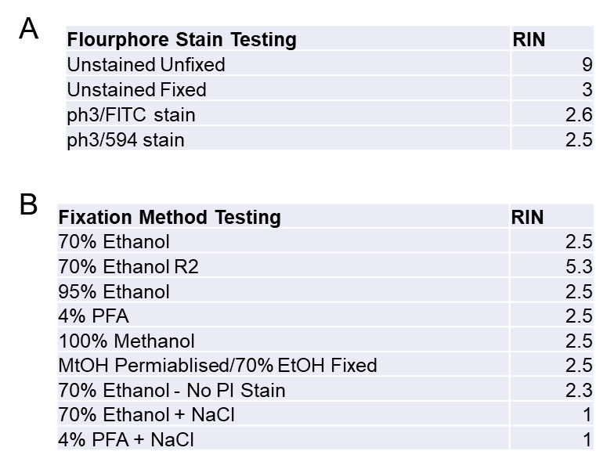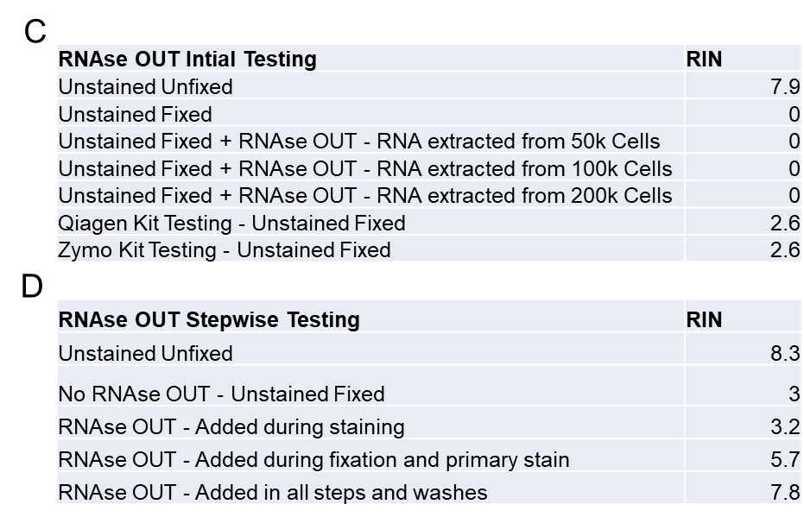
Figure 4.3 Bioanalyser results optimising RNA extraction form FACSMelody Sorted Cells. RNA integrity number (RIN) of 6 or above was required for proper bulk RNA seq analysis via novogene thus optimisation of RNA extraction post fixation, ph3/PI and FACSMelody sorting required extensive optimisation A) A range of fluorophores adhering to ph3 were tested showing minimal spectral interference with the FACSMelody excitation lasers and minimal impact on RIN B) Representation of fixation methods tested, 70% Ethanol fixation repeat 2 gave the optimum RIN. Samples analysed on the Bioanalyzer (Agilent) at the Sheffield Institute for Translational Neuroscience. C) RNAseOUT Recombinant Ribonuclease Inhibitor (ThermoFischer,10777019) was tested during collection steps of FACSMelody sorting to minimal effectiveness on RIN, RNA extraction kit also had minimal RIN effect. D) Adding the RNAse OUT during the fixation, staining and washing steps significantly increased RIN and was standard practice going forward. Samples analysed on the Bioanalyzer (Agilent) at the Sheffield Institute for Translational Neuroscience. 0 RIN score represents an undetectable value returned.
Following the optimisation of the protocol, samples were prepared for analysis. The four experimental sorting conditions all achieved the RIN scores and RNA quantities required by Novogene for RNA sequencing as shown in Figure 4.4. Using the RNAseOUT inhibitor during all steps of preparation for flow cytometry significantly improved RNA quality. Figure 4.5 represents repeat 2 of 3 that all scored high and viable RIN values using the Bioanalyser. With sufficient RNA integrity present insight from RNA sequencing and bioinformatics analysis produced reliable transcriptomic insights. High RIN scores ensure sequencing steps in later sections will not be impacted by RNA artefacts. The samples were then stored and safely shipped to Novogene for RNA sequencing 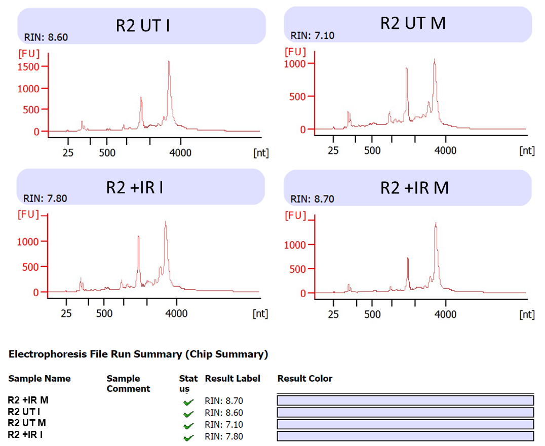.
Figure 4.4 Bioanalyser results testing optimised RNA cell extraction purity. Once optimisation was completed three repeats of full experimental RNA extraction was performed with the 4 conditions highlighted in the example data above, thus giving 12 samples to be sent to Novogene with optimum RIN and sufficient RNA levels present for RNA sequencing. Samples analysed on the Bioanalyzer (Agilent) at the Sheffield Institute for Translational Neuroscience.

4.5.4 Novogene quality control of RNA used in RNA sequencing
The RNA extracts were processed externally via Novogene RNA sequencing facilities. Bulk RNA sequencing was completed by using the provided 12 samples which had high RIN values, 3 repeats were provided to ensure reliable and significant conclusions could be drawn from Bulk RNA Sequencing data. Errors in Novogenes RNA handling practices necessitated multiple sample provisions before 3 reliable repeats of RNA sequencing data could be collated. Samples were sequenced following Illumina-based RNA-seq, discussed in further detail in Section 1.4.1, protocol before returning pair-ended raw sequencing data for processing as outlined in Figure 1.5.
As shown in Figure 4.5, Novogene performed a further series of quality control testing post-RNA sequencing, all data sets have a high number of raw reads giving a large library size. The clean against raw total reads ratio in all samples was 95% or above indicating a highly effective and reliable sequencing run. This is further supported by low error rates and high Phred percentages, a Phred of 20 indicates the chance of finding 1 incorrect base call among 100 bases and a Phred of 30 indicates the chance of finding 1 incorrect base call among 1000 bases. The G and C base count ratio being close to 50 indicates an evenly distributed base pair sequencing. The samples sent returned high-quality reliable bulk RNA sequencing data.
As shown in Figure 4.5 the submitted sample returned successfully generated reliable RNA seq data that will be processed in further sections.

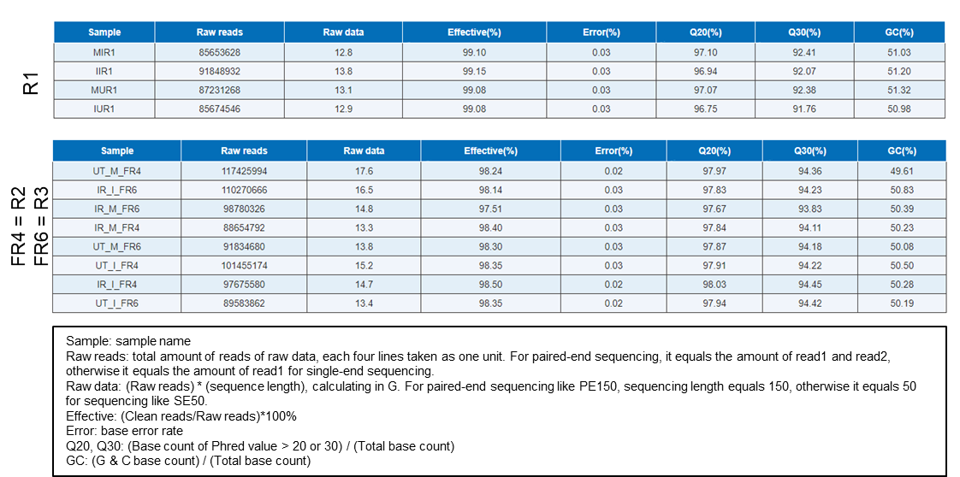
Figure 4.5 Novogene Quality Bulk RNA seq Control Information. Novogene Bulk RNA sequenced submitted RNA samples via Illumina Next Generation Sequencing, no significant base rate errors were present resulting in highly effective RNA seq read generation. G & C base count levels and over Phred values were within acceptable parameters for RNA seq read analysis to proceed.

4.5.5 Quality assessment of unaligned RNA seq reads
The raw paired RNA seq datasets were uploaded to Galaxy Europe, a central repository for a wide range of bioinformatic processing tools. The raw reads were collated for further processing via the workflow pipeline highlighted in Figure 1.5.
Before alignment mapping and downstream differential expression testing were completed quality control was first completed via FastQC (Andrews, 2010). FastQC is a program suite that runs a broad spectrum of quality control tests to highlight potential errors or issues in high throughput sequencing data using the raw fastq files which contain the bulk RNA sequencing results data, the QC results were then aggregated using MultiQC as shown in Figure 4.6.
As highlighted in Figure 4.6.A the sequencing depth (M Seqs) provided more than deep enough library size to allow for all downstream analysis. A larger sequencing depth represents a large ratio of the total number of bases obtained set against the size and repetition of bases being tested, a higher value results in more accurate mapping to a genome of individual fragments as there are far more points of reference to build sequences from.
The G/C ratio (%GC) while slightly higher than those provided by Novogene is still within the acceptable window. In the perfect RNA sample, the ratio of G bases and C bases is 50%, testing for this value ensures that errors in genomic weighting are not present and the data is representative of proper RNA makeup.
The percentage of duplicate reads while high can be accounted for as the data is pair-ended due to the overlapping nature of using a forward and reverse strand of the same sequences tested. The raw data read lanes will be combined and adjusted accordingly during read alignment steps.
The QC data shows the high-quality mean and per sequence quality scores indicating a highly reliable raw data set, as shown in Figure 4.6.B. FastQC tests only failure was sequence Duplication Levels testing but this is to be fully expected in this form of RNA sequencing and will not impact downstream analysis. As previously stated, the overlapping nature of pair-ended reads is accounted for as pair-ended settings were utilised during the alignment of base fragments to a human reference genome with the use of HISAT2 ("HISAT2", 2022).

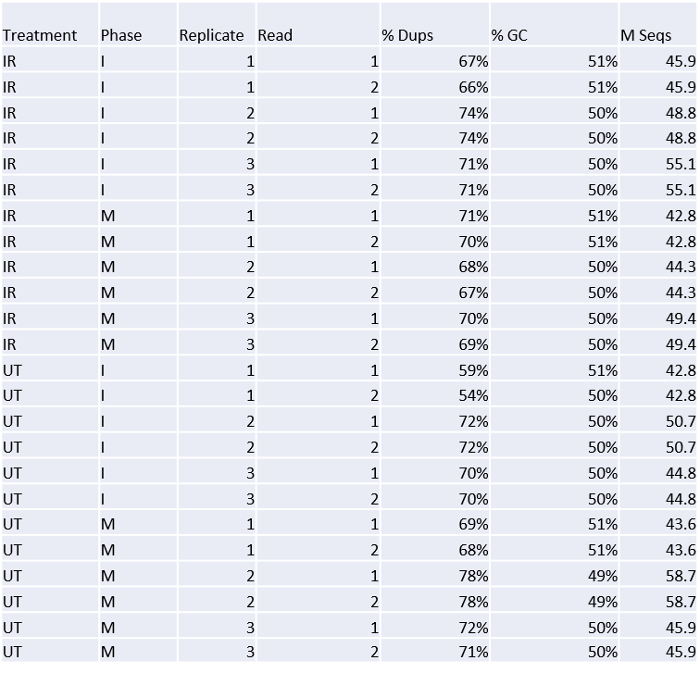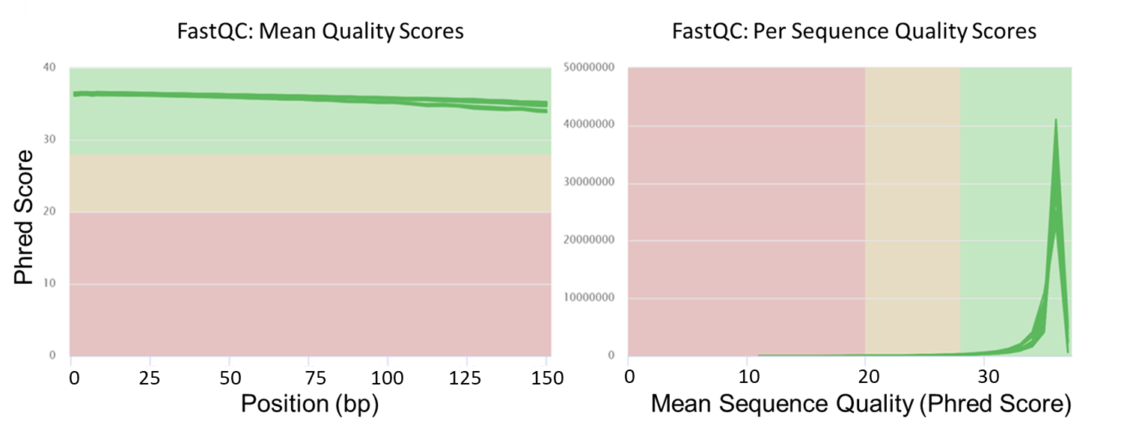
Figure 4.6 Quality assessment of sequencing data across all samples. A) The pair ended samples were analysed and averaged and are within expected parameters the samples fragments having crossover for alignment without too high a degree of sequence duplication that can be accounted for (% Dups). The G/C ratio (%GC) data supporting Novogene provided data and within acceptable limits as is library size (M seqs). B) MultiQC joining the FastQC analysed reads shows high average quality scores for all fragments and high-quality scores on a per sequence basis across all samples. Analysis completed via Galaxy EU using the FastQC tool, data was collated by the MultiQC tool.

A
B

4.5.6 RNA seq data library sizes
Raw data read counts library size is visualised in Figure 4.7 by plotting the number of reads on the million scale.
Novogene bulk RNA deep sequencing depth gives good read distribution allowing for high power and specificity in differential expression testing. Subsequent statistical testing becomes far more reliable due to the uniform spread of read counts across the tested parameters with very close clustering around the median.
The library sizes remain consistent between repeats and experimental conditions leading to no major library size differences. The good read coverage for alignment should bear no effect on downstream analysis resulting in reliable conclusions from the data.
Figure 4.7 Library Sizes of RNA seq samples. All three repeats were analysed across all conditions and read fragments. The total number of raw counts were collated and presented in a bar chart using Prism. Each number of reads represents a million reads present (M Seqs).
HISAT2 ("HISAT2", 2022) was then used to align the disparate RNA sequencing fragment reads to a human genome, outlined further in methods section 2.4.5. HISAT2 takes into account the presence of introns and performs spliced alignment to map the fragmented RNA to its correct position on a genome. Levels of expression of a given gene can be determined by how many fragments (reads) are mapped to a specific genetic sequence.

4.5.7 Quality assessment of aligned RNA seq reads
Post-alignment mapping of the combined raw fastq file format via HISAT2 analysis of the quality of said mapping was completed using the Samtools suite (Danecek et al., 2021). Thus suite was utilised to quality control the aligned read fragments. Collation for the presentation of these results was completed via MultiQC. Figure 4.8 is the MultiQC collected Samtools quality control scores completed for each of the tested samples across all three replicates.
As shown in Figure 4.8 there were minimal error rates and a high number of reads mapped and minimal unmapped reads evidencing consistent properly paired read outputs. This shows that the fragments of RNA aligned to the reference genome were completed accurately across all three replicates.
As shown visually in Figure 4.8 B a clear visual representation of a minimal volume of unmapped reads highly that a cohesive data set with a high volume of accurately mapped reads was produced in a more reader-digestible manner.
In all sequencing experiments, there are expected to be some unmapped or failed reads due to the high volume of data points being processed. Having such uniformly low values of errors evidences that the data set produced is highly reliable. Samtools testing highlights the correction of overlapping reads as previously seen in Figure 4.6.
Samtools (Danecek et al., 2021) accounts for the primary read with overlapping starting 5’ matching orientation post alignment. The properly matched and aligned reads tested in Figure 4.8 show data sets ideal for gene coordinate assignments and differential expression testing.
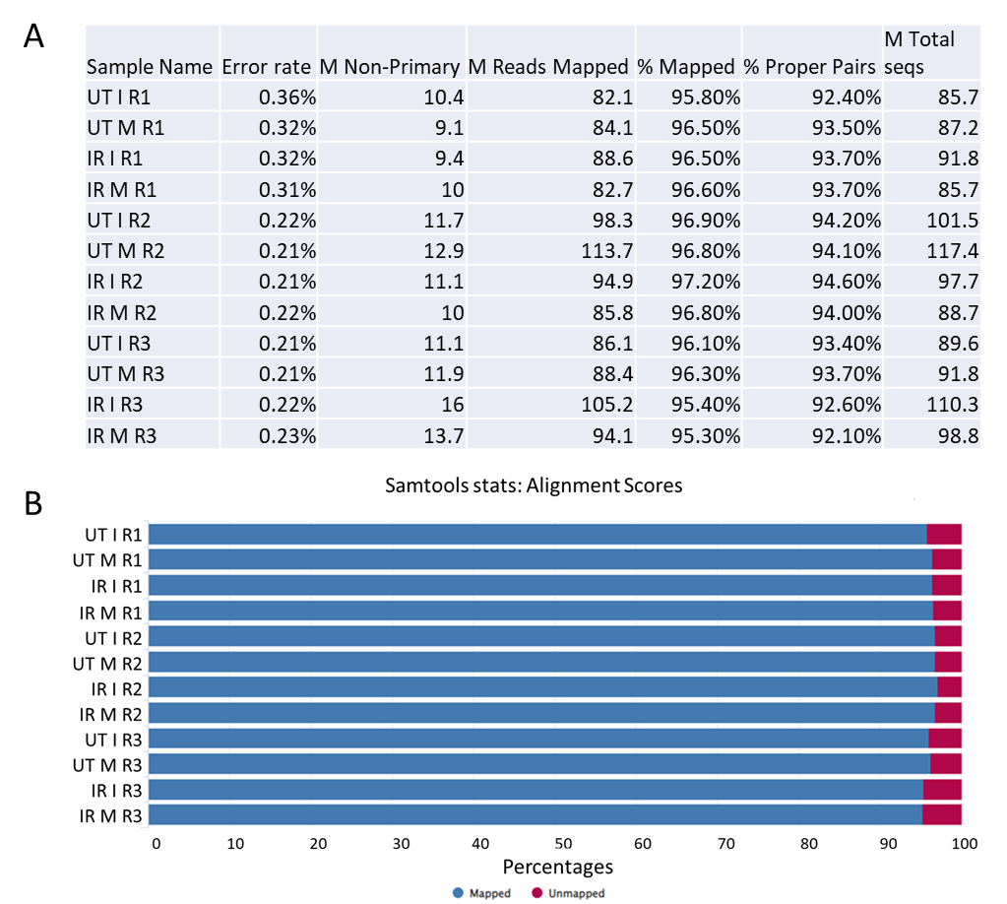
Figure 4.8 Quality assessment of the aligned reads. A) Quality control analysis post alignment via HISAT2 was completed. The total reads per sample well exceeds optimum ranges, as does the percentage of improperly paired reads or the total number of missed reads in each condition are well with expected parameters. B) A visual representation of the alignment scoring, again showing an acceptable number of reads being unmapped. Analysis completed via Galaxy EU using the Samtools, data was collated by the MultiQC tool.

4.5.8 PCA analysis of generated count matrix
An unsupervised principal components analysis (PCA) was performed post-count matrix generation. PCA testing performs a series of data transformation techniques, the data is compressed and the dimensional distances between samples are calculated.
PCA mapping is performed post-variable (across treatment, phase and replicate) value standardisation. The calculated distances allow for the separation of variation based on gene expression, and the degree of difference allows for the interference of the effect of variances across the processed samples.
As seen in Figure 4.9.A observed grouped PCA values primarily by replicate effect, the impact on gene expression from different time points, lab conditions or operating efficiency of Novogene. We determined the point of the severe impact of variance was the third replicate. DESeq2 (Love, Huber & Anders, 2014) has inbuilt tools to regress out variation factors and focus the differential expression analysis towards directed variables, such as the impact of phase on expression rather than replicate effect. The replicate effect is regressed in later steps so that differential expression testing compares the cell phase effect on gene expression.
When disregarding the replicate effect, the data still exhibits a consistent trend in variance when both phase and treatment are plotted as seen in Figure 4.9.B. Therefore, the data indicates that while the replicate effect is skewing the PC1 and PC2 plotting it can be accounted for. Considering this when designing subsequent DESeq2 tests we can observe the impact of phase-specific gene expression. The scope of this study is primarily concerned with just the cell phase effect, the data was tailored to focus on this rather than replicate or treatment.

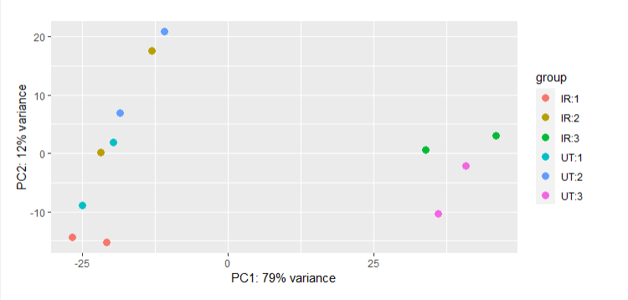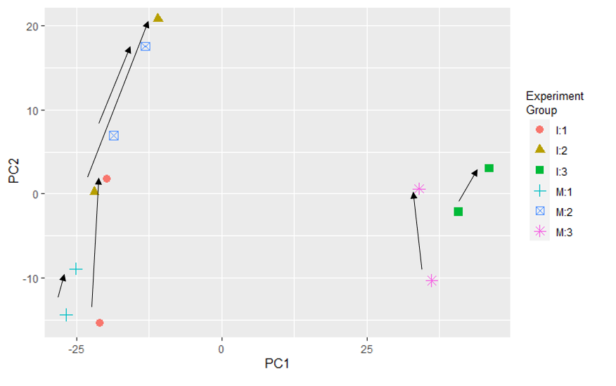
Figure 4.9 Principle component analysis plot showing gene expression variability. A) PCA used a variance stabilising approach to graph transformed gene expression. Samples were plotted on main variance points PC1 (replicate effect) and PC2 (phase effect). Distance from the axis and clustering of points indicating the relationship and impact of in the case treatment, phase and replicate effect. B) The replicate effect appears to cluster the data abnormally. All data points do share the same effect across the PC2 axis indicating shared impact of phase across data samples as indicated by the black arrows. Removing treatment and replicate effect allows subsequent analysis to only focus on phase effect. Graph generated in R using plotPCA.
A

B

4.5.9 Gene distribution expression profiles of generated RNA seq data
Post count matrix generation the transcriptomic data was used for differential expression analysis (DEA). After quality control was completed, the next stage of the study was to generate a phase-specific gene list of interest. In the case of this study regressing out the impacts of treatment and replicate effect. DEA was focused to determine phase difference between the RNA seq data sets.
DESeq2 experimental parameters were designed to combine and remove treatment effects from subsequent analysis. The first step was testing the distribution of genes across the libraries highlighted in Figure 4.7. The scaled (Counts Per Million or CPM) data set showed a relatively uniform distribution of read counts. The very close median clustering as seen in Figure 4.10 taken in conjunction with the large library sizes seen in Figure 4.7 indicates the input data is of good sequencing quality. 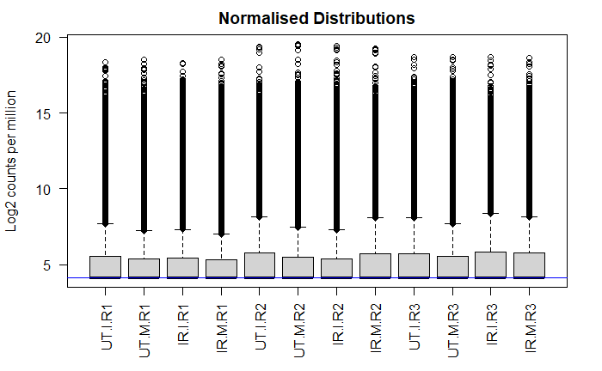
Figure 4.10 Boxplot Distributions of expression across scaled profiles of RNA-seq data. Post sequencing and read count matrix generation the samples were tested for differential expression via DESeq2. The gene distributions were checked post CPM expression transformation and the normalised distibutions were graphed, the blue horizontal line that corresponds to the median logCPM.
Differential expression testing at its core is to measure and statistically analyse the dispersion parameters of a gene count matrix. Dispersion parameters estimate the metric variance location relative to a mean value. In the case of this study the variance of gene expression between interphase and mitotic cells.
Of note, data gathered from Bulk Sequencing was utilised as interphase and mitotic cells, replicate and treatment effects were removed from the data model by regressing out these variables.
It is therefore important to ascertain the correct model for gene distribution to ensure true differential expression detection without false discovery (Landau & Liu, 2013).
Negative Binomial distribution model testing was completed due to the broad nature of the data set and the high degree of gene expression variance across the generated count matrix. As seen in Figure 4.11 plotting of the per gene dispersion estimates was completed using the plotDispEsts (DESeq2) in R. The dispersion decreases as the fitted mean counts decrease, as expected in this model. There are outliers on the upper and lower limits of this model. Independent filtering as part of DESeq2 (Love, Huber & Anders, 2014) processing was completed to regress low and outlier counts. 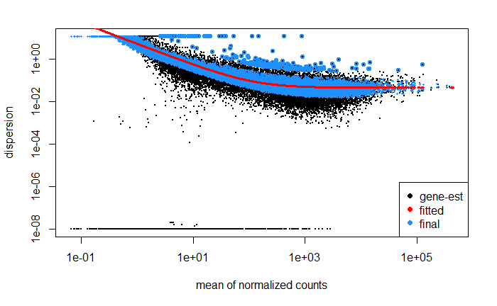
Figure 4.11 Gene Expression distribution in raw and differential expression tested data. The raw count matrix data dispersion estimate indicates a more probable gene presence as the dispersion mean value increases (x-axis), the mean of normalised counts indicating the spread of the genes across the sample (y-axis). Generated by DESeq2, blue dots representing adjusted gene dispersion, black dots with blue border indicating a high dispersion score set against the expected dispersion value (red curve).

4.5.10 Differentially expressed genes in the RNA seq data
Differential expression testing is then completed by the Bioconductor DESeq2 tool (Love, Huber & Anders, 2014). This step has internal independent filtering of data to remove lower expression variables calculating. Plotting was completed on viable and outlier data points that can be excluded via p-value and adjusted p-value as relevant (-log10 p-value).
DESeq2 (Love, Huber & Anders, 2014) provides quantitative data for differentially expressed genes via the calculation of gene dispersion parameters from relative mean expression.
This tool uses negative binomial distribution across the entire count matrix to determine differentially expressed genes. This linear model can be set up to focus on variance specific to experimental design, giving differential expression between interphase and mitotic RNA seq samples.
Gene-wise dispersion and the spread of relative mean count accounting for library size and design calculating a size factor by, the log2 fold change was then calculated based on the linear model equation:
K_{ij} ∼ NB(µ_{ij} , α_{i})
Kij for where the gene is represented by i, and the sample represented by j are attained using negative binomial distribution NB. NB in turn uses µ_{ij} a gene-specific dispersion parameter accounting for extra variability in the input sample α_{i}. The fitted mean is calculated via:
µ_{ij} = s_{j}q_{ij}
The fitted mean µ_{ij} is derived from sample-specific size factor s_{j} that remains a contestant variable across sample j. This is used in conjunction with a parameter proportional to the expected true concentration of expression q_{ij} from fragments of input sample j and gene i.
The log2 fold change log2 (q_{ij}) for samples j and gene i is then calculated via:
log2 (q_{ij}) = x_{j}.β_{i}
x_{j} is a design factor determined by the setup of experimental design in our case the difference between expression in interphase and mitotic bulk RNA seq data.
The coefficients β_{i} provide the calculated log2 fold changes for gene i for each column derived using the input matrix columns. This gives us a DESeq2 output as seen in table 4.1.
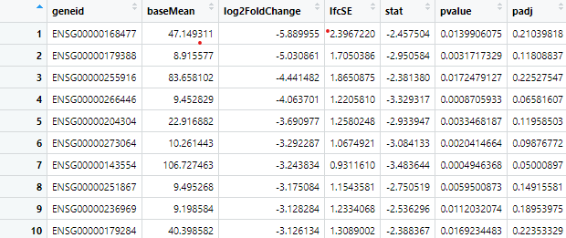
Table 4.1 Data output from DESeq2 DEA testing of bulk RNA seq input data, generated using R
Post differential expression testing via DESeq2 (Love, Huber & Anders, 2014) filter points for log2FoldChange (L2FC) and adjusted p-value (padj) were determined.
LF2C represents the degree to which a gene's net expression levels have changed between tested conditions. The padj variable represents the potential for false positives adjusted across the count matrix.
This study used baselines of the interphase gene expression set against those up or down-regulated in the mitotic conditions. Upregulated genes represent those more highly expressed during mitosis. Downregulated genes represent those more highly expressed during interphase.
A log2 value of 士 0.58-fold change representing 1.5 more or less gene expression was used as the cut-off minimum for L2FC. A clear shift in gene expression as a cut-off is in line is required to ensure significant shifts in gene expression when comparing interphase and mitotic phase-specific differences. This is in line with our central hypothesis, namely expression variance of key genes between phases acting as cell cycle markers.
By default, DESeq2 (Love, Huber & Anders, 2014) produces a p-value score output generated by the Wald test. The null hypothesis (H₀) of Wald tests, in this case, is there is no differential expression across the interphase and mitotic RNA fractions. If the p-value returns a small value (p<0.05) the null hypothesis is rejected, and the null hypothesis has a 5% chance that the null hypothesis is true.
The lower we take this p-value cut-off the less likely the null hypothesis has to be true. In a data set starting at 58336 genes that 5% chance leads to false positives of significant p values but does not consider shifts in phase-specific effects on gene expression.
A moving average (MA) mode was utilised to initially highlight log2 fold changes versus the mean of normalized gene expression counts. While Figure 4.12 highlights genes that may be differentially expressed, denoted as both blue-bordered or fully blue, the model does not account for p-based values. Genes present may have shifts in expression across phases but with non-viable low net overall expression. Lower expressed genes may have shifts in expression between phases but extremely low gene counts.
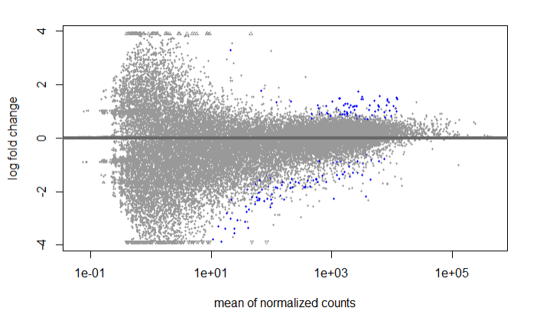
Figure 4.12 MA plot of RNA-seq data. Scatter plot of log2 fold changes versus the mean of normalized counts. Each dot represents a singular gene, blue dots represent differentially expressed genes under the preset padj<0.05 threshold. Grey dots are not statistically significant. The differentially expressed genes blue points with a positive log fold change are indicative of mitotic related genes. The differentially expressed genes blue points with a negative log fold change are indicative of interphase related genes. Data was plotted in R using plotMA from DESeq2 dds values regressing out the effect of treatment and replicate.
DESeq2 (Love, Huber & Anders, 2014) adjusts the p-values of individual DEA tests to account for the fact that multiple DEA tests are being performed simultaneously by DESeq2.
The outputted p-adjusted value (padj) is used in DESeq2 in place of the original single test p-value. In this study, the padj determines if the tested hypothesis is statistically significant to specific changes of expression between interphase and mitotic populations. With a padj value of under 0.05, we can isolate differentially expressed genes with overall low net expression levels. The off-plot genes are outliers that will be accounted for via a combined log2FoldChange gating.
Using the same padj<0.05 threshold combined with a log2Foldchange of ±0.58 gating we can remove the lower expressed genes and outlier expression levels as seen in Figure 4.13. We also separated up and down-regulated genes using the same log2Foldchange of ±0.58 threshold to determine a mitotic and interphase-related gene list respectively.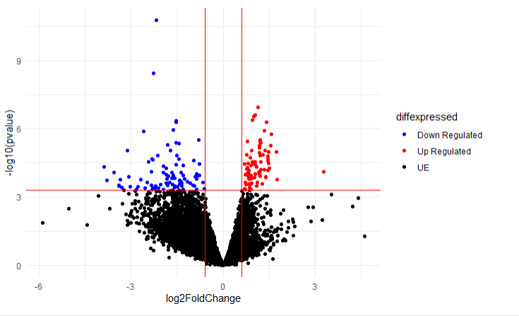
Figure 4.13 Differentially expressed genes in RNA-seq volcano plot. Red data points represent mitotic weighted genes, blue points represent interphase weighted genes. log2Foldchange of ±0.58 and padj value of ≤ 0.05. The volcano plot was created using the count matrix input and graphed via ggplot2. X-axis is log2 fold change, y-axis is statistical significance -log10 (adjusted p-value).
We chose to use a further more sensitive threshold of padj < 0.001 to ensure the likelihood of biological significance, it is vital to further experimental design the interphase and mitotic resultant gene lists are reliable key markers to each phase fraction.
As shown in table 4.2 our initial gene lists post DEA testing, we had 164 genes with padj < 0.05. The genes were separated into upregulated (Mitotic-related) and downregulated (interphase-related) before filtering gene expression changes of L2FC 士 0.58. We then had 76 mitotic-related marker genes and 88 interphase-related marker genes. The final steps of padj < 0.001 gave 27 mitotic-related marker genes and 18 interphase-related marker genes.
 | Initial Input | padj < 0.05 | Positive LF2C |  | Negative L2FC | L2FC 士 0.58 | padj < 0.001
Mitotic Genes | 58336 | 164 | 76 |  |  | 76 | 27
Interphase Genes | 58336 | 164 |  |  | 88 | 88 | 18

Table 4.2 Filter steps from DESeq2 DEA testing of bulk RNA seq input data, generated using R
These gene lists will form our basis of cell phase marker genes for further Seurat Cell Phase Scoring code modification and optimization. The derived gene list can be seen in Table 4.3 and we observe previously identified mitotic-specific genes such as CDC20 and Bub1 as present (Bruno et al., 2022). Capture of these expected genes further supports the validity of this generated gene list.

Downregulated Genes (Interphase) | Upregulated Genes (Mitotic)
E2F1 | CENPE
CCNE1 | KNL1
FBXL20 | PIMREG
DTL | PLK1
ENSG00000273759 | KIF14
RMI2 | TPX2
ZMYND19 | KIF20A
MCM5 | SAPCD2
ZNF367 | KNSTRN
FRAT1 | PRR11
BRD2 | NUF2
ENSG00000272106 | ASPM
PPP1R3C | CEP55
ENSG00000275484 | BUB1
UNG | SGO2
IFI27L1 | GAS2L3
CDC6 | NEK2
MIR25 | HMMR
 | DEPDC1
Table 4.3 Gene list post statistical significance and expression change filtering. The generated lists give interphase and mitotic specific gene lists, thus allowing for the customisation and optimisation of the Seurat CellCycleScoring pipeline. Canon gene symbols are used unless unnamed/novel in which case the Ensembl number is provided. | DLGAP5
 | ARL6IP1
 | NUSAP1
 | CCNA2
 | VANGL1
 | CDC20
 | KIF4A
 | KIF20B

In addition, the top 10 mitotic and interphase weighted genes are presented below, ordered by the highest Log2FoldChange post-differential expression testing of the bulk RNA sequencing data. The top upregulated genes, those weighted most towards mitosis, are shown in Table 4.4 ordered by largest Log2FoldChange.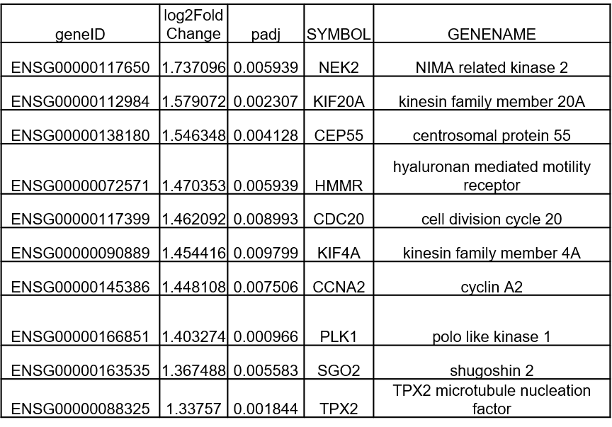
Table 4.4 Top ten most significantly upregulated differentially expressed genes related to mitotic cells. The figure highlights the top ten genes statistically significant in specifically mitotic cells. The gene list was generated post differential expression testing. Data is shown is the top ten genes ordered by the Log2FoldChange all with statistically significant padj values. Data processed using R.
The top downregulated genes, those weighted mostly towards interphase, are shown in Table 4.5 ordered by smallest Log2FoldChange.

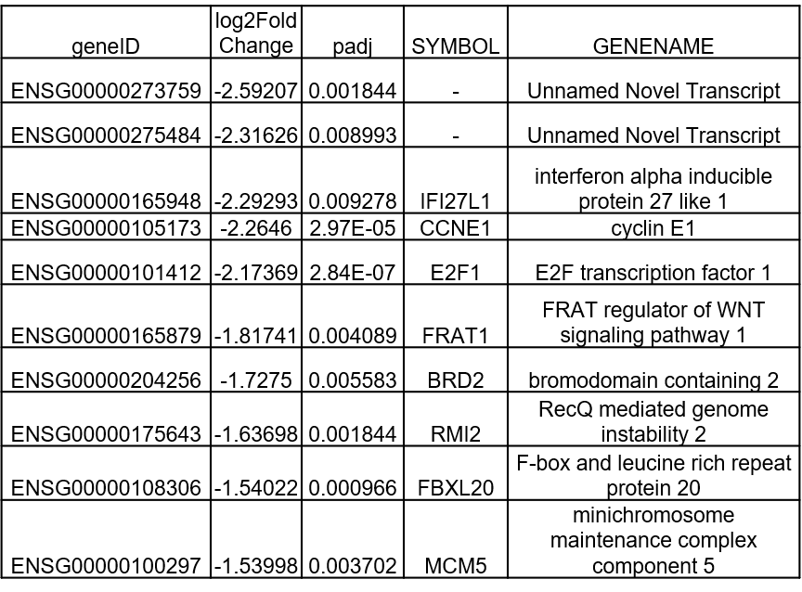
Table 4.5 Top ten most significantly downregulated differentially expressed genes related to mitotic cells. The figure highlights the bottom ten genes statistically significant in specifically mitotic cells. The gene list was generated post differential expression testing. Data is shown is the bottom ten genes ordered by the Log2FoldChange all with statistically significant padj values. Data processed using R.

4.5.11 Gene ontologues of differentially expressed gene lists.
Gene ontology (GO) testing was completed via GOrilla (Eden, Navon, Steinfeld, Lipson & Yakhini, 2009). Ontologies are homologous genes that share contributions to core biological functions, processes, and reaction pathways. These gene groupings also act as components of larger more intricate biological systems. In essence, gene ontologies are a method of grouping genes by their shared role within an organism.
GOrilla uses the complete gene list and the statistically significant target gene set of interest list. In the case of this study, the gene of interest list was the interphase and mitosis-related genes. GO GOrilla testing was used to calculate both the interphase and mitotic gene lists grouping of potential biological function, process involvement and role as a system component. GOrilla computes p-values for a range of significant functions the significant gene list is associated with.
GOrilla computes this via the identification of enriched GO terms via hypergeometric distribution, a discrete probability distribution that determines the GO success of enriched functions. The default function, as seen below, regards N as total genes, B as genes associated with a particular function. The value n represents the number of genes in the target gene set. The probability of genes associated with the given function GO term is then calculated. The higher the p-value threshold it crosses the more likely the target gene list is associated with that function.
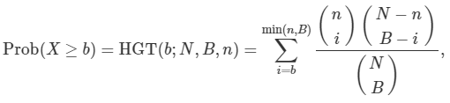
In the interphase-related gene list function GO rankings seen in Figure 4.14 there are some links to both DNA binding function and subsequently DNA replication origin. The DNA replication origin is an expected interphase function, although the statistical significance of the test results is relatively low. The nonspecific results of the gene of interest function testing on interphase genes of interest again could be because the sample population consists of G1, S and G2 cells tested via bulk RNA seq.
In the mitotic-related gene list function GO rankings seen in Figure 4.15 we see a range of cellular functions with strong p-valued rankings linked directly to mitotic progression. The presence of cytoskeletal binding resulting in microtubule binding and microtubule motor activity was highlighted. This GO result highlights expected roles in mitotic specific genes and our derived mitotic gene list, namely mitotic cellular division and spindle assembly progression during division.

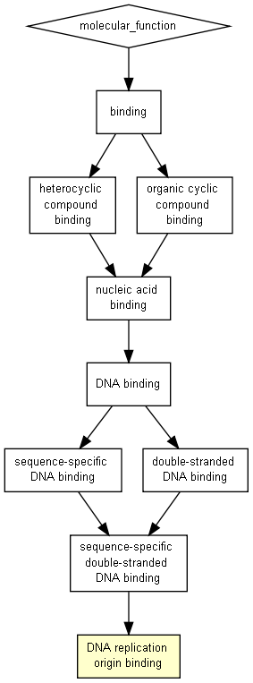
Figure 4.14 Gene orthologies for downregulated Genes (Interphase) function. The interphase generated gene list was used to determine if there was shared functionality of said genes. Gene orthologies were generated using two unranked lists of genes (target generated differentially expressed gene list against the total background gene list). Colour is representative of relative P-values of a function. Graph generated using GOrilla.

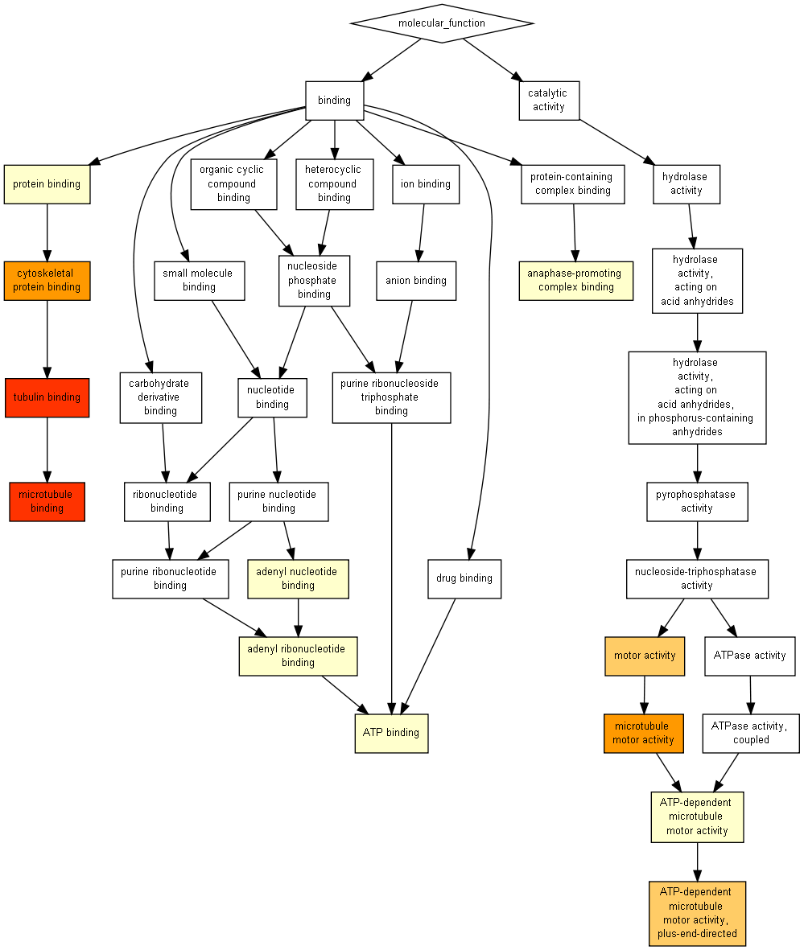
Figure 4.15 Gene orthologies for downregulated Genes (mitotic) function. The mitotic generated gene list was used to determine if there was shared functionality of said genes. Gene orthologies were generated using two unranked lists of genes (target generated differentially expressed gene list against the total background gene list). Colour is representative of relative P-values of a function. Functions highlighted are expected results in a mitotic specific gene list. Graph generated using GOrilla.

4.5.12 In detail function of Seurat cell phase assignment optimisation
The main phases of Seurat cell phase estimation are shown in Figure 4.16, the main phases being outlined in more detail below.
“CreateSeuratObject” which converts the raw count matrix into a format that can be analysed via Seurat (Hao et al., 2021). “NormalizeData” by default uses a data set-wide “LogNormalize” function. The data is normalized by measuring gene expression on a per-cell basis and dividing by the total expression.
The data is then multiplied by the scale factor before the log1p transformation. Scale factor acts as a valued measure to ensure transformed values account for low expression of tested input single cells RNA sequencing data. This internal Seurat step is vital to ensure false positives are not present in downstream analysis.
This step can also be set to a Relative Count or “RC” mode. In this mode, the same scaling against total counts and the scale factor is completed without log transformation. Again, this stage ensures the removal of downstream false positives via the removal of low-expression genes.
“FindVariableFeatures” identifies high cell-to-cell variation in expression levels across the data set. Finding variable features also removes outlier values to ensure the reliability of the downstream biological conclusion derived from scRNA seq data sets.
To determine expected variance the function uses variance stabilizing transformation (VST). “VST” uses local polynomial progression to fit the relationship of log(mean) and log(variance). The feature values are then standardised against the mean gene expression and overall expected gene expression variance. By default, Seurat returns 2000 features (Hao et al., 2021).
As shown below the standardized variance z_{ij} is calculated where i represents the raw feature value in cell j, x¯i is the mean raw value for feature i, and σ_{i} is the expected standard deviation of feature i derived from the global mean-variance fit (Stuart et al., 2019).
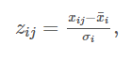
“ScaleData” is then used to apply a linear transformation to reduce dimensionality in subsequent PCA analysis and improper phase determination weighting. This stage shifts each gene expression data point so that per gene the mean expression and variance are more uniform across the data set.

This scaling gives a more equal weight for each gene in downstream analysis so that high-expression genes do not obfuscate the fitting to previously established features of more lowly expressed genes.

“CellCycleScoring” then standardises gene expression levels into log₂ counts per million format. The genes are then grouped based on their scaled mean expression levels and assigned to 25 bins of equivalent size. The mean expression levels are calculated for each histogram bin.

Across each cell, the S phase (Or G2/Interphase related) gene mean expression of the corresponding scaled and weighted bin is subtracted from the per cell gene expression levels. This step is repeated for the G2/M phase (Or Mitosis related) genes. This results in a standardised score for G2/M features and S features.

If both the assigned S-score and G2/M-score are lower than the average expression level per bin the cell is assigned G1, otherwise, the S or G2/M (G2 or M respectively) higher score determines the phase assignment (Butler, Hoffman, Smibert, Papalexi & Satija, 2018).

Read in Count Matrix
CreateSeuratObject
ScaleData
FindVariableFeatures
CellCycleScoring
NormalizeData
Figure 4.16 Core function of Seurat Cell Cycle Scoring. The central pipeline using the Seurat phase sorting tools are highlighted above, raw count matrices are used as general inputs. The counts are then PCA analysed, and Seurat formatted. The Modified Seurat Mitotic Sort uses this pipeline twice, once with the default Seurat gene list to generate a G2/M cell list and a second time to separate the G2 and M cells. Input gene lists of interest are used to find directed variables in the data and used to score based on relative expression levels present, in this studies case generated interphase and mitotic related genes (see figure 4.20).

4.5.13 Modified Seurat Mitotic Sort pipeline testing.
With the Modified Seurat Mitotic Sort (MoSMiS) being developed and optimised from the original Seurat function the next step is the application of the MoSMiS. The GSE81682 Nestorowa et al., 2016 dataset present in the Cell Cycle Scoring vignette was chosen for testing as it allowed for direct functional comparisons.
As highlighted in Figure 4.17 there are clear phase distributions when Seurat Cell Cycle Scoring is run as default. Seurat by default is unable to differentiate between G2 and M phases but can subset a G2/M population. Input data was log normalized as there is only a single scoring step. 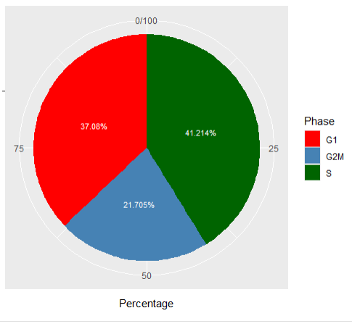
Figure 4.17 Comparative phase assignment from default Seurat Cell Cycle Sorting and Modified Seurat Mitotic Sort. Nestorowa et al., 2016 using Murine HSPC scRNA seq was used as the test data set. Tests were completed in R using the Modified Seurat Mitotic Sort (MoSMiS). A) Shows the default format run of Seurat as presented in the Cell Cycle Scoring Vignette found at https://satijalab.org/seurat/articles/cell_cycle_vignette.html. Graphs produced in R.
The Nestorowa et al., 2016 data set processed by the Seurat CellCycleScoring methods via the default Seurat functionality (highlighted in Figure 4.17) and the initial step of the MoSMiS (highlighted in Figure 4.18) give slightly different overall phase percentages.
This slight variance can be attributed to the loss of some uncategorised genes in the conversion of formatted data to allow Nestorowa et al., 2016 to be run via Modified Seurat Mitotic Sort (MoSMiS). Converting from gene symbols to Ensembl values is not a 1:1 process due to uncategorised genes sometimes often not having any information to convert. The data set tested needed to have gene symbols converted to Ensembl format gene IDs for proper function in MoSMiS.
This conversion is required to ensure downstream analysis is successful, uncategorised genes while useful for other avenues of research analysis do not have enough associated information and may not have the requisite associated information to analyse mitotic or interphase-specific effects.
In addition, the initial Seurat steps normalize data logarithmically (Figure 4.17) and in later stages via relative counts expression (4.18), this could also slightly alter the initial phase assignment.
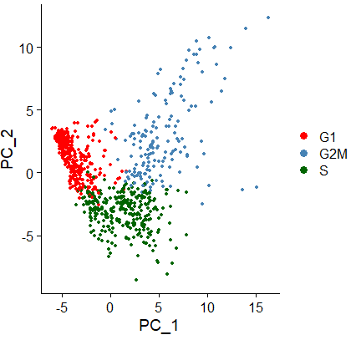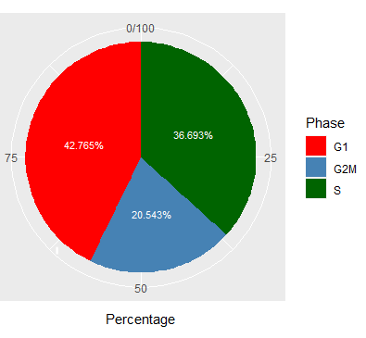.
Figure 4.18 Comparative phase assignment from default Seurat Cell Cycle Sorting and Modified Seurat Mitotic Sort. Nestorowa et al., 2016 using Murine HSPC scRNA seq was used as the test data set. Tests were completed in R using the Modified Seurat Mitotic Sort (MoSMiS). B) Shows the initial step function of Seurat based cells using RC normalization. Sorting is given in the distributed percentage of cell cycle phase assignments across the input data seen in both the plotted per cell PCA data (see left) and the total cell phase percentages (see right). Graphs produced in R.
When the data is run through the MoSMiS we utilised a secondary Seurat Cell Cycle Scoring on the isolated G2/M cell population. In this phase using the mitotic and interphase-related gene list of interest we can use the MoSMiS to score G2 and M features from the G2/M population. As shown in Figure 4.19.A PCA analysis is used to highlight the grouping of M and G2 phase cells from this subpopulation. Clear grouping is observed within each phase enabling clean isolation of the two individual parts of the cell cycle.
The adjusted more detailed cell cycle phase percentages are then collated showing a G2 and M population in addition to the previously assigned G1 and S phases, as shown in Figure 4.19.B. We show the same GSE81682 Nestorowa et al., 2016 dataset analysed for cell cycle phase assignment by MoSMiS. Whilst as expected, the G1 and S phase values do not change, the G2/ M population is now cleanly separated into two distinct G2 and M populations.
Further testing as needed can be completed on this M phase population from a given scRNA seq data set.
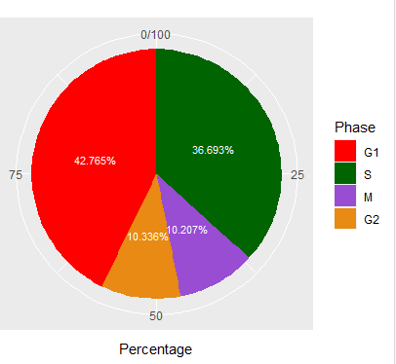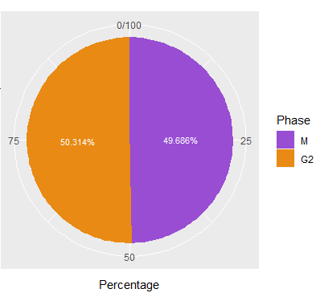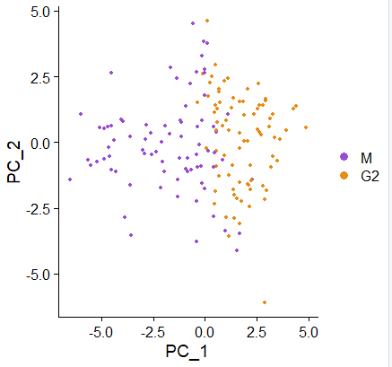
Figure 4.19 Comparative phase assignment from default Seurat Cell Cycle Sorting and Modified Seurat Mitotic Sort. Nestorowa et al., 2016 using Murine HSPC scRNA seq was used as the test data set. Tests were completed in R using the Modified Seurat Mitotic Sort (MoSMiS). C) Isolated and sorted G2 and M phase cells from the captured G2/M cell subset analysed by PCA and visually represented as components of the cell subset. D) GSE81682 Nestorowa et al., 2016 dataset analysed for cell cycle phase assignment by MoSMiS highlighting an unchanged G1 and S phase assignment but with a more accurate M and G2 phase specific assignment. Graphs produced in R.
B
A

4.5.14 Fourfold k-test Cross Validation
Further statistical validation was completed via a Fourfold k-test cross-validation method used to estimate the skill of a model: in this case phase assignment, on a range of test data sets.
The robustness of the mitotic separation was tested by dividing the mitotic gene list into four folds, for each fold we separated G2 from M cells using 75% of the genes in our gene list, holding out 25% of the genes. We then tested the separation by examining the expression of the isolated out 25%. This was carried out 4 times, each time excluding a different selection of genes until all genes had been tested. In all four folds, the excluded genes consistently showed higher expression in the cells which had been designated as mitotic by the remaining genes. This was conducted using different scRNAseq datasets and each showed the same outcome across Figures 4.20-22
Log normalised Fourfold k-test cross-validation method was used to estimate the skill of the MoSMiS phase assignment model across a range of test data. Average G2 and M phase expression were calculated for each removed 4-fold interphase and mitotic gene of interest (GOI) lists, thus giving an approximate estimate of the accuracy of phase prediction.
The initial GOI for interphase and mitotic-related genes was generated using bulk RNA sequencing on phase-isolated HeLa cells, the initial testing was completed on GSE129447 (Hu et al., 2019) which uses HeLa-CCL2 cells. The interphase Fourfold k-test test excluded genes that show minimal or no significance. The mitotic Fourfold k-test test excluded genes do show a highly statistically significant upregulation of average mitotic genes as shown in Figure 4.20.
Hela 1 represents cells 9 passages post thawing, Hela 2 represents cells 14 passages post thawing and Hela 3 represents cells 20 passages post thawing.
The same Log normalised Fourfold k-test cross-validation method was also used with study E-MTAB-6142 (Karlsson, Kroneis, Jonasson, Larsson & Ståhlberg, 2017) using Myxoid Liposarcoma MLS 1765-92 and GSE81682 (Nestorowa et al., 2016) using murine hematopoietic stem and progenitor cells.
The results as seen in Figure 4.21 show that the MoSMiS mitotic phase assignment is not cell line, species or experimental condition specific. The interphase Fourfold k-test test excluded genes show minimal or no significance, but the mitotic Fourfold k-test test excluded genes do show a highly statistically significant upregulation of average mitotic genes.
Further testing using Log normalised Fourfold k-test cross-validation using the study E-MTAB-7432 (Lun, 2019) which used RNA interference and LNAs to deplete the lncRNAs LINC00899. C1QTNF1-AS1 (C1) in HeLa cells and study run 2383 of E-MTAB-6819 (Lun, 2018) which uses H9 cells cultured to select for naive or primed phenotypes in said human embryonic stem cells was also tested.
The results as shown in Figure 4.22 further validate the Modified Seurat Mitotic Sort is robust in its assignment of mitotic cells from a parent population. The mitotic Fourfold k-test test excluded genes show a statistically significant alignment to the mitotic phase assignment even with 25% of the mitotic genes of interest missing.

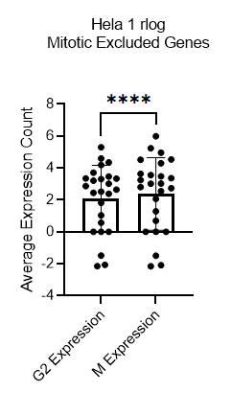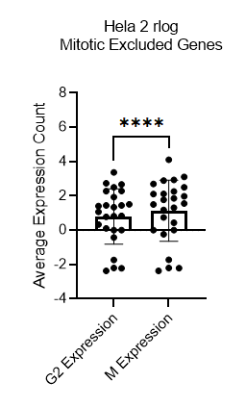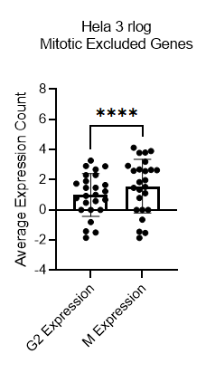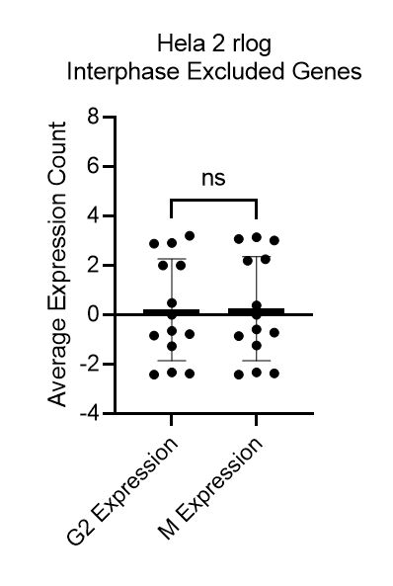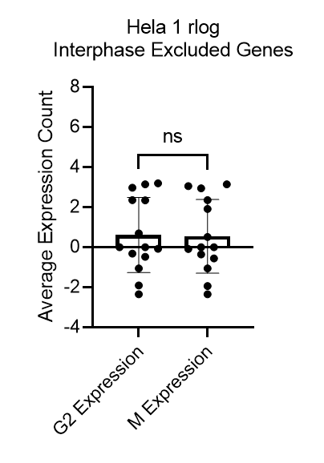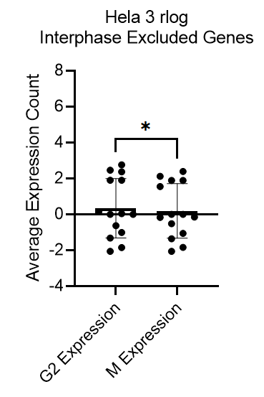
Figure 4.20 Four-fold K test of gene exclusion list expression levels on log2 count matrix. Testing relative average gene of interest expression excluding 25% of genes each time allows for deeper analysis of statistically significant genes. The interphase shows minimal or no significance, but the mitotic excluded genes do show a highly statistically significant upregulation of average mitotic genes. Data analysed via Prism. Paired t test performed compared to corresponding scrambled control. * = P ≤ 0.05, ** = P ≤ 0.01, *** = P ≤ 0.001, ****= P ≤ 0.0001. GSE129447 was used as the test data set. Tests were completed in R using a looped Modified Seurat Mitotic Sort designed to test with a 25% excluded mitotic or interphase gene list each time. N=4.

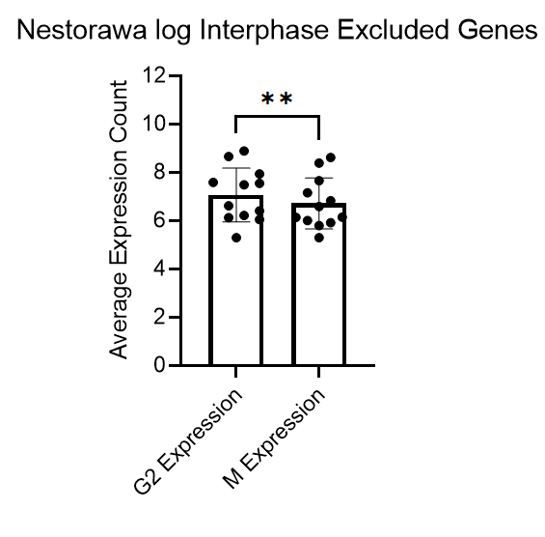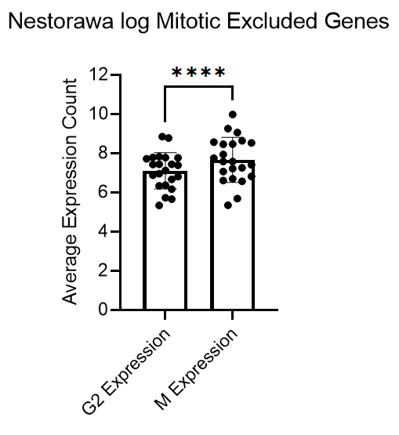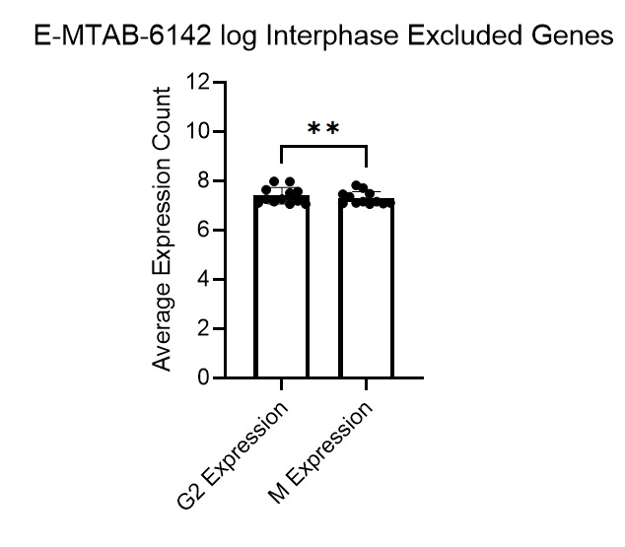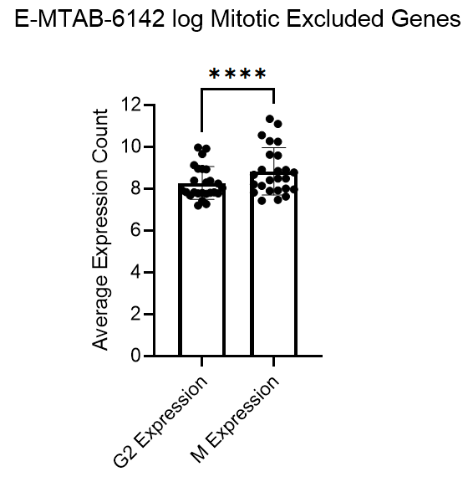
Figure 4.21. Four-fold K test of gene exclusion list expression levels on log2 count matrix. Testing relative average gene of interest expression excluding 25% of genes each time allows for deeper analysis of statistically significant genes. The interphase shows some significance, but the mitotic excluded genes do show a highly statistically significant upregulation of average mitotic genes. Data analysed via Prism. Paired t test performed compared to corresponding control. * = P ≤ 0.05, ** = P ≤ 0.01, *** = P ≤ 0.001, ****= P ≤ 0.0001. Nestorowa et al., 2016 using Murine HSPC scRNA seq and E-MTAB-6142 using Myxoid Liposarcoma MLS 1765-92 scRNA seq. Tests were completed in R using a looped Modified Seurat Mitotic Sort designed to test with a 25% excluded mitotic or interphase gene list each time. N=4.

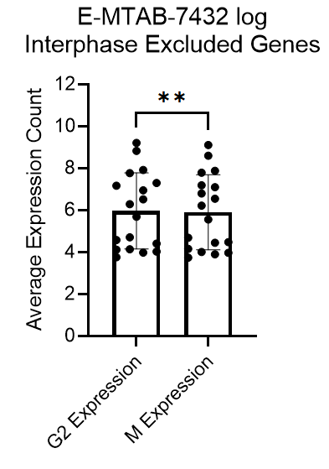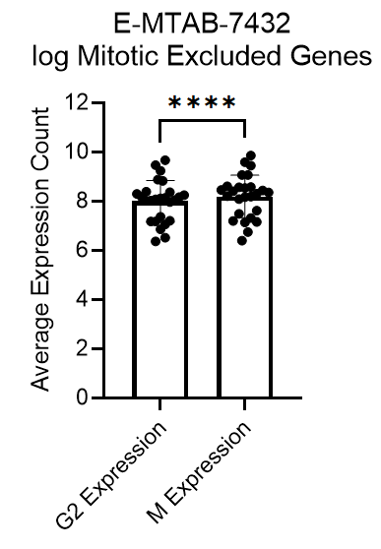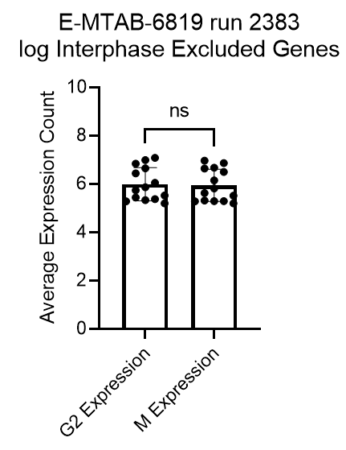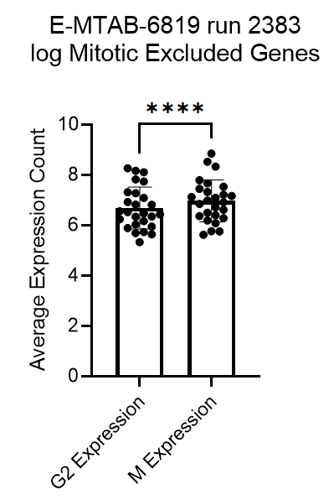
Figure 4.22. Four-fold K test of gene exclusion list expression levels on log2 count matrix. Testing relative average gene of interest expression excluding 25% of genes each time allows for deeper analysis of statistically significant genes. The interphase shows minimal significance, but the mitotic excluded genes do show a highly statistically significant upregulation of average mitotic genes. Data analysed via Prism. Paired t test performed compared to corresponding control. * = P ≤ 0.05, ** = P ≤ 0.01, *** = P ≤ 0.001, ****= P ≤ 0.0001. E-MTAB-7432 using RNA interference and LNAs to deplete the lncRNAs LINC00899 and C1QTNF1-AS1 (C1) in HeLa cells. E-MTAB-6819 using H9 cells cultured to select for naive or primed phenotypes in said human embryonic stem cells.
There appeared to be minimal to no significant expression change in the tested excluded interphase genes. Again, as mentioned this is mostly likely a result of the nonspecific nature of an interphase data set. The interphase set covers a far wider range of changing and modulating gene expression levels across G1, S and G2.

4.5.15 Quantitative RT PCR
NEK2, CEP55, KIF20A and CCNB1 were tested via quantitative real-time PCR. This test was completed to determine if the top Log2FoldChange mitotic-related genes were reproducibly upregulated in mitosis in lab conditions. Log2FoldChange analysis was used to determine genes with the highest changes in expression levels when comparing interphase and mitotic cells.
Changes in expression level were tested in mitotic enriched RNA samples calculated against non-specific phase RNA samples via SYBR Green PCR Master Mix RT PCR reactions.
The calculated expression fold change in the M phase enriched sample was plotted and tested against averaged housekeeping genes (18s and HPRT1). All genes show varying degrees of significant upregulation of the mitotic genes of interest in the mitotic enriched sample against the control fold change expression as shown in Figure 4.23.
This highlights that the shift in expression between phases is not just seen in the produced RNA sequencing data set, further testing would need to be completed to draw similar conclusions for the entire set of mitotic and interphase marker genes utilised in MoSMiS.
The genes tested via RT PCR respond as expected in terms of expression in mitotic-rich environments and are in line with the shifts in expression observed during bioinformatics-based analysis. Testing these samples and observing similar expression patterns lends further validity to the genes used to isolate mitotic and interphase fractions via MoSMiS and supports its application to a wider range of data sets outside of the training data produced during this project.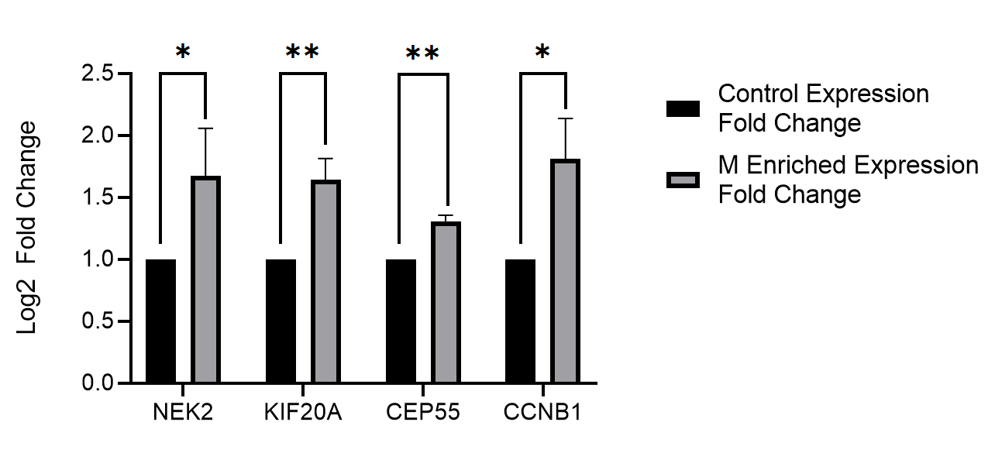
Figure 4.23 RT PCR of Mitotic genes of interest. In all cases there was significant log fold expression change in mitotic enriched samples compared to the averaged 18s and HPRT1 housekeeping gene controls. Tested markers are significant indicators of differentially expressed mitotic specific genes. High-Capacity RNA-to-cDNA Kit used to generated cDNA. SYBR Green PCR Master Mix used to generate RT PCR data in a Bio-Rad PTC-0200 DNA Engine thermal cycler. Paired t test performed compared to corresponding control. Data analysed via Prism, * = P ≤ 0.05, ** = P ≤ 0.01. N=3.

Discussion

The need for MoSMiS
To investigate the MDDC we set out to interrogate the mitotic transcriptomic profile. The lack of appropriate code for the isolation of mitotic cells using scRNA-Seq datasets necessitated the development of a tool to accurately isolate, investigate and categorise mitotic transcriptomics.
A wide range of single-cell RNA sequencing data sets have been published that can be utilised in entirely novel manners to gain new genomic insights without further in-lab experimentation. To analyse the mitotic transcriptome cell populations in this phase needed to be isolated from their interphase counterpoint. Pre-existing data is present that with such a tool could provide further insight in data sets regarding mitotic populations across cells, species and treatment types.
Additional value can be added to data without extensive lab work being completed mitigating cost, ethical, logistical, and formatting requisites instead of using public domain information in an entirely novel manner (Rung & Brazma, 2012)..

Other phase assignment systems available and their limits
Previously established R-based cell phase separation had the major issue of grouping G2/M as a singular variable. The separation of the mitotic population is core to achieving the objectives of this study.
Peco (Hsiao et al., 2020) was first tested. Peco was unable to discretely differentiate between G2 and M-specific expression FUCCI profiles using its 0-2π fluorescence intensity scale. Other continuous phase assignments such as Oscope (Leng et al., 2015); used a sine model module, searching for oscillating gene expression in the G2/M population. reCAT (Liu et al., 2017) was another continuous model that was unable to discretely assign mitotic cell phase. All three systems are continuous models for cell cycle phase assignment which makes it particularly difficult to discretely separate G2 and M.
Published discrete phase assignment systems were also tested. Cyclone (Scialdone et al., 2015) used pair-based prediction methods. Cyclone utilised pre-established classifiers provided for gene marker datasets to assign phase. Cyclone did not have adaptable systems to discretely classify the M phase even after modification testing.
Seurat (Hao et al., 2021) after modification provided a tailorable system for Mitotic subsetting from pre-existing data sets. Seurat was tested against the other systems listed in Hsiao et al., 2020. The variable approaches led to changes in called phase assignment percentages. As previously discussed there is no best model for bioinformatic base cell phase assignment (Hsiao et al., 2020), currently, research is focused on creating a universally accepted best-fit model.
Seurat (Hao et al., 2021) uses directed genes of interest feature variables to assign phase. The system did not rely on a pre-established marker approach using data from FUCCI or set classifiers (Paul Hoffman, Satija Lab and Collaborators, 2022). This marker-agnostic form of phase assignment made the tool suite ideal for modification and refinement.
The data set provided by Seurat’s “Cell-Cycle Scoring and Regression” vignette, derived from Nestorowa et al., 2016 allows for reliable testing of modification towards M phase subsetting. Further data sets were tested in conjunction with the Nestorowa et al., 2016 data set.

Generating MoSMiS
The central model for differential expression testing within this study analysed changes in differential expression between RNA extracted from interphase and mitotic FACS Melody isolated cells. These populations when sorted by a PI/ph3 co-stain allow for the isolation of mitotic and interphase-specific cells, the stain differentiating those with different DNA content because of cell phase (Lee et al., 2015).
While traditional lab practices allow for the simple enrichment of a mitotic sample the direct gated sorting of a FACS Melody ensures that downstream RNA sequencing practices; even at a bulk level, gave clean and distinct testing populations (Yu et al., 2018). The optimisation of RNA stability further ensured no downstream errors occurred from processing during differential expression testing of the RNA seq data (Masotti & Preckel, 2006).
Bioinformatic quality control steps performed during the processing steps via Galaxy EU resulted in reliable downstream gene expression insights. Quality control was completed on both unaligned reads via FastQC (Andrews, 2010) and on aligned reads using Samtools (Danecek et al., 2021). Multiple QC steps ensured each phase of the gene of interest generation remained accurate and reliable.
Differential gene analysis is common practice for the analysis of a transcriptome-wide study. DESeq2 (Love, Huber & Anders, 2014) was chosen for differential expression testing due to its high reliability and ability to be tailored across multiple differential expression testing setup conditions.
With no leading consensus on optimal processing tools choice, it is important to use pipelines with the best fit for the study at hand (Dal Molin, Baruzzo & Di Camillo, 2017). In the case of this study testing cells based on phase-based gene expression. While differential expression testing tools are being perpetually iterated and improved generation of a commonly available and accessible pipeline for findings replication is another key factor in tool choice (Wang, Li, Nelson & Nabavi, 2019). This ensures the contents of this study could improve workflows and data insights in the wider bioinformatics sector.
The data as mentioned fitted a Negative Binomial distribution model, DESeq2 having internal normalisation steps (Love, Huber & Anders, 2014) and previously established accurate differential expressed gene analysis (Wang, Li, Nelson & Nabavi, 2019) made it well suited for this study’s central objectives.
This study used cell sorting and bulk RNA sequencing to categorise gene of interest (GOI) lists for phase-specific genes. The GOI list is used to modify and optimise Seurat (Hao et al., 2021) to discretely assign mitotic phases to established single-cell RNA sequencing data sets from a G2/M cell phase population.
Post differential expression gene list Log2FoldChange were used to determine genes weighted towards interphase and mitosis expression. MA plots were the initial step to plot expression and determine cut-off points.
Initial testing of padj<0.05 while significant had such a breadth of possible low-regulated genes that conflated and skewed phase assignment.
Further cut-off points were implemented to ensure the mitotic and interphase gene of interest list accurately linked to their related phase. A further level of significance of padj<0.01 and gene with a shift up or down in expression by 1.5 times were utilised to ensure reliable data outcomes.
The phase assignment was completed via a modified stepwise variant of Seurat’s code; dubbed the Modified Seurat Mitotic Sort (MoSMiS), generated in this study. The change in cut-offs enabled the assignment of the G1, S, G2 and M phases from scRNA seq data Nestorowa et al., 2016 when tested.
Function gene ontologues were also mapped highlighting a logical consensus between GOI-shared functions and expected function. The most upregulated pathways in the mitotic-related GOI list were involved in microtubule, tubulin binding or other cytoskeletal protein binding. Interestingly there was some involvement in the kinetochore and anaphase-promoting complex and ATPase and microtubule motor proteins.

Validation of MoSMiS
Post-generation optimisation of MoSMiS code a full run-through of count matrix processing was completed using Nestorowa et al., 2016. This data set was produced for the cell cycle scoring Seurat vignette (Nestorowa et al., 2016). Using this processed murine progenitor data set with MoSMiS we gain a clear comparison to the previously established Seurat default phase assignment protocol.
The resultant MoSMiS phase assignment closely agreed with the default Seruat S and G1 phase assignment, the G2 and M populations derived from a combined G2/M subset. PCA analysis of the subsetted G2 and M-assigned cell populations show clear and distinct clustering of each population. The PCA clustering implies a strong correlation when assigning M and G2 phases from the subset G2/M population (Jolliffe & Cadima, 2016).
In lab validation of highest Log2FoldChange mitotic GOI was chosen for quantitative RT PCR investigation. The gene primers were selected before implementing the padj<0.01 further cut-off. NEK2, CEP55 and KIF20A are presently used in the MoSMiS mitotic GOI list using the more significant padj cut-off. CCNB1 just falls slightly outside that cut-off but it is of interest to test. The cutoffs are used to ensure accurate data outcomes but could be too stringent in specific use cases.
All four tested genes in a mitotic enriched sample were calculated against a nonspecific sample counterpart. When tested against an averaged housekeeping control 18s and HPRT1 (Kozera & Rapacz, 2013), the RT PCR results all showed significant upregulation in all cases as shown in Figure 4.23.
The combination of bioinformatics and in-lab testing indicates the mitotic GOI list generated for MoSMiS can be used as reliable mitotic-specific expression markers. The randomly selected markers all fitted the expected pattern of increased expression in a mitotic enriched sample tested via RT PCR.
Datasets from GSE129447 (Hu et al., 2019) using HeLa-CCL2 cells, E-MTAB-6142 (Karlsson, Kroneis, Jonasson, Larsson & Ståhlberg, 2017) using Myxoid Liposarcoma MLS 1765-92 and GSE81682 (Nestorowa et al., 2016) using murine hematopoietic stem and progenitor cells were all tested via Fourfold k-test cross-validation.
There appeared to be minimal to no significant expression change in the tested excluded interphase genes assigned as interphase in each of the tested data sets. This outcome likely a result of the nonspecific nature of an interphase data set covering a far wider range of changing and modulating gene expression levels across G1, S and G2.
On the other hand, very significantly higher expression levels of the excluded mitotic genes in the cells assigned as mitotic were detected. The higher level of focus in the mitotic GOI could explain this factor.
This does lead to two major conclusions; MoSMiS can accurately attribute phase to a tested mitotic fraction and the MoSMiS can be applied to a data set regardless of experimental design so long as it’s a scRNA seq data set.

How MoSMiS can be applied and the next research steps.
Now MoSMiS has been developed, tested, and validated application of MoSMiS to a range of established single-cell RNA sequencing data sets will be the next phase of the study.
Investigation into mitotic-specific gene expression from a previously published study on its own would give a brand-new insight into data. Multimodal uses of a data set vastly increase biological conclusions drawn without the need for further cost-prohibitive or time-consuming work.
The MoSMiS can also be used across a wide range of data sets. The system functions in phase assignment regardless of cell type, the organism of origin or treatment methodology. MoSMiS utilisation opens new avenues of testing in previously established data sets, allowing mitotic populations to be interrogated in data sets where the cell phase has been overlooked.
We believe that this tool can be utilised across a plethora of published single-cell RNA seq data sets to collate and compare mitotic cell-specific gene expression in the context of whole cell cycle gene expression and potentially identify genes important to the MDDC.
The generation of new significantly expressed genes across multiple data sets could give new targets of study to further accurately map the MDDC.

Chapter 5 – Further validation and the application of MoSMiS

5.1 Introduction

The primary objective of this study is the investigation of a Mitotic DNA damage checkpoint (MDDC). The established mitotic spindle assembly checkpoint ensures proper spindle attachment and chromosome alignment, rather than acting as a point of repairing DNA integrity. Understanding a transcriptomic response to DNA damage in mitosis, a section of the cell cycle often viewed as experiencing transcriptomic repression, could provide new key insights into cancer progression from a novel mitotic perspective.

This chapter uses MoSMiS, designed and validated in Chapter 4, and applies it to available single-cell RNA sequencing (scRNA-Seq) datasets. Mitotic differentially expressed genes are identified in single-cell RNA sequencing data sets observing the effects of DNA damage. This will provide new genes of interest for future investigations into the MDDC role in mitotic DNA damage response.

MoSMiS was used to analyse two scRNA-Seq datasets and derive the mitotic population from treated and untreated cells. DESeq2 (Love, Huber & Anders., 2014) was used to ensure proper expression distribution of the data sets. Analysis and processing steps from the tools were used to identify changes in gene expression in response to DNA-damaging treatment.

The two main stages were to first analyse differentially expressed genes (DEG) between mitotic and interphase cells, and second to analyse changes in gene expression following treatment specifically in mitotic cells. The first method uses p-values to assign and determine differentially expressed genes. The second stage uses threshold-free analysis to analyse the impact of treatment on core mitotic functional processes.

Threshold-free analysis does not use p-values to separate DEG but rather utilises gene list alignment to prescribed ontologies. Genes contributing to these ontologies can be derived and the impact of treatment determined. This method is known as Gene Set Enrichment Analysis (GSEA), rather than identifying individual genes it identifies sets of genes with functional themes. The situational choice of differential expression analysis or threshold-free analysis is determined by the experimental design of the scRNA seq experiment.

We can utilise these two methods to find genes of interest. Specifically, genes that control the mitotic response to DNA damage alongside the mitotic progression of cells post-repair at the MDDC.

In this section, we will identify scRNA-Seq datasets which use DNA-damaging agents to assess the transcriptomic response to DNA damage in mitosis.

First MoSMiS will be used to identify the mitotic population in both unchallenged and treated cells. The data sets utilised multiple cells in each condition, we derived a processed count matrix but did not have true experimental repeats due to the published data’s experimental design. This meant the data was unsuitable in their default format for differential expression testing via DESeq2.

Therefore, two approaches were utilised. The first combining the count matrix data by condition (pseudo bulking) to investigate changes in gene ontology between isolated cell phases. The second analysis technique used was the aforementioned GSEA, this was completed to attain gene sets related to mitotic cell progression and the attenuated response of mitotic cells to DNA damage.

5.2 Hypothesis and Aims

The central hypothesis of this chapter is that despite global repression of transcription in mitosis and in response to DNA damage, there will be a subset of DNA damage response and cell cycle control genes which are upregulated in mitosis in response to DNA damage. These upregulated genes can be isolated and analysed across multiple single-cell RNA sequencing data sets.

As such the aims of this chapter are:
- Source relevant published scRNA seq data sets
- For each dataset, assign and validate the mitotic population.
Identify mitotic-specific genes of interest transcriptional responsive to DNA damage. Compare between datasets.

5.3 Sourcing datasets
Two databases; the Gene Expression Omnibus (GEO) (Edgar, 2002) and BioStudies ArrayExpress (Parkinson et al., 2007), were used to find scRNA seq data sets in which human cancer cells had been sequenced before and after challenge with DNA damaging agents.

The data sets were filtered by “Expression profiling by high throughput sequencing” in GEO and “RNA-seq of coding RNA from single-cells” in ArrayExpress to find data sets of relevance by study type. Using key terms related to treatment effect analysis to derive data sets well suited for the parameters of this study.

5.4 Detail data sets and full phase assignment via MoSMiS
The data sets chosen for phase comparison analysis were taken from Gao et al., 2021 and Wu et al., 2019.

The first data set, Wu et al., 2019, was chosen for analysis because it had published clear scRNA seq data before and after irradiation treatment in human cells. The data set is available via accession number GSE81812 published via the Gene Expression Omnibus (Edgar, 2002). This study compares the transcriptomic impact of fractionated IR treatment on Homo sapiens Esophageal squamous carcinoma cell line, Esophageal Squamous Cell Carcinoma From Middle Intra-Thoracic Esophagus Of A 53-Year-Old Man Prior To Treatment (KYSE-180) with total cumulative doses at 0Gy, 12Gy and 30Gy. Cells were irradiated with 2Gy X-rays via a linear accelerator every 24 hours for 3 days followed by a 24-hour recovery period. This cycle of fractionated irradiation was repeated until a final 12Gy or 30Gy dose was achieved. (Wu et al., 2019).

The second dataset, Gao et al., 2021, was chosen because the dataset once again used untreated and IR-treated cells, the comparison of the unchallenged and treated MoSMiS isolated mitotic cell population would be ideal for this study. The data set is available via accession number GSE145700 published via the Gene Expression Omnibus (Edgar, 2002). The study analyses the transcriptomic impact of 5Gy IR treatment on Homo sapiens breast epithelial cell line “Epithelial, Human Breast Cancer Cell Line Of A 51-Year-Old Caucasian Female With A Metastatic Mammary Adenocarcinoma” (MDA-MB-231). The study used both wild-type cell and ATM kinase-depleted cell variants to analyse the impact of ATM reduction of radiosensitivity (Gao et al., 2021). As the ATM-depleted cells were not relevant to our biological question, we only studied the treated and untreated wild-type cells.

Both data sets meet the central criteria of this section providing a data set with cells untreated and cells treated with IR. Phase separation was completed to isolate the mitotic and interphase cell populations.

5.5 Analysis of mitotic gene expression levels in scRNA seq data sets in response to DNA damage

5.5.1 GSE81812
Using MoSMiS, the cells in the GSE81812 data set (Wu et al., 2019) were separated into the four phases of the cell cycle. This isolated a viable number of mitotic cells for expression testing, separating a percentage of mitotic cells from the overall cell population as seen in Figure 5.1. 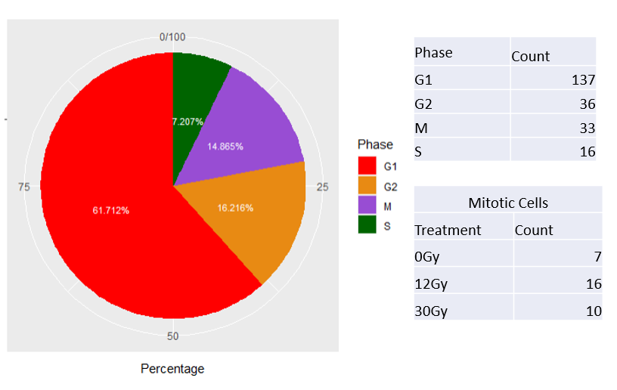
Figure 5.1 Mitotic phase assignment via MoSMiS of GSE81812. Phase assignment was completed via MoSMiS R based code as outlined in appendix A.10. Mitotic cell population was subdivided into treatment types present in experimental design of GSE81812. Low number of mitotic reads were present in each condition, overall mitotic population therefore is a more reliably testable parameter.

5.5.1.1 Combined Data Set Analysis

To achieve sufficient power for the identification of gene ontology changes between interphase and mitotic cells, the datasets were “pseudobulked”. The dataset had counts of mitotic and interphase treated and untreated cells collated and combined to allow for ontological analysis. This enabled the data to be run as if it were a bulk RNA-Seq dataset, as opposed to a single-cell RNA-Seq dataset. This was completed by summing the read counts of all cells that met certain criteria. Specific DEGs could not be identified here as the dataset has essentially become n=1 for each condition.
As previously stated, this was required as a processed count matrix was derivable, but the data sets tested did not have true biological repeats in the published data’s experimental design.
This approach established a methodology to still analyse biological insights from data, even in cases of published data with a limited data set. Pseudobulking enabled this study to test differences in gene ontology weighting when comparing the changes between interphase and mitotic populations.
First, we determined whether there is a suitable distribution of read counts and if the resultant PCA graphs will fit further analysis, this is outlined further in sections 4.5.9 – 4.5.10. The p-values cannot be calculated to highlight differential expression genes with statistical confidence due to the lack of true experimental repeats but can capture a snapshot of gene weighting towards specific ontologies. Further testing via GSEA was required to test genes of interest to derive statistical insights from the data.
The first step in this study was to determine if the GSE81812 data could be used for downstream analysis. Library size and distribution analysis were key to determining if the data set was viable for pseudobulked and GSEA testing.
As seen in Figure 5.2 the normalised and scaled (Counts Per Million) combined gene expression data shows a reasonably uniform distribution between categories. The 12Gy interphase (Interphase -12Gy) sample slightly differs from the other data points present but is well within acceptable limits for library size. There is close median clustering present, proximity of the box plot to the blue median line, and good library size for downstream analysis.
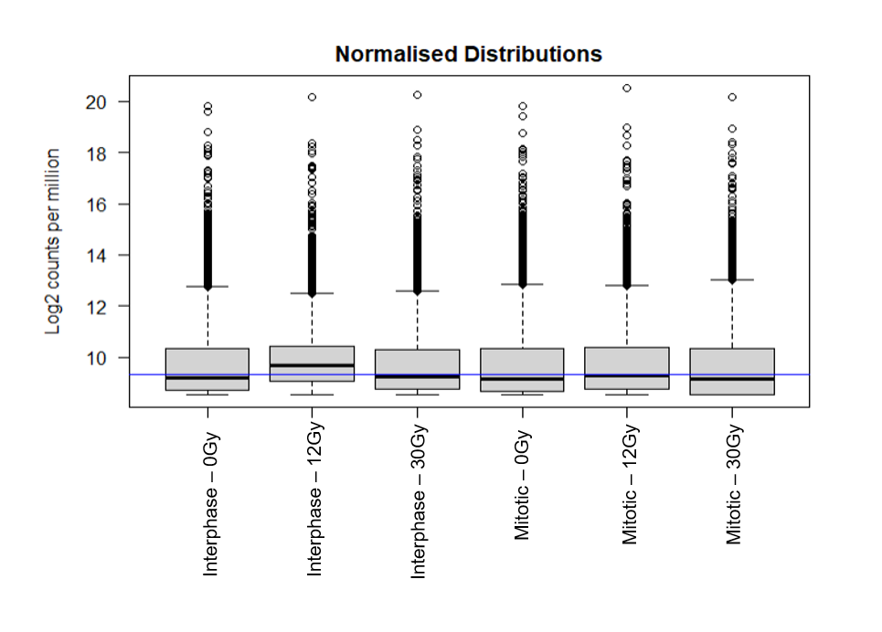
Figure 5.2 Gene count distribution of combined condition GSE81812 count matrix. Gene distributions of combined gene expression were converted to counts per million, the normalised distributions were graphed, the blue horizontal line that corresponds to the median logCPM. Gene expression data shows a reasonably uniform distribution between categories within acceptable limits for downstream analysis
When tested further as simple raw reads we returned poor levels a failure in meaningful ontology testing when investigating upregulated mitotic genes as individual counts as seen in Figure 5.3. This highlighted a need for collating data points and testing ontologies via pseudobulked data points. Raw data alone was non-specific due to a lack of biological repeats within the data, ontological analysis of raw data was ineffective.

To generate Figure 5.3 raw data was utilised, individual cells were treated as replicates for DESeq2 testing, and gene ontologies were generated via GOrilla. Post-differential expression testing and significance gating were used to attain mitotic and interphase upregulated gene lists. The gene lists were compared to the total gene list and only a weak p-value ontology test was viable for function in the 12Gy vs 0Gy mitotic-specific gene list.

The specific genes used in the ranked gene list for the single-cell upregulated mitotic-related genes can be found in appendices B.1.

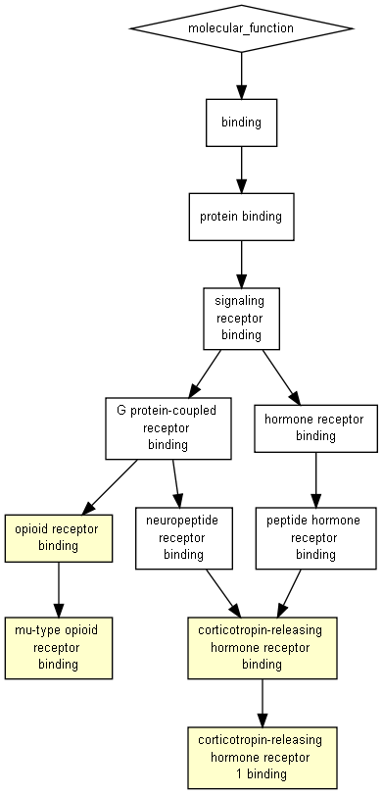
Figure 5.3 Initial testing of upregulated mitotic genes via GOrilla ontology testing gave minimal meaningful results when comparing treatment. 12Gy vs 0Gy is shown and 30Gy vs 0Gy failed completely.
Following the identification of a mitotic cell population but a weak response in the mitotic gene of interest ontology testing, PCA plotting was completed to determine if there was a clear grouping of data points based on phase or treatment.
In the raw data plotting, as seen in Figure 5.4.A, we see a clear treatment-based grouping of the 30Gy treatment compared to the 0Gy samples, we also see a mixed grouping of 0Gy and 12Gy making it harder to separate the samples.
PCA was completed on a combined (pseudo bulked) data set to determine the grouping of the samples, as seen in Figure 5.4.B, tested using an I vs M “~ treatment + phase” model. Treated and untreated were used as combined replicates for each phase to analyse treatment and cell phase-specific response. This was completed to delineate between 0Gy and 12Gy treatment effects, previously overlapping in PCA analysis of raw data.
PC1 separated the data on treatment response, the amount of variance being dependent on increased levels of IR accrued treatment present. PC2 separated the cells based on the phase-specific response.
The 12Gy interphase sample appeared to be an outlier as also seen previously in Figure 5.2 most likely due to the interphase fraction utilising combined expression from all non-mitotic cell phases.
GSE81812 appears to have generated only repeats for 12Gy samples and normalised the data before publishing count data, this could also negatively impact PCA grouping.
The grouping is clearer in the bulked samples, with 12Gy interphase as the exception, when compared to the non-bulked samples separated by both phase and treatment. The data in this form would be suitable for testing the impact of treatment of the 0Gy vs. 12Gy and 0Gy vs. 30Gy mitotic bulked samples, analysis of the interphase samples may cause issues based on their outlying nature.
Phase was the primary testing parameter of MoSMiS, isolating and collating treatment effect limits data insights but resulted in viable insights as to the effect of phase. Treatment effects combined with phase effects were analysed using GSEA in the following sections.

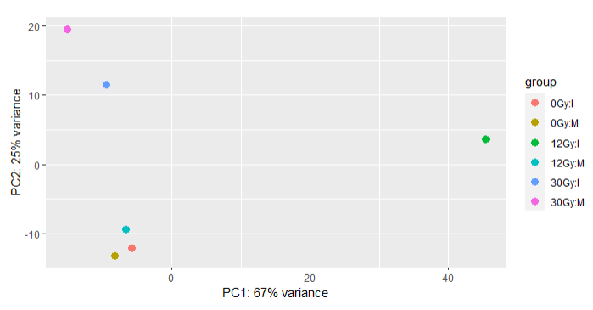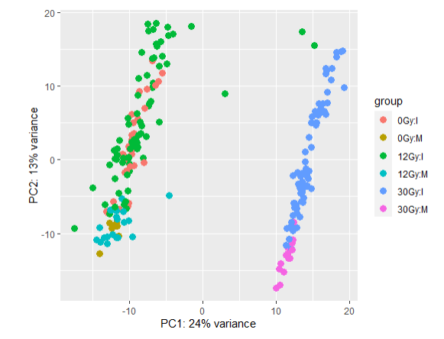
A
B
Figure 5.4 Principal component analysis plot showing gene expression variability of combined condition count matrix for GSE81812. PCA graphs transformed gene expression. The samples were plotted on main components, PC1 and PC2, the clustering of points indicating the relationship and impact of variance in gene expression based on phase or treatment. Graph generated in R using plotPCA. A) Highlights the entire raw matrix plotted we can see a much clearer grouping of the 30Gy treatment, and some grouping based on phase but the 12Gy and 0Gy are hard to differentiate b) Pseudobulked data gives clear comparison points between phases and far higher variance to separate out the 12Gy treatment option.
Cut-off points for the comparison of the combined (pseudobulked) data sets were analysed by volcano plot differential expression testing, as shown in Figure 5.5. Analysing the thresholds for expression testing allows for the direct comparison ontology testing of the combined count matrix mitotic and interphase-specific genes. While direct statistical tests cannot be completed reliably on the combined count data it does allow for further observation of MoSMiS phase assignment. Ontologies should be weighted by isolated phases irrespective of count matrix treatment.

To ensure a clear significant difference in gene expression between interphase and mitotic assigned samples, a p-adjusted cut-off of <0.001 was utilised to minimise the risk of false positives.
Genes depicted as “UE”, show no significant change between phases. A log2Foldchange threshold of ± 1.5 was also utilised to ensure a clear difference in expression. the higher the differential expression log2Foldchange, the greater the shift in expression between samples in different phases.
This approach allowed for the isolation of mitotic and interphase-weighted genes for use in further ontology testing.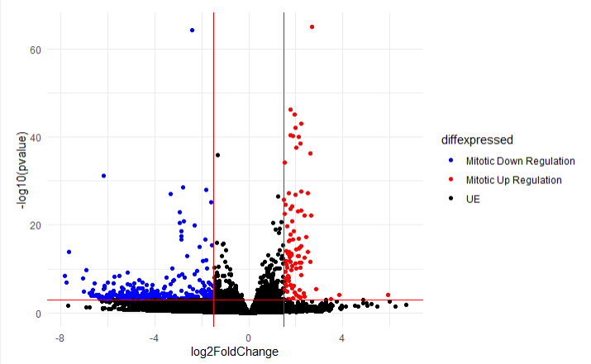
Figure 5.5 Differential expression testing of combined count matrix for GSE81812. Using previously established cut-off points for gene expression changes and statistical significance the differentially expression genes were replotted. Interphase and mitotic genes of interest were isolated from up and down regulation data points, this was used in further ontology testing.
Red data points represent upregulated genes in mitosis, blue points represent downregulated genes in mitosis. Cut-offs used were log2Foldchange of ±1.5 and padj value of ≤ 0. 001. UE represents cells that are not differentially expressed based on the previous cut-offs. The volcano plot was created using the count matrix input and graphed via ggplot2. X-axis is log2 fold change, y-axis is statistical significance -log10 p-value (adjusted p-value or padj).
padj ≤ 0. 001 cutoff
log2Foldchange of ±1.5 cutoff
Next, shared function testing between the mitotic gene list derived from the combined count matrix was completed via gene ontology (GO) testing as shown in Figure 5.6 using GOrilla (Eden, Navon, Steinfeld, Lipson & Yakhini, 2009).
Greater detail on GO testing can be found in section 4.5.12. The GO results show elevated gene expression in microtubule and tubulin binding pathways (Figure 5.6), as expected for mitotic cells.
Furthermore, microtubule motor activity and cytoskeletal protein binding are also upregulated in mitotic cells (Vicente & Wordeman, 2015). The upregulation of mitotic genes in our MoSMiS-assigned mitotic population is a good indication of accurate phase assignment. The associated ontologies of function are directly related to mitotic function. This result indicates that even in the combined count matrix MoSMiS is accurately isolating a mitotic subpopulation for further testing. Even in cases where the treatment effect has to be collated phase can be reliably isolated.
The specific genes used in the ranked gene list for the pseudobulked upregulated mitotic-related genes can be found in appendices B.2. Function GO was tested using a P-value threshold of 10⁻⁷.

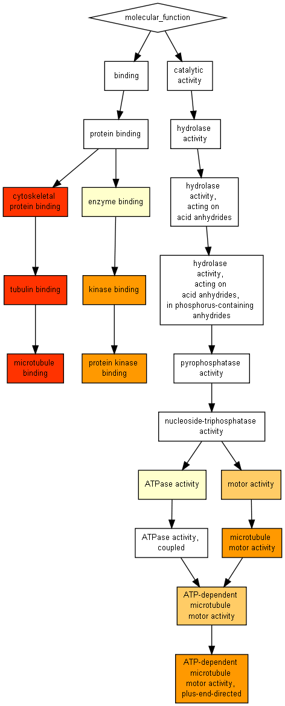
Figure 5.6 Ontology for upregulated mitotic genes in GSE81812. The differentially expressed mitotic genes in the combined expression count matrix of mitotic cells was tested to determine if they shared functional roles. Gene ontologies were generated using two unranked lists of genes (target generated differentially expressed gene list against the total background gene list). Colour is representative of relative P-values of a function. Graph generated using GOrilla. P-value cutoff of 10^7 was used to simplify the graph. Full GO can be found at http://cbl-gorilla.cs.technion.ac.il/GOrilla/n8rrb983/GOResults.html.

5.5.1.2 Threshold-free analysis

To analyse the effects of treatment, the samples were de-bulked and assessed as individual mitotic cells derived from MoSMiS for assessment. GSE81812 (Wu et al., 2019) was filtered; removing low-expression outlier cells.
Log2FoldChange between the 0Gy data and both the 12Gy and 30Gy data were calculated from the complete count matrix using individual cell expression data. The variance of expression level between all the individual cells in a condition had a significant effect on the calculated Log2FoldChange.
Pseudobulked samples due to the combined phase and treatment the data give a less accurate representation of changes in expression between conditions across the complete matrix.
MoSMiS was used, as previously outlined in section 5.5.1, to isolate the mitotic specific fraction for testing of treatment effect within these cells.
Initial quality testing was completed to ensure individual counts per condition were within acceptable limits for normalised gene expression, as shown in Figure 5.7.A.
The samples were also tested successfully in Figure 5.7.A to ensure sufficient library size was present per sample for viable downstream analysis.
The isolated Mitotic cells were also tested to ensure they had a negative binomial distribution of data points, as shown in Figure 5.7.B. This was completed to determine if the same methodology for differential expression testing from Chapter 4 could be applied to the GSE 81812 data set. Results confirmed a negative binomial distribution of the data.
PCA analysis was completed post DESeq2 filtrating and elimination of outliers. The clear clustering of cells by radiation treatment levels is seen in Figure 5.7.C. This clean separation of data points indicated a significant response to differing treatment levels, as such GSE81812 mitotic cells can be accurately separated and analysed in response to treatment effect.

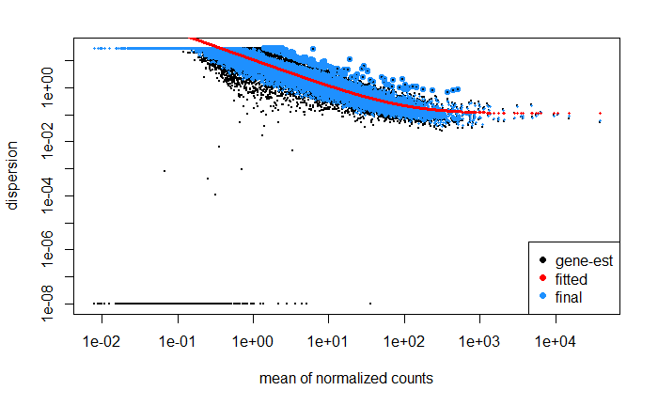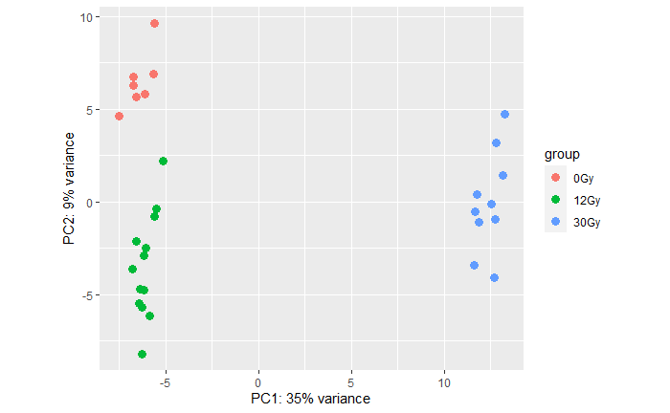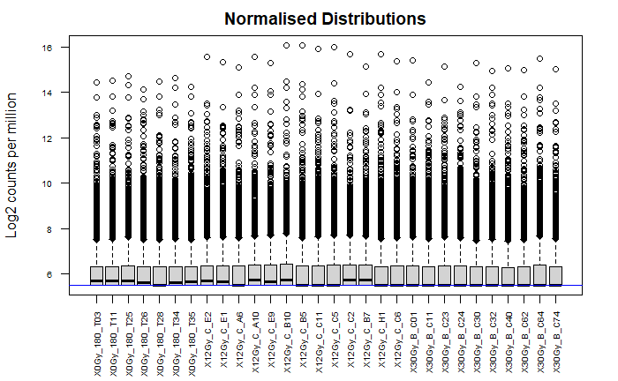
A
B
C
5.7 Reanalysis of GSE81812 count matrix. Rather than using combined expression counts the initial untransformed count matrix was reanalysed. A) Gene distributions of GSE81812 expression were converted to counts per million, the normalised distributions were graphed, the blue horizontal line that corresponds to the median logCPM. Count distribution was analysed post normalisation by vsd function of DESeq2 B). Data showed clear negative binomial distribution. C) The count matrix had mitotic cell populations isolated via MoSMiS, said mitotic fraction had PCA plotting completed based on treatment. Clear grouping between 0Gy, 12Gy and 30Gy treatments can be seen.
The data was then analysed via threshold-free analysis using Log2FoldChange in gene expression across treatment conditions. Threshold-free analysis was used instead of traditional enrichment analysis. Whilst differential expression analysis also looks at ontology networks, the threshold-free analysis does not require p-values only obtainable when there are true experimental replicates.
GeneTrail (Gerstner et al., 2021) transcriptomics tool provides Gene Set Enrichment Analysis (GSEA), the tool associating phenotypes with input genes based on shifts in expression. This tool determines if the gene ontology process/ cellular function was depleted or enriched alongside Reactome pathway testing (Fabregat et al., 2017).
GSEA uses a Kolmogorov–Smirnov test, a nonparametric test which continuously compares the cumulative distribution of a sample’s gene expression against the cumulative theoretical distribution.
GSEA is used goodness-of-fit test to analyse the degree to which a given set of genes are depleted or enriched for a given ontology category or pathway. The GeneTrail GSEA returns both a ranked score for the degree to which the distribution of scores for pathway members (“hits”) deviates from an expected null distribution, calculated from random simulations (Fleming & Miller, 2016. Clark & Ma’ayan, 2011).
GSEA testing also returns the p-value of an ontology being significantly depleted or enriched across the entire data set. The p-value is adjusted for the Benjamini-Hochberg false discovery rate (minimum confidence level of 0.05).
This form of testing allows for a input agnostic approach to the statistical testing of the impact of treatment on key functions and processes of mitotic cells. Isolated mitotic cells combined with GSEA analysis allow for more accurate insight into disrupted or upregulated phase-specific functions, altered by exogenous damage sources in the case of this study. The ranked values of depletion or enrichment alongside significance levels of gene ontology categories and Reactome pathways are returned in a searchable format. The data is comprehensive and can be tailored to a specific biological question.
This study aims to analyse the mitotic response to DNA damage so the data provided in this section is a snapshot of the larger conclusions that can be derived from threshold-free analysis. As shown in Figure 5.8 we have a wide range of statistically significant enrichments and depletions in gene ontologies based on shifts in transcription comparing 0Gy versus 12Gy treatment (A) and 0Gy versus 30Gy treatment (B). The top and bottom ten rankings of ontologies may be useful for investigating another biological question. Enrichment results are extensive so data output data must be refined based on a biological question being investigated. We narrowed ontologies and contributing genes to derived genes of interest lists better suited for finding genes altered in mitosis in response to DNA damaging treatment.

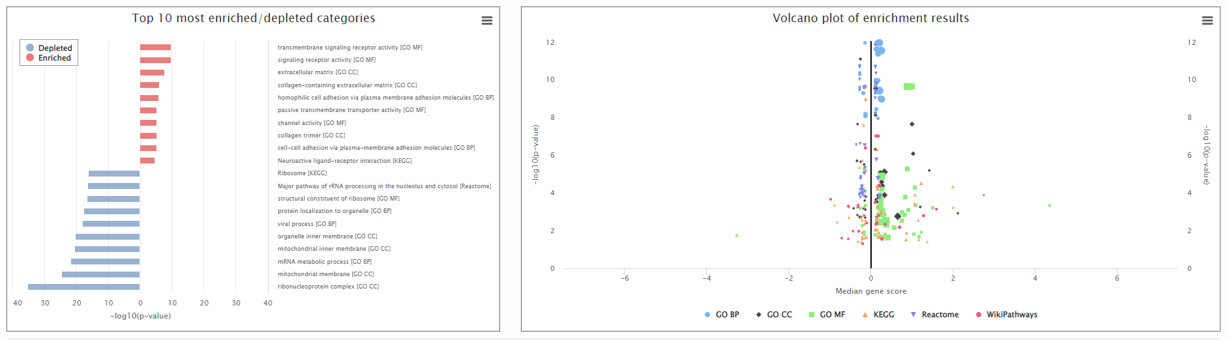
A
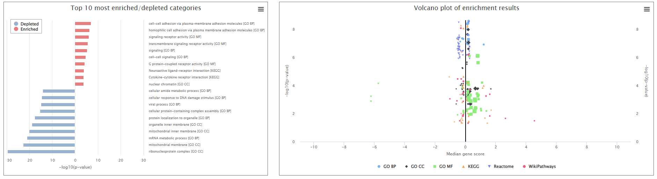
Figure 5.8 Threshold free analysis in response to treatment in mitotic cells. A) The top ranked enriched and depleted ontologies resulting from Log2FoldChange in 0Gy versus 12Gy treated cells. Also included is a graphical representation of all statistically significant gene ontologies. B) The top ranked enriched and depleted ontologies resulting from Log2FoldChange in 0Gy versus 30Gy treated cells. Also included is a graphical representation of all statistically significant gene ontologies. Analysis was completed using Kolmogorov-Smirnov test (GSEA) enrichment analysis via GeneTrail 3.2 Transcriptomics tool. Utilised significance level of 0.05 and adjusted p-values to q-values using FDR Benjamini-Hochberg adjustment.
B
Due to global repression of transcription both in mitotic cells and in response to DNA damage, we hypothesised that whole pathways may not be altered in our checkpoint. Therefore, we specifically searched the analysed dataset for ontology networks involved in mitotic transit and DNA damage response. Not all genes in a given pathway or function would necessarily be altered so tailoring the GSEA to analyse terms involved with the subject of this study would provide more appropriate insight into a mitotic DNA damage checkpoint/response.
As seen in Figure 5.9 the effects of 12Gy radiation treatment were GSEA tested against the 0Gy samples post-mitotic isolation of cells used in GSE81812. GSEA analysis resulted in ranked lists of statistically altered gene ontologies. The individual genes contributing to the gene ontologies and their respective Log2FoldChange are present for each term.
We observed in Figure 5.9 a response in the negative regulation of genes related to mitotic transit and regulation of the cell cycle. This fits with our practical data showing slowed mitotic transit in response to DNA damage. Surprisingly, we also observed a general decrease in the expression of DDR genes. We observed a more general depletion of ontologies, potentially due to the accrued damage type of radiation treatment GSE81812 utilises inducing some degree of apoptosis in cells.
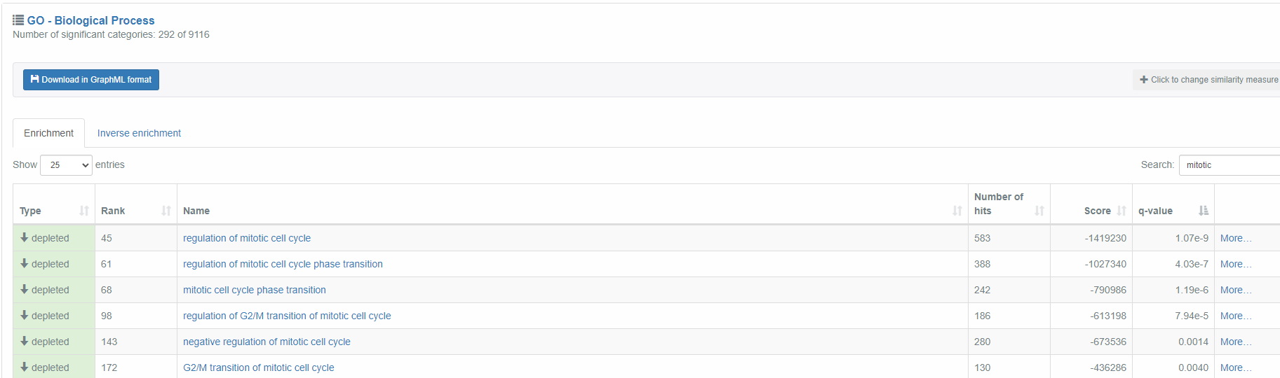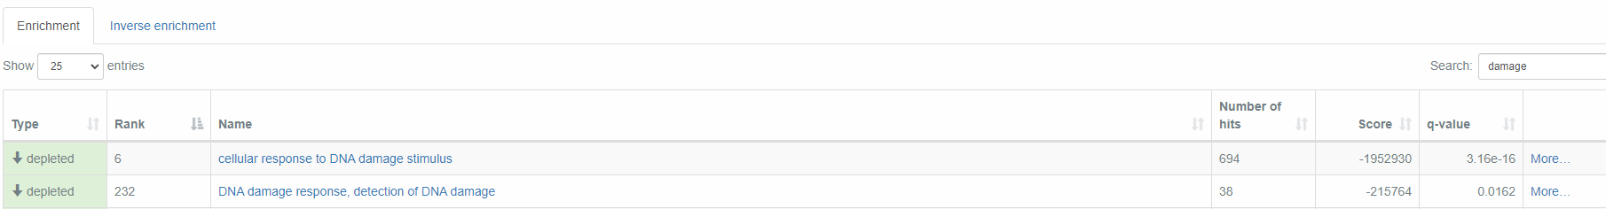
5.9 Threshold free analysis of mitotic 0Gy vs 12Gy treated esophageal squamous cell carcinoma line KYSE-180 from GSE81812. Analysis was completed using Kolmogorov-Smirnov test (GSEA) enrichment analysis via GeneTrail 3.2 Transcriptomics tool. Utilised significance level of 0.05 and adjusted p-values to q-values using FDR Benjamini-Hochberg adjustment.
As seen in Figure 5.10 the effects of 30Gy radiation treatment were GSEAtested against the 0Gy samples post-mitotic isolation of cells used in GSE81812. GSEA analysis resulted in ranked lists of statistically altered gene ontologies. The individual genes contributing to the gene ontologies and their respective Log2FoldChange are present for each term.
Threshold-free analysis generates metrics that allow for the comparison of depletion levels across different treatment degrees. The same responses of 0Gy vs. 12Gy gene ontologies can be seen in 0Gy vs. 30Gy, with a seeming increase in levels of ontology term depletion following 30Gy treatment versus 12Gy treatment (Figure 5.10). The more obvious response of ontology depletion in the presence of increased radiation treatment fits the trend we would expect to see in GSEA outcomes.
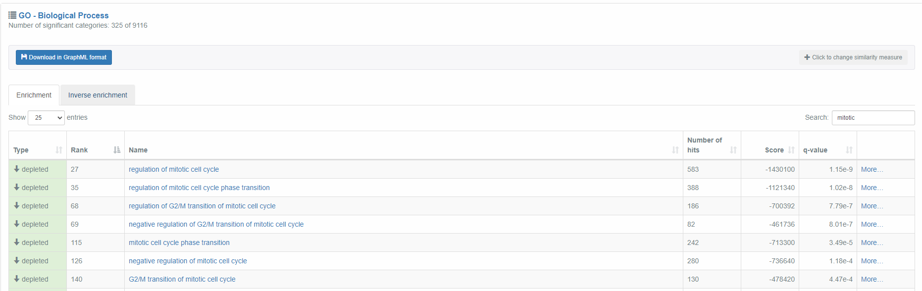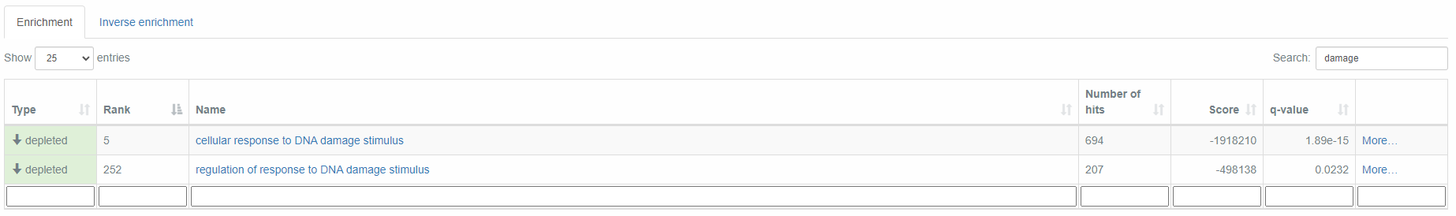
5.10 Threshold free analysis of 0Gy vs 30Gy treated esophageal squamous cell carcinoma line KYSE-180 from GSE81812. Analysis was completed using Kolmogorov-Smirnov test (GSEA) enrichment analysis via GeneTrail 3.2 Transcriptomics tool. Utilised significance level of 0.05 and adjusted p-values to q-values using FDR Benjamini-Hochberg adjustment.

We do see a similarly depleted response in ontology categories related to the regulation of the mitotic cell cycle in both the interphase 0Gy vs. 12Gy and 0Gy vs. 30Gy, seen respectively in Figure 5.11 and Figure 5.12.
This is most likely because the interphase fraction of cells contains cells in G2 and genotoxic damage would alter a cellular response in the G2/M checkpoint, the induced damage would alter mitotic entry.
On the other hand, we clear difference in the “Regulation of response to DNA damage stimulus” ontology and a lack of the “Cellular response to DNA damage stimulus” ontology.
GSEA does not give individual p-values for genes we cannot say for certain that there is an entirely different response between interphase and mitotic samples. This response could be an over-representation of the result due to an imperfect data set as seen in the 12Gy outlier data in Figure 5.4.
We do observe a seemingly different response in the “Regulation of response to DNA damage stimulus” gene ontologies and the grouped genes Log2FoldChange do vary between interphase and mitotic tested expression data requiring further testing on a range of data sets to draw a clearer picture of this changing response.
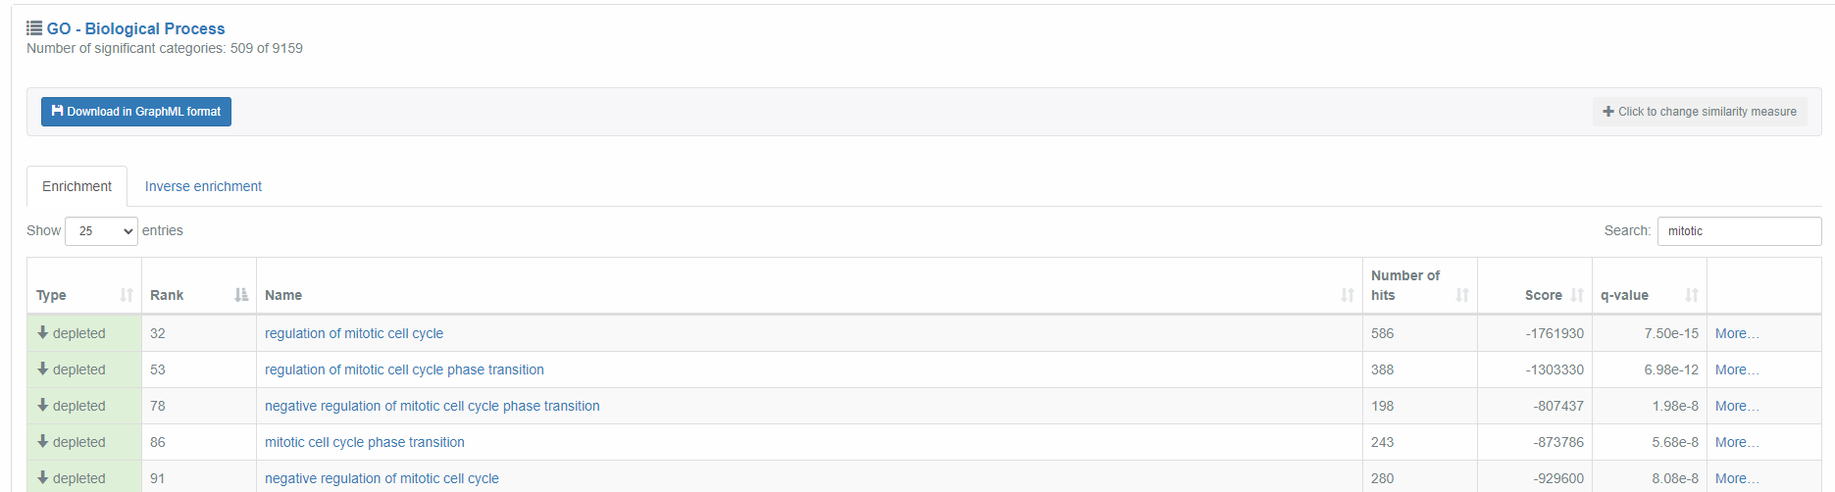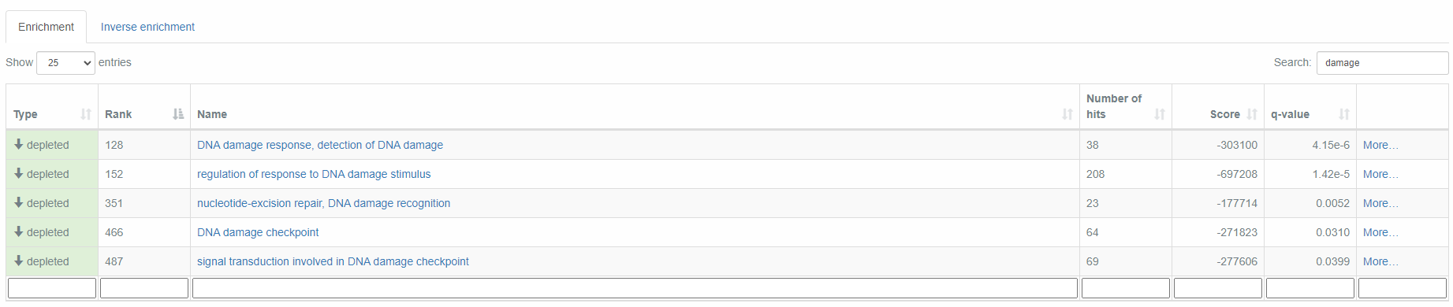
5.11 Threshold free analysis of interphase 0Gy vs 12Gy treated esophageal squamous cell carcinoma line KYSE-180 from GSE81812. Analysis was completed using Kolmogorov-Smirnov test (GSEA) enrichment analysis via GeneTrail 3.2 Transcriptomics tool. Utilised significance level of 0.05 and adjusted p-values to q-values using FDR Benjamini-Hochberg adjustment.

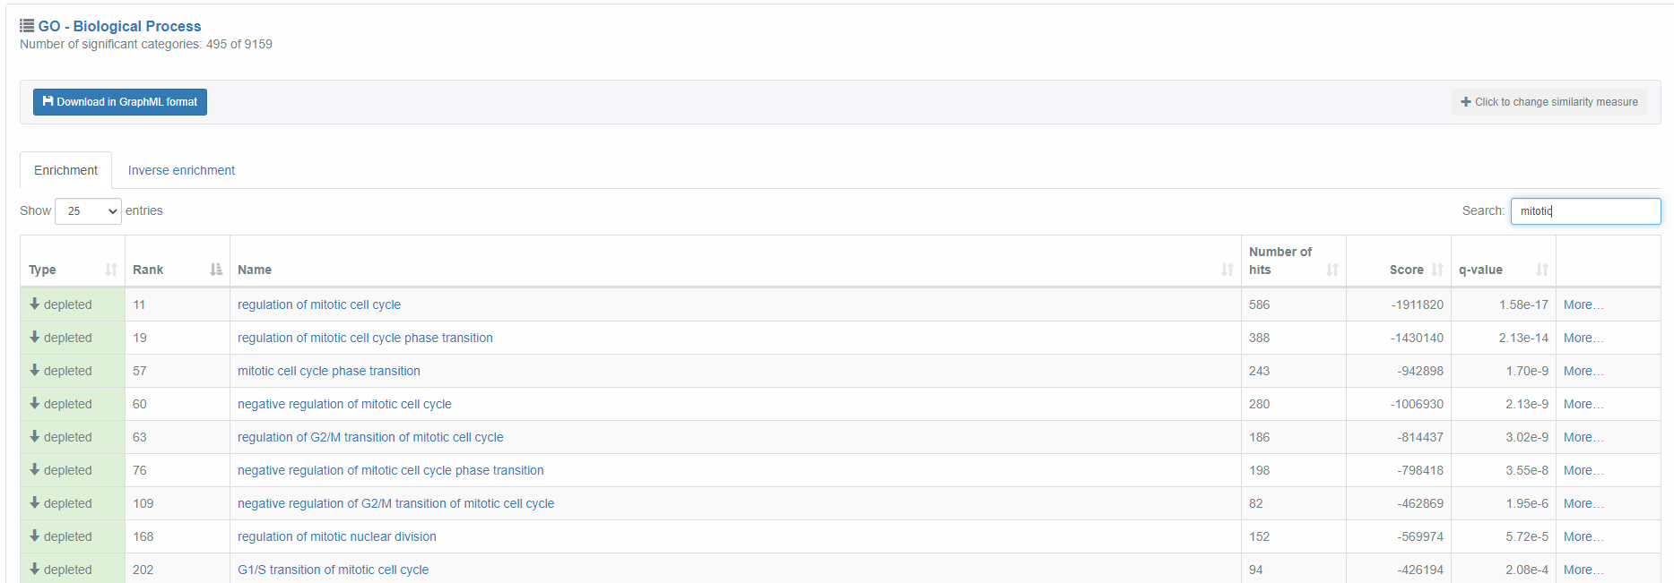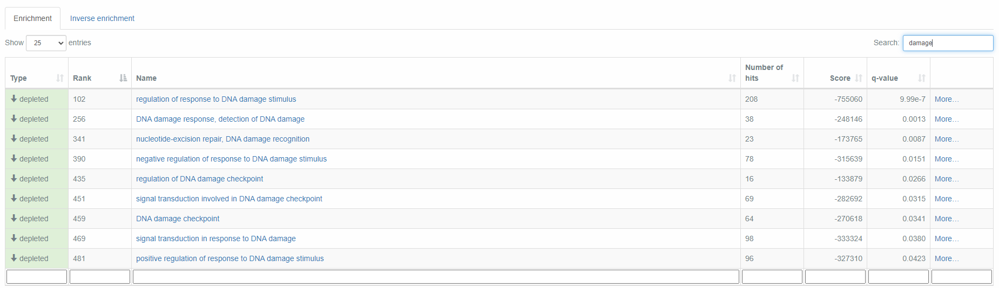
5.12 Threshold free analysis of interphase 0Gy vs 30Gy treated esophageal squamous cell carcinoma line KYSE-180 from GSE81812. Analysis was completed using Kolmogorov-Smirnov test (GSEA) enrichment analysis via GeneTrail 3.2 Transcriptomics tool. Utilised significance level of 0.05 and adjusted p-values to q-values using FDR Benjamini-Hochberg adjustment.

5.5.1.3 Enrichment profiles and gene of interest

Threshold-free analysis results in the ability to analyse shifts in expression in themed groups of genes, comparing these shifts in gene expression from untreated to 12Gy and 30Gy treated populations.
GSEA allows for the identification of the pattern of gene expression changes, we can analyse individual genes but without the same statistical confidence of p-values, we cannot draw direct conclusions as to identifying key genes.
We can use this data as the initial basis for potential future genes to be tested and validated by statistically significant means.
Highlighting upregulated genes responding to experimental conditions and present in significantly altered gene ontologies.
We can also analyse leading-edge genes; these are the genes that most contribute to the ontology depletion and are those present past the maximum running sum statistic on enrichment/depletion graphs highlighted in Figure 5.13 and Figure 5.14
The direct comparison of gene enrichment of 0Gy vs. 12Gy against the 0Gy vs. 30Gy profiles further highlights the depletion of the “Regulation of mitotic cell cycle” core biological process as seen in Figure 5.13.
Furthermore the “Cellular response to DNA damage stimulus” was also clearly depleted in both 12Gy and 30Gy accumulated DNA damage-inducing treatment profiles, as seen in Figure 5.14.
As the irradiation treatment of 12Gy and 30Gy, we see more depletion of gene ontologies related to the aforementioned ontologies. As the levels of DNA damage increase the core biological process involved in both the DNA damage response and mitotic cell cycle regulation are proportionally depleted in mitotic cells.
This can be seen when comparing key biological process ontology depletion categories across both Figure 5.13.A and 5.13.B. to Figure 5.14.A and 5.14.B respectively.

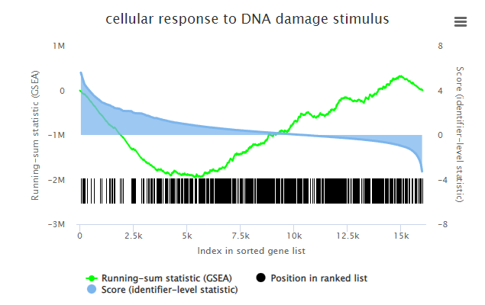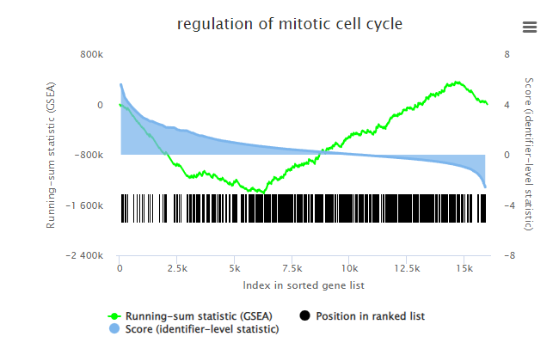
A
B
Figure 5.13 Enrichment graphs of 0Gy vs 12Gy comparing individual genes present across gene ontologies of biological processes. Both enrichment graphs are weighted towards depleted function of this biological process in response to 12Gy accumulated treatment. A) Represents a loss in the cell’s response to DNA damage stimulus in specifically mitotic cells post treatment. B) Represents mitotic cell cycle regulation in specifically mitotic cells post treatment. GSEA rank corresponds to the position in the ranked list shown as black lines, the green line represents a running sum statistic of deviation from zero, blue represents the scoring levels of the genes (in this study the value of Log2FoldChange).

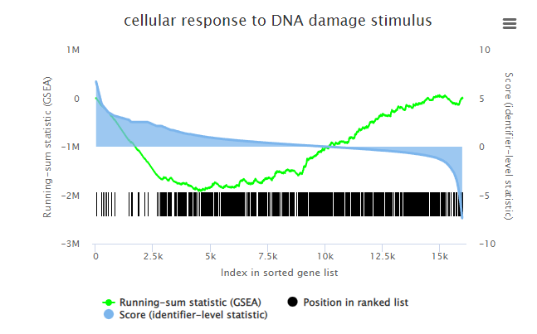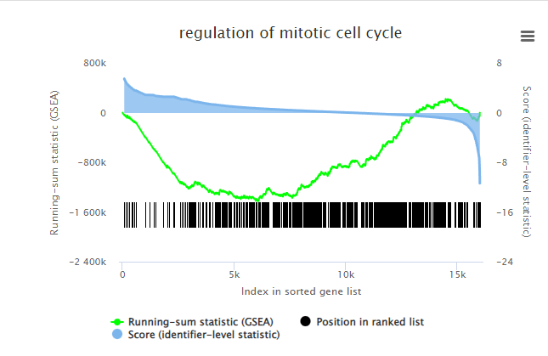
A
B
Figure 5.14 Enrichment graphs of 0Gy vs 30Gy comparing individual genes present across gene ontologies of biological processes. Both enrichment graphs are weighted towards depleted function of this biological process in response to 30Gy accumulated treatment. A) Represents a loss in the cell’s response to DNA damage stimulus in specifically mitotic cells post treatment. B) Represents mitotic cell cycle regulation in specifically mitotic cells post treatment. GSEA rank corresponds to the position in the ranked list shown as black lines, the green line represents a running sum statistic of deviation from zero, blue represents the scoring levels of the genes (in this study the value of Log2FoldChange).
We must be very careful when analysing specific genes which may be playing a role in the MDDC, p-values give confidence markers of the significance of Log2FoldChange data.
Individual genes can be highlighted for further analysis, but we cannot draw direct conclusions on their role in MDDC but merely as leads for future investigation.
We found the ten highest and lowest ranked (leading-edge) genes in each of the ontology categories that we are interested in, in this case, “Regulation of mitotic cell cycle and Cellular response to DNA damage stimulus”.
Those related to the “Regulation of mitotic cell cycle” in both 12Gy and 30Gy accumulated DNA damage-inducing treatment are shown in Figure 5.15.

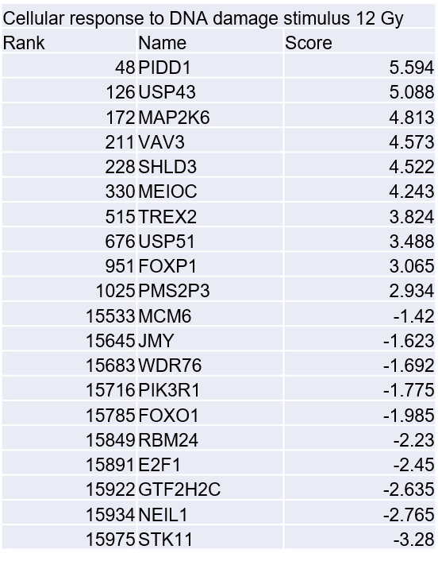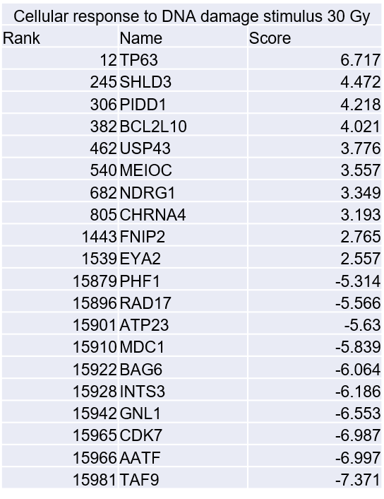
Figure 5.15 Top and bottom ranked genes in the depleted “Cellular response to DNA damage stimulus” biological process gene ontology. The genes are derived post GSEA enrichment analysis via GeneTrail 3.2 Transcriptomics tool. Individual gene ontologies were investigated, and the highest and lowest ranked genes were collated. Gene ontology derived from had a q-value < 0.05.
The genes of interest related to “Cellular response to DNA damage stimulus” in both 12Gy and 30Gy treatment are shown in Figure 5.16. The relative Log2FoldChange is listed under the gene’s score value.

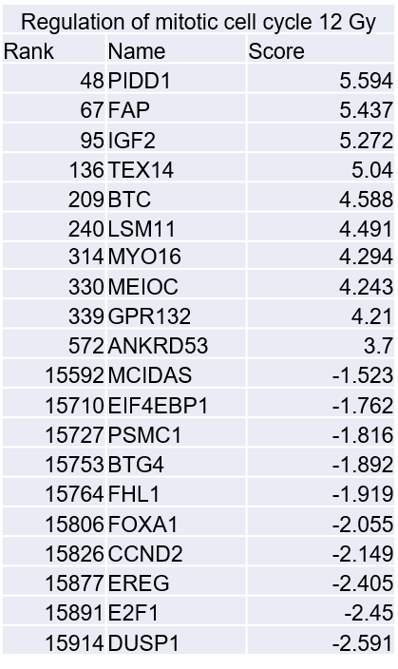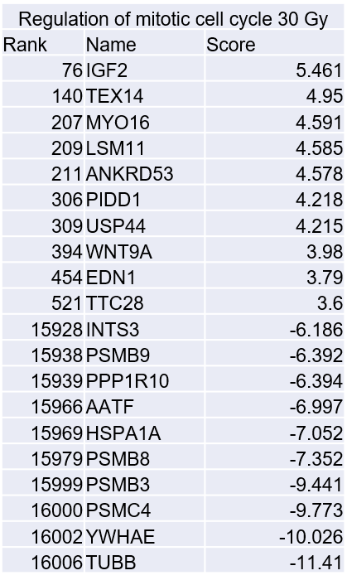
Figure 5.16 Top and bottom ranked genes in the depleted “Regulation of mitotic cell cycle” biological process gene ontology. The genes are derived post GSEA enrichment analysis via GeneTrail 3.2 Transcriptomics tool. Individual gene ontologies were investigated, and the highest and lowest ranked genes were collated. Gene ontology derived from had a q-value < 0.05.
To compare the gene set depletion and mitosis-specific ontology categories, threshold-free analysis was completed on the interphase fraction, as seen in Figures 5.11 and 5.12.
Analysis of the enrichment profiles shared between populations, namely “Regulation of mitotic cell cycle” showed a similar profile of depletion between the interphase and mitotic population tested as seen in Figure 5.17.A and 5.17.B.
We do see a clearer percentage of genes upregulated in the interphase 12Gy treated ontology, present in Figure 5.17.A, but a far more attenuated depletion response in the 30Gy ontology. This would imply while there is a mitotic regulation response in and outside of the mitotic phase the genes involved and the changes in expression levels of key genes are phase-specific.
A lack of a shared ontology response in “Cellular response to DNA damage stimulus” further highlights that while the expression profiles may be similar the actual response could vary at a transcriptomic level.
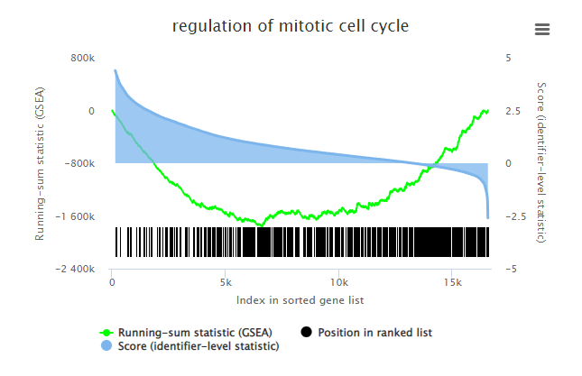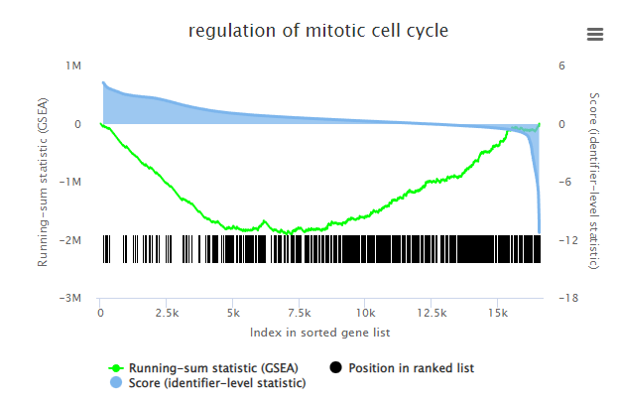
A
B
Figure 5.17 Enrichment graphs of comparing individual genes present in regulation of interphase cell cycle ontology. Both enrichment graphs are weighted towards depleted function of this biological process in response accumulated treatment. A) Represents a depletion cycle regulation in specifically interphase cells post 12Gy accrued treatment B) Represents a depletion cycle regulation in specifically interphase cells post 30Gy accrued treatment. GSEA rank corresponds to the position in the ranked list shown as black lines, the green line represents a running sum statistic of deviation from zero, blue represents the scoring levels of the genes (in this study the value of Log2FoldChange).
As shown in Figure 5.18 there are some similarities between the upregulated and downregulated genes of the corresponding mitotic and interphase genes ontologies, potentially due to cells in G2 preparing/beginning to enter the M phase.
We do see a clear difference in the upregulated genes between interphase and mitotic cell populations tested. We also see a difference in the most contributing to depletion leading-edge genes in the 12Gy interphase and mitotic populations.
The increased 30Gy samples seem to have crossover in leading-edge genes most likely due to the activation of proteosome PSMB encoding genes. This is most likely due to the presence of vastly increased cell damage resulting in the degradation of damaged proteins. The shared response could be due to the activation of apoptosis in higher-treated samples.
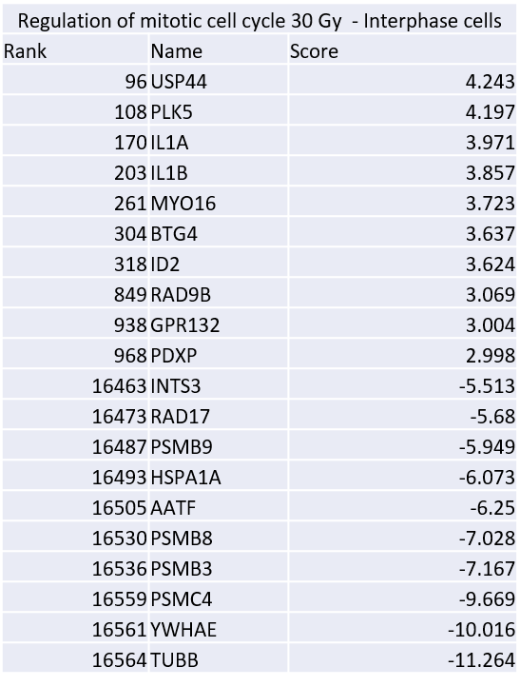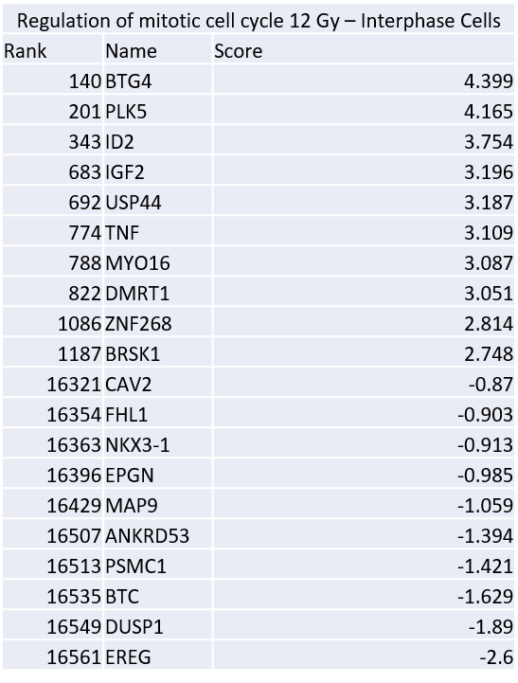
Figure 5.18 Top and bottom ranked genes in the depleted “Regulation of mitotic cell cycle” biological process gene ontology in interphase cells. The genes are derived post GSEA enrichment analysis via GeneTrail 3.2 Transcriptomics tool. Individual gene ontologies were investigated, and the highest and lowest ranked genes were collated. Gene ontology derived from had a q-value < 0.05.

5.5.2 GSE145700
The GSE145700 dataset was also analysed by MoSMiS to give a reasonable percentage of cells, across multiple conditions and repeats as seen in Figure 5.19.

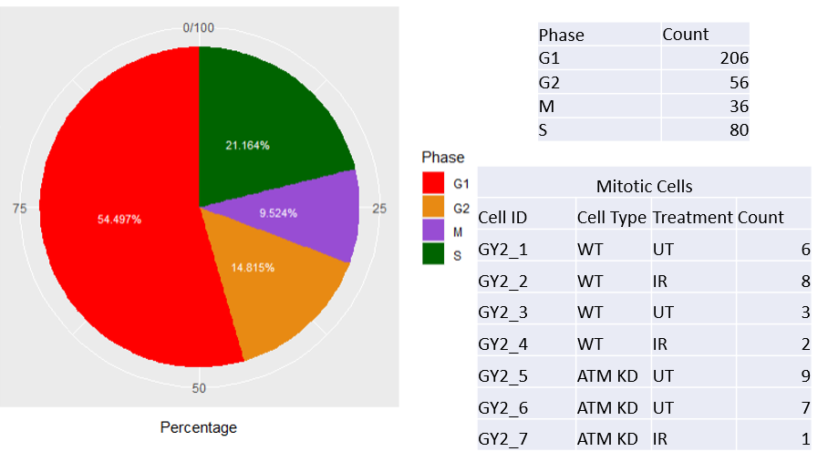
Figure 5.19 Mitotic phase assignment via MoSMiS of GSE145700. Phase assignment was completed via MoSMiS R based code as outlined in appendix A.10. Mitotic cell population was subdivided into treatment types present in experimental design of GSE145700. Low number of mitotic reads were present in each condition, overall mitotic population therefore is a more reliably testable parameter.
GSE145700 (Gao et al., 2021) overall has more cells than GSE81812, but the study splits across wild-type and ATM-depleted MDA-MB-231 cells meaning in the population we are interested in (the wild-type cells) there is a lower number of cells than in GSE81812.

As shown in Figure 5.20.A the normalised and scaled (Counts Per Million) combined bulked gene expression data shows a uniform distribution, the counts per million indicate a good library size for gene testing. As seen in Figure 5.20.B whilst the genes dispersion is still negative binomial distribution, this is not as tight as for GSE81812.

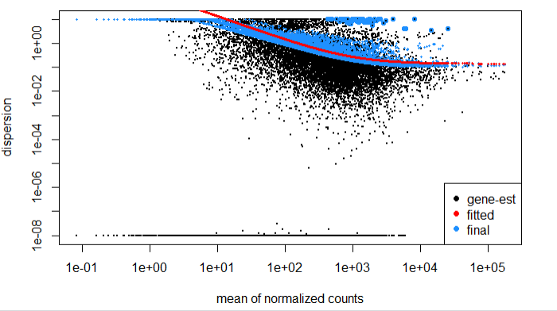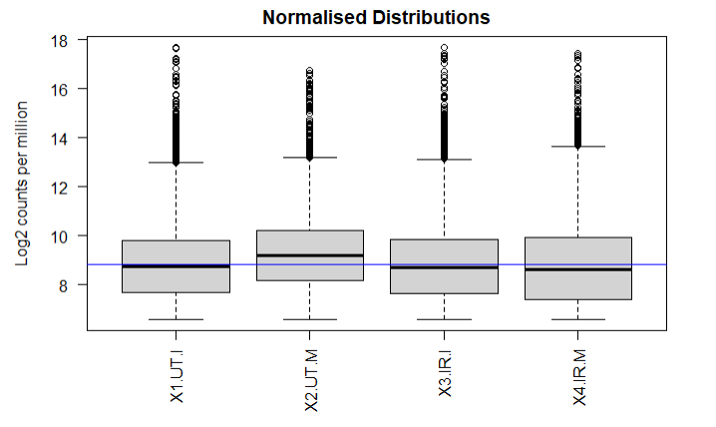
A
B
Figure 5.20 Gene distribution of pseudo bulked GSE145700 count matrix. A) Gene distributions of pseudo bulked gene expression were converted to counts per million, the normalised distibutions were graphed, the blue horizontal line that corresponds to the median logCPM. B) Post differential expression analysis using DESeq2; based on a negative binominal distribution model, the count matrix data dispersion estimate was modelled. The graph indicates a more probable gene presence as the dispersion mean value increases (x-axis), the mean of normalised counts indicating the spread of the genes across the sample (y-axis). Generated by DESeq2, blue dots representing adjusted gene dispersion, black dots with blue border indicating a high dispersion score set against the expected dispersion value (red curve).
PCA plotting (Figure 5.21) highlights an issue with low gene expression in the mitotic samples. The far lower combined matrix expression levels in mitotic samples are significantly lower than those found in interphase.
The PC1 weighting of the UT mitotic samples fundamentally alters the grouping and inhibits the ability for downstream analysis via differential expression testing.
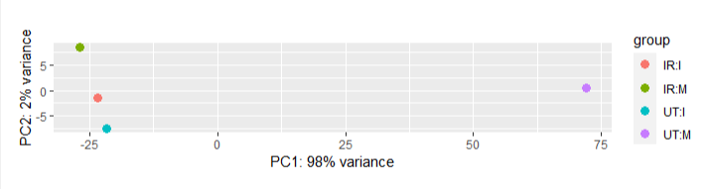
Figure 5.21 Principal component analysis plot showing gene expression variability of pseudo bulked GSE145700. PCA graphs transformed gene expression. The samples were plotted on main components, PC1 and PC2, the clustering of points indicating the relationship and impact of variance in gene expression based on phase or treatment. The untreated mitotic sample shows as a large outlier when compared to the grouping present in IR treated samples. Graph generated in R using plotPCA.
Despite the large variance in the PCA, we performed GO testing and found that the genes showed no clear unified function components or processes. Testing was completed across the combined mitotic or interphase weighted genes using the established statistical significance cut-offs. Both phase-specific lists failed any significance of GO testing.
Also, this data set was tested via threshold-free analysis using individual cell shifts in expression levels testing untreated against treated cells (ranked using Log2FoldChange).
We observed a disordered array of depleted and enriched gene ontologies, and the results of the GeneTrail Transcriptomics tool (Gerstner et al., 2021) provided no insight into the effects of said treatment on the mitotic population.

5.6 Discussion
A deeper understanding of the key transcriptionally active genes during mitosis could further expand upon our understanding of a mitotic DNA damage checkpoint (MDDC).
It is therefore vital to identify key genes responsive to DNA damage and genes involved with mitotic progression and genotoxic damage response. Isolating these genes in an otherwise transcriptionally repressed environment would give a more robust understanding of the mitotic DNA damage response.
While individual ontologies might be depleted or enriched giving an overall trend in the effects of treatment on mitotic transcription, analysis of individual gene regulation could give greater insight into the mitotic response to DNA damage.

5.6.1 Datasets used and problems encountered.

This study struggled to find scRNA seq data comparing treated and untreated cells with an experimental design that looked at DNA-inducing damage treatments.
A reliance on microarray methodologies, the relative newness of large-scale scRNA seq data set generation and data more focused on the initial mapping of cancer (without directed treatment) meant this study was somewhat limited in its resource pool.
Of the 2 datasets identified GSE81812 provided a data set suitable for ontology and threshold-free analysis once mitotic cells were separated using MoSMiS.
Whilst only low numbers of mitotic cells were identified, this was to be expected given that approximately 3-5% of cells would be expected to be in mitosis in the absence of treatment (Miettinen et al., 2019. Figure 3.3).
The fact that more mitotic cells are identified following radiation treatment (Figure 5.1) fits with our previous observations that exogenous radiation slows mitotic transit time and leads to an increase of cells in mitosis (Gatenby thesis (2021), Gatenby et al., 2022. Figure 3.3).
The number of cells associated with read count levels remained viable for threshold-free analysis even at these lower numbers. A lack of true experimental repeats and low count numbers limited the analysis of differentially expressed genes of interest.
GSE147500 failed both testing approaches due to a low number of cells especially once isolated via MoSMiS.
Analysis via combining count values allows for the pseudobulked data sets to be analysed based on gene ontology impact. These results give a snapshot of the mitotic and non-mitotic up and down-regulation of key processes. However, this does have the drawback that any differentially expressed genes of interest cannot be used further. The pseudobulked p-values do not have a level of reliable significance. This is due to the data sets counting no true experimental repeats between single cells so collating counts is the only way they can progress through DESeq2 differential expression testing.
For this reason, threshold-free analysis was used. The threshold-free analysis does not utilise p-values in the analysis of gene ontologies. GSEA uses internal random walk tests and the ability to assign adjusted p-values to gene ontologies. Depletion or enrichment of mitotic function generates potential genes suitable for further investigation into their role in the mitotic response to DNA damage.
MoSMiS provided a mitotic population within expected percentages and with a clear grouping of GSE81812 by treatment. Ontology and GSEA testing highlighted treatment response transcriptional active genes involved in key aspects of mitotic function.
We do see some issues with the 12Gy sample being closely grouped with 0Gy when PCA plotted the debulked data and significantly increased variance when pseudobulked. This is most likely due to the accrued damage of cells due to the experimental design of GSE81812 resulting in a lesser separation of the population. The results do show an attenuated response to damage overall, this larger variance being more apparent post-combining count data during pseudobulking.
The experimental design of GSE81812 using two repeats only in the 12Gy sample could have caused potential issues, but both the pseudobulked and unbulked GSEA do appear to give viable data points.

5.6.2 Effects of treatment on mitotic biological processes.

Via threshold-free analysis, we can see a depletion in both mitotic cell cycle progression and the response to DNA damage. This does not perform entirely to expectation, as we would expect to see a depletion of mitotic progression in response to DNA damage, but a clear enrichment of the response to DNA damage stimuli.
We do see a clear difference in upregulated and down-regulated leading-edge genes involved in mitotic cell cycle control when comparing gene ontologies. This data indicated a possible difference in the mechanistic pathway for controlling either mitotic or interphase cell cycle. This can be seen when comparing top and bottom Log2FoldChanges in Figure 5.16 and Figure 5.18, although it is worth noting without experimental repeats and p-values the conclusions and specific genes would have to be experimentally validated to ensure reliable conclusions being drawn.
Depletion of gene ontologies involved in mitotic progression in ontology and GSEA correlates with this study's lab-based work showing the slowing of mitotic progression in response to DNA damage.
Genes integral to the spindle assembly checkpoint, such as BubR1 or MAD2 may be a contributing factor to a slowed mitotic progression (Meraldi et al., 2004). In line with Gatenby et al., 2022, we do not see; in the gene lists used in ontology or GSEA testing, a notable change in gene expression BubR1 or MAD2 (Gatenby et al., 2022).
Increased activation of this checkpoint as an attenuated response to mitotic-specific damage could increase mitotic transit time. The slowing in mitotic progression as damage increases would also logically be seen alongside the upregulated activity of SAC genes attempting spindle repair steps.
Furthermore, the damage could disrupt the cyclin B/CKD1 activity by negatively impacting its pathway of interaction with the anaphase-promoting complex. A failure in these cell cycle-controlling genes could also be an explanation for the depletion of mitotic progression. (Fung & Poon, 2005). In addition, the novel MDDC may be directly involved with mitotic progression stalling cells to ensure proper DNA damage repair in a manner specific to mitosis.

5.6.3 Further experimental testing of MoSMiS and transcriptional gene expression

The threshold-free analysis gave an extremely wide scope of returned hits across many ontologies, as outlined in section 5.8. It is therefore important to analyse the data related to and focused on, answering specific biological questions. In the case of this study the development of new targets of interest for interrogation of the mechanisms of the MDDC.
A major disadvantage of this study is that only a single dataset was used. Further applications of MoSMiS and the study of mitotic-specific cells would collate data to find shared markers of the mitotic transcription response across multiple data sets. While this singular data set tested provides useful information, the end goal would be to find key genes of interest to an MDDC shared regardless of experimental conditions.
Given time and unlimited resources, datasets would be generated to study different cell lines and tissues before and after treatment. Experiments would be designed to use direct exogenous damage such as IR set alongside spindle poison treatments such as Nocodazole.
Further testing would also be completed to analyse the comparative effects of inhibitors of key pathways such as PARP and cancer treatment drugs such as alkylating agent temozolomide or carboplatin.
Another stage of testing would be to stain and sort all cell phases and isolate individual mitotic internal phases. Biopsies and derived cell lines of tumours and recurring tumours with the same treatment range could also give insight into the in vivo transcriptional effects of said treatments. Analysis of genes shared across multiple ontologies and treatment types could provide new avenues for lab-based investigation of the MDDC.

5.6.4 Potential targets for investigation and mapping of a mitotic DNA damage checkpoint derived from GSE81812 testing

In this section, I discuss three genes which GSEA testing indicated were specifically upregulated in mitosis in the GSE81812 dataset tested. These genes may play a significant role in mitotic progression, these genes being P53-Induced Death Domain Protein 1 (PIDD1), MEIOC and Shieldin Complex Subunit 3 (SHLD3).
The genes are present and upregulated in 12 and 30Gy samples, appearing in multiple relevant ontologies to this study. Also presented is a potential gene of interest from the leading edge of the depletions of the terms analysed in section 5.5.1, namely E2F Transcription Factor 1 (E2F1).
As stated, these genes without p-values cannot have proper conclusions drawn as to their potential role in the MDDC, but provide novel genes from this study generated from a transcription level insight into treatment response.

5.6.4.1 PIDD1

As shown in figures 5.13 and 5.14 in both treatment conditions we see upregulation of p53-induced death domain protein 1 (PIDD1) in response to DNA damage in mitotic cells.
PIDD1 is a potential gene of interest in current studies due to its multifaceted role in Caspase-2 and p53-related cell cycle arrest from centrosome-based defects (Weiler et al., 2022).
The PIDDosome (PIDD1-RAIDD-caspase-2) complex acts as a strong driving force for caspase-2-mediated apoptosis (Sidi & Bouchier-Hayes, 2017. Liu & Sidi, 2019). Data indicates as seen in figures 5.15 and 5.16 we see a deregulation of Transcription factor E2F1 (E2F1) in the leading-edge genes of multiple gene ontologies. E2F1 has been categorised as a direct transcription factor of PIDD1 with overexpression of E2F1 resulting in increased PIDD1 mRNA levels (Sladky et al., 2020).
We see a decrease in positive shifts in PIDD1 expression in the 30Gy sample compared to the 12Gy sample set of GSE81812. This was observed alongside an increase in E2F1 levels when comparing Log2FoldChange of the 0Gy versus 12Gy mitotic cell expression levels against the 0Gy versus 30Gy mitotic cell expression levels.
This response seems to be counter to the previously observed relationship (Sladky et al., 2020). The relationship between mitotic-specific PIDD1 and E2F1 could indicate expression levels are affected by other uncategorized expression regulation pathways. Examples of this could be those that would be present in the control mechanisms of an MDDC. It could also be explained by an increase in apoptosis in general due to higher DNA-damaging treatment levels.
PIDD1 expression has been linked via its recruitment to Fanconi Anemia, Complementation Group I (FANCI), which in turn activates the apoptotic-linked Caspase-2. PIDD1 plays a vital role in programmed cell death when DNA crosslinks cannot be corrected by repair pathways (Shah et al., 2021).
While not shown in Figure 5.13 or 5.14 we do detect a hit for Caspase-2 in both gene ontologies with downregulated Log2FoldChange of -1.143 alongside net deregulation in FANCI expression and little to no change in non-apoptosis-related binding factors expression levels post-treatment such as IKBKG or RIPK1 (String Consortium, 2023).
More directly related to the response seen in Figure 5.13 there is evidence to suggest that PIDD and its binding to caspase-2 also is directly related to mitotic progression linking the complex to mitotic cycle regulation. Our lab has previously demonstrated that the MCC protein BubR1, acts as a direct inhibitor of the PIDDosome PIDD-RAIDD-caspase-2 complex (Thompson et al., 2015).
Although not shown we do detect a decrease in all components of the MCC. We observed this in the treated single-cell mitotic population tests across both gene ontologies in tandem with the upregulation of PIDD1. While the published data shows BubR1 acts to restrain PIDDosome formation, and by extension mitotic apoptosis, the data in this study indicates a net upregulation of PIDD1.
This data would appear to indicate PIDD1 as a very strong target for investigation. Its role in centromere-related cell cycle arrest, programmed cell death post failing of other repair pathways and clear PIDD links to mitotic progression make it a prime candidate for further investigation.

5.6.4.2 MEIOC

The data showed high levels of upregulation following DNA damage in mitosis with a high positive Log2FoldChange, in both treatment and biological process ontologies tested for Meiosis Specific with Coiled-Coil Domain (MEIOC).
The gene MEIOC has been categorised as playing a role in gamete generation and cell cycle switching in germline cells, mRNA stabilisation and interestingly the switching of mitosis to meiotic cell division (Soh et al., 2017).
While meiosis is traditionally repressed in normal human cells, evidence indicates that meiosis-specific genes can be reactivated in cancer cells (Kalejs et al., 2006). The reactivation of these meiotic genes can lead to oncogenesis in human tumour cells.

Data suggests MEIOC depletion causes meiotic progression failure with an aberrant expression of mitotic-related cyclin A2 and factors of chromosome condensation (Abby et al., 2016. Jain et al., 2018).
A study by Ishiguro et al., 2020 summarised several studies and posited that the activation of Meioc; a MEIOC mouse paralog, alongside meiosis-regulating gene Yth N6-Methyladenosine Rna Binding Protein C2 (Ythdc2) downstream products actively prevented mitotic cell cycle progression associated transcript translation (Abby et al., 2016. Jain et al., 2018. Ishiguro et al., 2020).
The upregulation of MEIOC in response to DNA damage indicates a possible corresponding decrease in mitotic cell cycle transcript translation, resulting in an increased mitotic transit or contributing to mitotic stalling.
A shift in key mitotic progression and DNA damage responses from preestablished but initially seemingly unrelated systems could provide insight into MDDC regulation. MDDC could not be a singular discrete functional role but instead interacting and being regulated by other biological systems could be a new avenue of MDDC interrogation.

5.6.4.3 SHLD3

The Shieldin Complex Subunit 3 (SHLD3) is shown to be highly upregulated at both 12Gy and 30Gy treatment levels, a gene with clear ranked hits in the cellular response to DNA damage.
SHLD3 has been recently shown to be both a negative regulator of homologous recombination and a positive regulator of nonhomologous end-joining in response to double-strand DNA breaks. SHLD3 acts downstream of 53BP1 to protect broken DNA ends from premature resection (Liang et al., 2020).
We do see in mitotic cells an inactivation of DSB repair. Mitotic kinases phosphorylate 53BP1 to inhibit recruitment to DSB in chromatin. The restoration of 53BP1 resumes DNA repair at DSB sites but causes deleterious aberrantly controlled repair that results in telomeric fusion in dividing daughter cells (Orthwein et al., 2014).
Furthermore, studies indicate that NHEJ factors were detectable in G1 after damage occurring in mitosis. 53BP1 is observed post-mitosis, indicating a DSB repair is ongoing between cell phases (Gomez-Godinez et al., 2010). This could be interesting in the context of an MDDC. Ongoing repair with the retention of repair factors between phases could indicate a potential involvement of NHEJ in the MDDC or at least NHEJ factors in a different role.
SHLD3 forms a direct complex with Mitotic Arrest Deficient 2 Like 2 (MAD2L2 or REV7), this interaction is severely under-categorised. Recent studies have shown a clear link between the two functional proteins do form the Shieldin DNA end-protecting complex. The complex recruitment to double-strand breaks is still being investigated (Dai et al., 2020, Susvirkar & Faesen, 2022).
These studies do establish the SHLD3-REV7 link, REV7 being a key protein for mitotic progression. REV7 sharing homology with MAD2 directly interacting with anaphase-promoting complex/cyclosome (APC/C) of the spindle assembly checkpoint (SAC), details of the SAC can be found in section 1.2.3.
This could be a potentially interesting avenue of future research a previously established checkpoint protein strongly responding to DNA damage is to be expected but its multifaceted role in cell cycle management in addition to the response could be explored further.

5.6.4.4 Leading edge gene – E2F1

As previously established E2F1 is present in multiple leading edges of ontologies relevant to this study. We observed an overall depletion of the gene in those ontologies but an increase in PIDD1 levels, E2F1 acting as a direct transcription factor of PIDD1. This increase in one and decrease in a related transcription factor could indicate the levels of PIDD1 are mediated by other avenues relevant to an MDDC.
Current studies suggest that E2F1 and the suite of E2F transcription factors play a distinct role in the regulation of mitotic regulators BubR1 and Shugoshin 1 (Sgo1 ) (Lee et al., 2017). The depletion of E2F factors can be counterbalanced by Sgo1-mediated mitotic checkpoints to maintain genomic integrity (Lee et al., 2017).
Studies also highlighted the complex role of E2F1, inhibition studies of E2F1 in melanoma, cancer with classically overexpressed E2F1, and increased cell death in both in vitro and in vivo studies (Rouaud et al., 2018).
The data of E2F1 and PIDD1 levels, their relation to relevant ontologies and their established role in mitotic control and cell fate would make them ideal MDDC investigation targets.
Lab work could validate the response in expression to exogenous DNA damage seen in this study, such as via RT qPCR, and could be directly involved with the MDDC and its regulation of function.

5.7 Conclusion

While this section provides some key hits for further study, the data generated just in the analysis of this one data set is limited. This method of threshold-free analysis can be utilised to find potential targets for MDDC investigation. Threshold-free analysis is unaffected by a lack of true experimental repeats.
Analysis by GSEA utilising single-cell Log2FoldChange alongside internal confidence testing to provide clear and reliable testing methods. Tested ontologies and cellular pathways can be tailored to investigate studies' core biological questions. GSEA provides, in this case, leading-edge genes alongside the Log2FoldChange highlighting upregulated ontology contributing genes.
This section of the study further validates the effectiveness of isolation and the markers of mitotic cell population via MoSMiS. Combined data set analysis highlights situations where the MoSMiS code structure may fail in low expression or cell count data sets.
These points of failure provide key direction for future optimisation steps but did enable viable biological insights to be gained from suboptimal data sets. Precision from the generation of key genes of mitotic separation could be derived from scRNA seq data rather than bulk analysis, covering each cell phase, to increase the accuracy with which MoSMiS isolated mitotic cells.
Data sets if and where available with experimental repeats would allow for the direct analysis of differentially expressed genes. The derived p-values give a clearer set of potential MDDC genes to investigate.
The limitations of the availability of DNA damage comparison scRNA sequencing data initially hampered the application of MoSMiS, but this section highlights the derivation of viable data regardless of the abundance of perfectly suited data.
MoSMiS while performing well could be further improved. Future work would entail performing more testing on low expression count/cell count data sets to ensure MoSMiS testing can function even on lower power data sets.
Following that would be the lab-based investigation of some of the key genes of interest hits presented in this chapter. This two-fold approach eventually expands the scope of MoSMiS data analysis to perform mitotic isolation and threshold-free analysis on a wider pool of single-cell RNA sequencing data.

Chapter 6 – Discussion

6.1 Introduction

The core objective of this project was to uncover proteins involved in a novel Mitotic DNA damage checkpoint (MDDC). This was done via two methods. The first follow-up hits from a siRNA screen for DNA damage response genes potentially involved in the MDDC. We specifically interrogated the role of XRCC4 and the impact of its depletion in the presence of DNA damage. The data presented within this study demonstrates XRCC4 depletion resulting in faster more error-prone mitosis, as highlighted in Figure 6.1.
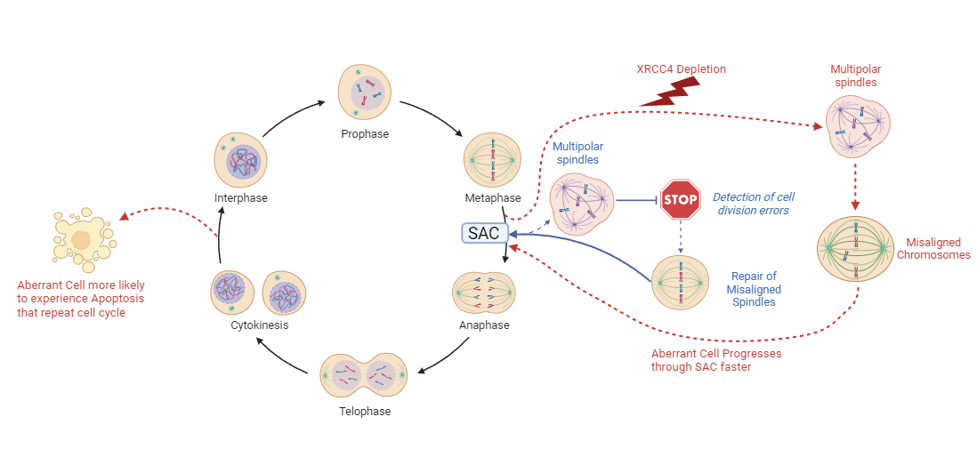
Figure 6.1 Representation of the impact of XRCC4 depletion. Cells with depleted XRCC4 levels were shown within this study to progress more quickly through mitosis, even when treated with an exogenous damage source. This increased speed of mitotic transit potentially reduced mitotic cell populations resulting in more error-prone cellular division resulting in increased cell death. Diagram designed in Biorender.
The second method utilised within this study was the development of an input-agnostic bioinformatics tool to isolate and analyse differentially expressed genes in mitosis in response to DNA damage. A specific mitotic gene list for MoSMiS-based isolation was developed using Bulk RNA Sequencing.
Modified Seurat Mitotic Sort (MoSMiS) was designed to isolate a mitotic population from single-cell RNA sequencing (scRNA seq) experiments. This isolation allows for the analysis of a transcriptional response in specifically mitotic cells. MoSMiS can be applied to a broad spectrum of data sets. A representative overview of this tool can be seen in Figure 6.2.

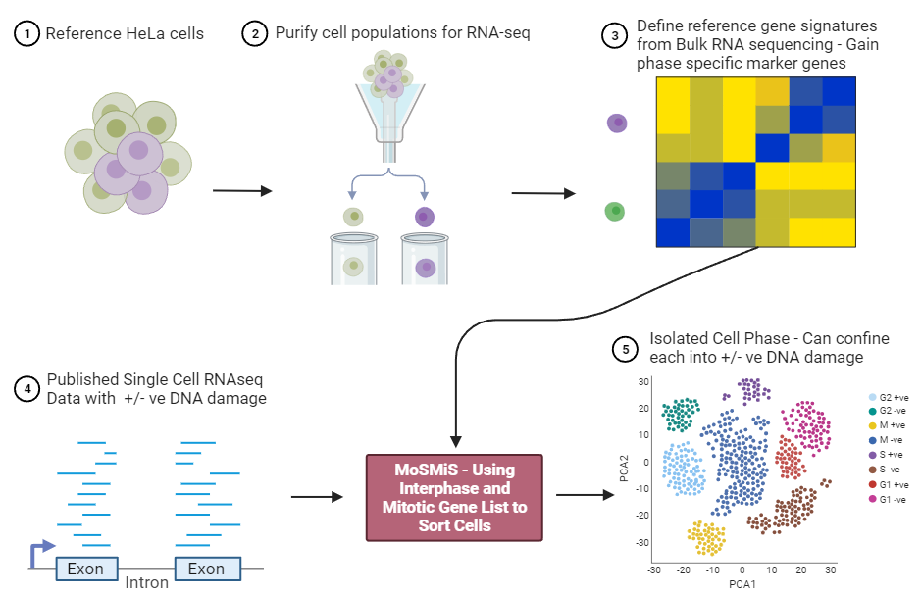
Figure 6.2 Representative diagram of the development and use case of MoSMiS. The MoSMiS tool was developed to isolate mitotic genes from a given single-cell RNA sequencing data set. Mitotic and interphase genes of interest were developed using Bulk RNA sequencing for use in MoSMiS isolation. The MoSMiS tool is able to separate and cluster cells by phase and treatment type for further transcriptomics analysis. MoSMiS was developed within this study to isolate cells by phase, but was designed to be input agnostic and could be modified to interrogate other biological questions. Diagram designed in Biorender

6.2 The potential importance of the MDDC in cancer treatment

There is pre-established precedence for a mitotic checkpoint and misregulation of its central components contributing to drug resistance. A functional Spindle Assembly Checkpoint (SAC) was determined to be a pre-requisite for the proper function of the microtubule-targeting chemotherapy drug Paclitaxel (PTX). Suppression of BubR1 or MAD2 expression resulted in a net increase in PTX resistance (Sudo et al., 2004).
Studies by Fu et al., 2007 demonstrated reduced levels of BubR1 expression and a weakened SAC response in paclitaxel-resistant ovarian cancer cells (Fu et al., 2007). The study highlights a far more complex system of mitotic drug resistance. The MAD2 binding protein p31^{comet} was shown to form a SAC deactivating complex. p31^{comet} when bound to MAD2 negatively impacted the effect of mitotic-specific cancer treatments (Fu et al., 2007).
Furthermore, a study by He et al., 2016 indicated that systems not directly involved with the SAC could increase PTX resistance (He et al., 2016). Cancer cells with increased mitotic slippage and survival after PTX treatment had both an increased level of the cell division cycle six (Cdc6) and inhibited levels of Cyclin-dependent kinase 1 (Cdk1). Both play major roles in cell replication and cell cycle progression (He et al., 2016). Cdc6 contributes to mitotic exit in treated cells, potentially via inactivating Cdk1, and while not SAC involved are potential targets for increasing the effectiveness of PTX (He et al., 2016).
Paclitaxel acts as a mitotic progression inhibitor by the introduction of spindle defects stopping cells at the SAC. The issue with a theoretical MDDC is it would directly limit the effectiveness of such a treatment option. The MDDC could have the potential to overcome these treatment options, stalling cells could allow the MDDC to repair those induced defects. Thereby allowing otherwise apoptotic cancer cells to bypass the target for PTX treatment limiting treatment effectiveness. This becomes a more prominent concern if there is increased error-prone repair at the MDDC, which can in turn bypass established mitotic checkpoints.
Understanding the mechanisms of the MDDC would allow for it to also be inhibited and accounted for in treatment.

6.3 Discovery of new treatment methodologies via the identification of novel targets

Understanding the ways that our cells respond to, and repair, DNA damage is paramount for the development of novel therapeutics.
A prime example of the development of how understanding the fundamentals of DNA repair led to the development of a new drug is the development of Olaparib. Olaparib is a PARP inhibitor developed for cancer treatment in those with BRCA1/ Breast Cancer Gene 2 (BRCA2) genetic mutation. The first investigation showed that PARP-1 played an enzymatic role in DNA repair (Chambon et al., 1963). This discovery developed into very initial work that showed the potential for PARP inhibitors to inhibit DNA repair pathways (Durkacz et al., 1981). It was only the key identification of BRCA2 as a point of breast cancer susceptibility that led to a breakthrough in the treatment of this cancer type.
Application of inhibitors targeting DNA repair, namely PARP inhibitors, leads to the highly effective and sensitive treatment of cancer cells lacking either BRCA mutation (Bryant et al., 2007. Farmer et al., 2005). These discovered novel genetic factors and developed inhibitors resulted in the development a treatment of BRCA-mutated cancer cells (Kim et al., 2015).
Discovery of a novel Mitotic DNA Damage Checkpoint and investigation of its key components could similarly lead to novel targets for treatment. A deeper understanding of cancer and its progression through mitosis could elucidate new key vectors for inhibition or avenues for increasing the effectiveness of previously established treatments. MoSMiS was centrally developed to aid in this avenue of research. Isolating and understanding, at a transcriptomic level, the role mitotic DNA damage repair plays in cancer cells could highlight these novel targets for investigation with increased effectiveness.
The transcriptionally active mitotic genes responding to DNA damage which were identified as part of this study would be a good starting point for future studies into the MDDC.

6.4 Potential for wider application of MoSMiS

It is important to understand the place and relevance of MoSMiS within a wider academic context. This novel method allows for the expansion of RNA seq data analysis and experimental design tailored to mitotic-specific questions.
The advent of new tools for phase-based analysis of cells is still a developing field but brand new insights are being gained from this avenue of study. One such example is the work by Krenning et al., 2022 which used a FUCCI staining-based scRNA seq approach combined with fluorescently tagged live cell imaging to analyse G1 phase cells (Krenning et al., 2022). The study highlighted that time-specific mRNA decay acts as an additional control mechanism for gene expression regulation during the cell cycle. The study indicating two discrete waves of mRNA mediate mitotic exit to the G1 phase with a de-adenylation protein CNOT1 acting as a contributing factor to phase-specific mRNA decay (Krenning et al., 2022). This novel insight derived from phase-specific analysis of the transcriptome response in G1 provides new insight into mRNA decay undiscovered by classical methodologies.
New bioinformatics tools can provide a whole new, previously unattainable perspective, into phase-specific response cell responses. MoSMiS being able to isolate a mitotic fraction allows a direct comparison to interphase cells. This is pertinent as the transcriptional landscape of mitosis differs from the other cell phases (Palozola et al., 2017).
Analysing the transcriptional response to DNA damage and comparing it across all individual cell phases would enable a clearer understanding of the different mechanisms for DNA damage repair.

6.5 Other use cases for MoSMiS

Investigating the DNA damage response in mitosis is just one facet of how MoSMiS could be utilised. Isolating mitotic cells from RNA sequencing data would also allow for the removal of dividing cells during analysis. This could allow for a clearer investigation of the cell's transcriptional response at other key cell cycle checkpoints. The focus of this study was mitosis but interphase or cells stalled outside of mitosis unable to progress into cellular division phases could be interrogated further.
MoSMiS could also provide new ways of answering important questions about mitosis. For example, the study of whether various inherited mutations or epigenetic changes affect mitotic signalling. Also whether other environmental changes such as temperature and nutrient availability affect mitotic signalling. MoSMiS was designed to isolate cells and the methodologies within this study interrogate DNA damage response. Isolating single-cell RNA sequencing data with different biological questions used in experimental design would also be viable via MoSMiS.
It would also be interesting to study mitosis in the presence of tumour-treating fields, an emerging cancer treatment which utilises alternating magnetic fields to disrupt mitosis (Kirson et al., 2007).
MoSMiS can also have applications for other diseases and genetic conditions. Human autosomal trisomy 13, 15, 16, 18, and 21 have all attributed causal links to mitotic separation errors (Antonarakis et al., 1993. Nicolaidis & Petersen, 1998. Gisselsson et al., 2010). These mitotic separation errors result from spindle assembly checkpoint (SAC) errors and even errors in cell division resulting from cytokinesis failures (Gisselsson et al., 2010).
MoSMiS could isolate the mitotic fractions from scRNA-Seq profiles from paired cell lines with and without engineered polysomies. This would allow for the investigation of how various trisomy impact mitotic division across the transcriptomic landscape. Single-cell RNA-Seq datasets from patients with trisomy disorders compared to family members would also be viable for MoSMiS mitotic cell isolation and investigation.

6.6 Investigating other biological questions using MoSMiS cell population isolation

At its core, MoSMiS derived from Seurat isolates cell populations based on genes of interest, with the correct development MoSMiS could isolate on more than just the cell phase. With some slight modifications, we see far-reaching applications of this MoSMiS.
Segregation errors can have a major impact on the production of aberrant reproductive gamete cells contributing to birth defects (Potapova & Gorbsky, 2017). Development of other gene lists for separation i.e. aberrant meiotic cells vs healthy meiotic cells would allow MoSMiS to potentially isolate separate meiotic cells in gamete progenitor cells for the study of meiotic signalling and gametogenesis. Thus meiosis could be studied in reproductively challenged individuals to assess potential defects in gametogenesis.
Modification of the gene list used for population separation could allow far-reaching application of this tool. Analysis and isolation of key markers could allow a variant of MoSMiS to isolate cells that are senescent or quiescent, comparing cells which are actively cycling cells against those which have undergone cell-cycle exit. Gene list modifications could allow for the isolation of tumour vs. non-tumour cells, stem cells vs. differentiated cells, cancer initiating vs. late-stage tumour cells, mutant vs. non-mutant cells and so on.
If a gene list could be derived for the phenotype you wished to study, MoSMiS would form the basis of the code required to identify that subset of cells from a scRNA seq dataset.

6.7 Future Work on MoSMiS

Future refinement of MoSMiS would test the R-based code on a much broader spectrum of data sets. The analysis of a greater pool of scRNA seq data that experimentally tests the effects of DNA damage would remove any experimental bias and allow cross-comparison of derived genes of interest.
Given a longer research period without resource concerns, we would generate our scRNA seq data set for testing with the finalised MoSMiS code. We would generate a cell data set utilising a range of treatment options that induce DNA damage directly and indirectly. Primarily testing IR treatment alongside mitotic stalling treatments such as nocodazole and etoposide to determine if they altered the transcriptional response.
We could also expand this data set further using sorted and analysed bulk and single-cell sequencing data sets. These induction techniques would include inhibitor compounds such as those targeting PARP pathways, cancer treatment drugs such as alkylating agents i.e., temozolomide or carboplatin or antimetabolite treatments such as 5-fluorouracil or methotrexate. This testing to further aid in the mapping of treatment responses in mitosis at the transcription level via MoSMiS isolation.
In addition to expanding the treatment parameters, we would also utilise a range of cell lines. Again primarily testing HeLa, while using other immortalised cell lines such as HEK 293 human kidney cells or expanding the species pool and deriving cancer cells from murine models. This would allow further validation of MoSMiS regardless of input species.
Furthermore, we would increase the cell cycles sorted using expanded staining and sorting to gain cells in all major cell phases. This would be performed alongside sorting mitotic cells into individual mitotic cell progression phases. This increases the resolution and confirms the sorting profile of other phases in MoSMiS.
The current limited availability of robust and comprehensive single-cell RNA sequencing data sets limits the effectiveness of MoSMiS testing. The generation of a replete data set for testing would mitigate a lack of current data set availability while also enabling more accurate MoSMiS training across a range of treatment, cell and species scenarios.
With enough time another more comprehensive solution to more refined MoSMiS development would be creating a sorting system without using modified and optimised pre-existing toolsets. Instead generating a novel sorting solution from the ground up, designed to be completely agnostic of input data and tailorable to any biological question being investigated.
Building in considerations and optional tailored targeted gene lists considering sorting parameters for species, and cancer type while separating cycling and non-cycling cells or even undifferentiated cells/ stem cells would greatly increase the utilization of MoSMiS. Sorting cells and truly mapping a transcriptomic landscape regardless of external parameters would allow true multimodal use of both pre-existing or generated RNA sequencing data sets.

Bibliography – Journals and Books

ABBY, E., TOURPIN, S., RIBEIRO, J., DANIEL, K., MESSIAEN, S., MOISON, D., GUERQUIN, J., GAILLARD, J.-C., ARMENGAUD, J., LANGA, F., TOTH, A., MARTINI, E., & LIVERA, G. (2016). Implementation of meiosis prophase I programme requires a conserved retinoid-independent stabilizer of meiotic transcripts. Nature Communications, 7(1). https://doi.org/10.1038/ncomms10324
AHNESORG, P., SMITH, P., & JACKSON, S. P. (2006). XLF Interacts with the XRCC4-DNA Ligase IV Complex to Promote DNA Nonhomologous End-Joining. Cell, 124(2), 301-313. https://doi.org/10.1016/j.cell.2005.12.031
AMADOR, V., GE, S., SANTAMARÍA, P. G., GUARDAVACCARO, D., & PAGANO, M. (2007). APC/CCDC20 controls the ubiquitin-mediated degradation of p21 in Prometaphase. Molecular Cell, 27(3), 462–473. https://doi.org/10.1016/j.molcel.2007.06.013
ANDERS, S., PYL, P. T., & HUBER, W. (2014). HTseq2–a Python framework to work with high-throughput sequencing data. Bioinformatics, 31(2), 166–169. https://doi.org/10.1093/bioinformatics/btu638
ANDRECKA, J., LEWIS, R., BRÜCKNER, F., LEHMANN, E., CRAMER, P., & MICHAELIS, J. (2008). Single-molecule tracking of mrna exiting from RNA polymerase II. Proceedings of the National Academy of Sciences, 105(1), 135–140. https://doi.org/10.1073/pnas.0703815105
ANDRES, S. N., VERGNES, A., RISTIC, D., WYMAN, C., MODESTI, M., & JUNOP, M. (2012). A human XRCC4–XLF complex bridges DNA. Nucleic Acids Research, 40(4), 1868–1878. https://doi.org/10.1093/nar/gks022
ANTONARAKIS, S. E., AVRAMOPOULOS, D., BLOUIN, J.-L., CONOVER TALBOT, C., & SCHINZEL, A. A. (1993). Mitotic errors in somatic cells cause trisomy 21 in about 4.5% of cases and are not associated with advanced maternal age. Nature Genetics, 3(2), 146–150. https://doi.org/10.1038/ng0293-146
AOUFOUCHI, S., FLATTER, E., DAHAN, A., FAILI, A., BERTOCCI, B., STORCK, S., DELBOS, F., COCEA, L., GUPTA, N., WEILL, J. C., & REYNAUD, C. A. (2000). Two novel human and mouse DNA polymerases of the polX family. Nucleic acids research, 28(18), 3684–3693. https://doi.org/10.1093/nar/28.18.3684
AZAROVA, A. M., LYU, Y. L., LIN, C.-P., TSAI, Y.-C., LAU, J. Y.-N., WANG, J. C., & LIU, L. F. (2007). Roles of DNA topoisomerase II isozymes in chemotherapy and secondary malignancies. Proceedings of the National Academy of Sciences, 104(26), 11014–11019. https://doi.org/10.1073/pnas.0704002104
BAKHOUM, S. F., KABECHE, L., MURNANE, J. P., ZAKI, B. I., & COMPTON, D. A. (2014). DNA-damage response during mitosis induces whole-chromosome missegregation. Cancer Discovery, 4(11), 1281–1289. https://doi.org/10.1158/2159-8290.cd-14-0403
BAYAT, A. (2002). Science, medicine, and the future: Bioinformatics. BMJ, 324(7344), 1018–1022. https://doi.org/10.1136/bmj.324.7344.1018
BENADA, J., BURDOVÁ, K., LIDAK, T., VON MORGEN, P., & MACUREK, L. (2015). Polo-like kinase 1 inhibits DNA damage response during mitosis. Cell Cycle, 14(2), 219–231. https://doi.org/10.4161/15384101.2014.977067
BIEHS, R., STEINLAGE, M., BARTON, O., JUHÁSZ, S., KÜNZEL, J., SPIES, J., SHIBATA, A., JEGGO, P. A., & LÖBRICH, M. (2017). DNA double-strand break resection occurs during non-homologous end joining in G1 but is distinct from resection during homologous recombination. Molecular Cell, 65(4). https://doi.org/10.1016/j.molcel.2016.12.016
BODER E, SEDGWICK RP. Ataxia-Telangiectasia. In: Vinken PJ, Bruyn GW, Klawans HL, De Jong JMBV, editors. Handbook of Clinical Neurology. 60. Hereditary Neuropathies and Spinocerebellar atrophies. Elsevier Science Publishers; Amsterdan, The Netherlands: 1991. pp. 347–423. Revised Series 16.
BODER E, SEDGWICK RP. Ataxia-telangiectasia. A review of 101 cases. In: Walsh G, editor. Little Club Clinics in Develop. London: Heinemann Medical Books; 1963. pp. 110–118.
BOLANOS-GARCIA, V. M., WU, Q., OCHI, T., CHIRGADZE, D. Y., SIBANDA, B. L., & BLUNDELL, T. L. (2012). Spatial and temporal organization of multi-protein assemblies: achieving sensitive control in information-rich cell-regulatory systems. Philosophical Transactions of the Royal Society A: Mathematical, Physical and Engineering Sciences, 370(1969), 3023-3039. https://doi.org/10.1098/rsta.2011.0268
BORK, P., HOFMANN, K., BUCHER, P., NEUWALD, A. F., ALTSCHUL, S. F., & KOONIN, E. V. (1997). A superfamily of conserved domains in DNA damage‐ responsive cell cycle checkpoint proteins. The FASEB Journal, 11(1), 68-76. https://doi.org/10.1096/fasebj.11.1.9034168
BROUWER, I., SITTERS, G., CANDELLI, A., HEEREMA, S. J., HELLER, I., MELO DE, A. J., ZHANG, H., NORMANNO, D., MODESTI, M., PETERMAN, E. J., & WUITE, G. J. (2016). Sliding sleeves of XRCC4–XLF Bridge DNA and connect fragments of broken DNA. Nature, 535(7613), 566–569. https://doi.org/10.1038/nature18643
BROWN-SUEDEL, A. N., & BOUCHIER-HAYES, L. (2020). Caspase-2 substrates: To apoptosis, cell cycle control, and beyond. Frontiers in Cell and Developmental Biology, 8. https://doi.org/10.3389/fcell.2020.610022
BRUNO, S., GHELLI LUSERNA DI RORÀ, A., NAPOLITANO, R., SOVERINI, S., MARTINELLI, G., & SIMONETTI, G. (2022). Cdc20 in and out of mitosis: A prognostic factor and therapeutic target in hematological malignancies. Journal of Experimental & Clinical Cancer Research, 41(1). https://doi.org/10.1186/s13046-022-02363-9
BRYANT, H. E., SCHULTZ, N., THOMAS, H. D., PARKER, K. M., FLOWER, D., LOPEZ, E., KYLE, S., MEUTH, M., CURTIN, N. J., & HELLEDAY, T. (2007). Specific killing of BRCA2-deficient tumours with inhibitors of poly(adp-ribose) polymerase. Nature, 447(7142), 346–346. https://doi.org/10.1038/nature05789
BUTLER, A., HOFFMAN, P., SMIBERT, P., PAPALEXI, E., & SATIJA, R. (2018). Integrating single-cell transcriptomic data across different conditions, technologies, and species. Nature Biotechnology, 36(5), 411-420. https://doi.org/10.1038/nbt.4096
CANNAN, W. J., & PEDERSON, D. S. (2015). Mechanisms and consequences of double-strand DNA break formation in chromatin. Journal of Cellular Physiology, 231(1), 3–14. https://doi.org/10.1002/jcp.25048
CHAMBON, P., WEILL, J. D., & MANDEL, P. (1963). Nicotinamide mononucleotide activation of a new DNA-dependent polyadenylic acid synthesizing nuclear enzyme. Biochemical and Biophysical Research Communications, 11(1), 39–43. https://doi.org/10.1016/0006-291x(63)90024-x
CHAN, Y. W., & WEST, S. C. (2018). A new class of ultrafine anaphase bridges generated by homologous recombination. Cell Cycle, 17(17), 2101–2109. https://doi.org/10.1080/15384101.2018.1515555
CHUNG, F.-L., CHEN, H.-J. C., & NATH, R. G. (1996). Lipid peroxidation as a potential endogenous source for the formation of exocyclic DNA adducts. Carcinogenesis, 17(10), 2105–2111. https://doi.org/10.1093/carcin/17.10.2105
CLARK, N. R., & MA’AYAN, A. (2011). Introduction to statistical methods for analyzing large data sets: Gene-set enrichment analysis. Science Signaling, 4(190). https://doi.org/10.1126/scisignal.2001966
COCK, P. J., FIELDS, C. J., GOTO, N., HEUER, M. L., & RICE, P. M. (2009). The Sanger FASTQ file format for sequences with quality scores, and the Solexa/Illumina FASTQ variants. Nucleic Acids Research, 38(6), 1767–1771. https://doi.org/10.1093/nar/gkp1137
CORCHETE, L. A., ROJAS, E. A., ALONSO-LÓPEZ, D., DE LAS RIVAS, J., GUTIÉRREZ, N. C., & BURGUILLO, F. J. (2020). Systematic comparison and assessment of RNA-seq procedures for gene expression quantitative analysis. Scientific Reports, 10(1). https://doi.org/10.1038/s41598-020-76881-x
CRASTA, K., GANEM, N. J., DAGHER, R., LANTERMANN, A. B., IVANOVA, E. V., PAN, Y., NEZI, L., PROTOPOPOV, A., CHOWDHURY, D., & PELLMAN, D. (2012). DNA breaks and chromosome pulverization from errors in mitosis. Nature, 482(7383), 53–58. https://doi.org/10.1038/nature10802
CROSIO, C., FIMIA, G. M., LOURY, R., KIMURA, M., OKANO, Y., ZHOU, H., SEN, S., ALLIS, C. D., & SASSONE-CORSI, P. (2002). Mitotic phosphorylation of histone H3: Spatio-temporal regulation by mammalian Aurora kinases. Molecular and Cellular Biology, 22(3), 874–885. https://doi.org/10.1128/mcb.22.3.874-885.2002
DAI, Y., ZHANG, F., WANG, L., SHAN, S., GONG, Z., & ZHOU, Z. (2020). Structural basis for shieldin complex subunit 3–mediated recruitment of the checkpoint protein Rev7 during DNA double-strand break repair. Journal of Biological Chemistry, 295(1), 250–262. https://doi.org/10.1074/jbc.ra119.011464
DAL MOLIN, A., BARUZZO, G., & DI CAMILLO, B. (2017). Single-Cell RNA-Sequencing: Assessment of Differential Expression Analysis Methods. Frontiers In Genetics, 8. https://doi.org/10.3389/fgene.2017.00062
DANECEK, P., BONFIELD, J., LIDDLE, J., MARSHALL, J., OHAN, V., & POLLARD, M. (2021). Twelve years of SAMtools and BCFtools. Gigascience, 10(2). https://doi.org/10.1093/gigascience/giab008
DEFAZIO, L. G., STANSEL, R. M., GRIFFITH, J. D., & CHU, G. (2002). Synapsis of DNA ends by DNA-dependent protein kinase. The EMBO journal, 21(12), 3192–3200. https://doi.org/10.1093/emboj/cdf299
DIMITROVA, N., CHEN, Y.-C. M., SPECTOR, D. L., & DE LANGE, T. (2008). 53BP1 promotes non-homologous end-joining of telomeres by increasing chromatin mobility. Nature, 456(7221), 524–528. https://doi.org/10.1038/nature07433
DOBIN, A., DAVIS, C. A., SCHLESINGER, F., DRENKOW, J., ZALESKI, C., JHA, S., BATUT, P., CHAISSON, M., & GINGERAS, T. R. (2012). Star: Ultrafast universal RNA-seq aligner. Bioinformatics, 29(1), 15–21. https://doi.org/10.1093/bioinformatics/bts635
DURKACZ, B. W., IRWIN, J., & SHALL, S. (1981). Inhibition of (ADP-ribose)n biosynthesis retards DNA repair but does not inhibit DNA repair synthesis. Biochemical and Biophysical Research Communications, 101(4), 1433–1441. https://doi.org/10.1016/0006-291x(81)91607-7
EDEN, E., NAVON, R., STEINFELD, I., LIPSON, D., & YAKHINI, Z. (2009). GOrilla: a tool for discovery and visualization of enriched GO terms in ranked gene lists. BMC Bioinformatics, 10(1). https://doi.org/10.1186/1471-2105-10-48
EDGAR, R. (2002). Gene expression omnibus: NCBI gene expression and Hybridization Array Data Repository. Nucleic Acids Research, 30(1), 207–210. https://doi.org/10.1093/nar/30.1.207
ELIEZER, Y., ARGAMAN, L., KORNOWSKI, M., RONIGER, M., & GOLDBERG, M. (2014). Interplay between the DNA Damage Proteins MDC1 and ATM in the Regulation of the Spindle Assembly Checkpoint. Journal Of Biological Chemistry, 289(12), 8182-8193. https://doi.org/10.1074/jbc.m113.532739
ELLIS, N. A., GRODEN, J., YE, T.-Z., STRAUGHEN, J., LENNON, D. J., CIOCCI, S., PROYTCHEVA, M., & GERMAN, J. (1995). The Bloom’s syndrome gene product is homologous to RecQ helicases. Cell, 83(4), 655–666. https://doi.org/10.1016/0092-8674(95)90105-1
EWELS, P., MAGNUSSON, M., LUNDIN, S., & KÃ¤LLER, M. (2016). MultiQC: summarize analysis results for multiple tools and samples in a single report. Bioinformatics, 32(19), 3047–3048. https://doi.org/10.1093/bioinformatics/btw354
FABREGAT, A., SIDIROPOULOS, K., VITERI, G., FORNER, O., MARIN-GARCIA, P., ARNAU, V., D’EUSTACHIO, P., STEIN, L., & HERMJAKOB, H. (2017). Reactome Pathway Analysis: A high-performance in-memory approach. BMC Bioinformatics, 18(1). https://doi.org/10.1186/s12859-017-1559-2
FARMER, H., MCCABE, N., LORD, C. J., TUTT, A. N., JOHNSON, D. A., RICHARDSON, T. B., SANTAROSA, M., DILLON, K. J., HICKSON, I., KNIGHTS, C., MARTIN, N. M., JACKSON, S. P., SMITH, G. C., & ASHWORTH, A. (2005). Targeting the DNA repair defect in BRCA mutant cells as a therapeutic strategy. Nature, 434(7035), 917–921. https://doi.org/10.1038/nature03445
FLEISCHMANN, R. D., ADAMS, M. D., WHITE, O., CLAYTON, R. A., KIRKNESS, E. F., KERLAVAGE, A. R., BULT, C. J., TOMB, J.-F., DOUGHERTY, B. A., MERRICK, J. M., MCKENNEY, K., SUTTON, G., FITZHUGH,, W., FIELDS, C., GOCAYNE, J. D., SCOTT, J., SHIRLEY, R., LIU, L.-LNG, GLODEK, A., … VENTER, J. C. (1995). Whole-genome random sequencing and assembly of haemophilus influenzae. Science, 269(5223), 496–512. https://doi.org/10.1126/science.7542800.
FLEMING, D. S., & MILLER, L. C. (2016). Leading edge analysis of transcriptomic changes during pseudorabies virus infection. Genomics Data, 10, 104–106. https://doi.org/10.1016/j.gdata.2016.09.014
FONG, C. S., MAZO, G., DAS, T., GOODMAN, J., KIM, M., O'ROURKE, B. P., IZQUIERDO, D., & TSOU, M.-F. B. (2016). 53BP1 and USP28 mediate p53-dependent cell cycle arrest in response to centrosome loss and prolonged mitosis. ELife, 5. https://doi.org/10.7554/elife.16270
FU, Y., YE, D., CHEN, H., LU, W., YE, F., & XIE, X. (2007). Weakened spindle checkpoint with reduced BubR1 expression in paclitaxel-resistant ovarian carcinoma cell line skov3-TR30. Gynecologic Oncology, 105(1), 66–73. https://doi.org/10.1016/j.ygyno.2006.10.061
FUNG, T., & POON, R. (2005). A roller coaster ride with the mitotic cyclins. Seminars in Cell & Developmental Biology, 16(3), 335–342. https://doi.org/10.1016/j.semcdb.2005.02.014
GANDHI, M. J., FERRIOLA, D., HUANG, Y., DUKE, J. L., & MONOS, D. (2017). Targeted next-generation sequencing for human leukocyte antigen typing in a clinical laboratory: Metrics of relevance and considerations for its successful implementation. Archives of Pathology & Laboratory Medicine, 141(6), 806–812. https://doi.org/10.5858/arpa.2016-0537-ra
GAO, Y., WU, N., WANG, S., YANG, X., WANG, X., & XU, B. (2021). Concurrent mutations associated with trastuzumab-resistance revealed by single-cell sequencing. Breast Cancer Research and Treatment, 187(3), 613-624. https://doi.org/10.1007/s10549-021-06237-0
GATENBY, R. (2021) The identification of proteins involved in a novel mitotic DNA damage checkpoint. PhD thesis, University of Sheffield.
GATENBY, R., LI, N., LATA, P., WALNE, T., TUFAIL, A., BREITWEISER, A., & THOMPSON, R. (2022). A SOD1-dependent mitotic DNA damage checkpoint. In: Cold Spring Harbor Laboratory.
GATTI, R. A., BERKEL, I., BODER, E., BRAEDT, G., CHARMLEY, P., CONCANNON, P., ERSOY, F., FOROUD, T., JASPERS, N. G., LANGE, K., LATHROP, G. M., LEPPERT, M., NAKAMURA, Y., O’CONNELL, P., PATERSON, M., SALSER, W., SANAL, O., SILVER, J., SPARKES, R. S., … YODER, F. (1988). Localization of an ataxia-telangiectasia gene to chromosome 11q22–23. Nature, 336(6199), 577–580. https://doi.org/10.1038/336577a0
GAUTHIER, J., VINCENT, A. T., CHARETTE, S. J., & DEROME, N. (2018). A brief history of bioinformatics. Briefings in Bioinformatics, 20(6), 1981–1996. https://doi.org/10.1093/bib/bby063
GERSTNER, N., KEHL, T., LENHOF, K., ECKHART, L., SCHNEIDER, L., STÖCKEL, D., BACKES, C., MEESE, E., KELLER, A., & LENHOF, H.-P. (2021). GeneTrail: A framework for the analysis of high-throughput profiles. Frontiers in Molecular Biosciences, 8. https://doi.org/10.3389/fmolb.2021.716544
GISSELSSON, D., JIN, Y., LINDGREN, D., PERSSON, J., GISSELSSON, L., HANKS, S., SEHIC, D., MENGELBIER, L. H., ØRA, I., RAHMAN, N., MERTENS, F., MITELMAN, F., & MANDAHL, N. (2010). Generation of trisomies in cancer cells by multipolar mitosis and incomplete cytokinesis. Proceedings of the National Academy of Sciences, 107(47), 20489–20493. https://doi.org/10.1073/pnas.1006829107
GIUNTA, S., & JACKSON, S. P. (2011). Give me a break, but not in mitosis: the mitotic DNA damage response marks DNA double-strand breaks with early signaling events. Cell cycle (Georgetown, Tex.), 10(8), 1215-1221. https://doi.org/10.4161/cc.10.8.15334
GIUNTA, S., BELOTSERKOVSKAYA, R., & JACKSON, S. P. (2010). DNA damage signaling in response to double-strand breaks during mitosis. Journal of Cell Biology, 190(2), 197–207. https://doi.org/10.1083/jcb.200911156
GOMEZ GODINEZ, V., KABBARA, S., SHERMAN, A., WU, T., COHEN, S., KONG, X., MARAVILLAS-MONTERO, J. L., SHI, Z., PREECE, D., YOKOMORI, K., & BERNS, M. W. (2020). DNA damage induced during mitosis undergoes DNA repair synthesis. PLOS ONE, 15(4). https://doi.org/10.1371/journal.pone.0227849
GOMEZ-GODINEZ, V., WU, T., SHERMAN, A. J., LEE, C. S., LIAW, L.-H., ZHONGSHENG, Y., YOKOMORI, K., & BERNS, M. W. (2010). Analysis of DNA double-strand break response and chromatin structure in mitosis using laser microirradiation. Nucleic Acids Research, 38(22). https://doi.org/10.1093/nar/gkq836
GOODWIN, S., MCPHERSON, J. D., & MCCOMBIE, W. R. (2016). Coming of age: Ten Years of next-generation Sequencing Technologies. Nature Reviews Genetics, 17(6), 333–351. https://doi.org/10.1038/nrg.2016.49
GOTTESFELD, J. (1997). Mitotic repression of the transcriptional machinery. Trends in Biochemical Sciences, 22(6), 197–202. https://doi.org/10.1016/s0968-0004(97)01045-1
GRIMSON, A., SRIVASTAVA, M., FAHEY, B., WOODCROFT, B. J., CHIANG, H. R., KING, N., DEGNAN, B. M., ROKHSAR, D. S., & BARTEL, D. P. (2008). Early origins and evolution of micrornas and piwi-interacting RNAS in Animals. Nature, 455(7217), 1193–1197. https://doi.org/10.1038/nature07415
GU, J., LU, H., TIPPIN, B., SHIMAZAKI, N., GOODMAN, M. F., & LIEBER, M. R. (2007). XRCC4:DNA ligase IV can ligate incompatible DNA ends and can ligate across gaps. The EMBO journal, 26(4), 1010-1023. https://doi.org/10.1038/sj.emboj.7601559
GUERRERO, A. A., MARTÍNEZ-A, C., & VAN WELY, K. H. (2010). Merotelic attachments and non-homologous end-joining are the basis of chromosomal instability. Cell division, 5, 13-13. https://doi.org/10.1186/1747-1028-5-13
HABU, T., & MATSUMOTO, T. (2013). P31comet inactivates the chemically induced MAD2-dependent spindle assembly checkpoint and leads to resistance to anti-mitotic drugs. SpringerPlus, 2(1). https://doi.org/10.1186/2193-1801-2-562
HAMMEL, M., REY, M., YU, Y., MANI, R. S., CLASSEN, S., LIU, M., . . . TAINER, J. A. (2011). XRCC4 protein interactions with XRCC4-like factor (XLF) create an extended grooved scaffold for DNA ligation and double-strand break repair. The Journal of biological chemistry, 286(37), 32638-32650. https://doi.org/10.1074/jbc.M111.272641
HANAHAN, D., & WEINBERG, R. A. (2000). The hallmarks of cancer. Cell, 100(1), 57–70. https://doi.org/10.1016/s0092-8674(00)81683-9
HANAHAN, D., & WEINBERG, R. A. (2011). Hallmarks of cancer: The next generation. Cell, 144(5), 646–674. https://doi.org/10.1016/j.cell.2011.02.013
HANAHAN, D. (2022). Hallmarks of cancer: New dimensions. Cancer Discovery, 12(1), 31–46. https://doi.org/10.1158/2159-8290.cd-21-1059
HAO, Y., HAO, S., ANDERSEN-NISSEN, E., MAUCK, W. M., ZHENG, S., BUTLER, A., LEE, M. J., WILK, A. J., DARBY, C., ZAGER, M., HOFFMAN, P., STOECKIUS, M., PAPALEXI, E., MIMITOU, E. P., JAIN, J., SRIVASTAVA, A., STUART, T., FLEMING, L. M., YEUNG, B., … SATIJA, R. (2021). Integrated Analysis of multimodal single-cell data. Cell, 184(13). https://doi.org/10.1016/j.cell.2021.04.048
HE, Y., YAN, D., ZHENG, D., HU, Z., LI, H., & LI, J. (2016). Cell division cycle 6 promotes mitotic slippage and contributes to drug resistance in paclitaxel-treated cancer cells. PLOS ONE, 11(9). https://doi.org/10.1371/journal.pone.0162633
HEINE, G. F., HORWITZ, A. A., & PARVIN, J. D. (2008). Multiple mechanisms contribute to inhibit transcription in response to DNA damage. Journal of Biological Chemistry, 283(15), 9555–9561. https://doi.org/10.1074/jbc.m707700200
HENDZEL, M. J., WEI, Y., MANCINI, M. A., VAN HOOSER, A., RANALLI, T., BRINKLEY, B. R., BAZETT-JONES, D. P., & ALLIS, C. D. (1997). Mitosis-specific phosphorylation of histone H3 initiates primarily within pericentromeric heterochromatin during G2 and spreads in an ordered fashion coincident with mitotic chromosome condensation. Chromosoma, 106(6), 348–360. https://doi.org/10.1007/s004120050256
HOLLIDAY, R., & HO, T. (1998). Gene silencing and endogenous DNA methylation in mammalian cells. Mutation Research/Fundamental and Molecular Mechanisms of Mutagenesis, 400(1-2), 361–368. https://doi.org/10.1016/s0027-5107(98)00034-7
HORNIG, N., KNOWLES, P., MCDONALD, N., & UHLMANN, F. (2002). The Dual Mechanism of Separase Regulation by Securin. Current Biology, 12(12), 973-982. https://doi.org/10.1016/s0960-9822(02)00847-3
HSIAO, C. J., TUNG, P. Y., BLISCHAK, J. D., BURNETT, J. E., BARR, K. A., DEY, K. K., STEPHENS, M., & GILAD, Y. (2019). Characterizing and inferring quantitative cell cycle phase in single-cell RNA-seq data analysis. https://doi.org/10.1101/526848
HSU, D.-W., KIELY, R., COUTO, C. A.-M., WANG, H.-Y., HUDSON, J. J. R., BORER, C., . . . LAKIN, N. D. (2011). DNA double-strand break repair pathway choice in Dictyostelium. Journal of Cell Science, 124(10), 1655-1663. https://doi.org/10.1242/jcs.081471
HU, T., CHITNIS, N., MONOS, D., & DINH, A. (2021). Next-generation sequencing technologies: An overview. Human Immunology, 82(11), 801–811. https://doi.org/10.1016/j.humimm.2021.02.012
HU, W., ZHANG, X., GUO, Q., YANG, J., YANG, Y., WEI, S., & SU, X. (2019). HeLa-CCL2 cell heterogeneity studied by single-cell DNA and RNA sequencing. PLOS ONE, 14(12), e0225466. https://doi.org/10.1371/journal.pone.0225466
HÜBNER, N. C., WANG, L. H.-C., KAULICH, M., DESCOMBES, P., POSER, I., & NIGG, E. A. (2009). Re-examination of Sirna specificity questions role of Pich and Tao1 in the spindle checkpoint and identifies MAD2 as a sensitive target for small RNAS. Chromosoma, 119(2), 149–165. https://doi.org/10.1007/s00412-009-0244-2
ISHIGURO, K.-ICHIRO, MATSUURA, K., TANI, N., TAKEDA, N., USUKI, S., YAMANE, M., SUGIMOTO, M., FUJIMURA, S., HOSOKAWA, M., CHUMA, S., KO, M. S. H., ARAKI, K., & NIWA, H. (2020). Meiosin directs the switch from mitosis to meiosis in mammalian germ cells. Developmental Cell, 52(4). https://doi.org/10.1016/j.devcel.2020.01.010
JACKSON, A. L., & LINSLEY, P. S. (2010). Recognizing and avoiding Sirna off-target effects for target identification and therapeutic application. Nature Reviews Drug Discovery, 9(1), 57–67. https://doi.org/10.1038/nrd3010
JAIN, D., PUNO, M. R., MEYDAN, C., LAILLER, N., MASON, C. E., LIMA, C. D., ANDERSON, K. V., & KEENEY, S. (2018). Ketu mutant mice uncover an essential meiotic function for the ancient RNA helicase YTHDC2. ELife, 7. https://doi.org/10.7554/elife.30919
JESSULAT, M., MALTY, R. H., NGUYEN-TRAN, D.-H., DEINEKO, V., AOKI, H., VLASBLOM, J., OMIDI, K., JIN, K., MINIC, Z., HOOSHYAR, M., BURNSIDE, D., SAMANFAR, B., PHANSE, S., FREYWALD, T., PRASAD, B., ZHANG, Z., VIZEACOUMAR, F., KROGAN, N. J., FREYWALD, A., GOLSHANI, A. & BABU, M. (2015). Spindle Checkpoint Factors Bub1 and Bub2 Promote DNA Double- Strand Break Repair by Nonhomologous End Joining. Molecular and cellular biology, 35, 2448-2463. https://doi.org/10.1128/MCB.00007-15
JI, F., & SADREYEV, R. I. (2018). RNA-seq: Basic bioinformatics analysis. Current Protocols in Molecular Biology, 124(1). https://doi.org/10.1002/cpmb.68
JIANG, J., SEO, H., & CHOW, C. S. (2016). Post-transcriptional modifications modulate rrna structure and ligand interactions. Accounts of Chemical Research, 49(5), 893–901. https://doi.org/10.1021/acs.accounts.6b00014
JOLLIFFE, I., & CADIMA, J. (2016). Principal component analysis: a review and recent developments. Philosophical Transactions Of The Royal Society A: Mathematical, Physical And Engineering Sciences, 374(2065), 20150202. https://doi.org/10.1098/rsta.2015.0202
JONES, M. B., HIGHLANDER, S. K., ANDERSON, E. L., LI, W., DAYRIT, M., KLITGORD, N., FABANI, M. M., SEGURITAN, V., GREEN, J., PRIDE, D. T., YOOSEPH, S., BIGGS, W., NELSON, K. E., & VENTER, J. C. (2015). Library preparation methodology can influence genomic and functional predictions in human microbiome research. Proceedings of the National Academy of Sciences, 112(45), 14024–14029. https://doi.org/10.1073/pnas.1519288112
JUNOP, M. (2000). Crystal structure of the Xrcc4 DNA repair protein and implications for end-joining. The EMBO Journal, 19(22), 5962-5970. https://doi.org/10.1093/emboj/19.22.5962
JUNTTILA, S., SMOLANDER, J., & ELO, L. L. (2022). Benchmarking methods for detecting differential states between conditions from multi-subject single-cell RNA-seq data. https://doi.org/10.1101/2022.02.16.480662
KALEJS, M., IVANOV, A., PLAKHINS, G., CRAGG, M. S., EMZINSH, D., ILLIDGE, T. M., & ERENPREISA, J. (2006). Upregulation of meiosis-specific genes in lymphoma cell lines following genotoxic insult and induction of mitotic catastrophe. BMC Cancer, 6(1). https://doi.org/10.1186/1471-2407-6-6
KARLSSON, J., KRONEIS, T., JONASSON, E., LARSSON, E., & STÅHLBERG, A. (2017). Transcriptomic Characterization of the Human Cell Cycle in Individual Unsynchronized Cells. Journal Of Molecular Biology, 429(24), 3909-3924. https://doi.org/10.1016/j.jmb.2017.10.011
KEREN, L., VAN DIJK, D., WEINGARTEN-GABBAY, S., DAVIDI, D., JONA, G., WEINBERGER, A., MILO, R., & SEGAL, E. (2015). Noise in gene expression is coupled to growth rate. Genome Research, 25(12), 1893–1902. https://doi.org/10.1101/gr.191635.115
KIM, D., LANGMEAD, B., & SALZBERG, S. L. (2015). HISAT: a fast spliced aligner with low memory requirements. Nature Methods, 12(4), 357–360. https://doi.org/10.1038/nmeth.3317
KIM, D., PAGGI, J. M., PARK, C., BENNETT, C., & SALZBERG, S. L. (2019). Graph-based genome alignment and genotyping with HISAT2 and HISAT-genotype. Nat Biotechnol, 37(8), 907-915. https://doi.org/10.1038/s41587-019-0201-4
KIM, E., & BURKE, D. (2008). DNA Damage Activates the SAC in an ATM/ATR-Dependent Manner, Independently of the Kinetochore. Plos Genetics, 4(2), e1000015. https://doi.org/10.1371/journal.pgen.1000015
KIM, G., ISON, G., MCKEE, A. E., ZHANG, H., TANG, S., GWISE, T., SRIDHARA, R., LEE, E., TZOU, A., PHILIP, R., CHIU, H.-J., RICKS, T. K., PALMBY, T., RUSSELL, A. M., LADOUCEUR, G., PFUMA, E., LI, H., ZHAO, L., LIU, Q., … PAZDUR, R. (2015). FDA approval summary: Olaparib monotherapy in patients with deleterious germline brca-mutated advanced ovarian cancer treated with three or more lines of chemotherapy. Clinical Cancer Research, 21(19), 4257–4261. https://doi.org/10.1158/1078-0432.ccr-15-0887
KIRSON, E. D., DBALÝ, V., TOVARYŠ, F., VYMAZAL, J., SOUSTIEL, J. F., ITZHAKI, A., MORDECHOVICH, D., STEINBERG-SHAPIRA, S., GURVICH, Z., SCHNEIDERMAN, R., WASSERMAN, Y., SALZBERG, M., RYFFEL, B., GOLDSHER, D., DEKEL, E., & PALTI, Y. (2007). Alternating electric fields arrest cell proliferation in animal tumor models and human brain tumors. Proceedings of the National Academy of Sciences, 104(24), 10152–10157. https://doi.org/10.1073/pnas.0702916104
KOZERA, B., & RAPACZ, M. (2013). Reference genes in real-time PCR. Journal Of Applied Genetics, 54(4), 391-406. https://doi.org/10.1007/s13353-013-0173-x
KRENNING, L., SONNEVELD, S., & TANENBAUM, M. E. (2022). Time-resolved single-cell sequencing identifies multiple waves of mrna decay during the mitosis-to-G1 phase transition. ELife, 11. https://doi.org/10.7554/elife.71356
KURIMASA, A., KUMANO, S., BOUBNOV, N. V., STORY, M. D., TUNG, C. S., PETERSON, S. R., & CHEN, D. J. (1999). Requirement for the kinase activity of human DNA-dependent protein kinase catalytic subunit in DNA strand break rejoining. Molecular and cellular biology, 19(5), 3877-3884. https://doi.org/10.1128/MCB.19.5.3877
LAMBERT, S. A., JOLMA, A., CAMPITELLI, L. F., DAS, P. K., YIN, Y., ALBU, M., . . . WEIRAUCH, M. T. (2018). The Human Transcription Factors. Cell, 172(4), 650-665. https://doi.org/10.1016/j.cell.2018.01.029
LANDAU, W., & LIU, P. (2013). Dispersion Estimation and Its Effect on Test Performance in RNA-seq Data Analysis: A Simulation-Based Comparison of Methods. Plos ONE, 8(12), e81415. https://doi.org/10.1371/journal.pone.0081415
LANGMEAD, B., TRAPNELL, C., POP, M., & SALZBERG, S. L. (2009). Ultrafast and memory-efficient alignment of short DNA sequences to the human genome. Genome Biology, 10(3). https://doi.org/10.1186/gb-2009-10-3-r25
LATCHMAN, D. S. (2005). Transcription factors. ELS. https://doi.org/10.1038/npg.els.0005278
LAU, H. W., MA, H. T., YEUNG, T. K., TAM, M. Y., ZHENG, D., CHU, S. K., & POON, R. Y. C. (2021). Quantitative differences between cyclin-dependent kinases underlie the unique functions of CDK1 in human cells. Cell reports, 37(2), 109808. https://doi.org/10.1016/j.celrep.2021.109808
LAWRENCE, K., CHAU, T. & ENGEBRECHT, J. (2015). DNA Damage Response and Spindle Assembly Checkpoint Function throughout the Cell Cycle to Ensure Genomic Integrity: e1005150. PLoS Genetics, 11.
LEE, K., SHANG, Z., LIN, Y., SUN, J., MOROTOMI-YANO, K., SAHA, D., & CHEN, B. (2015). The Catalytic Subunit of DNA-Dependent Protein Kinase Coordinates with Polo-Like Kinase 1 to Facilitate Mitotic Entry. Neoplasia, 17(4), 329-338. https://doi.org/10.1016/j.neo.2015.02.004
LEE, M., RIVERA-RIVERA, Y., MORENO, C. S., & SAAVEDRA, H. I. (2017). The E2F activators control multiple mitotic regulators and maintain genomic integrity through sgo1 and BubR1. Oncotarget, 8(44), 77649–77672. https://doi.org/10.18632/oncotarget.20765
LEIMBACHER, P.-A., JONES, S. E., SHORROCKS, A.-M. K., DE MARCO ZOMPIT, M., DAY, M., BLAAUWENDRAAD, J., BUNDSCHUH, D., BONHAM, S., FISCHER, R., FINK, D., KESSLER, B. M., OLIVER, A. W., PEARL, L. H., BLACKFORD, A. N., & STUCKI, M. (2019). MDC1 interacts with TOPBP1 to maintain chromosomal stability during mitosis. Molecular Cell, 74(3). https://doi.org/10.1016/j.molcel.2019.02.014
LENG, N., CHU, L.-F., BARRY, C., LI, Y., CHOI, J., LI, X., JIANG, P., STEWART, R. M., THOMSON, J. A., & KENDZIORSKI, C. (2015). Oscope identifies oscillatory genes in unsynchronized single-cell RNA-seq experiments. Nature Methods, 12(10), 947–950. https://doi.org/10.1038/nmeth.3549
LI, X., & HEYER, W. D. (2008). Homologous recombination in DNA repair and DNA damage tolerance. Cell Research, 18(1), 99–113. https://doi.org/10.1038/cr.2008.1
LI, H., HANDSAKER, B., WYSOKER, A., FENNELL, T., RUAN, J., HOMER, N., MARTH, G., ABECASIS, G., & DURBIN, R. (2009). The sequence alignment/map format and SAMtools. Bioinformatics, 25(16), 2078–2079. https://doi.org/10.1093/bioinformatics/btp352
LIANG, L., FENG, J., ZUO, P., YANG, J., LU, Y., & YIN, Y. (2020). Molecular basis for assembly of the Shieldin Complex and its implications for NHEJ. Nature Communications, 11(1). https://doi.org/10.1038/s41467-020-15879-5
LINDSEY, S. F., BYRNES, D. M., ELLER, M. S., ROSA, A. M., DABAS, N., ESCANDON, J., & GRICHNIK, J. M. (2013). Potential role of meiosis proteins in melanoma chromosomal instability. Journal of Skin Cancer, 2013, 1–9. https://doi.org/10.1155/2013/190109
LIU, P. H., & SIDI, S. (2019). Targeting the innate immune kinase IRAK1 in radioresistantcancer: Double-edged sword or one-two punch? Frontiers in Oncology, 9. https://doi.org/10.3389/fonc.2019.01174
LIU, X., ZHAO, J., XUE, L., ZHAO, T., DING, W., HAN, Y., & YE, H. (2022). A comparison of transcriptome analysis methods with reference genome. BMC Genomics, 23(1). https://doi.org/10.1186/s12864-022-08465-0
LIU, Z., LOU, H., XIE, K., WANG, H., CHEN, N., APARICIO, O. M., ZHANG, M. Q., JIANG, R., & CHEN, T. (2017). Reconstructing cell cycle pseudo time-series via single-cell transcriptome data. Nature Communications, 8(1). https://doi.org/10.1038/s41467-017-00039-z
LIU, X., SHAO, Z., JIANG, W., LEE, B. J., & ZHA, S. (2017). PAXX promotes ku accumulation at DNA breaks and is essential for end-joining in XLF-deficient mice. Nature Communications, 8(1). https://doi.org/10.1038/ncomms13816
LÖBRICH, M., & JEGGO, P. (2017). A process of resection-dependent nonhomologous end joining involving the goddess Artemis. Trends in Biochemical Sciences, 42(9), 690–701. https://doi.org/10.1016/j.tibs.2017.06.011
LOEWITH, R., JACINTO, E., WULLSCHLEGER, S., LORBERG, A., CRESPO, J. L., BONENFANT, D., OPPLIGER, W., JENOE, P., & HALL, M. N. (2002). Two tor complexes, only one of which is rapamycin sensitive, have distinct roles in cell growth control. Molecular Cell, 10(3), 457–468. https://doi.org/10.1016/s1097-2765(02)00636-6
LOUIS-BAR, D. (1941). Sur Un syndrome progressif comprenant des Télangiectasies capillaires cutanées et conjonctivales symétriques, à disposition naevoïde et des troubles Cérébelleux. Stereotactic and Functional Neurosurgery, 4(1–2), 32–42. https://doi.org/10.1159/000106149
LOVE, M., HUBER, W., & ANDERS, S. (2014). Moderated estimation of fold change and dispersion for RNA-seq data with DESeq2. Genome Biology, 15(12). https://doi.org/10.1186/s13059-014-0550-8
LUKAS, C., SAVIC, V., BEKKER-JENSEN, S., DOIL, C., NEUMANN, B., SØLVHØJ PEDERSEN, R., GRØFTE, M., CHAN, K. L., HICKSON, I. D., BARTEK, J., & LUKAS, J. (2011). 53BP1 nuclear bodies form around DNA lesions generated by mitotic transmission of chromosomes under replication stress. Nature Cell Biology, 13(3), 243–253. https://doi.org/10.1038/ncb2201
MA, C., HA, K., KIM, M.-S., NOH, Y.-W., LIN, H., TANG, L., . . . ZHANG, P. (2018). The anaphase promoting complex promotes NHEJ repair through stabilizing Ku80 at DNA damage sites. Cell cycle (Georgetown, Tex.), 17(9), 1138-1145. https://doi.org/10.1080/15384101.2018.1464836
MA, Y., LU, H., TIPPIN, B., GOODMAN, M. F., SHIMAZAKI, N., KOIWAI, O., . . . LIEBER, M. R. (2004). A Biochemically Defined System for Mammalian Nonhomologous DNA End Joining. Molecular Cell, 16(5), 701-713. https://doi.org/10.1016/j.molcel.2004.11.017
MACFARLANE, L.-A., & R. MURPHY, P. (2010). MicroRNA: Biogenesis, function and role in cancer. Current Genomics, 11(7), 537–561. https://doi.org/10.2174/138920210793175895
MACHERET, M., BHOWMICK, R., SOBKOWIAK, K., PADAYACHY, L., MAILLER, J., HICKSON, I. D., & HALAZONETIS, T. D. (2020). High-resolution mapping of mitotic DNA synthesis regions and common fragile sites in the human genome through direct sequencing. Cell Research, 30(11), 997–1008. https://doi.org/10.1038/s41422-020-0358-x
MACOSKO, E. Z., BASU, A., SATIJA, R., NEMESH, J., SHEKHAR, K., GOLDMAN, M., TIROSH, I., BIALAS, A. R., KAMITAKI, N., MARTERSTECK, E. M., TROMBETTA, J. J., WEITZ, D. A., SANES, J. R., SHALEK, A. K., REGEV, A., & MCCARROLL, S. A. (2015). Highly parallel genome-wide expression profiling of individual cells using Nanoliter droplets. Cell, 161(5), 1202–1214. https://doi.org/10.1016/j.cell.2015.05.002
MAIATO, H., DELUCA, J., SALMON, E. D., & EARNSHAW, W. C. (2004). The dynamic kinetochore-microtubule interface. Journal of Cell Science, 117(23), 5461–5477. https://doi.org/10.1242/jcs.01536
MAO, Z., BOZZELLA, M., SELUANOV, A., & GORBUNOVA, V. (2008). Comparison of nonhomologous end-joining and homologous recombination in human cells. DNA repair, 7(10), 1765-1771. https://doi.org/10.1016/j.dnarep.2008.06.018
MASOTTI, A., & PRECKEL, T. (2006). Analysis of small RNAs with the Agilent 2100 Bioanalyzer. Nature Methods, 3(8), 658-658. https://doi.org/10.1038/nmeth908
MATSUZAKI, K., TERASAWA, M., IWASAKI, D., HIGASHIDE, M., & SHINOHARA, M. (2012). Cyclin-dependent kinase-dependent phosphorylation of LIF1 and Sae2 controls imprecise nonhomologous end-joining accompanied by double-strand break resection. Genes to Cells, 17(6), 473–493. https://doi.org/10.1111/j.1365-2443.2012.01602.x
MAYA-MENDOZA, A., OLIVARES-CHAUVET, P., SHAW, A., & JACKSON, D. A. (2010). S phase progression in human cells is dictated by the genetic continuity of DNA foci. PLoS genetics, 6(4), e1000900-e1000900. https://doi.org/10.1371/journal.pgen.1000900
MCKELLAR, D. W., MANTRI, M., HINCHMAN, M., PARKER, J. S. L., SETHUPATHY, P., COSGROVE, B. D., & DE VLAMINCK, I. (2022). In situ polyadenylation enables spatial mapping of the total transcriptome. https://doi.org/10.1101/2022.04.20.488964
MERALDI, P., DRAVIAM, V. M., & SORGER, P. K. (2004). Timing and checkpoints in the regulation of mitotic progression. Developmental Cell, 7(1), 45–60. https://doi.org/10.1016/j.devcel.2004.06.006
MIETTINEN, T. P., KANG, J. H., YANG, L. F., & MANALIS, S. R. (2019). Mammalian cell growth dynamics in mitosis. ELife, 8. https://doi.org/10.7554/elife.44700
MITSIS, T., EFTHIMIADOU, A., BACOPOULOU, F., VLACHAKIS, D., CHROUSOS, G., & ELIOPOULOS, E. (2020). Transcription factors and evolution: An integral part of gene expression (review). World Academy of Sciences Journal. https://doi.org/10.3892/wasj.2020.32
MOORE, J. K., & HABER, J. E. (1996). Cell cycle and genetic requirements of two pathways of nonhomologous end-joining repair of double-strand breaks in saccharomyces cerevisiae. Molecular and Cellular Biology, 16(5), 2164–2173. https://doi.org/10.1128/mcb.16.5.2164
MÜLLER, H., BRACKEN, A. P., VERNELL, R., MORONI, M. C., CHRISTIANS, F., GRASSILLI, E., PROSPERINI, E., VIGO, E., OLINER, J. D., & HELIN, K. (2001). E2Fs regulate the expression of genes involved in differentiation, development, proliferation, and apoptosis. Genes & Development, 15(3), 267–285. https://doi.org/10.1101/gad.864201
NAGAI, K., MUTO, Y., POMERANZ KRUMMEL, D. A., KAMBACH, C., IGNJATOVIC, T., WALKE, S., & KUGLSTATTER, A. (2001). Structure and assembly of the spliceosomal snRNPs. Biochemical Society transactions, 29(Pt 2), 15–26. https://doi.org/10.1042/0300-5127:0290015
NAGALAKSHMI, U., WANG, Z., WAERN, K., SHOU, C., RAHA, D., GERSTEIN, M., & SNYDER, M. (2008). The transcriptional landscape of the yeast genome defined by RNA sequencing. Science, 320(5881), 1344–1349. https://doi.org/10.1126/science.1158441
NAKAMURA, J., LA, D. K., & SWENBERG, J. A. (2000). 5′-nicked Apurinic/APYRIMIDINIC sites are resistant to β-elimination by β-polymerase and are persistent in human cultured cells after oxidative stress. Journal of Biological Chemistry, 275(8), 5323–5328. https://doi.org/10.1074/jbc.275.8.5323
NASSIF, N., PENNEY, J., PAL, S., ENGELS, W. R., & GLOOR, G. B. (1994). Efficient copying of nonhomologous sequences from ectopic sites via p-element-induced gap repair. Molecular and Cellular Biology, 14(3), 1613–1625. https://doi.org/10.1128/mcb.14.3.1613-1625.1994
NESTOROWA, S., HAMEY, F. K., PIJUAN SALA, B., DIAMANTI, E., SHEPHERD, M., LAURENTI, E., WILSON, N. K., KENT, D. G., & GÖTTGENS, B. (2016). A single-cell resolution map of mouse hematopoietic stem and progenitor cell differentiation. Blood, 128(8). https://doi.org/10.1182/blood-2016-05-716480
NICOLAIDIS, P., & PETERSEN, M. B. (1998). Origin and mechanisms of non-disjunction in human autosomal trisomies. Human Reproduction, 13(2), 313–319. https://doi.org/10.1093/humrep/13.2.313
NISHIZAWA-YOKOI, A., NONAKA, S., SAIKA, H., KWON, Y.-I., OSAKABE, K., & TOKI, S. (2012). Suppression of Ku70/80 or Lig4 leads to decreased stable transformation and enhanced homologous recombination in rice. The New phytologist, 196(4), 1048-1059. https://doi.org/10.1111/j.1469-8137.2012.04350.x
OCHI, T., BLACKFORD, A. N., COATES, J., JHUJH, S., MEHMOOD, S., TAMURA, N., TRAVERS, J., WU, Q., DRAVIAM, V. M., ROBINSON, C. V., BLUNDELL, T. L., & JACKSON, S. P. (2015). Paxx, a paralog of XRCC4 and XLF, interacts with KU to promote DNA double-strand break repair. Science, 347(6218), 185–188. https://doi.org/10.1126/science.1261971
ORTHWEIN, A., FRADET-TURCOTTE, A., NOORDERMEER, S. M., CANNY, M. D., BRUN, C. M., STRECKER, J., ESCRIBANO-DIAZ, C., & DUROCHER, D. (2014). Mitosis inhibits DNA double-strand break repair to guard against telomere fusions. Science, 344(6180), 189–193. https://doi.org/10.1126/science.1248024
OTTO, T., & SICINSKI, P. (2017). Cell cycle proteins as promising targets in cancer therapy. Nature, 17(2), 93–115. https://doi.org/10.1038/nrc.2016.138
PALOU, R., PALOU, G., & QUINTANA, D. G. (2017). A role for the spindle assembly checkpoint in the DNA damage response. Current genetics, 63(2), 275-280. https://doi.org/10.1007/s00294-016-0634-y
PALOZOLA, K. C., DONAHUE, G., LIU, H., GRANT, G. R., BECKER, J. S., COTE, A., YU, H., RAJ, A., & ZARET, K. S. (2017). Mitotic transcription and waves of gene reactivation during mitotic exit. Science, 358(6359), 119–122. https://doi.org/10.1126/science.aal4671
PARKINSON, H., KAPUSHESKY, M., SHOJATALAB, M., ABEYGUNAWARDENA, N., COULSON, R., FARNE, A., HOLLOWAY, E., KOLESNYKOV, N., LILJA, P., LUKK, M., MANI, R., RAYNER, T., SHARMA, A., WILLIAM, E., SARKANS, U., & BRAZMA, A. (2007). ArrayExpress--a public database of microarray experiments and gene expression profiles. Nucleic Acids Research, 35(Database). https://doi.org/10.1093/nar/gkl995
PARSONS, G. G., & SPENCER, C. A. (1997). Mitotic repression of RNA polymerase II transcription is accompanied by release of transcription elongation complexes. Molecular and Cellular Biology, 17(10), 5791–5802. https://doi.org/10.1128/mcb.17.10.5791
PASSMORE, L. A., SCHMEING, T. M., MAAG, D., APPLEFIELD, D. J., ACKER, M. G., ALGIRE, M. A., LORSCH, J. R., & RAMAKRISHNAN, V. (2007). The eukaryotic translation initiation factors EIF1 and eIF1A induce an open conformation of the 40s ribosome. Molecular Cell, 26(1), 41–50. https://doi.org/10.1016/j.molcel.2007.03.018
PEDERSEN, R., KRUSE, T., NILSSON, J., OESTERGAARD, V., & LISBY, M. (2015). TopBP1 is required at mitosis to reduce transmission of DNA damage to G1 daughter cells. The Journal Of Cell Biology, 210(4), 565-582. https://doi.org/10.1083/jcb.201502107
PETERMANN, E., WOODCOCK, M., & HELLEDAY, T. (2010). Chk1 promotes replication fork progression by controlling replication initiation. Proceedings of the National Academy of Sciences, 107(37), 16090–16095. https://doi.org/10.1073/pnas.1005031107
PIERACCIOLI, M., NICOLAI, S., ANTONOV, A., SOMERS, J., MALEWICZ, M., MELINO, G., & RASCHELLÀ, G. (2015). ZNF281 contributes to the DNA damage response by controlling the expression of XRCC2 and XRCC4. Oncogene, 35(20), 2592-2601. https://doi.org/10.1038/onc.2015.320
POIRION, O. B., ZHU, X., CHING, T., & GARMIRE, L. (2016). Single-cell transcriptomics bioinformatics and computational challenges. Frontiers in Genetics, 7. https://doi.org/10.3389/fgene.2016.00163
PORTER, J. R., FISHER, B. E., BARANELLO, L., LIU, J. C., KAMBACH, D. M., NIE, Z., KOH, W. S., LUO, J., STOMMEL, J. M., LEVENS, D., & BATCHELOR, E. (2017). Global inhibition with specific activation: How p53 and Myc redistribute the transcriptome in the DNA double-strand break response. Molecular Cell, 67(6). https://doi.org/10.1016/j.molcel.2017.07.028
POTAPOVA, T., & GORBSKY, G. (2017). The consequences of chromosome segregation errors in mitosis and meiosis. Biology, 6(4), 12. https://doi.org/10.3390/biology6010012
PUTRI, G. H., ANDERS, S., PYL, P. T., PIMANDA, J. E., & ZANINI, F. (2022). Analysing high-throughput sequencing data in python with HTseq2 2.0. Bioinformatics, 38(10), 2943–2945. https://doi.org/10.1093/bioinformatics/btac166
REE, A. H., STOKKE, T., BRATLAND, A., PATZKE, S., NOME, R. V., FOLKVORD, S., MEZA-ZEPEDA, L. A., FLATMARK, K., FODSTAD, O., & ANDERSSON, Y. (2006). DNA damage responses in cell cycle G2 phase and mitosis--tracking and targeting. Anticancer research, 26(3A), 1909–1916.
REICHOW, S. L., HAMMA, T., FERRE-D'AMARE, A. R., & VARANI, G. (2007). The structure and function of small nucleolar ribonucleoproteins. Nucleic Acids Research, 35(5), 1452–1464. https://doi.org/10.1093/nar/gkl1172
REN, X., & KUAN, P. (2020). Negative binomial additive model for RNA-Seq data analysis. BMC Bioinformatics, 21(1). https://doi.org/10.1186/s12859-020-3506-x
RIBALLO, E., WOODBINE, L., STIFF, T., WALKER, S. A., GOODARZI, A. A., & JEGGO, P. A. (2009). XLF-Cernunnos promotes DNA ligase IV-XRCC4 re-adenylation following ligation. Nucleic acids research, 37(2), 482-492. https://doi.org/10.1093/nar/gkn957
RODRIGUEZ, J., PEREZ, A., & LOZANO, J. (2010). Sensitivity Analysis of k-Fold Cross Validation in Prediction Error Estimation. IEEE Transactions On Pattern Analysis And Machine Intelligence, 32(3), 569-575. https://doi.org/10.1109/tpami.2009.187
ROUAUD, F., HAMOUDA-TEKAYA, N., CEREZO, M., ABBE, P., ZANGARI, J., HOFMAN, V., OHANNA, M., MOGRABI, B., EL-HACHEM, N., BENFODDA, Z., LEBEAU, A., TULIC, M. K., HOFMAN, P., BERTOLOTTO, C., PASSERON, T., ANNICOTTE, J.-S., BALLOTTI, R., & ROCCHI, S. (2018). E2F1 inhibition mediates cell death of metastatic melanoma. Cell Death & Disease, 9(5). https://doi.org/10.1038/s41419-018-0566-1
ROY, S., DE MELO, A. J., XU, Y., TADI, S. K., NÉGREL, A., HENDRICKSON, E., . . . MEEK, K. (2015). XRCC4/XLF Interaction Is Variably Required for DNA Repair and Is Not Required for Ligase IV Stimulation. Molecular and cellular biology, 35(17), 3017-3028. https://doi.org/10.1128/MCB.01503-14
ROYOU, A., GAGOU, M., KARESS, R., & SULLIVAN, W. (2010). BubR1- and Polo-Coated DNA Tethers Facilitate Poleward Segregation of Acentric Chromatids. Cell, 140(2), 235-245. https://doi.org/10.1016/j.cell.2009.12.043
RUNG, J., & BRAZMA, A. (2012). Reuse of public genome-wide gene expression data. Nature Reviews Genetics, 14(2), 89-99. https://doi.org/10.1038/nrg3394
SANCHEZ, A., & GOLDING, I. (2013). Genetic determinants and cellular constraints in noisy gene expression. Science, 342(6163), 1188–1193. https://doi.org/10.1126/science.1242975
SAVITSKY, K., BAR-SHIRA, A., GILAD, S., ROTMAN, G., ZIV, Y., VANAGAITE, L., TAGLE, D. A., SMITH, S., UZIEL, T., SFEZ, S., ASHKENAZI, M., PECKER, I., FRYDMAN, M., HARNIK, R., PATANJALI, S. R., SIMMONS, A., CLINES, G. A., SARTIEL, A., GATTI, R. A., … SHILOH, Y. (1995). A single ataxia telangiectasia gene with a product similar to PI-3 kinase. Science, 268(5218), 1749–1753. https://doi.org/10.1126/science.7792600
SCHULTE-UENTROP, L., EL-AWADY, R. A., SCHLIECKER, L., WILLERS, H., & DAHM-DAPHI, J. (2008). Distinct roles of XRCC4 and Ku80 in non-homologous end-joining of endonuclease- and ionizing radiation-induced DNA double-strand breaks. Nucleic acids research, 36(8), 2561-2569. https://doi.org/10.1093/nar/gkn094
SCIALDONE, A., NATARAJAN, K. N., SARAIVA, L. R., PROSERPIO, V., TEICHMANN, S. A., STEGLE, O., MARIONI, J. C., & BUETTNER, F. (2015). Computational assignment of cell-cycle stage from single-cell transcriptome data. Methods, 85, 54–61. https://doi.org/10.1016/j.ymeth.2015.06.021
SEIF-EL-DAHAN, M., KEFALA-STAVRIDI, A., FRIT, P., HARDWICK, S. W., CHIRGADZE, D. Y., MAIA DE OLIVIERA, T., BRITTON, S., BARBOULE, N., BOSSAERT, M., PANDURANGAN, A. P., MEEK, K., BLUNDELL, T. L., ROPARS, V., CALSOU, P., CHARBONNIER, J.-B., & CHAPLIN, A. K. (2023). Paxx binding to the NHEJ machinery explains functional redundancy with XLF. Science Advances, 9(22). https://doi.org/10.1126/sciadv.adg2834
SHAH, R. B., KERNAN, J. L., VAN HOOGSTRATEN, A., ANDO, K., LI, Y., BELCHER, A. L., MININGER, I., BUSSENAULT, A. M., RAMAN, R., RAMANAGOUDR-BHOJAPPA, R., HUANG, T. T., D’ANDREA, A. D., CHANDRASEKHARAPPA, S. C., AGGARWAL, A. K., THOMPSON, R., & SIDI, S. (2021). Fanci functions as a repair/apoptosis switch in response to DNA crosslinks. Developmental Cell, 56(15). https://doi.org/10.1016/j.devcel.2021.06.010
SHANG, Z., YU, L., LIN, Y. F., MATSUNAGA, S., SHEN, C. Y., & CHEN, B. P. C. (2014). DNA-PKcs activates the Chk2-Brca1 pathway during mitosis to ensure chromosomal stability. Oncogenesis, 3(2), e85-e85. https://doi.org/10.1038/oncsis.2013.49
SHARP, S. J., SCHAACK, J., COOLEY, L., BURKE, D. J., & SOIL, D. (1985). Structure and transcription of eukaryotic trna gene. Critical Reviews in Biochemistry, 19(2), 107–144. https://doi.org/10.3109/10409238509082541
SIBANDA, B. L., CRITCHLOW, S. E., BEGUN, J., PEI, X. Y., JACKSON, S. P., BLUNDELL, T. L., & PELLEGRINI, L. (2001). Crystal structure of a XRCC4-DNA ligase IV complex. https://doi.org/10.2210/pdb1ik9/pdb
SIDI, S., & BOUCHIER-HAYES, L. (2017). Direct pro-apoptotic role for NPM1 as a regulator of Piddosome Formation. Molecular & Cellular Oncology, 4(5). https://doi.org/10.1080/23723556.2017.1348325
SILVA, E., & IDEKER, T. (2019). Transcriptional responses to DNA damage. DNA Repair, 79, 40–49. https://doi.org/10.1016/j.dnarep.2019.05.002
SIPLEY, J. D., MENNINGER, J. C., HARTLEY, K. O., WARD, D. C., JACKSON, S. P., & ANDERSON, C. W. (1995). Gene for the catalytic subunit of the human DNA-activated protein kinase maps to the site of the XRCC7 gene on chromosome 8. Proceedings of the National Academy of Sciences of the United States of America, 92(16), 7515–7519. https://doi.org/10.1073/pnas.92.16.7515
SKOUFIAS, D. A., ANDREASSEN, P. R., LACROIX, F. B., WILSON, L., & MARGOLIS, R. L. (2001). Mammalian MAD2 and Bub1/BUBR1 recognize distinct spindle-attachment and kinetochore-tension checkpoints. Proceedings of the National Academy of Sciences, 98(8), 4492–4497. https://doi.org/10.1073/pnas.081076898
SLADKY, V. C., KNAPP, K., SORATROI, C., HEPPKE, J., EICHIN, F., ROCAMORA-REVERTE, L., SZABO, T. G., BONGIOVANNI, L., WESTENDORP, B., MORENO, E., VAN LIERE, E. A., BAKKER, B., SPIERINGS, D. C. J., WARDENAAR, R., PEREYRA, D., STARLINGER, P., SCHULTZE, S., TRAUNER, M., STOJAKOVIC, T., … VILLUNGER, A. (2020). E2F-family members engage the piddosome to limit hepatocyte ploidy in liver development and regeneration. Developmental Cell, 52(3). https://doi.org/10.1016/j.devcel.2019.12.016
SOH, Y. Q., MIKEDIS, M. M., KOJIMA, M., GODFREY, A. K., DE ROOIJ, D. G., & PAGE, D. C. (2017). MEIOC maintains an extended meiotic prophase I in mice. PLOS Genetics, 13(4). https://doi.org/10.1371/journal.pgen.1006704
SPRINZAK, E., COKUS, S., YEATES, T., EISENBERG, D., & PELLEGRINI, M. (2009). Detecting coordinated regulation of multi-protein complexes using logic analysis of gene expression. BMC Systems Biology, 3(1), 115. https://doi.org/10.1186/1752-0509-3-115
STUART, T., BUTLER, A., HOFFMAN, P., HAFEMEISTER, C., PAPALEXI, E., MAUCK, W. M., HAO, Y., STOECKIUS, M., SMIBERT, P., & SATIJA, R. (2019). Comprehensive integration of single-cell data. Cell, 177(7). https://doi.org/10.1016/j.cell.2019.05.031
SUDAKIN, V., CHAN, G. K. T., & YEN, T. J. (2001). Checkpoint inhibition of the APC/C in Hela cells is mediated by a complex of BUBR1, Bub3, cdc20, and MAD2. Journal of Cell Biology, 154(5), 925–936. https://doi.org/10.1083/jcb.200102093
SUDO, T., NITTA, M., SAYA, H., & UENO, N. T. (2004). Dependence of paclitaxel sensitivity on a functional spindle assembly checkpoint. Cancer Research, 64(7), 2502–2508. https://doi.org/10.1158/0008-5472.can-03-2013
SUSVIRKAR, V., & FAESEN, A. C. (2022). Molecular insights into human shieldin complex assembly and recruitment to DSB. Not Peer Reviewed - Preprint. https://doi.org/10.1101/2022.06.09.495453
SZOSTAK, J. W., ORR-WEAVER, T. L., ROTHSTEIN, R. J., & STAHL, F. W. (1983). The double-strand-break repair model for recombination. Cell, 33(1), 25–35. https://doi.org/10.1016/0092-8674(83)90331-8
SYLJUÅSEN, R. G., SØRENSEN, C. S., HANSEN, L. T., FUGGER, K., LUNDIN, C., JOHANSSON, F., HELLEDAY, T., SEHESTED, M., LUKAS, J., & BARTEK, J. (2005). Inhibition of human Chk1 causes increased initiation of DNA replication, phosphorylation of ATR targets, and DNA breakage. Molecular and Cellular Biology, 25(9), 3553–3562. https://doi.org/10.1128/mcb.25.9.3553-3562.2005
TACCIOLI, G. E., AMATUCCI, A. G., BEAMISH, H. J., GELL, D., XIANG, X. H., ARZAYUS, M. I. T., PRIESTLEY, A., JACKSON, S. P., ROTHSTEIN, A. M., JEGGO, P. A., & HERRERA, V. L. M. (1998). Targeted disruption of the catalytic subunit of the DNA-PK gene in mice confers severe combined immunodeficiency and radiosensitivity. Immunity, 9(3), 355–366. https://doi.org/10.1016/s1074-7613(00)80618-4
TERASAWA, M., SHINOHARA, A., & SHINOHARA, M. (2014). Canonical non-homologous end-joining in mitosis induces genome instability and is suppressed by M-phase-specific phosphorylation of XRCC4. PLoS Genetics, 10(8). https://doi.org/10.1371/journal.pgen.1004563
TERCERO, J. A., & DIFFLEY, J. F. (2001). Regulation of DNA replication fork progression through damaged DNA by the Mec1/rad53 checkpoint. Nature, 412(6846), 553–557. https://doi.org/10.1038/35087607
THOMPSON, R., SHAH, R. B., LIU, P. H., GUPTA, Y. K., ANDO, K., AGGARWAL, A. K., & SIDI, S. (2015). An inhibitor of PIDDosome Formation. Molecular Cell, 58(5), 767–779. https://doi.org/10.1016/j.molcel.2015.03.034
TONG, Y. (2021). The comparison of limma and DESeq2 in gene analysis. E3S Web Of Conferences, 271, 03058. https://doi.org/10.1051/e3sconf/202127103058
TVEGÅRD, T., SOLTANI, H., SKJØLBERG, H. C., KROHN, M., NILSSEN, E. A., KEARSEY, S. E., . . . BOYE, E. (2007). A novel checkpoint mechanism regulating the G1/S transition. Genes & development, 21(6), 649-654. https://doi.org/10.1101/gad.421807
UHLEN, M., ZHANG, C., LEE, S., SJÖSTEDT, E., FAGERBERG, L., BIDKHORI, G., BENFEITAS, R., ARIF, M., LIU, Z., EDFORS, F., SANLI, K., VON FEILITZEN, K., OKSVOLD, P., LUNDBERG, E., HOBER, S., NILSSON, P., MATTSSON, J., SCHWENK, J. M., BRUNNSTRÖM, H., GLIMELIUS, B., … PONTEN, F. (2017). A pathology atlas of the human cancer transcriptome. Science (New York, N.Y.), 357(6352), eaan2507. https://doi.org/10.1126/science.aan2507
UHLMANN, F., LOTTSPEICH, F., & NASMYTH, K. (1999). Sister-chromatid separation at anaphase onset is promoted by cleavage of the cohesin subunit SCC1. Nature, 400(6739), 37–42. https://doi.org/10.1038/21831
VAN HEEMST, D., BRUGMANS, L., VERKAIK, N. S., & VAN GENT, D. C. (2004). End-joining of blunt DNA double-strand breaks in mammalian fibroblasts is precise and requires DNA-PK and XRCC4. DNA Repair, 3(1), 43-50. https://doi.org/10.1016/j.dnarep.2003.09.004
VAN VUGT, M. A., GARDINO, A. K., LINDING, R., OSTHEIMER, G. J., REINHARDT, H. C., ONG, S.-E., TAN, C. S., MIAO, H., KEEZER, S. M., LI, J., PAWSON, T., LEWIS, T. A., CARR, S. A., SMERDON, S. J., BRUMMELKAMP, T. R., & YAFFE, M. B. (2010). A mitotic phosphorylation feedback network connects Cdk1, PLK1, 53BP1, and CHK2 to inactivate the G2/m DNA damage checkpoint. PLoS Biology, 8(1). https://doi.org/10.1371/journal.pbio.1000287
VENEZIA, T. A., MERCHANT, A. A., RAMOS, C. A., WHITEHOUSE, N. L., YOUNG, A. S., SHAW, C. A., & GOODELL, M. A. (2004). Molecular signatures of proliferation and quiescence in hematopoietic stem cells. PLoS Biology, 2(10). https://doi.org/10.1371/journal.pbio.0020301
VÖLKENING, L., VATSELIA, A., ASGEDOM, G., BASTIANS, H., LAVIN, M., SCHINDLER, D., SCHAMBACH, A., BOUSSET, K., & DÖRK, T. (2019). RAD50 regulates mitotic progression independent of DNA repair functions. The FASEB Journal, 34(2), 2812–2820. https://doi.org/10.1096/fj.201902318r
WALKER, J. R., CORPINA, R. A., & GOLDBERG, J. (2001). Structure of the Ku heterodimer bound to DNA and its implications for double-strand break repair. Nature, 412(6847), 607-614. https://doi.org/10.1038/35088000
WANG, T., LI, B., NELSON, C., & NABAVI, S. (2019). Comparative analysis of differential gene expression analysis tools for single-cell RNA sequencing data. BMC Bioinformatics, 20(1). https://doi.org/10.1186/s12859-019-2599-6
WANG, Z., GERSTEIN, M., & SNYDER, M. (2009). RNA-seq: A revolutionary tool for transcriptomics. Nature Reviews Genetics, 10(1), 57–63. https://doi.org/10.1038/nrg2484
WARBURG, O. (1925). The metabolism of carcinoma cells. The Journal of Cancer Research, 9(1), 148–163. https://doi.org/10.1158/jcr.1925.148
WARD, J. F. (1994). DNA damage as the cause of ionizing radiation-induced gene activation. Radiation Research, 138(1). https://doi.org/10.2307/3578769
WEEMAES, C. M., HUSTINX, T. W., SCHERES, J. M., MUNSTER, P. J., BAKKEREN, J. A., & TAALMAN, R. D. (1981). A new chromosomal instability disorder: The nijmegen breakage syndrome. Acta Paediatrica, 70(4), 557–564. https://doi.org/10.1111/j.1651-2227.1981.tb05740.x
WEI, R., WANG, Z., ZHANG, Y., WANG, B., SHEN, N., E, L., LI, X., SHANG, L., SHANG, Y., YAN, W., ZHANG, X., MA, W., & WANG, C. (2020). Bioinformatic analysis revealing mitotic spindle assembly regulated NDC80 and MAD2L1 as prognostic biomarkers in non-small cell lung cancer development. https://doi.org/10.21203/rs.3.rs-43770/v3
WOOSTER, R., BIGNELL, G., LANCASTER, J., SWIFT, S., SEAL, S., MANGION, J., COLLINS, N., GREGORY, S., GUMBS, C., MICKLEM, G., BARFOOT, R., HAMOUDI, R., PATEL, S., RICES, C., BIGGS, P., HASHIM, Y., SMITH, A., CONNOR, F., ARASON, A., … STRATTON, M. R. (1995). Identification of the breast cancer susceptibility gene BRCA2. Nature, 378(6559), 789–792. https://doi.org/10.1038/378789a0
WU, H., YU, J., KONG, D., XU, Y., ZHANG, Z., SHUI, J., LI, Z., LUO, H., & WANG, K. (2019). Population and single‑cell transcriptome analyses reveal diverse transcriptional changes associated with radioresistance in esophageal squamous cell carcinoma. International Journal of Oncology. https://doi.org/10.3892/ijo.2019.4897
WU, P.-Y., FRIT, P., MEESALA, S. L., DAUVILLIER, S., MODESTI, M., ANDRES, S. N., HUANG, Y., SEKIGUCHI, J. A., CALSOU, P., SALLES, B., & JUNOP, M. S. (2009). Structural and functional interaction between the human DNA repair proteins DNA ligase IV and XRCC4. Molecular and Cellular Biology, 29(11), 3163–3172. https://doi.org/10.1128/mcb.01895-08
YANEVA, M. (1997). Interaction of DNA-dependent protein kinase with DNA and with ku: Biochemical and Atomic-Force Microscopy Studies. The EMBO Journal, 16(16), 5098–5112. https://doi.org/10.1093/emboj/16.16.5098
YANG, C., HAO, J., KONG, D., CUI, X., ZHANG, W., WANG, H., GUO, X., MA, S., LIU, X., PU, P., & XU, B. (2014). ATM-mediated mad1 serine 214 phosphorylation regulates mad1 dimerization and the spindle assembly checkpoint. Carcinogenesis, 35(9), 2007–2013. https://doi.org/10.1093/carcin/bgu087
YEELES, J. T., POLI, J., MARIANS, K. J., & PASERO, P. (2013). Rescuing stalled or damaged replication forks. Cold Spring Harbor Perspectives in Biology, 5(5). https://doi.org/10.1101/cshperspect.a012815
YU, L., SA, S., WANG, L., DULMAGE, K., BHAGWAT, N., YEE, S. S., SEN, M., PLETCHER, C. H., MOORE, J. S., SAKSENA, S., DIXON, E. P., & CARPENTER, E. L. (2018). An integrated enrichment system to facilitate isolation and molecular characterization of single cancer cells from Whole Blood. Cytometry Part A, 93(12), 1226–1233. https://doi.org/10.1002/cyto.a.23599
ZENG, X., XU, W. K., LOK, T. M., MA, H. T., & POON, R. Y. (2019). Imbalance of the spindle-assembly checkpoint promotes spindle poison-mediated cytotoxicity with distinct kinetics. Cell Death & Disease, 10(4). https://doi.org/10.1038/s41419-019-1539-8
ZHAI, W., & COMAI, L. (2000). Repression of RNA polymerase I transcription by the tumor suppressor p53. Molecular and Cellular Biology, 20(16), 5930–5938. https://doi.org/10.1128/mcb.20.16.5930-5938.2000
ZHANG, P., WU, W., CHEN, Q., & CHEN, M. (2019). Non-coding RNAS and their integrated networks. Journal of Integrative Bioinformatics, 16(3). https://doi.org/10.1515/jib-2019-0027
ZHAO, B. S., ROUNDTREE, I. A., & HE, C. (2016). Post-transcriptional gene regulation by mrna modifications. Nature Reviews Molecular Cell Biology, 18(1), 31–42. https://doi.org/10.1038/nrm.2016.132
ZHU, C., MILLS, K. D., FERGUSON, D. O., LEE, C., MANIS, J., FLEMING, J., GAO, Y., MORTON, C. C., & ALT, F. W. (2002). Unrepaired DNA breaks in p53-deficient cells lead to oncogenic gene amplification subsequent to translocations. Cell, 109(7), 811–821. https://doi.org/10.1016/s0092-8674(02)00770-5

Bibliography – Websites

ANDREW, S. (2010). A Quality Control Tool for High Throughput Sequence Data. Babraham Bioinformatics - FastQC a quality control tool for high throughput sequence data. Retrieved November 3, 2022, from http://www.bioinformatics.babraham.ac.uk/projects/fastqc/
ANDREWS, S. (2010). FastQC A Quality Control tool for High Throughput Sequence Data. Retrieved 18 October 2022, from http://www.bioinformatics.babraham.ac.uk/projects/fastqc/
FONSECA, N. (2021). fastq_utils. In GitHub repository. GitHub. https://github.com/nunofonseca/fastq_utils
HISAT2. (2022). Retrieved 11 September 2022, from https://daehwankimlab.github.io/hisat2/
LUN, A. (2018). Single-cell RNA-seq of naive and primed human embryonic stem cells. BioStudies, E-MTAB-6819. Retrieved from https://www.ebi.ac.uk/biostudies/arrayexpress/studies/E-MTAB-6819
LUN, A. (2019). Quantifying the transcriptional effects of lncRNA depletion in HeLa cells with RNA-seq. BioStudies, E-MTAB-7432. Retrieved from https://www.ebi.ac.uk/biostudies/arrayexpress/studies/E-MTAB-7432
NCBI. (2023, March 23). Blast: Basic local alignment search tool. National Center for Biotechnology Information. Retrieved March 23, 2023, from https://blast.ncbi.nlm.nih.gov/Blast.cgi
NHGRI. (2022). Human genome project fact sheet. Genome.gov. Retrieved November 3, 2022, from https://www.genome.gov/11006943/Human-Genome-Project-Completion-Frequently-Asked-Questions
PAUL HOFFMAN, SATIJA LAB AND COLLABORATORS. (2022). Cell-Cycle Scoring and Regression. Retrieved 13 October 2022, from https://satijalab.org/seurat/articles/cell_cycle_vignette.html
VECTORBUILDER. (2023, March 23). Sequence alignment. VectorBuilder. Retrieved March 23, 2023, from https://en.vectorbuilder.com/tool/sequence-alignment.html

Bibliography – R Libraries

Library | Source | Reference
"DESeq2" | https://bioconductor.org/packages/release/bioc/html/DESeq2.html | Love MI, Huber W, Anders S (2014). “Moderated estimation of fold change and dispersion for RNA-seq data with DESeq2.” Genome Biology, 15, 550. doi: 10.1186/s13059-014-0550-8.
dplyr | https://cran.r-project.org/web/packages/dplyr/ | Wickham H, François R, Henry L, Müller K (2022). dplyr: A Grammar of Data Manipulation. https://dplyr.tidyverse.org, https://github.com/tidyverse/dplyr.
edgeR | https://bioconductor.org/packages/release/bioc/html/edgeR.html | Robinson MD, McCarthy DJ, Smyth GK (2010). “edgeR: a Bioconductor package for differential expression analysis of digital gene expression data.” Bioinformatics, 26(1), 139-140. doi: 10.1093/bioinformatics/btp616.
foreach | https://cran.r-project.org/web/packages/foreach/index.html | Ooi, H., Calaway, R., & Weston, S. (2022). GitHub - RevolutionAnalytics/foreach: R package to provide foreach looping construct. Retrieved 3 October 2022, from https://github.com/RevolutionAnalytics/foreach
ggplot2 | https://cran.r-project.org/web/packages/ggplot2/index.html | Wickham H (2016). ggplot2: Elegant Graphics for Data Analysis. Springer-Verlag New York.
Glimma | https://bioconductor.org/packages/release/bioc/html/Glimma.html | Su S, Law CW, Ah-Cann C, Asselin-Labat M, Blewitt ME, Ritchie ME (2017). “Glimma: interactive graphics for gene expression analysis.” Bioinformatics, 33(13), 2050-2052.
knitr | https://cran.r-project.org/web/packages/knitr/index.html | Sachs, M. (2022). GitHub - sachsmc/knit-git-markr-guide: Tools that I use for reproducible research. Retrieved 3 October 2022, from https://github.com/sachsmc/knit-git-markr-guide
limma | https://bioconductor.org/packages/release/bioc/html/limma.html | Ritchie ME, Phipson B, Wu D, Hu Y, Law CW, Shi W, Smyth GK (2015). “limma powers differential expression analyses for RNA-sequencing and microarray studies.” Nucleic Acids Research, 43(7), e47. doi: 10.1093/nar/gkv007.
peco | http://www.bioconductor.org/packages/release/bioc/html/peco.html | Hsiao CJ, Stephens M (2019). “Characterizing and inferring quantitative cell cycle phase in single-cell RNA-seq data analysis.” 10.1101/526848.
plyr | https://cran.r-project.org/web/packages/plyr/index.html | Wickham H (2011). “The Split-Apply-Combine Strategy for Data Analysis.” Journal of Statistical Software, 40(1), 1–29. https://www.jstatsoft.org/v40/i01/.
readr | https://cran.r-project.org/web/packages/readr/ | Wickham H, Hester J, Bryan J (2022). readr: Read Rectangular Text Data. https://readr.tidyverse.org, https://github.com/tidyverse/readr.
scales | https://cran.r-project.org/web/packages/scales/index.html | Wickham, H., & Seidel, D. (2022). Scale Functions for Visualization. Retrieved 3 October 2022, from https://scales.r-lib.org/
scran | https://bioconductor.org/packages/release/bioc/html/scran.html | Lun ATL, McCarthy DJ, Marioni JC (2016). “A step-by-step workflow for low-level analysis of single-cell RNA-seq data with Bioconductor.” F1000Res., 5, 2122. doi: 10.12688/f1000research.9501.2.
scRNA-Seq | https://bioconductor.org/packages/release/data/experiment/html/scRNA-Seq.html | Risso D, Cole M (2022). scRNA-Seq: Collection of Public Single-Cell RNA-Seq Datasets. R package version 2.10.0.
SingleCellExperiment | https://bioconductor.org/packages/release/bioc/html/SingleCellExperiment.html | https://bioconductor.org/packages/release/bioc/html/SingleCellExperiment.htmlAmezquita R, Lun A, Becht E, Carey V, Carpp L, Geistlinger L, Marini F, Rue-Albrecht K, Risso D, Soneson C, Waldron L, Pages H, Smith M, Huber W, Morgan M, Gottardo R, Hicks S (2020). “Orchestrating single-cell analysis with Bioconductor.” Nature Methods, 17, 137–145. https://www.nature.com/articles/s41592-019-0654-x.
tibble | https://cran.r-project.org/web/packages/tibble/ | Müller K, Wickham H (2022). tibble: Simple Data Frames. https://tibble.tidyverse.org/, https://github.com/tidyverse/tibble.
yarrr | https://cran.r-project.org/web/packages/yarrr/index.html | Phillips, N. (2022). YaRrr! The Pirate’s Guide to R. Retrieved 3 October 2022, from https://bookdown.org/ndphillips/YaRrr/chapter-14-anova.html

Appendices A – R Code

A.1 Derivation of gene dispersion testing, PCA analysis and DESeq2 differential expression analysis

- ---
- title: "DESeq2 Setup"
- output: html_notebook
- ---
- ```{r}
- # Read the sample information into R
- library(readr)
- library(dplyr)
- library(edgeR)
- library(limma)
- library(Glimma)
- library(tibble)
- library("DESeq2")
- library(ggplot2)
- suppressMessages(library(dplyr))
- workingdir <- "./"
- ```
- ```{r}
- coldata <- read.delim(paste0(workingdir, "meta_data/sampleinfo.txt"))
- coldata <- coldata %>% relocate(KEY, .before = run)
- rownames(coldata) <- coldata[,1]
- coldata$Replicate <- factor(coldata$Replicate)
- #coldata <- subset(coldata, Replicate != "3")
- sampleinfo <- coldata
- cts <- read.CSV(paste0(workingdir, "Count_Matrix_Rerun.CSV"))
- rownames(cts) <- cts[,1]
- cts <- cts[, rownames(coldata)]
- all(rownames(coldata) %in% colnames(cts))
- all(rownames(coldata) == colnames(cts))
- ```
- ```{r}
- dds <- DESeqDataSetFromMatrix(countData = cts, colData = coldata, design = ~Treatment + Replicate+ Phase + Treatment:Phase)
- #head(assay(dds))
- #colData(dds)
- ```
- ```{r}
- #dds$Phase
- dds$Phase <- factor(dds$Phase, levels=c("I", "M"))
- #dds$Treatment
- dds$Treatment <- factor(dds$Treatment, levels=c("UT", "IR"))
- #dds$Replicate
- dds$Replicate <- factor(dds$Replicate)
- ```
- ```{r}
- colSums(assay(dds))
- boxplot(assay(dds))
- # Get log2 counts
- vsd <- vst(dds,blind=TRUE)
- # Check distributions of samples using boxplots
- boxplot(assay(vsd), xlab="", ylab="Log2 counts per million",las=2,main="Normalised Distributions")
- # Let's add a blue horizontal line that corresponds to the median logCPM
- abline(h=median(assay(vsd)), col="blue")
- ```
- ```{r}
- plotPCA(vsd,intgroup=c("Phase", "Replicate"))
- plotPCA(vsd,intgroup=c("Treatment", "Replicate"))
- plotPCA(vsd,intgroup=c("Treatment", "Phase"))
- ```
- ```{r}
- de_treated <- DESeq(dds)
- resultsNames (de_treated)
- de_treated
- de_treated_results <- results(de_treated, name="Treatment_IR_vs_UT", alpha=0.05)
- summary(de_treated_results)
- de_treated_results %>%
- as.data.frame() %>%
- filter(padj<0.05) %>%
- arrange(log2FoldChange)
- de_treated_results %>%
- as.data.frame() %>%
- rownames_to_column("geneid") %>%
- arrange(padj<0.05, log2FoldChange) %>%
- write.table("de_analysis/Steven_IR_vs_untreated.tsv", sep="\t", row.names=FALSE)
- ```
- ```{r}
- plotDispEsts(de_treated)
- ```
- ```{r}
- de_phase_results <- results(de_treated, name="Phase_M_vs_I", alpha=0.05)
- summary(de_phase_results)
- de_phase_results %>%
- as.data.frame() %>%
- filter(padj<0.05) %>%
- arrange(log2FoldChange)
- de_phase_results %>%
- as.data.frame() %>%
- rownames_to_column("geneid") %>%
- arrange(padj<0.05, log2FoldChange) %>%
- write.table("de_analysis/Steven_mitotic_vs_interphase.tsv", sep="\t", row.names=FALSE)
- ```
- ```{r}
- plotMA(de_phase_results)
- ```
- ```{r}
- de_interaction_results <- results(de_treated, name="TreatmentIR.PhaseM", alpha=0.05)
- summary(de_interaction_results)
- de_interaction_results %>%
- as.data.frame() %>%
- filter(padj<0.05) %>%
- arrange(log2FoldChange)
- de_interaction_results %>%
- as.data.frame() %>%
- rownames_to_column("geneid") %>%
- arrange(padj<0.05, log2FoldChange) %>%
- write.table("de_analysis/Steven_interaction.tsv", sep="\t", row.names=FALSE)
- ```
- ```{r}
- plotCounts(dds,"ENSG00000157873",intgroup = "Treatment")
- plotCounts(dds,"ENSG00000157873",intgroup = "Phase")
- plotCounts(dds,"ENSG00000157873",intgroup = c("Phase", "Replicate"))
- plotCounts(dds,"ENSG00000101412",intgroup = c("Replicate", "Treatment"))
- plotCounts(dds,"ENSG00000101412",intgroup = c("Replicate","Phase"))
- plotCounts(dds,"ENSG00000101412",intgroup = c("Treatment", "Phase"))
- plotCounts(dds,"ENSG00000256967",intgroup = "Treatment")
- plotCounts(dds,"ENSG00000256967",intgroup = "Phase")
- plotCounts(dds,"ENSG00000256967",intgroup = c("Phase", "Replicate"))
- ```

A.2 Volcano plot and Histogram plotting
- ---
- title: "Graphing"
- output: html_notebook
- ---
- ```{r}
- library(ggplot2)
- library(readr)
- library(dplyr)
- library(Seurat)
- library(plyr)
- library(tibble)
- library(edgeR)
- library(limma)
- library(Glimma)
- library("DESeq2")
- ```
- ```{r setup, include=FALSE, echo=FALSE}
- ## Set Root dir
- require("knitr")
- opts_knit$set(root.dir = "~/PhD/RNA se/RNA seq/Combined Model RNA seq/")

- de <- read_tsv("~/PhD/RNA seq/Combined Model RNA seq/de_analysis/Steven_mitotic_vs_interphase.tsv")
- de <- na.omit(de)

- raw_count <- read.CSV("~/PhD/RNA seq/Combined Model RNA seq/Bulk RNA seq Raw Count Matrix.CSV", header = TRUE,
- as.is = TRUE , row.names = 1)
- right <- read.CSV("~/PhD/RNA seq/Combined Model RNA seq/de_analysis/FullAnno_MvsI_Sig.CSV")
- left <- read.CSV("~/PhD/RNA seq/Combined Model RNA seq/Bulk RNA seq Raw Count Matrix.CSV")
- samp <- left_join(right,left,by="geneid")
- match <- samp[,-1]
- rownames(match) <- samp[,1]
- match <- match[ -c(1:9) ]
- ```
- ```{r}
- p <- ggplot(data=de, aes(x=log2FoldChange, y=-log10(pvalue))) + geom_point() + theme_minimal()

- # The significantly differentially expressed genes are the ones found in the upper-left and upper-right corners.
- # Add a column to the data frame to specify if they are UP- or DOWN- regulated (log2FoldChange respectively positive or negative)

- # add a column of NAs
- de$diffexpressed <- "UE"
- # if log2Foldchange > 0.6 and pvalue < 0.001, set as "UP"
- de$diffexpressed[de$log2FoldChange > 0.6 & de$pvalue < 0.001] <- "Up Regulated"
- # if log2Foldchange < -0.6 and pvalue < 0.001, set as "DOWN"
- de$diffexpressed[de$log2FoldChange < -0.6 & de$pvalue < 0.001] <- "Down Regulated"
- p <- ggplot(data=de, aes(x=log2FoldChange, y=-log10(pvalue), col=diffexpressed)) + geom_point() + theme_minimal()
- p2 <- p + geom_vline(xintercept=c(-0.6, 0.6), col="red") +
  - geom_hline(yintercept=-log10(0.001), col="red")
- # 1. by default, it is assigned to the categories in an alphabetical order):
- p3 <- p2 + scale_color_manual(values=c("blue", "black", "red"))
- # 2. to automate a bit: ceate a named vector: the values are the colors to be used, the names are the categories they will be assigned to:
- mycolors <- c("blue", "red", "black")
- names(mycolors) <- c("Down Regulated", "Up Regulated", "UE")
- p3 <- p2 + scale_colour_manual(values = mycolors)
- p3
- ```
- ```{r}
- hist<- ggplot(match, aes(x=Average.Count)) + geom_histogram(bins = 20) + scale_x_discrete(name ="Averaged Expression Counts") + scale_y_discrete(name ="Number of Genes")
- hist
- ```

A.3 Cyclone Testing
- ---
- title: "R Notebook"
- output: html_notebook
- ---
- ```{r}
- library(SingleCellExperiment)
- library(peco)
- library(yarrr)
- library(tidyverse)
- library(scran)
- library(scRNA-Seq)
- ```
- ```{r setup, include=FALSE, echo=FALSE}
- ## Set Root dir
- require("knitr")
- opts_knit$set(root.dir = "~/PhD/Bioinformatics/RNA seq/Combined Model RNA seq/Test Published Data/GSE129447")
- ```
- ```{r}
- ## Read in count data
- counts <- read.CSV("GSM3713084_HeLa_1_p9 Ensembl.CSV", header = TRUE,
- as.is = TRUE, row.names = NULL )
- ensg <- counts$ï..ENSG
- ```
- ```{r}
- library(scRNA-Seq)
- sce.ref <- BuettnerESCData()
- sce.ref
- # Find genes that are present in both datasets and are cell cycle-related.
- library(org.Mm.eg.db)
- cycle.anno <- select(org.Mm.eg.db, keytype="GOALL", keys="GO:0007049",
- columns="ENSEMBL")[,"ENSEMBL"]
- candidates <- Reduce(intersect,
- list(rownames(sce.ref), rowData(counts$ï..Gene ), cycle.anno))
- str(candidates)
- # Identifying markers between cell cycle phases.
- sce.ref <- logNormCounts(sce.ref)
- phase.stats <- pairwiseWilcox(logcounts(sce.ref), sce.ref$phase,
- direction="up", subset.row=candidates)
- cycle.markers <- getTopMarkers(phase.stats[[1]], phase.stats[[2]])
- test.data <- logcounts(counts)
- rownames(test.data) <- rowData(counts$ï..Gene)
- library(SingleR)
- assignments <- SingleR(test.data, ref=sce.ref,
- label=sce.ref$phase, genes=cycle.markers)
- tab <- table(assignments$labels, colLabels(counts))
- tab
- ```
- ```{r}
- hs.pairs <- readRDS(system.file("exdata", "human_cycle_markers.rds", package="scran"))
- counts<-data.matrix(counts, rownames.force = NA)
- assignments <- cyclone(counts, hs.pairs, gene.names=ensg)
- plot(assignments$score$G1, assignments$score$G2M,
- xlab="G1 score", ylab="G2/M score", pch=16)
- table(assignments$phases)
- ```

A.4 Peco Testing
- ---
- title: "peco GSE129447"
- output: html_notebook
- ---

- ```{r}
- library(ggplot2)
- library(readr)
- library(dplyr)
- library(tidyr)
- library(devtools)
- library(SingleCellExperiment)
- library(peco)
- library(plyr)
- library(knitr)
- library(yarrr)
- ```

- ```{r setup, include=FALSE, echo=FALSE}
- ## Set Root dir
- require("knitr")
- opts_knit$set(root.dir = "~/PhD/Bioinformatics/RNA seq/Combined Model RNA seq/Test Published Data/GSE129447")

- ```

- ```{r}
- ## Read in count data

- read_data <- read.CSV("GSM3713084_HeLa_1_p9 Ensembl.CSV", header = TRUE,
- as.is = TRUE, row.names = 1 )

- # Convert ensembl id to gene name if needed using http://biit.cs.ut.ee/gprofiler/convert
- # Remove duplicate proteins
- # Remove n/a values
- # Remove empty rows

- ```

- ```{r}
- read_data <- read_data[apply(read_data[,-1], 1, function(x) !all(x==0)),]

- counts <- select(read_data, -ENSG)
- counts=log(counts+1)

- counts <- add_column(counts, ENSG = read_data$ENSG, .before = 1)

- ```

- ```{r}
- cell_marker_Macosko <- read_CSV("~/PhD/Bioinformatics/Seurat/cell_marker_Macosko_G2_M.CSV")
- g2_genes <- cell_marker_Macosko$`G2`
- m_genes <- cell_marker_Macosko$`M`

- sce101 <- read.CSV("~/PhD/Bioinformatics/peco_sce101top.CSV", header = TRUE,
- as.is = TRUE , row.names = 1)

- counts <- left_join(sce101, counts)
- counts <- select(counts, -NAME, -CHR, -START,-END, -SOURCE, -STRAND)

- write.CSV(counts,"countprocessed.CSV")
- counts <- read.CSV("countprocessed.CSV", header = TRUE,
- as.is = TRUE, row.names = 2 )
- counts <- select(counts, -X)

- counts[is.na(counts)] <- 0

- g2_sce101 <- filter(sce101, NAME %in% g2_genes)
- g2_sce101 <- select(g2_sce101,-CHR, -START,-END, -SOURCE, -STRAND)

- m_sce101 <- filter(sce101, NAME %in% m_genes)
- m_sce101 <- select(m_sce101, -CHR, -START,-END, -SOURCE, -STRAND)

- ```
- ```{r}
- data("training_human")

- scecountss <- SingleCellExperiment(counts)
- scecountss <- SingleCellExperiment(list(counts=counts))
- scecountss <- data_transform_quantile(scecountss)
- assays(scecountss)

- pred_top101gene <- cycle_npreg_outsample(
- Y_test=scecountss,
- sigma_est=training_human$sigma[rownames(scecounts),],
- funs_est=training_human$cellcycle_function[rownames(scecounts)],
- method.trend="trendfilter",
- ncores=1,
- get_trend_estimates=FALSE)

- head(colData(pred_top101gene$Y)$cellcycle_peco)
- ```
- ```{r}
- # M Phase Genes
- # predicted cell time in the input data
- theta_predict = colData(pred_top101gene$Y)$cellcycle_peco
- names(theta_predict) = rownames(colData(pred_top101gene$Y))

- # expression values of 101 genes in the input data
- yy_input = assay(pred_top101gene$Y,"cpm_quantNormed")[c(1, 8, 9, 14, 15, 25, 34, 35, 47, 48, 49, 53, 57, 84, 94),]

- # apply trendfilter to estimate cyclic gene expression trend
- fit_cyclic <- fit_cyclical_many(Y=yy_input,
          - theta=theta_predict)

- gene_symbols <- sce101$NAME
- gene_symbols <- gene_symbols [c(1, 8, 9, 14, 15, 25, 34, 35, 47, 48, 49, 53, 57, 84, 94)]

- for (i in 1:15) {
- plot(y=yy_input[i,],
- x=fit_cyclic$cellcycle_peco_ordered,
- main = gene_symbols[i],
- ylab = "quantile normalized expression")
- points(y=fit_cyclic$cellcycle_function[[i]](seq(0,2*pi, length.out=100)),
  - x=seq(0,2*pi, length.out=100), col = "blue", pch =16)
- }
- ```
- ```{r}
- # G2 Phase Genes
- # predicted cell time in the input data
- theta_predict = colData(pred_top101gene$Y)$cellcycle_peco
- names(theta_predict) = rownames(colData(pred_top101gene$Y))

- # expression values of 101 genes in the input data
- yy_input = assay(pred_top101gene$Y,"cpm_quantNormed")[c(2, 3, 12, 16, 24, 27, 28, 29, 30, 39, 42, 44, 46, 51, 56, 64, 67, 81, 98, 100),]

- # apply trendfilter to estimate cyclic gene expression trend
- fit_cyclic <- fit_cyclical_many(Y=yy_input,
          - theta=theta_predict)

- gene_symbols <- sce101$NAME
- gene_symbols <- gene_symbols [c(2, 3, 12, 16, 24, 27, 28, 29, 30, 39, 42, 44, 46, 51, 56, 64, 67, 81, 98, 100)]

- for (i in 1:20) {
- plot(y=yy_input[i,],
- x=fit_cyclic$cellcycle_peco_ordered,
- main = gene_symbols[i],
- ylab = "quantile normalized expression")
- points(y=fit_cyclic$cellcycle_function[[i]](seq(0,2*pi, length.out=100)),
  - x=seq(0,2*pi, length.out=100), col = "blue", pch =16)
- }
- ```

A.5 Default Seurat Setup
---
title: "Seurat Test"
output: html_notebook
---

```{r}
library(ggplot2)
library(readr)
library(dplyr)
library(tidyr)
library(foreach)
library(Seurat)
library(plyr)
library("scales")
workingdir <- "~/PhD/RNA seq/Seurat Testing//"
```

```{r setup, include=FALSE, echo=FALSE}
## Set Root dir
require("knitr")
opts_knit$set(root.dir = "~/PhD/RNA seq/Seurat Testing/")
```

```{r}
# Read in the expression matrix The first row is a header row, the first column is rownames
exp.mat <- read.table(file = "~/PhD/RNA seq/Seurat Testing/nestorawa_forcellcycle_expressionMatrix.txt", header = TRUE,
as.is = TRUE, row.names = 1)

# A list of cell cycle markers, from Tirosh et al, 2015, is loaded with Seurat. We can
# segregate this list into markers of G2/M phase and markers of S phase
s.genes <- cc.genes$s.genes
g2m.genes <- cc.genes$g2m.genes

# Create our Seurat object and complete the initalization steps
marrow <- CreateSeuratObject(counts = exp.mat)
marrow <- NormalizeData(marrow)
marrow <- FindVariableFeatures(marrow, selection.method = "vst")
marrow <- ScaleData(marrow, features = rownames(marrow))
```

```{r}
#If we run a PCA on our object, using the variable genes we found in FindVariableFeatures() above, we see that while most of the variance can be explained by lineage, PC8 and PC10 are split on cell-cycle genes including TOP2A and MKI67. We will attempt to regress this signal from the data, so that cell-cycle heterogeneity does not contribute to PCA or downstream analysis.

marrow <- RunPCA(marrow, features = VariableFeatures(marrow), ndims.print = 6:10, nfeatures.print = 10)

DimHeatmap(marrow, dims = c(8, 10))
```

```{r}
#We assign scores in the CellCycleScoring() function, which stores S and G2/M scores in object meta data, along with the predicted classification of each cell in either G2M, S or G1 phase. CellCycleScoring() can also set the identity of the Seurat object to the cell-cycle phase by passing set.ident = TRUE (the original identities are stored as old.ident). Please note that Seurat does not use the discrete classifications (G2M/G1/S) in downstream cell cycle regression. Instead, it uses the quantitative scores for G2M and S phase. However, we provide our predicted classifications in case they are of interest.

marrow <- CellCycleScoring(marrow, s.features = s.genes, g2m.features = g2m.genes, set.ident = TRUE)

# view cell cycle scores and phase assignments
head(marrow[[]])

# Visualize the distribution of cell cycle markers across
RidgePlot(marrow, features = c("PCNA", "TOP2A", "MCM6", "MKI67"), ncol = 2)
```

```{r}
# Running a PCA on cell cycle genes reveals, unsurprisingly, that cells separate entirely byphase
marrow <- RunPCA(marrow, features = c(s.genes, g2m.genes))
DimPlot(marrow)

phase_marrow <- marrow$Phase
phase_marrow <- count(phase_marrow)
names(phase_marrow)[1] <- 'Phase'
sumphase <- sum(phase_marrow$freq)
percentage_marrow <- phase_marrow$freq /sumphase *100

phase_marrow$Percentage <- percentage_marrow

phase_marrow

# Simple Horizontal Bar Plot with Added Labels

H <- phase_marrow$freq
M <- phase_marrow$Phase

barplot(H,names.arg=M,xlab="Phase",ylab="Assigned Runs",col="blue",
main="Phase Counts",border="Black")

# Simple Pie Plot with Added Labels

pie(phase_marrow$Percentage, labels = phase_marrow$Percentage, main = "Phase %",col = rainbow(length(phase_marrow$Percentage)), cex = 0.8) + legend("topright", c(phase_marrow$Phase))

```
A.6 Modified Seurat Mitotic Sort 1.1

- ---
- title: "Modified Seurat Mitotic Sort 1.1"
- output: html_notebook
- ---

- ```{r}
- library(ggplot2)
- library(readr)
- library(dplyr)
- library(tidyr)
- library(devtools)
- library(SingleCellExperiment)
- library(doParallel)
- library(foreach)
- library(Seurat)
- library(plyr)
- library(tibble)
- ```

- ```{r setup, include=FALSE, echo=FALSE}
- ## Set Root dir
- require("knitr")
- opts_knit$set(root.dir = "~/PhD/RNA seq/Combined Model RNA seq/Test Published Data/GSE129447/")
- ```

- ```{r}
- ## assign GSE numbers from file
- GSE <- "tester"

- ## Read in count data
- read_data <- read.CSV("GSM3713084_HeLa_1_p9.CSV", header = TRUE,
- as.is = TRUE , row.names = 1)

- # Convert ensembl id to gene name if needed using http://biit.cs.ut.ee/gprofiler/convert
- # Remove duplicate proteins
- # Remove n/a values
- # Remove empty rows
- # Name First Column Gene and Remove any other data columns
- ```

- ```{r}

- seurat.s.genes <- cc.genes.updated.2019$s.genes
- seurat.g2m.genes <- cc.genes.updated.2019$g2m.genes

- rnaseq_data <- CreateSeuratObject(counts = read_data)

- rnaseq_data_nom <- NormalizeData(
- rnaseq_data,
- assay = "RNA",
- normalization.method = "LogNormalize",
- scale.factor = 10000,
- margin = 1,
- verbose = TRUE
- )

- rnaseq_data_var <- FindVariableFeatures(rnaseq_data_nom, selection.method = "vst")

- rnaseq_data_scale <- ScaleData(rnaseq_data_var, features = rownames(rnaseq_data))

- rnaseq_data_pca <- RunPCA(rnaseq_data_scale, features = VariableFeatures(rnaseq_data_scale), npcs = 50, ndims.print = 6:10, nfeatures.print = 10)

- DimHeatmap(rnaseq_data_pca, dims = c(8,10))
- ```

- ```{r}
- rnaseq_data_score <- CellCycleScoring(rnaseq_data_pca, s.features = seurat.s.genes, g2m.features = seurat.g2m.genes, set.ident = TRUE)

- head(rnaseq_data_score[[]])
- RidgePlot(rnaseq_data_score, features = c("CDK1", "BUB1", "CDC20", "TOp9A"), ncol = 2)
- rnaseq_data_score_pca <- RunPCA(rnaseq_data_score, features = c(seurat.s.genes, seurat.g2m.genes))
- DimPlot(object = rnaseq_data_score_pca, combine = FALSE)

- rnaseq_data_score_pca_get <- FetchData(object = rnaseq_data_score_pca, vars = c('orig.ident', 'nCount_RNA', 'nFeature_RNA', 'S.Score', 'G2M.Score', 'Phase'))
- #write.CSV (rnaseq_data_score_pca_get, file = paste((GSE),"All Phases Before G2M Split.CSV"))

- rnaseq_data_score_pca_get_G2M <- filter(rnaseq_data_score_pca_get, Phase == "G2M")

- rnaseq_data_score_pca_get_S <- filter(rnaseq_data_score_pca_get, Phase == "S")
- rnaseq_data_score_pca_get_G1 <- filter(rnaseq_data_score_pca_get, Phase == "G1")

- ```

- ```{r}

- read_data_rotate <- data.frame(t(read_data[]))
- read_data_rotate <- tibble::rownames_to_column(read_data_rotate)
- names(read_data_rotate)[names(read_data_rotate) == "rowname"] <- "X"

- rnaseqfilter_forjoin <- tibble::rownames_to_column(rnaseq_data_score_pca_get_G2M)
- names(rnaseqfilter_forjoin)[names(rnaseqfilter_forjoin) == "rowname"] <- "X"

- ```

- ```{r}

- g2m_filtercells <- rnaseqfilter_forjoin$X
- g2m_countdata <- filter(read_data_rotate, X %in% g2m_filtercells)

- g2m_countdata <- data.frame(t(g2m_countdata[]))
- names(g2m_countdata) <- as.matrix(g2m_countdata[1, ])
- g2m_countdata <- g2m_countdata[-1, ]
- g2m_countdata[] <- lapply(g2m_countdata, function(x) type.convert(as.character(x)))

- write.CSV(g2m_countdata, file = paste((GSE),"G2m Isolated.CSV"))
- ```

A.7 Modified Seurat Mitotic Sort 1.2
- ---
- title: "Modified Seurat Mitotic Sort"
- output: html_notebook
- ---

- ```{r}
- library(ggplot2)
- library(readr)
- library(dplyr)
- library(tidyr)
- library(devtools)
- library(SingleCellExperiment)
- library(doParallel)
- library(foreach)
- library(Seurat)
- library(plyr)
- library(tibble)
- ```

- ```{r setup, include=FALSE, echo=FALSE}
- ## Set Root dir
- require("knitr")
- opts_knit$set(root.dir = "#Input Directory")
- ```

- ```{r}
- ## assign GSE numbers from file
- GSE <- "#Input GSE Number"

- ## Read in count data
- read_data <- read.CSV("#Input CSV File", header = TRUE,
- as.is = TRUE , row.names = 1)

- # Convert ensembl id to gene name if needed using http://biit.cs.ut.ee/gprofiler/convert
- # Remove duplicate proteins
- # Remove n/a values
- # Remove empty rows
- # Name First Column Gene and Remove any other data columns
- ```

- ```{r}

- seurat.s.genes <- cc.genes.updated.2019$s.genes
- seurat.g2m.genes <- cc.genes.updated.2019$g2m.genes

- rnaseq_data <- CreateSeuratObject(counts = read_data)

- rnaseq_data_nom <- NormalizeData(
- rnaseq_data,
- assay = "RNA",
- normalization.method = "LogNormalize",
- scale.factor = 10000,
- margin = 1,
- verbose = TRUE
- )

- rnaseq_data_var <- FindVariableFeatures(rnaseq_data_nom, selection.method = "vst")

- rnaseq_data_scale <- ScaleData(rnaseq_data_var, features = rownames(rnaseq_data))

- rnaseq_data_pca <- RunPCA(rnaseq_data_scale, features = VariableFeatures(rnaseq_data_scale), npcs = 50, ndims.print = 6:10, nfeatures.print = 10)

- DimHeatmap(rnaseq_data_pca, dims = c(8,10))
- ```

- ```{r}
- rnaseq_data_score <- CellCycleScoring(rnaseq_data_pca, s.features = seurat.s.genes, g2m.features = seurat.g2m.genes, set.ident = TRUE)

- head(rnaseq_data_score[[]])
- RidgePlot(rnaseq_data_score, features = c("CDK1", "BUB1", "CDC20", "TOp9A"), ncol = 2)
- rnaseq_data_score_pca <- RunPCA(rnaseq_data_score, features = c(seurat.s.genes, seurat.g2m.genes))
- DimPlot(object = rnaseq_data_score_pca, combine = FALSE)

- rnaseq_data_score_pca_get <- FetchData(object = rnaseq_data_score_pca, vars = c('orig.ident', 'nCount_RNA', 'nFeature_RNA', 'S.Score', 'G2M.Score', 'Phase'))
- write.CSV (rnaseq_data_score_pca_get, file = paste((GSE),"All Phases Before G2M Split.CSV"))

- rnaseq_data_score_pca_get_G2M <- filter(rnaseq_data_score_pca_get, Phase == "G2M")

- rnaseq_data_score_pca_get_S <- filter(rnaseq_data_score_pca_get, Phase == "S")
- rnaseq_data_score_pca_get_G1 <- filter(rnaseq_data_score_pca_get, Phase == "G1")

- ```

- ```{r}

- # input both raw read data and G2M filters cells from cellcycle

- read_data_rotate <- data.frame(t(read_data[]))
- write.CSV (read_data_rotate, file = 'read_data_rotate.CSV')
- read_rotate_in <- read.CSV("read_data_rotate.CSV", header = TRUE, row.names = NULL)

- write.CSV(rnaseq_data_score_pca_get_filter, file = 'rnaseq_data_score_pca_forjoin.CSV')
- rnaseqfilter_forjoin <- read.CSV("rnaseq_data_score_pca_forjoin.CSV", header = TRUE, row.names = NULL)

- # use G2M cells from cellcyclesorting with intial read inputs to find raw G2M reads

- g2m_filtercells <- rnaseqfilter_forjoin$X
- g2m_countdata <- filter(read_rotate_in, X %in% g2m_filtercells)

- g2m_countdata <- data.frame(t(g2m_countdata[]))
- names(g2m_countdata) <- as.matrix(g2m_countdata[1, ])
- g2m_countdata <- g2m_countdata[-1, ]
- g2m_countdata[] <- lapply(g2m_countdata, function(x) type.convert(as.character(x)))

- ```

- ```{r}

- # Macosko_seurat phase markers for use in G2 and M seperation in raw data
- cell_marker_Macosko <- read_CSV("~/PhD/Bioinformatics/Seurat/cell_marker_Macosko_G2_M.CSV")
- g2_genes <- cell_marker_Macosko$`G2`
- m_genes <- cell_marker_Macosko$`M`

- seurat.s.genes <- m_genes
- seurat.g2m.genes <- g2_genes

- rnaseq_data <- CreateSeuratObject(counts = g2m_countdata)

- rnaseq_data_nom <- NormalizeData(
- rnaseq_data,
- assay = "RNA",
- normalization.method = "LogNormalize",
- scale.factor = 10000,
- margin = 1,
- verbose = TRUE
- )

- rnaseq_data_var <- FindVariableFeatures(rnaseq_data_nom, selection.method = "vst")

- rnaseq_data_scale <- ScaleData(rnaseq_data_var, features = rownames(rnaseq_data))

- rnaseq_data_pca2 <- RunPCA(rnaseq_data_scale, features = VariableFeatures(rnaseq_data_scale), npcs = 50, ndims.print = 6:10, nfeatures.print = 10)

- DimHeatmap(rnaseq_data_pca2, dims = c(8,10))
- ```

- ```{r}
- rnaseq_data_score <- CellCycleScoring(rnaseq_data_pca2, s.features = seurat.s.genes, g2m.features = seurat.g2m.genes, set.ident = TRUE)

- head(rnaseq_data_score[[]])
- RidgePlot(rnaseq_data_score, features = c("CDK1", "BUB1", "CDC20", "TOp9A"), ncol = 2)
- rnaseq_data_score_pca <- RunPCA(rnaseq_data_score, features = c(seurat.s.genes, seurat.g2m.genes))
- DimPlot(object = rnaseq_data_score_pca, combine = FALSE)

- rnaseq_G2_M <- FetchData(object = rnaseq_data_score_pca, vars = c('orig.ident', 'nCount_RNA', 'nFeature_RNA', 'S.Score', 'G2M.Score', 'Phase'))
- rnaseq_G2_M$Phase <- revalue(rnaseq_G2_M$Phase, c("G2M"="M"))
- rnaseq_G2_M$Phase <- revalue(rnaseq_G2_M$Phase, c("S"="G2"))

- rnaseq_G2_M <- filter(rnaseq_G2_M, Phase != "G1")
- table(rnaseq_G2_M$Phase)
- rnaseq_G2_M_row<- rnaseq_G2_M %>% rownames_to_column("Cell")

- OriginalData <- read_data
- OriginalData <- data.frame(t(OriginalData[]))
- OriginalData <- OriginalData %>% rownames_to_column("Cell")

- Phase_Counts <- left_join(rnaseq_G2_M_row, OriginalData, by = "Cell")
- Phase_Counts <- subset(Phase_Counts, select = -c(orig.ident, nCount_RNA, nFeature_RNA, S.Score, G2M.Score))

- write.CSV (Phase_Counts_full, file = paste((GSE),"G2_and_M_phasespecific_counts.CSV"))

- ## G2 is G2 Phase
- ## M is S Phase
- ```

- ```{r}

- SPhaseCells <- rnaseq_data_score_pca_get_S %>% rownames_to_column("Cell")
- G1PhaseCells<- rnaseq_data_score_pca_get_G1 %>% rownames_to_column("Cell")

- AllPhaseDataSet <- rbind(SPhaseCells, G1PhaseCells,rnaseq_G2_M_row)
- AllPhaseDataSetCounts <- left_join(AllPhaseDataSet, OriginalData, by = "Cell")
- AllPhaseDataSetCounts <- subset(AllPhaseDataSetCounts, select = -c (orig.ident, nCount_RNA, nFeature_RNA, S.Score, G2M.Score))

- #write.CSV (AllPhaseDataSetCounts, file = paste((GSE),"G1_G2_S_M_phasecounts.CSV"))

A.8 Modified Seurat Mitotic Sort 1.3
- ---
- title: "Modified Seurat Mitotic Sort 1.3"
- output: html_notebook
- ---

- ```{r}
- library(ggplot2)
- library(readr)
- library(dplyr)
- library(tidyr)
- library(devtools)
- library(SingleCellExperiment)
- library(doParallel)
- library(foreach)
- library(Seurat)
- library(plyr)
- library(tibble)
- workingdir <- "~/PhD/RNA seq/Combined Model RNA seq/"
- ```

- ```{r setup, include=FALSE, echo=FALSE}
- ## Set Root dir
- require("knitr")
- opts_knit$set(root.dir = "~/PhD/RNA seq/Combined Model RNA seq/")
- ```

- ```{r}
- ## assign GSE numbers from file
- GSE <- "GenInput_GeneSymbol_"

- ## Read in count data
- read_data <- read.CSV("Count_Matrix_Rerun_UT_genesymbol.CSV", header = TRUE,
- as.is = TRUE , row.names = 1)
- ```

- ```{r}
- npcs_num <- ncol(read_data)

- #Ensembl Input
- #cell_marker_suerat <- read_CSV("~/PhD/RNA seq/Combined Model RNA seq/Marker Genes/Seurat Genes Ensembl.CSV")
- #seurat.s.genes <- cell_marker_suerat$seurat.s.genes
- #seurat.g2m.genes <- cell_marker_suerat$seurat.g2m.genes

- #Gene Symbol Input
- seurat.s.genes <- cc.genes.updated.2019$s.genes
- seurat.g2m.genes <- cc.genes.updated.2019$g2m.genes

- rnaseq_data_seuratgenes <- CreateSeuratObject(counts = read_data)

- rnaseq_data_var_seuratgenes <- NormalizeData(
- rnaseq_data_seuratgenes,
- assay = "RNA",
- normalization.method = "LogNormalize",
- scale.factor = 10000,
- margin = 1,
- verbose = TRUE
- )

- rnaseq_data_var_seuratgenes <- FindVariableFeatures(rnaseq_data_var_seuratgenes, selection.method = "vst")
- rnaseq_data_var_seuratgenes <- ScaleData(rnaseq_data_var_seuratgenes, features = rownames(rnaseq_data_seuratgenes))
- rnaseq_data_var_seuratgenes <- RunPCA(rnaseq_data_var_seuratgenes, features = VariableFeatures(rnaseq_data_var_seuratgenes), npcs = (npcs_num-1), ndims.print = 1:10, nfeatures.print = 10)
- rnaseq_data_score_seuratgenes <- CellCycleScoring(rnaseq_data_var_seuratgenes, s.features = seurat.s.genes, g2m.features = seurat.g2m.genes, set.ident = TRUE)

- DimPlot(object = rnaseq_data_score_seuratgenes, combine = FALSE)
- DimHeatmap(rnaseq_data_var_seuratgenes, dims = c(1,2))
- print(rnaseq_data_score_seuratgenes[[]])

- #Ensembl Input
- #RidgePlot(rnaseq_data_score_seuratgenes, features = c("ENSG00000117399", "ENSG00000169679", "ENSG00000170312", "ENSG00000177302"), ncol = 2)

- #Gene Symbol Input
- RidgePlot(rnaseq_data_score_seuratgenes, features = c("CDC20", "BUB1", "CDK1", "TOP3A"), ncol = 2)

- #ENSG00000117399=CDC20, ENSG00000169679=BUB1, ENSG00000170312=CDK1, ENSG00000177302=TOP3A
- rnaseq_data_score_seuratgenes_pca <- RunPCA(rnaseq_data_score_seuratgenes, features = c(seurat.s.genes, seurat.g2m.genes))
- DimPlot(rnaseq_data_score_seuratgenes_pca)
- ```

- ```{r}
- rnaseq_seuratgenes_PCA_PhaseData <- FetchData(object = rnaseq_data_score_seuratgenes, vars = c('orig.ident', 'nCount_RNA', 'nFeature_RNA', 'S.Score', 'G2M.Score', 'Phase'))
- rnaseq_seuratgenes_PCA_PhaseData<-tibble::rownames_to_column(rnaseq_seuratgenes_PCA_PhaseData, "run")
- write.CSV(rnaseq_seuratgenes_PCA_PhaseData, file = (paste0(workingdir,paste((GSE),"All_Phases_preG2M_sueratdata.CSV"))), row.names = FALSE)

- rnaseq_seuratgenes_G2M <- filter(rnaseq_seuratgenes_PCA_PhaseData, Phase == "G2M")
- rnaseq_seuratgenes_S <- filter(rnaseq_seuratgenes_PCA_PhaseData, Phase == "S")
- rnaseq_seuratgenes_G1 <- filter(rnaseq_seuratgenes_PCA_PhaseData, Phase == "G1")
- ```

- ```{r}
- read_data_rotate <- data.frame(t(read_data[]))
- read_data_rotate <- tibble::rownames_to_column(read_data_rotate)
- names(read_data_rotate)[names(read_data_rotate) == "rowname"] <- "run"

- joinfilter_g2m <- tibble::rownames_to_column(rnaseq_seuratgenes_G2M)

- g2m_filtercells <- joinfilter_g2m$run
- g2m_readdata <- filter(read_data_rotate, run %in% g2m_filtercells)
- g2m_readdata <- data.frame(t(g2m_readdata[]))
- names(g2m_readdata) <- as.matrix(g2m_readdata[1, ])
- g2m_readdata <- g2m_readdata[-1, ]
- ```

- ```{r}
- npcs_num <- ncol(g2m_readdata)

- #Ensembl Input
- #cell_marker_generated <- read_CSV("~/PhD/RNA seq/Combined Model RNA seq/RNA-Seq_sigGene_MvsI_Ensembl.CSV")
- #g2_genes <- cell_marker_generated$Interphase
- #m_genes <- cell_marker_generated$Mitotic

- #Gene Symbol Input
- cell_marker_generated <- read_CSV("~/PhD/RNA seq/Combined Model RNA seq/Marker Genes/RNA-Seq_sigGene_MvsI_GeneSymbols.CSV")
- g2_genes <- cell_marker_generated$Interphase
- m_genes <- cell_marker_generated$Mitotic

- rnaseq_data_generatedgenes <- CreateSeuratObject(counts = g2m_readdata)

- rnaseq_data_var_generatedgenes <- NormalizeData(
- rnaseq_data_generatedgenes,
- assay = "RNA",
- normalization.method = "LogNormalize",
- scale.factor = 10000,
- margin = 1,
- verbose = TRUE
- )

- rnaseq_data_var_generatedgenes <- FindVariableFeatures(rnaseq_data_var_generatedgenes, selection.method = "vst")
- rnaseq_data_var_generatedgenes <- ScaleData(rnaseq_data_var_generatedgenes, features = rownames(rnaseq_data_generatedgenes))
- rnaseq_data_var_generatedgenes <- RunPCA(rnaseq_data_var_generatedgenes, features = VariableFeatures(rnaseq_data_var_generatedgenes), npcs = (npcs_num-1), ndims.print = 1:10, nfeatures.print = 10)
- rnaseq_data_score_generatedgenes <- CellCycleScoring(rnaseq_data_var_generatedgenes, s.features = g2_genes, g2m.features = m_genes, set.ident = TRUE)

- DimPlot(object = rnaseq_data_score_generatedgenes, combine = FALSE)
- DimHeatmap(rnaseq_data_var_generatedgenes, dims = c(1,2))
- print(rnaseq_data_score_generatedgenes[[]])

- #Ensembl Input
- #RidgePlot(rnaseq_data_score_seuratgenes, features = c("ENSG00000117399", "ENSG00000169679", "ENSG00000170312", "ENSG00000177302"), ncol = 2)

- #Gene Symbol Input
- RidgePlot(rnaseq_data_score_generatedgenes, features = c("CDC20", "BUB1", "CDK1", "TOP3A"), ncol = 2)

- #ENSG00000117399=CDC20, ENSG00000169679=BUB1, ENSG00000170312=CDK1, ENSG00000177302=TOP3A
- rnaseq_data_score_generatedgenes_pca <- RunPCA(rnaseq_data_score_generatedgenes, features = c(seurat.s.genes, seurat.g2m.genes))
- DimPlot(rnaseq_data_score_seuratgenes_pca)
- ```

- ```{r}
- g2m_cellcyclescored <- FetchData(object = rnaseq_data_score_generatedgenes, vars = c('orig.ident', 'nCount_RNA', 'nFeature_RNA', 'S.Score', 'G2M.Score', 'Phase'))
- g2m_cellcyclescored$Phase <- revalue(g2m_cellcyclescored$Phase, c("G2M"="M"))
- g2m_cellcyclescored$Phase <- revalue(g2m_cellcyclescored$Phase, c("S"="G2"))
- g2m_cellcyclescored$Phase <- revalue(g2m_cellcyclescored$Phase, c("G1"="Interphase_Other"))
- g2m_cellcyclescored <- filter(g2m_cellcyclescored, Phase != "Interphase_Other")

- g2_m_finalsplit <- g2m_cellcyclescored %>% rownames_to_column("run")
- g2_m_phase_Counts <- left_join(g2_m_finalsplit, read_data_rotate, by = "run")
- g2_m_phase_Counts <- subset(g2_m_phase_Counts, select = -c(orig.ident, nCount_RNA, nFeature_RNA, S.Score, G2M.Score))
- g2_m_phase_Counts <- data.frame(t(g2_m_phase_Counts[]))
- names(g2_m_phase_Counts) <- as.matrix(g2_m_phase_Counts[1, ])
- g2_m_phase_Counts <- g2_m_phase_Counts[-1, ]

- write.CSV(g2_m_phase_Counts, file = (paste0(workingdir,paste((GSE),"G2_and_M_phasespecific_counts.CSV"))))

- ```

- ```{r}
- phasescored_allruns <- rbind(rnaseq_seuratgenes_S,rnaseq_seuratgenes_G1,g2_m_finalsplit)
- phasescored_allruns_countmatrix <- left_join(phasescored_allruns, read_data_rotate, by = "run")
- phasescored_allruns_countmatrix <- subset(phasescored_allruns_countmatrix, select = -c (orig.ident, nCount_RNA, nFeature_RNA, S.Score, G2M.Score))
- phasescored_allruns_countmatrix <- data.frame(t(phasescored_allruns_countmatrix[]))
- names(phasescored_allruns_countmatrix) <- as.matrix(phasescored_allruns_countmatrix[1, ])
- phasescored_allruns_countmatrix <- phasescored_allruns_countmatrix[-1, ]

- write.CSV(phasescored_allruns_countmatrix, file = (paste0(workingdir,paste((GSE),"allphases_counts.CSV"))))

- ```

A.9 Modified Seurat Mitotic Sort 1.4
- ---
- title: "Modified Seurat Mitotic Sort 1.4"
- output: html_notebook
- ---

- ```{r}
- library(ggplot2)
- library(readr)
- library(dplyr)
- library(tidyr)
- library(devtools)
- library(SingleCellExperiment)
- library(doParallel)
- library(foreach)
- library(Seurat)
- library(plyr)
- library(tibble)
- workingdir <- "~/PhD/RNA seq/Combined Model RNA seq/Test Published Data/GSE129447/"
- ```

- ```{r setup, include=FALSE, echo=FALSE}
- ## Set Root dir
- require("knitr")
- opts_knit$set(root.dir = (paste0(workingdir)))

- ```

- ```{r}
- ## assign GSE numbers from file
- GSE <- "TEST_"

- ## Read in count data
- read_data <- read.CSV("GSM3713084_HeLa_1_p9_Ensembl.CSV", header = TRUE,
- as.is = TRUE , row.names = 1)
- ```

- ```{r}
- npcs_num <- ncol(read_data)

- if (npcs_num < 50) {
- npcs_use <- npcs_num-1
- } else {
- npcs_use <- 50
- }

- #Ensembl Generated Input
- #cell_marker_generated <- read_CSV("~/PhD/RNA seq/Combined Model RNA seq/Marker Genes/RNA-Seq_sigGene_MvsI_Ensembl.CSV")
- #seurat.s.genes <- cell_marker_generated$Interphase
- #seurat.g2m.genes <- cell_marker_generated$Mitotic
- #seurat.s.genes <- na.omit(seurat.s.genes)
- #seurat.g2m.genes <- na.omit(seurat.g2m.genes)

- #Ensembl Seurat Generic Input
- cell_marker_suerat <- read_CSV("~/PhD/RNA seq/Combined Model RNA seq/Marker Genes/Seurat Genes Ensembl.CSV")
- seurat.s.genes <- cell_marker_suerat$seurat.s.genes
- seurat.g2m.genes <- cell_marker_suerat$seurat.g2m.genes

- #Gene Seurat Generic Symbol Input
- #seurat.s.genes <- cc.genes.updated.2019$s.genes
- #seurat.g2m.genes <- cc.genes.updated.2019$g2m.genes
- #rnaseq_data_seuratgenes <- CreateSeuratObject(counts = read_data)

- rnaseq_data_var_seuratgenes <- NormalizeData(
- rnaseq_data_seuratgenes,
- assay = "RNA",
- normalization.method = "RC",
- scale.factor = 10000,
- margin = 1,
- verbose = TRUE
- )

- rnaseq_data_var_seuratgenes <- FindVariableFeatures(rnaseq_data_var_seuratgenes, selection.method = "vst")
- rnaseq_data_var_seuratgenes <- ScaleData(rnaseq_data_var_seuratgenes, features = rownames(rnaseq_data_seuratgenes))
- rnaseq_data_var_seuratgenes <- RunPCA(rnaseq_data_var_seuratgenes, features = VariableFeatures(rnaseq_data_var_seuratgenes), npcs = (npcs_use), ndims.print = 1:10, nfeatures.print = 10)

- rnaseq_data_score_seuratgenes <- CellCycleScoring(rnaseq_data_var_seuratgenes, s.features = seurat.s.genes, g2m.features = seurat.g2m.genes, set.ident = TRUE)

- DimPlot(object = rnaseq_data_score_seuratgenes, combine = FALSE)
- DimHeatmap(rnaseq_data_var_seuratgenes, dims = c(1,2))
- print(rnaseq_data_score_seuratgenes[[]])

- #Ensembl Input
- RidgePlot(rnaseq_data_score_seuratgenes, features = c("ENSG00000117399", "ENSG00000169679", "ENSG00000170312", "ENSG00000177302"), ncol = 2)

- #Gene Symbol Input
- #RidgePlot(rnaseq_data_score_seuratgenes, features = c("CDC20", "BUB1", "CDK1", "TOP3A"), ncol = 2)
- #ENSG00000117399=CDC20, ENSG00000169679=BUB1, ENSG00000170312=CDK1, ENSG00000177302=TOP3A

- rnaseq_data_score_seuratgenes_pca <- RunPCA(rnaseq_data_score_seuratgenes, npcs = (npcs_use), features = c(seurat.s.genes, seurat.g2m.genes))
- DimPlot(rnaseq_data_score_seuratgenes_pca)

- phase_df <- rnaseq_data_score_seuratgenes_pca$Phase
- phase_df <- count(phase_df)
- names(phase_df)[1] <- 'Phase'
- sumphase <- sum(phase_df$freq)
- percentage_df <- phase_df$freq /sumphase *100
- phase_df$Percentage <- percentage_df

- phase_df
- ```

- ```{r}
- rnaseq_seuratgenes_PCA_PhaseData <- FetchData(object = rnaseq_data_score_seuratgenes, vars = c('orig.ident', 'nCount_RNA', 'nFeature_RNA', 'S.Score', 'G2M.Score', 'Phase'))
- rnaseq_seuratgenes_PCA_PhaseData<-tibble::rownames_to_column(rnaseq_seuratgenes_PCA_PhaseData, "run")
- ##write.CSV(rnaseq_seuratgenes_PCA_PhaseData, file = (paste0(workingdir,paste((GSE),"All_Phases_preG2M_sueratdata.CSV"))), row.names = FALSE)

- rnaseq_seuratgenes_G2M <- filter(rnaseq_seuratgenes_PCA_PhaseData, Phase == "G2M")
- rnaseq_seuratgenes_S <- filter(rnaseq_seuratgenes_PCA_PhaseData, Phase == "S")
- rnaseq_seuratgenes_G1 <- filter(rnaseq_seuratgenes_PCA_PhaseData, Phase == "G1")
- ```

- ```{r}
- read_data_rotate <- data.frame(t(read_data[]))
- read_data_rotate <- tibble::rownames_to_column(read_data_rotate)
- names(read_data_rotate)[names(read_data_rotate) == "rowname"] <- "run"

- joinfilter_g2m <- tibble::rownames_to_column(rnaseq_seuratgenes_G2M)

- g2m_filtercells <- joinfilter_g2m$run
- g2m_readdata <- filter(read_data_rotate, run %in% g2m_filtercells)
- g2m_readdata <- data.frame(t(g2m_readdata[]))
- names(g2m_readdata) <- as.matrix(g2m_readdata[1, ])
- g2m_readdata <- g2m_readdata[-1, ]
- ```

- ```{r}
- npcs_num <- ncol(g2m_readdata)

- if (npcs_num < 50) {
- npcs_use_g2m <- npcs_num-1
- } else {
- npcs_use_g2m <- 50
- }

- #Ensembl Input
- cell_marker_generated <- read_CSV("~/PhD/RNA seq/Combined Model RNA seq/Marker Genes/RNA-Seq_sigGene_MvsI_Ensembl.CSV")
- g2_genes <- cell_marker_generated$Interphase_Padj
- m_genes <- cell_marker_generated$Mitotic_Padj
- g2_genes <- na.omit(g2_genes)
- m_genes <- na.omit(m_genes)

- #Gene Symbol Input
- #cell_marker_generated <- read_CSV("~/PhD/RNA seq/Combined Model RNA seq/Marker Genes/RNA-Seq_sigGene_MvsI_GeneSymbols.CSV")
- #g2_genes <- cell_marker_generated$Interphase
- #m_genes <- cell_marker_generated$Mitotic

- rnaseq_data_generatedgenes <- CreateSeuratObject(counts = g2m_readdata)

- rnaseq_data_var_generatedgenes <- NormalizeData(
- rnaseq_data_generatedgenes,
- assay = "RNA",
- normalization.method = "LogNormalize",
- scale.factor = 10000,
- margin = 1,
- verbose = TRUE
- )

- rnaseq_data_var_generatedgenes <- FindVariableFeatures(rnaseq_data_var_generatedgenes, selection.method = "vst")
- rnaseq_data_var_generatedgenes <- ScaleData(rnaseq_data_var_generatedgenes, features = rownames(rnaseq_data_generatedgenes))
- rnaseq_data_var_generatedgenes <- RunPCA(rnaseq_data_var_generatedgenes, features = VariableFeatures(rnaseq_data_var_generatedgenes), npcs = (npcs_use_g2m), ndims.print = 1:10, nfeatures.print = 10)

- rnaseq_data_score_generatedgenes <- CellCycleScoring(rnaseq_data_var_generatedgenes, s.features = g2_genes, g2m.features = m_genes, set.ident = TRUE)

- DimPlot(object = rnaseq_data_score_generatedgenes, combine = FALSE)
- DimHeatmap(rnaseq_data_var_generatedgenes, dims = c(1,2))
- print(rnaseq_data_score_generatedgenes[[]])

- rnaseq_data_score_generatedgenes_pca <- RunPCA(rnaseq_data_score_generatedgenes, npcs = (npcs_use), features = c(g2_genes, m_genes))
- DimPlot(object = rnaseq_data_score_generatedgenes_pca, combine = FALSE)

- #Ensembl Input
- RidgePlot(rnaseq_data_score_generatedgenes, features = c("ENSG00000117399", "ENSG00000169679", "ENSG00000170312", "ENSG00000177302"), ncol = 2)

- #Gene Symbol Input
- #RidgePlot(rnaseq_data_score_generatedgenes, features = c("CDC20", "BUB1", "CDK1", "TOP3A"), ncol = 2)
- #ENSG00000117399=CDC20, ENSG00000169679=BUB1, ENSG00000170312=CDK1, ENSG00000177302=TOP3A

- phase_geninput <- rnaseq_data_score_seuratgenes_pca$Phase
- phase_geninput <- count(phase_geninput)
- names(phase_geninput)[1] <- 'Phase'
- sumphase <- sum(phase_geninput$freq)
- percentage_df <- phase_geninput$freq /sumphase *100
- phase_geninput$Percentage <- percentage_df

- phase_geninput

- #G1 = G1
- #G2M= M
- #S= G2

- ```

- ```{r}
- g2m_cellcyclescored <- FetchData(object = rnaseq_data_score_generatedgenes, vars = c('orig.ident', 'nCount_RNA', 'nFeature_RNA', 'S.Score', 'G2M.Score', 'Phase'))
- g2m_cellcyclescored$Phase <- revalue(g2m_cellcyclescored$Phase, c("G2M"="M"))
- g2m_cellcyclescored$Phase <- revalue(g2m_cellcyclescored$Phase, c("S"="G2"))
- g2m_cellcyclescored <- filter(g2m_cellcyclescored, Phase != "G1")

- g2_m_finalsplit <- g2m_cellcyclescored %>% rownames_to_column("run")
- g2_m_phase_Counts <- left_join(g2_m_finalsplit, read_data_rotate, by = "run")
- g2_m_phase_Counts <- subset(g2_m_phase_Counts, select = -c(orig.ident, nCount_RNA, nFeature_RNA, S.Score, G2M.Score))
- g2_m_phase_Counts <- data.frame(t(g2_m_phase_Counts[]))
- names(g2_m_phase_Counts) <- as.matrix(g2_m_phase_Counts[1, ])
- g2_m_phase_Counts <- g2_m_phase_Counts[-1, ]

- ##write.CSV(g2_m_phase_Counts, file = (paste0(workingdir,paste((GSE),"G2_and_M_phasespecific_counts.CSV"))))
- ```

- ```{r}
- phasescored_allruns <- rbind(rnaseq_seuratgenes_S,rnaseq_seuratgenes_G1,g2_m_finalsplit)
- phasescored_allruns_countmatrix <- left_join(phasescored_allruns, read_data_rotate, by = "run")
- phasescored_allruns_countmatrix <- subset(phasescored_allruns_countmatrix, select = -c (orig.ident, nCount_RNA, nFeature_RNA, S.Score, G2M.Score))
- phasescored_allruns_countmatrix <- data.frame(t(phasescored_allruns_countmatrix[]))
- names(phasescored_allruns_countmatrix) <- as.matrix(phasescored_allruns_countmatrix[1, ])
- phasescored_allruns_countmatrix <- phasescored_allruns_countmatrix[-1, ]

- ##write.CSV(phasescored_allruns_countmatrix, file = (paste0(workingdir,paste((GSE),"allphases_counts.CSV"))))

- ```

A.10 Modified Seurat Mitotic Sort 1.5 – Final
- ---
- title: "Modified Seurat Mitotic Sort 1.5"
- output: html_notebook
- ---

- ```{r}
- #Note this version used Ensembl gene inputs needs conversion fron canon gene names to Ensembl assignment numbers to function

- #Require Input packages
- library(ggplot2)
- library(readr)
- library(dplyr)
- library(tidyr)
- library(devtools)
- library(SingleCellExperiment)
- library(doParallel)
- library(foreach)
- library(Seurat)
- library(plyr)
- library(tibble)
- workingdir <- "~/PhD/RNA seq/Combined Model RNA seq/Test Published Data/Nestorawa/"
- ```

- ```{r setup, include=FALSE, echo=FALSE}
- ## Set Root directory
- require("knitr")
- opts_knit$set(root.dir = (paste0(workingdir)))
- ```

- ```{r}
- ## assign GSE numbers from file - Will write with this prefix on output files
- GSE <- "Nestorawa_"

- ## Read in count data
- read_data <- read.CSV("~/PhD/RNA seq/Combined Model RNA seq/Test Published Data/Nestorawa/nestorawa_forcellcycle_expressionMatrix_Ensembl.CSV", header = TRUE,
- as.is = TRUE , row.names = 1)
- ```

- ```{r}
- #Assigns column numbers for npcs used in RunPCA Functions
- #Seurat functions and annotations derived from https://satijalab.org/seurat/articles/cell_cycle_vignette.html
- npcs_num <- ncol(read_data)

- if (npcs_num < 50) {
- npcs_use <- npcs_num-1
- } else {
- npcs_use <- 50
- }

- #Chosen input in this step uses the default seurat provided s and G2M genes to isolate a G2M only fraction
- #Ensembl Seurat Generic Input - converted from cc.genes.updated.2019
- cell_marker_suerat <- read_CSV("~/PhD/RNA seq/Combined Model RNA seq/Marker Genes/Seurat Genes Ensembl.CSV")
- seurat.s.genes <- cell_marker_suerat$seurat.s.genes
- seurat.g2m.genes <- cell_marker_suerat$seurat.g2m.genes
- seurat.s.genes <- na.omit(seurat.s.genes)
- seurat.g2m.genes <- na.omit(seurat.g2m.genes)

- #Create a Seurat object from raw data
- rnaseq_data_seuratgenes <- CreateSeuratObject(counts = read_data)

- #Normalisation step of count matrix using Relative counts, input G2M and S feature counts for each cell are divided bt total counts and scaled by scale.factor. RC uses no log transformation, in further steps will log G2M fraction do not want to repeat log function.
- rnaseq_data_var_seuratgenes <- NormalizeData(
- rnaseq_data_seuratgenes,
- assay = "RNA",
- normalization.method = "RC",
- scale.factor = 10000,
- margin = 1,
- verbose = TRUE
- )

- #A mean variability plot is used to assign outliers in data set, the selection method vst was chosen. Vst fits the relationship of log(variance) and log(mean) using local polynomial regression (loess). The function then standardizes the feature valued using the mean and expected variance from that fitted relationship. The standardized values are used to calculate the feature variance.
- rnaseq_data_var_seuratgenes <- FindVariableFeatures(rnaseq_data_var_seuratgenes, selection.method = "vst")

- #Features are centered and scaled in the dataset.
- rnaseq_data_var_seuratgenes <- ScaleData(rnaseq_data_var_seuratgenes, features = rownames(rnaseq_data_seuratgenes))

- #Run a PCA dimensionality reduction. Used npcs assigned at chunk start, uses variable features of input count matrix with default seurat gene list of interest. PrintPCAParams can be run for more detail.
- rnaseq_data_var_seuratgenes <- RunPCA(rnaseq_data_var_seuratgenes, features = VariableFeatures(rnaseq_data_var_seuratgenes), npcs = (npcs_use), ndims.print = 1:10, nfeatures.print = 10)

- #Plots a heat map of the major points of variance PC1 and PC2
- DimHeatmap(rnaseq_data_var_seuratgenes, dims = c(1:10))

- #Cell Cycle Scoring used default Seurat G2M and S genes of interest to assign each cell a score, based on its expression of G2/M and S phase markers. Cells expressing neither are likely not cycling and in G1 phase as the data set should be anticorrelated.
- rnaseq_data_score_seuratgenes <- CellCycleScoring(rnaseq_data_var_seuratgenes, s.features = seurat.s.genes, g2m.features = seurat.g2m.genes, set.ident = TRUE)

- #Plots the PCA scored data without dimensionality reduction
- DimPlot(object = rnaseq_data_score_seuratgenes, combine = FALSE, cols = c("red", "steelblue", "darkgreen"))

- #Prints the top six results to ensure proper output of phase assignment, S.Score and G2M.Score
- head(rnaseq_data_score_seuratgenes[[]])

- #Plots commonly seen genes to ensure the proper differentiation of high S and high G2M scoring genes
- RidgePlot(rnaseq_data_score_seuratgenes, features = c("ENSG00000117399", "ENSG00000169679", "ENSG00000170312", "ENSG00000177302"), ncol = 2, cols = c("red", "steelblue", "darkgreen"))

- #Generated and plots PCA with proper grouping of phase scoring
- rnaseq_data_score_seuratgenes_pca <- RunPCA(rnaseq_data_score_seuratgenes, npcs = (npcs_use), features = c(seurat.s.genes, seurat.g2m.genes))
- DimPlot(rnaseq_data_score_seuratgenes_pca,combine = FALSE, cols = c("red", "steelblue", "darkgreen"))

- #Calculates and plots values of phase percentages of G1, S and G2M
- phase_df <- rnaseq_data_score_seuratgenes_pca$Phase
- phase_df <- count(phase_df)
- names(phase_df)[1] <- 'Phase'
- sumphase <- sum(phase_df$freq)
- percentage_df <- phase_df$freq /sumphase *100
- phase_df$Percentage <- percentage_df
- phase_df <- phase_df %>%
- arrange(desc(Phase)) %>%
- mutate(prop = freq / sum(phase_df$freq) *100) %>%
- mutate(ypos = cumsum(prop)- 0.5*prop )
- percent=(phase_df$Percentage)
- percent=round(percent,digits=3)
- phase_df$PercentageLabel <- paste0((percent), "%")

- #Plots as a pie chart the assigned phase percentages in the overall intial count matrix
- ggplot(data = phase_df, aes(x = "", y = Percentage, fill = Phase)) +
- geom_bar(stat = "identity") +
- coord_polar("y") + geom_text(aes(y = ypos, label = PercentageLabel), color = "white", size=3)+ scale_fill_manual(values = c("G1"= "red", "G2M"="steelblue","S"= "darkgreen"))

- ```

- ```{r}
- #Isolates and subsets G2M, S and G1 into seperate variables so G2M can be processed further
- rnaseq_seuratgenes_PCA_PhaseData <- FetchData(object = rnaseq_data_score_seuratgenes, vars = c('orig.ident', 'nCount_RNA', 'nFeature_RNA', 'S.Score', 'G2M.Score', 'Phase'))
- rnaseq_seuratgenes_PCA_PhaseData<-tibble::rownames_to_column(rnaseq_seuratgenes_PCA_PhaseData, "run")
- rnaseq_seuratgenes_G2M <- filter(rnaseq_seuratgenes_PCA_PhaseData, Phase == "G2M")
- rnaseq_seuratgenes_S <- filter(rnaseq_seuratgenes_PCA_PhaseData, Phase == "S")
- rnaseq_seuratgenes_G1 <- filter(rnaseq_seuratgenes_PCA_PhaseData, Phase == "G1")
- ```

- ```{r}
- #Cleans up G2M scored data and removes extra data so the G2M only fraction of input data can be ran through a modified Seurat phase assignment chunk to seperate out a mitotic-specific fraction

- read_data_rotate <- data.frame(t(read_data[]))
- read_data_rotate <- tibble::rownames_to_column(read_data_rotate)
- names(read_data_rotate)[names(read_data_rotate) == "rowname"] <- "run"

- joinfilter_g2m <- tibble::rownames_to_column(rnaseq_seuratgenes_G2M)

- g2m_filtercells <- joinfilter_g2m$run
- g2m_readdata <- filter(read_data_rotate, run %in% g2m_filtercells)
- g2m_readdata <- data.frame(t(g2m_readdata[]))
- names(g2m_readdata) <- as.matrix(g2m_readdata[1, ])
- g2m_readdata <- g2m_readdata[-1, ]
- ```

- ```{r}
- CellCycleScoring_G1Disable <- function(
- object,
- s.features,
- g2m.features,
- ctrl = NULL,
- set.ident = FALSE,
- ...
- ) {
- name <- 'Cell.Cycle'
- features <- list('S.Score' = s.features, 'G2M.Score' = g2m.features)
- if (is.null(x = ctrl)) {
- ctrl <- min(vapply(X = features, FUN = length, FUN.VALUE = numeric(length = 1)))
- }
- object.cc <- AddModuleScore(
- object = object,
- features = features,
- name = name,
- ctrl = ctrl,
- ...
- )
- cc.columns <- grep(pattern = name, x = colnames(x = object.cc[[]]), value = TRUE)
- cc.scores <- object.cc[[cc.columns]]
- rm(object.cc)
- CheckGC()
- assignments <- apply(
- X = cc.scores,
- MARGIN = 1,
- FUN = function(scores, first = 'G2', second = 'M', null = 'G1') {
  - if (length(which(x = scores == max(scores))) > 1) {
    - return('Undecided')
  - } else {
    - return(c(first, second)[which(x = scores == max(scores))])
  - }
  - }
- )
- cc.scores <- merge(x = cc.scores, y = data.frame(assignments), by = 0)
- colnames(x = cc.scores) <- c('rownames', 'S.Score', 'G2M.Score', 'Phase')
- rownames(x = cc.scores) <- cc.scores$rownames
- cc.scores <- cc.scores[, c('S.Score', 'G2M.Score', 'Phase')]
- object[[colnames(x = cc.scores)]] <- cc.scores
- if (set.ident) {
- object[['old.ident']] <- Idents(object = object)
- Idents(object = object) <- 'Phase'
- }
- return(object)
- }
- ```

- ```{r}
- #Reassigns column numbers for npcs used in RunPCA Functions for the G2M only subsetted fraction
- #Seurat functions and annotations derived from https://satijalab.org/seurat/articles/cell_cycle_vignette.html
- npcs_num <- ncol(g2m_readdata)

- if (npcs_num < 50) {
- npcs_use_g2m <- npcs_num-1
- } else {
- npcs_use_g2m <- 50
- }

- #Chosen input in this step uses SW generated gene list so the points of variance for phase assignment are Interphase (Regarded as G2 as they are derived from a G2M only fraction) and M Phase fraction
- #Ensembl Seurat Generic Input
- cell_marker_generated <- read_CSV("~/PhD/RNA seq/Combined Model RNA seq/Marker Genes/RNA-Seq_sigGene_MvsI_Ensembl.CSV")
- g2_genes <- cell_marker_generated$Interphase_Padj
- m_genes <- cell_marker_generated$Mitotic_Padj
- g2_genes <- na.omit(g2_genes)
- m_genes <- na.omit(m_genes)

- #Create a Seurat object from raw data
- rnaseq_data_generatedgenes <- CreateSeuratObject(counts = g2m_readdata)

- #Normalisation step of count matrix using Relative counts, input G2 and M feature counts for each cell are divided bt total counts and scaled by scale.factor. This is then natural-log transformed using log1p to now accurately scale the G2 and M variables respectively.
- rnaseq_data_var_generatedgenes <- NormalizeData(
- rnaseq_data_generatedgenes,
- assay = "RNA",
- normalization.method = "LogNormalize",
- scale.factor = 10000,
- margin = 1,
- verbose = TRUE
- )

- #A mean variability plot is used to assign outliers in data set, the selection method vst was chosen. Vst fits the relationship of log(variance) and log(mean) using local polynomial regression (loess). The function then standardizes the feature valued using the mean and expected variance from that fitted relationship. The standardized values are used to calculate the feature variance. In this step as stated G2 and M rather than S and G2M.
- rnaseq_data_var_generatedgenes <- FindVariableFeatures(rnaseq_data_var_generatedgenes, selection.method = "vst")

- #Features are centered and scaled in the dataset.
- rnaseq_data_var_generatedgenes <- ScaleData(rnaseq_data_var_generatedgenes, features = rownames(rnaseq_data_generatedgenes))

- #Run a PCA dimensionality reduction. Used npcs assigned at chunk start, uses variable features of input count matrix with SW G2 and M gene list of interest. PrintPCAParams can be run for more detail.
- rnaseq_data_var_generatedgenes <- RunPCA(rnaseq_data_var_generatedgenes, features = VariableFeatures(rnaseq_data_var_generatedgenes), npcs = (npcs_use_g2m), ndims.print = 1:10, nfeatures.print = 10)

- #Plots a heat map of the major points of variance PC1 and PC2
- DimHeatmap(rnaseq_data_var_generatedgenes, dims = c(1:10))

- #Cell Cycle Scoring used default Seurat G2M and S genes of interest to assign each cell a score, based on its expression of G2 (Interphase) and M phase markers. Cells expressing neither are likely not unable to be assigned at any stage so the remainder population is regarded as G1.
- rnaseq_data_score_generatedgenes <- CellCycleScoring_G1Disable(rnaseq_data_var_generatedgenes, s.features = g2_genes, g2m.features = m_genes, set.ident = TRUE)

- #Plots the PCA scored data without dimensionality reduction
- #G1 = G1
- #G2M = M
- #S= G2
- DimPlot(object = rnaseq_data_score_generatedgenes, combine = FALSE, cols = c("#E3E857", "#6a329f", "#8fce00"))

- #Prints the top six results to ensure proper output of phase assignment, S.Score( Modified to investigate G2 genes of interest) and G2M.Score ( Modified to investigate M genes of interest)
- #G1 = G1
- #G2M = M
- #S= G2
- print(rnaseq_data_score_generatedgenes[[]])

- #Generated and plots PCA with proper grouping of phase scoring
- #G1 = G1
- #G2M = M
- #S= G2
- rnaseq_data_score_generatedgenes_pca <- RunPCA(rnaseq_data_score_generatedgenes, npcs = (npcs_use), features = c(g2_genes, m_genes))

- DimPlot(object = rnaseq_data_score_generatedgenes_pca, combine = FALSE, cols = c("#984DD3", "#E88A13", "#8fce00"))

- #Plots commonly seen genes to ensure the proper differentiation of high S (representing the G2 cells) and high G2M scoring genes(representing the M cells)
- RidgePlot(rnaseq_data_score_generatedgenes, features = c("ENSG00000117399", "ENSG00000169679", "ENSG00000170312", "ENSG00000177302"), ncol = 2, cols = c("#984DD3", "#E88A13", "#8fce00"))

- #Calculates and plots values of phase percentages of G1, S (representing the G2 cells) and G2M (representing the M cells)
- phase_geninput <- rnaseq_data_score_generatedgenes$Phase
- phase_geninput <- count(phase_geninput)
- names(phase_geninput)[1] <- 'Phase'
- sumphase <- sum(phase_geninput$freq)
- percentage_df <- phase_geninput$freq /sumphase *100
- phase_geninput$Percentage <- percentage_df
- phase_geninput <- phase_geninput %>%
- arrange(desc(Phase)) %>%
- mutate(prop = freq / sum(phase_geninput$freq) *100) %>%
- mutate(ypos = cumsum(prop)- 0.5*prop )
- percent=(phase_geninput$Percentage)
- percent=round(percent,digits=3)
- phase_geninput$PercentageLabel <- paste0((percent), "%")

- #Plots as a pie chart the assigned phase percentages in the overall intial count matrix
- ggplot(data = phase_geninput, aes(x = "", y = Percentage, fill = Phase)) +
- geom_bar(stat = "identity") +
- coord_polar("y") + geom_text(aes(y = ypos, label = PercentageLabel), color = "white", size=3) + scale_fill_manual(values = c("M"= "#984DD3", "G2"="#E88A13"))
- ```

- ```{r}
- #As Seurat core naming structure only allows for G2M and S in its core function in the Cell Phase Scoring function with SW generated gene list of interest in the previous chunk for further accuracy the phase scoring must be renamed appropriately. Thus G2M is converted to M and S is converted to G2 scored genes. G1 scores are unassigned thus are subsetted out of the G2 and M data set.
- g2m_cellcyclescored <- FetchData(object = rnaseq_data_score_generatedgenes, vars = c('orig.ident', 'nCount_RNA', 'nFeature_RNA', 'S.Score', 'G2M.Score', 'Phase'))
- g2m_cellcyclescored$Phase <- revalue(g2m_cellcyclescored$Phase, c("G2M"="M"))
- g2m_cellcyclescored$Phase <- revalue(g2m_cellcyclescored$Phase, c("S"="G2"))
- g2m_cellcyclescored <- filter(g2m_cellcyclescored, Phase != "G1")

- #The now renamed G2 and M scored cells are the rejoined with the intial count matrix to generated a new matrix containing G2 and M scored genes from the SW generated Seurat sort in the previous chunk
- g2_m_finalsplit <- g2m_cellcyclescored %>% rownames_to_column("run")
- g2_m_phase_Counts <- left_join(g2_m_finalsplit, read_data_rotate, by = "run")
- g2_m_phase_Counts <- subset(g2_m_phase_Counts, select = -c(orig.ident, nCount_RNA, nFeature_RNA, S.Score, G2M.Score))
- g2_m_phase_Counts <- data.frame(t(g2_m_phase_Counts[]))
- names(g2_m_phase_Counts) <- as.matrix(g2_m_phase_Counts[1, ])
- g2_m_phase_Counts <- g2_m_phase_Counts[-1, ]

- #If required can write out this G2 and M-specific count matrix
- ##write.CSV(g2_m_phase_Counts, file = (paste0(workingdir,paste((GSE),"G2_and_M_phasespecific_counts.CSV"))))
- ```

- ```{r}
- #Combined all phase assigned variables together to get a count matrix with G1, G2, S and M assigned cells
- phasescored_allruns <- rbind(rnaseq_seuratgenes_S,rnaseq_seuratgenes_G1,g2_m_finalsplit)
- phasescored_allruns_countmatrix <- left_join(phasescored_allruns, read_data_rotate, by = "run")
- phasescored_allruns_countmatrix <- subset(phasescored_allruns_countmatrix, select = -c (orig.ident, nCount_RNA, nFeature_RNA, S.Score, G2M.Score))
- phasescored_allruns_countmatrix <- data.frame(t(phasescored_allruns_countmatrix[]))
- names(phasescored_allruns_countmatrix) <- as.matrix(phasescored_allruns_countmatrix[1, ])
- phasescored_allruns_countmatrix <- phasescored_allruns_countmatrix[-1, ]

- pcafinal <- RunPCA(g2_m_phase_Counts, npcs = (npcs_use), features = c(g2_genes, m_genes))

- DimPlot(object = pcafinal, combine = FALSE, cols = c("#984DD3", "#E88A13", "#8fce00"))

- #Write out this combined phase assigned matrix as required
- ##write.CSV(phasescored_allruns_countmatrix, file = (paste0(workingdir,paste((GSE),"allphases_counts.CSV"))))

- #Calculates the assigned phase percentages in the overall intial count matrix
- phasescored_allruns_countmatrix <- data.frame(t(phasescored_allruns_countmatrix[]))
- phase_df1 <- phasescored_allruns_countmatrix$Phase
- phase_df1 <- count(phase_df1)
- names(phase_df1)[1] <- 'Phase'
- sumphase <- sum(phase_df1$freq)
- percentage_df <- phase_df1$freq /sumphase *100
- phase_df1$Percentage <- percentage_df
- phase_df1 <- phase_df1 %>%
- arrange(desc(Phase)) %>%
- mutate(prop = freq / sum(phase_df1$freq) *100) %>%
- mutate(ypos = cumsum(prop)- 0.5*prop )
- percent=(phase_df1$Percentage)
- percent=round(percent,digits=3)
- phase_df1$PercentageLabel <- paste0((percent), "%")

- #Plots as a pie chart the assigned phase percentages in the overall intial count matrix
- ggplot(data = phase_df1, aes(x = "", y = Percentage, fill = Phase)) +
- geom_bar(stat = "identity") +
- coord_polar("y") + geom_text(aes(y = ypos, label = PercentageLabel), color = "white", size=3) + scale_fill_manual(values = c("G1"= "red","S"= "darkgreen","M"= "#984DD3", "G2"="#E88A13"))
```
A.11 Log Transform Dataset
- ---
- title: "Log Dataset"
- output: html_notebook
- ---

- ```{r}
- # Read the sample information into R
- library(readr)
- library(dplyr)
- library(edgeR)
- library(limma)
- library(Glimma)
- library(tibble)
- library("DESeq2")
- library(ggplot2)
- suppressMessages(library(dplyr))
- ```

- ```{r}
- coldata <- read.delim("~/PhD/RNA seq/Combined Model RNA seq/E-MTAB-2805.processed.1/metainfo etmab2805.txt")
- coldata <- coldata %>% relocate(KEY, .before = run)
- rownames(coldata) <- coldata[,1]
- sampleinfo <- coldata

- cts <- read.CSV( "~/PhD/RNA seq/Combined Model RNA seq/E-MTAB-2805.processed.1/ensemblMUS_combinedcountmatrix_etmab2805.CSV")
- rownames(cts) <- cts[,1]
- colnames(cts)[1] <- "run"
- dplyr::select(cts, -run)

- cts <- cts[, rownames(coldata)]

- all(rownames(coldata) %in% colnames(cts))
- all(rownames(coldata) == colnames(cts))

- ```

- ```{r}
- dds <- DESeqDataSetFromMatrix(countData = cts, colData = coldata, design =~1)
- rlog_read <- vst(dds)
- outputlog <- assay(rlog_read)
- write.CSV(outputlog, file = "~/PhD/RNA seq/Combined Model RNA seq/E-MTAB-2805.processed.1/ensemblMUS_etmab2805_vst.CSV")
- ```

A.12 k-fold testing
- ---
- title: "kfold test seurat.html"
- output: html_notebook
- ---

- ```{r}
- library(ggplot2)
- library(readr)
- library(dplyr)
- library(tidyr)
- library(devtools)
- library(SingleCellExperiment)
- library(doParallel)
- library(foreach)
- library(Seurat)
- library(plyr)
- library(tibble)
- workingdir <- "~/PhD/RNA seq/Combined Model RNA seq/Test Published Data/E-MTAB-7432/"
- ```

- ```{r setup, include=FALSE, echo=FALSE}
- ## Set Root dir
- require("knitr")
- opts_knit$set(root.dir = (paste0(workingdir)))

- ```

- ```{r}
- ## assign GSE numbers from file
- GSE <- "E-MTAB-7432_"

- ## Read in count data
- read_data <- read.CSV("E-MTAB-7432_vst.CSV", header = TRUE,
- as.is = TRUE , row.names = 1)

- #Ensembl Input
- cell_marker_suerat <- read_CSV("~/PhD/RNA seq/Combined Model RNA seq/Marker Genes/Seurat Genes Ensembl.CSV")
- cell_marker_generated_default <- read_CSV("~/PhD/RNA seq/Combined Model RNA seq/Marker Genes/RNA-Seq_sigGene_MvsI_Ensembl.CSV")

- cell_marker_generated <- read_CSV("~/PhD/RNA seq/Combined Model RNA seq/K_Fold_testgenes_random.CSV")

- storevalues_int <- select(cell_marker_generated, c(1,3,5,7))
- storevalues_int <- colnames(storevalues_int)
- removed_int <- select(cell_marker_generated, c(2,4,6,8))
- removed_int <- colnames(removed_int)

- storevalues_mit <- select(cell_marker_generated, c(9,11,13,15))
- storevalues_mit <- colnames(storevalues_mit)
- removed_mit <- select(cell_marker_generated, c(10,12,14,16))
- removed_mit <- colnames(removed_mit)

- ```

- ```{r}
- CellCycleScoring_G1Disable <- function(
- object,
- s.features,
- g2m.features,
- ctrl = NULL,
- set.ident = FALSE,
- ...
- ) {
- name <- 'Cell.Cycle'
- features <- list('S.Score' = s.features, 'G2M.Score' = g2m.features)
- if (is.null(x = ctrl)) {
- ctrl <- min(vapply(X = features, FUN = length, FUN.VALUE = numeric(length = 1)))
- }
- object.cc <- AddModuleScore(
- object = object,
- features = features,
- name = name,
- ctrl = ctrl,
- ...
- )
- cc.columns <- grep(pattern = name, x = colnames(x = object.cc[[]]), value = TRUE)
- cc.scores <- object.cc[[cc.columns]]
- rm(object.cc)
- CheckGC()
- assignments <- apply(
- X = cc.scores,
- MARGIN = 1,
- FUN = function(scores, first = 'G2', second = 'M', null = 'G1') {
  - if (all(scores = 0)) {
  - return("No Expression")
  - } else {
  - if (length(which(x = scores == max(scores))) > 1) {
    - return('Undecided')
  - } else {
    - return(c(first, second)[which(x = scores == max(scores))])
  - }
  - }
- }
- )
- cc.scores <- merge(x = cc.scores, y = data.frame(assignments), by = 0)
- colnames(x = cc.scores) <- c('rownames', 'S.Score', 'G2M.Score', 'Phase')
- rownames(x = cc.scores) <- cc.scores$rownames
- cc.scores <- cc.scores[, c('S.Score', 'G2M.Score', 'Phase')]
- object[[colnames(x = cc.scores)]] <- cc.scores
- if (set.ident) {
- object[['old.ident']] <- Idents(object = object)
- Idents(object = object) <- 'Phase'
- }
- return(object)
- }
- ```

- ```{r}
- #Line 111- 122 change based on Phase of Interest

- for (x in storevalues_mit) {

- pastevalue <- x

- npcs_num <- ncol(read_data)
- if (npcs_num < 50) {
- npcs_use <- npcs_num-1
- } else {
- npcs_use <- 50
- }

- seurat.s.genes <- cell_marker_suerat$seurat.s.genes
- seurat.g2m.genes <- cell_marker_suerat$seurat.g2m.genes
- rnaseq_data_seuratgenes <- CreateSeuratObject(counts = read_data)
- rnaseq_data_var_seuratgenes <- NormalizeData(
- rnaseq_data_seuratgenes,
- assay = "RNA",
- normalization.method = "RC",
- scale.factor = 10000,
- margin = 1,
- verbose = TRUE
- )
- rnaseq_data_var_seuratgenes <- FindVariableFeatures(rnaseq_data_var_seuratgenes, selection.method = "vst")
- rnaseq_data_var_seuratgenes <- ScaleData(rnaseq_data_var_seuratgenes, features = rownames(rnaseq_data_seuratgenes))
- rnaseq_data_var_seuratgenes <- RunPCA(rnaseq_data_var_seuratgenes, features = VariableFeatures(rnaseq_data_var_seuratgenes), npcs = (npcs_use), ndims.print = 1:10, nfeatures.print = 10)
- rnaseq_data_score_seuratgenes <- CellCycleScoring(rnaseq_data_var_seuratgenes, s.features = seurat.s.genes, g2m.features = seurat.g2m.genes, set.ident = TRUE)
- rnaseq_data_score_seuratgenes_pca <- RunPCA(rnaseq_data_score_seuratgenes, npcs = (npcs_use), features = c(seurat.s.genes, seurat.g2m.genes))

- rnaseq_seuratgenes_PCA_PhaseData <- FetchData(object = rnaseq_data_score_seuratgenes, vars = c('orig.ident', 'nCount_RNA', 'nFeature_RNA', 'S.Score', 'G2M.Score', 'Phase'))
- rnaseq_seuratgenes_PCA_PhaseData<-tibble::rownames_to_column(rnaseq_seuratgenes_PCA_PhaseData, "run")
- ##write.CSV(rnaseq_seuratgenes_PCA_PhaseData, file = (paste0(workingdir,paste((GSE),"All_Phases_preG2M_sueratdata.CSV"))), row.names = FALSE)
- rnaseq_seuratgenes_G2M <- filter(rnaseq_seuratgenes_PCA_PhaseData, Phase == "G2M")
- rnaseq_seuratgenes_S <- filter(rnaseq_seuratgenes_PCA_PhaseData, Phase == "S")
- rnaseq_seuratgenes_G1 <- filter(rnaseq_seuratgenes_PCA_PhaseData, Phase == "G1")

- read_data_rotate <- data.frame(t(read_data[]))
- read_data_rotate <- tibble::rownames_to_column(read_data_rotate)
- names(read_data_rotate)[names(read_data_rotate) == "rowname"] <- "run"
- joinfilter_g2m <- tibble::rownames_to_column(rnaseq_seuratgenes_G2M)
- g2m_filtercells <- joinfilter_g2m$run
- g2m_readdata <- filter(read_data_rotate, run %in% g2m_filtercells)
- g2m_readdata <- data.frame(t(g2m_readdata[]))
- names(g2m_readdata) <- as.matrix(g2m_readdata[1, ])
- g2m_readdata <- g2m_readdata[-1, ]

- npcs_num <- ncol(g2m_readdata)
- if (npcs_num < 50) {
- npcs_use_g2m <- npcs_num-1
- } else {
- npcs_use_g2m <- 50
- }

- #Ensembl Input - Alter based on Phase of Interest
- ############################################

- m_genes <- select(cell_marker_generated, c(paste(pastevalue)))
- colnames(m_genes)[1] <- "input"
- m_genes <- m_genes$input

- #m_genes <- cell_marker_generated_default$Mitotic_Padj

- ############################################

- #g2_genes <- select(cell_marker_generated, c(paste(pastevalue)))
- #colnames(g2_genes)[1] <- "input"
- #g2_genes <- g2_genes$input

- g2_genes <- cell_marker_generated_default$Interphase_Padj

- ############################################

- g2_genes <- na.omit(g2_genes)
- m_genes <- na.omit(m_genes)

- rnaseq_data_generatedgenes <- CreateSeuratObject(counts = g2m_readdata)
- rnaseq_data_var_generatedgenes <- NormalizeData(
- rnaseq_data_generatedgenes,
- assay = "RNA",
- normalization.method = "LogNormalize",
- scale.factor = 10000,
- margin = 1,
- verbose = TRUE
- )

- rnaseq_data_var_generatedgenes <- FindVariableFeatures(rnaseq_data_var_generatedgenes, selection.method = "vst")
- rnaseq_data_var_generatedgenes <- ScaleData(rnaseq_data_var_generatedgenes, features = rownames(rnaseq_data_generatedgenes))
- rnaseq_data_var_generatedgenes <- RunPCA(rnaseq_data_var_generatedgenes, features = VariableFeatures(rnaseq_data_var_generatedgenes), npcs = (npcs_use_g2m), ndims.print = 1:10, nfeatures.print = 10)

- rnaseq_data_score_generatedgenes <- CellCycleScoring_G1Disable(rnaseq_data_var_generatedgenes, s.features = g2_genes, g2m.features = m_genes, set.ident = TRUE)
- rnaseq_data_score_generatedgenes_pca <- RunPCA(rnaseq_data_score_generatedgenes, npcs = (npcs_use_g2m), features = c(g2_genes, m_genes))
- g2m_cellcyclescored <- FetchData(object = rnaseq_data_score_generatedgenes, vars = c('orig.ident', 'nCount_RNA', 'nFeature_RNA', 'S.Score', 'G2M.Score', 'Phase'))
- g2m_cellcyclescored$Phase <- revalue(g2m_cellcyclescored$Phase, c("G2M"="M"))
- g2m_cellcyclescored$Phase <- revalue(g2m_cellcyclescored$Phase, c("S"="G2"))

- g2_m_finalsplit <- g2m_cellcyclescored %>% rownames_to_column("run")
- g2_m_phase_Counts <- left_join(g2_m_finalsplit, read_data_rotate, by = "run")
- g2_m_phase_Counts <- subset(g2_m_phase_Counts, select = -c(orig.ident, nCount_RNA, nFeature_RNA, S.Score, G2M.Score))
- g2_m_phase_Counts <- data.frame(t(g2_m_phase_Counts[]))
- names(g2_m_phase_Counts) <- as.matrix(g2_m_phase_Counts[1, ])
- g2_m_phase_Counts <- g2_m_phase_Counts[-1, ]

- phasescored_allruns <- rbind(rnaseq_seuratgenes_S,rnaseq_seuratgenes_G1,g2_m_finalsplit)
- phasescored_allruns_countmatrix <- left_join(phasescored_allruns, read_data_rotate, by = "run")
- phasescored_allruns_countmatrix <- subset(phasescored_allruns_countmatrix, select = -c (orig.ident, nCount_RNA, nFeature_RNA, S.Score, G2M.Score))
- phasescored_allruns_countmatrix <- data.frame(t(phasescored_allruns_countmatrix[]))
- names(phasescored_allruns_countmatrix) <- as.matrix(phasescored_allruns_countmatrix[1, ])
- phasescored_allruns_countmatrix <- phasescored_allruns_countmatrix[-1, ]
- phasescored_allruns_countmatrix <- data.frame(t(phasescored_allruns_countmatrix[]))

- phase_df1 <- phasescored_allruns_countmatrix$Phase
- phase_df1 <- count(phase_df1)
- names(phase_df1)[1] <- 'Phase'
- sumphase <- sum(phase_df1$freq)
- percentage_df <- phase_df1$freq /sumphase *100
- phase_df1$Percentage <- percentage_df

- write.CSV (phase_df1, file = paste((pastevalue),"-25%totalgenes_rlog.CSV"))
- write.CSV(g2_m_phase_Counts, file = (paste0(workingdir,paste((pastevalue),"G2_and_M_phasespecific_rlogcounts.CSV"))))

- }
- ```

- ```{r}
- #Line 111- 122 change based on Phase of Interest

- for (x in storevalues_int) {

- pastevalue <- x

- npcs_num <- ncol(read_data)
- if (npcs_num < 50) {
- npcs_use <- npcs_num-1
- } else {
- npcs_use <- 50
- }

- seurat.s.genes <- cell_marker_suerat$seurat.s.genes
- seurat.g2m.genes <- cell_marker_suerat$seurat.g2m.genes
- rnaseq_data_seuratgenes <- CreateSeuratObject(counts = read_data)
- rnaseq_data_var_seuratgenes <- NormalizeData(
- rnaseq_data_seuratgenes,
- assay = "RNA",
- normalization.method = "RC",
- scale.factor = 10000,
- margin = 1,
- verbose = TRUE
- )
- rnaseq_data_var_seuratgenes <- FindVariableFeatures(rnaseq_data_var_seuratgenes, selection.method = "vst")
- rnaseq_data_var_seuratgenes <- ScaleData(rnaseq_data_var_seuratgenes, features = rownames(rnaseq_data_seuratgenes))
- rnaseq_data_var_seuratgenes <- RunPCA(rnaseq_data_var_seuratgenes, features = VariableFeatures(rnaseq_data_var_seuratgenes), npcs = (npcs_use), ndims.print = 1:10, nfeatures.print = 10)
- rnaseq_data_score_seuratgenes <- CellCycleScoring(rnaseq_data_var_seuratgenes, s.features = seurat.s.genes, g2m.features = seurat.g2m.genes, set.ident = TRUE)
- rnaseq_data_score_seuratgenes_pca <- RunPCA(rnaseq_data_score_seuratgenes, npcs = (npcs_use), features = c(seurat.s.genes, seurat.g2m.genes))

- rnaseq_seuratgenes_PCA_PhaseData <- FetchData(object = rnaseq_data_score_seuratgenes, vars = c('orig.ident', 'nCount_RNA', 'nFeature_RNA', 'S.Score', 'G2M.Score', 'Phase'))
- rnaseq_seuratgenes_PCA_PhaseData<-tibble::rownames_to_column(rnaseq_seuratgenes_PCA_PhaseData, "run")
- ##write.CSV(rnaseq_seuratgenes_PCA_PhaseData, file = (paste0(workingdir,paste((GSE),"All_Phases_preG2M_sueratdata.CSV"))), row.names = FALSE)
- rnaseq_seuratgenes_G2M <- filter(rnaseq_seuratgenes_PCA_PhaseData, Phase == "G2M")
- rnaseq_seuratgenes_S <- filter(rnaseq_seuratgenes_PCA_PhaseData, Phase == "S")
- rnaseq_seuratgenes_G1 <- filter(rnaseq_seuratgenes_PCA_PhaseData, Phase == "G1")

- read_data_rotate <- data.frame(t(read_data[]))
- read_data_rotate <- tibble::rownames_to_column(read_data_rotate)
- names(read_data_rotate)[names(read_data_rotate) == "rowname"] <- "run"
- joinfilter_g2m <- tibble::rownames_to_column(rnaseq_seuratgenes_G2M)
- g2m_filtercells <- joinfilter_g2m$run
- g2m_readdata <- filter(read_data_rotate, run %in% g2m_filtercells)
- g2m_readdata <- data.frame(t(g2m_readdata[]))
- names(g2m_readdata) <- as.matrix(g2m_readdata[1, ])
- g2m_readdata <- g2m_readdata[-1, ]

- npcs_num <- ncol(g2m_readdata)
- if (npcs_num < 50) {
- npcs_use_g2m <- npcs_num-1
- } else {
- npcs_use_g2m <- 50
- }

- #Ensembl Input - Alter based on Phase of Interest
- ############################################

- #m_genes <- select(cell_marker_generated, c(paste(pastevalue)))
- #colnames(m_genes)[1] <- "input"
- #m_genes <- m_genes$input

- m_genes <- cell_marker_generated_default$Mitotic_Padj

- ############################################

- g2_genes <- select(cell_marker_generated, c(paste(pastevalue)))
- colnames(g2_genes)[1] <- "input"
- g2_genes <- g2_genes$input

- #g2_genes <- cell_marker_generated_default$Interphase_Padj

- ############################################

- g2_genes <- na.omit(g2_genes)
- m_genes <- na.omit(m_genes)

- rnaseq_data_generatedgenes <- CreateSeuratObject(counts = g2m_readdata)
- rnaseq_data_var_generatedgenes <- NormalizeData(
- rnaseq_data_generatedgenes,
- assay = "RNA",
- normalization.method = "LogNormalize",
- scale.factor = 10000,
- margin = 1,
- verbose = TRUE
- )

- rnaseq_data_var_generatedgenes <- FindVariableFeatures(rnaseq_data_var_generatedgenes, selection.method = "vst")
- rnaseq_data_var_generatedgenes <- ScaleData(rnaseq_data_var_generatedgenes, features = rownames(rnaseq_data_generatedgenes))
- rnaseq_data_var_generatedgenes <- RunPCA(rnaseq_data_var_generatedgenes, features = VariableFeatures(rnaseq_data_var_generatedgenes), npcs = (npcs_use_g2m), ndims.print = 1:10, nfeatures.print = 10)

- rnaseq_data_score_generatedgenes <- CellCycleScoring_G1Disable(rnaseq_data_var_generatedgenes, s.features = g2_genes, g2m.features = m_genes, set.ident = TRUE)
- rnaseq_data_score_generatedgenes_pca <- RunPCA(rnaseq_data_score_generatedgenes, npcs = (npcs_use_g2m), features = c(g2_genes, m_genes))

- g2m_cellcyclescored <- FetchData(object = rnaseq_data_score_generatedgenes, vars = c('orig.ident', 'nCount_RNA', 'nFeature_RNA', 'S.Score', 'G2M.Score', 'Phase'))
- g2m_cellcyclescored$Phase <- revalue(g2m_cellcyclescored$Phase, c("G2M"="M"))
- g2m_cellcyclescored$Phase <- revalue(g2m_cellcyclescored$Phase, c("S"="G2"))

- g2_m_finalsplit <- g2m_cellcyclescored %>% rownames_to_column("run")
- g2_m_phase_Counts <- left_join(g2_m_finalsplit, read_data_rotate, by = "run")
- g2_m_phase_Counts <- subset(g2_m_phase_Counts, select = -c(orig.ident, nCount_RNA, nFeature_RNA, S.Score, G2M.Score))
- g2_m_phase_Counts <- data.frame(t(g2_m_phase_Counts[]))
- names(g2_m_phase_Counts) <- as.matrix(g2_m_phase_Counts[1, ])
- g2_m_phase_Counts <- g2_m_phase_Counts[-1, ]

- phasescored_allruns <- rbind(rnaseq_seuratgenes_S,rnaseq_seuratgenes_G1,g2_m_finalsplit)
- phasescored_allruns_countmatrix <- left_join(phasescored_allruns, read_data_rotate, by = "run")
- phasescored_allruns_countmatrix <- subset(phasescored_allruns_countmatrix, select = -c (orig.ident, nCount_RNA, nFeature_RNA, S.Score, G2M.Score))
- phasescored_allruns_countmatrix <- data.frame(t(phasescored_allruns_countmatrix[]))
- names(phasescored_allruns_countmatrix) <- as.matrix(phasescored_allruns_countmatrix[1, ])
- phasescored_allruns_countmatrix <- phasescored_allruns_countmatrix[-1, ]
- phasescored_allruns_countmatrix <- data.frame(t(phasescored_allruns_countmatrix[]))

- phase_df1 <- phasescored_allruns_countmatrix$Phase
- phase_df1 <- count(phase_df1)
- names(phase_df1)[1] <- 'Phase'
- sumphase <- sum(phase_df1$freq)
- percentage_df <- phase_df1$freq /sumphase *100
- phase_df1$Percentage <- percentage_df

- write.CSV (phase_df1, file = paste((pastevalue),"-25%totalgenes_rlog.CSV"))
- write.CSV(g2_m_phase_Counts, file = (paste0(workingdir,paste((pastevalue),"G2_and_M_phasespecific_rlogcounts.CSV"))))

- }
- ```

- ```{r}

- kfold_leftover <- read_CSV("Mit_K1 G2_and_M_phasespecific_rlogcounts.CSV")
- kfold_leftover_flip <- data.frame(t(kfold_leftover[]))
- names(kfold_leftover_flip) <- as.matrix(kfold_leftover_flip[1, ])
- kfold_leftover_flip <- kfold_leftover_flip[-1, ]
- kfold_input <- read_CSV("~/PhD/RNA seq/Combined Model RNA seq/K_Fold_testgenes_random.CSV")
- kfold_input_rem <- kfold_input$Mit_K1_rem
- kfold_input_rem <- na.omit(kfold_input_rem)
- exludedgenes_Ktest <- select(kfold_leftover_flip, matches(kfold_input_rem))
- exludedgenes_Ktest <- cbind(exludedgenes_Ktest, kfold_leftover_flip$Phase)
- exludedgenes_Ktest <- exludedgenes_Ktest %>% select("kfold_leftover_flip$Phase", everything())
- names(exludedgenes_Ktest)[1] <- 'Phase'
- exludedgenes_Ktest<- exludedgenes_Ktest[order(exludedgenes_Ktest$Phase),]
- write.CSV(exludedgenes_Ktest,"Mit_k1_4kfold_excludedgenes.CSV", sep="")

- kfold_leftover <- read_CSV("Mit_K2 G2_and_M_phasespecific_rlogcounts.CSV")
- kfold_leftover_flip <- data.frame(t(kfold_leftover[]))
- names(kfold_leftover_flip) <- as.matrix(kfold_leftover_flip[1, ])
- kfold_leftover_flip <- kfold_leftover_flip[-1, ]
- kfold_input <- read_CSV("~/PhD/RNA seq/Combined Model RNA seq/K_Fold_testgenes_random.CSV")
- kfold_input_rem <- kfold_input$Mit_K2_rem
- kfold_input_rem <- na.omit(kfold_input_rem)
- exludedgenes_Ktest <- select(kfold_leftover_flip, matches(kfold_input_rem))
- exludedgenes_Ktest <- cbind(exludedgenes_Ktest, kfold_leftover_flip$Phase)
- exludedgenes_Ktest <- exludedgenes_Ktest %>% select("kfold_leftover_flip$Phase", everything())
- names(exludedgenes_Ktest)[1] <- 'Phase'
- exludedgenes_Ktest<- exludedgenes_Ktest[order(exludedgenes_Ktest$Phase),]
- write.CSV(exludedgenes_Ktest,"Mit_k2_4kfold_excludedgenes.CSV", sep="")

- kfold_leftover <- read_CSV("Mit_K3 G2_and_M_phasespecific_rlogcounts.CSV")
- kfold_leftover_flip <- data.frame(t(kfold_leftover[]))
- names(kfold_leftover_flip) <- as.matrix(kfold_leftover_flip[1, ])
- kfold_leftover_flip <- kfold_leftover_flip[-1, ]
- kfold_input <- read_CSV("~/PhD/RNA seq/Combined Model RNA seq/K_Fold_testgenes_random.CSV")
- kfold_input_rem <- kfold_input$Mit_K3_rem
- kfold_input_rem <- na.omit(kfold_input_rem)
- exludedgenes_Ktest <- select(kfold_leftover_flip, matches(kfold_input_rem))
- exludedgenes_Ktest <- cbind(exludedgenes_Ktest, kfold_leftover_flip$Phase)
- exludedgenes_Ktest <- exludedgenes_Ktest %>% select("kfold_leftover_flip$Phase", everything())
- names(exludedgenes_Ktest)[1] <- 'Phase'
- exludedgenes_Ktest<- exludedgenes_Ktest[order(exludedgenes_Ktest$Phase),]
- write.CSV(exludedgenes_Ktest,"Mit_k3_4kfold_excludedgenes.CSV", sep="")

- kfold_leftover <- read_CSV("Mit_K4 G2_and_M_phasespecific_rlogcounts.CSV")
- kfold_leftover_flip <- data.frame(t(kfold_leftover[]))
- names(kfold_leftover_flip) <- as.matrix(kfold_leftover_flip[1, ])
- kfold_leftover_flip <- kfold_leftover_flip[-1, ]
- kfold_input <- read_CSV("~/PhD/RNA seq/Combined Model RNA seq/K_Fold_testgenes_random.CSV")
- kfold_input_rem <- kfold_input$Mit_K4_rem
- kfold_input_rem <- na.omit(kfold_input_rem)
- exludedgenes_Ktest <- select(kfold_leftover_flip, matches(kfold_input_rem))
- exludedgenes_Ktest <- cbind(exludedgenes_Ktest, kfold_leftover_flip$Phase)
- exludedgenes_Ktest <- exludedgenes_Ktest %>% select("kfold_leftover_flip$Phase", everything())
- names(exludedgenes_Ktest)[1] <- 'Phase'
- exludedgenes_Ktest<- exludedgenes_Ktest[order(exludedgenes_Ktest$Phase),]
- write.CSV(exludedgenes_Ktest,"Mit_k4_4kfold_excludedgenes.CSV", sep="")

- kfold_leftover <- read_CSV("Int_K1 G2_and_M_phasespecific_rlogcounts.CSV")
- kfold_leftover_flip <- data.frame(t(kfold_leftover[]))
- names(kfold_leftover_flip) <- as.matrix(kfold_leftover_flip[1, ])
- kfold_leftover_flip <- kfold_leftover_flip[-1, ]
- kfold_input <- read_CSV("~/PhD/RNA seq/Combined Model RNA seq/K_Fold_testgenes_random.CSV")
- kfold_input_rem <- kfold_input$Int_K1_rem
- kfold_input_rem <- na.omit(kfold_input_rem)
- exludedgenes_Ktest <- select(kfold_leftover_flip, matches(kfold_input_rem))
- exludedgenes_Ktest <- cbind(exludedgenes_Ktest, kfold_leftover_flip$Phase)
- exludedgenes_Ktest <- exludedgenes_Ktest %>% select("kfold_leftover_flip$Phase", everything())
- names(exludedgenes_Ktest)[1] <- 'Phase'
- exludedgenes_Ktest<- exludedgenes_Ktest[order(exludedgenes_Ktest$Phase),]
- write.CSV(exludedgenes_Ktest,"Int_k1_4kfold_excludedgenes.CSV", sep="")

- kfold_leftover <- read_CSV("Int_K2 G2_and_M_phasespecific_rlogcounts.CSV")
- kfold_leftover_flip <- data.frame(t(kfold_leftover[]))
- names(kfold_leftover_flip) <- as.matrix(kfold_leftover_flip[1, ])
- kfold_leftover_flip <- kfold_leftover_flip[-1, ]
- kfold_input <- read_CSV("~/PhD/RNA seq/Combined Model RNA seq/K_Fold_testgenes_random.CSV")
- kfold_input_rem <- kfold_input$Int_K2_rem
- kfold_input_rem <- na.omit(kfold_input_rem)
- exludedgenes_Ktest <- select(kfold_leftover_flip, matches(kfold_input_rem))
- exludedgenes_Ktest <- cbind(exludedgenes_Ktest, kfold_leftover_flip$Phase)
- exludedgenes_Ktest <- exludedgenes_Ktest %>% select("kfold_leftover_flip$Phase", everything())
- names(exludedgenes_Ktest)[1] <- 'Phase'
- exludedgenes_Ktest<- exludedgenes_Ktest[order(exludedgenes_Ktest$Phase),]
- write.CSV(exludedgenes_Ktest,"Int_k2_4kfold_excludedgenes.CSV", sep="")

- kfold_leftover <- read_CSV("Int_K3 G2_and_M_phasespecific_rlogcounts.CSV")
- kfold_leftover_flip <- data.frame(t(kfold_leftover[]))
- names(kfold_leftover_flip) <- as.matrix(kfold_leftover_flip[1, ])
- kfold_leftover_flip <- kfold_leftover_flip[-1, ]
- kfold_input <- read_CSV("~/PhD/RNA seq/Combined Model RNA seq/K_Fold_testgenes_random.CSV")
- kfold_input_rem <- kfold_input$Int_K3_rem
- kfold_input_rem <- na.omit(kfold_input_rem)
- exludedgenes_Ktest <- select(kfold_leftover_flip, matches(kfold_input_rem))
- exludedgenes_Ktest <- cbind(exludedgenes_Ktest, kfold_leftover_flip$Phase)
- exludedgenes_Ktest <- exludedgenes_Ktest %>% select("kfold_leftover_flip$Phase", everything())
- names(exludedgenes_Ktest)[1] <- 'Phase'
- exludedgenes_Ktest<- exludedgenes_Ktest[order(exludedgenes_Ktest$Phase),]
- write.CSV(exludedgenes_Ktest,"Int_k3_4kfold_excludedgenes.CSV", sep="")

- kfold_leftover <- read_CSV("Int_K4 G2_and_M_phasespecific_rlogcounts.CSV")
- kfold_leftover_flip <- data.frame(t(kfold_leftover[]))
- names(kfold_leftover_flip) <- as.matrix(kfold_leftover_flip[1, ])
- kfold_leftover_flip <- kfold_leftover_flip[-1, ]
- kfold_input <- read_CSV("~/PhD/RNA seq/Combined Model RNA seq/K_Fold_testgenes_random.CSV")
- kfold_input_rem <- kfold_input$Int_K4_rem
- kfold_input_rem <- na.omit(kfold_input_rem)
- exludedgenes_Ktest <- select(kfold_leftover_flip, matches(kfold_input_rem))
- exludedgenes_Ktest <- cbind(exludedgenes_Ktest, kfold_leftover_flip$Phase)
- exludedgenes_Ktest <- exludedgenes_Ktest %>% select("kfold_leftover_flip$Phase", everything())
- names(exludedgenes_Ktest)[1] <- 'Phase'
- exludedgenes_Ktest<- exludedgenes_Ktest[order(exludedgenes_Ktest$Phase),]
- write.CSV(exludedgenes_Ktest,"Int_k4_4kfold_excludedgenes.CSV", sep="")

- ```

Appendices B – Differentially expressed genes used in Chapter 5 GO analysis.

B.1 Single Cell Upregulated Mitotic Related Genes
Emsembl geneid | Name
ENSG00000096696 | DSP
ENSG00000132182 | NUP210
ENSG00000124225 | PMEPA1
ENSG00000175315 | CST6
ENSG00000161970 | RPL26
ENSG00000162496 | DHRS3
ENSG00000225630 | MTND2P28
ENSG00000248360 | LINC00504
ENSG00000169715 | MT1E
ENSG00000229833 | PET100
ENSG00000228253 | MT-ATP8
ENSG00000279184 | None
ENSG00000226958 | None
ENSG00000198589 | LRBA
ENSG00000198417 | MT1F
ENSG00000213977 | TAX1BP3
ENSG00000259380 | LINC02895
ENSG00000236008 | LINC01814
ENSG00000185864 | NPIPB4
ENSG00000175768 | TOMM5
ENSG00000281392 | LINC00506
ENSG00000173212 | MAB21L3
ENSG00000280156 | None
ENSG00000263563 | UBBP4
ENSG00000228863 | None
ENSG00000229344 | MTCO2P12
ENSG00000198744 | MTCO3P12
ENSG00000139631 | CSAD
ENSG00000187193 | MT1X
ENSG00000206341 | HLA-H
ENSG00000144893 | MED12L
ENSG00000111816 | FRK
ENSG00000247627 | MTND4P12
ENSG00000225840 | None
ENSG00000255823 | None

B.2 Pseudobulked Upregulated Mitotic Specific DE Genes
Emsembl geneid | Name
ENSG00000186193 | SAPCD2
ENSG00000138160 | KIF11
ENSG00000198901 | PRC1
ENSG00000164611 | PTTG1
ENSG00000272009 | None
ENSG00000121621 | KIF18A
ENSG00000136108 | CKAP2
ENSG00000178999 | AURKB
ENSG00000110723 | EXPH5
ENSG00000122966 | CIT
ENSG00000184661 | CDCA2
ENSG00000162063 | CCNF
ENSG00000123485 | HJURP
ENSG00000089685 | BIRC5
ENSG00000175216 | CKAP5
ENSG00000170312 | CDK1
ENSG00000112742 | TTK
ENSG00000156970 | BUB1B
ENSG00000197619 | ZNF615
ENSG00000092140 | G2E3
ENSG00000068489 | PRR11
ENSG00000132031 | MATN3
ENSG00000011426 | ANLN
ENSG00000072864 | NDE1
ENSG00000169607 | CKAP2L
ENSG00000136122 | BORA
ENSG00000197279 | ZNF165
ENSG00000137807 | KIF23
ENSG00000080986 | NDC80
ENSG00000111665 | CDCA3
ENSG00000158402 | CDC25C
ENSG00000072571 | HMMR
ENSG00000183856 | IQGAP3
ENSG00000168476 | REEP4
ENSG00000121957 | GPSM2
ENSG00000145386 | CCNA2
ENSG00000035499 | DEPDC1B
ENSG00000161800 | RACGAP1
ENSG00000169621 | APLF
ENSG00000160183 | TMPRSS3
ENSG00000100526 | CDKN3
ENSG00000138182 | KIF20B
ENSG00000157456 | CCNB2
ENSG00000076382 | SPAG5
ENSG00000169679 | BUB1
ENSG00000101224 | CDC25B
ENSG00000112983 | BRD8
ENSG00000121716 | PILRB
ENSG00000142945 | KIF2C
ENSG00000126787 | DLGAP5
ENSG00000117650 | NEK2
ENSG00000163535 | SGO2
ENSG00000135451 | TROAP
ENSG00000088325 | TPX2
ENSG00000118193 | KIF14
ENSG00000182481 | KPNA2
ENSG00000117724 | CENPF
ENSG00000129195 | PIMREG
ENSG00000128944 | KNSTRN
ENSG00000131747 | TOP2A
ENSG00000143228 | NUF2
ENSG00000196550 | FAM72A
ENSG00000134222 | PSRC1
ENSG00000075218 | GTSE1
ENSG00000265415 | PRR11-AS1
ENSG00000117399 | CDC20
ENSG00000187951 | None
ENSG00000123975 | CKS2
ENSG00000134690 | CDCA8
ENSG00000263335 | None
ENSG00000175063 | UBE2C
ENSG00000139354 | GAS2L3
ENSG00000066279 | ASPM
ENSG00000170540 | ARL6IP1
ENSG00000138778 | CENPE
ENSG00000185361 | TNFAIP8L1
ENSG00000134057 | CCNB1
ENSG00000024526 | DEPDC1
ENSG00000101447 | FAM83D
ENSG00000166851 | PLK1
ENSG00000087586 | AURKA
ENSG00000112984 | KIF20A
ENSG00000124635 | H2BC11

