Digital Citizenship and Computer and Information Technology Curricula in Saudi Intermediate Schools

By
Majed Oqalaa Alshammari
B.Ed., Hail University, Saudi Arabia, 2011
M.A., The University of Hull, United Kingdom, 2017

A Thesis Submitted in Partial Fulfilment of the Requirements for the Degree of Doctor of Philosophy (PhD)

School of Education
The University of Sheffield
September, 2022

Abstract
This study provides an in-depth understanding of the digital citizenship in Saudi intermediate schools (12 to 15 years old) by analysing 6 textbooks of computer and information technology (CIT) and exploring the perceptions and experiences of 6 students and 6 CIT teachers in these schools. This qualitative study uses document analysis, semi-structured interviews, and thematic analysis to generate, collect, and analyse the data. The results of this study reveal that the CIT textbooks do not focus on presenting digital citizenship as safe, responsible, and appropriate use of technology or as digital participation. Instead, they focus on defining and referring to the tools that can be used to achieve these purposes. On the other hand, the views of participants, especially CIT teachers, were closer to expressing digital citizenship as safe, responsible, and appropriate use, or as digital participation. Also, the results reveal that CIT textbooks and student and teacher perspectives were lacking in cohesion between knowledge, skills, and attitudes in issues related to digital literacy, digital protection, digital law, digital footprint, and digital creativity and innovation. Moreover, the analysis reveals that the lack of time and weekly lessons, the underestimation of the value of textbooks, the lack of resources and laboratory readiness represent the most prominent obstacles facing digital citizenship education. Furthermore, the conservative Saudi culture and the Saudi Vision 2030 represent other factors that can impose some challenges. In response, this study proposes a model consisting of three dimensions and five topics that may help educational institutions to understand digital citizenship and thus contribute to establishing appropriate frameworks for digital citizenship education. Therefore, to support digital citizenship education in Saudi Arabia, this study suggests applying a framework for teaching digital citizenship; reviewing relevant textbooks; increasing weekly lessons for CIT textbooks; preparing laboratories and providing resources; and supporting collective efforts.

Table of Contents
Abstract 2
Table of Contents 3
List of Figures 7
List of Tables 8
List of Appendices 9
List of Abbreviations 10
Acknowledgments 11
Chapter 1: Introduction 1
Introduction 1
1.1 Background Information of the Study 1
1.2 Aims, Objectives, and Questions of the Study 6
1.3 Significance and Importance of the Study 7
1.4 My Positionality 8
1.5 The Influence of my Positionality on the Study 9
1.6 Thesis Structure 12
Summary of the Chapter 14
Chapter 2: Context 14
Introduction 14
2.1 Overview of Saudi Arabia 15
2.2 Background Information of Saudi Culture 18
2.2.1 Citizenship and Islamic Religion 18
2.2.2 Citizenship and Arab Culture 21
2.2.3 Citizenship and Saudi Vision 2030 24
2.3 Education System in Saudi Arabia 26
Summary of the Chapter 30
Chapter 3. Literature Review 31
Introduction 31
3.4 Digital Citizenship Frameworks 32
3.1 The Citizenship Concept 41
3.2 The Digital Citizenship Concept 44
3.3 Digital Citizenship Education 47
3.5 Digital Citizenship Topics 51
3.5.1 Digital literacy 51
3.5.2 Digital Protection 56
3.5.3 Digital Law 59
3.5.4 Digital Footprint 61
3.5.5 Digital Creativity and Innovation 63
3.6 Teaching Dimensions and Approaches 65
3.7 Previous Studies in Digital Citizenship Education 72
3.7.1 Integrating Digital Citizenship in School Curricula 73
3.7.2 Perceptions and Experiences of Digital Citizenship 77
Summary of the Chapter 82
Chapter 4: Methodology and Methods 83
Introduction 83
4.1 Research Stance 83
4.2 Research Design 85
4.3 Research Methods 87
4.4 Purposive Selection of the Samples 92
4.5 Ethical Considerations 95
4.6 Validity and Reliability/ Trustworthiness 96
4.7 Procedures of Data Collection and Analysis 98
4.7.1 Translation Challenges 98
4.7.2 Getting Access and Gaining Consents 102
4.7.3 Description of CIT Textbooks. 105
4.7.4 Analysing CIT Textbooks 109
4.7.5 Pilot Interview 118
4.7.6 Remote Interviews 121
4.7.7 Recording and Transcription 125
4.7.8 Analysing Interviews Data 127
Summary of the Chapter 136
Chapter 5: Findings 1 (CIT Textbooks) 136
Introduction 136
5.1 Digital Literacy 138
5.1.1 Basic Knowledge 138
5.1.2 Data and information 140
5.1.3 Technology Use 142
5.2 Digital Protection 146
5.2.1 Digital Safety 146
5.2.2 Digital Security 149
5.3 Digital Law 150
5.3.1 Rights and Responsibilities. 151
5.3.2 Rules and Legislations. 153
5.4 Digital Footprint 154
5.4.1 Identity and Reputation 155
5.4.2 Interaction and Participation 157
5.4.3 Electronic Transaction 160
5.5 Creativity and Innovation 162
5.5.1 Digital Content 162
5.5.2 Intelligence and problem solving 166
Summary of the Chapter 170
Chapter 6: Findings 2 (Students and CIT Teachers) 170
Introduction 170
6.1 Participants’ Understanding of Digital Citizenship 171
6.1.1 Understanding of Digital Citizenship Concept 172
6.1.1.1 Technology Knowledge and Use 172
6.1.1.2 Electronic Services 173
6.1.1.3 Belonging in the Digital World 174
6.1.2 Understanding of Digital Citizen Characteristics 174
6.1.2.1 Digital Awareness 175
6.1.2.2 Responsibility and Productivity 176
6.1.2.3 Morality and Ethics 177
6.1.3 Understanding of Digital Citizenship Topics 177
6.1.3.1 Understanding of Digital Literacy 178
6.1.3.1.1 Basic Knowledge 178
6.1.3.1.2 Technology Use 178
6.1.3.2 Understanding of Digital Protection 180
6.1.3.2.1 Protecting Digital Property 180
6.1.3.2.2 Fraud and Deception 181
6.1.3.2.3 Protecting Morals and Beliefs 182
6.1.3.3 Understanding of Digital Law 182
6.1.3.3.1 Rights and Responsibilities 182
6.1.3.3.2 Rules and Legislations 184
6.1.3.4 Understanding of Digital Footprint 185
6.1.3.4.1 Digital Identity 185
6.1.3.4.2 Social Media 186
6.1.3.5 Understanding of Creativity and Innovation 188
6.1.3.5.1 Programming 188
6.1.3.5.2 Graphic and Design 190
6.1.3.5.2 Fame and Celebrity 190
6.2 Participants’ Perceptions of Teaching Digital Citizenship 191
6.2.1 CIT Textbooks Contents 192
6.2.1.1 Inclusion and Variety 192
6.2.1.2 Limitation and Superficiality 193
6.2.1.3 Design and Presentation 194
6.2.1.4 Enrichment Content 196
6.2.2 Teaching Process and Activities 197
6.2.2.1 Teaching Methods and Strategies 197
6.2.2.2 Students’ Interaction 198
6.2.2.3 Projects and Assignments 200
6.2.3 Teaching Obstacles 201
6.2.3.1 Time and lessons 201
6.2.3.2 The Value of CIT Curricula 203
6.2.3.3 Laboratories and Resources 204
6.2.4 Teaching Challenges 205
6.2.4.1 Challenges Related to Saudi Culture 205
6.2.4.2 Challenges Related to Saudi Vision 2030 207
6.2.4.3 Challenges Related to CIT Teachers 209
Summary of the Chapter 210
Chapter 7: Discussion of the Findings 211
Introduction 211
7.1. Presenting and Understanding Digital Citizenship 211
7.1.1 Presenting and Understanding Digital Literacy 212
7.1.2 Presenting and Understanding Digital Protection 215
7.1.3 Presenting and Understanding Digital Law 219
7.1.4 Presenting and Understanding Digital Footprint 223
7.1.5 Presenting and Understanding Creativity and Innovation 227
7.1.6 Presenting and Understanding the Concept of Digital Citizenship 231
7.2. Participants’ Perceptions of Teaching Digital Citizenship 237
7.2.1 CIT Teachers’ Perception of CIT Textbooks Contents 237
7.2.2 CIT Teachers’ Perception of Teaching Process and Activities 240
7.2.3 Students’ and CIT Teachers’ Perception of Teaching Obstacles 242
7.2.4 Students’ and CIT Teachers’ Perception of Teaching Challenges 245
Summary of the Chapter 249
Chapter 8: Conclusions and Recommendations 250
Introduction 250
8.1 Summary of Key Findings 251
8.1.1 The First Research Question 251
8.1.2 The Second Research Question 253
8.1.3 The Third Research Question 255
8.1.4 The Fourth Research Question 256
8.2 The Implications of the Study on Digital Citizenship 258
8.2.1 Contributions to Knowledge 258
8.2.2 Recommendations for Teaching Digital Citizenship in Saudi Arabia 263
8.2.2.1 Choosing and applying a Framework of Digital Citizenship 263
8.2.2.2 Reviewing and Developing the CIT Textbooks 265
8.2.2.3 Increasing Weekly Lessons for CIT Textbooks 268
8.2.2.4 Equipping Laboratories and Providing Resources 270
8.2.2.6 Keeping Pace with Saudi Vision 2030 271
8.2.2.5 Support and Adoption Collective Efforts 272
8. 3 Limitations of the Study and Suggestions for Future Research 273
8. 4 Reflexivity 275
References 281
Appendixes 311

List of Figures
Figure [1]. Saudi Arabia Location. 15
Figure [2]. Saudi Arabia Regions. 16
Figure [3]. Important indicators of Saudi Education. . 28
Figure [4]. Example from Common Sense framework. 66
Figure [5]. Example from DigComp 2.2 framework. . 67
Figure [6]. Example from DQ framework. 68
Figure [7]. Example of digital security scenario. . 69
Figure [8]. Computer types. 108
Figure [9]. Example of online communication programs. 108
Figure [10]. An example of emerging themes from the familiarisation process of CIT textbooks 110
Figure [11]. Process of identifying thematic framework for the CIT textbooks 112
Figure [12]. An example of indexing process of CIT textbooks 115
Figure [13]. Examples of emerging themes from the familiarisation process of interview data 128
Figure [14]. An example of indexing process of interview data 131
Figure [15]. Summary of themes relevant to the first research question 137
Figure [16]. Example of social networks. 144
Figure [17]. Connecting the computer and its peripherals. 147
Figure [18]. Correct sitting position. 148
Figure [19]. Anti-cybercrime law 154
Figure [20]. An exercise of drawing Muslim identity. 155
Figure [21]. An exercise of using the scanner. 156
Figure [22]. IEN National Education Portal.. 160
Figure [23]. Absher Website. 161
Figure [24]. Word processing exercises. 163
Figure [25]. Presentation design exercises.. 164
Figure [26]. Advantages of using spreadsheets.. 165
Figure [27]. Simulation of building an atom.. 168
Figure [28]. First stage of the Blockly maze. 168
Figure [29]. Tracing black path. 169
Figure [30]. Summary of themes relevant to the second research question 171
Figure [31]. Summary of themes relevant to the third and fourth research question 191
Figure [32]. The relationship between the literature review and the study results. 260
Figure [33]. Proposed Model for Digital Citizenship. 262
Figure [34]. An example from Anti-Cyber Crime Law in Saudi Arabia.. 267

List of Tables
Table [1]. Summary of the frameworks of digital citizenship. 40
Table [2]. Sample criteria 94
Table [3]. Examples of informal Arabic words from interview data. 101
Table [4]. Contents of Computer and Information Technology Textbooks. 107
Table [5]. Final Thematic framework for CIT textbooks. 114
Table [6]. An example of charting process of CIT textbooks analysis 117
Table [7]. Pilot Interview sample. 119
Table [8]. Participants information. 124
Table [9]. Common thematic framework for CIT teachers and students. 130
Table [10]. An example of charting process of interview data 135
Table [11]. An example of using the proposed model of digital citizenship. 265

List of Appendices
Appendix A: Sheffield University Approval 311
Appendix B: Information Sheet for Ministry of Education 312
Appendix C: Teachers’ Information Sheet 315
Appendix D: Parent’s Information Sheet 318
Appendix E: Child’s Information Sheet 321
Appendix F: Teachers’ Consents Form 322
Appendix G: Parents’ Consents Form 323
Appendix H: Data Management Plan 324
Appendix I: Researcher’s Status Letter 327
Appendix J: Ministry of Education Approval 328
Appendix K: Example of familiarising the CIT textbooks. 329
Appendix L: Initial Thematic Framework for CIT Textbooks 330
Appendix M: Interview Guide for CIT Teachers 332
Appendix N: Interview Guide for Students 335
Appendix O: Initial Thematic Framework for CIT Teachers 337
Appendix P: Initial Thematic Framework for Students 339

List of Abbreviations

CIT | Computer and Information Technology
DQ framework | Digital Intelligence framework
DKAP framework | Digital Kids Asia-Pacific framework
DigComp 2.2 framework | European Digital Competence framework
ISTE | International Society for Technology Education
CITC | Communication and Information Technology Commission
OECD | Organisation for Economic Co-operation and Development
UNESCO | United Nations Educational, Scientific and Cultural Organization
GASTAT | General Authority for Statistics of the Kingdom of Saudi Arabia
GEA | General Entertainment Authority

Acknowledgments
First, I thank Almighty Allah (the God), who gave me hearing, sight, and intellect, which helped me acquire knowledge in various fields. Also, I thank the participants who contributed to the development of my knowledge and allowed me to explore the topic of study by sharing their perceptions, opinions, and experiences with me.
I sincerely thank Professor Jackie Marsh for her support, encouragement, and contribution to this study, especially in the first year of my PhD. Also, I heartily acknowledge my supervisors, Dr Yinka Olusoga and Professor Rebecca Lawthom, I appreciate their efforts and time to supervise my thesis. Their comments and advice helped me in guiding, organising, discussing, and presenting my ideas in this thesis. Also, I thank them for their support in the difficult times especially during the Corona pandemic and the lockdown periods.
I am deeply grateful to my wife and daughter who accompanied me during my studies in the UK. In moments of distance and separation from the homeland, they were the homeland that never left me. Also, with all words of respect, appreciation, and affection, I thank my parents who always encourage me despite their constant longing during my years of study abroad. Moreover, I thank my brothers and sisters for their support and encouragement.
Last but not least, I thank my friends both in the UK and in Saudi Arabia who helped me overcome difficulties and supported me when I needed them. Also, I would like to thank the University of Hail and the Ministry of Education in Saudi Arabia for providing me with a PhD scholarship and for facilitating the procedures of data collection and contacting the intermediate schools. Finally, I would also like to thank all those who had any contribution to my thesis, whether I knew them or not. Without their roles and contributions, I would not have been able to complete my thesis.

Chapter 1: Introduction

Introduction
This chapter is concerned with providing an overview of the study, as it first provides basic information about the subject of the study. Later it shows the purpose of this study and its questions. This is followed by an explanation of the importance and the rationales for conducting this study. This is also followed by an explanation of my position as a researcher and how my beliefs and experiences may affect the subject of the study. Finally, this chapter includes a description of the structure of the thesis and the content of its chapters.

1.1 Background Information of the Study
Technology permeates every aspect of our lives—at home, work, school, road, restaurant, and market. Technology use increased dramatically after the advent of Web 2.0 technologies. This development led to the emergence of efficient digital devices with small size and low cost, which in turn made access to information at the touch of a finger (Kozma, 2008). However, although technology and the Internet bring many benefits and advantages, they also bring some challenges and risks. Chaudron et al. (2015) state that although today’s children can use technology in an innovative and intelligent way, they face situations they do not manage and often need help, as their abilities are limited by their cognitive development. Also, Alotaibi et al. (2016), investigate Saudis’ cybersecurity awareness and discover that although participants had a good knowledge of information technology, their awareness of information security and cybercrime was limited. Despite the efforts of countries to combat the misuse of technology, a pattern of use continues to appear in which cases of electronic fraud, false advertisements and rumours, various diversions, online plagiarism, intolerance, transgression of dialogue, illegal downloading of material, and publishing and accessing of pornographic sites proliferate (Ribble & Bailey, 2004). Therefore, the debate is no longer about the importance of technology education or whether people should be prepared for a future that depends heavily on technology or not, as this has become almost agreed upon due to the challenges facing users and the patterns of misuse that continue to emerge (Hollandsworth et al., 2011; Lindsay & Davis, 2010; Manzuoli et al., 2019; Muhammad et al., 2018; Ng, 2012; Ohler, 2011; Ribble, 2012; Ribble, 2015; Surmelioglu & Seferoglu, 2019; Shin et al., 2019; UNICEF, 2017; Walters et al., 2019; Young, 2014).
Ribble (2015) states that as technology and the Internet become more intertwined with daily life, people need to be taught how to act when they use technology and the Internet. Ng (2012) concludes in her study that although the current generation of students gain digital knowledge and skills such as they are using mobile phones, computers, internet, and social media, there is a need to formally expand their knowledge and hone their skills. Lindsay and Davis (2010) indicate that students should be educated about technology once the students start using digital technology to communicate, collaborate, and create whether online or offline, and this could be in early stages of education.
The debate on the importance of technology education and preparing students for a digital future has contributed to the emergence of some terms and concepts such as digital skills, digital literacy, digital readiness, digital competence, and digital citizenship, which often revolves around providing students with the knowledge and skills they need in the digital world (Carretero et al., 2017; James et al., 2021; Pangrazio & Sefton-Green, 2021; Park, 2019; Ribble et al., 2004; Shin et al., 2019). Pangrazio and Sefton-Green (2021) indicate that although that using the adjective ‘digital’ with such terms may refer to specific or different fields, ‘it is often used to explain the ways that the digital modifies, expands or extends preexisting fields’ (p. 16). Hence, digital citizenship can be understood as if people being citizens of the digital, where all digital portals, social network platforms, shopping websites are kind of countries and states, and it can be understood as traditional model of citizenship that enables citizens to involve through digital civic forums and digital voting systems (Pangrazio & Sefton-Green, 2021).
The concept of digital citizenship arose with the spread of the Internet and technology in the 21st century. Catalina-García, et al., (2018) note that the Internet and networks have contributed to a fundamental change in the form of social participation because on the one hand, individuals are disaffected with traditional forms of democracy, and on the other hand, networks and social media enable ease and speed communication. Catalina-García et al. (2018) argue that freedom of expression can be supported by social networks especially in societies that do not guarantee the offline freedom of expression. For example, social media and online networks played an active role in shaping political debates during the events of the Arab Spring in the early 2010s (Howard et al., 2011). However, this role is not always positive; Lim (2017) notes that ‘social media users claim and legitimize their own versions of nationalism by excluding equality and justice for others’ (p. 14). This raises many important issues that concern the use of digital technology and the Internet, such as freedoms, rights and responsibilities, and acceptable and appropriate behaviour. Therefore, the concept of digital citizenship is often framed through the safe, responsible, and appropriate use of technology or through effective participation using the Internet (Chen et al., 2021). However, the concept of citizenship in both its traditional and digital forms is complex and there is no specific definition to describe it (Frau-Meigs et al., 2017; Lister, 2003).
The complexity of the citizenship concept has also led to a difference and disparity in the frameworks and models concerned with citizenship education. Hence, countries in general and educational institutions in particular adopt different forms of citizenship such as focusing on national identity; focusing on multiculturalism; supporting human rights and international ties; promoting an understanding of the equality of all individuals; emphasising appreciation of religious and cultural differences; and global citizenship and shared values (Alharbi, 2017; Alhashmi, 2019; Andrews & Mycock; 2007; Goren & Yemini, 2017; Kisby & Sloam, 2011; O’Connor & Faas, 2012). Also, when it comes to digital citizenship education, there are many models and frameworks such as Common-Sense Media framework (James et al., 2019); Digital Intelligence (DQ) framework (Park, 2019); Digital Kids Asia-Pacific (DKAP) framework (Shin et al., 2019); European Digital Competence (DigComp 2.2) framework (Vuorikari et al., 2022); International Society for Technology Education (ISTE) standards (ISTE, 2017); and Ribble’s model (Ribble, 2015). These frameworks are also different in addressing digital citizenship, where some focus on reinforcing traditional values, some focus on safe digital use, and some focus on digital participation (Mattson, 2016; Shin et al., 2019; Shmatkov, 2021).
In Saudi Arabia, citizenship education is primarily focused on local identity and therefore, the strong tendency towards a conservative religious culture may make the issue of citizenship more complex than it is, especially when it comes to digital citizenship (Alharbi, 2017; Al-Zahrani, 2015). A 2019 report from the Communication and Information Technology Commission (CITC) indicates that 95.7% of the Saudi population who are between 10 and 74 years old are internet users compared to 93.3% in 2018. The report also notes that 70.3% of these users spend more than four hours a day on the internet. Moreover, the report indicates that 68.1% of these users use electronic banking services, 61.3% use e-government services, and more than half do online shopping (CITC, 2019). Furthermore, Radcliffe and Lam (2018) state that Saudis have a large number of applications users in the Middle East. The Snapchat application, for example, has 13,425,000 users (about 40% of the whole population), and ‘Saudi Arabia is YouTube’s biggest market (globally) in per capita consumption’ (Radcliffe and Lam, 2018, p. 12). Therefore, given the misuse of technology and potential digital risks, the large number of Internet and applications users in Saudi Arabia, and the strong tendency towards Islamic religion and conservative culture, digital citizenship education in Saudi Arabia is a critical issue that should receive attention.
Unfortunately, although Saudi Arabia is trying to adopt moderate Islam and reforming Saudi sectors and supporting digital transformation programs in the light of its Vision 2030 (see section 2.2.3), it seems that education is still hesitant in this regard. Alqahtani (2017a) notes that although the various structural, human resource, political frames in Saudi Arabia have integral functions in facilitating the realisation of objectives and goals, the progress of promoting and addressing digital citizenship is still slow in the educational system. For example, a recent report on education in Saudi Arabia by the Organisation for Economic Co-operation and Development (OECD), states that although the Saudi Vision 2030 has powerful aims, these aims ‘have not yet been translated into a clear definition of quality schooling’, and it is not clear ‘what the underlying purpose of schooling should be in the context of Vision 2030’ (OECD, 2020, p. 32). Also, this report states that Saudi teachers do not tend to adapt materials to students’ needs, instead they rely heavily on the given materials and resources especially textbooks, and the reason behind this is due to the way teachers are evaluated by the responsible institutions in Saudi Arabia, where much attention is paid to the curriculum and teachers’ evaluation process depends on ‘how much of the curriculum they have covered’ (OECD, 2020, p. 12).
I would argue that teachers, students, and the entire learning process in Saudi schools are constrained by the decisions issued by the Ministry of Education and by provided curricula and means. For example, Alabdulkareem (2015) indicates that although teachers and students in Saudi schools are willing to use technology and social media for teaching and learning and although they believe that this will enhance their experience and skills, the real practice of that belief was significantly low. However, the direct transition to remote education in Saudi Arabia can represent an example that supports my previous argument. Saudi Arabia reported the first confirmed case of coronavirus on March 2, 2020, and on March 6, 2020, suspended education in any affected region. Right after that (on March 8, 2020), The Ministry of Education enforced distance education for schools and universities, and on March 9, 2020, attendance was suspended in all public and private education. The Ministry of Education also provided the necessary support to teachers, students, and families and provided them with training courses and workshops to help them use distance education systems and tools (Ministry of Education, 2020g). Furthermore, in addition to the five available distance learning platforms (Future Gate, IEN National e-portal, IEN TV Channels, Unified Education System (Vschool), and Virtual Kindergarten), the Ministry of Education launched the ‘Madrasati’ platform on 2020/21 (UNESCO, 2021b). This transfer to full use of technology in education clearly indicates that the educational process is greatly affected by the decisions issued by the Ministry of Education and the means it adopts in the education and assessment process.
School textbooks represent the second factor that significantly affects digital citizenship education, as Saudi teachers rely heavily on them (OECD, 2020), and thus, it can be said that the lack of integration of digital citizenship topics in the school textbooks would lead to a lack of digital citizenship education. Unfortunately, the recent Saudi studies that explored the digital citizenship, reveal that there is a weakness in integrating digital citizenship topics in the textbooks of computer and information technology (Al-Harthy & Al-Mutairi, 2019; Alkhalifah & Alebaikan, 2018; Aloufi & Alzahrani, 2021) and in other textbooks such as Islamic studies textbooks (Al-Bassam , 2021; Alshakrah & Alzahrani, 2020), social studies and life skills textbooks (Al-Ghamdi & Al-Saadoun, 2021; Al-Hanaki, 2020; Al-Mulhim & Jaballah, 2018) and Arabic language textbooks (Al-Rasasimah, 2021).
Based on the forementioned, I would argue that to advance the teaching of digital citizenship, schools need guidance on how to deliver education. For example, when it comes to online safety, schools are asked to deliver education in this regard without helping them to do that or providing them with guidance and advice (Phippen, 2016). Therefore, the Saudi Ministry of Education should establish relevant policies and practices to digital citizenship; review and evaluate digital citizenship curricula; and educating administrators, teachers, students, parents (Hollandsworth et al, 2011) as well as addressing the digital divide (Rowsell et al., 2017), which appears to be more prominent within Saudi schools (see section 3.7). Personally, I think that the use of technology in this digital age is no longer a secondary option, but rather an urgent need. Therefore, educational systems and policies must comply with the need to support and promote digital citizenship education.

1.2 Aims, Objectives, and Questions of the Study
The main purpose of this study is to achieve an in-depth understanding of the construction and presentation of digital citizenship within the curricula of computer and information technology (CIT) in Saudi intermediate schools and explore the perceptions and experiences of digital citizenship of CIT teachers and students in these schools. The aims and objectives of this study are: (i) clarifying and interpreting the way in which the concept and topics of digital citizenship are constructed and presented in the CIT textbooks in Saudi intermediate schools; (ii) interpreting the way in which CIT teachers and students in Saudi intermediate schools understand the concept and the topics of digital citizenship; (iii) exploring how CIT teachers in Saudi intermediate schools approach teaching of digital citizenship; (iv) exploring the perceived obstacles and challenges of teaching digital citizenship in Saudi intermediate schools, and finally (v) clarifying the implications of the study for the promotion of digital citizenship education in Saudi intermediate schools. Hence, this study seeks to answer the following questions:
1. How do CIT textbooks construct and present the concept and topics of digital citizenship in Saudi intermediate schools?
2. What are the perceptions of CIT teachers and students in Saudi intermediate schools about the concept and topics of digital citizenship?
3. What are the perceptions and experiences of CIT teachers about teaching digital citizenship in Saudi intermediate schools?
4. What are the perceived obstacles and challenges to teaching digital citizenship in Saudi intermediate schools?
5. What are the implications of the study for the promotion of digital citizenship education in Saudi intermediate schools?

1.3 Significance and Importance of the Study
The importance of the study is derived from two respects. The first is the importance of the issue of digital citizenship. This concept arose with the spread of the Internet and technology in the 21st century, and since technology is rapidly evolving, digital citizenship requires constant study and examination. As mentioned in section 1.1, the concept of digital citizenship is complex as it is linked to traditional citizenship on the one hand and to the digital environment on the other, and therefore it is ramified between the issues that arise on both sides. Therefore, the importance of this study lies in its contribution to understanding and clarifying the concept and topics of digital citizenship. This study suggests a broader concept of digital citizenship that is not limited to appropriate and responsible use of technology or digital participation. Also, this study provides a model that may help educational institutions understand what they need in digital citizenship education.
The other aspect from which the study derives its importance is that the issue of digital citizenship in the context of Saudi Arabia is more complex than it is in the first place, and this is due to the strong tendency towards religious and cultural conservatism (Al-Zahrani, 2015). Islam and Arab culture on the one hand and the Kingdom’s Vision 2030 on the other make digital citizenship a subject of strong debate that needs in-depth study to examine it within these factors. However, the Saudi studies that explored and examined digital citizenship education provided useful results and highlighted many issues, but they did not examine digital citizenship in depth, nor did they clarify how digital citizenship is constructed and presented in the school curricula
Most Saudi studies have examined digital citizenship using quantitative methods, whether those that analysed schools’ textbooks or those that explored the opinions of students and teachers. The only studies that used mixed methods (interviews and questionnaires) were Alhajri and Alsubaie (2021) and Alqahtani (2017b). However, although these two studies reveal useful findings, especially those from interviews, they focus on the teachers and principals and did not explore students’ views or analyse the textbooks (see section 3.7). To gain a deep understanding of digital citizenship, this issue should be examined and approached from different perspectives (curricula, teachers, and students) and by using research methods that help to explore the phenomenon in depth and reveal the reasons behind it (Bryman, 2012; Creswell, 2012; Hammond & Wellington, 2013; Leedy & Ormrod, 2015). Therefore, this qualitative study attempts to examine the concept of digital citizenship by analysing the CIT textbooks and exploring the perceptions of teachers and students in Saudi intermediate schools. Overall, my study continues the efforts that seek to understand digital citizenship and discuss its education. In particular, it would help Saudi educational institutions to assess their curricula and explore the conformity of these curricula with the perceptions of teachers and students. In addition, my study will help the Ministry of Education in Saudi Arabia in establishing and applying a framework of digital citizenship education.

1.4 My Positionality
Positionality is the explanation of how the background, beliefs and values of the researcher may affect his/her research (Hammond & Wellington, 2013). Therefore, I will provide a brief explanation of my positionality as a researcher in this section, while my reflexivity will be presented at the end of this thesis (see section 8.4). As a Muslim, ‘Islam represents [my] ideological world view, comprising a set of beliefs, practices and values’ (Ali & Bagley, 2013, p. 22). The Holy book Qur’an in many verses urges and invites people to seek and search for the truth through contemplation and reflection. For example, Allah says ‘O mankind, indeed We have created you from male and female and made you peoples and tribes that you may know one another’ (The Qur'an, 49;13). Also, Allah says ‘and of His signs is the creation of the heavens and the earth and the diversity of your languages and your colors. Indeed in that are signs for those of knowledge’ (The Qur'an, 30;22). Moreover, in another verse, the Holy book Qur’an states ‘and Allah has extracted you from the wombs of your mothers not knowing a thing, and He made for you hearing and vision and hearts [i.e., intellect] that perhaps you would be grateful’ (The Qur'an, 16;79).
Through the contemplation of these three verses, I find that knowledge is associated with the difference and diversity in the first and second verses, while in the third verse knowledge is associated with hearing, seeing and feeling which are the senses that we use to acquire the knowledge (Kamil, 2011). Therefore, I understand that reality is different as we are different human beings and that we are the ones who make meaning through our social interaction and therefore we acquire knowledge through our intellect, feelings, hearing and sight. However, further discussion of my philosophical ideas will be presented in the methodology chapter (see section 4.1).
As for my educational experiences, I graduated from the University of Hail in Saudi Arabia as a computer and information technology teacher in 2011. I worked in Saudi intermediate schools for more than two years before moving to work at the University of Hail in late 2013. During my work in Saudi intermediate schools, I had the opportunity to learn about the work environment and the regulations and policies related to Saudi intermediate schools. Therefore, I have good knowledge about the work of CIT teachers who are part of the sample of this study. Also, during my work in the intermediate schools, I had the opportunity to interact with intermediate school students and learn more about their behaviours and characteristics, who are also part of the sample of this study. Moreover, as a CIT teacher, I had the opportunity to get acquainted with the CIT textbooks and their contents and activities, which are also part of the sample of this study. However, although my previous experience guides me and helps me in this study, this study also helps me expand my knowledge and develop my understanding about the CIT textbooks, CIT teachers, and students in Saudi intermediate schools, especially since I have not been in contact with this environment since 2014. On the other hand, working as a lecturer at the University of Hail helped me develop my understanding and knowledge about curricula and teaching methods, as well as helped me develop my research skills and gave me the opportunity to complete my postgraduate studies. Therefore, I consider myself as part of those who practise education (Schools) and a part of those who contribute to the planning and development of education (Universities).

1.5 The Influence of my Positionality on the Study
Holmes (2020) states that researchers should ‘acknowledge that their positionality is unique to them and that it can impact all aspects and stages of the research process’ (p. 2-3). Therefore, as a continuation of the previous section in which I explained my position, background, and previous experience, in this section I will explain how my positionality affected my research (taking into consideration that the reflexivity will be presented at the end of this thesis, see section 8.4).
My Saudi background influenced the way in which this study was formed and presented, through my understanding of the lived realities of Saudi culture, derived from the Islamic religion and Arab customs and traditions and how it affects the daily life of Saudis. The Kingdom of Saudi Arabia is a society that is conservative but at the same time open to the world through the internet and with the support of Saudi Vision 2030. As I explain in more depth in Chapter 2, the Islamic religion, Arab culture, and Saudi Vision 2030 all contribute to shaping the identities of Saudis, and influence the actions and reactions of Saudis. Hence, while examining the CIT textbooks, the Islamic religion, Arab culture, and the Saudi Vision 2030 were among the issues that I focused on. For example, I was keen to examine how Islam and Arab customs and traditions might influence the formation and presentation of Saudi digital citizenship through these textbooks. Also, while exploring the opinions and perceptions of my respondents, I needed to be mindful of the particular contexts of the CIT teachers and students. Moreover, my Saudi background influenced the way in which this study was conducted and helped me to identify opportunities and to acknowledge and address barriers. For example, the Saudi education system teaches boys and girls in separate schools. I therefore decided to limit this study to respondents from boys’ schools. This is because, as a male researcher, gaining access to and interviewing female teachers and students would be challenging and likely to result in respondents who were not comfortable with the situation (see section 4.4 for more information about sample selection).
Through my work as a former computer teacher in Saudi intermediate schools, I had noticed that technology education in Saudi schools was not given much attention. This was evident in the fact that primary schools did not include any curriculum for technology education. Even in intermediate schools, there was only one weekly lesson for technology education (see section 2.3 for more information). Therefore, I had a feeling that something was missing in this regard. The use of technology in Saudi Arabia is widely spread, and the Saudis represent a large number of users of applications and social media in the Middle East (CITC, 2019; Radcliffe & Lam, 2018). However, education does not seem to have kept pace with the digital environment in which Saudis are involved, especially in light of the religious and cultural conservatism that is one of the characteristics of this country as well as the Saudi Vision 2030 that seeks to develop and reform many sectors. However, I was not primarily seeking to criticise the state of technology education, instead I was seeking to provide a plan for development. Therefore, in order to advance and develop technology education, I examined the literature in the field of technology education and preparing students for a future based on digital technology. In my exploration of the literature, I identified many key terms such as digital skills, digital literacy, digital readiness, digital competence, digital resilience, and digital citizenship – that I was keen to examine critically. I felt that digital citizenship was the broader term that could include these terms and help me to examine how they interrelate, so my interest and focus began to revolve around this topic. Thus, it can be said that my previous experience as a teacher led me to choose digital citizenship as my research topic.
Also, through my work as a former CIT teacher in Saudi intermediate schools I was able to identify some issues that need to be explored, whether in CIT textbooks or in the perspectives and perceptions of students and teachers. Therefore, it can be said that my previous experience helped me focus on areas that need further research and discovery. For example, as a former CIT teacher I knew from my own experience that activities, exercises, and enrichment content were liable to be ignored. Therefore, during my analysis of CIT textbooks, I focused on these issues to explore the importance of what is at risk of being ignored. Also, as a former CIT teacher I was sensitive to issues related to the teaching obstacles and challenges. For example, in my experience although the content of the CIT textbooks is rich, it does not correspond to the number of weekly lessons devoted to teaching these textbooks. Therefore, during the interviews, this issue was a topic of discussion I wished to explore with CIT teachers and students. Moreover, from my previous experience as a teacher, the readiness of laboratories and the availability of resources was the most significant obstacle I regularly encountered when it comes to the practical aspect. Therefore, this issue was one of the issues I was keen to discuss during the interviews of teachers and students.
Furthermore, my experience as a teacher in Saudi intermediate schools helped me build a good rapport with the participants, especially the CIT teachers. From my experience as a teacher and my knowledge about the Saudi school environment, I was able to ask questions about the issues and challenges that CIT teachers face in teaching digital citizenship, and consequently CIT teachers were more open to talking to me about many issues. I think this is due to the fact that they may consider me a colleague who shares similar experiences, which generates a sense of belonging for both of us. On the other hand, I think that being a former teacher did not push the students to be as open to me as the teachers were. I felt as if the students thought I was still a teacher or that I would judge them, despite my attempts to change this view. However, although the Ministry of Education facilitates and supports the work of all researchers, I believe that my previous experience as a teacher in Saudi schools made me aware of official procedures for recruiting serving teachers as research respondents, all of which has to be achieved via the Ministry of Education. This involves providing all of the necessary documentation such as research ethical approval, research information sheets, and consent forms to the Ministry of Education (see section 4.7.2 for more information about access and consents). Hence, my previous experience helped me to know how these formal procedures are done and how long they take, and this is definitely important for planning my research.
Finally, from my previous experience as a teacher, I am aware that the educational process in Saudi schools is greatly affected by the policies, procedures and decisions taken by the Ministry of Education. Therefore, the recommendations of this study focused on addressing the Ministry of Education more than addressing schools (see section 8.2.2). I believe that schools as educational institutions can play a pivotal role in teaching technology and preparing Saudi citizens for a future that depends on digital technology, but they need the necessary policies and decisions, which it is hoped will be taken by the Ministry of Education as a result of the recommendations of this study.
Overall, my Saudi background and my previous experience as CIT teacher were the main motive that led this study, starting from choosing the subject and condition of the study, and ending with analysing and presenting its results and recommendations.

1.6 Thesis Structure
Although that thesis can be presented with different structures, it is preferable that researchers clarify how their theses are structured (Wellington, 2015). In this study, I adapted what is called traditional sequence (Wellington, 2015) or the typical structure as described by Bryman (2012). However, my thesis contains eight chapters as follows:
The first chapter is the introduction chapter, it includes the background information of the study and explains the purpose, objectives, and questions of the study. This chapter also explains the importance of the study in relation to the subject of the study (digital citizenship) and in relation to the study context (Saudi schools). Moreover, this chapter includes a description of my position as a researcher and its relationship to the subject of the study, also it includes a description of the study chapters and their contents.
The second chapter is the context chapter, it includes an overview of Saudi Arabia: geography and demography, religion and culture, political and educational system, middle schools, and CIT curricula. However, this chapter focuses on discussing Saudi culture, which is influenced by Islamic religion and conservative Arab culture, and thus many rights and responsibilities are defined according to these factors. Also, this chapter discusses the Saudi Vision 2030, which emerges as another influencing factor that adopts a moderate ideology and seeks to reform many sectors. Moreover, this chapter discusses Saudi education in general with a focus on Saudi intermediate schools and computer curricula.
The third chapter is the literature review, it focuses on discussing the concept of digital citizenship by comparing it with the traditional concept of citizenship. Also, this chapter discusses digital citizenship education by examining and reviewing six frameworks chosen for specific reasons. Therefore, this chapter summarises and discusses the basic topics of digital citizenship that have been extracted from these frameworks, as well as the dimensions through which these topics are taught. Furthermore, this chapter reviews recent studies that have examined digital citizenship education in Arab and Saudi schools and determines the gap in these studies.
The fourth chapter is the methodology and methods, the first part of this chapter sets out the methodology and the research tools: it discusses and justifies the qualitative design of this study and the methods used to generate, collect, and analyse data (document analysis, semi-structured interview, and thematic analysis). In addition, this chapter highlights and discusses some challenges and ethical considerations regarding the study sample and participation. While the second part explains in detail the procedures and processes that are used in collecting and analysing the data.
The fifth and sixth chapters are the results and findings, the fifth chapter presents the results and findings related to the CIT textbooks. It addresses how the CIT textbooks construct and present the concept and topics of digital citizenship. While the sixth chapter presents the results and findings related to students and CIT teachers. It addresses how they understand the concept and topics of digital citizenship. Also, it presents their view and perception of teaching digital citizenship and the obstacles and challenges facing this process.
The seventh chapter is the discussion of the findings, it includes two main parts: the first discusses how the concept and topics of digital citizenship are presented and constructed in the CIT textbooks and how they are understood by CIT teachers and students. While the second part discusses the views and perspectives of students and CIT teachers about teaching digital citizenship and the obstacles and challenges facing this process.
The eighth chapter is the conclusions and recommendations, it summarises the most important findings of the study and discusses its implications for the concept and topics of digital citizenship in general, and for Saudi intermediate schools in particular. Also, this chapter includes an original contribution to knowledge by presenting a proposed model to help understand what educational institutions need regarding digital citizenship education. Furthermore, this chapter includes an explanation of the research limitations and suggested recommendations for future research, and my reflections on the topic and methodology of this research in particular and on the PhD journey in general. Finally, this thesis ends with a set of related appendices and a set of references that were used in this study.

Summary of the Chapter
This chapter gives an initial view of the study, its subject, objectives, and questions. Also, it reveals the justifications that made this study gain its importance and significance. Moreover, this chapter explains my position as a researcher and reveals my relevant educational experiences. Finally, this chapter provides an overview of the structure and content of the thesis

Chapter 2: Context

Introduction
This chapter addresses and discusses the context in which this research was conducted. This chapter begins with a comprehensive overview of Saudi Arabia, its geography, population, system of government, and economy. The second part of this chapter discusses Saudi culture and its impact on Saudi citizenship, which relies heavily on the Islamic religion and Arab customs and traditions. Moreover, this chapter highlights Saudi Vision 2030, which can be considered the third factor that may greatly affect the shape of the Saudi identity in addition to the Islamic religion and Arab culture. Finally, this chapter gives an overview of the education system in Saudi Arabia with a focus on the intermediate stage as it represents the first stage in which students formally learn something about technology in Saudi Arabia.

2.1 Overview of Saudi Arabia
The Kingdom of Saudi Arabia (KSA), known simply as Saudi Arabia, is an Arab Islamic country. The main religion in Saudi Arabia is Islam, the official language is Arabic, and the capital is the city of Riyadh (Bureau of Experts at the Council of Ministers, 2019a). Saudi Arabia is in Asia with a privileged location that mediates between three continents: Asia, Europe, and Africa (see Figure 1).
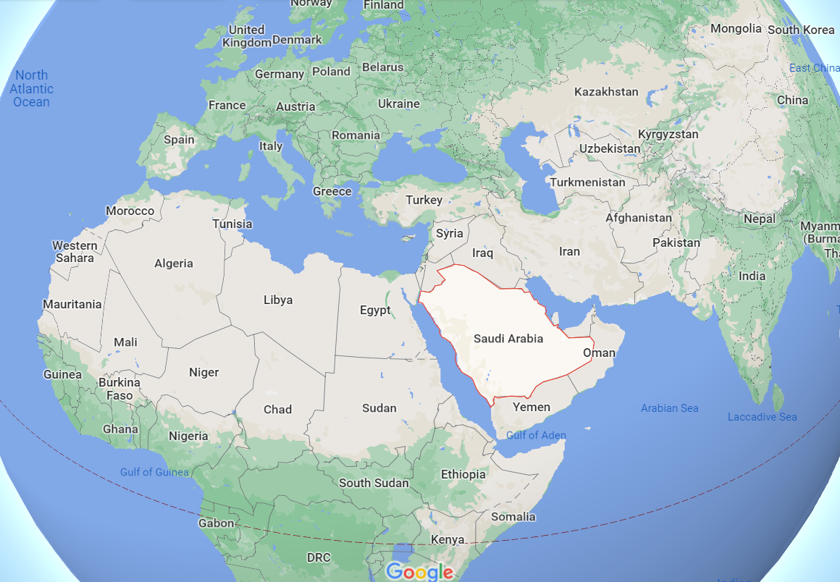
Figure [1]. Saudi Arabia Location (Google, 2022).

This advantageous geography provides many opportunities at political, economic, and cultural levels (General Authority for Statistics, 2022). This position has not been properly taken advantage of for decades; however, the Kingdom recently decided to invest in its geographical location as it announced in 2016 a long-term plan called ‘Saudi Vision 2030’ which includes many projects that focus on investing the Kingdom’s location, large area, and diverse terrain (Habibi, 2019; Saudi Vision 2030, 2019). For more information about Saudi Vision 2030, see section 2.2.3. The area of the Kingdom is more than 2,000,000 square kilometres and it is divided into 13 regions (see Figure 2).
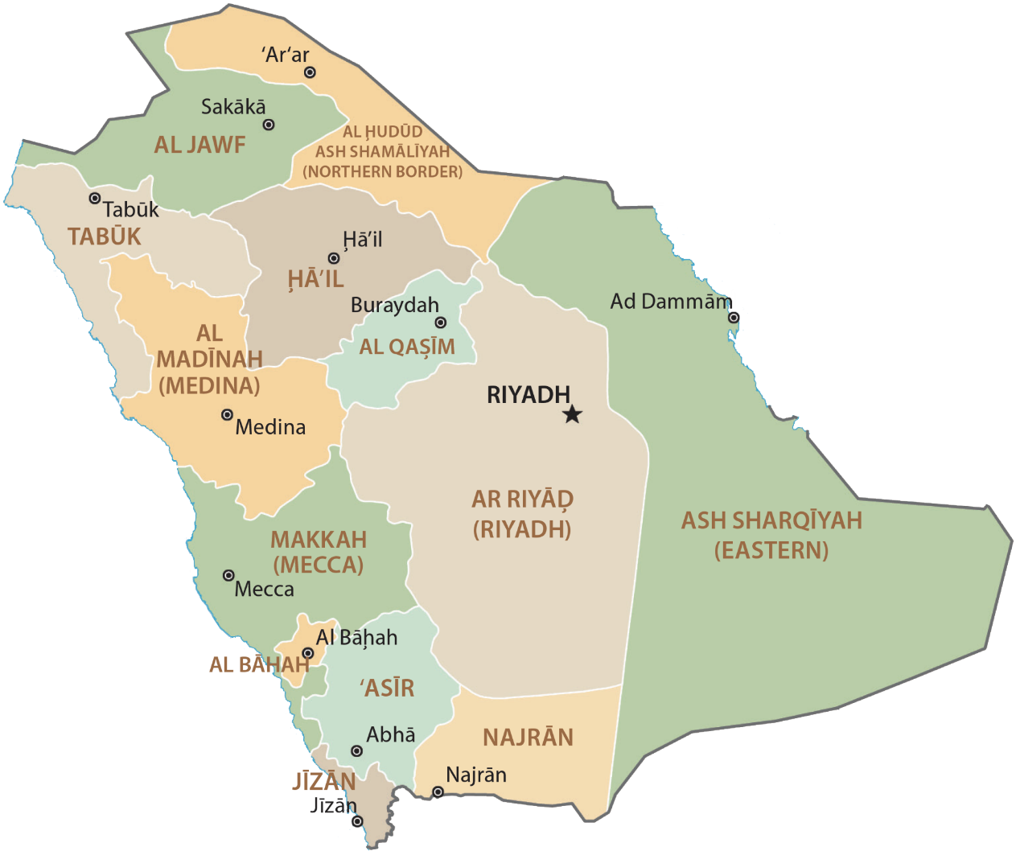
Figure [2]. Saudi Arabia Regions. (GIS Geography, 2022)

Two coasts surround this vast space, one along the Arabian Gulf in the east and the other along the Red Sea in the west. Also, it is surrounded by many Arab countries such as the United Arab Emirates, Qatar, Bahrain, Kuwait, Iraq, Jordan, Yemen, and Oman (General Authority for Statistics, 2022).
According to the Statistical Yearbook of 2018 published by the General Authority for Statistics of the Kingdom of Saudi Arabia (GASTAT), the population of the Kingdom is 34,218,169. Sixty percent of the population (20,768,627) are Saudis. Statistical data also shows that most Saudis are young: 13,921,811, or about 67% of the Saudi population, are under age 35 (General Authority for Statistics, 2018). This issue presents Saudi Arabia with many challenges for schools and universities, who need to accommodate more students as well as provide suitable job opportunities. The number of young, which makes up two-thirds of Saudis, are not only looking for good education, health services, and jobs, but like other young people in this world they have a great interest in sports, entertainment, fun, music festivals, etc. Therefore, Saudi Vision 2030 addresses this issue and comes with a package of entertainment programs (see section 2.2.3).
The system of rule in Saudi Arabia is monarchy, and the current King of Saudi Arabia is King Salman bin Abdulaziz Al Saud who represents the highest authority in the state. Next comes the Crown Prince Mohammed bin Salman Al Saud who is the second authority in the country after the King (Ministry of Foreign Affairs, 2019a). The country is administered according to the Basic Law of Governance issued in 1992. This law is still in force, but amendments have been made according to the requirements of the present era (Ministry of Foreign Affairs, 2019b; Bureau of Experts at the Council of Ministers, 2019a). The king and his crown prince get help in managing the country’s affairs from the Council of Ministers and the Shura Council (Ministry of Foreign Affairs, 2019c; Bureau of Experts at the Council of Ministers, 2019b, 2019c). In 2013 a clause was added in one of the articles of the composition of the Shura Council, which states that the percentage of female members should not be less than 20 of the members of the Shura Council. This amendment is a courageous step by the government towards the inclusion of women in decision-making, as it was not customary for women to hold senior positions in Saudi Arabia (Ministry of Foreign Affairs, 2019c; Bureau of Experts at the Council of Ministers, 2019c).
Saudi Arabia’s economy is heavily dependent on oil. Since the seventy years, when it began to export oil, the economy began to grow and expand, and the state spent more money on education, health, and infrastructure. However, with increased spending, the kingdom needs a good price of oil to maintain welfare and free services such as education and health, energy, and electricity (Filkins, 2018). The Kingdom has recently recognised the importance of transforming its resource-based economy into a knowledge-based economy. Therefore, Riyadh planned for this transformation by diversifying the economy through developing various sectors such as infrastructure, education, health, tourism, and entertainment, as well as increasing spending on research and development and human capital development (Mitchell & Alfuraih, 2018). Hence, the idea of Saudi Vision 2030 comes to diversify the Kingdom’s economy and take advantage of its resources, geographical location, and culture (Filkins, 2018).

2.2 Background Information of Saudi Culture
Since Saudi Arabia is an Arab and Islamic country, the identity of the Saudis has always been greatly influenced by two main factors: the Islamic religion and Arab customs and traditions. However, I would argue that Saudi Vision 2030 will be the third factor that will have a strong impact in reshaping Saudi identity. Therefore, I will discuss these three factors in the following sections.

2.2.1 Citizenship and Islamic Religion
For many Muslim ‘Islam represents their ideological world view, comprising a set of beliefs, practices and values. It includes both religious beliefs and cultural practices necessary for the formation of a cultural identity’ (Ali & Bagley, 2013, p. 22). Therefore, Muslims around the world look at Saudi Arabia as the heart of their religion, where Islam began in the holy cities of Mecca and Medina that contain the two holy mosques. Each year, Muslims come to Saudi Arabia to visit Mecca and Madinah and perform Hajj and Umrah (religious obligations of pilgrimage to the holy city of Makkah; Almutairi et al., 2018). In this regard, Article 24 of the Basic Law of Saudi Governance states that the government must take care of the two holy mosques in Mecca and Madinah and provide services to their visitors from home and abroad to perform Hajj and Umrah (Bureau of Experts at the Council of Ministers, 2019a). The Kingdom of Saudi Arabia is considered as a home to all Muslims, not just Saudis; this imposes constraints on taking decisions by the Saudi government where one decision may affect or irritate the Muslims in any place of the world. Therefore, the responsibility placed on the state is heavy.

In 1744, the Islam played a prominent role when the religious scholar Sheikh Muhammad ibn Abd al-Wahhab and Prince Muhammad ibn Saud allied to establish the first Saudi state (Khoury et al., 1990). In a discussion about the Saudi government and religion, Al-Atawneh (2009) described Saudi Arabia as a state ‘shaped by religion and long-standing religio-cultural norms. It is based on an ongoing compromise between the two major authorities, the existing religious institutions and Saudi monarchy’ (p.733). He argues, through the cooperation of the royal and religious authorities, religious scholars preserved the religious advantage of the state in the social and political sphere, and on the other hand, the king continued to consider the opinions and advice of religious scholars (Al-Atawneh, 2009). Thus, political and religious authorities in Saudi Arabia work together to achieve stability and keep pace with development in a manner that preserves religious and cultural identity.
The authority in Saudi Arabia is derived from the Holy book Quran and the Sunnah of the Prophet Muhammad (Peace be upon him) based on justice and equality in the light of Islamic law. Hence, Islam is the core of Saudi Arabia and affects all political, economic, and cultural aspects of the country (Ministry of Foreign Affairs, 2019b; Bureau of Experts at the Council of Ministers, 2019a). For example, article 8 of the Basic Law of Saudi Governance states ‘that the governance in the Kingdom of Saudi Arabia is based on justice, consultation, and equality, in accordance with Islamic Sharia’ (Bureau of Experts at the Council of Ministers, 2019a, article 8). Also, article 26 states that ‘the state shall protect human rights in accordance with Sharia’ (Bureau of Experts at the Council of Ministers, 2019a, article 26). According to Johnson and Sergie (2014), Sharia is a set of Islamic teachings derived from Holy book Qur'an and the life of the Prophet Muhammad (Peace be upon him). Therefore, the interpretation of justice, equality, and freedom in Saudi society is influenced by Islam. Accordingly, rights, responsibilities, and duties are formed in accordance with this religion.
However, Turner (1990) points out that Islam and Christianity as religions have contributed to the development of citizenship by maintaining a global discourse. For example, in 622, the so-called ‘Constitution of Medina’, was the first written constitution in the Arab and Muslim world. The Medina constitution is a document containing about 53 articles that clarifies some rights and duties that must be adhered to by different group of people in Medina: the Muslims who migrated from Mecca (Muhajirun); the residents of Medina who believed in the Prophet Muhammad (peace be upon him) and welcomed him and the Muhajirun (Ansar); and the tribes of Jews who live in Medina (Arjomand, 2009; Emon, 2001; Lecker, 2004; Serjeant, 1964; Warren & Gilmore, 2012). This written document helped clarify the rights and duties and govern and facilitated life in Medina at that time (Islam, 2018). In addition, Mubarak (2016) indicates that Islam is based on the principle of Shura (consultation), which represents the other face of democracy. Kurzman (1998) believes that democracy and Shura are similar in many aspects: both consider majority rule more effective and accurate than minority rule; both consider that collective deliberations often provide a just and favourable outcome to society; both support the idea that everyone is equal in rights and responsibilities; and both are committed to governing the people through law enforcement rather than authoritarian rule. Moreover, Castelli and Trevathan (2008) argue that Islam through its contribution to students’ moral development and through some principles such as Shura may represent an appeal methodology to support citizenship education. Furthermore, Alharbi (2015) and Islam (2018) indicate that the Holy book Qur'an and the Sunnah of the Prophet Muhammad (Peace be upon him) contain many teachings and principles that may fit into the education of citizenship such as peaceful coexistence, tolerance, and the rejection of racism and discrimination. For example, the Holy Qur'an states that:
O mankind, indeed We have created you from male and female and made you peoples and tribes that you may know one another. Indeed, the most noble of you in the sight of Allah is the most righteous of you. Indeed, Allah is Knowing and Acquainted. (The Qur'an, 49;13).
Another example from the teachings of the Prophet Muhammad (Peace be upon him) is his saying:
O people! Your Lord is one Lord, and you all share the same father. There is no preference for Arabs over non-Arabs, nor for non-Arabs over Arabs. Neither is their preference for white people over black people, nor for black people over white people. Preference is only through righteousness. (Ahmad, 2012, p.420)
Obviously, these examples from Qur'an and the Sunnah contain a call for peaceful coexistence and non-discrimination, whether ethnically, religiously, or culturally (Alharbi, 2015). However, there are some verses in the Qur'an which some may find to be inconsistent with the examples above. For example, ‘O you who have believed, fight those adjacent to you of the disbelievers and let them find in you harshness. And know that Allah is with the righteous’ (The Qur'an, 9;123). Alharbi (2015) indicates that this text, when it is understood in its context, it contains a call from Allah to fight because the Prophet Muhammad and those who believed with him were at a war with the disbelievers and were under attack from enemies. Therefore, Allah in another verse says:
Allah does not forbid you from those who do not fight you because of religion and do not expel you from your homes–from being righteous toward them and acting justly toward them. Indeed, Allah loves those who act justly. (The Qur'an, 60;8).
My aim of presenting these examples is to highlight the challenge of understanding religion and its teachings and how this may influence Saudi attitudes and behaviours whether offline or online. Therefore, what poses a significant challenge to citizenship is not the religious or cultural reference, but the misunderstanding that may cause clashes between different religions and cultures, especially after the privacy space for those religions and cultures narrowed as a result of the spread of technology and social media. For example, Tan (2007) indicates that with the spread of technology and internet chatting, the negative or inflammatory remarks about another religion can spread fast and wide, where ‘individualistic expression of speech can potentially aggravate inter-religious distrust and conflicts’ (p. 4). However, Islam (2018) indicates that Islamic religion is based on the principle of moderation ‘between rights of the individual and consideration for others, between practice and preaching, between the need for peace and the reasons for war, between engagement in this world and perception of the Hereafter…’ (p. 189). Therefore, the challenge here lies in the ability of Saudi education in achieving this balance where the need for peaceful coexistence, tolerance and non-discrimination has become an urgent matter in a multi-religious and multicultural environment such as the online environment.

2.2.2 Citizenship and Arab Culture
In the Arab world, concepts such as citizen and citizenship became more heard in the second decade of the twentieth century in order to confront successive threats to existence and identity, such as Turkish, British, French, and Italian colonialism (Alhashmi, 2019). Although Western colonialism affected the form of citizenship in some Arab and Gulf countries and left its mark on their civil and political systems (Kinninmont, 2013), some cultural paradoxes changed the shape of this citizenship. For example, in Western culture, citizenship originated based on individuality, while citizenship in Arab culture originated based on the support of the tribe in its struggle against others. Also, while the individual in Western, to be a good citizen of his/her city council, should be fair, courageous, and responsible, the individual in the Arabian Peninsula is known only for his/her affiliation to the tribe, and the status of the individual is determined by the status of the tribe and its ancestry (Alhashmi, 2019; Alsawoyan, 2010). In the Western context, the city is a factor of stability for human groups, such that everyone seeks to develop, build, and protect his/her city and the conduct of internal and external matters. In the Arabic context, however, the tribe is the factor of stability for its members, and the leader of the tribe ‘Sheikh’ represents the tribe, so that the value of the tribe and the strength of its existence are measured by the value and strength of its leader. Hence, all members of the tribe seek to protect and care for their leader or what is called ‘Sheikh’ (Alhashmi, 2019). Moreover, in the tribal systems, people do not necessarily acquire their reputation from their work and effort, but rather they inherit it because of their tribal affiliation and the social class into which they are born; thus, this reputation determines their rights and duties towards others (Alsawoyan, 2010).
However, Alhashmi (2019) argues that talking about citizenship is not commensurate with a state based on tribal, ethnic, or sectarian grounds. In contrast, the issue of citizenship cannot be ignored just because the state is based on a tribal system. In the Arabian Peninsula, the tribes are an important social fact, whose existence and influence should not be ignored (Alshawi, 2013). Also, Kymlicka believes that relying on developing loyalty to common principles is not enough, the idea of belonging must be promoted, as history and language play a central role in citizenship education (1997). Therefore, from the perspective of belonging and loyalty in the tribal system, some characteristics of citizenship can be supported. For example, in Saudi Arabia, the tribe is a cultural point of reference for many Saudis. Akers (2001) defines a Saudi tribe as ‘a mental construct based upon descent, maintained through endogamy, with political, social, and symbolic significance’ (p.231). Akers (2001) also describes the relationship between the individual and the tribe as a strong relationship that the identity of the individual merges with the identity of the tribe. This integration also contributes to shaping Saudi identity, as all members of the tribe follow a similar approach in their social life, according to their own customs and traditions. Moreover, Özev (2017) states that tribal traditions and the kinship ties are so strong in the Saudi family, therefore, ‘the dishonorable behaviour of any member of the family or tribe deeply affects all members of the tribe’ (p. 1013).
Tribes and their leaders were ‘the common Saudi political organisation during the first (1744-1822) and second (1823-1891) Saudi states’, and during the third state that king Abdul-Aziz Al Saud re-established in 1902 (Khoury et al., 1990, p. 227). Tribal leaders and the ruler of the state succeeded in maintaining the independence of the various segments of the tribes, as well as alliance and cooperation under a unified leadership. Also, the tribes provided a form of support to the state and played a critical role in the formation of the state institutions and maintained a sense of safety and familiarity during a period of social and economic change (Khoury et al., 1990). Khoury et al. (1990) argue that tribes compensated for the absence of political parties in the state, however, they did not replace state institutions, but rather modified them to become familiar and adaptable. For example, tribal leaders helped form a link between the citizens and the state institutions as they contributed to convey the individuals’ voices and express their needs in a manner similar to the work of parties’ representatives (Khoury et al., 1990). Saad Alsawoyan, a leading Saudi anthropologist, argues that the tribes in Arab societies in terms of organisational and political practices may be the most efficient component to play the role of political parties and absorb the democratic process, nomination, and election processes. However, despite the end of the conflict between the tribe and the state in the present era, the tribe has not completely lost its role, but rather has turned into something like civil institutions in the modern state (Alsawoyan, 2010). Moreover, the tribes influenced other groups in the state to recreate and reform identities based on ties of descent, profession, or even mythical genealogy to form new tribal or semi-tribal identities (Khoury et al., 1990).
However, Maisel (2014) indicates that the term tribal nowadays refers to a special code of behaviour or a way of behaving more than a certain lifestyle or a way of living. It is ‘a type of behavior that is based on shared values and customs’ (Maisel, 2015, p. 5). Maisel (2014) also indicates that with technological development and the impact of globalisation, tribal members ‘‘have simultaneously boosted the ‘old ways’ and pushed them into modernity’’ (p. 119). For example, some tribal members use car plates that refer to their tribes, as it became known that the car plate number 555 indicated that its owner is Shammari, 511 Otaibi, 501 Anzi, and 305 Mutairi. Also, with the spread of the internet, the tribes have strengthened their presence in the online environment by creating tribal forums ‘al-muntadayat’ such as Shammar forum, Anza forum and Mutair forum. These forums provide an opportunity for tribal members to communicate with each other inside and outside Saudi Arabia as well as allow them to conduct some discussions and learn about their history, heritage, and customs (Maisel, 2014).
Obviously, the Arab tribes and traditions in Saudi Arabia play an essential role in shaping the identity of the Saudis and thus determining their priorities, attitudes, and behaviours whether offline or online. However, Xiaochun (2016) argues that digital technologies provide a good chance to bridge the gap between different cultures where it leads to ‘a profound impact on the society and on individual people’s values, lifestyles, and social structure—everything is changing’ (p. 264). Personally, I believe that digital technology represents an opportunity for those who are not satisfied with their current situation and want to make changes, while it is a problem or a challenge for those who see these changes as a threat to their religion, culture, or customs. Therefore, the same challenge that arose in the previous section arises here; what is the ability of Saudi education in achieving a balance between preserving Saudi customs and traditions and showing acceptance and tolerance for different cultures, especially in multi-cultural environments such as the digital world?

2.2.3 Citizenship and Saudi Vision 2030
In 2016, Saudi Arabia announced a long-term plan called ‘Saudi Vision 2030’, which carries a package of national transformation programs in the field of culture, economy, and social institutions to elevate Saudi Arabia to the ranks of developed countries in all aspects (Saudi Vision 2030, 2019; Habibi, 2019). Saudi Arabia’s vision has three themes: Vibrant society (preserving its roots and fulfilling its future life); Thriving economy (open for business, geo-location investment, long-term investment); and Ambitious nation (responsibly enabled and effectively administered) (Saudi Vision 2030, 2019). In order to achieve the vision, the government has taken serious steps over the past three years. For example, as part of the National Transformation Program, the government established the National Committee for National Transformation, which is responsible for formulating policies and strategies related to digital transformation at the level of public agencies (National Digital Transformation Unit, 2021). Absher platform represents the most prominent example of the digital transformation process, as it provides all government services to the institutions, companies, citizens, and residents in a safe and smooth manner (Absher, 2021). Another example of the digital transformation can be seen in the way the country deals with the COVID-19, where three electronic applications (Tetamman, Tabaud & Tawakkalna) were launched by the government to curb the COVID-19 pandemic (Hidayat-ur-Rehman et al., 2021). Also, during the shutdown of educational institutions, five electronic platforms (Future Gate, IEN National e-portal, IEN TV Channels, Unified Education System (Vschool), and Virtual Kindergarten) were available to help Saudi educational institutions, teachers, and students to continue the education process remotely (Ministry of Education, 2020g; UNESCO, 2021a).
Moreover, regarding the entertainment industry, the government established an authority called the General Entertainment Authority (GEA), and since 2019, GEA has organised several world-class music festivals, concerts, and sporting events. Also, it supported the establishment and opening of cinemas (Grand & Wolff, 2020; Habibi, 2019). The government is also working on a project called ‘Qiddiya’. This project, southwest of the capital Riyadh, covers an area of 340 square kilometres. Qiddiya will be a cultural, recreational, and tourist area that will include parks, shopping centres, sports centres, festivals, and concert halls. The project aims to be an attractive destination to spend holidays in Saudi Arabia. It also aims to attract capital from abroad to promote and diversify the economy (Saudi Vision 2030, 2019; Habibi, 2019).
Neom City is also another project that Saudi Arabia is working on under Saudi Vision 2030. Neom is in the northwestern part of the Red Sea coast, and it will be a future of bioscience and digital technology with models of innovative and intelligent construction, sustainability programs and renewable energy (Aly, 2019; Habibi, 2019). Neom will cover about 26,000 square kilometres and it will be transnational in Saudi Arabia as it will be connected by land to Egypt and Jordan (Aly, 2019). According to a July 31, 2018, online article on Sabq (a well-known Saudi news site), King Salman that year spent his vacation in Neom—a clear message from the king to support local tourism even though the Neom project is still under construction (Sabq, 2018). Furthermore, to promote transparency, fight corruption, and control unnecessary waste and spending in the state budget, the government arrested 250 Saudis in corruption cases, including princes and other businessmen. About $100 billion has been recovered from illicit transactions in the anti-corruption effort (Cochran, 2019). This action surprised the Saudis, as they were not used to seeing people of high standing in a position of accountability. However, the king and his crown prince sent a clear signal that all those involved in corruption will be held legally accountable.
Furthermore, under the Saudi Vision 2030, the nationalist ideology of the country has shifted from a conservative religious nationalism to moderate Islam nationalism (Chulov, 2017; Eum, 2019). Therefore, the government is trying to change the stereotype of the country by hosting international festivals, events, and sports such as the Dakar Rally and Formula One. Kobierecki and Strożek (2021) argue ‘that hosting sports mega-events increases the international visibility and familiarity of the host country’ (p. 66). Personally, I agree with this argument, and I also argue that hosting festivals, concerts, and sports events can lead to many changes on the level of local culture. For example, Derbal (2020) argues that hosting dance music festivals “is instrumental in reorienting the representation of Saudi youth in particular, as modern, cosmopolitan, globalized, fun, in short as ‘normal’ youth” (para. 4). However, some people may consider such these festivals and concerts a chance to challenge the prevailing Saudi customs and traditions, which may ‘take the form of outward disobedience towards security personal, sexual harassment and vandalism’ (Derbal, 2020, para. 5). Therefore, the challenge lies in the ability of Saudi education to keep pace with Saudi Vision 2030, which adopt the moderate Islam that may achieve a balance between conservative religion and culture in Saudi Arabia, and other religions and cultures around the world.

2.3 Education System in Saudi Arabia
This Section will discuss Saudi education in general and will focus on the intermediate stage and CIT textbooks. Saudi Arabia’s emphasis on education has accompanied the development of the Kingdom since 1926, when the Directorate of Knowledge was established (Ministry of Education, 2021a). After the establishment of the Directorate of Knowledge, education began to expand and spread throughout Saudi Arabia, so the country needed more than a directorate to cope with the rapid spread of education in the State. The Ministry of Knowledge was therefore established in 1952 (Ministry of Education, 2021a). Today, the Ministry of Education (formerly known as the Ministry of Knowledge before it was renamed in 2003) is the official authority responsible for education at all levels in Saudi Arabia.
Saudi education consists of five levels: Early Childhood, for children who are under 6 years old, and it includes nurseries and pre-school; Elementary (primary), for students who their ages between 6 and 11 years old, and it consists of 6 grades; Intermediate (middle), for students who their ages between 12 and 15 years old, and it consists of 3 grades; Secondary, for students who their ages between 16 and 19 years old, and it consists of 3 grades; and Higher Education, for students who have successfully completed secondary level, and it includes all types of post-secondary study such as diploma, bachelor’s, master’s and doctoral degrees (Ministry of Education, 2021a, Ministry of Education, 2021b; Unified National Platform, 2021). In all these levels except early childhood, males and females are taught in separate schools. Also, in all these levels, the academic year was divided into two semesters, and each semester consisted of 18 weeks. However, after May 2021, the Ministry of Education announced a development plan, so that the academic year is divided into three semesters, and each semester consisted of 13 weeks (Ministry of Education, 2021c).
According to the education and training survey published by the General Authority for Statistics in Saudi Arabia in 2017, the percentage of people who can read and write is 99% for those aged 15 to 24 years old, while the percentage drops slightly to 95% for those aged 15 years and over. Also, Saudis enrolled in formal education from ages 3 to 24 represent about 43% of the population of the Kingdom (see Figure 3 for more indicators).
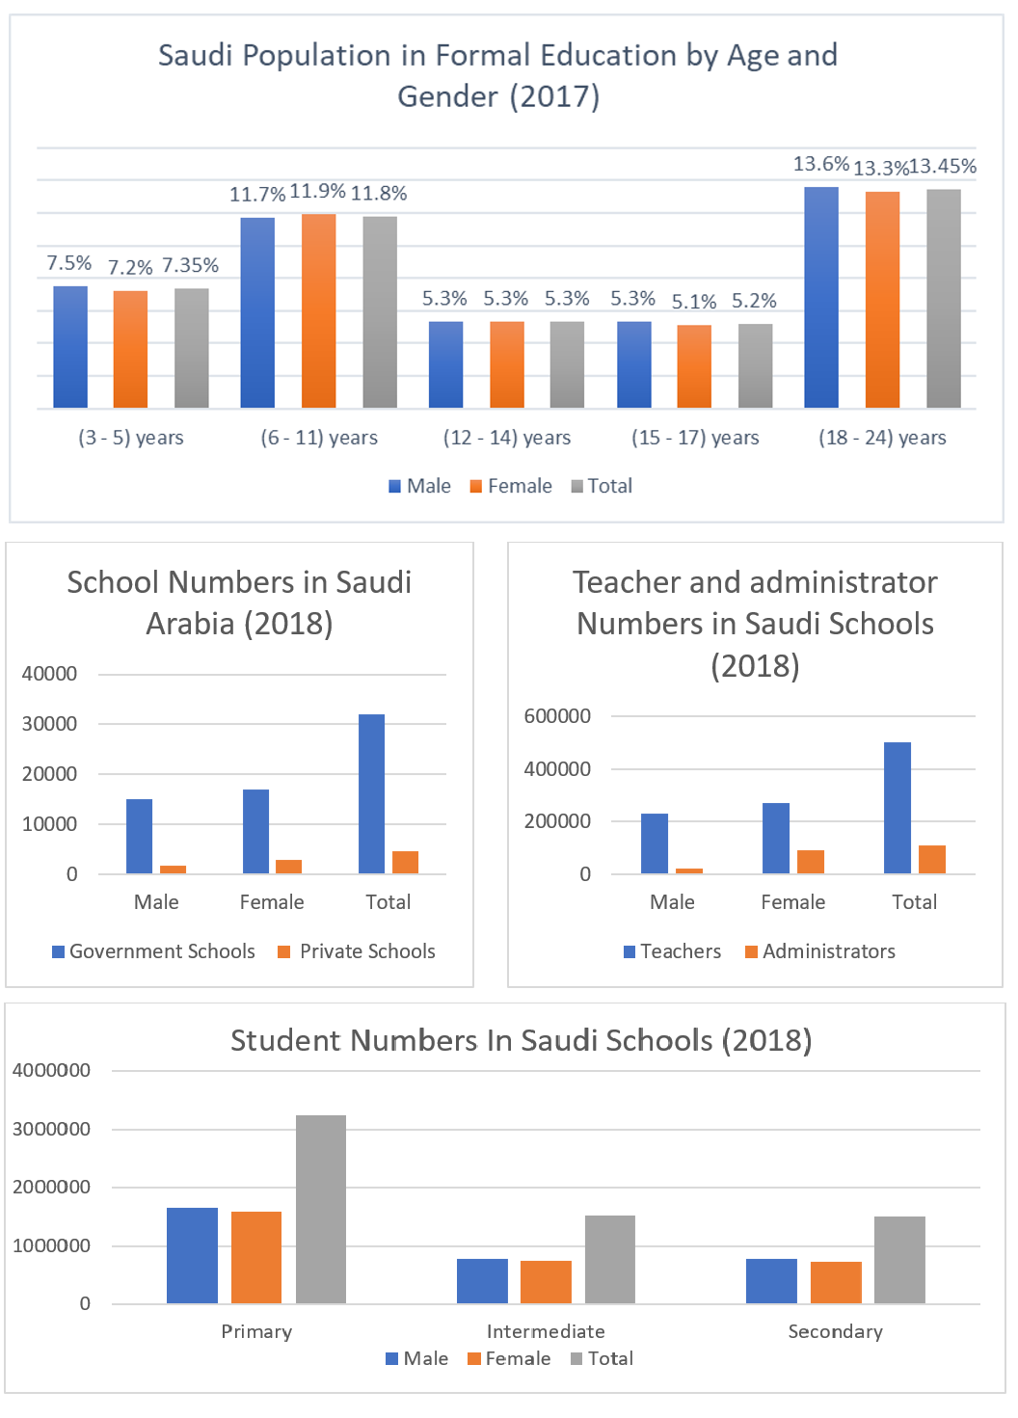
Figure [3]. Important indicators of Saudi Education. (General Authority for Statistics, 2018).
Figure 3 shows that almost half of the Saudi population (43%) are students under the age of 24—a significant percentage despite the number in postgraduate studies and over age 24. Figure 3 also reveals the considerable number of schools, teachers, and administrators distributed across the vast country, which poses further challenges for the Ministry of Education. These statistics support the large budget allocation by the state for education. Saudi Arabia allocates about one fifth of the State budget to the Ministry of Education, which amounted to approximately $51,292,422,011 in 2018 (General Authority for Statistics, 2018). Moreover, Figure 3 shows that education access and opportunities are available to both males and females as the number of schools, students and teachers is almost similar for both males and females. However, the Saudi government formally began educating girls in 1960, when the government opened 15 primary schools for women (Alsharari et al., 2019). Today, the number of female schools (16917 government schools and 2965 private schools) is greater than the number of male schools (15110 government schools and 1701 private schools). 7588 of these schools represent government intermediate schools while 1003 represent private intermediate schools (General Authority for Statistics, 2018).
The general policy of education in Saudi Arabia emphasises in many of its articles on the societal reference derived from Islamic religion and heritage, as well as the Arabic language, customs, and traditions. For example, the 28 article of this policy indicates that the purpose of education in Saudi Arabia is ‘to understand Islam in a correct and integrated way, to inculcate and spread the Islamic faith, and to provide the students with Islamic values and teachings’ (Al-Minqash, 2006, p. 413). Also, article 24 indicates that the Arabic language is the primary language of instruction in all curricula and at all levels (Al-Minqash, 2006). Moreover, the third chapter of the education policy in Saudi Arabia states that intermediate (middle) stage is ‘a general educational stage, aims to raising the student with a comprehensive Islamic education for his/her faith, mind, body and character, considering the stages of growth’ (Hakeem, 2012, p. 243).
The intermediate stage includes three grades: the first intermediate grade (grade 7); the second intermediate grade (grade 8); and the third intermediate grade (grade 9). The intermediate stage includes different curricula which are taught through different weekly lessons (each lesson is about 45 minutes). In each grade of intermediate schools there are: nine weekly lessons for religious curricula; six weekly lessons for Arabic language; five weekly lessons for mathematics; four weekly lessons for science; three weekly lessons for social and national curricula; two weekly lessons for artistic and professional curricula; and one weekly lesson for computer and information technology (CIT); and one weekly lesson for physical education. It is worth mentioning that the development plan that was announced by the Ministry of Education in May 2021, included many changes and improvements. For example, the computer and information technology curricula were developed and renamed to ‘Digital Skills’, and the number of weekly lessons allocated to them was increased to two lessons for each grade. Also, the digital skills curricula have been added in the primary stage to be taught with one weekly lesson for the fifth and sixth grades (Ministry of Education, 2021c).
However, before May 2021 (when the data of this study was collected), the intermediate school was the first educational stage in which students formally learned something about computers and technology. In all Saudi intermediate schools, there was one curriculum called ‘computer and information technology’ and it was taught through six textbooks. Each grade in intermediate school had two textbooks: one for the first semester and one for the second semester (see section 4.7.3 for more information about the CIT textbooks). Also, before that date (May 2021), the IEN National Education Portal of the Ministry of Education in Saudi Arabia shows that primary and early education had no curriculum on digital technology (IEN National Education Portal, 2019). This means that students spent 6 years in primary school without learning anything about technology or computers. Therefore, the computer and information technology curricula in Saudi intermediate schools play a pivotal role in preparing Saudi digital citizens and providing them with necessary digital knowledge and skills, especially since previous studies (see section 3.7.1) reveal that other school curricula in Saudi Arabia fail to address digital citizenship topics, which makes the CIT curricula take most of the responsibility in this regard.
Therefore, considering the benefits and risks of digital technology, the strong tendency towards Islamic religion and conservative Arab culture, and the Saudi Vision 2030 which adopts a more moderate ideology, it can be said that the CIT curricula in Saudi intermediate schools stand alone in achieving the balance that was discussed in the previous sections.

Summary of the Chapter
This chapter explains and discusses the context in which this study was conducted. It provides an overview of Saudi Arabia and its education system, highlighting the most prominent influences on Saudi citizenship, such as the Islamic religion, Arab culture, and Saudi Vision 2030. On the one hand, Islamic religion represents the spirit of Saudi Arabia and plays an essential role in shaping the Saudi identity in addition to the Arab culture and customs and traditions of the tribes. On the other hand, Saudi Vision 2030 comes with a set of reform programs that target the economy, politics, education, culture, and lifestyle, and thus it represents a turning point in the form of Saudi citizenship. Overall, Saudi Arabia’s commitment to keeping pace with digital and technical developments is evident from the program package that accompanied the announcement of Vision 2030. Thus far the country has not taken practical steps in preparing citizens to deal with the vision projected for 2030. The disparity between what Saudi Arabia aspires to be in 2030 and what can be achieved in reality is an important point that should not be overlooked. The link between reality and hope should not remain on paper but must be translated into practical steps within a time series that leads to the desired goals. Education in Saudi Arabia needs rapid change to keep pace with recent developments in Saudi Arabia. curricula need to be consistent with the desired goal of the Saudi vision of modernity, development, and diversity.

Chapter 3. Literature Review

Introduction
The primary purpose of this research is to achieve an in-depth understanding of digital citizenship and its topics within the Saudi context. Therefore, my literature review focuses on three areas. First, understanding the concept of digital citizenship by discussing this concept in its traditional form and then tracing its evolution to its digital form. Second, understanding the topics of digital citizenship and the dimensions and strategies of its education by reviewing six frameworks concerned with digital citizenship, which are selected for specific reasons. Finally, understanding digital citizenship education and its challenges in the Arab and Saudi context by reviewing the latest studies that explore the inclusion of digital citizenship topics in curricula, and the studies that explore the perspectives of students, teachers, or school principals in that context. As such, this chapter addresses the following sections sequentially: the citizenship concept; the digital citizenship concept; digital citizenship education; digital citizenship frameworks; digital citizenship topics; digital literacy; digital protection; digital law; digital footprint, digital creativity and innovation; teaching dimensions and approaches; previous studies in digital citizenship education; integrating digital citizenship in school curricula; and perceptions and experiences of digital citizenship.

3.4 Digital Citizenship Frameworks
There are many models and frameworks concerned with digital citizenship education and it is difficult to define a specific framework as the most appropriate for digital citizenship education. Therefore, considering my research purpose of achieving a deep understanding of digital citizenship topics, I reviewed six frameworks which are: Common Sense Media framework (James et al., 2019); Digital Intelligence (DQ) framework (Park, 2019); Digital Kids Asia-Pacific (DKAP) framework (Shin et al., 2019); European Digital Competence framework ‘DigComp 2.2’ (Vuorikari et al., 2022); ISTE standards (ISTE, 2017); and Ribble’s model (Ribble, 2015). I chose these frameworks to be the basis of my analysis of CIT textbooks for different reasons. DKAP and DQ frameworks were identified because they were built based on other frameworks for digital literacy, digital resilience, media literacy, and computer and information literacy. DKAP framework was developed from reviewing 11 frameworks (Shin et al., 2019) while DQ framework was developed from reviewing 25 frameworks (Park, 2019). Therefore, they represent an international scope and include most of the topics of digital citizenship education, and this is consistent with the research purpose of achieving a deep understanding of digital citizenship and covering a wide range of its topics. On the other hand, Common Sense Media framework, DigComp 2.2 framework, ISTE standards, and Ribble’s model were identified because they include not only classifications of digital citizenship topics, but also illustrative steps, practical examples, and guidance for teaching these topics (see section 3.6). However, these frameworks also have some features that encouraged me to select them which will be revealed through exploring these frameworks from earliest to recent in the following paragraphs.
International Society for Technology Education (ISTE) is one of the leading non-profit organisations concerned with technology education and empowering learners (from 4 to 18 years old) in a connected world (ISTE, 2017). When ISTE standards for students were introduced in 1998, the focus was on teaching students how to use technology, while later when these standards were revised in 2007, the focus became on how to use technology for learning, creativity, and innovation. However, learning about the technology itself or learning how to use technology in the learning process remain the focus of ISTE standards in its latest 2016 edition (ISTE, 2017). Therefore, it was important to include these standards in my review because they have strong relevance to the CIT textbooks that will be analysed in this study. However, ISTE standards for students consist of 28 standards important for dealing with technology and employing it competently. These standards are organised into seven areas: ‘empowered learner; digital citizen; knowledge constructor; innovative designer; computational thinker; creative communicator; and global collaborator’ (ISTE, 2017, p. 3).
Mike Ribble is one of the most influential scholars in the field of digital citizenship education and has made significant contributions (Ribble et al., 2004; Ribble, 2008, 2012, 2015). Ribble’s model represents the backbone of digital citizenship since it was presented by Ribble, Bailey, and Ross (Chen et al., 2021). Therefore, it has become a common model used in many studies exploring digital citizenship in the Arab countries in general and Saudi Arabia in particular (Abdelhad, 2020; Abu-Omar & Jwaifell, 2018; Al-Ghamdi & Al-Saadoun, 2021; Al-Hanaki, 2020; Al-Harthy & Al-Mutairi, 2019; Aloufi & Alzahrani, 2021; Al-Rasasimah, 2021; Alshakrah & Alzahrani, 2020; Alsuhaim & Albrahim, 2019; Ibrahim, 2019; Maharos, 2018; Najmuldeen, 2021; Shahin, 2021). However, Ribble divides digital citizenship into nine elements: ‘digital access; digital commerce; digital communication; digital literacy; digital etiquette; digital law; digital rights and responsibilities; and digital security’ (Ribble, 2015, pp. 16-17). Ribble believes that all students should know these nine elements, which he outlined in his well-known book Digital citizenship in schools: Nine elements all students should know, which contains a detailed explanation of how these nine elements are presented in the educational process through a set of procedures and scenarios (see section 3.6).
Common Sense is also one of the leading non-profit organisations in the field of technology education and increasing digital awareness. It offers many free programmes and curricula in this area, as well as advice to teachers and parents on digital citizenship (Common Sense Media, 2019). Common Sense also provides a digital citizenship curriculum for 76% of all public schools in the United States (Gleason & Von Gillern, 2018). In 2010, Common Sense launched the first comprehensive digital citizenship curriculum which was called ‘Digital Literacy and Citizenship Curriculum’, while the recent version of this curriculum was launched in 2019 and it is called ‘Digital Citizenship Curriculum’ (James et al., 2021, p. 5). Common Sense curriculum consists of six themes: ‘media balance and well-being; privacy and security; digital footprint and identity; relationships and communication; cyberbullying, digital drama, and hate speech; and news and media literacy’ (James et al., 2021, p. 14).
DigComp framework was developed by the European Commission to improve the digital competence of European citizens. The earliest version of this framework was launched in 2013 while the recent version ‘DigComp 2.2’ was launched in 2022 (Vuorikari et al., 2022). DigComp 2.2 includes 21 digital competencies spread over five main themes: ‘information and data literacy; communication and collaboration; digital content creation; safety; and problem solving’ (Vuorikari et al., 2022, p. 4). DigComp can be described as a ‘reference for the development and planning of digital competence initiatives both at European and Member State level’ (Nascimbeni & Vosloo, 2019, p. 17). Also, it is an adaptable framework as it can be used in different levels of proficiency (foundation, intermediate, advanced) and in different contexts such as school and work (Vuorikari et al., 2022). However, more information on the strategies by which this framework can be adapted and implemented will be provided in section 3.6.
Digital Intelligence (DQ) framework was developed to create a unified global framework for digital literacy, skills, and readiness, and thus, it was created by reviewing relevant 25 frameworks from different countries such as Australia, Bangkok, Brussels, Canada, France, Netherlands, Singapore, Switzerland, United Kingdom, and United States of America (Park, 2019). Therefore, this framework includes a wide and different range of topics, which helps to gain a comprehensive understanding of the most prominent digital issues related to digital citizenship. DQ framework includes 24 competencies divided into eight main themes: ‘digital identity, digital use, digital safety, digital security, digital emotional intelligence, digital communication, digital literacy, and digital rights’ (Park, 2019, p. 14). Unlike the DigComp 2.2, DQ framework does not include clear examples of how these competencies can be presented at different educational levels, however, it provides guidance on what these competencies mean in different aspects such as knowledge, skills, and attitudes (Park, 2019).
Similarly, Digital Kids Asia-Pacific (DKAP) framework can be presented as another global framework as it was developed from reviewing 11 frameworks concerned with digital citizenship and digital skills. DKAP framework includes 16 competencies presented in five domains: ‘digital literacy; digital safety and resilience; digital participation and agency; digital emotional intelligence; and digital creativity and innovation’ (Shin et al., 2019, pp. 9-10). However, although the DKAP framework was developed from frameworks, most of which were reviewed in the DQ framework, this was not a reason not to include this framework in my review, on the contrary, I believe that the inclusion of DKAP framework will allow further revision and review of digital citizenship topics. Thus, a more comprehensive summary can be obtained.
Overall, these six selected frameworks have some similarities and some differences, whether in the naming and classification of digital citizenship topics or in the way these topics are addressed and presented. For example, Mattson (2016) in his critical discourse analysis concludes that Ribble’s digital citizenship curriculum attempts to ‘reinforce traditional offline values through a focus on personal responsibility with regard to technology use’ (p. 191). In contrast, the diversity and multiplicity of the topics covered by the Common-Sense curriculum seem to be incompatible with the traditional citizenship. In addition, Shmatkov (2021) investigates the intellectual property rights in DigComp 2.1 framework and finds that unlike DQ framework, DigComp 2.1 ‘does not address the allocation of intellectual property rights to created objects’ or ‘the ability to understand and manage intellectual property rights (e.g., copyrights, trademarks, and patents)’ (p. 3). However, it is worth mentioning that the recent version ‘DigComp 2.2’ addresses this issue and covers copyrights, trademarks, and patents (Vuorikari et al., 2022). Moreover, some frameworks such as common sense and DQ focus more on safe digital use while some frameworks such as DigComp focus on effective use and participation in society (Shin et al., 2019).
Similarly, my review of these frameworks reveals that there is some slight variation in these frameworks, as mentioned above, but they often revolve around five areas (literacy, protection, Law, footprint, and creativity and innovation) as well as three dimensions (knowledge, skills, attitudes). In my review, I used a table to category the competencies and standards of these six frameworks (see Table 1).

Frameworks and Model | Digital  Literacy | Digital  Protection | Digital  Law | Digital  Footprint | Digital Creativity and Innovation
Ribble’s Model  (Ribble, 2015, pp. 18-41) | - Using Browsers  - Search engines  - Download engines  - Email  - Evaluating online  Resources  - Online learning and distance education | - Proper ergonomics  - Avoiding injuries  - Addiction to the Internet or games  - withdrawing from society  - Sexting and illicit photos  - Personal, school, and community security:  identity theft,  phishing,  hackers,  viruses, and  terrorist threats | - Equitable access  students with special needs  -Using file-sharing sites  -Pirating software  - Rights Management  -Hacking into systems  -Stealing identity  - Acceptable use policies  - plagiarism and copyrights  - Reporting inappropriate use. | - Minimising the negative effects on others.  -Respecting others online  - Avoiding flaming and inflammatory language  -Email and Cell phones  -Personal video calls  -Instant and text messaging  -Blogs and Wikis  -Social networking  -Online buying and selling  -Media subscriptions and purchases
Common Sense’s Framework  (James et al., 2021, pp.28-52). | - Defining and analysing media  -Understanding photo manipulation  - Using effective search strategies  - Analysing information  - Understanding misinformation and disinformation  - Close reading and lateral reading.  - Seeking facts and evidence | - Understanding addictive design and its impact  - Digital impact on health and well-being  - Balancing media in life  - Understanding the risks of sharing data and information  - Understanding the benefits of safe sharing.  - Understanding mean behaviour and cyberbullying and their impact on feeling. | - Taking the responsibility of Sharing  - Advocating for privacy rights.  -Understanding copyright and fair use  - Knowing what to do in cyberbullying situation  - Supporting those who are bullied  - combating online cruelty  - building positive and supportive communities | - Sharing private and non-private information  - Exploring the effects of digital expressions on the sense of self, reputation, and relationships.  - Considering the effects of personal, moral, and ethical issues on online identities.  - Understanding the impact of digital media in relationships  - Considering how audiences perspectives and preventing miscommunication  - Adapting civil dialogue to different audiences.
DigComp2.2 Framework  (Vuorikari et al., 2022, pp. 9-49) | - Exploring search strategies and articulating information needs  - Searching and navigating data, information, and digital content  - Analysing and evaluating the credibility and reliability  - Organising and storing, and processing data and information, and digital content. | - Understanding digital risks and threats  - Knowing safety and security measures.  - Understanding personal information safety  -Protecting devices  - Avoiding digital risks and threats to both physical and psychological health  - Understanding the impact of using digital technologies on the environment | -Understanding the rights and responsibilities regarding copyrights and licences of digital content. | - Understanding appropriate digital communication tools for a specific context.  - Interacting through different digital technologies and means  - Sharing different types of digital content through appropriate digital technologies.  - Participating in society through different digital services.  - Collaborating with others through different digital technologies  - Understanding behavioural norms and communication strategies to the specific audience  - Understanding generational and cultural diversity in online environments.  - Creating and manage digital identities and reputation | -Creating and editing digital content and expressing oneself through digital technology.  -Modifying and integrating information and content to create new or relevant content and knowledge.  -Identifying technical problems and providing understandable instructions to solve them.  -Identifying technical needs and selecting and using digital tools to address them.  -Innovating processes and products by using digital tools and technologies  - Seeking opportunities for self-development and supporting digital development of others
ISTE Standards for Students  (ISTE, 2017, pp. 4-5) | - Building networks and customising learning environments to support the learning process.  - Using technology to seek feedback and demonstrate learning.  - Understanding basic concepts of technology  - Exploring current technologies and transferring knowledge to explore emerging technologies  - Employing effective research strategies.  - Evaluating the accuracy and credibility of information and media. | - Managing personal data and information  - Maintaining digital privacy and security  - Understanding tracking technology used to collect users’ data | - Engaging in legal and ethical behaviour when using technology  - Interacting legally and ethically when using social networks  - Understanding and respecting the intellectual property the copyrights | - Managing digital identity and reputation and realising the permanence of actions in online environment  - Connecting and engaging with a variety of backgrounds and cultures to broaden mutual understanding and learning.  - Working with others to examine and address local and global issues from multiple viewpoints.  - Working effectively with others toward a common goal by using technology | - Creating or demonstrating original works and meaningful conclusions.  - Using technology to build knowledge, develop ideas, or solving problems.  - Formulating problems by using technology tools to facilitate problem-solving and decision-making.  - Use digital tools to collect, analyse, and represent data in various ways  - Communicating complex ideas by creating or using digital objects such as models or simulations.  - publishing or presenting customising content or message for intended audiences.
Digital Intelligence (DQ) Framework (Park, 2019, pp. 16-17) | - Knowing how to search and evaluate media and information  - Knowing how to organise and analyse media and information | - Understanding the technology impact on mental and physical health  - Prioritising health and well-being when using technology  -Balancing both online and offline life and managing screen time.  - Identifying, mitigating, and managing cyber-risks related to personal online behaviours.  - Detecting cyber threats against personal data and device  - Understanding and Using security strategies and protection tools.  - considering safe sharing of personal data and information  - Using and implementing cyber security defences and strategies. | - Identifying, mitigating, and managing harmful content (racist/hateful content, image-based abuse).  - Understanding and managing intellectual property rights when using and creating content and technology.  - Understanding and exercising one’s powers and right to online participation (such as privacy rights and freedom of expression) | - Understanding digital footprints and their real-life consequences  - Building and managing a digital identity with integrity and a positive digital reputation.  - Being sensitive and supportive other’s feelings, needs and concerns online.  - Communicating effectively and collaborating collectively by using technology  - Engaging in local, national, and global civic participation for the well-being and growth of communities  - Communicating effectively with the audience to exchange ideas, messages, or opinions.  - Identifying and managing commercial cyber-risks online, such as embedded marketing, online propaganda, or gambling | - Being a co-creator of the digital ecosystem or a competent changemaker in the digital economy.  - Creating and producing information, media, and technology innovatively and creatively  - Generating, analysing, processing, and presenting meaningful information from data.  - Developing, using, and applying artificial intelligence (AI)  - Using algorithmic tools and strategies in order to guide informed and optimised decision-making processes.
Digital Kids Asia-Pacific (DKAP) Framework  (Shin et al., 2019, pp. 9-10) | - Managing and operating ICT hardware and software responsibly  - Using technology to access, search, and utilize data, information, and content.  - Seeking and critically evaluating digital information to make informed decisions. | - Identifying and managing health risks  - Using digital technology in protecting and improving physical and psychological well-being.  - Considering safe sharing of personal identifiable information and avoiding harm.  - Implementing strategies for personal security and for information and device security | - Understand legal rights and responsibilities within the local and global context.  - Demonstrating ethical and courteous behaviour in different digital environments and with diverse audiences. | - Interacting and sharing data and information, and collaborating using suitable digital technologies  - Recognising and seeking out opportunities to positively influence local and global communities  - Understanding the impact of moods, emotions, and drives on oneself and others  - Managing emotions and moods during online engagements.  - Building positive online trust and rapport and embrace diversity and manage conflicts  - Demonstrating awareness and compassion for the feelings and needs | - Applying digital skills and using digital tools to create and adapt digital content.  - Using technology to represent or creatively express oneself and identity
Table [1]. Summary of the frameworks of digital citizenship.

I noticed that there is some overlap in digital citizenship topics as one issue can be addressed in different ways. For example, cyberbullying can be presented within digital literacy topics (What does cyberbullying mean and what does it look like?); digital protection topics (How do students protect themselves from cyberbullying or how do they avoid cyberbullying situations?); digital law topics (what are rights and responsibilities of those who are involved in cyberbullying situations?); or even as a creativity and innovation topic (How to develop strategies, tools, or software that help identify and report forms of cyberbullying?). Another challenge faced me when I reviewed these frameworks is that each topic or issue can be presented in different dimensions. For example, to know and understand the behavioural cyber-risks such as cyberbullying (knowledge), to be able to address and manage cyberbullying situations (skills), or to show empathy and kindness to those who are being bullied online (attitudes). However, it is worth noting that the purpose of my review is not to evaluate these frameworks or come up with a new one, but to identify the main topics or areas that represent the umbrella under which the sub-topics of digital citizenship fall. Further detail on digital citizenship topics and their teaching dimensions will be discussed in the next sections.

3.1 The Citizenship Concept
It is not easy to arrive at a single definition of citizenship, as this concept has economic, political, and cultural aspects which lead to the branching of its meaning (Lister, 2003). However, the roots of citizenship are found in Greek and Roman civilization, beginning with the cities of Athens and Sparta (Riesenberg, 1994). Since then, citizenship has been affected by many historical events that have left their mark on its theory and practice, such as the Renaissance, the Enlightenment, and the French Revolution.
Thomas Humphrey Marshall, a well-known English sociologist on the subject, defines citizenship as ‘a status bestowed on those who are full members of a community’ where they ‘are equal with respect to the rights and duties with which the status is endowed’ (1950, p. 14). Despite the widespread influence of Marshall’s theory in the literature on citizenship, this theory has been criticised. The first criticism is that Marshall’s theory focused on the British case, whereas formulating a general theory of citizenship requires a comparative historical perspective. A bona fide historical analysis of citizenship should not only focus on the Western—i.e., Greek and Roman—legacy, but should be broader in scope, in order to understand the patterns that make up citizenship across cultures (Mann,1987; Turner,1990). The second criticism of Marshall’s theory is that he considers citizenship in society to be homogeneous, the only differences being those related to social class divisions, whereas he did not address differences in citizenship related to ethnic diversity (Turner, 1997). Therefore, Turner (1993) believes that citizenship is a set of practices that belong to the legal, economic, and cultural spheres, which in turn determine whether an individual is a productive member of society.
However, Alharbi (2015) indicates that some eastern scholars argue that the history of citizenship in Islam dates to the constitution of Medina which was mentioned in section 2.2.1. From Islamic perspectives, Huaydi (1995) believes that citizenship depends on the homeland and the citizen. Therefore, he defines citizenship as an expression of the nature and essence of the relations that exist between the home of Islam or the homeland of Islam and those who reside in this homeland, whether they are Muslims or non-Muslims. Also, Abo Dof (2004) defines citizenship as:
A form of human interaction between members of the same society on the one hand and the global human society on the other hand, which is based on the rights and duties and benevolence of people and concern for their benefit and to cooperate with them in light of Islamic principles. (p. 251)
Obviously, there is a consensus in the previous definitions that citizenship is a relationship between an individual and a community or state, so this relationship is controlled and regulated through a set of rights and duties. Therefore, it can be said that the form of recognised rights and duties determines the form of citizenship. Marshall (1963) divides citizenship into three elements. The first, the civil component, is a set of important rights related to individual freedom such as freedom of opinion, belief, and faith; the right to justice, and the right to own property. The closest institution to these rights is the Court of Justice. Second is the political component, another set of important rights that revolve around exercising political power either through membership in a political party or through the election of such a party. The closest institution to these rights is a legislative body such as Parliament. Finally, the social component which is a set of important rights, such as the right to economic well-being, a sense of security, and the right to participate in one’s social heritage and live a civilised life governed by standards. The closest institution to these rights is the social service agencies and educational institutions (Marshall, 1963).
Considering the three aspects of citizenship identified by Marshall and the strong influence and presence of the Islamic religion and Arab tribes in Saudi Arabia (see section 2.2.1 and 2.2.2), it can be argued that citizenship in Saudi Arabia has been modified and adapted either intentionally or unintentionally to match the context and culture of the state. It can be said that the ruling family had the greatest control and influence over the political component, while religious institutions and Arab tribes dominated the civil and social components. Therefore, some civil and social issues have been the subject of controversy and discussion between religious and tribal institutions for a long time (Doumato, 1992). For example, the ban on women driving in the past was mainly derived from customs and norms as in Islam there is no prohibition or evidence for preventing women from driving (Alharbi, 2015). I mentioned this example just to illustrate how rights and duties are formed in Saudi Arabia by the influence of these two factors. Hence, as indicated in section 2.2.3, Saudi Vision 2030 emerged in 2016 as another strong factor trying to reform the state by adopting moderate Islam and trying to achieve a balance between the state, religion, and customs and traditions. Thus, it was not surprising that the ban on women driving was repealed in 2018.
However, Choi (2016) indicates that the traditional concept of citizenship has been also criticised by many scholars because it did not address the phenomenon of globalisation or multiculturalism and it does not include those who are marginalised either ethnically, religiously, linguistically, or culturally. With the end of the 20th century, a debate arose over the form of citizenship and the skills needed to prepare citizens for the 21st century (Gilbert, 1996; Cogan & Derricott, 2000; Falk, 2000; Larson & Miller, 2001; Willis, 2002). Since then, many states have started paying attention to this issue, to keep pace with this century’s globalisation and spread of capitalism, which have changed many roles and concepts. Falk (2000) believes that economic globalisation has led to a change in the concept of citizenship with the decline of national citizenship, due to different reasons such as the change in the role of the state and the emergence of new identities. For example, with regard to providing security, the role of states becomes more active when it comes to providing economic security rather than defending territorial integrity, and the most prominent example is the Gulf War. In addition, international migrations and the spread of technology and communication tools have contributed to the creation of cultural, ethnic, and religious diversity in most countries of the world, which in turn led to adopting new forms of citizenship which are not focused on national identity only (Castles & Davidson, 2000; Falk, 2000). Furthermore, with the spread of certain concepts and international standards, such as human rights, certain rights are no longer regarded as exclusive to formal citizens, but rather as universal and deriving from human beings themselves, not from their country of origin (Castles & Davidson, 2000).
Overall, criticisms of the traditional concept of citizenship and the requirements of the 21st century led to the adoption of other forms of citizenship such as global citizenship and multicultural citizenship. Global citizenship can be defined as ‘a sense of belonging to a broader community and common humanity. It emphasises political, economic, social and cultural interdependency and interconnectedness between the local, the national and the global’ (UNESCO, 2015, p. 14). Osler and Starkey (2003) argue that global citizenship does not necessarily mean the marginalisation of national citizenship but rather it is the ability to make connections between national and global contexts through solidarity and recognition of our humanity. Also, Banks (2008), argues that multicultural citizenship enables full participation in the national civic culture and at the same time allows citizens to retain their local identities, community, and culture. On the other hand, technology and communications have played an active part in many discussions reformulating the concept of citizenship (Cogan & Derricott, 2000; Larson & Miller, 2001; Isman & Canan Gungoren, 2014). According to Isman and Canan Gungoren (2014), the technological revolution is the most prominent feature of the 21st century, so that this era in which we live has been called the digital age. Thus, the ability to deal with technology and employ it perfectly is one of the most important skills for students to have in the 21st century (Larson & Miller, 2011). I would argue that the technological revolution has also led to a change in the state role as Falk (2000) mentioned, so when it comes to security for example, it can be said that the role of the state in the digital environment is to provide digital security. Hence, the technological changes have contributed to shaping new concepts of citizenship, such as ‘Digital Citizenship’ which will be discussed in the next section.

3.2 The Digital Citizenship Concept
Citizenship has always been affected by revolutions and the struggle of individuals to obtain their rights and freedom. Similarly, it appears that the technological revolution was the main reason for the emergence of terms such as digital citizens and digital citizenship. Ribble (2015) believes that technological development since the spread of telephones and televisions in the 1950s and later the development of the Internet and the cellular phone in the 1990s and 2000s has changed the dynamics of the societies and thus an urgent need has arisen to identify the advantages, disadvantages, and ethics of using this technology. Technological developments create a constantly changing environment and have an enormous impact on people’s lives. For example, online safety risks and solutions are evolving rapidly and there is no way to anticipate the safety concerns of the future (Miles, 2011). Also, when it comes to the use of technology, there are few rules about what is acceptable and appropriate and what is not (Ribble, 2015). There is no doubt that the technological revolution provided many benefits and opportunities, but also it brought many challenges. Therefore, the concept of digital citizenship has constantly changed according to the rapid change of technology and the way individuals interact with it, either positively or negatively.
According to Ribble (2008), digital citizenship can be described as the standards of acceptable and appropriate behaviour when using technology. Similarly, Miles (2011) describes digital citizenship as ‘a sensible and reasonable approach to online interaction’ (pp. 1-2). Moreover, Park (2019) describes it as ‘the ability to use digital technology and media in safe, responsible, and ethical ways’ (p. 15). It seems that the concept of digital citizenship here takes a normative form, which is framed by appropriate rules and behaviours that individuals must follow while they are online. On the other hand, Mossberger (2008) describes digital citizenship as the ability of individuals to participate in society through the Internet which requires regular access and effective use of technology (2008). Also, Coleman (2006) notes that digital citizenship must include a broader concept of politics which encompasses traditional issues of power, organisation, inequality, ideology and the intersections between power and popular culture.
These two perspectives: the safe, appropriate, and acceptable use led by Ribble; and the digital participation led by Mossberger, played a pivotal role in introducing and shaping the concept of digital citizenship (Chen et al., 2021). However, others prefer to combine these two perspectives when they express digital citizenship. For example, Farmer’s (2011) expresses it as ‘the ability to use technology safely, responsibly, critically, productively, and civically’ (p. 388). Farmer suggests that citizenship does not only mean that individuals behave responsibly, but that they also participate civilly, and that this certainly applies to the digital environment (Farmer, 2011). Similarly, Jones and Mitchell (2016) believe that digital citizenship should focus on two specific areas: acceptable behaviour when dealing with the Internet and effective civic participation through the Internet. Moreover, James et al. (2021) express digital citizenship as ‘the responsible use of technology to learn, create, and participate’ (p. 5). However, Lindsay and Davis (2010) argue that digital citizenship is not a set of things to do when you are online and not a specific curriculum that can be adopted for the next ten years. They describe digital citizenship as the ability to turn oneself into a professional who can research trends in technology in an effective way and monitor technology use in one’s society.
From another perspective Choi (2016) believes that viewing digital citizenship as an extension of traditional citizenship would be beneficial to gain an in-depth understanding of digital citizenship because ‘cyberspace is no longer a new and mysterious space. Rather, it is where we think, feel, behave, and experience on a daily basis in connection with mixed offline and online participation’ (p. 585). Similarly, Ribble (2015) states in this regard that ‘the hope is that one day there will not be a distinction between digital and other citizenship discussions, that the skills we use online will be the same we use face-to-face’ (p. 20). In addition, Pangrazio and Sefton-Green (2021) argue that digital citizenship can be understood as a traditional model of citizenship that enables citizens to participate through digital civic forums and digital voting systems. Therefore, considering citizenship definitions in the previous section, digital citizenship could be expressed as a relationship between an individual and the digital world, so this relationship is controlled and regulated through a set of rights and duties. Referring to what Pangrazio and Sefton-Green (2021) argue that using the adjective of digital could be to describe new or different fields, or could be to expand the previous fields to include new things, I would argue that the digital world is as same as the known world, but when it is associated with the adjective of digital, the intention here is to focus on issues related to our life in this world that take a digital dimension. Thus, the rights and duties that govern our relationship with this world are those rights and duties that take a digital dimension (digital rights and duties) such as the right to privacy and protection of data, information, digital property, and the responsibility to respect the digital property of others and abide by digital laws.
Choi (2016) in her review of the subject of digital citizenship between 2003 and 2014, concluded that between 2003 and 2007 the focus was on basic skills such as computer knowledge, digital literacy, and digital awareness. Between 2007 and 2011 the focus was on higher skills such as communicative and social skills, and the effective use of the web. Later, in 2011 and the following years, there was an emphasis on the role of individual users in terms of digital participation and support for collective efforts of making the world a better place. Choi (2016) also notes that digital participation has been considered only in terms of political participation, while economic, cultural and social participation has been rarely discussed. However, it seems that the concept of citizenship has shifted from a focus on digital literacy or digital skills to a holistic approach that emphasises cultural and critical thinking, and digital civic participation (Nascimbeni & Vosloo, 2019). Therefore, I would argue that digital citizenship as a relationship is influenced by people’s attitudes and interaction with technology, starting with digital illiteracy and fear of technology, then use, and sometimes manipulation of technology, to ending with employment of technology in fields of participation, innovation, and creativity. Overall, although there is no single definition of this concept, Frau-Meigs et al. (2017) conclude ‘that there is an emerging consensus that digital citizenship is a transversal dimension that involves the values, skills, attitudes, knowledge and critical understanding which citizens require in the digital era’ (p. 23).

3.3 Digital Citizenship Education
Education is one of the most important fields in which our knowledge and experience are formed, and educational curricula represent the most important tool in this process. Curricula represent the ‘intellectual center of schooling and its main message system’ (Williamson, 2013, p. 15): they connect the knowledge and skills with personal identity as well as with the public culture of society; they clarify what should be studied and how it should be studied; they identify topics and subjects and describe specific and general values and goals; and they shape people’s identities (their thinking, feeling and actions). Therefore, Williamson (2013) describes a curriculum ‘as a microcosm of society’ (p. 115), it reflects how the past is remembered, how the present is understood, and how the future is aspired. Similarly, Alhashmi (2019) describes the curriculum as the mirror reflecting an authority’s handling of any issue; thus, to understand any issue, one should examine how it is addressed in the educational curricula of one’s society. Therefore, before moving to discuss digital citizenship education, I will briefly discuss how educational curricula around the world address citizenship education.
Many countries are trying to adopt a global discourse on citizenship, but, despite these efforts, each country deals with citizenship education in the light of its own national needs (Goren & Yemini, 2017). For example, in countries with high migrant and refugee populations, such as Canada and Northern Ireland, citizenship education is offered in a way that supports peace, dialogue, and the creation of a common identity, while in low-income countries, citizenship education is offered in a way that supports human rights and supports student empowerment and opportunity (Goren & Yemini, 2017). In China, for example, Pan (2011) explores the perceptions of Chinese students in Beijing about the multi-dimensional model of citizenship (self, local, national, and global) and finds that the students have a strong sense of belonging to and interest in self, local, and national identity. This reflects that citizenship education in China focuses primarily on Chinese identity and heritage.
As another example, when Goren & Yemini (2017) observe that the multidimensional model promoted by the EU allows policy makers and educators to choose the most appropriate lens for every environment. They conclude this from studies such as Orltoff (2011) and O’Connor and Faas (2012). According to Orltoff (2011), teachers in Germany prefer to not discuss German citizenship but instead refer to European citizenship, and this is because of their desire to avoid debate on the controversial past of their own nation. Conversely, in schools where immigrants represent a high percentage of students, teachers tend to adopt models of global citizenship. As for France, England, and Ireland, when O’Connor and Faas (2012) examined the curricula of national education in those countries, they found that each country focuses on a different model of citizenship, taking into account important aspects such as the country’s history, demographic composition, and national goals. The French curriculum tends to adopt a pattern that focuses more on assimilation and motivates students to adopt the national culture. In the UK, the curriculum tends to adopt a multicultural style, where more emphasis is placed on global citizenship and shared values than on British culture and heritage. The Irish curriculum takes a more holistic approach, while promoting an understanding of the equality of all individuals as well as emphasising appreciation of religious and cultural differences (Goren & Yemini, 2017). These differences in citizenship education, furthermore, occur not only at the national level but also at regional levels within a single country. For example, in the UK, although there is a common commitment to citizenship education, that education has taken different forms, such that there is a focus on cultural identity and society in Wales and Scotland, a focus on identity and multiculturalism in England, and a focus on human rights and international ties in Northern Ireland (Kisby & Sloam, 2011; Andrews & Mycock; 2007).
In the case of the Gulf States, education has made remarkable leaps since the mid-twentieth century. However, such implications of citizenship as freedom, participation, equality, and acceptance of diversity are still in their rudimentary stages (Alhashmi, 2019). Alhashmi (2019) describes the curricula of national education in the Gulf states as ‘almost identical in teaching students’ loyalty, obedience, identity pride, and national pride, and amplifies feelings towards all that is local in the face of all that is global’ (p.35). Moreover, he adds, the educational systems in the Gulf states do not encourage serious discussions on issues such as pluralism, diversity, freedom, and equality (Alhashmi, 2019). Also, in the Gulf states, the political, legal, and economic construction of these states is designed to provide incentives for Gulf nationals to support the existing Gulf states rather than focus on supporting other trends such as Arab identity (Kinninmont, 2013). Moreover, Alharbi (2017), in his review of citizenship education in Saudi Arabia, refers to several studies showing that the problem in citizenship education in Saudi Arabia is the focus on national knowledge rather than international awareness, so that the curricula do not focus on such important global issues as economics, environment, migration, participation, and human rights, which are typical of US and EU citizenship education (Alharbi, 2015; Almarshad, 2015; Aldubyan, 2013; Faour & Muasher, 2011).
However, adopting different forms of citizenship may be effective when talking about offline life while it may not be so in an online life because the challenge here lies in the fact that offline life is usually depends on the geographical borders of a country or region, as well as specific rights and duties that are adopted and applied within those borders, while in the online life there are no such geographical borders nor certain rights and duties can be identified. Therefore, there is a challenge in defining the issues and topics that the curricula should focus on with regard to digital citizenship education. Although adopting global citizenship form or global values may achieve a consensus in online life, most global citizenship forms focus on strengthening economic competitiveness more than ‘commitment to challenging inequalities and creating a more peaceful world’ (DiCicco, 2016, p. 6). Hence, the priority is given to the skills that enable students to get jobs and become effective workers (Cogan & Derricott, 2000, Falk,2000). Also, adopting global citizenship may not be appropriate in conservative religious states such as Saudi Arabia. For example, there are some issues such as homosexuality that has global support and resonance on the Internet, in contrast, it is wrong, immoral, and sinful in conservative religious states (Jaspal, 2016). Hence, ‘opposition to homosexuality has become a means of affirming cultural integrity and authenticity’ in such states (Dalacoura, 2014, p.2).
Williamson (2013) points out that the curricula are not only related to political and economic goals, but also to the culture of society or what society considers to be a real culture. Therefore, in conservative cultures, curricula face a challenge in their ability to include what people consider part of their culture, which may conflict at the same time with what is considered part of Internet culture. Thus, the vision for the future of curriculum is that a single and central version of curriculum does not fit with the digital age. Instead, there is a promotion for ‘a much more centrifugal and decentralized vision of schooling’ (Williamson, 2013, p. 121). Therefore, the curriculum of centrifugal schooling can be viewed as ‘a more “open source” process rather than a fixed product’ (p. 9). Similarly, Lindsay and Davis (2010) argue that when it comes to digital citizenship education, it is unimaginable that there is a single or specific curriculum that can be adopted for the next ten years. Thus, it can be said that digital citizenship education could be promoted through relevant frameworks and models rather than through specific and customised curricula. Due to the ever-changing nature of the digital age, which has led to a change in the ways of communication and interaction through which meanings are made and knowledge is generated and consumed (Burnett and Merchant, 2015; Burnett et al., 2014), curricula in the digital age need to be more flexible and adaptable to different models and frameworks of digital citizenship, digital literacy, or digital skills. However, this presents a challenge for technology education in Saudi Arabia since the CIT textbooks form the only required curriculum that schools and teachers have to follow in order to provide students with technological knowledge and skills. Therefore, I would argue that digital citizenship education, especially in conservative religious cultures, must take an adaptive form, so in some situations people need to embrace local values and in other situations they need to embrace global values, or as Lindsay and Davis (2010) argued that people need to research technology trends in an effective way and monitor technology use in the society. Also, in terms of digital citizenship, I would argue that education should not only focus on digital knowledge or digital skills but should also address and discuss the values and attitudes that drive people’s behaviours. In other words, even if students have the digital knowledge and skills that enable them to use technology safely and responsibly or enable them to participate in society, this does not mean that they will do, and thus, they need the motivation to make use of their digital knowledge and skills (see section 3.6).
Selwyn (2002) points out that when it comes to citizenship education and technology, the focus should not be limited to discussing the potential use of technology but also its actual use in society. Therefore, Selwyn suggests that curricula include areas such as awareness of the social; cultural, political and economic effects of technology on individuals and societies; addressing issues related to equal access to and use of technology; awareness of technology issues related to power and control; and awareness of the future potentials of new technologies. Similarly, Ohler (2011) believes that any curriculum on digital citizenship should focus on issues such as understanding the effects of technology in the past, present, and possible future; sense of balance that considers responsibility, opportunity, caution, empowerment, community and global well-being; ‘safety and security; cyberbullying; sexting; and copyright and plagiarism’ (p. 5). Also, Capuno et al., (2022) state that digital citizenship education aims to teach students to ‘effectively navigate the digital world’ (p. 427), and provide them with critical skills such as: using technology safely and appropriately; identifying reliable information and suspicious content; preserving and respecting information privacy; and participating and cooperating responsibly. However, Melhuish et al. (2018) note that the spread of abstract terms and concepts of digital citizenship does not help schools and there is a need for consensus on the issues underpinning these concepts. Therefore, I will explore in the next section some education frameworks and models to understand the digital topics and issues that concern digital citizenship education.

3.5 Digital Citizenship Topics
This section will discuss the topics that resulted from the review of six frameworks of digital citizenship (see the previous section), which are revolved around five main areas: digital literacy, digital protection, digital law, digital footprint, and digital creativity and innovation.

3.5.1 Digital literacy
Education aims to prepare students for their present and future, therefore, it is essential to prepare ‘digital citizens’ since life has become increasingly dependent on technology (Snyder, 2016). Burnett et al. (2014) discuss the 21st Century literacies and point out that there are some themes that appear in this regard, such as: recognition of digital connectivity and changing practices; learning about technology; learning with or through technology; emphasising collaboration and problem-solving; emphasising flexibility, creativity, and innovation; continuity of education outside the school and beyond the compulsory form; and emphasis on digital economic competition skills. Also, Burnett and Merchant (2015) mention that promoting literacies in the 21st Century requires a ‘recognition that resources for communication are richer, more diverse and more flexible than before’ (p.272). This may be consistent with what Williamson (2013) mentions that the future visions of the curricula of the digital age promote the idea that a single or centralised curriculum may not be commensurate with the nature of this digital age and that there is a need to adopt decentralised curricula (open source) where there is a possibility of collective authoring and collaborative production. Hence, the new ways of making meaning and the different ways of communication and interaction could be described as new literacies or digital literacies (Burnett et al., 2014). The advent of digital technology has called for the emergence of different types of literacies such as computer, information, media, communication, and technology literacy which most refer to digital literacy (Covello & Lei, 2010; UNESCO, 2018). However, Nichols and Stornaiuolo (2019) indicate that despite the wide use of the digital literacy term, its ‘meaning remains stubbornly nebulous’ (p. 14).
Digital literacy or whatever it is called, is used to indicate that learning the skills needed to use technology and deal with information and media is just as important as learning the skills of reading and writing (Tornero, 2004). Walters et al. (2019) indicate that in recent years the individual should have literacy skills such as ‘reading, researching, understanding, interpreting, collaborating, and sharing’ to be an acceptable member of society (p. 10). However, Rowsell and Pahl (2015) express literacy as ‘an ensemble of communicative practices’ (p. 14), including printed forms. Thus, literacy in digital environments is associated with a wide range of digital communicative practices, whether text, audio or visual. In this regard, Rowsell and Walsh (2011) present a good demonstration of the change that technology has made to literacy through an example that discusses reading and writing on screen. Rowsell and Walsh (2011) mention that when a student is asked to research a specific topic, this requires skills such as: knowing how to use search engines and search strategies; identifying relevant results; evaluating sources and checking information validity; dealing with different types of data and information (texts, images, sounds and videos); using hyperlinks and navigating web pages. Likewise, writing on screen goes beyond texts into a product that includes texts, images, graphics, sounds, and movements, thus students need to learn design skills, merging texts, images, movements, and the use of colours and shapes to be able to write using technology. Similarly, Dezuanni (2018) states that understanding digital literacy or literacies associated with digital platforms ‘needs to move beyond text and knowledge-centric approaches to include performativity, or ‘doings and actions’ in digital contexts’ (p. 247).
Gilster (1997) defines digital literacy as ‘the ability to understand and use information in multiple formats from a wide range of sources when it is presented via computers’ (p. 6). Therefore, digital literacy links to issues such evaluating, curating, and producing the information in digital contexts. Also, it is associated with components such as: computer literacy (computer knowledge and networks use); information literacy (searching, evaluating, and managing information); and media literacy (producing and consuming messages) (Nichols & Stornaiuolo, 2019). Hence, a digitally literate person can be defined as one who has comprehensive knowledge about technology and its use; has technical and cognitive skills to search, evaluate, share the information; and has the motivation to participate and interact with others via digital technologies (Burgess et al., 2012; Reddy et al., 2020).
Prensky (2001) argues that the new generation of students in the digital age can be described as “digital natives”, because they ‘are all “native speakers” of the digital language of computers, video games and the Internet’ (p. 1). The term of digital natives has become a topic of controversy in the literature and has raised many issues of debate. For example, there is debate about what digital natives means, whether their brain structures are different from those of digital immigrants, and whether they need digital literacy (Bennett, 2012; Helsper & Eynon, 2010; Kennedy & Fox, 2013; Li & Ranieri, 2010; Ng, 2012; Selwyn, 2009). Helsper and Eynon (2010) point out that according to Prensky’s original definition, digital natives are all those born after 1980. However, regardless of whether individuals are born in this digital age or not, some studies such as Bennett (2012), Helsper and Eynon (2010), and Selwyn (2009) show that digital knowledge and skills are affected by many factors such as gender, age, economic status, social class, background, experience, and the breadth of use. Therefore, it cannot be assumed that everyone born after 1980 is a digital native. Also, some studies such as Kennedy and Fox (2013), Li and Ranieri (2010), Ng (2012), and Selwyn (2009) reveal that although young people possess digital skills and tend to use technology and the Internet more than adults, this does not mean that they are digitally competent or digital natives, and they certainly need to expand their knowledge, refine their skills, and direct their abilities towards the active use of technology. For example, young people are seen as distinguished and skilled in using digital technologies when they wish or in the areas they prefer, and this does not mean that they are distinguished and skilled in all fields. Moreover, most young people’s use of technology takes passive forms such as playing games or watching media, videos, and television programs, in addition to that this use is often solitary and sporadic. In other words, their technology use ‘remains rather less expansive and empowering than the rhetoric of the digital native would lead us to believe’ (Selwyn, 2009, p. 372). However, a digital native can be described as
someone who comes from a media rich household, who uses the Internet as a first port of call for information, multi-tasks using ICTs and uses the Internet to carry out a range of activities particularly those with a focus on learning. (Helsper & Eynon, 2010, p. 14).
Given how Helsper and Eynon (2010) describe the digital natives, it can be said that there is no specific age for someone who can be described as a digital native, but rather a set of factors that influence the amount of digital knowledge and skills a person possesses. Similarly, Phippen et al. (2021) indicate that the digital generation is not homogenous when it comes to digital knowledge and skills. Instead, they have digital diversity that is influenced by their background, experiences, and their access to information and the Internet. Therefore, Phippen et al. (2021) describe Prensky’s hypothesis as ‘both misleading and unhelpful as it lends itself to a false conjecture that there is a little need to develop educational strategies around digital literacies’ (p. 40). Also, Phippen and Bond (2022) argue that such a term may be adopted and used as an excuse not to address issues of online abuse or online safety, assuming these digital natives know more than we do, so there is not much we can do for them. Hence, the rights of the digital generation to receive education, support and advice about technology and its use are undermined by such assumptions. However, Selwyn (2009) suggests that the notion of digital natives could be used as rhetorical space to discuss the developments in digital technology in a way that adults should not feel that the interaction of younger generations with digital technologies is a threat to them, and likewise that young people should not feel that the pre-digital structures of older generations constrain their engagements with digital technologies. Similarly, I believe that the use of such terminology should consider not to widen the gap between adults and young people by focusing on the differences between them. Instead, if there is a need to use these terms, I believe that the goal should be to bridge this gap by providing both the adults and young people with digital knowledge and skills and directing them towards the active use of technology. Therefore, I believe that digital literacy is essential for all people, regardless of their classification or age.
Digital literacy has become a key aspect in many models and frameworks of digital citizenship education such as Ribble’s model (Ribble, 2015); Common Sense Framework (James et al., 2019); DigComp 2.2 framework (Vuorikari et al., 2022); ISTE Standards for Students (ISTE, 2017); DQ framework (Park, 2019); and DKAP framework (Shin et al., 2019). According to Ribble (2015), digital literacy is the ‘process of teaching and learning about technology and the use of technology’ (p. 35). It revolves around understanding the basics of digital technology and how it works: computer hardware and software; internet browsers; search engines and email; information accuracy and online sources; and distance learning modes and websites (ISTE, 2017; Ribble, 2015). Digital literacy also is addressed by Common-Sense framework (James et al., 2019), DigComp 2.2 framework (Vuorikari et al., 2022), DQ framework (Park, 2019), and DKAP framework (Shin et al., 2019), however, they place more emphasis on information and data literacy: using digital tools and strategies to search for data and information and to ensure its validity, accuracy, and reliability.
Thomas (2018) indicates that some similarities and overlaps can be noticed in digital literacy and digital citizenship: ‘both advocate for best practices; both serve to give insight on how to gain a skill set to protect themselves as well as others; both encourage responsibility to treat others as one would like to be treated’ (p. 60). Jones and Mitchell (2016) argue that digital citizenship education should be separated from digital literacy education in order to reduce some of the confusion. However, in the case of digital citizenship, I would argue that digital literacy is a significant and basic topic of digital citizenship, and it can be understood by considering its association with the term ‘literacy’ (the ability to read and write) as Rowsell and Walsh (2011) explained about writing and reading on screen. Thus, by considering digital literacy as one of the five topics of digital citizenship (digital literacy, digital protection, digital law, digital footprint, digital creativity and innovation), it can be said that it relates to the skills that students need to search, evaluate, process, reproduce, present, and communicate knowledge. Certainly, this calls for integration among the five topics of digital citizenship. For example, when students read or write on screen or when they research an issue they need to be aware of dangerous websites or hyperlinks (digital protection), when they use text, images, video or sounds they need to be aware of copyright (digital law) When they want to write on the screen, they need awareness about the potential impact on their reputation (digital footprint), when they want to produce and present knowledge, they need graphics and design skills (creativity and digital innovation). In other words, when digital literacy is viewed separately, it can represent all five topics, while when viewed as a topic under the umbrella of digital citizenship, it preferably expresses the basic skills that students need to read and write using digital technologies.
Therefore, digital literacy could be viewed as the basic knowledge or minimum skill required to ‘allow an individual to use ICT with a certain level of independence’ and thus he or she can be described as digitally literate (Tornero, 2004, p. 30). Also, digital literacy may go beyond the ability to use technology and the Internet to the ability to ‘discern and critically analyse content in digital form’ (Burgess et al., 2012, p. 15). Moreover, Martin (2006) describes digital literacy as individuals’ awareness to use digital tools in appropriate manner to ‘identify, access, manage, integrate, evaluate, analyse and synthesise digital resources....’ (Martin, 2006, p. 19). Similarly, digital literacy can be defined as individuals’ ability ‘to access, manage, understand, integrate, communicate, evaluate and create information safely and appropriately’ by using digital tools and technologies (UNESCO, 2018, p. 6). In general, digital literacy is a broad term and is expressed differently; some believe it is restricted to basic or minimum skills to know and deal with digital tools and technologies, while others believe it includes advanced skills such as the ability to produce and create in new media (Bawden, 2008; Martin, 2006; Tornero, 2004).

3.5.2 Digital Protection
Digital literacy alone is not enough to prepare students to be responsible digital citizens, students need to know how to protect themselves, their devices, and their information (Pusey & Sadera, 2011), and thus, there was a need to be alert to the risks and damage that could occur from the misuse of the technology. Therefore, terms such as Digital Health and Wellness, Digital Security, Digital Safety, Privacy and Security, and Internet Safety have emerged and become a key aspect in many models and frameworks of digital citizenship education such as Ribble’s model (Ribble, 2015); Common Sense Framework (James et al., 2019); DigComp 2.2 framework (Vuorikari et al., 2022); ISTE Standards for Students (ISTE, 2017); DQ framework (Park, 2019); and DKAP framework (Shin et al., 2019).
In Ribble’s model, digital protection is introduced in two elements: digital health and wellness which refers to physical and psychological risks such as internet addiction and proper ergonomics; and digital security which refers to the issues of protecting data and devices such using antivirus programs and firewall, protecting passwords and encrypting the networks, and awareness of hacking and terrorist threats (Ribble, 2015). Also, DigComp 2.2 framework pays attention to the issue of digital safety and emphasises the need to protect personal data, privacy, devices, as well as the health and well-being of the citizens (Carretero et al., 2017; Vuorikari et al., 2022). In addition, Common-Sense Framework indicates that students should learn privacy protection practices in the early stages. For example, students should recognise private and personal data; they should be aware of the potential risks of data sharing; they should understand the advantages of safe online sharing; they should understand the importance and confidentiality of passwords; and they should recognise the threats such as fraud, scams, and phishing. (James et al., 2019). Moreover, DQ framework emphasises digital safety and security which includes understanding and managing various cyber-risks and thus using technology safely and protecting data, devices, and networks (Park, 2019). Furthermore, ISTE standards indicate that students should understand the importance of keeping personal data private and secure, and they should be aware of some topics such as computer viruses, passwords, encryption, and cookies (ISTE, 2017). In general, although these frameworks address a wide range of protection issues, most of them focus on the issue of privacy and protection of data and devices.
However, there are other risks that people can be exposed to when they are online. Walters et al. (2019) argue that students in early stages do not have sufficient digital knowledge or advanced digital skills, therefore, they are susceptible to technology misuse. Also, Willard (2007) indicates that although the Internet and digital technologies offer many benefits, there are some risks and sensitive issues that can face technology and Internet users, especially young people. For example, cyberbullying such as nasty messages, online aggression, and violence; sexual activities such as sexual harassment and posting or receiving pornography; scams such as impersonation and identity theft; dangerous activities such as self-harm and suicide; and illegal activities such as hacking, plagiarism, and copyright infringement. Similarly, Jones and Mitchell (2016) and Sadiku et al., (2018) indicate that both children and youth experience, practice, or face some bad behaviours such as cyberbullying, sexting, and pornography. Therefore, Ohler (2011) believes that issues such as ‘safety and security; cyberbullying; sexting; and copyright and plagiarism’ should be covered and addressed in any digital citizenship curriculum (p. 5).
Obviously, digital safety and security includes many critical issues that require attention and consideration. However, it seems easier to talk about the types of digital risks and threats rather than to discuss how to tackle them. Phippen (2016) suggests in this regard that focusing on underlying behaviours could be more effective than taking a prohibitive approach or blaming the technology industry. From a long experience of talking with young people, Phippen (2016) state that instead of telling young people how to use technologies safely, they ask for an area of discussion that helps them develop an awareness of the legal and rights related to online safety, and also an awareness that if things do go wrong, that they have someone to talk to who will not judge or blame them.. Hence, young people need education that enables them to have discussions in the classroom with teachers who understand digital issues and can manage the debates (Phippen, 2022). Similarly, Bond and Rawlings (2018) indicate that educating parents, teachers, and students about potential risks and possible protections can preventing or reducing online risks. Also, identifying digital risks early is key to effectively responding, and to do that, it is essential ‘to understand what children are doing online and what their experiences’ (p. 263). Young people are exposed to a lot of harassment and abuse on the Internet, but they often do not disclose it. In contrast, they are not asked about their lives online and are not given the opportunity to talk about their experiences and what they encounter in online environments (Bond & Rawlings, 2018). For example, Phippen and Kennedy (2018) state that when it comes to online healthy relationships, young people really want to be provided with information and guidance on respect and boundaries in this regard, thus, to tackle issues of online safety and forming healthy relationships, schools need to include Relationships and Sex Education as compulsory education. Similarly, when it comes to encountering and responding to online hate and unwanted sexual content, Setty (2022) indicates that young people wish to have inclusive discussions that equip them with digital skills and help them recognise the emotional burden and address the social contexts. Therefore, ‘digital citizenship in this regard was not just about specific forms of civic activity but also how young people conceive of themselves as citizens and what this means to them’ (Setty, 2022, p.212).
A report of online risk and safety from an online survey of EU children indicates that there is ‘strong evidence that online activities and experiences are closely linked with offline activities and experiences’ (Hasebrink et al., 2011, p. 70). Therefore, the behaviours and experiences that occur in offline environments is a predictor of the possibility of such behaviours occurring in online environments. For example, the chance of experiencing cyberbullying is 15 times greater for those who experience bullying offline environments, also the chance of seeing sexual materials is 17 times greater for those who see them in offline environments (Hasebrink et al., 2011). Thus, Setty (2021) suggests that instead of blaming young people and holding them accountable, they should be helped to understand the connections between online and offline lives. For example, in online environments when young people receive pornographic content, the response is often that they should ignore it, while if it happens in offline environments, it is a form of sexual harassment, so the response is different (Setty, 2021). Therefore, it is necessary to discuss and understand the forms of harm and how they look in the offline and online environments because there is a possibility that the understanding of some behaviours such as harassment or bullying and realising their risks and consequences may differ according to the environment in which they occur (offline or online), and therefore there is a possibility to simplify and accept them in online environments under the pretext of joking and pranking or under the pretext of ignorance that this is immoral or illegal (Phippen & Kennedy, 2018; Phippen & Ashby, 2015). Hence, my argument in section 3.3. that digital citizenship education should focus not only on knowledge and skills but on discussing attitudes that drive behaviours could be a feasible approach in topics such as digital safety and protection or even in topics such as digital law that will be discussed in the next section.

3.5.3 Digital Law
In offline life, people need rules, regulations, and ethics that regulate and facilitate their work in a manner that preserves their rights and freedoms. Similarly, in online life, people need rules and ethics that organise, facilitate, and preserve their rights and freedoms. Ribble (2015) in his digital citizenship model describes digital law as ‘electronic responsibility for actions and deeds’ (p. 16), and whether individuals are aware of the rules and policies that govern and organise digital technology use. According to Ribble (2015), digital law, rights, and responsibilities address some issues such as pirating software, hacking systems, stealing identity, sexting, cyberbullying, threats, copyright, and plagiarism. Also, ISTE standards emphasise that digital citizens should engage in legal and ethical behaviours, respect for the rights of intellectual property, and abide by copyright and fair use laws (ISTE, 2017). Moreover, the DQ framework indicates that students should be able to identify, mitigate, and manage ethical and legal issues such as racism, hate, abuse, copyrights, trademarks, privacy, and freedom of expression when they create or use digital content (Park, 2019). Furthermore, the frameworks of Common-Sense (James et al., 2019), DigComp 2.2 (Vuorikari et al., 2022), and DKAP (Shin et al., 2019) emphasise ethical and legal behaviours related to privacy, intellectual property, and copyrights, they also emphasise that students should be aware of their and rights and responsibilities in this regard. However, in the digital world, rights and responsibilities sometimes are unclear or contested. For example, access to the Internet or information is a matter of debate whether it should be considered a citizen’s right or not. Ribble (2015) refers to access as an important issue where the availability of digital devices and Internet access must be taken into consideration, especially for those who are marginalised or who do not have sufficient means. Ribble (2015) also stresses that ‘planning for greater access for all students is a necessity’ for preparing the future students (p. 25). Moreover, Oyedemi (2014) discusses this issue and concludes that participation in society (especially in this digital age) requires the use of technology and access to information, Therefore, access to the Internet as well as information should be recognised by a legislative statement ‘as basic rights of every citizen’ (p. 12). Farmer (2011) points out that in an ever-changing technological environment, students need to know their digital rights and responsibilities, therefore, case studies are one of the effective ways to discuss behaviours from a legal and ethical point of view. Hence, students can develop their knowledge about legal rights and duties by discussing ‘technology issues that arise in access to confidential information, broadcasting inappropriate information, social networking, file transfer, pirating or plagiarising information, and other intellectual property issues’ (p. 390). Similarly, Phippen (2016) indicates that young people have questions on legal, moral, and emotional issues related to their online lives, and thus, they wish to have a discussion around these issues.
Overall, there are common issues between digital protection and digital law, both may address issues such as data protection, information access, privacy, cyberbullying, hacking, phishing, sexting, copyright, and plagiarism. However, to clarify this confusion, it is best to look at the difference between digital protection and digital law. Ribble (2015) points out that most technology users unintentionally misuse technology and they ‘often remark, we did not think it was wrong - all we were doing was sharing information’ (p. 42). Similarly, Phippen and Ashby (2015) indicate that through speaking with young people, they noticed that most of what young people think are just banter, or pranks, were immoral, illegal behaviours, or misuse of technology. For example, when it comes pornography such as sending a “nude”, most young people do not realise the seriousness of what they are doing nor the consequences of that. Also, some of them do not believe that there are any laws in this regard, and therefore they do not realise that they are committing an offence (Phippen & Kennedy, 2018). Therefore, digital citizenship education is not only limited to providing individuals with knowledge of how to protect themselves, their data, their information, or even the data and information of others (digital protection), but it also includes informing individuals of responsibilities and duties towards these issues (digital law). It can be said that digital protection focuses on providing individuals with the necessary knowledge and skills and increasing their awareness about the potential risks and how to avoid them, while digital law focuses on addressing digital risks and clarifying the rights and responsibilities of those who are exposed to these risks. However, although legislation and rules play an important role in guiding behaviour, this does not mean that people will always abide by them. Therefore, what Phippen (2016) suggested regarding digital safety may also apply to digital law. In other words, focusing on digital laws such as cybercrime laws or intellectual property and copyright laws is not enough to address technology misuse. There is a need to discuss and look at the reasons behind the behaviours that may lead people to comply with digital laws sometimes and try to break them at other times.

3.5.4 Digital Footprint
Today, a lot of people’s activities and interactions depend on and take place through technology and the Internet, and ‘most – if not all – of this interaction is logged and often stored for a long time’, and thus, a digital footprint is created intentionally or unintentionally (Sjöberg et al., 2017, p. 155). Weaver and Gahegan (2007) explain digital footprint as ‘every shred of digital data-every movement, every transaction, every record-is woven together into a single virtual database’ (p. 329). Also, Surmelioglu and Seferoglu (2019). Indicate that all electronic transactions such as ‘shopping, banking, debt payments, socialisations, social sharings and games’ are recorded and handled as digital footprint (p. 49). However, digital footprint can be classified into two categories: passive digital footprint that is unintentionally generated by users, where data generated by platforms and algorithmic operations through using users’ IP addresses, locations, search histories, and websites visits. Conversely, active digital footprint is generated by the users themselves by sending, sharing, submitting, and uploading something on the Internet through using digital media such as social media, blogs, and websites (Girardin et al, 2008; McDermott, 2018; Micheli et al., 2018).
Active or passive digital footprint both raise many issues and concerns such as security and privacy concerns: how individuals protect their data and how they preserve their right not to have their privacy violated (Muhammad et al., 2018). For example, the competition between commercial companies has led to the use of the latest digital methods and technologies in the marketing process, so the digital footprint has played a prominent role in this through oriented marketing that depends on tracking customers behaviours. Hence, there are concerns about the extent to which digital footprint is being used or exploited in this process (Muhammad et al., 2018). In addition, there are some concerns about online reputation and etiquette: Internet users may think that their identities are unknown, so they do not pay much attention to their actions and words, and thus may reflect poorly on their reputation. Kryder (2013) states in this regard that people should keep in their mind that their online actions and words are part of their digital footprints, for which only they are responsible. Surmelioglu and Seferoglu (2019) point out that young people use the Internet and technology more intensively than expected, so they are more likely to leave their digital footprints. Surmelioglu and Seferoglu also find that the awareness of users about the digital footprint increases among adults compared to young people and in upper grades compared to lower grades. Thus, attention must be paid to the issue of digital footprint in the early stages of education.
Digital footprint is emphasised in many digital citizenship education models and frameworks. For example, Ribble (2015) emphasises in his model on digital etiquette and reputation, Ribble believes that the challenge is that in an offline life children learn etiquette from their parents or from older people, while in an online life it seems that both parents and children do not have enough knowledge about digital etiquette. Therefore, schools should address this issue and focus on teaching digital etiquette. Also, Common-Sense framework states that ‘kids develop their identities with access to digital media as spaces to express, curate, broadcast, and record their lives’ (James et al., 2019, p. 25). Therefore, students should consider what are the benefits and risks of online sharing, also they should explore how their digital expressions may affect their relationships and reputations (James et al., 2019). Similarly, DQ framework indicates that individuals should use technology effectively to communicate and collaborate; identify, mitigate, and manage commercial cyber-risks; consider what digital footprint means; what are the consequences of online sharing; and how to build positive reputation whether at the individual, institutional or societal level (Park, 2019). Moreover, the DKAP framework indicates that individuals should be able to use technology in communicating, interacting, and collaborating with others; sharing data and information; building positive online rapport; and embracing diversity and demonstrating compassion for the others’ feelings and needs (Shin et al., 2019). Furthermore, DigComp 2.2 framework emphasises topics such as digital identity, reputation, etiquette, behaviours, privacy, engagement, interaction, and collaboration with a focus on supporting and encouraging participation in society as a citizen (Vuorikari et al., 2022).
Overall, it can be said that the passive digital footprint revolves around electronic transactions and related matters such as right of privacy and data protection, while the active digital footprint revolves around reputation, etiquette, communication and interaction, and participation. However, I think people can understand and realise the digital footprint and its importance when they ask themselves about the cost of using these free services offered by all these applications and websites including social media.

3.5.5 Digital Creativity and Innovation
Creativity and innovation are among the 21st century skills that receive widespread attention (Burnett et al., 2014; Howard, 2015; Shin et al., 2019; Saleh et al., 2022). Amabile (1997) broadly explains creativity as ‘the production of novel, appropriate ideas in any realm of human activity’ (p. 39). On the other hand, innovation is described as the process by which these new ideas are converted into useful products and methods. Iqbal (2011) states that ‘creativity is an internal and rational process of creating new ideas, while innovation refers to the implementation of such ideas’ (p. 376). Technology has a positive impact on creativity and innovation and has provided useful tools and programs such as drawing, composing, editing, modelling, and simulation; programming and coding; artificial intelligence; and the Internet that support and enhance creative works (Geist, 2016; Mitchell et al., 2003; Zagalo & Branco; 2015). For example, design programs provide students with many advantages such as the ability to make several new versions of the same project and modify them, also design programs help the students to overcome their fear of wasting the paper and colours (Vaidyanathan, 2012). Thus, they can design or draw in different ways than usual without fear of failure. Also, the flexibility of social media has contributed to the creation of innovative forms of communication and cultural production, Hence, creative self-expression can be practised and performed in different text, visual, audio, and graphic forms such as YouTube videos and selfie memes (Mainsah, 2017). Moreover, Programming and coding can improve kids’ creativity because ‘when they try to solve a problem, they use imagination, knowledge, background and experience to find a solution’ (Abesadze & Nozadze, 2020, p. 159). Programming and coding also help students to be not only consumers of technology but also makers who can imagine what their games and websites would be like and thus create and build them (Abesadze & Nozadze, 2020; Geist, 2016).
However, creativity and innovation are emphasised in many models and frameworks of digital citizenship. For example, DQ framework presents creativity as individuals’ ability to be active members of digital society who are able to ‘create new knowledge, technologies, and content to turn ideas into reality’ (Park, 2019, p. 15). In addition, ISTE standards emphasise creativity and innovation, and indicate that students should know how to use the technological tools within a design process to produce artefacts and solve problems in new, creative, and imaginative ways (ISTE, 2017). Moreover, DigComp 2.1 framework emphasises the ability to identify the needs and use technologies to solve technical problems in a creative manner (Carretero et al., 2017). Furthermore, the DKAP framework presents creativity and innovation as the ability of young people to express their identity and use technological tools to ‘create, adapt and curate digital content’ (Shin et al., 2019, p. 10).
Overall, creativity and innovation as Amabile (1997) states could be ‘in any realm of human activity’ (p. 39), the issue of creativity and innovation can be found in all the previous digital citizenship topics, it could be a way of learning about technology, a software to protect data and information, an algorithm for filtering unethical content, or so on. I believe that creativity and innovation are not subject to rationality, it may be new, innovative, or unusual ideas. I remember when I was a student in high school, we had a practical lesson to get to know the components of a computer desktop. The teacher asked one of the students to click on the Start menu on the screen. The student raised his hand towards the screen and pressed on the Start icon with his finger. At that moment all the students as well as the teacher and I laughed at him (at that time we didn't know anything about touch screens). Today, I think that if we were thinking creatively at that time, instead of laughing at our colleague we would have asked ourselves why we need a mouse to control the computer, why we cannot interact directly with the screen as we do today through touch screens.

3.6 Teaching Dimensions and Approaches
As mentioned in section 3.4, while examining the digital citizenship frameworks, I noticed that there are three aspects or dimensions through which digital citizenship topics are presented. Therefore, I will address these dimensions and discuss some relevant teaching strategies and approaches.
For teaching digital citizenship topics, Ribble (2008) proposes a four-stage model: ‘awareness; guided practice; modelling and demonstration; and feedback and analysis’ (p. 16). In the awareness stage, students should be educated about the technology itself, appropriate and inappropriate use, potential risks, and ethical and legal issues. In the second stage, Ribble recommends that students should be allowed to use the same technologies they normally use outside of school because the guided practice is a safe environment that helps avoid misuse of technology. In the third stage, Ribble emphasises modelling and demonstration and states that students should be provided with examples of appropriate use of technology. Teachers themselves must be good role models by not misusing technology and adhering to school technology use policies. In the final stage, Ribble points out that students should be encouraged to review their behaviour when using technology. Hence, the classroom should be a place that helps students analyse and reflect on digital behaviours and obtain feedback that helps them avoid misuse of technology (Ribble, 2008). These four stages show that teaching digital citizenship topics is not limited to digital knowledge but also includes developing digital skills and reflecting on digital behaviours.
Digital knowledge and digital skills are also emphasised in the Common Sense framework where it does not focus only on the digital skills students need but also on ‘fostering the dispositions necessary to actually enact those skills’ (James et al., 2021, p. 10). See Figure 4.
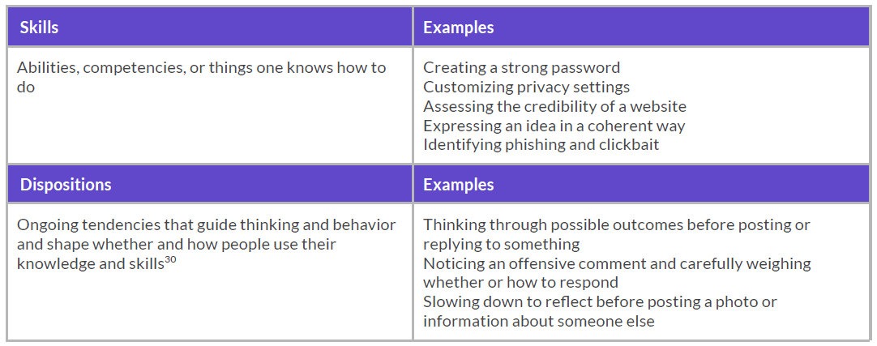
Figure [4]. Example from Common Sense framework. (James et al., 2021, p. 16)

Through a skills and dispositions approach, Common Sense curriculum encourages students before taking online action to slow down, think and self-reflect; explore different perspectives with empathy; evaluate evidence and seek facts, and envision possible options and impacts (James et al., 2021). This approach helps students realise issues related to their digital skills and behaviours. For example, in online sharing, students learn not only how they can share data and information but also what kind of data can be shared, with whom it can be shared, and how this might be reflected on their reputation or their future.
Similarly, the DigComp 2.2 framework emphasises knowledge, skills, and attitudes. in DigComp 2.2 framework, the digital competences are presented in a combination of three dimensions: knowledge such as digital concepts, facts, principles, and theories; cognitive and practical skills such as logical and intuitive thinking or manual dexterity to do something; and attitudes (motivators of performance) such as values and priorities (Vuorikari et al., 2022; see Figure 5).
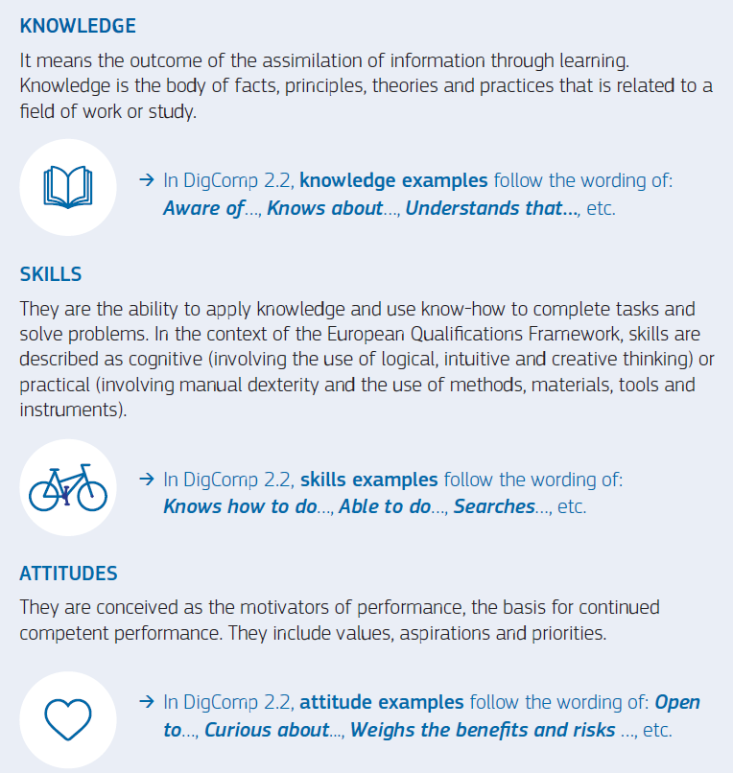
Figure [5]. Example from DigComp 2.2 framework. (Vuorikari et al., 2022, p. 3).

Moreover, DQ frameworks present digital Competencies in three aspects: knowledge, skills, and attitudes and values. This framework provides a definition of 24 competencies and what they mean within these three aspects (Park, 2019). See Figure 6 as an example.
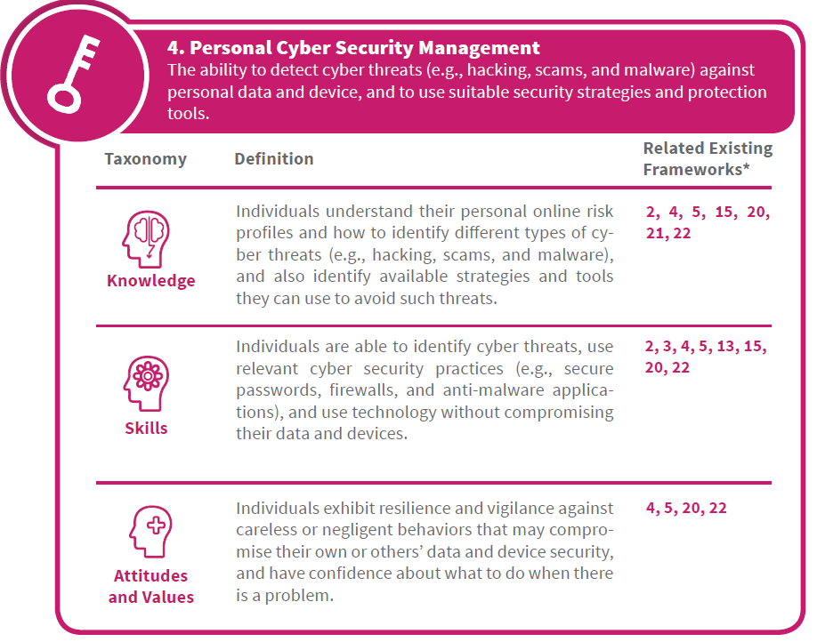
Figure [6]. Example from DQ framework. (Park, 2019, p. 22).

Obviously, teaching digital citizenship topics focus on developing three dimensions: knowledge, skills, and attitudes. According to Ten Berge and Van Hezewijk (1999), Knowledge can be declarative (knowing ‘that’) or procedural (knowing ‘how’). Declarative Knowledge can be described as ‘the factual information that a person knows and can report’ (Anderson, J. R., & Schunn, p. 3), while procedural knowledge can be described as ‘the connection or use of pieces of declarative knowledge’ (Baartman and De Bruijn, 2011, p. 127). Skills can be defined as an organised sequence of doing or acting in practice and activities, that includes both motor skills and cognitive skills (Baartman and De Bruijn, 2011). Attitudes can be described as a psychological tendency that leads people to express a degree of favour or disfavour towards particular things (Eagly & Chaiken, 1998).
However, Baartman and De Bruijn (2011) indicate competence development is not only acquiring knowledge, skills, and attitudes, but also integrating them. Thus, digital competence can be defined as an integration of ‘skills, knowledge and attitudes that make learners able to use digital media for participation, work and problem solving, independently and in collaboration with others in a critical, responsible and creative manner’ (Hatlevik et al, 2015, p. 346). Hence, teaching digital citizenship should consider these three dimensions.
Walters et al. (2019) argue that establishing what is acceptable and what is unacceptable and addressing what is appropriate and what is inappropriate will likely help students to make good choices when they use the technology. Ribble (2015) in his digital citizenship model explains in detail how digital citizenship topics can be presented in the educational process through a set of procedures and scenarios that are very similar to the argument of Walters et al. (2019). See Figure 7 as an example.
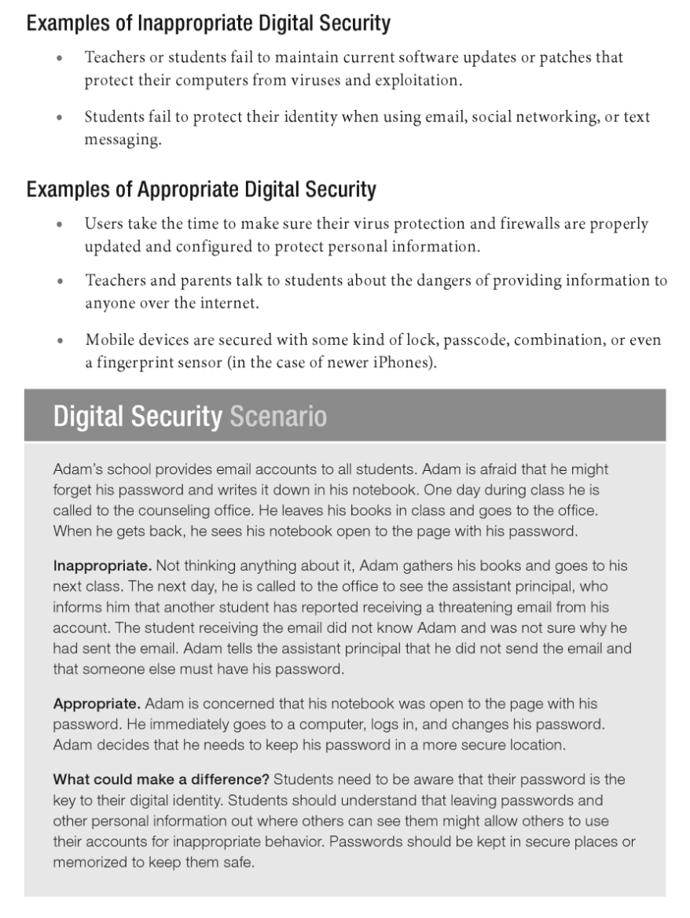
Figure [7]. Example of digital security scenario. (Ribble, 2015, pp. 53-54).

The Common Sense curriculum also emphasise using digital scenarios and dilemmas where it mentions that through ‘engaging videos and scenarios, and thinking routines’, students can ‘consider personal, moral, and ethical issues’ of using technology and weigh the potential risks and benefits (James et al., 2019, p. 24). A digital dilemma is ‘a tricky situation related to tech or social media use—and it doesn't always have an obvious right or wrong answer’, for example, what to do if you are being bullied online, if your password is stolen, or if you are contacted online by stranger (James et al., 2021, p. 18). Hence, discussing such dilemmas help students to increase their awareness, develop their skills, and come up with realistic and thoughtful solutions that guide them in addressing real issues they face. Similar to dilemmas and scenarios, case studies can help in teaching digital citizenship topics, where students can develop their knowledge and attitudes about critical issues by discussing these issues that arise in different cases. For example, Farmer (2011) points out that in an ever-changing technological environment, case studies are one of the effective ways to discuss behaviours from a legal and ethical point of view, where students can develop their knowledge about digital rights and duties in many issues such as broadcasting inappropriate information, social networking, and intellectual property and plagiarism.
From my experience, I believe that discussing different scenarios is useful in addressing issues such as ethics, rights, and responsibilities. During my PhD study, the module of Research Ethics and Integrity was one of the compulsory modules. Prior to attending this course, I thought that I had good knowledge in this regard, but I was surprised when I attended this course that my knowledge in this field is limited. However, the discussion of various scenarios involving issues of ethics and integrity raised critical issues about ethics and integrity that encouraged me to adopt diverse perspectives which has aided me immensely in addressing the ethical issues of my research. Therefore, I think that discussing case studies and scenarios would help in teaching digital citizenship topics, especially in relation to the attitudes.
Gamification is another teaching strategy that can be used in teaching digital citizenship. According to Rogers-Whitehead (2019) gamification is ‘adding elements of gaming in a non-game context’ such as organising competitions and challenges, giving prizes and rewards, showcasing winners (p. 32), progress indicators, scoring and ratings, and virtual currencies (Kateryna et al., 2020). Gamification is a useful approach that can be used with digital citizenship because it improves self-efficacy, encourages autonomy, and helps students to take active roles which are important elements of digital citizenship (Rogers-Whitehead, 2019). Also, gamification helps in addressing students’ attitudes and behaviours such as motivation and self‐ guided study as well as develop students’ skills such as collaboration, creativity, and problem-solving (Caponetto et al., 2014; Ricoy & Sánchez-Martínez, 2022) Therefore, gamification can be an effective way or approach to develop not only digital knowledge but also digital skills and attitudes. However, a good example of using gamification in teaching digital topics is ‘Interland’ which is an interactive game video. In 2017, Google launched an online platform called Be Internet Awesome which aims to raise digital awareness of children. The most prominent feature in this platform is the Interland Game. This game includes four parts – reality river, tower of treasure, mindful mountain, and kind kingdom – which promote awareness, responsibility, a sense of security and caution in children by taking on challenges, engaging in tasks, and solving dilemmas (Google, 2021). Also, Minecraft and Scratch are also good examples of using gamification as a learning approach. Dezuanni (2018) mention that Minecraft platform allows students to possess and master conceptual understandings as well as to combine, assemble, and synthesize them performatively. Similarly, Minecraft Education Edition is a genius game that helps students to learn the basics of coding, programming, and script creation, as well as helps students to develop their imagination, creativity, and innovation (Kateryna et al., 2020; Minaudo, 2020). While Scratch is a simple coding language that helps students to create interactive stories, games, and animations, and it develops important skills such as creative thinking, self-expression, and problem solving (Scratch, 2022)
Moreover, experiential learning is another valuable strategy to learn about digital citizenship topics. Experiential learning is ‘human naturally learn by trying to figure things out’, it is to do something and then learn from the reflection upon that action (Rogers-Whitehead, 2019, p. 34). By contemplating what happened and asking why it happened that way rather than another way, students can expand their knowledge and extrapolate it to other topics (Rogers-Whitehead, 2019). According to Kingsmill (2018) students prefer learning to be linked to real life examples and to be participatory, visual, and collaborative. Hence, experiential learning helps students to engage, participate, and reflect on topics and activities that affect them personally, thus, their knowledge is constructed based on their learning needs (Pretorius, 2018). Also, experiential learning can develop and improve digital resilience which is achieved through experience. Digital resilience as defined by UK Council for Internet Safety is ‘a dynamic personality asset that grows from digital activation’, where the engagement through appropriate opportunities and challenges helps people in developing their digital knowledge and skills. (UK Council for Internet Safety, 2020, p. 4). Experiential learning is also useful in exploring new technologies and devices as people learn independently how to use mobile phones, computers or the Internet through real experiments that sometimes succeed and sometimes fail (Comunello et al., 2015). Therefore, students can familiarise themselves with digital devices, connect their accessories, and explore digital technologies through real experience in school labs or through guided practice as mentioned by Ribble (2008). However, experiential learning also can take place without going through a real experience or real-world contact, but rather a virtual experience in conditions quite similar to what happens in reality such as simulation which is a form of surrogate experiential learning (Gentry, 1990). Simulation is a flexible, efficient, accurate and safe way that facilitates students to observe scientific models and understand concepts that are complex or difficult to visualise (Perdana et al, 2020), which also consistent with ISTE standards and DigComp 2.2 framework that indicate that students should be able to use digital tools such as simulations to explore, understand, and solve complex systems and issues (ISTE, 2017; Vuorikari et al., 2022).
Overall, the methods and strategies used in teaching digital citizenship are not limited to discussing scenarios, dilemmas or case studies; gamification; experiential learning; and simulation, but these are discussed in this section because they are suggested by the frameworks of digital citizenship as proper methods for teaching digital citizenship topics, and they are consistent with the teaching dimensions (knowledge, skills, and attitudes) that also are emphasised by the frameworks of digital citizenship.

3.7 Previous Studies in Digital Citizenship Education
Many studies have explored digital citizenship education from different views and at different levels (kindergarten, schools, and universities). However, taking into consideration the objectives and questions of this research, this review will be limited to recent studies that explore the topic of digital citizenship at school level with a focus in Arab and Saudi context. Also, this review will be focused on two areas: the inclusion of digital citizenship in the school curricula and the perceptions and experiences of digital citizenship and its education.

3.7.1 Integrating Digital Citizenship in School Curricula
Including digital citizenship topics in school curricula has become essential to prepare students for a future that depends heavily on technology and the Internet. Ribble (2015) stresses the importance of including and discussing digital citizenship topics and scenarios in all educational curricula. Similarly, Tamayo (2016) indicates that integrating digital citizenship across all core standards and curricula ‘has become more important than ever before’ (p. 7). Moreover, Kingsmill (2018) concludes that teachers and students share the same perspective which indicates that digital citizenship should not be limited to a specific curriculum, but must be integrated into all educational curricula, topics and activities whenever it is related. Frau-Meigs et al (2017) point out that a comprehensive approach should be adopted to teach digital citizenship and integrate its topics into school curricula. Furthermore, Hollandsworth et al. (2011) state that technology is constantly evolving as well as digital citizenship issues, thus, ‘a one-time class, or waiting until 8th or 9th grade does not adequately address the issues’ (p. 46). Hollandsworth et al. argue that digital citizenship education requires a comprehensive process that includes not only the integration of citizenship into the curricula but also discussion, dialogue, and collaboration among students, teachers, parents, and stakeholders.
However, despite the importance of digital citizenship and the urgent need to include its topics in school curricula, some recent studies that explore integrating digital citizenship into school curricula show disappointing results. For example, Abdelhad (2020) explores the concept and themes of digital citizenship in the textbooks of Civic Education in third and fourth grade in middle school in Algeria. These textbooks are analysed by calculating frequencies for a set of knowledge and skills that are developed based on Ribble’s model. Unfortunately, the results show that these textbooks do not include the term digital citizenship, and they also fail to address or cover digital citizenship topics, which were almost absent. In addition, Abu-Omar and Jwaifell (2018) explore digital citizenship in the Arabic Language textbooks for grades eight, nine and ten in Jordan by calculating frequencies and percentages of 73 elements of digital citizenship that were designed based on Ribble’s model in addition to previous studies. Abu-Omar and Jwaifell find that the digital citizenship term is absent in all these textbooks, while the term digital access has been repeated in these textbooks 36 times. On the other hand, the rest of the digital citizenship topics such as digital communication, digital etiquette, and digital literacy were almost absent, while digital security, digital health, rights and responsibilities, and digital commerce were completely absent. Moreover, Ibrahim (2019) analyses the computer textbook for the second intermediate grade in Iraq by using frequencies and percentages of a set of digital citizenship standards that were designed based on the Ribble’s model in addition to previous studies. Ibrahim finds that there is a difference in the extent to which digital citizenship topics are integrated, where the percentages are (45.29%) for digital literacy; (40.36%) for digital communication; (12.11%) for digital behaviour; (1.79%) for digital security; and (0.45%) for digital health and safety. While digital access, digital laws, digital rights and responsibilities, and digital commerce are not covered in this textbook. Furthermore, Shahin (2021) evaluates computer information technology textbooks in Egyptian intermediate school in light of digital citizenship by calculating frequencies and percentages for a list of 52 indicators of digital citizenship that were designed based on Ribble’s model in addition to previous studies. Shahin finds that topics such as digital access and digital literacy are integrated in medium percentages and the other topics are integrated in low percentages except the commerce topic which is not covered at all.
Similarly, the results of Saudi studies that have explored this issue show a weakness in addressing digital citizenship issues. For example, Al-Harthy and Al-Mutairi (2019) examine the degree to which citizenship topics are included in the computer and information technology textbook for the second intermediate grade in Saudi schools. They use frequencies and percentages to evaluate the textbook through a list of 52 standards of digital citizenship designed based on Ribble’s model and previous studies. The results indicate that citizenship topics are included with low percentages except for digital literacy, which got a good percentage (64.5%), followed by digital access (11.8%), digital communication (5.9%), digital ethics and behaviour (5.4%), digital health and safety (2.2%), digital commerce standard (1.6%), and digital rights and responsibilities (1%). Also, Alkhalifah and Alebaikan (2018) conduct quantitative content analysis of computer and Information technology textbooks in Saudi secondary schools in the light of Common Sense framework for digital citizenship. The researchers designed an analysis tool that contains 60 indicators of digital citizenship, and then frequencies and percentages were used to analyse the content of textbooks. The results show that inclusion of digital citizenship topics in these curricula is generally low where the percentages show that: 41.3% of the content was on information literacy, 21.2% on privacy and security, 17.7% on creative credit and copyright, 5.2% on digital footprint and reputation, 0.9% on relationships and communication, 0.1% on cyberbullying .In addition, Aloufi and Alzahrani (2021) use an analysis tool contains 63 indicators developed based on Ribble’s model and related studies to explore digital citizenship topics included in the computer and information technology textbook for the third intermediate grade in Saudi schools. They find that the topic of digital literacy was included in a high percentage (83.79%) while the rest of the digital citizenship topics were included in low percentages (9%) and less. Moreover, Alshammry (2021) explores the degree to which the concepts of the digital age are included in computer and information technology textbooks in Saudi middle schools through an analysis tool that includes six concepts (digital control, augmented reality, cybersecurity, digital resources, digital devices, and cloud computing) developed from the literature review and previous studies. The frequencies and percentages used by the researcher in the analysis process show that the degree of inclusion of the concepts of the digital age in the CIT textbooks ranges between low and very low. Therefore, the researcher suggests developing the content of CIT textbooks in line with these concepts. Furthermore, the results of other Saudi studies that explore the integration of digital citizenship topics in textbooks other than the CIT textbooks such as the textbooks of Islamic studies (Al-Bassam , 2021; Alshakrah & Alzahrani, 2020), the textbooks of social studies and life skills (Al-Ghamdi & Al-Saadoun, 2021; Al-Hanaki, 2020; Al-Mulhim & Jaballah, 2018; Najmuldeen, 2021) and the textbooks of Arabic language (Al-Rasasimah, 2021), reveal that there is also a weakness in including digital citizenship topics in these textbooks except for the topic of digital literacy.
Overall, these previous studies provided valuable information and results about the integration and inclusion of digital citizenship topics in different school textbooks and at different levels of education. The brief conclusion that can be drawn from these studies is that the degree of inclusion of digital citizenship topics is still low except for digital literacy which is apparently well included in school textbooks. However, all of these non-Saudi studies (Abdelhad, 2020; Abu-Omar & Jwaifell, 2018; Ibrahim, 2019; Shahin, 2021) and Saudi studies (Al-Ghamdi & Al-Saadoun, 2021; Al-Hanaki, 2020; Al-Harthy & Al-Mutairi, 2019; Alkhalifah & Alebaikan,2018; Al-Mulhim & Jaballah, 2018; Aloufi & Alzahrani, 2021; Al-Rasasimah, 2021; Alshakrah & Alzahrani, 2020; Alshammry, 2021; Najmuldeen, 2021) used quantitative methods to analyse the textbooks by calculating the frequencies and percentages for a set of digital citizenship indicators that were designed for this purpose, except for Al-Bassam’s (2021) study which used a questionnaire to analyse textbooks and then calculate the averages and standard deviation. Although the quantitative approach helps in determining the general direction of a phenomenon or determining where a problem lies, it does not help in explaining the phenomenon or revealing the reasons behind the problem (Bryman, 2012; Creswell, 2012; Hammond & Wellington, 2013; Leedy & Ormrod, 2015). In other words, previous studies did not explain how digital citizenship topics were presented within the three dimensions (knowledge, skills, and attitudes). Also, most of these studies (Abdelhad, 2020; Abu-Omar & Jwaifell, 2018; Al-Ghamdi & Al-Saadoun, 2021; Al-Hanaki, 2020; Al-Harthy & Al-Mutairi, 2019; Aloufi & Alzahrani, 2021; Al-Rasasimah, 2021; Alshakrah & Alzahrani, 2020; Ibrahim, 2019; Najmuldeen,2021; Shahin, 2021) relied on Ribble’s model in the developing the analysis tool, while there are many models and frameworks for digital citizenship (see section 3.4). Thus, the quantitative analysis of these textbooks may fail in exploring some digital issues that were not highlighted in the Ribble’s model. Moreover, these studies focus on the issue of including digital citizenship topics by analysing the textbooks without exploring the perspectives and experiences of students and teachers that can help in achieving more understanding. Therefore, through this qualitative study, I seek to achieve an in-depth understanding of digital citizenship topics by reviewing six digital citizenship frameworks. Also, through thematic analysis, I seek to explore how the CIT textbooks construct and present digital citizenship topics considering the three dimensions. Moreover, through semi-structured interviews, I seek to reveal how students and CIT teachers understand the topics of digital citizenship and to explore their perceptions and experiences about teaching digital citizenship and challenges facing this process.

3.7.2 Perceptions and Experiences of Digital Citizenship
Bollmer (2018) believes that good understanding of digital experience can be gained by looking at what people do or how they interact with digital technology rather than what they should do or what digital technology allows them to do. Therefore, this section will highlight and discuss some Arab and Saudi studies that examine the perceptions and experiences of students, teachers, and school leaders about digital citizenship and its education.
Afshi (2022) uses a questionnaire to explore digital citizenship awareness among the female teachers and supervisors of Arabic language in intermediate and secondary school in Riyadh, Saudi Arabia. The results reveal that both female teachers and supervisors of Arabic language curricula have a good level of digital citizenship awareness. However, the results show that the awareness’s level is higher among the supervisors compared to the teachers and among teachers with higher degrees compared to teachers with only a bachelor’s degree.
Aldossari (2017) uses a questionnaire to examine the awareness of digital citizenship among male CIT teachers in Riyadh, Saudi Arabia. He finds that teachers’ awareness and understanding of digital citizenship topics is good in general. However, teachers’ awareness in topics like digital communication, digital access, digital etiquette, digital rights and responsibilities, and digital health, was better than topics like digital literacy, digital law, digital protection, digital commerce. The results also showed that there are no statistically significant differences in the level of awareness between teachers who have a bachelor’s degree and teachers who have a master’s degree.
Alhajri and Alsubaie (2021) use questionnaires and interviews to explore the views of female teachers and principals in public education schools (primary, intermediate, secondary) in Al-Nairyah in Saudi Arabia about promoting and supporting digital citizenship education and the obstacles facing this process. The results reveal that the most important challenges facing digital citizenship education are the lack of clear policies on promoting digital citizenship, lack of awareness of digital citizenship, lack of training programs and workshops, lack of electronic devices and maintenance, lack of time, poor tendency to use technology, lack of access to the Internet, and lack of family cooperation. Therefore, female teachers and principals recommend the necessity of having a common vision and plan to support digital citizenship, identifying a working group to enhance digital citizenship, providing appropriate technical support, qualifying teachers and developing their digital knowledge and skills, involving families in digital citizenship activities, activating digital tools for communication between home and school, and encouraging positive practices of citizenship digital.
Alhasri (2016) explores the awareness’s level of digital citizenship topics among social studies teachers in Medina, Saudi Arabia. The results reveal that social studies teachers have little knowledge of digital citizenship in general. However, the results also show that this knowledge was better for teachers who have master’s degrees as well as teachers who have more training courses. Therefore, the study recommends supporting teacher development and providing more training and workshops.
Alqahtani (2017) uses a questionnaire and interviews to explore the extent of digital citizenship knowledge among Saudi teachers in the light of three areas: respect, education, and protection. The results indicate that Saudi teachers have good knowledge regarding respect domains (etiquette, access, law) and they believe that respecting culture and religion of a society guides people to proper technology use and avoiding harmful consequences. Therefore, Islamic religion is very important for teachers because it represents a guide of their rules and principles. Also, the results show that in the education domain (communication, literacy, and commerce), teachers believe that knowing how to develop safe communication, demonstrating appropriate communicative skills, and evaluating the available sources is essential for preparing citizens for a digital society. While in the protection domain (rights and responsibility, safety, and health), teachers believe that digital rights, digital security, and digital health are crucial in their work, however, they believe that more attention should be paid to standards and norms in this field which usually are interpreted ‘under the umbrella of such aspects as religion, culture, and education’ (p.97).
Alsuhaim and Albrahim (2019) examine the extent in which female CIT teachers in secondary schools in Riyadh, Saudi Arabia, activate the digital citizenship topics. The results indicate that topics such as digital law, digital behaviour, digital literacy, digital protection, and rights and responsibilities are largely activated by teachers during teaching. While standards such as digital access and communication are activated to a moderate degree due to technical problems related to networks and the Internet within school environments. Teachers’ opinions also reveal that there are some obstacles facing digital citizenship education such as not including digital citizenship topics in the curricula, the absence of policies for the acceptable use of technology in the school, school’s lack of awareness of its role in providing a supportive environment and suitable training, and students’ lack of awareness of what digital citizenship is and what is its importance in this digital age.
Ateeq (2020). uses a questionnaire to explore female teachers’ and female principals’ perceptions of the role of secondary schools in supporting digital citizenship in Shaqra, Saudi Arabia. The views of teachers and principals reveal that issues such as the interest in empowering religious and moral values, the development of students’ ability of using of digital technology, and limiting students’ connection to the Internet within the school for educational purposes, receive more attention compared to issues such as educating parents and the community about digital citizenship, educating students about the importance of reading the terms of use agreements, and training students to obtain information in legal and ethical ways. In addition, the views of teachers and principals reveal that the most prominent obstacles facing citizenship education are problems of internet connection and weak signal, lack in including digital citizenship topics in the curricula, some students possessing high technical skills that are difficult to keep up with, focusing on academic achievement rather than behavioural and ethical aspects, and lack of cooperation between parents and school.
Elbelbisi (2022) uses a questionnaire to explore the awareness of digital citizenship among female students in secondary school in Gaza. The results of the study generally indicate that the students have a good awareness about digital citizenship topics. However, their awareness on topics such as digital etiquette, digital rights and responsibilities, digital law, and digital safety and security was better than topics such as digital literacy and digital access and communication.
Ghamrawi (2018) explores the views, perceptions, and practices of Lebanese teachers on digital citizenship by using a questionnaire and a structured focus group interview. The results show that teachers’ perceptions, understanding and practice of digital citizenship was marginal and modest, and they attributed the reason for this to the fact that they do not receive appropriate training and that the time allocated to teaching does not help them to discuss digital citizenship issues.
Jallad et al. (2022) use questionnaires and semi-structured interviews to explore the awareness of secondary school principals about digital citizenship in Palestine. In general, the results revealed that the level of school principals’ awareness of digital citizenship was moderate. Also, the results also revealed that the most prominent obstacles facing citizenship education in secondary schools are the lack of maintenance of computers and laboratories, poor Internet speed in schools, and a lack of development workshops.
Saari and Alharbi (2021) use a questionnaire to explore the digital citizenship skills among female students and teachers in the intermediate and secondary schools in Medina, Saudi Arabia. They find that students and teachers in general have a good awareness of digital citizenship topics and skills. However, the awareness of digital citizenship and its skills was better among secondary school students compared to intermediate students, as well as among CIT teachers compared to other teachers.
It is clear from the above studies that the tendency to use quantitative methodologies in Arab and Saudi studies is still prevalent, as is the case with studies that examined the school textbooks in the previous section. Seven of the above studies relied on questionnaires only to examine awareness of digital citizenship (Afshi, 2022; Aldossari, 2017; Alhasri, 2016; Alsuhaim & Albrahim, 2019; Ateeq, 2020; Elbelbisi, 2022; Saari & Alharbi, 2021) while only four studies used a mixed methods by combining questionnaires and interviews (Alhajri & Alsubaie, 2021; Alqahtani, 2017; Ghamrawi, 2018; Jallad et al, 2022). However, as discussed in the previous section, although a quantitative approach helps describe a phenomenon or shed light on a problem, it does not help in examining it in depth or revealing its causes (Bryman, 2012; Creswell, 2012; Hammond & Wellington, 2013; Leedy & Ormrod, 2015). In other words, although these studies helped reveal the level of awareness about digital citizenship topics, most of them did not discuss how these topics are understood and practised.
As for how these studies address the topic of digital citizenship, it can be said that they focus on two aspects: exploring awareness about digital citizenship and exploring challenges, obstacles, and ways of support. Some studies (Afshi, 2022; Alhasri, 2016; Elbelbisi, 2022; Ghamrawi, 2018; Saari & Alharbi, 2021) indicate that awareness about digital citizenship in general is good, however, what is worth noting here is that this awareness increases at the secondary stage compared to the intermediate stage, among supervisors compared to teachers, among computer teachers compared to the rest of the teachers, among those with higher degrees compared to those with bachelor’s degree, and among those who have more training courses and workshops. Therefore, it can be said that awareness of digital citizenship can be improved and supported with more education, development and training, especially when this education and training is about technology because unlike previous studies, Aldossari’s (2017) study shows that there are no differences between the level of awareness of digital citizenship among CIT teachers with master’s degrees compared to CIT teachers with bachelor’s degrees, so it can be said that the field of study (technology) was the most prominent factor compared to the scientific degree. Thus, CIT teachers both with bachelors or masters have good digital awareness because they specialise in technology.
On the other hand, some studies (Alhajri & Alsubaie, 2021; Alsuhaim & Albrahim, 2019; Ateeq, 2020; Jallad et al, 2022) focus on addressing the obstacles facing digital citizenship education and how it can be promoted. The results of these studies are summarised in five obstacles to teaching digital citizenship: lack of clear policies and plans regarding digital citizenship; lack in including citizenship topics in school curricula; lack in digital devices, laboratories, and Internet access; and lack of time; and lack of interest and cooperation from students, teachers, or families. These results are consistent with what is mentioned in section 2.2.3 that although digital transformation is one of the important programs in the Saudi Vision 2030, the aims of this vision are still unclear when it comes to education, and therefore schools do not understand their role in achieving this vision (OECD, 2020). Also, these results are consistent with the studies mentioned in the previous section, whose results reveal a weakness in including digital citizenship topics in the Saudi curricula. Moreover, these results are consistent with what was discussed in section 1.1 that although the statistics indicate an intense use of the Internet, applications and social media by Saudis, the actual practice of this use in education was almost absent (Alabdulkareem, 2015).
It can be said that regarding technology education and digital citizenship within Saudi schools, the results of the above studies indicate that there is a digital divide, whether at the level of owning digital devices and tools, access to the Internet, or even at the level of how this digital technology is used. However, Rowsell et al. (2017) indicate that confronting the digital divide requires collective action by governments, institutions, schools, and families. For example, supporting digital literacy education, providing digital devices and tools, supporting consumption and production cultures, allocating places in schools to encourage production and innovation, enabling access for those who are marginalised, and supporting digital access outside the school (Rowsell et al., 2017). Hence, confronting the obstacles to teaching digital citizenship in Saudi Arabia requires collective actions, starting with establishing related policies, clarifying the role of educational and community institutions, and ending with the cooperation of families. Therefore, to come up with a comprehensive understanding of digital citizenship and suggestions for its education in Saudi Arabia, I seek through this qualitative study to understand digital citizenship and explore how it is presented in the CIT textbooks, how it is understood by students and CIT teachers, and what are the challenges and obstacles facing its education.

Summary of the Chapter
This chapter discusses the concept of citizenship in its traditional and digital form, and it seems that there is a change and development in both concepts as a result of the industrial and technological revolution and the development of means of transportation and communication that contributed to creating new versions of traditional citizenship such as global citizenship, multicultural citizenship, and digital citizenship. This chapter also discusses how Saudi citizenship in its traditional and digital forms is affected by the influence of the Islamic religion, Arab culture and Saudi Vision 2030. Moreover, this chapter discusses citizenship education and how it is presented through different lenses and in different contexts and illustrates the complexity of this issue regarding digital citizenship because in the digital world it is difficult to define the lens through which digital citizenship can be viewed and presented. Furthermore, this chapter reviews some digital citizenship frameworks and models and extracts the most prominent topics of digital citizenship (digital literacy, digital protection, digital law, digital footprint, and digital creativity and innovation) as well as the dimensions through which these topics are presented and taught (knowledge, skills, and attitudes). Finally, this chapter reviews the studies that explored digital citizenship in the Arab and Saudi context and concludes that there is a lack of inclusion of digital citizenship topics in the curricula, readiness of laboratories, electronic equipment, and Internet access.

Chapter 4: Methodology and Methods

Introduction
The main purpose of this study is to achieve an in-depth understanding of the construction and presentation of the concept and topics of digital citizenship within the computer and information technology textbooks in Saudi intermediate schools and explore the perceptions and experiences of digital citizenship of teachers and students in these schools. This chapter presents the methodology used to answer my research question:
1. How do CIT textbooks construct and present the concept and topics of digital citizenship in Saudi intermediate schools?
2. What are the perceptions of CIT teachers and students in Saudi intermediate schools about the concept and topics of digital citizenship?
3. What are the perceptions and experiences of CIT teachers about teaching digital citizenship in Saudi intermediate schools?
4. What are the perceived obstacles and challenges to teaching digital citizenship in Saudi intermediate schools?

The first part of this chapter sets out the methodology and methods used to generate, collect, and analyse data. In addition, it highlights and discusses some challenges and ethical considerations regarding the research sample and participation. While the second part starting from section 4.7, it explains in detail the procedures and processes that used in collecting and analysing the data such as: translation challenges; getting access and gaining consents; description of CIT textbooks; analysing the CIT textbooks; pilot interview; remote interview; recording and transcription; and analysing interview data.

4.1 Research Stance
Although philosophical ideas about the world are not usually clearly visible in research, they inevitably affect the research in one way or another. Creswell (2014) suggests that researchers should explain the major philosophical ideas they follow, as this will help them explain their choice of specific research approach. According to Creswell (2014), philosophical ideas about the world are referred to in the literature using various terms. For example, Crotty (1998) refers to them as epistemologies and ontologies. He defines epistemology as ‘a way of looking at the world and making sense of it’, which involves understanding what knowledge is entailed - ‘how we know what we know’ (p. 8), while ontology as ‘a study of being. It is concerned with what is, the nature of existence and the structure of reality’ (p. 10). Guba (1990) and Mertens (2010) refer to epistemologies and ontologies as paradigms, defining them as ‘a basic set of beliefs that guide action’ (Guba, 1990, p. 17), and as ‘a way of looking at the world’, which directs thinking and action through certain philosophical assumptions (Mertens, 2010, p. 7). Creswell (2014) calls them worldviews and defines them as ‘a general philosophical orientation about the world and the nature of research that a researcher brings to a study’ (p. 35). However, the term paradigms will be used in this study to express philosophical ideas about the world.
Creswell (2014) and Mertens (2010) highlight four paradigms that are widely discussed: positivism and postpositivism, interpretivism and constructivism, transformatism, and pragmatism. The paradigm perspective of positivism and pragmatism is that there is one reality or a single real world; while positivists believe that the researcher should discover that reality, pragmatists argue that ‘all individuals have their own unique interpretations of that world’ (Mertens, 2010, p. 36), and the researchers are free to study the phenomena that are important to them, to choose the methods that they consider appropriate to conduct that study, and bring positive consequences by using the results in different ways. On the other hand, the paradigm perspective of interpretivism and constructivism is that ‘reality is socially constructed’ (Mertens, 2010, p. 18). Therefore, many mental constructions that may be in conflict with one other can be found, where socially constructed phenomena such as feminism, disability and minority mean different things to different people (Mertens, 2010). The epistemological perspective of interpretivism and constructivism is ‘data, interpretations, and outcomes are rooted in contexts and persons apart from the researchers and are not figments of their imagination’ (Mertens, 2010, p. 19). Similarly, the transformative paradigm can agree with the view of interpretivism and constructivism that there is more than one reality. However, it emphasises that that “which seems ‘real’ may instead be reified structures that are taken to be real because of historical situations” or because of the issues of power that determine what can be considered legitimate knowledge (Mertens, 2014, p. 32).
In this research, I adopt an interpretivist paradigm because my thoughts and beliefs about the world and knowledge are logically consistent with the interpretive perspective. However, Interpretivism and constructivism are usually mentioned together because they are closely related, and one is often seen as a subset of the other (Creswell, 2014; Hammond & Wellington, 2013). Both share an idea that ‘as human beings we are meaning makers: the world is one in which we are required to seek out meaning rather than enter a world in which meanings are ﬁxed’ (Hammond & Wellington, 2013, p. 90). In contrast to positivism and postpositivism, interpretivists and constructivists assert that the social world and the natural world are different. Therefore, they cannot be studied in the same way; they require different methods (Gray, 2004). Interpretivist researchers suggest that reality is socially constructed, and a single phenomenon can be interpreted in various ways (Merriam, 2009). Also, the interpretivist research aims to ‘understand the meaning that cultural and institutional practices have for those taking part’ (Hammond & Wellington, 2013, p. 88), and to develop insights by exploring shared perspectives and meanings into some situations such as classrooms (Wellington, 2015). Drawing from these elaborations, I believe that the interpretivist paradigm fits the purpose and the objectives of this research. Also, the interpretivist paradigm fits with the idea that the concept of digital citizenship in the literature has been interpreted differently, and that people understand and practice digital citizenship differently according to their understanding and beliefs (see section 3.2).

4.2 Research Design
Research design helps different research processes to be conducted in an organised and smooth manner, it makes research as effective as possible by helping to determine the appropriate procedures for carrying out the research, collecting data and analysing it in appropriate ways (Kothari, 2004). The design represents the blueprint of the research, it helps researchers to define their ideas and organise them in a way that allows them to look for flaws and inadequacies. However, there are many research designs which are often discussed as quantitative, qualitative, and mixed methods (Bryman, 2012; Coolican, 2014; Creswell, 2012, 2014; Hammond & Wellington, 2013; Kothari, 2004; Leedy & Ormrod, 2015; Maxwell, 2012; Mertens, 2010). According to Maxwell (2012), the quantitative and qualitative approaches are not simply different methods of doing research. Instead, ‘they have different strengths and logics and are often best used to address different questions and purposes’ (p. 17). The quantitative approach is concerned with measurement of quantity or amount, while the qualitative approach is focused on the quality or kind (Kothari, 2004). Similarly, Bryman (2012), construes quantitative research as a ‘strategy that emphasizes quantification in the collection and analysis of data’, while qualitative research ‘emphasizes words rather than quantification’ (pp. 35-36). Therefore, the quantitative approach is seen as a more deductive approach that uses descriptive and inferential statistical analysis for hypothesis testing. In contrast, the qualitative approach is seen as a more inductive approach that explains and uncovers the problem or the phenomenon and generates new theoretical views (Bryman, 2012; Hammond & Wellington, 2013). In quantitative research, a research problem is identiﬁed based on trends. By describing the trends, the investigator can answer the problem. Therefore, the quantitative researcher seeks to determine the general direction of individual responses and explore the difference between these trends (Creswell, 2012). In contrast, the qualitative approach is considered appropriate and preferred when the researcher intends to address a problem or phenomenon in which the variables are not known or have not been adequately studied and addressed (Creswell, 2012; Leedy & Ormrod, 2015). Therefore, the qualitative researcher seeks to understand the physical events and behaviour, underlying motives and desires, how the participants make sense of this, and how it influences their behaviour (Kothari, 2004; Maxwell, 2012).
Obviously, both approaches have strengths and weaknesses, and it is not possible to be certain when choosing an approach that it is the best one. For example, the quantitative approach is limited as it does not collect a wide range of opinions, while the qualitative approach that does not use scientific methods is lacking objectivity (Coolican, 2014). Therefore, the mixed methods approach emerged, combining quantitative and qualitative advantages to neutralise the weaknesses of each approach (Creswell, 2012). However, choosing a specific design is affected by several factors such as the purpose of the study, the nature of the study, means of obtaining data, the researcher’s skill, and available capabilities (Kothari, 2004). Therefore, a qualitative design will be used in this study since it fits with the purpose and the objectives of this study. However, it must be noted here that qualitative, quantitative, and mixed methods are often situated within a particular paradigm. For example, the interpretivist paradigm that has been chosen for this study tends to adopt the qualitative methods, while postpositivism paradigm tends to adopt the quantitative methods (Creswell, 2014).

4.3 Research Methods
Research methods can be defined as means or techniques used for gathering and analysing research data (Crotty, 1998; Hammond & Wellington, 2013). Research methods can also be defined as a ‘range of approaches used in educational research to gather data which are to be used as a basis for inference and interpretation, for explanation and prediction’ (Cohen et al., 2007, p. 47). Research methods are generally discussed in the light of quantitative and qualitative research; some methods are often used with quantitative data such as surveys and statistics, and some are often used with qualitative data such as interviews and content analysis (Hammond & Wellington, 2013). However, Leedy and Ormrod (2015) note that there are many factors that must be considered when choosing data collection methods, such as the type of data required, location, and the manner of data interpretation. This qualitative study aims to achieve an in-depth understanding of how the concept and topics of digital citizenship are constructed and presented in the CIT textbooks in Saudi intermediate schools and explore the perceptions of students and CIT teachers about digital citizenship. Therefore, the targeted data was collected and generated from the CIT textbooks, students, and CIT teachers.
With regard to the CIT textbooks, it was clear to me that the data does not need to be generated but only need to be collected, however, I was confused about this issue because I thought that there is no need to use data collection method since that all the CIT textbooks in intermediate schools will be analysed, and they contain textual data that can be analysed directly. However, this confusion faded when I realised the purpose of using a collection method. For example, in the interview, the researcher explores someone’s opinions about certain issues, meaning that not all that person’s beliefs and opinions are explored, that is, the purpose of using the data collection method is not to generate or collect data in general but to generate or collect data within a specific context or on a specific topic. Hence, I realised that even if the CIT textbooks contain data ready for analysis, not all that data is relevant to my research question. Bowen (2009) argues that it is not enough to determine whether the documents are related to the topic of the research, but also whether the content of the documents is consistent with the conceptual framework of the research. Therefore, Bowen believes that document analysis ‘requires data selection, instead of data collection’ (p.31). O'Leary (2004) defines document analysis as ‘collection, review, interrogation, and analysis of various forms of text as a primary source of research data’ (p. 177) and describes it as a significant method for obtaining rich qualitative data and understanding the reality of what you research. Moreover, document analysis is an efficient method as it consumes less time and effort, where the data does not need a generation process, but only collection or selection, in addition to the fact that most documents are publicly available which make them easy to access and use (Bowen, 2009). Drawing from this, I used document analysis as a selection and analysing method related to the CIT textbooks. However, there are some issues that must be considered in document analysis, which often focus on the pre-analysis stage such as document selection, description, and evaluation (Bowen, 2009; O'Leary, 2004). Therefore, the CIT textbooks were examined, described, and prepared taking into account the considerations of document analysis (see section 4.7.3 for more information).
With regard to the students and CIT teachers, I used the interviews to explore their perspectives and experiences about digital citizenship. The interview is one of the most flexible and powerful tools for collecting data as it enables ‘multi-sensory channels to be used: verbal, non-verbal, spoken and heard’, and allows the researcher to press the participants for deep data (Cohen et al., 2007, p. 349). The interview is defined by Hammond and Wellington as ‘conversations between the researcher and those being researched’ (2013, p. 91). Interviews have the advantage that they allow the researcher to investigate a phenomenon or problem in depth, as it is possible to explore the ideas, beliefs, and feelings of the participants. Interviews also help clarify the general picture obtained through non-interactive methods such as questionnaires (Hammond & Wellington, 2013). However, interviews can be categorised into three forms: structured, unstructured, and semi-structured. A structured interview is suitable for large numbers of respondents but is inflexible as the questions take a specific form and order. An unstructured interview offers more flexibility and is suitable for smaller numbers of participants. However, the unstructured format may collect extensive data, since each interview may have different questions, which could overburden the researcher (Hammond & Wellington, 2013). A semi-structured interview takes a specific form yet is adaptable, allowing for the collection of information in an organised but flexible manner (Leedy & Ormrod, 2015). In the semi-structured interview, predetermined open-ended questions are often organised, with the chance of emerging other questions from the dialogue. (DiCicco-Bloom and Crabtree, 2006). Whether structured, unstructured, or semi-structured, an interview can be conducted in various ways, such as face-to-face, over the telephone, or by email (Bowden & Galindo-Gonzalez, 2015; Leedy & Ormrod, 2015). To achieve the research goals of this study, a semi-structured, face-to-face interview was chosen. Unfortunately, due to the global outbreak of coronavirus (COVID-19), the interviews were conducted remotely to protect participants from any risks. However, this format still allows for establishing rapport with the participants, thereby increasing the opportunity to obtain accurate and honest data (Leedy & Ormrod, 2015). Johnson et al. (2019) in their analysis of more than 300 interviews conducted in person and remotely (by phone or Skype), conclude that there is no significant difference between in person and remote interviews when it comes to word count or length of interviews. On the other hand, they find that in person interviews have advantages regarding the conversation turns and field notes. They state in this regard that ‘in-person interviews, by virtue of their conversational and more detailed nature, are indeed superior to telephone and Skype interviews’ where the ‘distance or technology may place a constraint on interaction’ (p. 14). However, challenges related to remote interviews as well as my experience in using remote interviews will be discussed in depth in section 4.7.6.
As for the analysing methods, there are many methods to analyse qualitative data and determining the appropriate method depends largely on the form of these data. Regarding the documentary analysis, Bowen (2009) argues that ‘documents include more than transcriptions of interviews and other forms of talk’ (p. 32) and he believes that document analysis is a combination of content analysis and thematic analysis, the content analysis can be used to determine the pertinent information or relevant passages of the documents, whereas the thematic analysis can be used to uncover themes and interpreter the phenomenon or subject of study. Thematic analysis is appropriate when the researcher seeks to interpret, explain, and understand feelings, behaviours, and practices, as well as it is appropriate for inductive and deductive methods (Alhojailan, 2012; Clarke & Braun, 2017). However, although thematic analysis is flexible and represents the most common method used in analysing qualitative data (Bryman, 2012), there are various approaches of doing it which sometimes conflict with each other (Braun & Clark, 2020; Wellington, 2015). Braun and Clark (2020) argue that some researchers present a method of thematic analysis to be used in their analysis, and unfortunately, they do it in other ways. Personally, I believe that the reason behind this is due to the flexibility of thematic analysis, so that researchers use it in more than one way and sometimes they combine two ways, intentionally or unintentionally. However, I believe that researchers should clarify the methods and procedures they used, and whether they adhere to the chosen methods or use them in different ways that could express their creativity (Bryman & Burgess, 2002). Overall, Braun and Clark (2020) classify the methods used in thematic analysis into three clusters: ‘Coding Reliability, Codebook, and Reflexive’ (p. 6). In coding reliability, thematic analysis approaches are often deductive where the themes are developed at an early stage of the analysis process or even before the analysis process begins. While in codebook, the thematic analysis approaches can be deductive and inductive at the same time, where a priori themes can be used as a framework with the possibility of developing and revising the framework by modifying existing themes or emerging new themes. On the other hand, in reflexive thematic analysis, ‘coding is open and organic, with no use of any coding framework’ therefore it can be more deductive or more inductive (Braun and Clark, 2020, p. 6). However, I found it useful to understand these clusters in a way similar to my understanding of interview types, where coding reliability approach is akin to a structured interview, codebook approach is akin to semi-structured interview, and reflexive approach is akin to an unstructured interview.
From my understanding of the codebook cluster, I found it fits with my research goals and methodology. Therefore, I used a framework approach which is one of the thematic approaches under the codebook cluster. A framework approach is a ‘purely mechanical process, a foolproof recipe with a guaranteed outcome’ that ‘involves a number of distinct though highly interconnected stages’ (Ritchie & Spencer, 2002, p. 177). The framework approach has five stages:
1. Familiarisation,
2. Identifying a thematic framework,
3. Indexing,
4. Charting, and
5. Mapping and interpretation (Ritchie & Spenser, 2002, p. 178).

Familiarisation refers to the stage in which the researcher gains an overview, becomes acquainted with the collected data, and identifies key issues and themes (Ritchie & Spenser, 2002). The importance of familiarisation is that it represents the first stage, it is similar to the foundations or bedrock of construction, so any defect in the foundations may lead to a defect in the entire analysis process (Braun & Clark, 2020; Ritchie et al, 2003). The second stage is identifying a thematic framework by reviewing the themes that emerged as a result of the familiarisation process and initially organising and grouping them as categories, main themes, and sub-themes (Ritchie & Spenser, 2002; Ritchie et al, 2003). The third stage is indexing, which basically means labelling, tagging, or coding the data (Ritchie et al, 2003). It represents the process in which the researcher applies the thematic framework to the textual form of data, where a portion of the data is identified as corresponding to a particular theme by using index classification (headings and subheadings) (Ritchie & Spenser, 2002). Charting is the fourth stage, in which a picture of the data as a whole is built by using charts, where the data is sifted and charted in the light of the core themes and a chart can be created for each theme or for each respondent (Ritchie & Spenser, 2002; Ritchie et al, 2003). Mapping and interpretation are the final stage, in which the charts and research notes are reviewed; perceptions, accounts, or experiences are compared; patterns and connections are searched and explained. (Ritchie & Spenser, 2002). However, the original research questions guide the mapping and interpretation process, where the researcher shapes and organises the charts in a way that serves his/her research goals (Ritchie & Spenser, 2002).
These five stages are well organised and provide a clear description of what should be done in each stage which make it easy to understand and apply this approach. Also, the framework approach is flexible as it allows for analysing data at the end or during the collection process (Srivastava & Thomson, 2009). Moreover, the framework approach involves documenting the analytical process, which means data will be readily accessible, facilitating the mobility of the analyst between the stages of the analysis (Ritchie & Spencer, 2002). Therefore, I applied this approach in my analysing of CIT textbooks and interview transcripts because I believe that it is important for the researcher to be familiar with the method or the approach he or she has chosen, as this would increase the efficiency and reliability of the analytical process, and this what I feel about the framework approach. However, the application of this approach will be discussed in more detail with the procedures of analysing the CIT textbooks and interview transcripts (see Section 4.7.4 and 4.7.8).

4.4 Purposive Selection of the Samples
It is important to define the target population before selecting a sample which is a small group of individuals selected from the population (Daniel, 2012; Gerrish & Lacey, 2010). In this study, the target population includes the CIT textbooks used in Saudi intermediate schools and the CIT teachers and students of this subject. This study will be limited to intermediate schools in the region and city of Hail. The reason for this is because the Saudi Arabian territory includes many different dialects, and the meanings of words differ from one region to another. Therefore, the Hail region was identified because I was born and raised there, and this would help me to communicate easily with the participants and understand their views and perceptions more clearly.
In addition, this study will be limited to intermediate schools for male students. To achieve the study’s main aim of an in-depth understanding of digital citizenship, data collection methods such as interviews are required. Unfortunately, it is difficult for a male researcher to interview females due to the Saudi education system, customs and traditions. In the Saudi education system, males and females are taught in separate schools. Males are not allowed to enter schools for females, and it is not culturally acceptable for males and females to meet or to be in contact if they are not relatives. In this regard, it is worth noting that the Ethical Guidelines for Educational Research, published by the British Educational Research Association (BERA), state that:
Individuals should be treated fairly, sensitively, and with dignity and freedom from prejudice, in recognition of both their rights and of differences arising from age, gender, sexuality, ethnicity, class, nationality, cultural identity, partnership status, faith, disability, political belief or any other significant characteristic. (BERA, 2018, p. 6)
However, although this study can be conducted in both boys’ schools and girls’ schools using different data collection methods for each gender, this option would require considerable effort as the study already depends on more than one method to collect data. Consequently, using different methods for each gender would increase the difficulties in collecting and analysing the data, which may make the research inapplicable. Therefore, the research samples were selected in the light of these limitations.
According to Daniel (2012), probability and non-probability are the common categories of sampling methods. Probability sampling is considered a scientific and objective method in which there is an equal chance of all items in the population being selected in the sample. In non-probability methods, items in the population do not have an equal chance of being selected or participated, and the researcher selects items according to certain conditions (Daniel, 2012). For example, purposive sampling is used when researchers need to access ‘knowledgeable people’, that is, those with a deep knowledge and comprehensive understanding of issues or situations due to their professional role, expertise, or experience (Cohen et al., 2007, p. 115). In purposive sampling, the researcher’s judgement plays a central role in determining the samples that have particular characteristics that satisfactory to the needs of the researcher and the study (Cohen et al., 2007). Therefore, I used purposive sampling according to the criteria in Table 2.
Sample type | Sampling criteria | Sample size
Textbooks | - Computer and information technology textbooks for the first intermediate grade | 2 Textbooks,  first and second semester
 | - Computer and information technology textbook for the second intermediate grade | 2 Textbooks,  first and second semester
 | - Computer and information technology textbook for the third intermediate grade | 2 Textbooks,  first and second semester
Total |  | 6 CIT Textbooks
Teachers | CIT teachers with different years of teaching experience from urban schools | 3 Teachers
 | CIT teachers with different years of teaching experience from rural schools | 3 Teachers
Total |  | 6 CIT Teachers
Students | - Students in the first intermediate grades: from urban and rural schools | 2 Students
 | - Students in the second intermediate grades: from urban and rural schools | 2 Students
 | - Students in the third intermediate grades: from urban and rural schools | 2 Students
Total |  | 6 Students
Table [2]. Sample criteria

Regarding the textbooks, computer and information technology textbooks were selected because of their relevance to the research purpose which is to explore how these textbooks present the concept and topics of digital citizenship in Saudi intermediate schools. It is worth noting here that until May 2021, the CIT textbooks were only the textbooks where students could learn about technology and digital citizenship in intermediate schools. After that date the Ministry of Education in Saudi Arabia decided to include new curricula called ‘digital skills’ in primary and intermediate schools. However, the research data was collected and analysed before the application of the new curricula of digital skills. Therefore, all the CIT textbooks in Saudi intermediate schools (6 textbooks) were selected as a sample for this research (see section 4.7.3 for more information about the CIT textbooks).
As for the teachers and students, they were also selected because of their relevance to the purpose and objectives of the research. To achieve a deep understanding of how digital citizenship is constructed and presented in the CIT textbooks, it was necessary to explore the perceptions and experiences of those who teach the CIT textbooks and those who learn from them. Hence, an important question arises about how many teachers and students should be interviewed. In qualitative research, the answer to this question is influenced by many considerations such as research purpose and methodology, in addition to the fact that this issue is subject of a disputed debate in terms of saturation (Baker & Edwards, 2012; Guest et al., 2006; O’reilly & Parker, 2013; Saunders & Townsend, 2018; Saunders, 2012). Guest et al (2006) defined the saturation as ‘the point at which no new information or themes are observed in the data’ and describe it as the gold standard in determining the sufficient size of purposive sample (p. 60). According to Guest et al (2006), six to twelve interviews are sufficient to understanding the perceptions and experiences when it comes to a group of homogeneous individuals. Similarly, Saunders (2012) concludes that in a homogeneous population the saturation point can be reached after collecting data from between four to twelve participants. While in a heterogeneous population, the saturation point needs collecting data from between twelve to thirty participants. Further, Leedy and Ormrod (2015) indicate that the typical sample is between five and twenty-five of individuals who have good experience on the subject of the study. However, Creswell (2012) argues that qualitative research usually includes a small number of individuals or cases where in some cases, it might be a single individual, while in others cases the number might be several or ranging from 1 to 40. Creswell (2012) believes that a large number of individuals or cases can lead to superficial interpretations and perspectives, as collecting and analysing qualitative data takes a long time and great effort, so large numbers may affect the researcher’s ability to achieve an in-depth understanding of the subject of the study. Whereas, in qualitative research ‘the aim is not to acquire a fixed number of participants rather it aims to gather sufficient depth of information’ (O’reilly & Parker, 2013, p. 9). Drawing from this, I believe that this study aims in the first place to achieve an in-depth understanding of digital citizenship in a specific case where the participants are from a specific region, in a specific stage of education, and within specific curricula. Therefore, considering the analysis of all the CIT textbooks (6 CIT textbooks), I think that a small number of participants (6 students and 6 CIT teachers) is sufficient to understand the perceptions of teachers and students about digital citizenship. Finally, CIT teacher experience standard is determined to ensure that a variety of experiences are explored, while the grades in urban and rural schools are determined because the CIT textbooks under the study are taught in three grades in urban and rural intermediate schools.

4.5 Ethical Considerations
Ethical considerations are an important issue to consider before conducting any research. Leedy and Ormrod (2015) state that ‘the researcher must obtain permission from the appropriate committee at his or her institution for any research’ (p. 337). Therefore, all information and ethical considerations concerning the study were submitted to the Ethics Committee of the School of Education at Sheffield University and an approval was obtained on 18/11/2020 (see Appendix A Sheffield university approval).
Also, having reviewed the ethics policy of Sheffield University and the ethics guidelines of British Educational Research Association (BERA), I understood that before starting to collect data, informed consent must be obtained, and participants must be advised that their participation is voluntary and when they want to withdraw they can do that at any stage of the study. Participants also must be fully aware of the purpose of the research and any risks or benefits of the participation as well as what their roles would be if they decide to participate. Therefore, information sheets and consent forms were designed to get an approval from Saudi Education Ministry and consents from CIT teachers and students (see Appendix B, C, D, and E for Information sheets and Appendix F and G for Consent forms). More information about the procedures that followed to obtain the consents starting from the Saudi Education Ministry and ending with the participants are explained in section 4.7.2
In addition, I understood that ensuring data privacy, confidentiality and anonymity is a right for individuals, institutions and all parties that have participated in the research. Therefore, a set of procedures in the Data Management Plan (DMP) were followed to fit the data protection principles (see Appendix H). I further understand that it is my duty as a researcher to inform the educational community and study participants of the results and interpretations that have emerged as a result of the study. The primary language of the people who participated in the study also must be considered. Therefore, this study will be published in the Saudi Digital Library and will be available in English with a summary in Arabic containing the most significant points related to the study, results, and recommendations.
Finally, I understood that it is my duty as a researcher to take all precautions to ensure the safety of participants, especially during fieldwork and data collection. Therefore, the interviews were conducted remotely to ensure the safety of the participants from any risks related to COVID-19. Also, the participants were provided with some advice on the appropriate conditions for conducting the interviews as well as were informed that they are free to choose the time and appropriate digital platform where the remote interviews can be conducted.

4.6 Validity and Reliability/ Trustworthiness
Validity and reliability are among the issues that should be given more attention, as they help to obtain valid and reliable data. In quantitative research, validity is ‘the extent to which the instrument measures what it is intended to measure’ (Leedy and Ormrod, 2015, p. 114). Reliability, in comparison, is ‘the consistency with which a measurement instrument yields a certain, consistent result when the entity being measured hasn’t changed’ (Leedy and Ormrod, 2015, p. 116). In general, validity means measurement appropriateness and reliability means measurement consistency (Hammond & Wellington, 2013). In qualitative research, validity and reliability may not be applied in the same ways as in quantitative research. The term of ‘Trustworthiness’ is more common in qualitative research which is divided into credibility, transferability, dependability, and confirmability. However, credibility and transferability can represent validity, while dependability can represent reliability (Connelly, 2016; Gunawan, 2015; Shenton, 2004). Whereas confirmability represents the ‘researcher’s ability to adequately tie together the data, analytic processes, and findings in such a way that the reader is able to confirm the adequacy of the findings’ (Morrow, 2005, p.252). However, qualitative data include many points that should be considered. For example, qualitative researchers should ensure that the procedures and methods used in the research are effective and appropriate for their studies. Researchers should develop prior knowledge about the participants and the study environment, employ more than one method to collect data, use appropriate tactics with the participants and provide detailed information about the study and its conditions (Kornbluh, 2015; Shenton, 2004).
Drawing from this, I have reviewed similar studies to explore how they address digital citizenship and what methodologies and methods have been used in collecting and analysing their data (See section 3.7). Also, I have reviewed the literature on research methodologies and methods with a focus on those that are consistent with the objective and questions of my research (see sections 4.2, 4.3, and 4.4). Thus, I used more than one method to collect data from the CIT textbooks, CIT Teacher, and students, which may increase the validity and accuracy of the data obtained as the subject of the study was explored from different angles. Moreover, I have sufficient knowledge about the participants and environment of the study as I worked for more than two years in teaching computer and information technology curricula in Saudi intermediate schools before moving to work as a lecturer in Hail University (see section 1.4). Furthermore, I explained the purpose of the research to the participants, stressing that participation is voluntary and when they want to withdraw they can do that at any stage of the research. These disclosures increase the opportunity to obtain honest and correct data, as they confirm volunteers’ desire to participate and share information. After consent is received from the participants, I recorded and transcribed the interviews. Transcriptions then are reviewed by participants to ensure what was written is consistent with their interview responses. Finally, I provided detailed information about the procedures that were done in collecting and analysing the data, which may help in ensuring the trustworthiness of this study (see section 4.7).

4.7 Procedures of Data Collection and Analysis
As mentioned earlier, clarifying the procedures of data collection and analysis can help in ensuring the trustworthiness of this study (Kornbluh, 2015; Shenton, 2004). This section will present detailed information about how and under which the data was collected and analysed. It is worth noting that the data collection and analysis of CIT textbooks was carried out prior to the collection and analysis of interview data. However, all data collection and analysis processes were carried out using the Arabic language, as it is the language used in the CIT textbooks and it is the first language of students and teachers (more information in the next section).

4.7.1 Translation Challenges
In qualitative research, the researcher seeks to study the meanings of subjective experiences which are constructed by the used language to express perspectives, experiences, and views (Van Nes, 2010). Therefore, the translation process becomes a challenge facing qualitative researchers when the language of the data source differs from the language in which the study will be presented or published (Nurjannah et al, 2014). The issue of translation was an important matter for me as a qualitative researcher, but I did not expect it to be complicated until I reached the stage where some texts must be translated from the language of CIT textbooks, students, and CIT teachers (Arabic) into the language in which this study will be presented (English). However, at an earlier stage of my study I was sure that translation was needed but the questions on my mind were: which data would be translated, when and by whom? I will answer these questions while I am discussing the challenges of the translation process in the next paragraphs.
Translation can be defined simply as transferring the meaning of written term, text, or message from source language to target language (Akan et al, 2019; Hendrawati & Budiarta, 2017). Translation process was described in a unique way as:
The technique used to transfer and/or transform the meaning of a written term or text of the source language into the target language using words which have direct equivalence, new words or terms, foreign words written in target language or using foreign words to fit the target language pronunciation. (Akan et al, 2019, p. 58)
Obviously, translation process involves more than simply converting terms or words from one language to another, achieving equivalence of meanings in the light of cultural, social, and political context must be also considered in the translation process (Akan et al, 2019; Buhler, 2002; Nurjannah et al, 2014). Achieving equivalence of meanings between two languages belonging to two different language families such as English and Arabic is more difficult and complex (Akan et al, 2019). Unlike English, which belongs to the Germanic language family, Arabic is classified as one of the Semitic languages whose morphology is complex and rich (Bassiouney & Katz, 2012; Ghazzawi, 1992; Robinson, 1992). Therefore, literal translation between Arabic and English as Akan et al, (2019) describe is ‘a bad practice’ and ‘often falters, particularly in the case of multi-word units like collocations and idioms’ (p. 59). For example, it is difficult to find an idiom in the English language that represents the same meaning in the Arabic language (Hendrawati & Budiarta, 2017). However, there are many differences between English and Arabic in terms of syntactic, semantic, and stylistic aspects (Akan et al, 2019). Unlike English, Arabic is written and read from right to left; Arabic contains 28 letters, while English contains 26 letters; and nine letter sounds in Arabic (ح خ ص ض ط ظ ع غ ق) are not found in English, while two letter sounds in English (P and V) are not found in Arabic (AlOtaibi & Khan, 2017; Javed, 2013). In English, the basic sentence structure is Subject + Verb + Object/ Complement (SVO), while in Arabic the sentence structure can be (SVO) like in English or can be (VSO) which called a verbal sentence because it starts with a verb (AlOtaibi & Khan, 2017; Akan et al, 2019). For example, ‘Majed ate the apple’ is a correct sentence in English and Arabic as well, but in Arabic it will be correct also if it was written like ‘ate Majed the apple’. Therefore, word-for-word literal translation will lead to illogical results in some cases or even frightening as in the last sentence which seems that Majed was eaten! Another example is from the participants data, UT2 said in Arabic ‘قد يرسم الطالب شيء مختلف من أفكاره’ by literal translation into English, the sentence will be ‘may draw the student something different from his ideas’. Even if the translator realises that in English sentence, the verb should come after the subject and he or she changes the sentence to be ‘the student may draw something different from his ideas’, this sentence still did not reflect the correct meaning of what UT2 said which is ‘the student may draw from his ideas something different’. Words order may be according to grammatical rules, as in the first part of the sentence, and it may be according to the context of speech, as in the second part, especially when participants use informal Arabic (AlOtaibi & Khan, 2017). Arabic also differs from English in terms of numbers and gender, in English the term 'student' is used to describe a male or female student, while the term 'students' is used to describe male and female students. Whereas in Arabic there are six terms to describe students: the male student is ‘طالب’(Talib); the female student is ‘طالبة’(Talibah); two male students are ‘طالبان’(Taliban); two female students are ‘طالبتان’(Talibtan); male students in plural form are ‘طلاب’(Tollab); and female students in plural form is ‘طالبات’(Talibat) (Akan et al, 2019). Another challenge in the Arabic language is polysemy, one single word has different meanings and can be used to describe different things (Akan et al, 2019). For example, one of the teachers (RT3) used the word ‘انصدمت’ (Insadamt) which literally means ‘I was shocked’ to describe his disappointment and feelings when he hears the principal or other teachers saying that CIT curricula are not important. Whereas he used the same word elsewhere to describe his happy feelings about one of his students who has excellent and in-depth knowledge of the CIT topics. That is, in the first place he was disappointed or shocked, while in the second place he was surprised or amazed. However, this word ‘انصدمت’ (Insadamt) according to the context in Arabic language can mean shocked, surprised, amazed, hit, or crushed.
Another challenge in translation between Arabic and English is using the metaphors (Akan et al, 2019). For example, RT2 used the metaphor ‘أنا ابصم’ (Ana Absom) which literally means in English ‘I fingerprint’ to express the extent of his certainty that some of the comments on social media are not from inside Saudi Arabia, or they are not Saudi in general. In this context the metaphor ‘أنا ابصم’ does not mean that RT2 is going to fingerprint, but rather, it means that he is so certain of what he says to the extent of signing or fingerprinting on it. Moreover, using words collections and idioms is another issue that challenges the translation between the languages (Hendrawati & Budiarta, 2017). For example, RT3 use this local idiom ‘إلى قُبل’ (Ela Kobal) this idiom cannot be translated into English as it will inevitably lead to a different meaning because the first word ‘إلى’ means ‘To’ and the closest term to the second one ‘قُبل’ is ‘Kiss’. Whereas the correct meaning of this idiom is ‘Too many’ as RT3 states that ‘كلنا نستخدم الجوالات الذكية وبه تطبيقات إلى قُبل’ which means in English ‘we all use smart phones and they have too many applications’. Notably, this term is locally understood in the Hail region, while it may not be understood at the level of other regions within Saudi Arabia, which confirms that language is affected by its social and cultural context (Akan et al, 2019; Buhler, 2002; Nurjannah et al, 2014). Therefore, it may be difficult for people from two different regions to understand each other accurately, even if they speak the same language (Arabic). AlOtaibi and Khan (2017) state that many people ‘utilize their own regional dialects, rather than opting for modern standard Arabic’ (p. 280). Thus, many words cannot be understood and translated without knowing what matches them in Standard Arabic (see Table 3 for some examples of these words from my participants’ data).
Informal Arabic | Standard Arabic | English meaning
تره ‘Taroh’ | إنه ‘Enaho’ | It is
برضو ‘Bardho’ | أيضا ‘Aydhan’ | Also
زي ‘Zay’ | مثل ‘Methel’ | Like / such
يبي ‘Yaby’ | يريد ‘Yureed’ | Want
Table [3]. Examples of informal Arabic words from interview data.

Taking these challenges into consideration, I realised that translating the entire data would be a complex process and might lead to the loss of the original meanings. Therefore, I decided not to do a translation of the data until I finished the analysis process, then I will only translate some quotes that will reflect, express, and support the emerging themes. Squires (2008) argues that in phenomenology studies, participants’ languages will change too significantly, therefore, the researchers should undertake their studies in their native tongue. He also suggests that researchers may ‘complete the analysis entirely in the language of the participants and then publish the completed results in another language’ (p. 8). Moreover, Nurjannah et al, (2014) argue that when the language of research team differs from the participants’ language, it may be better to translate all the data before the analysis process, while if the research team and the participants have the same language, it is better to translate the data after the analysis. Nurjannah (2014) further state that in a social constructionist and interpretive studies ‘the researcher will be better-placed than a professional translator to acknowledge and affirm the nature of the research work, including the contextualization of data in its transformation from one language to another’ (p. 5).
Drawing from these considerations and previous challenges, in addition to the fact that my mother language is the same as the CIT textbooks and participants’ language (Arabic) and I was born and raised in the same area in which my interviews were conducted, I adhered to these rules: First, the process of obtaining the approval of the Ministry of Education in Saudi Arabia, inviting the participants, and obtaining their consents was done in Arabic. Second, the process of collecting the data and interviewing the participants was done in Arabic. Third, participants’ data and the CIT textbooks were not translated, and they were preserved as they are in their original form. Fourth, the translation process was limited to the analysis frameworks so that the process of indexing and charting was done using the English version of the analysis frameworks while the data remained in Arabic. Finally, some quotes from the CIT textbooks and participants’ data were translated during the process of results presentation to support, clarify, and reflect the themes (see Chapter 5 and 6).

4.7.2 Getting Access and Gaining Consents
Before collecting data, the researcher needs to gain access which is considered a major challenge (O'Leary, 2004). Therefore, an approval was sought from the Ministry of Education in Saudi Arabia. Sheffield University approval, an information sheet about the research, and a letter explaining the researcher’s status (which was obtained from the Saudi Arabian Cultural Bureau in London) were sent to the General Administration of Education in Hail region on 22/11/2020 (see Appendix A, B, and I). The General Administration of Education in the Hail region was very cooperative, as it issued an approval on 06/12/2020 to facilitate the data collection process in intermediate schools in the Hail region (see Appendix J). Also, the General Administration of Education sent an electronic copy of this approval to all intermediate schools in the region and provided me with some information about intermediate schools and CIT teachers in the Hail region which helped me a lot when I contacted the schools and CIT teachers, as they had prior knowledge about this issue.
After obtaining the approval from the General Administration of Education in Hail, six CIT textbooks were downloaded from the Ministry’s IEN National Education Portal, where all public education curricula are provided as electronic copies (IEN, 2021). IEN is a free and secure portal that supports and improves teaching and learning processes, also it provides reliable e-learning services for all those interested in education, including students, teachers, educational leaders, supervisors, and parents (IEN, 2021). The downloaded textbooks are an electronic version of the paper textbooks, meaning they are not interactive.
As for CIT teachers, I decided to contact them before the students because I believed that they would help me in determining the students who may accept the participation in this study. Therefore, in the first stage, six CIT teachers were identified according to the selection criteria: three CIT teachers with a different number of years of teaching experience from urban schools and three CIT teachers with different number of years of teaching experience from rural schools. Then, emails with information sheets about the research and the approval letter obtained from the Ministry of Education were sent separately to 6 CIT teachers (see Appendix C Teachers’ Information Sheets and Appendix J Ministry of Education Approval). They were asked kindly to read the information sheet and respond to this email within a week if they wish to take part. I set a week to receive teachers’ responses in order to avoid long waiting times and to avoid the issue of receiving late responses from teachers who want to participate after the required number of participants is completed. However, during that week I got responses from four teachers who gave their initial consent to participate. Therefore, I sent them other emails thanking them and asking them to sign and return the consent form if they are still wishing to take part in this study (see Appendix F Teachers’ Consent Form). While waiting for their responses, I also emailed other two teachers inviting them to participate in my research and giving them a week to respond. Fortunately, I got their responses, and then I sent them other emails thanking them and asking them to sign and return the consent form if they are still wishing to take part in this study.
After obtaining the teachers’ consents, I explained to them that they had the right to determine the appropriate time and platform through which the remote interviews would be conducted. However, three CIT teachers suggested conducting the interviews by Microsoft Teams, while one chose Google Meet, and two told me that they did not have any suggestions. Therefore, I decided to conduct three interviews by Microsoft Teams and three interviews by Google Meet. As for the time, two teachers chose the time to be in the morning while the rest preferred to have the interviews after the dinner time. In my opinion, interview time was one of the factors that shaped or determined my interview style, some interviews were more formal, and some were more friendly (see section 4.7.6 for more information).
As for the students, it was necessary that students are contacted through their guardians because in Saudi intermediate schools the ages of the students range from 12 to 15 years. However, as I mentioned that the teachers helped in suggesting some students who could participate in my research as the teachers have good knowledge about their students. Therefore, after finishing each interview with the teachers, I asked each of them to suggest one or two students from each grade. The teachers were very cooperative in this regard, and I think this due to the good rapport that was built especially after the interviews. I got a total of 26 suggestions of the students who could accept the participation in my research, however, I started the process of contacting the students once I got six potential participants.
To obtain the contact details of the parents, I contacted the relevant school administrations and introduced myself and then provided some information about my research with reference to the approval of the Ministry of Education, which was sent to them electronically by the General Administration of Education in Hail. School principals and administrative staff were also cooperative in this regard and provided me with the contact details for the parents. At that stage, I used the same tactic when I contacted the teachers, so I identified six parents and sent them emails and attached information sheets for parents and children and the approval letter from the Ministry of Education (see Appendix D Parents’ Information Sheets, see Appendix E Child’s Information Sheets, and Appendix J Ministry of Education Approval). They were asked kindly to read the information sheets and respond to this email within a week if they accept the participation. During that week, I got responses from three parents who gave their initial consent for the participation of their children. Therefore, I sent them other emails thanking them and asking them to sign and return the consent form if they are still wishing to take part in this study (see Appendix G Parents’ Consent Form). Also, three other parents were contacted, and their consents were obtained by the same procedures. After gaining the consents from the students and their parents, I gave them the opportunity to choose the time and the platform through which the interviews would be conducted, two of them suggested using Microsoft Teams and four left that choice to me. Therefore, I decided to use Google Meet for those who did not choose. As for the time, students and their parents suggest the afternoon time (after school time until sunset).
Overall, contacting CIT teachers and obtaining their consent was easier compared to students and their parents. Although the information sheet contained sufficient information about the research, some parents had some questions about the consequences of participation and whether it would affect the achievement of their children. Therefore, I assured the parents that the participation of their children will take place in the light of a set of procedures that ensure the confidentiality of the data as mentioned in the information sheet. However, some parents were also concerned about recording their children’s interviews. Therefore, three student interviews were not recorded at the request of the participants (see section 4.7.7 for more information).

4.7.3 Description of CIT Textbooks.
As mentioned in research methods (see section 4.3, document analysis was used as a method to collect or select data from the CIT textbooks. Bowen (2009) states that ‘qualitative research requires robust data collection techniques and the documentation of the research procedure’ (p. 29), and he argues that in document analysis, it is not enough just to clarify the source of the documents, but also to provide detailed information about these documents and the procedures of data collection and analysis. However, there are some issues that should be considered in document analysis such as: determining a plan for collecting the documents and a strategy for the sample if necessary; reviewing the credibility of the documents; clarifying some information about the author, intended audience, purpose and style of those documents, and presentation and appearance; examining the content and determining which data should be collected and which method should be used for the analysis (O'Leary, 2004; Wellington, 2015). Therefore, detailed information and description of CIT textbooks will be provided in the following paragraphs.
Knowledge about digital technology in Saudi intermediate schools is introduced through the CIT textbooks only. The CIT textbooks contain many theoretical and practical topics about computers and technology which are taught at the rate of one lesson per week for each grade. Each grade in Saudi intermediate school has two CIT textbooks: one for the first semester and the other for the second semester. Each semester contains 15 teaching weeks (excluding examination weeks), which means that each textbook is taught during 15 lessons and each lesson is about 45 minutes. CIT textbooks are written and printed by the Ministry of Education as the CIT textbooks state in their covers that they are ‘written and revised by a team of professionals’.
The Ministry of Education provides all Saudi intermediate schools (public and private) with CIT textbooks, where it is not possible to teach from alternative textbooks other than those provided by the Ministry of Education. However, these CIT textbooks present the topics in the form of units preceded by a simple introduction and followed by a set of activities and exercises (see Table 4).

Book Title | Computer and Information Technology for the First Intermediate Grade
Semester | Pages | Units | Topics Number | Textbook  Cover | Author and publisher
Semester 1 | 112 | Basic of digital technology | 6 | 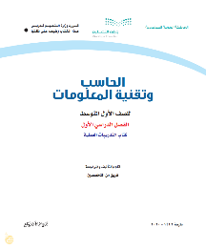 | Ministry of Education  2020
 |  | Computer hardware and peripherals | 2
 |  | Operating systems of computer and smart devices | 4
Semester 2 | 112 | Data input and output | 4 | 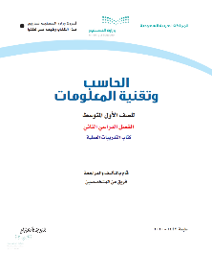
 |  | Word processing | 4
 |  | Hardware and software protection | 2
Total | 224 | 6 Units | 22
Book Title | Computer and Information Technology for the Second Intermediate Grade
Semester | Pages | Units Title | Topics Number | Textbook  Cover | Author and publisher
Semester 1 | 96 | Computer networks and the Internet | 8 | 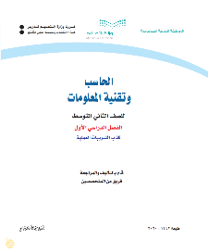 | Ministry of Education  2020
 |  | Preparing slides and presentations | 5
 |  | Knowledge society and intelligent world | 6
Semester 2 | 100 | Graphic applications and games | 7 | 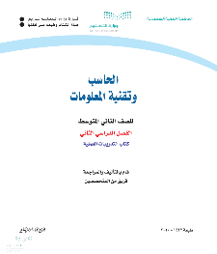
 |  | Spreadsheets | 8
Total | 196 | 5 Units | 34
Book Title | Computer and Information Technology for the Third Intermediate Grade
Semester | Pages | Units Title | Topics Number | Textbook  Cover | Author and publisher
Semester 1 | 126 | Computer programming and control | 6 | 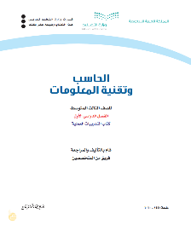 | Ministry of Education  2020
 |  | Electronic information resources | 4
 |  | Technology use for learning and education | 6
Semester 2 | 124 | Smart devices and robots | 3 | 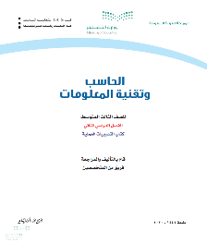
 |  | Internet services and website building | 4
Total | 250 | 5 Units | 23
Table [4]. Contents of Computer and Information Technology Textbooks.

As shown in this table, the CIT textbooks in intermediate schools start from the basics in providing knowledge about technology. This is not surprising given that intermediate schools are the first stage in which students begin to learn something about technology since there is no curricula about technology at the primary schools until May 2021 as mentioned in section 2.3. However, the units of CIT textbooks differ in their content, some focus on theoretical topics and others focus on practical topics. For example, the first unit of CIT textbook for the first intermediate grade focuses on providing theoretical knowledge about the principles and basics of technology such as data, information, types of digital devices, while the second unit of the same textbook focuses on how to connect and operate the computer and its peripherals such as keyboards, printers, and scanners.
Overall, relying on my experience of teaching the CIT textbooks as well as my knowledge about digital citizenship that I gained from the literature review, I extensively examined the CIT textbooks to identify the data that relevant to my research topic and can answer my first question: How do CIT textbooks construct and present the concept and topics of digital citizenship in Saudi intermediate schools? However, the CIT textbooks in general contain textual data as well as some images and figures. I noticed that most textual data such as the paragraphs of introductions, subjects, activities, and exercises, except the tables of contents and references, were relevant to the topics of digital citizenship. As for the images and figures, although that CIT textbooks include a set of images and figures, they often aim to introduce the technology such as computer’s types, components, and accessories. For example, see Figure 8. On the other hand, there are some images and figures that can be considered related to the subject of the study and can express some aspect of digital citizenship. For example, see Figure 9. Therefore, I identified a set of related images and figures that will be analysed within the textual data analysis process (see section 4.7.4).
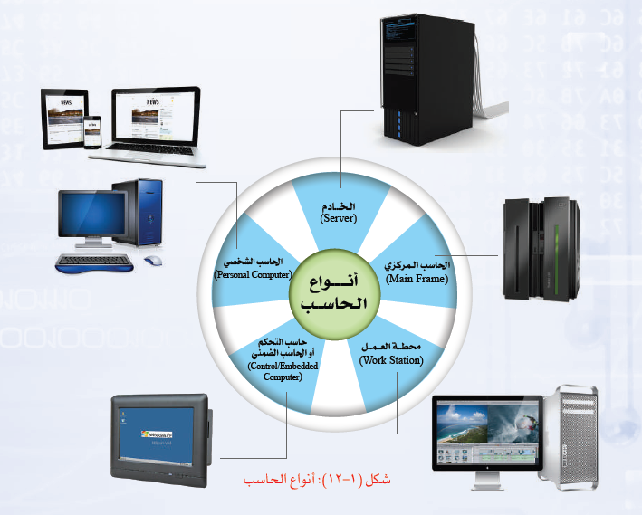
Figure [8]. Computer types. (Ministry of Education, 2020a, p. 15).

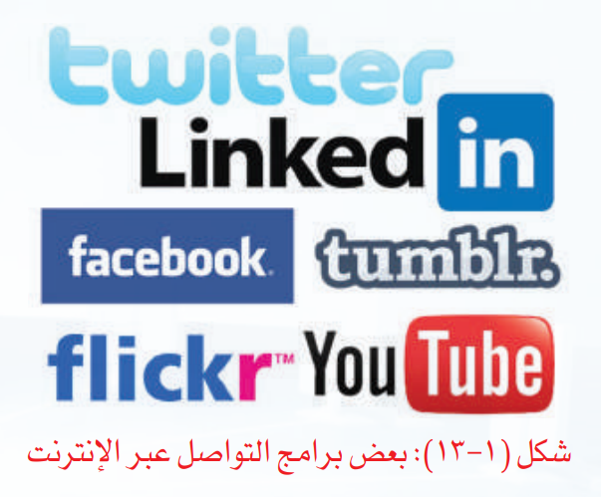
Figure [9]. Example of online communication programs. (Ministry of Education, 2020e, p. 84)

4.7.4 Analysing CIT Textbooks
As mentioned in the research methods (see section 4.3) that a framework approach consisting of five stages: ‘familiarisation; identifying a thematic framework; indexing; charting; and mapping and interpretation’, was used to analyse the CIT textbooks (Ritchie & Spenser, 2002, p. 178) For more information about these stages see section 4.3 as this section will not focus on introducing these stages, rather, it will focus the process of applying them.
4.7.3.1 Familiarisation (CIT textbooks)
I believe that this stage started from the moment I downloaded the CIT textbooks from the IEN portal. Also, there was an opportunity to familiarise myself with these textbooks when I presented a description of them in the previous section. However, the actual beginning of this stage was when I carefully examined the CIT textbooks, read them, and immersed in their content bearing in my mind what Bowen (2009) says that documents contain different forms of data which are not limited to interview transcripts. Therefore, my task at this stage was not only to familiarise myself with the data but also to identify the relevant data. The aim of analysing the CIT textbooks was related to the first research question: How do CIT textbooks construct and present the concept and topics of digital citizenship in Saudi intermediate schools? From this basis, the analysis process aims to explore the digital citizenship topics and understand how they are presented and constructed. In the literature review, I summarised five main topics of digital citizenship: digital literacy; digital protection; digital law; digital footprint; and creativity and innovation (see section 3.5). I used these main topics to guide my examination and review of CIT textbooks. I identified portions and textual parts of CIT textbooks related to these five topics by highlighting them with different colours for each topic and adding comments on the electronic versions of these textbooks (see Appendix K as an example). In this process, my focus was on getting a clear picture that helps me to organise the content of CIT textbooks rather than counting the relevant parts. As a result, some textual parts were associated with more than one topic and some parts were not associated with any topics.
In contrast to interview transcripts, which are often more structured because they are responses to questions asked according to the interview guide, the CIT textbooks contain multiple and overlapping forms of data. I felt that CIT textbooks need to be asked as if they can respond as the participants. Therefore, my question at this stage for the CIT textbooks was: Which parts of CIT textbooks reflect or express each topic of digital citizenship? However, the purpose of familiarisation stage is not only to gain an overview, but also to make notes and jot down recurrent issues and key themes (Ritchie & Spenser, 2002) Therefore, during my examination of CIT textbooks, I was observing key themes in each topic of digital citizenship and writing them down (see Figure 10 as an example). These initial themes represented the basis on which I relied in developing the analysis framework in the next section, where the CIT textbooks were re-examined and coded.
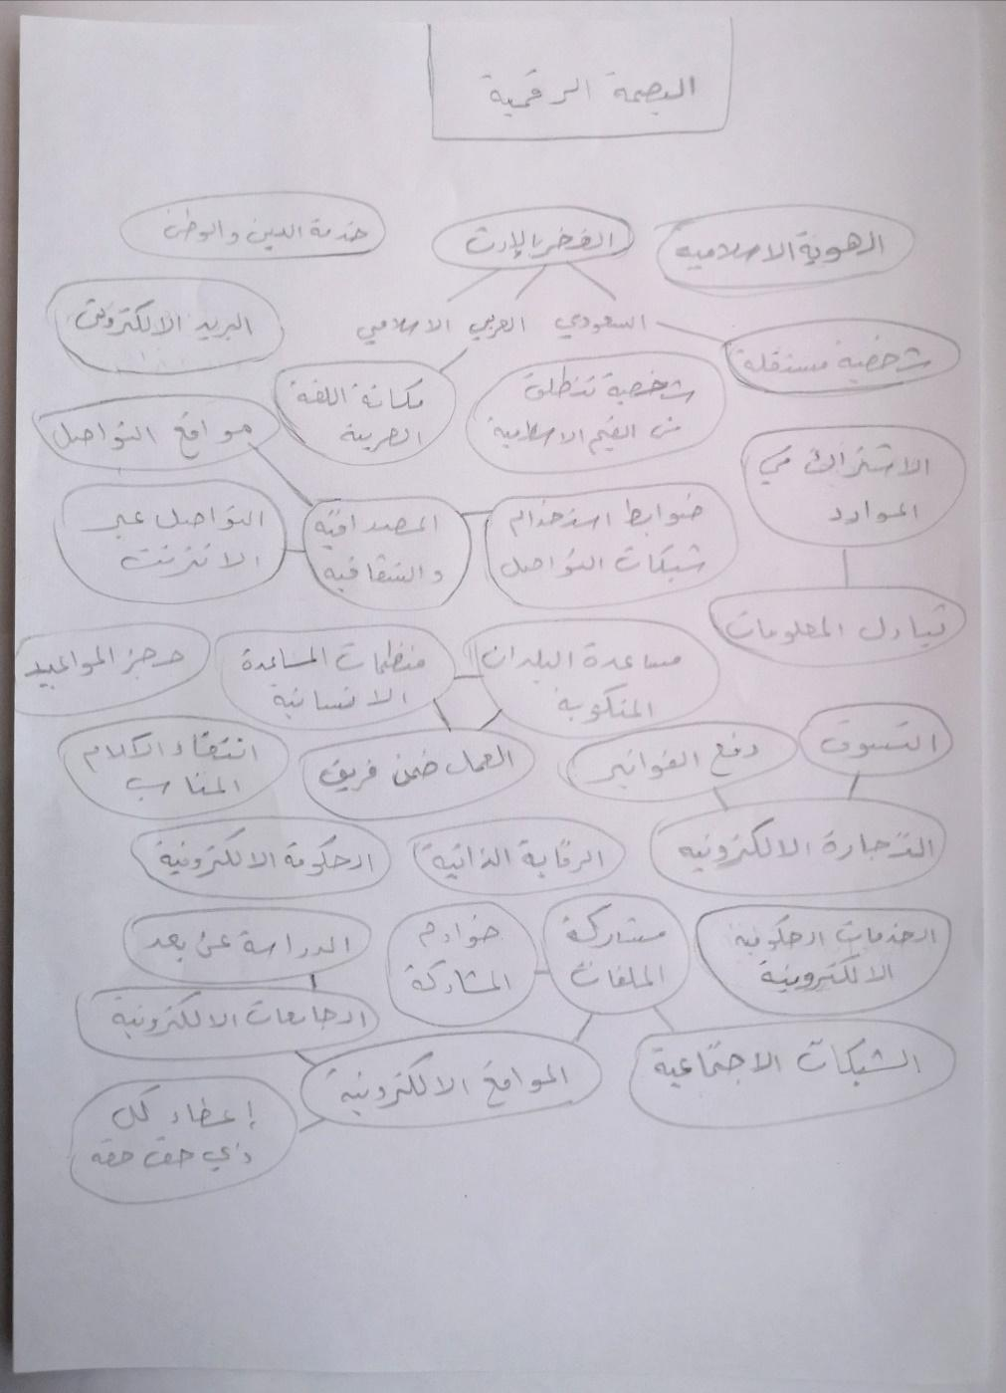
Figure [10]. An example of emerging themes from the familiarisation process of CIT textbooks

4.7.3.2 Identifying a Thematic Framework (CIT Textbooks)
Identifying an analysis framework is the next stage after familiarisation, which in my opinion they are closely interrelated even if they are presented as two stages. When I immerse myself in the data, my mind automatically moves to this stage because my goal of scanning and reading the data is to find recurring themes and issues. Therefore, I identified some connections between some themes, and I grouped some themes and sub themes as shown in Figure 10. However, this was done unintentionally in the familiarisation stage, while this stage ‘is not an automatic or mechanical process, but involves both logical and intuitive thinking’ (Ritchie & Spencer, 2002, p.180), it requires careful examination and review initial themes and making judgements about the implicit links between them, with the possibility for new themes and categories to be emerged (Ritchie & Spencer, 2002). To identify the framework, I reviewed the initial notes and themes that emerged from the familiarisation process and compared them with the content of CIT textbooks and sometimes the comparison was between a group of themes and another. To be honest, this stage was the most difficult because I think it is a combination of all stages. However, I used the main topics of digital citizenship as categories to organise the main themes and subthemes. Wellington (2015) indicates that categories derived from previous studies and literature can be used to make sense of the data, and he states that ‘a mixture of a priori and a posteriori [categories]...is the most rational approach to analysing qualitative data’ (p. 268). Therefore, about 169 codes were reviewed and distributed on the topics of digital citizenship that derived from the literature, so that each topic was written in a separate paper and each paper included a set of related codes (see Figure 11).
Figure [11]. Process of identifying thematic framework for the CIT textbooks

Then, each paper was divided into small groups according to the links and connection of the codes, and each section was reviewed separately to reduce the number of codes by merging similar codes with each other so that they represent emergent subthemes while each section represents an emergent theme. Finally, the initial framework is identified by bringing together the main categories, main themes, and subthemes (see Appendix L). It is worth noting here that Ritchie and Spenser (2002) state that the initial version of the framework ‘is often largely descriptive and heavily rooted in a priori issues’, however, this framework can be refined and changed at subsequent stages of analysis (p. 180). The next stage of the analysis where the framework is applied to the data, is a critical stage as it is a chance to make sure of the accuracy and reliability of the framework and to make further changes (Ritchie et al, 2003). Overall, I refined the framework many times during the analysis process, there were some tricky themes that required me to examine further and reconsider the context, however, the final framework became as it is shown in Table 5.
Research Question 1: How do CIT textbooks construct and present the concept and topics of digital citizenship in Saudi intermediate schools?
1. Digital Literacy
1.1 Basic Knowledge  1.1.1 Fundamental concept and terms  1.1.2 Technology principles  1.1.3 Operating systems and programs.  1.1.4 Devices and their peripherals. |  | 1.2 Data and Information  1.2.1 Browsing data and information.  1.2.2 Evaluating data and information.  1.2.3 Managing data and information.
1.3 Technology Use
1.3.1 Networking.
1.3.2 Social networks.
1.3.3 Digital games.
1.3.4 Digital learning.
2. Digital Protection
2.1 Digital Safety  2.1.1 Device safety  2.1.2 User safety. |  | 2.2 Digital Security  2.2.1 Device security.  2.2.2 Data and information security
3. Digital Law
3.1 Rights and Responsibilities  3.1.1 Internet availability and access.  3.1.2 Religious and moral boundaries.  3.1.3 Privacy. | 3.2 Rules and legislation  3.2.1 Intellectual property and copyright.  3.2.2 Cybercrimes.
4. Digital Footprint
4.1 Identity and Reputation  4.1.1 National identity  4.1.2 Netiquette.  4.1.3 Self-censorship |  | 4.2 Interaction and Participation  4.2.1 Sharing.  4.2.2 Communication.  4.2.3 Volunteering and cooperation.
4.3 Electronic transactions
4.3.1 Educational services
4.3.2 E-government.
4.3.3 E-commerce.
5 Creativity and Innovation
5.1 Digital Content  5.1.1 Word processing  5.1.2 Presentation design  5.1.3 Spreadsheets  5.1.4 Computer graphics  5.1.5 Website design |  | 5.2 Intelligence and problem solving  5.2.1 Knowledge society  5.2.2 Artificial intelligence  5.2.3 Simulation and models.  5.2.4 Programming Languages.
Table [5]. Final Thematic framework for CIT textbooks.

4.7.3.3 Indexing (CIT Textbooks)
Indexing refers to the process whereby the data is read and annotated in the light of the framework where the analyst matches themes with particular portions or sections of the data (Ritchie & Spenser, 2002; Ritchie et al, 2003). In my opinion, it is an interesting and exciting phase, it is like a puzzle, you have all these themes trying to find their matching from the textual data. However, there are some challenges that need to review the themes and examine the textual context. For example, the first semester of CIT textbook for first intermediate grade presents the keyboard, microphone, and scanner as computer peripherals and provides pictures of them. On the other hand, the second semester of the same textbook presents them again as data entry mechanisms. Ritchie et al (2003) state that “Indexing involves reading each phrase, sentence and paragraph in fine detail and deciding ‘what is this about?” (p. 224). This helped me in solving this dilemma, as I examined the paragraphs in which the keyboard, microphone and scanner were mentioned, and found that in the first semester the focus of the textbook was on introducing to students the components and peripherals of the computer, so some pictures were presented, while in the second semester the focus was on data management and processing where the textbook demonstrates to the students how data can be entered into the computer. Also, the advice of “deciding ‘what is this about?” (Ritchie et al; 2003; p. 224), helped me in analysing some pictures and Figures in the CIT textbooks, where I examined them, I asked questions about them, what are their purposes? What do they contain? What are they trying to tell or express? For example, the textbook for the first intermediate grade, in the subject of data types, presents a picture of the Prophet’s Mosque as an example of the type of data (Pictures). Also, in the exercise of using the scanner, the textbook uses another picture of the Prophet’s Mosque, Thus, these pictures can express some issues or themes such as religious or cultural identity. However, I matched all the textual data to the framework by adding comments next to each section of text on the electronic version of CIT textbooks which facilitated the index process as it was easy to navigate and search (see Figure 12).
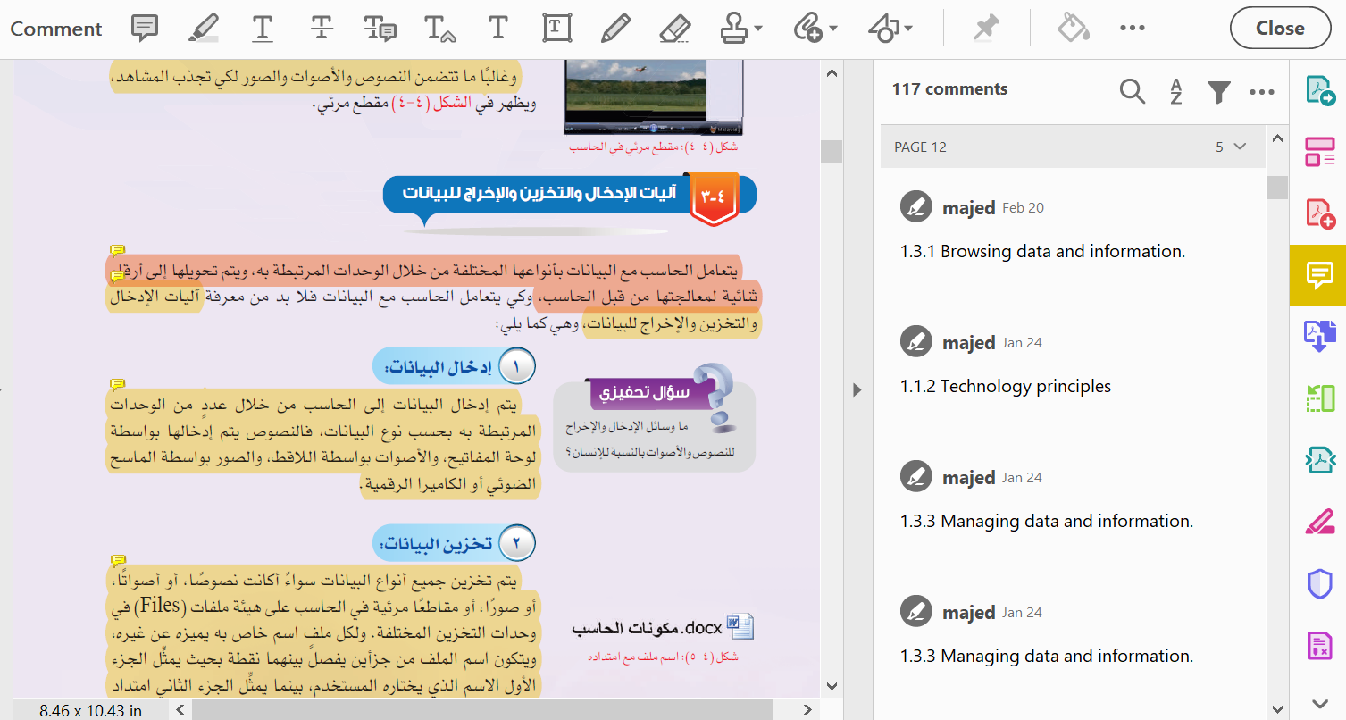
Figure [12]. An example of indexing process of CIT textbooks

4.7.3.4 Charting (CIT Textbooks)
Charting is the fourth stage where a picture of the data as a whole is formed through tables. I think it is the opposite of the previous stage. In indexing, themes are applied to the data, while in Charting, the data is lifted from its original form to the themes (Ritchie & Spenser, 2002). However, this process can be done through two ways, either creating a table for each theme where it includes all cases or creating a table for each case where it includes all themes related to that case (Ritchie & Spenser, 2002). The choice here depends on the goal of the analyst. If the focus is on understanding each case separately, the second method can be chosen, while for a comprehensive understanding of all cases according to each theme, the first method can be chosen. As mentioned previously, the goal of analysing the CIT textbooks is to find out how digital citizenship topics are presented and constructed. Therefore, my focus was on the themes because they express the presentation and construction of digital citizenship topics. I created a chart for each theme so that the columns reflect the sub themes of the main theme, and the rows reflect the data of the relevant CIT textbooks. However, there are some passages of text where one part matches a certain theme, and the other part matches another theme. It might be a good idea to associate each part with its corresponding theme. Unfortunately, some parts do not make sense when they are separated from their context. Therefore, some textual parts were associated with more than one theme with underlining the relevant text to each theme (for example see Table 6).
3. Digital Law | 3.1 Rights and Responsibilities
CIT Textbooks | 3.1.1 Internet availability and access. | 3.1.2 Religious and moral boundaries. | 3.1.3 Privacy.
First intermediate  Semester 1  (Ministry of Education, 2020a) | من الممكن تخزين الملفات في مجلدات محفوظة في أجهزة وسيطة تسمى خوادم (Servers) تقدم لنا خدمة الوصول إلى هذه الملفات متى ما أردنا ومن أي مكان  (p. 89)
First intermediate  Semester 2  (Ministry of Education, 2020b) | أتاح الإنترنت للطلاب والطالبات مئات المصادر المفتوحة ليرجعوا إليها، ولا يتطلب ذلك سوى النقر على جوجل (Google) ليجدوا إجابة لأي سؤال يدور في أذهانهم  (p. 28) | عند اختيار الصور لإضافتها لموضوع فلا بد من مراعاة مناسبتها لهذا الموضوع، والتزامها بضوابط الدين والأخلاق  (p. 80)
Second intermediate  Semester 1  (Ministry of Education, 2020c) | يوجد في الإنترنت مواقع سيئة لأغراض متعددة، هدفها هدم الدين والخلق، وتقوم هيئة الاتصالات وتقنية المعلومات في المملكة العربية السعودية بحجب هذه المواقع  (p. 15)  سنعمل على تطوير البنية التحتية الخاصة بالاتصالات وتقنية المعلومات وبخاصة النطاق العريض عالي السرعة لزيادة نسبة التغطية في المدن وخارجها وتحسين جودة الاتصال  (p. 85) | يوجد في الإنترنت مواقع سيئة لأغراض متعددة، هدفها هدم الدين والخلق، وتقوم هيئة الاتصالات وتقنية المعلومات في المملكة العربية السعودية بحجب هذه المواقع  (p. 15)
Second intermediate  Semester 2  (Ministry of Education, 2020d) |  | تعمل بعض الألعاب على الترويج لأفكار تخالف العقيدة والتعاليم والأخلاق النبيلة  (p. 17)
Third intermediate  Semester 1  (Ministry of Education, 2020e) | هل تتوقع أن تكون مصادر المعلومات الإلكترونية على شبكة الإنترنت متاحة جميعها بشكل مجاني؟  (p. 77) | نؤمن بأهمية بناء مجتمع حيوي يعيش أفراده وفق المبادئ الإسلامية السامية والقيم العربية الأصيلة وقيم ومبادئ المواطنة الصالحة ومنهج الوسطية والاعتدال والتسامح وقيم الاتقان والانضباط والعدالة والشفافية  (p. 83)
Third intermediate  Semester 2  (Ministry of Education, 2020f) |  | نحيا وفق مبادئنا الإسلامية حيث يمثل الإسلام ومبادئه منهج حياة لنا في جميع ممارساتنا العامة والإلكترونية وهو مرجعنا في كل أنظمتنا وأعمالنا وقراراتنا وتوجهاتنا  (p. 72) | - لا تنشر معلوماتك التفصيلية.  - اقرأ وتعرف على إعدادات الخصوصية الخاصة بحسابك، وتعلم كيفية تغييرها.  - لا تعط تصريح الدخول إلى معلوماتك الخاصة لأي تطبيق قبل أن تتعرف عليه جيدا.  (p. 73)
Table [6]. An example of charting process of CIT textbooks analysis

4.7.3.5 Mapping and Interpretation (CIT Textbooks)
Mapping and interpretation represent the last stage where the perceptions or accounts are compared; the patterns and connections are searched; and the explanations and interpretations are presented (Ritchie & Spenser, 2002) I believe that this stage are closely related to the charting stage, it is an advanced stage and higher level of the charting. It aims to present the conclusion by reviewing the previous stages, considering the objectives and questions of the research. Ritchie and Spenser (2002) state that it is an indescribable process which involves thinking, intuition, imagination, and creativity. However, to map and interpret the data, I relied on some tactics to deal with my data such as returning to research questions, looking for buzzwords, or looking for commonly used words and phrases (Wellington, 2015). The process of analysing the CIT textbooks was guided by the first research question since the early stages, and this stage is not exceptional. Therefore, the themes and the connection between them were organised according to five topics that express digital citizenship which are presented with more explanations and interpretations in the next chapter. Overall, this stage can be clearly demonstrated through the fifth chapter, which presents the findings related to the analysis of CIT textbooks.

4.7.5 Pilot Interview
After completing the CIT textbooks analysis, I became more confident about the topics that I would discuss with the students and CIT teachers. Examining and analysing the CIT textbooks provided me with sufficient knowledge and highlighted some issues that should be discussed with the participants such as activities, exercises, and enrichment content (Bowen, 2009). However, interviewing people for research purposes is not just a casual conversation, the interviewer is looking for specific information in order to answer specific research questions. Therefore, if the interviewer is not well prepared, he or she may not get satisfactory results. In contrast, the participants may not express a desire to disclose information or speak when they feel uncomfortable during the interview. Knox and Burkard (2009) state that participants ‘may continue to remain open and engaged with the interviewer only when they feel that their experiences are validated and supported and when the interviewer is equally as open during the interview’ (p. 10). Hence, I felt that conducting a pilot interview before interviewing the real participants is essential to familiarise myself with the interview procedures and practice the interview questions in a situation quite similar to actual interviews.
Pilot interview can be defined as ‘a practice interview that can serve many purposes: getting started, practising interview questions, and getting feedback on the topic as well as the interview method’ (Griffee, 2005, p. 36). After obtaining the approval from General Administration of Education in Hail region, I conducted pilot interviews with four participants who are known to me: two teachers and two students (see Table 7).
Pilot Interview Sample
Teacher number | School type | Teaching Experience
1 | Urban | 6 years
1 | Rural | 11 years
Student number | School type | Grade
1 | Urban | First intermediate
1 | Rural | Third intermediate
Table [7]. Pilot Interview sample.

Although the participants had the right to choose the platform which we will use to conduct the remote interviews, they were happy to give me this right. Therefore, I chose Microsoft Teams application because it is a reliable platform and it is the same application that students and teachers have been using to study remotely in Saudi Schools since the outbreak of the COVID-19. However, before conducting the pilot interviews, I was worried about the students’ ability to engage with me in remote interviews. Conversely, I found that the students had good knowledge and experience regarding this issue. I believe that the remote study pattern followed by Saudi schools since the outbreak of the COVID-19 has had a positive impact in this regard. So, contrary to what was expected, there were no technical obstacles or challenges except a slow internet connection sometimes. However, this was not a concern as the congestion of communication networks was expected due to the period exam of the first semester in Saudi Arabia.
These pilot interviews were a good opportunity to reveal important issues such as how the participants interact with me and how they understand and answer my questions. For example, at the beginning of the pilot interviews, I felt that the participants were concerned that I might assess them, or I might be the judge who will judge them after these interviews. So, I tried to solve this issue by putting myself in a position that belongs to them. I used my previous experience in teaching computer and information technology in Saudi intermediate schools to establish a good rapport with the participants. As a result, the participants were encouraged to remain open with me, by sharing with them some of my past experiences in Saudi intermediate schools (Knox & Burkard, 2009). However, some participants still tend to not answer in detail when the question is directly about them or their experience. For example, when I asked one of the teachers (Tell me about your experience in teaching digital citizenship topics?). He answered very briefly, even when trying to obtain more information, the answer is often general and does not give a description of the participant’s experience. Therefore, I paraphrased some questions to fit some participants of this type. For example, Question 7.1 was (What teaching aids and methods do you use in teaching digital citizenship topics?) and became after paraphrasing (What teaching aids and methods do computer teachers use in teaching digital citizenship topics?). However, I do not think this may affect the validity or accuracy of the information provided by the participants because the aim here is to identify the means that are used in the education process instead of identifying the person who used them. Hence, I believe that the participants will still talk about their experiences but in third person. Kross et al. (2014) conclude that ‘small shifts in the language people use to refer to the self during introspection consequentially influence their ability to regulate their thoughts, feelings, and behaviour under social stress’ (p. 304). Therefore, the participants provided informative and detailed answers for those questions that they expect to answer by using non-first-person pronouns, especially when criticising and talking about negative experiences.
As for the order of interview questions, I think semi-structured interviews are flexible so that one question can be asked before another, and new questions can emerge. However, from my experience in the pilot interviews, I believe that it is necessary to divide the interview guide into sections (see Appendix M and N), so that the interviewer can manoeuvre the questions within each section while sticking to the order of these sections. In other words, the sections helped me to guide the interview while at the same time allowing me to give the interview a conversational manner as each section represented similar topics which can be discussed flexibly and smoothly.
Another important issue that was revealed from the pilot interviews is when the participants were asked about the concept of digital citizenship and its definition, their perspectives were different and interesting. However, when moving to the rest of the questions, the participants answered based on their definitions of digital citizenship. This is not a problem when their definitions are close to the digital citizenship definition that was reviewed from the literature, the problem is when the participants understand digital citizenship differently from its meaning. For example, when I asked a student what digital citizenship means? He answered that there would be robots with nationality. So, when he was asked later, do you consider yourself a digital citizen? He answered: No, I am human. Therefore, I bear in mind that if I face this situation with other participants, then I would try to rephrase the question. For example, do you think a person who uses the Internet can be called a digital citizen? Or do you think that a digital citizen is someone who uses technology in an appropriate and responsible manner. However, I also bear in my mind that sharing knowledge about digital citizenship should be presented as another point of view or another perspective, which certainly does not mean that their opinions or ideas are wrong.
To conclude, the pilot interview was a valuable and interesting experience. I believe that the pilot interview is just as important as the actual interviews. Rather, it plays a critical role in making the actual interviews successful and effective. It also helped me in assessing my readiness as an interviewer. I believe that conducting interviews for research purposes is a complex process more like the operations carried out by computers, sending data (questions), receiving data (answers), and processing data (analysing answers) at the same time. These processes require training in order for the interviews to go smoothly and harmoniously without wasting the interview time in long periods of silence. Overall, I think what makes the pilot interview so important is that it is a unique experience that its results cannot be predicted without going through it.

4.7.6 Remote Interviews
After analysing the CIT textbooks and conducting the pilot interviews, I felt ready to conduct interviews with CIT teachers and students (see section 4.7.2 for more information on contacting with participants and obtaining consent). I planned to conduct face-to-face interviews before the emergence of COVID-19, which made face-to-face interviews pose risks to the participants’ health. Therefore, I conducted the interviews remotely using video-calling programmes such as Microsoft Teams and Google Meet which were chosen by the participants. Sevilla (2020) indicates that unlike Google Meet which is basically a video conferencing tool, Microsoft Teams ‘is a viable option but makes most sense for organizations, like businesses and schools’ (p. 5). Microsoft Teams is an effective tool in providing remote lessons and lectures where its strength lies in the system of sharing files and sending messages (Bergman, 2021). However, although Microsoft Teams facilitates the process of sending messaging and making conversations and calls for users within an organisation, it is difficult to invite external participants and that requires some steps and procedures. On the other hand, getting to the video calling on Google Meet is straightforward, and it is easy for any participants to set up and join a call. Also, it provides a preview mode so the participants can check how they look and mute, turn on, or turn off their microphone and camera before starting the call (Sevilla, 2020). From my experience using both platforms, I found that Google Meet is more suitable for conducting interviews with participants because it is simple, easy, and suitable for personal use, while I agree that Microsoft Teams is more suitable for institutions and organisations as it provides many effective tools, but they are not necessary in the case of my interviews. Therefore, when the participants did not choose any platform to conduct the interviews and gave me this right, I chose Google Meet because of the previous considerations.
Regardless of the platform used to conduct the interviews, in remote interviews there are some issues and challenges that must be considered such as online rapport, data richness, and availability of devices and the Internet. Orgad (2005) argues that building an online rapport is a challenge because relationships are highly dependent on trust which can be ‘more fragile in a disembodied, anonymous and textual setting’ (p. 55). However, researchers can construct a good level of online rapport with their participants by providing or sharing personal information about themselves. For example, sharing some information about family life and work (Kivits 2005). In addition, communicating and sending several emails before starting the interviews can help in developing and building a good relationship with the participants (Deakin & Wakefield, 2014; Seitz, 2015). From my experience, I believe that some factors such as the personal characteristics of the researchers and participants may influence the online rapport more than the method itself. Deakin and Wakefield (2014) argue that online rapport is ‘only an issue when interviewing an individual who is more reserved or less responsive’ (p. 610). I noticed this in my interview with the students, where it was difficult to get a good level of the rapport with the students as they were more reserved or less responsive as Deakin and Wakefield (2014) described. On the other hand, CIT teachers were more likely to express their views and interact with me comfortably, so it was easy to construct a good level of rapport with them and as a result they were happy to talk with me for a long time compared with the students (see Table 8).
Another challenge in remote interviews was the claim that although remote interviews are useful and appropriate in some cases, ‘they likely do often come at a cost to the richness of information’ (p. 1). However, the assumption that the data obtained online is less rich, truthful or authentic than the data obtained face to face is not always true. Orgad (2009) argues that using online or offline methods depends on the researcher’s assessment of the suitability of the method for the research objectives and questions, where sometimes the online methods are better than the offline. For example, ‘online self-narratives, can be rich, detailed, and illuminating about information that could have not been gained using offline methodologies’ (Orgad, 2009, p. 21). Also, online interviews are useful for sensitive topics so that embarrassing questions can be asked, and reflective responses can be gained from the participants (Madge & O'connor, 2004). However, the online and remote interview can be a face-to-face or in-person interview, but it is often performed using technology, Bryman (2012) argues that using webcam and Skype ‘would make online interview similar to an in-person interview, since those involved in the exchange would be able to see each other’ (p. 669). Personally, I do not think that there is much difference in terms of the richness of information between remote and face-to-face interviews, especially when the interviews are conducted remotely with video and audio. In contrast to the argument that distance in remote interview may place a constraint on interaction (Johnson et al, 2019), I think distance may give the participants a kind of feeling of comfort and thus they spend more time talking and expressing their perspectives because they do not feel that there is pressure on them as they are not surrounded by the researcher who may encroach on their personal space (Hanna, 2012). Another thing I noticed regarding the richness of information is that interview time greatly influences the duration and the format of my interviews. For example, the interviews that the participants chose to be in the morning were more formal and did not take a long time, while the interviews that the participants chose to be in the evening were more friendly and took a long time. I think the reason behind this is that the morning is often the time of study and official work in Saudi Arabia, so the interviews at that time unintentionally seemed official. Whereas the evening time (after dinner until midnight) is the preferred time for Saudis to talk and spend time with their friends. Thus, the interviews at that time seemed more informal and friendly compared to the morning interviews. Thus, they were long and produced detailed and rich information.
Participants Information
Participants Reference:
R= Rural Schools |  | U= Urban Schools
T= Teachers |  | S= Students
Numbers = Participant Count
CIT Teachers:
Participant Code | Teaching Experience |  | Interview Length | Interview Date
RT1 | 12 Years |  | 01:26:12 | 23/03/21
UT1 | 15 Years |  | 00:54:07 | 26/03/21
UT2 | 10 Years |  | 01:11:59 | 28/03/21
RT2 | 7 Years |  | 01:21:04 | 03/04/21
RT3 | 6 Years |  | 02:16:56 | 14/04/21
UT3 | 5 Years |  | 01:52:31 | 17/04/21
Students:
Participant Code | Grade |  | Interview Length | Interview Date
RS1 | Third Intermediate |  | 00:27:05 | 07/04/21
US1 | Second Intermediate |  | 00:45:20 | 14/04/21
RS2 | Second Intermediate |  | 00:29:06 | 18/04/21
US2 | First Intermediate |  | 00:30:12 | 22/04/21
RS3 | First Intermediate |  | 00:42:30 | 25/04/21
US3 | Third Intermediate |  | 00:48:50 | 26/04/21
Table [8]. Participants information.

Another challenge in remote interviews is the availability of devices and the Internet, in remote interviews some participants who do not have the required hardware or software or even do not have Internet access may be excluded, and even those who already have devices and internet access may cannot complete the interviews due to some technological problems. (Deakin & Wakefield, 2014; Johnson et al., 2019). From my experience, my participants and I did not face any problems regarding internet connection and access or regarding the devices and the programmes. I believed that my participants were familiar with the remote interviews because of the remote study pattern followed by Saudi schools since the outbreak of COVID-19. Therefore, when the interviews were conducted, the participants already had devices, Internet access, and previous experience in using platforms such as Microsoft Teams. In addition, half of my participants are CIT teachers who are qualified and educated in computer and technology. However, Communication and technical issues are unpredictable and even to a professional it can sometimes seem problematic. Deakin and Wakefield (2014) argue that familiarity of the interviewer to the participants can help in solving the technical problems that are facing them and may lead to their failure to join the remote interviews. Therefore, building a good rapport with the participants before conducting the interviews is not only useful in solving technical problems, but also helps to obtain detailed and rich information. Overall, I was keen to build a good relationship with my participants from the first email I sent to invite them to participate and then later in the second email to sign the consent form and later in several subsequent emails to determine the interview platform and the appropriate time for them. Moreover, my experience as a former CIT teacher helped me to share with my participants some of my previous experiences in teaching the CIT textbooks. In addition, the analysis of CIT textbooks helped me understand the content of current CIT textbooks, so I became more immersed in the environment and subject matter of the research, and thus I was able to establish a good relationship with my participants.

4.7.7 Recording and Transcription
In qualitative research, interviews are preferable to be recorded and transcribed because researchers are interested not only in what people say about their opinions and experiences but also in the way they express that. Therefore, audio records and transcripts give researchers an opportunity to check, examine, and review the data more than once, in addition to helping them to focus on the conversation with the participants rather than writing notes during interviews (Bryman, 2012). Therefore, I informed my participants in the information sheet, the consent forms, and at the beginning of the interviews that their voice will be recorded for the purpose of data accuracy and analysis. Nine of my participants (6 CIT teachers and 3 students) gave permission for their voice to be recorded, while 3 students refused that. However, I conducted the interviews with those who refused the recording because I believe that although recording the interview can be helpful for the researcher, it may concern the participants so their experiences and opinions may not be disclosed in detail. For those who accepted to be recorded, I used a digital recorder in my laptop to record the interviews. Bryman (2012) points out that digital recorder represents the superior recording medium because the sound quality is better in digital audio-recording and it can easily be transcribed, backed up, and played back again and again. The Digital recorder helped me in the process of transcription, where I played the audio records in slow playback mode so that I could catch up on the speech while I was transcribing. I transcribed all the audio records into Word files, and I named them according to the participants’ codes.
What caught my attention here is that after spending a long time listening to the audio records in slow playback mode, my ears are becoming more accustomed to this pattern, so after each transcription I found that my family’s speech seems fast and unclear. This led me to think that what I consider as normal or real, or even true may be because I am used to it, so when I get used to hearing participants’ records in slow playback mode, I find my family’s speech seems strange and fast. Looking at this situation, I began to ask myself about the reality of things and how people may consider them. Mertens (2010) states that ‘reality is socially constructed’ (p. 18), therefore many conflicting mental constructions can be found. I think that at the beginning of listening to my participants’ voice in slow playback mode, my mind recognised their voice as slow and strange, while after a long time of listening to them in slow playback mode, my mind recognised my family’s speech as fast and strange.
However, through my experience in the interview transcription process, I found that this process takes time and effort, so I set one working day for transcribing each interview. I advise the researchers to take this into consideration and set sufficient time for this process so that the interviews are accurately transcribed. However, the transcription process provides an opportunity for researchers to closely familiarise themselves with their data. Looking at the transcription process from this angle may help researchers spend a long time in transcription without getting bored. After the transcription process was completed, I sent copies of transcripts to the participants and asked them to read their transcripts and make sure that they matched what they said in the interviews. All participants confirmed the accuracy of the transcripts except for one of the teachers, who pointed out that the years of his experience were not written correctly, as he said in the interview six years while it is five years. Therefore, I updated the data according to the teacher’s last statement.

4.7.8 Analysing Interviews Data
To analyse interview transcripts, I used the same approach that used to analyse the CIT textbooks. Ritchie and Spenser (2002), indicate that although the thematic framework approach can be applied to any textual material, it is mainly applied to interviews transcripts. This approach consists of five stages: ‘familiarisation; identifying a thematic framework; indexing; charting; and mapping and interpretation’ (Ritchie & Spenser, 2002, p. 178). More information about these stages were presented in the sections 4.3 and 4.7.4. However, this section will also provide some information, but it will focus more on the process of applying these stages in analysing the interview transcripts of students and CIT teachers.
4.7.7.1 Familiarisation (Interviews data)
The familiarisation begins during the process of transcribing the interviews, however, I think that I initially familiarised myself with the data when I conducted the interviews. Later, during the transcription process, my knowledge of data improved significantly, and I was able to notice key issues and primary themes. However, I organised the data before starting the analysis process by dividing the transcripts into some sections. In the process of familiarising the CIT textbooks, the data was organised according to digital citizenship topics related to the first research question, while the interview data related to the second, third, and fourth research questions which are: What are the perceptions of CIT teachers and students in Saudi intermediate schools about the concept and topics of digital citizenship?; What are the perceptions and experiences of CIT teachers about teaching digital citizenship in Saudi intermediate schools?; and What are the perceived obstacles and challenges to teaching digital citizenship in Saudi intermediate schools? Therefore, the data were organised into two main sections: digital citizenship understanding and digital citizenship teaching. Supported by the knowledge obtained from the literature; the results that emerged from the process of analysing the CIT textbooks; and the notes of the interviews and transcriptions process, I examined, read and reread each section to observe meanings and patterns; identify key issues and themes; and writing them down in in pieces of papers (Braun & Clarke, 2006). Usually, I use printer paper to write my notes or draw some diagrams, white papers without any lines give me space to express as I want, while lined papers distract me (for example see Figure 13).
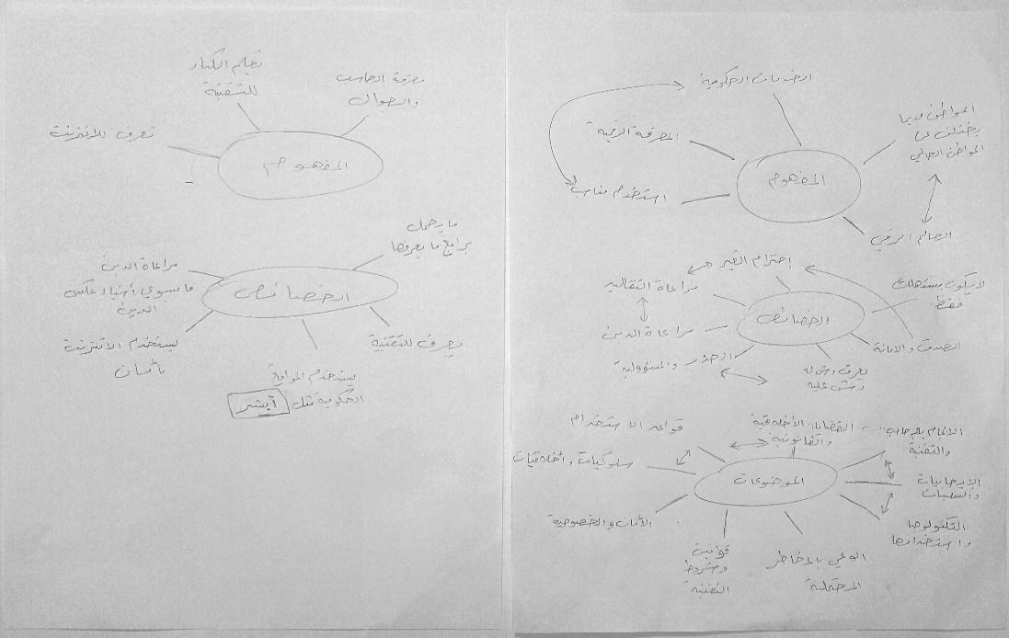
Figure [13]. Examples of emerging themes from the familiarisation process of interview data

Although the same procedures were followed in the familiarisation stage for both CIT teachers and students, these procedures were applied separately, starting first with CIT teachers’ transcripts. Dividing the data and working on its sections separately helps me to spend more time scanning, searching, reading, and re-reading because my mind is not occupied with the large amount of data, so in each section I have a reasonable set of data that do not let me get bored or skip a portion of the data. Braun and Clarke (2006) state that in the familiarisation stage ‘it is ideal to read through the entire data set at least once before you begin your coding’ (p. 87). However, this does not conflict with data divide, but may support it because in dividing data the analyst can assure that all data are examined, while working on the entire data some data may be accidentally skipped. Also, data divide does not mean that it is not possible to form a comprehensive picture, as it is possible to get an overview of the data by reviewing the results of examining each section, and this may be somewhat similar to what the analyst does in the mapping and interpretation stage.
4.7.7.2 Identifying a Thematic Framework (Interviews Data)
The previous stage outlined the path to be followed in dealing with data by working separately on teachers’ and students’ data. Therefore, at this stage, I identified a thematic framework for teachers’ data and another for students’ data. Ritchie and Spenser (2002), indicate that developing separate frameworks may be necessary if the study explores more than one population, however, they argue that the analyst should keep a common framework for the different population. Therefore, at an initial stage, I examined and reviewed the initial issues and themes observed in the familiarisation stage as well as I re-examined the data to discover the relationships between the themes and to understand the perspectives behind them by reviewing the original contexts in the transcripts. As a result of this process, two separate frameworks were defined, one for CIT teachers and one for students (see Appendix O and P). Later, I combined the two frameworks to form a common framework, taking into account the division of data, so that the first part of the common framework includes categories, themes, and subthemes related to understanding digital citizenship, while the second part includes categories, themes, and subthemes related to teaching digital citizenship in Saudi intermediate schools (see Table 9). By merging the two frameworks, I got a reasonable number of participants (six teachers and six students) to express the themes and discuss the similarity of their views on some themes and their difference on others. For example, the theme of ‘Technology knowledge and use’ represents the opinion of students and CIT teachers about the concept of digital citizenship so that students tend to describe it as the ability to use technology in general while teachers tend to describe it as the responsible use of technology. However, these differences and similarities between the viewpoints were reviewed and organised in the mapping and interpretation stage and clarified and explained in the findings’ chapters.

1. Understanding Digital Citizenship
1.1 Digital Citizenship Concept | 1.2 Digital Citizens Characteristics
1.1.1 Technology knowledge and use  1.1.2 Electronic services  1.1.3 Belonging in the digital world |  | 1.2.1 Digital awareness  1.2.2 Responsibility and productivity  1.2.3 Morality and ethics
1.3 Digital Citizenship Topics
1.3.1 Digital literacy  1.3.1.1 Basic knowledge  1.3.1.2 Technology use |  | 1.3.2 Digital Protection  1.3.2.1 Protecting digital property  1.3.2.2 Fraud and deception  1.3.2.3 Protecting morals and beliefs
1.3.3 Digital Law  1.3.3.1 Rights and responsibilities  1.3.3.2 Rules and legislation |  | 1.3.4 Digital Footprint  1.3.4.1 Digital identity  1.3.4.2 Social media
1.3.5 Creativity and Innovation
1.3.5.1 Programming
1.3.5.2 Graphic and design
1.3.5.3 Fame and celebrity
2. Teaching Digital Citizenship
2.1 CIT Textbooks Contents | 2.2 Teaching Activities
2.1.1 Inclusion and variety  2.1.2 Limitations and superficiality  2.1.3 Design and presentation  2.1.4 Enrichment content | 2.2.1 Methods and strategies  2.2.2 Students interaction  2.2.3 Projects and assignments
2.3 Teaching Obstacles | 2.4 Teaching Challenges
2.3.1 Time and sessions  2.3.2 The value of the CIT curricula  2.3.3 laboratory and resources | 2.4.1 Challenges related to Saudi culture  2.4.2 Challenges related to Saudi Vision 2030  2.4.3 Challenges related to CIT teachers
Table [9]. Common thematic framework for CIT teachers and students.

4.7.7.3 Indexing (Interviews Data)
Indexing, as explained previously, is the process of applying the framework to the data. At this stage, the analyst indexes the data by identifying the textual parts that correspond to themes and sub-themes (Ritchie & Spencer, 2002; Ritchie et al, 2003). At an initial stage, I applied two separate frameworks, one for CIT teachers and the other for students. The themes in the two frameworks were linked to the relevant text by adding marginal comments to the transcripts’ files (Word files). Then, at a later stage, I applied the common framework to the data of CIT teachers and students together. I compared the common framework that resulted from merging the previous two frameworks by replacing the previous indexing of the data with the corresponding indexing in the common framework (see Figure 14). My aim in working by this way was to make sure of two things: first, to ensure that the data was indexed through its own frameworks (one for CIT teachers and one for students), second, to review the common framework and ensure that it is accurate and comprehensive for both CIT teacher and students. However, what I found different compared with indexing the CIT textbooks is that some of the texts in the interviews’ transcripts are unclear, so at this point the audio records were crucial to understanding the meanings and intentions behind these silent texts. Therefore, in some places, I listened to parts of the audio records to properly index the data.
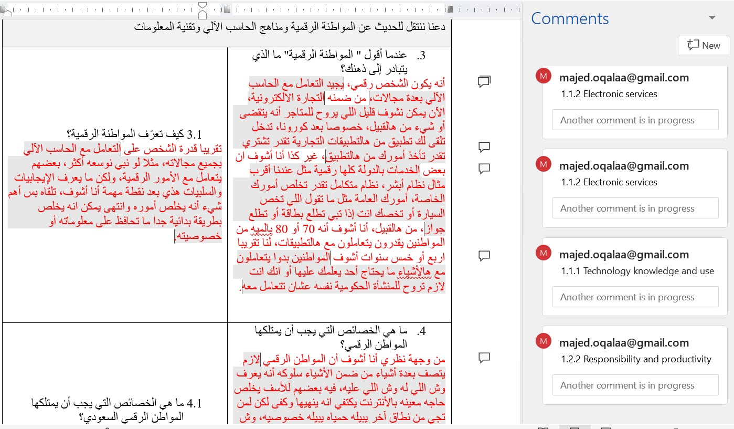
Figure [14]. An example of indexing process of interview data
4.7.7.4 Charting (Interviews Data)
I described this stage previously as an inverse indexing process, in which data is lifted from transcripts and linked to the relevant themes by tables. Each theme can be represented by a chart that includes a group of participants, or vice versa. Each chart represents a group of themes for a single participant (Ritchie & Spenser, 2002). This stage gives the flavour of the themes, as each theme is presented through a chart that includes a group of participants’ perspectives and opinions. Thus, the Charting stage helps the analyst in clarifying the meanings of the themes and their interpretation. However, at this stage, I lifted the textual data that was indexed according to the common framework, which includes the data of students and CIT teachers, so each chart represents one of the themes, while the rows represent the quotes of students and CIT teachers (see Table 10). I presented each theme in a chart because I am trying to understand each theme rather than each participant. Therefore, the charts allowed me to understand themes from the perspective of CIT teachers and students at the same time and allowed me to compare the two perspectives. The first six rows were allocated to CIT teachers while the last six rows were allocated to students. Ritchie and Spenser (2002) point out that it is important to keep in the same order of the participants in the Charting process so that a specific order is adopted and applied to all charts, which helps in organising the data and making it easy to understand. Therefore, the participants were arranged in the charts according to their order when the interviews were conducted.
1. Understanding Digital Citizenship
1.1 Digital Citizenship Concept
Participants | 1.1.1 Technology knowledge and use | 1.1.2 Electronic services | 1.1.3 Belonging in the digital world
RT1 |  |  | أن الفرد جزء من عالم رقمي يؤثر فيه ويتأثر به، وأن هذا العالم الرقمي غير محصور في شيء معين فهو يشمل كل ما تكون التقنية جزء منه سواء على مستوى الخدمات أو على مستوى الرغبات.
UT1 |  | يمكن أقول أنه قدرة الشخص على التعامل مع الخدمات الحكومية الالكترونية واستخدامها مثل منصة أبشر، يعني أقدر أقول انه قدرة الفرد على التعامل مع الخدمات الالكترونية بشكل عام.
UT2 | المواطن الرقمي هو الشخص أو الفرد الذي يستطيع أن يتعامل مع التقنية أو يكون ملم بالتقنية  الاستخدام الصحيح للتقنية في جميع مجالاتها ومعرفة ما هو المطلوب من حقوق وواجبات في التقنية.
RT2 |  | انه فيه فرق بين المواطن قديما والمواطن الآن، مثلا المواطن قبل مئة عام، طريقة حياته إذا بيستفيد من خدمات الأحوال او المستشفى مثلا لازم هو يروح ويقدم أوراقه، الآن تقدر تخلص أمورك كله في البيت. مثلا تقدر تخلص جواز السفر أو تحجز موعد بالمستشفى أو تشوف نتيجة التحاليل.
RT3 | أنه يكون الشخص رقمي، يجيد التعامل مع الحاسب الآلي بعدة مجالات،  التعامل مع الحاسب الآلي بجميع مجالاته، مثلا لو نبي نوسعه أكثر، بعضهم يتعامل مع الأمور الرقمية، ولكن ما يعرف الإيجابيات والسلبيات هذي بعد نقطة مهمة أنا أشوف، تلقاه بس أهم شيء أنه يخلص أموره وانتهى يمكن انه يخلص بطريقة بدائية جدا ما تحافظ على معلوماته أو خصوصيته. | من ضمنه التجارة الالكترونية، الآن يمكن نشوف قليل اللي يروح للمتاجر أنه يتقضى أو شيء من هالقبيل، خصوصا بعد كورونا، تدخل تلقى لك تطبيق من هالتطبيقات التجارية تقدر تشتري تقدر تأخذ أمورك من هالتطبيق  الخدمات بالدولة كلها رقمية مثل عندنا أقرب مثال نظام أبشر، نظام متكامل تقدر تخلص أمورك الخاصة، أمورك العامة مثل ما تقول اللي تخص السيارة أو تخصك انت إذا تبي تطلع بطاقة أو تطلع جواز،
UT3 | طريقة استخدام الانترنت هي المواطنة الرقمية، شلون تستخدم الانترنت بشكل صحيح، أنا هذي فكرتي تجاهه  زي ما تقول استخدام الانترنت بشكل صحيح، أعتقد إن له أنظمة وقواعد يعني أقرب ماله خلن أشرح لك كمثال مثل نظام المرور، أنت الآن لما تقود سيارة فيه يعني زي ما تقول قواعد، أربط الحزام، لا جيت تبي تلف يمين دق إشارة يمين، يعني إذا ما سويته احتمال إنك تصدم أو يصير لك حادث لا سمح الله.
RS1 | مجتمع يقوم على التقنية ويستفيد منه  استعمال التقنية بالحياة اليومية
US1 |  | البطاقة الجديدة اللي به شريحة، يعني يكون عندك بطاقة هوية رقمية اللي به شريحة، أول البطايق مابهن شرايح
US2 | يعني نستخدم أجهزة الحاسب والانترنت والمستندات بأمان بدون فيروسات، يمكن تدخل بجهازك فيروسات وتنحذف البيانات
RS2 | يستخدم التكنولوجيا يعني تكنولوجي بشكل عام، يوم أدخل على الانترنت أعرف كيف استخدمه |  | المواطن الرقمي يعني يعيش بالعصر الحديث هذا
RS3 |  | يعني المواطنين يصير عندهم حسابات بأبشر ويخلصون منه شغلهم  تصير كل أوراقك الكترونية بطاقتك ورخصتك ما يحتاج تأخذهن معك يصرن بالجوال
US3 |  | يعني تحجز مواعيدك بالأنترنت مثلا بالتطبيقات تقدر تحجز موعد قبل تروح لمكان
Table [10]. An example of charting process of interview data

4.7.7.5 Mapping and interpretation (Interviews Data)
Mapping and interpretation as mentioned earlier represent the last stage where the analyst searches for patterns and connections by comparing experiences, perceptions or accounts to present explanations and interpretations (Ritchie & Spenser, 2002). Personally, I think that the mapping stage represents the basis for presenting and discussing the results. In my opinion, it revolves around three issues: how the participants expressed their views and experiences, how I understood their views and experiences, and finally how I organised and presented them as new knowledge. Therefore, I think it is helpful at this point to remind yourself as a researcher of your primary research objectives or questions. The data can be organised and discussed in more than one way, the research questions are considered the best directed and organised through which the data can be mapped in a way that leads to answering the research questions (Wellington, 2015). However, as mentioned in the familiarisation stage that data were organised and divided according to the research questions into two main sections: understanding digital citizenship and teaching digital citizenship. This division helped me also in this stage, where my focus was first on understanding digital citizenship and comparing concepts and exploring the connections between the concept of digital citizenship, the characteristics of the digital citizen and the topics of digital citizenship. While in the second section, my focus was on teaching digital citizenship and exploring the teaching methods, activities, obstacles and challenges of teaching and the connections between them. Overall, this stage can be clearly demonstrated through the sixth chapter, which presents the findings related to the interviews data.

Summary of the Chapter
This chapter describes in detail the research methodology and procedures used to answer the research questions. This chapter presents and discusses many sections such as: the research stance; research design; research methods; purposive selection of the samples; ethical consideration; trustworthiness; translation challenges; access and gaining consents; description of CIT textbooks; analysing the CIT textbooks; pilot interviews; remote interviews; recording and transcription; and analysing interviews data. Overall, this chapter presents, discusses, and justifies the choices that the researcher made to generate, collect, and analyse the data. Also, this chapter focuses on clarifying and discussing the procedures through which the methodology was applied and addressing the challenges that accompanied the process of generating, collecting, and analysing data.

Chapter 5: Findings 1 (CIT Textbooks)

Introduction
Dealing with a large volume of data can be confusing not only for the readers but for the researchers as well. Therefore, it is important to organise and present this data in a logical or familiar way. Wellington (2015) suggests some tactics to deal with textual data such as returning ‘to the original research questions which were used to guide and plan the research’ (p. 271). Through my work on this research, I find that dividing or organising the data according to the research questions is something you may do unintentionally, as the data related to a particular question are more interrelated with each other. However, I think that organising the data according to a set of questions may be what Wellington describes as ‘returning to research questions’ (2015, p. 271). Therefore, this and the next chapter were organised by their relevance to the research questions. This chapter presents the results and findings related to the first research question: How do CIT textbooks construct and present the concept and topics of digital citizenship in Saudi intermediate schools? On the other hand, the next chapter presents the results and findings related to the questions 2, 3, and 4 which are about the CIT teachers’ and students’ perceptions and experiences of digital citizenship. This and the next chapter will present the themes and subthemes that emerged from the data analysis and also will present a set of chosen quotes that illustrate and support these themes (Bryman, 2012). However, although presenting verbatim quotes related to the themes may reinforce these themes and help in understanding them, it is impossible to present all relevant quotes due to the large volume of data and the word limit of the thesis (Wellington, 2015).
This chapter contains five categories or main themes that were derived from the relevant literature and frameworks of digital citizenship (see section 3.5). These five categories represent the main topics of digital citizenship which are: (i) digital literacy; (ii) digital protection; (iii) digital law; (iv) digital footprint; (v) and digital creativity and innovation. Each topic includes a set of themes and subthemes that emerged from the analysis process of the CIT textbooks in Saudi intermediate schools (see Figure 15).
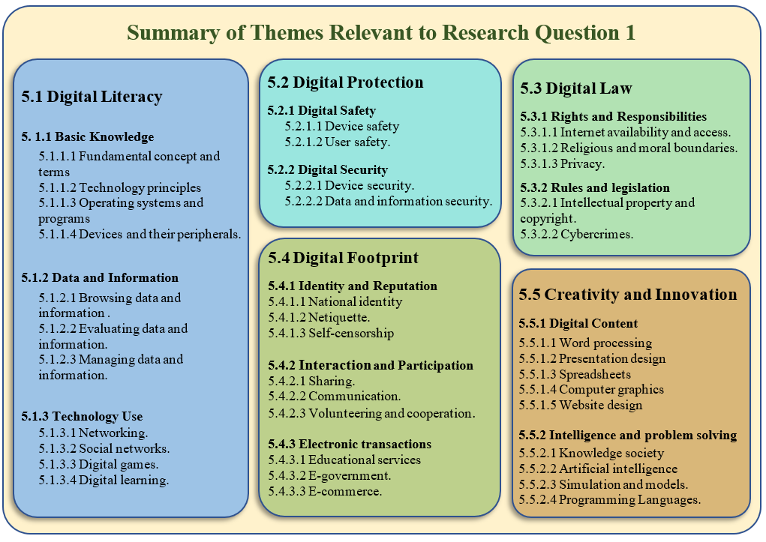
Figure [15]. Summary of themes relevant to the first research question

5.1 Digital Literacy
Digital literacy is one of the most important topics of digital citizenship discussed in the literature review (see section 3.5.1). Digital literacy can be considered the core or base topic on which the rest of the digital citizenship topics can be based. However, the process of analysing the CIT textbooks in the light of digital literacy ended with three main themes: basic knowledge; data and information; and technology use. These main themes and their sub themes will be presented in the following sections of this chapter, while they will be discussed in more detail in chapter 7.

5.1.1 Basic Knowledge
This theme is generated from a group of subthemes that express the primary knowledge provided by the CIT textbooks about technology. The CIT textbooks include many technology concepts and terms, for example, but not limited to, digital technology, data, information, digital devices, computer, software, hardware, motherboard, data bus, ports, hard disk, operating system, programme, and servers.
Hence the first subtheme, which is fundamental concepts and terms, has emerged to represent all these definitions, terms, and concepts in the CIT textbooks. For example, The CIT textbook for the first intermediate grade states that:
We hear the terms digital device and computer, and we see around us a lot of electronic devices such as televisions, projectors, cameras, and mobile phones, so do we call them computers or digital devices? To answer this question, we must first define these terms. Digital device: it is every device that relies on digital logic in its work. Computer: it is a digital device that can be programmed to enter, process, store, and extract the data. (Ministry of Education ,2020a, p. 14)
This quotation shows how the concepts and terms are presented to the students. Although the paragraph that preceded these two concepts tried to lead the students towards finding the difference between the digital device and the computer, it did not continue in that way and reverted towards presenting the concepts directly to the students. However, this applies to the rest of the CIT textbooks as they often present the concepts in a similar way to the previous example.
The second sub theme of the basic knowledge is technology principles, it represents the parts of CIT textbooks that explain the principles and rules on which technology and digital devices work. For example, but not limited to, how digital devices work by using the binary digits, how the computers interact with people through input and output units, how processor speed is measured, and how data is stored. The CIT textbooks include many parts explaining how technology works, but most of them are concentrated in the CIT textbook for the first intermediate grade. For example, this CIT textbook in the first semester states that:
In fact, digital devices depend on electricity in their work, and therefore they do not understand human languages, but rather they convert all data, whether texts, images, sounds, or videos, into electrical signals, and these signals are just two: (ON) if the circuit is closed, then the electricity will pass. This means that there is an electrical signal, and it will be represented by the number (1). (OFF) if the circuit is open, then the electricity will not pass. This means that there is not an electrical signal, and it will be represented by the number (0). From here, we conclude that data is represented within the digital device by numbers consisting of (0) and (1), and they are called binary digits. (Ministry of Education ,2020a, p. 9)
Clarifying the way technology works may help students understand the concepts and terms. Looking at the first quote, digital logic is referred to in the definition of a digital device, and in the second quote, digital logic is clarified by explaining how digital devices work using the binary digits.
The third sub theme of the basic knowledge is operating systems. It expresses the topics or parts related to operating systems and their role in operating the computer and controlling the work of the hardware and the applications. The CIT textbooks provide good information about the operating systems of computers and smart devices. Operating systems such as DOS, UNIX, Linux, Mac, iOS and Windows Phone are briefly reviewed in these textbooks, while Windows and Android are discussed in more detail. Although there are many devices that use different operating systems than Windows and Android, the CIT textbooks use these two operating systems to teach students how to deal with computers and smart devices. However, what I found interesting is that the CIT textbooks used a simulation program to teach students about Android. The CIT textbook for the first intermediate grade, first semester, page 94, provides a practical exercise that helps students to explore the Android system menus, options, and settings by using the Windroy program which runs the Android system on the Windows system. Teaching with simulation has many advantages, Luo et al (2018) state that ‘interactive computer simulations give students a sense of control and ownership of their exploration and discovery, and thus, it enhances their understanding and retention of information’ (p. 60).
The last sub theme under the basic knowledge is devices and their peripherals. This sub theme represents the topics and paragraphs that provide information about digital devices and their peripherals. The CIT textbooks provide various information about computers and smart devices such as their types, uses and advantages. It also provides information about the internal components of these devices, such as processors, memory, and ports. Moreover, it provides information about the external peripherals such as but not limited to input units, output units, storage units, and smart boards. The CIT textbooks not only provide knowledge about digital devices but also try to encourage the students to evaluate these digital devices and their peripherals. For example, the CIT textbook for the first intermediate grade, first semester presents an inquiry question on page 11 as below:
Your father wanted to buy a laptop for your brother on the occasion of his graduation from the university, and he asked you would we buy a laptop with 250gb storage or with 1tb storage? Which one would you choose? and why? (Ministry of Education, 2020a, p.11)
This inquiry motivates the students to think about the advantages and the differences between the digital devices. Also, it helps them to reach a point where they know what works for them and meets their needs. Evaluating digital technologies and devices is important in this digital age, where the digital devices and technologies are constantly renewed and changing. Therefore, it is important for the students to have the necessary skills that help them in recognising and evaluating these technologies.

5.1.2 Data and information
Data and information are the second theme under digital literacy. I prefer to address this subject through a separate theme because data and information are an essential pillar in the field of digital technology, and without it, digital devices are useless as they depend on digital logic. However, this theme presents the subject of data and information within the topic of digital literacy, therefore, data and information security will not be presented here, but in the digital protection topic (see section 5.2). However, this theme contains three sub themes that focus on how the CIT textbooks provide the knowledge about browsing, managing, and evaluating data and information.
Firstly, browsing data and information, this subject is well covered in the CIT textbooks. Topics such as types of data, sources of information, methods of research and obtaining data and information are presented in the CIT textbook for the first and third intermediate grades. However, the CIT textbooks introduce these topics in later stages, while in early stages they indicate that the students can use the Internet to search for information or files. For example, the topics of information sources and Internet search methods are presented in the CIT textbook for the third intermediate grade. In contrast, the CIT textbook for the first intermediate grade asks the students to use the Internet to search and download printer drivers as below:
If the printer is not automatically identified, and you do not have the printer installation disc, you can search for the printer installation program through the Internet and download it by typing the following sentence in one of the search engines: (Driver) printer name and model. As in the next example: (driver HP Color LaserJet CP2025). (Ministry of Education, 2020a, p. 53)
The previous example shows that the order of the topics in the CIT textbooks is an important issue that should be given more attention, the presentation of these topics should be consistent with the prior knowledge that students may have.
Secondly, managing data and information, this subject is well covered in the CIT textbook for the first intermediate grade. The first semester of this textbook includes topics such as creating, naming, copying, pasting, and deleting files and folders. Also, it includes good information about the types of the files and the folders and their uses. Whereas the second semester includes topics such as data entry, storage, and output. Moreover, the CIT textbook for the first intermediate grade provided students with a set of steps that explain how text data can be input by the keyboard, sounds by the microphone, and pictures by the scanner. Also, this textbook explains how this data can be output by speaker and a printer. Overall, the CIT textbook for the first intermediate grade provides good foundational information about data management and explains some practical steps that help students organise their data and information on their devices.
Finally, evaluating data and information, this sub theme represents topics concerned with the validity of data and information as well as the reliability of the sources. The CIT textbook for the third intermediate grade, first semester presents a topic on evaluating information sources on the Internet. This textbook on page 86 states that:
Despite the large amount of information that is available on the Internet, not everything on the Internet is true, so we must evaluate the information we obtain by applying some criteria that help us to ensure the validity of this information. (Ministry of Education, 2020e, p. 86)
After this paragraph, the textbook explains how the validity of the information can be ensured by checking the website information and design, the data sources and references, and the writer’s information. However, the issue of the order of the topics mentioned in browsing data and information appears here in evaluating data and information. While the topic of information validity and the reliability of sources is presented in the third intermediate grade, the CIT textbook for the first intermediate grade presents the following activity:
In cooperation with your colleagues, search for a reliable site on the Internet to check the computer for viruses and present it in class to your colleagues with the method of using it. (Ministry of Education, 2020b, p. 94)
This is the second example that shows that the order of the CIT textbook topics may need to be revised. Such activities and tasks that are supposed to help the students to check and protect their devices, may pose a threat if the students use unreliable websites.

5.1.3 Technology Use
Technology use is the third theme under the topic of digital literacy. At the beginning of the analysis process, I called it secondary knowledge because it represents digital knowledge, but it is not basic or primary as the digital knowledge mentioned in the first theme. However, in the theme review process, I realised that the appropriate description of this digital knowledge should be the technology use because it focuses on the fields of technology use. For example, the use of technology in learning, communication, entertainment, and play.
The first subtheme of the technology use is networking, the knowledge about the networks is presented to the students in the second intermediate grade. The CIT textbooks for the second intermediate grade, first semester, includes a range of topics which address different types of the networks, whether they are online or offline, wired or wireless. However, topics such as local computer networks, types of networks, and communication tools are briefly presented, while the topic of the Internet is discussed in more detail. The CIT textbook for the second intermediate grade, first semester presents on pages 14 and 15 great information about the advantages and disadvantages of the Internet. Internet addiction is one of the important issues mentioned on page 16, and although the information is presented briefly about this serious problem, the CIT textbook tries to encourage the students to discuss this issue and find some solutions or tips through some activities and tasks. For example, The CIT textbook for the second intermediate grade, first semester, on page 16 presents the following activity to the students:
Ask the following question to some of your colleagues: How many hours do you spend on the Internet? What is appropriate advice if your colleague spends a lot of time on the Internet? (Ministry of Education, 2020c, p. 16)
This type of activity may be useful for students in examining the effects of using the Internet for a long time and its impact on their health and personal lives. However, carrying out such activities may require more time, which may be a problem in the case of the CIT textbooks, which are taught at the rate of one lesson per week.
The second subtheme of the technology use is social networks. It was possible to introduce this subject in the previous subtheme, but I preferred to introduce it in a separate sub theme because it is an important issue. Despite the importance of this subject, the CIT textbooks did not cover it sufficiently. This subject is mentioned in the CIT textbooks for the second and third intermediate grade, and in both textbooks the presentation of this subject is not specifically aimed at social networks. In the CIT textbook for the second intermediate grade, the social networks are mentioned in the exercises of using the LibreOffice Impress program to design a presentation. On page 49, the CIT textbooks states that:
We will create a presentation on social networks, and the purpose of this presentation will be to explain the definition of social networks, their advantages, disadvantages, some common examples of them and the rules that must be adhered to when using social networks. (Ministry of Education, 2020c, p. 49)
This exercise seems like a great idea to teach students about social networks while they are learning how to design a presentation. However, the challenge here lies in implementing this exercise and covering both topics as required. In addition, there are many factors that may affect the implementation of this exercise such as time, teachers’ attitudes, students’ behaviour, and available resources. The second place where the social networks are mentioned, is in the first semester of the CIT textbook for the third intermediate grade, this textbook on page 83 presents the topic of information sources and states that social networks are one of the most important sources of information on the Internet and the most popular for a large group of people. It also refers on page 84 to some examples of the social networks by presenting the following Figure:
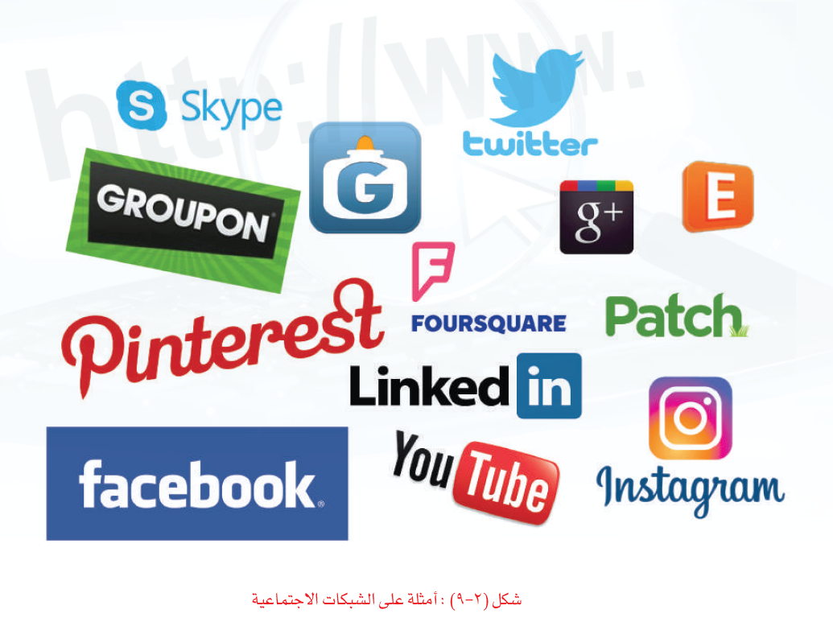
Figure [16]. Example of social networks. (Ministry of Education, 2020e, p. 84)

However, in both CIT textbooks, the subject of social networks is presented in a way that does not reflect its importance, where this subject is not presented as the main topic, instead of that, it is presented within other topics. Also, the CIT textbooks focus only on the knowledge dimension.
The third sub theme of the technology use is digital games. Digital games can be the favourite subject of most students especially in primary and intermediate schools. The CIT textbook for the second intermediate grade includes topics such as game platforms, game types, and their positive and negative effects. This textbook provides students with some knowledge that helps them to know which games are good and which are not by knowing the positive and negative effects. This textbook also tries to develop students’ skills of evaluating digital games by assigning them some projects and tasks. For example, the CIT textbook for the second intermediate grade presents in the second semester this task:
Your task will be to present the three best computer games from your point of view in the following areas: educational games for children - games for developing problem-solving skills - cultural games. Either as a presentation or poster and make sure you cover the following data: Game name - game objective - type of device on which the game is running - game description - the advantages. (Ministry of Education, 2020d, p. 18)
As mentioned before, such projects or exercises may help students in acquiring good skills, but this depends on the way these projects are implemented and to what extent teachers and students can go in this direction, especially with the challenge of time and available resources.
The final sub theme of the technology use is digital learning. Digital learning is well addressed in the CIT textbook for the third intermediate grade. This textbook includes many topics such as training and practice programs, learning management systems, and virtual collaboration tools. This textbook also mentioned some examples of these programs and tools such as Moodle, acaDOX, Edmodo, and Dabbleboard. However, this textbook moves from just providing information about digital learning to the level of practice, as it provides students on page 120 with an exercise on the use of simulation in education. The CIT textbook explains a set of practical steps to run one of the simulation programs on PhET which is a platform of interactive simulations provided by the University of Colorado Boulder. This exercise helps the students to run the simulation program of building an atom, where they can build an atom, change its properties, and observe the changes. However, except for this subtheme, the presented knowledge in the rest of subthemes under technology use remains within the limits of providing information and it does not reach the stage of the practice.

5.2 Digital Protection
Digital protection is the second important topic of digital citizenship. This topics includes important issues discussed in the literature review (see section 3.5.2). In the CIT textbook, the focus is on the issue of providing students with knowledge and information about the safety and security, instead of the issue of how safety and security can be achieved. However, the process of analysing the CIT textbooks in Saudi intermediate schools ended with the emergence of two main themes which are digital safety and digital security. These main themes and their sub themes will be presented in the following sections of this chapter, while they will be discussed in more detail in chapter 7.

5.2.1 Digital Safety
Digital safety is the first theme of digital protection, it represents topics concerned with the safety of the digital devices as well as the safety of the users. The CIT textbooks for first and second intermediate grades include good topics on the issue of safety. For example, but not limited to, the effects of electricity, dust, heat, liquids, the Internet, and games. However, these topics will be covered in the following subthemes: device safety and user safety.
Device safety is the first subtheme under digital safety, it reflects some topics focused on protecting digital devices from potential risks. The textbook for the first intermediate grade includes most of these topics and presents them in a simple and clear way for students. For example, the first semester of this CIT textbook states on pages 48 and 52 that it is necessary to ensure that the power supply is compatible with the devices before connecting them. Also, this CIT textbook explains to the students the correct way to connect computers and their peripherals through some instructions and pictures (see Figure 17).
Figure [17]. Connecting the computer and its peripherals. (Ministry of Education, 2020a, pp. 47- 48).

Furthermore, in the second semester, the textbook explains the effects of unstable voltages, and offers tips such as using a voltage stabiliser and not plugging more than one device into a single power socket. It is not only the power effects that are covered in the CIT textbook for the first intermediate grade, but also some topics such as dust, liquids, and heat are mentioned as other factors affecting the safety of devices. However, the CIT textbook does not provide advice on how to avoid the potential effects of the dust, liquids, and heat. Instead, it presents this as an activity that includes these questions: How to protect your device from the effect of dust? How to protect your device from the effect of liquids? How to protect your device from the effect of heat? (Ministry of Education, 2020b, p. 93). Although this activity helps students in developing thinking skills, the implementation of the activities as mentioned previously depends on several factors and it cannot be certain that all the activities of the textbook will be implemented as required.
User safety is the second subtheme under digital safety, it represents the topics concerned with the safety of the people who deal with technology and digital devices. The CIT textbook for the first intermediate grade refers to some issues related to physical health such as adequate ventilation, suitable lighting, and correct sitting position when using a computer and digital devices. Also, this textbook provides some tips and advice on how to sit correctly which are supported by some pictures (see Figure 18).
Figure [18]. Correct sitting position. (Ministry of Education, 2020b, p. 15).

In addition, the CIT textbook for the first intermediate grade provides some information about some exercises that help in relaxing the eyes. For example, it states on the page 15 that:
It is preferable to take a break from time to time to relax the eyes and body, and some simple physical exercises can be done by applying the rule (20 * 20 * 20) to relax the eyes. Every 20 minutes, close and open your eyes for 20 times to moisturise them and walk 20 steps to improve your blood circulation. (Ministry of Education, 2020b, p. 15)
On the other hand, although the CIT textbooks refer to some psychological or mental issues such as Internet addiction, social isolation, and violent tendencies, they are mentioned superficially by linking them to some topics such as the negative effects of digital games and the Internet. For example, the CIT textbook for the second intermediate grade in the second semester indicates that some games may have negative effects such as promoting ideas that contradict religion, teachings, and noble morality, and some games may promote the use of violence and using bad words. Also, gaming addiction and social isolation are mentioned as other negative sides of digital games. However, the textbook does not address and discuss these issues in detail and does not provide advice or guidance to students in this regard. Overall, in terms of users’ safety, the CIT textbooks focus more on physical harm than psychological or mental harm.

5.2.2 Digital Security
Digital security is the second theme of digital protection, it expresses topics that concern with the security of data, information, and devices, CIT textbooks include some topics such as computer viruses, penetration, spoofing, hacking, backup, firewalls, and encryption. However, these topics can be divided into two sub themes: device security, and data and information security, as follows.
Device security is the first sub theme that represents some topics such as computer virus, systems update, and firewall. Although these topics are related to the data and information security, they are primarily intended to secure the devices. The CIT textbook for the first intermediate grade provides in the second semester a good introduction about computer viruses, their types, causes of infection, and methods of protection. However, the textbook does not clearly explain how devices can be protected from viruses, the textbook only indicates some advice, as in the following example:
To protect our devices from viruses and reduce their risks or damages, it is recommended to follow the following instructions:
- Install antivirus program on your device
- Update your antivirus program regularly
- Regularly check your computer for viruses
- Scan storage media for viruses when connected to a computer
- Block pop-up windows when browsing the Internet
- Secure your wireless network with a password
- Constantly update the software and operating system (Ministry of Education, 2020b, p. 94)
Although the CIT textbook provides useful instructions for protecting devices, it does not explain how the students can implement the previous instructions or at least some of them. However, these instructions may need more than two lessons to be covered, taking into consideration the readiness of the computer labs and the availability of the Internet and resources.
On the other hand, data and information security represents the second subtheme of digital security. The CIT textbooks for the first and second intermediate grades provide introductory topics about data and information security such as backup and encryption of information, as well as indicating some of the means through which data and information can be stolen, such as spoofing, eavesdropping, and hacking. However, the topic of backup is explained in more detail in the second semester of the CIT textbook for the first intermediate grade. This textbook provides practical steps on how to create a backup copy of your data, how to save that copy, and how to restore it when needed. Although the backup helps restore data when it gets deleted or corrupted, it does not prevent hackers from stealing it. Unfortunately, the CIT textbooks provide little information about how data and information can be protected. For example, the first semester of the CIT textbook for the second intermediate grade presents the topic of information encryption in only few words, The same also applies to the topics of eavesdropping and spoofing, which are also presented in simple and small paragraphs that aim only to define these terms (Ministry of Education, 2020c, p. 94). Overall, except for the topic of backup, the CIT textbooks focus on the knowledge aspect of digital security as they illustrate potential digital risks without developing students’ skills in detecting, identifying, and avoiding digital risks.

5.3 Digital Law
Digital law is the third topic of digital citizenship, and it includes important issues discussed in the literature review (see section 3.5.3). In the CIT textbooks, the digital law is not given more attention as there are no specific topics that discuss this issue. Instead of that, the CIT textbooks present this topic in the form of small paragraphs within different topics. However, the process of analysing the CIT textbooks in Saudi intermediate schools ended with the emergence of two main themes. These main themes and their sub themes will be presented in the following sections of this chapter, while they will be discussed in more detail in chapter 7.

5.3.1 Rights and Responsibilities.
Rights and responsibilities are the first theme under the topic of digital law, it is presented under the topic of digital law because it includes sensitive topics related to ethical, religious, and cultural boundaries, which are considered more like the laws and the rules especially in the context in which the research was conducted. The CIT textbooks present rights and responsibilities in an unclear manner, while rights and responsibilities need to be more explicit to be adhered to. However, the CIT textbooks include some topics related to the Internet availability and access, religious and moral boundaries, and privacy, which will be presented in the following subthemes: Internet availability and access; religious and moral boundaries; and privacy.
Internet availability and access is the first subtheme of rights and responsibilities, it is optimistically mentioned in the CIT textbooks through some quotes from Saudi Vision 2030 related to improving Internet speed and quality in urban and rural areas. For example, the CIT textbook for the second intermediate grade refers to this quote from Saudi Vision 2030:
A sophisticated digital infrastructure is integral to today’s advanced industrial activities. It attracts investors and enhances the fundamental competitiveness of the Saudi economy. We will partner with the private sector to develop the telecommunications and information technology infrastructure, especially high-speed broadband, expanding its coverage and capacity within and around cities and improving its quality. (Ministry of Education, 2020c, p. 85)
The CIT textbooks participate in presenting this ambitious vision to students and present the issue of Internet availability as a right that must be available to all individuals inside and outside cities. However, in Saudi Arabia, getting access to some websites on the internet is restricted due to some religion or moral reasons. The CIT textbook for the second intermediate grade indicates that the Internet contains some websites that aim to destroy religion and morality. Therefore, the Communications and Information Technology Commission in the Kingdom of Saudi Arabia blocks these websites (Ministry of Education, 2020c, p. 15).
Religious and moral boundaries are the second subtheme under the rights and responsibilities. Religion and morality are significant issues that are given more attention in Saudi Arabia (see section 2.2). The CIT textbooks present religion and morality as a guide that must be followed in offline life and online life as well. For example, the second semester of the CIT textbook for the first intermediate grade indicates that:
The picture is an effective means of expressing and clarifying the meaning easily. When choosing pictures to add to a topic, it must be taken into account that they are appropriate for this topic, adhere to the rules of religion and morals, and respect intellectual property. (Ministry of Education, 2020b, p. 80)
This quote illustrates the importance of religion and morality, as they were mentioned before intellectual property. This importance is also reflected in the way that CIT textbooks present the subject of electronic transactions, where the CIT textbooks indicate that religion and morals must be adhered to in the electronic transactions. For example, the CIT textbook for the third intermediate grade indicates in the topic of social networks that ‘We live according to our Islamic principles, where Islam and its principles represent a way of life for us in all our public and electronic practices, and it is our reference in all our systems, decisions, and attitude’ (Ministry of Education, 2020f, p. 72). Although the CIT textbooks clarify in the previous two examples the importance of religion and morality for digital transactions and practices, they do not clarify or discuss the religious and moral boundaries that must be adhered to. Digital world is a vast and multicultural environment that differs significantly from the environment and culture of certain people within certain geographic boundaries. Therefore, the CIT textbooks may need to highlight some digital issues that may not be compatible with the religion and the culture in Saudi Arabia.
Privacy is the last sub theme of the rights and responsibilities. Unfortunately, the privacy issue is not adequately addressed in the CIT textbooks as it is mentioned only in the second semester of the CIT textbook for the third intermediate grade. This textbook refers to the issue of privacy in the form of enrichment information, where it states on page 73 that when you use social networks you should ‘read and learn about your account’s privacy settings, and learn how to change them’ and ‘do not give access to your private information to any application before you know it well’ (Ministry of Education, 2020f, p. 72) Although, the enrichment contents may be important and contain valuable information, they are sometimes ignored or skipped for certain reasons such as the lack of time or resources. Overall, in terms of rights and responsibilities, the CIT textbooks focus on the aspect of knowledge and attitudes. However, this knowledge was little and not clear, so the rights and responsibilities related to issues such as digital access and privacy remain almost unknown. Also, the CIT textbooks do not discuss or developed digital attitudes in relation to religious and culture.

5.3.2 Rules and Legislations.
Rules and legislations are the second theme of the digital law, it represents topics such as intellectual property, copyright, and cybercrimes which are mentioned in the CIT textbooks for the first and second intermediate grades. However, intellectual property and copyright are referred to in small paragraphs within some topics, while the cybercrimes are presented in more detail in a separate topic.
Intellectual property and copyright are the first sub theme of rules and legislations. It is mentioned superficially and presented with a little information only in the second semester of the CIT textbook for the first intermediate grade. Intellectual property is mentioned in the sixth exercise of the topic of word processing, where it indicates that when you add pictures to your work, you should make sure that you ‘adhere to the rules of religion and morals, and respect intellectual property’ (Ministry of Education, 2020b, p. 80). Copyright is also mentioned in the word processing topic, where it presents on page 45 a thought-provoking question: ‘your colleague using a commercial program that he obtained for a small fee from a vendor who copies programs without the owner’s permission. What do you call that? And what is your advice?’ (Ministry of Education, 2020b, p. 45).
On the other hand, the rest of CIT textbooks assign students to some tasks and assignments without drawing their attention to the issue of intellectual property and copyright. For example, the CIT textbook for the first intermediate grade, first semester, on page 66 assigns students to write a research paper on Apple operating system (iOS), while the issue of intellectual property and copyright is not mentioned at all in that textbook. However, students in intermediate grades may not fully understand what these terms mean rather than knowing the risks and ethical issues involved.
Cybercrimes are the second sub theme of the rules and legislations. The CIT textbooks for the second intermediate grade address some topics such as eavesdropping, spoofing, penetration, and malware which are presented with little details as examples of cybercrimes. However, this CIT textbook clearly indicates on page 17 that eavesdropping, spoofing, penetration, and malware are crimes punishable by law, and many states prepared regulations and laws to punish those who commit the cybercrimes. Also, this CIT textbook indicates that Saudi Arabia is among those countries that have anti-cybercrime law and provides a picture of this law as below.
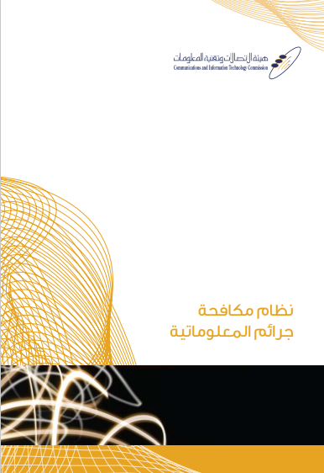
Figure [19]. Anti-cybercrime law (Ministry of Education, 2020c, p. 17).

Although this picture may help students to identify the law when they search for it, it does not give any hints about the content of this law. Overall, the CIT textbooks give simple knowledge about cybercrimes, while students in intermediate grades may need to be provided with some situations or scenarios of cybercrimes in which they can learn how such crimes occur and how they can be avoided.

5.4 Digital Footprint
Digital footprint is the fourth topic of digital citizenship, it represents everything that is left by users on the Internet, either directly or indirectly (see section 3.5.4). The CIT textbooks contain different topics related to the digital footprint, including but not limited to, digital identity, netiquette, sharing, interaction, cooperation, and electronic transactions. However, the process of analysing CIT textbooks ended with the emergence of three main themes: identity and reputation, interaction and participation, and electronic transactions. These main themes and their sub themes will be presented in the following sections of this chapter, while they will be discussed in more detail in chapter 7.

5.4.1 Identity and Reputation
Identity and reputation are the first theme of digital footprint, it includes some topics related to national identity, netiquette, and self-censorship. The CIT textbooks for the second and third intermediate grades focus on the national identity and refer to this issue in several topics, while the issues of netiquette and self-censorship are presented briefly in the form of tips or advice. However, these issues will be presented in the following subthemes.
National identity is the first subtheme under identity and reputation, and it represents an important issue that is strongly referred to in the CIT textbooks. The CIT textbooks mention on different pages that people should preserve and be proud of their national identity. For example, the second semester of the CIT textbook for the second intermediate grade refers to this quote from Saudi Vision 2030:
We take immense pride in the historical and cultural legacy of our Saudi, Arab, and Islamic heritage. We recognise the importance of preserving this sophisticated heritage in order to promote national unity and consolidate true Islamic and Arab values. Therefore, we will endeavor to strengthen, preserve and highlight our national identity so that it can guide the lives of future generations. (Ministry of Education, 2020d, p. 25).
In addition, in a drawing exercise using Inkscape program, the CIT textbooks for the second intermediate grade expresses the national identity in three main pillars: Islam, Arabic language, and homeland (see Figure 20).
Figure [20]. An exercise of drawing Muslim identity. (Ministry of Education, 2020d, p. 25).

This figure contains three shapes in the circles around the person icon, these three shapes represent the Holy Qur’an, the Arabic language, and the homeland. Another example from the CIT textbook for the first intermediate grade, in the subject of data types, the textbook presents a picture of the Prophet’s Mosque as an example of the type of data (Pictures), and also in the exercise of using the scanner, the textbook also uses another picture of the Prophet’s Mosque (see Figure 21).
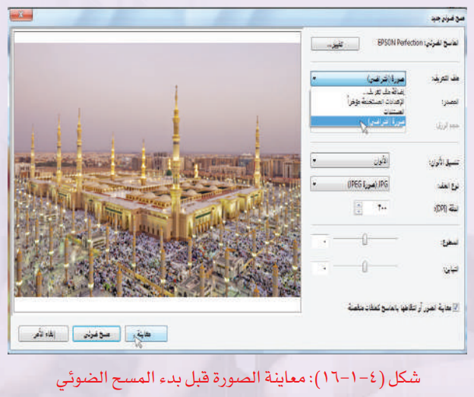
Figure [21]. An exercise of using the scanner. (Ministry of Education, 2020b, p. 32).

These figures reflect how the CIT textbooks express and present the national identity to the students by reminding them of their culture derived from religion and the Arabic language. However, focusing on national identity without mentioning or discussing the global issues may increase the gap between local culture and global culture, and thus, a cultural conflict is inevitable, especially in the digital environment.
Netiquette is the second sub-theme of identity and reputation. It represents polite behaviour when communicating with other people on the Internet. Internet users may think that they cannot be identified or cannot be reached. Therefore, they sometimes go beyond the limits of acceptable behaviour when addressing or communicating with others. However, the CIT textbooks do not cover this issue, but they mention digital etiquette in limited words in the form of marginal advice. The CIT textbook for the third intermediate grade is only the textbook that mentioned this issue, where it presents in the topic of social network this advice: ‘delight yourself and those around you with your politeness and respect’ (Ministry of Education, 2020e, p. 83). The second place in which the textbook mentions something about the netiquette is in the second semester, where it discusses the topic of online communication and presents this advice: ‘participate in the meaningful and useful and be sure to choose the appropriate speech’ (Ministry of Education, 2020f, p. 73). These two quotes represent the provided knowledge on the issue of netiquette in the CIT textbooks. However, although students may learn about etiquette from other textbooks, it cannot be asserted that these textbooks discuss this issue from a digital perspective.
Self-censorship is the third sub-theme of identity and reputation, it is presented in the CIT textbooks quite similarly to the way in which the topic of netiquette is presented. This issue is not discussed in detail but is presented in the form of a note or advice. The textbook for the third intermediate grade mentions self-censorship only on page 83 in the first semester of the CIT textbook for the third intermediate grade. This textbook presents in the topic of social network this advice: ‘do not pay attention to those who make fun of your self-censorship’ and ‘always remember that even if there is no censorship, you are responsible for your actions and your works’ (Ministry of Education, 2020e, p. 83). However, although providing such advice is good for reminding students of the need to monitor their actions when dealing with the digital world, students may need further clarification, explanation, and models in this regard.

5.4.2 Interaction and Participation
Interaction and participation are the second theme of digital footprint. It represents topics such as sharing, communication, cooperation, and volunteering. These topics are presented in a way that invites and encourages students to practise rather than just providing them with information. Although the CIT textbooks encourage students to share, communicate, cooperate, and volunteer, they do not discuss these issues in detail. However, these issues will be presented in the following sub-themes.
Sharing is the first sub-theme of interaction and participation. The CIT textbooks include some topics that encourage students to share files using networks and cloud storage. For example, the second semester of the CIT textbook for the third intermediate grade indicates that ‘Information sharing has an important role in people’s lives, as it is used in various fields such as correspondence, marketing, and research’ (Ministry of Education, 2020f, p. 75). The textbook also explains how the Internet helps and facilitates the process of sharing information through websites such as the website of the Ministry of Education, and through cloud storage such as OneDrive, Dropbox, Google Drive, and Amazon Drive. In addition, the CIT textbooks encourage students to share not only the information but also their creative work and projects by uploading them online. For example, the first semester of the CIT textbook for the third intermediate grade indicates that students can share programming projects they have designed by Scratch program, where it states that ‘the project can be shared with the Scratch community by uploading it to the Scratch website, where the site provides the ability to view, test, and edit projects’ (Ministry of Education, 2020e, p. 72).
However, the CIT textbooks focus on providing students with knowledge and information about the importance and benefits of sharing, while they do not explain how sharing tools can be used and do not discuss some important issues such as what can be shared, and with whom?
Communication is the second sub-theme of interaction and participation. It represents some topics such as the conversations and video conferencing, social media, and email. The CIT textbooks present the topic of communication as related to the human instinct and the tendency of people to communicate with each other. The CIT textbook for the second intermediate grade states that ‘People, by their nature, love meeting others and communicating with others. In this era, there are many ways to communicate with everyone, despite the distances’ (Ministry of Education, 2020c, p. 9). In this regard, the CIT textbook for the third intermediate grade outlines a range of communication means, where it presents on page 71 a topic entitled communication via the Internet. In this topic, the textbook explains to the students the different ways of communication such as email, social media, websites, and conferences. In addition, the CIT textbook for the third intermediate grade refers to a quote from Saudi Vision 2030 which states that:
We will interact with everyone and work to strengthen communication channels between government institutions on the one hand, and between citizens and the private sector on the other. We will facilitate interaction through smart means, we will listen to everyone’s opinions, encourage government agencies to meet the needs of every citizen, and enhance the quality of services we provide. (Ministry of Education, 2020f, p. 76).
The CIT textbooks present the topic of communication positively and invite and encourage students to use appropriate communication tools. However, as with the topic of sharing, the CIT textbooks do not discuss or explain important issues to students such as how they use communication tools or with whom they can communicate.
Volunteering and cooperation are the last sub-theme under the interaction and participation. This sub-theme represents topics that encourage students to cooperate and provide volunteer services. The CIT textbook for the second intermediate grade refers to this issue through the introductory paragraph to the presentation design lesson. In this paragraph, the textbook tells a motivational story about a group of volunteers in a team that prepares, packages, and sends foods to help children in conflict and disaster countries around the world, in cooperation with accredited humanitarian aid organisations. However, the textbook mentions in this story that some of those volunteers designed a presentation about the conflict and disaster areas of the world, the nutritional needs of children, and how to volunteer or help, and then they published this presentation through the media. As a result, there has been a significant increase in the amount of aid provided to these countries and areas (Ministry of Education, 2020c, p. 36). After presenting this introductory paragraph, the textbook invites students to design their own presentations and states that ‘as those volunteers were able to get benefits from the presentations in helping the children of the world, you can also serve your religion and country by designing your own presentation’ (Ministry of Education, 2020c, p. 36).
Although the textbooks encourage students to volunteer to serve their religion and country in the first place, they highlight some global humanitarian issues and present the people working on them in an honourable manner that leads students to appreciate them. However, the issue of volunteering and cooperation is not mentioned or covered in all the CIT textbooks except in this place of the first semester of the CIT textbook for the second intermediate grade.
Overall, in terms of interaction and participation, the CIT textbooks focus on providing knowledge about the communication and interaction tools as well as encourage students to share, communicate, and participate. However, the CIT textbooks do not develop students’ skills regarding using these tools responsibly and appropriately.

5.4.3 Electronic Transaction
Electronic transaction is the third theme of digital footprint. This theme represents topics that discuss the issue of electronic transactions such as educational, government and commercial services. However, the electronic transactions are presented only in the CIT textbook for the third intermediate grade. The CIT textbook for the third intermediate grade refers to educational services through the subject of electronic transactions. The textbook explains some educational services that can be completed using the Internet, such as distance education, self-learning, and virtual classes. The textbook also mentions some examples, such as the Saudi Electronic University and IEN National Education Portal (see Figure 22).
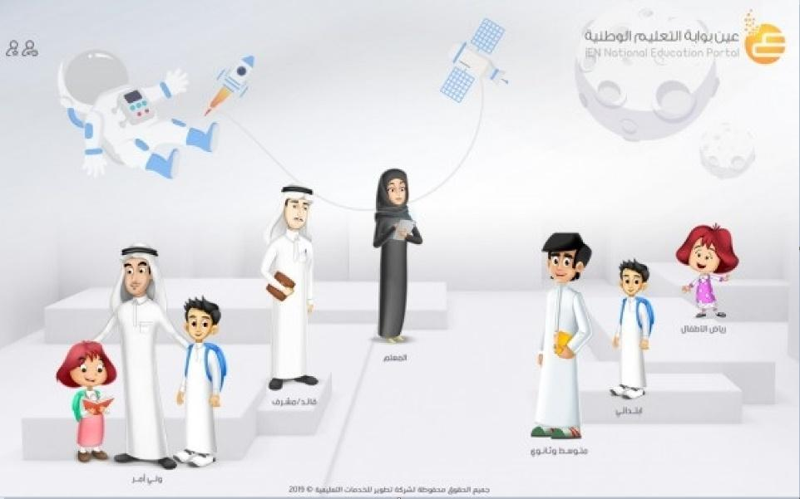
Figure [22]. IEN National Education Portal. (Ministry of Education, 2020f, p. 76).

As presented in the CIT textbook, this figure shows the National Education Portal which is called IEN. Although the CIT textbook only mentions IEN as an example of educational services without further information about it, IEN is one of the educational websites which is well known to most students, teachers, and parents. IEN provides all the textbooks for public education in the form of electronic copies, and provides a set of lessons, exercises, and activities. IEN also allows all students, teachers, and parents to register and benefit from its services.
E-government is also mentioned in the CIT textbook for the third intermediate grade through the subject of electronic transactions. In the enrichment information paragraph, the CIT textbook refers to e-government as an example of electronic services. The CIT textbook explains the benefits of activating e-government such as saving time and reducing costs. Also, the CIT textbook provides an example of the services that can be done through Absher such as the possibility of issuing a passport and having it delivered to your address (see Figure 23).
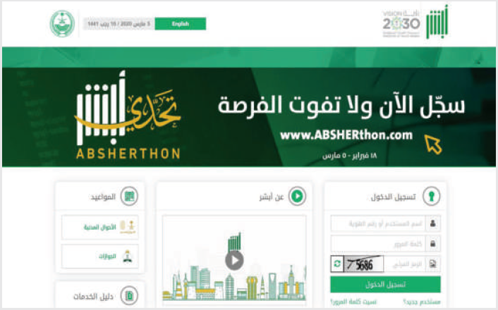
Figure [23]. Absher Website. (Ministry of Education, 2020f, p. 77).

This figure shows Absher website as it is presented in the CIT textbook. Absher is an electronic system launched by the Ministry of Interior in Saudi Arabia that allows Saudi citizens and residents to communicate with government agencies and finish their own transactions and get their affairs done without the need to visit government departments or ministries (Absher, 2021). Although the information provided about government services is little, The CIT textbooks link this information with examples that are common and known to the students, such as Absher system in this example and IEN as in the previous example.
E-commerce is the last sub-theme under electronic transactions. It represents topics related to the use of the Internet in the field of commerce, such as buying, selling, and marketing. The CIT textbook for the third intermediate grade only states in a small paragraph that the Internet can be used in selling, buying, marketing products, or communicating with customers and serving them. Although the CIT textbook refers to electronic commerce, it does not discuss this issue in detail. For example, the CIT textbooks do not discuss e-commerce risks or address the students’ interests such as buying electronic games or subscribing to game servers. However, transactions that involve money are often high-risk, especially if they are used by individuals who may be unaware of its risks. Therefore, the CIT textbooks may need to present the subject of e-commerce in detail and clarify the critical issues and the potential risks. Overall, in terms of electronic transactions, the CIT textbooks focus on providing knowledge about the educational, government and commercial transactions without developing the students’ skills or attitudes in this regard.

5.5 Creativity and Innovation
Creativity and innovation are the last topic of digital citizenship, it represents various topics concerned with the area of creativity and innovation (see section 3.5.5). The CIT textbooks include some topics on creating digital content such as designing presentations, websites, computer graphics, and working on word processor and spreadsheet programs. In addition, the CIT textbooks include some topics about intelligence and problem solving such as knowledge society, artificial intelligence, simulation and programming languages. However, these topics will be organised and presented in the following sections of this chapter, while they will be discussed in more detail in chapter 7.

5.5.1 Digital Content
Digital content is the first theme under creativity and innovation. This theme represents the topics that help and train students to create and work with digital content, whether this content is interactive such as websites or presentations, or it is non-interactive such as images, graphics, and text documents. The CIT textbooks provide good theoretical knowledge about these topics as well as provide the students with practical training to work on programs related to these topics. However, the topics covered in the CIT textbooks in relation to digital content will be presented in the following sub-themes.
Word processing is the first sub-theme of digital content. This topic is only covered in the CIT textbook for the first intermediate grade; however, it is covered in detail in the fifth unit starting from page 43 to 84. This unit is divided into two sections: the first section contains theoretical knowledge about word processing programs such as their types and features; while the second section includes seven practical exercises on word processing, from creating the document to printing the document. The CIT textbook for the first intermediate grade provides detailed practical steps for dealing with the LibreOffice Writer program. For example, but not limited to entering and modifying texts, inserting images, creating and modifying tables, formatting pages and paragraphs, and printing documents. The CIT textbook provides a detailed explanation of the practical steps supported by some pictures (see Figure 24).
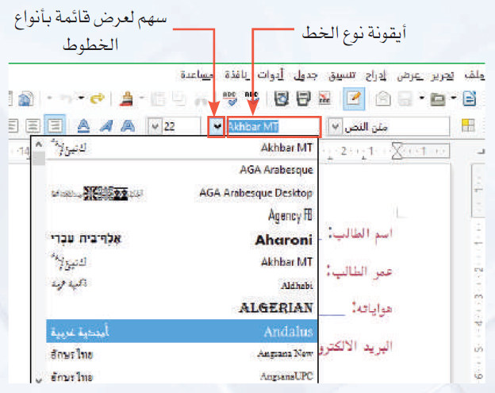
Figure [24]. Word processing exercises. (Ministry of Education, 2020b, p. 68).

In addition to the fact that the CIT textbook explains these exercises in detail and supports them with pictures, it also presents them in the form of main topics rather than presenting them in the form of additional activities. This method of presentation gives importance to these exercises which may affect the interaction of teachers and students and thus increases the opportunity to implement these exercises as required.
Presentation design is the second sub-theme of the digital content. As with word processing, presentation design is only covered in the CIT textbook for the second intermediate grade, however, it is covered in detail in the second unit starting from page 37 to 74. This unit is divided into two sections: the first section contains theoretical knowledge about presentation programs such as their types and features; while the second section includes six practical exercises to practise presentation design, starting with slides insert and ending with slides show. The CIT textbook for the second intermediate grade provides detailed practical steps for dealing with the LibreOffice Impress program. The textbook explains to the students how to add text, images, sounds and video, as well as how to format slides, add motion effects, and show slides. Also, the textbook provides some pictures to help students deal with the program and implement the training steps (see Figure 25).
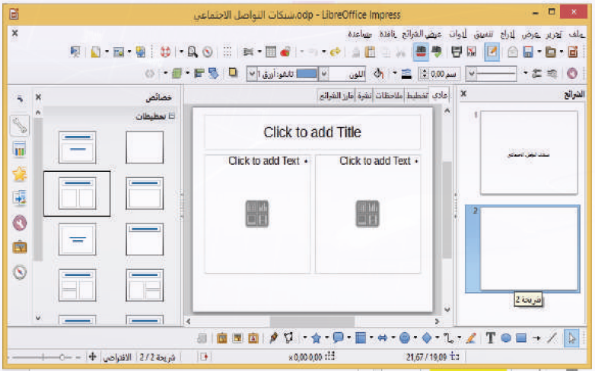
Figure [25]. Presentation design exercises. (Ministry of Education, 2020c, p. 55).

The CIT textbooks continue to present topics of digital content through units, as the textbook for the second intermediate grade presents the subject of spreadsheets through the fifth unit. This unit consists of 45 pages, and it is divided into two sections: the first section contains theoretical knowledge about spreadsheet programs such as their components, importance, and uses; while the second section includes six practical exercises on the use of spreadsheet programs, starting with data entry, processing, using functions, and ending with graphic representation. The CIT textbook for the second intermediate grade provides sufficient information in the theoretical part that facilitates the implementation of the practical part. On the other hand, the CIT textbook illustrates with pictures the practical part by implementing a set of exercises using the LibreOffice Calc program. Overall, the CIT textbooks present the topic of spreadsheets in a very similar way to the topics of presentations design and word processing. However, what caught my attention is a picture provided by the CIT textbook to illustrate the difference between a teacher who uses spreadsheets to score students’ grades and another teacher who scores them manually (see Figure 26).
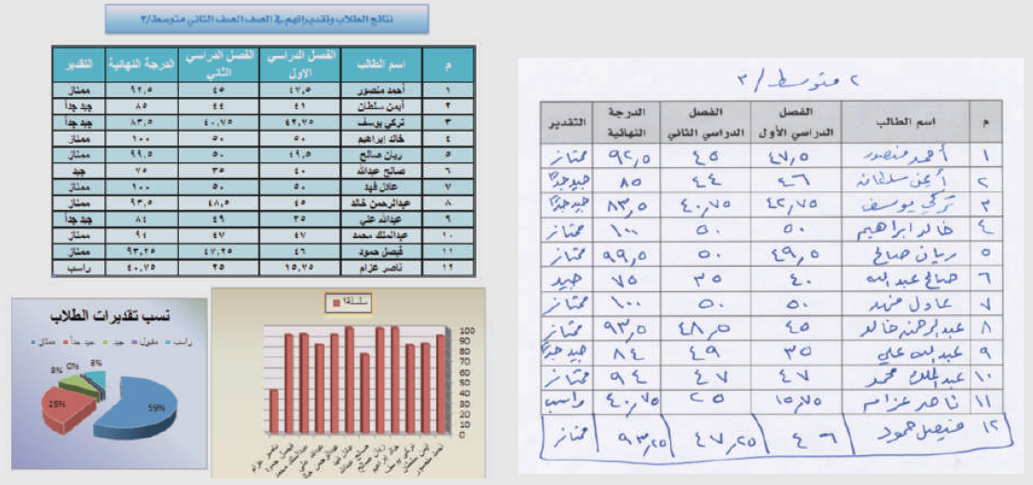
Figure [26]. Advantages of using spreadsheets. (Ministry of Education, 2020d, p. 51).

Using pictures and figures may clarify the benefits of using programs more than words, because this figure shows a lot of what can be done through the spreadsheet programs, and thus, students’ attitudes towards using such programs can be developed.
Computer graphics is the fourth sub-theme under digital content. It is also covered in the CIT textbooks through specific units that provide both theoretical and practical knowledge. However, the topic of computer graphics is presented in the fourth unit of the CIT textbook for the second intermediate grade. This unit includes in the theoretical part information about the importance of computer drawing programs, their types, and examples, while the practical part includes four exercises to work on the Inkscape program.
Website design is the last sub-theme under the digital content. It is presented in the fifth unit of the CIT textbook for the third intermediate grade. This unit provides little knowledge in the theoretical parts, while in the practical part it provides a lot of information such as creating and formatting web pages, adding text, images, videos, tables, creating hyperlinks, and publishing the website. However, in the design and graphic exercises, the CIT textbooks do not refer to some important issues such as intellectual property and copyright, while they encourage the students and teach them how to include and use pictures, sounds, and videos in their designs. Overall, in terms of digital content, the CIT textbooks focus on developing students’ knowledge and skills through presenting the topics in separate units and dividing each unit into theoretical part and practical part.

5.5.2 Intelligence and problem solving
Intelligence and problem solving are the second theme under creativity and innovation. This theme represents the topics such as intelligent world, artificial intelligence, simulation and models, and programming languages. However, these topics will be addressed and presented in the following subthemes.
Knowledge society is the first subtheme of intelligence and problem solving. It is presented in the CIT textbook for the second intermediate grade. This textbook includes topics about the characteristics of the knowledge society and the importance of transforming not only to a knowledge-based society, but to a knowledge-based economy as well. In addition, this textbook, in the first semester, refers to the Saudi Vision 2030 as a supportive of this transformation, where it states on page 85 that:
One of the most important themes contained in Vision 2030 is a thriving economy and attractive competitiveness, it is one of the indicators of achieving a knowledge-based economy so that the Kingdom of Saudi Arabia assumes a prominent position as a leading country regionally and internationally. (Ministry of Education, 2020c, p. 85)
The CIT textbook presents the subject of the knowledge society in an interesting way by linking it not only to the vision of Saudi Arabia 2030, but also to the intelligent world as in the following subtheme.
Artificial intelligence is the second subtheme of intelligence and problem solving. It represents some topics such as the intelligent world and Internet of Things. The CIT textbook for the second intermediate grade indicates that the knowledge society is gradually transforming to an intelligent society by being able to produce and use smart products such as smart devices, cars, homes, and cities. The CIT textbook explains to students that knowledge is what makes societies turn into smart worlds, and it reinforces this idea through some activities and projects. For example, the CIT textbook for the second intermediate grade in the first semester presents the following activity:
Present a project to transform your school into a smart school so that it includes the stages of transformation and the services that will be provided within this project, in addition to identifying the beneficiaries of each smart service within the school.
- The project should be implemented by a group of no less than three students and no more than five.
- The project should include a statement of the tasks carried out by each member.
- The project should be presented using a detailed flyer or visual presentation.
- Students should submit a project file that includes the project plan and all its details. (Ministry of Education, 2020c, p. 89)
These activities may develop the thinking skills of the students and encourage them to find new ideas or suggest improvements, whether in their schools, homes, or communities, and thus their creativity can be improved. However, the implementation of such activities and projects requires time and resources, which seem to be challenges for teachers and students (see section 6.2.3).
Simulation and models are the third sub-theme of intelligence and problem solving. Simulation programs and applications help students learn about technical and software problems through a virtual environment that creates a kind of challenge. The first semester of the CIT textbook for the first intermediate grade provides a practical exercise that helps students to explore the Android system menus, options, and settings by using the Windroy program which is a simulation program to run the Android system on the Windows system. Also, the simulation is presented in the CIT textbook for the third intermediate grade as an exercise of digital learning where this exercise provides instructions to run a simulation program of building an atom on PhET which is a platform of interactive simulations provided by the University of Colorado Boulder. In this exercise, the students can build an atom, change its properties, and observe the changes (see Figure 27).
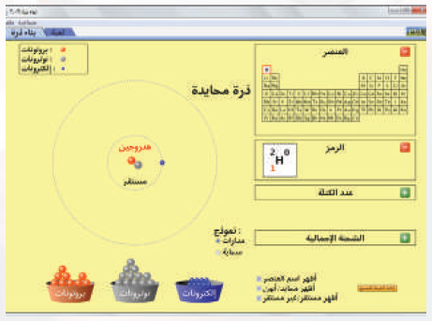
Figure [27]. Simulation of building an atom. (Ministry of Education, 2020e, p. 122).

Moreover, the simulation is presented in the CIT textbook for the third intermediate grade as an introductory exercise to programming with Scratch. This exercise is based on the use of a Blockly maze where the students try to use certain blocks to find a solution to the maze. the maze simulates a specific problem that students must solve, while the blocks simulate the multiple solutions that could be found for that problem (see Figure 28).
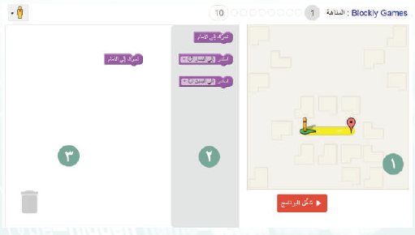
Figure [28]. First stage of the Blockly maze. (Ministry of Education, 2020e, p. 28).

Simulation-based learning gives the students a sense that their behaviour can make a difference, where their interactions with these programs give them different and varied results every time. In addition, the simulation helps the students to understand the subjects and retain the information (Luo et al, 2018).
Programming languages is the last sub theme of intelligence and problem solving. It is covered in detail in the CIT textbook for the third intermediate grade. In the first semester, this CIT textbook provides theoretical knowledge about programming languages, their levels, types, and examples. Also, it provides information about Scratch program and the most important programming rules such as sequence, selection, and repetition. Moreover, the CIT textbook provides some practical exercises on using Scratch program, including but not limited to, creating, moving, formatting objects, adding pictures, backgrounds, using variables, and processing data. Furthermore, in the second semester, the CIT textbook provides good information about the robots and its fields and uses. The CIT textbook also refers to educational competitions in the field of robotics, such as the National Robot Olympiad in Saudi Arabia, the Arab Open Robot Championship in Jordan, the World Robot Olympiad, and the International Robot Olympiad. Moreover, the CIT textbook presents in the second semester six practical exercises for programming robots using the Robomind program. These practical exercises include a set of important programming commands for the robot such as drawing shapes, picking up and dropping objects, avoiding obstacles, and tracing paths (see Figure 29).
Figure [29]. Tracing black path. (Ministry of Education, 2020f, p. 57).

Overall, in terms of intelligence and problem solving, the CIT textbooks focus on providing students with knowledge and develop their skills that help them to think creatively and solve problems.

Summary of the Chapter
This chapter addresses the first research question and provides an in-depth analysis and presentation of how the CIT textbooks construct and present the topics of digital citizenship. This chapter presents a set of main themes and subthemes divided into five basic subjects of digital citizenship that were derived from the literature review. In digital literacy topics, the CIT textbooks focus heavily on providing digital knowledge, however, digital skills such as using digital devices, internet, and dealing with data and information are also covered and developed. In digital protection topics, the CIT textbooks focus on developing students’ knowledge, they focus only on clarifying potential risks without clarifying how to avoid them or how to act when exposed to them. In digital law topics, the CIT textbooks provide little knowledge about rights and responsibilities and this knowledge is presented in a vague manner with only broad outlines such as religion, morality, and cybercrimes. In digital footprint topics, the CIT textbooks provide good knowledge and encourage students to participate, communicate and interact. However, CIT textbooks do not develop students’ skills that enable them to participate, communicate and interact responsibly. Finally, in creativity and innovation topics, the CIT textbooks provide students with good knowledge and develop their skills in creating and editing digital content as well as develop their creative thinking and problem solving.

Chapter 6: Findings 2 (Students and CIT Teachers)

Introduction
As mentioned in the previous chapter, presentation of findings is organised by their relevance to the research questions. This chapter presents the results and findings from the teacher interviews and student interviews, related to the second, third, and fourth questions. The second research question: What are the perceptions and experiences of students and CIT teachers in Saudi intermediate schools about the concept and topics of digital citizenship? focuses on the understanding of the concept and topics of digital citizenship. On the other hand, the third and fourth research questions: What are the perceptions and experiences of CIT teachers about teaching digital citizenship in Saudi intermediate schools? and What are the perceived obstacles and challenges to teaching digital citizenship in Saudi intermediate schools? focus on teaching digital citizenship. Therefore, the results related to the second, third and fourth questions were organised in two main sections which are participants’ understanding of digital citizenship and participants’ perceptions of teaching digital citizenship.

6.1 Participants’ Understanding of Digital Citizenship
This broad category contains some themes and subthemes concerned with the issue of how students and CIT teachers in Saudi intermediate schools understand the concept and topics of digital citizenship. This category includes three main themes which are the concept of digital citizenship, the characteristics of the digital citizen, and the topics of digital citizenship (see Figure 30). These main themes and their sub themes will be presented in the following sections of this chapter, while they will be discussed in more detail in chapter 7.
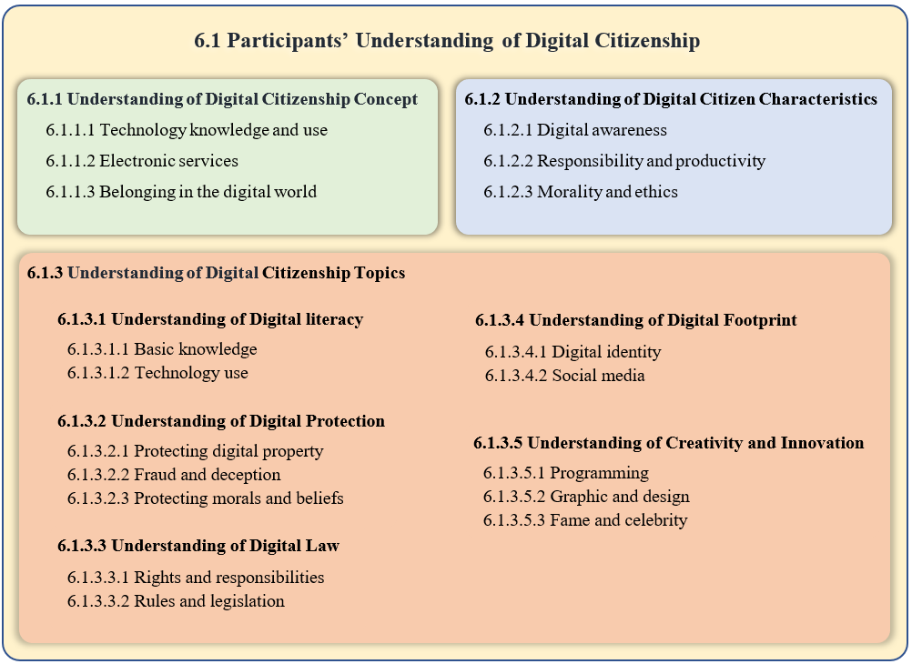
Figure [30]. Summary of themes relevant to the second research question

6.1.1 Understanding of Digital Citizenship Concept
This theme concerns participants’ understanding of the concept of digital citizenship in response to the question: When I say digital citizenship, what comes to your mind/How would you define it? The responses of students and CIT teachers revolve around three areas which are technology knowledge and use, electronic services, and digital word. However, these themes will be presented in the following sections of this chapter, while they will be discussed in more detail in chapter 7.

6.1.1.1 Technology Knowledge and Use
In my exploration of how students and CIT teachers understand the digital citizenship concept, I found that some of the participants such as RS1, RS2, US2, UT2, RT3, and UT3 (see section 4.7.6 for participants codes and information) tend to describe digital citizenship as the ability to use technology in general and the Internet in particular. However, students express digital citizenship as the use of technology and the Internet in daily life. RS1 and RS2 do not link the use of technology to certain restrictions or conditions, while US2 links this use of technology and the Internet to safety, where he expressed digital citizenship as ‘using computers, Internet, and documents safely without viruses, viruses can get into your device and delete data’. On the other hand, the perspectives of CIT teachers on the concept of digital citizenship revolve around the responsible and appropriate use of technology. CIT teachers refer to some issues such as rights, duties, advantages, disadvantages, and rules, when they mention the use of technology. For example, UT2 perceives digital citizenship as the ‘correct use of technology in all its fields, and knowing what rights and duties are required’. RT3 also perceives digital citizenship as:
A person’s ability to deal with the computer in all its fields, for example, if we want to expand it more, some people deal with digital things, but they don’t know the pros and cons. I think this is an important point. The most important thing for some people is that they get their things done, but they may do that in a very simple way that does not preserve their information or privacy.
Similarly, UT3 expressed digital citizenship as a way of using the Internet while considering the rules and regulations. He articulates his view by giving a unique example:
The way to use the Internet correctly, I think it has regulations and rules. I mean, let me explain it to you with an example. It is like the traffic system, when you drive a car there are rules such as, fasten your seat belt, when you turn right use the turn signal, and if you don't, you may get into trouble or have an accident.
Overall, while the students express digital citizenship as the ability to use technology and the Internet in general, CIT teachers believe that this use should be in an appropriate manner, considering the rules, rights, duties, negatives, and positives. Therefore, it can be said that digital citizenship requires not only the ability to use technology but also having the necessary knowledge about the risks, benefits, rights, responsibilities, and rules that regulate and control this ability.

6.1.1.2 Electronic Services
Some students and CIT teachers (US1, RS3, US3, UT1, RT2, and RT3) express the concept of digital citizenship as electronic services in general, whether they are government, commercial or educational services. It can be said that electronic services may fall under the previous theme if it is viewed from the standpoint of using technology, but the opinions of students and CIT teachers in this regard focus on providing services electronically rather than using these services. For example, US3 indicates that digital citizenship is the ability to book an appointment by using applications. Also, RS3 in his response to the question: When I say digital citizenship, what comes to your mind? He indicates ‘Absher and Tawakkalna application’, then he expresses his view about digital citizenship as a case in which ‘your identification documents become electronic, your ID card and your licence, you do not need to take them with you, they are on your mobile’. RS3 refers in his response to the application of Absher and Tawakkalna, which are two of the most famous government applications through which citizens and residents can explore their information, show their identification documents, and finish their transactions in many sectors, institutions, and ministries. Similarly, RT3 in his response states that:
Now we may see a few who go to the stores for shopping or something like that, especially after COVID-19. you may get an application from these shopping applications so that you can buy and take your needs from this application. Also, I think that some services in the country have become digital. The closest example is Absher system, an integrated system where you can finish your private or public affairs related to the car or related to you such as if you want to get a national identity card or get a passport.
Further, RT2 expresses his view on digital citizenship by comparing people’s lives in the past and their lives today as he explained that:
There is a difference between the citizen in the past and the citizen now, for example, a hundred years ago, the citizen’s way of life when he wanted to use the civil or hospital services, he must go and submit his papers himself. Today you can finish your things at home. For example, you can get your passport, book an appointment at the hospital, or see the results of the tests.
Although the views of students and CIT teachers refer to the use of electronic services, they focus on the idea that these services have become available electronically and they can use them, in the sense that they express digital citizenship as providing or facilitating services electronically for individuals so that they can complete their transactions and affairs. This understanding or perception may not be surprising, especially since many institutions and sectors have provided their services electronically due to the spread of the Coronavirus. Moreover, digital transformation is one of the most prominent programs of the Saudi Vision 2030, which has received great attention by government, commercial and media institutions over the past four years.

6.1.1.3 Belonging in the Digital World
Only a few participants (RS2 and RT1) explain digital citizenship from the perspective of belonging or living in the digital world. RS2 alleges that a digital citizen is ‘who lives in this modern age’, while RT1 argues that digital citizenship means that ‘the individual is part of a digital world so that he affects this world and is affected by this world’. RT1 explains his point of view briefly and says ‘the digital world is not limited to a specific thing, it includes everything that technology is a part of, whether at the level of services or at the level of desires’. However, although the participants reveal a little information about belonging or living in a digital world, this view is interesting because it is consistent with traditional citizenship in relying on the idea of belonging.

6.1.2 Understanding of Digital Citizen Characteristics
This theme concerns participants’ understanding of the characteristics of digital citizens in response to the questions: What are the characteristics that a digital citizen should possess? /Do you consider yourself a digital citizen? Why/ why not? However, some of the views of students and CIT teachers about the characteristics of a digital citizen are consistent with their understanding of the concept of digital citizenship, especially regarding digital awareness and the use of technology. On the other hand, there are some other points of view that may be unique and different, especially regarding ethics, etiquette, and respect. However, how students and CIT teachers expressed the digital citizen and what characteristics he or she should have, will be addressed in the following sections.

6.1.2.1 Digital Awareness
Almost all the participants mentioned that the digital citizen should have basic knowledge about technology in general, they believe that the digital citizen should know how to use technology and its negatives and positives. For example, students said that a digital citizen should ‘have general knowledge of technology’ (RS1), ‘know how to use technology’ (RS2), ‘use the Internet safely’ (US2), and ‘understand computers and the Internet’ (US3). Similarly, CIT teachers said that the digital citizen should be ‘aware of this technology and how to use it’ (RT1) and ‘familiar with electronic services and how to benefit from them’ (UT1). Further, RT2 states that the digital citizen should have ‘an understanding of technology in general, understand how technology works, how to access websites and how to use them’. However, the CIT teachers moved to addressing some important topics such as negatives, positives, and potential risks. UT2 argues that ‘there are forbidden, negatives, and positives that the user of the technology must know’. In addition, UT1 says that the digital citizen should be ‘careful when he uses those services (electronic services), meaning he understands the potential risks that may incur him when he uses electronic services’. UT3 also expresses a similar viewpoint where he states that ‘caution is a duty. I see this is the most important characteristic. A person must be careful and not deal with anything unless he is 100% sure and guaranteed what he is dealing with’.
Overall, although students’ and CIT teachers’ perspectives revolve around the need to educate the digital citizen in general about technology and its uses, CIT teachers’ views reflect a better understanding of the characteristics that a digital citizen should possess as they indicate issues such as caution and knowing negatives, positives, and potential risks.

6.1.2.2 Responsibility and Productivity
Responsibility and productivity are mentioned only by CIT teachers, the majority of CIT teachers believe that digital citizens should be responsible for their actions when using technology as well as being productive. The CIT teachers expressed their perspectives on the responsibility by addressing some important issues such as terms and conditions, rights, duties, protection, and privacy. CIT teachers believe that such issues should be known to digital citizens so that they can properly direct their behaviour and actions when dealing with technology. For example, RT1 indicates that the digital citizen must be ‘responsible for anything that comes from him, or anything he/she deals with regarding technology’. Also, UT2 says that the digital citizen must ‘know the terms or conditions of the technology, the conditions on the Internet or the use of technology in general, and the rights and duties’. Further, RT3 states:
I see that the digital citizen must be characterised by several things, including his behaviour, he must know what his rights and duties are. Unfortunately, some of them (digital citizens) complete their affairs online and they are happy that they finish them. However, from another angle, doing these things needs protection, needs privacy, needs to know the negative or positive effects of dealing with this application… when I deal with these applications, there is a possibility that I make mistakes without realising that, and there is a possibility that I will be held accountable for these mistakes.
On the other hand, some CIT teachers believe that the digital citizen should not only be a user or consumer of technology but should contribute to the development of this technology. For example, RT1 indicates that the digital citizen must ‘enrich, innovate or create in the digital world, and not only be a consumer’. UT1 also expresses a similar view as he states that the digital citizen must have ‘a positive impact not only on society, but also on technology’.
Overall, CIT teachers believe that digital citizens should be responsible for their actions in the online environment as they are in the offline environment. Therefore, they express in their views the urgent need to know the rights, duties, rules, and conditions related to the digital world, which seem to be vague or unclear to them.

6.1.2.3 Morality and Ethics
Some students and CIT teachers (RS1, US3, RT1, UT1, RT2, UT2, and RT3) indicate that morality and ethics are distinguishing features that digital citizens should have. They associate morality and ethics with religion and culture by giving Islam and Saudi culture the most prominent role in controlling their behaviour and actions when they are online. RT1 argued that ‘there are norms for the Saudi digital citizen due to the identity, traditions, and privacy of Saudi society in terms of religion, morals and Saudi culture’. Similarly, UT1 says ‘we, as Saudis, pay great attention to our religion and our customs and traditions. I think that we must adhere to our religion and respect our customs and traditions, whether in normal life or on the Internet’. In addition, UT2 alleges that the characteristics of the digital citizen ‘depend on customs, depend on the curriculum, depend on the culture and many other things, it is difficult for everyone to have the same characteristics, they must be within the framework of the country’s culture, customs, and traditions’. Moreover, RT3 states that ‘on a personal level, I see that Islam has given us certain rules. For example, I do not do things that conflict with my Islam or my customs and traditions’. Further, RS1 and US3 indicate that the Saudi digital citizens should not do things contrary to their religion, such as listening to songs or lying to people.
However, RT2 expresses his view in general and indicates that ‘digital citizens must be honest, digital citizenship needs honesty. For example, if there is a request to vote, some people do not vote if they do not need this thing or vote against what the community needs’. However, honesty is an important issue especially in the digital world where there is a lot of fake information, websites, accounts, and identities. Overall, Although the views of students and CIT teachers show positive attitudes towards the commitment to morality and ethics, whether online or offline, they did not refer to specific qualities except honesty. Instead, they refer to religion, customs, and traditions as principles and guidelines in this regard.

6.1.3 Understanding of Digital Citizenship Topics
This theme concerns participants’ understanding of the topics of digital citizenship in response to the question: What topics should be covered by the digital citizenship curricula? This was followed by the probing question: In your opinion, what topics should be included in each section of digital literacy, protection, law, footprint, and innovation. The responses of students and CIT teachers were organised according to these five sections which were derived from the relevant literature to represent the main topics of digital citizenship (see section 3.5). However, these themes will be presented in the following sections, while they will be discussed in more detail in chapter 7.

6.1.3.1 Understanding of Digital Literacy
In my exploration of how students and CIT teachers understand digital literacy, I found that participants’ views on digital literacy centre around basic knowledge and technology use. It seems that there is a link between students’ and CIT teachers’ understanding of digital literacy and how the CIT textbooks introduce this topic. However, there are some unique opinions expressed by the participants such as their belief that digital literacy is about educating the elderly. These opinions and the other views of the students and CIT teachers on digital literacy will be addressed in the following subthemes.

6.1.3.1.1 Basic Knowledge
Some students and CIT teachers (RS1, RS3, US3, UT1, and UT2) describe digital literacy as basic and necessary knowledge about technology such as knowing digital terms and concepts, digital devices, and hardware and software. For example, RS1 describes digital literacy as ‘providing technical knowledge to all people…. computer and mobile knowledge’. Also, RS3 expresses it as ‘learning about computers, the Internet, and digital devices’. Further, US3 indicates that digital literacy means ‘that you understand computers and technology’. Moreover, UT1 expresses his opinion about digital literacy as ‘providing knowledge in general about computers, technology, and the Internet ... such as terms and concepts, definition of technology and smart devices, types of smart devices and how they work’. Similarly, UT2 states that digital literacy means ‘recognising the parts or peripherals of the computer or mobile, recognising programs’. Overall, students and CIT teachers alike understand that digital literacy is about the basic knowledge that should be provided to people about technology and digital devices.

6.1.3.1.2 Technology Use
Some students and CIT teachers express digital literacy as the knowledge concerned with technology use. Students and CIT teachers referred to topics such as how to use computers, smartphones, and Internet applications. For example, US3 indicates that digital literacy is ‘knowing the computer and knowing the Internet... knowing how to download programs’. Similarly, RT1 says that ‘everyone should have the basics of dealing with technology, whether it is a mobile phone, computer or software such as word processors, also networks and Internet connection’. Although RT1 refers to basic knowledge, he associates it with dealing with technology. Also, UT2 in his view on digital literacy refers to basic knowledge as well as ‘knowing how to use a mobile phone, knowing how to operate a computer’. Further, UT3 expressed a similar view on digital literacy:
It is about people who do not know how to deal with technology... They must be taught how to use technology in general, because there are people who do not know how to use technology, let them know how to use technology in the first place and then teach them about digital citizenship.
It is clear from the previous viewpoints that some students and CIT teachers express digital literacy as providing knowledge regarding the use of technology. However, some students and CIT teachers referred to another view of digital literacy. Although they expressed it as the knowledge related to the use of technology, they believe that it means teaching old people how to use technology. For example, US1 describes digital literacy as ‘teaching the elderly how to use the computer and the Internet’, and RS2 indicates that ‘old people are taught about technology...literacy is only taught to the elderly. Moreover, RT3 states:
Honestly, the first thing that came to my mind was the elderly in our society. It came to my mind that the old people today do not know how to deal with existing applications, the Internet in general, or digital things in general, whether they are private or public. For example, an elderly person who wants to finish his government affairs such as renewing his licence…he does not know, he must go to a service office or ask his family.
These opinions may be consistent with Prensky’s (2001) view that described the new generation of students in the digital age as digital natives. Therefore, some participants’ perspectives may rely on the belief that today’s students do not need to be educated about digital technology because they are digital natives unlike old people who may be described as digital immigrants. However, I believe that there are other reasons for such an assumption which differ from Prensky’s view (more discussion on this issue will be presented in the discussion chapter).

6.1.3.2 Understanding of Digital Protection
The perspectives of the students and CIT teachers on digital protection centre around three main issues: protecting digital property, fraud and deception, and protecting morals and beliefs. Overall, the perceptions of students and CIT teachers on digital protection are similar to what is presented in the CIT textbooks on that topic. The views indicate that students and CIT teachers realise that there are digital risks that people should be aware of and protect their data, devices and even themselves from, but they do not seem to understand how they can detect, manage, and avoid these threats. However, the views of the students and CIT teachers on digital protection will be addressed in the following sections.

6.1.3.2.1 Protecting Digital Property
This sub theme represents all opinions and views that express digital protection as the protection of digital property, whether it is data, information, accounts, or even digital devices. RT3 indicates that ‘the first thing I need to know is what is the protection and what should I protect...should I protect myself, my data, or my digital property’. Also, UT2 in his response to the topics that should be covered by digital protection, he states ‘such as cyber espionage, hacking, and cyber security, which is very necessary in the intermediate stage because they (students) use the devices without knowing the risks’. Moreover, US2 says that digital protection ‘means that we protect our phones from viruses and download antivirus applications’. Furthermore, RS3 states that digital protection ‘means protecting your data, setting a password for the mobile...making a copy of the data’. These opinions revolved around the need to protect data, information, and even digital devices from direct threats such as viruses, hacking and cyber espionage, however, there are some risks and threats that may be unclear or indirect as RT3 states:
I must teach him (the student) how to deal with these applications. When he wants to download any program, he must know what the positives are, what the negatives are, and how he deals with this program in safety and protection. Also, he must know whether this program saves his right or his data or not. Perhaps if I ask a Twitter user now, he does not know what his rights and responsibilities are…he doesn't know the positive and the negative.
RT3 expresses an important point of view regarding protecting data when using applications, where violation of privacy became a critical issue especially with the spread of applications on the Internet. Data and information can be stolen in different ways than hacking or espionage. For example, usage agreements of programs and applications can get what cannot be obtained by using malware. However, the responsibility to protect data when using programs and applications lies with the user in the first place, where he must be sure of the actions that applications take to process, manage, and use his or her data.

6.1.3.2.2 Fraud and Deception
Some students and CIT teachers expressed digital protection by referring to potential risks such as deception and fraud. They tend to associate digital protection with the need to exercise caution. Some CIT teachers (RT1, UT3, and RT3) mention issues related to deception and fraud such as phishing, spoofing, and identity theft. Also, some students (RS1 and US3) mention issues such as the need to beware of hackers, strangers, and blackmail. Further, UT1 expresses his view in detail and says:
We need topics that discuss the risks that a student can fall into while using the Internet, we need to understand that digital technology may be misleading, especially on the Internet...I mean that some applications and websites on the Internet and even people sometimes may be fake and target other users to steal their data, files, or money.
Obviously, students and CIT teachers are aware of the potential risks associated with fraud and deception, but the important question is whether they know how to detect, identify, manage, and avoid these risks. US2 in his answer to this question: If one of your friends is being bullied or blackmailed through the Internet, what would you advise him to do? He replies that he would advise him to ‘go to a mobile programmer’. This response illustrates the need for students to provide them with knowledge and advice on the procedures to be followed when they are exposed to critical situations that put them at risk. Unfortunately, UT2 indicates that ‘the topics of protection and safety in current CIT textbooks are often only headlines, meaning there is no explanation or illustrated steps’ (see section 6.2.1 for more perceptions on CIT contents).

6.1.3.2.3 Protecting Morals and Beliefs
Only two teachers (RT1 and RT2) mention that digital protection also includes protection from risks that affect the morals, beliefs, or culture of people. RT1 states that ‘the damage is not only at the level of individuals but may also be at the level of countries, the damage is not only physically but may also be moral, religious, civil, or cultural damage’. Also, RT2 in his response to this question: Are there threats other than viruses? he says:
Internet addiction or the use of some programs or websites, for example, there are some foreign websites that may be bad, their ideas may be misguided, some websites have porn contents, or communication with people whose ideas are bad or pornographic.
These views highlight an important aspect of digital protection. People’s thoughts, beliefs, morals, and behaviours are subject to change and this change is unpredictable in the online environment. However, in the Saudi context, it seems that this change is expressed as a threat. Therefore, when is this change desirable and when it is rejected, and what is the role of CIT textbooks in this regard? More discussion on this issue will be presented in the discussion chapter.

6.1.3.3 Understanding of Digital Law
In my exploration of how students and CIT teachers understand the subject of digital law, I found that participants’ views on digital law revolved around two main perspectives: rights and responsibilities such as what should be done and what should be not or what is right and wrong; and rules and legislations such as intellectual property, copyright, usage agreements, and cybercrime. However, how students and CIT teachers expressed their opinions on the digital law, will be addressed in the following section.

6.1.3.3.1 Rights and Responsibilities
Some CIT teachers expressed the digital law as the procedures or rules that explain what is allowed and what is not when using technology. Although CIT teachers did not mention specific issues in this regard, they believe that there are rights and responsibilities that regulate and control the process of using technology. For example, RT1 states that digital law is ‘what controls the behaviour of the individual within the digital world, preserves your rights’. Also, UT2 indicates that:
The existing laws in normal life are similar to those laws when using devices. What society rejects in real life is also rejected in the digital world...may be what is not allowed in my society, is allowed in another, and this is what I mentioned earlier that the students should know the main lines and procedures, including digital law, and the difference in customs and cultures between societies before they know the technology.
This view associated rights and responsibilities with the differences between societies in which the Internet users may be confused about their rights and responsibilities when dealing with members of other societies. UT1 expresses a similar view but he focused on the people’s understanding of their rights and duties, regardless of whether their societies are different or not. UT1 states that:
I think there should be clarity regarding the laws in social media, I think that people think they can do or say whatever they want without responsibility...someone may think they have the right to spy on you or on your data. Especially young people such as intermediate school students may get into legal troubles due to misuse of technology thinking that this is a joke, play, or that they are anonymous, and no one can reach them.
Further, RT3 indicates that digital law is broad, and it is difficult to explain everything, but it can be clarified in general so that the individual is behaviourally polite and knows how to deal with technology. However, RT3 also mentioned specifically some important issues such as privacy as he says:
When Snapchat appeared in 2013 or 2014, it was used in a very random way, meaning that I could take pictures in a public place and in a restaurant. There is an absence or a gap between the responsible authorities and the user, meaning that in public places things must be placed like regulations, for example photography is not allowed, please ask permission to use the camera.
RT3 highlights the issue of people’s privacy and expresses it from an ethical perspective when he mentions polite behaviour and from a legal perspective when he mentions the need for regulations such as asking permission before using the camera. This view highlights the confusion of people in understanding their rights. For example, photographing people in public places or in restaurants, is it right for an individual to share his moments in social media, or is it a right for another individual not to violate his privacy. However, Lim (2017) concludes that social media users legitimise their rights by excluding others’ rights such as equality and justice. Overall, the previous participants’ views agree that rights and responsibilities should be considered when dealing with technology, although these rights and responsibilities differ according to different societies and different understandings of individuals.

6.1.3.3.2 Rules and Legislations
This sub theme represents the perspectives of students and CIT teachers that revolved around laws and legislation. Almost half of the participants (RS1, US1, US2, RS3, UT2, RT2, and UT3) mention issues such as copyright, intellectual property, and usage agreements. Students and CIT teachers alike expressed similar views about intellectual property and copyright as they believe that there are procedures and rules for using other people’s texts, images or videos. For example, UT2 in his response on topics that could be within the digital law he says, ‘like scientific plagiarism, if the student quotes words from websites and claims that it is his words, he must know these rights so that he is not subjected to punishment’. Also, RT2 expresses a similar opinion as he states that:
The Internet is a great platform, and every person can speak on it. Each person has his own account and speaks on it...No other person comes to take words, pictures or private things of another without referring to this person (the owner of the content) or without taking permission, which I consider as a crime.
Further, RS1 and US2 believe that copyrighted images or pictures cannot be used directly and using the ideas or words of others without permission is considered plagiarism. On the other hand, US1 thinks that using other people’s photos or pictures without permission ‘is okay if the pictures have nothing wrong or they are not private’. Another interesting point of view was presented by RS3, while he believes that digital law is what is used or relied upon if a Snapchat account is stolen or hacked, he believes that hacking accounts that are contrary to religion and morals is acceptable because they are bad accounts. Although this point of view was confusing and contradictory, it expresses digital law from the perspective of cybercrimes such as hacking. However, UT3 views digital law from an angle other than copyright or cybercrimes. UT3 believes that digital law is those issues related to use agreements where he said, ‘I think that some websites, when you register or set up an account, show you terms and conditions or a usage agreement and terms, so you agree to the terms and then the registration is done’.
Overall, the previous views of students and CIT teachers revolved around three main issues: copyright, cybercrime, and usage agreements. There was almost agreement from the participants on issues related to copyright, except for US1, who expresses a view that may be consistent with the view presented by RS3 where they understand digital law and presenting it as subject to the cultures or beliefs of individuals. Finally, the issue of usage agreements was only mentioned by UT3, although it is no less important than the issue of copyright.

6.1.3.4 Understanding of Digital Footprint
The perspectives of the students and CIT teachers on digital footprint centre around two main issues: digital identity and social media. Students and CIT teachers mention some topics related to digital identity such as etiquette, reputation, and fake identities. In addition, students and CIT teachers referred to some issues related to communication and participation such as social media, public opinion, and freedom of speech. However, these perspectives and views will be addressed in the following sections.

6.1.3.4.1 Digital Identity
Some students and CIT teachers (RS1, RS2, US1, UT1, UT2, RT2, RT3) express digital footprint as those issues related to digital identity such as etiquette, reputation, and fake identities. For example, regarding etiquette and reputation, RS2 believes that digital footprint means ‘having a good standing or reputation’. US1 indicates that a good reputation can be maintained if ‘you do not do something wrong, do not speak bad words, and do not do bad things’. Similarly, UT1 states that ‘it is important for students to understand the general etiquette of online communication and participation’. Further, UT2 expresses a unique point of view when he describes digital footprint as:
To prove yourself as a person, to have a CV or information about you on the Internet for a long time, where you put your mark if it is negative or positive...students at this stage (intermediate grades) participate in electronic games or electronic competitions such as PlayStation games, where they put their full names and pictures. This will be their digital footprint in the near future, so they should be alerted that whatever they put on the internet will still be there.
The previous views address the digital identity from the perspective of etiquette and good reputation and that through the digital identity it is possible to create an impression about people. However, there are some opinions that also express the digital identity from this perspective, but they indicate that some digital identities or accounts are fake. RT3 stated that:
I think that your personality, your integrated personality in all your aspects is your digital footprint... I mean, I may know about a person’s ambitions, aspects, interests, name, age. Of course, I am talking about verified accounts and not fake accounts.
Moreover, RS1 thinks that some accounts on social media are not real and fake. Similarly, RT2 thinks that people behind some accounts may pretend some roles that are not related to them. RT2 states in this regard that:
Anyone who appears in these programs (social media) it is not certain that what he presents is his natural personality, there are people who pretend a new personality as it is their personality, such as pretending kindness and mercy...it is not certain that anything happened in social media is a nature or reality.
Overall, some students and CIT teachers believe that a digital identity can represent the digital footprint of people on the Internet, so they refer to issues related to etiquette, morals, and reputation. In contrast, others believe that not all online identities or accounts are real, so they refer to issues such as fake identities and pretending some roles and characteristics that are not realistic.

6.1.3.4.2 Social Media
Some participants’ perspectives associated the digital footprint with social media. Students were more likely to describe digital footprint as social media applications while CIT teachers were more likely to discuss what could be done through social media. For example, some participants directly mentioned that digital footprint is ‘like Snapchat and Instagram’ (US1), ‘apps like Snapchat and Tik Tok’ (RS3), ‘social media...Instagram, Tik Tok, Snapchat, WhatsApp’ (US3), and ‘social media or social networking websites’ (UT2). The previous views express the digital footprint as a social media application regardless of how those applications are used. On the other hand, CIT teachers’ views tend to address the issue of social media in terms of community participation and freedom of speech. For example, RT3 states regarding social media ‘it may be the best program in the Kingdom of Saudi Arabia is Twitter, we see many trends on Twitter, social matters happen on Twitter, and there are basically problems that have been solved by Twitter.’ RT3 explains his view of how social media application such as Twitter may contribute to address some community issues by a clear example and says:
For example, when you write on Twitter to the municipality that you noticed a problem that is supposed to be fixed, I may have seen it before, but it was far from my mind that I went to complain, but when I saw someone who opened this door, I started writing and the second, third and fourth started responding, here the problem moved from the opinion of someone to a public opinion, when it comes to public opinion, I will inevitably tell you that this problem will be solved because it has become a public opinion.
Similarly, RT2 said in this regard, ‘when you want to communicate with any sector and you have a problem, they will not give you attention, but if the issue grows and becomes a trend on Twitter, it will be resolved as you like’. Obviously, CIT teachers believe that social media provides an opportunity for sectors or ministries to provide their services and communicate with clients or citizens, but at the same time it also provides another opportunity for clients or citizens to direct public opinion towards addressing some issues related to those sectors or ministries by using the hashtags. However, CIT teachers are aware of the risks that can occur as a result of engaging in such hashtags. Speaking about Twitter and the use of hashtags to address some issues, RT2 said: ‘a while ago, gasoline prices had risen, some of the responses were irrational incitement, I am sure and certain that these accounts or these responses are not from inside Saudi Arabia, or they are not Saudi in general’. RT2 believes that some hashtags can be used to incite or destabilise the security by people who are not necessarily related to the issues discussed by those hashtags. Similarly, RT3 stated that:
Sometimes I see on Twitter or any platform for communication, some problems are true on the ground, but their purposes are personal... Some of the problems that arise on these platforms, whether Twitter or others, may be for the personal purposes of the person who raised this hashtag, or they may be to destabilise security and safety, they may be to riot.
RT3 also indicates that some people may exploit the characteristics of Saudi society for their own purposes as he points out that ‘Saudi people are very emotional, very emotional to the extreme, because of their Islamic character and fraternal and social sympathy. If I play on the sensitive thing in any society, I am completely confident that I will win the case’. RT3 refers to an important point, which is that Saudi society pays great attention to its religion and culture. Therefore, some may use this to influence public opinion by giving a religious character to some issues in order to gain the sympathy of the community. Overall, the perspectives of students and CIT teachers indicate that the digital footprint can be expressed through social media. While some of them (especially students) believe it is just about having accounts and participating in social media, others (especially teachers) tend to describe it as effective community participation by supporting community issues and contributing to addressing them.

6.1.3.5 Understanding of Creativity and Innovation
The views of students and CIT teachers regarding creativity and innovation focused largely on programming, however there were some points of view that referred to graphic and design, and a few participants referred to issues related to fame and celebrity. These views are consistent with the content of CIT textbooks as they include detailed topics in programming, graphic, and design. However, how students and CIT teachers expressed their opinions on creativity and innovation, will be addressed in the following sections.

6.1.3.5.1 Programming
CIT teachers focus on the topic of programming when they express creativity and innovation. CIT teachers believe that students can be creative and innovative by learning game programming because it includes activities that challenge students’ abilities and help them to develop creative skills such as evaluating and solving problems. For example, UT3 says that
There is creativity, it varies from student to student. Creativity can be developed especially in programming, especially programming that includes games such as Scratch and Blockly Maze. In the intermediate grades there is a Scratch program, Scratch is amazing, it teaches you the basics of programming and how to think, I mean how to think logically.
Similarly, RT2 states that ‘Scratch program needs creativity in the way that you are presenting an idea, for example, make the object speak with a voice, add a sound, add words, add movement, and create a story’. Further, RT3 indicates that:
This year, the Ministry applied an hour of code which is “My School is Programming” on the Minecraft program. This is something more creative than what you can imagine for the student in particular...it is tasks that must be completed, programming commands and codes formulated in the same game, meaning the student does not need to write, he just uses a pre-made code in the form of certain blocks. I was shocked that 40% means 15 students, 6 to 7 of them tell me that they have already completed their tasks.
Previous CIT teachers’ views focus on game programming which appears to be more preferred by students than other types of programming. However, although CIT teachers think students are creative in game programming, students think they are not yet at the stage where they can consider themselves creative. RS3 says that ‘you can be creative with programming if you develop yourself a little’, while US1 states that ‘we learned a little programming, but until now we do not know how to do things like creativity’. The reason behind students’ views may be that they think that creativity is to make the impossible. US1 in his response to a question: How can a person be creative when using technology? He replied, ‘if you do something that no one has done before you, or no one can do it except you... like the hacker, he can do things that you cannot do’.
Overall, CIT teachers believe that programming is an important aspect that can lead students to be creative and innovative, also they believe that students are creative in game programming. On the other hand, some students believe that they are still in the beginning stages of programming that do not reach the level of creativity. However, these perspectives may shed light on the support or encouragement that students receive in terms of programming and whether it helps them to create innovative work or at least convince them that they can.

6.1.3.5.2 Graphic and Design
Some students and CIT teachers associate creativity and innovation with graphic and design. They believe that graphic and design topics can contribute to create opportunities for creativity and innovation. US2 indicates that some people are creative in using graphic programs. Also, RS3 states that creativity and innovation ‘like for example composing video clips, merging images with audio or video with audio’. US3 expresses a similar view and said about creativity and innovation ‘some of them make a video and put it on YouTube’. Moreover, RT2 states ‘practical things need creativity, meaning there is a difference between a student and a student, the method of use, the method of work, the method of presentation and the method of thinking’. RT2 adds in this regard that a student may change the shape of the background or change its colour in a way that is different from the others. Further, UT3 says that ‘now it is popular to design video, video design programs that merge a video clip with another, as you know the photography revolution’. Overall, CIT teachers and students alike believe that graphic and design are suitable fields that enable people to develop their creativity and innovation.

6.1.3.5.2 Fame and Celebrity
Only a few participants (RS2, US3 and UT1) explained creativity and innovation from the perspective of fame and celebrity. US3 links creativity of a person to the extent of his popularity in society and how many followers he or she has. RS2 described creativity and innovation as being ‘like celebrities. If they were not creative, they would not have followers’. US3 also referred to some celebrities and said that ‘some have Snapchat and tell stories…some are creative with games like PUBG and so on’. Similarly, UT1 says:
This field (creativity and innovation) is very important, and students today are different from students twenty years ago. They grew up with technology from a young age. I think they understand technology in a way that is different from us. On YouTube, for example, there are many channels whose content presenter or hero is a child. Despite this, I think that they are still only in the scope of the use of technology. They need to direct their abilities and creativity to areas that serve society such as design, programming, and creating valuable content.
Although these views look at creativity and innovation in terms of fame, there is a difference between the student and teacher perspectives. US3 associated creativity with the number of followers regardless of the content provided by those celebrities, while UT1 believes that such creativity should be well directed and used to serve society. In other words, US3 believes that being famous is enough to be creative, while UT1 believes that fame does not always mean creativity unless it has a positive effect.

6.2 Participants’ Perceptions of Teaching Digital Citizenship
This broad category represents the second part of this chapter. It contains some themes and subthemes related to the third and fourth research questions: What are the perceptions and experiences of CIT teachers about teaching digital citizenship in Saudi intermediate schools? and What are the perceived obstacles and challenges to teaching digital citizenship in Saudi intermediate schools?. However, this part includes four main themes which are CIT textbooks content, teaching activities, teaching obstacles, and teaching challenges (see Figure 31). These main themes and their sub themes will be presented in the following sections of this chapter, while they will be discussed in more detail chapter 7.
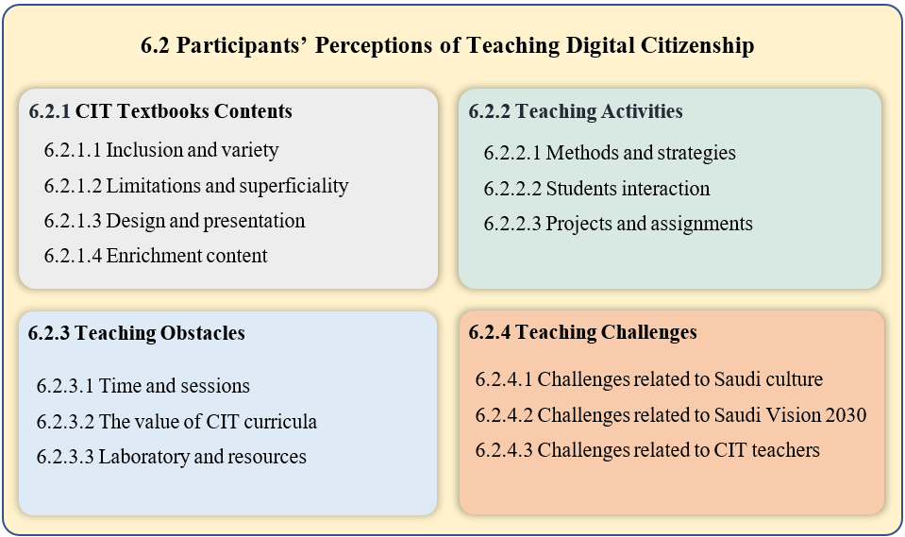
Figure [31]. Summary of themes relevant to the third and fourth research question

6.2.1 CIT Textbooks Contents
This theme represents CIT teachers’ perceptions of CIT textbook coverage and presentation of digital citizenship topics. CIT teachers’ views are positive towards the CIT textbooks regarding the topics of digital literacy, while they criticise the lack of explanation regarding digital protection, limitation and superficiality regarding digital law and footprint. Also, they criticise how the topics are presented and organised in the CIT textbooks. However, the views of CIT teachers on the content of CIT textbooks will be presented in the following sections.

6.2.1.1 Inclusion and Variety
Some CIT teachers believe that the CIT textbook topics are comprehensive and varied in terms of digital literacy. However, CIT teachers indicate that although CIT textbooks provide good knowledge in this area, the lack of time and resources limit getting the most out of this rich content. UT3 points out that:
The textbook talks about technology, explains to them (the students) the technology, it contains information, but most of it is headlines, meaning that it did not go into depth. But it is considered excellent because these curricula start from the first intermediate grade, they start from the first intermediate grade to almost the second secondary grade, it is considered excellent if we are talking about the intermediate stage.
Also, RT1 says about the CIT textbooks in regard to digital literacy:
As textbooks, it can be said that they cover literacy well, but as lessons I do not think so. I think the textbooks are strong and have good enrichment, but they need enough lessons as one lesson per week does not cover the textbooks.
Further, UT1 expresses a similar view and states that:
In general, I think that the CIT textbook in intermediate schools is good in introducing students to technology, but it is complex, and the topics are many, I mean, as it is a new textbook for the students, it is supposed that there is a prior preparation or increase in the lessons.
The previous views indicate that CIT textbooks include many topics and cover many aspects, especially with regard to digital literacy, but the multiplicity and diversity of these topics does not correspond to the time and lessons allocated to these textbooks. Therefore, while the diversity and multiplicity of the topics is supposed to be positive, in the case of CIT textbooks it may be negative due to the lack of time.

6.2.1.2 Limitation and Superficiality
Some CIT teachers believe that CIT textbooks were in some places limited and focused on certain issues, while in other places they were comprehensive but superficial, meaning that there was a lack of explanation. For example, regarding digital law topics, RT1 says that CIT textbooks refer to ‘information crimes such as eavesdropping, hacking, and spoofing, and that the Kingdom is making an effort to combat these crimes’, On the other hand, regarding copyright and intellectual property, RT1 states that:
Unfortunately, the textbook does not mention that (copyright and intellectual property), and there is a clear weakness in this aspect. In fact, there are programs in the textbooks that must be taught but we face difficulty in installing them due to the difficulty of obtaining a licensed copy.
Also, in terms of the digital footprint, the CIT teachers believe that the CIT textbooks focused on communication and participation methods more than digital reputation and etiquette. For example, RT2 says that ‘the CIT textbooks talked about communication methods and programs, they talked about blogs and Facebook, but they did not talk about the things that you want to publish to people, they may be preserved and remain for years ahead. Similarly, UT2 states that digital footprint in the CIT textbooks is ‘incomprehensible and not clearly explained in the textbooks as required. Most students now publish information about themselves and their families, sometimes false, which distorts their digital footprint’. Moreover, regarding digital protection, RT2 and UT3 indicate that the CIT textbooks did not cover topics about psychological harm that may occur due to some issues like cyberbullying or blackmail. However, focusing on some issues and ignoring others is not the only criticism, the CIT teachers also criticise the CIT textbooks in terms of digital protection as they argued that although CIT textbooks include a variety of topics, they do not explain the steps or procedures that help students protect their data and devices. UT2 says in this regard that ‘there are only main headings, there is no detail, meaning, it explains about protection: its concept, methods, confidentiality, safety and data transmission, and that they must be preserved, but it does not explain how that can be done’. Similarly, RT3 in his response to whether textbooks cover protection topics, he states that:
I see from my point of view that it is covered by 90%, the 10% that is missing is how to do it, the textbook presents it as information only, I will give you an example, it talks about viruses, but it did not go into it. How does my device get viruses, how do I bring viruses to myself, and how do I save myself from viruses…I mean, if I come to him (the student) and say, you studied about viruses, studied device protection, and studied data protection, ok, I have a device and I want you to protect it, he tells me, oh my teacher, I don't know! He doesn't know what the steps are. Unfortunately, the intermediate textbooks contain very great information, but they are only main headings.
Further, UT3 argues that the CIT textbooks provide only the basics and do not explain to students the procedures and do not expand in dealing with protection issues. UT3 states in this regard that ‘there is no expansion, you are supposed to explain to me why I should download an anti-virus program and provide me with an official website to download an anti-virus program without being exposed to the virus itself’. Overall, CIT teachers believe that CIT textbooks present good topics on digital citizenship, but they criticised the limitations of some topics in both digital law and digital footprint as well as the superficiality of the topics of digital protection.

6.2.1.3 Design and Presentation
Some CIT teachers criticised the way in which the topics are designed and presented in the CIT textbooks for example, topics order was mentioned by UT1 as he says that digital protection topics ‘are sometimes dispersed, the topic of protection and security is mentioned in more than one place, and it is not covered in detail... it is better if one or two units are allocated for protection and security’. Similarly, RT3 thinks that the topics of the CIT textbooks overlap with each other and sometimes there are important topics presented as side topics within the main topics. RT3 says in this regard that:
I mean, for example, in protection and safety, you find a side topic within a certain topic... the lesson ends while I did not explain my main topic as I was talking about these (side) topics, because you really need main topics for these exceptional things that the writer of the textbook think that they are side things.
Also, UT2 criticises the way that some topics are presented as he states, ‘there is a missing link when we talk about textbook topics, including programming, subjects are given from the widest sections, there is no gradation’. Another criticism of designing topics in textbooks is that the topics do not match students’ interests and needs. UT2 argues that the topics should be compatible with students interests and needs as he states:
When I explained to the students the Excel program, there was no interaction, a table like a lined paper that the students did not interact with, while for example when I taught them the Photoshop program, there was interaction, because their tendencies or the stage they are in are interested in pictures, graphics and designs
UT2 also adds that:
Currently, we have applications that are taught, and they are outdated, sometimes they are not found in the application stores. Also, the most famous social media programs such as Snapchat and Instagram are not mentioned in the CIT textbooks, and many students ask about them...things that students always use are not in the CIT textbooks.
Further, RT3 expresses a similar view about the students interests and needs, He indicates that the CIT textbooks should ‘talk about the famous applications we have in Saudi Arabia, talk about snapchat, talk about Twitter, talk about Instagram, talk about WhatsApp, and talk about well-known programs or games’. RT3 suggests that CIT textbooks should identify some programs and applications and allow teachers to choose the programs that match their students’ interests and needs. RT3 clearly states:
The environment of the students I teach is not like the environment of a student studying in another region, I think if I had flexibility in 15 programs, I would choose 3 according to their ideas (the students), according to what they like and according to their preferences. Why do you restrict me, for example, to Word and PowerPoint?
Overall, the CIT teachers believe that there is a need to revise the way in which the topics are organised and presented in that CIT textbooks, also they believe that CIT textbook topics should be more attractive and interesting to students, or at least match their needs.

6.2.1.4 Enrichment Content
Enrichment content is one of the issues that caught my attention when I analysed the CIT textbooks as Bowen (2009) states that documents analysis ‘can suggest some questions that need to be asked and situations that need to be observed as part of the research’ (p. 30). During the analysis process of the CIT textbooks, I noticed that they contain important information that is presented in the form of enrichment content. From my experience as a student and later as a teacher, enrichment content was often neglected, therefore, it was important to explore teachers’ opinions on the way they approach this issue.
Some CIT teachers believe that enrichment content contains valuable information, but they do not have time to go through, while others think that enrichment content is not important and make the students confused. RT1 says that enrichment information ‘may be overlooked by some because they think it is too much for the basic content, to be fair, I think the lack of time does not allow teachers to cover the enrichment content’. Similarly, UT1 states that:
Sometimes we discuss it, but always our focus is on the main lesson topics. Even when we try to include enrichment content in the lesson, students often ask us: Is this required with us on the exam? In fairness, we cannot say that it is required as we did not cover it well due to lack of time, and we also cannot say that it is not required as it is valuable content and contains important information.
Also, RT2 indicates that he skips the enrichment content for two reasons, ‘the first thing there is no time, the second thing it is not presented within the main content, if it is important, it should be presented as a main content and not an enrichment’. RT3 also expresses a similar point of view and says:
If I am not accountable for it (enrichment content), why do they mention it? Either mention it and hold me accountable for it and give me plenty of time to express my opinion and explore the student’s opinion, and discuss it, or do not mention it at all, so we do not lose the main idea because of the side idea.
These perspectives indicate that enrichment content is often skipped and neglected due to a lack of time in the first place, and a lack of accountability in the second place. Teachers feel that they are not given enough time to hold them accountable for teaching or discussing enrichment content with their students. In return, they do not feel that it is fair to hold their students accountable or assess them on this enrichment content.

6.2.2 Teaching Process and Activities
This theme represents CIT teachers’ perceptions of some issues related to teaching processes and procedures: what are the methods and strategies they use to teach the topics of CIT textbooks; how students interact with the topics of CIT textbooks; and how the activities and projects in the CIT textbooks are implemented. However, CIT teachers’ views on these issues will be addressed in the following subthemes.

6.2.2.1 Teaching Methods and Strategies
This subtopic reflects teachers’ views on the methods and strategies they use to teach the CIT textbook topics. In theoretical subjects, CIT teachers tend to use teaching methods such as lecture, brainstorming, and group learning. RT1 says ‘I often start the lesson with a discussion with the students or brainstorming a set of questions such as what do you do if the computer stops working?’. Similarly, UT1 states that ‘in theoretical parts we usually use lecture or group learning where we put students into working groups and discuss the topic, also sometimes, depending on the topic of the lesson, we show videos or presentations through the projector’. Further, UT3 expresses a similar view in regard to the theoretical part and says, ‘I let every two (students) share ideas like groups, I try to implement it, but the number is small, so I try to apply it by making every two together’. Obviously, CIT teachers use a variety of teaching methods for theoretical topics and do not face any challenges or obstacles in this regard. On the contrary, in practical subjects, CIT teachers rely heavily on the use of laboratories and resource rooms. For example, regarding the practical topics, UT1 states that ‘it is often in the computer lab, where I explain the steps through the projector and the students implement them on their devices’. Also, RT2 states that:
In general, my method is that I rely heavily on the data show, meaning all my lessons are on PowerPoint, even the homework I present it on PowerPoint, after that I apply the process, while I implement the practical part for them, I try to re-implement the steps once or twice to make sure that they understand them, when I finish, give them a chance that they are doing the steps using computers.
These views pointed to the importance of computer labs in relation to practical topics and how teachers rely on them to explain and apply practical activities and topics. However, laboratories and resource rooms sometimes are inadequately equipped. For example, RT3 criticises the readiness of the computer lab and states:
I use the lab, but unfortunately my lab is not equipped, it needs the internet, it needs a search engine, it needs a network, I have ten devices that are not connected to each other, imagine if I want to explain (practical subjects) unfortunately we all gather on one computer.
Overall, teachers use a variety of teaching methods regardless of their suitability for digital citizenship topics. However, UT2 expresses a unique point of view and says, ‘for me, I am trying to introduce technology, even recording students’ attendance is done by technology using existing applications that record students’ attendance and display graphs so that we move from the traditional method, and this motivates students more’. Using and presenting technology in this way may have more impact on students than presenting many topics in the CIT textbooks on the uses of technology. A single applied example like this may enhance students’ motivation.

6.2.2.2 Students’ Interaction
The views of students and CIT teachers regarding how students interact with the teaching process revolved around four areas. CIT teachers believe that students are more interactive and enthusiastic with topics related to entertainment and games. RT1 says that ‘students often interact with technology for entertainment purposes only, for example, when we ask students to open a website, they often go to YouTube, and watch programs or clips for fun and entertainment’. Similarly, UT2 states ‘in the intermediate stage, students interact with topics close to them that correspond to their abilities and goals, such as electronic games, designs, drawing, programming as games’. Also, UT2 states that ‘sometimes there is interaction when talking about e-mail because they (the students) need it in games’. Another area of interest for students is the Internet and applications. CIT teachers believe that students are more interactive with the topics related to the Internet such as social media applications and e-commerce. For example, UT1 indicates that ‘enthusiasm decreases when topics are far from applications and the Internet, such as introducing technology and computers, terms and concepts, and data and information’. In addition, RT2 states that:
Social media programs, they are the ones that students are excited about, and also the e-commerce, they are excited about the idea of electronic commerce, I mean even those who did not buy from these websites are excited by the idea.
Similarly, RT3 believes that students in the third intermediate grade pay more attention when he talks about e-commerce or applications. Moreover, CIT teachers believe that students prefer the practical subjects more than the theoretical, and even in the theoretical subjects they usually prefer the lesson to be in the lab rather than in the classroom. UT1 clearly states that ‘enthusiasm increases on the practical side, and students often ask me to go to the lab even when the subject is theoretical’. Similarly, RT3 states that ‘practical things are very effective with students, programming matters which are theoretical and not practical are very boring for the student’. The last area that excites and motivates students is challenging and competitive topics or activities. For example, UT2 says that when we ‘talk about hackers, most students interact because they like to learn how they can hack or spy. This is common with them because they think that the hacker is a strong person, so they try to be like him’ Similarly, UT3 points out that the ‘student does not ask how to avoid hacking or how to protect himself, but how to become a hacker!’. However, CIT teachers’ views on students’ tendencies to challenge and competition topics are not all about hacking. Some teachers believe that students are competitive and prefer competition-style activities as well as activities that give them leadership roles. For example, RT3 says that:
The student is active with me when we are on a specific exercise that I apply in front of them or when I ask about a specific thing in the same program that I am working on, and I say you have time to the end of the lesson, show me your creativity! Here I see interaction become a challenge, I see creativity and I see things implemented even if they are not required.
Also, RT3 points out that students show great enthusiasm when they take on a leadership role, such as answering their colleagues’ questions instead of the teacher. RT3 states that sometimes he does not answer students’ questions directly, but rather he asks: ‘who knows the answer to his colleague’s question’. Then, ‘you find three students who raise their hands, some of them with enthusiasm move from his computer and sit on his colleague’s computer to teach him’. Overall, the perceptions of CIT teachers indicate that students are interested and interactive in topics such as games, competitions, challenges, and Internet applications.

6.2.2.3 Projects and Assignments
As with the enrichment content, in my analysing of the CIT textbooks, I noticed that they contain unique activities and assignments at the end of each unit which prompted me to explore the teachers’ opinions on them. However, CIT teachers’ opinions were positive about these projects and assignments, but unfortunately most of them did not have enough time or resources for the implementation. For example, RT1 states:
We assign them to work on it in a limited way during the lesson in the lab, because there are difficulties to work on it outside the school, as some students do not have the required program or some of them have problems with accessing the Internet. Therefore, we are working with them together on one project during the practical lessons.
Also, UT2 points out that he does not assign students to implement projects and tasks, ‘for several difficulties such as the lack of devices for students, also the CIT textbook always asks students to do things but does not teach them how to do them correctly such as conducting research’. These views referred to the issue of the availability of appropriate resources as well as to the issue of the realistic and applicability of these activities. On the other hand, some CIT teachers focus more on the issue of the time. UT1 says in this regard that:
I usually do not assign them to the students, because they need a review, and this means that I will spend the next lesson discussing and reviewing the students’ projects, which means that I will spend half of the semester’s lessons on projects and activities and in this way the entire textbook cannot be completed.
Similarly, RT2 states that ‘I do not focus on them (projects), because I have the theoretical and practical parts, and I hardly accomplish them, because of the time’. Further, RT3 expresses his view clearly and honestly as he states:
I will be honest with you, sometimes I implement them and sometimes I do not, according to the students’ interaction with me and if the curriculum and time help me. Sometimes the students interact, but the delay is not on my part, the curriculum is rich, meaning if I do the first unit project, I need two lessons... Likewise, if I did the project for the first unit and proceeded with this tactic that I would settle the project in one or two lessons, I would discover at the end of the semester that I had missed four lessons or four subjects.
Overall, these views express CIT teachers’ problem regarding activities and projects as the issue of time hinders and limits their abilities to make use of CIT textbooks. However, it seems that the lack of time and resources is one of the obstacles that affect teaching digital citizenship in general. Therefore, this issue should receive more attention to find appropriate solutions or at least bridge the gap between the content of CIT textbooks and the number of lessons.

6.2.3 Teaching Obstacles
This theme represents the perceptions of the students and CIT teachers on the obstacles facing digital citizenship education in Saudi intermediate schools. The views of the students and CIT teachers indicate some expected issues such as time and lessons, lab readiness, and availability of resources. However, there are some unique perspectives such as the value and reputation of the CIT curriculum. This perspective and the other views of the students and CIT teachers will be addressed in the following sections.

6.2.3.1 Time and lessons
Lack of time was one of the issues that was mentioned by the majority of CIT teachers even before they were asked about the obstacles to teaching digital citizenship. However, the lack of time was an expected obstacle as the CIT Textbooks are taught in one lesson per week. UT1 says in this regard that ‘the factor of time strongly affects the progress of the educational process, our choices and decisions are all affected by the available time, so time has always been a problem even for students’. RT2 also states that ‘the allocated lessons for the CIT textbooks should be at least two lessons per week, this is at least, because one lesson never does anything’. Moreover, UT3 says that ‘the hours are really one of the obstacles, I mean one lesson is not enough for the textbook, the textbook is much more than 45 minutes per week’. Further, RT1 expresses a similar view and says that:
I believe that one lesson limits the capabilities of the CIT textbook in preparing students, as I mentioned previously, the CIT textbooks contain various topics and good enrichment, but the lack of time makes it difficult for us as teachers to use the CIT textbooks effectively.
Another significant issue related to teaching a textbook in one lesson per week is expressed by RT1 as he states:
One of the problems of one lesson per week is that when a student misses one class, this means that there is a gap of two weeks between the last lesson attended by the student and the next lesson that he will attend, and this gap distracting the student and the teacher alike.
This view pointed to the dilemma of distraction or interruption that occurs because of students’ absence in the courses that are taught at the rate of one lesson per week. However, even when the student does not miss a lesson, this dilemma still exists as some topics cannot be completed in the same lesson and teachers need another lesson. RT3 says in this regard that:
The program itself sometimes is not enough to finish it in one lesson, I mean, for example, the Word program is impossible to explain all its menus in one lesson... Imagine that I am in this lesson explaining to the student about a specific menu, the next class when I move to the second menu, the student does not know anything about the first menu, he basically forgets it, because there is a gap of a week.
Overall, the problem of time seems to be a critical issue for teachers, whether it is because of the number of weekly lessons or because of the allocated time to each lesson (45 minutes). Thus, there are distractions or interruptions that occur when students are absent or when the topics are heavy and need more than one lesson to cover them.

6.2.3.2 The Value of CIT Curricula
The value and reputation of the curricula represents the second obstacle facing digital citizenship education. Some students and CIT teachers indicate that CIT textbooks are not given importance and attention, whether by school administrations, other teachers, students or even their families. Some CIT teachers believe that the main reason for underestimating the value of CIT curricula is the number of lessons (one lesson per week) compared to other curricula taught by four or five lessons per week such as science and mathematics. For example, RT1 states that:
Students, parents, and sometimes school administrators and teachers consider CIT curricula as a non-pivotal or nonessential as they are taught only in one lesson per week...the students always say, ‘oh teacher, it is only one lesson’ (indicating that it is not important), while, for example, we find that the art education curriculum is two lessons per week.
Also, UT2 expresses a similar view but he thinks that educated parents understand the importance of CIT curricula, UT2 clearly says:
I think that educated guardian knows that the CIT curriculum is important, and he always gives importance to the curriculum through his son or when he meets us at school, but most parents and also students see it as unimportant because they evaluate it by the number of lessons, meaning if it was important, it would be more than one lesson per week.
Moreover, RT2 indicates that when parents come to school to monitor their children’s achievement, they do not care about what we tell them related to the CIT curriculum. RT2 states in this regard that ‘If you say, your son’s achievement level is low, he does not care, they focus on scientific curricula, chemistry, physics, and mathematics’. Further, CIT curriculua are considered unimportant or non-pivotal not only by students or parents but also by administrators and other teachers. RT3 says
If a student says that the CIT curriculum is not important, I do not blame him, I swear that I do not blame him, but one of the grave mistakes that I am shocked about, when a school principal or teacher says, oh my brother, it is a CIT Curriculum! Let the students pass! It is like a physical education curriculum or art education curriculum.
However, the issue of curricula value was addressed in most of the CIT teachers’ points of view, while the students did not address this issue except for RS1 who said about the CIT curriculum that ‘some families and parents think it is dangerous and not useful’. Overall, although there is no specific curriculum for teaching digital citizenship, the CIT textbooks which are a great opportunity to teach digital citizenship do not receive enough attention. There is a lack of lessons and time as mentioned in the previous subtheme, which contributed to the formation of the underestimation of the value of these curricula at the level of administrators, teachers, students, and their families.

6.2.3.3 Laboratories and Resources
The readiness of laboratories and the availability of resources represent the third obstacle that concerns teachers and students, as they referred to issues such as lack of equipment, damage of some of computers and peripherals, and the internet access. RT1 says that ‘available resources and equipment may affect digital citizenship education, for example if the local network does not work in my lab, I may stop explaining the practical part because I do not have a projector’. Similarly, UT2 states that ‘having a lab is very necessary and it must be consistent with the curriculum, as most of the labs have outdated equipment and systems which are not compatible with the programs or applications that should be taught’. Moreover, RT2 mentions an important issue, which is the need for someone to help in preparing the lab for the lessons. RT2 says:
Schools do not have a computer lab assistant, it is necessary to have an assistant, the lab needs maintenance, needs operation, needs cleaning, the student needs to come to the lab and find it working and ready. The students need to be monitored in the lab, does the teacher teach or monitor the students! The devices are under the teacher’s responsibility, if there is any problem with the devices, the teacher will be punished, the teacher will be held accountable for this.
In addition, RT3 indicates that the reason for not paying attention to computer labs and their equipment is due to the ‘absence of the idea that the CIT curriculum is like mathematics and like science’. RT3 indicates that when he went to the Education Department to request some equipment for the lab, they shocked him by saying, ‘brother, two computers are enough for all students’. This view indicates that underestimating the value of CIT curricula that presented in the previous section, may be a possible reason for not paying attention to the readiness and maintenance of laboratories
The students also mention some problems related to laboratories such as ‘lack of devices and computer labs’ (RS1), and that ‘computers sometimes stop working and some are broken’ (US1), However, they focus more on the internet access whether at school or at home. For example, RS1 says that they need ‘very fast internet and coverage available in all places’, US1 indicates that ‘if the internet was free, we would use it every day’, US2 says, the student ‘must have the internet and a computer’, and RS3 mentions that they need ‘new computers and internet at school’. Overall, lab readiness and availability of resources are critical issues facing digital citizenship education where CIT teachers emphasise the need for adequate and well-equipped laboratories and the students emphasise the need for Internet availability and access. However, it seems that there is a correlation between the obstacles to teaching digital citizenship, where the lack of time and lessons represent the main obstacle that caused an inferior view of the CIT curricula and thus a lack of interest in their laboratories.

6.2.4 Teaching Challenges
This theme represents the perceptions of the students and CIT teachers on the challenges facing digital citizenship education in Saudi intermediate schools. The views of the students and CIT teachers revolved around three areas: Saudi culture, Saudi Vision 2030, CIT teachers. I presented these three issues in the form of challenges because I do not think that they represent obstacles as in the previous theme. I believe that Islamic religion, Arab culture, the ambitious vision of Saudi Arabia, as well as teacher development are issues that should not be treated as problems or obstacles, but rather they are important issues that affect digital citizenship and must be given attention and consideration. However, the perceptions of the students and CIT teachers on these issues will be addressed in the following sections.

6.2.4.1 Challenges Related to Saudi Culture
Although Saudi culture varies from region to region due to the large area of the Kingdom of Saudi Arabia, the Islamic religion and Arab culture are two main factors that greatly affect the shape of Saudi culture in general (see section 2.2). In my exploration of students’ and teachers’ perspectives on this challenge, I noticed that some viewpoints focus on the positive impact of religion and culture on the Saudi digital citizen. For example, RT3 states that:
Islamic values, customs, and traditions have a good and positive impact on digital citizenship, because they discipline people, their behaviours, and their natural instincts. So, what would it be like if all these values that humans deal with in normal life were transferred to digital life? You will see geniuses in the digital world, their influence is positive. I see their influence is positive, broad, and very good. Sometimes when you follow someone on any digital platform, you admire him, why? Because he is committed to the things, values, and customs that he has in real life.
Also, UT3 states that the impact of the Islamic religion on digital citizenship education is positive, and some good qualities and morals are mainly topics that are presented by religious curricula. UT3 clearly says in this regard, ‘are not the honesty and trustworthy lessons in religion, you must adhere to honesty and trustworthiness’. However, UT3 also adds that ‘you must be aware of the laws of the other country, or its religion...you must respect them’. Obviously, UT3 has a positive view of his religion and customs and in return he respects the laws or cultures of other countries. Similarly, UT1 says:
The digital world is wider and includes many races, religions and cultures, so I think it is important that the Saudi digital citizen adhere to his religion, morals and culture, and respect the culture of others, which may be significantly different from his own.
Moreover, UT2 expresses a similar view and states that:
I believe that teaching digital citizenship should take into account and adhere to your principles and culture, in addition to informing you of the principles and culture of others, students must be aware that the digital society is not only your society, but there are also other societies and different cultures.
Further, RT2 expresses an interesting point of view about criticising people with different customs and traditions, RT2 states:
I criticise those who are my flesh and blood, whose customs and traditions are supposed to be like me because they are from my community, but I do not criticise others because they are different from us, and they have their own customs and traditions.
Recent views have reflected a reasonable understanding of the influence of religion and culture on digital citizenship, which are summarised in their assertion that religion and culture play a positive role in shaping digital citizenship. Also, they emphasised that students should be encouraged to adhere to their religion and customs as well as to accept and respect the differences that exist in the digital world. However, RS1 expressed an important point of view that may explain how religion or customs may affect the behaviour of individuals. RS1 says that ‘there are differences in terms of religion, there are some things which are forbidden...such as listening to songs’. This view led me to many questions such as how students understand religion and customs and to what extent this can affect their behaviour. Therefore, I continued with RS1 with this question. Do you mean that you might refrain from listening to a song on the Internet because of religion? And he answered yes. Obviously, the Islamic religion and Arab culture determine many of the behaviour of individuals in Saudi Arabia. So, it is worth paying attention to how they can be used to support digital citizenship education. Overall, I think that the most important challenge lies in how the Saudis understand Islam, customs, traditions, and to what extent this can affect their actions and reactions on the Internet. However, RT1 expressed a unique point of view in this regard as he states, ‘regarding religion and culture, I believe that if everyone understands his rights and responsibilities in the digital world, this can control any potential influence of religion or culture’.

6.2.4.2 Challenges Related to Saudi Vision 2030
The Saudi vision 2030 represents one of the factors that led to many changes in Saudi Arabia recently. The vision adopts many projects that affect digital citizenship directly or indirectly (see section 2.2.3). In my exploration of CIT teachers’ views on the potential impact of the vision on digital citizenship, I found that some CIT teachers believe that the Saudi vision 2030 contributed significantly to supporting digital citizenship through digital transformation programs and facilitating electronic services. RT1 says about Saudi Vision 2030:
I think that it is one of the most important factors that will help and support digital citizenship, because as a result of it (Saudi Vision), there has been a great development in infrastructure, communications and electronic services, and evidence of this is the shift from traditional education to remote education directly due to COVID-19.
Also, RT3 states that ‘so far, I see its support (the Vision) is good, from these applications that I see, from the transformation of our government into a digital government, I will not say 100%, but to 80% or 70% it turned into digital. Similarly, RT2 states that:
Things started to improve, and some things started to facilitate such as government and electronic services. There are programs that have spread and helped people such as the Tawakkalna program, there are many things that you can do while you are at home.
Another perspective is provided by UT2 as he alleges that CIT textbooks promote the goals and ambitions of the Saudi vision that supports digital citizenship. UT2 thinks ‘that the current textbooks for nearly two years have taken a positive approach toward it (the Saudi Vision), as there is the logo of the vision in the textbooks as well as there are quotes from the vision’. This viewpoint is consistent with the results presented in the previous chapter, where the analysis of CIT textbooks showed that they included many quotes from the Saudi vision about infrastructure, Internet, communication, and electronic services. In addition, another interesting point of view on how Saudi Vision 2030 supports digital citizenship is presented by UT1 as he states:
I think it has contributed somewhat to support digital citizenship by blending Saudi culture with other cultures through encouraging tourism and organising international festivals and races, there was an opportunity for the Saudi citizen to know or meet many other cultures...for example, Dakar Rally which passes through most regions of the Kingdom, contributed to bridge the gap between the local Saudi culture and other cultures.
Overall, CIT teachers’ views were positive about the impact of the Saudi vision 2030, where it supports digital citizenship through the digital transformation program. However, the challenge lies in the ability of school curricula such as CIT curricula to keep pace with the Saudi vision that carries many ambitious programs and aims to reform different sectors especially regarding the technology field.

6.2.4.3 Challenges Related to CIT Teachers
This theme represents the views of students and CIT teachers that express some challenges related to the CIT teachers. Some views express issues related to the qualification of CIT teachers and keeping pace with the development in their field. UT1 states that:
The field of technology is rapidly changing, and we may miss a lot, so sometimes we get into embarrassing situations with students when they ask about something we don’t know, so I think the biggest challenge for us is to keep pace with changes and be aware of the new in our field.
Also, RS3 expresses a similar view regarding CIT teachers, where he says, ‘sometimes when we ask teachers, they do not answer us, they say this is outside the scope of the lesson’. the reason for not answering students’ questions may be due to lack of knowledge or it may be due to lack of time, which represents the most important obstacle as mentioned previously. However, both reasons should not be an excuse to ignore students’ questions, and students should at least be instructed about who can answer their inquiries. Another challenge expressed by RT3 is assigning teachers to roles that do not match their qualifications. RT3 indicates that besides teaching the CIT textbooks, he is assigned to teach other textbooks such as religion because the CIT textbooks are taught in one lesson per week. This view reflects another problem that resulted from the number of lessons allocated to the computer. Therefore, schools are trying to meet their need for teachers in other curricula through computer teachers. Although this is a challenge for computer educators, it is a critical issue for those curricula that are taught by non-specialist teachers.
Overall, the previous views indicate that qualifying and training teachers on the one hand and assigning them to roles that are not in line with their qualifications on the other hand are among the prominent challenges facing digital citizenship education in Saudi Arabia. However, the Ministry of Education in Saudi Arabia has recently made many efforts to address some of these issues by developing CIT curricula and adding a digital skills curriculum in the primary schools, as well as requiring teachers to obtain a teaching licence, which needs to be renewed every five years.

Summary of the Chapter
This chapter addresses the second, third, and fourth research questions, it provides an in-depth analysis and presentation of the perceptions and experiences of the students and CIT teachers about digital citizenship. This chapter includes two main sections: the first section addresses how students and CIT teachers understand the concept and topics of digital citizenship, while the second section addresses the perceptions and experiences of students and CIT teachers about teaching digital citizenship and potential obstacles and challenges. To sum, although most students’ and teachers’ perspectives describe digital citizenship as the ability to use technology and the Internet in general, some teachers associate this ability with appropriate and responsible use. However, there was a unique view about digital citizenship such as belonging and living in the digital world. In addition, the students and CIT teachers believe that a digital citizen should have some characteristics such as digital awareness, responsibility and productivity, and politeness. Also, they believe that Islamic religion and Arab culture play a pivotal role in shaping and building the personality and morality of the Saudi digital citizen. As for understanding digital citizenship topics, students and CIT teachers expressed views that are somewhat similar to the contents of CIT textbooks in terms of digital literacy, digital protection, digital law, digital footprint, and creativity and innovation.
As for the second section, the perception of the students and CIT teachers revolve around four main themes which are CIT textbooks contents, teaching activities, teaching obstacles, and teaching challenges. With regard to CIT textbooks, CIT teachers believe that textbooks contain many and varied information, but on the other hand, they were superficial and often did not provide details. As for teaching activities, the views indicated that teachers use various and good teaching methods in theoretical subjects, but in practical subjects they rely on laboratories, which are often ill-equipped. In addition, CIT teachers believe that students are more interactive and enthusiastic in practical subjects and with topics related to entertainment and games, Internet and applications, and challenge and competition. Moreover, CIT teachers indicates that activities, exercises, and enrichment content in the CIT textbooks are often neglected due to lack of time and lessons. Finally, students and CIT teachers indicates that the lack of time, the readiness of the laboratories, and the underestimating of the value of CIT curricula, are the most prominent obstacles facing the education of digital citizenship. While there are some challenges related to Saudi culture, Saudi vision 2030, and CIT teachers that affect digital citizenship education in Saudi Arabia.

Chapter 7: Discussion of the Findings

Introduction
This chapter includes a discussion of the results in the light of the literature review with a focus on digital citizenship models and frameworks that are summarised in five main themes: digital literacy, digital protection, digital law, digital footprint, digital creativity and innovation (see Chapter 3). The context of Saudi Arabia is also considered in the discussion process, with more emphasis on public education schools, particularly intermediate schools. However, this chapter is organised based on the research questions where the discussion process is divided into two main parts: the first is concerned with discussing the concept and topics of digital citizenship (how they are presented in the CIT textbooks and how they are understood by students and CIT teachers), while the second section is concerned with discussing the teaching of digital citizenship (perceptions and experiences of students and CIT teachers on teaching digital citizenship and the obstacles and challenges facing this process).

7.1. Presenting and Understanding Digital Citizenship
This section will include the discussion related to the first questions: How do CIT textbooks construct and present the concept and topics of digital citizenship in Saudi intermediate schools? and the second question: What are the perceptions of CIT teachers and students in Saudi intermediate schools about the concept and topics of digital citizenship? I will discuss these questions together to achieve a comprehensive understanding of how the concept and the topics of digital citizenship are presented in the CIT textbooks and how they are understood by the students and CIT teachers. My discussion will begin with digital citizenship topics before the concept because I believe that understanding the way in which these topics are presented will lead me to the conclusion of how the concept is presented in general.

7.1.1 Presenting and Understanding Digital Literacy
The topics of digital literacy presented in the CIT textbooks are summarised in three main themes: basic knowledge, data and information, and technology use (see section 5.1). The topics under these themes are presented from scratch and occupy a large part of the content of CIT textbooks in Saudi intermediate schools. This is not surprising, because until May 2021, the intermediate schools in Saudi Arabia were the first stage in which the students were formally taught about technology and the Internet. [However, after that date the Ministry of Education in Saudi Arabia decided to include digital skills curricula in Saudi primary schools (see section 2.3)]. Also, covering many topics of digital literacy in the CIT textbooks was expected because several studies that investigate digital citizenship topics reveal that digital literacy is the most common topic that is integrated in computer and technology textbooks (Al-Harthy & Al-Mutairi, 2019; Alkhalifah & Alebaikan, 2018; Aloufi & Alzahrani 2021; Ibrahim, 2019; Shahin, 2021), and also in other school textbooks such as Islamic textbooks (Al-Bassam , 2021; Alshakrah & Alzahrani, 2020), Arabic language textbooks (Al-Rasasimah, 2021), and social studies textbooks (Al-Ghamdi & Al-Saadoun, 2021; Al-Hanaki, 2020; Al-Mulhim & Jaballah, 2018).
The CIT textbooks cover a variety of different topics of digital literacy including, but not limited to, fundamental concepts and terms; technology principles; operating systems; hardware and software; digital devices and peripherals; browsing data and information; evaluating data and information; social networks; digital games; and digital learning. These topics are consistent with the topics included in some models and frameworks of technology and digital citizenship education such as Common Sense framework (James et al., 2019), DigComp 2.1 framework (Vuorikari et al., 2022), DQ framework (Park, 2019), DKAP framework (Shin et al., 2019), ISTE standards (ISTE, 2017), and Ribble model (Ribble, 2015). However, the CIT textbooks focus on the knowledge aspect in topics related to concepts and terms, principles of technology, types of devices and technologies, and devices systems and accessories. Also, they focus on the skills aspect in topics related to operating digital devices, browsing data and information, data management (input, storage, output), evaluating technological devices, and evaluating information and its sources.
On the other hand, the aspect of attitudes was not focused on in the CIT textbooks, as they do not include activities or topics that motivate students or encourage them to adopt positive attitudes towards some issues or topics. For example, the CIT textbook for the third intermediate grade, first semester presents a topic on evaluating information sources on the Internet. This textbook on page 86 states that:
Despite the large amount of information that is available on the Internet, not everything on the Internet is true, so we must evaluate the information we obtain by applying some criteria that help us to ensure the validity of this information. (Ministry of Education, 2020e, p. 86)
This textbook also provides students with instructions that help them in evaluating information and its resources. However, knowing that the Internet may contain misleading information and knowing how to evaluate the information, does not necessarily mean that students will check the credibility and reliability of the information on the Internet. Therefore, the CIT textbooks need to include activities, scenarios, or case studies that help both students and teachers to consider personal, moral, and ethical issues, and to discuss the consequences, effects, and potential risks of not doing so (Farmer, 2011; James et al., 2019; Ribble, 2015).
In contrast, students’ and teachers’ understanding of digital literacy revolves around two main themes: basic knowledge and the use of technology. Some students and CIT teachers (RS1, RS2, US2, UT2, RT3, and UT3) describe digital literacy as basic and necessary knowledge about technology such as knowing digital terms and concepts, digital devices, hardware, and software as well as knowledge of the use of digital technologies such as smartphones, computers and the Internet. Obviously, there is a link between students’ and CIT teachers’ understanding of digital literacy and how the CIT textbooks introduce this topic because themes such as basic knowledge and technology use emerged also in the analysis of CIT textbooks. Therefore, students’ and teachers’ perspectives on digital literacy seem to have been strongly influenced by digital literacy topics that make up large parts of CIT textbook content. However, students and CIT teachers expressed some unique opinions such as their belief that digital literacy is about educating the elderly. For example, US1 describes digital literacy as ‘teaching the elderly how to use the computer and the Internet’, and RS2 states that ‘old people are taught about technology...literacy is only taught to the elderly’. Moreover, RT3 states:
Honestly, the first thing that came to my mind was the elderly in our society. It came to my mind that the old people today do not know how to deal with existing applications, the Internet in general, or digital things in general, whether they are private or public. For example, an elderly person who wants to finish his government affairs such as renewing his licence…he does not know, he must go to a service office or ask his family.
These opinions may be consistent with Prensky’s view that described the new generation of students in the digital age as digital natives (2001). Therefore, some participants’ perspectives may rely on the assumption that today’s students do not need to be educated about digital technology because they are digital natives unlike old people who may be described as digital immigrants. This assumption is also mentioned by Kingsmill’s (2018) study which indicates that students think that they know everything about technology and their digital knowledge is also superior to their teachers’ knowledge, thus, they do not need to be taught. However, Kingsmill (2018) indicates that the poor and inadequate qualification of teachers in this field is a possible reason for the prevalence of such an assumption. In this study, I think that the emergence of such an assumption is due to two main reasons: First, this assumption was mentioned by both students and teachers, and this means that some teachers share this view with students. Thus, it can be said that their belief that they have sufficient digital knowledge is due to the fact that the digital literacy topics provided by the CIT textbooks express primary and basic knowledge starting from scratch that does not match the needs and interests of students in the age (12-15). As mentioned previously, until May 2021, the primary stage in Saudi Arabia does not include any curricula for teaching technology, and therefore the intermediate stage may be consumed in primary subjects that students and teachers alike may consider to be topics known to them.
The second possible reason for the emergence of such an assumption among students and teachers is that the term ‘literacy’ is pronounced in Arabic language as ‘Maho Alummiah’, which closely related to schools for the education of elderly people who have never received education or have not completed their education at the primary, intermediate or secondary levels (Ministry of Education, 2022). Therefore, the term ‘digital literacy’, which is pronounced in Arabic as ‘Maho Alummiah Alragmiah’, may be the cause of some confusion or misunderstanding among students and teacher, thus, they think that this type of education is related to schools for the education of the elderly, which are often called literacy schools. Therefore, it can be said that, regardless of Prensky’s view, the form of knowledge presented in textbooks and the confusion that may arise as a result of the association of the term literacy with the education of the elderly in Saudi Arabia were the most prominent reasons for the belief of students and teachers that digital literacy is related to the education of the elderly. However, it is worth noting that the level of digital knowledge and skills that people possess is not only related to age, but there are other influencing factors such as gender, age, economic status, social class, background, experience, and the breadth of use (Bennett,2012; Helsper & Eynon,2010; Selwyn, 2009). Thus, instead of assuming that digital generation is homogenous, it can be said they have digital diversity (Phippen et al., 2021).
Overall, the digital literacy topics presented in the CIT textbooks are consistent with the models and frameworks of digital citizenship education discussed in the literature review (see section 3.4). However, considering the three components of digital literacy mentioned by Nichols and Stornaiuolo (2019), the CIT textbooks focus more on computer literacy than on information literacy and media literacy. Also, there is a focus on the aspects of knowledge and skills in digital literacy topics, while the aspect of attitudes is not addressed. Also, there is a similarity between students’ and CIT teachers’ understanding of digital literacy and what is provided by the CIT textbooks, as technology knowledge and technology use are the most common themes. Moreover, there is an assumption by some students and CIT teachers that they do not need this type of education, which is not surprising, since the content of textbooks was consumed in primary subjects, especially in the first intermediate grade.

7.1.2 Presenting and Understanding Digital Protection
The results of this research indicate that digital protection is addressed in the CIT textbooks through two main themes: digital safety and digital security. The CIT textbooks, especially in the first and second intermediate grades, cover a range of topics related to the safety of digital devices as well as the safety of their users, such as the effects of electricity, dust, heat, liquids, Internet, and games. Also, the CIT textbooks cover a range of topics related to the security of devices and information such as computer viruses, penetration, cyber-crimes, backup, firewall, and encryption. However, regardless of the topic of backup, the rest of the topics are addressed in superficial manner, and the information and activities provided in this regard do not comply with the models and frameworks of digital citizenship education such as Common-Sense framework (James et al., 2019), DQ framework (Park, 2019), DKAP framework (Shin et al., 2019), and Ribble model (Ribble, 2015).
CIT textbooks do not cover important topics such as cyberbullying and harassment which are mentioned in DQ framework and do not provide students with instructions or tips if they are involved in a cyberbullying situation as recommended by Common Sense framework. For example, the CIT textbook for the second intermediate grade in the second semester indicates that some games may have negative effects such as promoting ideas that contradict religion, teachings, and noble morality, and some games may promote the use of violence and bad words. However, the CIT textbooks did not address these issues in detail and did not provide advice and guidance to students in this regard. Moreover, although CIT textbooks address cyber risks and crimes, they do not present these topics in a way that helps students to identify, mitigate, and manage these risks, or at least help students to use and implement strategies for information and device security as mentioned in the DKAP framework (Shin et al., 2019). For example, the CIT textbook for the second intermediate grade presents the topic of spoofing and penetration in simple and small paragraphs that aim only to define these terms (Ministry of Education, 2020c). Thus, students cannot realise or understand the means or methods used by hackers in hacking or spoofing because these issues are not presented with examples and not discussed through scenarios as in the Ribble model (Ribble, 2012) or through dilemmas as in Common-Sense framework (James et al., 2019). Another example of CIT textbooks failing to help students protect their devices and data is shown in the CIT textbook for the first intermediate grade which presents in the second semester a good introduction about computer viruses, their types, causes of infection, and methods of protection. However, this textbook does not clearly explain how devices can be protected from viruses, the textbook only provides some alerts such as ‘install antivirus program on your device; update your antivirus program regularly; scan storage media for viruses when connected to a computer; block pop-up windows when browsing the Internet; and secure your wireless network with a password’ (Ministry of Education, 2020b, p. 94). Although the textbook provides useful advice for protecting devices, it does not explain how these instructions can be implemented. However, the implementation of these instructions may need more than two lessons to be covered, taking into consideration the readiness of the computer labs and the availability of time, the Internet, and resources which are expressed by students and CIT teachers as critical challenges and obstacles (see section 6.2.3).
In general, the CIT textbooks cover some basic topics of digital protection that are consistent with digital citizenship education models and frameworks as mentioned, but they focus more on the aspect of knowledge than the aspect of skills and attitudes. In other words, the CIT textbooks do not present these security topics in a way that helps students understand, identify, manage, and avoid these risks and threats. However, this is consistent with Saudi studies such as (Al-Harthy & Al-Mutairi, 2019; Alkhalifah & Alebaikan, 2018; Aloufi & Alzahrani 2021) and non-Saudi studies such as (Ibrahim, 2019; Shahin, 2021) which indicate that that CIT textbooks do not extensively address digital security and safety topics.
In contrast, the perspectives of the students and CIT teachers on digital protection centre around two main issues: protecting digital property, and understanding and recognising digital threats: some students and CIT teachers (US2, RS3, UT2, and RT3) tend to describe digital protection as keeping digital property secure, whether it is data, information, accounts, or even digital devices by setting a password, using antivirus applications, or making a copy of the data. On the other hand, some students and CIT teachers (RS1, US3, RT1, UT3, and RT3) suggest that digital protection is to be aware of the positives and negatives, and to understand the potential risks and threats of using technology and the Internet such as phishing, spoofing, hackers, and strangers. However, RT1and RT2 indicate that risks and threats are not limited to data, information, or devices, but also there are moral, religious, civil, or cultural damage because there are some websites that may promoting misguided ideas, or they contain pornographic contents.
The first views (protecting digital property) are more consistent with digital protection topics presented in the CIT textbooks, which means that students and CIT teachers’ opinions are influenced by the content of CIT textbooks. Also, this is consistent with the results of Gazi’s (2016) study which indicate that both students and teachers in high schools expressed digital protection as the use of security preventions and strategies to secure username and password. While the second views (understanding and recognising digital threats) are more consistent with digital citizenship frameworks such as Common-Sense framework (James et al., 2019), DQ framework (Park, 2019), DKAP framework (Shin et al., 2019), and Ribble model (Ribble, 2015), which indicates that students must recognise and understand the risks and cyber threats such as phishing, hackers, sexing, cyberbullying, and terrorist threats.
However, although the views of students and teachers on digital protection were broader than the topics presented in the CIT textbooks in this regard, students do not understand what they should do when exposed to digital risks and threats, as US2 points out when he asked: what would you advise your friend who is being bullied or blackmailed through the Internet? he answered that he would advise him to go to a mobile programmer! Unfortunately, it seems that CIT textbooks do not help students in this regard as they focus on providing knowledge about digital risks and threats and rely on teachers to explain the rest of the procedures. On the other hand, challenges such as teacher evaluation process that focuses on ‘how much of the curriculum they have covered’ (OECD, 2020, p. 12), underestimating of CIT curricula, lack of time, and lack of laboratory readiness (see section 6.2.3) impose constraints on teachers’ ability to elaborate on topics and implement activities and exercises.
Overall, it is clear that there is a gap between the knowledge provided in the CIT textbooks about digital protection and the understanding of teachers and students that reflects their needs. The textbooks provide basic topics on digital safety and security but do not address the application of methods and strategies to ensure that students protect their devices and data. The CIT textbooks also do not discuss potential risks and threats in a way such as scenarios, dilemmas, or case studies that helps students understand and explore the types of risks and ways in which these threats can be managed (Farmer, 2011; James et al., 2019; Ribble, 2015). I believe that helping students understand, recognise, and identify risks plays a pivotal role in their ability to avoid those risks or mitigate their effects. Therefore, the CIT textbooks need to include topics and activities that help both teachers and students to discuss digital threats and share their experiences and approaches (Alqahtani, 2017).

7.1.3 Presenting and Understanding Digital Law
Digital law topics presented in the CIT textbooks revolve around rights and responsibilities, and rules and legislations. In regard to digital rights and responsibilities, the CIT textbooks optimistically present the issue of Internet availability and access as a right that must be available to all individuals, and indicate in some paragraphs that Saudi Arabia seeks, within its vision 2030, to develop the infrastructure related to communications and improve the quality of the Internet and its coverage inside and outside cities. This is consistent with the DQ framework (Park, 2019) and Ribble’s model (Ribble, 2015), which present access as an important issue where the availability of digital devices and Internet access must be taken into consideration, especially for those who are marginalised or who do not have sufficient means (Rowsell et al., 2017). This is also consistent with Oyedemi’s (2014) conclusion that access to the Internet as well as information should be recognised by a legislative statement ‘as basic rights of every citizen’ (p. 12). However, in Saudi Arabia getting access to some websites on the internet is restricted due to some religion or morals reasons. The CIT textbook for the second intermediate grade indicates on page 15 that the Internet contains some websites that aim to destroy religion and morality. Therefore, the Communications and Information Technology Commission in the Kingdom of Saudi Arabia blocks these websites (Ministry of Education, 2020c).
Religion and morality are significant issues that are given more attention in Saudi Arabia (see sections 2.2.1 and 2.2.2), and this is evident on the case of blocking some websites that contradict religious and moral teachings. Hence, the CIT textbooks present religion and morality as a guide that must be followed in offline life and online life as well. For example, the CIT textbook for the third intermediate grade indicates in the topic of social networks that We live according to our Islamic principles, where Islam and its principles represent a way of life for us in all our public and electronic practices, and it is our reference in all our systems, decisions, and attitudes’ (Ministry of Education, 2020f, p. 72). Therefore, digital rights and responsibilities in Saudi Arabia are determined according to the Islamic religion. As Alqahtani’s (2017) study reveals, Islamic religion is very important for Saudi teachers because it represents a guide and determinant of their rules and principles. However, although religious beliefs, customs and traditions greatly influence the attitudes and tendencies of individuals and thus lead them to act in a certain way, the CIT textbooks do not clarify or discuss the religious and moral boundaries or principles that must be adhered to in a vast digital world and multicultural environment that differs significantly from the environment and culture of certain people within certain geographic boundaries (further discussion of this issue is presented in the section 7.2.4).
Moreover, the CIT textbooks mention the issue of privacy, which is emphasised in many digital citizenship frameworks such as Common-Sense framework (James et al., 2019), DigComp2.1 framework (Vuorikari et al., 2022), DQ framework (Park, 2019), ISTE standards (ISTE, 2017), and Ribble’s model (Ribble, 2015). However, the CIT textbooks are inconsistent with these frameworks in how they address or discuss this issue. The CIT textbooks do not educate students about ways in which they can maintain their privacy and respect the privacy of others. Privacy in the CIT textbooks is presented as enrichment content and mentioned only in the second semester of the CIT textbook for the third intermediate grade. This textbook states on page 73 that when you use social networks you should ‘read and learn about your account’s privacy settings and learn how to change them’ and ‘do not give access to your private information to any application before you know it well’ (Ministry of Education, 2020f, p. 73). Although the enrichment paragraphs may be important and contain valuable information, unfortunately, teachers’ experiences show that the enrichment content usually is ignored or skipped (see section 7.2.1).
Unlike rights and responsibilities, rules and legislations express issues that are more precise and clearer such as intellectual property, copyright, and cybercrimes. Intellectual property and copyright are only referred to in the second semester of the CIT textbook for the first intermediate grade. Intellectual property is mentioned in the sixth exercise of the topic of word processing, where it indicates that when you add pictures to your work, you should make sure that you ‘adhere to the rules of religion and morals, and respect intellectual property’ (Ministry of Education, 2020b, p. 80). Again, religion and morals appear as important factors in determining digital rights and responsibilities, as they were emphasised before intellectual property rights. Thus, privacy or intellectual property and copyright may be respected and complied with, when they are consistent with religion and morals, and may be violated when they do not, as indicated by some of the students’ views on digital law. However, although Common-Sense framework (James et al., 2019), DigComp2.2 framework (Vuorikari et al., 2022), ISTE standards (ISTE, 2017), and Ribble model (Ribble, 2015) indicate that students should be aware of digital rules and policies related to cybercrimes, plagiarism, piracy, copyright, and fair use, and they should respect the rights of using or sharing intellectual property, the CIT textbooks do not help students understand what intellectual property and copyright mean nor provide them with steps through which they can do so. Furthermore, although CIT textbooks mention that many states including Saudi Arabia prepared regulations and laws to punish those who commit the cybercrimes such as eavesdropping, spoofing, penetration, and malware, however, the result of this study, indicate that the penalties for these crimes are not explained or discussed in the CIT textbooks. Therefore, the CIT textbooks should include topics and activities that help students know their digital rights and responsibilities in an ever-changing technological environment, for example, case studies are one of the effective ways to discuss behaviours from a legal and ethical point of view (Farmer,2011). In general, inadequate inclusion of digital law topics in the CIT textbooks is consistent with the results of studies such as Al-Harthy and Al-Mutairi (2019), Aloufi and Alzahrani (2021), Ibrahim (2019), and Shahin (2021) which indicate that there is a weakness in integrating the topics of rights, responsibilities, and digital law in the technology textbooks.
In contrast, students’ and teachers’ understanding of rights and responsibilities, can be viewed from two perspectives: that different cultures and customs lead to different views of rights and responsibilities, and that poor awareness of rights and responsibilities leads to unacceptable actions such as privacy violations. Some CIT teachers (RT1, UT1, UT2, and RT3) believe that they have a good understanding of these issues, and in turn, they believe that students are not aware of digital rights and responsibilities either because of poor awareness about issues of multiculturalism and diversity or because they are not aware of the legal consequences of their actions that they think are just a kind of joke or play. Moreover, in terms of rules and legislation, some students and CIT teachers (RS1, US1, US2, RS3, UT2, RT2, and UT3) refer to issues such as intellectual property, plagiarism, copyright, and use agreements. However, there is confusion whether in digital rights and responsibilities or in digital rules and legislation. For example, RT3 mention the issue of privacy and states:
When snapchat appeared in 2013 or 2014, it was used in a very random way, meaning that I could take pictures in a public place and in a restaurant. There is an absence or a gap between the responsible authorities and the user, meaning that in public places things must be placed like regulations, for example photography is not allowed, please ask permission to use the camera.
In addition, some students’ views reflect that rights and responsibilities may be misunderstood and thus legislated in a way that is inconsistent with digital rules and regulations such as the belief of some students that using other people’s photos or pictures without permission ‘is okay if the pictures have nothing wrong or they are not private’ (US1), or the belief that hacking accounts which are contrary to religion and morals is acceptable because they are bad accounts (RS3). These points of view are consistent with what was mentioned by Phippen and Ashby (2015), Phippen and Kennedy (2018), and Ribble (2015) that young people do not realise that what they are doing may be dangerous and that it has consequences, and therefore they do not think that what they are doing can be a crime. This also supports Setty’s (2021) claim that in order to reduce online abuse and misuse of technology, young people need to understand the connections between online and offline lives. Thus, students need to understand that hacking someone’s account is quite similar to breaking into that person’s house or car, which are all offences. However, these views demonstrate that teachers have better awareness about rights and responsibilities as well as rules and legislation, while students show partial understanding about rules and legislation as well as misunderstanding and misinterpretation of religion and morals and thus may use them to legitimise unacceptable or unethical actions as indicated by Lim (2017) that some Internet users may legitimise their rights by excluding others’ rights such as equality and justice. However, the results of studies such as Aldossari (2017), Alqahtani (2017), Alsuhaim and Albrahim (2019) show that teachers in Saudi Arabia have good understanding of digital citizenship topics and the awareness of digital citizenship. Also, the results of studies such as Afshi (2022), Alhasri (2016), Elbelbisi (2022), Ghamrawi (2018), and Saari and Alharbi (2021) indicate that the awareness of digital citizenship increases in the secondary stages compared to the intermediate stages, among supervisors compared to teachers, among computer teachers compared to the rest of the teachers, and thus, it is expected that CIT teachers have a better understanding compared to the students.
Overall, it seems that CIT textbooks, students, and CIT teachers left the issue of rights and responsibilities floating between religion, culture, and morals, which cannot always be certain that they will lead to correct choices as shown in the views of US1 and RS3. Therefore, more attention should be paid to digital rights and responsibilities which are usually understood and interpreted ‘under the umbrella of such aspects as religion, culture, and education’ (Alqahtani, 2017, p.97).

7.1.4 Presenting and Understanding Digital Footprint
The results of the analysis of the CIT textbook show that the digital footprint is addressed in three main themes: identity and reputation, interaction and participation, and electronic transactions. Regarding digital identity and reputation, the CIT textbooks refer to the issue of etiquette and self-censorship in a few words presented in the form of marginal advice. For example, the CIT textbook for the third intermediate grade mentioned in the topic of social network this advice: ‘delight yourself and those around you with your politeness and respect’ (Ministry of Education, 2020e, p. 83). However, on one hand, the CIT textbooks focus on local identity and associate it with the Islamic religion, Arabic language and culture. This is evident through some activities and exercises, such as the exercise of drawing or designing a shape that expresses the identity of the Muslim, which includes three icons (Islamic religion, Arabic language, homeland). Also, this is evident in some paragraphs of CIT textbooks, which directly state the importance of being proud of the Arab Islamic heritage and culture. For example, the second semester of the CIT textbook for the second intermediate grade refers to this quote from Saudi Vision 2030:
We take immense pride in the historical and cultural legacy of our Saudi, Arab, and Islamic heritage. We recognise the importance of preserving this sophisticated heritage in order to promote national unity and consolidate true Islamic and Arab values. Therefore, we will endeavour to strengthen, preserve and highlight our national identity so that it can guide the lives of future generations (Ministry of Education, 2020d, p. 25).
This is consistent with studies such as Alharbi (2017) and Alhashmi (2019) which indicate that citizenship education in Saudi Arabia focuses on local issues such as loyalty and obedience, national pride and amplifies feelings towards what is local versus what is global. However, although Alharbi (2015) argues that focusing on national issues enhances social cohesion and makes Saudi society stronger in confronting external threats, this can increase the gap between a multicultural environment (such as the digital world) and conservative environment such as Saudi society. Hence, the individual expression of speech can potentially aggravate conflicts or spread negative or inflammatory remarks about another religion or culture (Tan, 2007).
On the other hand, the CIT textbooks encourage students and provide them with good information about means of communication and participation such as e-mail, social media, forums, and websites. Also, the CIT textbooks encourage students to use cloud storage such as OneDrive, Dropbox, Google Drive, and Amazon Drive to store and share information and creative work and projects. Moreover, the CIT textbooks refer to the issue of volunteering for the service of humanity through an introductory paragraph on the lesson of designing presentations. This paragraph tells a motivational story about a group of volunteers who designed a presentation about the conflict and disaster areas of the world, the nutritional needs of children, and how to volunteer or help, and then they published this presentation through the media. As a result, there has been a significant increase in the amount of aid provided to these countries and areas (Ministry of Education, 2020c, p. 36).
However, although these topics are consistent with some frameworks of digital citizenship education, there are some inconsistencies between what these frameworks recommend and what is presented in the CIT textbooks. For example, Ribble (2015) points out that most technology users unintentionally misuse technology and they ‘often remark, we did not think it was wrong - all we were doing was sharing information’ (p.42). Therefore, he recommends in his model that it is not enough for students to know the means that help them communicate, participate, and share information, but they must also know what they can and cannot share, with whom they can communicate and with whom they should not. Also, Common-Sense framework recommends that the benefits and risks of online sharing and how it may affect individuals’ relationships and reputations should be considered and explored (James et al., 2019, p. 25). Moreover, the CIT textbooks do not discuss or address issues such as: communicating effectively with audience and being sensitive and supportive to other’s feelings (DQ framework; Park, 2019); considering the audiences, and adapting civil dialogue to different audiences (Common-Sense framework; James et al., 2019); understanding cultural and generational diversity (DigComp2.2 framework; Vuorikari et al., 2022); and managing emotions and moods during online engagements, building positive online trust and rapport, and embrace diversity and manage conflicts (DKAP framework; Shin et al., 2019).
Finally, unlike commercial transactions that were poorly covered, the CIT textbooks addressed educational and governmental transactions in more detail and link them to well-known examples in Saudi Arabia such as IEN National Education Portal and the Governmental Absher website. However, the CIT textbooks do not discuss issues such as protecting individuals’ data and preserving privacy, especially in commercial transactions. Electronic transactions represent a strong reference in shaping the digital footprint which play a prominent role in the marketing process such as oriented marketing that depends on tracking customers behaviours. Hence, there are concerns about the extent to which digital footprint is being used or exploited in this process (Muhammad et al., 2018). DQ framework indicates that embedded marketing and online propaganda are examples of commercial cyber-risks to exploit individuals financially. Therefore, individuals should be able to identify, mitigate, and manage these risks (Park, 2019). Also, Ribble’s (2015) model stresses the issue of digital commerce and indicates that students often make online purchases without thinking about the consequences. For example, students’ lack of awareness about reliable websites and proper ways to buy online may make them victims of scams. Therefore, Ribble recommends that digital commerce concerns should be addressed and discussed with students in the schools. However, the failure of CIT textbooks in addressing the issues of digital footprint is not surprising where studies such as Abu-Omar and Jwaifell (2018), Al-Harthy and Al-Mutairi (2019), Alkhalifah and Alebaikan (2018), Aloufi and Alzahrani (2021), Ibrahim (2019), and Shahin (2021) indicate that topics such as digital identity, reputation, etiquette, communication and participation, and digital commerce were slightly included in computer and information technology curricula.
In contrast, students’ and CIT teachers’ understanding of the digital footprint, it can be summarised in two main themes: digital identity and reputation, and social media. Some views (RS2, US1, UT1, and UT2) show that students and CIT teachers demonstrate a good understanding of digital identity and reputation and believe that what they say or do can affect their reputation. For example, US1 said that a good reputation can be maintained if ‘you do not do something wrong, do not speak bad words, and do not do bad things’. On the other hand, some students and CIT teachers (RS1and RT2) realise that there are fake identities and that not everything that users show on the Internet reflect who they are in offline life. However, while US1 believes that not saying bad words or doing wrong things can help in maintaining a good reputation, it is hard sometimes to recognise what is good and what is bad, what is right and what is wrong. Therefore, the digital reputation may be affected not because people intentionally do wrong things, but because they think that what they did was not bad or not wrong (Ribble, 2015). This dilemma was also apparent in the subject of digital protection and digital law, as was previously discussed that some students think that hacking accounts that conflict with the teachings of religion is acceptable because they are bad accounts, and thus, this may put them under legal accountability for committing cyber-crimes. Therefore, students need topics and activities such as scenarios, dilemmas, and case studies that help them discuss and reflect on these issues (Farmer, 2011; James et al., 2019; Ribble, 2015), which unfortunately are not included in the CIT textbooks.
Moreover, some students and CIT teachers express the digital footprint from the lens of communication and engagement through social media. Some students (US1, RS3, and US3) tend to associate digital footprint with have and use social media applications such as Snapchat, Tik Tok, Instagram, and WhatsApp, regardless of how those applications are used, while CIT teachers tend to discuss how social media can be used in terms of community participation and freedom of speech. This may be consistent with what Selwyn (2009) mentioned that although young people use technology more often than adults, this use often takes passive forms. CIT teachers believe that social media provides an opportunity for sectors or ministries to provide their services and communicate with clients or citizens, but at the same time it also provides another opportunity for clients or citizens to direct public opinion towards addressing some issues related to those sectors or ministries by using the hashtags. For example, RT3, RT2, and UT3 believe that any individual issue or problem circulated in hashtags and takes a media momentum, will certainly be addressed by the responsible authorities because it has turned from an individual issue to a public opinion issue. These views are consistent with studies such as Alharbi and Alturki (2018), Al-Zahrani (2015), and Youssef and Abu al-Majd (2018) which show that social media plays an important role in promoting and supporting digital participation, freedom to express opinions, and access to a wide audience. Thus, they suggest and recommend the establishment of programmes and courses on the effective use of social media. However, some CIT teachers argue that some of the issues that are being raised in social media do not aim to address the main problem, but rather to create problems and destabilise the security of the state. Also, RT3 refers to an important point, which is that Saudi society pays great attention to its religion and culture. Therefore, some may use this to influence public opinion by giving a religious character to some issues in order to gain the sympathy of the community.
These views reveal that the content of CIT textbooks does not correspond to the interests of students or teachers, where the CIT textbooks do not adequately address the subject of social media, especially since Saudis represent a large percentage of social media users in the Middle East (Communication and Information Technology Commission, 2019; Radcliffe & Lam, 2018). Obviously, CIT teachers are aware of the benefits and risks that accompany the use of social media applications, while students’ opinions relate to simply having social media accounts. Therefore, it may be reasonable for the CIT textbooks to include topics that discuss how social media applications can be useful especially with regard to civic participation and how these applications can affect an individuals’ reputation, relationships, or even their future opportunities.

7.1.5 Presenting and Understanding Creativity and Innovation
The topics of creativity and innovation presented in the CIT textbooks are summarised in two main themes: digital content creation, intelligence and problem solving. The CIT textbooks provide good theoretical knowledge about topics such as word processing, presentation design, spreadsheets, computer graphics, and website design. The CIT textbooks also provide practical topics that help students create, edit, and modify digital content through programs such as Libre Office Writer program, LibreOffice Impress program, LibreOffice Calc program, Inkscape program, and Microsoft Expression Web4. It was remarkable that CIT textbooks present these topics in the form of main topics rather than presenting them in the form of additional activities. This method of presentation gives importance to these exercises which increases the opportunity to implement these exercises as required, especially that the teachers’ opinions showed a failure to implement the activities and exercises due to the lack of resources and time (see section 7.2.2).
These topics (word processing, presentation design, spreadsheets, computer graphics, and website design) are consistent with frameworks such as DigComp2.2 framework (Vuorikari et al., 2022), DQ framework (Park, 2019), DKAP framework (Shin et al., 2019), ISTE standards (ISTE, 2017), which emphasises that students should be able to develop, integrate and re-elaborate digital content as well as to synthesise, create, and produce information, media, technology, and innovative artefacts. Also, these topics can develop students’ creativity as Vaidyanathan (2012) and Mainsah (2017) indicate that graphics and design programs help in creative self-expression which can be performed in different text, visual, audio, and graphic forms with the ability to make several new versions of the same project and modify them. Thus, students can design or draw in different ways than usual without fear of failure or wasting the paper and colours. However, although the CIT textbooks include theoretical and practical topics that help students to be creative and innovative, the CIT textbooks do not focus on the attitude aspect and do not encourage students to use the knowledge and skills they have acquired to create digital content or express themselves creatively. Also, the CIT textbooks do not address the issues of intellectual property and copyright while they explain how to include and use pictures, sounds, and videos in designs and digital content.
Intelligence and problem solving is also another topic that is covered well in the CIT textbooks, as they include topics about the knowledge society and the importance of transforming not only to a knowledge-based society, but to a knowledge-based economy as well. The CIT textbooks explain to students that knowledge is what makes societies turn into smart worlds, and they reinforce this idea through some activities and projects. For example, the CIT textbook for the second intermediate grade in the first semester presents the following activity:
Present a project to transform your school into a smart school so that it includes the stages of transformation and the services that will be provided within this project, in addition to identifying the beneficiaries of each smart service within the school.
- The project should be implemented by a group of no less than three students and no more than five.
- The project should include a statement of the tasks carried out by each member.
- The project should be presented using a detailed flyer or visual presentation.
- Students should submit a project file that includes the project plan and all its details (Ministry of Education, 2020c, p. 89).
Unfortunately, although such projects may develop students’ creative thinking and develop their skills in this area, the results showed that teachers often do not implement such activities due to lack of time and resources (see section 7.2.2).
The CIT textbooks also include some lessons that use simulation to run the Android operating system on the Windows, and to run a simulation of building an atom. Moreover, the CIT textbooks provide good theoretical knowledge about programming languages with many practical exercises on using Scratch program, including but not limited to, creating, moving, formatting objects, adding pictures, backgrounds, using variables, and processing data. Furthermore, the CIT textbooks provide good information about the robots and its use with six practical exercises for programming robots using the Robomind program. These practical exercises include a set of important programming commands for the robot such as drawing shapes, picking up and dropping objects, avoiding obstacles, and tracing paths.
These topics (simulation, programming, and problem solving) are consistent with some frameworks such as DigComp2.2 framework (Vuorikari et al., 2022), DQ framework (Park, 2019), and ISTE standards (ISTE, 2017), which emphasise the need for students to be able to use digital objects such as models, visualisations, or simulations to extract key information, understand complex ideas, test automated solutions, facilitate problem-solving, and decision-making. Also, these topics can improve students’ creativity because simulation is a flexible, efficient, accurate and safe way that facilitates students to observe scientific models and understand concepts that are complex or difficult to visualise (Perdana et al, 2020); programming and coding encourage students to use their imagination, knowledge, and experience. For example, they can imagine what their games or websites would be like and thus create or build them (Abesadze & Nozadze, 2020; Geist, 2016); and Scratch and Minecraft are creative technologies that help students to be creative and innovative by embedding programming knowledge into visual elements (Zagalo & Branco; 2015). Therefore, it can be said that the CIT textbooks provide students with knowledge and skills that help them create digital content, design digital media, solve problems, and express themselves in creative and innovative ways.
In contrast, students’ and CIT teachers’ understanding of creativity and innovation revolve around programming, graphics and design, and fame or celebrity. CIT teachers believe that students can be creative and innovative by learning game programming because it includes activities that challenge students’ abilities and help them to develop creative skills such as evaluating and solving problems. For example, UT3 believes that game-based programming such as Scratch and Blockly Maze can improve creative thinking of the students. Similarly, RT2 states that ‘Scratch program needs creativity in the way that you are presenting an idea, for example, make the object speak with a voice, add a sound, add words, add movement, and create a story’. These views are consistent with what was mentioned by Abesadze and Nozadze (2020), Geist (2016), and Zagalo and Branco (2015) that programming and coding can improve creative and imaginative thinking. In contrast, students think they are not yet at the stage where they can consider themselves creative. RS3 says that ‘you can be creative with programming if you develop yourself a little’, US1 also states that ‘we learned a little programming, but until now we don't know how to do things like creativity’. It can be said that the reason behind these views is the students’ understanding of creativity. US1 in his response to how can a person be creative when using technology, he replies, ‘if you do something that no one has done before, or no one can do it except you... like the hacker, he can do things that you cannot do’. From the definition of creativity and innovation presented in section 3.5.5, it can be said that students confuse creative thinking with innovative work. This is consistent with the way in which the CIT textbooks present the topics of creativity and innovation as they focus heavily on practical exercises. Therefore, students should realise the importance of their ideas and imaginations because creativity starts with an idea before it becomes a creative practice.
Graphics and design are other aspects that students and CIT teachers alike associate with creativity and innovation. For example, RS3, US3, and UT3 express creativity and innovation such as composing video clips, merging images with audio, and making YouTube videos. This is consistent with what mentioned by Mainsah (2017) and Vaidyanathan (2012) that graphics and design programs help students to be creative because they provide unlimited tools and resources, so students can implement many projects and create many copies without fear of wasting paper, colours or materials. However, UT1 believes that students in this era are creatively using digital technologies, but their creativity should be guided. UT1 states in this regard that:
On YouTube, for example, there are many channels whose content presenter or hero is a child. Despite this, I think that they are still only in the scope of the use of technology. They need to direct their abilities and creativity to areas that serve society such as design, programming, and creating valuable content.
This teacher’s point of view reflects that being famous on YouTube, for example, does not mean you are creative unless what you present is positive and useful, while a student’s view like US3 associates creativity with the celebrity and the number of followers regardless of the content presented by those celebrities. This may be consistent with Hoxsey’s (2011) argument that ‘individuals are seeking a substantive form of citizenship through fortune, fame, or a lottery’ (p. 930). However, Abidin (2018) indicates that internet fame or popularity can be gained through exclusivity (elite practices and possession), exoticism (content that is far or different from audience’ comfort zone), exceptionalism (astounding qualities and unusual abilities), or everydayness (ordinary content or daily life content). Thus, it can be said that fame does not always mean creativity.
Overall, the CIT textbooks include different topics that can develop students’ creativity and innovation such as word processing, drawing, design, programming, and simulation which are consistent with the frameworks of digital citizenship as well as with the views of CIT teachers. On the other hand, it seems that the students do not realise how they can benefit from these programs and applications, or how they can create creative and innovative works or projects although CIT textbooks contain many practical exercises.

7.1.6 Presenting and Understanding the Concept of Digital Citizenship
Although CIT textbooks address and cover some topics of digital citizenship, they do not mention digital citizenship as a term. Therefore, I will discuss the concept of digital citizenship presented in the CIT textbooks through the previous discussion of how the CIT textbooks present and address the topics of digital citizenship.
As discussed in the literature review (see section 3.2) that digital citizenship concept is revolves around two aspects: safe, responsible, and appropriate use of technology; and effective participation in society through the Internet (Coleman, 2006; Farmer, 2011; James et al., 2021; Jones & Mitchell, 2016; Miles, 2011; Mossberger, 2008; Park, 2019; Ribble 2008). However, the discussion of digital citizenship topics in the previous sections reveals that CIT textbooks are still in the early stages of digital citizenship. The CIT textbooks address and cover these two aspects, but this starts from the basics. In other words, the presented topics in this regard are still in early stages. For example, in terms of the safe, responsible, and appropriate use of technology, the CIT textbooks focus on learning about digital technology and devices and how to use them rather than on safe, responsible, and appropriate use (see sections 7.1.2 and 7.1.3). Also, in terms of participation in society, the CIT textbooks focus on introducing students to the means and tools of communication rather than focusing on how these tools can be used in participation and support local or global communities (see section 7.1.4).
Choi (2016) in her literature review of the subject of digital citizenship between 2003 and 2014, concluded that between 2003 and 2007 the focus was on basic skills such as computer knowledge, digital literacy, and digital awareness. Between 2007 and 2011 the focus was on higher skills such as communicative and social skills, and the effective use of the web. Later, in 2011 and the following years, there was an emphasis on the role of individual users in terms of digital participation and support for collective efforts of making the world a better place. Hence, it can be said that although CIT textbooks are printed recently in the year 2020, their content regarding digital citizenship remains in 2011 according to Choi’s review. However, although it is reasonable that the CIT textbooks focus on basic knowledge about technology and its use because until May 2021 the intermediate school in Saudi Arabia (where these textbooks are taught) was the first stage in which students learn about technology and the Internet, it is unreasonable for students to spend six years in Saudi primary school without learning anything about technology while they are dealing with technology even before the school age (Frau-Meigs et al., 2017).
From another point of view the concept of digital citizenship can be viewed as an extension of traditional citizenship (Choi, 2016; Pangrazio & Sefton-Green, 2021; Ribble, 2015). Digital citizenship in this case can be described as a relationship between an individual and the digital world, so this relationship is controlled and regulated through a set of rights and duties (see section 3.2). Therefore, it can be said that digital citizenship is a new version of the traditional concept that was developed to keep pace with this digital age. Personally, I prefer to express digital citizenship from this perspective because the technology and the Internet have become ingrained in our life and hardly a day passes without relying on them or using them (Ribble, 2015). However, from this perspective, it can be said that CIT textbooks have multiple topics that help students improve their relationship with the digital world. For example, the CIT textbooks develop students’ knowledge and skills about technology, digital devices, Internet use, and applications (see section 7.1.1). In addition, the CIT textbooks develop students’ knowledge and skills about the most prominent programs they need in dealing with the digital world, such as word processing programs, graphics programs, design programs, presentation programs (see section 7.1.5).
However, the CIT textbooks present the concept of digital citizenship as an extension of local citizenship, and this was evident in the way in which the CIT textbooks emphasise pride in the Islamic and Arab heritage, adherence to the morals and teachings of the Islamic religion, respect for Arab culture, and preservation of national identity (see section 7.1.4 and 7.1.4). In contrast, the CIT textbooks do not address global issues such as multiculturalism, diversity, human rights, and equality, which was expected since citizenship education in Saudi Arabia focuses on teaching loyalty, national pride, and amplifies feelings of what is local versus what is global (Alhashmi, 2019; Alharbi, 2015; Almarshad, 2015; Aldubyan, 2013; Faour & Muasher, 2011). However, as discussed in section 3.3, focusing on local issues, and ignoring global issues in a rapidly changing and multicultural environment such as the digital world may increase the gap between the conservative Saudi society and the digital world. Therefore, a cultural clash is likely to occur, especially in critical and sensitive issues (see section 7.2.4).
In contrast, students’ and CIT teachers’ understanding of digital citizenship concept revolves around three main themes: knowledge and use of technology, e-services, and belonging in the digital world. Half of the participants (RS1, RS2, US2, UT2, RT3, and UT3) tend to describe digital citizenship as technology knowledge and the ability to use technology in general and the Internet in particular. Students such as RS1 and RS2 do not link the use of technology to certain rules or conditions, while US2 links this use of technology and the Internet to safety. On the other hand, CIT teachers such as UT2, RT3, and UT3 refer to issues such as rights, duties, advantages, disadvantages, and rules related to the use of technology (see section 6.1.1). This is consistent with the results of studies such as Aldossari (2017), Alqahtani (2017), Alsuhaim and Albrahim (2019) which show that teachers in Saudi Arabia have good understanding and awareness of digital citizenship. Also, This is consistent with the results of studies such as Afshi (2022), Alhasri (2016), Elbelbisi (2022), Ghamrawi (2018), and Saari and Alharbi (2021) which indicate that the awareness of digital citizenship increases in the secondary stages compared to the intermediate stages, among supervisors compared to teachers, among computer teachers compared to the rest of the teachers, and thus, it is expected that CIT teachers have a better understanding compared to the students.
From another point of view, some students and CIT teachers (RS1, RT2, and RT3) express digital citizenship as electronic services and refer to well-known government electronic portals and applications in Saudi Arabia such as Absher and Tawakkalna. However, although the views of students and CIT teachers refer to the use of electronic services, they focus on the idea that these services have become available electronically and they can use them. Hence, they express digital citizenship as providing or facilitating services electronically for individuals so that they can complete their transactions and affairs. This understanding is not surprising, especially since many institutions and sectors such as education and health have provided their services electronically due to the spread of Coronavirus. Moreover, digital transformation is one of the most prominent programs of the Saudi Vision 2030, which has received great attention by Saudi institutions and organisations over the past four years (see section 2.2.3).
Another unique understanding of digital citizenship is presented by few participants (RS2 and RT1) who explain it from the perspective of belonging to or living in the digital world. RS2 argues that a digital citizen is ‘who lives in this modern age’, while RT1 argues that digital citizenship means to be part of a digital world so that you affect this world and are affected by this world. Obviously, the idea of belonging to a homeland, tribe, ethnic, religion, or culture is still a form of citizenship that may be adopted and supported in many curricula. Alharbi (2017) indicates that one aim of citizenship education in Saudi Arabia is ‘developing pride in belonging to the Islamic nation’ (p. 80). Therefore, the view that expresses digital citizenship as belonging or living in the digital world may be derived from the idea that citizenship means belonging to something, whether it is a religion, tribe, community, or even a digital world as mentioned by the RS2 and RT1. This may be consistent with Pangrazio and Sefton-Green (2021) argument that digital citizenship can be expressed as if people were citizens of the digital world, where all digital portals, social network platforms, shopping websites are kind of countries and states. Thus, according to these views the concept of digital citizenship can be expressed as the relationship between individuals and the digital world which requires a set of rights and responsibilities.
As for digital citizen characteristics, students’ and CIT teachers’ understanding revolves around three themes: digital awareness, responsibility and productivity, and morality and ethics. The majority of students and CIT teachers believe that digital awareness is the most prominent characteristic of a digital citizen. Students such as (RS1, RS2, US2, and US3) believe that digital citizens should have general knowledge about computers and technology and should know how to use technology and the internet. Also, CIT teachers (UT1, RT1, RT2, UT2, UT3, RT3) share the same view, but they also refer to other characteristics such as caution, responsibility, and productivity. For example, UT3 mentions that caution is a duty, and the digital citizen must be careful when dealing with technology. Also, UT2 and RT3 say that that digital citizen must know the terms or conditions of the technology and the Internet and must know his/her rights and duties and responsibilities. Moreover, UT1 and RT1 indicate that a digital citizen must have a positive impact not only on society, but also on technology, and he or she must not only be a consumer of technology, but also to be a provider and producer of new knowledge or technology. These views are consistent with students’ and CIT teachers’ understanding of digital citizenship as the knowledge and use of technology. Also, these views are consistent with the perspective that digital citizenship is safe, responsible, and appropriate use of technology as well as effective participation in society through the Internet (Coleman, 2006; Farmer, 2011; James et al., 2021; Jon es & Mitchell, 2016; Miles, 2011; Mossberger, 2008; Park, 2019; Ribble 2008). Moreover, these views are consistent with frameworks of citizenship such as Common Sense Media framework (James et al., 2019), DigComp 2.2 framework (Vuorikari et al., 2022), DKAP framework (Shin et al., 2019), DQ framework (Park, 2019), ISTE Standards (ISTE, 2017), and Ribble’s model (Ribble, 2015), which assert that citizens in this digital age must have digital knowledge and be familiar with digital technologies so they can produce and provide new knowledge or technology.
Furthermore, some students and CIT teachers (RS1, US3, RT1, UT1, UT2, RT2, and RT3) indicate that morality and ethics are distinguishing features that digital citizens should have. However, most of them associate morality and ethics with religion and culture by giving Islam and Saudi culture the most prominent role in controlling their behaviour and actions when they are online. For example, RT1 argues that ‘there are norms for the Saudi digital citizen due to the identity, traditions, and privacy of Saudi society in terms of religion, morals and Saudi culture’. Similarly, RT3 stated that ‘on a personal level, I see that Islam has given us certain rules, for example, I do not do things that conflict with my Islam or my customs and traditions’. Moreover, RS1 and US3 indicates that the Saudi digital citizen should not do things contrary to his religion, such as listening to songs or lying to people. This is consistent with Alqahtani’s (2017) study which reveals that teachers believe that respecting religion and culture of a society guides people to proper technology use and avoiding harmful consequences. Also, it is consistent with the argument that the concept of digital citizenship can be viewed as an extension of traditional citizenship (Choi, 2016; Pangrazio & Sefton-Green, 2021). Therefore, morality and ethics play a critical role in controlling the relationship between individuals and the digital environment.
Overall, students and CIT teachers understand digital citizenship as the digital knowledge needed to deal with digital devices and use the Internet. Thus, they believe that digital awareness is one of the characteristics that a digital citizen should possess. However, CIT teachers tend to associate this awareness with rights and responsibilities. This understanding is consistent with the first part of the concept of digital citizenship (safe, responsible, and appropriate use of technology). On the other hand, it seems that the second part of the concept of digital citizenship, which expresses effective participation, does not appear explicitly in the views of students and teachers about the concept of digital citizenship. However, this does not negate that some views indicate what can be interpreted as a type of participation, such as saying that the digital citizen should have a positive impact on society and technology as well. Also, digital participation is expressed in teachers’ views on the topic of communication and digital footprint where some teachers point out that social media helps in addressing and solving community issues through hashtags (see section 7.1.4). This may indicate that participation as a concept is not clear to teachers and students alike but as a practice it may exist on the ground. This also may be consistent with the form of Saudi citizenship, as the tribes compensated for the absence of political parties, and thus the process of participation became a lifestyle rather than a democratic process (Alsawoyan, 2010; Khoury et al., 1990). Thus, there is a gap between theoretical knowledge and real practice as the contents of the CIT textbooks did not address the issue of social or political participation. Finally, some teachers’ and students’ opinions support the view that digital citizenship is an extension of local citizenship, as some views indicate that digital citizenship means living or belonging in the digital world, also some views indicate that Saudi digital citizen must abide by morals and ethics in the light of the teachings of the Islamic religion, and Saudi culture and traditions.

7.2. Participants’ Perceptions of Teaching Digital Citizenship
This section will include the discussion related to the third question: What are the perceptions and experiences of CIT teachers about teaching digital citizenship in Saudi intermediate schools? and the fourth question: What are the perceived obstacles and challenges to teaching digital citizenship in Saudi intermediate schools? This section will include discussion of four themes: the CIT textbooks content, teaching process and activities, teaching obstacles, and teaching challenges.

7.2.1 CIT Teachers’ Perception of CIT Textbooks Contents
Some CIT teachers (RT1, UT1, and UT3) believe that the CIT textbook topics are comprehensive and varied in terms of digital literacy. However, although CIT textbooks provide good knowledge in this area, the lack of time and resources limit getting the most out of this rich content. For example, RT1 says about the CIT textbooks ‘it can be said that they cover literacy well, but as lessons I do not think so. I think the textbooks are strong and have good enrichment, but they need enough lessons’. On the other hand, some CIT teachers believe that CIT textbooks were in some places limited and focused on certain issues, while in other places they were comprehensive but superficial, meaning that there was a lack of explanation. For example, in digital law, the CIT textbooks address cybercrimes such hacking and spoofing while ignoring other issues such as intellectual property and copyright (RT1). Also, in digital communication and participation, the CIT textbooks focus on providing knowledge about communication tools and social media applications more than the issues of privacy, identity, and digital footprint (RT2 and UT2). Moreover, in digital protection, the CIT textbooks do not cover psychological harm that may occur due to some issues like cyberbullying or blackmail (RT2 and UT3). Furthermore, the CIT textbooks address protection topics superficially and do not explain protection strategies or the steps that must be taken to avoid digital risks and threats (UT2, RT3, and UT3).
In general, CIT teachers believe that CIT textbooks present many, varied and comprehensive topics on digital citizenship especially in digital literacy, but they criticised the limitations of some topics in both digital law and digital footprint as well as the superficiality of digital protection topics. These views are consistent with the results of analysing the CIT textbooks which indicates that apart from the topic of digital literacy, there has been a failure to address and cover other digital citizenship topics as recommended in many models and frameworks of digital citizenship (see section 7.1). Also, these views are consistent with many Saudi studies that reveal that except for the topic of digital literacy, there is a weakness in integrating digital citizenship topics in the CIT textbooks (Al-Harthy and Al-Mutairi, 2019; Alkhalifah & Alebaikan, 2018; Aloufi & Alzahrani, 2021) and in other textbooks such as Islamic studies textbooks (Al-Bassam , 2021; Alshakrah & Alzahrani, 2020), social studies and life skills textbooks (Al-Ghamdi & Al-Saadoun, 2021; Al-Hanaki, 2020; Al-Mulhim & Jaballah, 2018) and Arabic language textbooks (Al-Rasasimah, 2021).
From another perspective, some CIT teachers criticise the CIT textbooks regarding designing and presenting the topics and their relevance to students’ needs. For example, there is an overlap in the topics, where some are mentioned in separate places, which causes confusion for students (UT1), while there is no gradation in presenting some topics (UT2). Also, RT3 indicates that there are some important topics that are presented in the form of sub-topics or side topics within main topics and therefore the CIT teachers become confused between covering the main topics or side topics while the time is not enough. Moreover, some subjects do not match the needs and interests of students such as spreadsheet lessons compared to graphics and design lessons (UT2). Similarly, RT3 states that CIT textbooks should ‘talk about the famous applications we have in Saudi Arabia, talk about snapchat, talk about Twitter, talk about Instagram, talk about WhatsApp, and talk about well-known programs or games’.
Unlike what Williamson (2013) mentioned that the curricula include the cultural dimension or cultural issues discuss what society considers to be real culture, the teachers’ views above indicate that the textbooks fail to address social media applications such as Snapchat, TikTok, Instagram, and WhatsApp, which are among the most popular applications in Saudi Arabia, and it represents what can be considered part of the digital society culture in Saudi Arabia. Also, teachers’ views are consistent with the results of analysing the CIT textbooks. For example, the topics of information sources and Internet search strategies are presented in the textbook for third intermediate grade while the textbook for first intermediate grade asks the students to use the Internet to search and download printer drivers or to use reliable website to check the computer for viruses (Ministry of Education, 2020a, p. 53; 2020b, p. 94). Therefore, it is worth starting by teaching students how to search safely and ensure the reliability of websites and information on the Internet before assigning them activities or tasks that require the use of the Internet. In addition, the CIT textbook for the second intermediate grade, presents the topics of social networks in the exercises of using the LibreOffice Impress program to design a presentation (Ministry of Education, 2020c, p. 49). However, although this practical lesson helps students to learn about social media while they are learning how to design a presentation, the challenge here as mentioned by RT3 lies in the implementing this lesson and covering both topics as required.

Moreover, the results of analysing the CIT textbooks show that some important information is presented in the form of enrichment content. Unfortunately, the CIT teachers’ experiences indicate that enrichment content is often skipped and neglected due to a lack of time in the first place, and a lack of accountability in the second place. For example, RT1, RT2, UT3 indicate that information which is presented in the CIT textbooks as an enrichment is often overlooked because it is not necessary and is considered an additional burden, especially with the lack of time. Also, UT1 states that:
Sometimes we discuss it, but always our focus is on the main lesson topics. Even when we try to include enrichment content in the lesson, students often ask us: Is this required with us on the exam? In fairness, we cannot say that it is required as we did not cover it well due to lack of time, and we also cannot say that it is not required as it is valuable content and contains important information.
However, RT3 points out that the reason for this problem is that they are not accountable for teaching these types of contents, so he suggests either presenting such contents and giving enough time to cover and discuss them and thus hold teachers and students accountable for them, or not to mention them at all. This is consistent with what mentioned in the report of OECD that Saudi teachers rely heavily on the textbooks to plan their lessons because the responsible institutions in Saudi Arabia pay much attention to the curricula and teachers evaluation process depends ‘on how much of the curriculum they have covered’ (OECD, 2020, p. 11-12). Hence, due to lack of time, it seems that CIT teachers limit their teaching to the main contents and topics for which they will be held accountable. Therefore, it may be preferable to provide enough time for teaching the CIT textbooks so that the topics of enrichment can be covered or at least the important topics are not presented in the form of enrichment.

7.2.2 CIT Teachers’ Perception of Teaching Process and Activities
The views of CIT teachers on the teaching process revolve around three main themes: teaching methods, student interaction, and projects and assignments. In theoretical subjects, the CIT teachers tend to use teaching methods such as lectures, brainstorming, group learning, and presentations (RT1, UT1, UT3, RT3). For example, asking students what to do if the computer stops working, or using a broken computer to explore and learn about its internal and external components (RT1). However, although that CIT teachers use variety of teaching methods, and although that some of them can be consistent with recommended approaches such as discussing scenarios, dilemmas or case studies (see section 3.6), the challenge is that Saudi teachers rely heavily on the CIT textbooks to plan and implement their lessons (OECD, 2020), and therefore, the CIT teachers are unlikely to use these approaches in discussing digital issues that are different from what is presented in textbooks. Therefore, using different teaching approaches whether lectures, brainstorming, group learning or discussing scenarios, dilemmas, and case studies is not sufficient to support digital citizenship, the CIT teachers must be directed towards the digital citizenship issues that need to be discussed using different methods.
On the other hand, in practical subjects, the CIT teachers tend to use teaching methods such as discovery and experiential learning. The CIT teachers depend heavily on practical training, where they implement the steps and explain them to the students through the local networks or projectors, and then give the students an opportunity to implement them on their devices (UT1, RT2, and RT3). However, although the experiential learning, practical training, or guided practice are effective methods for teaching digital citizenship topics because students learn by doing things and by reflecting upon their actions (Rogers-Whitehead, 2019), the readiness of the computer labs and the availability of resources and the Internet are significant obstacles facing CIT teachers (see section 7.2.3). Comunello et al. (2015) indicate that experiential learning is useful in exploring new technologies and devices, for example, people learn independently how to use mobile phones, computers or the Internet through real experiments that sometimes succeed and sometimes fail. Therefore, using experiential learning under teachers’ guidance as suggested by Ribble (2008), may help students have successful experiments when they learn, discover, and use the technology.
However, UT2 expresses a unique point of view and says, ‘for me, I am trying to introduce technology, even recording students’ attendance is done by technology using existing applications that record students’ attendance and display graphs so that we move from the traditional method, and this motivates students more’. This view is also consistent with what Ribble calls modelling and demonstration. Alqahtani (2017) indicates that teachers play a pivotal role by ‘role-modelling proper use behaviours and providing their students with the opportunity to learn from them on how to take advantage of the available technological applications’ (p.52). Therefore, it does not make sense for teachers to explain the importance and the benefits of using technology while they are recording their students’ attendance using a pen and paper.
Ohler (2011) indicates that preparing digital citizens requires incorporating technologies in the routine school lives of the students. Kingsmill (2018) also indicates that students prefer learning to be linked to real life examples and to be participatory, visual, and collaborative. This is consistent with CIT teachers’ views about the students’ interaction where CIT teachers believe that students prefer the practical subjects more than the theoretical, and even in the theoretical subjects they usually prefer the lesson to be in the lab rather than in the classroom (UT1 and RT3). Also, CIT teachers indicate that intermediate school students are more interactive and enthusiastic with topics related to entertainment and games (RT1 and UT2), the Internet and applications (UT1 and RT2), and challenging and competitive activities (UT2, UT3, and RT3). Unfortunately, some views of CIT teachers (UT2 and RT3) in the previous section indicate that the topics of the CIT textbooks do not match the interests and needs of the students and do not address popular digital games or social media applications in Saudi Arabia such as Twitter, Snapchat, Instagram or WhatsApp.
Moreover, some CIT teachers (RT1, UT1, UT2, RT2, and RT3) indicate that they often do not have the resources and time to implement competitive and challenging activities or assign students to tasks that excite them. For example, UT1 says in this regard that:
I usually do not assign them to the students, because they need a review, and this means that I will spend the next lesson discussing and reviewing the students’ projects, which means that I will spend half of the semester's lessons on projects and activities and in this way the entire textbook cannot be completed.
Similarly, RT3 says that implementing the first unit project in the CIT textbook requires one or two lessons, and thus the semester will end without covering the entire textbook topics. These views also consistent with what mentioned in the report OECD that teachers’ evaluation process depends ‘on how much of the curriculum they have covered’ (OECD, 2020, p. 11-12), and thus, with the lack of time, CIT teacher focus on covering textbook topics rather than implementing activities and projects. Overall, it seems that CIT teachers have the desire to use a variety of teaching methods and implement activities and projects, but the CIT textbooks, the availability of time and resources, and the readiness of laboratories do not help them in their endeavour. However, more about these obstacles and challenges will be discussed in the following sections.

7.2.3 Students’ and CIT Teachers’ Perception of Teaching Obstacles
The obstacles expressed by students and CIT teachers are summarised in three issues: lack of time and lessons, the value of CIT curriculum, readiness of laboratories and availability of resources. The majority of CIT teachers (RT1, UT1, RT2, RT3, UT3) mention that the lack of time and the number of weekly lessons allocated for teaching the CIT textbooks is the main obstacle to teaching digital citizenship topics. The CIT teachers believe that CIT textbooks are good and contain a variety of topics, enrichment, and activities, but the lack of time limits teachers’ choices and affects their decisions. These opinions are consistent with some studies such as (Alhajri & Alsubaie, 2021; Ghamrawi, 2018; Jimoyiannis & Gravani, 2011; Kingsmill 2018; Martin et al. 2020; Snyder, 2016) which indicate that the lack of time is the one of the common obstacles that facing digital citizenship education. However, these opinions are expected because as mentioned in section 2.3, that each grade of Saudi intermediate school has only one lesson per week (45 minutes) to teach the CIT textbooks. One lesson per week is nothing compared to the number of weekly lessons set for other textbooks in intermediate schools such as Religion (nine lessons), Arabic language (six lessons), Mathematics (five lessons), and Science (four lessons).
CIT teachers point out that one weekly lesson causes many problems. For example, RT1 states that when a student misses a lesson, it means that there is a gap of two weeks between the last lesson he attended and the next lesson, this causes distraction for both the student and the teacher. Also, RT3 indicates that some topics need more than one lesson to cover it, and when the topic is divided into two lessons, the students forget what they learned in the previous lesson because there is a week between these two lessons.
Moreover, the lack of time and lessons led to the emergence of the second obstacle, which is underestimating the CIT textbooks. For example, RT1 and UT2 believe that CIT textbooks are not given attention or appreciation whether by students, other teachers, the school administration, or even parents, as they often say if CIT textbooks were important, there would be more than one lesson per week. Similarly, RT2 states that ‘if we tell the parents that their son’s achievement level is low, they do not care, they focus on other curricula such as chemistry, physics, and mathematics, and English’. Also, RS1 indicates that some parents think that learning about computers and technology is not useful or dangerous sometimes. Moreover, RT3 states that he does not blame the students if they think that CIT textbooks are unimportant or unnecessary but what makes him disappointed is when he finds that the principal or other teachers have the same belief as the students.
These opinions are consistent with some studies (Alhajri & Alsubaie, 2021; Alsuhaim & Albrahim, 2019; Ateeq 2020) which reveal that the absence of clear policies of digital citizenship education; the school’s lack of awareness of its role in preparing the digital citizen and providing a supportive environment; and the lack of families’ cooperation, reduce the awareness about digital citizenship and thus its importance is not recognised. Snyder (2016) indicates that there is a stereotype where stakeholders, teachers, parents, or students assume that digital citizenship is not important and there is no need to teach digital skills or digital citizenship for digital age students. Similarly, Kingsmill (2018) reveals that students may think that they have better technological knowledge than teachers and therefore they assume that they do not need digital citizenship education. Therefore, the extent to which governments, schools and parents understand digital literacy issues, and their expectations and perceptions about the role of technology in the future of next generations, plays an important role in students’ acquisition of digital competencies (Nascimbeni & Vosloo, 2019).
The readiness of computer labs and the availability of the Internet is another obstacle mentioned by both students and CIT teachers. The opinions of students and CIT teachers show that some computer labs do not have a local network or projector (RT1), some computers’ equipment, systems and programs do not fit with the topics of textbooks (UT2), some computer labs do not contain a sufficient number of devices (RS1) some computer labs contain broken or non-working devices (US1), and finally, there is a need to provide fast internet and wide coverage (RS1, US2, and RS3). These views are consistent with what revealed by Alhajri and Alsubaie (2021) and Ateeq (2020) that the lack of computers and electronic devices, lack of maintenance, connection problems, and lack of Internet access are significant issues facing digital citizenship in Saudi Arabia. Similarly, Nascimbeni and Vosloo (2019) conclude in their review that the infrastructure and connectivity problems are the most factors that hinder the teaching of digital literacy. However, what makes the availability of devices and the Internet necessary and essential is the fact that CIT teachers indicate in section 7.2.2 that they rely on the computer labs in teaching the CIT textbooks, especially in practical topics, in addition to that the students are more enthusiastic and interactive when the lesson is in the labs, even in theoretical topics. Moreover, preparing students to be digital citizens requires incorporating technologies in the routine school lives of the students (Ohler, 2011). Therefore, attention must be paid to the readiness of laboratories and the availability of the Internet to create an environment suitable for the application of digital citizenship education strategies such as experiential learning and guided practice (Ribble, 2008; Rogers-Whitehead, 2019).
RT2 suggests that schools should have computer lab assistants so that they work on preparing the local network, installing the necessary software, and making sure that the devices work properly, and thus CIT teachers devote themselves to the teaching process instead of working as technicians in their schools. RT3 states in this regard that even when teachers work as technicians and try to equip and maintain their laboratories, sometimes they do not receive proper support from the responsible departments. RT3 describes his visit to the Department of Education to request some equipment for his computer lab and says that the equipment may be available, but the lack of awareness of the importance of CIT curricula and that they are no less important than the rest of the curricula makes officials not pay much attention to this matter. This also consistent with what is revealed by Alhajri and Alsubaie (2021), Alsuhaim and Albrahim (2019) and Nascimbeni and Vosloo (2019) that lack of clear policies regarding digital citizenship education, and the lack of awareness of governmental decision makers or education institutions of the importance of the role that technology plays in the future is an influential factor in the digital citizenship education. Consequently, this may be the main reason that led to a delay in including CIT curricula in Saudi primary schools, few weekly lessons in Saudi intermediate schools, lack of interest in CIT curricula, lack in the readiness of computer labs and Internet availability.
Consistent with these studies, I believe that the lack of awareness of Saudi educational institutions regarding digital citizenship education led to allocating few weekly lessons for teaching the CIT textbooks in intermediate schools, in addition to not including the CIT textbooks in primary schools. The number of weekly lessons (one lesson per week) led school administrators, some teachers, students, and parents to assume that such textbooks are not important. On the other hand, the lack of inclusion of CIT textbooks in primary schools led to the fact that most of the CIT textbook content in intermediate schools is basic and primary topics about technology that students may find boring or already familiar with, and thus, they think that CIT textbooks are not useful. Therefore, it can be said that the inclusion of textbooks in primary schools and the increase in the number of weekly lessons of CIT textbooks in intermediate schools is likely to change the stereotype about CIT curricula among principals, teachers, students, and parents.

7.2.4 Students’ and CIT Teachers’ Perception of Teaching Challenges
The challenges expressed by students and CIT teachers are summarised in three issues: challenges related to CIT teachers, challenges related to Saudi culture, and challenges related to Saudi Vision 2030. In terms of the challenge of CIT teachers, some views express issues related to the qualification of CIT teachers and keeping pace with the development in their field. For example, UT1 indicates that CIT teachers miss a lot because technology is constantly changing, and sometimes they get embarrassed when students ask them about something they do not know. Also, RS3 expressed a similar view regarding CIT teachers, where he said, ‘sometimes when we ask teachers, they do not answer us, they say this is outside the scope of the lesson’. This is consistent with some studies such as Alhajri and Alsubaie (2021) and Alsuhaim and Albrahim (2019) reveal that the lack of training courses and workshops related to technology education is one of the challenges faced by Saudi teachers. Similarly, Kingsmill (2018), Martin et al. (2020), Nascimbeni and Vosloo (2019), and Walters et al. (2019) indicate that teachers’ development is a common challenge facing digital citizenship education where several issues arise in this regard such as teachers’ lack of capacity, poor or inadequate qualification, and lack of training courses and workshops. However, some studies such as Aldossari (2017) and Alhasri (2016) reveal that Saudi teachers who have master’s degrees as well as teachers who have more training courses have better awareness of digital citizenship. Hence, developing and qualifying CIT teachers and providing more courses and workshops that meet their needs may help address this issue. Another possible reason for not answering students’ question is that some of the questions may be about sensitive issues and therefore teachers may fear that such discussions will displease parents or the school administration. Thus, teachers need first to be qualified to discuss such issues and secondly to have coordination or legislations that regulate and control this process (Phippen, 2022).
Another challenge expressed by RT3 is assigning teachers to roles that do not match their qualifications. RT3 indicates that besides teaching the CIT textbooks, he is assigned to teach other textbooks such as religion because the CIT textbooks are taught in one lesson per week. This view reflects another problem that resulted from the number of lessons allocated to the computer. Therefore, schools are trying to meet their need for teachers in other curricula through computer teachers. Although this is a challenge for CIT teachers, it is a critical issue for those curricula that are taught by non-specialist teachers. This may explain the confusion about some issues related to religion, such as what RS3 indicates that hacking accounts that violate religious teachings is acceptable because they are bad accounts. Thus, the spread of more misunderstandings is expected if the schools’ need for religious curriculum teachers is filled by other non-specialised teachers.
The Islamic religion and conservative Arabic culture in Saudi Arabia are another challenge facing digital citizenship education. Al-Zahrani (2015) notes that strong tendency towards conservatism and cultural–religious domination has made the issue of digital citizenship more problematic in Saudi Arabia. Islam represents a basic pillar in Saudi Arabia, and this is evident in the articles of the Basic Law of Governance and education policies (see sections 2.1, 2.2, and 2.3). Similarly, the conservative culture of the Arab tribes in Saudi Arabia is an important factor in shaping the Saudi identity, starting from the first Saudi state to the current Saudi state (see section 2.2). Therefore, it was not surprising that the results of the analysis of CIT textbooks show that they contain many paragraphs that present the Islamic religion and Arab customs and traditions as sources of pride and as principles that regulate and direct offline and online behaviour of individuals (see sections 7.1.3 and 7.1.4). Also, it was not surprising that students and CIT teachers adopt the same perspective where they have positive attitudes about religion, customs, and traditions as they positively affect the Saudi digital citizen (see section 7.1.6). For example, RT3 and UT3 believe that religion, customs, and traditions call for a commitment to virtue and good morals and control the behaviour of individuals and therefore it is likely that their online behaviours will be positively affected. Also, UT1 and UT2 believe that it is important for the Saudi digital citizens to abide by their religion, customs, and traditions, but also it is important to respect the customs and cultures of others. However, RT2 expresses an interesting point of view about criticising people with different customs and traditions, RT2 states:
I criticise those who are my flesh and blood, whose customs and traditions are supposed to be like me because they are from my community, but I do not criticise others because they are different from us, and they have their own customs and traditions.
This viewpoint may reflect how problematic the issue of digital citizenship is, as mentioned by Al-Zahrani (2015). This viewpoint shows that reactions to behaviours contrary to the religion, customs and traditions of Saudi society may be acceptable in some cases and rejected in others. In other words, Saudis are likely to show tolerance for different cultures and customs when they are associated with unrelated people, which confirms what Akers (2001), Maisel (2015), and Özev (2017) mention that the ties between the individual and the tribe are strong, and thus, the individual’s actions affect the reputation of the rest of the tribe members. This may put more pressure on Saudi digital citizens as adopting global issues that are in contrast with religion or conservative local culture may place them in a position of accountability or criticism at the local level and on the other hand not doing so may put them in a position of accountability or criticism at the global level. However, this did not seem like a big problem in the past, when geographical borders separated countries and different cultures had some privacy, while after the spread of technology and the Internet, the negative or inflammatory remarks about another religion or culture can spread fast and wide through using technology and internet chatting (Tan, 2007). Therefore, digital citizenship education should adopt an approach that balances between the conservative local culture and the various cultures around the world. Another interesting point of view expressed by RS1 as he indicates that there are forbidden things such as listening to songs, and therefore he does not do it whether he is online or offline. Regardless of the Islamic ruling of this issue, this view reflects that people’s understanding and interpretation of their religion, beliefs or customs certainly influences their behaviour when they are online. This point of view is consistent with what was stated in the report of online risk and safety of the EU kids that there is a correlation between offline and online behaviours and experiences, and therefore there is a possibility to consider the behaviours and experiences of people when they are offline as one of the predictors and factors helping to understand their behaviour when they are online (Hasebrink et al., 2011). Thus, some may find that technology and the Internet are an opportunity to support and strengthen their beliefs, customs, and traditions as mentioned be Maisel (2014) that Saudi tribes have strengthened their presence in the digital world by creating tribal forums to help tribal members to communicate and learn about their history, heritage, and customs. While others may find that technology and the Internet are an opportunity to break and challenge customs and traditions or at least to make a change in people’s values and lifestyle (Montagu, 2015; Xiaochun, 2016). However, in both cases, there is a need to adopt a moderate approach to digital citizenship education, as mentioned previously, that balances between conservatism or extremism and between openness and emancipation.
The Saudi Vision 2030 emerges here to address this issue by adopting moderate Islam and reforming the state economically, culturally and politically. In addition, it includes many programs that would support digital citizenship education such as digital transformation programs and the development of communications infrastructure (see section 2.2.3). Similarly, RT1, UT1, RT2, UT2, and RT3 believe that Saudi Vision 2030 supports digital citizenship through digital transformation, the development of communications infrastructure, and the expansion of the provision of government services electronically, in addition to encouraging tourism sectors and holding international competitions and festivals such as the Dakar Rally may help blend Saudi culture with other cultures. However, except for the use of the Vision’s logo and the inclusion of some quotes from its goals, the CIT textbooks do not include topics or activities that translate those goals into educational practice. This is consistent with a recent report on education in Saudi Arabia by OECD which indicates that the education aims of Saudi Vision 2030 ‘have not yet been translated into a clear definition of quality schooling’, and hence, schools do not understand ‘what the underlying purpose of schooling should be in the context of Vision 2030’ (2020, p. 32). For example, while the Saudi Vision 2030 seeks to transform state’s ideology to moderate Islam (Chulov, 2017; Eum, 2019), it seems that CIT textbooks still adopt a conservative religious approach. The results of this study show that CIT textbooks emphasise pride in religion, culture, and customs and that they must be adhered to in all electronic transactions, however, they did not discuss issues related to technology such as etiquette, rights, responsibilities, and digital laws, which are usually influenced by religion and customs (see sections 7.1.3 and 7.1.4). It seems that CIT textbooks leave these issues to be covered by other curricula or to be discussed by the teachers. Unfortunately, the results of studies that explore digital citizenship topics in Islamic textbooks (Al-Bassam , 2021; Alshakrah & Alzahrani, 2020), Arabic language textbooks (Al-Rasasimah, 2021), and social studies textbooks (Al-Ghamdi & Al-Saadoun, 2021; Al-Hanaki, 2020; Al-Mulhim & Jaballah, 2018) revel that they also fail to include, cover, and address digital citizenship topics. On the other hand, the results of this study reveal that CIT teachers are facing obstacles and challenges that limit their ability to address and cover such topics (see section 7.2.3). Therefore, intermediate school textbooks must be developed in line with the goals of Vision 2030, so that digital citizenship education is shared among all curricula in an integrated manner. However, some suggestions and recommendations in this regard will be presented in the next chapter.

Summary of the Chapter
This chapter includes a discussion of the research results in the light of the relevant literature, with a focus on the Saudi context. This research mainly aims to achieve a deep understanding of how to present the concept and topics of digital citizenship in textbooks in Saudi middle schools. It also explores the perceptions and experiences of students and teachers about the process of teaching digital citizenship and the obstacles facing this process. The first part of this chapter discusses first and second research questions which focus on the concept and topics of digital citizenship (how they are presented and how they are understood), while the second part discusses the third and fourth research questions which focus on teaching digital citizenship. However, the discussion reveals that by viewing digital citizenship as the safe, appropriate, and responsible use of technology, in addition to effective participation through the Internet, the CIT textbooks cover and address primary and basic topics which revolve around digital literacy issues. In other words, they do not address and discuss digital rights, responsibilities, and laws as well as they do not encourage civic and political participation. While considering digital citizenship as an extension of traditional citizenship, the CIT textbooks focus on local citizenship without considering the diversity and multiculturalism which are common issues in the digital world.
On the other hand, the views of students and CIT teachers about digital citizenship reveal that there are some similarities between their perceptions and the topics presented in the CIT textbooks. However, CIT teachers show more comprehensive understanding of digital citizenship especially with regard to digital protection, digital law and digital footprint, while students’ views appear to be confused about these issues. Also, there is some criticism about the way in which the CIT textbooks present the topics of digital citizenship. In addition, the students and CIT teachers mention some obstacles facing digital citizenship education such as the readiness of laboratories, availability of the Internet, lack of time and weekly lessons. Moreover, the discussion addresses some challenges facing digital citizenship education such as the conservative Saudi culture, the Saudi Vision 2030, and teachers’ qualification and training. However, more discussion about how these obstacles and challenges can be addressed, will be present in the next chapter which will address the fifth research question: What are the implications of the study for the promotion of digital citizenship education in Saudi middle schools? Also, next chapter will draw out the conclusions and recommendations of this research.

Chapter 8: Conclusions and Recommendations

Introduction
This chapter is concerned with addressing the fifth research question (What are the implications of the study for the promotion of digital citizenship education in Saudi middle schools?). This chapter provides a summary about the key findings of this study and discusses the implications and contributions of this study on the concept and topics of digital citizenship. Moreover, this chapter provides some recommendations for the Saudi Ministry of Education regarding the teaching of digital citizenship. Furthermore, this chapter includes an explanation of the research limitations and suggested recommendations for future research Finally, this chapter includes my reflections on the topic and methodology of this research in particular and on the PhD journey in general.

8.1 Summary of Key Findings
This section will provide a summary about the most important findings and results for the first, second, third, and fourth research questions, while the fifth research question will be discussed in a separate section (see section 8.2).

8.1.1 The First Research Question
Regarding the first research question: How do CIT textbooks construct and present the concept and topics of digital citizenship in Saudi intermediate schools? The results of this study reveal that:
- By expressing digital citizenship as the safe, responsible, and appropriate use of technology, the CIT textbooks include good topics about technology and its use in general, but they do not focus on safe, responsible, and appropriate use (see section 7.1.6).
- By expressing digital citizenship as participation in society through the Internet, the CIT textbooks include good topics on programs and tools that help students communicate and share information but do not focus on political or civic participation (see section 7.1.6).
- By expressing digital citizenship as a relationship between the individual and the digital world, the CIT textbooks focus on local citizenship and emphasise the Islamic religion, customs and traditions as principles that define and control the relationship between individuals and the digital world (see section 7.1.6).

- In terms of digital literacy, the CIT textbooks include a variety of topics that help students develop their knowledge and skills regarding the use of technology and the Internet. For example, although the CIT textbooks provide knowledge about browsing websites and information on the Internet and how to ensure their reliability and credibility, the CIT textbooks do not develop students’ attitudes that encourage them to make use of their knowledge and skills (see section 7.1.1).

- In terms of digital protection, the CIT textbooks provide students with knowledge about digital risks and threats such as computer viruses, penetration, and cyber-crimes, as well as provide students with knowledge about prevention strategies such as backup, firewall, and encryption. However, the CIT textbooks do not develop students’ skills and attitudes that help them identify, manage, and avoid these risks and threats. Pointing out that a computer can be protected from viruses by using antivirus software or by keeping the system up to date does not help students. Students need to know the procedural steps to do so (see section 7.1.2).

- In terms of digital law, the CIT textbooks present digital access as a right granted to all as long as it complies with religious and ethical principles, which are also presented as the compass through which rights and duties are realised. While the issues of privacy, intellectual property, and copyright are left on the side-lines as enriching content or marginal activities and thus they are covered if there is more time. However, although the CIT textbooks focus on local citizenship and presenting religion, customs and traditions as principles and rules to be adhered to in both online and offline life, they do not develop students’ attitudes related to some issues such as accepting and respecting diversity (see section 7.1.3).

- In terms of digital footprint, the CIT textbooks encourage students and provide them with good information about means of communication and participation such as e-mail, social media, forums, and websites. Also, the CIT textbooks encourage students to use cloud storage such as OneDrive, Dropbox, Google Drive, and Amazon Drive to store and share information and creative work and projects. However, the CIT textbooks do not cover related issues such as privacy or digital identity and reputation, and do not discuss issues like considering the audiences and being sensitive and supportive to other’s feelings; adapting civil dialogue to different audiences; understanding cultural and generational diversity; building positive online trust and rapport, embrace diversity, and manage conflicts (see section 7.1.4).

- In terms of digital creativity and innovation, the CIT textbooks develop students’ knowledge and skills about topics such as processing data and information, presentation design, spreadsheets, computer graphics, website design, programming, simulation, and problem solving. However, although the CIT textbooks introduce these topics in detail by addressing them in theoretical and practical lessons, the CIT textbooks do not develop students’ attitudes towards the use of such programs and tools. Therefore, students need encouragement and motivation to use these programs and tools to create new knowledge or produce creative and innovative work (see section 7.1.5).

8.1.2 The Second Research Question
Regarding the second research question: What are the perceptions of CIT teachers and students in Saudi intermediate schools about the concept and topics of digital citizenship? The results of this study reveal that:
- By expressing digital citizenship as the safe, responsible, and appropriate use of technology, some students and CIT teachers describe digital citizenship as technology knowledge and the ability to use technology in general and the Internet in particular. However, unlike students, CIT teachers’ views are the closest to describing digital citizenship as the safe, responsible, and appropriate use, as they refer to issues such as advantages and disadvantages of technology, potential risks, and rights and responsibilities, (see section 7.1.6).

- By expressing digital citizenship as participation in society through the Internet, although the views of students and CIT teachers do not directly reflect digital participation, some views indicate what can be interpreted as a type of participation, such as saying that the digital citizen should have a positive impact on society and technology as well. In addition, digital participation is expressed in teachers’ views on the topic of communication and digital footprint, where some teachers point out that social media helps in addressing and solving community issues through hashtags (see section 7.1.6).

- By expressing digital citizenship as a relationship between the individual and the digital world, some students’ and CIT teachers’ views indicate that digital citizenship means living or belonging in the digital world. Also, some views indicate that Saudi digital citizens must abide by morals and ethics in the light of the teachings of the Islamic religion, and Saudi culture and traditions. Thus, digital citizenship may represent a broader and more comprehensive dimension than being the safe, responsible, and appropriate use of technology or effective participation through the Internet (see section 7.1.6).

- In terms of digital literacy, most students and CIT teachers describe digital literacy as basic and necessary knowledge about technology such as digital terms and concepts, digital devices, hardware, and software as well as knowledge of the use of digital technologies such as smartphones, computers, and the Internet. In addition, there are some unique opinions such as the belief that digital literacy is about educating the elderly. However, although Prensky describes the new generation of students in the digital age as digital natives (2001), the reasons for such an assumption in the students’ and CIT teachers’ views may be different from Prensky’ argument (see section 7.1.1).

- In terms of digital protection, students and CIT teachers describe digital protection as keeping digital property secure, whether it is data, information, accounts, or even digital devices. Also, some views mention that digital protection is to be aware of the positives and negatives, and to understand the potential risks and threats of using technology and the Internet such as phishing, spoofing, hackers, and strangers. However, some views indicate that students do not know how to act when exposed to cyber-risks or when they are involved in cyberbullying or blackmail situations (see section 7.1.2).

- In terms of digital law, students and CIT teachers mention issues such as intellectual property, plagiarism, copyright, and use agreements. However, CIT teachers show a good understanding about rights and responsibilities, especially with regard to understanding their religion and customs and their impact on their behaviours, while students’ opinions show a confused understanding about rights and responsibilities, such as assuming that it is acceptable to hack accounts that contradict Islamic teachings and values because they are bad accounts (see section 7.1.3).

- In terms of digital footprint, students and CIT teachers demonstrate a good understanding of digital identity and reputation and believe that what they say or do can affect their reputation. Some students and CIT teachers realise that there are fake identities and that not everything that users show on the Internet reflect who they are in offline life. However, students’ understanding of digital communication and participation is fragmented as they believe that communication and participation is about having social media accounts regardless of what you provide or post while CIT teachers refer to using social media for more positive things such as addressing community issues and problems by using hashtags (see section 7.1.4).

- In terms of digital creativity and innovation, CIT teachers believe that students can be creative and innovative by learning programming, graphics, and design which help in composing video clips, merging images with audio, and making YouTube videos. However, students do not feel that the knowledge and skills provided to them in this regard help them to be creative and innovative. This may be because students understand creativity and innovation differently from teachers. For example, students think that being famous on social media means that you are creative, while teachers think that fame does not always mean creativity (see section 7.1.5).

8.1.3 The Third Research Question
Regarding the third research question: What are the perceptions and experiences of CIT teachers about teaching digital citizenship in Saudi intermediate schools? The results of this study reveal that:
- In terms of topics coverage, some CIT teachers believe that the CIT textbooks present many, varied, and comprehensive topics on digital citizenship especially in digital literacy, but they criticised the limitations of some topics in both digital law and digital footprint as well as the superficiality of digital protection topics (see section 7.2.1).

- In terms of topics design and presentation, some CIT teachers criticise the CIT textbooks regarding designing and presenting the topics because there is no gradation in presenting some topics, there is an overlap in the topics, and some important topics are presented as side, marginal, or enrichment content. Also, some CIT teachers criticise the CIT textbooks because they do not match the needs and interests of students (see section 7.2.1).

- In terms of teaching methods, CIT teachers tend to use teaching methods such as lectures, brainstorming, group learning, and presentations in theoretical subjects, while they tend to use teaching methods such as discovery and experiential learning in practical subjects. However, although the CIT teachers have the desire to use a variety of teaching methods and implement activities and projects, the CIT textbooks, the availability of time and resources, and the readiness of laboratories do not help them in their endeavour (see section 7.2.2).

- In terms of students’ interaction, CIT teachers believe that students prefer the practical subjects more than the theoretical, and even in the theoretical subjects they usually prefer the lesson to be in the lab rather than in the classroom. Also, CIT teachers indicate that intermediate school students are more interactive with topics related to entertainment and games, the Internet and applications, and challenging and competitive activities (see section 7.2.2).

- In terms of projects and assignments, CIT teachers try to implement the activities and projects included in the textbooks, but they often do not do so due to lack of time or readiness of the labs. Therefore, with these obstacles, CIT teachers tend to focus on covering textbook topics rather than implementing activities and projects (see section 7.2.2).

8.1.4 The Fourth Research Question
Regarding the fourth research question: What are the perceived obstacles and challenges to teaching digital citizenship in Saudi intermediate schools? The results of this study reveal that:
- The majority of CIT teachers mention that the lack of time and the number of weekly lessons (one lesson per week) allocated for teaching the CIT textbooks is the main obstacle to teaching digital citizenship topics. CIT teachers point out that one weekly lesson causes many problems. For example, when a student misses a lesson, it means that there is a gap of two weeks between the last lesson he attended and the next lesson, this causes distraction for both the student and the teacher. Also, some topics need more than one lesson to cover them, and when the topic is divided into two lessons, the students forget what they learned in the previous lesson because there is a week between these two lessons (see section 7.2.3).

- Some CIT teachers believe that CIT textbooks are underestimated and not given attention or appreciation whether by students, other teachers, the school administration, or even by parents. CIT teachers believe that the reason behind that is the number of weekly lessons (one lesson per week) because there is a common stereotype that if the CIT textbooks were important, they would be more than one lesson per week (see section 7.2.3).

- Some students and CIT teachers mention obstacles related to the readiness of computer labs and the availability of the Internet. They indicate that some computer labs do not have a local network or internet access; some computers’ equipment, systems and programs do not fit with the topics of textbooks; some labs do not contain a sufficient number of devices; and some labs contain broken or non-working devices (see section 7.2.3).

- Some viewpoints mention that CIT teachers face a challenge in keeping pace with technological changes, as they sometimes are asked about new issues or technologies that they do not know much about. Also, some points of view indicate that teachers are assigned tasks that are not commensurate with their qualifications and specialisations, such as teaching some other textbooks on the pretext that they, as CIT teachers, have few lessons (see section 7.2.4).

- Some viewpoints show that students and CIT teachers give great attention to their religion and culture, also the CIT textbooks focus on local identity and stress in more than one place the importance of adhering to religion, customs and traditions. Therefore, this may represent a challenge facing the education of digital citizenship, especially since the Saudi culture is religiously and culturally conservative, while the digital world is a vast world of diverse cultures and religions (see section 7.2.4).

- Some viewpoints indicate that Saudi Vision 2030 supports digital citizenship through digital transformation, the development of communications infrastructure, and the expansion of the provision of government services electronically. The Saudi Vision 2030 is taking serious steps towards adopting moderate Islam and reforming the state economically and culturally. However, when it comes to education it seems that educational goals of the vision are still unclear, and the schools still do not understand their role in achieving the Saudi vision (OECD, 2020). Therefore, the challenge here is to keep up with the Saudi Vision 2030 (see section 7.2.4).

8.2 The Implications of the Study on Digital Citizenship
This section will discuss the implications of the study on the concept and topics of digital citizenship, with a focus on addressing the fifth question of this study: What are the implications of the study for the promotion of digital citizenship education in Saudi middle schools?

8.2.1 Contributions to Knowledge
The literature review of this study reveals that the concept of digital citizenship is complex and has evolved from a concept that focuses on basic knowledge and skills of using technology, to a broader concept that includes digital literacy, acceptable and appropriate use of technology, and effective participation (Choi, 2016; Jones & Mitchell, 2016; Nascimbeni & Vosloo, 2019). However, I believe that the complexity of this concept is due to the failure of the definitions to adequately describe or signify digital citizenship. There is a gap between how digital citizenship is defined in the literature and how it is presented in some education models and frameworks. For example, some definitions that discussed in the literature review (see section 3.2) express digital citizenship as the safe, responsible, and appropriate use of technology (Miles, 2011; Park, 2019; Ribble 2008), some definitions express it as effective participation through the Internet (Coleman, 2006; Mossberger, 2008), and some definitions combine the two perspectives (Farmer, 2011; James et al., 2021; Jones & Mitchell, 2016). On the other hand, the review of some frameworks concerned with digital citizenship education (see section 3.4) reveals that they include multiple topics and issues that go beyond safe, responsible and appropriate use or digital participation, although they can be summarised in five main areas: digital literacy, digital protection, digital law, digital footprint, and digital creativity and innovation (see section 3.5). Also, the review of these frameworks reveals that these five main topics are often addressed through three dimensions: knowledge, skills, and attitudes (see section 3.6). Therefore, with the absence of a clear and comprehensive definition and with the multiplicity and diversity of the topics of digital citizenship, I argue that digital citizenship education has become confused between digital knowledge, skills, and attitudes.
The results of the present study support this argument as they reveal that the CIT textbooks that were analysed focus on knowledge in all five topics of digital citizenship (digital literacy, digital protection, digital law, digital footprint, digital creativity and innovation), also they focus on skills aspect in some topics such as digital literacy and digital creativity and innovation, while the attitudes aspect was almost absent in all topics except for some issues related to digital law and digital footprint (see sections 7.1 and 8.1.1).
Also, the results of the present study reveal that students and the CIT teachers are confused between knowledge, skills, and attitudes when they expressed their views about the concept and topics of digital citizenship. Students and CIT teachers focus on the knowledge and skills aspect when they express digital citizenship as the knowledge about technology and the ability to use it, while they focus on the attitudes aspect when they express citizenship as belonging in the digital world or when they indicate that the digital citizen should be responsible, productive, and committed to religion, customs, traditions, and good morals (see sections 7.1.6 and 8.1.2).
Moreover, in digital literacy, students and CIT teachers focus on knowledge such as recognising digital devices and technologies, knowing their pros and cons, also they focus on skills such as the ability to use digital devices, the ability to use the Internet and E-government services. In digital protection, students and CIT teachers focus on knowledge such as understanding and recognising digital risks and threats, also they focus on the skills such as and the ability to use prevention and protection strategies. In digital law, students and CIT teachers focus on knowledge such as knowing the rules, legislation, and laws, also they refer to issues related to attitudes such as commitment and responsibility, religious values, and customs and traditions. In digital footprint, students and CIT teachers focus on the skills such as using social media, also they tend to describe issues related to attitudes such as honesty, etiquette, reputation, and effective participation. In digital creativity and innovation, students and CIT teachers focus on skills such as programming, graphics, and design, composing video clips, merging images with audio, and making YouTube videos (see sections 7.1 and 8.1.2).
However, the following figure shows the relationships between the results of the study and the definitions of digital citizenship, its topics and dimensions that were extracted from the literature review (see Figure 32).
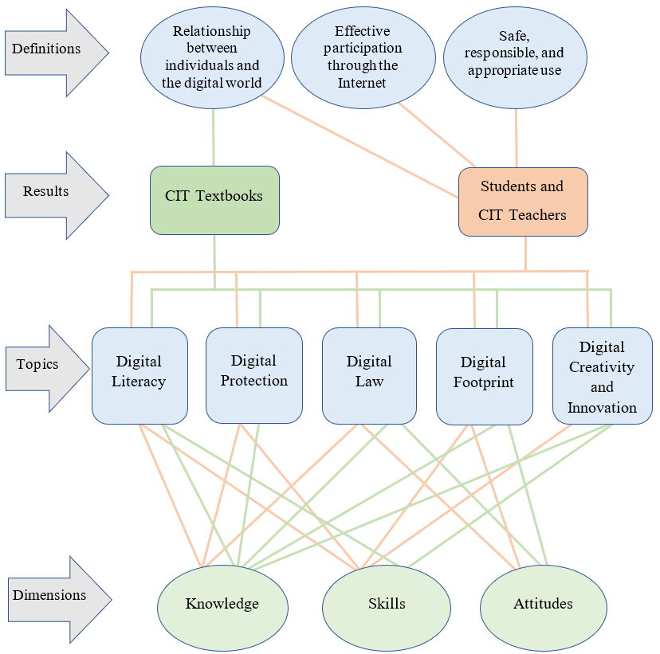
Figure [32]. The relationship between the literature review and the study results.

This figure demonstrates how the CIT textbooks present the concept and the topics of digital citizenship within three dimensions (knowledge, skills, and attitudes). Also, it demonstrates how students and CIT teachers understand the concept and the topics of digital citizenship within these dimensions (see section 8.1 for more information). As shown in Figure 32, digital citizenship is not presented in the CIT textbooks from the perspective of appropriate and responsible use of technology or from the perspective of digital participation. Instead, the CIT textbooks were closer to expressing digital citizenship as a relationship between the individual and the digital world. In contrast, the perspectives of the students and CIT teachers were varied to include these three possible definitions of digital citizenship. Moreover, Figure 32 demonstrates how knowledge, skills, and attitudes are emphasised differently whether by the CIT textbooks or by students and CIT teachers, where in some topics the focus is on knowledge, in some topics the focus is on skills, and in others the focus is on attitudes.
Therefore, I think that defining digital citizenship in another way, like what is concluded by Frau-Meigs et al. (2017), that digital citizenship ‘is a transversal dimension that involves the values, skills, attitudes, knowledge and critical understanding which citizens require in the digital era’ (p. 23), could be a starting point for shifting the definition of digital citizenship from a focus on appropriate and responsible use or digital participation to one that focuses on digital knowledge, skills, and attitudes. Definitely, responsible use and digital participation remain important issues for digital citizenship, but I would argue that they are among the components of digital citizenship rather than digital citizenship itself. Hence, based on the literature review and the findings of this study I suggest that digital citizenship is defined or described as: A relationship between the individuals and the digital world, which requires a set of knowledge, skills, and attitudes that individuals need to develop in relation to digital literacy, digital protection, digital law, digital footprint, and digital creativity and innovation. Thus, I suggest the following model to express digital citizenship, see Figure 33.
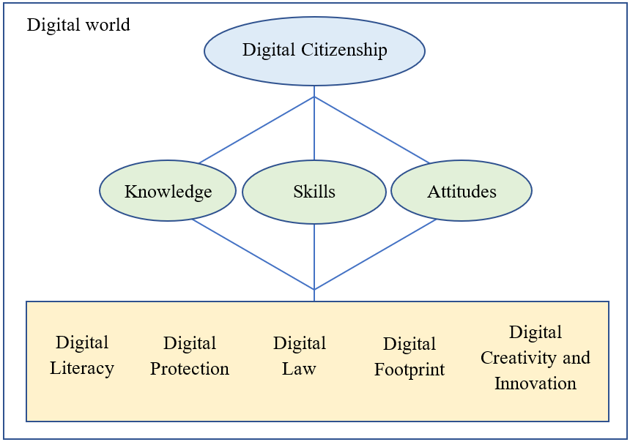
Figure [33]. Proposed Model for Digital Citizenship.
By presenting this model in this way, I am trying to shift the focus regarding digital citizenship to knowledge, skills, and attitudes. Therefore, I emphasised them in three separate shapes (green circles), while digital citizenship topics are presented inside the yellow box to show that these topics represent the main themes of digital citizenship, but they can also be expanded or modified. In other words, the yellow box provides space to add other digital issues that may arise in the future because of technological changes. However, any topic or issue within the yellow box must be addressed through the three dimensions emphasised by three separate circles. In other words, each issue inside the yellow box must be developed and delivered to the students through three dimensions (knowledge, skills, attitudes). See Table 11 in the next section for an example of the application of this model.
This model could be used as a guide to understand and teach digital citizenship because it clarifies what aspects should be focused on (knowledge, skills, and attitudes) and specify what topics or areas should be addressed (digital literacy, digital protection, digital law, digital footprint, and digital creativity and innovation). Also, this model can include the previous definitions of digital citizenship where safe, responsible, and appropriate use can be addressed in topics such as digital protection, digital law, while digital participation can be addressed in topics such as digital footprint, and digital creativity and innovation. Moreover, this model is flexible because it can be used to express digital citizenship at different educational levels and in different context where the educational institutions and organisations can determine the knowledge, skills, and attitudes that consistent with their education goals, needs, and levels in a way like what is presented in DigComp 2.2 framework (Vuorikari et al., 2022) and DQ framework (Park, 2019). An example of using this model with these frameworks will be presented in the next section.

8.2.2 Recommendations for Teaching Digital Citizenship in Saudi Arabia
The literature review of the present study that examined digital citizenship education in Saudi Arabia reveals that there is a lack of inclusion of digital citizenship topics in school textbooks in general and in the CIT textbooks in particular (see section 3.7.1). Also, the literature review of the present study reveals that digital citizenship education faces some obstacles and challenges such as lack of clear policies and plans regarding digital citizenship; lack in including citizenship topics in school curricula; lack in digital devices, laboratories, and Internet access; and lack of time; lack of interest and cooperation from students, teachers, or families (see section 3.7.2). Similarly, the results of this study reveal that digital citizenship education in Saudi Arabia is facing the same challenges, in addition to that strong tendency towards conservatism and cultural–religious domination makes digital citizenship education more complex and challenging (Al-Zahrani, 2015). Therefore, I will address in the following sections the challenges and obstacles facing digital citizenship education in Saudi Arabia and provide some suggestions in this regard.

8.2.2.1 Choosing and applying a Framework of Digital Citizenship
The results of the present study indicate that although the CIT textbooks include multiple and diverse topics that are consistent with the topics of digital citizenship, they fail in presenting these topics in line with the frameworks and models of digital citizenship. As mentioned in section 8.1 and 8.2.1, the CIT textbooks focus on digital knowledge in some topics and focus on digital skills in other topics, while digital attitudes and behaviours are almost not addressed in most of the topics. Also, the perceptions of students and CIT teachers reveal that the content of CIT textbooks are comprehensive and varied in terms of digital literacy, while it is limited and focused on certain issues in other topics. For example, students and CIT teachers criticised the selectivity and limitation of some topics in both digital law and digital footprint as well as the superficiality and lack of explanation in digital protection topics (see section 7.2.1). Therefore, to balance the CIT textbooks’ coverage of different aspects (knowledge, skills, and attitudes) and different topics (digital literacy, digital protection, digital law, digital footprint, and digital creativity and innovation), I suggest that the Ministry of Education in Saudi Arabia choose and apply a framework of digital citizenship. I believe that DigComp 2.2 framework and DQ framework are two of the digital citizenship frameworks that can be used in Saudi Arabia because they have an international scope, and they are flexible and adaptable to be applied in different contexts and cultures (Nascimbeni & Vosloo, 2019). Also, these frameworks can easily be combined with the proposed model in section 8.2.1 since the dimensions of the model (knowledge, skills, and attitudes) and its topics (digital literacy, digital protection, digital law, digital footprint, and digital creativity and innovation) are consistent with these frameworks. See Table 11 for example.
Digital literacy
Example from DigComp 2.2  (Vuorikari et al., 2022, p. 13) | Knowledge: to know that all types of information can be found in online environments including misinformation and disinformation.  Skills: to be able to analyse and evaluate data and information and to identify their origins.  Attitudes: to be inclined to check and ensure the accuracy and reliability of the information and preferring to use primary sources.
Digital Protection
Example from  DQ framework  (Park, 2019, p. 22) | Knowledge: to understand online risk and cyber threats such as hacking, scams, and malware.  Skills: to be able to identify online risks and cyber threats, and to use cyber security practices such as firewalls and anti-malware applications.  Attitudes: to exhibit resilience and vigilance against careless behaviours that may lead to compromise data and device security.
Digital Law
Example from DigComp 2.2  (Vuorikari et al., 2022, p. 32) | Knowledge: to know about intellectual property rights and understand that digital content and goods might be protected under these rights.  Skills: to be able to check the terms and conditions related to intellectual property and copyrights and use and share digital content legally.  Attitudes: to respect intellectual property and copyrights and incline to use legal sources.
Digital Footprint
Example from  DQ framework  (Park, 2019, p. 24) | Knowledge: to understand the possible uses and consequences of sharing information on the internet.  Skills: to be able to use digital tools to build a positive reputation and manage privacy settings.  Attitudes: to be inclined to respect others’ privacy and protecting their personal information
Digital Creativity and Innovation
Example from DigComp 2.2  (Vuorikari et al., 2022, p. 48) | Knowledge: to Know that innovation of new products can be supported by using digital technologies and electronic devices.  Skills: to be able to turn one’s idea into action by using digital technologies. For example, open a channel to share health information and advice.  Attitudes: to be motivated to use digital technologies and devices for designing or creating new products and services.
Table [11]. An example of using the proposed model of digital citizenship.

Certainly, this table does not represent all digital issues that fall under these five topics of digital citizenship, but it provides an example of how to develop a framework for teaching digital citizenship by integrating the proposed model with related frameworks of digital citizenship such as DigComp 2.2 framework and DQ framework. Therefore, I highly recommend that the Saudi Ministry of Education take serious steps to establish or develop a framework for digital citizenship education, or at least choose one of the digital citizenship models and frameworks that fit the Saudi context.

8.2.2.2 Reviewing and Developing the CIT Textbooks
As mentioned in the previous section, the results of analysing the CIT textbooks and the participant views reveal that the CIT textbooks need to be reviewed and improved in light of digital citizenship frameworks. First, the CIT textbooks need to balance their content between knowledge, skills, and attitudes as well as between the main topics of digital citizenship. Therefore, using and applying a digital citizenship framework as explained in the previous section would be an effective way to address this issue. Second, the CIT textbooks need to consider presenting digital citizenship topics in a way that helps teachers cover knowledge, skills, and attitudes. For example, including and motivating the use of recommended teaching approaches and strategies in digital citizenship frameworks such as guided practice, modelling, scenarios, dilemmas, and case studies (see section 3.6).
Third, the results of this study indicate that religion, customs, and traditions are given attention by the CIT textbooks as well as teachers and students (see section 7.1.6 and 7.2.4). For example, RT3 points out that:
The Saudi people are very emotional, very emotional to the extreme, because of their Islamic character and fraternal and social sympathy. If I play on the sensitive thing in any society, I am completely confident that I will win the case.
Obviously, Saudi society pays great attention to its religion and culture, and therefore, this could be used to support digital citizenship. For example, there are many Islamic teachings that call for adherence to virtues and good morals and encourage peaceful coexistence (see section 2.2.1). Thus, referring to them or discussing them in the relevant topics such as digital rights and responsibilities, digital footprint, and digital participation would support digital citizenship education in Saudi Arabia. Also, as discussed in section 7.2.4 that while the Saudi Vision 2030 seeks to transform state’s ideology to moderate Islam (Chulov, 2017; Eum, 2019), it seems that CIT textbooks still adopt a conservative religious approach. Therefore, it may be advisable for the CIT textbooks to adopt a moderate approach to local and global citizenship, because focusing only on local citizenship is not compatible with the digital environment, which includes many different cultures and many debates on issues such as pluralism, diversity, freedom, and equality of human rights. Hence, such debates should be addressed either in the CIT textbooks or in other textbooks. Moreover, RT1 expresses a unique point of view in this regard as he said, ‘regarding religion and culture, I believe that if everyone understands his rights and responsibilities in the digital world, this can control any potential influence of religion or culture’. Therefore, it is not enough that the CIT textbooks only mention that Saudi Arabia has Anti-Cyber Crime Law, but rather it would be better if the CIT textbooks include and present examples or quotes from this law so that students and teachers alike know what rights, responsibilities and penalties are included in this law. See Figure 34 as an example from Anti-Cyber Crime Law in Saudi Arabia.
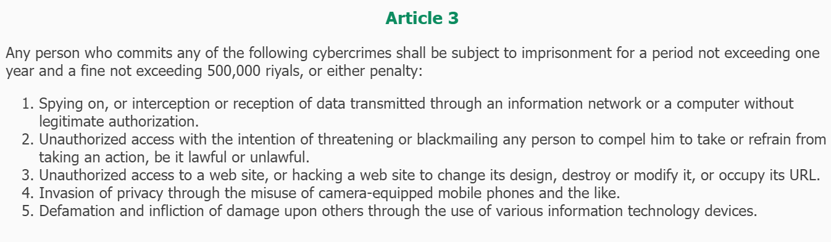
Figure [34]. An example from Anti-Cyber Crime Law in Saudi Arabia. (Bureau of Experts at the Council of Ministers, 2022, Article 3).

However, the purpose of presenting and discussing such laws should not be to adopt or promote a prohibitive approach, but rather, the purpose should be to discuss the underlying behaviours and why they are considered crimes according to the law, thus, deeper understanding of these behaviours can be developed (Phippen, 2016).
Fourth, the results of analysing the CIT textbooks reveal that CIT textbooks need to consider the order of the topics and the activities as some activities and exercises require knowledge and skills that have not been taught to students. For example, the topics of information sources and Internet search methods are presented in the CIT textbook for the third intermediate grade. In contrast, the CIT textbook for the first intermediate grade asks the students to use the Internet to search and download printer drivers. Therefore, it is important that the content of the CIT textbooks is presented in a sequential and orderly manner so that students can learn how to use the Internet to search for information or download files before they are assigned to activities that require the use of the Internet. Otherwise, students may put themselves at risk by browsing untrusted websites and thus may obtain incorrect information or download a computer virus instead of a printer driver.
Finally, the views of CIT teachers indicate that the CIT textbooks do not meet students’ interests and needs, also they restrict teachers to teach specific topics, programs, and applications. For example, UT2 indicates that the CIT textbooks do not address the applications that students are interested in and asked about, such as Snapchat and Instagram. Also, RT3 states ‘why do you restrict me, for example, to Word and PowerPoint’ and therefore he suggests that the CIT textbooks identify some programs and applications and allow teachers to choose the programs that match their students’ interests and needs. In addition to the suggestion of RT3, I suggest that the CIT textbooks should focus on knowledge, skills, and attitudes rather than on programs or applications themselves. For example, students can learn word processing using many word processing programs and applications, also design can be learned using many programs and applications. Therefore, focusing on knowledge, skills, and attitudes rather than the names and types of programs may give teachers some of the flexibility they need in choosing programs and applications that match the students’ interests and the available resources. This is also consistent with the future vision of digital age curricula that can be described as open source or not fixed (Lindsay &Davis, 2010; Williamson, 2013) as well as consistent with the fact that in this digital age, making meanings and generating and communicating knowledge is not limited to printed forms (Burnett and Merchant, 2015; Burnett et al., 2014). Hence, teachers need to feel their role as key participants in the development of the teaching process rather than as tools that implement the CIT textbooks and therefore, they are evaluated according to ‘how much of the curriculum they have covered’ (OECD, 2020, p.12).

8.2.2.3 Increasing Weekly Lessons for CIT Textbooks
The literature review and the results of the present study indicate that the lack of time represents a significant challenge facing digital citizenship education in Saudi Arabia for several reasons. First, as mentioned in section 2.3, that until May 2021 Saudi intermediate schools were the first educational stage in which students formally learn about computers and technology through the CIT textbooks (one weekly lesson for each grade). After that date, the Ministry of Education introduced digital skills textbooks to be taught in the fifth and sixth grades in the primary schools (one weekly lesson), and it increased the number of weekly lessons for CIT textbooks in intermediate schools to become two instead of one. However, before May 2021 (when the data for this study was collected), the CIT textbooks in Saudi intermediate school stood alone to teach students about technology and digital citizenship, especially since the studies that explored digital citizenship in other textbooks such as the textbooks of Islamic studies (Al-Bassam , 2021; Alshakrah & Alzahrani, 2020), the textbooks of social studies and life skills (Al-Ghamdi & Al-Saadoun, 2021; Al-Hanaki, 2020; Al-Mulhim & Jaballah, 2018), and the textbooks of Arabic language (Al-Rasasimah, 2021) reveal that there is a weakness in including digital citizenship topics in these textbooks. Therefore, CIT textbooks need weekly lessons consistent with their importance and role, which is not supposed to be one or two weekly lesson compared to nine weekly lessons for religion, six weekly lessons for Arabic language, five weekly lessons for mathematics, four weekly lessons for science, and three weekly lessons for social and national textbooks.
Second, CIT teachers’ opinions reveal that the lack of weekly lessons of CIT textbooks led to the emergence of a stereotype about the CIT textbooks among students, their parents, and even among other teachers and school principals. CIT teachers indicate that CIT textbooks do not get attention because there is an assumption that they are unimportant or unnecessary because they are taught in one lesson per week. For example, RT1 states that:
Students, parents, and sometimes school administrators and teachers consider CIT curricula as a non-pivotal or nonessential as they are taught only in one lesson per week...the students always say, ‘oh teacher, it is only one lesson’ (indicating that it is not important), while, for example, we find that the art education curriculum is two lessons per week.
Also, RT3 expresses his view on this and says that he does not blame the students if they hold this belief, but he is disappointed when the school principal or one of the other teachers says ‘oh my brother, it is a CIT Curriculum! Let the students pass! It is like a physical education curriculum or art education curriculum’. This is clear evidence that the small number of weekly lessons gives the impression that the CIT textbooks are not important because they are associated with physical education curriculum and art education curriculum which are also taught with a few weekly lessons. Therefore, the number of weekly lessons assigned to CIT textbooks must be reconsidered to give them the importance that corresponds to their role in preparing students for a future that depends heavily on technology.
Third, CIT teachers indicate that one lesson per week presents them with more challenges. For example, if a student is absent from one of the weekly lessons, this means that there is a two-week gap between the last lesson the student attended and the next lesson that he will attend, and this causes distraction for both the student and the teacher. Also, some subjects need more than one lesson to be covered and when CIT teachers divide this subject to be taught in two lessons, this distracts the students because there is a gap of a week between these two lessons (see section 7.2.3). Moreover, CIT teachers state that the content of CIT textbooks is rich and contains many enrichments and activities, but the small number of lessons does not help them to benefit from these textbooks. Therefore, they overlook some activities, exercises, and enrichments in order to cover the topics of the CIT textbooks before the end of the semester (see sections 7.2.1 and 7.2.2).
Taking into consideration these challenges posed by the small number of lessons allocated to the CIT textbooks, I suggest that more attention and more lessons should be given to the CIT textbooks because this gives students and teachers more time to study, discussion and interaction with technology, and more time to implement activities and exercises which provide a great opportunity to develop students’ skills and attitudes. Not only that but increasing the number of weekly lessons would achieve a balance between the CIT textbooks and the rest of textbooks, thus changing the impression or assumption that textbooks are unimportant or not useful.

8.2.2.4 Equipping Laboratories and Providing Resources
The readiness of laboratories and the availability of resources are other challenges or obstacles facing digital citizenship education as students and CIT teachers mention critical issues in this regard. Some students indicate that there is ‘lack of devices and computer labs’ (RS1), the ‘computers sometimes stop working and some are broken’ (US1), and there is a need for ‘new computers and internet at school’ (US3). Also, some CIT teachers such as RT1 indicate that he sometimes cannot explain the practical part of the CIT textbooks for the students because the local network does not work in his lab and there is no projector. Moreover, UT2 states that ‘most of the labs have outdated equipment and systems that are not compatible with the programs or applications that should be taught’. However, what makes these issues are major obstacles is that digital citizenship education requires direct interaction with technology and the Internet, requires guided practice, requires experiential learning (see section 3.6), and this is difficult to implement with unequipped labs, non-working devices, broken devices, or operating systems that are incompatible with applications and programs that should be taught. Therefore, more attention should be given to the readiness of laboratories and the availability of resources.
RT3 believes that the reason for not paying attention to computer labs and their equipment is due to the ‘absence of the idea that the CIT curriculum is like mathematics and like science’. This point of view confirms that what is mentioned in the previous section about the stereotype of CIT textbooks has also affected the readiness of laboratories. In other words, since there is an assumption or belief that the CIT textbooks are not as important as other textbooks, their laboratories are also unimportant. Therefore, the first step to address the problem of laboratories is to change the stereotype of the CIT textbooks by allocating more weekly lessons. This would give more importance to these textbooks and help in the feasibility of preparing the labs because they will be used more than once a week for each class.
Another suggestion to address the labs issue is presented by RT2 as he believes that schools need someone to work as a laboratory assistant or technician so that he helps them in dealing with laboratory problems such as updating operating systems, downloading software and applications, connecting devices to the local network and the Internet. Personally, I think this is a reasonable suggestion because to support digital citizenship education, CIT teachers need to focus on the teaching process rather than on equipping and maintaining laboratories. Schools in this digital age contain many digital devices such as computers, printers, scanners, projectors, and faxes, which are not limited to computer labs, they are everywhere in the school. Therefore, it is more efficient to have someone responsible for maintaining these devices and making sure they are working properly.

8.2.2.6 Keeping Pace with Saudi Vision 2030
As mentioned in section 2.2.3 that Saudi Vision focuses on three themes: Vibrant Society (preserving its roots and fulfilling its future life); Thriving Economy (open for business, geo-location investment, long-term investment); and Ambitious Nation (responsibly enabled and effectively administered) (Saudi Vision 2030). In addition, Mitchell and Alfuraih (2018) in their analysis of the documents of Saudi Vision 2030 and National Transformation Program emphasise that Saudi relied on three pillars; ‘to be positioned at the heart of the Arabic and Islamic world, to become a global investment powerhouse, and to be the connector of Asia, Europe, and Africa’ (p. 43), and they conclude that education and training are key factors that will help the Kingdom achieve its vision 2030. However, although Saudi Arabia has achieved many developments in terms of infrastructure and digital transformation by providing government, health, and educational services electronically which were evident during the lockdown periods due to COVID-19 (see section 2.2.3), the schooling system did not take serious steps towards supporting this vision. For example, while digital transformation is one of the important programs in the vision, digital technology education does not get much attention because until May 2021 there was no curriculum for teaching technology or digital skills in primary schools. Also, in intermediate schools, which is the first stage where students learn about the technology, a small number of lessons (one lesson per week for each grade) are allocated to teaching the CIT textbooks. Moreover, while Saudi Arabia seeks to be a global investment destination and to be a link between three continents (Asia, Europe and Africa), the CIT textbooks still support the first pillar of this vision, which is being the heart of the Islamic and Arab world. Therefore, considering the proposed suggestions presented in above sections will promote not only digital citizenship education but also the Saudi Vision 2030 because reviewing and developing the CIT textbooks in light of the previous suggestions (see section 8.2.2.2) would achieve a balance between local citizenship and global citizenship. This helps Saudi Arabia to be the heart of the Islamic and Arabic world and at the same time to be a global destination that links between three different continents (Asia, Europe and Africa). Also, increasing weekly lessons for the CIT textbooks and including them in primary schools would provide more time to develop digital knowledge, skills, and attitudes, and thus, this may support the Digital Transformation Program, which is one of the Vision 2030 programs (see section 8.2.2.3). Moreover, equipping laboratories and providing internet and resources would give students and educators a greater opportunity to interact with technology and use the available tools and resources to create creative and innovative digital works, and thus, this may support digital transformation as well as the Saudi Vision goals.

8.2.2.5 Support and Adoption Collective Efforts
Although the present study examines digital citizenship education by analysing the CIT textbooks in Saudi intermediate schools and provides some recommendations about them, addressing digital citizenship issues requires a set of efforts that are not limited to schools only. For example, when it comes to online safety, ‘schools are being told they need to deliver education around online safety, yet they are not helped to do this with any guidance on what this might look like’ (Phippen, 2016, p. 111).
Hollandsworth et al. (2011) indicate that promoting digital citizenship requires a comprehensive process that includes not only the integration of citizenship into the curricula but also discussion, dialogue, and collaboration among students, teachers, parents, and stakeholders; establishing relevant policies and practices to digital citizenship; educating administrators, teachers, students, parents, and community members about digital citizenship; evaluating digital citizenship curricula.
Rowsell et al. (2017) also indicate that confronting the digital divide requires collective action by governments, institutions, schools, and families. For example, supporting digital literacy education, providing digital devices and tools, supporting consumption and production cultures; allocating places in schools to encourage production and innovation; enabling access for those who are marginalised; and supporting digital access outside the school.
Therefore, the Ministry of Education in Saudi Arabia must create and introduce plans and programs that support digital citizenship education as well as adopt and encourage initiatives such as applying a framework of digital citizenship education; reviewing and developing the CIT textbooks; increasing weekly lessons for the CIT textbooks; equipping laboratories and providing resources; and keeping pace with Saudi Vision 2030 (see section 8.2.2). Also, educational institutions and families should cooperate to support digital citizenship as home and school are appropriate environments in which positive digital behaviours can be supported. Moreover, the private sector should support this process by supporting and adopting initiatives that may increase digital awareness and provide and facilitate digital access for all.

8. 3 Limitations of the Study and Suggestions for Future Research
The limitations of the present study are presented in detail in section 4.4 which discusses the selection of purposive samples. However, this section will summarise them and present some suggestions for future research.
First, this study was limited to the CIT textbooks in intermediate school in Saudi Arabia because until May 2021 (where the data of this study was collected), the intermediate school was the first stage where the students learn formally about the computer and technology through the CIT textbooks. However, after that date, the Ministry of Education introduced what is called ‘Digital Skills’ as new textbooks to be taught in fifth and sixth grade of primary schools. Therefore, it could be suggested that future studies explore digital citizenship in digital skills textbooks in Saudi primary schools and consider whether these new textbooks address the issues revealed in this study such as the lack of attention to digital skills and attitudes in topics such as digital protection, digital law, and digital footprint.
Second, the Saudi Arabian territory includes many different dialects, and the meanings of words differ from one region to another. Therefore, this study was limited to intermediate schools in the region and city of Hail (where I was born and raised) because this would help me to communicate easily with the participants and understand their views and perceptions more clearly. From this limitation, it could be suggested that future studies explore the views and perceptions of students and teachers about digital citizenship in other regions of Saudi Arabia and consider whether there is a difference in the perceptions and perspectives of students and teachers according to different regions.
Third, this study was limited to intermediate schools for male students because it is difficult for a male researcher to interview females due to the Saudi education system, customs, and traditions. In the Saudi education system, males and females are taught in separate schools, and thus, males are not allowed to enter schools for females. Also, it is not culturally acceptable for males and females to meet or to be in contact if they are not relatives. However, although this study can be conducted in both boys’ schools and girls’ schools using different data collection methods for each gender, this option would require considerable effort and may make the research inapplicable because it already depends on more than one method to collect data and using different methods for each gender would increase the difficulties in collecting and analysing the data. Therefore, it could be suggested that future studies explore digital citizenship in Saudi schools for girls and consider whether the perceptions and perspectives of students and teachers in these schools differ by gender.
Finally, this study is directed and led by its main purpose of achieving an in-depth understanding of the concept and topics of digital citizenship. However, although this study explored digital citizenship in all the CIT textbooks in Saudi intermediate schools (6 textbooks), it is still limited in terms of the number of teachers and students as it explored the perspectives and perceptions of only six teachers and six students. Therefore, it could be suggested that future studies include more participants to have good generalisability. Also, considering the study’s aim of achieving a deep understanding of digital citizenship, which resulted in the presentation of a proposed model that expresses digital citizenship. Therefore, future studies could develop this model or use it to generate a framework for teaching digital citizenship in general or within the Saudi context. Moreover, although this study explores the perspectives and perceptions of students and CIT teachers, it focuses on how they understand digital citizenship and its topics. However, some teachers’ perspectives described some of the practices and experiences around using social media to address some community issues through hashtags (see section 7.1.4). Therefore, future studies can address digital participation through social media and explore the experiences and practices of Saudis in this regard and how this type of participation can be encouraged and supported.

8. 4 Reflexivity
Reflexivity involves reflecting as a researcher on how your interpretations and findings are shaped by your personal background, culture, and experiences (Creswell, 2014). Reflexivity is not ‘to eliminate researcher effects (which is impossible, as researchers are part of the world that they are investigating)’, but rather it ‘suggests that researchers should acknowledge and disclose their own selves in the research, seeking to understand their part in, or influence on, the research’ (Cohen et al., 2007, p. 171). Therefore, I will address in this section my reflections on my PhD journey.
First, as a Muslim and Arab researcher, I consider my religious beliefs and Arab culture and customs because I believe that they are relevant to my research topic. As explained in the context chapter (see section 2.2), the Islamic religion and Arab customs and traditions are emphasised in the Basic Law of Governance in Saudi Arabia as well as in the education system whether in educational policies or in school curricula. Therefore, Islamic religion and Arab customs and traditions play an important role in shaping the identity of Saudis, and thus, rights, responsibilities, and ethics (which are important issues in digital citizenship) are defined and understood by Saudi citizens in the light of their Islamic religion and their Arab customs and traditions. However, in the context chapter, I tried to clarify the importance of religion, Arab traditions and tribal customs and their impact on the lives of Saudis from the first Saudi state to the current Saudi state. Also, I tried to clarify the role of the Saudi vision 2030 and highlight it as a factor of change working to reform the state economically, politically, and socially by adopting moderate Islam.
Second, regarding the topic of study, my work as a CIT teacher in Saudi intermediate schools between 2011 and 2013 was the starting point for my interest in this topic. I noticed at that time that CIT textbooks were not in line with the technological revolution that Saudis were experiencing at that time. For example, I remember how the students and I spent an entire semester just learning touch-typing which was a boring mandatory subject in that version of CIT textbooks. In 2014, I moved to work as a lecturer in the Department of Primary Classroom Teacher at the University of Hail, which gave me a greater opportunity to complete my postgraduate studies and develop my knowledge about education in general and curricula in particular. However, before I started my PhD, my knowledge, perceptions, and beliefs on digital citizenship revolved around Ribble’s (2015) model of nine topics (this was evident in the research proposal that I submitted to obtain my PhD offer). I think the reason behind this is that most of the Arab and Saudi studies (Abdelhad, 2020; Abu-Omar & Jwaifell, 2018; Al-Ghamdi & Al-Saadoun, 2021; Al-Hanaki, 2020; Al-Harthy & Al-Mutairi, 2019; Aloufi & Alzahrani, 2021; Al-Rasasimah, 2021; Alshakrah & Alzahrani, 2020; Ibrahim, 2019; Najmuldeen,2021; Shahin, 2021) focus on Ribble’s model when they address and explore digital citizenship. Therefore, as an individual who grew up in this culture, I had the idea that digital citizenship only revolved around what Ribble’s model presented. I believe that the literal use of the term digital citizenship in Ribble’s model led to its use in many Saudi studies. Therefore, Ribble’s model in Saudi Arabia became a reality that reflects digital citizenship, and thus, most Saudi studies used quantitative methodologies to explore and evaluate digital citizenship. However, my PhD research helped me to broaden and deepen my knowledge of digital citizenship and its topics, and to explore new models and frameworks related to this topic. Therefore, by using a qualitative methodology, I sought to understand digital citizenship in depth by examining it from different perspectives, and therefore I do not limit digital citizenship concept to appropriate and responsible use or participation in society nor do I limit its topics to a single framework or model. Hence, my interpretation of the concept and themes of digital citizenship resulted in proposing a comprehensive and flexible model so that digital issues that fit a particular culture or context could be included in five main themes and within three main dimensions.
Third, the PhD journey allowed me to explore many research methodologies and methods that can be used for different purposes and in different ways. However, as I explored research methodologies, I noticed that they are as complex as the topic of digital citizenship and the more I tried to understand or realise them through further research and reading the more confused I became about them. O'Leary (2004) argues that significant increase in the number of methods of research particularly in the social sciences has contributed to this complexity as what was relatively simple in its definition in the past has become more complex in recent times. However, during my work on my methodology I come across many situations and feelings that oscillate between doubt and certainty. In other words, when I read about a certain methodology, I find myself convinced that it fits with my research and when I read about another one, I find myself sceptical about the first. For example, at a stage of my PhD journey I thought that critical discourse analysis is a suitable approach for analysing the CIT textbooks. The origin of CDA dates back to the critical linguistics field which assumes that ‘language is a social act, and social structures and linguistic structures are interlinked’ (Harb, 2017, p. 60). CDA can be seen as an approach systematically explores ‘opaque relationships of causality and determination between (a) discursive practices, events and texts, and (b) wider social and cultural structures, relations and processes’ (Fairclough, 1995, pp. 132–133). Also, CDA can be seen as ‘a type of discourse analytical research that primarily studies the way social power abuse, dominance and inequality are enacted, reproduced and resisted by text and talk in the social and political context’ (Van Dijk, 2001, p. 352). CDA is one of the attractive approaches to analysing qualitative data, and I think what I liked about it is that it challenges my abilities as a researcher to reveal hidden meanings behind discourses or texts, so I prefer to call it the detective approach. However, at a later stage of my PhD I realised that my research was not primarily intended to explore and investigate the ideology and power relations that may be expressed in the CIT textbooks, instead my research purpose was to understand the concept of digital citizenship and explore the topics of digital citizenship presented in these textbooks. Therefore, I advise researchers to always remind themselves of the goals and questions of their research, especially in the PhD studies, because with the length of time (three years or more) and browsing through many books, literature, and studies, they may lose their research compass (the purpose and questions of research) as happened to me. However, I chose thematic analysis as an approach to analyse the CIT textbooks and as well as the interview data (see section 4.3 For more information about thematic analysis). In order to clearly understand this approach, I explored some of the studies that used thematic analysis and unfortunately, some researchers do not explain how they applied their approach and only provide general and brief information about the steps involved in thematic analysis without explaining their procedures in implementing this approach. I believe that some researchers may prefer not to disclose their implementation of the methods they used in their analysis because they may be afraid that they have applied them incorrectly or differently. To be honest, I had this feeling, but after attending some relevant seminars and workshops, I realised that researchers often prefer to use methodologies in the same way they were used before because this makes them feel comfortable and confident, but they forget that their creativity may be in their use of research methods in different ways. Therefore, in the methodology chapter, I tried to reveal in detail the procedures for analysing the CIT textbooks and interview data because I believe that this will help other researchers in understanding the analysis approach as well as help in ensuring the trustworthiness of this study, in addition to that it may show other aspects of possible and creative uses of research methods.
Fourth, the PhD journey increased my awareness of ethical issues and the need to consider them at every stage of my PhD. For example, Research Ethics and Integrity (FCS6100) was one of the modules that I attended in the first year of my PhD. Prior to completing this course, I thought that I had sufficient knowledge about research ethics, but I realised when I attended this course that my knowledge was limited. This course consists of two parts: a session and a workshop. In fact, the session closely resembled a workshop, in which students were seated as groups to discuss various scenarios involving issues of ethics and integrity. Students disagreed on these issues, and establishing a consensus was challenging. Each student held a different view for each issue, and at times we arrived at dead ends. Nevertheless, the discussions raised critical issues about ethics and integrity that encouraged me to adopt diverse perspectives and aided me immensely in addressing the ethical issues of my research. Also, I attended many seminars within the Doctoral Training in Education programme that helped me think about ethical issues that go beyond taking the consent of the participants and ensuring data privacy, confidentiality, and anonymity. I realised that having the paperwork needed to conduct the research did not mean that the research is ethical, I realised that participants’ feelings should be taken into account, I realised that even a questionnaire might cause pain to participants by asking or telling them things they did not expect, I realised that participants even if they agreed to participate in sensitive or critical studies, it is significant to consider their feelings and protect them from any effects and risks. Therefore, these issues played a crucial role in determining my choices and guiding my research procedures. For example, thinking that my use of critical discourse analysis as a methodology might put participants at risk was one of the reasons that made me refrained from using it, as well as it would not serve the purpose of the research as the thematic analysis would. Another example is when COVID-19 emerged, it became risky to proceed with face-to-face interviews which were identified as a tool for collecting data from teachers and students. Therefore, face-to-face interviews were replaced by remote interviews to protect participants from any potential risks to their health (see section 3.4 for more information). Moreover, when I invited the participants, I told the participants that acceptance of participation is available within one week from the date of receiving this invitation to avoid the issue of receiving responses from participants who want to participate after the required number of participants is completed, and thus, their feelings may hurt if they know that their participation is no longer required. Furthermore, in order to respect Saudi culture, I limited my participants to male teachers and students as interviewing female teachers and students by a male researcher may cause some discomfort or a feeling of disrespect for the local culture in Hail city. However, what I realised as a conclusion is no matter how small or large these issues are, they remain ethical issues and researchers must consider them and address them.
Finally, the PhD journey allowed me to develop many skills related to my academic writing and critical thinking which really helped me at different stages of my study. However, from my experience with regards to attending development courses and workshops I think it is acceptable to attend the same workshop more than once because sometimes you need to remind yourself about what you have learned. I mean, for the past three years, I have been intentionally going to some of the workshops I have attended before. What really surprised me is that even when I attend a workshop that I have already attended, I learn something new. If it is not from the presenter, it will be from the attendees. Another thing I would like to draw attention to is that choosing the courses that match your needs is crucial because it helps you confirm the knowledge you have got and practice the skills you have learned. For example, when I was working on my literature review, I attended some workshops relevant to academic writing which helped me develop my knowledge about academic writing and at the same time I had the opportunity to apply what I learned. Moreover, the PhD journey develops many skills regarding time management and work-life balance. I think that the researcher's ability to balance between study and life is an important factor not only for the success of his/her research, but for maintaining the stability of the primary environment that supports him/her in such times, which is the family. Therefore, my plan in this regard was not to take long vacations or breaks, instead I split my vacations throughout the months of the year so that each month I have a small break. Considering that my family and I live far from our relatives who are in Saudi Arabia, it was my responsibility to devote more time to my wife and daughter while we are abroad. Overall, my family and I went through this journey with many challenges, starting with leaving our parents and relatives and moving to study abroad, ending with the emergence of Corona and the lockdown last year. However, the support I have always received from colleagues at the University of Sheffield and especially from my supervisors has been a positive influence on my study as their advice and guidance helped me in making choices and decisions regarding my PhD research and regarding my life in the UK.
In conclusion, the PhD journey in general helped me develop my knowledge and skills in many aspects. While my PhD research helped me realise my responsibility as a researcher to explore digital citizenship in the Saudi context and try to find a link between its concept and themes and propose a model to help in the process of its education. Therefore, I believe that I have a responsibility to communicate what I have learned about digital citizenship and to share the findings of this study with interested parties and Saudi society. Also, with the inspiration I got from some of the frameworks and models I examined in this study, I seek in the future to build and develop a framework for teaching digital citizenship based on the proposed model in this study, considering the Saudi context. The Saudi culture, which is derived from the Islamic religion and Arab customs and traditions, represents a reference for many Saudis in determining their rights and duties. Thus, their behaviours, rights, and responsibilities in the digital environment are likely to be influenced by this culture. Therefore, Saudi culture must be considered in the design of any framework for teaching digital citizenship by employing it in a positive manner that supports peaceful coexistence and urges adherence to good morals and virtues.

References

Abdelhad, A. (2020). Digital Citizenship Values in Algerian Second Generation Textbooks: A Content Analysis of Third and Fourth year Middle School Second Generation Textbooks of Civic Education. Qabas Journal of Studies Human and Social, 4(2), 795-806.
Abesadze, S., & Nozadze, D. (2020). Make 21st Century Education: The Importance of Teaching Programming in Schools. International Journal of Learning and Teaching, 158-163.
Abidin, C. (2018). Internet celebrity: Understanding fame online. Emerald Group Publishing.
Abo Dof, M. (2004). Citizenship education from an Islamic perspective. Journal of the Faculty of Education - Al-Azhar University, 24, 44-56.
Absher. (2021). About Absher. Retrieved 1 February 2021, from https://www.absher.sa/wps/portal/individuals/Home/
Abu-Omar, R., & Jwaifell, M. (2018). Digital Citizenship in the Arabic Language Textbooks: Content Analysis. Journal of Education and Practice, 9(32), 47-63.
Afshi, E. A. (2022). Digital Citizenship Awareness Among Arabic Language Teachers and Supervisors in Riyadh. Journal of Educational Sciences, 8(1), 377- 414.
Ahmad, H. A. (2012). Musnad Imam Ahmad bin Hnbal. Riyadh: Dar Alsalam.
Ahmed, J. U., Sultana, H., & Khan, M. M. (2018). Saudi Aramco: A Blend between Profit and Politics. FIIB Business Review, 7(2), 88-99.
Akan, M. F., Karim, M. R., & Chowdhury, A. M. K. (2019). An analysis of Arabic-English translation: Problems and prospects. Advances in Language and Literary Studies, 10(1), 58-65.
Akers, D. S. (2001). The tribal concept in urban Saudi Arabia (Doctoral dissertation, The Ohio State University). The Ohio State University. https://etd.ohiolink.edu/apexprod/rws_etd/send_file/send?accession=osu148820427653002&disposition=inline
Alabdulkareem, S. A. (2015). Exploring the use and the impacts of social media on teaching and learning science in Saudi. Procedia-Social and Behavioral Sciences, 182, 213-224.
Al-Abdullatif, A., & Gameil, A. (2020). Exploring students’ knowledge and practice of digital citizenship in higher education. International Journal of Emerging Technologies in Learning (iJET), 15(19), 122-142.
Al-Atawneh, M. (2009). Is Saudi Arabia a theocracy? Religion and governance in contemporary Saudi Arabia. Middle Eastern Studies, 45(5), 721-737.
Al-Bassam, N. S. (2021). The degree of availability of the dimensions of digital citizenship values in the Islamic education courses for the secondary stage from the point of view of its teachers in Makkah Al-Mukarramah. Journal of Educational and Psychological Sciences. 19, 117-134
Aldossari, F. F. (2017). The Level of Availability of Digital Citizenship Standards Among Computer Science Teachers. Egyptian Association for Curriculum and Teaching Methods, 107-140
Aldubyan, A. (2013). Papers in citizenship chalanges and problems, London: Dar ALhikma
Al-Ghamdi, N. M., & Al-Saadoun, B. A. (2021). Content Analysis of Social Studies Textbook for Third Grade Intermediate in The Kingdom of Saudi Arabia Based on Dimensions of Digital Citizenship. Journal of Arab Studies in Education & Psychology, 136, 427- 445
Alhajri, N. A., & Alsubaie, O. A. (2021). The Role of School Leaders in Promoting Digital Citizenship Among Female Students in the Public Schools at AlNairyah Governorate. Journal of Educational Sciences, 34(1), 47-74.
Al-Hanaki, L. (2020). Digital citizenship in the social studies textbooks for the secondary stage, the curriculum system in the Kingdom of Saudi Arabia. Taif University Journal for Human Sciences. 20, 643-686
Alharbi, B. (2015). The ability of Islamic Religious Education to deliver Citizenship Education in elementary schools in the Kingdom of Saudi Arabia (PhD thesis, Faculty of Education, Exeter University, England). Exeter University, England. https://ore.exeter.ac.uk/repository/bitstream/handle/10871/18424/AlharbiB.pdf?sequence=1
Alharbi, B. A. (2017). Citizenship Education in the Kingdom of Saudi Arabia: History and Current Instructional Approaches. International Journal of Education and Literacy Studies, 5(4), 78-85.
Alharbi, W. O., & Alturki, K. I. (2018). Social Media Contribution to the Promotion of Digital Citizenship among Female Students at Imam Mohammed bin Saud Islamic University in Riyadh. English Language Teaching, 11(1), 80-92.
Al-Harthy, S. S., & Al-Mutairi, M. S. (2019). Evaluation of the content of the computer and information technology textbook for the second intermediate grade in light of digital citizenship standards. Journal of the College of Education, 35(12), 532-562.
Alhashmi, S. (2019) Cracked citizenship: an attempt to understand the reality of citizenship in the Gulf countries. In O. AlShehabi & K. Bohazza (Eds). The Constant and the Changing 2019: Citizenship in the Gulf’s Currents (pp. 16-44). Kuwait: Gulf Center for Development Policies.
Alhasri, K. D. (2016) The level of social studies teachers’ knowledge of the dimensions of digital citizenship and its relationship to some variables. The Arab Journal of Educational and Social Studies, 8, 89-141.
Alhojailan, M. I. (2012). Thematic analysis: A critical review of its process and evaluation. West East Journal of Social Sciences, 1(1), 39-4
Ali, F., & Bagley, C. (2013). Islamic education and multiculturalism: engaging with the Canadian experience. Journal of contemporary issues in education, 8(2), 19-31.
Alkhalifah, N., & Alebaikan, R. (2018). Content Analysis of Computer and Information Technology Books For Secondary Stage in Saudi Arabia Based on Dimensions of Digital Citizenship of Common Senes Education. The Arab Gulf Message, 37-56.
Almarshad, Y. (2015). The development of Citizenship Education curriculum for first grade in secondary school in Saudi Arabia in light of some contemporary global challenges. The Journal of School of Education in Zagazig, 78(1), 73-124.
Al-Minqash, S. A. (2006). Derasah Tahliliah Lesyasat Altaleem Vi Almamlakah Alarabiah Alsaudiah Wa Mugtrahat Letatuerha [An analytical study of education policy in the Kingdom of Saudi Arabia and suggestions for its development]. Journal of King Saud University - Educational Sciences and Islamic Studies. 19(1), 381- 440
Al-Mulhim, B. M., & Jaballah, A. S. (2018). Assessment of life Skills and Family Education Syllabus in Light of its Inclusion of Digital Citizenship Skills among Secondary School Students (Unpublished MA thesis, Qassim University). Almandumah. http://search.mandumah.com /Record/919674
Almutairi, M. M., Alsalem, W. S., Hassanain, M., & Hotez, P. J. (2018). Hajj, Umrah, and the neglected tropical diseases. PLoS neglected tropical diseases, 12(8), Article e0006539. https://doi.org/10.1371/journal.pntd.0006539
Alotaibi, F., Furnell, S., Stengel, I., & Papadaki, M. (2016, December). A survey of cyber-security awareness in Saudi Arabia. In 2016 11th International Conference for Internet Technology and Secured Transactions (ICITST) (pp. 154-158). IEEE.
AlOtaibi, S., & Khan, M. B. (2017). Sentiment analysis challenges of informal Arabic. IJACSA) International Journal of Advanced Computer Science and Applications, 8(2).
Aloufi, H. S., & Alzahrani, M. G. (2021). Availability Level of Digital Citizenship in the Computer and Information Technology Book for the Third Grade of the Intermediate Stage in the Kingdom of Saudi Arabia. Journal of Educational and Psychological Sciences, 5(19), 24 – 44
Alqahtani, A. (2017a). Organizational Frames and Digital Citizenship in Saudi Arabia Schools. Research on Humanities and Social Sciences, 7(8).
Alqahtani, A. (2017b). The Extent of Comprehension and Knowledge with Respect to Digital Citizenship among Saudi Arabia Teachers (doctoral thesis, College of Education and Behavioral Sciences, University of Northern Colorado). University of Northern Colorado. https://digscholarship.unco.edu/dissertations/438
Al-Rasasimah, T. S. (2021). An Analytical Study for Arabic Language Course for the Higher Level in The Primary Education Under the Digital Citizenship Values. Journal of Educational and Psychological Sciences, 5(28), 114-133.
Alsawoyan, S. A. (2010). Al Sahra al Arabiya, Thaqafatuha wa Shi'ruha 'abr al 'Usur, Qira'a anthrubulujiyya [The Arabian desert, its culture and poetry through the ages, an anthropological reading]. Beirut: Arab Network for Research and Publishing.
Alshakrah, M., & Alzahrani, S. (2020). Analysing Islamic Curricula in View of Digital Citizenship. Humanities and Management Sciences - Scientific Journal of King Faisal University. https://doi-org.sdl.idm.oclc.org/10.37575/h/edu/0044
Alshammry, F. F. (2021). Concepts of the digital age in computer books and information technology for the intermediate stage: an analytical study. Journal of Education - Sohag University, 83(2), 1–25.
Alsharari, S., Ahmad, A. C., & Aljohani, S. (2019). The self-concept level in the modified Al-Madinah program for talented students in Saudi Arabia. 9 International Transaction Journal of Engineering, Management, & Applied Sciences & Technologies, 10(11).
Alshawi, A. H., & Gardner, A. (2013). Tribalism, identity and citizenship in contemporary Qatar. Anthropology of the Middle East, 8(2), 46-59.
Alsuhaim, A., Albrahim, A. (2019). The scope of activation of digital citizenship standard in secondary schools by computer teachers. International Interdisciplinary Journal of Education, 8(4).
Aly, H. (2019). Royal Dream: City Branding and Saudi Arabia’s NEOM. Middle East-Topics & Arguments, 12, 99-109.
Al-Zahrani, A. (2015). Toward Digital Citizenship: Examining Factors Affecting Participation and Involvement in the Internet Society among Higher Education Students. International Education Studies, 8(12), 203-217.
Amabile, T. M. (1997). Motivating creativity in organizations: On doing what you love and loving what you do. California management review, 40(1), 39-58.
Anderson, J. R., & Schunn, C. D. (2013). Implications of the ACT-R learning theory: No magic bullets. In Advances in instructional psychology (pp. 1-33). Routledge.
Andrews, R., & Mycock, A. (2007). Citizenship education in the UK: devolution, diversity and divergence. Citizenship Teaching and Learning, 3(1), 73-88.
Arjomand, S. A. (2009). The Constitution of Medina: a sociolegal interpretation of Muhammad's acts of foundation of the umma. International Journal of Middle East Studies, 41(4), 555-575.
Ateeq, H. A. (2020). The role of Saudi secondary schools in promoting digital citizenship for their students. Journal of the Faculty of Education in Mansoura, 3, 478-501.
Baartman, L. K., & De Bruijn, E. (2011). Integrating knowledge, skills and attitudes: Conceptualising learning processes towards vocational competence. Educational Research Review, 6(2), 125-134.
Baker, S. E., & Edwards, R. (2012). How many qualitative interviews is enough. NCRM
Banks, J. (2008). Diversity and citizenship education in global times. Education for citizenship and democracy, 57-70.
Bashir, M., Afzal, M. T., & Azeem, M. (2008). Reliability and validity of qualitative and operational research paradigm. Pakistan journal of statistics and operation research, 4(1), 35-45.
Bassiouney, R., & Katz, E. G. (Eds.). (2012). Arabic language and linguistics. Georgetown University Press.
Bawden, D. (2008) Origins and Concepts of Digital Literacy. In: Lankshear, C. and Knobel, M. (eds). Digital Literacies: Concepts, Policies and Practices, Peter Lang, New York.
Bennett, S. (2012). Digital natives. In Encyclopedia of cyber behavior (pp. 212-219). IGI Global.
Bergman, E. (2021). Microsoft Teams: A qualitative usability study (Bachelor thesis, Karlstad Business School, Karlstad University). https://www.diva-portal.org/smash/get/diva2:1515094/FULLTEXT01.pdf
Bowden, C., & Galindo-Gonzalez, S. (2015). Interviewing when you’re not face-to-face: The use of email interviews in a phenomenological study. International Journal of Doctoral Studies, 10(12), 79-92.
Bowen, G. A. (2009). Document analysis as a qualitative research method. Qualitative research journal, 9(2), 27-40.
Braun, V., & Clarke, V. (2006). Using thematic analysis in psychology. Qualitative research in psychology, 3(2), 77-101.
Braun, V., & Clarke, V. (2020). One size fits all? What counts as quality practice in (reflexive) thematic analysis?. Qualitative research in psychology, 1-25.
British Educational Research Association [BERA] (2018) Ethical Guidelines for Educational Research, fourth edition, London. Retrieved 20 December 2019, from https://www.bera.ac.uk/publication/ethical-guidelines-for-educational-research-2018
Bryman, A. (2012). Social research methods (4th ed.). UK: Oxford: Oxford University Press
Bryman, A., & Burgess, B. (Eds.). (2002). Analyzing Qualitative Data. Routledge.
Buhler, A. (2002). Translation as interpretation. In A. Riccardi (Ed.), Translation studies: Perspectives on an emerging discipline (pp. 56-74). Cambridge, UK: Cambridge University Press.
Bureau of Experts at the Council of Ministers. (2019 a). Basic Law of Governance. Retrieved 20 October 2019, from https://laws.boe.gov.sa/BoeLaws/Laws/LawDetails/16b97fcb-4833-4f66-8531-a9a700f161b6/1
Bureau of Experts at the Council of Ministers. (2019 b). Law of The Council of Ministers. Retrieved 20 October 2019, from https://laws.boe.gov.sa/BoeLaws/Laws/LawDetails/b5cf540a-e6ac-426a-b348-a9a700f163de/1
Bureau of Experts at the Council of Ministers. (2019 c). Law of The Council of Shura. Retrieved 20 October 2019, from https://laws.boe.gov.sa/BoeLaws/Laws/LawDetails/b5cf540a-e6ac-426a-b348-a9a700f163de/1
Bureau of Experts at the Council of Ministers. (2022). Anti-Cyber Crime Law. Retrieved 18 July 2022, from https://laws.boe.gov.sa/BoeLaws/Laws/LawDetails/25df73d6-0f49-4dc5-b010-a9a700f2ec1d/2
Burgess, M. L., Price, D. P., & Caverly, D. C. (2012). Digital literacies in multiuser virtual environments among college-level developmental readers. Journal of College Reading and Learning, 43(1), 13-30.
Burnett, C., & Merchant, G. (2015). The challenge of 21st‐century literacies. Journal of Adolescent & Adult Literacy, 59(3), 271-274.
Burnett, C., Davies, J., Merchant, G., & Rowsell, J. (2104). New Literacies around the Globe: Policy and Pedagogy. New York: Routledge.
Caponetto, I., Earp, J., & Ott, M. (2014). Gamification and education: A literature review. In European Conference on Games Based Learning (Vol. 1, p. 50). Academic Conferences International Limited.
Capuno, R., Suson, R., Suladay, D., Arnaiz, V., Villarin, I., & Jungoy, E. (2022). Digital citizenship in education and its implication. World Journal on Educational Technology: Current Issues, 14(2), 426-437.
Carretero, S., Vuorikari, R., & Punie, Y. (2017). The Digital Competence Framework for Citizens. Publications Office of the European Union.
Castelli, M., & Trevathan, A. (2008). Citizenship and human rights in Islamic education. International Journal of Children's Spirituality, 13(1), 85-93.
Castles, S., & Davidson, A. (2000). Citizenship and Migration: Globalisation and the Politics of Belonging. London: Macmillan.
Catalina-García, B., de Ayala López, M. C. L., & Nieto, R. M. (2018). Social media and the political-civic participation of young people. A review of the digital citizenship debate. Doxa Comunicación, (27).
Chaudron, S., Beutel, M. E., Donoso Navarrete, V., Dreier, M., Fletcher-Watson, B., Heikkilä, A. S., ... & Wölfling, K. (2015). Young children (0-8) and digital technology: A qualitative exploratory study across seven countries. JRC; ISPRA, Italy.
Chen, L. L., Mirpuri, S., Rao, N., & Law, N. (2021). Conceptualization and measurement of digital citizenship across disciplines. Educational Research Review, 33, 100379.
Chenail, R. J. (2011). Interviewing the investigator: Strategies for addressing instrumentation and researcher bias concerns in qualitative research. Qualitative Report, 16(1), 255-262.
Children's Commissioner for England. (2017). Growing Up Digital: A Report of the Growing Up Digital Taskforce. [online] Available at: https://www.childrenscommissioner.gov.uk/publication/growing-up-digital/ [Accessed 13 May 2018].
Choi, M. (2016). A concept analysis of digital citizenship for democratic citizenship education in the internet age. Theory & research in social education, 44(4), 565-607.
Chulov, M. (2017). I will return Saudi Arabia to moderate Islam, says crown prince. Retrieved 1 February 2022, from https://www.theguardian.com/world/2017/oct/24/i-will-return-saudi-arabia-moderate-islam-crown-prince
Clarke, V., & Braun, V. (2017). Thematic analysis. The Journal of Positive Psychology, 12(3), 297-298.
Cochran, J. A. (2019). The rise in power of Crown Prince Mohammed bin Salman. Digest of Middle East Studies, 28(2), 369-385.
Cogan, J., & Derricott, R. (2000). Citizenship for the 21st century: An international perspective on education. Routledge.
Cohen, L., Manion, L. & Morrison, K. (2007) Research methods in education (6th ed.). Routledge
Coleman, S. (2006). Digital voices and analogue citizenship Bridging the gap between young people and the democratic process. Public policy research, 13(4), 257-261.
Colombo, S. (2012). The GCC countries and the Arab Spring. Between outreach, patronage and repression. The Arab Spring and the Arab Thaw: Unfinished Revolutions and the Quest for Democracy, 163-178.
Common Sense Media. (2016). Our K-12 Digital Citizenship Curriculum [Ebook]. common sense. Retrieved from https://www.commonsensemedia.org/sites/default/files/uploads/classroom_curriculum/cs_digitalcitizenshipcurric_2016_release.pdf
Common Sense Media. (2019). Our Mission | Common Sense Media. Retrieved 27 December 2019, from https://www.commonsensemedia.org/about-us/our-mission#about-us
Communication and Information Technology Commission. (2019). Individuals and Households Report - Results of ICT Market Survey. Communication and Information Technology Commission. Retrieved from https://www.citc.gov.sa/ar/researchs-studies/Studies/Documents/TheCommunicationsMarketStudyResultsRepor2019.pdf
Comunello, F., Mulargia, S., Belotti, F., & Fernández-Ardèvol, M. (2015). Older people’s attitude towards mobile communication in everyday life: Digital literacy and domestication processes. In International conference on human aspects of it for the aged population (pp. 439-450). Springer, Cham.
Connelly, L. M. (2016). Trustworthiness in qualitative research. Medsurg Nursing, 25(6), 435.
Coolican, H. (2014) Research methods and statistics in psychology, London, Psychology Press.
Covello, S., & Lei, J. (2010). A review of digital literacy assessment instruments. Syracuse University, 1, 31.
Creswell, J. W. (2012). Educational research: Planning, conducting, and evaluating quantitative. (6th ed.). PEARSON.
Creswell, J. W. (2014). Research design: Qualitative, quantitative and mixed methods approaches (4th ed.). Thousand Oaks, CA: SAGE Publications.
Crotty, M. (1998). The foundations of social research: Meaning and perspective in the research process. Thousand Oaks, CA: Sage.
Dalacoura, K. (2014). Homosexuality as cultural battleground in the Middle East: Culture and postcolonial international theory. Third World Quarterly, 35(7), 1290-1306.
Daniel, J. (2012). Sampling essentials: Practical guidelines for making sampling choices. Sage Publications.
Deakin, H., & Wakefield, K. (2014). Skype interviewing: Reflections of two PhD researchers. Qualitative research, 14(5), 603-616.
Derbal, N. (2020). Electronic Dance Music Festivals in Riyadh: Pop Culture as a Space of Cooptation and Contestation. Arabian Humanities. Revue internationale d’archéologie et de sciences sociales sur la péninsule Arabique/International Journal of Archaeology and Social Sciences in the Arabian Peninsula, (14).
Dezuanni, M. (2018). Minecraft and children’s digital making: Implications for media literacy education. Learning, Media and Technology, 43(3), 236-249.
DiCicco, M. C. (2016). Global citizenship education within a context of accountability and 21st century skills: The case of Olympus High School. Education Policy Analysis Archives/Archivos Analíticos de Políticas Educativas, 24, 1-26.
DiCicco-Bloom, B. & Crabtree, B.F. (2006) The Qualitative Research Interview. Medical Education, 40 (4):314-321
Doumato, E. A. (1992). Gender, monarchy, and national identity in Saudi Arabia. British Journal of Middle Eastern Studies, 19(1), 31-47.
Eagly, A., & Chaiken, S. (1998). Attitude structure. Handbook of social psychology, 1, 269-322.
Elbelbisi, E. A. (2022) Awareness of the values of digital citizenship among secondary school students in Gaza in light of the Corona pandemic. Journal of Arab Studies in Education & Psychology, 142(2), 127–166.
Emon, A. (2001). Reflections on the Constitution of Medina: an essay on methodology and ideology in Islamic legal history. UCLA J. Islamic & Near EL, 1, 103.
Eum, I. (2019). “New Women for a New Saudi Arabia?” Gendered Analysis of Saudi Vision 2030 and Women’s Reform Policies. Asian Women, 35(3), 115-133.
Fairclough, N. (1995). Critical Discourse Analysis: The Critical Study of Language. London: Longman.
Fairclough, N. (2001). Critical discourse analysis as a method in social scientific research. Methods of critical discourse analysis, 5(11), 121-138.
Falk, R. (2000). The decline of citizenship in an era of globalization. Citizenship studies, 4(1), 5-17.
Faour, M., & Muasher, M. (2011). Education for citizenship in the Arab world: Key to the future, Carnegie Endowment for International Peace.
Farmer, L. (2011, October). Teaching digital citizenship. In E-Learn: World Conference on E-Learning in Corporate, Government, Healthcare, and Higher Education (pp. 99-104). Association for the Advancement of Computing in Education (AACE).
Filkins, D. (2018). A Saudi prince’s quest to remake the middle east. The New Yorker, 9.
Frau-Meigs, D., O’Neill, B., Soriani, A., & Tomé, V. (2017). Digital citizenship education: Volume 1: Overview and new perspectives. Council of Europe.
Future Gate. (2019). Future Gate. Retrieved 26 December 2019, from https://fg.moe.gov.sa/
Gazi, Z. A. (2016). Internalization of Digital Citizenship for the Future of All Levels of Education. Education & Science/Egitim Ve Bilim, 41(186).
Geist, E. (2016). Robots, programming and coding, oh my!. Childhood Education, 92(4), 298-304.
General Authority for Statistics. (2016). Important indicators. Retrieved from http://www.stats.gov.sa/en/indicators
General Authority for Statistics. (2017). Education and Training Survey [Ebook]. General Authority for Statistics in Saudi Arabia. Retrieved from https://www.stats.gov.sa/sites/default/files/nshr_ltlym_wltdryb_2017.pdf
General Authority for Statistics. (2018). Statistical Yearbook of 2018 [Ebook]. General Authority for Statistics in Saudi Arabia. Retrieved from https://www.stats.gov.sa/en/258
General Authority for Statistics. (2019). Bulletin of Households and Individuals' ICT Access and Usage Survey [Ebook]. General Authority for Statistics in kingdom of Saudi Arabia. Retrieved from https://www.stats.gov.sa/sites/default/files/bulletin_of_households_and_individuals_ict_access_and_usage_survey2019_new.pdf
General Authority for Statistics. (2022). General Information about The Kingdom of Saudi Arabia. Retrieved 24 January 2022, from https://www.stats.gov.sa/en/page/259
Gentry, J. W. (1990). What is experiential learning. Guide to business gaming and experiential learning, 9, 20.
Gerrish, K., & Lacey, A. (2010). The research process in nursing. John Wiley & Sons.
Ghamrawi, N. A. R. (2018). Schooling for Digital Citizens. Open Journal of Leadership, 7, 209-224.
Ghandurh, R. A. (2021). The degree to which kindergarten curricula in the Kingdom of Saudi Arabia include some concepts of digital citizenship in light of the requirements of the digital age. Journal of Educational and Psychological Sciences. 39, 23-48
Ghazzawi, S. (1992). The Arabic Language. Washington DC: Center for Contemporary Arab Studies.
Gilbert, R. (1996). Identity, culture and environment: Education for citizenship for the 21st century. In Beyond Communitarianism (pp. 42-63). Palgrave Macmillan, London.
Gilster, P. (1997). Digital literacy. New York: Wiley Computer Publications.
Girardin, F., Calabrese, F., Dal Fiore, F., Ratti, C., & Blat, J. (2008). Digital footprinting: Uncovering tourists with user-generated content. IEEE Pervasive computing, 7(4), 36-43.
GIS Geography. (2022). Saudi Arabia Map - GIS Geography. Retrieved 24 January 2022, from https://gisgeography.com/saudi-arabia-map/
Gleason, B., & Von Gillern, S. (2018). Digital citizenship with social media: Participatory practices of teaching and learning in secondary education. Journal of Educational Technology & Society, 21(1), 200-212.
Google. (2021). Be Internet Awesome. Retrieved 30 December 2021, from https://beinternetawesome.withgoogle.com/en_us
Google. (2022). Saudi Arabia. Retrieved 24 January 2022, from https://www.google.com/maps/place/Saudi+Arabia/
Goren, H., & Yemini, M. (2017). Global citizenship education redefined–A systematic review of empirical studies on global citizenship education. International Journal of Educational Research, 82, 170-183.
Grand, S., & Wolff, K. (2020). Assessing Saudi Vision 2030: A 2020 review. Depth Research & Reports.
Gray, D. E. (2004). Doing research in the business world. Sage Publications Limited.
Griffee, D. T. (2005). Research Tips: Interview Data Collection. Journal of Developmental Education, 28(3), 36-37.
Guba, E. G. (1981). Criteria for assessing the trustworthiness of naturalistic inquiries. Ectj, 29(2), 75-91.
Guba, E. G. (1990). The paradigm dialog. In Alternative Paradigms Conference, Mar, 1989, Indiana U, School of Education, San Francisco, CA, US. Sage Publications, Inc.
Guest, G., Bunce, A., & Johnson, L. (2006). How many interviews are enough? An experiment with data saturation and variability. Field methods, 18(1), 59-82.
Guest, G., MacQueen, K. M., & Namey, E. E. (2012). Applied thematic analysis. Thousand Oaks, CA: Sage.
Gunawan, J. (2015). Ensuring trustworthiness in qualitative research. Belitung Nursing Journal, 1(1), 10-11.
Habibi, N. (2019). Implementing Saudi Arabia’s vision 2030: An interim balance sheet. Middle East Brief, 127, 1-9.
Hakeem, A. A. (2012). Nedam Altaleem Wa Syastoh [Education system and policy]. Cairo: Etrak.
Hamdan, A. (2005). Women and education in Saudi Arabia: Challenges and achievements. International Education Journal, 6(1), 42-64.
Hammond, M., & Wellington, J. (2013). Research methods: The key concepts (key guides). London; New York, NY: Routledge.
Hanna, P. (2012). Using internet technologies (such as Skype) as a research medium: A research note. Qualitative research, 12(2), 239-242.
Harb, M. (2017). Curriculum as a Discourse: Using Critical Discourse Analysis to Revive Curriculum Reconceptualists' Thought. Journal of Curriculum and Teaching, 6(1), 58-64.
Hasebrink, U., Görzig, A., Haddon, L., Kalmus, V., & Livingstone, S. (2011). Patterns of risk and safety online: in-depth analyses from the EU Kids Online survey of 9- to 16-year-olds and their parents in 25 European countries. EU Kids Online network, London, UK.
Hatlevik, O. E., Guðmundsdóttir, G. B., & Loi, M. (2015). Digital diversity among upper secondary students: A multilevel analysis of the relationship between cultural capital, self-efficacy, strategic use of information and digital competence. Computers & Education, 81, 345-353.
Helsper, E. J., & Eynon, R. (2010). Digital natives: where is the evidence?. British educational research journal, 36(3), 503-520.
Hendrawati, P. A., & Budiarta, I. W. (2017). The translation of idiomatic expression in Bloodline into “Garis Darah”. RETORIKA: Jurnal Ilmu Bahasa, 3(2), 228-239.
Hidayat-ur-Rehman, I., Ahmad, A., Ahmed, M., & Alam, A. (2021). Mobile Applications to Fight against COVID-19 Pandemic: The Case of Saudi Arabia. Tem Journal-Technology Education Management Informatics, 69-77.
Hinduja, S., & Patchin, J. W. (2010). Bullying, cyberbullying, and suicide. Archives of suicide research, 14(3), 206-221.
Hobbs, R. & Jensen, A. (2009) The past, present, and future of media literacy education. Journal of media literacy education, 1(1), 1.
Hollandsworth, R., Dowdy, L., & Donovan, J. (2011). Digital citizenship in K-12: It takes a village. TechTrends, 55(4), 37-47.
Holmes, A. G. D. (2020). Researcher Positionality--A Consideration of Its Influence and Place in Qualitative Research--A New Researcher Guide. Shanlax International Journal of Education, 8(4), 1-10.
Howard, P. (2015). Digital Citizenship in the Afterschool Space: Implications for Education for Sustainable Development. Journal of Teacher Education for Sustainability, 17(1), 23-34.
Howard, P. N., Duffy, A., Freelon, D., Hussain, M. M., Mari, W., & Maziad, M. (2011). Opening closed regimes: what was the role of social media during the Arab Spring?. Available at SSRN 2595096.
Hoxsey, D. (2011). Debating the ghost of Marshall: a critique of citizenship. Citizenship Studies, 15(6-7), 915-932.
Huaydi, F. (1995). Almuatanat Fi Al'iislam [Citizenship in Islam]. Middle East Journal, 590.
Ibrahim, Z. H. (2019). Analysis of Computer Textbook for the Second Intermediate Grade According to Digital Citizenship. Opción: Revista de Ciencias Humanas y Sociales, (35), 28.
IEN National Education Portal. (2019). Student Courses. Retrieved 28 October 2019, from https://ien.edu.sa/#/studentcourses/3
Iqbal, A. (2011). Creativity and innovation in Saudi Arabia: An overview. Innovation: Management, Policy & Practice, 13(3).
Islam, M. T. (2018). Peaceful Coexistence of Various Religious Groups in Islam. Journal of Islamic Thought and Civilization, 8(2), 183-203.
Isman, A., & Canan Gungoren, O. (2014). Digital citizenship. Turkish Online Journal of Educational Technology-TOJET, 13(1), 73-77.
ISTE – International Society for Technology Education (2017). ISTE STANDARDS FOR STUDENTS: A Practical Guide for Learning with Technology. International Society for Technology Education. Retrieved from https://portal.ct.gov/-/media/DAS/CTEdTech/publications/2018/ISTE_Student_Standards_eBook.pdf
Jallad, S. A., Abuhamad, L., Qashwae, A., & Jaeidi, B. (2022) the level of awareness of secondary school principals about digital citizenship in Palestine from their point of view. Arab Journal for Scientific Publishing, 40(2), 538–560.
James, C., Weinstein, E., & Mendoza, K. (2019). Teaching digital citizens in today's world: Research and insights behind the Common Sense K–12 Digital Citizenship Curriculum. San Francisco, CA: Common Sense Media.
James, C., Weinstein, E., & Mendoza, K. (2021). Teaching digital citizensin today's world: Research and insights behind the Common Sense K–12 Digital Citizenship Curriculum. (Version 2). San Francisco, CA: Common Sense Media.
Jaspal, R. (2016). Islam and Homosexuality. In The Wiley Blackwell Encyclopedia of Gender and Sexuality Studies.
Javed, F. (2013). Arabic and English phonetics: A comparative study. The Criterion: An International Journal in English, 4(4), 1-13.
Jimoyiannis, A., & Gravani, M. (2011). Exploring adult digital literacy using learners' and educators' perceptions and experiences: The case of the second chance schools in Greece. Journal of Educational Technology & Society, 14(1), 217-227.
Johnson, D. R., Scheitle, C. P., & Ecklund, E. H. (2021). Beyond the in-person interview? How interview quality varies across in-person, telephone, and Skype interviews. Social Science Computer Review, 39(6), 1142-1158.
Johnson, T., & Sergie, M. A. (2014). Islam: governing under Sharia. Council on Foreign Relations, 25.
Jones, L.M. & Mitchell, K.J. (2016) Defining and measuring youth digital citizenship. New media & society, 18(9), pp.2063-2079.
Kamil, M. (2011). Ontology and epistemology in management research: an Islamic perspective. Postmodern Openings, 7, 67-74.
Kammer, J., Atiso, K., & Borteye, E. M. (2021). Student Experiences with Digital Citizenship: A Comparative Cultural Study. Libri, 71(3), 279-291.
Kateryna, A., Oleksandr, R., Mariia, T., Iryna, S., Evgen, K., & Anastasiia, L. (2020). Digital literacy development trends in the professional environment. International Journal of Learning, Teaching and Educational Research, 19(7), 55-79.
Kennedy, D. M., & Fox, R. (2013). ‘Digital natives’: An Asian perspective for using learning technologies. International Journal of Education and Development using ICT, 9(1), 65-79.
Khoury, P. S., Khoury, P. S., & Kostiner, J. (Eds.). (1990). Tribes and state formation in the Middle East. Univ of California Press.
Khoury, Z. (2020). In Saudi Arabia, investments in digital infrastructure are paying off. Retrieved 1 February 2022, from https://blogs.worldbank.org/digital-development/saudi-arabia-investments-digital-infrastructure-are-paying
Kingsmill, T. (2018). The experience of digital citizenship in a secondary school curriculum. In EdMedia+ Innovate Learning (pp. 1710-1715). Association for the Advancement of Computing in Education (AACE).
Kinninmont, J. (2013). Citizenship in the Gulf. The Gulf states and the Arab uprisings, 47-58.
Kisby, B., & Sloam, J. (2011). Citizenship, democracy and education in the UK: Towards a common framework for citizenship lessons in the four home nations. Parliamentary Affairs, 65(1), 68-89.
Kivits, J. (2005). Online interviewing and the research relationship. In C. Hine (Ed.), Virtual methods: Issues in social research on the Internet (pp. 35–50). Oxford, England: Berg.
Kligerman, N. (2007). Homosexuality in Islam: A difficult paradox. Macalester Islam Journal, 2(3), 8.
Knox, S., & Burkard, A. W. (2009). Qualitative research interviews. Psychotherapy research, 19(4-5), 566-575.
Kobierecki, M. M., & Strożek, P. (2021). Sports mega-events and shaping the international image of states: How hosting the Olympic Games and FIFA World Cups affects interest in host nations. International Politics, 58(1), 49-70.
Kornbluh, M. (2015). Combatting challenges to establishing trustworthiness in qualitative research. Qualitative Research in Psychology, 12(4), 397-414.
Kothari, C. R. (2004). Research methodology: Methods and techniques. New Age International.
Kozma, R. B. (2008). Comparative analysis of policies for ICT in education. In International handbook of information technology in primary and secondary education (pp. 1083-1096). Springer, Boston, MA.
Kross, E., Bruehlman-Senecal, E., Park, J., Burson, A., Dougherty, A., Shablack, H., ... & Ayduk, O. (2014). Self-talk as a regulatory mechanism: how you do it matters. Journal of personality and social psychology, 106(2), 304.
Kryder, C. (2013). Online etiquette in the digital age. AMWA Journal, 28(3), 130-131.
Kubow, P. K. (1997). Citizenship Education for the 21st Century: Insights from Social Studies Teacher Preparation Students in Three Countries.
Kurzman, C. (Ed.). (1998). Liberal Islam: a source book. Oxford University Press, USA.
Kymlicka, W. (1997). Education for Citizenship. Philosophy & Public Affairs, 18(3), 259-96.
Larson, L. C., & Miller, T. N. (2011). 21st century skills: Prepare students for the future. Kappa Delta Pi Record, 47(3), 121-123.
Lecker, M. (2004). The" constitution of Medina": Muḥammad's first legal document. Princeton, New Jersey: The Darwin Press. Inc
Leedy, P. & Ormrod, J. (2015). Practical research: Planning and design (11th ed.). PEARSON.
Li, Y., & Ranieri, M. (2010). Are ‘digital natives’ really digitally competent?—A study on Chinese teenagers. British Journal of Educational Technology, 41(6), 1029-1042.
Lim, M. (2017). Freedom to hate: social media, algorithmic enclaves, and the rise of tribal nationalism in Indonesia. Critical Asian Studies, 49(3), 411-427.
Lindsay, J. & Davis, V. (2010) Navigate the digital rapids. Learning & Leading with Technology, 37(6), pp.12-15.
Lister, R. (2003). What is Citizenship?. In Citizenship: Feminist Perspectives (pp. 13-42).
Luo, W., Pelletier, J., Duffin, K., Ormand, C., Hung, W. C., Shernoff, D. J., ... & Furness, W. (2018). Advantages of computer simulation in enhancing students' learning about landform evolution: A case study using the Grand Canyon. Journal of Geoscience Education, 64(1), 60-73.
Madge, C., & O'connor, H. (2004). Online methods in geography educational research. Journal of Geography in Higher Education, 28(1), 143-152.
Maharos, GH. K. (2018). The Level of Knowledge of Kindergarten’s Teachers in Saudi Arabia on The Dimensions Of Digital Citizenship. Journal of Scientific Research in Education, 19 (5), 515-548.
Mainsah, H. N. (2017). Social media, design and creative citizenship: an introduction. Digital Creativity, 28(1), 1-7.
Maisel, S. (2014). The new rise of tribalism in Saudi Arabia. Nomadic Peoples, 18(2), 100-122.
Maisel, S. (2015). The resurgent tribal agenda in Saudi Arabia. Arab Gulf States Institute in Washington.
Mann, M. (1987). Ruling class strategies and citizenship. sociology, 21(3), 339-354.
Mansouri, F., Johns, A., & Marotta, V. (2017). Critical global citizenship: contextualising citizenship and globalisation. Journal of Citizenship and Globalisation Studies, 1(1), 1-9.
Manzuoli, C. H., Sánchez, A. V., & Bedoya, E. D. (2019). Digital Citizenship: A Theoretical Review of the Concept and Trends. Turkish Online Journal of Educational Technology-TOJET, 18(2), 10-18.
Marshall, T. H. (1963). Citizenship and social class. Sociology at the Crossroads, 79.
Marshall, T.H. (1950) Citizenship and Social Class Cambridge: Cambridge
Martin, A. (2006). Literacies for the digital age: preview of Part 1. Digital literacies for learning, 3-25.
Martin, F., Hunt, B., Wang, C., & Brooks, E. (2020). Middle school student perception of technology use and digital citizenship practices. Computers in the Schools, 37(3), 196-215.
Mattson, K. (2016). Moving beyond personal responsibility: A critical discourse analysis of digital citizenship curricula. Northern Illinois University.
Maxwell, J. A. (2012). Qualitative research design: An interactive approach (Vol. 41). Sage publications.
McDermott, M. (2018). Digital Footprints: Creation, Implication, and Higher Education. Distance Learning, 15(1), 51-54.
Melhuish, N., Spencer, K., Webster, A., & Spence, P. (2018). From Literacy to Fluency to Citizenship: Digital Citizenship in Education. Netsafe.(2018). From Literacy to Fluency to Citizenship: Digital Citizenship in Education (2nd ed.). Wellington, NZ: Netsafe.
Merriam, S. (2009). Qualitative research: A guide to design and implementation. San Francisco, Calif.: Jossey-Bass.
Mertens, D. M. (2010). Research and evaluation in education and psychology: Integrating diversity with quantitative, qualitative, and mixed methods. Sage publications.
Micheli, M., Lutz, C., & Büchi, M. (2018). Digital footprints: an emerging dimension of digital inequality. Journal of Information, Communication and Ethics in Society.
Miles, D. (2011). Youth protection: Digital citizenship—Principles & new resources. In 2011 Second Worldwide Cybersecurity Summit (WCS) (pp. 1-3). IEEE.
Minaudo, M. (2020). Minecraft and coding in education: an overview of effect of gamification. Int Rob Auto J, 6(1), 17-18.
Ministry of Education. (2019a). Ministry of Education - Establishment. Retrieved 24 October 2019, from https://www.moe.gov.sa/en/TheMinistry/AboutMinistry/Pages/EstablishmentoftheMinistryofEducation.aspx
Ministry of Education. (2019b). Government Higher Education. Retrieved 28 October 2019, from https://www.moe.gov.sa/en/HigherEducation/governmenthighereducation/Pages/default.aspx
Ministry of Education. (2020a). Computer and Information Technology for the first intermediate grade: the first semester - Book of student and practical exercises. Riyadh.
Ministry of Education. (2020b). Computer and Information Technology for the first intermediate grade: the second semester - Book of student and practical exercises. Riyadh.
Ministry of Education. (2020c). Computer and Information Technology for the second intermediate grade: the first semester - Book of student and practical exercises. Riyadh.
Ministry of Education. (2020d). Computer and Information Technology for the second intermediate grade: the second semester - Book of student and practical exercises. Riyadh.
Ministry of Education. (2020e). Computer and Information Technology for the third intermediate grade: the first semester - Book of student and practical exercises. Riyadh.
Ministry of Education. (2020f). Computer and Information Technology for the third intermediate grade: the second semester - Book of student and practical exercises. Riyadh.
Ministry of Education. (2020g). The Saudi MOE Leading Efforts to Combat Coronavirus Pandemic. Ministry of Education. Retrieved from https://iite.unesco.org/wp-content/uploads/2020/10/The-Saudi-MOE-Leading-Efforts-to-Combat-Coronavirus-Pandemic-COVID-19.pdf
Ministry of Education. (2021a). The Emergence of the Ministry. Retrieved 2 February 2022, from https://www.moe.gov.sa/en/aboutus/aboutministry/Pages/About.aspx
Ministry of Education. (2021b). Academic Calendar. Retrieved 2 February 2022, from https://www.moe.gov.sa/en/education/generaleducation/Pages/academicCalendar.aspx
Ministry of Education. (2021c). Developed Study Plan. Ministry of Education. Retrieved from https://www.moe.gov.sa/ar/education/generaleducation/StudyPlans/Documents/StudyPlans.pdf
Ministry of Education. (2022). Continuing Education And Literacy. Ministry of Education. Retrieved 17 January 2022, from https://moe.gov.sa/en/education/generaleducation/pages/literacy.aspx
Ministry of Foreign Affairs. (2019a). Saudi Leadership | kingdom of Saudi Arabia. Retrieved 19 October 2019, from https://www.mofa.gov.sa/sites/mofaen/aboutKingDom/SaudiGovernment/SaudiLeadership/Pages/default.aspx
Ministry of Foreign Affairs. (2019b). The Basic Law of Governance | kingdom of Saudi Arabia. Retrieved 20 October 2019, from https://www.mofa.gov.sa/sites/mofaen/aboutKingDom/SaudiGovernment/Pages/BasicSystemOfGovernance35297.aspx
Ministry of Foreign Affairs. (2019c). Shura Council Law | kingdom of Saudi Arabia. Retrieved 20 October 2019, from https://www.mofa.gov.sa/sites/mofaen/aboutKingDom/SaudiGovernment/Pages/TheShuraCouncil48011.aspx
Mitchell, B., & Alfuraih, A. (2018). The Kingdom of Saudi Arabia: Achieving the aspirations of the National Transformation Program 2020 and Saudi vision 2030 through education. Journal of Education and Development, 2(3), 36.
Mitchell, W. J., Inouye, A. S., & Blumenthal, M. S. (2003). Beyond productivity: Information technology, innovation, and creativity. Washington, DC: National Academies Press.
Mondschein, C. F., & Monda, C. (2019). The EU’s General Data Protection Regulation (GDPR) in a Research Context. In Fundamentals of Clinical Data Science (pp. 55-71). Springer, Cham.
Montagu, C. (2015). Civil society in Saudi Arabia: The power and challenges of association. Chatham House for the Royal Institute of International Affairs.
Morrow, S. L. (2005). Quality and trustworthiness in qualitative research in counseling psychology. Journal of counseling psychology, 52(2), 250.
Mossberger, K. (2008). Toward digital citizenship: Addressing inequality in the information age. In Routledge handbook of Internet politics (pp. 189-201). Routledge.
Mubarak, A. (2016). Democracy from Islamic law perspective. Kom: časopis za religijske nauke, (3), 1-18.
Muhammad, S. S., Dey, B. L., & Weerakkody, V. (2018). Analysis of factors that influence customers’ willingness to leave big data digital footprints on social media: A systematic review of literature. Information Systems Frontiers, 20(3), 559-576.
Najmuldeen, H. A. (2021). The degree of inclusion of digital citizenship elements in social studies textbooks at the intermediate stage in Saudi Arabia. The Arab Gulf Message, 55-77.
Nascimbeni, F., & Vosloo, S. (2019). Digital Literacy for Children. Exploring Definitions and Frameworks. UNICEF, New York.
National Digital Transformation Unit. (2021). Digital Transformation | National Digital Transformation Unit. Retrieved 1 February 2022, from https://ndu.gov.sa/en/about
Ng, W. (2012). Can we teach digital natives digital literacy?. Computers & education, 59(3), 1065-1078.
Ng, W. (2012). Can we teach digital natives digital literacy?. Computers & education, 59(3), 1065-1078.
Nichols, T. P., & Stornaiuolo, A. (2019). Assembling “digital literacies”: Contingent pasts, possible futures. Media and Communication, 7(2), 14.
Nurjannah, I., Mills, J., Park, T., & Usher, K. (2014). Conducting a grounded theory study in a language other than English: procedures for ensuring the integrity of translation. Sage Open, 4(1), 2158244014528920.
O’Leary, Z. (2004). The essential guide to doing research. Sage.
O’reilly, M., & Parker, N. (2013). ‘Unsatisfactory Saturation’: a critical exploration of the notion of saturated sample sizes in qualitative research. Qualitative research, 13(2), 190-197.
O'Connor, L., & Faas, D. (2012). The impact of migration on national identity in a globalized world: a comparison of civic education curricula in England, France and Ireland. Irish Educational Studies, 31(1), 51-66.
OECD. (2020). Education in Saudi Arabia. Reviews of national policies for education. OECD Publishing.
Ohler, J. (2011). Digital citizenship means character education for the digital age. Kappa Delta Pi Record, 47(sup1), 25-27.
Orgad, S. (2005). From online to offline and back: Moving from online to offline relationships with research participants. In C. Hine (Ed.), Virtual methods: Issues in social research on the Internet (pp. 51–66). Oxford, England: Berg.
Orgad, S. (2009). “How can Researchers Make Sense of the Issues Involved in Collecting and Interpreting Online and Offline Data?” Pp. 33-53 in Internet Inquiry: Conversations about Method edited by Annette Markham and Nancy Baym. SAGE, Thousand Oaks CA.
Ortloff, D. H. (2011). Moving the borders: multiculturalism and global citizenship in the German social studies classroom. Educational Research, 53(2), 137-149.
Osler, A., & Starkey, H. (2003). Learning for cosmopolitan citizenship: Theoretical debates and young people's experiences. Educational review, 55(3), 243-254.
Ottaway, D. (2011). Saudi Arabia in the Shadow of the Arab revolt. Woodrow Wilson International Center for Scholars, Middle East Program.
Oxley, C. (2011). Digital citizenship: Developing an ethical and responsible online culture. Access, 25(3), 5-9.
Oyedemi, T. (2015). Internet access as citizen's right? Citizenship in the digital age. Citizenship Studies, 19(3-4), 450-464.
Özev, M. H. (2017). Saudi society and the state: Ideational and material basis. Arab Studies Quarterly, 39(4), 996-1017.
Pan, S. Y. (2011). Multileveled citizenship and citizenship education: experiences of students in China's Beijing. Citizenship Studies, 15(02), 283-306.
Pangrazio, L., & Sefton-Green, J. (2021). Digital rights, digital citizenship and digital literacy: what's the difference?. Journal of new approaches in educational research, 10(1), 15-27.
Park, Y. (2019). DQ Global Standards Report 2019 Common Framework for Digital Literacy, Skills and Readiness [Ebook]. DQ Institute. Retrieved from https://www.dqinstitute.org/wp-content/uploads/2019/03/DQGlobalStandardsReport2019.pdf
Perdana, R., Jumadi, J., Rosana, D., & Riwayani, R. (2020). The online laboratory simulation with concept mapping and problem based learning (OLS-CMPBL): is it effective in improving students’ digital literacy skills?. Jurnal Cakrawala Pendidikan, 39(2), 382-394.
Phippen, A. (2016). Children’s online behaviour and safety: Policy and rights challenges. Springer.
Phippen, A. (2022). Protecting children in the metaverse: it’s easy to blame big tech, but we all have a role to play. Parenting for a Digital Future.
Phippen, A. D., & Ashby, S. (2015). Managing digital risk.Managing Digital Risk. Bookboon.
Phippen, A. D., & Kennedy, C. (2018). Sexting and sexting behaviour-" Oh you're all children, children do silly things. You'll be fine. Get over it!". Entertainment Law Review 28, (6).
Phippen, A., & Bond, E. (2022). Working with schools to tackle online harms and gender-based violence. Stopping Gender-based Violence in Higher Education: Policy, Practice, and Partnerships. Taylor & Francis.
Phippen, A., Bond, E., & Buck, E. (2021). Effective strategies for information literacy education: combatting ‘fake news’ and empowering critical thinking. In Future Directions in Digital Information (pp. 39-53). Chandos Publishing.
Prensky, M. (2001). Digital natives, digital immigrants. On the Horizon (NCB University Press, 9(5).
Pretorius, L. (2018). Experiential and self-discovery learning in digital literacy: Developing the discernment to evaluate source reliability. College & Undergraduate Libraries, 25(4), 388-405.
Prokop, M. (2003). Saudi Arabia: The politics of education. International Affairs, 79(1), 77-89.
Pusey, P., & Sadera, W. A. (2011). Cyberethics, cybersafety, and cybersecurity: Preservice teacher knowledge, preparedness, and the need for teacher education to make a difference. Journal of Digital Learning in Teacher Education, 28(2), 82-85.
Radcliffe, D., & Lam, A. (2018). Social Media in the Middle East: The Story of 2017; Key developments, stories and research findings.
Reddy, P., Sharma, B., & Chaudhary, K. (2020). Digital literacy: A review of literature. International Journal of Technoethics (IJT), 11(2), 65-94.
Ribble, M. & Bailey, G. (2004) Monitoring technology misuse & abuse. Technology Horizons in Education, 32(1), pp.22-25.
Ribble, M. (2008). Passport to digital citizenship. Learning & leading with technology, 36(4), 14-17.
Ribble, M. (2012). Digital citizenship for educational change. Kappa Delta Pi Record, 48(4), 148-151.
Ribble, M. (2015). Digital citizenship in schools: Nine elements all students should know. International Society for Technology in Education.
Ribble, M. S., Bailey, G. D., & Ross, T. W. (2004). Digital citizenship: Addressing appropriate technology behaviour. Learning & Leading with technology, 32(1), 6.
Ricoy, M. C., & Sánchez-Martínez, C. (2022). Raising Ecological Awareness and Digital Literacy in Primary School Children through Gamification. International Journal of Environmental Research and Public Health, 19(3), 1149.
Riesenberg, P. N. (1994). Citizenship in the western tradition: Plato to Rousseau. Univ of North Carolina Press.
Ritchie, J., & Spencer, L. (2002). Qualitative data analysis for applied policy research. In A.Bryman and R. G. Burgess [eds.] Analyzing qualitative data (pp. 187-208). Routledge.
Ritchie, J., Lewis, J., Nicholls, C. M., & Ormston, R. (Eds.). (2003). Qualitative research practice: A guide for social science students and researchers. sage.
Robinson, O. W. (1992). Old English and its closest relatives: a survey of the earliest Germanic languages. Stanford University Press.
Rogers-Whitehead, C. (2019). Digital citizenship: teaching strategies and practice from the field. Rowman & Littlefield.
Rowsell, J., & Pahl, K. (Eds.). (2015). The Routledge Handbook of Literacy Studies. Routledge.
Rowsell, J., & Walsh, M. (2011). Rethinking literacy education in new times: Multimodality, multiliteracies & new literacies. Brock Education: A Journal of Educational Research and Practice, 53-62.
Rowsell, J., Morrell, E., & Alvermann, D. E. (2017). Confronting the digital divide: Debunking brave new world discourses. The Reading Teacher, 71(2), 157-165.
Saari, A. A., & Alharbi, H. E. (2021). The level of digital citizenship skills among female students and teachers in the intermediate and secondary schools in Medina (MA thesis, Taibah University). Almandumah. http://search.mandumah.com/Record/1156685
Sabq. (2018). The King starts by himself. Neom vacation cuts distances and focuses attention on Saudi Arabia. Retrieved 24 October 2019, from https://sabq.org/GHXMgR
Sadiku, M. N., Tembely, M., & Musa, S. M. (2018). Digital Citizenship. International Journals of Advanced Research in Computer Science and Software Engineering, 8(5), 18-20.
Saleh, M., Komalasari, K., Sapriya, S., & Masyitoh, I. S. (2022, January). Building Digital Citizenship Literacy Skills Through 21st Century Skill-Based Civics Learning with Information Media and Technology Skills. In Annual Civic Education Conference (ACEC 2021) (pp. 250-255). Atlantis Press.
Saudi Vision 2030. (2019). Vision 2030 Overview. Retrieved 15 October 2019, from https://www.vision2030.gov.sa/v2030/overview/
Saunders, M. (2012). Choosing research participants. In G. Symon, & C. Cassell Qualitative organizational research (pp. 35-52). SAGE Publications, Inc., https://dx.doi.org/10.4135/9781526435620.n3
Saunders, M. N., & Townsend, K. (2018). Choosing participants. The Sage handbook of qualitative business and management research methods, 480-494.
Scott, D., & Lawson, H. (Eds.). (2002). Citizenship education and the curriculum (Vol. 2). Greenwood Publishing Group.
Scratch. (2022). Scratch - About. Retrieved 28 March 2022, from https://scratch.mit.edu/about
Seitz, S. (2015). Pixilated partnerships, overcoming obstacles in qualitative interviews via Skype: A research note. Qualitative Research, 16(2), 229-235.
Selwyn, N. (2002). Literature review in citizenship, technology and learning.
Selwyn, N. (2009, July). The digital native–myth and reality. In Aslib proceedings (Vol. 61, No. 4, pp. 364-379). Emerald Group Publishing Limited.
Serjeant, R. B. (1964). The Constitution of Medina. Islamic Quarterly, 8(1), 3.
Setty E (2021) Young people and online harms: Expanding digital safety educational interventions. Howard League for Penal Reform, 49, 8-15.
Setty, E. (2022). Young People’s Perspectives on Online Hate, Unwanted Sexual Content, and ‘Unrealistic’Body-and Appearance-Related Content: Implications for Resilience and Digital Citizenship. Youth, 2(2), 195-216.
Sevilla, G. (2020). Zoom vs. Microsoft Teams vs. Google Meet: Which top videoconferencing app is best. PC Mag.
Shahin, Y. M. (2021). Evaluating Computer, Information Technology and Communication for The Preparatory Stage in Light of Values of Digital Citizenship According to Egypt's Vision 2030 and A Suggested Framework for Enriching It. Journal of Research in Curriculum Instruction and Educational Technology, 7(4), 159-204.
Shenton, A. K. (2004). Strategies for ensuring trustworthiness in qualitative research projects. Education for information, 22(2), 63-75.
Shin, T. S., Hwang, H., Park, J., Teng, J. X., & Dang, T. (2019). Digital kids Asia-Pacific: Insights into children’s digital citizenship. UNESCO. Retrieved 11 May 2020 from https://unesdoc.unesco.org/ark:/48223/pf0000367985
Shmatkov, D. (2021). Analysis of the Content of Intellectual Property Rights Presented in The Digital Competence Framework for Citizens DigComp 2.1. Academia Letters, 2.
Sjöberg, M., Chen, H. H., Floréen, P., Koskela, M., Kuikkaniemi, K., Lehtiniemi, T., & Peltonen, J. (2016, September). Digital me: Controlling and making sense of my digital footprint. In International Workshop on Symbiotic Interaction (pp. 155-167). Springer, Cham.
Snyder, S. E. (2016). Teachers' perceptions of digital citizenship development in middle school students using social media and global collaborative projects (Doctoral dissertation, Walden University) Walden University Scholar Works. https://scholarworks.waldenu.edu/cgi/viewcontent.cgi?referer=&httpsredir=1&article=3607&context=dissertations
Squires, A. (2008). Language barriers and qualitative nursing research: methodological considerations. International nursing review, 55(3), 265-273.
Srivastava, A., & Thomson, S. B. (2009). Framework analysis: A qualitative methodology for applied policy research. Journal of Administration and Governance, 4(2), 72-79.
Starkey, H. (2018). Fundamental British Values and citizenship education: tensions between national and global perspectives. Geografiska Annaler: Series B, Human Geography, 100(2), 149-162.
Surmelioglu, Y., & Seferoglu, S. S. (2019). An Examination of Digital Footprint Awareness and Digital Experiences of Higher Education Students. World Journal on Educational Technology: Current Issues, 11(1), 48-64.
Tamayo, P. D. (2016). Report to the legislature: Digital citizenship recommendations. Retrieved 23 February 2021, from https://imature.in/downloads/OSPI_Washington_State_Digital_Citizenship_Recommendations.pdf
Tan, C. (2007). Islam and citizenship education in Singapore: Challenges and implications. Education, Citizenship and Social Justice, 2(1), 23-39.
Taylor, P. C., & Medina, M. (2011). Educational research paradigms: From positivism to pluralism. College Research Journal, 1(1), 1-16.
Ten Berge, T., & Van Hezewijk, R. (1999). Procedural and declarative knowledge: An evolutionary perspective. Theory & Psychology, 9(5), 605-624.
The Qur'an (Saheeh International, Trans.) (2004). King Fahd National Library
Thomas, S. N. (2018). Promoting digital citizenship in first-year students: Framing information literacy as a tool to help peers. College & Undergraduate Libraries, 25(1), 52-64.
Tornero, J. P. (2004). Promoting digital literacy: Final report (EAC/76/03). Understanding digital literacy. Gabinete de Comunicación y Educación, Universidad Autónoma de Barcelona.
Turner, B. S. (1990). Outline of a Theory of Citizenship. Sociology, 24(2), 189-217.
Turner, B. S. (1997). Citizenship studies: A general theory. Citizenship studies, 1(1), 5-18.
Turner, B. S. (Ed.). (1993). Citizenship and social theory (Vol. 24). Sage. University Press.
UK Council for Internet Safety. (2020). Digital Resilience Framework: A framework and tool for organisations, communities and groups to help people build resilience in their digital life. [Ebook]. DQ Institute. Retrieved 21 October 2020, from https://assets.publishing.service.gov.uk/government/uploads/system/uploads/attachment_data/file/831217/UKCIS_Digital_Resilience_Framework.pdf
UNESCO. (2015). Global citizenship education: topics and learning objectives [Ebook]. UNESCO. Retrieved 19 March 2019 from http://unesdoc.unesco.org/images/0023/002329/232993e.pdf
UNESCO. (2018). A Global Framework of Reference on Digital Literacy Skills for Indicator 4.4.2 [Ebook]. UNESCO. Retrieved from http://uis.unesco.org/sites/default/files/documents/ip51-global-framework-reference-digital-literacy-skills-2018-en.pdf
UNESCO. (2021a). National learning platforms and tools. Retrieved 1 February 2022, from https://en.unesco.org/covid19/educationresponse/nationalresponses
UNESCO. (2021b). Rebuilding a brighter future for education: Lessons learnt from educational innovations during the Covid-19 epidemic [Ebook]. UNESCO. Retrieved 12 January 2022 from http://www.ibe.unesco.org/sites/default/files/resources/book_ibe_-_global_education_innovation_initiative.pdf
UNICEF. (2017). The state of the world's children. 2017: children in a digital world / United Nations Children's Fund, UNICEF. Retrieved 25 October 2019 from https://policycommons.net/artifacts/101575/the-state-of-the-worlds-children-2017/145664/
Unified National Platform. (2021). Education and Training. Retrieved 2 February 2022, from https://www.my.gov.sa/wps/portal/snp/aboutksa/EducationInKSA#header2_10
Vaidyanathan, S. (2012). Fostering creativity and innovation through technology. Learning & Leading with Technology, 39(6), 24-27.
van Dijk, T. A. (2001). Critical Dsicourse Analysis. In D. Schiffrin, D. Tannen, & H. E. Hamilton, The Handbook of Discourse Analysis (pp. 352-371). Oxford: Blakwell
Van Nes, F., Abma, T., Jonsson, H., & Deeg, D. (2010). Language differences in qualitative research: is meaning lost in translation?. European journal of ageing, 7(4), 313-316.
Van Wyk, B. (2012). Research design and methods Part I. University of Western Cape.
Vuorikari, R., Kluzer, S. & Punie, Y. (2022). DigComp 2.2: The Digital Competence Framework for Citizens:With new examples of knowledge, skills and attitudes. EUR 31006 EN, Publications Office of the European Union, Luxembourg, 2022, ISBN 978-92-76-48882-8, doi:10.2760/115376, JRC128415.
Walters, M.G., Gee, D., & Mohammed, S. (2019). A literature review: Digital citizenship and the elementary educator. International Journal of Technology in Education (IJTE), 2(1), 1-21.
Warren, D. H., & Gilmore, C. (2012). Rethinking neo-Salafism through an Emerging Fiqh of Citizenship: The Changing Status of Minorities in the Discourse of Yusuf al-Qaradawi and the ‘School of the Middle Way’. New Middle Eastern Studies, 2.
Weaver, S. D., & Gahegan, M. (2007). Constructing, visualizing, and analyzing a digital footprint. Geographical Review, 97(3), 324-350.
Wellington, J. (2015). Educational research: Contemporary issues and practical approaches (2nd ed.). London: Bloomsbury Publishing.
White, M. D., & Marsh, E. E. (2006). Content analysis: A flexible methodology. Library trends, 55(1), 22-45.
Willard, N. E. (2007). Cyber-safe kids, cyber-savvy teens: Helping young people learn to use the Internet safely and responsibly. John Wiley & Sons.
Williams, C. (2007). Research methods. Journal of Business & Economics Research (JBER), 5(3).
Williamson, B. (2013). The future of the curriculum: School knowledge in the digital age (p. 152). The MIT Press.
Willis, D. B. (2002). Citizenship challenges for Japanese Education for the 21st century:«pure» or «Multicultural»? Multicultural Citizenship Education in Japan. International Education Journal, 3(5), 16-32.
Wolfsfeld, G., Segev, E., & Sheafer, T. (2013). Social media and the Arab Spring: Politics comes first. The International Journal of Press/Politics, 18(2), 115-137.
Xiaochun, S. (2016). Growing up in the ‘digital’age: Chinese traditional culture is coming back in digital era. Cultural Heritage in a Changing World, 255.
Young, D. (2014). A 21st-century model for teaching digital citizenship. Educational Horizons, 92(3), 9-12.
Youssef, I., Abu al-Majd, M. (2018). Social Networks and Ways to Employ them in Enhancing the Digital Citizenship Dimensions of University Students. Journal of Education - Sohag University, 691-722
Yue, A., Nekmat, E., & Beta, A. R. (2019). Digital literacy through digital citizenship: Online civic participation and public opinion evaluation of youth minorities in Southeast Asia. Media and Communication, 7(2), 100.
Zagalo, N., & Branco, P. (2015). The creative revolution that is changing the world. In Creativity in the digital age (pp. 3-15). Springer, London.

Appendixes
Appendix A: Sheffield University Approval
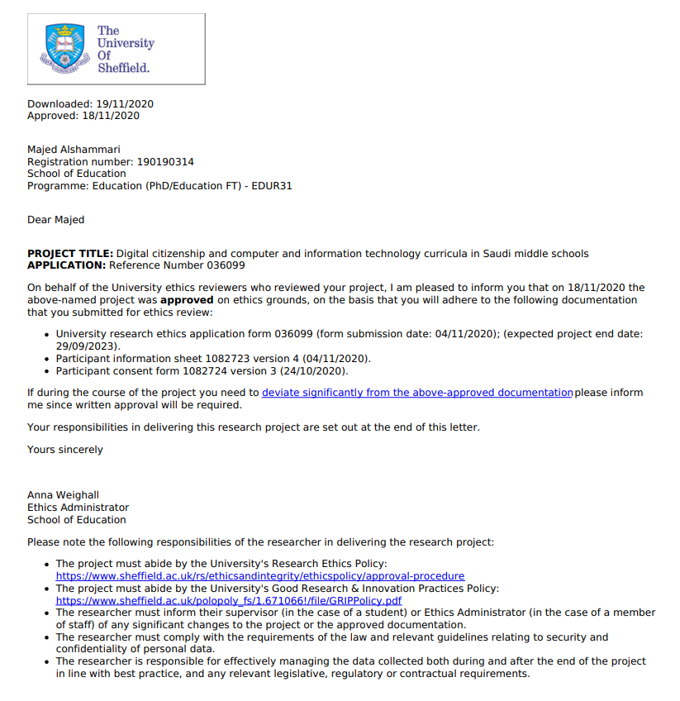

Appendix B: Information Sheet for Ministry of Education

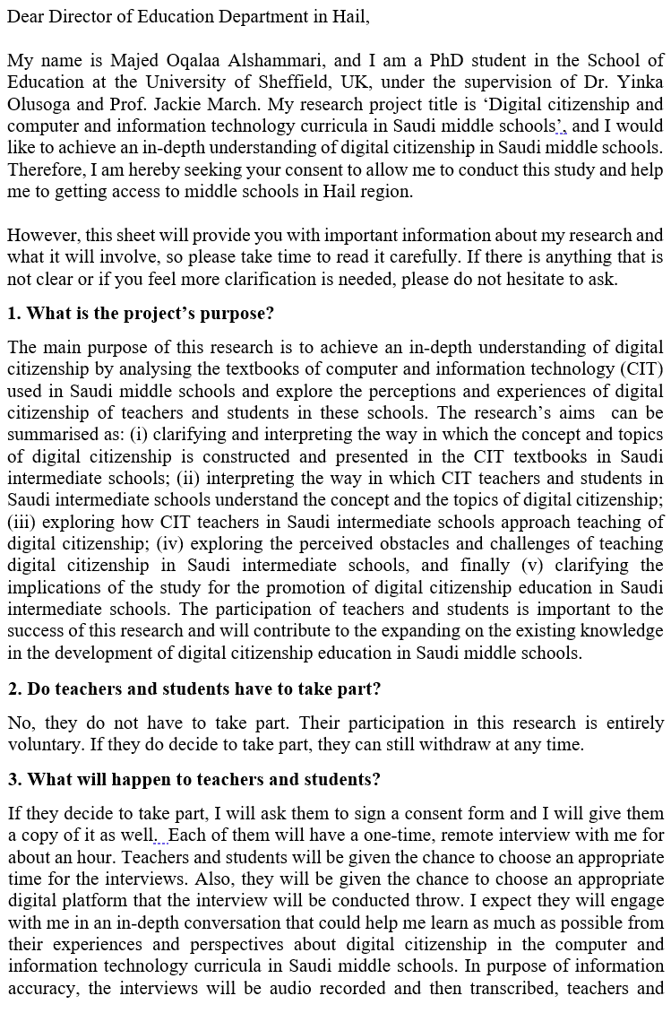

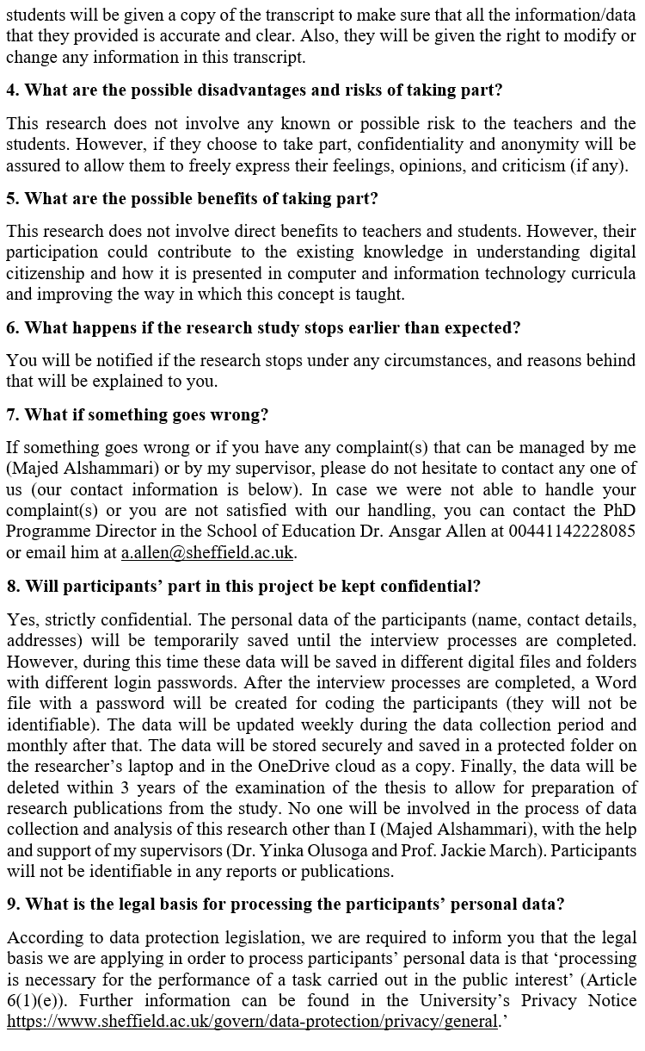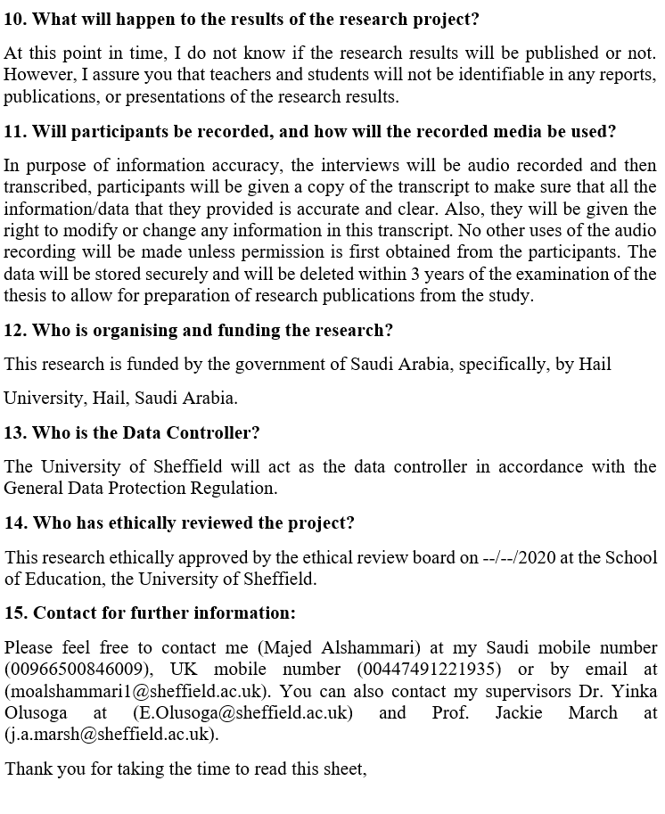

Appendix C: Teachers’ Information Sheet

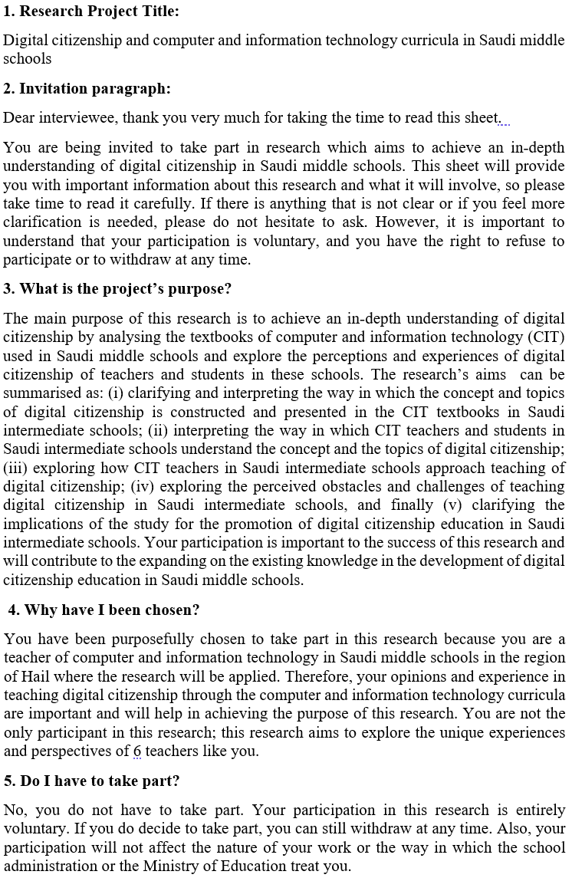
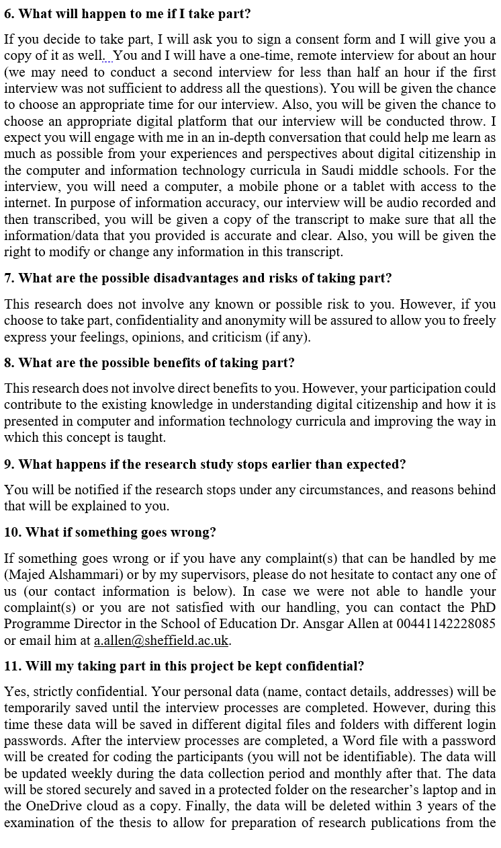
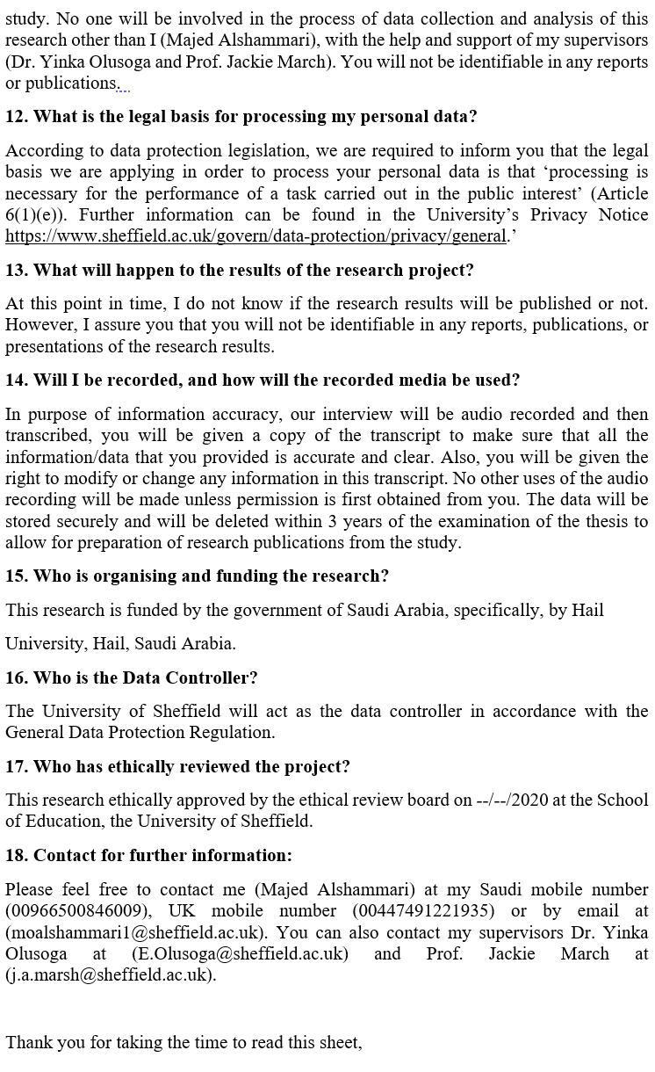
Appendix D: Parent’s Information Sheet
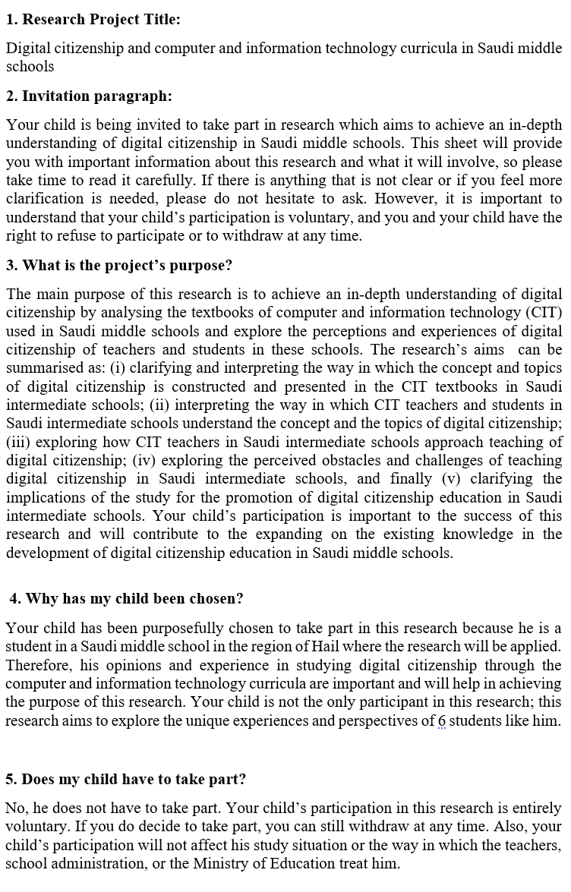
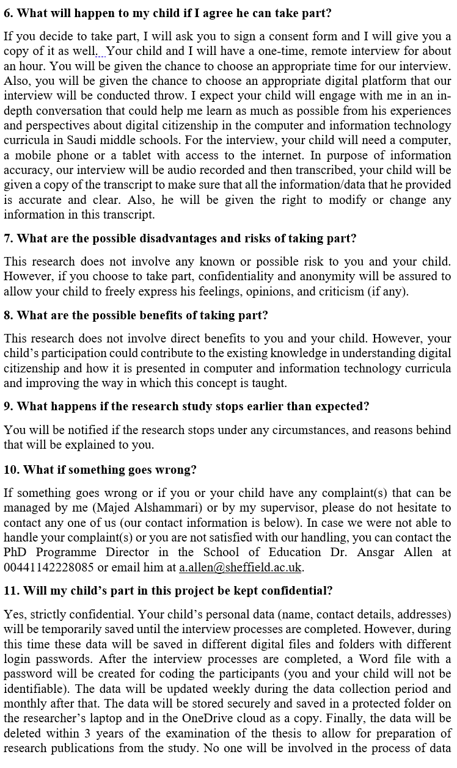
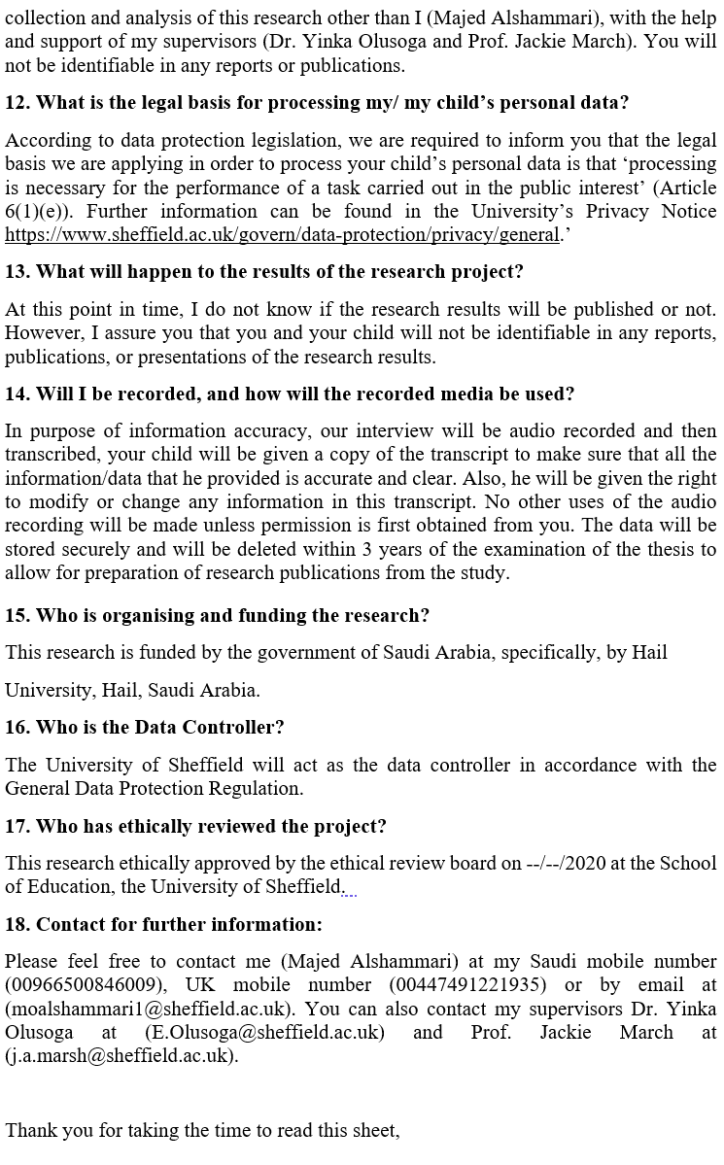
Appendix E: Child’s Information Sheet
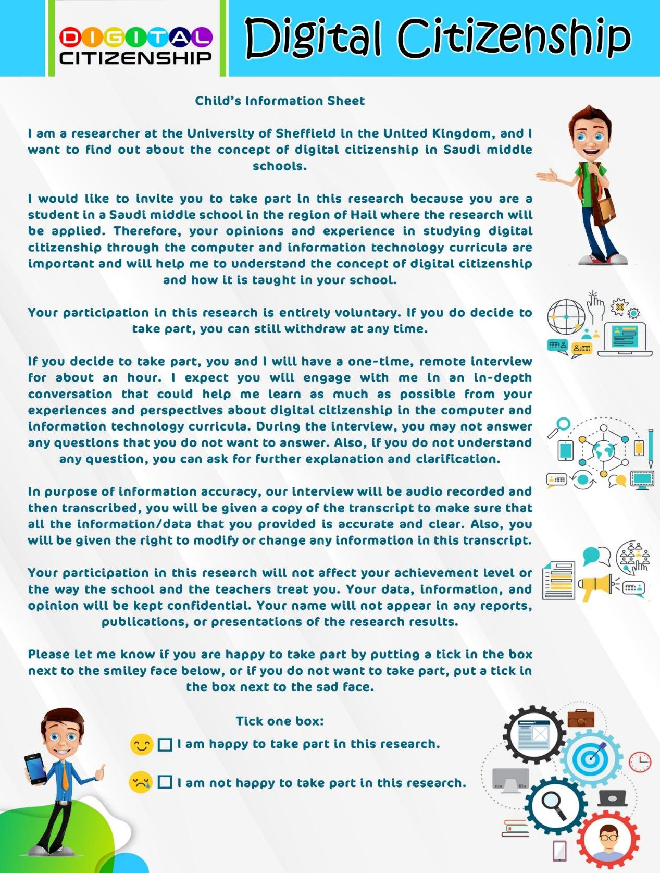

Appendix F: Teachers’ Consents Form
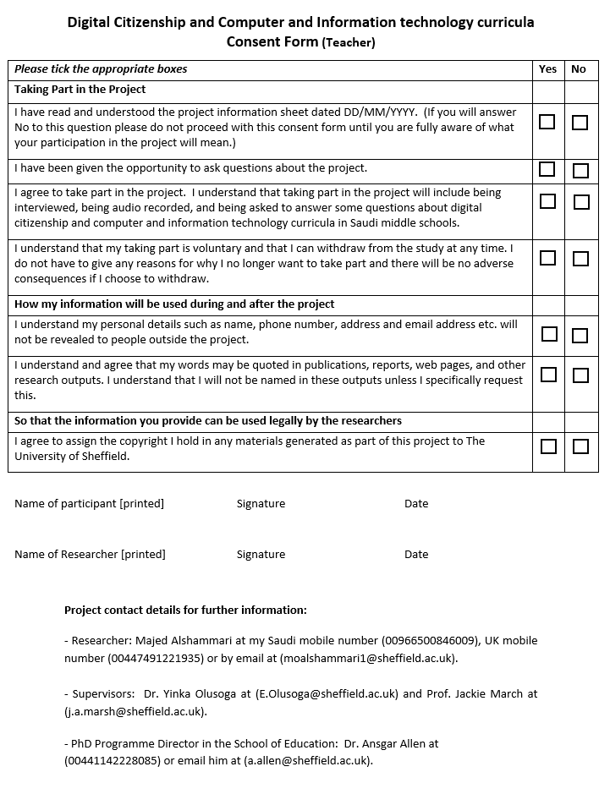

Appendix G: Parents’ Consents Form
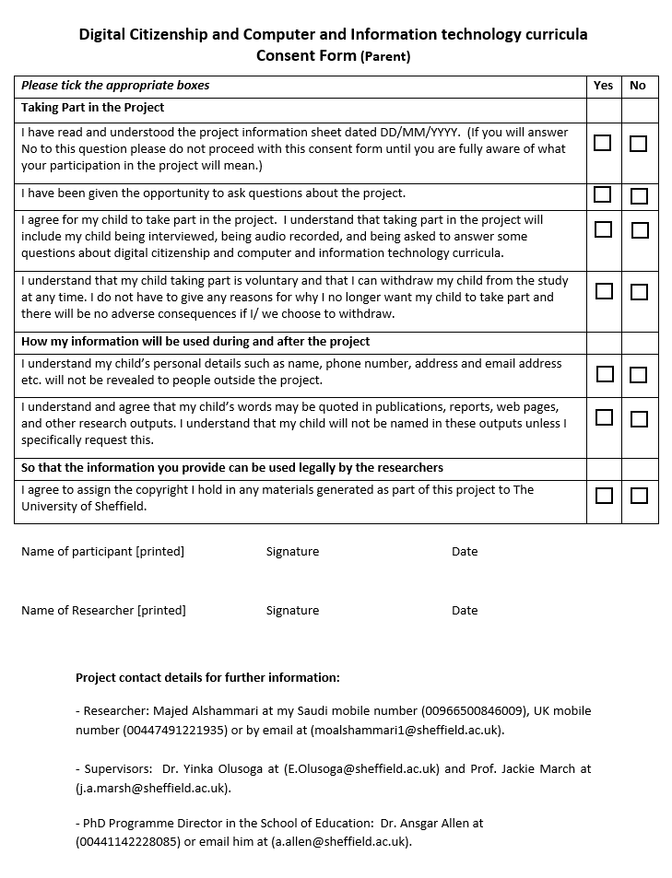

Appendix H: Data Management Plan

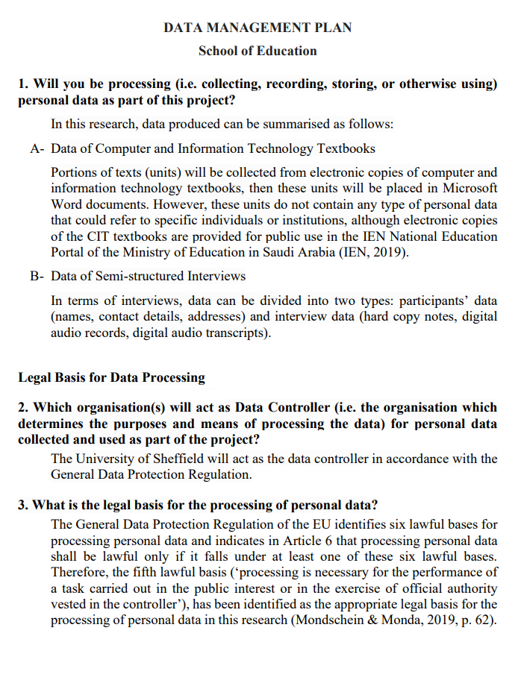

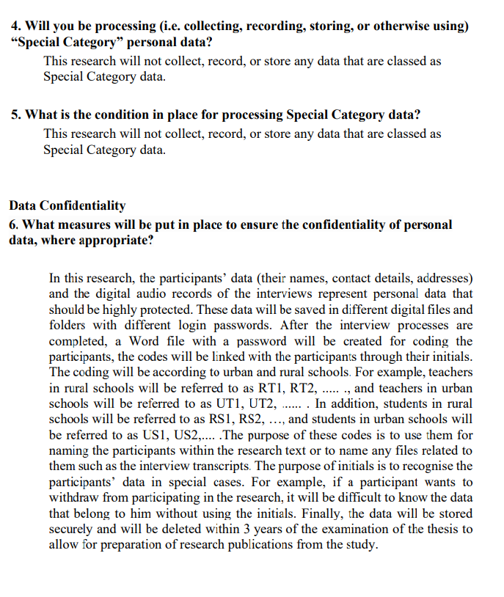

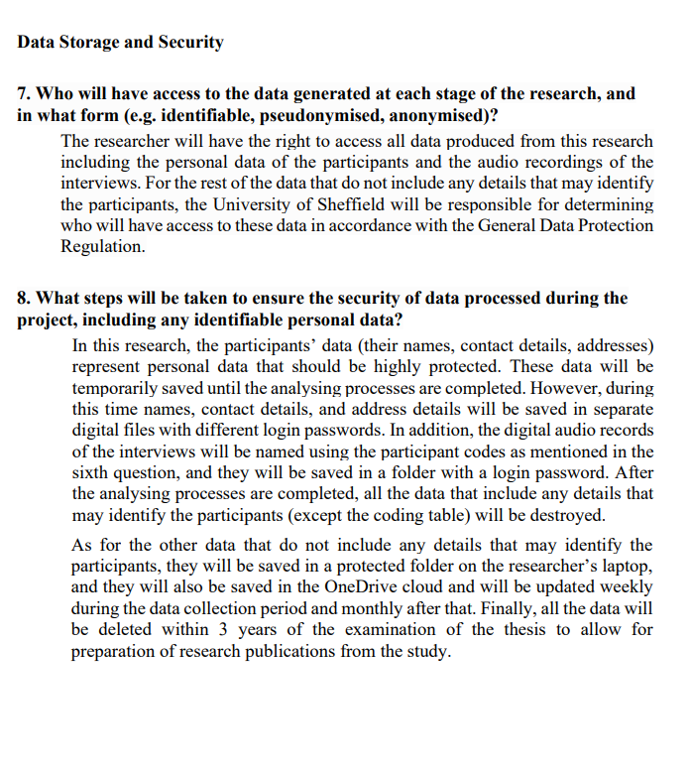

Appendix I: Researcher’s Status Letter
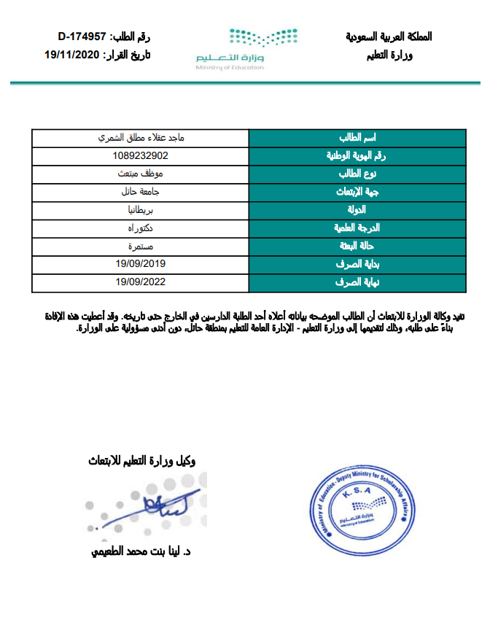

Appendix J: Ministry of Education Approval

Appendix K: Example of familiarising the CIT textbooks.
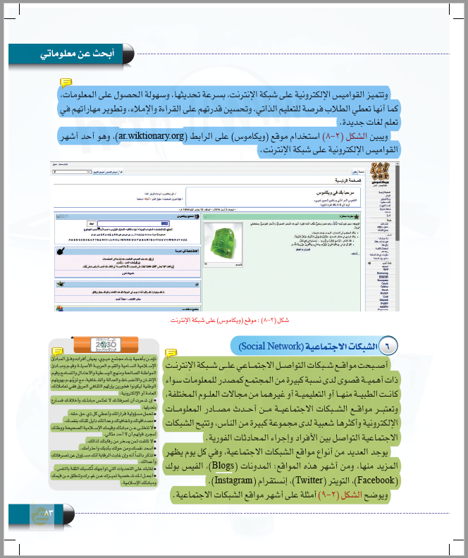

Appendix L: Initial Thematic Framework for CIT Textbooks
Research Question 1: How do CIT textbooks construct and present the concept and topics of digital citizenship in Saudi intermediate schools?
1. Digital Literacy  1.1 Basic Knowledge  1.1.1 Fundamental concept and terms  1.1.2 Technology principles  1.1.3 Operating Systems.  1.1.4 Exploring digital technologies and devices.  1.1.5 Evaluating digital technologies and devices.  1.2 Secondary Knowledge  1.2.1 Programmes and applications.  1.2.2 Networking  1.2.3 Digital Games  1.2.4 Digital Learning  1.2.5 Social Media  1.2.6 Programming Languages  1.3 Data and Information  1.3.1 Browsing data and information.  1.3.2 Evaluating data and information.  1.3.3 Managing data and information.  1.4 Technology Trends  1.4.1 Knowledge society  1.4.2 Artificial intelligence  1.4.3 Internet of Things  1.4.4 Robots  2. Digital Protection  2.1 Digital Safety  2.1.1 Human Safety  2.1.2 Devices Safety  2.2 Digital Security  2.2.1 Data security.  2.2.2 Devices security.  3. Digital Law  3.1 Rights and Responsibilities  3.1.1 Internet availability.  3.1.2 Knowledge access.  3.1.3 Ethical Boundaries  3.1.4 Religious boundaries  3.1.5 Breaches of privacy.  3.2 Rules and legislation  3.2.1 Intellectual Property  3.2.2Copyright and licenses.  3.2.3 Cyber Crimes | 4. Digital Footprint  4.1 Identity and Reputation  4.1.1 Cultural identity  4.1.2 Digital etiquette.  4.1.3 Self-censorship  4.2 Communication and Participation  4.2.1 Access  4.2.2 Sharing.  4.2.3 Interaction.  4.2.4 Collaboration  4.2.5 Publish or present content.  4.3 Electronic transactions  4.3.1 Government transactions  4.3.2 Educational transactions  4.3.3 Commercial transactions  5. Creativity and Innovation  5.1 Digital Content  5.1.1 Data processing  5.1.2 Word processing  5.1.3 Presentation design  5.1.4 Website design  5.1.5 Computer graphics  5.1.6 Spreadsheets  5.2 Intelligence and problem solving  5.2.1 Exploring technical problems and finding solutions.  5.2.2 Using digital objects such as, models or simulations.  5.2.3 Programming with Scratch.  5.2.4 Robot programming.

Appendix M: Interview Guide for CIT Teachers
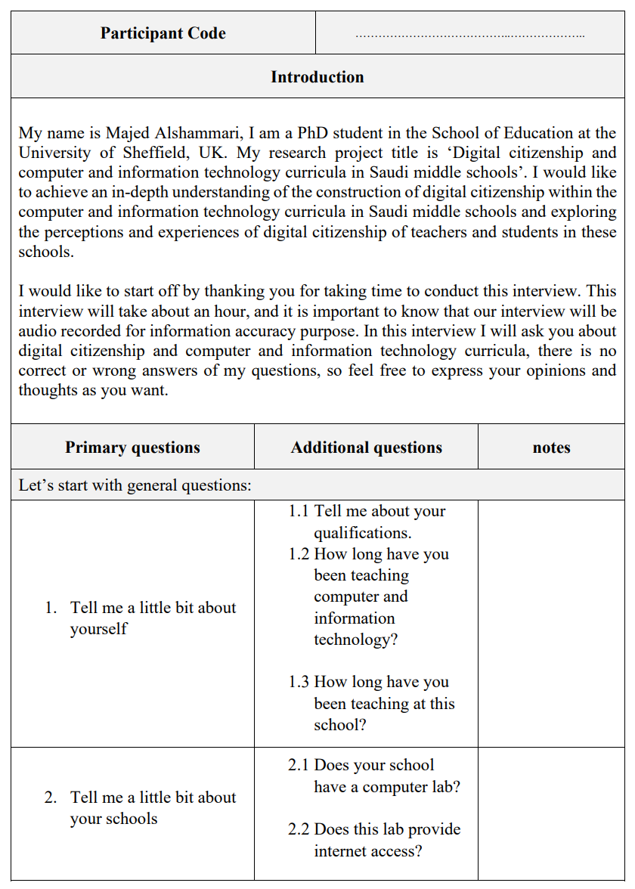

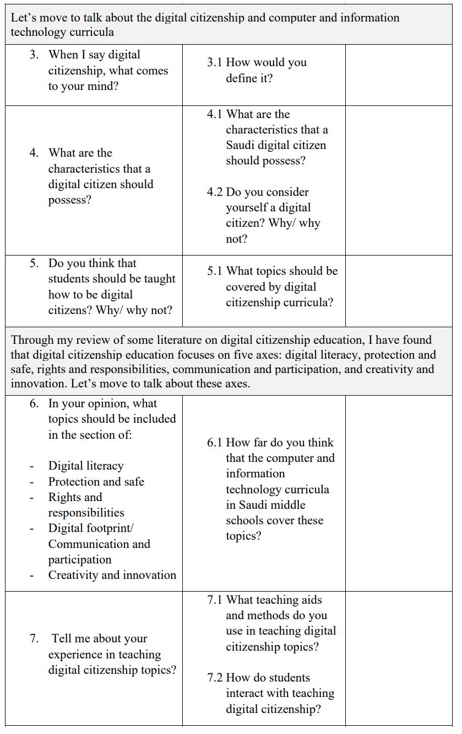
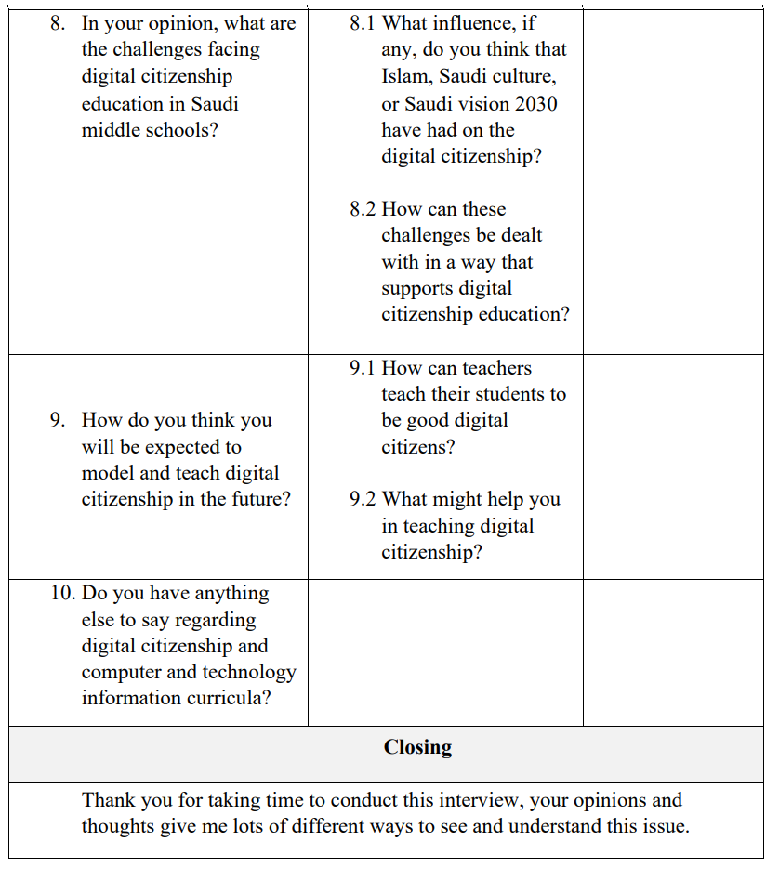

Appendix N: Interview Guide for Students
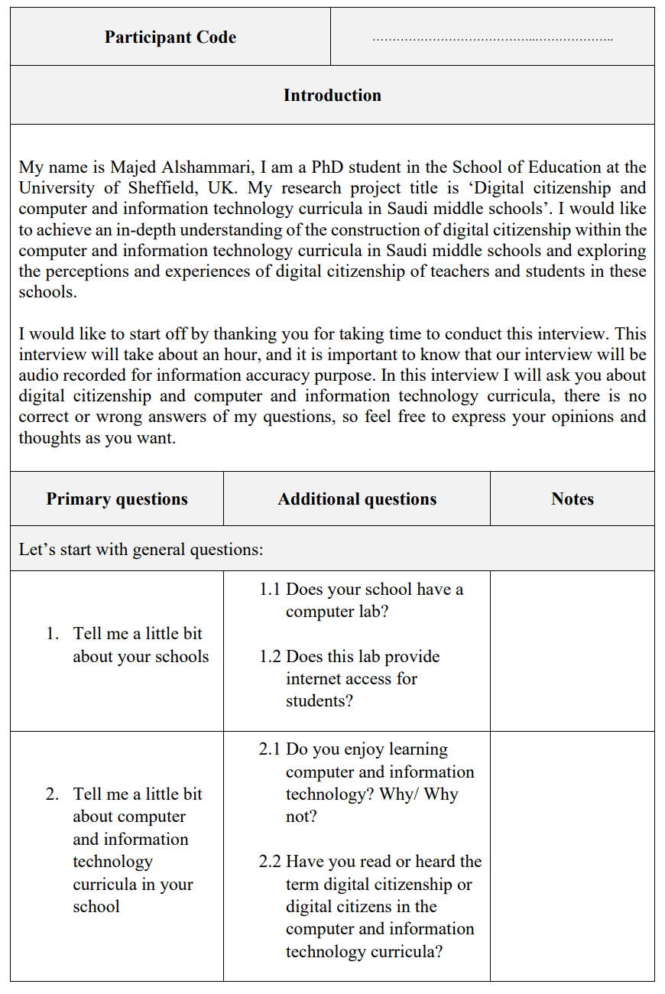

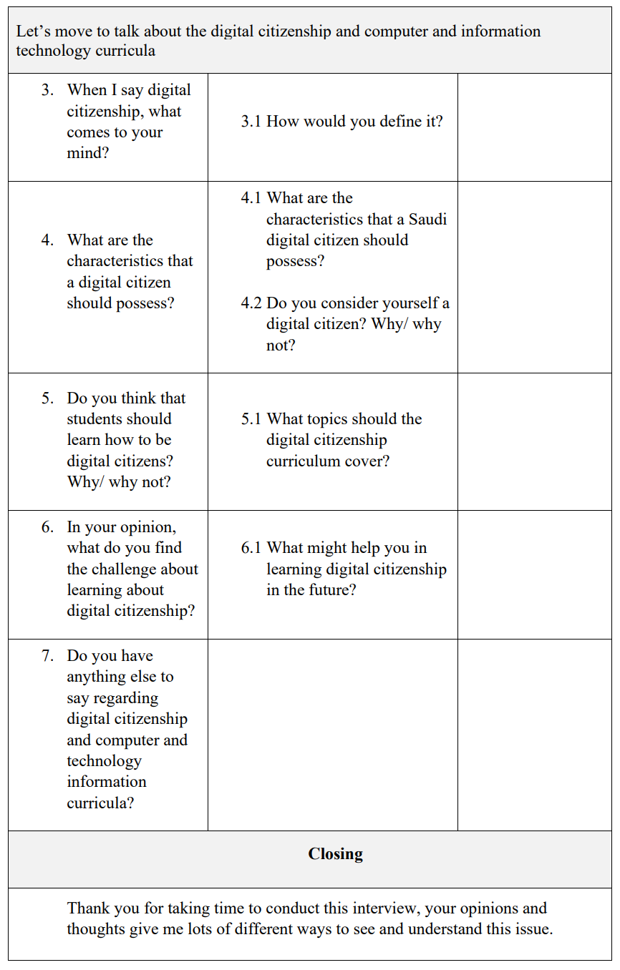
Appendix O: Initial Thematic Framework for CIT Teachers
Initial Teachers’ Framework
1. Understanding Digital Citizenship
1.1 Digital Citizenship Concept  1.1.1 Digital world  1.1.2 Electronic transactions  1.1.3 Digital literacy  1.1.4 Appropriate use  1.3 Digital Citizenship Topics  1.3.1 Digital literacy  1.3.1.1 Basic knowledge  1.3.1.2 Technology use  1.3.3 Digital Law  1.3.3.1 Behaviour and ethics  1.3.3.2 Rights and responsibilities  1.3.3.3 Rules and legislation  1.3.5 Creativity and Innovation  1.3.5.1 Programming  1.3.5.2 Graphic  1.3.5.3 Design | 1.2 Digital Citizens Characteristics  1.2.1Awareness  1.2.2 Responsibility  1.2.3 Productivity  1.2.4 Honesty  1.2.5 Respect  1.3.2 Digital Protection  1.3.2.1 Digital property  1.3.2.2 Data and information  1.3.2.3 Fraud  1.3.2.4 Personal protection  1.3.4 Digital Footprint  1.3.4.1 Identity and reputation  1.3.4.2 Communication and participation  1.3.4.3 Freedom of expression  1.3.4.4 Electronic transactions
2. Teaching Digital Citizenship
2.1 Tools and Methods  2.1.1 Practical topics  2.1.2 Theoretical topics  2.3 Students Interaction  2.3.1 Entertainment and games  2.3.2 Practice and computer lab  2.3.3 Internet and applications  2.3.4 Challenge and competitions  2.5 Topics Presentation  2.5.1 Lack of explanation  2.5.2 Design and organisation  2.7 Challenges  2.7.1 Saudi culture 2.7.2 Saudi Vision 2030  2.7.3 Teachers 2.7.4 Curriculums | 2.2 Activities and Exercises  2.2.1Projects and assignments  2.2.2 Enrichment information  2.4 Topics Coverage  2.4.1 Inclusion and variety  2.4.2 Limitations and superficiality  2.6 Obstacles  2.6.1 Time and sessions  2.6.2 CIT curriculum value  2.6.3 Computer labs

Appendix P: Initial Thematic Framework for Students
Initial Students’ Framework
1. Understanding Digital Citizenship
1.1 Digital Citizenship Concept  1.1.1 National ID Card  1.1.2 Electronic transactions  1.1.3 Technology use  1.3 Digital Citizenship Topics  1.3.1 Digital literacy  1.3.1.1 Computer and digital devices  1.3.1.2 Internet use  1.3.3 Digital Law  1.3.3.1 Intellectual property and copyright  1.3.3.2 Digital Accounts  1.3.5 Creativity and Innovation  1.3.5.1 Unusual things  1.3.5.2 Graphic and Design  1.3.5.3 Fame and celebrity | 1.2 Digital Citizens Characteristics  1.2.1 Awareness  1.2.2 Using the Internet  1.3.2 Digital Protection  1.3.2.1 Strangers and Hackers  1.3.2.2 Data and information  1.3.2.3 Accounts security  1.3.4 Digital Footprint  1.3.4.1 Identity and reputation  1.3.4.2 Social media  1.3.4.3 Digital privacy
2. Teaching Digital Citizenship
2.1 Obstacles  2.1.1 Time and sessions  2.1.2 CIT curriculum value  2.1.3 Computer labs  2.1.4 Internet access | 2.2 Challenges  2.2.1 Support and motivation

