

Ultrasonic NDT for In-Process Strip Gauging in Metal Rolling
By:
Thomas Richard Holdich
A thesis submitted in partial fulfilment of the requirements for the degree of Doctor of Philosophy

The University of Sheffield
Department of Mechanical Engineering

November 2022
Summary
Metal rolling is an important manufacturing technique, with steel products being used for a variety of different projects in a variety of markets. Because of this, being able to consistently control the strip thickness of rolled product is of paramount importance, as customers will have different tolerances and needs that they will require from the steel manufacturer. This work was carried out to investigate the properties of sheet metal whilst it is being rolled. Currently, techniques focus on measuring the strip thickness before and after the rolling stands, however, to increase reaction times when monitoring if the product is going out of specification, it is imperative that any deviance from the expected product is found as soon as possible. To this end, it is of interest to be able to investigate the strip during the roll bite itself in the stand. This also has potential other benefits, as if the strip can be monitored, then it opens possibilities to investigate other properties of the strip at the same time, such as the roller or lubrication conditions.
There is a challenge however, due to the constraints of the working environment present in a rolling stand. Because of this, any potential solution, must be applicable to an industrial rolling mill, once scaled up, and not cause any disruption to the rolling process, or the sheet metal being produced. This has been an issue with previous techniques, where the rollers were modified. This can be expensive, difficult, and needs to be repeated each time rollers are ground to keep them in specification. In addition, rollers often need to be changed out, so the system is liable to be damaged when this is taking place. Finally adjusting the rollers, themselves can cause issues with the metal sheet, due in the event of the modifications coming into contact with the rolled product.
In this work, ultrasonic methods in, various configurations, have been evaluated for the measurement of strip thickness. Tests were performed with different methods of coupling the ultrasonic energy to the rolling mill: bonded-on oblique and water coupled transducers using a water jet and, separately, a water shoe in pulse-echo mode in both water coupled cases. One problem with bonded on oblique ultrasound transducers is that they can only monitor one part of the rolling surface, on a periodic basis, as they turn with the roller. Metal rolling also causes a lot of signal noise, from, for example, the electrical connection through slip rings.
Water coupling requires less roller modification, transducers can be easily removed, and reinstalled, when rollers undergo maintenance. However, it was found that the water jet method had limited signal strength. The alternative and novel water shoe method used a 3D printed shoe flooded with water and held flush to the metal roller. This provided a more consistent contact. The method was tested in a laboratory rolling mill in pulse-echo mode, as it was possible to mount the shoe perpendicular to the rollers. In an industrial environment access would be limited and oblique water shoe coupling may be required. Water coupling enabled continuous strip thickness measurements, obtaining results based on averages over many scans, reducing measurement errors.
Results from the bonded-on transducers oblique ultrasound method had a 19 µm standard deviation around a mean value, against 12 µm for the water shoe. Thus, at the 99.8% confidence level the measurement value would be known to plus/minus 57 µm for the bonded system and 36 µm for the water shoe method. Sheet metal is between 0.5 and 6 mm, so a deviation measured at the micrometre scale is a clear benefit.
Finally, a resonance technique using water shoe coupling was investigated as a way of getting the strip thickness of thin rolled metal sheet with signal noise removal due to a Fourier transform. This could help provide flexibility, as several different rolling strands are used to shape the metal, and different ultrasonic systems can be installed within the rolling process. By having a variety of techniques, that work across a variety of strip thicknesses, the metal can be monitored throughout the rolling process.

i
Acknowledgments
I would first like to express gratitude to my lead supervisor, Professor Robert Dwyer-Joyce. Without his advice and guidance, this project would not have been possible, and I would not have developed into the engineer that I have. I would also like to thank Doctors Andrew Hunter, Xiangwei Li and Robin Mills, who have provided invaluable support over the length of the project, teaching me valuable skills I will continue to use in the future.
Thanks, must also be given to Dave Butcher and Luke Callaghan, for helping with the project, providing invaluable workshop experience and advice on the metal rolling process. Further to this I would like to thank all of the members of the Leonardo Centre for Tribology, without such an excellent group of peers, this project would never have been so enjoyable. Thanks, must also go to Doctor Gbenga Adeyemi, whose help in introducing me to the metal rolling pilot mill, and aid in conducting tests has been invaluable.
I must also thank Tata Steel, specifically Doctor Daniel Ooi and Doctor Camile Hol, who have been incredibly helpful regarding providing industrial guidance on what may or may not be applicable for future work and focus. My thanks also go to Tata Steel for sponsoring this PhD and for organising the meetings of other sponsored peers, to allow for discussion and networking with such a great knowledge base.
Finally, I would like to thank Amy, who has always done her best to support me through everything, as well as to my family. Who have helped provide inspiration for carrying out this work.

ii
Table of Contents
Summary……………………………………………………………………………………………..………….i
Acknowledgments ….………………………………………………………………………….………….ii
Table of Contents….………………………………………………………………………………….……iii
Nomenclature……….………………………………………………………………………………….……iv
Abbreviations…..…………………………………………………………………………………………...vi
Declaration……………………………………………………………………………………………………vii

1 Introduction 1
1.1 Motivation for Research 1
1.2 Introduction to Metal Rolling 1
1.3 Strip Thickness Importance 4
1.4 Aim 5
1.5 Objectives 5
2 Literature Review 7
2.1 Introduction 7
2.2 History of Steel Making 8
2.3 History of Metal Rolling 9
2.4 Modern Metal Rolling 11
2.4.1 Modern Metal Rolling Techniques 12
2.4.2 Typical Roller Arrangements 13
2.4.3 Typical Arrangement of Rollers for Rolling Mills 15
2.4.4 Metal Rolling Challenges 16
2.5 Measurement and Strip Thickness 18
Electromagnetic Acoustic Transducers 19
Laser Coupled Ultrasound 21
Radioactive Sensors 22
Other Non-Contacting Ultrasound 23
Summary of Common Problems for Sensors 24
Previously Trialled Ultrasound Techniques 25
2.6 Oblique Ultrasound Method 27
2.7 Water Coupled Ultrasound 29
2.8 Conclusion 31
3 Methodology - Theory 32
3.1 Ultrasound Basics 32
3.2 Ultrasonic Wave Types 32
3.3 Spring Mass Model 33
3.4 Reflection Coefficient 36
3.5 Snell's Law 38
3.6 Scan Modes 39
3.7 Ultrasonic Techniques 40
3.8 Ultrasonic Transducers 42
3.9 Piezoelectric Effect 43
3.10 Acoustoelastic Effect 45
3.11 Ultrasonic Beam Properties 47
3.12 Signal to Noise 49
3.13 Conclusion 50
4 Methodology – Experimental 51
4.1 Introduction 51
4.1.1 Pulse Echo 51
4.1.2 Oblique Ultrasound 53
4.1.3 Water Coupled Ultrasound 54
4.1.4 Assumptions 56
4.2 Ultrasound Generation 56
4.2.1 Transducer Types 56
4.2.2 Excitation Pulse 57
4.3 Apparatus 58
4.3.1 Ultrasonic Equipment 58
4.3.2 Metal Roller 58
4.4 Component Layout 61
4.5 Strip Thickness Calculation 62
4.6 Signal Processing 63
4.6.1 Time of Flight Techniques 64
4.6.2 Peak Detect / Threshold 64
4.6.3 Zero Crossing 66
4.6.4 Hilbert Threshold 67
4.6.5 Resonant Dip 68
4.6.6 Cross-correlation 68
4.7 Discussion 69
4.8 Conclusion 69
5 Oblique Ultrasound 71
5.1 Introduction 71
5.2 Method 72
5.3 Test Plan 75
5.4 Results 76
5.4.1 Strip Thickness 76
Strip Thickness Through the Rolling Process 78
5.4.2 Reflection Coefficient 81
5.4.3 Roll Contact Length 83
5.4.4 Roll Bite Time 85
5.4.5 Beam Location 85
5.4.6 Transducer Location 86
5.4.7 Beam Spread 89
5.4.8 Ultrasound Dispersion 92
5.5 Discussion 92
5.6 Conclusions 94
6 Water Coupled Ultrasound 95
6.1 Introduction 95
6.1 Through Transmission Testing 95
6.2 Method – Water Jet Technique 96
6.3 Method – Shoe Technique 98
Ultrasonic Shoe Design 98
Ultrasonic Shoe Set Up 102
6.4 Test Plan 104
6.5 Results – Water Jet Technique 104
Transducer Lift Off Trials 104
Water Jet Orientation 106
6.6 Results – Shoe Technique 109
Ultrasonic Response 109
Different Speed Trial 114
6.7 Discussion – Water Jet Technique 115
6.8 Discussion – Shoe Technique 117
6.9 Conclusions 119
7 Resonant Dip Technique 120
7.1 Introduction 120
7.1.1 Experimental Set Up 120
7.2 Static shim tests 121
7.3 Static roller tests 125
7.4 Dynamic roller tests 132
7.5 Conclusion 135
8 Post Processing Techniques and Sensitivity 137
8.1 Post Processing Techniques Methodology 137
8.1.1 Initial Set Up 137
8.1.2 Threshold Method 138
8.1.3 Peak Detect 139
8.1.4 Zero Crossing 140
8.2 Results 141
8.2.1 Rolling Data – Overall thickness 144
8.2.2 ToF comparison with resonant dip 149
8.3 Discussion 150
8.4 Uncertainties and Sensitivity 151
8.5 Conclusion 155
9 Conclusions and Future Work 157
9.1 Oblique Ultrasound 157
9.2 Water Coupled Ultrasound 158
9.3 Processing Techniques 159
9.4 Future Work 160
9.5 Liquid Coupled Ultrasound 160
9.6 Ultrasonic Technique Investigation 160
9.7 Post Processing Techniques 161
9.8 Industrial Testing Future Work 162
9.9 Closing comments 162
10 References 164
Appendix 173
Appendix I - Full Size Industrial Roll Tests 173
Appendix II - Roller Surface Oblique Testing 175
Roller Deformation 182
Attenuation 184
Roller Surface Oblique Testing 185

Nomenclature
The following is a list of the characters and symbols used in this thesis.
iv
Quantity | Symbol | Unit of Measurement
Wave amplitude | A | Volts (V)
Velocity of Sound | c | Metre per second  (m s⁻¹)
Piezoelectric Strain Constant | d | -
Modulus of Elasticity | E | Newtons per metre squared (N m⁻²)
External Electric Field | Ex | Volts per metre (V m⁻¹)
Frequency | f | Cycles per second (Hz)
Shear Modulus | G | Newtons per metre squared (N m⁻²)
Piezoelectric Voltage Constant | g | Volts (V)
Film Thickness | h | Metre (m)
Strip Thickness |  | Metre (m)
Electromechanical Coupling Factor | k | -
Poisson's Ratio | Ν | -
Nominal Contact Pressure | $$p_{nom }$$ | Pascals (Pa)
Mechanical Quality Factor | $$Q_{M}$$ | -
Reflection Coefficient | R | -
Separation of the Mean Lines | u | Metre (m)
Acoustic Impedance | Z | Pascal Second per cubic metre (Pa s m⁻³)
Angle of Ultrasound | α | Degrees (º)
Bulk Modulus | B | Pascals (Pa)
Angle of Beam Spread | β | Degrees (º)
Permittivity | $$ε$$ | Farad per metre (F m⁻¹)
Wavelength | Λ | Metre (m)
Density | ρ | Kilograms per metre cubed (kg m⁻³)
Angular Frequency of a Wave | $$ω$$ | Cycles per second (Hz)
v
Abbreviations
The following is a list of abbreviated terms used within this thesis.

ADC Analogue to Digital Convertor
EMAT Electro Magnetic Acoustic Transducers
FFT Fast Fourier Transform
n.d. No date
NDT Non-Destructive Testing
RF Radio Frequency
SNR Signal to Noise Ratio
SoS Speed Of Sound
ToF Time of Flight

vi
Declaration

I, the author, confirm that the Thesis is my own work. I am aware of the University’s Guidance on the Use of Unfair Means (www.sheffield.ac.uk/ssid/unfair-means). This work has not been previously been presented for an award at this, or any other, university.
vii

1 INTRODUCTION

Motivation for Research
Monitoring the strip thickness within the metal rolling process is of interest, as any changes in thickness that can be observed in real time, allowing for quicker changes of the rolling parameters to maintain a product specification. This can, therefore, limit the amount of material and energy wasted by having to reroll the metal to meet the required specifications, if needed.
The focus of this thesis is on taking ultrasonic measurements in situ during cold metal rolling. The work presented here builds upon some previous research, and work, with the intention to expand on it. Firstly, the roll bite has been investigated using a plug method. This involved drilling into the rolling surface and inserting a plug into the metal roller. This method in practice could, however, lead to the rolled metal being marked, therefore, reducing the effectiveness of this method (Hunter, AK 2018). Secondly, the oblique ultrasound method has been used previously to investigate the lubrication film properties in the roll bite. However, this was with expensive bespoke equipment and, therefore, this technique was investigated further with a different and simpler equipment, with different pulsing properties.
This research seeks to differentiate itself from this previous work, by focussing on the strip thickness, by utilising different techniques and equipment, and in less well-controlled environments than a laboratory in order to advise on potential techniques to develop towards use in industry.
To give context to this work, the background of metal rolling will be presented so that the importance can be fully understood. The following chapter will, therefore, cover the history and importance of metal rolling, before the problem being researched will be discussed, along with the aims and objectives of the project in more detail.

Introduction to Metal Rolling
Metal rolling is a widely used manufacturing technique for the creation of a wide variety of metal products. Therefore, investigating the metal rolling process is of interest. The global steel market size was valued at $807 billion in 2016 (Grandview research). Metal rolling is a very important step in the steel fabrication processes. This is because if metal rolling is not carried out to the required high standards, defects can occur in the rolled metal. This can be a problem when metal rolled products are then used in a wide variety of industries, from steel beams for construction, to vehicle parts (Swantonweld, 2016). An example of the metal rolling process can be seen in Figure 1-1.

Figure 1-1 – Metal rolling picture (From http://www.stahlseite.de/)
There are two main different types of metal rolling, hot rolling and cold rolling. Hot rolling is when the steel is rolled at a very high temperature, typically above 927ºC (Metal Supermarkets, 2014). This temperature is above the recrystallization temperature for steel, which allows the metal to be shaped and formed easier. Generally hot rolled steel is cheaper than cold rolled steel and does not require reheating, therefore reducing delays. However, the steel shrinks slightly when it cools and, therefore, there is less control over the size, and shape, of the finished product.
Cold rolling is where the steel is cooled to room temperature, before going through post processing. This allows for a greater level of control over the dimensions of the finished metal, as well as providing a wider range of surface finishes. In addition, steels produced by a cold process usually have superior concentricity and straightness as well as tolerance and surface finish. Cold rolling refers to rolling flat sheet, or coils, and cold finishing referring to steel bars. Cold finished bars are harder to work with than hot rolled bars due to the increased carbon content. Cold rolled sheet metal, however, does not suffer from this limitation. This is because the sheet metal is annealed, which makes the sheet metal softer.
Hot rolling is typically used to create a bloom, or slab, of metal from an ingot, or continuous casting, and these are the basis used to create a wide variety of different geometries. Blooms are defined as having a square cross section that is greater than 153 x 153 mm, whereas slabs are defined as being rectangular and having a cross section generally larger than 254 mm by 38.1 mm (The Library of Manufacturing 2016). Blooms can be rolled into bars, with slabs being rolled into sheets, or plates, where plates have a thickness of over 6 mm.
Metal rolling causes the work material to be plastically deformed due to the compressive forces between the spinning metal rollers. These forces reduce the thickness of the metal as well as changing the grain structure, with the thickness reduction being referred to as the ‘draft’. The rollers also feed the metal between them as the rolls spin in opposite directions and because of this friction is a key factor in metal rolling. Therefore, ensuring the level of friction present in the system is correct as both too little, and too much, friction will be detrimental to the rolling process. This is as too little friction results in the rolls slipping on the worked metal, whereas too much friction can cause issues with surface condition, on internal fractures. Lubrication is used to help control the level of friction present in the operation.
Basic flat rolling is outlined in Figure 1-2.

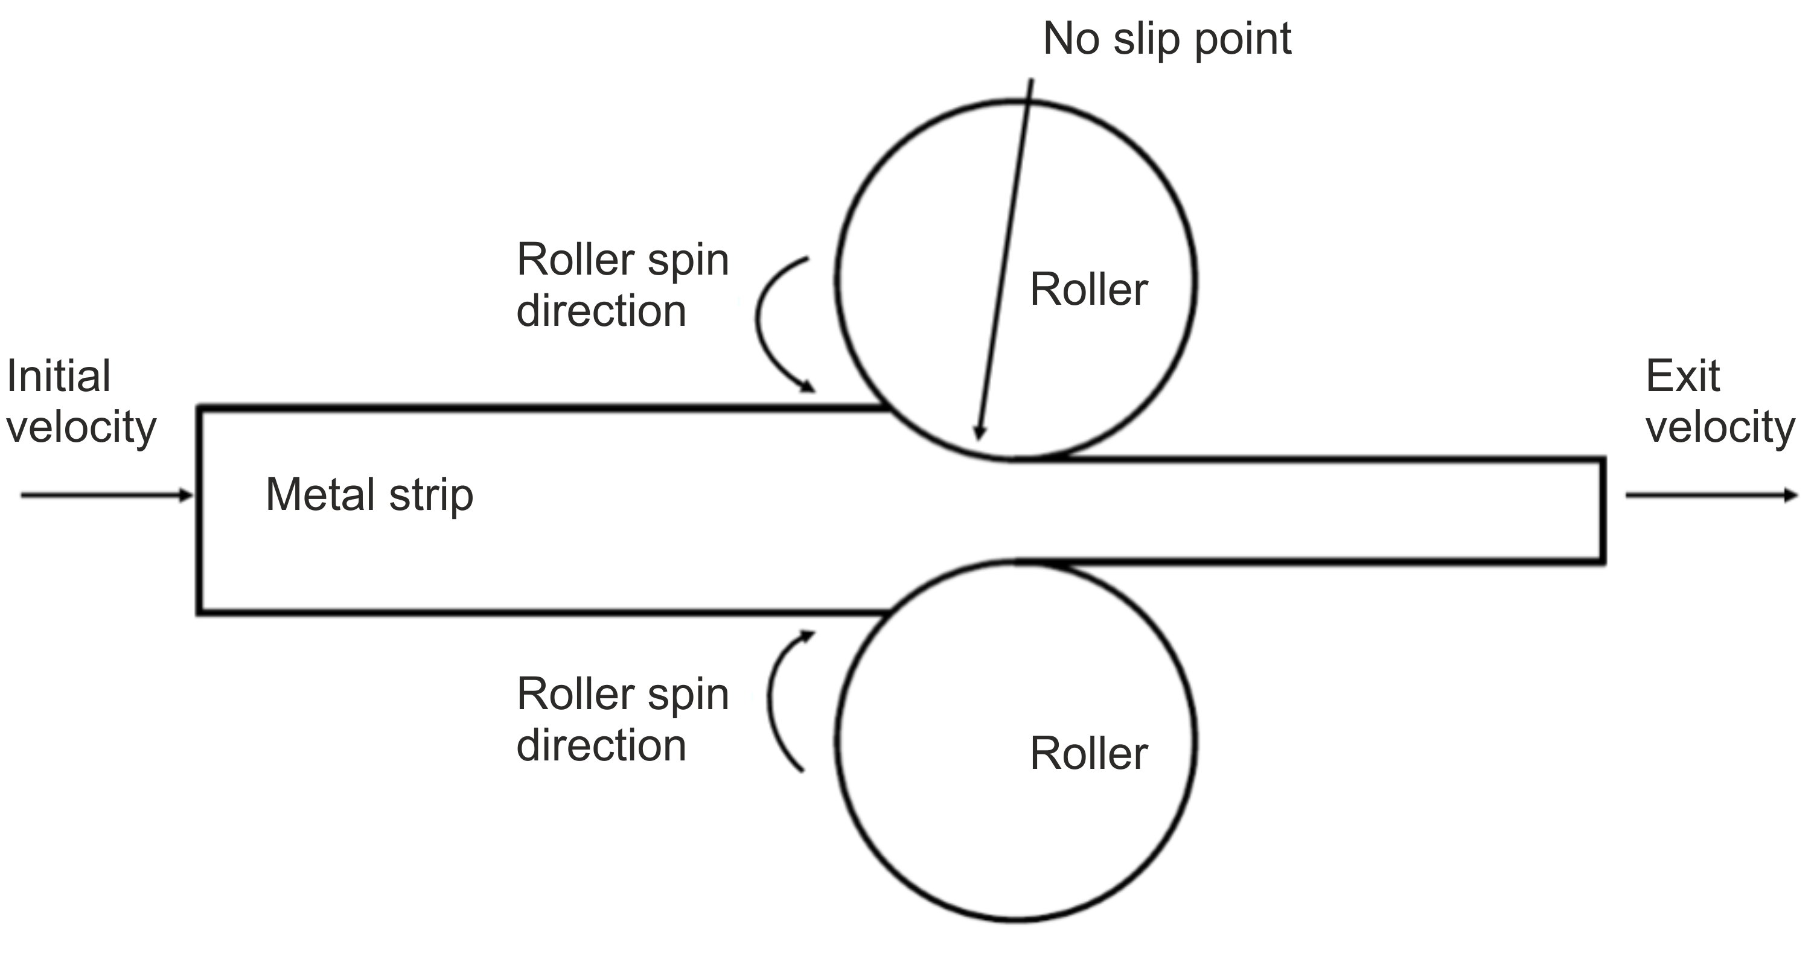
Figure 1-2. – Basic illustration of flat metal strip rolling
Metal rolling changes the shape of the metal, but not the volume, leading to the exit speed increasing as the thickness decreases. The speed of the metal rollers remains constant throughout the rolling processes, therefore at one point in the roll zone the surface velocity of the rolls and the material is the same. This is referred to as the no-slip point. Before this point the rolls may move faster than the steel and the steel moves faster afterwards, with the roll zone being defined as the area where the rollers work on the material.

Strip Thickness Importance
The strip thickness of metal sheet being rolled is an important property that is observed during the rolling process. This is because if the steel is too thick then it must be rerolled, wasting time and energy, but if it is too thin the material may be wasted as it is not fit for purpose. In addition, different rolling properties can be observed during the rolling process, which could provide information on whether the rolling process is consistent.
A technique to measure the thickness of metal, therefore, has been highlighted as an area of interest. The aim would be to use this in addition to current control measures, such as X-rays to monitor the strip thickness and other properties of the metal being rolled. This is important as it gives another level of control to the rolling process, whilst also reducing the amount of time between detection of thickness inconsistencies and adjusting of the rolling parameters to overcome those inconsistencies.
Further to this, the technique would ideally work within the roll bite and must operate without affecting the metal rolling rig. By using the data gained from the roll bite, the rolling rig can then be controlled in real time to allow for greater levels of control in the rolled thickness. This will allow for less wasted material, and time, in the rolling process.
There are several stipulations that need to be accounted for. Firstly, the accuracy of the measurements must be high. Depending on the application the accuracy must remain within the micron range, with a tolerance of plus or minus 50 $μ$m. Another factor in the measurement of the metal thickness is the time taken. As the metal is being rolled the time frame must be short to ensure the best quality using real time measurement and control. Commonly, it is believed that the time frame must be approximately 0.1 s, or less (Kraybill, 2016).
The location of the sensors and which part of the strip being measured is also an important consideration. At least the middle part of the sheet metal would be desirable, but it would be preferable to be able to measure the entire strip width. Not only would this provide more information on the thickness of the entire strip, but it would allow the controller to be able to tell if the strip is being rolled equally, or if the strip is being curved to one side.

Aim
The aim of the project, was to investigate systems that can measure the strip thickness of sheet metal, in situ in the rolling process, by using the ultrasonic response from the metal strip and roller system.

Objectives
The practical objectives of this project are therefore:
- Develop a system that can send and receive an ultrasonic pulse through a metal rolling rig and metal strip whilst rolling. The signal must be able to pass through the roller and strip geometries, whilst providing a good response to give the thickness of the steel strip being rolled.
- Investigate the limitations of installing a system into an industrial mill and developing a system that can work within these confines. Using the set rolling parameters and geometries of the product and rolling mills.
- Develop a system that does not affect the quality of the finished metal product. This will ensure that any products made whilst using this system inline are not affected, because this would cause a drop in product value.
- Contribute knowledge on different measurement processes, including different post processing, signal coupling and ultrasonic methods.

Literature REVIEW
The current techniques used in the steel making process, along with a brief history of metal rolling will be discussed. This will include a brief description on metal roller layouts for the stands, due to any potential techniques arising from this work needing to be able to be applied to industrial mills. After this, an overview of other, non-destructive testing methods will be highlighted, along with potential limitations. Following on from this, previously used ultrasonic techniques, along with an overview of their limitations will be discussed.

Introduction
Steel has been used as a material throughout history, being developed and manufactured in ancient Egypt and China through to the modern day with modern companies, such as Nippon Steel in Japan, producing 26 million tons of steel in 1987 (Wente, n.d.). Since steel is one of the most important materials in both engineering and construction (World Steel Association, n.d.), refining and ensuring the quality of material produced is highly important. The purpose of this section will be to give some background on metal rolling, as well as on several different measurement techniques that have been used to investigate the strip thickness during metal rolling.
The global steel industry has a large amount of influence on the economy, both directly and indirectly. This leads to a total value-added contribution of $2.9 trillion dollars or 3.8% of the global gross domestic product (GDP). Further to this every $1 of value that is added due to work within the steel industry itself leads to an extra $2.50 of value-added activity, such as purchasing raw materials, or buying equipment. (World Steel Association, July 2019)
1,808 million tonnes of crude steel were produced globally in 2018 with the majority being produced in China. (World Steel Association, July 2019)
To further demonstrate the size of the steel industry, including the growth of the industry, the global steel exports, for rolled products, around the Millennium, can be seen in Table 2-1.
Table 2-1 – World Steel exports analysed by selected products, excluding stainless steels (in millions of tonnes)
Product | 1998 | 1999 | 2000 | 2001 | 2002
Hot-rolled Strip | 2.6 | 2.7 | 3.1 | 3.4 | 3.4
Hot-rolled sheets and coils | 44.1 | 45.8 | 49.1 | 43.7 | 48.8
Cold-rolled strip | 2.9 | 3.0 | 3.5 | 3.2 | 3.4
Cold-rolled sheets and coils | 25.9 | 26.9 | 29.1 | 26.9 | 28.6
Plates | 17.0 | 19.1 | 21.9 | 20.5 | 23.0
Galvanised sheet | 17.9 | 19.1 | 21.9 | 20.5 | 23.0
Total | 243.8 | 253.4 | 276.4 | 270.0 | 279.4

As can be seen the amount rolled product being produced and exported is large, and therefore any improvement to the metal rolling process will have a large impact on both the industry and the economy.

History of Steel Making
Metal working as a technique has been reported back to before the birth of Christ, with some jewellery being dated back to around the fourth millennium B.C. (Metal Working World Magazine, n.d.). It has been noted that the techniques for processing metals that are present in nature such as copper and bronze, have not changed significantly since ancient times. Steel, however, is much more complex. Initially mild steel was created via the use of primordial furnaces, which did not really change until the beginning of the sixteenth century and the use of the blast furnace. The steel making process was further refined as early as 1847 by William Kelly and in 1856 Henry Bessemer patented the Bessemer converter, shown in Figure 2-1.

Figure 2-1 – Bessemer converter, (from https://www.britannica.com/technology/Bessemer-process)
The Bessemer converter was then further refined into the basic oxygen process, which itself was an improvement on the open-hearth process (Gregersen, 2020).

History of Metal Rolling
In 1751, what has been described as the first metal rolling mill in America was in use. This rolling mill used two water wheels to power the top and bottom rollers of both the rolling mill and the slitting mill. This can be seen in Figure 2-2.


Figure 2-2. – Water powered rolling mill (Two Hundred Years of Rolling on the Brandywine, 2011)

The rolling mill itself can be observed back to the 15th century and one of the earliest designs can be seen in drawings made by Leonardo da Vinci. These can be seen below in Figure 2-3.
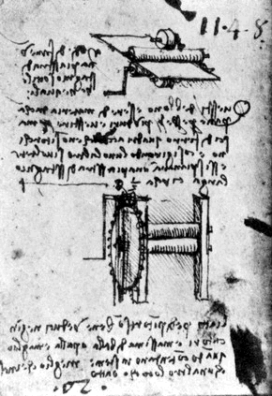
Figure 2-3 – Leonardo da Vinci's drawing of a rolling mill
As can be seen, it shows a backup roller being used to support smaller work rolls (Metal Rolling Blog, n.d.).
Small mills were used during the fifteenth century to produce small, decorative work in soft metals, with demand for products coming from metal rolling being required more as the techniques became more well known. For example, at the beginning of the seventeenth century there is evidence of two-high mills being used to roll lead and tin. At this point however, the products being produced were of a poor quality and were not produced on a large scale. At end of the seventeenth century large cast iron rolls were being produced to build heavier mills. These rollers were then driven by water wheels, or horses.
Four high mills started to be used during the eighteenth century, due to smaller diameter rolls requiring less load to reduce the thickness of the metal. These also allowed for the use of a lighter frame.
The end of the eighteenth century introduced steam power to the metal rolling process, with the mills starting to resemble modern rolling mills. Throughout the nineteenth and twentieth century the size and power of the mills changed, without altering the rolling mill design (Roberts, 1978). Electric power started to slowly replace steam power within the twentieth century.

Modern Metal Rolling
Modern rolling techniques are still being adapted and improved and since around half of the finished steel product in North America is either sheet, or strip, there is the ability to add considerable value to improving these processes (Santhirasegaran, 1988). The areas that have been highlighted for potential improvements are: energy conservation, controlled rolling and product quality (Devadas et al, 1986). The modern-day rolling process is highly automated, which focusses on producing high quality flat steel at a variety of different thicknesses.
Modern rolling mills are also used for processing a variety of metals for a large number of different applications, therefore causing modern mills to have to perform to demanding standards in dimensional accuracy, surface and material properties. Belt wrappers are also used before, and after, the roll stands and these are designed to move in and out when required, to produce either plate or coils. (Metal Rolling Blog, n.d.) This can be seen in Figure 2-4.
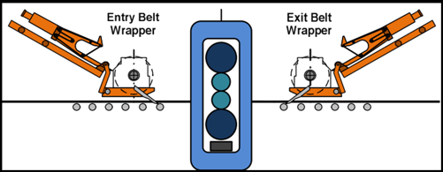
Figure 2-4 – Diagram of a rolling stand with belt wrappers
Further to this, modern rolling mills can have more than twenty rollers in the roll stack and process 200 kT of material per annum.

Modern Metal Rolling Techniques
Metal rolling has been highlighted as one of the most important manufacturing techniques used. This is because most metal products are rolled at some point in their life cycle (Library of Manufacturing, n.d.).
There are several different types of rolling process that can be used (Lenard, 2013). These processes include: continuous rolling, transverse rolling, ring rolling, powder rolling, thread rolling, hot rolling and cold rolling.
Hot rolling is carried out in the primary roughing mill, usually a blooming, slaving or cogging mill. A hot roll mill usually consists of a two high reversable roll sets with the roller diameters being around 0.6 m to 1.4 m. The slabs are heated initially to temperatures around 1100 to 1300ºC with the temperature in the last stand varying from 700 to 900ºC. The temperature should remain above the upper critical temperature, in order to produce uniform equiaxed ferrite grains.
Cold rolling is carried out under the metal recrystallisation temperature and will cause work hardening to occur. The metal strip used in cold rolling is hot rolled coil from a continuous hot-strip mill and the total reduction of strip thickness achieved by cold rolling can vary from around 50 to 90% (BS EN 10130:2006).

Typical Roller Arrangements
There are several different types of rolling mill set up that are used in industry. The first type of rolling mill is a two-high mill-pullover, seen in Figure 2-5.
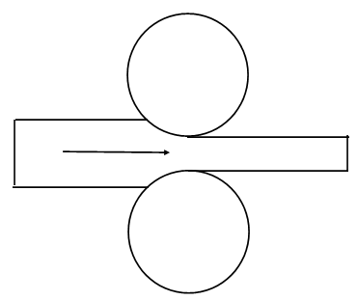
Figure 2-5 – Diagram of a two-high mill-pullover mill
In this type of mill the material is passed through the two metal rollers, before being taken out and returned to the roller entrance for further reduction.
Two-high mill-reversing mills have two metal rollers, but they can pass the metal through the mill in two directions. This mill can be seen in Figure 2-6.

Figure 2-6 – Diagram of a two-high mill-reversing mill
Three-high mills consist of an upper and lower, driven roller, with a middle roll which rotates via friction. This can be seen in Figure 2-7.

Figure 2-7 – Diagram of a three-high mill
Four-high mills are similar to two-high mills, with a pair of larger back up rollers turning the smaller primary rollers. This can be seen in Figure 2-8.

Figure 2-8 – Diagram of a four-high mill
Finally, a cluster mill, or a Sendzimir mill, can be used. This roller set up uses two backing rollers to support each of the work rolls. This arrangement can be seen in Figure 2-9.

Figure 2-9 – Diagram of a Sendzimir mill

Typical Arrangement of Rollers for Rolling Mills
One type of rolling mill arrangement is the continues rolling, or tandem mill. This can be seen in Figure 2-10.
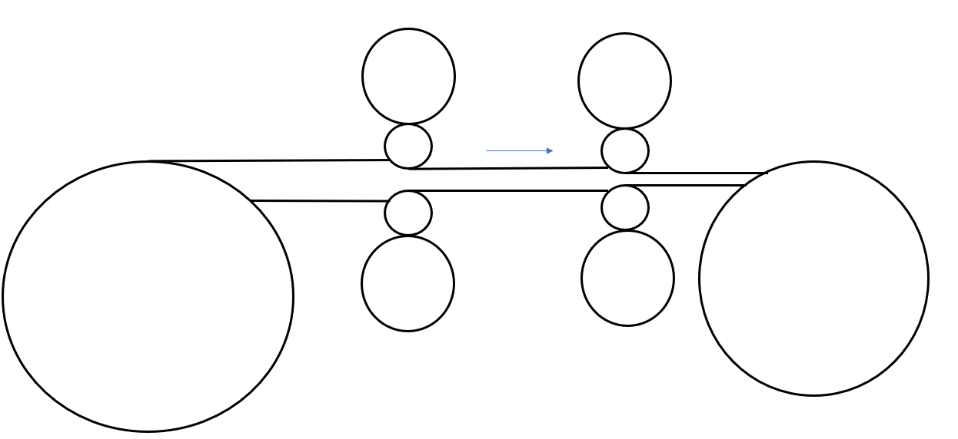
Figure 2-10 – Diagram of a tandem mill
This type of arrangement features a series of rolling mills, with each being referred to as a stand. Each stand rolls the strip at a different velocity, with each set of rollers being synchronised so that the input speed for each stand matches the output speed of the proceeding stand.
Back and front tensions is provided to the strip by the uncoiler and windup reel, in addition to feeding the strip into the rollers and coiling up the final product.
Another type of rolling mill arrangement is the planetary mill arrangement. This features a pair of heaving backing rolls, which are surrounded by a large number of planetary rollers. This can be seen in Figure 2-11.

Figure 2-11 – Diagram of a planetary mill
As each pair of planetary rollers moves around the back-up roller, they cease to have contact with the work piece. However as one set of planetary rollers leaves the work piece another one comes into contact with the strip. This causes the strip to be reduced by a small amount over several different roller passes, leading to the total reduction in strip thickness to be due to the summation of these small reductions.
Because of this, a planetary mill can reduce a slab directly to a strip, with only one pass through the rolling mill. However, the operation requires feed rolls to introduce the slab into the mill, with a pair of planishing rolls required to improve the surface finish on exit.
Other types of rolling processes include: continuous rolling, transverse rolling, shaped or section rolling, ring rolling, powder rolling, thread rolling and continuous casting and hot rolling (Jortner et al, 1960).

Metal Rolling Challenges
One of the most serious factors that can affect the metal rolling process is mill vibration during metal rolling (Fleck et al, 1992). This can be due to a cyclic exciting force, or due to self-excited vibration. There are several different types of rolling mill vibration that can cause a significant decrease in cold rolling productivity, due to causing a decrease in roll speed, or product quality. The common types of cold mill vibration include third octave and fifth octave chatter (Farley, 2009).
Cyclic exciting forces can be caused by forced vibration due to roller eccentricity. This causes the vibration to occur at all roller rotation frequencies. The frequency of this forced vibration is usually lower than the resonant frequencies of the mill stand, causing the gauge variation to be the result of the stiffness response of both the mill and the material. At higher roller speeds, the vibration can potentially be worse due to the excitation of the torsional resonance of the main, unwind and rewind drives. If the vibration mode involves a fluctuation of work roll speed, then lubrication instabilities can be caused as well. This can be referred to as torsional chatter (Smith, 2019).
Self-excited vibration is where the system begins to vibrate, without external influences. The amplitude increases until a non-linear effect starts to limit the amplitude increase. The alternating force that causes the vibration is generated due to motion and therefore stops when the motion of the system stops, with a natural resonance often providing the structural flexibility in the system. Third octave gauge chatter is an example of self-excited vibration.
Third octave chatter can produce significant gauge variation and can lead to strips breaking. This type of vibration occurs generally at high rolling speeds and usually the one way to remove the chatter is to reduce the rolling speed.
Fifth octave chatter is more prevalent on mills and causes surface quality issues. It usually causes marks to develop on the backup roller which are transferred to the strip surface via the work roller. When using very sensitive surface proximity measurements the surface features can be measured with amplitude of a few microns (Smith, 2019).

Measurement and Strip Thickness
Techniques have been used to investigate the strip thickness of metal sheet, both ultrasound and otherwise, will now be considered to provide more context for the investigated ultrasound methods in this thesis.
Being able to measure the thickness of metal strip whilst it is being rolled has been highlighted as an area of interest. This is because if the product is thicker than desired the manufacturing cost will be increased, due to the need to re-work the product. Conversely, if the product being rolled is thinner than desired then the finished material it could be unsuitable for the customer's needs and, therefore, must also be reworked to meet the specifications (Allport, 1976).
Previously the desired thickness was gained by using trial and error techniques, until the desired thickness was rolled. These trial sheets would hold no value and would have to be melted down and reprocessed, wasting time and energy.
There are several different types of measurement techniques available to measure the thickness of metal strip. These techniques include: contact probes or mechanical testing, radioactive based testing, laser-based testing and ultrasound based testing. Mechanical based measurement techniques are generally contact ones and are undesirable due to the fact that they mark the material, causing the material being processed to lose value as it has to be reworked. In addition, in-situ mechanical based gauges can easily be destroyed, or damaged, due to the operating conditions within a rolling mill. Furthermore, the vibrations created during the rolling processes can affect the response received by the mechanical gauges (Shoupp et al, 1940). Additional challenges to a precise measurement arise due to the variation in surface flatness, which is caused by many reasons (Greenwood and Williamson, 1966; Kendall and Tabor, 1971).
Previously developed metal rolling control systems used in most rolling mills work within the timeframe of 0.1 seconds or less, with the gauge thickness having an accuracy of approximately +/- 0.25% (Kraybill, 2016). Gauge techniques include both contacting mechanical gauges and non-contacting radiation gauges. In addition to the previously mentioned durability limitations of contacting gauges if the rolling takes place at a high speed, the sensor element can bump, or skip, on the material, leading to the data gained not providing a clear picture. The following sections report what has been done previously within the Sheffield research group, and other methods to determine thickness in-situ.

Electromagnetic Acoustic Transducers
Electromagnetic acoustic transducers, or EMATs, were first discovered in Denmark accidentally in 1967 (Dobbs, 1969). Conventional EMATS include a permanent magnet and an induction coil which induces RF eddy currents into the metallic test piece. Due to the presence of the permanent magnet field along with the RF eddy currents, oscillating Lorentz forces occur, which generates the ultrasound in the sample.
EMATS can be used as both transmitters and receivers of ultrasound and recently have been used for a variety of NDT applications. EMATs works by sending alternating current through a wire at the desired frequency. This is used to generate the eddy currents (J) in the sample and the penetration into the electrically conducting object is governed by the electromagnetic skin effect. When this occurs in the presence of a static magnetic field, the eddy currents experience Lorenz forces (f) and the relationship between these is shown in Equation 2-1.
2-1
$$f=J×B_{0}$$
(Bhagi, 1999)
This technique can be used to excite ultrasound in a sample from some distance away and can also generate ultrasound through most non-metallic barriers such as air, oil or oxides (Rueter, 2014). A limitation, however, with this technique is that the transmitted intensities can be limited, leading to very small “lift off“ distances of a few mm. Many areas where this technique could be applied would find this distance to be too small, leading to damage to the equipment.
However, an advantage when using EMATs is that it can work on hot materials, ranging up to 1000ºC, with water cooling, for single measurements and up to 500ºC for continuous measurements. Without water cooling, EMATs can be used up to temperatures of around 200ºC for continuous measurements (Warwick University, accessed August 2019).
The principle behind EMATs is the ultrasonic pulse generation, with no coupling agent needed and this is illustrated in Figure 2-12.

Figure 2-12 – EMAT diagram from (Rosen Group, 2019)
Figure 2-12 shows an example EMAT set up with the magnets set up on a pipe wall, along with the direction of the sounds travel. There are also several different ways of arranging the coil of the EMAT. These can be seen in Figure 2-13. 
EMATs are an attractive ultrasonic transducer due to them being able to transmit and receive ultrasonic waves, without the use of a coupling medium. It has been shown though that temperature does have an influence on the response from EMATs, as when the temperature it is working in increases, so does the resistance (Choi, S, 2018)
Figure 2-13 – EMAT coil types (Mirkhani et al, 2004)

Laser Coupled Ultrasound
Laser coupled ultrasound is used to investigate materials and components in industry when the measurements take place in high temperature environments, as well as when the surface of the component has varying curvature. Ultrasound can be generated through the use of a laser by two mechanisms. When the laser has a low power density, no phase change occurs at the surface. Since only transient surface heating occurs, tangential stresses are produced. When the laser has a high-power density then it causes surface melting and vaporisation. Ultrasonic stress is produced in this case by the recoil effect, following material ejection from the sample and this occurs normal to the surface. A longitudinal wave is therefore produced. A limitation of this method is, therefore, that a small amount of material is vaporised from the surface, however in many cases it is considered that this damage is in the order of a micrometre and is acceptable. On a production line, where steel products are being created at high temperatures, this technique is also desirable. Further to this, the generated ultrasonic wave front follows the surface curvature, allowing for complex shapes to be probed. The ability to detect the returning ultrasonic signal can depend on several conditions, including the surface roughness of the material and, therefore, the amount of optical scattering. Another factor that dictates the ability to observe the ultrasonic response is the speed of the surface (Aussel et al, 1989).
Laser based ultrasonic techniques are used in a variety of industrial applications, including the inspection of aircraft structures and on-line wall thickness gauging. As previously mentioned, the ability to investigate complex geometries is an advantage of this method. Further to this, laser-based testing methods also allow for greater ease of operations, for example due to not needing previous, detailed knowledge of the part being investigated.
Laser based techniques have been highlighted as useful for metal processing, in either hot rolling, or during the finishing stages during metal rolling. This could lead to further information on texture, or degree of recrystallisation. However, a limitation that has been highlighted when using laser based ultrasound systems is that shiny surfaces are not easily inspected, over a wide area, due to the reflected light suffering from a large variation of reflectivity (Monchalin, 2004). Laser based techniques are also not applicable to measurements taken over the roll bite region, or near to it, as the rollers will obscure the strip from the laser.

Radioactive Sensors
X-rays have been used for thickness gauging in metal rolling previously, measuring both the thickness as well as the mass per unit of area of sheet material. These techniques are able to take into account the changes in composition from nominal values since this can affect the material’s transmission coefficient for X-rays. X-rays have been used as a non-contacting technique for years, having been found to be a satisfactory method of in-process thickness measurements for a number of applications (Allport, 1976).
Radioisotope gauges have also been used to measure the strip thickness of sheet metal whilst being rolled, however a major limitation is that since the gauges only have a low radiation intensity, they are not capable of providing a response in the short time frame that is required, whilst also maintaining the required level of accuracy. This is because a typical Beta gauge requires an averaging time of around 5 seconds to achieve a measurement accuracy of ±0.5% to ±0.25%. Modern metal rolling mills however can be controlled in times of about 0.1 seconds or less, therefore they ideally require thickness gauging to an accuracy of ±0.25% or better in 0.01 seconds or less.
X-Ray gauges however can operate with signal averaging times of 0.01 to 0.005 seconds, whilst maintaining an accuracy of ±0.25%. A limitation however is that since the thickness, or mass per unit of area, is gathered from the absorption of the X-Rays passing through the material, this technique can be sensitive to the material composition. This can lead to large errors in measurement from minor material composition variations (Allport, 1976).
Radioactive gauges suffer similar limitations to mechanical contacting. For example, flutter can still be a problem as the emitted rays are affected by the material density in their path. This can lead to an emitter being placed close to the material being measured, which could still lead to them being damaged. An example of this is the Beta-ray gauges, which suffer due to the sensitivity to the air density and oil lubricant. A further limitation of Beta-ray gauges is that they are relatively non-responsive to alloy composition variations. The timeframe that they work in is approximately five seconds for the required accuracy of the data. This is far outside the previously mentioned time requirements for online measurements. The final limitation for Beta-rays is that due to the high kinetic energy generated at rolling mill speeds, they can suffer from misalignment over shorts periods of time (Kraybill, 2016).
Beta-ray gauges, therefore, are not desirable for a control system, but other current non-contacting radiation methods have limitations as well. For instance, the time frame during metal rolling is a major problem as most methods struggle to stay within the required time-tolerance. A second common major limitation is measurement accuracy, which is affected by: air gap temperature and distance, presence of rolling solution or oil, pass line height variations, material composition variations and sheet flutter.

Other Non-Contacting Ultrasound
Other non-contacting ultrasound techniques, other than laser based or EMATs, include air coupling, and optical holographic, or interferometric detection. These non-contacting methods allow for generation and detection of ultrasound with less modification of the detected waveform, however they are still limited by bandwidth. Air coupled ultrasound has been used to detect various characteristics in a variety of different materials. (Green, 2004).
The transmission of ultrasound between the transducer into a component by air coupling is limited, due to the acoustic impedance mismatch between the air and the transducer. This causes almost all of the ultrasonic energy to be reflected back at the transducer to air boundary during transmission, or at the component to air boundary if receiving.
There has been research into reducing these limitations, with one method being the use of electrostatic air-coupled transducers. These are wide band transducers, that can be used in NDT due to bulk wave propagation in the components. However, the signals received in these systems are low, leading to this method not being a popular choice for industrial applications.
More recently, piezo-ceramic, air-coupled, transducers have been used. These feature narrow band transducers, so the impulse response has a long duration, leading to the inspection having to take place in a thick structure. Another limitation with this method is that due to the long duration of the response from the near side of the component being tested, subsequent reflections from internal defects, or boundary layers, will be masked by the initial response. Because of this, these transducers are limited to through transmission, or pitch catch testing modes.
The possibility of using Lamb wave testing instead has been highlighted however, which could lead to possible, rapid, long-range inspections. (Castaings, 1998). Other commercial transducers have been reported in the literature, for example Andersen, 2001. In addition to measurement of the strip product for sale, strip thickness measurements are of use in developing and validating mathematical models of the performance of roller mills (Domanti and McElwain, 1998; Dixon and Yuen, 2003; Hunter, 2018).

Summary of Common Problems for Sensors
The main limitation that can affect the use of sensors is vulnerability to flutter. Because of this, the placement of the transducer is important as the transducer must be positioned where operation will not bring it into contact of the strip.
Secondly, rollers are removed and re-ground periodically to ensure the quality of the rolling surface. Because of this, the transducers are limited in where they can be placed and what roller geometries they can work with, as the rollers have to be removed and replaced, which could cause damage to the transducer assembly if it is in the way. Further to this if the set-up is moved, or knocked, during this process this could lead to the transducer no longer being able to accurately monitor the points of interest. Finally, since the roller diameter will be changed due to the grinding, the transducer assembly would be limited if it was too reliant on the original roller diameter.
Another potential problem facing the system is the response time required as the system must be able to process the strip thickness quickly enough to allow for the system to react, ideally in less than 0.1 seconds.
Finally, the system must be robust enough to survive operation in the rolling stands. If the system is too susceptible to the rolling coolant, or lubrication used in operation then the system could be displaced, so that the ultrasound is no longer coupled to the area required.

Previously Trialled Ultrasound Techniques
Ultrasonic measurement systems have been investigated previously to measure the strip thickness during metal rolling. This technique used metal plugs which were inserted into the metal roller (Hunter and Dwyer-Joyce, 2014). However, this method caused damage and geometric changes to the metal due to the different deformations experienced during the rolling process. Examples of what can happen to the strip if the roller surface is not uniform can be seen in Figures 2-14 and 2-15. The damage was made from a rectangular channel cut into the surface of the roller.
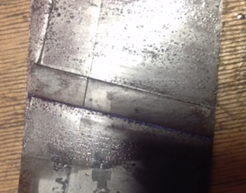
Figure 2-14 – Marking left on the metal strip

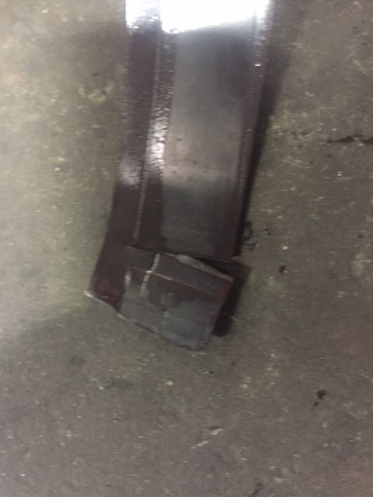
Figure 2-15 – Shear failure on a metal strip
As can be seen, this damage and marking of the metal would reduce the value of the produced strip metal and must be avoided to prevent wasted time and resources. This example shows damage from a channel cut into the roller surface, however, the damage done due to the roller surface not being uniform can be observed. If there are cuts in the roller, that part of the strip will not be rolled, and if part of the roller has raised areas, due to, for example, adhesive wear, then extra marks will be indented onto the metal roller.
Much work has been done on determining the lubricating oil thickness during the metal rolling process (Adeyemi et al, 2022; Dwyer-Joyce et al, 2003; Dwyer-Joyce et al, 2004; Dwyer-Joyce and Hunter, 2013; Dwyer-Joyce, 2017; Kanja et al, 2021), in-situ viscosity analysis (Peretti et al, 2022) and ultrasonic surface analysis (Mills et al, 2021). One example of reported work on the roll bite is Adeyemi et al, 2020. Within the group at Sheffield strip thickness measurement has also been a focus of research attention (Hunter, 2018; Adeyemi et al, 2022), but this was mainly using transducers directly coupled to the roller in an oblique ultrasound format. This has provided good results under certain circumstances, but suffers from only providing a usable signal scan periodically when the ultrasound transducer(s) line up once-per-roller-cycle to be at the right orientation for the signal to go through the rollers and the strip, and be reflected. This disadvantage could be more apparent with larger rollers, where the lining up of transducer(s) and strip will be less frequent compared with smaller rollers. Work has been done on both pitch catch and pulse echo techniques for strip thickness, but both of these techniques are subject to this alignment constraint. To-date, there has not been a systematic investigation of these different techniques focussing on in-situ measurement of strip thickness under conditions that may provide more noise than controlled laboratory conditions, and, in the research work reported in this thesis, comparison is also made with coupling the ultrasonic transducer to the rollers using a water shoe method. One major advantage of this technique is the ability to send, and receive, a signal from the transducer through the rollers and strip regardless of the rotational position of the roller. This would provide a more thorough data set during the rolling process and is a major part of the investigation reported in this thesis. Likewise, work is reported on the water jet means of coupling the transducer(s) to the rollers, which has the same non-dependence on roller rotational position advantage as the water shoe method, but could be more susceptible to noise interference with the signal to be processed when compared to the water shoe.
In all of the following work the speed of sound in the steel strip and rollers will be assumed to be a constant value, and not influenced by the acoustoelastic effect: where the acoustic wave speed depends on the properties of the material in which it is propagating (density and elasticity). This was investigated in detail by Hunter, 2018, and from his work it has been commonly assumed (Carretta et al, 2017; Carretta et al, 2018) that this effect has a marginal influence (<1%) on the speed of sound. Likewise, in common with other published work (Adeyemi et al, 2020) it will be assumed that the effect of the surface roughness on the measured values will also be marginal (<1%).

Oblique Ultrasound Method
The oblique ultrasound method has previously been highlighted as a technique that could be used to investigate the roll gap. By mounting transducers at an angle on the metal rollers, the roll bite can be monitored without changing the roller surface in contact with the metal strip. This also allows access to areas that could not normally be reached by perpendicular ultrasound, such as when the metal rolling mill is in four-high orientation. This is explained in greater detail in Chapter 5 and is shown in Figure 2-16.
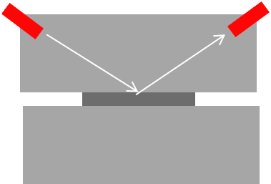
Figure 2-16 – Oblique ultrasound set up
This arrangement was used to investigate lubrication and strip conditions during metal rolling in a research environment, being used to investigate oil film thickness, roll bite length and strip thickness (Adeyemi, 2018).
The technique was found to be in good agreement with other measuring techniques, with the angle of incidence having a minor effect on the value of stiffness obtained.
Oblique ultrasonic techniques have also been used in other applications, such as for medical scanning. Traditionally ultrasound probes have been used to direct needle placement, usually perpendicular. However, by using an oblique approach a better visualization of the needle is observed. Further to this, this technique has been able to visualize the needle as well as the important structures within the body (Phelan, 2008).
Oblique ultrasound has also been used in other non-destructive testing applications, usually at an angle of 45º or 60º (Liaptsis, 2007).
Pitch catch, oblique ultrasound has also been used to monitor wind turbine blades, whilst in operation (Raisutis, 2016). This shows the increasing acceptance of this technique in industry and medicine.

Water Coupled Ultrasound
Water coupled ultrasound has also been used previously in both medical and industrial applications. One method of conducting ultrasonic investigations is to use a water bath to submerge the test piece. A water bath can be used to investigate the area of interest. This can have an advantage over using contact gel to couple other contact transducers as problems with the gel moving out of position, or marking, or causing damage, to the component or patient (Blaivas, 2004). Water baths have, therefore, been used to transmit ultrasound into components with awkward geometries. Further to this they allow for inspection from several different angles, without having to set up multiple testing points.
Whilst submersible baths have been used for years to couple the ultrasonic energy to a variety of components, it is not always possible to use them. This can be due to the design, or manufacturing process, preventing these components from being submersed. An example of a component that could not be investigated with submersed ultrasound would be an electronic component, as the moisture would cause the component to fail. Similar to this, components that are too large to fit in a conventional water bath would also be difficult to investigate using this method properly.
Previously this was overcome by painting the surfaces prior to submerging it. However, this then required the paint to be removed afterwards, with any remaining paint potentially causing problems with the component’s operation (Batzinger et al, 2003).
Water coupled ultrasound has been used in a variety of different areas to investigate different properties. Medical and industrial inspections are the most common, however ultrasonic inspection has also been used in food processing applications, investigating the presence of foreign bodies present in food packaging. The foreign bodies would be detected by comparing the pressure ratio between the echoes from the near side of the container and from inside the container, with locations of the echoes giving an estimate of the size of the foreign body. By using water jet ultrasound these foreign bodies can be investigated, without the need to physically couple a transducer to the subject of an investigation, e.g. bottles (Zhaoa, 2003).
Water coupled ultrasound has been used previously for ultrasonic non-destructive testing. This technique has been used as, in direct contact applications, if a small air gap is present between the test object and the transducer, a lot of the energy can be lost. Often this can make it appear that no energy is entering the sample to be tested. This would limit testing being carried out as attenuation of the signal would have a greater affect. Further to this, depending on the boundaries being investigated, not enough signal may be transferred to obtain a clear response. The effect noise has on the system will also be increased, as if the signal is weaker the effect of noise will be greater.
To overcome this limitation a coupling liquid is used between the transducer and the material to be investigated. This technique has been used to investigate a variety of components, including concrete and timber, alongside being used in archaeology and civil engineering to investigate material characteristics and defects.
A variety of different coupling liquids have been used, such as water, glycerine and oils of varying characteristics. Certain characteristics of the coupling liquid affect the testing, such as the acoustic coupling from the liquid into the sample. Thicker oils, or greases, are preferred for use on vertical or rough surface, as well as for high temperature applications.
However, using oil or other petroleum products increases costs for testing, in addition to not being sustainable. A further limitation of using oils for testing is that oils and greases are too messy for the inspection of concrete, refectory bricks, stones, timber or other civil structures. They can also cause the material being inspected to be marked or may be difficult to remove (Bindal, 2000).
Water coupled ultrasound has been used to investigate the surface properties as well. This is because checking the surface is of the required standard is important for successful products. Subsurface properties of the product can also be observed through the surface properties. These properties can include hardness, residual stress, deformation, chemical composition, and microstructure. Because of this, surface topography can be a useful tool in analysing, monitoring, and controlling fabrication methods (Roth et al, 1999). The water-based method has only been used on off-line components however. Therefore, there is an interest in how this technique can be used on-line, to investigate the roll bite, the strip thickness and what other conditions can be monitored in metal rolling.
There are several problems that can occur within moving systems. If the rolling speed is too high, the lubricant film thickness will be larger. This reduces friction and leads to conditions in the rolling mill where the rollers may slip, causing the roller to become damaged. Oil pool can also occur, causing surface roughening. Higher speeds can also cause chatter to occur in the system.
If the rolling speed is too slow, the cost per unit will raise due to the lower production rate. Pick up, where material is transferred from the workpiece to the roller, can also occur at lower rolling speeds. Finally, lower rolling speeds can cause excessive cooling within the workpiece (Adeyemi, 2018).
Because of this, the system being developed must be able to work under the speed conditions of rolling, a consistent connection must be present, and the signal must be able to pass through the roller and strip and be captured quickly enough to not limit the rolling speed. A successful system for metal rolling applications requires, depending on the application, the accuracy to remain within the micron range, with a tolerance of plus or minus 50 μm. In addition, for signal processing, it is believed that the time frame must be approximately 0.1 seconds, or less.

Conclusion
In conclusion, there are several different configurations that are used to carry out metal rolling, with these providing different challenges for measuring the strip thickness of sheet metal in situ. Various, different, non-destructive, non-contacting sensor methods have also been highlighted for use in this industry, however they all suffer similar limitations, particularly flutter, and limitations around the response time and working environment. Previous work on ultrasonic techniques has been promising, however, the sheet metal being rolled was negatively affected by the introduction of the technique, so it is not feasible for use in an industrial rolling mill.

METHODOLOGY - Theory
The theory behind the ultrasonic techniques used to measure the strip thickness of the metal sheet in situ, will be disused in this chapter. Several different ultrasonic techniques are available, including pitch catch and pulse echo ultrasound, in a variety of different set ups. These will be discussed, along with factors that affect them.

Ultrasound Basics
Ultrasonic waves are mechanical vibrations in a material which are above the frequency of human hearing, 20 kHz. These sound waves bounce back from interfaces in samples, such as cracks or changes in material, and these echoes can be used in non-destructive testing, to determine the size and location of these interfaces (Cheeke, 2012). Ultrasound is already commonly used for measurements in medicine and raw material supply (Butkus et al, 2005).

Ultrasonic Wave Types
There are several different types of waves (Ensminger and Bond, 2011), but the main types of waves focussed on in this work are longitudinal and shear waves. Longitudinal waves vibrate parallel to the direction that they are travelling in, whereas shear waves vibrate perpendicular to the direction they are traveling in. Due to this, longitudinal waves are sensitive to both liquid and solid interfaces, with shear waves only being sensitive to solid interfaces. Because of this however, by using both longitudinal and shear waves, liquid and solid mixed contacts can be investigated (Hunter, 2018).
These wave types can be explained using the spring-mass analogy. Longitudinal waves occur when all the masses in one row becomes excited at the same time and with the same force. This causes all the masses to oscillate which causes the length of the springs between the planes to change. These changes in spring length cause the second plane of masses to oscillate as well and these forces and oscillations are induced throughout the planes. This results in a regular movement of each particle in the material about its neutral position, with respect to the movement of the adjacent masses. Since these waves propagate in the longitudinal direction, this type of movement is referred to as a longitudinal wave (Fishbane et al, 1995).
Shear waves however vibrate in a direction perpendicular to the direction of travel and are only transmitted by solids, meaning they are only sensitive to solid contact. Because of this when oil films are being investigated, only longitudinal waves will pass through the film due to the nature of the wave types. However, if both wave types are used, then the amount of solid to liquid contact can be investigated. This is performed by analysing the received signals and then by observing the ratio of shear signal to longitudinal signal.
Sound waves move a discrete volume of material as they pass through a sample, unlike with light waves. This mechanical movement occurs about the material’s neutral position and is most commonly described by the number of cycles about the neutral position per second. This number of cycles per second, or frequency, is measured in Hertz (Hz).

Spring Mass Model
The material through which the sound waves pass can be modelled as a system of discrete masses, connected in a grid-like manner, provided that the material itself has not been stressed beyond its elastic limit. This system can be seen in Figure 3-1.
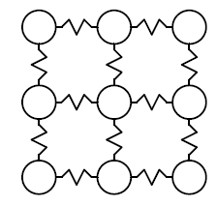
Figure 3-1 – Figure showing the grid like structure of the mass-spring system
The interaction between the ultrasonic waves and an interface with embedded pores, or inclusions, can be modelled by using this spring-mass system. However, this is only when the wavelength of the ultrasound is large compared to the size of the pores in the interface.
The effect of the mass term in the mass-spring model has been shown to be negligible and the damping of an interface layer only weakly affects the reflection coefficient (Drinkwater et al, 1996). As the frequency is decreased the mass and the damping becoming less significant and so in the low frequency region it is only the stiffness of the interface which governs the reflection coefficient. This system can be seen in Figure 3-2.
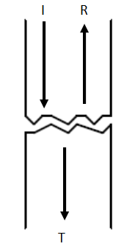
Figure 3-2 – Diagram of the interface
In Figure 3.4 an ultrasonic wave with an incident amplitude I, interacts with a partially contacting interface. A wave of amplitude R is reflected, with a wave of amplitude T being transmitted. This system can be represented by the static system shown in Figure 3-3.
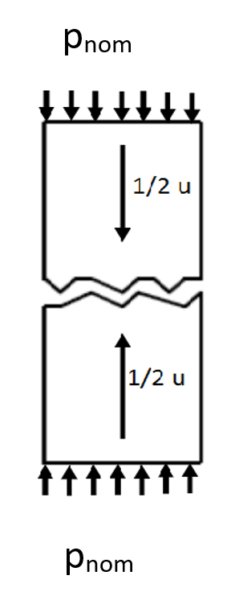
Figure 3.3 – Distributed load interface interaction
In Figure 3-3, the pressure $p_{nom}$ is applied to the same system, causing the interface to deflect by an amount u. Figure 3-4 shows the spring model representation of this interface.

Figure 3-4 – Figure showing the spring model of the system

The stiffness per unit area of this interface can be given by the rate of change of average pressure with interfacial deflection, which can be written as seen in Equation 3-1.
3-1
$$K=-\frac{dp_{nom}}{du}$$

$p_{nom}$ is the nominal contact force given by the applied load, divided by the nominal contact area. The approach of the mean lines of the two rough surfaces, or the average interfacial separation is shown by u (Drinkwater, 1996).
For both longitudinal waves and shear waves the speed of sound can be defined by Equation 3-2.
3-2
$$f×λ=c$$
The speed of sound for longitudinal waves is given by Equation 3-3.
3-3
$$c_{l}=\sqrt{\frac{E}{r}\frac{1-ν}{\left(1+ν\right)\left(1-2ν\right)}}$$
The speed of sound for shear waves is given by Equation 3-4.
3-4
$$c_{s}=\sqrt{\frac{E}{r}\frac{1}{2\left(1+ν\right)}}=\sqrt{\frac{G}{r}}$$
By combing these two velocities together the Equation 3-5 can be obtained.
3-5
$$\frac{c_{s}}{c_{l}}=\sqrt{\frac{1-2ν}{2\left(1-ν\right)}}$$

Reflection Coefficient
The reflection coefficient is an important quantity in ultrasonic testing and is found from the incident and reflected amplitudes, $A_{i}$ and $A_{r}$ respectively. This relationship is shown in Equation 3-6 below.
3-6
$$R=\frac{A_{r}}{A_{i}}$$
This relation is illustrated in Figure 3-5.

Figure 3-5 – Diagram showing the reflection and transmission of a signal
Another important term used in ultrasonic testing is the acoustic impedance. This is defined in Equation 3-7 below.
3-7
$$R=\frac{z_{1}-z_{2}}{z_{1}+z_{2}}$$
$$Z=ρc$$
Where c is the speed of sound in the material and $ρ$ is its density. Common boundary, reflection coefficients can be seen in Table 3-1 below (Hunter, 2014).
Table 3-1 – Table of common reflection coefficients
Interface | Reflection Coefficient
Steel-Steel | 0
Steel-Oil | 0.95
Steel-Air | 0.999

For thin layers, the reflection coefficient can be related to the interface stiffness, using the Equation 3-8.
3-8
$$\left|R\right|=\left|\frac{Z_{1}-Z_{2}+iω\frac{Z_{1}Z_{2}}{K}}{Z_{1}+Z_{2}+iω\frac{Z_{1}Z_{2}}{K}}\right|$$
Where $ω$ is the angular frequency of the wave. This equation is related to the spring model, similar to the oil film thickness reflection coefficient equation, see Equation 3-9.
Stiffness per unit area of an interface is given by Equation 3-1.
Where u is the separation of the mean lines of the two rough surfaces and $p_{nom }$is the nominal contact pressure (Dwyer-Joyce, 2000).
Oil film thickness can also be investigated, with the oil film behaving like a spring with reflection depending on spring stiffness. This can be seen in Equations 3-9.
3-9
$$\left|R\right|=\frac{1}{\sqrt{1+{\frac{2K}{ωZ}}^{2}}}$$
$$K=\frac{B}{h}$$
Where B is the bulk modulus and h is the film thickness.

Snell's Law
Snell’s law dictates how the ultrasound reacts when it is reflected by the boundary change, with both the return pulse from the far side of the strip and the roller being caught on the other side of the roller. This is outlined in Figure 3-6.
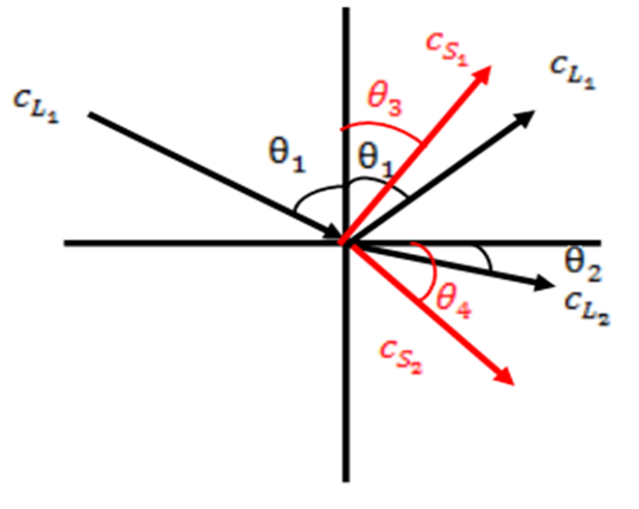

Figure 3-6– Schematic illustration of Snell's law reflections
Where c is the speed of sound in the material, $θ$ is the angle of the ultrasound. The subscripts L and S refer to whether the ultrasound is longitudinal or shear respectively. The relationship can be defined using Equation 3-11 below.
$$\frac{\sin{θ_{1}}}{c_{L_{1}}}=\frac{\sin{θ_{2}}}{c_{L_{2}}}$$
This is an important interaction for the oblique ultrasound method as, it requires angled chamfers to be machined onto the edges of the roller. So, by using this law, the angle of the chamfers can be calculated. Allowing for the ultrasound to be aimed at the area of interest for monitoring.
3-10

Scan Modes
There are several different scan modes that can be used during ultrasonic testing. The first type of scan mode is an A-mode scan. This involves using the time lag between emission and reception to calculate the distance of the reflecting structure. The energy received can also be displayed as an amplitude which can be used to gauge the strength of the signal, and this can be used to calculate the reflection coefficient. A B-mode scan is when the amplitude of an A-mode scan is converted into a brightness at a certain point. Finally, there is a M-mode, or motion-mode, scan. This is when a B-mode scan line is displayed along a moving sheet of paper, or screen. Therefore, this results in a B-mode scan line over time. B scans can be used, for example, to diagnose lesions in the eye in the medical field.

Ultrasonic Techniques
To investigate crack and boundary locations there are several different techniques that can be used. Firstly, there is the pulse echo technique, which can be seen in Figure 3-7.
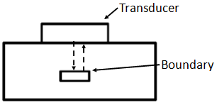
Figure 3-7 – Pulse echo technique

A transducer is used to generate an ultrasonic pulse by converting electrical energy to motion (mechanical energy). This pulse then travels through the material at a velocity which is dependent on the material being travelled through, Equations 3.9 or 3.10. This pulse continues through the material until it reaches an interface such as a boundary change, or a crack. The pulse is reflected from the crack and travels back through the material until it reaches the receiver, where it is converted back from mechanical energy to electrical energy. This is then displayed as an A-scan, with the horizontal axis of the scan being displayed as time, allowing for the time between reflections to be found. Amplitude is shown on the vertical axis. Therefore, the presence, size and location of a defect are related to the echo, signal amplitude and the time at which the echoed signal arrives at the receiver.
A limitation with the pulse echo method is that the signal must pass through several materials, which may include a couplant, transducer body or plexiglass shoe. The reflected signals from each of the interfaces encountered will produce reflected signals on the overall scan and these reflections are referred to as near field noise. Because of this, the pulse echo technique suffers from a loss of sensitivity near the testing surface.
The amplitude of the received echo in pulse echo testing depends on several influencing factors including:
- The transmitter power
- Direction of transmitter
- Size of the reflector
- Size and orientation of the receiver
- Surface qualities of the reflector
- Position and orientation of the reflector
- Loss of signal at receiver due to re-reflection and lack of coupling
- Attenuation of sound wave due to absorption and scattering
- Shadow effects
The effect these common occurrences give rise to are:
- The signal amplitude from two equivalent defects is reduced for a defect at a greater distance.
- The presence of a smaller defect is masked by a larger defect, shielding it from the ultrasonic signal.
- A reduced signal would be detected as a result of scattering of the beam at the defect depending on the defect orientation.
- A larger defect will reflect more ultrasonic energy, yielding a greater amplitude.
Another ultrasonic technique is the pitch catch technique. Unlike with the pulse echo technique, the pitch catch technique does not send and receive signals form the same transducer. Instead, two different transducers are used, one sending the signal and one receiving the signal. This technique can be used in either direct, or indirect modes.
Direct pitch catch works by placing the receiver where the reflected beam is expected to be, in the case that no defects are encountered. If the signal strength is lower than expected however, or if no return pulse is received, then a defect or crack is discovered. Conversely, when indirect pitch catch is used, the receiver is placed where the reflected beam is expected if a defect is present.
The direct pitch catch method is typically less prone to error caused by defect orientation and other defect characteristics. The indirect pitch catch technique however, is generally faster, although more susceptible to defect orientation. Direct and indirect pitch catch methods allow for both transducers to be placed on the same side of the specimen, or for the transducers to be placed on different sides.
A third ultrasonic technique is the through transmission technique. This is similar to the pitch catch method; however, the second transducer is positioned opposite the first transducer. The signal reflects from the far side of the interface, where the second transducer is positioned, before the signal reflects inside the system. These reflections are picked up on the second transducer and the time of flight between these reflections is used in order to calculate its thicknesses.

Ultrasonic Transducers
Transducers convert energy from one form to another. In the case of ultrasonic testing electrical energy is converted into pressure or ultrasonic energy. There are six categories of ultrasonic transducers: piezoelectric, electromagnetic, electrostatic, magnetostrictive, optical and miscellaneous. Piezoelectric transducers are one of the most commonly used transducers and are the ones used in this research. Piezoelectricity, otherwise known as pressure electricity, is a property of certain crystals, such as quartz. Electricity is generated when pressure is applied to the crystal, conversely when an electric field is applied to the crystals, the shape is rapidly changed, and this induces pressure. Ultrasonic probes use both properties to carry out ultrasonic testing.
The ultrasonic probe is the entire assembly used for ultrasonic testing. For a basic straight compression beam, the components that make up the assembly are: lead wires, damping block, the housing, a transducer and a transducer cover. This can be seen in Figure 3-8.

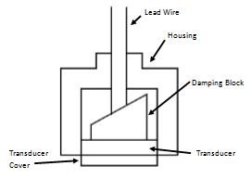
Figure 3-8 – Ultrasonic transducer diagram

The damping block is made from a material with very high attenuation and will have an inclined surface to minimize internal reflections (Federal Highway Administration Research and Technology, October 2004).

Piezoelectric Effect
Piezoelectric transducers have the advantage of simple construction and operation. The generator has a layer of piezoelectric material with thin metal electrodes on both sides. When alternating voltage is applied the thickness of the layer will vary according to the variation of the electrical field. This therefore produces ultrasonic waves in the material that the transducer has been bonded to. The piezoelectric effect also works in reverse to detect the waves, when the physical ultrasonic wave impacts on the transducer. The fluctuations in material are applied to the transducer and this causes an electrical signal to be generated, where the greater the pressure of the waves, the greater the induced voltage (Terzic, 2013).
The direct piezoelectric effect that is used here was discovered in 1880 by Piere and Jacques Curie in quartz. There are five figures of merit that have been identified in piezoelectrics. These are:
- The Piezoelectric strain constant, d
- Piezoelectric voltage constant, g
- Electromechanical coupling factor, k
- Mechanical quality factor, $Q_{M}$
- Acoustic impedance, Z.
The piezoelectric strain constant d is the magnitude of the induced strain $x$ by an external electric field E. This is shown below in Equation 3-11.
3-11
$$x=dE$$
Piezoelectric voltage constant g is used to relate the external stress X to the induced electric field E. This is shown in Equation 3-12.
3-12
$$E=gX$$
Taking into account the relation P=dX the relation between g and d is defined by Equation 3-13.
3-13
$$g=\frac{d}{ε0ε}$$
Where $ε=permittivity$
The electromechanical coupling factor k can be confused for energy transmission coefficient and efficiency. All are related to the conversion rate between electrical energy and mechanical energy. The definitions are however different, where k can be defined as seen in Equations 3-14 and 3-15.
3-14
$$k^{2}=\frac{Stored mechanical energy}{Input electrical energy}$$
And
3-15
$$k^{2}=\frac{Stored electrical energy}{Input mechanical energy}$$
When an electric field E is applied to the piezoelectric material $k^{2}$can be calculated by Equation 3-16.
3-16
$$k^{2}=\frac{\left[(\frac{1}{2})×\frac{{\left(dE\right)}^{2}}{s}\right]}{\left[\left(\frac{1}{2}\right)×ε×0×ε×E^{2}\right]}=\frac{d^{2}}{ε×0×ε}$$
This is taking into account that $input electrical energy=\left(\frac{1}{2}\right)×ε×0×ε×E^{2}$per unit volume and stored mechanical energy per unit volume under zero external stress is given by $\left(\frac{1}{2}\right)×\frac{x^{2}}{s}=\frac{\left(\frac{1}{2}\right)×{\left(dE\right)}^{2}}{s}$.
The energy transmission coefficient refers to the stored energy and how not all of it can be used and the actual work done is dependent on the mechanical load. When the mechanical load is zero, or the system is completely clamped, zero output work is done.
The mechanical quality factor $Q_{M}$ characterises the sharpness of the electromechanical resonance spectrum. When the motional admittance $Y_{m}$ is plotted around the resonant frequency $ω_{0}$ the mechanical quality factor is defined with respect to the full width $\frac{Y_{M}}{\sqrt{2}\left[2∆ω\right]}$ with Equation 3-17 (Uchino, 2003).
3-17
$$Q_{M}=\frac{ω_{0}}{2∆ω}$$
The acoustic impedance Z is used for evaluating the acoustic energy transfer between two materials. It is defined in Equation 3-18 below.
3-18
$$Z^{2}=\left(\frac{pressure}{volume velocity}\right)$$
In a solid material; $Z=\sqrt{ρc}$ where $ρ$ is the density and here c is the elastic stiffness of the material.

Acoustoelastic Effect
During the rolling process the speed of sound will change in the roller and strip, due to the change in elasticity resulting from stress within the material. This is known as the acoustoelastic effect and this effect occurs due to the non-linearity in the stress-strain relationship of the material. This relationship is treated as linear and characterised with the second order elastic constants λ and µ (Abiza et al, 2012). This is a well-established experimental technique, used for non-destructive measurements, with the principles being widely available. However, a mistake that can be found commonly in literature surrounding this effect is that since a small pre-strain and small-amplitude wave can be described by linear equations, then the relationship can be superposed linearly. This is flawed however, as the phenomena are successive, and not linearly superposed. Experiencing an infinitesimal pre-strain from a stress-free configuration is linear, as is propagating an infinitesimal wave in a stress-free configuration. However, in acoustoelasticity, the wave does not travel in a stress-free solid. Therefore, linear elastodynamics much be adapted to reflect this fact, causing second-order and TOE constants to appear in the speed expressions (Abiza et al, 2012).
The acoustoelastic effect has several advantages for evaluating the stress present in steel. Firstly, other non-destructive techniques are effective only at measuring the stress at the surface of the material, or near to the surface of the material. Secondly, the acoustoelastic approach is easier, theoretically, to use in-situ, which is why it is of such great interest to this research area. Experimentally, the acoustoelastic effect requires a very high level of accuracy to be in the measurements, in order to be observed. For each MPa of applied stress, the ultrasonic velocity only varies by around 0.001%.
Other models can be used to investigate the stresses present in the material, however these are based on the acoustic birefringence. The stress is calculated by using the time of flight difference between two shear waves, with differing polarizations, propagating through the material. There are some limitations when using this model however. For example, there is difficulty in distinguishing the birefringence that is induced due to the stress, compared to the texture of the material. This approach is also reliant on the use of coefficients, that have to be deduced from calibration curves.
A classically, and therefore widely used, theoretical model for interpretating acoustoelastic experiments is the Hughes and Kelly model. This model was developed using the framework of second order elastic theory, building off the approach used by Murnaghan. There are two fundamental assumptions with this model. Firstly, the material body is hyperelastic, with the initial stress state being reached from the natural, unstressed state, by finite elastic deformation. Secondly, the acoustic waves are considered to be small perturbations of this initial stressed body. Because of this, the acoustic wave velocity is related to the stress state, as well as the second and third order elastic constants. The second-order being the same ones considered in classical linear elasticity theory, and the third-order constants relating to the measurement of material nonlinearity.
There are several limitations to this approach, however. Firstly, is the assumption that the initial stress case in the body is reached by the finite hyperelastic deformation. Whereas it is often found that the body reaches this initial stress case because of inelastic deformations. Secondly, the acoustic response’s dependence on the initial stress is expressed with acoustoelastic coefficients. These then depend non-linearly on the initial stress, but for a given stress level, the ultrasonic wave velocity is independent of the loading path. Thirdly, for anisotropic materials, the applications are difficult. These limitations could lead to accuracy issues for any experimental measurements of the initial stress.
A second model has also been looked at, the Man and Lu acoustoelastic model (Castellano, 2017). This model has a more general approach to the problem and is also applicable in the cases of inelastic initial stresses as well as being able to by applied to the study of anisotropic materials. Whilst this is promising for the development of effective and accurate experimental procedures. There are some limitations with this model however, as experimental difficulties have caused the practical application to be held back. Firstly, the velocity measurements require a very high accuracy, and the signals that this method acquires, require careful cleaning up. This method also suffers from the same limitations, regarding contact non-destructive testing of residual stresses, as classical ultrasonic contact techniques. The application of which cannot be effectively employed, as they are only able to measure the average response of the sample, assuming that the sample’s body response is homogenous, and that the average response received is representative of the sample. Therefore, it can be advised, that for residual stresses, non-contacting methods, such as immersion testing, are preferable (Castellano, 2017).

Ultrasonic Beam Properties
To properly identify discontinuities, or defects, within a work piece the location of the ultrasonic beam is important, and its location must be correctly estimated. To estimate the beam location the following quantities must be taken into consideration: the beam attenuation, spread and centreline location. The beam attenuation is the decrease in signal strength as the beam travels through a non-idealised material. Beam diffraction occurs when sound waves encounter a finite boundary and an abrupt change in the propagation direction occurs. An example of this effect would be a crack tip, or the interface between material layers. Diffraction also occurs continuously as the beam travels through the material, and this is referred to as scattering. Scattering is due to the grains of material in the metal causing the beam to diffract and occurs due to the coarse-grained nature of metals. Grass refers to detectable echoes which can be found in materials with very large coarse-grains, typically presenting low-amplitude signals on an A-scan.
Beam absorption is when the sound energy is converted directly into heat, as the sound energy passes through the test material. In crystalline metals the conversion is generally due to friction converting the signal energy into heat. Beam spreading occurs in ultrasonic beams and occurs due to the energy not staying within the cross section of the transducer. The beam instead starts as a cylinder and then spreads out into a cone after a certain amount of distance. This spreading reduces the intensity of the wave at each discrete point and therefore lowers the amount of energy able to be reflected on contact with a defect, or boundary change. However, beam spread can be mitigated through the use of Distance Amplitude Correction (DAC).
The angle of beam spread (β) can be approximated by Equation 3-19 (NDT Resource Center 2016).
3-19
$$β=\sin^{-1}\left(\frac{0.61λ}{a}\right)$$
Where $a$ is the transducer active radius in metres and $λ$ is the wavelength also in metres.
The beam location is important as it allows for accurate interpretation of the returned signals. Therefore, the beam centreline location is needed. For straight beam transducers this is straightforward as the centreline of the beam is perpendicular to the test place, for angled beams however it is more complex (Whittingham and Martin, 2010).
The sound field from a typical transducer can be seen in Figure 3-9.

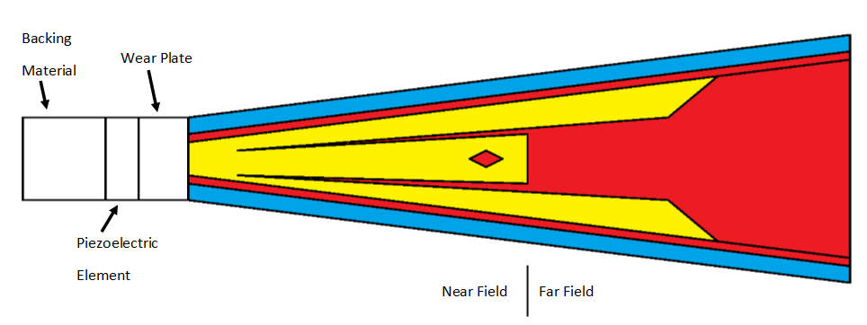
Figure 3-9 – Diagram showing beam spread

In Figure 3-9 the intensity is shown by the colour, with high intensity being shown by red and blue indicating low intensity. The intensity of the beam is affected by both constructive and destructive wave interference, and this is due to the ultrasound being emitted from a number of points along the transducer. The intensity experiences most fluctuations in the near field, or near the source of the ultrasound. This is due to the wave interference and, because of this, evaluating the flaw in the near field accurately is difficult. At the end of the near field, the waves combine to form a more uniform front, and the beam is referred to as the far field. In the far field the beam forms a pattern originating from the centre of the transducer and becomes more uniform, allowing for a greater level of accuracy. The distance where the near field transitions into the far field is referred to as the natural focus, or N. Due to the behaviour of the sound wave at this point, the wave has its maximum strength at N (NDT Resource Center, 2016).

Signal to Noise
An impact factor in ultrasonic measurements is the signal to noise ratio $\left(\frac{S}{N}\right)$. It is important to consider this as it is a good measure of how detectable a flaw or boundary is. The signal to noise ratio is a measure of how the received signal compares to the background reflections, or noise, during testing. Often a ratio of 3 to 1 is a minimum requirement. The factors that can affect the noise levels and signal strength are:
- The probe size and focal properties
- The probe frequency, bandwidth, and efficiency
- The interface, surface curvature and roughness
- The flaw location with respect to the incident beam
- The inherent noisiness of the material microstructure
- The inherent reflectivity of the flaw, this is dependent on the acoustic impedance, size, shape and orientation
- Cracks and volumetric defects can reflect ultrasonic waves quite differently. Many cracks are invisible from one direction and strong reflectors from another
- Multifaceted flaws will tend to scatter sound away from the transducer (Electronics Tutorial, 2016)
There are several relationships that can be used to describe the signal to noise ratio. One relationship is that the signal to noise ratio is inversely proportional to material density and acoustic velocity. The signal to noise ratio also generally increases with frequency, although this is not always the case, for example with titanium alloys. In those cases, the ratio is independent of frequency to a large extent. If the ultrasonic beam is more focussed, or the flaw size increases, the signal to noise ratio increases with the ratio decreasing when there is a large pulse width (Mogami, 2003).

Conclusion
In conclusion, ultrasound is a powerful technique that can be used to investigate a variety of different things, however, care must be taken to ensure it is set up correctly, to investigate the required areas of interest. Lots of different factors make up the use of ultrasound, and these should be kept in mind, when investigating the materials of interest to this research.

METHODOLOGY – EXPERIMENTAL
The different potential ultrasonic measurement concepts are outlined and discussed, giving both potential advantages and disadvantages to the techniques. Following on from this, different ultrasonic techniques are outlined, along with the equipment used to carry out the experiments. Finally, brief descriptions of the post processing techniques are outlined.

Introduction
Several different techniques are proposed for use in applying ultrasound to metal rolling. These concept ideas are outlined below, together with a description of the actual experimental equipment and signal processing used in the experimental work.

Pulse Echo
One concept that was considered for investigation is using pulse echo ultrasound, through the back up rollers. This technique could be used with the metal roller in quad configuration, although this technique could also be used in duo configuration. The transducer is mounted directly above or below the metal rollers and used to both send and receive the ultrasonic signal. The transducers would be mounted either in contact with (duo operation), or in the secondary rollers (quad operation). This can be seen in Figure 4-1.


Figure 4-1 – Pulse echo set up, with the transducer shown by the red bar
An advantage of this configuration is that it avoids any modifications to the primary rollers in contact with the metal strip being rolled. In addition, if the transducers are away from the main roller and strip then they will be less likely to be damaged by flutter, or debris from the rolling process.
However, whilst the primary rollers would not require any changes, and this would help when replacing the primary rollers, the area around the secondary rollers would still be an issue due to limitations as to where the transducers could be located. A second limitation would be that, especially in the case of quad configuration rolling, there would be a lot of material for the ultrasonic signal to pass through before reaching the roll gap. In addition to this they would have to pass through at least two boundaries before reaching the boundary of interest, before passing through the same boundaries back to the signal receiving transducer. This will create issues with signal strength. Further to this, back up rollers generally have a coarser grain structure than primary rollers, and this could again create issues with signal strength, as there may be a significant signal scattering.
Conversely, an advantage in having the transducer away from the roll bite and strip is that there should be more room to fit the transducers, and any assemblies, as well as keeping the wires away from possible damage and ensuring a good connection to, and from, the transducers used to send and receive data. In addition to this if the signal is strong enough to travel through both sets of rollers, then this would allow for both the primary and secondary roller to be investigated during the rolling process.

Oblique Ultrasound
The oblique ultrasound method uses the pitch catch ultrasonic technique which can be seen in Figure 4-2. The edges of the metal roller would be chamfered to the desired angle, before bonding on the ultrasonic transducers. The wires are fed through to the bonded-on transducers, to transmit and receive the signal. Depending on the rollers being used, this may require the shaft to be hollowed out, for the wires to safely put in place. The ultrasonic beam would then be sent at an angle, passing through the metal roller at an angle, before passing through the strip. Ultrasound is then reflected from both the far side of the roller and the far side of the strip, and this was captured on the far side of the metal roller.
Figure 4-2 – Oblique ultrasound set up
An advantage of this method was, that since the ultrasound is sent in at an angle, the transducers can be mounted away from the roll bite and this will help prevent damage from flutter. A limitation is that the angle must be calculated for the ultrasound beam and because of this only one point of the roll bite will be captured. In addition, when the rollers are removed to be reground the transducer angle will no longer be aligned. In this case, if the transducers are mounted separate to the roller then the angle must be adjusted separately, provided there is space around the roller to do so. However, if the transducers are bonded onto the rollers themselves then they would have to be reattached and realigned after regrinding. This would create extra expense and complexity in operation.

Water Coupled Ultrasound
The third concept idea was to use water to couple the ultrasound to the metal rollers and strip. This could be carried out in a variety of different configurations depending on the geometry of the rolling rig surrounding the metal rollers themselves. An example of oblique water coupling can be seen in Figure 4-3.
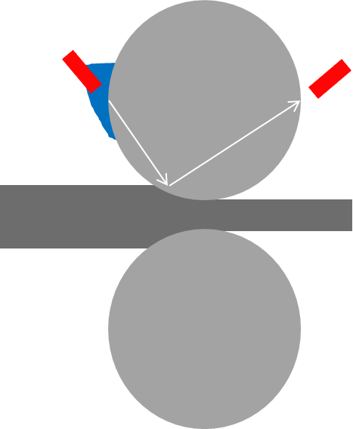

Figure 4-3 – Water coupled oblique ultrasound set up
This technique couples the ultrasound with the water before the water is directed towards the metal roller or sample. A non-oblique water jet ultrasound coupling example can be seen in Figure 4-4, working in pulse echo format.

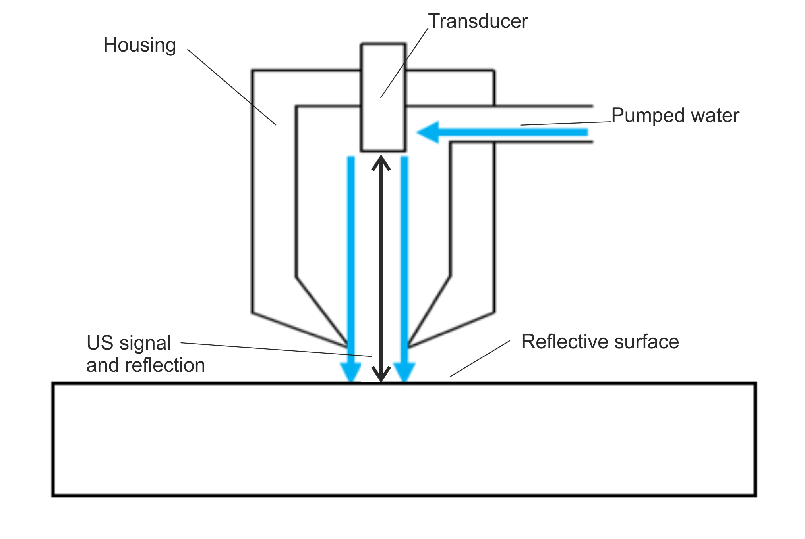
Figure 4-4 – Water jet coupled transducer set up
As can be seen in Figure 4-4, the ultrasonic transducer is mounted into an assembly, with water being pumped into the assembly. The ultrasound is then coupled with the water, and this is then pumped out onto the sample. An advantage of this method is that it allows for testing without a slip ring, required for the previous techniques where the electrics move with the rotation of the rollers. This reduces the complexity of setting up the transducer, along with reducing the noise from the slip ring. It also removes the problem of having to adjust the roller shaft to fit the wires in. However, a limitation with the water jet method is that a consistent connection must be maintained between the ultrasonic transducer and the correct point on the roller.
Another limitation with this method is that if the transducer assembly gets knocked, or damaged then the ultrasound and water will be in the wrong place. This will prevent the correct response from being gathered by the transducer. Further to this, the water coupling of the ultrasound to the metal rollers must be carefully aligned to ensure that the ultrasound reaches the correct part of the roll bite. It must also avoid being knocked or damaged, whilst in operation and during set up. Care must be taken to make sure that the ultrasound is always reliably delivered by the connecting water to the roll bite as the water may become mixed with oil during operation.
As described above, there have been two highlighted methods of coupling the ultrasound to the water and then to the roller. One involved using a water jet, being shot out of the coupled assembly and the other method involves using a shoe to sit on the roller, which is then flooded with water and used to transmit the ultrasound.

Assumptions
For this work, whatever system was going to be used, had to work both in a lab environment and an industrial one. Because of this, space around the rollers had to be considered, as well as the rolling process general, from installation, to use to removal. The signal must also be able to get through both the rollers and the metal strip. It has been assumed, and confirmed, that the signal can be brought into, and out of the system. In addition, it has been assumed that the roller is uniform when the ultrasound is passing through it, as if there was a hollowed out cavity, or a boundary change within the roller, this would affect ultrasounds ability to get through the system.

Ultrasound Generation

Transducer Types
Two different types of transducers were used in this project, contact transducers as well as bonded-on piezo electric elements. Both types of transducers can be used to send and receive the ultrasonic signal, due to the piezo material generating ultrasonic signals, when a current is applied to it. Or by the material receiving physical changes from the sound waves and generating a corresponding electrical signal.
The bonded-on piezo elements were 10 MHz, longitudinal, piezo discs which were used to send, and receive, the ultrasonic signal from the sides of the metal roller. These were used for oblique ultrasound testing and could operate between temperatures ranging from -200ºC to 120ºC. Due to being bonded onto the metal roller directly these transducers could provide a good, clean signal through the roller, provided they were bonded on correctly.
A variety of contact probes were used during this project, including 2.5 MHz and 5 MHz contact probes, along with a 10 MHz immersion probe, used to couple the ultrasound to the water. An example contact probe can be seen in Figure 4-5.
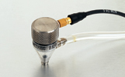
Figure 4-5 – Photo of a 5MHz contact transducer and bubbler probe

Excitation Pulse
Several different excitation pulses were used during this investigation, due to the different attributes being investigated. However, since a 10 MHz probe was generally used to send and receive the signals, 10 MHz was the most commonly used frequency. This was partly due to the transducer sending the signal, as by matching the frequencies a better signal was produced, but also because the 10 MHz signal was sensitive enough to the interfaces being investigated, whilst still giving visible responses.

Apparatus

Ultrasonic Equipment
The apparatus used during this investigation included a Picoscope digital oscilloscope (Picoscope 5423 B, two channels), which was used to both generate and receive ultrasonic signals. A Panametrics pulser and receiver (5052PR) was also used to amplify the sent and received signal, as well as to provide a high pass filter. An FMS was also used in order to generate and receive signals, as this could generate signals with a higher voltage amplitude, than the Picoscope. It also allowed for more in-depth control of the sent and received, signal.
A problem with the FMS used however is that it is bulky, expensive and fragile. Therefore, when scaling the experiment up to a larger, industrial roller the Picoscope and amplifier could still be viable, due to them being cheaper and more durable. The FMS is shown in Figure 4-6.
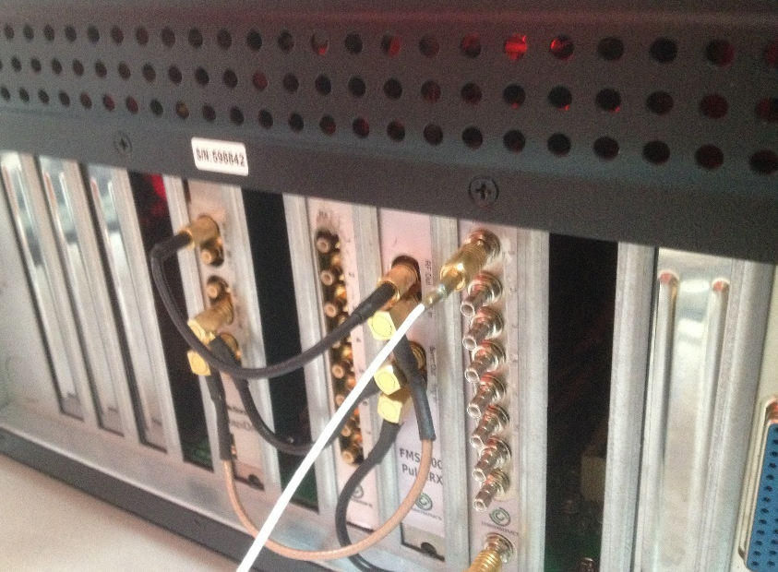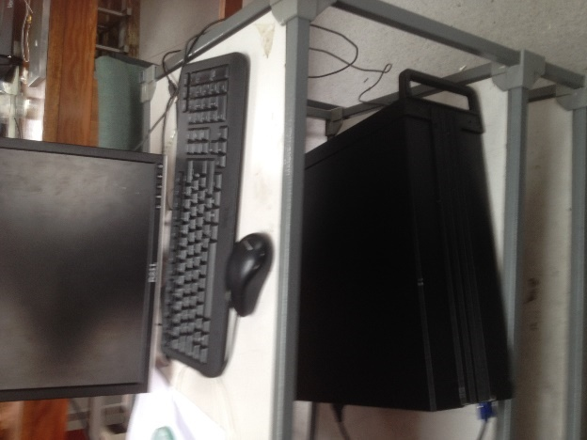
Figure 4-6 – FMS exciter computer unit

Metal Roller
The techniques were initially trialled on a pilot mill situated at The University of Sheffield. This was to provide a feasibility study of the techniques highlighted, in addition to testing the post processing techniques required, before scaling the techniques up for implementation on larger test mills.
The Sheffield pilot mill is a Hille 25, two-high cold rolling mill, with the rolling parameters shown in Table 4-1.

Table 4-1 – Hille 25 specifications
Roll Diameter | 111 mm
Load Capacity | 250 kN
Maximum Rolling Speed | 76 mm s⁻¹
Roll Gap | <10 mm
Strip Width | <80 mm

Figure 4-5 shows the Hille 25 rolling mill used.
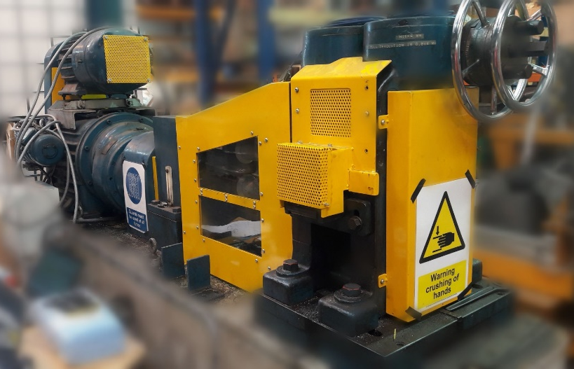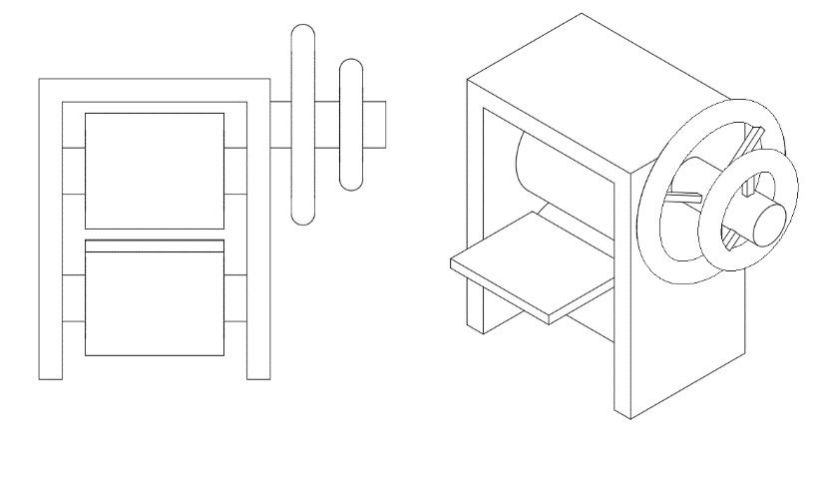
Figure 4-5 – Hille 25 Metal Rolling Mill and example sketch
The strips being rolled were lubricated before they were fed into the rolling mill. The lubricant used was Gerolub 5525 and was either applied to both sides of the metal strip with a brush, to help roll the strip, or to only one side to encourage more of the ultrasound to be reflected from the untreated boundary.
The rolling speed was kept low, under 80 mm s⁻¹, to provide more time for the sensors to send, and receive, the signal through the metal roller. This also helped the rolling mill to have a higher level of safety during operation and prevent possible damage to the equipment.

Component Layout
The basic layout used for ultrasonic testing is shown in Figure 4-6.
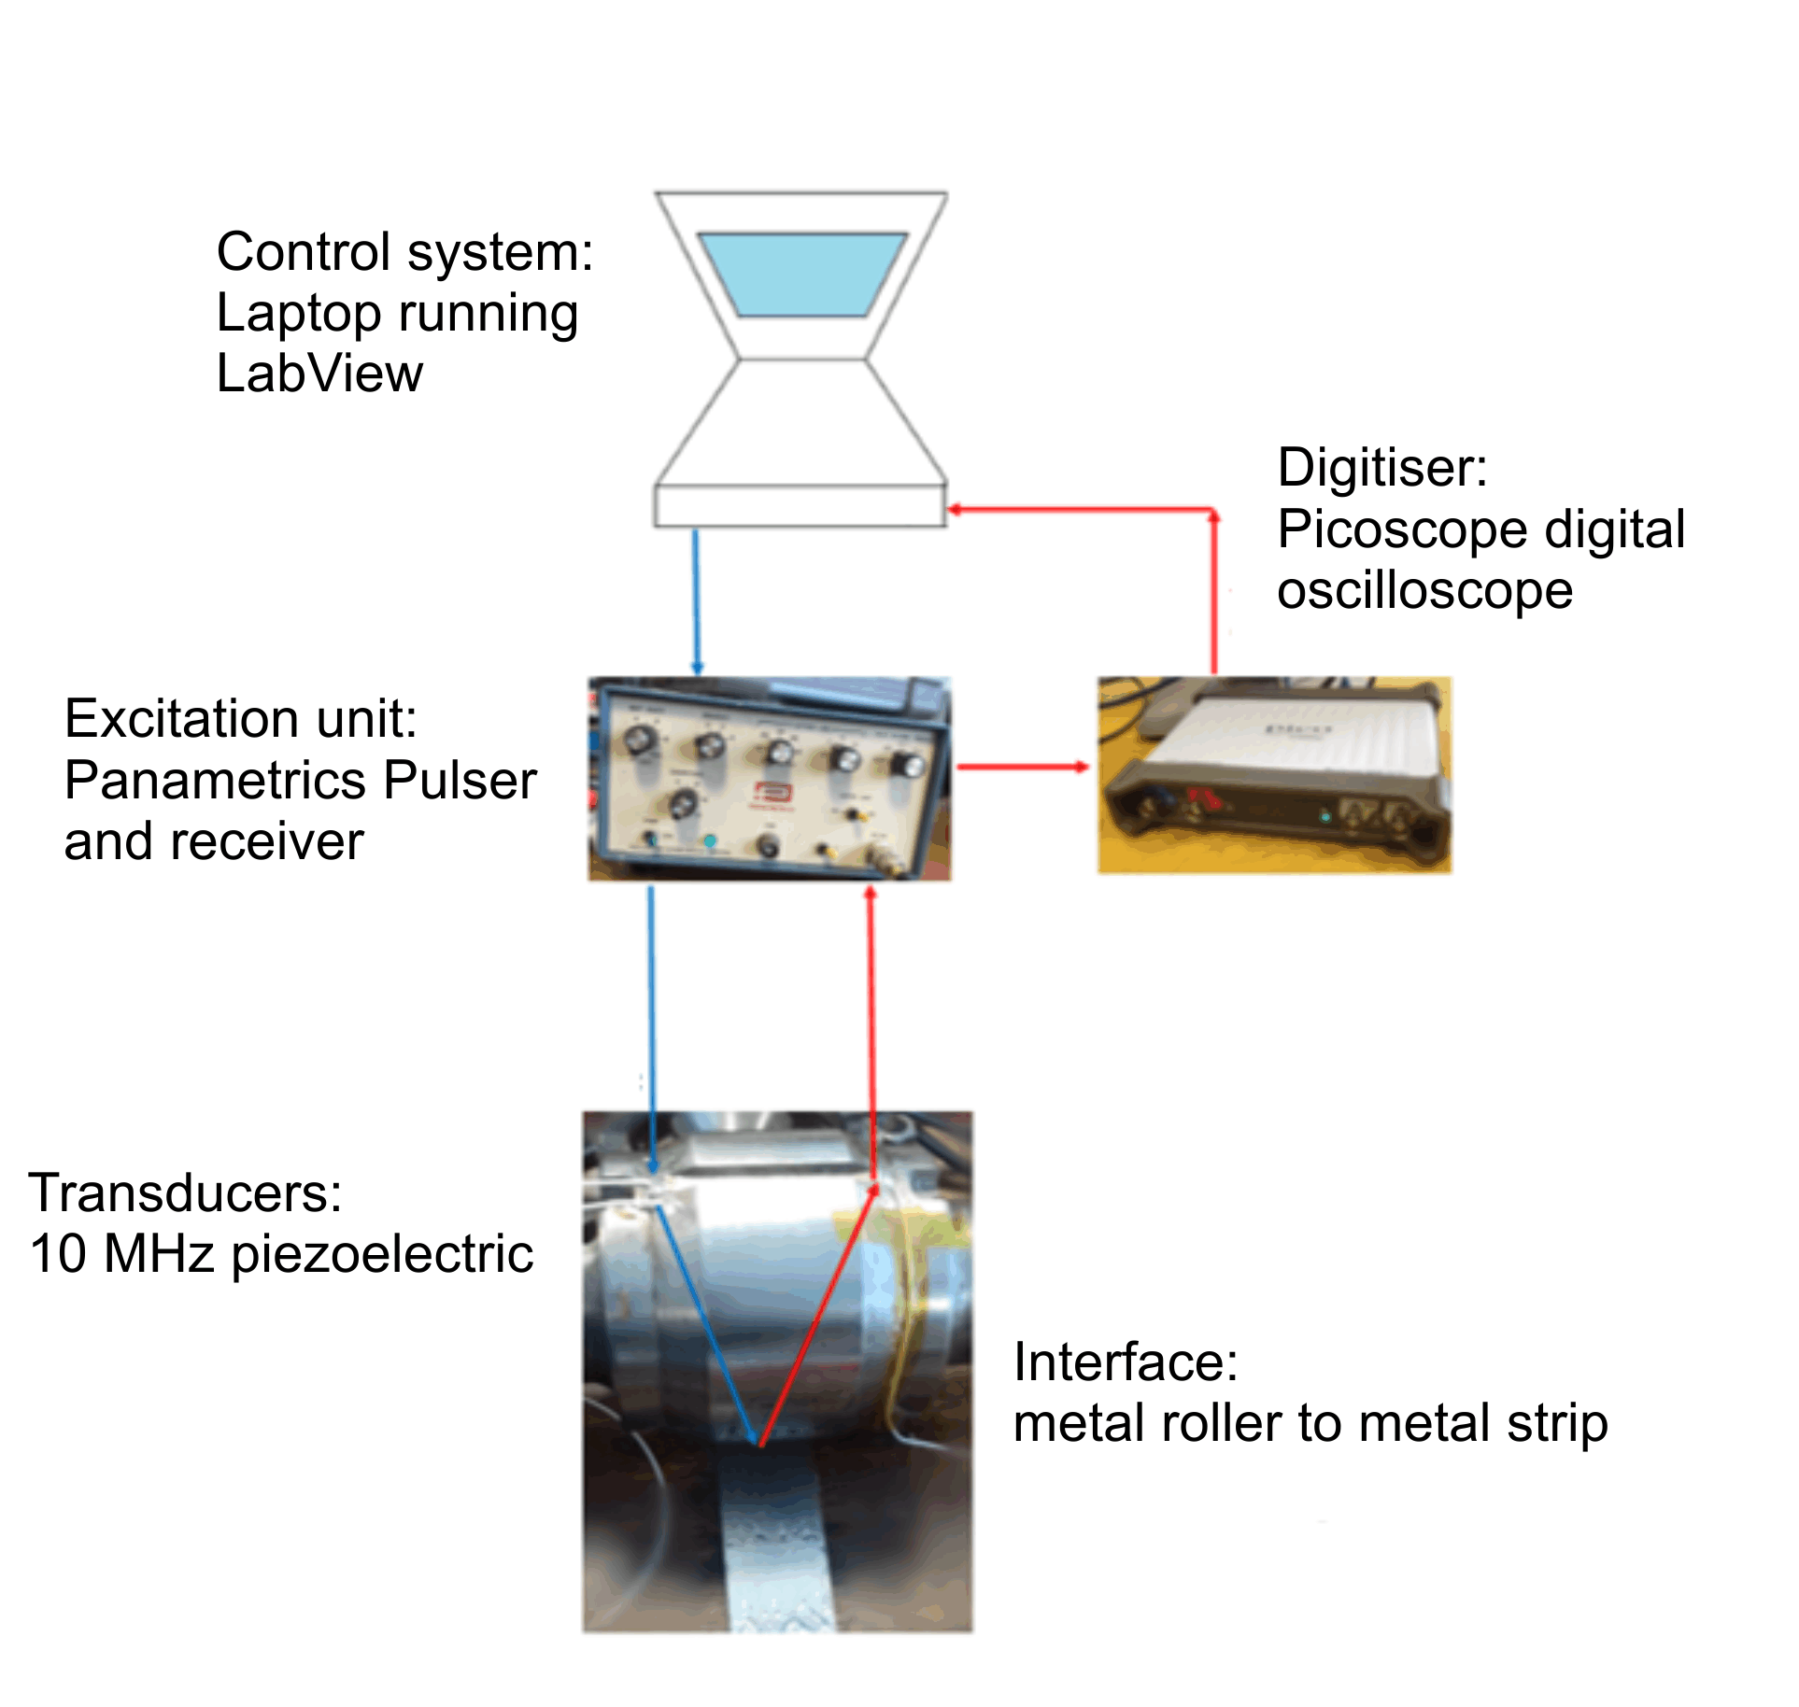
Figure 4-6 – Component layout
The system is controlled by a computer, either a laptop with the Picoscope and pulser and receiver, or the inbuilt computer with the FMS testing equipment. Labview was used to control the signals being produced by the equipment, as well as to process the return signals. The excitation unit created the pulse of ultrasound, which was sent to the transducers, before being sent through the material. After this the signal was reflected from the interfaces, and received either on the original transducer in the pulse echo configuration, or on a separate transducer for the pitch catch method. This signal was then passed through a digitiser, either the Picoscope, or the FMS, before finally being received back at the control unit where the signal was recorded. Filtering could take place both before sending and after receiving the signal, including during post processing.

Strip Thickness Calculation
The strip thickness can be calculated by using the Time of Flight (ToF) method. This method uses the speed of sound in the material being investigated, along with the time of flight between return pulses to calculate the distance between pulses, and therefore the strip thickness. This is shown in Equation 4-1 with an example given in Figure 4-7.
4-1
$$Distance=Speed of Sound ×Time of Flight$$


Figure 4-7 – Time of flight layout on a block
The transducer sends an ultrasonic pulse with a known speed of sound. The time between the initial signal being sent, and the pulse being received at the transducer gives the time of flight, so by using Equation 4-1, the distance can be calculated.
The speed of sound for different materials can either be taken from a data table, or by using the time between ultrasonic pulses on a measured, reference sample. The ultrasonic pulses could be read from the control equipment. When calculating the time of flight care was taken when the path the ultrasound was taking was determined. When using the pulse echo technique, the time of flight will need to be halved, due to the signal travelling out and back to the same transducer. When using the pitch catch method, depending on where the transducers are located, the time of flight will have to be adjusted to account for only the distance of interest. Further to this, the vertical component through the roller and strip must be calculated, using trigonometry to ensure the times being used are the times of relevance to the thicknesses of the item of interest.
In order to ensure the speed of sound being used for the material was correct, the thickness of the metal strips was measured using digital callipers. This measured distance could then be used with the time of flight gathered from the ultrasound response to validate the speed of sound being used for the material. Both techniques required a good ultrasonic response. Further to this, by measuring the metal strips being rolled with digital callipers a comparison could be made between the calculated and measured thickness. This would help with verification of the technique.

Signal Processing
Several different post processing techniques were used to analyse the rolling data. Both Labview and Matlab were used to investigate the rolling data, using a variety of different time of flight techniques.
Both single and timed captures were taken during rolling, with the timed captures taken during the water coupled ultrasonic testing being averaged with the surrounding captures to minimise the effects of noise, as described by Raftery et al, 2010.

Time of Flight Techniques
There are a variety of different techniques that can be used in order to process the received data from the ultrasonic system, in order to accurately determine the time of flight between the return responses and, therefore, the thickness of the metal strip. As previously mentioned, the time of flight method requires a highly accurate speed of sound in the material. This can be calculated by using the distance the beam is travelling through the material and dividing this by the time take to receive the response.
To ensure the time of flight method is providing an accurate speed of sound, a consistent point on the returned pulse is required. This is because if the pulses are affected by noise, or changes due to phase, this can lead to different thickness being calculated, which greatly reduces the accuracy of the system.
There are several different, commonly used methods to determine the time of flight method. These include the peak detect method, the threshold method and the zero-crossing method (Zloter, 2001).

Peak Detect / Threshold
The simplest method of determining the time of flight of a reflection is to take the time of the reflection, when it reaches the highest point of the peak. The time of flight can then be calculated between the peaks of the responses of interest. An example of this is shown in Figure 4-8 where the first peak for each response of interest has been highlighted in red. The time of flight when then be the time between these two peaks.
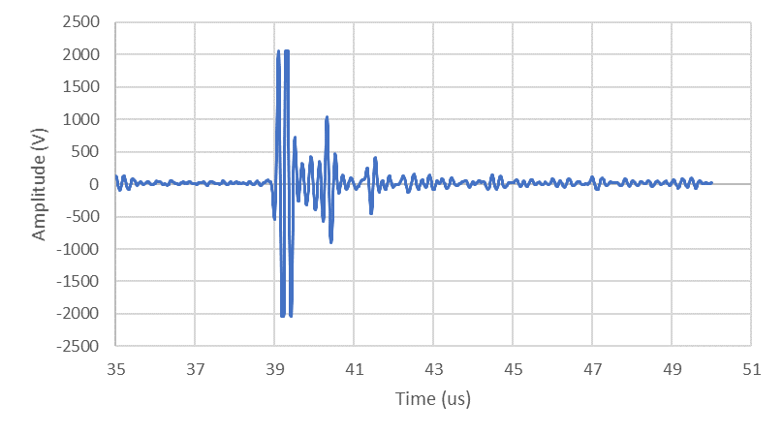
Figure 4-7 – Peak detect example
This method is dependent on there being a clear peak value for each response, as changes in phase, or response can lead to errors in reading the time of flight. Further to this if there are several cycles on the response, the same cycle peak must be taken each time, to limit the introduction of errors. Therefore, this method is also limited by the signal to noise ratio as if the cycles are obscured by noise, errors in reading the required values, from the signal response, will follow. In industrial applications the shape of the reflected pulses can cause other peaks, that have a similar amplitude, to be close to the maximum peak. Therefore, if noise in the system causes a small change in position of the maximum peak, errors can be introduced into the system.
Another limiting factor of the peak detection method is that, if no interpolation is performed between values, the resolution of the peak is the same as the sampling rate. If interpolation is used, the resolution of the peak can be improved by using a peak fitting algorithm. This algorithm is still vulnerable to noise in the response however, whilst also increasing the amount of computing power required to process the signal. This technique is relatively simple to implement in the post processing software, however, to implement this technique in the hardware, for real-time applications, is more complex.
The threshold method is similar to the peak detection method, but instead of taking the time at the peak value, an amplitude value is nominated and when the signal crosses this threshold value, the time is taken. This is then used to calculate the time of flight between the responses. This technique is preferred in certain applications due to the ease of which it can implemented in hardware. Since further reflections experience a drop in amplitude by a fixed value, the time for the pulse would be captured at a different point each time. To remove this problem, a couple of techniques can be used. The first is to use a non-linear amplifier to amplify the signal. By using this type of amplifier, the lower values of the signal would be amplified to a greater extent than other values. This distortion of the signal reduces the offset in the threshold point value, although it does not remove this offset completely.
The second technique that can be used is to scale the threshold amplitude, to the pulse amplitude. Provided only the pulse amplitude and not the pulse shape changes, this should remove the offset method, however errors introduced via phase change will always cause errors in the system (Hunter, 2018).

Zero Crossing
The zero crossing technique is similar to the threshold technique, which focusses on the points in the response where it crosses the X-axis. This technique has advantages over the threshold method as since the zero crossing method focusses on when the signal crosses the X-axis, the amplitude does not have any influence on the technique. Further to this, since the interpolated curve is steepest when crossing the X-axis if can be approximated to a straight line. This allows linear interpolation to be used to potentially increase the signal resolution. Phase changes can still affect this technique, however, and it can be implemented in hardware similar to the threshold method. An example of this is shown in Figure 4-8.
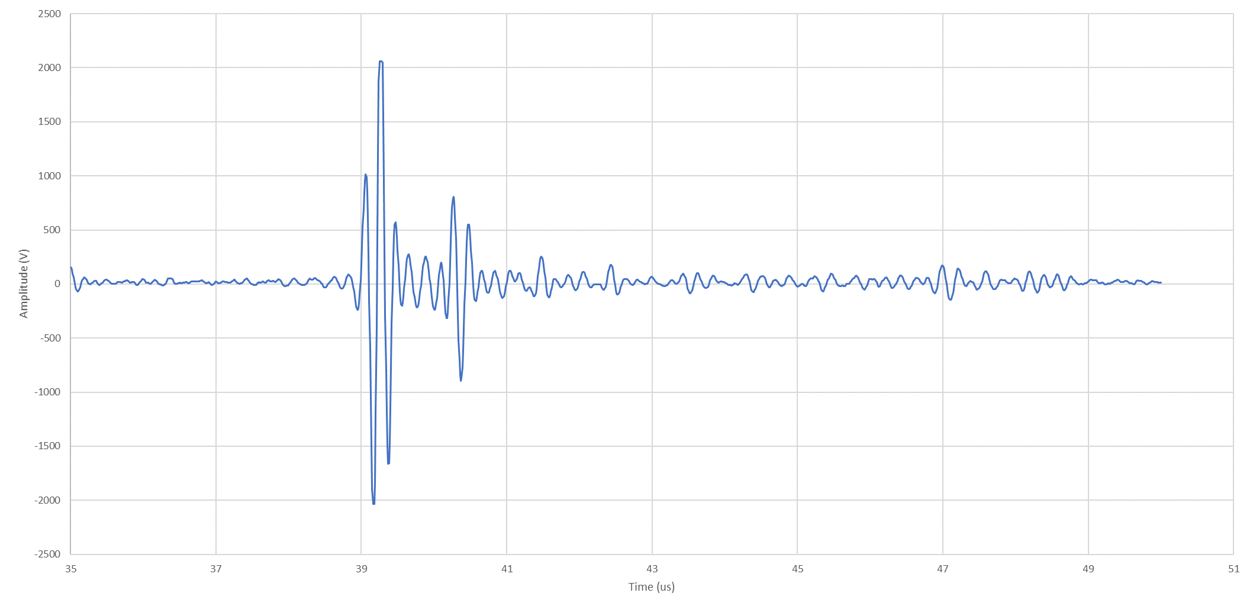
Figure 4-8 – Zero crossing example
The first time the response crosses the horizontal axis, after a response of interest is registered, is used, with the time between these two points being compared to get the time of flight.

Hilbert Threshold
The previous techniques have all focussed on taking a point on the waveform and using the time value for that point. Because of this all the previous techniques are vulnerable to changes in pulse shape, or phase. Therefore, removing this vulnerability is desirable. To do this the analytic signal is taken, which involves having a representation of the signal amplitude for both the real and imaginary part of the received signal. To do this a Hilbert transform is first used to get the imaginary component from the received signal, which is then used to get the analytic signal by using Equation 4-2.
4-2
$$S_{A}=\sqrt{S_{R}^{2}+S_{I}^{2}}$$
Where $S_{R}$ is the real signal component, $S_{I}$ is the imaginary signal component and $S_{A}$ is the analytic signal.
After gaining the analytic signal, the peak and threshold techniques can be evaluated to gain the time of flight. Unlike when previously applied however, the analytic signal prevents these methods from being susceptible to phase changes. In return however, the computation cost is significantly increased due to the added functions, and this can cause this method to be unsuitable for high speed measurements in real time, instead of being used during post processing of a data set. This method also assumes that only one signal is present in each data window, which could lead to further errors depending on the signals being investigated.

Resonant Dip
The resonant dip method can be used to investigate small layers of lubrication or material, typically between 30 to 900 µm (Hunter, 2018). This technique works by forcing the layer to resonate at a frequency which is dependent on the layer’s thickness, with a dip in the frequency spectrum being observed when the reflected wave is vibrating at resonance. The thickness of the layer can therefore be measured by obtaining this resonant frequency and converting it back into the time domain.

Cross-correlation
The cross-correlation method of time of flight evaluation works by comparing the transmitted and received signals, with the time at which the correlation reaches the maximum value giving the estimation of the time of flight. Because of this, the cross-correlation method works better in low signal to noise ratios, than the threshold technique and further to this is less affected by low sampling rate (Queiros et al, 2010). The cross-correlation method also uses all the information collected in a signal, leading to it being an advantageous ultrasonic technique.
The cross-correlation method is useful as it treats the response as a whole entity, rather than a singular point. A limitation however is that since this method is a more complex one, it will require greater processing power in the system. This could lead to longer processing times, or more expensive equipment being required.

Discussion
Several different coupling techniques can be used to couple the ultrasound to the metal strip. There are also several different techniques that can be used to process the ultrasound signal after receiving it for the purpose of real time control of the rolling process. These form the basis of the investigation reported in this thesis.
These techniques would need to be trialled both in lab and industrial environments, to check for their feasibility. Due to the difficulties present in installing and using sensors in both environments. They systems need to be trialled in a lab environment, to first check if the techniques can be used to get a signal through a, smaller, metal roller, but care must be taken to the rolling conditions present in industrial rolling strands. This is because, even if a technique works in a more controlled, lab environment, it might not be applicable during industrial conditions. This could be due to signal strength, or other technical limitations, or it could be due to logistical problems. Such as requiring changes to the roller geometry, which will create issues when the rollers are re ground or moved to a different strands, or the positioning could be an issue when the rollers are swapped over. Another problem is getting the signal into and out of the strands. It the transducers are bonded on, then the issue is that the transducers are constantly moving during the rolling process. Requiring a slip ring, or another method of ensuring a good connection between the control system and the transducers. Provided this is sorted however, the connection between the transducers and the metal roller will be consistent. Conversely, with water coupled ultrasound, the reverse is true. Connection to the transducers is easier, and more consistent, as the transducer is mounted away from the roller. However, ensuring a good, consistent connection between the transducers and the roller is more difficult.
In both cases, issues with damage to the sensors or system can be a problem. This is due to the messy, chaotic environment this system needs to work within.

Conclusion
Several different techniques can be coupled with the rollers, and provide the information required. However, the feasibility of these techniques is dependent on both lab testing, as well as scaled up industrial testing, to ensure that the transducers can be installed in the right place, without interrupting production, whilst still being able to provide the information required.

Oblique Ultrasound
The oblique ultrasound method was the first technique to be trialled, as the Leonardo group had performed work in this area already (Adeyemi, G, 2018). In this chapter the method of use of oblique ultrasound in pitch catch mode using transducers mounted directly onto two roller chamfered side-arms is reported. The purpose of this Chapter was to further investigate the potential of the oblique ultrasound technique, looking at strip thickness, reflection coefficient, roll contact length and beam spread.

5.1 Introduction
The oblique ultrasound method can be used in order to investigate the strip thickness of the metal strip whilst it is being rolled. An advantage of this technique is that since the transducers being used are bonded on, they are able to use both shear and longitudinal waves. This would allow for the interface to be investigated more thoroughly, as shear waves are not supported by liquids, by analysing the response from both shear and longitudinal waves the amount of lubrication in the contact region can be investigated (Hunter, 2018).
Since the transducers are bonded onto the roller itself, there will always be a consistent connection to the roller. This allows for a good quality connection, however the getting the signal in and out of the system presents a challenging problem. In this case the roller shaft was hollowed out, to create a safe area to place the wires. This is unlikely to be practicable however, as industrial rollers are large and getting the shafts machined as desired would be difficult and expensive. Furthermore, this method requires a slip ring to be used to ensure the wires and data can be safely removed from the roll gap. Getting a slip ring set up on an industrial roller would also be challenging as the rollers are much larger.
A further limitation with using a slip ring is that the rollers have to be removed for regrinding. During this process the slip ring would get in the way and this would add extra complication to the systems already present in a rolling mill. In addition to this, the rollers require chamfered edges, ground to the correct angle. Therefore, when the rollers are removed to be reground, these angles will be changed. This will either require a shoe or the ability to adjust the transducer between grindings, or the chamfers will have to be reground each time to match the newly ground roller. Because of this it would be useful to understand how the ultrasonic beam spreads out and interacts at the interface to ensure the best response is gained each time. It may be that these practical limitations to the use of Oblique Ultrasound could be overcome if the signal provided by the technique was sufficient to justify the effort needed to overcome the practical problems. This is the subject of the investigation in this chapter.

5.2 Method
To investigate oblique ultrasound, first the edges of the metal roller being used were chamfered to the desired angle. Trigonometry was used, with the metal rollers dimensions, in order to calculate the angle of the chamfers, needed to send the ultrasonic beam to interact at the centre of the roller / strip interface.
This was calculated to be 20º (rounded up) and this can be seen in Figure 5-1.
$$β=\tan^{-1}\left(\frac{35}{105}\right)$$

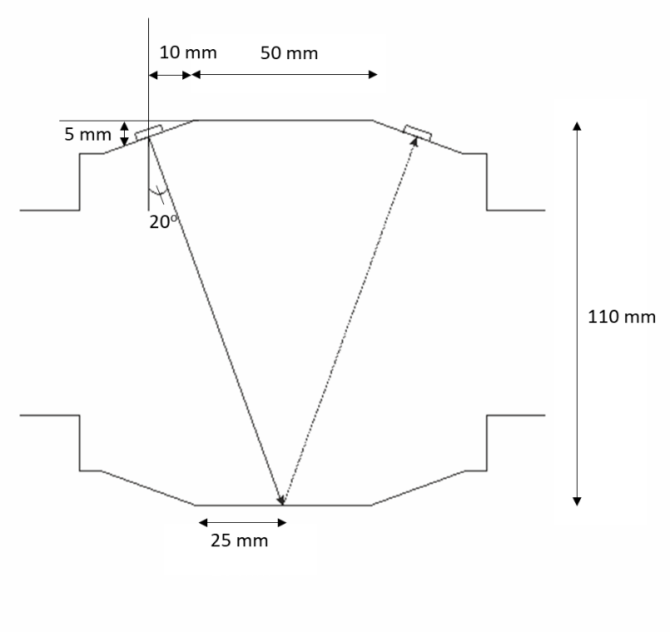
Figure 5-1 – Oblique angle calculated from geometry
Chamfers were made on the edges of the rolling surface, with these being large enough to be able to bond a piezo-electric transducer disc onto. Two 10 MHz piezo element discs were then bonded onto the chamfered edges of the metal roller and used to both send, and receive, the ultrasonic signal through the metal roller and strip. This set up can be seen in Figure 5-2.
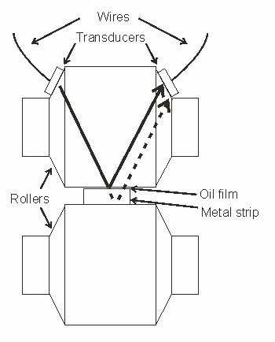
Figure 5-2 – Rollers shown above and below metal strip, with transducers bonded to the top roller
Figure 5-2. shows the location of the two transducers on the top chamfered metal roller However, they could have been positioned on the bottom roller as an alternative. Through transmission could also be potentially used, however in this case the reflected signal is being received on the same roller. In all cases the transducers must be aligned with each other in order to send, and receive, the signal without suffering from excessive loss of signal. This will be discussed in more detail later.
To wire the transducers on the chamfered edges, the shaft of the metal roller was hollowed out to allow for the wires to pass through, connecting the transducers to the pulser and receiver through a slip ring. This can be seen in Figure 5-3.

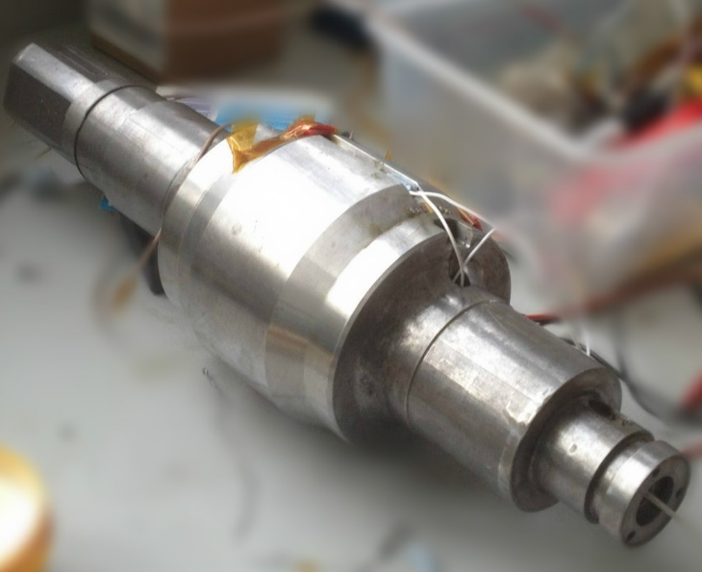
Figure 5-3 – Hollowed out Hille 25 top metal roller
The hollowed-out shaft can be seen, along with the white wires connecting to the transducers bonded onto the metal roller.
By putting the wires through the metal shaft, before bonding them onto the transducers, the wires were able to turn alongside the transducers as the rolling process was carried out. This is shown in Figure 5-4.
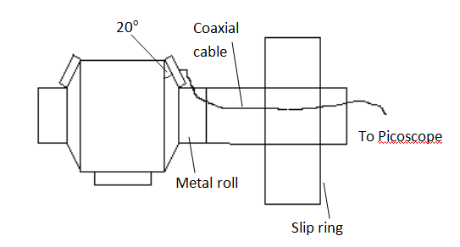
Figure 5-4 – Diagram of the modified metal roller
Since the transducers are turning with the metal roller, they will not always be in line of sight the strip. Because of this the length of time the transducers are in contact with both the roller and the strip can be calculated by observing when the signal strength from the far side of the metal roller drops. Further to this, since the roller and transducers are turning and coming into contact with the metal strip, the roll bite can be observed throughout the rolling process. Because of this the change in thickness from the strip's initial entry, through to the exit thickness can be seen. This can then be compared to other data, or previously conducted work.

5.3 Test Plan
The ultimate aim of all of the reported work was to investigate the Oblique Ultrasound technique as a method for determining the strip thickness during metal rolling. Most of the experimental work performed focused on this. However, the success of determining strip thickness this way is dependent on an understanding, and quantification, of the constituent aspects used in this process. These aspects include: reflection coefficient; roll contact length; roll bite time; beam location; transducer location; beam spread and ultrasound dispersion. Hence, experiments were also performed to elucidate the above aspects, with the intention of both checking the consistency of the results and to determine if the Oblique Ultrasound process could be enhanced by a suitable selection of conditions of one, or more, of the constituent aspects mentioned above.

5.4 Results

5.4.1 Strip Thickness
The strip thickness during the rolling process was the main objective, so initially the experiments were focussed towards finding the return pulse from the strip and the roller, before using these pulses to calculate the strip thickness. This was then compared back to the strip thickness measured using a pair of digital callipers. Initially the sample being used was measured to have an initial thickness of 3.38 mm and a final thickness of 2.60 mm. A typical capture taken mid-way through this rolling process can be seen in Figure 5-5.
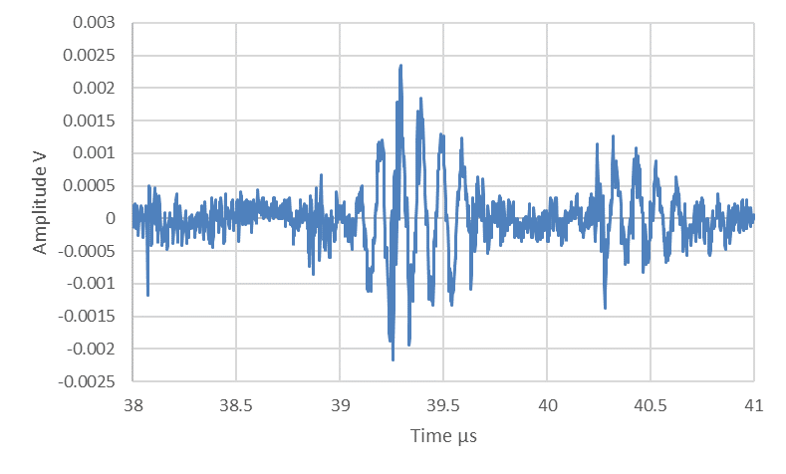
Strip Far Side
Roller Far Side
Figure 5-5 A-scan response from the metal roller and strip
The initial pulse from the far side of the metal roller can be seen highlighted in red, a five pulse input was used hence there are five main peaks between 39.198 and 39.590 microseconds. The return pulse, from the far side of the metal strip highlighted in green, shows five main peaks between 40.245 and 40.627 microseconds. From all these pulses the average time difference was 1.038 microseconds. Therefore, this is the time of flight for the pulse back and forth, through the metal strip.
This time however is the time of flight for the oblique travel, therefore, to get the strip thickness the vertical component of this time must be calculated. The first step to calculate this vertical time is to divide the original time of flight in half, since this is the time taken to travel through to the far side of the strip interface and back to the near side of the strip. This gives a time value of 0.519 microseconds. Then by using the angles calculated for the beam, the vertical time can be found using Equation 5-1. below.
5-1
$$T=0.519 \sin{70}$$

This gives a time of 0.488 microseconds. This is then used with the speed of sound in the material to get the vertical distance travelled in the metal strip. Since the material used for the strip was mild steel, the speed of sound is 5920 m s⁻¹ (Class instrumentation Ltd. Accessed July 2019). When used with the time of 0.488 microseconds the thickness can be calculated using Equation 5-2 below.
5-2
$$t=0.488×{10}^{-6}×5920$$
This gives a thickness value of $2.88×{10}^{-3}$m or 2.88 mm. The availability of multiple peaks enables a statistical analysis of the results, as given in Table 5-1.
Table 5-1 Analysis of peaks shown in Figure 5-5
Reflection  roller base  (µs) | Reflection  strip base  (µs) | Difference  (µs) | Time for travel  just one way  (µs) | Vertical time  equivalent  (µs) | Strip  thickness  (mm)
39.198 | 40.245 | 1.047 | 0.524 | 0.492 | 2.913
39.293 | 40.322 | 1.030 | 0.515 | 0.484 | 2.864
39.396 | 40.439 | 1.042 | 0.521 | 0.490 | 2.899
39.496 | 40.530 | 1.034 | 0.517 | 0.486 | 2.877
39.590 | 40.627 | 1.037 | 0.519 | 0.487 | 2.885
Statistics:
Mean average |  | 1.038 | 0.519 | 0.488 | 2.888 mm
Standard deviation |  | 0.007 | 0.003 | 0.003 | 0.019 mm
Coefficient of Variation |  | 0.66% | 0.66% | 0.66% | 0.66%
At 95% confidence level:
Lower bound value |  | 1.024 | 0.512 | 0.481 | 2.850 mm
Upper bound value |  | 1.052 | 0.526 | 0.494 | 2.925 mm

From the data presented in Table 5-1, we have 95% confidence that the strip thickness is between 2850 to 2925 µm, around an average value of 2888 µm. Note that any error in the speed of sound used in the calculation would be a systematic error and would not, therefore, change the expected variation around the mean strip thickness value. This is a tolerance of plus or minus 38 µm, at the 95% confidence level, which is within the stated required specification of plus or minus 50 µm range.

Strip Thickness Through the Rolling Process
The accuracy of this method was checked by comparing the start and end thicknesses to the calliper measured thickness values of the metal strip. In addition to this the accuracy was checked throughout the rolling process by analysing the measured strip thicknesses throughout rolling. This was aligned with one of the objectives of the project of measuring the strip thickness throughout the rolling process.
The thickness throughout the rolling process was calculated and this is shown in Figure 5-6.
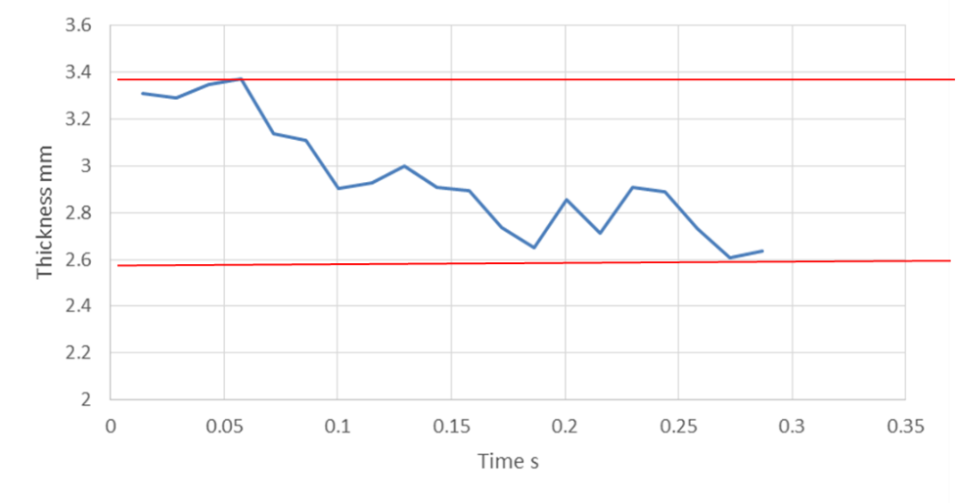
Final Measured Thickness – 2.60 mm
Initial Measured Thickness – 3.38 mm
Figure 5-6 – Calculated metal thickness during the rolling process
The two red lines show the initial and final calliper measured thicknesses, stated previously to be 3.38 mm and 2.60 mm respectively, using digital callipers with a precision of 10 µm. A clear trend of decreasing strip thickness can be observed, however there are apparent fluctuations in the thickness measurements and the final thickness reading is slightly higher than the final manually measured thickness, even allowing for the expected 38 um plus/minus variation between readings suggested from Table 5-1. A further anomalous looking result is at approximately 0.05 s. The thickness appears to go up before going sharply down. This can also be observed between 0.15 s and 0.25 s, where the thickness decreases sharply before increasing slightly to decrease again to the final values.
This could be due to the strip being rolled no longer being uniform, although this would not explain the apparent increase in thickness. The lack of uniformity could be due to inconsistent loading conditions on the strip, along with repeated rolling of the strip. Post rolling measurements with digital callipers along the strip did find that the strip thickness varied by approximately 0.3 mm along the strip, from the largest measured thickness to the thinnest. There could also be some form of signal interference as the strip enters the roll bite region, and exits the roll bite region, as detailed by Hunter, 2018.
Further tests were conducted, running the same strip through the metal roller twice and using ultrasound to observe it both times. This can be seen in Figure 5-7.
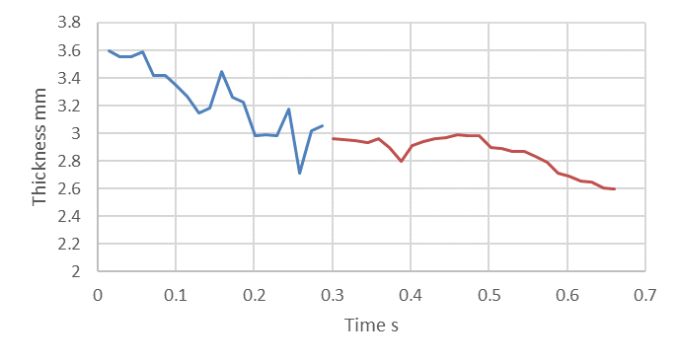
Figure 5-7. – Calculated strip thickness during two passes
The initial pass is shown by the blue line, with the second pass being shown in red. As can be seen, there was an apparent increase in thickness at around 0.15 seconds, with a couple of large drops in strip thickness at around 0.25 s, during the first pass and 0.37 s, during the second pass. Due to the same strip being rolled twice, the difference in times for these large drops could be either due to the strip not being uniform, or due to the strip being passed through the rolling mill the opposite way the second time. The thickness at the end of the first pass, does match up reasonably well to the beginning of the second pass, with the difference between them being 0.1 mm. Since the strip was rolled twice it is useful to observe these values as it allows for the thickness to be monitored over a longer time.
The proposed ultrasonic signals needed to be able to pass through an industrial sized roller. Therefore, a simple validation experiment was carried out, under optimal conditions, or a larger metal roller. The results from this experiment can be seen in Appendix I.

5.4.2 Reflection Coefficient
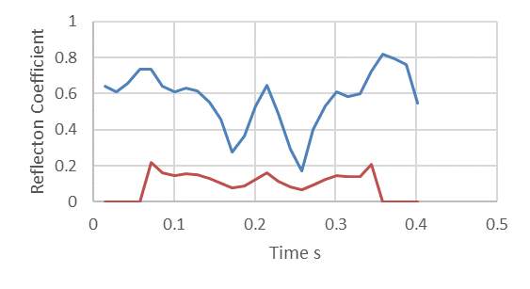
The reflection coefficient calculated using the method outlined in Chapter 3.2, for the far side of the roller and metal strip can be seen in Figure 5-8.
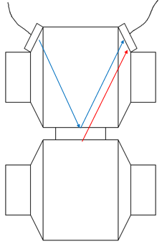
Figure 5-8 – Signal reflection from the top of the strip (blue line) and the bottom of the strip (red line), as the sensor passes over the strip

The first reflection coefficient is the reflection between the first metal roller and the metal strip with a thin oil film on top, shown in blue. The red line shows the reflection coefficient from the strip to the second roller contact on the far side of the roller. Literature gives the reflection coefficient for steel to oil as 0.95, with the reflection coefficient for steel to steel being zero. Thus, it can be seen that for the metal strip to roller contact, the red line, is close to zero. The reason this is not exactly zero is likely due to rolling lubricant that has dripped down onto the second side of the strip, as well as oil that has dripped down from previous testing runs. Consistent steel on steel contact is also unlikely due to the non-uniform flatness of the strip.
The first reflection coefficient between the far side of the roller and the near side of the strip has a greater range of values. This could be due to inconsistent levels of lubrication on the metal strip, as well as the varying strip flatness. However, the first coefficient value is always far greater than the measured second coefficient value.
The reflection coefficient is important because it can provide information on the lubrication conditions at the roll bite. This information can then be used to control the level of lubrication in the system and ensure the roller is running under optimal conditions. In addition to monitoring the lubrication conditions of the system, the reflection coefficient can also be used to calculate the interface stiffness and load. The reflection coefficient can be calculated using Equation 3-2, see Chapter 3.

5.4.3 Roll Contact Length
When the strip first encounters the roll, the signal jumps slightly and the sensor contact time with the strip can be calculated due to the amplitude for the far side of the roller dropping whilst the strip is in contact. This is because less of the signal is reflected, due to more being transferred through the metal. The amplitude of the roller to strip interface can be seen in Figure 5-9.

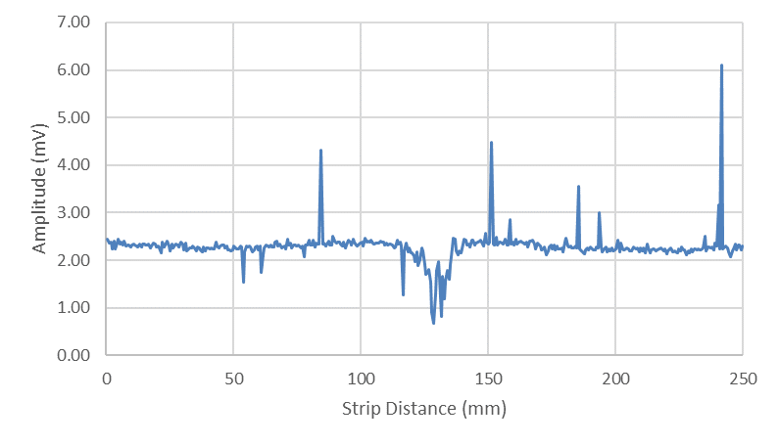
Transducer aligned with strip
Figure 5-9 – Amplitude from the roller far side reflection throughout the rolling process
This was found by taking the average value for the peak, due to the pulse moving slightly during the rolling process, which affected the response received. Because of this, the pulse was monitored throughout the capture so that the time values at which the peak response, from the far side of the roller, appeared at could all be averaged. By taking this average the effect of phase shift on determining the peak values was mitigated.
A median filter has been used to smooth the signal, however a few bursts of noise can still be seen. These bursts of noise are likely to be electrical noise, that the median filter has not been able to reduce, and further work could focus on removing these. A sharp drop in amplitude can be observed after approximately 125 mm of strip has passed through the roller, with the end value of this dip being taken as 140 mm. This gave a contact length of 15 mm per revolution of the bonded-on transducers.
Other contact lengths from subsequent rolling passes are shown in Table 5-2.

Table 5-2 Table of contact lengths from various tests

Test No | Contact length (mm)
1 | 13.3
2 | 16.3
3 | 12.5
4 | 12.5
5 | 11.3

The average contact length, neglecting the outlier, is therefore 12.5 mm. This method still needs refining as the results do have a wide spread, though the 16.3 mm result appeared to be an outlier. This method did however rely on taking a point on either side of the dip and therefore this left room for error in the contact time as the points to be used relied on the number of captures, along with how frequently the captures were taken.

5.4.4 Roll Bite Time
This technique, whilst having some advantages, also has several limitations. The first major limitation is that the ultrasound is a beam and not a point. This means that the beam will register the roll bite as starting slightly earlier and finish slightly later then the roll bite does. This is due to the way the beam spreads out as it passes through the material, leading to an overestimation of the roll bite time. Due to the accuracy required, this overestimation may be unacceptable. It can be seen however that this method works for finding the roll bite time and contact length, along with the strip thickness. Future work should focus on improving the accuracy of this method.

5.4.5 Beam Location
Previously the need to know where the ultrasonic beam was, along with how it interacted at the roller strip interface, was highlighted as important. To investigate this, the roller was taken out of the rolling mill and transducers were used on the chamfers, as well as the far side of the roller, to investigate where the beam was strongest. Further to this the transducers were rotated around the chamfered edges, to investigate if the two bonded-on transducers needed to be mounted directly across from each other, or if spacing them out would allow for a better response to be recorded. This is displayed in Figure 5-10.
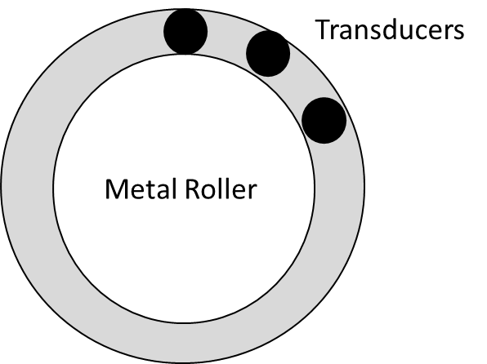
Figure 5-10 – Signal receiving transducer positioning alternatives tested
Figure 5-10 shows two basic views of the metal roller. One from the side where the transducers are lined up to send a signal through the metal roller and catch the signal on the other side of the roller, as used previously. The other diagram shows the two alternative positions at 45º and 90º offset to the original receiving transducer.
This is of interest as ultrasound energy is emitted, with a spherical wave from, in all directions equally, from the point of origin. The more nodes that are emitting ultrasonic energy, the more the ultrasonic wave front tends towards a flat line, of equal length to the emitting sensor (Brunskill, H, 2013). This is of interest however as since the ultrasound energy does not just propagate through the material to the point of interest, but spreads throughout the test piece, with further spherical waveforms being generated from this scattered energy, this can affect the response received. For example, the reflections can cause constructive and destructive interference, which can affect where the most sensitive part of the test piece is.

5.4.6 Transducer Location
To investigate the effect of moving the transducers around the metal roller a 5 MHz contact transducer was mounted on the chamfered edge and remained in place, whilst a second 2.25 MHz transducer was moved around the circumference of the chamfered edge on the opposite side of the roller. The angles investigated were directly opposite, 45º offset and 90º offset.
The response when the two transducers were directly opposite each other can be seen in Figure 5-11.
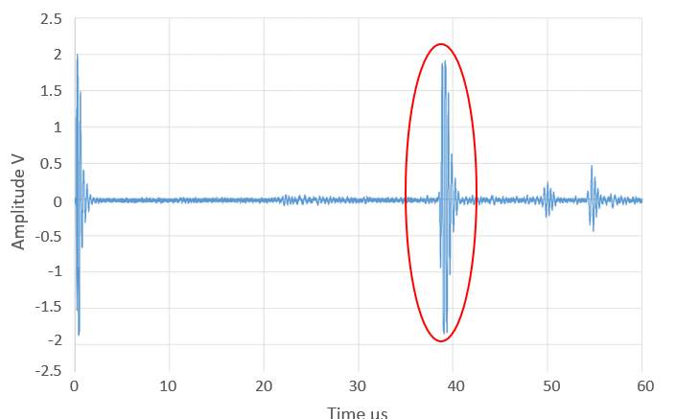
Internal reflection pulses
Return pulse of interest from far side of the roller
Figure 5-11 – Response when the two transducers were aligned

At approximately 39 µs a large return pulse can be observed, highlighted in red. This return pulse is the response from the far side of the roller, as previously shown from the rolling tests.
The response from the roller when the second, 2.25 MHz transducer was at a 45º offset is shown in Figure 5-12.
Internal reflection pulses
Return pulse of interest from far side of the roller
Figure 5-12. – Response when the two transducers were offset by 45º
The return pulse can still be observed at approximated 38 µs highlighted in red. However, the signal strength has decreased. Further to this, another reflection can be seen at approximately 30 µs. This is likely to be an internal reflection from inside the roller.
Finally, the response when the 2.25 MHz transducer was offset by 90º can be seen in Figure 5-13.
Internal reflection pulses
Return pulse of interest from far side of the roller
Figure 5-13 – Response when the two transducers were offset by 90º
The return pulse from the far side of the roller can now be seen at approximately 36 µs, again highlighted in red. In addition to this, other reflections can still be observed, and these are likely to be internal reflections from the roller. However, the difference in signal strength between the return pulse from the far side of the metal roller and the other reflection is no longer distinct, creating confusion in analysing the signal.

5.4.7 Beam Spread
How the ultrasonic beam spread out through the metal roller and strip was previously mentioned to be of interest. This was because the chamfers had been designed to direct the beam to the centre of the far side of the metal roller and confirmation of this was desired.
This was investigated in two different ways. Firstly, a bonded on 10 MHz piezo disc transducer was used in order to send the ultrasonic signal through the metal roller from the chamfered edge. This was then received by a 5 MHz contact probe on the far side of the roller at different lengths along the roller edge. This can be seen in Figure 5-14.
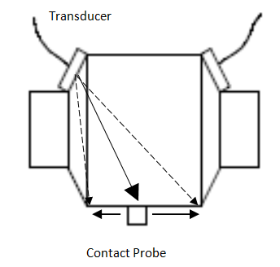
Figure 5-14. – Layout of the first beam location experiment
The ultrasonic response, from the 5 MHz transducer, from the far side of the roller can be seen in Figure 5-15.
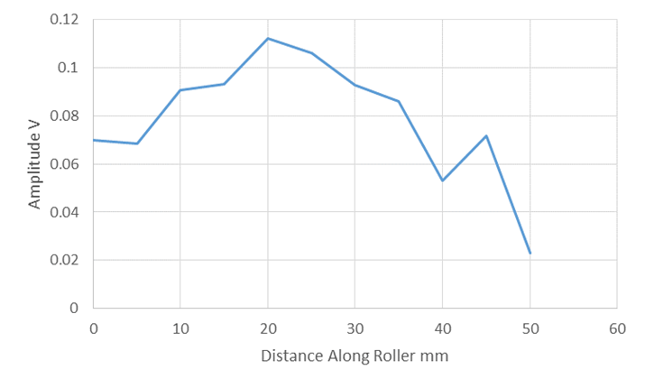
Figure 5-15. – 5 MHz contact transducer response from the first beam location experiment
As can be seen, as the contact probe is moved along the far side of the roller, the energy received increased to a peak at 20 mm. The energy then decreases again past this point, however a second peak can be observed at 45 mm. The far side of the metal roller being investigated had a length of 50 mm, so the energy peaks slightly before the centre of the metal roller. This could be due to overlapping lobes of ultrasound energy and will be discussed later.
After this another bonded-on transducer, mounted on the opposite chamfer, was used to receive the signal, but a contact was moved along the far side of the roller, to provide material for the signal to transfer into. This can be seen in Figure 5-16.
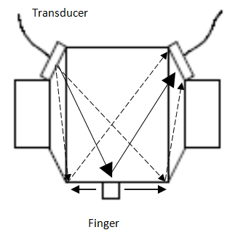
Figure 5-16 – Layout of the beam location experiment
The response captured can be seen in Figure 5-17.

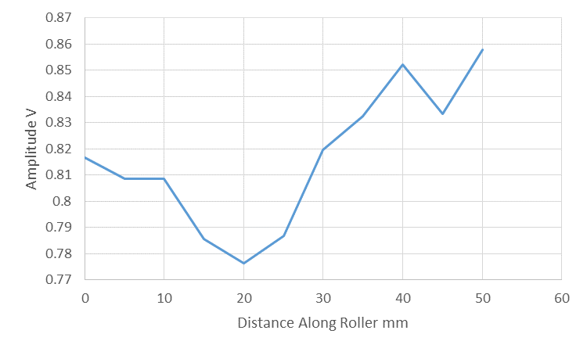
Figure 5-17 – Response from the second beam location experiment
The amplitude drops the most at 20 mm, corresponding to the previous results which showed the peak amplitude occurring at 20 mm. Further to this a second smaller drop can be observed at 45 mm, corresponding with the previous results, shown in Figure 5-15. The dips in the second response would be expected to occur in the same places as the peaks in the first set of responses as if the signal is strongest in that area, the biggest transfer of energy and therefore change in response, would also be expected to occur there.
Because of this for the chamfered angles in this scenario, the best response is from slightly before the centre of the metal roller.

5.4.8 Ultrasound Dispersion
As the ultrasonic signal travels through the material, side lobes are generated. These side lobes reflect off the sides of the test piece and can cause extra response on the A-scan. In this case they could also be the reason for the signals having a second pea, as shown in Figures 5-15 and 5-17. These side lobes are also likely causing the extra, smaller reflections in the response. The side lobes will also be reflecting off the sides of the metal roller, creating interference in the received response.
The factors that can influence the amplitude of the side lobes are the pitch size, number of elements, frequency and bandwidth.

5.5 Discussion
It can be seen that the oblique ultrasound method can be used in order to determine the strip thickness, in situ, in the roll bite. It can be used whilst the roller is turning and will not damage the strip whilst in operation. Further to this it allows for the interface between the metal strip and roller to be investigated using both longitudinal and shear waves, which allows for a greater number of other properties to be investigated, such as the lubrication conditions and contact. However, this is only possible when the transducers are bonded on, like in this example, with solid contact to the metal roller. If the transducers were not bonded on, then a solid matching layer would have to be used to achieve the same results, and this could influence the rolling process, or on the response received.
A limitation however is that since the transducers are bonded onto the metal roller, they turn with the roller, coming out of contact with the strip for most of the rolling process. However, this does allow for the strip to be monitored throughout the roll bite. Further to this, since the transducers are bonded in place whilst turning, they are only able to observe one point of the strip to roller interface as there is no space to mount further transducers to investigate other areas. This would cause a problem as it would prevent investigations into whether the strip was uniform. The limitation of only being able to observe the strip for part of the rolling process could be mitigated by using several pairs of transducers to monitor the strip thickness, however with the extra reflections passing through the roller this could lead to confusion in analysing the signal.
As has been shown in the transducer location the transducers can send and receive signals when not directly aligned with each other. This however could lead to further confusion if several different signals were being sent through the work piece at the same time.
Another consideration is that when scaled up to a larger industrial roller, the transducer placements will be of greater importance as misalignment will cause bigger difference in signal strength. Further to this, depending on the length of the roller, getting the chamfered angles correct will be difficult, especially after the rolls are reground. Also, the ultrasonic signal might attenuate too much whilst passing through the roller in the pitch catch, oblique orientation. To counter this, more powerful equipment might be required to send the signal, again adding complexity and cost to the system.
Therefore, further work may be required in order to determine the best angle for use with this method. In addition, the interface could be investigated in order to discover where the best response is from the reflections, whether it is from the centre of the metal roller or strip, or around them. Further to this an array should be trialled (possibly using different frequencies) in order to investigate whether this adds too much noise to the system, or if it allows for a larger width of strip to be investigated.
The way the ultrasonic beam spreads out as it passes through the roller would also differ in a large roller as there would be more space for the beam to spread out into, along with there being a longer time to the interface. This could lead to signal strength problems in the return signal and this should be investigated further, if the technique is deemed to be worthwhile in practice.

5.6 Conclusions
Overall, the Oblique Ultrasound technique has been shown to be a potential method of measuring strip thickness at the roll bite. It appears to fulfil the specification for the tolerance to be within 50 µm around a measured value. The actual tolerance calculated was 38 µm around a mean value, when applying a level of confidence in the result of 95%, see Table 5-1. This rises to 57 µm when the level of confidence in the results is 99.8%, which is just outside the required specification. Also, concerns have been raised that it would not be possible to implement the proposed, bonded on transducers at an industrial roller. This would be due to the transducers getting in the way when the rolls were removed to be reground, in addition to the angles then being calibrated for a different roller thickness.
Further to this, if the metal rollers have a hollowed-out shaft in the centre of the roller, then the signal will not be able to pass through from the chamfers to the rolling surface. There are also concerns due to the fact that the transducers currently turn with this method, causing the strip thickness to not be measured all the time, and the signal noise generated by the slip ring.
Whilst many of the operational limitations could be overcome, it would add unneeded complexity to the system. In addition, due to the confusion of multiple reflecting signals in the roller, combined with the inability to investigate more than one point of the roller at once, this method is not considered a viable solution. Future work into this method could look at using non bonded sensors as this could potentially allow this system to be implemented for specific investigation such as troubleshooting, when necessary. Investigating control systems for the transducers will also be required, as well as investigating how grinding the rollers and potentially changing which stand the rollers are used in, will affect this methods usefulness.

Water Coupled Ultrasound
Coupling the ultrasonic signal to the roller with water was trialled for a comparison to the oblique ultrasound method, to investigate if a superior signal to noise ratio and more reliable results could be obtained. Initially, water coupling by means of a jet is described and reported and this is followed by water coupling my means of a shoe which contains the transducer and is in close contact to one of the rollers.

Introduction
Initially, through transmission testing was performed to check if the signal strength was adequate when using a coupling fluid. The main body of the work was done using water jet coupling and, as an alternative, using coupling by a water shoe method. In both cases an ultrasonic transducer was in contact with water which transmitted the signal to the roller system under investigation.

6.1 Through Transmission Testing
Whether the signal was strong enough to pass through the metal roller and strip, after being coupled to the roller with water was of interest. Therefore, a roller was coupled to a strip with ultrasonic gel, with the transducer assembly being used to send the signal and a contact transducer being used to receive the signal. This layout can be seen in Figure 6-1. 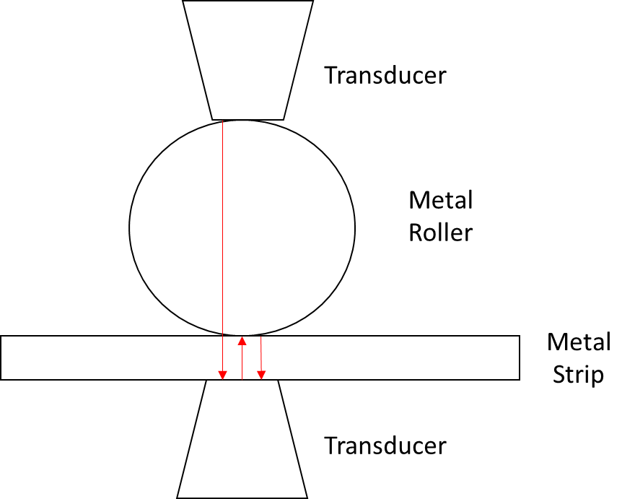
Figure 6-1 – Through transmission ultrasound layout

The transducers and metal roller and strip are shown in white. The signal is shown in red, being sent from the transducer assembly on the top of the roller, through the metal roller and strip, and the reflections from inside the strip are picked up by the contact probe on the bottom.
The response can be seen in Figure 6-2.
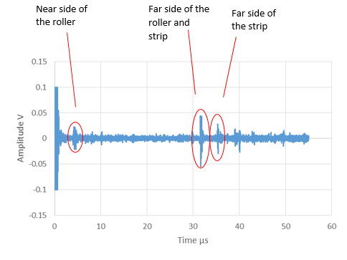
Figure 6-2 – A Scan response from the roller and strip

As can be seen in the above figure, the reflections from the far side of the roller and strip can be observed. Due to the signal getting through the roller and strip to the contact probe on the other side, more in-depth work on water coupling was performed.

Method – Water Jet Technique
Another method trialled to couple the ultrasonic signal to the metal roller was to use a water jet. This uses the previously mentioned technique (Chapter 4), where water is pumped into an assembly, made up of the ultrasonic transducer and a water jet nozzle. The ultrasound is then coupled with the water in the assembly before being directed out of the nozzle and onto the roller. This can be seen in Figure 6-3, a reproduced version of Figure 4-4.
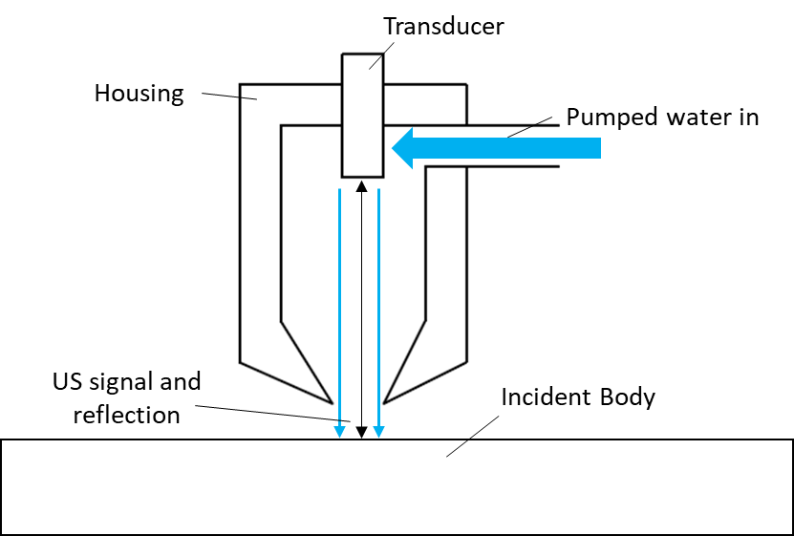
Figure 6-3 – Ultrasound transducer and water jet assembly

As can be seen the water is pumped into the nozzle, which has the transducer built in. This is then directed towards the sample. A picture of the assembly used can be seen in Figure 6-4.
Figure 6-4 – Ultrasound transducer and water jet assembly

This method allowed for greater levels of flexibility in positioning the transducer, as the assembly is quite small. It can, therefore, fit easily into small areas around the metal roller. Since it is not bonded in place, or reliant on a shoe it can also be moved around the testing area easily, in order to investigate the best angle to direct the signal from. However, this can also be a limitation if the water jet is not angled correctly, leading to signal loss. A consistent water path must also be maintained, or the signal can be lost as well.
The distance the transducer could be lifted off the component, but still work was of interest. The further away from the roller the safer the assembly would be from damage from the rolling process, however moving the transducer away from the roller would also lead to more attenuation in the signal, due to having to travel through more water, as well as most likely increasing amounts of entrained air within the water jet.

Method – Shoe Technique

Ultrasonic Shoe Design
To improve upon the previously described water jet method, an ultrasonic shoe assembly was also designed for use with the metal roller. This method used a 3D printed section that sat flush with the roller. The water was pumped into the shoe from a tank, currently mounted underneath the assembly, to flood the area in contact with the metal roller, ensuring a good consistent connection with the metal. The transducer was mounted on the bottom of the assembly to hold it in place. Similar to the previous assembly, the ultrasound was coupled with the water in the assembly, before it was fed through to the roller. As the roller turned and the water moved during the rolling process, a channel cut into the shoe collected the water and this was piped back into the water tank. Water was then pumped back into the assembly, near the ultrasonic transducer. This set up can be seen in Figure 6-5.
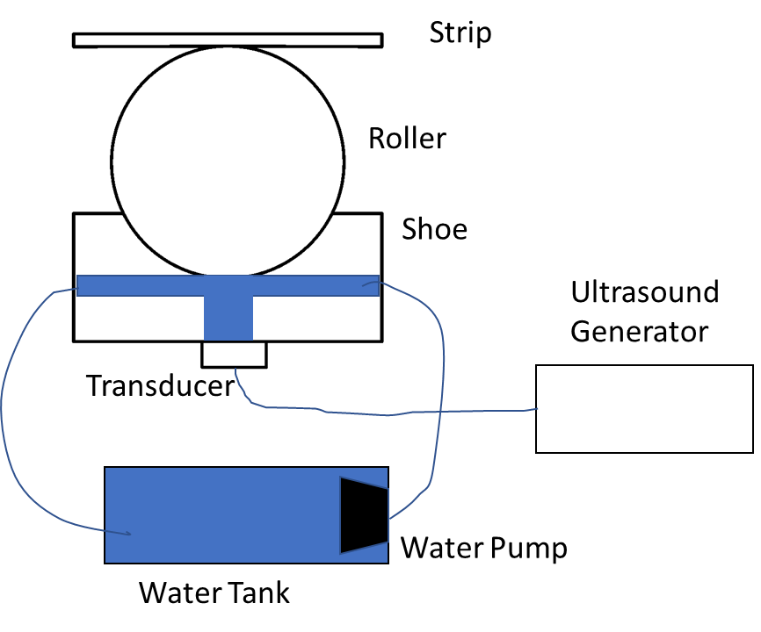
Water out
Water in
Transducer mount
Figure 6-5 – Shoe assembly drawing

The distance between the ultrasonic transducer and the near side of the roller was calculated to check if the beam was focussed before meeting the metal roller. Equation 6-1 shows the near field formula for calculating this focal length for circular transducers
(NDT Resource Center 2019, Ultrasonic Inspection – Near Field Calculation. [online].)
$$N=\frac{D^{2}F}{4c}$$
Where N is the near field length, D is the diameter of the transducer, F is the frequency of the transducer and c is the velocity of sound in the material. Therefore, the near field length was calculated using Equation 6-2.
6-1
6-2
$$N=\frac{{\left(0.024\right)}^{2}×10×{10}^{6}}{4×1450}=$$
The geometrical constraints were too large to fit in this shoe, however, a smaller shoe can be used, as when the water path connects to the test piece before the ultrasound has focussed, the focal point of the transducer changes. This is shown in Equation 6-3 (Olympus, Ultrasonic transducers technical notes, Olympus (ultrasound basics)).
6-3
$$WP=F-MD\left(\frac{c_{tm}}{c_{w}}\right)$$
Where WP is the water path, F is the focal length in water, MD is the material depth, $c_{tm}$ is the speed of sound in the test material and $c_{w}$ is the speed of sound in water. In addition, the natural variation of transducer frequencies around the nominal rating (bandwidth), will also reduce the required distance for the focussing.
The water path used was 23 mm, and was calculated as shown in Table 6-1, highlighted in red.
Table 6-1 Water path distance calculations
The top part of the shoe was 3D printed and made from PLA, with the radius of the shoe being matched to the radius of the roller the shoe was going to be used on. The bottom half of the shoe was made from aluminium and had two holes drilled and tapped in it. The water connector was attached to the system through the tapped hole on the side, with the hole on the bottom being tapped to the screw thread required by the ultrasonic transducer being used. The two halves making up the ultrasonic shoe were joined together using silicone sealant to seal the shoe and provide a consistent water path. The bottom half of the shoe is made from machined aluminium, to allow support the holes for the transducer and connector, with the top half being 3D printed from PLA, as this allowed for the design to easily be changed to fit against the roller, as well as installing the water removal channel.
The shoe assembly can be seen in Figure 6-6.
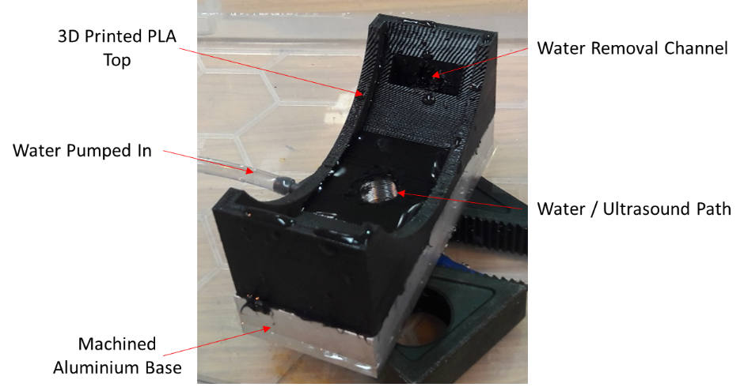
Figure 6-6 – Ultrasonic water coupled shoe

Ultrasonic Shoe Set Up
The shoe was mounted onto the bottom of the metal roller, with the 3D printed part helping to centre the transducer into the correct place. It also ensures a consistent placing of the transducer, along with a consistent connection to the metal roller. The transducer assembly was held in place using a scissor lift table. This can be seen in Figure 6-7.
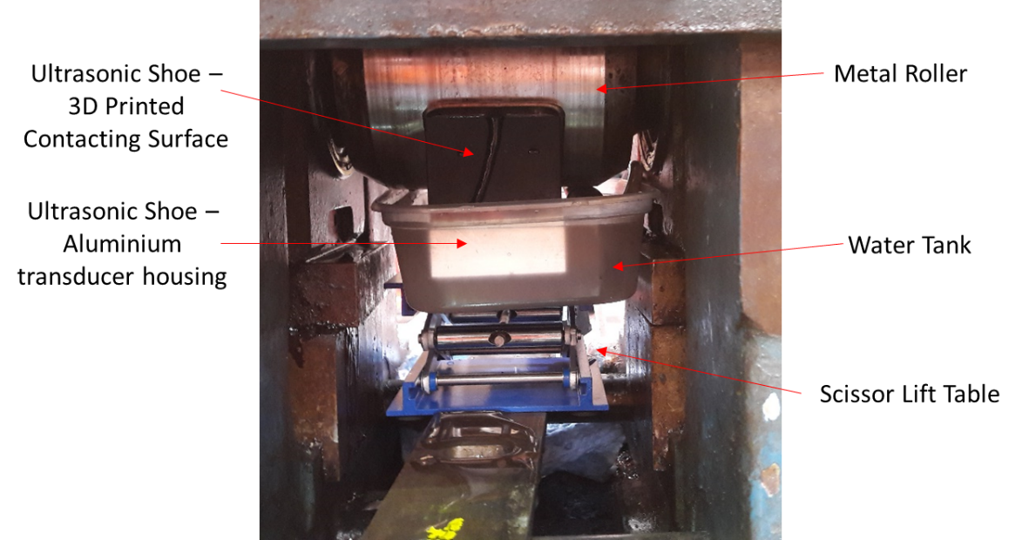
Figure 6-7 – Ultrasonic water coupled shoe connected to the pilot mill

As can be seen the scissor lift holds the shoe and water tank in place, allowing the system to move in response to movement in the metal roller. The shoe can also be positioned along the far edge of the metal roller, but for the purposes of this project, the shoe was kept in the centre of the roller, ensuring the transducer had a constant connection to the centre of the roller. This set up, with the ultrasound paths, is represented schematically in Figure 6-8.
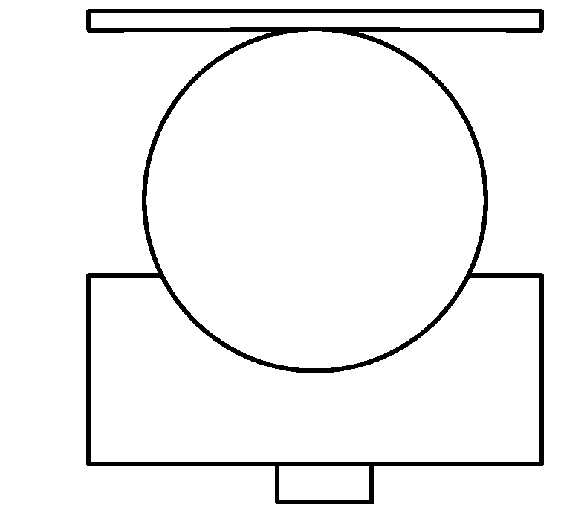
Transducer
Shoe
Roller
Strip
Figure 6-8 – Ultrasound path through the shoe, roller and strip

The ultrasonic paths can be seen in Figure 6-8. The yellow lines show the path from the transducer, before being reflected from the near side of the metal roller, with red showing the reflection from the far side of the metal roller and green showing the reflection from the far side of the metal strip.

Test Plan
Because of its inherent simplicity the water jet technique was trialled first, tests being performed on the distance the jet can be moved away from the roller, ‘Transducer lift off trials’, and water jet orientation, assessing the signal strength obtained and the ease of signal processing. These tests were performed using static samples, then followed by dynamic tests performed on the pilot roller system in operation. Likewise, with the water shoe technique tests were performed to assess the same items when using a shoe coupled signal. In addition to tests comparing the calculated strip thickness during rolling with the measured thickness, further tests were performed at different roller speeds to assess if this had an influence on the signal used to calculate the strip thickness.

Results – Water Jet Technique

Transducer Lift Off Trials
The transducer assembly and water pump were set up, with a flow rate of 2 l min⁻¹. A metal strip was set up, with the transducer assembly, mounted above it, similar to the set up seen in Figure 6-3. The ultrasound was then coupled with the water in the assembly, before being directed perpendicularly onto the metal strip in the pulse echo configuration. The response received from when the transducer was directly on the metal strip is shown in Figure 6-9.
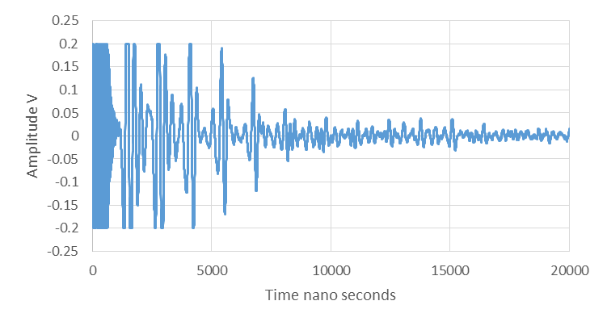
Return pulses from the roller near side
Figure 6-9 – A Scan response from the water coupled strip
As can be seen, several reflections occur after the initial pulse. These will be multiple reflections from inside the strip, due to the ultrasound energy reflecting from both sides of the metal strip.
Following this, the transducer was lifted off from the surface of the metal strip, to investigate how far away the transducer could be located. This was of interest as the further away from the metal roller the transducer could be located, the less likely the transducer was to be damaged during operation.
The response from the strip when the transducer was 5 mm away from the strip can be seen in Figure 6-10.
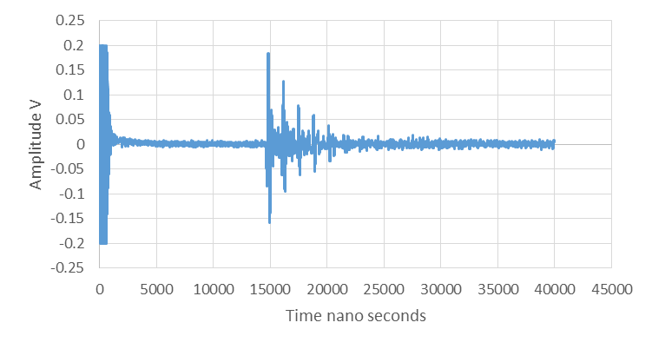
Return pulses from the roller near side
Figure 6-10 – A scan from the water coupled strip, raised away by 5 mm

The first reflection, highlighted in red, is the reflection from the near side of the strip, where the water to steel interface is. The reflections after this response are the reflections from the far side of the roller as the ultrasound reflects inside the metal strip.

Water Jet Orientation
The water jet was trialled in both the pitch catch, oblique orientation, Figure 4-3, as well as the pulse echo orientation, Figure 4-4. This was to investigate which of these orientations provided the best response.
The response from the pulse echo configuration can be seen in Figure 6-11.
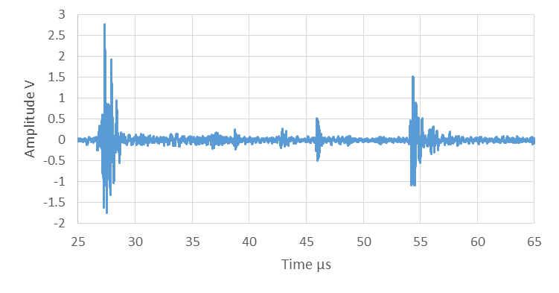
Figure 6-11 – A Scan response from water coupled ultrasound in pulse echo orientation
Return pulses from the roller near side
Roller internal reflections
Return pulse from the roller far side
The response from the pitch catch method can be seen in Figure 6-12.

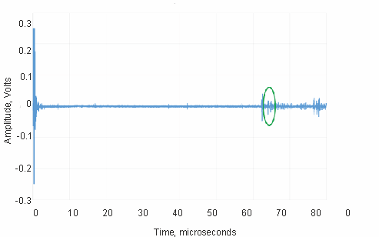
Return pulses from the roller near side
Return pulse from the roller far side
Figure 6-12 – A scan from the water coupled roller in pitch-catch orientation
As can be seen in the above figures, a response from the roller can be observed in both cases, however the response from the pitch catch method is far weaker than the response observed from the pulse echo method. Because of this the water jets were trialled in the pulse echo configuration. However, the pitch catch method could be useful for future testing, as it would allow for greater flexibility in transducer placement.
Figure 6-13 below shows the water jet transducer assembly being used on the metal roller at the Sheffield pilot mill.
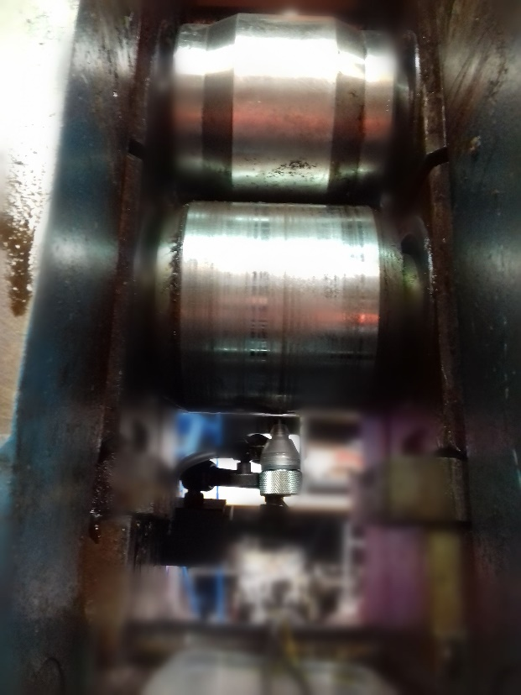
Water jet ultrasonic probe
Metal Rollers
Figure 6-13 – Pilot mill rollers with the water jet probe

Figure 6-13 shows the transducer assembly mounted underneath the bottom metal roller, with a magnetic clamp holding the assembly in place. The water jet is then directed onto the metal roller, with the ultrasound travelling through the water jet, through the metal roller and then through the strip. Ultrasound is reflected from the water jet to near side of the roller interface, the roller far side to the strip near side and from the far side of the strip.
The response from the metal roller and strip when coupled using the water jet can be seen in Figure 6-14.
Return pulse from the roller far side
Figure 6-14 – A Scan response from the pilot mill

As can be seen, the signal is very noisy, due to the roller movement, and from the inconsistent connection between the metal roller and the probe. Possible return pulses from the far side of the roller, can be seen at around 37 µs and 76 µs. A possible return pulse from the far side of the strip can be made out after the first roller return pulse. However, the signals are unclear when compared to the background noise of the system, so a different approach was investigated using the water shoe.

Results – Shoe Technique

Ultrasonic Response
An example response from the system, seen in Figures 6-7 and 6-8, can be seen below in Figure 6-15.
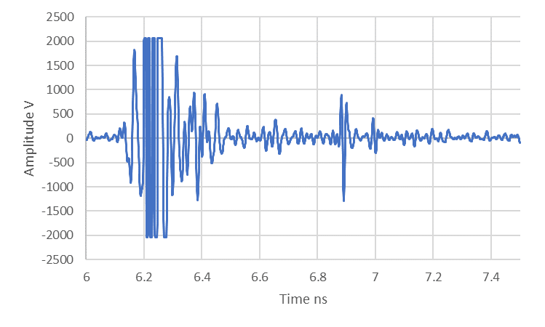
Figure 6-15 – A - Scan showing return pulses from the roller & strip using the shoe method
Corresponding return pulse from the strip far side, from the 1st return pulse
Corresponding return pulse from the roller far side, from the 1st return pulse
Second return pulse from the roller near side

As can be seen in Figure 6-15. several reflections can be observed. The reflection from the near side of the roller are highlighted in yellow, with the reflections from the far side of the roller and strip highlighted in red and green respectively. The strip was measured with a pair of digital callipers and was found to be 3.19 mm thick. By using the time-of-flight method, between the first peaks of the return pulses from the far side of the roller and strip and with the speed of sound for mild steel being 5920 m s⁻¹, from the investigation into the speed of sound in the material, a value very close to the stated value of longitudinal speed of sound for steel of 5940 m s⁻¹ in (Engineering Toolbox, 2004). The thickness of the metal strip can be calculated using the time of flight equation given previously. By using the values of time gained from the capture, along with the speed of sound given by the speed table, the distance is given by:
$$Thickness=5920 m s^{-1}*0.540 µs =3.197 mm$$
This gives the thickness to within 0.007 mm of the calliper measured value, which is well within the required tolerance for metal rolling (plus/minus 0.050 mm).
However, this is only for a single pass through the rollers. Two strips were sent through the metal rollers, and the thickness of the strip was monitored. The thickness of the metal strip was measured using digital callipers before and after each pass and these values, along with the calculated thickness from the ultrasonic measurement can be seen in Table 6-2.
Table 6-2 Calculated and measured strip thickness - Speed of sound used for the calculations was 5920 m s⁻¹

Test run | Measured thickness (mm): |  |  |  | Time  (s) | Pulse-Echo time  (µs) | Calculated strip thickness  (mm) | Error / (%)
 | 1 | 2 | 3 | Mean
1 | 3.50 | 3.50 | 3.50 | 3.50 | 5.91E-07 | 1.18 | 3.49 | 0.29%
2 | 3.36 | 3.35 | 3.32 | 3.34 | 5.64E-07 | 1.13 | 3.34 | 0.00%
3 | 3.25 | 3.25 | 3.27 | 3.26 | 5.50E-07 | 1.10 | 3.26 | 0.00%
4 | 3.20 | 3.19 | 3.25 | 3.21 | 5.43E-07 | 1.09 | 3.23 | -0.62%
5 | 3.19 | 3.22 | 3.17 | 3.19 | 5.39E-07 | 1.08 | 3.20 | -0.31%
1 | 4.00 | 4.02 | 4.03 | 4.02 | 6.78E-07 | 1.36 | 4.03 | -0.25%
2 | 4.01 | 4.03 | 4.01 | 4.02 | 6.78E-07 | 1.36 | 4.03 | -0.25%
3 | 4.00 | 3.99 | 3.99 | 3.99 | 6.75E-07 | 1.35 | 4.00 | -0.25%
4 | 4.00 | 3.99 | 3.99 | 3.99 | 6.75E-07 | 1.35 | 4.00 | -0.25%
5 | 3.94 | 3.96 | 3.99 | 3.96 | 6.69E-07 | 1.39 | 4.11 | -3.79%
6 | 3.85 | 3.84 | 3.86 | 3.85 | 6.50E-07 | 1.30 | 3.85 | 0.00%
7 | 3.85 | 3.81 | 3.83 | 3.83 | 6.47E-07 | 1.22 | 3.61 | 5.74%
8 | 3.66 | 3.56 | 3.60 | 3.61 | 6.09E-07 | 1.22 | 3.61 | 0.00%
9 | 3.49 | 3.48 | 3.49 | 3.49 | 5.90E-07 | 1.18 | 3.49 | 0.00%
10 | 3.42 | 3.42 | 3.42 | 3.42 | 5.78E-07 | 1.16 | 3.43 | -0.29%
11 | 3.21 | 3.19 | 3.23 | 3.21 | 5.42E-07 | 1.08 | 3.20 | 0.31%
12 | 3.07 | 3.07 | 3.05 | 3.06 | 5.17E-07 | 1.03 | 3.05 | 0.33%

Noise was reduced from the system by taking A-scans and averaging them with the A-scans around them. The speed of sound in the metal roller and strip was used along with the time taken to receive the pulse in order to calculate the thickness of the strip and roller. This was assuming the roller was not deforming. Although, this was also compared to the response from the roller, when not rolling.
The first strip was sent through the metal rollers five times, before the strip was bent too much to fit through the rollers. The second strip was then rolled twelve times. The measured and calculated thickness of the first metal strip can be seen in Figure 6-16.

Figure 6-16 – Measured and calculated strip thicknesses

As can be seen both values can be observed to decrease with increasing roll pass number. In addition, the calculated strip thickness appears to be well within the required 0.05 mm tolerance. The calculated and measured values for the second metal strip can be seen in Figure 6-17.

Figure 6-17 – Measured and calculated strip thicknesses

The thickness of the metal strip can be seen to decrease, although for the first four passes the thickness remains relatively the same, suggesting that the roll gap was not narrow enough to physically change the strip. However, the thickness could still be measured using the technique, and compared back to the measured values from the callipers. In addition the calculated strip thickness is within the required 0.05 mm tolerance. However, there were some passes where a clear return pulse could not be observed, e.g. pass number 5, and this lead to a spurious calculated strip thickness.
Additional metal strips were run through the metal rollers. The results from a less successful strip can be seen in Figure 6-18.

Figure 6-18 – Measured and calculated strip thicknesses

Again, the thickness can be seen to decrease through the rolling process, however the calculated thickness does not follow the measured thickness within the required tolerances. This error cannot be attributed to a systematic error, such as an incorrect speed of sound, as the calculated thicknesses vary between being too thick and too thin, around the measured values. It appears that the water shoe method provides some good results, but further improvements to this technique will, therefore, be required for consistent success.

Different Speed Trial
The effect of roll speed on the thickness measurements was also of interest as the previous work, shown in Chapters 5 and 6, had been conducted at a roll speed of 30 mm s⁻¹. Since the technique would be used in a variety of conditions however, it was of interest to see how changing the speed of the strip being investigated affected the calculated thickness being received. The roll speed was changed to 70 mm s⁻¹.
The response from this trial can be seen in Figure 6-19.

Figure 6-19 – Measured and calculated strip thicknesses

The initial calculated thicknesses, shown in orange, were read as being significantly larger than the measured values, shown in blue. However, as the strip thickness decreases the difference in the calculated and measured values decreases. However, the calculated thicknesses alternate around the measured thickness, so the processing techniques still require further refinements. Overall, the decreasing thickness trend can still be observed.

Discussion – Water Jet Technique

The water jet technique has several advantages:
- Flexibility in positioning the transducer
- Greater ability to install the transducer in the confines of a metal rolling rig.
- The transducer can be mounted away from the metal roller, preventing damage to the transducer and the water jet assembly, allowing the transducer to continue working.
- If the water jet coupled ultrasound is in pulse echo configuration, then the transducer can constantly measure the thickness of the strip, whilst it is being rolled.
- The transducer is also more flexible as it can be easily moved out of the way to allow for the rollers to be removed for regrinding.
There are several limitations however:
- Firstly, the coupling is dependent on having a good consistent water flow rate. Therefore, a pump system must ensure a good flow rate to ensure there is no signal loss when connecting the ultrasound to the roller. Further to this, during operation oil can mix with the water supply so the pump system must be able to maintain the flow rate under these conditions.
- Secondly since the transducer assembly is just held in place, it is vulnerable to being knocked out of position. This causes misalignment with the signal which can lead to signal loss, or the transducer no longer being able to receive a signal from the far side of the strip. Mounting the transducer further away can help limit this, however the further away the transducer is mounted, the longer the water path and the more the signal is attenuated before coming into contact with the roller. There is also increasing likelihood of entraining air in the water as the jet length is lengthened.
- Finally, during the rolling operation in industrial rolling mills, multiple water jets are used in order to supply lubrication and cooling to the rollers and strip. Because of this this method could suffer from signal loss due to these streams interfering with the ultrasonic path.
For industrial implementation however, these extra water jets however could be useful, as it would allow for more potential jets to be used to couple the ultrasound to the metal roller.
This would allow for less modifications to be carried out on the metal rolling rig, although the angle of the jets and the condition of the liquid being used would have to be taken into consideration when mounting a transducer. This is in addition to where the transducer would be located and whether it would be able to work in the environment. Overall, the water jet technique has several operational advantages, but from the results obtained here the signal strength is limited and, therefore, the signal to noise ratio is poor leading to great difficulty in obtaining reliable strip thicknesses on moving samples.

Discussion – Shoe Technique
The shoe coupled technique has several advantages:
- It allows for the transducer to be mounted onto the roller with a much more consistent connection.
- It holds the transducer more securely than the previously used assembly, whilst also providing more support and protection from the rolling process.
- By establishing this consistent connection, a more consistent signal is passed into the roller and received back from the roller.
- This helps this technique mitigate problems with signal to noise, as well as ensure that the signal drop and response from the far side of the roller and strip is detectable.
- This method also allows for the transducer and shoe to be removed and replaced easily when the rollers are removed for re-grinding. Unlike the previously trialled bonded oblique method required the roller to have the chamfers reground to maintain the required angle for the transducers. This also required the transducers to be bonded onto the metal roller again, causing the roller change over period to be longer.
- Due to being pushed flush to the metal roller, it is easier to align the transducer in the desired area, allowing for the beam to be angled correctly. This avoids the misalignment limitation of the previous method, although care must be taken to ensure the shoe fits the roller well, to prevent loss of water, or damage to either the metal roller or shoe. The fitting between the ultrasonic transducer and the shoe should also be as watertight as possible to prevent water loss, with the distance between the ultrasonic transducer and the metal roller being long enough to assist in beam focus, but without being too long to cause excess attenuation.
A limitation in using this method in the roll bite, however, is that currently this technique has only been trialled in a pulse echo configuration. This would be a problem in certain rolling mills as the shoe could only be installed in two high rolling mills. Rolling mills commonly have back up rollers and these would make it impossible to install the ultrasonic shoe in the pulse echo configuration. However, future work could focus on combining this method for connecting the ultrasound, with the oblique method to get the strip thickness.
There are points to consider, when applying this technique to an industrial environment.
- The technique has been used to get the thickness of the metal sheet whilst it is being rolled and unlike the oblique method this technique has been used throughout the rolling process, to monitor the strip as it enters and leaves, rather than just when the transducer has turned onto the strip. This method could also be used with several transducers mounted in a line across the roller, in order to investigate whether the strip was being uniformly rolled. This technique has also been trialled at two different rolling speeds, showing a decrease in strip thickness can be observed, even if the post processing techniques require further refinements in order to remove the alternating thickness readings as this would be a major limitation when rolling thinner pieces of metal strip.
- By using this technique, with signal averaging of the surrounding A-scans to average out the effects of noise, the average overall thickness of the strip can be found, or the thickness of the strip as it is being rolled, throughout the rolling process can be observed.
- Filling the ultrasonic shoe with water has been shown to work however, with the signal being able to pass into and through the metal roller and the strip. This signal can also be used to calculate the strip thickness when it is received, and this can be used to monitor the strip thickness throughout the rolling process.
- The effect of whether the transducer was mounted completely perpendicular to the strip was also of interest, so work moving the transducer around the roller, similar to the work carried out in Chapter 5.4.5, was carried out, with this being shown in Appendix II.

Conclusions
Two approached have been trialled, the water jet coupled ultrasound method can be used to transmit the ultrasonic energy onto and through the metal roller and strip and then receive it again afterwards. It can also do this in a way that allows for the strip thickness to be calculated, however care must be taken regarding the levels of noise in the set-up, along with the positioning of the water stream. A consistent connection between the water jet and the metal roller is also required, however this system is easier to set up and re-orientate then the bonded on transducer, pitch catch method. A water shoe coupled ultrasound method appears to provide a much better signal to noise ratio than the jet technique when operating on a dynamic system, rather than a static one, and several tests using the shoe method provided results that were within the desired tolerance for the calculated measured thickness of the strip, when compared to measurements obtained using callipers. Operating at higher rolling speed did not unduly influence the results, but further work appears to be required to ensure the consistency of the water shoe technique.
Both of these techniques offer potential solutions, to the challenge of in situ monitoring of strip thickness during metal rolling. They also allow for monitoring of the strip, without changes to the roller being required, which was highlighted as one of the important challenges to overcome. The ultrasonic shoe technique offers a more consistent connection, so therefore it is currently considered preferable to the water jet method. However, if the water jet probe could be installed into the systems already in place to deliver coolant or rolling lubricant, to the rollers. Then this technique would be more advantageous, compared to the water shoe method.

Resonant Dip Technique
Resonant dip was highlighted as a potential technique, in Chapter 4.7.4, to use when small thicknesses are investigated. It could give the thickness of lubrication layers, or small metal plates typically less than 0.5 mm. This technique uses the resonant frequency of the material of interest by causing it to vibrate at the frequency that corresponds to the thickness. This is observed as a dip in the frequency response and this frequency can, therefore, be used to find the thickness. This technique is only applicable for very thin applications however, such as shim steel.

Introduction
The resonant frequency response, of the object of interest, is given by Equation 7-1 (Banks et al, 1962).
7-1
$$f_{m}=\frac{cm}{2h}$$
Where $f_{m}$ is the resonant frequency of the material layer, c is the speed of sound in the material, m is the mode of resonance and h is the thickness of the layer. Using Equation 7.1, by taking the frequency of the dip in the Fast Fourier Transform (FFT) of the signal, it can be used with the speed of sound in the material and the resonant mode, to obtain the thickness.
The range of thicknesses that can be observed by a given transducer can be determined by using the frequency range of the probe. For this work, the water coupled probe had a frequency range including frequencies of of 5.1 – 15.86 MHz. Under the prevailing conditions, this gave a range of thicknesses of 0.568 – 0.187 mm, for steel in the first mode. As can be seen, thinner layers have a higher resonant frequency.

Experimental Set Up
To investigate the resonant dip technique a thin, approximately 0.5 mm, sheet of stainless, shim, steel was used with a 5 MHz contact transducer and the 10 MHz immersion probe previously used to investigate the roller and strip in Chapter 6. Initial experiments used an ultrasonic contact gel to couple the two different transducers to the shim steel. The ultrasound was then sent through the thin sheet using the pulse echo configuration.
Following this, the strip was placed between the two metal rollers of the Hille 25 rolling rig and the top roller was lowered to grip the strip. The contact probe was placed onto the metal roller, both in line with and without the strip in order to obtain a reference value. The immersion probe was then attached to the water bath shoe, see Figure 6-8, used previously to conduct the water coupled rolling tests. This allowed for stationary testing of the resonant dip technique.
Finally, the strip was rolled through the metal rollers, with the water-based ultrasound shoe method being used to investigate the metal strip.

Static shim tests
Initially a 5 MHz contact transducer was used to investigate a 0.5 mm strip of stainless, shim, steel. This thickness was chosen as it was within the range of the water coupled, 10 MHz system. A 5 MHz contact probe was initially used to investigate the response to provide a reference for the concave water coupled probe.
The 5 MHz contact probe was coupled to the steel with ultrasonic contact gel and the set up, and the, A-scan can be seen in Figure 7-1.

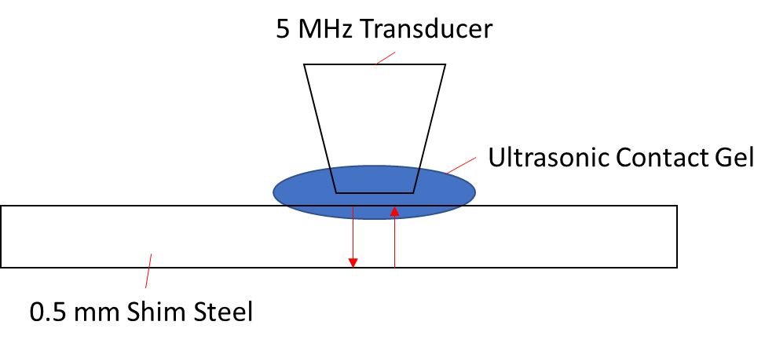
Figure 7-1 – Time domain response from just the shim steel strip, with the probe contacted directly to it using contact gel
Ultrasonic reflections from the shim steel sheet, pulses overlaying over each other

As can be seen in the A-scan in Figure 7-1 the far side of the shim steel is not observable, using the same technique used in Chapters 5 and 6, due to the reflections from the coupling of the contact transducer to the shim steel strip using contact gel. However, by using the FFT of this signal the dip in the frequency can be seen. This is shown in Figure 7-2.
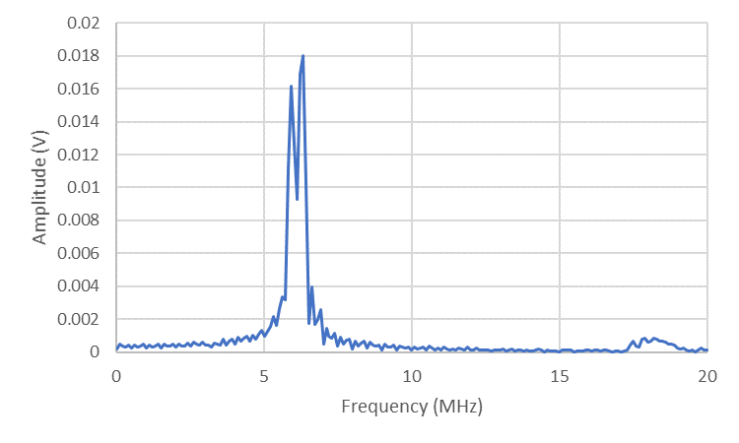
Figure 7-2 – FFT from the shim steel strip
Dip – located at 6.1 MHz

The dip can be observed at 6.1 MHz, which was the first resonant mode. The speed of sound in stainless steel was taken as 5920 m s⁻¹.

By rearranging Equation 7-2 the thickness can be determined.
7-2
$$h=\frac{c}{2f_{m}}=\frac{1×5920}{2×6100000}=4.85×{10}^{-4} m$$
This gives a value of 0.485 mm. This was then compared to the average measured value of the shim steel thickness of 0.497 mm. This was calculated by measuring the shim steel with digital callipers three times.
The 10 MHz water transducer was then coupled to the shim steel strip using contact gel. The set-up and response can be seen in Figure 7-3.
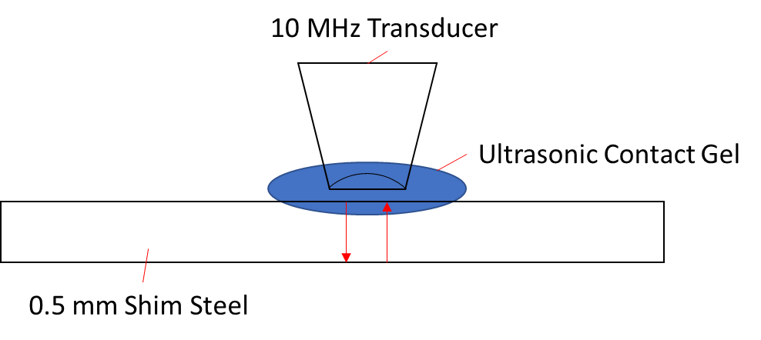
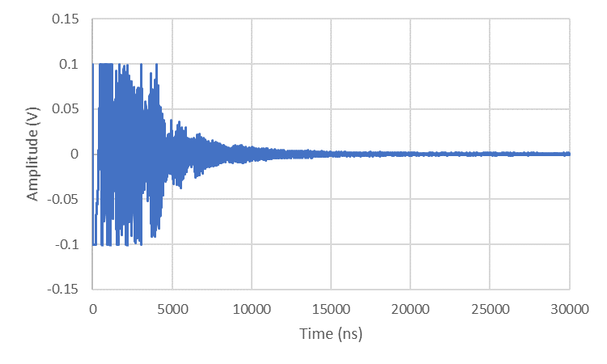
Figure 7-3 – Response from the immersion probe on the shim steel

Due to the responses overlapping with each other, using the previous time of flight techniques would not be possible. The FFT of this signal can be seen below in Figure 7-4.
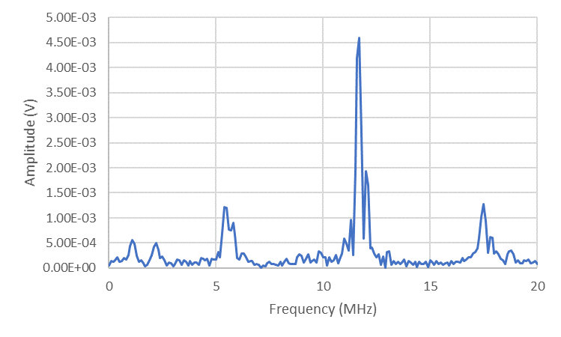
Dips in signal
Figure 7-4 – FFT from the shim steel with the immersion probe

The different resonance peaks can be observed, one just after 5 MHz, one at around 12 MHz and one around 18 MHz. To get the thickness the frequency was taken as 11.9 MHz. This was from the second frequency amplitude peak, so the mode number m will be 2.
This gave the thickness to be:
$$h=\frac{mc}{2f_{m}}=\frac{2×5920}{2×11900000}=4.97×{10}^{-4} m=0.50 mm$$
This again matches the measured by callipers value of 0.497 mm very well.

Static roller tests
After the initial testing on the shim steel strip, it was then coated with a rolling lubricant and placed within the metal rollers. The rollers where then closed to apply pressure to the shim steel strip. The 5 MHz contact probe was then placed on the roller to investigate the response from the strip, whilst held within the metal rollers. The set-up and reference response from the roller, without the strip can be seen in Figure 7-5.
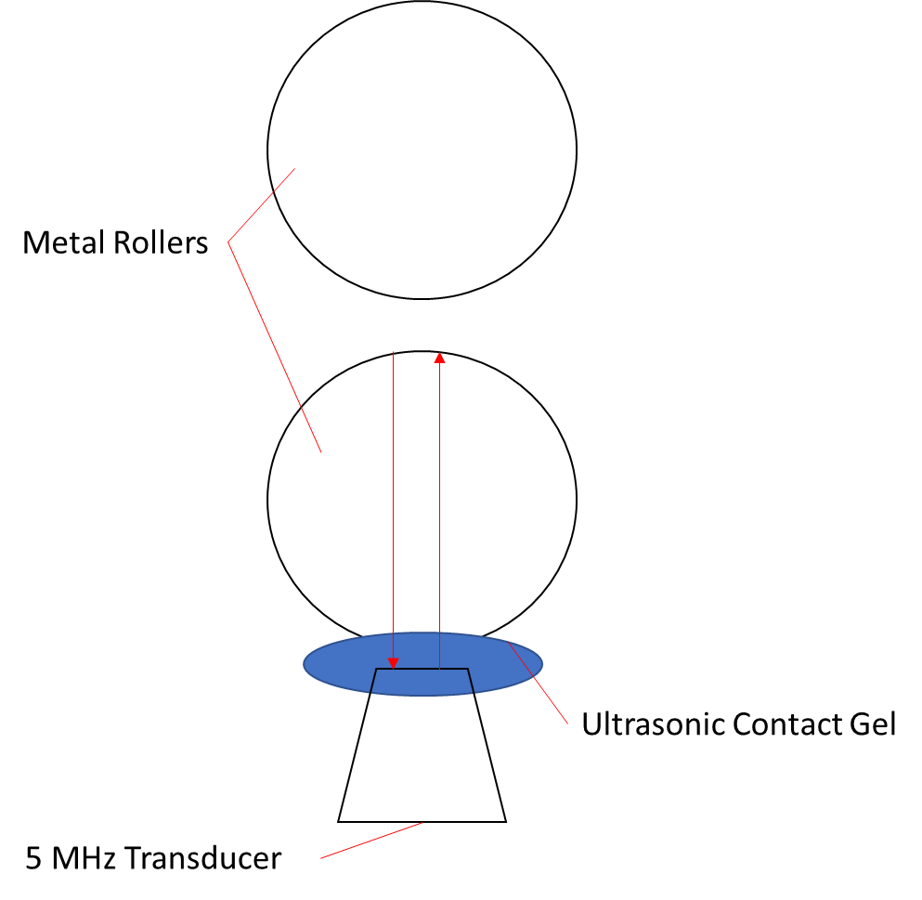

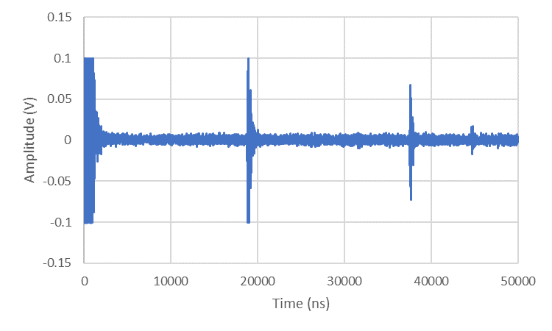
Response from the roller
Figure 7-5 – A scan response from the static roller

The corresponding FFT response is shown by Figure 7-6.
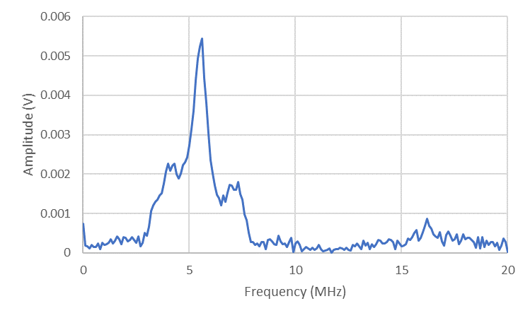
5 MHz response
Figure 7-6 – FFT response from the static roller

The frequency peak can be observed at around 5 MHz, in line with the transducers output frequency, but a resonant dip cannot be easily observed.
This can then be compared to the response when the probe is positioned on the roller, with the shim steel strip present in the system. The set-up and response from this can be seen in Figure 7-7.

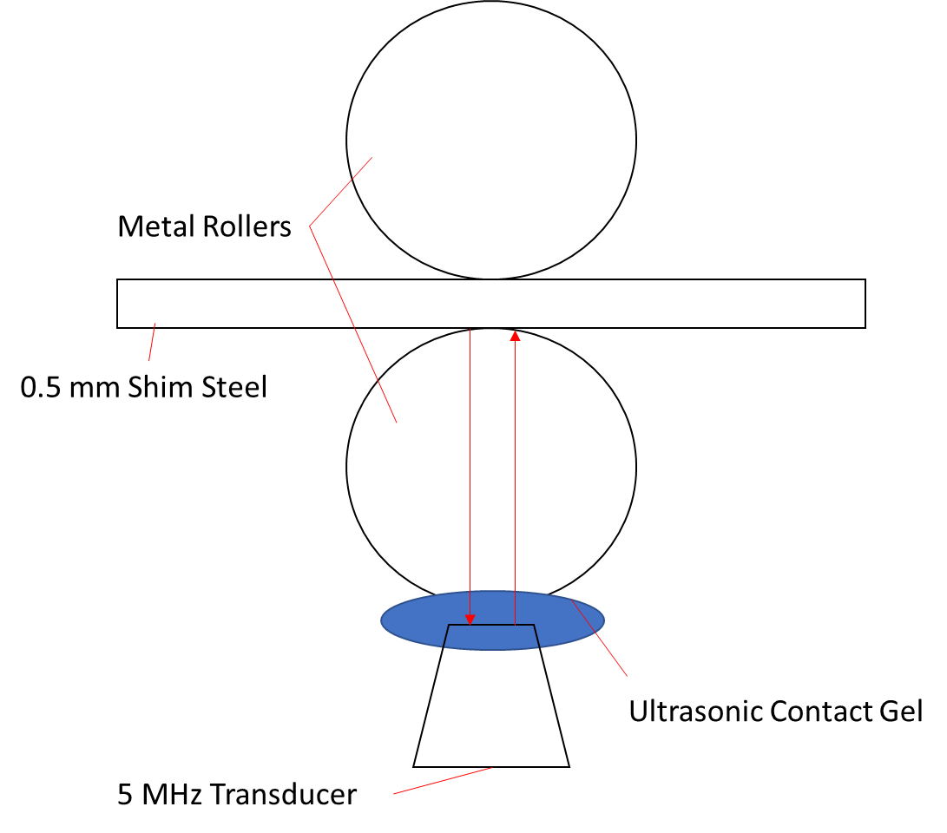
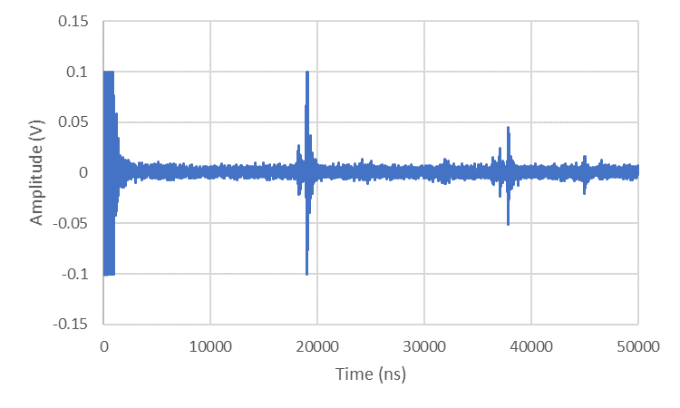
Response from the roller
Figure 7-7 – FFT response from the static roller

This data was then sectioned to focus on the first return pulse from far side of the roller. The FFT was then calculated from this section and is shown in Figure 7-8.
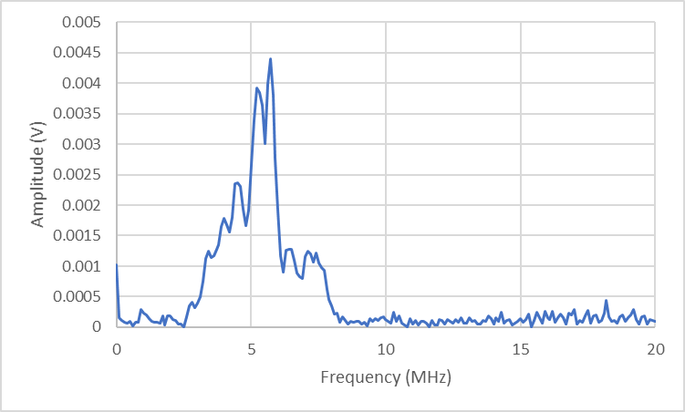
Drop in amplitude at 5.5 Mz
Figure 7-8 – FFT response from the static roller and strip

This can then be compared to the FFT from the roller without the strip. A dip can be observed at 5.5 MHz. This gives a thickness of 0.54 mm.
This was then repeated using the water coupled transducer. This was carried out by coupling the transducer to the metal roller and strip with the water coupled shoe.
This set-up, and the full capture from the water coupled shoe, can be seen in Figure 7-9.
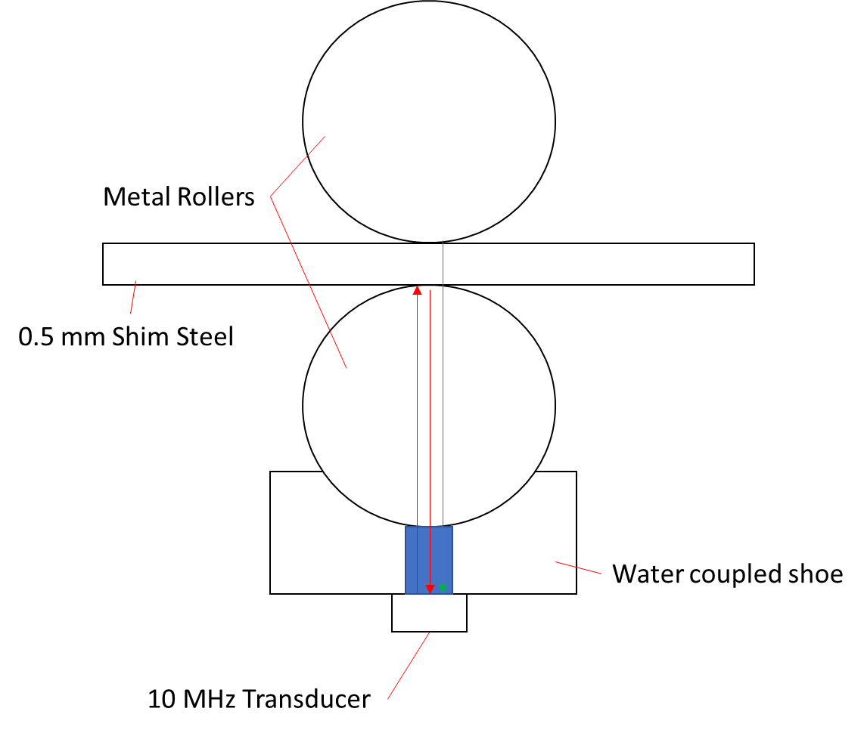

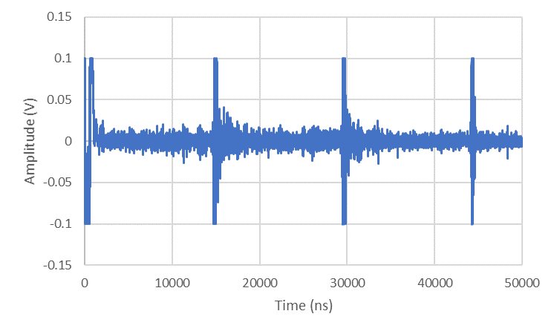
Response from the roller far side
Response from the roller near side
Figure 7-9 – A scan response from the roller – water coupled

The return pulse from the far side of the roller is then selected. This can be seen in Figure 7-10.
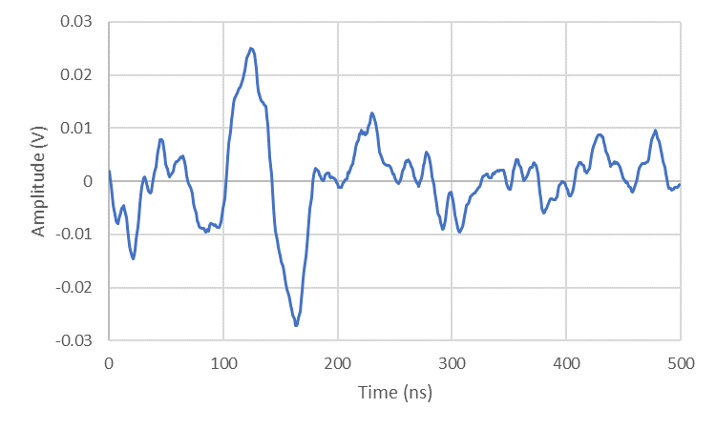
Response from the roller far side
Figure 7-10 – Zoomed in A scan on pulse of interest – water coupled

The FFT is then taken of this zoomed in area of interest. This can be seen in Figure 7-11.
5MHz area of interest – no strip
Figure 7-11 – FFT response from the roller – water coupled

This can then be compared to the response from the far side of the metal roller when the strip is present in the system. This is shown in Figure 7-12.
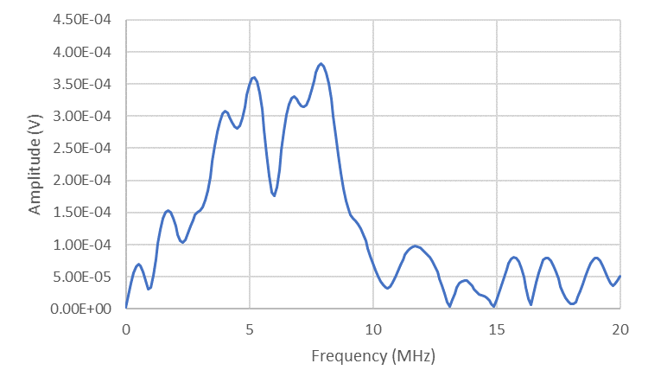
5MHz area of interest – strip giving a drop at 6MHz
Figure 7-12 – FFT response from the roller and strip – water coupled

A dip can be observed at 6 MHz, which gives a thickness of 0.49 mm.

Dynamic roller tests
The previous data was all taken from the rollers and strip whilst they were stationary. The response from the resonant dip technique during the rolling process, using the same set up as seen in Figure 7-9, can be seen below in Figure 7-13.
Two potential dips of interest
Figure 7-13 – FFT from the roller and strip when rolling

A dip can be observed at 7.2 MHz and 8 MHz, which gives a thickness of 0.41 mm and 0.36 mm respectively. This was then compared to the average measured value of the strip, which was 0.36 mm.
Three captures were taken during rolling, giving the average value to be 0.39 mm.
One of the dips could be due to the lubrication layer present in the system. To investigate this, the dry strip was investigated using a 5 MHz transducer. An example FFT can be seen in Figure 7-14.
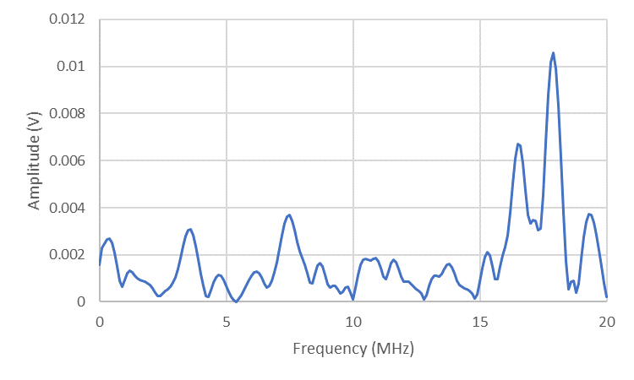
Dip at 17.4 MHz
Figure 7-14 – FFT response from the dry, rolled, strip

A peak of energy can be seen, occurring at around 16.6 MHz to 17.6 MHz. A dip in this response can be seen at approximately 17.4 MHz. This is the 2nd mode of reflection, giving a thickness value of 0.34 mm.
Three captures of the strip after the rolling process were taken and the average thickness value was calculated, to compare with the response from the rolling data. The average calculated thickness was found to be 0.34 mm. This was then compared to the average measured thickness of 0.36 mm.
These results can all be seen below in Table 7-1.
Table 7-1 – Table of measured and calculated strip thicknesses
 | Experimental Set Up | Average Measured Values (mm) | Average Calculated Values (mm) | Error  (%)
A | On Strip - No Rolling | 0.50 | 0.49 | 2
B | On Roller – Stationary | 0.50 | 0.48 | 4
C | On Roller – Dynamic | 0.36 | 0.39 | -8.33
D | On Strip – After Rolling | 0.36 | 0.34 | 5.56

This is also shown in Figure 7-15.
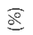
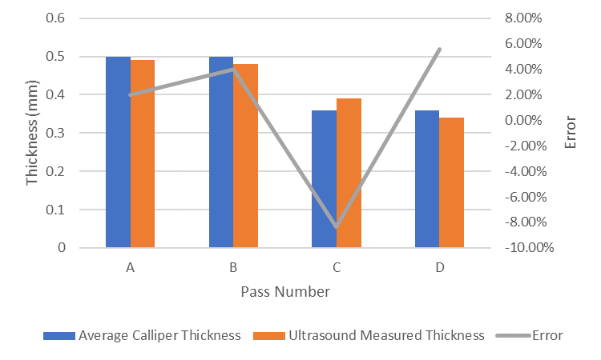
Figure 7-15 – Comparison of measured and resonant dip calculated thickness

The average calculated values for the strip thickness, has an error of ±0.03 mm, or approximately up to around 8% of the measured value. The requirements mentioned in earlier stated that the techniques had to be able to provide a thickness to within 50 µm, or 0.05 mm, which the resonant dip technique can accomplish. The resonant dip technique had an error of ±0.02 mm when just on the shim steel strip, or when the metal roller was stationary, in addition to giving a higher reading when the strip was being rolled, compared to under reading when stationary. Future work could investigate the effects of rolling on this method, with the aim to investigate whether one of the rolling properties causes this affect.

Conclusion
The resonant dip technique was used to investigate the strip thickness of thin, shim steel. This was due to the traditional time of flight method, used in Chapters 5 and 6, being unapplicable as the response pulses from the far side of the strip were obscured by other pulses. This technique used the frequency domain, and provided promising results, that also were not affected as much by the noise levels present in the system. This technique could, therefore, be useful when analysing very thin steel, in the final roller stands.
In conclusion the resonant dip method can be used to observe changes in the strip thickness. However, this method has a limit to the thickness of sample that can be observed through it. Therefore, for main rollers this method might not be appropriate. Counter to this is smaller rollers, or rollers used for finishing product. Therefore, this technique could be used, in conjunction with the other, previously discussed techniques. Where the water coupled ultrasonic sensors are used on the earlier rolling stands, where this technique can not be used, before this technique is used on the finishing mills, where the metal thickness is too small, around 0.5 mm, to be reliably picked up on the other techniques. Especially considering the noise limitations that this technique is able to work around, due to working in the frequency domain.
This method does provide a clearer response however over the other time of flight methods. Especially when significant noise is present, which removes one of the main limitations of the previously used time of flight methods. However, it does require slightly more processing as the data recovered needs to be converted into the frequency domain to be investigated. This would still be of merit though, as this technique works within the required 50 µm tolerance limit.

Post Processing Techniques AND SENSITIVITY
This chapter reports the postprocessing the A-scans using: Threshold method, Peak Detect, and Zero Crossing, with the results for strip thickness compared with calliper measurements. Results from these different methods were also compared with the resonant dip technique. Uncertainties and sensitivity of the readings is also provided, concentrating on the expected variation around a mean value of strip thickness obtained from the various techniques used in this thesis. The level of confidence considered to be relevant for this application being 99.8%, i.e. providing just 2 in 1000 readings outside the expected range.

Post Processing Techniques Methodology

Initial Set Up
Carrying on from the previous work, sensitivity trials were conducted. The focus of these trials was to investigate the smallest change in thickness that could be determined. This was due to the need to be able to monitor small changes in the sheet metal whilst it is being rolled.
A metal block of EN24 steel, with dimensions 200 mm x 100 mm x 20 mm, was used, with two channels marked out on the surface, see Figure 8-1. One of these channels was sanded in order to create a change of thickness, with the other channel being left as a reference. By leaving this second channel, temperature effects could be mitigated by monitoring any change in the reference signal due to temperature effects.
Ultrasonic sensors were bonded onto the metal block, within the marked channel area, but on the opposite side to the area that was to be sanded. A piezo 10 MHz disc was cut into two and bonded onto both the reference and sanded channel. The signal was sent from one of these halves and then received on the other half of the transducer.
This can be seen in Figure 8-1.
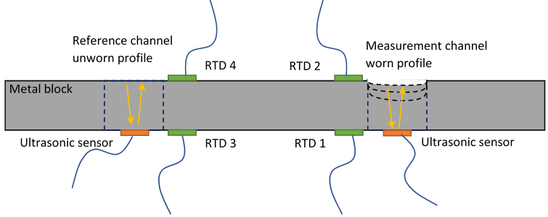
Figure 8-1 –Sensitivity test block

This experiment would remove less material than the previous grinding tests and would, therefore, help validate the best techniques highlighted from the previous testing. As can be seen in Figure 8-1 RTDs (resistance temperature detectors) were used to monitor the temperature to aid with assessing temperature affects. The following techniques were used with metal strip, and then the rolled strips, to analyse the ToF within LabView and Matlab.

Threshold Method
The first technique that was investigated was the threshold method. This method specified a threshold value, that when exceeded, a value of the time would be taken. If the captures taken were either side of when the threshold was crossed, then the value of time would be found by interpolating between these two values.
An example of this can be seen in Figure 8-2.
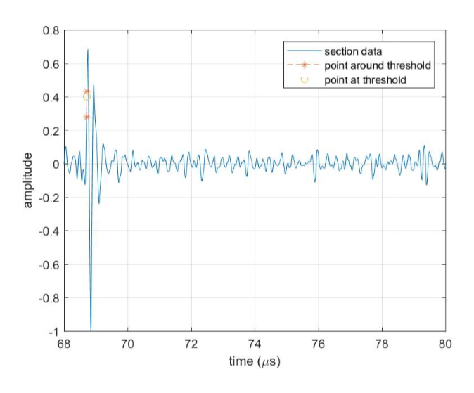
Figure 8-2 Example threshold response

The time for the return pulse from the far side of the roller is therefore found when the signal passes the threshold value.

Peak Detect
The second method investigated was to take the value from the peak of the response pulses. A polynomial fit was used between the peak values in order to accurately determine the peak, before taking the time for the peaks. An example of this can be seen in Figure 8-3.
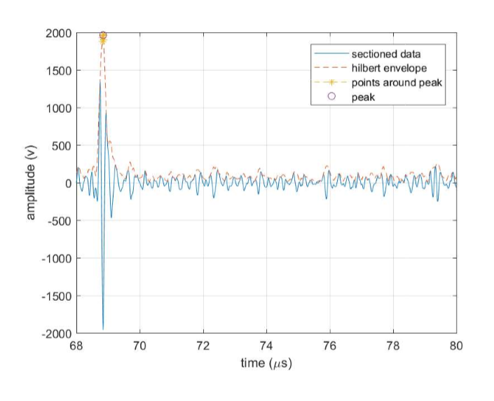
Figure 8-3 Example peak detect response

The time for the return pulse from the far side of the roller can be found by taking the value for time from the peak, calculated by using a Hilbert transform to remove phase effects.

Zero Crossing
The third method investigated was the zero crossing method. This technique used linear interpolation between the two points on either side of the X axis to determine the time when the response crossed zero. An example of this can be seen in Figure 8-4.
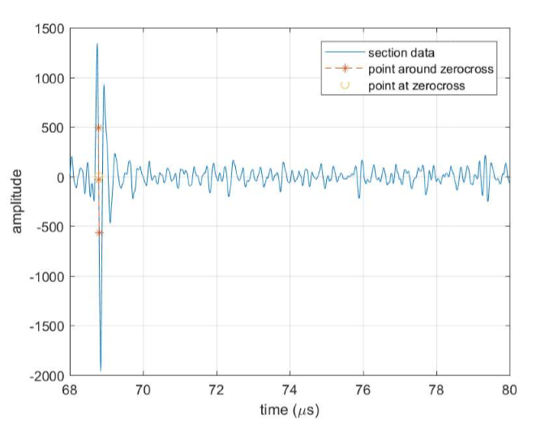
Figure 8-4 Example zero crossing response

The time for the return pulse from the far side of the roller can be calculated from when the signal crosses over the x-axis.
These methods were compared, using the metal block as a comparison piece, to validate the techniques and investigate how small a change could be measured. The most appropriate technique(s) could then be used on the metal roller and strip analysis.

Results
The changes in thickness between the rolling passes, shown in Table 6-1. along with the difference between the calculated change in thickness and the measured change in thickness were calculated using these different methods and could then be compared against each other. The initial results of change in thickness (∆t) can be seen in Figure 8-5.
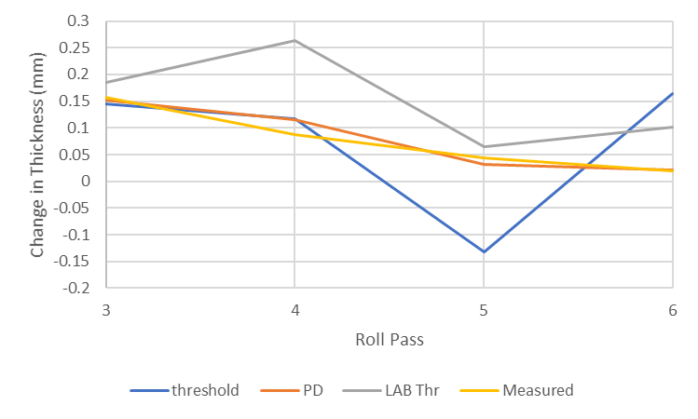
(∆t)
Figure 8-5 – Different change in thickness measurement techniques

The change in measured thickness between roll passes can be seen in yellow and this decreases reasonably smoothly. The decrease in thickness for the threshold method, performed using Matlab is shown in blue, with the peak detect method shown in orange. Finally, the threshold method carried out, by replaying the rolling data and averaging the signal can be seen in grey. All three measurement techniques had a sharp decrease for the 5th roll pass, with the threshold method having the largest decrease, followed by the signal averaged threshold method. The peak detect method, does not have much of a dip, but a small sharp reduction, below the measured value can still be seen.
The signal averaged method also sharply increases for the 4th roller pass, increasing again for the final roll pass, but not as much as the other threshold method. All three post processing techniques start reasonably close to the measured values, but only the peak detect method stays reasonably close to the measured values, for all the rolling passes. The difference between the measured values and the calculated values can be seen in Figure 8-6.
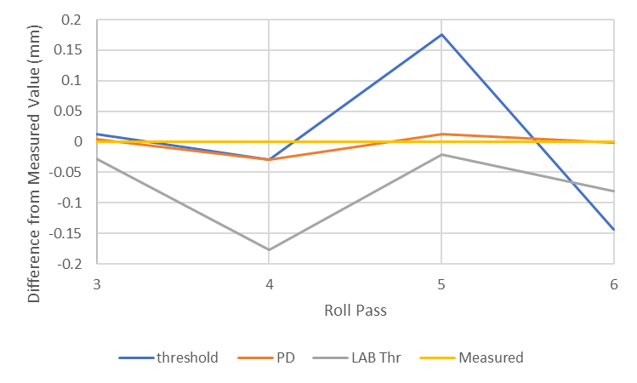
Figure 8-6 – Difference between measured values and calculated values of thickness

This shows that the peak detect method gives a value of thickness which is very close to the measured thickness, with both threshold methods deviating more than 0.05 mm from the measured values.

Rolling Data – Overall thickness
The water coupled data discussed in Chapter 6, Section 6.6, was gained by using Labview to average the A scans, whilst replaying the rolling data and then using the threshold method to determine the strip thickness. Matlab was also used, using all the captures after rolling, finding the thickness values for each capture and then averaging the strip thickness.
The response of all the A-scans from one roller pass, for the water shoe coupled rolling data can be seen in Figure 8-7.
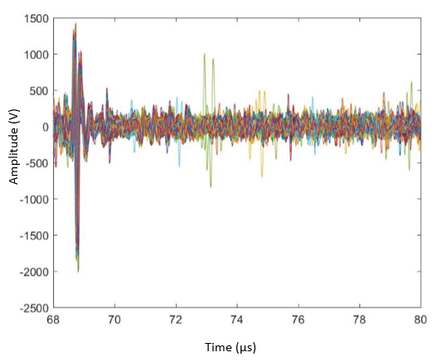
Figure 8-7 – A-scans of all captures taken during a roll pass

The B-scan of this data shows the shift in the response from the near and far side of the strip. This can be seen in Figure 8-8 with yellow on the B scan indicating high energy responses.

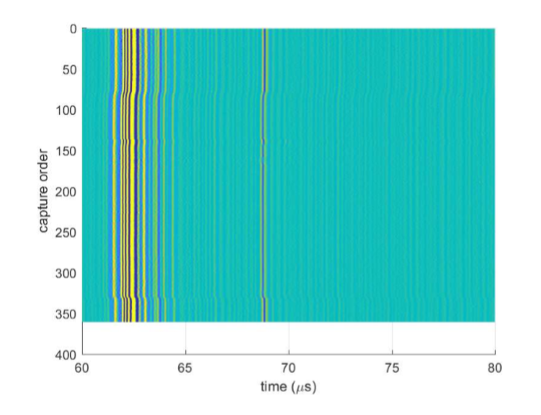
Figure 8-8 – B-scan of all captures taken during a roll pass

The return pulse from the near side of the roller is the clearest and one can be seen at approximately 62 µs, highlighted in orange. The response from the far side of the roller is much fainter and can be observed at approximately 69 µs. This is highlighted in red. The shifts in the signal can also be made out and shows when the strip is passing through the metal rollers.
The response focussing on the return pulse from the far side of the roller can be seen in Figure 8-9.
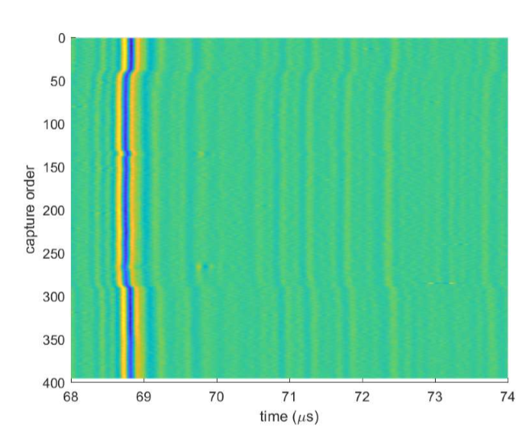
Figure 8-9 – B-scan of all captures taken during a roll pass focused on strip return location
The response from the far side of the roller can be seen, just before 69 µs, but there is a faint peak response, highlighted in blue, which is the response from the far side of the strip.
By taking the value of time from the peaks of the return pulse and using it with the time taken from the peak of the roller far side response the thickness from the first set of rolling data from Chapter 6. This can be seen in Figure 8-10.
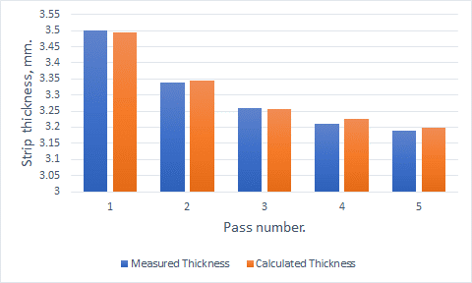
Figure 8-10 – Peak Detect calculated thickness against measured thickness

As can be seen, the calculated strip thickness is very close to the average measured thicknesses, apart from the 4th pass, where it is 0.016 mm too high. All the calculated thicknesses are within the 0.05 mm tolerance required.
This could then be compared to the data calculated using the threshold method, with this being shown in Figure 8-11.
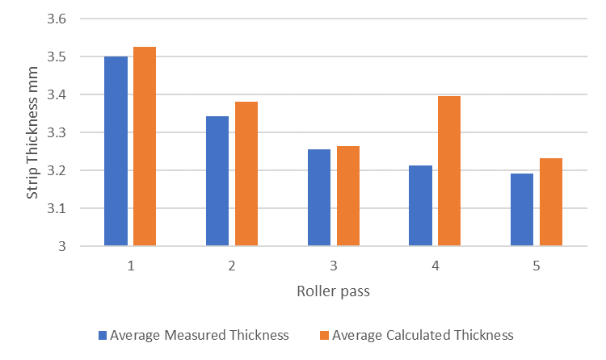
Figure 8-11 – Threshold calculated thickness against measured thickness

The threshold method gave a slight overestimate when compared to the measured thickness for most of the roller passes, however the reading for the 4th strip reduction pass appears to be anomalous. The measured results are compared to the threshold, peak detect and signal averaged, from Labview, results in Figure 8-12.

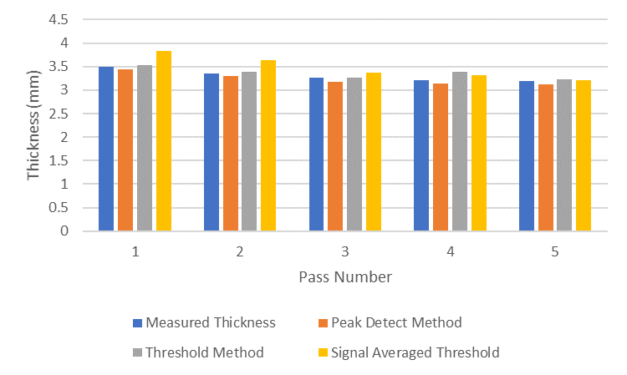
Figure 8-12 – Comparison of thickness measurements

The analysis carried out on Matlab after the rolling process generally provides more accurate results, in addition to having had any trends removed from the rolling data. However, the Labview data set is from a dynamic data set, where the captures were taken back, with the signal averaging removing noise effects from the data. In addition, being able to analyse the data during the rolling process, similar to how the data was processed using Labview would be beneficial when attempting to implement the system as an in-line process.

ToF comparison with resonant dip
The accuracy of the resonant dip method, Chapter 7, can then be compared back to the time of flight methods, Chapter 5 for the oblique ultrasound and Chapter 6 for the water coupled ultrasound. This was carried out by taking the difference between the measured value and calculated values, for the different time of flight methods and for the resonance dip technique.
This can be seen in Figure 8-13.
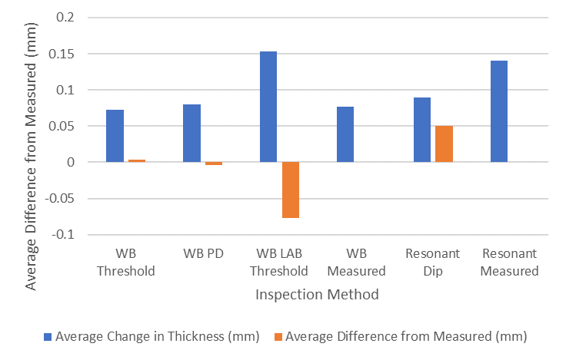
Figure 8-13 – Response from the shim steel compared to water coupled techniques

The maximum allowed error for readings, as highlighted in Tata Steel's requirements was for an error of ±0.05 mm. This has been shown on Figure 8-13, by a red line going across the graph at both 0.05 mm and -0.05 mm. The average change in thickness is shown in blue, with the average difference between the measured and calculated values being shown in orange. Therefore, if the orange bar exceeds the red line, then the technique is providing data which is too inaccurate for the requirements. As can be seen in Figure 8-13, the threshold method used with Labview provides, too great of an error and does not fit within these requirements. The difference for the resonant dip technique was 0.05 mm exactly, so whilst the technique is within the requirements, care must be taken when using the technique.
The peak detect and threshold method used with the water coupled ultrasound can both be seen to be below the 0.05 mm threshold.

Discussion
The different techniques have different strengths and weaknesses and are useful for automating the system. The threshold method can be used to ensure a certain point is met, however, if there is signal loss and the required threshold is not met this can cause problems. The peak detect method is useful, but noise spikes could cause false readings, so signal averaging techniques should be used to remove random noise spikes. The alternative to this is that an area can be selected to focus on, but this requires the expected value of thickness to be known. Although this could be defined by the other measurement techniques present in the rolling system.
The different time of flight techniques are all influenced by interpolation techniques and digital processing effects (Svilainis and Dumbrava, 2008; Svilainis and Kitov, 2010). They can be used either in conjunction with each other to investigate the thickness, or by themselves. This allows for several different ways of investigating strip thicknesses. Each technique has different advantages and disadvantages. By using a Hilbert transform the phase shift affects can be removed. This prevents errors being introduced into the system due to the pulses moving, but significantly increases processing time.
Care must be taken when setting up the system, as if there are noise effects, the wrong pulse could be taken as the return pulse. However, this can be mitigated by ensuring a good signal to noise ratio.
A further limitation to the time of flight techniques trialled is that, since the threshold, peak detect and zero crossing techniques use a percentage of the signal, rather than a discrete value, a value is always returned. When rolling a single strip this can create an issue as a value will be returned, even when the strip is not present in the system. In industrial applications where sheet metal is always being rolled from a coil this would be less of a limitation however, as the signal returned would always be from the sheet metal. Further to this, the method could be paused when it was known that no coil was being fed through the metal rollers.
The resonant dip technique is a potentially useful technique for getting the thickness of thin steel sheet. However, the thicknesses that can be observed are very thin. Whilst this could be an issue on most industrial rolling mills, it could still be useful when rolling very thin products. Further to this, the resonant dip technique could also be used to investigate the lubrication conditions of the strip. The resonant dip technique is useful when investigating thin layers however, especially if the layers would otherwise be obscured by other return reflections. Due to the small thicknesses being observed however, the percentage error of the technique will be greater than for the traditional time of flight techniques.
The resonant dip technique also requires a good FFT to determine the frequency and calculate the corresponding frequency. If a resonance mode is not observable, then this could lead to mistakes in processing the data as it could affect the value of m used in the equation. Because of this care must be taken when identifying the resonant dip in the FFT, as if there are several small layers then several small dips will be observable.
The resonant dip technique could be used in conjunction with other time of flight techniques in order to fully investigate the properties of the strip and lubrication conditions.

Uncertainties and Sensitivity
Accuracy of the measurements is dependent on a good signal to noise ratio. There are a number of contributors towards the noise and uncertainties during measurements, which have been comprehensively covered in the work by Hunter, 2018, conducted under conditions specified by Bell, 2001. Hunter noted that there are two numbers needed to quantify an uncertainty: the width of the margin (interval), and the confidence level. Commonly, this is also known as the specification and the confidence in achieving the specification. For example, Tata Steel has deemed a specification that the steel thickness measurement should be +/- 0.05 mm, without any confidence specified, from which it is assumed that the confidence should be very high: at least 95% (approximately two standard deviations around a mean average value).
In Hunter’s (Hunter, AK, 2018) analysis many contributors to uncertainty were quantified, such as ADC internal noise, Time Skew, Aliasing, the digitiser and environmental electromagnetic noise, but the greatest contributor was found to be the signal to noise generated by the slip ring connection required by the oblique ultrasound set-up. The Standard Uncertainty (i.e. one standard deviation divided by the square root of the number of samples compared) was for the Signal to Noise Ratio (SNR) 0.025, whereas the other contributors were in the order of 1E-05. The water coupled shoe in this work does not rely on slip rings for the electrical connection, but SNR will still be present due to reflections within the rollers, changes in grain structure, microcracks, etc.
The SNR contributes to the uncertainty around the experimental readings. An example of the practical consequence of this comes from Chapter 5 (Table 5-1) where the mean average strip thickness was found to be 2.888 mm with a standard deviation of 0.019 mm, Relative Standard Deviation of 0.66%. Assuming a normal distribution for readings distributed around the mean average value, the standard deviation can be used to calculate the expected confidence of a reading to be within upper and lower bounds (intervals). This is illustrated in Table 8-1.

Table 8-1 Oblique ultrasound confidence in experimental reading around mean value of 2.888 mm

Number of standard deviations from the mean | Variation from the mean  (mm) | Confidence for a single reading  (%)
1 (Standard error) | plus or minus 0.019 | 68
2 | plus or minus 0.038 | 95
3 | plus or minus 0.057 | 99.8

If a very high degree of confidence is required then it is appropriate to select the three times the standard deviation multiplier, which in this case would give a calculated strip thickness of 2.888 mm plus or minus 0.057 mm. This variation (interval) of 0.057 mm is very slightly above the desired value of 0.050 mm as specified by Tata Steel.
In the case of water coupling using a shoe data from Table 6-1 can be used to assess the confidence in each experimental reading. The difference between the measured thickness value by callipers and that from the peak detect calculated values for each reading is tabulated in Table 8-2. The modulus of the reading is taken, to remove negative values, and the mean average calculated over all the difference readings, together with the standard deviation of the differences around that mean. The upper and lower bounds (interval) around the calculated strip thickness is provided by adding, or subtracting, the mean difference together with the standard deviation of the differences multiplied by 1; 2; or 3 depending on the confidence required. This gives the total difference in um from the calculated thickness at the different confidence levels.

Table 8-2 Water shoe coupled ultrasound difference between measured and calculated strip thickness – data from Table 6-1

Test run | Measured thickness (mm): | Calculated strip thickness  (mm) | Difference in strip thickness  (µm) | Modulus of  Difference  (µm)
1 | 3.50 | 3.49 | 7.2 | 7.2
2 | 3.34 | 3.34 | -4.8 | 4.8
3 | 3.26 | 3.26 | 4 | 4
4 | 3.21 | 3.23 | -16.4 | 16.4
5 | 3.19 | 3.20 | -6.8 | 6.8
1 | 4.02 | 4.03 | -5.6 | 5.6
2 | 4.02 | 4.03 | -5.8 | 5.8
3 | 3.99 | 4.00 | -6 | 6
4 | 3.99 | 4.00 | -6 | 6
5 | 3.96 | 4.11 | -154.4 | (154)*
6 | 3.85 | 3.85 | 2 | 2
7 | 3.83 | 3.61 | 218.8 | (219)*
8 | 3.61 | 3.61 | -1.2 | 1.2
9 | 3.49 | 3.49 | -2.8 | 2.8
10 | 3.42 | 3.43 | 13.6 | 13.6
11 | 3.21 | 3.20 | 13.2 | 13.2
12 | 3.06 | 3.05 | 11.2 | 11.2
Statistics:
Mean average: |  |  |  | 7.09
Standard deviation: |  |  |  | 4.50
* values not used in mean and standard deviation calculations

In Table 8-2 two values of difference in strip thickness are clearly significantly out of line (outliers) compared to the remaining values. In an automated system the controlling software would need to check each value obtained to see if it is a reasonable value. Most likely this would be achieved by comparing it to the previous value(s) and rejecting any that are spurious. Such an algorithm was not used in this data acquisition, but could be relatively easily implemented. Thus, the mean average difference between measured and calculated strip thickness was 7.09 µm, with a standard deviation around that mean of 4.50 µm.
For comparison with the oblique ultrasound method (Table 8-1), the above statistics have been used to calculate the expected interval, lower and upper bounds, around the mean value of a measurement of strip thickness of 2.888 mm. This thickness is used in Table 8-1. The comparison provides some indication of the expected accuracy of the two different techniques for strip thickness measurement.
Table 8-3 Water shoe ultrasound confidence in experimental reading around mean value of 2.888 mm
Confidence level considered | Product of standard deviation and sigma multiplier  (µm) | Lower bound  (mm) | Upper bound  (mm) | Total difference  (µm)
68% - one sigma | 4.50 | 2.876 | 2.900 | 12
95% - two sigma | 9.00 | 2.872 | 2.904 | 16
99.8% - three sigma | 13.5 | 2.867 | 2.909 | 21

It is notable that at the three sigma level of confidence the value of strip thickness will be within 21 µm of the calculated value, i.e. 99.8% confidence, or 1 in 1000 readings will be below 21 µm and 1 in 1000 will be above 21 µm around the strip thickness value of 2.888 mm. This is well within the required specification of plus or minus 50 µm. However, this result is reliant on the rejection of the occasional spurious reading by an appropriate software routine within the monitoring software.

Conclusion
It appears that the oblique ultrasound method can meet the required plus or minus 50 µm threshold, as demonstrated in Figure 8-10. However, when considering uncertainty around the experimental readings at the 99.8% confidence level the maximum threshold provided by the technique in this work was 57 µm (Table 8-1), which is only just outside the required specification. The water shoe method of signal coupling, considered at the same value of strip thickness (2.888 mm), had a maximum threshold of 21 µm (Table 8-3), well within the desired threshold of 50 µm. However, this would be reliant on a suitable software trap in the monitoring software to remove any clearly spurious readings.
The different signal processing techniques of: signal threshold; zero crossing and peak detect for the different ultrasound techniques were considered, implemented in LabView and Matlab in Section 8.2, and it was found that the peak detect technique was the most reliable for signal processing. Clearly, this is dependent on the existing algorithms within those software packages, but this is the current position.
It can be seen that different techniques can be useful in different applications. For example, the resonance dip method can only be used for very thin sheet steel but provides a clear result even when the signal is noisy due to its use of a FFT. Whereas the water coupled ultrasound method can be used during the rolling process, however noise can be a factor and if the metal strip is too thin it will be more difficult to make out the return pulse from the far side of the metal strip.
In conclusion the processing technique used when looking through the data is important as if there is too much signal drop, or uncertainty due to the noise, then it will affect the ability to accurately read the strip thickness during rolling and error trapping could be important.

Conclusions and future work
A couple of different ways of coupling ultrasound to a metal roller in order to investigate the strip thickness were trialled as part of this work. They were investigated and appraised as techniques, both within a lab environment, and with an industrial environment in mind. A simple industrial validation test was carried out, in order to ensure the signal was strong enough to pass through an industrial sized roller, under optimal coupling conditions. The results from this are shown in Appendix I.

Oblique Ultrasound
The first method trialled was the chamfered edge, oblique ultrasound method. This technique has been shown to provide the strip thickness of the metal strip and can send a good consistent signal through the metal roller. However, since these transducers are mounted onto the edge of the metal roller, they do not send a signal through the metal strip consistently as the transducer will only align with the strip on a cyclic basis.
A further limitation with the bonded on, oblique method is that the area to be inspected has to be decided on, with the chamfers being ground to provide access to this area. However due to the size and angle constraints, only one part of the contacting roller can be investigated, preventing a profile of the whole roller from being observed.
They can provide a good image of the roll bite when the transducers are aligned, and this may allow for the strip thickness to be monitored throughout the roller pass. In addition, since the transducers are physically bonded onto the rollers, both longitudinal and shear waves can be used to investigate the roller, lubrication and strip conditions.
Several concerns were highlighted for use in an industrial environment, however, as the ultrasound would have to pass through a large amount of metal in the roller before reaching the strip. In addition, concerns have been raised regarding grinding the roller to fit the transducers and system in. Since the rollers have to be removed and ground down, this could lead to damage to the ultrasound system. In addition, since the roller geometry would be changed, the angle the ultrasound would travel at would have to be adjusted to compensate for this. Regrinding the chamfers would then add extra expense as it would add extra down time to the metal rollers, in addition to the costs to grind the metal roller.
In the tests reported in Chapter 5, Section 5.4.1, it was shown that under certain conditions the oblique ultrasound could measure the strip thickness to a good degree of precision: with a standard deviation of 0.019 mm around a mean value of 2.888 mm. This would provide a 99.8% confidence level of the strip thickness being 2.888 mm plus or minus 0.057 mm. This is very slightly outside of the required 0.050 mm requirement.

Water Coupled Ultrasound
The water coupled ultrasound technique has shown potential as it allows for the thickness of the metal strip to be investigated. This method can also be installed and moved easily, avoiding the limitation with the bonded on oblique method as the system does not require any changes to the metal roller itself. In addition, since the system can be moved, it should not restrict the ability to remove and replace the metal roller after grinding. The system can also be deployed along the metal roller, allowing for a profile of the roller and strip to be built up, rather than just one point.
A limitation however is that the system investigated was in the pulse-echo configuration and this would limit the types of metal rolling that could be investigated to the transducer being perpendicular to the rollers only. Combining this method with an oblique angle could help overcome this limitation, however. A second limitation with the water jet method is that if the probe and water coupling are not aligned properly, then the strip will not be investigated. By using the shoe, instead of a jet, this limitation is reduced but there must be space to fit the shoe in.
The water coupled method allows for a greater investigation of the metal roller. The ultrasound response from the near side of the roller can be used to investigate the roller profile, in addition to the roller deformation. Because of this the roller stress can be monitored, in addition to the roller profile. Since the system can be installed throughout the roller surface, the strip and roller profile can be monitored more thoroughly. This will also ensure that the strip is being rolled uniformly.
In the tests reported in Chapter 6, Section 6.6, and Table 8-3, it was shown that under most conditions the oblique ultrasound could measure the strip thickness to a good degree of precision: with a standard deviation of 0.012 mm around a mean value of 2.888 mm. This would provide a 99.8% confidence level of the strip thickness being 2.888 mm plus or minus 0.036 mm. This is well within the required 0.050 mm requirement.

Processing Techniques
The signal to noise ratio is a large factor, affecting the quality of the system used. Signal averaging of the captures surrounding a capture of interest can be used to limit the effects of electrical or spike noise, by averaging it out. Several different processing techniques can also be used to process the received data, including the peak detect, zero crossing and threshold method. In addition, a Hilbert transform can be used to remove the effects of phase changes, but with an additional signal processing time penalty.
The resonant dip technique can also be used to investigate the thickness of thin metal strips. However, this technique is only viable for very thin applications, so would not be useable in a general cold rolling mill. It does offer the opportunity to investigate thin metal, however, and has been used to monitor the thickness of the lubrication layer in several previous publications. This method benefits by using a FFT to substantially reduce the noise.
The most appropriate post processing technique found during this work was peak detect, Figures 8-5 and 8-6, which show that the calculated thickness of the strip closely matches the measured thickness using callipers. The alternative techniques of zero crossing and thresholding provided poor matching to the measured values, using the algorithms currently available within LabView and Matlab.

Future Work
Several different areas for future investigation have been highlighted during this project, which will be discussed below

Liquid Coupled Ultrasound
This work has been carried out using water to couple the ultrasound to the metal roller. However, work could be carried out to investigate the effect of using a different coupling fluid. This is due to the water getting mixed with the oil, or other rolling lubricant present when rolling. By investigating the effect of different coupling fluids, the affect this has on the monitoring process can be analysed and this would allow for any effects to be mitigated. Therefore, a variety of different mixtures of water and rolling lubricant could be investigated, along with using just rolling lubricant and the coolant used.
Further to this by investigating the effects of different coupling fluids, the system could be built into systems already present in the rolling mill and this would help reduce costs compared to regrinding rolls to fit oblique ultrasound transducers.
The work on water shoe coupled ultrasound reported here only used the pulse echo configuration. A more practical technique for wider use would be a water shoe at an appropriate oblique angle, this would necessitate the use of pitch catch. Thus, this is another area requiring further investigation.

Ultrasonic Technique Investigation
Two different methods of investigating the roll bite using ultrasound have been used in this investigation in order to monitor the roll bite. A third method however has been previously highlighted as a potential technique (Sheffield Roll Gap). Therefore, one area of interest to investigate would be this third technique, to find out if it could be used as a viable technique.
A further technique was also identified during the research, where a roller would have a hollowed out shaft, with the transducer mounted inside. A coupling fluid would then be used to couple this transducer to the inside of the metal roller and then the strip. This process could be investigated as by installing the transducer inside the metal roller, the amount of material the signal must pass through would be greatly reduced. Installing this transducer would be difficult however and a way to install, power and process the signals would need to be investigated. One solution would be to use a slip ring, but this would likely be undesirable so a way of inserting a transducer power and control system with the transducer would be ideal, with the data being sent wirelessly to the overall control system. The affect this would have on the rolling process would need to be investigated.
In addition, the oblique ultrasound and water coupled ultrasound techniques could also be used in conjunction. This could allow for more flexibility in transducer layout, possibly even being built into the water jets used to cool the roll bite if the angles could be set up correctly.
This would provide extra value as if the ultrasound could be coupled to the coolant already being used in the system, then this would further limit the amount of modification required to use the ultrasound system in the rolling environment. This would be beneficial in both cost of setting up the system, as well as ensuring the new ultrasonic testing set up did not interfere with the already present equipment, for both rolling and monitoring the strip conditions.
Other ultrasonic techniques would also be trialled, including the use of EMATs and air coupled transducers. This would allow for further comparison with the water coupled and oblique ultrasound methods, as well as potentially providing another way to conduct strip thickness measurements during the rolling process.

Post Processing Techniques
Another area that would be of interest to research further would be to trial the resonant dip technique on industrial rollers. This would test the viability of the technique on larger rollers. Further work on ensuring the processing techniques could return the strip thickness in the required time frame for rolling. This would be carried out by analysing a large variety of different rolling speeds used in industrial metal roller. All the techniques would also be trialled in the different roll stands, to investigate how the change in strip thickness into the different stands affected which processing technique returned the best response.

Industrial Testing Future Work
Another aspect that may be investigated would be using the water coupled ultrasonic shoe with a bigger, industrial sized roller. This would allow for verification that the ultrasonic system would work on a full-sized rolling mill. Further to this work would be performed to conduct the strip thickness analysis during the rolling process, ensuring the ultrasonic system worked in-line and in-situ under the required conditions.
In addition to investigating the attenuation of the ultrasonic signal, the ultrasonic system would also be further refined to ensure the signal was strong enough to pass through an industrial roller. The system would also be refined to ensure that operation of the ultrasonic set up does not affect the rolling process. The durability of the system would also be investigated.
Depending on the results from these trials, work could be carried out on integrating the feedback into a control system, to allow for changing the roll gap size during the rolling process.
Testing of the oblique ultrasound method with industrial rollers of up to 0.55 m has been done as part of this project, with the results provided in Appendix I.

Lubrication Conditions
A further area for future research would be investigating the different lubrication conditions that could be observed by using the different ultrasound techniques. This would add extra value to the system as several different components could be monitored at once.
In addition to this the effects of different rolling lubrications would also be investigated using this system, this would be to help investigate the factors that can affect the rolling process, as well as the monitoring system. This would help investigate the effect of different rolling lubricants on the ultrasound passing through the lubrication and strip.

Closing comments
Measuring strip thickness during rolling was demonstrated to be viable using both oblique ultrasound (with bonded on transducers) and with water coupling. In the case of water coupling the best signal response was obtained using a water shoe, rather than water jets. A water shoe system had a better precision for measurements of thickness compared to the bonded oblique ultrasound. The standard deviation around a mean strip size of 2.888 mm was 0.019 mm for the oblique ultrasound and 0.012 mm for the water shoe. At the 99.9% level of confidence, i.e. approximately 3 sigma. This provides 2 readings out of 1000 that will be further away from the mean value than 0.057 mm, and 0.036 mm, for the oblique and water shoe methods, respectively. The requirement was to have readings less than 0.050 mm difference from the true value of the strip thickness. Thus, the expected random variation from the oblique ultrasound readings will be slightly higher than the stated requirement of plus or minus 0.050 mm, but only for two readings in every 1000. The water shoe coupled ultrasound should provide a random measurement value variation that is well within the 0.050 mm requirement. Both types of types of ultrasound techniques are capable of providing an accurate value for the strip thickness.
Further work could be done on the computer code used to process the signal, providing trap(s) to reject spurious signals and to provide a dedicated package for the strip thickness measurement, probably using the peak detect method. A dedicated package would most likely run faster than one dependent on off-the-shelf software.

References
Adeyemi, G, 2018, Development of an External Ultrasonic Sensor Technique to Measure Interface Conditions in Metal Rolling, PhD Thesis, University of Sheffield, UK.
Adeyemi, GJ, Dwyer-Joyce, RS, Pinna, C, Hunter, A, Stephen, JT and Adebayo, AG,.2020. Non-intrusive measurement of strip thickness and roll-bite length in metal rolling. Proceedings of the Institution of Mechanical Engineers, Part B: Journal of Engineering Manufacture. 234.
Adeyemi, GJ, Dwyer-Joyce, RS, Stephen, JT, Adebayo, AG, 2020, Measurement of metal–roll interface during metal rolling using normal and oblique ultrasonic reflection, Tribology-Materials, Surfaces & Interfaces 14 (2), 79-91
Adeyemi, GJ, Dwyer-Joyce, RS, Stephen, JT, Adebayo, AG, 2022, Ultrasonic technique for measurement of oil-film thickness in metal cold rolling, Tribology-Materials, Surfaces & Interfaces 16 (2), 177-186
Allport, JJ, 1976, Self-compensating X-ray or gamma-ray thickness gauge, United States Patent 4047029 July 1976.
Andersen, CB., Ravn, BG and Wanheim, T, 2001,Development of a commercial transducer for measuring pressure and friction on a model die surface. Journal of Materials Processing Technology, 115(2): p. 205-211.
Arif, AFM, Khan, O, Sheikh, AK, 2004, Roll deformation and stress distribution under thermo-mechanical loading in cold rolling, Journal of Materials Processing Technology 147, pp 255–267.
Aussel, JD and Monchalin, JP, 1989, Measurement of ultrasound attenuation by laser ultrasonics, Journal of Applied Physics, 65, p 2918.
Banks, B, Oldfied, GE, Rawding, H, 1962, Ultrasonic Flaw Decection in Metals Theory and Practice, Prentice-Hall, New Jersey, USA.
Batzinger, TJ and Reed, FA, 2003, System and method for ultrasonic immersion inspection of components, United States Patent, US 6,591,680 B2.
Bell, S, 2001, Measurement Good Practice Guide: A Beginner's Guide to Uncertainty of Measurement. National Physical Laboratory, Centre for Basic, Thermal and Length Metrology.
Bessemer Process, https://www.britannica.com/technology/Bessemer-process, Accessed August 2019.
Bhagi, PCR, Kalyanasundaram, P, Raj, B, Jayakumar, T, 1999, Ultrasonic Detection and Characterisation of Defects Using Electromagnetic Acoustic Transducers (EMATs), Nondestructive Testing and Evaluation, 19(2), pp 23-28.
Bindal, VN, 2000, Water-Based Couplants for General Purpose Use for Ultrasonic NDT Applications, Journal of Scientific and Industrial Research, 59, pp 935-939.
Blaivas M, Lyon M, Brannam L, Duggal S, Sierzenski P, 2004, Water bath evaluation technique for emergency ultrasound of painful superficial structures, Am J Emerg Med, 22, pp 589-593.
Brunskill, HP, 2013, The Real-Time Characterisation of Dry Machine Element Contacts Using Ultrasonic Reflectometry, PhD Thesis, University of Sheffield, UK.
BS EN 10130:2006 - Cold Rolled Low Carbon Steel Flat Products for Cold Forming. Technical Delivery Conditions. (2006, December 29). (0 580 49900 6). BSI.
Butkus, J. Vladišauskas, A and Jakevičius, I, 2005, The use of ultrasound for determination of the thickness of glass panes of windows Ultragarsas" Ultrasound", 10(7): p. 17-21.
Carretta, Y, Hunter, AK., Boman, R, Ponthot, JP, Legrand, N, Laugier, M, and Dwyer-Joyce, R, 2017, Ultrasonic roll bite measurements in cold rolling - Roll stress and deformation. Journal of Materials Processing Tech., 249, 1-13.
Carretta, Y, Hunter, S, Boman, R, Ponthot, JP, Legrand, N, Laugier, M and Dwyer-Joyce, R, 2018, Ultrasonic roll bite measurements in cold rolling: Contact length and strip thickness. Proceedings of the Institution of Mechanical Engineers, Part J: Journal of Engineering Tribology,. 232(2): p. 179-192.

Castaings, M, Cawley, P, Farlow, R and Hayward, G, 1998, Single Sided Inspection of Composite Materials Using Air Coupled Ultrasound, Journal of Nondestructive Evaluation, 17, pp 37–45.
Castellano A, Fraddosio A, Marzano S, Piccioni MD, Some advancements in the ultrasonic evaluation of initial stress states by the analysis of the acoustoelastic effect, Procedia Engineering, 199 (2017) 1519-1526, 2017.
Cheeke, JD, 2012, Fundamentals and Applications of Ultrasonic Waves. CRC Press.
Abiza, Z, Destrade, M, Ogden, RW, 2012, Large acoustoelastic effect, Wave Motion
Choi, S, Cho, H, Lindsey, M and Lissenden, C, 2018, Electromagnetic Acoustic Transducers for Robotic non-destructive Inspection in Harsh Environments, Sensors, 18, 193.
Class instrumentation Ltd., http://www.classltd.com/sound_velocity_table.html, Accessed July 2019.
Devadas, C and Samarasekera, IV, 1986, Heat Transfer during Hot Rolling of Steel strip, Iron making and Steel making, l3, pp 311-21.
Domanti, S and McElwain, D,1998, Cold rolling of flat metal products: contribution of mathematical modelling. Proceedings of the Institution of Mechanical Engineers, Part B: Journal of Engineering Manufacture, 212(1): p. 73-86.
Dixon, AE and Yuen, WYD, 2003, The development of a fast and robust computer model for metal rolling. Proceedings of the Institution of Mechanical Engineers, Part B: Journal of Engineering Manufacture, 217(2): p. 169-179.
Dwyer-Joyce, RS, Drinkwater, BW, Quinn, AM, 2001, The Use of Ultrasound in the Investigation of Rough Surface Interfaces, Journal of Tribology, 123, pp 8-16.
Dwyer-Joyce, RS, Drinkwater, BW and Donohoe, C, 2003, The measurement of lubricant–film thickness using ultrasound. Proc Roy Soc Lond Ser A. 459(2032): p. 957–976.
Dwyer-Joyce, RS, Harper, P and Drinkwater, BW, 2004, A method for the measurement of hydrodynamic oil films using ultrasonic reflection. Tribology Letters, 17: p. 337-48.
Dwyer-Joyce, RS. and Hunter, A, 2013, A novel sensor for lubrication and contact measurement in metal rolling. in 5th World Tribology Congress, WTC 2013.Politecnico di Torino (DIMEAS).
Dwyer-Joyce, RS, 2017, Measuring a Surface Film of Oil with Surface Continuous Wave Ultrasound Tribology & Lubrication Technology 73 (12), 41-41
Economic and Societal Impact of the Global Steel Industry, https://www.worldsteel.org/en/dam/jcr:7a759646-a2c6-4f7c-9c54-9710c0eb33e2/Full_steel_impact_infographic.pdf, Accessed July 2019.
EMATs, https://warwick.ac.uk/fac/sci/physics/research/ultra/research/emat/ accessed August 2019.
Ensminger, D, and Bond, LJ, 2011. Ultrasonics: Fundamentals, Technologies, and Applications. CRC Press.
Fleck, NK, Johnson, M. Mear, and Zhang, I, 1992, Cold rolling of foil. Proceedings of the Institution of Mechanical Engineers, Part B: Journal of Engineering Manufacture, 206(2): p. 119-131.
Greenwood, JA and Williamson, JB, 1966, Contact of Nominally Flat Surfaces. Proc. R. Soc. Lond. A, 295, 300-19.
Engineering ToolBox, (2004). Solids and Metals - Speed of Sound. [online] Available at: https://www.engineeringtoolbox.com/sound-speed-solids-d_713.html [Accessed 13. 10. 2022]
Farley, T, 2009, Mill vibration during cold rolling, Technical note, Innoval Technology Ltd, Banbury, UK.
Federal Highway Administration Research and Technology October 2004
Fishbane, PM, Gasiorowicz, SG and Thornton, ST, 1995, Physics for Scientists and Engineers Volume 1, Extended Version, New York, USA.
Garver, FW, 1960, Method of Producing Metal Rollers, US patent 3007231A.
Green, RE, 2004, Non-contact ultrasonic techniques, Ultrasonics, 42, pp 9-16.
Gregersen, E., Bessemer process metallurgy, https://www.britannica.com/technology/Bessemer-process, Accessed August 2019
Hunter, AK, 2018, Ultrasonic Measurements of the Strip Thickness, Lubricant Film Thickness, Roll Deflection and Roll Stress in the Roll Bite in the Cold Rolling of Steel, PhD Thesis, University of Sheffield, UK.
Jortner, D, Osterle, JFand Zorowski, CF, 1960, An Analysis of Cold Strip Rolling. International Journal of Mechanical Sciences, 2, 179-194.
Kanja, J, Mills, R, Li, X, Brunskill, H, Hunter, AK and Dwyer-Joyce, RS, 2021, Non-contact measurement of the thickness of a surface film using a superimposed ultrasonic standing wave, Ultrasonics 110, 106291
Kendall, K and Tabor, D, 1971, Ultrasonic Study of Area of Contact between Stationary and Sliding Surfaces. Proceedings of the Royal Society of London Series a-Mathematical and Physical Sciences, 323(1554): p. 321-340.
Lenard, JG, 2013, Primer on Flat Rolling. Elsevier.
Liaptsis, D, Drinkwater, BW, Thomas, R., 2006, The Interaction of oblique incidence ultrasound with rough, partially contacting interfaces, Nondestructive Testing and Evaluation, 21, pp 109-121.
Library of Manufacturing, thelibraryofmanufacturing.com/metal-rolling.html, Accessed August 2019
Metal Rolling Blog https://www.innovaltec.com/history-metal-rolling-blog/ Accessed August 2019
Metal Rolling, https://thelibraryofmanufacturing.com/metal_rolling.html, Accessed August 2019.
Metal Rolling History, https://www.innovaltec.com/history-metal-rolling-blog/, Accessed August 2019.
Metal working World Magazine http://www.metalworkingworldmagazine.com/a-short-sheet-metal-history/ accessed August 2019
Metals and Alloys - Densities. The Engineering Toolbox: http://www.engineeringtoolbox.com/metal-alloys-densities-d_50.html, Accessed May 2019
Mills, R, Dwyer-joyce, RS and Marshall, M, 2021, Continuous wave ultrasound for analysis of a surface, US Patent 11,067,545.
Mill Vibration Phenomena during Cold Rolling, https://www.innovaltec.com/mill-vibration-blog/, Accessed August 2019
Mirkhani, K, Chaggares, C, Masterson,., Jastrzebski, M., Dusatko, T., Sinclair, A., Shapoorabadi, R., Konrad, A., Papini, M., 2004, Optimal design of EMAT transmitters, NDT & E International, 37, 181-193.
Monchalin, JP, 2004, Laser-Ultrasonics: From the Laboratory to Industry, AIP Conference Proceedings, 700, 3.
Peretti, G, Dwyer-Joyce, RS, Schirru, M and Ville, F, 2022, Measuring Lubricant Viscosity In-Situ Using Ultrasound, Book of Abstracts, 18,
Olympus, Ultrasonic transducers technical notes, https://www.olympus-ims.com/en/resources/white-papers/ultrasonic-transducer-technical-notes/, Accessed August 2019.
NDT Resource Center 2019, Ultrasonic Inspection – Near Field Calculation, https://www.nde-ed.org/GeneralResources/Formula/UTFormula/near_field/near.htm, Accessed 22 July 2019
Nutting Jack, History of Steel Making,
https://www.britannica.com/technology/steel/History, Accessed July 2019
Phelan, M and Hagerty, D, 2009, The Oblique View: An Alternative Approach for Ultrasound-Guided Central Line Placement, J Emerg Med. 37, pp 403-8.
Queiros R, Alegria, FC, Girao, PS, Serra, AC, 2010, Cross-Correlation and sine-fitting techniques for high resolution ultrasonic ranging, IEEE Transactions on Instrumentation and Measurement, 59, pp 3227-3236.
Raftery, AE. Kárný, M and Ettler, P, 2010, Online prediction under model uncertainty via dynamic model averaging: Application to a cold rolling mill. Technometrics,. 52(1): p. 52-66.
Raišutis, R, Jasiūnienė, E, Žukauskas, E, 2008, Ultrasonic NDT of wind turbine blades using guided waves, Ultrasound, 63, pp 7-11.
Ramasamy, S, 1988, Analysis of Rolling, Master of Science thesis, Ohio University, USA.
Roberts, WL. 1978. Cold Rolling of Steel. New York: M. Dekker.
Roland Dobbs, E, 1970, Electromagnetic generation of ultrasonic waves in metals, Journal of Physics and Chemistry of Solids, Volume 31, Issue 8, August 1970, pp 1657-1667.
Roth, DJ, Whalen, MF, Hendricks, L and Bodis, JR, 1999, Using High Frequency Focussed Water-Coupled Ultrasound for 3-D Surface Depression Profiling, Technical Report, NASA/TM-1999-209268, NAS 1.15:209268, E-11715, USA
Rueter, D and Morgenstern T, 2014, Ultrasound generation with high power and coil only EMAT concepts, Ultrasonics. 54(8), pp 2141-50.
Shoupp, WE and Tichvinsky, LM, 1940, Thickness gauge for rolling mills, United States Patent 2,264725.
Solids and Metals - Speed of Sound, https://www.engineeringtoolbox.com/sound-speed-solids-d_713.html, Accessed 26/07/2019
Speed of sound, http://hyperphysics.phy-astr.gsu.edu/hbase/Sound/souspe2.html, Accessed 26/07/2019
Steel Market Size, Share & Trends Analysis Report By Product, 2017, (Hot, Cold, Direct Rolled, Tubes), By Application (Pre-engineered Metal Buildings, Bridges, Industrial Structures), By PMB, By Region, And Segment Forecasts, 2018 – 2025, Available at: Steel Market Size, Share, Trends | Global Industry Growth Report, 2025 (grandviewresearch.com)
Svilainis, L and Dumbrava, V, 2008, Analysis of the Interpolation Techniques for Time-of-Flight Estimation. Ultragarsas, 63(4), 25-29.
Svilainis, L and Kitov, S, 2010, Analysis of the Digital Signal Processing Influence on Time-of-Flight Estimation. Ultragarsas, 65(4), 22-27.
Swanton Welding Company, 2016, Metal Rolling With Precision: Why It Should Matter To You, Available at: https://blog.swantonweld.com/metal-rolling-with-precision, Accessed May 2021
Warwick University, Available at: https://warwick.ac.uk/fac/sci/physics/research/ultra/research/emat/, Accessed August 2019.
Wente, EF Steel, Metallurgy, https://www.britannica.com/technology/steel/Testing-of-properties, Accessed August 2019.
Whittingham, T and Martin, K, 2010, Transducers and Beam-Forming. In P. R. Hoskins, K. Martin, & A. Thrush (Eds.), Diagnostic Ultrasound: Physics and Equipment. Cambridge University Press.
World Steel Association https://www.worldsteel.org/about-steel.html Accessed July 2019
World Steel in Figures 2019, https://www.worldsteel.org/en/dam/jcr:b5e18bcb-20bc-4d87-b656-dbaabc587fb7/Whole%2520piece_2019.pdf, Accessed July 2019
Zhao, B, Otman AB and Mittal, GS, 2003, Detection of metal, glass and plastic pieces in bottled beverages using ultrasound, Food Research International, 36, pp 513-521.
Zloter, Z, Shenholz, G and Serber, R, 2001, Systems and processing algorithms for ultrasound time-of-flight digitizer systems, Patent WO2000016291.
World Steel Association (2019), Available at: https://worldsteel.org/en/dam/jcr:7a759646-a2c6-4f7c-9c54-9710c0eb33e2/Full_steel_impact_infographic.pdf%20accessed%20July%202019 (Accessed: July 2019)
World Steel Association (2019), https://www.worldsteel.org/en/dam/jcr:b5e18bcb-20bc-4d87-b656-dbaabc587fb7/Whole%2520piece_2019.pdf (Accessed: July 2019)
Rosen Group (2019), https://www.rosen-group.com/global/company/explore/we-can/technologies/measurement/emat.html, (Accessed: July 2019)

APPENDIX

Appendix I - Full Size Industrial Roll Tests
Whether the signal would be strong enough to pass through industrial metal rollers was an area of interest. This was because the grain structure present in the metal rollers, can cause signal scattering within the roller, leading to a loss in signal. Further to this, some rollers have a core that the metal roller is built around. This boundary change will cause reflections within the metal roller. If this is known then this reflection can be ignored, but the signal must still be strong enough to pass through the two interfaces on both the way to the strip and from the strip (Garver, F.W. Method of Producing Metal Rollers, US patent 3007231, November 1961).
Finally, an issue with some metal rollers is that they have a hollowed out middle. This is more common in back up rollers, however this can still be an issue in some primary rollers.
To investigate the attenuation of the signal tests were trialled on stationary metal rollers fitted with transducers.
The attenuation of the ultrasonic signal is governed by Equation Ap-1.
Ap-1
$$A=A_{0}e^{-∝z}$$
Where A is the amplitude, $A_{0}$ is the initial amplitude of the signal, z is the distance travelled from the initial location and $∝$ is the attenuation coefficient of the wave.
The attenuation was tested on two different industrial sized, bigger rollers. The first can be seen in Figure Ap-1.
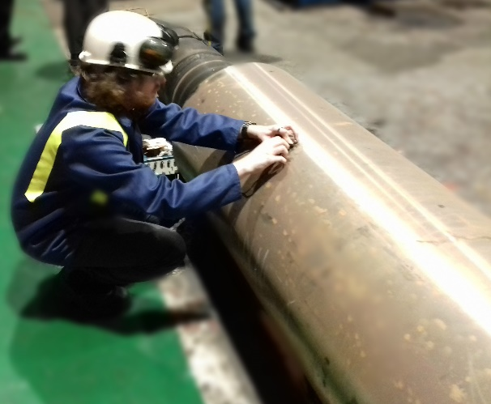
Figure Ap-1 – Transducer being used on an industrial roller

The ultrasonic response from a 5 MHz contact transducer, mounted onto the roller using contact gel, can be seen in Figure Ap-2.
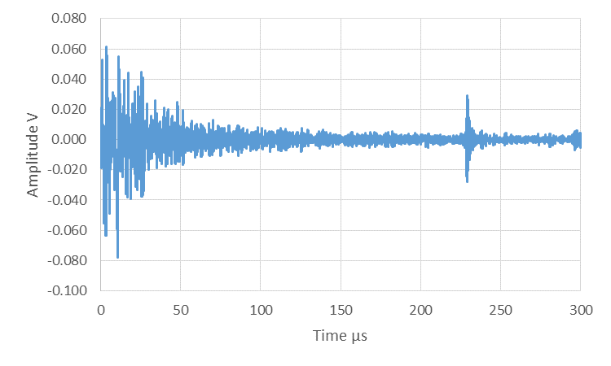
Figure Ap-2 – A scan response from full size industrial roller

The return pulse from the far side of the roller can be seen, highlighted in red. This shows that the signal is strong enough to pass through the metal roller of a diameter of 550 mm.

Appendix II - Roller Surface Oblique Testing
One aspect of the system that was of interest was the response from changing the angle of incidence into the roller, from the rolling surface. This was because it would be advantageous if the signal could be introduced into the system from angles other than perpendicular, allowing for greater flexibility in setting up the system. This would be especially important in four-high rolling mills, where it would be impossible to install the ultrasonic shoe perpendicular to the roller surface. By investigating the possibility of installing the shoe at an angle, this would potentially allow for the oblique and water coupled methods to be combined into a refined system.
To investigate this a metal strip was rolled into place between the metal rollers, before being shut off. The response through the metal roller and strip was then investigated, coupling the 10 MHz immersion transducer to the metal roller using contact gel. The angles investigated where: perpendicular to the strip, at ±30º, ±45º and ±60º. Figure Ap-3 helps show this set up.

Figure Ap-3 – Rollers and transducers at different incident angles

Following this the strip was rolled out of the system and the experiment was repeated without the strip present in the system. This could then be compared to the response with a strip, to remove the effect of internal reflections.
The response from the system, when the transducer was perpendicular to the roller, with no strip in the system can be seen in Figure Ap-4.
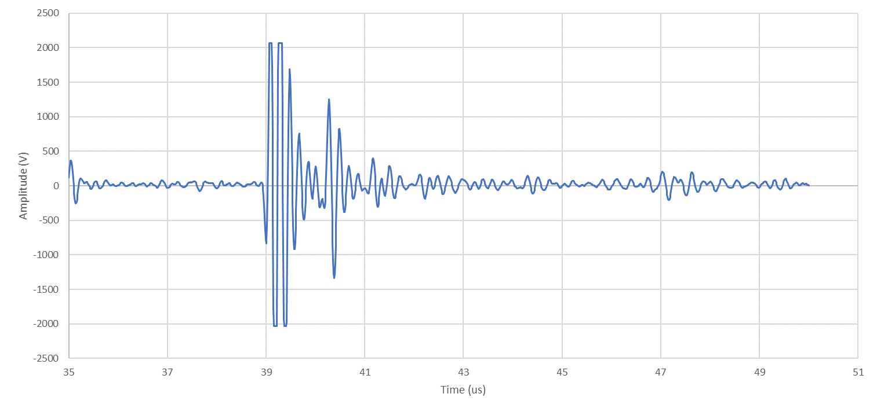
Figure Ap-4 – A scan response with no offset

The reflection from the far side of the roller can be observed at approximately 39 µs, highlighted in red, with reflections occurring at approximately 40.29 µs and 41.19 µs, highlighted in orange and green. These will be due to the concave nature of the 10 MHz immersion probe.
The corresponding response from the system, when the strip was present, can be seen in Figure Ap-5.
Figure Ap-5 – A scan response with strip present, with no offset

The return pulse from the far side of the roller can be observed at approximately 39 µs, in red, with a second return pulse at 40.28 µs, in green. The change in time between these peaks, gives a thickness of the strip of 3.58 mm, with the measured values of the strip, taken afterwards giving an average strip thickness of 3.65 mm. A limitation however is that this potential return pulse from the far side of the strip, occurs at approximately the same time as one of the previously observed reflections due to the geometry of the immersion probe used. The return pulse when the strip is present is reduced, possibly due to ultrasonic energy being transferred into the top roller.
The return pulse from the system without and with the strip, when the transducer was moved around the roller by 30º can be seen below in Figures Ap-6 and Ap-7 respectively.
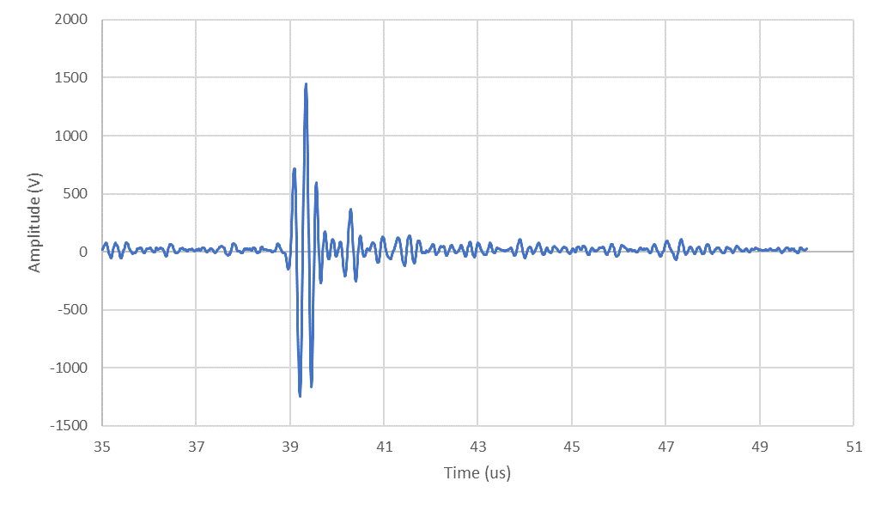
Figure Ap-6 – A scan response at with a 30º offset
Figure Ap-7 – A scan response at a 30º offset with the strip

The response from the system when the strip is not present has a few peaks after the initial response from the far side of the roller, highlighted in red, but the response when the strip is present provides a much stronger reflection, highlighted in green. The calculated strip thickness is approximately 3.61 mm.
The responses from the system, without and with the strip when the angle was 45º can be seen in Figures Ap-8 and Ap-9 respectively.
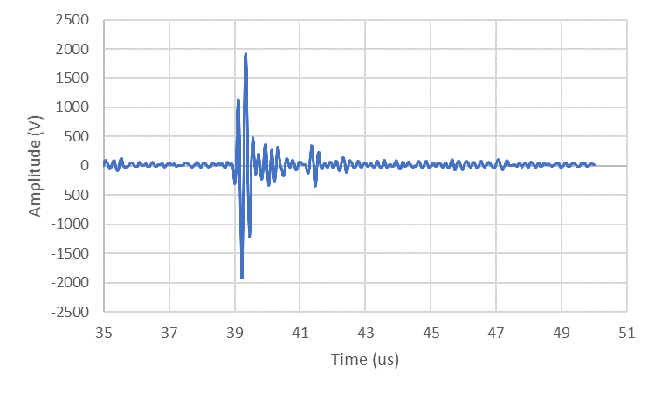
Figure Ap-8 – A scan response at a 45º offset without the strip

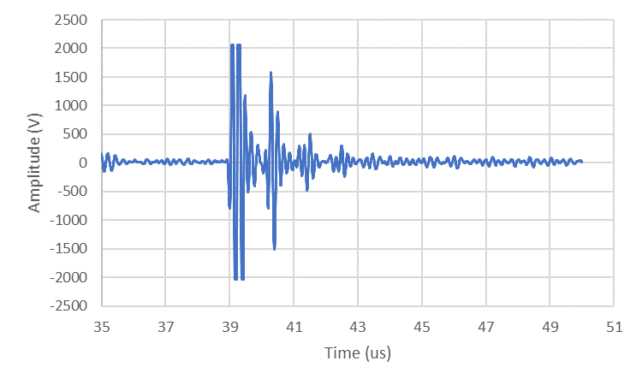
Figure Ap -9 – A scan response at a 45º offset with the strip

As can be seen, when the strip is not present in the system, the amplitude of the extra reflections has dropped, however when the strip is still present in the system, the response from the far side of the strip can be seen. This gives a strip thickness of 3.58 mm. The roller far side and strip far side are highlighted in red and green respectively.
Finally, the responses from when the transducer, without and with the strip, when there was a 60º angle are shown in Figures Ap-10 and Ap-11 respectively.
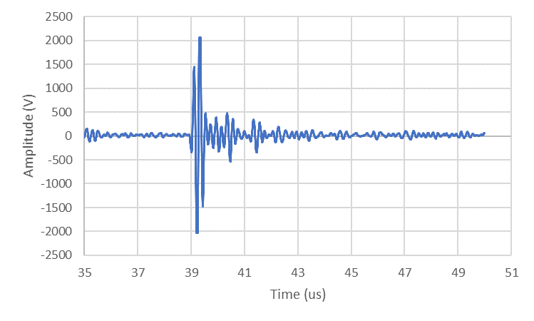
Figure Ap-10 – A scan response at a 60º offset with the strip

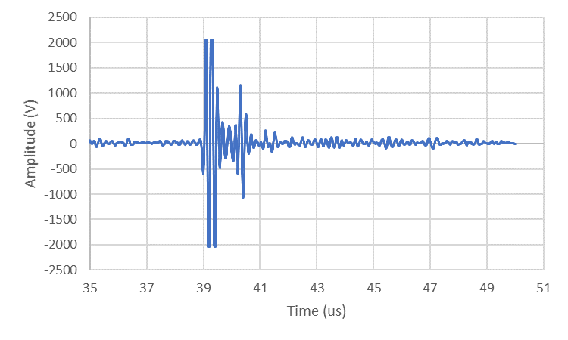
Figure Ap-11 – A scan response at a 60º offset with the strip
The response without the strip in the system, shows an increase in amplitude of the 2nd reflection when compared to the response when the transducer was mounted at 45º. The response with the strip present in the system however still shows a good response from the far side of the strip, which was calculated to be 3.52 mm thick. The response from the far side of the roller and strip are highlighted again in red and green respectively.
This was then repeated, by rotating the transducer around the metal roller, with the results from this shown below in Table Ap-1.
Table Ap-1 – Table showing the data from different angles of approach
Angle offset: | -60º | -45º | -30º | 0º | +30º | +45º | +60º
Thickness 1 (mm) | 3.40 | 3.58 | 3.58 | 3.58 | 3.61 | 3.58 | 3.52
Thickness 2 (mm) | 3.55 | 3.67 | 3.64 | 3.58 | 3.61 | 3.61 | 3.61
Thickness 3 (mm) | 3.46 | 3.61 | 3.61 | 3.55 | 3.61 | 3.61 | 3.67
Thickness Average (mm) | 3.47 | 3.62 | 3.61 | 3.57 | 3.61 | 3.6 | 3.6

The calculated average values are shown in Figure Ap-12, together with the measured value.
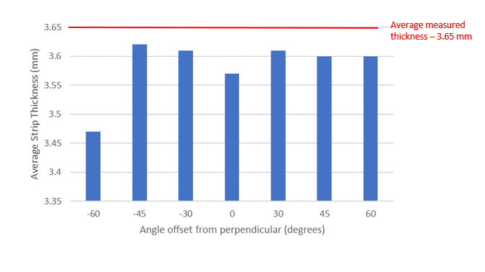
Figure Ap -12 – Average calculated strip thicknesses from the angled data

The average measured value is shown in red and can be observed to be between 0.03 mm to 0.13 mm over the calculated values, which suggests some form of systematic error. The response for an offset of 60º around the roller, appears to give too low a measured thickness and this would potentially be more of an issue when used on larger industrial sized metal rollers, due to more signal being lost during travel through the metal roller. A further limitation with using an angled approach is that ultrasound energy will be reflected at an angle at the interface, causing more signal loss.

Roller Deformation
The thickness of the metal roller during the rolling process could also be observed during the rolling process. This was carried out by using the same technique for finding the strip thickness, with the return pulses from the near side of the metal roller and the far side of the metal roller.
For the rolling data presented in Chapter 3, the time of flight method was used to get the thickness of the metal roller, during the rolling process. These thicknesses are shown in Table Ap-2.
Table Ap-2 – Table showing the roller thicknesses throughout the rolling process
Roll Pass | Roller near thickness without strip (mm) | Roller thickness with strip (mm) | Change in thickness (mm)
0 | 108.9 | N/A | 0
1 | 109.1 | N/A | 0
2 | 109.3 | 109.0 | 0.3023
3 | 109.3 | 108.8 | 0.4749
4 | 109.4 | 108.6 | 0.7475
5 | 109.3 | 108.7 | 0.5980
6 | 109.1 | 108.8 | 0.3682

This can also be seen in Figure Ap-13.
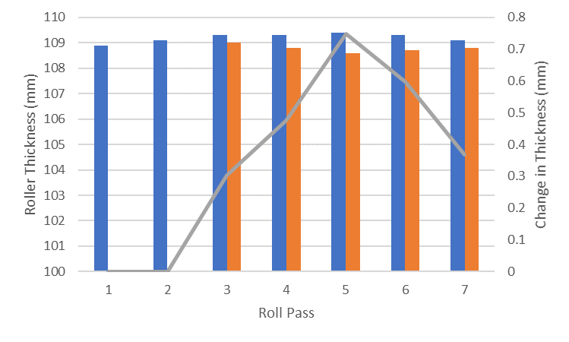
Figure Ap-13 – Change in Roller Thickness through different rolling passes

Where the response from the roller without the strip is in blue, the response with the strip is orange and the grey line shows the change in thickness on the secondary axis.
Strain is defined in Equation Ap-2.
$$ε=\frac{dL}{L}$$
Where $ε$ is the strain, $dL$ is the change in length and $L$ is the original length.
Ap-2
The strain in the roller for the data shown in Table Ap-2. is shown in Table Ap-3.

Table Ap-3 – Table showing the roller strain
Roller pass number | Roller Strain
0 | 0
1 | 0
2 | $$2.8×{10}^{-3}$$
3 | $$4.3×{10}^{-3}$$
4 | $$6.8×{10}^{-3}$$
5 | $$5.5×{10}^{-3}$$
6 | $$3.4×{10}^{-3}$$

The roller deflection is of interest as, if an array is used, whether the roller is deforming uniformly could be observed. By observing the far side of the roller, it is also possible to monitor the rolling surface and investigate whether the far side is suffering from either adhesive or abrasive wear, as, highlighted previously, this is an issue that can occur during rolling, especially when the rolling speed is too high or low. By monitoring the response from the far side of the roller, any changes to the roller profile can be observed and compared back to both, calculated values of roller thickness, as well as measured values.

Attenuation
If the hollowed-out shaft is only present in the back up rollers, then oblique ultrasound, pitch-catch techniques can be used in order to couple the ultrasonic beam in a way that will not be influenced by these hollowed out back up rollers. This could either use the oblique layout, presented earlier, where the transducers are mounted onto the sides of the metal roller, or future work will be carried out on investigating the ability to use the water coupled method on the rolling surface at an angle, mounting a transducer before and after the metal roller.
If the primary metal roller has a hollowed-out space in the middle, then both the techniques used in Chapters 5 and 6 will be severely limited. This is due to the metal to air interface that would be present in the middle of the roller. A way around this would be to use a coupling fluid within the metal rollers, or to investigate the geometries to try and direct the beam around the centre of the roller. A different solution could be to mount the transducer in the middle of the metal roller, which would reduce the amount of attenuation in the system as the signal would not have to travel through as much material to get to the strip. A limitation with this however would be installing and maintaining the system, along with connecting the transducer to the control system.

Roller Surface Oblique Testing
The oblique angled, pulse-echo testing investigated shows that the transducer does not have to be mounted perpendicular. This could provide more scope for installing the system in an industrial setting and could be used either in pulse-echo, or pitch-catch configuration depending on the space available to mount a second transducer. By using this method four high metal rollers could be investigated, also using the water coupled ultrasound method.

