

An application of value-based decision-making (VBDM) to the study of addiction and recovery from it

By:
Amber Copeland

A thesis submitted in partial fulfilment of the requirements for the degree of
Doctor of Philosophy

The University of Sheffield
Faculty of Science
Department of Psychology

August 2022

Acknowledgements

I would like to thank my supervisors, Professor Matt Field and Dr Tom Stafford. Matt, thank you for not only seeing something in me all those years ago, but for continuing to believe in my abilities and investing so many hours into my professional development. I am incredibly lucky to look up to you, your enthusiasm for research is infectious. Tom, thank you for being so patient, especially as I entered into the world of coding. Your kindness, generosity with your time, and our regular chats have helped me in so many ways. I could not have asked for more, and I am extremely excited to continue working with you both.

Thank you to the people who dedicated their time to participate in the studies, and to the Department of Psychology at the University of Sheffield for funding this PhD. To those in Cathedral Court, thank you. Anton Martínez, you have been my rock. Dr Ben Lorimer, Dr Fidan Turk, Haifa Bin Haamed, Dr Meghann Matthews, Danielle Beaton, Dr Ella James-Brabham, Dr Harriet Baird, Dr Mel Simmonds-Buckley, Dr Myles Jones, Dr Aikaterini Giannadou, I feel ridiculously lucky to have been surrounded by you all, we had so much (maybe at times, too much) fun. Jayne Whitley, not only have you been a great student support officer, but also a great friend.

To the Sheffield Alcohol Research Group, thank you for allowing me to be part of the team. A special acknowledgement goes to Dr Inge Kersbergen and Dr Melissa Oldham for the friendship and invaluable advice over the years. Jen Boyd, Olivia Sexton, Jane Hughes, Dr Abi Stevely, Dr Charlotte Buckley, and Maddy Henney–I am so happy to have met you all and I will always remember our hilarious trip to Utrecht. Lastly, Dr Emma Thornton, even though you are in Liverpool, you have always been an amazing friend to me, thank you.

Thank you to my family for always supporting me and for kindly not asking questions about how the PhD is going. Mum, a long time ago you made the decision to go to university as a single parent with three young children. So much of my motivation and ambition comes from you. Thank you for inspiring me. Lynn and Phil Langton, thank you for all the encouragement and for always being there for me. Regardless of anything else that was happening, being with you both brought me so much calmness and I owe so much to you (and to Alfie (the dog) for cuddling me when I felt stressed). Emily Langton, I am so grateful to have had your love and support throughout this time in my life. You kept me smiling every single day. Thank you for everything you have done, and everything that you continue to do. I hope I have made you as proud of me as I am of you. And to our kitten, Luca, in just one month you have brought so much happiness and joy to my life.

Declaration and Note on Inclusion of Published Work

I, Amber Copeland, confirm that the Thesis is my own work. I am aware of the University’s Guidance on the Use of Unfair Means (www.sheffield.ac.uk/ssid/unfair-means). This work has not previously been presented for an award at this, or any other, university.

This thesis is in a publication format, and contains the following published work:
The narrative review presented in Chapter 1 is published as a Chapter within an edited book:
Copeland, A., Stafford, T., & Field, M. (2021). Recovery from addiction: A synthesis of perspectives from behavioral economics, psychology, and decision modeling. In D. Frings & I. P. Albery (Eds.), The handbook of alcohol use (pp. 563-579). Academic Press. https://doi.org/10.1016/B978-0-12-816720-5.00002-5
Copyright of this book Chapter resides with the publishers; however, the reproduction of a variant of the book Chapter as a thesis Chapter is permitted in the terms of the copyright agreement.

The research presented in Chapter 2 has been published and is available online at Addiction Research & Theory:
Copeland, A., Jones, A., Acuff, S. F., Murphy, J. G., & Field, M. (2022). Meaning in life: Investigating protective and risk factors for harmful alcohol consumption. Addiction Research & Theory. https://doi.org/10.1080/16066359.2022.2134991
This open access article is distributed under a Creative Commons Attribution (CC-BY) 4.0 license which permits unrestricted use, distribution, and reproduction in any medium, provided the original work is properly cited. There is no requirement to obtain permission to reuse this article.

The research presented in Chapter 3 has been published and is available online at Cogent Psychology:
Copeland, A., Stafford, T., & Field, M. (2022). Methodological issues with value-based decision-making (VBDM) tasks: The effect of trial wording on evidence accumulation outputs from the EZ drift-diffusion model. Cogent Psychology, 9(1), 2079801. https://doi.org/10.1080/23311908.2022.2079801
This open access article is distributed under a Creative Commons Attribution (CC-BY) 4.0 license which permits unrestricted use, distribution, and reproduction in any medium, provided the original work is properly cited. There is no requirement to obtain permission to reuse this article.

The research presented in Chapter 6 has been published and is available online at Psychology of Addictive Behaviors:
Copeland, A., Stafford, T., Acuff, S. F., Murphy, J. G., & Field, M. (2022). Behavioral economic and value-based decision-making constructs that discriminate current heavy drinkers versus people who reduced their drinking without treatment. Psychology of Addictive Behaviors. https://doi.org/10.1037/adb0000873
Copyright of this article resides with the publishers; however, the reproduction of a variant of this article as a thesis Chapter is permitted in the terms of the copyright agreement.

The research presented in Chapter 7 has been submitted for publication and is available online as a preprint:
Copeland, A., Stafford, T., & Field, M. (2022). Recovery from nicotine addiction: A diffusion model decomposition of value-based decision-making in current smokers and ex-smokers. https://doi.org/10.31234/osf.io/3jrze
This preprint is distributed under a Creative Commons Attribution (CC-BY) 4.0 license which permits unrestricted use, distribution, and reproduction in any medium, provided the original work is properly cited. There is no requirement to obtain permission to reuse this article.

At the start of each Chapter, I detail my contribution(s) to the work, as well as that of my supervisors, co-authors, and collaborators. This thesis is in publication format which necessitates some repetition of methodological details and background literature across Chapters. Some Chapters contain additional methodological detail and discussion that is not in the submitted and/or published manuscripts, and therefore Chapters are sometimes variations of publications. For coherence, I also provide a brief commentary that links the Chapters together.

Conference Dissemination
Although not published in academic journals, Chapters 4 and 7 have been presented online as posters at the Society for the Study of Addiction’s Annual Conference (2020 and 2021), and these are publicly available (Chapter 4; https://www.addiction-ssa.org/author-publications/modelling-value-based-decision-making-in-regular-alcohol-consumers-after-experimental-manipulation-of-the-value-of-alcohol/, and Chapter 7; https://www.addiction-ssa.org/author-publications/modelling-value-based-decision-making-vbdm-in-current-smokers-and-ex-smokers/). More recently, Chapter 5 has been presented in-person as a poster at the Society for the Study of Addiction’s Annual Conference (2022; https://www.addiction-ssa.org/author-publications/modelling-value-based-decision-making-vbdm-in-daily-tobacco-smokers-after-experimental-manipulation-of-mood/).

Thesis Abstract
A body of theoretical and empirical work postulates that addiction arises from, and is maintained by, excessive valuation of substances relative to substance-free alternative reinforcers. Existing research, however, has largely focused on final choices that are made (Hardy et al., 2018) or temporally extended behavioural patterns over time (Tucker et al., 2021). Less is therefore known about how valuation processes affect the internal processes of decision-making that occur in the lead up to, and determine, discrete decisions that are made. This PhD aimed to address this important research gap. The first aim was to develop a novel value-based decision-making (VBDM) task that is methodologically appropriate to implement in addiction-related research and that can generate the behavioural data required to parameterise the internal processes of decision-making. The second aim was to empirically test predictions from recent conceptual accounts (Field, Heather, et al., 2020) by exploring whether decision parameters recovered from the VBDM task are sensitive to experimental manipulations of substance value (Chapters 4 and 5) and whether they characterise stable behaviour change and recovery from addiction (Chapters 6 and 7). Chapter 1 presented a narrative review that described in detail predictions derived from Field, Heather, et al. (2020). The sensitivity of VBDM tasks to minor alterations in trial wording was subsequently explored in Chapter 3, with the overall aim being to identify appropriate methodology that can be implemented in future addiction-related research. Chapters 4, 5, 6, and 7 then applied the VBDM task to the field of addiction. Findings demonstrated that the experimental manipulation of alcohol value, such that it was devalued (relative to valued), led to increases in evidence accumulation (EA) rates for soft drinks (Chapter 4) and that recovery from nicotine addiction was characterised by higher tobacco-related response thresholds (Chapter 7). As discussed in Chapter 8, the overall findings from this thesis offer partial support for the predictions derived from Field, Heather, et al. (2020) as the hypothesised alterations in VBDM decision parameters were not consistently observed among Chapters (see Chapters 5 and 6). By capitalising on methodological advances in the measurement of value-based choice, this research provides new insights into the internal processes that precede value-based decisions made about substances and substance-free alternatives, including how these may alter as a person changes their behaviour and recovers from addiction.

Table of Contents
Acknowledgements 2
Declaration and Note on Inclusion of Published Work 4
Thesis Abstract 7
Table of Contents 9
List of Tables 13
List of Figures 14
Chapter 1: General introduction 17
1.1. Substance use and addiction: Statistics, prevalence, and consequences 18
1.2. Addiction: Definitions and diagnosis 20
1.3. Behaviour change, recovery, and treatment 25
1.4. Substance use is goal-directed, even in people who are ‘addicted’ 30
1.5. Behavioural economic theories of addiction 33
1.6. Value-based decision-making (VBDM) as a theoretical framework for behaviour change and recovery from addiction 40
1.7. Self-control: What role does this play in VBDM? 47
1.8. Where is the research gap and why is this PhD important? 49
1.8.1. Core PhD aims: 50
Chapter 2: Meaning in life: Investigating protective and risk factors for harmful alcohol consumption 51
Abstract 52
2.1. Introduction 53
2.2. Method 57
2.3. Results 62
2.4. Discussion 68
Chapter 3: Methodological issues with value-based decision-making (VBDM) tasks: the effect of trial wording on evidence accumulation (EA) outputs from the EZ drift-diffusion model 74
Abstract 75
3.1. Introduction 76
3.2. Methods 79
3.3. Results 84
3.4. Discussion 87
Chapter 4: Modelling value-based decision-making (VBDM) in regular alcohol consumers after experimental manipulation of the value of alcohol 90
Abstract 91
4.1. Introduction 92
4.2. Method 97
4.3. Results 106
4.4. Discussion 114
Chapter 5: Modelling value-based decision-making (VBDM) in daily tobacco smokers after experimental manipulation of mood 120
Abstract 121
5.1. Introduction 122
5.2. Method 127
5.3. Results 139
5.4. Discussion 151
Chapter 6: Modelling value-based decision-making (VBDM) in heavy drinkers and people who have reduced their drinking without treatment 156
Abstract 157
6.1. Introduction 158
6.2. Method 164
6.3. Results 172
6.4. Discussion 180
Chapter 7: Modelling value-based decision-making (VBDM) in current smokers and ex-smokers 188
Abstract 189
7.1. Introduction 191
7.2. Method 197
7.3. Results 204
7.4. Discussion 214
Chapter 8: General discussion 220
8.1. Summary of main findings 221
8.2. Theoretical implications 225
8.2.1. Goal-directed accounts 226
8.2.2. Molar behavioural economic accounts 227
8.2.3. The role of self-control 229
8.2.4. Mood induction procedures 230
8.2.5. Meaning in life 232
8.3. Methodological implications 233
8.4. Clinical implications 239
8.5. Strengths and limitations 242
8.6. Future research 249
8.7. Conclusion 254
References 256
Appendix A 323
Appendix B 346
Appendix C 377
Appendix D 394
Appendix E 412
Appendix F 438

List of Tables
Table 2.1. Descriptive statistics (mean, standard deviations (SD) and range) of the total sample (n = 546). Two-thirds of the sample (n = 364; 66.67%) were likely hazardous or harmful drinkers (AUDIT > 7) 62
Table 2.2. Hierarchical regression predicting AUDIT scores, predictor variables are presence of meaning, search for meaning, and average alcohol-free reinforcement after controlling for age and gender 63
Table 2.3. Indirect associations between variables from the structural equation model 66
Table 4.1. Descriptive statistics of the sample (values represent the mean, standard deviation, and range). All but two people (94.44% of the sample) were hazardous or harmful drinkers (AUDIT > 7) 106
Table 5.1. Descriptive statistics of the sample (values represent the mean, standard deviation, and range) 139
Table 5.2. Descriptive statistics for the demand indices captured by the CPT (values are means and standard deviations) 150
Table 6.1. Descriptive statistics split by drinker status (values are means and standard deviations) 173
Table 6.2. Descriptive statistics for the APT split by drinker status (values are means and standard deviations, however for elasticity values represent the median and interquartile range) 177
Table 7.1. Descriptive statistics split by smoking status (values represent the mean and standard deviation) 206
Table 8.1. A brief overview of methodological details from the four empirical chapters that directly tested theoretical predictions derived from Copeland et al. (2021) and Field, Heather, et al. (2020) 226

List of Figures
Figure 1.1. A schematic depiction of a simple drift-diffusion model for two hypothetical decisions (Action A and Action B) 41
Figure 1.2. A schematic depiction of alterations in VBDM parameters (evidence accumulation (EA) rates and response thresholds) that are hypothesised to underlie addiction and recovery from it 44
Figure 2.1. Direct and indirect relationships between meaning in life, alcohol consumption, alcohol-free reinforcement, alcohol value, depressive symptoms, and drinking to cope 64
Figure 3.1. Example trials in the VBDM task 82
Figure 3.2. Mean evidence accumulation (EA) rates split by trial difficulty and trial wording 85
Figure 3.3. Scatterplots to show correlations between EA rates during the three blocks of trials 86
Figure 4.1. Schematic overview of the study procedure 104
Figure 4.2. Example of typical trials (in the soft drink block) 104
Figure 4.3. Mean AAAQ scores before (pre) and after (post) watching the negative video intended to decrease alcohol value 108
Figure 4.4. Mean AAAQ scores before (pre) and after (post) watching the positive video intended to increase alcohol value 108
Figure 4.5. Mean overall EA rates for alcohol and soft drink choices split by alcohol devaluation (solid black line; circle) and alcohol valuation (dashed black line; triangle) experimental conditions 111
Figure 4.6. Mean overall response thresholds for alcohol and soft drink choices split by alcohol devaluation (solid black line; circle) and alcohol valuation (dashed black line; triangle) experimental conditions 111
Figure 4.7. Mean evidence accumulation (EA) rates for alcohol and soft drink decisions (averaged across experimental conditions) split by trial difficulty level 114
Figure 5.1. Schematic overview of the study procedure 136
Figure 5.2. Schematic depiction of typical tobacco block (left) and typical animal block (right) trials 137
Figure 5.3. Average PANAS-X scores (happiness and sadness subscales) pre (before) and post (after) watching the negative videos in the negative mood experimental condition 140
Figure 5.4. Average PANAS-X scores (happiness and sadness subscales) pre (before) and post (after) watching the positive videos in the positive mood experimental condition 141
Figure 5.5. Mean craving to smoke scores pre (before) and post (after) in each of the experimental conditions 143
Figure 5.6. Mean overall EA rates for tobacco and animal choices split by negative (solid black line; circle) and positive (dashed black line; triangle) experimental conditions 145
Figure 5.7. Mean overall response thresholds for tobacco and animal choices split by negative mood (solid black line; circle) and positive (dashed black line; triangle) experimental conditions 146
Figure 5.8. Mean evidence accumulation (EA) rates for tobacco and tobacco-unrelated (animal) decisions (averaged across experimental condition) split by trial difficulty level 148
Figure 5.9. Cigarette demand curves for current smokers. Each data point represents average hypothetical consumption on a particular price of the CPT 150
Figure 6.1. Example of typical trials (in the soft drink block) 170
Figure 6.2. Mean evidence accumulation (EA) rates for alcohol and soft drink choices split by heavy drinkers (solid black line; circle) and moderated drinkers (dashed black line; triangle) 175
Figure 6.3. Mean response thresholds for alcohol and soft drink choices split by heavy drinkers (solid black line; circle) and moderated drinkers (dashed black line; triangle) 175
Figure 6.4. Alcohol demand curves (Panel A) and expenditure (Panel B) split by heavy drinkers and moderated drinkers 178
Figure 6.5. Mean evidence accumulation rates (including all participants) for alcohol and soft drink choices split by trial difficulty level 179
Figure 7.1. Schematic depiction of typical tobacco block (left) and typical animal block (right) trials 202
Figure 7.2. Schematic depiction of a typical MouseTracker trial 204
Figure 7.3. Mean overall EA rates for tobacco-unrelated (animal) and tobacco choices split by smokers (solid black line; circle) and ex-smokers (dashed black line; triangle) 207
Figure 7.4. Mean overall response thresholds for tobacco-unrelated (animal) and tobacco choices split by smokers (solid black line; circle) and ex-smokers (dashed black line; triangle) 208
Figure 7.5. Mean level of conflict represented by area under the curve (AUC scores) when correctly choosing the tobacco-unrelated and tobacco image split by current smoker (grey) and ex-smoker (striped) 210
Figure 7.6. Mean maximum deviation (MD) for tobacco and tobacco-unrelated trials split by current smoker (grey) and ex-smoker (striped) 211
Figure 7.7. Mean evidence accumulation rates (including all participants) for tobacco-unrelated (animal) and tobacco choices split by trial difficulty level 213
Figure 7.8. Mean level of conflict (AUC scores; including all participants) for tobacco-unrelated (animal) and tobacco choices split by trial difficulty level 214

Chapter 1: General introduction

Contributions: I wrote the Chapter. Matt Field and Tom Stafford (primary supervisors) provided feedback on the draft.

As mentioned previously (p.4), a variant of this thesis Chapter is published as a book Chapter in an edited book:
Copeland, A., Stafford, T., & Field, M. (2021). Recovery from addiction: A synthesis of perspectives from behavioral economics, psychology, and decision modeling. In D. Frings & I. P. Albery (Eds.), The handbook of alcohol use (pp. 563-579). Academic Press. https://doi.org/10.1016/B978-0-12-816720-5.00002-5

1.1. Substance use and addiction: Statistics, prevalence, and consequences
Globally, addiction (substance use disorder; SUD) is a significant public health concern (Rehm & Imtiaz, 2016). Both across the world and in the United Kingdom (UK), high levels of alcohol consumption and tobacco smoking are leading causes of preventable disease and death (Degenhardt et al., 2018; Forouzanfar et al., 2016). Statistics from the World Health Organization (WHO) demonstrate that per year, at least 3 million deaths are attributable to harmful alcohol use (WHO, 2022a) whilst at least 8 million deaths are attributable to tobacco smoking (WHO, 2022b). Illicit substance use (e.g., amphetamines, cocaine, and opioids) is also a core public health concern (Peacock et al., 2018). For example, in the United States of America (USA) there is an increasing prevalence in opioid-related deaths (Centers for Disease Control and Prevention, 2021) often referred to as the “opioid crisis” (Corrigan & Nieweglowski, 2018; Lim et al., 2022). Furthermore, in the UK, behaviours such as gambling are increasingly prevalent (Cowlishaw & Kessler, 2016) with figures demonstrating that a significant proportion of people are at risk of developing gambling problems (Gambling Commission, 2022).

In England, it is estimated that over 10 million people currently consume alcohol at harmful levels—that is, at levels above the UK Chief Medical Officers ‘low risk’ drinking guidelines of 14 units of alcohol per week (1 UK unit = 8g of pure alcohol; Office for Health Improvement and Disparities, 2022). Furthermore, over 600,000 people are estimated to be dependent on alcohol (Public Health England, 2021a). These figures are concerning given the numerous health related outcomes of addiction both in the short-term and in the long-term. For example, in the short-term acute alcohol consumption causes impairments in working memory and response inhibition (Zoethout et al., 2011). In the long-term alcohol use increases the risk of liver diseases, such as fatty liver, hepatitis, and cirrhosis (Rehm et al., 2010; Roerecke et al., 2019; Sheron & Gilmore, 2016; Simpson et al., 2019), respiratory problems (Simou et al., 2018), and various forms of cancer (Bagnardi et al., 2015; Rumgay et al., 2021). These risks are dose-related: increased levels of alcohol consumption result in increased risk of ill health (Hagström et al., 2018; Sheron & Gilmore, 2016; Simpson et al., 2019). During the year 2019-2020, there were 280,000 hospital admissions, and 6,985 deaths that were primarily due to alcohol consumption (NHS Digital, 2022; Office for Health Improvement & Disparities, 2021b).

In England, it is estimated that 13.9% of adults (≥18 years old) are dependent tobacco smokers which equates to approximately 5 million people (Office for National Statistics, 2020). Tobacco smoking is one of the leading risk factors for many chronic illnesses including cardiovascular diseases (Banks et al., 2019; Benowitz & Liakoni, 2022; Khan et al., 2021), respiratory conditions (NHS Digital, 2020), and multiple forms of cancer (Cancer Research UK, 2021; Lee et al., 2012; Lin et al., 2021). During the year 2019-2020, there were 506,100 hospital admissions, and 74,600 deaths that were primarily due to tobacco smoking (NHS Digital, 2020).

Crucially, as well as physical health, addiction also has negative impacts on a person’s mental health (Jané-Llopis & Matytsina, 2006). For example, alcohol use is positively associated with depression (Boden & Fergusson, 2011; Fergusson et al., 2009; Kessler et al., 1997). Furthermore, in alcohol-treatment settings, people with depressive symptoms have worse treatment outcomes than those in treatment without depressive symptoms (Pettinati et al., 2013). In England, a third of cigarettes smoked are by people with mental health conditions, with recent statistics showing that people with mental health conditions are at least twice as likely to smoke compared to the general population (Public Health England, 2020). In both general populations and clinical populations, compared to people who smoke, smoking cessation is associated with significant improvements in mental health, such as levels of stress, anxiety, and depression (Taylor et al., 2014, 2021). However, it is difficult to tease apart the causal direction between co-occurring mental health problems and addictive behaviours (Puddephatt et al., 2021). Therefore, it is less clear whether substance use exacerbates existing mental health condition(s), or whether existing mental health condition(s) arise from substance use.

In addition to being detrimental to the health of an individual, addiction also has adverse consequences to society as a whole. The estimated socioeconomic costs of alcohol consumption to society are £21 billion per year (Public Health England, 2016). A breakdown of this figure reveals that £11 billion is a result of crime (e.g., drink-driving and alcohol-related violence), £7 billion is a result of lost productivity to society (e.g., workdays lost through things such as hangovers), and £3.5 billion is direct to the National Health Service (NHS; Public Health England, 2016). The cost of tobacco smoking to society is in excess of £14 billion per year, of which £2.5 billion is direct to the NHS (Public Health England, 2018).

1.2. Addiction: Definitions and diagnosis
The Diagnostic and Statistical Manual of Mental Disorders-5 (DSM-5) is a tool that is used to characterise individuals on the clinical severity of symptoms associated with substance-related behaviours such as alcohol consumption and tobacco smoking (American Psychiatric Association, 2013). The DSM-IV was updated to the DSM-5 in 2013, accompanied by changes to how alcohol and smoking behaviours are classified (Boness et al., 2021).

In relation to the DSM-IV, individuals were categorised according to the severity of their symptoms associated with alcohol consumption, which ranged from alcohol abuse to alcohol dependence, with a clear distinction and specific criteria between the two. However, the DSM-5 upgraded this by changing the key label to alcohol use disorder (AUD) with mild, moderate, and severe sub-classifications depending on the number of criteria met. This was because although the dependence diagnosis had high test-retest reliability, the abuse diagnosis was much more variable, and did not always lead to dependence despite abuse often being viewed as a precursor (see Hasin et al., 2013 for a review). Furthermore, the distinction between abuse and dependence was arbitrary in nature: criteria for abuse were sometimes more severe than the criteria for dependence (Boness et al., 2021; Saha et al., 2007). Research is in support of a continuum model of AUD, demonstrating that dependence and abuse form a single factor and therefore exist on a single dimension (Hasin et al., 2012, 2013).

For behaviour to be labelled as an AUD, a person’s drinking behaviour must have led to at least 2 of the following symptoms in the past 12 months. The severity of AUD is defined by how many symptoms a person has. Mild AUD is the presence of 2 or 3 symptoms, moderate AUD is the presence of 4 or 5 symptoms, and severe AUD is the presence of 6 or more symptoms:

- Alcohol is often taken in larger amounts or over a longer period than was intended.
- There is a persistent desire or unsuccessful efforts to cut down or control alcohol use.
- A great deal of time is spent in activities necessary to obtain alcohol, use alcohol, or recover from its effects.
- Craving, or a strong desire or urge to use alcohol.
- Recurrent alcohol use resulting in a failure to fulfil major role obligations at work, school, or home.
- Continued alcohol use despite having persistent or recurrent social or interpersonal problems caused or exacerbated by the effects of alcohol.
- Important social, occupational, or recreational activities are given up or reduced because of alcohol use.
- Recurrent alcohol use in situations in which it is physically hazardous.
- Alcohol use is continued despite knowledge of having a persistent or recurrent physical or psychological problem that is likely to have been caused or exacerbated by alcohol.
- Tolerance, as defined by either of the following:
- A need for markedly increased amounts of alcohol to achieve intoxication or desired effect.
- A markedly diminished effect with continued use of the same amount of alcohol.
- Withdrawal, as manifested by either of the following:
- The characteristic withdrawal syndrome for alcohol
- Alcohol (or a closely related substance, such as a benzodiazepine) is taken to relieve or avoid withdrawal symptoms.

An advantage of using the DSM-5 criteria to categorize behaviour is that it enables direct comparisons to be made with existing research that has used the DSM-5. However, a major limitation is that the diagnosis of AUD depends on a person having two or more symptoms, resulting in over 2,036 possible combinations that qualify for a diagnosis. Therefore, the extent to which it is helpful to use the DSM-5 to diagnose AUD is questionable given the large number of combinations of symptoms that could result in the same ‘diagnosis’: two people could be diagnosed with an AUD despite having no symptoms in common (Heather, 2017).

Harmful alcohol consumption can be measured in the form of unit intake, or with the Alcohol Use Disorders Identification Test (AUDIT), a tool used to screen people for hazardous and harmful alcohol consumption (Saunders et al., 1993). In the UK, ‘low risk’ drinking guidelines were developed by Chief Medical Officers; drinking in excess of these guidelines (see p.18) is understood as increasing the risk of harm to health (Office for Health Improvement & Disparities, 2021a). The AUDIT questionnaire contains questions about alcohol consumption, specifically patterns and consequences of alcohol consumption (Higgins-Biddle & Babor, 2018). A score of 8 or more is used as a cut-off to index hazardous or harmful alcohol consumption. Hazardous alcohol consumption refers to drinking which is likely to lead to harm in the future, whereas harmful drinking refers to alcohol use where the current risk of damage to social, physical, and mental health is likely (Saunders et al., 1993).

There were also changes from the DSM-IV to the DSM-5 in relation to tobacco use. The DSM-IV only assessed nicotine dependence, and therefore did not include nicotine abuse as a diagnosis. The DSM-5 has upgraded this label to tobacco use disorder (TUD) with mild, moderate, and severe sub-classifications depending on the number of criteria met—similar to diagnosing AUD. Nicotine abuse criteria were often viewed to be redundant predictors of nicotine dependence (Hughes et al., 2011) in that they were assumed to be rarely endorsed in the absence of dependence. However, this has been challenged (Hasin et al., 2005; Shmulewitz et al., 2011), with research again supporting a continuum model by demonstrating that tobacco dependence and abuse exist on a single dimension (Shmulewitz et al., 2011).

Within the DSM-5, different substances are classified based on the same overarching criteria. For example, for behaviour to be labelled as TUD (and identical to the AUD diagnostic criteria) an individual’s tobacco use must have led to at least two of the following criteria in the past 12 months. The severity of TUD is defined by how many symptoms a person has. Mild tobacco use disorder is the presence of 2 or 3 symptoms, moderate tobacco use disorder is the presence of 4 or 5 symptoms, and severe tobacco use disorder is the presence of 6 or more symptoms:

- Tobacco is often taken in larger amounts or over a longer period than was intended.
- There is a persistent desire or unsuccessful efforts to cut down or control tobacco use.
- A great deal of time is spent in activities necessary to obtain or use tobacco.
- Craving, or a strong desire or urge to use tobacco.
- Recurrent tobacco use resulting in a failure to fulfil major role obligations at work, school, or home.
- Continued tobacco use despite having persistent or recurrent social or interpersonal problems caused or exacerbated by the effects of tobacco (e.g., arguments with others about tobacco use).
- Important social, occupational, or recreational activities are given up or reduced because of tobacco use.
- Recurrent tobacco use in situations in which it is physically hazardous (e.g., smoking in bed).
- Tobacco use is continued despite knowledge of having a persistent or recurrent physical or psychological problem that is likely to have been caused or exacerbated by tobacco.
- Tolerance, as defined by either of the following:
- A need for markedly increased amounts of tobacco to achieve the desired effect.
- A markedly diminished effect with continued use of the same amount of tobacco.
- Withdrawal, as manifested by either of the following:
- The characteristic withdrawal syndrome for tobacco (refer to Criteria A and B of the criteria set for tobacco withdrawal).
- Tobacco (or a closely related substance, such as nicotine) is taken to relieve or avoid withdrawal symptoms.

1.3. Behaviour change, recovery, and treatment
Despite the high prevalence of alcohol consumption and tobacco smoking in England, recent figures show that these behaviours have declined steadily over time. For example, the number of adults who self-report consumption in excess of the recommended 14 unit weekly guideline has declined, and this is accompanied by an increase in alcohol abstinence rates (Ng Fat et al., 2018; Public Health England, 2021b). In particular, 16- to 24-year-olds have shown reductions in drinking behaviours (e.g., being less likely to have drunk alcohol in the past week; Oldham et al., 2018) which extend into adulthood (Holmes et al., 2022). The decline in alcohol consumption has also been observed in children aged 11- to 15-years frequently referred to as “youth drinking in decline” (Oldham et al., 2020). There has also been an observable decline in tobacco smoking in England; in 2019, 13.9% of adults were classified as dependent tobacco smokers which is a substantial reduction from the 19.8% of adults in 2011, equating to an estimated 2 million less tobacco smokers (Office for National Statistics, 2020). Specifically, reductions in the uptake of tobacco smoking before the age of 25 have been observed (Opazo Breton et al., 2022).

Numerous factors may prompt or contribute to behaviour change. For example, there is increasing popularity of monthly campaigns whereby people try to abstain from substance use for a month, such as ‘Dry January’ for alcohol and ‘Stoptober’ for tobacco. Since the introduction of Stoptober by the Department of Health in 2012 (Brown, Kotz, et al., 2014) quit attempts during the October month have increased (Kuipers et al., 2019). Furthermore, expenditure on mass-media campaigns such as Stoptober is associated with a higher successful quitting rate in people who attempt to stop smoking (Kuipers et al., 2018). Participating in Dry January has been found to help reduce alcohol consumption and increase psychological and physiological well-being (Ballard, 2016; de Visser et al., 2016; de Visser & Nicholls, 2020; de Visser & Piper, 2020). However, a limitation of existing research is that it suffers from selection bias: participants recruited were already motivated to cut down and therefore this makes it difficult to distinguish whether the beneficial changes are the result of pre-motivation or the period of abstinence from drinking. Although the long-term effects of cutting down alcohol consumption for a month are yet to be empirically tested, promising advances have been made towards establishing feasible methodology to do so (Field, Puddephatt, et al., 2020). It is important to note that the campaign Dry January is not intended as an intervention for people with AUD, but rather, has an aim to help people to reset their relationship with drinking (Ballard, 2016). As well as campaigns, there are likely a variety of other factors that contribute to behaviour change, including modifications in tobacco policy such as increased financial price (HM Revenue & Customs, 2021), strict sale restrictions (e.g., minimum of 20 cigarettes or 30 grams of tobacco; Opazo Breton et al., 2020), verbal and pictorial health warnings (Department of Health & Social Care, 2021), and the ban on smoking inside public places (Tattan-Birch & Jarvis, 2022). Changes are continuously being made in attempt to divert future smokers; menthol cigarettes which have a less harsh taste have been banned since May 2020 (East et al., 2022). Increased health consciousness and a greater awareness of the adverse consequences of alcohol consumption and smoking might also contribute to behaviour change, in addition to the growing popularity of e-cigarettes as an alternative to tobacco smoking (Brose et al., 2020; Brown, West, et al., 2014) and alcohol-free variations of standard alcoholic drinks, such as Beck's Blue (Drinkaware, 2022).

In relation to recovery, current dominating theoretical frameworks posit addiction to be a chronic disease of the brain (Volkow et al., 2016), and in doing so, struggle to provide a coherent explanatory account of how people recover from addiction. To elaborate, brain disease models of addiction (BDMA) propose that although initial substance use is voluntary, the transition to addiction is chronic and characterised by a transition to compulsive behaviour. A core emphasis is that dependence is accompanied by a loss of control in the ability to limit or stop substance use (Leshner, 2001; Volkow & Li, 2004), even if there is desire to do so. This theoretical viewpoint however contrasts with a convincing line of evidence demonstrating that the majority of people with addiction eventually recover (Lopez-Quintero et al., 2011), including both people who seek treatment and those who do not (Dawson et al., 2006; Heyman, 2013, 2017; Tucker et al., 2020). Heyman (2013) synthesised data from national epidemiological surveys in the USA and found that among all participants who had met the DSM criteria for SUD in their lifetime, between 76% and 83% were in remission at the time of the surveys (remission is defined as the absence of any symptom of dependence during the year before the interview), and most people in remission achieved this without the benefit of treatment. Latency to remission varied according to what the primary substance of use was and legality status. For example, half of the individuals with AUD were in remission 16 years after the onset of the disorder, whilst for cocaine dependence this was 4 years. These findings contrast the BDMA which postulates that the longer a person is addicted, the less likely they are to recover (Volkow et al., 2016). This is because over three-quarters of people who once had a diagnosis of SUD reached remission, and this was generally increased with overall years of use (Heyman, 2013).

Evidence of recovery from addiction can be difficult to measure given that definitions of recovery are heterogeneous (Ashford et al., 2019) which may reflect the numerous pathways to recovery, such as treatment assisted recovery and natural recovery (White, 2007). In 2008, an attempt was made to define recovery by bringing together 16 addiction experts, however, they could not agree on a unanimous definition (UK Drug Policy Commission, 2008). Recovery is often characterised by complete abstinence; however, research has demonstrated that people with alcohol dependence can reduce their alcohol consumption, and that this reduction can be maintained for 1 year (Witkiewitz, Falk, et al., 2019), 3 years (Witkiewitz, Wilson, et al., 2019), and even up to 10 years following treatment (Witkiewitz et al., 2021). The implication of these findings is that moderation of consumption can yield a form of recovery that is meaningful and successful for some people. Therefore, although abstinence is often the core outcome (e.g., Volkow et al., 2016), the extent to which it should solely define engagement in the process of recovery is debatable (Ashford et al., 2019). As a result, researchers are moving away from an abstinence only approach. Indeed, a recent review of the literature by Witkiewitz et al. (2020) proposed a definition of recovery that recognises it to be a process of behaviour change that is dynamic and ongoing, characterised by improvements in biopsychosocial functioning and purpose in life.

For people who seek treatment, some of the effective psychological interventions for addiction include alcoholics anonymous (AA), motivational interviewing (MI) or motivational enhancement therapy (MET), and cognitive behavioural therapy (CBT; Dutra et al., 2008). Previous research has provided an insight into the psychological mechanisms by which these treatments exert their effects. For example, AA is a non-professional organisation whereby a person who is dependent on alcohol is paired with a person who is abstinent from alcohol (but who used to be dependent themselves, also referred to as a ‘sponsor’). Group meetings are held, and via a twelve-step programme, are used to advocate complete abstinence from alcohol. AA has been found to enhance recovery via several mechanisms. Prominent examples are through the facilitation of social network changes (Brooks et al., 2017; Kelly, 2017) and boosting social and negative affect abstinence self-efficacy (Kelly et al., 2009, 2012). MI or MET, on the other hand, is a client‐centred method that uses ‘change-talk’ techniques to augment a person’s intrinsic motivation to change, and this has been found to be effective in moving people into recovery (Magill et al., 2014, 2018). CBT works to tackle thought processes and aims to increase a person’s ability to cope (Sudhir, 2018) which is related to post-treatment drinking outcomes (Roos et al., 2017).

It is also common for people with addiction to recover on their own and without any formal treatment, often referred to as “self-change” and “natural recovery” (Dawson et al., 2005; Heyman, 2013; Klingemann et al., 2010; Tucker et al., 2020). Epidemiological data clearly show a pattern of age-related decline in alcohol consumption (Britton et al., 2015) which is referred to in the literature as “maturing-out” (O’Malley, 2004). This process can be explained through the role incompatibility theory (Yamaguchi & Kandel, 1985); the attainment of adult roles and responsibilities is in direct conflict with heavy drinking. For example, roles such as marriage, cohabitation, employment, and parenthood (Dawson et al., 2006; Staff et al., 2010, 2014) are inversely associated with substance use. Importantly, these transitions can occur at any point in a person’s life (Vergés et al., 2013). Acquiring adult roles is related to establishing a sense of ‘meaning’ in life (Negru-Subtirica et al., 2016), which is negatively associated with alcohol consumption (Copeland et al., 2020; Csabonyi & Phillips, 2017) and positively associated with remission from AUD (Krentzman et al., 2015).

Johannessen et al. (2019) conducted a systematic review of psychosocial factors connected to recovery after SUD treatment and found that perceived social support, employment, and improvements in mental health facilitated coping behaviours. These findings are interesting because they demonstrate the diverse pathways to recovery; treatments and life changes facilitate recovery from addiction in different ways. For example, AA facilitates changes in social support (Kelly, 2017), employment is a social role that may give a person meaning in life through a clear sense of structure and order (Stavrova et al., 2018), and these have been found to both facilitate coping behaviours which is a primary aim of CBT (Sudhir, 2018). Therefore, treatments and life transitions both facilitate psychosocial changes that play an important role in sustaining recovery from addiction, such as self-efficacy, social support, responsibility, and structure in life (Moos, 2007). This was indeed important during the UK Drug Policy Commission consensus meeting in that although they could not define recovery, interestingly they did agree that being in recovery is “characterised by voluntarily-sustained control over substance use which maximises health and wellbeing and participation in the rights, roles and responsibilities of society” (UK Drug Policy Commission, 2008; p.6). Therefore, the overall effect may be to increase the value of alcohol-free alternatives and place emphasis on the capacity a person has to change (Heyman, 2013). This point is discussed later in the discussion on behavioural economics (Section 1.5).

1.4. Substance use is goal-directed, even in people who are ‘addicted’
Addiction is often characterised by maladaptive or dysregulated decision-making (Ekhtiari et al., 2017). When investigating why people make the decision to use drugs, there are two dissociable learning processes that might underlie such behaviour; habitual behaviour (i.e., behaviour elicited directly by antecedent stimuli), and goal-directed behaviour (i.e., behaviour mediated by knowledge of the outcome, combined with knowledge about the incentive value of the outcome). Habitual behaviour includes automaticity and inflexibility whilst goal-directed behaviour includes active deliberation and adaptive flexibility (Dolan & Dayan, 2013).

The widely accepted scientific view of addiction (SUD) is that initial substance use is a goal-directed voluntary act, but that addiction occurs through a transition into habitual and compulsive behaviour (Clemens et al., 2014; Everitt & Robbins, 2005). This viewpoint therefore proposes that people with addiction are compulsive and experience loss of control over their behaviour (Everitt & Robbins, 2016) in accordance with the dominating brain disease model of addiction (Volkow et al., 2016). However, theories of addiction that emphasise the role of habit and compulsion have been challenged (Hogarth, 2020, 2022): evidence of habitual behaviour in addiction relies heavily upon animal research, whilst there is only weak evidence for impaired goal-directed control in humans (Hogarth et al., 2019). This point is further exacerbated by the increasing scepticism in the extent to which findings from animal research are fully transferrable to understanding and treating addiction in humans (Field & Kersbergen, 2019). Instead, a growing body of literature on humans provides compelling evidence that dependence is driven by excessive goal-directed drug choice (Hogarth, 2020, 2022; Hogarth et al., 2019; Hogarth & Field, 2020; Pickard, 2020b).

To explore goal-directed processes, research typically uses concurrent choice training tasks whereby a substance-related image (e.g., tobacco) and a control image (e.g., chocolate) are presented simultaneously on a screen and participants select one of the images to earn a reward by pressing one of two keys. Rewards vary from things such as points, consumption, or enlargement of images (Hardy et al., 2018; Hogarth & Chase, 2011; Stoops et al., 2012). Within these tasks, the percentage of substance choice is used as an index of the relative value that is ascribed to the substance-related reward versus the control reward: greater preference for the substance reward is reflective of a greater value ascribed to the substance. Previous research has demonstrated that substance value increases with the severity of dependence, including alcohol (Hardy et al., 2017, 2018; Hardy & Hogarth, 2017; Hogarth & Hardy, 2018b), tobacco (Chase et al., 2013; Hardy et al., 2018; Hogarth & Chase, 2011; Lawn et al., 2015, 2018; Miele et al., 2018), and cocaine (Moeller et al., 2009, 2013, 2018). In addition, research has demonstrated that the relative value of substances is sensitive to manipulations that alter motivation for consumption (Acuff, Amlung, et al., 2020). For example, when dependent smokers are deprived of nicotine for 12 hours, they demonstrate increased preference for cigarettes (Lawn et al., 2015), and when tobacco is devalued through health warnings and nicotine satiety, preference for tobacco is reduced (Hogarth, 2012; Hogarth & Chase, 2011). Furthermore, even when satiated, the induction of negative mood reverses this effect on preference, highlighting the sensitivity of tobacco preference to mood manipulation (Hogarth et al., 2015). The effect of negative mood on valuation processes have also been demonstrated in studies with alcohol (Hogarth et al., 2018; Hogarth & Hardy, 2018a). Furthermore, when the taste of alcohol is manipulated to be aversive to humans, preference for alcohol is reduced (Rose et al., 2013) as well as actual consumption of alcohol (Rose et al., 2018). Therefore, substance use is goal-directed rather than compulsive or habitual, even in people who are ‘addicted’ (Hogarth, 2020).

Anhedonia is a common consequence of addiction (Garfield et al., 2014) and is characterised by the diminished interest, pleasure, or enjoyment from substance-free activities or events that would typically be enjoyed (Sussman & Leventhal, 2014). Anhedonia may contribute to the overvaluation of substances through the undervaluation of alternative substance-free rewards (Leventhal, Trujillo, et al., 2014; Meyer et al., 2016). This imbalance is indeed reflected within the unified framework for addiction proposed by Redish et al. (2008), whereby various “vulnerabilities” within the decision-making process refer to distortions in valuation processes. For example, excess positive value-error signals lead to an overvaluation of substance-seeking (non-compensable dopamine) and sensitisation of motivational signals drives excess motivation for substances and substance-related cues (incentive-salience; Redish et al., 2008). Consequently, people with addiction are sensitized to the motivational effects of substances and substance-related stimuli (Robinson & Berridge, 1993) and desensitised to other non-substance alternative reinforcers (Volkow et al., 2016). This is evident within the DSM-5 criteria for various SUDs (American Psychiatric Association, 2013), for example, overvaluation of substances may be represented through increased “craving” and “continued drug use despite having persistent or recurrent social or interpersonal problems caused or exacerbated by the drug”; whilst devaluation of alternative substance-free reinforcers may be represented through “important social, occupational, or recreational activities are given up or reduced because of drug use”. Therefore, a distortion in valuation processes for substances and substance-free alternative reinforcers may be an important mechanism through which addiction is maintained (Leventhal, Trujillo, et al., 2014).

1.5. Behavioural economic theories of addiction
“Behavioural economics” is a discipline in which principles and concepts from economics and psychology are combined in an attempt to better understand the choices that people make (MacKillop, 2016). Behavioural economic theories are molar in nature: they attempt to understand the distribution of behaviour to response alternatives by looking at patterns of behaviours to patterns of reinforcement over time (Murphy, MacKillop, et al., 2012; Tucker & Vuchinich, 2015). Applied to addiction, behavioural economic theories explore patterns of substance use in the context of changes in access (e.g., availability and price) to substance use and to alternative sources of substance-free reinforcement (Bickel et al., 2014). Therefore, behavioural economic accounts incorporate wider environmental contexts, and in doing so, emphasise the importance of reinforcement derived from substance-free alternatives within the development and maintenance of addiction (Bickel et al., 2014; Khoddam & Leventhal, 2016).

Behavioural economic methodology comprises different constructs that are useful in understanding addiction, in particular; demand and delay-discounting (Bickel et al., 2014; MacKillop, 2016). Demand is a quantitative measure of the relationship between cost and attainment of a commodity (e.g., alcohol or nicotine), and is used to index the reinforcing value of a substance (Martínez-Loredo et al., 2021). Demand is typically assessed using self-report purchase tasks, such as the alcohol purchase task (APT; Murphy & MacKillop, 2006) and the cigarette purchase task (CPT; Jacobs & Bickel, 1999; MacKillop et al., 2008) which assess a person’s estimated hypothetical consumption across a set of prices that gradually increase. By plotting consumption of a commodity as a function of its price, numerous indices of value can be calculated: intensity (i.e., consumption when price is at zero), O_{max} (i.e., maximum expenditure across prices), P_{max} (i.e., the price by which demand becomes elastic), breakpoint (i.e., first price that suppresses consumption to zero), and elasticity (i.e., rate at which consumption becomes dependent upon price; Hursh & Silberberg, 2008; Murphy & MacKillop, 2006). A brief assessment of alcohol demand (BAAD; Owens et al., 2015) was developed as a shorter and more convenient way to capture core indices of demand (intensity, O_{max}, breakpoint). Importantly, the BAAD has been found to produce comparable results to those obtained with the full APT (Merrill & Aston, 2020; Owens et al., 2015). There is currently no validated brief version of the CPT.

Research using the APT has demonstrated that alcohol demand is associated with the quantity and frequency of alcohol consumption (Murphy & MacKillop, 2006), AUD severity (MacKillop et al., 2010), and is predictive of brief treatment outcomes (MacKillop & Murphy, 2007; Murphy et al., 2015). Despite choices being hypothetical in nature, responses on the APT have been found to be highly correlated with consumption of alcohol in the laboratory (Amlung et al., 2012; Amlung & MacKillop, 2015) demonstrating that indices of demand are indicative of actual drinking behaviour. Similarly, research using the CPT has demonstrated that cigarette demand is associated with consumption of cigarettes (González-Roz et al., 2019), nicotine dependence (MacKillop et al., 2008; Murphy et al., 2011), and predicts future smoking behaviour in those attempting to quit (MacKillop et al., 2016). Responses on hypothetical purchase tasks and concurrent choice tasks have been found to be correlated with one another (Chase et al., 2013) demonstrating that they tap into some common construct of value. Demand indices from self-report hypothetical purchase tasks are also sensitive to experimental manipulation (Acuff, Amlung, et al., 2020) such as exposure to substance-related cues, withdrawal, and the induction of stress (Amlung & MacKillop, 2014; Aston et al., 2021; MacKillop et al., 2012) further supporting the notion that substance-related decisions are goal-directed (Hogarth, 2020).

Delay discounting (DD) refers to the subjective devaluation of rewards based on their delay to receipt, and therefore reflects the process of how rapidly a reward loses its value based on its temporal distance (MacKillop et al., 2011). In other words, DD is a measure of intertemporal choice that symbolises a person’s excessive preferences for smaller, sooner rewards over larger long-term rewards (Bickel et al., 2014; MacKillop, 2016). In the context of addiction, excessive preference for substance-related rewards may be related to a more general tendency to devalue future outcomes or rewards (e.g., improvements in health) relative to immediately available rewards (e.g., intoxication). Indeed, a previous meta-analysis found a significant difference in DD with a medium effect size (d = 0.62) between people with addiction versus controls without addiction (MacKillop et al., 2011). This is complemented by another more recent meta-analysis (Amlung et al., 2017) which demonstrated robust associations between DD and addiction severity across different types of addictive behaviours, including both alcohol and tobacco use. Substance use and addiction may in part develop as a result of lower engagement in alternative behaviours because the benefits of other constructive behaviours to substance use are generally delayed and therefore lose value (e.g., studying typically leads to the award of a qualification in the long-term). SUDs can therefore be conceptualised within a behavioural economic framework whereby there is persistently high valuation of a substance and devaluation of larger long-term rewards (Bickel et al., 2014).

Behavioural economics can also be applied to behaviour change and recovery from addiction (Bickel et al., 2014; Bickel & Athamneh, 2020; Field, Heather, et al., 2020; Hogarth & Field, 2020; Tucker et al., 2021). Specifically, for recovery to occur, substances must reduce in value and substance-free alternatives must increase in value (including those that are only available after a delay). Indeed, a systematic review of the literature revealed that there is a robust inverse association between substance-free reinforcement and substance use; as the proportion of one increases the other decreases (Acuff et al., 2019). Furthermore, increased engagement with tobacco-unrelated alternative reinforcers have been found to be important predictors of both short-term (Goelz et al., 2014) and long-term (Schnoll et al., 2016) abstinence from smoking. Consequently, substance-free reinforcement is recognised as a significant target for addiction treatment (McKay, 2017). However, a challenge is that many people with a SUD may not have access to ‘natural reinforcers’ that serve as alternatives to substance use. To elaborate, years of addiction may have resulted in several adverse outcomes, including breakdowns in social relationships and/or declines in meaningful activities that provide a sense of purpose in life (McKay, 2017). As a result of this, there may be a lack of strong incentives for sustained behaviour change and recovery and it instead poses as ‘existential crisis’ (Pickard, 2020a): a person may start to wonder “who am I?” if they do not use substances because there is no clear alternative. Hypothetically, in the scenario where there is no clear alternative, the decision will be between using a substance versus not using a substance.

Considering this research, there are now a number of novel evidence-based treatments that are based upon principles from behavioural economics, which aim to increase a person’s engagement with substance-free activities (Fazzino et al., 2019). For example, contingency management (CM), behavioural activation (BA), and substance-free activity sessions (SFAS) all broadly aim to simultaneously increase the value of substance-free alternatives relative to substance use, albeit through slightly different methods. CM is a behaviour modification technique that aims to reinforce desired behaviours (e.g., reductions in substance use) with the use of incentives (Petry et al., 2017). These incentives can vary, but typically include things such as small cash rewards, vouchers, prize-draw methods, and clinic privileges. CM is an effective treatment (Lussier et al., 2006; Petry et al., 2011, 2012; Prendergast et al., 2006; Stitzer & Petry, 2006) particularly in the short-term (Benishek et al., 2014). A Cochrane review examined the long-term effectiveness of CM programmes for smoking cessation and found that incentives (such as cash or vouchers) improve the rate of smoking cessation, and that this is continued even in the long-term (Notley et al., 2019). BA is another promising technique for reducing substance use (Daughters et al., 2018; Martínez-Vispo et al., 2018) which is often administered alongside techniques from CBT and uses strategies to encourage people to engage in rewarding activities (Lejuez et al., 2011) such as activity scheduling, assessment of life goals and values, activity monitoring, and skills training (Kanter et al., 2010).

SFAS use principles from motivational interviewing (Miller & Rollnick, 2012) and are often administered alongside brief interventions (Murphy, Dennhardt, et al., 2012). SFAS include things such as identifying personal goals (both short-term and long-term) and then exploring how drinking may interfere with attainment of these goals. Importantly, SFAS provide personalised feedback for each individual that clusters behaviours into patterns and then explores how these patterns impact attainment of future goals. SFAS were originally designed in an attempt to engage students with meaningful alternative sources of reinforcement to alcohol (Murphy, Dennhardt, et al., 2012; Murphy, Skidmore, et al., 2012) but have since been extended to clinical treatment settings (Meshesha et al., 2020). SFAS are associated with a reduction in how much reinforcement people in treatment get from alcohol relative to alcohol-free alternative activities (Meshesha et al., 2020) and reductions in alcohol reinforcement has been found to mediate the effects of brief interventions on alcohol use and problems (Murphy et al., 2019). These findings suggest that shifting behaviour away from substance use and towards alternative substance-free behaviours may be a key mechanism that accounts for successful intervention outcomes (McKay, 2017).

Episodic future thinking (EFT) is an effective intervention which asks a person to think about and describe positive events that they are looking forward to at different time points in the future (e.g., 1 day away, 1 week away, 1 month away, 6 months away). It may be, for example, that a person is looking forward to their upcoming birthday, a holiday that they have booked, or a special occasion with their extended family. People are then cued to imagine these events while completing a delay-discounting task in attempt to increase the salience of future events. EFT has been found to reduce DD in student drinkers (Bulley & Gullo, 2017) and people who meet criteria for AUD (Snider et al., 2016), with another study demonstrating larger reductions in DD alongside repeated EFT sessions (Mellis et al., 2019). These findings have recently been expanded upon by exploring the use and feasibility of EFT in a sample of people who are enrolled in treatment for AUD, which found promising effects of EFT in both reducing the value of alcohol and improving preferences for delayed rewards (Patel & Amlung, 2020).

Interestingly, research in treatment settings has demonstrated that self-report alcohol and tobacco abstinence is characterised by lowered alcohol value (Hardy et al., 2018) indexed by lowered percentage choice of substance relative to substance-free alternative rewards. These experimental findings are compatible with behavioural economic accounts (Bickel et al., 2014; Bickel & Athamneh, 2020; MacKillop, 2016; Murphy, MacKillop, et al., 2012)—however, they are cross-sectional which makes the causal role of valuation processes less clear. Overall, behavioural economics has contributed significantly to the molar understanding of addiction and recovery from it. However, to the best of our knowledge, none of this research has attempted to explain or model the internal processes that precede discrete decisions made (i.e., a molecular perspective; Field, Heather, et al., 2020). It is crucial for research to explore decision-making processes regarding substance use and substance-free alternatives from a molecular perspective because one of the first steps towards behaviour change and recovery from addiction will involve the momentary decision to not use a substance.

1.6. Value-based decision-making (VBDM) as a theoretical framework for behaviour change and recovery from addiction
Value-based decision-making (VBDM) is a theoretical framework that can be used to guide the modelling of internal processes that occur in the lead up to a decision being made (Berkman et al., 2017; Levy & Glimcher, 2012; Rangel et al., 2008). VBDM postulates that people act in accordance with what they value, and that this determines decisions that are made. Interestingly, a recent conceptual paper extended VBDM to recovery from addiction (Field, Heather, et al., 2020) which is discussed later within this section (p.44).

According to contemporary VBDM accounts (e.g., Berkman, 2018; Berkman et al., 2017), when a person is making a decision, the value of each response option is determined as the weighted sum of choice-relevant attributes (also termed ‘input processes’). These attributes are postulated to be diverse in nature, including things such as the anticipated positive and negative consequences, effort, financial and opportunity costs, and so on (Berkman, 2018). For example, when faced with the hypothetical decision between consuming pizza or a salad for lunch, attributes that may feed into the value of pizza may be ease of acquisition (+), hedonic liking of food (+), however consumption would be at the cost of going against a personal goal to eat healthier (-). Whereas attributes that may feed into the value of eating a salad may be progress towards a long-term goal (+), norm conformity (+), but at the cost of increased financial price (-). These attributes are then translated into a common metric of value which is essential to allow comparison of response options (Levy & Glimcher, 2012). The response option highest in value is subsequently acted upon through a value-to-action evidence accumulation (EA) process which can be modelled using computational methodology, such as the prominent drift-diffusion model (DDM; Ratcliff & McKoon, 2008). The DDM assumes that subjective value is tracked by neurons in a manner that is noisy and probabilistic; fluctuating signals are interpreted as evidence for or against a response option. These signals are accumulated over time until the accumulated evidence passes a response threshold for responding (see Figure 1.1). Therefore, VBDM provides a framework that can model the internal processes that determine discrete decisions made, specifically, the rate at which people accumulate value evidence (EA rate) and the response threshold, for different types of decisions.

Figure 1.1
A schematic depiction of a simple drift-diffusion model for two hypothetical decisions (Action A and Action B)
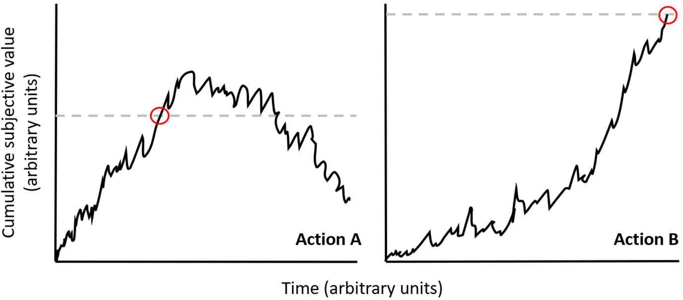
Note. The black solid line represents the EA rates, while the grey dashed line represents response thresholds, for hypothetical Action A (left) and hypothetical Action B (right). Red circles indicate the point at which the EA rate crosses the response threshold, at which point the point a decision is made. The EA rate for Action A increases rapidly, and the response threshold is lower, a combination that means the decision is acted upon rapidly. However, the EA rate for Action B is lowered meaning that evidence accumulates much more gradually, and the response threshold is higher, meaning the decision takes a longer time to act upon because more evidence needs to be accumulated before the response threshold is reached. Schematics are adapted with permission from those in Berkman et al. (2017).

For the DDM to recover parameters that reflect the internal processes of decision-making, behavioural data is required from tasks involving value-based choice (reaction time (RT) and accuracy). In typical VBDM tasks (e.g., Polanía et al., 2014) participants view and then make value judgements about a set of pictorial stimuli which enables them to be ranked from most valued to least valued. Subsequently, two images appear side-by-side on a computer screen and participants are asked to choose the image that they prefer as quickly as possible (e.g., within a 4-second cut-off) which generates both RT and accuracy data. RT is determined by how long the participant took to respond, whilst accuracy is determined by whether the participant chose the image that was consistent with their previous value judgement.

A limitation of existing approaches which only analyse RT or accuracy data is that the speed-accuracy trade-off (SATO) is often unaccounted for (Stafford et al., 2020); this is something inherent in any decision when instructed to respond as quickly as accurately as possible. Some people will respond faster at the cost of being less accurate, whilst others will respond slower to increase accuracy (Heitz, 2014). A benefit of using the VBDM framework is that instead of making indirect inferences about cognition from RT or accuracy data in isolation, the DDM provides a principled reconciliation of speed and accuracy data and in doing so recovers parameters of decision-making that reflect the internal cognitive components of decision-making (Roberts & Hutcherson, 2019; Stafford et al., 2020). Core parameters recovered from the DDM are EA rate (the average rate by which people accumulate evidence; also termed ‘drift rate’), response threshold (how cautious a person is when responding, indexed by their SATO), and non-decision time (time attributed to a person encoding stimuli and executing a motor process). Importantly, the DDM (Forstmann et al., 2016; Ratcliff & McKoon, 2008) has been shown to capture choice and response time patterns with high accuracy across different domains of decision-making, including value-based, perceptual, memory-related, and social (Krajbich et al., 2015; Ratcliff & Frank, 2012; Roberts & Hutcherson, 2019).

As previously mentioned, the value of a response option is determined by the weighted sum of choice-relevant attributes (Berkman et al., 2017), and Berkman (2018) extended this framework to health-related behaviour more broadly. A core benefit of such application is that it provides a mechanism-focused approach which has implications for behaviour change. To elaborate, if it is possible to identify the underlying mechanism by which people make the choices they do, then this has potential to become a significant target within behaviour change interventions. Indeed, experimental research has demonstrated that the manipulation of goals can alter the weight that is applied to a decision attribute. For example, Tusche and Hutcherson (2018) fitted a DDM to their data and found that regulatory goals (e.g., instructing participants to focus on healthiness) changed choice behaviour by increasing weighting (i.e., relative decision value) of goal consistent attributes (e.g., healthiness) and decreasing weighting of goal-inconsistent attributes (e.g., tastiness).

Field, Heather, et al. (2020) recently extended Berkman et al.'s (2017) VBDM framework to addiction and recovery from it, and in doing so, outlined several hypotheses that await empirical testing. More specifically, Field, Heather, et al. (2020) hypothesise that the overvaluation of substances and undervaluation of substance-free alternatives may be reflected in alterations in decision-parameters recovered by the DDM. For example, overvaluation of substances may be reflected in augmented EA rates, and lower response thresholds, for decisions involving substances, whilst undervaluation of substance-free alternatives could be reflected in lowered EA rates, and higher response thresholds, for substance-free alternatives (see Panel A in Figure 1.2 for a visual depiction of VBDM parameters in a person with AUD). Importantly, for recovery to occur, it is proposed that the distortions in the internal mechanics of decision-making must be reversed, such that 1) response thresholds for substances increase, 2) EA rates for substances decrease, and 3) EA rates for substance-free alternatives increase (see Panel B in Figure 1.2 for a visual depiction of the hypothesised changes in VBDM parameters that characterise a person in a recovered state). As this has not yet been empirically tested, it is hypothesised that it might be all of the aforementioned changes that are important, or perhaps that just one or two of the changes are important. By applying VBDM to recovery and addiction, this will facilitate the extraction of individual differences in VBDM parameters for substance and substance-free decisions, and in doing so, enable the empirical test of predictions from Field, Heather, et al. (2020).

Figure 1.2
A schematic depiction of alterations in VBDM parameters (evidence accumulation (EA) rates and response thresholds) that are hypothesised to underlie addiction and recovery from it
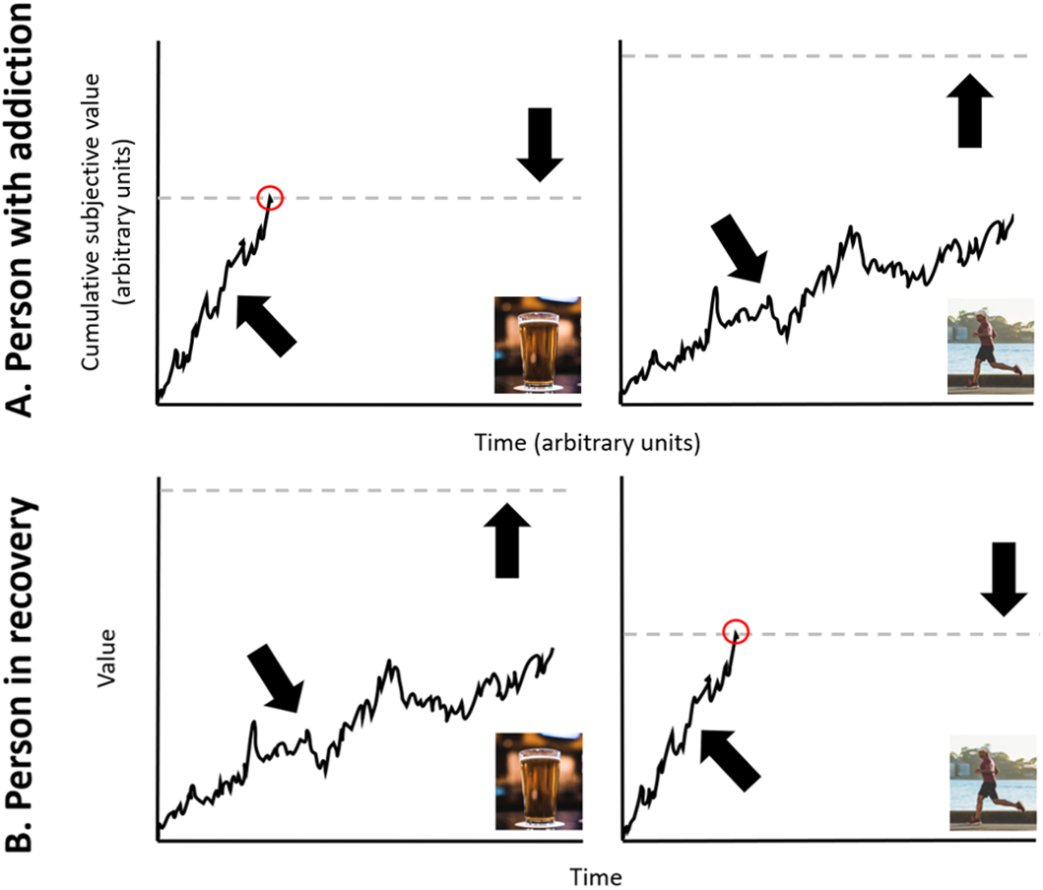
Note. Panel A represents the hypothesised changes in VBDM parameters in a person with addiction. Panel B represents the hypothesised changes in VBDM parameters in a person who is in recovery from addiction. The solid black line represents the EA rates, while the grey dashed line represents response thresholds, for alcohol (left) and an alcohol-free alternative (right). Red circles indicate the point at which the EA rate crosses the response threshold, at which point the point a decision is made. When a person has recovered from addiction and is faced with the opportunity to drink alcohol (or engage in some other alcohol-free activity), they may experience gradual increases in their alcohol-related response thresholds (the upwards shift depicted in the transition from panel A to panel B). Furthermore, they may experience gradual decreases in their alcohol-free response thresholds (the downwards shift depicted in the transition from panel A to panel B). EA rates for alcohol may become suppressed (the downwards shift depicted in the transition from panel A to panel B) whilst EA rates for alcohol-free alternatives may become amplified (the upwards shift depicted in the transition from panel A to panel B). These hypothesised changes may occur in combination or isolation and increase the probability that the alcohol-free alternative will cross the response threshold be acted upon. Schematics are adapted with permission from those in Berkman et al. (2017). Images are reproduced with permission from unsplash.com (https://unsplash.com/photos/AtfA8NDgpKA; https://unsplash.com/photos/rhkwKunIXyI).

By viewing relative drug value as the key underlying mechanism of vulnerability for addiction and recovery (Hogarth & Field, 2020), VBDM as a framework offers the potential to reconcile established risk factors for addiction, for example childhood adversity (Maté, 2022), substance-related cues and craving (Vafaie & Kober, 2022), identity as a person with addiction (Pickard, 2020a), negative affect (Hogarth, 2020), and lower socioeconomic status (Hogarth, 2022). Put another way, VBDM offers theoretical parsimony (Berkman, 2018; Berkman et al., 2017): value attributes and input signals can relate to any of the aforementioned factors. It may be that people who experience childhood adversity ascribe a greater value to alcohol because it numbs or suppresses emotion or traumatic memories, whereas people from disadvantaged backgrounds may ascribe greater value to alcohol because the benefits outweigh the costs given a realistic appreciation of the circumstances and options available (Pickard, 2012).

This aligns with philosophical conceptual pieces that speculate upon “the puzzle of addiction” (e.g., Pickard, 2018, 2020b); that is, the puzzle of why people with addiction continue to use substances despite the many accompanying consequences (e.g., health deterioration). What is often overlooked is that many of the things a person without addiction would consider to be a consequence of substance use may actually be beneficial to a person with addiction, elevating substance value (Pickard, 2020b). This demonstrates the juxtaposition in how, to an outside observer, things that might be seen as a consequence that should deter further use may actually be a desired and valued outcome. From this viewpoint, then, there is no puzzle as to why people with addiction continue to use despite consequences; it is a cost-benefit ratio of substance use in a given context and for a given individual. VBDM as a framework, then, entails the benefit of being able to incorporate value inputs that contribute to substance value that may not be immediately apparent to those without any experience of addiction.

1.7. Self-control: What role does this play in VBDM?
Self-control is a multidimensional construct. It incorporates elements of self-regulation, inhibitory control, and impulsivity (Duckworth & Kern, 2011) and is generally defined as the capacity a person has to exert control over thoughts, emotions, and behaviours (de Ridder et al., 2012). People higher in self-control ability are often able to attain long-term goals, even if there are tempting alternative options available (Hofmann et al., 2012; Metcalfe & Mischel, 1999). There is a robust body of evidence demonstrating that impaired self-control is important in the development and maintenance of addiction, via self-report (Copeland et al., 2020; de Ridder et al., 2012; Dvorak et al., 2011; Quinn & Fromme, 2010; Stein & Witkiewitz, 2019) and behavioural (Christiansen et al., 2012; Houston et al., 2014; Smith et al., 2014) measures of self-control.

Dual-process theories of addiction (Stacy & Wiers, 2010) posit that motivation to consume a substance results from an interplay of two cognitive processes; one which is automatic (implicit and impulsive) and another that is controlled (explicit and deliberate), often referred to as ‘hot’ and ‘cold’ processes, respectively. Dual-process approaches assume that the ability to inhibit a response towards a temptation characterises successful self-control; processes that are controlled inhibit processes that are automatic (Veling et al., 2008). According to dual-process theories, then, conflicting automatic and controlled processes underlie lapses in self-control (McClure & Bickel, 2014).

Most theories of addiction recognise the importance of impaired self-control but conceptualise self-control and value-based processes as conceptually distinct from one another. However, there are at least two theories that suggest self-control processes may be implicated within VBDM. For example, the behaviour-stimulus interaction theory proposed by Veling et al. (2008) assumes that successful self-control requires inhibiting impulses toward temptations or rewards, and by doing so, this alters the valuation of that reward such that it becomes devalued. Accordingly, in line with dual-process theories, controlled processes are proposed to inhibit automatic processes and therefore, dual-system theories conceptualise lapses in self-control in terms of a conflict between automatic and controlled models of behavioural control (McClure & Bickel, 2014).

Alternatively, researchers in the field of self-regulation developed a model of self-control in which outcomes are understood as a conflict between the value of two alternative options, rather than as a dual-process conflict between automatic and controlled processes (Berkman et al., 2017). In this model of self-control put forward by Berkman et al. (2017) decisions are made through a dynamic integration process as outlined earlier (p.40), but value evidence accumulates most rapidly for immediately available outcomes as opposed to outcomes whereby there is some type of delay. Therefore, this model provides a computational account of the effects of DD on choice.

1.8. Where is the research gap and why is this PhD important?
Addiction is frequently understood to be a chronic and relapsing brain disease characterised by a loss of control and compulsive substance use (Volkow et al., 2016). This is incompatible however with evidence demonstrating that most people recover from addiction, and frequently without any form of professional treatment (e.g., Dawson et al., 2005; Heyman, 2013; Lopez-Quintero et al., 2011; Tucker et al., 2020). Currently, then, less is known about how and why people recover from addiction.

Field, Heather, et al. (2020) recently introduced a conceptual account of recovery from addiction, inspired by Berkman et al.'s (2017) VBDM framework. This conceptual account (Field, Heather, et al., 2020) encompasses novel speculations about recovery from addiction that integrate principles from behavioural economics and cognitive neuroscience, thereby providing a framework that is interdisciplinary in nature. This conceptual account has not yet been systematically tested, however by doing so, a number of important research gaps will be addressed. To recap, behavioural economics have contributed substantially to the literature on addiction and recovery from it, emphasising the importance of distortions in valuation processes. However, as mentioned previously, these accounts are molar in nature, meaning that their focus is on patterns of behaviour over time. On the other hand, computational decision models—such as the DDM—originated in the field of cognitive neuroscience and are molecular in nature, providing insight into the internal mechanics that determine discrete decisions made. Although these models have been successfully applied to other domains, they have not yet been utilised in research exploring recovery from addiction.

This PhD is important because currently there is not a validated VBDM task that can be used in the field of addiction to explore how valuation processes impact “in-the-moment” decisions made. As a result, this impedes the exploration of whether recovery from addiction is characterised by alterations in VBDM parameters. In this PhD, computational modelling techniques will be fitted to behavioural data derived from a novel VBDM task to parameterise the internal processes that precede decisions made about substance and substance-free alternative cues.

1.8.1. Core PhD aims:
There are two core aims of this PhD. The first aim is to develop a VBDM task that can be applied in addiction-related research to generate the behavioural data required to parameterise the internal processes of decision-making. The second aim is to empirically test predictions from recent conceptual accounts (Field, Heather, et al., 2020) by exploring whether decision parameters recovered from the VBDM task are sensitive to experimental manipulations of substance value and whether they characterise stable behaviour change and recovery from addiction.

Chapter 2: Meaning in life: Investigating protective and risk factors for harmful alcohol consumption
Before focusing on value-based decision-making (VBDM), I first wanted to explore links between constructs that I studied in my pre-PhD research (meaning in life; Copeland et al., 2020) and established self-report behavioural economic measures of reinforcer value. This Chapter therefore extends upon my master’s thesis (Copeland et al., 2020) by investigating whether the association between meaning in life and AUDIT scores (alcohol use and related problems) can be explained via individual differences in alcohol value, reinforcement derived from alcohol-free activities, depressive symptoms, and drinking to cope.

Contributions: I designed the study, which was approved by Matt Field (primary supervisor). Third year undergraduate students at the University of Sheffield collected the data as part of their dissertation projects; I assisted with data collection. I analysed the data and wrote the Chapter. Matt Field, and collaborators Andrew Jones, Samuel F. Acuff, and James G. Murphy provided feedback on the draft.

As mentioned previously (p.4), a variant of this thesis Chapter is published online at Addiction Research & Theory:
Copeland, A., Jones, A., Acuff, S. F., Murphy, J. G., & Field, M. (2022). Meaning in life: Investigating protective and risk factors for harmful alcohol consumption. Addiction Research & Theory. https://doi.org/10.1080/16066359.2022.2134991

Abstract
Background: Individuals who report greater meaning in life tend to consume less alcohol. However, research elucidating pathways through which meaning in life influences consumption is lacking. Behavioural economic theories posit that distortions in valuation processes, whilst negative reinforcement models posit that avoidance or regulation of negative internal states, are central in decisions to consume alcohol. Method: Pre-registered, cross-sectional design. Five hundred forty-six regular alcohol consumers (≥ 18 years old) completed an online questionnaire which asked about their alcohol use and related problems, meaning in life, alcohol-free reinforcement, alcohol value, depressive symptoms, and drinking to cope motives. Results: Presence of meaning in life had a significant negative association with AUDIT scores (β = -.26, p < .001), but neither search for meaning in life nor total alcohol-free reinforcement were significant predictors (ps > .53). Subsequent path analyses revealed a significant indirect effect of presence of meaning in life on AUDIT scores through lower alcohol value (95% CI = -.17 to -.08) and drinking to cope (95% CI = -.07 to -.00), and a serial mediation effect through both lower depressive symptoms and drinking to cope (95% CI = -.09 to -.04). Although search for meaning in life was not a direct predictor of AUDIT scores, there was a significant indirect effect through greater drinking to cope (95% CI = .01 to .06) and a serial mediation effect through both greater depressive symptoms and drinking to cope (95% CI = .01 to .04). Conclusions: Meaning in life subscales predict alcohol consumption indirectly via individual differences in alcohol value, depressive symptoms, and drinking to cope.

2.1. Introduction
Excessive alcohol consumption results in an array of adverse social and economic outcomes (Rehm & Imtiaz, 2016). Meaning in life (defined as the pursuit of goals that are intrinsically valued) is often divided into two subscales (Steger et al., 2006): ‘presence’ reflects the extent to which a person currently experiences life meaning and ‘search’ reflects the extent to which a person is actively seeking life meaning. Research reliably demonstrates that presence of meaning in life is inversely associated with alcohol consumption (Copeland et al., 2020; Csabonyi & Phillips, 2017; Krentzman et al., 2017; Robinson et al., 2007; Schnetzer et al., 2013), however the relationship between search for meaning in life and alcohol consumption is less clear: one study found a positive association (Copeland et al., 2020) whilst another study found no significant association (Csabonyi & Phillips, 2017) between the two. Less is currently understood about what characterises a meaningful life and how this construct in turn influences alcohol consumption.

Behavioural economic theories emphasise that harmful alcohol consumption and dependence arise from, and are maintained by, excessive valuation of alcohol relative to alcohol-free alternative reinforcers (Bickel et al., 2014; Hogarth & Field, 2020). Alcohol’s reinforcing value (also termed ‘demand’) is commonly measured using hypothetical purchase tasks which instruct participants to estimate consumption of alcohol across a set of prices that gradually increase (Murphy & MacKillop, 2006; Owens et al., 2015). Alternatively, alcohol-free reinforcement is often measured using reinforcement surveys which capture the frequency of participation in, and enjoyment derived from, activities that do not involve consuming alcohol (Murphy et al., 2005). There is robust evidence to show that alcohol value is positively associated (Martínez-Loredo et al., 2021), whilst alcohol-free reinforcement is negatively associated (Acuff et al., 2019) with harmful alcohol consumption. To date few studies have attempted to link these behavioural economic constructs with research on meaning in life.

One recent cross-sectional study found that people with high presence of meaning have lowered behavioural economic demand for alcohol and lower scores on the alcohol use disorders identification test (AUDIT; Copeland et al., 2020), which may in part be due to elevated alcohol-free alternative reinforcement. Different factors may contribute to increasing alcohol-free reinforcement, one of them being age. To elaborate, age-related declines in alcohol consumption are common (Britton et al., 2015), and alongside age, presence of meaning increases whilst search for meaning decreases (Steger et al., 2009), an observed pattern which may be attributable to shifts to more alcohol-free reinforcement. For example, “maturing-out” (O’Malley, 2004) of alcohol use is often accompanied by the acquisition of adult roles that are incompatible with heavy drinking (e.g., parenthood and employment; Staff et al., 2010, 2014), but that might lead to increased opportunity to derive reinforcement from alcohol-free activities (e.g., after becoming a parent a person might enjoy spending more time with family).

Further evidence for the tentative link between meaning in life and alcohol-free reinforcement stems from research by Steger et al. (2013) who asked people to take photos of and write about things that made their life feel meaningful, and subsequently categorised these images to reflect different sources of meaning. Although multifaceted in nature, many categories of meaning were compatible with elevated alcohol-free reinforcement: work/occupation, relationships with others (e.g., family), engaging with hobbies (e.g., art/exercise/gardening) and activities (e.g., volunteering), were among the categories, for example. This is broadly consistent with other research that has aimed to identify important sources of meaning in life (Debats, 1999; Glaw et al., 2017; Hill et al., 2013). In line with behavioural economic accounts (Murphy, MacKillop, et al., 2012) then, it may be that as a person increases reinforcement from alcohol-free activities that provide a sense of meaning, alcohol becomes less valuable as the perceived costs of harmful alcohol consumption (such as being hungover for childcare or work) increase and/or the benefits (such as intoxication) decrease.

Depression may be another important factor within the relationships between meaning in life and alcohol consumption. Elevated depressive symptoms are negatively correlated with presence of meaning and positively correlated with search for meaning (Steger et al., 2009), and a longitudinal study found that increased presence of meaning in life predicted decreased depressive symptoms over a 6-month period (Disabato et al., 2017). Furthermore, depressive symptoms are positively associated with alcohol consumption (Brière et al., 2014; Graham et al., 2007; Lai et al., 2015; Pedrelli et al., 2016), although the high co-morbidity between the two makes it difficult to disentangle directional relationships (Puddephatt et al., 2021). Negative reinforcement models are not incompatible with behavioural economic accounts; rather, they differ on their relative point of emphasis in that they posit that people are likely to consume alcohol to avoid or regulate negative internal states (Baker et al., 2004; Blevins et al., 2016; Cooper et al., 1995). Indeed, drinking to cope (i.e., consuming alcohol to relieve negative affective states) is consistently associated with alcohol consumption and problems (Cooper et al., 2016). The cross-sectional and longitudinal associations between depressive symptoms and drinking to cope (Bravo et al., 2018; Grant et al., 2009; Holahan et al., 2003; Kenney et al., 2015) suggest that alcohol may be a crucial coping mechanism for people with elevated levels of depression. Interestingly, meaning in life plays an important role in a person’s ability to cope with stressful or demanding situations, and promotes adaptive coping strategies (Frankl, 1985; Hooker et al., 2018; Miao & Gan, 2018). For example, Ostafin and Proulx (2020) demonstrated that following aversive states, meaning in life is linked to reduced levels of psychological distress and repetitive negative thinking. This in turn may enable or facilitate the use of adaptive coping strategies, including acceptance, self-efficacy, and positive reframing (Hooker et al., 2018; Park et al., 2008). Therefore, presence of meaning is associated with reduced levels of depression and increased adaptive coping which may represent a potential pathway through which meaning protects against harmful alcohol consumption, however this has not yet been explored.

This study aimed to clarify the role of search for meaning in life and explore the mediating effects of alcohol-free reinforcement, alcohol value, depression, and drinking to cope within the relationships between meaning in life and AUDIT scores. Design, hypotheses, and analysis strategy were pre-registered before data collection commenced (https://aspredicted.org/blind.php?x=/6SF_RQ8). Specifically, it was hypothesised that:
- Elevated AUDIT scores will be significantly negatively associated (p < .05) with presence of meaning in life, but significantly positively associated with search for meaning in life. We also hypothesise that elevated AUDIT scores will be significantly negatively associated with alcohol-free reinforcement.
- There will be significant indirect effects of meaning in life subscales (presence of meaning and search for meaning) on AUDIT scores through alcohol-free reinforcement, depressive symptoms, drinking to cope, and alcohol value.

2.2. Method
Design
Cross-sectional observational study. The dependent variable was scores on the AUDIT, which provides an indication of hazardous drinking. Predictor variables included presence of meaning in life, search for meaning in life, and alcohol-free reinforcement. In the structural equation model (SEM), alcohol value, alcohol-free reinforcement, depression, and coping drinking motives were included as both independent and dependent variables as this technique enables the exploration of complex direct and indirect relationships. For SEM analyses, it has been recommended that the sample size is a minimum of 200 (Kline, 2005) however we aimed for a minimum of 400 participants. We oversampled because our recruitment target was reached prior to the end of our testing period, and this allowed us to increase the robustness of our parameter estimates.

Participants
An initial 959 volunteers accessed the study link; however, after removal of data from participants who withdrew from participation before completing the survey (n = 352), responded ‘never’ to consuming alcohol (n = 4), demonstrated misunderstanding of questionnaire instructions (n = 50; see Appendix A for further detail), had a duration below our specified minimum cut-off of 3 minutes (n = 1), and failed over 75% of the attention checks (n = 6), a total sample of 546 volunteers remained in our analytical sample. Ages ranged from 18 to 75 years old (mean age = 32.95, SD = 14.22), 351 volunteers were female, 190 were male, 3 were non-binary, and 2 did not disclose their gender. The inclusion criterion was consumption of alcohol (at least one occasion per week), and the exclusion criterion was any history of treatment for alcohol use disorder. Data were collected between November 2020 and January 2021. Participants were recruited via social media platforms (e.g., Facebook and Twitter) and an online research participation system (ORPS) for undergraduate students. There was no financial reimbursement for participation, however undergraduate students who took part through ORPS (n = 49) were reimbursed with a course credit. The study was approved by the University of Sheffield research ethics committee, and all volunteers provided informed consent.

Materials
Alcohol Use Disorders Identification Test (AUDIT; Saunders et al., 1993): This 10–item scale was used to detect patterns of alcohol consumption that are harmful or hazardous to health. Total scores range between 0 and 40. The AUDIT had acceptable internal reliability in the current study, McDonald’s ω = .79 (McDonald, 1970, 1999).

The Meaning in Life Questionnaire (MLQ; Steger et al., 2006): This 10-item scale was used to measure (1) presence (how much meaning people perceive their life to have), and (2) search (how much people are striving to find meaning in their life) for meaning in life. Each construct is evaluated by 5 items and participants responded on a scale ranging from 1 (absolutely untrue) to 7 (absolutely true). Total scores on each subscale range from 5 to 35, with higher scores indicating higher presence of meaning and search for meaning. Both subscales had excellent internal reliability in this study; presence subscale ω = .92, search subscale ω = .91.

Personal Health Questionnaire Depression Scale (PHQ-8; Kroenke et al., 2009): This 8-item scale was used to measure depressive symptoms. Participants rated how often they experienced each item in the past two-weeks on a scale ranging from 0 (not at all) to 3 (nearly every day). Total scores range from 0 to 24. The PHQ-8 had good internal reliability in this study, ω = .89.

Activity Level Questionnaire (ALQ; based on Meshesha et al., 2020): This modified 17-item measure was used to assess past-month reinforcement derived from alcohol-free activities only. Past month ratings of frequency of engagement in each activity were made on a scale ranging from 0 (0 times in the past month) to 6 (several times per day) and enjoyment on a scale ranging from 0 (unpleasant or neutral) to 4 (extremely pleasant). Participants were explicitly instructed to only consider activities that did not involve alcohol when responding to the items. We modified this measure by extending the range of response options for frequency, reducing the number of items to reduce participant burden, and updating content to reflect currently common activities (see Appendix B). The frequency and enjoyment ratings were multiplied to obtain cross-product scores (range = 0–24 for each item) which reflected overall activity reinforcement. The cross-product scores were then averaged across all activities to compute a mean alcohol-free reinforcement score for each participant. This approach to measuring and calculating alcohol-free reinforcement is similar to that of previous research (Murphy, Dennhardt, et al., 2012).

Drinking Motives Questionnaire - Revised (DMQ-R; Cooper, 1994): We administered the 5-item coping subscale to measure participants’ coping motives for alcohol use. Participants responded on a scale ranging from 1 (almost never / never) to 5 (almost always / always). The coping subscale had good internal reliability in this study, ω = .83.

Brief Assessment of Alcohol Demand (BAAD; Owens et al., 2015): This 3-item scale was used to measure three indices of alcohol demand. Intensity represents alcohol consumption independent of price (“If drinks were free, how many would you have?”) with responses ranging from 0 to 10 drinks. O_{max} represents the maximum expenditure a person is willing to spend on alcohol (“What is the maximum total amount you would spend on drinking during that drinking occasion?”) with responses ranging from £0 to £30. Breakpoint represents the first price that suppresses consumption to zero (“What is the maximum you would pay for a single drink?”) with responses ranging from £0 to £15.

Demographic questions: Participants answered questions about their age (continuous), gender (male / female / non-binary / prefer not to say), ethnic group (multiple options), and highest educational attainment (multiple options).

Data preparation and analysis
We pre-registered that if the BAAD indices were significantly intercorrelated they would be combined into a proxy of alcohol value in line with previous research (Copeland et al., 2020), however this was not the case (breakpoint and intensity, r(544) = -.02, p = .58; intensity and O_{max}, r(544) = .48, p < .001; O_{max} and breakpoint, r(544) = .40, p < .001). Similar to other research (Hardy et al., 2021; Rose et al., 2018), we used intensity to represent alcohol value which is a reliable index of demand (Acuff & Murphy, 2017). See Appendix A for analyses repeated with O_{max} and breakpoint.

Hierarchical regression was used to investigate whether the associations between meaning in life subscales and AUDIT scores from Copeland et al. (2020) could be replicated. We expanded by including alcohol-free reinforcement as an additional step in the model to explore whether this can predict additional variance in AUDIT scores. Age and gender were adjusted for because they are associated with alcohol use (Chaiyasong et al., 2018). Gender was entered into the model as a dichotomous variable (comprising male and female) as only a small subset of the sample identified as non-binary or preferred not to say (0.9%; n = 5). Therefore, the minority of participants who identified as non-binary or preferred not to say were excluded from this analysis.

SEM was used to explore direct and indirect relationships between meaning in life subscales and alcohol value, alcohol-free reinforcement, depressive symptoms, drinking to cope, and AUDIT scores. Maximum likelihood estimation was used to test the hypothesised model.
Multiple indices of model fit were calculated. A normed chi-square value was calculated (Χ²/df) because in larger sample sizes the standard chi-square test is highly sensitive (Kenny, 2020; Kline, 1998); values up to 5 are indicative of acceptable model fit (Schumacker & Lomax, 2004). Standardized root mean residual (SRMR) values under .08 are indicative of a good model fit, and Tucker-Lewis index (TLI) values of above .90 are considered acceptable (Hu & Bentler, 1999). Additionally, comparative fit index (CFI) values of .90 or greater are considered acceptable, while root mean square error of approximation (RMSEA) values of lower than .08 indicate an acceptable fit (Browne & Cudeck, 1993). Following inspection of the modification indices, where appropriate covariance pathways were added between error terms to improve model fit. The relationships within the model were described using standardised regression coefficients and bias-corrected bootstrapping (5000 times) was used to generate confidence intervals (95% CI) for all regression coefficients and indirect effects in the structural model. Statistical analyses were conducted in RStudio version 4.0.2 (R Core Team, 2020). For the SEM, we used the “lavaan” package (Rosseel, 2012). Data and analysis scripts are available and can be found here: https://researchbox.org/677&PEER_REVIEW_passcode=JGMCYR.

2.3. Results
Table 2.1
Descriptive statistics (mean, standard deviations (SD) and range) of the total sample (n = 546). Two-thirds of the sample (n = 364; 66.67%) were likely hazardous or harmful drinkers (AUDIT > 7)
Variable | Mean (SD, range)
AUDIT | 10.83 (±5.80; 1–31)
Alcohol-free reinforcement | 6.19 (±2.62; 0–19.06)
Presence | 23.76 (±7.02; 5–35)
Search | 21.08 (±7.38; 5–35)
Depressive symptoms | 6.57 (±5.39; 0–24)
Drinking to cope | 1.80 (±0.73; 1–4.80)
Alcohol value (intensity) | 5.68 (±2.65; 1–10)
Note. AUDIT = Alcohol Use Disorders Identification Test (alcohol use and related problems; 1 UK unit = 8g of alcohol; possible range of values = 0 to 40). Presence = presence of meaning in life; Search = search for meaning in life (possible range of values = 5 to 35). Alcohol value (intensity) = how many drinks would be consumed if they were free (possible range of values = 0 to 10). Alcohol-free reinforcement (possible range of values = 0 to 24). Depressive symptoms (possible range of values = 0 to 24). Drinking to cope (possible range of values = 1 to 5).

Pre-registered analyses
See Table 2.1 for descriptive statistics. To test our first hypothesis, we conducted a hierarchical regression. The first step of the regression consisted of age and gender, whilst presence of meaning and search for meaning in life scores were added on the second step, and average alcohol-free reinforcement was added on the third step. The overall regression model significantly predicted approximately 12% of variance in AUDIT scores (R² = .12, F(5, 535) = 14.25, p < .001). Age and gender predicted approximately 6% of variance in AUDIT scores. After adjusting for age and gender, presence of meaning and search for meaning in life predicted a further 6% of variance in AUDIT scores. The addition of alcohol-free reinforcement did not account for any additional variance in AUDIT scores (see Table 2.2). Multi-collinearity indices were low (VIFs < 1.29).

Table 2.2
Hierarchical regression predicting AUDIT scores, predictor variables are presence of meaning, search for meaning, and average alcohol-free reinforcement after controlling for age and gender
Variable | Cumulative |  | Simultaneous
 | R²-change | F-change | B | B(SE) | β | p
Step 1
Age | .06 | F(2, 538) = 15.56*** | -.07 | .02 | -.18 | p < .001
Gender |  |  | .23 | .51 | .02 | p = .65
Step 2
Presence | .06 | F(2, 536) = 18.96*** | -.22 | .04 | -.26 | p < .001
Search |  |  | -.02 | .04 | -.03 | p = .53
Step 3
Alcohol-free reinforcement | .00 | F(1, 535) = .21 | -.04 | .10 | -.02 | p = .65
Note. Presence = presence of meaning in life; Search = search for meaning in life; Alcohol-free reinforcement = overall alcohol-free reinforcement (cross-product scores averaged across all activities). ***p < .001.

Structural Model
To explore our second hypothesis, we conducted a SEM to investigate whether some of the variance in the relationship between meaning in life and AUDIT scores could be accounted for by individual differences in alcohol value, alcohol-free reinforcement, depressive symptoms, and drinking to cope. As clarified in our pre-registration, we wanted to explore the complex direct and indirect relationships between our observed variables from two angles: 1) A perspective that focuses on risk factors for elevated alcohol use and related problems (stemming from the search subscale, with predicted positive associations with alcohol value, depressive symptoms, drinking to cope, and negative with alcohol-free reinforcement. 2) A perspective that focuses on protective factors for lower alcohol use and related problems (stemming from the presence subscale, with predicted negative associations with alcohol value, depressive symptoms, drinking to cope, and positive with alcohol-free reinforcement).

Model fit. Modification indices suggested covariances needed to be added (alcohol value and drinking to cope, and alcohol-free reinforcement and depressive symptoms) which led to a notable improvement in model fit. After adding covariances, the hypothesized structural model proved to be a good fit of the data (SRMR = .03; CFI = .99: TLI = .92; RMSEA = .08 (90% CI = .03 to .14); Χ²/df = 4.65) and the overall model predicted approximately 43% of variance in AUDIT scores (R² = .43).

Figure 2.1
Direct and indirect relationships between meaning in life, alcohol consumption, alcohol-free reinforcement, alcohol value, depressive symptoms, and drinking to cope
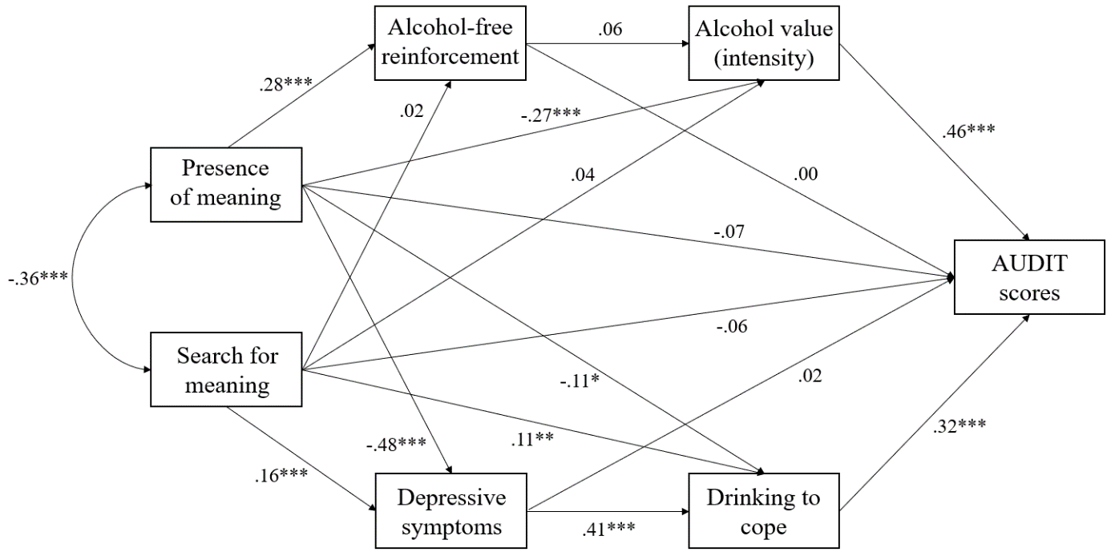
Note. Standardised parameter estimates are presented. Age is not modelled as a covariate; the analyses were repeated with age included as a covariate this did not alter model fit or the nature of the regression coefficients (this is placed in Appendix A). ***p < .001, **p < .01, *p < .05.

Model evaluation (Figure 2.1)

Direct effects
Presence of meaning had a significant positive association with alcohol-free reinforcement (95% CI = .19 to .36), and a significant negative association with alcohol value (95% CI = -.36 to -.18), depressive symptoms (95% CI = -.54 to -.40) and drinking to cope (95% CI = -.21 to -.02). The direct effect of presence of meaning on AUDIT scores was not statistically significant (95% CI = -.16 to .01).

Search for meaning had a significant positive association with depressive symptoms (95% CI = .09 to .24) and drinking to cope (95% CI = .03 to .19). However, there were no significant associations between search for meaning and alcohol-free reinforcement (95% CI = -.07 to .12), alcohol value (95% CI = -.05 to .13), and AUDIT scores (95% CI = -.14 to .01).

Depressive symptoms had a significant positive association with drinking to cope (95% CI = .31 to .51) and drinking to cope had a significant positive association with AUDIT scores (95% CI = .22 to .41). Alcohol-free reinforcement had no significant association with alcohol value (95% CI = -.03 to .14), but alcohol value had a significant positive association with AUDIT scores (95% CI = .39 to .53). Neither alcohol-free reinforcement (95% CI = -.06 to .07) or depressive symptoms (95% CI = -.08 to .12) had any significant association with AUDIT scores.

Indirect effects
See Table 2.3 for standardised coefficients, p-values, and 95% confidence intervals (CI) for all possible indirect effects.

Table 2.3
Indirect associations between variables from the structural equation model
Association | β | p-value | 95% CI
Presence → alcohol-free reinforcement → AUDIT | .00 | p = .95 | -.02 to .02
Presence → alcohol value → AUDIT | -.13 | p < .001 | -.17 to -.08
Presence → alcohol-free reinforcement → alcohol value | .01 | p = .20 | -.01 to .04
Presence → alcohol-free reinforcement → alcohol value → AUDIT | .01 | p = .20 | -.00 to .02
Presence → depressive symptoms → AUDIT | -.01 | p = .68 | -.06 to .04
Presence → drinking to cope → AUDIT | -.04 | p = .01 | -.07 to -.00
Presence → depressive symptoms → drinking to cope | -.19 | p < .001 | -.25 to -.14
Presence → depressive symptoms → drinking to cope → AUDIT | -.06 | p < .001 | -.09 to -.04
Search → alcohol-free reinforcement → AUDIT | .00 | p = .95 | -.00 to .00
Search → alcohol value → AUDIT | .02 | p = .35 | -.02 to .06
Search → alcohol-free reinforcement → alcohol value | .00 | p = .64 | -.00 to .01
Search → alcohol-free reinforcement → alcohol value → AUDIT | .00 | p = .64 | -.00 to .01
Search → depressive symptoms → AUDIT | .00 | p = .68 | -.01 to .02
Search → drinking to cope → AUDIT | .04 | p = .01 | .01 to .06
Search → depressive symptoms → drinking to cope | .07 | p < .001 | .03 to .11
Search → depressive symptoms → drinking to cope → AUDIT | .02 | p < .001 | .01 to .04
Alcohol-free reinforcement → alcohol value → AUDIT | .03 | p = .20 | -.01 to .06
Depressive symptoms → drinking to cope → AUDIT | .13 | p < .001 | .08 to .19
Note. Standardised parameter estimates are presented for all indirect effects. Presence = presence of meaning in life; Search = search for meaning in life. AUDIT = Alcohol Use Disorders Identification Test.

There was a significant indirect effect of presence of meaning in life on AUDIT scores through lower alcohol value and drinking to cope. Depressive symptoms alone were not a significant mediator within the relationship between presence of meaning in life and AUDIT scores, however there was a serial mediation effect through both depressive symptoms and drinking to cope.

There was a significant indirect effect of search for meaning on AUDIT scores through greater drinking to cope. Similarly, depressive symptoms alone were not a significant mediator within the relationship between search for meaning in life and AUDIT scores, however there was a serial mediation effect through both depressive symptoms and drinking to cope.

There was a significant indirect effect of presence of meaning on drinking to cope through lower depressive symptoms and a significant indirect effect of search for meaning on drinking to cope via greater depressive symptoms. There was also a significant indirect effect of depressive symptoms on AUDIT scores through greater drinking to cope.

2.4. Discussion
The aim of this study was to clarify the relationships between presence of and search for meaning in life and AUDIT scores, and to elucidate potential pathways that can explain variance in these associations. Our finding that presence of meaning in life is inversely associated with AUDIT scores aligns with previous correlational and longitudinal research conducted across diverse samples, including young adults (Csabonyi & Phillips, 2017), students (Schnetzer et al., 2013), general populations (Copeland et al., 2020), and people receiving treatment for alcohol use disorder (Robinson et al., 2007; Roos et al., 2015).

We also found that search for meaning in life was not a significant predictor of AUDIT scores, and therefore we did not replicate findings from Copeland et al. (2020). Nevertheless, these findings are in line with Csabonyi and Phillips (2017) and add to a mixed evidence base, supporting the notion that search for meaning in life is not a robust predictor of elevated AUDIT scores. A potential explanation for these mixed findings may be due to the idiosyncratic nature of what it means to be searching for meaning, in that this construct may be experienced differently across individuals (Steger et al., 2008). To elaborate, for some people, searching for meaning may symbolise something that is negative while for other people this might symbolise something that is positive, promoting active seeking of meaning (Watson et al., 2020) and this may in turn differentially impact alcohol consumption. Another possible explanation may be due to subjectivity—many common self-report measures of meaning in life require participants to interpret question items with the words “meaning” and “meaningful” for themselves (Prinzing et al., 2021). Lack of understanding about search for meaning in life specifically may be exacerbated through the scarcity of research exploring this construct: many existing measures utilised in alcohol-related research only explore presence of, as opposed to search for, meaning in life (Martin et al., 2011; Robinson et al., 2007; Schnetzer et al., 2013). To the best of our knowledge, this is only the third study to explore the relationship between search for meaning and alcohol consumption.

Unexpectedly we observed that greater reinforcement derived from alcohol-free activities was not significantly associated with lower AUDIT scores. A wealth of evidence demonstrates inverse associations between alcohol-free reinforcement and substance use (Bickel et al., 2014; Correia et al., 2005). For example, Acuff et al. (2019) conducted a systematic review of the existing literature and concluded that across a diverse range of studies, engagement with substance-free alternative activities is protective against harmful consumption. However, it is difficult to directly reconcile our findings with existing behavioural economic literature because the current study did not compute a proportionate measure of alcohol-free reinforcement (i.e., the relative reinforcement derived from alcohol-free activities as relative to alcohol-related activities). In line with Hallgren et al. (2016), these findings highlight the complexity of alcohol-free reinforcement measurement and the subsequent associations with AUDIT scores. The context by which the study took place is also of importance, in that COVID-19 lockdown regulations likely meant that access to many sources of substance-free reinforcement that compete with harmful alcohol consumption had been restricted (Acuff, Tucker, et al., 2020), and therefore the reported pattern of reinforcement may not have been reflective of a person’s typical pattern (i.e., their pattern of reinforcement prior to the pandemic). Alternatively, it may be that regular sources of alcohol-free reinforcement have become unavailable due to lockdown restrictions (Coughlin et al., 2021) and consequently reinforcement may have shifted to activities in the home that are not so incompatible with harmful drinking (e.g., watching TV or virtual socialising; Boursier et al., 2021; Nguyen et al., 2020).

Our structural model revealed interesting insights into the potential pathways through which presence of meaning in life is negatively associated with AUDIT scores. The mediating effect of alcohol value aligns with existing research (Copeland et al., 2020) which also found that people with higher presence of meaning attach less value to alcohol, and in turn have lower AUDIT scores. Theoretical accounts emphasise the importance of valuation processes within decisions to consume alcohol (Field, Heather, et al., 2020; Hogarth & Field, 2020) and a recent meta-analysis revealed robust associations between indices of alcohol value (e.g., intensity) and alcohol consumption (r = .49, 95% CI = .46 to .53; Martínez-Loredo et al., 2021). The extent to which alcohol is highly valued is therefore likely a key mechanism within the association between presence of meaning in life and AUDIT scores. Perhaps as a person acquires life meaning, this provides structure that exacerbates the costs of drinking relative to the benefits, and this in-turn alters the value that people ascribe to alcohol. Indeed, people with presence of meaning in life experience an increased sense of structure and order (Stavrova et al., 2018) and it may be that sources of meaning that provide such structure (e.g., employment, volunteering, or parenting) are prioritised over consuming alcohol. For example, a study in a student population found that they valued alcohol less when their daily structure or routine encompasses some form of next day responsibility, specifically those which require an early waking routine (Gilbert et al., 2014). Accordingly, alcohol may decrease in value as the costs become more significant (e.g., being hungover when you need to wake up early for work or childcare), whereas this is potentially absent in people who are searching for meaning in life. Another potential explanation in light of COVID-19 may be that alcohol has become a valuable way of managing acute mood states, such as boredom (Lunnay et al., 2021), and it may be that people with presence of meaning are less likely to experience this increase in alcohol value because there are other meaningful activities for them to engage in. Interestingly from a behavioural economic perspective, although presence of meaning is characterised by greater alcohol-free reinforcement, findings from this study demonstrate that it is the reinforcing value of alcohol that has a crucial indirect effect in the link between presence of meaning and AUDIT scores.

Our findings also extend prior research by demonstrating—for the first time—the indirect effect of presence of and search for meaning in life on AUDIT scores via drinking to cope. These findings are particularly interesting because although search for meaning did not directly predict AUDIT scores, our structural model revealed a significant indirect effect through drinking to cope. Indeed, drinking to cope is a robust predictor of increased alcohol consumption (Cooper et al., 2016) which has emerged as a salient motive during the COVID-19 pandemic (Irizar et al., 2021; McPhee et al., 2020; Rogers et al., 2020). Similar to previous research (Bravo et al., 2018; Grant et al., 2009; Holahan et al., 2003; Kenney et al., 2015; Magee & Connell, 2021) we found a positive association between depressive symptoms and drinking to cope, and although depressive symptoms alone were not a significant mediator within the relationship between meaning in life and AUDIT scores, there was a serial mediation effect through both depressive symptoms and drinking to cope. These findings can be interpreted in line with negative reinforcement and motivational models that posit substances are used in attempt to ameliorate negative mood states (Blevins et al., 2016; Cooper et al., 2016). Given that people with meaning in life have been found to experience lower levels of depressive symptoms (Disabato et al., 2017; Steger et al., 2009), and experience reduced psychological distress and negative thinking following aversive events (Ostafin & Proulx, 2020), it may therefore be that people who acquire meaning are less likely to consume alcohol to cope with negative affect. Instead, acquiring meaning may enable people to implement forms of coping that are adaptive, such as implementation of strategies that enable positive reframing and acceptance, alongside engagement in healthy alternative behaviours such as exercise (Cairney et al., 2014; Hooker et al., 2018; Hooker & Masters, 2016).

There were some limitations to this study. First, it was conducted during a global pandemic thereby limiting the generalizability of these findings to other time-periods. Second, there is likely a reasonable degree of measurement error in the quantification of alcohol-free reinforcement and other variables that may impact alcohol-free reinforcement, such as income, were not measured. Third, the data were cross-sectional which means it is not possible to establish causal relationships between the variables. For example, it is not possible to ascertain whether alterations in meaning in life subscales lead to changes in other variables (e.g., depressive symptoms), which in turn lead to changes in AUDIT scores. Indeed, these variables may interact in the reverse order. Furthermore, mediation analyses on cross-sectional data should be interpreted with caution (Fairchild & McDaniel, 2017). Future research may address these limitations by computing a proportionate alcohol-free reinforcement score alongside the continued refinement of question items to work towards developing accurate measurements of retrospective activity enjoyment and frequency, but also map changes in value, meaning in life, and alcohol consumption longitudinally. Future studies could also further explore the idiosyncratic nature of search for meaning in life, such as through the use of qualitative research, to better understand how this construct relates to patterns of alcohol consumption across different people.

To conclude, this study adds to a robust body of evidence demonstrating an inverse relationship between presence of meaning in life and AUDIT scores, but we were unable to replicate or reconcile recent findings regarding search for meaning in life. In regular alcohol consumers, presence of meaning accounts for variance in AUDIT scores indirectly through lower alcohol value, depressive symptoms, and drinking to cope, whereas search for meaning accounts for variance only indirectly through increased depressive symptoms and drinking to cope. These findings contribute towards bridging the gap between behavioural economic and meaning in life research, and in doing so, elucidate potential pathways through which acquiring life meaning may in turn influence alcohol use and related problems. Increasing the perception of life as meaningful should be a core target for treatment interventions for those who consume alcohol regularly and are trying to reduce hazardous patterns of alcohol consumption which in turn may help people to value alcohol less and find other healthy ways to cope that do not involve alcohol. In the remainder of the thesis, I will build on these findings by developing a VBDM task (as outlined in general introduction; p.50) and exploring the associations between computational parameters derived from the task and established behavioural economic measures such as those used in the present study.

Chapter 3: Methodological issues with value-based decision-making (VBDM) tasks: the effect of trial wording on evidence accumulation (EA) outputs from the EZ drift-diffusion model

Previously (Chapter 2), I highlighted the importance of alcohol value from a self-report perspective. In the present Chapter, I conducted an experimental study in which I developed a value-based decision-making (VBDM) task to explore valuation processes from a behavioural perspective. More specifically, I investigated how robust the task was to minor alterations in trial wording with the overall aim being to identify appropriate methodology for use in future addiction-related research.

Contributions: I designed the study, which was approved by Matt Field and Tom Stafford (primary supervisors). I collected and analysed the data. I wrote the chapter. Matt Field and Tom Stafford provided feedback on the draft.

As mentioned previously (p.5), a variant of this thesis Chapter is published online at Cogent Psychology:
Copeland, A., Stafford, T., & Field, M. (2022). Methodological issues with value-based decision-making (VBDM) tasks: The effect of trial wording on evidence accumulation (EA) outputs from the EZ drift-diffusion model. Cogent Psychology, 9(1), 2079801. https://doi.org/10.1080/23311908.2022.2079801

Abstract
Background: Most existing value-based decision-making (VBDM) tasks instruct people to make value judgements about pictorial stimuli using wording relating to consumption, however in some contexts this may be inappropriate. This study aims to explore whether variations of wording that do not involve consumption capture a common construct of value. Method: This is a pre-registered experimental study with a within-subject design. Fifty-nine participants completed a two-alternative forced choice task where they chose between two food images. Participants completed three blocks of trials that differed in trial wording: one asked which they would rather consume (standard wording), one asked which image they like more, and one asked them to recall which image they rated higher during a previous block. We fitted the EZ drift-diffusion model to the reaction time and choice data to estimate evidence accumulation (EA) processes during the different blocks. Results: There was a highly significant main effect of trial difficulty, but this was not modified by trial wording (F = 2.00, p = .11, η_{p}² = .03, BF₁₀ = .05). We also found highly significant positive correlations between EA rates across task blocks (rs > .44, ps < .001). Conclusions: Findings provide initial validation of alternative wording in VBDM tasks that can be used in contexts where it may be undesirable to ask participants to make consummatory judgements, such as research into VBDM in people who are in recovery from addiction.

3.1. Introduction
In everyday life, people are confronted with multiple choices which range from trivial (e.g., whether to drink tea or coffee in the morning) to important (e.g., whether to say yes or no to a marriage proposal). Value-based decision-making (VBDM) is a theoretical framework that posits on average, a person makes decisions based upon the things that they value (Berkman et al., 2017; Levy & Glimcher, 2012; Rangel et al., 2008). According to this account, an overall value for each response option is calculated through a dynamic integration of different sources of value which incorporate the anticipated positive and negative consequences. For example, input processes for a healthy lifestyle choice, such as going to the gym, might comprise progress towards a long-term goal (+), social interaction and comparison (+), and effort and monetary costs (-). The computation of overall value is essential: it enables a person to compare and subsequently choose the response option with the highest overall value (Berkman et al., 2017).

Computational models, such as the drift-diffusion model (DDM; Ratcliff & McKoon, 2008), are widely used because of their ability to parameterise the internal cognitive components of decision-making. The DDM takes behavioural data (response time (RT) and choice accuracy) from two-alternative forced choice (2AFC) tasks as input, and then through a principled reconciliation, recovers decision parameters including evidence accumulation (EA) rate (also known as the ‘drift rate’, the rate at which momentary evidence is accumulated), response threshold (response caution represented in the speed-accuracy trade-off that a participant maintains), and non-decision time (encoding of stimuli and response execution) (Stafford et al., 2020). The assumption that evidence accumulates noisily until it reaches a threshold for responding underlies the DDM (Ratcliff et al., 2016) which has been implemented across various domains of decision-making, including value-based (Berkman et al., 2017; Krajbich et al., 2010; Polanía et al., 2014).

In typical VBDM tasks (e.g., Polanía et al., 2014) participants initially make value judgements about a set of images, and in a subsequent 2AFC task they select the image they rated higher in value as quickly as possible. This experimental procedure generates the behavioural data that is necessary for the DDM to parameterise the internal processes of decision-making because it measures RT (the speed at which participants respond) and choice accuracy (whether the participant chose in accordance with their previous value ratings). The majority of existing VBDM tasks rely on the strength of desire to consume a commodity as a reflection of value (Krajbich et al., 2010; Mormann et al., 2010; Polanía et al., 2014; Tusche & Hutcherson, 2018): participants are initially instructed to rate and subsequently make choices about food images according to how much they would like to consume the food depicted in the image at the end of the experiment. However, the exact terminology used within the trials is often not made explicitly clear. This point is discussed in detail elsewhere (Pennington et al., 2021), but such lack of transparency has implications for the reproducibility of research because those who wish to expand, or replicate findings, are left to guess methodological details.

Conceptual work (Copeland et al., 2021; Field, Heather, et al., 2020) extended VBDM to recovery from addiction and outlined a number of hypotheses that await empirical testing. More recently, the application of computational models has been advocated to improve methodological rigour in the field of addiction (Pennington et al., 2021). However, methodological considerations—such as trial wording—have impeded the implementation of this research. This is because asking people in recovery to make consummatory judgements about substance-related images could be unethical (e.g., triggering desire to consume a substance could jeopardise recovery) or cause discomfort for people trying to abstain. Put another way, people who are in the process of recovery or ‘stable recovery’ should not choose (or be asked to choose) which substance they would rather consume. Variations of trial wording, such as “which do you like more?”, could be less aversive; however, no research has explored whether variations of wording in VBDM tasks do indeed capture a common construct of value.

Given the lack of a standard methodology and the ambiguity in some existing research, it was important to explore how sensitive VBDM tasks are to alterations in wording. To explore this, we investigated whether behavioural data from the same task—but with variations of wording other than “which would you rather consume”—reflected a coherent construct of value as captured by EA rates. Design, hypothesis, and analysis strategy were pre-registered before data collection commenced (https://aspredicted.org/2tm3s.pdf). It was hypothesised that:
- There will be no significant differences in EA rates for food images when participants complete the VBDM task with the trial wording “which would you rather consume?” versus “which do you like more?” and “which did you rate higher?”. Specifically, we hypothesise A) no significant main effect of trial wording on EA rates, and B) no significant interaction between trial wording and trial difficulty.
- There will be a ‘difficulty effect’ such that EA rates for food images will significantly decrease alongside increasing difficulty level, and this will be consistent regardless of trial wording.
To complement these pre-registered hypotheses, we also predicted that there would be significant correlations (> 0.7) between EA rates across trial wording conditions.

3.2. Methods
Design
This was an experimental study with a within-subject design. The dependent variable was EA rates (estimated by fitting the DDM to RT and accuracy data from the VBDM task). Independent variables were trial wording (“consume”, “like”, and “recall” variants, see below) and trial difficulty (easy, medium, and hard). There is not a G*Power (Faul et al., 2007) function to conduct an a priori power analysis for a two-way repeated measures ANOVA. For a one-way repeated measures ANOVA, to detect a medium effect (η_{p}² = .06) at 80% power with an alpha of .05, a power analysis indicated that we would need to recruit 28 participants. However, this estimate does not account for any potential interaction effect and given that other research in this area typically recruits a larger sample than this (e.g., Tusche & Hutcherson, 2018) we offered study participation to 60 participants based on heuristics (Lakens, 2021). However, existing research was considered only as a guide, and we recruited a larger amount than is the norm (see Table S3.1 in Appendix B).

Participants
We recruited 60 participants through Prolific (https://www.prolific.co/) but removed data from 1 participant who failed all attention checks in line with the preregistered exclusion criteria (see Appendix B for detail on attention checks). Our total sample therefore comprised 59 participants (33 female and 26 male) and ages ranged from 19 to 66 years old (mean age = 35.08, SD = 12.78). Inclusion criteria were age ≥ 18 years, current residence in the United Kingdom, having no dietary restrictions (e.g., being vegetarian / vegan), not following any diet (e.g., Weight Watchers), and having ≥ 95% approval rate from previous Prolific participations. The University of Sheffield research ethics committee approved the study, and all participants gave informed consent. Recruitment took place in November 2020 and participants were reimbursed with £6.25 Prolific credit for their time.

Materials
Pictorial stimuli for the VBDM task
The 30 food images used in this study were taken from an image database (CROCUFID; Toet et al., 2019) which is accompanied by valence ratings. There are a variety of images: the food depicted varied from being fresh to moulded, rotten, and partly consumed. This meant that images could be selected in order to solicit differential value judgements (standardised CROCUFID images are available from the OSF repository at https://osf.io/5jtqx; see Appendix B for images used in this study).

Brief self-report questions
Participants answered demographic questions (age and gender) and their current (at the time of participation) level of hunger using a visual analogue scale that ranged from 0 (I am not hungry at all) to 10 (very hungry). The mean hunger level was 4.49 (SD = 2.61).

Procedure
Participants completed the study online which took an average of 28.45 minutes (SD = 14.29). Participants firstly completed self-report questions prior to completing an image-rating phase and the VBDM task (both programmed in PsychoPy and hosted on Pavlovia; Peirce et al., 2019).

Image-rating phase
Participants viewed 30 food images and made value judgements about them by placing each of the images into one of four boxes using a computer mouse to indicate how much they would like to consume the food depicted in the image “right now”, ranging from: ‘A lot’, ‘A little bit’, ‘Not really’, and ‘Not at all’. Participants were instructed to rate all 30 images while assigning at least five to each value category. Subsequently, five images were randomly selected from each value category for use in the VBDM task.

VBDM task
To begin, the five images randomly selected from each of the four value categories were displayed in the centre of the screen for 3 seconds each, followed by a 500ms fixation cross, in order to remind participants about how they had ranked the images and to show them which subset of images had been randomly selected for use in the task. Participants subsequently completed the 2AFC trials. On each trial, two images appeared (one on the left and one on the right), and participants were instructed to press one of two computer keys (‘Z’ for left and ‘M’ for right) to select one of the images as quickly as possible (see Figure 3.1). Participants firstly completed a practice block consisting of six trials. In the real task, there were three blocks of trials and in each block, participants were asked to think about the images in a different way. Specifically, the trial instructions varied between “which would you rather consume?” (‘consume’ condition), “which do you like more?” (‘like’ condition) and “which did you rate higher?” (‘recall’ condition). Block order was randomised, with 150 trials in each, making 450 trials in total with a short break after every 50 trials. Difficulty levels across trials were varied, in that the difference in rating between the two images could be 1, 2 or 3 (hard, medium, and easy choices respectively). On each trial, there was a correct answer, and whether this appeared on the left or the right of the screen was random. Participants were given a maximum of four seconds to respond on each trial, responses outside of this window were classed as “miss trials” as commonly used in VBDM tasks (e.g., Polanía et al., 2014).

Figure 3.1
Example trials in the VBDM task
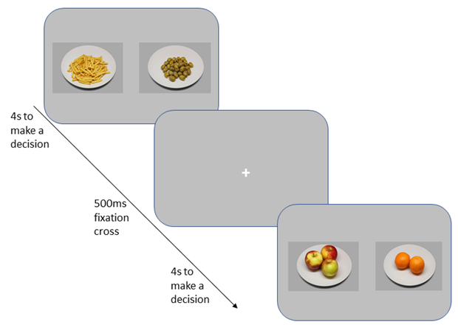
Note. Trial wording varied between three blocks from “which would you rather consume?”, “which do you like more?”, and “which did you rate higher?”. Participants were instructed to press a key to select either of the images (‘Z’ for left, ‘M’ for right). Participants had up to 4 seconds to make their decision per trial, and each trial was followed by a 500ms fixation cross located in the centre of the screen. Images are taken from the CROCUFID image database (Toet et al., 2019).

Data preparation and analysis
On the VBDM task, “miss trials” (responses exceeding 4 seconds) were removed (0.24%) as well as trials that were under 300ms (0.03%) as these are likely to be fast guesses (Ratcliff et al., 2006b) which resulted in the overall removal of 0.27% of trials. There are a wide variety of sequential sampling models that are based on the common underlying assumption that decisions arise from a noisy accumulation-to-threshold process (Bogacz et al., 2006; Busemeyer et al., 2019). A prominent example is the DDM (Ratcliff & McKoon, 2008), of which there are also variations, but no consensus of which model is optimal to use. We fitted the EZ-DDM (Wagenmakers et al., 2007) to RT and accuracy data from the VBDM task. This simplified version of the DDM is a powerful tool (van Ravenzwaaij et al., 2017) that allows researchers to overcome the complexity of the parameter fitting procedure of the full DDM (Stafford et al., 2020). Crucially, research has demonstrated that relatively simple models such as the EZ-DDM yield comparatively accurate and robust inferences when compared to more complex model fitting approaches (Dutilh et al., 2019; Lerche et al., 2017; Lin et al., 2020; Stafford et al., 2020; van Ravenzwaaij & Oberauer, 2009). The EZ-DDM takes the mean correct RT, variance of correct RT, and response accuracy as input and produces three key parameters, which are drift rate (v), boundary separation (a), and non-decision time (T_{er}). We estimated the parameters for each participant in each condition and for each difficulty level.

A two-way repeated measures ANOVA and correlational analyses were used to analyse EA rates in accordance with our primary hypotheses. We calculated Bayes factors in JASP using default priors (version 0.16; JASP Team, 2021) because we hypothesised specifically that trial wording would not affect EA rates and this method allows us to quantify evidence in favour of the null hypothesis beyond p-values (Wagenmakers et al., 2018). We used common cut-offs for interpretation (Jeffreys, 1961) with Bayes factors greater than 3, or else lower than 0.3, representing evidence in favour of the experimental and null hypotheses, respectively. All other analyses were conducted in RStudio version 4.0.2 (R Core Team, 2020). We did not make any pre-registered hypotheses about other DDM outputs (response thresholds and non-decision time), but these exploratory analyses are reported in Appendix B.

3.3. Results
Preregistered analyses
EA rates were analysed using a two-way repeated measures ANOVA with trial wording (3: “consume”; “like”; “recall”) and trial difficulty (3: easy; medium, hard) as within-subject variables. There was a significant main effect of difficulty, F(2, 116) = 286.34, p < .001, η_{p}² = .83, with the Bayes factor indicating extreme evidence in favour of the experimental hypothesis (BF₁₀ > 100), but not of trial wording, F(2, 116) = 2.81, p = .06, η_{p}² = .05, with the Bayes factor indicating moderate evidence in favour of the null hypothesis (BF₁₀ = .19). Furthermore, there was no significant interaction between trial wording and trial difficulty, F(3.39, 196.47) = 2.00, p = .11, η_{p}² = .03, with the Bayes factor indicating strong evidence in favour of the null hypothesis (BF₁₀ = .05).

Figure 3.2
Mean evidence accumulation (EA) rates split by trial difficulty and trial wording
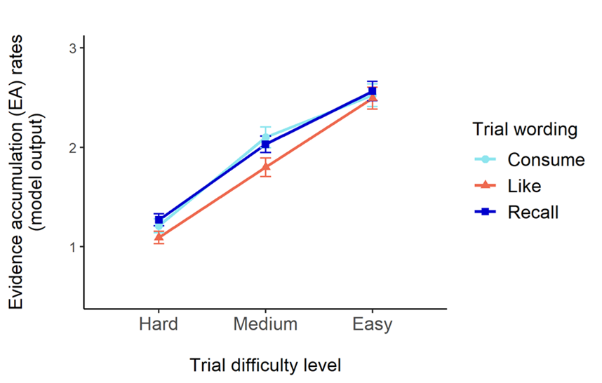
Note. Light blue (circle) represents EA rates with the wording “which would you rather consume”, orange (triangle) represents EA rates with the wording “which do you like more”, and dark blue (square) represents EA rates with the wording “which did you rate higher”. Error bars represent the standard error of the mean (SE).

Post-hoc tests for the significant main effect of difficulty (applying the Holm-Bonferroni correction to p-values for multiple comparison) revealed that EA rates in the easier trials (M = 2.53, SD = .82) were significantly higher compared to medium trials (M = 1.98, SD = .73; p < .001) and hard trials (M = 1.19, SD = .50; p < .001). Furthermore, EA rates on medium trials were significantly higher compared to EA rates on hard trials (p < .001). Overall, as shown in Figure 3.2, these findings demonstrate that EA rates increased as trial difficulty decreased, and this was not modified by trial wording.

We conducted Pearson's correlation coefficient analyses to explore the direction, strength, and significance of the relationships between EA rates across the different trial wording blocks. As shown in Figure 3.3, these correlational analyses revealed highly significant positive correlations between EA rates in all three blocks (all ps < .001; consume and recall wording, r(57) = .68, p < .001; consume and like wording, r(57) = .46, p < .001; recall and like wording, r(57) = .44, p < .001).

Figure 3.3
Scatterplots to show correlations between EA rates during the three blocks of trials
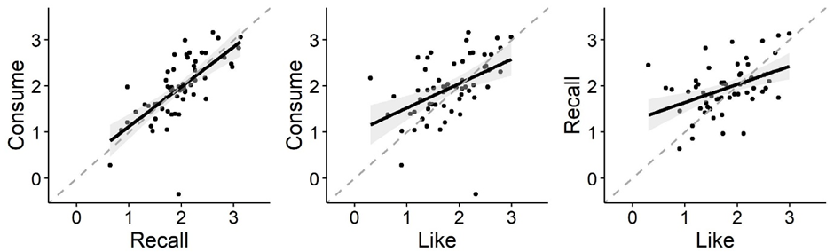
Note. On the left is the correlation between EA rates during the block of trials with “which would you rather consume” and the block of trials with “which did you rate higher”. In the middle is the correlation between EA rates during the block of trials with “which would you rather consume” and the block of trials with “which do you like more”. On the right is the correlation between EA rates during the block of trials with “which did you rate higher” and the block of trials with “which do you like more”. The grey dashed line represents the line of equality. Shaded areas represent the 95% confidence interval.

3.4. Discussion
We explored whether a coherent construct of value was captured by variations of trial wording that do not require participants to think about their momentary desire to consume objects depicted in pictures. As hypothesised, EA rates significantly increased alongside decreasing trial difficulty, and this was not modified by trial wording. Contrary to our hypothesis, there was a trend towards a main effect of trial wording on EA rates, regardless of trial difficulty, reflective of lower EA rates when participants considered how much they “liked” the images compared to when asked to indicate how much they wanted to consume the food depicted, or to recall which they had rated higher previously. This effect however was sensitive to the software used to fit the DDM, and it fell short of statistical significance when data were analysed using the EZ-DDM in accordance with our pre-registered analysis plan. Finally, EA rates across the different blocks were significantly positively correlated with each other, although coefficients were not as large (> .70) as we predicted (Abma et al., 2016).

These findings are important because the majority of VBDM tasks require participants to make choices across trials about their strength of desire to consume a commodity (Krajbich et al., 2010; Mormann et al., 2010; Polanía et al., 2014; Tusche & Hutcherson, 2018), and our findings suggest that variations of trial wording are viable alternatives that can capture value-based choice. Importantly, the variations in trial wording are interpreted to be viable alternatives as opposed to completely identical substitutes because the correlations between EA rates varied in strength across comparisons and the main effect of trial wording approached statistical significance. Furthermore, in line with other research, EA rates increased as trial difficulty decreased (Polanía et al., 2014). This establishment of a ‘difficulty effect’, regardless of the wording of the value-based question on that block of trials, is important because it demonstrates that the way that participants were responding during the 2AFC trials was compatible with the value judgments that they had made during the image-rating task.

The core focus of this study was EA rates because this parameter is hypothesised to represent value (Field, Heather, et al., 2020), however analyses on other decision parameters derived from the EZ-DDM (response thresholds and non-decision time) are presented in Appendix B. An implication of this research is that variations of trial wording used in this study may be appropriate to implement in future research contexts whereby it is undesirable to ask participants to make consummatory judgements, such as those in recovery from addiction (Copeland et al., 2021; Field, Heather, et al., 2020). It may be less aversive for people in recovery to express preferences in relation to how much they like an image rather than in relation to their desire to consume the item depicted; indeed, similar procedures have been implemented with people with addiction in clinical settings (Moeller & Stoops, 2015). A limitation of this study is that the EZ-DDM model fitting approach (Wagenmakers et al., 2007) precluded the fixing of decision parameters across conditions; however, when we used alternative software (the fast-dm-30; Voss et al., 2015) that enabled us to fix decision parameters, the main effect of trial wording on EA rates became statistically significant (see Appendix B). A broader issue is that alternative, more complex models may provide a better fit to behavioural data and thereby be more sensitive to the effects of trial wording (Colas, 2017)–an important topic for future research. Another limitation is that participants made value ratings, and were reminded of these, prior to completion of the 2AFC task which may have inadvertently affected participant behaviour. Future research could explore the impact of all combinations of initial value ratings and subsequent wording of 2AFC trials using a full factorial design to investigate the robustness of the findings reported in this study.

To conclude, this study was an exploration into the sensitivity of VBDM tasks to minor alterations in trial wording. Results demonstrated robust evidence that differences in EA rates (sensitivity to whether trials are easy, medium, or hard determined by participants own value ratings) were equivalent across the variations of trial wording. There was an effect of trial wording on EA rates, however this is confined to absolute EA rates, is not robust, and appeared sensitive to the software used to fit the DDM. This study contributes towards an initial validation of alternative wording that can be appropriate to implement in future research in which it is undesirable to ask participants to make consummatory judgments about the stimuli, such as research into VBDM in people who are in recovery from addiction.

Chapter 4: Modelling value-based decision-making (VBDM) in regular alcohol consumers after experimental manipulation of the value of alcohol

In Chapter 3, I found that differences in EA rates (sensitivity to whether trials are easy, medium, or hard determined by participants own value ratings) were equivalent across the variations of trial wording on the VBDM task that do not explicitly ask about consumption (i.e., “gold-standard” wording). I therefore demonstrated initial validation of alternative VBDM task trial wording that can be implemented in future research addiction and recovery from it. In the present Chapter, I applied the VBDM task to addiction-related research by investigating whether experimentally manipulating alcohol value (via videos that depict the positive and negative consequences of alcohol) in regular alcohol consumers prior to completion of the task alters decision parameters of value-based choice for alcoholic and soft drink cues.

Contributions: I designed the study, which was approved by Matt Field and Tom Stafford (primary supervisors). I collected and analysed the data. I wrote the chapter. Matt Field and Tom Stafford provided feedback on the draft.

As mentioned previously (p.6), findings from this Chapter have been presented as a poster at the Society for the Study of Addiction’s Annual Conference (https://www.addiction-ssa.org/author-publications/modelling-value-based-decision-making-in-regular-alcohol-consumers-after-experimental-manipulation-of-the-value-of-alcohol/)

Abstract
Background: Devaluation of alcohol leads to reductions in alcohol choice and consumption; however, less is known about the mechanisms behind this. This is the first study to manipulate the value of alcohol and apply a computational model of value-based decision-making (VBDM) to parameterise the internal processes of decision-making. Method: This study was pre-registered. Using a within-subject design, 36 regular alcohol consumers were primed to value and devalue alcohol by watching videos that emphasised the positive versus the negative consequences of alcohol consumption. After being primed, participants completed a two-alternative forced choice task in which they chose between either two alcohol images (in one block) or two soft drink images (in a different block). On each block, participants pressed a key to select the drink image that they would rather consume. We applied a drift-diffusion model (DDM) to the reaction time and accuracy data to estimate evidence accumulation (EA) processes and response thresholds during the different blocks. Results: After devaluation of alcohol, soft drink EA rates were significantly increased compared to alcohol EA rates (p = .04, d = .31) and compared to soft drink EA rates when participants were primed to value alcohol (p = .01, d = .38). However, the experimental manipulation had no effect on EA rates for alcoholic drinks or on response thresholds in either priming condition. Conclusions: The manipulation of alcohol value led to alterations in EA rates for soft drinks compared to alcoholic drinks. Surprisingly, the experimental manipulation of alcohol value only altered the internal processes that precede decision-making for soft drinks rather than alcoholic drinks.

4.1. Introduction
Harmful alcohol consumption increases the risk of premature death and ill health (Degenhardt et al., 2018; Rehm et al., 2017). In England alone, over 10 million people consume alcohol at levels which are above the United Kingdom (UK) Chief Medical Officers ‘low risk’ drinking guidelines of 14 units per week (Office for Health Improvement and Disparities, 2022). Consequently, this leads to substantial socioeconomic costs, of which, £3.5 billion is direct to the National Health Service (Public Health England, 2016). Behavioural economic accounts argue that shifts in valuation processes related to alcohol and competing alcohol-free alternative reinforcers at least partially underlie changes in alcohol consumption (Bickel et al., 2014; Bickel & Athamneh, 2020; Hogarth & Field, 2020; Murphy, MacKillop, et al., 2012; Tucker et al., 2021). Indeed, experimental research has demonstrated that devaluation of alcohol leads to reductions in alcohol choice and consumption (Rose et al., 2018), however little is known about the underlying mechanisms by which valuation processes exert these effects (Rose et al., 2013). This study aimed to explore the underlying mechanisms that determine discrete alcohol-related choices by applying a computational model of value-based decision-making (VBDM) to regular alcohol consumers’ choices after manipulating alcohol value.

Behavioural economic theories of addiction combine principles from psychology and economics with the goal to better understand the choices that people make over time (MacKillop, 2016). The central tenet of these accounts is that the progression to addiction is characterised by persistently high valuation of substance use compared to alternative substance-free reinforcers, and devaluation of outcomes that are only available after a delay (Bickel et al., 2014; Bickel & Athamneh, 2020). Research typically uses hypothetical purchase tasks (Murphy & MacKillop, 2006) and concurrent choice tasks (Hogarth & Hardy, 2018b) to measure “demand”—a behavioural economic construct that represents the reinforcing value of a substance (MacKillop, 2016). The alcohol purchase task (APT; Murphy & MacKillop, 2006) and brief assessment of alcohol demand (BAAD; Owens et al., 2015) are used to assess a person’s hypothetical consumption of alcohol across a range of escalating prices. In concurrent choice tasks (Hogarth & Hardy, 2018b) people make repeated choices between alcohol and non-alcohol alternative (e.g., food) reinforcers for some type of reward, such as points or enlargement of the image. The percentage choice of alcohol versus the alternative reward is used to infer the relative value that is ascribed to alcohol. Although hypothetical purchase tasks and concurrent choice tasks are methodologically different, scores on these measures are correlated which demonstrates that they tap into a common construct of alcohol value (Chase et al., 2013).

The value ascribed to alcohol is positively associated with alcohol use disorder symptom severity in students (Hardy et al., 2017; Hogarth & Hardy, 2018b), young adults (Hogarth et al., 2018), community samples (Hardy & Hogarth, 2017), and dependent drinkers engaged with treatment services (Hardy et al., 2018). These findings are compatible with behavioural economic accounts (Bickel et al., 2014; MacKillop, 2016). Furthermore, the value ascribed to alcohol is sensitive to experimental manipulations that alter motivation for consumption (Acuff, Amlung, et al., 2020). In regular alcohol consumers, when alcohol is manipulated to taste aversive to humans, this results in devaluation of alcohol: both the percentage of alcohol choice (Rose et al., 2013) and actual consumption of alcohol (Rose et al., 2018) reduce compared to a control condition (no manipulation). Furthermore, when negative mood is induced, this results in increased value of alcohol, reflected in a greater percentage of alcohol choice (Hardy & Hogarth, 2017; Hogarth et al., 2018; Hogarth & Hardy, 2018a) compared to baseline and when positive mood is induced. The implication of these findings is that addiction is the result of goal-directed behaviour because alcohol choice is governed by the current motivational value of alcohol (see Hogarth, 2020, for a review).

A lack of competing alternative reinforcers in a person’s environment is also of importance within the development and persistence of addiction (McKay, 2017; Vuchinich & Tucker, 1988). Indeed, a robust body of research has demonstrated inverse associations between alcohol consumption and availability of alternative reinforcers (Acuff et al., 2019; Correia et al., 2003; Vuchinich & Tucker, 1983). For example, one study found that young adults who were randomly assigned to a condition that instructed them to increase engagement with alcohol-free alternative reinforcers (creative activities and exercise) demonstrated significant reductions in alcohol consumption compared to those in a control condition (Correia et al., 2005). Furthermore, anhedonia is a common consequence of addiction (Garfield et al., 2014; Sussman & Leventhal, 2014) and the overvaluation of alcohol may therefore be explained in part by an absence of competing rewarding activities and/or reduced ability to experience reinforcement derived from alcohol-free alternative activities. In line with this, many effective treatments and interventions for reducing alcohol consumption emphasise the importance of targeting substance-free engagement (McKay, 2017), such as behavioural activation (Daughters et al., 2018), contingency management (Petry et al., 2017), and substance-free activity sessions (SFAS; Murphy, Dennhardt, et al., 2012). The efficacy of treatment interventions may therefore depend on the extent to which they can increase the value of substance-free alternative activities, and/or reduce the value of alcohol (McKay, 2017). Consistent with behavioural economic predictions then, behaviour change and recovery depend upon the rebalance of distorted valuation processes that leave people vulnerable to addiction (Bickel et al., 2014; Redish et al., 2008). However, although behavioural economics has contributed substantially to knowledge on addiction, what is less known are the underlying mechanisms by which changes in valuation processes alter decision-making (Rose et al., 2013).

Value-based decision-making (VBDM) provides a framework and set of experimental tools that can model the internal processes that constitute decision-making (Berkman et al., 2017), and this has been tentatively extended to the study of addiction and recovery from it (Field, Heather, et al., 2020). VBDM postulates that when a person is faced with a decision, they firstly identify the possible response options. The overall value of each response option is determined via a dynamic integration of choice-relevant attributes, which include things such as the anticipated positive and negative consequences (Berkman, 2018; Berkman et al., 2017). Subsequently, response options are compared and the option with the highest value is acted upon through a value-to-action evidence accumulation (EA) process (Berkman, 2018) which can be parameterised using the drift-diffusion model (DDM; Forstmann et al., 2016; Ratcliff & McKoon, 2008). The DDM assumes that value signals from the brain are tracked in a noisy and probabilistic manner, accumulating until some response threshold for committing to a decision is crossed.

The standard procedure of a VBDM task (Polanía et al., 2014) involves participants rank ordering a set of stimuli (e.g., food images) from most valued to least valued. Subsequently, two images appear on the screen and participants are instructed to select the image they prefer as quickly as possible over repeated trials. This generates both reaction time (RT) and accuracy data (i.e., how long the participant took to make a decision, and whether they chose the image that they had previously rated as highest in value), and the DDM is fitted to this behavioural data to recover parameters of decision-making (Stafford et al., 2020). Key parameters include EA rate (also known as the ‘drift rate’; the average rate by which participants accumulate value evidence), response threshold (participant caution), and non-decision time (processes related to encoding and motor execution; Ratcliff et al., 2016; Wagenmakers et al., 2007). Importantly, by reconciling RT and accuracy data in a principled way, the DDM is able to decompose raw behavioural data into decision parameters that represent the underlying cognitive components of decision-making (Evans & Wagenmakers, 2019).

VBDM was recently extended by Field, Heather, et al. (2020) to recovery from addiction. The authors propose three main hypotheses about recovery—inspired by Berkman et al.'s (2017) VBDM framework and informed by existing behavioural economic research (Bickel et al., 2014; Murphy, MacKillop, et al., 2012). These hypotheses are that recovery is characterised by the following, either in combination or isolation: 1) amplified EA rates for substance-free alternatives, 2) suppressed EA rates for substances, and 3) increased response thresholds when making substance-related choices. Therefore, according to this conceptual account the underlying mechanisms by which valuation exerts its effects may be shifts in the internal processes that precede decision-making: specifically, alterations in response thresholds and EA rates. However, this has not yet been explored.

This study investigated whether experimental manipulation of alcohol value alters the recovered parameters of VBDM in regular alcohol consumers. To achieve this, the DDM was fitted to RT and error data from a VBDM task in two different experimental conditions: an alcohol valuation condition and an alcohol devaluation condition. Design, hypothesis, and analysis strategy were pre-registered before data collection commenced (http://aspredicted.org/blind.php?x=fp9z36). It was hypothesised that:
- When participants are primed to value alcohol, they will have increased EA rates and lower response thresholds when choosing between alcohol images compared to when choosing between soft drink images.
- When participants are primed to devalue alcohol, they will have increased EA rates and lower response thresholds when choosing between soft drink images compared to when choosing between alcohol images.
- When participants are choosing between alcohol images, they will have increased EA rates and lower response thresholds when primed to value alcohol compared to when primed to devalue alcohol.
- When participants are choosing between soft drink images, they will have increased EA rates and lower response thresholds when primed to devalue alcohol compared to when primed to value alcohol.

4.2. Method
Design
Pre-registered experimental within-subject design. Dependent variables were EA rates and response thresholds (estimated by applying a DDM to reaction time and error data during the VBDM task). Independent variables were experimental manipulation condition (alcohol valuation and alcohol devaluation), and image type (alcohol images and soft drink (control) images). An a priori power analysis conducted on G*power (Faul et al., 2007) revealed that to detect a difference between two dependent groups with a medium effect (d = 0.5; Cohen, 1988), at 90% power with an alpha of 0.05, a sample size of at least 36 volunteers was required.

Participants
Thirty-six regular alcohol consumers were recruited to attend the laboratory through social media platforms (Facebook and Twitter) and the online research participation system (ORPS) at the University of Sheffield. Ages ranged from 18 to 62 years old (mean age = 26.11, SD = 10.84). Inclusion criteria were consumption of at least 14 UK units of alcohol per week (1 UK unit = 8g of pure alcohol). The 14-unit threshold was chosen because it represents alcohol consumption levels that exceed the “low-risk” weekly drinking guideline recommended by the UK Government (Department of Health, 2016). The exclusion criterion was history of treatment for alcohol use disorder. The average score on the Alcohol Use Disorders Identification Test (AUDIT) was 13.75 (SD = 4.80) with 94.44% of participants scoring >7, demonstrating that the sample were indeed hazardous alcohol consumers. The study was approved by the University of Sheffield research ethics committee, and all participants gave informed consent. Recruitment took place between January 2020 and February 2020. Participants were reimbursed with a £10 high-street voucher (or course credits if they were students who participated through the ORPS).

Materials
Pictorial stimuli
The 35 alcohol and 35 soft drink images were taken from Amsterdam Beverage Picture Set (ABPS: Pronk et al., 2015) and Google. We selected a subsection of images from the ABPS that depicted common brands in English and that only portrayed the drink on a white background (e.g., no glass, tray, or person present in the image). We then complemented these with images from Google that similarly portrayed common brands of drinks on a white background. This was done to increase the variability of recognisable alcohol (e.g., spirits, beer, wine) and soft drink (e.g., hot drinks, fizzy drinks, smoothies) options and ensure there were images that people would evaluate as high in value (e.g., want to consume a lot), others that were likely to be evaluated as low in value (e.g., not want to consume at all), and others that are in-between.

Video stimuli (experimental manipulation)
Previously validated videos (Di Lemma et al., 2015) were used to prime participants to 'value' (evoke approach inclinations) and 'devalue' (evoke avoidance inclinations) alcohol. As in Hogarth et al. (2015), we did not include a neutral group because the contrast between two more extreme groups (alcohol valuation versus alcohol devaluation) offered the best strategy to detect an effect. The videos were created in Windows Movie Maker (version 2.6). Each video lasted for 3 minutes and 45 seconds, and participants wore headphones while watching the videos on a Dell computer screen, with a spatial resolution of 1920 x 1080 pixels and a temporal resolution of 60Hz.

The alcohol-positive video was intended to prime participants to value alcohol (evoke approach inclinations). It comprised of positive images of people having fun whilst consuming alcohol (e.g., partying and playing pool), accompanied by an upbeat soundtrack and slides with text about the positive consequences of consuming alcohol. The alcohol-negative video was intended to prime participants to devalue alcohol (evoke approach inclinations). It comprised of negative images of people consuming alcohol (e.g., vomiting and alcohol-related violence), accompanied by a downbeat soundtrack and slides with text about alcohol-related organ damage and consequences of drink-driving.

Questionnaires
Brief self-control scale (BSCS; Tangney et al., 2004): This 13-item scale is used to capture the extent to which people feel that they can resist external influences and exert control over their behaviour, for example “I refuse things that are bad for me”. Participants responded on a 1 (not at all like me) to 5 (very much like me) scale. In the current sample, the BSCS had acceptable internal reliability, McDonald’s ω = .81 (McDonald, 1970, 1999)

Alcohol Use Disorders Identification Test (AUDIT; Saunders et al., 1993): The full 10-item AUDIT is used to detect patterns of alcohol consumption that are hazardous to health. Total scores range between 0 and 40, with scores of > 7 indicating hazardous alcohol use. The AUDIT had just under acceptable internal reliability, ω = .64.

Brief Assessment of Alcohol Demand (BAAD; Owens et al., 2015): This 3-item scale was used to measure alcohol demand (intensity, O_{max}, and breakpoint) by asking participants about their alcohol consumption across a range of escalating price points. The hypothetical scenario presented to participants read “Think about a scenario that is typical of your usual drinking behaviour, such as at a bar on a night out with friends, or drinking at home. The following questions ask how many drinks you would purchase at various prices. The available drinks are a pint of beer or lager, wine (medium glass), and shots of spirits (25ml) or mixed drinks with one shot of spirits”. Intensity refers to alcohol consumption independent of price and was measured with the question “If drinks were free, how many would you have?” (Responses were multiple choice and ranged from: 0 to 10 drinks). O_{max} refers to the maximum expenditure on alcohol across differing prices, and was measured with the question “What is the maximum total amount you would spend on drinking during that drinking occasion?” (Responses were multiple choice, given in pounds, and ranged from £0 to £30 or more). Breakpoint refers to the first price that suppresses consumption to zero and was measured with the question “What is the maximum you would pay for a single drink?” (Reponses were multiple choice, given in pounds, and ranged from £0 to £15 or more). See Appendix C for the exact price increments that were used in this study.

Approach and Avoidance of Alcohol Questionnaire, Right Now Version (AAAQ; McEvoy et al., 2004): This 14-item questionnaire is used to assess motivational tendencies to approach or avoid drinking at that moment in time. Three subscales are generated from this questionnaire, which are: Inclined-indulgent (mild inclinations to drink), assessed by questions such as “I would like to have a drink or two”. Obsessed-compelled (strong inclinations to drink), assessed by questions such as “My desire to drink seems overwhelming”. Resolved-regulated (inclinations to avoid alcohol), assessed by questions such as “I am thinking about the benefits of being sober”. The three subscales had acceptable internal reliability in each of the four times that the questionnaire was administered (all ω’s ≥ .72). Specifically, reliability of the AAAQ subscales before the negative video: inclined-indulgent, ω = .85; obsessed-compelled, ω = .77; resolved-regulated, ω = .84. After the negative video: inclined-indulgent, ω = .88; obsessed-compelled, ω = .81; resolved-regulated, ω = .80. Reliability of the AAAQ subscales before the positive video: inclined-indulgent, ω = .89; obsessed-compelled, ω = .79; resolved-regulated, ω = .72. After the positive video: inclined-indulgent, ω = .89; obsessed-compelled, ω = .87; resolved-regulated, ω = .78.

Procedure
See Figure 4.1 for a schematic overview of the study procedure. Volunteers attended a single session at the University of Sheffield’s Department of Psychology, which lasted between 60–80 minutes. They firstly completed an online questionnaire, which consisted of demographic questions (age and gender), AUDIT, BAAD, BSCS, and an image-rating phase.

Before attending the laboratory, participants were randomly assigned to one of two experimental conditions which meant the order of video viewing was randomized across participants, such that for half of the sample the alcohol value condition was first, while for the other half the alcohol devalue condition was first. In the alcohol devalue condition participants watched an alcohol-negative video, whilst in the alcohol value condition participants watched an alcohol-positive video. Regardless of the condition they were assigned to, the remaining procedure was identical (aside from the content of the video). Participants self-reported their inclinations to approach and avoid alcohol, both before and after watching the video, and this was followed by the completion of the VBDM task. In-between the experimental conditions, we included a “washout” phase to minimise any carry-over effects from the previously viewed video. This consisted of a distraction task where participants were presented with random facts about Sheffield and then asked to recall them (see Appendix C for order effect analyses and further detail about the distraction task).

Image-rating phase
We asked participants to view two sets of 35 images (an alcohol set, and a soft drink set) and make value judgements about each. This was done firstly for soft drink images and then for alcohol images. They did this by placing each of the images into one of four boxes to indicate how much they would like to consume the drink depicted at the end of the experiment, with the following options: ‘A lot’, ‘A little bit, ‘Not really’, and ‘Not at all’. For each picture set, participants were instructed to rate all 35 images, whilst assigning at least five images to each category by dragging and dropping them using a computer mouse.

Value-based decision-making (VBDM) task
The task was programmed in PsychoPy (Peirce et al., 2019). To begin, five images were randomly selected from each of the categories of value (‘A lot’, ‘A little bit’, ‘Not really’, ‘Not at all’) and were displayed on the centre of the screen for 3 seconds, followed by a 500ms fixation cross. The purpose of this was to show participants which 5 images from each value category had been selected at random, as well as to remind them how they evaluated each of the images. Following this, participants completed the VBDM task. On each trial, two images appeared in the centre of the screen (one on the left and one on the right), and participants were instructed to use one of two keys to choose the image that they would rather consume by pressing one of two keys (‘Z’ for left and ‘M’ for right) as quickly as possible (see Figure 4.2). Before starting the VBDM task, to familiarise participants, they completed a practice block consisting of 12 trials (50% soft drink trials and 50% alcohol trials). The choice task consisted of two blocks (one soft drink block and one alcohol block; order randomised) of 150 trials (300 trials in total) with embedded breaks after every 50 trials. Difficulty levels varied, in that some of the trials were more difficult than others. For example, when the differences in the value ratings between the two images were minimal, these were difficult trials (e.g., “A little bit” versus “Not really”) because it is harder to immediately distinguish which one is higher in value. However, when the differences in the value ratings between the two images were large, these were easier trials (e.g., “A lot” versus “Not at all”), because it is likely to be more apparent which one is higher in value. On each trial there was a correct answer, and whether this appeared on the left or the right of the screen was random so that the ‘correct’ answer should have been a left or right key press with equal frequency. Stimuli were displayed on a Dell computer screen, with a spatial resolution of 1920 x 1080 pixels and a temporal resolution of 60Hz. Participants were given maximum of four seconds to respond on each trial, responses outside of this response window were classed as “miss trials” as commonly used in VBDM tasks (Polanía et al., 2014).

Figure 4.1
Schematic overview of the study procedure
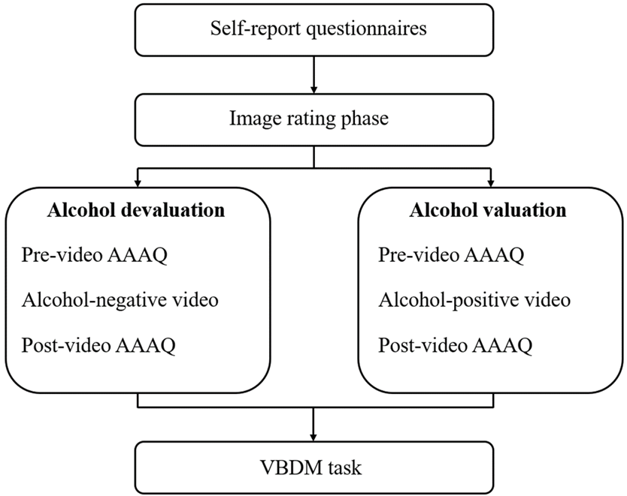
Note. Self-report questionnaires comprise demographic questions (age and gender), the Brief self-control scale (BSCS), the Alcohol Use Disorders Identification Test (AUDIT), and the Brief Assessment of Alcohol Demand (BAAD). The order by which participants completed the experimental conditions to manipulate alcohol value was randomised across participants.

Figure 4.2
Example of typical trials (in the soft drink block)
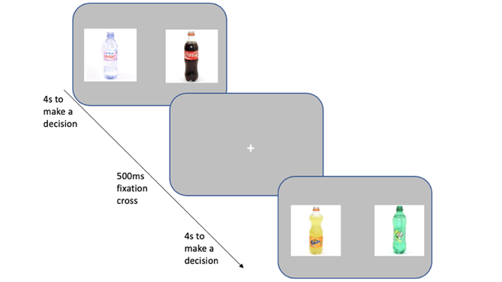
Note. The question asked was “which would you rather consume” and participants were instructed to press a key to select either of the images (‘Z’ for left, ‘M’ for right). Participants had 4 seconds to make a decision per trial, and each trial was followed by a 500ms fixation cross located in the centre of the screen. Images are taken from the Amsterdam Beverage
Picture Set (Pronk et al., 2015).

Data preparation and analysis
On the VBDM task, “miss trials” (responses exceeding 4 seconds) were removed (0.13%) in addition to trials that were under 300ms (0.06%) as these are likely to be fast guesses (Ratcliff et al., 2006b). This resulted in the overall removal of 0.19% of trials. We then fitted the DDM (Ratcliff & McKoon, 2008) to accuracy and speed data from responses on the VBDM task, using the EZ method (Wagenmakers et al., 2007). This simplified version of the DDM takes the mean correct response time, variance of correct response, and response accuracy as input and produces three key parameters which are: drift rate (v), boundary separation (a), and non-decision time (T_{er}). We estimated the parameters (EA rates and response thresholds) for each of the experimental conditions, for each difficulty level, and for each image type separately (see Appendix C for analyses on difficulty levels in isolation).

Paired samples (one-tailed) t-tests were used to analyse the data for the core pre-registered hypotheses, supplemented by exploratory repeated-measure ANOVAs to interpret any group differences in VBDM parameters. Non-parametric tests were used for data that were not approximately normally distributed. Statistical analyses were conducted in RStudio version 4.0.2 (R Core Team, 2020).

4.3. Results
Table 4.1
Descriptive statistics of the sample (values represent the mean, standard deviation, and range). All but two people (94.44% of the sample) were hazardous or harmful drinkers (AUDIT > 7)
 | Mean (SD, range)
Age | 26.11 (10.84, 18-62)
BSCS | 39.47 (7.60, 25-53)
AUDIT | 13.75 (4.80, 6-23)
Intensity | 6.67 (2.18, 3-10)
O_{max} | 20.33 (7.53, 3-30)
Breakpoint | 6.24 (2.36, 3-15)
Note. BSCS refers to brief self-control scale (possible range of values: 13 to 65). AUDIT refers to the Alcohol Use Disorders Identification Test (possible range of values: 0 to 40). Intensity refers to hypothetical consumption of drinks if they are free (possible range of values: 0-10 drinks). O_{max} refers to the hypothetical maximum expenditure on alcohol during a drinking occasion (possible range of values: £0 - £30). Breakpoint refers to hypothetical maximum expenditure on a single drink (possible range of values: £0 to £15 or more).

See Table 4.1 for descriptive statistics.

Effects of video manipulation on AAAQ scores (Figures 4.3 and 4.4)
AAAQ ratings were analysed using a three-way repeated measures ANOVA with subscale (3: inclined-indulgent; obsessed-compelled; resolved-regulated), time (2: before video; after video), and experimental condition (2: alcohol value; alcohol devalue) as within-subject variables. There was a significant three-way interaction between subscale, time, and condition, F(1.65, 57.60) = 42.68, p < .001, η_{p}² = .55. To examine this interaction further, subsequent two-way ANOVAs were conducted on each subscale separately, followed by post-hoc tests (applying Bonferonni-Holm correction to p-values for multiple comparisons). These analyses revealed a significant interaction between time and experimental condition for all three subscales (inclined-indulgent, F(1, 35) = 35.19, p < .001, η_{p}² = .50; obsessed-compelled, F(1, 35) = 24.80, p < .001, η_{p}² = .41; and resolved-regulated, F(1, 35) = 41.14, p < .001, η_{p}² = .54). Post-hoc tests revealed that in the alcohol devalue condition, after watching the alcohol-negative video scores on the inclined-indulgent and obsessed-compelled subscales decreased compared to before the video (both p’s < .001). Whereas scores on the resolved-regulated subscale increased after watching the video (p < .001). A different pattern was seen in the alcohol value condition; after participants watched the alcohol-positive video (positive condition) scores on the inclined-indulgent and obsessed-compelled subscales increased (both p’s < .001). However, there were no significant decreases in scores on the resolved-regulated subscale after watching the positive video (p = .18).

To explore differences in each of the subscale scores after watching each of the videos (e.g., the positive video versus the negative video), a two-way ANOVA with subscale (3: inclined-indulgent; obsessed-compelled; resolved-regulated) and experimental condition (2: alcohol value; alcohol devalue) using only scores from after video viewing was conducted. There was a significant interaction between subscale and experimental condition, F(1.46, 50.94) = 25.22, p < .001, η_{p}² = .42. Post-hoc tests revealed that scores on the inclined-indulgent and obsessed-compelled subscales were decreased in the alcohol devalue condition after watching the negative video compared to in the alcohol value condition after watching the positive video (p < .001 and p = .03, respectively). Scores on the resolved-regulated subscale were increased after watching the negative video (alcohol devalue condition) compared to after watching the positive video (alcohol value condition; p < .001). These findings are comparable to those reported in Di Lemma et al. (2015).

Figure 4.3
Mean AAAQ scores before (pre) and after (post) watching the negative video intended to decrease alcohol value
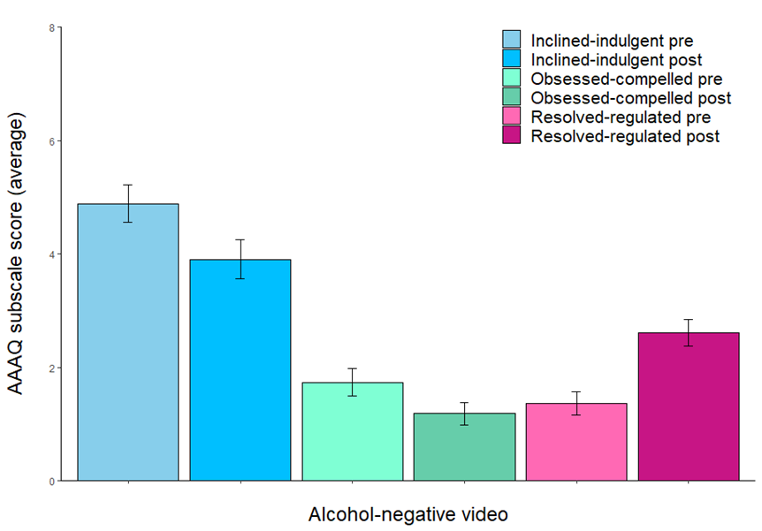
Note. Error bars represent the standard error of the mean (SE).

Figure 4.4
Mean AAAQ scores before (pre) and after (post) watching the positive video intended to increase alcohol value
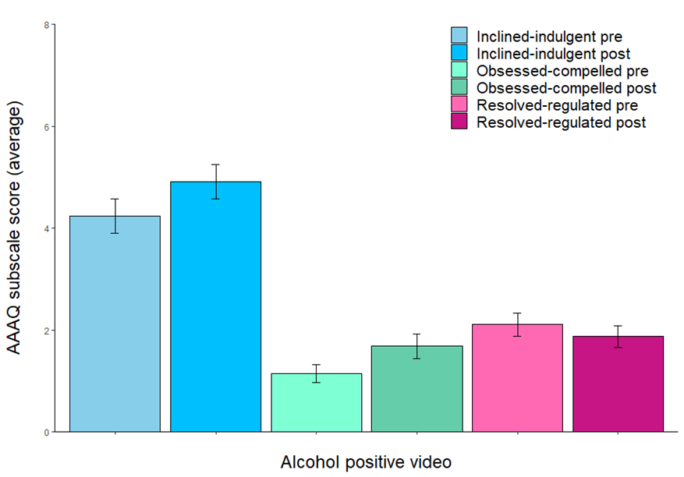
Note. Error bars represent the standard error of the mean (SE).

Hypothesis 1: When participants are primed to value alcohol, they will have increased EA rates and lower response thresholds when choosing between alcohol images compared to when choosing between soft drink images.

When participants were primed to value alcohol, there were no significant increases in alcohol EA rates (M = 1.89, SD = .55) compared to soft drink EA rates (M = 1.89, SD = .34), t(35) = .07, p = .47, d = .01. Furthermore, there were no significant decreases in alcohol response thresholds (M = 1.64, SD = .39) compared to soft drink thresholds (M = 1.63, SD = .36), t(35) = .26, p = .60, d = .04.

Hypothesis 2: When participants are primed to devalue alcohol, they will have increased EA rates and lower response thresholds when choosing between soft drink images compared to when choosing between alcohol images.

When participants were primed to devalue alcohol, they had significantly increased soft drink EA rates (M = 2.02, SD = .49) compared to alcohol EA rates (M = 1.88, SD = .50), t(35) = -1.86, p = .04, d = .31. Response thresholds for soft drinks (M = 1.54, SD = .36) were lower compared to response thresholds for alcoholic drinks (M = 1.60, SD = .30), however this did not reach statistical significance, t(35) = 1.35, p = .09, d = .22.

Hypothesis 3: When participants are choosing between alcohol images, they will have increased EA rates and lower response thresholds when primed to value alcohol compared to when primed to devalue alcohol.

When participants are choosing between alcohol images, there were no significant increases in alcohol EA rates in the alcohol value priming condition (M = 1.89, SD = .55) compared to the alcohol devalue priming condition (M = 1.88, SD = .50), t(35) = .18, p = .43, d = .03. Furthermore, participants did not have a lower response threshold for alcohol in the value priming condition (M = 1.64, SD = .39) compared to in the devalue priming condition (M = 1.60, SD = .30), t(35) = 1.00, p = .84, d = .17.

Hypothesis 4: When participants are choosing between soft drink images, they will have increased EA rates and lower response thresholds when primed to devalue alcohol compared to when primed to value alcohol.

When participants are choosing between soft drink images, they had significantly increased soft drink EA rates in the alcohol devalue priming condition (M = 2.02, SD = .49) compared to the alcohol value priming condition (M = 1.89, SD = .34, t(35) = -2.27, p = .01, d = .38. Participants also had a lower response threshold for soft drinks in the alcohol devalue priming condition (M = 1.54, SD = .36) compared to the alcohol value priming condition (M = 1.63, SD = .36), however this was not statistically significant, t(35) = 1.52, p = .07, d = .25.

Figure 4.5
Mean overall EA rates for alcohol and soft drink choices split by alcohol devaluation (solid black line; circle) and alcohol valuation (dashed black line; triangle) experimental conditions
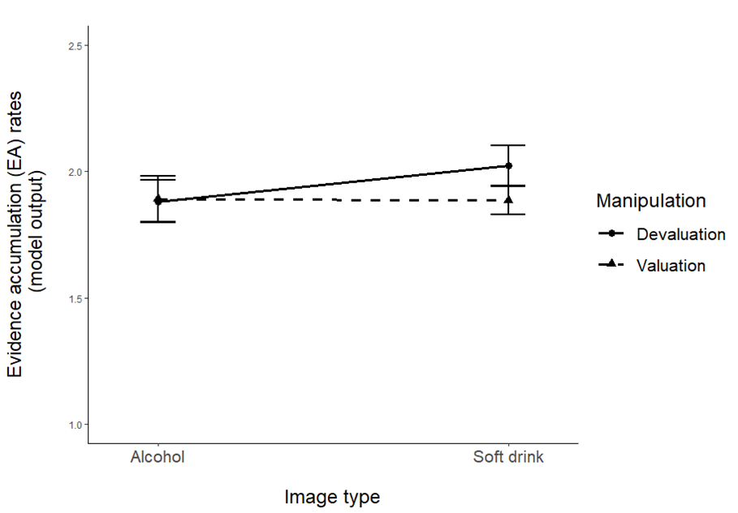
Note. Error bars represent the standard error of the mean (SE).

Figure 4.6
Mean overall response thresholds for alcohol and soft drink choices split by alcohol devaluation (solid black line; circle) and alcohol valuation (dashed black line; triangle) experimental conditions
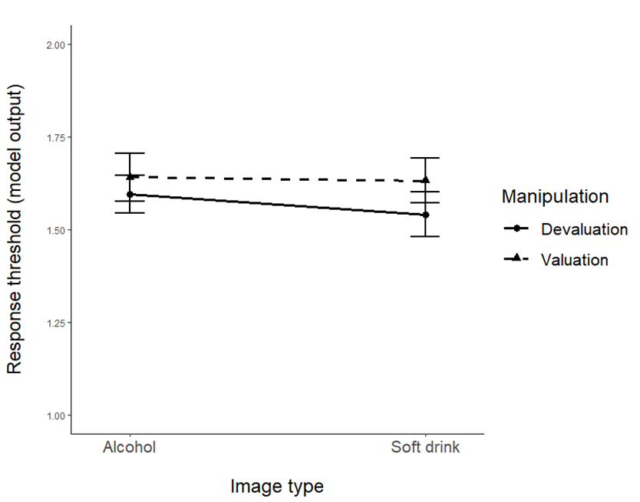
Note. Error bars represent the standard error of the mean (SE).

Exploratory analyses
To further supplement the VBDM analyses presented above (Figures 4.5 and 4.6), we conducted exploratory repeated-measure ANOVAs on EA rates and response thresholds using within-subject factors of image type (2: alcohol; soft drink) and experimental condition (2: alcohol value; alcohol devalue). When looking at EA rates, there was a significant interaction between image type and experimental condition (F(1, 35) = 4.37, p = .04, η_{p}² = .11), but no main effect of image type (F(1, 35) = 1.19, p = .28, η_{p}² = .03) or experimental condition (F(1, 35) = 2.20, p = .15, η_{p}² = .06). Post-hoc tests for the significant interaction effect revealed that soft drink EA rates were higher in the alcohol devalue condition (M = 2.02, SD = .49) compared to in the alcohol value condition (M = 1.89, SD = .34) although this fell short of statistical significance (p = .10). This analysis demonstrates that soft drink EA rates were elevated when participants were primed to devalue alcohol compared to when they were primed to value alcohol, but that this is perhaps not robust. However, it should be noted that in line with our pre-registration, our study was powered to detect differences in means between two dependent groups rather than an interaction effect, and our previously reported results are one-tailed to reflect the pre-registered directional hypotheses. When looking at response thresholds, there was no significant main effect of image type (F(1, 35) = 1.24, p = .27, η_{p}² = .03) or experimental condition (F(1, 35) = 2.47, p = 2.13, η_{p}² = .06), and no interaction between the two (F(1, 35) = .08, p = .37, η_{p}² = .02).

Establishing a ‘difficulty effect’ on the VBDM task
We preregistered that we were interested in establishing whether there is a ‘difficulty effect’, such that on trials where the difference between the value ratings for the images is large (easier trials), EA rates are increased compared to when the difference between the value ratings for the images is minimal (difficult trials). Separate one-way repeated measure ANOVAs were used to compare EA rates for alcohol and for soft drinks on each of the difficulty levels (easy, medium, and difficult trials). There was a significant main effect of difficulty on alcohol EA rates, F(2, 70), = 156.93, p < .001, η_{p}² = .82. Post-hoc tests demonstrated that alcohol EA rates in the easier trials (M = 2.48, SD = .56) were significantly increased compared to medium trials (M = 2.00, SD = .67; p < .001) and difficult trials (M = 1.18, SD = .45; p < .001). Furthermore, alcohol EA rates on medium trials were significantly increased compared to EA rates on difficult trials (p < .001). There was also significant main effect of difficulty on soft drink EA rates, F(1.67, 58.33) = 192.95, p < .001, η_{p}² = .85. Post-hoc tests demonstrated that soft drink EA rates in the easier trials (M = 2.64, SD = .55) were significantly increased compared to medium trials (M = 2.04, SD = .45; p < .001) and difficult trials (M = 1.18, SD = .36; p < .001). Furthermore, soft drink EA rates on medium trials were significantly increased compared to EA rates on difficult trials (p < .001). Therefore, EA rates decreased with increasing difficulty levels in the trials (Figure 4.7).

Figure 4.7
Mean evidence accumulation (EA) rates for alcohol and soft drink decisions (averaged across experimental conditions) split by trial difficulty level
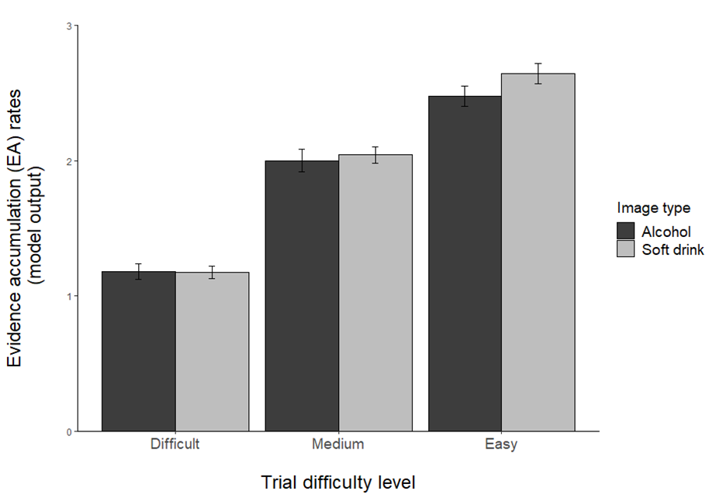
Note. Error bars represent the standard error of the mean (SE).

4.4. Discussion
The aim of this study was to expand upon existing behavioural economic research by modelling the internal processes that determine discrete choices in regular alcohol consumers. Specifically, we explored whether the experimental manipulation of the value of alcohol alters the internal processes that precede decision-making regarding alcohol cues and soft drink cues (Field, Heather, et al., 2020).

The novel finding of this study is that manipulating the value of alcohol alters the internal processes of decision-making. Specifically, when participants were primed to devalue alcohol, their EA rates when making decisions about soft drinks increased significantly compared to their EA rates when making decisions about alcohol. This finding is further complimented by a within-condition difference: when participants were primed to devalue alcohol, EA rates for soft drinks increased significantly compared to EA rates for soft drinks when they were primed to value alcohol. These findings demonstrate that devaluation of alcohol results in increases in the value that is ascribed to soft drinks which is reflected in augmented soft drink EA rates. Put another way, when participants were primed to devalue alcohol (relative to when they were primed to value alcohol), they acquired significantly more value evidence for soft drinks, making it much more likely to cross their response threshold.

These findings can be viewed in line with previous research that has manipulated the value of alcohol. For example, two experimental studies directly manipulated the value of alcohol by altering the taste to be aversive to humans (devaluation) or no manipulation (control). These studies found that when participants were primed to devalue alcohol, this led to a decrease in the percentage of choice, and therefore value of, alcohol compared to soft drinks (Rose et al., 2013, 2018). However, a closer look at these findings reveals some ambiguity: another way to frame decreases in the percentage choice of alcohol is to frame it as increases in the percentage choice of soft drinks. It is therefore unclear whether their findings directly reflect decreased value of alcohol, increased value of soft drinks, or a bit of both. The authors solely attributed their findings to decreased value of alcohol, whereas our findings have demonstrated the opposite, in that it is increased value of soft drinks that is important.

Our study expands upon existing research by modelling the internal processes that precede decision-making and showing that manipulating alcohol value increases soft drink EA rates, rather than reducing alcohol EA rates. Interestingly, Rose et al. (2018) also demonstrated that when participants were primed to devalue alcohol, this reduced fixation and dwell time on alcohol cues and increased fixation and dwell time on soft drink cues. Therefore, it may be that adjustment in EA rates after devaluation of alcohol may be a result of changes in attentional preferences. Indeed, an extension of the DDM is the attentional drift diffusion model (aDDM) which incorporates visual fixations in the value integration process (Krajbich et al., 2010, 2012, 2015; Krajbich & Rangel, 2011) and posits that on average a person accumulates more value evidence for an item when it is being looked at than when it is not. Therefore, devaluation of alcohol may augment EA rates for soft drinks through an increase in fixation and dwelling to soft drink cues. In relation to the aforementioned ambiguity, these attentional findings from Rose et al. (2018) can be interpreted in line with our findings: devaluation of alcohol may result in decreased alcohol preference through adjustment of alcohol-free (i.e., soft drink) value.

We found that participants did not accumulate more value evidence for alcohol when they were primed to value alcohol compared to when they were primed to devalue alcohol. Therefore, to our surprise, our data did not identify the changes in alcohol EA rates that we would expect to see on the basis of overt preferences in previous research. For example, induction of negative mood has been found to increase the value of alcohol (indexed by an increase in percentage choice of alcohol rewards; Hardy & Hogarth, 2017; Hogarth et al., 2018; Hogarth & Hardy, 2018a) whilst manipulation of the taste of alcohol so that it is aversive reduces the value of alcohol (indexed by a reduction in percentage choice of alcohol rewards; Rose et al., 2013, 2018). These findings support the notion that alcohol choices are goal-directed, in that they are governed by the current motivational value of alcohol (Hogarth, 2020), and we anticipated that manipulation of the value of alcohol would be reflected in alterations in alcohol EA rates, but this was not the case. However, there are two important considerations. First, many of the aforementioned studies have the potential to be re-interpreted in a way that at least partially includes changes in the value of the alcohol-free alternative as a mechanism by which the manipulation influences alcohol choice. For example, negative mood (Hardy & Hogarth, 2017) may decrease the value of the alcohol-free alternative because they do not have the same mood repairing qualities of alcoholic drinks, whilst manipulation of alcohol taste (Rose et al., 2018) may increase the value of the alcohol-free alternative because it does not taste aversive, but alcohol does. Second, there are methodological differences that mean it is difficult to interpret our findings in line with previous research. Rather than focusing on overt choices (e.g., whether participants choose between an alcohol or a soft drink image), we asked participants to choose between two alcohol or two soft drink images because this generates the behavioural data that is essential to model the internal processes that precede decisions made. Furthermore, our manipulation of alcohol value differs from previous research. In one study, the value of alcohol was increased by inducing a negative mood among participants by asking them to carefully read negative statements such as “things are never going to get better” whilst listening to sad music (Hogarth et al., 2018). Our study manipulated the value of alcohol in a different way by asking participants to view videos that depicted positive (e.g., drinking with friends) and negative (e.g., alcohol-related violence) outcomes or consequences of alcohol consumption, accompanied by upbeat or downbeat track (Di Lemma et al., 2015). Moreover, it may be that our manipulation to increase alcohol value was not as effective as our manipulation to decrease the value of alcohol. This is because each of the three AAAQ subscales (alcohol approach and avoid inclinations) altered significantly after watching the negative video that was intended to devalue alcohol. However, after watching the positive video that was intended to increase the value of alcohol, only approach inclinations changed significantly and not avoid inclinations (i.e., participants did not want to avoid alcohol less).

We did not find any significant differences in response thresholds as a result of our experimental manipulation. Therefore, in this study not all of the predictions derived from the theoretical model proposed by (Field, Heather, et al., 2020) were supported. However, it may be that recovery is characterised by cautious decision-making because people are actively making the choice to not consume a substance in their everyday lives, whereas in the present study the participants were regular alcohol consumers who were making decisions in a laboratory with no consequences. Future research could explore this speculation.

Our pre-registered analyses included the exploration of whether there is a ‘difficulty effect’. Indeed, EA rates on the VBDM task decreased with increasing difficulty level on the trials. This is in line with previous research (Dutilh & Rieskamp, 2016; Fontanesi et al., 2019; Polanía et al., 2014) and demonstrates that the way that participants were responding to the stimuli during the VBDM task was compatible with the value judgments that they had made about those stimuli during the rating task.

This study has some strengths; the experimental design meant it is possible to infer causal relationships between experimental conditions and VBDM parameters, and there is an increasing awareness of the benefits of applying the DDM to behavioural data (Stafford et al., 2020). However, there are also some important limitations, and our findings identify important avenues for future research. Firstly, females were overrepresented in our sample which limits the generalizability of the findings to the wider population. In addition, due to the manipulation in this study, we cannot establish whether the augmented EA for soft drinks after alcohol devaluation would also be seen in comparison to a more neutral manipulation (rather than a manipulation that increases the value of alcohol). Future research could clarify this. It might be interesting for future research to also explore whether other forms of manipulation replicate our findings, such as directly manipulating alcohol taste (Rose et al., 2013; 2018) or acute alcohol administration (also known as the alcohol priming effect; Halsall et al., 2022), or whether similar findings are found when the value of other substances, such as nicotine, are manipulated. Furthermore, cross-sectional comparison or longitudinal follow-up studies of people who are heavy drinkers or dependent on alcohol and those in recovery may prove further insights into whether alterations in internal processes that precede value-based choices are important in alcohol-related behaviour change.

To conclude, this study applied a computational model of VBDM (Field, Heather, et al., 2020) to explore the underlying mechanisms that determine value-based choices for alcohol and soft drink cues after the experimental manipulation of alcohol value. Our results provide clarity on some ambiguities of existing research, but only demonstrate only partial support for the theoretical predictions in Field, Heather, et al. (2020): manipulation of alcohol value altered EA rates for soft drinks, although EA rates for alcoholic drinks were unaffected by the experimental manipulation. Furthermore, the experimental manipulation had no effect on response thresholds in either priming condition. Therefore, findings do not support all of the theoretical predictions from Field, Heather, et al. (2020).

Chapter 5: Modelling value-based decision-making (VBDM) in daily tobacco smokers after experimental manipulation of mood

Previously (Chapter 4), I found that when participants were primed to devalue alcohol, this led to augmented EA rates for soft drinks compared to for alcoholic drinks and compared to EA rates for soft drinks when participants were primed to value alcohol. However, there were no significant differences in EA rates for alcoholic drinks or in response thresholds for either drink type. I subsequently conducted a mirror study that investigated whether experimentally manipulating nicotine value (via videos that temporarily induce positive and negative mood) in daily tobacco smokers prior to the completion of the VBDM task alters the decision parameters of value-based choice for tobacco and tobacco-unrelated cues.

Contributions: I designed the study, which was approved by Matt Field and Tom Stafford (primary supervisors). I collected and analysed the data. I wrote the chapter. Matt Field and Tom Stafford provided feedback on the draft.

As mentioned previously (p.6), findings from this Chapter have been presented as a poster at the Society for the Study of Addiction’s Annual Conference (https://www.addiction-ssa.org/author-publications/modelling-value-based-decision-making-vbdm-in-daily-tobacco-smokers-after-experimental-manipulation-of-mood/).

Abstract
Background: The induction of negative mood increases tobacco choice in dependent smokers; however, less is known about the mechanisms behind this. This study aimed to address this research gap by applying a computational model of value-based decision-making (VBDM) to decisions about tobacco and tobacco-unrelated cues after experimental manipulation of mood. Method: This study was pre-registered. Using a within-subject design, 49 daily tobacco smokers (>10 cigarettes smoked per day) were recruited and primed to value and devalue tobacco by watching videos that induce negative versus positive mood, respectively. Before and after being primed, participants completed self-report measures of mood and craving to smoke. Subsequently, they completed a two-alternative forced choice task in which they chose between either two tobacco-related images (in one block) or two tobacco-unrelated (animal) images (in a different block). On each block, participants pressed a key to select the image that they rated most positively during a previous task block. A drift-diffusion model (DDM) was fitted to the reaction time and error data to estimate evidence accumulation (EA) processes and response thresholds during the different blocks. Results: After watching videos intended to induce negative mood, happiness scores were lower (p < .001), while sadness and craving to smoke scores were higher (both ps < .001), compared to after watching videos intended to induce positive mood. However, contrary to hypotheses there were no robust differences in EA rates or response thresholds for either tobacco or tobacco-unrelated (animal) decisions. Conclusions: Manipulation of mood in daily smokers does not lead to alterations in the internal processes that precede value-based decisions made about tobacco and tobacco-unrelated cues.

5.1. Introduction
Tobacco smoking is a leading global cause of preventable disease and death (Forouzanfar et al., 2016). In England, approximately 5.7 million people are current tobacco smokers which leads to substantial health and socioeconomic consequences (Office for National Statistics, 2020). To elaborate, tobacco smoking has a causal role in various forms of cancer and respiratory disease and is estimated to cost the National Health Service £2.6 billion per year (Public Health England, 2017). Behavioural economic accounts posit that distortions in valuation processes related to tobacco and tobacco-unrelated rewards underlie the development and maintenance of nicotine dependence (Bickel et al., 2014; González-Roz et al., 2019; Hogarth & Field, 2020; Murphy, MacKillop, et al., 2012). Indeed, experimental research has shown that the induction of negative mood augments the expected value of tobacco indexed by increased tobacco choice (Hogarth et al., 2015), however little is known about the underlying mechanisms by which valuation processes exert these effects. This study aimed to explore the underlying mechanisms that determine discrete tobacco-related choices by applying a computational model of value-based decision-making (VBDM) to daily smokers’ choices after manipulating tobacco value indirectly via mood manipulation.

In behavioural economic models the dominant approach to measuring tobacco reinforcing value (also termed ‘demand’) is with hypothetical cigarette purchase tasks (CPT; e.g., MacKillop et al., 2008). During the CPT, participants are instructed to estimate how many cigarettes they would hypothetically purchase across a set of prices that gradually increase. From this, a tobacco demand curve (i.e., a plot of the level of consumption and tobacco-related expenditure as function of cigarette price) can be generated that enables interrelated, yet dissociable indices of tobacco value to be extracted (Aston & Cassidy, 2019). These indices are intensity (consumption when price is zero), O_{max} (maximum expenditure), breakpoint (price which suppresses consumption to zero), P_{max} (point at which price becomes elastic), and elasticity (sensitivity to changes in price). An alternative, but also frequently used approach to measure tobacco value is with concurrent choice tasks (e.g., Hardy et al., 2018) whereby participants choose between a tobacco-related and a tobacco-unrelated image for a reward (e.g., image enlargement) over repeated trials. The percentage choice of tobacco relative to tobacco-unrelated reward is used to infer the value ascribed to tobacco. Interestingly, although methodologically different, outputs from the CPT and concurrent choice tasks have been found to be moderately correlated (Chase et al., 2013) which indicates that they may tap into a common construct of value.

A robust body of evidence has demonstrated positive associations between nicotine dependence and tobacco value (González-Roz et al., 2019; Hardy et al., 2018; Lawn et al., 2018; Miele et al., 2018; Zvorsky et al., 2019), however the value ascribed to tobacco-unrelated alternative rewards is also important. This is because the central tenet of behavioural economic accounts is that the development of addiction arises from—and is maintained by—excessive valuation of substances relative to competing alternative reinforcers in the environment (Bickel et al., 2014; Hogarth & Field, 2020; Murphy, MacKillop, et al., 2012; Tucker et al., 2016). Put simply, as addiction progresses, not only do substances increase in value, but substance-free alternative reinforcers decrease in value. Indeed, a neuroimaging study by Lawn and colleagues (2020) found that compared to non-dependent occasional smokers, dependent smokers have blunted value signals in the posterior cingulate cortex when making decisions about tobacco-unrelated rewards (shopping vouchers). Furthermore, anhedonia (i.e., the reduced ability to derive enjoyment or pleasure from events or activities that would typically be enjoyed; Snaith, 1993) predicts greater value ascribed to tobacco (Leventhal, Trujillo, et al., 2014) and impedes quit attempts in dependent smokers (Leventhal, Piper, et al., 2014). These findings therefore support the notion that nicotine addiction is maintained by distortions in valuation processes, in line with behavioural economic accounts.

Interestingly, valuation processes are not fixed. Rather, they are malleable because they are sensitive to changes in policy (Grace et al., 2015) and experimental manipulation (Acuff, Amlung, et al., 2020). For example, induction of stress (Aston et al., 2021), exposure to tobacco cues (e.g., opening a pack of cigarettes and lighting a cigarette but refraining from smoking; MacKillop et al., 2012), and deprivation of nicotine (Lawn et al., 2015) increase tobacco value. On the other hand, satiation (Hogarth, 2012; Hogarth & Chase, 2011), and ingestion of varenicline (Green & Ray, 2018) reduce tobacco value. An interesting experimental study by Hogarth et al. (2015) recruited nicotine deprived smokers and administered a concurrent choice task comprising tobacco and tobacco-unrelated rewards. Participants were then instructed to smoke to satiety (i.e., tobacco devaluation), before being allocated to either a negative or a positive mood induction condition. When choice was measured again in extinction, the findings showed that tobacco choice decreased in the positive mood condition but increased in the negative mood condition. These findings demonstrate that despite smoking to satiety, the induction of negative mood augmented tobacco value to the extent that it outweighed the previous devaluation effect. Similar mood induction procedures have been successfully implemented in alcohol-related research, thereby demonstrating that negative mood is a powerful technique to elevate substance value (Hardy & Hogarth, 2017; Hogarth et al., 2018). The effectiveness of mood induction procedures can be interpreted in line with negative reinforcement models (T. B. Baker et al., 2004; Blevins et al., 2016; Cooper et al., 1995): substances may increase in value because they assist with the avoidance or regulation of negative internal states (Hogarth, 2022). Tobacco choice is therefore goal-directed because even in people with nicotine dependence, preferential tobacco choice is controlled by greater expected drug value (Hogarth, 2020). However, what is less understood are the underlying mechanisms through which valuation processes alter decision-making (Rose et al., 2013).

The current study aimed to address this research gap guided by contemporary accounts of VBDM that provide a framework to model the internal processes that determine decisions (e.g., Berkman, 2018; Berkman et al., 2017). According to this VBDM account, when a person is deciding between alternative response options (e.g., whether to smoke a cigarette, or whether to do something else), the possible response options are identified and assigned an overall value. The overall value is dependent upon a set of value attributes (also termed ‘input processes’) which comprise anticipated gains (e.g., satisfying craving) and costs (e.g., price) that are associated with the response option. Once each response option has an overall value, the response option with the highest value is acted upon (Berkman et al., 2017). This can be parameterised via the application of a drift-diffusion model (DDM; Ratcliff & McKoon, 2008) which assumes that people accumulate evidence in favour of a response option until a response threshold is reached, at which point the decision is made (for a review, see Ratcliff & McKoon, 2008). By fitting the DDM to behavioural data (reaction time (RT) and error) from two-alternative forced choice (2AFC) tasks, decision parameters with well-established psychological interpretations can be recovered. These include the rate of evidence accumulation (EA rate; also termed ‘drift rate’) and response threshold (decision caution reflected in speed-accuracy trade-offs). Recent work (Copeland et al., 2021; Field, Heather, et al., 2020a) tentatively extended VBDM to addiction and recovery from it, hypothesising that alterations in the value ascribed to substances and substance-free alternative rewards can be mapped onto changes in the internal mechanics of decision-making, specifically, alterations in EA rates and response thresholds. However, it remains unexplored whether manipulations of tobacco value do indeed map onto changes in value-based decision parameters recovered from the DDM.

This study expanded on research by Hogarth et al. (2015) by investigating whether the indirect manipulation of tobacco value via mood altered parameters of VBDM for tobacco and tobacco-unrelated cues in current tobacco smokers. To achieve this, the DDM was fitted to RT and error data from a VBDM task that asks participants to recall their value ratings in two different experimental conditions: negative mood induction (i.e., tobacco value condition) and positive mood induction (i.e., tobacco devalue condition). The VBDM task was informed by our prior work (Chapter 3) which showed recall wording to be sensitive alternative methodology in contexts where it not appropriate to ask for consummatory judgements. Design, hypothesis, and analysis strategy were pre-registered before data collection commenced (https://aspredicted.org/see_one.php). Our hypotheses were:
- When participants are primed to experience negative mood, they will have increased EA rates and lower response thresholds when choosing between tobacco-related images compared to when choosing between tobacco-unrelated (animal) images.
- When participants are primed to experience positive mood, they will have increased EA rates and lower response thresholds when choosing between tobacco-unrelated (animal) images compared to when choosing between tobacco images.
- When participants are choosing between tobacco images, they will have increased EA rates and lower response thresholds when primed to experience negative mood compared to when primed to experience positive mood.
- When participants are choosing between tobacco-unrelated (animal) images, they will have increased EA rates and lower response thresholds when primed to experience positive mood compared to when primed to experience negative mood.

5.2. Method
Design
Experimental within-subject design. Dependent variables were EA rates and response thresholds (estimated by applying a DDM to reaction time and error data during the VBDM task). Independent variables were experimental condition (positive mood and negative mood induction), and image type (tobacco-related images and tobacco-unrelated (animal) images). An a priori power analysis conducted on G*power (Faul et al., 2007) revealed that to detect a difference between two dependent groups with a medium effect (d = 0.5; Cohen, 1988), at 90% power with an alpha of 0.05, a sample size of at least 36 volunteers was required. We oversampled to account for any technical issues or drop-outs that may occur with online testing and ensure the study is still sufficiently powered.

Participants
We recruited 50 daily tobacco smokers through Prolific (https://www.prolific.co/), however data from one participant was removed. Forty-nine participants remained in the analytical sample (30 female, 19 male) who were aged between 26 and 69 years old (mean age = 46.96, SD = 12.33). Inclusion criteria were age ≥18 years old, current residence in the United Kingdom, and identification as a current smoker who has smoked for at least 1 year, smoking >10 cigarettes per day, and only smoking tobacco. We also required that participants had taken part in at least 10 previous studies and that they had a high level of previous approval (>95% approval) on Prolific to maximise retention in the study and ensure that the data collected was of good quality. The study was approved by the University of Sheffield research ethics committee, and all participants gave informed consent. Recruitment took place between July and August 2021. Participants were reimbursed with £12.50 Prolific credit for their time.

Materials
Pictorial stimuli for the VBDM task
The 30 smoking images were selected from the Geneva smoking pictures data set (Khazaal et al., 2012), whilst the 30 smoking-unrelated (animal) images were selected from the international affective picture system (IAPS) data set (Lang et al., 2008). We utilised standardised valence ratings that accompany the picture sets to identify images that were likely to be evaluated as highly positive, others that were likely to be evaluated as highly negative, and others that are intermediate (for more detail, see Appendix D).

Video stimuli (experimental manipulation)
Previously validated videos (Marcusson-Clavertz et al., 2019) which comprised film clips and self-referential statements accompanied by music were used to manipulate participant mood in this study. These videos were selected because they have been found to successfully alter participant mood in an online sample recruited from Prolific (Marcusson-Clavertz et al., 2019). In the current study, the videos were used with the aim to induce positive mood (tobacco devaluation) in one condition and to induce negative mood (tobacco valuation) in another separate condition. As this was an online study, to maximise the likelihood that participants actually watched the videos that were presented (detailed below), they were firstly told that they would be asked two questions about the video content in each of the experimental conditions. All participants answered these questions correctly immediately after watching the videos, which is indicative of attentive behaviour.

Positive mood induction
We aimed to induce positive mood by instructing participants to watch a 4-minute video of Timon & Pumbaa’s “Hakuna Matata” scene from the Lion King, followed by another 4-minute video which presented 15 positive Velten statements (e.g., “Most people like me” and “If I set my mind to it, I can make things turn out fine”) accompanied by upbeat music (Coppelia, Act I: 1. Prelude et Mazurka by Léo Delibes). Existing positivity ratings gathered about the Velten statements (Marcusson-Clavertz et al., 2019) guided the order of presentation, such that the video ended with the most highly rated positive statement.

Negative mood induction
We aimed to induce negative mood by instructing participants to watch a 4-minute video of Mufasa’s death scene from the Lion King, followed by another 4-minute video which presented 15 negative Velten statements (e.g., “Nobody understands me or even tries to” and “When I talk no one really listens”) accompanied by downbeat music (Adagio for Strings, Op. 11 by Samuel Barber). Existing negativity ratings gathered about the Velten statements (Marcusson-Clavertz et al., 2019) guided the order of presentation, such that the video ended with the most highly rated negative statement. This experimental condition also contained a ‘mood repair’ so that participants would not end their participation in a heightened negative mood. The mood repair included eight of the most highly rated amusement video clips from an established film library (Samson et al., 2016), each of which lasted ~30 seconds. These clips were selected because they differ from the materials used in the core manipulation of mood which is important when considering the counterbalanced order of experimental condition across participants. As in Hogarth et al. (2015), we did not include a neutral group because the contrast between two more extreme groups (i.e., positive versus negative mood) offered the best strategy to detect an effect.

Questionnaires
The Patient Health Questionnaire-2 (PHQ-2; Kroenke et al., 2003): This two-item scale was used to measure depressed mood. Question items were “Little interest or pleasure in doing things” and “Feeling down, depressed or hopeless”. Participants were asked how often they experienced each item over the past two weeks on a scale ranging from 0 (not at all) to 3 (nearly every day).

Fagerström Test for Cigarette Dependence (Fagerström, 2012): This six-item scale was used to measure cigarette dependence. An example question is “How soon after you wake do you have your first cigarette?”. Total scores ranged from 0 to 10, with the category labels of low dependence (1-2), low to moderate dependence (3-4), moderate dependence (5-7), and high dependence (8+). In the current sample, the scale had unacceptable internal reliability, McDonald’s ω = .60 (McDonald, 1970, 1999).

Brief self-control scale (BSCS; Tangney et al., 2004): This 13-item scale was used to capture the extent to which people feel that they can control their behaviour, for example “I refuse things that are bad for me”. Participants responded on a 1 (not at all like me) to 5 (very much like me) scale. The BSCS had good internal reliability, ω = .80.

Positive and Negative Affect Schedule-Expanded (PANAS-X; Watson & Clark, 1999): We used two subscales from the PANAS-X (joviality and sadness). The joviality subscale included the following eight items: happy, joyful, delighted, cheerful, excited, enthusiastic, lively, and energetic. The sadness subscale included the following five items: sad, blue, downhearted, alone, and lonely. For each item, participants were asked “Please answer honestly how you feel right now” using a scale which ranged from 0 (very slightly or not at all) to 4 (extremely). In line with previous research (Marcusson-Clavertz et al., 2019), the mean score of joviality was used to index positive mood and the mean score of sadness was used to index negative mood. The two subscales had good internal reliability in each of the four times the questionnaire was administered (all ω’s > .77). More specifically, before the negative mood induction: joviality, ω = .92; sadness, ω = .84, and after the negative mood induction: joviality ω = .96; sadness ω = .93. Before the positive mood induction: joviality, ω = .93; sadness, ω = .91, and after the positive mood induction: joviality ω = .96; sadness ω = .77.

A single item of craving (West & Ussher, 2010): Participants answered a single question to assess their craving to smoke, which was “How strong is your urge to smoke now?”. Participants responded on a visual analogue scale ranging from 0 (no urge to smoke) to 100 (extreme urge to smoke). Single item measures of craving have been found to have good reliability (West & Ussher, 2010).

Cigarette Purchase Task (CPT; MacKillop et al., 2008): The CPT was used to measure cigarette demand by asking participants about their cigarette consumption on a typical day across a range of escalating price points. In line with Aston et al. (2021), the CPT comprised 22 price points. The prices ranged from free to £10, and each price point was presented alongside the associated standard pack size (e.g., if cigarettes are 20p each, then a standard pack of 20 cigarettes would be £4). The hypothetical scenario presented to participants read “Imagine a TYPICAL DAY during which you smoke. The following questions ask how many cigarettes you would consume if they cost various amounts of money. Assume the available cigarettes are your favourite brand. Assume that you have the same income/savings that you have now and NO ACCESS to any cigarettes or nicotine products other than those offered at these prices. In addition, assume that you would consume the cigarettes that you request on that day. You cannot save or stockpile cigarettes for a later date. Be sure to consider each price increment carefully”. Before completing the CPT, to ensure that participants had read and understood the scenario they were instructed to imagine, they firstly took part in a comprehension check where they could only proceed if they correctly answered two questions about the scenario (“In the typical scenario above, should you assume the available cigarettes are your favourite brand?” and “In the typical scenario above, should you assume you can save or stockpile cigarettes for a later date?”). The use of comprehension checks has also been employed in previous purchase task research (Kaplan & Reed, 2018). Several indices can be calculated using the CPT, and these are: intensity (consumption when price is at zero), O_{max} (maximum expenditure), P_{max} (the price by which demand becomes elastic), breakpoint (first price that suppresses consumption to zero), and elasticity (rate at which consumption becomes more or less dependent upon price). See Appendix D for the exact price points that were used in this study.

Contemplation Ladder (Biener & Abrams, 1991): Participants completed the contemplation ladder to capture motivation (readiness) to quit smoking. The ladder was presented on a scale that ranged from 0 “no thought about quitting” to 10 “taking action to quit”.

Demographic and smoking questions: Finally, we obtained demographic information such as participants’ age and gender. We asked additional questions regarding cigarette use such as quit attempts (if any), typical cigarette consumption per day, years smoked, and age of initiation of smoking.

Procedure
This was an online study and participants were recruited via Prolific (https://www.prolific.co/). In line with the procedure from Marcusson-Clavertz et al. (2019), participants firstly completed a pre-screen phase where they answered questions to assess current depressive symptoms. If participants scored below a set threshold (<1 on both questions) they were eligible to participate. This step was included to safeguard participants who might be vulnerable to distress induced by the negative mood induction.

Eligible participants were subsequently invited to participate in the study which comprised two separate testing sessions (part 1 and part 2). Experimental condition assignment was counterbalanced across participants, such that for half of the sample the positive mood induction was first, whilst for the other half the negative mood induction was first (see Appendix D for order effect analyses). After completing part 1 of the study, all participants completed part 2 within 10 days. The average duration between participation in part 1 and part 2 was 2.65 days (SD = 1.69). In each experimental condition, participants firstly completed the image-rating phase. Next, they completed the questionnaires listed above in a randomised order (these were only completed in part 1 for each participant, i.e., the first experimental condition they took part in). Next, they self-reported their mood and subjective craving to smoke, both before and after watching the videos intended to manipulate mood, and this was followed by completion of the VBDM task. For a schematic overview of the procedure see Figure 5.1. Completion of both experimental conditions (i.e., negative mood and positive mood induction) took on average 88.30 minutes (SD = 19.07 minutes). Split by experimental condition, participants took on average 48.37 minutes (SD = 16.03 minutes) in the negative mood induction, and 39.93 minutes (SD = 12.00 minutes) in the positive mood induction. We anticipated that the duration of the negative condition would be slightly longer because this contained the mood repair video at the end. Both the image-rating phase and VBDM task (described below) were programmed in PsychoPy and hosted on Pavlovia (Peirce et al., 2019).

Image-rating phase
We asked participants to view two sets of 30 images (a tobacco-related set, and a tobacco-unrelated (animal) set) and make preferential judgements about them. This was done firstly for animal images and then for tobacco images. Each participant used a computer mouse to place each of the images into one of four boxes to indicate how positive they rate the image: ‘Most positive’, ‘Somewhat positive’, ‘Somewhat negative’, and ‘Most negative’. For each picture set, participants were instructed to rate all 30 images, whilst assigning at least five images to each category. All participants completed the rating task, which solicited the subjective values of the stimuli.

Value-based decision-making (VBDM) task
In the VBDM task, five images were randomly selected from each of the value categories (‘Most positive’, ‘Somewhat positive’, ‘Somewhat negative’, and ‘Most negative’). To begin, images were displayed on the centre of the screen for 3 seconds each, followed by a 500ms fixation cross. The purpose of this was to show participants which 5 images from each value category had been selected at random, as well as to remind them how they evaluated each of the images. Following this, participants completed the task. On each trial, two images appeared in the centre of the screen (one on the left and one on the right), and participants were instructed to use one of two keys to choose the image that they rated higher by pressing one of two keys (‘Z’ for left and ‘M’ for right) as quickly as possible (see Figure 5.2). To familiarise participants with the task, they completed a practice block consisting of 12 trials (50% tobacco-unrelated (animal) trials and 50% tobacco-related trials). Next, they completed the task which comprised two blocks (a tobacco-unrelated (animal) block and a tobacco-related block; order randomized) of 150 trials (300 trials in total with embedded breaks after every 50 trials). Difficulty levels for each trial were varied, in that the difference in rating between the two images could be 1, 2 or 3 (hard, medium, and easy choices respectively). When the differences in the value ratings between the two images were minimal (i.e., rating difference 1, e.g., ‘Somewhat positive’, ‘Somewhat negative’), these were difficult trials because it is harder to immediately distinguish which one is higher in value. However, when the differences in the value ratings between the two images were large (i.e., rating difference 3, e.g., ‘Most positive’ versus ‘Most negative’), these were easier trials because it is likely to be more apparent which one is higher in value. On each trial there was an image that had been rated higher, and whether this appeared on the left or the right of the screen was random so that the ‘correct’ answer should have been a left or right key press with equal frequency. Participants were given a maximum of four seconds to respond on each trial, responses outside of this response window were classed as “miss trials” as commonly used in VBDM tasks (Polanía et al., 2014).

Figure 5.1
Schematic overview of the study procedure

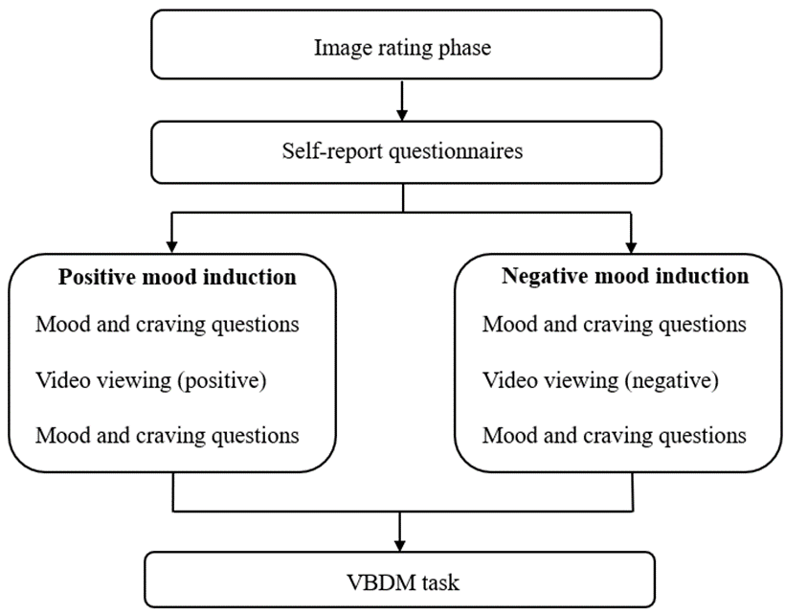
Note. Self-report questionnaires comprise demographic questions (age and gender), questions about cigarette use such as quit attempts (if any), typical cigarette consumption per day, years smoked, and age of initiation of smoking, Fagerström Test for Cigarette Dependence, the Brief self-control scale (BSCS), the Cigarette Purchase Task (CPT), and a Contemplation Ladder. The order of mood induction was counterbalanced, and participants only completed the self-report questionnaires in the first experimental condition that they completed.

Figure 5.2
Schematic depiction of typical tobacco block (left) and typical animal block (right) trials
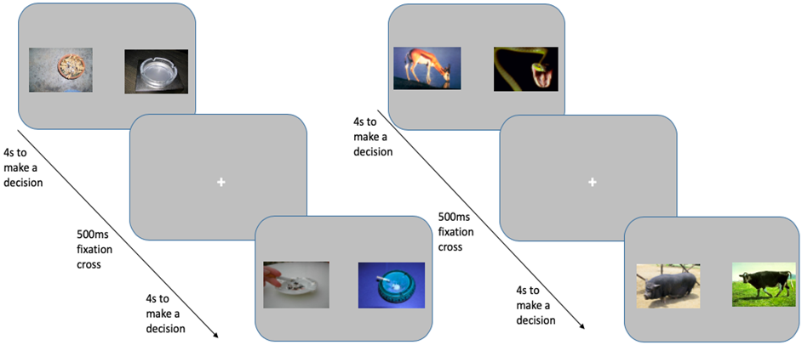
Note. The question asked was “Which did you rate higher? Press ‘Z’ for the left image or ‘M’ for the right image”. Participants had 4 seconds to make a decision per trial, and each trial was followed by a 500ms fixation cross located in the centre of the screen. Images are taken from the Geneva smoking pictures data set (Khazaal et al., 2012) and the international affective picture system (IAPS) data set (Lang et al., 2008).

Data preparation and analysis
On the VBDM task, “miss trials” (responses exceeding 4 seconds) were removed (0.15%) in addition to trials that were under 300ms (0.21%) as these are likely to be fast guesses (Ratcliff et al., 2006b). This resulted in the overall removal of 0.36% of trials. We then fitted the DDM (Ratcliff & McKoon, 2008) using the EZ method (Wagenmakers et al., 2007) which takes response accuracy, mean correct RT, and variance of correct RT as input to produce three key parameters which are: drift rate (v), boundary separation (a), and non-decision time (T_{er}). We estimated the parameters (EA rates and response thresholds) for each of the experimental conditions, for each difficulty level, and for each image type separately (see Appendix D for analyses on difficulty levels in isolation).

For the CPT, using the R package “beezdemand” (Kaplan et al., 2019) we firstly checked the consistency of the demand data using a standardised 3-point algorithm (Stein et al., 2015). All participants met these criteria. Both observed (intensity, breakpoint, O_{max}, P_{max}) and derived (elasticity) values were subsequently estimated using the exponentiated demand equation (see Koffarnus et al., 2015). As recommended by (Tabachnick & Fidell, 2013), outliers greater than 3.29 standard deviations away from the mean were detected and recoded as one unit than the greatest nonoutlier value (this was the case for 5 values). The adequacy of the fit of the model to the data was evaluated by R² values which represent the percentage of variance accounted for by the demand equation. The exponentiated equation provided an excellent fit for both participant-level and aggregated data (R² = 0.92 and R² = 0.98 respectively).

Paired samples (one-tailed) t-tests were used to analyse the data for the core pre-registered hypotheses, supplemented by exploratory repeated-measure ANOVAs to interpret any group differences in VBDM parameters. Non-parametric tests were used for data that were not approximately normally distributed. Data preparation and statistical analyses were conducted in RStudio version 4.0.2 (R Core Team, 2020). All participants passed >75% of the embedded attention checks which was our pre-registered criterion. As previously mentioned under the subheading ‘Participants’, data from one participant was removed. The rationale for this is that it was not possible to recover DDM parameters for this participant in one of the conditions (easy smoking trials in the negative mood induction) due to an accuracy score of 0. As the VBDM task is relatively simple, this is indicative of unreliable responding and we therefore did not retain this participants data.

5.3. Results

Table 5.1
Descriptive statistics of the sample (values represent the mean, standard deviation, and range)
Variable | Mean (SD, range)
BSCS | 37.61 (7.75, 23-52)
FTCD | 5.10 (1.79, 1-10)
Contemplation ladder | 5.45 (2.56, 0-10)
Cigarettes smoked per day | 17.94 (8.13, 5-60)
Years smoked | 30.84 (12.09, 12-53)
Age of smoking initiation | 15.49 (2.76, 10-22)
Number of previous quit attempts | 1.76 (1.52, 0-6)
Note. BSCS = brief self-control scale (possible range of values: 13 to 65). FTCD = Fagerström test for cigarette dependence (possible range of values: 0 to 10). Contemplation ladder provides an index of motivation to quit smoking (possible range of values: 0 to 10).

See Table 5.1 for descriptive statistics.

Effects of experimental manipulation on mood scores (Figures 5.3 and 5.4)
Self-report mood ratings were analysed using a three-way repeated measures ANOVA with mood (2: happy; sad), time (2: before video; after video), and experimental condition (2: positive; negative) as within-subject variables. There was a significant three-way interaction between mood, time, and condition, F(1, 48) = 66.96, p < .001, η_{p}² = .58. To examine this interaction further, subsequent two-way ANOVAs were conducted on each mood separately, followed by post-hoc tests (applying the Holm-Bonferroni correction to p-values for multiple comparison). These analyses revealed a significant interaction between time and experimental condition for both moods (happy mood, F(1, 48) = 67.32, p < .001, η_{p}² = .58; sad mood, F(1, 48) = 43.01, p < .001, η_{p}² = .47). Post-hoc tests revealed that after watching the negative mood videos (negative condition), happiness scores decreased whilst sadness scores increased compared to before the videos (both ps < .001). A different pattern was seen after participants watched the positive mood videos (positive condition): happiness scores increased compared to before the videos (p < .001), but sadness scores did not significantly decrease (p = .07).

Looking at contrasts for scores after watching the videos only, sadness scores were significantly higher after the negative videos compared to after the positive videos (p < .001), while happiness scores were significantly higher after the positive videos compared to after the negative videos (p < .001). Looking at contrasts for before watching the videos only, there were no significant differences in sadness (p = .70) or happiness (p = .73) scores.

Figure 5.3
Average PANAS-X scores (happiness and sadness subscales) pre (before) and post (after) watching the negative videos in the negative mood experimental condition
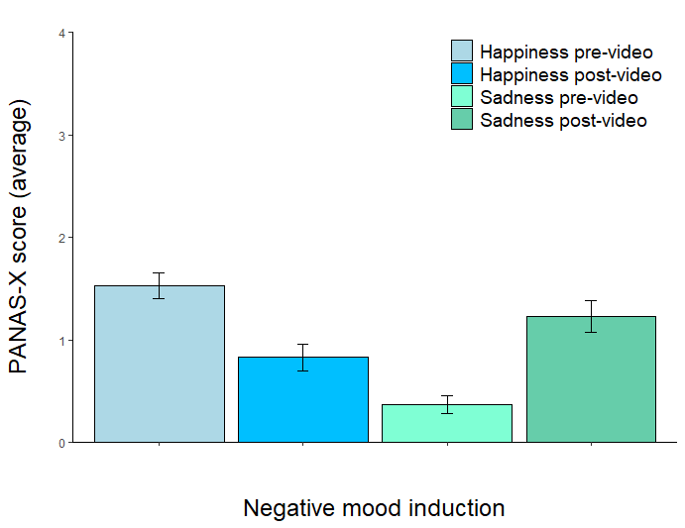
Note. Blue bars represent happiness scores, while green bars represent sadness scores, pre (before) and post (after) watching videos in the negative mood condition. Error bars represent the standard error of the mean (SE).

Figure 5.4
Average PANAS-X scores (happiness and sadness subscales) pre (before) and post (after) watching the positive videos in the positive mood experimental condition
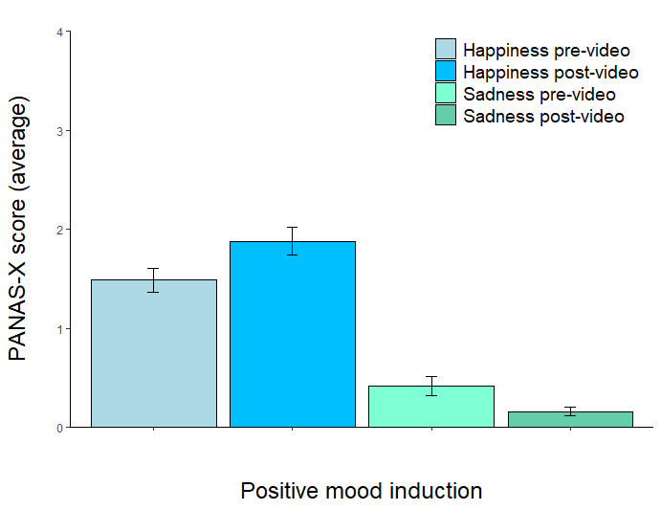
Note. Blue bars represent happiness scores, while green bars represent sadness scores, pre (before) and post (after) watching videos in the positive mood condition. Error bars represent the standard error of the mean (SE).

Effects of experimental manipulation on craving to smoke (Figure 5.5)
Craving scores were analysed using a two-way repeated measures ANOVA with time (2: before video; after video), and experimental condition (2: positive; negative) as within-subject variables. There was a significant interaction between time and condition (F(1,48) = 17.90, p < .001, η_{p}² = .27). Post-hoc tests revealed that in the negative mood condition, craving was marginally significantly increased after watching the videos compared to before watching (p = .05). However, in the positive mood condition, there were no significant differences in craving before versus after watching the videos (p = .08).

Looking only at craving after viewing the videos, craving scores were significantly increased after the negative videos compared to after positive videos (p < .001). Looking at contrasts only before watching the videos, there were no significant differences in craving scores (p = .39).

Figure 5.5
Mean craving to smoke scores pre (before) and post (after) in each of the experimental conditions
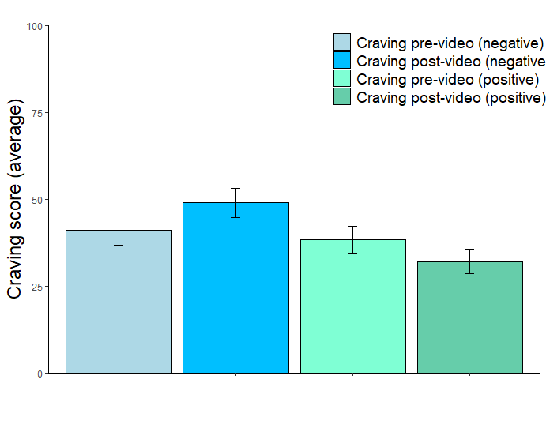
Note. Blue bars represent pre (before) and after (post) scores in the negative mood experimental condition while green bars represent before (pre) and after (post) scores in the positive mood experimental condition. Error bars represent the standard error of the mean (SE).

Pre-registered analyses

Hypothesis 1: When participants are primed to experience negative mood, they will have increased EA rates and lower response thresholds when choosing between tobacco-related images compared to when choosing between tobacco-unrelated (animal) images.

When primed to experience a negative mood, participants did not have significantly increased tobacco EA rates (M = 1.83 SD = .49) compared to animal EA rates (M = 2.13, SD = .45), t(48) = 4.50, p = 1.00, d = .64. Furthermore, participants did not have significantly decreased tobacco response thresholds (M = 1.57, SD = .31) compared to animal thresholds (M = 1.57, SD = .31), t(48) = .09, p = .46, d = .01.

Hypothesis 2: When participants are primed to experience positive mood, they will have increased EA rates and lower response thresholds when choosing between tobacco-unrelated (animal) images compared to when choosing between tobacco-related images.

When primed to experience a positive mood, participants had significantly increased animal EA rates (M = 2.14, SD = .44) compared to tobacco EA rates (M = 1.75, SD = .48), t(48) = 6.02, p < .001, d = .86. However, they did not have significantly decreased animal response thresholds (M = 1.54, SD = .29) compared to tobacco response thresholds (M = 1.52, SE = .29); t(48) = .53, p = .70, d = .08.

Hypothesis 3: When participants are choosing between tobacco-related images, they will have increased EA rates and lower response thresholds when primed to experience negative mood compared to when primed to experience positive mood.

When choosing between tobacco images, EA rates in the negative mood condition (M = 1.83, SD = .49) were not significantly increased compared to in the positive mood condition (M = 1.75, SD = .48); t(48) = 1.15, p = .13, d = .16. Furthermore, smoking response thresholds were not decreased in the negative mood condition (M = 1.57, SD = .31) compared to in the positive mood condition (M = 1.52, SD = .29), t(48) = 1.24, p = .89, d = .18.

Hypothesis 4: When participants are choosing between tobacco-unrelated (animal) images, they will have increased EA rates and lower response thresholds when primed to experience positive mood compared to when primed to experience negative mood.

When choosing between animal images, EA rates were not significantly increased in the positive mood condition (M = 2.14, SD = .44) compared to the negative mood condition (M = 2.13, SD = .45), t(48) = .10, p = .46, d = .01. Furthermore, animal response thresholds were not significantly decreased in the positive mood condition (M = 1.54, SD = .29) compared to the negative mood condition (M = 1.57, SD = .31), t(48) = .89, p = .19, d = .13.

Figure 5.6
Mean overall EA rates for tobacco and animal choices split by negative (solid black line; circle) and positive (dashed black line; triangle) experimental conditions
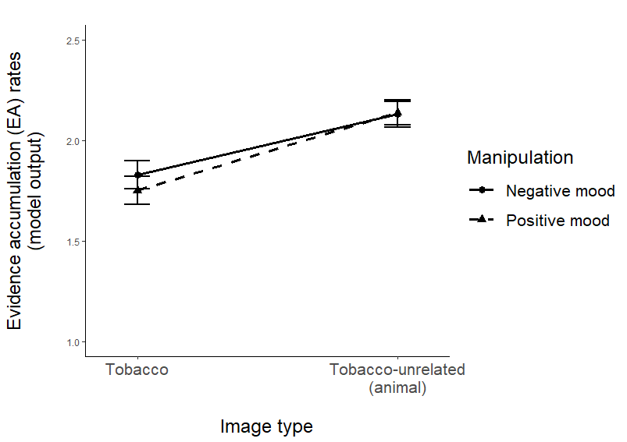
Note. Error bars represent the standard error of the mean (SE).

Figure 5.7
Mean overall response thresholds for tobacco and animal choices split by negative mood (solid black line; circle) and positive (dashed black line; triangle) experimental conditions
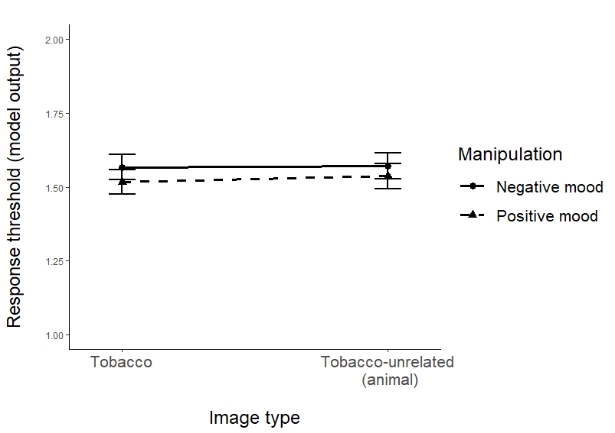
Note. Error bars represent the standard error of the mean (SE).

Exploratory analyses
To further supplement the VBDM analyses presented above, we conducted exploratory repeated-measure ANOVAs on EA rates and response thresholds using within-subject factors of image type (2: tobacco-unrelated (animal); tobacco) and experimental condition (2: positive; negative). However, in line with our pre-registration, our study was powered to detect differences in means between two dependent groups rather than an interaction effect. When looking at EA rates, there was a significant main effect of image type (F(1, 48) = 43.37, p < .001, η_{p}² = .47), but there was no significant main effect of experimental condition (F(1, 48) = .33, p = .57, η_{p}² = .01), and no interaction (F(1, 48) = 1.15, p = .29, η_{p}² = .02). Post-hoc tests for the significant main effect of image type revealed that, collapsed across experimental condition, EA rates were higher for animal choices (M = 2.14, SD = .35) compared to tobacco choices (M = 1.79, SD = .43; p < .001). This analysis demonstrates that there was a main effect of image type that was not robustly moderated by experimental condition. When looking at response thresholds, there was no significant main effect of image type (F(1, 48) = .20, p = .66, η_{p}² = .00) or experimental condition (F(1, 48) = 2.47, p = .12, η_{p}² = .05), and no interaction (F(1,48) = .07, p = .79, η_{p}² = .00).

Establishing a ‘difficulty effect’ on the VBDM task
A pre-registered exploratory analysis was that there should be a ‘difficulty effect’, such that on trials where the difference between the value ratings for the competing images is large (i.e., easier trials), EA rates should be increased compared to when the difference between the value ratings for the competing images is minimal (i.e., difficult trials). Separate one-way repeated measure ANOVAs were used to compare EA rates for tobacco and for animals on each of the difficulty levels (easy, medium, and difficult trials). There was a significant main effect of difficulty on tobacco EA rates, F(1.68, 80.43) = 292.59, p < .001, η_{p}² = .86. Post-hoc tests demonstrated that tobacco EA rates in the easier trials (M = 2.46, SD = .61) were significantly increased compared to medium trials (M = 1.88, SD = .48; p < .001) and difficult trials (M = 1.03, SD = .35; p < .001). Furthermore, tobacco EA rates on medium trials were significantly increased compared to EA rates on difficult trials (p < .001). There was also significant main effect of difficulty on animal EA rates, F(2, 96) = 270.53, p < .001, η_{p}² = .85. Post-hoc tests demonstrated that animal EA rates in the easier trials (M = 2.64, SD = .46) were significantly increased compared to medium trials (M = 2.40, SD = .44; p < .001) and difficult trials (M = 1.36, SD = .37; p < .001). Furthermore, animal EA rates on medium trials were significantly increased compared to EA rates on difficult trials (p < .001). Therefore, EA rates decreased with increasing difficulty levels in the trials (Figure 5.8). For analyses on response thresholds, see Appendix D.

Figure 5.8
Mean evidence accumulation (EA) rates for tobacco and tobacco-unrelated (animal) decisions (averaged across experimental condition) split by trial difficulty level
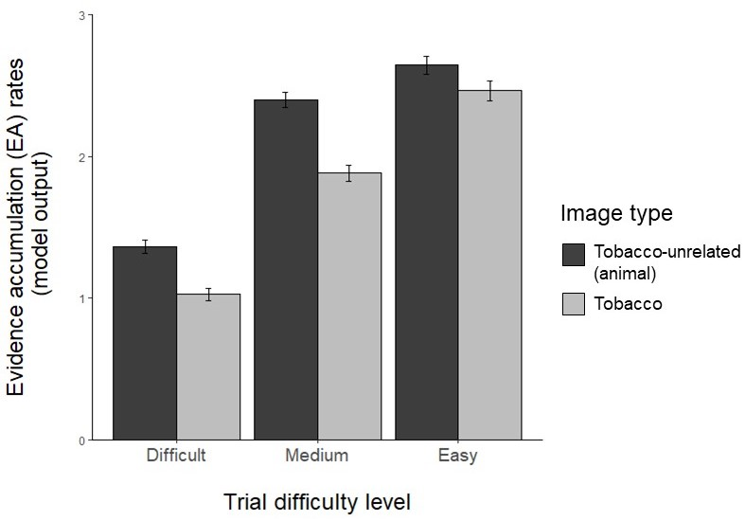
Note. Error bars represent the standard error of the mean (SE).

Cigarette purchase task (CPT)
The CPT was administered for exploratory purposes to investigate the relationships between indices of demand generated from this measure and VBDM tobacco-related decision parameters. Overall, there were no significant correlations (all ps > .05). As these analyses are not of primary interest, they are placed in Appendix D, however, see Table 5.2 for descriptive statistics of the demand indices and Figure 5.9 for current smokers’ demand curve.

Table 5.2
Descriptive statistics for the demand indices captured by the CPT (values are means and standard deviations)
Variable | Mean (SD, range)
Intensity | 23.55 (11.96, 10-70)
O_{max} | 15.17 (16.23; 2-100)
Breakpoint | 2.89 (2.72, .40-10)
P_{max} | 1.91 (2.28, .20-10)
Elasticity | .01 (.01, .00-.04)

Figure 5.9
Demand curve for current smokers. Each data point represents average hypothetical consumption on a particular price of the CPT
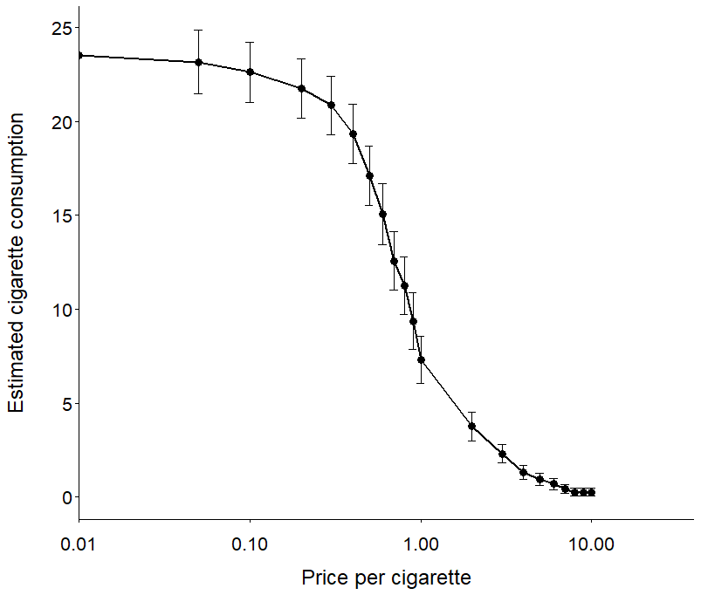
Note. The x-axis is log-transformed (zero values are replaced by trivial nonzero values (0.01) to permit logarithmic units). Error bars represent the standard error of the mean (SE).

5.4. Discussion
This study aimed to investigate the underlying mechanisms by which valuation processes exert their influence on tobacco choice. We applied a computational model of VBDM to daily smokers’ decisions made about tobacco and tobacco-unrelated (animal) cues after experimental manipulation of mood. Unexpectedly, there were no robust between or within-condition differences in VBDM parameters, and therefore our findings failed to provide support for our pre-registered hypotheses. Although animal EA rates were significantly higher compared to tobacco EA rates when participants were primed to experience positive mood, our exploratory analyses revealed that animal EA rates were consistently higher regardless of the experimental manipulation. Given that there were no between-condition differences in animal EA rates, these findings are interpreted as providing no robust evidence in favour of the alternative hypothesis.

Our findings contrast with existing studies that have manipulated participant mood and subsequently measured overt choice (Hardy & Hogarth, 2017; Hogarth et al., 2015, 2018). For example, Hogarth et al. (2015) found that percentage choice (and therefore value) of tobacco (i.e., cigarette) relative to tobacco-unrelated (i.e., chocolate) rewards increased in participants who were primed to experience negative mood, but decreased in participants who were primed to experience positive mood. In line with predictions from recent theoretical accounts (Copeland et al., 2021; Field, Heather, et al., 2020a), we anticipated that negative mood would augment tobacco value in the current study and alter the internal mechanics of decision-making, either in the form of elevated tobacco EA rates, lower tobacco response thresholds, or both. However, it is important to acknowledge that there are several methodological differences which impede direct comparison between our study and previous work: Hogarth et al. (2015) used a similar, but briefer manipulation of mood and only administered a singular-scale to explore the effectiveness of the experimental manipulation on mood. In the current study, we administered several self-report questions to measure positive and negative affect as unidimensional constructs and it may be that the gap between the viewing of videos and completion of the VBDM task inadvertently enabled any powerful mood effect to be diminished by the time the trials were completed. Other methodological differences are that our study used a within-subjects design as the same participants underwent both experimental manipulations of mood, and that it was conducted online rather than in a laboratory setting (due to the ongoing COVID-19 pandemic). This increases the power of our study because individual variation is removed. However, the online setting meant that we were unable to strictly control the environment by which participants took part. Finally, the experimental tasks used to capture value-based choice differed methodologically, with only ours enabling the parameterisation of the internal processes that precede decisions made (for more detail, see Field et al., 2020). Overall, these methodological differences may in part account for why our findings cannot be reconciled or interpreted in line with previous findings (Hardy & Hogarth, 2017; Hogarth et al., 2015, 2018).

Another potential explanation may stem from recent research which has begun to uncover complexity within the relationships between mood and substance use (Tovmasyan, Monk, & Heim, 2022). Although research has successfully manipulated tobacco value via mood (Hogarth et al., 2015) in line with negative reinforcement accounts (T. B. Baker et al., 2004; Blevins et al., 2016; Cooper et al., 1995; Hogarth, 2022), an individual-level meta-analysis revealed that people are actually more likely to consume a substance (e.g., alcohol) harmfully when they are in a positive mood rather than negative mood (Dora et al., 2022). These findings are specific to alcohol, but nevertheless the use of mood as the core manipulation in the current study may have obscured any clear distinction in VBDM parameters. Furthermore, our manipulation of tobacco value may have been relatively weak in comparison to other techniques such as deprivation (Lawn et al., 2015), satiation (Hogarth, 2012; Hogarth & Chase, 2011), and stress induction (Aston et al., 2021). To elaborate, we found that the experimental manipulation of mood was effective in inducing happy and sad mood states, in line with findings from (Marcusson-Clavertz et al., 2019). However, craving to smoke has been linked to higher drug valuation (Biernacki et al., 2021), and although the contrasts for self-report craving scores differed statistically after watching the videos aimed to induce negative versus positive mood, the pre and post contrasts did not reveal a robust effect. This is because there was only a marginally significant increase in craving in the negative mood condition, and there was no statistically significant decrease in craving in the positive mood condition.

Interestingly, in Chapter 4 we found that the experimental manipulation of alcohol value selectively augmented EA rates for alcohol-free alternatives (i.e., soft drinks), but we were unable to detect differences in EA rates in the current study. However, it may be that tobacco value is more difficult to manipulate than other substance types (e.g., alcohol). Indeed, a recent meta-analysis (Acuff, Amlung, et al., 2020) quantified only small and non-significant effect sizes for the influence of negative affect on tobacco value.

Part of our pre-registered analyses was to establish whether there was a ‘difficulty effect’ observed from the behavioural data from the VBDM task. Indeed, we found that EA rates decreased alongside increasing level of difficulty in the trials (Figure 5.8). This is in line with other chapters in this thesis and previous research (Polanía et al., 2014), and is a particularly reassuring finding because despite the online nature of the study, participants’ responding to the stimuli during the VBDM task was compatible with the value judgments that they had made about those stimuli during the rating task.

This study has several limitations, and we have identified avenues for future research. Firstly, unlike in other laboratory research (Dahne et al., 2017), we did not measure or control for time since participants last smoked a cigarette prior to participating in the study, and therefore it may be possible that there were baseline differences in value ascribed to tobacco that add noise to the comparison of the manipulation effects. Secondly, because participants took part online from their own home, this means that we were unable to fully control their environment. However, as this was an experimental manipulation study, we explicitly instructed participants to only take part if they are in a quiet place where they would not be distracted, and we included frequent attention checks. Furthermore, we recruited from Prolific which has been found to have high levels of data quality, including attention from participants (Peer et al., 2021). Thirdly, depression is associated with mood-induced tobacco-seeking (Hogarth et al., 2017), but for ethical reasons given the pandemic and online nature of the study, we firstly pre-screened participants on depressive symptoms. The limitation here is that we potentially washed out the participants for whom the mood-induced increase in tobacco value would have been most potent. Finally, our choice of tobacco-unrelated (animal) stimuli may not have been appropriate to make interpretable comparisons with tobacco-related stimuli. Indeed, previous studies have used food (Chase et al., 2013) or face-related (Hardy et al., 2018) stimuli. However, our choice to use animal stimuli was guided by wanting to remain consistent and enable comparability with Chapter 7 in this thesis.

Future research, if possible, may recruit a sample for in-person testing and use potentially stronger techniques to manipulate tobacco value such as deprivation (Lawn et al., 2015) and satiety (Hogarth, 2012; Hogarth & Chase, 2011) which can be verified with a carbon monoxide breathalyser. This would also enable quantification of time since participants last smoked, meaning that this can be controlled for. Future research may consider extending recruitment to a sample that encompasses a range of scores on the depressive symptom scale, and given that research reliably shows that people who self-report higher coping motivations are more sensitive to negative mood-induced tobacco-seeking (see Hogarth, 2022), may also measure participants coping motivations. Finally, a core focus of future research could be to continue to refine the methodology used in VBDM research to contribute towards identifying an appropriate control category of images that can be used for making comparisons with tobacco images.

To conclude, this study is the first to apply a computational model of VBDM (Field, Heather, et al., 2020a) to explore the underlying mechanisms that determine choices for tobacco and tobacco-unrelated (animal) cues after the experimental manipulation of mood. The experimental manipulation had no effect on EA rates or response thresholds in either priming condition, and therefore, our findings do not provide support for predictions derived from recent theoretical models (Copeland et al., 2021; Field, Heather, et al., 2020a).

Chapter 6: Modelling value-based decision-making (VBDM) in heavy drinkers and people who have reduced their drinking without treatment

In Chapter 5, I found no robust differences in VBDM parameters for tobacco versus tobacco-unrelated cues when participants were primed to value tobacco compared to when they were primed to devalue tobacco. This is because tobacco-unrelated (control) EA rates were consistently higher regardless of the experimental manipulation. In the present Chapter, I extend on previous Chapters that are experimental manipulations of substance value by exploring whether alcohol-related behaviour change is characterised by alterations in VBDM parameters for alcoholic and soft drink cues. I did this by comparing parameters in current heavy drinkers and in people who used to consume alcohol heavily but now consume alcohol in moderation.

Contributions: I designed the study, which was approved by Matt Field and Tom Stafford (primary supervisors). I collected and analysed the data. I wrote the chapter. Matt Field, Tom Stafford, and collaborators Samuel F. Acuff and James G. Murphy provided feedback on the draft.

As mentioned previously (p.5), a variant of this thesis Chapter is published online at Psychology of Addictive Behaviors:
Copeland, A., Stafford, T., Acuff, S. F., Murphy, J. G., & Field, M. (2022). Behavioral economic and value-based decision-making constructs that discriminate current heavy drinkers versus people who reduced their drinking without treatment. Psychology of Addictive Behaviors. https://doi.org/10.1037/adb0000873

Abstract
Background: A substantial number of people reduce their consumption of alcohol in the absence of formal treatment; however, less is known about the mechanisms of change. The aim of this study is to explore whether computational parameters of value-based decision-making (VBDM) and constructs derived from behavioural economics characterise the moderation of alcohol consumption that many heavy drinkers experience without treatment. Method: Between-subject, pre-registered design. People who reside in the United Kingdom and who drink heavily (n = 60) or used to drink heavily but now consume alcohol in moderation (n = 60) were recruited. Participants completed a two-alternative forced choice task in which they chose between two alcoholic (in one block) or two soft drink images (in a different block) alongside self-report behavioural economic measures (alcohol demand and alcohol-related and alcohol-free reinforcement). A drift-diffusion model was fitted to responses from the two-alternative forced choice task to yield the underlying parameters of value-based choice. Results: Compared to heavy drinkers, moderated drinkers had significantly lower alcohol demand (O_{max}, p = .03, Cohen’s d = .36; elasticity, p = .03, rank-biserial correlation (r_{rb}) = .21) and higher proportionate alcohol-free reinforcement (p < .001, Cohen’s d = .75). However, contrary to hypotheses, there were no robust between-group differences in VBDM parameters. Conclusions: Self-report behavioural economic measures demonstrate that alcohol moderation without treatment is characterised by lowered alcohol demand, and greater behavioural allocation to alcohol-free reinforcement, in line with behavioural economic theory. However, a computerized VBDM measure yielded inconclusive findings.

6.1. Introduction
Alcohol consumption increases the risk of ill health and premature death and is consequently a global public health concern (Degenhardt et al., 2018; Rehm et al., 2017). People often experience declines in alcohol consumption with age (Britton et al., 2015) commonly referred to as “maturing-out” (O’Malley, 2004), and most people with alcohol problems and alcohol use disorder (AUD) eventually recover, largely without treatment (Heyman, 2013; Tucker et al., 2020). Dominating theoretical frameworks that conceptualise addiction as a chronic disease of the brain (Volkow et al., 2016) struggle to provide a coherent explanatory account for the frequent instances of behaviour change. Behavioural economic accounts posit that shifts in behavioural allocation away from alcohol and towards alcohol-free alternative reinforcers at least partially underlie changes in alcohol consumption (Bickel et al., 2014; Murphy, MacKillop, et al., 2012; Rachlin, 1997; Tucker et al., 2016; Vuchinich & Heather, 2003). The aim of this study is to apply a computational model of value-based decision-making (VBDM), alongside established self-report behavioural economic measures, in an attempt to characterise the moderation of alcohol consumption that many heavy drinkers experience in the absence of treatment (Field, Heather, et al., 2020).

In behavioural economic models the primary approach to measuring strength of desire for alcohol, also referred to as alcohol reinforcing value or efficacy, is to construct an alcohol demand curve (Martínez-Loredo et al., 2021). Alcohol demand curves plot level of consumption and alcohol-related expenditures as a function of drink price and can be easily estimated with hypothetical alcohol purchase tasks (e.g., Murphy & MacKillop, 2006). Concurrent choice tasks also measure alcohol reinforcing value (e.g., Hogarth & Hardy, 2018b) via a series of choices between an alcohol and alcohol-free alternative reinforcer; the percentage choice of alcohol versus alcohol-free alternative is used to index alcohol value. The value of (or demand for) alcohol is robustly positively associated with AUD symptom severity and consumption, and this has been demonstrated with both alcohol purchase tasks (Martínez-Loredo et al., 2021) and concurrent choice tasks (Hogarth & Hardy, 2018b; Rose et al., 2018). Although methodologically different, both approaches capture a common construct of value as evidenced by observed correlations between the two measures (Chase et al., 2013).

These findings are consistent with molar behavioural economic accounts (Bickel et al., 2014; MacKillop, 2016; Murphy, MacKillop, et al., 2012; Rachlin, 1997; Vuchinich & Heather, 2003) which suggest that the relative degree of preference for alcohol over time is related to both the relative availability and price of alcohol as well as the relative availability and price of alcohol-free alternative reinforcers (Rachlin et al., 2018). Originating from Herrnstein's (1974) Matching Law, this is an important extension because it acknowledges, from a final cause perspective (Rachlin, 1992), that all behaviour derives from choice between engaging in a particular behaviour versus engaging in some other behaviour (Rachlin et al., 2018). More specifically, that behaviour must be understood by looking at temporal patterns over time within a dynamic environmental context (Tucker & Vuchinich, 2015). Consequently, addiction is often understood to develop over time as a ‘reinforcer pathology’ comprising hyper and hypo valuation of alcohol and alcohol-free alternatives, respectively (Bickel et al., 2014; Tucker et al., 2016).

An influential laboratory study by Vuchinich and Tucker (1983) found that by raising the magnitude of alternative rewards (i.e., money), this directly influenced human preference for alcohol as captured by lowered alcohol choice. Since then, measures of proportional behavioural allocation and enjoyment have been commonly used to capture the reinforcing value of alcohol relative to other reinforcers in the environment (Murphy et al., 2005). Indeed, across diverse samples and substance types (including alcohol), substance-free reinforcement is inversely related to substance use (Acuff et al., 2019; Ginsburg & Lamb, 2018). For example, a recent longitudinal study (Murphy et al., 2021) found that deprivation of environmental reward is a significant risk factor for future alcohol consumption and AUD symptomatology in young adults. Another study found that reward deficits predicted smoking escalation longitudinally in young adults (Audrain-McGovern et al., 2011). Both the development and maintenance of addiction may therefore be explained partially by an environmental absence of competing rewarding activities and/or some reduced capacity to derive reinforcement from alcohol-free activities (Garfield et al., 2014; Higgins et al., 2004).

It is common for people to reduce their consumption of alcohol without seeking treatment (Britton et al., 2015; Dawson et al., 2005, 2006; Heyman, 2013; Tucker et al., 2020) and overall there are likely several different pathways to alcohol moderation. For example, a study using data from a national monthly survey in England identified that approximately 20% of high-risk drinkers were attempting to moderate or reduce their consumption (Beard et al., 2017) and that core motivations were health, concern from others, and financial costs (Beard et al., 2017). Motivation to reduce drinking has been found to prospectively predict attempts to cut down (de Vocht et al., 2018), although this did not translate into reductions in actual alcohol consumption at a 6-month follow-up.

Behavioural economic accounts (Bickel et al., 2014; Tucker et al., 2021) posit that for such behaviour change to occur, the distortions in valuation processes that leave people vulnerable to addiction must be reversed such that alcohol is no longer excessively valued relative to alcohol-free alternative reinforcers. Indeed, research conducted in treatment settings (Hardy et al., 2018) found that compared to people who self-reported current alcohol consumption, self-report alcohol abstinence was characterised by lowered alcohol value (indexed by lower percentage of alcohol relative to alcohol-free choice). Furthermore, prospective studies support the notion that shifts in behavioural allocation away from alcohol and towards alcohol-free alternative reinforcers underlie natural recovery from AUD (Tucker et al., 2016, 2021). In line with being recognised as a core target (McKay, 2017), many efficacious treatment and brief interventions are based upon behavioural economic principles and aim to reinforce patterns of behaviour that offset distortions in valuation processes (Fazzino et al., 2019). These include contingency management (Petry et al., 2017), behavioural activation (Daughters et al., 2018), and substance-free activity sessions (Murphy, Dennhardt, et al., 2012), for example. However, less is known about how valuation processes change as people who consume alcohol heavily (but who are not dependent) moderate their drinking. This study aimed to address this research question by characterizing alcohol moderation in heavy drinkers.

A further aim of this study was to apply recent advances in the measurement of value-based choice, specifically computational work on VBDM, to this research question. VBDM provides a framework and experimental procedure that can be used to model the internal processes that may precede observable behavioural choices, postulating that on average, people make momentary decisions guided by things that they value (Berkman et al., 2017; Levy & Glimcher, 2012; Rangel et al., 2008). Contemporary VBDM accounts (e.g., Berkman et al., 2017) posit that once possible response options have been identified (e.g., whether to consume alcohol, or whether to do something else), an overall value for each is computed as the weighted sum of diverse value input signals comprising the anticipated gains (e.g., social approval) and costs (e.g., effort). This is essential because it enables a person to compare and subsequently choose the response option with higher value (Berkman et al., 2017). Core parameters that are hypothesized to underlie value-based choice can be recovered through the application of the drift-diffusion model (DDM; Ratcliff & McKoon, 2008) to behavioural data (reaction time (RT) and accuracy) from two-alternative forced choice tasks. More specifically, the rate at which momentary value evidence is accumulated (EA rate) and how much evidence needs to be accumulated to trigger a response (response threshold) (Stafford et al., 2020). The following assumption underlies the DDM: evidence accumulates noisily until it reaches some threshold for responding, at which point that the decision is acted upon (for a review, see Ratcliff et al., 2016).

VBDM has been tentatively extended to recovery from addiction (Copeland et al., 2021; Field, Heather, et al., 2020). According to this account, behaviour change occurs when distortions in valuation processes (i.e., hypervaluation of alcohol and hypovaluation of alcohol-free alternative rewards) are reversed, and this process can be attributed to alterations in the internal processes that precede discrete behavioural choices. More specifically, either in combination or isolation: suppressed EA rates for alcohol, amplified EA rates for alcohol-free alternatives, and upwards shifts in alcohol-related response thresholds. This neuroscientific account offers a molecular perspective that aligns with identification of efficient causes (Rachlin, 1992), but that is independent of the assumption of irrationality: choices are driven by valuation processes and reflect decision-making that may, in the moment, be contextually rational (e.g., consuming alcohol after interpersonal conflict to elevate mood or become intoxicated might maximize utility over a short temporal horizon), even if such choice is regretted subsequently and deemed irrational due to its effect of lowering utility over a longer temporal horizon (e.g., the next day). Interestingly, this introduces a solid parallel between behavioural economics and VBDM despite their respective molar and molecular perspectives: both recognize that behaviour depends on the context within which it occurs. Furthermore, this approach may offer an efficient-causal explanation that can serve as the basis for observed final cause patterns of behaviour over time (Rachlin, 2017). VBDM therefore offers a complementary neuroscientific extension to behavioural economics which aligns with emerging enthusiasm for interdisciplinary collaborations in the field (Acuff et al., 2022; Amlung et al., 2015) including the application of computational modelling (Bickel & Athamneh, 2020).

This study applied a computational model VBDM, alongside established self-report behavioural economic measures, in an attempt to characterise the moderation of alcohol consumption that many heavy drinkers experience in the absence of treatment (Field, Heather, et al., 2020). To achieve this, we used the DDM to provide a principled reconciliation of the RT and accuracy of VBDM in two drinker groups: heavy drinkers and moderated (former heavy) drinkers. Design, hypotheses, and analysis strategy were pre-registered before data collection commenced (https://aspredicted.org/dh7vp.pdf). It was hypothesised that compared to heavy drinkers, moderated drinkers will have: 1) lower EA rates for alcohol, 2) greater EA rates for soft drinks, 3) lower behavioural economic alcohol demand, 4) greater proportional alcohol-free reinforcement.

Additional hypotheses were formulated in the study protocol, however we forgot to include these in our pre-registration. We still present these hypotheses as pre-registered but would like to ensure that we are transparent about this researcher error. These hypotheses were that compared to heavy drinkers, moderated drinkers will have higher response thresholds for alcohol, and lower response thresholds for soft drinks.

6.2. Method
Design
Between-subject design. Our behavioural dependent variables were EA rates and response thresholds for alcohol and soft drinks (estimated by fitting the DDM to reaction time and accuracy data during the VBDM task). Our self-report dependent variables were alcohol demand and alcohol-free reinforcement. Independent variables were group membership (heavy drinker or moderated (former heavy) drinker) and drink type (alcohol and soft drink images). An a priori power analysis conducted on G*power (Faul et al., 2007) revealed that to detect a difference between two independent groups with a medium effect (d = 0.5; Cohen, 1988), at 80% power with an alpha of 0.05, a sample size of at least 51 per group was required. We oversampled by recruiting 120 (60 heavy and 60 moderated) drinkers to accommodate for potential dropouts that may occur with online testing.

Participants
We recruited 120 participants through Prolific (https://www.prolific.co/), who were aged between 18 and 72 years old (mean age = 36.56, SD = 13.05). Sixty participants were male and 59 were female (one did not disclose their gender). Inclusion criteria were age ≥18 years old, current residence in the United Kingdom (UK), and self-reporting either current consumption of at least 28 units of alcohol per week (to take part as a heavy drinker) or under 14 units per week but having previously consumed at least 28 units per week in the past (to take part as a moderated drinker). Importantly, participants were eligible to take part only if they self-report consuming 28 or more units of alcohol per week for a minimum of 3 months (for heavy drinkers this refers to currently; for moderated drinkers this refers to retrospectively, before they reduced their drinking). The 28-unit threshold was chosen because it represents a doubling of the “low-risk” weekly drinking guideline of 14 units or less recommended by the UK Government (Department of Health, 2016). We also required that participants had a high level of approval from previous participation on Prolific (>95% approval) to ensure good data quality. Exclusion criteria consisted of any history of treatment for AUD. The study was approved by the University of Sheffield research ethics committee, and all participants gave informed consent. Recruitment took place in December 2020. Participants were reimbursed with £10 Prolific credit for their time.

Materials
Pictorial stimuli for the VBDM task
The 30 alcohol and 30 soft drink images were taken from the Amsterdam Beverage Picture Set (ABPS; Pronk et al., 2015) and Google. We selected a subsection of images from the ABPS and compiled these with additional images from Google that portrayed English brands of drinks on a white background. This was done to ensure variability in the perceived value of images by increasing the number of recognizable alcohol (e.g., spirit, beer, wine) and soft drink (e.g., hot drink, fizzy drink, smoothie) options (for more detail, see Appendix E).

Questionnaire measures
Alcohol Use Disorders Identification Test (AUDIT; Saunders et al., 1993): The full 10-item AUDIT was used to detect patterns of alcohol consumption that are hazardous to health. Total scores range between 0 and 40, with scores > 7 indicating hazardous consumption. The AUDIT had good internal reliability in this study, McDonald’s ω = .83 (McDonald, 1970, 1999).

Brief self-control scale (BSCS; Tangney et al., 2004): This 13-item was used to capture the extent to which people feel that they can resist external influences and control their behaviour, for example “I am able to work effectively toward long-term goals”. Participants responded on a 1 (not at all like me) to 5 (very much like me) scale with higher scores indicating higher levels of self-control. In the current sample, the BSCS had unacceptable internal reliability, ω = .55.

The Meaning in Life Questionnaire (MLQ; Steger et al., 2006): This 10-item scale was used to measure two dimensions: presence of meaning (how much respondents feel their lives have meaning), and search for meaning (how much respondents are striving to find meaning in their lives). Questions included “I have discovered a satisfying life purpose” and “I am looking for something that makes my life feel meaningful”. Participants responded on a scale ranging from 1 (absolutely untrue) to 7 (absolutely true). Higher scores indicate higher presence of meaning or search for meaning. In the current study, each subscale had excellent internal reliability; presence, ω = .93, search ω = .92.

Alcohol Purchase Task (APT; Murphy & MacKillop, 2006): An adapted brief 8-item version of the APT was used to capture alcohol demand. Participants were instructed to report the number of standard alcoholic drinks they would purchase and consume in a typical drinking scenario across a range of escalating price points (for exact wording of the scenario, see Appendix E). Importantly, moderated drinkers completed the APT in relation to their current desire to purchase (i.e., not a retrospective estimate of what they would have done prior to reducing their consumption). The APT consisted of the following eight price points: free, 50p, £1, £2, £4, £6, £9, £15. Before completing the APT, participants were required to correctly respond to two comprehension check items to ensure that participants read and understood the hypothetical scenario. The use of comprehension checks has also been implemented in other purchase task research (Kaplan & Reed, 2018). Several demand indices can be reliably calculated using the APT, which are: intensity (consumption when price is at zero), O_{max} (maximum expenditure across prices), P_{max} (the price by which demand becomes elastic), breakpoint (first price that suppresses consumption to zero), and elasticity (rate at which consumption becomes dependent upon price) (Acuff & Murphy, 2017).

Activity Level Questionnaire (ALQ; based on Meshesha et al., 2020): This measure was used to measure behaviour allocation and enjoyment across alcohol-related and alcohol-free activities. Past month ratings of activity engagement frequency were made on a 7-point scale (0 = 0 times in the past month to 6 = several times per day) and enjoyment on a 5-point scale (0 = unpleasant or neutral to 4 = extremely pleasant). We modified this measure by extending the range of responses for frequency, reducing the number of items, and updating content to include more currently common activities (e.g., asking about virtual socializing instead of writing letters and sending emails). For exploratory purposes (see Appendix E), we also added an additional question on a 5-point scale about whether frequency of engagement in each activity has changed since the national COVID-19 lockdowns commenced in the UK in March 2020 (0 = much less often to 4 = much more often). The frequency and enjoyment ratings were multiplied to obtain cross-product scores (range = 0 – 24) which were then averaged across all activities to calculate total alcohol-free and alcohol-related reinforcement scores for each participant. We then computed a reinforcement ratio (range = 0 – 1) by dividing the mean alcohol-free reinforcement by the mean of all available reinforcements (alcohol-free + alcohol-related). Our reinforcement ratio therefore reflects proportionate alcohol-free, rather than alcohol-related, reinforcement because this is the pre-registered outcome of interest.

Stages of Change Readiness and Treatment Eagerness Scale (SOCRATES; Miller & Tonigan, 1996): we administered 4-items from the original SOCRATES to assess problem recognition, which has also been used in previous research (Morris et al., 2020, 2022). Two items relate to the Ambivalence Scale within the original SOCRATES (“There are times when I wonder if I drink too much” and “Sometimes I wonder if I am in control of my drinking”) and two items relate to the Recognition Scale (“If I don’t change my drinking soon, my problems are going to get worse” and “My drinking is causing a lot of harm”). Participants responded on a 5-point Likert scale, rating each item from 1 (strongly disagree) to 5 (strongly agree). Scores range from 4 to 20, with higher scores indicating a higher level of problem recognition. The present study indicated this measure had good internal reliability (ω = .88).

Drinking Refusal Self-Efficacy Questionnaire (Young et al., 1991): In line with previous research (Field, Puddephatt, et al., 2020), we used a 9-item version of the original 31-item measure to assess participants' belief in their ability to resist alcohol. This measures self-efficacy across three subscales: social pressure (e.g., “When I am with friends”), emotional relief (e.g., “When I am worried”), and opportunistic (e.g., “When I am watching TV”). Participants responded on a 7-item scale ranging from 1 (very difficult to refuse) to 7 (very easy to refuse). Higher scores indicate higher drinking refusal self-efficacy. The measure had good internal reliability for all three subscales (all ωs > .84). Specifically: social pressure (ω = .84), emotional relief (ω = .91), and opportunistic (ω = .85).

Questions about COVID-19: We asked exploratory questions about COVID. Participants were presented with the following text: “The global COVID-19 pandemic has changed many aspects of people’s lives, such as their alcohol consumption and mental health. Please answer the following questions about your own experience since the lockdowns started in March 2020”. They were then asked to indicate using a 5-point scale whether they felt they were drinking 1 (much less) or 5 (much more) and whether their mental health was 1 (much better) or 5 (much worse).

Demographic questions: Participants answered questions about their age, gender, duration of current and previous (prior to moderation) level of alcohol consumption, highest educational attainment, student status, employment status (and whether COVID-19 has impacted this), household income, relationship status, whether they have any children, and cohabitation (whether they live with partner and / or children). See Appendix E for detail on participant demographics in the present study.

Procedure
The study was completed online and took on average 46.92 minutes (SD = 22.78). After providing informed consent, participants initially completed the AUDIT before completing an image-rating phase and VBDM task (both programmed in PsychoPy and hosted on Pavlovia; Peirce et al., 2019). Subsequently, they completed the remaining questionnaires listed above (randomised order).

Image-rating phase
We instructed participants to make value judgements about two separate sets of images (30 soft drink and then 30 alcohol). Participants used a computer mouse to place each of the images into 1 of 4 boxes to indicate how much they would like to consume the drink depicted right now: ‘A lot’, ‘A little bit, ‘Not really’, and ‘Not at all’. For both image sets, five images from each value category were randomly selected for use in the task and these were displayed in the centre of the screen for 3 seconds each, followed by a 500ms fixation cross.

Value-based decision-making (VBDM) task
On each trial, two images appeared in the centre of the screen (one on the left and one on the right), and participants were instructed to press one of two keys (‘Z’ for left and ‘M’ for right) to choose the image that depicts the drink that they would rather consume, as quickly as possible (see Figure 6.1). After some practice trials, participants completed two blocks (one soft drink block and one alcohol block; order randomised) of 150 trials (300 trials in total with short, embedded breaks after every 50 trials). On each trial, one of the images was of higher value than the other image as determined by the initial value judgements, and the (relatively) high value image appeared on the left or right of the screen with equal frequency. Participants were given 4 seconds to respond per trial, responses outside of this response window were classed as “miss trials” as commonly used in VBDM tasks (Polanía et al., 2014).

Figure 6.1
Example of typical trials (in the soft drink block)
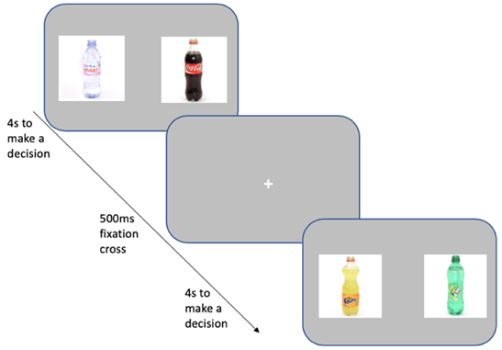
Note. Trial wording was “which would you rather consume?” and participants were instructed to press a key to select either of the images (‘Z’ for left, ‘M’ for right). Participants had 4 seconds to make a decision per trial, and each trial was followed by a 500ms fixation cross located in the centre of the screen. Images are taken from the Amsterdam Beverage Picture Set (Pronk et al., 2015).

Data preparation and analysis
On the VBDM task, “miss trials” (responses exceeding 4 seconds) were removed (0.43%) in addition to trials that were under 300ms (1.23%) as these are likely to be fast guesses (Ratcliff et al., 2006b) which resulted in the overall removal of 1.66% of trials. We then fitted the DDM (Ratcliff & McKoon, 2008) using the EZ method (Wagenmakers et al., 2007) which takes response accuracy, mean correct RT, and variance of correct RT as input to produce three key parameters which are: EA rate (also termed ‘drift rate’; v), response threshold (also termed ‘boundary separation’; a), and non-decision time (encoding of stimuli and motor execution; T_{er}). We estimated parameters for each participant, difficulty level, and drink type separately (for analyses on difficulty levels in isolation, see Appendix E).

For the APT, non-systematic data were firstly identified and removed using an established algorithm (Stein et al., 2015) as cases that violate any of the following criteria: trend, bounce, and reversals from zero. This was achieved using the R package “beezdemand” (see Kaplan et al., 2019 for more detail). Both observed (intensity, breakpoint, O_{max}, P_{max}) and derived (elasticity) values were subsequently estimated using the exponentiated demand equation (see Koffarnus et al., 2015). The exponentiated equation provided a good fit for participant-level data (mean R² = 0.87; median R² = 0.91), including when split into heavy (mean R² = 0.87; median R² = 0.91) and moderated (mean R² = 0.88; median R² = 0.92) drinkers. The aggregated data provided an excellent fit (R² = 0.97 for all participants).

Statistical analyses were conducted in RStudio version 4.0.2 (R Core Team, 2020). Independent samples t-tests (one-tailed) were used to analyse the data for the pre-registered hypotheses, supplemented by mixed-design ANOVAs to establish the robustness of any group differences in the VBDM task. Non-parametric tests were used for data that are not approximately normally distributed. All participants passed at least 6 out of 8 (75%) of the embedded attention checks which was our pre-registered minimum requirement for attentive responding. Six participants had non-systematic demand data on the APT and so were not retained within the analyses that included alcohol demand. Twelve participants misunderstood instructions in the ALQ and so were not retained within the analyses that included proportionate alcohol-free reinforcement (for detail, see Appendix E). Data and scripts are available and can be found on ResearchBox: https://researchbox.org/597.

6.3. Results
See Table 6.1 for descriptive statistics of questionnaire measures.

Table 6.1
Descriptive statistics split by drinker status (values are means and standard deviations)
Variable | Heavy drinkers (n = 60) | Moderated drinkers (n = 60) | p-value and effect size
Age (years) | 40.48 (13.35) | 32.63 (11.56) | p < .001, d = .63
AUDIT score | 18.77 (6.59) | 11.25 (4.69) | p < .001, d = 1.32
AUDIT-C score | 10.18 (1.56) | 6.20 (2.09) | p < .001, r_{rb} = .88
AUDIT-C score (retrospective) | - | 8.52 (1.81) | -
Self-control | 2.71 (.61) | 2.80 (.67) | p = .42, d = .15
Presence of meaning in life | 20.57 (7.05) | 20.15 (7.34) | p = .75, d = .06
Search for meaning in life | 22.57 (7.48) | 23.68 (6.27) | p = .38, d = .16
Drinking problem recognition | 12.62 (4.57) | 9.13 (3.37) | p < .001, d = .87
Drinking refusal self-efficacy (social pressure subscale) | 2.41 (1.37) | 3.28 (1.38) | p < .001, d = .64
Drinking refusal self-efficacy (emotional relief subscale) | 3.53 (1.77) | 4.64 (1.63) | p < .001, d = .65
Drinking refusal self-efficacy (opportunistic subscale) | 4.45 (1.39) | 5.86 (1.15) | p < .001, d = 1.11
Duration of current pattern of consumption (years) | 8.61 (8.88) | 5.10 (6.35) | p = .01, r_{rb} = .27
Duration of consumption pattern before cutting down (years) | - | 5.21 (6.18) | -
Note. Effect sizes are Cohen’s d (for data that are approximately normally distributed) or rank-biserial correlations (r_{rb}) (for data that are not approximately normally distributed). AUDIT scores reflect alcohol use and related problems, whilst AUDIT-C scores reflect hazardous or harmful alcohol consumption (retrospective AUDIT-C refers to the period before cutting down for moderated drinkers). Current pattern of consumption duration (years) reflects how long participants have been consuming alcohol at their current level (i.e., over 28 units for heavy drinkers and under 14 units for moderated drinkers, per week). Consumption pattern before cutting down duration (years) reflects how long moderated drinkers consumed over 28 units of alcohol (per week) prior to cutting down.

Pre-registered analyses

Hypothesis 1: Compared to heavy drinkers, moderated drinkers will have lower EA rates and higher response thresholds for alcohol.

When making alcohol decisions, moderated drinkers (M = 1.62, SD = .47) did not have significantly lower EA rates compared to heavy drinkers (M = 1.65, SD = .50; t(118) = .28, p = .39, d = .05). Furthermore, moderated drinkers (M = 1.57, SD = .28) did not have significantly higher response thresholds compared to heavy drinkers (M = 1.66, SD = .27; t(118) = 1.93, p = .97, d = .35).

Hypothesis 2: Compared to heavy drinkers, moderated drinkers will have greater EA rates and lower response thresholds for soft drinks.

When making soft drink decisions, moderated drinkers (M = 1.70, SD = .54) did not have significantly higher EA rates compared to heavy drinkers (M = 1.65, SD = .45; t(118) = -.61, p = .27, d = .11). However, moderated drinkers (M = 1.54, SD = .34) had significantly lower response thresholds compared to heavy drinkers (M = 1.66, SD = .31; t(118) = 2.04, p = .02, d = .37).

Figure 6.2
Mean evidence accumulation (EA) rates for alcohol and soft drink choices split by heavy drinkers (solid black line; circle) and moderated drinkers (dashed black line; triangle)
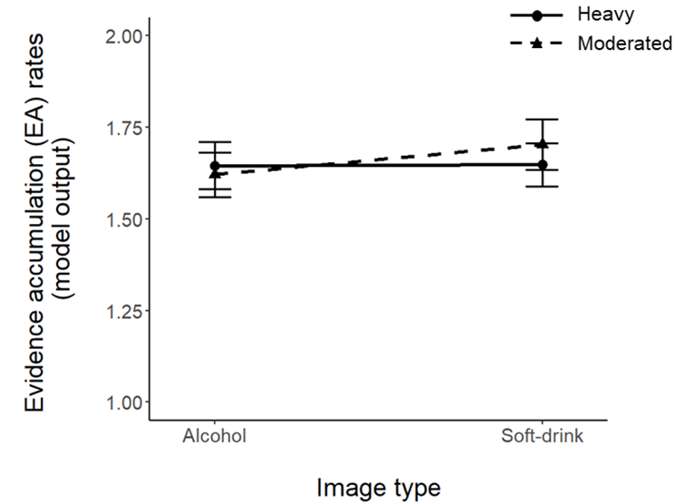
Note. Error bars represent the standard error of the mean.

Figure 6.3
Mean response thresholds for alcohol and soft drink choices split by heavy drinkers (solid black line; circle) and moderated drinkers (dashed black line; triangle)
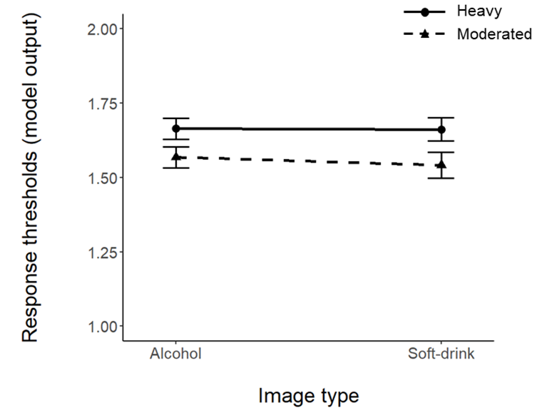
Note. Error bars represent the standard error of the mean.

To aid interpretation of the VBDM results presented above (Figures 6.2 and 6.3), we conducted exploratory mixed ANOVAs on EA rates and response thresholds using a within-subject factor of drink type (2: alcohol; soft drink), and a between-subject factor of drinker status (2: heavy; moderated). However, in line with our pre-registration, our study was powered specifically to detect differences in means between two independent groups rather than an interaction effect. When looking at EA rates, there were no significant main effects of drink type (F(1, 118) = .91, p = .34, η_{p}² = .01) or drinker status (F(1, 118) = .04, p = .84, η_{p}² = .00), and no interaction (F(1, 118) = .82, p = .37, η_{p}² = .01). When looking at response thresholds, there was a significant main effect of drinker status (F(1,118) = 4.68, p = .03, η_{p}² = .04). There was however no significant main effect of drink type (F(1, 118) = .42, p = .52, η_{p}² = .00) and no interaction (F(1,118) = .30, p = .58, η_{p}² = .00). Post-hoc tests for the significant main effect of drinker status revealed that, collapsed across alcohol and soft drink images, response thresholds were higher in heavy drinkers (M = 1.66, SD = .29) compared to moderated drinkers (M = 1.55, SD = .31; p = .03). This analysis demonstrates that there was a main effect of drinker status which was not robustly moderated by drink type.

Hypotheses 3 and 4: Compared to heavy drinkers, moderated drinkers will have lower behavioural economic alcohol demand and greater proportional alcohol-free reinforcement.

Compared to heavy drinkers, moderated drinkers had significantly lower O_{max} (t(112) = 1.93, p = .03, d = .36) and higher elasticity (W = 1278, p = .03, rank-biserial correlation (r_{rb}) = .21). Moderated drinkers also had lower intensity, however this difference was not statistically significant (t(112) = 1.55, p = .06, d = .29). Moderated drinkers did not have lower P_{max} (t(112) = .58, p = .72, d = .11) or breakpoint (t(112) = .18, p = .43, d = .03). See Table 6.2 for APT descriptive statistics (Figure 6.4). Moderated drinkers (M = .76, SD = .15) had significantly higher proportionate reinforcement from alcohol-free activities compared to heavy drinkers (M = .65, SD = .14; t(106) = -3.90, p < .001, d = .75).

Table 6.2
Descriptive statistics for the APT split by drinker status (values are means and standard deviations, however for elasticity values represent the median and interquartile range)
 | Heavy drinkers (n = 56) | Moderated drinkers (n = 58)
Intensity | 8.02 (3.95) | 6.81 (4.35)
Breakpoint | 9.42 (4.53) | 9.27 (4.71)
O_{max} | 22.50 (12.83) | 18.13 (11.28)
P_{max} | 6.47 (3.51) | 6.89 (4.09)
Elasticity | .006 (.004) | .008 (.012)
Note. Elasticity is reported to 3 decimal places to show the distinction in values.

Figure 6.4
Alcohol demand curves (Panel A) and expenditure (Panel B) split by heavy drinkers and moderated drinkers
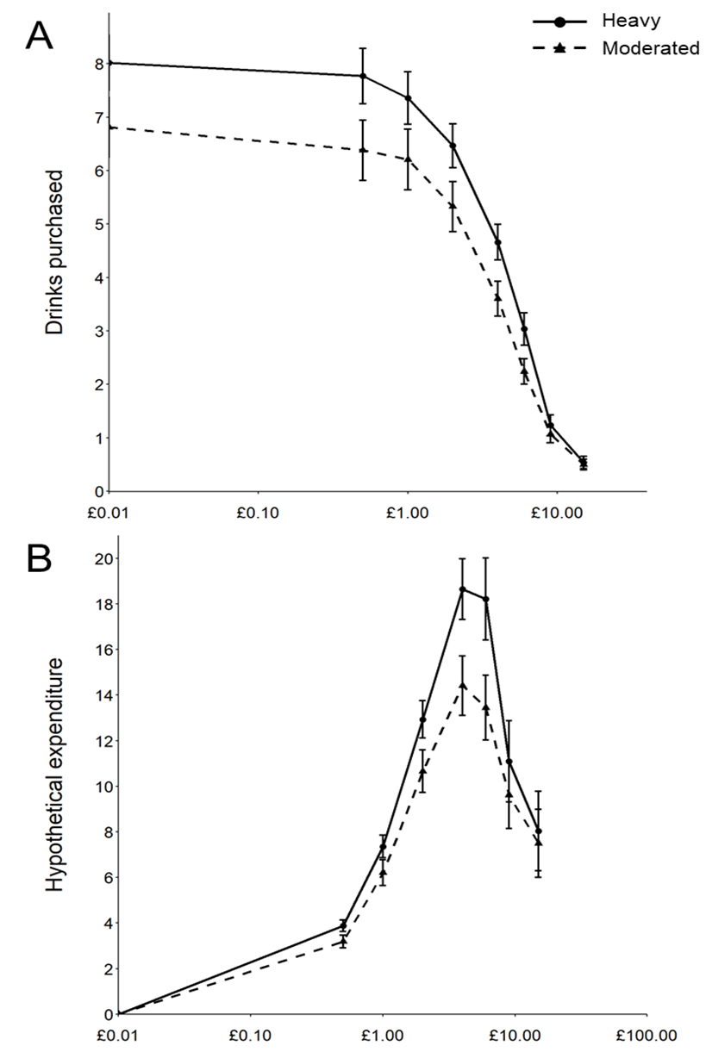
Note. Each data point represents average hypothetical consumption at a particular price on the APT (Panel A) or average expenditure (consumption multiplied by price; Panel B) for both current heavy drinkers and moderated drinkers. The x-axis is log-transformed (zero values are replaced by trivial nonzero values (0.01) to permit logarithmic units). Error bars represent the standard error of the mean (SE).

Establishing a ‘difficulty effect’ on the VBDM task
We were interested in establishing whether there is a ‘difficulty effect’, such that on trials in the VBDM task where the difference between the value ratings for the competing images is large (i.e., rating difference 3, e.g., ‘A lot’ versus ‘Not at all’), EA rates were increased compared to when the differences between the value ratings for the competing images is minimal (i.e., rating difference 1, e.g., ‘A little bit’ versus ‘Not really’). One-way repeated measures ANOVAs were used to compare EA rates across difficulty levels (i.e., easy, medium, and difficult trials) for alcohol and soft drinks. There was a significant main effect of difficulty on alcohol EA rates (F(2, 238) = 422.80, p < .001, ηp² = .78). Subsequent post-hoc tests (applying the Holm-Bonferroni correction to p-values for multiple comparison) revealed that alcohol EA rates in the easier trials (M = 2.22, SD = .61) were significantly increased compared to medium trials (M = 1.76, SD = .66; p < .001) and difficult trials (M = .92, SD = .39; p < .001). Furthermore, alcohol EA rates on medium trials were significantly increased compared to EA rates on difficult trials (p < .001). There was also a significant main effect of difficulty on soft drink EA rates (F(1.90, 225.58) = 349.09, p < .001, ηp² =.75). Post-hoc tests revealed that soft drink EA rates in the easier trials (M = 2.27, SD = .70) were increased compared to medium trials (M = 1.82, SD = .63; p < .001) and difficult trials (M = .95, SD = .40; p < .001). Furthermore, soft drink EA rates on medium trials were significantly increased compared to EA rates on difficult trials (p < .001).

Figure 6.5
Mean evidence accumulation rates (including all participants) for alcohol and soft drink choices split by trial difficulty level
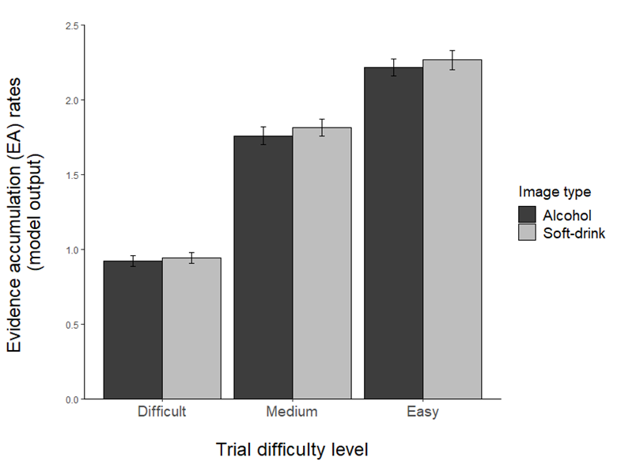
Note. Error bars represent the standard error of the mean (SE).

6.4. Discussion
The aim of this study was to explore whether alterations in value-based choice parameters and self-report behavioural economic measures characterise the moderation of alcohol consumption that many heavy drinkers experience without treatment. More specifically, this study expanded on existing behavioural economic research by applying a neuroscience-informed computational model of VBDM to decisions made about alcohol and soft drink cues in heavy and moderated drinkers (Field, Heather, et al., 2020).

In relation to the computational VBDM analysis, findings did not provide robust support for the first and second hypotheses and therefore contrast with predictions from recent theoretical advances (Field, Heather, et al., 2020). To elaborate, EA rates are hypothesized to represent value evidence accumulation, and we did not identify the changes in EA rates that we would expect to see based on overt preferences between alcohol and alcohol-free alternative reinforcers that have been observed in other studies (e.g., Hardy et al., 2018; Hardy & Hogarth, 2017; Hogarth & Hardy, 2018). However, it is difficult to directly reconcile the findings from this study with previous research because the tasks used differ methodologically, with only ours enabling disambiguation between alcohol and alcohol-free alternative value (Field, Heather, et al., 2020). Furthermore, because moderated drinkers still consume alcohol (albeit at a reduced level), it is likely that they still attach some value to alcohol which in turn may obscure clear divergence in EA rates among comparisons with heavy drinkers.

A novel finding from this study is that moderation of alcohol consumption is characterised by lower cautiousness when making value-based decisions, although this effect was not robustly moderated by drink type. Whilst the group difference in response thresholds may be more pronounced and is in the hypothesised direction for soft drinks (Copeland et al., 2021; Field, Heather, et al., 2020), it is important to acknowledge that the response threshold for alcohol was also lowered in moderated drinkers. This downward shift in response thresholds in moderated drinkers suggests that alcohol-related behaviour change is characterised by reduced cautiousness when making decisions because the DDM adjusts response thresholds based upon the speed-accuracy trade-off (SATO) a person maintains — lower response thresholds reflect faster and less accurate decisions (Stafford et al., 2020). One potential explanation for the general tendency for moderated drinkers to be less cautious in their overall decision-making could be related to participant demographics. To elaborate, moderated drinkers were of a younger age compared to the heavy drinkers (potentially indicative of successful “maturing-out”; Britton et al., 2015; O’Malley, 2004), and older adults generally use more conservative response criteria when making decisions reflected in increased response thresholds (Theisen et al., 2021). However, another speculation may be related to moderated drinkers’ current pattern of alcohol consumption, in that when they are consuming alcohol, they are consuming less than they used to. Indeed, self-reported data in the present study (Table 6.1) demonstrated that compared to heavy drinkers, moderated drinkers have lower AUDIT scores (i.e., alcohol use and related problems), lower AUDIT-C scores (i.e., hazardous and harmful consumption), lower drinking problem recognition (i.e., the extent to which own drinking is viewed as problematic) and increased drinking refusal self-efficacy (i.e., belief in own ability to resist alcohol). Therefore, hypothetically, it may be that when making a decision that involves alcohol, higher levels of drinking refusal self-efficacy enable moderated drinkers to adhere to self-imposed limits (e.g., only having 2 drinks during a drinking occasion) which in turn may reduce the likelihood of alcohol-related consequences, such as severe hangover. Accordingly, moderated drinkers may be able to afford to be less cautious when making alcohol alcohol-related decisions, potentially indexed by lower response thresholds.

Providing partial support for the third hypothesis, we found that moderated drinkers had lower behavioural economic demand for alcohol compared to heavy drinkers. These findings align with empirical evidence demonstrating positive associations between alcohol demand and consumption (Martínez-Loredo et al., 2021; Murphy & MacKillop, 2006), however, in the current study only O_{max} and elasticity significantly discriminated heavy and moderated drinkers. In other words, compared to current heavy drinkers, moderated drinkers showed greater sensitivity to constraints because they were less willing to allocate economic resources to obtain alcohol and were more sensitive to price increases. Interestingly, these indices of demand are derived from the ‘persistence’ latent component of demand (MacKillop et al., 2009), which reflects the (in)sensitivity of heavy drinking to environmental constraints. These findings support a recent claim (Acuff et al., 2021) that researchers should try to distinguish the contextual factors that enable a person to continue drinking heavily from those contextual factors that prompt a person to reduce their alcohol intake. These findings also align with research distinguishing alcohol moderation specifically from other drinking outcomes (i.e., abstinence and continued heavy drinking) as characterized by behavioural flexibility that facilitates favourable contextual and monetary allocation patterns (Tucker et al., 2016, 2021). Therefore, this may provide one potential explanation as to why some of the APT indices (i.e., O_{max} and elasticity) significantly differentiate between drinker type, but others do not. Another potential explanation may be that unlike contemporary accounts of VBDM which acknowledge that a diverse range of input processes (internal and external) contribute to value (Berkman et al., 2017), purchase tasks such as the APT are confined to price. Indeed, a recent commentary (Acuff & Murphy, 2021) speculated upon the potential to modify hypothetical purchase tasks in future research by including constraints beyond price, which will in turn facilitate future opportunities for idiographic measurement using these tools.

Our findings support hypothesis four, and in doing so, align with existing research demonstrating inverse associations between substance-free reinforcement and substance use (Acuff et al., 2019; Ginsburg & Lamb, 2018; Murphy et al., 2021; Vuchinich & Tucker, 1983). More specifically, our finding that alcohol moderation is characterized by shifts in patterns of behaviour away from alcohol-related activities and towards activities that do not involve alcohol corroborates findings from behavioural economic research using measures of monetary resource allocation (Tucker et al., 2016, 2021). Crucially, however, our findings expand upon the existing research because to the best of our knowledge, this is the first cross-sectional study to apply a behavioural economic framework to characterize alcohol moderation without treatment in people who were heavy—rather than dependent—drinkers. A further novel contribution of this study is that prior to reducing their consumption, moderated drinkers were on average drinking heavily for a shorter timeframe than reported in previous studies conducted in the USA (Tucker et al., 2016, 2021). For example, in Tucker et al. (2016) the mean duration was approximately 17 years whereas in the current study this estimate was approximately 5 years.

Although we did not recruit a clinical sample, our findings are consistent with efficacious treatment and brief interventions which broadly aim to increase substance-free reinforcement (Daughters et al., 2018; Fazzino et al., 2019; Murphy, Dennhardt, et al., 2012; Petry et al., 2017) as well findings that alongside recovery, anhedonia diminishes (Garfield et al., 2014), potentially reflecting shifts to more alcohol-free reinforcement via interests and hobbies. Our findings cannot speak to causal mechanisms that underpin alcohol moderation. However, increasing the availability of, and capacity to derive reinforcement from, alcohol-free alternatives have been highlighted as important targets to promote behaviour change (McKay, 2017). Consistent with molar behavioural economic accounts (Bickel et al., 2014; Murphy, MacKillop, et al., 2012; Rachlin, 1997; Tucker et al., 2021; Vuchinich & Heather, 2003) then, alcohol moderation in heavy drinkers is characterized by higher value ascribed to sources of alcohol-free reinforcement relative to value ascribed to alcohol.

There are several important limitations to consider. Firstly, although all participants self-reported consumption of at least 28 alcohol units per week either currently or in the past, we could not establish if people who had successfully moderated their alcohol consumption had historically been drinking at the same high level as the group who were currently drinking heavily. Indeed, comparison of retrospective AUDIT-C scores in the moderated drinker group with current AUDIT-C scores in the heavy drinker group (see Table 6.1) suggest that the groups were not perfectly matched in this regard. There may also have been other unmeasured variables that discriminated the groups prior to moderation (e.g., socioeconomic status) that were not captured in this study. Secondly, this study took place in the UK with a predominantly white sample and during a global pandemic (COVID-19) which may have inadvertently affected our variables of interest, therefore limiting the generalizability of these findings to other contexts and populations. For example, due to lockdown restrictions, many people are expected to have experienced unprecedented barriers to engagement with alcohol-free alternative reinforcers (Acuff et al., 2020). Thirdly, we took and then modified an existing measure of alcohol-free reinforcement to address some of the existing limitations (e.g., updating item content; Acuff et al., 2019), however there is likely a reasonable degree of measurement error in the quantification of alcohol-free reinforcement because many of the updated items comprise social activities. Furthermore, although we did not observe group differences in some demand indices (e.g., breakpoint), this may be due to the fact that the limited range of price points (8 values including 0) on the APT reduced measurement precision (Kaplan et al., 2018; Zvorsky et al., 2019) and requires further validation. Fourthly, the cross-sectional nature of the study means that it is not possible to establish any causal or temporal relationships between the variables measured in this study and alcohol consumption. Finally, patterns of alcohol consumption were assessed online which mean that responses could have been biased. However, our online recruitment took place via Prolific which has extremely high levels of data quality, including attention and honesty from participants (Peer et al., 2021).

To address these limitations, future research could employ longitudinal designs (e.g., following a person over repeated time points) to explore how behavioural economic and VBDM parameters alter during behaviour change. This might encompass studies of drinkers recruited from both community (Hardy et al., 2021) and treatment (Meshesha et al., 2020) settings with careful matching of potential confounding variables such as socioeconomic status and severity comorbidity. It is also important to explore how cultural and societal changes might facilitate or impede transitions from heavy to moderate drinking and attempt to identify how behavioural economic constructs and VBDM parameters may mediate these transitions. For example, there has been a substantial increase in the availability of alcohol-free and low alcohol alternatives to standard alcoholic beverages in the UK, and a considerable number of people report consuming these products to cut down their consumption of alcohol (Alcohol Change UK, 2020; Drinkaware, 2022). These products may act as substitute reinforcers (Rachlin et al., 2018), which given their novelty, might require low levels of decision caution before committing to the choice of consumption, possibly indexed by alterations in alcohol-free response thresholds. As some drinks presented in the soft drink block may have been indirectly associated with alcohol among participants who frequently consume mixed drinks (e.g., an image of a bottle of Coca-Cola may be associated with alcohol among people who regularly drink rum and coke), future studies might mitigate this concern by excluding such potentially ambiguous drinks from the soft drink block.

To conclude, this study contributes a novel understanding of what characterizes alcohol moderation in heavy drinkers who do not receive treatment. Although cross-sectional, findings from self-report measures are compatible with molar behavioural economic accounts (e.g., Rachlin et al., 2018) which emphasize the importance of lowered demand for alcohol and heightened behavioural allocation towards activities that do not involve drinking as important correlates of the transition from heavy to moderated drinking. This is an important extension to the literature because 20% of heavy drinkers in England are attempting to reduce their consumption (Beard et al., 2017) and these findings may inform intervention targets for this population. Evidence from a computational VBDM analysis is less clear, however it may be that alterations in response thresholds represent how, in the moment, people decide to engage with alcohol-free alternatives. Alongside the development of novel measurement tool that be used to monitor cognitive processes, we conducted the first empirical test of recent theoretical predictions (Copeland et al., 2021; Field, Heather, et al., 2020), although the findings were inconclusive. In line with enthusiasm (Acuff et al., 2022; Amlung et al., 2015; Bickel & Athamneh, 2020), we believe this study opens exciting interdisciplinary avenues for future research.

Chapter 7: Modelling value-based decision-making (VBDM) in current smokers and ex-smokers

Previously (Chapter 6), I found no robust differences in decision parameters for alcoholic and soft drink cues across heavy drinkers and moderated (former heavy) drinkers, although moderated drinkers’ response thresholds were consistently lower regardless of drink type. Interestingly, in this study I found that self-report measures of alcohol reinforcing value and behavioural allocation to activities that do not involve alcohol differentiated drinker type in that alcohol moderation was characterised by lower alcohol value and greater reinforcement derived from alcohol-free activities. Following this, in Chapter 7 I conducted a mirror study by exploring whether recovery from nicotine addiction is characterised by alterations in VBDM parameters. I also employed a different type of decision-making task that measured the magnitude of decision conflict for tobacco and tobacco-unrelated cues. Parameters in daily smokers and in people who used to smoke daily but have since quit smoking were compared.

Contributions: I designed the study, which was approved by Matt Field and Tom Stafford (primary supervisors). I collected and analysed the data. I wrote the chapter. Matt Field and Tom Stafford provided feedback on the draft.

As mentioned previously (p.5-p.6), a variant of this thesis Chapter is published online as a preprint:
Copeland, A., Stafford, T., & Field, M. (2022). Recovery from nicotine addiction: A diffusion model decomposition of value-based decision-making in current smokers and ex-smokers. https://doi.org/10.31234/osf.io/3jrze
Findings from this Chapter have also been presented as a poster at the Society for the Study of Addiction’s Annual Conference (https://www.addiction-ssa.org/author-publications/modelling-value-based-decision-making-vbdm-in-current-smokers-and-ex-smokers/)

Abstract
Background: A considerable number of people successfully give up tobacco smoking.
Tobacco choice in dependent individuals is determined by greater expected drug value, but less is known about the underlying mechanisms through which people quit smoking. The aim of this study is to explore whether computational parameters of value-based decision-making (VBDM) characterise recovery from nicotine addiction. Method: Between-subject, pre-registered design. Fifty-one current smokers and 51 ex-smokers were recruited. Participants completed a two-alternative forced choice task in which they chose between either two tobacco-related images (in one block) or tobacco-unrelated (animal) images (in a different block). On each block, participants pressed a key to select the image that they previously rated most positively during a previous task block. A drift-diffusion model (DDM) was fitted to the reaction time and error data to estimate evidence accumulation (EA) processes and response thresholds during the different blocks. In a separate mouse-tracking task in which a tobacco-related and a tobacco-unrelated image were presented, participants identified the image they had previously rated most positively, and mouse trajectories were modelled to infer the strength and temporal unfolding of conflict during decision-making. Results: Ex-smokers had significantly higher response thresholds compared to current smokers when they were making tobacco-related choices (p = .01, d = .45), although there were no group differences in responses thresholds when they were making tobacco-unrelated choices. Furthermore, there were no significant differences in EA rates for tobacco or tobacco-unrelated stimuli. There were also no significant differences in the strength of conflict between smokers and ex-smokers when choosing between tobacco-related and tobacco-unrelated images, however, the temporal unfolding of conflict followed a dynamic VBDM—as opposed to dual-system—approach (maximum deviation values < .09). Conclusions: Recovery from nicotine addiction is characterised by greater cautiousness when making value-based decisions about tobacco-related images. However, contrary to hypotheses, EA rates and magnitude of decision conflict did not discriminate current and ex-smokers.

7.1. Introduction
Although tobacco smoking is a leading causal factor in preventable disease and death (Forouzanfar et al., 2016), there has been a considerable decline in tobacco smoking during the past decade. For example, in England 13.9% of adults are current tobacco smokers—a substantial reduction from the 19.8% of adults in 2011 (Office for National Statistics, 2020). This equates to approximately 2 million less smokers. Dominating theoretical accounts that conceptualise addiction as chronic and relapsing (Volkow et al., 2016) struggle to provide a coherent explanatory account of how and why these high rates of recovery occur. The aim of this study is to apply a computational model of value-based decision-making (VBDM) in an attempt to characterise recovery from nicotine addiction (Field, Heather, et al., 2020).

“Demand” is a behavioural economic construct that refers to the reinforcing value of a commodity (MacKillop, 2016) and is typically measured with hypothetical purchase tasks (Jacobs & Bickel, 1999; MacKillop et al., 2008) and concurrent choice tasks (Chase et al., 2013). For example, the cigarette purchase task (MacKillop et al., 2008) assesses a person’s hypothetical consumption of cigarettes across a range of escalating prices. This generates separate indices of demand that capture the reinforcing value of tobacco, most prominently: intensity (consumption when price is at zero), O_{max} (maximum expenditure), and breakpoint (first price that suppresses consumption to zero). In concurrent choice tasks (Chase et al., 2013) participants repeatedly choose between tobacco (e.g., cigarette) rewards and tobacco-unrelated alternative (e.g., chocolate) rewards, with the percentage choice of cigarette versus the alternative reward used as an index of the relative value that is ascribed to tobacco. Scores on these two measures are correlated (Chase et al., 2013) demonstrating that they tap into a common construct of value.

Behavioural economic accounts emphasise the importance of ‘reinforcer pathologies’ in the development and maintenance of addiction (Bickel et al., 2014). More specifically, they posit that the progression of addiction over time is accompanied by increases in the value of substances and decreases in the value of substance-free alternative reinforcers. Indeed, a robust body of literature demonstrates that cigarette consumption and severity of dependence to nicotine is associated with increased value of tobacco (González-Roz et al., 2019; MacKillop et al., 2008) compared to tobacco-unrelated alternatives (Chase et al., 2013; Hardy et al., 2018; Hogarth & Chase, 2011; Lawn et al., 2018; Miele et al., 2018). Furthermore, experimental manipulations of substance value (e.g., via nicotine deprivation or satiation) directly alter tobacco choice (Hogarth, 2012; Hogarth & Chase, 2011; Lawn et al., 2015). These findings align with the notion that substance use is goal-directed (Hogarth, 2020; Hogarth & Field, 2020): preferential tobacco choice in dependent individuals is controlled by greater substance value.

Anhedonia is a common consequence of addiction, including nicotine dependence (Leventhal, Trujillo, et al., 2014), and may contribute to augmented tobacco value through diminished enjoyment and pleasure derived from tobacco-unrelated alternative rewards (Sussman & Leventhal, 2014). Indeed, dependent smokers have blunted value signals in the posterior cingulate cortex when making choices about non-tobacco alternative rewards (shopping vouchers) compared to non-dependent smokers (Lawn et al., 2019). Furthermore, another study found that in dependent smokers, higher levels of anhedonia were predictive of increased value of tobacco (Leventhal, Trujillo, et al., 2014). In accordance with behavioural economic accounts, then, this imbalance in valuation of tobacco and tobacco-unrelated alternative reinforcers may be an important mechanism through which addiction is maintained.

From a behavioural economic viewpoint, for recovery to occur a person must overcome the ‘reinforcer pathologies’ and distortions in valuation processes that leave them vulnerable to addiction (Bickel et al., 2014; Bickel & Athamneh, 2020; Field, Heather, et al., 2020; Murphy, MacKillop, et al., 2012). Aligning with this, a novel finding from Hardy et al. (2018) was that compared to people who self-report current tobacco smoking, those who self-report tobacco abstinence attached lower value to tobacco as indexed by a reduction in the percentage choice of tobacco compared to tobacco-unrelated rewards. Furthermore, increased engagement with tobacco-unrelated alternative reinforcers have been found to be important predictors of both short-term (Goelz et al., 2014) and long-term (Schnoll et al., 2016) abstinence from smoking. Many effective treatment interventions for addiction are based upon behavioural economic principles (Correia et al., 2010; Fazzino et al., 2019); during contingency management (CM), for example, people receive alcohol-free incentives (e.g., cash) for desired behaviour(s) such as verified abstinence which may in turn amplify the value of tobacco-unrelated incentives (Petry et al., 2017). CM is an effective treatment for smoking cessation (Benishek et al., 2014) with effects continued in the long-term (Notley et al., 2019).

Behavioural economic approaches have contributed substantially to knowledge on addiction and recovery from it, however they are molar in nature meaning that they explore patterns of behaviour over time (Tucker & Vuchinich, 2015). Consequently, what is lacking is a molecular perspective (Copeland et al., 2021; Field, Heather, et al., 2020). In other words, less is known about the internal processes that occur in the lead up to a decision being made, and how these processes may change during addiction and recovery from it.

Value-based decision-making (VBDM) provides a theoretical framework that can be used to model the internal processes that precede decisions made about substances and substance-free alternatives (Berkman, 2018; Berkman et al., 2017; Levy & Glimcher, 2012; Rangel et al., 2008). Within this framework, diverse determinants of substance value (such as the anticipated gains and costs associated with a response option) are integrated into a common metric of subjective value that is essential to allow comparison between response options. This occurs through a value-to-action evidence accumulation (EA) process (Berkman et al., 2017) that can be parameterised via application of the drift-diffusion model (DDM; Ratcliff & McKoon, 2008). The DDM provides a principled reconciliation of behavioural data from experimental tasks (e.g., Polanía et al., 2014) to recover the following parameters of VBDM: EA rate (the rate at which evidence accumulates; also termed ‘drift rate’) and response thresholds (how conservative a person is when responding indexed by their speed-accuracy trade-off). The assumption of the DDM is that evidence accumulates in favour of a decision until a response threshold is crossed, at which point the choice is made (Forstmann et al., 2016). Recent conceptual work (Field, Heather, et al., 2020) extended VBDM to recovery from addiction, proposing that three potential changes that may underlie recovery: 1) increased response thresholds when making decisions about substances, 2) suppressed EA rates for substances, and 3) amplified EA rates for substance-free alternatives.

Interestingly, another internal process of decision-making that may be important when people recover from nicotine addiction is the strength and temporal unfolding of conflict when a person is faced with the decision between substance use and an alternative reward or behaviour (Copeland et al., 2021). MouseTracker is a software commonly used to measure decision conflict (Freeman & Ambady, 2010) by recording computer mouse movements on a millisecond-by-millisecond basis revealing unique insight into the on-going dynamics of the choice process in the lead up to decision being made (Freeman et al., 2011; Stillman et al., 2018). Two key metrics produced from this software are area under the curve (AUC) and maximum deviation (MD). AUC reflects the area between a person’s mouse trajectory and a straight trajectory towards the response option: the more conflict that is inherent in the choice, the less direct the mouse trajectory will be, which results in a greater AUC (Freeman & Ambady, 2010). Maximum deviation similarly measures conflict; however, it is calculated by how far the furthest point on the person’s mouse trajectory is from a straight trajectory (Freeman & Ambady, 2010). An advantage of mouse-tracking is that it generates metrics (e.g., AUC) that are dissociable from RT (Stillman et al., 2017), therefore providing a more in-depth insight into the decision process by isolating additional components that contribute to RT (Freeman, 2018; Stillman et al., 2018).

Mouse trajectories are able to provide further insights by exploring whether the resolution of conflict when people are making decisions about substance-related cues aligns with a dual-process or a dynamical VBDM approach. Dual-process approaches (Kahneman, 2011; Strack & Deutsch, 2004) assume that successful self-control is characterised by the ability to inhibit impulses for alternative options that are tempting. Put another way, controlled processes override automatic processes (Veling et al., 2008). This would be reflected in abrupt mouse movements that initially move towards a temptation (automatic process), but then experience a mid-flight correction in favour of the other option (controlled process). Conversely, dynamical approaches such as the VBDM framework (Berkman et al., 2017) theorise that information from different response options compete against each-other dynamically over time until a final response emerges. This would be reflected in smooth mouse trajectories.

Previous mouse-tracking studies have demonstrated that people with greater self-report self-control experience a lesser magnitude of conflict when choosing long-term goals over short term temptations (Gillebaart et al., 2016; Stillman et al., 2017). Indeed, increased self-control is an important predictor of recovery from addiction (Stein & Witkiewitz, 2019). Therefore, when faced with the decision between a long-term goal (e.g., health benefits) and a short-term temptation (e.g., smoking a cigarette), a person in recovery may experience decreases in the magnitude of conflict experienced. However, although research has demonstrated the advantages of mouse-tracking techniques in relation to revealing underlying cognitive processes during decision-making and the potential to advance theory (Stillman et al., 2018), this has not yet been investigated in relation to recovery from addiction (Copeland et al., 2021).

This study applied a computational model of VBDM in attempt to characterise recovery from nicotine addiction. To achieve this, we used the DDM to provide a principled reconciliation of the RT and accuracy of VBDM in two groups: current smokers and ex-smokers. Using a mouse-tracking task, we also explored the strength and the temporal unfolding of conflict during VBDM and empirically distinguished between two competing accounts (dynamical VBDM and dual-process theory). Design, hypotheses, and analysis strategy were pre-registered before data collection commenced (http://aspredicted.org/blind.php?x=cc4ir6). Our hypotheses were that compared to current smokers, ex-smokers will have: 1) lower EA rates and higher response thresholds for tobacco, 2) greater EA rates and lower response thresholds for tobacco-unrelated (animals), 3) greater conflict when tobacco images are the ‘correct’ answer, and 4) lower conflict when tobacco-unrelated (animals) are the ‘correct’ answer.

7.2. Method
Design
Pre-registered, between-subject design. Our behavioural dependent variables were EA rates and response thresholds (estimated by fitting the DDM to reaction time and accuracy data during the VBDM task), and AUC (estimated by calculating the geometric area between a person’s actual trajectory and a straight trajectory during the MouseTracker task). Independent variables were group membership (current smoker or ex- smoker), and image type (tobacco images and tobacco-unrelated (animal) images). An a priori power analysis conducted on G*power (Faul et al., 2007) revealed that to detect a difference between two independent groups with a medium effect (d = 0.5; Cohen, 1988), at 80% power with an alpha of 0.05, a sample size of at least 51 per group was required. We recruited 102 volunteers in total, comprising 51 current smokers and 51 ex-smokers.

Participants
We recruited 102 participants, who were aged between 18 and 71 years old (mean age = 37.04, SD = 13.92) to attend a session at the University of Sheffield’s Department of Psychology through social media platforms (e.g., Facebook and Twitter) and advertisements in the local community. Sixty-one participants were female and 41 were male. Inclusion criteria were age ≥18 years old and self-identifying as either a current smoker (defined as daily tobacco smoking) or an ex-smoker (defined as a history of daily tobacco smoking but having quit smoking for at least 6 months). The study was approved by the University of Sheffield research ethics committee, and all participants gave informed consent. Recruitment took place between February 2019 and August 2019. Participants were reimbursed with a £10 high-street voucher for their time.

Materials
Pictorial stimuli for the VBDM and MouseTracker tasks
The 20 tobacco-related images were selected from the Geneva smoking pictures data set (Khazaal et al., 2012), whilst the 20 tobacco-unrelated (animal) images were selected from the international affective picture system (IAPS) data set (Lang et al., 2008). To ensure that there was a wide spread of perceived valence, we used the standardised set of valence ratings accompanies both picture sets to identify some images that were likely to be evaluated as highly positive, others that were likely to be evaluated as highly negative, and others that are in-between (for more detail, see Appendix F). Stimuli were displayed on a Dell computer screen, with a spatial resolution of 1920 x 1080 pixels and a temporal resolution of 60Hz.

Questionnaire measures
Brief self-control scale (BSCS; Tangney et al., 2004): This 13-item scale was used to capture the extent to which people feel that they can resist external influences and control their behaviour, for example “I am good at resisting temptation”. Participants responded on a 1 (not at all like me) to 5 (very much like me) scale. In the current sample, the BSCS had acceptable internal reliability, McDonald’s ω = .80 (McDonald, 1970, 1999).

Fagerström Test for Cigarette Dependence (Fagerström, 2012): This scale consisted of six items, such as “Do you smoke even if you are sick in bed most of the day?”. Total scores ranged from 0 to 10, with the category labels of low dependence (1-2), low to moderate dependence (3-4), moderate dependence (5-7), and high dependence (8+). Due to a researcher error, the first question (“How soon after waking do you smoke your first cigarette?”) only included the first 3 response options, rather than 4. In other words, the response option “after 60 minutes” was not presented to the participants. The implication is that the current dependence scores could have potentially been 1 score lower than they are presented in the current study. However, the scores were already low, scoring in the low to moderate dependence category, and so even with the subtraction of 1, this does not substantially affect the conclusions drawn from this measure. The scale had acceptable internal reliability, ω = .72.

Contemplation Ladder (Biener & Abrams, 1991): Participants completed the contemplation ladder as an index of motivation (readiness) to quit smoking. The ladder was presented on a scale that ranged from 0 “no thought about quitting” to 10 “taking action to quit”.

One question from the cigarette purchase task (CPT; MacKillop et al., 2008): Currently, there is no validated brief version of the CPT. Nevertheless, the single item “breakpoint” has been advocated to be a valid brief method of measuring tobacco demand (Athamneh et al., 2019). We assessed tobacco demand by asking “What is the maximum price that you would pay for a single cigarette” (scores ranged from £0-£15; for exact price increments see Appendix F).

Demographic and smoking questions: Finally, we obtained demographic information such as participants’ age and gender. We asked additional questions regarding cigarette use such as smoking status, quit attempts (if any), typical cigarette consumption per day, years smoked, age of initiation of smoking, and time since quitting smoking (for ex-smokers).

Procedure
Participants attended a single session at the University of Sheffield’s Psychology Department, which lasted between 60–80 minutes. They first provided informed consent and then completed the questionnaire measures listed above. Subsequently, participants completed an image-rating phase, the VBDM task (programmed in PsychoPy; Peirce et al., 2019) and the MouseTracker task (programmed in MouseTracker; Freeman & Ambady, 2010).

Image-rating phase
We asked participants to view two sets of 20 images (a tobacco-unrelated (animal) set and then a tobacco-related set) and make value judgements about them by placing them into categories labelled ‘Most positive’, ‘Somewhat positive’, ‘Somewhat negative’, and ‘Most negative’. For both image sets, participants assigned five images to each category by dragging and dropping them using a computer mouse. Prior to completing the VBDM task, each image from each value category was displayed in the centre of the screen for 3 seconds each, followed by a 500ms fixation cross. The purpose of this was to remind participants how they evaluated each of the images.

Value-based decision-making (VBDM) task
On each trial, two images appeared in the centre of the screen (one on the left and one on the right), and participants were instructed to use one of two keys to choose the image that they had rated higher by pressing one of two keys (‘Z’ for left and ‘M’ for right) as quickly as possible (see Figure 7.1). Before starting the VBDM task, to familiarise participants, they completed a practice block consisting of 12 trials (50% tobacco-unrelated (animal) trials and 50% tobacco-related trials). Next, they completed the task which consisted of two blocks (a tobacco-unrelated (animal) block and a tobacco-related block; order randomized) of 150 trials each (300 trials in total) with embedded breaks after every 50 trials. Difficulty levels varied; when the differences in the value ratings between the two images were minimal, these were difficult trials (“Somewhat Positive” versus “Somewhat Negative”) because it is harder to immediately distinguish which one is higher in value. However, when the differences in the value ratings between the two images were large (“Most Positive” versus “Most Negative”), these were easier trials because it is likely to be more apparent which one is higher in value. On each trial there was an image that had been rated higher, and whether this appeared on the left or the right of the screen was random so that the ‘correct’ answer should have been a left and right key press with equal frequency. Participants were given a maximum of four seconds to respond on each trial, responses outside of this response window were classed as “miss trials” as commonly used in VBDM tasks (Polanía et al., 2014).

Figure 7.1
Schematic depiction of typical tobacco block (left) and typical animal block (right) trials
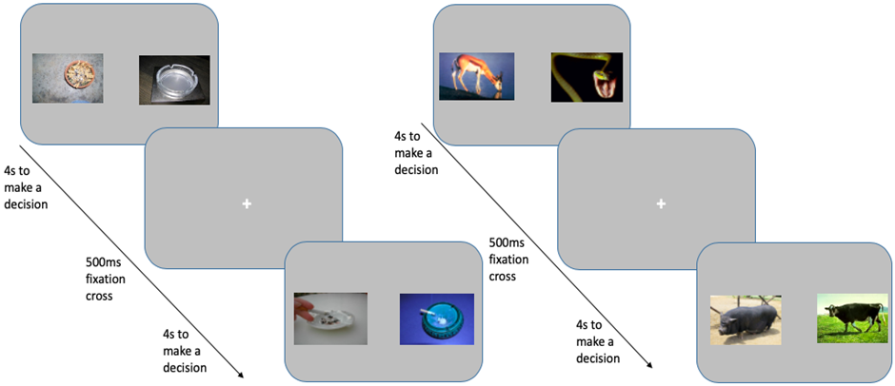
Note. The question asked was “Which did you rate higher? Press ‘Z’ for the left image or ‘M’ for the right image”. Participants had 4 seconds to make a decision per trial, and each trial was followed by a 500ms fixation cross located in the centre of the screen. Images are taken from the Geneva smoking pictures data set (Khazaal et al., 2012) and the international affective picture system (IAPS) data set (Lang et al., 2008).

MouseTracker task
Two images (one tobacco-related and one tobacco-unrelated (animal)) were displayed in the top left-hand and the top right-hand corner of the computer screen and participants were instructed to drag a mouse cursor to click on the image they rated higher. Each trial began with a “START” button at the bottom centre of the screen; once participants clicked on this the two images appeared, along with a caption that said “Choose” (see Figure 7.2). The decision in this task was between smoking and animal stimuli. Participants firstly completed a practice block, consisting of 12 trials (50% tobacco-unrelated (animal) trials and 50% tobacco-related). Next, they completed the task which consisted of 300 trials (with embedded breaks after every 50 trials). In 150 of the trials the smoking image was the ‘correct’ answer, whilst in the other 150 trials the animal image was the ‘correct’ answer; whether this was on the left or the right side was random so that the ‘correct’ answer should have been a left and right mouse click with equal frequency. In line with previous research (Stillman et al., 2017), participants were asked to select the image as quickly as possible, and if they took longer than 1000ms to initiate mouse movement, a message asking them to respond quicker appeared (e.g., “Please start moving earlier on even if you are not fully certain of a response yet!”). Encouraging participants to initiate mouse movements early within the trial is important to capture varying components of cognition, including initial response tendency and momentary changes of mind within mouse trajectories (Kieslich et al., 2020). For example, if a person were to make a decision before mouse movement is initiated, their mouse trajectory would appear straight indicating minimal conflict. However, this would not necessarily mean that the person did not experience conflict, but rather, because they made their choice before moving their mouse, the conflict is not reflected in the mouse trajectory (Kieslich et al., 2020).

Figure 7.2
Schematic depiction of a typical MouseTracker trial
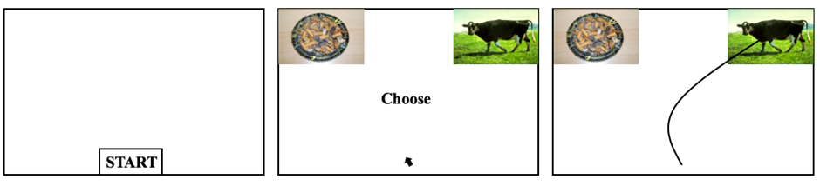
Note. On each trial, participants clicked on the “START” button, and then were asked to choose between two images by dragging the mouse to click on the image that they rated as more positive. Participants were asked to respond as quickly as possible. A warning message appeared saying “Please start moving earlier on even if you are not fully certain of a response yet!” if participants took over 1000ms to initiate mouse movement. Schematics are adapted with permission from those in (Stillman et al., 2017).

Data preparation and analysis
On the VBDM task, in addition to “miss trials” (responses exceeding 4 seconds) were removed (0.47%) in addition to trials that were under 300ms (0.14%) as these are likely to be fast guesses (Ratcliff et al., 2006b), which resulted in the overall removal of 0.61% of trials. We then fitted the DDM (Ratcliff & McKoon, 2008) using the EZ method (Wagenmakers et al., 2007) to estimate the DDM parameters. The EZ-DDM takes the mean correct response time, variance of correct response, and response accuracy as input and produces three key parameters which are: drift rate (v), boundary separation (a), and non-decision time (T_{er}). We estimated the parameters (EA rates and response thresholds) for each participant, for each difficulty level, and for each image type separately (see Appendix F for analyses on difficulty levels in isolation).

Standard recommended practices were followed in relation to preparation of MouseTracker data (see Freeman & Ambady, 2010). Mouse trajectories were time-normalized into 101-time bins and responses were rescaled such that the trajectory terminated at the top-right response location. Trials whereby participants made the incorrect choice (i.e., they did not choose the image that was rated higher) were removed. Following established procedures (Stillman et al., 2017), outliers that were ±3 standard deviations from individual participant means on reaction time, AUC, and time until initial mouse movement were then removed, which resulted in the removal of 11.33% of trials. The mean time until initial mouse movement was 228.4ms (SD = 188.42) which demonstrates that participants were moving their mouse from the onset of the choices rather than waiting until relatively late in their processing stream to begin moving the mouse. Difficulty levels were averaged to generate overall AUC scores for tobacco and tobacco-unrelated (animal) choices (see Appendix F for analyses on difficulty levels in isolation).

Independent samples t-tests (one-tailed) were used to analyse the data for the pre-registered hypotheses, supplemented by mixed-design ANOVAs to establish the robustness of any group differences. Non-parametric tests were used for data that were not approximately normally distributed. Statistical analyses were conducted in RStudio version 4.0.2 (R Core Team, 2020).

7.3. Results
See Table 7.1 for descriptive statistics of questionnaire measures.

Table 7.1
Descriptive statistics split by smoking status (values represent the mean and standard deviation)
 | Smokers | Ex-smokers | p-value and effect size
Age (years) | 31.37 (11.81) | 42.71 (13.65) | p < .001, d = .89
BSCS | 36.16 (6.65) | 39.57 (8.82) | p = .03, d = .44
Quit attempts | 1.98 (1.57) | 3.23 (2.64) | p = .01, r_{rb} = .28
Cigarettes per day | 12.01 (8.67) | 16.99 (9.83) | p < .01, r_{rb} = .33
Duration of time smoked (years) | 14.92 (12.42) | 16.79 (11.43) | p = .43, d = .16
Age of smoking initiation | 16.31 (3.29) | 16.44 (3.14) | p = .84, d = .04
Duration since quitting | - | 8.37 (8.93)
Fagerström dependence | 3.55 (2.18) | -
Motivation to quit | 5.18 (2.84) | -
Breakpoint (demand) | 2.12 (2.13) | -
Note. Effect sizes are Cohen’s d (for data that are approximately normally distributed) or rank-biserial correlations (r_{rb}; for data that are not approximately normally distributed). BSCS = brief self-control scale (possible range of values: 13 to 65). FTCD = Fagerström test for cigarette dependence (possible range of values: 0 to 10). Contemplation ladder provides an index of motivation to quit smoking (possible range of values: 0 to 10). Breakpoint = first price that suppresses consumption to zero (possible range of values: £0 to £15).

Hypothesis 1: Compared to current smokers, ex-smokers will have lower EA rates and higher response thresholds for tobacco images.

When making tobacco decisions, ex-smokers (M = 1.56, SD = .42) did not have significantly lower EA rates compared to current smokers (M = 1.54, SD = .42); t(100) = -.24, p = .60, d = .05. However, ex-smokers did have significantly higher response thresholds (M = 2.06, SD = .34) compared to current smokers (M = 1.91, SD = .30); t(100) = -2.29, p = .01, d = .45.

Hypothesis 2: Compared to current smokers, ex-smokers will have greater EA rates and lower response thresholds for tobacco-unrelated (animal) images.

When making tobacco-unrelated (animal) decisions, ex-smokers (M = 1.88, SD = .38) did not have significantly higher EA rates compared to current smokers (M = 1.84, SD = .38); t(100) = -.49, p = .31, d = .10. Furthermore, ex-smokers (M = 2.00, SD = .31) did not have significantly lower response thresholds compared to current smokers (M = 1.96, SD = .29); t(100) = -.72, p = .76, d = .14.

Figure 7.3
Mean overall EA rates for tobacco-unrelated (animal) and tobacco choices split by smokers (solid black line; circle) and ex-smokers (dashed black line; triangle)
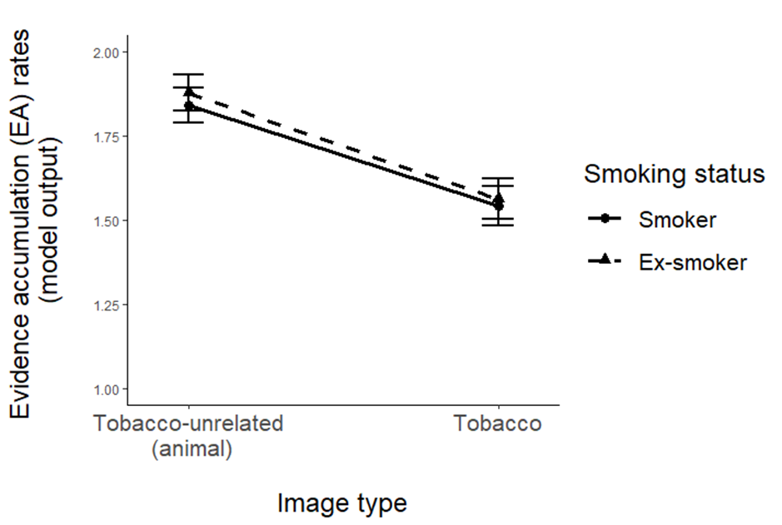
Note. Error bars represent the standard error of the mean.

Figure 7.4
Mean overall response thresholds for tobacco-unrelated (animal) and tobacco choices split by smokers (solid black line; circle) and ex-smokers (dashed black line; triangle)
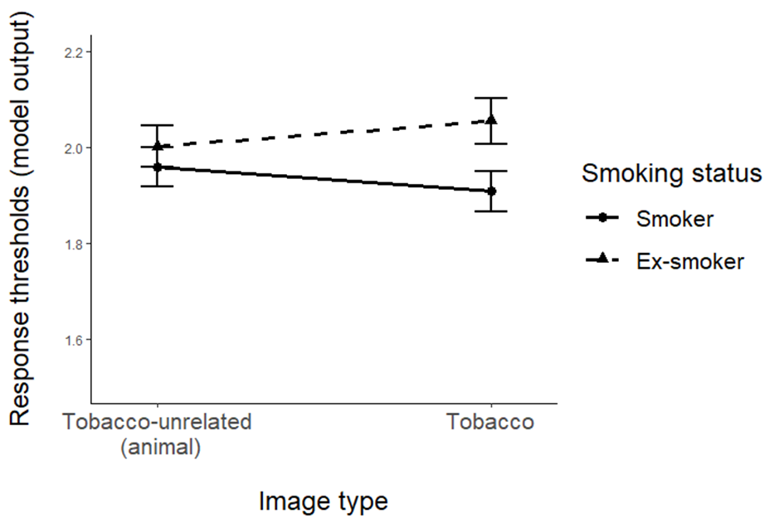
Note. Error bars represent the standard error of the mean.

To aid interpretation of the VBDM results presented above, we conducted exploratory mixed ANOVAs on EA rates and response thresholds using a within-subject factor of image type (2: tobacco; tobacco-unrelated), and a between-subject factor of smoker status (2: current smoker; ex-smoker). When looking at EA rates, there was a significant main effect of image type (F(1, 100) = 68.20, p < .001, η_{p}² = .41), but there was no significant main effect of smoking status (F(1, 100) = .17, p = .68, η_{p}² = .00), and no interaction (F(1, 100) = .05, p = .83, η_{p}² = .00). Post-hoc tests for the significant main effect of image type revealed that, collapsed across smoker status, EA rates were higher for tobacco-unrelated (animal) choices (M = 1.86, SD = .37) compared to tobacco choices (M = 1.55, SD = .42; p < .001). This analysis demonstrates that there was a main effect of image type that was not robustly moderated by smoker status. When looking at response thresholds, there was no significant main effect of image type (F(1, 100) = .00, p = .95, η_{p}² = .00) or smoker status (F(1, 100) = 2.95, p = .09, η_{p}² = .03), and no interaction (F(1, 100) = 3.37, p = .07, η_{p}² = .03), although this was approaching statistical significance. This analysis demonstrates that although ex-smokers have lower tobacco-related response thresholds compared to current smokers, this is perhaps not robust. However, in line with our pre-registration, our study was powered specifically to detect differences in means between two independent groups rather than an interaction effect.

Hypothesis 3 and 4: Compared to current smokers, ex-smokers will have greater conflict when tobacco images are the ‘correct’ answer, and lower conflict when tobacco-unrelated (animal) images are the ‘correct’ answer.

When the tobacco image was the correct answer, ex-smokers (M = 1.00, SD = .61) did not have significantly greater conflict compared to current smokers (M = 1.08, SD = .57); t(100) = .72, p = .76, d = .14. Similarly, when the tobacco-unrelated (animal) image was the correct answer, ex-smokers (M = .79, SD = .46) did not have significantly lower conflict compared to current smokers (M = .90, SD = .45); t(100) = 1.16, p = .13, d = .23.

Figure 7.5
Mean level of conflict represented by area under the curve (AUC scores) when correctly choosing the tobacco-unrelated and tobacco image split by current smoker (grey) and ex-smoker (striped)
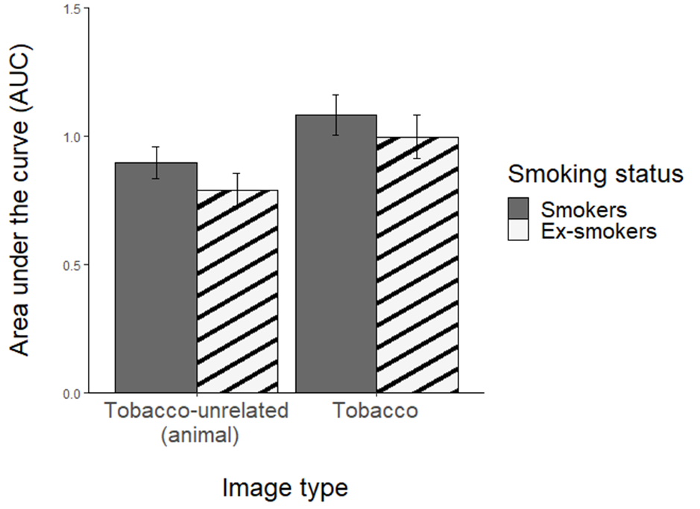
Note. Error bars represent the standard error of the mean.

Exploratory analyses that were pre-registered
In our pre-registration, we stated that we were interested in exploring the nature of the mouse trajectories from the MouseTracker task to explore whether they are in line with a dual-systems model or a dynamical systems model. In previous research, it has been demonstrated that trajectories for which the MD exceeds 0.9 demonstrate the abrupt mid-flight corrections that dual-systems accounts predict (Freeman, 2014). Findings from our sample are in line with dynamical systems approach, as the average MD score for both animal and smoking choices were below the .09 cut-off (see Figure 7.6).

Further supporting this, we conducted additional analyses to quantify the nature of mouse trajectories by exploring the modality of the distributions of conflict across MouseTracker trials (Freeman & Dale, 2013). Dual-process accounts posit that during decision-making, ‘automatic’ processes are either confirmed (resulting in relatively small levels of conflict) or are overridden by ‘controlled’ processes (resulting in larger amounts of conflict), which results in a bimodal distribution of conflict. Conversely, dynamical VBDM approaches posit that information from different response options compete against each-other dynamically over time until a final response emerges, which would result in a continuum of conflict that range from small to large and so a unimodal distribution of conflict. Therefore, if distributions are bimodal, that is evidence of abrupt trajectories with mid-flight corrections (in line with dual-process accounts) whereas if they are unimodal, that is evidence of smooth trajectories (in line with a dynamical VBDM account). A statistical method, referred to as Hartigan’s dip statistic, is a robust measure of bimodality (Freeman & Dale, 2013; Hartigan & Hartigan, 1985). If the test is significant, this is evidence against the null hypothesis of a unimodal distribution. Using Hartigan’s dip statistic we found no evidence for bimodality in either tobacco-unrelated (animal) trials, p = .96, or tobacco trials, p = .20. Therefore, trials were unimodal in nature, and this further supports the notion that making value-based decisions appear to unfold in a smooth and dynamical, rather than abrupt, manner.

Figure 7.6
Mean maximum deviation (MD) for tobacco and tobacco-unrelated trials split by current smoker (grey) and ex-smoker (striped)
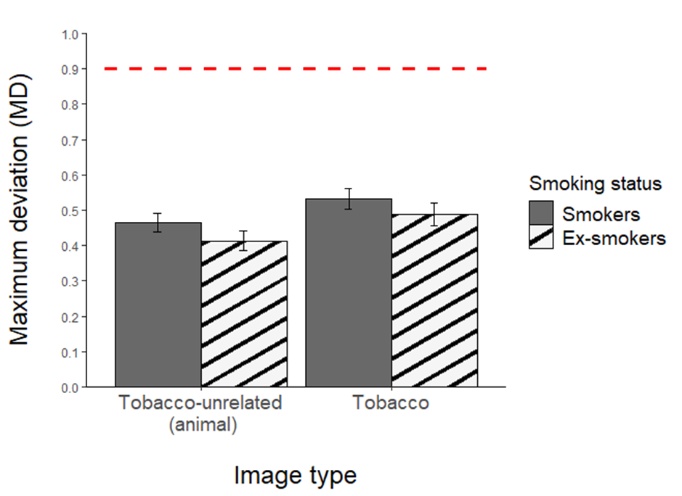
Note. The red dashed line represents the 0.9 cut-off for abrupt trajectories with mid-flight corrections that dual processes theories predict. Error bars represent the standard error of the mean.

Establishing a ‘difficulty effect’ on the VBDM task
We interested in establishing whether there is a ‘difficulty effect’, such that on trials where the difference between the value ratings for the competing images is large (i.e., easier trials), EA rates on the VBDM task should be increased whereas conflict in the MouseTracker task should be reduced, compared to when the differences between the value ratings for the competing images are minimal (i.e., difficult trials). One-way repeated measures ANOVAs were used to compare EA rates and response conflict on each of the different difficulty levels (easy, medium, and difficult trials). There was a significant main effect of difficulty on tobacco-unrelated (animal) EA rates, F(1.77, 179.07) = 215.16, p < .001, ηp² =.68. Subsequent post-hoc contrasts (applying the Holm-Bonferroni correction to p-values for multiple comparison) revealed that tobacco-unrelated (animal) EA rates in the easier trials (M = 2.23, SD = .53) were significantly increased compared to medium trials (M = 2.02, SD = .46; p < .001) and difficult trials (M = 1.33, SD = .36; p < .001). Furthermore, tobacco-unrelated (animal) EA rates on medium trials were significantly increased compared to EA rates on difficult trials (p < .001). There was also a significant main effect of difficulty on tobacco EA rates F(1.69, 170.32) = 295.19, p < .001, ηp² =.75. Post-hoc contrasts revealed that tobacco EA rates in the easier trials (M = 1.96, SD = .55) were increased compared to medium trials (M = 1.68, SD = .50; p < .001) and difficult trials (M = 1.02, SD = .37; p < .001). Furthermore, tobacco EA rates on medium trials were significantly increased compared to EA rates on difficult trials (p < .001).

Figure 7.7
Mean evidence accumulation rates (including all participants) for tobacco-unrelated (animal) and tobacco choices split by trial difficulty level
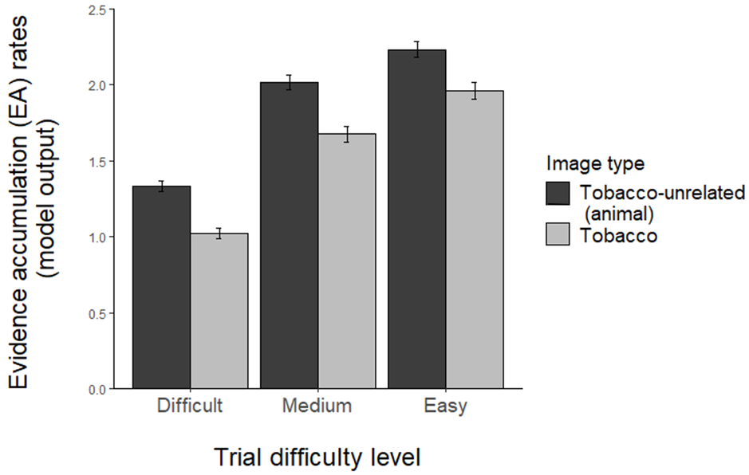
Note. Error bars represent the standard error of the mean (SE).

There was also significant main effect of difficulty on response conflict on trials where the tobacco-unrelated (animal) image was the correct answer, F(1.78, 180.16) = 220.30, p < .001, ηp² =.69. Post-hoc tests revealed that tobacco-unrelated (animal) response conflict in the easier trials (M = .55, SD = .45) was reduced compared to medium trials (M = .70, SD = .46; p < .001) and difficult trials (M = 1.07, SD = .50; p < .001). Furthermore, tobacco-unrelated (animal) response conflict on medium trials was reduced compared to conflict on difficult trials (p < .001). There was also significant main effect of difficulty on conflict on trials where the tobacco image was the correct answer, F(2, 202) = 233.12, p < .001, ηp² = .70. Post-hoc tests revealed that tobacco response conflict in the easier trials (M = .63, SD = .54) was reduced compared to medium trials (M = .90, SD = .65; p < .001) and difficult trials (M = 1.36, SD = .65; p < .001). Furthermore, tobacco response conflict on medium trials was significantly reduced compared to conflict on difficult trials (p < .001).

Figure 7.8
Mean level of conflict (AUC scores; including all participants) for tobacco-unrelated (animal) and tobacco choices split by trial difficulty level
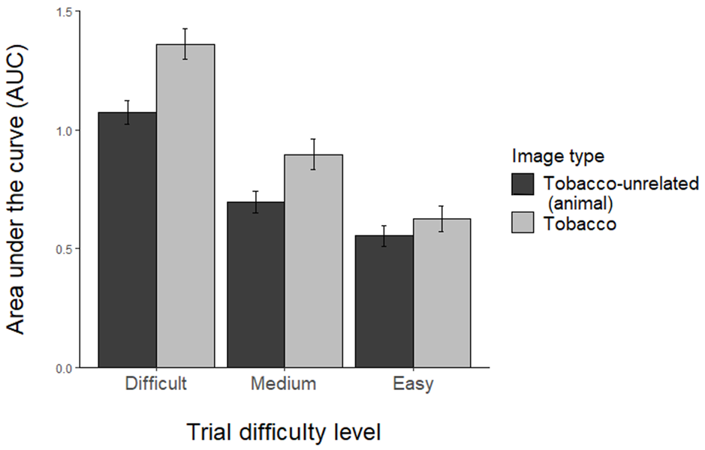
Note. Error bars represent the standard error of the mean.

7.4. Discussion
The aim of this study was to expand upon existing behavioural economic research by modelling the internal processes that determine discrete choices in current smokers and ex-smokers. Specifically, we explored whether recovery from nicotine addiction is characterised by alterations in the internal processes that precede decision-making regarding tobacco cues and control cues that were unrelated to tobacco (Field, Heather, et al., 2020). We found partial support for our first hypothesis: there were no significant differences in tobacco EA rates, however, ex-smokers had significantly higher response thresholds when making tobacco-related choices compared to current smokers. Our second hypothesis was not supported as we found no significant differences in EA rates or response thresholds when making tobacco-unrelated (animal) choices in ex-smokers compared to current smokers.

The primary novel finding from this study is that in line with predictions from Field, Heather, et al. (2020) ex-smokers have significantly higher response thresholds when making tobacco-related choices compared to current smokers. In other words, ex-smokers require significantly more value evidence to be accumulated before they reach a threshold for committing to a tobacco decision. This upwards shift in substance-related response thresholds in ex-smokers suggests that recovery is characterised by cautious substance-related decision-making because the DDM adjusts response thresholds based upon the SATO a person maintains—higher response thresholds reflect slower and more accurate decisions (Stafford et al., 2020).

Self-control is an important predictor of recovery from addiction (Stein & Witkiewitz, 2019) and it may be that when people recover from nicotine addiction, they are able to manipulate their environment in a way that makes it easier to act in accordance with their goal-oriented valuation system as opposed to their temptation-oriented valuation system (Duckworth et al., 2016). Indeed, qualitative research has shown that people in stable recovery from addiction cite several situational strategies that they use which minimise their temptation to use substances, many of which involve adjustments in their environment (Snoek et al., 2016). For example, it may be that when a person quits smoking, they cross the road to avoid walking past people who are smoking or walk a different way home to avoid the shop that they used to buy cigarettes from. As a result of the use of situational strategies, the exposure to smoking-cues is minimised, which could lead to changes in tobacco craving (Shiffman et al., 2013; Vafaie & Kober, 2022) and this may enable people to make more cautious decisions, potentially reflected in the increased response thresholds.

Another potential explanation for the increased response thresholds in ex-smokers may come from the use of psychological and/or pharmacological treatment. For example, some psychological treatments aim to increase a person’s abstinence self-efficacy (Elshatarat et al., 2016; Hendricks et al., 2010; Smit et al., 2014). Others aim to increase the value of tobacco-unrelated reinforcers by helping a person to discover alternative rewarding experiences other than substance use (Martínez-Vispo et al., 2018) or by providing incentives (e.g., money) for desired behaviours, such as smoking abstinence (Benishek et al., 2014). Alternatively, pharmacological treatments, such as nicotine replacement therapy (Lindson et al., 2019) and varenicline (Taylor et al., 2016) are effective in reducing tobacco craving and blocking the reinforcing effects of smoking. It may be that increased confidence to remain abstinent, greater availability of non-tobacco reinforcers, and/or diminished craving and reinforcing effects of tobacco enable people to step back and carefully consider their options when faced with the decision to smoke versus to do something else, potentially resulting in increased response thresholds.

Current smokers did not accumulate more value evidence for tobacco stimuli compared to ex-smokers, and ex-smokers did not accumulate more value evidence for tobacco-unrelated (animal) stimuli compared to current smokers. Therefore, our data did not identify the changes in EA rates that we would expect to see based on overt preferences between tobacco and tobacco-unrelated rewards that have been demonstrated in other studies (Chase et al., 2013; Hogarth & Chase, 2011; Lawn et al., 2018). For example, Hardy et al. (2018) found that people who self-report themselves as having quit smoking (ex-smokers) demonstrate decreased value of tobacco, indexed by a reduction in preference for tobacco rewards compared to tobacco-unrelated alternative rewards. However, there are differences in the methodologies that make it challenging to reconcile our findings with existing research. In previous studies, for example, participants chose between tobacco (e.g., cigarette) and tobacco-unrelated alternative (e.g., chocolate) images for some type of reward (e.g., points, enlargement of image, actual consumption of the image depicted). In order to test predictions from recent conceptual accounts (e.g., Field, Heather, et al., 2020), it was not possible for us to depict tobacco and tobacco-unrelated images side-by-side simultaneously. Furthermore, participants did not receive any type of reward when selecting an image on a trial as decisions were inconsequential. Secondly our non-tobacco alternative images were animal images and therefore not something that is appetitive unlike the stimuli that were used in the previous studies (see p.247 in Chapter 8 for the rationale for using animal images as the comparator).

Our findings also did not reveal any significant differences in the magnitude of conflict between current smokers and ex-smokers when tobacco was the correct answer and when the tobacco-unrelated (animal) was the correct answer, refuting hypotheses 3 and 4. Self-control is inversely associated with conflict during decision-making (Gillebaart et al., 2016; Stillman et al., 2017), and positively associated with recovery from addiction (Stein & Witkiewitz, 2019). We therefore anticipated that a difference would exist between current smokers and ex-smokers, but this was not the case for our sample. However, in line with previous findings (Stillman et al., 2017), mouse trajectories during choices whereby participants correctly choose the image that they rated higher in value were unimodal in nature. These findings support the notion that value-based decisions unfold in a smooth and dynamical manner in line with a VBDM approach, rather than a dual-process approach. This demonstrates that when faced with a conflicting decision, resolution of conflict is characterised by the dynamical integration of value inputs, in line with neuroscientific work (Cosme et al., 2019) and recent theoretical advances in the field of self-regulation (Berkman et al., 2017) as opposed to ‘controlled’ processes inhibiting ‘automatic’ processes (Veling et al., 2008).

Our pre-registered analyses included the exploration of whether there is a ‘difficulty effect’. Indeed, we found that EA rates on the VBDM task decreased, and magnitude of conflict on the MouseTracker task increased, with the level of difficulty in the trials (Figures 7.7 and 7.8). This is in line with previous research (Calluso et al., 2015; Dutilh & Rieskamp, 2016; Fontanesi et al., 2019; Polanía et al., 2014) and confirms that the way that participants were responding to the stimuli during the VBDM task and MouseTracker task was compatible with the value judgments that they had made about those stimuli during the image-rating phase.

Our study has some strengths; the use of DDM has considerable statistical power gains and benefits when comparing two groups (Stafford et al., 2020). However, there are also some important limitations. Firstly, given the cross-sectional nature of the data, it is not possible to establish any causal relationships between the VBDM parameters, addiction, and recovery from it. Secondly, although Athamneh et al. (2019) found breakpoint to be a reliable index of tobacco demand, more recently González-Roz et al. (2021) contested this, instead postulating that this is an unreliable index of demand. Furthermore, the measure of breakpoint in the current study entails price points directly translated from the Brief Assessment of Alcohol Demand (Owens et al., 2015) despite differences in the typical cost of a single alcoholic beverage versus a single cigarette (see Appendix F for price points). Self-report demand within this Chapter should therefore be interpreted cautiously. Finally, although the recruitment criterion of smoking at least 1 cigarette per day has been used in previous research (Hogarth et al., 2015) and increased the pool of eligible participants for the present study, this may have inadvertently resulted in a sample that are relatively low in dependence. As a result, the strength of contrast between current smoker and ex-smoker may have been weak.

To address these limitations, future studies could set a minimum threshold of smoking at least 10 cigarettes per day (see Lawn et al., 2019) in order to recruit a sample that are higher in dependence to contrast to people who are abstinent. Furthermore, longitudinal designs (e.g., following a person from early recovery and forward in time) will provide insight into the casual relationships between variables captured in the present study. Furthermore, mixed-methods approaches that integrate qualitative techniques alongside computational modelling may be useful to better understand what the parameters are reflecting from an individual perspective (we make some suggestions about what the increased response thresholds in ex-smokers represent in the current study, but these remain speculative). Interestingly, a recent study raised a similar question by speculating on whether response thresholds (the decision parameter that reflects response caution) correlate to self-reported impulsivity, finding no evidence that the two are correlated (Hedge et al., 2020). Future research in this area will contribute towards characterising the changes in decision-making that underlie recovery from addiction and help to identify novel targets for treatment.

To conclude, these findings contribute towards a novel insight into recovery from nicotine addiction. Our findings demonstrate that recovery was accompanied by increased cautiousness when making tobacco-related decisions, rather than decreased valuation of smoking. Therefore, this study provides partial support for the theoretical predictions put forward by Field, Heather, et al. (2020). Although there were no differences in magnitude of conflict during decision-making, conflict resolution was quantified as dynamical in line with a VBDM approach rather than a dual-process approach. Alterations in substance-related response thresholds may be a core mechanism that underlies recovery and a novel target for treatment interventions.

Chapter 8: General discussion
Contributions: I wrote the Chapter. Matt Field and Tom Stafford (primary supervisors) provided feedback on the draft.

This thesis had two overarching aims; the first aim was to develop a decision-making task that can be used in addiction-related research to recover decision parameters that reflect the underlying processes of value-based choice (e.g., evidence accumulation (EA) rates and response thresholds). The second aim was to empirically test predictions from recent conceptual accounts (Copeland et al., 2021; Field, Heather, et al., 2020) by exploring whether decision parameters recovered from the task are sensitive to experimental manipulations of substance value and whether they characterise stable behaviour change and recovery from addiction. In this chapter I will firstly provide a summary of the main findings from the six empirical studies presented in the thesis before discussing the theoretical, methodological, and clinical implications. I will then discuss the strengths and limitations of the research. Finally, I will discuss avenues for future research before providing a final conclusion.

8.1. Summary of main findings
In Chapter 2 (online study), I investigated whether the association between meaning in life and AUDIT scores (alcohol use and related problems) can be explained via individual differences in alcohol value, reinforcement derived from alcohol-free activities, depressive symptoms, and drinking to cope. This chapter extended upon my master’s thesis (Copeland et al., 2020) by incorporating a behavioural economic measure of alcohol-free reinforcement alongside alcohol value. Results demonstrated that presence of meaning in life predicted lower AUDIT scores indirectly via lower alcohol value and drinking to cope. This was an online survey, and these findings therefore highlight the importance of alcohol value from a self-report perspective.

Following these results, in Chapter 3 (online study) I developed a value-based decision-making (VBDM) task to explore valuation processes from a behavioural perspective. In this chapter, I investigated how robust the task was to minor alterations in trial wording with the aim being to identify appropriate methodology for use in addiction-related research. After comparing participants’ EA rates (i.e., their rate of value evidence accumulation) across blocks of trials, results showed that differences in EA rates (sensitivity to whether trials are easy, medium, or hard determined by participants own value ratings) were equivalent across the variations of trial wording. Therefore, variations of trial wording which do not explicitly ask about consumption (i.e., “gold-standard” wording) may still effectively capture value-based choice. This study provided initial validation of alternative trial wording that can be implemented in future research exploring VBDM, addiction and recovery from it.

In Chapter 4 (in-person study), I applied the VBDM task to addiction-related research by investigating whether experimentally manipulating alcohol value (via videos that depict the positive and negative consequences of alcohol) in regular alcohol consumers prior to completion of the task alters decision parameters of value-based choice for alcoholic and soft drink cues. The video that depicts the negative consequences of alcohol consumption was intended to decrease the value of alcohol based upon findings from Di Lemma et al. (2015). Indeed, findings from self-report measures revealed that the experimental manipulation was effective: mild and strong alcohol approach tendencies decreased, while alcohol avoidance tendencies increased, compared to before the experimental manipulation. Results from a computational VBDM analysis demonstrated that when participants were primed to devalue alcohol, this led to augmented EA rates for soft drinks compared to for alcoholic drinks and compared to EA rates for soft drinks when participants were primed to value alcohol. However, there were no significant differences in EA rates for alcoholic drinks or in response thresholds (i.e., the amount of evidence required to reach a decision) for either drink type.

I subsequently conducted a study that investigated whether experimentally manipulating nicotine value (via videos that temporarily induce positive and negative mood) in daily tobacco smokers prior to the completion of the VBDM task alters the decision parameters of value-based choice for tobacco and tobacco-unrelated cues (Chapter 5; online study). The negative mood induction was intended to increase the value of tobacco based upon findings from Hogarth et al. (2015). Indeed, findings self-report measures revealed that the experimental induction of negative mood was effective: happiness decreased while both sadness and craving to smoke increased compared to before the experimental manipulation (although the latter increase was of marginal significance, p = .05). Contrary to findings from Chapter 4, results from a computational VBDM analysis did not reveal any robust differences in decision parameters for tobacco versus tobacco-unrelated cues when participants were primed to value tobacco compared to when they were primed to devalue tobacco. Tobacco-unrelated (control) EA rates were consistently higher regardless of the experimental manipulation.

In Chapter 6 (online study), I explored whether alcohol-related behaviour change is characterised by alterations in decision parameters that represent the underlying processes of value-based choice for alcoholic and soft drink cues. I did this by comparing those parameters in current heavy drinkers and in people who used to consume alcohol heavily but now consume alcohol in moderation. Results did not reveal any robust differences in decision parameters for alcoholic and soft drink cues across drinker type, although moderated drinkers’ response thresholds were consistently lower regardless of drink type. Interestingly, however, in this study self-report measures of alcohol reinforcing value and behavioural allocation to activities that do not involve alcohol differentiated drinker type in line with behavioural economic accounts: alcohol moderation was characterised by lower alcohol value and greater reinforcement derived from alcohol-free activities.

Following this, in Chapter 7 (in-person study) I explored whether recovery from nicotine addiction is characterised by alterations in decision parameters of value-based choice and, using a different type of decision-making task, magnitude of decision conflict for tobacco and tobacco-unrelated cues. Parameters in daily smokers and in people who used to smoke daily but have since quit smoking were compared. Results demonstrated that ex-smokers had significantly higher response thresholds when making tobacco-related decisions, but that there were no differences in response thresholds for tobacco-unrelated decisions or in EA rates for either type of decision. There were also no group differences in magnitude of decision-conflict when making value-based decisions about tobacco and tobacco-unrelated cues.

Findings from this thesis provide partial support for speculations derived from VBDM accounts (Copeland et al., 2021; Field, Heather, et al., 2020): manipulation of alcohol value (Chapter 4) and recovery from nicotine addiction (Chapter 7) were characterised by changes in VBDM parameters, although not all predictions were supported. To elaborate, changes in EA rates and response thresholds were hypothesised to be important, whereas only changes in EA rates were observed in Chapter 4 and only changes in response thresholds were observed in Chapter 7 (see Table 8.1). However, in Chapter 5 and Chapter 6, the hypothesised predictions were not supported by the findings, and therefore were not aligned with predictions from the VBDM framework, thereby demonstrating a lack of consistent support.

Table 8.1
A brief overview of methodological details from the four empirical chapters that directly tested theoretical predictions derived from Copeland et al. (2021) and Field, Heather, et al. (2020)
Chapter number | Substance type | Study design | EA rates | Response thresholds | Data collection
4 | Alcohol | Manipulation | Yes | No | In-person
5 | Nicotine | Manipulation | Inconclusive | No | Online
6 | Alcohol | Cross-sectional | No | Inconclusive | Online
7 | Nicotine | Cross-sectional | No | Yes | In-person
Note. EA rates and response thresholds are decision parameters estimated by fitting the behavioural data generated from the VBDM task to a drift-diffusion model (DDM). A significant difference in VBDM parameters (i.e., EA rates / response thresholds) in line with one (or more) hypotheses from recent conceptual accounts (Copeland et al., 2021; Field, Heather, et al., 2020) is denoted by ‘Yes’, whereas ‘No’ denotes where hypotheses were not supported. ‘Inconclusive’ refers to chapters whereby the findings aligned with one (or more) hypotheses, but where the full interpretation is complicated by other factor(s)—see discussion sections within individual thesis chapters for further detail.

8.2. Theoretical implications
This thesis contains the first empirical test of predictions about recovery from addiction that stem from recent conceptual pieces (Copeland et al., 2021; Field, Heather, et al., 2020) that are inspired by neuroscience-informed accounts of self-control (Berkman et al., 2017) and behavioural economics (Bickel et al., 2014). By using novel methodology to quantify the internal mechanics of decision-making that determine value-based decisions, the findings from this thesis have a number of theoretical implications, which I discuss below.

8.2.1. Goal-directed accounts
A wealth of research supports the notion that substance-related decisions are goal-directed in humans (Acuff, Amlung, et al., 2020; Hogarth, 2020, 2022; Lawn et al., 2015; Pickard, 2020b; Rose et al., 2018). This line of evidence is complemented by findings from Chapter 4: experimentally manipulating the value of alcohol such that it is devalued (relative to valued) in turn increased EA rates for alcohol-free alternatives, thereby making it more likely that soft drinks (rather than alcohol) would cross their response threshold required for committing to a decision. Chapter 5 however did not demonstrate this effect with nicotine, thereby contrasting with goal-directed accounts. Although findings from this thesis cannot be completely reconciled with existing research studies due to methodological differences (e.g., decision-making task and dependent variable of interest), they demonstrate that the experimental mood-induced increase in tobacco value may not be robust. It may also be important to consider factors that distinguish Chapter 4 and Chapter 5 when interpreting the findings presented within this thesis, such as whether the research was conducted in-person or online, whether the stimuli used for the experimental manipulation of substance value was directly (e.g., depicting benefits or consequences of alcohol consumption) or indirectly (e.g., via the induction of negative or positive mood) focused on the substance. One possibility is that nicotine value is somewhat more difficult to manipulate than alcohol value. Indeed, there are considerably fewer situational constraints on tobacco use compared to alcohol use (Dora et al., 2022): people typically smoke at repeated intervals throughout the day and week, and this can include when people are at work, for example. Whereas for alcohol, people are likely to consume this in the evening or on weekends (Kuntsche & Gmel, 2013), and it would not be appropriate to do so when faced with responsibilities, such as when at work. There are therefore obvious consequences to alcohol use that stem from intoxication that can be exploited within experimental manipulations to target alcohol value. Interestingly, a systematic review by (Acuff et al., 2019) found differential results for the effect of negative affect on value depending on substance type: the effect was quantified as significant for alcohol, but non-significant for tobacco. This alludes to how tobacco value may indeed be more challenging to manipulate in comparison to other substance types, such as alcohol.

8.2.2. Molar behavioural economic accounts
Existing experimental evidence is frequently interpreted through the lens of behavioural economics (Field, Heather, et al., 2020; Hogarth & Field, 2020) which recognise the importance of the environment (e.g., the availability and access to substances versus substance-free alternative reinforcers) in order to contextualise decisions made over time. Importantly, however, findings from this thesis also expand upon behavioural economic accounts. This is because behavioural economic accounts are molar in nature; they are primarily concerned with the exploration of final causes, that is, the placing of behaviour within broader patterns of behaviour over time (Rachlin et al., 2018; Tucker & Vuchinich, 2015). Thus, they do not, and cannot, provide insight into the processes that occur during “in-the-moment” decisions (i.e., the molecular perspective). VBDM, informed by neuroscience, explores efficient causes (Rachlin, 1992) as the focus is on identification of cognitive processes that occur immediately prior to a given behaviour (Berkman et al., 2017; Field, Heather, et al., 2020). It is important for research to investigate momentary decision-making: constraints of any given drinking context will impact the momentary cost-benefit ratio of alcohol (Acuff et al., 2021; Strickland, 2022). Hypothetically, for example, if a person were at a bar where alcohol is expensive to purchase and consume, this may differentially impact their decision-making relative to if they were at an event where there is an open bar (i.e., where alcohol is served for free). This hypothetical example alludes to how, by only looking at aggregate patterns of behaviour over time, important information may be missed about the environmental and momentary context that may differentially impact upon decisions to use a substance. Overall, then, the second theoretical contribution is that VBDM can expand and complement molar accounts, and in doing so, contribute towards enhancing predictive utility (Acuff et al., 2021; Field, Heather, et al., 2020). Indeed, various researchers are enthusiastic about interdisciplinary extensions to traditional behavioural economic accounts (Acuff et al., 2022; Amlung et al., 2015; Bickel & Athamneh, 2020).

In Chapter 6, self-report findings supported behavioural economic accounts; adults who had moderated their drinking were characterised by lower behavioural economic demand for alcohol and greater proportionate alcohol-free reinforcement. Evidence from a computational VBDM analysis demonstrated that alcohol moderation was not characterised by alterations in the rate at which value evidence is accumulated, but rather, by lower response caution regardless of drink type (i.e., alcoholic or soft drink). Somewhat similar conclusions can be drawn from Chapter 7 which found that recovery from nicotine addiction was characterised by higher response caution when making substance-related decisions as opposed to alterations in rate of value evidence accumulation for either tobacco or tobacco-unrelated cues. Therefore, VBDM findings do not clearly align with behavioural economic accounts which emphasise the reversal of distortions in valuation processes (Bickel et al., 2014; Hogarth & Field, 2020; Murphy, MacKillop, et al., 2012; Tucker et al., 2021) because EA rates are hypothesised to reflect the rate at which value evidence is accumulated (Field, Heather, et al., 2020). However, it is somewhat difficult to directly reconcile the VBDM findings from this thesis with molar behavioural economic accounts: studies were either experimental manipulations (Chapters 4 and 5) or cross-sectional comparisons (Chapters 6 and 7), and therefore did not prospectively explore decision-making processes at repeated time points or longitudinally over time. Rather, the VBDM findings may reflect more ‘state-like’ processes as opposed to ‘trait-like’ processes.

8.2.3. The role of self-control
By viewing relative drug value as the key underlying mechanism of vulnerability for addiction and recovery (Hogarth & Field 2020), what VBDM can offer is theoretical parsimony. A benefit of such parsimony is that the VBDM framework can contribute to important on-going theoretical debates regarding the role of self-control—an important predictor of recovery from addiction (Stein & Witkiewitz, 2019). Broadly, there are two theoretical viewpoints by which the role of self-control might be important. The VBDM account explored within this thesis adheres to a dynamical, as opposed to dual-process, account of self-control (Berkman et al., 2017). More specifically, this account posits that although self-control choices may feel like a duality (i.e., a battle between automatic and controlled processes), rather, they can be understood as a form of value-based choice (Berkman et al., 2017). This account (Berkman et al., 2017; Berkman, 2018) acknowledges that the pathways to self-control success may be diverse, extending beyond “effortful inhibition” (Fujita, 2011). For example, if faced with the self-control relevant decision between a pizza and salad for lunch, a person could focus on specific attributes such as by noticing the juicy tomatoes in the salad, or they could choose a restaurant that only serves healthy food. In relation to the DDM, self-control is proposed to interact with the integration of value attributes during decision-making such that evidence accumulates most rapidly for immediately available outcomes. Indeed, there are robust associations between delay discounting (DD) and addiction severity (Amlung et al., 2017). Given findings from Chapter 4, it may be that when temporarily primed to devalue alcohol, this may enable a person to employ better self-control. To elaborate, evidence may no longer accumulate most rapidly for alcohol which often has immediate rewards (e.g., intoxication) relative to soft drinks. An alternative speculation regarding findings from Chapter 7 may be that elevated response thresholds signify increased self-control, given that these index response caution characterised by slower and more accurate decisions (Stafford et al., 2020). In the context of behaviour change, this may represent the ability to implement situational strategies such as changing the environment to act in accordance with goals as opposed to temptations (Duckworth et al., 2016; Snoek et al., 2016). However, it should be noted that there were no significant correlations between self-report self-control and response thresholds in Chapter 7 (see Appendix F), and the general question of what exactly response caution represents (indexed by thresholds) is an on-going question of interest (Hedge et al., 2020). Interestingly, Chapter 7 implemented a technique which enabled the nature of the mouse trajectories during decision-making to be quantified as either unfolding in a manner that is consistent with dual-process accounts (i.e., initial response towards an option with an abrupt mid-flight correction) or dynamical VBDM accounts (i.e., trajectories that comprise a smooth curvature). As found in Stillman et al. (2017), in Chapter 7 decisions were quantified as unfolding in line with dynamical VBDM accounts, complementing neuroimaging research which reached the same conclusion (Cosme et al., 2019).

8.2.4. Mood induction procedures
There are also several findings that have emerged from this thesis that were not central predictions within the computational VBDM account (Field, Heather, et al., 2020), but nevertheless have implications for theory development and refinement. Indeed, experimental studies have shown that negative mood increases the value ascribed to tobacco (Hogarth et al., 2015) and alcohol (Hogarth et al., 2018), and a recent systematic review (Sliedrecht et al., 2019) revealed negative affect to be a robust predictor of relapse for AUD. However, the null findings derived from Chapter 5 may add to existing literature which has begun to uncover complexity within the relationships between mood and substance use (Tovmasyan, Monk, & Heim, 2022). For example, an individual level meta-analysis (comprising 69 studies; n = 12,394) on negative affect and alcohol use revealed that the predictive ability of negative affect is not robust (Dora et al., 2022). Instead, this meta-analysis uncovered that people are more likely to consume alcohol on days where they experience positive affect. More recently, this finding has been replicated in non-clinical samples (Tovmasyan, Monk, Sawicka, et al., 2022). Although in relation to tobacco, the findings from Chapter 5 may be interpreted in line with this recently published research. This is because there were no negative mood-induced alterations in VBDM parameters relative to when positive mood was induced; however, the use of mood as the core manipulation may have obscured the ability to detect a distinction. I contrasted negative and positive mood based upon Hogarth et al. (2015), however the inclusion of a neutral comparison may have been more effective in light of knowledge derived from recent syntheses of the literature (e.g., Dora et al., 2022; Tovmasyan, Monk, Sawicka, et al., 2022). Alternatively, an interesting point raised by Dora et al. (2022) is that negative affect may drive substance use for some people, some of the time, and authors call for increased research efforts that contain methodology capable of capturing the immediate context that decisions are made. A contribution from this thesis is that methodology employed enabled the exploration of the effect of mood on substance-related decision-making at a momentary level by parameterising the internal processes of discrete decisions made, with findings indicating that the previously reported relationship between negative mood and tobacco value (e.g., Hogarth et al., 2015) may not be robust.

8.2.5. Meaning in life
Another contribution is that less is currently understood about the theoretical basis by which meaning in life influences decisions to consume alcohol (Sliedrecht et al., 2022), and findings from Chapters 2 and 6 contribute towards enhancing this. Chapter 2 corroborated existing research demonstrating that meaning in life is inversely associated with AUDIT scores (Copeland et al., 2020). However, this chapter did not find any significant association between search for meaning in life and AUDIT scores. These findings directly contribute to an inconsistent evidence base regarding the relationship between search for meaning in life and alcohol consumption (Copeland et al., 2020; Csabonyi & Phillips, 2017) thereby supporting the notion that elevated search for meaning is not a robust predictor of AUDIT scores. I subsequently explored meaning in life in Chapter 6, but unexpectedly found that neither presence of meaning, nor search for meaning in life distinguished current heavy drinkers and moderated (former heavy) drinkers. Given the inverse associations found between presence of meaning in life and AUDIT scores in Chapter 2 and existing studies (Copeland et al., 2020; Csabonyi & Phillips, 2017), this was an unexpected observation and did not align with research highlighting meaning in life as important for behaviour change and recovery (Robinson et al., 2011; Roos et al., 2015). However, these findings may be interpreted in line with even more recent findings: Sliedrecht et al. (2022) prospectively followed up a clinical sample of people in treatment for alcohol use disorder (AUD) and found no significant associations between meaning in life and levels of craving or alcohol relapse. Although previous research (e.g., Roos et al., 2015) concludes the importance of meaning in life in relation to recovery, it is important to note that this research uses measures that capture ‘purpose in life’ which may be conceptually distinct from meaning in life (Martela & Steger, 2016). Indeed, George and Park (2013) advocate that although used synonymously, purpose and meaning are distinct constructs. Given that cross-sectional (Chapter 6) and prospective (Sliedrecht et al., 2022) studies which implement direct measures of meaning in life are unable to replicate previous findings, theoretically it may be purpose in life, as opposed to meaning in life, that is important for behaviour change and recovery from addiction.

8.3. Methodological implications
There are a number of methodological implications that arise from the research conducted within this thesis. I developed a novel VBDM task that has potential to be used by other researchers to generate data required for the drift-diffusion model (DDM) to recover decision parameters that reflect the underlying processes of value-based choice. In doing so, I explored the robustness of variations in trial wording within the VBDM task to generate alternative versions that are appropriate to implement in research on recovery from addiction (Chapter 3; Copeland et al., 2022). This is important because several theoretical frameworks (Bickel & Athamneh, 2020; Copeland et al., 2021; Field, Heather, et al., 2020; Hogarth & Field, 2020) and methodological commentaries (Pennington et al., 2021) advocate the use of computational modelling, but until the work presented in this thesis there was no validated behavioural paradigm that was appropriate for this purpose.

It is important to acknowledge that there are existing experimental tasks that capture value-based choice in addiction, and that these have been used extensively in published research on tobacco (Chase et al., 2013; Hogarth et al., 2015; Hogarth & Chase, 2011; Lawn et al., 2019) and alcohol (Hardy et al., 2017, 2018; Hardy & Hogarth, 2017; Hogarth & Hardy, 2018b; Rose et al., 2013, 2018) choice (for a review, see Hogarth & Field, 2020). In these tasks, two images are displayed simultaneously, one of which is substance-related (e.g., alcohol) and the other is substance-free (e.g., food). Participants are instructed to press a key to select their preferred image over numerous trials for a reward (e.g., ‘points’ which determine the quantity of reward received at the end of the experiment). The dependent variable on this task is the percentage of substance versus substance-free choice which is used as an index of substance value. However, by focusing on percentage choice only, these tasks are silent on the internal cognitive components of decision-making that occur in the lead up to choice. A further limitation is that currently used methodology cannot distinguish the value ascribed to substances from the value ascribed to substance-free alternatives (Leventhal, Trujillo, et al., 2014).

The VBDM task that I developed differs from the existing experimental tasks in a number of ways, and in doing so, brings about considerable methodological strengths. For example, I included an image rating phase within the experimental procedure; participants were shown sets of stimuli (substance-related and substance-free) and were instructed to rank order the images in relation to their preferences prior to completing the VBDM task. This was done separately for the substance-related set and the substance-free set of images. The VBDM task was subsequently personalised for each participant to reflect their previous ratings where participants were instructed to choose their preferred image between either two substance-related or two substance-free images, as quickly as possible. The outlined experimental procedure generated the behavioural data that is required to fit the DDM to recover parameters of value-based choice because there was a measure of choice accuracy (unlike in existing concurrent choice tasks, e.g., Hardy et al., 2018), alongside reaction time (RT).

The methodological benefit of fitting the DDM is that it takes observed behavioural data (RT and choice accuracy) as input to decompose different cognitive processes that determine overt behaviour (White et al., 2016, 2018). These processes are represented in parameters recovered from the model, which have well established psychological interpretations (Stafford et al., 2020): EA rate (also known as the ‘drift rate’; the rate at which momentary evidence is accumulated), response threshold (participant caution indexed by their speed-accuracy trade-off (SATO)) and non-decision time (encoding and motor processes). Crucially, then, the DDM provides a principled reconciliation of both RT and accuracy data, and in doing so, disentangles different processes that determine decisions made, including those that are value-based (Berkman et al., 2017; Mormann et al., 2010; Polanía et al., 2014).

Studying individual differences in laboratory-based research can be challenging, in part due to measurement error and poor reliability (Dang et al., 2020; Hedge et al., 2018). A potential contributor to this may arise from traditional approaches which often take mean RT or choice accuracy to be the dependent variable. Limitations of this method are that it is unable to account for participant’s SATO, something that is inherent whenever a participant is instructed to respond as quickly as possible (Stafford et al., 2020). Responding faster is often at the cost of lowering accuracy, while the reverse is also true; responding slower enables a person to consider their option and thereby increase accuracy. Furthermore, when RT is used as the outcome measure of interest, this assumes that systematic differences in RT are driven only by the construct under investigation, whereas it is known that various cognitive (e.g., response caution) and motor processes (e.g., executing a response, such as a key press) influence RT simultaneously (Hedge et al., 2018). Therefore, RT is often confounded by various extraneous processes, with implications for enhanced measurement noise (Pennington et al., 2021). The overall methodological implication of the DDM then is that unlike traditional analysis approaches, it can produce parameters that account for these separable cognitive and motor processes, thereby producing estimates that are more precise and more sensitive.

This is supported by the re-analysis of observed behavioural data with the DDM which uncovered new interpretations: Pirrone et al. (2017) found that when RT was the dependent variable (representing perception), results showed that people with autism had significantly slower RTs indicative of difficulties in perceptual judgement. Interestingly, however, when the authors fitted the DDM to the same data, there were actually no significant differences in perceptual judgement (indexed by participants EA rate). Rather, there were differences in decision caution, indexed by response thresholds. This demonstrates how the conclusions of research studies change when the DDM is fitted, and indeed similar reinterpretations of behavioural data have also been found in other domains (e.g., ageing; Ratcliff et al., 2001, 2006a, 2016).

Therefore, by generating more precise estimates, this in turn highlights the DDM as a methodological approach that can provide enhanced specificity for investigating individual differences (White et al., 2016). This may be an especially salient methodological benefit; experimental research is often postulated to optimise the detection of within-person differences as opposed to between-subject (or individual difference) effects (Dang et al., 2020; Hedge et al., 2018). This is particularly important when studying clinical topics (Evans & Wagenmakers, 2019); indeed, individual differences in parameters derived from the DDM have distinguished between controls and people with schizophrenia (Limongi et al., 2018), anxiety (White et al., 2010), and autism (Pirrone et al., 2017). The DDM is therefore a powerful tool to apply to behavioural data to capture individual differences (van Ravenzwaaij & Oberauer, 2009).

Another methodological benefit is that by fitting the DDM (in comparison to relying on observed behavioural data, i.e., RT or choice accuracy), this has been found to enhance statistical power when comparing two groups without requiring more participants or task trials (Stafford et al., 2020). Alongside the potential to minimise study costs and time, this may bring about a wider implication, in that statistical power, or in other words, the ability to detect true experimental effects, is a contributor in relation to the on-going “reproducibility crisis” (Baker, 2016; Munafò et al., 2017). The combination of more precise and sensitive measures, alongside enhanced power, may correspond to ability to uncover meaningful between-subject (or individual difference) effects.

Importantly, the VBDM task that I developed provides the opportunity to distinguish the value ascribed to substances and the value ascribed to substance-free alternatives. This is because VBDM parameters are recovered separately for each commodity, something that is impossible with conventional tasks that capture value-based choice whereby the outcome is percentage of substance (e.g., Hardy et al., 2018). This has implications for deriving more fine-grained conclusions from experimental research which in turn may inform future research. For example, in Rose et al. (2018), participants were primed to devalue alcohol by consuming alcohol that had been experimentally manipulated to taste aversive to humans and this was found to decrease the percentage choice for alcohol rewards, which the authors solely interpret to be indicative of decreased value of alcohol. However, because participants are choosing between alcohol and soft drinks, another way to frame such decreases in the percentage of alcohol choice is to frame it as increases in the percentage of soft drink choice, which may be indicative of increased value ascribed to the non-alcohol alternative. Put another way, perhaps as the taste of alcohol alters in an unpleasant way, people begin to shift their preference to soft drinks. As a result, the interpretation of data in Rose et al. (2018) is somewhat ambiguous: it is not clear whether the findings reflect decreased value of alcohol, increased value of soft drinks, or potentially an element of both. The findings from Chapter 4 in this thesis would suggest that it is changes in the value ascribed to the alcohol-free alternative that is important in how manipulation of alcohol value influences decisions made. Despite this difference in interpretation, however, the findings from both Rose et al. (2018) and Chapter 4 are indeed compatible as devaluation of alcohol influences alcohol choice; the distinction is on the underlying process by which this occurs. Therefore, a core methodological implication of this thesis is the creation of a VBDM task that has potential to be used by other researchers to capture individual differences in cognitive processes that contribute to the valuation of both the substance and to substance-free alternatives, both of which have been implicated in addiction.

An important methodological question may be what the computational VBDM approach adopted within this thesis offers beyond existing standard self-report measures of valuation, such as the Alcohol Purchase Task (Murphy & MacKillop, 2006) or Brief Assessment of Alcohol Demand (Owens et al., 2015). In addition to the benefits discussed above, the VBDM task used within this thesis offers a method to quantify the ways in which people value different commodities without overtly asking people to think about how much they would spend; participants are unlikely to have prior knowledge about how the captured behavioural data (i.e., RT and accuracy) correspond to parameters of value-based choice. This approach also offers a way of quantifying other potentially important aspects of VBDM that may otherwise be missed, including response caution. In other words, how much value evidence a person needs to accumulate to commit to a decision—indexed by response thresholds.

8.4. Clinical implications
By using computational modelling to explore the internal processes of decision-making, findings may contribute towards the identification of novel targets for treatment interventions. Self-report findings from Chapter 6 extend on behavioural economic research by demonstrating that moderation of alcohol consumption is characterised by lowered alcohol demand and greater reinforcement derived from alcohol-free activities. Evidence from the computational VBDM analysis is less clear, however it may be that alterations in response thresholds represent how, in the moment, people decide to engage with alcohol-free alternatives. This is because alcohol moderation was characterised by lowered soft drink response thresholds, meaning that a lower rate of accumulated value evidence was required to commit to a choice. However, it is important to acknowledge that, unexpectedly, alcohol response thresholds were also lowered. This is an important extension as current research findings are specific to the transition from dependence to moderation (Tucker et al., 2006, 2009, 2016, 2021) meaning less is known about how people who consume alcohol heavily (but are not dependent) achieve moderation. Given that 20% of heavy drinkers in England are attempting to reduce their alcohol consumption (Beard et al., 2017), these findings may inform intervention targets for this population.

Findings from Chapter 7 showed that recovery from nicotine addiction is characterised by higher response thresholds when making tobacco-related decisions. Elevation of substance-related response thresholds may therefore be a novel mechanism that underlies recovery in absence of changes in the rate of value EA for those substance cues. Indeed, some of the benefits of existing psychological treatments and pharmacotherapies may correspond to people being able to step back and carefully consider their options when faced with the decision to smoke versus to do something else. One example is mindfulness-based interventions which broadly train people to be aware of their body and mind in the present moment (Witkiewitz et al., 2014), and this has been linked to higher tobacco smoking abstinence rates (Brewer et al., 2011; Goldberg et al., 2018; Oikonomou et al., 2017), although further research is required to conclude the long-term effects (Jackson et al., 2022). To elaborate, it may be that when a thought arises (e.g., about substance use), elevated response thresholds allow people to be present in the moment and to let the thought pass without attempts to process or judge the content. Interestingly, Moniz-Lewis et al. (2022) recruited participants from community treatment facilities and found that mindfulness training increased self-efficacy—that is, a person’s belief in their own ability to achieve a desired outcome. Self-efficacy is recognised to be an important predictor of tobacco smoking cessation (Elshatarat et al., 2016; Smit et al., 2014); it may therefore be that elevated response thresholds enable a person to step back and carefully consider their options and in doing so provide an opportunity to develop and exploit self-efficacy.

Although distortions in valuation processes are emphasized by behavioural economic models, and indeed many efficacious treatments aim to reverse these distortions (Fazzino et al., 2019; Meshesha et al., 2020), it remains somewhat ambiguous exactly how valuation processes change. For example, the substance-free activity session (SFAS; Murphy, Dennhardt, et al., 2012) was initially developed for students with three broad aims: 1) increase salience of future academic / career goals, 2) discuss the potential negative impact of alcohol on goal-attainment, and 3) increase engagement with substance-free alternative activities. The ambiguity here is that it is not possible to determine whether the SFAS is effective because alcohol becomes devalued, because substance-free alternatives increase in value, or potentially an element of both. VBDM as a theoretical framework offers the opportunity to distinguish these valuation processes, and therefore future studies with a SFAS component could include computational VBDM measures in the process evaluation to better understand which exact processes change. Findings from Chapter 4 align with behavioural economic accounts by showing that alcohol value is malleable (Acuff, Amlung, et al., 2020), and that manipulation of alcohol value influences decisions made about alcohol-free alternatives. Given these findings, it may be that increases in the value of alcohol-free alternatives is the important underlying mechanism.

A further contribution is that the findings from the empirical Chapters within this thesis suggest that different decision-making processes may be important to target for different substance types. For example, Chapter 4 is specific to alcohol findings indicate that it may be changes in decision-making processes for the alcohol-free alternative that is important, whereas for Chapter 7 which is specific to tobacco, findings indicate that changes in decision-making processes for tobacco may be most important. These findings imply that it may be required for treatments to be personalised by targeting specific processes depending on the type of substance a person is receiving a brief intervention or treatment for.

Another implication of VBDM is that it provides an opportunity to quantify the process of behaviour change and recovery beyond alterations in substance-related decision parameters. Indeed, Witkiewitz and Tucker (2020) advocate that changes in substance use should not dominate how improvement or recovery is defined. Rather, authors propose that other things which symbolise on-going improvements in well-being and psychological functioning should be considered as equally important features of recovery (Witkiewitz et al., 2020). In VBDM, it is possible to track changes in decision-making processes regarding alternative reinforcers to substance use, possible examples may be spending time with family, friends, or engaging in hobbies (e.g., exercise). Being able to quantify and interpret changes in substance-free decision parameters could enable researchers and/or clinicians to monitor the recovery process beyond substance use alone. This is synonymous with observations that there are no unanimous definitions of recovery (Ashford et al., 2019) or relapse (Sliedrecht et al., 2019); addiction is heterogeneous (Pickard, 2020b) meaning that recovery may look different for different people.

Finally, by using computational methodology to quantify decision-making processes that occur in the lead up to a decision being made, if the task were to be completed at repeated intervals, VBDM may offer a novel opportunity to track a person’s progress in the absence of overt behaviour (Field, Heather, et al., 2020). This may have implications for the administration of “booster-sessions” (Nation et al., 2003) within treatment settings. For example, based upon the findings from Chapter 7, this may be appropriate if a person was experiencing momentarily lowered response thresholds for tobacco. Another hypothetical example may be that, based upon findings from Chapter 4, changes in EA rates for alcohol-free alternatives may signify early signs of behaviour change or engagement with a brief intervention or treatment, and these changes might be detectable before any overt changes in substance use itself.

8.5. Strengths and limitations
There are several strengths to the research presented within this thesis. I used validated image sets (e.g., the Amsterdam Beverage Picture Set; Pronk et al., 2015) accompanied by valence ratings which enabled me to select a variety of images that could be differentially evaluated, as well as making it possible for other researchers to use the exact same images in future research. Where this was not possible (e.g., due to limits of existing image sets), I piloted images of drink beverages that I selected from Google to ensure that there was sufficient variability for different types of evaluative judgements to be made. In addition, I clearly detailed what the images depicted, alongside all VBDM task instructions, in the supplementary materials (see Appendix C for an example). This is a strength; it ensures research transparency and means that future researchers can replicate the research presented within this thesis which is often lacking in experimental and cognitive research in the field of addiction (Pennington et al., 2021).

The materials that I selected for use in the experimental manipulation studies (e.g., video stimuli in Chapters 4 and 5) were validated in previous work (Di Lemma et al., 2015; Marcusson-Clavertz et al., 2019) which maximised the likelihood that they would have the desired experimental effect. I also relied on validated scales and measurements where possible throughout the thesis to ensure that psychological processes and self-report behaviour were measured sensitively, and I corroborated this by calculating and reporting internal reliability estimates (McDonald, 1970; 1999).

All studies were aligned with values derived from Open Science (Pennington et al., 2021); studies were pre-registered and the accompanying analysis scripts and anonymised datasets are available on accessible public repositories (https://aspredicted.org/; https://researchbox.org/). Sample sizes for all studies were justified to ensure that the research was sufficiently powered. Finally, the research in this thesis largely recruited participants from the general population (e.g., via advertisements in the local community) and therefore generalizability is not limited to student samples, thereby extending research whereby students are the focus (Hogarth & Hardy, 2018b; Joyner et al., 2018; Rose et al., 2013).

Another strength is that some studies (Chapters 2, 3, 5, and 6) were conducted online which meant that I could recruit and test a large number of participants simultaneously, thereby collecting self-report and behavioural data at a relatively fast pace compared to in-person data collection. Furthermore, I used Prolific (https://www.prolific.co/), and the large pool of current active participants (n = 121,958) and accompanying custom pre-screen filters (e.g., patterns of substance use and country of residence) meant that I had access to a diverse sample of participants, extending beyond people in my local community. Prolific is a platform dedicated to fair and ethical reimbursement rates for participants and has been recognised in particular for the high level of attention and honesty from participants (Peer et al., 2021). As a result, data quality is high compared to competing platforms, such as Amazon Mechanical Turk (Peer et al., 2021). Crucially, shifting my research online enabled me to continue my planned research studies throughout the COVID-19 pandemic as national lockdown restrictions precluded the in-person recruitment of participants.

However, there were also some important limitations to the research in this thesis, which includes the online nature of the research as this meant that I was unable to strictly control the environments in which participants took part in the studies. Uncontrolled conditions in online experiments that entail cognitive tasks can be problematic when inferences are dependent on RT, especially when this is captured at the millisecond level (Plant, 2016; Santangelo & Solovey, 2021). Therefore, behavioural data captured in the online studies within this thesis may have been susceptible to enhanced noise and interference, potentially affecting decision parameters recovered from the DDM. The online setting also meant that it is not possible to ascertain the extent to which participants truly understood or maintained attention during task instructions, which could in turn impact data collected. For example, in Chapter 5, it was not possible to fit the DDM to behavioural data from one participant, and given the online nature of the study, it is impossible to investigate why this occurred on behalf of the participant. Finally, although guidance exists (see Sauter et al., 2020), synchronising the VBDM task programmed in PsychoPy to an online host (Pavlovia; https://pavlovia.org/) in order to collect data from participants online was both difficult and time-consuming. This was in part due to the necessary transition of the task into JavaScript language alongside the complexity of the VBDM task that I developed; it requires a random sub selection of initially rated images to be carried through to subsequent trials, in addition to personalisation across participants based on prior value ratings. In order for other researchers to make use of my VBDM task in the future, they therefore require a level of experience or expertise in the domains mentioned above, which may preclude the uptake in researchers who do not have this.

Furthermore, the self-report measure of demand differed across Chapters; only in Chapters 5 and 6 were “full” hypothetical purchase task measures (Murphy & MacKillop, 2006; MacKillop et al., 2008) used. This was the result of receiving training in more advanced demand curve fitting techniques prior to these studies being conducted. Although brief measures of alcohol demand (e.g., Brief Assessment of Alcohol Demand; Owens et al., 2015) used in this thesis (Chapters 2 and 4) are common in existing literature (Copeland et al., 2020; Hardy et al., 2021; Merrill & Aston, 2020), they require additional validation (Owens et al., 2015). Furthermore, there is currently not a validated brief version of the cigarette purchase task, however at the time I followed recommendations by Athamneh et al. (2019) and administered the single item breakpoint to index value. However, more recently González-Roz et al. (2021) did not find any support for the clinical utility of breakpoint as an index of demand. Therefore, self-report demand within this thesis should be interpreted cautiously.

A further limitation is that choices made by participants were hypothetical because they did not comprise any actual outcome during the experimental procedure. Such inconsequential decision-making differs from other published studies outside the field of addiction (Krajbich et al., 2010; Mormann et al., 2010; Polanía et al., 2014; Tusche & Hutcherson, 2018) which require participants to consume (or at least partially consume) one item depicted in an image rated high in value from a trial selected at random. This is typically done to encourage participants to make value judgements that reflect their true preferences. However, in the research presented within this thesis it was necessary for decisions to be hypothetical in-part for ethical reasons (e.g., ex-smokers should not receive or be offered cigarette rewards during their participation as they are in recovery). This was corroborated by the COVID-19 pandemic because the national lockdown restrictions precluded face-to-face data collection, which means it would be additionally challenging to give participants an actual reward immediately following their participation. However, I conducted additional analyses which quantified robust difficulty effects. To elaborate, across all Chapters, EA rates decreased alongside increasing level of difficulty in the trials thereby revealing participants’ responding to the stimuli during the VBDM task was compatible with the value judgments that they had made about those stimuli during the rating task. Furthermore, existing tasks that infer substance value via the percentage of substance relative to substance-free choice often do not comprise actual outcomes either, instead using procedures such as image enlargement as the reward (e.g., Hardy & Hogarth, 2017; Moeller et al., 2009, 2013, 2020; Moeller & Stoops, 2015).

Another methodological limitation is that the control stimuli used in the Chapters 5 and 7 were perhaps not appropriate to make comparisons with tobacco-related images. To elaborate, animal images were used as the control, and I found EA rates for animal images were always higher than EA rates for tobacco (regardless of experimental manipulation or group membership) which precluded any meaningful interpretation of difference between these two categories. An explanation for the increase in EA rates is that EA rates are sensitive to both participant ability and task difficulty (Evans & Wagenmakers, 2019; Wagenmakers et al., 2007) and the animal stimuli may have been easier for participants to distinguish between. For example, the difference in valence between two different animals (e.g., a snake and a puppy) may be more obvious than the difference between two different ashtrays.

A recent methodological commentary postulated that to appropriately match control stimuli to a substance-related stimuli, the control category should contain some element of incentive value (Pennington et al., 2021). Within this thesis, I considered using food images as the control category for tobacco-related cues instead of animal images. However, at the time of planning the first research study, there were no openly available validated food image sets that comprised a variety of images that participants would likely evaluate differentially. There were additional considerations that guided my decision to use animal images. If food images were to be used, there may be a potential confound: nicotine is a metabolic stimulant and an appetite suppressant and research has demonstrated that appetite changes when people give up smoking (Courtemanche et al., 2018). Furthermore, using food as the control category would have required additional inclusion criteria, such as no history of an eating disorder, not being on a diet or trying to lose weight, and not being vegetarian or vegan, which may inadvertently limit the pool of participants available to participate. Nonetheless, food images are commonly used as the comparator in other addiction studies (e.g., Hogarth et al., 2015, 2017; Hogarth & Chase, 2011), therefore this is an important avenue for future research in the context of VBDM.

There are also some important limitations to the method used to estimate DDM model parameters. I fitted the EZ-DDM (Wagenmakers et al., 2007) which uses a closed-form algorithm, and therefore unlike other more complex model approaches (e.g., the “full” DDM; Ratcliff & McKoon, 2008), takes the mean reaction time, variance in reaction time, and proportion of correct responses as input. Although this reduces the complexity and level of computational expertise required (Stafford et al., 2020), it does however mean that only the three most relevant parameters of the diffusion model can be estimated (e.g., EA rates, response thresholds, and non-decision time; Wagenmakers et al., 2007). Another potential limitation is that the EZ-DDM assumes that the starting point parameter (z) is equidistant from the response thresholds that represent the different response options for each commodity, for example, when choosing between two alcoholic images (on an alcohol block), or two soft drink images (on a soft drink block). If the starting point is closer to the response threshold for a stimulus, then a person would need to accumulate less value evidence to commit to a decision. Some researchers contend this to be problematic in relation to the estimation of other decision parameters (Alexandrowicz & Gula, 2022). However, I made this decision because it is recommended that other parameters (such as those that relate to trial-by-trial variability) should only be estimated when there is strong justification to do so and when there is a sufficient number of trials to adequately power this and avoid “over-fitting” (Voss et al., 2015); neither of which were the case for the studies presented within this thesis. Furthermore, because there was a ‘correct’ answer on the VBDM task that was distributed randomly such that on half of the trials this was on the left and the other half right on the right, there is no sound basis to anticipate or expect the starting point parameter to be biased in favour of either. Therefore, I believe the EZ-DDM to be appropriate for research conducted in this thesis. Indeed, the EZ-DDM has been implemented successfully in a diverse range of research, including children’s development (Retzler et al., 2020) and psychiatric disorders (Sripada & Weigard, 2021). Furthermore, in the process of publishing Chapter 3 (Copeland et al., 2022), as a supplementary analysis I used an alternative model fitting approach that was capable of constraining model parameters across conditions (the fast-dm-30; Voss et al., 2015); this made no material difference to the core conclusion and therefore I did not apply this to other studies within this thesis.

8.6. Future research
The findings from this thesis highlight exciting avenues for future research. Firstly, it would be interesting for future research to implement qualitative methods to explore further what decision parameters reflect at an individual level. For example, although in Chapter 7 findings demonstrate that recovery from nicotine addiction is characterised by higher tobacco-related response thresholds, less is known about what exactly this means in the context of addiction and recovery from it. The research question of what exactly response thresholds index is of broad interest: a meta-analysis quantified that there is no evidence that response thresholds are correlated with self-report impulsivity (correlation coefficients ranged from -.04 to -.02; Hedge et al., 2020). Therefore, this avenue is certainly worth investigating further.

A further possibility is that qualitative research could generate insight into the specific attributes that feed into substance value. This is because unlike current dominating self-report measures of value that limit constraints on alcohol to price only (Acuff & Murphy, 2021), VBDM enables a diverse range of constraints that can vary across contexts, people, and time (Copeland et al., 2021; Field, Heather, et al., 2020). Berkman (2018) speculates upon how these attributes may be potentially impossible to quantify—both a strength and a weakness of VBDM as a framework (it offers parsimony but at the cost of being difficult to precisely identify targets). By collecting written or verbal responses after experimental manipulations in future research, this may give some insight into the potentially salient attributes that feed into value. Meanwhile, a quantitative approach to exploring the salient attributes that feed into value could be to compare VBDM parameters after experimental manipulations that influence substance value in different ways. For example, if the induction of craving via substance deprivation alters VBDM parameters, but induction of low self-worth does not have any effect, it may be that craving is a more salient attribute that feeds into substance value. Future research that focuses on directly mapping different sources of value to VBDM parameters could be supplemented by comprehensive and robust theoretical reviews, such as the Etiologic, Theory-based, Ontogenetic Hierarchical Framework (ETOH) of AUD recently published by Boness et al. (2021) which identified a number of fundamental mechanisms implicated in AUD (e.g., craving, coping motives, and delay discounting).

Future studies may also build upon the research presented within this thesis by altering the sample studied. For example, a study comparing heavy drinkers and people who used to be dependent, but no longer consume any alcohol, may be effective in detecting group differences in VBDM. This however would require careful consideration as to whether it is ethically appropriate to ask people with a history of alcohol dependence to make these types of decisions as they could jeopardise stable recovery or cause distress for people who are abstinent. However, it should be emphasised that in existing research, people in recovery have been recruited and instructed to make value-based decisions about substances (e.g., alcohol) and substance-free alternatives (e.g., Hardy et al., 2018). In future VBDM research, protocols could be designed in combination with feedback from patient and public involvement (PPI) panels comprising lived experience of addiction, such as the Sheffield Addiction Recovery Research Panel (ShARRP; Moore et al., 2020).

As this thesis was an initial application of VBDM to recovery from addiction, further refining of VBDM task methodology is warranted, for example, by exploring whether there is an appropriate control category for tobacco-related images. It might also be interesting for future research on alcohol-related decision-making to replace the soft drink image set with idiographic image sets whereby participants are making decisions about alcohol versus some other real-life choice. Indeed, Steger et al. (2013) used a photographic method in their research by asking participants to take photos of things that are meaningful to them, many of which are compatible with hobbies and activities that may compete with alcohol use (e.g., hobbies such as painting, spending time with family, driving). A potential benefit of this type of approach is that it may enable more of a comparison to self-report measures of alcohol-free reinforcement that are typically employed in behavioural economic research (e.g., reinforcement surveys; Acuff et al. 2019). However, in doing so, researchers should be cautious in ensuring that the image categories are appropriately matched to make effective comparisons, as discussed previously (p.247).

Future studies may also consider using methodology that can capture decision-making in real-life contexts and thereby increase ecological validity. A recent study by Motschman et al. (2022) used ecological momentary assessment (EMA) and found that momentary fluctuations in alcohol demand were predictive of elevated alcohol consumption in real-life settings. In the future, it may be possible for VBDM tasks to be administered on different devices (e.g., tablets or mobile phones) which would facilitate the collection of data at frequent intervals. In doing so, this approach would enable the exploration of whether VBDM parameters are capable of accurately predicting real-life behaviours (Field et al., 2020). In addition, extending beyond binary decisions in decision-making tasks and employing more advanced computational methodology such as multi-alternative DDMs (Krajbich & Rangel, 2011) may reflect decision-making that applies more to a real-life setting (e.g., when deciding in a supermarket and faced with multiple choice options), thereby enhancing ecological validity.

Interestingly, other variations of DDMs have been developed to incorporate other potentially important factors, such as attentional bias (AB). VBDM offers a novel interpretation of the importance of attentional biases in addiction: according to this account, AB does not operate through an automatic process, but rather, it inflates the monetary value of alcohol which in turn would make it more likely to be acted upon. Variations of the DDM, such as the attentional drift diffusion model (aDDM; Krajbich et al., 2010) directly support this notion: greater eye fixations augment the value of the commodity as captured by EA rates. Although the aDDM has been applied to decisions made about food cues (Krajbich et al., 2010), this has not yet been applied to addiction-related research. Interestingly, experimental studies with somewhat ambiguous conclusions (e.g., Rose et al., 2013, 2018) have used eye-tracking methodology and captured value-based choice, albeit not with the DDM. These findings can be reinterpreted in such a way that aligns with the conclusion in Chapter 4 of this thesis: they found increased AB to soft drinks when participants were primed to devalue alcohol compared to a control condition, which interpreted in line with the aDDM would suggest that soft drinks increase in value. This is therefore an extremely interesting avenue for future research.

To address the cross-sectional limitations of Chapters 6 and 7, future research might use longitudinal designs that prospectively follow people up in order to uncover the temporal and causal relationships between VBDM, behaviour change, and recovery. In doing so, this future research could facilitate, or contribute to, continued refinement of VBDM conceptual accounts (Copeland et al., 2021; Field, Heather, et al., 2020). Although entirely tentative, here I introduce a theoretical speculation that may inform future iterations of VBDM. In Chapter 4 I found that devaluation of alcohol selectively increases EA rates for soft drinks, whilst in Chapter 7 I found that ex-smokers have significantly higher response thresholds for tobacco. I therefore speculatively propose that EA rates and response thresholds may have a core temporal component: initial thoughts about changing or early behaviour change may be characterised by alterations in EA rates, and these may gradually stabilise into shifts in response thresholds over time. Therefore, at the point of stable recovery, altered valuation may be reflected in response thresholds rather than EA rates. Interestingly, this speculation may provide one way to reconcile findings from Chapter 7 with behavioural economic accounts which emphasise the reversal of distortions in valuation processes. What this tentative extension to VBDM accounts alludes to is an efficient-causal explanation that can serve as the basis for observed final cause patterns of behaviour over time (Rachlin, 2017)—directly bringing together VBDM and behavioural economic accounts. Efficient causes (i.e., mechanisms that immediately precede a discrete act) and final causes (i.e., temporally extended behaviour patterns) therefore do not need to be mutually exclusive as proposed in Tucker and Vuchinich (2015). More recently however, it is becoming recognised that both types of analysis have potential to contribute towards enriching theoretical understanding of addiction and recovery from it (Tucker et al., 2022). Future prospective research may therefore explore this speculation further by conducting longitudinal studies that capture both “in-the-moment” decisions as well as temporally extended patterns of behaviour (Field, Heather, et al., 2020).

8.7. Conclusion
Behavioural economic accounts posit that greater expected value of drugs relative to alternative non-drug rewards underpins addiction and recovery from it. However, these accounts explore patterns of behaviour over time (i.e., the molar perspective) and do not provide any insight into individual “in-the-moment” decisions (i.e., the molecular perspective). Consequently, less is currently known about the underlying mechanisms through which valuation processes influence decisions made about substances and substance-free alternatives. VBDM provides a framework that can be used to explore how momentary decisions are made (Berkman et al., 2017; Berkman, 2018). Inspired by this account, Field, Heather, et al. (2020) extended it to the study of recovery from addiction, and in doing so, outlined a number of predictions that await empirical testing. However, prior to this PhD, there was not a VBDM task that could be used to generate the behavioural data required to fit the DDM. I therefore developed a novel VBDM task that can be used to explore predictions from Field, Heather, et al. (2020) and subsequently applied this to several studies which differ in design (experimental manipulation / cross-sectional comparison), substance focus (alcohol / tobacco), and mode of data collection (in-person / online). Findings from empirical studies presented in this thesis provide partial support for predictions derived from conceptual advances in the field (e.g., Copeland et al., 2021; Field, Heather, et al., 2020): changes in alcohol value map onto changes in soft drink EA rates and recovery from nicotine addiction is characterised by increased response thresholds when making tobacco-related decisions. Overall, then, manipulation of substance value and recovery from addiction map onto alterations in computational parameters of value-based choice that precede decisions made, however not all empirical studies provided support for these predictions. In line with enthusiasm for extensions to traditional behavioural economic approaches (Acuff et al., 2022; Amlung et al., 2015; Bickel & Athamneh, 2020), future research should continue to explore VBDM which will add to what is currently an inconsistent evidence base; this may provide greater clarity on the role of momentary decision-making parameters, addiction, and recovery from it.

References
Abma, I. L., Rovers, M., & van der Wees, P. J. (2016). Appraising convergent validity of patient-reported outcome measures in systematic reviews: Constructing hypotheses and interpreting outcomes. BMC Research Notes, 9(1), 1–5. https://doi.org/10.1186/s13104-016-2034-2
Acuff, S. F., Amlung, M., Dennhardt, A. A., MacKillop, J., & Murphy, J. G. (2020). Experimental manipulations of behavioral economic demand for addictive commodities: A meta-analysis. Addiction, 115(5), 817–831. https://doi.org/10.1111/add.14865
Acuff, S. F., Dennhardt, A. A., Correia, C. J., & Murphy, J. G. (2019). Measurement of substance-free reinforcement in addiction: A systematic review. Clinical Psychology Review, 70, 79–90. https://doi.org/10.1016/j.cpr.2019.04.003
Acuff, S. F., & Murphy, J. G. (2017). Further examination of the temporal stability of alcohol demand. Behavioural Processes, 141(1), 33–41. https://doi.org/10.1016/j.beproc.2017.03.020
Acuff, S. F., & Murphy, J. G. (2021). Commentary on Martínez-Loredo et al.: Where do we go from here? Increasing the clinical utility of alcohol purchase tasks by expanding our definition of constraint. Addiction, 116(10), 2651–2652. https://doi.org/10.1111/add.15481
Acuff, S. F., Soltis, K. E., & Murphy, J. G. (2020). Using demand curves to quantify the reinforcing value of social and solitary drinking. Alcoholism: Clinical and Experimental Research, 44(7), 1497–1507. https://doi.org/10.1111/acer.14382
Acuff, S. F., Stoops, W. W., & Strickland, J. C. (2021). Behavioral economics and the aggregate versus proximal impact of sociality on heavy drinking. Drug and Alcohol Dependence, 220, 108523. https://doi.org/10.1016/j.drugalcdep.2021.108523
Acuff, S. F., Tucker, J. A., & Murphy, J. G. (2020). Behavioral economics of substance use: Understanding and reducing harmful use during the COVID-19 pandemic. Experimental and Clinical Psychopharmacology, 29(6), 739–749. https://doi.org/10.1037/pha0000431
Acuff, S. F., Tucker, J. A., Vuchinich, R. E., & Murphy, J. G. (2022). Addiction is not (only) in the brain: Molar behavioral economic models of etiology and cessation of harmful substance use. In N. Heather, M. Field, A. C. Moss, & S. Satel (Eds.), Evaluating the brain disease model of addiction (pp. 459–474). Routledge.
Alcohol Change UK. (2020). Alcohol-free and low alcohol drinks. https://alcoholchange.org.uk/policy/policy-insights/alcohol-free-and-low-alcohol-drinks
Alexandrowicz, R. W., & Gula, B. (2022). Problems when fixing the response bias parameter z in drift diffusion analysis: A Commentary on Stafford et al. (2020). Behavior Research Methods. https://doi.org/10.3758/s13428-021-01786-0
American Psychiatric Association. (2013). Diagnostic and statistical manual of mental disorders (5th ed.). American Psychiatric Publishing, Inc. https://doi.org/10.1176/appi.books.9780890425596
Amlung, M., Acker, J., Stojek, M., Murphy, J. G., & MacKillop, J. (2012). Is talk ‘cheap’? An initial investigation of the equivalence of Alcohol Purchase Task performance for hypothetical and actual rewards. Alcoholism, Clinical and Experimental Research, 36(4), 716–724. https://doi.org/10.1111/j.1530-0277.2011.01656.x
Amlung, M., & MacKillop, J. (2014). Understanding the effects of stress and alcohol cues on motivation for alcohol via behavioral economics. Alcoholism, Clinical and Experimental Research, 38(6), 1780–1789. https://doi.org/10.1111/acer.12423
Amlung, M., & MacKillop, J. (2015). Further evidence of close correspondence for alcohol demand decision making for hypothetical and incentivized rewards. Behavioural Processes, 113, 187–191. https://doi.org/10.1016/j.beproc.2015.02.012
Amlung, M., McCarty, K., Morris, D., Tsai, C.-L., & Mccarthy, D. (2015). Response to Tucker & Vuchinich (2015): Behavioral economics in the broader context of addiction science. Addiction, 110(9), 1430–1431. https://doi.org/10.1111/add.13015
Amlung, M., Vedelago, L., Acker, J., Balodis, I., & MacKillop, J. (2017). Steep delay discounting and addictive behavior: A meta-analysis of continuous associations. Addiction, 112(1), 51–62. https://doi.org/10.1111/add.13535
Ashford, R. D., Brown, A., Brown, T., Callis, J., Cleveland, H. H., Eisenhart, E., Groover, H., Hayes, N., Johnston, T., Kimball, T., Manteuffel, B., McDaniel, J., Montgomery, L., Phillips, S., Polacek, M., Statman, M., & Whitney, J. (2019). Defining and operationalizing the phenomena of recovery: A working definition from the recovery science research collaborative. Addiction Research & Theory, 27(3), 179–188. https://doi.org/10.1080/16066359.2018.1515352
Aston, E. R., & Cassidy, R. N. (2019). Behavioral economic demand assessments in the addictions. Current Opinion in Psychology, 30, 42–47. https://doi.org/10.1016/j.copsyc.2019.01.016
Aston, E. R., Smith, J. E., DiBello, A. M., & Farris, S. G. (2021). Effects of acute distress and tobacco cues on tobacco demand. Drug and Alcohol Dependence, 221, 108522. https://doi.org/10.1016/j.drugalcdep.2021.108522
Athamneh, L. N., Stein, J. S., Amlung, M., & Bickel, W. K. (2019). Validation of a brief behavioral economic assessment of demand among cigarette smokers. Experimental and Clinical Psychopharmacology, 27(1), 96–102. https://doi.org/10.1037/pha0000228
Audrain-McGovern, J., Rodriguez, D., Rodgers, K., & Cuevas, J. (2011). Declining alternative reinforcers link depression to young adult smoking. Addiction, 106(1), 178–187. https://doi.org/10.1111/j.1360-0443.2010.03113.x
Bagnardi, V., Rota, M., Botteri, E., Tramacere, I., Islami, F., Fedirko, V., Scotti, L., Jenab, M., Turati, F., Pasquali, E., Pelucchi, C., Galeone, C., Bellocco, R., Negri, E., Corrao, G., Boffetta, P., & La Vecchia, C. (2015). Alcohol consumption and site-specific cancer risk: A comprehensive dose–response meta-analysis. British Journal of Cancer, 112(3), 580–593. https://doi.org/10.1038/bjc.2014.579
Baker, M. (2016). 1,500 scientists lift the lid on reproducibility. Nature, 533(7604), 452–454. https://doi.org/10.1038/533452a
Baker, T. B., Piper, M. E., McCarthy, D. E., Majeskie, M. R., & Fiore, M. C. (2004). Addiction motivation reformulated: An affective processing model of negative reinforcement. Psychological Review, 111(1), 33–51. https://doi.org/10.1037/0033-295X.111.1.33
Ballard, J. (2016). What is Dry January? The British Journal of General Practice, 66(642), 32. https://doi.org/10.3399/bjgp16X683173
Banks, E., Joshy, G., Korda, R. J., Stavreski, B., Soga, K., Egger, S., Day, C., Clarke, N. E., Lewington, S., & Lopez, A. D. (2019). Tobacco smoking and risk of 36 cardiovascular disease subtypes: Fatal and non-fatal outcomes in a large prospective Australian study. BMC Medicine, 17(1), 128. https://doi.org/10.1186/s12916-019-1351-4
Beard, E., Brown, J., Kaner, E., West, R., & Michie, S. (2017). Predictors of and reasons for attempts to reduce alcohol intake: A population survey of adults in England. PLOS ONE, 12(3), e0173458. https://doi.org/10.1371/journal.pone.0173458
Benishek, L. A., Dugosh, K. L., Kirby, K. C., Matejkowski, J., Clements, N. T., Seymour, B. L., & Festinger, D. S. (2014). Prize-based contingency management for the treatment of substance abusers: A meta-analysis. Addiction, 109(9), 1426–1436. https://doi.org/10.1111/add.12589
Benowitz, N. L., & Liakoni, E. (2022). Tobacco use disorder and cardiovascular health. Addiction, 117(4), 1128–1138. https://doi.org/10.1111/add.15703
Berkman, E. T. (2018). Value-based choice: An integrative, neuroscience-informed model of health goals. Psychology & Health, 33(1), 40–57. https://doi.org/10.1080/08870446.2017.1316847
Berkman, E. T., Hutcherson, C. A., Livingston, J. L., Kahn, L. E., & Inzlicht, M. (2017). Self-control as value-based choice. Current Directions in Psychological Science, 26(5), 422–428. https://doi.org/10.1177/0963721417704394
Bickel, W. K., & Athamneh, L. N. (2020). A Reinforcer Pathology perspective on relapse. Journal of the Experimental Analysis of Behavior, 113(1), 48–56. https://doi.org/10.1002/jeab.564
Bickel, W. K., Johnson, M. W., Koffarnus, M. N., MacKillop, J., & Murphy, J. G. (2014). The behavioral economics of substance use disorders: Reinforcement pathologies and their repair. Annual Review of Clinical Psychology, 10, 641–677. https://doi.org/10.1146/annurev-clinpsy-032813-153724
Biener, L., & Abrams, D. B. (1991). The Contemplation Ladder: Validation of a measure of readiness to consider smoking cessation. Health Psychology, 10(5), 360–365. https://doi.org/10.1037//0278-6133.10.5.360
Biernacki, K., Lopez-Guzman, S., Messinger, J. C., Banavar, N. V., Rotrosen, J., Glimcher, P. W., & Konova, A. B. (2021). A neuroeconomic signature of opioid craving: How fluctuations in craving bias drug-related and nondrug-related value. Neuropsychopharmacology, 47, 1440–1448. https://doi.org/10.1038/s41386-021-01248-3
Blevins, C. E., Abrantes, A. M., & Stephens, R. S. (2016). Motivational pathways from antecedents of alcohol use to consequences: A structural model of using alcohol to cope with negative affect. The American Journal of Drug and Alcohol Abuse, 42(4), 395–403. https://doi.org/10.3109/00952990.2016.1141915
Boden, J. M., & Fergusson, D. M. (2011). Alcohol and depression. Addiction, 106(5), 906–914. https://doi.org/10.1111/j.1360-0443.2010.03351.x
Bogacz, R., Brown, E., Moehlis, J., Holmes, P., & Cohen, J. D. (2006). The physics of optimal decision making: A formal analysis of models of performance in two-alternative forced-choice tasks. Psychological Review, 113(4), 700–765. https://doi.org/10.1037/0033-295X.113.4.700
Boness, C. L., Watts, A. L., Moeller, K. N., & Sher, K. J. (2021). The etiologic, theory-based, ontogenetic hierarchical framework of alcohol use disorder: A translational systematic review of reviews. Psychological Bulletin, 147(10), 1075–1123. https://doi.org/10.1037/bul0000333
Boursier, V., Musetti, A., Gioia, F., Flayelle, M., Billieux, J., & Schimmenti, A. (2021). Is watching TV series an adaptive coping strategy during the COVID-19 pandemic? Insights from an Italian community sample. Frontiers in Psychiatry, 12, 599859. https://doi.org/10.3389/fpsyt.2021.698404
Bravo, A. J., Pilatti, A., Pearson, M. R., Mezquita, L., Ibáñez, M. I., & Ortet, G. (2018). Depressive symptoms, ruminative thinking, drinking motives, and alcohol outcomes: A multiple mediation model among college students in three countries. Addictive Behaviors, 76, 319–327. https://doi.org/10.1016/j.addbeh.2017.08.028
Brewer, J. A., Mallik, S., Babuscio, T. A., Nich, C., Johnson, H. E., Deleone, C. M., Minnix-Cotton, C. A., Byrne, S. A., Kober, H., Weinstein, A. J., Carroll, K. M., & Rounsaville, B. J. (2011). Mindfulness training for smoking cessation: Results from a randomized controlled trial. Drug and Alcohol Dependence, 119(1–2), 72–80. https://doi.org/10.1016/j.drugalcdep.2011.05.027
Brière, F. N., Rohde, P., Seeley, J. R., Klein, D., & Lewinsohn, P. M. (2014). Comorbidity between major depression and alcohol use disorder from adolescence to adulthood. Comprehensive Psychiatry, 55(3), 526–533. https://doi.org/10.1016/j.comppsych.2013.10.007
Britton, A., Ben-Shlomo, Y., Benzeval, M., Kuh, D., & Bell, S. (2015). Life course trajectories of alcohol consumption in the United Kingdom using longitudinal data from nine cohort studies. BMC Medicine, 13, 47. https://doi.org/10.1186/s12916-015-0273-z
Brooks, A. T., Magaña Lòpez, M., Ranucci, A., Krumlauf, M., & Wallen, G. R. (2017). A qualitative exploration of social support during treatment for severe alcohol use disorder and recovery. Addictive Behaviors Reports, 6, 76–82. https://doi.org/10.1016/j.abrep.2017.08.002
Brose, L. S., Brown, J., & McNeill, A. (2020). Mental health and smoking cessation—A population survey in England. BMC Medicine, 18(1), 161. https://doi.org/10.1186/s12916-020-01617-7
Brown, J., Kotz, D., Michie, S., Stapleton, J., Walmsley, M., & West, R. (2014). How effective and cost-effective was the national mass media smoking cessation campaign ‘Stoptober’? Drug and Alcohol Dependence, 135, 52–58. https://doi.org/10.1016/j.drugalcdep.2013.11.003
Brown, J., West, R., Beard, E., Michie, S., Shahab, L., & McNeill, A. (2014). Prevalence and characteristics of e-cigarette users in Great Britain: Findings from a general population survey of smokers. Addictive Behaviors, 39(6), 1120–1125. https://doi.org/10.1016/j.addbeh.2014.03.009
Browne, M. W., & Cudeck, R. (1993). Alternative ways of assessing model fit. In K. A. Bollen & J. S. Long (Eds.), Testing structural equation models (pp. 136–162). Sage.
Bulley, A., & Gullo, M. J. (2017). The influence of episodic foresight on delay discounting and demand for alcohol. Addictive Behaviors, 66, 1–6. https://doi.org/10.1016/j.addbeh.2016.11.003
Busemeyer, J. R., Gluth, S., Rieskamp, J., & Turner, B. M. (2019). Cognitive and neural bases of multi-attribute, multi-alternative, value-based decisions. Trends in Cognitive Sciences, 23(3), 251–263. https://doi.org/10.1016/j.tics.2018.12.003
Cairney, J., Kwan, M. Y. W., Veldhuizen, S., & Faulkner, G. E. J. (2014). Who uses exercise as a coping strategy for stress? Results from a national survey of Canadians. Journal of Physical Activity & Health, 11(5), 908–916. https://doi.org/10.1123/jpah.2012-0107
Calluso, C., Committeri, G., Pezzulo, G., Lepora, N., & Tosoni, A. (2015). Analysis of hand kinematics reveals inter-individual differences in intertemporal decision dynamics. Experimental Brain Research, 233(12), 3597–3611. https://doi.org/10.1007/s00221-015-4427-1
Cancer Research UK. (2021). How does smoking cause cancer? Cancer Research UK. https://www.cancerresearchuk.org/about-cancer/causes-of-cancer/smoking-and-cancer/how-does-smoking-cause-cancer
Centers for Disease Control and Prevention. (2021). Drug Overdose Deaths in the U.S. Top 100,000 Annually. https://www.cdc.gov/nchs/pressroom/nchs_press_releases/2021/20211117.htm
Chaiyasong, S., Huckle, T., Mackintosh, A.-M., Meier, P., Parry, C. D. H., Callinan, S., Viet Cuong, P., Kazantseva, E., Gray-Phillip, G., Parker, K., & Casswell, S. (2018). Drinking patterns vary by gender, age and country-level income: Cross-country analysis of the International Alcohol Control Study. Drug and Alcohol Review, 37 Suppl 2, S53–S62. https://doi.org/10.1111/dar.12820
Chase, H. W., Mackillop, J., & Hogarth, L. (2013). Isolating behavioural economic indices of demand in relation to nicotine dependence. Psychopharmacology, 226(2), 371–380. https://doi.org/10.1007/s00213-012-2911-x
Christiansen, P., Cole, J. C., Goudie, A. J., & Field, M. (2012). Components of behavioural impulsivity and automatic cue approach predict unique variance in hazardous drinking. Psychopharmacology, 219(2), 501–510. https://doi.org/10.1007/s00213-011-2396-z
Clemens, K. J., Castino, M. R., Cornish, J. L., Goodchild, A. K., & Holmes, N. M. (2014). Behavioral and neural substrates of habit formation in rats intravenously self-administering nicotine. Neuropsychopharmacology, 39(11), 2584–2593. https://doi.org/10.1038/npp.2014.111
Cohen, J. (1988). Statistical power analysis for the behavioral sciences (2nd ed.). Routledge. https://doi.org/10.4324/9780203771587
Colas, J. T. (2017). Value-based decision making via sequential sampling with hierarchical competition and attentional modulation. PLOS ONE, 12(10), e0186822. https://doi.org/10.1371/journal.pone.0186822
Cooper, M. L. (1994). Motivations for alcohol use among adolescents: Development and validation of a four-factor model. Psychological Assessment, 6(2), 117–128. https://doi.org/10.1037/1040-3590.6.2.117
Cooper, M. L., Frone, M. R., Russell, M., & Mudar, P. (1995). Drinking to regulate positive and negative emotions: A motivational model of alcohol use. Journal of Personality and Social Psychology, 69(5), 990–1005. https://doi.org/10.1037//0022-3514.69.5.990
Cooper, M. L., Kuntsche, E., Levitt, A., Barber, L. L., & Wolf, S. (2016). Motivational models of substance use: A review of theory and research on motives for using alcohol, marijuana, and tobacco. In K. J. Sher (Ed.), The Oxford handbook of substance use and substance use disorders (Vol. 1, pp. 375–421). Oxford University Press. https://doi.org/10.1093/oxfordhb/9780199381678.013.017
Copeland, A., Jones, A., & Field, M. (2020). The association between meaning in life and harmful drinking is mediated by individual differences in self-control and alcohol value. Addictive Behaviors Reports, 11, 100258. https://doi.org/10.1016/j.abrep.2020.100258
Copeland, A., Stafford, T., & Field, M. (2021). Recovery from addiction: A synthesis of perspectives from behavioral economics, psychology, and decision modeling. In D. Frings & I. P. Albery (Eds.), The handbook of alcohol use (pp. 563–579). Academic Press. https://doi.org/10.1016/B978-0-12-816720-5.00002-5
Copeland, A., Stafford, T., & Field, M. (2022). Methodological issues with value-based decision-making (VBDM) tasks: The effect of trial wording on evidence accumulation outputs from the EZ drift-diffusion model. Cogent Psychology, 9(1), 2079801. https://doi.org/10.1080/23311908.2022.2079801
Correia, C. J., Benson, T. A., & Carey, K. B. (2005). Decreased substance use following increases in alternative behaviors: A preliminary investigation. Addictive Behaviors, 30(1), 19–27. https://doi.org/10.1016/j.addbeh.2004.04.006
Correia, C. J., Carey, K. B., Simons, J., & Borsari, B. E. (2003). Relationships between binge drinking and substance-free reinforcement in a sample of college students A preliminary investigation. Addictive Behaviors, 28(2), 361–368.
Correia, C. J., Murphy, J. G., Irons, J. G., & Vasi, A. E. (2010). The behavioral economics of substance use: Research on the relationship between substance use and alternative reinforcers. Journal of Behavioral Health and Medicine, 1(3), 216. https://doi.org/10.1037/h0100553
Corrigan, P. W., & Nieweglowski, K. (2018). Stigma and the public health agenda for the opioid crisis in America. The International Journal on Drug Policy, 59, 44–49. https://doi.org/10.1016/j.drugpo.2018.06.015
Cosme, D., Ludwig, R. M., & Berkman, E. T. (2019). Comparing two neurocognitive models of self-control during dietary decisions. Social Cognitive and Affective Neuroscience, 14(9), 957–966. https://doi.org/10.1093/scan/nsz068
Coughlin, L. N., Bonar, E. E., & Bickel, W. K. (2021). Considerations for remote delivery of behavioral economic interventions for substance use disorder during COVID-19 and beyond. Journal of Substance Abuse Treatment, 120, 108150. https://doi.org/10.1016/j.jsat.2020.108150
Courtemanche, C., Tchernis, R., & Ukert, B. (2018). The effect of smoking on obesity: Evidence from a randomized trial. Journal of Health Economics, 57, 31–44. https://doi.org/10.1016/j.jhealeco.2017.10.006
Cowlishaw, S., & Kessler, D. (2016). Problem gambling in the UK: Implications for health, psychosocial adjustment and health care utilization. European Addiction Research, 22(2), 90–98. https://doi.org/10.1159/000437260
Csabonyi, M., & Phillips, L. J. (2017). Meaning in life and substance use. Journal of Humanistic Psychology, 60(1), 3–19. https://doi.org/10.1177/0022167816687674
Dahne, J., Murphy, J. G., & MacPherson, L. (2017). Depressive symptoms and cigarette demand as a function of induced stress. Nicotine & Tobacco Research, 19(1), 49–58. https://doi.org/10.1093/ntr/ntw145
Dang, J., King, K. M., & Inzlicht, M. (2020). Why are self-report and behavioral Mmeasures weakly correlated? Trends in Cognitive Sciences, 24(4), 267–269. https://doi.org/10.1016/j.tics.2020.01.007
Daughters, S. B., Magidson, J. F., Anand, D., Seitz-Brown, C. J., Chen, Y., & Baker, S. (2018). The effect of a behavioral activation treatment for substance use on post-treatment abstinence: A randomized controlled trial. Addiction, 113(3), 535–544. https://doi.org/10.1111/add.14049
Dawson, D. A., Grant, B. F., Stinson, F. S., & Chou, P. S. (2006). Maturing out of alcohol dependence: The impact of transitional life events. Journal of Studies on Alcohol, 67(2), 195–203. https://doi.org/10.15288/jsa.2006.67.195
Dawson, D. A., Grant, B. F., Stinson, F. S., Chou, P. S., Huang, B., & Ruan, W. J. (2005). Recovery from DSM-IV alcohol dependence: United States, 2001–2002. Addiction, 100(3), 281–292. https://doi.org/10.1111/j.1360-0443.2004.00964.x
de Ridder, D. T. D., Lensvelt-Mulders, G., Finkenauer, C., Stok, F. M., & Baumeister, R. F. (2012). Taking stock of self-control: A meta-analysis of how trait self-control relates to a wide range of behaviors. Personality and Social Psychology Review, 16(1), 76–99. https://doi.org/10.1177/1088868311418749
de Visser, R. O., & Nicholls, J. (2020). Temporary abstinence during Dry January: Predictors of success; impact on well-being and self-efficacy. Psychology & Health, 35(11), 1293–1305. https://doi.org/10.1080/08870446.2020.1743840
de Visser, R. O., & Piper, R. (2020). Short- and longer-term benefits of temporary alcohol abstinence during ‘Dry January’ are not also observed among adult drinkers in the general population: Prospective cohort study. Alcohol and Alcoholism, 55(4), 433–438. https://doi.org/10.1093/alcalc/agaa025
de Visser, R. O., Robinson, E., & Bond, R. (2016). Voluntary temporary abstinence from alcohol during “Dry January” and subsequent alcohol use. Health Psychology, 35(3), 281–289. https://doi.org/10.1037/hea0000297
de Vocht, F., Brown, J., Beard, E., West, R., Michie, S., Campbell, R., & Hickman, M. (2018). Motivation to reduce alcohol consumption and subsequent attempts at reduction and changes in consumption in increasing and higher-risk drinkers in England: A prospective population survey. Addiction, 113(5), 817–827. https://doi.org/10.1111/add.14132
Debats, D. (1999). Sources of meaning: An investigation of significant commitments in life. Journal of Humanistic Psychology, 39, 30–57. https://doi.org/10.1177/0022167899394003
Degenhardt, L., Charlson, F., Ferrari, A., Santomauro, D., Erskine, H., Mantilla-Herrara, A., Whiteford, H., Leung, J., Naghavi, M., Griswold, M., Rehm, J., Hall, W., Sartorius, B., Scott, J., Vollset, S. E., Knudsen, A. K., Haro, J. M., Patton, G., Kopec, J., … Vos, T. (2018). The global burden of disease attributable to alcohol and drug use in 195 countries and territories, 1990–2016: A systematic analysis for the Global Burden of Disease Study 2016. The Lancet Psychiatry, 5(12), 987–1012. https://doi.org/10.1016/S2215-0366(18)30337-7
Department of Health. (2016). UK Chief Medical Officers’ Low Risk Drinking Guidelines. Department of Health. https:// assets.publishing.service.gov.uk/government/uploads/system/uploads/ attachment_data/file/602132/Communicating_2016_CMO_guidelines_Mar_17.pdf
Department of Health & Social Care. (2021). Changes to packaging requirements for tobacco products. GOV.UK. https://www.gov.uk/government/publications/packaging-of-tobacco-products/packaging-requirements-for-tobacco-products
Di Lemma, L. C. G., Dickson, J. M., Jedras, P., Roefs, A., & Field, M. (2015). Priming of conflicting motivational orientations in heavy drinkers: Robust effects on self-report but not implicit measures. Frontiers in Psychology, 6, 1465.
Disabato, D. J., Kashdan, T. B., Short, J. L., & Jarden, A. (2017). What predicts positive life events that influence the course of depression? A longitudinal examination of gratitude and meaning in life. Cognitive Therapy and Research, 41(3), 444–458. https://doi.org/10.1007/s10608-016-9785-x
Dolan, R. J., & Dayan, P. (2013). Goals and habits in the brain. Neuron, 80(2), 312–325. https://doi.org/10.1016/j.neuron.2013.09.007
Dora, J., Piccirillo, M., Foster, K. T., Arbeau, K., Armeli, S., Auriacombe, M., Bartholow, B. D., Beltz, A., Blumenstock, S., Bold, K., Bonar, E., Braitman, A., Carpenter, R., Creswell, K., DeHart, T., Dvorak, R., Emery, N. N., Enkema, M., Fairbairn, C., … King, K. (2022). The daily association between affect and alcohol use: A meta-analysis of individual participant data. In PsyArXiv. https://doi.org/10.31234/osf.io/xevct
Drinkaware. (2022). Low alcohol drinks. https://www.drinkaware.co.uk/advice/how-to-reduce-your-drinking/low-alcohol-drinks
Duckworth, A. L., Gendler, T. S., & Gross, J. J. (2016). Situational strategies for self-control. Perspectives on Psychological Science, 11(1), 35–55. https://doi.org/10.1177/1745691615623247
Duckworth, A. L., & Kern, M. L. (2011). A meta-analysis of the convergent validity of self-control measures. Journal of Research in Personality, 45(3), 259–268. https://doi.org/10.1016/j.jrp.2011.02.004
Dutilh, G., Annis, J., Brown, S. D., Cassey, P., Evans, N. J., Grasman, R. P. P. P., Hawkins, G. E., Heathcote, A., Holmes, W. R., Krypotos, A.-M., Kupitz, C. N., Leite, F. P., Lerche, V., Lin, Y.-S., Logan, G. D., Palmeri, T. J., Starns, J. J., Trueblood, J. S., van Maanen, L., … Donkin, C. (2019). The quality of response time data inference: A blinded, collaborative assessment of the validity of cognitive models. Psychonomic Bulletin & Review, 26(4), 1051–1069. https://doi.org/10.3758/s13423-017-1417-2
Dutilh, G., & Rieskamp, J. (2016). Comparing perceptual and preferential decision making. Psychonomic Bulletin & Review, 23(3), 723–737. https://doi.org/10.3758/s13423-015-0941-1
Dutra, L., Stathopoulou, G., Basden, S. L., Leyro, T. M., Powers, M. B., & Otto, M. W. (2008). A meta-analytic review of psychosocial interventions for substance use disorders. The American Journal of Psychiatry, 165(2), 179–187. https://doi.org/10.1176/appi.ajp.2007.06111851
Dvorak, R. D., Simons, J. S., & Wray, T. B. (2011). Alcohol use and problem severity: Associations with dual systems of self-control. Journal of Studies on Alcohol and Drugs, 72(4), 678–684.
East, K. A., Reid, J. L., Burkhalter, R., Kock, L., Hyland, A., Fong, G. T., & Hammond, D. (2022). Evaluating the outcomes of the menthol cigarette ban in England by comparing menthol cigarette smoking among youth in England, Canada, and the US, 2018-2020. JAMA Network Open, 5(5), e2210029. https://doi.org/10.1001/jamanetworkopen.2022.10029
Ekhtiari, H., Victor, T. A., & Paulus, M. P. (2017). Aberrant decision-making and drug addiction—How strong is the evidence? Current Opinion in Behavioral Sciences, 13, 25–33. https://doi.org/10.1016/j.cobeha.2016.09.002
Elshatarat, R. A., Yacoub, M. I., Khraim, F. M., Saleh, Z. T., & Afaneh, T. R. (2016). Self-efficacy in treating tobacco use: A review article. Proceedings of Singapore Healthcare, 25(4), 243–248. https://doi.org/10.1177/2010105816667137
Evans, N. J., & Wagenmakers, E.-J. (2019). Theoretically meaningful models can answer clinically relevant questions. Brain, 142(5), 1172–1175. https://doi.org/10.1093/brain/awz073
Everitt, B. J., & Robbins, T. W. (2005). Neural systems of reinforcement for drug addiction: From actions to habits to compulsion. Nature Neuroscience, 8(11), 1481–1489. https://doi.org/10.1038/nn1579
Everitt, B. J., & Robbins, T. W. (2016). Drug addiction: Updating actions to habits to compulsions ten years on. Annual Review of Psychology, 67, 23–50. https://doi.org/10.1146/annurev-psych-122414-033457
Fagerström, K. (2012). Determinants of tobacco use and renaming the FTND to the Fagerstrom Test for Cigarette Dependence. Nicotine & Tobacco Research, 14(1), 75–78. https://doi.org/10.1093/ntr/ntr137
Fairchild, A. J., & McDaniel, H. L. (2017). Best (but oft-forgotten) practices: Mediation analysis. The American Journal of Clinical Nutrition, 105(6), 1259–1271. https://doi.org/10.3945/ajcn.117.152546
Faul, F., Erdfelder, E., Lang, A.-G., & Buchner, A. (2007). G*Power 3: A flexible statistical power analysis program for the social, behavioral, and biomedical sciences. Behavior Research Methods, 39(2), 175–191. https://doi.org/10.3758/BF03193146
Fazzino, T. L., Bjorlie, K., & Lejuez, C. W. (2019). A systematic review of reinforcement-based interventions for substance use: Efficacy, mechanisms of action, and moderators of treatment effects. Journal of Substance Abuse Treatment, 104, 83–96. https://doi.org/10.1016/j.jsat.2019.06.016
Fergusson, D. M., Boden, J. M., & Horwood, L. J. (2009). Tests of causal links between alcohol abuse or dependence and major depression. Archives of General Psychiatry, 66(3), 260–266. https://doi.org/10.1001/archgenpsychiatry.2008.543
Field, M., Heather, N., Murphy, J. G., Stafford, T., Tucker, J. A., & Witkiewitz, K. (2020). Recovery from addiction: Behavioral economics and value-based decision making. Psychology of Addictive Behaviors, 34(1), 182–193. https://doi.org/10.1037/adb0000518
Field, M., & Kersbergen, I. (2019). Are animal models of addiction useful? Addiction, 115(1), 6–12. https://doi.org/10.1111/add.14764
Field, M., Puddephatt, J.-A., Goodwin, L., Owens, L., Reaves, D., & Holmes, J. (2020). Benefits of temporary alcohol restriction: A feasibility randomized trial. Pilot and Feasibility Studies, 6(1), 9. https://doi.org/10.1186/s40814-020-0554-y
Fontanesi, L., Gluth, S., Spektor, M. S., & Rieskamp, J. (2019). A reinforcement learning diffusion decision model for value-based decisions. Psychonomic Bulletin & Review, 26(4), 1099–1121. https://doi.org/10.3758/s13423-018-1554-2
Forouzanfar, M. H., Afshin, A., Alexander, L. T., Anderson, H. R., Bhutta, Z. A., Biryukov, S., Brauer, M., Burnett, R., Cercy, K., Charlson, F. J., Cohen, A. J., Dandona, L., Estep, K., Ferrari, A. J., Frostad, J. J., Fullman, N., Gething, P. W., Godwin, W. W., Griswold, M., … Murray, C. J. L. (2016). Global, regional, and national comparative risk assessment of 79 behavioural, environmental and occupational, and metabolic risks or clusters of risks, 1990–2015: A systematic analysis for the Global Burden of Disease Study 2015. The Lancet, 388(10053), 1659–1724. https://doi.org/10.1016/S0140-6736(16)31679-8
Forstmann, B. U., Ratcliff, R., & Wagenmakers, E.-J. (2016). Sequential sampling models in cognitive neuroscience: Advantages, applications, and extensions. Annual Review of Psychology, 67, 641–666. https://doi.org/10.1146/annurev-psych-122414-033645
Frankl, V. E. (1985). Man’s search for meaning. Simon and Schuster.
Freeman, J. B. (2014). Abrupt category shifts during real-time person perception. Psychonomic Bulletin & Review, 21(1), 85–92. https://doi.org/10.3758/s13423-013-0470-8
Freeman, J. B. (2018). Doing psychological science by hand. Current Directions in Psychological Science, 27(5), 315–323. https://doi.org/10.1177/0963721417746793
Freeman, J. B., & Ambady, N. (2010). MouseTracker: Software for studying real-time mental processing using a computer mouse-tracking method. Behavior Research Methods, 42(1), 226–241. https://doi.org/10.3758/BRM.42.1.226
Freeman, J. B., & Dale, R. (2013). Assessing bimodality to detect the presence of a dual cognitive process. Behavior Research Methods, 45(1), 83–97. https://doi.org/10.3758/s13428-012-0225-x
Freeman, J. B., Dale, R., & Farmer, T. A. (2011). Hand in motion reveals mind in motion. Frontiers in Psychology, 2, 59. https://doi.org/10.3389/fpsyg.2011.00059
Fujita, K. (2011). On conceptualizing self-control as more than the effortful inhibition of impulses. Personality and Social Psychology Review, 15(4), 352–366. https://doi.org/10.1177/1088868311411165
Gambling Commission. (2022). Problem and at-risk gambling. Gambling Commission. https://www.gamblingcommission.gov.uk/about-us/guide/page/problem-and-at-risk-gambling
Garfield, J. B. B., Lubman, D. I., & Yücel, M. (2014). Anhedonia in substance use disorders: A systematic review of its nature, course and clinical correlates. The Australian and New Zealand Journal of Psychiatry, 48(1), 36–51. https://doi.org/10.1177/0004867413508455
George, L. S., & Park, C. L. (2013). Are meaning and purpose distinct? An examination of correlates and predictors. The Journal of Positive Psychology, 8(5), 365–375. https://doi.org/10.1080/17439760.2013.805801
Gilbert, L. J., Murphy, J. G., & Dennhardt, A. A. (2014). A behavioral economic analysis of the effect of next-day responsibilities on drinking. Psychology of Addictive Behaviors, 28(4), 1253–1258. https://doi.org/10.1037/a0038369
Gillebaart, M., Schneider, I. K., & De Ridder, D. T. D. (2016). Effects of trait self-control on response conflict about healthy and unhealthy food. Journal of Personality, 84(6), 789–798. https://doi.org/10.1111/jopy.12219
Ginsburg, B. C., & Lamb, R. J. (2018). Frustration stress (unexpected loss of alternative reinforcement) increases opioid self-administration in a model of recovery. Drug and Alcohol Dependence, 182, 33–39. https://doi.org/10.1016/j.drugalcdep.2017.09.016
Glaw, X., Kable, A., Hazelton, M., & Inder, K. (2017). Meaning in life and meaning of life in mental health care: An integrative literature review. Issues in Mental Health Nursing, 38(3), 243–252. https://doi.org/10.1080/01612840.2016.1253804
Goelz, P. M., Audrain-McGovern, J. E., Hitsman, B., Leone, F. T., Veluz-Wilkins, A., Jepson, C., Wileyto, E. P., D’Avanzo, P. A., Rivera, J. G., & Schnoll, R. A. (2014). The association between changes in alternative reinforcers and short-term smoking cessation. Drug and Alcohol Dependence, 138, 67–74. https://doi.org/10.1016/j.drugalcdep.2014.02.007
Goldberg, S. B., Tucker, R. P., Greene, P. A., Davidson, R. J., Wampold, B. E., Kearney, D. J., & Simpson, T. L. (2018). Mindfulness-based interventions for psychiatric disorders: A systematic review and meta-analysis. Clinical Psychology Review, 59, 52–60. https://doi.org/10.1016/j.cpr.2017.10.011
González-Roz, A., Jackson, J., Murphy, C., Rohsenow, D. J., & MacKillop, J. (2019). Behavioral economic tobacco demand in relation to cigarette consumption and nicotine dependence: A meta-analysis of cross-sectional relationships. Addiction, 114(11), 1926–1940. https://doi.org/10.1111/add.14736
González-Roz, A., Secades-Villa, R., Aonso-Diego, G., Weidberg, S., & Fernández-Hermida, J. R. (2021). No evidence of the clinical utility of single-item breakpoint to inform on tobacco demand in persons with substance use disorders. Psychopharmacology, 238(9), 2525–2533. https://doi.org/10.1007/s00213-021-05875-y
Grace, R. C., Kivell, B. M., & Laugesen, M. (2015). Predicting decreases in smoking with a cigarette purchase task: Evidence from an excise tax rise in New Zealand. Tobacco Control, 24(6), 582–587. https://doi.org/10.1136/tobaccocontrol-2014-051594
Graham, K., Massak, A., Demers, A., & Rehm, J. (2007). Does the association between alcohol consumption and depression depend on how they are measured? Alcoholism, Clinical and Experimental Research, 31(1), 78–88. https://doi.org/10.1111/j.1530-0277.2006.00274.x
Grant, V. V., Stewart, S. H., & Mohr, C. D. (2009). Coping-anxiety and coping-depression motives predict different daily mood-drinking relationships. Psychology of Addictive Behaviors, 23(2), 226–237. https://doi.org/10.1037/a0015006
Green, R., & Ray, L. A. (2018). Effects of varenicline on subjective craving and relative reinforcing value of cigarettes. Drug and Alcohol Dependence, 188, 53–59. https://doi.org/10.1016/j.drugalcdep.2018.03.037
Hagström, H., Hemmingsson, T., Discacciati, A., & Andreasson, A. (2018). Alcohol consumption in late adolescence is associated with an increased risk of severe liver disease later in life. Journal of Hepatology, 68(3), 505–510. https://doi.org/10.1016/j.jhep.2017.11.019
Hallgren, K. A., Greenfield, B. L., & Ladd, B. O. (2016). Psychometric properties of the adolescent reinforcement survey schedule – alcohol use version with college student drinkers. Substance Use & Misuse, 51(7), 812–822. https://doi.org/10.3109/10826084.2016.1155609
Halsall, L., Jones, A., Roberts, C., Knibb, G., & Rose, A. K. (2022). The impact of alcohol priming on craving and motivation to drink: A meta-analysis. Addiction. https://doi.org/10.1111/add.15962
Hardy, L., Bakou, A. E., Shuai, R., Acuff, S. F., MacKillop, J., Murphy, C. M., Murphy, J. G., & Hogarth, L. (2021). Associations between the Brief Assessment of Alcohol Demand (BAAD) questionnaire and alcohol use disorder severity in UK samples of student and community drinkers. Addictive Behaviors, 113, 106724. https://doi.org/10.1016/j.addbeh.2020.106724
Hardy, L., & Hogarth, L. (2017). A novel concurrent pictorial choice model of mood-induced relapse in hazardous drinkers. Experimental and Clinical Psychopharmacology, 25(6), 448–455. https://doi.org/10.1037/pha0000155
Hardy, L., Mitchell, C., Seabrooke, T., & Hogarth, L. (2017). Drug cue reactivity involves hierarchical instrumental learning: Evidence from a biconditional Pavlovian to instrumental transfer task. Psychopharmacology, 234(13), 1977–1984. https://doi.org/10.1007/s00213-017-4605-x
Hardy, L., Parker, S., Hartley, L., & Hogarth, L. (2018). A concurrent pictorial drug choice task marks multiple risk factors in treatment-engaged smokers and drinkers. Behavioural Pharmacology, 29(8), 716–725. https://doi.org/10.1097/FBP.0000000000000421
Hartigan, J. A., & Hartigan, P. M. (1985). The dip test of unimodality. The Annals of Statistics, 13(1), 70–84.
Hasin, D. S., Fenton, M. C., Beseler, C., Park, J. Y., & Wall, M. M. (2012). Analyses related to the development of DSM-5 criteria for substance use related disorders: 2. Proposed DSM-5 criteria for alcohol, cannabis, cocaine and heroin disorders in 663 substance abuse patients. Drug and Alcohol Dependence, 122(1), 28–37. https://doi.org/10.1016/j.drugalcdep.2011.09.005
Hasin, D. S., Hatzenbueler, M., Smith, S., & Grant, B. F. (2005). Co-occurring DSM-IV drug abuse in DSM-IV drug dependence: Results from the National Epidemiologic Survey on Alcohol and Related Conditions. Drug and Alcohol Dependence, 80(1), 117–123. https://doi.org/10.1016/j.drugalcdep.2005.03.010
Hasin, D. S., O’Brien, C. P., Auriacombe, M., Borges, G., Bucholz, K., Budney, A., Compton, W. M., Crowley, T., Ling, W., Petry, N. M., Schuckit, M., & Grant, B. F. (2013). DSM-5 criteria for substance use disorders: Recommendations and rationale. The American Journal of Psychiatry, 170(8), 834–851. https://doi.org/10.1176/appi.ajp.2013.12060782
Heather, N. (2017). On defining addiction. In N. Heather & G. Segal (Eds.), Addiction and choice: Rethinking the relationship (pp. 3–25). Oxford University Press. https://academic.oup.com/book/2163/chapter/142139187
Hedge, C., Powell, G., Bompas, A., & Sumner, P. (2020). Self-reported impulsivity does not predict response caution. Personality and Individual Differences, 167, 110257. https://doi.org/10.1016/j.paid.2020.110257
Hedge, C., Powell, G., & Sumner, P. (2018). The reliability paradox: Why robust cognitive tasks do not produce reliable individual differences. Behavior Research Methods, 50(3), 1166–1186. https://doi.org/10.3758/s13428-017-0935-1
Heitz, R. P. (2014). The speed-accuracy tradeoff: History, physiology, methodology, and behavior. Frontiers in Neuroscience, 8. https://www.frontiersin.org/articles/10.3389/fnins.2014.00150
Hendricks, P. S., Delucchi, K. L., & Hall, S. M. (2010). Mechanisms of change in extended cognitive behavioral treatment for tobacco dependence. Drug and Alcohol Dependence, 109(1–3), 114–119. https://doi.org/10.1016/j.drugalcdep.2009.12.021
Herrnstein, R. J. (1974). Formal properties of the matching law. Journal of the Experimental Analysis of Behavior, 21(1), 159–164. https://doi.org/10.1901/jeab.1974.21-159
Heyman, G. M. (2013). Addiction and Choice: Theory and New Data. Frontiers in Psychiatry, 4. https://www.frontiersin.org/articles/10.3389/fpsyt.2013.00031
Heyman, G. M. (2017). Do addicts have free will? An empirical approach to a vexing question. Addictive Behaviors Reports, 5, 85–93. https://doi.org/10.1016/j.abrep.2017.02.001
Higgins, S. T., Heil, S. H., & Lussier, J. P. (2004). Clinical implications of reinforcement as a determinant of substance use disorders. Annual Review of Psychology, 55, 431–461. https://doi.org/10.1146/annurev.psych.55.090902.142033
Higgins-Biddle, J. C., & Babor, T. F. (2018). A review of the Alcohol Use Disorders Identification Test (AUDIT), AUDIT-C, and USAUDIT for screening in the United States: Past issues and future directions. The American Journal of Drug and Alcohol Abuse, 44(6), 578–586. https://doi.org/10.1080/00952990.2018.1456545
Hill, C., Bowers, G., Costello, A., England, J., Houston-Ludlam, A., Knowlton, G., May, M., Moraff, E., Pinto-Coelho, K., Rosenberg, L., Sauber, E., Crook-Lyon, R., & Thompson, B. (2013). What’s it all about? A qualitative study of undergraduate students’ beliefs about meaning of life. Journal of Humanistic Psychology, 53, 386–414. https://doi.org/10.1177/0022167813477733
HM Revenue & Customs. (2021). Changes to tobacco duty rates. GOV.UK. https://www.gov.uk/government/publications/changes-to-tobacco-duty-rates/changes-to-tobacco-duty-rates
Hofmann, W., Baumeister, R. F., Förster, G., & Vohs, K. D. (2012). Everyday temptations: An experience sampling study of desire, conflict, and self-control. Journal of Personality and Social Psychology, 102(6), 1318–1335. https://doi.org/10.1037/a0026545
Hogarth, L. (2012). Goal-directed and transfer-cue-elicited drug-seeking are dissociated by pharmacotherapy: Evidence for independent additive controllers. Journal of Experimental Psychology: Animal Behavior Processes, 38(3), 266–278. https://doi.org/10.1037/a0028914
Hogarth, L. (2020). Addiction is driven by excessive goal-directed drug choice under negative affect: Translational critique of habit and compulsion theory. Neuropsychopharmacology, 45(5), 720–735. https://doi.org/10.1038/s41386-020-0600-8
Hogarth, L. (2022). The persistence of addiction is better explained by socioeconomic deprivation-related factors powerfully motivating goal-directed drug choice than by automaticity, habit or compulsion theories favored by the brain disease model. In N. Heather, M. Field, A. C. Moss, & S. Satel (Eds.), Evaluating the brain disease model of addiction. Routledge.
Hogarth, L., & Chase, H. W. (2011). Parallel goal-directed and habitual control of human drug-seeking: Implications for dependence vulnerability. Journal of Experimental Psychology: Animal Behavior Processes, 37(3), 261–276. https://doi.org/10.1037/a0022913
Hogarth, L., & Field, M. (2020). Relative expected value of drugs versus competing rewards underpins vulnerability to and recovery from addiction. Behavioural Brain Research, 394, 112815. https://doi.org/10.1016/j.bbr.2020.112815
Hogarth, L., & Hardy, L. (2018a). Depressive statements prime goal-directed alcohol-seeking in individuals who report drinking to cope with negative affect. Psychopharmacology, 235(1), 269–279. https://doi.org/10.1007/s00213-017-4765-8
Hogarth, L., & Hardy, L. (2018b). Alcohol use disorder symptoms are associated with greater relative value ascribed to alcohol, but not greater discounting of costs imposed on alcohol. Psychopharmacology, 235(8), 2257–2266. https://doi.org/10.1007/s00213-018-4922-8
Hogarth, L., Hardy, L., Mathew, A. R., & Hitsman, B. (2018). Negative mood-induced alcohol-seeking is greater in young adults who report depression symptoms, drinking to cope, and subjective reactivity. Experimental and Clinical Psychopharmacology, 26(2), 138–146. https://doi.org/10.1037/pha0000177
Hogarth, L., He, Z., Chase, H. W., Wills, A. J., Troisi, J., Leventhal, A. M., Mathew, A. R., & Hitsman, B. (2015). Negative mood reverses devaluation of goal-directed drug-seeking favouring an incentive learning account of drug dependence. Psychopharmacology, 232(17), 3235–3247. https://doi.org/10.1007/s00213-015-3977-z
Hogarth, L., Lam-Cassettari, C., Pacitti, H., Currah, T., Mahlberg, J., Hartley, L., & Moustafa, A. (2019). Intact goal-directed control in treatment-seeking drug users indexed by outcome-devaluation and Pavlovian to instrumental transfer: Critique of habit theory. The European Journal of Neuroscience, 50(3), 2513–2525. https://doi.org/10.1111/ejn.13961
Hogarth, L., Mathew, A. R., & Hitsman, B. (2017). Current major depression is associated with greater sensitivity to the motivational effect of both negative mood induction and abstinence on tobacco-seeking behaviour. Drug and Alcohol Dependence, 176, 1–6. https://doi.org/10.1016/j.drugalcdep.2017.02.009
Holahan, C. J., Moos, R. H., Holahan, C. K., Cronkite, R. C., & Randall, P. K. (2003). Drinking to cope and alcohol use and abuse in unipolar depression: A 10-year model. Journal of Abnormal Psychology, 112(1), 159–165. https://doi.org/10.1037/0021-843X.112.1.159
Holmes, J., Fairbrother, H., Livingston, M., Meier, P. S., Oldham, M., Pennay, A., & Whitaker, V. (2022). Youth drinking in decline: What are the implications for public health, public policy and public debate? The International Journal on Drug Policy, 102, 103606. https://doi.org/10.1016/j.drugpo.2022.103606
Hooker, S. A., & Masters, K. S. (2016). Purpose in life is associated with physical activity measured by accelerometer. Journal of Health Psychology, 21(6), 962–971. https://doi.org/10.1177/1359105314542822
Hooker, S. A., Masters, K. S., & Park, C. L. (2018). A meaningful life is a healthy life: A conceptual model linking meaning and meaning salience to health. Review of General Psychology, 22(1), 11–24. https://doi.org/10.1037/gpr0000115
Houston, R. J., Derrick, J. L., Leonard, K. E., Testa, M., Quigley, B. M., & Kubiak, A. (2014). Effects of heavy drinking on executive cognitive functioning in a community sample. Addictive Behaviors, 39(1), 345–349. https://doi.org/10.1016/j.addbeh.2013.09.032
Hu, L., & Bentler, P. M. (1999). Cutoff criteria for fit indexes in covariance structure analysis: Conventional criteria versus new alternatives. Structural Equation Modeling, 6(1), 1–55. https://doi.org/10.1080/10705519909540118
Hughes, J. R., Baker, T., Breslau, N., Covey, L., & Shiffman, S. (2011). Applicability of DSM criteria to nicotine dependence. Addiction, 106(5), 894–895; discussion 895-897. https://doi.org/10.1111/j.1360-0443.2010.03281.x
Hursh, S. R., & Silberberg, A. (2008). Economic demand and essential value. Psychological Review, 115(1), 186–198. https://doi.org/10.1037/0033-295X.115.1.186
Irizar, P., Jones, A., Christiansen, P., Goodwin, L., Gage, S. H., Roberts, C., Knibb, G., Cooke, R., & Rose, A. K. (2021). Longitudinal associations with alcohol consumption during the first COVID-19 lockdown: Associations with mood, drinking motives, context of drinking, and mental health. Drug and Alcohol Dependence, 226, 108913. https://doi.org/10.1016/j.drugalcdep.2021.108913
Jackson, S., Brown, J., Norris, E., Livingstone-Banks, J., Hayes, E., & Lindson, N. (2022). Mindfulness for smoking cessation. The Cochrane Database of Systematic Reviews, 4, CD013696. https://doi.org/10.1002/14651858.CD013696.pub2
Jacobs, E. A., & Bickel, W. K. (1999). Modeling drug consumption in the clinic using simulation procedures: Demand for heroin and cigarettes in opioid-dependent outpatients. Experimental and Clinical Psychopharmacology, 7(4), 412–426. https://doi.org/10.1037/1064-1297.7.4.412
Jané-Llopis, E., & Matytsina, I. (2006). Mental health and alcohol, drugs and tobacco: A review of the comorbidity between mental disorders and the use of alcohol, tobacco and illicit drugs. Drug and Alcohol Review, 25(6), 515–536. https://doi.org/10.1080/09595230600944461
JASP Team. (2021). JASP (Version 0.16). https://jasp-stats.org/
Jeffreys, H. (1961). Theory of probability (3rd ed.). Oxford University Press.
Johannessen, D. A., Nordfjærn, T., & Geirdal, A. Ø. (2019). Change in psychosocial factors connected to coping after inpatient treatment for substance use disorder: A systematic review. Substance Abuse Treatment, Prevention, and Policy, 14(1), 16. https://doi.org/10.1186/s13011-019-0210-9
Joyner, K. J., Acuff, S. F., Meshesha, L. Z., Patrick, C. J., & Murphy, J. G. (2018). Alcohol family history moderates the association between evening substance-free reinforcement and alcohol problems. Experimental and Clinical Psychopharmacology, 26(6), 560–569. https://doi.org/10.1037/pha0000223
Kahneman, D. (2011). Thinking, fast and slow (1st edition). Farrar, Straus and Giroux.
Kanter, J. W., Manos, R. C., Bowe, W. M., Baruch, D. E., Busch, A. M., & Rusch, L. C. (2010). What is behavioral activation? A review of the empirical literature. Clinical Psychology Review, 30(6), 608–620. https://doi.org/10.1016/j.cpr.2010.04.001
Kaplan, B. A., Foster, R. N. S., Reed, D. D., Amlung, M., Murphy, J. G., & MacKillop, J. (2018). Understanding alcohol motivation using the alcohol purchase task: A methodological systematic review. Drug and Alcohol Dependence, 191, 117–140. https://doi.org/10.1016/j.drugalcdep.2018.06.029
Kaplan, B. A., Gilroy, S. P., Reed, D. D., Koffarnus, M. N., & Hursh, S. R. (2019). The R package beezdemand: Behavioral Economic Easy Demand. Perspectives on Behavior Science, 42(1), 163–180. https://doi.org/10.1007/s40614-018-00187-7
Kaplan, B. A., & Reed, D. D. (2018). Happy hour drink specials in the alcohol purchase task. Experimental and Clinical Psychopharmacology, 26(2), 156–167. https://doi.org/10.1037/pha0000174
Kelly, J. F. (2017). Is Alcoholics Anonymous religious, spiritual, neither? Findings from 25 years of mechanisms of behavior change research. Addiction, 112(6), 929–936. https://doi.org/10.1111/add.13590
Kelly, J. F., Hoeppner, B., Stout, R. L., & Pagano, M. (2012). Determining the relative importance of the mechanisms of behavior change within Alcoholics Anonymous: A multiple mediator analysis. Addiction, 107(2), 289–299. https://doi.org/10.1111/j.1360-0443.2011.03593.x
Kelly, J. F., Magill, M., & Stout, R. L. (2009). How do people recover from alcohol dependence? A systematic review of the research on mechanisms of behavior change in Alcoholics Anonymous. Addiction Research & Theory, 17(3), 236–259. https://doi.org/10.1080/16066350902770458
Kenney, S., Jones, R. N., & Barnett, N. P. (2015). Gender differences in the effect of depressive symptoms on prospective alcohol expectancies, coping motives, and alcohol outcomes in the first year of college. Journal of Youth and Adolescence, 44(10), 1884–1897. https://doi.org/10.1007/s10964-015-0311-3
Kenny, D. A. (2020). Measuring model fit. http://www.davidakenny.net/cm/fit.htm
Kessler, R. C., Crum, R. M., Warner, L. A., Nelson, C. B., Schulenberg, J., & Anthony, J. C. (1997). Lifetime co-occurrence of DSM-III-R alcohol abuse and dependence with other psychiatric disorders in the National Comorbidity Survey. Archives of General Psychiatry, 54(4), 313–321. https://doi.org/10.1001/archpsyc.1997.01830160031005
Khan, S. S., Ning, H., Sinha, A., Wilkins, J., Allen, N. B., Vu, T. H. T., Berry, J. D., Lloyd‐Jones, D. M., & Sweis, R. (2021). Cigarette smoking and competing risks for fatal and nonfatal cardiovascular disease subtypes across the life course. Journal of the American Heart Association, 10(23), e021751. https://doi.org/10.1161/JAHA.121.021751
Khazaal, Y., Zullino, D., & Billieux, J. (2012). The Geneva Smoking Pictures: Development and preliminary validation. European Addiction Research, 18(3), 103–109. https://doi.org/10.1159/000335083
Khoddam, R., & Leventhal, A. M. (2016). Alternative and complementary reinforcers as mechanisms linking adolescent conduct problems and substance use. Experimental and Clinical Psychopharmacology, 24(5), 376–389. https://doi.org/10.1037/pha0000088
Kieslich, P. J., Schoemann, M., Grage, T., Hepp, J., & Scherbaum, S. (2020). Design factors in mouse-tracking: What makes a difference? Behavior Research Methods, 52(1), 317–341. https://doi.org/10.3758/s13428-019-01228-y
Kline, R. B. (1998). Principles and practice of structural equation modeling. Guilford Press.
Kline, R. B. (2005). Principles and practice of structural equation modeling, 2nd ed. Guilford Press.
Klingemann, H., Sobell, M. B., & Sobell, L. C. (2010). Continuities and changes in self-change research. Addiction, 105(9), 1510–1518. https://doi.org/10.1111/j.1360-0443.2009.02770.x
Koffarnus, M. N., Franck, C. T., Stein, J. S., & Bickel, W. K. (2015). A modified exponential behavioral economic demand model to better describe consumption data. Experimental and Clinical Psychopharmacology, 23(6), 504–512. https://doi.org/10.1037/pha0000045
Krajbich, I., Armel, C., & Rangel, A. (2010). Visual fixations and the computation and comparison of value in simple choice. Nature Neuroscience, 13(10), 1292–1298. https://doi.org/10.1038/nn.2635
Krajbich, I., Hare, T., Bartling, B., Morishima, Y., & Fehr, E. (2015). A common mechanism underlying food choice and social decisions. PLoS Computational Biology, 11(10), e1004371. https://doi.org/10.1371/journal.pcbi.1004371
Krajbich, I., Lu, D., Camerer, C., & Rangel, A. (2012). The attentional drift-diffusion model extends to simple purchasing decisions. Frontiers in Psychology, 3. https://www.frontiersin.org/articles/10.3389/fpsyg.2012.00193
Krajbich, I., & Rangel, A. (2011). Multialternative drift-diffusion model predicts the relationship between visual fixations and choice in value-based decisions. Proceedings of the National Academy of Sciences, 108(33), 13852–13857. https://doi.org/10.1073/pnas.1101328108
Krentzman, A. R., Cranford, J., & Robinson, E. (2015). Long-term increases in purpose in life are associated with remission from alcohol dependence. Alcoholism Treatment Quarterly, 33, 252–269. https://doi.org/10.1080/07347324.2015.1050924
Krentzman, A. R., Strobbe, S., Harris, J. I., Jester, J. M., & Robinson, E. A. R. (2017). Decreased drinking and alcoholics anonymous are associated with different dimensions of spirituality. Psychology of Religion and Spirituality, 9(Suppl 1), S40–S48. https://doi.org/10.1037/rel0000121
Kroenke, K., Spitzer, R. L., & Williams, J. B. W. (2003). The Patient Health Questionnaire-2: Validity of a two-item depression screener. Medical Care, 41(11), 1284–1292. https://doi.org/10.1097/01.MLR.0000093487.78664.3C
Kroenke, K., Strine, T. W., Spitzer, R. L., Williams, J. B. W., Berry, J. T., & Mokdad, A. H. (2009). The PHQ-8 as a measure of current depression in the general population. Journal of Affective Disorders, 114(1–3), 163–173. https://doi.org/10.1016/j.jad.2008.06.026
Kuipers, M. A. G., Beard, E., West, R., & Brown, J. (2018). Associations between tobacco control mass media campaign expenditure and smoking prevalence and quitting in England: A time series analysis. Tobacco Control, 27(4), 455–462. https://doi.org/10.1136/tobaccocontrol-2017-053662
Kuipers, M. A. G., West, R., Beard, E. V., & Brown, J. (2019). Impact of the “Stoptober” smoking cessation campaign in England from 2012 to 2017: A quasiexperimental repeat cross-sectional study. Nicotine & Tobacco Research, 22(9), 1453–1459. https://doi.org/10.1093/ntr/ntz108
Kuntsche, E., & Gmel, G. (2013). Alcohol consumption in late adolescence and early adulthood—Where is the problem? Swiss Medical Weekly, 143, w13826. https://doi.org/10.4414/smw.2013.13826
Lai, H. M. X., Cleary, M., Sitharthan, T., & Hunt, G. E. (2015). Prevalence of comorbid substance use, anxiety and mood disorders in epidemiological surveys, 1990–2014: A systematic review and meta-analysis. Drug and Alcohol Dependence, 154, 1–13. https://doi.org/10.1016/j.drugalcdep.2015.05.031
Lakens, D. (2021). Sample size justification. PsyArXiv. https://doi.org/10.31234/osf.io/9d3yf
Lang, P. J., Bradley, M., & Cuthbert, B. (2008). International affective picture system (IAPS): Affective ratings of pictures and instruction manual. University of Florida. https://ci.nii.ac.jp/naid/20001061266/
Lawn, W., Freeman, T. P., East, K., Gaule, A., Aston, E. R., Bloomfield, M. A. P., Das, R. K., Morgan, C. J. A., & Curran, H. V. (2018). The acute effects of a dopamine D3 receptor preferring agonist on motivation for cigarettes in dependent and occasional cigarette smokers. Nicotine & Tobacco Research, 20(7), 800–809. https://doi.org/10.1093/ntr/ntx159
Lawn, W., Freeman, T. P., Hindocha, C., Mokrysz, C., Das, R. K., Morgan, C. J. A., & Curran, H. V. (2015). The effects of nicotine dependence and acute abstinence on the processing of drug and non-drug rewards. Psychopharmacology, 232(14), 2503–2517. https://doi.org/10.1007/s00213-015-3883-4
Lawn, W., Mithchener, L., Freeman, T. P., Benattayallah, A., Bisby, J. A., Wall, M. B., Dodds, C. M., Curran, H. V., & Morgan, C. J. A. (2019). Value-based decision-making of cigarette and nondrug rewards in dependent and occasional cigarette smokers: An FMRI study. Addiction Biology, 25(4), e12802. https://doi.org/10.1111/adb.12802
Lee, P. N., Forey, B. A., & Coombs, K. J. (2012). Systematic review with meta-analysis of the epidemiological evidence in the 1900s relating smoking to lung cancer. BMC Cancer, 12(1), 385. https://doi.org/10.1186/1471-2407-12-385
Lejuez, C. W., Hopko, D. R., Acierno, R., Daughters, S. B., & Pagoto, S. L. (2011). Ten year revision of the brief behavioral activation treatment for depression: Revised treatment manual. Behavior Modification, 35(2), 111–161. https://doi.org/10.1177/0145445510390929
Lerche, V., Voss, A., & Nagler, M. (2017). How many trials are required for parameter estimation in diffusion modeling? A comparison of different optimization criteria. Behavior Research Methods, 49(2), 513–537. https://doi.org/10.3758/s13428-016-0740-2
Leshner, A. I. (2001). Addiction is a brain disease. Issues in Science and Technology, 17(3), 75–80.
Leventhal, A. M., Piper, M. E., Japuntich, S. J., Baker, T. B., & Cook, J. W. (2014). Anhedonia, depressed mood, and smoking cessation outcome. Journal of Consulting and Clinical Psychology, 82(1), 122–129. https://doi.org/10.1037/a0035046
Leventhal, A. M., Trujillo, M., Ameringer, K. J., Tidey, J. W., Sussman, S., & Kahler, C. W. (2014). Anhedonia and the relative reward value of drug and nondrug reinforcers in cigarette smokers. Journal of Abnormal Psychology, 123(2), 375–386. https://doi.org/10.1037/a0036384
Levy, D. J., & Glimcher, P. W. (2012). The root of all value: A neural common currency for choice. Current Opinion in Neurobiology, 22(6), 1027–1038. https://doi.org/10.1016/j.conb.2012.06.001
Lim, T. Y., Stringfellow, E. J., Stafford, C. A., DiGennaro, C., Homer, J. B., Wakeland, W., Eggers, S. L., Kazemi, R., Glos, L., Ewing, E. G., Bannister, C. B., Humphreys, K., Throckmorton, D. C., & Jalali, M. S. (2022). Modeling the evolution of the US opioid crisis for national policy development. Proceedings of the National Academy of Sciences, 119(23), e2115714119. https://doi.org/10.1073/pnas.2115714119
Limongi, R., Bohaterewicz, B., Nowicka, M., Plewka, A., & Friston, K. J. (2018). Knowing when to stop: Aberrant precision and evidence accumulation in schizophrenia. Schizophrenia Research, 197, 386–391. https://doi.org/10.1016/j.schres.2017.12.018
Lin, H., Saunders, B., Friese, M., Evans, N. J., & Inzlicht, M. (2020). Strong effort manipulations reduce response caution: A preregistered reinvention of the ego-depletion paradigm. Psychological Science, 31(5), 531–547. https://doi.org/10.1177/0956797620904990
Lin, J. H., Wen, C. P., Jiang, C. Q., Yuan, J.-M., Chen, C. J., Ho, S. Y., Gao, W., Zhang, W., Wang, R., Chien, Y.-C., Xu, L., Wu, X., Jin, Y. L., Koh, W.-P., Hsu, W.-L., Zhu, F., Wen, C., Zhu, T., Lee, J. H., … Lam, T.-H. (2021). Smoking and nasopharyngeal cancer: Individual data meta-analysis of six prospective studies on 334 935 men. International Journal of Epidemiology, 50(3), 975–986. https://doi.org/10.1093/ije/dyab060
Lindson, N., Chepkin, S. C., Ye, W., Fanshawe, T. R., Bullen, C., & Hartmann-Boyce, J. (2019). Different doses, durations and modes of delivery of nicotine replacement therapy for smoking cessation. The Cochrane Database of Systematic Reviews, 4, CD013308. https://doi.org/10.1002/14651858.CD013308
Lopez-Quintero, C., Hasin, D. S., de los Cobos, J. P., Pines, A., Wang, S., Grant, B. F., & Blanco, C. (2011). Probability and predictors of remission from lifetime nicotine, alcohol, cannabis, or cocaine dependence: Results from the National Epidemiologic Survey on Alcohol and Related Conditions. Addiction, 106(3), 657–669. https://doi.org/10.1111/j.1360-0443.2010.03194.x
Luciano, M. T., Acuff, S. F., McDevitt-Murphy, M. E., & Murphy, J. G. (2019). Behavioral economics and coping-related drinking motives in trauma exposed drinkers: Implications for the self-medication hypothesis. Experimental and Clinical Psychopharmacology, 28(3), 265–270. https://doi.org/10.1037/pha0000318
Lunnay, B., Foley, K., Meyer, S. B., Warin, M., Wilson, C., Olver, I., Miller, E. R., Thomas, J., & Ward, P. R. (2021). Alcohol consumption and perceptions of health risks during COVID-19: A qualitative study of middle-aged women in South Australia. Frontiers in Public Health, 9, 401. https://doi.org/10.3389/fpubh.2021.616870
Lussier, J. P., Heil, S. H., Mongeon, J. A., Badger, G. J., & Higgins, S. T. (2006). A meta-analysis of voucher-based reinforcement therapy for substance use disorders. Addiction, 101(2), 192–203. https://doi.org/10.1111/j.1360-0443.2006.01311.x
MacKillop, J. (2016). The behavioral economics and neuroeconomics of alcohol use disorders. Alcoholism: Clinical and Experimental Research, 40(4), 672–685. https://doi.org/10.1111/acer.13004
MacKillop, J., Amlung, M. T., Few, L. R., Ray, L. A., Sweet, L. H., & Munafò, M. R. (2011). Delayed reward discounting and addictive behavior: A meta-analysis. Psychopharmacology, 216(3), 305–321. https://doi.org/10.1007/s00213-011-2229-0
MacKillop, J., Brown, C. L., Stojek, M. K., Murphy, C. M., Sweet, L., & Niaura, R. S. (2012). Behavioral economic analysis of withdrawal- and cue-elicited craving for tobacco: An initial investigation. Nicotine & Tobacco Research, 14(12), 1426–1434. https://doi.org/10.1093/ntr/nts006
MacKillop, J., Miranda, R., Monti, P. M., Ray, L. A., Murphy, J. G., Rohsenow, D. J., McGeary, J. E., Swift, R. M., Tidey, J. W., & Gwaltney, C. J. (2010). Alcohol demand, delayed reward discounting, and craving in relation to drinking and alcohol use disorders. Journal of Abnormal Psychology, 119(1), 106–114. https://doi.org/10.1037/a0017513
MacKillop, J., Murphy, C. M., Martin, R. A., Stojek, M., Tidey, J. W., Colby, S. M., & Rohsenow, D. J. (2016). Predictive validity of a Cigarette Purchase Task in a randomized controlled trial of contingent vouchers for smoking in individuals with substance use disorders. Nicotine & Tobacco Research, 18(5), 531–537. https://doi.org/10.1093/ntr/ntv233
MacKillop, J., & Murphy, J. G. (2007). A behavioral economic measure of demand for alcohol predicts brief intervention outcomes. Drug and Alcohol Dependence, 89(2–3), 227–233. https://doi.org/10.1016/j.drugalcdep.2007.01.002
MacKillop, J., Murphy, J. G., Ray, L. A., Eisenberg, D. T. A., Lisman, S. A., Lum, J. K., & Wilson, D. S. (2008). Further validation of a cigarette purchase task for assessing the relative reinforcing efficacy of nicotine in college smokers. Experimental and Clinical Psychopharmacology, 16(1), 57–65. https://doi.org/10.1037/1064-1297.16.1.57
MacKillop, J., Murphy, J. G., Tidey, J. W., Kahler, C. W., Ray, L. A., & Bickel, W. K. (2009). Latent structure of facets of alcohol reinforcement from a behavioral economic demand curve. Psychopharmacology, 203(1), 33–40. https://doi.org/10.1007/s00213-008-1367-5
Magee, K. E., & Connell, A. M. (2021). The role of substance use coping in linking depression and alcohol use from late adolescence through early adulthood. Experimental and Clinical Psychopharmacology, 26(6), 659–669. https://doi.org/10.1037/pha0000436
Magill, M., Apodaca, T. R., Borsari, B., Gaume, J., Hoadley, A., Gordon, R. E. F., Tonigan, J. S., & Moyers, T. (2018). A meta-analysis of motivational interviewing process: Technical, relational, and conditional process models of change. Journal of Consulting and Clinical Psychology, 86(2), 140–157. https://doi.org/10.1037/ccp0000250
Magill, M., Gaume, J., Apodaca, T. R., Walthers, J., Mastroleo, N. R., Borsari, B., & Longabaugh, R. (2014). The technical hypothesis of motivational interviewing: A meta-analysis of MI’s key causal model. Journal of Consulting and Clinical Psychology, 82(6), 973–983. https://doi.org/10.1037/a0036833
Marcusson-Clavertz, D., Kjell, O. N. E., Persson, S. D., & Cardeña, E. (2019). Online validation of combined mood induction procedures. PLoS ONE, 14(6). https://doi.org/10.1371/journal.pone.0217848
Martela, F., & Steger, M. F. (2016). The three meanings of meaning in life: Distinguishing coherence, purpose, and significance. The Journal of Positive Psychology, 11(5), 531–545. https://doi.org/10.1080/17439760.2015.1137623
Martin, R. A., MacKinnon, S., Johnson, J., & Rohsenow, D. J. (2011). Purpose in life predicts treatment outcome among adult cocaine abusers in treatment. Journal of Substance Abuse Treatment, 40(2), 183–188. https://doi.org/10.1016/j.jsat.2010.10.002
Martínez-Loredo, V., González-Roz, A., Secades-Villa, R., Fernández-Hermida, J. R., & MacKillop, J. (2021). Concurrent validity of the Alcohol Purchase Task for measuring the reinforcing efficacy of alcohol: An updated systematic review and meta-analysis. Addiction, 116(10), 2635–2650. https://doi.org/10.1111/add.15379
Martínez-Vispo, C., Martínez, Ú., López-Durán, A., Fernández Del Río, E., & Becoña, E. (2018). Effects of behavioural activation on substance use and depression: A systematic review. Substance Abuse Treatment, Prevention, and Policy, 13(1), 36. https://doi.org/10.1186/s13011-018-0173-2
Maté, G. (2022). Beyond the medical model: Addiction as a response to trauma and stress. In N. Heather, M. Field, A. C. Moss, & S. Satel (Eds.), Evaluating the brain disease model of addiction (pp. 431–443). Routledge.
McClure, S. M., & Bickel, W. K. (2014). A dual-systems perspective on addiction: Contributions from neuroimaging and cognitive training. Annals of the New York Academy of Sciences, 1327, 62–78. https://doi.org/10.1111/nyas.12561
McDonald, R. P. (1970). The theoretical foundations of principal factor analysis, canonical factor analysis, and alpha factor analysis. British Journal of Mathematical and Statistical Psychology, 23(1), 1–21. https://doi.org/10.1111/j.2044-8317.1970.tb00432.x
McDonald, R. P. (1999). Test theory: A unified treatment. Lawrence Erlbaum Associates Publishers.
McEvoy, P. M., Stritzke, W. G. K., French, D. J., Lang, A. R., & Ketterman, R. (2004). Comparison of three models of alcohol craving in young adults: A cross-validation. Addiction, 99(4), 482–497. https://doi.org/10.1111/j.1360-0443.2004.00714.x
McKay, J. R. (2017). Making the hard work of recovery more attractive for those with substance use disorders. Addiction, 112(5), 751–757. https://doi.org/10.1111/add.13502
McPhee, M. D., Keough, M. T., Rundle, S., Heath, L. M., Wardell, J. D., & Hendershot, C. S. (2020). Depression, environmental reward, coping motives and alcohol consumption during the COVID-19 pandemic. Frontiers in Psychiatry, 11, 574676. https://doi.org/10.3389/fpsyt.2020.574676
Mellis, A. M., Snider, S. E., Deshpande, H. U., LaConte, S. M., & Bickel, W. K. (2019). Practicing prospection promotes patience: Repeated episodic future thinking cumulatively reduces delay discounting. Drug and Alcohol Dependence, 204, 107507. https://doi.org/10.1016/j.drugalcdep.2019.06.010
Merrill, J. E., & Aston, E. R. (2020). Alcohol demand assessed daily: Validity, variability, and the influence of drinking-related consequences. Drug and Alcohol Dependence, 208, 107838. https://doi.org/10.1016/j.drugalcdep.2020.107838
Meshesha, L. Z., Soltis, K. E., Wise, E. A., Rohsenow, D. J., Witkiewitz, K., & Murphy, J. G. (2020). Pilot trial investigating a brief behavioral economic intervention as an adjunctive treatment for alcohol use disorder. Journal of Substance Abuse Treatment, 113, 108002. https://doi.org/10.1016/j.jsat.2020.108002
Metcalfe, J., & Mischel, W. (1999). A hot/cool-system analysis of delay of gratification: Dynamics of willpower. Psychological Review, 106(1), 3–19. https://doi.org/10.1037/0033-295X.106.1.3
Meyer, P. J., King, C. P., & Ferrario, C. R. (2016). Motivational processes underlying substance abuse disorder. Current Topics in Behavioral Neurosciences, 27, 473–506. https://doi.org/10.1007/7854_2015_391
Miao, M., & Gan, Y. (2018). How does meaning in life predict proactive coping? The self‐regulatory mechanism on emotion and cognition. Journal of Personality, 87(3), 579–592. https://doi.org/10.1111/jopy.12416
Miele, A., Thompson, M., Jao, N. C., Kalhan, R., Leone, F., Hogarth, L., Hitsman, B., & Schnoll, R. (2018). Cancer patients enrolled in a smoking cessation clinical trial: Characteristics and correlates of smoking rate and nicotine dependence. Journal of Addiction, 2018, 2438161. https://doi.org/10.1155/2018/2438161
Miller, W. R., & Rollnick, S. (2012). Motivational interviewing: Helping people change. Guilford Press.
Miller, W. R., & Tonigan, J. S. (1996). Assessing drinkers’ motivation for change: The Stages of Change Readiness and Treatment Eagerness Scale (SOCRATES). Psychology of Addictive Behaviors, 10(2), 81–89. https://doi.org/10.1037/0893-164X.10.2.81
Moeller, S. J., Beebe-Wang, N., Woicik, P. A., Konova, A. B., Maloney, T., & Goldstein, R. Z. (2013). Choice to view cocaine images predicts concurrent and prospective drug use in cocaine addiction. Drug and Alcohol Dependence, 130(0), 178–185. https://doi.org/10.1016/j.drugalcdep.2012.11.001
Moeller, S. J., Hanley, A. W., & Garland, E. L. (2020). Behavioral preference for viewing drug v. Pleasant images predicts current and future opioid misuse among chronic pain patients. Psychological Medicine, 50(4), 644–652. https://doi.org/10.1017/S0033291719000461
Moeller, S. J., Maloney, T., Parvaz, M. A., Dunning, J. P., Alia-Klein, N., Woicik, P. A., Hajcak, G., Telang, F., Wang, G.-J., Volkow, N. D., & Goldstein, R. Z. (2009). Enhanced choice for viewing cocaine pictures in cocaine addiction. Biological Psychiatry, 66(2), 169. https://doi.org/10.1016/j.biopsych.2009.02.015
Moeller, S. J., & Stoops, W. W. (2015). Cocaine choice procedures in animals, humans, and treatment-seekers: Can we bridge the divide? Pharmacology, Biochemistry, and Behavior, 138, 133–141. https://doi.org/10.1016/j.pbb.2015.09.020
Moeller, S. J., Zilverstand, A., Konova, A. B., Kundu, P., Parvaz, M. A., Preston-Campbell, R., Bachi, K., Alia-Klein, N., & Goldstein, R. Z. (2018). Neural correlates of drug-biased choice in currently-using and abstinent individuals with cocaine use disorder. Biological Psychiatry: Cognitive Neuroscience and Neuroimaging, 3(5), 485–494. https://doi.org/10.1016/j.bpsc.2017.11.001
Moniz-Lewis, D. I. K., Stein, E. R., Bowen, S., & Witkiewitz, K. (2022). Self-efficacy as a potential mechanism of behavior change in mindfulness-based relapse prevention. Mindfulness. https://doi.org/10.1007/s12671-022-01946-z
Moore, S. C., Allen, D., Amos, Y., Blake, J., Brennan, A., Buykx, P., Goodacre, S., Gray, L., Irving, A., O’Cathain, A., Sivarajasingam, V., & Young, T. (2020). Patient and public involvement. In Evaluating alcohol intoxication management services: The EDARA mixed-methods study. NIHR Journals Library. https://www.ncbi.nlm.nih.gov/books/NBK558118/
Moos, R. H. (2007). Theory-based active ingredients of effective treatments for substance use disorders. Drug and Alcohol Dependence, 88(2–3), 109–121. https://doi.org/10.1016/j.drugalcdep.2006.10.010
Mormann, M., Malmaud, J., Huth, A., Koch, C., & Rangel, A. (2010). The drift diffusion model can account for the accuracy and reaction time of value-based choices under high and low time pressure. Judgment and Decision Making, 5(6), 437–449.
Morris, J., Albery, I. P., Heather, N., & Moss, A. C. (2020). Continuum beliefs are associated with higher problem recognition than binary beliefs among harmful drinkers without addiction experience. Addictive Behaviors, 105, 106292. https://doi.org/10.1016/j.addbeh.2020.106292
Morris, J., Moss, A. C., Albery, I., & Heather, N. (2022). The “alcoholic other”: Harmful drinkers resist problem recognition to manage identity threat. Addictive Behaviors, 124, 107093. https://doi.org/10.1016/j.addbeh.2021.107093
Motschman, C. A., Amlung, M., & McCarthy, D. M. (2022). Alcohol demand as a predictor of drinking behavior in the natural environment. Addiction, 117(7), 1887–1896. https://doi.org/10.1111/add.15822
Munafò, M. R., Nosek, B. A., Bishop, D. V. M., Button, K. S., Chambers, C. D., Percie du Sert, N., Simonsohn, U., Wagenmakers, E.-J., Ware, J. J., & Ioannidis, J. P. A. (2017). A manifesto for reproducible science. Nature Human Behaviour, 1(1), 1–9. https://doi.org/10.1038/s41562-016-0021
Murphy, J. G., Campbell, K. W., Joyner, K. J., Dennhardt, A. A., Martens, M. P., & Borsari, B. (2021). Trajectories of reward availability moderate the impact of brief alcohol interventions on alcohol severity in heavy-drinking young adults. Alcoholism: Clinical and Experimental Research, 45(10), 2147–2159. https://doi.org/10.1111/acer.14681
Murphy, J. G., Correia, C. J., Colby, S. M., & Vuchinich, R. E. (2005). Using behavioral theories of choice to predict drinking outcomes following a brief intervention. Experimental and Clinical Psychopharmacology, 13(2), 93–101. https://doi.org/10.1037/1064-1297.13.2.93
Murphy, J. G., Dennhardt, A. A., Martens, M. P., Borsari, B., Witkiewitz, K., & Meshesha, L. Z. (2019). A randomized clinical trial evaluating the efficacy of a brief alcohol intervention supplemented with a substance-free activity session or relaxation training. Journal of Consulting and Clinical Psychology, 87(7), 657–669. https://doi.org/10.1037/ccp0000412
Murphy, J. G., Dennhardt, A. A., Martens, M. P., Yurasek, A. M., Skidmore, J. R., MacKillop, J., & McDevitt-Murphy, M. E. (2015). Behavioral economic predictors of brief alcohol intervention outcomes. Journal of Consulting and Clinical Psychology, 83(6), 1033–1043. https://doi.org/10.1037/ccp0000032
Murphy, J. G., Dennhardt, A. A., Skidmore, J. R., Borsari, B., Barnett, N. P., Colby, S. M., & Martens, M. P. (2012). A randomized controlled trial of a behavioral economic supplement to brief motivational interventions for college drinking. Journal of Consulting and Clinical Psychology, 80(5), 876–886. https://doi.org/10.1037/a0028763
Murphy, J. G., & MacKillop, J. (2006). Relative reinforcing efficacy of alcohol among college student drinkers. Experimental and Clinical Psychopharmacology, 14(2), 219–227. https://doi.org/10.1037/1064-1297.14.2.219
Murphy, J. G., MacKillop, J., Tidey, J. W., Brazil, L. A., & Colby, S. M. (2011). Validity of a demand curve measure of nicotine reinforcement with adolescent smokers. Drug and Alcohol Dependence, 113(2–3), 207–214. https://doi.org/10.1016/j.drugalcdep.2010.08.004
Murphy, J. G., MacKillop, J., Vuchinich, R. E., & Tucker, J. A. (2012). The behavioral economics of substance abuse. In S. T. Walters & F. Rotgers. (Eds.), Treating substance abuse: Theory and technique (3rd ed., pp. 48–80). The Guilford Press.
Murphy, J. G., Skidmore, J. R., Dennhardt, A. A., Martens, M. P., Borsari, B., Barnett, N. P., & Colby, S. M. (2012). A behavioral economic supplement to brief motivational interventions for college drinking. Addiction Research & Theory, 20(6), 456–465. https://doi.org/10.3109/16066359.2012.665965
Nation, M., Crusto, C., Wandersman, A., Kumpfer, K. L., Seybolt, D., Morrissey-Kane, E., & Davino, K. (2003). What works in prevention. Principles of effective prevention programs. The American Psychologist, 58(6–7), 449–456. https://doi.org/10.1037/0003-066x.58.6-7.449
Negru-Subtirica, O., Pop, E. I., Luyckx, K., Dezutter, J., & Steger, M. F. (2016). The meaningful identity: A longitudinal look at the interplay between identity and meaning in life in adolescence. Developmental Psychology, 52(11), 1926–1936. https://doi.org/10.1037/dev0000176
Ng Fat, L., Shelton, N., & Cable, N. (2018). Investigating the growing trend of non-drinking among young people; analysis of repeated cross-sectional surveys in England 2005–2015. BMC Public Health, 18(1), 1090. https://doi.org/10.1186/s12889-018-5995-3
Nguyen, M. H., Gruber, J., Fuchs, J., Marler, W., Hunsaker, A., & Hargittai, E. (2020). Changes in digital communication during the COVID-19 global pandemic: Implications for digital inequality and future research. Social Media + Society, 6(3), 2056305120948255. https://doi.org/10.1177/2056305120948255
NHS Digital. (2020). Part 1: Smoking-related ill health and mortality. NHS Digital. https://digital.nhs.uk/data-and-information/publications/statistical/statistics-on-smoking/statistics-on-smoking-england-2020/part-1-smoking-related-ill-health-and-mortality
NHS Digital. (2022). Part 1: Alcohol-related hospital admissions. NHS Digital. https://digital.nhs.uk/data-and-information/publications/statistical/statistics-on-alcohol/2021/part-1
Notley, C., Gentry, S., Livingstone‐Banks, J., Bauld, L., Perera, R., & Hartmann‐Boyce, J. (2019). Incentives for smoking cessation. Cochrane Database of Systematic Reviews, 7. https://doi.org/10.1002/14651858.CD004307.pub6
Office for Health Improvement & Disparities. (2021a). Chapter 12: Alcohol. GOV.UK. https://www.gov.uk/government/publications/delivering-better-oral-health-an-evidence-based-toolkit-for-prevention/chapter-12-alcohol
Office for Health Improvement & Disparities. (2021b). Local Alcohol Profiles for England (LAPE): December 2021 update. GOV.UK. https://www.gov.uk/government/statistics/local-alcohol-profiles-for-england-lape-december-2021-update/local-alcohol-profiles-for-england-short-statistical-commentary-december-2021
Office for Health Improvement & Disparities. (2022). Alcohol: Applying All Our Health. GOV.UK. https://www.gov.uk/government/publications/alcohol-applying-all-our-health/alcohol-applying-all-our-health
Office for National Statistics. (2020). Adult smoking habits in the UK: 2019. https://www.ons.gov.uk/peoplepopulationandcommunity/healthandsocialcare/healthandlifeexpectancies/bulletins/adultsmokinghabitsingreatbritain/2019
Oikonomou, M. T., Arvanitis, M., & Sokolove, R. L. (2017). Mindfulness training for smoking cessation: A meta-analysis of randomized-controlled trials. Journal of Health Psychology, 22(14), 1841–1850. https://doi.org/10.1177/1359105316637667
Oldham, M., Callinan, S., Whitaker, V., Fairbrother, H., Curtis, P., Meier, P., Livingston, M., & Holmes, J. (2020). The decline in youth drinking in England—is everyone drinking less? A quantile regression analysis. Addiction, 115(2), 230–238. https://doi.org/10.1111/add.14824
Oldham, M., Holmes, J., Whitaker, V., Fairbrother, H., & Curtis, P. (2018). Youth Drinking in Decline [Monograph]. University of Sheffield. https://www.sheffield.ac.uk/polopoly_fs/1.806889!/file/Oldham_Holmes_Youth_drinking_in_decline_FINAL.pdf
O’Malley, P. M. (2004). Maturing out of problematic alcohol use. Alcohol Research & Health, 28(4), 202–204.
Opazo Breton, M., Britton, J., & Bogdanovica, I. (2020). Changes in roll-your-own tobacco and cigarette sales volume and prices before, during and after plain packaging legislation in the UK. Tobacco Control, 29(3), 263–268. https://doi.org/10.1136/tobaccocontrol-2018-054734
Opazo Breton, M., Gillespie, D., Pryce, R., Bogdanovica, I., Angus, C., Hernandez Alava, M., Brennan, A., & Britton, J. (2022). Understanding long-term trends in smoking in England, 1972-2019: An age-period-cohort approach. Addiction, 117(5), 1392–1403. https://doi.org/10.1111/add.15696
Ostafin, B. D., & Proulx, T. (2020). Meaning in life and resilience to stressors. Anxiety, Stress & Coping, 33(6), 603–622. https://doi.org/10.1080/10615806.2020.1800655
Owens, M. M., Murphy, C. M., & MacKillop, J. (2015). Initial development of a brief behavioral economic assessment of alcohol demand. Psychology of Consciousness: Theory, Research, and Practice, 2(2), 144–152. https://doi.org/10.1037/cns0000056
Park, C. L., Malone, M., Suresh, D., Bliss, D., & Rosen, R. (2008). Coping, meaning in life, and quality of life in congestive heart failure patients. Quality of Life Research, 17, 21–26. https://doi.org/10.1007/s11136-007-9279-0
Patel, H., & Amlung, M. (2020). Acute and extended exposure to episodic future thinking in a treatment seeking addiction sample: A pilot study. Journal of Substance Abuse Treatment, 116, 108046. https://doi.org/10.1016/j.jsat.2020.108046
Peacock, A., Leung, J., Larney, S., Colledge, S., Hickman, M., Rehm, J., Giovino, G. A., West, R., Hall, W., Griffiths, P., Ali, R., Gowing, L., Marsden, J., Ferrari, A. J., Grebely, J., Farrell, M., & Degenhardt, L. (2018). Global statistics on alcohol, tobacco and illicit drug use: 2017 status report. Addiction, 113(10), 1905–1926. https://doi.org/10.1111/add.14234
Pedrelli, P., Shapero, B., Archibald, A., & Dale, C. (2016). Alcohol use and depression during adolescence and young adulthood: A summary and interpretation of mixed findings. Current Addiction Reports, 3(1), 91–97. https://doi.org/10.1007/s40429-016-0084-0
Peer, E., Rothschild, D., Gordon, A., Evernden, Z., & Damer, E. (2021). Data quality of platforms and panels for online behavioral research. Behavior Research Methods, 53, 1-20. https://doi.org/10.3758/s13428-021-01694-3
Peirce, J., Gray, J. R., Simpson, S., MacAskill, M., Höchenberger, R., Sogo, H., Kastman, E., & Lindeløv, J. K. (2019). PsychoPy2: Experiments in behavior made easy. Behavior Research Methods, 51(1), 195–203. https://doi.org/10.3758/s13428-018-01193-y
Pennington, C. R., Jones, A., Bartlett, J. E., Copeland, A., & Shaw, D. J. (2021). Raising the bar: Improving methodological rigour in cognitive alcohol research. Addiction, 116(11), 3243–3251. https://doi.org/10.1111/add.15563
Petry, N. M., Alessi, S. M., & Ledgerwood, D. M. (2012). A randomized trial of contingency management delivered by community therapists. Journal of Consulting and Clinical Psychology, 80(2), 286–298. https://doi.org/10.1037/a0026826
Petry, N. M., Alessi, S. M., Olmstead, T. A., Rash, C. J., & Zajac, K. (2017). Contingency management treatment for substance use disorders: How far has it come, and where does it need to go? Psychology of Addictive Behaviors, 31(8), 897–906. https://doi.org/10.1037/adb0000287
Petry, N. M., Weinstock, J., & Alessi, S. M. (2011). A randomized trial of contingency management delivered in the context of group counseling. Journal of Consulting and Clinical Psychology, 79(5), 686–696. https://doi.org/10.1037/a0024813
Pettinati, H. M., O’Brien, C. P., & Dundon, W. D. (2013). Current status of co-occurring mood and substance use disorders: A new therapeutic target. The American Journal of Psychiatry, 170(1), 23–30. https://doi.org/10.1176/appi.ajp.2012.12010112
Pickard, H. (2012). The purpose in chronic addiction. AJOB Neuroscience, 3(2), 40–49. https://doi.org/10.1080/21507740.2012.663058
Pickard, H. (2018). The puzzle of addiction. In The Routledge handbook of philosophy and science of addiction. Routledge.
Pickard, H. (2020a). Addiction and the self. Noûs, 55(4), 737–761. https://doi.org/10.1111/nous.12328
Pickard, H. (2020b). What we’re not talking about when we talk about addiction. Hastings Center Report, 50(4), 37–46. https://doi.org/10.1002/hast.1172
Pirrone, A., Dickinson, A., Gomez, R., Stafford, T., & Milne, E. (2017). Understanding perceptual judgment in autism spectrum disorder using the drift diffusion model. Neuropsychology, 31(2), 173–180. https://doi.org/10.1037/neu0000320
Plant, R. R. (2016). A reminder on millisecond timing accuracy and potential replication failure in computer-based psychology experiments: An open letter. Behavior Research Methods, 48(1), 408–411. https://doi.org/10.3758/s13428-015-0577-0
Polanía, R., Krajbich, I., Grueschow, M., & Ruff, C. C. (2014). Neural oscillations and synchronization differentially support evidence accumulation in perceptual and value-based decision making. Neuron, 82(3), 709–720. https://doi.org/10.1016/j.neuron.2014.03.014
Prendergast, M., Podus, D., Finney, J., Greenwell, L., & Roll, J. (2006). Contingency management for treatment of substance use disorders: A meta-analysis. Addiction, 101(11), 1546–1560. https://doi.org/10.1111/j.1360-0443.2006.01581.x
Prinzing, M., De Freitas, J., & Fredrickson, B. L. (2021). The ordinary concept of a meaningful life: The role of subjective and objective factors in third-person attributions of meaning. The Journal of Positive Psychology, 1–16. https://doi.org/10.1080/17439760.2021.1897866
Pronk, T., van Deursen, D. S., Beraha, E. M., Larsen, H., & Wiers, R. W. (2015). Validation of the Amsterdam Beverage Picture Set: A controlled picture set for cognitive bias measurement and modification paradigms. Alcoholism: Clinical and Experimental Research, 39(10), 2047–2055. https://doi.org/10.1111/acer.12853
Public Health England. (2016). Health matters: Harmful drinking and alcohol dependence. GOV.UK. https://www.gov.uk/government/publications/health-matters-harmful-drinking-and-alcohol-dependence/health-matters-harmful-drinking-and-alcohol-dependence
Public Health England. (2017). Cost of smoking to the NHS in England: 2015. GOV.UK. https://www.gov.uk/government/publications/cost-of-smoking-to-the-nhs-in-england-2015/cost-of-smoking-to-the-nhs-in-england-2015
Public Health England. (2018). Tobacco commissioning support: Principles and indicators. GOV.UK. https://www.gov.uk/government/publications/alcohol-drugs-and-tobacco-commissioning-support-pack/tobacco-commissioning-support-pack-2019-to-2020-principles-and-indicators
Public Health England. (2020). Health matters: Smoking and mental health. GOV.UK. https://www.gov.uk/government/publications/health-matters-smoking-and-mental-health/health-matters-smoking-and-mental-health
Public Health England. (2021a). Alcohol dependence prevalence in England. GOV.UK. https://www.gov.uk/government/publications/alcohol-dependence-prevalence-in-england
Public Health England. (2021b). Local alcohol profiles for England (LAPE): July 2021 update. GOV.UK. https://www.gov.uk/government/statistics/local-alcohol-profiles-for-england-lape-july-2021-update/local-alcohol-profiles-for-england-short-statistical-commentary-july-2021
Puddephatt, J.-A., Irizar, P., Jones, A., Gage, S. H., & Goodwin, L. (2021). Associations of common mental disorder with alcohol use in the adult general population: A systematic review and meta-analysis. Addiction, 117(6), 1543–1572. https://doi.org/10.1111/add.15735
Quinn, P. D., & Fromme, K. (2010). Self-regulation as a protective factor against risky drinking and sexual behavior. Psychology of Addictive Behaviors, 24(3), 376–385. https://doi.org/10.1037/a0018547
R Core Team. (2020). A language and environment for statistical computing. R Foundation for Statistical Computing. https://www.R-project.org/
Rachlin, H. (1992). Teleological behaviorism. The American Psychologist, 47(11), 1371–1382. https://doi.org/10.1037//0003-066x.47.11.1371
Rachlin, H. (1997). Four teleological theories of addiction. Psychonomic Bulletin & Review, 4(4), 462–473. https://doi.org/10.3758/BF03214335
Rachlin, H. (2017). In defense of teleological behaviorism. Journal of Theoretical and Philosophical Psychology, 37(2), 65–76. https://doi.org/10.1037/teo0000060
Rachlin, H., Green, L., Vanderveldt, A., & Fisher, E. B. (2018). Behavioral medicine’s roots in behaviorism: Concepts and applications. In E. B. Fisher, L. Cameron, A. Christensen, U. Ehlert, Y. Guo, B. Oldenburg, & F. J. Snoek (Eds.), Principles and concepts of behavioral medicine (pp. 241–275). Springer. https://doi.org/10.1007/978-0-387-93826-4_9
Rangel, A., Camerer, C., & Montague, P. R. (2008). A framework for studying the neurobiology of value-based decision making. Nature Reviews Neuroscience, 9(7), 545–556. https://doi.org/10.1038/nrn2357
Ratcliff, R., & Frank, M. J. (2012). Reinforcement-based decision making in corticostriatal circuits: Mutual constraints by neurocomputational and diffusion models. Neural Computation, 24(5), 1186–1229. https://doi.org/10.1162/NECO_a_00270
Ratcliff, R., & McKoon, G. (2008). The diffusion decision model: Theory and data for two-choice decision tasks. Neural Computation, 20(4), 873–922. https://doi.org/10.1162/neco.2008.12-06-420
Ratcliff, R., Smith, P. L., Brown, S. D., & McKoon, G. (2016). Diffusion decision model: Current issues and history. Trends in Cognitive Sciences, 20(4), 260–281. https://doi.org/10.1016/j.tics.2016.01.007
Ratcliff, R., Thapar, A., & McKoon, G. (2001). The effects of aging on reaction time in a signal detection task. Psychology and Aging, 16(2), 323–341.
Ratcliff, R., Thapar, A., & McKoon, G. (2006a). Aging and individual differences in rapid two-choice decisions. Psychonomic Bulletin & Review, 13(4), 626–635. https://doi.org/10.3758/BF03193973
Ratcliff, R., Thapar, A., & McKoon, G. (2006b). Aging, practice, and perceptual tasks: A diffusion model analysis. Psychology and Aging, 21(2), 353–371. https://doi.org/10.1037/0882-7974.21.2.353
Redish, A. D., Jensen, S., & Johnson, A. (2008). A unified framework for addiction: Vulnerabilities in the decision process. The Behavioral and Brain Sciences, 31(4), 415–487. https://doi.org/10.1017/S0140525X0800472X
Rehm, J., Gmel, G. E., Gmel, G., Hasan, O. S. M., Imtiaz, S., Popova, S., Probst, C., Roerecke, M., Room, R., Samokhvalov, A. V., Shield, K. D., & Shuper, P. A. (2017). The relationship between different dimensions of alcohol use and the burden of disease—An update. Addiction, 112(6), 968–1001. https://doi.org/10.1111/add.13757
Rehm, J., & Imtiaz, S. (2016). A narrative review of alcohol consumption as a risk factor for global burden of disease. Substance Abuse Treatment, Prevention, and Policy, 11(1), 37. https://doi.org/10.1186/s13011-016-0081-2
Rehm, J., Taylor, B., Mohapatra, S., Irving, H., Baliunas, D., Patra, J., & Roerecke, M. (2010). Alcohol as a risk factor for liver cirrhosis: A systematic review and meta-analysis. Drug and Alcohol Review, 29(4), 437–445. https://doi.org/10.1111/j.1465-3362.2009.00153.x
Retzler, J., Retzler, C., Groom, M., Johnson, S., & Cragg, L. (2020). Using drift diffusion modeling to understand inattentive behavior in preterm and term-born children. Neuropsychology, 34(1), 77–87. https://doi.org/10.1037/neu0000590
Roberts, I. D., & Hutcherson, C. A. (2019). Affect and decision making: Insights and predictions from computational models. Trends in Cognitive Sciences, 23(7), 602–614. https://doi.org/10.1016/j.tics.2019.04.005
Robinson, E. A. R., Cranford, J. A., Webb, J. R., & Brower, K. J. (2007). Six-month changes in spirituality, religiousness, and heavy drinking in a treatment-seeking sample. Journal of Studies on Alcohol and Drugs, 68(2), 282–290. https://doi.org/10.15288/jsad.2007.68.282
Robinson, E. A. R., Krentzman, A. R., Webb, J. R., & Brower, K. J. (2011). Six-month changes in spirituality and religiousness in alcoholics predict drinking outcomes at nine months. Journal of Studies on Alcohol and Drugs, 72(4), 660–668.
Robinson, T. E., & Berridge, K. C. (1993). The neural basis of drug craving: An incentive-sensitization theory of addiction. Brain Research. Brain Research Reviews, 18(3), 247–291. https://doi.org/10.1016/0165-0173(93)90013-p
Roerecke, M., Vafaei, A., Hasan, O. S. M., Chrystoja, B. R., Cruz, M., Lee, R., Neuman, M. G., & Rehm, J. (2019). Alcohol consumption and risk of liver cirrhosis: A systematic review and meta-analysis. The American Journal of Gastroenterology, 114(10), 1574–1586. https://doi.org/10.14309/ajg.0000000000000340
Rogers, A. H., Shepherd, J. M., Garey, L., & Zvolensky, M. J. (2020). Psychological factors associated with substance use initiation during the COVID-19 pandemic. Psychiatry Research, 293, 113407. https://doi.org/10.1016/j.psychres.2020.113407
Roos, C. R., Kirouac, M., Pearson, M. R., Fink, B. C., & Witkiewitz, K. (2015). Examining temptation to drink from an existential perspective: Associations among temptation, purpose in life, and drinking outcomes. Psychology of Addictive Behaviors, 29(3), 716–724. https://doi.org/10.1037/adb0000063
Roos, C. R., Maisto, S. A., & Witkiewitz, K. (2017). Coping mediates the effects of cognitive-behavioral therapy for alcohol use disorder among out-patient clients in Project MATCH when dependence severity is high. Addiction, 112(9), 1547–1557. https://doi.org/10.1111/add.13841
Rose, A. K., Brown, K., Field, M., & Hogarth, L. (2013). The contributions of value-based decision-making and attentional bias to alcohol-seeking following devaluation. Addiction, 108(7), 1241–1249. https://doi.org/10.1111/add.12152
Rose, A. K., Brown, K., MacKillop, J., Field, M., & Hogarth, L. (2018). Alcohol devaluation has dissociable effects on distinct components of alcohol behaviour. Psychopharmacology, 235(4), 1233–1244. https://doi.org/10.1007/s00213-018-4839-2
Rosseel, Y. (2012). lavaan: An R package for structural equation modeling. Journal of Statistical Software, 48(2), 1–36. https://doi.org/10.18637/jss.v048.i02
Rumgay, H., Shield, K., Charvat, H., Ferrari, P., Sornpaisarn, B., Obot, I., Islami, F., Lemmens, V. E. P. P., Rehm, J., & Soerjomataram, I. (2021). Global burden of cancer in 2020 attributable to alcohol consumption: A population-based study. The Lancet Oncology, 22(8), 1071–1080. https://doi.org/10.1016/S1470-2045(21)00279-5
Saha, T. D., Stinson, F. S., & Grant, B. F. (2007). The role of alcohol consumption in future classifications of alcohol use disorders. Drug and Alcohol Dependence, 89(1), 82–92. https://doi.org/10.1016/j.drugalcdep.2006.12.003
Samson, A. C., Kreibig, S. D., Soderstrom, B., Wade, A. A., & Gross, J. J. (2016). Eliciting positive, negative and mixed emotional states: A film library for affective scientists. Cognition and Emotion, 30(5), 827–856. https://doi.org/10.1080/02699931.2015.1031089
Santangelo, A. P., & Solovey, G. (2021). Running online behavioral experiments using R: Implementation of a response-time decision making task as an R-Shiny app. Journal of Cognition, 5(1), 9. https://doi.org/10.5334/joc.200
Saunders, J. B., Aasland, O. G., Babor, T. F., de la Fuente, J. R., & Grant, M. (1993). Development of the Alcohol Use Disorders Identification Test (AUDIT): WHO collaborative project on early detection of persons with harmful alcohol consumption--II. Addiction, 88(6), 791–804. https://doi.org/10.1111/j.1360-0443.1993.tb02093.x
Sauter, M., Draschkow, D., & Mack, W. (2020). Building, hosting and recruiting: A brief introduction to running behavioral experiments online. Brain Sciences, 10(4), 251. https://doi.org/10.3390/brainsci10040251
Schnetzer, L., Schulenberg, S., & Buchanan, E. (2013). Differential associations among alcohol use, depression and perceived life meaning in male and female college students. Journal of Substance Use, 18(4), 311–319. https://doi.org/10.3109/14659891.2012.661026
Schnoll, R. A., Hitsman, B., Blazekovic, S., Veluz-Wilkins, A., Wileyto, E. P., Leone, F. T., & Audrain-McGovern, J. E. (2016). Longitudinal changes in smoking abstinence symptoms and alternative reinforcers predict long-term smoking cessation outcomes. Drug and Alcohol Dependence, 165, 245–252. https://doi.org/10.1016/j.drugalcdep.2016.06.017
Schumacker, R. E., & Lomax, R. G. (2004). A beginner’s guide to structural equation modeling (2nd ed.). Lawrence Erlbaum Associates Publishers.
Sheron, N., & Gilmore, I. (2016). Effect of policy, economics, and the changing alcohol marketplace on alcohol related deaths in England and Wales. BMJ, 353, i1860. https://doi.org/10.1136/bmj.i1860
Shiffman, S., Dunbar, M., Kirchner, T., Li, X., Tindle, H., Anderson, S., & Scholl, S. (2013). Smoker reactivity to cues: Effects on craving and on smoking behavior. Journal of Abnormal Psychology, 122(1), 264–280. https://doi.org/10.1037/a0028339
Shmulewitz, D., Keyes, K. M., Wall, M. M., Aharonovich, E., Aivadyan, C., Greenstein, E., Spivak, B., Weizman, A., Frisch, A., Grant, B. F., & Hasin, D. (2011). Nicotine dependence, abuse, and craving: Dimensionality in an Israeli sample. Addiction, 106(9), 1675–1686. https://doi.org/10.1111/j.1360-0443.2011.03484.x
Simou, E., Leonardi-Bee, J., & Britton, J. (2018). The effect of alcohol consumption on the risk of ARDS: A systematic review and meta-analysis. Chest, 154(1), 58–68. https://doi.org/10.1016/j.chest.2017.11.041
Simpson, R. F., Hermon, C., Liu, B., Green, J., Reeves, G. K., Beral, V., & Floud, S. (2019). Alcohol drinking patterns and liver cirrhosis risk: Analysis of the prospective UK Million Women Study. The Lancet Public Health, 4(1), e41–e48. https://doi.org/10.1016/S2468-2667(18)30230-5
Sliedrecht, W., de Waart, R., Witkiewitz, K., & Roozen, H. G. (2019). Alcohol use disorder relapse factors: A systematic review. Psychiatry Research, 278, 97–115. https://doi.org/10.1016/j.psychres.2019.05.038
Sliedrecht, W., Seesink, H. J., Vrijmoeth, C., de Waart, R., Wiers, R. W., Ostafin, B., Schaap-Jonker, H., Roozen, H., Witkiewitz, K., & Dom, G. (2022). Alcohol use disorder relapse factors: An exploratory investigation of craving, alcohol dependence severity, and meaning in life. Addiction Research & Theory, 1–9. https://doi.org/10.1080/16066359.2022.2040488
Smit, E. S., Hoving, C., Schelleman-Offermans, K., West, R., & de Vries, H. (2014). Predictors of successful and unsuccessful quit attempts among smokers motivated to quit. Addictive Behaviors, 39(9), 1318–1324. https://doi.org/10.1016/j.addbeh.2014.04.017
Smith, J. L., Mattick, R. P., Jamadar, S. D., & Iredale, J. M. (2014). Deficits in behavioural inhibition in substance abuse and addiction: A meta-analysis. Drug and Alcohol Dependence, 145, 1–33. https://doi.org/10.1016/j.drugalcdep.2014.08.009
Snaith, P. (1993). Anhedonia: A neglected symptom of psychopathology. Psychological Medicine, 23(4), 957–966. https://doi.org/10.1017/s0033291700026428
Snider, S. E., LaConte, S. M., & Bickel, W. K. (2016). Episodic future thinking: Expansion of the temporal window in individuals with alcohol dependence. Alcoholism, Clinical and Experimental Research, 40(7), 1558–1566. https://doi.org/10.1111/acer.13112
Snoek, A., Levy, N., & Kennett, J. (2016). Strong-willed but not successful: The importance of strategies in recovery from addiction. Addictive Behaviors Reports, 4, 102–107. https://doi.org/10.1016/j.abrep.2016.09.002
Sripada, C., & Weigard, A. (2021). Impaired evidence accumulation as a transdiagnostic vulnerability factor in psychopathology. Frontiers in Psychiatry, 12, 627179. https://doi.org/10.3389/fpsyt.2021.627179
Stacy, A. W., & Wiers, R. W. (2010). Implicit cognition and addiction: A tool for explaining paradoxical behavior. Annual Review of Clinical Psychology, 6, 551–575. https://doi.org/10.1146/annurev.clinpsy.121208.131444
Staff, J., Greene, K. M., Maggs, J. L., & Schoon, I. (2014). Family transitions and changes in drinking from adolescence through mid-life. Addiction, 109(2), 227–236. https://doi.org/10.1111/add.12394
Staff, J., Schulenberg, J. E., Maslowsky, J., Bachman, J. G., O’Malley, P. M., Maggs, J. L., & Johnston, L. D. (2010). Substance use changes and social role transitions: Proximal developmental effects on ongoing trajectories from late adolescence through early adulthood. Development and Psychopathology, 22(4), 917–932. https://doi.org/10.1017/S0954579410000544
Stafford, T., Pirrone, A., Croucher, M., & Krystalli, A. (2020). Quantifying the benefits of using decision models with response time and accuracy data. Behavior Research Methods, 52(5), 2142–2155. https://doi.org/10.3758/s13428-020-01372-w
Stavrova, O., Pronk, T., & Kokkoris, M. D. (2018). Finding meaning in self-control: The effect of self-control on the perception of meaning in life. Self and Identity, 19(2), 201–218. https://doi.org/10.1080/15298868.2018.1558107
Steger, M. F., Frazier, P., Oishi, S., & Kaler, M. (2006). The meaning in life questionnaire: Assessing the presence of and search for meaning in life. Journal of Counseling Psychology, 53(1), 80–93. https://doi.org/10.1037/0022-0167.53.1.80
Steger, M. F., Kashdan, T. B., Sullivan, B. A., & Lorentz, D. (2008). Understanding the search for meaning in life: Personality, cognitive style, and the dynamic between seeking and experiencing meaning. Journal of Personality, 76(2), 199–228. https://doi.org/10.1111/j.1467-6494.2007.00484.x
Steger, M. F., Oishi, S., & Kashdan, T. B. (2009). Meaning in life across the life span: Levels and correlates of meaning in life from emerging adulthood to older adulthood. The Journal of Positive Psychology, 4(1), 43–52. https://doi.org/10.1080/17439760802303127
Steger, M. F., Shim, Y., Rush, B. R., Brueske, L. A., Shin, J. Y., & Merriman, L. A. (2013). The mind’s eye: A photographic method for understanding meaning in people’s lives. The Journal of Positive Psychology, 8(6), 530–542. https://doi.org/10.1080/17439760.2013.830760
Stein, E., & Witkiewitz, K. (2019). Trait self-control predicts drinking patterns during treatment for alcohol use disorder and recovery up to three years following treatment. Addictive Behaviors, 99, 106083. https://doi.org/10.1016/j.addbeh.2019.106083
Stein, J. S., Koffarnus, M. N., Snider, S. E., Quisenberry, A. J., & Bickel, W. K. (2015). Identification and management of nonsystematic purchase-task data: Towards best practice. Experimental and Clinical Psychopharmacology, 23(5), 377–386. https://doi.org/10.1037/pha0000020
Stillman, P. E., Medvedev, D., & Ferguson, M. J. (2017). Resisting temptation: Tracking how self-control conflicts are successfully resolved in real time. Psychological Science, 28(9), 1240–1258. https://doi.org/10.1177/0956797617705386
Stillman, P. E., Shen, X., & Ferguson, M. J. (2018). How mouse-tracking can advance social cognitive theory. Trends in Cognitive Sciences, 22(6), 531–543. https://doi.org/10.1016/j.tics.2018.03.012
Stitzer, M., & Petry, N. (2006). Contingency management for treatment of substance abuse. Annual Review of Clinical Psychology, 2, 411–434. https://doi.org/10.1146/annurev.clinpsy.2.022305.095219
Stoops, W. W., Lile, J. A., Glaser, P. E. A., Hays, L. R., & Rush, C. R. (2012). Influence of acute bupropion pre-treatment on the effects of intranasal cocaine. Addiction, 107(6), 1140–1147. https://doi.org/10.1111/j.1360-0443.2011.03766.x
Strack, F., & Deutsch, R. (2004). Reflective and impulsive determinants of social behavior. Personality and Social Psychology Review, 8(3), 220–247. https://doi.org/10.1207/s15327957pspr0803_1
Strickland, J. C. (2022). Commentary on Motschman et al.: Moving behavioral economic demand into the real world means moving beyond single schedules of reinforcement. Addiction, 117(7), 1897–1898. https://doi.org/10.1111/add.15888
Sudhir, P. M. (2018). Cognitive behavioural interventions in addictive disorders. Indian Journal of Psychiatry, 60(Suppl 4), S479–S484. https://doi.org/10.4103/psychiatry.IndianJPsychiatry_15_18
Sussman, S., & Leventhal, A. (2014). Substance misuse prevention: Addressing anhedonia. New Directions for Youth Development, 2014(141), 45–56, 10. https://doi.org/10.1002/yd.20085
Tabachnick, B. G., & Fidell, L. S. (2013). Using multivariate statistics (6th ed.). Pearson.
Tangney, J. P., Baumeister, R. F., & Boone, A. L. (2004). High self-control predicts good adjustment, less pathology, better grades, and interpersonal success. Journal of Personality, 72(2), 271–324. https://doi.org/10.1111/j.0022-3506.2004.00263.x
Tattan-Birch, H., & Jarvis, M. J. (2022). Children’s exposure to second-hand smoke 10 years on from smoke-free legislation in England: Cotinine data from the Health Survey for England 1998-2018. The Lancet Regional Health - Europe, 15, 100315. https://doi.org/10.1016/j.lanepe.2022.100315
Taylor, G., Lindson, N., Farley, A., Leinberger-Jabari, A., Sawyer, K., Naudé, R. te W., Theodoulou, A., King, N., Burke, C., & Aveyard, P. (2021). Smoking cessation for improving mental health. Cochrane Database of Systematic Reviews, 3. https://doi.org/10.1002/14651858.CD013522.pub2
Taylor, G. M. J., Taylor, A. E., Thomas, K. H., Jones, T., Martin, R. M., Munafò, M. R., Windmeijer, F., & Davies, N. M. (2016). Effectiveness of varenicline versus nicotine replacement therapy on long-term smoking cessation in primary care: A prospective, cohort study of electronic medical records. The Lancet, 388, S107. https://doi.org/10.1016/S0140-6736(16)32343-1
Taylor, G., McNeill, A., Girling, A., Farley, A., Lindson-Hawley, N., & Aveyard, P. (2014). Change in mental health after smoking cessation: Systematic review and meta-analysis. BMJ, 348, g1151. https://doi.org/10.1136/bmj.g1151
Theisen, M., Lerche, V., von Krause, M., & Voss, A. (2021). Age differences in diffusion model parameters: A meta-analysis. Psychological Research, 85(5), 2012–2021. https://doi.org/10.1007/s00426-020-01371-8
Toet, A., Kaneko, D., de Kruijf, I., Ushiama, S., van Schaik, M. G., Brouwer, A.-M., Kallen, V., & van Erp, J. B. F. (2019). CROCUFID: A cross-cultural food image database for research on food elicited affective responses. Frontiers in Psychology, 10, 58. https://doi.org/10.3389/fpsyg.2019.00058
Tovmasyan, A., Monk, R. L., & Heim, D. (2022). Towards an affect intensity regulation hypothesis: Systematic review and meta-analyses of the relationship between affective states and alcohol consumption. PLOS ONE, 17(1), e0262670. https://doi.org/10.1371/journal.pone.0262670
Tovmasyan, A., Monk, R. L., Sawicka, I., & Heim, D. (2022). Positive but not negative affect is associated with increased daily drinking likelihood in non-clinical populations: Systematic review and meta-analyses. The American Journal of Drug and Alcohol Abuse, 1–15. https://doi.org/10.1080/00952990.2022.2082300
Tucker, J. A., Buscemi, J., Murphy, J. G., Reed, D. D., & Vuchinich, R. E. (2022). Addictive behavior as molar behavioral allocation: Distinguishing efficient and final causes in translational research and practice. Psychology of Addictive Behaviors. https://doi.org/10.1037/adb0000845
Tucker, J. A., Chandler, S. D., & Witkiewitz, K. (2020). Epidemiology of recovery from alcohol use disorder. Alcohol Research: Current Reviews, 40(3), 02. https://doi.org/10.35946/arcr.v40.3.02
Tucker, J. A., Cheong, J., & Chandler, S. D. (2021). Shifts in behavioral allocation patterns as a natural recovery mechanism: Postresolution expenditure patterns. Alcoholism: Clinical and Experimental Research, 45(6), 1304–1316. https://doi.org/10.1111/acer.14620
Tucker, J. A., Cheong, J., Chandler, S. D., Lambert, B. H., Pietrzak, B., Kwok, H., & Davies, S. L. (2016). Prospective analysis of behavioral economic predictors of stable moderation drinking among problem drinkers attempting natural recovery. Alcoholism: Clinical and Experimental Research, 40(12), 2676–2684. https://doi.org/10.1111/acer.13245
Tucker, J. A., Roth, D. L., Vignolo, M. J., & Westfall, A. O. (2009). A behavioral economic reward index predicts drinking resolutions: Moderation re-visited and compared with other outcomes. Journal of Consulting and Clinical Psychology, 77(2), 219. https://doi.org/10.1037/a0014968
Tucker, J. A., & Vuchinich, R. E. (2015). Efficient and final causes of alcohol consumption. Addiction, 110(9), 1429–1430. https://doi.org/10.1111/add.12983
Tucker, J. A., Vuchinich, R. E., Black, B. C., & Rippens, P. D. (2006). Significance of a behavioral economic index of reward value in predicting drinking problem resolution. Journal of Consulting and Clinical Psychology, 74(2), 317–326. https://doi.org/10.1037/0022-006X.74.2.317
Tusche, A., & Hutcherson, C. A. (2018). Cognitive regulation alters social and dietary choice by changing attribute representations in domain-general and domain-specific brain circuits. ELife, 7, e31185. https://doi.org/10.7554/eLife.31185
UK Drug Policy Commission. (2008). The UK drug policy commission recovery consensus group: A vision of recovery. https://www.ukdpc.org.uk/wp-content/uploads/Policy%20report%20-%20A%20vision%20of%20recovery_%20UKDPC%20recovery%20consensus%20group.pdf
Vafaie, N., & Kober, H. (2022). Association of drug cues and craving with drug use and relapse: A systematic review and meta-analysis. JAMA Psychiatry, 79(7), 641–650. https://doi.org/10.1001/jamapsychiatry.2022.1240
van Ravenzwaaij, D., Donkin, C., & Vandekerckhove, J. (2017). The EZ diffusion model provides a powerful test of simple empirical effects. Psychonomic Bulletin & Review, 24(2), 547–556. https://doi.org/10.3758/s13423-016-1081-y
van Ravenzwaaij, D., & Oberauer, K. (2009). How to use the diffusion model: Parameter recovery of three methods: EZ, fast-dm, and DMAT. Journal of Mathematical Psychology, 53(6), 463–473. https://doi.org/10.1016/j.jmp.2009.09.004
Veling, H., Holland, R. W., & van Knippenberg, A. (2008). When approach motivation and behavioral inhibition collide: Behavior regulation through stimulus devaluation. Journal of Experimental Social Psychology, 44(4), 1013–1019. https://doi.org/10.1016/j.jesp.2008.03.004
Vergés, A., Haeny, A. M., Jackson, K. M., Bucholz, K. K., Grant, J. D., Trull, T. J., Wood, P. K., & Sher, K. J. (2013). Refining the notion of maturing out: Results from the national epidemiologic survey on alcohol and related conditions. American Journal of Public Health, 103(12), e67–e73. https://doi.org/10.2105/AJPH.2013.301358
Volkow, N. D., Koob, G. F., & McLellan, A. T. (2016). Neurobiologic advances from the brain disease model of addiction. The New England Journal of Medicine, 374(4), 363–371. https://doi.org/10.1056/NEJMra1511480
Volkow, N. D., & Li, T.-K. (2004). Drug addiction: The neurobiology of behaviour gone awry. Nature Reviews. Neuroscience, 5(12), 963–970. https://doi.org/10.1038/nrn1539
Voss, A., Voss, J., & Lerche, V. (2015). Assessing cognitive processes with diffusion model analyses: A tutorial based on fast-dm-30. Frontiers in Psychology, 6. https://www.frontiersin.org/articles/10.3389/fpsyg.2015.00336
Vuchinich, R. E., & Heather, N. (Eds.). (2003). Choice, behavioural economics and addiction. Elsevier.
Vuchinich, R. E., & Tucker, J. A. (1983). Behavioral theories of choice as a framework for studying drinking behavior. Journal of Abnormal Psychology, 92(4), 408–416. https://doi.org/10.1037/0021-843X.92.4.408
Vuchinich, R. E., & Tucker, J. A. (1988). Contributions from behavioral theories of choice to an analysis of alcohol abuse. Journal of Abnormal Psychology, 97(2), 181–195. https://doi.org/10.1037/0021-843X.97.2.181
Wagenmakers, E.-J., Love, J., Marsman, M., Jamil, T., Ly, A., Verhagen, J., Selker, R., Gronau, Q. F., Dropmann, D., Boutin, B., Meerhoff, F., Knight, P., Raj, A., van Kesteren, E.-J., van Doorn, J., Šmíra, M., Epskamp, S., Etz, A., Matzke, D., … Morey, R. D. (2018). Bayesian inference for psychology. Part II: Example applications with JASP. Psychonomic Bulletin & Review, 25(1), 58–76. https://doi.org/10.3758/s13423-017-1323-7
Wagenmakers, E.-J., Van Der Maas, H. L. J., & Grasman, R. P. P. P. (2007). An EZ-diffusion model for response time and accuracy. Psychonomic Bulletin & Review, 14(1), 3–22. https://doi.org/10.3758/BF03194023
Watson, D., & Clark, L. (1999). The PANAS-X: Manual for the positive and negative affect schedule-expanded form. Psychology Publications.
Watson, R., Harvey, K., McCabe, C., & Reynolds, S. (2020). Understanding anhedonia: A qualitative study exploring loss of interest and pleasure in adolescent depression. European Child & Adolescent Psychiatry, 29(4), 489–499. https://doi.org/10.1007/s00787-019-01364-y
West, R., & Ussher, M. (2010). Is the ten-item Questionnaire of Smoking Urges (QSU-brief) more sensitive to abstinence than shorter craving measures? Psychopharmacology, 208(3), 427–432. https://doi.org/10.1007/s00213-009-1742-x
White, C. N., Curl, R. A., & Sloane, J. F. (2016). Using decision models to enhance investigations of individual differences in cognitive neuroscience. Frontiers in Psychology, 7, 81.
White, C. N., Ratcliff, R., Vasey, M. W., & McKoon, G. (2010). Using diffusion models to understand clinical disorders. Journal of Mathematical Psychology, 54(1), 39–52. https://doi.org/10.1016/j.jmp.2010.01.004
White, C. N., Servant, M., & Logan, G. D. (2018). Testing the validity of conflict drift-diffusion models for use in estimating cognitive processes: A parameter-recovery study. Psychonomic Bulletin & Review, 25(1), 286–301. https://doi.org/10.3758/s13423-017-1271-2
White, W. L. (2007). Addiction recovery: Its definition and conceptual boundaries. Journal of Substance Abuse Treatment, 33(3), 229–241. https://doi.org/10.1016/j.jsat.2007.04.015
WHO. (2022a). Alcohol. https://www.who.int/news-room/fact-sheets/detail/alcohol
WHO. (2022b). Tobacco. https://www.who.int/news-room/fact-sheets/detail/tobacco
Witkiewitz, K., Bowen, S., Harrop, E. N., Douglas, H., Enkema, M., & Sedgwick, C. (2014). Mindfulness-based treatment to prevent addictive behavior relapse: Theoretical models and hypothesized mechanisms of change. Substance Use & Misuse, 49(5), 513–524. https://doi.org/10.3109/10826084.2014.891845
Witkiewitz, K., Falk, D. E., Litten, R. Z., Hasin, D. S., Kranzler, H. R., Mann, K. F., O’Malley, S. S., & Anton, R. F. (2019). Maintenance of World Health Organization risk drinking level reductions and posttreatment functioning following a large alcohol use disorder clinical trial. Alcoholism, Clinical and Experimental Research, 43(5), 979–987. https://doi.org/10.1111/acer.14018
Witkiewitz, K., Montes, K. S., Schwebel, F. J., & Tucker, J. A. (2020). What is recovery? Alcohol Research: Current Reviews, 40(3), 01. https://doi.org/10.35946/arcr.v40.3.01
Witkiewitz, K., & Tucker, J. A. (2020). Abstinence not required: Expanding the definition of recovery from alcohol use disorder. Alcoholism, Clinical and Experimental Research, 44(1), 36–40. https://doi.org/10.1111/acer.14235
Witkiewitz, K., Wilson, A. D., Pearson, M. R., Montes, K. S., Kirouac, M., Roos, C. R., Hallgren, K. A., & Maisto, S. A. (2019). Profiles of recovery from alcohol use disorder at three years following treatment: Can the definition of recovery be extended to include high functioning heavy drinkers? Addiction, 114(1), 69–80. https://doi.org/10.1111/add.14403
Witkiewitz, K., Wilson, A. D., Roos, C. R., Swan, J. E., Votaw, V. R., Stein, E. R., Pearson, M. R., Edwards, K. A., Tonigan, J. S., Hallgren, K. A., Montes, K. S., Maisto, S. A., & Tucker, J. A. (2021). Can individuals with alcohol use disorder sustain non-abstinent recovery? Non-abstinent outcomes 10 years after alcohol use disorder treatment. Journal of Addiction Medicine, 15(4), 303–310. https://doi.org/10.1097/ADM.0000000000000760
Yamaguchi, K., & Kandel, D. B. (1985). On the resolution of role incompatibility: A life event history analysis of family roles and marijuana use. American Journal of Sociology, 90(6), 1284–1325. https://doi.org/10.1086/228211
Young, R. M., Oei, T. P. S., & Crook, G. M. (1991). Development of a drinking self-efficacy questionnaire. Journal of Psychopathology and Behavioral Assessment, 13(1), 1–15. https://doi.org/10.1007/BF00960735
Zoethout, R. W. M., Delgado, W. L., Ippel, A. E., Dahan, A., & van Gerven, J. M. A. (2011). Functional biomarkers for the acute effects of alcohol on the central nervous system in healthy volunteers. British Journal of Clinical Pharmacology, 71(3), 331–350. https://doi.org/10.1111/j.1365-2125.2010.03846.x
Zvorsky, I., Nighbor, T. D., Kurti, A. N., DeSarno, M., Naudé, G., Reed, D. D., & Higgins, S. T. (2019). Sensitivity of hypothetical purchase task indices when studying substance use: A systematic literature review. Preventive Medicine, 128, 105789. https://doi.org/10.1016/j.ypmed.2019.105789

Appendix A
Supplementary files Chapter 2: “Meaning in life: Investigating protective and risk factors for harmful alcohol consumption”
Contents:
- Methods: Participant demographics (Table S2.1)
- Methods: Additional detail on data preparation
- Methods: Activity Level Questionnaire – Revised Items
- Methods: BAAD instructions and price increments
- Analysis: Minor deviation from pre-registration and exploratory analyses
- Analysis: Hierarchical regression repeated with the enjoyment and frequency alcohol-free reinforcement subscales (Table S2.2)
- Analysis: SEM analyses with age as a covariate (Figure S2.1)
- Analysis: SEM analyses repeated with O_{max} and breakpoint (Figure S2.2 and S2.3)
- Analysis: Exploratory correlations (Table S2.3)

1. Participant demographics
Table S2.1
Demographic breakdown of sample
 | Total (n = 546)
Gender
Male; n (%) | 190 (34.8%)
Female; n (%) | 351 (64.3%)
Non-binary; n (%) | 3 (0.5%)
Prefer not to say; n (%) | 2 (0.4%)
Ethnic group
White; n (%) | 516 (94.5%)
Mixed / multiple ethnic groups; n (%) | 12 (2.2%)
Asian / Asian British; n (%) | 6 (1.1%)
Black / African / Caribbean / Black British; n (%) | 3 (0.5%)
Other ethnic group; n (%) | 9 (1.6%)
Highest educational attainment
Postgraduate; n (%) | 187 (34.2%)
Undergraduate; n (%) | 156 (28.6%)
A levels, vocational level 3 and equivalents; n (%) | 175 (32.1%)
GCSE/ O Level A* to C, vocational level 2 and equivalents; n (%) | 20 (3.7%)
Qualifications at level 1 and below; n (%) | 2 (0.4%)
Other qualifications; n (%) | 6 (1.1%)

2. Additional detail on data preparation

Misunderstanding of questionnaire instructions
Data from participants who misunderstood questionnaire instructions were removed. To clarify, this is referring to responses on the Activity Level Questionnaire. Participants were instructed to “not make an enjoyment rating if you have not engaged in the activity in the past 30 days”. However, some participants (n = 50) either selected “0 times” (frequency) for an activity but then did not select “I didn’t do this at least once” (enjoyment), or the reverse, they did not select “0 times” but then selected “I didn’t do this at least once” (enjoyment). Our survey was not optimised to avoid this, and our interpretation is that these participants misunderstood the questionnaire instructions. Therefore, their data were removed on this basis.

Proxy of alcohol value
As stated in Chapter 2, we used intensity as a representation of alcohol value in this study because the indices of demand (i.e., intensity, O_{max}, and breakpoint) were not all significantly intercorrelated. This is in line with recent work (Hardy et al., 2021) which has conceptualised intensity as value. Given other research demonstrates that intensity is a critical index from alcohol purchase tasks (Martínez-Loredo et al., 2021; Merrill & Aston, 2020; Zvorsky et al., 2019), and have used intensity as a representation of alcohol value (Rose et al., 2018), this is why we made the decision to focus on intensity in this study as a proxy for value. See section 8 for analyses repeated with O_{max} and breakpoint.

Convergent and discriminant validity of meaning in life subscales
The meaning in life subscales demonstrate convergent and discriminant validity (Steger et al., 2006), and therefore they were included separately in the analyses within the manuscript. This approach is in line with previous research (Copeland et al., 2020; Csabonyi & Phillips, 2017; Li et al., 2019) which found dissociable effects for presence of meaning in life and search for meaning in life.

3. Activity Level Questionnaire – Revised Items

“The following is a list of activities, events, and experiences. For the time frame of the last 30 days, please rate how often you have engaged in each activity, and how much you enjoyed each activity when you were not drinking alcohol. Therefore, please do not count an activity if you were drinking alcohol or under the influence of alcohol when you did the activity. If you have experienced an activity more than once in the past month, try to rate how enjoyable it was on the average. Do not make an enjoyment rating if you have not engaged in the activity in the past 30 days.”

 | Frequency | Enjoyment
 | How often did you do this without drinking alcohol, over the past 30 days?  Remember, you should only include things in the count if you were not drinking alcohol, or were not under the influence of alcohol, when you did them | If you did this at least once, how enjoyable did you find it?
1. Meeting individuals and small groups (up to 6 people)
E.g., Meeting friends, going for a meal, going for coffee
2. Larger group meetups (over 6 people)
E.g., Large gatherings and parties, society meetups, sports club socials
3. Virtual socialising
E.g., Texting, social media, phone calls, FaceTime
4. Sport and exercise
E.g., Playing sport, going to the gym
5. Entertainment at home
E.g., Video games, reading a book, watching a movie, streaming show, listening to a podcast or audiobook
6. Entertainment outside the home
E.g., Going to the cinema, going to the theatre, visiting museums or art galleries
7. Hobbies
E.g., Photography, gardening, painting, playing an instrument
8. Work
E.g., Doing paid work
9. University
E.g., Being a student, time spent studying
10. Volunteering
E.g., Helping out locally or for a charity
11. Relaxing
E.g., Napping, meditation, taking a bath
12. Being alone
E.g., Spending time by yourself and not focused on an activity
13. Religion and politics
E.g., Going to church, going to protest
14. Sexual activity
E.g., Use your imagination
15. Caring for others
E.g., Baby, children, elderly, pets, bathing a child, playing with a child
16. Domestic activity
E.g., Housework, grocery shopping, cooking, cleaning
17. Time in nature
E.g., Going for walks, sitting in a park, visiting green-spaces
Were there any alcohol-free activities that you either do often or enjoy doing that did not fit into any of the categories or questions above? If so, please write this down below:

Frequency | Enjoyment
0 = 0 times | 0 = unpleasant or neutral
1 = once | 1 = mildly pleasant
2 = a few times | 2 = moderately pleasant
3 = about once per week | 3 = very pleasant
4 = several times per week | 4 = extremely pleasant
5 = daily or almost daily
6 = several times per day

Note. If participants did not take part in the activity in the past month (i.e., they selected “0 times” under frequency), then 0 was scored in the enjoyment column.

4. BAAD instructions and price increments

Hypothetical scenario: “Think about a scenario that is typical of your usual drinking behaviour, such as at a bar on a night out with friends or drinking at home. The following questions ask how many drinks you would purchase at various prices. The available drinks are a pint of beer or lager, wine (medium glass), and shots of spirits (25ml) or mixed drinks with one shot of spirits”. We included a currency converter so that respondents outside of the UK could provide an accurate answer.

Question: “If drinks were free, how many would you have?” (intensity)
Response options: 0, 1, 2, 3, 4, 5, 6, 7, 8, 9, 10

Question: “What is the maximum total amount that you would spend on drinking during that drinking occasion?” (O_{max})
Response options: £0, £3, £6, £9, £12, £15, £18, £21, £24, £27, £30 or more

Question: “What is the maximum you would pay for a single drink?” (breakpoint)
Response options: £0, £1.50, £3, £4.50, £6, £7.50, £9, £10.50, £12, £13.50, £15 or more

5. Minor deviation from pre-registration and exploratory analyses

We initially pre-registered that we would enter the frequency and enjoyment subscales of alcohol-free reinforcement separately into the model. However, we deviated from our pre-registration by entering overall alcohol-free reinforcement (derived by calculating and averaging cross-product scores). This is to ensure consistency in the manuscript because the subsequent SEM is conducted with overall alcohol-free reinforcement. Further to this, the pattern of results and interpretation do not change (see section 6 below).

6. Hierarchical regression repeated with the enjoyment and frequency alcohol-free reinforcement subscales
Below we conduct exploratory analyses on frequency and enjoyment separately, as clarified in our pre-registration. The rationale from these analyses stems from correlational research by Magidson et al. (2017) which demonstrated that only enjoyment was a significant predictor of alcohol consumption. This is interesting because it suggests that it might be less important how often a person engages in an activity, and that instead the importance is how much the activity is enjoyed.

The first step of the regression comprised age and gender, presence of meaning and search for meaning in life scores were added on the second step, and alcohol-free reinforcement subscales (frequency and enjoyment) were added on the third step. The overall regression model significantly predicted approximately 12% of variance in alcohol consumption (R² = .12, F(6, 534) = 11.87, p < .001). Age and gender significantly predicted approximately 6% of variance, and after adjusting for age and gender, presence of meaning and search for meaning in life significantly predicted a further 6% of variance in alcohol consumption. The addition of subscales (frequency, enjoyment) of alcohol-free reinforcement did not account for any additional variance in AUDIT scores (see Table S2.2).

Table S2.2
Hierarchical regression predicting AUDIT scores, predictor variables are presence of meaning, search for meaning, and alcohol-free reinforcement after controlling for age and gender
Variable | Cumulative |  |  | Simultaneous
 | R²-change | F-change | B |  | B(SE) | β | p
Step 1
Age | .06 | F(2, 538) = 15.56*** | -.07 |  | .02 | -.18 | p < .001
Gender |  |  | .23 |  | .51 | .02 | p = .66
Step 2
Presence | .06 | F(2, 536) = 18.96*** | -.22 |  | .04 | -.26 | p < .001
Search |  |  | -.02 |  | .04 | -.03 | p = .54
Step 3
Frequency | .00 | F(2, 534) = .17 | -.23 |  | .52 | -.02 | p = .66
Enjoyment |  |  | .01 |  | .60 | .00 | p = .99
Note. Presence = presence of meaning in life; Search = search for meaning in life; Frequency = how often a person engaged in alcohol-free activities; Enjoyment = how much a person derived enjoyment from alcohol-free activities. ***p < .001.

Similar to the primary findings as reported in Chapter 2, Table S2.2 shows presence of meaning in life had a highly significant negative association with AUDIT scores, meaning that as presence of meaning in life increases, AUDIT scores decrease. However, there was no significant association between searching for meaning in life and AUDIT scores. Furthermore, the frequency and enjoyment subscales of alcohol-free reinforcement did not account for any additional variance, or have any significant association with, AUDIT scores.

7. SEM analyses with age as a covariate

Model fit. Modification indices suggested covariances needed to be added (alcohol value and drinking to cope, and alcohol-free reinforcement and depressive symptoms) which led to a notable improvement in model fit. After adding covariances, the hypothesized structural model proved to be a good fit of the data (SRMR = .01; CFI = ~.99: TLI = .98; RMSEA = .04 (90% CI = .00 to .10); Χ²/df = 1.89) and the overall model predicted approximately 44% of variance in AUDIT scores (R² = .44).

Figure S2.1
Direct and indirect relationships between meaning in life, alcohol consumption, alcohol-free reinforcement, alcohol value, depressive symptoms, and drinking to cope
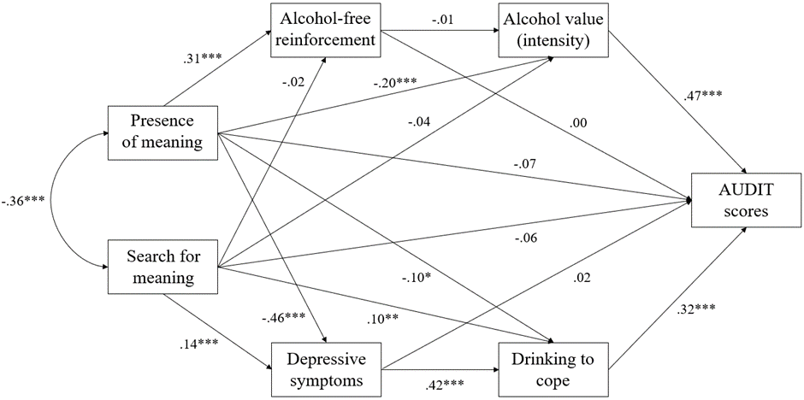
Note. Standardized parameter estimates are presented. Age is included as a covariate, but this is not modelled in the figure. ***p < .001, **p < .01, *p < .05.

Model evaluation (Figure S2.1)

Direct effects
Presence of meaning had a significant positive association with alcohol-free reinforcement (95% CI = .22 to .39), and a significant negative association with alcohol value (95% CI = -.29 to -.11), depressive symptoms (95% CI = -.53 to -.39) and drinking to cope (95% CI = -.20 to -.01). The direct effect of presence of meaning on AUDIT scores was not statistically significant (95% CI = -.16 to .01). Search for meaning had a significant positive association with depressive symptoms (95% CI = .06 to .22) and drinking to cope (95% CI = .02 to .19). However, there were no significant associations between search for meaning and alcohol-free reinforcement (95% CI = -.12 to .07), alcohol value (95% CI = -.13 to .04), and AUDIT scores (95% CI = -.14 to .02).

Depressive symptoms had a significant positive association with drinking to cope (95% CI = .32 to .51) and drinking to cope had a significant positive association with AUDIT scores (95% CI = .22 to .41). Alcohol-free reinforcement had no significant association with alcohol value (95% CI = -.08 to .07), but alcohol value had a significant positive association with AUDIT scores (95% CI = .39 to .54). Neither alcohol-free reinforcement (95% CI = -.06 to .07) or depressive symptoms (95% CI = -.08 to .12) had any significant association with AUDIT scores.

Indirect effects
There was a significant indirect effect of presence of meaning in life on AUDIT scores through lower alcohol value (β = -.09, p < .001, 95% CI = -.14 to -.05) and drinking to cope (β = -.03, p = .02, 95% CI = -.07 to -.00). Although there was no significant indirect effect of depressive symptoms on its own (β = -.01, p = .66, 95% CI = -.06 to .04), there was an indirect effect through two variables: depressive symptoms and drinking to cope (β = -.06, p < .001, 95% CI = -.09 to -.04). There was no significant indirect effect of alcohol-free reinforcement (β = .00, p = .91, 95% CI = -.02 to .02).

There was a significant indirect effect of search for meaning on AUDIT scores through greater drinking to cope (β = .03, p = .01, 95% CI = .01 to .06). Although there was no significant indirect effect of depressive symptoms on its own (β = .00, p = .66, 95% CI = -.01 to .02), there was an indirect effect through two variables: depressive symptoms and drinking to cope (β = .02, p = .002, 95% CI = .01 to .03). There were however no significant indirect effects of alcohol value (β = -.02, p = .32, 95% CI = -.06 to .02) or alcohol-free reinforcement (β = .00, p = .91, 95% CI = .00 to .01).

There was a significant indirect effect of presence of meaning on drinking to cope through lower depressive symptoms (β = -.19, p < .001, 95% CI = -.25 to -.14) and a significant indirect effect of search for meaning on drinking to cope via greater depressive symptoms (β = .06, p = .001, 95% CI = .02 to .10). There was a significant indirect effect of depressive symptoms on AUDIT scores through greater drinking to cope (β = .13, p < .001, 95% CI = .08 to .19). To conclude, the inclusion of age as a covariate does not confound the model fit, the variance accounted for in AUDIT scores, or the relationships reported in Chapter 2.

8. SEM analyses repeated with O_{max} and breakpoint

The structural models presented below were calculated similar to the model reported in Chapter 2, with the difference being the variable that represents demand (see Data preparation in Chapter 2 (p.60) and section 1 of Appendix A (p.328) for justification of why intensity was selected for the core analyses).

First, O_{max}:
Model fit. Modification indices suggested covariances needed to be added (alcohol value and drinking to cope) which led to a notable improvement in model fit. Subsequently, the hypothesized structural model proved to be a good fit of the data (SRMR = .02; CFI = .99, TLI = .94, RMSEA = .06 (90% CI = .02 to .11), Χ²/df = 3.01) and the overall model predicted approximately 33% of variance in AUDIT scores (R² = .33).

Figure S2.2
Direct and indirect relationships between meaning in life, alcohol consumption, alcohol-free reinforcement, alcohol value, depressive symptoms, and drinking to cope

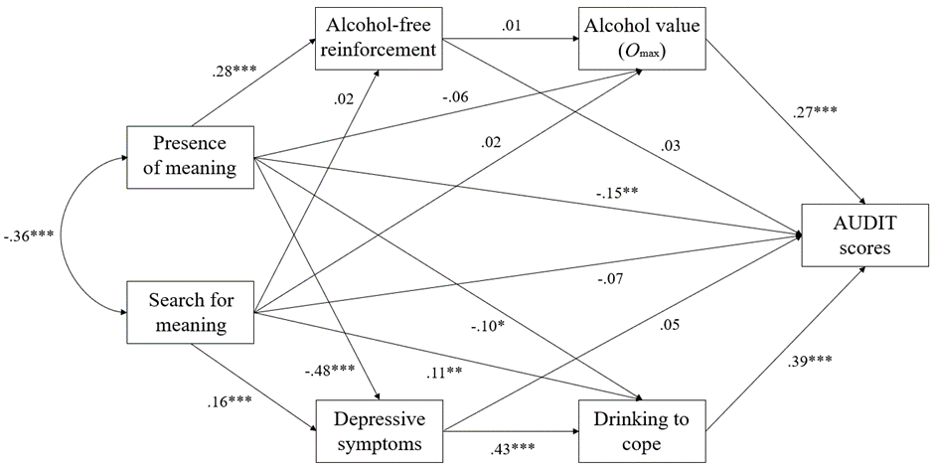

Note. Standardized parameter estimates are presented. ***p < .001, **p < .01, *p < .05.

Model evaluation (Figure S2.2)
Direct effects
There was a statistically significant association between presence of meaning and AUDIT scores (95% CI = -.23 to -.06). Presence of meaning also had a significant positive association with alcohol-free reinforcement (95% CI = .19 to .36), and significant negative associations with depressive symptoms (95% CI = -.55 to -.40) and drinking to cope (95% CI = -.20 to .00). However, there was no significant association between presence of meaning and alcohol value (O_{max}) (95% CI = -.15 to .03). Search for meaning had a significant positive association with depressive symptoms (95% CI = .08 to .24) and drinking to cope (95% CI = .02 to .19). However, there were no significant associations between search for meaning and alcohol-free reinforcement (95% CI = -.07 to .12), alcohol value (O_{max}) (95% CI = -.08 to .11), and AUDIT scores (95% CI = -.15 to .02).

Depressive symptoms had a significant positive association with drinking to cope (95% CI = .33 to .52) and drinking to cope had a significant positive association with AUDIT scores (95% CI = .29 to .48). Alcohol-free reinforcement had no significant association with alcohol value (O_{max}) (95% CI = -.08 to .10), but alcohol value (O_{max}) had a significant positive association with AUDIT scores (95% CI = .19 to .34). Neither alcohol-free reinforcement (95% CI = -.04 to .10) or depression (95% CI = -.06 to .16) had any significant association with AUDIT scores.

Indirect effects
There was a significant indirect effect of presence of meaning in life on AUDIT scores through lower drinking to cope (β = -.04, p = .03, 95% CI = -.08 to .00). Although there was no significant indirect effect of depressive symptoms on its own (β = -.02, p = .32, 95% CI = -.07 to .03), there was an indirect effect through two variables: depressive symptoms and drinking to cope (β = -.08, p < .001, 95% CI = -.11 to -.05). There were however no significant indirect effects of alcohol value (O_{max}) (β = -.02, p = .19, 95% CI = -.04 to .01) or alcohol-free reinforcement (β = .01, p = .40, 95% CI = -.01 to .03).

There was a significant indirect effect of search for meaning on AUDIT scores through greater drinking to cope (β = .04, p = .01, 95% CI = .01 to .08). Although there was no significant indirect effect of depressive symptoms on its own (β = .01, p = .33, 95% CI = -.01 to .03), there was an indirect effect through two variables: depressive symptoms and drinking to cope (β = .03, p < .001, 95% CI = .01 to .05). There were no significant indirect effects of alcohol value (O_{max}) (β = .00, p = .71, 95% CI = -.02 to .03) or alcohol-free reinforcement (β = .00, p = .67, 95% CI = -.00 to .01).

There was a significant indirect effect of presence of meaning on drinking to cope through lower depressive symptoms (β = -.20, p < .001, 95% CI = -.26 to -.15) and a significant indirect effect of search for meaning on drinking to cope via greater depressive symptoms (β = .07, p < .001, 95% CI = .03 to .11). There was a significant indirect effect of depressive symptoms on AUDIT scores through greater drinking to cope (β = .17, p < .001, 95% CI = .11 to .23).

Divergences from primary analyses reported in Chapter 2: Unlike with intensity, when O_{max} is entered into the model, the direct effect of presence of meaning on AUDIT scores is significant, indicative of partial mediation of drinking to cope. Furthermore, there are no significant indirect effects of alcohol value in this model when represented by O_{max}.

Secondly, breakpoint:
Model fit. The hypothesized structural model proved to be a good fit of the data (SRMR = .02; CFI = .99, TLI = .95, RMSEA = .05 (90% CI = .01 to .10); Χ²/df = 2.56) and the overall model predicted approximately 26% of variance in AUDIT scores (R² = .26).

Figure S2.3
Direct and indirect relationships between meaning in life, alcohol consumption, alcohol-free reinforcement, alcohol value, depressive symptoms, and drinking to cope

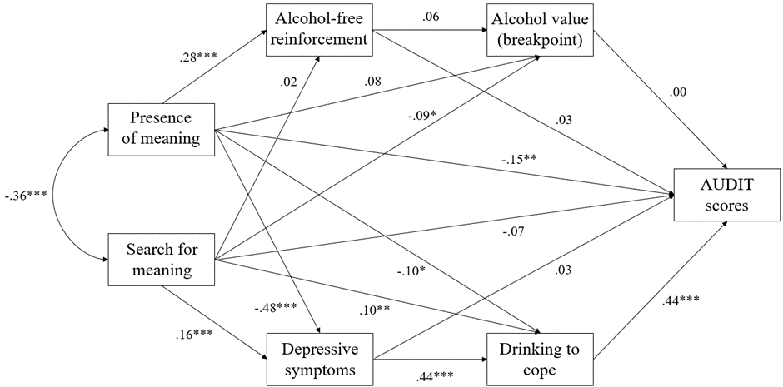

Note. Standardized parameter estimates are presented. ***p < .001, **p < .01, *p < .05.

Model evaluation (Figure S2.3)
Direct effects
There was a statistically significant association between presence of meaning and AUDIT scores (95% CI = -.25 to -.06). Presence of meaning also had a significant positive association with alcohol-free reinforcement (95% CI = .19 to .36), and significant negative associations with depressive symptoms (95% CI = -.54 to -.40) and drinking to cope (95% CI = -.19 to -.00). However, there was no significant association between presence of meaning and alcohol value (breakpoint) (95% CI = -.02 to .17). Search for meaning had significant positive associations with depressive symptoms (95% CI = .09 to .24) and drinking to cope (95% CI = .02 to .19) and a marginally significant negative association with alcohol value (breakpoint) (95% CI = -.19 to .01). However, there were no significant associations between search for meaning and alcohol-free reinforcement (95% CI = -.07 to .12) and AUDIT scores (95% CI = -.15 to .02).

Depressive symptoms had a significant positive association with drinking to cope (95% CI = .34 to .53) and drinking to cope had a significant positive association with AUDIT scores (95% CI = .35 to .53). Alcohol-free reinforcement had no significant association with alcohol value (breakpoint) (95% CI = -.02 to .16). Furthermore, neither alcohol value (breakpoint) (95% CI = -.07 to .07), alcohol-free reinforcement (95% CI = -.04 to .11) or depression (95% CI = -.08 to .15) had any significant association with AUDIT scores.

Indirect effects
There was a significant indirect effect of presence of meaning in life on AUDIT scores through lower drinking to cope (β = -.04, p = .03, 95% CI = -.09 to -.00). Although there was no significant indirect effect of depressive symptoms on its own (β = -.01, p = .51, 95% CI = -.07 to .04), there was an indirect effect through two variables: depressive symptoms and drinking to cope (β = -.09, p < .001, 95% CI = -.13 to -.06). There were no significant indirect effects of alcohol value (breakpoint) (β = .00, p = .99, 95% CI = -.01 to .01) or alcohol-free reinforcement (β = .01, p = .38, 95% CI = -.01 to .03)

There was a significant indirect effect of search for meaning on AUDIT scores through greater drinking to cope (β = .05, p = .01, 95% CI = .01 to .09). Although there was no significant indirect effect of depressive symptoms on its own (β = .00, p = .52, 95% CI = -.01 to .03), there was an indirect effect through two variables: depressive symptoms and drinking to cope (β = .03, p < .001, 95% CI = .01 to .05). There were no significant indirect effects of alcohol value (breakpoint) (β = .00, p = .99, 95% CI = -.01 to .01) or alcohol-free reinforcement (β = .00, p = .67, 95% CI = -.00 to .01).

There was a significant indirect effect of presence of meaning on drinking to cope through lower depressive symptoms (β = -.21, p < .001, 95% CI = -.27 to -.15) and a significant indirect effect of search for meaning on drinking to cope via greater depressive symptoms (β = .07, p < .001, 95% CI = .03 to .11). There was a significant indirect effect of depressive symptoms on AUDIT scores through greater drinking to cope (β = .19, p < .001, 95% CI = .13 to .26).

Divergences from primary analyses reported in Chapter 2: Unlike intensity (but similar to O_{max}), when breakpoint is entered into the model, the direct effect of presence of meaning on AUDIT scores is significant, indicative of partial mediation of drinking to cope. Furthermore, there are no significant indirect effects of alcohol value in this model as represented by breakpoint. Furthermore, unique to breakpoint, alcohol value is not associated with AUDIT scores (this is the only model where this is the case, suggesting breakpoint may not be as important of a risk factor for alcohol use and related problems relative to other demand indices).

9. Exploratory correlations
We conducted exploratory correlational analyses to further investigate the relationships between variables measured in this study. This is because our pre-registered analysis focused on directional relationships stemming from meaning in life subscales (presence and search) to other observed variables. However, there is also theoretical and empirical work which raises interesting questions regarding independent relationships between the other observed variables. For example, experimental research has shown that alcohol value is elevated by negative mood states, and that this is augmented in people who report coping motives (see Hogarth, 2020 for a review). Therefore, perhaps of interest are the relationships between alcohol value, depression, and drinking to cope, particularly given the self-reported nature of the data in this study. Furthermore, anhedonia (i.e., loss of or reduced ability to experience reinforcement derived from activities or events that would typically be enjoyed) is common in people with depression (De Fruyt et al., 2020), and therefore the relationship between alcohol-free reinforcement and depression may be of interest. An alternative option was to include these additional relationships within the SEM; however, this deviates from our pre-registration and makes it challenging to maintain model complexity and fit, and so for this reason we instead present these exploratory correlations here.

Table S2.3
Correlation matrix for the variables explored within the study
 | 1. | 2. | 3. | 4. | 5. | 6. | 7.
1. AUDIT
2. Alcohol-free reinforcement | -.07
3. Presence of meaning | -.29*** | .29***
4. Search for meaning | .14** | -.05 | -.36***
5. Depression | .27*** | -.24*** | -.52*** | .34***
6. Coping motives | .49*** | -.12** | -.34*** | .31*** | .47***
7. Alcohol value (intensity) | .61*** | -.05 | -.27*** | .14** | .25*** | .38***
Note. ***p < .001, **p < .01, *p < .05.

Although Chapter 2 explored two potential pathways to alcohol consumption guided by two theoretical viewpoints which differ in their relative point of emphasis (i.e., behavioural economic and negative reinforcement accounts), a reconciliation of the highlighted mechanisms (alcohol value and drinking to cope) within the associations between meaning in life and alcohol consumption aligns with a goal-directed negative reinforcement account of addiction (Hogarth, 2020). Indeed, there are significant positive correlations between depression, drinking to cope and alcohol value. Future research may explore this further.

Appendix B
Supplementary materials for Chapter 3 “Methodological issues with value-based decision-making (VBDM) tasks: the effect of trial wording on evidence accumulation (EA) outputs from the EZ drift-diffusion model”
Contents:
- Methods: A comparison of methods across different studies exploring VBDM (Table S3.1).
- Methods: Embedded attention checks.
- Methods: Food images used in this study and their valence ratings (Table S3.2).
- Methods: Exact wording used in the task.
- Analysis: Post-hoc tests for thoroughness.
- Analysis: Order of the first block of trials: does this matter?
- Analysis: Exploratory correlations between self-reported hunger and EA rates.
- Analysis: Core analyses repeated on response thresholds (Figures S3.1 and S3.2).
- Analysis: Core analyses repeated on non-decision time (Figures S3.4 and S3.4).
- Discussion: Additional analyses on response thresholds and non-decision time.
- Supplementary: Core analyses repeated on parameters derived from the fast-dm-30 (Figures S3.5 and S3.6).
- Supplementary: Reaction time (RT) and accuracy summary statistics (Table S3.3).

1. A comparison of methods across different studies exploring VBDM (Table S3.1).

Table S3.1
A comparison of methods across different studies including whether precise trial wording is included within the manuscript
Study | Rating phase wording | Trial wording | Other experimental details
Milosavljevic et al. (2010) | Participants were asked to rate how much they would like to eat each food item at the end of the experiment (scale -2 to 2). | Trial wording not explicitly clear.  “Subjects chose the best item (as determined by their own liking-ratings)”. | Subjects attend the lab after not eating for >3 hours.  At the end subjects were required to eat whatever food they chose from one randomly selected trial.  8 participants took part.
Krajbich et al. (2010) | Participants were asked: “How much would you like to eat this at the end of the experiment?” (scale -10 to 10). | Trial wording not explicitly clear.  “In the choice phase, subjects made their choices using the keyboard.”  After emailing, authors responded “we typically tell them ‘Choose the food that you would prefer to eat at the end of the study’”. | Subjects attend the lab after not eating for >3 hours.  After the experiment they were required to stay in the room and consume the food item that they chose in a randomly selected trial.  39 participants took part.
Tusche and Hutcherson (2018) | Participants were asked to rate food images in relation to perceived “tastiness” and “healthiness” on 5-point scales (very untasty to very tasty; very unhealthy to very healthy).  This differs from the other studies, because it does not explicitly ask about desire for consumption in the rating phase. | Trial wording not explicitly clear.  “Subjects chose between one of 90 food items presented on-screen (4s) and a default food. Subjects responded by pressing one of four buttons corresponding to ‘strong yes’, ‘yes’, ‘no’, ‘strong no’ (displayed at the bottom of the screen), using a button box placed in their right hand.”  After emailing, authors responded with a document which hints at consumption, but still does not contain the explicit wording. In this document, participant instructions said in the choice task “you are always just choosing whether you want to eat the proposal food or not”.  A paper they cite (Hare et al., 2011) when discussing their task says, “to indicate whether they wanted to eat that food at the end of the experiment.” | Subjects attend the lab after not eating for >4 hours.  Participants were told: “At the end of the experiment, you will be required to eat at least a few bites of the food that you chose, so think about each choice carefully”.  37 participants took part (food task).
Polanía et al. (2014) | Participants indicated “how much they wanted to eat the presented food snack at the end of the experiment” with a scale from −10 to 10 in steps of 1. | Trial wording not explicitly clear.  “In the VDM task, subjects indicated which item (upper or lower) they would prefer to receive at the end of the experiment.” | Subjects attend the lab after not eating for >3 hours.  After the experiment, subjects were required to stay in the room with the experimenter while eating the food item that they chose in a randomly selected trial.  23 participants took part.
Krajbich et al. (2012)  This is an example of a VBDM task that is not centred on consumption. | Subjects first reveal how much they are willing to pay for each of the 50 consumer good products, using a Becker–Degroot–Marshak auction. | Trial wording not explicitly clear.  “On every trial subjects decided whether to buy the shown item at the stated price, or to keep their entire $50. They indicated their choice to purchase (left arrow) or not purchase (right arrow).” | At the beginning subjects were given $50 that they could use.  At the end of the experiment one trial was randomly chosen and the subject is paid and/or the chosen product shipped.  30 participants took part.

One viewpoint may be that in VBDM tasks (such as those where participants choose between two food images), the task instructions are not critical because participants are told that they will receive a food to eat at the end of the study based on one of their choices. In this instance, it could be argued that trial wording does not matter: “choose the best item” mirrors “which would you rather consume”. However, we posit that there are specific contexts whereby it is important to explicitly consider trial wording. First is the nature of addiction and recovery. It is particularly challenging to make decisions consequential when the participants are people in recovery because there is never an instance where we would ask participants who are in recovery to consume alcohol (or any substance) if they are actively trying to abstain. Therefore, because there is no actual outcome of the task, it could be argued that trial wording is indeed important in this context. Furthermore, an additional challenge to making decisions consequential is the COVID-19 pandemic because this has meant that participants are unable to attend the lab and receive something to consume at the end of the experiment. We believe it is important to explore how sensitive VBDM tasks are to minor alterations in trial wording explicitly because of the instances described above where it is not possible to provide actual outcomes.

2. Embedded attention checks.
There were 4 embedded attention checks in the VBDM task, and our pre-registered criterion was that data from participants who pass at least 75% (3 out of 4) of these checks would be retained for analysis. Each of the attention checks required participants to use their keyboard to type a response. Specifically, participants were presented with the following text “Please read the statement and question on the next page carefully and press the space bar once you have typed your response to the question”. On the next slide the text “Type the word ‘blue’ in response to the question below, and then press the space bar” was displayed. Underneath this, the text “Question: what colour have you been asked to type in?” was presented and participants used their keyboard to type their response. This is one example, however the exact wording (i.e., colour) used within the attention checks varied between: blue, green, red, and yellow.

3. Food images used in this study and their valence ratings.
Standardised images were taken from the CROCUFID database available from the OSF repository at https://osf.io/5jtqx. All food depicted in the images appeared on a white plate. Higher valence scores reflect higher valence.

Table S3.2
Image filenames, content, and valence ratings of the CROCUFID images
Image filename | Image content | Valence rating (range 0 – 100)
0001.jpg | Oranges | 73.07
0002.jpg | Apples | 68.82
0009.jpg | Greek salad | 62.44
0015.jpg | Kit Kat | 69.25
0021.jpg | Stroopwaffles | 59.19
0025.jpg | Blueberries | 66.67
0031.jpg | Crisps | 61.44
0038.jpg | Raspberries | 68.16
0048.jpg | Pistachio nuts | 57.54
0063.jpg | Raw mushrooms | 44.07
0066.jpg | Bananas | 71.06
0080.jpg | Green olives | 45.21
0102.jpg | Muesli cereal | 55.17
0128.jpg | M&M’s chocolate | 67.20
0132.jpg | Mints | 28.77
0140.jpg | Cheeses | 63.23
0146.jpg | Strawberries | 84.11
0158.jpg | Wholemeal biscuits | 60.65
0169.jpg | Raw chicken | 36.97
0190.jpg | Moulded banana | 4.75
0289.jpg | Chips | 68.16
0292.jpg | Cheeseburger | 62.13
0293.jpg | Chicken nuggets | 48.62
0301.jpg | Croissants | 71.10
0312.jpg | Ice-creams | 75.96
0315.jpg | Hotdog | 51.93
0328.jpg | Chocolate chip cookies | 76.31
0336.jpg | Popcorn | 65.26
0340.jpg | Moulded potatoes | 12.95
0357.jpg | Pizza | 75.80
Note. Images included both sweet and savoury images so that there was a variation for participants to view and make value ratings about. We acknowledge that preferences across people will be different. Importantly, we can accommodate for these preferences because our task is personalised for every participant to reflect their own individual judgements. In the process of designing the study, we piloted the selection of images with n = 6 (the image-rating phase of the task), to ensure that there was sufficient variability within the images for people to place them into the different value categories.

4. Methods: Exact wording used in the task.
Image-rating phase:
- “In this part of the task you will be shown 30 images of food. We would like you to use the computer mouse to DRAG and DROP each of the images into 1 of 4 boxes, labelled: ‘A lot’, ‘A little bit’, ‘Not really, and ‘Not at all’, depending on how much you would like to consume the food depicted in the image right now”
- “Once you have placed an image within a box, this is not fixed. You can reset images by clicking on them, and then replace them in another box. Each box can hold up to 10 images.
- Please take your time and consider your rating of each image separately. Interpret the food in the images how they are, so if they have mould on them, assume they are mouldy food. You can only proceed once you have rated all 30 images, and once each box contains at least 5 images in total. Please press the space bar when you are ready”.

Guidance before each block of trials:
“This is the start of a block of trials where we will ask you to think about the images in a specific way”.
- In the recall block: “In this block we would like you to think back to when you rated the images and select the image that you rated you would rather consume, press the space bar to begin”.
- In the like block: “In this block you will be asked to choose which image you like the most, press the space bar to begin”.
- In the consume block: “In this block you will be asked to choose which image you would rather consume right now, press the space bar to begin”.

5. Analysis: Post-hoc tests for thoroughness.
Further investigation of the non-significant main effect of trial wording (applying the Holm-Bonferroni correction to p-values for multiple comparison) revealed that EA rates between the three blocks of trial wording did not significantly differ (all ps > .11). More specifically, EA rates in the consume wording block (M = 1.95, SD = .92) were not significantly different to in the recall wording block (M = 1.96, SD = .82; p = .89). Furthermore, EA rates in the like wording block (M = 1.80, SD = .90) were not significantly different to those in the consume wording block (p = .11). Finally, EA rates in the like wording block were not significantly different to in the recall wording block (p = .11).

Further investigation of the non-significant interaction between trial wording and trial difficulty revealed that on hard trials there were no significant differences in EA across the three blocks of trial wording (all ps > .43). Specifically, EA rates on the like block (M = 1.09, SD = .48) were not significantly different to in the recall block (M = 1.27, SD = .47; p = .43) or consume block (M = 1.21, SD = .53, p = 1.00). Furthermore, there were no significant differences between EA rates on the consume block compared to in the recall block (p = 1.00). On medium trials, there were no significant differences in EA rates on the consume block (M = 2.10, SD = .80) compared to in the recall block (M = 2.03, SD = .64; p = 1.00). Furthermore, EA rates on the recall block were not significantly different than on the like block (M = 1.80, SD = .72; p = .13). However, EA rates on the consume block were significantly higher than on the like block (p = .02). Finally, on easy trials, there were no significant differences in EA rates across the three blocks of wording (all ps = 1.00). Specifically, EA rates on the consume block (M = 2.52, SD = .87) were not significantly different to in the recall block (M = 2.57, SD = .76; p = 1.00) or the like block (M = 2.49, SD = .84; p = 1.00). Furthermore, EA rates on the recall block were not significantly different than on the like block (p = 1.00). These findings demonstrate that, in line with the overall non-significant interaction effect, there were no differences in EA rates across trial wording and difficulty trials (apart from on medium trials only where EA rates on the consume block were significantly higher than on the like block). See Figure 3.2 in Chapter 3 (p.85) for EA rates split by trial wording and trial difficulty.

6. Order of the first block of trials: does this matter?
We were also interested in exploring whether the order that the blocks of trials were presented to participants in the VBDM task may have altered EA rates. For example, the three blocks of trial wording were presented in a random order across participants, and it might be that completing the recall trial wording (“which did you rate higher?”) as the first block lead to increased EA rates in this condition compared to when the consume (“which would you rather consume”) and like (“which do you like more”) wording were presented first. To explore this further, we conducted one-way ANOVAs for EA rates in each of the trial wording conditions with trial block order (3: consume first, recall first, like first) as the between-subject factor.

EA rates in the recall block
There was no significant main effect of trial block order on EA rates from the recall block, F(2, 55) = 1.47, p = .24, η_{p}² = .05. Post-hoc tests revealed that there was no significant difference in EA rates when the recall block was first (M = 1.87, SD = .53) compared to when the consume block was first (M = 2.13, SD = .51; p = .37). Furthermore, there was no significant difference in EA rates when the like block was first (M = 1.87, SD = .47) compared to when the consume block was first (p = .37). Finally, there was no significant difference in EA rates when the recall block was first compared to when the like block was first (p = .96).

EA rates in the consume block
There was no significant main effect of trial block order on EA rates from the consume block, F(2, 56) = .66, p = .52, η_{p}² = .02. Post-hoc tests revealed that there was no significant difference in EA rates when the recall block was first (M = 1.82, SD = .84) compared to when the consume block was first (M = 1.98, SD = .54; p = .97). Furthermore, there was no significant difference in EA rates when the like block was first (M = 2.05, SD = .54) compared to when the consume block was first (p = .97). Finally, there was no significant difference in EA rates when the recall block was first compared to when the like block was first (p = .79).

EA rates in the like block
There was no significant main effect of trial block order on EA rates from the like block, F(2, 56) = 1.79, p = .18, η_{p}² = .06. Post-hoc tests revealed that there was no significant difference in EA rates when the recall block was first (M = 1.63, SD = .67) compared to when the consume block was first (M = 1.98, SD = .49; p = .21). Furthermore, there was no significant difference in EA rates when the like block was first (M = 1.84, SD = .52) compared to when the consume block was first (p = .46). Finally, there was no significant difference in EA rates when the recall block was first compared to when the like block was first (p = .46).

To supplement these analyses, we conducted a mixed ANOVA with a between-subject factor of overall block order (6: consume, recall, like; consume, like, recall; recall, consume, like; recall, like, consume; like, consume, recall; like, recall, consume) and within-subject factors of trial wording (3: like; consume; recall) and trial difficulty (3: easy, medium, hard). Crucially, there was no significant three-way interaction between the order participants completed the blocks of trials, trial wording, and trial difficulty on EA rates (F(16.77, 177.74) = .41, p = .98, η_{p}² = .04). This analysis demonstrates that EA rates did not vary as a function of the order by which participants completed the blocks of trials.

7. Exploratory correlations between self-reported hunger and EA rates.
Finally, we explored whether there are any significant correlations between self-reported hunger at the time of completing the task and food EA rates. Self-reported hunger was not correlated with any EA rates (all ps > .19). More specifically, there were no significant correlations between hunger and EA rates in the consume block (r(57) = .05, p = .70), recall block (r(57) = -.17, p = .19), like block (r(57) = -.04, p = .78) or overall EA rates averaged across trial wording blocks (r(57) = -.05, p = .69).

To supplement the analyses reported above, we conducted an ANOVA with trial wording (3: “like”, “consume”, “recall”) and a median split of hunger level (2: low, high) predicting EA rates. This analysis shows that there was no main effect of hunger level (F(1, 57) = .10, p = .75, η_{p}² = .00), trial wording (F(1.83, 104.43) = 2.54, p = .09, η_{p}² = .04), or interaction between hunger level and trial wording (F(1.83, 104.43) = 2.12, p = .13, η_{p}² = .04) on EA rates. This analysis demonstrates that subjective hunger did not modify EA rates or their sensitivity to trial wording.

8. Core analyses repeated on response thresholds.
We did not make any pre-registered hypotheses about response thresholds, however here we explore whether response thresholds for food images differ across trial wording and trial difficulty level. Response thresholds were analysed using a two-way repeated measures ANOVA with trial wording (3: “consume”; “like”; “recall”) and trial difficulty (3: easy; medium, hard) as within-subject variables. As in Chapter 3, if data violated assumptions of sphericity, F values were derived using a correction (Huynh-Feldt correction if the Greenhouse-Geisser epsilon (ε) ≥ 0.75, otherwise if ε < 0.75 the Greenhouse-Geisser correction was used).

There was a significant main effect of trial wording, F(2, 116) = 5.97, p < .01, η_{p}² = .09, with the Bayes factor indicating strong evidence in favour of the experimental hypothesis (BF₁₀ = 28.53), and of trial difficulty, F(1.74, 100.65) = 11.41, p < .001, η_{p}² = .16, with the Bayes factor indicating extreme evidence in favour of the experimental hypothesis (BF₁₀ > 100). Furthermore, there was a significant interaction between trial difficulty level and trial wording, F(4, 232) = 2.99, p = .02, η_{p}² = .05, however the Bayes factor did not support the experimental hypothesis (BF₁₀ = .21).

Main effect: trial wording
Response thresholds were higher in the recall block (M = 1.66, SD = .45) compared to in the consume block (M = 1.57, SD = .45; p = .04) and the like block (M = 1.53, SD = .44; p < .01). There were no differences in response thresholds between the consume block and the like block (p = .35). These findings suggest that participants were more cautious in their decision-making when they were instructed to recall their previous value rating compared to when they were making subjective like or consumption judgements, but that there were no differences between subjective consumption and liking judgements.

Main effect: difficulty
Response thresholds were higher in the medium block of trials (M = 1.69, SD = .44) compared to in the easy trials (M = 1.52, SD = .48; p < .001) and in the hard trials (M = 1.55, SD = .39; p < .001). There were no significant differences in response thresholds in the easy trials compared to the hard trials (p = .52). This demonstrates that participants cautiousness in decision-making is increased on medium trials (but that there are no differences between easy and hard choices).

Interaction effect: trial wording and difficulty (see Figure S3.1)
On hard trials, response thresholds on the like block (M = 1.42, SD = .35) were significantly lower compared to in the recall block (M = 1.67, SD = .40; p < .001). There were no significant differences between response thresholds on the consume block (M = 1.55, SD = .39) compared to the recall block (p = .72) and like block (p = .63). On medium trials, there were no significant differences in response thresholds across the three blocks of wording (all ps > .19). Specifically, response thresholds on the consume block (M = 1.63, SD = .42) were not significantly different to in the recall block (M = 1.79, SD = .42; p = .19) or the like block (M = 1.65, SD = .47; p = 1.00). Furthermore, response thresholds on the recall block were not significantly different than on the like block (p = .45). Finally, on easy trials, there were also no significant differences in response thresholds across the three blocks of wording (all ps = 1.00). Specifically, response thresholds on the consume block (M = 1.52, SD = .52) were not significantly different to in the recall block (M = 1.54, SD = .48; p = 1.00) or the like block (M = 1.51, SD = .46; p = 1.00). Furthermore, response thresholds on the recall block were not significantly different than on the like block (p = 1.00). These findings demonstrate that on hard trials, response thresholds were higher when participants had to recall their previous value rating versus when they had to make a subjective liking rating.

Figure S3.1
Mean response thresholds split by trial difficulty and trial wording
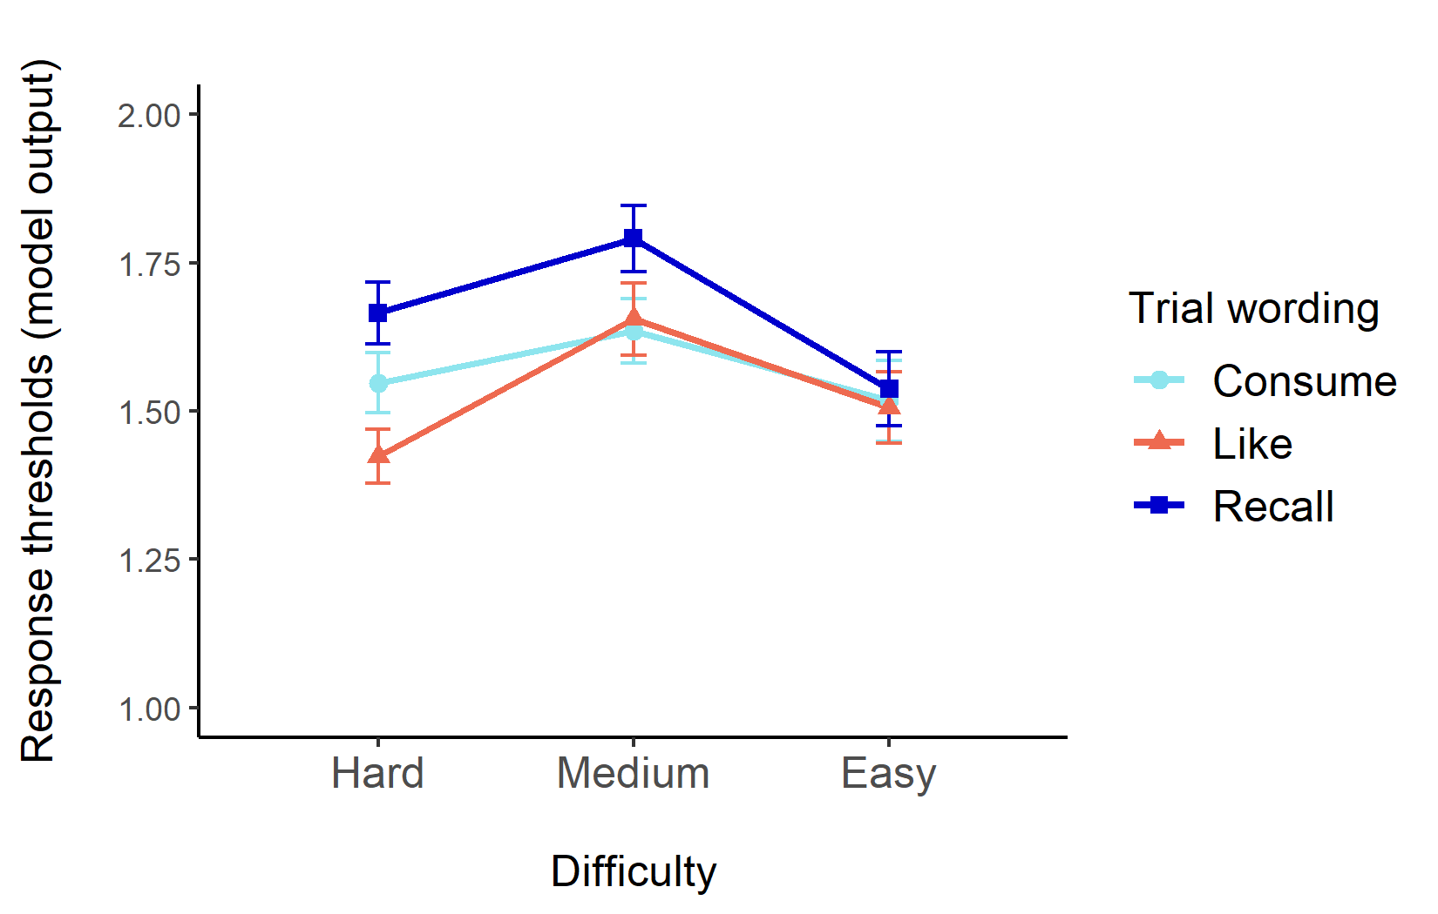
Note. Light blue (circle) represents response thresholds with the wording “which would you rather consume”, orange (triangle) represents response thresholds with the wording “which do you like more”, and dark blue (square) represents response thresholds with the wording “which did you rate higher”. Error bars represent the standard error of the mean (SE).

Correlational analyses
As shown in Figure S3.2, correlational analyses revealed highly significant positive correlations between response thresholds in all three blocks (all ps < .001; consume wording and recall wording r(57) = .68, p < .001; recall wording and like wording r(57) = .61, p < .001; consume wording and like wording r(57) = .59, p < .001).

Figure S3.2
Scatterplots to show correlations between response thresholds during the three blocks of trials
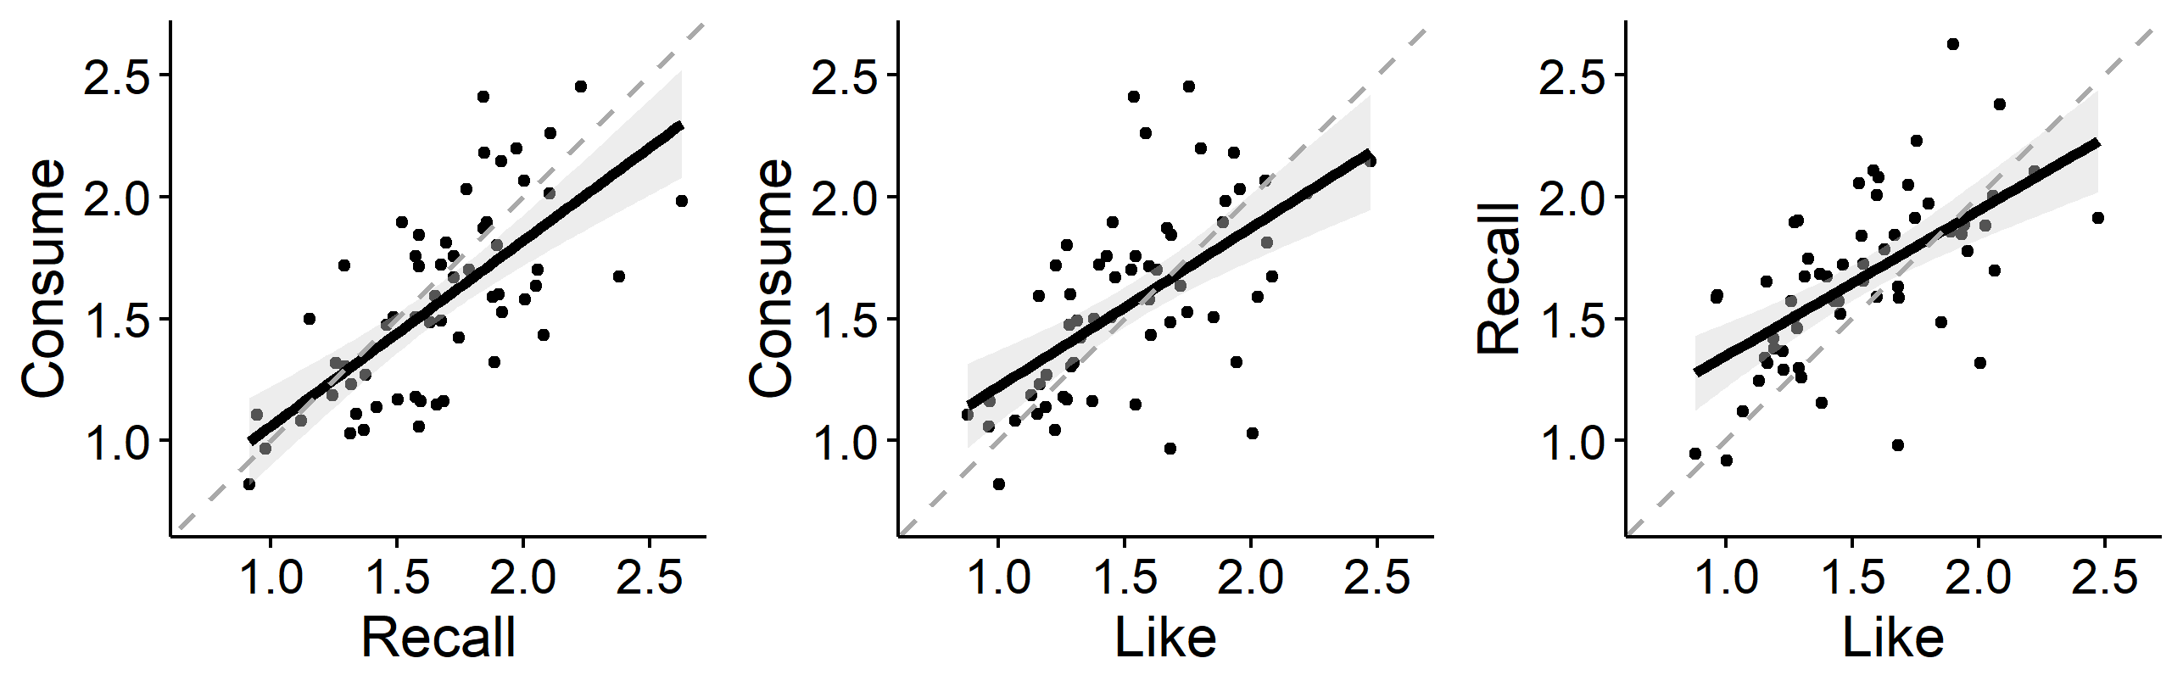
Note. On the left is the correlation between response thresholds during the block of trials with “which would you rather consume” and the block of trials with “which did you rate higher”. In the middle is the correlation between response thresholds during the block of trials with “which would you rather consume” and the block of trials with “which do you like more”. On the right is the correlation between response thresholds during the block of trials with “which did you rate higher” and the block of trials with “which do you like more”. The grey dashed line represents the line of equality. Shaded areas represent the 95% confidence interval.

9. Analyses repeated on non-decision time.
We did not make any pre-registered hypotheses about non-decision time, however here we explore whether non-decision times for food images differ across trial wording and trial difficulty level. Non-decision times were analysed using a two-way repeated measures ANOVA with trial wording (3: “consume”; “like”; “recall”) and trial difficulty (3: easy; medium, hard) as within-subject variables.

There was a significant main effect of trial difficulty F(1.72, 99.98) = 11.30, p < .001, η_{p}² = .16, with the Bayes factor indicating extreme evidence in favour of the experimental hypothesis (BF₁₀ > 100). There was however no significant main effect of trial wording, F(2, 116) = 1.04, p = .36, η_{p}² = .02, with the Bayes factor indicating moderate evidence in favour of the null hypothesis (BF₁₀ = .08). Furthermore, there was no significant interaction between trial difficulty level and trial wording, F(4, 232) = 1.57, p = .18, η_{p}² = .03, with the Bayes factor indicating moderate evidence in favour of the null hypothesis (BF₁₀ = .05).

Main effect: trial wording
Further investigation of the non-significant main effect of trial wording revealed that non-decision time between the three blocks of trial wording did not significantly differ (all ps > .57). More specifically, there were no significant differences in non-decision times in the recall block (M = .46, SD = .15) compared to in the consume block (M = .47, SD = .14; p = .57) and the like block (M = .47, SD = .14; p = .57). There were also no differences in non-decision times between the consume block and the like block (p = .88). These findings suggest that participants non-decision time did not alter as a result of trial wording condition.

Main effect: difficulty
Non-decision times were higher in the difficult block of trials (M = .50, SD = .13) compared to in the easy trials (M = .46, SD = .15; p < .001) and in the medium trials (M = .45, SD = .14; p < .001). There were no significant differences in non-decision times in the easy trials compared to the medium trials (p = .56). This demonstrates that participants non-decision time is increased on difficult trials but that there are no differences between easy and medium choices.

Interaction effect: trial wording and difficulty (see Figure S3.3)
Further investigation of the non-significant interaction between trial wording and trial difficulty revealed that on hard trials there were no significant differences in non-decision time across the three blocks of trial wording (all ps = 1.00). Specifically, non-decision time on the like block (M = .52, SD = .12) were not significantly different to in the recall block (M =.48, SD = .12; p = 1.00) or consume block (M = .50, SD = .14, p = 1.00). Furthermore, there were no significant differences between non-decision time on the consume block compared to in the recall block (p = 1.00). On medium trials, there were no significant differences in non-decision time across the three blocks of wording (all ps = 1.00). Specifically, non-decision time on the consume block (M = .47, SD = .12) were not significantly different to in the recall block (M = .44, SD = .15; p = 1.00) or the like block (M = .44, SD = .15; p = 1.00). Furthermore, non-decision time on the recall block were not significantly different than on the like block (p = 1.00). Finally, on easy trials, there were no significant differences in non-decision time across the three blocks of wording (all ps = 1.00). Specifically, non-decision time on the consume block (M = .45, SD = .16) were not significantly different to in the recall block (M = .46, SD = .16; p = 1.00) or the like block (M = .46, SD = .14; p = 1.00). Furthermore, non-decision time on the recall block were not significantly different than on the like block (p = 1.00). These findings demonstrate that across all difficulty levels, there were no significant differences in non-decision times between trial wording conditions.

Figure S3.3
Mean non-decision time split by trial difficulty and trial wording
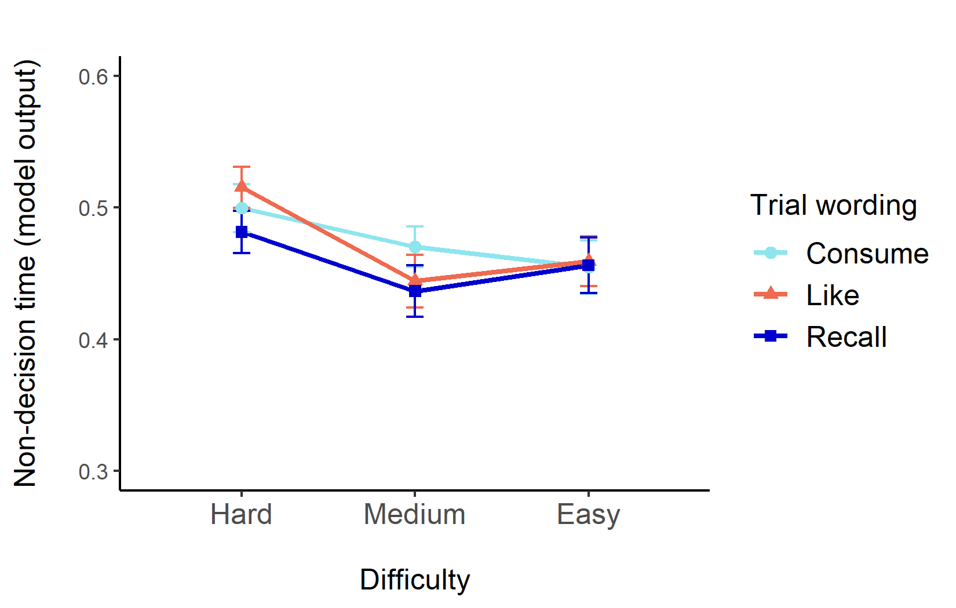
Note. Light blue (circle) represents non-decision time with the wording “which would you rather consume”, orange (triangle) represents non-decision time with the wording “which do you like more”, and dark blue (square) represents non-decision time with the wording “which did you rate higher”. Error bars represent the standard error of the mean (SE).

Correlational analyses
As shown in Figure S3.4, correlational analyses revealed highly significant positive correlations between non-decision time in all three blocks (all ps < .001; consume wording and recall wording r(57) = .67, p < .001; recall wording and like wording r(57) = .63, p < .001; consume wording and like wording r(57) = .72, p < .001).

Figure S3.4
Scatterplots to show correlations between non-decision time during the three blocks of trials
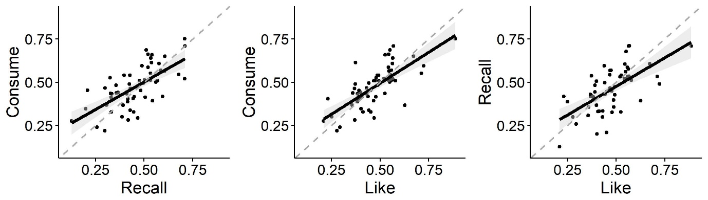
Note. On the left is the correlation between non-decision time during the block of trials with “which would you rather consume” and the block of trials with “which did you rate higher”. In the middle is the correlation between non-decision time during the block of trials with “which would you rather consume” and the block of trials with “which do you like more”. On the right is the correlation between non-decision time during the block of trials with “which did you rate higher” and the block of trials with “which do you like more”. The grey dashed line represents the line of equality. Shaded areas represent the 95% confidence interval.

10. Discussion: Additional analyses on response thresholds and non-decision time.
Of primary interest in the manuscript were EA rates because these are hypothesised to represent value (Field et al., 2020) and the key theoretical question being explored in Chapter 3 was whether variations of preference wording capture some common construct of value. However, we acknowledge that the EZ-DDM yields other parameters, namely response thresholds which are often interpreted to be a measure of decision caution, and non-decision time which reflects stimulus encoding and motor execution processes. Above we conducted and reported the results of the main analyses repeated on each of the additional parameters (response thresholds and non-decision time) and below we discuss these findings in more detail.

The findings from the analyses on response thresholds demonstrate that there was a significant main effect of trial wording, with response thresholds in the “recall” condition being significantly higher than in the “consume” and “like” conditions. This is perhaps unsurprising given that in the recall condition participants were explicitly instructed to try and remember their previous value ratings, which might in turn correspond to participants being more cautious. There was also a main effect of difficulty, with response thresholds in medium difficulty trials being significantly higher than in the easy and hard trials. Although response thresholds are not anticipated to change across difficulty levels, we note that similar findings have been observed in other studies (e.g., Pirrone et al., 2017; Dix & Li, 2020). Finally, there was a significant interaction between trial wording and trial difficulty. Exploring this interaction further revealed that on hard trials only, response thresholds in the “recall” condition were significantly higher compared to response thresholds in the “like” condition (which similarly may correspond to participants actively trying to remember their previous value ratings), but there were no significant differences in response thresholds across trial wording conditions on the medium or easy trials.

It may be that there is an important distinction between the different wording blocks, with “recall” being primarily a memory task, while “consume” and “like” are subjective valuation tasks. However, we emphasise that even if the “recall” block places more demands on participants’ memory than the other blocks, the distinction between this block and other blocks is perhaps not so large, partially because participants are actively trying to remember their own value ratings (rather than some other general category that requires a memory component). An implication of these findings is that if researchers are exploring response thresholds in future research, they should acknowledge that the “recall” wording may inadvertently affect participants decision caution and particularly on trials that are difficult.

The findings from the analyses comprising non-decision time demonstrate that there was a significant main effect of difficulty, with non-decision time increased on hard trials compared to medium and easy trials. Higher non-decision time values alongside increasing trial difficulty level have also been observed in other research that used the DDM (e.g., Dix & Li, 2020; Berberyan et al., 2021). There was no main effect of trial wording or interaction between trial wording and trial difficulty. This demonstrates there were no differences in non-decision time across trial wording and trial difficulty level.

11. Supplementary: Core analyses repeated on parameters derived from the fast-dm-30.
Here we repeat the core analyses with the fast-dm given that it is not possible to fix parameters across different conditions when using the EZ-DDM. The maximum likelihood procedure as implemented in fast-dm-30 (Voss et al., 2015) was used to estimate decision parameters with precision set at 5. The drift rate parameter was left free to vary in the fitting procedure, while the response threshold and non-decision time parameters were fixed. More specifically, response thresholds were fixed across trial difficulty level, while non-decision times were fixed across trial difficulty level and trial wording condition. As responses are coded as correct and incorrect, starting point was fixed at 0.5. All other parameters in the model were fixed to 0 (Voss et al., 2015).

Core analyses
EA rates were analysed using a two-way repeated measures ANOVA with trial wording (3: “consume”; “like”; “recall”) and trial difficulty (3: easy; medium, hard) as within-subject variables. There were significant main effects of difficulty, (F(2, 116) = 507.15, p < .001, η_{p}² = .90, with the Bayes factor indicating extreme evidence in favour of the experimental hypothesis (BF₁₀ > 100), and of trial wording, F(1.82, 105.39) = 6.94, p < .01, η_{p}² = .11, with the Bayes factor indicating moderate evidence in favour of the experimental hypothesis (BF₁₀ = 4.18). There was no significant interaction between trial wording and trial difficulty, F(3.04, 176.53) = 1.15, p = .33, η_{p}² = .02, with the Bayes factor indicating strong evidence in favour of the null hypothesis (BF₁₀ = .02).

Figure S3.5
Mean evidence accumulation (EA) rates split by trial difficulty and trial wording
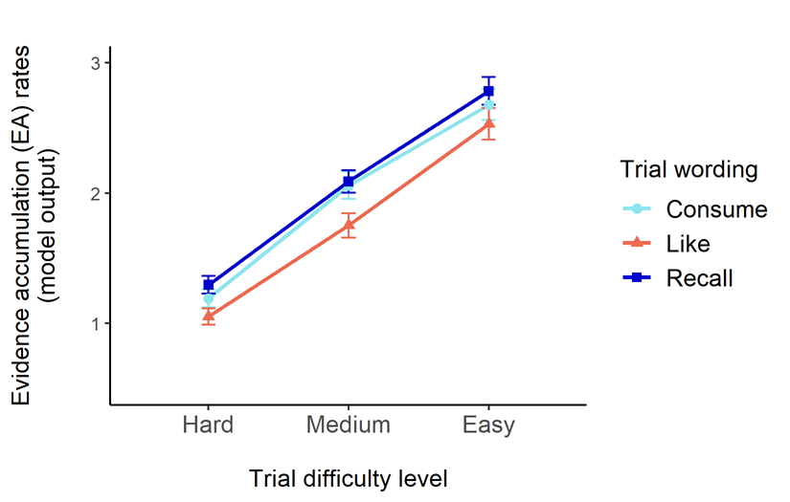

Note. Light blue (circle) represents EA rates with the wording “which would you rather consume”, orange (triangle) represents EA rates with the wording “which do you like more”, and dark blue (square) represents EA rates with the wording “which did you rate higher”. Error bars represent the standard error of the mean (SE).

Post-hoc tests for the significant main effect of difficulty (applying the Holm-Bonferroni correction to p-values for multiple comparison) revealed that EA rates were significantly increased in easy (M = 2.66, SD = .89) compared to medium (M = 1.97, SD = .74; p < .001) and difficult (M = 1.18, SD = .52; p < .001) trials. EA rates on medium trials were significantly increased compared to difficult trials (p < .001). Post-hoc tests for the significant main effect of trial wording revealed that EA rates were significantly decreased in the “like” wording condition (M = 1.78, SD = .95) compared to in the “consume” wording condition (M = 1.98, SD = .98; p = .02) and in the “recall” wording condition (M = 2.06, SD = .91; p = .001). There were no differences between EA rates in the “consume” and “recall” wording conditions (p = .30).

We conducted Pearson's correlation coefficient analyses to explore the direction, strength, and significance of the relationships between EA rates across the different trial wording blocks. There were highly significant positive correlations between EA rates in all three blocks (all ps < .001; consume and recall wording, r(57) = .73, p < .001; consume and like wording, r(57) = .49, p < .001; recall and like wording, r(57) = .58, p < .001).

Figure S3.6
Scatterplots to show correlations between EA rates during the three blocks of trials
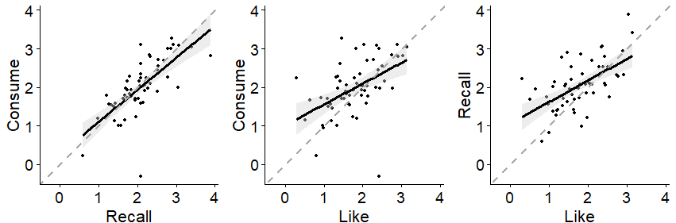
Note. On the left is the correlation between EA rates during the block of trials with “which would you rather consume” and the block of trials with “which did you rate higher”. In the middle is the correlation between EA rates during the block of trials with “which would you rather consume” and the block of trials with “which do you like more”. On the right is the correlation between EA rates during the block of trials with “which did you rate higher” and the block of trials with “which do you like more”. The grey dashed line represents the line of equality. Shaded areas represent the 95% confidence interval.

Overall, the only difference from the analysis presented in the manuscript and the analysis presented here is that the non-significant (albeit marginal at p = .06) main effect of trial wording on EA rates is now statistically significant. This difference supports the conclusion that the variations of trial wordings are viable alternatives, but not that they are identical substitutes. The core reason for this is that differences in drift due to condition are equivalent across variations in trial wording (as reflected by the non-significant interaction effect). The implication of these findings is that although variations of trial wording are not necessarily identical, they are still valid and sensitive alternatives for capturing value-based choice in instances whereby it is necessary to alter trial wording.

Response thresholds (analyses not pre-registered)
As response thresholds are fixed across trial difficulty level, a one-way repeated measures ANOVA was conducted to explore whether there are any differences across trial wording conditions. There was a main effect of trial wording condition on response thresholds (F(2, 116) = 7.21, p = .001, η_{p}² = .11) with the Bayes factor indicating strong evidence in favour of the experimental hypothesis (BF₁₀ = 23.54).

Post-hoc tests for the significant main effect of trial wording revealed that response thresholds in the “recall” wording condition (M = 1.90, SD = .42) were significantly higher than in the “like” wording condition (M = 1.71, SD = .35; p < .001). However, there were no significant differences in response thresholds in the “recall” wording compared to in the “consume” wording condition (M = 1.82, SD = .45; p = .10), or in “consume” wording compared to the “like” wording condition (p = .07)

This analysis reiterates that researchers should acknowledge that “recall” wording may inadvertently affect participants decision caution. However, compared to the EZ-DDM, this analysis suggests that response thresholds may be more robust to variations in trial wording because only the contrast between “recall” and “like” wording conditions was statistically significant.

13. Supplementary: Reaction time (RT) and accuracy summary statistics (Table S3.3).
Table S3.3
Summary statistics for reaction time and accuracy split by trial wording condition and trial difficulty level (values are means and standard deviations)
Trial wording condition | Easy trials | Medium trials | Difficult trials | Difficulty levels averaged
“like” condition
Reaction time (s) | .80 (.17) | .87 (.17) | .94 (.19) | .87 (.17)
Accuracy (%) | .97 (.06) | .91 (.11) | .80 (.11) | .89 (.08)
“consume” condition
Reaction time (s) | .78 (.14) | .86 (.17) | .97 (.21) | .87 (.17)
Accuracy (%) | .97 (.09) | .94 (.10) | .84 (.11) | .92 (.09)
“recall” condition
Reaction time (s) | .79 (.15) | .87 (.15) | .99 (.18) | .89 (.15)
Accuracy (%) | .99 (.04) | .96 (.06) | .86 (.09) | .94 (.06)
Table S3.3 shows that RTs were higher while accuracy was lower relative to increasing trial difficulty level.

Appendix C
Supplementary materials for Chapter 4: “Modelling value-based decision-making in regular alcohol consumers after experimental manipulation of the value of alcohol”
Contents:
- Images used in the VBDM task to depict alcohol and soft-drinks (Table S4.1)
- Further detail on the distraction block in-between priming conditions
- BAAD questionnaire details
- Core analyses split by difficulty level (Table S4.2)
- Order of experimental manipulation of alcohol value: does this matter?
- Order of trial block completion: does this matter?
- Exploratory correlations (Table S4.3)
- A priori power analysis output

1. Images used in the VBDM task to depict alcohol and soft-drinks (Table S4.1)
The 35 alcohol and 35 soft-drink images that were used in the task were taken from Amsterdam Beverage Picture Set (ABPS; Pronk et al., 2015) and Google. Ideally, we would have only used images from a validated and open source image set (such as the ABPS), however piloting work where we instructed peers (n = 6) to list their favourite and least favourite 3 beverages indicated that the range of drink images required to elicit varied evaluations (i.e., want to consume a lot, not want to consume at all) exceeded what was available from the ABPS alone (e.g., having a variety drinks common in England, such as Irn Bru and Baileys). Below we detail the content of the images used so that other researchers can use similar image sets if they wish to replicate this study in the future. Every image depicted a single drink beverage in its packaging with a plain white background.

Table S4.1
Description of the content in the images used in the task to depict alcohol and soft-drinks
Alcohol | Soft-drinks
Can of Fosters | Bottle of Coke*
Bottle of Budweiser | Bottle of Dr Pepper
Bottle of Corona | Bottle of 7UP*
Can of Brewdog Punk IPA | Bottle of Irn Bru
Can of Guinness | Bottle of Orangina
Can of John Smiths Extra Smooth | Bottle of Lucozade (Original)
Can of Old Speckled Hen | Bottle of Fanta (Orange)*
Bottle of Caribbean Twist (Mixed Mango) | Bottle of San Pellegrino Sparkling Water
Bottle of Hooch | Bottle of Pepsi Max*
Can of Archers Schnapps | Can of Monster Energy
Bottle of WKD (blue) | Can of San Pellegrino Limonata
Bottle of Smirnoff Ice* | Can of San Pellegrino Lemon & Mint
Can of Strongbow (Dark Fruit) | Can of San Pellegrino Pomegranate & Orange
Can of Strongbow (Original) | Bottle of Lipton Ice Tea*
Bottle of Stella Artois Apple Cidre | Tropicana Apple Juice
Can of Scrumpy Jack | Tropicana Orange Juice
Bottle of Kopparberg (Pear) | Tropicana Orange Juice (with bits)
Bottle of Kopparberg (Strawberry and Lime) | Capri-Sun Orange
Bottle of Kopparberg (Mixed Fruit) | Capri-Sun Cherry
Bottle of Smirnoff Vodka* | J20 Orange and Passion Fruit
Bottle of Baileys (Irish Cream Liqueur) | J20 Apple and Raspberry
Bottle of Gordon’s Gin | Ribena Blackcurrant
Bottle of Jack Daniel’s Whiskey | Bottle of Evian Still Water*
Bottle of Pimm’s | Naked Green Machine Smoothie
Bottle of Apple Sourz | Naked Orange Carrot Smoothie
Bottle of Sierra Tequila | Naked Blue Machine Smoothie
Bottle of Captain Morgan’s Spiced Rum | Milk (1 pint; semi-skimmed)
Bottle of Aperol | Frijj Chocolate Milkshake
Bottle of Rosé Wine (Blossom Hill) | Frijj Strawberry Milkshake
Bottle of Rosé Wine (White Zinfandel; Gallo Family) | Lipton Green Tea
Bottle of White Wine (Blossom Hill) | Twinings Earl Grey Tea
Bottle of White Wine (Pinot Grigio; Gallo Family) | Breakfast Tea*
Bottle of Red Wine (Blossom Hill) | Latte
Bottle of Red Wine (Cabernet Sauvignon; Gallo Family) | Americano
Bottle of Prosecco* | Iced Coffee
Note. Images from the ABPS are denoted by *.

2. Distraction block in-between experimental conditions
In-between the alcohol value and alcohol devalue conditions, we included a “washout” phase to minimise any carry-over effects from the previously viewed video. This comprised a distraction task by presenting participants with random facts about Sheffield and then asking them to recall these facts.

Statements about Sheffield (each statement was presented on the screen for 7s)
- “The football team Sheffield United was founded in 1857”
- “An estimated 534,500 people live in Sheffield”
- “61% of Sheffield is green space (e.g., parks and forests)”
- “Sheffield is estimated to have 4.5 million trees”
- “The river Sheaf meets the river Don in Sheffield”
- “The two large theatres in Sheffield are the Lyceum Theatre and the Crucible Theatre”
- “Sheffield is the greenest city in Europe”
- “Sheffield is famous for making steel”

Distraction questions that were asked and the response options (order of presentation = randomised)
- In what year was the football team Sheffield United founded?
- 1857; 1957
- How many people are estimated to live in Sheffield?
- 334,500 people; 534,500 people
- What percentage of Sheffield is green space (e.g., parks and forests)?
- 61%; 66%
- The river ____ meets the river _____ in Sheffield
- River Sheaf, River Don; River Rothay, River Esk
- How many trees is Sheffield estimated to have?
- 2.5 million; 4.5 million
- Sheffield is the greenest city in ____
- The world; Europe
- Sheffield is famous for making ____
- Steel; Cotton
- The two large theatres in Sheffield are ____ and ____
- Lyceum theatre and the Crucible theatre; Cambridge theatre and the Crucible theatre

3. BAAD questionnaire details
Below are the exact price points that were used in the Brief Assessment of Alcohol Demand which are similar to those employed in recent research (Owens et al., 2015). However as in Copeland et al. (2020), we modified the prices so that they are presented in pounds (£) rather than dollars ($) because our sample comprised people residing in the United Kingdom.

Question: “If drinks were free, how many would you have?” (intensity)
Response options: 0, 1, 2, 3, 4, 5, 6, 7, 8, 9, 10

Question: “What is the maximum total amount that you would spend on drinking during that drinking occasion?” (O_{max})
Response options: £0, £3, £6, £9, £12, £15, £18, £21, £24, £27, £30 or more

Question: “What is the maximum you would pay for a single drink?” (breakpoint)
Response options: £0, £1.50, £3, £4.50, £6, £7.50, £9, £10.50, £12, £13.50, £15 or more

4. Core analyses split by difficulty level

In Chapter 4, we reported the results of our hypotheses on decision-parameters that were averaged across difficulty levels. Here, we report exploratory analyses to explore whether the main effects reported in the results section of the manuscript are carried by differences in difficulty level. Specifically, we conducted separate three-way ANOVAs with experimental condition (2: alcohol value; alcohol devalue), difficulty level (3: easy; medium; difficult), and image type (2: alcohol; soft drink) on decision parameters. There was no significant three-way interaction between experimental condition, difficulty, and image type on EA rates (F(2, 70) = 1.80, p = .17, η_{p}² = .05) or response thresholds (F(2, 70) = .46, p = .64, η_{p}² = .01). Findings crucially revealed that the hypothesised interaction between experimental condition and image type was not subsumed under a three-way interaction between experimental condition, image type, and difficulty level. Therefore, analyses are retained using the average and the core analyses split by difficulty level are reported below for interested readers.

Table S4.2
A table displaying the p-value and effect size for each of the hypotheses split by difficulty level
Contrast | Easy trials | Medium trials | Difficult trials
Drift / EA rate
Positive condition: alcohol vs. soft drink | p = .57, d =.03 | p = .57, d = .03 | p = .20, d = .14
Negative condition: alcohol vs. soft drink | p < .01, d = .42 | p = .27, d = .10 | p = .29, d = .09
Alcohol: positive vs. negative condition | p = .06, d = .27 | p = .97, d = .33 | p = .40, d = .04
Soft drink: positive vs. negative condition | p = .09, d = .23 | p = .01, d = .38 | p = .08, d = .24
Response threshold
Positive condition: alcohol vs. soft drink | p = .55, d = .02 | p = .50, d = .00 | p = .66, d = .07
Negative condition: alcohol vs. soft drink | p = .10, d = .22 | p = .51, d = .00 | p = .15, d = .18
Alcohol: positive vs. negative condition | p = .28, d = .10 | p = .99, d = .41 | p = .61, d = .05
Soft drink: positive vs. negative condition | p = .22, d = .13 | p = .05, d = .28 | p = .17, d = .16
Note. Significant findings are in bold. Positive condition refers to the condition where participants viewed the alcohol-positive video intended to elevate alcohol value (alcohol valuation). Negative condition refers to the condition where participants viewed the alcohol-negative video intended to lower alcohol value (alcohol devaluation).

Brief summary: The main effect of EA rates (hypothesis 2) was found in easy trials, in that when participants were primed to devalue alcohol, soft-drink EA rates (M = 2.71, SD = .70) were significantly higher than alcohol EA rates (M = 2.40, SD = .58). The main effect of EA rates (hypothesis) 4 was found in medium trials, in that soft-drink EA rates were increased when participants were primed to devalue alcohol (M = 2.14, SD = .58) compared to when they were primed to value alcohol (M = 1.95, SD = .45). Although there were no significant differences in soft-drink response thresholds in the negative versus positive mood conditions (hypothesis 4), we can see here that in trials that are medium difficulty, the hypothesised effect is observed (although this is of marginal significance; p = .05). In other words, soft-drink response thresholds decreased (M = 1.63, SD = .44) when participants were primed to devalue alcohol compared to when they were primed to value alcohol (M = 1.78, SD = .52).

5. Order of experimental manipulation of alcohol value: does this matter?
The order of experimental manipulation of alcohol value was randomised, such that half of the sample were primed to devalue alcohol first, while the other half were primed to value alcohol first. To explore whether the order by which participants completed the study impacted the findings, we conducted mixed two-way ANOVAs between experimental condition (2: alcohol value; alcohol devalue) and order of experimental manipulation (2: negative first; positive first) on EA rates and response thresholds. In the data, negative first is coded as 1 and positive first is coded as 2. As in Chapter 4, if data violated assumptions of sphericity, F values were derived using a correction (Huynh-Feldt correction if the Greenhouse-Geisser epsilon (ε) > 0.75, otherwise if ε < 0.75 the Greenhouse-Geisser correction was used).

Soft-drink EA rates
There was a significant main effect of experimental condition on soft-drink drift rates, F(1, 34) = 5.33, p = .03, η_{p}² = .14, with post-hoc tests demonstrating that soft-drink EA rates were significantly increased in the alcohol devalue condition (M = 2.02, SD = .49) compared to the alcohol value condition (M = 1.89, SD = .34; p = .03). There was no significant main effect of order on soft-drink drift rates, F(1, 34) = .19, p = .66, η_{p}² = .01, or interaction between condition and order on soft-drink drift rates, F(1, 34) = 2.35, p = .13, η_{p}² = .06. Crucially, then, the order by which participants underwent the experimental manipulation of alcohol value did not significantly affect soft-drink EA rates, and this is particularly important as this relates to the core significant findings presented within Chapter 4.

Soft drink response thresholds
There was no significant main effect of experimental condition (F(1, 34) = 2.86, p = .10, η_{p}² = .08) or order (F(1, 34) = 2.60, p = .12, η_{p}² = .07) on soft-drink response thresholds. However, there was a significant interaction between experimental condition and order, F(1, 34) = 9.32, p < .01, η_{p}² = .22. Post-hoc tests revealed that in the alcohol value condition, soft-drink thresholds were significantly lower in order 1 (M = 1,47, SD = .29) compared to order 2 (M = 1.80, SD = .35; p = .03). This analysis shows that soft-drink response thresholds were lower when the positive alcohol value induction was completed second. However, in the alcohol devalue condition, there were no significant differences in soft-drink thresholds between order 1 and order 2 (p = 1.00). In order 1, there were no significant differences in soft-drink response thresholds between the alcohol value and alcohol devalue conditions (p = .12), however, in order 2 soft drink thresholds were significantly increased in the alcohol value (M = 1.80, SD = .35) compared to the alcohol devalue condition (M = 1.54, SD = .40; p = .01). This analysis shows that, as hypothesised, soft-drink response thresholds were lower in the in the alcohol devalue condition compared to the value condition, but only in participants who completed the alcohol devaluation condition second.

Alcohol EA rates
There was no significant main effect of experimental condition (F(1, 34) = .05, p = .82, η_{p}² = .00) or order (F(1, 34) = .07, p = .79, η_{p}² = .00) on alcohol drift rates. However, there was a significant interaction between experimental condition and order on alcohol drift rates, F(1, 34) = 23.10, p < .001, η_{p}² = .40. Post-hoc tests revealed that in the alcohol value condition, there were no significant differences in alcohol EA rates in order 1 compared to order 2 (p = .76). Similarly, in the alcohol devalue condition, there were no significant differences in EA rates in between order 1 compared to order 2 (p = 1.00). Alcohol EA rates were significantly decreased in the alcohol devalue condition (M = 1.81, SD = .59) compared to alcohol EA rates in the alcohol value condition (M = 2.01, SD = .68; p < .01), but only in participants who completed the alcohol devalue condition first (order 1). Furthermore, alcohol EA rates were significantly decreased in the alcohol value condition (M = 1.77, SD = .36) compared to the alcohol devalue condition (M = 1.95, SD = .40; p = .01), but only in participants who completed the alcohol valuate condition first (order 2). Therefore, alcohol EA rates were significantly lower during the first VBDM task that was completed, regardless of experimental manipulation (i.e., whether participants were primed to value or devalue alcohol first).

Alcohol response threshold
There was no significant main effect of experimental condition (F(1, 34) = 1.74, p = .20, η_{p}² = .05) or order (F(1, 34) = 1.64, p = .21, η_{p}² = .05) on alcohol response thresholds. However, there was a significant interaction between experimental condition and order on alcohol response thresholds, F(1, 34) = 26.43, p < .001, η_{p}² = .44. Post-hoc tests revealed that in the alcohol value condition, alcohol thresholds were significantly higher in order 2 (M = 1.80, SD = .36) compared to order 1 (M = 1.49, SD = .36; p = .04). However, in the alcohol devalue condition, there were no significant differences in alcohol thresholds between order 1 and order 2 (p = .84). Alcohol thresholds were significantly increased in the alcohol devalue condition (M = 1.62, SD = .32) compared to the alcohol value condition (M = 1.49, SD = .36; p = .04), but only in participants who completed the alcohol devalue condition first (order 1). Furthermore, alcohol thresholds were significantly increased in the alcohol value condition (M = 1.80, SD = .36) compared to the alcohol devalue condition (M = 1.58, SD = .30; p < .001), but only in participants who completed the alcohol value condition first (order 2). Therefore, alcohol response thresholds were significantly lower during the first VBDM task that was completed, regardless of experimental manipulation (i.e., whether participants were primed to value or devalue alcohol first).

6. Order of trial block completion: does this matter?
The order of blocks in the decision-making task were randomised, such that for some participants the soft-drink trials were completed first, whilst for others the alcohol trials were completed first. To explore the importance of order of blocks presented in the decision-making task, we conducted independent samples t-tests on EA rates and response thresholds with block order (2: soft-drink first; alcohol first) as the between-subjects variable. In the data, soft-drink first is coded as 1 and alcohol first is coded as 2. The within-subject design of this study means that each participant completed the VBDM task twice (once in each experimental condition), and therefore we split the analyses below by experimental condition. This is because a participant may have completed the soft-drink block of trials first (and alcohol block of trials second) in the alcohol devalue condition, but then completed the alcohol block of trials first (and soft-drink block of trials second) in the alcohol value condition. Overall, for EA rates and response thresholds for both soft-drink and alcohol decisions, there was no evidence to suggest that the order in which participants completed the blocks altered the decision-parameters (see below).

Positive (alcohol value) condition
There were no significant differences between those who completed the soft-drink block first compared to those who completed the alcohol block first for alcohol EA rates (t(34) =-1 .73, p = .09, d = .58), soft-drink EA rates (t(34) = -.86, p = .39, d = .29), alcohol response thresholds (t(34) = 1. 76, p = .10, d = .56), or soft-drink response thresholds (t(34) = .54, p = .56, d = .20).

Negative (alcohol devalue) condition

There were no significant differences between those who completed the soft-drink block first compared to those who completed the alcohol block first for alcohol EA rates (t(34) =-1 .18, p = .25, d = .39), soft-drink EA rates (t(34) = -.38, p = .71, d = .13), alcohol response thresholds (t(34) = -.23, p = .82, d = .08), or soft-drink response thresholds (t(34) = -.76, p = .45, d = .25).

7. Exploratory correlations
Table S4.3
Exploratory correlations between variables measured in Chapter 4
 | 1 | 2 | 3 | 4 | 5 | 6 | 7 | 8 | 9 | 10 | 11 | 12 | 13 | 14
1. Soft-drink drift (N)
2. Soft-drink drift (P) | .67***
3. Alcohol drift (N) | .58*** | .61***
4. Alcohol drift (P) | .55*** | .68*** | .84***
5. Soft-drink threshold (N) | -.39* | -.26 | -.08 | -.08
6. Soft-drink threshold (P) | -.08 | -.38* | -.08 | -.22 | .50**
7. Alcohol threshold (N) | -.24 | -.15 | -.21 | -.11 | .74*** | .60***
8. Alcohol threshold (P) | -.18 | -.35* | -.24 | -.33* | .55*** | .84*** | .72***
9. Age | .05 | -.19 | -.12 | -.13 | .30 | .47** | .39* | .43**
10. AUDIT | -.38* | -.30 | -.24 | -.27 | -.01 | -.01 | -.09 | -.11 | .06
11. Self-control | .45** | .32 | .32 | .16 | -.22 | .00 | -.18 | .06 | -.05 | -.46**
12. Intensity | -.20 | -.29 | -.05 | -.15 | .14 | .20 | .14 | .07 | -.10 | .16 | -.22
13. Omax | .06 | -.28 | -.08 | -.10 | .28 | .35* | .28 | .36* | .19 | -.07 | -.06 | .29
14. Breakpoint | .11 | -.09 | -.26 | -.31 | .03 | .00 | .11 | .06 | .30 | -.15 | .05 | .02 | .30
Note. (N) = negative video (alcohol devalue) condition; (P) = positive video (alcohol value) condition. Bold text indicates statistical significance. ***p < .001, **p < .01, *p < .05.

8. A priori power analysis output

t tests - Means: Difference between two dependent means (matched pairs)
Analysis: A priori: Compute required sample size
Input: Tail(s) = One
Effect size dz = 0.5
α err prob = 0.05
Power (1-β err prob) = 0.90
Output: Noncentrality parameter δ = 3.0000000
Critical t = 1.6895725
Df = 35
Total sample size = 36
Actual power = 0.9025746

Appendix D
Supplementary files for Chapter 5 “Modelling value-based decision-making (VBDM) in daily tobacco smokers after experimental manipulation of mood”.

Contents:
- Images used in the VBDM task and their valence ratings (Table S5.1 and Table S5.2)
- Further detail on the experimental manipulation of mood
- CPT questionnaire details
- Core analyses split by difficulty level (Table S5.3)
- Order of experimental manipulation of mood: does this matter?
- Order of trial block completion: does this matter?
- Exploratory correlations (Table S5.4)
- A priori power analysis output

1. Images used in the VBDM task and their valence ratings
The 30 smoking images are taken from the Geneva Smoking Images (Khazaal et al., 2012). These tobacco-related images comprise the product itself (e.g., a burning cigarette), smoking-related behaviours (e.g., a person smoking), and tobacco-related cues (e.g., an ashtray, a lighter). Images which depicted tobacco brands were not included to reflect the plain packaging legislation in the UK. Below are the filenames of the images and their valence ratings. All images can be found in the supplementary material of the original paper here: https://www.karger.com/Article/Fulltext/335083

Table S5.1
Image filenames and valence ratings of the Geneva Smoking Images
Image (file) name | Valence rating
GSP1.jpg | 3.50
GSP29.jpg | 3.96
GSP25.jpg | 4.22
GSP30.jpg | 4.30
GSP20.jpg | 4.30
GSP28.jpg | 4.41
GSP39.jpg | 4.70
GSP37.jpg | 4.76
GSP40.jpg | 5.09
GSP32.jpg | 5.13
GSP6.jpg | 5.15
GSP50.jpg | 5.15
GSP31.jpg | 5.26
GSP26.jpg | 5.33
GSP54.jpg | 5.37
GSP23.jpg | 5.87
GSP58.jpg | 5.98
GSP8.jpg | 6.07
GSP17.jpg | 6.09
GSP22.jpg | 6.13
GSP15.jpg | 6.24
GSP13.jpg | 6.33
GSP10.jpg | 6.62
GSP43.jpg | 6.63
GSP47.jpg | 7.17
GSP24.jpg | 7.26
GSP11.jpg | 7.59
GSP56.jpg | 7.83
GSP9.jpg | 7.83
GSP51.jpg | 7.96

The 30 animal images are taken from the International Affective Picture System (IAPS; Lang et al., 2008). These images comprise a number of different animals (e.g., parrots, dogs, insects, snakes). Below are the filenames of these images and their valence ratings. This link has information on how to request access to the images: https://csea.phhp.ufl.edu/media/iapsmessage.html.

Table S5.2
Image filenames and valence ratings of the International Affective Picture System images
Image (file) name | Valence rating
1710.jpg | 8.34
1750.jpg | 8.28
1460.jpg | 8.21
1400.jpg | 8.19
1620.jpg | 7.37
1600.jpg | 7.37
1721.jpg | 7.30
1500.jpg | 7.24
1740.jpg | 6.91
1603.jpg | 6.90
1812.jpg | 6.83
1720.jpg | 6.79
1650.jpg | 6.65
1419.jpg | 6.54
1333.jpg | 6.11
1560.jpg | 5.97
1670.jpg | 5.82
1121.jpg | 5.79
1903.jpg | 5.50
1350.jpg | 5.25
1726.jpg | 4.79
1945.jpg | 4.59
1390.jpg | 4.50
1321.jpg | 4.32
1930.jpg | 3.79
1280.jpg | 3.66
1300.jpg | 3.55
1050.jpg | 3.46
1202.jpg | 3.35
1274.jpg | 3.17

2. Further detail on the experimental manipulation of mood
The experimental manipulation of mood in this study used materials from a previous study which found they were effective in inducing happy and sad moods via online methods (Marcusson-Clavertz et al., 2019; please contact these author(s) for permission if you wish to access or use these materials).

Positive mood induction (8 minutes in total)
Video 1: Lion King: Timon & Pumbaa - “Hakuna Matata” (4 minutes)
Video 2: Music: Coppelia, Act I: 1. Prelude et Mazurka (4 minutes) + 15 positive Velten statements (each presented for 16s)

Positive Velten statements:
- “If I set my mind to it, I can make things turn out fine”
- “Most people like me”
- “When I have the right attitude, nothing can depress me”
- “The world is full of opportunities and I’m trying to take advantage of them”
- “I feel creative”
- “I can make things happen”
- “I’m in charge of my life and I like it that way”
- “I’m energized”
- “I’m pleased that most people are so friendly to me”
- “I know I can do it; I’m going to seize the day!”
- “The relationships I have now are the best I’ve ever had”
- “I’ve got some good friends”
- “Life’s a blast: I can’t remember when I felt so good”
- “Things look totally awesome”
- “It’s great to be alive”

Negative mood induction (8 minutes in total)
Video 1: Lion King: Death of Mufasa (4 minutes)
Video 2: Music: Barber’s Adagio for Strings (4 minutes) + 15 negative Velten statements (each presented for 16s)

Negative Velten statements:
- “Sometimes I feel really guilty about the way I’ve treated my parents”
- “I feel like my life’s in a rut that I’m never going to get out of”
- “Nobody understands me or even tries to”
- “Life is such a heavy burden”
- “I wish I could be myself, but nobody likes me when I am”
- “Every time I turn around, something else has gone wrong”
- “When I talk no one really listens”
- “I don’t think things are ever going to get better”
- “I feel cheated by life”
- “My mistakes haunt me; I’ve made too many”
- “I’m unhappy with myself”
- “I feel I am being suffocated by the weight of my past mistakes”
- “Sometimes I feel so guilty that I can’t sleep”
- “I’m completely alone”
- “I feel worthless”

3. CPT questionnaire details
Below are the exact price points that were used in the Cigarette Purchase Task (CPT) which are similar to those employed in recent research (Aston et al., 2021), however we modified the prices so that they are presented in pounds (£) rather than dollars ($) because our sample comprised people residing in the United Kingdom.

- Free [£0/pack]
- 1p each [20p/pack]
- 5p each [£1/pack]
- 10p each [£2/pack]
- 20p each [£4/pack]
- 30p each [£6/pack]
- 40p each [£8/pack]
- 50p each [£10/pack]
- 60p each [£12/pack]
- 70p each [£14/pack]
- 80p each [£16/pack]
- 90p each [£18/pack]
- £1 each [£20/pack]
- £2 each [£40/pack]
- £3 each [£60/pack]
- £4 each [£80/pack]
- £5 each [£100/pack]
- £6 each [£120/pack]
- £7 each [£140/pack]
- £8 each [£160/pack]
- £9 each [£180/pack]
- £10 each [£200/pack]

4. Core analyses split by difficulty level
Table S5.3
A table displaying the p-value and effect size for each of the hypotheses split by difficulty level
Contrast | Easy trials | Medium trials | Difficult trials
Drift / EA rate
Positive condition: tobacco vs. animal | p = .01, d =.34 | p < .001 d = .81 | p < .001, d = .71
Negative condition: tobacco vs. animal | p = .81, d = .13 | p = 1.00, d = .76 | p = 1.00, d = .74
Tobacco: positive vs. negative condition | p = .35, d = .05 | p = .23, d = .11 | p = .03, d = .28
Animal: positive vs. negative condition | p = .18, d = .13 | p = .46, d = .02 | p = .91, d = .19
Response threshold
Positive condition: tobacco vs. animal | p = .30, d = .08 | p = .75, d = .10 | p = .90, d = .19
Negative condition: tobacco vs. animal | p = .54, d = .02 | p = .55, d = .02 | p = .25, d = .10
Tobacco: positive vs. negative condition | p = .50, d = .00 | p = .95, d = .24 | p = .83, d = .14
Animal: positive vs. negative condition | p = .32, d = .07 | p = .12, d = .17 | p = .40, d = .04
Note. Significant findings are in bold. Positive condition refers to the induction of positive mood intended to lower tobacco value. Negative condition refers to the induction of negative mood intended to elevate tobacco value.

Brief summary: In the positive mood condition the data strongly support hypothesis 2 (although this is likely because animal EA rates are always higher than tobacco which makes this difficult to interpret). Although there were no significant differences in tobacco EA rates in the negative versus positive mood induction conditions, we can see here that in trials that are difficult, the hypothesised effect is observed. In other words, tobacco EA rates increased (M = 1.09, SD = .41) when negative mood was induced compared to when positive mood was induced (M = .97, SD = .41).

5. Order of experimental manipulation of mood: does this matter?
The order of experimental manipulation of mood was counterbalanced, such that for half of the sample, negative mood was induced first, while for the other half positive mood was induced first. To explore whether the order by which participants completed the study impacted the findings, we conducted mixed two-way ANOVAs between condition (2: positive mood; negative mood) and order of experimental manipulation (2: negative first; positive first) on EA rates and response thresholds. In the data, negative first is coded as 1 and positive first is coded as 2. As in the Chapter 5, if data violated assumptions of sphericity, F values were derived using a correction (Huynh-Feldt correction if the Greenhouse-Geisser epsilon (ε) > 0.75, otherwise if ε < 0.75 the Greenhouse-Geisser correction was used).

Tobacco-unrelated (animal) EA rates
There was a significant interaction between condition and order on animal EA rates (F(1, 47) = 30.05, p < .001, η_{p}² = .39). Post-hoc tests revealed that in the negative mood condition, animal EA rates were significantly higher in order 2 (M = 2.38, SD = .34) compared to order 1 (M = 1.89, SD = .41, p < .001). In the positive mood condition, there were no significant differences in animal EA rates between order 1 (M = 2.23, SD = .45) and order 2 (M = 2.05, SD = .42, p = .38). In order 1, animal EA rates were significantly increased in the positive mood condition compared to in the negative mood condition (p < .01). In order 2, animal EA rates were significantly increased in the negative mood condition compared to in the positive mood condition (p < .01). Another way to interpret these analyses is that animal EA rates were higher in the experimental condition that was completed second. There were no significant main effects of condition (F(1, 47) = .00, p = .99, η_{p}² = .00) or order (F(1, 47) = 2.44, p = .13, η_{p}² = .05) on animal EA rates.

Tobacco EA rates
There was a significant interaction between condition and order on tobacco EA rates (F(1, 47) = 24.29, p < .001, η_{p}² = .34). Post-hoc tests revealed that in the negative mood condition, tobacco EA rates were marginally higher in order 2 (M = 2.01, SD = .42) compared to order 1 (M = 1.66, SD = .50, p = .05). In the positive mood condition, there were no significant differences in tobacco EA rates between order 1 (M = 1.85, SD = .55) and order 2 (M = 1.65, SD = .39, p = .44). In order 1, there were no significant differences in tobacco EA rates in the positive mood condition compared to in the negative mood condition (p = .07). However, in order 2, tobacco EA rates were significantly increased in the negative mood condition compared to in the positive mood condition (p < .001). This analysis shows that tobacco EA rates were higher when the negative mood induction was completed second. There were no significant main effects of condition (F(1, 47) = 2.24, p = .14, η_{p}² = .05) or order (F(1, 47) = .41, p = .53, η_{p}² = .01) on tobacco EA rates.

Tobacco-unrelated (animal) response thresholds
There was a significant interaction between condition and order on animal response thresholds (F(1, 47) = 11.22, p = .002, η_{p}² = .19). Post-hoc tests revealed that in the negative mood condition, there were no significant differences in animal response thresholds between order 1 (M = 1.66, SD = .30) and order 2 (M = 1.47, SD = .30, p = .15). Similarly, in the positive mood condition, there were no significant differences in animal response thresholds between order 1 (M = 1.51, SD = .27) and order 2 (M = 1.56, SD = .32, p = 1.00). In order 1, animal response thresholds were significantly increased in the negative mood condition compared to in the positive mood condition (p = .02). This analysis shows that animal response thresholds were higher when the negative mood induction was completed first. However, in order 2, there were no significant differences in animal response thresholds in the negative mood condition compared to in the positive mood condition (p = .38). There were no significant main effects of condition (F(1, 47) = .82, p = .37, η_{p}² = .02) or order (F(1, 47) = .80, p = .37, η_{p}² = .02) on animal response thresholds.

Tobacco response thresholds
There was a marginally significant interaction between condition and order on tobacco response thresholds (F(1, 47) = 3.99, p = .05, η_{p}² = .08). Post-hoc tests revealed that in the negative mood condition, there were no significant differences in tobacco response thresholds between order 1 (M = 1.64, SD = .30) and order 2 (M = 1.49, SD = .30, p = .48). Similarly, in the positive mood condition, there were no significant differences in tobacco response thresholds between order 1 (M = 1.51, SD = .31) and order 2 (M = 1.52, SD = .29, p = 1.00). In order 1, there were no significant differences in tobacco response thresholds in the negative mood condition compared to in the positive mood condition (p = .15). Similarly, in order 2, there were no significant differences in tobacco response thresholds in the negative mood condition compared to in the positive mood condition (p = 1.00). There were no significant main effects of condition (F(1, 47) = 1.53, p = .22, η_{p}² = .03) or order (F(1, 47) = .73, p = .40, η_{p}² = .02) on tobacco response thresholds.

6. Order of trial block completion: does this matter?
The order of blocks in the decision-making task were randomised, such that for some participants the tobacco-unrelated (animal) trials were completed first, whilst for others the tobacco-related trials were completed first. To explore the importance of order of blocks presented in the decision-making task, we conducted independent samples t-tests on EA rates and response thresholds with block order (2: animal first; tobacco first) as the between-subjects variable. In the data, animal first is coded as 1 and tobacco first is coded as 2. The within-subject design of this study means that each participant completed the VBDM task twice (once in each experimental condition), and therefore we split the analyses below by experimental condition. This is because a participant may have completed the animal block of trials first (and tobacco block of trials second) in the negative mood condition, but then completed the tobacco block of trials first (and animal block of trials second) in the positive mood condition. Overall, for EA rates and response thresholds for both animal and tobacco decisions, there was minimal evidence to suggest that the order in which participants completed the blocks altered the decision-parameters (see below).

Positive mood condition
There were no significant differences between those who completed the animal block first compared to those who completed the tobacco block first for tobacco EA rates (t(47) = .51, p = .61, d = .14), tobacco-unrelated (animal) EA rates (t(47) = -.02, p = .99, d = .01), or tobacco response thresholds (t(47) = .54, p = .59, d = .15). There was however a marginally significant difference for tobacco-unrelated (animal) response thresholds (t(47) = 2.02, p = .05, d = .58), with the mean being slightly higher when the animal block was completed first.

Negative mood condition
There were no significant differences between those who completed the animal block first compared to those who completed the tobacco block first for tobacco EA rates (t(47) = -1.48, p = .15, d = .42), tobacco response thresholds (t(47) = -.13, p = .90, d = .04), and tobacco-unrelated (animal) response thresholds (t(47) = 1.85, p = .07, d = .53). There was however a significant difference for tobacco-unrelated (animal) EA rates (t(47) = 2.97, p < .01, d = .85), with the mean being higher when the animal block was completed second.

7. Exploratory correlations
Table S5.4
Exploratory correlations between variables measured in Chapter 5
 | 1 | 2 | 3 | 4 | 5 | 6 | 7 | 8 | 9 | 10 | 11 | 12 | 13 | 14 | 15 | 16 | 17 | 18 | 19 | 20 | 21
1. Animal drift (N)
2. Animal threshold (N) | -.48***
3. Tobacco drift (N) | .44** | .01
4. Tobacco threshold (N) | -.21 | .53*** | -.25
5. Animal drift (P) | .26 | .11 | .15 | .03
6. Animal threshold (P) | -.17 | .59*** | .02 | .53*** | -.37**
7. Tobacco drift (P) | .13 | .09 | .41** | -.03 | .50*** | -.22
8. Tobacco threshold (P) | -.20 | .64*** | -.17 | .55*** | -.10 | .61*** | -.11
9. Age | .33* | -.04 | .13 | .07 | .13 | -.11 | -.04 | -.08
10. Age of initiation | -.10 | .16 | .23 | -.09 | .14 | -.20 | .14 | .03 | .22
11. Years smoked | .32* | -.10 | .05 | .12 | .08 | -.07 | -.06 | -.12 | .96*** | .01
12. Cigarettes per day | .09 | -.05 | -.06 | -.02 | -.04 | -.16 | .09 | -.12 | -.09 | -.08 | -.04
13. Quit attempts | .04 | .10 | -.01 | .13 | .17 | .26 | .14 | .24 | .21 | -.04 | .22 | .02
14. Motivation to quit | -.10 | .01 | -.23 | .16 | -.16 | .02 | -.07 | .18 | .17 | .17 | .12 | -.15 | .29*
15. Self-control | .21 | -.02 | .23 | -.24 | .00 | -.05 | -.01 | -.10 | .29* | .03 | .27 | -.07 | -.02 | -.25
16. Dependence | .07 | -.03 | -.01 | .00 | .04 | .03 | -.00 | .10 | -.01 | -.14 | .01 | .51*** | .06 | -.07 | -.25
17. Intensity | -.20 | -.18 | -.17 | -.13 | -.24 | -.06 | .22 | -.21 | -.27 | -.17 | -.19 | .60*** | .08 | .12 | -.26 | .26
18. Breakpoint | .27 | -.07 | .16 | -.03 | .00 | .14 | .10 | -.17 | .02 | .17 | -.02 | .28* | -.17 | -.17 | -.05 | .15 | .17
19. Omax | .13 | -.17 | -.08 | .03 | -.09 | -.11 | .03 | -.21 | -.05 | -.20 | .03 | .44** | -.16 | -.12 | .00 | .16 | .39** | .63***
20. Pmax | .32* | -.18 | .10 | -.07 | -.11 | -.05 | .01 | -.06 | .04 | .02 | .02 | .16 | -.23 | -.20 | -.06 | .10 | .03 | .82*** | .66***
21. Elasticity | -.16 | .04 | .04 | -.13 | .05 | .08 | -.02 | .14 | -.01 | .16 | -.08 | -.43** | .16 | .11 | -.03 | -.11 | -.27 | -.67*** | -.93*** | -.62***
Note. (N) = negative mood condition; (P) = positive mood condition. Bold text indicates statistical significance. ***p < .001, **p < .01, *p < .05.

8. A priori power analysis output

t tests - Means: Difference between two dependent means (matched pairs)
Analysis: A priori: Compute required sample size
Input: Tail(s) = One
Effect size dz = 0.5
α err prob = 0.05
Power (1-β err prob) = 0.90
Output: Noncentrality parameter δ = 3.0000000
Critical t = 1.6895725
Df = 35
Total sample size = 36
Actual power = 0.9025746

Appendix E
Supplementary materials for Chapter 6 “Modelling value-based decision-making (VBDM) in heavy drinkers and people who have reduced their drinking without treatment”.
Contents
- Participant demographic breakdown (Table S6.1).
- Exact wording of the hypothetical scenario in the Alcohol Purchase Task and comprehension checks.
- Activity Level Questionnaire – Revised items and further detail on participants who misunderstood questionnaire instructions.
- Images used in the VBDM task to depict alcohol and soft-drinks (Table S6.2).
- Within-subject differences
- DDM analyses conducted on each individual difficulty level in isolation (Table S6.3).
- Order of blocks of trials on the VBDM task: does this matter?
- Activity Level Questionnaire: exploring whether self-reported frequency of engagement with activities has changed since lockdown restrictions were introduced in March 2020 (Table S6.4 and Table S6.5).
- Exploratory correlations between self-report variables and DDM parameters split by drinker status (Table S6.6 and Table S6.7).
- A priori power analysis output (Figure S6.1).

1. Participant demographic breakdown (Table S6.1)

Table S6.1
Demographic breakdown of the sample split by drinker status (values represent the number of participants and percentage)
 | Heavy drinkers  (n = 60) | Moderated drinkers  (n = 60) | Overall sample  (n = 120)
Gender
Male; n (%) | 30 (50%) | 30 (50%) | 60 (50%)
Female; n (%) | 29 (48.33%) | 30 (50%) | 59 (49.17%)
Other; n (%) | 1 (1.67%) | 0 | 1 (.83%)
Ethnic group
White; n (%) | 59 (98.33%) | 53 (88.33%) | 112 (93.33%)
Mixed / multiple ethnic groups; n (%) | 1 (1.67%) | 0 | 1 (.83%)
Asian / Asian British; n (%) | 0 | 4 (6.67%) | 4 (3.33%)
Black / African / Caribbean / Black British; n (%) | 0 | 3 (5%) | 3 (2.50%)
Highest education
Postgraduate; n (%) | 13 (21.67%) | 8 (13.33%) | 21 (17.50%)
Undergraduate; n (%) | 23 (38.33%) | 26 (43.33%) | 49 (40.83%)
A levels, vocational level 3 and equivalents; n (%) | 14 (23.33%) | 22 (36.67%) | 36 (30%)
GCSE/ O Level A* to C, vocational level 2 and equivalents; n (%) | 10 (16.67%) | 4 (6.67%) | 14 (11.67%)
Student status
Part-time; n (%) | 1 (1.67%) | 3 (5%) | 4 (3.33%)
Full-time; n (%) | 8 (13.33%) | 18 (30%) | 26 (21.67%)
Not a student; n (%) | 51 (85%) | 39 (65%) | 90 (75%)
Employment status
Unemployed; n (%) | 14 (23.33%) | 13 (21.67%) | 27 (22.50%)
Part-time; n (%) | 11 (18.33%) | 16 (26.67%) | 27 (22.50%)
Full-time; n (%) | 32 (53.33%) | 30 (50%) | 62 (51.67%)
Retired; n (%) | 3 (5%) | 1 (1.67%) | 4 (3.33%)
COVID-19 and employment
Unaffected; n (%) | 41 (68.33%) | 41 (68.33%) | 82 (68.33%)
Furloughed; n (%) | 6 (10%) | 8 (13.33%) | 14 (11.67%)
Salary cut; n (%) | 1 (1.67%) | 3 (5%) | 4 (3.33%)
Made redundant; n (%) | 3 (5%) | 2 (3.33%) | 5 (4.17%)
Other; n (%) | 9 (15%) | 6 (10%) | 15 (12.50%)
COVID-19 and mental health
Much better | 0 (0%) | 2 (3.33%) | 2 (1.67%)
Slightly better | 5 (8.33%) | 10 (16.67%) | 15 (12.50%)
No change | 14 (23.33%) | 13 (21.67%) | 27 (22.50%)
Slightly worse | 29 (48.33%) | 25 (41.67%) | 54 (45%)
Much worse | 12 (20%) | 10 (16.67%) | 22 (18.33%)
COVID-19 and alcohol consumption
Much less | 0 (0%) | 16 (26.67%) | 16 (13.33%)
Slightly less | 7 (11.67%) | 16 (26.67%) | 23 (19.17%)
No change | 8 (13.33%) | 5 (8.33%) | 13 (10.83%)
Slightly more | 32 (53.33%) | 17 (28.33%) | 49 (40.83%)
Much more | 13 (21.67%) | 6 (10%) | 19 (15.83%)
Household annual income bracket
Below 7.5k; n (%) | 2 (3.33%) | 2 (3.33%) | 4 (3.33%)
7.5 – 15.5k; n (%) | 6 (10%) | 3 (5%) | 9 (7.50%)
15.5 – 28.5k; n (%) | 8 (13.33%) | 20 (33.33%) | 28 (23.33%)
28.5k – 46.5k; n (%) | 19 (31.67%) | 11 (18.33%) | 30 (25%)
46.5k – 88.5k; n (%) | 20 (33.33%) | 12 (20%) | 32 (26.67%)
Above 85k; n (%) | 3 (5%) | 5 (8.33%) | 8 (6.67%)
Prefer not to say; n (%) | 2 (3.33%) | 7 (11.67%) | 9 (7.50%)
Relationship status
Single; n (%) | 17 (28.33%) | 17 (28.33%) | 34 (28.33%)
In a relationship; n (%) | 18 (30%) | 26 (43.33%) | 44 (36.67%)
Married; n (%) | 23 (38.33%) | 17 (28.33%) | 40 (33.33%)
Divorced; n (%) | 2 (3.33%) | 0 | 2 (1.67%)
Cohabiting with partner; n (%) (only for those in a relationship or married) | 37 (90.24%) | 34 (79.07%) | 71 (84.52%)
Parent status
Yes | 24 (40%) | 18 (30%) | 42 (35%)
No | 36 (60%) | 42 (70%) | 78 (65%)
Cohabiting with child(ren); n (%) (only for those who are parents or carers) | 17 (70.83%) | 14 (77.78%) | 31 (73.81%)
Breakdown of AUDIT scores
Low risk (below 8); n (%) | 1 (1.66%) | 12 (20%) | 13 (10.83%)
Hazardous (between 8 and 15); n (%) | 18 (30%) | 37 (61.66%) | 55 (45.83%)
Harmful (between 16 and 19); n (%) | 14 (23.33%) | 9 (15%) | 23 (19.17%)
Possible dependence (above 19); n (%) | 27 (45%) | 2 (3.33%) | 29 (24.17%)

2. Exact wording of the hypothetical scenario in the Alcohol Purchase Task and comprehension checks
Hypothetical scenario: “Please respond to these questions as if you were actually in a TYPICAL SITUATION when you drink alcohol. Imagine where you typically drink, what you typically drink, and who you typically drink with, if anyone. The available drinks are a pint of beer or lager, wine (medium glass), and shots of spirits (25ml) or mixed drinks with one shot of spirits. Assume that you did not drink alcohol before you are making these decisions and will not have an opportunity to drink elsewhere after making these decisions. In addition, assume that you would consume every drink you request; that is, you cannot stockpile drinks for a later date”.

Comprehension check questions: “In the typical situation above, should you assume you will consume every drink that you request?” and “In the typical situation above, should you assume you will have an opportunity to drink elsewhere after making these decisions?”. These were administered to ensure that participants read and understood the scenario they were instructed to imagine.

3. Activity Level Questionnaire – Revised Items and further detail on participants who misunderstood questionnaire instructions
“The following is a list of activities, events, and experiences. For the time frame of the last 30 days, please rate how often you have engaged in each activity, and how much you enjoyed each activity when you were not drinking alcohol. Please also rate whether how often you have engaged in each activity has changed since the COVID-19 lockdown restrictions came into place in March 2020. If you have experienced an activity more than once in the past month, try to rate how enjoyable it was on the average. Do not make an enjoyment rating if you have not engaged in the activity in the past 30 days”.

 | Frequency | Enjoyment | COVID-19
 | How often did you do this without drinking alcohol, over the past 30 days?  Remember, you should only include things in the count if you were not drinking alcohol, or were not under the influence of alcohol, when you did them | If you did this at least once, how enjoyable did you find it? | Did you do this activity more or less often compared to before the COVID lockdown restrictions were introduced in March 2020?
1. Meeting individuals and small groups (up to 6 people)
E.g., Meeting friends, going for a meal, going for coffee
2. Larger group meetups (over 6 people)
E.g., Large gatherings and parties, society meetups, sports club socials
3. Virtual socialising
E.g., Texting, social media, phone calls, FaceTime
4. Sport and exercise
E.g., Playing sport, going to the gym
5. Entertainment at home
E.g., Video games, reading a book, watching a movie, streaming show, listening to a podcast or audiobook
6. Entertainment outside the home
E.g., Going to the cinema, going to the theatre, visiting museums or art galleries
7. Hobbies
E.g., Photography, gardening, painting, playing an instrument
8. Work
E.g., Doing paid work
9. University
E.g., Being a student, time spent studying
10. Volunteering
E.g., Helping out locally or for a charity
11. Relaxing
E.g., Napping, meditation, taking a bath
12. Being alone
E.g., Spending time by yourself and not focused on an activity
13. Religion and politics
E.g., Going to church, going to protest
14. Sexual activity
E.g., Use your imagination
15. Caring for others
E.g. Baby, children, elderly, pets, bathing a child, playing with a child
16. Domestic activity
E.g., Housework, grocery shopping, cooking, cleaning
17. Time in nature
E.g., Going for walks, sitting in a park, visiting green-spaces
Were there any alcohol-free activities that you either do often or enjoy doing that did not fit into any of the categories or questions above? If so, please write this down:
_________________________________________________________________

Frequency | Enjoyment | COVID-19
0 = 0 times | 0 = unpleasant or neutral | 0 = much less often
1 = once | 1 = mildly pleasant | 1 = slightly less often
2 = a few times | 2 = moderately pleasant | 2 = no change
3 = about once per week | 3 = very pleasant | 3 = slightly more often
4 = several times per week | 4 = extremely pleasant | 4 = much more often
5 = daily or almost daily
6 = several times per day

Note. If participants did not take part in the activity in the past month (i.e., they selected “0 times” under frequency), then 0 was scored in the enjoyment column. The example in this supplementary material refers to the alcohol-free reinforcement version of the ALQ. For the alcohol-related version we used the same 17-items but with the wording changed to “when you were drinking alcohol, or under the influence of alcohol”.

Misunderstanding of questionnaire instructions
In Chapter 6 (p.172), it was stated that data from twelve participants who misunderstood questionnaire instructions on the ALQ were not retained in the analyses that included proportionate alcohol-free reinforcement. To clarify, this is referring to responses on the Activity Level Questionnaire. Participants were instructed to “not make an enjoyment rating if you have not engaged in the activity in the past 30 days”. However, some participants (n = 12) either selected “0 times” (frequency) for an activity but then did not select “I didn’t do this at least once” (enjoyment), or the reverse, they did not select “0 times” but then selected “I didn’t do this at least once” (enjoyment). Our survey was not optimized to avoid this, and our interpretation is that these participants misunderstood the questionnaire instructions. Therefore, their data were removed on this basis.

4. Images used in the VBDM task to depict alcohol and soft-drinks (Table S6.2)
The 30 alcohol and 30 soft-drink images that were used in the task were taken from Amsterdam Beverage Picture Set (ABPS; Pronk et al., 2015) and Google. Ideally, we would have only used images from a validated and open source image set (such as the ABPS), however piloting work where we instructed peers (n = 6) to list their favourite and least favourite 3 beverages indicated that the range of drink images required to elicit varied evaluations (i.e., want to consume a lot, not want to consume at all) exceeded what was available from the ABPS alone (e.g., having a variety drinks common in England, such as Irn Bru and Baileys). Below we detail the content of the images used so that other researchers can use similar image sets if they wish to replicate this study in the future. Every image depicted a single drink beverage in its packaging with a plain white background.

Table S6.2
Description of the content in the images used in the task to depict alcohol and soft-drinks
Alcohol | Soft-drinks
Can of Fosters | Bottle of Coke*
Bottle of Budweiser | Bottle of Dr Pepper
Bottle of Corona | Bottle of 7UP*
Can of Brewdog Punk IPA | Bottle of Irn Bru
Can of Guinness | Bottle of Orangina
Can of John Smiths Extra Smooth | Bottle of Lucozade (Original)
Can of Old Speckled Hen | Bottle of Fanta (Orange)*
Bottle of Caribbean Twist (Mixed Mango) | Bottle of San Pellegrino Sparkling Water
Can of Archers Schnapps | Can of Monster Energy
Bottle of WKD (blue) | Can of San Pellegrino Limonata
Bottle of Smirnoff Ice* | Bottle of Lipton Ice Tea*
Can of Strongbow (Dark Fruit) | Tropicana Apple Juice
Can of Strongbow (Original) | Tropicana Orange Juice
Bottle of Stella Artois Apple Cidre | Capri-Sun Orange
Can of Scrumpy Jack | Capri-Sun Cherry
Bottle of Kopparberg (Pear) | J20 Orange and Passion Fruit
Bottle of Kopparberg (Strawberry and Lime) | J20 Apple and Raspberry
Bottle of Smirnoff Vodka* | Ribena Blackcurrant
Bottle of Baileys (Irish Cream Liqueur) | Bottle of Evian Still Water*
Bottle of Gordon’s Gin | Naked Green Machine Smoothie
Bottle of Jack Daniel’s Whiskey | Naked Orange Carrot Smoothie
Bottle of Pimm’s | Milk (1 pint; semi-skimmed)
Bottle of Apple Sourz | Frijj Chocolate Milkshake
Bottle of Sierra Tequila | Frijj Strawberry Milkshake
Bottle of Captain Morgan’s Spiced Rum | Lipton Green Tea
Bottle of Aperol | Twinings Earl Grey Tea
Bottle of Rosé Wine (Blossom Hill) | Breakfast Tea*
Bottle of White Wine (Blossom Hill) | Latte
Bottle of Red Wine (Blossom Hill) | Americano
Bottle of Prosecco* | Iced Coffee
Note. Images from the ABPS are denoted by *.

5. Within-subject differences and establishing a ‘difficulty effect’ on the VBDM task
Pre-registered exploratory analyses
We explored within-subject differences in EA rates and response thresholds across drinker type. In both heavy and moderated drinkers, there were no significant differences in EA rates for alcohol compared to for soft-drinks (both ps ≥ .26, ds ≤ .15). Similarly, in both heavy and moderated drinkers, there were no significant differences in response thresholds for alcohol compared to for soft-drinks (both ps ≥ .43, ds ≤ .10) which supplement the non-significant interaction effect reported previously.

6. DDM analyses conducted on each individual difficulty level in isolation (Table S6.3)
Table S6.3
Core analyses repeated on each difficulty level in isolation split by DDM parameter
Contrast | Easy trials | Medium trials | Difficult trials
EA rate / drift
Alcohol: heavy vs. moderated drinkers | p = .47, r_{rb} = .01 | p = .30, d = .10 | p = .37, d = .06
Soft-drink: heavy vs. moderated drinkers | p = .17, d = .17 | p = .39, d = .05 | p = .42, d = .04
Heavy drinkers: alcohol vs. soft-drink | p = .48, d = .007 | p = .54, d = .01 | p = .52, d = .01
Moderated drinkers: alcohol vs. soft-drink | p = .14, d = .14 | p = .15, d = .13 | p = .24, d = .09
Response threshold / boundary
Alcohol: heavy vs. moderated drinkers | p = .95, d = .30 | p = .97, d = .34 | p = .85, d = .19
Soft-drink: heavy vs. moderated drinkers | p = .14, d = .20 | p = .06, d = .28 | p < .01, d = .53
Heavy drinkers: alcohol vs. soft-drink | p = .58, d = .03 | p = .31, d = .07 | p = .75, d = .09
Moderated drinkers: alcohol vs. soft-drink | p = .48, d = .01 | p = .77, d = .09 | p < .001, d = .43
Note. d = Cohen’s d effect size, r_{rb} = rank biserial correlation effect size.

The finding that moderated drinkers have significantly lower response thresholds for soft-drinks reported in the manuscript appears to be carried by trials that are difficult. To elaborate, in difficult trials, soft-drink response thresholds were lower in moderated drinkers (M = 1.41, SD = .27) compared to in heavy drinkers (M = 1.56, SD = .28). Interestingly, although the within-subject comparison in moderated drinkers between average alcohol and soft-drink response thresholds was non-significant, when looking at difficulty levels in isolation, moderated drinkers have significantly reduced soft-drink response thresholds compared to their alcohol response thresholds (M = 1.52, SD = .32), but only on trials that are difficult.

7. Order of blocks of trials on the VBDM task: does this matter?
The order of blocks in the decision-making task was randomized, such that for some participants the soft-drink trials were completed first, whilst for others the alcohol trials were completed first. To explore the importance of order of blocks presented in the decision-making task, we conducted a two-way between-subjects ANOVA with drinker type (2: heavy; moderated) and order (2: soft-drink first; alcohol first). In the data, order of blocks is coded as 1 = soft-drink first, and 2 = alcohol first. Overall, for EA rates and response thresholds for both alcohol and soft-drinks, there was no evidence to suggest that the order in which participants completed the blocks altered the decision-parameters (all ps > .05, see below).

EA rates
There was no significant main effect of drinker status (F(1,116) = .13, p = .72, np² = .00) or order of blocks (F(1, 116) = .35, p = .56, np2 = .00) on alcohol EA rates. Furthermore, there was no significant interaction between drinker status and order of blocks (F(1, 116) = .19, p = .66, np² = .00). There was no significant main effect of drinker status (F(1,116) = .49, p = .48, np² = .00) or order of blocks (F(1, 116) = 1.43, p = .23, np² = .01) on soft-drink EA rates. Furthermore, there was no significant interaction between drinker status and order of blocks (F(1, 116) = .13, p = .72, np² = .00).

Response thresholds
There was no significant main effect of drinker status (F(1,116) = 3.11, p = .08, np² = .03) or order of blocks (F(1, 116) = .66, p = .42, np² = .01) on alcohol response thresholds. Furthermore, there was no significant interaction between drinker status and order of blocks (F(1, 116) = 1.21, p = .27, np² = .01). There was a marginally significant main effect of drinker status (F(1,116) = 3.78, p = .05, np² = .03) on soft-drink response thresholds. There was however no significant main effect of order of blocks (F(1, 116) = .00, p = 1.00, np² = .00) or interaction between drinker status and order of blocks (F(1, 116) = 1.13, p = .29, np² = .01).

8. Activity Level Questionnaire: exploring whether self-reported frequency of engagement with activities has changed since lockdown restrictions were introduced in March 2020 (Table S6.4 and Table S6.5).
On the Activity Level Questionnaire, we added an additional column containing a question on a 5-point scale about whether people’s frequency of engagement in each activity has changed since the national COVID-19 lockdowns began in March 2020 (0 = much less often, 1 = slightly less often, 2 = no change, 3 = slightly more often, 4 = much more often). The scores were then averaged across all activities to compute a mean value reflecting self-reported change for alcohol-related and alcohol-free scores.

Total sample
The mean score for alcohol-free reinforcement was 1.96 (SD = .35) and alcohol-related reinforcement was 1.89 (SD = .34); these were significantly different (p = .03, d = .21). Therefore, since lockdown restrictions in March 2020, overall means are located within slightly less often and no change. Alcohol-related reinforcement declined (slightly but significantly) more in response to the lockdown, compared to alcohol-free reinforcement.

Comparison by drinker type
When comparing moderated and heavy drinkers, there were no significant differences in self-reported change in frequency of engagement in alcohol-related (p = .35, d = .18) or alcohol-free (p = .40, d = .16) activities since COVID-19 lockdown restrictions were introduced in March 2020.

The Activity Level Questionnaire comprises 17 different items, and a further breakdown by activity revealed that changes in frequency of engagement in some of the alcohol-related activities since COVID-19 lockdown restrictions were more pronounced than others. Meeting up with people and entertainment outside the home were estimated to be less frequent (scores below 2), whilst entertainment within the home and virtual socialising were estimated to be more frequent (scores above 2), compared to before COVID-19 lockdown restrictions, for example (see table below for means and standard deviations). Some activities remained relatively unchanged, such as work and time in nature. There was a significant difference between heavy drinkers and moderated drinkers in the frequency of entertainment at home with alcohol since COVID-19 lockdown restrictions were introduced (see Table S6.4 below).

Table S6.4
A table to show whether engagement with alcohol-related activities changed since national lockdown restrictions began in March 2020 (values are means and standard deviations)
Activities with alcohol | Total sample | Heavy drinkers | Moderated drinkers | p-value
Meeting individuals and small groups | 1.11 (1.23) | 1.02 (1.18) | 1.21 (1.27) | p = .44
Larger group meet-ups | 1.04 (1.28) | .93 (1.19) | 1.15 (1.38) | p = .52
Virtual socialising | 2.36 (1.13) | 2.48 (1.03) | 2.23 (1.23) | p = .29
Sport and exercise | 1.73 (.80) | 1.77 (.66) | 1.69 (.94) | p = .64
Entertainment at home | 2.43 (.85) | 2.62 (.84) | 2.21 (.80) | p < .01*
Entertainment outside the home | 1.46 (.90) | 1.43 (.85) | 1.50 (.96) | p = .76
Hobbies | 1.92 (.74) | 1.96 (.63) | 1.87 (.84) | p = .78
Work | 1.95 (.48) | 1.96 (.42) | 1.94 (.54) | p = 1.00
University | 1.89 (.59) | 1.91 (.44) | 1.87 (.71) | p = .72
Volunteering | 1.86 (.52) | 1.88 (.54) | 1.85 (.50) | p = .50
Relaxing | 2.20 (.75) | 2.30 (.78) | 2.10 (.69) | p = .13
Being alone | 2.25 (.87) | 2.30 (.93) | 2.19 (.79) | p = .37
Religion and politics | 1.90 (.51) | 1.89 (.45) | 1.90 (.57) | p = .94
Sexual activity | 1.80 (.99) | 1.80 (.96) | 1.79 (1.04) | p = .80
Caring for others | 1.95 (.54) | 1.95 (.59) | 1.96 (.48) | p = 1.00
Domestic activity | 2.07 (.71) | 2.14 (.72) | 2.00 (.69) | p = .35
Time in nature | 1.97 (.72) | 2.04 (.74) | 1.90 (.69) | p = .62
Note: p-values correspond to comparisons in heavy drinkers and moderated drinkers. Significance is in bold. Meeting individuals and small groups refers to under 6 people. Larger group meet-ups refers to 6 or more people. Responses are scored on a 5-point scale (0 = much less often; 1 = slightly less often; 2 = no change; 3 = slightly more often, 4 = much more often).

A further breakdown by activity revealed that changes in frequency of engagement in some of the alcohol-free activities since COVID-19 lockdown restrictions were more pronounced than others (see table below). For example, activities such as meeting up with people and entertainment outside the home were estimated to be less frequent (scores below 2), whilst entertainment within the home, domestic activity, and virtual socialising were estimated to be more frequent (scores above 2), compared to before COVID-19 lockdown restrictions. Some activities remained relatively unchanged, such as work and university. There was a significant difference between heavy drinkers and moderated drinkers in the frequency of engagement in religion and politics without alcohol since COVID-19 lockdown restrictions were introduced (see Table S6.5).

Table S6.5
A table to show whether engagement with alcohol-free activities changed since national lockdown restrictions began in March 2020 (values are means and standard deviations)
Activities without alcohol | Total sample | Heavy drinkers | Moderated drinkers | p-value
Meeting individuals and small groups | 1.18 (1.46) | 1.05 (1.44) | 1.31 (1.48) | p = .27
Larger group meet-ups | 1.15 (1.45) | 1.04 (1.43) | 1.27 (1.48) | p = .37
Virtual socialising | 2.69 (1.16) | 2.54 (1.14) | 2.85 (1.16) | p = .11
Sport and exercise | 1.70 (1.19) | 1.77 (1.13) | 1.63 (1.25) | p = .57
Entertainment at home | 2.80 (0.92) | 2.73 (0.94) | 2.87 (0.91) | p = .40
Entertainment outside the home | 1.06 (1.24) | 0.95 (1.17) | 1.17 (1.32) | p = .39
Hobbies | 2.18 (1.04) | 2.18 (1.06) | 2.17 (1.02) | p = .78
Work | 1.84 (0.98) | 1.86 (0.90) | 1.83 (1.06) | p = .89
University | 1.98 (0.79) | 1.95 (0.59) | 2.02 (0.96) | p = .49
Volunteering | 1.81 (0.80) | 1.82 (0.77) | 1.81 (0.84) | p = .87
Relaxing | 2.32 (0.93) | 2.29 (1.00) | 2.37 (0.84) | p = .58
Being alone | 2.26 (1.24) | 2.32 (1.18) | 2.19 (1.31) | p = .64
Religion and politics | 1.81 (0.55) | 1.93 (0.42) | 1.67 (0.65) | p < .01*
Sexual activity | 1.63 (1.01) | 1.70 (0.93) | 1.56 (1.09) | p = .33
Caring for others | 2.15 (0.97) | 2.05 (0.84) | 2.25 (1.10) | p = .36
Domestic activity | 2.50 (0.89) | 2.43 (0.81) | 2.58 (0.98) | p = .24
Time in nature | 2.20 (1.14) | 2.20 (1.15) | 2.21 (1.14) | p = .78
Note: p-values correspond to comparisons in heavy drinkers and moderated drinkers. Significance is in bold. Meeting individuals and small groups refers to under 6 people. Larger group meet-ups refers to 6 or more people. Responses are scored on a 5-point scale (0 = much less often; 1 = slightly less often; 2 = no change; 3 = slightly more often, 4 = much more often).

9. Exploratory correlations between self-report variables and DDM parameters split by drinker status (Table S6 and Table S7).

Table S6.6
Correlations between self-report variables and DDM parameters in moderated drinkers
 | 1 | 2 | 3 | 4 | 5 | 6 | 7 | 8 | 9 | 10 | 11 | 12 | 13 | 14 | 15 | 16 | 17 | 18 | 19 | 20
1. Alcohol drift
2. Soft-drink drift | .36***
3. Alcohol boundary | -.19 | -.23
4. Soft-drink boundary | -.10 | -.27* | .69***
5. AUDIT | .07 | .01 | .00 | .07
6. Problem recognition | -.07 | -.27* | -.02 | .00 | .42***
7. Self-efficacy  (social) | -.20 | -.18 | .01 | -.02 | -.36** | -.21
8. Self-efficacy  (emotional) | -.08 | -.10 | .12 | .18 | -.21 | -.35** | .42***
9. Self-efficacy  (opportunity) | -.05 | .03 | -.02 | -.06 | -.12 | -.24 | .23 | .43**
10. Presence of meaning | .05 | .15 | -.22 | -.32* | -.10 | -.21 | .12 | .11 | -.20
11. Search for meaning | .07 | -.05 | .14 | .00 | -.15 | -.02 | -.06 | -.12 | -.11 | -.42***
12. Brief self-control | .09 | .06 | -.05 | -.04 | -.24 | -.40** | .14 | .26* | .06 | .37** | -.12
13. Alcohol-free  reinforcement | .17 | .26 | -.12 | -.11 | .01 | -.03 | -.02 | -.05 | -.02 | .15 | -.17 | .13
14. Alcohol-related  reinforcement | -.10 | -.16 | -.14 | -.06 | .44** | .24 | -.21 | -.26 | -.46** | .17 | -.15 | -.09 | .21
15. Reinforcement ratio | .21 | .24 | .09 | -.02 | -.38** | -.21 | .20 | .22 | .43** | -.11 | .13 | .08 | .18 | -.91***
16. Intensity | .15 | -.00 | .11 | .13 | .42** | .08 | -.36** | -.10 | .08 | -.09 | -.10 | -.18 | .01 | .15 | -.15
17. Breakpoint | .28* | .05 | -.19 | -.23 | .19 | -.08 | -.11 | -.08 | -.03 | .12 | -.16 | -.00 | .11 | .02 | -.08 | .19
18. Omax | .29* | -.12 | .01 | .07 | .28* | -.09 | -.24 | -.10 | -.02 | .02 | -.23 | -.13 | .01 | .00 | .02 | .60*** | .64***
19. Pmax | .13 | .01 | -.30* | -.29* | .13 | -.01 | -.04 | -.05 | .04 | .03 | -.10 | -.04 | .08 | -.09 | .18 | -.08 | .84*** | .48***
20. Elasticity | -.27* | .06 | -.05 | -.02 | -.24 | .09 | .26* | .14 | .05 | .08 | .13 | .06 | -.04 | -.02 | -.03 | -.55*** | -.67*** | -.97*** -.49***
Note. ***p <.001, **p <.01, *p <.05. Reinforcement ratio here is calculated to reflect proportionate substance-free reinforcement.

Table S6.7
Correlations between self-report variables and DDM parameters in heavy drinkers
 | 1 | 2 | 3 | 4 | 5 | 6 | 7 | 8 | 9 | 10 | 11 | 12 | 13 | 14 |  | 15 | 16 | 17 | 18 | 19 | 20
1. Alcohol drift
2. Soft-drink drift | .59***
3. Alcohol boundary | -.21 | -.10
4. Soft-drink boundary | -.02 | -.19 | .70***
5. AUDIT | -.04 | -.04 | .26* | .26*
6. Problem recognition | .03 | .10 | .20 | .21 | .70***
7. Self-efficacy  (social) | -.02 | -.18 | .02 | -.05 | -.31* | -.38**
8. Self-efficacy  (emotional) | -.04 | -.14 | -.06 | .09 | -.51*** | -.55*** | .55***
9. Self-efficacy  (opportunity) | -.04 | .07 | -.13 | -.20 | -.34*** | -.50*** | .16 | .41**
10. Presence of meaning | -.25 | -.22 | .24 | .25 | -.10 | -.16 | .11 | .24 | .04
11. Search for meaning | -.00 | -.08 | -.16 | -.09 | .09 | .15 | -.22 | -.21 | .01 | -.23
12. Brief self-control | -.07 | -.20 | -.12 | -.10 | -.32* | -.42*** | .28* | .39** | .18 | .44*** | -.01
13. Alcohol-free  reinforcement | .15 | .19 | -.04 | -.21 | -.35** | -.49*** | .08 | .06 | .26 | .06 | .02 | .36**
14. Alcohol-related  reinforcement | .13 | .14 | .14 | .10 | .08 | -.15 | -.15 | -.24 | -.14 | .08 | -.14 | .05 | .21
15. Reinforcement ratios | .07 | .05 | -.14 | -.23 | -.34* | -.22 | .19 | .22 | .22 | .04 | .09 | .27* | .58*** | -.61***
16. Intensity | -.21 | -.02 | .15 | -.06 | .33* | .08 | -.14 | -.11 | -.09 | .00 | -.12 | -.22 | -.21 | .02 |  | -.21
17. Breakpoint | -.03 | -.02 | -.20 | -.24 | .01 | -.10 | -.07 | -.21 | -.16 | .21 | -.08 | .13 | .13 | .23 |  | -.08 | .13
18. Omax | .16 | .10 | -.04 | -.15 | .11 | -.14 | -.05 | -.10 | -.05 | .03 | -.04 | -.04 | .20 | .21 |  | -.06 | .52*** | .48***
19. Pmax | -.10 | -.05 | -.11 | -.06 | -.05 | -.17 | -.14 | -.14 | .06 | .33* | -.06 | .19 | .23 | .27 |  | -.01 | -.20 | .64*** | .23
20. Elasticity | -.13 | -.10 | .00 | .14 | -.13 | .15 | .08 | .12 | .07 | -.12 | .07 | -.01 | -.15 | -.20 |  | .07 | -.48*** | -.59*** -.96*** -.29*
Note. ***p <.001, **p <.01, *p <.05. Reinforcement ratio here is calculated to reflect proportionate substance-free reinforcement.

10. A priori power analysis output (Figure S6.1)

t tests - Means: Difference between two independent means (two groups)
Analysis: A priori: Compute required sample size
Input: Tail(s) = One
Effect size d = 0.5
α err prob = 0.05
Power (1-β err prob) = 0.80
Allocation ratio N2/N1 = 1
Output: Noncentrality parameter δ = 2.5248762
Critical t = 1.6602343
Df = 100
Sample size group 1 = 51
Sample size group 2 = 51
Total sample size = 102
Actual power = 0.8058986

Figure S6.1
A graph to show the relationship between sample size and power level
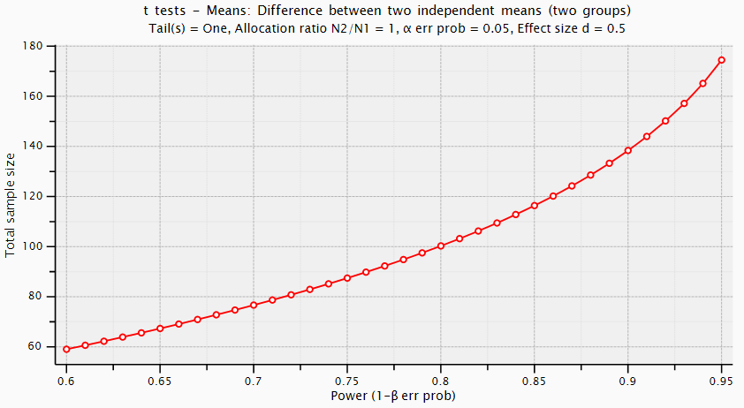

Appendix F
Supplementary materials for Chapter 7 “Value-based decision-making in current smokers and ex-smokers”
Contents
- Exact wording of breakpoint (tobacco demand) and price point increments
- Images used in the VBDM and MouseTracker tasks to depict tobacco and tobacco-unrelated (animal) images
- Within-subject differences
- DDM analyses conducted on each individual difficulty level in isolation (Table S7.1)
- Exploratory correlations between self-report variables, DDM parameters, and AUC, split by smoker status (Tables S7.2-S7.4; Figure S7.1)
- A priori power analysis output

1. Exact wording of breakpoint (tobacco demand) and price point increments
“Think about a scenario that is typical of your usual smoking behaviour, such as smoking on a night out with friends, or smoking at home. The following question asks you how much you would pay for a single cigarette at various prices. The cigarette would be of the brand that you typically smoke.”

“What is the maximum that you would pay for a single cigarette?” (breakpoint)
Response options: £0, £1.50, £3, £4.50, £6, £7.50, £9, £10.50, £12, £13.50, £15 or more

2. Images used in the VBDM and MouseTracker tasks to depict tobacco and tobacco-unrelated (animal) images
Geneva Smoking Images (Khazaal et al., 2012)
Image (file) name | Valence rating
GSP1.jpg | 3.50
GSP29.jpg | 3.96
GSP25.jpg | 4.22
GSP30.jpg | 4.30
GSP20.jpg | 4.30
GSP32.jpg | 5.13
GSP6.jpg | 5.15
GSP50.jpg | 5.15
GSP31.jpg | 5.26
GSP26.jpg | 5.33
GSP8.jpg | 6.07
GSP17.jpg | 6.09
GSP22.jpg | 6.13
GSP15.jpg | 6.24
GSP10.jpg | 6.62
GSP24.jpg | 7.26
GSP11.jpg | 7.59
GSP56.jpg | 7.83
GSP9.jpg | 7.83
GSP51.jpg | 7.96
Note. Lower scores reflect increased valence.

IAPS animal (control) images (Lang et al., 2008)
Image (file) name | Valence rating
1710.jpg | 8.34
1750.jpg | 8.28
1460.jpg | 8.21
1400.jpg | 8.19
1620.jpg | 7.37
1740.jpg | 6.91
1603.jpg | 6.90
1812.jpg | 6.83
1650.jpg | 6.65
1419.jpg | 6.54
1670.jpg | 5.82
1903.jpg | 5.50
1350.jpg | 5.25
1726.jpg | 4.79
1390.jpg | 4.50
1930.jpg | 3.79
1300.jpg | 3.55
1050.jpg | 3.46
1202.jpg | 3.35
1274.jpg | 3.17
Note. Higher scores reflect increased valence.

In the process of selecting 20 smoking images for our study, I ruled out any images that visibly depicted cigarette branding (n = 13) to reflect the plain packaging government guidelines that have been implemented in the United Kingdom. Our selection of animal images based on their validated valence ratings is in line with previous research on IAPS images which suggests that scores > 5 represent positive images, whilst scores < 5 represent negative images (Mikels et al., 2005). Importantly, the VBDM task allows for subjective valuation of images to differ across participants because the task is personalised for each participant to reflect their own ratings. Therefore, the process of ensuring that there was a wide spread of perceived valence by using the standardised valence ratings data that accompanies both picture sets was merely to ensure that there was a wide spread of perceived valence, rather than as a strict guide as to what images should be placed in each value category.

3. Within-subject differences
VBDM task. In current smokers, EA rates for tobacco-unrelated (animal) decisions (median = 1.81, IQR = .52) were significantly higher than EA rates for tobacco decisions (median = 1.60, IQR = .48), W = 1207, p < .001, r_{rb} = .82. There were no significant differences in tobacco-unrelated (animal) (M = 1.96, SD = .29) and tobacco response thresholds (M = 1.91, SD = .30), t(50) = 1.36, p = .18, d = .19. In ex-smokers, EA rates for tobacco-unrelated (animal) decisions (M = 1.88, SD = .38) were significantly higher than for tobacco decisions (M = 1.56, SD = .42), t(50) = 5.78, p < .001, d = .81. However, there were no significant differences in response thresholds for tobacco (M = 2.06, SD = .34) compared to for tobacco-unrelated (animal) decisions choices (2.00, SD = .31), t(50) = 1.25, p = .22, d = .18.

MouseTracker task. Current smokers experienced significantly greater levels of conflict when the tobacco image was the correct answer (median = 1.00, IQR = .74) compared to when the tobacco-unrelated (animal) image was the correct answer (median = .87, IQR = .65), W = 988, p = .002, r_{rb} = .49. A similar pattern was found for ex-smokers, in that they experienced significantly greater levels of conflict when the tobacco image was the correct answer (median = .84, IQR = .82) compared to when the tobacco-unrelated (animal) image was the correct answer (median = .78, IQR = .58), W = 1187, p < .001, r_{rb} = .79.

4. DDM analyses conducted on each individual difficulty level in isolation (Table S7.1)
Table S7.1
Statistical analyses on each difficulty level in isolation
Contrast | Easy trials | Medium trials | Difficult trials
Drift / EA rate
Smoking: smokers vs. ex-smokers | p = .615, d = .06 | p = .466, d = .02 | p = .694, d = .10
Animal: smokers vs. ex-smokers | p = .256, d = .13 | p = .623, d = .06 | p = .170, d = .19
Smokers: animal vs. smoking | p = .001, d = .47 | p < .001, r = .68 | p < .001, d = .80
Ex-smokers: animal vs. smoking | p = .002, d = .46 | p < .001, d = .68 | p <. 001, d = .86
Response threshold / boundary
Smoking: smokers vs. ex-smokers | p = .123, d = .23 | p = .004, d = .53 | p = .053*, r = .19
Animal: smokers vs. ex-smokers | p = .394, d = .05 | p = .533, d = .02 | p = .984, d = .43
Smokers: animal vs. smoking | p = .607, d = .07 | p = .167, d = .20 | p = .024, d = .33
Ex-smokers: animal vs. smoking | p = .042, d = .29 | p = .044, d = .29 | p = .086, d = .24
AUC scores (conflict)
Smoking: smokers vs. ex-smokers | p = .924, r = .16 | p = .853, r = .12 | p = .723, d = .12
Animal: smokers vs. ex-smokers | p = .082, r = .16 | p = .106, d = .25 | p = .172, d = .19
Smokers: animal vs. smoking | p = .218, r = .20 | p = .005, r = .45 | p < .001, r = .57
Ex-smokers: animal vs. smoking | p = .386, r = .14 | p < .001, r = .66 | p < .001, d = .81
d = Cohen’s d effect size, r_{rb} = rank biserial correlation effect size. Significance is represented by bold text, * = marginal significance.

Interestingly, current smokers have significantly lower response thresholds when making tobacco decisions (M = 1.83, SD = .38) compared to tobacco-unrelated (animal) decisions (M = 1.93, SD = .30), but only on trials that are difficult. Furthermore, ex-smokers have significantly higher response thresholds when making tobacco-decisions (M = 2.25, SD = .40) compared to tobacco-unrelated (animal) decisions (M = 2.14, SD = .38) on medium trials. A similar pattern is found on easy trials; ex-smokers have significantly higher response thresholds when making tobacco-decisions (M = 1.95, SD = .45) compared to tobacco-unrelated (animal) decisions (M = 1.79, SD = .48).

5. Exploratory correlations between DDM decision parameters, area under the curve, and self-report questionnaire variables, split by smoker status

Below, in Table S7.2, we report correlational analyses between the DDM decision-parameters (EA rates and response thresholds), area-under-the-curve (AUC), and self-report questionnaire variables. In the manuscript we explored whether DDM parameters and response conflict (reflected in AUC scores) are important internal processes of decision-making that might characterise recovery from addiction. However, as this was the first exploration of this in relation to recovery, we were unsure whether either (if any) would be important, and we made no prediction about how DDM parameters might be conceptually related to AUC scores other than acknowledging that they are both internal aspects that precede decisions made. However, a recent preprint (Leontyev & Yamauchi, 2020) explored how these two internal processes may be related - finding only a significant negative correlation between AUC scores and a DDM parameter that reflects motor execution (non-decision time). This association is relatively weak (-.39, p < .05); and there were no other associations with the other decision model parameters. Importantly this work is recent and was therefore uploaded after our study planning and pre-registration. For this reason, we report here the exploratory correlations using our data.

Furthermore, given that previous research has found that people with higher levels of self-reported self-control experience a lesser magnitude of conflict (represented in AUC scores; Stillman et al., 2017), we were particularly interested in the relationship between self-reported self-control and magnitude of conflict within our sample.

Table S7.2
Correlations between DDM parameters, area under the curve scores (AUC), and self-report questionnaire variables
 | 1 | 2 | 3 | 4 | 5 | 6 | 7
1. Animal AUC | -
2. Smoking AUC | .85*** | -
3. Animal EA rates | -.10 | -.15 | -
4. Smoking EA rates | -.19 | -.37*** | .56*** | -
5. Animal thresholds | .04 | .02 | -.64*** | -.22* | -
6. Smoking thresholds | .02 | .06 | -.26** | -.19 | .54*** | -
7. BSCS | -.06 | -.04 | .07 | -.01 | .10 | .12 | -
Note. *p < .05*, **p<.01, ***p<.001
As reported in table S7.2, there is a negative correlation between AUC scores and EA rates for tobacco. In other words, higher levels of conflict correspond to lower levels of evidence accumulation (Figure S7.1). Furthermore, we found no significant correlation between self-reported self-control and AUC scores, or any of the DDM parameters.

Figure S7.1
A scatterplot to show the correlation between smoking conflict and smoking evidence accumulation rates
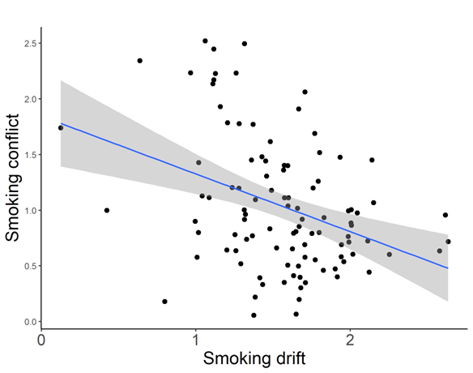
Note. Shaded area represents the 95% CI.

Next, correlations split by smoker status:
Table S7.3
Correlations between DDM parameters, area under the curve scores (AUC), and self-report questionnaire variables in current-smokers
 | 1 | 2 | 3 | 4 | 5 | 6 | 7 | 8 | 9 | 10
1. Animal AUC | -
2. Smoking AUC | .77*** | -
3. Animal EA rates | -.00 | .02 | -
4. Smoking EA rates | .02 | -.25 | .54*** | -
5. Animal thresholds | .14 | -.01 | -.67*** | -.22 | -
6. Smoking thresholds | .11 | .07 | -.31* | .05 | .61*** | -
7. BSCS | -.11 | -.17 | .10 | .09 | -.14 | .04 | -
8. Dependence | .01 | .10 | -.10 | -.17 | .20 | .02 | -.27 | -
9. Motivation to quit | .09 | .02 | -.25 | -.34* | .07 | .12 | .04 | -.05 | -
10. Breakpoint | .15 | -.11 | -.04 | .23 | .23 | .25 | -.07 | -.14 | -.05 | -
Note. *p < .05*, **p<.01, ***p<.001

Interestingly, in current smokers, motivation to quit smoking is negatively correlated with smoking EA rates. Put another way, higher motivation to give up smoking is characterised by lower EA rates for tobacco.

Table S7.4
Correlations between DDM parameters, area under the curve scores (AUC), and self-report questionnaire variables in ex-smokers
 | 1 | 2 | 3 | 4 | 5 | 6 | 7
1. Animal AUC | -
2. Smoking AUC | .90*** | -
3. Animal EA rates | -.18 | -.30* | -
4. Smoking EA rates | -.40** | -.48*** | .53*** | -
5. Animal thresholds | -.04 | .05 | -.61*** | -.24 | -
6. Smoking thresholds | .00 | .02 | -.26 | -.41** | .49*** | -
7. BSCS | .02 | .12 | .03 | .05 | .05 | .12 | -
Note. *p < .05*, **p<.01, ***p<.001

6. A priori power analysis output

t tests - Means: Difference between two independent means (two groups)
Analysis: A priori: Compute required sample size
Input: Tail(s) = One
Effect size d = 0.5
α err prob = 0.05
Power (1-β err prob) = 0.80
Allocation ratio N2/N1 = 1
Output: Noncentrality parameter δ = 2.5248762
Critical t = 1.6602343
Df = 100
Sample size group 1 = 51
Sample size group 2 = 51
Total sample size = 102
Actual power = 0.8058986

Figure S7.1
A graph to show the relationship between sample size and power level
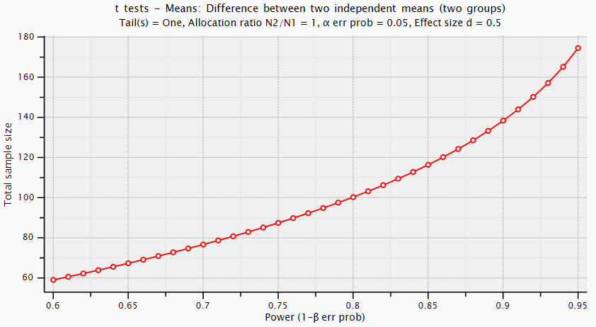

This hypothesis reflects the pre-registered focus on whether alcohol-free reinforcement can account for additional variance beyond meaning in life variables. We made a minor deviation from our pre-registration by entering average alcohol-free reinforcement instead of the frequency and enjoyment subscales (this does not change the interpretation of results; see supplementary materials for justification).
We made a minor deviation from our pre-registration by entering average alcohol-free reinforcement instead of frequency and enjoyment subscales which does not change the interpretation of results (see Appendix A for justification).
Prior to the implementation of modifications, not all model fit indices of the hypothesized structural model were a good fit of the data (SRMR = .06; CFI = .95, TLI = .73, RMSEA = .15 (90% CI = .11 to .18); X²/df = 12.71).
Serial mediation effect refers to the indirect effect of two variables in succession (Hoon Ko et al., 2018).
See Table S3.1 in Appendix B for a comparison of methods across different studies (including whether precise trial wording is included within the manuscript).
Difficulty is operationalised as the difference in value rating between the two images presented on each trial of the VBDM task. Trials are categorised into the following difficulty levels: hard (difference of 1), medium (difference of 2), or easy (difference of 3).
r scale fixed effects = 0.5; r scale random effects = 1.
As requested by an anonymous reviewer, we repeated these analyses using alternative software–the fast-dm-30 (Voss et al., 2015)–which enabled us to explore if trial wording would affect EA rates after fixing response thresholds across difficulty conditions and non-decision times across all conditions (i.e., per participant). These analyses are reported in Appendix B, but in brief we found that the main effect of trial wording became statistically significant when analysed with the fast-dm-30, with a Bayes factor indicative of moderate evidence in favour of the experimental hypothesis (BF₁₀ = 4.18); contrasting with moderate evidence in favour of the null (BF₁₀ = .19) when the EZ-DDM was used.
See Appendix B for post-hoc tests on the main effect of trial wording and interaction between trial wording and trial difficulty.
From this point onwards, tobacco smokers will be referred to as smokers.
For ethical reasons, image enlargement is one type of reward used (Moeller & Stoops, 2015) and is a reliable way to capture reinforcing value as demonstrated by studies showing a robust increase in substance choice alongside dependence severity (Hardy et al., 2018; Moeller et al., 2009, 2013).
This was due to an accuracy score of 0 for this participant in the VBDM task. Further detail is provided under ‘Data preparation and analysis.’
The videos are maintained in a library that is owned by Marcusson-Clavertz et al. (2019). Please contact the author(s) for permission to access or use these materials.
The videos are maintained in a library that is owned by Samson et al. (2016). Please contact these author(s) for permission if you wish to access or use these materials.
We did include an open textbox for participants to share their experience of taking part in the online research study (e.g., if they experienced any technical problems or disruption), however this participant did not leave a response and so it is impossible to establish the exact cause of this responding pattern. Ideally this study would have been conducted in a university laboratory which would have enabled us to monitor participation, however the ongoing global COVID-19 pandemic precluded in-person testing.
This is because we were mimicking the procedure of Marcusson-Clavertz et al. (2019) who successfully manipulated mood in an online Prolific sample.
In line with conceptual and empirical advances, the definition of recovery is not limited to abstinence and incorporates moderated drinking (Witkiewitz et al., 2020, 2021).
We use the term ‘heavy drinkers’ in this study to reflect the inclusion criterion which relates to participants volume of alcohol consumption (i.e., >28 weekly UK units; 1 UK unit = 8g of alcohol).
From this point onwards, ‘moderated (former heavy) drinkers’ will be referred to as moderated drinkers.
All APT indices apart from elasticity demonstrated skewness or kurtosis values within limits (-2 and 2) that have been deemed acceptable and used in previous research using these variables (e.g., Acuff, Soltis, et al., 2020; Luciano et al., 2019). Attempts to improve the distribution of elasticity via transformation (e.g., square- root and log-transformation) did not produce skewness and kurtosis values within the acceptable limits, and therefore we used a non-parametric test for this index of demand.
From this point onwards “tobacco smokers” will be referred to as “smokers”.
The International Affective Picture System (IAPS; Lang et al., 2008) did exist, however the food depicted within the images appeared dated and the category of images were not as large or comprised a range of differential valence ratings relative to the images that depicted animals.
Prior to the implementation of modifications, not all model fit indices of the hypothesized structural model were a good fit of the data (SRMR = .05; CFI = .96, TLI = .68, RMSEA = .15 (90% CI = .11 to .18); X²/df = 12.94).
Prior to the implementation of modifications, not all model fit indices of the hypothesized structural model were a good fit of the data (SRMR = .04; CFI = .97, TLI = .84, RMSEA = .10 (90% CI = .07 to .14); X²/df = 6.71).
We fixed response thresholds across difficulty level only because these are hypothesised to differ among different types of commodities (see Field et al., 2020) whereas there are no specific hypotheses or theoretical basis to expect non-decision times to differ (non-decision time represents participants’ encoding and motor execution processes).
This corroborates the findings reported in Chapter 4; however, it is not a one-sided t-test which is reported in the manuscript hence the difference in significance reported here.
The within-subject t-tests are two-tailed because unlike the core hypotheses of the study, we did not hypothesize directional effects for these exploratory analyses.

