

The role of numerical methods in the design and instrumentation of a complex flow phantom

Simone Ferrari

A thesis submitted in partial fulfilment of the requirements for the degree of
Doctor of Philosophy

The University of Sheffield
Faculty of Medicine, Dentistry and Health
Department of Infection, Immunity and Cardiovascular Disease
Mathematical Modelling in Medicine
Medical Physics Group

Contents
Chapter 1 – Background 1
1.1 Aim of the work 1
1.2 Introduction to the ring vortex 2
1.2.1 What is the ring vortex 2
1.2.2 How does the ring vortex form 2
1.2.3 Ring vortex life cycle 3
1.2.4 Ring vortex characterization 4
1.3 Vortex rings in natural and artificial processes 6
1.3.1 Applications in biological systems 6
1.3.2 Applications in engineered systems 6
1.4 Vortex rings in physiology 7
1.4.1 Cardiovascular system anatomy 7
1.4.2 Flow disturbances in the cardiovascular system 8
1.4.3 Ring vortex formation in the heart 9
1.5 Complex flows in diagnosis/prognosis 9
1.5.1 Flow quantification modalities 9
1.5.2 Quality assurance 12
1.6 Research hypothesis 15
Chapter 2 - Analytical Models 17
2.1 Introduction 17
2.1.1 Vortex dynamics theory 17
2.1.2 Theory of axisymmetric vortex rings 18
2.2 Ring vortex theoretical models 23
2.2.1 Formation models 23
2.2.2 Evolution models 25
2.3 Ring vortex and modal analysis 28
2.3.1 Modal decomposition and fluid mechanics 28
2.3.2 Foundations for modal decomposition techniques 28
2.3.3 Main data-based decomposition techniques 29
2.3.4 Ring vortex and modal analyses – an example from the literature 31
Chapter 3 – Numerical Simulations 32
3.1 Introduction 32
3.2 CFD simulations of the ring vortex 35
3.2.1 Problem Formulation 36
3.2.2 Governing Equations 36
3.2.3 Geometry 36
3.2.4 Spatial and temporal discretization 39
3.2.4 Boundary and initial conditions 43
3.2.5 Solver 44
3.3 Characterization 44
3.4 Results 45
3.4.1 Reference case 45
3.4.2 Parametric characterization of ring vortex motion 50
3.5 Numerical vs Analytical 65
3.6 Discussion 65
Chapter 4 - Experimental Validation 67
4.1 Introduction 67
4.1.1 Prototype rig 67
4.2 Methods 68
4.2.1 Laser Particle Image Velocimetry 68
4.2.3 Experiment setup 68
4.3 Results 69
4.3.1 Reference case 69
4.3.2 Parametric characterization of ring vortex motion 74
4.4 Experimental vs Numerical 86
4.5 Discussion 88
Chapter 5 - Accelerated methods for computational modelling of vortex ring motion 90
5.1 POD-based reduced order modelling 90
5.1.1 Introduction 90
5.1.2 Methods 91
5.1.3 Results 92
5.2 Discovery Live 94
5.2.1 Introduction 94
5.2.2 Methods 94
5.2.3 Results 100
5.2.4 Discussion 109
Chapter 6 - Conclusion and Future Work 113
6.1 Thesis overview 113
6.2 Limitations for flow phantom design 114
6.3 Future work 115
6.4 Final message 116
References 116

Abstract
The present work proposes the use of numerical methods as an aid for the design and instrumentation of a complex flow phantom. Intended for calibration purposes, flow phantoms deliver a well-known and well-characterized flow to the scanner. Interpretation capabilities are evaluated referencing the phantom flow behaviour. Most commonly used flow phantoms deliver either a simple and well-characterized flow (e.g. parallel flow in straight pipe) or more complex but ambiguous reference flows (e.g. anthropomorphic phantoms). The ring vortex was proposed as a potential candidate combining characteristics of relevant complexity (comparable to patho- physiological flows) and knowability.
In order to implement a new flow standard, this has to be completely characterized in the context of a phantom. Characterization can be accomplished by means of a variety of methods, analytical, numerical, and experimental, cross-validating each other and contributing to the comprehensive knowledge of the flow behaviour. The focus of the present work is on numerical methods, as a tool aiding design and instrumentation of the device. The use of different (mechanistic, statistical) modelling techniques is explored with pros and cons evaluation.
Results confirm the value of numerical methods in multiple aspects of flow phantom development. Computational Fluid Dynamics techniques can be applied to inform the design of the device. Collected CFD data can be used to build Reduced Order Models, providing real time simulation and output evaluation capabilities, useful to quickly provide a solution during phantom operation. A novel commercial tool claiming to provide real time simulation without the need to train the model is explored. Outcomes encourage further developments towards the realization of a multimodal ring vortex phantom.

Publications
Ferrari, S., Ambrogio, S., Walker, A., Verma, P., Narracott, A. J., Wilkinson, I. & Fenner, J. W. (2017). “The Ring Vortex: Concepts for a Novel Complex Flow Phantom for Medical Imaging”. Open Journal of Medical Imaging.

Ferrari, S., Ambrogio, S., Walker, A., Narracott, A. J. & Fenner, J. W. (2018). “The Ring Vortex: A Candidate for a Liquid-Based Complex Flow Phantom for Medical Imaging”. Lecture Notes in Computational Vision and Biomechanics.

Ambrogio, S., Walker, A., Narracott, A. J., Ferrari, S., Verma, P. & Fenner J. W. (2019). “A Complex Flow Phantom for Medical Imaging: Ring Vortex Phantom Design and Technical Specification”. Journal of Medical Engineering and Technology.

Ferrari, S., Ambrogio, S., Narracott, A. J., Walker, A., Morris, P. D. & Fenner, J. W. (2021). “An Encounter with Lattice Boltzmann for Biomedical Applications: Interactive Simulation to Support Clinical and Design Decisions”. Journal of Engineering and Science in Medical Diagnostics and Theraphy.

Chapter 1 – Background

Aim of the work
Cardiovascular disease (CVD), including all pathologies affecting the human circulatory system, remains the main cause of death worldwide (Benjamin et al. 2019). Despite recent trends for prevalence of- and death rates due to CVD show a decline, the burden of CVD remains significant.
Better medical care, in combination with preventative strategies, has contributed to improved outcomes for patients affected by CVD, with reduced mortality rates and increased hospital discharge rates overall (Krumholz, Normand, and Wang 2014).
Early detection of CVD is crucial to support patient treatment (e.g. surgery, drug therapy), hence diagnostic methods are continuously developed. A combination of mechanical, electrical, and haemodynamic information is usually considered in order to derive more comprehensive evaluations. In particular, haemodynamics has been observed (Pedrizzetti et al. 2014) to anticipate the onset of abnormal conditions compared to mechanical or electrical changes, and could play a role in the early prediction of CVD. Several imaging techniques (e.g. Doppler Ultrasound, Phase Contrast Magnetic Resonance Imaging) have been developed in the last few decades for the quantitative evaluation of the cardiovascular flow.
Capabilities of medical imaging modalities in terms of accurate and precise quantification of physical parameters must be assessed as part of Quality Assurance/Control (QA/QC) protocols. These aim to verify/refute compliance with product specification. Commonly performed through the acquisition of images of dedicated test objects, so-called phantoms, the evaluation of specific indices (e.g. resolution) is compared to reference values within specified tolerances. In case of mismatch, corrective actions must be taken. Designed and manufactured according to rigorous specifications, phantoms ensure consistent measurements for medical device calibration and for validation of new techniques.
Currently available flow phantoms generally fail to capture the most complex flow features present in the cardiovascular system. Therefore, calibration of flow imaging modalities and definition of QC standards is challenging. An innovative, complex flow phantom would contribute to more effectively establish the interpretation capabilities of imaging modalities. Complexity of the delivered flow can be accomplished by means of different strategies. An anthropomorphic fluid domain can be considered, mimicking a specific compartment of the cardiovascular system. Or an inherently complex flow (e.g. ring vortex) can be considered, encapsulating features resembling patho-physiological flow patterns.
The fundamental concept behind calibration is that, knowing the reference flow a priori allows to exactly evaluate the scanner performance by measuring the difference between imaged and delivered flows. The main focus of the present work is exploring the role of numerical methods, including Computational Fluid Dynamics and Proper Orthogonal Decomposition, in the design and instrumentation of an innovative complex flow phantom. This was designed and prototyped in collaboration with an industrial company, namely Leeds Test Objects Ltd. Preliminary results of numerical and experimental analysis encourage further investigations.

1.2 Introduction to the ring vortex

1.2.1 What is the ring vortex
The ring vortex represents one of the most fundamental phenomena in fluid dynamics. A Saffman (P. Saffman 1981) statement describes it as a motion exemplifying a whole range of vortex motion problems. In particular, its formation represents a problem of vortex sheet dynamics, the steady state represents a problem of existence, its duration represents a problem of stability, and the mutual interaction represents a problem of vortex interactions.
An exhaustive definition of ring vortex was provided by Akhmetov (Akhmetov 2009), who described it as a toroidal volume of vortical fluid moving in a surrounding medium at an approximately constant speed perpendicular to the ring plane. The flow is axisymmetric, and the vector of vorticity in the torus is directed along the circles concentric with the axis of the torus. The vortex atmosphere, an ellipsoidal volume of fluid embracing the ring, moves with the toroidal ring vortex. While inside the vortex atmosphere, the fluid circulates along closed streamlines, motion of the fluid surrounding the vortex atmosphere looks like the flow past a corresponding solid body.

1.2.2 How does the ring vortex form
Several methods can be used to generate vortex rings (Rogers 1858). Among the many classifications that can be applied to the ring vortex, one of them concerns formation method and motion features in an unbounded medium
- Buoyant vortex rings are generated by buoyancy of a light fluid (or gas) in a denser medium
- Pulsed vortex rings are generated by rapidly providing momentum to the fluid
Pulsed vortex rings can be drilled down as
- [half-]rings generated by moving a pseudo-circular disk in a fluid perpendicular to the surface then extracted from the fluid
- Rings generated by pushing a volume of fluid through a pseudo-circular orifice in a wall or from the open end of a tube
The present work considers pulsed vortex rings formed by pushing a column of fluid from a circular orifice in a plane wall. The use of piston-cylinder mechanisms, allowing finer control of the formation conditions, makes it appropriate for producing repeatable flow.
Ring vortex formation involves a number of processes:
- Boundary layer formation, due to the contact with the solid surface (a purely viscous phenomenon). Within the boundary layer region, velocity rapidly grows from a zero value at the wall to the freestream (bulk flow) value.
- Boundary layer separation from the orifice edge (due to the Kutta condition) and roll-up into a spiral. Boundary layer separation represents the start of the vortex formation process. Curving and roll-up of the shear layer is then promoted by the velocity difference across the layer.
- Pinch-off (due to the Kelvin-Benjamin variational principle). The process is characterized by a critical dimensionless time, namely the vortex formation number. At this point the total circulation supplied by the vortex generator equals the pinched-off ring vortex circulation.

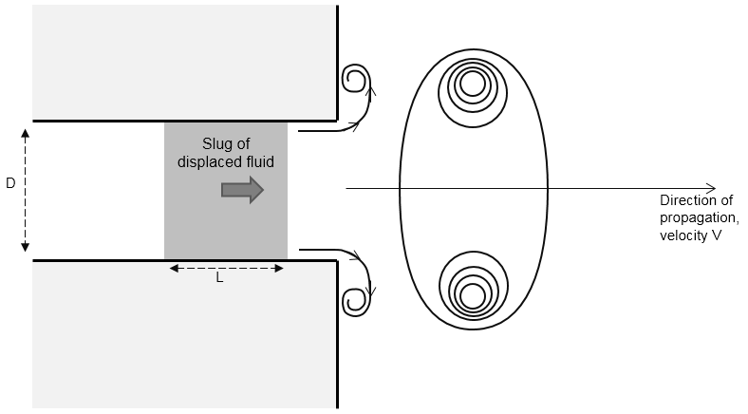

Figure 1.1 Typical features of the ring vortex generation. A volume of fluid is pushed through a pseudo-circular orifice. The shear layer roll-up and pinch-off form a toroidal vortex that propagates along its axis direction.

1.2.3 Ring vortex life cycle
The ring vortex development goes across several stages
- Formation
Depending on the generating process parameters, vortex rings may be either laminar or turbulent upon creation. An attempt to codify the conditions producing a laminar or a turbulent ring was made by Glezer (Glezer 1988) who built a transition map. Through the combination of dimensional arguments and experimental observations, Glezer recognized two dimensionless parameters, namely Reynolds number and stroke ratio (see §1.1.4), often sufficient to characterize the ring vortex behaviour during its formation.
- Stable laminar stage
According to the generation parameters, the early behaviour of a ring vortex can be laminar or turbulent. Among the factors affecting the initial regime of a ring vortex (in addition to the Reynolds number) details of the piston motion (i.e. piston velocity history), influencing the core structure, can be counted. The ingestion of negative vorticity (making the ring vortex susceptible to Rayleigh’s centrifugal instability) into the core should also be taken into account.
- Turbulent transition
The wavy azimuthal instability (also known as elliptical or Widnall instability) was observed for the first time on vortex rings by Krutzsch (Krutzsch 1939) who explained it with the acquisition of foreign matter (from the region outside the orifice) during the ring vortex generation. This phenomenon was then analysed in detail by Widnall and Sullivan (Widnall and Sullivan 1973) who considered sinusoidal perturbations of vortex rings in an ideal fluid environment. In a subsequent study (P. Saffman 1978b), Saffman identified a relationship between the number and growth rate of the waves and the Reynolds number (also identified a dependence on the vorticity distribution within the core).
- Turbulence and decay
In the small time limit, when the ring vortex core is thin, the Saffman’s (Po G Saffman 1970) viscous solution for a diffusing Gaussian core remains valid. In the large time limit, velocities decrease due to the total momentum to be shared with more fluid (eventually reaching the Stokes flow limit).

1.2.4 Ring vortex characterization
The behaviour of a ring vortex generated by a standard piston-cylinder system (see Figure 1.2) depends on eight parameters
- Piston displacement Δ
- Piston velocity U_{p}
- Piston area A_{p}
- Orifice area A₀
- Orifice thickness W₀
- Cylinder volume V_{c}
- Fluid kinematic viscosity ν
- Fluid density ρ
According to the Buckingham-Π theorem (Buckingham 1915), these can be reduced to five independent non-dimensional parameters (also called Π groups), describing the generator geometric and operating conditions:
$$Π_{1}=Δ/A_{0}^{\frac{1}{2}}$$
$$Π_{2}=A_{p}/A_{0}$$
$Π_{3}=V_{c}/(A_{p}A_{0}^{\frac{1}{2}})$ (1.1)
$$Π_{4}=W_{0}/A_{0}^{\frac{1}{2}}$$
$$Π_{5}=U_{p}A_{0}/νΔ$$
Further reduction can be achieved by assuming incompressibility of the flow
$L≜\frac{U_{0}Δ}{U_{p}A_{0}^{\frac{1}{2}}}∝\frac{ΔA_{p}}{A_{0}^{\frac{3}{2}}}=Π_{1}Π_{2}$ (1.2)
$Re≜\frac{U_{0}A_{0}^{\frac{1}{2}}}{ν}∝\frac{U_{p}A_{p}}{νA_{0}^{\frac{1}{2}}}=Π_{1}Π_{2}Π_{5}$ (1.3)
Where L represents the non-dimensional stroke length and Re represents the Reynolds number (U₀ is the space- and time- averaged velocity over the stroke time).
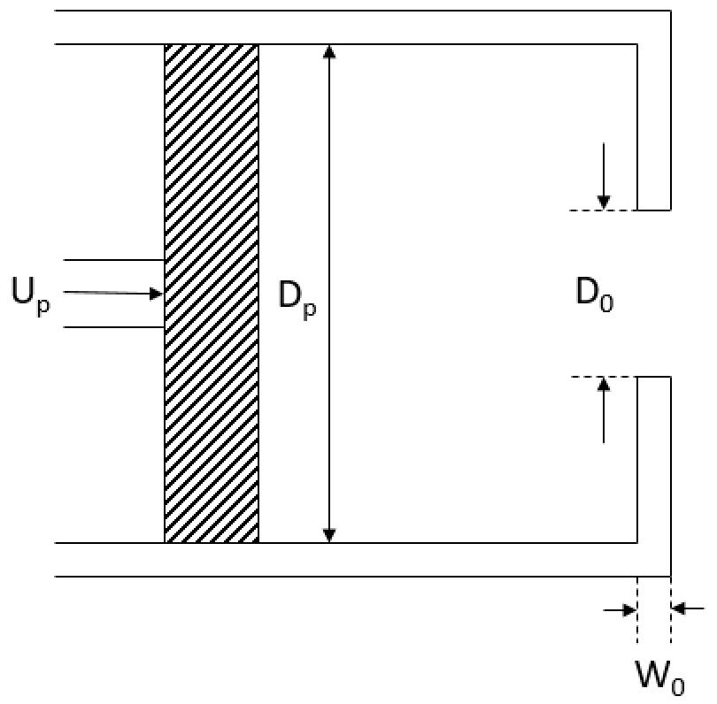

Figure 1.2 Standard piston/cylinder ring vortex generator
Therefore, following the dimensional argument, for a given geometry, the ring vortex behaviour depends on two dimensionless parameters
- Non-dimensional stroke length (or stroke ratio) L (indicated with L₀/D₀ in the following chapters), quantifying the time during which impulse is added to the ring vortex. An upper limit to L for vortex rings generated by piston-cylinder mechanisms was found by Gharib (Gharib, Rambod, and Shariff 1998), who formulated an energy balance where the ring vortex formation goes on as long as its kinetic energy is lower than that supplied by the generator. For $L≥4$ with no extra forcing a jet is formed instead of a single ring vortex
- Reynolds number Re, quantifying the ratio between inertial forcing and viscous damping
Among the definitions of Reynolds number applied to the ring vortex there are
- $Re_{o}=\frac{U_{0}D_{0}}{ν}$ (1.4)
Formulated by Maxworthy (Maxworthy 1977), it offers the advantage of straightforward calculation. Indeed, for experimental generation, the parameters used to define the ring vortex are typically known. On the other hand, it does not comprehensively describe the inertial dynamics of the ring vortex. A complete description should also include the contributions of the formation time, and the outlet geometry (although less important than U₀ and D₀).
- $Re_{Γ}=\frac{Γ_{0}}{ν}$ (1.4)
where Γ₀ is the ring vortex initial circulation
Formulated by Glezer (Glezer 1988), it offers a more appropriate measure of the ring vortex dynamics, encapsulating the entirety of the formation process. Notice that circulation measurement through the calculation of an integral of the vorticity field can be simplified through the Stokes theorem.
- $Re_{I}=\frac{\sqrt{\frac{I_{h}}{ρ}}}{ν\sqrt{(t)}}$ (1.5)
Formulated by Stanaway (Stanaway, Cantwell, and Spalart 1988), it was intended for numerical simulations of vortex rings. In fact, the computation from experimental data is challenged by the accurate measurement of the vorticity field.
- $Re_{s}=σδ^{2}/ν$ (1.6)
Formulated by Saffman (P. Saffman 1978b) considering the instabilities formed. σ represents the strain rate, δ represents the inner core radius.

1.3 Vortex rings in natural and artificial processes

1.3.1 Applications in biological systems
Moving in a fluid, animals are subjected to inertial, gravitational and frictional forces. In accordance with the Newton’s second and third laws, these must be counterbalanced by forces applied on the fluid. The flux of momentum left in their wake by flying birds and swimming fish highlights the generated propelling and sustaining forces. Since bird flight and fish swimming typically occur in the Reynolds number regime $Re>{10}^{2}$, the wake momentum will be characterized by vortex structures. According to the Helmholtz’s laws (Helmholtz 1858), closed-loop vortices are the only mechanisms of momentum flux in an inviscid fluid.
Wake vortices are essential to the locomotion mechanics of any flying or swimming vertebrate. Indeed, no vortices would mean no momentum flux, so no movement. Since the energy spent to generate the vortices can be significant, an optimal vortex wake should minimize energy consumption while maintaining the force required for locomotion. Therefore, the mechanical problems of flying and swimming vertebrates can be addressed by considering the efficient generation of a vortex wake. For example, drag-based paddling or rowing gives rise to local, intense drag vortices which are generally inefficient and cannot generate sufficient lift for flying vertebrates – due that the paddling limb or fin must travel backwards relative to the water, rowing is limited to relatively slow swimming. Instead, lifting structures (e.g. aerofoil, hydrofoil) are more effective. Other force-generating mechanisms used for thrust in swimming and flying, e.g. propellers and jets, also produce vortex wakes, but for anatomical and morphological reasons have no direct analogue in vertebrates. As indicated by experiment and theory, wake vortices tend to adopt (through interactions and deformations) a limited number of optimum structures, including vortex lines, loops and rings, which are appropriate for flying and swimming. Structure and degree of organization of the wake can be related to efficient locomotion. Poorly structured wakes are likely to correspond to high induced drag and, therefore, will be inefficient.

1.3.2 Applications in engineered systems
Circular jets, used in many engineering applications, can generate vortex rings. Understanding the ring vortex dynamics in jets contributes to development and improvement of technology that uses jets in engineering applications.
The generating mechanism of vortex rings, successively evolving near the jet exit, is determined by the boundary layer properties at the jet exit.
- Laminar boundary layer. Vortex rings formed by the rolled up shear layer merge into large-scale vortex rings.
- Turbulent boundary layer. Large-scale vortex rings (also known as coherent structures) generated due to the clustered concentration of vorticity in the shear layer break down as a result of wavy deformation and stretching, in the azimuthal and streamwise direction respectively.
Dynamics of vortex rings influences (by features like entrainment and self-induced travelling) the surrounding flow field properties. Therefore, several applications of ring vortex manipulation in flow control have been proposed.
- Entrainment and mixing enhancement
Mixing is a two stage process; (1) entrainment of surrounding fluid through large-scale vortex motions; (2) small-scale turbulent mixing through vortex breakdown, accelerating the molecular contact between the fluids. In circular jets, the entrainment of surrounding fluid can be effectively increased by enhancing the large-scale ring vortex evolution (Hussain and Zaman 1980).
- Suppression of noise and turbulence
Aerodynamic sound (e.g. jet noise), generated by unsteady vortical flows, represents a problem in many engineering applications. Several techniques have been developed to control the vortex rings related to the sound source, with the aim to suppress the jet noise.
- Heat transfer enhancement
Various mechanisms have been proposed to enhance hear transfer. Among these
Impinging jets. The dynamics of the vortical structures at the maximum heat are characterized by tilting and breaking before impingement, flapping and precessing in the stagnation region. Enhancement of heat transfer results from the thinner boundary layer, due to the flow acceleration caused by the impingement of the eddies.
Counter-rotating vortex pairs (streamwise vortices) along the wall surface. Enhancement of heat transfer results from the induced velocity effect of the vortex pairs.
Acoustic excitation of the initial shear layer at the natural instability frequency (f_{n}). Enhancement of heat transfer results from the ‘lump eddy’ caused by breakdown of vortex rings.
- Mass transport and thrust production
Ring vortex circulation is important to consider for applications to mass transport and thrust production. The maximum circulation attained for L₀/D₀ = 4 (Gharib, Rambod, and Shariff 1998) can be further increased by forcing jets at the frequency 0.125 U₀/D₀ (Kiya and Izawa 1999).

1.4 Vortex rings in physiology

1.4.1 Cardiovascular system anatomy
The cardiovascular system is responsible for delivering blood to/from the organs in order to enable diffusive exchange of metabolites/catabolites at cellular level in the tissues. The circulatory system is divided into
- Pulmonary circulation, going from the right ventricle to the left atrium, passing through pulmonary artery, lungs and pulmonary veins. This is responsible for delivering deoxygenated blood to the lungs. Oxygenated blood is then collected to be delivered to the left heart
- Systemic circulation, going from the left ventricle to the right atrium, passing through aorta, micro circulation, and venae cavae. This is responsible for delivering oxygenated blood to the organs. Deoxygenated blood is then collected to be delivered to the right heart
The systemic circulation can be further divided into
- Arterial system, responsible for the transport of blood to the tissues. Other important functions of the arterial system are transforming the pulsatile flow produced by the heart into a quasi-steady flow in the smaller arteries, and regulating the local pressure (and the corresponding flow) in accordance to needs. This is achieved by tailoring the peripheral resistance either through bifurcations or dynamic changes (vasoconstriction/vasodilation) of the vessel diameter. According to characteristic velocity and length scale (diameter in the order of 0.5-20 mm) inertial forces dominate over viscous forces.
- Capillary system, a network of small vessels, continuation of the arterioles. At the level of the capillary (or micro) circulation occurs the exchange of nutrients between the blood and the tissues. Due to reduced characteristic velocity and length scales (diameter in the order of 5-500μm), viscous forces dominate over inertial forces in their equilibrium with the driving pressure forces.
- Venous system, responsible for the transport of blood back to the heart. An important storage function is provided by the venous system, enabling the heart to regulate the arterial blood volume, controlled by vasoconstriction. Inertial forces may become significant; nevertheless, due to lower velocities and pressure amplitudes, non-stationary inertial forces will be less important than in the arterial system.
Forces needed for the motion of the blood around the circulatory system are provided by the heart. The left heart delivers blood to the systemic circulation in a two stages cycle
Diastole - Due to atrial contraction induced by a stimulus generated by the sinoatrial node, the left ventricle is filled with almost steady (constant) pressure. The mitral valve is open and the aortic valve is closed.
Systole - Due to ventricular contraction induced by a stimulus generated by the atrioventricular node, the pressure in the left ventricle sharply increases while the mitral valve closes. When the ventricular pressure exceeds the aortic pressure, the aortic valve opens and blood is ejected into the aorta.

1.4.2 Flow disturbances in the cardiovascular system
Blood flow disturbances eventually lead to turbulence and occur in several regions of the cardiovascular system, as a result of multiple haemodynamic factors
- velocity, viscosity, and density of the blood (Reynolds number)
- pulsatility, possibly leading to flow instability
- lesions/irregularities of the vessel wall
- aortic and pulmonary valves – the valvular leaflets act as natural projections into the stream of flow
On the other hand, a number of anatomic/haematologic factors tend to reduce flow disturbances
- vessel branching - branch to trunk area ratio less than 1.0 and acute angles of branching
- arterial tapering
- vessel distensibility
- normal concentration of RBCs and deformability of RBCs

1.4.3 Ring vortex formation in the heart
Left Ventricle
The formation of an asymmetric ring vortex is induced by the jet-like structure of the early trans-mitral flow. The asymmetric structure may be attributed to both the irregular shape of the mitral valve (anterior leaflet larger than posterior leaflet) and the interaction with ventricular walls. Prior to the pinch-off from the trans-mitral jet, the vortex deforms due to non-uniform core thickness and non-homogeneous pressure gradient inside the left ventricle.
The leading vortex contributes to efficient blood transport by transferring extra momentum from left atrium to left ventricle. Supplementary momentum can be transferred by the added mass effect (Krueger and Gharib 2003), or the fluid entrainment inside the trans-mitral vortex atmosphere (Dabiri and Gharib 2004). While some of the residual blood inside the ventricle is accelerated ahead during the trans-mitral jet initiation, some ambient fluid must be brought in behind the ring vortex to preserve the continuity of the flow.
Right Ventricle
The formation of a quasi-perfect ring vortex past the tricuspid valve, in the early diastole, is followed by the ring dissipation, during the filling, due to the interaction with the interventricular septum. The complex crescent-shape geometry of the right ventricle induces flow disturbances and, in the late diastole, the ring breaks down into smaller vortex elements. Regularization of the flow takes place during systole. The residual vorticity inside the right ventricle is largely due to the breakdown of the leading trans-tricuspid vortex rearranging into a streamwise vortex filament toward the outflow tract.

1.5 Complex flows in diagnosis/prognosis

1.5.1 Flow quantification modalities

1.5.1.1 Magnetic Resonance Imaging
Magnetic resonance imaging (MRI) provides accurate, non-invasive, and radiation-free methods for the anatomical representation of the cardiovascular system. The intrinsic sensitivity of MRI to motion also allows to simultaneously (within a single measurement) acquire spatially registered blood flow and morphological data. Recent progress in data acquisition, reconstruction, and analysis, affecting the capability to assess cardiovascular haemodynamics, envisage new applications for advanced flow imaging.
-Methods-
Flow imaging with MRI depends on the phase-contrast (PC) technique, exploitable to encode blood flow velocity along all principal dimensions. PC-MRI is typically performed, in current clinical routine practice, using methods resolving two spatial dimensions (in individual sections) and the perpendicular velocity component as a function of time. More advanced flow MRI techniques, allowing a more comprehensive evaluation of haemodynamics, include
- real-time 2D PC-MRI, for assessing short timescales flow changes (e.g. beat-to-beat variations)(Fasshauer et al. 2014)
- multiple-venc PC-MRI, for enhancing velocity dynamic range and/or encoding flow velocities as a separate dimension along with assessment of sub-voxel velocity distributions (Markl et al. 2016)
- 4D flow MRI, for analysing complex time-resolved 3D blood flow characteristics (Stankovic et al. 2014)
- advanced data analysis, for quantifying complex haemodynamic properties (Sotelo et al. 2016)
- multi-dimensional data under-sampling and advanced respiratory control, for accelerating 2D and 4D flow MRI (Hollingsworth 2015)
-Clinical Applications-
Aortic/Pulmonary disease – Flow imaging, combined with additional MRI techniques (e.g. cine imaging, MR angiography) is typically performed to assess the aortic/pulmonary structure and function, potentially contributing to the evaluation of several diseases (e.g. aortic dissection (François et al. 2013), pulmonary branch stenosis (Chen and Kilner 2013)). Additional improvements in aortic/pulmonary data analysis have encouraged the development of new applications, including pressure difference maps and WSS.
Congenital heart disease (CHD) – Associated changes of cardiovascular physiology and flow requires continuous evaluation from birth to adulthood. Current diagnostic tools are either invasive (e.g. catheter angiography) or unable to provide a complete assessment of the haemodynamics. The challenges arising with flow MRI in this patient population demand high spatio-temporal resolution, shorter scan times, and complete coverage of cardiovascular malformations (Driessen et al. 2015).
Atrial fibrillation (AF) – Transoesophageal echocardiography, used to measure flow decrease in the left atrium as an independent risk factor for stroke (Goldman et al. 1999) has some limitations (including required oesophageal intubation, limited access to 3D flow patterns). These could be overcome by 4D flow MRI, allowing for full spatial (3D) and temporal (cardiac cycle) coverage of the atrium. Furthermore, 3D segmentation of the left atrium, used to obtain anatomical maps, provide intuitive visualization of left atrial flow dynamics. Optimized and accelerated 2D flow imaging pulse sequences, combining effective data readout modules with under-sampling and parallel reconstruction makes possible real-time evaluation of beat-to-beat variation in presence of AF and breathing exercise. To further improve temporal resolution, shared velocity encoding (Kellman, Epstein, and McVeigh 2001), built on shared sets of full k-space data between adjacent frames (doubling the effective frame rate), has been proposed. A better understanding of how AF affects the left atrium haemodynamics may benefit from the combination of multi-beat and beat-to-beat flow metrics.
Coronary artery flow – Coronary artery flow assessment by means of MRI is challenged by the need for high spatial resolution and highly dynamic motion of the coronary arteries during the cardiac cycle. Nevertheless, the successful acquisition of coronary flow images by means of advanced imaging acceleration techniques or more efficient non-cartesian data sampling strategies has been reported by several studies (e.g. (Johnson, Sharma, and Oshinski 2008), (Brandts et al. 2010)). Despite motion remains a major challenge, further enhancement of the spatial resolution, required for stable coronary flow imaging methods, is expected to be obtained from improvements in hardware and imaging at high field strength. Early results obtained by retrospective motion correction for navigated 2D cine velocity mapping (Baltes et al. 2004) or data acquisition using readout modules less motion sensitive encourage further investigations evaluating the reliability of flow assessment in all coronary segments.

1.5.1.2 Echocardiography
Ultrasound (US) flow imaging techniques provide high temporal resolution at relatively low cost.
-Methods-
Color Doppler echocardiography – Measures only axial velocities along the ultrasound beam. In order to estimate the radial velocity component (directed perpendicularly to the axial velocity), allowing calculation of the true flow vector at each site, different methods have been proposed
- Crossed-beam ultrasound (Fox et al. 1978), using an array with three transducers, two transmitters, and one receiver, all directed to the same site but oriented at somewhat different insonating angles. Despite not being used for routine clinical applications, this method has been proven to work both theoretically and in simple phantoms.
- Vector flow mapping (Ohtsuki and Tanaka 2006), combining acquired axial velocities with radial velocities estimated based on physical principles. Assuming the flow along each radius within an image to be the combination of a laminar and a vortical component, this is deconstructed to compute the transverse velocity under the assumption that the vortical component satisfies the continuity equation from pixel to pixel, along each radius, and across all the scan lines in the field of the color flow image.
- Speckle tracking (Garcia et al. 2010) – The radial velocity of endocardial wall motion is measured based on the application of the continuity equation such that the resulting radial velocity matches the radial velocity at the wall. Notice that grey-scale data for the speckle tracking of the wall motion and color flow data for estimating the blood velocity are separately acquired.
All the above mentioned methods do not consider throughplane flow in the third dimension in addition to depending on the accuracy of the Doppler color data. Future development of these methods will benefit from improved basic color flow and automated de-aliasing of the color data. New methods for reconstructing the blood flow based on 2D/3D Doppler imaging are currently under investigation.
Echocardiographic particle image velocimetry (PIV) – Ultrasound based PIV or echo-PIV allows evaluating blood flow directions and streamlines, mapping principal flow patterns, and defining recirculation regions and vortices with reasonable confidence in a visually reproducible scheme. This method has been proven to work both experimentally (Sengupta et al. 2007) and clinically (Hong et al. 2008).

1.5.1.3 Invasive techniques
Invasive techniques involve the insertion of miniaturized pressure transducers of flow meters into the cardiovascular system.
-Methods-
Cardiac catheterization and angiography – Cardiac catheterization represents the gold standard technique for cardiac haemodynamics assessment; it is indicated for patients before percutaneous or surgical treatment. Tolerability and safety have been further improved by technological and methodological advances.
Cardiac catheterization implies inserting fine-bore tubes (catheters) into the heart through a peripheral artery or vein under fluoroscopic guidance. Several accesses have been used
- Left antecubital vein (cutdown)(Afshar, Steensma, and Kyle 2018)
- Brachial artery (cutdown)(Fergusson and Kamada 1986)
- Femoral (Conahan, Schwartz, and Geer 1977)
- Radial artery (Campeau 1989)
Left heart catheterization provides visual information through the injection of a contrast agent into the coronary arteries, and/or left ventricle, and/or aorta, also allowing ventricular and aortic pressure measurement.
Right heart catheterization involves pressure measurements in the pulmonary circulation and right heart chambers.
-Clinical Applications-
Coronary artery disease, aortic regurgitation, aortic root dilation - Providing visual information on left ventricular function and anatomy in addition to allowing left ventricular end-diastolic pressure and systolic pressure gradient across the aortic valve measurement, left catheterization helps clarifying the diagnosis and planning an optimal treatment strategy.
Mitral, tricuspid, or pulmonary valve disease, heart failure, pericardial constriction or suspected intracardiac shunts. - Left catheterization provide information on pulmonary/tricuspid valve pressure gradients, right ventricular function, pulmonary artery pressure, right-sided and left-sided filling pressures, cardiac output, and left-to-right shunts. Right catheterization provides information on left ventricular and mitral valve function and related coronary disease.

1.5.2 Quality assurance

1.5.2.1 Calibration of diagnostic imaging scanner – the role of flow phantoms
Images produced by scanners contain information that have to be interpreted in order to make a diagnosis, and establish treatment (e.g. surgery, drug therapy). The more accurate is the scanner, the more information will be contained in the images produced, and then the more objective (unbiased) will be their interpretation. It is then essential to quantify scanner performance in terms of accuracy and specificity to confirm that the information provided is reliable. The process aiming to establish a correlation between quantity values provided by measurement standards and corresponding indications of an instrument is called calibration.
Before being actually used in the diagnostic process, MR and US modalities must be calibrated. In order to assess how effectively the image produced by the scanner corresponds to real conditions, a well-known flow field is submitted to the machine. The keystone of an effective calibration, indeed, is the prior knowledge of the answer, which is to be exposed by the scanner. Therefore, flow calibration of MR and US scanners requires the use of a well characterised, well described flow. Experimental systems referred to as phantoms are designed and built for this purpose.
Although since their conception (Michie and Fried 1973) a lot of different flow phantoms have been designed and manufactured, the basic structure of a flow phantom includes (see Figure 1.3):
- a channel or a moving target, to simulate the flow within a vessel;
- a volume of solid or fluid material, to represent the tissue surrounding the vessel;
- a pumping or motor system, to actuate the flow;
- tanks and tubes to close the circuit

Figure 1.3 Schematic of a typical flow phantom

1.5.2.2 Design of a flow phantom
The main aspects of the phantoms’ design are:
- Geometry. Two opposite philosophies have been historically developed about geometry of the phantom channels: one aiming to produce a highly reproducible and characterizable flow using simple channel geometries (e.g. parallel flow in a straight pipe); the other one aiming to reproduce the complex physiological and pathological geometries, and associated flow fields, of the arterial system. Poepping et al. (Poepping et al. 2004), for example, produced an anatomical phantom simulating the carotid artery bifurcation.
- Flow pulsatility. Physiologic flows are, in general, pulsatile. To closely simulate physiological flows, also the phantom will have to produce pulsatile flow. To this end, different strategies have been implemented over years, primarily based on altering the pump output to produce pulsatile flow (Meagher et al. 2007), or alternatively on altering the distal resistance to modulate the waveform pulsatility (Shortland and Cochrane 1989). According to the anatomical region (e.g. brachial artery) different waveforms can be produced (Blake et al. 2008).
- Pumps. Different types of pump (gear (McDicken 1986), roller (Jorgensen, Campau, and Baker 1973), piston (Poots et al. 1986), centrifugal (Giddens and Khalifa 1982)) have been studied with the aim of identifying the most suitable solution. When choosing the type of pump to be used, the guidelines should be to maximize temporal resolution and flow stability, and minimize damage to the fluid. In this regard, piston-based systems offer the best compromise.
- Materials. When selecting materials to build a phantom, MR and US technologies present different requirements. In general, the choice of suitable materials for a phantom mainly concerns the results obtained (signal quality, resolution) with different materials. Imaging and measurement in vivo, in fact, is critically dependent on the physical properties of human tissues. Therefore, in order to obtain data relevant to scanning in patients, the physical properties of the phantom should ideally mimic those of human tissues. To this end specific properties like relaxation times for MR or propagation speed of sound and attenuation for US must assume appropriate values, prescribed by international directives. Compatibility with the specific modality addressed (MR or US) is also required.

1.5.2.3 Construction of a flow phantom
Test devices used to calibrate medical imaging scanners can be classified in two main categories (Browne 2014):
- phantoms that aim to mimic the properties of tissues and fluids. Flow phantoms represent an example of tissue/fluid mimicking phantoms. They generally represent a vessel, embedded in a block of tissue mimicking material, through which blood mimicking fluid is pumped. Historically, with the aim of making these test devices portable, two relevant trade-offs have become part of their design: (i) limited range of usable velocities, due to the need to limit the inlet length; (ii) limited range of vessel diameters, preventing the opportunity of exploring in depth sensitivity and spatial resolution of the scanner.
- phantoms that present a moving object (e.g. piece of string) to the scanner for the assessment of the response. String phantoms represent the most common example of non-tissue mimicking test objects. They are based on the controlled movement of a filament contained within a fluid tank (usually water) (Goldstein 1991; Russell, McHugh, and Moreman 1993; Hoskins 1994). In addition to these, other types of phantoms have been proposed: rotating phantoms (McDicken, Morrison, and Smith 1983), rotating torus phantoms (Stewart 1999), belt phantoms (Rickey, Rankin, and Fenster 1992), vibrating disk phantoms (Wang, Bone, and Hossack 1992), oscillating thin film test objects (Phillips, McAleavey, and Parker 1997) and electronic injection devices (Evans, Price, and Luhana 1989).

1.5.2.4 Current limitations and new prospects for flow phantoms
In spite of the large number of studies reported in literature, which envisage the use of different solutions, currently flow calibration predominantly relies on a well-developed, steady parabolic flow within a straight pipe. Unfortunately, this bears little resemblance to the complex physiological and pathological flows that imaging modalities routinely encounter in the clinic (i.e. accelerating, pulsatile, and/or vortical flows) and consequently numerous inaccuracies of flow interpretation can be expected, with implications for misdiagnosis.
To improve the performance evaluation of medical imaging scanners, the flow field implemented in the phantoms used for their calibration should aim to meet the following requirements:
i. characterizability. Basically, characterization of the flow generally includes the knowledge of the velocity field in each point (x,y,z) of the space at each point t of the time. The analytical solution of the equations governing the fluid motion is available only for a narrow range of simple flows. However, experimental characterization, perhaps assisted by Computational Fluid Dynamics (CFD) analysis, can be valuable for this purpose.
ii. affinity/resemblance with pathophysiological flows. In order to obtain an accurate interpretation of the complex physiological and pathological flows routinely encountered in the clinic by imaging modalities, the reference flow used in calibrating scanners should bear some resemblance to those flows. Several studies have focused on possible improvements of affinity of the reference flow with physiological flows either by reproducing:
- the physiological pulsatile flow (Hoskins, Anderson, and McDicken 1989).
- the physiological fluids, which are generally viscous non-Newtonian fluids (Lubbers 1999).
- the complex anatomical geometries of vessels, both for physiological (Smith, Rutt, and Holdsworth 1999) and pathological (Watts et al. 2007) conditions.

1.6 Research hypothesis
In the context of flow imaging, the present study starts from the following hypothesis (research question): “Is the ring vortex a good candidate for a flow phantom?”
Some of the illustrated characteristics of vortex rings, namely stability, reproducibility, and complexity (e.g. pulsatility, vorticity) support the initial hypothesis and encourage further investigations. The long-term goal of the project is the design and realization of an innovative flow phantom, possibly applicable to multiple modalities (e.g. Ultrasound, Magnetic Resonance Imaging), able to improve the current calibration strategies and perhaps useful to redefine some of the design principles of medical imaging scanners.
The aim of the present project is to characterize the full flow field of the ring vortex motion. The work will include theoretical characterization of the flow, carried out with analytical and numerical methods (e.g. Computational Fluid Dynamics (CFD), Proper Orthogonal Decomposition (POD)), and experimental characterization, carried out through the construction of a prototype rig, and the application of flow visualization techniques (e.g. dye visualization, laser particle image velocimetry (PIV)).
Fundamental aspects of the characterization, also related to the application of the ring vortex as a reference flow for the calibration of diagnostic imaging scanners are:
1. Stability. Any variation of the flow must not affect the initial state of the system. The application of flows with suitable characteristics to mimic the complex patho-physiological flows, but unstable (e.g. Karman flow) as reference flow, in fact, does not provide good results to the calibration.
2. Reproducibility. The same flow field, within specified tolerances, must be produced by the application of the same initial and boundary conditions to the system. Considering the studies published in literature and the early results of the project, presented in the following chapters, the ring vortex presents characteristics of
- Predictability (within specified tolerances, known fluid dynamics at every point in space and time)
- Controllability (relevant flow features can be varied in a controlled manner)
- Stability (resistance to disturbances)
- Reproducibility (repeatability over time, within defined tolerances)
At least under certain conditions, that make it a good candidate to become the calibration reference flow for medical imaging scanners.
An important observation concerns the reason why the ring vortex was chosen over a number of potential candidate flows. The ring vortex observation within the cardiovascular system, extensively reported in the literature, was not the driver of the research question. The intrinsic properties of the flow, encapsulating a range of complex features combined with high stability and reproducibility, were instead considered as the key factors potentially making the ring vortex a good candidate as a calibration reference.
Currently the calibration of flow imaging scanners is performed by means of either phantoms delivering a simple flow, not representative of the patho-physiological complexity routinely encountered in the clinic, or complex anthropomorphic phantoms, representative of specific compartments and conditions. The novelty of the present study lies in the attempt to aggregate characteristics of complexity of the flow, i.e. vortical/pulsatile, and simplicity of the design, i.e. ease to set up/portable. The use of more complex calibration references is intended for challenging the interpretation capabilities of the imaging modalities. In fact, a number of artefacts/misinterpretations can be counted when evaluating the scanner performance. Changing the target flow, also including flow features undetected by current technologies, can contribute to continuous development.

Chapter 2 - Analytical Models

2.1 Introduction

2.1.1 Vortex dynamics theory
Identifying the concepts of potential and vortex motion of a fluid, Helmholtz (Helmholtz 1858) laid the theoretical foundations of vortical or rotational motion. He also introduced the definitions of vortex lines and vortex filaments and established three fundamental theorems (valid under the assumption of only conservative forces acting on the fluid)(Meleshko, Gourjii, and Krasnopolskaya 2012)
- ‘No element of the fluid which was not originally in rotation is made to rotate’.
- ‘The elements which at any time belong to one vortex-line, however they may be translated, remain on one vortex-line’.
- ‘The strength (or circulation) of an infinitely thin vortex-filament is constant throughout its whole length, and retains the same value during all displacements of the filament. Hence, vortex-filaments must either be closed curves, or must have their ends in the bounding surface of the fluid’
Starting from the equations governing the motion of an ideal (uniform incompressible inviscid) fluid under the action of conservative volume forces
$∇∙u=0$ (2.1)
$\frac{∂u}{∂t}+\left(u∙∇\right)u=-\frac{1}{ρ}∇p$ (2.2)
representing conservation of mass and conservation of momentum, respectively, where u is the Eulerian velocity (vector) field, p(x,t) is the (scalar) pressure, and ρ is the constant fluid density, and applying the rotor operator to equation (2.2), two equivalent equations can be obtained
$\frac{∂ω}{∂t}=∇×\left(u×ω\right)$, or $\frac{∂ω}{∂t}+\left(u∙∇\right)ω=\left(ω∙∇\right)u$ (2.3)
where
$ω=∇×u$ (2.4)
is the vorticity vector, fundamental characteristic of vortex motions of the fluid.
Notice that the description of fluid motion in terms of velocity and vorticity (and not of the pressure) was later applied as a basis for the theory of vortices in an ideal fluid.
Any motion of an infinitesimal fluid element can be decomposed into the transfer of its centre of gravity, tension or compression of this element along three main directions, and local rotation around an instantaneous axis passing through its centre. It can be demonstrated that the sum of tensions/compressions along three nonorthogonal directions corresponds to the sum of tensions along orthogonal directions and some rotation. Fluid particles move along straight lines and not along certain orbits, but the diagonal of any infinitesimal rectangle rotates around an axis perpendicular to the plane of flow.
The solution of equations (2.3) for the vorticity vector presents enormous difficulties, related to their substantial nonlinearity. Despite modern computers and growing understanding of the mathematical properties of original equations, the complete solution of the problem of the motion of an ideal fluid with arbitrary initial vorticity distribution is not available at present.

2.1.2 Theory of axisymmetric vortex rings (Meleshko, Gourjii, and Krasnopolskaya 2012)

2.1.2.1 Equations of motion
Vortex rings represent a particular case of vortex motion. The application of the Helmholtz theorems (I, II, III) to the problem of the motion of a ring vortex in an ideal unbounded medium delivers some important insights about the associated laws of motion.
- According to the hypothesis of ideal fluid, the ring vortex takes part in the motion for an indefinite time
- According to theorem II, the ring vortex volume remains constant during its motion
- According to theorem III, the vortex strength can be quantified as
$Γ=\int_{S}{\left(ω∙n\right)dS=const}$ (2.5)
where n is the unit vector perpendicular to the plane of the ring vortex cross section.
Since the problem is axisymmetric, it is useful to assume a cylindrical coordinate system (z, r, θ),
where z is the axial coordinate (corresponding to the symmetry axis of the ring vortex), r is the radial coordinate, and θ is the azimuthal coordinate (see Figure 2.1). In this coordinate system, the vorticity vector field has a single azimuthal component $ω=(0,0,ω)$, the velocity vector field has two, axial and radial, components $U=\left(u_{z},u_{r},0\right)=(u,v,0)$, and the Helmholtz vector equation for vorticity (2.3) becomes a single scalar equation
$\frac{∂}{∂t}\left(\frac{ω}{r}\right)+v\frac{∂}{∂r}\left(\frac{ω}{r}\right)+u\frac{∂}{∂z}\left(\frac{ω}{r}\right)=0$ (2.6)
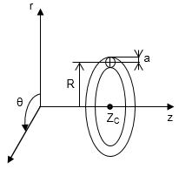

Figure 2.1 The ring vortex in a cylindrical coordinate system

A particular solution of equation (2.6) is
$\frac{ω}{r}=const$ (2.7)
which corresponds to uniform vorticity within the ring vortex volume. Notice that (2.7) is valid for both stationary and nonstationary motion as not explicitly dependent on time. Solution (2.7) must be equal to zero outside the ring vortex domain, where the fluid motion is potential. A typical problem of splicing potential and vortex motion arises on the ring surface, where the continuity of the velocity components must be guaranteed.
The difficult problem of determining the exact shape of the ring vortex cross section satisfying equation (2.6) can be substantially simplified by considering thin vortex rings, with approximately circular cross section. In this case, the vortex motion is characterized by the deformation of its boundary with invariable shape of its cross section and vorticity distribution inside the ring.
According to the definition of vorticity ($ω=∇×u$) and to solution (2.7)
$ω=\frac{∂u}{∂z}-\frac{∂v}{∂r}=rM$ (2.8)
where M is a constant.
Equation (2.5) presupposes the existence of a Stokes stream function Ψ (vector potential) related to the velocity components such that
$v=-\frac{1}{r}\frac{∂Ψ}{∂z}$, u$=\frac{1}{r}\frac{∂Ψ}{∂r}$ (2.9)
Equation (2.8) for an axisymmetric incompressible fluid flow becomes
$\frac{∂^{2}Ψ}{{∂r}^{2}}-\frac{1}{r}\frac{∂Ψ}{∂r}+\frac{∂^{2}Ψ}{{∂z}^{2}}=\left\{\begin{aligned}-r^{2}M inside the ring \\ 0 outside the ring.\end{aligned}\right.$ (2.10)
Introducing the change of variables $Ψ=Φr$ and assuming that Φ=Φ(z, r, θ), the expression (2.10) becomes the (vector) Poisson and the Laplace equation, respectively, in the cylindrical coordinate system,
$\frac{∂^{2}Φ}{{∂r}^{2}}+\frac{1}{r}\frac{∂Φ}{∂r}+\frac{1}{r^{2}}\frac{∂^{2}Φ}{{∂θ}^{2}}+\frac{∂^{2}Ψ}{{∂z}^{2}}=\left\{\begin{aligned}-r^{2}M inside the ring \\ 0 outside the ring.\end{aligned}\right.$ (2.11)
solved by the integral over the volume (V) filled with vortical fluid, allegedly known under the continuity assumption for the stream function Ψ and its derivatives over the surface of the ring vortex
$Ψ\left(r^{*},z^{*}\right)=\frac{Mr^{*}}{4π}\int_{V}{\frac{rcosθdV}{{\left[{\left(z-z^{*}\right)}^{2}+{\left(r^{*}\right)}^{2}+r^{2}-2rr^{*}cosθ\right]}^{\frac{1}{2}}}}$ (2.12)
where r* and z* are the coordinates of a moving integration point in the region V, where the vorticity distribution ω is given. Notice that solution (2.12) is unique if u is everywhere continuous and null at infinity.
Let us introduce now local variables related to the centre of gravity of the ring cross section (see Figure 2.2)
$r=R_{K}-r'$ , $z=Z_{K}+z'$. (2.13)

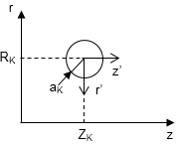

Figure 2.2 Local variables connected to the centre of gravity of the ring vortex cross section

The stream function (2.12) in these coordinates takes the form
$Ψ\left(r^{*},z^{*}\right)=\frac{Mr^{*}}{4π}\int_{V}{\frac{{\left(R_{K}-r^{'}\right)}^{2}cosθdθdr^{'}dz^{'}}{{\left[{\left(z^{*}-Z_{K}-z^{'}\right)}^{2}+{\left(r^{*}\right)}^{2}+{\left(R_{K}-r^{'}\right)}^{2}-2\left(R_{K}-r^{'}\right)r^{*}cosθ\right]}^{\frac{1}{2}}}}$ (2.14)
By introducing the notation
$I=\int_{0}^{2π}{Fdθ=\int_{0}^{2π}{\frac{{\left(R_{K}-r^{'}\right)}^{2}cosθdθ}{{\left[{\left(z^{*}-Z_{K}-z^{'}\right)}^{2}+{\left(r^{*}\right)}^{2}+{\left(R_{K}-r^{'}\right)}^{2}-2(R_{K}-r^{'})r^{*}cosθ\right]}^{\frac{1}{2}}}}}$ (2.15)

The integrand is written here in terms of R_{K}-r’ and Z_{K}+z’,
$\frac{∂^{n}F}{∂Z_{K}^{n}}=\frac{∂^{n}F}{∂{(z^{'})}^{n}}$, $\frac{∂^{n}F}{∂R_{K}^{n}}={(-1)}^{n}\frac{∂^{n}F}{∂{(r^{'})}^{n}}$ (2.16)
Therefore, the expansion of (2.15) into a Taylor series in the neighbourhood of (r’=z’=0) takes the form
$I\left(r^{'},z^{'}\right)=\sum_{n,m=0}^{∞}{{\left.\frac{1}{n!m!}\frac{∂^{n+m}}{∂{(z^{'})}^{n}∂{(r^{'})}^{m}}I\right|}_{\begin{aligned}r^{'}=0 \\ z^{'}=0\end{aligned}}{(z^{'})}^{n}{(r^{'})}^{m}}=\sum_{n,m=0}^{∞}{{\left.\frac{{(-1)}^{m}}{n!m!}\frac{∂^{n+m}}{∂Z_{K}^{n}∂R_{K}^{m}}{(z^{'})}^{n}{(r^{'})}^{m}I\right|}_{\begin{aligned}r^{'}=0 \\ z^{'}=0\end{aligned}}}$ (2.17)
Hence, the stream function at (r*,z*) assumes the value
$Ψ\left(r^{*},z^{*}\right)=\frac{Mr^{*}}{4π}\int_{(S)}{exp⁡[r^{'}\frac{∂}{{∂Z}_{K}}-r^{'}\frac{∂}{{∂R}_{K}}]{dr}^{'}{dz}^{'}×}\int_{0}^{2π}{\frac{R_{K}^{2}cosθdθ}{{\left[{\left(z^{*}-Z_{K}\right)}^{2}+{\left(r^{*}\right)}^{2}+{\left(R_{K}\right)}^{2}-2R_{K}r^{*}cosθ\right]}^{\frac{1}{2}}}}$ (2.18)
Integration is carried out independently with respect to the circumferential coordinate and over the ring cross-sectional area. Assuming that
$\frac{∂}{{∂R}_{K}}=Lcosα$, $\frac{∂}{{∂Z}_{K}}=Lsinα$, $L^{2}=\frac{∂^{2}}{{∂Z}_{K}^{2}}+\frac{∂^{2}}{{∂R}_{K}^{2}}$ (2.19)
the integral over the cross section of the ring vortex equals
$\int_{(S)}{\exp\left[-L\left(r^{'}cosα-z^{'}sinα\right)\right]{dz}^{'}{dr}^{'}}$ (2.20)
And, after replacement
$ξ=\frac{1}{a_{K}}(r^{'}cosα-z^{'}sinα)$, $η=\frac{1}{a_{K}}(-r^{'}sinα-z^{'}cosα)$ (2.21)
Finally, the stream function is represented as a series of operators acting on the definite integral
$Ψ\left(r^{*},z^{*}\right)=\frac{Mr^{*}a_{K}}{2}\left\{1+\frac{1}{8}{\left(La_{K}\right)}^{2}+\frac{1}{192}{\left(La_{K}\right)}^{4}+…\right\}×\int_{0}^{2π}{\frac{R_{K}^{2}cosθdθ}{{\left[{\left(z^{*}-Z_{K}\right)}^{2}+{\left(r^{*}\right)}^{2}+{\left(R_{K}\right)}^{2}-2R_{K}r^{*}cosθ\right]}^{\frac{1}{2}}}}$ (2.22)
which in turn can be expressed via the complete elliptic integrals of the first K(k) and second E(k) kind:
$\int_{0}^{2π}{\frac{R_{K}^{2}cosθdθ}{{\left[{\left(z^{*}-Z_{K}\right)}^{2}+{\left(r^{*}\right)}^{2}+{\left(R_{K}\right)}^{2}-2R_{K}r^{*}cosθ\right]}^{\frac{1}{2}}}}=\frac{kR_{K}^{2}}{\sqrt{r^{*}R}}[\frac{2}{k}\left\{K\left(k\right)-E\left(k\right)\right\}-bK\left(k\right)]$ (2.23)
where
$k^{2}=\frac{4R_{K}r^{*}}{{(z^{*}-Z_{K})}^{2}+{\left(r^{*}-R_{K}\right)}^{2}}$ (2.24)
Consider a single ring vortex travelling with axial velocity ${\dot{Z}}_{K}(t)$ and radial velocity ${\dot{R}}_{K}(t)$. According to the condition $a_{K}^{2}R_{K}=const$ (constant volume of the ring), the rate of change in the cross-section radius
${\dot{a}}_{K}=-\frac{1}{2}\frac{a_{K}}{R_{K}}{\dot{R}}_{K}$ (2.25)
for a thin ring is smaller than the radial velocity component by an order of magnitude.
At an arbitrary point on the ring surface, its normal velocity component can be expressed as
$U\left(β\right)={\dot{Z}}_{K}sinβ-{\dot{R}}_{K}cosβ-{\dot{a}}_{K}$ (2.26)
where β is the angle in the local coordinate system (see Figure 2.2). This can also be obtained from the stream function calculated on the ring core surface:
$U\left(β\right)=\frac{1}{r^{*}a_{K}}\frac{∂}{∂β}Ψ(r^{*},z^{*})$ (2.27)
where (r*, z*) are the coordinates of an arbitrary point on the vortex surface:
$r^{*}=R_{K}-a_{K}cosβ$, $z^{*}=Z_{K}+a_{K}sinβ$ (2.28)
and Ψ(r*,z*) is determined from equation (2.22).
In order to calculate the stream function on the surface of a toroidal ring, (2.22) can be conveniently expanded in a power series of the parameter s=aK/RK. Using the expansions of complete elliptic integrals in a power series of the complementary modulus $m^{2}=1-k^{2}$
$E\left(k\right)=1+\frac{m^{2}}{2}\left(ln\frac{4}{m}-\frac{1}{2}\right)+O\left(m^{4}\right)$ (2.29)
$K\left(k\right)=ln\frac{4}{m}+\frac{m^{2}}{4}\left(ln\frac{4}{m}-1\right)+O\left(m^{4}\right)$ (2.30)
where
$m^{2}=\frac{s^{2}}{4}+\frac{s^{3}}{4}cosβ+O(s^{4})$, (2.31)
$ln\frac{4}{m}=ln\frac{8}{s}-\frac{s}{2}cosβ+\frac{s^{2}}{8}cos2β+O\left(s^{3}lns^{-1}\right)$, (2.32)
the stream function on the surface of a ring vortex is given by
$Ψ\left(r^{*},z^{*}\right)=\frac{Mr^{*}R_{K}a_{K}^{2}}{2}\left[1+\frac{{\left(La_{K}\right)}^{2}}{8}+\frac{{\left(La_{K}\right)}^{4}}{192}+…\right]×\left\{\left(ln\frac{8}{s}-1\right)+\frac{s}{2}\left(cosβln\frac{8}{s}-3cosβ\right)+\frac{s^{2}}{16}(3cos2βln\frac{8}{s}+6ln\frac{8}{s}-10cos2β-11)\right\}$ (2.33)
An integral of the form
$J=\int_{0}^{π}{\frac{R_{K}cosθdθ}{{\left[{\left(z^{*}-z_{K}\right)}^{2}+{\left(r^{*}\right)}^{2}+R_{K}^{2}-2R_{K}r^{*}cosθ\right]}^{\frac{1}{2}}}}$ (2.34)
is a solution of the equation
$\frac{∂^{2}J}{∂Z_{K}^{2}}+\frac{∂^{2}J}{∂R_{K}^{2}}-\frac{1}{R_{K}}\frac{∂J}{∂R_{K}}=0$, (2.35)
and, therefore,
$L^{2}\left(JR_{K}\right)=3\frac{∂J}{∂R_{K}}$, $L^{4}\left(JR_{K}\right)=3\frac{∂}{∂R_{K}}(\frac{1}{R_{K}}\frac{∂J}{∂R_{K}})$ (2.36)
Thus,
$\frac{{({La}_{K})}^{2}}{8}\int_{0}^{2π}{\frac{R_{K}^{2}cosθdθ}{{\left[{\left(z^{*}-Z_{K}\right)}^{2}+{\left(r^{*}\right)}^{2}+R_{K}^{2}-2R_{K}r^{*}cosθ\right]}^{\frac{1}{2}}}}=\frac{s}{8}\left(-3cosβ\right)+\frac{s^{2}}{32}\left(6ln\frac{8}{s}-3cos2β-9\right)+O(s^{3}lns^{-1})$ (2.37)
$\frac{{({La}_{K})}^{4}}{192}\int_{0}^{2π}{\frac{R_{K}^{2}cosθdθ}{{\left[{\left(z^{*}-Z_{K}\right)}^{2}+{\left(r^{*}\right)}^{2}+R_{K}^{2}-2R_{K}r^{*}cosθ\right]}^{\frac{1}{2}}}}=\frac{s^{2}}{64}cos2β+O(s^{3}lns^{-1})$ (2.38)
The stream function on the surface of a ring vortex is then represented by:
$Ψ\left(r^{*},z^{*}\right)=\frac{ΓR_{K}}{2π}(\left(ln\frac{8}{s}-2\right)+\frac{s}{8}\left(cosβ-4cosβln\frac{8}{s}\right)+\frac{s^{2}}{64}\left(20ln\frac{8}{s}-4cosβln\frac{8}{s}-15cosβ-2\right)+O\left(s^{3}lns^{-1}\right))$ (2.39)
where $Γ=πMR_{K}a_{K}^{2}$ is the vortex strength.
The normal velocity component on the surface of the ring vortex can be obtained by differentiating (2.39) with respect to the circumferential coordinate β.
$U\left(β\right)=\frac{Γ}{4πR_{K}}(sinβ\left(ln\frac{8}{s}-\frac{1}{4}\right)+ssin2β\left(\frac{3}{4}ln\frac{8}{s}-\frac{17}{16}\right)+\frac{s}{2}\left(ln\frac{8}{s}-\frac{1}{4}\right)+O\left(s^{2}lns^{-1}\right))$ (2.40)
The comparison between (2.39) and (2.25) allows to conclude that the self-induced velocity of a ring vortex in an unbounded medium has the following axial and radial velocity components:
${\dot{Z}}_{K}=\frac{Γ}{4πR_{K}}\left(ln\frac{8R_{K}}{a_{K}}-\frac{1}{4}\right)+O(\frac{a_{K}}{R_{K}}ln\frac{R_{K}}{a_{K}})$, ${\dot{R}}_{K}=0$ (2.41)

2.1.2.2 Invariants of motion
Several integral parameters contribute to the characterization of a ring vortex
- Circulation, characterizing the amount of swirling around the vortex centre, and defined as:
$Γ=\oint_{C}{u∙dl}$, (2.42)
where u is the flow velocity, and C is a closed circuit. The circulation Γ around a closed contour C can be expressed, in accordance with the Stokes theorem, as the flux of vorticity ω through an arbitrary surface Σ, bounded by C:
$Γ=\iint_{Σ}{ω∙dΣ}$, (2.43)
- Impulse, defined as
$I=\frac{1}{2}ρ\int_{V}{r×ωdV}$, (2.44)
where r is the radius vector, and V is the volume including all vortices.
Lamb (Lamb 1932) first introduced the concept of vortex impulse, meant as the impulse of external forces to be applied to a limited portion of flow with the aim of generating the observed fluid motion from rest. This because the common definition of momentum, i.e.
$K=ρ\int_{V}{UdV}$, (2.45)
fails for most of the flows of an ideal incompressible fluid at rest at infinity. Lugovtsov (Lugovtsov 1976) then proved that the vortex impulse I is invariant in time also in a viscous incompressible fluid.
- Energy, given by the integral
$E=(\frac{ρ}{2})\int_{V}{u∙udV}=(\frac{ρ}{2})\int_{V}{u\left(∇×A\right)dV}$ (2.46)
over the volume V of an unbounded medium occupied by the fluid. By assuming the identity
$∇∙\left(a×b\right)=b\left(∇×a\right)-a(∇×b)$ (2.47)
this expression can be reformulated as
$E=(\frac{ρ}{2})\int_{V}{\left[A\left(∇×u\right)-∇∙\left(u×A\right)\right]dV}$ (2.48)
The divergence form term becomes a surface integral, that is zero in an unbounded fluid, thus
$E=(\frac{ρ}{2})\int{A∙ωdV}$ (2.49)
Vorticity outside of the ring vortex is zero, thus the integration region reduces to the ring volume. Therefore, assuming that in cylindrical coordinates ω=(0,0,ω), A=A(0,0, A), and A=Ψ/r, the kinetic energy of the ring vortex becomes
$E=\frac{1}{2}ρ\int_{Σ}{\frac{Ψ}{r}ωdrrdθdz=}πρ\iint_{Σ}{Ψωdrdz}$, (2.50)
where Σ is the cross section of the ring.

2.1.2.3 Translational speed of vortex rings
The speed of propagation V is one of the major features of a ring vortex, and its calculation represents a nontrivial problem. A universal formula for the translational speed of thin vortex rings with an arbitrary distribution of vorticity was obtained by Saffman (Philip G Saffman 1992) for vortex motion
- in an inviscid fluid $V=\frac{Γ}{4πR}(ln\frac{8R}{a}-\frac{1}{2})$, and
- in a viscous fluid $V=\frac{Γ}{4πR}(ln\frac{8R}{\sqrt{4νT}}-0.558)$,
where ν is the kinematic viscosity and T is the stroke time.

2.2 Ring vortex theoretical models

2.2.1 Formation models

2.2.1.1 Slug-flow model
The slug-flow model allows to estimate starting flow measures (e.g. circulation Γ₀, impulse I₀) from the generation parameters. The formulation is based on two main assumptions
- The boundary layer edge velocity equals the piston velocity, therefore the rate of vorticity flux (Lim and Nickels 1995) can be approximated as
$\frac{dΓ_{slug}}{dt}=\int{ωudr≈\int{-\frac{∂u}{∂r}udr}}≈\frac{1}{2}U_{p}^{2}(t)$ (2.51)
where the first approximation sign refers to boundary layer assumptions and the second to the assumed equality between boundary layer and piston velocities
- All the generated vorticity rolls up into the formed ring vortex, therefore the initial circulation Γ₀ (Maxworthy 1977) can be approximated as
$Γ_{0}=\int_{0}^{T_{0}}{\frac{1}{2}U_{p}^{2}\left(t\right)dt}$ (2.52)
Due to the following factors
- Velocity at the edge of the boundary layer at the exit higher than the piston speed.
This results from the acceleration of the flow around the edge and the boundary layer displacement effect at later times
- Ingestion of negative vorticity created on the outer wall
The slug flow model either
- Underestimates the total vortex circulation in the regime Γ_{slug}/ν<7000 (the acceleration effect must dominate)(Didden 1979) or
- Overestimates the total vortex circulation in the regime Γ_{slug}/ν>3-5 x10⁴ (Maxworthy 1977) perhaps indicating greater vorticity cancellation

2.2.1.2 Self-similar roll-up
Self-similarity allows to estimate ring diameter, core diameter and starting circulation. The formulation is based on two main assumptions
- Piston velocities expressed as U_{p}(t)=U_{p}t^{m}. This permits to keep the formation problem time-scale free
- Times during which the size of the spiral δ_{s} is much larger than the viscous scale √νt are considered. This permits to keep the formation problem length-scale free
First discussed by Saffman (P. Saffman 1978a) who considered an axisymmetric model of an impulsively started jet (arriving at approximations for D0, δ0, Γ0)
$D_{0}=D_{O}+c_{1}c_{4}^{\frac{2}{3}}L_{0}^{\frac{2}{3}}D_{O}^{\frac{1}{3}}$ (2.53)
$δ_{0}=\frac{c_{3}^{2}c_{4}^{\frac{2}{3}}}{c_{2}^{2}}L_{0}^{\frac{2}{3}}D_{O}^{\frac{1}{5}}$ (2.54)
$Γ_{0}=c_{3}c_{4}^{\frac{4}{3}}\overline{U_{0}}L_{0}^{\frac{1}{3}}D_{0}^{\frac{2}{3}}$ (2.55)
where c₁, c₂, c₃ and c₄ are constants, the model was validated against experimental data for small stroke ratios L₀/D₀.
Pullin (Pullin 1979) extended Saffman’s work to account for the axisymmetric roll-up of a vortex sheet, also including a variety of piston velocity programs (other than impulsive). Circulation and core radius were then defined according to the generation time T0, for some constant K0,
$K_{0}=K_{1}A_{p}D^{\frac{1}{2}}$ (2.56)
$Γ_{0}=K_{2}{\left[\frac{0.75K_{0}^{4}}{1+m}\right]}^{\frac{1}{3}}T_{0}^{\frac{4}{3}\left(1+m\right)-1}$ (2.57)
$δ_{0}=K_{3}{\left[\frac{0.75K_{0}}{1+m}\right]}^{\frac{2}{3}}T_{0}^{\frac{2}{3}(1+m)}$ (2.58)
where the constants K₁, K₂, and K₃ are associated to the generator geometry and obtained from similarity theory calculations, respectively. Finally, the ring diameter is expressed in terms of another constant, K₅, associated with the generator geometry as well,
$D_{0}=D_{0}+K_{5}D_{0}{\left(\frac{L_{0}}{D_{0}}\right)}^{\frac{4}{3}}$ (2.59)
Numerous drawbacks are connected with these approaches:
- both slug-flow and self-similar roll-up ignore the production of counter-vorticity in order to keep a slip free wall
- the validity of the self-similar roll-up model is based on the absence of a length scale, only true in two-dimensions
Several other empirical/semi-empirical models of vortex ring formation have been proposed and validated over the last few years.

2.2.2 Evolution models

2.2.2.1 Infinitely thin
The main assumption concerns the distribution of vorticity, represented by Dirac-delta functions $ω=Γ_{0}δ(z-z_{0})δ(r-R)$,
where z=z0, r=R are the line coordinates.
The main physical quantities are calculated as
$I=ρΓπR^{2}$,
$E=∞$,
$V=∞$,
An approximated solution to equation (2.6) can be obtained in the vicinity of the vortex line. Consider a polar coordinates system (s,α) with the origin at the intersection between a meridional plane and the line, under the assumption $\frac{s}{R}≪1$. The stream function Ψ of the flow induced by the circular line vortex is
$Ψ≈\frac{Γ_{0}R}{2π}[ln\frac{8R}{s}-2+\frac{s}{2R}sinα\left(ln\frac{8R}{s}-1\right)+O\left(\frac{s^{2}}{R^{2}}ln\frac{8R}{s}\right)]$ (2.60)

2.2.2.2 Thin-cored vortex rings (Lamb’s model)(Lamb 1932)
Three main assumptions to be considered
- inviscid fluid
- constant circulation $Γ=const$
- thin core $R≫a$
The main physical quantities are calculated as
$I=ρΓπR^{2}$ (2.61)
$E=\frac{1}{2}ρΓ^{2}R[ln\frac{8R}{a}-α]$ (2.62)
$V=\frac{Γ}{4πR}(ln\frac{8R}{a}-β)$ (2.63)
where α and β are constants whose value depends on the core model adopted (see Table 2.1)

Table 2.1 Values of α and β for classical vortex rings with different core models (Sullivan et al. 2008)
Model | α | β
Solid rotating core, constant volume | 7/4 | ¼
Hollow core, constant volume | 2 | ½
Hollow core, constant pressure | 3/2 | ½
Hollow core, with surface tension | 1 | 0
NLSE solution | 1.615 | 0.615
Viscous core | 2.04 | 0.558

2.2.2.3 Norbury-Fraenkel model
Three main assumptions to be considered
- inviscid fluid
- linear distribution of vorticity $ω=Ωr$
- vortex rings characterized by a single geometric parameter
$α=\frac{\sqrt{|Ω_{C}/π}}{R}$ (2.64)
where Ω_{C} is the cross-sectional area of the vortex, and R is the ring radius.
The main physical quantities are calculated as
$Γ=ΩR_{C}^{3}α^{2}Γ_{NF}(α)$ (2.65)
$I=ΩR_{C}^{5}α^{2}I_{NF}(α)$ (2.66)
$E=Ω^{2}R_{C}^{7}α^{4}E_{NF}(α)$ (2.67)
$V=ΩR_{C}^{2}α^{2}V_{NF}\left(α\right)$ (2.68)
where non-dimensional quantities ()_{NF} are provided in tabular form.
Asymptotic expressions are given by Fraenkel (Fraenkel 1972b) for α->0 (thin core)
$Γ_{NF}\left(α\right)=π$ (2.69)
$I_{NF}(α)=π^{2}(1+\frac{3}{4}α^{2})$ (2.70)
$E_{NF}(α)=π^{2}[\frac{1}{2}ln\frac{8}{α}-\frac{7}{8}+\frac{3}{16}α^{2}ln\frac{8}{α}]$ (2.71)
$V_{NF}=\frac{1}{4}\ln\left(\frac{8}{α}\right)-\frac{1}{16}+α^{2}[-\frac{3}{32}\ln\left(\frac{8}{α}\right)+\frac{15}{128}$ (2.72)
and Norbury (Norbury 1973) for α->√2 (thick core)
$Γ_{NF}\left(α\right)=\frac{1}{3}a^{3}\left[1+\sqrt{2}\overline{α}-\frac{3}{16}{\overline{α}}^{2}\ln\left(\frac{8\sqrt{2}}{\overline{α}}\right)+1.69{\overline{α}}^{2}\right]$ (2.73)
$I_{NF}\left(α\right)=\frac{2π}{15}a^{5}\left[1+\sqrt{2}\overline{α}+\frac{141}{64}{\overline{α}}^{2}\right]$ (2.74)
$E_{NF}\left(α\right)=\frac{2π}{315}a^{7}\left[1+2\sqrt{2}\overline{α}+\frac{383}{64}{\overline{α}}^{2}\right]$ (2.75)
$V_{NF}\left(α\right)=\frac{2}{15}a^{2}$ (2.76)
where $\overline{α}=\sqrt{2}-α$ and $a=2(1-\frac{\overline{α}}{2\sqrt{2}})$.

2.2.2.4 Kaplanski-Rudi model (Kaplanski and Rudi 2005)
Three main assumptions to be considered
- viscous fluid
- constant impulse $I=const$
- Gaussian distribution of vorticity $ω=Ω\exp\left[-\frac{1}{2}\left(σ^{2}+η^{2}+τ^{2}\right)\right]I_{1}(στ)$,
where $σ=r/l$, $η=\left[z-Z_{C}\left(t\right)\right]/l$, and Z_{C} is the axial coordinate of the vortex centre. The parameter $τ=Rl$ characterizes the ring vortex, where R is the ring radius and l is the diffusivity scale of the ring core.
The main physical quantities are calculated as
$Γ=Γ_{0}[1-\exp\left(-\frac{τ^{2}}{2}\right)]$, $Γ_{0}=\frac{I}{πR^{2}}$ (2.77)
$E=\frac{I^{2}}{2π^{2}}\frac{τ}{R^{3}}[\frac{1}{12}\sqrt{π}τ^{2} _{2}F_{2}\left(\left\{\frac{3}{2},\frac{3}{2}\right\},\left\{\frac{5}{2},3\right\},-τ^{2}\right)]$ (2.78)
$V=\frac{I}{4π^{2}}\frac{τ}{R^{3}}(3\sqrt{π}\exp\left(-\frac{τ^{2}}{2}\right)I_{1}\left(\frac{τ^{2}}{2}\right)+\frac{1}{12}\sqrt{π}τ^{2} _{2}F_{2}\left(\left\{\frac{3}{2},\frac{3}{2}\right\},\left\{\frac{5}{2},3\right\},-τ^{2}\right)-\frac{3}{5}\sqrt{π}τ^{2} _{2}F_{2}\left(\left\{\frac{3}{2},\frac{5}{2}\right\},\left\{2,\frac{7}{2}\right\},-τ^{2}\right))$ (2.79)
where I₁ is the first-order modified Bessel function and ₂F₂ the generalized hypergeometric function.

2.2.2.5 Hill’s spherical vortex model
Three main assumptions to be considered
- inviscid fluid
- linear distribution of vorticity $ω/r=A=const$ inside a sphere of radius a
- constant translational speed $V=u_{0}=const$.
The main physical quantities are calculated as
$Γ=5au_{0}$ (2.80)
$I=2ρπa^{3}u_{0}$ (2.81)
$E=(\frac{10}{7})ρπa^{3}u_{0}^{2}$ (2.82)
An exact solution to equation (2.6), known as the Hill’s spherical vortex (Hill 1894) can be obtained under the assumption $\frac{ω}{r}=f\left(Ψ\right)=A=const$ inside a sphere of radius a. The stream function Ψ inside the sphere solving the equation
$\frac{∂^{2}Ψ}{{∂r}^{2}}-\frac{1}{r}\frac{∂Ψ}{∂r}+\frac{∂^{2}Ψ}{{∂z}^{2}}=-r^{2}A$ (2.83)
and satisfying the condition $Ψ=0$ on the surface of the sphere is
$ψ=\left(\frac{1}{10}\right)Ar^{2}\left(a^{2}-z^{2}-r^{2}\right)$ (2.84)
Matching the internal and external (assumed equal to the potential flow past a solid sphere) flows gives
$A=\frac{15u_{0}}{2a^{2}}$ (2.85)
Therefore, the stream function and the vorticity distribution within the sphere are given by
$ψ=(\frac{3}{4})u_{0}r^{2}a^{-2}(a^{2}-z^{2}-r^{2})$ (2.86) and
$ω=rA=(\frac{15}{2})u_{0}a^{-2}r$ (2.87)

2.3 Ring vortex and modal analyses

2.3.1 Modal decomposition and fluid mechanics
Modal decomposition techniques are used to extract important features of fluid flows, rated based on energy and dynamics considerations. Spatial features (referred to as modes) are weighted by coefficients characterizing the energy content or growth rates and frequencies.

2.3.2 Foundations for modal decomposition techniques

2.3.2.1 Eigenvalue Decomposition
Eigenvalue decomposition is performed on a square matrix. It is typically employed for analyses when the linear operator range and domain are the same, i.e. the matrix can map a vector into the same space (Trefethen and Bau III 1997).
Eigenvalues and eigenvectors of a matrix capture the directions of a vector growth/shrink. For a given matrix $A∈C^{n×n}$, a vector $v∈C^{n}$ and a scalar $λ∈C$ are referred to as an eigenvector and an eigenvalue, respectively, of A if they meet the following condition
$Av=λv$ (2.88)
Notice that if v is an eigenvector, αv is also an eigenvector (where α ∈ C). The set of all eigenvalues of A forms the spectrum of A.
Assume that A has n linearly independent eigenvectors v_{j} with associated eigenvalues λ_{j} (j=1,…, n). So we have
$AV=VΛ$ (2.89)
where $V=\left[v_{1} v_{2}…v_{n}\right]∈C^{n×n}$ and $Λ=diag\left(λ_{1},λ_{2},…,λ_{n}\right)∈C^{n×n}$. Post-multiplying V⁻¹ to equation x.x, we obtain the eigenvalue decomposition
$A=VΛV^{-1}$ (2.90)
Thus, in order for the eigenvalue decomposition to be valid, the matrix must have a full set of n linearly independent eigenvectors.

2.3.2.2 Singular Value Decomposition
Singular Value Decomposition (SVD) extends the eigenvalue decomposition to rectangular matrices, i.e. the operator range and domain are not necessarily the same.
Among the many uses and interpretations of SVD, it can be used in dimensionality reduction to obtain low-rank matrix approximations (Eckart and Young 1936). SVD also informs about a vector stretch/rotation.
For a given matrix $A∈C^{m×n}$, $v_{j}∈C^{n}$, and $u_{j}∈C^{m}$, we have
$Av_{j}=σ_{j}u_{j}$ (2.91)
which in matrix form becomes
$AV=UΣ$ (2.92)
where $U=\left[u_{1} u_{2}…u_{m}\right]∈C^{m×m}$ and $V=\left[v_{1} v_{2}…v_{n}\right]∈C^{n×n}$ are unitary matrices and Σ ∈ R^{m×n} is a diagonal matrix with σ₁ ≥ σ₂ ≥ … ≥ σ_{p} ≥ 0 along its diagonal, where p = min(m, n). Multiplying V⁻¹ = V* from the right side of equation 2.65, we obtain the singular value decomposition
$A=UΣV^{*}$ (2.93)
where * represents the conjugate transpose. Column vectors u_{j} of U and v_{j} of V are called the left and right singular vectors, respectively. These can both be determined up to a complex scalar of magnitude one (i.e., eiθ, where θ ∈ [0; 2π]).
Similar to the eigenvalue decomposition, SVD can be used to represent the effect of matrix operation by means of multiplication by scalars (singular values) given the appropriate directions. Because SVD is performed on a rectangular matrix, two sets of basis vectors are requested to span domain (by V) and range (by U) of the matrix.
Eigenvalue and singular value decompositions are closely related. In fact,
- the left and right singular vectors of A ∈ C^{m×n} are also the orthonormal eigenvectors of AA* and A*A, respectively.
- the nonzero singular values of A are the square roots of the nonzero eigenvalues of AA* and A*A. Therefore, the eigenvalue decomposition can be performed on AA* or A*A to get the singular vectors and singular values of A. The smaller between the square matrices of AA* and A*A are often chosen to save computational resources as compared to performing the full SVD.

2.3.3 Main data-based decomposition techniques
The present study focuses on data-based modal decomposition techniques using flow field data from numerical simulations or experiments. These methods require only the output data and no knowledge of the dynamics. On the other hand, operator-based techniques determine modes from the governing equations.

2.3.3.1 Proper Orthogonal Decomposition
Proper Orthogonal Decomposition (POD)(Lumley 1967) is a mathematical technique used to determine modes based on optimizing the mean square of the field variable under consideration. POD provides an algorithm to reduce a set of data to a minimum number of basis functions (modes) containing maximum energy.
When applied to fluid flow analysis, POD starts with a vector field $q(ξ,t)$(e.g., velocity) with its temporal mean $\overline{q}(ξ)$ subtracted. The unsteady component of the vector field is then decomposed as
$q\left(ξ, t\right)-\overline{q}\left(ξ\right)=\sum_{j}{a_{j}ϕ_{j}(ξ, t)}$ (2.94)
where $ϕ_{j}(ξ, t)$ represents the modes and a_{j} represents the expansion coefficients. Here, ξ denotes the spatial vector. Equation (2.67) expresses the flow field in terms of a generalized Fourier series for some set of basis functions $ϕ_{j}(ξ, t)$. In the framework of POD, we seek the optimal set of basis functions for a given flow field. Despite early applications of POD typically sought modes as functions of space and time/frequency (Herzog 1986; Aubry et al. 1988), recent applications further split space and time, i.e. only needing spatial modes. In that context, equation (2.67) can be expressed as
$q\left(ξ, t\right)-\overline{q}\left(ξ\right)=\sum_{j}{a_{j}\left(t\right)ϕ_{j}(ξ)}$, (2.95)
where the expansion coefficients a_{j} are now time dependent. The application of one form rather than the other should depend on the properties of the flow and the information sought.
Arguably one of the most widely used techniques in analyzing fluid flows, POD has many variations with applications including reduced-order modeling, data compression/reconstruction, flow control, and aerodynamic design optimization.
Table 2.2 Strengths and weaknesses of Proper Orthogonal Decomposition
Strengths | Weaknesses
The construction of a reduced-order model of the flow field benefits from the orthogonal set of basis vectors with the minimal dimension [given by the POD] | third/higher-order correlations are ignored (POD is based on second-order correlation)
Simple computation of POD modes | A mix of frequencies is generally contained within the temporal coefficients of spatial POD modes
Incoherent noise, generally appearing as high-order POD modes, can be practically removed | Modes arranged according to energy content rather than dynamical importance
POD analysis is used in a wide range of studies | Ambiguous truncation criteria to establish how many POD modes should be kept

2.3.3.2 Dynamic Mode Decomposition
Dynamic mode decomposition (DMD)(Schmid 2010) enables decomposition of time-resolved data into modes having a single characteristic frequency of oscillation and growth/decay rate. DMD is based on the eigendecomposition of a best-fit linear operator approximating the dynamics within the data.
DMD combines positive characteristics of POD and discrete Fourier transform (Rowley et al. 2009; Mezić 2013), producing spatiotemporal coherent structures identified purely from data. Firmly rooted in linear algebra, DMD is highly expandable. Like many modal decomposition techniques, DMD is more often used to provide physical insight into a system rather than for future-state prediction, estimation, and control (Kutz et al. 2016).
Table 2.3 Strengths and weaknesses of Dynamic Mode Decomposition
Strengths | Weaknesses
No requirement of a priori assumption or knowledge of the underlying dynamics | Difficult to identify the most physically relevant modes
Applicable to many data types | Requires time-resolved data to identify dynamics
Under certain conditions, can be used to describe non-linear dynamics | If used for system identification, the resulting model will be linear
DMD modes can isolate specific dynamic structures (associated to specific frequencies) | Can be unreliable for nonlinear systems
Customizable to address weaknesses | Outputs can be sensitive to noisy data
 | Should only be used for autonomous systems
 | Modes are not orthogonal
 | Relies fundamentally on the separation of variables, hence does not readily extend to traveling wave problems
 | Typically does not work well for systems with highly intermittent dynamics

2.3.4 Ring vortex modal decomposition – An example from the literature
Proper Orthogonal Decomposition and Dynamic Mode Decomposition were used by Ponitz and co-workers (Ponitz Sastuba and Brucker, 2016) to post-process PIV data of the ring vortex life cycle. In particular, the application of POD and DMD allowed to highlight smaller-scale features of importance otherwise masked by measurement noise. Different modes showed the raise of secondary structures.
The main conclusion refers that synthesizing 3D time-resolved data and DMD analysis provides valuable insights into the complex fluid flow, its mechanisms and spatiotemporal scales. DMD was found to better represent the highly transient process (temporal evolution of the ring vortex life cycle) compared to POD. In fact, while POD is based on a statistical approach, DMD computes a linear approximation of the underlying dynamics.

Chapter 3 – Numerical Simulations

3.1 Introduction
Computational fluid dynamics (CFD) represents the mathematical modelling of a problem involving fluid flow, and is applicable to chemical processes, heat transfer and/or species diffusion. With computers and networks achieving computational powers sufficiently large to enable calculation of solutions to meaningful fluid problems, CFD experienced a remarkable growth both in academia and industry in the last few decades. Alongside this, a number of intuitive user-friendly commercial software packages have become available allowing wider access to CFD modelling.
CFD code uses simple physical concepts to describe the fluid flow behaviour. A set of partial differential equations based on the laws of conservation of mass, conservation of momentum and conservation of energy (presented in the following for the 2D space) are used to describe the involved physical phenomena.
Conservation of mass
The rate of change of density of an element is proportional to the net rate of mass flow into the element, as mathematically expressed by:
$\frac{∂ρ}{∂t}+\frac{∂\left(ρu\right)}{∂x}+\frac{∂\left(ρv\right)}{∂y}=0$ (3.1)
where ρ is the density of the element, x and y are dimensional vectors and u and v are the velocity vectors.
In case of incompressible flow, i.e. = 0 and ρ is uniform (not a function of x and y), the equation becomes:
$\frac{∂u}{∂x}+\frac{∂v}{∂y}=0$ (3.2)
Conservation of momentum
Newton’s second law states: the rate of increase of momentum is equal to the sum of the forces or F = ma. This can be applied in fluid dynamics:
inertial force (mass × acceleration) = body force (e.g. gravity)+ pressure force + viscous force
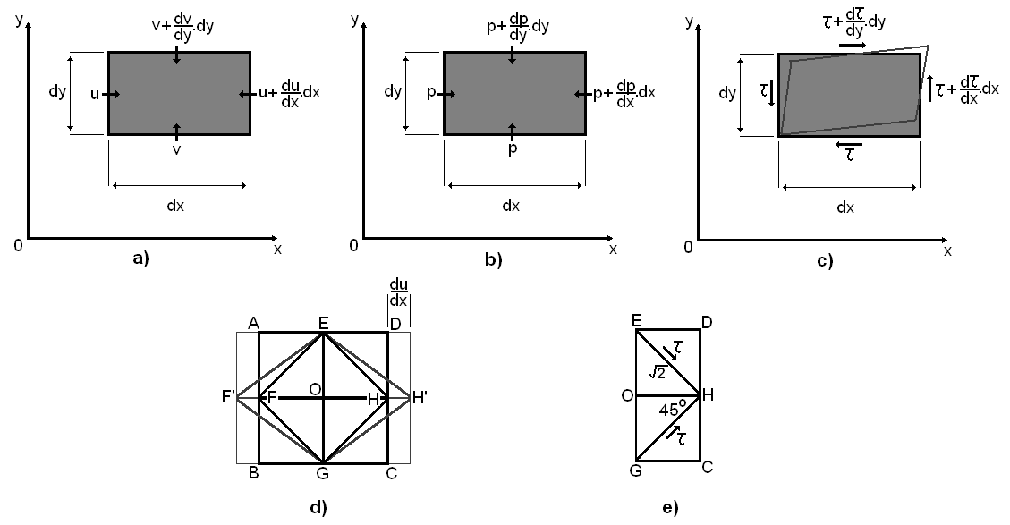

Figure 3.1 Fluid element: (a) velocity, (b) pressure, (c) angular deformation, (d) elongation transformation, (e) shearing and tensile stress (reproduced from Sucharov (2003))
Inertial force
Consider an elementary rectangle of fluid of sides dx, dy with thickness b.
From Newton’s second law it follows that:
$ρbdxdy\frac{du}{dt}=F_{x}$ (3.3)
$ρbdxdy\frac{dv}{dt}=F_{y}$ (3.4)
The left-hand side is known as the inertial force. Change in velocity, for example du, is brought about by movement of the element position and/or change with time, as mathematically expressed by:
$$du=\frac{∂u}{∂t}dt+\frac{∂u}{∂x}dx+\frac{∂u}{∂y}dy$$
Dividing through by dt:
$$\frac{du}{dt}=\frac{∂u}{∂t}+\frac{∂u}{∂x}\frac{dx}{dt}+\frac{∂u}{∂y}\frac{dy}{dt}=\frac{∂u}{∂t}+u\frac{∂u}{∂x}+v\frac{∂u}{∂y}$$
By substituting into Equations (3.3) and (3.4):
$$ρbdxdy\left(\frac{∂u}{∂t}+u\frac{∂u}{∂x}+v\frac{∂u}{∂y}\right)=F_{x}$$
$$ρbdxdy\left(\frac{∂v}{∂t}+u\frac{∂v}{∂x}+v\frac{∂v}{∂y}\right)=F_{y}$$
As stated above, the forces acting on the element are the sum of body force, pressure force, and viscous force.
$F_{x}=B_{x}+P_{x}+S_{x}$ (3.5)
$F_{y}=B_{y}+P_{y}+S_{y}$ (3.6)
Body force
General directional forces that are applied throughout the model and include whole body forces such as gravitational forces, or centrifugal forces. Splitting B into its x and y components. From:
$B_{x}=ρbdxdyX$ (3.7)
$B_{y}=ρbdxdyY$ (3.8)
where X and Y are the x and y components of acceleration
Pressure force
Pressure force acts upon the element on every side:
$P_{x}=ρbdy-\left(p+\frac{∂p}{∂x}dx\right)bdy=-\frac{∂p}{∂x}bdxdy$ (3.9)
$P_{y}=-\frac{∂p}{∂y}bdxdy$ (3.10)
Viscous force
The sum of the elongation transformation force and the angular deformation force. Stress is expressed as τ, strain as γ, and viscosity as μ.
As τ=μ.dγ/dt, and the strain on an element can be considered to be γ=γ₁+γ₂
$τ=μ\frac{∂γ}{∂t}=μ\left(\frac{∂γ_{1}}{∂t}+\frac{∂γ_{2}}{∂t}\right)=μ(\frac{∂u}{∂y}+\frac{∂v}{∂x})$ (3.11)
Angular deformation S_{x1} is caused by a change of stress with position.
$S_{x1}=\frac{∂τ}{∂y}bdxdy=μ\left(\frac{∂^{2}u}{∂y^{2}}+\frac{∂^{2}v}{∂x∂y}\right)bdxdy=μ(\frac{∂^{2}u}{∂y^{2}}-\frac{∂^{2}u}{∂x^{2}})bdxdy$ (3.12)
Elongation deformation S_{x2} produces a force in the x-direction. [An elongated flow also undergoes an angular deformation.] The angular deformation is of velocity Du/dx and thus a shearing strain is μ.du/dx created on the four sides of the rhombus. Taking OH to be a unit length:
$$2×τcos45°×EH=-σE$$
$$τ=-σ$$
The tensile strain across the face EG is – μ.u/x. A similar strain is set up one element along at CD incremented by a change of u/x. The net force on the element of fluid is:
$σ_{x_{1}}=-μ\frac{∂u}{∂x}+{\left(μ\frac{∂u}{∂x}\right)}_{+1}=-μ\frac{∂u}{∂x}+μ\left(\frac{∂u}{∂x}+\frac{∂^{2}u}{∂x^{2}}\right)=μ\frac{{ ∂}^{2}u}{∂x^{2}}$ (3.13)
Elongation in the y-direction is affected by the x-direction. The y-direction will experience shrinkage that is a function of the x-direction elongation.
$σ_{x_{2}}=μ\frac{∂v}{∂y}-μ\left(\frac{∂v}{∂y}+\frac{∂^{2}v}{∂x∂y}\right)=-μ\frac{{ ∂}^{2}v}{∂x∂y}$ (3.14)
The force on the element is the sum of these two forces:
$σ_{x}=σ_{x_{1}}+σ_{x_{2}}= μ\frac{{ ∂}^{2}u}{∂x^{2}}- μ\frac{{ ∂}^{2}v}{∂x∂y}= μ\frac{{ ∂}^{2}u}{∂x^{2}}+ μ\frac{{ ∂}^{2}u}{∂x^{2}}-μ\frac{∂}{∂x}\left(\frac{∂u}{∂x}+\frac{∂v}{∂y}\right)=2μ\frac{∂^{2}u}{∂x^{2}}$ (3.15)
Applying this to the fluid element b.dx.dy, the force S_{x2} is created:
$S_{x2}=2μ\frac{∂^{2}u}{∂x^{2}}bdxdy$ (3.16)
Thus
$S_{x}=S_{x1}+S_{x2}=μ\left(\frac{∂^{2}u}{∂x^{2}}+\frac{∂^{2}u}{∂y^{2}}\right)bdxdy$ (3.17)
$S_{y}=μ\left(\frac{∂^{2}v}{∂x^{2}}+\frac{∂^{2}v}{∂y^{2}}\right)bdxdy$ (3.18)
By substituting Equations (3.4)–(3.6) into (3.3):
$ρ\left(\frac{∂u}{∂t}+u\frac{∂u}{∂x}+v\frac{∂u}{∂y}\right)=ρX-\frac{∂p}{∂x}+μ\left(\frac{∂^{2}u}{∂x^{2}}+\frac{∂^{2}u}{∂y^{2}}\right)$ (3.19)
$ρ\left(\frac{∂v}{∂t}+u\frac{∂v}{∂x}+v\frac{∂v}{∂y}\right)=ρY-\frac{∂p}{∂y}+μ\left(\frac{∂^{2}v}{∂x^{2}}+\frac{∂^{2}v}{∂y^{2}}\right)$ (3.20)
These derivations are known as the Navier–Stokes equations, in honour of their originators.

3.2 CFD simulations of the ring vortex
Vortex ring motion involves a complexity of flow that can be solved analytically only through the introduction of important assumptions, which can introduce discrepancy between the theoretical models and the experimental observations (real behaviour). In order to better describe the sorts of real flows obtained experimentally, the problem has to be solved numerically. The exponential increase of available computational resources, allowing numerical solution of more and more complex flow problems, has provided a leading role to CFD. Furthermore, CFD allows to study a large number of flow conditions with a considerable saving in time and costs compared to experimental analysis.
A large number of studies have been published in literature over recent years aiming to investigate the following properties of vortex rings by numerical means:
- formation
- post-formation evolution
- interactions
Nitsche and Krasny (Nitsche and Krasny 1994), for example, in order to simulate an experiment carried out by Didden (Didden 1979), considered the formation of a ring vortex by forcing fluid, through a moving piston, from a circular orifice, and applied an axisymmetric vortex sheet model. The authors then compared the computed results with the experimental measurements. Results showed good agreement between simulation and experiments with a couple of surprising observations: the vortex sheet theory fails to predict the ring coordinates; at small times the computed value of the inner shedding rate exceeds the experimental measurements leading to higher circulation and axial velocity of the computed ring.
Rosenfeld et al. (Rosenfeld, Rambod, and Gharib 1998), in order to investigate the formation time scale of axisymmetric vortex rings, developed numerical extensions of an experimental study carried out by Gharib et al. (Gharib, Rambod, and Shariff 1998). The results of numerical simulations confirmed the experimental findings, in particular about: the relative insensitiveness of the scaled circulation of the ring vortex to the details of the formation process (e.g. velocity programme, velocity profile, vortex generator geometry, Reynolds number); the existence of a maximum in the circulation a ring vortex can acquire as the stroke ratio increases. Further, the study identified a dependency of the formation time from the discharge velocity profile, and velocity programme.
Direct numerical simulations (DNS) of a viscous laminar ring vortex were performed by James and Madnia (James and Madnia 1996) to study the effects of different generator configurations and velocity programs on the formation and post-formation characteristics of vortex rings. Numerical results for time evolution of total circulation, and axial and radial coordinates of the vortex were in agreement with previous experimental findings (Didden 1979).
A similar approach was adopted by Danaila and Hélie (Danaila and Hélie 2008) to investigate the post-formation evolution of a laminar ring vortex. The computed power laws describing the decay of the translational speed and the integrals of motion were compared with experimental results obtained by Dabiri and Gharib (Dabiri and Gharib 2004), and with experimental prediction of Maxworthy (Maxworthy 1972), showing consistency. Also, the computationally generated vortex rings were matched to the classical Norbury-Fraenkel model and the Kaplanski-Rudi model. By matching the simulated vortex to ideal models a good prediction of normalized quantities and individual integrals of motion can be obtained.

3.2.1 Problem Formulation
For the case of vortex rings generated by the ring vortex phantom in this thesis, direct numerical simulations (DNS) were used to study the formation and post-formation evolution of a laminar ring vortex. Laminar vortex rings are typically generated in the laboratory by piston/cylinder arrangements. A slug of fluid is pushed by a piston into a quiescent medium. Boundary layer separation and roll-up at the edge of the cylinder generate a ring vortex.
The primary objective of the present study is to numerically investigate the ring vortex behaviour during formation and early propagation phases in support of the ring vortex phantom. The characterization includes
- Velocity field
- Vorticity distribution
- Bulk properties (ring radius, core radius, translational speed)

3.2.2 Governing Equations
The Navier-Stokes equations for incompressible fluids
$∇∙u=0$ (3.21)
$\frac{∂u}{∂t}+\left(u∙∇\right)u-μ∇^{2}u=-\frac{1}{ρ}∇p$ (3.22)
govern the flow behaviour.
In case of axisymmetric flow, these can be conveniently expressed in cylindrical coordinates
$\frac{1}{r}\frac{∂}{∂r}\left(rv\right)+\frac{∂u}{∂z}$ (3.23)
$\frac{∂u}{∂t}+v\frac{∂u}{∂r}+u\frac{∂u}{∂z}-μ(\frac{1}{r}\frac{∂}{∂r}\left(r\frac{∂u}{∂r}\right)+\frac{∂^{2}u}{∂z^{2}}=-\frac{1}{ρ}\frac{∂p}{∂z}$ (3.24)
$\frac{∂v}{∂t}+v\frac{∂v}{∂r}+u\frac{∂v}{∂z}-μ(\frac{1}{r}\frac{∂}{∂r}\left(r\frac{∂v}{∂r}\right)+\frac{∂^{2}v}{∂z^{2}}=-\frac{1}{ρ}\frac{∂p}{∂z}$ (3.25)

3.2.3 Geometry
Several considerations must be made when setting up a model of ring vortex generator, including
1. Generator type, classified according to the geometric profile of the cylinder’s edge (see Figure 3.2)
  - Orifice – i.e. cylindrical chamber in a horizontal plane
  - Nozzle – turning angle 2π
  - Vena contracta – orifice area smaller than the physical size produced by the cylinder (Krueger 2008)

2. Generator model (piston-cylinder arrangements)(see Figure 3.3)
Figure 3.2 Different geometric configurations for a vortex ring generator. (top) orifice, (bottom) nozzle (reproduced from Shariff & Leonard (1992))
  - Plug inlet velocity, equal to the piston velocity, specified at the entry of the cylinder. Flow development within the cylinder is also simulated
  - Specified discharge velocity (SVD), i.e. space- and time- dependent velocity profile prescribed at the orifice
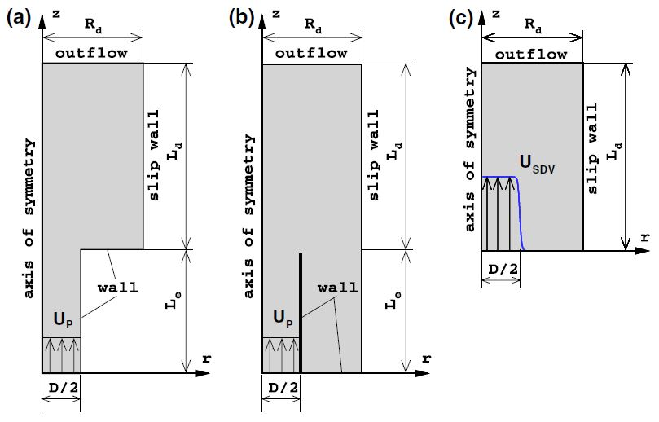

Figure 3.3 Computational domain for vortex ring simulation: (a) orifice, (b) tube, (c) specified discharge velocity (SVD) configurations. Reproduced from Danaila et al. (2009)

The SVD approach was adopted and a discharge velocity profile varying in time and space was specified at the inlet (z = 0)
$V_{z}\left(r,t\right)=V_{zb}\left(r\right)V_{0}(t)$ (3.26)
where
$V_{zb}\left(r\right)=\frac{1}{2}\left(1+\tanh\left(\frac{1}{2δ_{ω}}\left(\frac{D_{0}}{2r}-\frac{2r}{D_{0}}\right)\right)\right)$ (3.27)
is the hyperbolic tangent profile, matching jet profiles measured in experiments (Michalke 1984), and
$V_{0}\left(t\right)=\left\{\begin{aligned}\frac{W_{p}}{2}\left(1+\tanh\left(\frac{5}{τ_{1}}\left(t-τ_{1}\right)\right)\right), t≤τ_{1}+\frac{τ_{2}}{2} \\ \frac{W_{p}}{2}\left(1+\tanh\left(\frac{5}{τ_{1}}\left(τ_{1}+τ_{2}-t\right)\right)\right), t>τ_{1}+\frac{τ_{2}}{2}\end{aligned}\right.$ (3.28)
is the velocity program proposed by James and Madnia (James and Madnia 1996) to describe the piston motion. Here, δ_{ω} is the dimensionless thickness of the vorticity layer at the inlet, i.e.,
$δ_{ω}=W_{p}D_{0}/{\left\|\frac{∂V_{z}}{∂r}\right\|}_{max}$ (3.29)
where D₀ is the orifice diameter.
Constants τ₁ and τ₂ separate the piston motion in three parts
- acceleration for $t∈[0,τ_{1}[)$,
- velocity plateau V₀=W_{p} for $t∈ ]τ_{1},τ_{2}]$
- deceleration for $t∈ ]τ_{2},τ_{off}]$.
where t_{off} is the time when the axial velocity at the inflow boundary becomes zero.
Figure 3.4 shows a sketch of the axisymmetric computational domain. The orifice diameter was kept constant and equal to 15 millimeters. Downstream and lateral boundaries were placed at a distance of 20D₀ and 4D₀, respectively, far enough to ensure a negligible influence of the boundary conditions on the ring vortex dynamics.

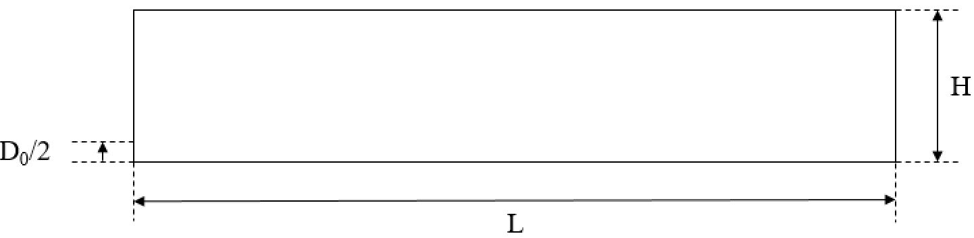
Figure 3.4 Geometry of the computational domain

Spatial and temporal discretization
A structured mesh of quadrilateral linear four node elements was used to discretize the fluid domain. Stretching is applied in both the axial and radial direction, aiming to better resolve high gradients. A preliminary sensitivity analysis was performed to determine an adequate mesh size (dx), necessary to provide a satisfactory numerical accuracy along with acceptable numerical performance. A sample mesh is shown in Figures 3.5 and 3.6 (detail of the formation region). The computational results are validated by performing mesh and time-step refinement studies as well as by comparing with experimental results. In the present section, the numerical tests are reported. Comparisons with experimental results are described in section 3.5.
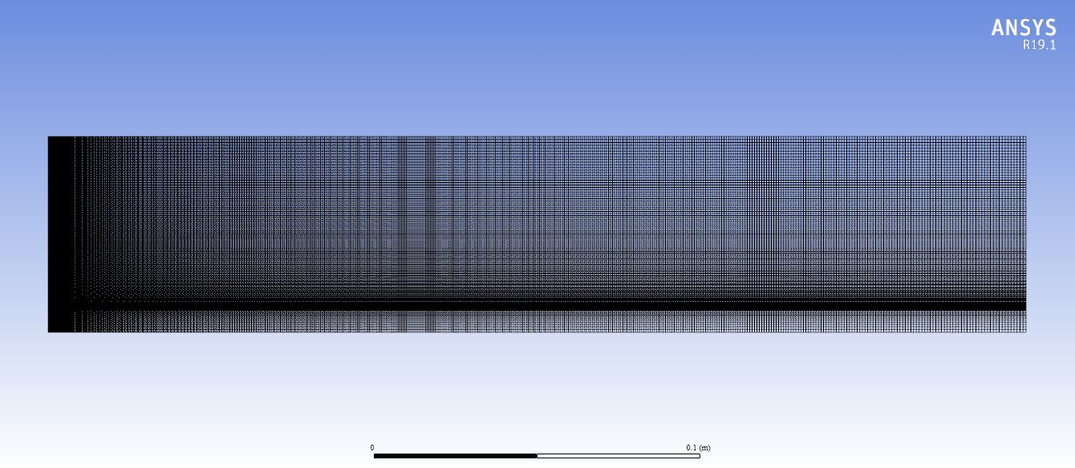
Figure 3.5 Structured mesh used to discretize the computational domain. Notice the higher density in correspondence of formation region (i.e. the region where roll-up and pinch-off take place, at an axial distance within 5D₀ from the orifice section) and vortex region (i.e. the region where the ring vortex propagates, at a radial distance within D₀ from the axis).

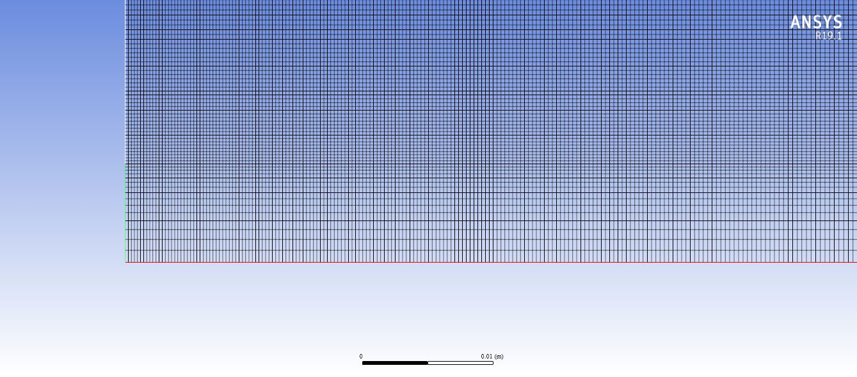
Figure 3.6 Detail of the structured mesh in correspondence of the orifice.

3.2.4.1 Mesh sensitivity analysis
The main objective of mesh and time step sensitivity studies is to determine the minimal number of mesh elements and time steps necessary to obtain accurate solutions in the regions of interest. All the tests were carried out for the case stroke ratio L₀/D₀ = 2 and Reynolds number Re = 2000 (reference case (see §3.4.1)). The downstream boundary was placed at a distance of 30 cm from the orifice, while the lateral boundary was at a distance of 6 cm away from the axis of symmetry. Three meshes with 18000, 72000, 288000 elements, corresponding to mesh average size equal to 0.25 mm, 0.5 mm, 1 mm respectively, were employed in the mesh refinement study.
Refinement studies are performed on the axial and radial velocity profile along the r-axis in the plane z=Z_{c} and along the z-axis in the plane r=R_{c}, respectively, where (Z_{c}, R_{c}) represents the axial and radial coordinates of the vortex centre. The evolution of the axial velocity component u for the three meshes is given in Figure 3.7. In order to evaluate convergence of the solution, the average distance between the curves is measured. The velocity obtained for the medium (dx = 0.5 mm) mesh deviates less than 5% from that of the finest mesh. The evolution of the radial velocity component v for the three meshes is given in Figure 3.8. Also in this case, the velocity obtained for the medium mesh deviates less than 5% from that of the finest mesh. Consequently, the medium mesh of 72000 elements was used in the numerical simulations.

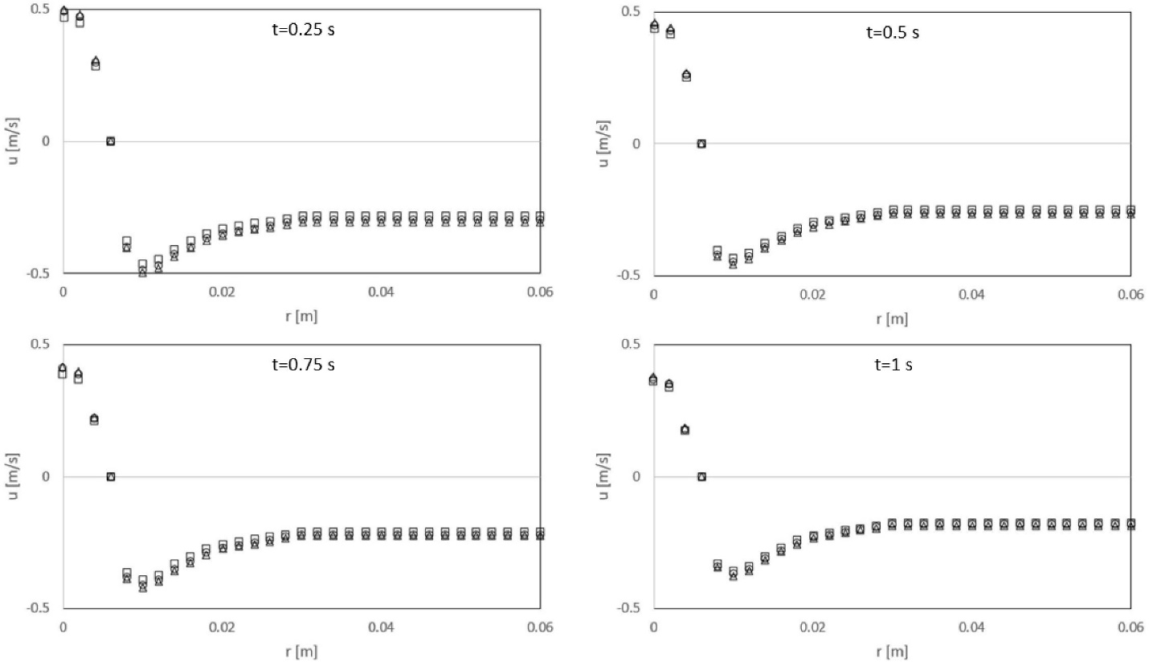
Figure 3.7 Distribution of the axial velocity component along the plane z = Z_{c} (L₀/D₀ = 2, Re = 2000) (Square marker dx = 1 mm, circle marker dx = 0.5 mm, triangle marker dx = 0.25 mm).
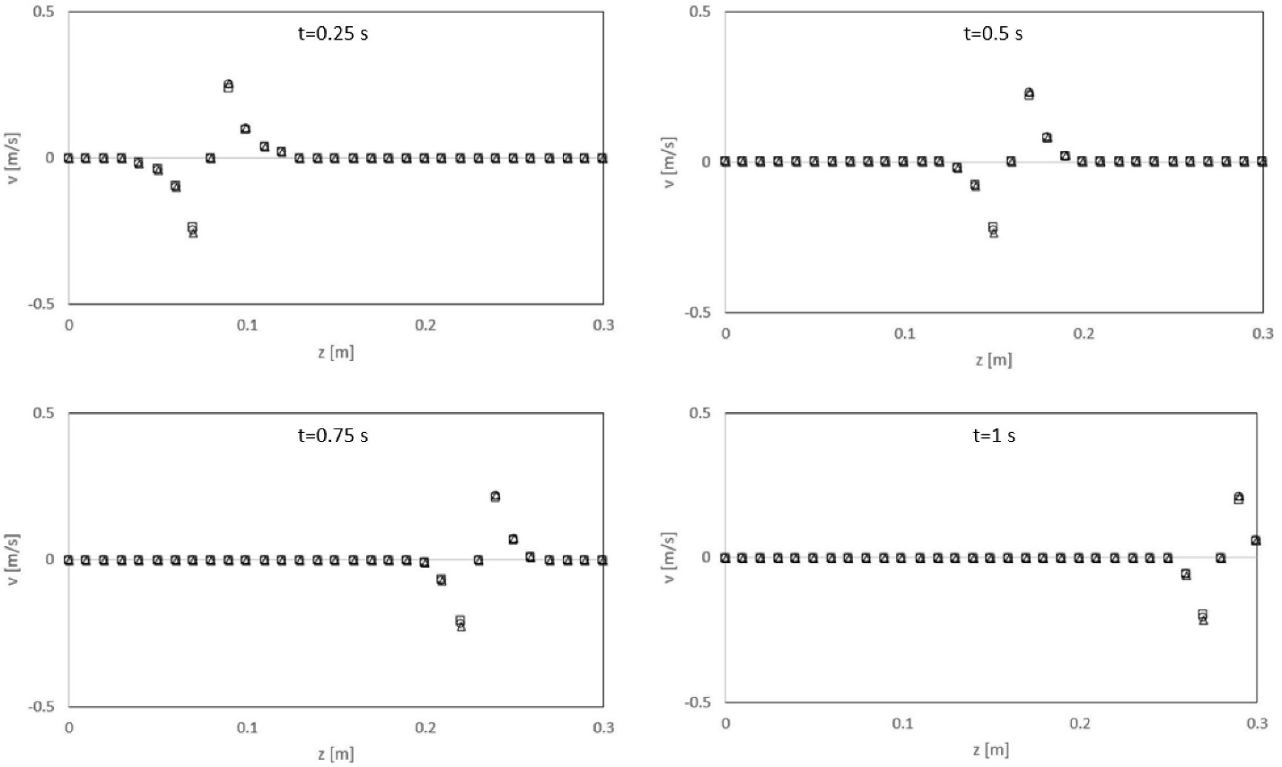
Figure 3.8 Distribution of the radial velocity component along the plane r = R_{c} (L₀/D₀ = 2, Re = 2000) (Square marker dx = 1 mm, circle marker dx = 0.5 mm, triangle marker dx = 0.25 mm).

3.2.4.2 Time step sensitivity analysis
In the time-step-refinement study the reference case (i.e. L₀/D₀ = 2, Re = 2000) with a mesh of 72000 elements (dx = 0.5 mm) was solved for several time steps, namely 0.05 ms, 0.1 ms, 0.2 ms. The evolution of the axial velocity profile along the r-axis in the plane z=Z_{c} for these time steps is presented in Figure 3.9. The evolution of the radial velocity component for the same time steps is given in Figure 3.10. As per the mesh sensitivity, the average distance between the curves was considered as a measure of convergence of the solution. As the ring vortex propagates, the magnitude of the time step has a larger effect on the solution. Thus, it is necessary to use quite small time steps for long time simulations. The present study is not concerned with the long time properties of the flow field. Rather, it focuses on formation and early propagation of the ring vortex (t < 1 sec) and therefore a time step of dt = 0.1 ms was employed, resulting in less than 5% deviation with respect to the solution obtained for the finest time step. Values of mesh and time step size explored are summarized in Table 3.1.

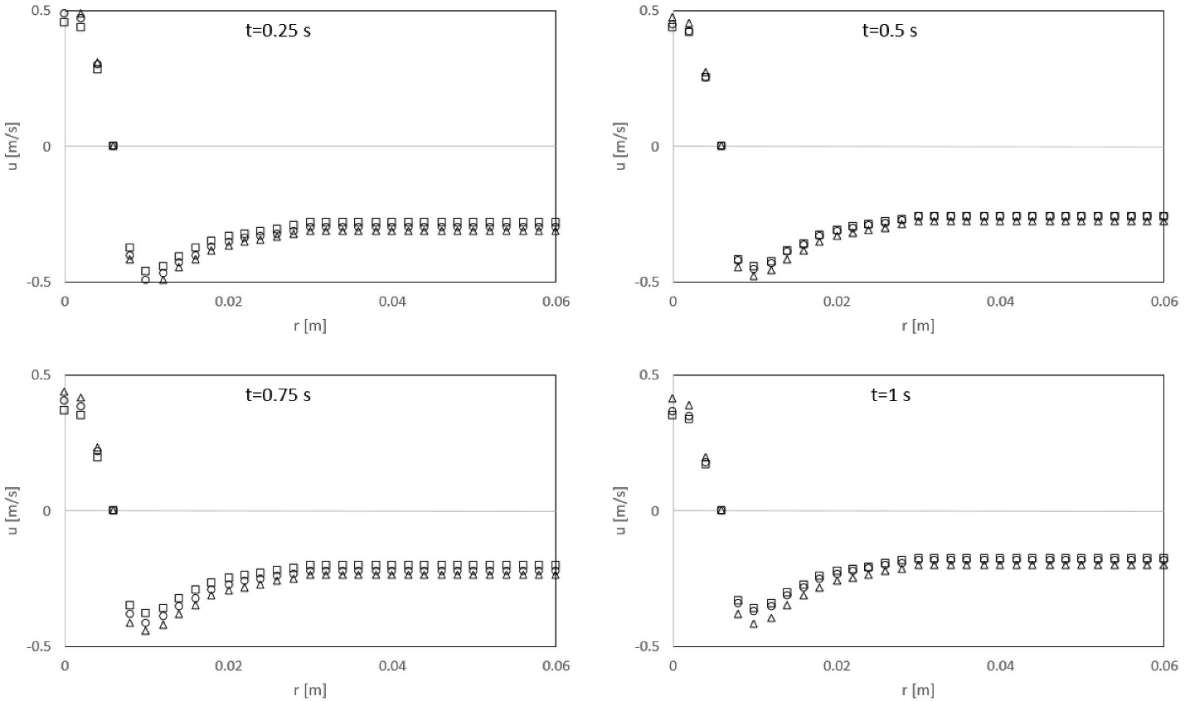
Figure 3.9 Distribution of the axial velocity component along the plane z = Zc (L0/D0 = 2, Re = 2000) (Square marker dt = 0.2 ms, circle marker dx = 0.1 ms, triangle marker dx = 0.05 ms).
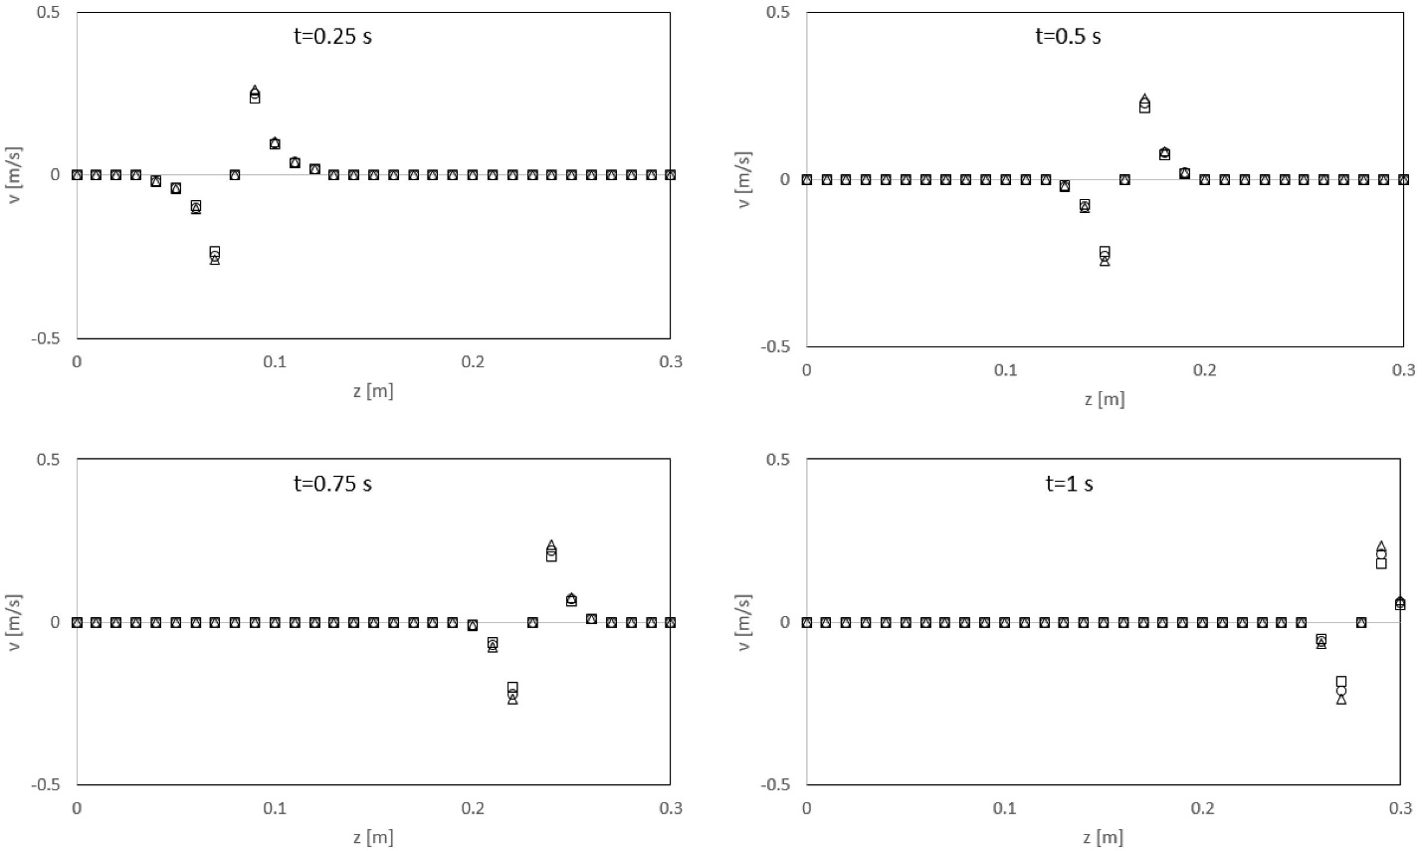
Figure 3.10 Distribution of the radial velocity component along the plane r = Rc (L0/D0 = 2, Re = 2000) (Square marker dt = 0.2 ms, circle marker dx = 0.1 ms, triangle marker dx = 0.05 ms).

Table 3.1 Mesh and time step size combinations explored in order to test the sensitivity of the numerical solution to the discretization resolution
Mesh size [mm] | Time step size [ms]
0.25 | 0.1
0.5 | 0.05
0.5 | 0.1
0.5 | 0.2
1 | 0.1

3.2.4 Boundary and initial conditions
The following boundary conditions were applied in order to simulate the generation of a single laminar ring vortex in an unbounded medium (see Figure 3.11)
- space and time varying inlet velocity profile, as described in §3.2.3
- axial symmetry condition (no tangential velocity), on the axis boundary
As widely reported in the literature, under specified conditions, the ring vortex flow can be assumed to be axisymmetric. Outside the aforementioned range of operating conditions, three-dimensional flow features (e.g. azimuthal instabilities) arise thus making the assumption no longer valid.
- no-slip wall on the exit boundary in the orifice plane
- Zero Gauge outlet pressure, on the outer and downstream boundaries
The initial condition for the velocity field was u=0 everywhere in the domain.

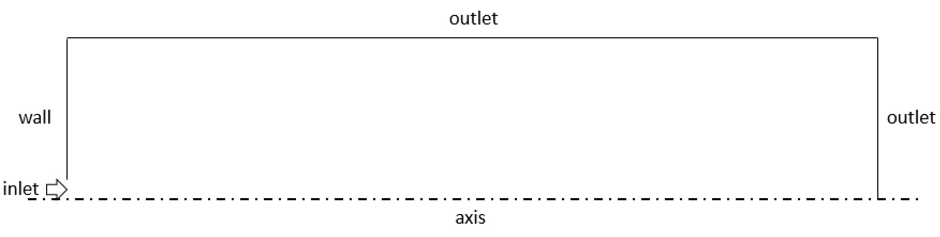
Figure 3.11 Boundary conditions applied to model the ring vortex phantom

3.2.5 Solver
The Finite-Volume package of Fluent v19.1, ANSYS, Inc (Canonsburg, PA, US) was used to solve the axisymmetric, incompressible, time dependent, and laminar Navier-Stokes equations. Second-order accurate temporal and spatial schemes were used with pressure implicit with splitting of operators (PISO) pressure-velocity coupling.

Characterization
The following dimensionless parameters were explored for the characterization of the flow behaviour:
- Reynolds number $Re=\frac{U_{0}D_{0}}{ν}$, where U₀ is the average inlet velocity, D₀ is the orifice diameter, ν is the fluid kinematic viscosity
- stroke ratio (stroke length/stroke time) $\frac{L_{0}}{D_{0}}=\frac{U_{0}T}{D_{0}}$, where T is the ejection duration (or stroke time)
The chosen range of operating conditions, summarized in Table 3.2, was borrowed from two studies published in the literature, respectively by Danaila & Hélie (Danaila and Hélie 2008) and Maxworthy (Maxworthy 1972).
Table 3.2 Operating conditions considered for the ring vortex characterization
Reynolds number Re | Stroke ratio L₀/D₀ | Orifice Diameter D0 [cm] | Piston Velocity U0 [cm/s] | Stroke time (T) [s]
1000 | 2 | 1.5 | 6.65 | 0.451
2000 | 2 | 1.5 | 13.3 | 0.226
4000 | 2 | 1.5 | 26.6 | 0.113
8000 | 2 | 1.5 | 53.2 | 0.056
2000 | 1 | 1.5 | 13.3 | 0.113
2000 | 2 | 1.5 | 13.3 | 0.451
2000 | 4 | 1.5 | 13.3 | 0.677
2000 | 8 | 1.5 | 13.3 | 0.902

Bulk properties of vortex rings
A formed ring vortex can be considered as a closed volume of vortical fluid with a shape similar to an oblate ellipsoid of revolution moving in the surrounding fluid with translational speed along the minor axis of the ellipsoid. This closed volume of the fluid is known as vortex atmosphere. The motion of the medium around the vortex atmosphere is similar in pattern to a potential flow without separation past the corresponding solid body. Inside the vortex atmosphere, the fluid circulates along closed streamlines that encompass the toroidal vortex core consisting of circular vortex lines. The vorticity distribution in the meridional section of the ring vortex has a bell-shaped form with the maximum at the centre of the core. About half the total vorticity flux (velocity circulation flux) is concentrated within the core, which, in most cases, occupies only 3-5% of the cross sectional area of the vortex atmosphere. The main properties of a ring vortex with the specified structure are characterized in a simplified form by the following finite set of parameters
- ring radius R (or the radius of the vortex circular axis)
- core radius a
- translational speed V

Results

3.4.1 Reference case
The following operating conditions
L₀/D₀ = 2
Re = 2000
were chosen as the reference case for further investigations, including the use of different methods to fully characterize the flow. The reason why this combination was chosen is that, according to the literature and to preliminary studies whose details have not been reported in the present document, it provides the most stable and reproducible flow behaviour, suitable for numerical modelling and for the target application.
Velocity field
Distributions of the axial, u, and radial, v, velocity components as a function of time are shown in Figure 3.13 and Figure 3.14, respectively. Velocity distributions are presented in the reference frame moving with the ring vortex. The distribution of the axial velocity component along the r-axis in the plane z=Z_{c} (axial coordinate of the vortex centre), where the radial velocity component is zero, provides insights about the vortex structure. The radius R of the ring vortex corresponds to the distance along the r-axis from the origin to the point of intersection of the curve u(0, r) with the x-axis. The linear segment of the curve in the neighbourhood of r ≈ R_{c} (radial coordinate of the vortex centre)(distance between the extreme points) corresponds to the vortex core diameter 2a. The dashed straight (parallel to the x-axis) line corresponds to the value of the translational speed V of the ring vortex.
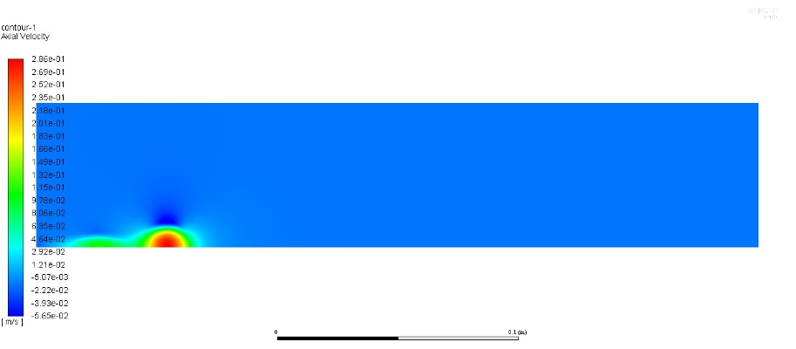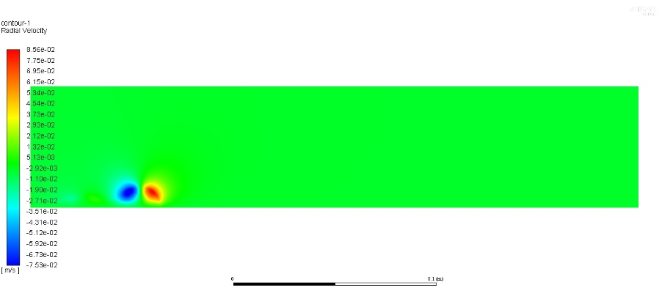

Figure 3.12. Contour of the axial (top) and radial (bottom) velocity component for the reference case (L₀/D₀ = 2, Re = 2000) at t = 0.5 sec.

Figure 3.13 Distribution of the axial velocity component along the plane z = Z_{c} (L₀/D₀ = 2, Re = 2000). The dashed line corresponds to the value of the translational speed.
Figure 3.14 Distribution of the radial velocity component along the plane r = R_{c} (L₀/D₀ = 2, Re = 2000).

Vorticity distribution
Figures 3.15 and 3.16 show the evolution of the vorticity ω field during the post-formation phase. Despite the fact that the ring vortex can be considered to be formed after the pinch-off, a well-defined ellipsoidal shape, appropriate to comparison to theoretical predictions, is observed in later times. Figure 3.15 and 3.16 show the distribution of vorticity along the radial coordinate r in the plane z = Z_{c} and along the axial coordinate z at r = R_{c} respectively. The vorticity is concentrated in the form of a sharp peak in the neighbourhood of the point z = Z_{c}, r = R_{c}, and reaches its maximum at this point. The region of vorticity concentration corresponds to the ring vortex core, whose coordinates correspond by definition to Z_{c} and R_{c}. Such concentrated vorticity distribution in a real ring may provide some substantiation for the theoretical models of vortex rings, which assume that vorticity is completely localized within a toroidal region. Although in a real ring vortex the vorticity distribution is smooth and does not have a sharp boundary, the width of the vorticity distribution in some sense characterizes the effective size of the cross-section of the vortex core.
Since the shape of the core cross-section is close to a circle, it is possible to introduce the notion of the radius of the vortex core a. Of greater interest is the dimensionless ratio of the vortex core radius to the radius of the vortex ring ε = a/R, assumed in theoretical models as a parameter of thinness of the core size. The values of a and velocity u_{max} at the core boundary allow determination of the circulation around the core
$$Γ=\oint{u∙dl=2πau_{max}}$$
The velocity distribution provides the values of circulation around the closed streamlines inside the vortex atmosphere as well. Of interest is the estimation of the translational speed of the vortex ring from the values R, Γ, a.
Figure 3.15 Vorticity distribution along the r-axis in the plane z = Z_{c}
Figure 3.16 Vorticity distribution along the z-axis at r = R_{c}

Figure 3.17 illustrates the evolution of the ring vortex radius R. From an initial value approximately equal to the orifice radius, this grows up to an asymptotic value. The sudden drop at t = 0.32 sec can be attributed to the method used to calculate the coordinates of the vortex centre, considering the vorticity of the full flow field. A better approach would consist in isolating the ring vortex from the outer domain and then post-processing the local flow field to extract parameters of interest.
Figure 3.17 Evolution of the ring radius R (L₀/D₀ = 2, Re = 2000)
Figure 3.18 illustrates the evolution of the ring vortex core radius a. To an initial rapid growth during the formation phase follows a slower decrease to an asymptotic value. Notice that the lack of smoothness can be attributed to discretization and sampling. In fact, the numerical solution was calculated every 0.1 ms but saved and displayed (in Figure 3.18) every 20 ms.
Figure 3.18 Evolution of the core radius a (L₀/D₀ = 2, Re = 2000)

Figure 3.19 illustrates the evolution of the ring vortex translational speed V. Starting from an initial value approximately equal to the piston velocity, this decreases exponentially.
Figure 3.19 Evolution of the ring vortex translational speed V (L₀/D₀ = 2, Re = 2000)

3.4.2 Parametric characterization of ring vortex motion
The aim of the present study is to investigate structure and properties of a whole class of vortex rings formed during pulsed ejection of a finite-length jet and to recognize dependence of ring vortex parameters on criteria that characterize the generation process.
The ring vortex parameters were determined with variation of two dimensionless quantities, namely L₀/D₀ and Re, respectively specifying the dimensionless jet length (or stroke ratio) and the Reynolds number of the jet.

3.4.2.1 Ring vortex parameters as a function of the stroke ratio
The influence of the stroke ratio L₀/D₀, on the properties of a ring vortex was studied at a fixed jet velocity U₀ = 0.133 m/s, which corresponds to the Reynolds number of the jet Re = 2000.
The stroke length was varied by changing the jet discharge duration (or stroke time) T. Simulations were performed for four values of the stroke ratio: L₀/D₀ = {1, 2, 4, 8}.
Results of a preliminary investigation on the influence of the stroke ratio on the characteristics of a ring vortex are reported in the present section. As will be clarified, a consequence of the increased stroke ratio is the reduced residence time of the ring vortex inside the computational domain. The observation period then is in turn reduced, introducing additional assumptions on the actual behaviour of the ring vortex. Further investigation, aiming to better characterize the dependence of ring vortex properties on the stroke ratio will be required.
-Geometric properties-
The evolution of the ring vortex radius R as function of the stroke ratio is shown in Figure 3.20. Trend lines illustrate the asymptotic behaviour. It can be inferred that the ring radius increases at a faster rate as the stroke ratio decreases. To explain this behaviour, consider that for lower stroke ratios, the ejected slug of fluid travels a shorter distance in the axial direction while the roll-up determines the ring vortex formation. For higher stroke ratios, the ejected slug of fluid is projected forward before rolling-up into a spiral of limited radial extent.
Figure 3.20 Evolution of the ring vortex radius as function of the stroke ratio L₀/D₀ (Re = 2000) (square marker L₀/D₀ = 1, circle marker L₀/D₀ = 2 triangle marker L₀/D₀ = 4, diamond marker L₀/D₀ = 8).
The evolution of the vortex core radius a as function of the stroke ratio is reported in figure 3.21. Results show that the core radius increases at faster rate as the stroke ratio increases. To explain this behaviour, it should be considered that, as reported by Dabiri and Gharib (Gharib, Rambod, and Shariff 1998), there is a limit to the volume of fluid that, according to the formation conditions, can be entrained by the vortex core. Beyond this limit, the fluid in excess gives rise to secondary phenomena. Notice that the observation period was too short for the case with stroke ratio equal to 4 to obtain an accurate description of the ring vortex behaviour during the post-formation phase. Since the observation period is further reduced for the case with stroke ratio equal to 8, the actual behaviour of the ring vortex can be expected to be quite different from the one observed. Notice that the drop observed after 0.72-0.74 seconds for the case with stroke ratio equal to 8 is possibly due to the method used to extract the measure.
Figure 3.21 Evolution of the vortex core radius as a function of the stroke ratio L₀/D₀ (Re = 2000) (square marker L₀/D₀ = 1, circle marker L₀/D₀ = 2 triangle marker L₀/D₀ = 4, diamond marker L₀/D₀ = 8).
-Translational speed-
The evolution of the translational speed as a function of the stroke ratio is reported in Figure 3.22. Results show that the translational speed decays at slower rates for increasing stroke ratios. The same behaviour has been observed and reported in literature (e.g. (Danaila and Hélie 2008)), in this case the observation period for the cases with stroke ratio equal to 8 is too short to assume that the computed solution is representative of the ring vortex behaviour during the post-formation evolution. Further investigations are needed.
Notice that the sudden decay in the translational speed generated for stroke ratio equal to 8 is due to the fact that the primary vortex has left the domain from the downstream boundary. Therefore, the algorithm tracking the vortex centre, assumed to correspond to the maximum vorticity, is now looking at a secondary slow vortex, travelling behind the primary one.
Figure 3.22 Evolution of the ring vortex translational speed as a function of the stroke ratio L₀/D₀ (Re = 2000) (square marker L₀/D₀ = 1, circle marker L₀/D₀ = 2 triangle marker L₀/D₀ = 4, diamond marker L₀/D₀ = 8).
-Velocity field-
Figure 3.23 illustrates the evolution of the axial velocity component u along the r axis at z = Z_{c} as a function of the stroke ratio. A few observations can be made
- the three vortices generated for stroke ratio 1, 2, and 4 have a similar structure and energy content
- the translational velocity is approximately the same
- the rotational energy is comparable (almost overlapping profiles)
- the ring vortex generated for stroke ratio equal to 8 is far from the other ones, with a significantly higher energy content
Figure 3.24 illustrates the evolution of the radial velocity component v along the z axis at r = R_{c} as a function of the stroke ratio. Main observations concern
- The symmetry of the profile – compared to the radial profile of the axial velocity, this is not affected by flattening due to viscous motion along the axis
- The decay during ring vortex propagation
Notice that while for the cases with stroke ratio in the range 1-4 the primary vortex is visible within the domain for the entire observation period (0-1 sec), the case with stroke ratio equal to 8 sees the fast migration of the vortex leading to the vortex outside of the domain. The profile observed after 1 second does not correspond to the primary vortex but to one of the secondary vortices.

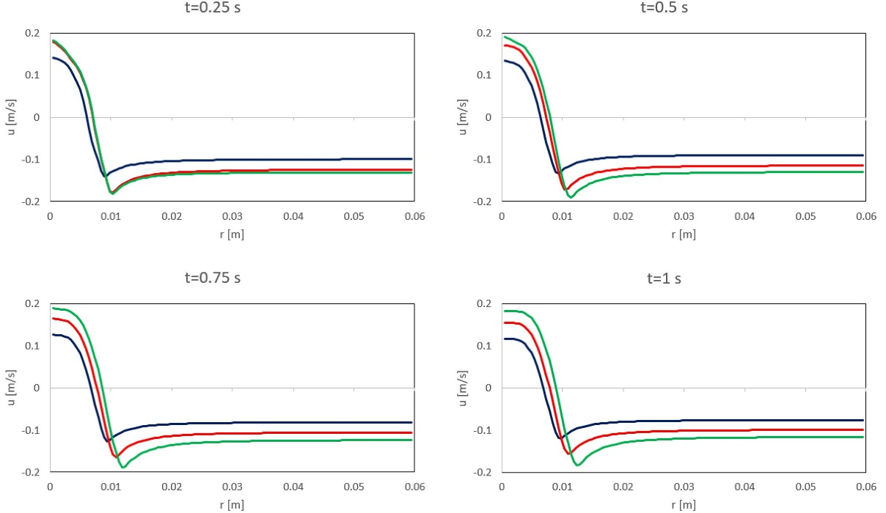
Figure 3.23 Distribution of the axial velocity component as a function of the stroke ratio L₀/D₀ (Re = 2000) (blue line L₀/D₀ = 1, red line L₀/D₀ = 2, green line L₀/D₀ = 4).
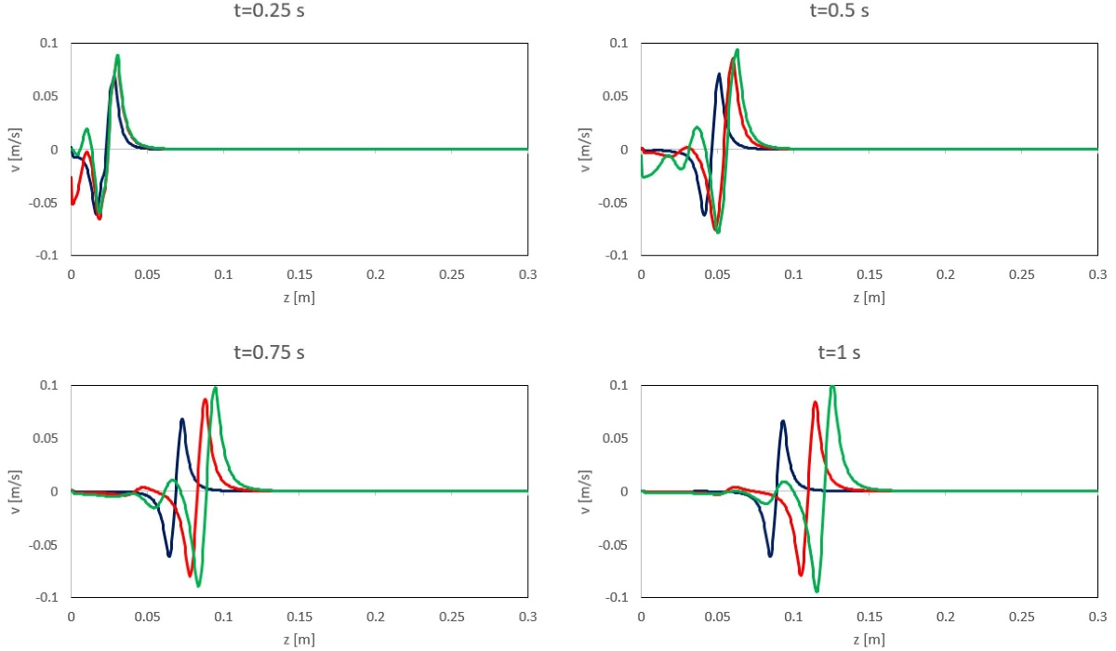
Figure 3.24 Distribution of the radial velocity component as a function of the stroke ratio L₀/D₀ (Re = 2000) (blue line L₀/D₀ = 1, red line L₀/D₀ = 2, green line L₀/D₀ = 4).
Vorticity distribution
Figure 3.25 shows the evolution of the vorticity ω distribution along the z-axis at r = R_{c} as a function of the stroke ratio. The most informative features are
- the peak value, indicative of the rotational energy content
- the peak relative position, indicative of the translational energy content
Notice that for t = 0.75 sec the secondary vortex due to the ring vortex produced for stroke ratio equal to 8 (diamond shape marker) has more energy than the primary vortex produced for stroke ratio equal to 4 (triangle shape marker).
Figure 3.26 shows the evolution of the vorticity distribution along the r-axis at z = Z_{c} as a function of the stroke ratio. Remarkable is the shape of the profile, indicative of viscous effects. Notice that for t = 0.75 sec the secondary vortex due to the ring vortex produced for stroke ratio equal to 8 (diamond shape marker) can be distinguished as having a radius lower than the orifice size.
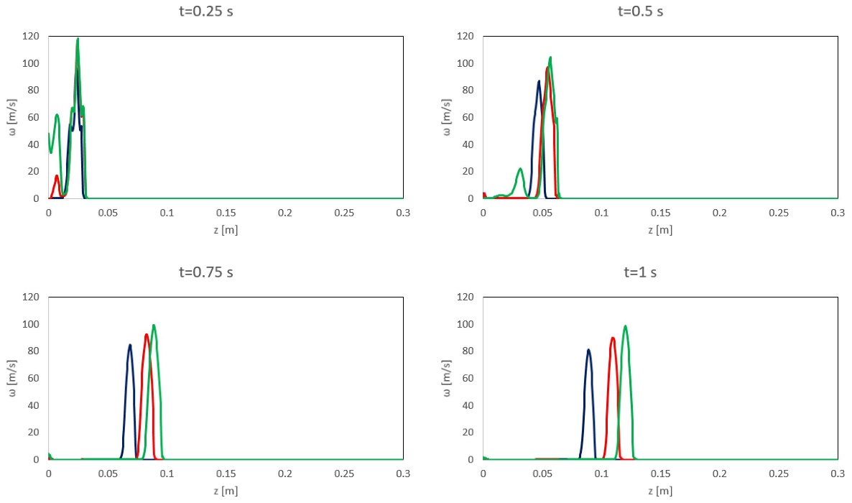
Figure 3.25 Vorticity distribution along the z-axis at r = R_{c} as a function of the stroke ratio L₀/D₀ (Re = 2000) (blue line L₀/D₀ = 1, red line L₀/D₀ = 2, green line L₀/D₀ = 4).
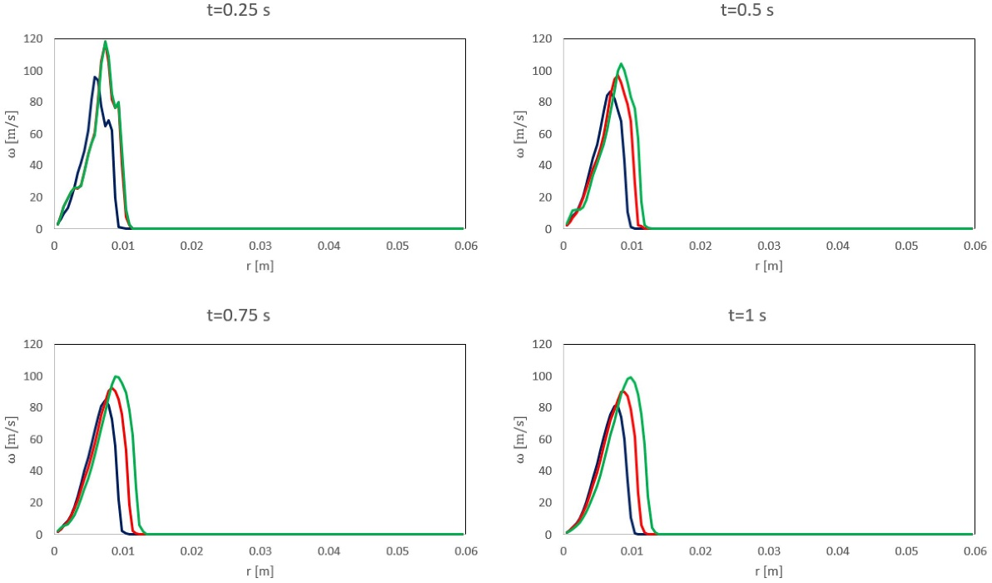
Figure 3.26 Vorticity distribution along the r-axis in the plane z = Z_{c} as a function of the stroke ratio L₀/D₀ (Re = 2000) (blue line L₀/D₀ = 1, red line L₀/D₀ = 2, green line L₀/D₀ = 4).

3.4.2.2 Vortex ring parameters as a function of the Reynolds number Re
The effect of the jet Reynolds number on the ring vortex structure was studied at constant values of the stroke ratio L₀/D₀ = 2. The Reynolds number was varied by changing the jet velocity U₀. In order to keep constant the stroke ratio, the jet discharge duration (or stroke time) T was varied to follow the variation of the jet velocity. The most thorough studies of the ring vortex structure were performed at jet velocities U₀ = {0.067, 0.133, 0.266, 0.532} m/s, i.e. for the jet Reynolds number ranging from 1000 to 8000.
A premise has to be done to justify what is presented below. Since the main objectives of the computational model were
- To establish a correlation between analytical description and numerical solution
- To establish a correlation between experimental observations and numerical solution
- To undertake preliminary investigation of the flow properties suitable for the application proposed
and considering that
- The analytical description of vortex rings considers the fluid dynamics of the well-formed vortex ring, decoupling ring vortex formation and propagation. Under a few assumptions, the formation phase can be described by simple models (e.g. slug-flow model (see §2.2.1))
- The experimental investigation consisted in the post-processing of images captured by a video camera with low temporal resolution (see §4.2.1), not able to get the details of the short formation phase.
- The application proposed, i.e. calibration of medical imaging scanner, will arguably address the more stable phases of the ring vortex motion
the performed analysis considered the post-formation evolution, defined to start as follows.
The post-formation evolution of the ring vortex can be considered to start right after the pinch-off, defined to occur when the contour line of the normalized vorticity
$$\overline{ω}=\frac{ω}{ω_{MAX}}=0.05$$
encircles the vortex for the first time (Danaila and Hélie 2008). The pinch-off is estimated to occur at time T_{e} (Reynolds 1000 and 2000) or even earlier (Reynolds 500). However, since a well-developed shape is observed starting from later times, the analysis of the post-formation phase considered vortex ring evolution for 0<t<1 s (observation period).
-Geometric properties-
The evolution of the ring vortex radius R as function of the Reynolds number is shown in Figure 3.27. As previously observed and reported in literature (Clark, Krieg, and Mohseni 2008), the initial ring radius is approximately equal to the orifice radius. It quickly increases during the formation phase, finally reaching an asymptotic value.
Results show that R grows at faster rates as Re increases. During the observation period (0-1 sec), however, only for the cases with Re equal to 1000 and 2000 R seems to reach an asymptotic value, while for the cases with Re equal to 4000 and 8000, R continuously increases. It can be inferred that the time interval required by the ring radius to reach the steady state value is longer for higher Reynolds numbers. Notice that the trend in steps of the computed values of R is an intrinsic effect of the discretization. The minimum gap between two different values of R coincides, in fact, with the average size of the mesh elements.
To explain this behaviour, it should be born in mind that the variation of the Reynolds number was carried out by changing the inflow velocity U₀. For lower inflow velocities, associated with lower Reynolds numbers, a thick boundary layer is formed along the walls of the cavity. As a result, at the exit of the vortex generator, the roll-up mechanism is, to a certain extent, inhibited and the radial development of the ring vortex is limited. For higher inflow velocities, on the other hand, associated to higher Reynolds numbers, a thin boundary layer is formed along and separates from the walls of the cavity. As a result, at the exit of the vortex generator, the roll-up mechanism is promoted, and the acceleration provided by the convergent cross-section of the cavity further improves the radial development of the ring vortex.
Notice that sudden decreases (at t = 0.22 sec for Re = 8000; at t = 0.42 sec for Re = 4000) observed in the value of the ring radius can be attributed to the method used to extract the measure. An important observation concerns the decay of the ring radius at t = 0.7 sec for Re equal to 8000. This is due to the fact that the primary vortex has left the computational domain (over the downstream boundary) but secondary vortices and trailing jets are travelling behind it. So, the algorithm estimating the ring radius based on the position of the maximum vorticity is now tracking one of those secondary vortices.
Figure 3.27 Evolution of the vortex ring radius as function of the Reynolds number (L₀/D₀ = 2) (square marker Re = 1000, circle marker Re = 2000, triangle marker Re = 4000, diamond marker Re = 8000).
The evolution of the vortex core radius a as function of the Reynolds number is shown in figure 3.28. Results show that the core radius is substantially insensitive to variations of the Reynolds number, in the range of flow regimes considered. Since the swept volume was the same for the different Reynolds numbers, if most of the ejected fluid was entrained in the vortex spiral, to an increase of the ring radius would correspond to a decrease of the core radius. The results obtained contradict the expected behaviour, revealing that for increasing Reynolds number, part of the ejected fluid does not form the main vortex ring, but it gives rise to secondary phenomena (e.g. double vortices, trailing jets).
A theoretical expression for the evolution of the vortex core radius, due to diffusion of vorticity, was obtained by Saffman (Po G Saffman 1970)
$a=\sqrt{4νt}$ (3.5)
Computed results underestimate the values predicted by Saffman’s theory. Part of the reason is that for the range of Reynolds numbers considered (1000-8000) the cross-sectional area of the vortex rings is far from being circular. Due to the viscous interaction with the surrounding irrotational fluid, the ring assumes the profile of an ellipsoid flattened in the direction of motion. As previously observed by Maxworthy (Maxworthy 1972), the generation of ‘ideal’ thin vortex rings with approximately circular cross-section is only obtained for higher Reynolds numbers (≥10⁴). A more accurate representation of the ring vortex cross section would be obtained by applying the presented method for a number of directions in the meridional plane.
Figure 3.28 Evolution of the vortex core radius as function of the Reynolds number (L₀/D₀ = 2)(square marker Re = 1000, circle marker Re = 2000, triangle marker Re = 4000, diamond marker Re = 8000).
-Translational speed-
Figure 3.29 shows the evolution of the ring vortex translational speed V. According to Maxworthy’s theory, the decay of the translational speed of a ring vortex can be attributed to several mechanisms:
- Spread of vorticity over a wider atmosphere volume, as a result of fluid entrainment, as time progresses
- Cancellation of vorticity across the axis of symmetry
- Loss of vorticity to a wake
and the power-law decay for the translational speed is
$V\sim t^{-1}$,
A clear dependence of the decay rate of the translational speed on the Reynolds number could not be established.
Figure 3.29 Evolution of the ring vortex translational speed as function of the Reynolds number (L₀/D₀ = 2)(square marker Re = 1000, circle marker Re = 2000, triangle marker Re = 4000, diamond marker Re = 8000).
Figure 3.30 illustrates the evolution of the axial velocity profile u along the r axis at z = Z_{c} as a function of the Reynolds number. The instantaneous value of the translational speed is reported as well. A few observation can be made about
- the shape of the profile, with a sharper gradient for increasing Reynolds numbers
- translational speed, proportionally increasing as the Reynolds number increases
- the similar shape kept by the profile during the vortex ring translation, indicative of the flow stability
Figure 3.31 illustrates the evolution of the radial velocity profile v along the z axis at r = R_{c} as a function of the Reynolds number. Notice that while for the cases with Re in the range 1000-4000 the primary vortex is visible within the domain for the entire observation period (0-1 sec), the case with Re equal to 8000 sees the fast migration of the vortex leading to the vortex outside of the domain. The profile observed at t = 1 sec does not correspond to the primary vortex but to one of the secondary vortices travelling behind it.
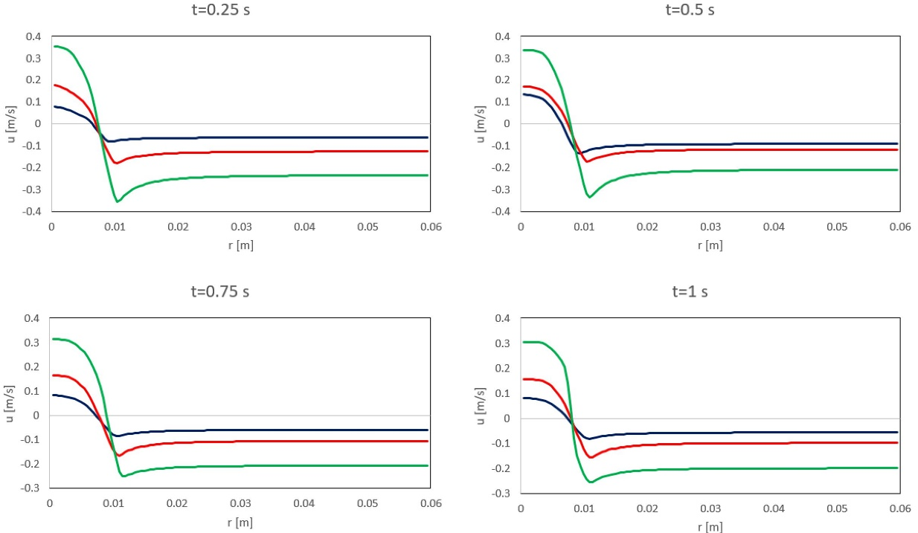
Figure 3.30 Distribution of the axial velocity component along the plane z = Z_{c}, as a function of the Reynolds number (L₀/D₀ = 2) (blue line Re = 1000, red line Re = 2000, green line Re = 4000).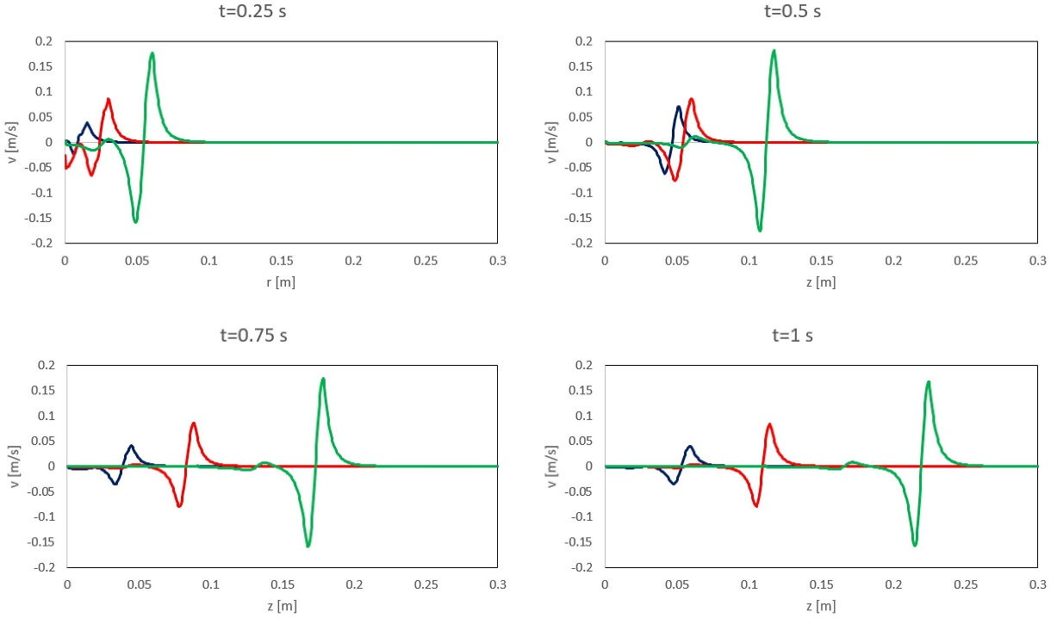
Figure 3.31 Distribution of radial velocity component along the plane r = R_{c}, as a function of the Reynolds number (L₀/D₀ = 2) (blue line Re = 1000, red line Re = 2000, green line Re = 4000).
Figure 3.32 shows the evolution of the vorticity distribution ω for Reynolds number equal to 1000. Here you see the ring vortex formation has not been completed at t = 0.25 sec (top contour map). Pinch-off of the ring vortex happens for t between 0.5 sec and 0.75 sec. At t = 1 sec (bottom contour map) the ring vortex is finally formed and travelling rightwards.
Figure 3.32 Evolution of the distribution of vorticity for Re = 1000 (L₀/D₀ = 2). Vorticity contour at t={0.25, 0.5, 0.75, 1} sec (from top to bottom) is shown.
Figure 3.33 shows the evolution of the vorticity distribution ω for Reynolds number equal to 2000. Here the vortex ring pinch-off occurs earlier compared to the case Reynolds = 1000, for t between 0.25 sec and 0.5 sec. A secondary slower ring vortex can be observed travelling behind the primary one.
Figure 3.33 Evolution of the distribution of vorticity for Re = 2000 (L₀/D₀ = 2). Vorticity contour at t={0.25, 0.5, 0.75, 1} sec (from top to bottom) is shown.
Figure 3.34 shows the evolution of the vorticity distribution ω for Reynolds number equal to 4000. At t =0.25 sec (top contour map), the ring vortex pinch off, marking the end of the ring vortex formation, has already occurred. An estimate of the different amount of energy provided to the primary vortex compared to the secondary vortex can be obtained by approximating mass and velocity of the two.
Figure 3.34 Evolution of the distribution of vorticity for Re = 4000 (L₀/D₀ = 2). Vorticity contour at t={0.25, 0.5, 0.75, 1} sec (from top to bottom) is shown.
Figure 3.35 shows the evolution of the vorticity distribution ω for Reynolds number equal to 8000. In this case, the primary vortex is contained within the model domain at t = 0.25 sec and 0.5 sec. At t = 0.75 sec, the leading vortex ring has already left the domain through the right boundary and the secondary vortex is visible. Looking at the scale, the primary vortex is expected to have a higher vorticity at t = 0.75 sec but the secondary vortex determined rescale to fit in.

Figure 3.35 Evolution of the distribution of vorticity for Re = 8000 (L₀/D₀ = 2). Vorticity contour at t={0.25, 0.5, 0.75, 1} sec (from top to bottom) is shown.
Figure 3.32 shows the evolution of the vorticity distribution ω along the z-axis at r = R_{c} as a function of the Reynolds number. Notice that for t = 0.75 sec the secondary vortex due to the ring vortex produced for Re equal to 8000 (diamond shape marker) has almost the same energy content as the primary vortex produced for Re equal to 4000 (triangle shape marker).

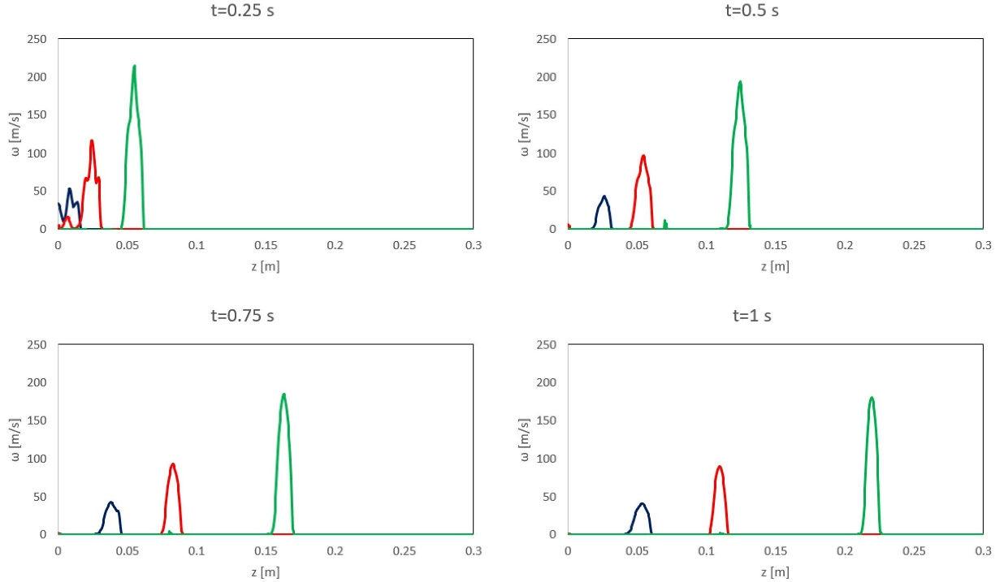
Figure 3.36 Evolution of the vorticity distribution along the z-axis at r = R_{c} as a function of the Reynolds number (L₀/D₀ = 2) (blue line Re = 1000, red line Re = 2000, green line Re = 4000).
Figure 3.37 shows the evolution of the vorticity distribution along the r-axis in the plane z = Z_{c} as a function of the Reynolds number.
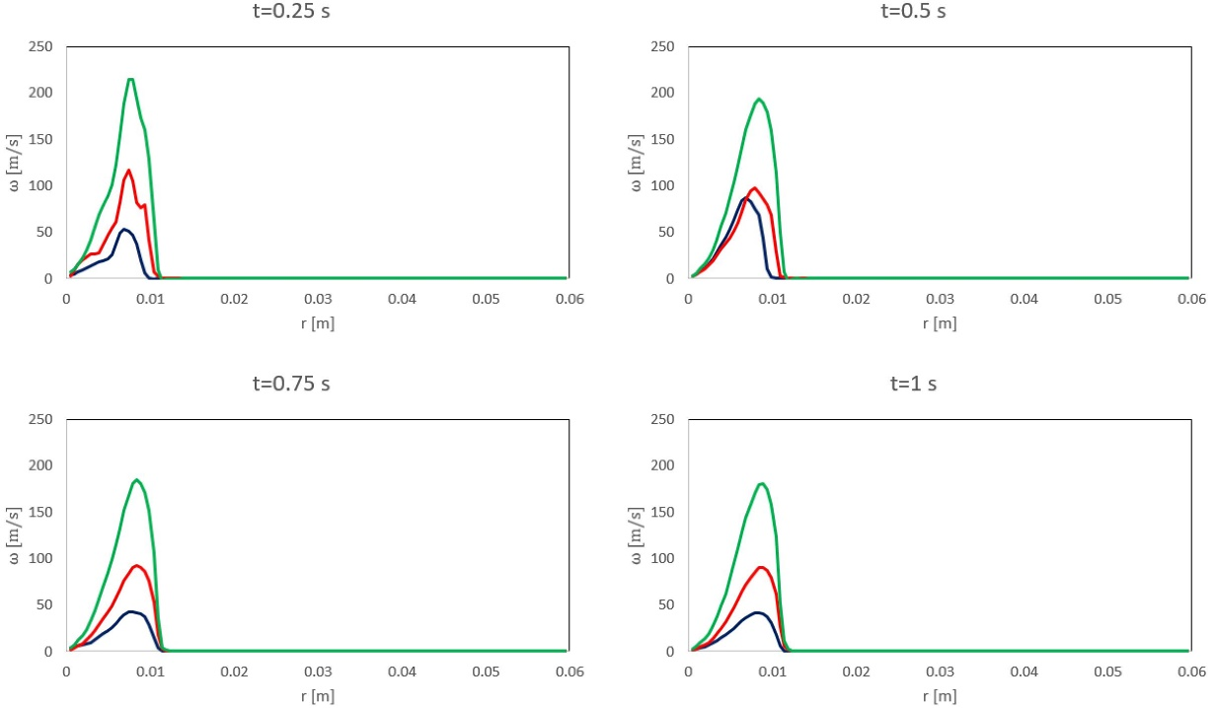
Figure 3.37 Evolution of the vorticity distribution along the r-axis in the plane z = 0 as a function of the Reynolds number (L₀/D₀ = 2) (blue line Re = 1000, red line Re = 2000, green line Re = 4000)

Numerical vs Analytical
In order to validate the computational model, numerically generated vortex rings are matched to ideal vortex models. Among the several analytical models formulated and documented in the literature to describe the post-formation evolution of the ring vortex (see §2.2.2), we consider two classes: Norbury-Fraenkel (Norbury 1973; Fraenkel 1972a) and Kaplanski-Rudi (Kaplanski and Rudi 2005). The ring vortex numerically obtained for Re = 2000 and L₀/D₀=2 at t=0.5 sec was matched to these two models.
-Norbury-Fraenkel-
As reported in §2.2.2.3, vortex rings belonging to this family are characterized by a linear distribution of vorticity, proportional to the distance from the axis of symmetry, and identified by a single geometric parameter α, i.e. the dimensionless mean core radius. Once calculated α, all remaining characteristic scales of the vortex can be computed from tabulated values.
-Kaplanski-Rudi-
As reported in §2.2.2.4, vortex rings belonging to this family are characterized by a Gaussian distribution of vorticity in the core, and identified by a single geometric parameter τ. Once calculated τ, the integrals of motion can be computed from analytical expressions.
The comparison between the simulated vortex and the resulting fits to analytical models is shown in Figure 3.38. The vorticity field was numerically reconstructed for each vortex model. As expected, normalized vorticity isocontours are circular (quasi-Gaussian vorticity distribution) for the Kaplanski-Rudi vortex and straight (linear vorticity distribution) for the Norbury-Fraenkel vortex.

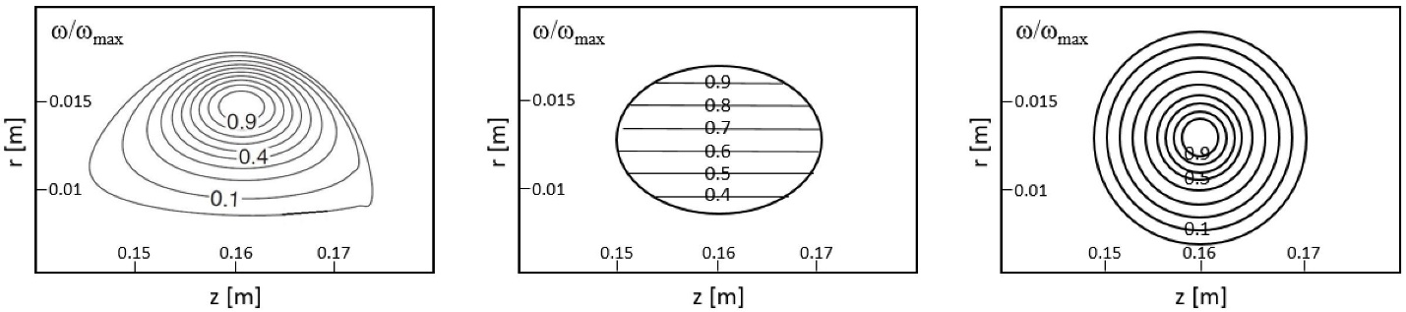
Figure 3.38 Fit of the ring vortex numerically obtained for Re = 2000 and L₀/D₀ = 2 at t = 0.5 sec (left) to ideal models of Norbury-Fraenkel (middle) and Kaplanski-Rudi (right)

Discussion
The present chapter illustrates setup and exercise of CFD modelling for the ring vortex flow in the context of a flow phantom. The problem was formulated according to the typical representation of a ring vortex generator (piston/cylinder system). With the model purpose in mind, formation and early propagation (rather than turbulent transition or decay) of the ring vortex are subjected to analysis. Knowing the equations governing the physical phenomenon (laminar flow of an incompressible fluid), model set up starts from defining the fluid domain. Under the assumption of axisymmetric flow, valid in a specified range of operating conditions, a 2D geometry was considered to mimic the phantom domain.
The computational domain was discretized by means of a structured mesh of quadrilateral elements, with elements clustered in the regions deputies to resolve higher gradients. Mesh and time step sensitivity studies were performed in order to identify the minimal grid and time step size providing satisfactory numerical accuracy along with acceptable performance. The evolution of the axial and radial velocity profile along the radial and axial plane crossing the ring vortex centre were used to evaluate sensitivity of the solution to mesh and time step size. 0.5 millimetres and 0.1 milliseconds were considered to be a good compromise between numerical accuracy and computational cost.
Applied boundary conditions included inlet velocity on the orifice section, axis (no tangential velocity) on the axis of symmetry, no-slip wall on the exit boundary in the orifice plane, outlet on the lateral and downstream boundaries. Considering the target application, a specified range of operating conditions was used to characterize the flow. In particular, a Reynolds number between 2000 and 8000, as calculated at the orifice section, and a stroke ratio between 1 and 8, were considered. Characterization of the flow was carried out in terms of velocity and vorticity distribution as well as bulk parameters, namely ring radius, core radius, and translational speed.
According to presented results, the ring vortex can be effectively modelled by means of Direct Numerical Simulations in a wide range of operating conditions, namely for Reynolds number ranging between 1000 and 8000, and stroke ratio ranging between 1 and 8. Accurate solutions can be obtained at reasonable computational costs, with the solution error decreasingly affected by mesh and time step size. The main implication concerns the extensive use of numerical modelling in the characterization of the flow, with reduced time and cost required to obtain a solution compared to experimental analysis.
To some extent, Computational Fluid Dynamics could replace experiments in the exercise of obtaining a large number of solutions derived from the exploration of the parameter space. But the numerical solution would need to be experimentally validated, arguably for the most challenging operating conditions, to confirm the validity of the assumptions introduced with the model. This is interesting with respect to Reduced Order Modelling applications, requiring large datasets to train and test the models. Also notice that the value of precisely resolving the flow behaviour within the phantom domain before prototyping the rig, allowing to reduce the design process iterations number.

Chapter 4 - Experimental Validation

4.1 Introduction

4.1.1 Prototype rig
With the dual purpose of validating the computational model described in Chapter 3 and anticipating compatibility issues arising when considering the application for the calibration of medical imaging technology, a prototype rig was designed and constructed as part of a collaboration with Leeds Test Objects Ltd (www.leedstestobjects.com). The liaison was intended to conjugate theoretical characterization, including analytical and numerical methods, and experimental characterization, including a variety of methods (e.g. qualitative/quantitative flow visualization, echo/laser Particle Image Velocimetry). The rig was numerically designed as part of the present project, aiming to characterize the flow standard, and prototyped as part of a parallel project, aiming to develop a complex flow phantom, including consideration about compatibility, portability etc.
As with most of the ring vortex generators designed for the laboratory, the proposed flow phantom design uses a piston to propel a slug of fluid along a cylindrical channel, through an orifice connected to a free surface propagation chamber. The generation process is controlled by piston displacement, delivering the fluid column with a specified velocity/displacement profile.
The phantom comprises three main components
- Imaging tank, i.e. the environment where the ring vortex propagates. Manufactured from clear poly(metyl methacrylate)(PMMA), this stands on four adjustable (to allow levelling of the system) screw feet. Internal dimensions of the tank box are 15 cm (W) x 35 cm (L) x 16.5 cm (H). These were considered (as suggested by numerical simulations) sufficiently large such that the walls do not influence the flow behaviour. A number of reference markers and a ruler intended to support positioning and measurement, were laser-cut into the tank walls. For imaging calibration/testing purposes, the tank is open on the top, allowing access for Ultrasound imaging probes.
- A piston-cylinder system, i.e. the mechanism responsible for ring vortex generation. Manufactured from PMMA, the cylinder has the extremities threaded for coupling with the imaging tank and orifice on one hand, and piston guide on the other hand. Internal diameter of the cylinder is 70+/-0.1 mm. Made from white PMMA with a stem of square cross-section sliding through the guide intended for aiding the alignment and minimizing mechanical play, the plunger has a piston head incorporating an O-ring offering a leak-proof seal between piston and cylinder. The prototype includes a set of interchangeable orifices generating rings with characteristics that are relevant to human physiology (length scales comparable to vortex structures observed in the cardiovascular system).
- A programmable actuator acts as the system actuator. The nut/lead screw arrangement enables the piston to be driven by a linear stepper motor. A Nema 23 external linear stepper motor is used to drive the threaded screw of length 150 mm (Nema 23 external linear actuator, OMC Corporation Limited, Nanjing, China). Power is delivered through a digital stepper driver (OMC Corporation Limited, Nanjing, China). Motor control is delivered via an Arduino Uno (Atmega328) microcontroller (Atmel Corporation, San Jose, California, USA).
Figure 4.1 shows a schematic block diagram of the system. Programmed to deliver a preconfigured displacement profile (e.g. top-hat), the actuator moves the piston through the cylinder and propels a slug of fluid through the orifice. A ring vortex, steadily travelling along the length of the tank is obtained.
Figure 4.1 Block-diagram of the prototype phantom (reproduced from (Ambrogio et al. 2019))

4.2 Methods

4.2.1 Laser Particle Image Velocimetry
The Laser-PIV setup required neutrally buoyant scattering particles to provide satisfactory conditions for flow capture. Fluorescent particles of size 10-20 micron were mixed within the volume of water and illuminated by a laser sheet cutting the propagating ring vortex through the center in the vertical plane. Particle displacement is reconstructed using two camera projections (stereoscopic view). Digital Image Correlation allowed reconstruction of the flow field at a spatial resolution of 0.4 mm and a temporal resolution/frame rate of 0.071 s (Frame Rate 14 fps). Accuracy of the instantaneous velocities, as declared by LaVisionUK Ltd (LaVisionUK Ltd, Bicester, UK), should be better than +/-0.1%.

4.2.3 Experiment setup
A summary of the experimental configurations used to demonstrate the vortex flows is listed in Table 4.1. Reynolds number calculations are based on flow through the orifice generating the ring (Re = ρU₀D₀/μ, ρ density, U₀ velocity, D₀ orifice diameter, μ dynamic viscosity). Stroke ratio calculations are based on stroke time as calculated from piston displacement and velocity.
Table 4.1 Summary of the flow generating conditions, with Reynolds number at the throat of the orifice cited. Each configuration was repeated 10 times to evaluate reproducibility
Configuration | D₀ [mm] | U_{p} [cm/s] | Δ [mm] | Re | L₀/D₀
1 | 10 | 2 | 0.8 | 9800 | 3.92
2 | 10 | 1.33 | 0.8 | 6517 | 3.92
3 | 15 | 2 | 0.8 | 6534 | 1.16
4 | 15 | 2 | 0.6 | 6534 | 0.87
5 | 15 | 1.33 | 0.8 | 4345 | 1.16
6 | 15 | 1 | 0.8 | 3267 | 1.16
7 | 20 | 2 | 0.8 | 4900 | 0.49
8 | 20 | 1.33 | 0.8 | 3258 | 0.49
9 | 25 | 2 | 0.8 | 3920 | 0.25
10 | 25 | 1.33 | 0.8 | 2606 | 0.25

The PIV work was undertaken at the IICD department of the University of Sheffield (Royal Hallamshire Hospital, Sheffield, United Kingdom) and performed with a calibrated LaVision system (LaVision GmbH, Gottingen, Germany). The PIV methodology followed that described by Wieneke (Wieneke 2005), with calibration procedures performed under the supervision of a LaVisionUK Ltd (LaVisionUK Ltd, Bicester, United Kingdom) application consultant. The imaging tank (with relevant orifice) and piston channel were filled with water. Data was collected from two identically constructed phantoms, both of which were produced by Leeds Test Objects Ltd (Leeds Test Objects Ltd, Boroughbridge, United Kingdom). Experiments were conducted for all four orifice sizes provided with the phantom. A single programmed piston displacement of 0.8+/‐0.04 mm, and two principal piston speeds, 2+/‐0.1 cm/s and 1.33+/‐0.06 cm/s, were used for this evaluation. The piston speed of 2 cm/s was of interest because it drives the motor close to its maximum achievable speed. Ten separate ring vortices were generated, enabling the reproducibility of rings produced by the phantom to be quantified. Finally, a further piston displacement of 0.6+/‐0.03 mm and piston speed 1 cm/s was also tested.

4.3 Results

4.3.1 Reference case (configuration 3)
Figure 4.2 shows the velocity vector field for the case with Reynolds number equal to 6534 and stroke ratio equal to 1.16 at t = 0.5 sec. The ring vortex can be identified from the vectors concentration in correspondence of the torus minimal diameter, where the vortex core rotational velocity adds up to the translational velocity of the ring. Figure 4.3 shows a detail of the same field, where the ring vortex core centre can be tracked and the core radius can be approximately computed.
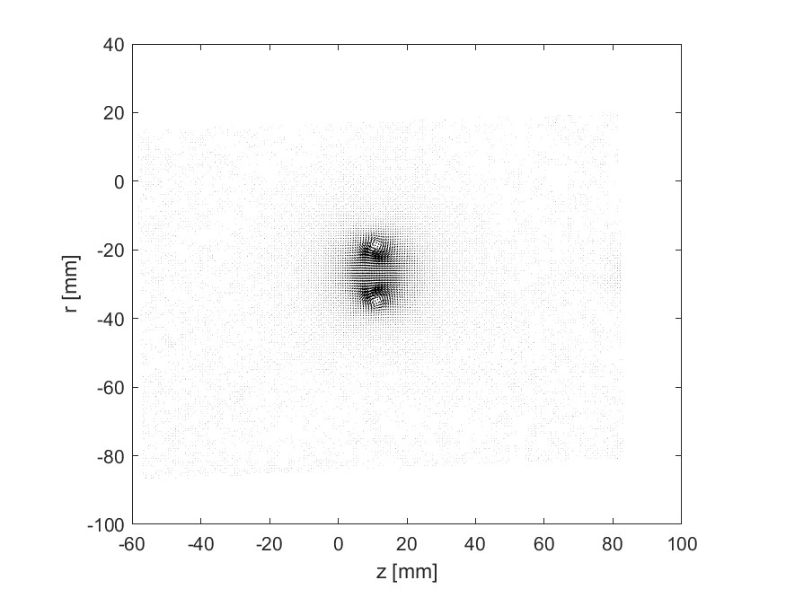
Figure 4.2 Velocity vectors

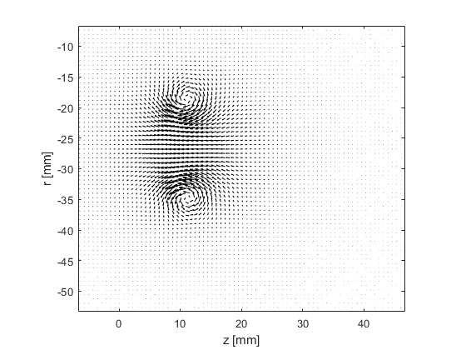
Figure 4.3 Velocity vectors (detail)
-Velocity field-
Figure 4.4 illustrates the evolution of the axial velocity component u along the plane z = Z_{c} (reference frame moving with the ring vortex) obtained from configuration 3 (see Table 4.1). The radius of the ring vortex corresponds to the distance along the r-axis from the origin to the point of intersection of the curve u(0, r) with the x-axis. The linear segment of the curve in the neighbourhood of the point r ≈ R_{c} (distance between the extreme points) corresponds to the vortex core diameter. The dashed straight (parallel to the x-axis) line corresponds to the value of the translational velocity of the ring vortex. Notice that this assumes negative values since the vortex is travelling leftwards (negative z coordinates). Figure show consecutive frames approximately corresponding to t={0.25, 0.5, 0.75, 1} sec.
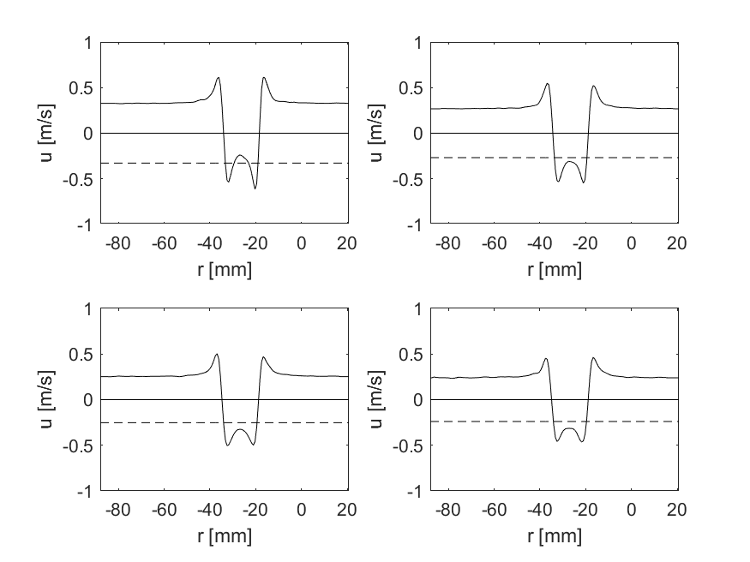
Figure 4.4 Distribution of the axial velocity component along the plane z = 0 (L₀/D₀ = 1.16, Re = 6534 (Configuration 3)). Velocity profile at t = 0.25, 0.5, 0.75, 1 sec (from top left to bottom right) is shown.
Figure 4.5 illustrates the evolution of the radial velocity component v along the plane r=R_{c} obtained from configuration 3 (see Table 4.1)
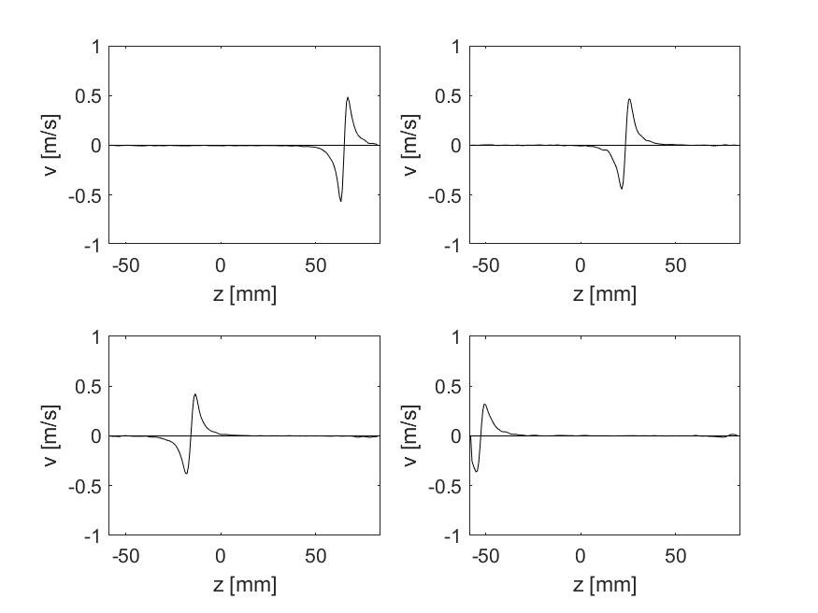
Figure 4.5 Distribution of the radial velocity component along the plane r = R_{c} (L₀/D₀ = 1.16, Re = 6534 (Configuration 3)). Velocity profile at t = 0.25, 0.5, 0.75, 1 sec (from top left to bottom right) is shown.
Since the flow considered is time-dependent, going across a number of stages throughout its development/evolution, in order to establish a direct comparison between experimental observation and numerical solution, the PIV experiment and CFD model have to be synchronized.
The experimental setup did not include synchronization between generating signal and acquisition system – thus no mapping can be established between the acquired frames and real time (the first acquired frame is supposed to be close (<1 sec) to the pulse).
An attempt to synchronize real (PIV) and virtual (CFD) flow behaviour was made a posteriori, based on position and translational speed assumed by the ring vortex in the first convenient frame.
For the sake of clarity this is exemplified below. For the reference case, corresponding to configuration 3 in Table 4.1, 9 frames were acquired were the ring vortex is within the field of view, which has dimensions 18.7x19.4 cm and is shifted 8.5 mm with respect to the orifice exit section. In the first of the 9 frames, the ring vortex position is 10 mm from the field of view boundary, so 18.5 mm from the orifice exit section. The translational speed can be deducted from the distribution of the axial velocity component. Now, assuming that the ring vortex translational speed decays exponentially, the elapsed time can be calculated as
t = ln(Vtrans(0)/Vtrans) (=0.42 s)
The numerical solution was saved every 10 ms. Therefore the closest frame (CFD solution time) to be compared with the PIV image will be the 42nd one. Proceeding with subsequent frames, the nearest matching CFD frame will be considered.
-Vorticity distribution-
Figure 4.6 shows the evolution of vorticity ω along the r-axis in the plane z = 0

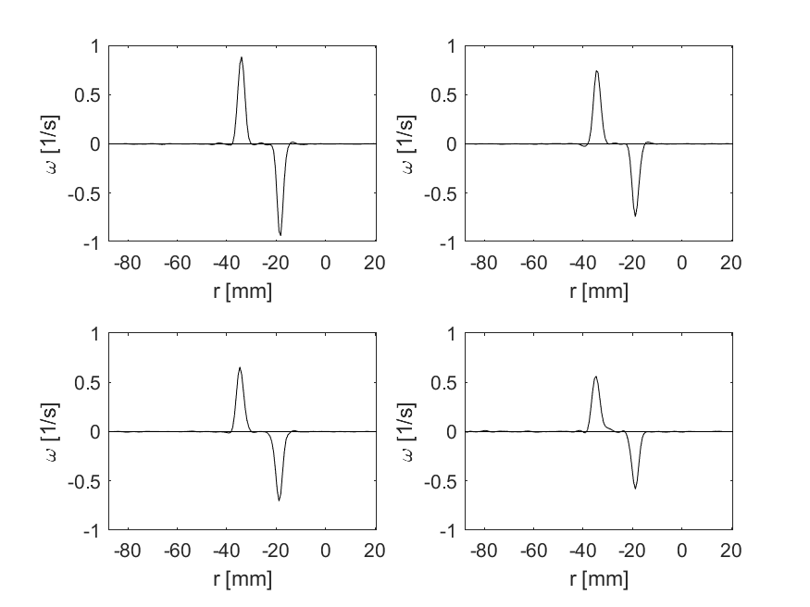
Figure 4.6 Vorticity distribution along the r-axis in the plane z = Z_{c} (L₀/D₀ = 1.16, Re = 6534 (Configuration 3)). Vorticity profile at t=0.25, 0.5, 0.75, 1 sec (from top left to bottom right) is shown.
Figure 4.7 shows the evolution of the vorticity ω along the z-axis in the plane r = R_{c}

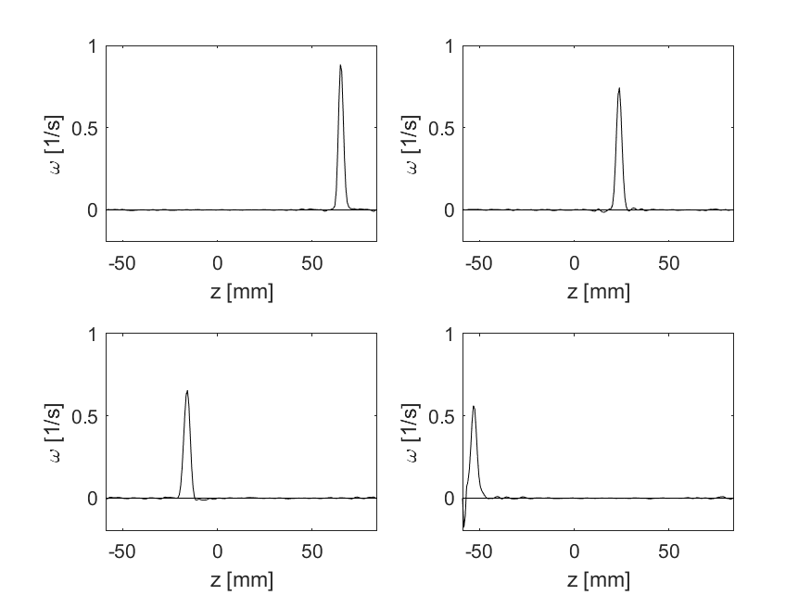
Figure 4.7 Vorticity distribution along the z-axis at r = R_{c} (L₀/D₀ = 1.16, Re = 6534 (Configuration 3)). Vorticity profile at t=0.25, 0.5, 0.75, 1 sec (from top left to bottom right) is shown.
Figure 4.8 shows the evolution of the vorticity ω contour. The ring travels from right to left. Iso-contour maps can provide insights about the evolution of the core vorticity distribution as well as energy considerations looking at the total circulation of the ring vortex.
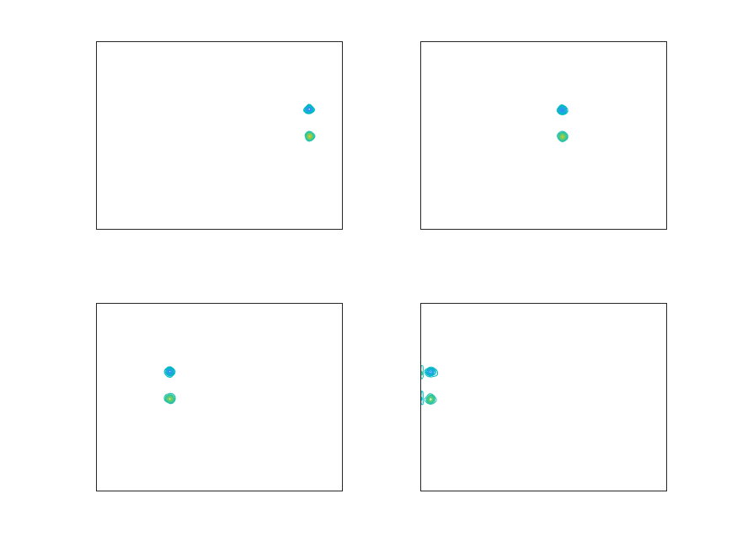
Figure 4.8 Vorticity contour (L₀/D₀ = 1.16, Re = 6534 (Configuration 3)). Vorticity iso-contours at t=0.25, 0.5, 0.75, 1 sec (from top left to bottom right) are shown.

4.3.2 Parametric characterization of ring vortex motion
-Vortex ring parameters as a function of the piston velocity (orifice diameter D₀= constant)-
Two values of the piston velocity U_{p} were considered, namely 2 cm/s and 1.33 cm/s
In the present section, results obtained from configurations with the same orifice size are compared and contrasted.
-Configuration 1 vs Configuration 2 (D₀ = 10 mm)-
Figure 4.9 shows the radial distribution of the axial velocity component u, along the plane z = Z_{c} for configurations 1 and 2 (see Table 4.1) Main observations concern
- Asymmetry of the profile, due to actual asymmetry of the ring or tilting of the ring. In fact, the profile is obtained by orthogonal projection of the axial velocity field on the plane vertically crossing the ring centre, assumed to be the location of the maximum vorticity
- Decay, as the vortex ring travels it loses energy due to viscosity of the medium
Notice that for the 4th frames among those considered, the ring vortex produced for configuration 1, travelling faster, has already left the field of view. The observed profile can be attributed to a secondary vortex (formed from the trailing jet and entering the domain).
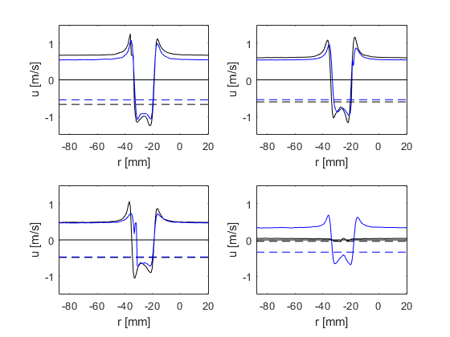
Figure 4.9 Distribution of the axial velocity component along the plane z = 0 (black line: U_{p} = 2 cm/s (L₀/D₀ = 3.92, Re = 9800 (Configuration 1)); blue line: U_{p} = 1.33 cm/s (L₀/D₀ = 3.92, Re = 6517 (Configuration 2)). Velocity profile at t=0.25, 0.5, 0.75, 1 sec (from top left to bottom right) is shown.
Figure 4.10 shows the axial distribution of the radial velocity component v, along the plane r = R_{c} for configurations 1 and 2. Main observations concern
- Symmetric distribution
- Relative position of the two vortices at the same time – a rough estimate of the ring vortex rotational energy can be made by extracting
  - ring radius R from the radial distribution of the axial velocity u (see above)
  - core radius a from the axial distribution of the radial velocity component v (half of the linear segment crossing the origin), thus calculating the volume and mass of the vortex ring
  - Rotational velocity
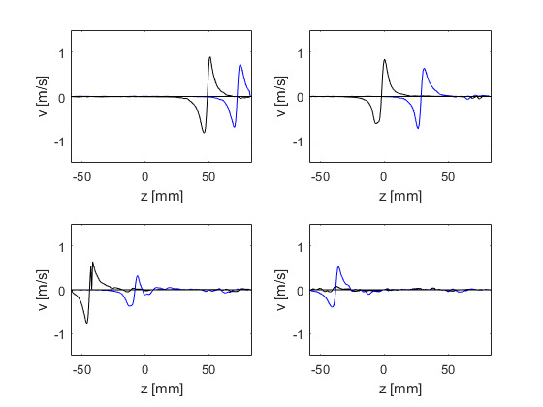
Figure 4.10 Distribution of the radial velocity component along the plane r = R (black line: U_{p} = 2 cm/s (L₀/D₀ = 3.92, Re = 9800 (Configuration 1)); blue line: U_{p} = 1.33 cm/s (L₀/D₀ = 3.92, Re = 6517 (Configuration 2)). Velocity profile at t=0.25, 0.5, 0.75, 1 sec (from top left to bottom right) is shown.
Figure 4.11 shows the evolution of the vorticity ω distribution along the r-axis in the plane z = Z_{c} for configurations 1 and 2. Main observations concern
- Almost symmetric distribution of the profile, demonstrating the generation of a stable/controlled ring vortex
- Decay as the vortex travels, with spread of the quasi-Gaussian profile
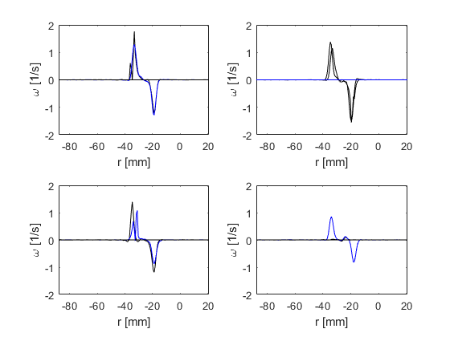
Figure 4.11 Vorticity distribution along the r-axis in the plane z = Z_{c} (black line: U_{p} = 2 cm/s (L₀/D₀ = 3.92, Re = 9800 (Configuration 1)); blue line: U_{p} = 1.33 cm/s (L₀/D₀ = 3.92, Re = 6517 (Configuration 2)). Vorticity profile at t=0.25, 0.5, 0.75, 1 sec (from top left to bottom right) is shown.
Figure 4.12 shows the evolution of the vorticity distribution along the z-axis at r=R_{c} for configurations 1 and 2.
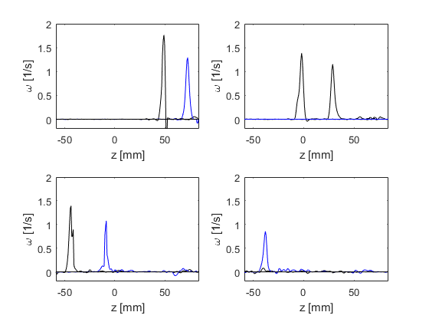
Figure 4.12 Vorticity distribution along the z-axis at r = R_{c} (black line: U_{p} = 2 cm/s (L₀/D₀ = 3.92, Re = 9800 Configuration 1)); blue line: U_{p} = 1.33 cm/s (L₀/D₀ = 3.92, Re = 6517 (Configuration 2)). Vorticity profile at t=0.25, 0.5, 0.75, 1 sec (from top left to bottom right) is shown.
Figure 4.13 shows the evolution of the vorticity contour in the meridional plane for configurations 1 and 2. The two vortices are visible for the first 3 frames considered (out of 4). In the last frame, the faster vortex has left the field of view.
Main observations concern the wake left behind the vortex ring as it travel leftwards.
Among the advantages of using quantitative methods (including field, point-by-point techniques), such as Particle Image Velocimetry, there is the ability to detect small changes in the flow field, otherwise neglected as not identifiable by qualitative methods.
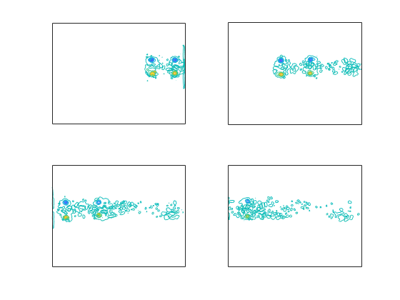
Figure 4.13 Vorticity contour (U_{p} = 2 / 1.33 cm/s (L₀/D₀ = 3.92, Re = 9800 (Configuration 1)); blue line: U_{p} = 1.33 cm/s (L₀/D₀ = 3.92, Re = 6517 (Configuration 2)). Vorticity contours at t=0.25, 0.5, 0.75, 1 sec (from top left to bottom right) are shown.

-Configuration 7 vs Configuration 8 (orifice diameter = 20 mm)-
Figure 4.14 shows the radial distribution of the axial velocity component u, along the plane z = Z_{c} for configurations 7 and 8 (see Table 4.1).
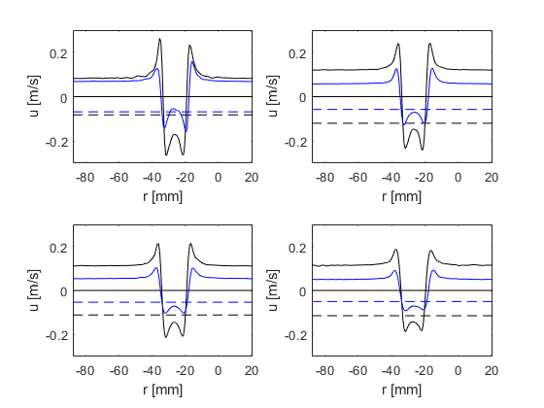
Figure 4.14 Distribution of the axial velocity component along the plane z = Z_{c} (black line: U_{p} = 2 cm/s (L₀/D₀ = 0.49, Re = 4900 (Configuration 7)); blue line: U_{p} = 1.33 cm/s (L₀/D₀ = 0.49, Re = 3258 (Configuration 8)). Velocity profile at t=0.25, 0.5, 0.75, 1 sec (from top left to bottom right) is shown.
Figure 4.15 shows the axial distribution of the radial velocity component v, along the plane r = R_{c} for configurations 7 and 8.
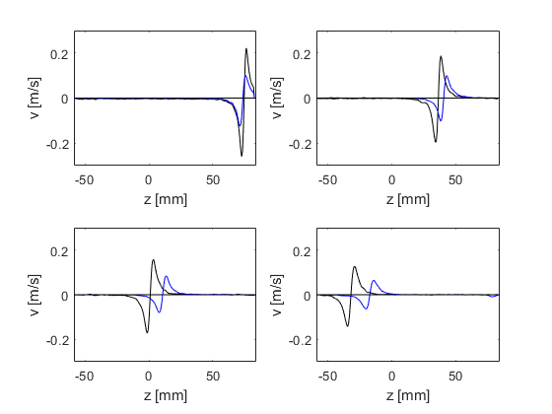
Figure 4.15 Distribution of the radial velocity component along the plane r = R_{c} (black line: U_{p} = 2 cm/s (L₀/D₀ = 0.49, Re = 4900 (Configuration 7)); blue line: U_{p} = 1.33 cm/s (L₀/D₀ = 0.49, Re = 3258 (Configuration 8)). Velocity profile at t=0.25, 0.5, 0.75, 1 sec (from top left to bottom right) is shown.
Figure 4.16 shows the evolution of the vorticity distribution ω along the r-axis in the plane z = Z_{c} for configurations 7 and 8.
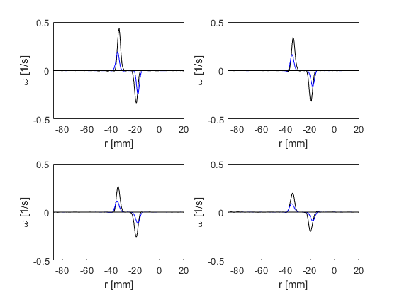
Figure 4.16 Vorticity distribution along the r-axis in the plane z = Z_{c} (black line: U_{p} = 2 cm/s (L₀/D₀ = 0.49, Re = 4900 (Configuration 7)); blue line: U_{p} = 1.33 cm/s (L₀/D₀ = 0.49, Re = 3258 (Configuration 8)). Vorticity profile at t=0.25, 0.5, 0.75, 1 sec (from top left to bottom right) is shown.
Figure 4.17 shows the evolution of the vorticity ω distribution along the z-axis at r=R for configurations 7 and 8.
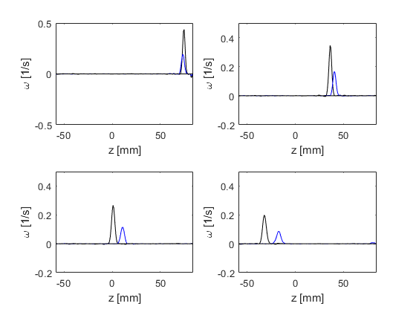
Figure 4.17 Vorticity distribution along the z-axis at r = R_{c} (black line: U_{p} = 2 cm/s (L₀/D₀ = 0.49, Re = 4900 (Configuration 7)); blue line: U_{p} = 1.33 cm/s (L₀/D₀ = 0.49, Re = 3258 (Configuration 8)). Vorticity profile at t=0.25, 0.5, 0.75, 1 sec (from top left to bottom right) is shown.
Figure 4.18 shows the evolution of the vorticity contour in the meridional plane for configurations 7 and 8.
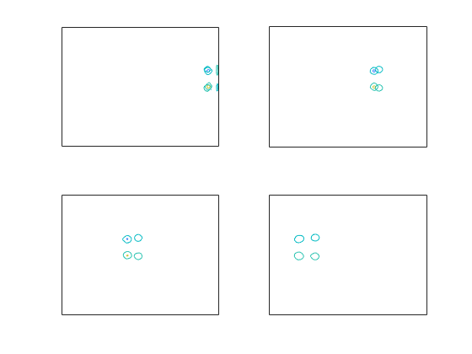
Figure 4.18 Vorticity contour (U_{p} = 2 / 1.33 cm/s (L₀/D₀ = 0.49, Re = 4900 (Configuration 7); U_{p} = 1.33 cm/s (L₀/D₀ = 0.49, Re = 3258 (Configuration 8)). Vorticity contours at t=0.25, 0.5, 0.75, 1 sec (from top left to bottom right) are shown.

-Configuration 9 vs Configuration 10 (orifice diameter = 25 mm)-
Figure 4.19 shows the radial distribution of the axial velocity component u, along the plane z = Z_{c} for configurations 9 and 10 (see Table 4.1).
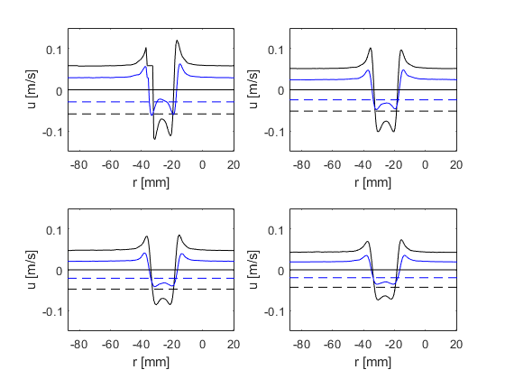
Figure 4.19 Distribution of the axial velocity component along the plane z = Z_{c} (black line: U_{p} = 2 cm/s (L₀/D₀ = 0.25, Re = 3920 (Configuration 9)); blue line: U_{p} = 1.33 cm/s (L₀/D₀ = 0.25, Re = 2606 (Configuration 10)). Velocity profile at t=0.25, 0.5, 0.75, 1 sec (from top left to bottom right) is shown.
Figure 4.20 shows the axial distribution of the radial velocity component v, along the plane r = R_{c} for configurations 9 and 10.
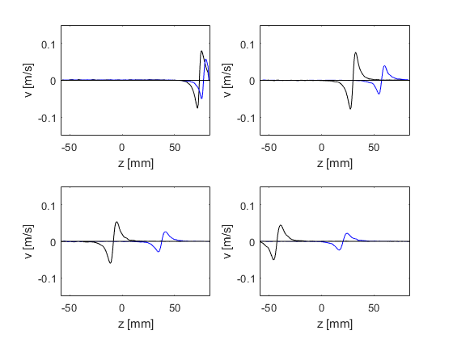
Figure 4.20 Distribution of the radial velocity component along the plane r = R_{c} (black line: U_{p} = 2 cm/s (L₀/D₀ = 0.25, Re = 3920 (Configuration 9)); blue line: U_{p} = 1.33 cm/s (L₀/D₀ = 0.25, Re = 2606 (Configuration 10)). Velocity profile at t=0.25, 0.5, 0.75, 1 sec (from top left to bottom right) is shown.
Figure 4.21 shows the evolution of the vorticity ω distribution along the r-axis in the plane z = Z_{c} for configurations 9 and 10.
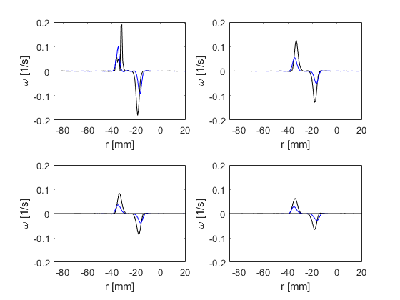
Figure 4.21 Vorticity distribution along the r-axis in the plane z = Z_{c} (black line: U_{p} = 2 cm/s (L₀/D₀ = 0.25, Re = 3920 (Configuration 9)); blue line: U_{p} = 1.33 cm/s (L₀/D₀ = 0.25, Re = 2606 (Configuration 10)). Vorticity profile at t=0.25, 0.5, 0.75, 1 sec (from top left to bottom right) is shown.
Figure 4.22 shows the evolution of the vorticity ω distribution along the z-axis at r=R_{c} for configurations 9 and 10.
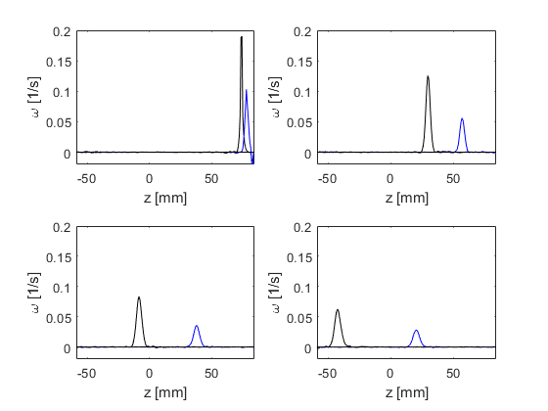
Figure 4.22 Vorticity distribution along the z-axis at r = R_{c} (black line: U_{p} = 2 cm/s (L₀/D₀ = 0.25, Re = 3920 (Configuration 9)); blue line: U_{p} = 1.33 cm/s (L₀/D₀ = 0.25, Re = 2606 (Configuration 10)). Vorticity profile at t=0.25, 0.5, 0.75, 1 sec (from top left to bottom right) is shown.
Figure 4.23 shows the evolution of the vorticity ω contour in the meridional plane for configurations 9 and 10.
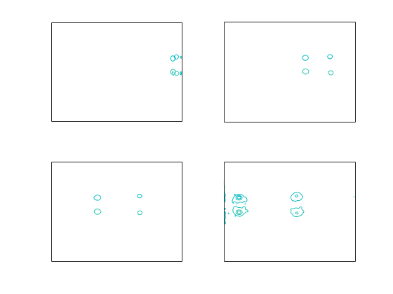
Figure 4.23 Vorticity contour (U_{p} = 2 / 1.33 cm/s (L₀/D₀ = 0.25, Re = 3920 (Configuration 9), U_{p} = 1.33 cm/s (L₀/D₀ = 0.25, Re = 2606 (Configuration 10)). Vorticity contours at t=0.25, 0.5, 0.75, 1 sec (from top left to bottom right) are shown.
-Vortex ring parameters as a function of the orifice diameter-
-Configuration 1 vs Configuration 3 vs Configuration 7 vs Configuration 9 (U_{p} = 2 cm/s)-
Figure 4.24 shows the radial distribution of the axial velocity component u, along the plane z = Z_{c} for configurations 1, 3, 7 and 9 (see Table 4.1).
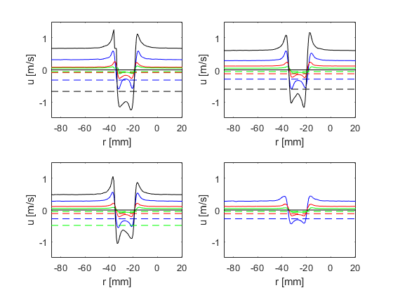
Figure 4.24 Distribution of the axial velocity component along the plane z = Z_{c} (black line: D₀ = 10 mm (Configuration 1); blue line: D₀ = 15 mm (Configuration 3); red line: D₀ = 20 mm (Configuration 7); green line: D₀ = 25 mm (Configuration 9). Velocity profile at t=0.25, 0.5, 0.75, 1 sec (from top left to bottom right) is shown.

Figure 4.24 shows the axial distribution of the radial velocity component v, along the plane r = R_{c} for configurations 1, 3, 7 and 9.
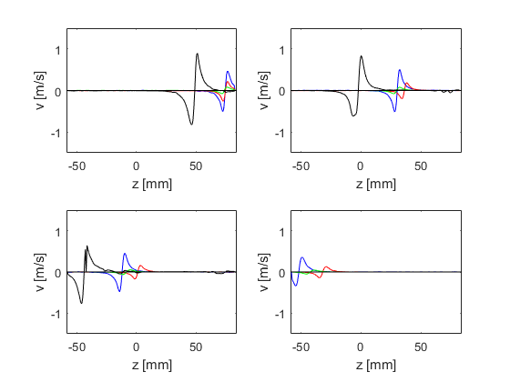
Figure 4.25 Distribution of the radial velocity component, v, along the plane r = R (black line: D₀ = 10 mm (Configuration 1); blue line: D₀ = 15 mm (Configuration 3); red line: D₀ = 20 mm (Configuration 7); green line: D₀ = 25 mm (Configuration 9). Velocity profile at t=0.25, 0.5, 0.75, 1 sec (from top left to bottom right) is shown.

Figure 4.25 shows the evolution of the vorticity ω distribution along the r-axis in the plane z = Z_{c} for configurations 1, 3, 7 and 9.
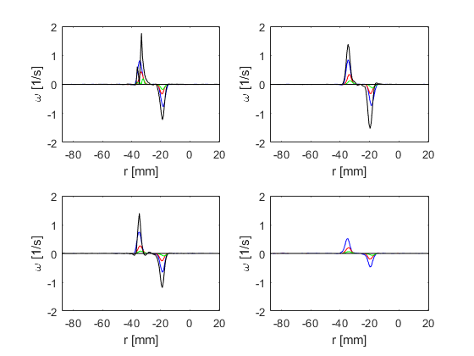
Figure 4.26 Vorticity ω distribution along the r-axis in the plane z = Z_{c} (black line: D₀ = 10 mm (Configuration 1); blue line: D₀ = 15 mm (Configuration 3); red line: D₀ = 20 mm (Configuration 7); green line: D₀ = 25 mm (Configuration 9). Vorticity profile at t=0.25, 0.5, 0.75, 1 sec (from top left to bottom right) is shown.
Figure 4.26 shows the evolution of the vorticity ω distribution along the z-axis at r=R_{c} for configurations 1, 3, 7 and 9.
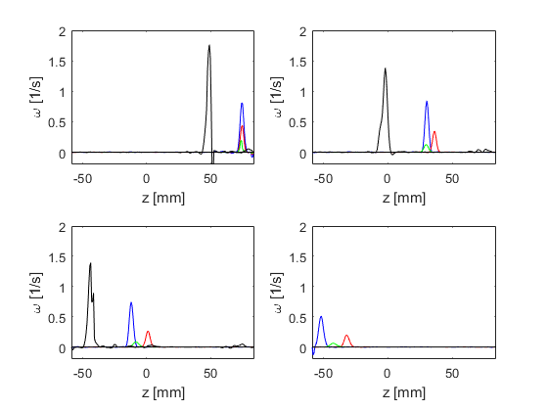
Figure 4.27 Vorticity ω distribution along the z-axis at r = R (black line: D₀ = 10 mm (Configuration 1); blue line: D₀ = 15 mm (Configuration 3); red line: D₀ = 20 mm (Configuration 7); green line: D₀ = 25 mm (Configuration 9). Vorticity profile at t=0.25, 0.5, 0.75, 1 sec (from top left to bottom right) is shown.

Figure 4.27 shows the evolution of the vorticity contour in the meridional plane for configurations 1, 3, 7 and 9.
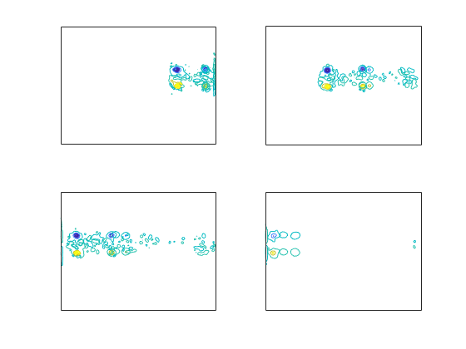
Figure 4.28 Vorticity contour (D₀ = 10/15/20/25 mm (Configuration 1/3/7/9). Vorticity contours at t=0.25, 0.5, 0.75, 1 sec (from top left to bottom right) are shown.

4.4 Experimental vs Numerical
A direct comparison between experiments and numerical simulations was attempted with the purpose of validating the numerical model. Useful insights about the experiment setup could also be derived from comparison with numerical results. Configuration 6 (D₀ = 15 mm, L₀/D₀ = 1.16, Re = 3000)(see Table 4.1), closest to the numerical reference case (D₀ = 15 mm, L₀/D₀ = 2, Re = 2000), was reproduced numerically and results obtained were compared with the experimental equivalent. Evolution of the bulk properties, namely ring radius R, core radius a, and translational speed V, was considered as a measure for contrast/comparison between numerically and experimentally generated vortex rings.
Figure 4.29 shows the time evolution of the ring radius R for the ring vortex obtained numerically (line) and experimentally (marker). Starting from a size approximately equal to the orifice diameter, the ring radius grows up to a steady value. A good agreement is obtained between numerical and experimental flow, as demonstrated by the distance between the curves, always within 5% error. Notice how the measure variation is displayed against phantom position rather than time. This is because the bulk properties of the experimentally generated ring vortex were measured in space (taking the phantom as a reference) since the time origin was not known (had to be approximated (see §4.3.1)).
Figure 4.30 shows the evolution of the core radius a for the ring vortex obtained numerically (line) and experimentally (marker). To the initial stage seeing the growth of the core radius during the roll-up, follows a regular decrease down to a steady value. As for the ring radius, a good agreement is observed between numerical and experimental flow, as demonstrated by the distance between the curves (less than +/-5% error once the steady state has been reached).
Figure 4.31 shows the evolution of the translational speed V for the ring vortex obtained numerically (line) and experimentally (marker). Maximum at the beginning of the observation period (formation and early propagation) for the numerical case, this is not measured for the experimental case (field of view is far from the orifice). However, in the early stage of the post-formation evolution, the numerically generated ring vortex is much faster; as the flow becomes quasi-stationary, i.e. velocity converging to a constant value, the distance between the curves decreases down to less than +/-5% error.

Figure 4.29 Evolution of the ring radius, numerical (line) vs experimental (marker) ring vortex

Figure 4.30 Evolution of the core radius, numerical (line) vs experimental (marker) ring vortex

Figure 4.31 Evolution of the translational speed, numerical (line) vs experimental (marker) ring vortex

4.5 Discussion
The present chapter illustrates the results of the experimental characterization of the ring vortex in the context of a flow phantom. Applied operating conditions were in the suggested range of values for Reynolds number and stroke ratio, such that stability and reproducibility of the flow could be preserved (maximized in a sense). Similar to the numerical analysis, the characterization of the flow was carried out in terms of velocity and vorticity distribution but also in terms of bulk properties, namely ring radius, core radius, and translational speed.
A prototype rig, designed according to preliminary results of numerical simulations, was built in collaboration with Leeds Test Objects (LTO), an industrial company partner of the VPH-CaSE network. A parallel project, focused on the development of the flow phantom, also including considerations about multi-modal compatibility was carried out at LTO. Main components of the system are imaging tank, i.e. the environment where the ring vortex propagates; piston/cylinder arrangement, i.e. the mechanism responsible for ring vortex generation; and system actuator, i.e. a stepper motor driving the piston displacement.
Laser Particle Image Velocimetry (PIV) was employed to acquire images of a single laminar vortex ring. The PIV work was undertaken at the IICD department of the University of Sheffield (Royal Hallamshire Hospital, Sheffield, United Kingdom) and performed with a calibrated LaVision system (LaVision GmbH, Gottingen, Germany). Experiments were conducted for a total of 10 different combinations of three parameters contributing to the value of Reynolds number and stroke ratio, namely orifice diameter, piston velocity, and piston displacement. Ten vortex rings were generated for each of the above mentioned configurations, allowing to quantify reproducibility of the flow.
Results, presented by comparing velocity/vorticity distribution as obtained by varying a single parameter, namely the orifice diameter, while keeping constant piston velocity and piston displacement, confirm the suitability of the flow for the target application. In particular, considering the limited range of operating conditions that could be implemented in the current system, outcomes were very informative about the flow stability and reproducibility. PIV results were directly compared with numerical results for a single, reference case. Bulk properties extracted from numerical and experimental flow field were matched resulting in a distance always within +/-5% error.

Chapter 5 - Accelerated methods for computational modelling of vortex ring motion

5.1 POD-based reduced order modelling

5.1.1 Introduction
Numerical description of complex physical systems can only be achieved by means of expensive simulations. The nonlinearity of these problems implies that changing the operating conditions (model’s input) can introduce remarkable changes in the system’s state (model’s output). Therefore, a comprehensive knowledge about the system’s behaviour can only be obtained by running several simulations with varying inputs, until a sufficient number of observations of the system’s state is obtained.
There are big advantages in developing surrogate models (SMs) of fluidic systems, able to represent the flow behaviour in a wide range of operating conditions, without the need for expensive CFD simulations. This is especially suitable for the development of digital counterparts of real systems, with application in monitoring, diagnostics, and prognostics. Machine learning techniques have been borrowed for this purpose.
For example, a CFD simulation can be considered as a black box, providing a certain output y given a certain input x, and indicated by F()
$$y=F(x)$$
The evaluation of F() generally requires hours of computational time. Once a sufficient number of observations of the model’s output have been collected, $y\left(x_{i}\right) ∀i=1, …, M$, a surrogate model can be trained. The output for a set of unexplored inputs x* can be predicted without the need for evaluating F(x*). Indeed, F() is approximated by a new function M() whose evaluation is much cheaper than F()
$$y^{*}=F(x^{*})≈M\left(x^{*}\right)$$
Surrogate models are data-driven mathematical models aiming to approximate the relationship between input and output. They are particularly useful when this relationship is either not known or expressed by expensive simulations. Surrogate models are built from a relatively small set of observations of the model’s output, corresponding to a set of training points in the model parameter space. Once trained, surrogate models allow to quickly evaluate the system’s state over a wide range of operating conditions. Therefore, they are appropriate in the context of uncertainty quantification and global optimization problems.
Ideally, surrogate models should preserve the physics of the investigated phenomena, and be built from a limited number of observations. They are generally constructed directly on the variables of interest (e.g. velocity/pressure field). A surrogate model for every single output variable is trained and a response surface is found, indicating the input/output relationship. In case of numerous output variables, any correlation between these variables might be lost in the process of training individual surrogate models. If the original set of variables can be represented by a new set of fewer scalars (corresponding to the idea that the original variables are actually realization of unknown latent variables), the number of surrogate models to train can be reduced.
Proper Orthogonal Decomposition (POD) offers the potential of preserving the physics while reducing the size of the problem. POD is a statistical technique used to find a set of orthogonal low-dimensional basis functions, called principal components, to represent an ensemble of high dimensional data. POD finds a new smaller set of uncorrelated variables (POD scores) which is representative of the original variables of interest. Once these POD scores are founds, a reduced order surrogate model can be built for each one of them. Surrogate models usually include interpolation of regression techniques depending on the choice of some particular design functions, defined by a set of hyper-parameters whose values affect the surrogate model’s predictive abilities.
Reduced order models (ROMs) are less sensitive to the particular design functions chosen for their development. They also have a reduced number of variables for which a surrogate model needs to be trained, i.e. fewer optimization problems need to be solved in order to estimate feasible values for the hyper-parameters of the design functions. In addition, reduced order models usually scale better than classic surrogate models for parallel computing.
These features are what makes POD-based ROMs very attractive candidates for the development of physics-preserving surrogate models (SMs). The objective is to develop advanced SMs, trained on a reduced number of full simulations, able to predict the full system state in unexplored conditions, without running a new simulation. To this end, an approach based on the combination of POD and linear regression was chosen. POD is used to extract the invariant (w.r.t. the input parameters) physics-related information of an investigated system and identify the system’s coefficients which instead depend on the operating conditions, the POD scores. Linear regression is then used to find a response surface for these scores. With this strategy it was possible to build a ROM for parameter exploration with reduced computational cost. Linear regression was chosen over other regression techniques as a preliminary formulation. The objective of the present work is to demonstrate the applicability of the proposed methodology for the development of reduced-order models of multi-scale and multi-physics computer models. In this perspective, this work paves the way for the development of digital twins of realistic engineering systems.

5.1.2 Methods
-Training data set-
Velocity vector fields obtained from the CFD model for a series of input cases.
The investigated parameters, whose contribution was independently evaluated are
- Reynolds number (1000, 2000, 4000, 8000)
- stroke ratio (1,2,4,8)
The resulting data matrix has dimension 72721x4 (#meshNodes x #observations).
In order to reduce the computational costs, the original dataset was sub-sampled.
The resulting mesh density mimics the PIV experiment spatial resolution (0.4 mm).
Subsampled data matrix has dimensions 35280x4.
So, we start from
- 2 data matrices, for the axial and radial velocity components, containing the solution at dimensionless time
T* = tV₀/D₀= 4
for 4 different values of the Reynolds number (and constant stroke ratio = 2)
- 2 data matrices, for the axial and radial velocity components, containing the solution at dimensionless time 4 for 4 different values of the stroke ratio (and constant Reynolds number = 2000)
Proper Orthogonal Decomposition was carried out on each of the data matrices.
Looking at the distribution of the variance explained by the principal components (PCs), represented in Figure 5.1, it can be observed that more the 95% of the variance is explained by the First PC (most energetic).
Therefore, reduced data matrices (obtained by projecting the data onto the First PC) were considered for Reduced Order Modelling purposes.
A generalized linear model was constructed for each node of the mesh. The obtained models were then used to predict the state of the system for unexplored values of the input parameters (Reynolds number, stroke ratio).
In particular a single case for each parameter was considered
- Reynolds = 3000 (stroke ratio = 2)
- stroke ratio = 3 (Reynolds = 2000)
The obtained prediction is compared to full order numerical results.

Figure 5.1 Energy distribution of velocity

5.1.3 Results
-Reynolds number variation-
Figure 5.2 compares the contour of the axial velocity component u for the case Reynolds = 3000 and stroke ratio = 2, as obtained from ROM and CFD.
Figure 5.2 Contour of the axial velocity component u, at dimensionless time 4, as obtained from the proposed ROM (top) and from CFD (bottom)
Figure 5.3 compares the contour of the radial velocity component v for the case Reynolds = 3000 and stroke ratio = 2, as obtained from ROM and CFD.
Figure 5.3 Contour of the radial velocity component v, at dimensionless time 4, as obtained from the proposed ROM (top) and from CFD (bottom)
Quantitative evaluation of the ROM are needed in order to inform setup improvement.

5.2 Discovery Live
As part of accelerated methods, i.e. numerical methods able to provide real-time or almost real-time solutions, a solver recently released based on reduced order methods, is introduced in the present chapter as alternative to POD-based ROM. Compared to the above mentioned techniques, this new tool does not require expensive training with large datasets, to be computed off-line before the model can actually be put on-line to interpolate/extrapolate new solutions. Also, it does not imply any specific technical knowledge for the model to be set up. It only requires to define computational domain and boundary conditions. On the other hand, lower numerical accuracy can be expected. This could be considered as a further validation strategy for the methods described in the previous chapters.

5.2.1 Introduction
ANSYS Discovery Live (ANSYS Inc., Canonsburg, PA, USA) is a new accelerated solver that exploits Lattice Boltzmann methods to produce near real-time transient solutions for a wide range of flow problems, based around an accessible interface.
The capability of ANSYS Discovery Live, in the context of the proposed application, has been evaluated with respect to several flow conditions, relevant for medical device design, for which well documented benchmark solutions exist.
An example of ring vortex generation, mimicking the reference case (Re = 2000, L₀/D₀ = 2) has also been considered.
The performance of this new solution technology in these areas (med device design) can be suggested to be an indication of its capability for more general device-related and physiological simulation
The capability of Discovery Live to accurately depict flows in increasing complexity was explored, namely
- Laminar parabolic flow in a straight pipe – steady state boundary conditions (input), and resulting steady state velocity/pressure distribution (output)(White 1999)
- Periodic flow (Karman vortex) in both an unconstrained (unbounded) domain and a straight pipe – steady state boundary conditions, and unsteady output (Fenner et al. 2008)
- FDA nozzle benchmark challenge – steady state boundary conditions, with community validated experimental and numerical velocity/pressure distributions (Stewart et al. 2012)
- Ring vortex – in the context of the phantom
Each case represents a well-studied and well-described flow allowing the results from ANSYS Discovery Live to be evaluated in each instance. Of particular interest is the description of the flow field (velocity, pressure etc.) as well as the capability of the solver to report the flow field (solution time, robustness etc.).

5.2.2 Methods
A Discovery Live simulation begins with definition of the fluid domain and this is most easily achieved by importing a CAD representation of the geometry of interest. Internal or external flows can be specified. Details of the geometries and boundary conditions are provided with each of the cases (straight pipe, Karman vortex shedding, FDA nozzle model) described below. In all examples, steady state boundary conditions only were considered, with physiologically relevant Reynolds numbers used to explore the flow behaviour. Both water and blood (modelled as Newtonian) were used as the fluid within the domain with fluid properties specified prior to the simulation. Unlike other computational fluid dynamics approaches, the software requires relatively little input from the user in terms of discretization of the domain through a meshing process as this is handled automatically. The user is provided with an option to select the ‘Fidelity’ vs Speed of the simulation through a slider on the interface. The ‘Fidelity’ setting influences solution speed and the accuracy of the solver output. In these examples moderate fidelity was chosen, with the slider placed 2/3 of the way towards the high ‘Fidelity’ position. The simulation starts when the ‘Start simulation’ button in the software is pressed.
Following this a full 3D solution is displayed dynamically, evolving in real time, with an incrementing time counter visible at the side of the screen. The evolving display is interactive, allowing alternative visualisation modes to be selected in real-time (e.g. pressure, velocity, particles, streamlines, contours etc.) as the solution progresses. The solver can even be paused to change boundary condition values, so that these changes influence the subsequent flow field when the simulation is restarted. The facility to report results at fixed points within the flow field (through the use of manually placed point probes and data exported as a csv file) was used in this study to record
parameters of interest. This data was also presented as a live plot, updating in real-time on the screen. The version of Discovery Live used in this exercise was bundled as part of ANSYS release 19.2 and ran on a Win10 platform, hosted on a PC equipped with an nVidia GTX1080 graphics card with 8GB RAM.
Laminar Flow in a Straight Pipe
Steady state flow in a long cylindrical pipe of constant diameter is a simple, but well described and validated flow, providing a suitable reference for comparison with the ANSYS Discovery Live solution. The CAD representation of the geometry is shown (internal radius 32mm, length 2m), with boundary conditions that impose a plug flow inlet velocity and zero pressure at the outlet (see Figure 5.4). Along the pipe, the boundary layer originating from the interior wall steadily expands with distance along the pipe to eventually fill the entire width. In this condition the flow is fully developed, i.e. flow characteristics no longer change with increasing distance along the pipe.
Table 5.1 Simulation settings for laminar flow in a straight cylindrical pipe
 |  | Steady State Laminar Flow in Cylindrical Pipe
Boundary conditions |  | Plug flows at the inlet covering a range of velocities corresponding to Reynolds numbers (Re) from 100 -1000 in steps of 100.
 |  | Zero gauge pressure present at the outlet
 |  | Non-slip conditions on the pipe wall
Metrics of Performance |  | Accuracy of the fully developed parabolic flow profile, with reference to established, documented behaviour
 |  | Entrance length
Discovery Live settings |  | Modelled as an internal flow
 |  | Probes placed along the axis and radially to report flow velocity data

Figure 5.4 A schematic of the cylindrical straight pipe with plug inlet flow and zero pressure at the outlet
The distance over which the flow becomes fully developed is known as the entrance length and is a function of the Reynolds number. In the case of laminar flow it is established to be
𝐿 = 0.05 ∙ 𝐷 ∙ 𝑅𝑒 (5.1)
With non-slip boundary conditions at the pipe wall and axial symmetry about the centreline, the fully developed steady state velocity profile is given by
$u\left(r\right)=2U∙\frac{R^{2}-r^{2}}{R^{2}}$ (5.2)
where U is the average flow velocity, R represents pipe radius (<< length L), and r is the radial coordinate (distance from the pipe centreline). The values of Reynolds number were varied, by changing the inlet velocity, from 100 to 1000, in steps of 100. In order to reconstruct the cross-sectional velocity profile, the numerical solution was probed radially at 9 points, located at distances of 0.5LE, 0.8LE and LE from the pipe entrance.
The velocity profile – u(r) - obtained at steady state (determined visually, supported by probe data) was compared to the expected parabolic profile given by (5.1). For investigation of development length, probes were placed along the pipe centreline to report flow velocity, since this is a maximum under fully developed flow, equating to 2U. The parameters reported from Discovery Live were plotted and compared with (5.1) and (5.2).
Karman Vortex
The Karman Vortex refers to the periodic shedding of vortices from a cylindrical bluff body in an unconstrained free field flow. The resulting flow is typically unsteady and provides a much more challenging scenario for the ANSYS Discovery Live solver, whilst still allowing comparison with well documented behaviour. This study was performed with a 5mm diameter cylindrical pin, in both the free field and with the pin bisecting a cylindrical pipe (32mm diameter, fully developed flow at the pin) the latter relating to direct comparison with a physical and numerical example of the same described in the literature.
Table 5.2 Simulation settings for the Karman vortex - free field and straight pipe
 |  | Karman Vortex  (free field, 5mm pin) | Karman Vortex  (5mm pin, 32mm pipe)
Boundary conditions |  | Steady, free field flow covering a range of velocities corresponding to Reynolds numbers (Re) from 100 -1000 in steps of 100. | Plug flows at the inlet covering a range of velocities corresponding to Reynolds numbers (Re) from 100 -1000 in steps of 100.
 |  | Slip conditions at the boundary of the free field domain | Zero gauge pressure present at the outlet
 |  |  | No-slip conditions on the pipe wall
Metrics of Performance |  | Re at the onset of shedding | Re at the onset of shedding
 |  | Shedding frequency as a function of Re | Shedding frequency as a function of Re
Discovery Live settings |  | Modelled as an external flow | Modelled as an internal flow
 |  | Probes reporting z-velocity, placed 10 pin diameters downstream and 5 pin diameters off axis from pin position | Probes reporting z-velocity, placed 10 pin diameters downstream and 5 pin diameters off axis from pin position

A dimensionless parameter - the Strouhal number (St) – is used to characterize the periodicity of the shedding flow. As reported in the literature, the Strouhal number is a function of the Reynolds number according to:
$St=\frac{fD}{U}$ (5.3)
where f refers to the shedding frequency, D is the diameter of the cylindrical pin, and U is the free field flow velocity. Reynolds number was varied, by changing the field velocity, from 100 to 1000 in steps of 100. In both cases (i.e. free field and pipe flow), the shedding frequency was obtained from a probe located at a distance 10D downstream and 1.6D off-axis from the cylindrical pin centre (see the figures). By plotting the periodic oscillations of the z-velocity flow component, the shedding frequency could be determined once steady oscillations were visibly established. The St vs Re behaviour from ANSYS Discovery Live was compared to results reported in the literature.

Figure 5.5 A schematic of the Karman Vortex pipe with plug inlet flow and zero pressure at the outlet
FDA Nozzle Model
The FDA benchmark medical device flow models for CFD were specifically designed to exercise flow solvers and compare their outputs with experimentally obtained reference measurements. These are flows with characteristics that are considered to be representative of those found in medical devices. Two benchmark problems have been proposed for CFD validation
- flow through connected nozzles of various diameters
- flow in a simplified centrifugal blood pump
This paper considers the Nozzle Benchmark. The geometry consists of an inlet cylinder, coupled to a converging nozzle that connects to a sudden expansion through a short cylindrical pipe section. The CAD representation of the geometry is shown (see Figure 5.6), with boundary conditions that impose steady flow at the inlet (plug velocity profile converted to parabolic by long entrance length) and zero gauge pressure at the outlet. Specifically, the model geometry consists of
- an inlet pipe of radius 6mm and length LE sufficient to ensure fully developed flow
- a converging section (α=20°, 22.685mm)
- a throat region of radius 2mm and length 40mm, ending with sudden expansion into…
- …a pipe of radius 6mm and length 180mm, chosen to ensure a negligible influence of the outlet boundary condition on the reattachment point.
Table 5.3 Simulation settings for the FDA geometry
 |  | FDA Challenge Geometry
Boundary conditions |  | Plug flows at the inlet at Re 2000 and 3500 as reported in the literature
 |  | Zero gauge pressure at the outlet
 |  | Non-slip conditions on the pipe wall
Metrics of Performance |  | Accuracy of the axial velocity profile at specified locations within the geometry, 8mm ahead or 25 and 32mm downstream of the sudden expansion
 |  | Distribution of the z-component of flow velocity as a function of position along the central axis of the geometry
Discovery Live settings |  | Modelled as an internal flow
 |  | Probes reporting z-velocity, placed along the axisymmetric axis and radially

Figure 5.6 A schematic of the FDA geometry. Plug inlet flow and zero pressure at the outlet are specified as boundary conditions

Vortex ring
The CAD representation of the prototype rig is shown in Figure 5.7. In order to reduce the computational costs, the volume of the cylinder was not included in the model geometry. A uniform velocity profile was applied on the inlet boundary with no-slip wall conditions on all the other boundaries except the top surface, modelled as a zero Gauge pressure outlet.
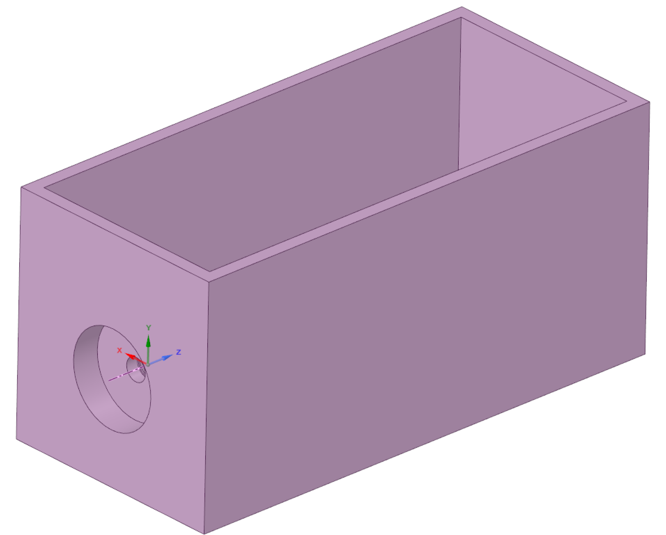
Figure 5.7 A schematic of the ring vortex phantom

5.2.3 Results
The results reported below relate to solution data from the straight pipe, Karman Vortex and FDA nozzle models and ring vortex. In all cases the 3D simulation was allowed to run until steady state or cyclically reproducible flow behaviour was obtained – this is the data reported here. The Discovery Live solver instantly produces a visible, evolving full field solution once initiated, and consequently, the rate at which simulation time evolved in comparison to wall clock time is also reported.
Laminar flow in a straight pipe
Once the solver is initiated, the plug flow at the inlet is seen to develop into a steady state flow over a period of about 20 simulation seconds (Re dependent), with parabolic profile apparent at the development length and beyond (Fig. 5.7). Each second of simulation time for the 2m pipe took ~15 seconds of wall clock time using our hardware.
Radial velocity profiles at distances of 0.5LE, 0.8LE and LE from the pipe entrance are presented in Figure 5.8. The velocity along the central axis in the steady state is reported over a range of Re values in Figure 5.9 with parabolic flow established when the peak velocity reaches twice the velocity at the inlet. By way of example, the evolving central axis velocity distribution at LE is shown as a function of simulation time for Re 500 in Figure 5.9. Expected values for the flow according to Eq. 5.1 and Eq. 5.2 provide context by which to judge the accuracy of the numerical solutions.
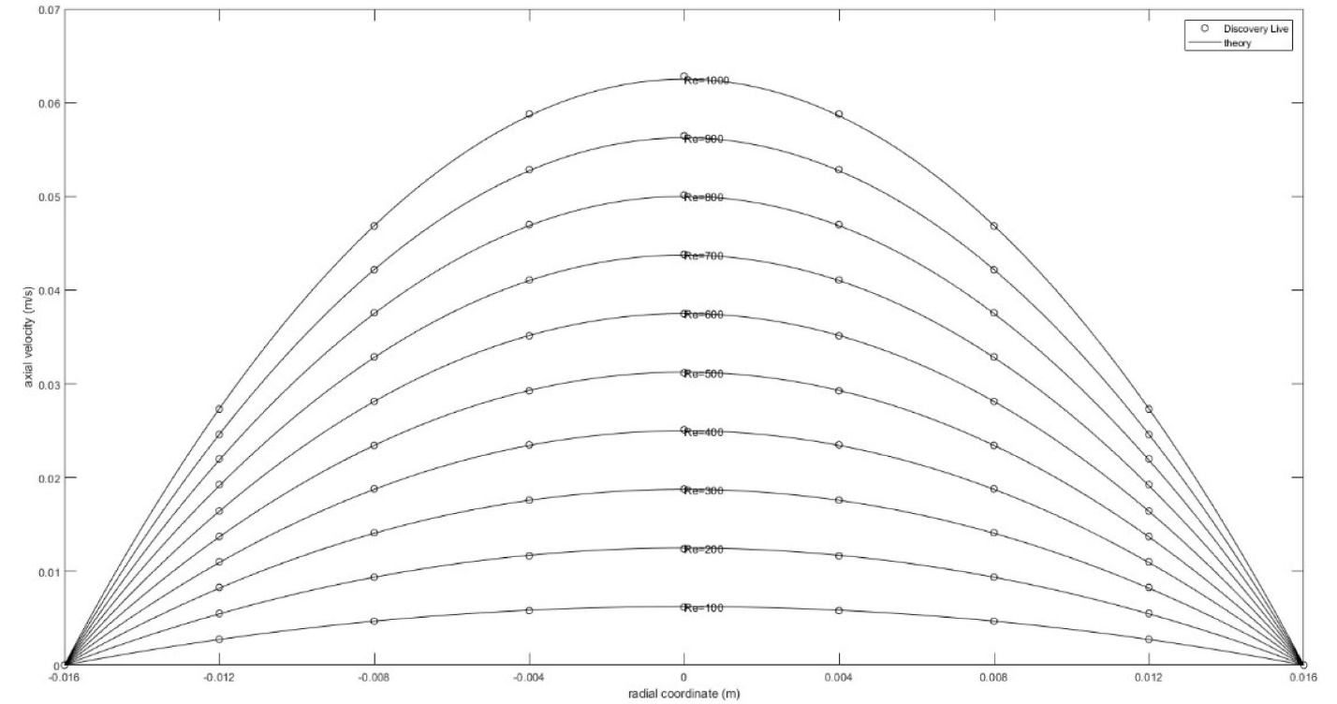
Figure 5.8 Comparison between numerically obtained (markers) and expected (solid line) axial velocity profile at a distance L_{E} from the pipe entrance for Re from 100-1000

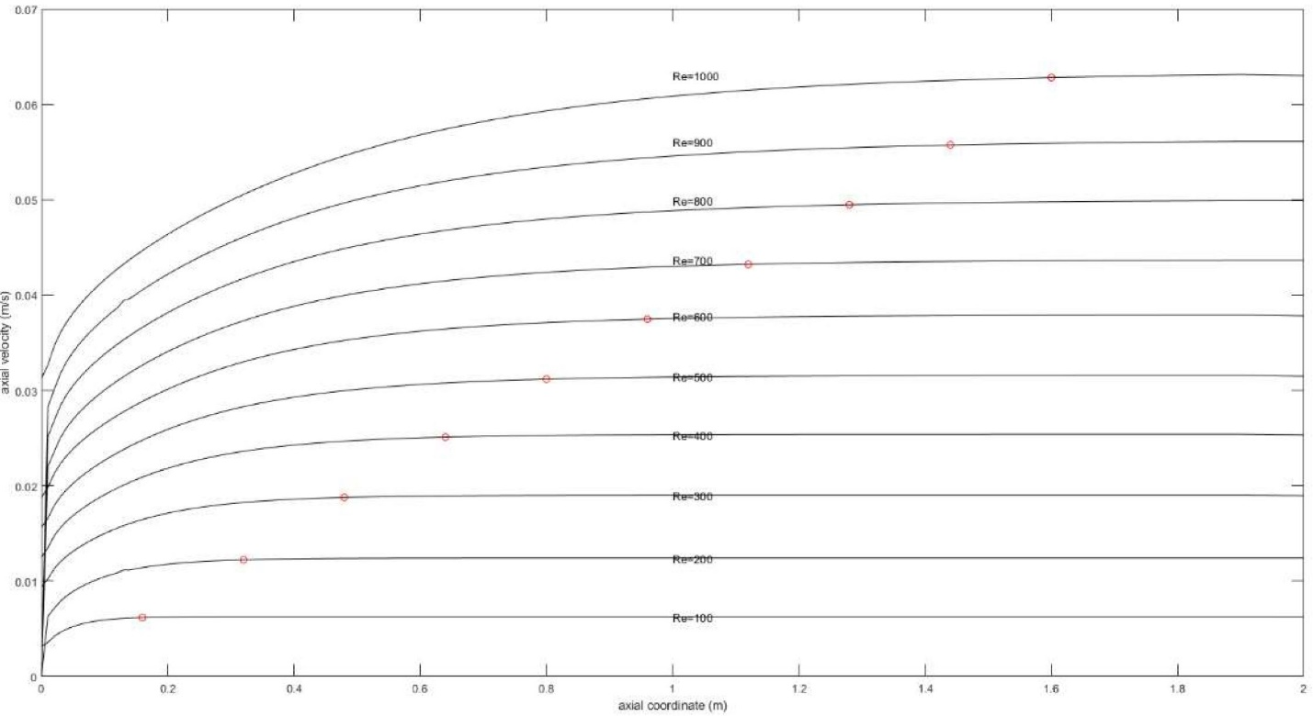

Figure 5.9 Axial velocity along the centreline at steady state for Re from 100-1000

Karman vortex
The shedding of vortices from a 5mm diameter pin was simulated in both the free field and within a 32mm diameter pipe. The free field condition has been examined extensively in the literature, we refer the reader to the collated information presented in the review by Williamson (1996) as an established reference. In the case of the pipe flow, the near wall conditions of the straight pipe influences the shedding, and for this case the ANSYS Discovery Live solution is compared with the paper by Fenner et al. (Fenner et al. 2008).
-Free field-
In the free field case, the frequency of shedding as a function of Re is reported in Table 5.4 and shown in Figure 5.10. At Re<100 the flow has a tendency to be steady and not shed, and although the threshold for shedding is notionally about Re 40, this can be quite dependent on subtleties of the experimental conditions (eg. stability of the incident flow, smoothness of the pin etc.). ANSYS Discovery Live did not demonstrate vortex shedding at Re<90. At higher Re, shedding within the simulation does occur, but not immediately, since the flow typically requires a transition period of many seconds (simulation time) at these Re before it reaches a steady shedding rhythm. This reproduces behaviour observed under experimental conditions. The rate at which shedding occurs is effectively reported by the periodic behaviour of the z-velocity as revealed by the off-axis simulation probe. For this simulation 10 seconds wall clock time is required for about 1 second of simulation time.
Table 5.4 Simulation settings for the FDA nozzle model
Inlet Velocity  (m/s) | Re | St | Shedding Freq from Discovery Live simulation  (Hz) | Shedding Freq according to literature  (Hz) | Transition time to steady shedding  (simulated secs) | Approximate number of seconds wall clock time per second of simulation time.
0.02 | 100 | 0.6 | 0.15 | 0.16 | 40 | 3
0.04 | 200 | 1.2 | 0.15 | 0.18 | 25 | 5
0.06 | 300 | 2.1 | 0.18 | 0.18 | 15 | 8
0.08 | 400 | 2.9 | 0.18 | 0.19 | 10 | 12
0.1 | 500 | 3.8 | 0.19 | 0.19 | 7-8 | 15
0.12 | 600 | 4.5 | 0.19 | 0.19 | 5 | 18
0.14 | 700 | 5.4 | 0.19 | 0.19 | 4 | 21
0.16 | 800 | 6.1 | 0.19 | 0.19 | 4 | 25
0.18 | 900 | 6.7 | 0.19 | 0.19 | 4 | 28
0.2 | 1000 | 7.6 | 0.19 | 0.19 | 2-3 | 31

Figure 5.10 76 secs of simulation time with free field periodic shedding evident. The bounding box illustrates the volume of the solution domain, with visualisation of the pressure field down the central plane in this example
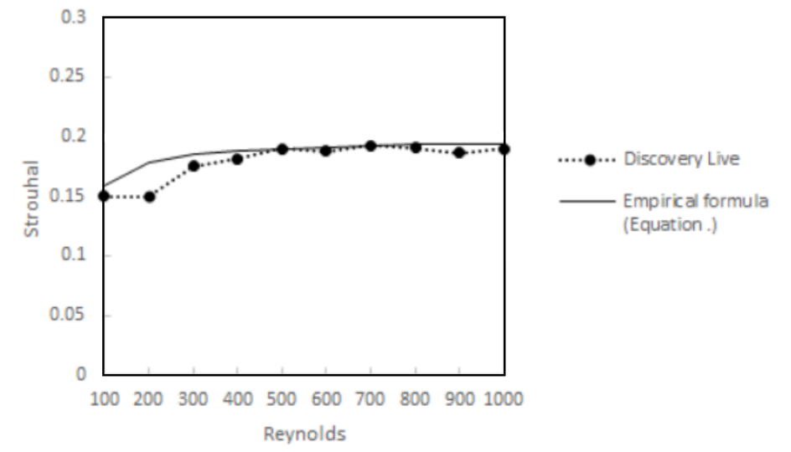
Figure 5.11 Strouhal number vs Reynolds number for the free field case

Placing the free field simulation results in context, Lienhard (Lienhard 1966) reports that the vortex street is laminar for Re<150, with periodicity governed either by wake instability (40<Re<90) or by vortex shedding (90<Re<150). Transition to turbulence occurs for 150<Re<300 in which the wake is characterized by periodic irregular disturbances. For Re>300 (300<Re<300,000) the vortex street is fully turbulent. Blevins (Blevins 1977) reports that the Strouhal number is close to 0.2 over a large range of Reynolds numbers. In the range 250<Re<200,000 the empirical formula of Eq. 4 is known to hold true.
$St=0.198(1-\frac{19.7}{Re})$ (5.4)

-Karman vortex in a straight pipe (near wall case)-
The straight pipe demonstrates similar behaviour to the free field case, but the closeness of the cylindrical walls of the pipe to the pin influences the shedding behaviour. This is discussed in the paper by Fenner et al. (Fenner et al. 2008), which provides the context for the Discovery Live simulation described here (see Table 5.5 and Figure 5.12).
Table 5.5 Tabulated characteristics of the free field shedding flow (Karman vortex) as computed by Discovery Live for a range or Re.
Inlet Velocity [m/s] | Re | Shedding Freq from Discovery Live simulation [Hz] | St | St according to literature | Transition time to steady shedding (simulated secs) | Approximate number of seconds wall clock time per second of simulation time
0.02 | 100 | 0.6 | 0.15 | 0.16 | 40 | 3
0.04 | 200 | 1.2 | 0.15 | 0.18 | 25 | 5
0.06 | 300 | 2.1 | 0.18 | 0.18 | 15 | 8
0.08 | 400 | 2.9 | 0.18 | 0.19 | 10 | 12
0.1 | 500 | 3.8 | 0.19 | 0.19 | 7-8 | 15
0.12 | 600 | 4.5 | 0.19 | 0.19 | 5 | 18
0.14 | 700 | 5.4 | 0.19 | 0.19 | 4 | 21
0.16 | 800 | 6.1 | 0.19 | 0.19 | 4 | 25
0.18 | 900 | 6.7 | 0.19 | 0.19 | 4 | 28
0.2 | 1000 | 7.6 | 0.19 | 0.19 | 2-3 | 31

Figure 5.12 Strouhal number vs Reynols number for the Karman vortex in the cylindrical pipe
FDA nozzle model
The FDA geometry has proven challenging to a wide range of solvers attempting to describe the flow under steady state inlet conditions. The flow is largely transitional and approaches turbulence in regions of the flow domain (particularly, downstream of the sudden expansion). Experimental results help to confirm the plug-like velocity profile associated with acceleration through the converging nozzle, and the regions of recirculation downstream of the sudden expansion orifice (Figure 5.13). The literature reports velocities along the central axis, as well as the axial velocity radial distribution at specified locations for Re 2000 and 3500, and these are used for comparison with this simulation (see Fig. 5.13-16). 1 second of simulation time took approximately 500 seconds of wall clock time.
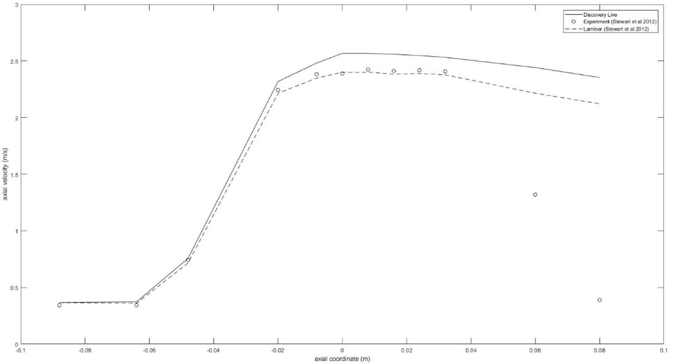
Figure 5.13 Distribution of z-velocity along the nozzle centreline at steady state for
Re=2000. The position of the sudden expansion occurs at z=0
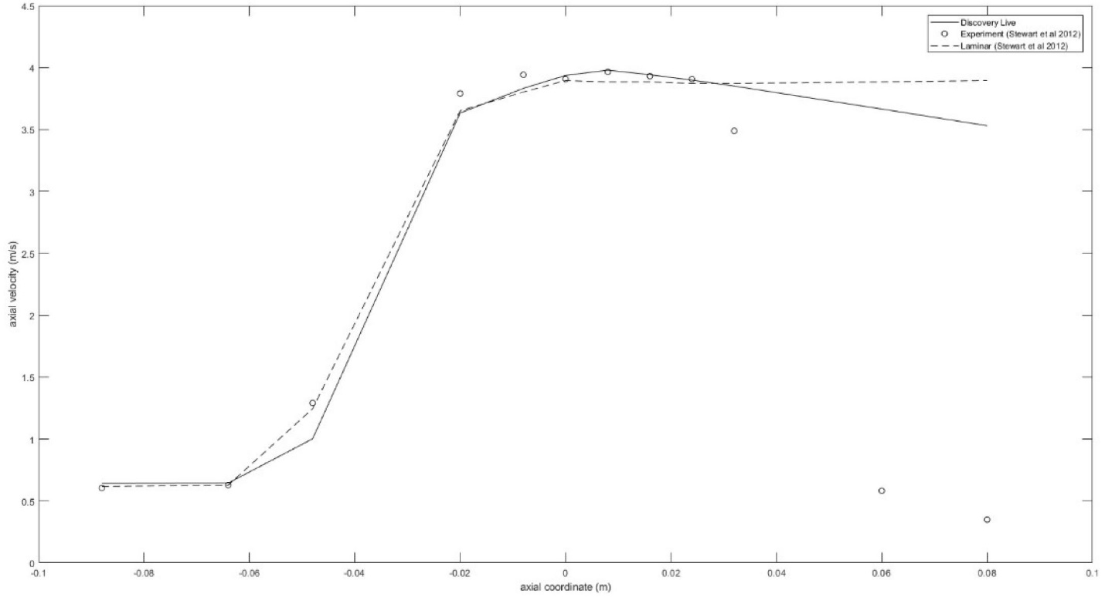
Figure 5.14 Distribution of z-velocity along the nozzle centreline at steady state for
Re=3500. The position of the sudden expansion occurs at z=0.

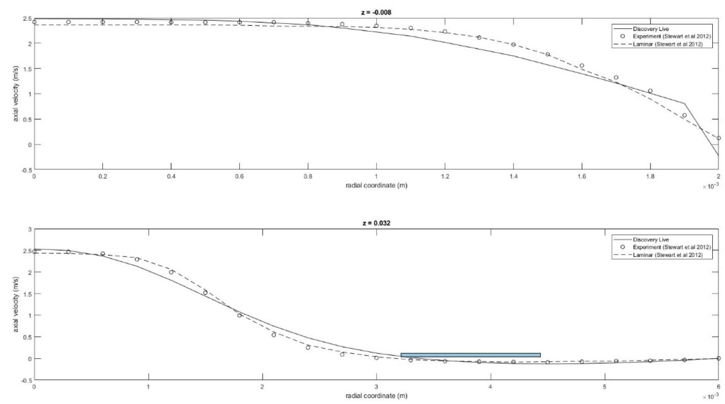
Figure 5.15 Distribution of the z-velocity in the nozzle along the radial direction at z =
-0.008 and z = 0.032 at steady state for Re=2000
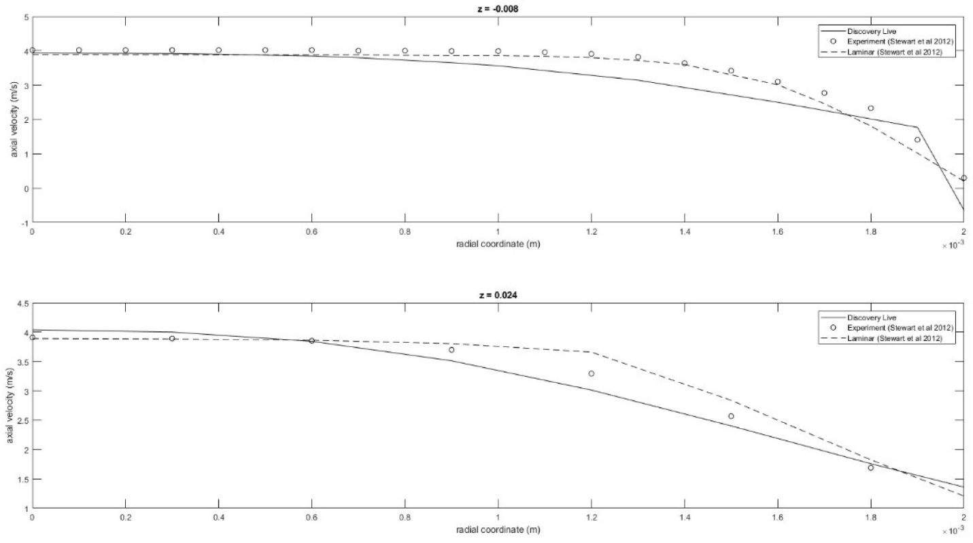
Figure 5.16 Distribution of the z-velocity in the nozzle along the radial direction at z =
-0.008 z = 0.024 at steady state for Re=3500

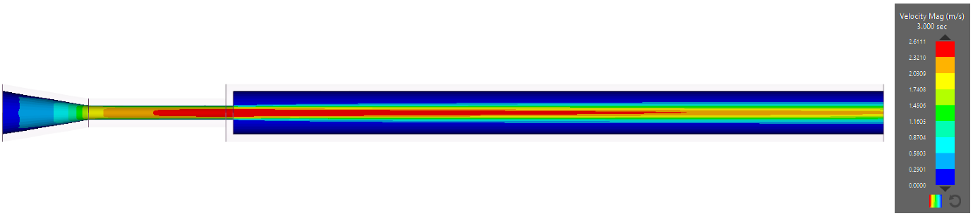

Figure 5.17 Color plots of the magnitude of the velocity field at steady state at Re =
2000, with visible recirculating flow downstream of the sudden expansion.
Ring vortex
Qualitative results are presented for the ring vortex. A number of limitations present in the current implementation of the tool prevented the generation of vortex rings comparable to those obtained by more accurate numerical methods, validated by the experiment. Figure 5.17 shows the contour of the velocity magnitude at the end of the pulse (ejection duration 40 ms). Figure 5.18 shows the contour of the velocity magnitude after 1 s. Simulating configuration 3, the ring is supposed to travel at approximately 30 cm/s but that is not the case since it barely travelled for 10 cm. Difficulties related to short pulses and sharp gradients in addition to numerical dissipation represent a limit to be address in the future releases
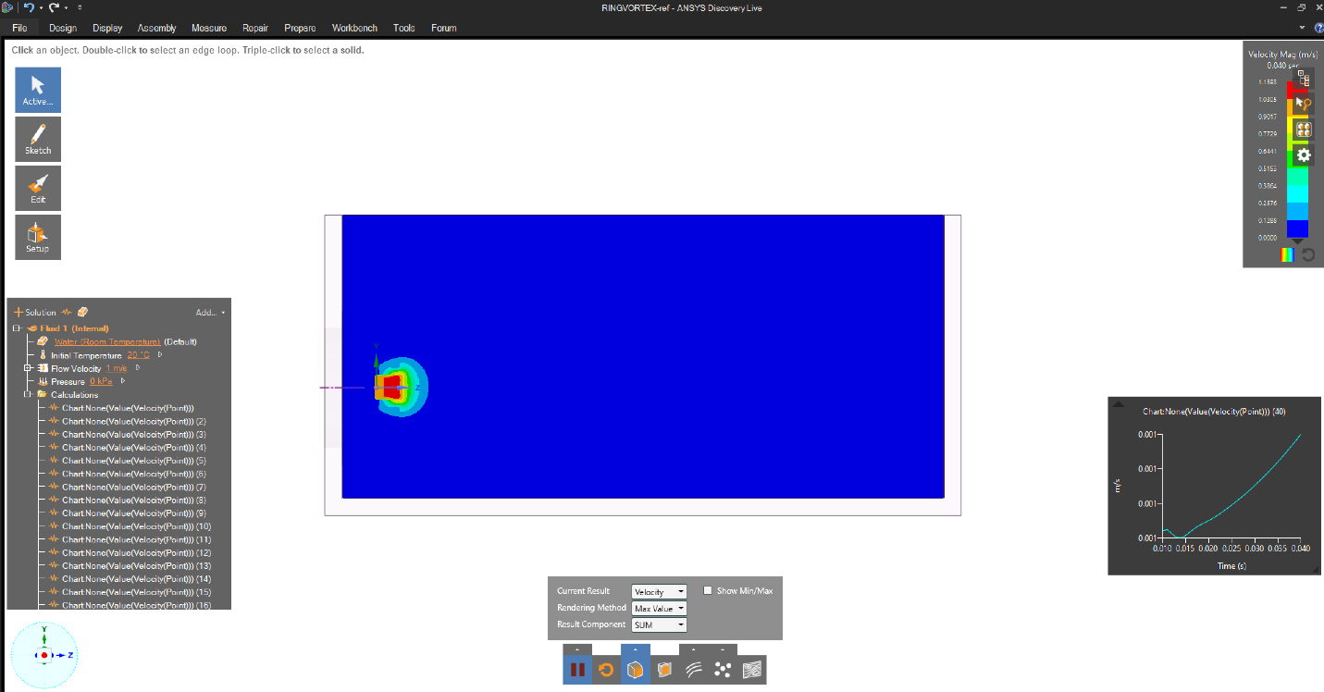
Figure 5.18 Contour of velocity magnitude at the end of the pulse

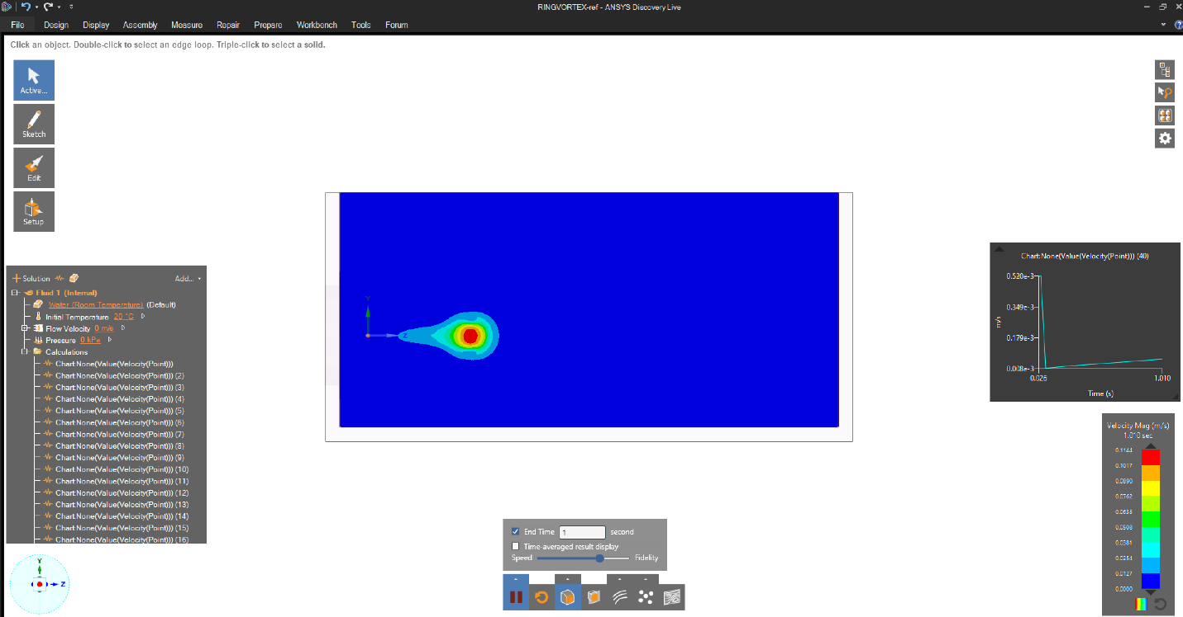
Figure 5.19 Contour of velocity magnitude at t = 1s

5.2.4 Discussion
These results present application of a new commercial solver to a range of fluid problems from a simple straight pipe to vortex shedding to an FDA-defined nozzle geometry. In respect of flow in a straight pipe, the ANSYS Discovery Live solver proved very capable, accounting for the attachment length and the parabolic profiles at different Re as expected. Since this represents the most fundamental and simplest of flows, it is important that the solver should demonstrate excellent description in this case, for purposes of credibility. The Karman Vortex is much more demanding and shedding frequency was underestimated by approximately 20% compared with experimental data. Fenner et al. (2008) explored shedding behaviour in the cylindrical pipe, noting at the time of writing (2008) that an IBM SP3 supercomputer was used to compute the shedding flow, requiring weeks of solution time. Discovery Live computes a solution in seconds and reports overall features of the shedding behaviour. This solution is less accurate than the SP3 solution, which was able to describe the shedding frequency to within 10% of that determined by experimental measurement. The feasibility of almost-real-time feedback with interactive visualisation has significant implications for the design phases of medical devices, even though some compromise in accuracy might be necessary. Similar outcomes were observed when analysing results from the FDA benchmark geometry in this study. The original context of this problem involved numerous centres submitting numerical solutions during the initial call of the FDA Challenge over a decade ago. Stewart et al. (2009) reported that a significant fraction of the submitted numerical solutions were so far removed from the experimental data that they were not considered in the final analysis. In this paper, despite the use of a single ‘Fidelity’ setting for all analyses presented, ANSYS Discovery Live produced a credible solution that falls within the range of the acceptable solutions reported by
Stewart et al. (2009). To obtain these results little expertise was necessary, Discovery Live produced a solution using only the bounding geometry for the flow and inlet and outlet conditions, providing results within minutes. Unsurprisingly the results were less credible downstream of the sudden expansion, where turbulent effects are more significant, which was addressed by some centres using turbulence models in the original 2009 analyses.
Hardware
In the context of hardware, Discovery Live relies on GPU acceleration to deliver fast, fluid dynamic simulations. It is only very recently that the marriage of Lattice Boltzmann code with commodity GPU platforms has become effective for real problems. The solver used in Discovery Live exploits a Lattice Boltzmann method in which the discretised space involves transport of 'particles' between interconnected nodes and resolution of collisions at nodes. Each stage is dealt with separately/alternately in accordance with simulation time which is also discretised. With suitable choice of collision operators, the Lattice Boltzmann solution is known to approach (in the limit) a Navier-Stokes description of the flow. The solution process is amenable to parallel computation and
consequently the method can benefit greatly from implementation on a GPU platform.
A key limitation here is GPU memory (which limits the number of nodes) and only recently have commodity graphics cards become available with sufficient RAM to address realistic problems of the kind described in this paper. A recommended specification is the nVidia GTX 1080 series with 8GB of onboard RAM. The specification of the host PC should be designed to run the graphics card optimally, but the key factor influencing solver performance relates to the GPU specifications. The examples cited in this paper ran on both a desktop equipped with a GTX1080 (8GB) and separately, a laptop equipped with an onboard GTX1070 (8GB). In general the latter ran approximately 50% slower than the former.
Software interface
The most striking feature of the solver is its immediate presentation of an evolving solution, developing at a smooth frame rate with a ‘simulation clock’ that advances at a rate comparable with the ‘real world clock’. At higher fidelity settings, simulation time increments more slowly, but the solution remains dynamic and the facilities for flow visualisation and probing the flow are informative to the user. The interface is straightforward, enabling exploration of the flow field through views from different perspectives (by dragging the mouse) and/or imposing a different flow visualisation mode. This includes cut planes through the field (oriented via mouse) to display velocity, pressure, etc. as contours and streamlines. A particle representation is also available, but the lack of full vector field data is a notable omission. This adversely impacts Discovery Live's capacity to act as a quantitative tool, since detailed quantitative field data is not available. Arguably, this can be obtained to some extent through the use of point probes, but these are placed individually and manually to provide point-like measurements and do not replicate the full field data available from traditional Navier Stokes CFD solutions or experimental methods such as PIV. Consequently, Discovery Live offers a semi-quantitative tool for 'getting a feel' for the flow, and particularly the influence of changes that might be introduced through altering parameters such as flow rate, geometry, fluid properties etc. The interactive nature of the interface and the ease with which changes to the flow simulation can be introduced make this an environment for exploration, and this is the strongest aspect of the Discovery Live software, providing the user with an innate feel for the dynamics of the flow and its sensitivities which can then be applied to design problems. In this capacity, Discovery Live acts as an exploratory tool, providing useful real time feedback that can inform design at an appropriate level of ‘Fidelity’ for this process. This can then be examined at higher ‘Fidelity’ within Discovery Live and tested more rigorously via established CFD methods and/or experimentation. Use of the software provides insight to the nature of the flow, whilst limiting access to full field characterisation which requires alternative methods - this ‘two stage’ approach is helpfully promoted by the lack of available vector flow field data.
Constraints
A weakness of the software in its current form is that only a restricted set of flow inlet/outlet boundary conditions can be prescribed. For instance, in our case there was no facility to impose parabolic developed flow at the inlet, all inlet flows used a plug profile. A long pipe was used at the inlet to allow flow development if parabolic inlet profiles were required, with associated increase in solution overhead. Additionally, transient inlet flows are not supported, motivating selection of the examples in this paper with steady state inlet conditions. The flexibility of the interface allows the user to pause the simulation, specify a new inlet velocity and then restart it, but this is a crude and unreliable method that is impractical for anything but the simplest of transient inlet conditions.
Potential future applications of such simulation tools include flow phantom design for medical imaging quality assurance applications. We have reported development of an experimental system that produces ring vortex flows from an orifice [10]. This requires an inlet fluid impulse that propels a slug of fluid through the orifice with resultant production of a propagating ring vortex. To explore such flows within Discovery Live the impulse can be simulated by pausing the simulation at predefined time points to manually modify the inlet flow velocity. Although this does produce a ring vortex of sorts it is outside the intended application of the solver and is prone to error. As a result the vortex flow is far removed from the ring vortices observed under experimental conditions or those produced by computation from established fully transient Navier-Stokes solvers.
The qualitative nature of ANSYS Discovery Live encourages its solutions to be interpreted with caution, but in truth, this has always been the case for numerical simulation. The best simulations typically require tuning of the solver to the problem in hand, whereas Discovery Live is a versatile tool whose strength is its flexibility. This comes with a cost, namely compromise of solution accuracy, although the software does attempt to address this through the use of the 'Fidelity' slider. The slider offers a trade-off between simulation speed and the accuracy of the solution. In the free field Karman Vortex example, moving the slider to the ‘Speed’ setting (ie. minimum fidelity) delivered 2 secs of simulation time for 1 second of wall clock time, with noticeably coarser spatial solutions. In contrast, at the maximum fidelity setting, the solution required almost 60 secs of wall clock time to achieve 1 sec of simulation time. The user must make a judgement about the trade-offs they are willing to accept in respect of fidelity vs speed.
Finally, because of the design philosophy behind Discovery Live, all problems are innately 3D and time dependent. Consequently, it is not always easy to judge what constitutes the 'steady state' solution (working with Discovery Live is very similar to working with an experiment in this respect). The visual nature of the interface encourages visual assessment of what is a representative outcome, and the ability to probe the flow at discreet points can provide evidence to support that decision.
Implications
The medical device engineer operates with an array of tools to achieve optimal design and Discovery Live is a useful addition to the designer’s toolkit. It should not be considered a precision tool however, but it does offer many properties that can contribute to the design workflow. For instance, the limited options for setting up the simulation is both a strength and a weakness. Unlike a finite element/volume solver, the user has no control over element type, meshing strategy, density, etc. which is all handled automatically by the software. Mesh sensitivity testing is not a feature of Discovery Live and again this emphasises the semi-quantitative nature of the software, yet it performs remarkably competently with the three examples that we investigated. In design, the original specification pertaining to a medical device might be contemplated as an inverse problem, in which an effective design process might be interpreted as the solution – delivering a device consistent with that specification. A common strategy for solving any inverse problem is iterative solution of many forward problems to identify the best candidate, and the majority of real life design solutions could be characterised this way. Discovery Live actively facilitates this process through its interactive, near-real-time capabilities, thereby informing and potentially accelerating design decisions. This contraction of the early design phase can lead to more fruitful use of time in respect of experimentation and more rigorous numerical methods to determine the optimal design.
It is for similar reasons that Discovery Live has relevance to clinical practice. For example, interventional procedures can be central to managing cardiovascular pathologies, and initiatives like HeartFlow (FDA certified and NICE approved) and VirtuHeart are promoting increasingly patient specific approaches based on simulation results. Discovery Live is better equipped to offer insights than it is to offer high fidelity simulation results, but medicine has always been a combination of art and science, and Discovery Live provides a tool which bridges that gap. The insights afforded come through an accessible and responsive interface that encourages exploration of the flow and is capable of informing clinical decision making to help deliver improved outcomes.
Even outside the clinic it may have a teaching role, educating clinicians about the impact of their clinical decisions on flow outcomes. Despite the limitations described above, the software has something significant to offer which may help to accelerate the arrival of improved patient specific medical devices.
This study describes application of novel near-real-time fluids solution - through ANSYS Discovery Live - to three incrementally demanding fluid dynamics scenarios (straight pipe, Karman Vortex shedding, FDA nozzle benchmark). Solutions are displayed and updated at smooth frame rates on screen and encourage exploration of the evolving simulation through interactive visualisation. Results were compared with the literature and demonstrated credible solutions in every case. Despite limitations relating to inlet/outlet boundary conditions, meshing and access to full field vector flow data, the real-time nature of the solver brings numerous benefits to the design cycle which may help to accelerate the arrival of improved patient specific medical devices.

Chapter 6 - Conclusion and Future Work

6.1 Thesis overview
The work presented in this thesis focuses on the envisaged application of a well-characterized flow, namely the ring vortex, as a calibration reference for quantitative flow imaging techniques. Towards the design and construction of a test object delivering such a reference flow, the use of several methods for design and instrumentation purposes is explored.
Chapter 1 introduces the flow. Fundamental definitions and characteristics of the ring vortex flow behaviour are given. Examples taken from biological and engineered systems are used to provide a broad intro to the subject. Occurrence of the ring vortex in pathophysiology is described.
Despite the presence of ring-vortex like structures within the human circulatory system provides additional arguments to the consideration of this particular class of flows for the application in medical imaging technology, the ring vortex was considered as a paradigm of standard flow, gathering all together characteristics of
- Stability
- Reproducibility
- Controllability
- Predictability
making it an ideal candidate for the targeted application.
In the context of medical imaging, the envisaged application of the flow considered in the present study, characteristics looked for in a potential calibration reference are listed and explained. Quantitative flow imaging techniques are mentioned with reference to potential improvements related to the use of more complex calibration references, able to indicate misinterpretation of complex flow features. Quality assurance and quality control processes, carried out by means of test objects referred to as flow phantoms, are briefly illustrated with particular reference to phantom design and construction, which might benefit from the introduction of more complex reference flows.
Chapter 2 introduces theoretical models of ring vortex motion. Starting from fundamental theorems of vortex dynamics, the analytical description of ring vortex motion, classically decoupling formation and post-formation evolution, is illustrated. Among the several formation models proposed, two are referenced (slug-flow, self-similarity). The most used evolution models, each with its own merits, are presented. Finally, the application of modal analysis to fluid mechanics, and in particular, to the ring vortex, is introduced.
Chapter 3 talks about the use of Computational Fluid Dynamics modelling to simulate the ring vortex behaviour. A brief introduction with derivation of the equations governing fluid flow (Navier-Stokes) is given at the beginning. The use of CFD to describe vortex rings is contextualized with some examples from the literature. The numerical formulation of the problem is then detailed. Results show a number of representative cases from collected data with some interpretation. A direct comparison between numerical and analytical models is also attempted.
Chapter 4 talks about the use of experimental methods, in particular particle image velocimetry, for aiding characterization of the flow. In order to validate the computational model and as a preliminary step in the design of a compatible flow phantom, the realization of a prototype rig is described. Main requirements of the device, with particular reference to the flow delivered, are illustrated Results show a number of representative cases from collected data with some interpretation. A direct comparison between experiment and numerics is also attempted.
Chapter 5 introduces the use of accelerated methods, as a further move in considering the targeted application. Two categories of accelerated methods, namely
- data-driven reduced order modelling
- real-time simulation capabilities provided by ANSYS Discovery Live
are explored.

6.2 Limitations for flow phantom design
Main limitations to be addressed for future developments include
- 3D characterization of the flow by means of CFD. The assumed axial symmetry of the flow is valid for the range of investigated conditions and observation period. However, in order to better define the boundaries of the parameter space where the flow can be reasonably modelled as axisymmetric, a 3D model should be considered. Different discretization methods (e.g. adaptive mesh) could be considered aiming to reduce the CPU time without negatively affecting the solution accuracy. This would have important implications on the mapping with ROM but could be used as a complement, not as a substitute. Further conditions could be explored, forcing the phantom to operate outside the standard range.
- Synchronization of CFD model and PIV experiment. To be used for validation purpose, the experiment has to include proper synchronization between ring vortex generation and acquisition – the proposed approach requires further analysis and deeper evaluation. The method described in §4.3.1 consists in manually tracing the experimental ring vortex back to the generator (out of the field of view) thus identifying the origin corresponding to numerical time zero (piston motion start). This is far from ideal and somewhat error prone since a number of assumptions have to be considered during the exercise (e.g. ring vortex translational speed, relative position of the field of view).
- A direct comparison between analytical, numerical, and experimental representations of the ring vortex would provide additional value. Analytical models are based on a number of assumptions about the flow (e.g. steady state, initial distribution of vorticity). In order to directly compare analytical models with numerical or experimental vortex rings, these should be generated according to precise protocols, aiming to produce almost ideal vortex rings. Numerical and experimental results can be more easily compared with the double purpose of quantifying the uncertainty of the model and estimate the error of the experiment. In order to be directly compared, experiment and simulation should use the same operating conditions. This wasn’t done in the first place because the study started from the CFD model and the prototype rig wasn’t built to operate in the range of conditions explored numerically.
- The use of more complex algorithms for Reduced Order Modelling, suitable to predict complex features of the ring vortex, should be considered – additional considerations about model setup (e.g. amount of training data, overfitting).
- The interpolation capabilities of the ROM currently implemented have been tested. Extrapolation capabilities should be investigated too.
- Proper energy analysis would contribute to fill the gaps between formation and post-formation stages.
The above listed limitations imply that, in order to be implemented as a calibration reference delivered by an imaging phantom, the ring vortex flow should be characterized following a more rigorous path. In particular, starting from the operating conditions of interest, verify the validity of the assumptions (e.g. axial symmetry). Then, validate the computational model with experiment. A sufficient number of CFD simulations should be run to train the envisaged ROM. Real-time simulation tools (e.g. ANSYS Discovery Live) can assist the process, also facilitating the early design of the device.

6.3 Future work
According to the limitations listed in §6.2, the following recommendations for future work are
- Development of a 3D model. This would also allow to explore a wider range of operating conditions, without the risk of obtaining erroneous results as the flow becomes unstable. Once established the boundaries of the parameter space (Re, L₀/D₀), the 2D model could be effectively employed for the actual study.
- Design of a new PIV experiment, with preliminary considerations about synchronization between the rig and the acquisition system. This would avoid the need to approximate the origin by tracing back the ring to the vortex generator. Also the experiment should be more properly planned in terms of the operating conditions to be explored (dimensionless parameters explored by varying the same quantity as was made for the numerical model).
- Development of a comprehensive framework, including analytical, numerical, experimental analysis. In order to cross-validate each other, analytical numerical and experimental analysis should be made comparable/contrastable, i.e. the same range of operating conditions/length scales should be considered. Also, the assumptions made to build analytical/numerical models should be carefully considered. The experiment should be properly set up to replicate the same conditions. Different methods could be used (e.g. echoPIV) also considering the target application.
The above listed recommendations are directed to the further research activity that will be done on the subject. In particular, better integration between analytical, numerical, and experimental analysis will be the key to a comprehensive knowledge of the flow behaviour, such that it might be applied as a calibration reference. Notice that, the path towards the use of the ring vortex in the calibration of quantitative flow imaging techniques will involve several steps in addition to the demonstrated appropriateness of the flow. In particular, characteristics of compatibility with the imaging technology (e.g. MRI) will have to be carefully considered.

6.4 Final message
Numerical methods are valuable to flow phantom design and instrumentation.
CFD techniques can be proficiently applied to inform the design of the device.
Accelerated methods can replace the experiment (virtual PIV) providing real time solution and output evaluation.

References
Afshar, Ahmadreza, David P Steensma, and Robert A Kyle. 2018. "Werner Forssmann: a pioneer of interventional cardiology and auto-experimentation." Mayo Clinic Proceedings.
Akhmetov, Darvin Gazizovich. 2009. Vortex rings. Springer Science & Business Media.
Ambrogio, Simone, Adrian Walker, Andrew Narracott, Simone Ferrari, Prashant Verma, and John Fenner. 2019. "A complex flow phantom for medical imaging: ring vortex phantom design and technical specification." Journal of medical engineering & technology 43 (3): 190-201.
Aubry, Nadine, Philip Holmes, John L Lumley, and Emily Stone. 1988. "The dynamics of coherent structures in the wall region of a turbulent boundary layer." Journal of Fluid Mechanics 192: 115-173.
Baltes, Christof, Sebastian Kozerke, David Atkinson, and Peter Boesiger. 2004. "Retrospective respiratory motion correction for navigated cine velocity mapping." Journal of Cardiovascular Magnetic Resonance 6 (4): 785-792.
Benjamin, Emelia J, Paul Muntner, Alvaro Alonso, Marcio S Bittencourt, Clifton W Callaway, April P Carson, Alanna M Chamberlain, Alexander R Chang, Susan Cheng, and Sandeep R Das. 2019. "Heart disease and stroke statistics—2019 update: a report from the American Heart Association." Circulation 139 (10): e56-e528.
Blake, James R, Siobhan Meagher, Katharine H Fraser, William J Easson, and Peter R Hoskins. 2008. "A method to estimate wall shear rate with a clinical ultrasound scanner." Ultrasound in medicine & biology 34 (5): 760-774.
Blevins, Robert D. 1977. "Flow-induced vibration." New York.
Borazjani, Iman, John Westerdale, Eileen M McMahon, Prathish K Rajaraman, Jeffrey J Heys, and Marek Belohlavek. 2013. "Left ventricular flow analysis: recent advances in numerical methods and applications in cardiac ultrasound." Computational and mathematical methods in medicine 2013.
Brandts, Anne, Stijntje D Roes, Joost Doornbos, Robert G Weiss, Albert de Roos, Matthias Stuber, and Jos JM Westenberg. 2010. "Right coronary artery flow velocity and volume assessment with spiral K‐space sampled breathhold velocity‐encoded MRI at 3 tesla: Accuracy and reproducibility." Journal of Magnetic Resonance Imaging: An Official Journal of the International Society for Magnetic Resonance in Medicine 31 (5): 1215-1223.
Browne, Jacinta E. 2014. "A review of Doppler ultrasound quality assurance protocols and test devices." Physica Medica 30 (7): 742-751.
Buckingham, Edgar. 1915. Model experiments and the forms of empirical equations. Verlag nicht ermittelbar.
Campeau, Lucien. 1989. "Percutaneous radial artery approach for coronary angiography." Catheterization and cardiovascular diagnosis 16 (1): 3-7.
Chen, Sylvia SM, and Philip J Kilner. 2013. "Unilateral pulmonary artery branch stenosis: Diastolic prolongation of forward flow appears to maintain flow to the affected lung if the pulmonary valve is competent." International journal of cardiology 168 (4): 3698-3703.
Clark, Torin K, Michael Krieg, and Kamran Mohseni. 2008. "Flow visualization for pulsatile vortex ring actuators." ASME 2008 International Mechanical Engineering Congress and Exposition.
Conahan, Thomas J, Alan J Schwartz, and Ralph Taggart Geer. 1977. "Percutaneous catheter introduction: the Seldinger technique." JAMA 237 (5): 446-447.
Dabiri, John O, and Morteza Gharib. 2004. "Fluid entrainment by isolated vortex rings." Journal of fluid mechanics 511: 311-331.
Danaila, Ionut, and Jérôme Hélie. 2008. "Numerical simulation of the postformation evolution of a laminar vortex ring." Physics of Fluids (1994-present) 20 (7): 073602.
Didden, Norbert. 1979. "On the formation of vortex rings: rolling-up and production of circulation." Zeitschrift für angewandte Mathematik und Physik ZAMP 30 (1): 101-116.
Driessen, Mieke MP, Johannes MPJ Breur, Ricardo PJ Budde, Joep WM van Oorschot, Roland RJ van Kimmenade, Gertjan Tj Sieswerda, Folkert J Meijboom, and Tim Leiner. 2015. "Advances in cardiac magnetic resonance imaging of congenital heart disease." Pediatric radiology 45 (1): 5-19.
Eckart, Carl, and Gale Young. 1936. "The approximation of one matrix by another of lower rank." Psychometrika 1 (3): 211-218.
Evans, JA, R Price, and F Luhana. 1989. "A novel testing device for Doppler ultrasound equipment." Physics in Medicine and Biology 34 (11): 1701.
Fasshauer, M, AA Joseph, JT Kowallick, C Unterberg-Buchwald, KD Merboldt, D Voit, M Steinmetz, W Staab, S Schaetz, and S Zhang. 2014. "Real-time phase-contrast flow MRI of haemodynamic changes in the ascending aorta and superior vena cava during Mueller manoeuvre." Clinical radiology 69 (10): 1066-1071.
Fenner, John, Toby Sucharov, D Rodney Hose, Ian Jones, Paul Griffiths, and Iain Wilkinson. 2008. "The Karman Vortex in a Medical Imaging Context: A Validated Computational Model of Laminar Shedding." MSV.
Fergusson, David JG, and Roy O Kamada. 1986. "Percutaneous brachial artery catheterization: The technique and its advantages." Postgraduate medicine 80 (4): 73-78.
Fox, KM, RG Patel, GR Graham, JF Taylor, J Stark, MR De Leval, and FJ Macartney. 1978. "Multiple and single ventricular septal defect. A clinical and haemodynamic comparison." British heart journal 40 (2): 141.
Fraenkel, Lo E. 1972a. "Examples of steady vortex rings of small cross-section in an ideal fluid." Journal of Fluid Mechanics 51 (1): 119-135.
---. 1972b. "Examples of steady vortex rings of small cross-section in an ideal fluid." Journal of Fluid Mechanics 51 (01): 119-135.
François, Christopher J, Michael Markl, Mark L Schiebler, Eric Niespodzany, Benjamin R Landgraf, Christian Schlensak, and Alex Frydrychowicz. 2013. "Four-dimensional, flow-sensitive magnetic resonance imaging of blood flow patterns in thoracic aortic dissections." The Journal of thoracic and cardiovascular surgery 145 (5): 1359-1366.
Garcia, Damien, Juan C del Álamo, David Tanné, Raquel Yotti, Cristina Cortina, Éric Bertrand, José Carlos Antoranz, Esther Pérez-David, Régis Rieu, and Francisco Fernández-Avilés. 2010. "Two-dimensional intraventricular flow mapping by digital processing conventional color-Doppler echocardiography images." IEEE transactions on medical imaging 29 (10): 1701-1713.
Gharib, Morteza, Edmond Rambod, and Karim Shariff. 1998. "A universal time scale for vortex ring formation." Journal of Fluid Mechanics 360: 121-140.
Giddens, Don P, and AMA Khalifa. 1982. "Turbulence measurements with pulsed Doppler ultrasound employing a frequency tracking method." Ultrasound in medicine & biology 8 (4): 427-437.
Glezer, Ari. 1988. "The formation of vortex rings." The Physics of fluids 31 (12): 3532-3542.
Goldman, Martin E, Lesly A Pearce, Robert G Hart, Miguel Zabalgoitia, Richard W Asinger, Robert Safford, Jonathan L Halperin, and Stroke Prevention in Atrial Fibrillation Investigators. 1999. "Pathophysiologic correlates of thromboembolism in nonvalvular atrial fibrillation: I. Reduced flow velocity in the left atrial appendage (The Stroke Prevention in Atrial Fibrillation [SPAF-III] study)." Journal of the American Society of Echocardiography 12 (12): 1080-1087.
Goldstein, A. 1991. "Performance tests of Doppler ultrasound equipment with a string phantom." Journal of ultrasound in medicine 10 (3): 125-139.
Helmholtz, H. 1858. Über Integrale der hydrodynamischen Gleichungen, welche den Wirbelbewegungen entsprechen. Journal für die reine und angewandte Mathematik.
Herzog, Siegfried. 1986. "The large scale structure in the near-wall region of turbulent pipe flow." Dissertation Abstracts International Part B: Science and Engineering[DISS. ABST. INT. PT. B- SCI. & ENG.] 47 (2).
Hill, Micaiah John Muller. 1894. "On a spherical vortex." Proceedings of the Royal Society of London 55 (331-335): 219-224.
Hollingsworth, Kieren Grant. 2015. "Reducing acquisition time in clinical MRI by data undersampling and compressed sensing reconstruction." Physics in Medicine & Biology 60 (21): R297.
Hong, Geu-Ru, Gianni Pedrizzetti, Giovanni Tonti, Peng Li, Zhao Wei, Jin Kyung Kim, Abinav Baweja, Shizhen Liu, Namsik Chung, and Helene Houle. 2008. "Characterization and quantification of vortex flow in the human left ventricle by contrast echocardiography using vector particle image velocimetry." JACC: Cardiovascular Imaging 1 (6): 705-717.
Hoskins, PR. 1994. "Choice of moving target for a string phantom: I. Measurement of filament backscatter characteristics." Ultrasound in medicine & biology 20 (8): 773-780.
Hoskins, PR, T Anderson, and WN McDicken. 1989. "A computer controlled flow phantom for generation of physiological Doppler waveforms." Physics in medicine and biology 34 (11): 1709.
Hussain, AKMF, and KBMQ Zaman. 1980. "Vortex pairing in a circular jet under controlled excitation. Part 2. Coherent structure dynamics." Journal of Fluid Mechanics 101 (3): 493-544.
James, Sunil, and CK Madnia. 1996. "Direct numerical simulation of a laminar vortex ring." Physics of Fluids (1994-present) 8 (9): 2400-2414.
Johnson, Kevin, Puneet Sharma, and John Oshinski. 2008. "Coronary artery flow measurement using navigator echo gated phase contrast magnetic resonance velocity mapping at 3.0 T." Journal of biomechanics 41 (3): 595-602.
Jorgensen, Jens E, Daniel N Campau, and Donald W Baker. 1973. "Physical characteristics and mathematical modelling of the pulsed ultrasonic flowmeter." Medical and biological engineering 11 (4): 404-421.
Kaplanski, Felix B, and Ylo A Rudi. 2005. "A model for the formation of “optimal” vortex rings taking into account viscosity." Physics of Fluids 17 (8): 087101.
Kellman, Peter, Frederick H Epstein, and Elliot R McVeigh. 2001. "Adaptive sensitivity encoding incorporating temporal filtering (TSENSE)." Magnetic Resonance in Medicine: An Official Journal of the International Society for Magnetic Resonance in Medicine 45 (5): 846-852.
Kiya, Masaru, and Seiichiro Izawa. 1999. "Generation of vortex ring with maximum circulation." Nihon Kikai Gakkai Ronbunshu, B Hen/Transactions of the Japan Society of Mechanical Engineers, Part B 65 (640): 3986-3992.
Krueger, Paul S. 2008. "Circulation and trajectories of vortex rings formed from tube and orifice openings." Physica D: Nonlinear Phenomena 237 (14-17): 2218-2222.
Krueger, Paul S, and Morteza Gharib. 2003. "The significance of vortex ring formation to the impulse and thrust of a starting jet." Physics of fluids 15 (5): 1271-1281.
Krumholz, Harlan M, Sharon-Lise T Normand, and Yun Wang. 2014. "Trends in hospitalizations and outcomes for acute cardiovascular disease and stroke, 1999–2011." Circulation 130 (12): 966-975.
Krutzsch, Carl‐Heinz. 1939. "Über eine experimentell beobachtete Erscheinung an Wirbelringen bei ihrer translatorischen Bewegung in wirklichen Flüssigkeiten." Annalen der Physik 427 (6): 497-523.
Kutz, J Nathan, Steven L Brunton, Bingni W Brunton, and Joshua L Proctor. 2016. Dynamic mode decomposition: data-driven modeling of complex systems. Vol. 149. Siam.
Lamb, Horace. 1932. Hydrodynamics. Cambridge university press.
Lienhard, John H. 1966. Synopsis of lift, drag, and vortex frequency data for rigid circular cylinders. Vol. 300. Technical Extension Service, Washington State University Pullman, WA.
Lim, TT, and TB Nickels. 1995. "Vortex rings." In Fluid vortices, 95-153. Springer.
Lubbers, Jaap. 1999. "Application of a new blood-mimicking fluid in a flow Doppler test object." European Journal of ultrasound 9 (3): 267-276.
Lugovtsov, BA. 1976. "On the motion of a turbulent vortex ring." Archiv of Mechanics, Archiwum Mechaniki Stosowanej 28: 759-766.
Lumley, John Leask. 1967. "The structure of inhomogeneous turbulent flows." Atmospheric turbulence and radio wave propagation.
Markl, M, S Schnell, C Wu, E Bollache, K Jarvis, AJ Barker, JD Robinson, and CK Rigsby. 2016. "Advanced flow MRI: emerging techniques and applications." Clinical radiology 71 (8): 779-795.
Maxworthy, T. 1972. "The structure and stability of vortex rings." Journal of Fluid Mechanics 51 (01): 15-32.
---. 1977. "Some experimental studies of vortex rings." Journal of Fluid Mechanics 81 (3): 465-495.
McDicken, WN. 1986. "A versatile test-object for the calibration of ultrasonic Doppler flow instruments." Ultrasound in medicine & biology 12 (3): 245-249.
McDicken, WN, DC Morrison, and DSA Smith. 1983. "A moving tissue-equivalent phantom for ultrasonic real-time scanning and Doppler techniques." Ultrasound in medicine & biology 9 (4): L455-L459.
Meagher, S, TL Poepping, KV Ramnarine, RA Black, and PR Hoskins. 2007. "Anatomical flow phantoms of the nonplanar carotid bifurcation, part II: experimental validation with Doppler ultrasound." Ultrasound in medicine & biology 33 (2): 303-310.
Meleshko, VV, AA Gourjii, and TS Krasnopolskaya. 2012. "Vortex rings: history and state of the art." Journal of Mathematical Sciences 187 (6): 772-808.
Mezić, Igor. 2013. "Analysis of fluid flows via spectral properties of the Koopman operator." Annual Review of Fluid Mechanics 45: 357-378.
Michalke, Alfons. 1984. "Survey on jet instability theory." Progress in Aerospace Sciences 21: 159-199.
Michie, DD, and WI Fried. 1973. "An in vitro test medium for evaluating clinical Doppler ultrasonic flow systems." Journal of clinical ultrasound: JCU 1 (2): 130.
Nitsche, Monika, and Robert Krasny. 1994. "A numerical study of vortex ring formation at the edge of a circular tube." Journal of Fluid Mechanics 276 (1): 139-161.
Norbury, John. 1973. "A family of steady vortex rings." Journal of Fluid Mechanics 57 (03): 417-431.
Ohtsuki, Shigeo, and Motonao Tanaka. 2006. "The flow velocity distribution from the Doppler information on a plane in three-dimensional flow." Journal of visualization 9 (1): 69-82.
Pedrizzetti, Gianni, Giovanni La Canna, Ottavio Alfieri, and Giovanni Tonti. 2014. "The vortex—an early predictor of cardiovascular outcome?" Nature Reviews Cardiology 11 (9): 545.
Phillips, Daniel, Stephen McAleavey, and Kevin J Parker. 1997. "Color Doppler spatial resolution measurements with an oscillating thin film test object." Ultrasonics Symposium, 1997. Proceedings., 1997 IEEE.
Poepping, Tamie L, Hristo N Nikolov, Meghan L Thorne, and David W Holdsworth. 2004. "A thin-walled carotid vessel phantom for Doppler ultrasound flow studies." Ultrasound in medicine & biology 30 (8): 1067-1078.
Poots, JK, KW Johnston, RSC Cobbold, and M Kassam. 1986. "Comparison of CW Doppler ultrasound spectra with the spectra derived from a flow visualization model." Ultrasound in medicine & biology 12 (2): 125-133.
Pullin, DI. 1979. "Vortex ring formation at tube and orifice openings." The Physics of Fluids 22 (3): 401-403.
Rickey, DW, R Rankin, and A Fenster. 1992. "A velocity evaluation phantom for colour and pulsed Doppler instruments." Ultrasound in medicine & biology 18 (5): 479-494.
Rogers, William Barton. 1858. On the formation of rotating rings by air and liquids under certain conditions of discharge. E. Hayes.
Rosenfeld, Moshe, Edmond Rambod, and Morteza Gharib. 1998. "Circulation and formation number of laminar vortex rings." Journal of Fluid Mechanics 376: 297-318.
Rowley, Clarence W, Igor Mezić, Shervin Bagheri, Philipp Schlatter, and Dan S Henningson. 2009. "Spectral analysis of nonlinear flows." Journal of fluid mechanics 641: 115-127.
Russell, Steve V, David McHugh, and Bruce R Moreman. 1993. "A programmable Doppler string test object." Physics in medicine and biology 38 (11): 1623.
Saffman, PG. 1978a. "The number of waves on unstable vortex rings." Journal of Fluid Mechanics 84 (4): 625-639.
---. 1978b. "The number of waves on unstable vortex rings." Journal of Fluid Mechanics 84 (04): 625-639.
---. 1981. "Dynamics of vorticity." Journal of Fluid Mechanics 106: 49-58.
Saffman, Philip G. 1992. Vortex dynamics. Cambridge university press.
Saffman, Po G. 1970. "The velocity of viscous vortex rings." Studies in Applied Mathematics 49 (4): 371-380.
Schmid, Peter J. 2010. "Dynamic mode decomposition of numerical and experimental data." Journal of fluid mechanics 656: 5-28.
Sengupta, Partho P, Bijoy K Khandheria, Josef Korinek, Arshad Jahangir, Shiro Yoshifuku, Ilija Milosevic, and Marek Belohlavek. 2007. "Left ventricular isovolumic flow sequence during sinus and paced rhythms: new insights from use of high-resolution Doppler and ultrasonic digital particle imaging velocimetry." Journal of the American College of Cardiology 49 (8): 899-908.
Shortland, Adam P, and Thomas Cochrane. 1989. "Doppler spectral waveform generation in vitro: an aid to diagnosis of vascular disease." Ultrasound in medicine & biology 15 (8): 737-748.
Smith, Robert F, Brian K Rutt, and David W Holdsworth. 1999. "Anthropomorphic carotid bifurcation phantom for MRI applications." Journal of Magnetic Resonance Imaging 10 (4): 533-544.
Sotelo, Julio, Jesus Urbina, Israel Valverde, Cristian Tejos, Pablo Irarrázaval, Marcelo E Andia, Sergio Uribe, and Daniel E Hurtado. 2016. "3D quantification of wall shear stress and oscillatory shear index using a finite-element method in 3D CINE PC-MRI data of the thoracic aorta." IEEE transactions on medical imaging 35 (6): 1475-1487.
Stanaway, Sharon K, BJ Cantwell, and Philippe R Spalart. 1988. "A numerical study of viscous vortex rings using a spectral method."
Stankovic, Zoran, Bradley D Allen, Julio Garcia, Kelly B Jarvis, and Michael Markl. 2014. "4D flow imaging with MRI." Cardiovascular diagnosis and therapy 4 (2): 173.
Stewart, Sandy FC. 1999. "A rotating torus phantom for assessing color Doppler accuracy." Ultrasound in medicine & biology 25 (8): 1251-1264.
Stewart, Sandy FC, Eric G Paterson, Greg W Burgreen, Prasanna Hariharan, Matthew Giarra, Varun Reddy, Steven W Day, Keefe B Manning, Steven Deutsch, and Michael R Berman. 2012. "Assessment of CFD performance in simulations of an idealized medical device: results of FDA’s first computational interlaboratory study." Cardiovascular Engineering and Technology 3 (2): 139-160.
Sullivan, Ian S, Joseph J Niemela, Robert E Hershberger, Diogo Bolster, and Russell J Donnelly. 2008. "Dynamics of thin vortex rings." Journal of Fluid Mechanics 609: 319-347.
Trefethen, Lloyd N, and David Bau III. 1997. Numerical linear algebra. Vol. 50. Siam.
Wang, Keith Y, Samuel N Bone, and James M Hossack. 1992. "A tool for evaluating Doppler sensitivity." Journal of Vascular Technology 16 (3): 87-94.
Watts, Darren M, CJ Sutcliffe, RH Morgan, S Meagher, J Wardlaw, M Connell, ME Bastin, I Marshall, KV Ramnarine, and PR Hoskins. 2007. "Anatomical flow phantoms of the nonplanar carotid bifurcation, part I: computer-aided design and fabrication." Ultrasound in medicine & biology 33 (2): 296-302.
White, Frank M. 1999. "Fluid mechanics, WCB." ed: McGraw-Hill, Boston.
Widnall, Sheila E, and JP Sullivan. 1973. "On the stability of vortex rings." Proc. R. Soc. Lond. A 332 (1590): 335-353.
Wieneke, B. 2005. "Stereo-PIV using self-calibration on particle images." Experiments in fluids 39 (2): 267-280.

lines punctually coinciding with the instantaneous axis of rotation of a fluid element
fluid portions bounded by vortex lines drawn on the boundary of an infinitely small closed curve

