
The Development of Silver - and Copper-Substituted Melt-Derived Bioactive Glasses with Antimicrobial Properties for the Treatment of Deep Bone Infections

A THESIS SUBMITTED TOWARDS THE DEGREE OF
DOCTOR OF PHILOSOPHY

RAYAN IBRAHIM H BINDUHAYYIM

Supervisors: Prof Paul Hatton, Prof Cheryl Miller & Dr Joey Shepherd

Faculty of Medicine, Dentistry and Health

University of Sheffield
2021

Abstract
Existing commercial bioactive glasses are reported to inhibit the growth of bacteria and are used to treat osteomyelitis. These formulations may be modified to introduce metal ions with even greater antimicrobial activity, but relatively little work has been reported, including the effects on osteoconductivity. This research aimed to investigate the substitution of CaO with Ag₂O or CuO in the 45S5 and S53P4 compositions and determine the effects on properties, including their ability to inhibit the growth of pathogenic microorganisms.
In the classical bioactive glass system SiO₂-CaO-Na₂O-P₂O₅, melt-derived glass was modified by molar substitutions of CaO with silver and copper and compared with those of its counterpart, 45S5 and S53P4. BG were characterised using various techniques, including (XRD) X-ray diffraction, X-ray fluorescence (XRF), and Differential Thermal Analysis (DTA). Glasses were then investigated for their ability to inhibit both planktonic and biofilm bacterial growth using clinically relevant bacteria (Staphylococcus aureus and Escherichia coli) and their biocompatibility on fibroblasts cells. Finally, the effect of Ag and Cu on BG bioactivity was investigated by immersion of the samples in simulated body fluid (SBF)
Our results have shown that it was possible to produce glasses with Ag₂O at the lowest concentration, with no significant changes to glass structure detected following silver substitution. It also was shown that the CuO was incorporated successfully in the glass system and has produced a homogenous glass frit. The incorporation of Ag₂O and CuO conferred antimicrobial properties to the glass without apparently compromising its bioactivity. Ag and Cu BG exhibited a marked antimicrobial effect on S. aureus and E. coli at a concentration of 25 mg/mL. In comparison, 45S5 and S53P4 did not possess enhanced antimicrobial properties over the concentration range investigated. Our results show that Ag- and Cu- BG were found to strongly inhibit S. aureus biofilm formation, while both 45S5 and S53P4 did not exhibit similar behaviour. This improvement in antimicrobial activity was made without loss of in vitro biocompatibility; all BG showed similar levels of cell viability, and both Ag and Cu had no adverse effects on cultured fibroblast cell. Furthermore, there was no significant difference between tested samples after exposure to SBF, as surface reactivity was demonstrated in all modified bioactive glasses. It was concluded that Ag- and Cu-substituted bioactive glasses represent the first true multi-functional biomaterials with significant potential for use as antimicrobial bone graft substitutes to treat osteomyelitis and related bone infections.

COVID-19 Impact Statement
COVID-19 has ceased much disruption to the world. However, research and universities suffered the consequences of disruptions that led to changes and delays for most university staff and students. Unfortunately, I was one of so many affected by the pandemic.
In my second year of doing my PhD, I relied heavily on laboratories outside the School of Clinical Dentistry, such as the School of Chemistry or School of Engineering, to use their equipment. Many of my characterisation experiments required access to advanced equipment such as (XPS) X-ray photoelectron spectroscopy and (XRF) X-ray fluorescence. As a result of school closure, I could not carry-on training and complete some of the characterizations of all the samples.
Moreover, restricted access to labs and social distancing made it deficits to use some of the school faculties and be able to plan for long experiments such as cell culture and cytocompatibility essay. Due to the worldwide COVID-19 pandemic in 2020, a shortage of clinical supplies emerged as a serious issue; likewise, supplies for basic research have been limited. Specific to cell culture inserts have been in exceptionally short supply as well as cell culture media. We have placed orders with different suppliers, but as demand is very high for certain products, this is inevitably causing long delays in shipped items and companies not always providing a delivery date. Therefore, we limited the cytocompatibility experiment to one day. We have also faced the same issue with the short supply of reagent for simulated body fluid (SBF) which is a fatal part of this project and consequently led to delays in the characterization of the samples following the 21 days experiment.
Finally, due to the pandemic, the frequency of supervision decreased as most of the supervisors tried their best to accommodate all students' needs and the extra time for online teaching and preparing. Also, the pandemic has been a stressful and uncertain time for everyone, especially for those about to give birth, as with my wife. Being the only family member, we try to be careful, which causes some disruption to my work and my progress.

Acknowledgement
First and foremost, I am extremely grateful to my supervisor, Professor Paul Hatton, for his kindness and guidance, patience and understanding, knowledge and support. I will be forever indebted to him for everything he has done and believing in me. From the bottom of my heart, I would like to say a big thank you to my other supervisors Professor Cheryl Miller and Dr Joey Shepherd; their knowledge and wealth of experience have aided me throughout my academic career and daily life. They have been a real role model and an absolute joy to work with and learn from.
I would like to extend my thanks to all members of the (Miller-Hatton group). Because of their generous assistance and support, my studies and life in the UK have been so enjoyable and full of many wonderful and amazing moments over the years.
I would also like to thank our professional and approachable technical staff in the School of Clinical Dentistry, who are always willing to help.
I would like to give great thanks To the Royce Institute for Advanced Materials & Innovation for providing access to the thermal analysis laboratory of Imperial College London, and special thanks to Mr Richard Sweeney for his time and insight regarding glass characterisation. Also, to Dr Tony Bell from Sheffield Hallam University for his help in XRF.
Finally, I am deeply grateful to my parents, whom without, I'm nothing. I am deeply grateful to my soulmate and wife Sarah for her support. It would have been impossible for me to finish my studies without her wonderful understanding and encouragement throughout the last few years, especially during the dark nights of covid 19. Big thanks to my brothers and sisters for their love and encouragement.

Abbreviations
BG: Bioactive glasses
BO: Bridging oxygen
Ca/P: Calcium: phosphorus molar ratio
CaO: Calcium oxide
DMEM: Dulbecco's Modified Eagle Medium
DTA: Differential Thermal Analysis
FTIR: Fourier transform infrared spectroscopy
HA: Hydroxyapatite
HCA: Hydroxy carbonate apatite
ICP: Inductively coupled plasma
MBC: Minimum bactericidal concentration
MBG: Mesoporous bioactive glasses
MIC: Minimum inhibition concentration
Mol. %: Molar Percentage
NBO: Non-bridging oxygen
NC: Network connectivity
OD: Optical density
ppm: Parts per million
rpm: revolutions per minute
SBF: Simulated body fluid
SEM: Scanning electron microscopy
Tc: Crystallisation temperature
Tg: Glass transition temperature
Tm: Melting temperature
Tp: Crystallisation peak temperature
Wt. %: Weight Percentage
XPS: X-ray photoelectron spectroscopy
XRD: X-ray diffraction
XRF: X-ray fluorescence

Table of Contents
Abstract 2
Acknowledgement 6
Abbreviations 7
List of Figures 13
List of Tables 18
1. Introduction 19
2. Literature Review 23
2.1. Bone Tissue 23
2.2. The Risk of Bone Infection 26
2.3. The Antibiotic Resistance Problem and Treatment of Bone Infection 30
2.4. The Use of Metal Ions in Fighting and Treating Bacterial Microorganisms. 33
2.5. Bone Replacement with Synthetic Biomaterials 36
2.6. Properties for an Ideal Biomaterial 38
2.7. Glasses as Biomaterials 40
(a) Glass: what is glass? 41
(b) Glass Theory: 43
(c) Glass network connectivity 45
2.8 Bioactive Glasses 47
(a) Silver bioactive glass 56
(b) Copper bioactive glass 61
(C) Gallium bioactive glass 63
(d) Zinc bioactive glass 64
(e) Strontium bioactive glass 65
3. Aim and Objectives 67
3.1 Aim 67
3.2 Objectives 67
4. Materials and Methods 69
4.1 Silver-Glass Preparation 71
4.2 Copper-Glass Preparation 74
4.1 Glass Characterisation 75
4.1.1 X-Ray Diffraction 75
4.1.2 X-Ray Fluorescence 76
4.1.3 Differential Thermal Analysis 77
4.1.4 Fourier-Transform Infrared Spectroscopy 79
4.1.5 X-Ray Photoelectron Spectroscopy 80
4.1.6 Scanning Electron Microscope 81
4.2. In Vitro Antibacterial Activity and Cytocompatibility 82
4.2.1. Planktonic Bacteria Model 82
4.2.2. Bactria Biofilm Model 83
4.2.3. Cell Viability Assay 84
4.3. In Vitro Bioactivity of BG Using SBF 87
4.3.1 Leaching Test and pH Profile 88
4.3.2 X-Ray Diffraction 89
4.3.3 Fourier Transform Infrared Spectroscopy 89
4.3.4 Scanning Electron Microscope 89
5. Results 90
5.1. Glass Characterisation 90
5.1.2 X-Ray Diffraction 92
5.1.3 X-Ray Fluorescence 93
5.1.4 Differential Thermal Analysis 94
4.1.5 X-Ray Photoelectron Spectroscopy 97
5.1.6 Fourier Transform Infrared Spectroscopy 99
5.1.7 Scanning Electron Microscope and Energy-Dispersive X-Ray Spectroscopy 100
5.2. In Vitro Antibacterial Activity and Cytocompatibility 104
5.2.1. Planktonic Bacteria Model 104
5.2.2. Bactria Biofilm Model 109
5.2.3. Cell Viability Assay 111
5.3. In Vitro Bioactivity of BG Using SBF 115
5.3.1 Leaching Test and pH Profile 115
5.3.2 X-Ray Diffraction 121
5.3.3 Fourier Transform Infrared Spectroscopy 129
5.3.4. Scanning Electron Microscope 137
6. Discussion 143
6.1. Glass Characterisation 143
6.2. In Vitro Antibacterial Activity and Cytocompatibility 148
6.2. In vitro bioactivity of BG using SBF 154
7. Conclusion 159
8. Future Work 162
Bibliography 164

List of Figures
Figure 1 Schematic drawing to show the biofilm formation development (Rabin et al., 2015). 29
Figure 2. A classical diagram illustrates the relationship between glass structure, crystallisation, and temperature. Tm is the melting temperature. (Debenedetti and Stillinger, 2001). 42
Figure 3. Schematic of atomic structural presentation of A₂O₃ crystal and glass in three dimensions adapted from (Varshneya, 2006). 44
Figure 4. Composition illustration for the bioactivity of melt derived SiO2 based glass. A (bone-bonding), B (bio-inert), C (total dissolution), D (non glass-forming) and S (osteoinductive)(Hench, 2006). 49
Figure 5. Glass-melting flow illustrates the steps of making glass using the conventional methods (melt-route) to fabricate glass powder and glass pallet. 50
Figure 6. Schematic illustration of the structure of soda- silica glass and the two types of oxygens. On the left, non-bridging oxygen is bonded to only one silica, and on the right, bridging oxygen is bonded to two silica, adapted from (Rawson and Institute of Metals (1985-), 1991). 52
Figure 7. Summary of the sequence of interfacial reactions involved in forming a bond between bone and a bioactive glass modified after reference (Hench and Wilson, 1993). 55
Figure 8. Schematic illustration of the two proposed antibacterial mechanisms of silver ions describes the toxicity of Ag+ against microorganisms (Goudouri et al., 2014a). 58
Figure 9. Schematic diagram of the experimental study design. 69
Figure 10. This image shows the damaged platinum crucibles with dyed water to demonstrate the leaking as a result of the Ag reaction with platinum. 72
Figure 11. Schematic diagram for a powder X-ray diffractometer (Waseda et al., 2011). 76
Figure 12. Basic DTA curve showing a glass transition at T g, crystallisation at T c, and melting at T m. 79
Figure 13. Photographs of BG frits generated vie melt-route. (A) 45S5, (B) S53P4, (C) Ag 0.25, (D) Ag 2.5, (E) Cu 1 and (F) Cu 2.5. Scale bar = 5 cm. 91
Figure 14. XRD pattern of silver- glass series with 45S5 as control showing the amorphous “hump” with no evidence for crystallization. 92
Figure 15. DTA trace for BG compositions at 50 ml/min airflow and heating rate at 20˚C min⁻¹. Results were obtained using NETZSCH STA 449 F3 Jupiter®. 95
Figure 16. XRD patterns of the post-heated samples after being recovered from the crucibles from a temperature of 950˚C. ▀ Indicate a Na₄Ca₄Si₆O₁₈ (combeite) phase. 96
Figure 17. XPS spectra of (A) 45S5 and (B) Ag 0.25 showing the Ag3d spectra for the 0.25Ag in the inside box. 98
Figure 18. FT-IR spectra of glass with different Ag content and 45S5 as control samples showing the bands and their group. 100
Figure 19. SEM images of silica-based bioactive glass powders made by melt-route and the corresponding EDS for each sample. (A) 45S5, (B) S53P4, (C) Ag0.25, (D) Ag 2.5, (E) Cu 1 and (F) Cu 2.5. Scale bar =50 μm. 104
Figure 20. Viable numbers of S. aureus bacteria as colony-forming units (CFU) after exposure to suspensions (25 mg/mL) of glasses for 24 h compared to S. aureus bacteria alone as a control. (A) for silver modified glass and (B) for copper modified glass. Data were analysed by one-way ANOVA and Tukey's multiple comparisons test. Asterisks indicate significant differences (*P < 0.05) Error bars = Standard Deviation (SD). 106
Figure 21. Viable numbers of E. coli bacteria in colony-forming units (CFU) after exposure to suspensions (25 mg/mL) of glasses for 24 h compared to E. coli bacteria alone as a control. (A) for silver modified glass and (B) for copper modified glass. Data were analysed by one-way ANOVA and Tukey's multiple comparisons test. Asterisks indicate significant differences (*P < 0.05) Error bars = Standard Deviation (SD). 107
Figure 22. Light microscopy of biofilms. Microscopy images of S. aureus biofilm growth over time. Light microscopy images show the morphology of S. aureus biofilm growth in a 96 well plate stained with crystal violet at one day, three days and seven days. Scale bar =400 μm 108
Figure 23. The quantification of S. aureus biofilm formation was evaluated by crystal violet staining after 1, 3, and 7 days incubation using a concentration of (25 mg/mL) and bacteria only as control. "*" indicates a significant difference in the OD value of S. aureus biofilm between the glass groups and the control (P < 0.05) Error bars = Standard Deviation (SD). 110
Figure 24. S. aureus strains were incubated in 96-well plates for 1, 3 and 7 days, and their ability to form biofilms was measured by staining with 0.1% crystal violet. After incubation with crystal violet, wells were repeatedly washed with PBS, dried, then dissolved with acetic acid and photographed.. 110
Figure 25. Cell viability percentage of L929 fibroblast cells obtained according to the cytotoxicity evaluation of bioactive glasses with a concentration of 25 mg/mL unconditioned after 24 hours assessed by cell metabolic activity via Presto Blue® assay. The tissue culture plastic (TCP) seeded with L929 cells was used as a control. The percentage of cell viability was calculated from the fluorescence values obtained in cytotoxicity assay, and values were normalised to the control group. Asterisks indicate significant differences *(p <0.05). Error bars= ± SD; n=3. 112
Figure 26. Cell viability percentage of L929 fibroblast cells obtained according to the evaluation of cytotoxicity of bioactive glasses with a concentration of 25mg/mL after pre-conditioning after 24 hours assessed by cell metabolic activity via Presto Blue® assay. The tissue culture plastic (TCP) seeded with L929 cells was used as a control. The percentage of cell viability was calculated from the fluorescence values obtained in cytotoxicity assay, and values were normalised to the control group. Asterisks indicate significant differences *(p <0.05). Error bars= ± SD; n=3. 113
Figure 27. The difference before and after the washing cycle on the cell viability percentage. Asterisks indicate significant differences *(p <0.05). Error bars= ± SD; n=3. 114
Figure 28. Image of 24 well plates after 24 h incubation of L929 fibroblast cells subsequently being stained with Presto Blue® to evaluate cytotoxicity of bioactive glasses. 114
Figure 29. Change of pH value of the SBF solution during the in vitro test 116
Figure 30. Ions release profile of BG determined by inductively coupled plasma (ICP). The concentration of Na (A), Si (B), P (C) and Ca (D) deionised water for 1, 3, 7, 14 and 21 days. n=1. 118
Figure 31. ICP measurements of cumulative ions released of (A) for Ag and (B) for Cu ions from modified glasses with a concentration of (25 mg/mL) at 1, 3, 6,9,24, and 48h. n=1. 119
Figure 32. XRD spectra of 45S5 glass powder after 0, 1, 3, 7, 14, and 21 Days immersion in SBF. ●= Hydroxyapatite (ICDD 00-009-0432). 123
Figure 33. XRD spectra of S53P4 glass powder after 0, 1, 3, 7, 14, and 21 Days immersion in SBF. ●= Hydroxyapatite (ICDD 00-009-0432). 124
Figure 34. XRD spectra of Cu 1 glass powder after 0, 1, 3, 7, 14, and 21 Days immersion in SBF. ●= Hydroxyapatite (ICDD 00-009-0432). 125
Figure 35. XRD spectra of Cu 2.5 glass powder after 0, 1, 3, 7, 14, and 21 Days immersion in SBF. ●= Hydroxyapatite (ICDD 00-009-0432). 126
Figure 36. XRD spectra of Ag 0.25 glass powder after 0, 1, 3, 7, 14, and 21 Days immersion in SBF. ●= Hydroxyapatite (ICDD 00-009-0432). 127
Figure 37. XRD spectra of Ag 2.5 glass powder after 0, 1, 3, 7, 14, and 21 Days immersion in SBF. ●= Hydroxyapatite (ICDD 00-009-0432). 128
Figure 38. FTIR spectra for 45S5 samples before and after soaking in SBF solution from 1 day to 21 days. 131
Figure 39. FTIR spectra for S53P4 samples before and after soaking in SBF solution from 1 day to 21 days. 132
Figure 40. FTIR spectra for Cu 1 samples before and after soaking in SBF solution from 1 day to 21 days. 133
Figure 41. FTIR spectra for Cu 2.5 samples before and after soaking in SBF solution from 1 day to 21 days. 134
Figure 42. FTIR spectra for Ag 0.25 samples before and after soaking in SBF solution from 1 day to 21 days. 135
Figure 43. FTIR spectra for Ag 2.5 samples before and after soaking in SBF solution from 1 day to 21 days. 136
Figure 44. SEM of sample surface after immersion in conventional simulated body fluid for 21 days. The coating surfaces are fully covered by apatite layer, as shown from images A (45S5), B (S53P4), C (Cu 1), D (Cu 2.5), E (Ag 0.25) and F (Ag 2.5). Scale bar =5 μm 138
Figure 45. SEM of sample surface after immersion in conventional simulated body fluid for 14 days. The coating surfaces are fully covered by apatite layer, as shown from images A (45S5), B (S53P4), C (Cu 1), D (Cu 2.5), E (Ag 0.25) and F (Ag 2.5). Scale bar =5 μm 139
Figure 46. SEM of sample surface after immersion in conventional simulated body fluid for seven days. The coating surfaces are fully covered by apatite layer, as shown from images A (45S5), B (S53P4), C (Cu 1), D (Cu 2.5), E (Ag 0.25) and F (Ag 2.5). Scale bar =5 μm 140
Figure 47. SEM of sample surface after immersion in conventional simulated body fluid for three days. A (45S5), B (S53P4), C (Cu 1), D (Cu 2.5), E (Ag 0.25) and F (Ag 2.5). Scale bar =5 μm 141
Figure 48. SEM of sample surface after immersion in conventional simulated body fluid for one day. A (45S5), B (S53P4), C (Cu 1), D (Cu 2.5), E (Ag 0.25) and F (Ag 2.5). Scale bar =5 μm 142

List of Tables
Table 1. Summary of the information obtained from (Varshneya.2006), which show the list of raw materials categories and the expected behaviour in the molten glass. 51
Table 2. List of bioactive glasses with addition of silver. 60
Table 3 Reagents used in synthesis and characterisation of BG 70
Table 4 First series of glasses with their compositions in (Wt. % and Mol. % ) 72
Table 5. Second series of silver modified glasses and their compositions in (Wt.% and Mol.%) for the sample where SiO2 was reduced and silver-iron. 73
Table 6. Copper-glass compositions series in (Wt. % and Mol. %) for the Copper bioactive glass 74
Table 8. Consumables used in biological characterisation experiments. 86
Table 9. Reagents order and amounts used for preparing SBF solution. 88
Table 10. XRF data show the melt-derived glasses' composition values (Mol. %) based on the SiO₂-Na₂O-CaO-P₂O₅ system in the first and second series. In addition, the data shows the difference (Mol. %) between the theoretical glass compositions and the XRF values after melting. * Less than 1 Wt. % of Al₂O₃. n.d= not detected. 94
Table 11. Glass transition (Tg), crystallisation temperatures (Tc), the peak of crystallisation (Tp) of glass compositions and processing window (Tc-Tg). 97

1. Introduction
Vastly improved life quality is one of the main triumphs of the last century, yet it also continues to present one of the most significant health challenges of our time. According to the latest statistics, over the next five years, the general population in the UK is expected to rise by 3%, and the number of people aged 65-year-old or over in the population is estimated to increase by 12% to 18%. These numbers mean more impact on the National Health Service (NHS) and social care facilities as a result of an increase in age-related health conditions (Parliament, 2015). In addition, the proportion of the world's population aged 60 and up will nearly double from 12 % to 22% by 2050. As the aged population grows, so does the number of diseases and conditions that regularly affect them, and one area associated with ageing is the risk of bone infection (WHO, 2018)
Microbial colonisation of bone tissue is considered a major challenge in medicine and dentistry, where it is associated with a range of severe conditions, including osteomyelitis, noma, medical device-associated infections, and medication-related osteonecrosis of the jaw. Bone infections are generally considered difficult to treat, especially in ageing or compromised patients, for various reasons, including impaired vascularisation and the wide range of organisms and strains that cause them (including resistant antibiotic strains). The hospital costs per patient of treating osteomyelitis alone have been estimated to range from approximately £4000 to £75000 in the NHS (Shirley et al., 2018). Deep bone infections also adversely affect patients’ quality of life, causing pain and mobility issues, lost working hours, and extended hospital stays for the most challenging cases (Steinmetz et al., 2019).
Antibiotics remain the most common therapeutic intervention, but these may be combined with debridement and/or other surgical interventions where necessary, adding to the costs noted above (Mankin et al., 2005). While often effective, there are increasing concerns regarding the prevalence of resistant strains (especially among hospital-acquired infections), and again ageing or compromised patients are frequently the more complex cases (Foster, 2017). Therefore, there is great interest in replacing - or more likely enhancing – antibiotic therapies using antimicrobial biomaterials, and much research has been directed at the latter. This work includes the development of systems that deliver antibiotics to make them more effective, such as via The encapsulation of cells with various polyelectrolytes through layer-by-layer (Gao et al., 2011) loaded organic-inorganic sol-gel with different antibiotic (Jairo Aguilera-Correa et al., 2020) or exploration of alternative antimicrobial molecules such as fatty acids (Casillas-Vargas et al., 2021) or enzymes (Thallinger et al., 2013). Despite progress in laboratory studies, none of these approaches has been applied successfully in treating bone infection. There is, therefore, significant interest in the modification of calcium phosphate bone grafts to introduce the antimicrobial activity. While recent data on the addition of zinc oxide to modified nanoscale hydroxyapatite shows considerable promise, further work is required to commercialise this medical device for patient benefit (Harrison et al., 2021). However, more translational progress has been made using synthetic bioactive glasses, where the S53P4 composition has been adopted for clinical use with some evidence of efficacy (van Gestel et al., 2015). While encouraging, the S53P4 bioactive glass does not contain any components with specific antimicrobial activity and appears to work primarily via pH effects. For this reason, a recent review has recommended that a new approach should be taken, with the deliberate design and fabrication of highly antimicrobial glasses (or glass-ceramics) that retain the ability to promote local bone healing (Fernandes et al., 2017).
A wide range of metal ions with antimicrobial properties may be suitable for incorporation into bioactive glasses, typically by substitution of calcium oxide in the melt. These include copper, silver, zinc, cerium and possibly strontium, where the form of presentation of specific ions may be an essential determinant of activity, as explained by Fernandes et al. in his recent review (Fernandes et al., 2017). While a growing body of research describes a wide range of novel antimicrobial glasses, there are distinct advantages in modifying the existing commercially available melt-derived compositions, including the existence of quality assured supply chain that meets the standards required by regulatory authorities. In addition, the established 45S5 and S53P4 bioactive glasses are already capable of stimulating bone tissue regeneration, so retaining this property alongside the introduction of antimicrobial activity is highly desirable (Bhakta et al., 2012).
To summarise, bone infections are frequently complex and challenging to treat, creating high costs for healthcare systems and having a devastating impact on patients’ quality of life. Furthermore, current treatments are not ideal and attempt to replace (or enhance) antibiotics using antimicrobial biomaterials have provided at best only partial success. With respect to the latter, bioactive glasses have shown some promise, but current commercial compositions rely primarily on high pH and possibly osmotic effects to inhibit pathogenic microorganisms. There is clearly huge potential in further modifying bioactive glasses to generate more potent antimicrobial formulations, but this approach has not been translated to clinical use to date. This research aimed to investigate the development of antimicrobial formulations based on the substitution of calcium by either silver or copper in the 45S5 bioactive glass composition, the parent glass for the most common commercial systems in use today. This work has the potential to transform clinical success by identifying a potent antimicrobial composition that retains the ability to promote bone tissue regeneration at the site of use.

2. Literature Review
The primary goal for this research is to develop bioactive glasses with antimicrobial properties, as outlined in Chapter one. Before describing the technical approach and findings, it is important to place this work in context, especially with respect to published work and the current clinical needs. Key subjects in the field are reviewed below, starting with bone tissue biology and clinical drivers.

2.1. Bone Tissue
Tissue in the human body can be classified into four types: epithelial, muscular, nervous and connective tissues, which include bone. Connective tissues are mainly responsible for depositing an additional matrix on free surfaces, protecting soft tissues such as muscles and tendons. They also play roles in blood cell production. Moreover, the rigid structure of these tissues plays a huge role in movement (Alberts, 2008).
Connective tissues can be found in many shapes and forms in the body. They can include elastic tissue, bone and cartilage which often closely related to ortho restorations like implants and grafting. However, they all share the existence of a matrix alongside their cells. This matrix is non-living intercellular material, and each type of connective tissue has its own unique matrix. Blood, for example, is a type of connective tissue, and its matrix is known as plasma, which consists of 90% water. Bone, on the other hand, has calcium salts and collagen as its matrix. The extracellular matrix (ECM) of bone composed of over 60% inorganic material, and the rest is organic material and water. The unique matrix of bone is 95% collagen and carbonated hydroxyapatite (HA) with the simplified chemical formula Ca₁₀ (PO₄)₆(OH) ₂ (Gelse et al., 2003). The first layer is called cortical bone, which has a smooth surface and a closed-cell network, making up to 80% of the skeletal mass. The porosity of cortical bone is around 10%; therefore, it has a dense structure that makes it ideal for protecting the trabecular bone, with porosity between 50-90% (Mohamed, 2008). Trabecular bone has an open network that allows blood, nutrition and cells to transfer through the bone, and it has ten times the surface area of the cortical bone (Alberts, 2008).
Bone within the connective tissue has, besides the ECM, specialised cells, which can be divided into three main types: osteoblasts, osteocytes, and osteoclasts. Every type has its own purpose (Alberts, 2008). Osteoblasts, for example, represent a total of 4–6% of the bone cells, and they are responsible for creating new bone tissue. They are derived from mesenchymal stromal or stem cells found primarily in the bone marrow. Osteoblasts secrete collagen proteins and then mineralise the bone extracellular matrix (ECM), becoming "entombed" in the ECM during this process, where they are termed osteocytes (Mohamed, 2008). Osteoclasts are bone-resorbing cells and working together (bone producing and bone removing cells) gives rise to the phenomenon of remodelling. Remodelling is essential as it maintains the mechanical properties of bone tissue and plays a further role in fracture healing.
The ageing population has raised the demand for surgery and procedures to repair or replace tissues and organs. One of the most vulnerable organs is bone. In the United States alone, more than 500,000 bone-grafting procedures are carried out every year (Delloye et al., 2007). Bone grafting can be done by three approaches autograft, allograft and graft substitute. An autograft is when the bone is taken from one area to another from the patient and is still considered the benchmark for bone tissue repair. Autografts do not induce an immunogenic response in patients and enhance healing properties (Zamborsky et al., 2016).
However, the amount that can be safely taken from the patients is often insufficient; moreover, there is a risk of donor-site morbidity during bone harvest (Lomas et al., 2013). An allograft, another option wherein patients acquire bones from donors, has shown excellent results clinically, equal to those acquired by autograft (McNamara, 2010). It is the most used approach for bone reconstruction in the USA and Europe. Allografts are preferred because they encourage bone formation by having osteoconductive properties that are easily transferred to bone structure (Delloye et al., 2007). In addition, the mechanical stability of the graft and the host site's vascularity are critical to initiate a healing response from the allograft interference with the host tissue (Hamandi et al., 2014).
Nevertheless, the safety of bone allograft is still a major challenge. Allografts are associated with a slight risk of transmission of diseases and being rejected by the immune system (Nandi et al,. 2016). Moreover, the allograft is associated with morbidity and mortality as a result of post-surgical infection complications (Hamandi et al., 2014). Allografts are usually stored in tissue banks nationwide, and measures are in place to safely acquire, store and sterilise allografts. However, bacterial contamination is difficult to avoid, and allograft infections can still be life-threatening (Ireland and Spelman, 2005). Whilst there is strict adherence to the screening and testing procedures to decrease the risk of bacterial infection, the reported incidence for bacterial infections in allograft surgery is still high, with more than 13% in 2005 in the UK (Delloye et al., 2007). Furthermore, an infection can be disastrous once it occurs in the allograft region because it is challenging to treat, as it can lead to the allograft being removed, requiring further surgery (Lord et al., 1988).

2.2. The Risk of Bone Infection
While a healthy, intact bone remains resistant to infection, it becomes predisposed to disease with the presence of a vast bacteria inoculum from ischemia, trauma, or the existence of foreign bodies subject to the exposure of bone sites that can allow microorganisms to bind. Osteomyelitis denotes an inflammatory bone disease that emanates from an infecting microorganism and results in progressive bone deformation and loss. Commensal staphylococci, such as Staphylococcus epidermidis and Staphylococcus aureus, are associated with the majority of the cases. Staphylococcal infections are considered issues of increasing global concern due to the resistance approaches generated by staphylococci to evade antibiotic treatment and the immune system of the host.
Furthermore, patients are susceptible to increased impairment when subjected to surgical interventions to remove necrotic and infected bone (Kavanagh et al., 2018). Thus, the recurring and persisting nature of the bone disease renders it a major clinical challenge despite the advances in contemporary healthcare. Staphylococcus aureus exemplifies bacteria that express receptors, adhesins, to adhere to the bone for some bone matrix elements, for example, collagen, bone sialoglycoprotein, fibronectin, and laminin. A collagen-binding adhesin allows the attachment of Staphylococcus aureus to bone cartilage (Momodu et al., 2021), whereas fibronectin-binding adhesin facilitates the bacteria to attach to surgically implanted devices in the bone, thereby forming biofilm-colonies that render them difficult to treat (Dapunt et al., 2016). Moreover, internalising these bacteria through cultured osteoblasts enhances their survival intracellularly. Notably, some bacteria are known to generate a protective coating around underlying surfaces and themselves. Their ability to adhere to the bone and surgically implanted devices results in the expression of phenotypic resistance to antibiotics and enables them to survive intracellularly. Consequently, persistence and high failure rates characterise bone infections and shorter courses of antimicrobial treatment.
With the increased use of prosthetic implants such as hip, knees and elbows, there has been an increase in the reported cases of osteomyelitis associated with prosthesis. Over one million hip replacements are surgically placed each year worldwide, and sometimes the infection is inevitable. The risk of infection is high for the first two years, and the risk continues as long as the prosthesis remains in the body (Hamilton et al., 2015). The treatment for this infection has usually required the removal of the prosthesis that has consequences such as large skeletal defects and functional deficiency. Therefore, patients will undergo extended stays in hospitals, stressful rehabilitation and increased financial burden on patients and healthcare providers (Andrades et al., 2011).
Gram-positive pathogens such as S. aureus and S epidermidis are considered the most likely microorganisms to cause osteomyelitis. S. aureus has the ability to attach and colonise host tissue and implanted materials. Moreover, S. aureus can resist host defence and form an antibiotic-resistant biofilm. In order to develop a biofilm, the planktonic bacteria must be able to get close enough to adhere to a surface such as prosthetic joints. Bactria then will be in a fight against both attractive and repulsive forces. However, the bacteria surface's negative charge will resist the most negative surfaces; however, bacteria might overcome this by their fimbriae and flagella and then attached to the surface. Once the bacteria are attached to the surface, intercations between the bacteria and surface rapidly switch from reversible to irreversible. Other cells, often of a different species, then adhere to the early colonisers and inter bacterial extracellular polysacharide (EPS) bridges form to cement the biofilm as well as forming a ‘protective coat ‘ of EPS. The biofilm will then mature and grow exponentially before dispersal and initiation of a new biofilm elsewhere (Rabin et al., 2015).

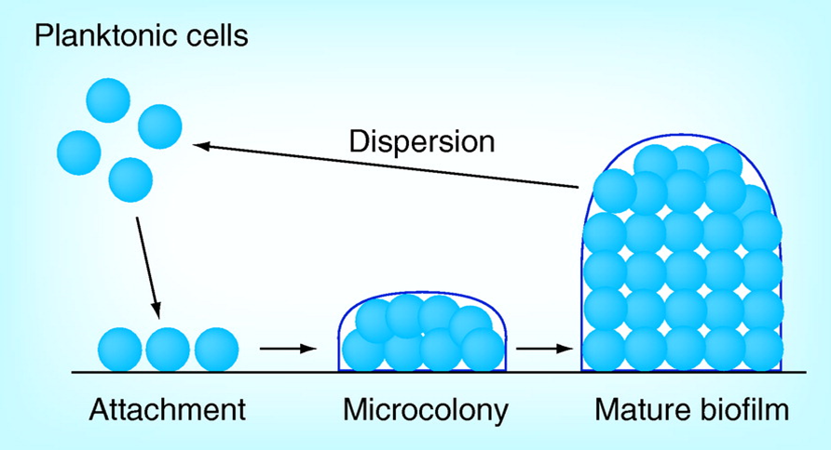
Figure 1 Schematic drawing to show the biofilm formation development (Rabin et al., 2015).
Despite acknowledging antibiotic treatment as the most critical and effective intervention for microbial infection control, it seems impossible to eradicate biofilm infections. The formation of biofilm, a structured consortium on an inert or living surface produced by a colony of microbial cells and encompassed by a self-generated extracellular polymeric matrix, denotes a survival mechanism for fungi and bacteria to adapt to their living conditions, particularly in the hostile environment. The interventions for countering bacterial biofilm infections, reviewed by Wu et al., showed that biofilm protection provided for microbial cells in biofilm enable them to exhibit resistance and tolerance to immune responses and antibiotics, resulting in increased difficulties for the clinical treatment of these infections. Moreover, the existence of a perspicuous correlation between indwelling bodies or foreign medical bodies and biofilm infection was proven, while the inadequacy of antibiotic treatment to eradicate biofilm infection in most cases solely was ascertained. Therefore, the study advocated for the integration of various elements, such as biofilm-active selection, infected foreign bodies removal, and topical or systemic antibiotic administration in high combinations and dosage to form a well-established multidisciplinary intervention for eradicating biofilm (Wu et al., 2013, Wu et al., 2015).
Other components of this framework should encompass sensitive and well-penetrating antibiotics and biofilm dispersal or anti-quorum sensing agents administration. These outcomes were consistent with the findings of Roy et al., focusing on anti-biofilm agents and their approaches to action. The authors attributed the ineffectiveness of antibiotics in treating biofilm infections to their minimum bactericidal concentration and higher minimum inhibitory concentration values, leading to in vivo toxicity (Roy et al., 2018).

2.3. The Antibiotic Resistance Problem and Treatment of Bone Infection
Tuchscherr et al., in 2016, investigated the efficacy of antibiotics in treating bone infections by determining the ability of Staphylococcus aureus to develop resistance against antibiotics. The experiment aimed at examining whether these bacteria use different strategies, such as intracellular invasion through the slow-growing phenotypes of S. aureus, so-called small-colony variants, to cause therapy-refractory infections. While this study adopted long-term in vivo and in vitro osteomyelitis models in the analysis of the efficacy of antibiotics in the chronic and acute stages of bone infections, it tested various antibiotics, including clindamycin, rifampicin, β-lactams, fosfomycin gentamicin, daptomycin, linezolid, fluoroquinolones, and vancomycin (Tuchscherr et al., 2016). The findings of the cell culture infection experiments indicated that all the tested antibiotics caused a reduction in bacterial numbers within infected osteoblasts immediately after treatment initiation. Conversely, persisting intracellular bacteria saw some antibiotics lose their activity. Notably, rifampicin is the only antibiotic that almost managed to clear all the infected osteoblasts in the chronic and acute phases. Moreover, clindamycin, moxifloxacin, and gentamicin were identified to enhance the development of small colony variant phenotypes, which could stimulate chronic infections. Osteomyelitis is caused by infecting pathogens, leading to an inflammatory process in the affected bone and being spared to several regions. Osteomyelitis is a severe condition and can be classified into three different types. 1- Secondary to contiguous source occurs when microorganisms are in contact with bone from direct or indirect inoculation following surgery, trauma or implantation where bacteria proliferate in the bone defect tissues. 2- Secondary to vascular insufficiency and often in people with diabetes. 3- Haematogenous osteomyelitis is caused by bacteria seeding from the patient's own blood that often-follows minor bone injury (Parsons and Strauss, 2004).
Moreover, acute osteomyelitis develops within days and does not last for longer than a few weeks. However, when the infection continued to exist after months with the presence of bone destruction and formation of sequestra, then it can be classified as chronic osteomyelitis. The most affected site of osteomyelitis in adults are vertebrae, long bones, and clavicle. In addition, it is common in children as primary haematogenous osteomyelitis, which could be reactivated later through childhood (Fink, 2014).
The treatment of a murine osteomyelitis model in the chronic and acute phases revealed rifampicin as the only antibiotic that significantly reduced the bacterial load of bones in the acute stage. In contrast, less effectiveness was noted in gentamicin and cefuroxime, and less concentrations of gentamicin promote the formation of small colony variant which could lead to chronic infections (Parsons and Strauss, 2004, Tuchscherr et al., 2016). Nonetheless, none of the antimicrobial compounds assessed lowered the quantity of persisting bacteria or indicated a beneficial impact on bone deformation during chronicity. Therefore, the experiment revealed the inefficacy of antibiotics in treating bone infection, as the tested compounds failed to eradicate persisting bacteria, and others caused small colony variant phenotypes formation.
Friedman et al. researched the adverse impact of antibiotic resistance, which forms part of the most significant contemporary medical developments. This resistance is associated with undermining the massive gains yielded by the availability of this intervention. Typically, infections emanating from resistant bacteria result in up to double-fold higher rates of negative outcomes compared with similar infections originating from susceptible strains. While the adverse outcomes may be economic or clinical and primarily indicate the delay or failure of the antibiotic intervention, their increased prevalence corresponds with rising host vulnerability, strain virulence, and disease severity (Friedman et al., 2016). Moreover, they are measurable at the patient level through mortality and morbidity, reduced hospital activity, increased resource utilisation, higher healthcare costs, and antibiotic intervention guidelines promoting increasingly wide-spectrum empiric treatment at the society level. In another study, Khatoon et al. reviewed the existing developments in biofilm interventions related to implant and wound infections to understand the current direction to research. The researchers highlighted implant removal and delayed healing as the adverse effects of biofilm formation in implants and wounds on the patient's health. Moreover, they suggested various potential interventions for combating biofilm infections, including implant modifications and combined therapies besides nanotechnology-based strategies for drug delivery (Khatoon et al., 2018).

2.4. The Use of Metal Ions in Fighting and Treating Bacterial Microorganisms.
In the past years, the use of metal ions to fight and treat bacterial microorganisms has been widely common (Vargas-Reus et al., 2012, Davies and Etris, 1997, Goudouri et al., 2014a). In a recent review, Evans and Kevin evaluated the utilisation of metal-based antimicrobial compounds in treating bacterial pathogens. The advent of the adoption of this intervention is dated at the beginning of the 20th century after discovering salvarsan. This arsenic-containing compound effectively treated syphilis, which emanates from bacterial infection due to Treponema pallidum (Evans and Kavanagh, 2021).
The discovery of penicillin and other antibiotics triggered a sharp decline in the clinical utilisation of metal-based antibacterial compounds. The latest advancements are subject to increased antimicrobial resistance and difficulties in developing antibiotics with new action modes, thereby triggering research into the utilisation of metal-based interventions as antibacterial agents (Gaynes, 2017). The development for antibacterial purposes could entail complexing metals to a biomolecule or an antibiotic or using it in conjunction with an antibiotic. Remarkably, biomolecules comprise compounds taken into a bacterial cell; thus, the exertion of the antibacterial effect of the metal becomes possible after complexing a metal with a biomolecule, as it easily gains entry into a particular region of the cell (Greulich et al., 2012).
Metal-based antibiotics are deemed advantageous for various reasons. Firstly, they exhibit numerous action modes compared to conventional organic antibiotics (Evans and Kavanagh, 2021). Secondly, new and additional action modes are achieved after adding metals to antibiotics, which renders them better than a single organic drug. Therefore, the utilisation of metal-based compounds alone or in conjunction with antibiotics presents a promising effective intervention against recurring and persistent bacterial infections (Anagnostakos et al., 2009). However, the use of metal ion intervention is associated with adverse implications, such as toxicity when administered systematically; hence, they should be used in smaller quantities. On the other hand, silver, gallium, manganese, gold, and copper represent metals that indicate a promising antibacterial activity and capability for systematic or safe topical administration (Akter et al., 2018, Kalaoglu-Altan et al., 2021).
Weiss and Carve emphasised the significance of divalent metals, such as manganese, copper, zinc, selenium, and iron, in infectious disease susceptibility and outcome (Weiss and Carver, 2018). These compounds ensure the maintenance of metabolism and cellular growth of invading microbes and eukaryotic hosts, whereby both overload and deficiency can lead to damage or abnormal cellular function. When subtle changes of divalent metal homeostasis occur during the manifestation of infectious disease, it may either lower the availability of respective metals to pathogens or ensure toxic accumulation of the metals to eliminate microbes. Therefore, divalent metals represent essential factors for growth and pathogenicity and provide adequate protection against antimicrobial host responses, for example, toxic radical formation (20). Nonetheless, pathogens have evolved multiple mechanisms to prevent their access to this intervention. Notably, alterations of divalent metal levels may cause decreased or increased susceptibility to infection and mainly manifests in response to infections. Moreover, imbalances may be detrimental to the health of the patient.
Qiao et al. tested the bacterial capturing ability for magnetically targeted composites with microwave responsive Fe₃O₄/CNT/Gent, to investigate its effect on methicillin-resistant S.aureus (MRSA) osteomyelitis. The results showed that Fe₃O₄/CNT /Gent eradicated the MRSA-infected rabbit tibia osteomyelitis efficiently. The outcome was attributed to the influence of Fe₃O₄/CNT, among other factors, including the magnetic targeting of the nano-capturer and the unique bacteria-capturing ability of Fe₃O₄ (Qiao et al., 2020). Therefore, the use of an iron-based intervention in conjunction with other compounds marks an effective remedy for bacterial infections.
Surgical site infection is also a huge concern, specifically with the increased rate of antibiotic resistance, which has attracted more attention in the last years (Cosgrove and Carmeli, 2003). Many common pathogens have increasingly acquired antimicrobial resistance to commonly used antibiotics over a short period of time which has triggered some catastrophic consequences on both the medical community and the public (Lee et al., 2013). The excessive use of antibiotics has enabled bacteria to rapidly develop resistance to even newly synthesised agents due to their similar modes of action to previous antibiotics (Neu, 1992). Therefore, many have emphasised the need for a feasible alternative to antibiotics (Rios et al., 2016).
Furthermore, the huge demand for bone grafts have increased attention toward synthetic bone grafts, which could enhance graft properties and improve their performance. Studies have been conducted on bone tissue repair and regeneration over the last decades, establishing new principles, creating novel materials and using new methods (Lomas et al., 2013). Currently, tissue engineering is considered one of the best examples of a multidisciplinary approach to these challenges.
Varieties of bone graft substitutes are now available for surgeons with considerable supplies. They are able to increase osteoblast proliferation and enhance bone formation to be comparable to autografts and allografts. However, it is crucial to understand the tissue response to the substitute materials and the role of bioactivity and biocompatibility.

2.5. Bone Replacement with Synthetic Biomaterials
Since the early stages of human civilisation, human beings have found ways to use artificial materials to repair bodily defects. For example, evidence shows that ancient Egyptians used linen as sutures, and there is evidence of bridges replacing missing teeth by attaching the artificial tooth to gold or silver wires. Likewise, an implant was discovered in the remains of a Celtic woman in France, considered the oldest of its kind; archaeologists believe it was made 2300 years ago (Tortora and Grabowski, 2001).
According to D. F. Williams, Biomaterials are non-living materials used in a medical device and are intended to interact with the host's biological systems (Williams, 1987). Williams redefined biomaterials in 2009 as "a substance that has been engineered to take a form which, alone or as part of a complex system, is used to direct, by control of interactions with components of living systems, the course of any therapeutic or diagnostic procedure, in human or veterinary medicine" (Williams, 2009). The latter definition was his attempt to stop the confusion concerning the use of this term in other non-medical or health-related fields. Materials such as metals, ceramic, glasses, plastics, fibres, composite, and even living tissue have all have been successfully employed in many biomaterial applications. Those applications can be as small as teeth or much bigger and complicated devices such as artificial hearts (Williams, 2009).
Biomaterials have witnessed enormous advances in recent years (Kim et al., 1998). Now, the value of commercially available applications related to tissue and biomaterials engineering around the world is more than $1.5 billion (Khademhosseini et al., 2009). However, many applications have not seen industrial success because of the lack of patient trials, the ineffective transformation of these applications into clinical use, and the dominant use of other materials.
Bonfield is considered one of the first pioneers in the field of modern biomaterials science. Between the 1960s and 1970s, he designed the first bioactive composite used explicitly inside the human body (Bonfield et al., 1981). His developments have opened the door for other scientists. However, it is important to understand the mechanical and biological properties of tissue to create more reliable applications (Hench and Thompson, 2010).

2.6. Properties for an Ideal Biomaterial
There are some requirements for a material to be able to achieve clinical success and not be rejected by the body as well as considering the neutral healing processes (Lzquierdo-Barba et al., 2008).
These requirements can be divided into two categories: mechanical properties and biological properties (Rezwan et al., 2006). First, it is essential for a biomaterial to survive the process of regeneration and to afford enough mechanical support to the surrounding tissue. The mean pore size is a key factor when developing scaffolds for tissue engineering applications. For scaffolds to promote cell growth, migration, and nutrient flow, they must be permeable with interconnected pores. Properties such as fracture toughness, porosity, wettability and elastic modulus should have similar values as the implant-surrounding tissues. Thus, the materials mechanical properties should be designed in a way that withstands the human body environment.
Second, for the biological properties, Cao and Hench classified biomaterials according to their biological behaviour into four categories (Cao and Hench, 1996):
- Nearly inert
- Porous
- Resorbable
- Bioactive
The challenge is that the materials should enhance the healing processes by mimicking the biomineralization and reducing the postoperative period (Lzquierdo-Barba et al., 2008).
The four categories have different levels of biological response from the host tissues; therefore, none of them is totally inert. However, if the implanted materials are toxic, this will cause inflammation and lead the surrounding tissue to die; therefore, toxic materials should be avoided or carefully used below their toxicity levels if needed (Heimann, 2015). Nearly inert materials, such as metal alloys, form a non-adherent fibrous capsule once are they implanted in the body. Also, they exhibit a micro-rejection response with the host tissue as a result of their distinct chemical and biological bond type (Cao and Hench, 1996). Even though nearly inert materials are generally chosen due to their excellent mechanical properties, they are easily affected and corroded by the surrounding body fluids (Hench et al.). Porous biomaterials are capable of providing an interfacial fixation by allowing the growth of tissue into and on their surface.
Nevertheless, such pores must be larger than 100 μm to assist the blood supply in reaching the host tissues (Hench, 1991). Resorbable or biodegradable biomaterials have the ability to degrade and disappear over time, thereafter being replaced with natural host tissues. However, they must comply with two requirements. First, the resorption rate must be controlled either by mechanically optimising the material's porosity or by modifying its chemistry. Second, they must be metabolically acceptable (Bohner, 2010).
Lastly, bioactive materials, the main focus of this research, were identified by Hench in 1969, who established for the first time the concept of bioactivity as when the material elicits a specific biological response when they are implanted in the host tissue and, as a result, the formation of a bond between the implanted materials and the body's surrounding tissues (Hench, 1991). Wilson and Hench, in 1994 have classified bioactive materials into two types according to their responses when implanted in tissue. They classify the materials that elicit both intracellular and extracellular responses, such as 45S5 Bioglass® as class A. Osteoconductive materials only elicit an extracellular response and have the ability to provide a biocompatible interface along which bone migrate, such as synthetic hydroxyapatite as class B. As a result of class A bioactivity, bioactive glasses show promising potential for bone-tissue engineering (Hench and Wilson, 1993). However, to understand the bioactive glass phenomenon, we should define glass according to its structure and properties and review some of the theories that describe glass formation.

2.7. Glasses as Biomaterials
Many scientific revolutions happen by coincidence. Bioactive glass is not an exception. Hench, considered the pioneer of bioactive glasses, told his story in his article, 'The Story of Bioglass®'. He told of a recently returned army colonel from Vietnam who witnessed the calamity of war and gave treatment for many wounded men whom the metallic and plastic prosthesis had failed. 'We need new materials that will not be rejected by the body', the colonel said. This was enough for Hench to start looking for such a material (Hench, 2006).
The challenge was making a material that would not be rejected by the body and bond with the living tissue. A bioactive bond of some kind must be created in order for this bond to happen by reacting with the body fluids, and a hydroxyapatite layer, similar to the one the bone possesses, will be formed (Hench, 2006). These were the challenges for the innovation of Bioglass®. Thus, the following sections will be dedicated to bioactive glass and its use in biomedical devices, reviewing the mechanisms and the therapeutic properties associated with specific ions in the glass composition. However, to understand the bioactive glass phenomenon, we should define glass according to its structure and properties and review some of the theories that describe glass formation.

Glass: what is glass?
Glass, like gold and silver, has a long history in human civilisation. Shelby defined glass as any amorphous solid where its internal arrangement of atoms or molecules lacking periodic order, demonstrating a region of glass transformation behaviour. It used to be assumed that glass was only produced by cooling a molten liquid without crystallisation. However, this belief has been contradicted with the use of different manufacturing techniques such as sol-gel and vapour deposition. Also, different kinds of materials have been produced as glasses, either inorganic or organic (Shelby, 1997). However, an energy of some kind is needed to push glass to exhibit such a transformation. This energy is known as the glass transition temperature (Tg), a range of temperatures needed to disturb the atomic arrangement and transform a super cooled liquid into a solid. However, for crystalline materials, when they melt, their liquid undergoes a slower cooling, which gives atoms enough time to re-arrange; hence, further crystallisation will occur at the melting temperature (Tm). In a glass, this crystallisation is avoided by cooling the liquid rapidly in such a way that its cooling rate is faster than the time it would take the atoms to re-arrange (Rawson and Institute of Metals (1985-), 1991), (Shelby, 1997). Figure 2 shows the temperature dependence of a liquid's volume or enthalpy.
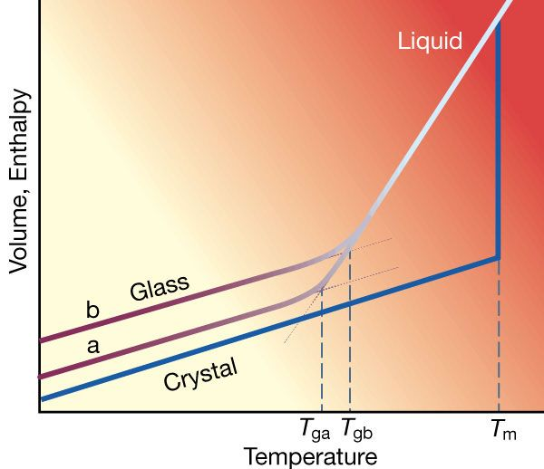
Figure 2. A classical diagram illustrates the relationship between glass structure, crystallisation, and temperature. Tm is the melting temperature. (Debenedetti and Stillinger, 2001).

Glass Theory:
Goldschmid theory: The existence of glass has provoked many scholars throughout the years to understand the phenomena of glass making. Consequently, scientists have proposed several theories in an attempt to establish principles for this field. Goldschmid, one of the first to do so, proposed a role for glass formation in that a ratio of the radius of cation Ra to the radius of anion Ra should be around 0.2 to 0.4. However, some compounds have failed to form glass, even though they satisfy these conditions, such as BeO, which has a radius ratio similar to SiO₂ yet has never been made into the glass (Zachariasen, 1932).
Zachariasen random network theory: The random network theory posed by Zachariasen is the most cited theory in glass-making science. Zachariasen claimed that glass must have a similar atomic force to its corresponding crystal due to the resemblances between them regarding their mechanical properties. Additionally, X-ray diffraction indicates that glass has larger unit cell than crystals. Therefore, he believed that glass must consist of a three-dimensional random network. Glass, because of this randomness, would have higher internal energy than a crystal. Moreover, he indicated that the differences in internal energy should be small between the glass and the corresponding crystal which require an open and flexible structure that shares corners. Figure 3 shows the structures of A₂O₃ crystal and glass.
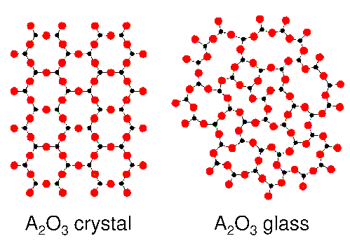
Figure 3. Schematic of atomic structural presentation of A₂O₃ crystal and glass in three dimensions adapted from (Varshneya, 2006).

Thus, he defined glass as a 'substance (that) can form extended three-dimensional network lacing periodicity with an energy content compared with that of the corresponding crystal network'; furthermore, he laid the following rules for glass-making (Zachariasen, 1932),(Varshneya, 2006):
- For a compound A_{m}O_{n} where A represents cation and m, n represents the number of cation per oxygen atom, no more than two atoms are linked to an oxygen atom.
- The number of oxygen surrounding atom A is small and no more than 4.
- The cation polyhedron does not share edges or faces; they only share corners.
- In a three-dimensional network, three corners should be shared.
Zachariasen did not mention the term 'random network'; in fact, he believed in a 'Vitreous network' as he considered it not totally random. However, he stated that these requirements were empirical and based on the knowledge of glass known at his time (Shelby, 1997).
Smekal's mixed-bond hypothesis for glass formation: Smekal argued that defined bond length and angles in pure covalent bonds contradicted the presence of a disordered network in a glass structure. He thought that “mixed” chemical bonding in a compound is a requirement for glass formation. Moreover, Smekal divided those compounds that are able to form glass into three categories:
- Inorganic compounds with partly ionic and covalent bonds such as silica.
- Elements such as S and Se that have existing Van der Waals forces between the chains and covalent bonds within the chain.
- Organic compounds that are produced by molecules linked together by Van der Waals forces and covalent bonds within themselves.

(c) Glass network connectivity
Glass network connectivity (NC) can be used to predict glass surface bioactivity, and it can be quantified by the equation devolved by Hill (Hill, 1996)
$$\left(NC=2+ \frac{BO-NBO}{G}\right)$$
Equation 1

Where BO is the sum of bridging oxygen for the network-forming ion, NBO is the sum of non-bridging oxygen per network modifier, and G is the total number of glass-forming units. According to (Equation 1), 45S5 has network connectivity of 2.11, and S53P4 is at 2.54. The higher the glass NC, the less likely glass will form apatite on their surface once they contact biological fluids, which is due to more network connectivity. As the number of network modifiers increases, the non-bridging oxygen increases and the glass NC is reduced (Wallace et al., 1999). However, predicting the glass bioactivity by the NC has its limitation. First, it assumes the glass is homogeneous, but this is highly unlikely as submicron phase separation is a common issue. Also, it assumes the behaviour of every ion as either a 100% network modifier or 100% network former, and it neglects the role of network intermediates. Additionally, it presumes the disappearance of the broken bridging oxygen bond when it is replaced by a non-bridging oxygen bond (Hill, 1996). Nevertheless, glass NC can be still used as a valuable tool to compare the bioactivity of different glass systems in parallel with different glass characterisation techniques.

2.8 Bioactive Glasses
Bioactive glasses have been proven a clinical success since Hench introduced the first generation in the 1960s. His glass has the ability to bond with the surrounding tissues as soon as it contacts body fluids due to the formation of a hydroxy carbonated apatite layer (HCA) [Ca₅(PO₄)₃OH] which is chemically similar to the bone's surface minerals (Arcos et al., 2003), (Hench, 1991). The majority of bioactive glasses have been synthesised using an approach similar to the one established by Hench. The melt-derived silicate glass's bioactivity is demonstrated in Figure 4 (Nandi et al., 2016).
Hench's bioactive glass with a composition of 45SiO₂-24.5Na₂O-24.5CaO-6P₂O₅ wt.%, based on melt-derived technique, was selected due to the large amount of calcium it provides alongside some phosphates, which makes it easy to melt (Hench, 1991). Therefore, Ca⁺ and PO₄ were chosen to be in the glass composition, in addition to the main components Si⁴⁺ and Na²⁺, as they exist in the human body (Arcos et al., 2003). However, the role of PO₄ was assumed to be indispensable for the glass bioactivity before Kokubo in 1990 proved that PO₄ free ceramics have shown both in-vitro and in-vivo signs for bioactivity (Kokubo, 1991). Therefore, it is now believed that PO₄ contributes to the Ca-P phase's nucleation but is not essential for the glass system due to the abundance of phosphate ions in the body fluid. Therefore, the glass will adsorb the ions from the body fluid and continue growing the HCA layer (Pereira et al., 1994).
Hench melted and cast this composition into an implant and, in an experiment, he inserted these implants into rats for six weeks. The implants were not rejected; instead, they were held in their place while the control implants slid out easily. Bioglass®, or as it is also known, 45S5, was then translated into a clinical device: 'the Bioglass® Ossicular Reconstruction Prosthesis', which could replace the middle ear bone to restore hearing loss (Hench, 2006). Since then, Hench bioglass® was the only bioactive glass that exhibited long-term success because of its high rate of surface reactivity and its ability to demonstrate direct bonding to the soft tissue (Hench, 2006). However, different bioactive glass products have been developed based on Hench findings, such as PerioGlas®, a bioactive glass application for regenerating periodontal bone defects and sinus elevation surgeries. In addition, Nova Bone® was an orthopaedic bone filler, and Novamin® glass particles were industrialised for use in toothpaste for repairing and protecting the tooth from sensitivity (Macon, 2015).

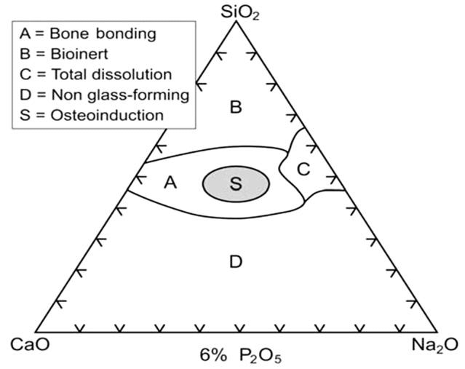
Figure 4. Composition illustration for the bioactivity of melt derived SiO2 based glass. A (bone-bonding), B (bio-inert), C (total dissolution), D (non glass-forming) and S (osteoinductive)(Hench, 2006).
Initially, bioactive glasses were all made by melting raw materials since it was the simplest method to produce glass. Moreover, melting, as it required little time, was cost-efficient (Nandi et al., 2016). The diagram in Figure 5 demonstrates the steps involved in the glass-melting approach:

Figure 5. Glass-melting flow illustrates the steps of making glass using the conventional methods (melt-route) to fabricate glass powder and glass pallet.

The raw materials should be selected carefully according to their role in the glass system to control its behaviour during and after melting; therefore, the materials used to synthesise glass have been divided into four categories, as shown in the Table 1.

Table 1. Summary of the information obtained from (Varshneya.2006), which show the list of raw materials categories and the expected behaviour in the molten glass.
Raw materials categories | Role | Example
Network former | It forms the glass matrix of the glass structure and is considered the cornerstone of the glass system. | silica SiO₂, boric oxide B₂O₃, phosphorus oxide P₂O₅
Flux | Used to decrease the melting temperature of the glass | Na₂O, K₂O and PbO
Network modifier | Introduced to the glass system to modify its properties | Na₂O, CaO, TiO and MgO
fining agent | Used to remove bubbles and maintain low viscosity during melting | As, Sb₂O₃, K and NaNO₃

The oxides that are able to bond with oxygen to form the glass network have been termed 'network formers'. However, oxides that do not form glass by themselves but tend to disrupt the glass network are called 'network modifiers', such as alkaline earth oxides and alkali metals. Network modifiers can form non-bridging oxygen by breaking the bond between two glass former cations to uphold the electroneutrality of the glass system. Figure 6 shows the effect of the glass modifier (Na⁺) on the glass system.
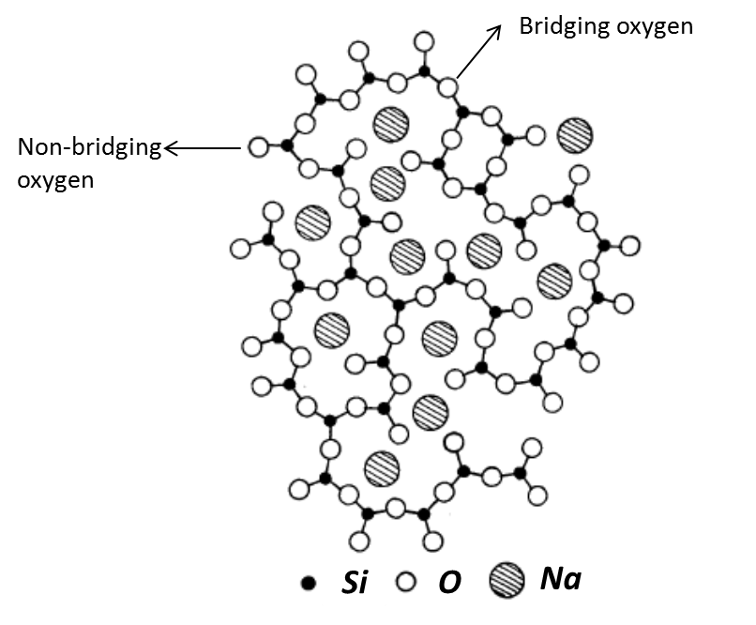
Figure 6. Schematic illustration of the structure of soda- silica glass and the two types of oxygens. On the left, non-bridging oxygen is bonded to only one silica, and on the right, bridging oxygen is bonded to two silica, adapted from (Rawson and Institute of Metals (1985-), 1991).

Silica has attracted the most attention as a glass former for the majority of bioactive glass systems. Additionally, it is important to consider glass viscosity in order to achieve a homogenous and bubble-free melt. Moreover, the melting temperatures have been reported as having an effect on microstructure and chemical properties when a different heat treatment is applied to the same composition (Elgayar et al., 2005).
The average number of bridging oxygen bonds to a tetrahedral unit in the glass system identifies glass network connectivity. It is considered as the most important factor to identify glass dissolution. A well-connected glass system indicates a high value of connectivity, and the presence of non-bridging oxygen ions leads to the open structure of silica; similarly, when network modifiers are added to the glass system, such as Na⁺ or Ca+, this also replaces bridging oxygens with non-bridging ones. However, silicate glasses with less than 60 wt% of SiO₂ are considered bioactive because every SiO⁴ has more than 2.6 non-bridging oxygen ions (Ylanen et al., 2000).
As illustrated, the HCA layer is chemically similar to the bone mineral, which creates substantial interference between the implants and body tissues. Therefore, in order for the bond between the bioactive glasses and bone to be achieved, it has to pass five stages after being exposed to the body's fluids (Hench, 1991):
- In the first stage, Si-OH groups are formed during the rapid exchange of alkali metal ions such as Ca and Na with H or H₃O from aqueous solutions, causing hydrolysis of the silica group as well as increasing the pH of the solution due to the replacement of H ions by cation.
- The second stage comes after the silica group has experienced hydrolysis from the previous stage; then, it will produce soluble Si(OH)₄ in the solution. This will result from the breaking of Si-O-Si bonds and with the formation of Si-O-H at the glass solution interface.
- Stages 3 to 5 could be summarised by the condensation and re-polymerisation of the Si-O-H groups, resulting in a silica-rich layer on the glass surface. Ions from calcium and phosphate will then migrate to the silica-rich surface, forming CaO-P₂O₅ film. This film will then crystallise to make a mixed carbonated hydroxyapatite HCA layer which is considered the bonding layer by incorporating the OH⁻ and CO₃ ²⁻ anions. This layer will attach to the tissues as it nearly matches the natural bone mineral.
These stages do not need the presence of tissues because bioactive glasses typically undergo these stages on the implant surface. Furthermore, they were based on a soda-lime silica glass dissolution mechanism when they first proposed and should take a few hours to be completed (Jarcho et al., 1979). Additionally, bioactive glasses have the ability to bond with bone more rapidly than synthetic hydroxyapatite and are more osteoconductive (Oonishi et al., 2000). This is due to the rapid sequence of chemical reactions on the surface of the glass when inserted into the body (Hench, 2006). As cited previously, the first five stages release the soluble ionic species and form a high surface area hydrated silica and (HCA) bi-layer on the implantation surface.
In 1979, Hench proposed more sequence to the stages associated with the formation of bone-bonding with implanted materials. It starts when the reaction layers increase the growth factor's adsorption and desorption (stage 6). This reaction is believed to happen within 12 to 24 hours after the implant has been inserted into the body. This is followed by a significant decrease in the time required for the macrophages to prepare the implant site for tissue repair (stage 7). After that, there is the attachment of stem cells (stage 8) and the matched proliferation and differentiation of the cells (stage 9). Finally, the matrix is now mineralised, and mature osteocytes are covered in a collagen HCA matrix (13). Figure 7 shows the sequence of interfacial reactions involved in forming a bond between bone and a bioactive glass with increasing time (Hench, 1997).

Figure 7. Summary of the sequence of interfacial reactions involved in forming a bond between bone and a bioactive glass modified after reference (Hench and Wilson, 1993).
Moreover, the clinical successes of bioactive glass can also be attributed to their capability to release ions such as copper, zinc and silver that have been incorporated, essential for several medical applications and which can have antimicrobial properties (Andersson and Karlsson, 1991, Lakhkar et al., 2013, Pantano et al., 1974, Brauer, 2015). infection is still a significant challenge in implant surgeries and can eventually lead to implant failure. In this case, patients must undergo another surgical intervention and prolong the usage of antibiotics (Fernandes et al., 2017). Therefore, glasses have been modified to enhance their properties based on the first generation of bioactive glass combining bone regeneration and bacterial inhibition. (Yue et al., 2015).
Thus, the ion substitution approach and the incorporation of different elements have been suggested to tackle these issues (Rabiee et al., 2015). Ion substitution can be beneficial in improving the physical characteristics and adding more therapeutic properties to a glass system (Hoppe et al., 2011). Understanding the role of each element may help in the processes of designing and producing multifunctional bioactive glasses (Fernandes et al., 2017). There are different methods in the literature to introduce a variety of ions into the glass system, such as ion exchange (Di Nunzio et al., 2004), (Miola et al., 2016), melt derived (Inoue et al., 1995), and sol-gel (Bellantone et al., 2002), (Vichery and Nedelec, 2016), (Fernandes et al., 2017). The following are some examples of different metal ions and their theoretical effect when incorporated into the glass system.

(a) Silver bioactive glass
Silver (Ag) has a broad spectrum of antimicrobial properties. It is considered one of the effective antimicrobial elements in the periodic table, and it has been used for many medical purposes since ancient times. As early as 1000 BC, the Phoenicians used silver-coated bottles to protect water and other liquids from contamination (Villapun et al., 2016). It was also used in the 19th century as a cure for rheumatism and tetanus. Moreover, it has been used to treat colds and gonorrhoea before discovering advanced antibiotics at the beginning of the 20th century (Mirsattari et al., 2004). Silver nitrate was used after the Second World War to treat burns and infections associated with open wounds and ulcers (Klasen, 2000). It also showed antimicrobial activity against anaerobic conditions associated with oral bacteria (Kawahara et al., 2000). In bioactive glass and ceramics, it has been introduced to the glass system and is beneficial for enhancing the antimicrobial properties of the glass and helping to treat bone infections (Luo et al., 2010). However, the mechanism of the antibacterial action of silver has not been sufficiently explained. Some explanations include:
- Ag ions form an S-Ag bond with thiol groups (-SH) in enzymes after interaction with the respiratory and transport proteins. This will cause them to deactivate, therefore disrupting the ATP synthesis (Davies and Etris, 1997, Klueh et al., 2000, Dibrov et al., 2002, Lok et al., 2006).
- The large generated ion concentration further helps to penetrate the bacterial cell and cause membrane denaturation; This action can lead to membrane damage and cellular content leakage. (Ahearn et al., 1995, Marambio-Jones and Hoek, 2010). Figure 8 is a schematic representation of the two mechanisms.
Figure 8. Schematic illustration of the two proposed antibacterial mechanisms of silver ions describes the toxicity of Ag+ against microorganisms (Goudouri et al., 2014a).
The methods in which the silver ion is introduced into an application for its antibacterial effect can determine to what extent it effectively delivers these properties. This is attributed to the sufficiency of these applications in releasing silver ions and the ability of silver ions to be free to migrate in the ionic form (Dibrov et al., 2002). Therefore, many applications such as amalgam and ionomer cement were not successful or have limited the antimicrobial effect of silver. Sheehan et al. investigated this behaviour and concluded that implants had not shown any significant decline in bacterial adhesion even though a silver coating was applied to these implants. They suggested that ions were not being successfully released from the implant to the surrounding tissues (Sheehan et al., 2004). Therefore, it is essential to consider the freedom of silver ions to migrate and move before incorporating silver ions into the application (Goudouri et al., 2014b).
There have been many attempts to introduce silver ions into dental and orthopaedic applications such as bioactive glass and ceramics for bone replacement. It is an area of great interest in the medical field, and different methods have been investigated for this purpose, including melt-derived, sol-gel and ion exchange (Bellantone et al., 2000), (Di Nunzio et al., 2004). Bioactive glass is the main focus for the scope of this research, and Table 2 presents some examples of silver bioactive glass from the literature. Sol-gel methods produce glass with high porosity, which facilitates silver ions in delivering antimicrobial properties from the matrix in a controlled and sustained way (Bellantone et al., 2002).
It is worth noting that silver addition has not shown any significant effect on the glass's bioactivity, but, at the same time, silver has reduced the solubility of silica-based glass when replaced by calcium. This is due to the difference between the valency of the two elements. Silver is monovalent and requires two ions to make two non-bridging oxygen groups to replace one calcium ion. Hence, silver tends to reduce glass dissolution (Nandi et al,. 2016).
Toxicity of silver should be considered, too, when introducing silver into a bioactive glass, as it can be harmful to the host cells. It has been reported that 2 wt% of silver in borate bioactive glass after being immersed in simulated body fluids (SBF) showed cytotoxic effects. In contrast, glass with 0.75 and 1 wt% silver did not demonstrate a similar effect (Luo et al., 2010). However, most studies have conducted toxicity tests in simple environments that do not reflect the environment inside the living organism; therefore, it cannot be a representation of toxic behaviour in real systems (Lysenko et al., 2015).
Table 2. List of bioactive glasses with addition of silver.
Reference | Glass former | Ag2O (X) Mol.% | Technique  Used
(Magyari et al., 2014) | P₂O₅ | 0.1,0.2,0.3,0.4,0.5,1,1.5 | Melt/ quench
(Ahmed et al., 2011) | P₂O₅ | 0.5, 1, 2 | Melt/ quench
(Sharifianjazi et al., 2017b) | SiO₂ | 2, 4, 6, | Sol-gel
(Vulpoi et al., 2012) | SiO₂ | 3, 4, 6, 8, 10 | Sol-gel
(Bellantone et al., 2002) | SiO₂ | 2 | Sol-gel
(Carta et al., 2017) | SiO₂ | 2, 4, 6 | Sol-gel
(Miola et al., 2016) | SiO₂ | 6 | Melt/quench
(El-Kady et al., 2012) | SiO₂ | 1, 3, 5, 10 | Sol-gel
(Delben et al., 2009) | SiO₂ | 1, 3, 5, | Sol-gel
(Aravindan et al., 2012) | P₂O₅ | 3, 6, 8, 10, 12 | Melt/ quench
(Lee et al., 2017) | P₂O₅ | 1, 2, 3, 4, 5 | Melt/ quench
(Sharifianjazi et al., 2017a) | SiO₂ | 1, 3, 5, 8, 10 | Sol-gel
(Ottomeyer et al., 2016) | B₂O₃ | 0.8 | Melt/ quench
(Pouraghaei et al., 2016) | SiO₂ | 1.5 | Sol-gel
(Catauro et al., 2015) | SiO₂ | 0.08, 0.14, 0.19, 0.27 | Sol-gel
(Lysenko et al., 2015) | SiO₂ | 0.1, 0.5, 1,2,10 | Sol-gel
(Ahmed et al., 2006) | P₂O₅ | 0, 1, 2, 3, 4, 5, 10, 15 | Melt/quench
(Magyari et al., 2014) | P₂O₅ | 0.3, 0.5, 0.8, 1 | Melt/quench

(b) Copper bioactive glass
Copper (Cu), as with silver, has been used since ancient times to sterilise drinking water and as an antimicrobial. Also, a low percentage of copper can effectively inhibit different bacteria such as Escherichia coli (Grass et al., 2011). Thus, copper was and still is used for pots and glass bottles (Sudha et al., 2012). Now, copper has attracted more interest as a sanitising agent and has proven its efficiency in decreasing bacterial surface load by up to 90% when used on surfaces that frequently contact patients in hospitals and care centres (Casey et al., 2010). Moreover, the World Health Organisation (WHO) recommended that adults should intake up to 20 μg per kg per day while infants should have up to 50 μg per kg of their weight due to the huge role of copper in growth and reproduction (WHO, 1996).
Copper is known for its effect on endothelial cell proliferation and stimulating the formation of new blood vessels. Therefore, it was incorporated in different biomaterial applications to improve and enhance their biological properties(Wu et al., 2013, Barralet et al., 2009). Romero-Sánchez et al. incorporated Cu into a mesoporous bioactive glass (MBG) to study the angiogenic responses of the cell from the ionic products. They found that the ionic dissolution products of Cu-MBG have a stimulatory influence on vascularization in copper to Cu free samples (Romero-Sanchez et al., 2018). Also, Paterson et al. reported that copper-containing MBG demonstrated a proangiogenic effect similar to the effect found from the proangiogenic vascular endothelial growth factor (VEGF), which could be a better alternative clinically to the latter because VEGF is expensive and has been challenging to use clinically – if not controlled, new vasculature can be disorganised and leaky, and there have been some links with tumous. They also found that Cu-MBG were shown to have robust antibacterial activity when tested using 3D infected skin model compared with those of its commercial dressing counterpart (Paterson et al., 2020).
Copper-containing BG have been shown a broad spectrum of antimicrobial action. For example, Mulligan et al. investigated the addition of copper into a phosphate-based glass system in different Mol. %(1, 5, 10 and 15) and found that, at a high percentage of copper, the glass starts to show antimicrobial properties against Streptococcus sanguis (Mulligan et al., 2003). Also, Gupta et al. investigated the effect of three metal ions (Ag, Cu and Fe), finding that copper glass has shown a higher antimicrobial effect against both Gram-negative and Gram-positive bacteria than other metal ions (Gupta et al., 2018).
Copper could be an effective method for long-term antimicrobial properties, as Goh et al. reported that copper ions are released into a medium more slowly than silver ions. However, over a more extended period of time 4, 7 and 14 days, copper releases more ions than silver; hence, they suggested that it is better than silver in delivering sustained and long-term antimicrobial activity (Goh et al., 2014). Consequently, copper ions could be an appropriate candidate to incorporate into other systems of bioactive glass.

(C) Gallium bioactive glass
In a borate-based bioactive glass, the addition of gallium (Ga) improves the antibacterial proprieties of the glass, affecting the pathological functions related to bone metabolism
Studies have shown that gallium additions contributed to blocking bone resorption by osteoclasts and increasing the calcium content in the bone (Verron et al., 2010). Gallium has also shown the most significant in-vivo anti-tumour activity among IIIa metal ions (Chitambar, 2012). Yazdi et al. investigated the addition of Ga at the expense of boron. They found that glass with higher Ga ion release has repressed the growth of Gram-negative bacteria Pseudomonas aeruginosa. They attributed this significant increase to the gallium's ability to interfere with various enzymes involved in vital metabolic functions, such as DNA synthesis and electron transport (Yazdi et al., 2018).
Consequently, they require iron for proper functioning. As gallium has a very similar ionic radius to iron, it has been revealed to disrupt these Fe-dependent properties by staying in its trivalent conditions (Rzhepishevska et al., 2011). The chemical similarity between gallium (Ga³⁺) and iron (Fe³⁺) plays a huge role in the antibacterial properties of Ga in bioactive glass, and this is primarily attributed to the similar oxidation state of Fe and Ga. The reduction of Fe³⁺ is the key step in many intracellular processes, and since many proteins require Fe³⁺, gallium, as it is nearly identical to iron, can work as a Fe³⁺. Nevertheless, Ga³⁺ cannot be reduced to Ga²⁺ under physiological conditions; therefore, it has the potential to function as an antibacterial agent with a very broad spectrum by targeting bacterial Fe³⁺ metabolism (Kelson et al., 2013).
Other ions play a vital role in the human body; they are essential for osteoblast and osteoclast cells. For example, the presence of zinc, magnesium, boron, silicon and phosphorous in glass composition directly impacts bone metabolism. The following presents some of the many possible examples of inorganic ions and their reported effects.

(d) Zinc bioactive glass
Zinc is an essential trace element and directly influences bones cell growth, development, and differentiation. It also has an effect on DNA replication and targeting protein synthesis (Hadley et al., 2010, Yamaguchi, 1998, Baia et al., 2007),. In a bioactive glass, zinc has been reported to increase aluminosilicate glasses' antimicrobial properties when tested against Gram-negative bacteria and peri-implant pathogens (Soderberg et al., 1990). Moreover, adding 5 Mol.% of zinc into a bioactive glass system SiO₂-CaO-P₂O₅-ZnO may improve alkaline phosphatase activity and increase osteoblast proliferation. Also, ZnO does not decrease glass bioactivity and can maintain the pH within the biological limits after forming Zn (OH)₂ in the SBF solution (Balamurugan et al., 2006). However, more than 10 Mol.% of zinc can cause an immediate drop in the glass bioactivity due to ZnO changing from a network modifier to an intermediate oxide, reducing the number of non-bridging oxygens (Yamaguchi, 1998).

(e) Strontium bioactive glass
Strontium (Sr), which exists naturally in water and food such as seafood, whole grains, and leafy vegetables, is another essential element for the human body. Sr increases bone metabolism and stimulates bone formation (Petite et al., 2000). Moreover, Sr tends to decrease the rate of ions released from the surface of biomaterials, consequently increasing therapeutic abilities (Usuda et al., 2007). It has also been added to 45S5 Bioglass in place of calcium and has shown a slight change in the glass structure and promising anti-osteoporosis activity (O'Donnell et al., 2010). In boron glass, Sr addition has improved the cytocompatibility of the glass as well as increased the formation of a bone-like layer on the glass surface (Lao et al., 2009). Furthermore, substituting Sr in place of Ca can improve the glass's ability for bone proliferation and increase alkaline phosphatase activity (Rabiee et al., 2015).
Additionally, in mesoporous bioactive glass, Sr has stimulated bone-forming and increased glass degradation compared to Sr-free bioactive glass (Zhang et al., 2010). Santocildes-Romero et al. substituted calcium oxide with strontium oxide in 45S5 composition by 50 and 100 Mol.% and found that Sr has been shown to stimulate osteoblastic differentiation. However, Sr may have altered the BG bioactivity compared to the parent composition (Santocildes-Romero et al., 2015).
Bone infections, including device-associated infections, represent a serious and growing challenge in orthopaedic, dental and craniofacial surgery. Current approaches have limitations; for example, the use of antibiotics increases the risk of isolation of resistant species, while the first generation of materials that claim intrinsic antimicrobial activity are clearly limited in their potency and range of susceptible organisms. Of these, bioactive glasses appear to offer some potential, not least because they are relatively easy to modify by inorganic substitution with metal ions that can inhibit microbial growth. These metal ions include silver, copper, zinc, gallium, and strontium. Of these, silver and copper appear to offer the greatest potency against key pathogens. Thus, there is clearly an opportunity to increase the antimicrobial activity of bioactive glasses. However, relatively little work has been reported, and no real translation to medical devices is seen in the market.
Moreover, the ideal materials need to combine enhanced antimicrobial activity with good biocompatibility. To summarise, bone surgery would benefit greatly from a new generation of multifunctional biomaterials that are capable of enhancing tissue regeneration while inhibiting microbial colonisation and growth from reducing the risk of infection. The first generation of bioactive glasses appear to show some limited antimicrobial activity, and there is an opportunity to modify their composition to introduce known antimicrobial ions. However, despite some progress, an optimised multifunctional bioactive glass has not yet been translated. Thus, there is a demonstrable need for further research into inorganic modifications that introduce antimicrobial activity while retaining excellent biocompatibility with bone and living tissues.

3. Aim and Objectives

3.1 Aim
The previous chapter presented some of the challenges in bone repair and the huge opportunities to tackle these issues by modifying and enhancing the antimicrobial activity of bioactive glasses. Therefore, this PhD programme aims to design, fabricate, and characterize a range of modified bioactive glasses and then investigate the effects of these substitutions on antimicrobial activity and biocompatibility.

3.2 Objectives
- To design and fabricate a range of bioactive glasses based on the SiO₂-Na₂O-CaO-P₂O₅ system via a melt-quench route and incorporate silver and copper into systematic series of glass compositions.
- To characterise the glasses produced using techniques previously reported in the literature. The glasses will be characterised by X-ray diffraction (XRD), X-ray fluorescence (XRF), Differential Thermal Analysis (DTA), scanning electron microscopy (SEM), and Fourier-transform infrared spectroscopy (FT-IR) to investigate the effect of silver and copper addition on the glass.
- To investigate the antimicrobial activity of the modified bioactive glass against clinically relevant bacteria, including planktonic and biofilm cultures in comparison to parent glass (45S5) and FDA approved BG (S53P4) compositions.
- To determine the in vitro cytotoxicity of modified bioactive glass containing silver and copper and their effect on fibroblasts cells.
- Investigate the effect of silver and copper on the predicted bioactivity determined using immersion in simulated body fluid (SBF).
On completion of this work, considerable scientific progress will have been made towards developing a new generation of multi-functional bioactive glasses that combine the enhancement of bone tissue regeneration with antimicrobial activity.

4. Materials and Methods
In this chapter, the experimental techniques performed during this work are described together with the corresponding data analysis.
Figure 9. Schematic diagram of the experimental study design.
Table 3 Reagents used in synthesis and characterisation of BG.
Reagent | Molecular formula | Molecular weight  (g.mol⁻¹) | Supplier
Silica Sand | SiO₂ | 60.08 | Sigma Aldrich (UK)
Sodium carbonate | NaCO₃ | 105.9888 | Sigma Aldrich (UK)
Calcium carbonate | CaCO₃ | 100.0869 | Sigma Aldrich (UK)
Dicalcium phosphate | CaHPO₄ | 136.06 | Sigma Aldrich (UK)
Silver nitrate | AgNO₃ | 169.87 | Sigma Aldrich (UK)
Silver oxide | Ag₂O | 231.735 | Sigma Aldrich (UK)
Copper (II) oxide | CuO | 79.545 | Sigma Aldrich (UK)
Iron (III) oxide | Fe₂O₃ | 159.69 | Sigma Aldrich (UK)

4.1 Silver-Glass Preparation
Bioactive glasses based on the system (SiO₂-Na₂O-CaO-P₂O₅) were prepared in a series using a melt-quench route. Initially, silver was added to the glass system at the expense of CaO at 0.15, 0.25 and 2.5 Mol.%. The second series was made by reducing SiO₂ by 0.5 mol% and replacing it with Ag₂O. Also, Iron oxide F₂O₃ was used as a reducing agent of silver at the expense of CaO at 0.25 Mol.%. Two silver sources have been chosen to evaluate their behaviour on the glass system Ag₂O and AgNO₃ respectably. The glass compositions in wt% and Mol.%, are shown in Table 4 and Table 5. 45S5 Bioglass® was prepared as described by Hench (2006). Initially, a platinum crucible was chosen for glass melting. However, an issue was identified where the silver metal generated by heating the Ag₂O alloyed with the platinum to damage the crucibles, as shown in Figure 10. Subsequently, the glass melting was performed using alumina crucibles.
All glasses have been inspected visually after being dried to look for any sign of irregularities. Therefore, as some issues with the consistency of manufacturing modified glass with silver and iron include glass inhomogeneity and inadequate melting, we have discarded the second series from further characterisation.
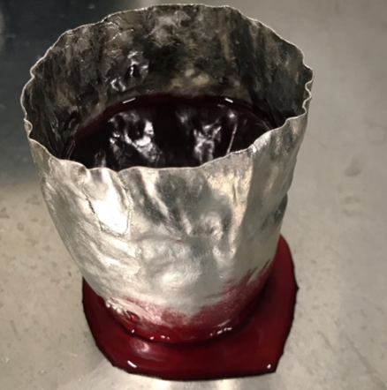
Figure 10. This image shows the damaged platinum crucibles with dyed water to demonstrate the leaking as a result of the Ag reaction with platinum.

Table 4 First series of glasses with their compositions in (Wt. % and Mol. %).
Glass  label | SiO₂ |  | Na₂O |  | CaO |  | P₂O₅ |  | Ag₂O
Glass  label | Mol.% | Wt.% | Mol.% | Wt.% | Mol.% | Wt.% | Mol.% | Wt.% | Mol.% | Wt.%
45S5 | 46.1 | 45 | 24.3 | 24.5 | 26.9 | 24.5 | 2.6 | 6 | 0 | 0
S53P4 | 53.8 | 53 | 22.7 | 23.1 | 21.8 | 20 | 1.7 | 4 | 0 | 0
Ag0.25 | 46.1 | 44.7 | 24.3 | 24.3 | 26.7 | 24.1 | 2.6 | 6 | 0.25 | 0.9
Ag2.5 | 46.1 | 42 | 24.3 | 22.8 | 24.4 | 20.7 | 2.6 | 5.6 | 2.5 | 8.8

Glass  label | SiO₂ |  | Na₂O |  | Fe₂O₃ |  | CaO |  | P₂O₅ |  | Ag₂O
Glass  label | Mol.% | Wt.% | Mol.% | Wt.% | Mol.% | Wt.% | Mol.% | Wt.% | Mol.% | Wt.% | Mol.% | Wt.%
Ag-Fe0.25 | 46.1 | 44.3 | 24.3 | 24.4 | 0.25 | 0.9 | 26.5 | 23.7 | 2.6 | 6 | 0.25 | 0.9
Table 5. Second series of silver modified glasses and their compositions in (Wt.% and Mol.%) for the sample where SiO₂ was reduced and replaced by silver-iron.

The appropriate analytical grade reagents in Table 3 were selected. Then they were mixed in a rubber container for about 15 min. The mixers were then transferred into the crucibles. According to the reported literature, the glasses melting temperature and the melting time were chosen carefully (Bellantone et al., 2000, Bellantone et al., 2002, Cao and Hench, 1996). Initially, glasses were prepared using platinum crucibles (type BC20 Birmingham Metal, UK). Afterwards, the batches were
transferred and placed in a chamber furnace (BRF16/5, Elite Thermal Systems Ltd) at temperatures between (1350 to 1450 C°). The molten glass was then shock-quenched in stainless steel container filled with water to obtain granular frit. The frit was subsequently retrieved and dried for 24 h at 37 C°. The dried granules were then transferred into mortar and manually reduced to the particles size to about 5 mm. To achieve the appropriate particle size, the coarse glass frit was processed for 15 minutes at 500 rpm in a rotatory ball miller (Retsch PM100, Germany) with 80 ml
grinding bowls and nine 15 mm tempered zirconia balls to ensure fine ground powder. Finally, the powder was sieved through 120, 70 and 45 μm sieve (Endecotts Ltd., UK.)
Glass discs have been prepared by melting some of the obtained frits in smaller crucibles. The crucibles were placed in a chamber furnace (Model VF2, Vecstar Ltd., UK) at a temperature between 1350 C° and 1450 C° for four hours until the melt reached the desired temperature. Then the melt was poured into the casting ring and annealed to remove any stress from the glass and obtain stress-free glass. Finally, two glass discs were made for each composition for further characterisation.
Glass  label | SiO₂ |  | Na₂O |  | CaO |  | P₂O₅ |  | CuO
Glass  label | Mol.% | Wt.% | Mol.% | Wt.% | Mol.% | Wt.% | Mol.% | Wt.% | Mol.% | Wt.%
45S5 | 46.1 | 45 | 24.3 | 24.5 | 26.9 | 24.5 | 2.6 | 6 | 0 | 0
Cu 1 | 46.1 | 44.8 | 24.3 | 24.4 | 25.9 | 23.5 | 2.6 | 6 | 1 | 1.3
Cu2.5 | 46.1 | 44.6 | 24.3 | 24.2 | 24.4 | 22 | 2.6 | 6 | 2.5 | 3.2

4.2 Copper-Glass Preparation
For the copper glass, the same approach in section 4-1 for silver glass was applied and (1 and 2.5 Mol.% of CuO) were used as it shown in Table 6.

Table 6. Copper-glass compositions series in (Wt. % and Mol. %) for the Copper bioactive glass.

4.1 Glass Characterisation
Different techniques have been used to characterise the glass. The section below is the description of these techniques and the sample preparation for each one.

4.1.1 X-Ray Diffraction
X-ray diffraction (XRD) is an essential technique to examine the structure of a solid state and is an indispensable tool in chemistry. It can be used as both quantitative and qualitative tools in glass samples to identify the sample crystallinity, size of crystals, and unite cell parameters. Glasses diffraction pattern should not display peaks, but it should show a broad hump.
XRD is based on Bragg's law which describes the link between the incident X-ray wavelength, angle of incidence, and distance between atoms' crystal lattice plans and expressed as
𝑛𝜆 = 2d sin(θ)
Equation 2
Glass samples were reduced in size to obtain well-grounded powder by mortar and pestle, and then they were labelled and transferred into a plastic tube. The powder was then mounted uniformly in a polymethyl methacrylate (PMMA) holder, and a microscope slide was used to ensure that the specimen surface was level with the top of the holder. A Burker 2D PHASER (Bruker AXS Inc. Madison, WI, USA) was used at the department of materials science and engineering (University of Sheffield) with a scanning rate of 1°/min, scan range between 15° to 60° 2θ and the radiation source was CuKα.
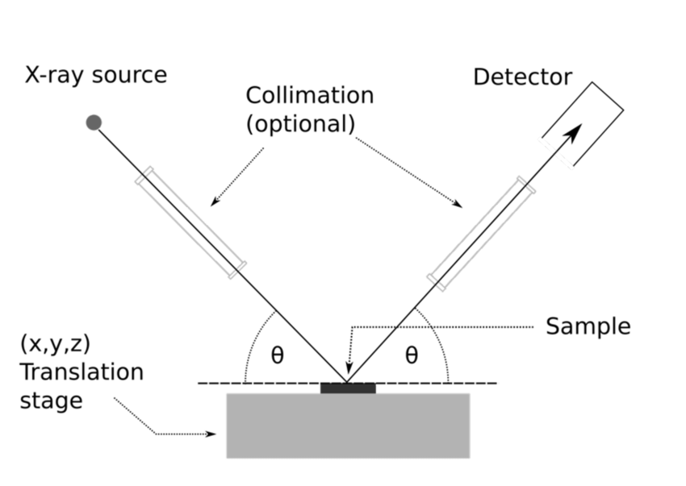
Figure 11. Schematic diagram for a powder X-ray diffractometer (Waseda et al., 2011).

4.1.2 X-Ray Fluorescence
X-ray fluorescence (XRF) is used to identify the elements in solid material composition. It is a non-destructive and fast technique to characterise materials that require little preparation. It is based on the photoelectric effect so that a vacancy will be yielded by sufficient energy from the initial X-ray to eject an electron from the inner shells. This vacancy will lead to instability, and an outer electron from a higher shell substitute the missing inner electron. When this happens, multiple peaks of different intensities will be formed due to the difference between the inner and outer binding energy. These peaks can be used to identify the element present in a sample and their concentration from the net intensity of these peaks.
Three glass samples were prepared and sent to Sheffield Hallam University, UK for X-ray Fluorescence (XRF) analysis; these were 45S5 bioactive glass, 0.25Ag, and 2.5Ag. These samples had been prepared as discs with flat surfaces, which were the right size to be loaded into XRF sample holders. These samples were loaded into the PANalytical MagiX Pro X-ray Fluorescence (XRF) spectrometer (Malvern Panalytical Ltd, UK) to collect XRF spectra. It uses a Rhodium anode for the X-ray source; hence Rh lines can sometimes be observed in the XRF spectra. Although XRF can provide information about the elemental composition of materials for sodium and heavier elements, the emitted X-rays for elements lighter than sodium are too weak to be easily detected by XRF. The XRF data for weight % concentration was analysed using "IQ+" software.

4.1.3 Differential Thermal Analysis
Differential Thermal Analysis (DTA) is a technique that involves thermal control to study the physical and chemical properties of a sample, which ceramicist first developed as a tool to investigate the phenomena occurring while melting a material (Rosenfeld et al., 1966). In contrast to XRD and XRF, DTA is a distractive technique that demonstrates the enthalpy changes (ΔH) where (ΔH) = (T_{S} - T_{R}), where T_{S} is the temperature of the sample, and T_{R} is the temperature of the reference. An endothermic or exothermic consumption (production) causes the temperature difference between the T_{S} and T_{R}. It is now widely used to measure the heat changes when a material is heated at a specific rate and through a temperature gradient. The sample and reference material are heated under the same conditions. During this procedure, a thermocouple will measure the temperature difference between the sample and the reference. DTA curve will be provided as a fingerprint to identify the samples glass transition temperature (T_{g}), glass crystallisation temperature (T_{c}) and glass melting temperature (T_{m}). Due to a breakdown of local equipment, thermal analysis was performed at Imperial College London using a grant from the Royce Institute. The simultaneous thermal analyser NETZSCH STA 449 F3 Jupiter® was used with approximately 85 mg of glass powder. The exact weight of alumina was used as a reference in an air atmosphere at a 20˚C min⁻¹ heating rate. The post-heated samples at 950 °C were recovered to check the main crystalline phases in the surface using XRD.
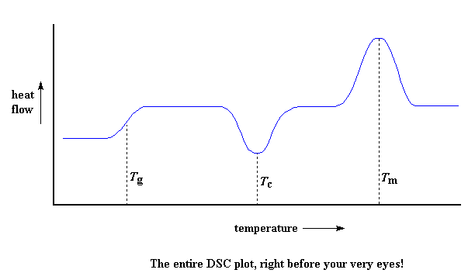
Figure 12. Basic DTA curve showing a glass transition at T g, crystallisation at T c, and melting at T m.

4.1.4 Fourier-Transform Infrared Spectroscopy
Fourier-transform infrared spectroscopy (FT-IR) is an analytical technique used to provide information on the material's molecular components and structure. This sensitive technique is based on infrared radiation passed through a sample, then partially absorbed and partially transmitted. Therefore, the main advantage is that all compounds exhibit characteristics of absorptions or emission in the infrared spectral region. As a result, they could be both quantitively and qualitatively analysed. The signal collected at the detector is presented as a spectrum ranging between (400 cm⁻¹ and 4000 cm⁻¹. This signal exemplifies the sample molecular fingerprint. This analysis was carried out at the Department of Chemistry (University of Sheffield, UK), using a Bruker α Alpha-P with Opus 6.5 software (Bruker Optic, GmbH) and a diamond attachment in absorbance mode.

4.1.5 X-Ray Photoelectron Spectroscopy
X-ray Photoelectron Spectroscopy XPS is used to analyse the wide range of materials and provide quantitative information for the samples chemical state. This technique is based on monoenergetic Al Kα X-rays that exited a sample surface and caused the photoelectrons to be emitted from the sample surface. Subsequently, an electron energy analyser will measure the emitted photoelectron energy. The chemical state and the concentration of the elements in the glass samples will be identified by the binding energy and the intensity of the photoelectron peaks. The average analysis depth of XPS is approximately 5 nm. The instrument that has been used to collect the XPS data was a Kratos Supra. The area analysed was 700 µm by 300 µm, and charge neutralisation was used throughout since the samples were insulators. Monochromated aluminium radiation was used to collect XPS survey scans (wide scans) with 160 eV pass energy, between 1200 to 0 eV at 1 eV intervals and 300 seconds sweep time. High-resolution XPS spectra for silver were requested. In addition, the C 1s was collected to enable a binding energy calibration to be carried out. Ag 3d and the Auger spectra Ag LMM were initially collected at 20 eV pass energy, 0.1 eV intervals and a sweep time of 300 seconds with two passes. However, the silver concentration was found to be extremely low.
Consequently, the pass energy was increased to 40 eV; the number of sweeps extended to 4 for the Ag 3d spectra and the Ag LMM Auger spectra was not collected as the signal was too weak for the scans to be of value. The raw data collected is corrected by a transmission function characteristic of our instrument, determined using software from the National Physics Laboratory. The adjusted data can then be quantified using the theoretically derived Schofield relative sensitivity factors, which have been corrected for the geometry of our instrument. Three analysis points were collected per sample. The samples 0.15 Ag, 0.25 and 45S5 were analysed as they have the lowest concentration of silver. The limit of detection of XPS is typically approximately at 0.1%.

4.1.6 Scanning Electron Microscope
Scanning electron microscopy (SEM) is an invaluable technique used to generate a high-resolution image to characterize and observe the sample's surface by applying a high-energy electron beam on its surface. The interaction yielded from the electron-sample provides information about the studied sample's morphology, topography, and chemical composition.
The SEM was performed on melt-derived glass powders with a particle size of less than 45 µm and glass granules. These analyses have been conducted at the Department of Biomedical Science (University of Sheffield, UK)

4.2. In Vitro Antibacterial Activity and Cytocompatibility
For BG sterilization before antibacterial activity and cytocompatibility test, all BG were stored in a 30ml universal glass vial and covered with aluminium foil. Then they were placed in a dry oven at 160 °C for one hour. They were then stored in a dry and dark place.

4.2.1. Planktonic Bacteria Model
Overnight cultures of Gram-positive S. aureus (S-235) and Gram-negative E. coli (MG 1655) bacteria at 37 °C, were cultured using Brain heart infusion (BHI) and Luria-Bertani (LB) broth, respectively. Then they were adjusted to an optical density of 1.0 at 600 nm to standardise the number of bacteria in overnight cultures and ten-fold diluted in fresh broth. The sterilised BG samples were weighed and added to fresh BHI or LB broth to achieve a final concentration of 25 mg/mL. Next, 100 μL of diluted overnight bacteria suspension was mixed with 100 μL of sample suspension in a 96 well plate. A negative control containing only bacteria in the growth medium was used. The 96 well plate was left to incubate overnight at 37 °C. A Miles and Misra standard quantification of colony-forming units per ml (CFU/ml) in the samples was then carried out as follows. Serial dilutions of the samples were made, and 5ul of each sample (in triplicate) was spotted onto BHI or LB agar plates and incubated overnight at 37C. Colonies were counted (each colony derives from a single cell, therefore this method is an indication of bacterial cell numbers and viability), and CFU/ml were calculated according to Equation 3. Each sample was tested in triplicate. Statistical analyses were tested for significance using a one way ANOVA test with Tukey’s multiple comparisons tests applied using GraphPad Prism 9 software. Cell viability was normalised to the viability of the control group.
.
$$CFU/ml = (no. of colonies x dilution factor) / volume of culture plate$$
Equation 3

4.2.2. Bactria Biofilm Model
Bacterial biofilm is more of an actual representation of microbial communities growth in nature. Therefore, models to simulate biofilms' production and properties within host tissue must be developed and used in studies of innovative treatments targeting bone and soft tissue infections. The most frequent colorimetric approach for biofilm measurement is crystal violet (CV) staining. Because it stains negatively charged molecules and polymers in the extracellular matrix and cells, it is utilised to assess the growth of biofilms on a surface; as a result, it is a valuable tool to quantify total biomass.
Therefore a microtiter dish biofilm formation model was used according to the standard procedure developed by (O'Toole, 2011). First, S. aureus (S-235) was cultured overnight in a BHI broth. Then the culture was adjusted to an optical density of 1.0 at 600 nm before adding 1 μL of adjusted bacterial to 96 well plate and incubating at 37 °C overnight. Bacterial growth in the wells was then examined by measuring the optical density before adding 100 μL of the BG suspension in a 96 well dish and incubating at 37°C for 1, 3 and 7 days. For quantitative assays, four replicate wells for each sample were used. As a control, 100 μL of broth with 1 μL of bacterial culture was used. After incubation, planktonic cells were removed by turning the plate over and shaking out the liquid. Next, 175 μL of a 0.1% solution of crystal violet was added into each well of the microtiter plate. Then, the microtiter plate was left at room temperature for 30 minutes. Next, it was rinsed and left to dry. For qualitative assays, the wells were photographed. Then 175 μL of 30% acetic acid was added into each well, resolubilized the crystal violet in order to measure absorbance in a plate reader at 595 nm quantitatively. Each sample was tested in triplicate. Statistical analyses were tested for significance using a one way ANOVA test with Tukey’s multiple comparisons tests applied using GraphPad Prism 9 software. Cell viability was normalised to the viability of the control group.

4.2.3. Cell Viability Assay
Direct contact method to test viability of L929 using the PrestoBlue® assay (Thermo Fisher Scientific, Massachusetts, United States) according to ISO 10993-5. This resazurin-based solution acts as a cell health indicator by quantifying viability using the reducing power of living cells. It is a non-distractive assay in which it uses the reducing power of living cells, and the reagent changes colour and fluorescence as a result of the reduction. It thus can be quantified using either a fluorometric or spectrophotometric technique.
First, L929 fibroblast cells were directly cultured using a cell culture medium supplemented with (v/v %) 88 % DMEM, 10 % foetal calf serum (FCS), 1% penicillin-streptomycin, 1% L-alanyl-l-glutamine under standard cell culture conditions (i.e. 37 °C, humified, 5% CO₂/95 % air environment). After reaching complete confluence, the cells were detached by a 0.25% solution of trypsin-ethylenediaminetetraacetic acid (EDTA) to be sub-cultured in a 24 well plate with a density of 5 x 10⁴. The cells were incubated at 37 °C, 5% CO2 for 24 h, after which the media was removed, and a 0.9 mL media was added. Permeable Millicell® hanging inserts (0.4 µm pore size, Merck Millipore) were then placed in each well, and 0.2 mL complete media was added inside each insert. BG at a 25 mg/mL concentration was pre-treated via exposure to DMEM for 24 h, then added to each insert in triplicate. The plates were incubated at 37 °C, 5% CO₂ for an additional 24 h. Millicell® membranes containing cell culture media DMEM alone were also prepared as control samples. After incubation, the inserts were removed. The media was removed from the cells, and 500 µL of a 10% (v/v) PrestoBlue® solution in complete media was added to each well. To investigate the effect of the pH on the cell viability, BG samples were also pre-conditioned in DMEM for 24 hours. After that, the BG samples were washed with sterilising PBS then the cells were cultured in these conditioned BG. PrestoBlue® solution was also added in triplicate to empty wells as a control to subtract from the fluorescence values obtained. The samples were incubated at 37 °C, 5% CO_{2,} until appropriate colour change was observed. 0.2 mL of solution was placed into a 96 well plate at each time point. The fluorescence of the solutions was measured using a plate reader with an excitation wavelength of 535 nm and an emission wavelength of 590 nm. All PrestoBlue® assays results were expressed as the mean of the three triplicate repeats (n = 9). Statistical analyses were tested for significance using a one way ANOVA test with Tukey’s multiple comparisons tests applied using GraphPad Prism 9 software. Cell viability was normalised to the viability of the control group.
Table 7. Consumables used in biological characterisation experiments.
Item | Supplier
Brain heart infusion (BHI) agar | Oxoid (UK.)
Brain heart infusion (BHI) broth | Oxoid (UK.)
Luria-Bertani (LB) agar | Oxoid (UK.)
Luria-Bertani (LB) broth | Oxoid (UK.)
L-glutamine | Sigma Aldrich (UK)
Minimum essentials media | Sigma Aldrich (UK)
Eagles (α-modification) (α-MEM) | Sigma Aldrich (UK)
Non-essential amino acid | Sigma Aldrich (UK)
Penicillin/streptomycin | Sigma Aldrich (UK)
Phosphate buffered saline | Sigma Aldrich (UK)
Trypsin EDTA | Sigma Aldrich (UK)
PrestoBlue® cell viability reagent | Fisher Scientific (UK.)

4.3. In Vitro Bioactivity of BG Using SBF
One of the methods to study the bioactivity of biomaterials is by immersion in a simulated body fluid (SBF) and observing the newly HA precipitation on its surface, as mentioned in chapter two. Thus, simulated body fluid (SBF) solution was prepared according to Kobubo's method (Kokubo et al., 1990). However, ISO / FDIS 23317 This technique was never intended to be used with glass powders or porous materials; instead, it was only intended to be used with solid, regularly shaped samples, such tiles or discs. Therefore, modified protocol has been suggested to fix this issue which was developed as an outcome from the TC-O4 committee from the International Commission on Glass based on sample mass to liquid ratio (Maçon et al., 2015).
Table 8. Reagents order and amounts used for preparing SBF solution.
Order | Reagent | Amount (g) | Supplier
1 | NaCl | 8.035 | Sigma Aldrich (UK.)
2 | NaHCO₃ | 0.355 | Sigma Aldrich (UK.)
3 | KCl | 0.225 | Sigma Aldrich (UK.)
4 | K₂HPO_{4.}3H₂O | 0.231 | Sigma Aldrich (UK.)
5 | MgCl₂.6H₂O | 0.311 | Sigma Aldrich (UK.)
6 | 1M HCl | 40mL | Sigma Aldrich (UK.)
7 | CaCl₂ | 0.292 | Sigma Aldrich (UK.)
8 | Na₂SO₄ | 0.072 | Sigma Aldrich (UK.)
9 | Tris | 6.118 | Sigma Aldrich (UK.)
Firstly, deionized water (DI, 700 mL) was poured into a 1 L polypropylene beaker and heated to 37 °C in a water bath for the duration of the procedure while stirring at (200 rpm). Then, with an accuracy of 0.5 mg, the reagents specified in Table 8 were carefully added to the DI water in order. The pH of the solution was carefully controlled to avoid a sudden rise in pH, which could lead to precipitation. After mixing all of the ingredients in the beaker, the beaker was filled to 1 L and stored at 37 °C overnight. Before using at 37 °C, the pH was corrected to 7.4. The SBF solution is typically used between two days and no more than one month. Next, glass particles (30 mg <45 μm) were immersed in SBF (45 mL) in a polypropylene container. The container was placed in an incubator at 37 °C with time points were taken at 1, 3, 7, 14, 21 days with three replicates for each sample group. These samples were used for the later surface analysis, which included FTIR, XRD and SEM. Next, the samples used for surface analysis were filtered using filter paper to collect the glass samples. Finally, the glass samples were rinsed with acetone to terminate the reaction and placed in a 40 °C oven to dry.

4.3.1 Leaching Test and pH Profile
Ion release profiles were measured using an Inductively Coupled Plasma Optical Emission Spectrometer (ICP). At each time point, 10 mL of SBF solution were taken, and the pH of the solution was measured, and then the elemental concentration of silicon sodium, calcium, phosphorus, silver and copper were calculated

4.3.2 X-Ray Diffraction
Dried glass powder samples were placed on the holder. The Diffraction was measured with Aeris Malvern Panalytical Ltd, UK, between 5° and 80° 2θ angle, with step size 0.0217° and step time 100 s.

4.3.3 Fourier Transform Infrared Spectroscopy
The dried glass powder samples acquired from the SBF experiment were characterised in the range of 2000 to 400 cm⁻¹ across 16 scans using a Perkin Elmer Spectrum Two FTIR fitted with Diamond Attenuated Total Reflection (ATR) module. The sample was placed neatly onto the sample stage. The pressure was applied to provide good contact and then analysed.

4.3.4 Scanning Electron Microscope
SEM was used in this study to investigate surface topography changes of BG at 1, 3, 7, 14 and 21 days after immersion in SBF. Samples were mounted on double-sided carbon tape and coated with gold.

5. Results

5.1. Glass Characterisation
Following the visual examination, the frits from 45S5 and S53P4 samples were transparent with no evidence of crystallisation. However, the glasses containing Ag₂O tended to be light yellow with some visual evidence of metallic deposits, which was more pronounced in Ag 2.5 samples. Furthermore, glass made by CuO tends to be blue, which increases in intensity with the addition of more CuO, as is shown in Figure 13. Moreover, the frits were homogeneous, unlike Ag BG samples Figure 13.

A | 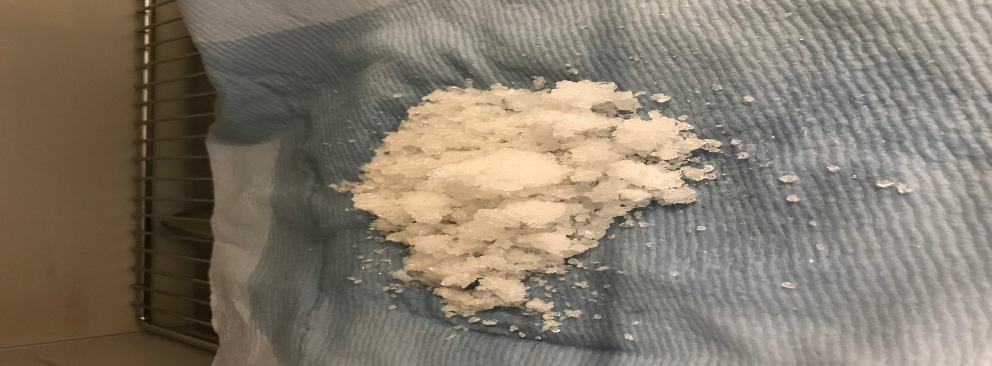 | B | 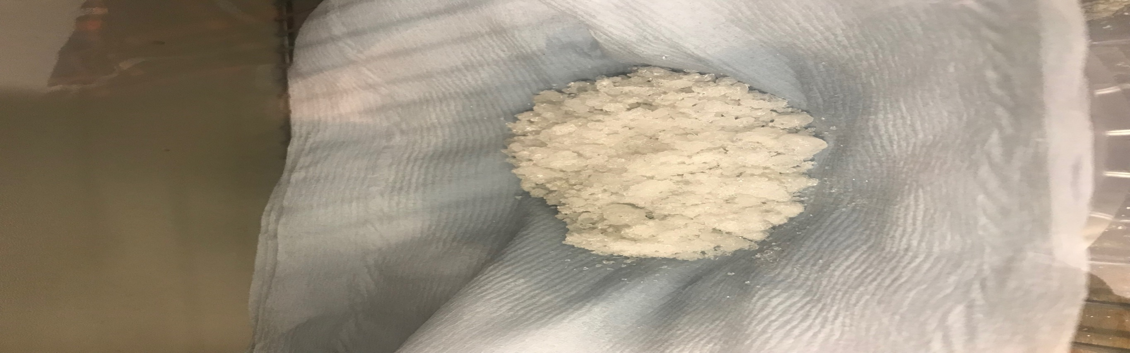
C | 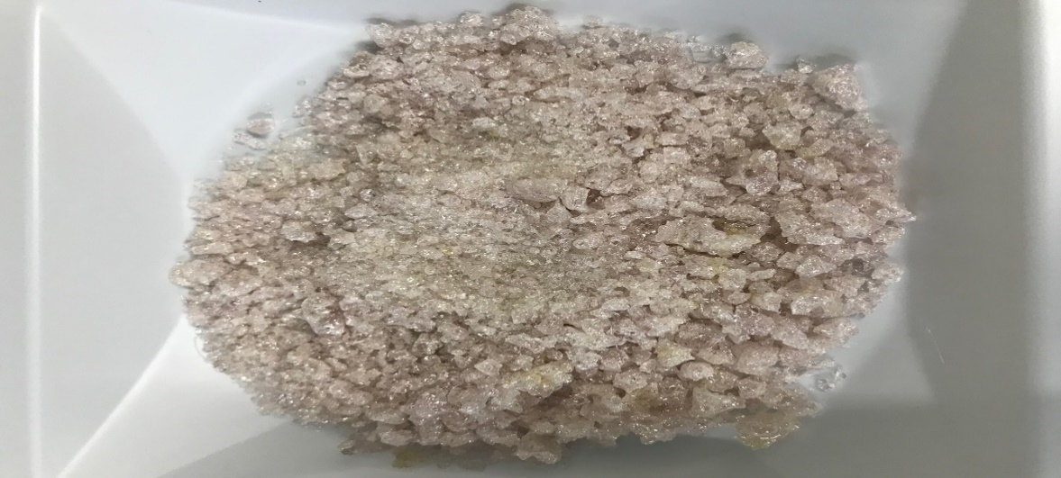 | D | 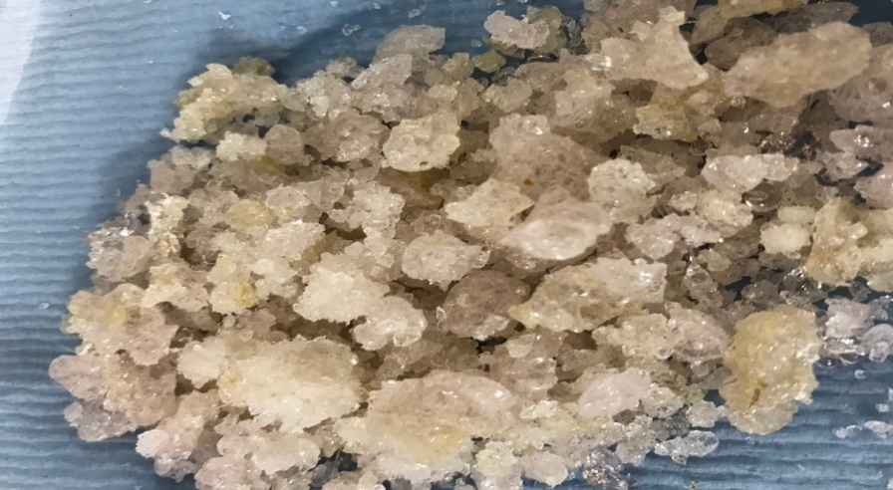
E | 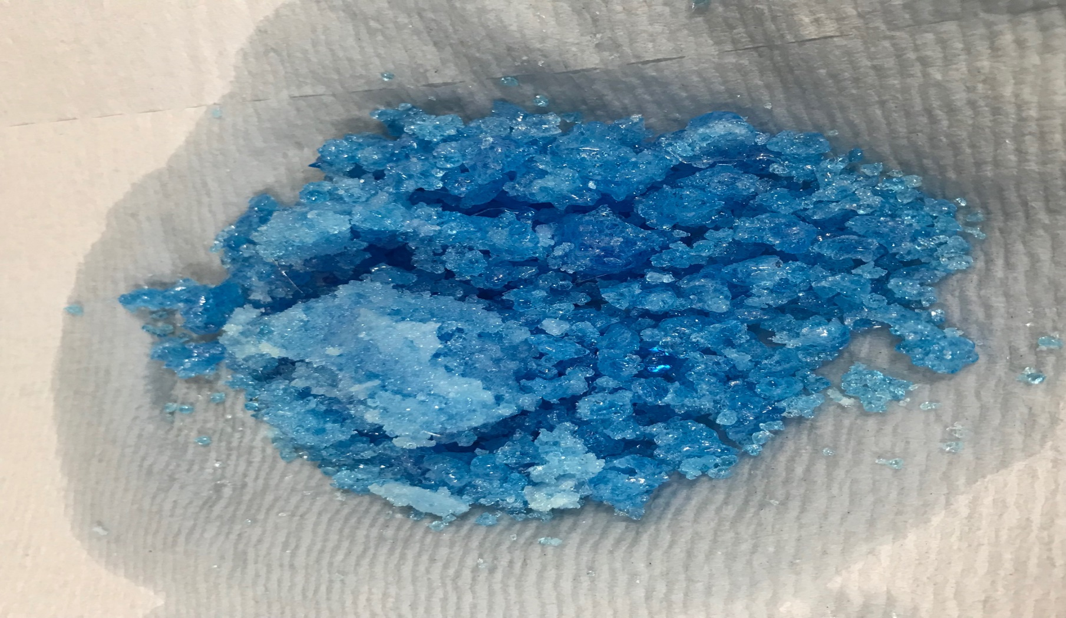 | F | 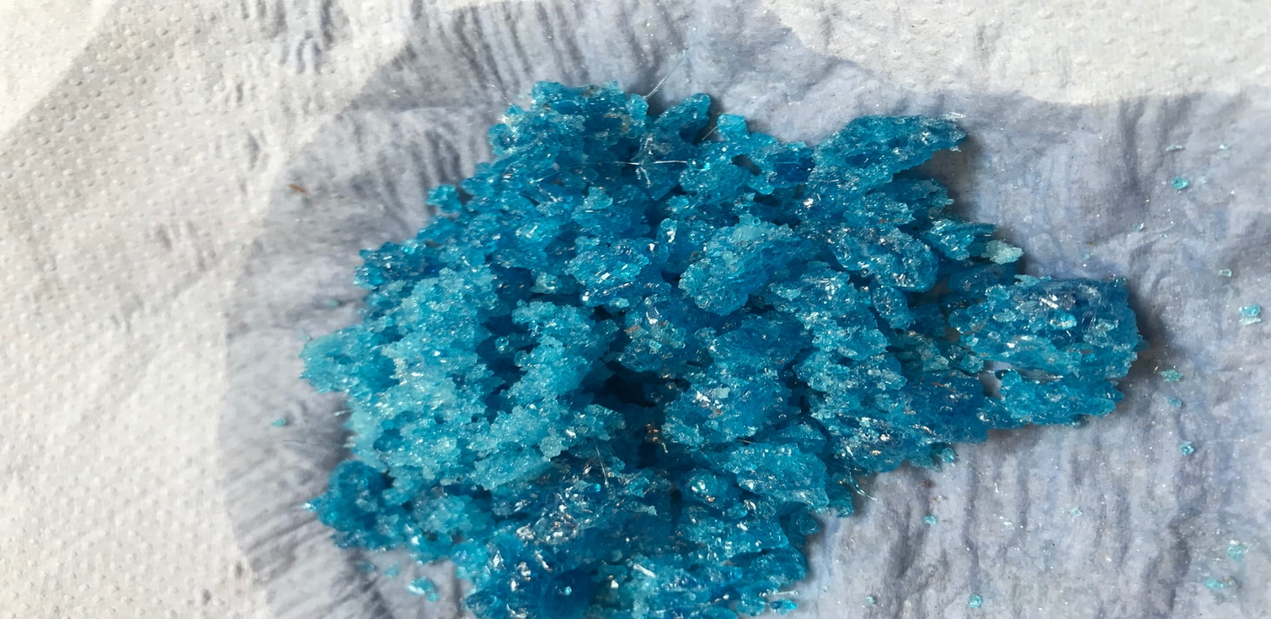
Figure 13. Photographs of BG frits generated vie melt-route. (A) 45S5, (B) S53P4, (C) Ag 0.25, (D) Ag 2.5, (E) Cu 1 and (F) Cu 2.5. Scale bar = 5 cm.

5.1.2 X-Ray Diffraction
XRD was used to investigate the amorphous state of the melt-derived glasses in powder form. The broad peak is shown in Figure 14 between 26°, and 38° is the typical halo that reveres the glassy state of the glass. There was no evidence for peaks that would have suggested the presence of characterising crystalline phases. This data aligns with the published literature at the 2-theta range (Sepulveda et al., 2001, Groh et al., 2014).
Figure 14. XRD pattern of silver- glass series with 45S5 as control showing the amorphous “hump” with no evidence for crystallization.

5.1.3 X-Ray Fluorescence
XRF was conducted to show the difference between (TGC) the theoretical glass compositions and post-melt compositions and quantify the trace impurities present. In addition, it was used to confirm the incorporation of Ag₂O and CuO in the modified glasses. Table 9 shows the difference between the theoretical glass composition and the XRF data in Mol.% after normalising to 100%. It can be seen that Ag concentration has dropped significantly in Ag 2.5 with 60% of its initial composition compared to 20% in Ag 0.25 samples. However, copper was more adherent to its initial design and had maintained its compositional value after glass melting, as shown in Table 9. The SiO₂ has also shown a comparable value in all BG samples except for Cu modified glass, which was reduced by about 7%. Also, a slight decrease in Na₂O was detected in the glass after melting in S53P4 and Ag 0.25, wherein copper modified BG showed an increase in Na₂O concentration. Calcium was similar to the theoretical composition in all BG samples; however, it has increased by 7% in 45S5 and Ag 0.25 samples. Finally, P₂O₅ did not lose much of its theoretical values after glass melting, as shown in Table 9.

Table 9. XRF data show the melt-derived glasses' composition values (Mol. %) based on the SiO₂-Na₂O-CaO-P₂O₅ system in the first and second series. In addition, the data shows the difference (Mol. %) between the theoretical glass compositions (TGC) and the XRF values after melting. * Less than 1 Wt. % of Al₂O₃. n.d= not detected.
Glass composition | SiO₂ |  | Na₂O |  | CaO |  | P₂O₅ |  | Ag₂O |  | CuO
Glass composition | TGC | Post | TGC | Post | TGC | Post | TGC | Post | TGC | Post | TGC | Post
45S5 | 46.1 | 45.4 | 24.3 | 24.1 | 26.9 | 28.1 | 2.6 | 2.4 | n.d | n.d | n.d | n.d
S53P4 | 53.9 | 53 | 22.7 | 22.0 | 21.8 | 24.2 | 1.7 | 1.5 | n.d | n.d | n.d | n.d
Ag0.25 | 46.1 | 45.8 | 24.3 | 23.8 | 26.7 | 28.7 | 2.6 | 2.3 | 0.25 | 0.20 | n.d | n.d
Ag2.5 | 46.1 | 48.1 | 24.3 | 26.5 | 24.5 | 22.1 | 2.6 | 2.4 | 2.5 | 0.9 | n.d | n.d
Cu 1 | 46.1 | 43.5 | 24.4 | 29.8 | 25.9 | 24.3 | 2.6 | 2.4 | n.d | n.d | 1 | 1
Cu 2.5 | 46.1 | 43.8 | 24.4 | 28.4 | 24.4 | 23.9 | 2.6 | 2.2 | n.d | n.d | 2.5 | 2.5

5.1.4 Differential Thermal Analysis
Figure 15 shows the DTA trace from the silver-glass compositions. The glass transition temperatures (Tg) and crystallisation temperatures (Tc) are indicated in Table 10. The Tg for 45S5 was found to be at 570˚C and for S53P4 was at 555 ˚C. BG Tg has decreased with the introduction of Ag and Cu at 562, 551 and 540 ˚C for Cu 1, Cu 2.5 and Ag 0.25, respectively. The Tc has decreased with the addition of silver and copper comper to 45S5 and S53P4 samples. The Tc was estimated at 673 ˚C for 45S5 and 682 ˚C for S53P4 samples, respectively. However, for Ag2.5 sample was found to be higher and broader than the other metal modified samples at 690 ˚C. The working window, which is the difference between Tc and Tg, was also higher for Ag 2.5 samples at 150 ˚C and lowest was for Cu 1 samples at 87 ˚C. Moreover, the post-heated samples were recovered to check the main crystalline phases in the surface
using XRD which were almost identical in all tested samples. As a result, the main crystalline phases identified were Na₄Ca₄Si₆O₁₈ (combeite), as shown in Figure 16.
Figure 15. DTA trace for BG compositions at 50 ml/min airflow and heating rate at 20˚C min⁻¹. Results were obtained using NETZSCH STA 449 F3 Jupiter®.
Glass label | Tg (˚C) | Tc (˚C) | Tp (˚C) | (Tc-Tg)
45S5 | 570 | 673 | 781 | 103
S53P4 | 555 | 682 | 748 | 127
Cu1 | 562 | 664 | 789 | 102
Cu2.5 | 551 | 659 | 780 | 108
Ag 0.25 | 560 | 668 | 725 | 108
Ag 2.5 | 540 | 651 | 814 | 111
Table 10. Glass transition (Tg), crystallisation temperatures (Tc), the peak of crystallisation (Tp) of glass compositions and processing window (Tc-Tg).
Figure 16. XRD patterns of the post-heated samples after being recovered from the crucibles from a temperature of 950˚C. ▀ Indicate a Na₄Ca₄Si₆O₁₈ (combeite) phase.

4.1.5 X-Ray Photoelectron Spectroscopy
Figure 17 shows the XPS spectra of 45S5 and Ag 0.25 are shown. However, the limit of XPS detection is at approximately 0.1%; thus, all detected peaks are higher than 0.1 wt%. Si, Na, Ca, and O peaks are present as expected in both the samples examined. The sample of Ag0.15 did not fit within the instrument; therefore, it was discarded. The spectra of Ag 0.25 display a peak that corresponds to Ag 3d at the binding energy of 363 eV, which is assigned to Ag⁺ (Akhavan et al., 2011). The presence of Al peaks is due to the contamination from the alumina crucibles. Moreover, the absence of the P peak could be due to its low amount in the glass composition, and it was hard to be detected by the XPS analysis.

A | 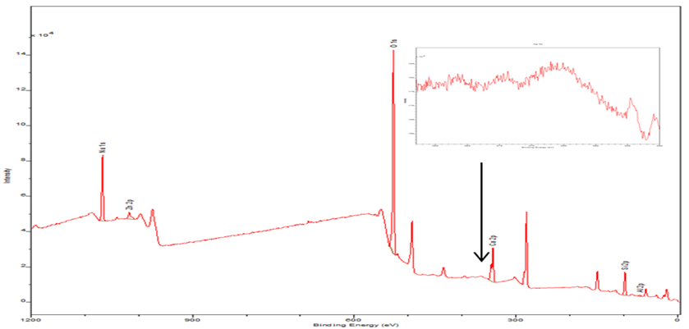
B | 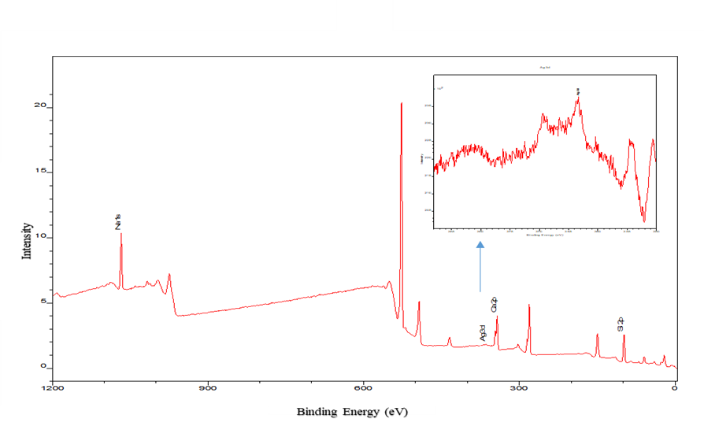
Figure 17. XPS spectra of (A) 45S5 and (B) Ag 0.25 showing the Ag3d spectra for the 0.25Ag in the inside box.

5.1.6 Fourier Transform Infrared Spectroscopy
Figure 18 exhibit the IR spectra and the peaks of the melt-derived glasses with the variation in glass compositions. The band centred at approximately 1460 cm⁻¹ is attributed to carbonate group (CO₃)²⁻ as reported by Veres et al.(2016). This band was identified at all glasses compositions. The peaks at approximately 1000 cm⁻¹ that can be observed in all glasses are attributed to the Si-O-Si stretch group. This peak has slightly changed by increasing the silver content in the glass composition and shifted to a lower wavenumber. This peak is in line with the finding in the literature. In addition, in the spectra, it can be shown that at approximately 910 cm^{-1,} another peak referred to Si-O-NBO as it was reported in the literature (Serra et al., 2002, Aguiar et al., 2009, Veres et al., 2016).
A broad peak at 700 cm⁻¹ observed in all the glasses associated with the Si-O-Si group. Additionally, at the region, 400 cm⁻¹ and 590 cm^{-1,} two peaks can be observed. The first is centred at approximately 570 cm⁻¹ and is related to the P-O group (Veres et al., 2016). The second one is related to the Si-O-Si group at 450 cm⁻¹. Finally, glasses with Ag 2.5 have a low-intensity peak at 1730 cm⁻¹.
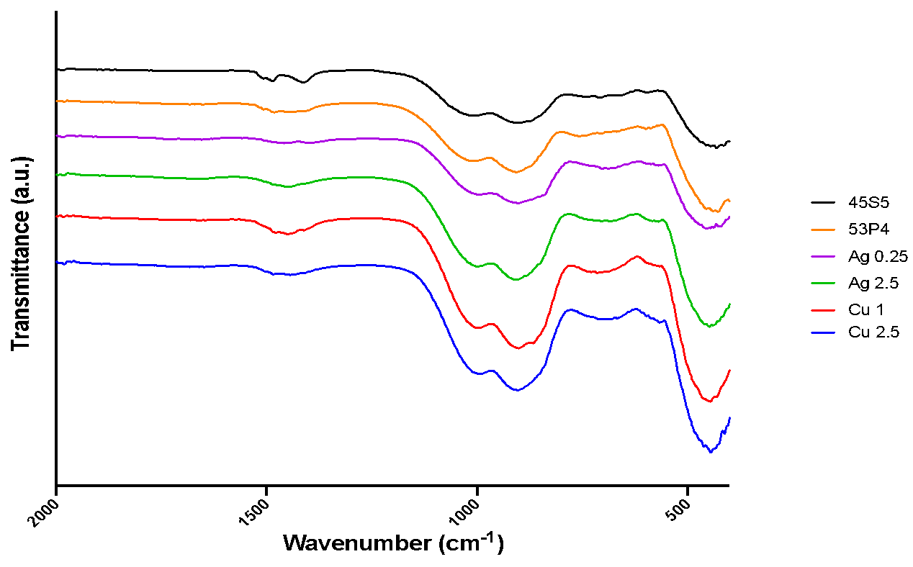
Figure 18. FT-IR spectra of glass with different Ag content and 45S5 as control samples showing the bands and their group.

5.1.7 Scanning Electron Microscope and Energy-Dispersive X-Ray Spectroscopy
SEM and EDX analysis show the presence of Si, Na, Ca, and P in all samples by analyzing three spots to create elemental maps of the surface of a sample. Gold also has been detected due to the coating technique. Silver modified samples show a trace of Ag with the corresponding EDX spectra Figure 19 (C and D). Also, the presence of Cu was confirmed by EDX in the copper-modified BG Figure 19 (E and F). EDX also revealed the presence of Al in all BG 1.2 wt.%.

A | 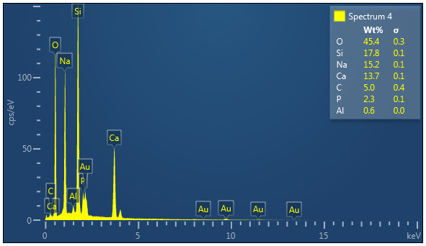
B | 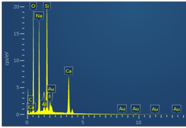
C | 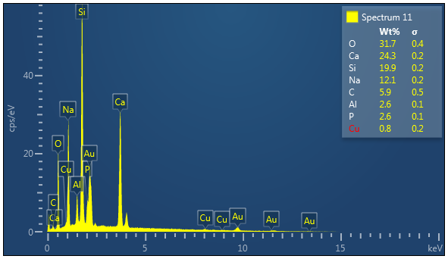
D | 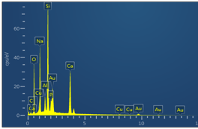
E | 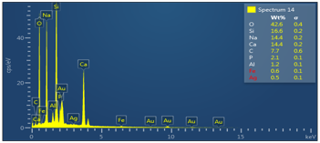  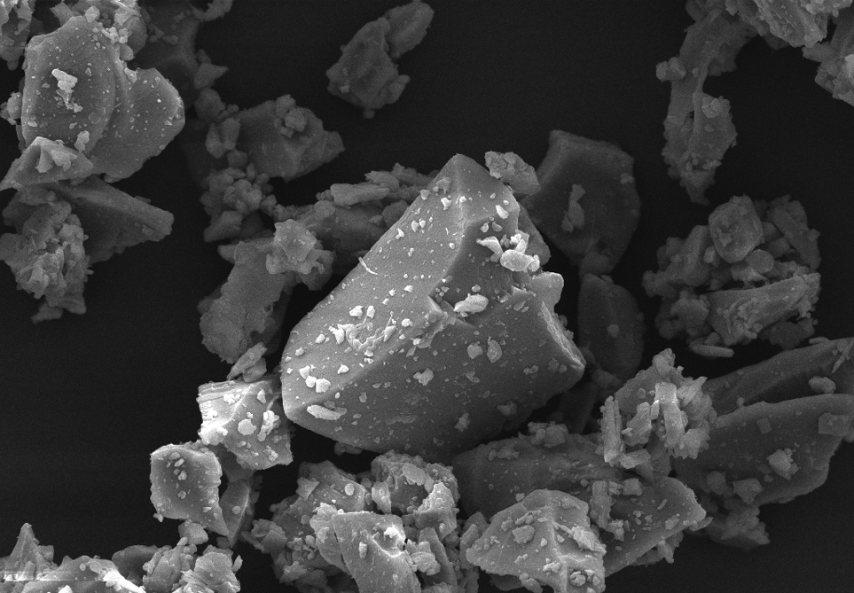
F | 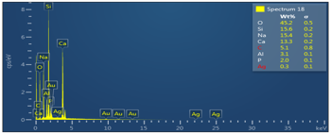
Figure 19. SEM images of silica-based bioactive glass powders made by melt-route and the corresponding EDS for each sample. (A) 45S5, (B) S53P4, (C) Ag0.25, (D) Ag 2.5, (E) Cu 1 and (F) Cu 2.5. Scale bar =50 μm.

5.2. In Vitro Antibacterial Activity and Cytocompatibility

5.2.1. Planktonic Bacteria Model
We then used the planktonic bacteria model to evaluate the antimicrobial activity of synthesised BG using both Gram-negative and Gram-positive strains. Figure 20 shows that Ag- and Cu-modified glasses significantly reduce the colony-forming units (CFU) compared to the control group. They also demonstrate higher bacterial reduction than 45S5 and S53P4 glasses. For S. aureus, after 24 h incubation, the Ag 0.25 and Ag 2.5 glasses displayed statistically significant reductions in CFU number by 2 and 4- log, respectively. Moreover, Cu 1 and Cu 2.5 glasses also show similar behaviours, with log redactions of 2 and 3 compared to the control group. However, 45S5 and S53P4 showed no significant difference in CFU number compared to the control group. For glasses tested against E.coli Gram-negative bacteria, both Ag-modified samples exhibit statistically significant degrees of bacteria viability compared to the control. Ag 2.5 samples have led to 5 log reduction while Ag 0.25 3 log reduction compared to the control group. Also, the Cu-modified glasses Figure 21B caused reductions in CFU number, and the log numbers for Cu 1 and Cu 2.5 were statistically decreased by approximately 4 and 5, respectively. 45S5 and S53P4 did not demonstrate any significant decrease in bacteria viability compared to the control.
A
B
Figure 20. Viable numbers of S. aureus bacteria as colony-forming units (CFU) after exposure to suspensions (25 mg/mL) of glasses for 24 h compared to S. aureus bacteria alone as a control. (A) for silver modified glass and (B) for copper modified glass. Data were analysed by one-way ANOVA and Tukey's multiple comparisons test. Asterisks indicate significant differences (*P < 0.05) Error bars = Standard Deviation (SD).
A
B
Figure 21. Viable numbers of E. coli bacteria in colony-forming units (CFU) after exposure to suspensions (25 mg/mL) of glasses for 24 h compared to E. coli bacteria alone as a control. (A) for silver modified glass and (B) for copper modified glass. Data were analysed by one-way ANOVA and Tukey's multiple comparisons test. Asterisks indicate significant differences (*P < 0.05) Error bars = Standard Deviation (SD).
C | Day 1 | Day 3 | Day 7
45S5 | 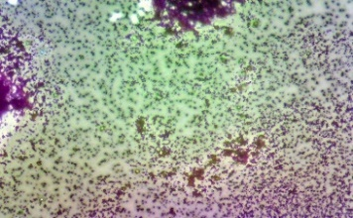 | 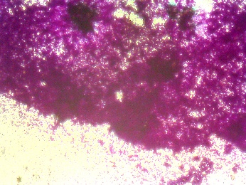 | 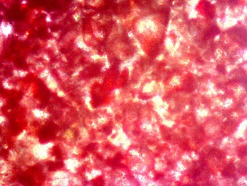
S53P4 | 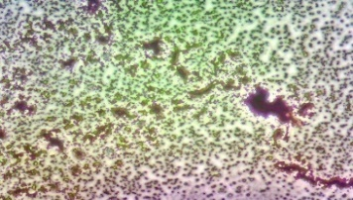 | 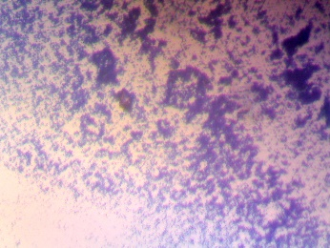 | 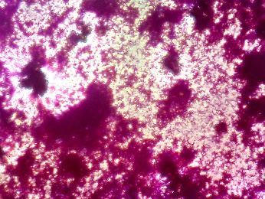
Ag 0.25 | 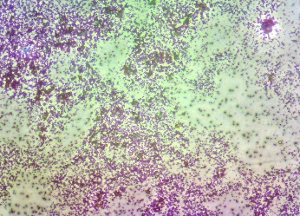 | 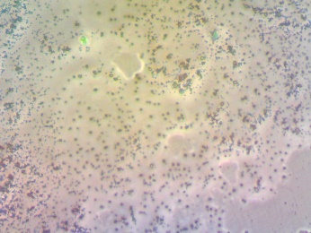 | 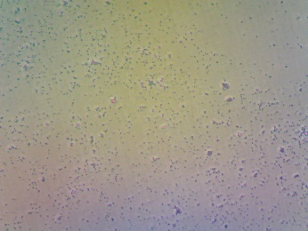
Ag 2.5 | 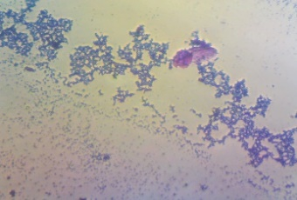 | 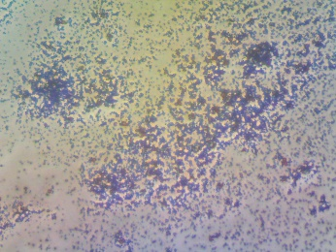 | 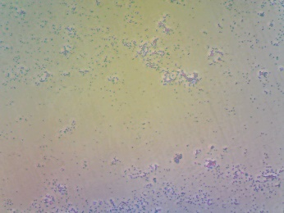
Cu 1 | 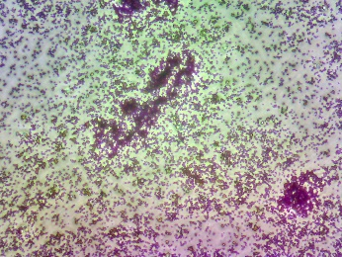 | 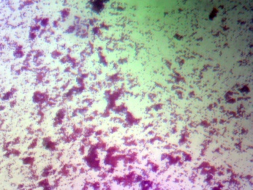 | 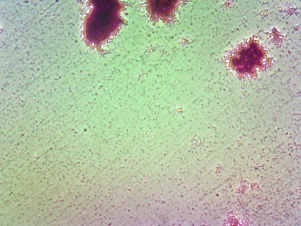
Cu 2.5 |  | 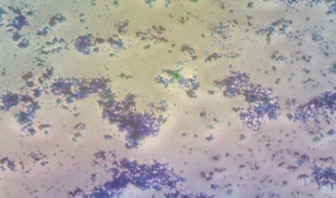 | 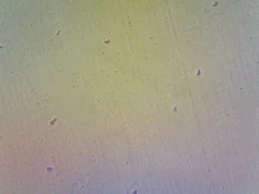
Figure 22. Light microscopy of biofilms. Microscopy images of S. aureus biofilm growth over time. Light microscopy images show the morphology of S. aureus biofilm growth in a 96 well plate stained with crystal violet at one day, three days and seven days. Scale bar =400 μm

5.2.2. Bactria Biofilm Model
The results of the bacteria biofilm model presented in Figure 23 show that all modified glasses reduced S. aureus biofilm formation after 24 h of incubation. A significant reduction of biofilm growth was determined when the cultures were performed in the presence of Ag and Cu modified BG particles, compared to 45S5 and S53P4. Neither 45S5 nor S53P4 significantly reduced biofilm formation compared to the untreated biofilm. The results in Figure 23 evidenced a similar trend
on day three and day seven after the incubation with the Ag and Cu modified glass particles, showing that the biofilm growth suppression was correlated to the presence of both Cu and Ag ions and its increasing availability in the bacterial culture media.
On day three, Ag- and Cu-modified glasses continued to reduce the OD value of the S. aureus biofilm. The highest reduction was observed in the Ag 2.5 samples, where both unmodified glasses have significantly increased biofilm formation. Finally, at day seven, a similar trend was noticed; the metal ion-modified glass continued to demonstrate higher biofilm reduction than 45S5 and S53P4, which did not show any significant degree of S. aureus biofilm formation. By visualising the biofilm morphology after being exposed to BG Figure 22, it was evident that the presence of both Ag and Cu ions prevented the attachment of biofilm and reduced the number of clusters that were explicitly found in unmodified glass samples. Most of S. aureus biofilms treated with Ag and Cu BG were less visible after seven days of incubation; conversely, the biofilm was more noticeable in the presence of unmodified BG.
Figure 23. The quantification of S. aureus biofilm formation was evaluated by crystal violet staining after 1, 3, and 7 days incubation using a concentration of (25 mg/mL) and bacteria only as control. "*" indicates a significant difference in the OD value of S. aureus biofilm between the glass groups and the control (P < 0.05) Error bars = Standard Deviation (SD).

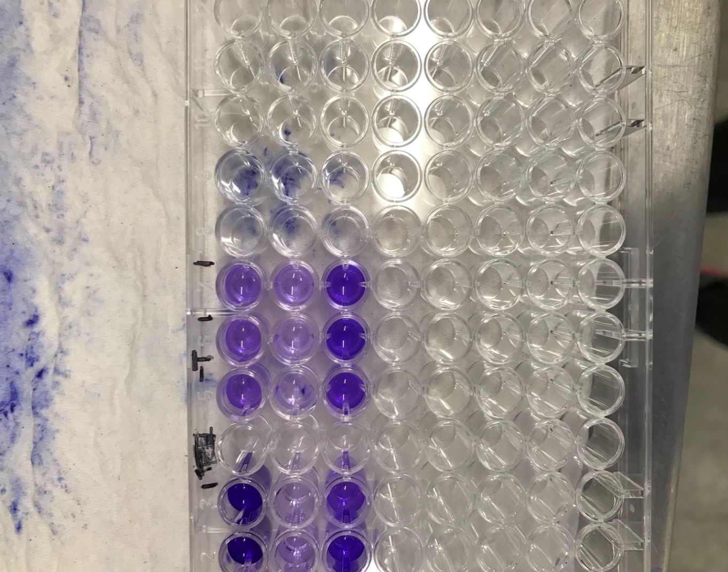

Figure 24. S. aureus strains were incubated in 96-well plates for 1, 3 and 7 days, and their ability to form biofilms was measured by staining with 0.1% crystal violet. After incubation with crystal violet, wells were repeatedly washed with PBS, dried, then dissolved with acetic acid and photographed..

5.2.3. Cell Viability Assay
The cytocompatibility of BG was investigated using L929 fibroblasts cultured with glass samples at a (25 mg/mL) concentration. The BG particles had previously undergone a washing cycle with cell culture media for 24 h, and the cell viability was measured before and after conditioning. All BG samples showed a decrease in cell viability compared to cells cultured in the absence of BG before conditioning, as is shown in Figure 25. In addition, a significantly higher decrease in the cell viability of L929 was observed after exposure to Ag 2.5 compared to the rest of the samples. On the other hand, cell-cultured with 45S5, S53P4 and Ag 0.25 were significantly more viable; however, all BG samples managed to achieve cell viability above 70% before conditioning, which is not considered cytotoxic for materials according to (ISO 10993-5). Interestingly, only Cu 1 and Ag 2.5 samples exhibited a statistically significant difference compared to unmodified BG (45S5 and S53P4).
After conditioning, BG demonstrated similar behaviour to pre-conditioned particles Figure 26. Ag 2.5 BG continued to show significantly lower cell viability than other samples. Also, no statistically significant difference between 45S5, S53P4 and Ag 0.25 samples were observed. Pre-conditioned samples should reduce the effect of the rapid increase in cell media pH and therefore measure the influence of Cu and Ag substitution in the viability of the cells. Figure 27 shows that pre-conditioned 4565, S53P4 and Ag 0.25 BG had no detrimental effect on the cell viability compared to non-conditioned particles. However, Ag 2.5, Cu 1, and Cu 2.5 BG particles seem to be affected by the washing cycle and show a statistically significant difference before and after washing with cell culture media Figure 27. All BG maintained cell viability above 70% after 24 h after pre-conditioning treatment of BG samples.
Figure 25. Cell viability percentage of L929 fibroblast cells obtained according to the cytotoxicity evaluation of bioactive glasses with a concentration of 25 mg/mL unconditioned after 24 hours assessed by cell metabolic activity via Presto Blue® assay. The tissue culture plastic (TCP) seeded with L929 cells was used as a control. The percentage of cell viability was calculated from the fluorescence values obtained in cytotoxicity assay, and values were normalised to the control group. Asterisks indicate significant differences *(p <0.05). Error bars= ± SD; n=3.
Figure 26. Cell viability percentage of L929 fibroblast cells obtained according to the evaluation of cytotoxicity of bioactive glasses with a concentration of 25mg/mL after pre-conditioning after 24 hours assessed by cell metabolic activity via Presto Blue® assay. The tissue culture plastic (TCP) seeded with L929 cells was used as a control. The percentage of cell viability was calculated from the fluorescence values obtained in cytotoxicity assay, and values were normalised to the control group. Asterisks indicate significant differences *(p <0.05). Error bars= ± SD; n=3.

Figure 27. The difference before and after the washing cycle on the cell viability percentage. Asterisks indicate significant differences *(p <0.05). Error bars= ± SD; n=3.
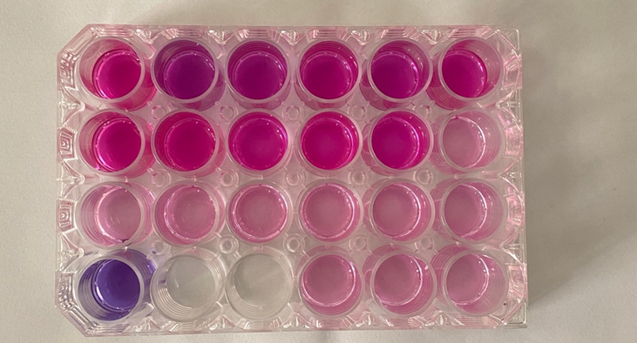
Figure 28. Image of 24 well plates after 24 h incubation of L929 fibroblast cells subsequently being stained with Presto Blue® to evaluate cytotoxicity of bioactive glasses.

5.3. In Vitro Bioactivity of BG Using SBF

5.3.1 Leaching Test and pH Profile
Figure 29 summarises the pH change after BG powder immersion in SBF. The rise in pH was due to the release of cations into solution from glass through the exchange of H⁺. The pH value of SBF was constant at 7.4~7.5 throughout the length of the study. The Ag BG and Cu BG glasses produced a similar pH increase in the first 24 h, with Cu 2.5 and Cu 1 burst to 8.01 and 8.06, respectively. Ag 0.25 and Ag 2.5 surge to7.95 and 7.97 respectively, whereas 45S5 and S53P4 have recorded pH values of 7.84 and 7.97n the first 24 h. After 72 h immersion in SBF, All BG samples reached their maximum pH value and stayed stable at this value throughout the rest of the study. Cu 1 glass caused a slightly higher pH value than Cu 2.5, 8.4 after 72 h. However, it continuously increased after 72 h, peaking at 8.42 after 21 days,
Figure 29. Change of pH value of the SBF solution during the in vitro test

A
B
C
D
Figure 30. Ions release profile of BG determined by inductively coupled plasma (ICP). The concentration of Na (A), Si (B), P (C) and Ca (D) deionised water for 1, 3, 7, 14 and 21 days. n=1.
A
B
Figure 31. ICP measurements of cumulative ions released of (A) for Ag and (B) for Cu ions from modified glasses with a concentration of (25 mg/mL) at 1, 3, 6,9,24, and 48h. n=1.
The influence of the silver and copper substitution for calcium in the glass on its ion release kinetic as it shown in Figure 30. A. The results plotted in part per million (ppm) would indicate that this substitution increases the ion release from the glass. Silica was the main network former of BG except for the small amount of phosphate within the glass composition. Thus, the dissolution of silica mainly reflects the degradation rate of the glass. All glasses followed the same trend with a burst release in the first 24 h, reaching around 70 ppm. The silica release in the 45S5 and Cu 2.5 had the highest release with 68 and 69.3 ppm values. The lowest was recorded for Ag 0.25 at 52 ppm after 24 h. as shown in Figure 30. A, and the silica ion release continues with an upward trend at 48 h. Since all BG had the same composition except that the calcium in Ag and Cu modified glass was partially replaced, it was shown that Ag and Cu had no significant impact on the silica dissolution rate.
The results of Na⁺ release is shown in Figure 30.B. steady and continuous release was detected over 48 h. both 45S5 and Ag 2.5 samples have the highest Na release among the tested samples reaching 222 and 215 ppm respectively at 24 h and S53P4 recording 189 ppm as the lowest. Thus, the Na release of all tested samples gradually increased during the observation period.
Figure 30.C shows the calcium dissolution over 48 h in DW, which show the highest release in DW for 45S5 and S53P4 reached 62 and 59 ppm in the first 6 h. Both Ag-modified glasses have reached 46 for Ag 2.5 and 35 for Ag 0.25, while copper modified glass has recorded 51 and 48 for Cu 2.5 and Cu 1, respectively. After the first 6 h, all BG decreased calcium, more evident in the 45S5 and S53P4. After 24 h, the calcium concentration in BG increased again between 60 and 80 ppm, with the highest increase noted for Cu 2.5. Ag and Cu BG shows a similar release curve for the calcium with a burst increase in the first 6 h followed by a reduction for almost half at 9 h. The maximum calcium concentration for Ag and Cu BG were recorded at 48 h.
Figure 30.D shows the phosphate ion dissolution over 48 h. A reduction in phosphate ion was observed in all samples at 48 h. The phosphorus concentration decreased to 6 ppm at 48 h from 8.3 ppm at 24 for 45S5 samples; similarly, all Ag and Cu modified samples except for Ag 0.25 did not progressively decrease at 48 h.
For BG that contain silver and copper from this study and its dissolution profile shown in Figure 31.A, the concentration of Ag¹⁺ increased rapidly and reached its maximum at 0.91 ppm for Ag 2.5 and 0.42 ppm for Ag 0.25 at 48 h. For both copper BG, the concentration of Cu²⁺ was more than those recorded in Ag BG, with their maximum at 1.15 ppm for Cu 2.5 and 0.42 ppm for Cu 1 Figure 31.B.

5.3.2 X-Ray Diffraction
XRD was used to confirm the nature of the newly generated crystalline phase on the surface of BG Figure 17 to 21. With peaks detected from day 1 to day 21, XRD data agreed with FTIR results. It showed, the most prominent diffraction peak at 2θ = 28.9°, 31.7°, and 45.3° corresponding (210), (211), (203), which they associated with the development of HCA crystals (ICDD 00-009-0432). These peaks tend to sharpen over time in the SBF. It was noticed that the diffraction peak at 25.9° and 31.9° became stronger over time. The two diffraction peaks at 2θ = 45.3° and 48°, respectively, corresponding to (203) and (312), became more visible on day 14. The peak at 25.9° on the XRD traces was found at all BG after SBF; however, it was more intense at Cu 1 and Ag 0.25 samples.
Figure 32 illustrates the spectra for 45S5 BG. It has indicated that the formation of apatite phase start to present at day 1 with a peak at 25.9°corresponding to (002). On day seven, the peaks at 28.9°, 45.3° and 31.7° start to strengthen; however, for S53P4 samples no evidence for apatite phase until day 7, as is shown in Figure 33. Both Cu samples exhibited a similar trend to the parent glass. On day one peak at 28.9° was noticed for Cu 1 samples, which correspond to (210) as shown in Figure 34. However, for Cu 2.5 samples, the first peak associated with the apatite phase started to show on day three as the glass exhibited a small peak at 31.7°, as shown in Figure 35.
Furthermore, Ag 0.25 and Ag 2.5 exhibit the first evidence of apatite formation on the glass surface at day three, as shown in Figure 36 and Figure 37. Also, they show extra peaks associated with (112) reflection at 2θ = 32.2° and the peak at day 21 linked to the development of HCA (ICDD 00-009-0432). However, the Ag 0.25 samples pattern peaks show more intensity than Ag 2.5 samples, as is shown in Figure 36 and Figure 37.

Figure 32. XRD spectra of 45S5 glass powder after 0, 1, 3, 7, 14, and 21 Days immersion in SBF. ●= Hydroxyapatite (ICDD 00-009-0432).
Figure 33. XRD spectra of S53P4 glass powder after 0, 1, 3, 7, 14, and 21 Days immersion in SBF. ●= Hydroxyapatite (ICDD 00-009-0432).

Figure 34. XRD spectra of Cu 1 glass powder after 0, 1, 3, 7, 14, and 21 Days immersion in SBF. ●= Hydroxyapatite (ICDD 00-009-0432).
Figure 35. XRD spectra of Cu 2.5 glass powder after 0, 1, 3, 7, 14, and 21 Days immersion in SBF. ●= Hydroxyapatite (ICDD 00-009-0432).
Figure 36. XRD spectra of Ag 0.25 glass powder after 0, 1, 3, 7, 14, and 21 Days immersion in SBF. ●= Hydroxyapatite (ICDD 00-009-0432).
Figure 37. XRD spectra of Ag 2.5 glass powder after 0, 1, 3, 7, 14, and 21 Days immersion in SBF. ●= Hydroxyapatite (ICDD 00-009-0432).

5.3.3 Fourier Transform Infrared Spectroscopy
Figure 38 to Figure 43 shows the FTIR spectra of the BG samples before and after soaking in SBF for 21 days. For untreated samples, the FTIR spectra of the sample exhibited Si–O–Si stretching and bonds at (1090-1100) cm⁻¹. The band at around (478-441) cm⁻¹ and (800-790) cm⁻¹ corresponds to the vibrational mode of the asymmetric stretch of Si–O–Si, the band at 800 cm⁻¹ corresponds to the symmetric stretch of Si–O.
After one day of SBF exposure, when compared to the FTIR spectrum of the untreated BG, the treated BG changes dramatically. The band at around 900 cm⁻¹ corresponds to the vibrational mode of the asymmetric stretch of Si–O–S disappears after one day of SPF exposure. On the other hand, the P-O stretching band at around 1020 cm−¹ starts to sharpen and shift as the exposure time increases. Moreover, sharping of the band at 470 cm⁻¹ and the stretching of the Si–O–Si bond at 1250 and 1095 cm⁻¹ confirm the presence of silica reach layer, which can be noted in all the tested samples. The formation of the silica reach layer indicates the ability of glass’s dissolution in the SPF due to ions exchange with (H⁺ /H₃O ⁺) from the solution (Kokubo, 1991). The band's appearance at around 560 cm⁻¹ was attributed to PO₄³⁻bending vibration was only found at 45S5 samples after 1 day.
On the other hand, the strong band at around 1030 cm⁻¹ was affected by PO₄³⁻symmetric stretching vibration can be seen in all BG samples after day 1. On day 3, peaks start to intensify around 600 and 560 cm⁻¹ among all tested samples, which correspond to bending vibrations of P-O bonds of HCA and a decrease in the intensity of the peak corresponding to Si-O-Si. By day seven, the duel band at 600 and 560 cm⁻¹ become more devolved in 45S5, Cu 1, Cu 2.5 and Ag 0.25 samples. Also, The broad peak at 1035 cm⁻¹ corresponding to the P-O vibration mode tends to be sharper with time, indicating HCA formation. On day 21, both 600, 560 and 1035 cm⁻¹ dominate the spectra at all tested samples and become more apparent, suggesting the apatite layer's growth on all the BG surface.
(cm⁻¹)
Figure 38. FTIR spectra for 45S5 samples before and after soaking in SBF solution from 1 day to 21 days.
(cm⁻¹)
Figure 39. FTIR spectra for S53P4 samples before and after soaking in SBF solution from 1 day to 21 days.
(cm⁻¹)
Figure 40. FTIR spectra for Cu 1 samples before and after soaking in SBF solution from 1 day to 21 days.
(cm⁻¹)
Figure 41. FTIR spectra for Cu 2.5 samples before and after soaking in SBF solution from 1 day to 21 days.
(cm⁻¹)
Figure 42. FTIR spectra for Ag 0.25 samples before and after soaking in SBF solution from 1 day to 21 days.
(cm⁻¹)
Figure 43. FTIR spectra for Ag 2.5 samples before and after soaking in SBF solution from 1 day to 21 days.

5.3.4. Scanning Electron Microscope
At all-time points, SEM was taken to observe the surface change of the glass due to calcium-phosphate dissolution and precipitation. The SEM data were in good agreement with the FTIR and XRD results, indicating visible evidence of HCA layer deposition on the glass surface. Before immersion in SBF, the glass surfaces were dense, with no evidence of any HCA in the surface of the frit. However, the surface of BG was covered with a layer needle-like structure after day 3 Figure 46, indicating that the HCA crystal nucleus formed on the glass surface (Ylanen et al., 2000). In addition, the chemical reaction occurred faster in metal-modified glasses than in 45S5 and S53P4 glasses. As the test continued, Ag and Cu BG showed an increase in the coverage area of the HCA layer.

A |  | D
B |  | E
C |  | F
Figure 44. SEM of sample surface after immersion in conventional simulated body fluid for 21 days. The coating surfaces are fully covered by apatite layer, as shown from images A (45S5), B (S53P4), C (Cu 1), D (Cu 2.5), E (Ag 0.25) and F (Ag 2.5). Scale bar =5 μm
A |  | D | 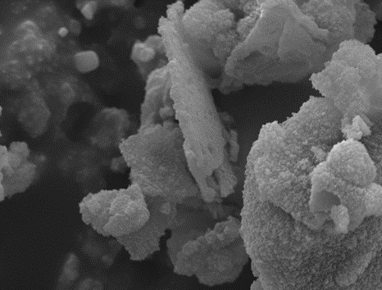
B |  | E | 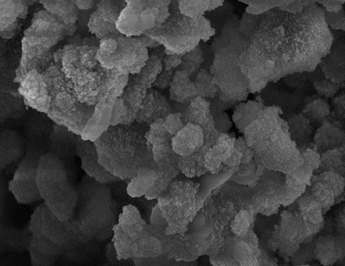
C |  | F | 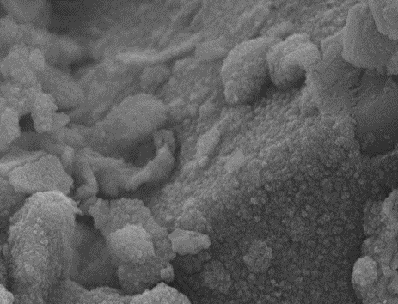
Figure 45. SEM of sample surface after immersion in conventional simulated body fluid for 14 days. The coating surfaces are fully covered by apatite layer, as shown from images A (45S5), B (S53P4), C (Cu 1), D (Cu 2.5), E (Ag 0.25) and F (Ag 2.5). Scale bar =5 μm
A |  | D
B |  | E
C |  | F
Figure 46. SEM of sample surface after immersion in conventional simulated body fluid for seven days. The coating surfaces are fully covered by apatite layer, as shown from images A (45S5), B (S53P4), C (Cu 1), D (Cu 2.5), E (Ag 0.25) and F (Ag 2.5). Scale bar =5 μm
A |  | D
B |  | E
C |  | F
Figure 47. SEM of sample surface after immersion in conventional simulated body fluid for three days. A (45S5), B (S53P4), C (Cu 1), D (Cu 2.5), E (Ag 0.25) and F (Ag 2.5). Scale bar =5 μm
A | 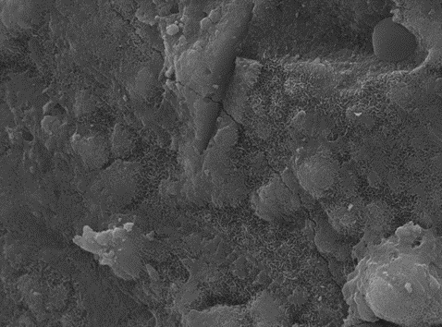 | D
B | 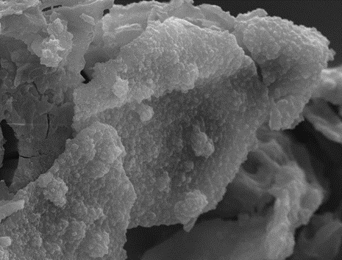 | E
C |  | F | 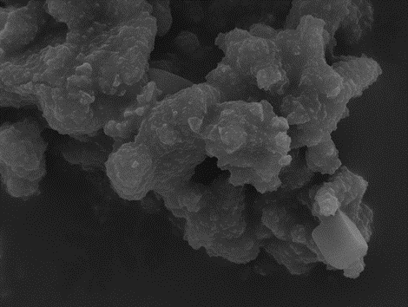
Figure 48. SEM of sample surface after immersion in conventional simulated body fluid for one day. A (45S5), B (S53P4), C (Cu 1), D (Cu 2.5), E (Ag 0.25) and F (Ag 2.5). Scale bar =5 μm

6. Discussion

6.1. Glass Characterisation
Novel bioactive glasses based on the composition of 45S5 where calcium was substituted by silver or copper in molar proportions (0.25 and 2.5% for silver oxide and, 1 and 2.5% for copper oxide) were fabricated by the melt quench route. The melt-quenching route is the most common synthesis method in the glass industry, and glass-based medical devices are therefore manufactured following this method. However, to the best of our knowledge, there has been no attempt to incorporate silver to produce silicate glass by melting route for clinical application, as clearly the major challenge is to prevent the formation of silver metal at high temperature.
Our results showed that a high concentration (< 0.25 Mol. %) Ag could not be incorporated without some decomposition into metallic silver during melting. Microscopic particles of metallic silver can be observed in glass samples where silver is ≤ 0.25 Mol.%. However, most reduced silver was attached to the crucible’s well and did not integrate with the quenched glass. The behaviour of silver oxide in the silicate glass melt did not attract much attention, and the literature is scarce on this subject. However, it has been suggested that silver is introduced to the glass system as a fluxing agent, which creates NBO atoms and causes the silver reduction into Ag˚. Simon et al. found that high content of Ag in the glass matrix tends to precipitate into micrometric size metallic particles, which were not found in samples with lower Ag content (Ag < 3 Mol.%) (Simon et al., 2008). Moreover, because of the silver oxide's low melting point, which causes it to become molten first, the melting points may have an impact on how much silver is incorporated in the melted glass.(Araujo, 1992, Stookey, 1949).
Another explanation is that silver forms a monovalent cation that is not easily substituted by the divalent cations (Ca²⁺). According to Araujo, silver in the molten glass needs enough high field strength ions to achieve a charge balance in the glass system, such as Fe³⁺ or Al³⁺(Araujo, 1992). Nevertheless, Fe³⁺ or Al³⁺ ions are reported to reduce glass bioactivity and have a negative effect on cell viability (El-Fiqi and Kim, 2021, Melchers et al., 2016). Therefore, silver is less stable in a silicate glass system when its concentration is greater than 0.25 Mol.%, although, in phosphate glasses, higher silver concentrations were found to be more easily incorporated into the glass system (Ahmed et al., 2011, Magyari et al., 2014, Araujo and Trotter, 2003). However, it has been reported that introducing Ag to phosphate glass system between 2 and 10 Mol.% yielded unavoidable metallic silver nanoparticles due to the decomposition of silver oxide at around 485 °C, according to (Vulpoi et al., 2012). The formation of metallic silver phases has also been documented for Ag concentrations higher than three Mol.% in sol-gel phospho-silicate glasses heat-treated at 600 °C (Delben et al., 2009).
Moreover, Al₂O₃ found to have an adverse effect on the glass system as the presence of small amount of Al₂O₃ in BG due to the preparation in an alumina crucible. This could affect the amount silver incorporated in the glass due to the Al₂O₃ acting as network former and therefore increasing the network connectivity of the glass (Tulyaganov et al., 2017). The EDX and XRF results demonstrate that Al₂O₃ becomes incorporated into the glass structure during its melting stage in an alumina crucible. According to Goel et al., the amount of Al₂O₃ incorporated from the alumina crucibles throughout the process of making glass were between 1.5 to 2.0 Wt%. (Goel et al., 2007).
Another indication of the ionic state of the dissolved species of silver in the glass is their ability to colour the glass after melting; as Mcmillan mentions in his book that Ag⁺ does not affect the glass colour (McMillan, 1979). Here, higher concentrations of Ag had led to yellow colour while Ag 0.25 samples had yielded colourless glass similar to the parent composition (45S5). Therefore, it seems reasonable that most silver in Ag 0.25 samples was presented as Ag⁺ ions and behave as a glass network modifier in contrast with Ag 2.5 samples. This observation was supported by the compositional analysis using XRF, where the high silver substituted glasses sample Ag 2.5 had lost about 60% of its silver from its design composition. However, Ag 0.25 samples had only lost less than 20% of their theoretical composition Table 9. Furthermore, the XPS confirmed the ionic state of silver in Ag 0.25 samples as the peak corresponding to Ag 3d at a binding energy of 363 eV is assigned to Ag⁺ Figure 17. According to the XPS data, Magyari et al. found that when the amount of metallic silver in phosphate-based glasses increases, so does the glass' silver content. In addition, the authors found that most silver atoms are in the Ag⁺ chemical state at low concentrations (0.3–0.5) Mol.% and in the Ag⁰ chemical state at higher concentrations (0.8–1) Mol.% (Magyari et al., 2014).
Copper is far more stable than silver in a silicate glass system and is introduced as a glass network modifier. Therefore, when the copper oxide is added to the silicate glass system, the copper is mainly presented as a Cu²⁺ ion, and as a consequence, the glass will have a distinctive blue colour, as it showed in Figure 13. Furthermore, the copper BG were more homogenous than silver BG, as XRF data confirmed that copper BG had accommodated all the copper into the glass system, as shown in Table 9 (McMillan, 1979). Moreover, Klysubun et al., suggested that metallic copper should have no significant impact on the glass colour. They investigated a series of glass made with copper and other metal oxides using X-ray absorption near edge structure (XANES). They concluded that Cu²⁺ species significantly contribute to the colouration of the glass (Klysubun et al., 2015). Our results also suggested that copper BG have higher ion release than silver BG, suggesting more copper species availability in the BG system than glass made with silver and delivering sustained and long-term antimicrobial activity Figure 31.
The XRD pattern of all BG in Figure 14 confirmed the amorphous characteristics of these glasses with a broad hump between 26° and 38°. The introduction of Ag and Cu did not affect XRD, and no new diffraction peaks were assigned to either one. In 2014 (Goh et al., 2014) investigated the effect of dopping 1, 5 and 10 Mol.% of Cu and Ag into BG via sol-gel methods. They have found that Ag-doped glasses have demonstrated metallic phase assigned to silver peaks at 5 and 10 Mol.%, wherein Cu-doped glasses have retained their amorphous nature even at high concentrations. They concluded that copper was presented only as Cu⁺² in the glass matrix, while silver was integrated as an ionic and metallic species at 5 and 10 Mol.% (Goh et al., 2014). Therefore introducing Ag or Cu below 5 Mol.% will most likely not be detectable by XRD, as our results confirmed.
The thermal analysis of the BG samples showed a decrease in glass transition temperature (Tg) with the increase in silver and copper oxides content, as it showed in Table 10. This behaviour could be attributed to the chemical properties of silver and copper compared to calcium. For example, electronegativity, which is the ability of an atom in a molecule to attract bonding electrons, is believed to influence the glass Tg and Tc. The electronegativity of calcium is 1 Pauling unit. In comparison, silver and copper are 1.93 and 1.90 Pauling unit; therefore, both Ag₂O and CuO bonds are more covalent than CaO bonds. Hence, the calcium substitution with silver and copper would decrease the glass Tg (El-Kady et al., 2012). In addition, Wers et al. observed a significant decrease in Tg due to increased internal strain relaxation of Cu modified glasses as relaxation required less energy and, therefore, lower Tg value (Wers et al., 2014).
We also observed an increase in the workability window, which is the temperature difference between Tc and Tg, with the increase of silver and copper content in the glass. 45S5 and S53P4 BG are both known to have high calcium and low silica content. Consequently, the workability window is too small, making those glasses harder to process and sinter without crystallization. Jones, in 2013 suggested a balanced approach to maximize the workability window without compromising BG bioactivity. One way is to introduce a variety of glass network modifiers, e.g. (SrO, MgO and K₂O) and keep the network connectivity consistent around 2 (Brink, 1997, Jones, 2013). Our results suggest a remarkable benefit for future application of silver and copper modified BG to achieve scaffolds with amorphous nature but strength suitable for handling in surgical applications.
FT-IR spectra in Figure 18 showed no significant differences between the parent composition and Ag and Cu modified BG. However, the slight change in the stretching bonds of Si-O-Si to lower wavenumber could be linked to the silver content in the glass system (Catauro et al., 2015). Two primary bonds observed on all glass at approximately 1020-1050 cm⁻¹ related to Si-O-1NBO (Q³) and 920-960 cm⁻¹ related to Si-O-2NBO (Q²). Hence, it is likely that the glass modification did not change the Q structure in the silicate system. Similarly, D’Onofrio et al. reported that the addition of strontium did not cause any change in the glass structure or compromise the network connectivity.; nevertheless, they observed that the P-O band had shifted to lower frequency caused by the relatively larger Sr²⁺ replacing Ca²⁺ (D'Onofrio et al., 2016). When replacing Ca with a larger cation, it might increase the glass's average spacing and change its structure; however, we found that both Ag and Cu, which are smaller than Ca, did not cause a similar effect.

6.2. In Vitro Antibacterial Activity and Cytocompatibility
Bone infection is one of the most severe and devastating issues linked to bone repair and surgery (Bohner, 2010). S. aureus is responsible for more than 75% of osteomyelitis cases, and more than half of these are caused by methicillin-resistant S. aureus (MRSA) strains (Kaplan, 2014). Our results have shown efficient microbial inhibitory activity against tested organisms for Ag- and Cu-modified BG. In contrast, the 45S5 and S53P4 compositions did not show any statistically significant decrease, as is shown in Figure 20 and Figure 21. There are ongoing debates regarding the antibacterial mechanisms of metal ions (Sondi and Salopek-Sondi, 2004, Kim et al., 2018). One theory states that the direct contact between metal ions and bacteria cell wells causes cytoplasm ruptures, leading to cell death. This theory is one of the most proposed antibacterial mechanisms. Furthermore, Ag ions may produce reactive oxygen species (ROS) by interacting with specific respiratory enzyme systems in the bacterial cell, which could cause cell damage, as discussed in (section 2.8) (Wang et al., 2016, Esteban-Tejeda et al., 2009, Gupta et al., 2018).
At the outset, the concentrations chosen for the antibacterial study were 25 mg/ml, which was based on existing literature, that reported that BAGs at these concentrations exhibited antibacterial efficacy against a range of pathogens (Di Nunzio et al., 2004, Ahmed et al., 2006, Ahmed et al., 2011, Hu et al., 2009). Therefore, Ag and Cu BG samples had high levels of antibacterial activity, as indicated by the significant log reduction in CFU after 24 h incubation. Furthermore, Ag-modified BG were more potent than Cu-modified BG in general, as Ag could be presented in the glass in different species (Ag˚ and Ag⁺¹) as discussed above (Meincke et al., 2017); therefore, it might have different antibacterial mechanisms. Conversely, unmodified BG showed no statistically significant difference in CFU number.
We also observed that Ag and Cu modified BG showed species-specific efficacy. Ag modified BG were more effective against Gram-positive bacteria, while Cu- BG were more effective against planktonic Gram-negative species. Copper ions are well known to have a robust oxidative behaviour which leads to membrane damage in Gram-negative bacteria (Vincent et al., 2018). Similarly, other groups have reported that Cu mesoporous glass was more effective against P. aeruginosa than S. aureus and has shown a significant increase in proangiogenic effect (Paterson et al., 2020). Goh et al. reported that incorporating Cu (above 10 Mol.%) and Ag (above 5 Mol.%) into sol-gel BG is associated with bactericidal activity. They also suggested that Cu was better at long term release than Ag, which, instead of rising in the solution, appears to be reduced (Goh et al., 2014). However, a study reported by Wilkinson et al. found that Ag-doped BG were more potent against P. aeruginosa and S. aureus than BG or Ag alone. They also reported that the release of Ag might improve antibiotic treatment by penetrating bacterial cell membranes, therefore making them more susceptible to treatment (Wilkinson et al., 2018). Conversely, Zheng et al. found no impact for Ag mesoporous bioactive glass against Gram-negative P. aeruginosa bacteria. They suggest that Ag⁺ ions and the generated ROS failed to penetrate the bacteria cell wall (Zheng et al., 2019).
In general, BG are not resistant to colonisation by bacteria, leading to microorganism growth on their surfaces (Gubler et al., 2008). However, when using a high sample concentration of >100 mg/mL, the increase in pH due to the ionic release of glass modifiers (e.g., Na⁺) is thought to be the leading cause of the antimicrobial effects of the BG (Gupta et al., 2018). S53P4 glass has been reported to be more potent to the microorganism than 45S5 glass and has been used in various clinical settings (Bortolin et al., 2018). A study by Drago et al. demonstrated the antibacterial properties of S53P4 using high concentrations (400–800 mg/mL). They attributed the bactericidal effect to the ions released, which caused an increase in pH and osmotic pressure, thus an imperfect bacterial growth environment (Drago et al., 2015). However, at lower concentrations (10 mg/mL), Begum et al. did not find such bactericidal effects on 45S5 BG when tested against E. coli and S. aureus (Begum et al., 2016). Furthermore, Hu et al. observed an antibacterial effect of 45S5 BG only at a concentration above (50 mg/mL). They also showed that 45S5 particles did rupture the bacteria cellular structure due to the needle-like debris on its surface, which suggest another layer of defence against bacteria adhesion (Hu et al., 2009). Our results suggested that Ag and Cu addition to the BG have considerably improved their antimicrobial properties even at a low concentration.
Although silver and copper have broad-spectrum antimicrobial activities against a wide range of bacterial species, there has been relatively little research on the anti-biofilm efficacy of BG compositions. However, biofilm formation is one of the bacteria’s robust mechanisms that allow it to evade immune systems and resist antibiotic treatment (Al-Maiyah et al., 2007). Moreover, introducing foreign materials to a biological system creates an ideal environment for bacterial colonisation and growth (Masters et al., 2019). however, the formation of the Si-rich layer on the surface of BG upon exposure to an aqueous environment negatively charged the surface. Thus, it decreases the adhesion to negatively charged microorganisms and prevents bacteria biofilm from remaining adhered to the surface (Stoor et al., 1999, Khatoon et al., 2018).
Our results show that Ag- and Cu-modified BG were strongly effective in inhibiting S. aureus biofilm formation. In contrast, both 45S5 and S53P4 display no inhibitory effect after seven days of incubation with S. aureus. Similarly, Wilkinson et al. reported that binary sol-gel derived BG was ineffective in preventing the formation of co-culture biofilms of S. aureus and P. aeruginosa. However, samples with 2 Mol.%, silver exhibited a significant reduction in bacterial biofilm after 24 h of incubation. (Wilkinson et al., 2018). Also, Paterson et al. found that adding Cu into sol-gel derived BG has significantly reduced biofilm biomass and biofilm metabolic activity compared to Cu free BG (Paterson et al., 2020).
Bearing in mind the widespread frequent presence of chronic and recurrent infections and the harmful effect of S. aureus biofilms in various clinical settings, previous studies did not follow biofilm development beyond 24 h. In contrast, we have observed that biofilm has increased by more than two-fold as incubation time increases up to day 7 in unmodified BG Figure 23, which indicates that BG surface is a favourable environment for bacterial biofilm, as suggested earlier. Also, by the morphological observation, biofilm was more noticeable in 45S5 and S53P4 samples than Ag and Cu BG Figure 22. Thus, the decrease in the biofilm formation may indicate that the continuous ion release of Cu and Ag beyond the initial exposure to the aqueous environment works to deactivate the production of exopolysaccharides, essential for bacterial biofilm formation (Alt et al., 2004).
The evidence we provided in this work of silver and copper addition to BG composition offers the first wall of defence against bacterial and biofilm formation associated with orthopaedic and dentistry surgeries. It also may provide an alternative to antibiotics-based therapy and therefore reduce the risk of antibiotic resistance.
The cytotoxicity effect of the produced BG on the viability of L929 fibroblast cells was investigated. The general assumption is that biomaterials containing Ag are associated with cytotoxic effects on mammalian cells (Zheng et al., 2019). Also, an excess of Cu has shown some level of cytotoxicity, as they tend to generate more free radical species (Gaetke and Chow, 2003). These results show that Ag and Cu BG have no adverse effects on fibroblast cells compared to unmodified BG. In agreement these findings, Stähli et al. studied CuO incorporation into BG scaffolds and found no effect caused by 2.5% Cu on endothelial cells. At the same time, they reported an increase in cell angiogenesis activity with the increase of Cu ionic release rate (Stahli et al., 2015). Conversely, Milkovic et al. reported a decrease in the cell viability for BG doped with 1 and 2.5 Mol% Cu. They suggested that the fast and rabid release of Cu ions have generated excess reactive oxygen species that led to cell damage (Milkovic et al., 2014).
Generally, with the inevitable increase in pH due to glass dissolution, all BG show similar levels of cytotoxicity; thus, here a preconditioning procedure was applied to compare the cell viability before and after conditioning with cell culture media. The cell viability was higher when BG were preconditioned for 24 h, Figure 26. Hohenbild et al. stated that preconditioning of BG before cell culture should be considered to limit the pH provoked cytotoxicity and help understand the actual BG/cell interface. They found out that after 24 h, the cell viability significantly improved; however, this effect was concentrations depending and different concentrations, or different BG particle sizes may require a longer or shorter preconditioning period (Hohenbild et al., 2020). Though all BG demonstrate better cytocompatibility after preconditioning, it was only statistically significant with 45S5, S53P4 and Ag 0.25 samples Figure 27. This might be due to ion release kinetics of modified glass which we will cover next. Nevertheless, all BG maintained cell viability above 70% after 24 h after pre-conditioning treatment of BG samples which is not considered cytotoxic according to (ISO 10993-5).

6.2. In vitro bioactivity of BG using SBF
The slight change in BG composition might significantly influence the dissolution ability and the formation of an apatite layer on its surface. Generally, the increase in pH due to the ion dissolution of glass modifiers (e.g., Na⁺ and Ca²⁺) is thought to be the leading cause of the antimicrobial effects of the BG (Gupta et al., 2018). Figure 29 show that all BG demonstrated a comparable increase of pH during the first 24 h. Xie et al. found that BG were less effective to exhibit antibacterial properties in vivo. The ability of 45S5 particulate to raise the pH leave in the implantation site was less effective than the buffer system in the body (Xie et al., 2009). Also, Begum et al. neutralised the pH at 7.3 before testing the antibacterial activity of 45S5 in vitro and found no growth inhibition for either tested microorganisms (Begum et al., 2016). This was in accordance with our results of the planktonic bacteria model mentioned above, as both unmodified BG did not illustrate similar antibacterial effects to Ag and Cu BG.
ICP results for BG ionic release confirms the relationship between the pH increase and the dissolution profile of glass modifiers. Interestingly, calcium release dropped at around 9 h, which might be associated with precipitation of the Ca-P layer. Moreover, the precipitation Ca-P layer is reported to favour a high pH level, which has been the case due to the instant burst of Na⁺ in the solution (Stahli et al., 2015). Also, after 24 h, the pH stability was combined with the stability in the Ca, Na, and Si ions released in the solution; conversely, phosphate ion concentration has decreased with the increase in immersion time. These characteristics are in line with the formation of an apatite layer on the surface of the glass powder (Arstila et al., 2008).
On the other hand, the ion release profile of Ag and Cu ions increased steadily with the BG dissolution time. Silver's adverse effect on mammalian cells is well documented (Lohbauer et al., 2005, Akter et al., 2018). However, silver induced cytotoxicity depends on many variables, e.g. (cell type and contact time). Therefore, the minimum concentration is needed to inhibit bacterial infection and does not induce cytotoxicity in healthy cells is still controversial. We observed that after 48 h, the highest cumulative concentration was for Ag 2.5 at 0.91 ppm, which is less than the concentration reported elsewhere (Goh et al., 2014, Zheng et al., 2019). In addition to the previous findings, it can be noticed that the Ag modified BG ability and the rate to form an apatite layer were much slower than the other samples.
Furthermore, the peaks sharpness in the XRD pattern were less prominent in Figure 36 and Figure 37. That was consistent with the FTIR spectra in which the intensity of P-O bands between 600 and 560 cm⁻¹ was lower than the other BG. Thus, the low bioactivity of Ag modified BG might be explained by the initial design as Ag is incorporated at the expense of Ca, knowing that Ag did not incorporate fully into the glass system Table 9. Consequently, Ag modified BG have lower Ca content, which is known to initiate the ionic exchange with the H⁺ from the solution. Moreover, the role of Ag in the glass system is as a glass network modifier; thus, Ag BG will have fewer non-bridging oxygen than the other samples. Serra et al. found a strong correlation between alkali and alkali-earth oxide content in the silicate glasses and its bioactivity. They indicated that fewer number of non-bridging oxygen in the glass system leads to a decrease in glass bioactivity (Serra et al., 2002). Conversely, Newby et al. reported that incorporating Ag by ion-exchange did not impair glass bioactivity after immersion in SBF for 15 days compared to 45S5 samples (Newby et al., 2011). Considering that Al is incorporated within the glass system in the form of AlO4 tetrahedra, which might inhibit HA formation in the glass surface by decreasing the number of silanol groups released from the glass surface (Tulyaganov et al., 2017). Moreover, BG prepared in a Pt crucible showed HA formation after 12 h; however, with the same composition prepared in alumina crucible and zirconia crucibles the formation of HA layer was suppressed. They suggested that the small amount of Al has reduced the HA mineralization (Ohtsuki et al., 2009). thus, using an alumina crucible for BG preparation may limit the formation of the HA layer and cause delays in the appearance of the characteristic apatite behaviour.
Copper is an essential metal in the body, and numerous studies illustrated its advantages to promote angiogenesis and other cell activities, as mentioned in Chapter two. Copper ions release increased steadily with the BG dissolution time while Ca release decreased significantly in Cu modified glasses. The reduced concentration of Ca ions might indicate an early sign of apatite formation through the precipitation of the Ca-P layer. It has been reported that Cu incorporation in the glass system at the expense of Ca enhanced the dissolution due to the strength of the Cu-O covalent bond compared to the Ca-O bond (Kapoor et al., 2019). Moreover, the characteristic apatite peaks shown in the Cu modified XRD pattern, particularly at 2θ = 28.9° and 31.7°corresponding (210) and (211), were more intense and prominent than the other samples. In addition, the division of the P-O bands between 600 and 560 cm⁻¹ into two peaks was faster in Cu samples than in Ag samples, suggesting a faster formation rate of an apatite phase.
Conversely, Bejarano et al. found differences in the newly formed crystal apatite morphology of Cu doped glass with the undoped glass, indicating possible incorporation of Cu into the apatite layer. The incorporation of Cu led to the slower formation of the apatite layer, as was observed by XRD and FTIR. It is worth mentioning that Bejarano et al. used a higher Mol% of Cu than this present work; however, at 1 Mol% of Cu, they found no significant difference in the rate of the apatite formation (Bejarano et al., 2015).
The characteristic apatite diffraction peaks are present at 2θ = 25.9°,28.9°, 31.7°, and 45.3° corresponding (002), (210), (211),(203), were seen in all BG. However, it is crucial to highlight that in immersion tests with powder samples, the depth of the apatite layer is expected to be at a minimal depth which makes it challenging to analyse by XRD. Thus, complementing XRD with FTIR and SEM has helped gain more insight into the apatite phases.
By examining the morphology of all BG used in this study, we found no significant difference between tested samples after exposure to SBF. The apatite deposited layer growing in the BG surface was quite dense and homogeneous after the three days of exposure to SBF, as shown in the SEM images Figure 47. With the limitation of SBF, the result of XRD, FTIR, ICP, and SEM showed evidence of apatite formation during 21 days. All BG glasses show the same dissolution pattern; however, Cu modified glass displays apatite deposition earlier than the other.

7. Conclusion
Although BG have been widely used in clinical settings, there has been comparatively little research into the development of silver and copper by the melt-quench route. In this work are presented some of the challenges in bone repair and the huge opportunities to tackle these issues by modifying and enhancing the antimicrobial activity of bioactive glasses. As stated in Chapter 3, this project aimed first to design, fabricate, and characterize a range of modified bioactive glasses and then investigate the effects of these substitutions on antimicrobial activity, cytocompatibility and bioactivity. The findings of this study could have a wide range of implications. The conclusions are as follows:
Incorporating silver into the silicate glass system was challenging because of the tendency of the Ag in the glass to reduce to silver metal and low solubility in the molten mix. As a result, glasses with Ag content above 0.5 Mol% was not suitable for fabrication via the melt-quench route and produced an inhomogeneous frit. However, the results of XRD, XRF, DTA, FTIR, SEM-EDS, and XPS showed that it was possible to fabricate glasses with Ag₂O in the range between 0.1 to 0.5 Mol%. Concerning copper, the results of XRD, XRF, FT-IR and SEM-EDS suggested that it had been successfully incorporated into the bioactive glass system with minimal alteration to the structure. Furthermore, the glass was blue and was more homogeneous than Ag modified glasses, with no evidence of metallic deposit due to reduction into Cu°. Therefore, copper-containing glasses appear to be more suitable for the melt-quench route and can be substituted at a high concentration. In addition, copper and silver have improved the BG thermal stability and increased the working window between Tg ang Tc, crucial for thermally treating the glass for different applications such as metal coating and scaffold manufacture.
Data presented here strongly suggest that silver and copper incorporation into the glass system has contributed to a broad-spectrum antibacterial effect against Gram-positive and Gram-negative bacteria. Species-specific efficacy was observed as Ag demonstrated the most significant antimicrobial efficacy against S. aureus and Cu against E. coli; thus, the synergistic combinations of silver/copper have the potential to be used in a range of antimicrobial applications in the future. However, in contrast to the literature, 45S5 and S53P4 did not show any antibacterial activities at 25 mg/ml concentration, which indicated that these glasses may only possess antibacterial properties at high concentrations due to higher release of cations and, therefore, higher pH value. Additionally, Ag and Cu modified BG were able to inhibit the formation of clinically relevant bacteria biofilm at low concentrations due to the sustained release of metal ions; thus, it offers promising opportunities to prevent implant-related bone infections. Based on the fibroblast cells viability assay, we found that Ag 2.5 samples exhibited the most significant cytotoxicity effect; however, all BG maintained cell viability above 70% in vitro.
The current work suggested that Cu addition has improved BG surface reactivity and potentially bioactivity in terms of the rate of HCA formation. In contrast, Ag addition at high content has slowed the rate of HCA formation on the glass surface after immersion in SBF. Thus, this research offers excellent potential to help develop new multifunctional biomaterials with better outcomes for patients and clinicians. The next chapter describes the additional work required for future investigations to bring forward this work's promising results.

8. Future Work
Building on progress reported here, and for future development, several features of this project should be examined:
- For both silver and copper BG, one promising approach to increase the availabilities of metal ions for release is to selectively crystallize the materials to determine if it is possible to produce a residual glass phase that is both more soluble and has a higher bioavailability of metal ion. This would be a very novel approach to the challenge of producing an antimicrobial bioactive glass (or, in this case, a glass-ceramic). Heat treatments based on the thermal analysis data will be applied, and the effects on metal ion release will be investigated.
- Further characterisation of the BG produced using 29Si solid-state nuclear magnetic resonance (NMR) and got a more detailed insight into its connectivity and distribution of Q_{n} species after introducing silver and copper.
- In order to ensure the maximize the benefits of these materials, optimal silver concentrations should be evaluated in vivo. In addition, the silver modified BG robust antibacterial activity showed that a minimal amount of silver addition might be used to limit potential mammalian cytotoxicity while preserving antibacterial characteristics.
- In vitro cell studies using the newly developed BG compositions are also needed to evaluate the effect of silver and copper on osteogenic differentiation, assess the angiogenic response and matrix formation behaviour.
- Other exciting designs to consider could be the development of multifunctional BG by mixing both Ag and Cu, as this will help trigger different bacterial species and, at the same time, promote angiogenesis.
- As the in vitro cytocompatibility of BG has been shown, acceptable levels of cell viability next step will be testing the BG compositions in vivo in an animal model.

Bibliography
AGUIAR, H., SERRA, J., GONZALEZ, P. & LEON, B. 2009. Structural study of sol-gel silicate glasses by IR and Raman spectroscopies. Journal of Non-Crystalline Solids, 355, 475-480.
AHEARN, D. G., MAY, L. L. & GABRIEL, M. M. 1995. ADHERENCE OF ORGANISMS TO SILVER-COATED SURFACES. Journal of Industrial Microbiology, 15, 372-376.
AHMED, A. A., ALI, A. A., MAHMOUD, D. A. R. & EL-FIQI, A. M. 2011. Preparation and characterization of antibacterial P2O5-CaO-Na2O-Ag2O glasses. Journal of Biomedical Materials Research Part A, 98A, 132-142.
AHMED, I., READY, D., WILSON, M. & KNOWLES, J. C. 2006. Antimicrobial effect of silver-doped phosphate-based glasses. Journal of Biomedical Materials Research Part A, 79A, 618-626.
AKHAVAN, O., ABDOLAHAD, M., ABDI, Y. & MOHAJERZADEH, S. 2011. Silver nanoparticles within vertically aligned multi-wall carbon nanotubes with open tips for antibacterial purposes. Journal of Materials Chemistry, 21, 387-393.
AKTER, M., SIKDER, M. T., RAHMAN, M. M., ULLAH, A., HOSSAIN, K. F. B., BANIK, S., HOSOKAWA, T., SAITO, T. & KURASAKI, M. 2018. A systematic review on silver nanoparticles-induced cytotoxicity: Physicochemical properties and perspectives. J Adv Res, 9, 1-16.
AL-MAIYAH, M., HEMMADY, M. V., SHOAIB, A. & MORGAN-JONES, R. L. 2007. Recurrence of chronic osteomyelitis in a regenerated fibula after 65 years. Orthopedics, 30, 403-404.
ALBERTS, B. 2008. Molecular biology of the cell, New York, Garland Science.
ALT, V., BECHERT, T., STEINRUCKE, P., WAGENER, M., SEIDEL, P., DINGELDEIN, E., DOMANN, E. & SCHNETTLER, R. 2004. An in vitro assessment of the antibacterial properties and cytotoxicity of nanoparticulate silver bone cement. Biomaterials, 25, 4383-4391.
ANAGNOSTAKOS, K., WILMES, P., SCHMITT, E. & KELM, J. 2009. Elution of gentamicin and vancomycin from polymethylmethacrylate beads and hip spacers in vivo. Acta Orthopaedica, 80, 193-197.
ANDERSSON, O. H. & KARLSSON, K. H. 1991. ON THE BIOACTIVITY OF SILICATE GLASS. Journal of Non-Crystalline Solids, 129, 145-151.
ANDRADES, P., MILITSAKH, O., HANASONO, M. M., RIEGER, J. & ROSENTHAL, E. L. 2011. Current strategies in reconstruction of maxillectomy defects. Arch Otolaryngol Head Neck Surg, 137, 806-12.
ARAUJO, R. 1992. COLORLESS GLASSES CONTAINING ION-EXCHANGED SILVER. Applied Optics, 31, 5221-5224.
ARAUJO, R. J. & TROTTER, D. 2003. High silver borosilicates. Physics and Chemistry of Glasses, 44, 100-102.
ARAVINDAN, S., RAJENDRAN, V. & RAJENDRAN, N. 2012. Influence of Ag2O on crystallisation and structural modifications of phosphate glasses. Phase Transitions, 85, 630-649.
ARCOS, D., GREENSPAN, D. C. & VALLET-REGÍ, M. 2003. A new quantitative method to evaluate the in vitro bioactivity of melt and sol-gel-derived silicate glasses. J Biomed Mater Res A, 65, 344-51.
ARSTILA, H., HUPA, L., KARLSSON, K. H. & HUPA, M. 2008. Influence of heat treatment on crystallization of bioactive glasses. Journal of Non-Crystalline Solids, 354, 722-728.
BAIA, L., MURESAN, D., BAIA, M., POPP, J. & SIMON, S. 2007. Structural properties of silver nanoclusters-phosphate glass composites. Vibrational Spectroscopy, 43, 313-318.
BALAMURUGAN, A., SOCKALINGUM, G., MICHEL, J., FAURE, J., BANCHET, V., WORTHAM, L., BOUTHORS, S., LAURENT-MAQUIN, D. & BALOSSIER, G. 2006. Synthesis and characterisation of sol gel derived bioactive glass for biomedical applications. Materials Letters, 60, 3752-3757.
BARRALET, J., GBURECK, U., HABIBOVIC, P., VORNDRAN, E., GERARD, C. & DOILLON, C. J. 2009. Angiogenesis in Calcium Phosphate Scaffolds by Inorganic Copper Ion Release. Tissue Engineering Part A, 15, 1601-1609.
BEGUM, S., JOHNSON, W. E., WORTHINGTON, T. & MARTIN, R. A. 2016. The influence of pH and fluid dynamics on the antibacterial efficacy of 45S5 Bioglass. Biomedical Materials, 11.
BEJARANO, J., CAVIEDES, P. & PALZA, H. 2015. Sol-gel synthesis and in vitro bioactivity of copper and zinc-doped silicate bioactive glasses and glass-ceramics. Biomedical Materials, 10.
BELLANTONE, M., COLEMAN, N. J. & HENCH, L. L. 2000. Bacteriostatic action of a novel four-component bioactive glass. Journal of Biomedical Materials Research, 51, 484-490.
BELLANTONE, M., WILLIAMS, H. D. & HENCH, L. L. 2002. Broad-spectrum bactericidal activity of Ag2O-doped bioactive glass. Antimicrobial Agents and Chemotherapy, 46, 1940-1945.
BHAKTA, S., FAIRA, P. E., SALATA, L. A., DE OLIVEIRA NETO, P. J., MILLER, C. A., VAN NOORT, R., REANEY, I. M., BROOK, I. M. & HATTON, P. V. 2012. Determination of relative in vivo osteoconductivity of modified potassium fluorrichterite glass-ceramics compared with 45S5 bioglass. Journal of Materials Science-Materials in Medicine, 23, 2521-2529.
BOHNER, M. 2010. Resorbable biomaterials as bone graft substitutes. Materials Today, 13, 24-30.
BONFIELD, W., GRYNPAS, M. D., TULLY, A. E., BOWMAN, J. & ABRAM, J. 1981. Hydroxyapatite reinforced polyethylene--a mechanically compatible implant material for bone replacement. Biomaterials, 2, 185-6.
BORTOLIN, M., ROMANO, C. L., BIDOSSI, A., DE VECCHI, E., MATTINA, R. & DRAGO, L. 2018. BAG-S53P4 as bone graft extender and antimicrobial activity against gentamicin- and vancomycin-resistant bacteria. Future Microbiology, 13, 525-533.
BRAUER, D. S. 2015. Bioactive Glasses-Structure and Properties. Angewandte Chemie-International Edition, 54, 4160-4181.
BRINK, M. 1997. The influence of alkali and alkaline earths on the working range for bioactive glasses. Journal of Biomedical Materials Research, 36, 109-117.
CAO, W. P. & HENCH, L. L. 1996. Bioactive materials. Ceramics International, 22, 493-507.
CARTA, D., JONES, J. R., LIN, S., POOLOGASUNDARAMPILLAI, G., NEWPORT, R. J. & PICKUP, D. M. 2017. Neutron diffraction study of antibacterial bioactive calcium silicate sol-gel glasses containing silver. International Journal of Applied Glass Science, 8, 364-371.
CASILLAS-VARGAS, G., OCASIO-MALAVE, C., MEDINA, S., MORALES-GUZMAN, C., DEL VALLE, R. G., CARBALLEIRA, N. M. & SANABRIA-RIOS, D. J. 2021. Antibacterial fatty acids: An update of possible mechanisms of action and implications in the development of the next-generation of antibacterial agents. Progress in Lipid Research, 82.
CATAURO, M., BOLLINO, F., PAPALE, F. & CIPRIOTI, S. V. 2015. Investigation on bioactivity, biocompatibility, thermal behavior and antibacterial properties of calcium silicate glass coatings containing Ag. Journal of Non-Crystalline Solids, 422, 16-22.
CHITAMBAR, C. R. 2012. Gallium-containing anticancer compounds. Future Medicinal Chemistry, 4, 1257-1272.
COSGROVE, S. & CARMELI, Y. 2003. The impact of antimicrobial resistance on health and economic outcomes. Clinical Infectious Diseases, 36, 1433-1437.
D'ONOFRIO, A., KENT, N. W., SHAHDAD, S. A. & HILL, R. G. 2016. Development of novel strontium containing bioactive glass based calcium phosphate cement. Dent Mater, 32, 703-12.
DAPUNT, U., GIESE, T., STEGMAIER, S., MOGHADDAM, A. & HAENSCH, G. M. 2016. The osteoblast as an inflammatory cell: production of cytokines in response to bacteria and components of bacterial biofilms. Bmc Musculoskeletal Disorders, 17.
DAVIES, R. L. & ETRIS, S. F. 1997. The development and functions of silver in water purification and disease control. Catalysis Today, 36, 107-114.
DEBENEDETTI, P. & STILLINGER, F. 2001. Supercooled liquids and the glass transition. Nature, 410, 259-267.
DELBEN, J. R. J., PIMENTEL, O. M., COELHO, M. B., CANDELORIO, P. D., FURINI, L. N., DOS SANTOS, F. A., DE VICENTE, F. S. & DELBEN, A. 2009. Synthesis and thermal properties of nanoparticles of bioactive glasses containing silver. Journal of Thermal Analysis and Calorimetry, 97, 433-436.
DELLOYE, C., CORNU, O., DRUEZ, V. & BARBIER, O. 2007. Bone allografts - What they can offer and what they cannot. Journal of Bone and Joint Surgery-British Volume, 89B, 574-579.
DI NUNZIO, S., BROVARONE, C. V., SPRIANO, S., MILANESE, D., VERNE, E., BERGO, V., MAINA, G. & SPINELLI, P. 2004. Silver containing bioactive glasses prepared by molten salt ion-exchange. Journal of the European Ceramic Society, 24, 2935-2942.
DIBROV, P., DZIOBA, J., GOSINK, K. K. & HASE, C. C. 2002. Chemiosmotic mechanism of antimicrobial activity of Ag+ in Vibrio cholerae. Antimicrobial Agents and Chemotherapy, 46, 2668-2670.
DRAGO, L., DE VECCHI, E., BORTOLIN, M., TOSCANO, M., MATTINA, R. & ROMANO, C. L. 2015. Antimicrobial activity and resistance selection of different bioglass S53P4 formulations against multidrug resistant strains. Future Microbiology, 10, 1293-1299.
EL-FIQI, A. & KIM, H.-W. 2021. Iron ions-releasing mesoporous bioactive glass ultrasmall nanoparticles designed as ferroptosis-based bone cancer nanotherapeutics: Ultrasonic-coupled sol-gel synthesis, properties and iron ions release. Materials Letters, 294.
EL-KADY, A. M., ALI, A. F., RIZK, R. A. & AHMED, M. M. 2012. Synthesis, characterization and microbiological response of silver doped bioactive glass nanoparticles. Ceramics International, 38, 177-188.
ELGAYAR, I., ALIEV, A. E., BOCCACCINI, A. R. & HILL, R. G. 2005. Structural analysis of bioactive glasses. Journal of Non-Crystalline Solids, 351, 173-183.
ESTEBAN-TEJEDA, L., MALPARTIDA, F., ESTEBAN-CUBILLO, A., PECHARROMAN, C. & MOYA, J. S. 2009. The antibacterial and antifungal activity of a soda-lime glass containing silver nanoparticles. Nanotechnology, 20, 6.
EVANS, A. & KAVANAGH, K. A. 2021. Evaluation of metal-based antimicrobial compounds for the treatment of bacterial pathogens. Journal of medical microbiology, 70.
FERNANDES, J. S., GENTILE, P., PIRES, R. A., REIS, R. L. & HATTON, P. V. 2017. Multifunctional bioactive glass and glass-ceramic biomaterials with antibacterial properties for repair and regeneration of bone tissue. Acta Biomaterialia, 59, 2-11.
FINK, E. P. 2014. Acute osteomyelitis in children. N Engl J Med, 370, 1365.
FOSTER, T. J. 2017. Antibiotic resistance in Staphylococcus aureus. Current status and future prospects. Fems Microbiology Reviews, 41, 430-449.
FRIEDMAN, N. D., TEMKIN, E. & CARMELI, Y. 2016. The negative impact of antibiotic resistance. Clinical Microbiology and Infection, 22, 416-422.
GAETKE, L. M. & CHOW, C. K. 2003. Copper toxicity, oxidative stress, and antioxidant nutrients. Toxicology, 189, 147-163.
GAO, P., NIE, X., ZOU, M., SHI, Y. & CHENG, G. 2011. Recent advances in materials for extended-release antibiotic delivery system. Journal of Antibiotics, 64, 625-634.
GAYNES, R. 2017. The Discovery of Penicillin-New Insights After More Than 75 Years of Clinical Use. Emerging Infectious Diseases, 23, 849-853.
GELSE, K., POSCHL, E. & AIGNER, T. 2003. Collagens - structure, function, and biosynthesis. Advanced Drug Delivery Reviews, 55, 1531-1546.
GOEL, A., TULYAGANOV, D. U., AGATHOPOULOS, S., RIBEIRO, M. J., BASU, R. N. & FERREIRA, J. M. F. 2007. Diopside-Ca-Tschermak clinopyroxene based glass-ceramics processed via sintering and crystallization of glass powder compacts. Journal of the European Ceramic Society, 27, 2325-2331.
GOH, Y. F., ALSHEMARY, A. Z., AKRAM, M., KADIR, M. R. A. & HUSSAIN, R. 2014. Bioactive Glass: An In-Vitro Comparative Study of Doping with Nanoscale Copper and Silver Particles. International Journal of Applied Glass Science, 5, 255-266.
GOUDOURI, O. M., KONTONASAKI, E., LOHBAUER, U. & BOCCACCINI, A. R. 2014a. Antibacterial properties of metal and metalloid ions in chronic periodontitis and peri-implantitis therapy. Acta Biomaterialia, 10, 3795-3810.
GOUDOURI, O. M., THEODOSOGLOU, E., KONTONASAKI, E., WILL, J., CHRISSAFIS, K., KOIDIS, P., PARASKEVOPOULOS, K. M. & BOCCACCINI, A. R. 2014b. Development of highly porous scaffolds based on bioactive silicates for dental tissue engineering. Materials Research Bulletin, 49, 399-404.
GRASS, G., RENSING, C. & SOLIOZ, M. 2011. Metallic Copper as an Antimicrobial Surface. Applied and Environmental Microbiology, 77, 1541-1547.
GREULICH, C., BRAUN, D., PEETSCH, A., DIENDORF, J., SIEBERS, B., EPPLE, M. & KOLLER, M. 2012. The toxic effect of silver ions and silver nanoparticles towards bacteria and human cells occurs in the same concentration range. Rsc Advances, 2, 6981-6987.
GROH, D., DOHLER, F. & BRAUER, D. S. 2014. Bioactive glasses with improved processing. Part 1. Thermal properties, ion release and apatite formation. Acta Biomaterialia, 10, 4465-4473.
GUBLER, M., BRUNNER, T. J., ZEHNDER, M., WALTIMO, T., SENER, B. & STARK, W. J. 2008. Do bioactive glasses convey a disinfecting mechanism beyond a mere increase in pH? International Endodontic Journal, 41, 670-678.
GUPTA, N., SANTHIYA, D., MURUGAVEL, S., KUMAR, A., ADITYA, A., GANGULI, M. & GUPTA, S. 2018. Effects of transition metal ion dopants (Ag, Cu and Fe) on the structural, mechanical and antibacterial properties of bioactive glass. Colloids and Surfaces a-Physicochemical and Engineering Aspects, 538, 393-403.
HADLEY, K. B., NEWMAN, S. M. & HUNT, J. R. 2010. Dietary zinc reduces osteoclast resorption activities and increases markers of osteoblast differentiation, matrix maturation, and mineralization in the long bones of growing rats. Journal of Nutritional Biochemistry, 21, 297-303.
HAMANDI, B., HUSAIN, S., HUMAR, A. & PAPADIMITROPOULOS, E. A. 2014. Impact of Infectious Disease Consultation on the Clinical and Economic Outcomes of Solid Organ Transplant Recipients Admitted for Infectious Complications. Clinical Infectious Diseases, 59, 1074-1082.
HAMILTON, D. F., HOWIE, C. R., BURNETT, R., SIMPSON, A. H. & PATTON, J. T. 2015. Dealing with the predicted increase in demand for revision total knee arthroplasty: challenges, risks and opportunities. Bone Joint J, 97-B, 723-8.
HARRISON, C. J., VINCENT, H. P., LOUISE, H. R. & ANN, M. C. 2021. Solid Suspension. GB patent application 17/271107.
HEIMANN, R. B. 2015. Editorial : materials science of bioceramic coatings: an editorial. Open Biomed Eng J, 9, 25-8.
HENCH, L. L. 1991. BIOCERAMICS - FROM CONCEPT TO CLINIC. Journal of the American Ceramic Society, 74, 1487-1510.
HENCH, L. L. 1997. Sol-gel materials for bioceramic applications. Current Opinion in Solid State & Materials Science, 2, 604-610.
HENCH, L. L. 2006. The story of Bioglass. J Mater Sci Mater Med, 17, 967-78.
HENCH, L. L., JONES, J. R. & INSTITUTE OF MATERIALS MINERALS AND MINING Biomaterials, artificial organs and tissue engineering.
HENCH, L. L. & THOMPSON, I. 2010. Twenty-first century challenges for biomaterials. Journal of the Royal Society Interface, 7, S379-S391.
HENCH, L. L. & WILSON, J. 1993. An Introduction to bioceramics, Singapore ; New Jersey, World Scientific.
HILL, R. 1996. An alternative view of the degradation of bioglass. Journal of Materials Science Letters, 15, 1122-1125.
HOHENBILD, F., ARANGO-OSPINA, M., MOGHADDAM, A., BOCCACCINI, A. R. & WESTHAUSER, F. 2020. Preconditioning of Bioactive Glasses before Introduction to Static Cell Culture: What Is Really Necessary? Methods and Protocols, 3.
HOPPE, A., GULDAL, N. S. & BOCCACCINI, A. R. 2011. A review of the biological response to ionic dissolution products from bioactive glasses and glass-ceramics. Biomaterials, 32, 2757-2774.
HU, S., CHANG, J., LIU, M. Q. & NING, C. Q. 2009. Study on antibacterial effect of 45S5 Bioglass(A (R)). Journal of Materials Science-Materials in Medicine, 20, 281-286.
INOUE, A., SHIBATA, T. & ZHANG, T. 1995. Effect of additional elements on glass transition behavior and glass formation tendency of Zr-Al-Cu-Ni alloys. Materials Transactions Jim, 36, 1420-1426.
IRELAND, L. & SPELMAN, D. 2005. Bacterial contamination of tissue allografts - experiences of the donor tissue bank of Victoria. Cell Tissue Bank, 6, 181-9.
JAIRO AGUILERA-CORREA, J., GARCIA-CASAS, A., MEDIERO, A., ROMERA, D., MULERO, F., CUEVAS-LOPEZ, I., JIMENEZ-MORALES, A. & ESTEBAN, J. 2020. A New Antibiotic-Loaded Sol-Gel Can Prevent Bacterial Prosthetic Joint Infection: From in vitro Studies to an in vivo Model. Frontiers in Microbiology, 10.
JARCHO, M., SALSBURY, R. L., THOMAS, M. B. & DOREMUS, R. H. 1979. SYNTHESIS AND FABRICATION OF BETA-TRICALCIUM PHOSPHATE (WHITLOCKITE) CERAMICS FOR POTENTIAL PROSTHETIC APPLICATIONS. Journal of Materials Science, 14, 142-150.
JONES, J. R. 2013. Review of bioactive glass: from Hench to hybrids. Acta Biomater, 9, 4457-86.
KALAOGLU-ALTAN, O. I., BASKAN, H., MEIREMAN, T., BASNETT, P., AZIMI, B., FUSCO, A., FUNEL, N., DONNARUMMA, G., LAZZERI, A., ROY, I., DANTI, S. & DE CLERCK, K. 2021. Silver Nanoparticle-Coated Polyhydroxyalkanoate Based Electrospun Fibers for Wound Dressing Applications. Materials (Basel), 14.
KAPLAN, S. L. 2014. Recent lessons for the management of bone and joint infections. Journal of Infection, 68, S51-S56.
KAPOOR, S., BRAZETE, D., PEREIRA, I. C., BHATIA, G., KAUR, M., SANTOS, L. F., BANERJEE, D., GOEL, A. & FERREIRA, J. M. F. 2019. Impact of transition metal ions on the structure and bioactivity of alkali-free bioactive glasses. Journal of Non-Crystalline Solids, 506, 98-108.
KAVANAGH, N., RYAN, E. J., WIDAA, A., SEXTON, G., FENNELL, J., O'ROURKE, S., CAHILL, K. C., KEARNEY, C. J., O'BRIEN, F. J. & KERRIGAN, S. W. 2018. Staphylococcal Osteomyelitis: Disease Progression, Treatment Challenges, and Future Directions. Clinical Microbiology Reviews, 31.
KAWAHARA, K., TSURUDA, K., MORISHITA, M. & UCHIDA, M. 2000. Antibacterial effect of silver-zeolite on oral bacteria under anaerobic conditions. Dental Materials, 16, 452-455.
KELSON, A. B., CARNEVALI, M. & TRUONG-LE, V. 2013. Gallium-based anti-infectives: targeting microbial iron-uptake mechanisms. Current Opinion in Pharmacology, 13, 707-716.
KHADEMHOSSEINI, A., VACANTI, J. P. & LANGER, R. 2009. PROGRESS IN TISSUE ENGINEERING. Scientific American, 300, 64-+.
KHATOON, Z., MCTIERNAN, C. D., SUURONEN, E. J., MAH, T. F. & ALARCON, E. I. 2018. Bacterial biofilm formation on implantable devices and approaches to its treatment and prevention. Heliyon, 4, e01067.
KIM, T. N., FENG, Q. L., KIM, J. O., WU, J., WANG, H., CHEN, G. Q. & CUI, F. Z. 1998. Antimicrobial effects of metal ions (Ag+, Cu2+, Zn2+) in hydroxyapatite. Journal of Materials Science-Materials in Medicine, 9, 129-134.
KIM, T. S., CHA, J. R. & GONG, M. S. 2018. Investigation of the antimicrobial and wound healing properties of silver nanoparticle-loaded cotton prepared using silver carbamate. Textile Research Journal, 88, 766-776.
KLASEN, H. J. 2000. A historical review of the use of silver in the treatment of burns. II. Renewed interest for silver. Burns, 26, 131-138.
KLUEH, U., WAGNER, V., KELLY, S., JOHNSON, A. & BRYERS, J. D. 2000. Efficacy of silver-coated fabric to prevent bacterial colonization and subsequent device-based biofilm formation. Journal of Biomedical Materials Research, 53, 621-631.
KLYSUBUN, W., HAUZENBERGER, C. A., RAVEL, B., KLYSUBUN, P., HUANG, Y., WONGTEPA, W. & SOMBUNCHOO, P. 2015. Understanding the blue color in antique mosaic mirrored glass from the Temple of the Emerald Buddha, Thailand. X-Ray Spectrometry, 44, 116-123.
KOKUBO, T. 1991. BIOACTIVE GLASS-CERAMICS - PROPERTIES AND APPLICATIONS. Biomaterials, 12, 155-163.
KOKUBO, T., KUSHITANI, H., SAKKA, S., KITSUGI, T. & YAMAMURO, T. 1990. SOLUTIONS ABLE TO REPRODUCE INVIVO SURFACE-STRUCTURE CHANGES IN BIOACTIVE GLASS-CERAMIC A-W3. Journal of Biomedical Materials Research, 24, 721-734.
LAKHKAR, N. J., LEE, I.-H., KIM, H.-W., SALIH, V., WALL, I. B. & KNOWLES, J. C. 2013. Bone formation controlled by biologically relevant inorganic ions: Role and controlled delivery from phosphate-based glasses. Advanced Drug Delivery Reviews, 65, 405-420.
LAO, J., NEDELEC, J. M. & JALLOT, E. 2009. New strontium-based bioactive glasses: physicochemical reactivity and delivering capability of biologically active dissolution products. Journal of Materials Chemistry, 19, 2940-2949.
LEE, C., CHO, I., JEONG, B. & LEE, S. 2013. Strategies to Minimize Antibiotic Resistance. International Journal of Environmental Research and Public Health, 10, 4274-4305.
LEE, S., NAKANO, T. & KASUGA, T. 2017. Structure, dissolution behavior, cytocompatibility, and antibacterial activity of silver-containing calcium phosphate invert glasses. Journal of Biomedical Materials Research Part A, 105, 3127-3135.
LOHBAUER, U., JELL, G., SARAVANAPAVAN, P., JONES, J. R. & HENCH, L. L. 2005. Indirect cytotoxicity evaluation of silver doped bioglass Ag-S70C30 on human primary keratinocytes. Bioceramics, Vol 17, 284-286, 431-434.
LOK, C. N., HO, C. M., CHEN, R., HE, Q. Y., YU, W. Y., SUN, H. Z., TAM, P. K. H., CHIU, J. F. & CHE, C. M. 2006. Proteomic analysis of the mode of antibacterial action of silver nanoparticles. Journal of Proteome Research, 5, 916-924.
LOMAS, R., CHANDRASEKAR, A. & BOARD, T. N. 2013. Bone allograft in the U.K.: perceptions and realities. Hip Int, 23, 427-33.
LORD, C. F., GEBHARDT, M. C., TOMFORD, W. W. & MANKIN, H. J. 1988. INFECTION IN BONE ALLOGRAFTS - INCIDENCE, NATURE, AND TREATMENT. Journal of Bone and Joint Surgery-American Volume, 70A, 369-376.
LUO, S. H., XIAO, W., WEI, X. J., JIA, W. T., ZHANG, C. Q., HUANG, W. H., JIN, D. X., RAHAMAN, M. N. & DAY, D. E. 2010. In vitro evaluation of cytotoxicity of silver-containing borate bioactive glass. Journal of Biomedical Materials Research Part B-Applied Biomaterials, 95B, 441-448.
LYSENKO, O., DUBOK, O., BORYSENKO, A. & SHINKARUK, O. 2015. The biological properties of the silver- and copper-doped ceramic biomaterial. Journal of Nanoparticle Research, 17, 15.
LZQUIERDO-BARBA, I., ARCOS, D., SAKAMOTO, Y., TERASAKI, O., LOPEZ-NORIEGA, A. & VALLET-REGI, M. 2008. High-performance mesoporous bioceramics mimicking bone mineralization. Chemistry of Materials, 20, 3191-3198.
MACON, A. A., E. EARL, J. JONES, J 2015. ioactivity of toothpaste containing bioactive glass in remineralizing media: Effect of fluoride release from the enzymatic cleavage of monofluorophosphate. Biomed, 1, 41–50.
MAGYARI, K., STEFAN, R., VODNAR, D. C., VULPOI, A. & BAIA, L. 2014. The silver influence on the structure and antibacterial properties of the bioactive 10B(2)O(3)-30Na(2)O-60P(2)O(2) glass. Journal of Non-Crystalline Solids, 402, 182-186.
MANKIN, H. J., HORNICEK, F. J. & RASKIN, K. A. 2005. Infection in massive bone allografts. Clinical Orthopaedics and Related Research, 210-216.
MARAMBIO-JONES, C. & HOEK, E. M. V. 2010. A review of the antibacterial effects of silver nanomaterials and potential implications for human health and the environment. Journal of Nanoparticle Research, 12, 1531-1551.
MASTERS, E. A., TROMBETTA, R. P., BENTLEY, K. L. D., BOYCE, B. F., GILL, A. L., GILL, S. R., NISHITANI, K., ISHIKAWA, M., MORITA, Y., ITO, H., BELLO-IRIZARRY, S. N., NINOMIYA, M., BRODELL, J. D., LEE, C. C., HAO, S. P., OH, I., XIE, C., AWAD, H. A., DAISS, J. L., OWEN, J. R., KATES, S. L., SCHWARZ, E. M. & MUTHUKRISHNAN, G. 2019. Evolving concepts in bone infection: redefining "biofilm", "acute vs. chronic osteomyelitis", "the immune proteome" and "local antibiotic therapy". Bone Research, 7, 18.
MAÇON, A. L., KIM, T. B., VALLIANT, E. M., GOETSCHIUS, K., BROW, R. K., DAY, D. E., HOPPE, A., BOCCACCINI, A. R., KIM, I. Y., OHTSUKI, C., KOKUBO, T., OSAKA, A., VALLET-REGÍ, M., ARCOS, D., FRAILE, L., SALINAS, A. J., TEIXEIRA, A. V., VUEVA, Y., ALMEIDA, R. M., MIOLA, M., VITALE-BROVARONE, C., VERNÉ, E., HÖLAND, W. & JONES, J. R. 2015. A unified in vitro evaluation for apatite-forming ability of bioactive glasses and their variants. J Mater Sci Mater Med, 26, 115.
MCMILLAN, P. W. 1979. Glass-ceramics, London, Academic Press.
MCNAMARA, I. R. 2010. Impaction bone grafting in revision hip surgery: past, present and future. Cell Tissue Bank, 11, 57-73.
MEINCKE, T., PACHECO, V. M., HOFFMANN, D., BOCCACCINI, A. R. & TAYLOR, R. N. K. 2017. Engineering the surface functionality of 45S5 bioactive glass-based scaffolds by the heterogeneous nucleation and growth of silver particles. Journal of Materials Science, 52, 9082-9090.
MELCHERS, S., UESBECK, T., WINTER, O., ECKERT, H. & EDER, D. 2016. Effect of Aluminum Ion Incorporation on the Bioactivity and Structure in Mesoporous Bioactive Glasses. Chemistry of Materials, 28, 3254-3264.
MILKOVIC, L., HOPPE, A., DETSCH, R., BOCCACCINI, A. R. & ZARKOVIC, N. 2014. Effects of Cu-doped 45S5 bioactive glass on the lipid peroxidation-associated growth of human osteoblast-like cells in vitro. J Biomed Mater Res A, 102, 3556-61.
MIOLA, M., VERNE, E., VITALE-BROVARONE, C. & BAINO, F. 2016. Antibacterial Bioglass-Derived Scaffolds: Innovative Synthesis Approach and Characterization. International Journal of Applied Glass Science, 7, 238-247.
MIRSATTARI, S. M., HAMMOND, R. R., SHARPE, M. D., LEUNG, F. Y. & YOUNG, G. B. 2004. Myoclonic status epilepticus following repeated oral ingestion of colloidal silver. Neurology, 62, 1408-1410.
MOHAMED, A. M. 2008. An overview of bone cells and their regulating factors of differentiation. Malays J Med Sci, 15, 4-12.
MOMODU, II, SAVALIYA, V. & DOERR, C. 2021. Osteomyelitis (Nursing). StatPearls. Treasure Island (FL).
MULLIGAN, A. M., WILSON, M. & KNOWLES, J. C. 2003. The effect of increasing copper content in phosphate-based glasses on biofilms of Streptococcus sanguis. Biomaterials, 24, 1797-1807.
NANDI, S., MAHATO, A., KUNDU, A. & MUKHERJEE, P. 2016. Doped Bioactive Glass Materials in Bone Regeneration. In: ZORZI, A. R. & MIRANDA, J. B. D. (eds.) Advanced Techniques in Bone Regeneration. IntechOpen Limited.
NEU, H. C. 1992. THE CRISIS IN ANTIBIOTIC-RESISTANCE. Science, 257, 1064-1073.
NEWBY, P. J., EL-GENDY, R., KIRKHAM, J., YANG, X. B., THOMPSON, I. D. & BOCCACCINI, A. R. 2011. Ag-doped 45S5 Bioglass (R)-based bone scaffolds by molten salt ion exchange: processing and characterisation. Journal of Materials Science-Materials in Medicine, 22, 557-569.
O'DONNELL, M. D., CANDARLIOGLU, P. L., MILLER, C. A., GENTLEMAN, E. & STEVENS, M. M. 2010. Materials characterisation and cytotoxic assessment of strontium-substituted bioactive glasses for bone regeneration. Journal of Materials Chemistry, 20, 8934-8941.
O'TOOLE, G. A. 2011. Microtiter dish biofilm formation assay. J Vis Exp.
OHTSUKI, C., KAMITAKAHARA, M. & MIYAZAKI, T. 2009. Bioactive ceramic-based materials with designed reactivity for bone tissue regeneration. Journal of the Royal Society Interface, 6, S349-S360.
OONISHI, H., HENCH, L. L., WILSON, J., SUGIHARA, F., TSUJI, E., MATSUURA, M., KIN, S., YAMAMOTO, T. & MIZOKAWA, S. 2000. Quantitative comparison of bone growth behavior in granules of Bioglass (R), A-W glass-ceramic, and hydroxyapatite. Journal of Biomedical Materials Research, 51, 37-46.
OTTOMEYER, M., MOHAMMADKAH, A., DAY, D. & WESTENBERG, D. 2016. Broad-Spectrum Antibacterial Characteristics of Four Novel Borate-Based Bioactive Glasses. Advances in Microbiology, 6, 776-787.
PANTANO, C. G., CLARK, A. E. & HENCH, L. L. 1974. MULTILAYER CORROSION FILMS ON BIOGLASS SURFACES. Journal of the American Ceramic Society, 57, 412-413.
PARLIAMENT, T. 2015. Challenges of an ageing population [Online]. UK: The Parliament. Available: https://www.parliament.uk/business/publications/research/key-issues-parliament-2015/social-change/ageing-population/ [Accessed 2015].
PARSONS, B. & STRAUSS, E. 2004. Surgical management of chronic osteomyelitis. Am J Surg, 188, 57-66.
PATERSON, T. E., BARI, A., BULLOCK, A. J., TURNER, R., MONTALBANO, G., FIORILLI, S., VITALE-BROVARONE, C., MACNEIL, S. & SHEPHERD, J. 2020. Multifunctional Copper-Containing Mesoporous Glass Nanoparticles as Antibacterial and Proangiogenic Agents for Chronic Wounds. Frontiers in Bioengineering and Biotechnology, 8.
PEREIRA, M. M., CLARK, A. E. & HENCH, L. L. 1994. Calcium phosphate formation on sol-gel-derived bioactive glasses in vitro. J Biomed Mater Res, 28, 693-8.
PETITE, H., VIATEAU, V., BENSAID, W., MEUNIER, A., DE POLLAK, C., BOURGUIGNON, M., OUDINA, K., SEDEL, L. & GUILLEMIN, G. 2000. Tissue-engineered bone regeneration. Nature Biotechnology, 18, 959-963.
POURAGHAEI, S., MOZTARZADEH, F., NEZAFATI, N. & RAHMANIAN, F. 2016. Synthesis and Characterization of Silver-containing Sol-gel Derived Bioactive Glass Coating. Protection of Metals and Physical Chemistry of Surfaces, 52, 285-290.
QIAO, Y., LIU, X., LI, B., HAN, Y., ZHENG, Y., YEUNG, K. W. K., LI, C., CUI, Z., LIANG, Y., LI, Z., ZHU, S., WANG, X. & WU, S. 2020. Treatment of MRSA-infected osteomyelitis using bacterial capturing, magnetically targeted composites with microwave-assisted bacterial killing. Nature Communications, 11.
RABIEE, S. M., NAZPARVAR, N., AZIZIAN, M., VASHAEE, D. & TAYEBI, L. 2015. Effect of ion substitution on properties of bioactive glasses: A review. Ceramics International, 41, 7241-7251.
RABIN, N., ZHENG, Y., OPOKU-TEMENG, C., DU, Y., BONSU, E. & SINTIM, H. O. 2015. Biofilm formation mechanisms and targets for developing antibiofilm agents. Future Med Chem, 7, 493-512.
RAWSON, H. & INSTITUTE OF METALS (1985-) 1991. Glasses and their applications, London, Institute of Metals.
REZWAN, K., CHEN, Q. Z., BLAKER, J. J. & BOCCACCINI, A. R. 2006. Biodegradable and bioactive porous polymer/inorganic composite scaffolds for bone tissue engineering. Biomaterials, 27, 3413-31.
RIOS, A. C., MOUTINHO, C. G., PINTO, F. C., DEL FIOL, F. S., JOZALA, A., CHAUD, M. V., VILA, M. M. D. C., TEIXEIRA, J. A. & BALCAO, V. M. 2016. Alternatives to overcoming bacterial resistances: State-of-the-art. Microbiological Research, 191, 51-80.
ROMERO-SANCHEZ, L. B., MARI-BEFFA, M., CARRILLO, P., MEDINA, M. A. & DIAZ-CUENCA, A. 2018. Copper-containing mesoporous bioactive glass promotes angiogenesis in an in vivo zebrafish model. Acta Biomater, 68, 272-285.
ROSENFELD, J. M., LONCRINI, D. F. & MURPHY, C. B. 1966. HYDROLYSIS STUDY OF ORGANIC ACID ANHYDRIDES BY DIFFERENTIAL THERMAL ANALYSIS .I. PYROMELLITIC DIANHYDRIDE. Talanta, 13, 1129-+.
ROY, R., TIWARI, M., DONELLI, G. & TIWARI, V. 2018. Strategies for combating bacterial biofilms: A focus on anti-biofilm agents and their mechanisms of action. Virulence, 9, 522-554.
RZHEPISHEVSKA, O., EKSTRAND-HAMMARSTROM, B., POPP, M., BJORN, E., BUCHT, A., SJOSTEDT, A., ANTTI, H. & RAMSTEDT, M. 2011. The Antibacterial Activity of Ga3+ Is Influenced by Ligand Complexation as Well as the Bacterial Carbon Source. Antimicrobial Agents and Chemotherapy, 55, 5568-5580.
SANTOCILDES-ROMERO, M. E., CRAWFORD, A., HATTON, P. V., GOODCHILD, R. L., REANEY, I. M. & MILLER, C. A. 2015. The osteogenic response of mesenchymal stromal cells to strontium-substituted bioactive glasses. J Tissue Eng Regen Med, 9, 619-31.
SEPULVEDA, P., JONES, J. R. & HENCH, L. L. 2001. Characterization of melt-derived 45S5 and sol-gel-derived 58S bioactive glasses. Journal of Biomedical Materials Research, 58, 734-740.
SERRA, J., GONZALEZ, P., LISTE, S., CHIUSSI, S., LEON, B., PEREZ-AMOR, M., YLANEN, H. O. & HUPA, M. 2002. Influence of the non-bridging oxygen groups on the bioactivity of silicate glasses. J Mater Sci Mater Med, 13, 1221-5.
SHARIFIANJAZI, F., PARVIN, N. & TAHRIRI, M. 2017a. Formation of apatite nano-needles on novel gel derived SiO2-P2O(5)-CaO-SrO-Ag2O bioactive glasses. Ceramics International, 43, 15214-15220.
SHARIFIANJAZI, F., PARVIN, N. & TAHRIRI, M. 2017b. Synthesis and characteristics of sol-gel bioactive SiO2-P2O5-CaO-Ag2O glasses. Journal of Non-Crystalline Solids, 476, 108-113.
SHEEHAN, E., MCKENNA, J., MULHALL, K. J., MARKS, P. & MCCORMACK, D. 2004. Adhesion of Staphylococcus to orthopaedic metals, an in vivo study. J Orthop Res, 22, 39-43.
SHELBY, J. E. 1997. Introduction to glass science and technology, Cambridge, Royal Society of Chemistry.
SHIRLEY, R., FAZEKAS, J., MCNALLY, M. & RAMSDEN, A. 2018. Costs and renumeration of osteomyelitis treatment involving free flaps: implications of return to theatre. Journal of bone and joint infection, 3, 15-19.
SIMON, V., ALBON, C. & SIMON, S. 2008. Silver release from hydroxyapatite self-assembling calcium-phosphate glasses. Journal of Non-Crystalline Solids, 354, 1751-1755.
SK, N., A, M., B, K. & P, M. 2016. Doped Bioactive Glass Materials in Bone Regeneration. In: ZORZI, A. R. & MIRANDA, J. B. D. (eds.) Advanced Techniques in Bone Regeneration. IntechOpen Limited.
SODERBERG, T. A., SUNZEL, B., HOLM, S., ELMROS, T., HALLMANS, G. & SJOBERG, S. 1990. ANTIBACTERIAL EFFECT OF ZINC-OXIDE INVITRO. Scandinavian Journal of Plastic and Reconstructive Surgery and Hand Surgery, 24, 193-197.
SONDI, I. & SALOPEK-SONDI, B. 2004. Silver nanoparticles as antimicrobial agent: a case study on E-coli as a model for Gram-negative bacteria. Journal of Colloid and Interface Science, 275, 177-182.
STAHLI, C., JAMES-BHASIN, M., HOPPE, A., BOCCACCINI, A. R. & NAZHAT, S. N. 2015. Effect of ion release from Cu-doped 45S5 Bioglass (R) on 3D endothelial cell morphogenesis. Acta Biomaterialia, 19, 15-22.
STEINMETZ, S., WERNLY, D., MOERENHOUT, K., TRAMPUZ, A. & BORENS, O. 2019. Infection after fracture fixation. Efort Open Reviews, 4, 468-475.
STOOKEY, S. 1949. COLORATION OF GLASS BY GOLD, SILVER, AND COPPER. Journal of the American Ceramic Society, 32, 246-249.
STOOR, P., SODERLING, E. & GRENMAN, R. 1999. Interactions between the bioactive glass S53P4 and the atrophic rhinitis-associated microorganism klebsiella ozaenae. J Biomed Mater Res, 48, 869-74.
SUDHA, V. B. P., GANESAN, S., PAZHANI, G. P., RAMAMURTHY, T., NAIR, G. B. & VENKATASUBRAMANIAN, P. 2012. Storing Drinking-water in Copper pots Kills Contaminating Diarrhoeagenic Bacteria. Journal of Health Population and Nutrition, 30, 17-21.
THALLINGER, B., PRASETYO, E. N., NYANHONGO, G. S. & GUEBITZ, G. M. 2013. Antimicrobial enzymes: An emerging strategy to fight microbes and microbial biofilms. Biotechnology Journal, 8, 97-+.
TORTORA, G. J. & GRABOWSKI, S. R. 2001. Introduction to the human body : the essentials of anatomy and physiology, New York ; Chichester, Wiley.
TUCHSCHERR, L., KREIS, C. A., HOERR, V., FLINT, L., HACHMEISTER, M., GERACI, J., BREMER-STRECK, S., KIEHNTOPF, M., MEDINA, E., KRIBUS, M., RASCHKE, M., PLETZ, M., PETERS, G. & LOEFFLER, B. 2016. Staphylococcus aureus develops increased resistance to antibiotics by forming dynamic small colony variants during chronic osteomyelitis. Journal of Antimicrobial Chemotherapy, 71, 438-448.
TULYAGANOV, D., ABDUKAYUMOV, K., RUZIMURADOV, O., HOJAMBERDIEV, M., IONESCU, E. & RIEDEL, R. 2017. Effect of Alumina Incorporation on the Surface Mineralization and Degradation of a Bioactive Glass (CaO-MgO-SiO₂-Na₂O-P₂O₅-CaF₂)-Glycerol Paste. Materials (Basel), 10.
USUDA, K., KONO, K., DOTE, T., WATANABE, M., SHIMIZU, H., TANIMOTO, Y. & YAMADORI, E. 2007. An overview of boron, lithium, and strontium in human health and profiles of these elements in urine of Japanese. Environmental Health and Preventive Medicine, 12, 231-237.
VAN GESTEL, N. A. P., GEURTS, J., HULSEN, D. J. W., VAN RIETBERGEN, B., HOFMANN, S. & ARTS, J. J. 2015. Clinical Applications of S53P4 Bioactive Glass in Bone Healing and Osteomyelitic Treatment: A Literature Review. Biomed Research International, 12.
VARGAS-REUS, M. A., MEMARZADEH, K., HUANG, J., REN, G. G. G. & ALLAKER, R. P. 2012. Antimicrobial activity of nanoparticulate metal oxides against peri-implantitis pathogens. International Journal of Antimicrobial Agents, 40, 135-139.
VARSHNEYA, A. K. 2006. Fundamentals of inorganic glasses, Sheffield, Society of Glass Technology.
VERES, R., TRANDAFIR, D., MAGYARI, K., SIMON, S., BARBOS, D. & SIMON, V. 2016. Gamma irradiation effect on bioactive glasses synthesized with polyethylene-glycol template. Ceramics International, 42, 1990-1997.
VERRON, E., MASSON, M., KHOSHNIAT, S., DUPLOMB, L., WITTRANT, Y., BAUD'HUIN, M., BADRAN, Z., BUJOLI, B., JANVIER, P., SCIMECA, J. C., BOULER, J. M. & GUICHEUX, J. 2010. Gallium modulates osteoclastic bone resorption in vitro without affecting osteoblasts. British Journal of Pharmacology, 159, 1681-1692.
VICHERY, C. & NEDELEC, J. M. 2016. Bioactive Glass Nanoparticles: From Synthesis to Materials Design for Biomedical Applications. Materials, 9.
VILLAPUN, V. M., DOVER, L. G., CROSS, A. & GONZALEZ, S. 2016. Antibacterial Metallic Touch Surfaces. Materials, 9.
VINCENT, M., DUVAL, R. E., HARTEMANN, P. & ENGELS-DEUTSCH, M. 2018. Contact killing and antimicrobial properties of copper. J Appl Microbiol, 124, 1032-1046.
VULPOI, A., BAIA, L., SIMON, S. & SIMON, V. 2012. Silver effect on the structure of SiO2-CaO-P2O5 ternary system. Materials Science & Engineering C-Materials for Biological Applications, 32, 178-183.
WALLACE, K. E., HILL, R. G., PEMBROKE, J. T., BROWN, C. J. & HATTON, P. V. 1999. Influence of sodium oxide content on bioactive glass properties. Journal of Materials Science-Materials in Medicine, 10, 697-701.
WANG, X. J., CHENG, F., LIU, J., SMATT, J. H., GEPPERTH, D., LASTUSAARI, M., XU, C. L. & HUPA, L. 2016. Biocomposites of copper-containing mesoporous bioactive glass and nanofibrillated cellulose: Biocompatibility and angiogenic promotion in chronic wound healing application. Acta Biomaterialia, 46, 286-298.
WASEDA, Y., MATSUBARA, E. & SHINODA, K. 2011. X-Ray diffraction crystallography : introduction, examples and solved problems, Heidelberg Germany ; New York, Springer.
WEISS, G. & CARVER, P. L. 2018. Role of divalent metals in infectious disease susceptibility and outcome. Clinical Microbiology and Infection, 24, 16-23.
WERS, E., OUDADESSE, H., LEFEUVRE, B., LUCAS-GIROT, A., ROCHERULLE, J. & LEBULLENGER, R. 2014. Excess entropy and thermal behavior of Cu- and Ti-doped bioactive glasses. Journal of Thermal Analysis and Calorimetry, 117, 579-588.
WHO 2018. Global health and aging. In: (NIA), N. I. O. A. (ed.). U.S.; Washington: Department of Health and Human Services.
WHO, W. H. O. 1996. Trace elements in human nutrition and
health. Geneva.
WILKINSON, H. N., IVESON, S., CATHERALL, P. & HARDMAN, M. J. 2018. A Novel Silver Bioactive Glass Elicits Antimicrobial Efficacy Against Pseudomonas aeruginosa and Staphylococcus aureus in an ex Vivo Skin Wound Biofilm Model. Frontiers in Microbiology, 9.
WILLIAMS, D. 2009. On the nature of biomaterials. Biomaterials, 30, 5897-5909.
WILLIAMS, D. F. 1987. TISSUE - BIOMATERIAL INTERACTIONS. Journal of Materials Science, 22, 3421-3445.
WU, C. T., ZHOU, Y. H., XU, M. C., HAN, P. P., CHEN, L., CHANG, J. & XIAO, Y. 2013. Copper-containing mesoporous bioactive glass scaffolds with multifunctional properties of angiogenesis capacity, osteostimulation and antibacterial activity. Biomaterials, 34, 422-433.
WU, H., MOSER, C., WANG, H.-Z., HOIBY, N. & SONG, Z.-J. 2015. Strategies for combating bacterial biofilm infections. International Journal of Oral Science, 7, 1-7.
XIE, Z. P., ZHANG, C. Q., YI, C. Q., QIU, J. J., WANG, J. Q. & ZHOU, J. 2009. In vivo study effect of particulate Bioglass in the prevention of infection in open fracture fixation. J Biomed Mater Res B Appl Biomater, 90, 195-201.
YAMAGUCHI, M. 1998. Role of zinc in bone formation and bone resorption. Journal of Trace Elements in Experimental Medicine, 11, 119-135.
YAZDI, A. R., TORKAN, L., STONE, W. & TOWLER, M. R. 2018. The impact of gallium content on degradation, bioactivity, and antibacterial potency of zinc borate bioactive glass. Journal of Biomedical Materials Research Part B-Applied Biomaterials, 106, 367-376.
YLANEN, H., KARLSSON, K. H., ITALA, A. & ARO, H. T. 2000. Effect of immersion in SBF on porous bioactive bodies made by sintering bioactive glass microspheres. Journal of Non-Crystalline Solids, 275, 107-115.
YUE, C., ZHAO, B., REN, Y., KUIJER, R., VAN DER MEI, H. C., BUSSCHER, H. J. & ROCHFORD, E. T. J. 2015. THE IMPLANT INFECTION PARADOX: WHY DO SOME SUCCEED WHEN OTHERS FAIL? OPINION AND DISCUSSION PAPER. European Cells & Materials, 29, 303-313.
ZACHARIASEN, W. H. 1932. The atomic arrangement in glass, [Chicago], [University of Chicago].
ZAMBORSKY, R., SVEC, A., BOHAC, M., KILIAN, M. & KOKAVEC, M. 2016. Infection in Bone Allograft Transplants. Experimental and Clinical Transplantation, 14, 484-490.
ZHANG, D., LEPPÄRANTA, O., MUNUKKA, E., YLÄNEN, H., VILJANEN, M. K., EEROLA, E., HUPA, M. & HUPA, L. 2010. Antibacterial effects and dissolution behavior of six bioactive glasses. J Biomed Mater Res A, 93, 475-83.
ZHENG, K., BALASUBRAMANIAN, P., PATERSON, T. E., STEIN, R., MACNEI, S., FIORILLI, S., VITALE-BROVARONE, C., SHEPHERD, J. & BOCCACCINI, A. R. 2019. Ag modified mesoporous bioactive glass nanoparticles for enhanced antibacterial activity in 3D infected skin model. Materials Science & Engineering C-Materials for Biological Applications, 103.

