‘You're not set up for this - we had to rapidly evolve and change and adapt’
Tutor-student relationships during the Covid-19 lockdowns - a mixed methods study in an FE college

Adèle Neale

Research thesis submitted in part requirement for the Doctor of Educational and Child Psychology
The University of Sheffield
School of Education
May 2022
Dedication

This thesis is dedicated to my parents, who taught me there is no such word as ‘can’t’. You may not have made it to the end of the journey but I hope I made you proud. And to my children, who are starting to discover the power within.

Many thanks to my participants who made this research possible, and to my supervisor, Dr Lorraine Campbell for invaluable feedback and always knowing the right way to steer my thinking. To the ‘Dream Team’ and the ‘Help’ team for keeping me sane - the Educational Psychology community are lucky to have you. And by no means least, to my husband for always picking up the slack without complaint.

Table of contents

Table of contents 3
List of Tables 7
List of Figures 7
Glossary of terms 9
Abstract 10
Chapter 1: Introduction 11
1.1 Research interest and positionality 11
1.2 Rationale 12
1.3 Research aims 13
Chapter 2: Literature Review 15
2.1. Introduction 15
2.2 The complex role of the FE tutor 16
2.3 The role of the tutor and developing and sustaining tutor-student relationships 16
2.4 Theoretical perspectives of tutor-student relationships 18
2.5 Retention and tutor-student relationships 19
2.6 School-college transition and tutor-student relationships 20
2.7 The role of tutor-student relationships in student engagement, motivation and happiness 22
2.8 Emotional labour and the role of emotional support in tutor-student relationships 23
2.9 The challenges of a global pandemic in developing and sustaining tutor-student relationships 24
Chapter 3: Methodology 27
3.1 Introduction 27
3.2 Pragmatism 27
3.3 Research design - Mixed Methods 29
3.3.1 Rationale 29
3.3.2 Mixed methods explanatory sequential design 30
3.3.3 Data integration 31
3.3.4 Abduction 31
3.3.5 Quality issues 32
3.4 Research process 33
3.5 Participants 34
3.5.1 Tutor participants’ demographic characteristics 35
3.5.2 Student participants’ demographic characteristics 36
3.6 Procedure: Phase 1 - Quantitative methodology 37
3.6.1 Rationale 37
3.6.2 Questionnaire development (Students) 37
3.6.3 Questionnaire development (Staff) 39
3.6.4 Pilot study 40
3.6.5 Administration of questionnaire 40
3.6.6 Data analysis and integration 41
3.7 Procedure: Phase 2 - Qualitative methodology 41
3.7.1 Rationale / overview 41
3.7.2 Development of questions 41
3.7.3 Recording 42
3.7.4 Method - Outline of focus groups 42
3.7.4.1 Tutors 42
3.7.4.2 Students 42
3.7.5 Data analysis 43
3.8 Ethics and consent 44
3.9 College details, demographic information 45
Chapter 4 Findings and analysis 46
4.1 Introduction 46
4.2 Quantitative data findings 46
4.2.2 Tutor responses 46
4.2.2.1 The role of the tutor 46
4.2.2.2 Good tutor-student relationships 48
4.2.2.3 Tutor relationship with students online 50
4.2.4 Student responses 55
4.2.4.1 The role of the tutor 55
4.2.4.2 Good tutor-student relationships 57
4.2.4.3 Students’ relationship with their tutor during online learning 58
4.2.5 Conclusion 62
4.3 Qualitative data findings 63
4.3.1 Figure 18: Thematic map - primary themes - tutor data 63
4.3.2 Figure 19: Full thematic map - tutor data 64
4.3.2.1 Barriers: Primary theme 1 - Difficulties with Technology 65
4.3.2.2 Barriers: Primary theme 2 - Not noticing 65
4.3.2.3 Barriers: Primary theme 3 - Not engaging 66
4.3.2.4 Barriers: Primary theme 4 - Lack of opportunities 68
4.3.2.5 Opportunities: Primary theme 5 - Flexibility 70
4.3.2.6 Opportunities: Primary theme 6 - Intimacy 72
4.3.2.7 Opportunities: Primary theme 7 - Comfort 72
4.3.2.8 Opportunities: Primary theme 8 - Privacy 73
4.3.3 Figure 20: Thematic map - primary themes - student data 74
4.3.4 Figure 21: Full thematic map - student data 75
4.3.4.1 Barriers: Primary theme 1 - Exposure 76
4.3.4.2 Barriers: Primary theme 2 - Motivation and distraction 76
4.3.4.3 Barriers: Primary theme 3 - Difficulties Connecting 77
4.3.4.4 Barriers: Primary theme 4 - Accessing Support 78
4.3.4.5 Opportunities: Primary theme 5: Less demands 80
4.3.4.6 Opportunities: Primary theme 6: Developing Rapport 81
4.3.4.7 Opportunities: Primary theme 7: Showing care, being fair and respectful 82
4.3.4.8 Opportunities: Primary theme 8: Support and engagement 83
4.3.5 Conclusion 83
Chapter 5 Discussion, Reflections and Limitations 84
5.1 Introduction 84
5.2 Tutor and student perceptions of the role of tutor 84
5.2.1 Key finding 1: 84
5.3 What are tutor and students’ understandings of tutor-student relationships? 85
5.3.1 Key finding 2: 85
5.3.2 Key finding 3: 86
5.4 Tutor and student experiences of tutor-student relationships during online learning: How effectively do tutors feel they have been able to develop and sustain relationships with students using blended / online learning? How effectively do students feel they have been able to develop and sustain relationships with tutors using blended / online learning? 88
5.4.1 Key finding 4: 88
5.4.2 Key finding 5: 89
5.4.3 Key finding 6: 92
5.5 In what ways does blended / online learning impact positively and negatively upon tutor-student relationships? 92
5.5.1 Key finding 7: 92
5.5.2 Key finding 8: 93
5.5.3 Key finding 9: 94
5.5.4 Key finding 10: 97
5.5.6 Key finding 11: 98
5.6 Summary 98
5.7 Reflections and Limitations 99
5.7.1 Methodological issues 100
Chapter 6 Conclusion and Recommendations 101
6.1 Aims of the study, summary of findings and suggestions for the FE college 101
6.2 Implications for Educational Psychology practice 104
References 105
Appendices 118
Appendix 1: Ethical Approval letter 118
Appendix 2: Senior Management Research Summary 119
Appendix 3: Email invite to participate in study 124
Appendix 4: Participant Information Sheet - Questionnaire 125
Appendix 5: Participant Consent Form 128
Appendix 6: Student Questionnaire 129
Appendix 7: Tutor Questionnaire 135
Appendix 8: Interview Schedule for Tutor Focus Groups 141
Appendix 9: Interview Schedule for Student Focus Groups 143
Appendix 10: Participant Information Sheet - Focus Groups 146
Appendix 11: List of initial codes - tutor data 148
Appendix 12: List of initial codes - student data 150
Appendix 13: Focus group quotes by theme from tutor data 152
Appendix 14: Focus group quotes by theme from student data 160

List of Tables

Table 1: Explanatory sequential design - Threats and Strategies (Creswell & Plano Clark, 2018) | 33
Table 2: Research Process | 34
Table 3: Tutor participants’ demographic statistics (subject areas) | 35
Table 4: Tutor participants’ demographic statistics (length of time as tutor) | 36
Table 5: Student participants’ demographic statistics (subject areas) | 36
Table 6: Student participants’ demographic statistics (age) | 37
Table 7: Braun & Clark’s (2022) six phase Thematic Analysis framework | 44
Table 8: Tutor comments on role of tutor | 48
Table 9: Tutor comments on tutor-student relationships during online learning | 54-55
Table 10: Student responses on the role of tutor: Important / V. important factors | 56
Table 11: Student comments on tutor-student relationships during online learning | 62

List of Figures

Figure 1: Explanatory Sequential Mixed Methods Design diagram | 31
Figure 2: Student Questionnaire Design | 38
Figure 3: Staff Questionnaire Design | 40
Figure 4: Tutor responses: The Role of Tutor - How important do you think the following [factors] are for a course tutor? | 47
Figure 5: Tutor responses: Good tutor-student relationships - Which factors do you think are important when considering a good relationship with your students? | 49
Figure 6: Tutor responses: Good tutor-student relationships - How important do you think a good tutor-student relationship is for the following [factors]? | 50
Figure 7: Tutor responses: Tutor-student relationships during online learning - How would you rate your relationships with your students during online learning? | 51
Figure 8: Tutor responses: Tutor-student relationships during online learning - Do you feel these factors have been demonstrated during online learning? | 51
Figure 9: Tutor responses: Tutor-student relationships during online learning - During online learning, what effect do you think your relationship with your students has had on [the following factors]? | 51
Figure 10: Tutor responses: Tutor-student relationships during online learning - Do you feel that online learning has made it easier or harder to have a good relationship with your students compared to face-to-face learning? | 52
Figure 11: Student responses: The Role of Tutor - How important do you think the following [factors] are for a course tutor? | 55
Figure 12: Student responses: Good tutor-student relationships - Which factors do you think are important when considering a good relationship with your tutor? | 56
Figure 13: Student responses: Good tutor-student relationships - How important do you think a good tutor-student relationship is for the following [factors] | 57
Figure 14: Student responses: Tutor-student relationships during online learning - How would you rate your relationships with your tutor during online learning? | 58
Figure 15: Student responses: Tutor-student relationships during online learning - Do you feel these factors have been demonstrated during online learning? | 58
Figure 16: Student responses: Tutor-student relationships during online learning - During online learning, what effect do you think your relationship with your tutor has had on [the following factors]? | 59
Figure 17: Student responses: Tutor-student relationships during online learning - Do you feel that online learning has made it easier or harder to have a good relationship with your tutor compared to face-to-face learning? | 60
Figure 18: Thematic map - primary themes - tutor data | 62
Figure 19: Full thematic map - tutor data | 63
Figure 20: Thematic map - primary themes - student data | 73
Figure 21: Full thematic map - student data | 74

Glossary of terms

FE course tutor - the member of teaching staff in the Further Education College responsible for a particular cohort of students, usually a particular level within a course subject e.g. Health and Social Care Level 3.

Pastoral needs / support - the support needs of a student which are not directly related to the vocational demands of the course.

Lockdown - the period of time during the Covid-19 pandemic when UK schools and colleges were closed for face-to-face learning with the exception of those students deemed ‘vulnerable’ by the UK Government.

Blended learning - a combination of online and face-to-face learning.

Online learning - learning conducted fully virtually using online platforms such as Microsoft Teams

Vocational learning - learning which prepares students for a specific trade, job or profession e.g., Plumbing

Tutor-student relationships - the relationship between a course tutor and their student

NEET - Not in employment, education or training

Level 1 course - a qualification for those with no qualifications or GCSE level qualifications 1/E -3/D.

Level 2 course - a qualification for those with existing qualifications at GCSE grade 1/E to 4/C or a level 1 course successfully completed

Level 3 course - a qualification for those with a minimum of 5 GCSE grade 4/C and above or a level 2 course successfully completed

Abstract

This research aimed to explore what could be learned about Post 16 college tutor-student relationships from the experiences of course tutors and students within a Post 16 college following national college closures during the lockdowns of the Covid-19 pandemic. Tutor and student understandings of the role of course tutor and the phenomenon of tutor-student relationships were explored as well as how effectively those relationships were developed and sustained during online learning, when opportunities for face-to-face contact were limited or non-existent. Finally, the ways in which online learning positively and negatively impacted upon tutor-student relationships was considered. The study used a mixed methods approach, and the views of 38 course tutors and 34 students from the college were obtained via questionnaire. 6 tutors and 17 students then participated in focus groups to further explore the questionnaire’s findings. Data was analysed using descriptive statistics and reflexive thematic analysis (Braun & Clarke, 2022). Findings suggest that tutor and students’ collective understandings of the tutor role, and of tutor-student relationships were broadly similar. Although the majority of students and tutors rated their relationships as ‘good’ or ‘very good’ during online learning, some aspects of the face-to-face relationship were felt to be missing. Barriers identified were: difficulties with technology, students not engaging, being unmotivated or distracted, students feeling exposed or judged, lack of non-verbal cues and feedback, lack of opportunities and difficulties accessing support. Online learning did, however, create opportunities to provide more flexibility, reduce demands for students, and for some, create a sense of intimacy and privacy. Many students felt tutors made efforts to develop rapport and demonstrate care and respect. Implications for the use of online learning in post-16 colleges and for the future role of Educational Psychologists in developing understanding of the importance of tutor-student relationships are considered.

Chapter 1: Introduction

1.1 Research interest and positionality

The idea for this research was conceived from my previous role working in an FE college. My main role was managing the pastoral needs of students and helping them to stay at college, progress and achieve. Whilst my role was useful in supporting tutors to manage some of the more complex pastoral needs of their students, for example, if they were made homeless, or had persistent non-attendance since I had the flexibility to conduct home visits and attend appointments as a non-teaching staff member, I was responsible for a large number of students and I tended to only see students once a week unless they sought me out. Consequently, it was the course tutors with whom they had more regular contact, who were the ‘first port of call’ for pastoral support, and who had the vocational expertise to provide academic support. These tutor-student relationships, then, were for the majority of students, important in how they experienced college life. A positive tutor-student relationship appeared to be significant for many students in helping them to progress and achieve, whilst students also cited a lack of connection with their tutor as a reason why they were considering dropping out, and I was interested in investigating this further. My experiences working with course tutors across the college highlighted the complex role of an FE course tutor, and varying approaches to working with students - for some, the role was exclusively about preparing students for work in their chosen vocational area, imparting knowledge and developing skills within that sector and not about dealing with personal problems, or getting to know their students at an interpersonal level. For others, they were ‘loco parentis’, and understanding their students’ pastoral needs, personal lives and difficulties was a key part of the role. Having worked with teenagers in several roles for many years, I knew the challenges and the rewards that were brought by working with adolescents on the cusp of adulthood. Tutor-student relationships, I felt, were one of the most crucial components as to whether a student was successful in their college experience. My journey as a trainee Educational Psychologist has strengthened my belief that relational approaches are one of the most important tools available to help young people learn, develop and succeed. I was intrigued, therefore, as to how these relationships would be developed and sustained when opportunities for face-to-face interactions were reduced or removed during the lockdowns imposed as part of the UK Government’s Covid-19 response. It was important to me to hear from both students and course tutors to attempt to make sense of this challenging situation and explore what could be learnt about tutor-student relationships from it.

My research was conducted in the vocational FE college in which I had previously worked for nine years. This meant that I was aware of the systems and structures within the college, and knew the Assistant Principal who helped facilitate the research by discussing it with the Senior Leadership Team and by sending out the initial email to tutors and students. Undoubtedly, knowing some members of college staff helped me with recruitment of participants. However, I also needed to reflect on how my familiarity with the college and with some course tutors may have affected my assumptions, responses and actions. Pragmatism recognises that research is an ‘human experience, based on the beliefs and actions of researchers’ (Morgan, 2007) and reflexive thematic analysis emphasises the interpretive nature of research and encourages the researcher to consider how their prior experiences, assumptions and beliefs influence the research process (Braun & Clarke, 2022). The impact of this is welcomed rather than avoided. I knew none of the student participants but knew three of the six tutor participants from my previous role. I have reflected on my position as a previous staff member, and consider that the tutors who took part felt comfortable speaking to me as a previous ‘insider’. In my previous role as s a pastoral member of staff, I had little responsibility. Whilst the job could be considered by some as ‘lowly’, it was valued and regarded positively by course tutors as helpful to them, whilst senior management could often be viewed by tutors with suspicion. I was returning in a different role, with arguably an elevated position. This meant that I needed to be clear about the boundaries of my role as a researcher, the aims of the research and how it would be disseminated so as not to mislead participants. I also had to reflect on my position as an ‘ally’ to tutors, and be careful not to inadvertently collude. Being subjective has been an acknowledged part of the reflexive process. As a researcher, receiving participants’ views can generate an emotional response which can impact on further questions asked and in what is reflected back to participants, which is therefore an integral part of data analysis. Whilst my beliefs about online learning and tutor-student relationships influence this research, I have tried to be careful to allow the voices of participants to be heard, whether I am in agreement with them or not. It is acknowledged, however, that my belief in the importance of tutor-student relationships threads through my research, since it is the driving force for its creation.

1.2 Rationale

Research suggests that positive staff-student relationships can be a protective factor for adjustment during transition between educational establishments (Longobardi, Prino, Marengo & Settanni, 2016). During 2020, students transitioned from school to post-16 college following lockdown and the closure of schools and colleges, experienced college with social distancing and other restrictions in place and experienced a further lockdown. The majority of teaching will have taken place virtually, with some limited blended learning opportunities to facilitate vocational learning. Post 16 staff will therefore have had to develop relationships with their students using primarily online methods. For students new to the college, blended and online learning may create challenges and opportunities to establish relationships with previously unknown staff and peers. For students who are continuing at college, they will have had to adjust to learning online with staff and students they may previously have developed face-to-face relationships with, and there may be different challenges (and possibly advantages) to sustaining those relationships online.

Tutor-student relationships have been found to have direct associations with student engagement, which also mediates student achievement (Rooda, Jak, Zee, Oort & Koomen, 2017). Young people experiencing positive relationships with their teachers, including perceived emotional support, have also been found to have more positive attitudes towards learning (Wentzel, 1994) and are less likely to drop out of education (Stabel Tvedt, Bru & Idsoe, 2021). Strong and supportive student-teacher relationships can also serve as a protective factor towards students’ school, behaviour and emotion related problems (Baker, 2006; Baker, Grant & Morlock, 2008), reducing students’ externalised problem behaviours (Granot, 2016), developing relational and social skills (Pianta et al, 2008b) and increasing a sense of belonging (Dutton Tillery et al, 2013; Suldo et al, 2009; Nichols, 2008; Libbey, 2004). Furthermore, tutor support can increase academic achievement and motivation to learn (Fraire et al, 2013; Baker et al, 2008; Hughes, 2011; Sointu et al, 2017).

There has, however, been little research into tutor-student relationships in Post 16 / Further Education, with most studies focusing on school aged pupils or Higher Education students. It could be argued that tutor-student relationships in Post 16 education are increasingly more complex as students navigate the boundaries of impending adulthood, and Peart (2017) suggests that it is Further Education’s roots in Adult Education which has influenced its valuing of students as ‘independent adults’ with FE colleges viewing themselves as offering something different to schools with regard to interpersonal relationships between staff and students. This study hopes to explore some of the issues specific to relationships with this age group.

Research in other educational sectors suggests that there may be both benefits and drawbacks to online learning, with König, Wagner & Valtin (2011) expressing concern that young people’s social learning and development is adversely affected, whilst Gillmore and Warren (2007) suggest that online interpersonal communication offers potential for greater intimacy. There appear to be a number of challenges in developing and sustaining relationships when face-to-face contact is not possible. Guidance from the Association of Colleges (AOC, 2020) regarding online learning urges FE providers to consider the ‘hidden risk’ of pastoral care, and to explore how students can ‘see modelled behaviour, experience healthy conflict and conflict resolution, develop essential social skills in a safe environment, experience failure, tests of confidence and acceptance of others’.

Anecdotal comments from new students in other colleges suggest that some have had difficulty in getting to know staff and peers which may have affected their sense of belonging to the college. It appears, therefore, that there is potential to learn a great deal about staff-student relationships from exploring their experiences of online and blended learning during the Covid 19 pandemic. (Neale, 2021)

1.3 Research aims

The overarching research question guiding the research is:
- What can we learn about tutor-student relationships from the experiences of course tutors and students using blended/online learning?
This will be explored using the accompanying sub questions:
- What are tutor and students’ understandings of tutor-student relationships?
- How effectively do tutors feel they have been able to develop and sustain relationships with students using blended / online learning?
- How effectively do students feel they have been able to develop and sustain relationships with their course tutor using blended/online learning?
- In what ways does blended / online learning impact positively and negatively upon tutor-student relationships?

It is hoped that this research will highlight the importance of tutor-student relationships and enable a greater understanding of their impact for post 16 tutors and students. It is expected that there may also be a role for Educational Psychologists in promoting a relational approach in Post 16 settings. Furthermore, the FE college participating in this research had been exploring a greater use of blended and online learning prior to the pandemic, and it therefore would be relevant to explore drawbacks and advantages of this approach to inform practice going forward.

Chapter 2: Literature Review

2.1. Introduction

In 2013, the Government increased the age of participation in education and training for young people to 17, followed by an increase to 18 in September 2015. Statistics collected by the Association of Colleges (AOC, 2021) show that 707,000 16-18 year olds and 267,000 19-24 year olds were studying in colleges in 2019/20, with an additional 55,000 16-18 year olds in apprenticeship provision in colleges. College provision, therefore, can have a significant impact on the lives of young people, and may afford a ‘second chance’ for many whose experience of education may not have been what they would have wanted it to be (Foster, 2005).

A raise in the participation age may mean that many young people who may have previously become NEET (not in education, employment or training) are on roll on college courses, and a rise in the number of children with complex needs (Pinny, 2017) means that college staff are increasingly working with young people who require them to have multiple ‘hats’ - tutor, vocational expert, social worker, pastoral support, safeguarding, learning support, careers adviser. This may be at odds with their initial expectations of the job. For some tutors new to the FE sector, there can be an expectation that FE students will demonstrate greater motivation and better behaviour than school pupils due to the belief that they are at college because they ‘want to be there’ and ‘want to learn’ which often quickly dissipates once they begin their career in the sector (Wallace, 2014).

FE tutor expectations and competing pressures

Thompson and Wolstencroft (2012) investigated the experiences of new FE tutors during their first year of teaching in the vocational sector. They discovered a contrast between tutors’ expectations, which tended to stem from the idea of making a difference in students’ lives, and the reality of working within a target driven environment with an emphasis on finance and measurement. Whilst tutors had expected to work with students who may not have been successful at school, and to offer a level of individual support, they were not expecting many of the difficulties they encountered, such as poor attendance, attitude, behaviour and motivation. In addition to this, they were faced with the dichotomy of ensuring student retention and achievement whilst upholding standards. New tutors are keen to ensure student wellbeing and success, and generally favour a teaching style that places the student at the heart (Avis & Bathmaker, 2004; Maxwell, 2009). They therefore experience conflicting paradigms in their teaching careers, which Randle and Brady (1997) describe as professional versus managerial with associated competing goals and values: loyalty to students and colleagues versus loyalty to the organisation; primacy of student learning and the teaching process versus primacy of student through-put and income generation, and concern for academic standards versus concern to achieve an acceptable balance between efficiency and effectiveness. These competing demands are compounded by the expectations of a range of stakeholders in FE, including pressure to produce a skilled and able workforce for the labour market (Jephcote, Sainsbury & Rees, 2008).

2.2 The complex role of the FE tutor

Hence, the role of an FE tutor is a complex one. Research by Hart (1996) found the role of ‘tutor’ encompassed monitoring of attendance and progression, course planning, careers guidance, liaising with parents and other members of staff, writing academic references and dealing with student’s personal problems. Clow (2005) conducted a study of full-time FE tutors using a mixed methods approach. She found that tutors carried out a hugely diverse range of tasks, many of which would be found in administrative, supervisory and organisational roles within other organisations. She suggests this may be at the expense of effective teaching or pedagogy and queries whether those recruited into the FE sector possess all the skills expected. Not only are young people aged 16-25 dealing with many of the issues seen in a school aged population, there are added factors such as balancing studies with part-time work, housing and financial issues and possibly becoming parents. Increasing responsibilities and potentially a reduction in family-based support may mean that further education staff have a growing role in pastoral support. Schofield (2007) also cites both parental and student high academic expectations, the loss of existing peer support groups who may have been part of school life, and a change in teaching styles as additional challenges. Further education affords a greater degree of personal freedom, but with this is coupled personal responsibility, and post 16 students are expected to manage this appropriately. Balancing these expectations with the expectations of the college, enabling students to succeed whilst supporting them to develop independence skills and ensuring that there are appropriate levels of support for any difficulties that arise requires a great deal of skill.

2.3 The role of the tutor and developing and sustaining tutor-student relationships

There is limited research into the role of the tutor and tutor-student relationships in post 16 provision. Despite a wealth of studies into the relationship in Higher Education and several in the 11-16 age sector, Further Education has not been well researched. Schofield (2007) conducted a small-scale case study with one UK sixth form college, using a mixed methods approach to seek the views of students and tutors. The study identified the role of tutors in a further education setting as ‘unique’. Schofield acknowledges the difficulty in defining the term ‘role’, which she suggests can be seen as the product of interactions between the tutor and the student, or as a set of expected behaviours attached to the position of tutor. The most frequent responses regarding the tutor role from both tutors and students were to monitor attendance, monitor progression of subjects, and to offer emotional support, and the latter two roles were considered by both tutors and students to be the most important. Understandably, tutors identified a greater range of roles than students, including dealing with discipline, liaison with parents and negotiating with teachers. Difficulties with individual interpretation of experiences was also identified. There is agreement, however, in the difficulties experienced by tutors in balancing their administrative role, their teaching role and providing time to meet with students and offer support. Both tutors and students felt they did not have the time or opportunity to develop a trusted and familiar relationship. Difficulties in the value of talking as a coping strategy for adults and adolescents and the inheritance of student perceptions of tutors from previous schools were identified as barriers to developing good relationships.

It must be noted that this research may not be considered to be generalisable due to the small-scale nature of the study. The focus of the research was a sixth form college providing A and AS level courses, rather than an FE college which offers a range of vocational courses, and there may be significant differences in the student and tutor populations as well as the nature of the role of the tutor and student and tutor perceptions. Furthermore, it considers only one model of tutor delivery - with all students being allocated a tutor group, daily tutorial time and weekly delivery of a tutorial programme - a similar model to many school-based ‘form-tutors’. There is considerable variance in models of tutor support within further education. Nevertheless, the study offers some valuable insights into the importance of developing relationships to provide support and the complex range of roles undertaken by tutors in further education.

Jephcote, Sainsbury and Rees (2008) suggest that learning is both a product of the influence of the wider social, economic and political contexts and of the social interactions between students and teachers. These social interactions can be shaped by both the experiences of learning of the student themselves, and by the personal experiences of the teacher, and how they responded to their own experiences of being taught as well as how they conceptualised ‘good’ and ‘bad’ teaching. This can equally be applied to previous experiences of relationships, both professional and personal, and highlights the complexity of interpersonal interactions.

Herd & Legge (2017) explore how positive supportive relationships between college staff and students can contribute to the welfare of looked after children and highlight how FE may be well placed to provide nurturing, safe and stable environments to young people experiencing a difficult life transition. Positive interpersonal relationships between college staff and students can also be seen to be an effective strategy in motivating students and encouraging positive behaviour, particularly when that relationship is mutually respectful, and staff interact in a way which demonstrates positive regard, often using humour and being ‘cheerful’ (Wallace, 2014). Wentzel (2012) considers the importance of teacher-student interpersonal relationships to student motivation and engagement in learning. She acknowledges the role of belongingness and emotional connectedness in student motivation but argues that how the teacher-student relationship relates to this is not well understood. She draws upon theories of attachment, models of parent-child interaction and teacher-student relationships across specific dimensions and provisions to guide thinking and proposes a specific model of teacher-student relationships which draws upon emotional warmth and expectations for goal pursuit.

Lebor (2018) identifies barriers for FE staff in developing relationships with students, namely the number of students that a tutor may teach, and the length of time students are in college - contrasted with the five years of school which he suggests allows more time to build relationships. A further potential risk is a mismatch or misunderstanding of perceived support needs. Bruce, Parker and Renfrew (2005) consider the expectations, views and experiences of two FE students with aphasia and their tutors. They found a discrepancy between the students’ accounts, who found tutors demonstrated a lack of awareness of their needs and found problems in explaining their needs due in part to their language difficulties, and tutor accounts, who felt they did have an awareness of students’ needs, which they felt were being met. These different perceptions, although on a limited scale, highlight further difficulties when students and staff bring different expectations and experiences to the supportive relationship.

2.4 Theoretical perspectives of tutor-student relationships

There are a number of theoretical approaches which can be helpful when considering the phenomenon of tutor-student relationships. Developmental psychology, with particular reference to attachment theory, suggests that tutor-student relationships are experienced through the lens of mental representations which develop over time, and with respect to specific experiences (Wentzel, 2012), both those of the tutor, and the student. Those working from an attachment perspective emphasise the importance of the affective quality of tutor-student relationships (Verschueren & Koomen, 2012; Granot, 2016) including its function in promoting a sense of school belonging (Dutton Tilley et al, 2013). Duckworth and Smith (2019) argue that FE tutors play a vital role in ‘creating the social conditions and establishing the strong relational ties through which transformative learning takes place’ (p26). They acknowledge that tutors need to take account of students’ prior learning experiences, which, for some students, may have been negative ones. Thus, they argue, FE tutors, even more than teachers of compulsory education, must create a safe learning environment, establish trust, build confidence and form affective bonds.

Further theoretical approaches relate particularly to motivation. Attribution theory suggests that attributions are learned from our interactions with others, including with teachers (Weiner, 2010), for example, if a teacher believes a young person can achieve, they will be more likely to believe this themselves, which will increase motivation. Whilst goal theory proposes that the influence of significant others such as tutors, can encourage and facilitate goal pursuit (such as explicit learning outcomes) amongst students (Maehr & Zusho, 2009). Self -determination theory posits that when an individual’s innate psychological needs of competence, relatedness and autonomy are met, wellbeing and engagement will be enhanced (Deci & Ryan, 2008). Autonomy support can be defined as support whereby choice and opportunities for self-initiative and free expression are provided, and student views are taken into account. Academic support includes instructional assistance, guidance and encouragement. Relatedness is defined as feeling connected to others and experiencing a sense of belonging. Research suggests that when autonomy support, academic support and relatedness are provided, students are better able to engage in their learning and experience a sense of motivation (Tao, Meng, Gao & Lang, 2022).

Whilst attachment theory and self-determination theory have distinct differences, the dimensions of relatedness and belongingness both express the innate need to form connections with others (Baumeister & Leary, 1995). La Guardia, Ryan, Couchman and Deci (2000) posit that psychological needs satisfaction as outlined in self-determination theory is related to a greater security of attachment, and hence the theories can be seen in some sense as interrelated. There is a growing body of research utilising the framework of self-determination theory to explore teacher-student relationships, some of which is considered here.

2.5 Retention and tutor-student relationships

Colleges are increasingly under pressure to ensure that students do not ‘drop out’ and employ a range of strategies to reduce the numbers of students leaving prematurely. Student retention impacts college success, and has financial implications since colleges are funded by retained students. Losing students also affects course numbers and, in turn, staff retention (Allen, 2012). There has been some research into the potential reasons for and narratives behind drop out from post-16 education. Martinez and Munday (1998) in their study involving 9000 students and staff from 31 FE colleges, one of the few to investigate FE drop out, suggest reasons are multiple, complex and interrelated. However, when asked which aspects of college they liked and disliked, relationships with peers and relationships with staff were significantly the most popular aspects of college cited by FE students. Relationships with staff also featured as a ‘dislike’, and withdrawn students were less likely to say they ‘got on well with their tutors’.

Research by Allen (2012) investigating current and withdrawn students and staff opinions at one UK FE college found a significant discrepancy in the factors perceived by students and by tutors to affect student retention. Interestingly, staff-student relationships are not explicitly mentioned, although a number of the withdrawn students’ responses suggest issues with relationships may impact indirectly - when asked how the college could have prevented them from withdrawing, they suggested ‘hire better and more friendly staff’, ‘it wasn’t the college, it was a specific tutor’ and ‘show more concern and talk to me’ amongst the responses. This study is one of the few to seek the views of withdrawn students, albeit a small focus group of nine participants, however, difficulties recruiting these meant that some were previously taught by the researcher, which may have impacted upon responses. Additionally, the study concentrates on level 3 programme students, and cannot, therefore be generalised. However, the differences in student and staff narratives are marked, and consideration should be given to the reasons for this difference. It could be hypothesised that staff have positioned their narratives focusing on external factors as a protective response - by explaining student withdrawal as due to reasons out of their control. Similarly, students may apportion blame fully to college factors in order to absolve themselves of any responsibility for dropping out. The differing views of staff and students are replicated in previous studies (Kenwright, 1996; Davies et al, 2000; Kambouri, Tourounji & Francis, 1996) with staff again emphasising factors over which they perceive they have little or no control, such as resource issues or the ‘type’ of student being recruited and students expressing dissatisfaction with internal college factors such as dissatisfaction with the course content or teaching. This research supports the need to consider both tutor and student perspectives in research exploring tutor-student relationships.

The decision to withdraw, however, is a complex one, with a number of contributing factors (Davies, 2001; Medway & Penney, 1994) which are seen as rational from the point of view of the student (Martinez, 2002). Davies suggests that personal / financial / employment problems when combined with a perceived lack of support at the classroom level are what can tip the balance. Thus, it may be argued that developing a supportive and positive relationship with college staff may act as a protective factor in college drop-out decision making. Stable Tvedt, Bru and Idsoe’s (2021) study of 16-19 year old Norwegian students found that perceptions of teacher support had a modest impact on intentions to quit school, though much of the associations were indirect via emotional engagement and academic boredom.

Anderson and Peart (2016) interviewed eight students enrolled on a fast-track GCSE programme at a large city centre East Midlands FE college. Participants were purposefully selected having previously attended low performing schools. Researchers were interested in students’ experiences of the college compared with school, hypothesising that further education can provide a ‘second chance’ for those who have ‘failed’ at school. In terms of teacher-pupil relationship, participants cited difficulties with the relationships they had experienced at school, suggesting teachers wanting to be seen as friends. The difficulties this can create are highlighted by Ofsted (2014) as fostering a lack of respect for staff. Participants indicated that they felt these ‘unprofessional’ relationships contributed to demotivating them. In contrast, college staff were seen as ‘more professional’, ‘more open’, ‘not belittling or ordering you about’. What participants experienced as ‘professional and supportive relationships’ were cited as a factor in enabling them to re-engage in education. This study is small in scale, and it is important to note that participants were required to reflect upon their experiences within the context of their current FE provision. It appears that data was also collected by staff from the FE college, possibly introducing bias effects, despite attempts by the researchers to counteract this with a group interview. There may also have been an effect of participants’ increasing maturity contributing to more positive relationships experienced. Nevertheless, Anderson and Peart’s (2016) assertion that ‘the delicate interactions between teacher and pupils can be decisive in student learning’ (p203) appears to support previous research.

Attwood, Croll and Hamilton (2004) surveyed 90 young people aged 14-16 at an FE college accessing vocational provision for ‘excluded and disaffected pupils’. Their research suggests that personal relationships, particularly those with teachers, contributed to the breakdown of school placements. Participants expressed resentment at being ‘treated like a child’, contrasted with positive relationships with college staff expressed as ‘being treated like an adult’. Interestingly, for almost all participants, the aspect of college life favoured most was the positive relationship they had developed with their college tutors. Smith (2009) identified similar themes in a single student case study, who explained ‘I like [college staff] they talk to me properly and respect me and what I do so I respect them. They don’t treat me like I’m stupid so I don’t mind going to them for help when I need it’ (p190). Peart (2017) suggests that it is Further Education’s roots in Adult Education which has influenced its valuing of students as ‘independent adults’ and that FE colleges view themselves as offering something different to schools with regard to interpersonal relationships between staff and students.

2.6 School-college transition and tutor-student relationships

In considering transitions from alternative provision to post 16 provision, Tate and Greatbatch (2017) identify the inherent tensions between a personalised approach which is tailored to meet the varying needs of individual students and the imperative to meet academically related performance targets. Longobardi et al (2016) found positive tutor-student relationships to be a protective factor for school adjustment during middle to high school transition for 122 Italian students. For young people transitioning to college, developing good relationships with staff is seen as crucial, particularly for those whose needs mean they may require additional support. Gaona, Palikara & Castro (2019) sought the views of 12 autistic young people transitioning to college or school sixth form and identified concerns in losing ‘trustworthy links that served as a safe base’ (p.351) suggesting that this could be helped by providing a key worker or significant adult prior to the change of setting with whom a relationship could be developed.

A systematic review of literature (Lawson & Parker, 2019) investigating how young people with special educational needs experience the transition from school to further education found that feeling valued was cited as a key motivator for young people and teacher support was felt to be important in five of the six studies analysed, both before and after transition. Whilst relationships were not constructed as an overarching theme, they appeared to be critical in understanding how young people make sense of and navigate transition, were given importance in the voices of the studies’ participants, and the authors suggest that relationships mediated the four overarching themes identified.

Longden (2019) used Q methodology to explore important factors in the transition from school to college for 31 young people with special educational needs. The majority of participants felt there needed to be a balance between having help from college staff and staff listening to their ideas, suggesting a need for autonomy. Having their emotional needs met by college staff, feeling as though staff cared about them, staff listening to them if they had a problem and support staff checking they were ok was valued. Overall, the importance of interpersonal relationships between students and college staff was relatively high which Longden suggests has implications for how these relationships are fostered both prior to and in the early stages of transition. However, Rogers’ (2009) research into post 16 withdrawal rates amongst FE students who were previously (now defunct) AimHigher programme students in South East England found that students complained about the ‘impersonal’ nature of further education, with one stating:

‘It was completely different from school. No-one helped out. It was like ‘get on with it, you’re an adult now’’ (p115)

and another explaining:

‘I’ve got my personal tutor, but she’s not someone that I, I don’t feel I could really talk to. Well, she’s got too many students as well. Well, basically, I don’t think I’d really click with her, that’s the main thing.’ (p116)

It is important to note, however, that these students had experienced a high level of pastoral support through the Aim Higher programme in school, which would have ended upon their transition. Hickey (2016), in her doctoral research into the initial experiences of young people with severe learning difficulties transitioning to an FE college, found that all of the participants of the study reported feeling supported by college staff and feeling that they belonged at college. In particular, the feeling of being included was found to be of particular importance to those young people. A sense of belonging is seen as a fundamental human need (Baumeister & Leary, 1995) and it could be argued that connectedness, which has been cited as a factor in understanding and addressing school or college drop-out, is created in part through positive staff-student and peer relationships. Libbey’s (2004) review of measures of school connectedness identified ‘level of teacher’s supportiveness and caring’ as one of seven consistent themes, and Hebron (2018) suggests that whilst the study of school connectedness was initially developed to understand and address school drop-out, recent research has been consistent in identifying links to educational, mental health and psychosocial outcomes such as greater academic motivation, greater educational engagement and higher levels of self-esteem.

2.7 The role of tutor-student relationships in student engagement, motivation and happiness

Engagement can be defined as students’ active participation in learning (Tao, Meng, Gao & Yang, 2022). Motivation can be defined as the desire to engage in learning, generated by a set of beliefs which drive and sustain behaviour, and are important to learning and achievement (Wentzel, 2012). The role of tutor-student relationships in engaging and motivating students to learn appears to be a complex one. Martin and Collie (2018) explored the balance of positive and negatively perceived student-teacher relationships and their impact on student engagement in a study of 2079 high school students. They found that student engagement was higher the more positive relationships were perceived, and there was a cumulative engagement yield through increasing the number of positively perceived relationships across school subjects. Furrer and Skinner (2003) found that students were more engaged in school when they experienced a higher sense of connectedness with their teacher, and Wu et al (2022) found that perceived teacher relationships predicted student motivation and educational outcomes more than peer relationships, particularly for girls. They highlight, however, cultural differences in Chinese student-tutor relationships which need to be considered when interpreting this study. Skinner and Belmont (1993) suggested that interpersonal involvement from teachers (albeit research focused upon much younger students) affects student engagement, through the provision of clear expectations, contingent responses and strategic help, but also, student engagement influences teacher behaviour, for example, teachers may respond negatively to a lack of student engagement. They point out that ‘engagement’ includes both behavioural and emotional components (p572) which can impact differently. Fredricks, Blumenfeld and Paris (2004), however, define dimensions of engagement as having a further cognitive engagement factor which provides psychological investment in learning, including intrinsic and extrinsic motivation, self-competency and self-efficacy, as do Rooda, Jak, Zee, Oort and Koomen (2017) in their meta-analysis of 189 studies.

Rooda et al (2017) found that associations between positive and negatively perceived tutor-student relationships and students’ achievement was partially mediated by student engagement, with a stronger direct association for secondary age students than primary, but that few empirical studies have examined the mediating role of engagement. It is encouraging to note, however, that relationships with their tutors appear to be no less important for older young people than younger students. There also appears to be a positive relationship between student’s perceptions of teacher support on academic achievement, partially mediated by engagement, (Tao, Meng, Gao & Yang, 2022). Sointu, Savolaine, Lappalainen and Lambert (2017) explored the effects of tutor-student relationships on academic achievement via the development of emotional and behavioural strengths and highlighted the need for tutors to be aware of how their behaviour influences outcomes for students, with positive tutor-student relationships functioning as resiliency factors against school related difficulties.

A number of studies suggest that positive tutor-student relationships promote autonomous motivation to learn (Froiland, Davison & Worrell, 2016; Patrick, Ryan & Kaplan, 2007; Young-Jones et al, 2014) Autonomous motivation has also been found to relate to emotional health and happiness (Ryan & Deci, 2000, 2017; Froiland, 2011, 2015) and Froiland, Worrell and Oh (2019) suggest tutor-student relationships may increase student wellbeing through the meeting of psychological needs. Student wellbeing can be further related to teacher support, both instrumental and emotional (Suldo et al, 2009). Wallace (2014) found that the attitude and demeanour of the teacher led to students feeling happier and more motivated to learn. The ways in which tutor-student relationships function by satisfying competency, autonomy and relatedness needs is neatly conceptualised by Suldo et al (2009):

‘Students perceive teachers to be supportive primarily when they attempt to connect with students on an emotional level, use diverse and best-practice teaching strategies, acknowledge and boost students’ academic success, demonstrate fairness during interactions with students and foster a classroom environment in which questions are encouraged’ (p.67)

Finally, it is important to also note the impact of tutor-student relationships upon tutors’ wellbeing, since relationships are dynamic and responsive, and, it is argued, it is difficult for tutors to provide positive affective support when their own needs are not met. Klassen, Perry and Frenzel (2012) found that teachers’ satisfaction of the need for relatedness with their students led to higher levels of teaching-related engagement and positive emotions, illustrating the dyadic and reciprocal nature of the teacher-student relationship.

2.8 Emotional labour and the role of emotional support in tutor-student relationships

Arguably, a not insubstantial part of the work of FE teaching staff is offering help and support for student’s personal issues. Hochschild (1983) described ‘emotional labour’ as the process involved in controlling, by changing or under- or over-playing one’s emotions and feelings in the context of paid employment. A number of studies (Jephcote, Salisbury & Rees, 2008; Robson & Bailey, 2009; Clow, 2005) attest to both FE tutors and support workers’ experiences of emotional struggle and control. Jephcote et al (2008) suggest that teachers see listening to student’s problems as a time-consuming but integral part of their job, which brings with it complexity as they strive to walk a tightrope between teaching and caring. Staff interviewed for this study described relationships with students where a good deal of personal information was shared by the students, much of which was emotionally demanding for staff, and required careful management of the need to both improve achievement, maintain retention and ‘scaffold the wider realities’ of students’ lives. As a result, staff engaged in an ‘act’ which belied their own feelings and demonstrated tolerance and responses which they felt to be appropriate rather than honest. It could be argued that this stance is not exclusive to FE staff. However, it is perhaps less widely recognised than that in other professions which have a more explicitly caring role.

To some extent in contrast to these findings, Robson and Bailey’s (2009) study which investigates the way in which learning support workers and teachers construct their professional roles and identities, found that a number of narratives had developed which positioned teachers as a remote and distant authority, too busy and stressed to deal with students’ personal problems, whilst learning support assistants were positioned as ‘empathetic, adaptable, caring and dedicated’ with beneficial one to one relationships with students. These contrasting narratives suggested a two-way division of student support, with teachers responsible for the management of whole groups of students and class discipline, and learning support assistants typically developing one-to-one relationships. The authors suggest that all parties carry out ‘emotional labour’, exercising emotional control but in different ways. They cite previous research (Avis & Bathmaker, 2004) which suggests that FE tutors may respond to increasing levels of stress and the emotional cost of a close involvement by creating emotional distance and they further consider that the role of the learning support worker is enabling tutors to withdraw emotionally from students’ problems. It should be noted, however, that this study was undertaken shortly after the introduction of learning support workers as a new role within FE, and may not present an accurate picture of the current roles undertaken now, some years later.

There is evidence for the positive impact of emotional support upon students’ learning. In a recent meta-analysis of 71 empirical studies, perceived emotional support from teachers was found to have a greater effect on student academic achievement than autonomy or academic support, partially mediated by engagement (Tao, Meng, Gao & Yang, 2022). Schofield (2007) highlights the importance of the role of emotional support and suggests that in order for this role to be fulfilled adequately, greater value must be placed upon the importance of the relationship between student and tutor. In her research, however, students identified limitations in the sorts of topics they would feel comfortable dealing with, with college-based issues linked to learning considered acceptable topics to bring to tutors, whilst there was concern as to the skills or level of expertise a tutor could bring to emotional or personal issues. This is also apparent in the analysis of tutor perceptions, with individual differences in the willingness to provide emotional support. Examples are given of a tutor recognising the need to be available for students to talk to, contrasted with another who felt that her responsibility to help students should be limited to enabling them to succeed at college. There appears, therefore, to be disagreement between tutors themselves as to how boundaried the role should be.

2.9 The challenges of a global pandemic in developing and sustaining tutor-student relationships
In March 2020, the UK government closed education provision indefinitely to all but those who were deemed ‘vulnerable’ and the children of critical workers. As a result, the FE sector, along with schools and alternative provision, were forced to consider how to continue educating their students in the absence of college attendance and face-to-face contact. As has been discussed, tutor-student relationships can be seen to play a significant role in supporting student engagement, achievement and retention as well as providing wider emotional and pastoral support. There appear to be a number of challenges in developing and sustaining relationships when face-to-face contact is not possible. Guidance from the Association of Colleges (AOC, 2020) regarding online learning urges FE providers to consider the ‘hidden risk’ of pastoral care, and to explore how students can ‘see modelled behaviour, experience healthy conflict and conflict resolution, develop essential social skills in a safe environment, experience failure, tests of confidence and acceptance of others’ (p.50). In short, to think beyond subject-based learning and develop a more explicitly holistic approach which would naturally occur in a traditional teaching environment. Government guidance gives a range of practical advice but is scant on pastoral support approaches.

There is little research into the use of online teaching and blended learning in Further Education, presumably as it was not well used prior to the closure of FE provision due to the global pandemic of Covid 19 in March 2020. There is, however, research into the use of online technologies in Higher Education, and whilst learner characteristics are likely to be significantly different, there are some points which may be relevant to the FE sector. Poon (2013) examined blended learning delivery (a combination of face-to-face and online delivery) with 260 Higher Education students and 9 tutors. It is useful to consider her findings, since a move towards blended learning approaches which could be seen prior to the outbreak of Covid-19 has been accelerated considerably as learning moved online in Further Education. Poon’s findings suggest some positive aspects of online interaction, namely the availability of resources and flexibility of access which also enabled students to go at their own pace and encouraged them to become more independent in their learning. However, it could be argued that FE students may be at an earlier stage of independence and are likely to require more scaffolded input than HE students. Poon concludes that online learning should not totally replace face-to-face contact, with students clearly stating their preference for face-to-face personal interactions to provide reassurance and ongoing support. She suggests that successful blended learning requires time and resources, as well as understanding students’ preferred learning methods and the type of support they require. There is a danger in reducing the amount of face-to-face contact that some students may ‘slip through the net’ and their needs may not be properly identified. Richards (2009) considers how online technology may provide that support, by examining the usefulness of bounded online chat rooms as a source of pastoral support in a sixth form college. Whilst students’ use of technology has moved on somewhat since this study was undertaken, Richards found that students accessed support online in different ways to that in person, and that online support could be used to empower students who found accessing face-to-face support difficult.

Jelfs, Richardson and Price (2009) surveyed 457 Open University students and 602 tutors to explore their conceptions of a ‘good tutor’. Both students and staff identified ‘pastoral care’ as a key factor, which suggests that this remains important despite the method of delivery, and although this study relates to Higher Education, demonstrates a need to provide such support using online methods as well as face-to-face ones. A recent Further Education and Skills review into online education during the Covid-19 pandemic in the sector which is detailed in an online blog (Joyce, 2020) found that students’ experiences varied considerably. Whilst some found online communication easier and more convenient than face-to-face, with some students re-engaging with learning, many missed the social interaction and opportunities for instant feedback and questioning that face-to-face learning affords. There was significant variability in the quality of online learning provided, with some tutors providing live online sessions, providing a higher level of engagement and interaction, and others providing non-interactive materials which are poorly utilised. The report speaks more widely to the difficulties in developing and sustaining relationships with students online, and to the need for staff to themselves feel confident, competent and supported in the use of online methods in order to support students effectively with both their learning and their wider pastoral needs.

Clearly further research is needed into the development and maintenance of staff-student relationships in the FE sector during a global pandemic when face-to-face contact is reduced and blended and online learning becomes the norm.

Chapter 3: Methodology

3.1 Introduction

The following chapter provides an overview of the research undertaken, detailing how it was conducted to address the research questions. How research is conceived, undertaken and interpreted, however, depends on the researcher’s guiding theoretical framework and thus the rationale for the chosen methodology is discussed along with its underlying philosophy. This section will therefore firstly explore pragmatism as philosophy underpinning research and the mixed methods research approach, before introducing my research design and process. I will then explain how participants were selected and recruited, detail the development, method and data analysis of each phase of the research and consider ethical issues and consent in relation to the study. Finally, demographic information of the college selected for the study will be detailed.

3.2 Pragmatism

When selecting a methodology for research, a researcher must be clear about the philosophical basis of the research, since different propositions about social reality influence investigation of the world (Hitchcock & Hughes, 1995). These background assumptions inform methods of data collection, analysis and interpretation. Traditionally, these assumptions are thought of as the epistemological and ontological stances of the researcher(s). Epistemology is the branch of philosophy concerned with knowledge (knowledge and how it is acquired). Ontology is the branch of philosophy that studies concepts such as existence, being, becoming and reality. However, in examining pragmatism further, I will explore the relevance of these terms for pragmatic research.

There is some debate on the interpretation of the term ‘paradigm’ (see Morgan, 2007) but here, the term is used to define an epistemological stance for research (Feilzer, 2010), despite arguments that pragmatism is better thought of as a method (Burke, 2013), or as a ‘set of philosophical tools that can be used to address problems’ rather than a philosophy per se (Biesta, 2010, p97). Creswell and Plano Clark (2018) use the term ‘worldview’ to encompass the philosophical assumptions that guide research rather than paradigm, a distinction from Kuhn’s (1970) original use of the term ‘paradigm’ as they suggest it may or may not be associated with a specific discipline or community of scholars, but shares the definition of shared values and beliefs. Ghiara (2020), however, argues that mixed methods research can be considered a new paradigm in its own right since mixed methods researchers form a community which shares a set of exemplars, but further argues that members of that community can adopt different ‘worldviews’ as they do in both qualitative and quantitative method communities. This debate highlights the pluralistic nature of mixed methods research, and the importance in researchers considering carefully their own ‘worldviews’ as defined by their values, beliefs and assumptions rather than automatically selecting pragmatism as a ‘worldview’ due to the assumption that it is that most closely aligned to mixed methods. Creswell and Clark (2018) argue that pragmatism focuses on the importance of the research question rather than the methods of data collection used to address it.

Pragmatism is often presented as a worldview which focuses on practicality - ‘what works’ rather than a philosophical stance. Some critics believe that those choosing a pragmatist approach to their research sidesteps the issues relating to epistemology or ontology, for example, Lincoln (2010) states ‘the mixed methods pragmatists tell us nothing about their ontology or epistemology’ (p.7). However, as Morgan (2007) argues, this ignores the reasons and thinking behind the decision to conduct research in a particular way - the ‘why to’ questions. Denzin (2012) posits that pragmatism as a philosophy goes beyond merely problem solving. Indeed, I would argue that reducing pragmatism to a solely practical approach which concentrates only upon ‘what works’ diminishes research which takes this approach to ‘less than’ or inferior to that which takes a social constructivist or post-positivist philosophy by inferring that pragmatic researchers have ignored or reduced epistemological considerations. In considering pragmatism as a paradigm, to be held as equal to that of post-positivism or social constructivism, it is pertinent to explore the work of John Dewey. Whilst post-positivism focuses on ‘knowledge’, pragmatism concentrates on ‘inquiry’. Dewey’s conception of inquiry begins with a problem, with the ‘goal’ of inquiry being generating ideas for action which can be tested (Dewey, 1938). He emphasises the need for the ‘problem’ to initiate careful, reflective decision making (Morgan, 2007). Dewey also conceives ‘experience’ as a cyclical link between beliefs and actions - whereby our beliefs generate actions and actions create beliefs. These experiences are context dependent and historically and culturally located, which means that knowing the world is inseparable from agency within it. Pragmatism supports the view that we are unable to distinguish the world of objects from our subjective experience of it, since human beings are objects within that world (Briggs, 2019). Thus, the mind and body work together to process sensory experiences subjectively. Following this train of thought, experiences are social in nature, and inquiry is the process by which sense is made of those experiences.

Pragmatists argue that any attempt to produce knowledge occurs within a social context (Morgan, 2007), and accept that there are singular and multiple realities (Feilzer, 2010). Pragmatism offers a ‘practical and outcome-oriented method of inquiry that is based on action and leads’ (Johnson & Onwuegbuzie, 2004, p17). Whilst post-positivist doctrine is that the world exists separately from our understanding of it, thus research aims to find the ‘truth’ about something, and social constructivism posits that the world is created by our interactions with it, thus research aims to examine aspects of these social constructions, pragmatism views knowledge as both constructed and based on the reality of the world we experience and live in (Robson & McCartan, 2016), thus research aims to gain a better understanding of the ‘problem’ by taking an outcome-oriented approach. Furthermore, pragmatism ‘insists on treating research as a human experience that is based on the beliefs and actions of actual researchers’ (Morgan, 2007, p1051) which addresses concerns about the role of the researcher. As my research questions have been developed from my own experiences of working in a post-16 college, it is inevitable that my own beliefs and actions will shape the research in a number of ways - conception of the research idea, development of the questions and interactions with participants.

Briggs (2019) argues that if we accept this view, and that ‘knowledge’ is created in interactions, and that everything in the world is subject to change, there is no constant ‘truth’ to be discovered, rather, truth is action which helps us solve a given problem (p.12). Morgan (2014) argues that pragmatism, by refocusing inquiry as a key form of human experience, ‘reconsiders the philosophy of knowledge by replacing the older emphasis on ontology and epistemology with a concentration on enquiries about the nature of human experience’ (p.1048). Hence it is argued that pragmatism moves away from traditional conceptions of ontology and epistemology by ‘treating differences [between different paradigms and methods] as social contexts for enquiry as a form of social action rather than as abstract philosophical systems’ (Morgan, 2014, p.1049).

In terms of my personal standpoint, I am not prone to ‘navel gazing’ and philosophical musing but rather tend to adopt a stance of ‘so what can we DO about it?’ Johnson and Onwuegbuzie (2004) argue that pragmatism prefers action to philosophising. I would argue that Educational Psychologists are problem solvers, who are able to see different viewpoints and, as Burnham (2013) concludes, can be seen as ‘bricoleurs’ - selecting from a range of theoretical and practical approaches to devise bespoke solutions (p.26). Indeed, Briggs (2019) suggests that pragmatism is ideally suited to the work of Educational Psychologists since the purpose of their work is not to uncover the ‘reality’ of a situation, but to ‘bring an understanding of the uniqueness and temporality of all situations and…seek to apply this knowledge to help people identify and evaluate possible actions and bring about effective change’ (p.17). Furthermore, a pragmatic approach requires careful and thoughtful consideration of ‘the tools for the job’, which mirrors my own approach to Educational Psychology practice.

3.3 Research design - Mixed Methods

3.3.1 Rationale

There were a number of reasons for selecting a mixed methods design. The first, overarching principle is that I have always felt torn between the two camps of qualitative and quantitative methods. I am, in essence, a pragmatist, who appreciates what both methods are able to offer, and feels no strong allegiance to either. Shorten and Smith (2017) suggests that the purposeful integration of quantitative and qualitative data ‘enables researchers to seek a more panoramic view of their research landscape, viewing phenomena from different viewpoints and through diverse research lenses’ (p74) and this is my aim in my research. Plano Clark and Ivankova (2016) suggest that the fundamental principle of mixed methods research is the belief that research methods should be combined or integrated in order to build on their complementary strengths and reduce the impact of their weaknesses. Whilst I have experience in quantitative data collection and analysis, and I appreciate its strengths in enabling data to be collected in a relatively brief timeframe from a large number of participants (McCrudden, Marchand & Schutz, 2019), allowing researchers to examine the relationships between variables by collecting and analysing primarily numerical data (Plano Clark & Ivankova, 2016), I have also been drawn to the depth and richness of data obtained by qualitative methods, which explores individual’s experiences by collecting and analysing text (Plano Clark & Ivankova, 2016).

Secondly, in answering my research questions, I was interested in obtaining both a breadth and depth of views. A quantitative approach would enable me to survey the views of a large number of students and college tutors, and potentially generalise these findings (depending on the sample size), measuring the degree of agreement between participants (Ghiara, 2020) but not to explore these in any depth. A qualitative approach would provide depth, but in isolation, may not capture the views of a wider number of students and college tutors, essentially a broader picture, or demonstrate agreement or disagreement across a cohort. It is hoped it will, however, help to obtain a contextual understanding of the phenomena of student-tutor relationships during online learning through the personal histories and experiences of some of those individuals involved. Creswell and Plano Clark (2018) argue that a research design can be selected by considering the problem to be addressed, exploring deficiencies in the existing literature and identifying knowledge needed to fill that ‘gap’. As considered in the Literature Review chapter, it was difficult to find research which considers the issue of student-tutor relationships in post-16 provision, and therefore there was little to no existing data on this topic. This meant that I felt there was a need to generate a larger body of data than that which could be generated by qualitative means in order to provide a broad context for exploring the effect of online learning on that relationship.

Thirdly, in order to consider the phenomena of student-tutor relationships, I felt it was important to explore collective understandings of the college tutor role, since an understanding of the tutor role was likely to inform views about the student-tutor relationship. For example, if a student felt that part of the role of a tutor was to listen to and advise on a student’s personal problems, they may not feel they have a ‘good’ relationship with their tutor if they do not fulfil that aspect of their role if the student perceives a need for it. Obtaining ‘background’ data such as this lends itself to a quantitative approach since it is not the main focus of the study, but provides contextual information.

3.3.2 Mixed methods explanatory sequential design

The research design for this research is a mixed methods explanatory sequential design (Creswell & Plano Clark, 2018). An explanatory sequential design was selected as the quantitative phase informed the purposeful sampling of the qualitative sample, and the qualitative data was used to explore and explain the quantitative data. The questionnaire data was used to develop the focus group questions, which enabled a broader understanding of tutor-student relationships during online learning, and strengthened the questionnaire’s findings.

The design is ‘fixed’, which describes a design where all components are planned at conceptualisation (Plano Clark & Ivankova, 2016). There are differing views as to the priority of the quantitative and qualitative strands of the research. Some literature suggests that the weighting is predetermined by the purpose of the research (e.g., Creswell & Plano Clark, 2018; Leech & Onwuegbuzie, 2009) whilst for this study, the view is taken, as suggested by Teddlie and Tashakkori (2009) that the priority is flexible and cannot be determined before the research is completed. The following diagram demonstrates the sequence of research activities:

Figure 1:
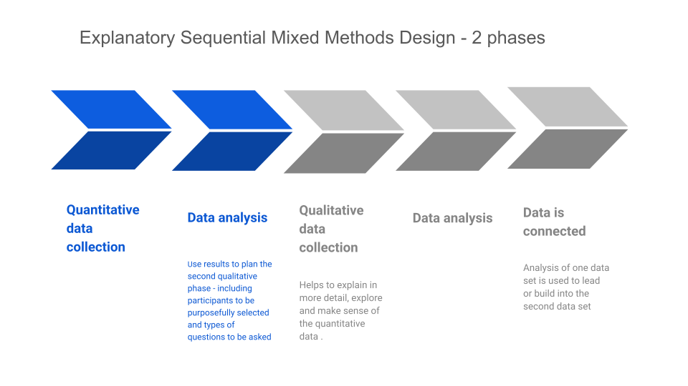

3.3.3 Data integration

The study is an explanatory sequential design, where sequential integration of data is achieved by connecting the qualitative data and results to explain the quantitative results. The questionnaire findings are examined to identify patterns, themes and anything surprising or unusual, and this then informs the focus group questions, which explore the questionnaire findings in more depth. Thus, mixed methods research undertakes the process of triangulating information from different data sources (Lund, 2012). I would argue that the process of triangulation mirrors that which is used by an Educational Psychologist undertaking casework, using observation, consultation and assessment (Beaver, 2011), and as such, feels to be a familiar and justifiable approach.

3.3.4 Abduction

Teddlie and Tashakkori (2012) argue that one core characteristic of mixed method research is an iterative, cyclical approach which includes both inductive and deductive logic. This approach refers to the interplay between data collection and analysis, moving from ‘facts’ or data through inductive logic to general inferences (or theory) and then from those general inferences through deductive logic to initial hypotheses based on results, and back again.

Traditionally (though not exclusively), quantitative researchers have tended to adopt a deductive approach, whereby they begin with a specific theory, or hypothesis, and examine how the data supports or disproves that hypothesis or theory, whereas qualitative researchers have tended to adopt an inductive approach, whereby patterns, concepts and theories emerge from the data to create theories or conclusions. This is a somewhat simplistic interpretation, and discussion of the wider complexities of deduction and induction, which is beyond the scope of this section, can be found in Kennedy’s (2018) chapter in the SAGE Handbook of Qualitative Data Collection. Mixed methods research, however lends itself to an abductive reasoning approach, which requires an iterative interplay between data collection and analysis, where the ongoing analysis of data suggests possible hypotheses to further explore, and between data and theory, where previous theoretical knowledge is drawn upon, and then challenged, revised or reconsidered in the light of data obtained (Kennedy, 2018). Morgan (2007) succinctly summarises abduction as the ‘move back and forth between induction and deduction - first converting observations into theories and then assessing those theories through action’ (p.71). As an approach, he argues that abduction can connect the quantitative and qualitative data, and it is this approach that will be attempted in the current study.

3.3.5 Quality issues

Quality is measured quite differently in quantitative and qualitative methodology. Quantitative designs measure validity and reliability in a number of different ways, traditionally using statistical procedures. Validity refers to the degree to which inferences can be made accurately based on the quantitative measures, and reliability refers to how accurately the measurement procedures consistently produce the same scores (Plano Clark & Ivankova, 2016). Qualitative researchers can demonstrate quality through member checking (where the researcher revisits the participants with the data to gather their thoughts on the findings), peer debriefing (discussing findings with colleagues or experts in the field), audit trails (keeping a full record of activities throughout the study), prolonged involvement and / or triangulation. (Robson & McCartan, 2016; McCrudden, Marchand & Schurtz, 2019). Qualitative research is assessed according to whether it is genuinely finding new information, and whether it is balanced, thorough and fair (Thomas, 2017). Lincoln and Guba (1986) introduced the term ‘trustworthiness’ to convey the extent to which results can be accepted as persuasive and notable. Credibility refers to the extent to which results are perceived to accurately reflect participants’ experiences (Plano Clark & Ivankova, 2016).

The marked differences in determining quality between the two methodologies poses the question - how can quality be maximised in mixed methods research which combines these two approaches? Mixed methods researchers need to implement each phase with the same rigour required for the chosen methodology (McCrudden, Marchand & Schurtz, 2019), but there are additional considerations regarding the mixing of the two data sets. The quality of the inferences made in the first phase of mixed methods research may impact significantly upon the quality of the second phase (Ivankova, 2014) and Teddlie and Tashakkori (2009) suggest the term ‘inference quality’ to consider the quality of the inferences made from the process of abduction in mixed methods research. Furthermore, integration of the two approaches should be clearly outlined with sufficient detail for the reader to see how the findings combine and relate to the research question (McCrudden, Marchand & Schurtz, 2019). Onwuegbuzie and Johnson (2004) refer to ‘legitimation’ as a process of continuous evaluation to assess the trustworthiness of both phases of mixed methods research and the subsequent interpretations of both data sets as well as their combination. Acknowledgement of the limitations of the research is also important in determining quality, as is considering the impact or influence of the researcher’s own beliefs and context. These points will be considered in Chapter 5 of this study.

Creswell and Plano Clark (2018, p.252) suggest the following validity threats and strategies to address them when using an explanatory sequential design:

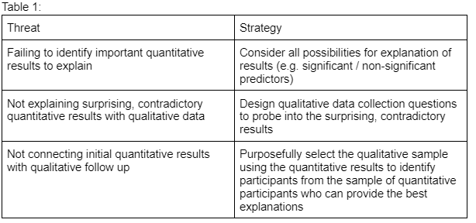
With regard to the current study, the questions for the focus groups were generated to explore different perspectives of participants by looking at the perceived advantages and disadvantages of online learning upon tutor-staff relationships, and participants were purposefully selected for their differing viewpoints as to whether online learning had had a positive or negative impact. The focus groups were designed to explore how these viewpoints were justified alongside opposing views. Pilot studies were used to increase the quality of the questionnaire and focus group questions, and member checking was used to agree a summary of the discussions which took place at the end of the focus groups.

3.4 Research process

The process undertaken to conduct this mixed methods study is outlined in the table below.

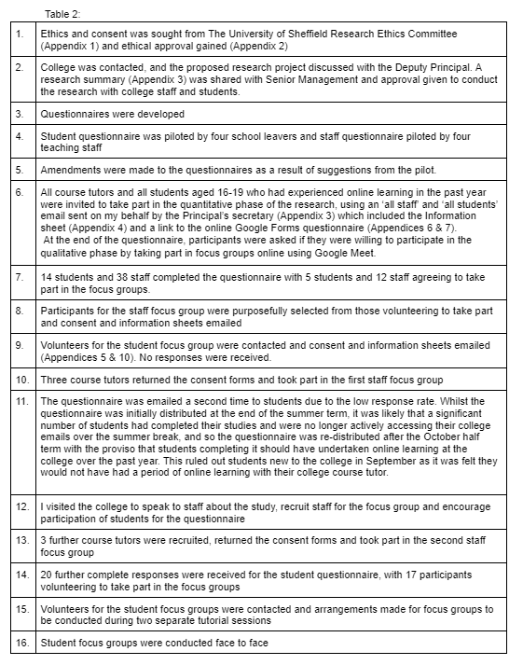

3.5 Participants

It was important to me to seek the views of both students and tutors in my research for a number of reasons. Firstly, a review of the literature indicated a discrepancy between staff and student views especially relating to the role of relationships in student dropout (Allen, 2012). Additionally, much of the literature tends to focus on staff or student views, rather than considering both. In previous work roles I had advocated for students and so it was important to me that both voices were heard. Furthermore, my preferred way of working as a trainee EP is to seek the views of the child or young person as well as consulting with school staff and parents, triangulating information in a similar way to that which I planned to construct my study. As Beaver (2011) states, it is helpful to ‘explore how different participants may perceive the problem, and how it is a problem for them’ (p.49).

The process of recruiting participants is detailed in Table 2. Foundation learning students were excluded as they fell under the ‘vulnerable learners’ category and were mainly educated face-to-face during the lockdown periods whilst other courses were delivered remotely. My original aim had been to purposefully select participants to create a mix of views by selecting a cross section of answers to the question ‘Do you feel online learning made it easier or more difficult for you to have a good relationship with your students compared to face-to-face learning?’ (easier / harder / about the same), fortuitously, this was still possible despite difficulties with focus group recruitment.

3.5.1 Tutor participants’ demographic characteristics

38 college course tutors completed the questionnaire from a potential sample of 104. However, the questionnaire did not force responses but allowed participants to choose which questions to respond to. As a result, only 31 participants fully completed all questions, and so the range of responses for each question is between 31 and 38. The course area tutors worked in, and the length of time tutors had worked at the college for were collated.

Tutor participants worked in the following course areas:

Table 3:
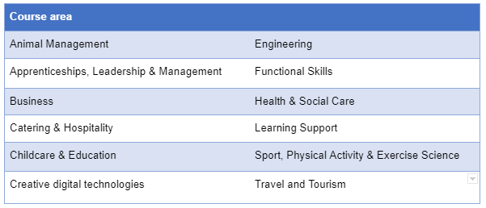

A breakdown of the length of time participants have worked as course tutors is shown below.

Table 4:
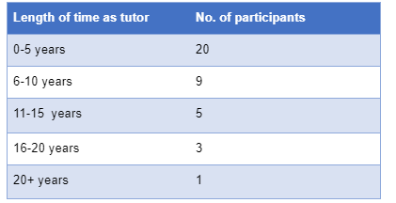

6 tutors took part in the two focus groups, three female and three male, but to preserve anonymity, their course areas are not reported.

3.5.2 Student participants’ demographic characteristics

A total of 45 students completed the questionnaire, from a total population of 893 students. Of those, 11 participants did not fully complete the questionnaire, and were eliminated from analysis, leaving a total of 34 student participants. The ages and course areas of participants were recorded. Participants studied in the following areas:

Table 5:
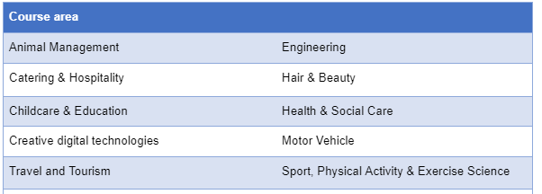
The ages of student participants are as follows:

Table 6:
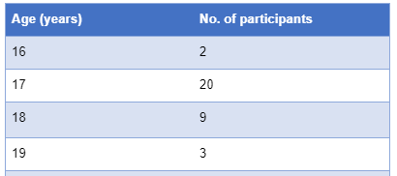

17 students took part in the two focus groups, 7 male and 10 female. Course areas are not reported to preserve anonymity.

3.6 Procedure: Phase 1 - Quantitative methodology

3.6.1 Rationale

A questionnaire was selected as the quantitative element for the research for a number of reasons. Firstly, I had previous experience in developing and administering questionnaires for previous research. It is a method with which I feel familiar and with which I have a degree of confidence in administering. Secondly, it is a time efficient, relatively easy method of targeting a larger number of participants. Thirdly, it can be conducted using online methods - which assists with ease of administration and completion, particularly due to the restrictions placed upon this research by the Covid-19 pandemic.

3.6.2 Questionnaire development (Students)

I was unable to find a questionnaire which fitted my requirements in full, and I did not find a measure designed to be used with 16-19 year olds, and as previously stated in Chapter 2, I feel the relationship between college students of this age and their course tutors differs from both that of younger school-based students and their teachers, and from that of older, adult students and their tutors. Furthermore, most studies explore tutor/teacher - student relationships from the perspective of the teacher rather than the student. However, I explored the School Wellbeing profile questionnaire (Konu, Alanen, Lintonen & Rimpela, 2002; Konu & Lintonen, 2006), and the Student version of the Teacher Student Relationship Inventory (S-TSRI) (Ang, Ong & Li, 2020) which used attachment theory as a theoretical framework to understand teacher-student relationships. Whilst items were not taken from either scale, they influenced topic areas for the current questionnaire.

The questionnaires were designed to be completed online for ease, and to overcome any difficulties presented by Covid-19 restrictions. Brace (2013) suggests online questionnaires can create less social desirability bias and more honest responses due to the lack of interviewer presence, as well as being a visual medium which allows for longer lists of response options. They can also be completed more quickly than telephone or face-to-face options. Research suggests that online questionnaires lend themselves better to multiple choice options rather than open ended questions, which are easier to answer and to analyse (Oppenheim, 1992).

The questionnaire required exploration of several different elements:

- Understanding of the role of tutor
- Student-tutor relationship factors
- Students’ relationships with their tutors online

Essentially, the questions were developed to provide a ‘funnelling’ of focus from the broad concept of the role of tutor to the specific student-tutor relationship during online learning:

Figure 2: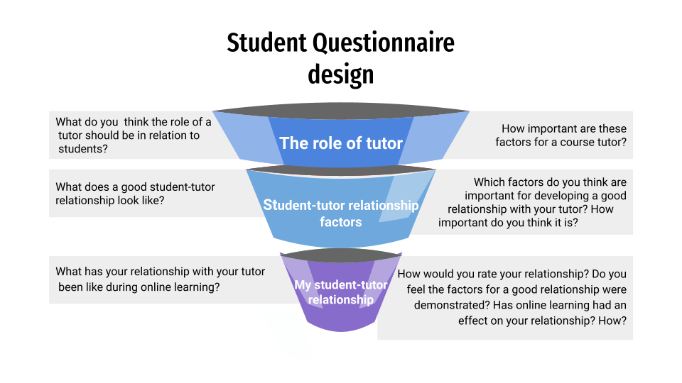

Understanding of the role of tutor was explored to situate the research within a shared (or otherwise) understanding of the role of tutor. Given the complexity of the role outlined in Chapter 2, I felt it was important to ascertain participants’ perspectives in order to avoid making assumptions about the student-tutor relationship. For example, a student’s responses to questions related to whether they can talk to their tutor about anything that is bothering them is likely to be influenced by whether they feel it is important for a tutor to care about their students, or whether they think it is important for a tutor to treat their students fairly may impact upon their own feelings about being treated fairly and vice versa.

Content for these questions was determined by synthesising information gained from research into the role of the tutor - in particular, the questionnaire items developed by Schofield (2007) in her study of student and tutor perceptions of the role of tutor in a sixth form college - with my personal experience of the role during my nine years working there, as well as speaking to staff members in the pilot group. I selected only those aspects which I felt to be relevant to the student-tutor relationship, omitting aspects of the role relating to administration and resources, for example.

The second block of questions relate to factors pertaining to the student-tutor relationship. Again, these items were influenced by my own experience supported by themes identified in the literature. For example, the three factors of closeness (the degree to which the relationship is satisfactory and positive), conflict (the degree to which the relationship is negative, unpleasant and conflictual) and instrumental help (defined as the degree to which teachers provide advice, encouragement and have a caring attitude and a genuine interest in their students, (Ang, Ong & Li, 2020) which were used to develop the S-TSRI influenced the question areas for the questionnaire when outlining factors that were felt to be important for developing a good tutor-student relationship. The factors were also designed to relate to actions of the student as well as actions of the tutor e.g., ‘they respect me’ as well as ‘I respect my tutor’ to measure the reciprocal nature of the relationship. The questions in this block also built upon the themes generated in the first block, for example, ‘giving good feedback’ was an option for block 1 (The role of tutor) and ‘they give helpful feedback’ was a factor for block 2 (Student-tutor relationships).

The final block of questions related specifically to the participant’s student-tutor relationship during online learning. It drew upon the participant’s responses to the second block (factors pertaining to student-tutor relationships) and asked participants to consider these factors in relation to their specific relationship with their course tutor during online learning. The final two questions asked participants to compare their experience learning online with their experience of face-to-face learning in order to take a comparative measure of impact.

Scaling

I deliberately omitted a neutral mid-point scaling option from the ratings scale, using a four-point scale of subjective importance (Very important/Important/Not very important/Not important at all) to give sufficient discrimination whilst attempting to avoid satisficing.

3.6.3 Questionnaire development (Staff)

The items for the staff version of the questionnaire were developed concurrently with the student version, and so the same information was drawn upon.

I also considered the Student-Teacher Relationship Scale (Pianta, 2001) and the Teacher version of the Teacher-Student Relationship Inventory (Ang, 2005). In order to enable comparisons in the research, the items used were the same as the student questionnaire, but adapted for tutor rather than student responses, for example ‘They treat me like an adult’ became ‘I treat them like an adult‘. The questions were ‘funnelled’ as detailed:

Figure 3:
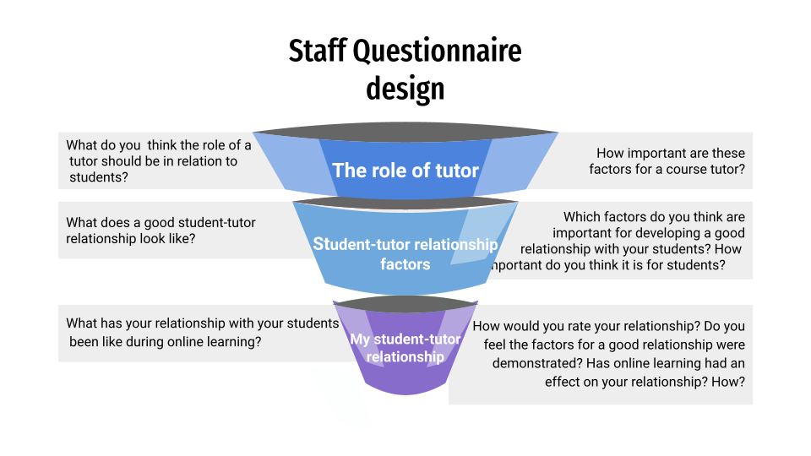

3.6.4 Pilot study

The draft student questionnaire was administered to three school leavers, to check that the questions were meaningful, understandable and that the questionnaire was not too long or onerous to complete which could dissuade participants. One participant suggested reducing the number of items in one question as he felt there were too many, and some were not needed so I reviewed these items and reduced them from 25 to 22 items. The other two participants felt the questionnaire length, question content and comprehensibility to be appropriate.

The draft staff questionnaire was administered to three teachers, who all were happy with the question length, content and comprehensibility.

3.6.5 Administration of questionnaire

All college course tutors and all college students aged 16-19 years old who had undertaken online learning within the past year were invited to complete the questionnaire via an online link, which was sent via email to all students and staff (see Appendix 3), alongside the Participant Information Sheet (see Appendix 4). Data were collected at two collection points - June and October/November 2021.

3.6.6 Data analysis and integration

Questionnaire responses were analysed using descriptive statistics and thematic analysis. Descriptive statistics were used to summarise and simplify the data to provide ‘key messages’ to be discussed in the focus groups. Since there were two open questions, one of which requested further information about a key question (whether participants found it easier, harder or about the same to have a good relationship with their tutor/students using online learning) the responses to these questions were collated, coded and themes created. Both the descriptive statistics and open-ended responses were used to create the focus group questions.

McCrudden, Marchand & Schutz (2019) argue that the success of mixed methods research enquiry is in a large part due to how effectively the quantitative and qualitative strands of the research are integrated. Integration occurred at three points during the study (Matthews & López, 2019). Firstly, in line with the exploratory sequential design, data from the questionnaire was used to generate the questions for the focus groups. Secondly, integration occurred during the selection of participants for the focus groups (see Phase 2, below). Thirdly, integration occurred during data interpretation, as will be discussed in the Findings and Analysis chapter.

3.7 Procedure: Phase 2 - Qualitative methodology

3.7.1 Rationale / overview

I chose to collect data through the use of focus groups rather than individual interviews as I was interested in the ways in which ideas are generated, shaped, altered and adapted through discussion between people, particularly those with different views and perspectives. Focus groups encourage the sharing of information. Breen (2006) suggests that as attitudes and opinions are socially formed, focus groups provide a social environment in which to articulate them. Group dynamics help to focus on which topics are important, and it is relatively easy to assess levels of disagreement and consensus. Krueger and Casey (2000) suggest that focus groups can also be less threatening to research participants than individual interviews. They can facilitate discussion between participants, encourage self-disclosure and help scaffold participants’ meanings and understandings (Xerri, 2018 in Smothers et al, 2021). The focus groups are designed to explore the findings of the questionnaire, complementing and further explaining information obtained. It is hoped that a deeper understanding of how online learning impacts and affects student tutor relationships can be obtained through focus group discussion.

3.7.2 Development of questions

Separate interview schedules for the staff focus group and the student focus group were developed based on the descriptive statistics generated by the quantitative phase questionnaire (Appendices 9 & 10) in order to triangulate data between the two phases. Open ended questions were used to encourage discussion. Distinct themes of ‘advantages’ and ‘disadvantages’ to online learning in developing and sustaining relationships emerged from the quantitative data and formed the structure of the focus group questions.

3.7.3 Recording

The tutor focus group sessions were recorded on Google Meet and the student focus groups using a phone and tape recorder. Permission for recording was obtained via the Consent form (Appendix 5) and verbally at the beginning of the focus group.

3.7.4 Method - Outline of focus groups

3.7.4.1 Tutors
The interview schedule outlines the procedure for the focus groups. Focus groups were conducted online using Google Meet which enabled participants to be brought together remotely. I began by reminding participants about the aims of the study, checking understanding of the consent form and information sheet and inviting questions. I reminded participants about confidentiality, and outlined my role as facilitator. I then suggested ground rules for the group and checked that all participants were happy with these. Finally, I explained to participants that I would be feeding back to them the broad themes we had discussed. It was important to me that participants were able to collaborate in a basic analysis of the data with a brief member checking procedure.

The interview schedule broadly aimed to explore participant’s views about tutor-student relationships and questions were broken down into four key areas:
- How relationships were developed
- Disadvantages of online learning for developing and sustaining relationships
- SEND
- Advantages of online learning for developing and sustaining relationships

The interview schedule went through a drafting process by means of a pilot focus group with three pastoral support staff from the college.

It should be noted that three of the six staff participants in the focus groups were known to me from my work at the college three years previously. Implications of this will be discussed in the Discussion section.

3.7.4.2 Students
The interview schedule for student participants followed much the same process as outlined above, although these focus groups were conducted face-to-face. However, the questions differed slightly since the student participants completing the questionnaire generated less qualitative data than the tutor participants, and therefore there was greater reliance on descriptive statistics, with the focus group data exploring participants’ experiences in relation to those findings.

3.7.5 Data analysis

Focus group data was analysed using Braun and Clarke’s (2022) reflexive thematic analysis. Focus group data can be analysed as individual data, group data and/or group interaction data (Duggleby, 2005) and I was interested in the interactions between participants, and whether views and ideas were shaped, amended, challenged or accepted through discussion.

Thematic analysis was used to identify themes from the data using Braun and Clarke’s (2022) framework as detailed below. NVivo software was used to assist in transcription and coding. Thematic analysis allows a degree of flexibility, and Braun & Clarke (2006) emphasise the need for analysis to be a recursive, rather than a linear process, which fits with an abductive reasoning approach. Given that I had noted some broad summaries of the discussions in the focus groups during the focus group discussions and checked these with the participants (a form of member checking), these were incorporated into the framework at phase 3 and compared to the themes generated from the transcription data, since there should be familiarity between the two.

Table 7: Braun & Clarke’s (2022) six phase framework for doing reflexive thematic analysis
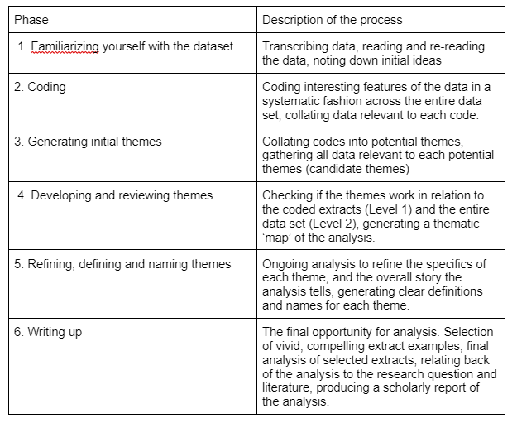

3.8 Ethics and consent

Ethical approval for this research study was obtained from the University of Sheffield Research Ethics Committee (see Appendix 1). Ethical considerations such as informed consent, minimising potential harm to participants and others, reporting of safeguarding concerns, data processing, confidentiality and storage were addressed prior to the research being undertaken.

Participants were provided with an email invitation to participate in the study (Appendix 3) and Participant Information Sheet (Appendix 4). The Participant Consent Form (Appendix 5) formed the first page of the online questionnaire and participants were unable to proceed to the questionnaire without giving consent. Information Sheets (Appendix 10) and Participant Consent Forms (Appendix 5) were also provided and sought from focus group participants. My email address and that of my supervisor were provided for participants to contact with any questions, and the procedure for withdrawal from the study was outlined in the Participant Information Sheet. Participants were additionally reminded verbally about the aims of the study, confidentiality, consent and their right to withdraw at the beginning of the focus group.

3.9 College details, demographic information

Participants were recruited from a medium sized Post-16 Further Education provider in the North of England which provides vocational courses (such as T levels, technical certificates and diplomas) and across a wide range of subject areas at foundation level and level 1, 2 and 3 as well as Higher Education courses. The college draws from a wide geographical area which includes rural villages as well as a town whose main industry is manufacturing. Learners aged 16-19 constitute the majority cohort, with approximately 1500 learners, of which approximately 900 are returning (second or third year) learners. There are just over 100 course tutors. The published Analysis of Workforce Composition data from 2019-20 shows the total college workforce was 36.86% male and 63.14% female, 95.19% white and 4.65% BAME. The student enrolment profile for the same year comprised 56.06% male, 43.94% female, 92.62% white and 6.69% BAME.

During the Covid-19 pandemic, courses at the college were adapted to include online and face-to-face teaching. Tutors planned a three-day delivery model based on the needs of learners and provides a combination of online lessons and attendance in college. Staff have the autonomy to determine the best way to teach their subject. The mode of delivery for tutorial sessions is the whole tutor group once a week and tutors also usually teach at least one course module. Fortnightly online individual 1:1 sessions are scheduled. Managers changed the order of the curriculum in response to COVID-19 restrictions. They identified modules that could most easily be taught online, and they used new methods to develop learners’ skills (Ofsted, 2020).

Chapter 4 Findings and analysis

4.1 Introduction

This chapter presents the results from the quantitative and qualitative phases of the study. As the study follows an explanatory sequential mixed methods design, results from the quantitative phase, the questionnaire, are firstly discussed in Section 4.2. Descriptive statistics detailing the tutor participants are presented followed by analysis of the tutor responses. Next, descriptive statistics detailing the student participants are presented followed by analysis of the student responses. Section 4.3 details the qualitative data findings. As detailed in the Methodology chapter, 6 college course tutors and 17 college students took part in 2 tutor and 2 student focus groups to provide a better understanding of the viewpoints expressed in the questionnaires. Focus group data was transcribed and analysed using Braun and Clarke’s (2022) six-phase reflexive thematic analysis structure. Thematic maps of the primary themes from the tutor data and the main themes from the student data are detailed in Figure 18 (3.2.2) and Figure 20 (3.2.3) with full thematic sub-maps presented in Figure 19 (3.2.2.1) and Figure 21 (3.2.3.1). Each of the main themes are presented in subsections - 3.2.2.2 - 3.2.2.9 (tutor themes) and 3.2.3.2 - 3.2.3.7 (student themes), exploring tutor and students’ views about their relationships during online / blended learning. The tutor and student themes are divided into ‘Barriers’ and ‘Opportunities’ to represent how online learning was felt to impact positively and negatively upon tutor-student relationships. Both sections conclude with summaries of the key findings before the next Chapter provides discussion of the findings.

The overarching research question: ‘What can we learn about tutor-student relationships from the experiences of course tutors and students using blended / online learning?’ as well as the sub-questions: ‘How effectively do tutors feel they have been able to develop and sustain relationships with students using blended / online learning?’ and ‘How effectively do students feel they have been able to develop and sustain relationships with tutors using blended / online learning?’ are addressed through both research phases, whilst the quantitative phase of the study addresses the sub-question ‘What are tutors’ and students’ understandings of tutor-student relationships?’ and the qualitative phase addresses the sub-question: ‘In what ways has blended / online learning impacted positively and negatively upon tutor-student relationships?’

4.2 Quantitative data findings

4.2.2 Tutor responses

4.2.2.1 The role of the tutor

The following chart illustrates the results of tutor responses to the question ‘how important do you think the following [factors] are for a course tutor?’ when given a list of factors with the options ‘very important’, ‘important’, ‘not really important’ and ‘not important at all’:
Figure 4:
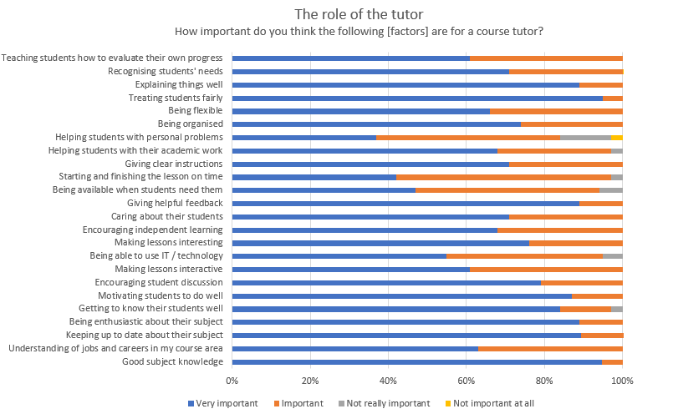

The factors identified by the most tutors as ‘very important’ were ‘good subject knowledge’ and ‘treating students fairly’ (95%) followed by ‘being enthusiastic about their subject’, ‘explaining things well’, ‘giving helpful feedback’ and ‘keeping up to date about the course subject (89%).

Only one factor was identified as ‘not important at all’ (3%) which was ‘helping students with personal problems’, and this was also the factor with the lowest combined ‘very important’ and ‘important’ responses (84%). The following factors were identified by a minority of respondents as ‘not really important’: ‘being available when students need them’ (5%), starting and finishing the lesson on time and helping students with their academic work (3%).

Overall, results suggest a general consensus amongst tutor respondents regarding identified factors as important to the role of tutor.

Participants were also given the opportunity to identify any other factors which they felt to be important, and all comments are shown below grouped into categories:

Table 8:
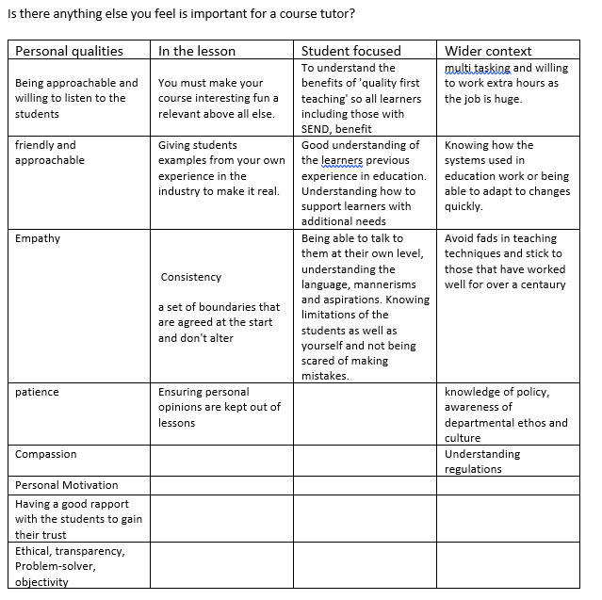

4.2.2.2 Good tutor-student relationships

These questions concern the tutor’s understanding of ‘good relationships’ between tutors and students. The following chart illustrates the results of tutor responses to the question ‘Which factors do you think are important when considering a good relationship with your students?’ when given a list of twenty-two factors.

Figure 5:

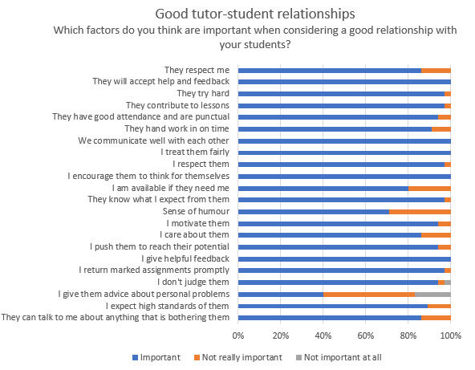

The majority of factors were considered important by over 80% of respondents, with the exception of ‘Sense of humour’ (71%) and ‘I give them advice about personal problems’ (40%). 100% of tutors felt ‘I give helpful feedback’, ‘I encourage them to think for themselves’, ‘I treat them fairly’, ‘We communicate well with each other’ and ‘They will accept help and feedback’ were important factors.

The following chart illustrates the results of tutor responses to the question ‘How important do you think a good relationship between student and tutor is for the following?’ when given a list of seven factors with the options ‘important’, ‘not really important’ and ‘not important at all’.

Figure 6:

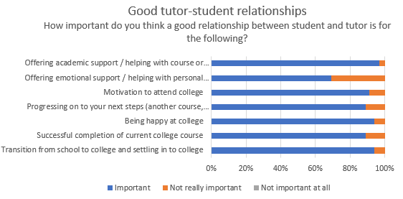

The majority of respondents rated a good relationship between student and tutor as ‘important’ for all seven factors. There were no factors which respondents rated a good relationship between student and tutor as ‘not important at all’ for. The greatest discrepancy between respondents was for the factor ‘offering emotional support / helping with personal problems’ with 11 tutors (31%) feeling that a good relationship between student and tutor was ‘not really important’. The factor with the highest number of respondents selecting a good relationship between student and tutor as ‘important’ for was ‘offering academic support / helping with course or college problems’.

4.2.2.3 Tutor relationship with students online

The final set of questions relates to the tutor’s relationship with their students during online learning. Participants were asked to rate this relationship as ‘very good’ / ‘good’ / ‘not very good’ or ‘bad’. The following chart illustrates the results of tutor responses:

Figure 7:
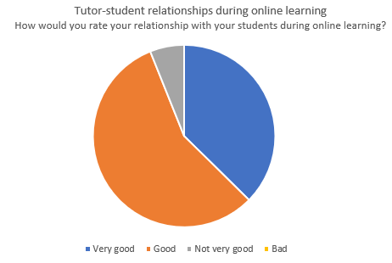

The majority of tutors rated their relationship with students during online learning as ‘very good’ (37%) or ‘good’ (56%), with only two participants (6%) rating their relationship as ‘not very good’

Respondents were then asked to consider whether the factors they had previously identified in question 6 as important to a good relationship with their students had been present during online learning. The following chart illustrates the results of tutor responses:

Figure 8:

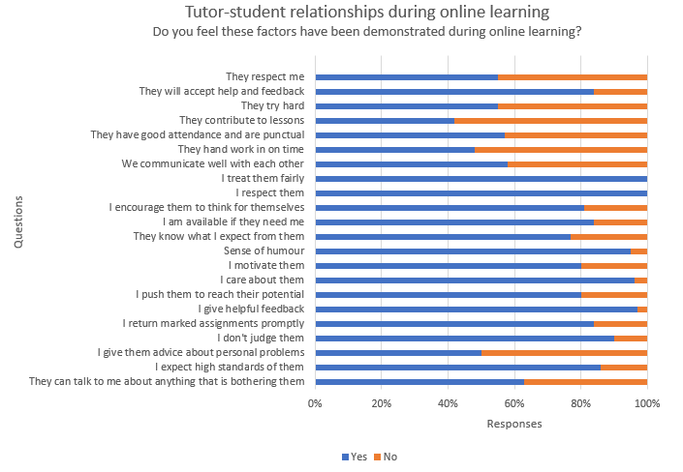

All tutors who had identified ‘I respect them’ and ‘I treat them fairly’ as important felt that this had been demonstrated during online learning. The majority of respondents (58%) did not feel the factor ‘they contribute to lessons’ had been demonstrated during online learning, despite 97% identifying it as important for a good relationship between tutor and student, and 52% did not feel ‘they hand work in on time’ had been demonstrated despite 91% identifying it as an important factor for a good tutor-student relationship. An even split of respondents (50/50%) who thought it was important indicated that ‘I give advice about personal problems’ was demonstrated.

Respondents were asked whether they felt the factors they previously identified as important for a good tutor-student relationship had been affected by their relationship with their students during online learning. Thus, the comparison was not between face-to-face and online methods but between the identification of what makes a good relationship and whether this was present during online learning. They were asked to rate these factors as ‘your relationship with your students during online learning has made this better / worse / made no difference’. Results are illustrated in the table below:

Figure 9:
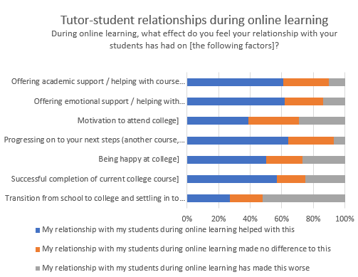

Most tutors felt that their relationship with their students during online learning had either had no effect on, or made all factors better. School-college transition was the factor that the highest number of tutors (29%) felt was made worse by their relationship with their students during online learning, followed by ‘motivation to attend college’ and ‘being happy at college’ (29%) despite a high majority of tutors identifying a good tutor-student relationship are being important for these factors (91% and 94% respectively).

Tutors were asked whether they felt their relationship with their students had been made easier or harder by online learning, or easier for some and harder for others. Results are shown in the chart below:

Figure 10:
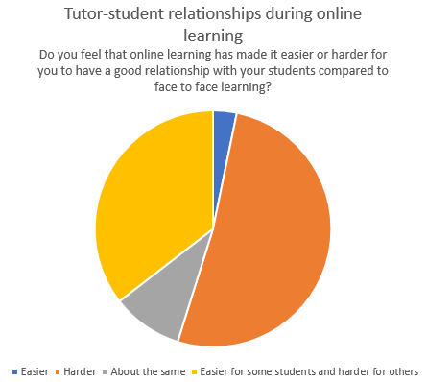

Finally, tutors were asked to comment on what ways they felt it had been easier or harder to have a good relationship with their students during online learning and comments were categorised into broad themes in the tables below, with positive comments in green and negative comments in red:

Table 9:
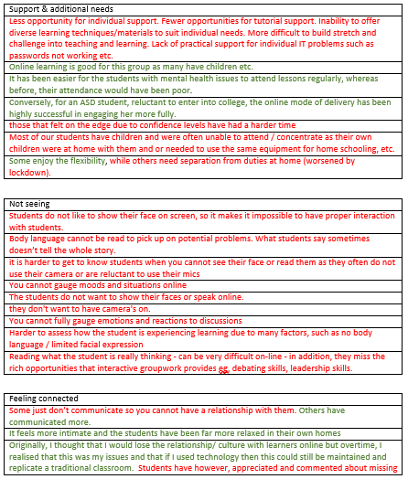
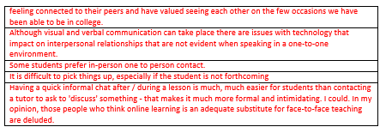

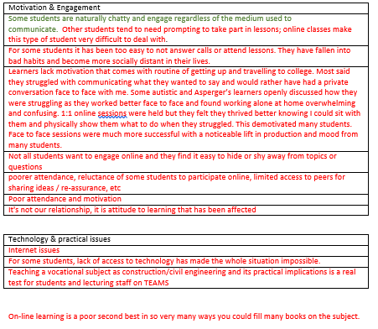

4.2.4 Student responses

4.2.4.1 The role of the tutor

The following chart illustrates the results of student responses to the question ‘how important do you think the following [factors] are for a course tutor?’ when given a list of factors with the options ‘very important’, ‘important’, ‘not really important’ and ‘not important at all’:

Figure 11:

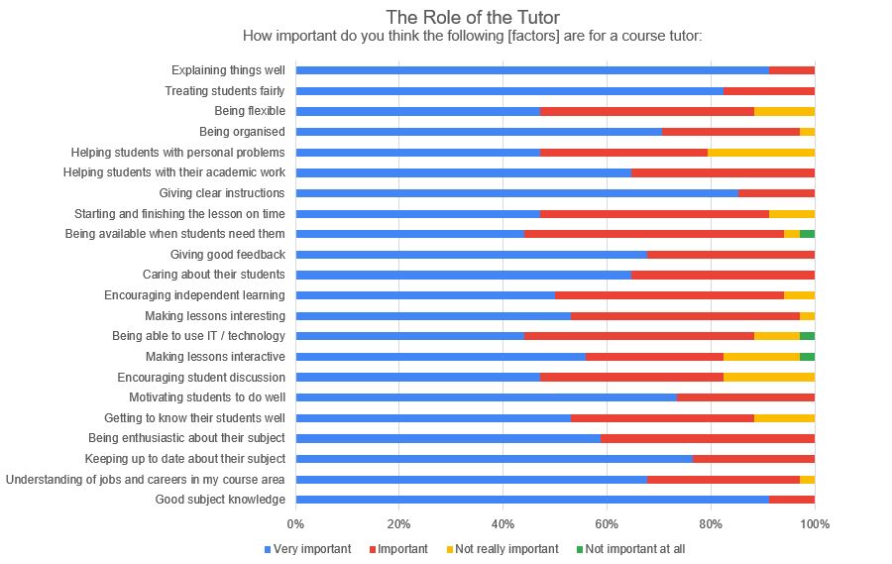

The majority of students (between 79% and 100%) identified all 22 factors as being important or very important, with the following being identified as ‘very important’/‘important’ by all respondents:

Table 10:
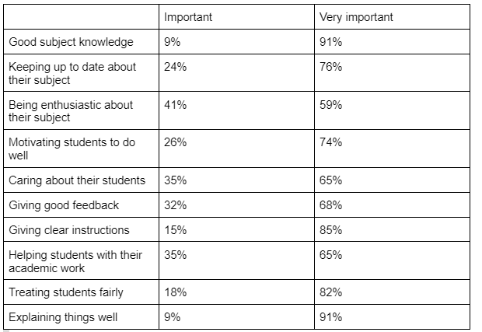

The factors identified by the most students as ‘very important’ were ‘good subject knowledge’ and ‘explaining things well’ (91%) and the factors identified by the most students as ‘not really important’ or ‘not important at all’ were ‘helping students with personal problems’ (21%), ‘encouraging student discussion’ and ‘making lessons interactive’ (18%).

Participants were also given the opportunity to identify any other factors which they felt to be important, but no comments were made.

4.2.4.2 Good tutor-student relationships

These questions concern students’ understanding of ‘good relationships’ between tutors and students. The following chart illustrates the results of student responses to the question ‘Which factors do you think are important when considering a good relationship with your tutor?’ when given a list of factors with the options ‘very important’, ‘important’, ‘not really important’ and ‘not important at all’:

Figure 12:
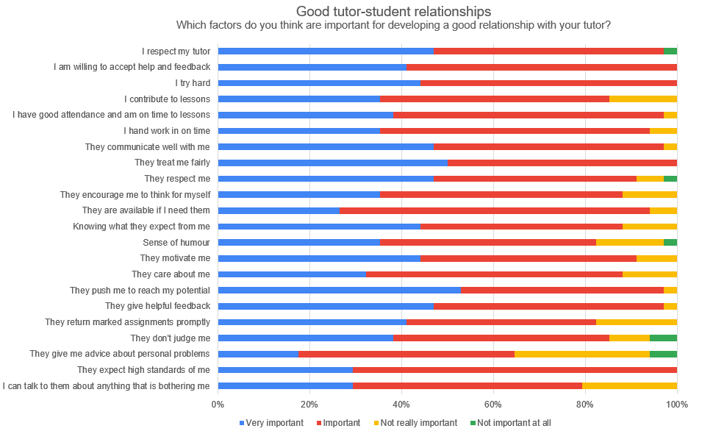

All students felt the following factors were very important / important: ‘They treat me fairly’, ‘I try hard’ and ‘I am willing to accept help and feedback’. The factors identified by a minority of students as not important at all were ‘They don’t judge me’ (6%), ‘Sense of humour’ (3%), ‘They respect me’ (3%), ‘I respect my tutor’ (3%) and ‘They give me advice about personal problems’ (6%) which was also the factor which the least number of respondents felt to be important (65%).

The following chart illustrates the results of student responses to the question ‘How important do you think a good relationship between student and tutor is for the following?’ when given a list of seven factors with the options ‘important’, ‘not really important’ and ‘not important at all’:

Figure 13:

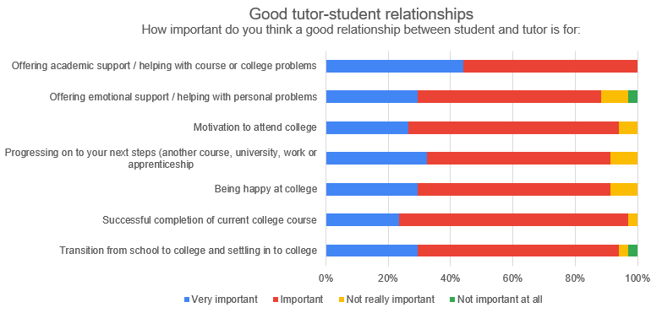

The majority of respondents rated a good relationship between student and tutor as ‘very important’ or ‘important’ for all seven factors. 100% of students felt a good tutor-student relationship was important or very important for offering academic support / helping with course or college problems. The highest number of ‘not really important / not important at all’ responses was for ‘offering emotional support / helping with personal problems’ but this was still only 12% of responses.

4.2.4.3 Students’ relationship with their tutor during online learning

The final set of questions relates to the student’s relationship with their tutor during online learning. Participants were asked to rate this relationship as ‘very good’ / ‘good’ / ‘not very good’ or ‘bad’. The following chart illustrates the results of tutor responses:

Figure 14:
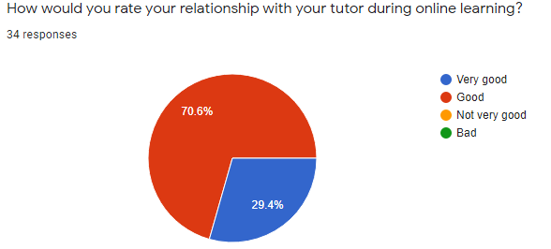

All students rated their relationship with their tutor during online learning as ‘very good’ (29%) or ‘good’ (71%).

Respondents were then asked to consider whether the factors they had previously identified in question 6 as important to a good relationship with their tutor had been present during online learning. The following chart illustrates the results of student responses:

Figure 15:
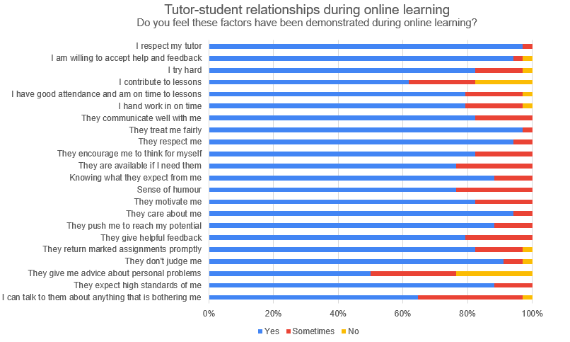

The majority of students identified that all 22 factors had been present during online learning at least ‘sometimes’. The factors which the highest number of respondents identified as present during online learning (a ‘yes’ response) were ‘They treat me fairly’ (97%) and ‘I respect my tutor’ (97%) closely followed by ‘They care about me’, ‘They respect me’ and ‘I am willing to accept help and feedback’. 9 of the 22 factors had at least one ‘no’ response, with the largest number of ‘no’ responses being ‘They give me advice about personal problems’ (24%) and ‘I contribute to lessons’ (18%).

Respondents had previously identified a good tutor-student relationship as important for a number of factors. They were now asked what effect their relationship with their tutor during online learning had made on these factors (better / worse / no difference). Results are illustrated in the table below:

Figure 16:
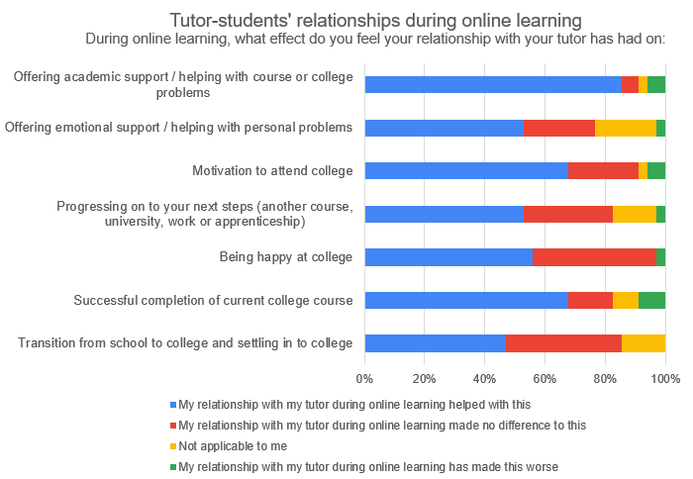

Most students felt that their relationship with their tutor during online learning had either had no effect on, or made all factors better.

The factors which were identified by the greatest number of students as being impacted by the tutor-student relationship during online learning were ‘Offering academic support’ with 85% identifying a positive and 6% identifying a negative impact, ‘Successful completion of college course’ and ‘Motivation to attend college’ both with 68% identifying a positive and 9% / 6% respectively identifying a negative impact. No-one felt ‘Transition from school to college and settling in to college’ had been negatively impacted by the relationship with their tutor, but 38% felt it had made no difference, which was also the case for ‘Being happy at college’. Interestingly, 94% of students had previously identified (in question 7) this factor as being very important / important for a good staff-student relationship.

Students were asked if online learning had made it easier, harder or about the same for them to have a good relationship with their tutor. Results are shown in the chart below:

Figure 17: Tutor-student relationships during online learning

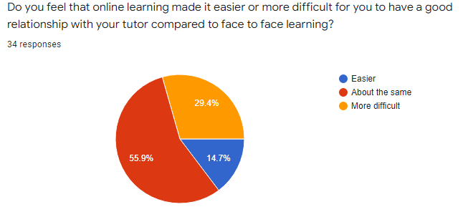

More than half of students felt online learning had made no difference, and almost a third felt it had been more difficult to have a good relationship with their tutor.

Open-ended comments

Finally, students were asked to comment on what ways they felt it had been easier or harder to have a good relationship with their tutor during online learning and comments were categorised into broad themes in the tables below, with positive comments in green and negative comments in red:

Table 11: (N.B. direct quotes from student participants, therefore spelling and grammatical errors have not been corrected)
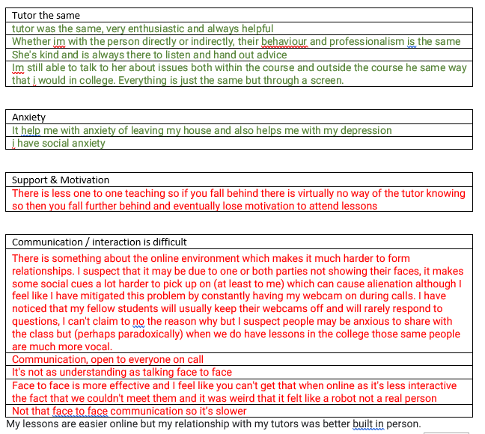

4.2.5 Conclusion

The majority of both tutors and students appear to value the importance of the tutor-student relationship in helping support school-college transition, course completion, student motivation and progression and in providing emotional and academic support. The role of course tutors in providing emotional support and listening to students’ personal problems did not appear to be considered important for a good tutor-student relationship by many tutors and students. Most tutors and all students felt their tutor-student relationships had been ‘good’ or ‘very good’ during online learning. Difficulties in developing and sustaining tutor-student relationships were highlighted, but some positive aspects were also noted.

The findings from this quantitative phase of the research were developed into questions to be further explored in the qualitative phase, the findings of which are outlined in Section 3.2

4.3 Qualitative data findings

4.3.1 Figure 18: Thematic map - primary themes - tutor data

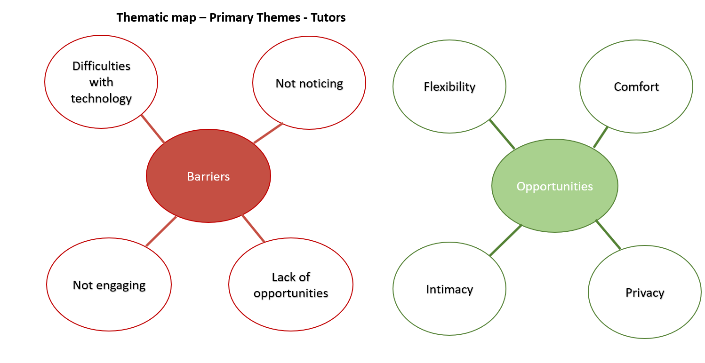

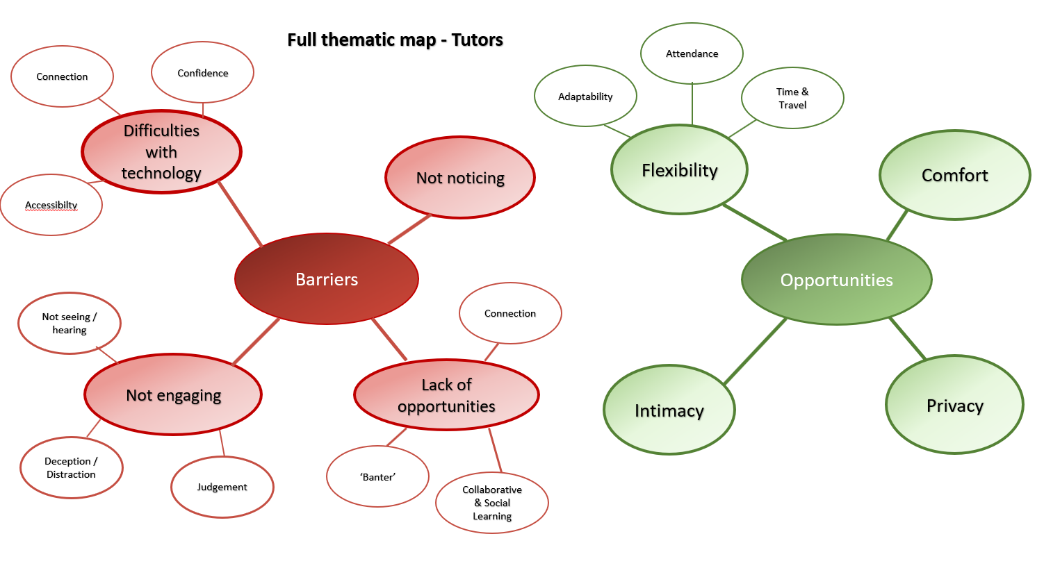
4.3.2 Figure 19: Full thematic map - tutor data

4.3.2.1 Barriers: Primary theme 1 - Difficulties with Technology

The first theme identified by tutors as having an impact on their relationships with students is ‘Difficulties with Technology’. Within this theme are the sub themes of ‘Confidence’, ‘Connection’ and ‘Accessibility’. Tutors talked about not knowing what was going to happen during the first lockdown, with both tutors and students ‘in the unknown’ and feeling that students were looking to them for answers. A distinction was made between the first and second lockdowns - initially staff found it difficult to navigate unfamiliar technology, feeling they were in ‘the complete unknown’. During the second lockdown they reported the increased confidence both staff and students felt in connecting with each other using technology as communicating in this way became more familiar. However, difficulties with internet connections affected the confidence that tutors felt in communicating with their students, and they expressed frustration with this:

T2: Yeah, it's been a big issue…we're 2021 - accessibility and connections should all be there. But let's face it, it's not.

They talked about a lack of confidence in their own internet connection ‘holding up’. There was also concern that interaction would be interrupted, leading to missed communication, and that students would lack the confidence to tell tutors if this was the case. Tutors highlighted this as one of the difficulties in building and sustaining relationships with students. They noted that students lacked the confidence to let them know that there were difficulties with internet connections, or that they were on mute or were difficult to hear. Another tutor suggested that difficulties with online connections affected their ability to prepare their students for the world of work, which they saw as their key role. Furthermore, lack of accessibility to technology was identified as a potential problem, with one tutor noting:

T4: Others had very limited anything, and we had to provide dongles and laptops for them.

4.3.2.2 Barriers: Primary theme 2 - Not noticing

The next theme identified is ‘Not noticing’. Tutors suggested that not being able to see students face-to-face during online learning was a significant barrier, since it prevented them from noticing their appearance, mood or demeanour which they felt was important to their role as tutor and to their ongoing relationship with their students, enabling them to gauge how students were feeling, and identify any problems. Some tutors felt this affected their position as ‘loco parentis’ since they had difficulty in identifying any potential safeguarding concerns:

T2:..when a boy walks in my classroom, my eyes flash from toes to top, and I can tell whether he's slept on the sofa, slept in a bed...whether he's happy, whether he's got something on his mind - in that split second…sometimes he'll say to me as he gets to the door - 'What time's break? I'm starving'. That's a little alarm bell so online, when you're looking at a black screen..how do I tick if he's hungry? How do I tick if he's a night's sleep? If he's moody, if he's happy, if he's you know - how? I'm waiting for somebody to explain to me how we do that.

This appeared to emphasise an important part of the tutor role as it was understood by tutors, in identifying risks to student wellbeing. They also highlighted the impact on interpersonal skills due to the lack of non-verbal communication, such as care and empathy:

T5: I do think that you pick up on things with students when you see them face-to-face, and that just doesn't happen when you're online, you can't tell that students move. You can't tell that students…how they're acting. You can't gauge anything… And I think that there's the problem of…totally online…you're going to end up missing things that…you can pick up when you see them.

Furthermore, one tutor suggested that being in the classroom enabled them to notice peer interactions which, on one occasion in the example given, identified a potential risk to a student.

4.3.2.3 Barriers: Primary theme 3 - Not engaging

Tutors felt that the reciprocal nature of interaction was often lacking during online learning, and students not engaging was highlighted as a notable difficulty in developing and maintaining relationships. This primary theme is explored through the sub themes ‘not seeing/hearing’, ‘deception/distraction’ and ‘judgement’.

Some students were described as not engaging at all during online learning:

T1: I’d say only a third of them actually use it at all. That’s the big pain in the arse that some of them aren’t bothering with it

Students not putting their cameras or microphones on during online interactions was felt to be particularly problematic. Some tutors felt that not having cameras on created a distance from them, and a lack of engagement in the relationship, as well as possibly a sense of disempowerment for the tutor:

T1: some of those that do turn up, I think, because we can't force them to have the camera on. They're there, but they're not there.

One tutor suggested perceived helplessness at not being able to ‘force’ students to put cameras on, but felt they had to balance this with the possibility that they may disengage completely if they did. One of the issues which resulted from this was a need to recognise voices which one tutor had difficulty with. One tutor contrasted the experience of tutors not putting their cameras on online with their experience of seeing the student face-to-face:

T1: But when [student name] is in the workshop with me, she'll talk and talk and talk

and another, with the experience of students putting their cameras on: which they described as ‘brilliant’. This tutor attributed the putting on of cameras to student confidence, whilst another suggested it may be that students kept their cameras switched off because their peers did, or due to concerns as to how they would be perceived by others:

T1: It's a bit - it's that - I don't know whether it's the pressure of looking like a tool in front of people.

Another tutor spoke about how they felt that students were reluctant to put on their cameras for fear of being judged by others, on both their physical appearance and their backgrounds which gave information about where they lived. This affected relationships as it created discomfort and anxiety for the students. Similarly, students remaining on ‘mute’ and not contributing to sessions, or answering questions was experienced as a barrier for staff:

T4: You did have very silent groups and that was quite challenging. And, we said…use the chat button and it just wasn't working very well at all. And then you don't know whether the students are listening, and we found that really tricky.

One tutor contrasted this with their experience in the classroom, where they felt students engaged and interacted much more:

T6: [in the classroom] generally we would get lively, bubbly, loud students that are competitive and sort of bounce off each other, and you spend most of the time telling them to be quiet. Flip that into an online session and it's the complete opposite…my students were very quiet…those awkward silences when you ask a question or you do something and it almost falls flat and…waiting and see who blinks first, really, just to give you an answer that will come break that silence. So - students not being comfortable with their cameras on, students not being comfortable with their microphones off so sitting on mute. And that was quite a common theme in my classes.

This discomfort of this tutor is evident in his description and the impression that is given of interaction being an effort online is echoed by other tutors, and tutors appeared to find it difficult to connect with students at a personal level when cameras or microphones were off:

T2: online you don’t get that social interaction

Deception & Distractions

Almost all tutors expressed concern that students could be easily distracted whilst working online, and may be doing other things whilst logged on to college sessions, indeed, two tutors shared stories of students who had been found to be ‘multi-tasking’:

T2: I had a kid one day…His dad sent me a message - I've just walked behind him and he's playing Fortnite. I've just clipped his ear and told him to get on online. So, he'd got me in a little corner in the bottom and Fortnite on the rest of it.

T1: I was just thinking, I had one lad…last year...he'd answer at nine o'clock in the morning. Then just leave his phone on, then go out for the day.

Their frustration with this ‘deception’ was evident:

T1: If he put all that energy and effort into actually passing the course.

4.3.2.4 Barriers: Primary theme 4 - Lack of opportunities

A lack of opportunities was found to be a theme spanning a range of issues, and is presented through the sub-themes ‘Banter’, ‘Collaborative and Social Learning’ and ‘Support’.

Banter

In one focus group, tutors identified a lack of incidental conversations online, which they described as ‘banter’ or ‘talking crap’ as a barrier to getting to know their students. They contrasted their experience of being in a classroom:

T1: whereas in the classroom you can have that bit of banter

T1: They've missed that, being in a room of people and talking crap as well as learning and doing the assessments.

An example was given as to how personal information was felt to be ‘missed’ online which had impacted on student engagement and attendance:

T1: I had a chat with one of my returning students this year, and he wasn't the greatest last year, online or in college. And we just got on about something, I found out so much about - about his dad and loads of issues and stuff, and it was just like - I would never, ever have found that out unless it had been in front of me…I found out loads about why he missed a few sessions last year.

Another tutor felt that ‘banter’ online could be subject to misinterpretation or misunderstandings as non-verbal cues and ‘timing’ were missing, and they talked about how difficult they found this, and a concern that a parent may overhear and misunderstand, contrasting it with sharing ‘banter’ in the classroom.

Collaborative and Social Learning

Tutors in the same focus group also suggested that online learning prevented or reduced opportunities to develop relationships through collaborative or social learning. One tutor explained how incidental conversations in the classroom could lead to developing rapport and important learning experiences as the tutor is more able to pick up on and respond to comments:

T2: …little links? Tiny little things were not that one time, but these little conversations that go on, little chats that - the digression of chats when you're in a room and you suddenly - 'hang on, sorry, what - what were you saying at the back there?' That's the - wouldn't have happened online…I might not have picked that up online but because he was there with me and it was the right thing that I could see his face and we could do it properly…I think little tiny things like that are massive.

The same tutor highlighted how he was able to foster debate and discussion in the classroom by digressing from one subject onto another, enabling him to involve different students which he did not feel was possible during online learning. Additionally, he was able to create situations for collaborative working or social interaction which he did not feel was possible online. It could be argued that a good tutor-student relationship is necessary to enable these opportunities to be brokered effectively.

Support

A further opportunity which some tutors felt was lacking, or more difficult, during online learning was supporting students. They suggested that connecting face-to-face with students was important to ‘coax’ them along, and that the interaction required was lacking online:

T1: Um, the last lad with autism again, he was - because everything is very straight John Bull, you can't, you can't see his eyes. You can't talk to him and reassure him and reaffirm stuff…and try and get that - coax the information back out of him.

One tutor suggested that students did not feel confident asking for help online:

T1: because they're not in the classroom with you, they're too scared to say, 'Can you go over that bit again?', and it's not until you do the one to ones afterwards...if you do quiz, - have they got it? that you get to be able to do that.

They also suggested that it was more difficult to monitor students online, and that students may be disadvantaged when not able to access support face-to-face, with one tutor discussing how some students with additional needs had chosen to come onto site to access TA support, and another who did not, and did not submit any written work or engage with online materials despite working well in the classroom the previous year. Finally, tutors noted the lack of opportunity for a suitable workspace for some students which affected their ability to sustain a relationship online:

T4:..students working environment, actually. We've got a home office. We've got a desk. We've got a lovely space to work. Not every student has that. They have very chaotic, busy home lives, multiple siblings and family at home…and that contributed to some difficulties with those students didn't have an appropriate work space…they didn't even necessarily have a desk or a space - private space - to work in. The kitchen table with their whole family around them. And there were other siblings at home working alongside them, which made it very difficult.

4.3.2.5 Opportunities: Primary theme 5 - Flexibility

There were, however, some opportunities created by online learning. The theme of ‘flexibility’ was identified as a positive impact on tutor-student relationships, and is explored using the sub themes ‘Adaptability’, ‘Attendance’ and ‘Time and Travel’.

Adaptability
Some tutors accepted the need to adapt to the unfamiliar situation they found themselves in:

T4: You're not set up for this - I had to rapidly evolve and change and adapt

Tutors talked about how they had adapted their practice to accommodate online learning, and how it had provided opportunities to work more flexibly, with some positive outcomes for their relationships with students. One tutor talked about how she was able to use Microsoft Teams to respond to students out of college hours. She explained how she could respond quickly, and how some staff worked ‘out of hours’ because it suited both them and the students, although this was not the case for all tutors:

T4: I never turn my Teams off. I will answer a student's question at nine o'clock at night. If they message me…And that gave them an instant response...they could send us a text message if you like...and it comes up as a chat option and I'll get asked a question, and I'll be able to respond immediately…I was shopping in Lidl yesterday afternoon and she said, 'have you got my assignment'….and I responded to her Sunday afternoon while I was doing my shopping. So, some staff don't do that.

Another tutor talked about adapting an assessment for students to do at home, and how one benefit of that had been increased student confidence, and since the assessment was being filmed, the opportunity to repeat it if needed.

Attendance
A further opportunity was the ability to accommodate student attendance more flexibly. Some staff talked about how technology had enabled isolating students, or those with health needs to join sessions remotely even for sessions that took place on site, and that this had been reassuring and reduced worry for students:

T5: I think it…eliminates the sort of worry about...the students missing. And there's been loads of them that have actually requested, they will send you a message and say, I'm not in today because of this, but can you call me in the lesson?...and there they are saying, I want to come - please include me…or students that have been told they've got to isolate and they suddenly panic. And say 'aw no I'm gonna miss everything', and it's like, well, no, we'll call you in and they go - 'oh, that's, that's brilliant! don't forget to call me'...So them cameras have been brilliant for us

T4: I have had a couple of students that have got significant health concerns…They much prefer the online because they can be comfortable and…near the toilet, actually, one of my students….much prefers online and attends and engages well. Whereas her attendance on site is much poorer because of her health…Attendance and engagement, when they can have both options, if they can come to site - brilliant. If they can't, then they're not - you're not excluding them from the session because they can do it virtually, can't they.

Another tutor suggested that it was also helpful to ‘eliminate excuses’ when students were not motivated to attend college as they could still maintain contact. For one tutor, eliminating the need for childcare had provided a more flexible response and removed a potential barrier to attending:

T3: a lot of my learners have got children of their own, and especially during lockdown, but…even when the older kids are at school, there's often a little one starts crying in a lesson, and they can go deal with that, whereas coming into college would mean getting babysitters and things.

Time & Travel
Online learning also meant that tutors were able to be more flexible with time, with some tutors adapting session start times or shortening sessions, since they felt that some aspects of the course could be covered more quickly online, or that working online could be more demanding. Additionally, not having to travel to site meant that tutors were able to engage with students in new and more flexible ways where location was not an issue:

T3: And I've got students all over now. A girl she started with me, moved to [different town], carried on.

T3: mine are taking the laptop when they go away and then tuning in from [specific place some distance away]

T6: it means we can provide them with a flexible approach…we've got a student on my course who's a dancer who lives in Italy…which is really quite strange to say…But the use of those cameras means that around her training schedule, it means we can be adaptable to work with her and that's I think that's key, really.…definitely the adaptability, the flexibility…with these cameras especially...able to offer a more flexible and bespoke academic programme to those individuals.

Unnecessary demands on students could be reduced, such as long journey times or inconvenient public transport and some tutors could, at times, act reactively to student need, such as responding to a question by calling an impromptu meeting or scheduling an exam to fit the best time for students. Even tutors who, generally, felt that online learning had had a negative impact, acknowledged that the flexibility it allowed offered some opportunity:

T1: I think when we was in lockdown, it was a tool that could have worked with certain age groups and certain courses….If we could do it once a month for a smaller group on a set theme, I think it would work really well.

4.3.2.6 Opportunities: Primary theme 6 - Intimacy

Engaging with students in their home environment led some tutors to feel that online learning afforded a level of intimacy as students seemed to connect on a more personal level:

T3: a lot of my students can't make eye contact, but they can online, you know. And I find it actually, more intimate. I think you see more of them

or were able to share some aspects of their home lives,

T5: And I think that established a further sort of relationship with them...because...they were in their home. It was almost like they were sharing a bit with us, you know, which was quite nice. And they all did really well, actually, with that…you could see them sort of thriving...in their own environment really. It was nice.

Being able to acknowledge shared experiences was also felt to support the development and sustaining of tutor-student relationships as tutors were able to empathise with students’ experiences of online learning since they were teaching from home:

T5: I think that helps with relationships with them because it made them realise that we understand what they're doing. I was teaching in my bedroom…So it was sort of having that, you know, realisation between us all wasn't it? [murmured agreement from T4] That actually, we're all trying to, you know, we're just trying to work from home. Um, you know, and they were all similar boats.

4.3.2.7 Opportunities: Primary theme 7 - Comfort

Tutors talked about some students being more relaxed in their own homes, and this was evident from their behaviour, in particular for T3 whose students had had negative experiences of school in the past, and were described as ‘frightened of education’:

T3: They love it online, absolutely love it, they're relaxed, they're in their own atmosphere…They're so relaxed that...the first time somebody started smoking in my English lesson, I was like, oh! but…I guess...in your own home, you know?

For T5, the impact of one of her students working online enabled a better understanding of her needs and abilities:

T5: one of my students, who was really quite bad with anxiety, actually her grades went up. And when I talked to her about it, it was because she could concentrate fully and…because she was at home and comfortable…in…what she would consider a safe environment. Sometimes coming into college was very daunting for her, and actually, being at home meant that she could fully focus on what she was doing, she didn't have the distractions of anybody in the class. And she found that very comforting…actually, I was really surprised…I didn't quite realise how good that student was because she had the opportunity [to be] independent…everything was answered from her…rather than her being over spoken by people or scared to say answers. So…she kind of shone, really…that was positive for her.

Tutors explained how they developed opportunities to support their students’ mental and physical health by demonstrating care and empathy, such as encouraging breaks and fitness challenges, or running a session on how to help their mind switch from ‘relaxing’ to ‘work’ time whilst in the same home space.

4.3.2.8 Opportunities: Primary theme 8 - Privacy

Several staff highlighted that online learning afforded them the opportunity to speak to students on a one-to-one basis in a much more private way than face-to-face, which meant that there was potentially more opportunity to develop rapport and for students to speak about more personal, individual issues, potentially sharing things that they may not do in the classroom setting:

T4: Yeah, privacy is probably a really key one, actually, isn't it? Because in a group setting, whether you're on site or...in an online class is not private. Whereas if it's a 1 to 1 and it's just you on a call, then they can potentially share more with you, can't they?

T6: Maybe that's what allowed them to relax a little bit more and open up.

One-to-one online sessions were identified by tutors as a key tool for developing and sustaining relationships with their students, and online technology afforded them the opportunity to set aside dedicated time for each student in a way that could sometimes be difficult in a classroom, with conflicting demands on time and attention.

4.3.3 Figure 20: Thematic map - primary themes - student data

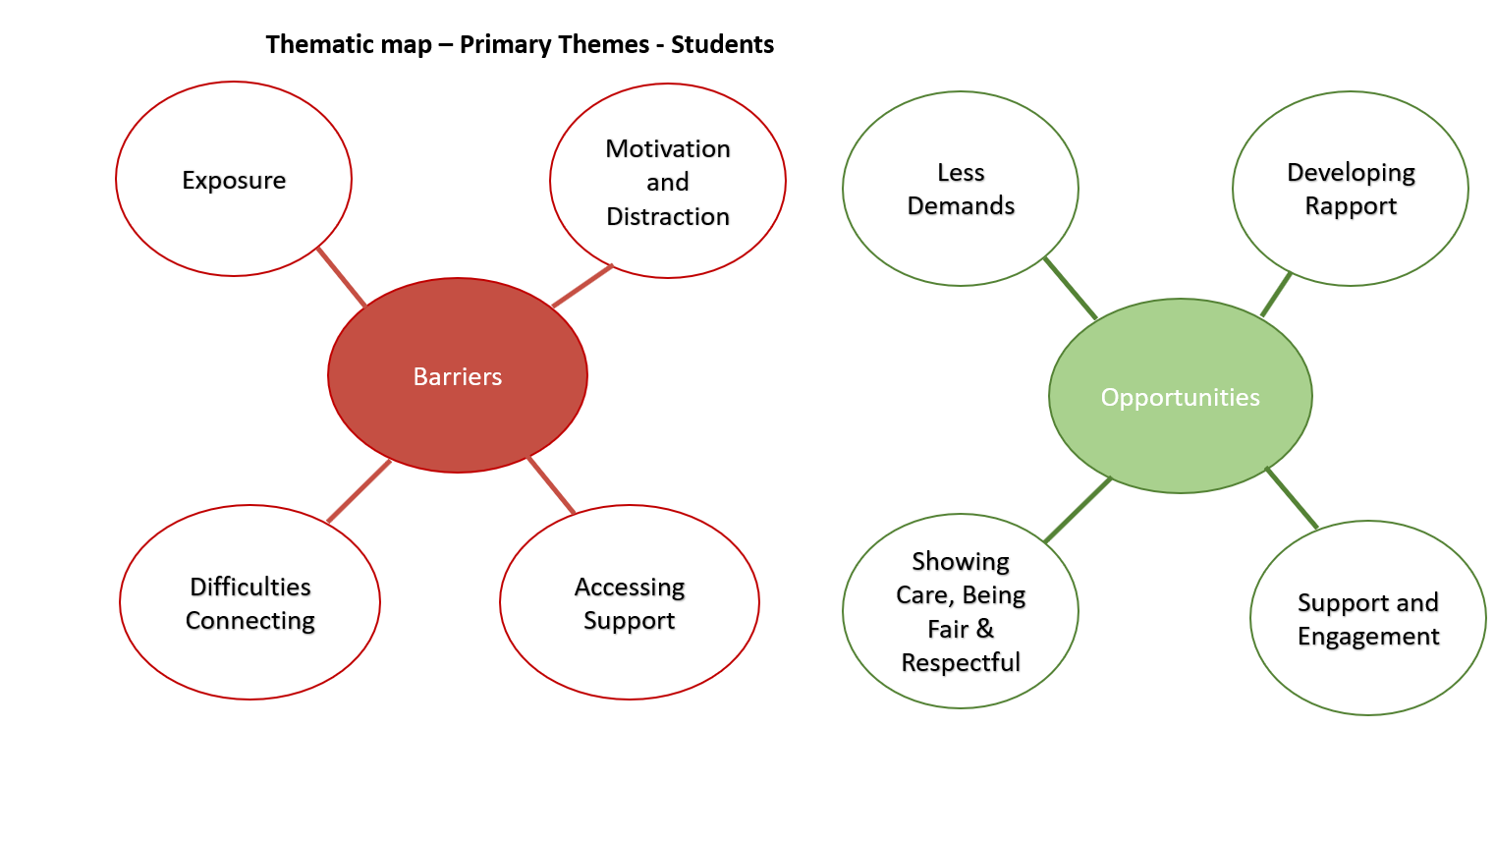

4.3.4 Figure 21: Full thematic map - student data

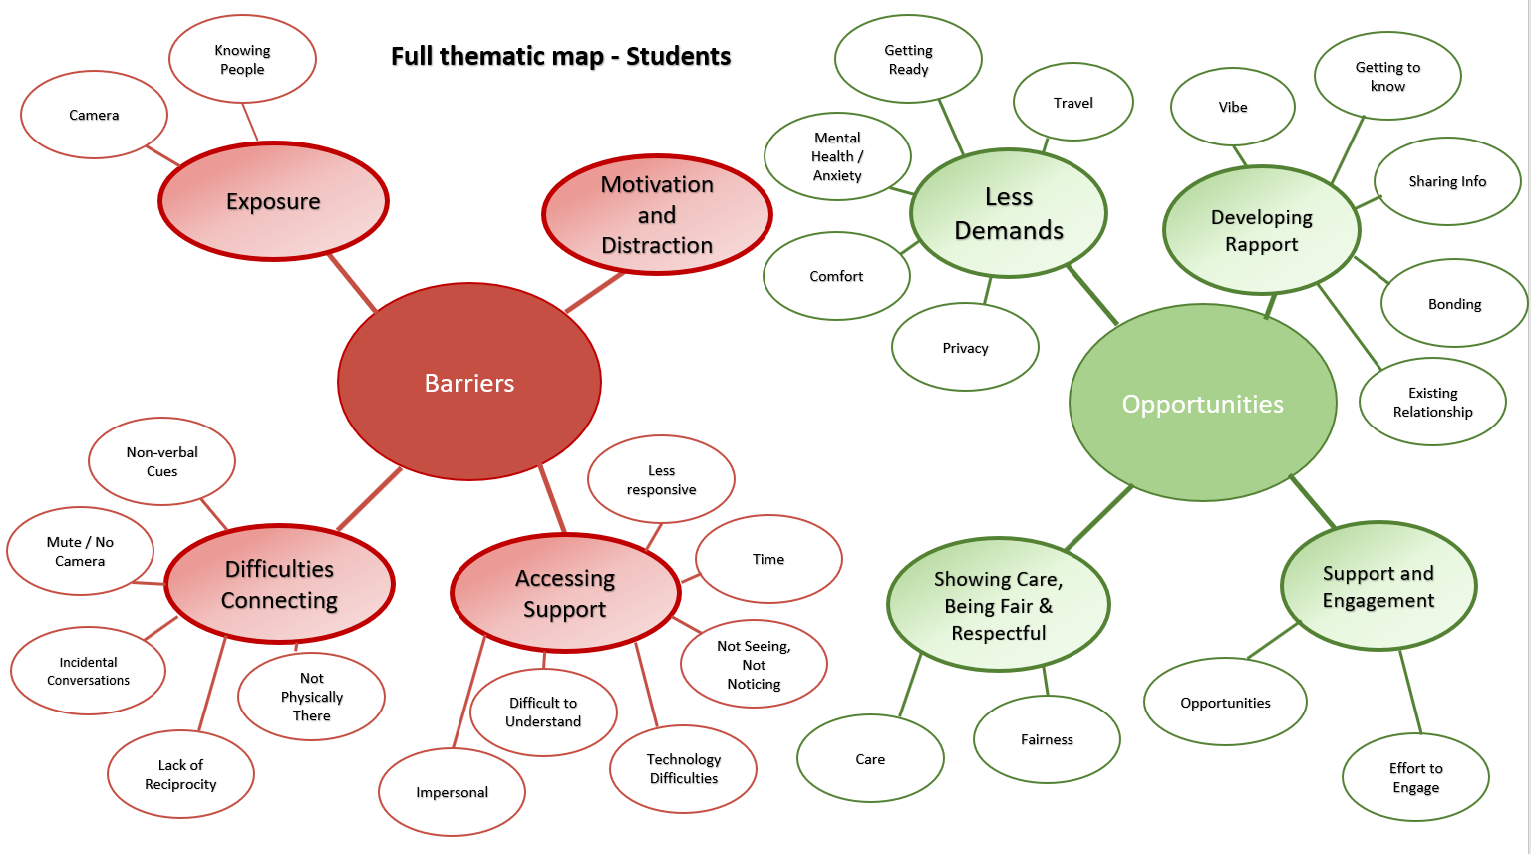

4.3.4.1 Barriers: Primary theme 1 - Exposure

This theme encompasses students’ feelings about putting on their camera and not knowing peers or tutors, with students expressing vulnerability and the impact of this upon their relationship with their tutor. When asked how it felt putting cameras on, S13 said:

Hated it...cause it was sort of in your face, in our personal space. I was in my own home, in my bed…I didn’t want people to see me

Whilst S11 added:

I used to leave...I didn’t want no-one to stare at me!

One student worried about inadvertently putting her camera on when she wasn’t prepared for it, and how exposing that would be. Another student who did put his camera on described how uncomfortable it made him being the only person in the class who switched his camera on. Students also talked about how having peers in the sessions that they didn’t know left them feeling exposed, particularly when classes had been combined which meant that their tutor could be delivering a session to multiple classes:

S17: And you don't know them people.

S10: Yeah.

S17: So it's, like, daunting

This produced feelings of discomfort, which could be unsettling since they had already formed a relationship with their tutor and getting used to new peers affected this.

4.3.4.2 Barriers: Primary theme 2 - Motivation and distraction

The second main theme highlighted by students was difficulties being motivated during online learning, and the opportunities for distraction which impacted on their relationship with their tutor since they were not always fully ‘present’:

S2: I find it a lot harder to concentrate at home and although people find it more comfortable, and like there's less pressure, everything like that - I find it hard to concentrate...and sort of engage because I'm just so distracted.

They may, in fact, actively ignore their tutor and go and do other things, with students talking about going out for the day, going back to sleep or playing on their phone, the majority of students in the second focus group admitting to this. This was contrasted with their experiences of being in the classroom, where there were less distractions, and how, in the classroom, their tutor would intervene to ‘keep them in check’. The presence of the tutor, being able to see what they were doing, would impact on their behaviour. One student also talked about how motivation could be impacted by a lack of contributing, which is discussed further in the third theme ‘Difficulties Connecting’:

S9: Because if no-one speaks, it's just very boring. Like no-one really cares.

S10: It's a one-sided conversation innit? And you're not bothered what they're saying.

S9: Yeah, you're not interested.

4.3.4.3 Barriers: Primary theme 3 - Difficulties Connecting

A significant theme identified in the student data was ‘Difficulty Connecting’. This included the sub themes ‘Not physically there’, ‘Lack of reciprocity’, ‘Mute/no camera’, ‘Non-verbal cues’ and ‘Incidental Conversations’. Students made a distinction between how connected they felt to their tutor online as opposed to face-to-face:

S2: I feel like if we didn't have that day where we came in, then…we wouldn't really have a connection at all of a relationship.

S2:…online I feel like you don't have that personal level of a relationship with your tutor.

When asked why they felt some students found it more difficult to have a good relationship with their tutor online than face-to-face, one student suggested a disconnect due to a lack of physical presence which affected the ability to ‘hold a conversation’. The idea of feeling disconnected online was echoed by others:

S9: It was kind of like you just felt like spaced out from everyone.

Other students felt that not being able to read non-verbal cues such as body language and direct eye contact impacted negatively upon the relationship with their tutor. Students explained the lack of non-verbal cues made it more difficult to understand their tutor:

S1: And like, I have, like, trouble understanding people without seeing their face. So that was definitely a barrier of gauging like tone or how they reacted, really.
S2: but also in person, you can sort of see that [makes movements with hands] - is it called articulate? So, you see them moving, with their hands -

A further barrier to developing a tutor-student relationship was felt to be students being on mute, or not turning on their cameras:

S2: a lot of the time, obviously, when you're on your online lessons, you don't really tend to put your camera on, and you don't really speak unless you're being asked to speak…So there wasn't any real relationship building.

This also had implications for relationships back in the classroom with tutors unable to match faces to names. Whilst students appreciated the importance of having the camera on in terms of building relationships, with one group highlighting how their tutor having her camera on helped them to connect with her, and both groups identifying switching on their cameras and not sitting on mute as the advice they would give to students new to online learning, as previously explored, students did not feel comfortable doing so. One student with a hearing impairment highlighted the necessity of tutors having their cameras on in order for her to know what was being said.

Students noted that the lack of reciprocal conversation impacted:

S9: All our cameras were off, and our microphones, so no-one said a word.
S10: Yeah.
S9: It was just her talking - not to herself, like - to us, but it seemed like she was talking to herself, d'you know what I mean.

The lack of student contribution meant that some felt that tutors did not really get to know them:

S11: With the relationship with your tutor, I think contributing was - It was, like, quite important. Cause then they'd learn your personality. But none of us did that, we just sat in silence.

And one student expressed empathy with their tutor’s discomfort when students did not contribute which led her to speak. Finally, one student suggested the importance of ‘incidental conversations’ in connecting with their tutor, and identified a lack of this during online learning.

4.3.4.4 Barriers: Primary theme 4 - Accessing Support

Responses to the questionnaire highlighted that all students felt a good tutor-student relationship was important or very important for offering academic support. Overall, most students felt that there were issues with accessing support online, although, as will be discussed later, offers of support were available. For some students, tutors were less responsive, taking a long time to reply to messages or not replying at all, which affected students’ confidence in them. Others found it more difficult to understand when explanations were given remotely as opposed to face-to-face:

S11: When you used to ask for help...so you'd message her, and then they'd send it over text that never went through to me. I need to hear it.
S13: yeah, same here
S11: I can't look at it and read what they've said cause sometimes I need them to like, do something a bit more practical.

and were more reluctant to ‘bother’ tutors due to a perceived additional effort in communicating remotely:

S11: And you don't wanna, like, bother them by saying - 'I don't get it, still don't get it' because they've just wrote that explanation.

Online support seemed to lack opportunities for prompting than were created in face-to-face interaction. Some highlighted difficulties with time, since a session could be cut off online without students having the opportunity to seek help, or with tutors having too many students to get around which meant too little time, or none at all, for one-to-one support. Some students felt that not being able to be seen, and the lack of non-verbal communication made it harder for tutors to notice if they needed support. This applied to academic support, but more commonly for students, to emotional support, since it could be argued that they felt more comfortable asking for academic support but relied on tutors noticing a need for emotional support:

S2: It's not as easy as them seeing that you're a little bit distressed on one day or a bit upset and speaking to you about it

S3: I feel like with tutors online…they can't necessarily see you and see that you are distressed

Responses mirrored findings from the questionnaire, in that students were more reluctant to go to tutors for emotional support, although some students felt that this was generally more difficult to access online than face-to-face due to it being a less personal approach:

S1: just feeling like just slightly more impersonal over online..I don't think I would have gone to them for it if I needed it at the time.
S2: I think the same on that. Online, if I had a personal problem, I would have never gone to my tutor but when being in college, I would have.

S2: with online learning, it was a lot more difficult for students as a whole to go to tutors with..personal problems. Obviously, with the exception for people who struggle with social interactions and anxiety, that could be more difficult in person. But..online I feel like you don't have that personal level of a relationship with your tutor

Finally, difficulties with technology were perceived to create a barrier to accessing support, with students reflecting on both their own and tutor’s shortcomings with the required software.

4.3.4.5 Opportunities: Primary theme 5: Less demands

A significant theme identified in considering the positive impacts of online learning on tutor-student relationships was a reduction in demands upon the student. Effort was a relevant factor here, with students appreciating not having to get ready to come to college, not just for the opportunity to lie in, but the fact that working from home was less mentally demanding than coming in to college, particularly for those who had difficulties with their mental health:

S7: sometimes when you're having a hard day and you're struggling to get out of bed, and you're thinking, I really don't want to go into college. You don't wanna have to..put myself in a place where I have to communicate, when you're online, you don't have to do that because it's literally right next to you where you can just join the call and do the lesson. So it's people that struggle with stuff like that - they're not missing out on the stuff that they could be involved in by having to put themselves in an uncomfortable situation.

S9: No, it was easier...in some aspects. Cause sometimes, it's like - it's hard to wake up, and think, like - you've got to put your mindset to, like, aww, I've got to go to college, I've got to do this, like you've got to mentally prepare yourself.

One student suggested that her mental health had improved as a result of online learning since she did not have to come into college.

Students in one focus group credited their tutor with reducing demands resulting in them feeling more comfortable and less pressured, focusing on engagement as the important factor rather than the need to get ready. Another student found interacting virtually less demanding:

S1: Um, maybe I'm in the minority. But…online speaking through...a microphone or something, I find way more - well, I'm way more comfortable doing that, than speaking in front of a group of people, you know, (S3 nods)

The opportunity for privacy when having a 1:1 online also reduced demands:
S5: I mean, sometimes I don't like speaking in front of loads of people. And so obviously it was better that the tutors were offering to just speak to you individually

For some students, online learning was less distracting and they appreciated less demands on their time:

S14: I found it easier just because…I had more time to figure it out independently…I could figure it out because I had more time. Whereas we spend like the whole day here, doing other stuff as well as college work so I found it easier to just get on with work at home.
Researcher: Okay. So, would you say there were less distractions for you at home?
S14: Yeah

Finally, some students appreciated not having to travel into college when they did not have a full day of lessons, particularly as this enabled the opportunity to access additional individual support from their tutor.

4.3.4.6 Opportunities: Primary theme 6: Developing Rapport

Students appreciated the effort that some tutors went to develop rapport with them, which impacted positively upon their tutor-student relationship. Tutors tried to get to know students by using class ice-breaker activities which they found helpful. They also linked college work to things relevant to the student:
S2: it was linking our topics into the animals that we have at home, which helped a lot.
They showed interest by celebrating important milestones:

S10: I had my 18th birthday when we was in lockdown and the thing is she made everyone sing 'Happy Birthday' to me. On the whole call.
Researcher: And how was that?
S10: It was funny.
They took opportunities to chat individually, take an interest and notice things that were important to the student:
S4: if you were one of the first to join the lesson, they'd…say hello and that, and then they'd ask just general questions like '...d'you have any animals?' or 'can I see your animals' because normally, my cat would just come and join - jump on my desk…But yeah, she'd just ask 'how is he today' and I'd be like, yeah, he's alright.

S10: And... she’d go...oh how you been?
S17: What you been doing? And... little things... - what are you having for dinner then?
S10: Yeah, or...if she knows you've got a boyfriend, she'd...ask how you are with them and stuff like that.
Some students were able to sense positive feelings which they termed a ‘vibe’ from their tutor which they responded to positively. Tutors also built rapport by sharing information about themselves:
S2: I think, sometimes as well, one of our teachers loved to do little personal stories. And so, them little personal stories helped a lot to get to know them. If they linked in with our topic, they helped a lot just to get to know them and have a bit of a laugh.
which developed a sense of trust and enabled some students to feel able to open up through reciprocal sharing:

S9: Yeah, Yeah. I think it was - I think it is important to have, like, speak about personal problems with your tutor. Because we understood [tutor name] like that as well. Like she was going -
S10:(overspeaking) she shared her personal problems -
S9: through this stuff she was going through at home. She spoke to us about it as if to say, like, look, you can trust me because I've told you this, and we'd speak to her about our personal problems cause we felt she could understand. She give us advice and she helped us, like it dunt matter if it was online or not.

For some students, an existing relationship, developed face-to-face prior to online learning, meant that previously established rapport with their tutor made online learning much easier.

4.3.4.7 Opportunities: Primary theme 7: Showing care, being fair and respectful

Given that the factors which the highest number of respondents identified as present during online learning related to being treated fairly, being cared about and respected, it is perhaps unsurprising that this emerged as a theme which impacted positively on tutor-student relationships during online learning. Tutors demonstrated care by using messaging to check that students were ok, and students felt that this was not just from a sense of duty or part of the job, but genuine care and concern which they appeared to really appreciate:

S2: they would message you out of concern. Just saying 'hiya just making sure you're okay'. And not even asking like - why haven't you joined the lesson? It's more just, oh I've noticed that you haven't joined, have you reported your absence? Are you okay?

S10: She'd be like - how you feeling? Especially with covid when I had covid she was messaging me, like every four days being, like - are you are right? How you doing?
Researcher: Okay. And why do you think that is important for your relationship?
S11: Shows she cares. Showing that she's got interest even when it's - It's not just a job. Like, when she's not at college, she'll still message us and check on us…she'll go out of her way to do things for us.

Some tutors would message out of college hours if they were aware that students may need support. For one tutor, some students felt that the way she demonstrated care and support meant that the tutor-student relationship became more like that of a parent and child, describing her as a ‘college mum’. In both focus groups, students gave examples of how they felt their tutors had demonstrated fairness and respect, by treating mistakes with kindness, not singling students out, encouraging students to speak if they wanted to but not forcing them to do so, and giving everyone the opportunity to answer questions, setting boundaries such as ensuring they spoke one at a time.

4.3.4.8 Opportunities: Primary theme 8: Support and engagement

The final theme which was identified as impacting positively upon tutor-student relationships was support and engagement. Although difficulties accessing support was identified by many students as a negative impact, other students noted that tutors providing opportunities to access support was appreciated, and that frequent reminders that this was available were given. One student explained how they felt they had made an effort to engage with their tutor by putting on their camera and speaking during online sessions. They felt that this had helped their tutor to get to know them, and how it had built rapport, despite often feeling uncomfortable ‘putting yourself out there’. This student identified that making an effort, which they described as their ‘commitment’ had a positive effect on their relationship with their tutor, and this view was shared by some peers:
S2: I feel like the more you engaged so as S1's said he made it his goal to engage. And the more you engage and talk, answer questions, the more you have that relationship, and you have a bit of a laugh and a bit of a joke with them. But if you just keep yourself on mute and only answer when you're spoken to, then you're not going to build that relationship.
S11: With the relationship with your tutor, I think contributing was - It was, like, quite important. cause then they'd learn your personality.

4.3.5 Conclusion

Students and tutors built upon the questionnaire data by exploring some of the positive and negative aspects of online learning in relation to the tutor-student relationship. Whilst a number of difficulties were discussed, there were also opportunities. The following discussion chapter will interrogate the research questions by reference to data from both the questionnaire and focus groups.

Chapter 5 Discussion, Reflections and Limitations

5.1 Introduction

Tutor-student relationships have been found to be important for student school-college transition, progress, engagement, achievement and happiness in college. Understanding the impact of online learning upon tutor-student relationships, where opportunities for face-to-face contact were minimal or non-existent, enables some insight into how tutor-student relationships can be maximised to promote student engagement and motivation to achieve and make progress, and get the most out of their learning experience. This is particularly important in a Post 16 college where students have greater autonomy than school, and, as they grow into young adults, tutors hold a significant role in shaping their progress by the relationships they develop and sustain.

This chapter will draw together the research findings from both the quantitative and qualitative phases, and from both groups of participants to address the overarching research question: What can we learn about tutor-student relationships from the experiences of course tutors and students using blended / online learning? The key findings from the research will be explored and interpreted in relation to past research and evidence from the study. Firstly, the role of tutor will be discussed, then tutor and students’ understandings of tutor-student relationships generally, which will address the question What are tutor and students’ understandings of tutor-student relationships? I will then explore tutor and student experiences of tutor-student relationships during online learning, considering challenges and opportunities presented, in order to address the questions How effectively do tutors feel they have been able to develop and sustain relationships with students using blended / online learning?, How effectively do students feel they have been able to develop and sustain relationships with tutors using blended / online learning? and In what ways does blended / online learning impact positively and negatively upon tutor-student relationships? Finally, limitations of the research and methodological issues will be discussed.

5.2 Tutor and student perceptions of the role of tutor

5.2.1 Key finding 1:
Tutors and students demonstrated a largely shared understanding of the role of course tutor.

The first part of the questionnaire related to the role of tutor, since perceptions of this would impact upon respondents’ understandings of the tutor-student relationship and so a shared understanding of the role was sought. Research by Clow (2005) and Schofield (2007) highlights the complexity of the role, but there has been little research in this area since mandatory professional standards for FE teaching staff were introduced in 2007 (LLUK, 2007), and it is also worth noting that this research was undertaken at a time when education, employment or training was not mandatory for school leavers. Factors included in the questionnaire in relation to the tutor role were influenced by Schofield’s findings, focusing on and expanding upon those aspects of the role which related to the tutor-student relationship.

In the current study, there was general consensus between both tutor and student participants regarding important factors relating to the role of course tutor. Most factors were identified as very important / important by staff and students, with ‘good subject knowledge’ being identified as the factor with the highest ‘very important’ responses by both tutors and students, along with ‘treating students fairly’ by tutors and ‘explaining things well’ which were also felt to be very important / important by all student respondents. 18% of students also identified ‘encouraging student discussion’ and ‘making lessons interactive’ as unimportant, whilst all tutors felt these factors were important. This may indicate tutors’ awareness of a need to develop student self-efficacy as an aspect of their role, whilst students are less aware of this aspect.

Qualitative data in answer to the question ‘Is there anything else that you feel is important for a course tutor?’ yielded twenty comments from staff respondents and none from students, which were grouped into loose themes (see Table 8). A number of personal qualities were identified: being approachable, empathy, patience, compassion, motivation, being ethical, transparent, a problem solver and objective. ‘Student focused’ comments included tutor ability to build rapport, being relatable, and having an understanding of SEND, tutor not being scared of making a mistake and delivering quality first teaching. Comments concerning ‘in the lesson’ factors included consistency, making lessons interesting, giving examples from industry and being objective (keeping personal opinions out of lessons). Finally, comments related to the wider college context, such as the need to multitask, adapt, work extra hours, avoid teaching fads, and an understanding of college systems, policy, culture, ethos and regulations. These comments reflect the complexity and breadth of the FE tutor role, allude to the competing pressures explored in the literature (Thompson & Wolstencroft, 2012; Avis & Bathmaker, 2006) and are evocative of Bronfenbrener’s Ecological Systems Theory (Bronfenbrener, 1979), where factors relating to different environmental and systemic ‘layers’ are considered. Whilst an appreciation of the breadth of the role is helpful, the concern of this research is on those aspects of the tutor role which relate primarily to the tutor-student relationship, and it is those aspects which were explored in the focus groups. No comments were received from student participants.

Overall, results demonstrate a good general consistency in understandings of the role of tutor between students and tutors, which enables the tutor-student relationship to be considered from a relatively shared conception of the role.

5.3 What are tutor and students’ understandings of tutor-student relationships?

5.3.1 Key finding 2:
Tutors and students demonstrated a largely similar understanding of tutor-student relationships and a shared appreciation of their importance.

Regarding the factors felt to be important to a good tutor-student relationship, all tutors and students identified treating students fairly and students being willing to accept help and feedback as important, with all students also identifying ‘I try hard’ and all tutors identifying ‘I give helpful feedback’, ‘I encourage them to think for themselves’ and ‘we communicate well with each other’ as important.

The majority of tutors and students felt that a good tutor-student relationship was important for transition to college, completion of current course, being happy in college, progression, student motivation, academic and emotional support. In terms of transition, many Educational Psychology Services and Local Authorities produce advice leaflets for parents and young people transitioning from school to college, as it is seen as a time when young people may need extra support. FE colleges put time and effort into reducing the stress and anxiety for young people at this time, and the findings of a number of studies, particularly in relation to SEND students (Longden, 2019; Gaona, Palikara & Castro, 2019; Lawson & Parker, 2019), suggest that a positive relationship with their tutor can support students at transition. It is perhaps not surprising that there was felt to be an impact on course completion, with research by Martinez and Munday (1998) looking at FE student drop-out noting that peer and staff relationships were cited by students as the most popular aspects of college cited by FE students, whilst withdrawn students were less likely to say they ‘got on well with their teachers’. It is, perhaps, more unexpected that tutors and students felt that a good tutor-student relationship was important for progression, given that the tutor is likely to change as the student progresses to a higher course level or to a different subject. One explanation may be that a good tutor-student relationship supports course completion which facilitates progression, or another is that it increases motivation and willingness to continue at the college.

The factor which the highest number of tutors and students identified a good tutor-student relationship as important for was offering academic support (97% of tutors and 100% of students). A number of empirical studies have supported this view, for example Chen (2005) found that perceived teacher support had both a direct and indirect relationship to academic engagement.

In the main, students and tutors demonstrated a shared understanding of the importance of tutor-student relationships, considering them to be important for students to access academic and emotional support, for transition, course completion and progression and for student happiness and motivation. This view is supported by previous studies.

5.3.2 Key finding 3:
For questionnaire participants, offering emotional support / help with personal problems was felt by many students and tutors to not be an important aspect generally of the course tutor’s role, although some students and tutors in the focus groups provided anecdotal evidence of the value of this aspect. However, during online learning, most students did feel emotional support had been demonstrated and most felt that their relationship with their tutor had helped with this.

‘Helping students with personal problems’ was the only factor identified by any tutor respondents as not important at all (3%) as part of the tutor role and 21% of student respondents agreed. Interestingly, this contrasts with the small-scale study at a sixth form college undertaken by Schofield (2007) in which Year 12 and 13 students and tutors identified ‘offering emotional support’ as within the top two most important tutor roles, scoring more highly than academic support, although Schofield did find individual differences in tutor’s willingness to provide emotional support. Results may perhaps reflect the great variance associated with this aspect of the tutor role, with differing tutor opinions as to its relevance, and with some students making use of this type of support, whilst others have no need for it.

When asked about factors that are important for developing a good tutor-student relationship, giving advice about personal problems was felt by both tutors (60% ‘not important at all’/ ‘not really important’) and students (35% ‘not important at all’ / ‘not really important’) to be the least important factor. Additionally, a good tutor-student relationship was thought by 31% of tutors and 29% of students as not really important as a prerequisite for offering emotional support. Findings from the admittedly sparse literature on the topic of emotional support by FE tutors for FE students demonstrates little agreement, with Jephcote et al (2008) finding that FE teachers saw listening to students’ personal problems as an integral part of their job, whilst Robson and Bailey (2009) found tutors created emotional distance as they felt they were too busy and stressed to deal with students’ personal problems. Interestingly, 62% of students felt emotional support from their tutor had been present during online learning, and 25% felt it was sometimes present. A third felt their relationship with their tutor had helped to deal with personal problems with only 11% feeling their relationship had made this worse. 62% of tutors felt their relationship with their students had helped with this support. So, this was not the factor that most students and tutors felt had been lacking during online learning. Furthermore, it was a subject which was highlighted as important during the focus groups, suggesting that whilst tutors and students do not necessarily recognise it theoretically as an important aspect, in practice, there were many examples shared as to the key role this factor can play in developing and sustaining tutor-student relationships. Some students in the focus groups highlighted ways in which tutors had provided this support, by using regular messages to check they were ok, or by providing regular online 1:1 meetings. However, some students noted that they had not required this support, although several felt that, had they needed this, they felt less comfortable or confident accessing it online compared to face-to-face. This was largely attributed to online interactions feeling more ‘impersonal’. It is relevant to note here that differences in opinions emerged depending on the number of students tutors were working with. Some students felt that support was diluted due to the number of students each tutor was responsible for, or that being online limited their access to their tutor:

Researcher: If you had a personal problem, do you think you'd be able to go to [tutor name]?

S13: Not online.

Researcher: Okay. Why not?

S13: Cause you didn't really get a chance to.

For the students who described their tutor as ‘like a mum’, however, shared personal information developed trust, rapport and understanding, and online communication did not appear to be a barrier:

S9: ...we'd speak to her about our personal problems cause we felt she could understand. She give us advice and she helped us, like it dunt matter if it was online or not.

Although tutors had not rated provision of emotional support highly in the questionnaire, during the focus groups many examples relating to the challenges of online learning cited the need for tutors to notice and respond to the need for pastoral care. Hence it may not be that giving emotional support was not felt to be important, but that it was not recognised as such. It could also be the case that there was a greater need from students for emotional support during online learning than face-to-face learning, which raises questions as to why this might be. It may be that the experience of connection, care and rapport is relevant here, which is further explored in 5.4.5.

5.4 Tutor and student experiences of tutor-student relationships during online learning: How effectively do tutors feel they have been able to develop and sustain relationships with students using blended / online learning? How effectively do students feel they have been able to develop and sustain relationships with tutors using blended / online learning?

5.4.1 Key finding 4:
Overall, tutor-student relationships during online learning were felt to be good. More than half of tutors and almost a third of students felt that it had been harder to develop and sustain relationships whilst almost half of students felt there had been no difference.

The majority of tutors rated their relationship with students during online learning as ‘very good’ (37%) or ‘good’ (56%), with only two participants (6%) rating their relationship as ‘not very good’. It is important to note that tutors were asked to consider their students as a homogeneous group and therefore generalise, whilst in reality there is likely to have been considerable variance in their relationships with individual students, which was further explored in the focus groups.

All students completing the questionnaire rated their relationship with their tutor during online learning as ‘very good’ (29%) or ‘good’ (71%). This suggests that students felt that tutors had been able to develop and sustain relationships with them during online learning. However, during the focus group discussions, some students contradicted these findings, for example,

S2: ‘there wasn't any real relationship building’.

Finally, the questionnaire asked whether online learning had made it easier or harder for tutors to have a good relationship with their students compared to face-to-face learning. Only one respondent felt it had been easier, with just over half (52%) feeling it had been harder. 10% of tutors felt it had been ‘about the same’, and 35% felt it had been harder with some students and easier for others. It is perhaps obvious that this may be the case, since neither tutors or students are a homogeneous group, but respond as individuals, whose personal circumstances, previous experiences and preferred ways of working will impact on those responses. This mixed feedback was borne out by the focus group findings. T1, for example, stated: ‘Some have been good, some of them bad’, relating this to students’ motivation to engage with online learning: ‘some have been proactive…some aren’t bothering’.

For students, more than half of students felt that it had been about the same, with almost a third (29%) feeling it was more difficult and 15% finding it easier. Students were asked to comment upon the ways in which online learning made tutor-student relationships easier or more difficult, and thirteen comments were received, which were divided into positive comments reflecting ‘easier’ responses and negative comments reflecting ‘harder’ responses. One comment succinctly summarised the findings of the focus groups where these positive / negative comments were further explored:

‘My lessons are easier online but my relationship with my tutor was better built in person’.

When asked to consider whether their tutor-student relationship had helped students’ transition, course completion, progression, motivation, happiness at college and academic and emotional support during online learning, results were mixed. A higher number of students than tutors felt the tutor-student relationship had helped for every factor apart from emotional support and transition. More than half of tutors and a quarter of students felt their relationship had made no difference to transition during online learning, which may reflect the experience of limited transition arrangements that had been possible during Covid-19 restrictions. More than a quarter of tutors felt their relationship had actually made student motivation, transition and happiness worse, although students did not agree. It could be, therefore, that students feel more supported than tutors think they are, or that tutors are more focused on perceived reduced student motivation online than their students are.

5.4.2 Key finding 5:
Student engagement and motivation had a significant impact on student-tutor relationships during online learning.

Student engagement online appears to have been a significant issue experienced, largely negatively, by both students and tutors. Participants’ questionnaire responses reflected a lack of students ‘contributing to lessons’ and a reduction in student motivation compared to face-to-face learning. For example, factors a significant number of tutors felt had not been demonstrated were ‘they contribute to lessons’ (58%), ‘they hand work in on time’ (52%), ‘they try hard’ (45%) and ‘they have good attendance and are punctual’ (43%). Students scored all these factors more highly, however, only 60% admitted to often contributing to lessons. No students admitted to not trying hard, handing work in on time or having poor attendance although some conceded this happened ‘sometimes’. It may be that students and tutors have different ideas about what is expected of them in online learning, and perhaps different norms in terms of ways of working needed to be established.

A significantly larger number of students (68%) felt that their tutor-student relationship had helped with motivation compared to tutors (39%). Whilst this suggests that many students did not identify a particular issue with engagement and motivation, the focus groups told a different story. When asked directly if they felt contributing to lessons impacted on the tutor-student relationship at all, students in the focus groups felt that it did, explaining:

S9: Because if no-one speaks, it's just very boring. Like no-one really cares.

S10: It's a one-sided conversation innit? And you're not bothered what they're saying.

S9: Yeah, you're not interested.

Indeed, engagement and motivation were found as primary themes in both the tutor and student data. Many students admitted that they did not fully engage in online lessons, logging on to the lesson but spending time doing other things, such as sleeping and gaming. Most felt that there were more distractions at home which affected their motivation to learn. Tutors also reported this, and their frustration was evident. Students having cameras and microphones off contributed to a lack of reciprocal interaction in the tutor-student relationship and generally, there was a sense that it was more difficult for students to engage and remain motivated online as opposed to face-to-face. Some students, however, did engage. In the first focus group, for one student, they felt that their willingness to contribute had a direct positive impact on the relationship they developed with their tutor:

S1: Absolutely, it has an effect…that's what I was thinking when I had planned to have my camera on all the time and engaging, interacting…You're not going to get as much out of it unless you actually put yourself forward and actually try to make an effort to sort of build that rapport between the tutor. That's what I found.

This is supported by findings from Ofsted (Joyce, 2020) who noted that learners who made use of ‘voice channels’ benefitted from the instant interactions with their tutor. Another student talked about feeling more motivated during online learning as they felt there were less distractions at home.

Student engagement can be thought of as an outcome of motivational processes, and therefore, the more motivated a student is, the more engaged they will be. Research by Chiu (2022) looking at the experiences of Hong Kong school students during online learning as a result of Covid-19 related school closures investigated the relationships between psychological needs as conceptualised by self-determination theory and student engagement. Chiu considered the teacher support dimensions of autonomy support, structure and involvement in relation to student engagement, and found perceived relatedness to be the primary predictor of students’ behavioural (participating in course activities), emotional (positive feelings about the course, teachers, peers and learning activities) and agentic (speaking up about their learning needs) engagement, and perceived competence to be the most important predictor of cognitive engagement. This suggests that student-tutor relationships are crucial in engagement in online learning. Chiu (2022) emphasises that online learning requires more autonomy than face-to-face, since it is less supervised, and that there is a greater need for relatedness, due to the lack of physical human interaction. It is possible that the combination of greater autonomy, with some students choosing to take advantage of greater freedom afforded to them in choosing whether to engage in learning or not, and less relatedness, with students feeling less connected to their tutor and peers and reduced opportunities to foster a sense of belonging and develop attachments, alongside the reduced competence experienced through the novelty of online learning and the unique and uncertain context created by a global pandemic, create a decrease in student engagement. There is perhaps a role to play for Educational Psychologists in increasing tutor awareness of the theoretical and practical aspects of motivation and helping tutors to develop practices that enhance and sustain student motivation.

Although students admitted to contributing less online, and becoming more distracted, they could also recognise the importance of contributing, since when asked what they would recommend to others about online learning, they identified ‘contributing more to lessons’. It could be that the novelty of learning at home and increased autonomy at first meant they took advantage of distractions and the opportunity to engage less, but were able on reflection, after face-to-face learning was restored, to see the importance of contributing and what they had lost by not doing so, particularly in terms of a sense of connection with their tutor. It may be that the age and levels of maturity are relevant here, since young people have less autonomy and are more used to having expectations imposed on them than adults, and may be less likely to reflect ‘in action’ (Schön, 1983) than adults. It is also the case that some students were more willing, more comfortable and more confident developing those relationships online, which again may be in part connected to maturity. They had perhaps been able to establish new explicit norms and expectations, with an absence of the usual social pressures to participate.

It could be that the course subject also had an impact on this, with some subjects lending themselves more easily to developing ways to learn online, as considered by T1:

I think when we was in lockdown, it was a tool that could have worked with certain age groups and certain courses……I think if it's more of an academic course like Maths or English, where you you don't have to be in a workshop - Yeah, I think they're probably more inclined to engage with it then

Students on a primarily practical course, who may have chosen that course as they preferred practical learning, may find it more difficult to engage online than students whose subject requires a greater emphasis on reading, writing, listening and online research. This idea is supported by research suggesting that some disciplines are more compatible than others with online learning (Leszczyński et al, 2018). T2 also suggested that the level of course may also be relevant, feeling that level 3 students coped better and were more motivated than level 1 students. This appears to be supported by findings from Ofsted:

‘Generally speaking, learners at levels 1 and 2 have engaged less well than those at level 3. Learners at level 1 and 2 often find it harder to engage with the technology necessary for online learning’ (Joyce, 2020)

5.4.3 Key finding 6:
Tutor-student relationships appeared to be more effectively sustained when tutors were willing to adapt their practice.

The tutors in the second focus group seemed more willing to try to find ways of engaging students, and building relationships by trying new technology and seeking out different ways of interacting with their students. They appreciated the need to ‘rapidly evolve, change and adapt’ (T4). One of the tutors (T2) in the first focus group, however, appeared quite resistant to adapting their practice in order to engage students, and stated numerous times that online learning ‘does not work’. They were frustrated by the situation they had found themselves in and were suspicious of plans by the college to continue a ‘blended learning’ approach. They felt they were unable to develop or sustain relationships with their students adequately online. It may be, then, that tutors’ willingness to adapt their practice has a significant effect on the effectiveness of relationship building.

5.5 In what ways does blended / online learning impact positively and negatively upon tutor-student relationships?

5.5.1 Key finding 7:
‘Not seeing’ students in person, and students not putting their cameras on during online learning was felt by tutors and many students to have a negative impact on tutor-student relationships. In particular, tutors felt this could lead to missing safeguarding concerns. Students cited feeling exposed and judged by the use of cameras but appreciated positive impacts of having cameras on.

‘Not seeing’ and ‘not noticing’ were emphasised particularly by tutors as a barrier to positive tutor-student relationships. Amongst responses to the questionnaire’s open-ended question about what had made the tutor-student relationship easier or harder, the theme that occurred most often was ‘not seeing’, with nine negative comments relating to difficulties with students not putting cameras on, and not being able to pick up non-verbal information such as mood and body language. Caring about students was felt to be an important aspect of the role of tutor in questionnaire responses, and tutor focus group participants felt that not being able to see students affected this, since they could not pick up on mood, or notice safeguarding issues. This was particularly exacerbated by students not putting their cameras on.

For some students (and possibly some tutors) online learning left them feeling exposed and open to judgement, particularly when contributing verbally to online discussions, or when their camera was on. Castell and Sarvary (2021) found that the reasons given for not putting on cameras during online learning included concern about personal appearance, concern about their physical location or other people being seen in the background, social norms (everyone else having their cameras turned off) and not wanting to be seen not paying attention or doing other things. Furthermore, it was noted that students may not have access to a private space, or may be embarrassed about their home environment. These findings were supported by Tobi, Osman, Bakah and Othman’s (2021) study of Malaysian students which also included not being comfortable with being looked at by peers and Gherhes et al’s (2021) study of Romanian students. All of these reasons were given by either students or tutors during the focus group discussions. It could be argued that this discomfort created emotional vulnerability which did not create the appropriate conditions for students to feel safe and secure. Unless these needs were met, students would find it difficult to engage in learning. For tutors, students putting on their cameras helped stop them feeling that they were not talking to themselves, and gave them the ability to communicate with non-verbal cues. Research supports the idea that tutors are able to monitor and evaluate student responses during synchronous learning by noticing non-verbal cues such as smiles, nods, frowns, looks of boredom or confusion, and adjust their teaching accordingly (Miller, 1988; Mottet & Richmond, 2002). Furthermore, Mottet (2000) found that interactive instructors’ perceptions of teacher-student interpersonal relationships were positively correlated with perceptions of student nonverbal responsiveness.

Despite their reservations about putting on their cameras, students were able to reflect on the importance of having their cameras on for connecting with their tutor and, when asked what they would do differently if returning to online learning, many students identified ‘putting their cameras on’, suggesting they appreciated that something had been missed by not doing so. One student in the focus group had consistently put their camera on and their peers as well as their tutor valued this in helping with relationship building.

Although tutors usually had their cameras on, some students noted that not being able to see their tutors when PowerPoint presentations were on screen was challenging for them, and they also felt that they missed out on non-verbal cues from their tutor which helped them bond and understand interactions better.

5.5.2 Key finding 8:
Technology presented both positive and negative impacts on tutor-student relationships. Difficulties with connection and access impacted negatively, whilst opportunities for flexibility and privacy were presented.

Three negative comments in the tutor questionnaire data related to ‘technology and practical issues’, focused on the difficulties of access and connectivity to the internet and the challenges of teaching a practical subject remotely. These issues were further explored during the focus groups.

A distinction should be made between planned online learning, and emergency remote teaching (Hodges et al, 2020) as experienced during the Covid-19 pandemic lockdowns. The difficulties that many tutors and students referred to in this study may be in a large part due to a lack of preparedness created by an emergency situation which they did not choose and were not in control of. König, Jäger-Biela and Glutsch (2020) suggest that teacher and student digital competence requires not only knowledge and skills but confidence. A lack of confidence in digital competence was evident from comments made by both students and tutors during the focus groups. This could be seen to relate to the core psychological need of competence posited in Self-Determination Theory, which needs to be satisfied for students to feel actively motivated to engage in learning, and as a result is likely to impact upon student motivation, and tutor and student satisfaction with online learning as a whole. Chiu (2022) argues that most teachers who lack experience in online teaching are unlikely to deliver effective online learning. Certainly, tutors in the focus groups reflected that they felt more confident during the second lockdown as both students and tutors were more familiar with the technology required. Responses to these difficulties, however, differed amongst tutors. For participants in the first focus group, their lack of digital competence led them to research digital platforms and methodologies which provided opportunities to work in ways they felt were lacking remotely, such as providing increased interactivity for students:

T5: because obviously we experienced the first lockdown...over the summer my main driver was - I do not want to be on online sessions for however many hours a day with no interaction or…not even knowing if they're listening. I knew that would happen with PowerPoint...so I started looking for something, which is how I found Nearpod.

They spent time considering how teaching and student support could be adapted for remote learning. For T2, and at times T1, however, a lack of competence led to feelings of frustration and resistance. Two tutors who gave responses in the questionnaire were able to see both positive and negative aspects of technology, with one tutor reflecting:

Originally, I thought that I would lose the relationship/ culture with learners online but overtime, I realised that this was my issue and that if I used technology then this could still be maintained and replicate a traditional classroom.

This appears to link back to the comment from T4 discussed in 5.11 about the need to evolve and adapt, and to the theme identified in the tutor focus group of ‘flexibility’. It demonstrates a degree of reflexivity for that tutor which may well be an important personal quality for sustaining relationships with their students.

Students in the second focus group expressed frustration with their tutor’s lack of competency in using technology, whilst students in the first focus group highlighted their own difficulties and demonstrated a greater understanding, perhaps reflecting a level of empathy borne out of shared experiences which will be further discussed in 5.5.3.

5.5.3 Key finding 9:
Despite feeling that online learning was a barrier to feeling connected with each other, many students and tutors felt care, respect and fairness remained evident. Many tutors worked hard to develop rapport. For some, there was a greater level of intimacy in the tutor-student relationship, and shared experiences enhanced connectedness.

Results demonstrated a mixed response regarding rapport and connectedness between tutor and student online. The questionnaire results showed that mutual respect, and tutors caring about students and treating them fairly had been evident during online learning. Unlike tutor respondents, students were given the ‘sometimes’ option, as their responses referred to an individual, rather than a group (where it would have been difficult to determine if the ‘sometimes’ response related to ‘some students’ or ‘on some occasions’), however, this made it more difficult to compare responses. 100% of tutors and 92% of students felt they were always treated fairly with 8% of students feeling that was the case ‘sometimes’. 96% of tutors and 80% of students felt tutors cared about their students, with the remaining 20% of students feeling this was the case ‘sometimes’.

For some of the students in the second focus group, their tutor appeared to make a concerted effort to develop and sustain relationships, and for these students, they did not see a significant difference between their relationship online and face-to-face, in terms of how effectively that relationship was built and maintained. For this group of students, they had met their tutor face-to-face a couple of times prior to lockdown, and they seemed to appreciate the consistency:

S9: She kept the same vibe...she just stayed the same

It was clear that this tutor’s efforts to develop relationships by messaging, sharing personal information, noticing personal details about her students, picking up on mood, developing icebreaker activities and giving a positive, friendly ‘vibe’ were appreciated by her students, and greatly helped them. This supports findings by Wallace (2014) that a positive, cheerful and mutually respectful teacher attitude and demeanour built student motivation, and that a more relaxed and mutually respectful tutor-student relationship helped students feel more confident engaging with learning (Fuller and Macfadyen 2012; Peart 2017), and it was interesting that for these students this appeared to be possible during online learning. For another student in the same focus group, little effort appeared to be made by their tutor:

S16: some tutors, it just seemed like they were aiming to have as much free time as possible

and as a result, they did not feel any relationship had been built.

It also appeared from this focus group, relevant to consider the type of relationship students wanted from their tutor. For some students, a close relationship with their tutor appeared to work well, perhaps meeting their needs:

S17: she just reminds me of a mum, d'you know what I mean?

whilst another student appreciated being ‘left to it’ to get on with her work independently.

During the focus groups, students were able to give a range of examples where they felt tutors had demonstrated fairness, respect and care. These qualities demonstrate positive regard, and are important for relationship-building both from an attachment and a self-determination theoretical perspective. Self-determination theory recognises the importance of relatedness, which is defined as the student feeling that their teacher genuinely likes, respects and values them (Niemiec & Ryan, 2009). Research suggests that students are more likely to use intrinsic motivation, which is central to our tendency to learn and develop, if their need for relatedness is satisfied (Deci & Ryan, 2008). Whilst intrinsic motivation was not measured by the current study, and indeed evaluations of student motivation as a whole were not felt to be particularly positive during online learning, it could be suggested that for many students the condition of relatedness may have been met.

One tutor felt online learning afforded more intimacy in the tutor-student relationship and noted this in their questionnaire responses. They discussed this further in the focus group as feeling they connected with their students on a more personal level than they had in the classroom. This supports the findings of Gillmore and Warren (2007) who suggest that online interpersonal communication offers potential for greater intimacy. Whilst this term was only used by one tutor, examples of increased intimacy were also given by other tutors and by students, such as the sharing of aspects of home life that they would not ordinarily have access to. Some students also talked about feeling more relaxed and comfortable working from home. Taking this alongside questionnaire findings demonstrating that care and being treated fairly were felt by almost all students and tutors to have been present during online learning, I would suggest that many positive interpersonal skills were demonstrated for some students and tutors during online learning, despite the difficulties in building rapport previously stated for many.

Some tutors spoke about the shared experience of online learning, and the challenges that brought, providing a ‘bonding’ experience for tutors and students, which led to a greater awareness and appreciation of the difficulties each faced. As T4 explained:

I think that helps with relationships with them because it made them realise that we understand what they're doing...So it was sort of having that...realisation between us all wasn't it?..That actually, we're all trying to…work from home…and they were all similar boats.

Shared experiences can strengthen social connection (Jolly, Tamir, Burum & Mitchell, 2019) and foster a sense of belonging which enhances achievement motivation (Walton, Cohen, Cwir & Spencer, 2012). Thus, sharing the positives and negatives of online learning may strengthen a sense of connectedness between tutor and student, and students may be more willing to engage if they recognise and empathise with the difficulties experienced by tutors.

Despite these findings, many students and tutors found it more difficult to experience a connection, with five students commenting in the questionnaire that they found communication with their tutor online more difficult than face-to-face for a number of reasons including it being less interactive, not seeing faces, not being as private, being slower and for one student, being more impersonal, which they described as ‘it felt like a robot and not a real person’. Participants in the focus groups also noted a disconnect, with some feeling that they did not have a relationship at a personal level, and one student noting that they felt ‘spaced out from everyone’. ‘Banter’ and humour for T2 was a way of connecting, and being unable to do this online made him feel uncomfortable and de-skilled. ‘Banter’ as a form of social communication has been found to create a comfortable connection, building trust and offering closeness and intimacy, and is possible in both face-to-face and online contexts (Buglass et al, 2020). There is research to suggest that the use of humour can increase student engagement and build relationships between students and tutors (Hackathorn et al, 2011). Wallace (2014) suggests teachers demonstrating a sense of humour implies positive regard. For T2, however, there was a reluctance to engage in ‘banter’ remotely, due to a stated concern about being overheard by parents, being misunderstood due to a lack of non-verbal cues such as gesture and facial expression, and possibly (unstated) lack of confidence and familiarity with online communication channels.

It could be suggested that these comments relate to the interactional context within which the tutor-student relationship is situated rather than the tutor-student relationship itself. Furthermore, research into social connectedness during the Covid-19 pandemic highlights a range of protective and risk factors which emphasise individual differences in the way we experience feeling connected (Matos et al, 2021; Okabe-Miyamoto & Lyubomirsky, 2021). There are perhaps opportunities for Educational Psychologists to contribute to tutors’ understanding of theoretical and practical ways of developing connection, how students’ individual differences may affect their ability to connect and what the impact of this may be on their learning.

5.5.4 Key finding 10:
Online learning afforded opportunities for flexibility and privacy in the ways students and tutors engaged with each other, which for some students made it easier than face-to-face. In some cases, better accessibility to learning gave tutors a better understanding of needs.

Tutors highlighted flexibility as a benefit of online learning, which impacted upon tutor-student relationships by enabling students to engage in situations where they may not have done so face-to-face, and provide opportunities for more flexible tutor-student interactions. This was touched upon in comments provided in the questionnaire: ‘some [students] enjoy the flexibility’ and ‘online learning is good for this group as many have children etc.’ and further explored in focus groups. Tutors talked about adapting their practice, with technology enabling them to communicate with and respond to students more flexibly and often more quickly than face-to-face. This is mirrored in the findings of Jisc’s (2021b) survey of 2,822 FE staff who suggested that students benefited from access to a greater variety of ways to communicate with their tutors. Tutors also talked about online learning enabling students with health conditions or who were isolating, or those in other locations such as athletes training overseas, or those with children or other caring responsibilities to access learning more easily, which meant that interactions and support were not interrupted. Whilst students did not raise flexibility as a benefit as such, they made reference to similar themes which they received positively - tutors contacting them via messaging outside of core college hours and not having to travel into college when their timetable does not require them in for a full day.

Online learning was felt by some staff and students as affording greater levels of privacy to the tutor-student relationship than face-to-face, allowing virtual interactions on a one-to-one basis which would have not been possible in the classroom. Although the perceived ‘impersonal’ nature of these interactions could also be seen as a barrier, it also enabled some students to share more willingly and interruptions by peers or other tutors were prevented, as well as ensuring that all students had equal access to this, with an equal allocation of time, rather than some students demanding a greater share, as can happen in the classroom.

5.5.6 Key finding 11:
Online learning placed less demands on many students and, particularly for some students with social anxiety, afforded greater comfort and engagement with learning and interacting with tutors.

Students in the focus groups talked about the benefit of less demands being placed upon them, including not having to get ready in the mornings, with some students highlighting how this was affected by their relationship with their tutor who ‘did not care what they looked like’ and just wanted them to be present, resulting in them feeling more comfortable and less pressured. In this case, the positive relationship with their tutor enabled this, but appreciation of the reduction in demands also enabled them to feel more positively about their tutor.

Both students and tutors noted that not having to go into college had had a positive impact for some students with anxiety and/or mental health issues. Tutors made comments in the questionnaire that it was easier for these students to attend lessons regularly online, and has been successful in engaging a student reluctant to attend more fully. For one tutor in the focus group, online learning provided a safer environment for one particular student and enabled them to have a better understanding of that student’s needs which had a positive impact on both that student’s engagement and success in lessons and on their tutor-student relationship. The second positive theme suggested by the comments was that it was easier for students with anxiety as they felt more comfortable interacting at home with decreased demands placed upon them by having to come into college. This is supported by the Ofsted review of online learning in FE during Covid-19 restrictions, which notes:

‘Some learners who were previously anxious about attending college have re-engaged’ (Joyce, 2020)

Students commented in the questionnaire that they found online learning easier because ‘I have social anxiety’ and ‘it helps me with the anxiety of leaving my house and also helps me with my depression’, but students did not take the opportunity to further explore this in the focus groups, despite one of the students who had commented being present. It is possible that the in-person focus group did not afford this student the safe space they found online and therefore they did not feel comfortable to discuss this further. Educational Psychology has a significant role to play in promoting inclusion, and EPs are skilled and experienced in advising school staff in ways to adapt their practice to facilitate this. There may, therefore, be a role for the EP in Post-16 provision to ensure opportunities are maximised for young people who may find face-to-face learning more difficult.

5.6 Summary

Whilst there was good overall consistency regarding the importance of tutor-student relationships between tutors and students, and overall, relationships during online learning were felt to be good, there were differences in opinion as to the effect of online learning, with more than half of tutors rating it more difficult to have a good tutor-student relationship, whilst more than half of students felt it made no difference. This may have been due to a tutor focus on student engagement and motivation, which many students admitted was poor, and the lack of ‘seeing’ related to students not using cameras contributed to this. Meanwhile, students focused on the support they were given which was more varied. Although many examples of emotional support and care were shared, and most students felt this was in evidence, they generally found it easier to access this face-to-face. Self-determination theory provided a useful framework with which to consider many of the findings, particularly in consideration of the need for relatedness and competence needs to be met to promote student engagement. In terms of relatedness, some students felt awkward and exposed online and their tutors did not always adequately foster a sense of connection. Other tutors built rapport, provided flexibility, demonstrated care and, for some, an increased sense of intimacy which enhanced student relatedness. Regarding competence, both tutors and students were affected by a lack of familiarity with technology and the difficulties in providing effective academic support online. There were individual differences for both tutors and students. Some tutors adapted their practice and were able to overcome many of the difficulties presented by working online, enabling students to feel more confident and competent. Other students felt it was difficult to access support and this affected their engagement. It could be argued that tutors needed to develop competence and relatedness for students to be motivated to engage. Interestingly, many students were able to reflect on their lack of contribution and use of cameras and identify this as problematic. Findings from the study suggest that some tutors and students felt they had adapted ways of working to facilitate a positive tutor-student relationship, whilst others did not feel a relationship had been effectively built.

5.7 Reflections and Limitations

There are a number of limitations relating to the present study that must be addressed. This is a small-scale study, even within the population of the college within which the research took place. As such, findings cannot be generalised. I would have liked to have had a larger number of participants, but time constraints and Covid-19 restrictions did not allow for a sufficiently personalised approach, such as personally visiting a wide range of tutor groups which may have generated increased participation. It is possible that with a larger number of participants, greater variability of personal and professional characteristics may have generated a wider diversity of views.

The study took place within a college which I had previously worked at. This may have impacted upon responses, primarily from tutors, some of whom were familiar to me. Care was taken to ensure that focus group participants were a mix of known and unknown to me, and my position as ‘impartial’ was highlighted, but I found it difficult to avoid agreeing with some of the points made by both tutor and focus group participants and it may be that this was communicated nonverbally. It is important to note, however, that a research-facilitator can never claim to be completely neutral and unbiased, and focus groups will, by necessity, be influenced by the relationships created within that space by researcher and participants.

Upon reflection, opportunities to create more collaborative ways of working within the focus groups were missed, rather than just being verbally asked questions, options for greater involvement in generating themes could have been explored. In particular, it is reflected that the benefits of online learning mentioned in the questionnaire responses relating to anxiety and mental health issues were not fully explored within the focus groups, despite some of the participants highlighting this as a personal experience in the questionnaire. It may be that the focus group was not an appropriate vehicle for this to be explored with those individuals and perhaps opportunities for alternative ways of communicating this in ways perceived as safe by those individuals may have worked better, despite them ‘signing up’ to take part in focus groups.

5.7.1 Methodological issues
In analysing the questionnaire data, it was not always easy to compare and combine tutor and student data, due to differences in their experiences of the relationship - tutors have relationships with a number of students but students only have one course tutor, further thought could have been given to this and to possible misinterpretations. Whilst I stand by my use of mixed methods, it has been time consuming and challenging for a novice researcher and combining data has been more successful in some areas than others. I feel I could have spent more time considering how the questionnaire data could be explored in the focus groups and at times the focus group discussions veered off topic and my management of this could have been tighter, but did result in some interesting observations.
Although a smaller scale study than hoped for, mixed methods methodology has enabled me to gain the views of a wider range of tutors and students than qualitative methods alone, whilst the focus groups have provided opportunities to make sense of the questionnaire findings and develop a richer, deeper understanding, unearthing some interesting perspectives. Participants demonstrated both diversity and agreement in their views and the methodology was instrumental in highlighting this. It also allowed some voices to be heard which may have been lost with a single research method, for example, themes of ‘privacy’, ‘comfort’ and ‘adapting practice’ were not clearly evident in the questionnaire data, and the voices of those with social anxiety were not fully explored in the focus groups but heard in the questionnaire responses.

An abductive approach worked well, since it enabled movement between the data and theory which allowed theory to make sense of the findings, with data informing the theory which was drawn upon and for data to be reconsidered in the light of theory. For example, data demonstrated student motivation as a barrier to tutor-student relationships so theories about student motivation were explored; self-determination theory emerged as a potentially helpful theory; data was then reconsidered in the light of this theory and themes of autonomy and relatedness could be drawn out of the data.

Chapter 6 Conclusion and Recommendations

6.1 Aims of the study, summary of findings and suggestions for the FE college

The aim of this study was to explore what could be learned about FE tutor-student relationships from the experiences of course tutors and students using online learning during the Covid-19 pandemic at an FE college in the North of England. The Covid-19 pandemic provided a unique opportunity to investigate how tutor-student relationships could be developed and sustained without face-to-face contact. Given that the college participating in the study, along with other colleges, is considering continuing with a ‘blended’ model of course delivery (where face-to-face and online learning is combined), lessons that can be learned from student and tutor experiences of their relationships using online learning have additional relevance. Prior to completing this study, my personal experience had made me aware of the importance of tutor-student relationships in Post 16 colleges, but it was not clear what impact online learning would have upon those relationships. I had heard from friends and ex-colleagues, as well as my own experience of studying for the doctorate during lockdown, that tutors experienced difficulties with student motivation, particularly students not putting cameras on to engage in online learning. I envisaged that this would create difficulties with ‘connection’ between tutors and students. My experience in working with students, particularly those from less affluent, stable home backgrounds, suggested that there would also be inconsistencies in accessing technology which would impact on their learning. What I found, however, was a richer, more complex picture of how relationships were developed and sustained, which provided challenges that need to be addressed, but also opportunities that need to be further utilised.

This study appears to support the view that the majority of both tutors and students value the importance of the tutor-student relationship in helping support school-college transition, course completion, student motivation and progression and in providing emotional and academic support. Findings suggest there was considerable variance in how effectively tutor-student relationships were developed and sustained during online learning at this FE college, despite all students and most tutors rating their relationship as good. Some students and tutors felt that they had successfully adapted ways of working to ensure that they continued to have a positive relationship, whilst others felt that a relationship had not really been built.

A number of challenges emerged. Students not engaging with tutors, engaging in other activities and becoming distracted was problematic, and difficulties with technology affected effective communication and engagement. Students not putting on their cameras and contributing verbally was found to be particularly challenging for FE tutors, and students shared that they felt exposed, whilst tutors were concerned that students felt judged or may not have a quiet, private space to undertake online learning. Not picking up on non-verbal communication and being able to notice potentially important information was highlighted as an issue.

With regards to student motivation and engagement, this was a barrier mentioned by a number of tutors and students. Understanding why and how students are motivated is necessary to develop student engagement. Highlighting this important aspect of the tutor-student relationship may be helpful in informing the ways that relatedness can be fostered. Considering self-determination theory as a way of interpreting the findings of this study has been helpful in explaining the relationships between tutor-student relationships, student engagement, relatedness and competence. If tutors want to engage students, they need to ensure their needs for relatedness and competence are met. This study highlights individual differences in the ways this was experienced - for some students, tutors developed rapport and demonstrated care, respect and fairness which led to their need for relatedness being met. Others had a far lesser need for this. Tutors differed in how they provided this, and going forward, I feel there is a need for tutors to understand the different ways in which relatedness can be demonstrated, both online and face-to-face, to meet students’ needs.

Similarly, competence needs were highlighted in the ways in which tutors and students experienced technology difficulties as a barrier. Increasing tutor and student familiarity and confidence in using technology may help to develop perceived competence for both tutors and students which will help with student engagement. Competency needs were also evident in students’ experiences of academic support, which was rated as important by students and tutors. Opportunities to provide academic support both face-to-face and online could be developed to meet student preference, in order to help students feel more competent and therefore more engaged.

The phenomenon of students not putting on their cameras and microphones was explored in the focus groups, and reasons were given relating to students feeling exposed, uncomfortable and embarrassed. Since tutors (and some students) conceived this as a significant barrier to both student engagement and tutor-student relationships, it is important that tutors are aware of these reasons and consideration is given to ways to address and overcome them are investigated if online learning continues to be utilised by colleges, both because of its impact on engagement, but also on relatedness between tutor and student. This study replicates some the findings of Jisc’s FE Digital Experience Insights survey (2021a & 2021b) that not ‘seeing’ students means that social learning, key forms of interpersonal communication important for developing rapport such as ‘banter’ and incidental conversations, noticing potential safeguarding issues and much crucial information gathered by non-verbal forms of communication is lost. These aspects are very difficult to replicate online, and are significant in developing tutor-student relationships for many students and tutors. In the drive to increase efficiency by the use of online learning, it is vital that these opportunities are not lost.

Opportunities have also been presented by online learning, with increased flexibility, privacy and intimacy in the ways that tutors and students interact. For some students, particularly those with social anxiety and mental health issues, the removal of the demand to attend college in person has enabled greater engagement and provided opportunities to attend to individual needs.

Some tutors demonstrated thoughtful ways to build rapport and provide flexibility that increased student inclusion. Being able to respond to students’ needs by allowing them to access learning and support online when they have difficulty in coming into college, or in providing a range of ways for them to communicate with tutors could be sustained now that face-to-face contact is again the ‘norm’. Shared experiences appeared to provide a useful way of developing ‘intimacy’, adding to a sense of connection, and ways to promote shared experiences could be considered by tutors. Online learning offers increased flexibility in working with young people, particularly those with caring responsibilities, health issues, social anxiety or mental health issues which make it difficult for them to commit to regular face-to-face learning, and should be explored as an option to engage students who may not previously have been able to access FE courses.

Although providing emotional support and help with personal problems to students was not rated highly in questionnaire responses as an aspect of the course tutor role, focus group data showed that many students value this and most tutors provide it, even if they do not recognise it as such, or as part of their role. In particular, ‘noticing’ e.g. when a student’s mood is different or something about their appearance causes concern demonstrates a care and interest which is a precursor to offering emotional support and interpersonal connection. It was also evident that there are individual differences in the need for this support, with some students making use of it when offered and others not.

The study findings have also broadened my understanding of what is meant by ‘tutor-student relationships’. For some tutors, the relationship is restricted to their academic or vocational subject - they have little interest in getting to know their students on a personal level - but this does not mean that they do not demonstrate care and support. I have also learnt that this model of relationship is also satisfactory for some students - they are happy to be left to ‘get on with it’ and don’t feel a need for significant interpersonal connection. Thus, we return to individual differences, and the concept that a ‘one size fits all’ approach to tutor-student relationships does not work. For tutors to engage their students and support them to succeed on their course, an understanding of the differing needs relating to that relationship is key - providing students with what they need based on their competence and relatedness needs. For this, tutors need to get to know their students, and doing this online requires effort, but as students in the second focus group testified, can be successful. Research has also highlighted the importance of the interactional context in how relationships are developed and sustained. There are a number of conditions that need to be satisfied in order for relationships to be effective, and findings suggest that these were not always present for all tutors and students during online learning. Individual differences were found, and therefore working collaboratively with students to identify issues and explore solutions promotes student autonomy, problem solving and involvement in their own learning and should be part of every course tutor’s practice.

Online learning provides opportunities for colleges to be creative in the ways tutor-student relationships are developed and sustained, but as suggested by this study, individual course needs should be considered, since research suggests that some disciplines and some levels can be more successfully accommodated than others. Level 1 and 2 courses, and those with a high level of practical learning content have particular difficulties in engaging students online. By developing positive relationships with their students, course tutors will have an understanding of approaches that will work best, and therefore a level of autonomy in the way courses are taught and tutor-student interactions take place should be afforded to course tutors and their managers.

6.2 Implications for Educational Psychology practice

Currently, Educational Psychologists are under-utilised in the Post 16 sector, and can often feel lacking in expertise in working with post-16 students and tutors. However, Educational Psychologists have a wealth of knowledge and experience regarding both practical ways in which relationships can be developed and the theoretical approaches which underpin them. For example, research shows a range of protective and risk factors impact social connectedness (Matos et al, 2021; Okabe-Miyamoto & Lyubomirsky, 2021), and self-determination theory offers insights into student motivation. There are opportunities, therefore, for EPs to work with college tutors to raise awareness of both theoretical and practical approaches to help develop effective relationships with all students.

EPs can also help consider how to adapt practice to increase inclusion to ensure that the opportunities which were presented by online learning for young people who would find face-to-face learning difficult are maximised.

The experiences of tutors and students using online learning has much to teach us about tutor-student relationships, and it is hoped that the findings of this study can be used to strengthen and enhance opportunities for positive affective and supportive relationships that benefit both FE students and tutors going forward.

References

Adedoyin, O. B., & Soykan, E. (2020). Covid-19 pandemic and online learning: The challenges and opportunities. Interactive Learning Environments, 1–13. https://doi.org/10.1080/10494820.2020.1813180

Allen, J. (2012). Student Retention in Further Education: A case study (Master’s dissertation, University of York). White Rose eTheses. https://etheses.whiterose.ac.uk/4004/1/Final_Thesis_after_amendments.pdf

Association of Colleges (AOC). (2020, July). Creating a post Covid-19 Tech strategy inc: Safeguarding: Ensuring no-one is left behind during Covid-19 lockdown - Kirklees College, and Exploring Online Learning and Student Mental Health - East Coast College
https://www.aoc.co.uk/sites/default/files/Creating%20a%20post-COVID-19%20edTech%20strategy%20-%20July%202020.pdf

Association of Colleges (AOC). (2021). College Key Facts 2020-2021. Retrieved from: https://www.aoc.co.uk/sites/default/files/AoC%20College%20Key%20Facts%202021-22.pdf

Anderson, N, & Peart, S. (2016). Back on track: Exploring how a further education college re-motivates learners to re-sit previously failed qualifications at GCSE. Research in Post-compulsory Education, 21(3), 196-213.

Ang, R.P. (2005). Development and Validation of the Teacher-Student Relationship Inventory Using Exploratory and Confirmatory Factor Analysis, The Journal of Experimental Education, 74(1), 55-74.

Ang, R. P., Ong, S. L., & Li, X. (2020). Student Version of the Teacher–Student Relationship Inventory (S-TSRI): Development, Validation and Invariance. Frontiers in Psychology, 11, 1724–1724. https://doi.org/10.3389/fpsyg.2020.01724

Attwood, G., Croll, P. & Hamilton, J. (2004). Challenging students in further education: themes arising from a study of innovative FE provision for excluded and disaffected young people, Journal of Further and Higher Education, 28(1), 107-119,
DOI: 10.1080/0309877032000161850 To link to this article: https://doi.org/10.1080/0309877032000161850

Avis, J. & Bathmaker, A-M. (2004). The politics of care: emotional labour and trainee further education lecturers, Journal of Vocational Education and Training, 56(1), 5–19.

Baker J. A. (2006). Contributions of teacher-child relationships to positive school adjustment during elementary school. Journal of School Psychology, 44, 211–229. 10.1016/j.jsp.2006.02.002

Baker, J. A., Grant, S., & Morlock, L. (2008). The teacher–student relationship as a developmental context for children with internalizing or externalizing behavior problems. School Psychology Quarterly, 23, 3–15.

Baker, Z.G., Watlington, E.M. & Knee, C.R. (2020). The Role of Rapport in Satisfying One's Basic Psychological Needs. Motivation and Emotion, 44. DOI: 10.1007/s11031-020-09819-5.

Baumeister, R.F. & Leary, M.R. (1995). The need to belong: Desire for interpersonal attachments as a fundamental human motivation. Psychological Bulletin, 117(3), 497–529.
Beaver, R. (2011). Educational Psychology Casework: A Practice Guide (2nd. ed.). London: Jessica Kingsley.
Biesta, G. (2010). Pragmatism and the philosophical foundations of mixed methods research. In A. Tashakkori & C. Teddlie (Eds.), Handbook of mixed methods in social & behavioral research (2nd ed., pp. 95–118). Thousand Oaks, CA: SAGE.
Brace, I. (2013). Questionnaire Design (3rd ed.). London: Kogan Page Ltd.
Braun, V. & Clarke, V. (2006). Using thematic analysis in psychology. Qualitative Research in Psychology, 3, 77-101.
Braun, V. & Clarke, V. (2022). Thematic analysis - A Practical Guide. London: SAGE.
Breen, R. L. (2006). A Practical Guide to Focus-Group Research. Journal of Geography in Higher Education, 30(3), 463-475. DOI: 10.1080/03098260600927575
Briggs, C. (2019). Pragmatics vs Pragmatist: Have we misunderstood what it means to adopt a
pragmatist stance to Educational Psychology practice? Debate, 170 (March), 11-15.

Bronfenbrener, U. (1979). The Ecology of Human Development. Cambridge, MA: Harvard University Press.

Bruce, C., Parker, A. & Renfrew, L. (2005). ‘Helping or something’: perceptions of students with
aphasia and tutors in further education. International Journal of Language and Communication
Disorders, 41(2), 137-154.

Buglass, S.L., Abell, L., Betts, L.R., Hill, R. & Saunders, J. (2021). Banter Versus Bullying: a
University Student Perspective. International Journal of Bullying Prevention, 3, 287-299.

Burke, F.T. (2013). What Pragmatism was. Bloomington: Indiana University Press.

Burnham, S. (2013). Realists or pragmatists? “Reliable evidence” and the role of the educational psychologist. Educational Psychology in Practice, 29(1), 19-35.

Castelli, F., & Sarvary, M. (2021). Why students do not turn on their video cameras during online
classes and an equitable and inclusive plan to encourage them to do so. Ecology and
Evolution. DOI: 10.1002/ece3.7123.

Chen, J. J. L. (2005). Relation of academic support from parents, teachers, and peers to Hong Kong adolescents' academic achievement: The mediating role of academic engagement. Genetic, Social, and General Psychology Monographs, 131(2), 77–127. https://doi.org/10.3200/MONO.131.2.77-127

Chiu, T.K.F. (2022). Applying the self-determination theory (SDT) to explain student engagement
in online learning during the COVID-19 pandemic. Journal of Research on Technology in
Education, 54(sup1), S14-S30, DOI: 10.1080/15391523.2021.1891998

Clow, R. (2005). Just teachers: the work carried out by full-time further education teachers.
Research in Post-Compulsory Education, 10(1), 63-82. DOI: 10.1080/13596740500200193

Creswell, J.W. (2005). Educational research: Planning, conducting, and evaluating quantitative and qualitative approaches to research (2nd ed.). Upper Saddle River, NJ: Pearson Education.

Creswell, J.W. & Plano Clark, V.L. (2018). Designing and Conducting Mixed Methods Research
(3rd ed.). Los Angeles: SAGE.

Davies, P. (2001). Closing the Achievement Gap – colleges making a difference. London:
Learning and Skills Development Agency.

Davis, H. A. (2003). Conceptualizing the role and influence of student–teacher relationships on children’s social and cognitive development. Educational Psychologist, 38, 207–234.

Day, T., Chang, I-C.C, King Lam Chung, C., Doolittle, W.E., Housel, J. & McDaniel, P.N. (2021). The Immediate Impact of COVID-19 on Postsecondary Teaching and Learning, The Professional Geographer, 73(1), 1-13, DOI: 10.1080/00330124.2020.1823864

Deci, E. L., & Ryan, R. M. (2008). Self-determination theory: A macrotheory of human motivation, development, and health. Canadian Psychology/Psychologie canadienne, 49(3), 182–185. https://doi.org/10.1037/a0012801

Denzin, N.K. (2012). Triangulation 2.0. Journal of Mixed Methods Research, 6(2), 80-88.

Dewey, J. (1938). Logic: The theory of inquiry. New York: Henry Holt & Co.

Duckworth, V. & Smith, R. (2016, October 18). Why further education is a lifeline for its learners.
Times Educational Supplement. https://www.tes.com/news/why-fe-lifeline-its-learners.

Duckworth, V. & Smith, R. (2019). Transformative teaching and learning in further education:
Summative report for the University and College Union Transforming Lives and Communities
Project. University and College Union, London. Retrieved from:
http://hdl.voced.edu.au/10707/513965.

Duggleby, W. (2005). What about focus group interaction data? Qualitative Health Research, 15,
832–840.

Dutton Tillery, A., Varjas, K., Roach, A.T., Kuperminc, G.P. & Meyers, J. (2013). The Importance of
Adult Connections in Adolescents' Sense of School Belonging: Implications for Schools and Practitioners,
Journal of School Violence, 12(2), 134-155, DOI: 10.1080/15388220.2012.762518

Education and Training Foundation (ETF). (2014, December). Effective Practices in Post-16 Vocational Maths. The Research Base. http://www.et-foundation.co.uk/wp-content/uploads/2014/12/ Effective-Practices-in-Post-16-Vocational-Maths-v4-0.pdf

Fall, A. M., & Roberts, G. (2012). High school dropouts: Interactions between social context,
self-perceptions, school engagement, and student dropout. Journal of Adolescence, 35(4),
787–798.

Federici, R. A., & Skaalvik, E. M. (2014). Students’ perceptions of emotional and instrumental
teacher support: Relations with motivational and emotional responses. International Education
Studies, 7(1), 21–36.

Feilzer, M.Y. (2010). Doing mixed methods research pragmatically: Implications for the
rediscovery of pragmatism as a research paradigm. Journal of Mixed Methods Research, 4(1), 6-16

Foster, A. (2005). Realising the Potential: A Review of the Future Role of FE Colleges. Nottingham: DfES.

Fraire M., Longobardi C., Prino L. E., Sclavo E., Settanni M. (2013). Examining the student-teacher relationship scale in the Italian context: a factorial validity study. Electronic Journal of Research in Educational Psychology, 11, 649–664. DOI: 10.14204/ejrep.31.13064

Fredricks, J. A., Blumenfeld, P. C., & Paris, A. H. (2004). School engagement: Potential of the concept, state of the evidence. Review of Educational Research, 74(1), 59–109.
https://doi.org/10.3102/00346543074001059

Froiland, J.M. (2011). Parental Autonomy Support and Student Learning Goals: A Preliminary Examination
Of an Intrinsic Motivation Intervention. Child Youth Care Forum, 40, 135-149.

Froiland, J. M. (2015). Parents' weekly descriptions of autonomy supportive communication: Promoting
children's motivation to learn and positive emotions. Journal of Child and Family Studies, 24(1), 117–126.
https://doi.org/10.1007/s10826-013-9819-x

Froiland, J.M., Worrell, F.C. & Oh, H. (2019). Teacher-student relationships, psychological needs
satisfaction, and happiness among diverse students. Psychology in the Schools, 56(5). 856-870.

Froiland, J.M., Davison, M.L. & Worrell, F.C. (2016). Aloha teachers: Teacher autonomy support promotes
Native Hawaiian and Pacific Islander students’ motivation, school belonging, course-taking and math
achievement. Social Psychology of Education, 19, 879-894.

Fuller, C. & Macfadyen, T. (2012). ‘What, with your grades?’ Students’ motivation for and
experiences of vocational courses in further education. Journal of Vocational Education &
Training, 64(1), 87-101, DOI: 10.1080/13636820.2011.622447

Furrer, C. & Skinner, E. (2003). Sense of Relatedness as a Factor in Children’s Academic Engagement
and Performance. Journal of Educational Psychology, 95(1), 148-162.

Gaona, C., Palikara, O. & Castro, S. (2019). ‘I’m ready for a new chapter’: The voices of young people with autism spectrum disorder in transition to post-16 education and employment. British Educational Research Journal, 45(2), 340-355.

Gherheș, V., Șimon, S., & Para, I. (2021). Analysing Students’ Reasons for Keeping Their Webcams on or off during Online Classes. Sustainability, 13(6), 3203. DOI:10.3390/su13063203

Ghiara, V. (2020). Disambiguating the role of paradigms in mixed methods research. Journal of Mixed Methods Research, 14 (1), 11-25.

Gilmore, S. & Warren, S. (2007). Themed article: Emotion online: experiences of teaching in a virtual learning environment. Human Relations, 60(4), 581-608. doi:10.1177/0018726707078351

Granot, D. (2016). Socioemotional and behavioural adaptation of students with disabilities: the significance of teacher–student attachment-like relationships, Emotional and Behavioural Difficulties, 21(4), 416-432.

Guba, E.G. & Lincoln, Y.S. (2005). Paradigmatic controversies, contradictions, and emerging confluences. In N.K. Denzin & Y.S. Lincoln (Eds.) The SAGE handbook of qualitative research (3rd edition). Thousand Oaks, CA: SAGE, pp 191-215.

Hackathorn, J., Garczynski, A. M., Blankmeyer, K., Tennial, R. D., & Solomon, E. D. (2011). All kidding aside: Humor increases learning at knowledge and comprehension levels. Journal of The Scholarship of Teaching and Learning, 11(4), 116–123.

Hart, N. (1996). The role of the tutor in a college of further education: A comparison of skills used by personal tutors and by student counsellors when working with students in distress. British Journal of Guidance & Counselling, 24(1), 83-96. DOI: 10.1080/03069889608253710

Hebron, J. S. (2018). School connectedness and the primary to secondary transition for young people with autistic spectrum condition. British Journal of Educational Psychology, 88, 396-409.

Herd, R. & Legge, T. (2017). The education of looked after children: the social implications of further education. Adoption & Fostering, 41(1), 67-74. https://journals-sagepub-com.sheffield.idm.oclc.org/doi/pdf/10.1177/0308575916681712

Hickey, S. (2016). The Initial Experiences of Young People with Severe Learning Difficulties Transitioning from Post-16 School to a FE College. (Doctoral Thesis, UCL, London). http://discovery.ucl.ac.uk/1482275/1/Hickey_DrSHickey_Thesis.pdf.

Hitchcock, G. & Hughes, D. (1995). Research and the Teacher: A Qualitative Introduction to School Based Research. (2nd ed.). London: Routledge.

Hochschild, A.R. (1983). The managed heart: Commercialization of human feeling. Berkeley, CA: University of California Press.

Hodges, C., Moore, S., Lockee, B.,Trust, T. & Bond, A. (2020). The Difference Between Emergency Remote Teaching and Online Learning. Educause Review. Retrieved from: https://er.educause.edu/articles/2020/3/the-difference-between-emergency-remote-teaching-and-online-learning (accessed 21 March 2022)

Hughes J. N. (2011). Longitudinal effects of teacher and student perceptions of teacher-student relationship, qualities on academic adjustment. Elementary School Journal, 112, 38–60. 10.1086/660686

Ivankova, N.V. (2014). Implementing quality criteria in designing and conducting a sequential
QUAN→QUAL mixed methods student of student engagement with learning applied research
methods online. Journal of Mixed Methods Research, 8(1), 25-51.

Jelfs, A., Richardson, J.T.E. & Price, L. (2009). Student and tutor perceptions of effective tutoring in distance education. Distance Education, 30(3), 419-441, DOI: 10.1080/01587910903236551 To link to this article: https://doi.org/10.1080/01587910903236551

Jephcote, M., Salisbury, J. & Rees, G. (2008). Being a teacher in further education in changing times. Research in Post-Compulsory Education, 13(2), 163-172.

Jisc (2021) (a). Learner digital experience insights survey 2020/21. UK Further Education (FE) findings September 2021. Retrieved from: https://repository.jisc.ac.uk/8488/1/Student%20DEI%20FE%20report%202021%20final.pdf

Jisc (2021) (b). Teaching staff digital experience insights survey 2020/21. UK Further Education (FE) findings November 2021. Retrieved from: https://repository.jisc.ac.uk/8567/1/DEI-FE-teaching-report-2021.pdf

Johnson, R.B. & Onwuegbuzie, A.J. (2004). Mixed methods research: a research paradigm whose time has come. Educational Researcher, 33(7), 14-26.

Jolly, E., Tamir, D. I., Burum, B., & Mitchell, J. P. (2019). Wanting without enjoying: The social value of sharing experiences. PloS one, 14(4), e0215318. https://doi.org/10.1371/journal.pone.0215318

Joyce, P. (2020, July 15). Online education in further education and skills: learning about what works. Blog. Retrieved from: https://educationinspection.blog.gov.uk/2020/07/15/online-education-in-further-education-and-skills-learning-about-what-works/

Kambouri, M., Toutounji, I. & Francis, H. (1996). Where next? Drop out and progression from ESOL provision. London: Basic Skills Agency.

Kennedy, B.L. (2018). Deduction, Induction and Abduction. In: Flick, U (ed.) The SAGE Handbook of Qualitative Data Collection. London: SAGE Publications Ltd.

Kenwright, H. (1996). Developing Retention Strategies: did they fall or were they pushed?
York: York College of Further and Higher Education.

Kingston, P. (2008, April 1). Remembering 1993 and all that. Retrieved from
https://www.theguardian.com/education/2008/apr/01/highereducation.furthereducation

Klassen, R.M., Perry, W.E. and Frenzel, A.C. (2012). Teachers’ Relatedness with Students: An Underemphasised Component of Teachers’ Basic Psychological Needs. Journal of Educational Psychology, 104(1), 150-165.

König, J., Wagner, C. & Valtin, R. (2011). Jugend - Schule - Zukunft. Psychosoziale Bedingungen Der Persönlichkeitsentwicklung - Ergebnisse Der Längsschnittstudie AIDA. [Adolescence – School – Future. Psycho-social Factors of Personality Development.]. Münster: Waxmann.

König, J., Jäger-Biela, D.J. & Glutsch, N. (2020). Adapting to online teaching during COVID-19 school closure: teacher education and teacher competence effects among early career teachers in Germany. European Journal of Teacher Education, 43(4), 608-622, DOI: 10.1080/02619768.2020.1809650

Konu, A., Alanen, E., Lintonen, T. & Rimpelä, M. (2002). Factor structure of the School Well-being Model, Health Education Research, 17(6), 732–742.

Konu, A. & Lintonen, T. (2006). Theory-based survey analysis of well-being in secondary schools in Finland, Health Promotion International, 21(1), 27–36.

Krueger, R. A. & Casey, M. A. (2000). Focus groups: A practical guide for applied researchers
(3rd ed.). Thousand Oaks, CA: Sage.

Kuhn, T.S. (1970). The structure of scientific revolutions. (2nd ed.). Chicago, IL: University of Chicago Press.

La Guardia, J.G., Ryan, R.M., Couchman, C.E. & Deci, E.L. (2000). Within - Person Variation
in Security of Attachment: A Self-Determination Perspective on Attachment, Need Fulfilment and
Wellbeing. Journal of Personality and Social Psychology, 79(3), 367-384.

Lawson, K. & Parker, R. (2019). How do young people with special educational needs experience the transition from school to further education? a review of literature. Pastoral Care in Education, 37(2), 143-161.

Lebor, M. (2018, November 2). The battle against being educated. Blog. https://www.bera.ac.uk/blog/the-battle-against-being-educated

Leech, N. L., & Onwuegbuzie, A. J. (2009). A typology of mixed methods research designs. Quality & Quantity: International Journal of Methodology, 43(2), 265–275. https://doi.org/10.1007/s11135-007-9105-3

Leszczyński, P., Charuta, A., Łaziuk, B., Gałązkowski, R., Wejnarski, A., Roszak, M., & Kołodziejczak, B. (2018). Multimedia and interactivity in distance learning of resuscitation guidelines: A randomised controlled trial. Interactive Learning Environments, 26(2), 151–162.

Libbey H. P. (2004). Measuring student relationships to school: attachment, bonding, connectedness, and engagement. Journal of School Health, 74, 274–284. DOI: 10.1111/j.1746-1561.2004.tb08284.x

Lincoln, Y. (2010). “What a long, strange trip it’s been…”: Twenty-Five years of qualitative and new paradigm research. Qualitative Inquiry, 16, 3-9.

Lincoln, Y. S., & Guba, E. G. (1986). But is it rigorous? Trustworthiness and authenticity in naturalistic evaluation. New directions for program evaluation, 1986(30), 73-84.

Longden, M. (2019). Moving on up: Using Q-Methodology to Explore What is Important to Young People with Special Educational Needs and Disabilities in their Transition to Post-16 Education. (Doctoral Thesis, University of Sheffield). White Rose eTheses. https://etheses.whiterose.ac.uk/24756/

Longobardi, C., Prino, L.E., Marengo, D. & Settani, M. (2016). Student-teacher relationships as a protective factor for school adjustment during the transition from middle school to high school. Frontiers in Psychology, 7.

LLUK. (2007). New Overarching Professional Standards for Teachers, Tutors and Trainers in the Lifelong Learning Sector. London: LLUK.

Lund, T. (2012). Combining qualitative and quantitative approaches: Some arguments for mixed methods research. Scandinavian journal of educational research, 56(2), 155-165.

Maehr, M. L., & Zusho, A. (2009). Achievement goal theory: The past, present, and future. In K. R. Wenzel & A. Wigfield (Eds.), Handbook of motivation at school (pp. 77–104). Routledge/Taylor & Francis Group.

Martin, A. J., & Collie, R. J. (2016). The role of teacher–student relationships in unlocking students’ academic potential: Exploring motivation, engagement, resilience, adaptability, goals, and instruction. In K. R. Wentzel & G. Ramani (Eds.), Handbook of social influences on social-emotional, motivation, and cognitive outcomes in school contexts. New York, NY: Routledge.

Martin, A. J., & Collie, R. J. (2018). Teacher-student relationships and Students’ Engagement in High School: Does the Number of Negative and Positive relationships with Teachers Matter? Journal of Educational Psychology, 111(5).

Martinez, P. (2002). Effectiveness and improvement: school and
college research compared. Research in Post-Compulsory Education, 7(1), 97-118, DOI:
10.1080/13596740200200121

Martinez, P. & Munday, F. (1998). 9000 voices: student persistence and drop out in further education. London: Further Education Development Agency. Retrieved from: https://files.eric.ed.gov/fulltext/ED427169.pdf

Matos, M., McEwan, K., Kanovský, M., Halamová, J., Steindl, S.R., Ferreira, N., Linharelhos, M., Rijo, D., Asano, K., Vilas, S.P., Márquez, M.G., Gregóno, S., Brito-Pons, G., Lucena-Santos, P., da Silva Oliveira, M., Leonardo de Souza, E., Llobenes, L., Gumiy, N., Ileana Costa, M….Gilbert, P. (2021). The role of social connection on the experience of COVID-19 related post-traumatic growth and stress. PLoS ONE 16(12): e0261384. https://doi.org/10.1371/journal.pone.0261384

Matthews, J.S. & López, F. (2019). Speaking their language: the role of cultural content integration and heritage language for academic achievement amongst Latino children. Contemporary Educational Psychology, 57, 72-86.

Maxwell, B. (2009). Becoming a teacher: conceptual and practice development in the learning and skills sector. Research in Post-Compulsory Education, 14(4), 459-478.

Mccrudden, M., Marchand, G & Schurtz, P.A. (2019). Mixed Methods in Educational Psychology Enquiry. Contemporary Educational Psychology, 57, 1-8.

Medway, J. & Penney, R. (1994). Factors Affecting Successful Completion: The Isle of Wight College. The Further Education Unit, unpublished report.

Miller, P. W. (1988). Nonverbal communication. Third Edition. What research says to the teacher. Washington, D.C: National Education Association Professional Library.

Morgan, D.L. (2007). Paradigms lost and paradigms regained. Journal of Mixed Methods Research, 1, 48-76.

Morgan, D. L. (2014). Pragmatism as a Paradigm for Social Research. Qualitative Inquiry, 20(8), 1045–1053. https://doi.org/10.1177/1077800413513733

Mottet, T. P. (2000). Interactive television instructors' perceptions of students' nonverbal responsiveness and their influence on distance teaching. Communication Education, 49(2), 146–164. https://doi.org/10.1080/03634520009379202

Mottet, T. P., & Richmond, V. P. (2002). Student nonverbal communication and its influence on teachers and teaching. In J. L. Chesebro & J. C. McCroskey (Eds.), Communication for Teachers, (pp. 47– 61). Boston: Allyn & Bacon.

Murray, C., Heinz, M., Munday, I., Keane, E., Flynn, N., Connolly, C., Hall, T. & MacRuairc, G. (2020). Reconceptualising relatedness in education in ‘Distanced’ Times, European Journal of Teacher Education, 43(4), 488-502, DOI: 10.1080/02619768.2020.1806820

Neale, A. (2021). Research Proposal submitted to outline planned research for thesis as part of DEdCPsy (University of Sheffield).

Nichols S. L. (2008). An exploration of students' belongingness beliefs in one middle school. Journal of Experimental Education, 76, 145–169. DOI: 10.3200/JEXE.76.2.145-169

Niemiec, C. P., & Ryan, R. M. (2009). Autonomy, competence, and relatedness in the classroom. Theory and Research in Education, 7(2), 133–144. https://doi.org/10.1177/1477878509104318

Ofsted (2014). Below the radar: low-level disruption in the country’s classrooms. Retrieved from: https://assets.publishing.service.gov.uk/government/uploads/system/uploads/attachment_data/file/379249/Below_20the_20radar_20-_20low-level_20disruption_20in_20the_20country_E2_80_99s_20classrooms.pdf

Ofsted (2020). ******************** College, Interim Visit report, 10 December, 2020.

Okabe-Miyamoto, K. & Lyubomirsky, S. (2021, March 20). Social Connection and Well-Being during COVID-19. In: World Happiness Report (pp.132 - 152). https://worldhappiness.report/ed/2021/social-connection-and-well-being-during-covid-19/

Onwuegbuzie, A.J., Dickinson, W.B., Leech, N.L. & Zoran, A.G. (2009). A Qualitative Framework for Collecting and Analysing Data in Focus Group Research. International Journal of Qualitative Methods, 8(3).

Onwuegbuzie, A.J. & Leech, N.L. (2009). Lessons learned for teaching mixed methods research: A framework for novice researchers. International Journal of Multiple Research Approaches, 3, 105-107.

Oppenheim, A.N. (1992). Questionnaire Design, Interviewing and Attitude Measurement. (2nd ed.). London: Continuum.

Patrick, H., Ryan, A. M., & Kaplan, A. (2007). Early adolescents’ perceptions of the classroom social environment, motivational beliefs, and engagement. Journal of Educational Psychology, 99(1), 83–98. https://doi.org/10.1037/0022-0663.99.1.83

Peart, S. Stories of Change and Transformation in F.E. (2017, Jan 28). Blog. Retrieved from: https://www.bera.ac.uk/blog/stories-of-change-and-transformation-and-in-further-education

Pianta R. C. (2001). Student-Teacher Relationship Scale (STRS): Professional Manual. Lutz, FL: Psychological Assessment Resources.

Pianta R. C., Mashburn A. J., Downer J. T., Hamre B. K. & Justice L. (2008b). Effects of web-mediated professional development resources on teacher-child interactions in pre-kindergarten classrooms. Early Childhood Research Quarterly, 23, 431–451. DOI: 10.1016/j.ecresq.2008.02.001

Pinney, A. (2017). Understanding the needs of disabled children with complex needs and life limiting conditions. Retrieved from: https://councilfordisabledchildren.org.uk/help-resources/resources/understanding-needs-disabled-children-complex-needs-or-life-limiting-conditions

Plano Clark, V. L., & Ivankova, N. V. (2016). Mixed methods research : a guide to the field. Los Angeles: SAGE.

Poon, J. (2013). Blended learning: an institutional approach for enhancing students' learning experiences. Journal of online learning and teaching, 9(2), 271-288.

Price, F. & Kadi-Hanifi, K. (2011). E-motivation! The role of popular technology in student motivation and retention. Research in Post-compulsory Education, 16(2), 173-187.

Randle, K. & Brady, N. (1997). Managerialism and professionalism in the ‘Cinderella service’. Journal of Vocational Education & Training, 49(1), 121-139. DOI: 10.1080/13636829700200007

Reeve, J., Bolt, E., & Cai, Y. (1999). Autonomy-supportive teachers: How
they teach and motivate students. Journal of Educational Psychology, 91, 537–548. doi:10.1037/0022-0663.91.3.537

Reich, R. (2020, November 3). Exploitation of full-time FE teachers is rife.Times Education Supplement. https://www.tes.com/news/teacher-workload-exploitation-full-time-teachers-rife-fe

Richards, C. (2009). How useful are bounded online chat rooms as a source of pastoral support in a sixth-form college? (Doctoral Thesis,University of Southampton). https://eprints.soton.ac.uk/66451/
Robson, J. & Bailey, B. (2009). ‘Bowing from the heart’: An investigation into discourses of professionalism and the work of caring for students in further education. British Educational Research Journal, 35(1), 99-117.

Robson, C. & McCartan, K. (2016). Real World Research (4th ed.) Chichester: Wiley

Rogers, R. A. (2009). ‘No one helped out. It was like, "Get on with it. You're an adult now. It's up to you". You don't ... it's not like you reach 17 and suddenly you don't need any help anymore': A study into post-16 pastoral support for 'Aimhigher Students’. Pastoral Care in Education, 27(2), 109-118.

Roorda, D.L., Jak, S., Zee, M., Oort, F.J. & Koomen, H.M.Y. (2017). Affective Teacher–Student Relationships and Students' Engagement and Achievement: A Meta-Analytic Update and Test of the Mediating Role of Engagement, School Psychology Review, 46(3), 239-261

Ryan, R. M., & Deci, E. L. (2000). Self-determination theory and the facilitation of intrinsic motivation, social development, and well-being. American Psychologist, 55(1), 68–78.

Ryan, R. M., & Deci, E. L. (2007). Self-determination theory: Basic Psychological Needs in Motivation, Development and Wellness. New York: The Guilford Press.

Schofield, T. (2007). Student and Tutor Perceptions of the Role of the Tutor in a Sixth Form College. Pastoral Care in Education, 25(1), 26-32.

Schön, D. (1983). The reflective practitioner. New York: Basic Books.

Shorten, A. & Smith, J. (2017). Mixed methods research: expanding the evidence base. Evidence-based nursing, 20 (3),74-75.

Skinner, E. A., & Belmont, M. J. (1993). Motivation in the classroom: Reciprocal effects of teacher behavior and student engagement across the school year. Journal of Educational Psychology, 85(4), 571–581. https://doi.org/10.1037/0022-0663.85.4.571

Smith, A. (2009). Darren: a case study in school-college liaison NASEN journals - Support for Learning 24(4)
https://nasenjournals-onlinelibrary-wiley-com.sheffield.idm.oclc.org/doi/pdfdirect/10.1111/j.1467-9604.2009.01422.x

Smothers, N., Cropley, B., Hanton, S., McKay, A. & Williams, T. (2021). (Re)conceptualising effective teaching in further education: an exploratory study. Journal of Further and Higher Education.

Sointu, E.T., Savolainen, H., Lappalainen, K. & Lambert, M.C. (2017). Longitudinal associations of student–teacher relationships and behavioural and emotional strengths on academic achievement, Educational Psychology, 37(4), 457-467, DOI: 10.1080/01443410.2016.1165796
Stabel Tvedt, M., Bru, E. & Idsoe,T. (2021). Perceived Teacher Support and Intentions to Quit Upper Secondary School: Direct, and Indirect Associations via Emotional Engagement and Boredom, Scandinavian Journal of Educational Research, 65(1), 101-122, DOI: 10.1080/00313831.2019.1659401

Suldo, S. M., Riley, K. N., & Shaffer, E. J. (2006). Academic correlates of children and adolescents’ life satisfaction. School Psychology International, 27, 567–582.

Suldo, S.M., Friedrich, A.A., White, T., Farmer, J., Minch, D. & Michalowski, J. (2009). Teacher Support and Adolescents' Subjective Well-Being: A Mixed-Methods Investigation, School Psychology Review, 38(1), 67-85, DOI: 10.1080/02796015.2009.12087850

Tao, Y., Meng, Y.,Gao, Z. & Yang, X. (2022). Perceived teacher support, student engagement, and academic achievement: a meta-analysis, Educational Psychology, DOI: 10.1080/01443410.2022.2033168

Tate, S. & Greatbatch, D. for Department of Education (DfE) (2017). Alternative Provision: Effective Practice and Post 16 Transition (Sue Tate Consulting, Jan 2017) Retrieved from: https://assets.publishing.service.gov.uk/government/uploads/system/uploads/attachment_data/file/585550/Alternative_provision_effective_practice_and_post-16_transition.pdf

Tashakkori, A. & Teddlie, C. (1998). Mixed methodology: combining qualitative and quantitative approaches. Thousand Oaks, CA ; London: SAGE.

Teddlie, C. & Tashakkori, A. (2009). Foundations of mixed methods research: Integrating quantitative and qualitative approaches in the social and behavioral sciences. Thousand Oaks, CA: SAGE.

Teddlie, C. & Tashakkori, A. (2012). Common ‘core’ characteristics of mixed methods research: A review of critical issues and a call for greater convergence. American Behavioral Scientist, 56(6), 774-788.

Thomas, G. (2017). How to do your research project. (3rd ed.). London: SAGE Publications.

Thompson, C. & Wolstencroft, P. (2012) A Year on the Frontline - Despatches from New FE Teachers. Journal of Pedagogic Development, 2(3). Retrieved from https://www.beds.ac.uk/jpd/journal-of-pedagogic-development-volume-2-issue-3/a-year-on-the-frontline-despatches-from-new-fe-teachers

Tobi, B., Osman, W.H., Bakah, A.L.A. & Othman, I.W. (2021). A Case Study on Students’ Reasons for Not Switching on Their Cameras During Online Class Sessions. International Journal of Education, Psychology and Counselling, 6(41), 216-224.

Verschueren, K. & Koomen, H.M.Y. (2012). Teacher-child relationships from an attachment perspective. Attachment and Human Development, 14(3), 205-211.

Wallace, S. (2014). When you’re smiling: exploring how teachers motivate and engage learners in the further education sector. Journal of Further and Higher Education, 38(3), 346-360, DOI: 10.1080/0309877X.2013.831040

Walton, G. M., Cohen, G. L., Cwir, D., & Spencer, S. J. (2012). Mere belonging: The power of social connections. Journal of Personality and Social Psychology, 102(3), 513–532. https://doi.org/10.1037/a0025731

Wang, M., & Eccles, J. S. (2013). School context, achievement motivation, and academic engagement: A longitudinal study of school engagement using a multidimensional perspective. Learning and Instruction, 28, 12–23. https://doi.org/10.1016/j.learninstruc.2013.04.002

Weiner, B. (2010). The Development of an Attribution-Based Theory of Motivation: A History of Ideas. Educational Psychologist, 45(1), 28-36.

Wentzel, K. R. (1994). Relations of social goal pursuit to social acceptance, classroom behavior, and perceived social support. Journal of Educational Psychology, 86(2), 173–182.

Wentzel, K. R. (2012). Teacher - student relationships and adolescent competence at school. In: Levy, J., Wubbels, T., den Brok, P., van Tartwijk, J. & van Tartwijk, J. (2012). Interpersonal Relationships in Education: An overview of contemporary research. Rotterdam: Sense Publishers.

Wilkinson, S. (2003). Focus groups. In J.A. Smith (Ed.) Qualitative Psychology: A Practical Guide to Research Methods. (pp. 184-204). SAGE Publications.

Wong, R. (2020). When no one can go to school: does online learning meet students’ basic learning needs? Interactive Learning Environments, DOI: 10.1080/10494820.2020.1789672

Wu, F., Jiang, Y., Liu, D., Konorova, E. & Yang, X. (2022). The role of perceived teacher and peer relationships in adolescent students’ academic motivation and educational outcomes, Educational Psychology, DOI: 10.1080/01443410.2022.2042488

Young-Jones, A., Cara, K.C. & Levesque-Bristol, C. (2014). Verbal and behavioural cues: creating an autonomy-supportive classroom. Teaching in Higher Education, 19(5), 497-509.

Appendices

Appendix 1: Ethical Approval letter

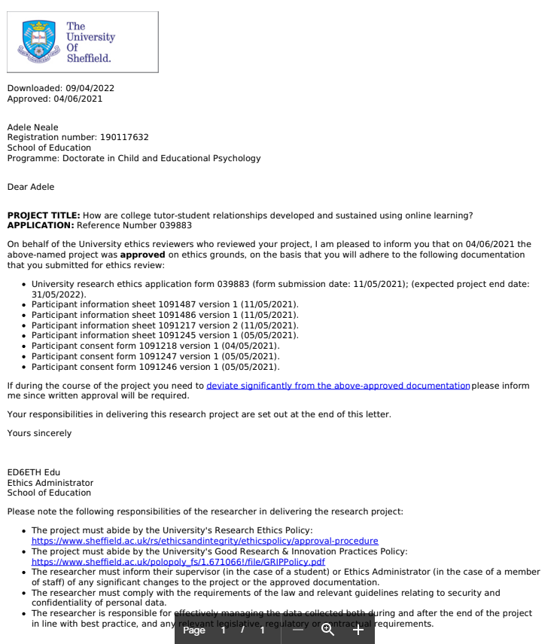

Appendix 2: Senior Management Research Summary

Research title (working title)
How can staff-student relationships be developed and sustained using online or blended learning?

Aims and Objectives of the research
The proposed study will form part of a doctoral thesis for the Doctor of Child and Educational Psychology course at Sheffield University, which is a requirement for UK Educational Psychologists. The researcher is a second year student on placement at North Lincolnshire Educational Psychology Service, and previously worked for North Lindsey College for nine years as a Student Adviser/ Progression & Achievement Coach.

The research aims to explore staff and students’ experiences of blended and online learning in a Post 16 college. Specifically, I would like to investigate how staff-student relationships are developed and sustained when opportunities for face-to-face contact are limited or non-existent.

Research questions
The overarching research question guiding the research is:
What can we learn about staff-student relationships from the experiences of staff and students using blended/online learning?
This will be explored using the accompanying sub questions:
- What are staff and students’ understandings of staff-student relationships?
- Do students feel they have been able to develop and sustain relationships with staff using blended/online learning?
- Do staff feel they have been able to develop and sustain relationships with students using blended/online learning?
- In what ways does blended / online learning impact positively and negatively upon staff-student relationships?

Rationale & Findings from the literature
Research suggests that positive staff-student relationships can be a protective factor for adjustment during transition between educational establishments (Longobardi, Prino, Marengo & Settanni, 2016). During 2020, students will have transitioned from school to post-16 college following lockdown and the closure of schools and colleges, experienced college with social distancing and other restrictions in place and experienced a further lockdown. The majority of teaching will have taken place virtually, with some limited blended learning opportunities to facilitate vocational learning. Post 16 staff will therefore have had to develop relationships with their students using primarily online methods. For students new to the college, blended and online learning may create challenges and opportunities to establish relationships with previously unknown staff and peers.

For students who are continuing at college, they will have had to adjust to learning online with staff and students they may previously have developed face-to-face relationships with, and there may be different challenges (and possibly advantages) to sustaining those relationships online.

Staff-student relationships have been found to have direct associations with student engagement, which also mediates student achievement (Rooda, Jak, Zee, Oort & Koomen, 2017). Young people experiencing positive relationships with their teachers, including perceived emotional support, have also been found to have more positive attitudes towards learning (Wentzel, 1994) and are less likely to drop out of education (Stabel Tvedt, Bru & Idsoe, 2021).

Strong and supportive student-teacher relationships can also serve as a protective factor towards students’ school, behaviour and emotion related problems (Baker, 2006; Baker, Grant & Morlock, 2008), reducing students’ externalised problem behaviours (Granot, 2016), developing relational and social skills (Pianta et al, 2008b) and increasing a sense of belonging (Dutton Tillery et al, 2012; Suldo et al, 2009; Nichols, 2008; Libbey, 2004). Furthermore, tutor support can increase academic achievement and motivation to learn (Fraire et al, 2013; Baker et al, 2008; Hughes, 2011; Sointu et al, 2017).

There has, however, been little research into staff-student relationships in Post-16 / further education, with most studies focusing on school aged pupils or Higher Education students. It could be argued that student-staff relationships in Post 16 education are increasingly more complex as students navigate the boundaries of impending adulthood, and Peart (2017) suggests that it is Further Education’s roots in Adult Education which has influenced its valuing of students as ‘independent adults’ with FE colleges viewing themselves as offering something different to schools with regard to interpersonal relationships between staff and students. This study hopes to explore some of the issues specific to relationships with this age group.

Research in other educational sectors suggests that there may be both benefits and drawbacks to online learning, with König, Wagner & Valtin (2011) expressing concern that young people’s social learning and development is adversely affected, whilst Gillmore and Warren (2007) suggest that online interpersonal communication offers potential for greater intimacy. There appear to be a number of challenges in developing and sustaining relationships when face-to-face contact is not possible. Guidance from the Association of Colleges (AoC, 2020) regarding online learning urges FE providers to consider the ‘hidden risk’ of pastoral care, and to explore how students can ‘see modelled behaviour, experience healthy conflict and conflict resolution, develop essential social skills in a safe environment, experience failure, tests of confidence and acceptance of others’.

Anecdotal comments from new students in other colleges suggest that some have had difficulty in getting to know staff and peers which may have affected their sense of belonging to the college. It appears, therefore, that there is potential to learn a great deal about staff-student relationships from exploring their experiences of online and blended learning during the Covid 19 pandemic. Additionally, college staff had been exploring a greater use of blended and online learning prior to the pandemic, and it therefore would be relevant to explore drawbacks and advantages of this approach to inform practice going forward.

Impact on the college
It is hoped that this research will provide examples of good practice and explore areas for development with regard to positive staff-student relationships. According to previous research, positive staff-student relationships is an important factor in student retention, achievement and wellbeing.

Proposed methodology
Phase 1 - an online survey will be sent to all staff and students across the DN Colleges group (North Lindsey College and Doncaster College) using the ‘all staff’ and ‘all students’ facility of the college’s email system. The survey will explore staff and student perceptions of staff-student relationships, and views as to how effectively those relationships have been developed and sustained using online / blended learning methods. Foundation Learning staff and students will be excluded from the study, as they have not received online learning. They will be filtered using the initial survey question.

Phase 2 - 2 groups of students (4-6 students in each group) and 2 groups of Staff (4-6 staff in each group) will be asked to participate in a one hour long focus group. The group will explore some of the ideas generated from the responses in the Phase 1 survey. Depending on Covid-19 restrictions, the focus groups will take place face-to-face in college or using Microsoft Teams. Focus groups will be video recorded to enable data analysis.

Ethics & Data Protection
This research will be subject to the University of Sheffield Ethics Approval. A consent form and participant information sheet will form the initial part of the online survey for staff and students. These will outline the nature and purpose of the project, research methods to be employed, who the research is being undertaken by and for what purpose, how data will be gathered and stored, potential risks and benefits to participants, and how to raise concerns. The right to refuse to participate and the right to withdraw at any time will be given.
Participation in the study should not have a detrimental effect on participants. However, it is acknowledged that some questions may be perceived to intrude upon a participant’s comfort or privacy, particularly in relation to the professional judgement or practice of college staff members.
The right to refuse to take part in the research will be made clear at the beginning and end of data collection, the opportunity given to ask questions by contacting the researcher and the right to withdraw at any time made clear throughout the project.

College staff, parents and pupil participants will be made aware of how to contact the researcher if they experience stress, harm or have any other concerns about the research.

It will be important that participants clearly understand that only the researcher and supervisor will have access to any identifiable information, and that any comments, views or responses shared will be anonymised and no identifiable personal information collected in order to protect identity, reduce risk of idealised answers and encourage honesty throughout data collection. This will be clearly stated in the participant information sheets for both Phase 1 and Phase 2 and in addition this will be read to the focus group prior to starting to ensure it has been clearly understood and give the opportunity for participants to ask questions.

With regard to staff participants it is important to ensure that time is given to complete the survey and take part in the focus group within the working day to minimise workload, Senior Management support will be required for this.

The college’s safeguarding policy will be adhered to at all times. If during research, the researcher obtains evidence of physical or psychological problems, such as a pupil becoming upset or distressed, research will be stopped, the participant will be informed and assistance sought from college pastoral staff if required. Participants will also be able to talk with a member of staff or the researcher if they wish immediately following the task.
Participants will be informed that data from the survey will be added to information from other participants and analysed as a set, so information will be anonymous. Participants in the focus group will not be identified by name, age or gender, but by a letter (‘participant A’) so that, whilst comments, views and responses will be recorded and may be reproduced in the study write up, they will be as anonymous as possible. No identifiable personal data will be collected, used, recorded or stored for both staff and pupil participants. Once collected, data will be securely stored on a password-protected computer and only accessible to the researcher. All raw data will be deleted upon completion of the report. Data will be analysed on a password protected computer.
The information will remain strictly confidential, anonymised and will only be identifiable from unique reference codes as opposed to names. Results from the study will appear in a final report, in an anonymised form so that none of the participants can be identified. It is possible that an anonymised version of the study write-up may be published at a later date.

Researcher contact information
Please address any questions to:

Adele Neale aneale1@sheffield.ac.uk

Research supervisor: Dr Lorraine Campbell l.n.campbell@sheffield.ac.uk

Appendix 3: Email invite to participate in study

Hello,
My name is Adele Neale and I'm a trainee Educational Psychologist who worked for 9 years at ******************** College. I'm currently undertaking my doctoral research into the effects of online learning on student-tutor relationships. If you are a course tutor, I'd be really grateful if you could complete the attached questionnaire which should take no more than 10 minutes to complete. Please read the attached Participant Information sheet before clicking on the link below or scanning the QR code.
Many thanks, Adele

Appendix 4: Participant Information Sheet - Questionnaire

Participant Information sheet

You are being invited to take part in a research project. Before you decide whether or not to participate, it is important for you to understand why the research is being done and what it will involve. Please take time to read the following information carefully and discuss it with others if you wish. Ask me if there is anything that is not clear or if you would like more information. Take time to decide whether or not you wish to take part. Thank you for reading this.

Research project title: How are college tutor-student relationships developed and sustained using online learning?

What is the project’s purpose?
This research will form part of the researcher’s doctoral thesis for the Doctorate of Child and Educational Psychology course at Sheffield University, which is a requirement for UK Educational Psychologists. The research aims to explore staff and students’ experiences in a Post 16 college. I am interested in your views about how your relationship with your course tutor can affect your college experience in general, and how this relationship has been affected by having to learn online or using a blended learning model during lockdown.

Why have I been chosen?
All course tutors and students aged 16-19 at your college who have used online learning have been asked to take part so I can collect as many views as possible.

Do I have to take part?
It is up to you to decide whether or not to take part. If you do decide to take part you will be given this information sheet to keep and be asked to sign a consent form. You can still withdraw at any time during the study and up to seven days after taking part without any negative consequences. You do not have to give a reason. If you decide to withdraw from the study, all information you have provided will be destroyed immediately. If you wish to withdraw from the research, please contact the researcher by emailing aneale1@sheffield.ac.uk. Please note that by choosing to participate in this research, this will not create a legally binding agreement, nor is it intended to create an employment relationship between you and the University of Sheffield.

What will happen to me if I take part? What do I have to do?
This first part of the study is an online questionnaire, which should take no more than 15 minutes to complete. You will be asked about what you understand about tutor-student relationships, how important you feel they are, how your relationship with your tutor was developed and continued using online learning, what has helped you and what could be improved. You will need to answer all questions in order for your responses to be submitted. At the end of the questionnaire, you will be invited to take part in the second part of the study, which will be participating in a small group of students on Microsoft Teams. Only a small number of staff and students will be selected, so agreeing to take part will not mean that you will automatically be selected. If you do not agree to take part in the second part of the student, or you agree but are not selected, completion of the questionnaire will be the end of your involvement in the study.

What are the possible disadvantages and risks of taking part?
Although the questionnaire has been designed to seek your personal views, and these will remain confidential, you may feel that some questions intrude upon your privacy or comfort.
As members of staff you may feel under pressure to take part or to give idealised answers, or you may not feel you have the time to complete the survey or take part. As students or staff you may feel concerned about sharing views which are critical of others or relate to experiences you have found difficult. Should you feel uncomfortable at any point taking part in the project, please remember that your involvement is entirely voluntary and you can withdraw at any point during and up to seven days after giving your responses by contacting the researcher via email at aneale1@sheffield.ac.uk. You are also able to discuss any concerns with the researcher, with your pastoral tutor or with the college safeguarding team.

What are the possible benefits of taking part?
Whilst there are no immediate benefits for those people participating in the project, it is hoped that finding out more about how staff develop and sustain relationships with students online will help plan how to support students in the future, and enable good practice to be shared.

Will my taking part in this project be kept confidential?
You will not be required to give your name or gender to take part in the questionnaire, and so you can only be identified as a member of your course area and by your age. Your age, however, and all the information that we collect about you during the course of the research will be kept strictly confidential and will only be accessible to members of the research team.
Your responses will be collected and analysed with all other responses, and so information provided to the college will only identify a course area as a collective e.g. “60% of Construction students who responded felt….” Researchers will be unable to identify you as an individual unless you provide your name and email address if you agree to participate in the second part of the research. You will not be able to be identified in any reports or publications unless you have given your explicit consent for this. If you agree to us sharing the information you provide with other researchers (e.g. by making it available in a data archive) then your personal details will not be included unless you explicitly request this.

What is the legal basis for processing my personal data?
According to data protection legislation, we are required to inform you that the legal basis we are applying in order to process your personal data is that ‘processing is necessary for the performance of a task carried out in the public interest’ (Article 6(1)(e)). Further information can be found in the University’s Privacy Notice https://www.sheffield.ac.uk/govern/data-protection/privacy/general.

What will happen to the data collected, and the results of the research project?
The results of the research project will be written up as a doctoral thesis, and will be published online. You will be notified via your college email address when the research is due to be published and given the opportunity to access a copy of the thesis. As previously explained, the data will be analysed and written about using letters to identify participants e.g. participant A and you will not be identified other than by that letter.

Who is organising and funding the research?
The research is organised by the researcher, Adele Neale, in agreement with ** Colleges Group’s Senior Management Team. There are no funding implications.

Who is the Data Controller?
The University of Sheffield will act as the Data Controller for this study. This means that the University is responsible for looking after your information and using it properly.

Who has ethically reviewed the project?
This project has been ethically approved via the University of Sheffield’s Ethics Review Procedure, as administered by the University of Sheffield’s School of Education.

What if something goes wrong and I wish to complain about the research or report a concern or incident?
If you are dissatisfied with any aspect of the research and wish to make a complaint, please contact Dr Lorraine Campbell via the email l.n.campbell@ sheffield.ac.uk in the first instance. If you feel your complaint has not been handled in a satisfactory way you can contact the DEdPsy Programme Lead, Dr Tony Williams via the email anthony.williams@sheffield.ac.uk. If the complaint relates to how your personal data has been handled, you can find information about how to raise a complaint in the University’s Privacy Notice: https://www.sheffield.ac.uk/govern/data-protection/privacy/general.

If you wish to make a report of a concern or incident relating to potential exploitation, abuse or harm resulting from your involvement in this project, please contact the project’s Designated Safeguarding Contact [Dr Lorraine Campbell via the email l.n.campbell@ sheffield.ac.uk]. If the concern or incident relates to the Designated Safeguarding Contact, or if you feel a report you have made to this Contact has not been handled in a satisfactory way, please contact the DEdPsy Programme Lead, Dr Tony Williams via the email anthony.williams@sheffield.ac.uk. and/or the University’s Research Ethics & Integrity Manager (Lindsay Unwin; l.v.unwin@sheffield.ac.uk).

Many thanks for your time and for considering participating in this research.

Contact for further information: Adele Neale, email: aneale1@sheffield.ac.uk

Appendix 5: Participant Consent Form

PARTICIPANT CONSENT FORM

Researcher’s name: Adele Neale aneale1@sheffield.ac.uk
Supervisor’s name: Dr Lorraine Campbell l.n.campbell@sheffield.ac.uk

Please read the following and sign if you are happy to take part in the study

- I have read the Participant Information Sheet and the nature and purpose of the research project has been explained to me. I understand and agree to take part.

- I understand the purpose of the research project and my involvement in it.

- I understand that I may withdraw from the research project at any stage up to 7 days after participation, without giving a reason and that this will not affect my status now or in the future.

- I understand that while information gained during the study may be published, I will not be identified and my personal results will remain confidential.

- I have had the opportunity to consider the information, ask questions and have these questions answered satisfactorily

- I understand that data will be stored electronically and will only be accessible to the researcher and supervisor

- I understand that I may contact the researcher or supervisor if I require further information about the research, and that I may contact Sheffield University, if I wish to make a complaint relating to my involvement in the research.

Signed …………………………………………………………………………
(research participant)

Print name …………………………………………………………………

Date …………………………………

Appendix 6: Student Questionnaire

- Is this your first year of study at this college?

Yes No

- Did you know your course tutor before this year?

Yes No

Next are some questions about the role of the course tutor and what you think is important about it.

The role of the tutor
- How important do you think the following are for a course tutor:

 | Very important | Important | Not really important | Not important at all
Good subject knowledge
Understanding of jobs and careers in my course area
Keeping up to date about their subject
Being enthusiastic about their subject
Getting to know their students well
Motivating students to do well
Encouraging student discussion
Making lessons interactive
Being able to use IT / technology
Making lessons interesting
Encouraging independent learning
Caring about their students
Giving good feedback
Being available when students need them
Starting and finishing the lesson on time
Giving clear instructions
Helping students with their academic work
Helping students with personal problems
Recognising their students’ needs
Being sympathetic
Being organised
Being flexible
Respecting students
Treating students fairly
Explaining things well
Encouraging questions

- Is there anything else you feel is important for a course tutor? (aspects of a course tutor’s role you feel are important?)

………………………………………………………………………………………………………………………………………………………………………………….

The next questions relate to your view of good relationships between tutors and students.

- Which factors do you think are important for developing a good relationship with your tutor?

 | Very important | Important | Not really important | Not important at all
I can talk to them about anything that is bothering me
They are a good listener
They expect high standards of me
They give me advice about personal problems
They don’t judge me
They give me advice about how to improve my work
They return marked assignments promptly
They give helpful feedback
They push me to reach my potential
They care about me
They motivate me
They treat me like an adult
Sense of humour
Knowing what they expect from me
They are available if I need them
They encourage me to think for myself
They make me feel safe
They respect me
They treat me fairly
They communicate well with me
I hand work in on time
I have good attendance and am punctual
I contribute to sessions
I am interested in the lesson
I am willing to accept help and feedback
I respect my tutor
I try hard
I communicate well with my tutor

Importance of good relationship with tutor

- How important do you think a good relationship between tutor and student is for:

 | Very important | Important | Not really important | Not important at all
Transition from school to college and settling in to college
Successful completion of current college course
Being happy at college
Progressing on to your next steps (another course, university, work or apprenticeship)
Motivation to attend college
Offering emotional support / helping with personal problems
Offering academic support / helping with course or college problems

The next questions relate to your relationship with your course tutor over the past year when you have been learning online.

- How would you rate your relationship with your tutor during online learning?

Very good
Good
Not very good
Bad

Or use 1-10 scale where 1 is bad and 10 is extremely good

- Thinking back to your answers for question 5, you identified the following factors as important or very important to a good relationship with your tutor:
[the answers from question 5 will be pulled through here]

Do you feel your tutor has demonstrated these factors during online learning?[list of factors here in a table] yes no sometimes

- Thinking back to your answers for question 6, you identified a good relationship between you and your tutor as being important for :
[the answers from question 6 will be pulled through here] During online learning, what effect do you think your relationship with your tutor has had on your:

 | My relationship with my tutor during online learning has helped me | My relationship with my tutor during online learning has not helped me | My relationship with my tutor during online learning has made no difference to me | Not applicable to me
Transition from school to college and settling in to college
Successful completion of current college course
Being happy at college
Progressing on to your next steps (another course, university, work or apprenticeship)
Motivation to attend college
Offering emotional support / helping with personal problems
Offering academic support / helping with course or college problems

- Do you feel that online learning has made it easier or harder for you to have a good relationship with your tutor compared to face-to-face learning?

More difficult About the same Less difficult

- In what ways?

Thank you for taking the time to complete this questionnaire. I will be inviting a small group of students to tell me more about their experience of tutor-student relationships using Microsoft Teams. There will be no more than six students in a group and it should take no longer than an hour and half. The focus groups are likely to run at the beginning of July. If you would be happy to take part, please add your first name and email address below. Many thanks!

Name:

Email address:

Appendix 7: Tutor Questionnaire

- How many years have you worked as a course tutor at this college?

- Which vocational area do you work in?

Next are some questions about the role of the course tutor and what you think is important about it.

The role of the tutor
- How important do you think the following are for a course tutor:

 | Very important | Important | Not really important | Not important at all
Good subject knowledge
Understanding of jobs and careers in my course area
Keeping up to date about their subject
Being enthusiastic about their subject
Getting to know their students well
Motivating students to do well
Encouraging student discussion
Making lessons interactive
Being able to use IT / technology
Making lessons interesting
Encouraging independent learning
Caring about their students
Giving good feedback
Being available when students need them
Starting and finishing the lesson on time
Giving clear instructions
Helping students with their academic work
Helping students with personal problems
Recognising their students’ needs
Being sympathetic
Being organised
Being flexible
Teaching students how to evaluate their own progress
Respecting students
Treating students fairly
Explaining things well
Encouraging questions

- Is there anything else you feel is important for a course tutor? (aspects of a course tutor’s role you feel are important?)

………………………………………………………………………………………………………………...

The next questions relate to your view of good relationships between tutors and students.

- Which factors do you think are important for developing a good relationship with your students?

 | Very important | Important | Not really important | Not important at all
They can talk to me about anything that is bothering them
I am a good listener
I expect high standards of them
I give me advice about personal problems
I don’t judge them
I give them advice about how to improve their work
I return marked assignments promptly
I give helpful feedback
They push me to reach my potential
I care about them
I motivate them
I treat them like an adult
Sense of humour
They know what I expect from them
I am available if they need me
I encourage them to think for themselves
They feel safe
I respect them
I treat them fairly
I communicate well with them
They hand work in on time
They have good attendance and are punctual
They contribute to sessions
They are interested in the lesson
They will accept help and feedback
They respect me
They will try hard
They communicate well with me

Importance of good relationship with tutor

- How important do you think a good relationship between tutor and student is for:

 | Very important | Important | Not really important | Not important at all
Transition from school to college and settling in to college
Successful completion of current college course
Being happy at college
Progressing on to next steps (another course, university, work or apprenticeship)
Motivation to attend college
Offering emotional support / helping with personal problems
Offering academic support / helping with course or college problems

The next questions relate to your relationship with your students over the past year when you have been teaching online.

- Thinking about the majority of your students, how would you rate your relationship with them during online learning?

Very good
Good
Not very good
Bad

Or use 1-10 scale where 1 is bad and 10 is extremely good

- Thinking back to your answers for question 5, you identified the following factors as important or very important to a good relationship with your students:
[the answers from question 5 will be pulled through here]

Do you feel these factors have been present during online learning?[list of factors in a table here with the option to select yes no sometimes for each question]

- Thinking back to your answers for question 6, you identified a good relationship between you and your students as being important for :
[list of factors from question 6 here] During online learning, what effect do you think your relationship with your students has had on their:

 | My relationship with my students during online learning has helped them | My relationship with my students during online learning has not helped them | My relationship with my students during online learning has made no difference to them | Not applicable to me
Transition from school to college and settling in to college
Successful completion of current college course
Being happy at college
Progressing on to your next steps (another course, university, work or apprenticeship)
Motivation to attend college
Offering emotional support / helping with personal problems
Offering academic support / helping with course or college problems

- Do you feel that online learning has made it easier or harder for you to have a good relationship with your students compared to face-to-face learning?

More difficult
About the same
Less difficult
More difficult for some students and easier for others

- In what ways?

Thank you for taking the time to complete this questionnaire. I will be inviting a small group of tutors to tell me more about their experience of tutor-student relationships using Microsoft Teams. There will be no more than six tutors in a group and it should take no longer than an hour and half. The focus groups are likely to run at the beginning of July. If you would be happy to take part, please add your first name and email address below. Many thanks!

Name:

Email address:

Appendix 8: Interview Schedule for Tutor Focus Groups

Research recap
Reminder about what research is about. Evidence to show a good relationship with their tutor can help student retention, progression and settling in.
Add: Most staff in the survey felt that a good relationship with their students contributed to student happiness, successful transition, successful course completion and progression and effective academic support.

Check on information sheet and consent form - make sure everyone has read and understands - any questions?

Confidentiality reminder: I’d like to reiterate and reassure you that all comments and opinions provided today will remain confidential. Everything said here today will be transcribed, anonymously, and will be used solely for the purpose of coding qualitative data in regard to the project.

It’s important to let you know that whilst I used to work at the college, I have no affiliation to it or the management and remain neutral on the topic. The management of the college will receive a copy of the final thesis write up and summary of the findings but they will not know who took part in the research, or what they said.

My role: I’m interested in finding out more about your experiences, good and bad. I’m not going to participate myself - my role will be to facilitate the group and ask questions.

Before we start, I’d like to agree some ground rules with you. [Put these up on screen]

Ground rules:
- Accept other people may have different views to you, please treat everyone with respect

- I’d like to hear from everyone so please don’t be offended if I stop you to hear from someone else - we only have limited time.

- Speak one at a time please!

- Keep focused on the topic and question we are discussing

Is everyone happy with these rules?

Timings Ok, we have about an hour, so I aim to finish by ___ Is this ok with everyone?

Questions

1.First question. I’m interested in finding out how you developed relationships with your students during online learning.

2.How was this different for existing students and new students?

Disadvantages
3. More than half of the tutors surveyed felt that online learning made it difficult to have good staff-student relationships. Why do you think this is?

(additional prompt questions if needed:)

4.(One of the things that came out strongly from the survey was the difficulties with communication - how do you think that affected your relationships with students?)

5. (Lots of staff in the survey mentioned that it was difficult to read students’ moods, emotions, reactions, what they were thinking, what was your experience of this?)

More than 90% of staff and all of the students surveyed felt that their course tutor staff/student relationship during online learning was good or very good, so you must be doing something right!

SEND
6. Some staff suggested that it was easier for those with mental health difficulties, autism and other special educational needs to interact online whilst other staff felt they found it more difficult. What was your experience in terms of developing and sustaining relationships with those students?

Advantages
7. Some staff did feel there had been some positive aspects for some staff-student relationships. They felt one advantage was flexibility and that online learning was easier for some with access issues e.g. childcare or caring responsibilities. What’s your view on that?

8. Finally, some staff suggested students were more relaxed at home and it was easier to develop intimacy between staff and students. What has been your experience of that?

9. Anything else you would like to add?

Appendix 9: Interview Schedule for Student Focus Groups

Research recap
Reminder about what research is about. Evidence to show a good relationship with their tutor can help student retention, progression and settling in.
Add: Most students in the survey felt that a good relationship with their tutor contributed to a successful transition from school, successful course completion and progression and effective academic support.

Check on information sheet and consent form - make sure everyone has read and understands - any questions?

Confidentiality reminder: I’d like to reiterate and reassure you that all comments and opinions provided today will remain confidential. Everything said here today will be transcribed, anonymously, and will be used solely for the purpose of coding qualitative data in regard to the project.

It’s important to let you know that whilst I used to work at the college, I have no affiliation to it or the management and remain neutral on the topic. The management of the college will receive a copy of the final thesis write up and summary of the findings but they will not know who took part in the research, or what they said.

My role: I’m interested in finding out more about your experiences, good and bad. I’m not going to participate myself - my role will be to facilitate the group and ask questions.

Before we start, I’d like to agree some ground rules with you. [Put these up on screen]

Ground rules:
- Accept other people may have different views to you, please treat everyone with respect

- I’d like to hear from everyone so please don’t be offended if I stop you to hear from someone else - we only have limited time.

- Speak one at a time please!

- Keep focused on the topic and question we are discussing

Is everyone happy with these rules?

Timings Ok, we have about an hour, so I aim to finish by the end of your tutorial session - Is this ok with everyone?

Questions

1.First question. Did you know your tutor before online learning, and if not, how did your tutor get to know you during online learning?

2.How did they keep a good relationship with you during online learning? What helped? What could have gone better?

3. All the students in the survey felt their relationship with their tutor during online learning was good or very good. But almost a third (29%) felt it was more difficult to have a good relationship with their tutor during online learning than face-to-face. Why do you think this is?

(prompt: harder to form relationships - pick up on social cues when cameras not on and can’t see faces)

(prompt: communication is open to everyone on call. Privacy?)

(prompt: I have social anxiety)

(prompt: less interactive - felt like a robot)

4. Just over half of students felt like their relationship with their tutor was about the same online as face-to-face. Some comments were that they were still able to talk about issues and that the tutor was still the same - helpful, kind, enthusiastic and always there to listen and hand out advice. If that was your experience - what helped with this?

5. 15% of students felt online learning was easier to build a relationship with their tutor. Are there any ways in which you think it was easier? (One example given was that it can help students who have anxiety and are worried about leaving the house.)

6. All students felt a good relationship with their tutor was important for academic support, but less students felt it was important for emotional support. Most students felt their relationship with their tutor helped or made no difference to the support they got when working online. How did your tutor support you online, and was this different to face-to-face?

7. Being treated fairly by your tutor was the highest scoring factor for student-tutor relationships, and everyone who completed the survey felt this had been demonstrated during online learning. Why do you think this is so important? How did your tutor demonstrate fairness during online learning?

8. The next highest scoring factors which students felt their tutors demonstrated during online learning were respect, caring about students and not judging them. How do you think this is demonstrated during online learning? Examples?

9. Contributing to lessons was the factor that had the highest number of students saying it wasn't important and that they didn’t do it during online lessons (although this was still a minority). Do you think that impacts on tutor-student relationships? How?

10. Giving advice about personal problems was the second factor that several students felt wasn’t important and wasn’t really demonstrated during online learning. What are your views on this? (Is it part of the tutor role? What about if those problems impact on your studies?)

Appendix 10: Participant Information Sheet - Focus Groups

PARTICIPANT INFORMATION SHEET - FOCUS GROUP

You are being invited to take part in a doctoral research project. Before you decide whether or not to participate, it is important for you to understand why the research is being done and what it will involve. Please take time to read the following information carefully and discuss it with others if you wish. Ask us if there is anything that is not clear or if you would like more information. Take time to decide whether or not you wish to take part. Thank you for reading this.

The research aims to explore staff and students’ experiences of blended and online learning in a Post 16 college. Specifically, I would like to investigate how staff-student relationships are developed and sustained when opportunities for face-to-face contact are limited or non-existent.

I am interested in your views about how your relationship with your course tutor can affect your college experience in general, and how these relationships have been affected by having to learn online or using a blended learning model during lockdown. It is hoped that finding out more about how staff develop and sustain relationships with students online will help plan how to support students in the future, and enable good practice to be shared.

Following the first stage of the research, which was an online questionnaire sent to all college staff and students, you indicated that you would be willing to take part in the second stage. The second stage of the research is four focus groups, two groups of staff and two groups of students. Each group will meet only once, and you will only be part of one group. You will meet with up to 10 other students to discuss the findings of the questionnaire in more detail during a tutorial session at college. There will be 15 minutes to settle into the group, ask any questions and go over what will happen, and then about 45 minutes of group discussion, when the researcher will ask questions to the group.

You can choose whether or not to participate in the focus group and can stop at any time. You can decide to share whatever you feel comfortable with and can choose to share your views or not. There are no right or wrong answers to the focus group questions. I want to hear many different viewpoints and would like to hear from everyone. I hope you can be honest even when your responses may not be in agreement with the rest of the group. In respect for each other, I ask that only one individual speak at a time in the group and that responses made by all participants be kept confidential.

Although the focus group will be video recorded, your responses will remain anonymous and no names will be mentioned in the report. The video recording is to help with analysis of the data and will be destroyed once analysis has taken place. All information you provide will remain confidential and will be stored on an encrypted hard drive which will be accessed only by myself and my supervisor on a password protected computer. The recordings will be initially stored on my personal laptop which is encrypted and password protected. They will be uploaded to the secure University of Sheffield Google Drive Account immediately after recording and then destroyed from the recording device. Data will be analysed collectively, and no one else will have access to individual data. Anonymised, collated data will be published in the final report, but will be destroyed once the research is completed.
Participation in the study is entirely voluntary and you can withdraw from the study without giving any reason and at any point during the study or up to seven days after taking part. If you decide to withdraw from the study, all information you have provided will be destroyed immediately.
If you have any questions or concerns, please ask using the email below:
Adele Neale - aneale1@sheffield.ac.uk

To raise any safeguarding concerns, please contact Dr Lorraine Campbell - l.n.campbell@sheffield.ac.uk

Appendix 11: List of initial codes - tutor data
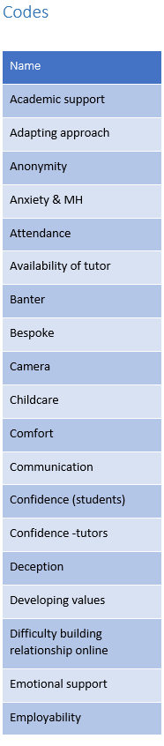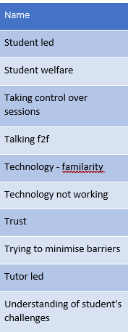
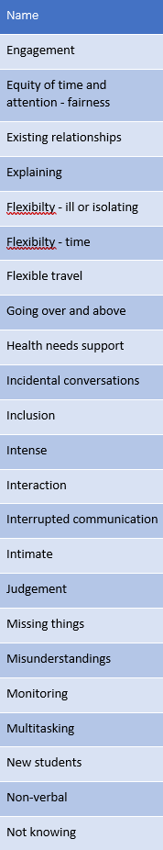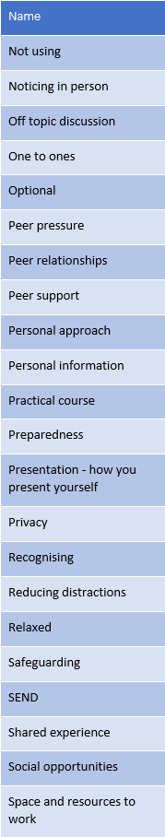

Appendix 12: List of initial codes - student data

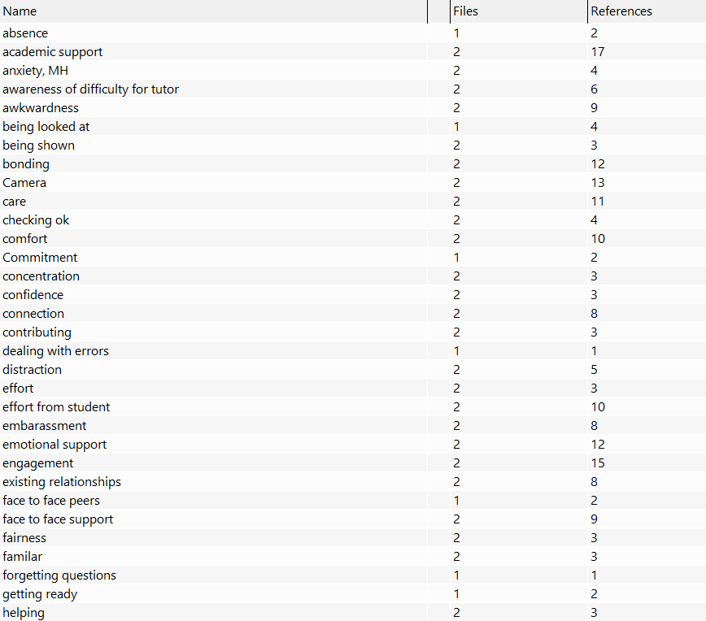

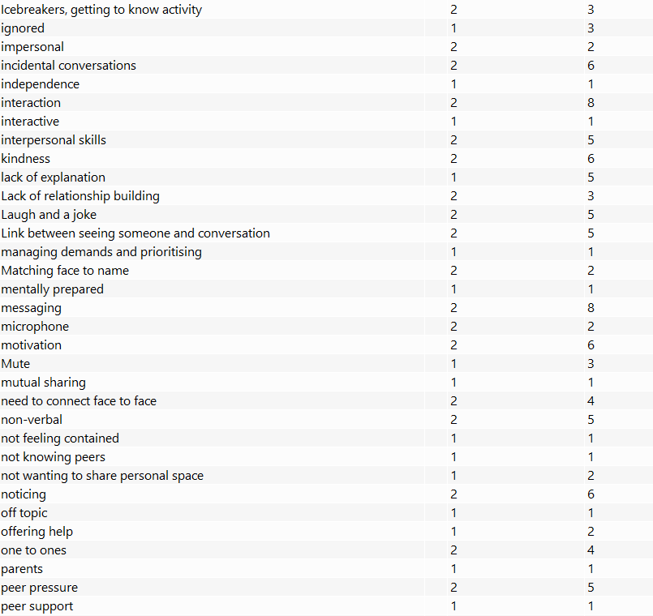
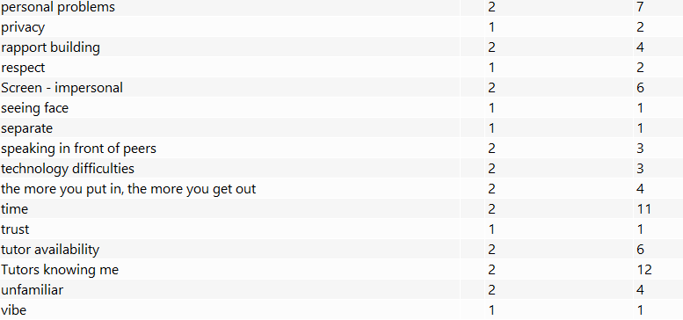

Appendix 13: Focus group quotes by theme from tutor data

Diffs with tech

T4: I've never used Teams before. I've never even seen it as a platform. I didn't know what Teams was, so getting used to the technology…..So the first lockdown..was completely different. It was more about welfare and ‘are you okay?’

T6: Initially, it was really really tough, because we were in the complete unknown.

T4: And they're asking questions. ‘What's happening? What we're gonna do now?’ And we were just like - ‘..we're looking at all the information’.

T6: So early doors, it was initially we were all in the unknown - teachers and students, and it was just a case of trying because..no one really had any answers. [T 5 murmured agreement] I remember leaving work on that…day and kind of thinking will we be back in two weeks? Will it be six months? Or what will it be?

T5: I think this second time around because we are all so much more familiar with Teams. Communication was easier because we could do that via that platform. And we knew what we were doing with that platform. And…a lot of students were familiar with it by that point. So I think..that was easier to a big degree, really, wasn't it?

T6: And then our confidence and compatibility with the apps and things that we were using grew and once ours grew, and then it allowed…that consistent approach

T1: …we're seven weeks into this term now in the I T. department and Microsoft teams and the online portals aren't working properly. I've got some lads that have tried weekly to get online, and I've been sat at the end of the phone trying to get them all in, and it's not worked.

T6: when we were at home and had really bad internet…not just the students, but my own internet. I would go in with my lack of confidence, not knowing if my internet was going to hold up for the full duration of the call. So it was hard. You almost felt as though you kind of rushed to make sure you’ve got everything in. So that was a massive issue for me. And I know other staff that experienced the same..and other students would have experienced that as well, not knowing how well your internet or technology is going to hold up.
T6:…and at that point, what - what have they missed? ..it could be..that moment's glitch or their screen's glitch that they've missed something that would have allowed them to piece everything together. Um, and without that confidence…and… sometimes you don't know how it's glitched. And if they're not confident enough to say, 'Excuse me, you're on mute', or 'can you just repeat that?' and you just carry on talking, you've kind of lost -

T5: my microphone wasn't - it kept on dipping in and out, but I had no idea. And it was only..this student was like, 'T5, is there something wrong with your microphone?'..And it wasn't that they couldn't hear me. It's just that I kept going really, really quiet and then really loud and really quiet…And of course, sometimes they don't have the confidence to let you know.

T6: I had a couple of students who..experienced technical difficulties..and really, if we..or they're having technical difficulties, if what you were trying to say - …that context about what you're talking about can be lost in a moment's glitch of an internet. If the student misses that glitch or if I glitch at that point and I don't know, because the students might not feel comfortable enough to - I'll hold my hand up. I spent five minutes the other month talking online, and I was on mute and no one told me for five minutes. [T4 & T5 laugh] I had to go and repeat it all!

T2: But online, you’d probably get about a third of them done, because of connection issues and someone doing this and someone doing that. And - and ‘are you - are you there so and so?’ no, he’s gone. So I’m dialling back in, and that’s not getting work ready.

T2: And we can smell drugs as well, when they come in. We've had that, knowing if they're under the influence of anything and also with smell, we can smell them, which is then linked to care and welfare.

Not noticing

T5: I was very keen that my tutorials were on site, so [during blended learning] I would make sure that that hour was where I was with them face-to-face, because my real concern was that I was going to miss picking up on those things that..like tutorial, is very difficult to do..online.

T2: And the lad who was passing the £10 note was a very quiet, insular - a nice boy but very, very quiet. And out the corner of my eye I saw the other lad saying, 'I don't want it, it's not mine' and push, push, push 'Have it' - 'no, I don't want it, you have it'. Anyway, we gets to the end because I took the second lad off to the side, and said 'so what was - what was that about?'..he said, ‘I know him from school, and I think he's trying to buy friendship’, so - I had to take the boy off to Safeguarding...Now then, online - what if he was doing that in the town, in the village, wherever he lived?..he'd have had loads of new friends, wouldn't he? Just the sort of friends everybody needs that…Being..with people in a social area, in an educational area, we pick up all sorts of things. And so we explained to that boy the dangers which links into county lines…How can we do county lines when they're all sat at home?

Not engaging

T4: I wish we’d have almost insisted from the start that they had the camera on…But we didn’t because there’s so many barriers to them students joining, they wouldn’t come. They didn’t want their cameras on. They didn't want to speak, so they avoided coming. So do we want the students in session listening or do we want them on camera not coming because we forced something? [murmured agreement - Participant 5] So we made the decision not to force the camera and not to force the microphone.

T6: and..you can't see them, and you're having to rely on recognising the voices. And I realised I couldn't

T4: And I had one group of level twos, and one student put the camera on…I was ‘aw it's amazing to see your face'. And then another student was like, I'll show you my face and another student, and then I had a whole class full of cameras and it was brilliant. But that was the only group for the whole year that did that. All of the others, there was one student that had his camera in one of the groups, and then nobody had the camera on in any of the others. And my favourite was the group that had the cameras on. [murmured agreement from T6]

T4: my favourite sessions…were with students that had the confidence to put the camera on.

T4: but it took - it took one confident, outgoing person to do that and the rest then were like, I'll do that, it's not that scary.

T1: I don't know if it's a bit of that - no one else has got the video on, so he won't have his video on. I'm not sure if that's part of it as well.

T5: I think…another sort of disadvantage of doing online, it's all nice having the students on the camera, but actually, I think the students feel that they're judged. They're being judged physical, like their physical appearance, but also their backgrounds. And at the time, I think when we first started using it, we weren't really sure…how to do that, how to change the background, how to hide things and stuff…I remember particular students who put the camera on and in the background, you know, you would…sort of be quite surprised…I think, to see what you could see in the background, and it wasn't people or anything, but just where they lived. And I think that that then makes people think - they're going to judge me. So cameras…..it's quite interesting because a lot of them use social media and they're always doing it, but they can't, I suppose when they're in a lesson, tailor that to what they want - have a filter on or whatever, you know. So..I do think that..the students were more worried about being judged from others…and therefore causing sort of more than a personal social level issue.

T5: I do not want to be on online sessions for however many hours a day with no interaction, or no - not even knowing if they’re listening.

T1: When you’ve got to sit there for three hours…and try to get them to engage in conversations

T4: a lot of the groups you asked a question and there was tumbleweed [murmured agreement from T5]

T1: you’re not getting…you’re not seeing them…d’you know what I mean - I’m looking at a blank screen…I’m not seeing the person

T1: that's a bit of a pain because you're not getting the interaction back

Deception & Distractions

T4: [with Nearpod] you could see that they were still engaged because I was worried about - that they had turned me off. They'd be joining, but they wouldn't really be present. And that was my big concern is, actually are they sat watching Netflix and not listening,

Banter

T2: And, you know, and things, um, I might - I might use the phrase to one of them one time, something - when he when he gives me an answer to something, I might just say to him - 'Oh, you tool, you need to buck up'. But he knows full well because I'm smiling, because the tone of my voice, and because I've thrown my hands in the air and sort of shaking my head - He knows fully that I'm pulling his leg and I'm joking with him. You try and get that over online….What if…there's a parent walking past in the background who I can't see and all they've heard me say is 'you tool'? Yeah, suddenly - management here, I've got a complaint, but the context is totally, totally wrong. Because, I've got the students there laughing saying 'Oh no! I know what I've - ' You know? In my classroom?

T2: because often…what can happen, I find is that if I was to say something on here now [online], it could be deemed as totally falling flat. It could have - it could be deemed the tone and the timing totally and utterly wrong. Yet if we were set in the same room together…you would get it.

Social learning

I had one the other day, lad said, so he says err, - we were talking about something - he says, 'what you mean, T2, like a retard kid?' I said, 'whoa, hang on. That's a term that we don't use anymore'. I said 'that's a derogatory term, whatever you’ - and I said, you know, 'we don't use that' and I start to explain…And he sat there and he went, 'Wow, I didn't know that' and suddenly - but that could have -

T2: ..when I'm in a classroom, we start off doing one subject and we might 10 minutes later go into a bit of a debate…totally random going off somewhere on a bit of a debate and I can drag everybody into that debate. I can say 'now then lad you in the corner, you've not had an opinion. D'you think Sid's right? Or do you think Harry's right? Where are you? Where do you think of? Online - virtually impossible.

T2: How can I do fundamental British values when they're not meeting each other?...if they are in a classroom together, working with each other for two or three days, we can - we can foster the fundamental British values because we can help each other. We can put them working with each other, buddy up.

T2: and then again, being in a classroom at my level is fostering relationships, and I always tell them about the very, very first student who I spoke to when I started [college name]... Online that would probably never have never happened because we went for a coffee and a sausage roll together, and we - we stood outside the classroom waiting for the tutor to arrive together. And then we worked on a bench next to each other, and we sat next to each other in theory, and it goes on. But online - online you don't get that social interaction.

Support

T1: You can't - you don't get that interaction where you can - you're like - well, you're happy with what you're doing. You just go do this extra bit. And this lad, you keep a bit more bit more time with that student to go to coax him through a little bit. When you're doing online, you always seem to be keeping an eye on the clock, and you know, is that, is that student where he should be? Is he not? Whereas you're in a classroom..they're in front of you.

T2: Virtually impossible, Um, to get everybody to - A, to keep your eye on everybody and to B get them interacting in a social - social way.

T1: Other than the obvious social interaction I can't do technical drawings online. Can't do one to one support we're doing, uh, constantly surveying the marks with them.

T4:..they chose to come into site to get TA support because that was a little bit harder? Yeah, yeah It was very much - I want to come into site, I don't like working online, just fully. I want some support.

T1: I had one student I was hand delivering..during the first lockdown, paper based work, I still wasn't getting anything back. Mum weren't supporting, the SENCO wasn't pushing the support. I've got nothing back from him at all in a year and a half, which is frustrating because when he was in the workshop he was one of the best…I've seen in college in 12 years but wouldn't do online theory. In the classroom, it was all right…..We got him through..at the end of last year, but it was kind of like - right, he's in..sit down, do this, but because he was in, I was able to help and support him and push him and get his qualification. If it had all been purely online based, he wouldn't have got it. And he'd never - he'd not [have] got the practical elements, either.

Flexibility

T4: I choose to respond. If it's - if it's something that I can answer I don't ignore them. And we definitely did that a lot during lockdowns. We did a lot out of hours as well, so we did a lot of revision sessions, five till six or six till seven because it suited us and we were at home and they were at home. They had nowhere to go, and we did a lot of - of extra, actually, because we was online and..that personal approach, even though we couldn't speak to them, they got an instant response via the chat option on teams. And that's been really used really well. A lot of the students will send you a quick ‘I need this’ or ‘what's happening with this’, and you can respond very quickly. I do use that a lot.
T5: …which, actually they really like that. And they loved, you know, and I would record - I'd either call them live and they'd do it live in front of me or they would film it and those students that filmed it, they were so confident when they were doing it was so lovely to see because they were in their kitchen or in their in their garage or whatever. So that was really nice. And then, of course, like I said, when I was doing it live with them, um I was able to sort of say to them - It's OK, you know, we'll start again if you want. You know, that didn't go quite as well as we planned or whatever you know, and and go back over that.

T4: I think the flexibility is really useful for some students and moving into this academic year, it's been used to the max because we've had students that've have to isolate because of Covid.

T6: ..what T5 and T4 have said it's the flexibility. It's the - …kind of eliminating excuses, whereas before…if it's a little bit cold outside and the students got a bit of a sniffle, it was an excuse. Um, I'm comfy in my nice warm bed, it's - I can just text in so I don't have to go to college. Now we're sort of taking away a few of those excuses. Okay, you can join online now. You can still get the contact. You can still speak to your tutor. You're sort of taking those away.

T1: I think that's worked for me and T2 as well being able to start lessons, like, half an hour earlier or later….for Friday mornings, I've set it back to half past nine, so they get that extra half an hour to get up and get ready. And that works quite well. Surprisingly well.

T3: we sort of shortened our sessions because of that but also because our learners seem to find online more intense and more tiring.

T2: Give me another half hour to get them up out of bed.

T2: And I said, the morning session will be three quarters of an hour long. We'll go for a break. We'll come back for another three quarters of an hour, and that will be it finished. Because I said, if I can get an hour and a half of quality, why be on till 12 o'clock of three hours of rubbish?

T1: But something that you normally do…that you'd do in, like…half an hour, three quarters of an hour, an hour in college, you can do in five minutes online.

T3: I've got a student who lives in [local village] and…used to have to get two buses…I think it's been far more flexible for things like that. And we can have impromptu meetings…if I've got something I want to tell them, or somebody rings me with a question I can ring another couple of students, bring them in, and we can talk about it.

T3: ..who can come on Thursday at 2? Yeah, I can. And you're not asking them to come anywhere. You know, you're asking them to be ready at five to two for an exam at two. You know, rather than setting off at one, type of thing.

Comfort

And some of them were drinking energy drinks and coffee, and I don't really need to know what else, but they love it.

T6: during that thick period of being in isolation to sort of break up the timetable and the online teaching and things we did fitness challenges to boost anxiety, mental health…encouraging them to go out…just for a walk, a walk with the dog. Or…to put..trainers on and go for a run or something? Just encourage students.

T5: I did a little bit on how their mind perceives their relaxing space versus a working space. So if they were trying to do studying in their bedroom..it's quite difficult for them to do that. So we sort of talked with them about..maybe finding an area or having, like, a cue for their brain to sort of realise this is work time now so they can then try and study. So even though they might not have that space, they might put like a tablecloth out which means that's when I work, and I'm going to do that, you know, piece of work then and then that goes away when they've finished. And the brain can sort of identify when it's work time and when it's relaxed time, because I think a lot of them struggled with that, didn't they? [murmured agreement from T4] So we were very aware of that

Privacy

T1: I have with some of the new ones, because there's a handful of them that have.. got a lot of anxiety needs and issues and mental health, so I can have the 1 to 1 privately….if he's in the classroom, I can still do that one to one but you don't get..that privacy

about anything academic and personal and just trying to understand, giving advice, etcetera. While you're doing that in a classroom, there's still ears. You're trying to be as private as you can.There's still ears about. So maybe in that online setting, where the - where they got that call and there's no more people listening in, they're in the comfort of their own home, they can see that they're only in a call with their tutor.

T6: over Microsoft teams, I would book..in for a ten minute one to one, so I would see every student every couple of weeks, which was sort of ten minutes dedicated to them - so a wellbeing check with academic progress catch up as well. Um, so that in difficult situation, difficult circumstances did work quite well in terms of building those relationships.

T4: when you've got a classroom of 30 students…all trying to - you'll get the loud ones, that will demand your attention and the quiet ones won't get so much. Whereas if you schedule a time, this is your one to one for this subject, then everybody gets equal quantity of time, really, I suppose, and that works really well [murmured agreement T5]

T6: some students trust..certain staff more than they do other staff and would open up more to…online was probably a little bit easier in that 1 to 1 call

Appendix 14: Focus group quotes by theme from student data

Feeling exposed
S16: I actually felt so paranoid…that I was going to catch my camera and put it on

S1: I didn't feel super comfortable…being the only person on camera all the time

S9: I'd only just got comfortable with my group and my tutor…but it was still..nerve racking…going in a group call as well…with other people.

Motivation & Distraction
S11: No, cause online you'd just be sat there. You'd easy be able to sit on your phone and stuff. Whereas..[face-to-face] if you're on your phone and [tutor name]'s like - errr, get off

S10: If you've not got someone there telling you - you have to do this - and you've got your own free will to not do it, you know you're not going to do it.

S9: Like, if you've just woke up and you're in bed, like, you wouldn't sit there and listen. You'd go back to sleep.
S17: They don't even know if you're on the call or - as long as it says you're on it, you can go out for the day, as long as it stays on (laughter)
Researcher: Okay, and do you think some people did do that?
S17: Yeah, I did it
S9: I think all of us could hold our hands up and say we did it.
S10: Yes.
S11: Yeah.
S17: Like if you need to go to the shop or summat you can just - leave it on - as long as you were just on your phone, she doesn't even know if you were listening or not

S1: I think it can be sometimes distracting in itself if you're in, I don't know, like, if you're in your room, you've got all you know, your stuff…it's you got everything - Iike in college, you wouldn't have, I don't know, any sort of games console, (S3 nods) or like, you can't just tab out and go and do something else. (S3 nods) So maybe the temptation to do something else, because obviously you've got your camera off then they're not going to know you're doing something else So, um, there is there is perhaps an element to that where, yeah, concentration [S2 - that's my problem] would be an issue.

S1: I think it can be sometimes distracting in itself if you're in, I don't know, like, if you're in your room, you've got all you know, your stuff…it's you got everything - Iike in college, you wouldn't have, I don't know, any sort of games console, (S3 nods) or like, you can't just tab out and go and do something else. (S3 nods) So maybe the temptation to do something else, because obviously you've got your camera off then they're not going to know you're doing something else So, um, there is there is perhaps an element to that where, yeah, concentration [S2 - that's my problem] would be an issue.

S10: We've had this thing, [tutor name]'s said make notes about this - no one would probably make notes. But when you're in class and he's saying make notes about this - you've got to, d'you know what I mean?

S3: I think it's cause when you're online, sort of like you're just looking at a computer screen. You're not actually there, in that room to have a proper joke, whereas face-to-face, you can see, like, physically see the person and have a decent conversation.
S11: Well, like when [tutor name]'s sat there, she's happy, she's doing all her hand movements, and she's smiling and stuff like that, sometimes when it's online she's sat there and she's like, saying everything - she's still happy, like, but it's just easier to read her with body language.

S11: Eye contact's a good thing as well. As weird as that is, but, like, if you don't get it in class, she'll come to ya, she'll sit to ya, she'll have a conversation and that. Online, that dun't really happen.

S7: Cause when you came back to college, they [tutors] was like, I know - I know the names, but I can't match the name to the face. And that was the problem when we came back to college for the second year.

S10: Like, I used to feel so bad for [tutor name], so I just used to say at any random point, because no one - he'd ask a question, and you'd just be sat there going -
S9 Yeah! 'Right, everyone' and like, Silence!
S10 'Okay...' and like he'd go 'nothing about that, then?' And it's like, I felt so bad. So
I just had to say something because I know he's just sat there, like -

S7: well, face-to-face, you can like you slightly go off topic (S3 & 4 nod) with..your tutors and you have little off topics and conversations like that. Whereas when you're online, it's just strict to the lesson. And no one goes off topic because - you know, having little conversations and stuff like that.

Accessing support

S17: It's..harder..because, like once they've gone through the Powerpoint, there was like, ten minutes and then they'd end the call, so
S10: And tell us to get on with it on our own
S17: Yeah, so you was kind of stuck, like, you could only, like, ring em, or message them, so it's not the same

S16: When I messaged a tutor for help, she just read it and didn't reply.

S17: And sometimes it takes a while to reply, dun't it?
S11: Yeah!
S17: like you'd message him at like, 10, cause you're doing the work then,
S10: Yeah.
S17: Yeah, and he'd message you back at, like, three - well, I was stuck on it four hours ago and I'm not stuck on it now.
S10: Yeah, it's like you, just like, I don't know what to put now, I'll just leave it and then you go out with your mates, and then they reply. And you think, oh yeah they've replied. When it comes to next week when you're at college and everything, and you think - oh, yeah, I was supposed to do that. I just never got round to it.

S10: Right, with examples.

S3: No - I feel like if it were face-to-face it would be easier, cause then they could actually point out and explain the bits instead of saying, 'just look at this screen' because you may not know what that screen is or where it is, whereas face-to-face they can actually pull the screen up and, like, point to it and show you where it's - where you're doing wrong.

S11: Cause if you're in person, you're like, what - and they expand -

S11: There's just way more support face to face.
S10: Yeah.
S11: Cause they'll just sit with ya.
S10: Yeah, and they'll remind ya of stuff.

S14: I feel like cause every single student was online and there'd only be one teacher, they'd be…fifty people from both classes and it'll just take longer for them to get to you…they could only have two minutes because there was only enough time in the day to see so many students. So some people would have…them then, and some people would have em the day after. And then sometimes people would forget so they never got one.

S2: For me, it's just I prefer a more personal, direct conversation, and I find there's more empathy there. Whereas on the phone, it's hard to read people as much, so they might just think - oh maybe it's not so bad, like 'oh I hope you are alright'. But in person, they can see if you are actually struggling quite a lot.

S10: And I think she can tell if you're not getting it, like, straight away - you know like online before, she would say a thing at the end, she'd be like, 'does everyone understand?' and people just go 'yes' out of default, they not might not actually understand it. Whereas face-to-face, she can see whether you are understanding it or not, because she'll see you doing the work. Yeah, but when it's online, she couldn't physically see us get it, you know what I mean.

S13: But if it was emotional support, I wouldn't.

S2: See, I think for people who struggle with technology and aren't great at using it, silly as it sounds - I'm terrible with technology. So when my tutor was sharing her screen with me and showing me how to do bits and bobs that I wasn't sure on, like how to share a PowerPoint with other students, as an example, I didn't personally know how to do that and showing that over the screen just did not work with me.

S14: It's cause no-one knew how to work Teams.
S10: Yeah, that was a big issue.
S14: even the teachers couldn't even work Teams. And we all had to figure it out together…I still don't even know how to use Teams.
S10: We all got added to, like, the wrong teams with the wrong tutors and everything, but they'd still be on your thing unless you deleted them from them.
S10: I had [tutor name]'s class for someone else's class. But it wasn't my work. So every time I tried to hand in my work into that one, it'd say it's not - the server's not recognised. But I wasn't in his other one to hand it in, But he couldn't figure that out to swop me back over.

S10: She couldn't even upload a PowerPoint properly. You had to figure it out yourself, because you could see that she had, like, labelled all the PowerPoint of things, but they were all jumbled together,
S14: and some of them were important, and some of them weren't. And you couldn't tell which ones were

S17: You didn't have to get ready or owt.
Researcher: not having to get ready?
S17: Yeah, cause you don't have to have your cameras on on, so you don't even - as long as you join the call
S10: Yeah, you can get more sleep can't ya?

S13: Yeah, but I didn't really have any [problems] in lockdown because it made my mental health better.
Researcher: Okay, that's interesting. It made your mental health better. Why do you think that was?
S13: Cause I wasn't coming in to college. Or going to work.

S13: And, she even said, I don't care if you're still in your pyjamas.
S10: Yeah. Like, she'd be, like, - you can just get out of the shower with your hair up, she wouldn't care
S13: Yeah. You can just get - you can be in bed.
Researcher: Okay.
S13: Just, listen to us, just be present, whatever…She didn't care what you looked like
Researcher: So that was helpful?
S13: Yeah.

S2: So, like on a Thursday, we are online on a Thursday, we only have a very short period of lessons, and it would be almost silly to come in just for an hour or so. And sometimes on them days, If [tutor name] can see that we're behind on our work, he'll say 'd'you want a 1 to 1, we'll do an online lesson. That's very helpful.

Developing rapport:

S8: Yeah, I know in my class, I don't know about them but in our first year two of our teachers did them fun fact type things. Where, well they went down the register, and you had to to say your name, turn your camera on and say a few fun facts about yourself.
Researcher: Okay. And did you find that helped?
S8: Yeah.

S10: [tutor name] gave us all weird nicknames…Relating to us, like curly hair..she asked you three things. And then she'd come up with a nickname from them three things that you gave her.
S9: Like when you first went - like when we first met her, that's when she asked us what three things, like relates to us. And then she'd like choose a nickname and ask us questions about it
Researcher: Okay, and was that helpful? Was that useful for getting to know each other?
S9: Yeah

S11: She used to show it by going around each person..she'd go, every time you joined she'd say morning, [student name]. And you'd have to say 'morning' back. If you didn't say 'morning' back, she'd be like - 'where are ya?' Yeah, '[student name]? [student name]?' and she'd go round every single person that joined. So that made ya - she didn't just say - morning to one person, she would go round every single person.
S9: She kept the same vibe.
Researcher: Kept the same vibe. In what way? What do you mean by she kept the same vibe?
S9: Like, she was always energetic, and happy, like she proper loves her job

S4: It was the previous relationships because I knew everyone. So I just thought, it was just a normal classroom situation really. Instead of being in here, we're on the computer instead which - it was a big change, but if you know everyone, it makes it better, doesn't it?

S9: I think it was alright because we did have a good relationship with [tutor name] beforehand. Like before going into Teams and online learning, we still - we still knew her, we still knew her enough to be able to message her and say 'can you help me with this?'

S11: She messages us a lot, anyone. She messages us…If you've not turned up, she's like, where are ya? She's bothered. She wants to know,
S10: and she's really like - she dun't - She's never there to get you in trouble, if you're unwell or something. She just prefers to tell you. And she lets you know that she's just doing it because she, like, she wants to know where we are in terms of safety. Not because she's bothered because we're missing, you know what I mean?
S11: She dun't want a problem, she just wants to know. So she keeps in contact with us. Yes, she likes to be engaged with everyone in the classes and everything. Just like to engage with other people and not just not care about us.

S17: Yeah, cause she'd find stuff out like, say she asked us about our boyfriends and we was like, upset about it. Then, she'd message us on the night and be like - what's wrong then? Or like, are you all right? D'you need help d'you need support at home, stuff like that. And because she was asking questions, she could figure stuff out.

S9: And if, like, she knew you was having a bad day, she'd like, check up on you the next day. Even if you're not at college. [not a college day] she'd message you. Check up on you the next day.

S11: She's chilled, int she? And I think that's what makes us all feel a lot more comfortable and at ease.
S13: Yeah.
S17: That she hasn't got such - you don't want to say high standards, but like, she's not, like, uptight or anything, is she? Like, you can say what you want in front of her but she's still like, she's like, a proper she just reminds me of a mum, d'you know what I mean?
S11: She's a college mum.
S10: Yeah, that's what she calls herself

Support and engagement

S2: And so with our tutor we had 1 to 1 sessions sometimes, if we were - during tutorial time, if they felt we were struggling or needed help during covid. And so there was a lot of support put out there from tutors, they did 1 to 1. So I suppose that sort of helped.

S2: In some aspects, yes, but at the end of the call, every teacher more or less said, in my opinion, every teacher more or less said, 'if anyone's got any questions, if anyone wants to speak to me, message me, or ring me or stay behind if you want to have a conversation'. And that happened more or less every call. (S4 nods)

S3: academic support, you have, as it's been said, you have 1 to 1 sessions, usually once a week more if you ask them. You can always message your tutor and just ask them about a question. They may not get back to you straightaway, but they'll get back to you about it eventually.

S1: I guess my time with trying to engage with the teachers themselves. I guess I built their relationship with me because I kind of ended up being the person who has the camera on all the time. So they would all sort of know me from that when we started going into in person sort of classes.
S1: You're not going to get as much out of it unless you actually put yourself forward and actually try to make an effort to sort of build that rapport between the tutor. That's what I found.

