Understanding the Role of Gratitude in Employee Wellbeing and Job Satisfaction.

By: Vicky Wall (Lamb)

A thesis submitted in partial fulfilment of the requirements for the award of Doctorate in Clinical Psychology

Clinical and Applied Psychology Unit Department of Psychology The University of Sheffield

Date of thesis submission: 31st May 2022

Declaration

This thesis is submitted in partial fulfilment of the Doctorate of Clinical Psychology award at the University of Sheffield.
It has not been submitted for any other degree or to any other institution.

Structure and Word Counts
Part I: Literature review
Excluding references and tables | 7188
Including references and tables | 11089
Part II: Empirical Project
Excluding references and tables | 7996
Including references and tables | 11026
Total word count
Excluding references and tables | 15184
Including references and tables | 22115

Lay Summary

Work-related stress, anxiety and depression are the highest levels since the start of the 21st century, therefore the mental health and wellbeing of the UK workforce is important. Gratitude has been considered as a concept related to wellbeing, and one thought to be able to improve employee wellbeing. Gratitude is both a personality trait and an emotion that can be felt in-the-moment. It involves being thankful towards others, expressing thanks and/or noticing life’s positives. What we know is that gratitude has a relational function, it helps with developing relationships with others, and drawing on these relationships to aid in times of stress and difficulty. Gratitude aids with wellbeing, as people experiencing gratitude, are more likely to seek support from others.
Part I aimed to understand the role gratitude played in employee job satisfaction. We know that job satisfaction can be improved with good social connections with colleagues, and that it is influenced by personality traits. Therefore, the relationship between gratitude and job satisfaction was one of interest, with a view to supporting employee wellbeing. The literature was searched to summarise what previous researchers had found on the relationship between gratitude and job satisfaction. A positive relationship was found between gratitude and job satisfaction, which means as one increases the other does too. This is important for employers to know in order to support their employee’s wellbeing. It’s possible that social connections with colleagues may influence this relationship, however further research is required in this area. Further investigation of the long-term impact of workplace gratitude on employee job satisfaction is recommended.
Part II considered the ongoing global pandemic and the impact this was having upon healthcare staff, for example, causing them added pressure, distress, low mood and affecting their wellbeing. With what we know about how gratitude interventions (i.e., writing down things you’re grateful for) can improve wellbeing and reduce depression, thought was given as to how to support healthcare employees. Healthcare staff were asked to complete a reflective diary once-a-week for four weeks, and the tasks differed depending on asking staff to think about things they were grateful for, or reflecting on anything (positive, negative and neutral topics). The group reporting things they

were grateful for were less distressed than when they started, with reduced negative emotions. This is different from what previous literature has found and it’s possible the pandemic and the barriers to social connection during this time affected the function of gratitude and therefore, the influence on wellbeing. Nevertheless, we know that gratitude interventions show promise for reducing distress in healthcare workers, at a time when we know distress is inevitable, i.e., during a global pandemic.

Acknowledgements

I cannot shake the irony of how incredibly grateful I’m feeling right now as I complete a thesis on gratitude.
To all the healthcare staff and occupational health teams who took the time to write their diary entries and supported this research, despite living and working through a pandemic, without you this would not have been possible, you are all incredibly selfless, so thank you.
To my supervisor Fuschia, supporting supervisors Jaime and Gillian, and to George, thank you for supporting me through this process, for your wisdom and calmness during the storm, I am forever grateful.
To my Dreamliners, Rose, Alex & Laura. Rose, the snack queen, our silly humour is what got me through this. Almo, your incredible brain is an inspiration, and your verbal faux pas are hilarious, I literally couldn’t have done this without you. Lau my wee Scottish lassy, your wicked sense of humour, voice note podcasts and giant smile will forever brighten my day. You are all truly incredible human beings and amazing psychologists, forever my queens.
To my family, who have never doubted me; you have all stood by me, grounding me, and forever bringing loudness and laughter into my life, for which I cannot thank you enough.
To Chester, my little wiggly bottomed pupster! Your perpetual state of happiness is the antidote to stress I needed. I couldn’t love you more monkey.
And finally, to Andy, my incredible husband; your support, silly humour and laid-back attitude is everything I needed and want in my life. You never failed to brighten the gloomiest of days, and scaffolded me throughout this process. You are one incredible husband and I’m lucky to have found you.
This isn’t just a thesis to me, this is the final step toward becoming a qualified clinical psychologist. So to you all, I am incredibly grateful, and to 18-year-old me, who said one day she would become a psychologist, you did it girl, well done.

Table of Contents

Declaration | ii
Structure and word counts | iii
Lay summary | iv
Acknowledgements | vi
Table of Contents | vii

Part I: Literature Review
The Association between Gratitude and Job Satisfaction: A Meta-Analysis

Title Page | 1
Abstract | 2
Introduction | 4
Job Satisfaction | 4
Gratitude | 6
Aims | 10
Method | 10
Protocol Registration | 10
Search strategy & Study Selection | 10
PRISMA Diagram | 13
Data Extraction | 13
Quality Assessment | 14
Data Synthesis | 15
Publication bias | 16
Results | 17
Study & Sample Characteristics | 17
Quality Appraisal | 21
Primary Meta Analysis | 22
Moderator Analyses | 26
Publication Bias | 28
Sensitivity Analyses | 29
Discussion | 30
Strengths and limitations | 33
Conclusions | 35
References | 36
Appendices | 48
Appendix A: JBI Quality Appraisal Checklist | 48
Appendix B: Reference List of Research Requested | 49
Appendix C: Meta-Regression Analyses | 51
Appendix D: PRISMA Checklist | 52

Part II: Empirical Project
Investigating the Effectiveness of a Gratitude Journaling Intervention with UK-Based Healthcare Staff During a Global Pandemic: A Randomised Control Trial

Title page | 55
Abstract | 56
Introduction | 58
Positive Psychology and Wellbeing | 58
Theories of Gratitude | 60

Gratitude Interventions | 62
Hypotheses | 64
Method | 64
Design | 64
Changes to Design following Trial Commencement | 65
Ethical Considerations and Implications | 66
Participants | 66
Intervention | 67
Procedure | 67
Sample Size | 68
Data Storage | 68
Outcome Measures | 68
Statistical Analyses | 70
Data Distribution and Assumption Testing | 71
Hypothesis Testing | 71
Manipulation Checks | 71
Secondary Analyses | 72
Results | 72
Sample Demographics | 72
Participant Flow and Preliminary Analysis | 74
CONSORT Flow Diagram | 75
Weekly Changes in Outcomes | 76
Equivalence of Baseline Outcomes | 78
Testing the effectiveness of the gratitude intervention | 80
Baseline to Post-Intervention Changes in Outcomes | 80
Equivalence of Post-Intervention Outcomes between Conditions | 82
Effects of Intervention when adjusting for Baseline Differences | 83
Moderation Effects of Trait Gratitude on Outcomes | 84
Discussion | 85
Strengths and limitations | 88
Implications & Future Research Recommendations | 89
Conclusions | 90
References | 92
Appendices | 102
Appendix A: Consultations with Staff Members | 102
Appendix B: Ethical & HRA Approval Grants | 103
Appendix C: Cohen’s (1992) Sample Size Calculation Table | 106
Appendix D: Study Advertisement | 107
Appendix E: Participant Information Sheet | 108
Appendix F: Consent form | 110
Appendix G: Eligibility Questions | 111
Appendix H: Demographic Information Form | 112
Appendix I: Outcome Measures | 113
Appendix J: Correspondence and Task Instructions | 115
Appendix K: Debrief Form | 119
Appendix L: Data Management Plan | 120
Appendix M: Histograms of Baseline and Post-Intervention Outcome Data | 122
Appendix N: CONSORT 2010 Checklist | 129

Part I: Literature review

The Association between Gratitude and Job Satisfaction: A Meta-Analysis

Abstract

Objectives

The literature highlighted the importance of job satisfaction in the happiness of employees, alongside the role gratitude plays in improving wellbeing. Therefore, it was important to understand the association between gratitude and job satisfaction in order to support employees’ wellbeing.

Methods

A systematic review and meta-analysis were conducted. Inclusion and exclusion criteria were pre-determined, and eligible papers were identified through Scopus, PsycINFO and Medline. A review protocol was pre-registered on the Open Science Framework.
Considerations were given to potential moderators of the gratitude/job satisfaction relationship.

Results

Fifteen eligible studies (N=4008) were included in the random effects meta-analysis.

A positive, medium strength relationship was identified between gratitude and job satisfaction, with significant heterogeneity between studies (>91%). Moderation analyses indicated the year in which the study was published accounted for 44% of the variance between the studies. Age, gender, gratitude type, employment sector and validity of the job satisfaction measure could not account for the remaining variance.
Risk of bias assessments indicated an absence of publication bias, and 13 papers of good quality. The main effects were unchanged following sensitivity analyses of studies with questionable quality and methodological differences.

Conclusions

Job satisfaction has a stronger relationship with gratitude than other personality traits including self-esteem, self-efficacy, locus of control, neuroticism, extroversion,

agreeableness, openness and conscientiousness. This is an important finding considering the role personality traits play in increasing or decreasing job satisfaction. This may be explained by the relational function of gratitude and the links between job satisfaction and social inclusion in the workplace.

Practitioner Points

- Gratitude and its role in employees job satisfaction, should be considered in workplace wellbeing.
- Further research is required to establish the role of social connection/co-worker support on the gratitude/job satisfaction relationship.
- With what we know about the impact of workplace gratitude on power in the organisation, the long-term impact of workplace gratitude on the job satisfaction relationship should be investigated.
Key words: ‘job satisfaction’, ‘gratitude’, ‘employees’, ‘workplaces’, ‘wellbeing’, ‘associations’

Introduction

With an average of 70-75% of adults in employment in the UK (Office for National Statistics, 2021), the adult workforce is a large population of interest. The mental health of UK employees is at an all-time low, with work related-stress, depression and anxiety at their highest rates since the start of the 21st century (Health and Safety Executive, 2021, December 16). Research has found employee wellbeing can be influenced by job satisfaction (Sironi, 2019). Furthermore, Fisher (2010) found that job satisfaction was one of the top three concepts related to happiness in the workplace. Job satisfaction is related to both personality traits and relationships with co-workers. A personality trait strongly linked to wellbeing with a function to develop and solidify relational connections is gratitude. With the personality and relational considerations in mind, it is important to assess the magnitude of the relationship between gratitude and job satisfaction as a potential tool to support employee wellbeing.

Job Satisfaction

Job satisfaction is defined differently among researchers (Brayfield & Rothe, 1951; Eagly & Chaiken, 1993; Hoppock, 1935; Locke, 1976). Locke (1976) defined it as predominately affect driven, namely the emotional appraisal of a job or job experiences, positive or pleasurable in nature. However, Hoppock (1935) defined job satisfaction as multi- faceted, made up of psychological, physiological, and environmental circumstances at work. Similarly, others defined it as an attitude towards work, therefore, both affect and cognition driven (Brayfield & Rothe, 1951; Eagly & Chaiken, 1993).
Due to the complex nature of the job satisfaction definition, literature has attempted to theoretically conceptualise what job satisfaction is. The job characteristics model describes increased job satisfaction as related to five intrinsically motivating job-specific characteristics (Hackman & Oldham, 1976). These characteristics include task identity (i.e., being able to see the job from beginning to end), task significance (i.e., seeing your work as important),

skill variety (i.e. ability to do different tasks), autonomy (i.e. the extent of control and discretion available to complete the work in the desired way) and feedback (i.e. how much the work allows for feedback on job performance). Employment high in these characteristics has demonstrated changes in employees, including increases in the meaningfulness of the occupation, more knowledge and more responsibility taking, which in turn increases job satisfaction (Judge & Klinger, 2020). In contrast, the values-percept theory considers the role of individual differences in job satisfaction (Locke, 1976). Locke (1976) asserts that dissatisfaction increases when what is desired in the job (want) and what is experienced (have) is incongruous, however only if that job facet is important to the person. Locke (1976) developed a formula to explain this:
Satisfaction = (want – have) x importance

This idea of personality traits determining satisfaction/dissatisfaction have increased in the job satisfaction literature, with studies measuring the relationships between them.
Research into the Big-Five personality traits found job satisfaction was negatively related to emotional stability (i.e. neuroticism), and positively related to extraversion and conscientiousness (Judge et al., 2002). Other personality traits have been considered, for example self-esteem, self-efficacy, locus of control and emotional stability (Judge et al., 2005). These four traits are facets of the core self-evaluation construct, i.e., the assumptions an individual holds about themselves (Judge et al., 2005). Core self-evaluations are reportedly stronger predictors of job satisfaction, than the Big-Five Personality traits (Judge et al., 2002).
Job satisfaction in employees is important in the workplace, with positive associations to organisational effectiveness, job performance, prosocial organizational behaviour and organizational citizenship behaviours (Bateman & Organ, 1983; Farrell, 1983; Judge & Kammeyer-Mueller, 2012; Judge et al., 2000; Society for Human Resource Management,

2015). Prosocial organization behaviour is defined as positive social acts within an organisation, such as helping, sharing, and cooperating (Brief & Motowidlo, 1986). Organizational citizenship behaviours are discrete behaviours, unconnected to a formal rewards system, that contribute to the effective functioning of a workplace (Bolon, 1997). When exploring job satisfaction with nurses, research found balanced workloads, individual career stage, patient care, environment and relationships with co-workers were central themes (McNeese-Smith, 1999) satisfaction at work. Additionally, co-worker support was found to moderate the relationship between turnover intent and job satisfaction (Tajuddin & Ambad, 2021), whereas, social exclusion, was linked to job dissatisfaction and a lower sense of well- being (Barak & Levin, 2002). In a study considering the role of Facebook use among co- workers, the connection outside of the workplace was identified as just as important as inside (Robertson & Kee, 2017). Robertson and Kee (2017) found job satisfaction was positively associated with the amount of time employees spent on Facebook interacting with their co- workers, indicating that co-worker connection is key in the role of job satisfaction.

Gratitude

One widely researched topic, theoretically associated with relational connection, is gratitude. Gratitude is both a personality trait and an in-the-moment social-cognitive emotional reaction, driven by observing and appreciating positives in the world (McCullough et al., 2002; Wood & Boyce, 2014). Gratitude can be benefit triggered or generalised. Benefit triggered gratitude is often experienced when undeserved acts of kindness or generosity are given freely and altruistically by another person, whereas generalised gratitude, is broader, relating to feelings of gratitude for all sorts of gifts in life, unrelated to acts of others (Emmons et al., 2003).
Generalised gratitude might also be described as dispositional gratitude. Dispositional (or trait) gratitude can be defined as a life orientation towards noticing and appreciating life’s

positives (Wood et al., 2010). Dispositional gratitude is characterised by experiencing the eight facets of gratitude, intensely, frequently and across a variety of stimuli (Wood et al., 2010). The eight facets of gratitude encompass individual differences in the experience of grateful affect, appreciation of other people, focus on what the individual has, feelings of awe when encountering beauty, behaviours to express gratitude, present moment focus on the positive, understanding life is short and positive social comparisons (Wood et al., 2010).
Wood et al. (2010) advised that these eight facets could all be experienced at a state (in-the- moment) affect level, however a person with a life orientation towards gratitude (i.e., dispositional), could frequently easily access these facets. This definition of gratitude was developed into a theoretical explanation known as the schematic hypothesis (Wood et al., 2010). The schematic hypothesis asserts that schema (i.e., the cognitive framework used to organise and interpret information) biases towards gratitude, skew events in a more positive light and therefore reinforce positive emotions, whilst reinforcing negative emotions for people lower in this trait (Wood et al., 2010).
Meta-analyses indicated gratitude was associated with positive wellbeing, such as positive affect, life satisfaction and happiness, and negatively associated with distress, such as suicidal ideation, negative affect, depression and anxiety, emotional exhaustion and depersonalisation (Iodice et al., 2020; Lanham, 2011; Portocarrero et al., 2020). Research has recommended cultivating gratitude, to improve individual wellbeing and happiness (Watkins et al., 2021). Studies aiming to cultivate gratitude through gratitude interventions have demonstrated positive outcomes, with increases in wellbeing, happiness, life satisfaction, grateful mood, grateful disposition, and positive affect, alongside a reduction in depressive symptoms (Dickens, 2017), with small to medium effect sizes.

The Social Role of Gratitude

Gratitude researchers have developed some theories to explain the function and benefit of gratitude in social connection. The broaden-and-build hypothesis states that each positive and negative emotion humans experience, has its own specific function (Fredrickson, 2004). Fredrickson (2004), states that gratitude serves to build connection when non-stressed, so that this connection can be utilised as a resource when in distress. This is similar to the find-remind-and-bind theory, which posits that gratitude helps to find new connections/relationships or reminds the individual of known good connections and binds the two individuals (Algoe, 2012). It goes beyond the benefit triggered literature, suggesting gratitude serves to solidify a connection to an individual, in what is perceived to be a high- quality lasting relationship.
However, there have been concerns raised in the context of relational gratitude, with research arguing that gratitude can dissipate as people become accustomed to the benefits they receive, with the feeling being replaced with indifference or entitlement (Harvey & Dasborough, 2015). This raises potential issues of the negative outcomes arising within groups of people, such as employees. To avoid this, it is argued that recipients need to be receptive to the benefits they receive, perceive the expressor to be genuine in their intentions and believe the received benefits to be of significant cost to the expressor (Wood et al., 2010).
In contrast to this, research has found a positive association between gratitude and pro-social behaviours (Ma et al., 2017). Furthermore, cyclical processes have been identified with expressions of gratitude having a positive effect on both the expressor and the recipient, i.e., those who received thanks, responded with more prosocial behaviour towards the expressor in the future (Clark et al., 1988; Crano & Sivacek, 1982; Goldman et al., 1982; Grant & Gino, 2010; Rind & Bordia, 1995). Furthermore, it has been found that people who

feel grateful “misdirect” their gratitude towards another when the original expressor is not present (Bartlett & DeSteno, 2006). This indicates the potential for a snowball effect of gratitude amongst a group of people.

Gratitude in the Workplace

The literature on gratitude has progressed more recently into workplace gratitude.

Workplace gratitude is defined as the tendency to notice and be thankful for elements in the workplace and the influence on one’s life (Cain et al., 2019). This definition is similar to that of dispositional and generalised gratitude (Emmons et al., 2003; Wood et al., 2010). Critics of positive organisational psychology suggested that when positive constructs, such as gratitude, were successfully embraced by employees, issues were likely to arise (Jacques, 1996; Reich, 1987; Voronov & Coleman, 2003). Research suggested employees were less likely to effect significant changes in their own organisation, as a result of positive constructs, such as gratitude, subsequently reinforcing the power in the organisation (Jacques, 1996; Reich, 1987; Voronov & Coleman, 2003). In contrast, research investigating the impact of gratitude interventions with employees, found improvements in desirable work outcomes, and reductions in undesirable work outcomes (Donaldson et al., 2019), alongside increases in job satisfaction (Stegen & Wankier, 2018). This brings into question the implications of gratitude in the workplace and its role within job satisfaction.

The Current Study

Knowing that gratitude can aid in developing and fostering relational connections, alongside the fact that co-worker support can influence job satisfaction, the association between gratitude and job satisfaction is an area of interest. Considering the well-established associations the two concepts have with well-being, it is an important relationship to investigate, with a view to supporting the mental health and wellbeing of employees.

This meta-analysis aims to investigate the magnitude and statistical significance of the gratitude and job satisfaction relationship. It was hypothesised that gratitude would positively relate to job satisfaction, given the positive relationships already identified between job satisfaction and connection with co-workers, and the relational function of gratitude, alongside the associations with wellbeing.
Meta-analysis also provides the opportunity to investigate moderators that may influence associations, either by limiting the association or amplifying it. Moderators may include validated measures of gratitude, or measures looking at different types of gratitude (trait, state and workplace). Validated or unvalidated measures of job satisfaction may also moderate associations, alongside age, gender and year of publication (Chopik et al., 2020; Gazioglu & Tansel, 2006; Kalleberg & Loscocco, 1983; Kashdan et al., 2009; Redmond & McGuinness, 2019). Employment sector may also have an influence, with research indicating employees in education and health sectors are typically more satisfied (Gazioglu & Tansel, 2006).

Method
Protocol Registration

The protocol for this meta-analytic review was pre-registered on the Open Science Framework (OSF), which can be accessed at the following link: https://osf.io/vuy6e/?view_only=0b985dc9a952407ba7a6f70dc1cecc36

Search Strategy and Study Selection

Scoping searches were conducted initially to ascertain feasibility of the proposed systematic review. The Cochrane library was searched for existing reviews, which indicated there were no ongoing or completed systematic reviews with the same concepts. The scoping search of the literature returned a large amount of search results on the topic. Abstracts and titles of key articles guided the search terms.

A systematic search of three electronic databases (Scopus, Medline and PsycINFO) was conducted on 14th January 2022, for papers meeting all inclusion criteria (see Table 1). Alerts were set up to retrieve any newly published studies from 14th January to 29th April 2022. The ‘map term to search’ heading was selected where available and the search of title, abstract and key words included variations of the following terms:
- gratitude OR grateful* OR thankful* OR blessing* OR appreciat*

- employe* OR staff OR person?el OR worker

- “job *satisfaction" OR "work *satisfaction" OR "employee *satisfaction" OR "staff *satisfaction".
Articles that examined the bivariate associations between gratitude and job satisfaction were included in the review. Studies (k=2) reporting only partial correlations were excluded as these were incomparable to bivariate correlations (as indicated by Aloe & Thompson, 2013). In line with the pre-registration plans on OSF, the grey literature was not searched due to the additional validity that comes with peer-reviewed published research (Pappas & Williams, 2011), alongside limitations in time and resource, given searching the grey literature requires more resource (Saleh et al., 2014).

Table 1

Inclusion Criteria

1. Employees in any workplace, aged 18+, any gender identity.
2. Gratitude and job satisfaction assessed using a continuous measure.
3. An association between gratitude and job satisfaction is included in the study.
- In experimental or longitudinal studies, baseline/pre-treatment measures should be available (as baseline measures will be extracted).
- Peer-reviewed published research.
6. Studies published by 29th April 2022.
7. Studies published in English language.

Following an initial systematic literature search, the results from the three databases were combined and duplicates were removed. All papers were screened for inclusion criteria, by abstract and title, prior to assessing full text papers for eligibility. Where abstracts or full papers were unavailable, access was requested through the ResearchGate website or by emailing the author directly (see Appendix A for a list of inaccessible papers). A forwards and backwards search of reference and citation lists was conducted, and eligible studies were included. Of the 51 full texts reviewed, 36 did not meet inclusion criteria, therefore, 15 studies were included in the final review. Figure 1 presents the screening and article selection process.

Figure 1

PRISMA diagram detailing meta-analytic screening process.
Full-text articles excluded
(n=36)
Reasons:
−
−
−
−
Unable to access abstract or full-text
Not measuring personal
gratitude
Not quantitative Not using
appropriate statistics
Reported partial correlations Retracted from the journal Not English language
14

4
1
−
−
−
12
2
1
2
Studies included in the meta-analysis
(n=15)
Full text articles assessed for eligibility
n=51
Additional records identified through references & citations (n=3)
Abstracts excluded (n= 514)
Reasons:
−
−
−
−
Not empirical study Qualitative Research Not measuring gratitude Not measuring job satisfaction
Other Population
Not English language
57
139
257
−
−
−
48
10
3
Records screened based on title and abstract n=562
Screening
Identification
Records identified through database search (Scopus, Medline PsycINFO) n=764
Duplicates Removed (n=202)

Data Extraction
Included
Eligibility

Study characteristics were extracted by the researcher, including the authors, year of publication, country of origin, study design, analysed sample size and selection method, age, gender, employment sector, measures used to assess gratitude and job satisfaction, type of

gratitude measured, statistic reflecting association between gratitude and job satisfaction, and type of analysis undertaken. Where analysed N is not reported, the documented demographic sample size was used instead. Additional information regarding statistical analyses and demographic data was requested from five authors. The requested information was provided for one paper, one email was undeliverable, and one author did not reply. The other two authors were unable to provide the requested data due to not conducting the analysis at the time of their research and no longer having access to the data. The three papers missing critical data required for the meta-analysis were excluded.

Quality Assessment

Two raters independently assessed the quality of the studies. The first rater (author) assessed the quality of all the studies, whilst the second rater independently assessed one third of the papers, selected at random. The Joanna Briggs Institute (JBI) Checklist for Analytical Cross-Sectional Studies (Moola et al., 2017, Appendix B) was used to assess quality. The JBI quality checklist assesses transparency and clarification in reporting, alongside valid and reliable methodological strategies. This includes items examining details of the sample and setting, confounding factors and strategies implemented to deal with these, appropriate choice of analysis, alongside valid and reliable measurement of the exposure, condition and outcomes.
In accordance with the checklist, the studies were rated as ‘Y’, yes satisfying that criterion, ‘?’, unclear, ‘N’, no not satisfying that criterion or NA, criterion not applicable. A two-step process dictated whether the study was included in the review, with pre-determined scores as advised by Aromataris and Munn (2020). Step one calculated the percentage of criteria satisfied (Y); studies with a score of >50% were included in the review. Studies
below this percentage came under review and progressed to the next step. Step two calculated quality criterion that had not been adequately met (N); studies with a score of >75% were

excluded from the review. All criteria were included in the percentage calculations excluding criterion marked as ‘NA’. Studies approaching exclusion (i.e., one criterion away from exclusion) were included with caution.

Data Synthesis

A random-effects meta-analysis was conducted using the Comprehensive Meta- Analysis software (CMA; Version 3; Borenstein, et al., 2013). As most studies reported r- values, all other effects were converted to this same common metric. Where more than one measure of gratitude or job satisfaction was utilised, and more than one effect size was present, weighted averages (calculated in CMA) were calculated and one overall effect size was generated for that study. A forest plot was created to visually represent effect sizes and confidence intervals for each study.
A random-effects model was used to reduce the likelihood of a Type 1 error (Borenstein, et al., 2010). CMA transformed all effect sizes into Fisher’s z (Hedges & Olkin, 1985) to calculate an integrated effect size. Effect sizes are reported as r in this review to ensure clarity. Cohen’s (1992) guidelines for effect sizes were used to assess the magnitude of relationships in this meta-analysis, with r = 0.10 deemed to be a small effect size, r = 0.30 a medium effect size and r = 0.50 a large effect size. Statistical significance was determined by an alpha value of <0.05, as guided by Borenstein et al. (2009).
The primary meta-analysis examined within-group effects of gratitude by calculating a pooled correlation co-efficient for all studies. Heterogeneity, assessing the variance between studies, was examined using Cochrane’s Q and I² statistics (Higgins et al., 2003).
The Q statistic assessed the amount of variability among the pooled effect sizes (Card, 2012). Moderator analyses were recommended when large confidence intervals were present (Card, 2012). The I² statistic estimated the amount of variability present that was not accounted for by sampling error within studies (Higgins & Thomson, 2002). I² values of 25% indicated low

variance, 50% indicated moderate variance, and 75% or more indicated high variance (Higgins et al., 2003).
Moderator analyses were identified a priori to assess the potential influence of variables on the significant effects. Categorical moderators were assessed using sub-group moderation analyses, which included type of job satisfaction measure (validated versus non- validated), type of gratitude measure (validated versus non-validated), category of gratitude measured (workplace specific gratitude versus non-workplace specific) and employment sector (primary, secondary, tertiary vs. mixed). Subgroup moderation analyses were run where there were three or more studies per group (as recommended by Card, 2012).
Continuous moderators were examined using a series of meta-regressions, including average age of the sample, gender (represented as number of females within the study), and year of publication. Analyses were conducted where 10 or more studies were available and studies with missing data were excluded from the meta-regression.
Sensitivity analyses were conducted to ascertain if effect sizes were robust to poor quality research and research with methodological differences i.e., outcomes collected one- month after baseline.

Publication Bias

Publication bias occurs when studies are not published based on the direction or strength of the results (Nair, 2019). A multi-method approach was used to assess for publication bias and reduce the likelihood of a Type 1 error occurring, as recommended by Card (2012). A fail-safe N was calculated for each effect size, following Rosenthal’s (1979) method. The fail-safe N estimates the number of studies with non-significant results required to compromise the conclusion of a significant association (Rosenthal, 1979). Rosenthal’s (1979) guidelines were used to interpret the fail-safe N, with an adequately high N above 5k + 10, where k = the number of studies included in the review.

Funnel plots were then produced, which combined the effect sizes at the study level and assessed for asymmetry (Peters et al., 2008). Where funnel plots deviated from the expected triangular configuration, publication bias was deemed to be a risk (Card, 2012). The ‘trim-and-fill’ approach was also used to assess asymmetry of the funnel plots, using Duval and Tweedle’s (2000) method. This was done by ‘trimming’ any studies contributing to asymmetry and reinstating or ‘filling’ in values to achieve symmetry in the funnel plot, before comparing to the original values (Duval & Tweedle, 2000). Results are deemed to be robust to publication bias if they are comparable to original values (Card, 2012). Finally, Egger’s Regression test statistically examined the asymmetry in the funnel plots (Egger et al., 1997). A significant value on the intercept test result would indicate a risk of publication bias, as determined by Egger et al. (1997).

Results

Study Characteristics

Of the 15 studies (and 24 effect sizes) identified for inclusion, seven were conducted in Asia, four in North America, three in Europe, and one in Australia (see Table 2). Most of the studies (k = 13) used large samples where N > 100, with working-age adults based in
tertiary or mixed industries. Mean age of the samples ranged from 25.12-48.23 years across the studies and females made up between 14.1%-100% of the sample. 12 studies utilised a cross-sectional design, two utilised an experimental design and one a mixed-methods design. All studies employed self-report measures to assess gratitude and job satisfaction (see Table 4). 14 different gratitude measures were used across the studies, this number reduced to ten different questionnaires when excluding translated versions of the same questionnaire. The type of gratitude measured ranged between trait (k=9), collective/workplace (k=7), state (k=2)

or other (k=1). A total of 13 job satisfaction measures were employed across the studies, which reduced to nine when excluding translations of the same questionnaire.
Of the 24 effect sizes obtained, 17 derived from a validated measure of gratitude, and seven used an unvalidated measure. Of these, six measured gratitude in the workplace and 18 measured more general gratitude. In terms of job satisfaction, 17 effect sizes derived from a validated measure of job satisfaction, and seven derived from a non-validated measure. All, but one study (Chen et al., 2020) obtained effect sizes at baseline. Chen et al. (2020) collected gratitude scores at baseline and job satisfaction scores one month later, with no intervention in-between. Therefore, a sensitivity analysis was conducted to ascertain if effect sizes were robust to this methodological difference. Some studies were excluded from meta-regressions as they reported ranges as opposed to means for age (Al-Hashimi & Al-Barri, 2018; Kim & Oh, 2020) and gender (Al-Hashimi & Al-Barri, 2018). Furthermore, Cortini et al. (2019) reported several different values for the proportions of males and females in the study, therefore this study was excluded from the meta-regression on gender.

Table 2

Studies and study characteristics utilised in meta-analysis
Author (Year of publication) | Study Design | Analysed sample size & Industry (employment sector) | Country of study | Mean Age | No. of females (% of sample)
Al-Hashimi & Al-Barri (2018) | Experimental | N= 145  Education & Retail (Tertiary) | Bahrain | - | -
Cain et al. (2019) | Cross-sectional | N = 207  Mental Health and Human Service Agencies (Tertiary) | United States | 40.70 | 166 (80.2%)
Chen et al. (2020) | Cross-sectional | N = 229  Architectural Engineering (Tertiary) | China | 31.09 | 88 (38.4%)
Chen et al. (2021) | Cross-Sectional | N = 360  Kindergarten Teachers (Tertiary) | China | 25.12 | 360 (100%)
Cortini et al. (2019) | Mixed-Methods | N= 96  Public administration employees (Tertiary) | Italy | 48.23 | -
Harzer & Ruch (2013) | Cross-Sectional | N = 1111  Mixed Professions (Mixed) | Germany | 43.53 | 632 (57%)
Kim & Oh (2020) | Cross-Sectional | N = 380*  Office workers in manufacturing, IT, finance, public institutions, distribution & travel (Mixed) | South Korea | - | 172 (45.2%)
Kim et al. (2019) | Cross-sectional | N = 310  Nurses (Tertiary) | South Korea | 34.1 | 309 (99.7%)
Komase et al. (2020) | Cross-Sectional | N = 206  Mixed Professions (Mixed) | Japan | 42.2 | 74 (35.9%)

Lanham et al. (2012) | Cross-Sectional | N = 65*  Community mental health agency & university counselling centre staff (Tertiary) | United States | 41.5 | 45 (69.2%)
Smith (2007) | Cross-sectional | N = 142*  Automobile Sales (Tertiary) | United States | 39.7 | 20 (14.1%)
Waters (2012) | Cross-Sectional | N = 164  Teaching and Finance (Tertiary) | Australia | 41.16 | 94 (55%)
Winslow et al. (2016) | Experimental | N = 92  Social Services Agency (Tertiary) | United States | 46.63 | 85 (92.4%)
Winslow et al. (2017) | Cross-Sectional | N = 100*  Tele-communication employees (Tertiary) | China | 29.05 | 112 (56%)
Wnuk (2020) | Cross-Sectional | N = 401  Various Organisations (Mixed) | Poland | 28.11 | 242 (60.4%)
Note. * = Didn’t report analysed N, therefore value was taken from demographic sample size; - = not reported or unable to calculate from data reported.

Quality Appraisal

All studies were included in the analysis following the quality assessment (see table 3). 14 studies met adequate quality criteria and one study (Al-Hashimi & Al-Barri, 2018) was included with caution. As a result of this, a sensitivity analysis was conducted to ascertain if effect sizes were robust to the poor quality study. A second researcher (AH, University of Sheffield) independently assessed one third of the papers (n=5), selected at random. Before discussion, inter-rater agreement was high at 82.5% and following discussion inter-rater agreement increased to 100%.
Two-thirds of the studies (k=10) met at least 71% of the criteria with three studies satisfying 100% (Chen et al., 2020; Harzer & Ruch, 2013; Winslow et al., 2016). Each criterion was successfully satisfied by at least nine studies. The majority of unclear reporting related to documenting inclusion/exclusion criteria for the sample, alongside the standard criteria utilised for measurement of the condition (in this case how the sample were reliably identified and assessed as employees). Whilst poor reporting does not necessarily indicate poor quality (Boland et al., 2015), this causes difficulty for replication. Areas for development, namely the criteria which most often were not satisfied, include identification of and strategies to deal with confounding factors. A lack of consideration for or control of confounding variables can limit the validity of the findings, something which a third of the studies (k=5) have not accounted for.

Table 3

Quality appraisal results for each study
Quality Criteria
Author(s) | Inclusion criteria for sample clear | Study subjects and setting clear | Exposure measured reliably and validly | Objective, standard criteria for condition measurement | Confounding factors identified | Strategies for confounding factors | Valid and reliable outcomes | Appropriate statistical analysis
 |  |  |  |  |  |  |  |  | Step 1  % Y | Step 2  % N
 |  |  |  |  |  |  |  |  |  |  | Outcome
Al-Hashimi & Al-Barri  (2018) | N | N | NA | ? | N | N | N | ? | 0% | 71% | Included*
Cain et al. (2019) | ? | Y | NA | Y | Y | Y | Y | Y | 86% | - | Included
Chen et al. (2020) | Y | Y | NA | Y | Y | Y | Y | Y | 100% | - | Included
Chen et al. (2021) | Y | N | NA | Y | Y | Y | Y | Y | 86% | - | Included
Cortini et al. (2019) | Y | N | NA | ? | Y | Y | Y | Y | 71% | - | Included
Harzer & Ruch (2013) | Y | Y | NA | Y | Y | Y | Y | Y | 100% | - | Included
Kim & Oh (2020) | Y | Y | NA | ? | Y | Y | Y | Y | 86% | - | Included
Kim et al. (2019) | Y | Y | NA | Y | Y | N | Y | Y | 86% | - | Included
Komase et al. (2020) | Y | Y | NA | Y | N | N | ? | Y | 57% | - | Included
Lanham et al. (2012) | ? | Y | NA | Y | Y | Y | Y | Y | 86% | - | Included
Smith (2007) | ? | Y | NA | Y | N | N | Y | Y | 57% | - | Included
Waters (2012) | ? | Y | NA | Y | Y | Y | Y | Y | 86% | - | Included
Winslow et al. (2016) | Y | Y | NA | Y | Y | Y | Y | Y | 100% | - | Included
Winslow et al. (2017) | Y | Y | NA | Y | ? | ? | ? | Y | 57% | - | Included
Wnuk (2020) | N | Y | NA | ? | N | N | ? | Y | 29% | 43% | Included
Note. * = included with caution.

Primary Meta-Analysis of the Association between Gratitude and Job Satisfaction

Overall, 15 studies were included in the meta-analysis, the data spread of effect sizes can be observed in the forest plot (Figure 2). Table 4 displays measures, effect sizes and random effects meta-analysis results, measuring the association between gratitude and job

satisfaction from k = 15 samples (pooled total N = 4008). All studies measured gratitude and job satisfaction using psychometric self-report measures. The meta-analysis results indicated a significant, positive, medium association between gratitude and job satisfaction ravg = 0.425, 95% CI [0.330, 0.511], p < .001. The tests of heterogeneity were significant Qtotal(14) = 157.584, p < .001; I² = 91.12%, indicating a high degree of variability in the effect sizes across the studies. As a result, moderator analyses were conducted to investigate potential sources of heterogeneity.
Figure 2

Forest plot of studies included in the meta-analysis.
Study | 95% CI and Effect Size
Al-Hashimi & Al-Barri (2018) Cain et al. (2019)  Chen et al. (2020) Chen et al. (2021) Cortini et al. (2019) Harzer & Ruch (2013) Kim & Oh (2020) Kim et al. (2019) Komase et al. (2020) Lanham et al. (2012) Smith (2007)  Waters (2012) Winslow et al. (2016) Winslow et al. (2017) Wnuk (2020) | 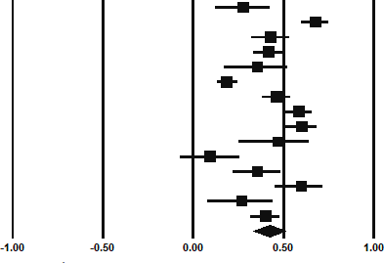

Table 4

Study measures, effect sizes and random effects meta-analysis results.
Study | N | Gratitude Measure | Job Satisfaction Measure | rsubscale | r | 95% CI
Al-Hashimi & Al-Barri (2018) | 145 | GQ-6 | JIG^{NA} |  | 0.276 | [0.118, 0.420]
Cain et al. (2019) | 207 | GAWS-SWE | MSQ-SF | 0.770 | 0.679 | [0.598, 0.746]
 |  | GAWS-MW |  | 0.560
Chen et al. (2020) | 229 | GAWS-C | A-JSS-C |  | 0.430 | [0.318, 0.530]
Chen et al. (2021) | 360 | GQ-6 | JSQ |  | 0.420 | [0.331, 0.502]
Cortini et al. (2019) | 96 | GQ-6-I | Two items from JDS | 0.149 | 0.357 | [0.168, 0.520]
 |  | CGS |  | 0.534
Harzer & Ruch (2013) | 1111 | VIA-IS-G | JSQ-G-R |  | 0.186 | [0.129, 0.242]
Kim & Oh (2020) | 310 | K-GQ-6 & GQ-6 | A-IS |  | 0.463 | [0.380, 0.539]
Kim et al. (2019) | 380 | GRAT-K | IS-K |  | 0.586 | [0.508, 0.655]
Komase et al. (2020) | 206 | GAWS-J | One item from BJSQ |  | 0.60 | [0.505, 0.681]
Lanham et al. (2012) | 65 | GQ-6 | MSQ-SF | 0.360 | 0.466 | [0.250, 0.637]
 |  | Workplace-specific gratitude  measure (Lanham et al., 2012) |  | 0.560
Smith (2007) | 142 | GQ-6 | JDI |  | 0.092 | [-0.074, 0.253]

Waters (2012) | 164 | GQ-6 | IS | 0.290 | 0.355 | [0.214, 0.482]
 |  | GAC |  | 0.450
 |  | IG-PPS |  | 0.320
Winslow et al. (2016) | 92 | GAC | IS (4-items) |  | 0.600 | [0.451, 0.717]
Winslow et al. (2017) | 100 | One 5-point Likert gratitude | A-JDI: Work | 0.416 | 0.268 | [0.075, 0.441]
 |  | scale | A-JDI: Supervisor | 0.228
 |  |  | A-JDI: Co-worker | 0.211
 |  |  | A-JDI: Promotion | 0.250
 |  |  | A-JDI: Salary | 0.223
Wnuk (2020) | 401 | GTOS | One 5-point Likert job satisfaction scale |  | 0.400 | [0.314, 0.479]
Random Effects Meta-Analysis | 4008 |  |  |  | 0.425 | [0.330, 0.511]

Note: N = number of participants; rsubscale = subscale effect size, r = effect size; 95% CI = 95% confidence intervals; *p<0.05; **p<0.01; ***p<0.001; ^{NA} = unreported definition of acronym; GQ-6 = Gratitude Questionnaire-Six (McCullough et al., 2002); GQ-6-I = Gratitude Questionnaire-Six-Italian Translation (Caputo, 2016); K-GQ-6 = Gratitude Questionnaire-Six Korean version (Kwon et al., 2006); GAWS-SWE = Gratitude for a Supportive Work Environment (Cain et al., 2019); GAWS-MW = Gratitude for Meaningful Work (Cain et al., 2019); GAWS-C = Gratitude at Work Scale Chinese version (Chen et al., 2020); GAWS-J = Gratitude at Work Scale Japanese version (Komase et al., 2020); CGS = the Collective Gratitude Scale (Akgün et al., 2016);); VIA-IS-G = Values in Action Inventory of Strengths German translation (Ruch et al., 2010); GRAT-K = Gratitude Resentment and Appreciation Test Korean version (Jung & Han, 2017; GAC = the Gratitude Adjective Checklist (McCullough et al., 2002); IG-PPS = The integrity and gratitude sub-scale of the Positive Practices Scale (Cameron et al., 2004); GTOS = Gratitude Toward the Orgnization Scale (Wnuk, 2020); MSQ-SF = The Minnesota Satisfaction Questionnaire-Short Form (Weiss et al., 1967); JDS = Job Diagnostic Survey (Hackman et al., 1975); A-JSS-C = Adapted three item Job Satisfaction Survey Chinese translation (Chen et al., 2020); JSQ = Job Satisfaction Questionnaire (Andrews and Withey, 1976); JSQ-G-R = Job Satisfaction Questionnaire German translation Revised (Harzer & Ruch.,2012); IS = Index of Job Satisfaction (Brayfield & Rothe, 1951); A-IS = Adapted Index of Job Satisfaction (Kim & Oh; 2020); IS-K = Index of Job Satisfaction Korean Version (Ko, 1999); BJSQ = Brief Job Stress Questionnaire (Shimonmitsu et al., 2000); JDI = Job Descriptive Index (Smith et al., 1969); A-JDI
= The abridged Job Descriptive Index (Stanton et al., 2002).

Moderator Analyses

Papers were grouped according to the employment sector of the sample. Two groups were identified, tertiary (k =11; N = 1910) and mixed (where the sample included employees from multiple sectors; k = 4; N = 2098). The subgroup analysis indicated that the effects obtained from studies that used tertiary employment sector samples (ravg = 0.428, 95% CI [0.319, 0.525], p < .001) were not significantly different in magnitude from the studies that used mixed employment sector samples (ravg = 0.419, 95% CI [0.227-0.579], p < .001, Qbetween (1) = 0.007, p = .934).
The moderator analysis of gratitude measures assessed whether workplace specific gratitude measures (k = 4; N = 1043) differed from other gratitude measures (k = 9; N = 2591). Papers (k = 2) using multiple types of measures (workplace and non-workplace specific) were excluded from the subgroup analysis, due to having a combined weighted average effect size. The analysis indicated that the effects obtained from studies using workplace specific gratitude measures (ravg = 0.535, 95% CI [0.387-0.656], p < .001) were not significantly different in magnitude from the studies that used non-workplace specific measures (ravg = 0.372, 95% CI [0.245-0.487], p < .001, Qbetween (1) = 2.931, p = .087).
Moderator analyses of validated versus non-validated measures of gratitude was not conducted as the number of non-validated measures, following exclusion of papers with combined weighted average effect sizes, did not meet the minimum number required for sub- group analysis (k=2).
The moderator analysis of job satisfaction measures assessed whether validated measures (k = 8; N = 2359) differed from non-validated measures (k = 5; N = 1308) of job satisfaction. Papers (k = 2) using both validated and non-validated measures were excluded from analysis, due to having a combined weighted average effect size prior to subgroup analysis. The analysis indicated that the effects obtained from studies using validated

measures of job satisfaction (ravg = 0.399, 95% CI [0.238-0.539], p < .001) were not significantly different in magnitude from the studies that used non-validated measures of job satisfaction (ravg = 0.492, 95% CI [0.409-0.566], p < .001, Qbetween (1) = 1.178, p = .278).
The meta-regression of the influence of gender (see Appendix C, Figure A1) indicated that associations between gratitude and job satisfaction did not vary significantly as a result of respondent gender, b = -0.000 [-0.001, 0.000], Qmodel (1) = 0.63, p = .428, Qresidual (11) = 97.74, p < .001. This indicated that the main effects were robust to the influence of participant gender.
The meta-regression of the influence of age (see Appendix C, Figure A2) indicated that associations between gratitude and job satisfaction did not vary significantly as a result of respondent age, b = 0.003 [-0.016, 0.021], Qmodel (1) = 0.08, p = .771, Qresidual (11) = 142.55, p < .001. This indicated that the main effects were robust to the influence of age.
The meta-regression of the influence of publication year indicated that associations between gratitude and job satisfaction varied significantly as a function of publication year, b
= 0.003 [0.008, 0.051], Qmodel (1) = 6.97, p = .008, Qresidual (13) = 78.85, p < .001. This

indicated that the main effects were influenced by the year in which the research was published, with larger effect sizes in more recent studies. Furthermore, r² = 0.47, indicating year of publication accounted for 47% of the variance between the studies. The data spread over time can be observed in Figure 3.

Figure 3

Graph of Meta-Regression Analysis of Year of Publication
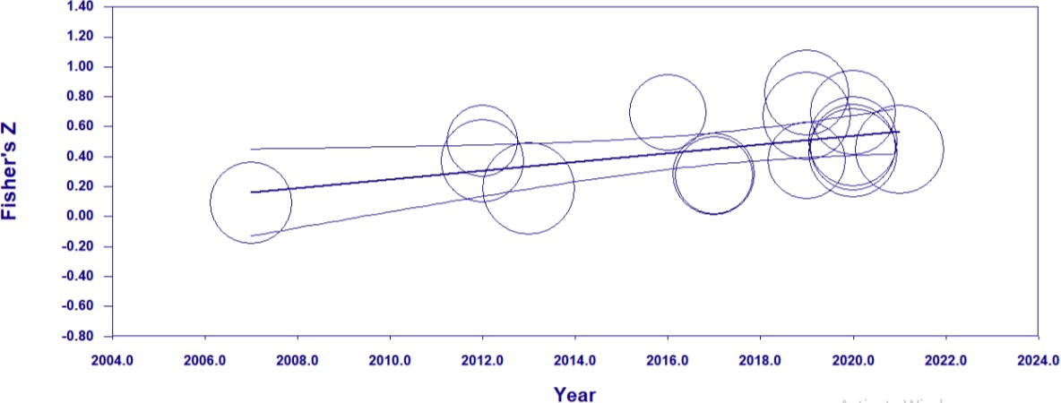

Publication Bias

The tests were unanimous for the absence of publication bias. For gratitude and job satisfaction, the fail-safe N analysis indicated 2550 studies with null results would be required to reduce the significance level of the effects and bring the p-value to > 0.05. This was well
above the threshold value of 85 required for this review, suggesting there is a low chance of publication bias. This was confirmed in additional analyses, for example the funnel plot (see Figure 4) showed relative symmetry and the trim-and-fill method indicated zero studies required trimming. Furthermore, Egger’s regression test indicated a non-significant result, b0
= 3.46[-1.26, 8.18], t(13) = 1.58, p = .14, suggestive of an absence of publication bias.

Figure 4

Funnel plot to assess publication bias in meta-analysis.

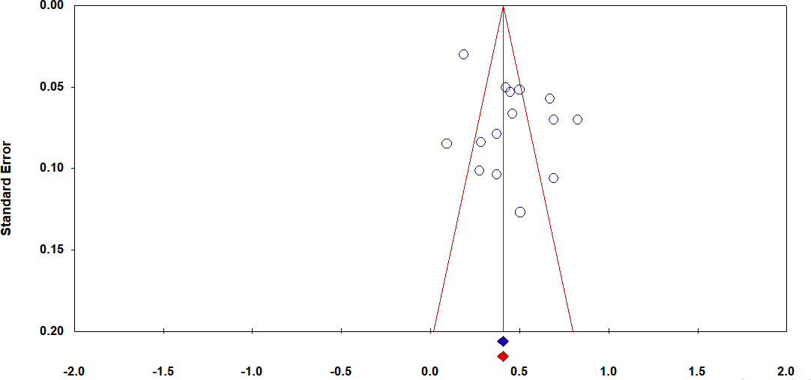

Sensitivity Analyses
Fisher’s Z

To explore if the observed effects were susceptible to influences from studies with methodological differences or poorer quality, two sensitivity analyses were completed. In the first instance, poor quality studies i.e., those which did not satisfy the threshold of meeting at least five of the quality criteria were removed from the meta-analyses. One study (Al- Hashimi & Al-Barri, 2018) with questionable quality was identified and removed. Results were largely unchanged, ravg = 0.437, k = 13, 95% CI [0.328-0.535], p < .001, supporting the decision to retain this poorer quality study in the meta-analysis.
One of the studies (Chen et al., 2020) measured gratitude and job satisfaction at two- different time-points, measuring gratitude at baseline and job satisfaction one-month later, without intervention. Removing this study from the analysis, made no difference to the effect size and significance of the association between gratitude and job satisfaction, ravg = 0.424, k
= 14, 95% CI [0.323-0.516], p < .001, again supporting the decision to retain it in the analysis.

Discussion

This comprehensive review of the empirical literature provides compelling evidence that gratitude is significantly positively associated with job satisfaction. 15 papers, with 24 effect sizes that included 4008 participants, were eligible for a quantitative synthesis, using a random effects meta-analysis. Due to the significant variability identified between effect sizes, moderators were assessed to explore if they accounted for this. Moderation analyses indicated the main effects were robust to the influence of gender, age, employment sector, validity of job satisfaction measure and type of gratitude measure. 47% of the variability identified could be accounted for by the year in which the study was published, with more recent studies showing a stronger association between gratitude and job satisfaction.
Considering the implications of low job satisfaction on wellbeing (Sironi, 2019), alongside the fact that job satisfaction is one of the top three concepts related to happiness in the workplace (Fisher, 2010), the outcome of this review is an important one. The gratitude/job satisfaction association identified in this meta-analysis is stronger than the associations identified in the individual traits measured in the Big-Five personality and the core self-evaluations literature (Judge et al., 2002; Judge et al., 2005). Given that gratitude is well defined as a personality trait (Wood et al., 2010), the gratitude/job satisfaction association is consistent with the values-percept theory (Locke, 1976). The values-percept theory considers individual differences as influencing the job satisfaction relationship (Locke, 1976). This review supports that theory, for example, if an individual has high levels of trait gratitude, the disparity between what the individual wants and what the individual has is likely to be minimized, resulting in increased satisfaction (Locke, 1976). This indication that those with a propensity towards experiencing gratitude (i.e., people high in trait gratitude) are more likely to feel more satisfied in their role, is a useful consideration for employers wishing

to support their employees. However, this raises concerns for those individuals who do not have a natural propensity for experiencing gratitude and not easily noticing life’s positives.
However, there were no differences found between the measures of gratitude (workplace or other), which suggests that workplace specific gratitude is similar to other forms of gratitude in the job satisfaction relationship. This is consistent with the earlier suggestion that workplace gratitude (Cain et al., 2019) is defined similarly to dispositional (trait) gratitude (Wood et al., 2010). Only one study (Winslow et al., 2016) in the subgroup analysis measured state gratitude, therefore more research is required into the impact of gratitude interventions on job satisfaction outcomes. This is particularly important when gratitude is required to be cultivated (i.e., those with low trait gratitude), considering the role of traits in job satisfaction (Locke, 1976).
Research measuring the outcomes of gratitude interventions in the workplace, found increases in job satisfaction (Stegen & Wankier, 2018). These significant differences were observed in the context of significant increases in leaders’ expressions of gratitude, not increases in self-expressions of gratitude. This is consistent with other research using self- expressions of gratitude (i.e. a gratitude journal) as the main intervention (Al-Hashimi & Al- Barri, 2018). Al-Hashimi & Al-Barri (2018) found that when employees journaled their workplace gratitude, over 7-days, both gratitude and job satisfaction did not improve. The variety of intervention effectiveness may be explained by the different ways in which gratitude is triggered (benefit or generalised). Stegen & Wankier (2018) utilised both benefit triggered (leader’s expressions) and generalised (self-expressions) gratitude, suggesting gratitude interventions in workplaces may be more effective if gratitude is benefit triggered (Emmons et al., 2003). This indicates that cultivated gratitude in the workplace and job satisfaction outcomes following a gratitude intervention, may be moderated by the

intervention type and the way in which gratitude is triggered, however further research is required in this area to investigate this.
The variance in the association between gratitude and job satisfaction was also not accounted for by gender of the employee, employment sector of the workplace, sample age or the validity of the job satisfaction measure utilised. However, the finding that the year of publication moderated the relationship between gratitude and job satisfaction is a novel one. Identifying that more recent studies demonstrated stronger relationships, may indicate changes in the research over time, for example, more rigour in testing, and/or a bias towards publication of more favourable results. However, the results of the publication bias tests indicated an absence of bias. Therefore, this strengthening of the gratitude-job satisfaction relationship may relate to the environmental context, namely the workplace. Previous research has found the quality of the workplace environment increased over time from 1983- 2009, with employees increasingly satisfied with wages, trusting and confident in the competence of managers, all in the context of recessions and reduced job security (Bryson & Forth, 2010). This trend implies a potential increase in satisfaction at work over the years.
Furthermore, with the context of recessions, this satisfaction may contribute to gratitude in employees. More research is required to understand the moderating effects of year of publication on the gratitude-job satisfaction relationship.
Bearing in mind the outstanding variance, consideration of other potential moderators is important. Co-worker support may be a potential moderator, as identified in the job satisfaction/turnover intent relationship (Tajuddin & Ambad, 2021). When considering the relational function of gratitude, suggested by the find-remind-and-bind theory, whereby gratitude aids in developing and reinforcing relationships (Algoe, 2012), relationships with colleagues are likely to play a role in gratitude. Fredrickson, (2004) reinforces this idea with the broaden-and-build hypothesis, which asserts that these pre-developed relationships can be

utilised as a resource when in distress. Knowing that social exclusion within the workplace, is linked to job dissatisfaction and a lower sense of well-being (Barak & Levin, 2002), co- worker support and/or inclusivity levels within a workplace could potentially moderate the gratitude/job satisfaction association.
Another moderator for consideration, is the role of prosocial behaviour in the workplace. Both job satisfaction and gratitude are associated with prosocial citizenship behaviours (Bateman & Organ, 1983; Farrell, 1983; Ma et al., 2017). Furthermore, considering the cyclical and potential snowball processes associated with gratitude and prosocial behaviour (Bartlett & DeSteno, 2006; Clark et al., 1988; Crano & Sivacek, 1982; Goldman et al., 1982; Grant & Gino, 2010; Rind & Bordia, 1995), this has the potential to impact a workforce and potentially moderate the relationship between gratitude and job satisfaction. Likewise, in workplaces where gratitude expression and social exclusion exist, this could impact the satisfaction levels and wellbeing levels of staff, an important consideration for businesses and future research.
Consideration of the employee-organisation power dynamic and its influence on the gratitude/job satisfaction association is suggested. As positive constructs in the workplace, such as gratitude are suggested to reinforce the power in the organisation (Jacques, 1996; Reich, 1987; Voronov & Coleman, 2003), and lead to issues between the employees and the organisation. Therefore, longitudinal studies of gratitude and job satisfaction in workplaces could be a consideration for future research, especially considering how people’s values and wants change over time, and the impact that this can have on job satisfaction as suggested by the values-percept theory (Locke, 1976).

Strengths and Limitations

The results should be considered in light of the strengths and limitations of this meta- analytic review. The systematic literature search was conducted across multiple databases to

ensure a full review of the literature. Furthermore, inclusion and exclusion criteria were pre- determined, in order to reduce researcher bias when screening and identifying eligible studies. A PRISMA diagram (Figure 1) and checklist (see Appendix D) is included for full transparency of the meta-analytic screening process and to ensure the review can be replicated. Use of risk of bias assessments strengthen this review further with quality appraisals of all studies and assessment of publication bias. The quality appraisal had high levels of inter-rater reliability and was conducted using a standardised quality appraisal tool, with a pre-determined cut-off percentage for inclusion/exclusion in the review. Furthermore, the assessment of publication bias, utilised multiple methods to ascertain certainty of the outcome. These methods rigorously tested for risk of bias, and therefore increased the validity and reliability of the meta-analytic review results. A critical approach was taken towards the outcomes of the main effects, with sensitivity and moderator analyses conducted to establish the robustness of the gratitude/job satisfaction association and explore other factors influencing this relationship. This increases the reliability and validity of the results of the meta-analysis.
One limitation of the research is that all studies utilise self-report measures, which has the potential to introduce bias and inflate correlations, due to same source response bias (Podsakoff, 2012). Additional limitations include the small number of subgroups identified for the employment sector moderation analysis, and the overlap between the two groups (mixed and tertiary), suggesting more research should be conducted in other employment sectors, such as primary or secondary groups in order to explore differences in the gratitude/job satisfaction association across employment sectors. Considering the increased job satisfaction reported in health and education sectors (Gazioglu & Tansel, 2006), results of the subgroup analysis on employment sector may have differed if subgroups were ‘health and education’ versus ‘others’.

Conclusions

The wellbeing of employees is important and with job satisfaction and gratitude both showing promise for increasing wellbeing, the gratitude/job satisfaction relationship is an important one. Job satisfaction and gratitude were found to have a positive association, and one that is stronger than job satisfaction has with other personality traits. This is an important finding considering the role in which personality traits play in improving job satisfaction.
There was some difference in the strength of the association noted between the studies, which was somewhat accounted for by the year in which they were published, with stronger associations noted more recently. Considering the relational role of gratitude and the positive association already established between job satisfaction and co-worker support, this difference between studies may depend on the workplace environment and connection between colleagues. Further research is required to establish the role of social connection in the gratitude/job satisfaction relationship. Considering the impact workplace gratitude can have in increasing the power in the organisation, the impact of long-term workplace gratitude on job satisfaction should be investigated.

References

Akgün, A. E., Erdil, O., Keskin, H., & Muceldilli, B. (2016). The relationship among gratitude, hope, connections, and innovativeness. The Service Industries Journal, 36(3-4), 1–22. https://doi.org/10.1080/02642069.2016.1155113
*Al-Hashimi, M., & Al-Barri, Z. (2018). Gratitude intervention at work: It’s impact on well-being, job satisfaction & organisational commitment. International Journal Advances in Social Science and Humanities, 5(3), 1-10. http://dx.doi.org/10.18374/JABE-17-2.8
http://ijassh.com/index.php/IJASSH/article/viewFile/274/290

Algoe, S. B. (2012). Find, remind, and bind: The functions of gratitude in everyday relationships. Social and Personality Psychology Compass, 6(6), 455-469. https://doi.org/10.1111/j.1751-9004.2012.00439.x
Aloe, A. M., & Thompson, C. G. (2013). The synthesis of partial effect sizes. Journal of the Society for Social Work and Research, 4(4), 390-405. https://www.jstor.org/stable/10.5243/jsswr.2013.24
Andrews, F. M., & Withey, S. B. (1976). Social indicators of well-being. Plenum Press. Aromataris, E., & Munn, Z. (2020). JBI manual for evidence synthesis. https://jbi-global-
wiki.refined.site/space/MANUAL

Barak, M. E. M., & Levin, A. (2002). Outside of the corporate mainstream and excluded from the work community: A study of diversity, job satisfaction and well-being. Community, Work & Family, 5(2), 133-157. https://doi.org/10.1080/13668800220146346
Bartlett, M. Y., & DeSteno, D. (2006). Gratitude and prosocial behavior: Helping when it costs you.

Psychological Science, 17(4), 319–325. https://doi.org/10.1111/j.1467-9280.2006.01705.x

Bateman, T. S., & Organ, D. W. (1983). Job satisfaction and the good soldier: The relationship between affect and employee “citizenship.” Academy of Management Journal, 26(4), 587–
595. https://doi.org/10.5465/255908

Boland, A., Cherry, G., & Dickson, R. (2014). Doing a systematic review: A student's guide. (2nd ed.). Sage Publications. https://uk.sagepub.com/sites/default/files/upm-
assets/87631_book_item_87631.pdf

Bolon, D. S. (1997). Organizational citizenship behavior among hospital employees: A multidimensional analysis involving job satisfaction and organizational commitment. Hospital and Health Services Administration, 42(2), 221-242.
https://www.researchgate.net/file.PostFileLoader.html?id=53bc21ddd2fd64ef4d8b4567&ass

etKey=AS%3A273554283663366%401442231831838

Borenstein, M., Hedges, L. V., Higgins, J. P. T., & Rothstein, H. R. (2009). Introduction to meta‐ analysis. John Wiley & Sons, Ltd.
Borenstein, M., Hedges, L. V., Higgins, J. P., & Rothstein, H. R. (2010). A basic introduction to fixed-effect and random-effects models for meta-analysis. Research Synthesis Methods, 1(2), 97–111. https://doi.org/10.1002/jrsm.12
Borenstein, M., Hedges, L., Higgins, L., & Rothstein, H. R. (2013). Comprehensive meta-analysis version 3.3 [computer software]. Biostat.
Brayfield, A. H., & Rothe, H. F. (1951). An index of job satisfaction. Journal of Applied Psychology, 35(5), 307–311. https://doi.org/10.1037/h0055617
Brief, A. P., & Motowidlo, S. J. (1986). Prosocial organizational behaviors. Academy of Management Review, 11(4), 710-725. https://doi.org/10.2307/258391
Bryson, A., & Forth, J. (2010). The evolution of the modern worker: attitudes to work. National Institute of Economic & Social Research [Discussion Paper No. 372]. https://www.niesr.ac.uk/wp-content/uploads/2021/10/dp372.pdf
*Cain, I. H., Cairo, A., Duffy, M., Meli, L., Rye, M. S., & Worthington Jr, E. L. (2019). Measuring gratitude at work. The Journal of Positive Psychology, 14(4), 440-451. https://doi.org/10.1080/17439760.2018.1484936

Cameron, K., Bright, D., & Caza, A. (2004). Exploring the relationships between organizational virtuousness and performance. American Behavioral Scientist, 47(6), 766-790. https://doi.org/10.1177/0002764203260209
Cameron, K., Mora, C., Leutscher, L., & Calarco, M. (2011). Effects of positive practices on organizational effectiveness. Journal of Applied Behavioral Science, 47(3), 266-308. https://doi.org/10.1177/0021886310395514
Caputo, A. (2016). Italian translation and validation of the Gratitude Questionnaire (GQ-6).

International Journal of Wellbeing, 6(2), 80–92. https://doi.org/10.5502/ijw.v6i2.492

Card, N. A. (2012). Applied meta-analysis for social science research. Guilford Press.

*Chen, H., Yang, X., Xia, W., Li, Y., Deng, Y., & Fan, C. (2021). The relationship between gratitude and job satisfaction: The mediating roles of social support and job crafting. Current Psychology, 1-8. https://doi.org/10.1007/s12144-021-01658-y
*Chen, L., Guo, Y., Song, L. J., & Lyu, B. (2020). From errors to OCBs and creativity: A multilevel mediation mechanism of workplace gratitude. Current Psychology, 1-15. https://doi.org/10.1007/s12144-020-01120-5
Chopik, W. J., Newton, N. J., Ryan, L. H., Kashdan, T. B., & Jarden, A. J. (2019). Gratitude across the life span: Age differences and links to subjective well-being. The Journal of Positive Psychology, 14(3), 292-302. 10.1080/17439760.2017.1414296
Clark, H. B., Northrop, J. T., & Barkshire, C. T. (1988). The effects of contingent thank-you notes on case managers’ visiting residential clients. Education & Treatment of Children, 11(1), 45–51. https://www.jstor.org/stable/42899049
Cohen, J. (1992). A power primer. Psychological Bulletin, 112(1), 155-159. https://doi.org/10.1037//0033-2909.112.1.155
*Cortini, M., Converso, D., Galanti, T., Di Fiore, T., Di Domenico, A., & Fantinelli, S. (2019). Gratitude at work works! A mix-method study on different dimensions of gratitude, job

satisfaction, and job performance. Sustainability, 11(14), 3902. https://doi.org/10.3390/su11143902
Crano, W. D., & Sivacek, J. (1982). Social reinforcement, self-attribution, and the foot-in-the-door phenomenon. Social Cognition, 1(2), 110–125. https://doi.org/10.1521/soco.1982.1.2.110
Dickens, L. R. (2017). Using gratitude to promote positive change: a series of meta-analyses investigating the effectiveness of gratitude interventions. Basic and Applied Social Psychology, 39(4), 193-208. https://doi.org/10.1080/01973533.2017.1323638
Donaldson, S. I., Lee, J. Y., & Donaldson, S. I. (2019). Evaluating positive psychology interventions at work: A systematic review and meta-analysis. International Journal of Applied Positive Psychology, 4(3), 113-134. https://doi.org/10.1007/s41042-019-00021-8
Duval, S., & Tweedie, R. (2000). Trim and fill: a simple funnel‐plot–based method of testing and adjusting for publication bias in meta‐analysis. Biometrics, 56(2), 455-463. 10.1111/j.0006-
341x.2000.00455.x

Eagly, A. H., & Chaiken, S. (1993). The psychology of attitudes. Harcourt Brace Jovanovich.

Egger, M., Smith, G. D., Schneider, M., & Minder, C. (1997). Bias in meta-analyses detected by a simple, graphical test. British Medical Journal, 315(7109), 629-634. https://doi.org/10.1136/bmj.315.7109.629
Emmons, R. A., McCullough, M. E., & Tsang, J. A. (2003). The assessment of gratitude. In S. J. Lopez & C. R. Snyder (Eds.), Positive psychological assessment: A handbook of models and measures (pp. 327–341). American Psychological
Association. https://doi.org/10.1037/10612-021

Farrell, D. (1983). Exit, voice, loyalty, and neglect as responses to job dissatisfaction: A multidimensional scaling study. Academy of management journal, 26, 596–607.
Fisher, C. D. (2010). Happiness at work. International Journal of Management Reviews, 12(4), 384-412. https://doi.org/10.1111/j.1468-2370.2009.00270.x

Fredrickson, B. (2004). Gratitude, like other positive emotions, broadens and builds. In R. A. Emmons & M. E. McCullough (Eds.), The Psychology of Gratitude (pp. 145-166). Oxford University Press. http://perpus.univpancasila.ac.id/repository/EBUPT190074.pdf
Gazioglu, S., & Tansel, A. (2006). Job satisfaction in Britain: individual and job-related factors. Applied Economics, 38(10), 1163-1171. https://doi.org/10.1080/00036840500392987
Goldman, M., Seever, M., & Seever, M. (1982). Social labeling and the foot-in-the-door effect. The Journal of Social Psychology, 117(1), 19–23. https://doi.org/10.1080/00224545.1982.9713402
Grant, A. M., & Gino, F. (2010). A little thanks goes a long way: Explaining why gratitude expressions motivate prosocial behavior. Journal of Personality and Social Psychology, 98(6), 946–955. https://doi.org/10.1037/a0017935
Hackman, J. R., & Oldham, G. R. (1975). Development of the Job Diagnostic Survey. Journal of applied psychology, 60(2), 159–170. https://doi.org/10.1037/h0076546.
Hackman, J. R., & Oldham, G. R. (1976). Motivation through the design of work: Test of a theory.

Organizational Behavior and Human Performance, 16(2), 250–279. https://doi.org/10.1016/0030-5073(76)90016-7
Harvey, P., & Dasborough, M. T. (2015). Entitled to solutions: The need for research on workplace entitlement. Journal of Organizational Behavior, 36(3), 460–465. https://doi.org/10.1002/job.1989
Harzer, C., & Ruch, W. (2012). When the job is a calling: The role of applying one's signature strengths at work. The Journal of Positive Psychology, 7(5), 362-371. https://doi.org/10.1080/17439760.2012.702784
*Harzer, C., & Ruch, W. (2013). The application of signature character strengths and positive experiences at work. Journal of Happiness Studies, 14(3), 965-983. https://doi.org/10.1007/s10902-012-9364-0

Health and Safety Executive. (2021, December 16). Work-related stress, anxiety or depression statistics in Great Britain [HSE.GOV.UK]. https://www.hse.gov.uk/statistics/causdis/stress.pdf
Hedges, L.V. & Olkin, I. (1985). Statistical methods for meta-analysis. Academic Press.

Higgins, J. P., & Thompson, S. G. (2002). Quantifying heterogeneity in a meta‐analysis. Statistics in Medicine, 21(11), 1539-1558. https://doi.org/10.1002/sim.1186
Higgins, J. P., Thompson, S. G., Deeks, J. J., & Altman, D. G. (2003). Measuring inconsistency in meta-analyses. Bmj, 327, 557-560. https://doi.org/10.1136/bmj.327.7414.557
Hoppock, R. (1935). Job satisfaction. Harper Publishing.

Iodice, J. A., Malouff, J. M., & Schutte, N. S. (2021). The Association Between Gratitude and Depression: A Meta-Analysis. International Journal of Depression and Anxiety, 4(1), 1-12. https://doi.org/10.23937/2643-4059/1710024
Jacques, R. (1996). Manufacturing the employee: Management knowledge from the 19th to 21st centuries. Sage Publishing.
Judge, T. A., & Kammeyer-Mueller, J. D. (2012). Job attitudes. Annual Review of Psychology, 63, 341-367. https://doi.org/10.1146/annurev-psych-120710-100511
Judge, T. A., Bono, J. E., Erez, A., & Locke, E. A. (2005). Core self-evaluations and job and life satisfaction: the role of self-concordance and goal attainment. Journal of Applied Psychology, 90(2), 257. https://doi.org/10.1037/0021-9010.90.2.257
Judge, T. A., Heller, D., & Mount, M. K. (2002). Five-factor model of personality and job satisfaction: A meta-analysis. Journal of Applied Psychology, 87(3), 530–541. https://doi.org/10.1037/0021-9010.87.3.530
Judge, T. A., Thoresen, C. J., Bono, J. E., & Patton, G. K. (2000). The job satisfaction– job performance relationship: A qualitative and quantitative review. Psychological Bulletin, 127(3), 376–407. https://doi.org/10.1037/0033-2909.127.3.376

Jung, M., & Han, K. (2017). Effectiveness of gratitude disposition promotion program on depression and quality of life of chronic schizophrenic patients. Indian Journal of Psychiatry, 59(2), 189–195. 10.4103/psychiatry.IndianJPsychiatry_227_16
Kalleberg, A. L., & Loscocco, K. A. (1983). Aging, values, and rewards: Explaining age differences in job satisfaction. American Sociological Review, 78-90. https://doi.org/10.2307/2095146
Kashdan, T. B., Mishra, A,. Breen, W. E., & Froh, J. J. (2009). Gender differences in gratitude: examining appraisals, narratives, the willingness to express emotions, and changes in psychological needs. Journal of Personality, 77(3), 691–730. https://doi.org/10.1111/j.1467-
6494.2009.00562.x

*Kim, C. D., & Oh, S. J. (2020). Impact of Employee's Gratitude Disposition on Organizational Citizenship Behavior: Focus on Multi-mediated Effects of Perceived Organizational Support and Job Satisfaction. The Journal of the Korea Contents Association, 20(4), 686-701. https://doi.org/10.5392/JKCA.2020.20.04.686
Kim, P. N., & Yi, I. H. (2009). Influence of gratitude perception on self‐focused attention and depression: Gratitude disposition and gratitude treatment. Korean Journal of Psychological Health, 14, 363–382. http://dx.doi.org/10.17315/kjhp.2009.14.2.009
*Kim, S. R., Park, O. L., Kim, H. Y., & Kim, J. Y. (2019). Factors influencing well‐being in clinical nurses: A path analysis using a multi‐mediation model. Journal of Clinical Nursing, 28(23-24), 4549-4559. https://doi.org/10.1111/jocn.15045
Ko, J. W. (1999). The effects of personality traits on job satisfaction. Korean Journal of Sociology, 33(2), 359–387. https://doi.org/10.13106/jafeb.2019.vol6.no2.161
*Komase, Y., Watanabe, K., Sasaki, N., & Kawakami, N. (2020). Reliability and validity of the Japanese version of the Gratitude at Work Scale (GAWS). Journal of Occupational Health, 62(1), https://doi.org/10.1002/1348-9585.12185
Kwon, S. J., Kim, K. H., & Lee, H. S. (2006). Validation of the Korean version of gratitude questionnaire. Korean Journal of Health Psychology, 11(1), 177-190.

Lanham, M. E. (2011). The relationship between gratitude and burnout in mental health professionals [Doctoral dissertation, University of Dayton]. The Ohio Library. https://etd.ohiolink.edu/apexprod/rws_etd/send_file/send?accession=dayton1322754714&di
sposition=inline

*Lanham, M., Rye, M., Rimsky, L., & Weill, S. (2012). How gratitude relates to burnout and job satisfaction in mental health professionals. Journal of Mental Health Counseling, 34(4), 341-354. https://doi.org/10.17744/mehc.34.4.w35q80w11kgpqn26
Locke, E. A. (1976). Handbook of industrial and organizational psychology. Rand McNally College Publishing Company.
Ma, L. K., Tunney, R. J., & Ferguson, E. (2017). Does gratitude enhance prosociality? A meta- analytic review. Psychological bulletin, 143(6), 601. https://doi.org/10.1037/bul0000103
McCullough, M. E., Emmons, R. A., Tsang, J. A., (2002). The grateful disposition: A conceptual and empirical topography. Journal of Personality and Social Psychology, 82(1), 112–
127. https://doi.org/10.1037/0022-3514.82.1.112

McNeese‐Smith, D. K. (1999). A content analysis of staff nurse descriptions of job satisfaction and dissatisfaction. Journal of Advanced Nursing, 29(6), 1332-1341. https://doi.org/10.1046/j.1365-2648.1999.01018.x
Moola, S., Munn, Z., Tufanaru, C., Aromataris, E., Sears, K., Sfetcu, R., Currie, M., Qureshi, R., Mattis, P., Lisy, K., Mu, P.F. (2017). Chapter 7: Systematic reviews of etiology and risk. In
E. Aromataris & Z. Munn. (Eds.), Joanna Briggs Institute Reviewer’s Manual.

JBI. https://doi.org/10.46658/JBIMES-20-08

Pappas, C., & Williams, I. (2011). Grey literature: its emerging importance. Journal of Hospital Librarianship, 11(3), 228-234. https://doi.org/10.1080/15323269.2011.587100
Peters, J. L., Sutton, A. J., Jones, D. R., Abrams, K. R., & Rushton, L. (2008). Contour-enhanced meta-analysis funnel plots help distinguish publication bias from other causes of

asymmetry. Journal of Clinical Epidemiology, 61(10), 991-996. https://doi.org/10.1016/j.jclinepi.2007.11.010
Podsakoff, P. M., MacKenzie, S. B., & Podsakoff, N. P. (2012). Sources of method bias in social science research and recommendations on how to control it. Annual Review of Psychology, 63, 539-569. https://doi.org/10.1146/annurev-psych-120710-100452
Portocarrero, F. F., Gonzalez, K., & Ekema-Agbaw, M. (2020). A meta-analytic review of the relationship between dispositional gratitude and well-being. Personality and Individual Differences, 164(1), 110101. https://doi.org/10.1016/j.paid.2020.110101
Redmond, P., & McGuinness, S. (2019). Explaining the gender gap in job satisfaction. Applied Economics Letters, 27(17), 1415-1418. https://ftp.iza.org/dp12703.pdf
Reich, R. (1987). Tales of a new America. Vintage Books.

Rind, B., & Bordia, P. (1995). Effect of server’s ‘thank you’ and personalization on restaurant tipping. Journal of Applied Social Psychology, 25(9), 745–751. https://doi.org/10.1111/j.1559-1816.1995.tb01772.x
Robertson, B. W., & Kee, K. F. (2017). Social media at work: The roles of job satisfaction, employment status, and Facebook use with co-workers. Computers in Human Behavior, 70, 191-196. https://doi.org/10.1016/j.chb.2016.12.080
Rosenthal, R. (1979). The file drawer problem and tolerance for null results. Psychological Bulletin, 86(3), 638. https://doi.org/10.1037/0033-2909.86.3.638
Ruch, W., Proyer, R. T., Harzer, C., Park, N., Peterson, C., & Seligman, M. E. P. (2010). Values in action inventory of strengths (VIA-IS): Adaptation and validation of the German version and the development of a peer-rating form. Journal of Individual Differences, 31(3), 138–
149. https://doi.org/10.1027/1614-0001/a000022

Saleh, A. A., Ratajeski, M. A., & Bertolet, M. (2014). Grey literature searching for health sciences systematic reviews: a prospective study of time spent and resources utilized. Evidence Based Library and Information Practice, 9(3), 28. https://doi.org/10.18438%2Fb8dw3k

Shimomitsu, T., Haratani, T., Nakamura, K., Kawakami, N., Hayashi, T., Hiro, H., Arai, M., Miyazaki, S., Furuki, K., Ohya, Y., Odagiri, Y. (2000). Final development of the Brief Job Stress Questionnaire mainly used for assessment of the individuals. In M. Kato (Ed.), The ministry of labor sponsored grant for the prevention of work-related illness, FY 1999 report (pp. 126–64). Tokyo Medical University.
Sironi, E. (2019). Job satisfaction as a determinant of employees’ optimal well-being in an instrumental variable approach. Quality & Quantity, 53(4), 1721-1742. https://doi.org/10.1007/s11135-019-00835-3
The Office for National Statistics. (2021, April 12). Employment rate (aged 16 to 64, seasonally adjusted) %. https://www.ons.gov.uk/employmentandlabourmarket/peopleinwork/employmentandemploy
eetypes/timeseries/lf24/lms

*Smith, J. G. (2007). Spirituality in the salesperson: the impact of the golden rule and personal faith on workplace job attitudes [Doctoral dissertation, Texas A&M University]. OAKTrust. https://hdl.handle.net/1969.1/5815
Smith, P. C., Kendall, L. M., & Hulin, C. L. (1969). The Measurement of satisfaction in work and retirement: A strategy for the study of attitudes. Rand McNally & Company.
Snyder, C. R. (2000). Handbook of hope. Academic Press.

Society for Human Resource Management. (2015). Employee job satisfaction and engagement optimizing organizational culture for success. https://www.shrm.org/resourcesandtools/business-solutions/documents/2015-job-
satisfaction-and-engagement-report.pdf

Stanton, J. M., Sinar, E. F., Balzer, W. K., Julian, A. L., Thoresen, P., Aziz, S., Fisher, G. G. & Smith, P. C. (2002). Development of a compact measure of job satisfaction: The abridged Job Descriptive Index. Educational and Psychological Measurement, 62(1), 173-191. https://doi.org/10.1177%2F001316440206200112

Stegen, A., & Wankier, J. (2018). Generating gratitude in the workplace to improve faculty job satisfaction. Journal of Nursing Education, 57(6), 375-378. https://doi.org/10.3928/01484834-20180522-10
Tait, M., Padgett, M. Y., & Baldwin, T. T. (1989). Job and life satisfaction: A re-evaluation of the strength of the relationship and gender effects as a function of the date of the study. Journal of Applied Psychology, 74(3), 502–507. https://doi.org/10.1037/0021-9010.74.3.502
Tajuddin, D., & Ambad, S. N. A. (2021). The relationship between job satisfaction and turnover intention among nurses in federal territory of Labuan: Coworker support as a
moderator. Journal of Management Info, 8(2), 105-119. https://doi.org/10.31580/jmi.v8i2.2000
Timothy, A. J., & Ryan, K. (2008). Job Satisfaction: Subjective well-being at work. In M. Eid & R.

J. Larsen (Eds.), The science of subjective well-being (pp. 393-413). The Guilford Press. https://smartlib.umri.ac.id/assets/uploads/files/77459-subjective-well-being.pdf#page=407
Voronov, M., & Coleman, P. T. (2003). Beyond ivory towers: Organizational power practices and "practical" critical postmodernism. Journal of Applied Behavioral Science, 39(2), 169-185. https://doi.org/10.1177/0021886303255560
*Waters, L (2012). Predicting job satisfaction: Contributions of individual gratitude and institutionalized gratitude. Psychology, 3, 1174–1176.
http://dx.doi.org/10.4236/psych.2012.312A173

Watkins, P. C., McLaughlin, T., & Parker, J. P. (2021). Gratitude and subjective well-being: Cultivating gratitude for a harvest of happiness. In Research Anthology on Rehabilitation Practices and Therapy (pp. 1737-1759). IGI Global.
Weiss, D. J., Dawis, R. V., & England, G. W. (1967). Manual for the Minnesota satisfaction questionnaire. Minnesota Studies in Vocational Rehabilitation. https://vpr.psych.umn.edu/sites/vpr.umn.edu/files/files/monograph_xxii_-
_manual_for_the_mn_satisfaction_questionnaire.pdf

*Winslow, C. J., Hu, X., Kaplan, S. A., & Li, Y. (2017). Accentuate the positive: Which discrete positive emotions predict which work outcomes? The Psychologist-Manager Journal, 20(2),
74. https://doi.org/10.1037/mgr0000053

*Winslow, C. J., Kaplan, S. A., Bradley-Geist, J. C., Lindsey, A. P., Ahmad, A. S., & Hargrove, A.

K. (2016). An examination of two positive organizational interventions: For whom do these interventions work? Journal of Occupational Health Psychology, 22(2), 129–
137. https://doi.org/10.1037/ocp0000035

*Wnuk, M. (2020). Psychometric Evaluation of the Gratitude Toward the Organization

Scale. Central European Management Journal, 28(3), 149-167. 10.7206/cemj.2658-0845.30

Wood, A. M. & Boyce, C. J. (2014). Personality, an Overview. In A. C. Michalos. (Ed.) Encyclopedia of Quality of Life and Well-Being Research. Springer. https://doi.org/10.1007/978-94-007-0753-5_2152
Wood, A. M., Froh, J. J., & Geraghty, A. W. (2010). Gratitude and well-being: A review and theoretical integration. Clinical Psychology Review, 30(7), 890-905. https://doi.org/10.1016/j.cpr.2010.03.005

Appendices

Appendix A

JBI Critical Appraisal Checklist – Redacted in line with copyright legislation

Appendix B

Reference List of Research Requested

Access to the following research was requested via research gate or through attempting contact with the author(s) as the abstract or full text was unavailable.

Bouws, M., & Weeda, J. (2019). Navigating Nursing Transitions: Joy in the Journey? Journal of Christian Nursing, 36(1), E1-E4. https://doi.org/10.1097/cnj.0000000000000580
Brennan, J. (1990). Put the stress on recognition, appreciation and acceptance. The Journal of Long Term Care Administration, 18(3), 13-14. https://europepmc.org/article/med/10107483
Buote, V. (2014). Gratitude at work: Its impact on job satisfaction & sense of community. Plasticity Labs. https://www.plasticitylabs.com/wp-
content/uploads/2017/01/Gratitude-At-Work-White-Paper.pdf

Gorjian, N. (2006). Virtue of transcendence in relation to work orientation, job satisfaction and turnover cognitions. Alliant International University. https://www.proquest.com/openview/bf920a2bf45442b693b0cb3538f34036/1?pq-
origsite=gscholar&cbl=18750&diss=y

Graham, G. H., & Unruh, J. (1990). The motivational impact of nonfinancial employee appreciation practices on medical technologists. The Health Care Manager, 8(3), 9-
18. https://europepmc.org/article/med/10104223

Janicke, S. H., Rieger, D., Reinecke, L., & Connor, W. (2018). Watching online videos at work: The role of positive and meaningful affect for recovery experiences and well- being at the workplace. Mass Communication and Society, 21(3), 345-367. https://doi.org/10.1080/15205436.2017.1381264

Kelly, L. A., Schaeffer, R., Roe, S., & Buchda, V. L. (2021). Using text messages to support nurse well-being. Nursing Administration Quarterly, 45(4), 338-345. https://doi.org/10.1097/NAQ.0000000000000490
Lamberts, R. (2010). Taking the job home with you. A little appreciation goes a long way when you're drained. Medical Economics, 87(24), 104. https://pubmed.ncbi.nlm.nih.gov/21341620/
LaPorte, M. (2009). Recognition and gratitude make big impact. Provider, 35(11), 20-1. https://europepmc.org/article/med/19938563
Messner, R. L. (1998). Gratitude: a stress buster. Rn, 61(6), 76-77. https://go.gale.com/ps/i.do?id=GALE%7CA20853040&sid=googleScholar&v=2.1&it
=r&linkaccess=abs&issn=00337021&p=AONE&sw=w&userGroupName=anon%7E

db5f3884

Naguie, I. (2011). Grateful for caregiving experience. Nursing New Zealand, 17(10), 4-4. https://europepmc.org/article/med/22216615
Parry, J., & Kalisch, B. J. (2012). The path to staff appreciation. Nursing Management, 43(5), 36-40. https://doi.org/10.1097/01.numa.0000412222.80532.e6
Richmond, N. J. (2016). Heroism of small things. Appreciating the common aspects of the job. JEMS: A Journal of Emergency MedicalSservices, 41(2), 63. https://pubmed.ncbi.nlm.nih.gov/27008733/
Steinert, C. (1998). Work in humanitarian aid: gratitude is a beautiful reward. Pflege Zeitschrift, 51(6), 444-445. https://europepmc.org/article/med/9661511

Appendix C

Meta-Regression Analyses

Figure A1

Meta-Regression Analysis of Gender

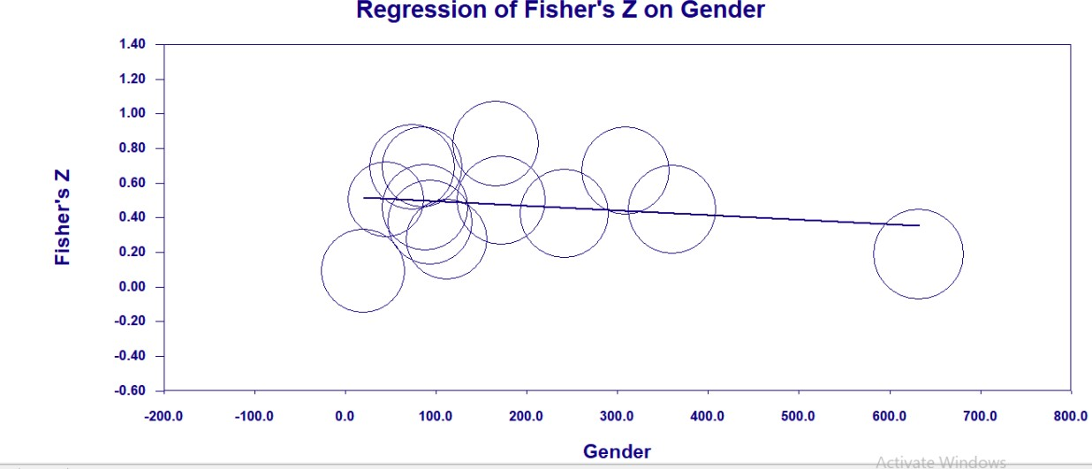
Meta-Regression Analysis of Age
Figure A2

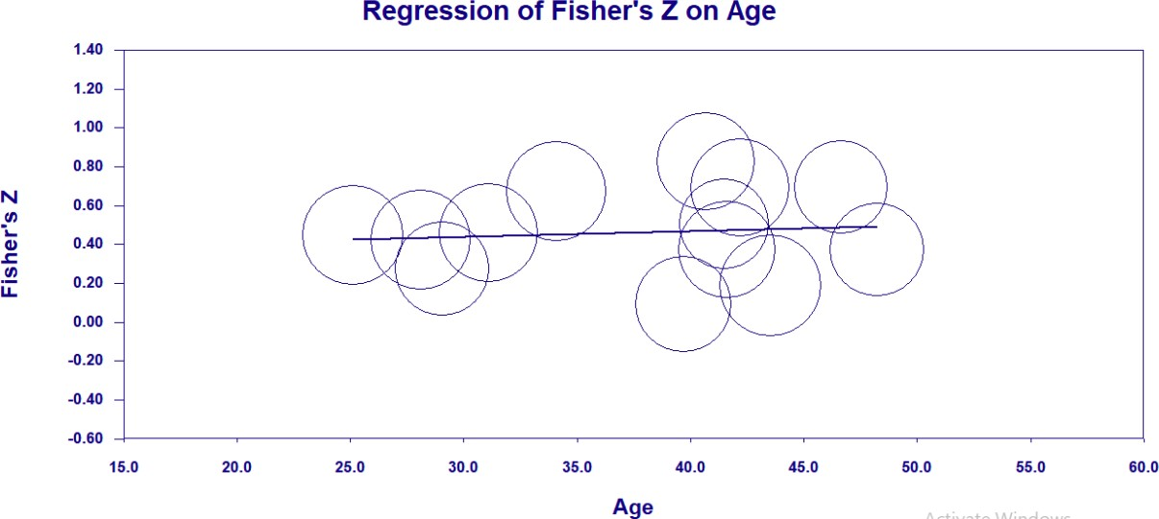

Appendix D

PRISMA Checklist – Redacted in line with copyright legislation

Part II: Empirical Project

Investigating the Effectiveness of a Gratitude Journaling Intervention with UK- Based Healthcare Staff During a Global Pandemic:
A Randomised Control Trial

Abstract

Objectives

During a health pandemic, healthcare workers (HCWs) are at risk of poor wellbeing and increased distress. This study aimed to assess the effectiveness of a gratitude intervention with healthcare staff during a global pandemic. It was hypothesised that a gratitude journaling intervention would demonstrate greater improvements in wellbeing and distress compared to a reflective diary control group.

Design

An online parallel, double-blind, two-armed (gratitude intervention and control), Randomised Control Trial (RCT) with equal individual randomisation (1:1) was conducted in the UK (4 sites, plus internet recruitment).

Methods

A sample of 117 healthcare workers (HCWs; 89.7% female; Mean age=39.73; SD=11.37) completed baseline measures of depression, happiness, positive and negative affect, alongside state and trait gratitude. HCWs were randomly allocated to one of two conditions, a gratitude journaling group (N=58) or a diary control group (N=59), where they were asked to complete the reflective task online, once a week, for 4-weeks.

Results

Independent and paired t-tests indicated that the gratitude intervention was effective at reducing negative affect in HCWs, with scores significantly decreasing from baseline (M=1.81) to post-intervention (M=1.49), t(1236) = -3.04, p = .002. The same reductions were not identified for the diary control group. Statistically significant differences were not observed for depression, happiness, positive affect and gratitude in both groups; however, means changed in the hypothesised direction.

Conclusions

This study supports findings from previous trials conducted during a global pandemic and highlights the value in engaging a healthcare workforce (with mild-to-moderate indicators of depression severity) in a gratitude intervention, to reduce distress.

Practitioner Points

- An online gratitude intervention is effective at reducing negative emotions in HCWs during a global pandemic, compared to an active control condition.
- Reflective practices in healthcare settings could consider focusing on gratitude to improve distress levels in healthcare staff during a time when distress is inevitable.
Key words: ‘gratitude intervention’, ‘healthcare workers’, ‘global pandemic’, ‘distress’

Introduction

UK sickness absence data indicated health and social care reported the highest sickness rates across industries, with 3.5% absence in 2020, and 0.8% higher sickness than the second highest industry (ONS, 2021). Staff sickness in the National Health Service (NHS) has gradually risen since 2017, from 4.00%, to 4.63% absence in June 2021 (NHS Digital, 2022, April 28). At its highest, in April 2020, 6.02% of staff were off sick. ‘Anxiety/stress/depression/other psychiatric illnesses’ is regularly reported as the main reason for staff sickness, with an average of 28-29% of cases reporting this since 2010 (NHS Digital, 2022, April 28). Unfortunately, only 29.3% of staff across the NHS felt their trust took positive action on health and wellbeing (NHS England, 2020, February). This lack of action may contribute to and prolong employee absences.
Health professionals reportedly experience higher levels of burnout than any other profession (De Hert, 2020). Burnout is defined as a state of emotional and physical exhaustion, cynicism, and detachment from work, caused by prolonged stress (Maslach & Leiter, 2016).
Burnout is assessed and measured on multiple dimensions, namely emotional exhaustion, depersonalisation, and sense of personal accomplishment (Maslach, 1998). Emotional exhaustion relates to the mental strain associated with job stress; depersonalisation, is defined as mentally detaching from others and taking a measured, less personable approach, alongside a reduced sense of personal accomplishment (Chiu & Tsai, 2006).
With the COVID-19 health pandemic adding additional pressure to the NHS, research from historical health pandemics indicate healthcare workers (HCWs) are at increased risk of mental health problems, including post-traumatic stress disorder, depression and substance misuse (Brooks et al., 2020). Furthermore, preliminary data from China (Lai et al., 2020) during the COVID-19 health pandemic indicated frontline HCWs experienced depression (50.4%), anxiety (44.6%), insomnia (34%) and distress (71.5%). A systematic review (Allan et al., 2020) indicated healthcare staff working in hospitals with patients infected through a pandemic, were most at risk of developing mental health difficulties during or following the pandemic. Coping behaviours,

resilience and social support were associated with positive mental health outcomes of HCWs (Labrague, 2021), with social support a moderator of the stress-burnout relationship (Etzion, 1984). Furthermore, when considering protective factors of distress during a pandemic, perceived control and social support were associated with lower distress (Sirois & Owens, 2020).

Positive Psychology and Wellbeing

Positive psychology provides an alternative approach to understand, support and improve the health and wellbeing of employees, and reduce burnout. Positive psychology considers the circumstances and processes of individuals, groups and organisations which contribute to optimal functioning (Gable & Haidt, 2005). It focuses on character strengths such as hope, optimism and gratitude, to encourage creativity, improve happiness and reduce mental barriers to productivity, as opposed to focusing on ‘problems’ (Hackett, 2017; Seligman & Csikszentmihalyi, 2000). Character strengths are intrinsically linked to individual and social wellbeing (Peterson, 2009). Littman- Ovadia & Steger (2010) recommended endorsement of individual character strengths, to improve wellbeing and mitigate burnout. Steffanina (2014) supported this, finding all aspects of burnout improved when an individual more strongly endorsed their character strengths.
Seligman (2018) developed the PERMA framework for understanding and assessing wellbeing, incorporating five elements: Positive emotions, Engagement, positive Relationships, Meaning and Accomplishment. The PERMA framework is strongly related to all character strengths, with zest, hope and gratitude being the most strongly related to all elements of the PERMA framework and as such, strongly related to wellbeing (Wagner et al., 2020). The gratitude character strength was most strongly related to the ‘Meaning’ domain (Wagner et al., 2020), a domain highly central to professional wellbeing (Larsen et al., 2021; Pakhol, 2018).
Positive Psychology Interventions (PPIs) are one approach for reducing distress, by increasing positive emotions, behaviours, and/or thoughts, thereby increasing the wellbeing of an individual (Parks & Biswas-Diener, 2013). PPIs can include gratitude journals, affirmations,
strength focussing exercises and mindful meditations (Lino, 2020, April). PPIs in workplaces have

improved performance, job wellbeing, engagement and other areas, whilst reducing negative performance and negative job wellbeing (Donaldson et al., 2019). PPIs have also been found to reduce symptoms of burnout, stress, anxiety and depression in employees (Alexiou et al., 2021). More specifically, workplace gratitude was found to negatively correlate to symptoms of burnout, such as emotional exhaustion and depersonalisation (Lanham, 2011).

Theories of Gratitude

Gratitude is both a personality trait and a social-cognitive emotional in-the-moment reaction driven by observing and appreciating positives in the world (McCullough et al., 2002; Wood & Boyce, 2014). Meta-analyses have found gratitude is positively associated with positive wellbeing, such as happiness, life satisfaction, pro social behaviours and personality traits, alongside religion/spirituality and negatively associated with suicidal ideation, negative affect, depression and anxiety, envy and materialistic attitudes (Iodice et al, 2020; McCullough et al., 2002; Portocarrero et al., 2020). Gratitude can be benefit triggered or generalised. Benefit triggered gratitude is often experienced when undeserved acts of kindness or generosity are given freely and altruistically by another person, whereas generalised gratitude, is broader, relating to feelings of gratitude for all sorts of gifts in life, unrelated to acts of others (Emmons et al., 2003).
This definition of generalised gratitude was expanded to define dispositional (trait) gratitude as part of a wider life orientation (Wood et al., 2010). Dispositional gratitude is defined by eight facets, experienced intensely, frequently and across a variety of stimuli (Wood et al., 2010).
The eight facets of gratitude included individual differences in the experience of grateful affect, appreciation of other people, focus on what the individual has, feelings of awe when encountering beauty, behaviours to express gratitude, present moment focus on the positive, understanding life is short and positive social comparisons (Wood et al., 2010). Wood et al. (2010) advised that these eight facets could all be experienced at a state (in-the-moment) affect level, however a person with a life orientation towards gratitude (i.e., dispositional), could frequently and easily access these facets. This supports the schematic hypothesis, which asserts that schematic biases towards

gratitude reinforce positive emotions by biasing interpretations of events in a more positive light, whilst reinforcing the opposite for people lower in this trait (Wood et al., 2010).
Gratitude theories have attempted to explain the causal relationship found between gratitude and wellbeing in previous studies (Emmons & McCullough, 2003; Lyubomirsky et al., 2005; Seligman et al., 2005). The coping hypothesis asserts that positive coping strategies are the link between gratitude and wellbeing, with grateful people more likely to seek support from others (Wood et al., 2010). This would suggest that gratitude interventions may only be effective for individuals with high levels of trait gratitude. Rash et al.’s (2011) research was consistent with this, finding dispositional gratitude moderated life satisfaction outcomes following a gratitude intervention. The resistance hypothesis (McCullough et al., 2004), support the notion of trait gratitude moderating outcomes, however questions the benefits of high levels of trait gratitude, stating that dispositional gratitude can be counterintuitive for gratitude interventions, due to the intervention being homogenous with how individuals would think and act anyway, and therefore not improving wellbeing.
Other researchers have posited that gratitude’s function is relational, and that this is how the causal relationship between gratitude and wellbeing can be understood. Fredrikson’s (2004) broaden-and-build hypothesis states that each positive and negative emotion humans experience has its own specific function, asserting that gratitude serves to build connection to others when non- stressed, so that this connection can be utilised as a resource when in distress (Garland et al., 2010). Similarly, the find-remind-and-bind theory (Algoe, 2012) argues that gratitude helps to find new connections/ relationships or remind of known good connections and bind the two individuals. It goes beyond the benefit triggered literature, suggesting gratitude serves to solidify a connection to an individual in what is perceived to be a high-quality relationship, not only one which brings personal benefits, but one which exists ‘through thick-and-thin’. Overall, gratitude theories indicate gratitude can influence emotional states, wellbeing, positive coping and connection to others, one way or the other.

Gratitude Interventions

Studies have attempted to experimentally activate or cultivate gratitude through gratitude interventions (i.e., writing gratitude lists, journals or letters, expressing gratitude etc.). Meta- analyses assessing the effectiveness of gratitude interventions found positive outcomes for wellbeing, happiness, life satisfaction, grateful mood, grateful disposition, and positive affect, alongside a reduction in depressive symptoms (Dickens, 2017), with small to medium effect sizes. Furthermore, positive activities (such as expressing gratitude) have been found to counteract the environmental triggers of stress (Layous et al., 2014). Research recently conducted during the covid-19 pandemic have shown contradictory results. Fekete and Deichert (2022) found stress and negative affect reduced following a gratitude intervention. However, Datu et al. (2020) found increases in positive affect, but no changes in life satisfaction, negative affect and covid-19 anxiety, following a gratitude intervention. These differences may be due to differences in the populations studied, for example, Fekete and Deichert (2022) studied a general population sample from the USA, with a mean age of 40.86 years, whereas Datu et al., (2020) studied a sample of Filipino undergraduate students with a mean age 20 years younger, at 20.27 years.
Gratitude interventions can be expressive (outward) or reflective (inward). Expressive gratitude involves giving small tokens of appreciation or paying gratitude visits. Reflective gratitude interventions involve writing personal gratitude lists or journals. Research comparing the two types of interventions, found similar outcomes between the two, with increased feelings of gratitude, elevation, connectedness, alongside indebtedness across interventions (Layous et al., 2017).
The type of comparison group was identified as an important consideration when synthesising gratitude intervention research (Wood et al., 2010). Meta-analyses found gratitude interventions were as effective as psychologically active comparisons (Davis et al., 2016; Dickens, 2017), and more effective when compared to negative conditions (Dickens, 2017). Mixed results were found when comparing gratitude interventions to alternative-activity conditions, with

significant improvements in gratitude, psychological wellbeing, happiness, positive affect and depression, and no change in anxiety and negative affect (Davis et al., 2016; Dickens, 2017).
The duration of the intervention may also have an impact on effectiveness. Cheng et al. (2015) found higher life satisfaction, more gratitude and improved positive affect in HCWs, after writing a gratitude diary bi-weekly over 4-weeks. In contrast, a shorter 5-day intervention in the workplace, using a similar journaling methodology, was not effective at improving gratitude (Al- Hashimi & Al-Barri, 2018). This may be explained by Toepfer and Walker’s (2009) results, which found a cumulative improvement in gratitude and happiness over 8-weeks of grateful letter writing, indicating frequency of the intervention can influence the outcomes of gratitude interventions.
To summarise, gratitude interventions are effective at improving a variety of emotional states and satisfaction levels, however recent studies completed during the Covid-19 pandemic have indicated mixed results, demonstrating some improvements in either distress or wellbeing. The coping hypothesis suggests gratitude serves as a function to aid human coping by increasing resources to seek support when in distress (Wood et al., 2010). The schematic hypothesis indicates positive coping is influenced by gratitude as a personality trait (Wood et al., 2010), whereas the resistance hypothesis argues trait gratitude would not initiate positive coping, and therefore gratitude interventions would be ineffective for those high in trait gratitude. The broaden-and-build and the find-remind-and-bind theories consider a social function of gratitude, to build connection and serve as a resource when in distress (Galand et al., 2010; Algoe, 2012).
What we know about HCWs during a pandemic, is that their distress levels are likely to be increased and their wellbeing impacted negatively, potentially risking burnout. What is unclear, is the effectiveness of a gratitude intervention at times of heightened distress; can HCWs draw upon their gratitude resource with support from a gratitude intervention and can their wellbeing and distress benefit from this? Furthermore, is the effectiveness of the intervention moderated by a grateful personality, could trait gratitude influence the effectiveness of an intervention during a health pandemic?

Given this theory and research, the current study aimed to examine the effectiveness of a gratitude journal intervention with HCWs during a health pandemic, in comparison to an active- control group, by assessing gratitude and psychological wellbeing (happiness and positive affect) and reducing psychological distress (depression and negative affect).

Hypotheses

Primary Hypothesis

- Gratitude journaling will reduce psychological distress (depression and negative affect) and increase wellbeing (happiness and positive affect) over time (baseline to post-intervention) when compared to a diary control.

Secondary Hypotheses

- Gratitude journaling will increase state gratitude over time (baseline to post-intervention) when compared to a diary control.
- Trait gratitude will moderate the outcomes of the gratitude intervention, with higher levels moderating changes in wellbeing and distress.

Method

Protocol Registration

The protocol for this trial was pre-registered in the ClinicalTrials.Gov Database under the protocol registration number: 170732.

Design

The research was a Randomised Control Trial (RCT), to enable a rigorous assessment of cause and effect between intervention and control conditions (Sibbald, 1998). This RCT was an online parallel, double-blind, two-armed (intervention, and control) trial with equal individual randomisation (1:1), conducted in the UK (four sites, plus internet recruitment).

Changes to Design following Trial Commencement

Research time limitations and difficulties sourcing participants resulted in changes to the design of the study. Trial registration detailed a three-armed study, comparing two types of gratitude interventions alongside a control condition, three months into commencement, one of the intervention arms was removed. Only three participants had completed baseline measures in this arm, and all dropped out prior to engaging in the intervention, therefore their data were removed from the dataset prior to analysis. These changes prompted changes to sample size calculations (see sample size).
The eligibility criteria were expanded to include all staff working in healthcare (clinical and non-clinical, mental and physical healthcare), as opposed to just those working clinically in physical healthcare. The criterion requiring staff to self-identify as experiencing difficulties with their mental health was removed and social media recruitment was also included to target a wider pool of potential participants. Changes were also made to analysis following recruitment (see statistical analysis).

Staff Involvement

Four consultations were conducted with five staff members in various healthcare occupations, employed by the NHS in the North of England (see Appendix A for details). Consultations were held both face-to-face and online. The consultations guided the development of the research, including practical recommendations, reflections on the concept and feasibility of conducting it. Recommendations included invitation and reminder logistics, correspondence language, barriers to engagement and incentives. NHS trust occupational health and wellbeing teams were also consulted regarding the health and wellbeing of participants, including potential risk factors and ways to minimise risk.

Ethical Considerations and Implications

Ethical approval was granted by the University of Sheffield ethics committee and the Health Research Authority (Appendix B). The research was conducted in accordance with the British Psychological Society ethical guidelines for internet-mediated research (Kaye et al., 2021).
Participation in the study was voluntary. Informed consent was achieved through providing participants with detailed information about the study, and how their data will be protected, with contact details for further information or to lodge a complaint. Participants were also informed of their right to withdraw and given a date to contact the researcher by, if they wished to remove their data from the research.
Potential risk to participants was minimised by frequent reminders to contact their GP, occupational health, or Samaritans if they had concerns about their mental health. Furthermore, participants were advised of the nature of the tasks being linked to a research study, therefore informed that their mental health may or may not be impacted by the tasks. All participants in the control group (including dropouts) were offered the opportunity to engage in the intervention within 4-weeks after completion of the study.

Participants

A convenience sample of 117 (89.7% female; 10.3% male) healthcare employees (age 18-63 years) were recruited through email, intranet and poster advertisements in various Yorkshire and Northeast-based NHS healthcare trusts (physical and mental health related), alongside posts on social media platforms (including Facebook, LinkedIn, Twitter and Instagram; see Appendix D). Inclusion criteria were UK-based adults (18+ years) working in a healthcare environment during or any time since the start of the COVID-19 health pandemic (i.e., March 2020 onwards), with a self- assessed basic level of English language reading and writing ability. Exclusion criteria included those without access to an electronic device or email address to complete the study, those receiving any other psychological intervention, or taking part in other research.

Intervention

Procedure

Recruitment opened in March 2021 and closed in February 2022, the scheduled date for closure; follow-up ceased in March 2022. Interested participants responded to an advertisement, which detailed the study information and participant/study criteria, alongside instructions on how to take part in the research. Online, participants were given information about the study (Appendix E) and gave consent (Appendix F), prior to answering eligibility questions (Appendix G), demographic data (Appendix H) and baseline outcome measures (Appendix I).
Participants were randomly allocated to conditions (gratitude intervention or diary control) following completion of baseline outcome measures (see Appendix K), using the Qualtrics online survey platform. Participants were blind to the allocation throughout, the researcher was made aware of allocation once allocated by the Qualtrics software.
Participants received an email prompt to complete their online task 6-8 days (sent between 8am and 10am) after baseline completion and then every week for total of four-weeks. Standardised reminder emails (Appendix J) were sent to participants with incomplete tasks, 24- and 72-hours later. The control condition was matched to the intervention through standardised correspondence, excluding the link to the relevant task. The weblink on the email took participants to a Qualtrics webpage, with task-specific instructions, which varied depending on condition. Participants in the diary control condition were asked to diary their week, including positive, negative and neutral events/experiences; ideas and examples were given to prompt participants. Participants in the gratitude intervention condition were asked to recall specific things they were grateful for in that week, be it people, events, small or large things (see Appendix J).
All data collection was completed via online Qualtrics software. This ensured that the researcher maintained separation from participants in the trial and followed government guidelines (User Research Community, 2020, April) at the time. Participants were taken to a debrief page at

the end of the study, following completion of post-intervention outcome measures (see Appendix K), and given the opportunity to enter a prize draw to win £75 in Amazon vouchers.

Sample Size

An a priori sample size calculation (Cohen, 1992, Appendix C) on the two-arm trial recommended a sample of 64 participants per group, assuming a medium effect size (as guided by Dickens, 2017) and a significance level of alpha = 0.05, in order to achieve power at 80%.
Considering attrition rates in e-health trials (Eysenbach, 2005), an additional 40% was recommended, totalling 107 participants in each group (a total of 214 people across the two conditions). This figure differed from the sample size noted in trial registration, due to changes in the number of arms of the trial.

Data Storage

Data were stored on the Qualtrics platform for the duration of data collection. Following study recruitment, data were downloaded to an encrypted device and individual participant scores from each week were collated for analysis purposes. All data were anonymised prior to analysis and dissemination and stored confidentially or disposed of at request, see data management plan (Appendix L). Identifiable personal data was destroyed at the close of the research (May 2022) including the key, which links the anonymised data to individuals.

Outcomes

Measures were selected based upon the mental health needs identified in HCWs during a pandemic, and those aspects of well-being which gratitude interventions are shown to benefit. The primary outcome was the mean change of depression from baseline to post-intervention. Secondary outcome measures included the difference in change from baseline to week four in the mean scores of subjective happiness and positive and negative affect.
Cronbach’s alpha measured the internal reliability of the outcome measures for the present study, with the following criteria applied for interpretation, α > 0.9, excellent; 0.8 ≤ α < 0.9, good;

0.7 ≤ α < 0.8, acceptable; 0.6 ≤ α < 0.7 questionable; 0.5 ≤ α < 0.6, poor and α < 0.5, unacceptable, as recommended by George and Mallery (2003). All outcome measures demonstrated ‘good’ internal consistency in the present study, excluding state gratitude (measured by the GAC) which demonstrated ‘excellent’ internal reliability and trait gratitude (measured by the GQ6), which demonstrated ‘acceptable’ internal reliability.

Primary Outcome Measure

Depression. The Primary Health Questionnaire - 9 (PHQ9; Kroenke et al., 2001) is a 9- item measure of depression, rated on a 4-point Likert scale ranging from 0 (“not at all”), to 3 (“nearly everyday”). It has good internal consistency (alpha = 0.89), the diagnostic sensitivity for scores ≥10 is 88% and 88% specificity for major depression (Kroenke et al., 2001). Internal consistency in the present study was alpha = .85. PHQ-9 scores of 5, 10, 15, and 20 represented mild, moderate, moderately severe, and severe depression, respectively (Kroenke et al., 2001).

Secondary Outcome Measures

Subjective Happiness. The Subjective Happiness Scale (SHS; Lyubomirsky &

Lepper, 1999) is a 4-item measure of an individual’s overall happiness, rated on various 7-point Likert scales specific to each question. It has good internal consistency (0.79 - 0.94; M = 0.86) across samples of varied age, culture, occupation and language (Lyubomirsky & Lepper, 1999). Internal consistency in the present study was alpha = .84. Higher scores indicated higher levels of happiness.
Positive and Negative Affect. The Positive and Negative Affect Scale - Short Form (PANAS-SF; Mackinnon et al., 1999) is a 10-item measure of positive and negative affect, rated on a 5-point Likert scale from 1 ("very slightly or not at all") to 5 ("extremely"). It has demonstrated good internal consistency for Positive Affect (alpha = 0.78) and Negative Affect (alpha = 0.87; Mackinnon et al., 1999). The positive affect scale’s (PANAS-P) internal consistency in the present study was alpha = .84, with higher scores indicating higher levels of positive affect. The negative

affect scale’s (PANAS-N) internal consistency in the present study was alpha = .84, with higher scores indicating higher levels of negative affect.
State Gratitude. The Gratitude Adjective Checklist (GAC; McCullough et al., 2002) is a 3- item measure of state gratitude using a 5-point Likert scale, ranging from 1 (“very slightly”) to 5 (“extremely”). GAC scores have demonstrated good internal consistency in adult samples (alpha = 0.87; McCullough et al., 2002). Higher scores indicate higher levels of state gratitude. State gratitude was measured as part of a manipulation check and was incorporated into the PANAS-SF to ensure participants were blind to the objectives of the study. Internal consistency in the present study was alpha = .92.
Trait Gratitude. The Gratitude Questionnaire - 6 (GQ-6; McCullough et al., 2002) is a 6- item measure of trait gratitude, rated on a 7-point Likert scale ranging from 1 ("strongly disagree") to 7 ("strongly agree"). The GQ-6 has good internal consistency and reliability with Cronbach’s alpha between 0.76 to 0.87 (McCullough et al., 2002; McCullough et al., 2004). The GQ-6 measures the disposition toward experiencing gratitude and was administered to assess any moderating effects high baseline trait gratitude had on outcomes of the intervention. Internal consistency in the present study was alpha = .78. Higher scores on the GQ-6 indicate higher levels of trait gratitude.

Statistical Analyses

Due to the recruitment target not being met prior to trial closure, and the study therefore being significantly underpowered, Intent-to-Treat analyses (ITT) were conducted, with comparison to per-protocol results, in order to retain as much participant data as possible over the course of the trial. The hypotheses made reference to investigating interaction effects, however mixed method Analysis of Variance (ANOVA) could not be conducted in SPSS with an ITT sample, therefore t- tests were utilised to compensate for these changes and constraints.

Descriptive statistics assessed central tendency, namely means for each continuous variable.

Weekly changes in means of state gratitude, positive affect and negative affect were observed between conditions using graphs. P values of less than .05 were considered significant. Cohen’s d was utilised to interpret effect sizes, with small (d = 0.2), medium (d = 0.5), and large (d = 0.8) effect sizes as guided by Cohen and Williamson (1988).

Data Distribution Assumption Testing

Data were inspected for outliers, and values with a z score of ±3.29 were treated as missing values and excluded during analysis (Tabachnick & Fidell, 2001). Distributional assumptions were evaluated, with normality assumptions tested through observing histograms and ensuring skewness and kurtosis fell within ±2, as guided by Tabachnick and Fidell (2001).
Hypothesis Testing (H1, H2, H3)

The data collected using Qualtrics were exported and analysed using the IBM Statistical Package for Social Sciences (SPSS; Version 26) analytics software. Given the changes to analysis A series of paired samples t-tests were performed to assess differences in means over time (baseline to post-intervention). A series of independent samples t-tests were performed to test for differences between groups at baseline and post-intervention. Outcome variables included self-reported depression (H1; PHQ9), subjective happiness (H2; SHS), positive affect (H2; PANAS-P) negative affect (H2; PANAS-N).
Trait gratitude was tested as a moderator of outcomes (state gratitude, happiness, depression, positive affect and negative affect) across conditions, using PROCESS macro for SPSS version 26.0 with 2000 bootstrap samples assessed (H3; Hayes, 2017).

Manipulation Checks

A manipulation check compared baseline state gratitude (using GAC results) scores vs. post- intervention scores based on condition; the gratitude journal condition was expected to have significantly larger outcomes than the control condition. A paired samples t-test assessed

differences in GAC means over time (baseline to post-intervention) and an independent samples t- test assessed for differences in state gratitude between groups at both baseline and post- intervention.

Secondary Analyses

Pearson chi-square tests assessed whether completers and non-completers varied on demographic variables (gender, job role, working hours, healthcare environment, employer, education status and ethnicity). Considering a per protocol analysis would significantly reduce sample size and power, Intention-To-Treat (ITT) analyses were conducted. Multiple imputation analyses were conducted in SPSS (version 26.0) utilising five imputations (as three to ten were recommended by Rubin, 1987), to replace missing values prior to statistical analysis. Pooled results were reported where possible. Where pooled results were unavailable, per protocol analyses were reported.

Results

Sample Demographics

Table 1 summarises the participants’ characteristics in the total sample and stratified across the two conditions. There was half the number of males in the intervention group (n=4) compared to the control group (n=8). Furthermore, there were less full-time workers in the intervention group (n=38) compared to the control group (n=46), and more part-time workers in the intervention group (n=20) compared to the control group (n=13). There were more clinical staff (n=87) who took part than non-clinical (n=25) or other (n=5), however they were evenly distributed between the two groups. Job roles varied with the largest groups working in psychological therapies (n=27, 22.2%), nursing (n=20, 17.1%), research (n=12, 10.3%), administration (n=11, 9.4%) and support work/healthcare assistant (n=13, 11.1%) roles.

Table 1
Sample Demographics

mean (SD) or n (%)
 |  | Total Sample (n=117) | Intervention Group (n=58) | Control Group (n=59)
Gender | Female | 105 (89.7%) | 54 (93.1%) | 51 (86.4%)
 | Male | 12 (10.3%) | 4 (6.9%) | 8 (13.6%)
Age (range 18-63) |  | 39.73 (11.37) | 39.59 (11.66) | 40 (11.19)
Race/ Ethnicity | White | 105 (89.7%) | 53 (91.4%) | 52 (88.1%)
 | Asian | 5 (4.3%) | 2 (3.4%) | 3 (5.1%)
 | Mixed | 7 (6.0%) | 3 (5.2%) | 4 (6.8%)
Employer | State-funded (e.g. NHS) | 112 (95.7%) | 56 (96.6%) | 56 (94.9%)
 | Private | 3 (2.6%) | 1 (1.7%) | 2 (3.4%)
 | Other (e.g. charity) | 2 (1.7%) | 1 (1.7%) | 1 (1.7%)
Role Type | Clinical (e.g. nursing, occupational therapy, psychology) | 87 (74.4%) | 44 (75.8%) | 43 (72.9%)
 | Non-Clinical (e.g. researcher, administration assistant) | 25 (21.3%) | 11 (19%) | 14 (23.7%)
 | Other (e.g. both) | 5 (4.3%) | 3 (5.2%) | 2 (3.4%)
Employment Status | Full-Time | 84 (71.8%) | 38 (65.5%) | 46 (78%)
 | Part-Time | 33 (28.2%) | 20 (34.5%) | 13 (22%)
Branch of Healthcare | Physical Health | 61 (52.1%) | 31 (53.4%) | 30 (50.8%)
 | Mental Health | 43 (36.8%) | 22 (37.9%) | 21 (35.6%)
 | Other (e.g. both) | 13 (11.1%) | 5 (8.6%) | 8 (13.6%)
Education Status | Postgraduate/ Graduate degree or higher | 61 (52.1%) | 30 (51.7%) | 31 (52.5%)
 | Undergraduate Degree | 43 (36.8%) | 21 (36.2%) | 22 (37.3%)
 | High school or less | 13 (11.1%) | 7 (12.1%) | 6 (10.2%)

Participant Flow and Preliminary Analysis

Figure 1 shows a CONSORT diagram describing the flow of participants and data through the various stages of the trial. Of 117 participants randomised to the gratitude journal or control group, baseline data were completed in full, whereas 48 (41%) participants did not complete at follow-up. Over the entire study (including weekly data-points), 50.43% of participants (n = 58) had missing data, which accounted for 24.46% of values (n = 2948) in the dataset, across 68.93% of variables (n = 71).
Participants who dropped out of the study (n = 48) did not differ to those who completed with respect to most demographic characteristics (i.e. gender, age, job role etc.). However, Pearson chi-square tests indicated significant differences between completers and non-completers on healthcare environment (physical/mental healthcare/other), χ²(2) = 9.33, p = .009, and employer (state-funded/private/other), χ²(2) = 6.04, p = .049. Of participants working in mental healthcare, 76.6% (n = 33) completed post-intervention data, compared to 46.6% (n = 27) working in physical healthcare and 58.3% (n = 7) in other healthcare. Of participants employed by the state 61.5% (n = 67) completed post-intervention data, compared to 0% (n = 0) employed by a private healthcare provider and 0% (n = 0) employed by other providers.

Figure 1

CONSORT Flow Diagram
Enrolment

Allocation
Week 1 Engagement
Week 2 Engagement
Completed Data (n=34) Missing Data Imputed (n=25) Analysed (n=59)
Completed Data (n=35) Missing Data Imputed (n=23) Analysed (n=58)
1st Reminder email sent (n=43) 2nd Reminder email sent (n=27) Intervention completed (n=34) Intervention incomplete (n=25)
1st Reminder email sent (n=34) 2nd Reminder email sent (n=24) Intervention completed (n=36) Intervention incomplete (n=22)
1st Reminder email sent (n=41) 2nd Reminder email sent (n=31) Intervention completed (n=35) Intervention incomplete (n=24)
1st Reminder email sent (n=36) 2nd Reminder email sent (n=27) Intervention completed (n=39) Intervention incomplete (n=19)
1st Reminder email sent (n=42) 2nd Reminder email sent (n=26) Intervention completed (n=38) Intervention incomplete (n=21)
1st Reminder email sent (n=36) 2nd Reminder email sent (n=20 Intervention completed (n=43) Intervention incomplete (n=15)
1st Reminder email sent (n=37) 2nd Reminder email sent (n=21) Intervention completed (n=43) Intervention incomplete (n=16)
1st Reminder email sent (n=35) 2nd Reminder email sent (n=19) Intervention completed (n=46) Intervention incomplete (n=12)
Allocated to Control Group (n=59) Received allocated intervention (n=59)
Allocated to Intervention Group (n=58) Received allocated intervention (n=58 )
Randomized (n=117)
Excluded (n=45)
Did not meet eligibility criteria (n=23) Declined to participate (n=22)
Assessed for Eligibility (n=162)

After removal of outliers, histograms and statistics of skewness and kurtosis statistics revealed a normal distribution of data across all measures (Tabachnick & Fidell, 2001; Appendix M). Given that the sample sizes between the two groups, intervention (n=58) and control (n=59) were highly similar, samples were deemed to be homogeneous (van den Berg, 2022).
Analysis
Week 4 (Outcomes)
Week 3 Engagement

Weekly Changes in State Gratitude, Positive Affect and Negative Affect

In terms of state gratitude, positive and negative affect, the mean scores week by week are presented in Figures 2, 3, and 4.

Figure 2

Weekly Positive Affect scores measured by the Positive and Negative Affect Subscale – Positive (PANAS-P) for gratitude intervention and diary control conditions.

5
Average score on Positive Affect Subscale
(PANAS-P)
4.5
4
3.5
3
2.5
2
1.5
1
0.5
0

Time-point of Data Collection

Gratitude Intervention Condition
Diary Control Condition

Figure 2 depicts a similar trend across both groups, excluding the final week where positive affect increases slightly in the gratitude condition, yet week three levels of affect are maintained in the diary control group.

Figure 3

Weekly Negative Affect scores measured by the Positive and Negative Affect Subscale – Negative (PANAS-N) for gratitude intervention and diary control conditions.

5
Average score on Negative Affect Subscale (PANAS-N)
4.5
4
3.5
3
2.5
2
1.5
1
0.5
0

Time-point of Data Collection

Gratitude Intervention Condition
Diary Control Condition

Figure 3 depicts a small reduction in negative affect after completion of the first week of the study in the gratitude intervention condition, beyond that, changes are similar across groups each week, with minimal change baseline to post-intervention. At week 4 the gratitude intervention group display slightly lower levels of negative affect compared to the diary control.

Figure 4

Weekly State Gratitude scores measured by the Gratitude Adjective Checklist (GAC) for gratitude intervention and diary control conditions.

5
Average score on State Gratitude Questionnaire
(GAC)
4.5
4
3.5
3
2.5
2
1.5
1
0.5
0

Time-point of Data Collection

Gratitude Intervention Condition
Diary Control Condition

Figure 4 depicts a similar weekly trend from baseline to post intervention with a small increase over time across both groups. At week 4 the gratitude intervention condition displays slightly higher levels of state gratitude compared to the diary control. Figures 2-4 suggest outcomes are headed in the expected direction; however, t-tests are required to determine if these differences are significant.

Equivalence of Baseline Primary and Secondary Outcomes between Conditions

Tests of baseline homogeneity were conducted (see Table 2) to ensure equivalence.

Independent samples t-tests indicated gratitude intervention and diary control conditions differed on baseline negative affect, t(114) = 2.68, p = .007, with those in the gratitude intervention condition (M=1.82) displaying significantly higher levels of negative affect than those in the diary control condition (M=1.50). There were no significant differences at baseline for depression, happiness, positive affect, state and dispositional gratitude. It is noted both groups were displaying mild levels

of depression prior to intervention (Kroenke et al., 2001). The ITT results are consistent with per- protocol analyses results for baseline homogeneity.

Table 2

ITT internal consistencies and independent samples t-test results of baseline primary and secondary outcome measures across Gratitude Intervention (GI) and Diary Control (DC) conditions.

Outcome | Assigned Condition |  | Independent samples t-test
 |  | N | M | t | df | p
Depression (PHQ9) | GI | 58 | 7.22 | 1.74 | 115 | .081
 | DC | 59 | 5.61
Subjective Happiness (SHS) | GI | 58 | 4.86 | -0.01 | 115 | .991
 | DC | 59 | 4.86
Positive Affect (PANAS-P) | GI | 58 | 2.83 | -0.56 | 115 | .575
 | DC | 59 | 2.92
Negative Affect (PANAS-N) | GI | 57 | 1.82 | 2.68 | 113 | .007*
 | DC | 58 | 1.50
State Gratitude (GAC) | GI | 58 | 3.51 | 0.39 | 115 | .695
 | DC | 59 | 3.44
Trait Gratitude (GQ6) | GI | 58 | 5.71 | -0.18 | 115 | .858
 | DC | 59 | 5.74
Note. Effect sizes (d) and Standard Deviations (SDs) were unobtainable from pooled imputations.

α = Cronbach’s alpha; *p <.05; N = Number analysed; M = Mean; t = t-value, df = degrees of freedom; p = p-value.

Testing the Effectiveness of the Gratitude Intervention on Wellbeing and Distress

Baseline to Post-Intervention Changes in Primary and Secondary Outcomes

Table 3 details the paired samples t-tests conducted on the ITT data for both conditions. All reported results are for ITT analyses, however as differences were observed from per protocol analysis, these differences will be discussed throughout.

Gratitude Intervention Condition.

Following gratitude intervention, negative affect (PANAS-N) scores significantly decreased from baseline (M=1.81) to post-intervention (M=1.49), t(1236) = -3.04, p = .002, indicating negative affect improved. There were no significant differences in depression, happiness, and positive affect following a gratitude intervention, indicated by the non-significant change scores baseline to post-intervention on the PHQ9, SHS and PANAS-P. The ITT analysis differed from the per protocol analysis for depression, with baseline PHQ9 scores (M=6.89, SD=4.73) significantly reducing post-intervention (M=5.45; SD=4.02) following a gratitude intervention, with a large effect size, t(34) = -2.50, d = 3.38, p = .017. In both per-protocol and ITT analyses, according to clinical interpretation (Kroenke et al., 2001), depression scores remained in the mild range from baseline to post-intervention.
Manipulation checks indicated state gratitude at baseline (M=3.51) did not significantly increase following a gratitude intervention (M=3.72), t(175) = 1.35, p = .178. However, this differed from per protocol analyses, which indicated state gratitude significantly increased from baseline (M=3.37, SD=1.22) to post-intervention (M=3.81, SD=1.11) following a gratitude intervention, with a large effect size, t(33) = 2.57, d = 1.00, p = .015.

Diary Control Condition.

In the diary control group, there were no significant differences in depression, happiness, positive affect and negative affect scores. There were no differences in ITT analyses compared to per protocol analyses.
Manipulation checks indicated state gratitude at baseline (M=3.44) did not significantly increase following an active control condition (M=3.66), t(281) = 1.74, p = .083. This differed from the per protocol analysis which indicated state gratitude increased following a diary control condition from baseline (M=3.32, SD=0.88) to post-intervention (M=3.62, SD=0.92), with a moderate effect size, t(32) = 2.14, d = 0.79, p = .04.

Table 3

ITT paired samples t-tests comparing baseline to post-intervention primary and secondary outcomes across both conditions.

Gratitude Intervention |  |  |  |  |  |  |  | Diary Control
 |  | M | N | t | df | p | M | N | t | df | p
Depression (PHQ9) | Baseline | 7.09 | 57 | -1.82 | 473 | .069 | 5.52 | 58 | 0.32 | 2564 | .750
 | Post-intervention | 5.90 |  |  |  |  | 5.72
Subjective Happiness (SHS) | Baseline | 4.86 | 58 | 1.06 | 96 | .294 | 4.86 | 59 | 0.96 | 2644 | .337
 | Post-intervention | 5.00 |  |  |  |  | 4.98
Positive Affect (PANAS-P) | Baseline | 2.83 | 58 | 0.03 | 179 | .978 | 2.92 | 59 | -1.32 | 37 | .195
 | Post-intervention | 2.83 |  |  |  |  | 2.75
Negative Affect (PANAS-N) | Baseline | 1.81 | 56 | -3.04 | 1236 | .002* | 1.50 | 57 | 0.83 | 1864 | .406
 | Post-intervention | 1.49 |  |  |  |  | 1.58
State Gratitude (GAC) | Baseline | 3.51 | 58 | 1.35 | 175 | .178 | 3.44 | 59 | 1.74 | 281 | .083
 | Post-intervention | 3.72 |  |  |  |  | 3.66
Note. Standard deviations (SDs) are unavailable in pooled imputations, *p<0.05; N = Number analysed; M = mean; t = t-test score; df = degrees of freedom; p = p-value.

Equivalence of Post-Intervention Primary and Secondary Outcomes between Conditions

ITT post-intervention independent samples t-tests (table 4) indicated no significant differences between conditions on both primary and secondary outcomes, depression, happiness, and positive and negative affect, alongside state gratitude, these results did not differ between per- protocol and ITT analyses.

Table 4

ITT independent samples t-test results of post-intervention primary and secondary outcome measures across Gratitude Intervention (GI) and Diary Control (DC) conditions.

Outcome | Assigned Condition |  | Independent samples t-test
 |  | N | M | t | df | p
Depression (PHQ9) | GI | 57 | 5.90 | 0.298 | 4659 | .766
 | DC | 58 | 5.72
Subjective Happiness (SHS) | GI | 58 | 5.00 | 0.10 | 143 | .924
 | DC | 59 | 4.98
Positive Affect (PANAS-P) | GI | 58 | 2.83 | 0.41 | 26 | .682
 | DC | 59 | 2.75
Negative Affect (PANAS-N) | GI | 57 | 1.50 | -0.88 | 102 | .380
 | DC | 58 | 1.58
State Gratitude (GAC) | GI | 58 | 3.72 | 0.36 | 295 | .721
 | DC | 59 | 3.66
Note. Effect sizes (d) and Standard Deviations (SDs) were unobtainable from pooled imputations.

N = Number analysed; M = Mean; t = t-value, df = degrees of freedom; p = p-value.

Effects of Intervention on Primary and Secondary Outcomes when adjusting for Baseline Negative Affect
Considering differences identified between groups at baseline for negative affect, ANCOVAs were conducted to adjust for this variable (see Table 5). Imputation analyses could not be pooled in SPSS for ANCOVAs therefore univariate analyses were conducted with per protocol samples. These results should be interpreted with caution as power (pβ) did not meet 80% on any of the tests. ANCOVAs indicated there were no significant differences baseline to post-intervention between the conditions, whilst adjusting for baseline negative affect scores.

Table 5

Per-protocol results of ANCOVA (adjusting for baseline negative affect) for primary and secondary outcome measures across Gratitude Intervention (GI) and Diary Control (DC) conditions.

Outcome | Assigned Condition |  |  |  | ANCOVA results
 |  | N | M | SD | F | df1 | df2 | p | N2 | pβ
Depression (PHQ9) | GI | 35 | 5.46 | 4.02 | 0.73 | 1 | 65 | .788 | 0.01 | 0.58
 | DC | 33 | 4.88 | 3.69
Subjective Happiness (SHS) | GI | 36 | 5.04 | 1.19 | 0.28 | 1 | 67 | .601 | 0.00 | 0.08
 | DC | 34 | 4.99 | 1.28
Positive Affect (PANAS-P) | GI | 34 | 2.85 | 1.05 | 1.18 | 1 | 64 | .282 | 0.02 | 0.19
 | DC | 33 | 2.71 | 0.88
Negative Affect (PANAS-N) | GI | 33 | 1.34 | 0.48 | 2.26 | 1 | 62 | .138 | 0.04 | 0.32
 | DC | 32 | 1.52 | 0.56
State Gratitude (GAC) | GI | 34 | 3.81 | 1.11 | 2.59 | 1 | 64 | .113 | 0.04 | 0.35
 | DC | 33 | 3.62 | 0.92
Note. Effect sizes (d) and Standard Deviations (SDs) were unobtainable from pooled imputations.

N = Number analysed; M = Mean; F = F-value, df = degrees of freedom; p = p-value; N² = partial eta squared; pβ = power.

Moderation Effects of Trait Gratitude on Outcomes of Wellbeing and Distress

Moderation analyses were conducted with per-protocol data, due to limitations in SPSS analyses. Results (see Table 6) indicated dispositional gratitude did not moderate the effects of a gratitude intervention versus control on depression, subjective happiness, positive and negative affect, or state gratitude, therefore the null hypothesis was accepted.

Table 6

Per-protocol moderation analyses results measuring trait gratitude (GQ6) as a moderator of outcomes from the study (IV = Assigned Condition).

Outcome Variable (DV) | Model Summary |  |  |  |  | Interaction
 | F | df1 | df2 | p | R2 | t | p
Depression (PHQ9) | 2.69 | 3 | 64 | .054 | 0.11 | 0.19 | .847
Subjective Happiness (SHS) | 5.02 | 3 | 66 | .003 | 0.19 | 1.19 | .238
Positive Affect (PANAS-P) | 3.84 | 3 | 63 | .014 | 0.15 | -0.72 | .474
Negative Affect (PANAS-N) | 1.36 | 3 | 61 | .264 | 0.06 | 1.15 | .253
State Gratitude (GAC) | 10.31 | 3 | 63 | .000 | 0.33 | -0.79 | .432

Discussion

Research on gratitude interventions suggests that they are effective at reducing psychological distress and improving wellbeing (Dickens, 2017; Emmons & Crumpler, 2000; McCullough et al., 2002; Rash et al., 2011), particularly when compared to negative conditions (Dickens, 2017). However, outcomes were mixed when considering active-control comparison groups (Davis et al., 2016). Furthermore, few, if any, have looked at the impact of online, short- term gratitude interventions with staff under significant pressure at work, namely HCWs during a global health pandemic. The current RCT addressed this gap by comparing a four-week online gratitude journal intervention with a four-week online active-control (reflective diary) condition. The gratitude intervention was effective at reducing negative affect in HCWs, and these changes were not evident in the active control group, nor were changes affected by pre-existing gratitude levels. However, the results should be interpreted with caution given the study was underpowered.
These findings are consistent with recent research by Fekete and Deichert (2022), conducted on a general population in the USA during the covid-19 pandemic, which found a reduction in negative affect and stress following a gratitude intervention. This suggests promising outcomes for gratitude interventions with Western cultures, across populations, including people directly impacted by the pandemic at work i.e., healthcare staff. The age of the sample was similar between the present study (mean age = 39.73) and Fekete and Deichert’s (2022) research (mean age = 40.86) with 1 year difference between mean age. This, alongside possible cultural differences may explain why Datu et al. (2020) found different outcomes. Datu et al. (2020) found no changes in negative affect following a gratitude intervention conducted during the pandemic, however found increases in positive affect. Given that their sample was a much younger (mean age = 20.27) group of Filipino students, this implies that gratitude interventions may be more effective at reducing distress in working age adults as opposed to students, and more effective at increasing positive affect in students. Considering age differences between the two studies and the similarities between the

present study and Fekete and Deichert’s (2022) research, their outcomes are likely more applicable to HCWs, than students for example.
Contrary to expectations, the outcomes of the present study are not consistent with those from Dickens’ (2017) meta-analysis. Dickens (2017) found gratitude interventions to be effective at improving positive affect, happiness, grateful mood and reducing depression levels, alongside being ineffective at reducing negative affect, with small to medium effect sizes. These differences were from baseline to post-intervention, when compared to a neutral control (Dickens, 2017), i.e., a similar control condition to the one in the present study. The healthcare workers in the present study were experiencing mild levels of depression prior to engaging in the research (Kroenke et al., 2001), which may differ from Dickens’ (2017) research, as all papers included studied non-clinical samples. However, the baseline levels of depression in the present were consistent with what was expected in HCWs during a pandemic (Lai et al., 2020). Furthermore, whilst the present study indicated depression levels reduced following the gratitude intervention, this was not a significant difference, and in clinical terms remained in the ‘mild’ range (Kroenke et al., 2001). The differences in outcomes between Dickens’ (2017) meta-analysis and the present study indicate that gratitude interventions may not be effective enough to reduce depression levels and improve the wellbeing and gratitude of HCWs, yet, may effectively buffer the negative emotions HCWs experience during a pandemic. However, this study was underpowered, and interactions were unable to be analysed, therefore sample size limitations may better explain these differences in findings. Nevertheless, this is a promising finding for employees and employers considering minimising their own or their workforce’s distress, at a time when distress is anticipated i.e., during a pandemic.
The frequency of the present intervention may also give reason as to why the gratitude intervention was ineffective at improving wellbeing, and reducing depression, given the research finding different frequencies of practising gratitude can lead to different outcomes (Al-Hashimi & Al-Barri, 2018; Chen et al., 2015; Komase et al., 2021). Komase et al.’s (2021) meta-analysis found

that studies completing gratitude lists four times or less did not report any significant outcomes, in comparison to studies conducting gratitude lists six times or more. This contradicts the present study where a significant difference in negative affect was observed with a 4-week gratitude intervention. This frequency may explain non-significant differences, suggesting that with increased frequency significant differences may have been observed. Therefore, it’s possible staff engaging in a longer intervention may experience further benefits, however additional research is required to test this hypothesis.
The similarities identified between conditions in state gratitude may be influenced by the content of the reflective tasks. Intervention adherence levels in both groups is unclear, due to manipulation checks not assessing this. The control condition advised people to consider positive, negative and neutral reflections, therefore the topics covered in reflections may be similar or differ significantly. Previous research has found significant differences between conditions, with gratitude interventions eliciting more grateful responses than control groups (Datu et al., 2020; Fekete & Deichert, 2022), suggesting intervention adherence is likely to have occurred in this study, however without manipulation checks, it remains unclear. If the responses in the diary control condition were skewed towards the positive i.e., gratitude or kindness, this may explain why the outcomes between groups did not reach a significant difference, as other positive psychology interventions were similar to gratitude interventions in their effectiveness (Davis et al., 2016).
Contrary to the expectations that the intervention would be more effective for HCWs with high levels of dispositional gratitude, there was no influence of personality traits i.e., baseline gratitude. Whilst this suggests a contradiction of the schematic, resistance and coping hypotheses of gratitude, which indicate dispositional gratitude can skew perceptions of events in a positive light and improve wellbeing (Wood et al., 2010), there are limitations to the analytical approach. The moderation analysis was conducted per-protocol, which meant only a small sample (n=69) were analysed, limiting the reliability of the results. This may explain the different results in the current study in comparison to results from previous research (Rash et al., 2011; Wood et al., 2010).

However, it’s possible that during a global pandemic, trait gratitude may be limited in its function to skew events and ‘notice life’s positives’. This may be explained by more recent theoretical explanations of gratitude, asserting its function in building and solidifying social connections, to be utilised as a resource in times of distress (Algoe, 2012; Fredrickson, 2004).
HCWs reported challenges to maintaining social connections during the pandemic (Bender et al., 2021), which are likely explained by the government guidelines to socially distance, wear Personal Protective Equipment (GOV.UK, 2020, April 2), stay-at-home and work from home (GOV.UK, 2022, April 1). Knowing that social connection is a mediator of gratitude and wellbeing (Liao & Weng, 2018), this may explain the ineffectiveness of this gratitude intervention improving wellbeing in HCWs. Future research may wish to consider the importance of social connection in the function of gratitude during times of distress, alongside the role dispositional gratitude plays in building and solidifying these foundations for later reconnection. This may provide further support for the find-remind-and-bind and broaden-and-build theories of gratitude (Algoe, 2012; Fredrickson, 2004).

Strengths and Limitations

The results of this research should be considered in light of several strengths and limitations. Strengths of the study include the methodological processes, such as blinding and randomisation to conditions, which reduced the likelihood of sampling bias. Whilst randomisation should eradicate heterogeneity at baseline, significant differences were identified between groups. Given that the CONSORT statement (Schulz et al., 2010) recommended not to assess differences at baseline, the differences identified in the present study may explain why RCTs continue to implement this analysis (Schulz et al., 2010). The study utilised an active control condition, a more stringent way of testing the effects of the intervention compared to passive control conditions.
Given that the study was only shared in Yorkshire and Northeast-based NHS trusts, this is likely to have biased the sample, making it less representative of the healthcare workforce in the UK. Attempts were made to increase the pool of recruitment, alongside generalisability by sharing

the research online, however there is no residential data on participants to analyse the sample spread around the UK. This may limit the generalisability to other parts of the UK, especially considering the varied vulnerability levels and healthcare staffing levels around the UK during the pandemic (Nicodemo et al., 2020). Furthermore, the sample is not representative of staff working outside of the NHS for example in private healthcare settings or non-for-profit organisations, nor is the sample representative of ethnicity, gender and role type, with larger amounts of white, females, in clinical roles than is representative of the NHS workforce (GOV.UK, 2021, January 26; NHS, 2021, October 29; The King’s Fund, 2020, October 1). However, working hours and qualification levels of the sample are representative (GOV.UK, 2021, January 26; NHS Digital, 2022, April 28). This may indicate limitations in generalising these results to all healthcare staff in the UK.
The level of attrition in this study (41%) is consistent with attrition rates in e-health trials (Eysenbach, 2005), which contributed to the low sample size and the study not reaching the necessary power to conduct the analysis as planned (per protocol, using Analysis of Variance) and detect significant effects. Attempts were made to mitigate attrition with two reminders each week, as recommended in RCTs, however as suggested by Brueton et al. (2014), this likely did not improve engagement. Completers analyses indicated staff in physical healthcare settings were least likely to complete the study, which may be indicative of increased risk of mental health conditions, due to the nature or their role being close to infected patients (Allan et al., 2020). To account for the attrition rate and low power, an ITT sample was used with appropriate statistical analyses, to increase reliability and validity of results. This was an important methodological technique given the differences noted throughout between per protocol and ITT analyses. An increased sample size may have provided the power necessary for other differences (identified by means) to achieve significance.

Implications & Future Research Recommendations

Employers of HCWs and HCWs may wish to consider the effectiveness of gratitude interventions during a pandemic, in comparison to general reflections. This could be used to guide

personal reflections of HCWs, support reflections in supervision, or encouraged as a whole staff team activity, in order to reduce distress levels in HCWs. This type of online intervention can be accessible to anyone working in healthcare, provided they have access to a PC, supporting the distress levels of staff working from home also. However, employers should also be mindful of the limitations identified in this research, and therefore effectiveness may be limited in practice. Any implementation therefore should be reviewed regularly. Consideration should be given to those who disengage from the intervention and alternative support offered to those individuals.
Given the small sample size in this study and the limited power, future research with a larger sample size may wish to analyse interaction effects using a per protocol sample. Furthermore, given the differences in outcomes related to frequency of the intervention, future research may wish to consider gratitude interventions with a frequency of completion at least six times or more. Inclusion of intervention adherence manipulation checks would be recommended in any future research.
Considerations could be given to conducting this UK-wide given the differences in healthcare staffing and patient vulnerability levels between counties. Further investigation of non-completers should be conducted in future research, to ascertain reasons for drop out, and/or consider different approaches for those who disengage from a gratitude intervention.

Conclusions

In light of the ongoing pandemic, the health and wellbeing of healthcare staff was a concern.

Gratitude interventions had shown promise for improving wellbeing and reducing distress levels across clinical and non-clinical populations. However, the effectiveness of these types of interventions with healthcare staff during a pandemic were unknown. Distress was reduced in healthcare staff following a 4-week gratitude intervention, when compared to general reflection. This study is consistent with findings from previous trials also conducted during a global pandemic, however, contradicts previous gratitude intervention outcomes. Current results should be considered in light of the study limitations, which may reduce the reliability and validity of the findings.
Therefore, the findings of the current study show promise for engaging a healthcare workforce

(displaying mild depression levels, Kroenke et al., 2001) in a gratitude intervention, and reducing distress. Reflection in healthcare settings may wish to consider gratitude as a focus, in order to support the distress levels that are inevitable during a pandemic.

References

Al-Hashimi, M. & Al-Barri, Z. (2018). Gratitude intervention at work: It’s impact on well-being, job satisfaction & organisational commitment. International Journal Advances in Social Sciences and Humanities, 5(3), 1-10. http://dx.doi.org/10.18374/JABE-17-2.8
Alexiou, E., Kotsoni, A., & Stalikas, A. (2021). The effectiveness of an online positive psychology intervention among healthcare professionals with depression, anxiety or stress symptoms and burnout. Psychology, 12(3), 392. 10.4236/psych.2021.123025
Algoe, S. B. (2012). Find, remind, and bind: The functions of gratitude in everyday relationships. Social and Personality Psychology Compass, 6(6), 455-469. https://doi.org/10.1111/j.1751-9004.2012.00439.x
Allan, S. M., Bealey, R., Birch, J., Cushing, T., Parke, S., Sergi, G., Bloomfield, M. & Meiser- Stedman, R. (2020). The prevalence of common and stress-related mental health disorders in healthcare workers based in pandemic-affected hospitals: a rapid systematic review and meta-analysis, European Journal of Psychotraumatology, 11(1), 1-13. https://doi.org/10.1080/20008198.2020.1810903
Bender, A. E., Berg, K. A., Miller, E. K., Evans, K. E., & Holmes, M. R. (2021). “Making sure we are all okay”: Healthcare workers’ strategies for emotional connectedness during the COVID-19 pandemic. Clinical Social Work Journal, 49(4), 445-455. https://doi.org/10.1007/s10615-020-00781-w
Brooks, S. K., Webster, R. K., Smith, L. E., Woodland, L., Wessely, S., Greenberg, N. & Rubin, G.

J. (2020). The psychological impact of quarantine and how to reduce it: rapid review of the evidence. Lancet, 395, 912-920. https://doi.org/10.1016/S0140-6736(20)30460-8
Brueton, V. C., Tierney, J. F., Stenning, S., Meredith, S., Harding, S., Nazareth, I., & Rait, G. (2014). Strategies to improve retention in randomised trials: a Cochrane systematic review and meta-analysis. BMJ Open, 4(2). 10.1136/bmjopen-2013-003821

Cheng, S. T., Tsui, P. K., & Lam, J. H. (2015). Improving mental health in health care practitioners: Randomized controlled trial of a gratitude intervention. Journal of Consulting and Clinical Psychology, 83(1), 177-186. https://doi.org/10.1037/a0037895
Chiu, S. F., & Tsai, M. C. (2006). Relationships among burnout, job involvement, and organizational citizenship behavior. The Journal of Psychology, 140(6), 517-530. https://doi.org/10.3200/JRLP.140.6.517-530
Cohen, J. (1992). A power primer. Psychological Bulletin, 112, 155-159. https://doi.org/10.1037//0033-2909.112.1.155
Cohen, S. and Williamson, G. M. (1988). Perceived stress in a probability sample of the United States. In S. Spacapan & S. Oskamp (Eds.), The Social Psychology of Health (pp. 31-67). Sage. https://psycnet.apa.org/record/1988-98838-002
Datu, J. A. D., Valdez, J. P. M., McInerney, D. M., & Cayubit, R. F. (2021). The effects of gratitude and kindness on life satisfaction, positive emotions, negative emotions, and COVID‐19 anxiety: An online pilot experimental study. Applied Psychology: Health and Well‐Being, 14(2), 347-361. https://doi.org/10.1111/aphw.12306
Davis, D. E., Choe, E., Meyers, J., Wade, N., Varjas, K., Gifford, A., Quinn, A., Hook, J. N., Van Tongeren, D. R., Griffin, B. J., & Worthington, E. L., Jr. (2016). Thankful for the little things: A meta-analysis of gratitude interventions. Journal of Counseling Psychology, 63(1),
20. https://doi.org/10.1037/cou0000107

De Hert, S. (2020). Burnout in healthcare workers: prevalence, impact and preventative strategies. Local and Regional Anesthesia, 13, 171. 10.2147/LRA.S240564
Dickens, L. R. (2017). Using gratitude to promote positive change: a series of meta-analyses investigating the effectiveness of gratitude interventions. Basic and Applied Social Psychology, 39(4), 193-208. https://doi.org/10.1080/01973533.2017.1323638

Donaldson, S. I., Lee, J. Y. & Donaldson, S. I. (2019). Evaluating positive psychology interventions at work: A systematic review and meta-analysis. International Journal of Applied Positive Psychology, 4, 113–134. https://doi.org/10.1007/s41042-019-00021-8
Emmons, R. A. (2004). The psychology of gratitude: An introduction. In R. A. Emmons & M. E. McCullough (Eds.), The Psychology of Gratitude (pp. 3-16). Oxford University Press. http://perpus.univpancasila.ac.id/repository/EBUPT190074.pdf
Emmons, R. A. & Crumpler, C. A. (2000). Gratitude as a human strength: Appraising the evidence. Journal of Social and Clinical Psychology, 19(1), 56-69. https://doi.org/10.1521/jscp.2000.19.1.56
Emmons, R. A., & McCullough, M. E. (2003). Counting blessings versus burdens: An experimental investigation of gratitude and subjective well-being in daily life. Journal of Personality and Social Psychology, 84(2), 377–389. https://doi.org/10.1037/0022-3514.84.2.377
Emmons, R. A., McCullough, M. E., & Tsang, J.-A. (2003). The assessment of gratitude. In S. J. Lopez & C. R. Snyder (Eds.), Positive psychological assessment: A handbook of models and measures (pp. 327–341). American Psychological
Association. https://doi.org/10.1037/10612-021

Etzion, D. (1984). Moderating effect of social support on the stress–burnout relationship. Journal of Applied Psychology, 69(4), 615. https://doi.org/10.1037/0021-9010.69.4.615.
Eysenbach, G. (2005). The law of attrition. Journal of Medical Internet Research, 7(1), e11. https://doi.org/10.2196/jmir.7.1.e11
Fekete, E. M., & Deichert, N. T. (2022). A Brief Gratitude Writing Intervention Decreased Stress and Negative Affect During the COVID-19 Pandemic. Journal of Happiness Studies, 1-22. https://doi.org/10.1007/s10902-022-00505-6
Fredrickson, B. (2004). Gratitude, like other positive emotions, broadens and builds. In R. A. Emmons & M. E. McCullough (Eds.), The Psychology of Gratitude (pp. 145-166). Oxford University Press. http://perpus.univpancasila.ac.id/repository/EBUPT190074.pdf

Gable, S. L., & Haidt, J. (2005). What (and why) is positive psychology? Review of General Psychology, 9(2), 103-110. https://doi.org/10.1037/1089-2680.9.2.103
Garland, E. L., Fredrickson, B., Kring, A. M., Johnson, D. P., Meyer, P. S., & Penn, D. L. (2010). Upward spirals of positive emotions counter downward spirals of negativity: Insights from the broaden-and-build theory and affective neuroscience on the treatment of emotion dysfunctions and deficits in psychopathology. Clinical Psychology Review, 30(7), 849-864. https://doi.org/10.1016%2Fj.cpr.2010.03.002
George, D., and Mallery, P. (2003). SPSS for Windows step by step: A simple guide and reference, (4th ed.). Allyn & Bacon.
GOV.UK. (2020, April 2). New personal protective equipment (PPE) guidance for NHS teams.

https://www.gov.uk/government/news/new-personal-protective-equipment-ppe-guidance-

for-nhs-teams

GOV.UK. (2021, January 26). NHS workforce: Ethnicity facts and figures. https://www.ethnicity-

facts-figures.service.gov.uk/workforce-and-business/workforce-diversity/nhs-

workforce/latest - :~:text=Summary of NHS workforce By ethnicity Summary&text=White

people made up 77.9,3.4%25 of working age people

GOV.UK. (2022, April 1). Reducing the spread of respiratory infections, including COVID-19, in the workplace. https://www.gov.uk/guidance/reducing-the-spread-of-respiratory-infections-
including-covid-19-in-the-workplace

Hackett, Y. N. (2017). Implementing positive psychology interventions to increase employee well- being and reduce organizational cost (Doctoral dissertation, Rutgers University-Camden Graduate School). https://rucore.libraries.rutgers.edu/rutgers-lib/52828/PDF/1/play/
Hayes, A. F. (2017). Introduction to mediation, moderation, and conditional process analysis: A regression-based approach. Guilford publications.

Iodice, J. A., Malouff, J. M., & Schutte, N. S. (2021). The Association Between Gratitude and Depression: A Meta-Analysis. International Journal of Depression & Anxiety, 4, 024. https://doi.org/10.23937/2643-4059/1710024
Kaye, L. K., Hewson, C., Buchanan, T., Coulson, N., Branley-Bell, D., Fullwood, C., and Devlin,

L. (2021). Ethics guidelines for internet-mediated research. British Psychological Society. https://www.bps.org.uk/sites/www.bps.org.uk/files/Policy/Policy%20-
%20Files/Ethics%20Guidelines%20for%20Internet-mediated%20Research.pdf

Komase, Y., Watanabe, K., Hori, D., Nozawa, K., Hidaka, Y., Iida, M., Imamura, K. & Kawakami,

N. (2021). Effects of gratitude intervention on mental health and well-being among workers: A systematic review. Journal of Occupational Health, 63(1). 10.1002/1348-9585.12290
Kroenke, K., Spitzer, R. L., & Williams, J. B. (2001). The PHQ-9: validity of a brief depression severity measure. Journal of General Internal Medicine, 16(9), 606–613. https://doi.org/10.1046/j.1525-1497.2001.016009606.x
Labrague, L. J. (2021). Psychological resilience, coping behaviours and social support among health care workers during the COVID‐19 pandemic: A systematic review of quantitative studies. Journal of Nursing Management, 29(7), 1893-1905. https://doi.org/10.1111/jonm.13336
Lai, J., Ma, S., Wang, Y., Cai, Z., Hu, J., Wei, N., Wu, J., Du, H., Chen, T., Li, R., Tan, H., Kang,

L., Yao, L., Huang, M., Wang, H., Wang, G., Liu, Z. & Hu, S. (2020). Factors associated with mental health outcomes among health care workers exposed to coronavirus disease 2019. JAMA Network Open, 3(3). https://dx.doi.org/10.1001%2Fjamanetworkopen.2020.3976
Lanham, M. E. (2011). The relationship between gratitude and burnout in mental health professionals [Doctoral dissertation, University of Dayton]. The Ohio Library. https://etd.ohiolink.edu/apexprod/rws_etd/send_file/send?accession=dayton1322754714&di
sposition=inline

Larsen, D., Chu, J. T., Yu, L., Chang, Y., Donelan, K., & Palamara, K. (2021). Correlating burnout and well-being in a multisite study of internal medicine residents and faculty. Journal of General Internal Medicine, 36(5), 1422-1426. https://doi.org/10.1007/s11606-021-06653-4
Layous, K., Chancellor, J., & Lyubomirsky, S. (2014). Positive activities as protective factors against mental health conditions. Journal of Abnormal Psychology, 123(1), 3. https://doi.org/10.1037/a0034709
Layous, K., Sweeny, K., Armenta, C., Na, S., Choi, I., & Lyubomirsky, S. (2017). The proximal experience of gratitude. PloS One, 12(7). 10.1371/journal.pone.0179123
Liao, K. Y. H., & Weng, C. Y. (2018). Gratefulness and subjective well-being: Social connectedness and presence of meaning as mediators. Journal of Counseling Psychology, 65(3), 383–393. https://doi.org/10.1037/cou0000271
Lino, C. (2020, April). Positive psychology examples: 5 ways to put it into practice. Positive Psychology. https://positivepsychology.com/positive-psychology-examples/
Littman-Ovadia, H., & Steger, M. (2010). Character strengths and well-being among volunteers and employees: Toward an integrative model. The Journal of Positive Psychology, 5(6), 419-
430. https://doi.org/10.1080/17439760.2010.516765

Lyubomirsky, S., & Lepper, H. S. (1999). A measure of subjective happiness: Preliminary reliability and construct validation. Social Indicators Research, 46(2), 137-155. https://doi.org/10.1023/A:1006824100041
Lyubomirsky, S., Sheldon, K. M., & Schkade, D. (2005). Pursuing happiness: The architecture of sustainable change. Review of General Psychology, 9(2), 111-131. https://doi.org/10.1037/1089-2680.9.2.111
Mackinnon, A., Jorm, A. F., Christensen, H., Korten, A. E., Jacomb, P. A., & Rodgers, B. (1999). A short form of the Positive and Negative Affect Schedule: Evaluation of factorial validity and invariance across demographic variables in a community sample. Personality and Individual Differences, 27(3), 405-416. https://doi.org/10.1016/S0191-8869(98)00251-7

Maslach, C. (1998). A multidimensional theory of burnout. In C. L. Cooper (Ed.), Theories of organizational stress (pp. 68-85). Oxford University Press.
Maslach, C., & Leiter, M. P. (2016). Understanding the burnout experience: recent research and its implications for psychiatry. World Psychiatry: Official Journal of the World Psychiatric Association (WPA), 15(2), 103–111. https://dx.doi.org/10.1002%2Fwps.20311
McCullough, M. E., Emmons, R. A., & Tsang, J. (2002). The grateful disposition: A conceptual and empirical topography. Journal of Personality and Social Psychology, 82(1), 112-127. https://doi.org/10.1037//0022-3514.82.1.112
McCullough, M. E., Tsang, J. & Emmons, R. A. (2004). Gratitude in intermediate affective terrain: Links of grateful moods to individual differences and daily emotional experiences. Journal of Personality and Social Psychology, 86(2), 295–309. https://psycnet.apa.org/doi/10.1037/0022-3514.86.2.295
NHS Digital. (2021) NHS Sickness Absence Rates.https://digital.nhs.uk/data-and-

information/publications/statistical/nhs-sickness-absence-rates

NHS Digital. (2022, April 28). NHS Workforce Statistics - January 2022. https://digital.nhs.uk/data-and-information/publications/statistical/nhs-workforce-
statistics/january-2022#

NHS England. (2020, February). NHS staff survey 2019: National results briefing.

https://www.nhsstaffsurveys.com/Caches/Files/ST19_National%20briefing_FINAL%20V2.

pdf

NHS. (2021, October 29). Gender pay gap report. https://www.england.nhs.uk/wp-

content/uploads/2021/10/B0986_iii_Gender-Pay-Gap-Report_2021.pdf

Nicodemo, C., Barzin, S., Lasserson, D., Moscone, F., Redding, S., & Shaikh, M. (2020).

Measuring geographical disparities in England at the time of COVID-19: results using a composite indicator of population vulnerability. BMJ Open, 10(9). http://orcid.org/0000-
0002-2800-0083

Pakhol, В. E. (2018). The structure of professional well-being: the definition of the phenomenon, factor structure and predictors. Український психологічний журнал, 3(9), 121-135. https://www.researchgate.net/publication/332190329_THE_STRUCTURE_OF_PROFESSI
ONAL_WELL-

BEING_THE_DEFINITION_OF_THE_PHENOMENON_FACTOR_STRUCTURE_AND

_PREDICTORS

Parks, A. C., & Biswas-Diener, R. (2013). Positive interventions: Past, present and

future. Mindfulness, Acceptance, and Positive Psychology: The Seven Foundations of Well- Being, 140-165. https://psycnet.apa.org/record/2013-10674-007
Peterson, R. A. (1994). A meta-analysis of Cronbach's coefficient alpha. Journal of Consumer Research, 21(2), 381-391. https://doi.org/10.1086/209405
Portocarrero, F. F., Gonzalez, K., & Ekema-Agbaw, M. (2020). A meta-analytic review of the relationship between dispositional gratitude and well-being. Personality and Individual Differences, 164(1), 110101. https://doi.org/10.1016/j.paid.2020.110101
Rash, J. A., Matsuba, M. K., & Prkachin, K. M. (2011). Gratitude and well‐being: Who benefits the most from a gratitude intervention? Applied Psychology: Health and Well‐Being, 3(3), 350-
369. https://doi.org/10.1111/j.1758-0854.2011.01058.x

Rubin, D. B. (1987). Multiple imputation for nonresponse in surveys. John Wiley & Sons.

Schulz, K. F., Altman, D. G., & Moher, D. (2010). CONSORT 2010 statement: updated guidelines for reporting parallel group randomised trials. Trials, 11(1), 1-8. https://doi.org/10.1186/1745-6215-11-32
Seligman, M. (2018). PERMA and the building blocks of well-being. The Journal of Positive Psychology, 13(4), 333-335. https://doi.org/10.1080/17439760.2018.1437466
Seligman, M. E. P. & Czikszentmihalyi, M. (2000). Positive Psychology: An Introduction.

American Psychologist, 55(1), 5-14. https://psycnet.apa.org/doi/10.1037/0003-066X.55.1.5

Seligman, M. E. P., Steen, T. A., Park, N., & Peterson, C. (2005). Positive psychology progress: Empirical validation of interventions. American Psychologist, 60(5), 410–421. https://doi.org/10.1037/0003-066x.60.5.410
Sibbald, B., & Roland, M. (1998). Understanding controlled trials. Why are randomised controlled trials important? BMJ: British Medical Journal, 316(7126), 201. https://doi.org/10.1136/bmj.316.7126.201
Sirois, F. & Owens, J. (2020). Factors associated with psychological distress in health-care workers during an infectious disease outbreak: A rapid living systematic review. MedRXIV (Preprint). https://doi.org/10.1101/2020.07.23.20160879
Steffanina, M. J. (2014). Extending strengths-theory: Differences in character strength endorsement and work experience on burnout in nurses [Doctoral dissertation, Northcentral University]. ProQuest Dissertations Publishing.
https://www.proquest.com/openview/6eba8f5f1e12081f9298553c654ad1a5/1?pq-

origsite=gscholar&cbl=18750

Tabachnick, B. G., and Fidell, L. S. (2001). Using Multivariate Statistics. (4th ed.). Allyn & Bacon. The King’s Fund. (2020, October 01). NHS Workforce. https://www.kingsfund.org.uk/projects/nhs-
in-a-nutshell/nhs-workforce

Toepfer, S. M., & Walker, K. (2009). Letters of Gratitude: Improving Well-Being through Expressive Writing. Journal of Writing Research, 1(3), 181-198. https://doi.org/10.17239/jowr-2009.01.03.1
User Research Community. (2020, April). Conducting user research while people must stay at home because of coronavirus. GOV.UK. https://www.gov.uk/service-manual/user-
research/conducting-user-research-while-people-must-stay-at-home-because-of-coronavirus

van den Berg, R. G. (2022). SPSS ANOVA – Levene’s Test “Significant”. https://www.spss-

tutorials.com/spss-anova-levenes-test-significant/

Wagner, L., Gander, F., Proyer, R. T., & Ruch, W. (2020). Character strengths and PERMA: Investigating the relationships of character strengths with a multidimensional framework of well-being. Applied Research in Quality of Life, 15(2), 307-328. https://www.zora.uzh.ch/id/eprint/164854/1/ARQOL_Wagner_Character_strengths_and_PE
RMA.pdf

Waters, L (2012). Predicting job satisfaction: Contributions of individual gratitude and institutionalized gratitude. Psychology, 3, 1174–1176.
http://dx.doi.org/10.4236/psych.2012.312A173

Watkins, P. C., Woodward, K., Stone, T., & Kolts, R. D. (2003). Gratitude and happiness: The development of a measure of gratitude and its relationship with subjective well-being. Social Behavior and Personality, 31(5), 431–451. https://psycnet.apa.org/doi/10.2224/sbp.2003.31.5.431
Wood, A. M., Froh, J. J., & Geraghty, A. W. (2010). Gratitude and well-being: A review and theoretical integration. Clinical Psychology Review, 30(7), 890-905. https://doi.org/10.1016/j.cpr.2010.03.005

Appendices

Appendix A

Consultations with Staff Members

Date / Mode | Occupation | County | Feedback
January  2021/ face- to-face | Midwife | West Yorkshire | Good idea, relevant at present, 15 minutes per week seems achievable, can tie in with reflective practice for revalidation for CPD, feels important as humans are so easily skewed towards the negative.
January 2021 / MS  Teams | Physiotherapist | West Yorkshire | Not a big ask, reminders are good given shift working, offering two is the best option. Revalidation doesn’t apply to physiotherapists, but reflective practice does, all groups cover reflective practice.
January 2021 / MS  Teams | Doctor | Northeast | Use of the University logo will encourage engagement as it is from a reputable source. Advertisement: Remove “first wave” and give another form of access alongside QR code. Use study email address not my university one if possible. Use of valid measures is good. Seems appropriate and necessary right now given stress levels of NHS staff and their inability to escape ‘work’ i.e. dangers at work are also at home. Engagement might be good as people are wanting to talk about their experiences, people are sharing things with radio stations for example. Reminders seem reasonable; send prompt to complete  study, then two reminders.
February 2021 / MS  Teams | Dietician, Psychologist | South Yorkshire | Reflection on timing – good time to do it when staff are out of the ‘thick’ of it – hopefully by May this will be a good time. Adapting inclusion criteria so it includes community staff too as they have had a  difficult time also. Laminate advertisement to adhere to infection, prevention and control policies.

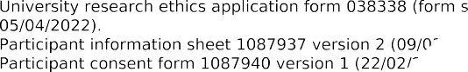
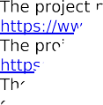
Appendix B

Ethical Approval Grants from University of Sheffield and Health Research Authority (HRA)

Letter from University of Sheffield Granting Ethical Approval.

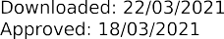

Letter from HRA Granting HRA Approval.

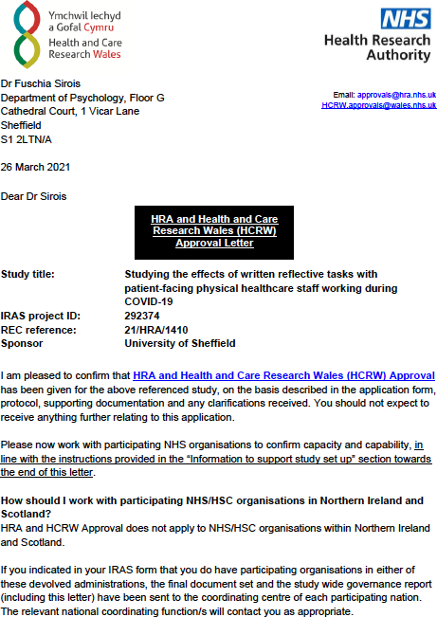

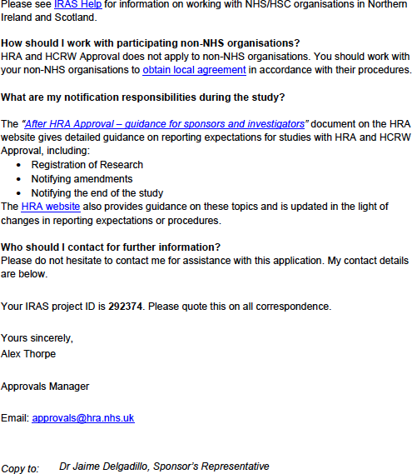

Appendix C

Cohen’s (1992) Sample Size Calculation Table

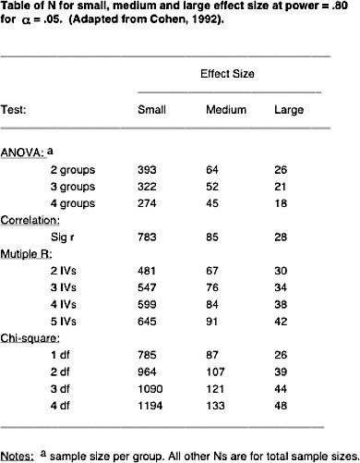

Appendix D

Study Advertisement

Calling ALL
Staff working in UK healthcare
for online reflective research
Win up to £75 in Amazon vouchers
Plus, use this research as evidence towards CPD / appraisals as appropriate

Appendix E

Participant Information Sheet

Reflective tasks with healthcare workers during COVID-19 Information about the Study

You are invited to take part in a research project. The following information will provide you with everything you need to know about the research and what it will involve, in order for you to decide whether or not to take part. Please read this information carefully and discuss it with others if you wish. Get in contact with us if anything is unclear or that you would like to discuss further. Thank you.

What is the study’s purpose & why have I been chosen?
The aims of this study are to further understand the impact of written reflective tasks on healthcare staff, and to determine if different types of reflective tasks have different effects. You have been chosen because you work or worked in a healthcare setting based in the UK, during the COVID-19 health pandemic.

Do I have to take part?
Your participation in this research is entirely voluntary. If you decide to take part, you will have this information sheet to keep, and be asked to sign a consent form. If at any point you decide to no longer participate you can withdraw any time before 30th December 2021*. If you decide to withdraw from the research, there will be no negative repercussions, and this will not affect your job. If you wish to withdraw from the research, please contact Vicky Lamb at vlamb2@sheffield.ac.uk.

*After this date it will not be possible for your individual data to be withdrawn from the research, this is because your data will have been anonymised and included within a large dataset.

What will happen to me if I take part? What do I have to do?
You will be asked to complete written reflective tasks online over a 4-week period. This will involve filling in questionnaires initially, which should take around 6-8 minutes to complete. You will then receive an email inviting you to complete a written reflective task online. This task will involve you thinking about your life, people in it and your experiences over the previous week and writing about them, alongside completing a short questionnaire. This should take no longer than 15-20 minutes to complete. You will be asked to do this once a week, for a total of 4-times over the 4-week period. At the end of the 4-weeks you will be asked to complete questionnaires once more, which again should around 6-8 minutes to complete, totalling around 100-120 minutes participation time overall.

What are the possible benefits and risks/disadvantages of taking part?
The written tasks you complete in this research will encourage reflection, and where relevant this can be inputted into documents related to your Continuing Professional Development (CPD) or appraisal. For example, using these reflections in work-related personal development plans. You are welcome to screenshot/print screen your written task as evidence of your writing to discuss with your supervisor/manager. After full 4-week study completion you will be placed (with your consent) into a draw for the chance to win
£75 in amazon vouchers.

There is a possibility that you may find the reflective tasks and/or questionnaires distressing. If for any reason you are personally affected by any of the material presented to you during the research and wish to speak with us, please contact either of the researchers (see details below). If you have concerns about your mental health and wish to seek support, please contact your GP, your occupational health department or Samaritans on phone number: 116 123.

The Prize Draw
If you wish to be added into the prize draw you will be asked to consent to this by entering your email address at the end of the study. Your email address will then be used as our point of contact for you for this draw. All

records of email addresses collected will be stored on a password protected computer by the researchers and deleted once the study has concluded and the draw is completed.

If you win the prize draw for this study, then you will be asked to electronically sign a form confirming that you have received this prize when you collect it. This form will be kept securely in a locked cabinet or as a digital copy for at least 7 years after the end of the project, accessible by University finance and administrative staff for reference in the event of a financial audit.

Will my taking part in this project be kept confidential?
Your information will be kept strictly confidential over the course of this research study and beyond. Personal data will only be accessible to members of the research team. Data will be anonymised for the purposes of any written publications or reports. Any consent given for the sharing of information with other researchers (i.e., research content available in University archives) will not include personal details. Identifiable personal data will be destroyed once analysis of the results is complete (up to 12 months post-study), this includes the key, which links the anonymised data to individuals.

What will happen to the data collected and the results of the research project?
Data collected will be stored on the Qualtrics software (the website where the online tasks are completed) for the duration of the research project. Once this is complete the data will be anonymised and downloaded for analysis purposes. The data will be used as part of a doctoral thesis and the research will be stored in University archives. Please contact the researchers directly (see their email addresses below) if you wish to be informed about the findings of this study.

Who is the data controller?
The University of Sheffield will act as the Data Controller and Sponsor for this study. This means that the University is responsible for looking after your information and using it properly.

Who has approved this research?
The project has been ethically approved and reviewed via University of Sheffield Ethics Committee.

What is the legal basis for processing my personal data?
The legal basis we are applying in order to process your personal data is that ‘processing is necessary for the performance of a task carried out in the public interest’ (Article 6(1)). Further information can be found in the University’s Privacy Notice https://www.sheffield.ac.uk/govern/data-protection/privacy/general. As we will be collecting some data that is defined in the legislation as more ‘sensitive’ (i.e. information about your mental health, gender, occupation and ethnicity), we are applying the following condition in law: that the use of your data is ‘necessary for scientific or historical research purposes’.

What if I wish to complain about the way the study has been carried out?
If you would like to make a complaint about this project, in the first instance you should contact the lead researcher. If you do not feel satisfied that your complaint has been dealt with appropriately you can contact the lead researcher’s supervisor. If you feel that your complaint has not been handled to your satisfaction following this, you can contact Prof. Elizabeth Milne, Head of Department at psy-hod@sheffield.ac.uk

Contact Information
This research is being conducted by Vicky Lamb [Trainee Clinical Psychologist & lead researcher] & Dr Fuschia Sirois [Clinical Psychologist & Research supervisor] who can be contacted via email on vlamb2@sheffield.ac.uk or f.sirois@sheffield.ac.uk.

If you have any questions or complaints about the research, please email vlamb2@sheffield.ac.uk or f.sirois@sheffield.ac.uk
Thank you for taking part in the project.
Please click through to the next screen to proceed.

Appendix F

Participant Consent Form

Reflective tasks with healthcare workers during COVID-19 Consent Form

Please tick the appropriate boxes | Yes |  |  | No
Taking Part in the Project
I have read and understood the project information sheet dated 1st February 2021 or the project has been fully explained to me. (If you will answer No to this question please do not proceed with this consent form until you are fully aware of what your participation in the project will mean).
I have been given the opportunity to ask questions about the project.
I agree to take part in the project. I understand that taking part in the project will include completing
questionnaires at the beginning and end of the project, alongside completing written tasks and a brief questionnaire once a week, for 4-weeks. I understand I will be completing these online via the link sent in an email.
I understand that by choosing to participate as a volunteer in this research, this does not create a legally binding agreement nor is it intended to create an employment relationship with the University of Sheffield.
I understand that my taking part is voluntary and that I can withdraw from the study before 31st December 2021. I do not have to give any reasons for why I no longer want to take part and there will be no adverse consequences if I choose to withdraw.
How my information will be used during and after the project
I understand my personal details such as name, phone number, address and email address etc. will not be revealed to people outside the project.
I understand and agree that my words may be quoted in publications, reports, web pages, and other research outputs. I understand that I will not be named in these outputs, and that if I wish to receive information on the findings of the research, I can contact the researchers directly via email.
I understand and agree that other authorised researchers will have access to this data only if they agree to
preserve the confidentiality of the information as requested in this form.
I understand and agree that other authorised researchers may use my words in publications, reports, web pages, and other research outputs, only if they agree to preserve the confidentiality of the information as requested in this project.
I give permission for the questionnaire & written data that I provide, to be deposited in password protected drives so it can be used for future research and learning.
So that the information you provide can be used legally by the researchers
I agree to assign the copyright I hold in any materials generated as part of this project to The University of Sheffield.

Do you wish to continue? To acknowledge that you have read and understood this information and would like to continue with the research study, please click on “I agree”.

I agree
No, thank you

If consent is not given: Thank you for your interest in the study, we are sorry you do not consent to taking part. Please close your browser to exit.

Appendix G

Eligibility Questions

Reflective tasks with healthcare workers during COVID-19 Study Eligibility Information

- Are you over the age of 18-years old?
Yes
No

- Are you employed in the UK at present?
Yes
No

- Is this employment in a healthcare environment?
Yes
No

- Are you currently involved in any other research or receiving psychological support from any other services?
Yes
No

If ineligibility is identified:

Thank you for your interest in the study. Unfortunately, you are unable to take part due to not meeting the eligibility criteria. If you have any concerns about your mental health and you feel you would benefit from additional support, please seek support from your occupational health department, your GP or Samaritans on 116 123.

If you feel this message should not have been displayed, please contact the main researcher via email on vlamb2@sheffield.ac.uk.
Please close your browser to exit.

Appendix H

Demographic Information Form

Reflective tasks with healthcare workers during COVID-19 General Information

Age:
Sex: |  | Female |  | Male |  | Other

What is your current Job Role?

  - What is your employment status?
full-time |  | part-time |  | Long term leave |  | Other

  - What does the majority of your role consist of?
Clinical Work | Non-clinical Work | Other (please describe):

  - Is your employer a…

Governmental Body / Local Authority e.g. NHS | Private Provider |  | Other |  | N/A
- Which branch of healthcare do you work within?
Physical Health Mental Health Other (please describe):
  - What is your highest level of education/qualification?
Some high school |  | A Level graduate |  | Postgraduate/Graduate degree or higher
High school graduate |  | Bachelor’s degree

Which ethnic background do you most identify with? (For example: Black, Asian, African- Caribbean, Latin American, White British, Romani, Black British, etc.)

Appendix I

Outcome Measures - Redacted in line with copyright legislation

Appendix J

Correspondence & Task Instructions

Prompt Email.

Hello!

It’s time for your [first/second/third/final] written task as part of the 4-week reflective task study. Please don't worry if you missed a previous week, you are still welcome to take part, we
understand people are busy and life gets in the way. If you wish to complete it, please click the link below. This should take you no longer than 20 minutes.

Before you start, consider the following:
    - Where are you located right now? We recommend a private, quiet location to allow you space to think and write with privacy.
    - Consider confidentiality, you may wish to write about events at work or patients, if you do, please try to keep patient names or services confidential, using ‘X’, ‘work’ or another name in replace of this.
    - Make sure you read the task instructions before you complete it.

Remember completion of tasks means you will be in with a chance of winning £75 in Amazon vouchers.
[Week 4 only] As this is the final week, there are some additional questionnaires after the written task, these should take no longer than 10 minutes to complete.
For any queries, please email the primary researcher Vicky Lamb on vlamb2@sheffield.ac.uk Thanks in advance,
The Research Team

24-hour Missed Task Reminder Email.

Hello!

This is a friendly reminder to complete your first/second/third/final written task as part of the 4- week reflective study. Please don't worry if you missed a previous week, you are still welcome to take part, we understand people are busy and life gets in the way, and we really appreciate the time you give to your thoughtful responses.

Please click on the link below to complete the short written task followed by a questionnaire. This should take you no longer than 20 minutes.

Before you start, consider the following:
    - Where are you located right now? We recommend a private, quiet location to allow you space to think and write with privacy.
    - Consider confidentiality, you may wish to write about events at work or patients, if you do, please try to keep patient names or services confidential, using ‘X’, ‘work’ or another name in replace of this.

    - Make sure you read the task instructions before you complete it.

Remember completion of all tasks means you will be in with a chance of winning £75 in Amazon vouchers.

[Week 4 only] As this is the final week, there are some additional questionnaires after the written task, these should take no longer than 10 minutes to complete.

For any queries, please email the primary researcher Vicky Lamb on vlamb2@sheffield.ac.uk

Thanks in advance, The Research Team

48-hour Missed Task Reminder Email.

Hello!

This is a friendly final reminder to complete your first/second/third/last written task as part of the 4- week reflective study. Please don't worry if you missed a previous week, you are still welcome to take part, we understand people are busy and life gets in the way, and we really appreciate the time you give to your thoughtful responses.

Please click on the link below to complete the short written task followed by a questionnaire. This should take you no longer than 20 minutes.

Before you start, consider the following:
    - Where are you located right now? We recommend a private, quiet location to allow you space to think and write with privacy.
    - Consider confidentiality, you may wish to write about events at work or patients, if you do, please try to keep patient names or services confidential, using ‘X’, ‘work’ or another name in replace of this.
    - Make sure you read the task instructions before you complete it.

Remember completion of all tasks means you will be in with a chance of winning £75 in Amazon vouchers.

[Week 4 only] As this is the final week, there are some additional questionnaires after the written task, these should take no longer than 10 minutes to complete.

For any queries, please email the primary researcher Vicky Lamb on vlamb2@sheffield.ac.uk

Thanks in advance, The Research Team

Task Instructions.

Please enter your email so that we may join up your weekly responses from the tasks.

Gratitude Journal. Redacted in line with copyright legislation

Control Group. Redacted in line with copyright legislation

End of task correspondence.

[Weeks 1-3] Thank you! Your responses for week 1/2/3 have been recorded. We really appreciate your time and effort and look forward to hearing more from you next week.
If you had any difficulties with completion of the task or have any queries, please email the main researcher, Vicky Lamb at vlamb2@sheffield.ac.uk
If you require additional support regarding your mental health, outside of this study. Please contact your occupational health department, your GP or Samaritans on 116 123.

[Week 4] Study complete! Thank you for taking part, we really appreciate all of your time and effort in completion of this research.

Please click the arrow below to submit your responses, you will then be redirected to a page with more information about the study.

On the next page you will be able to enter your email to be placed into the draw to win £75 in amazon vouchers.

Appendix K

Debrief Form

Reflective tasks with healthcare workers during COVID-19 Debrief Form

Project Title: Studying the effects of written reflective tasks with healthcare staff working during COVID-19
Researcher: Vicky Lamb
Supervisor: Fuschia Sirois

Aim of research: The research aimed to see if a particular type of reflective task involving gratitude is effective and beneficial for healthcare workers’ mental wellbeing, specifically mood, and subjective happiness. You were randomly assigned to engage in one of two reflective tasks. The gratitude task (the intervention group) involved completing a journal of gratitude. The other task (the control group) involved completing a reflective diary of your day/week. If you were in the group with the diary task, we will be in touch to offer you the gratitude task also.

If you consent to be placed into the draw to win £75 in amazon vouchers, please enter your email address in the text box at the bottom of this page. The voucher winner will be drawn once the required number of participants have completed the study (approximately December 2021). You will be contacted if your name is selected in the draw.

All information provided by yourself will be treated with strict confidentiality and under no circumstances will your name or any identifying characteristics be included in any reports or subsequent research articles. The research may be published, thus anonymised study data may be available in the public domain. Please be reminded that your participation is voluntary, you are free to withdraw at any time prior to 30th December 2021, without reason, which will have no negative consequences for you. Please contact us if you wish to do so, or if you have any further questions about this study, including requesting information about the findings of this research.

If for any reason you have been personally affected by any of the material presented to you during this research, please contact either of the researchers (see details below). If you have ongoing concerns about your mental health and wish to seek support, please contact your GP, your occupational health department or Samaritans on phone number: 116 123.

Researcher: Vicky Lamb E-Mail: vlamb2@sheffield.ac.uk
Supervisor: Fuschia Sirois E-Mail: f.sirois@sheffield.ac.uk

Thank you for your participation in this research project.
Remember to record any relevant work-related reflections from this study in personal
development plans or appraisals to support/evidence CPD.

I wish to be entered into the prize draw to win £75 in amazon vouchers [please enter your email address below]:

Appendix L

Data Management Plan

Defining your data.

- What data will you collect or create during the project?
- How will the data be collected or created, and over what time period?
- What formats will your digital data be in?
- Approximately how much digital data will be generated during the project?
- Are you using pre-existing datasets? Give details if possible, including conditions of use
  - Survey data will be collected in Qualtrics for the intervention, outcome measures and demographic information. When exported, tabular data, which will include demographic information and online questionnaire results, alongside task completion information and dates of commencement/completion will be stored, summarised and held in an MS excel spreadsheet, analysed in SPSS and written up in MS Word.
  - Data will be collected online via the Qualtrics survey database, where people will complete questionnaires, and fill-in free text boxes with their responses to the task. To ensure the task was completed tasks will be quality audited by the researcher. Data from questionnaires will then be extracted to Excel spreadsheet by myself. The range values of each questionnaire will be assessed to monitor for anomalous values or ranges. Tick boxes in questionnaires on Qualtrics will be utilised over free text boxes in order to minimise error during completion. To ensure data consistency, a sample of data inputted by myself will be double checked and peer-reviewed by the research supervisor. The time period for collection will be over a 6-month period. It will then be stored over a 12- month period.
  - Excel and Qualtrics Data will use comma-separated values (.csv). This is to ensure smooth exportation between Qualtrics and excel, also to ensure widespread long-term usage. SPSS data will be in .sav format, to ensure access throughout duration of the research. Word data storing the write up will be saved in .docx to ensure accessibility throughout the write up.
  - Up to 6MB (0.015-0.02MB in MS Excel, online data storage in Qualtrics, 0.015- 0.02MB in SPSS, 5MB in MS Word).
  - Not using existing datasets.

Looking after your data.

- How will you make data easier to understand and use? (e.g. creating a README file)
- Where will you store digital and physical data during the project?
- How will you name and organise your data files?
- How will you ensure data is backed up? (e.g. using University research data storage)
- How often will you check your backup files? (e.g. on backup, at set intervals)
- Will you use extra security precautions for any of your digital or physical data? (e.g. for sensitive and/or personal data)
  - A README.txt file will be developed to aid understanding of the dataset. Guidance for standardised instructions of the intervention will also be included in this, to enable reuse.
  - The data will be stored securely on the UniDrive, in a shared folder between myself and my supervisor. Raw data will also be stored on the Qualtrics system, under a password protected log-in.

  - Each person will be allocated a participant number, in order to anonymise responses. Their results will be added into one row on the Excel spreadsheet. A separate key (excel spreadsheet) will then link names to allocation numbers.
  - Appropriate formatting for data will be utilised in excel, for example Date columns labelled as so. The time period for collection will be over a 6 month period. It will then be stored over a 12-month period.
  - Data will be named with the most appropriate title, which maintains confidentiality of sensitive information and stored in the main UniDrive shared folder. Each version of the file will be stored using the date (YYYYMMDD) and the selected name for each file name e.g. ResearchData20201204.
  - Data will be automatically backed-up on the UniDrive.
  - Back-up files will be checked monthly, by myself.
  - Sensitive data such as names and email addresses will be stored in line with the Data Protection Act 2018.

Archiving your data.

- What data will be archived (stored on a long-term basis) at the end of the project?
- How long will the data be stored for? (e.g. standard TUoS retention period of 10 years)
- Where will the archive be stored? (e.g. subject-specific repository, or ORDA)
- Who will archive the data? (e.g. you, or your supervisor)
- If you plan to use storage other than a repository, who will be responsible for the data?
  - The write up of the research will be stored, alongside the anonymous dataset and the README.txt file which describes the procedure and aids understanding of the dataset.
  - Data will stored in accordance with the TUoS standard retention period of 10 years
  - The data will be stored in ORDA, Sheffield University's research repository, alongside the clinicaltrials.gov repository in accordance with the Elsevier research data policy, as guided by clinicaltrials.gov.
  - I will archive the data.
  - N/A

Sharing your data.

- How will you make your data available outside the research group after the project? (e.g. through data repository, or access on request via data availability statement)
- Will you make all of your data available, or are there reasons you can’t do this? (e.g. personal data, commercial or legal restrictions, very large datasets)
- How might you make more of your data available? (e.g. anonymisation, participant consent, analysed data only)
- What licence might you attach to your data to say how it can be reused and shared?
  - Results will be available in ORDA and on the clinicaltrials.gov website once completed.
  - Sensitive and personal information will not be available as the key linking participant numbers to the personal will be destroyed once the study is completed.
  - The data available will be completely anonymised.
  - Sheffield University will own the right's to the intellectual property of the research, therefore the license attached to the research will be in accordance with their policies. https://www.sheffield.ac.uk/library/rdm/requirements

Implementing your plan.

- Who is responsible for making sure the plan is followed? (e.g. you, your supervisor)
- How often will the plan be reviewed and updated? (e.g. if the project changes, yearly)
- What actions have you identified from the rest of this plan? (e.g. selecting a repository, requesting University research data storage)
  - Responsibility for activities are as follows; Data capture (myself with support from my supervisor); Metadata production (myself with support from my supervisor); Data Quality (myself and my supervisor); Storage and backup (myself, my supervisor, University of Sheffield) Data Archiving (myself, my supervisor, University of Sheffield and clinicaltrials.gov); Data Sharing (myself, my supervisor, University of Sheffield).
  - The plan will be reviewed if the project changes.
  - Developing metadata (README.txt file); registering trial on clinicaltirals.gov; arranging repository through clinicaltrials.gov and uploading the data on here and in ORDA when study is complete; creating a shared file on UniDrive and working from versions on here; destroying sensitive information and key to sensitive information once study is complete; reviewing legal information for storing data.

Appendix M

Histograms of Baseline and Post-Intervention Outcome Data

Figures A1 & A2

Baseline (Pre_Dep) and Post-Intervention (PostDep) Distributions with Normal Curve for Outcome: Depression

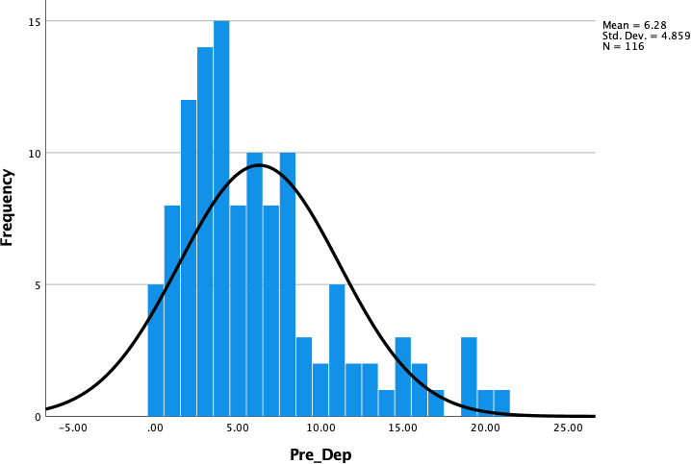
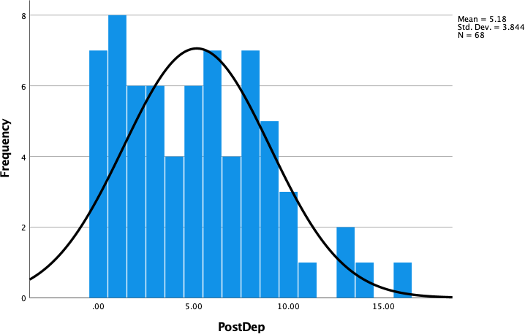

Figures A3 & A4

Baseline (Pre_SHS) and Post-Intervention (PostSHS) Distributions with Normal Curve for Outcome: Subjective Happiness

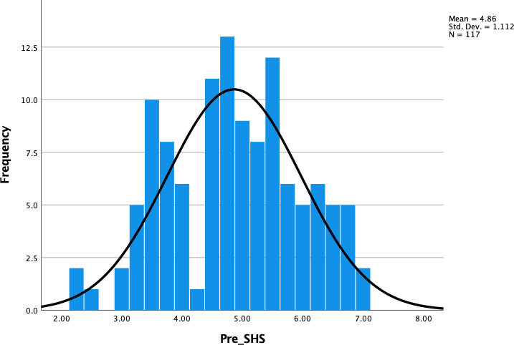
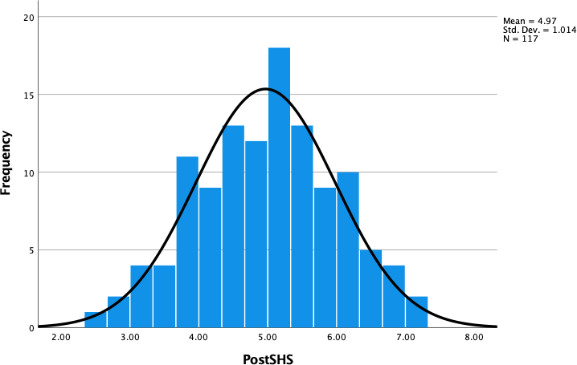

Figures A5 & A6

Baseline (Pre_PA) and Post-Intervention (PostPA) Distributions with Normal Curve for Outcome: Positive Affect

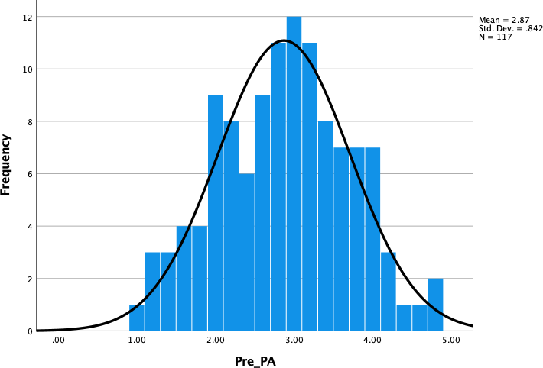
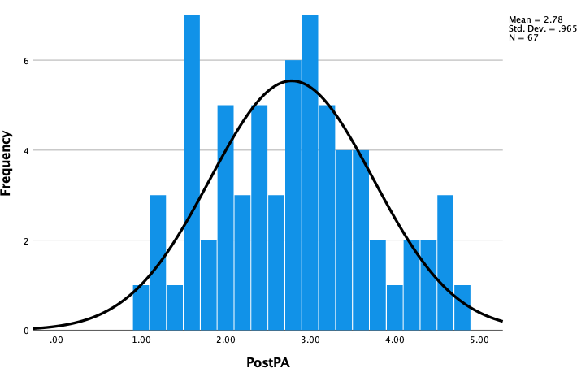

Figures A7 & A8

Baseline (Pre_NA) and Post-Intervention (PostNA) Distributions with Normal Curve for Outcome: Negative Affect

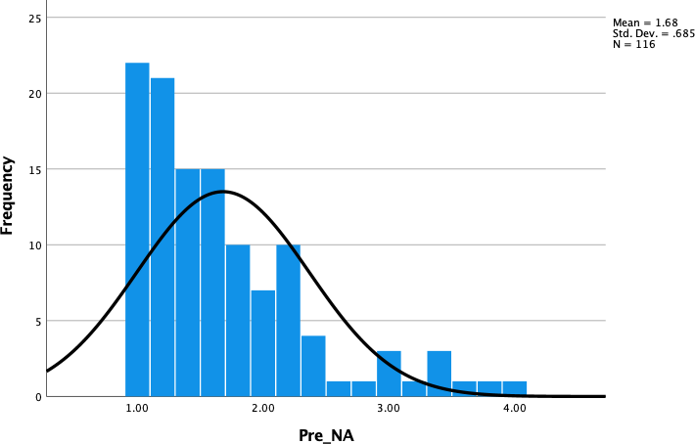
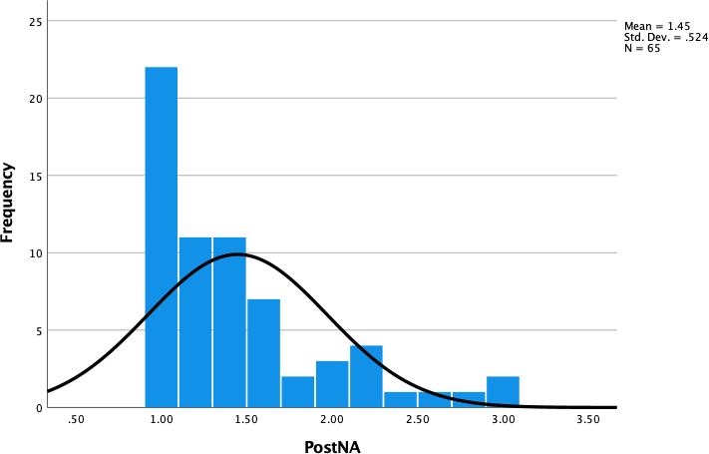

Figures A9 & A10

Baseline (Pre_GAC) and Post-Intervention (PostGAC) Distributions with Normal Curve for Outcome: State Gratitude

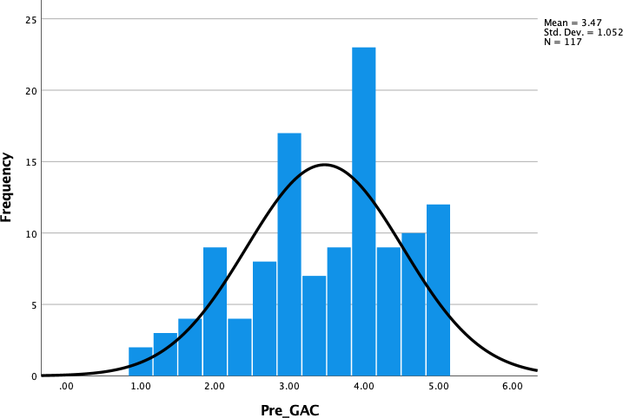
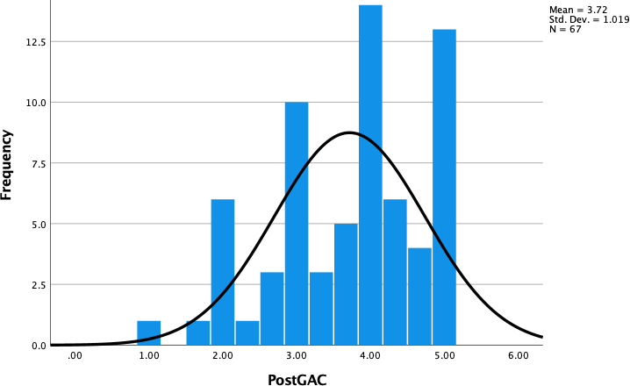

Figure A11

Baseline (Pre_GQ6) Distributions with Normal Curve for Outcome: Trait Gratitude

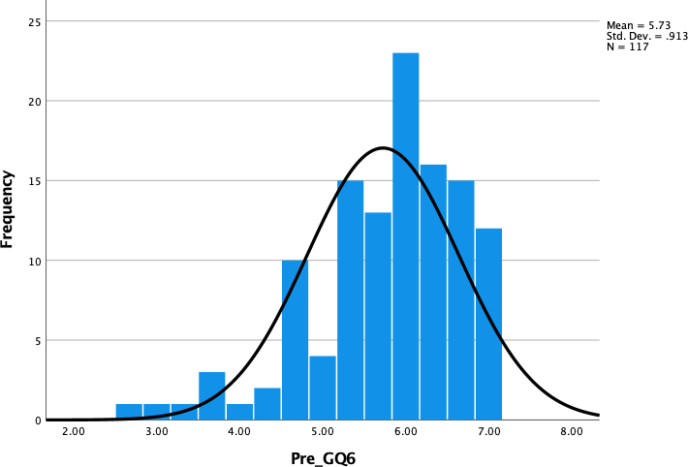

Appendix N

CONSORT 2010 Checklist - Redacted in line with copyright legislation

