

Measuring the effect of social knowledge on social attention by using gaze cueing effect

Nazli Altin Cesur

A thesis submitted for the degree of Doctor of Philosophy (PhD)

The University of Sheffield
Department of Psychology
February 2020

Table of Contents
List of Tables viii
Chapter 1. Review of the Literature 1
1.1 Introduction 1
1.2 Mechanisms of Visual Attention 4
1.3 Biological Basis of Gaze Perception 11
1.3.1 Inferring directions with eye gaze cues 13
1.3.2 Inferring others’ actions with eye gaze cues. 15
1.3.3 Inferring others’ mental states using eye gaze cues 16
1.4 Why Eye Gaze is Informative 18
1.5 What Enhances Gaze Cueing? 24
1.5.1 Physical features 26
1.5.2 Social factors 34
1.5.3 Personal differences 38
1.6 Overall Aims of the Thesis. 43
Chapter 2. Social Attention and Social Group Belonging 45
2.1 Overall Introduction 45
2.2 Aims and Hypothesis 50
2.3 Stimulus development study 50
2.3.1 Methods 50
2.3.2 Results 55
2.3.3 Discussion 61
2.4 Behavioural study 62
2.4.1 Methods 62
2.4.2 Results 68
2.4.3 Discussion 72
2.5 Overall Discussion 74
2.6 Limitations and Future Research 77
Chapter 3. The Effect of Gender and Social Power on Gaze Cueing in Dangerous Scenarios 79
3.1 Introduction 79
3.2 Aims and hypothesis 89
3.3 Methods 90
3.3.1 Ethics 90
3.3.2 Participants 90
3.3.3 Stimuli and apparatus 91
3.3.4 Design 93
3.3.5 Procedure 94
3.4 Results 95
3.5 Discussion 101
3.6 Limitations and future research 106
Chapter 4. The Effect of Observation of Leadership on the Strength of Gaze Cueing 109
4.1 Introduction 109
4.2 Aims and hypothesis 116
4.3 Methods 118
4.3.1 Ethics 118
4.3.2 Participants 119
4.3.3 Apparatus and Stimuli 119
4.3.4 Design 124
4.3.5 Procedure 130
4.3.6 Data pre-processing 131
4.3.7 Data exclusion 131
4.4 Results 133
4.4.1 Task 1: Learning Phase 133
4.4.2 Task 2: Face Ratings 137
4.4.3 Task 3: Testing Phase 141
4.4.4 Task 4: Questionnaires 144
4.5 Discussion 145
4.6 Limitations and Future Directions 149
Chapter 5. General Discussion 150
5.1 Summary of main findings 150
5.1.1 1. Theoretical explanation: 150
5.1.2 2. Experimental explanation: 152
5.2 Reflection on the measurements 156
5.2.1 SOA 156
5.2.2 Faces 158
5.2.3 The gaze cueing task 159
5.2.4 Computer versus real environment 160
5.3 Themes Emerging from the Thesis 161
5.3.1 Theme 1: Gender difference of the observer 161
5.3.2 Theme 2: Episodic learning 162
5.3.3 Theme 3: Attention mechanisms 163
5.3.4 Theme 4: Implicit versus Explicit 164
5.4 Implications 164
5.5 Future Direction 165
5.6 Conclusion 167
References 170

List of figures

Figure 1: Central cues combined with peripheral cue (1) and central cue (2) …………8
Figure 2: Extended system: Neural pathways related to eye gaze perception) ……….12
Figure 3: (A) Illustration of the fixation stimuli, can be perceived as a car or as a hat pulled down to the eyes depending on the given instructions. (B) The corrected RT for the stimuli which is appearing at the cued and non-cued locations and when perceived as Eyes or a Car 14
Figure 4: The scores for each question by story type 59
Figure 5: Example face stimuli with averted gaze and A) non-target, B) congruent target and C) incongruent target ……………………………………………………………...64
Figure 6: A congruent version of the gaze cueing trial with a left side eye gaze and target location …………………………………………………………………………….…..71
Figure 7: Mean reaction times (ms) and standard errors for University of Sheffield student story and Non-Student story by congruency type (congruent/incongruent)
Figure 8: Mean response to group belonging question scored 1 (not at all) to 6 (extremely) by story type ……………………………………………………………………………72
Figure 9: Example of face gazing left and right side of the screen - congruent trials ….92
Figure 10: Gaze cueing effect divided by gender of the gazer, reaction time scores and standard error mean were presented ……………………………………………………99
Figure 11: Gaze cueing effect by gender of the participant, gender of the gazer and social power 100
Figure 12: Example of 9 versions of a face with all angles …………………………...123
Figure 13: Example of leader versus follower trials, congruent versus incongruent versions and head turns 126
Figure 14: Example of face rating trials with leader or follower faces 128
Figure 15: Gaze cueing task: An example of congruent and incongruent trials……...129
Figure 16 Crossover interaction between leadership (leader X follower) and gender of gazer (male X female) 134
Figure 17: Learning phase: Mean total accuracy response of leader and follower conditions divided by gender 135
Figure 18: Learning phase- The accuracy rating of male and female gazers divided by leadership……………………………………………………………………………...136
Figure 19 Learning phase- The accuracy rating of male and female gazers divided by leadership 137
Figure 20: Learning phase- Overall average face rating scores divided by adjective and gender of gazer 139
Figure 21: Overall mean reaction times and error bars divided by adjective 140
Figure 22: Overall mean RT divided by gender and adjective. 141
Figure 23: Overall mean accuracy ratings divided by gender congruency and leadership 143

List of Tables

Table 1: Stimulus counterbalancing table: Photos in order in each version of the online questionnaire 53
Table 2: Means and standard deviation of nine question divided by story type 56
Table 3: Face stimuli X life story combination versions for the counterbalancing procedure 66
Table 4: Sample size and percentage divided by gender and condition 93
Table 5: Means and standard deviation of the Reaction time divided by social power and gender of the gazer 96
Table 6: Number of items and example questions from each of the five subscales of the AQ 120
Table 7: Mean and standard deviation reaction times for each condition in Phase 1 130
Table 8: Mean and standard deviation reaction times for each condition in Phase 3 133
Table 9: Mean and standard deviation of accuracy rating response 142
Table 10: Mean and standard deviation of AQ scores 144

Acknowledgements

First, I would like to thank my supervisor Dr. Megan Freeth for the continuous support of my PhD study, for her patience and guidance. Her positive attitude and motivation always helped me to keep going. I also want to thank Paul Norman, his encouragement kept me going. I also would like to express gratitude for the members of ShARL. Thanks to all my friend who become a family during this journey. I also would like to thank all the participants who attended my experiments, and patiently finished the study. I would like to thank my husband for letting me be myself always and supporting me. Thank you for acting as a root for me when I was ready to fall. Also, I want to thank my parents, my brother, my uncle and my grandparents for being there for me always. Lastly, I would like to thank past Nazli to dare taking this chance.

Abstract

This thesis examines the socio-cognitive variables that effects eye gaze following in neurotypical adults. Existing literature defined these socio-cognitive variables by showing visual representations or changing physical features of the observed gazer. However, in real world interactions, social relations are not only defined by visual awareness but also observes pre-existing memories. This is particularly important for laboratory based social attention studies that conducted in highly controlled environment since, it might cause losing the social context behind the social relations by only focus on visual attentional effects. Three experiments conducted to see if the gaze cueing effect would be enhanced by the information that participants know about the gazer face. Study one showed that, although participants did not have any knowledge about the gazer face besides which group they belong, they significantly reported themselves to be in the same group with in-group condition compared to outgroup condition. But, this did not affect the strength of gaze cueing. Participants showed similar gaze following both to in-group and outgroup faces. In study two, perceived social power manipulated in dangerous scenario and results indicated that female participants were more sensitive to social stimuli in dangerous situations. Study three, focused on observation of a person as a leader or a follower in group context. This study conducted with neurotypical females to see the effect of autistic traits in social attention as a continuum. Finding suggested that leadership manipulation was effective at the first observation, but this effect did not manipulate later social attention encounters with the observed face. Altogether, results suggested that visual awareness of social context was important to create the social categorization in computer-based gaze cueing tasks.

Review of the Literature

Introduction
Humans are social animals by nature and the underlying mechanisms of social cognition are yet to be fully explored. Social cognition can be defined as “how we interpret, analyse and remember information about the social world” (Baron & Byrne, 1997). As a first step, the information that we perceive is often interpreted using the social context and cultural values. Following this, the interpreted information is analysed to adjust, change and even reject the initial input. Finally, social information is stored in memory and can be recalled or retrieved at a later time. Early studies of social cognition focused on the perceived causes of behaviour, also known as attribution theories (Heider & Simmel, 1944; Heider, 1958; Jones & Davis, 1965; Michotte, 1963). These theories suggest that people attempt to predict, understand and control their social environments like a naive scientist by exploring reasons and causes for why people, including the self and others, behave in a particular way (Pennington, 2000). Simple situations such as not receiving an invitation from an acquaintance for a social gathering necessitate the use of such interpretations to fully understand the situation. People interpret the behaviour of others in terms of its causes and these interpretations play an important role in determining appropriate reactions to that behaviour. For instance, the person can think that they are deliberately dismissed or forgotten, yet it is also possible that the invitation is not received for an unrelated reason after being sent. Heider (1958) distinguishes such examples between causes within the person (i.e., traits or personality dispositions) and causes derived from the situation (e.g., social pressure).
As a social animal, humans want to know other’s intentions and dispositions (Harris et al., 2005) so they can communicate better in society. Therefore, gaining insights into the mind of the self and others is fundamental for social skills. Advances in neuroscience has led researchers to explore the capacity of the human brain in terms of social cognition. Humans have a larger brain than those of their nearest primate relatives (Herrmann et al., 2007) and the social brain hypothesis suggest that larger brains enable humans to perform all kinds of cognitive tasks more efficiently (Allman & Martin, 1999; Barrett & Henzi, 2005; Dunbar, 1998) including greater memory, faster learning, faster perceptual processing, more robust inferences, longer-range planning in decision-making and so on. Moreover, there is a correlation between mean group size among various primate species and their neocortex volume. This relationship has also been observed in several other mammals with complex social structure, such as bats and toothed whales (Allman & Martin, 1999). Such complex social structures include both cooperation for better security and more reliable food sources and also within-group competition (Emery, 2000) or hierarchical differences (Bendersky & Hays, 2012). Social interactions between humans are frequent and it is adaptive to prioritize social information to survive and thrive in the social world. Thus, an evolutionary approach to social cognition predicts mechanisms for cooperativity, altruism, and other aspects of prosocial behaviour as well as mechanisms for coercion, deception and manipulation of others.
Faces and gaze perception are particularly important in social communication. One of the richest information sources for social functioning is the face. Faces can reveal socially relevant information such as identity, group membership, age, gender, and race as well providing information about emotional state or current intentions (Haxby et al., 2002). Gazing into a person’s eyes represents a fundamental dimension of nonverbal and social communication. The eyes of another person can provide important information regarding the focus of their attention, as well as discern their emotions, attitudes, and thoughts. Among the many parts of the human face, the eyes are possibly the most critical when it comes to social attention. Indeed, the eyes of animals have evolved in a special way (Kobayashi & Kohshima, 1997). Research suggests that human eyes, unlike those of other animals, have large sclera that is lighter than skin tone, and irises and pupils that are darker (Kobayashi & Kohshima, 2001). As a consequence, human eyes appear to be morphologically unique. Newborn babies show preferences for focusing on faces with open or gaze-directed eyes compared to the same faces with closed eyes or averted gaze (Dupierrix et al., 2014; Farroni et al., 2002, 2005). Adults also use eye contact when engaged in face-to-face communication (Argyle & Cook, 1976). Face scanning always begins with eyes, despite the emotions shown in the face (Jones, Carr, & Klin, 2008). Eyes convey remarkable information about another person’s attentive, emotional, and cognitive state, often resulting in the modification of actions. Eyes can attract attention automatically and play a central role not only in processing faces but also social communication in general (Emery, 2000).
Human eyes might be evolutionally linked to a system of social cognition (Emery, 2000). Baron-Cohen and Cross (1992) suggested the existence of an “eye direction detector” in cognitive processes that play an important role in the early face processing system. This system comprises two main functions. First, eyes are detected, and second, their directions are coded. Baron-Cohen and Cross (1992) also forwarded that the first function is innate, whereas the second may emerge later in life. Baron-Cohen et al. (1997) examined the importance of eyes for evaluating facial emotions. In their study, participants were shown photographs of an actress with 10 basic emotions and 10 complex mental states (admire, interest, thoughtfulness, etc.). For each mental state, subjects were shown either the whole face, the eyes alone, or the mouth alone. The results showed eyes were more informative compared to the mouth in the interpretation of mental states, and that eyes were found to be as informative as a full face. This study suggests that eyes are critical in social communication because they help express emotions that are related to social interaction and attention.
Mounting research suggests that eye gaze is a potential source of social information. Direct eye contact demonstrates that a person is paying attention, signalling the desire to approach, whereas averted eye gaze signals avoidance or the general lack of attention. Although the context is clearly important to understand the effects of eye gaze, such as threat or attraction, a period of mutual eye contact is associated with elevated galvanic skin response, which is thought to be a measurement of emotional arousal (Nichols & Champness, 1971), as well as increased heart rate (Akechi et al., 2013). The ability of animals to perceive being watched has been demonstrated across species ranging from iguanas to non-human primates and humans (Barrett et al., 2007; Burger et al., 1992; Perrett et al., 1990). The direct eye gaze in humans does not require focused attention, thus research suggests that it is automatic (Farroni et al., 2002). Additionally, studies have found that the visual information gathered from direct eye gaze reaches conscious awareness faster than the faces with averted eye gaze (Yokoyama et al., 2013). Therefore, it is apparent that processing information from the eyes and the ability to follow eye gaze is important for many aspects of social communication. This is the focal topic of this thesis.
In the subsequent literature review, the following topics are addressed. First, the attention mechanism relating to eyes and visual attention will be explored, focusing on the specific style of attention called social attention. Second, the neural basis of gaze perception will be discussed. Third, the notions of eye gaze and gaze cueing will be introduced. Fourth, the context, personal traits, and faces, and their effects of gaze cueing behaviour will be examined. Fifth, the effects of faces in more depth, both with respect to physical features (e.g., race and physical similarity, dominance, age, and gender), social factors (e.g., social group belonging and social similarity, social status and lastly social power) and personal differences (e.g., gender and autistic traits) will be explored. These sections form an important theoretical basis for the empirical chapters that are introduced later in the thesis. Chapter 2 and 3 will examine the social factors in more depth and Chapter 4 will focus on personal differences.

Mechanisms of Visual Attention
We are constantly bombarded with all sorts of sensory information, especially visual stimuli; therefore, it is essential to be able to determine what information is relevant for the current space and time. We need selection because there are information bottlenecks (one process in a chain of processes) in the visual pathway. Visual data is about 25 megabytes per second, coming from 25 images per second received by about 126 millions of photoreceptors (around 12 millions of rods, 6-7 cons) at our retina. To navigate successfully, multiple attentional systems filter this flow of input, detect relevant ones and prepare to respond accordingly (Driver et al., 1999). This selection mechanism is considered to help focus on highly relevant items and suppress less important stimuli (Allport, 1993). Posner (1980) suggested that one needs to be able to do three things to pay attention to something. First, one needs to disengage from whatever is currently being focused on; second, identify what should be focused on next; and third, shift one’s attention to the new focus. Selective attention has also been divided into three components: engaging, disengaging, and shifting (Posner, Walker, Friedrich, & Rafal, 1984; Posner & Petersen, 1990). Selective attention begins with orienting of attention. Orienting is the process of moving attention to a location in space (spatial orienting) or time (temporal orienting). Stimuli or signals at a given location are enhanced, and therefore, it is possible to detect an important or relevant stimulus and to orient towards a significant event. Behaviourally, selective attention creates a focused perception leading to faster stimulus selection or heightened contrast sensitivity (Carrasco, 2011).
How attention is directed behaviourally is an important question for attention studies. In daily life, people move their eyes to the locations they wish to attend, our natural behaviour shows that gaze always follows where our attention is directed. On the other hand, Helmholtz (1871) proposed that it is possible to direct attention to a particular location voluntarily and selectively without making an eye movement, which was considered to be one of the most important contributions to the theory of attention (James, 2007). In terms of the eye movement, attention can be directed overtly by moving our gaze to where we select visual inputs or covertly by selecting from the corner of our eyes. It is now well-established that people can choose to attend to locations without moving their eyes (Eriksen & Colegate, 1971; Eriksen & Hoffman, 1973). Thus, as Posner (1980) suggested, selective attention can be directed in two distinct ways: overtly (by using eyes and head orientation) and covertly (without eye movements).
Posner (1980) was the first to propose that there are two modes of control over visual orienting: The first mode was exogenous or bottom-up attention, involving reflexive orienting in response to salient stimuli in the visual field whereas the second mode was endogenous or top-down attention, involving voluntary orienting in response to goal-relevant indicators. In an analogy to the guidance of saccadic eye movements, these two modes are referred to as reflexive and voluntary. The distinction between reflexive attention and voluntary attention is about the way in which attention is engaged. Unpredictable and/or unexpected events (such as loud noise from outside) in the environment are engaged with reflexively (Posner, 2014) whereas attentional shifts which controlled by internal processes of a particular individual are more voluntary and goal-oriented (Posner, 2014). Reflective attention is fast engaged (by 100- 300 ms) and fades quickly (around 500 ms) (Müller & Findlay, 1988). Voluntary attention, however, requires a longer time to emerge (300–500 ms) and lasts longer (1000 ms) (Müller & Rabbitt, 1989).
Bottom-up attention is derived only from low-level image properties, typically using contrast features. Bottom-up attention biases the observer towards selecting salient stimuli, which stands out from the environment (Itti & Koch, 2001). The basic assumption for bottom-up saliency is that pre-attentive processing is driven by the bottom-up features of a stimulus (such as colour, orientation), prior to the allocation of attention (Theeuwes, 2010). After the initial pre-attentive analysis of a scene, one object is selected on the basis of local feature contrast obtained from its relationship with respect to its surroundings (Egeth & Yantis, 1997). This mode of attention is considered to be fast, automatic, and task independent.
Top-down attention is driven by a task or a motive, and compared to bottom-up saliency, its deployment is slow and controlled by volition; this is why it is called “voluntary attention” in some research. In one seminal experimental method that investigated attention orienting, participants were asked to locate a target that could appear to the left or right of a fixation point (Posner, 1980). So-called spatial cueing involves identifying one of the possible target locations that appear in the middle of the screen, where faster reaction times indicate stronger orientation. Different cue types differentiate exogenous and endogenous orientation, and visual attention can be categorised according to how it is controlled. Exogenous attention is driven by stimuli and endogenous attention is determined by the internal expectations about events in the environment. Posner (1980) first described a so-called endogenous cueing procedure, which reflects top-down selection. In this paradigm, observers receive a cue showing them the likely location of the upcoming target. Typically, observers are faster and make fewer errors when the target appears at the cued location compared to when it appears at an un-cued location. Responding to an endogenous verbal cue as in the Posner cueing tasks takes about 200 to 300 ms (Müller & Rabbitt, 1989) whereas exogenous shift to peripheral onset (i.e., bottom-up attention) only takes about 100 ms (Nakayama & Mackeben, 1989). The other essential point here is that observers direct their attention to a particular location in space using their own volitional act when cued endogenously. The assumption here is that information from higher cortical areas needs to be sent to earlier areas to guide attention in a top-down manner. Awh et al. (2012) and Theeuwes (2018) both point out that attentional selection can sometimes neither be explained by the stimulus-driven or goal-driven manner; rather "selection history" can guide attention. The stimulus that receives "value" from the past episodes of attentional selection (i.e., through implicit or explicit learning) influences current attention above and beyond the dichotomy of endogenous or exogenous attention. Priming is the effect of past history and is considered to be a low-level facilitatory factor on perception (see Theeuwes, 2018). Even early examples of attentional research demonstrated that the locations that had been attended previously were responded faster compare to an unattended location (Posner, 1980). Research has confirmed the robustness of the priming effect even when the observer's goal was irrelevant or inconsistent with the primed cues (Theeuwes, 2010, 2018). Attention can be also controlled by overlearning particular behaviourally relevant stimuli such as those associated with arrows (Ristic & Kingstone, 2012). According to the literature, non-predictive arrows produce complex results (Gibson & Kingstone, 2006). Earlier studies suggested that endogenous cues, such as arrows, can shift attention only when they predicted the location of the target. But later studies suggested otherwise, as indicated by research indicating that non-predictive arrow cues can also cause attentional shifts (Ristic, Friesen, & Kingstone, 2002; Tipples, 2002).
To investigate this issue, Ristic & Kingstone, (2012) performed a double cueing task which involved combining non-predictive cues with central predictive cues. Participants were presented with a central non-predictive cue combined with either non-predictive peripheral cue to measure exogenous attention or a central predictive cue to measure endogenous attention (see Figure 1).

Figure 1

Central cues combined with peripheral cue (1) and central cue (2)

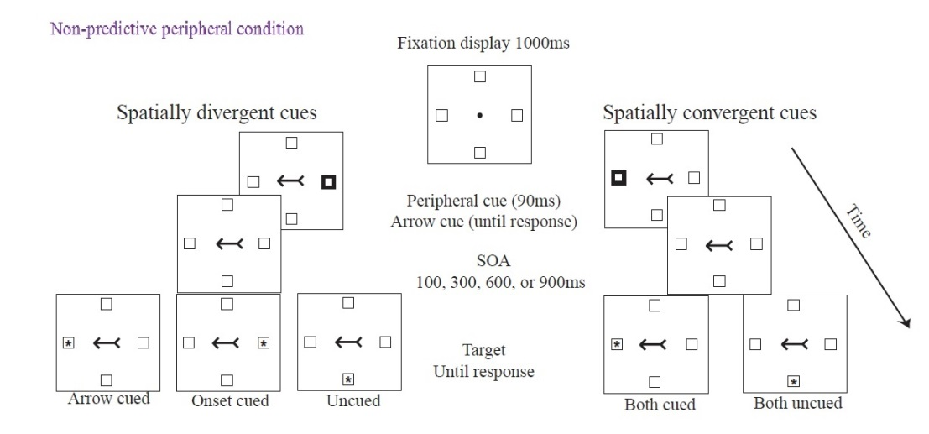
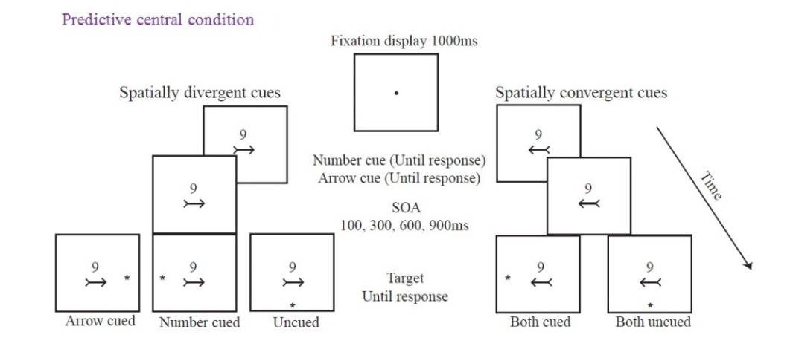

Note. Altered from (Jelena Ristic & Kingstone, 2012)

In this study, all the stimuli were black and white. Peripheral cues were created by thickening the outline of placeholder boxes and arrow cues were created by placing the arrow symbol in the middle of the screen. The authors deployed a between-participants experimental design to ensure that all the conditions were equally balanced. They had four stimulus onset asynchrony (SOA) (100, 300, 600 and 900 ms) for both conditions. For non-predictive peripheral cue treatment, they conducted two separate within-participants ANOVAs for validity (valid-invalid) and SOAs (100, 300, 600 and 900 ms) to compare participant reaction times. A similar analysis was performed for the central predictive cue treatment. The authors reported that non-predictive central arrow cues were independent of both the endogenous orienting (measured by predictive central symbolic cues) and the exogenous orienting (measured by non-productive peripheral onset). The study also indicated that arrow cues affected attention similarly regardless of whether the arrow was paired with an endogenous central cue or an exogenous peripheral cue. Interestingly, the time courses of these two couplings were similar. These results were replicated for all SOAs for both endogenous and exogenous pairings. Researchers suggested that the arrow cues might produce a form of orienting that is neither purely exogenous nor purely endogenous. They also suggested that this form of attention orienting is unique because it causes an involuntary response related to repeated exposure. The authors proposed that this mechanism be called “automated symbolic orienting”. Hence, it was suggested that directional cues from arrows, which is a non-social behaviourally relevant symbol, creates automaticity in attentional orienting due to learning its relevance by repeated exposure. But these results were only gathered from arrows (no other non-social stimuli) and it is not clear whether arrows are special about directing the attention or other non-social stimuli would activate a similar mechanism of attentional shifts.
Past studies have also indicated that some other non-social cues, such as digits (Dodd et al., 2008) and words with meaning (Hommel et al., 2001; Pratt & Hommel, 2003), show similar attentional effects that may be related but separate from both attentional systems. In contrast, other studies conducted with social-biologically relevant cues, such as eye gaze (Friesen & Kingstone, 1998; Friesen, Ristic, & Kingstone, 2004), finger point (Langton, 2000), or head direction (Friesen et al., 2004), revealed automatic attentional shifts. Attentional effects of biologically relevant stimuli, such as eye gaze, have been found to initiate strongly automatic attentional shifts. Previous work has examined the effect of gaze on attention through the gaze-cueing effect: an enhancement of performance in detecting targets that appear where another person is looking (Hungr & Hunt, 2012).
The tendency to follow the direction of another person’s gaze has been widely documented (Becker, 2010; Langton & Bruce, 1999). This phenomenon has been studied with gaze cueing tasks, in which a face is presented in the centre of the screen with the eyes gazing either to the left or to the right side of the screen. Then, a target appears to the right or left side of the screen and participants are asked to either detect the onset of the target or discriminate between several different targets as quickly and accurately as possible. With congruent trials, the target and the gaze appear on the same side of the screen and in incongruent trials, the target appears opposite to the gazed-at location. The gaze cueing is usually measured according to participant response time. Experiments have shown that people are faster to respond congruent trials compared to incongruent trials. Therefore, attentional shift mechanisms may vary as a function of the type of central cue (Ristic & Kingstone, 2012). One problem about the claim which says eye gaze orienting creates automatic attentional shifts is that arrow cues also shift attention in a reflexive manner (Ristic et al., 2002; Tipples, 2002). This means the orienting of spatial attention in a reflexive way is not the only result of social attention cues gathered by eye gaze (specifically at behavioural measurements).
To address this problem, Friesen and Kingstone (2003) looked for further differentiation between eye gaze cues and examined the functional characteristics of covert and overt orienting in response to non-predictive gaze direction cues. In this study, participants were presented a gaze cueing task with a schematic face drawing and asked for a response either by making a keypress or by making an eye movement to locate the target. For both response condition, the gazing face either stayed on the screen until response or diminished when target stimuli presented. The results of this study indicated that the keypress response condition created attention shifts regardless of the fixation condition; however, the eye movement condition oriented overtly only if the gazing face stayed on the screen until response but not when the gazing face disappeared when target stimuli presented. These results suggested that the attention shifts created by eye gaze do not trigger the preparation of an eye movement. They concluded that gaze triggered orienting is indeed a form of reflexive shifts and gaze does not activate the oculomotor system. A second approach is to examine the characteristics of eye gaze cues by examining the counter-predictive cues for both arrow and eye gaze cues. Counter-predictive cues require participants to reorient their attention away from the cued direction; therefore, any effect of eye gaze would suggest that such cues would operate against voluntary control. Indeed, Friesen et al. (2004) showed that arrows only triggered a volitional effect rather than an automatic attentional shift that was observed from eyes. They used a modified version of counter-predictive paradigm and had four target locations instead of two. This procedure was useful to measure voluntary and involuntary nature of orienting but added difficulty by requiring attention to be spread more widely. Although they reported some significant results, the method of this study makes it hard to compare it with other studies in the literature. In another study, Tipples (2002) found that both eye and arrow cues produced similar orienting using counter-predictive paradigm although some methodological problems remained. In their study, the eye gaze and arrow cues were tested in separate experiments and with separate group of participants and, as a result, a direct statistical comparison was not possible. Nevertheless, many studies from the literature examining the similarity and differences between eye gaze cues and arrow cues have not produced consistent results; both approaches explain some aspects about attentional shifts but not all. Therefore, it is important to implement biological measurements to test whether they trigger similar neural pathways. The next subtopic will explain the neural basis of eye gaze perception and the broader network related to eye gaze.

Biological Basis of Gaze Perception
The neural basis of social behaviour may originate in the social brain. Brothers (2002) suggested that the “social brain” is comprised of three major brain regions: the amygdala, the orbitofrontal cortex, and the superior temporal sulcus (STS). Evidence suggests that the STS, amygdala and orbitofrontal cortex, act together to detect another individual’s eye gaze direction (Emery, 2000). The STS may code individual gaze direction whereas the amygdala may play a role in perception or monitoring for gaze contact (Wicker et al., 1998). Various studies have demonstrated that averted eyes compared to straight eyes or other control stimuli trigger more activation in the STS, fusiform gyrus, inferior parietal lobule, and middle/inferior frontal gyrus (Calder et al., 2002; Hoffman & Haxby, 2000; Wicker et al., 1998). Eye gaze is also processed via a complex network of multiple areas in the human brain. These areas include anterior and posterior parts of the STS (Bristow et al., 2007), fusiform gyrus, amygdala, prefrontal cortex, and the orbitofrontal cortex (for reviews see, Emery, 2000; Nummenmaa & Calder, 2009). Additionally, the STS is heavily connected to the amygdala, fusiform gyrus (Wicker et al., 1998) and parietal cortex (Calder et al., 2007), which contribute to face perception (see Figure 4). Faces are considered to be highly social stimuli and can be processed even without conscious awareness by the STS and the amygdala (Jiang & He, 2006).

Figure 2
Extended system: Neural pathways related to eye gaze perception
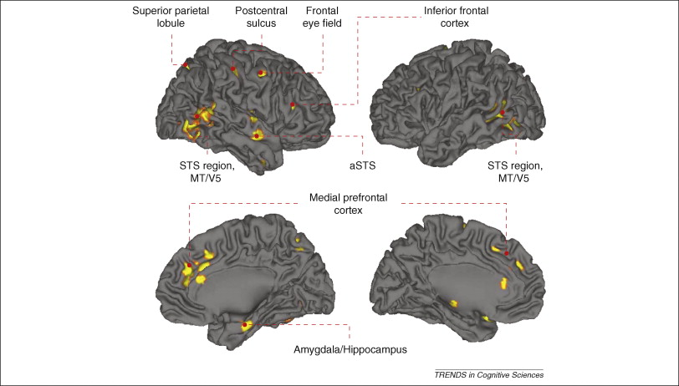
Note. Studies about the neural pathway related to gaze processing suggest the involvement STS region (Hoffman & Haxby, 2000), amygdala/ hippocampus (George et al., 2001; Kawashima et al., 1999), inferior frontal cortex (Calder et al., 2007), superior parietal lobule (Wicker et al., 1998), medial prefrontal cortex (Bristow et al., 2007), and other frontal regions (Vecera & Rizo, 2004). This figure altered from (Nummenmaa & Calder, 2009).

Eye gaze cues trigger reflexive visual attentional systems, cues for danger and sources from the environment as well as serving cues as an indicator of others’ mental states. These functions of eyes are crucial for social group living, explaining the multiple connections and systems that gaze processing triggers in the social brain and cognitive systems. Additionally, this system needs to be highly adaptive with the environment and with the other members of the group from that environment for successful survival. Hence, multiple perceptual systems in the brain can be triggered with eye gaze. In the next subsection, the attentional effects of eye gaze following will be explained as a directional special cue. The implications of eye gaze cues for imitating other's actions and inferring others’ minds will also be explained.

Inferring directions with eye gaze cues
Unlike other sensory organs, eyes are highly direction specific. Eyes need to be oriented to a specific target in the space to receive relevant stimuli and send it to brain regions for further processing via light receptors. As a result, eyes are often directed at the important stimulus such as food, important resources or targets of future action. Research studying social cognition suggest that the STS is a critical region for indicating someone’s eye gaze direction and triggering reflexive attention in the same direction (Emery, 2000). Inferring direction in space by using eye gaze cues exists in many species from iguanas to rhesus macaque monkeys (Perrett et al., 1990). Observing gaze shifts may trigger eye movements in the observer towards the same location.
Early studies, using electrophysiological single-cell recording, observed specific cell populations in the aSTS (anterior superior temporal sulcus) in the rhesus macaque monkeys for averted gaze (De Souza et al., 2005; Perrett et al., 1985, 1990). This is well illustrated by Perrett et al. (1990), who conducted a study with non-human primates and identified specific cells in the aSTS that respond to gaze direction. The authors presented pictures of different head and eye gaze, which were oriented to different sides of the screen. The study reported that STS cells demonstrated maximum cell activation when the eye gaze and head were orientated in the same direction, indicating that these cells are related to the direction of attention. These results were corroborated by a recent review providing evidence that the STS codes the direction of another person’s eye gaze (Emery, 2000).
Later, measurements from human subjects led researchers to conclude a specific module for eye gaze direction, which is called the “eye gaze detector” (Baron-Cohen & Cross, 1992). Research suggests a selective role for the STS in processing the eyes of others (for a review, see Kingstone et al., 2000). Kingstone, Tipper, Ristic, & Ngan (2004) conducted a functional magnetic resonance imaging (fMRI) study investigating neural systems under gaze cueing, using an ambiguous stimulus that could be perceived either as eyes looking left or right or as a car (see Figure 3). The results replicated those of Ristic et al. (2002) in terms of automatic attentional shift; however, the STS was specifically activated when the stimulus was perceived as eyes, suggesting a prominent role for socially relevant stimuli in that brain region. Both the eyes and car condition produced similar reflexive shifts in attention to the cued location when it was measured behaviourally with response time (ms). The results of the experiment concluded that although shifts in reflexive attention can be triggered by both social and non-social stimuli (e.g., eyes, arrows, and car) and the outcome of behavioural measurement would be similar; social and non-social stimuli may not be triggered by the same neural architecture.

Figure 3
(A) Illustration of the fixation stimuli, can be perceived as a car or as a hat pulled down to the eyes depending on the given instructions. (B) The corrected RT for the stimuli which is appearing at the cued and non-cued locations and when perceived as Eyes or a Car.

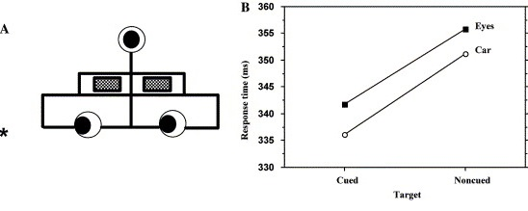
Note. Altered from Kingstone, Tipper, Ristic, and Ngan (2004).

With the more recent development of high resonance fMRI, researchers have been able to identify two regions within the STS that are correlated with different aspects of eye gaze processing: the anterior STS (aSTS) and the posterior STS (pSTS). Additionally, studies have found that the right anterior superior temporal sulcus (aSTS) shows reduced activity to leftward gaze compared to right gaze, suggesting that this part of STS is related to the direction of the gaze (Calder et al., 2007). Hence, this region has a function in the early processing of gaze direction and social relevance of the gaze would be processed via other parts of the network.

Inferring others’ actions with eye gaze cues.
The basic gaze following function is present in old world monkeys; however, understanding the social significance of these gaze cues may be only present in apes and humans (Emery et al., 1997). Understanding the social significance of eye gaze, rather than just following instant changes in the visual field might be necessary for the mentalistic understanding of others’ actions. Hence, additional mechanisms are needed to integrate the visual attention and social attention and reorient one’s own attentional system to the cued direction.
It has been shown that the aSTS is responsive to visual details of gaze direction (Jenkins et al., 2006) as predicted by non-human primate studies, whereas the posterior superior temporal sulcus (pSTS) has shown to respond when an actor behaves unexpectedly or when presented with incongruent rather than congruent gaze (Pelphrey et al., 2003). Unexpected behaviour needs to be interpreted and intention needs to be assessed, making it more cognitively demanding. There will also be a greater activation in the pSTS while observing gaze shifts when compared to opening and closing the eyes (Nummenmaa et al., 2010).
Human neuroimaging research has identified many areas that are involved in addressing face stimuli that are also reactive to gaze shifts, including the IPC and pSTS regions. The right IPC is a portion of the prefrontal care system, related to goal-directed and stimulus-driven attention, that plays an important role in reorienting attention to relevant events in the environment (Corbetta & Shulman, 2002). This region is also heavily connected with both the aSTS and pSTS (Harries & Perrett, 1991; Rozzi & Fogassi, 2017) suggesting that it has a role in reorienting attention rather than the perceptional representation of eye gaze (Corbetta et al., 1993; Nobre, 1997). In summary, neurological evidence suggests the eye gaze not only attracts attention but also affects the part of the core attention system which has a function of redirecting attention to behaviourally relevant stimuli within the environment.

Inferring others’ mental states using eye gaze cues
The gaze direction does not always indicate the direction of attention. To illustrate; imagine a friend is daydreaming while staring at the ceiling. This person would not be actively attending at something at the ceiling, but most likely lost in his or her thoughts. Hence, the eye gaze direction does not always signal where an individual is attending. At a more complex level than the direction of attention, eye gaze also carries information about an individual’s mental state and functions as a cue for inferring thoughts and intentions. Inferring the mental states of others is harder than just following someone’s eyes gaze direction and will therefore activate more regions in the brain. A neural network composed of the medial prefrontal cortex (mPFC), STS, fusiform gyrus (FG), amygdala, and intraparietal sulcus (IPS) is triggered when attempting to understand other peoples’ mental states (Adolphs, 1999; Brothers, 1990; Frith & Frith, 2006). Information collected from the eye gaze direction is amongst the most important sources for inferring other people's mental states (Frith & Frith, 2006).
Both the mPFC and amygdala have been demonstrated to be related to the processing of the eye gaze as a mental state cue. Several studies have explored the involvement of the amygdala in eye gaze processing in emotional faces. Direct gaze has been found to facilitate the activation of the amygdala in response to approach-oriented emotions such as anger, while averted gaze has been found to facilitate avoidance-oriented emotions such as fear (Adams & Kleck, 2003). Moreover, the amygdala is active during monitoring of emotional gaze events in others (Hooker et al., 2003). Hooker et al. (2003) performed an fMRI study in which participants attempted to detect a specific directional signal, generated either by gaze shifts on a face image, by a single arrow or a face conjoined arrow. Increased amygdala activity was shown when participants actively searched for emotional gaze events, but pSTS activation was observed for gaze signals that provided spatial information. Another fMRI study showed that amygdala activity occurs in response to when people view direct (with bilateral activation) or averted gaze (in the left amygdala) (Wicker et al., 1998). It has also been suggested that the amygdala is responsible for the active detection of eye gaze (Kawashima et al., 1999). Additionally, neuropsychological studies show that lesions of the amygdala result in deficits in judgments of both gaze direction and facial expression (Young et al., 1995), suggesting that it plays a critical role in both tasks. More recently, a neuropsychological study showed that unilateral amygdala lesions affect attentional orienting by gaze but not by arrow cues (Akiyama et al., 2007) suggesting the amygdala’s role in socially relevant stimuli.
Finally, the mPFC has been implicated in higher order social cognition tasks. Studies have shown that patients with damage in their mPFC regions had problems with theory of mind (ToM) tasks, but not executive function tasks (Gilbert et al., 2006). Importantly, the mPFC is not a common mirror neuron region, which means that this region is not highly related to mimicking others’ actions. The mPFC is more responsive to averted gaze compared to direct gaze with the possibility of the connection of the mPFC inferring mental states inferring through joint attention (Calder et al., 2002). Redcay et al. (2010) reported that the mPFC is particularly engaged in real social interactions. The authors suggested that when playing a joint attention game, the mPFC is preferentially engaged when the participant follows the eye of an actor to locate a target compared to when the participant is looking for the target alone while the actor blinks. To conclude, evidence indicates that the eye gaze system has more functions than just following the eyes in space. Such structures seem to build on each other, indicating their development as the environmental needs for complex social living have increased. The gaze following system may determine the gazer’s eye direction via the STS and reorient attention via the IPC. The biological motion cues of eye gaze actives the pSTS for further processing of mentalistic information with mPFC regions.

Why Eye Gaze is Informative
Animals, including humans, have developed the ability to orient their attention rapidly and automatically to the location where the gaze of another person has been directed in order to detect valuable sources and potentially relevant events. Animals appear to have a basic ability to follow gazes automatically, suggesting an evolutional basis to social cognition and social attention (Shepherd, 2010). In the classical cueing paradigm, participants were asked to detect a target stimulus (typically an arrow or cartoon of a human face) that appeared on the either left or the right side of the screen by either pressing a button or via eye fixation. These studies were measuring the effect of cueing direction and reaction times in the cued direction in comparison to the un-cued direction.
An early, seminal study in this field was conducted by Friesen and Kingstone (1998). In their study, eye symbols represented by black circles within larger white circles were used (Friesen & Kingstone, 1998). By presenting dark circles on either the right or left, this study found that when the cued location and the target were in the same side participants were quicker to correctly respond than incorrect ones. Friesen and Kingstone (1998) conducted a study in which a central un-predictive gaze was used as a cue to orient attention to either left or right side of the computer screen. A target appeared in either the direction in which the gaze was directed or in an opposite location. Participants were typically faster to detect or identify the target when it appeared in the direction signalled by the eye gaze, as compared to when it is presented in other locations (‘gaze effect’). This is also called as the gaze cueing effect and supported by the classical gaze cueing study conducted by Driver et al. (1999) where female faces looking either right or left on the screen were used in an experiment. Participants were told that the gaze cues are not informative about the location of the target. In the study, gaze cues were looking away from the target in 80% of the trials and participants still responded more quickly to the cued location (congruent trials) compared to non-cued trials (incongruent trials). This suggests that humans rapidly and automatically shift their visual attention in the direction of another’s gaze (Friesen & Kingstone, 1998; Kuhn & Kingstone, 2009), even when they are told to expect targets at the opposite location (e.g., Driver et al., 1999; Frischen, Bayliss, & Tipper, 2007; Frischen & Tipper, 2004). So, when participants were presented with non-predictive eye gaze cues they still tend to be faster at responding to validly cued targets than invalidly cued ones (Downing et al., 2004). On the basis of these findings, some researchers have proposed that automatic orientation in the direction of the eye gaze may represent a unique attentional process that reflects the operation of a specialized cognitive mechanism (Langton & Bruce, 1999).
Despite extensive research on the effects of gaze cueing, the cognitive mechanisms underlying attentional shifts in gaze cueing are still under debate. In non-social spatial orienting, many variables (e.g., central/peripheral; predictive/nonpredictive; directional/ nondirectional) have been examined extensively, but many aspects of the mechanism of social cues have not been clearly explained. There are three main competing ideas present in the literature. The first line of evidence has suggested that gaze dependent mechanisms are reflexive (Deaner & Platt, 2003; Driver et al., 1999; Friesen & Kingstone, 1998; Langton & Bruce, 1999; Langton, 2000). These studies focused on the differences between congruent and incongruent trials in gaze shifts and consistently showed that even if the eye gaze is counter-predictive for the task at hand (Friesen & Kingstone, 1998), participants still were unable to overlook the gaze cueing effect. The second line of evidence suggests that gaze dependent facilitation reflects learned mechanisms due to repeated exposure (Itier et al., 2007; Vecera & Rizzo, 2006). Thirdly, others (Friesen et al., 2004; Tipples, 2008) have found evidence of voluntary orienting with gaze cues when cues have predictive values.
Early studies suggested that that gaze-cueing occurs rapidly and engages involuntary attention systems (e.g., Driver et al., 1999). Non-social peripheral cues (e.g., presented on the side not in the centre) have been shown to activate the reflexive exogenous orienting of attention, whereas central cues cause activation of endogenous, voluntary orienting (Jonides, 1980; Nakayama & Mackeben, 1989). However, unlike non-social cues, social cues (such as eye gaze) have been shown to create automatic reflexive responses when presented centrally (Friesen & Kingstone, 1998). Kleinke (1986) showed that eye gaze serves as a signal for a directional cue to express non-verbally the relevant stimuli in the environment. These findings concluded that gaze cueing is hardwired in the brain to be automatic (Galfano et al., 2012).
The gaze cueing effect (GCE) is observed after brief (100–300 ms) viewing times of the cueing face (Driver et al., 1999), suggesting that the information provided by the face is processed rapidly and involuntarily by the observer. Friesen and Kingstone (1998) suggested that non-predictive eye gaze cues influence some factors including participants’ reaction times and accuracy at detecting, localizing, and discriminating peripheral targets. Furthermore, the time course strongly suggests that these attentional effects are reflexive but depends on stimulus onset asynchrony (SOA) - the length of time between gaze cue onset and target onset. Studies suggest that the gaze cueing effect appears at 200 ms (Friesen & Kingstone, 1998) and lasts up to 700 ms (Driver et al., 1999). For example, Ristic et al. (2002) conducted a classical gaze cueing paradigm experiment with centrally presented, uninformative schematic faces or arrows. The results showed that arrow cues and the eye gaze cues produced similar results; for both conditions the cueing effect emerged at a cue-target SOA of 195 ms and disappeared at 600 and 1,005 ms. The cueing effect seem to decay (Friesen & Kingstone, 1998) or reverse (Frischen, Smilek, et al., 2007) at longer SOAs. In summary, these studies provide strong support for the existence of a reflexive and informational-encapsulated mechanism involved in human gazing.
There is an ongoing debate on whether the attention system reflexively orients itself through exogenous processes in an automatic manner (Stevens et al., 2008) or intentionally via endogenous orientation system (Vecera & Rizzo, 2006). The first line of evidence suggests that the endogenous system, in which attention shifts are controlled and intentional, is related to gaze following. With non-social cues, exogenous shifts of attention occur with the cues (such as a flashlight) in the periphery; however, social cues (such as eye gaze) are centrally located. To extract the direction of the target, this may require a higher degree of processing. According to Friesen and Kingstone (1998), unlike the exogenous system, gaze cued attentional shifts appear to emerge relatively slowly. This idea is consistent with the volitional control of attention (Jonides, 1980). Next, evidence from neural mechanisms has shown that exogenous attentional shifts are related to the superior colliculus (Posner et al., 1985); however, later studies have failed to show associations between gaze cues and this structure (Friesen & Kingstone, 2003). Also, endogenous attention control has been found to be associated with a parietal-frontal attention system (Maurizio Corbetta & Shulman, 2002). Interestingly, a neuropsychological study conducted with a patient suffering from frontal damage showed that the patient was not able to complete gaze cueing attentional shifts (Vecera & Rizzo, 2006) which suggests top-down control over attention is necessary for gaze cueing. Lastly, exogenous shifts of attention have been found to produce subsequent IOR (inhibition of return) after 300 ms (Posner, 2014) but this is not the case for the gaze cues. Overall, the above evidence suggests that gaze cueing might be producing voluntary, controlled shifts of attention.
Despite the number of studies which have highlighted mechanisms related to voluntary orientation in gaze cueing, a large amount of evidence suggests otherwise. The second line of evidence suggests that overall gaze cues cause some form of automatic attention shifts. First, the inability to disengage from the gaze cues, even when viewing a counter-predictive shift indicates the opposite of a voluntary process. For example, Driver et al. (1999) found that even when participants were told that the target would appear on the uncued side of the screen 80% of the time and that they should avoid gaze cues, the eye cue effect persisted. Second, evidence has also been found against the assumption that the gaze cueing effect is slower than the automatic shifting of attention. One study showed that, under certain circumstances, gaze cueing effects could emerge as quickly as 14 ms (Hietanen & Leppänen, 2003). Importantly, the inhibition of return (IOR) that is the result of exogenous shifts of attention (Posner, 2014) has been shown in altered experimental designs (Frischen, Bayliss, et al., 2007; Frischen & Tipper, 2004). Lastly, although neuropsychological data are quite informative, there are few such studies. Moreover, there is a need for replication and large sample studies (more than one person) to draw reliable conclusions. Overall, evidence suggests that eye gaze cues evoke some kind of automatic shifts in the cued direction, independent of instruction.
Orienting attention via gaze cues is more likely to be the product of both stimulus-driven (or exogenous orienting) and goal-driven (or endogenous orienting) attentional mechanisms (Greene et al., 2009). Itier et al. (2007) argued against purely exogenous, automatic orienting-to-gaze mechanisms and put forward the idea that that the gaze cueing effect indeed has automatic tendencies, but that this is task-dependent. Previously, Egeth and Yantis (1997) showed that behaviourally relevant stimuli draw attention more efficiently, thereby arguing against a pure exogenous reflexive system. Interestingly, Pashler and Harris (2001) showed that reflexive orienting is more active when participants do not have a specific task at hand, suggesting that the reflexive bottom-up attentional orienting is affected by the current goal.
A recent study conducted by Slessor et al. (2019) investigated the mechanism of gaze cueing end endogenous shifts by comparing schematic or real faces (neutral or fearful expression) at three different SOAs (100 ms, 200 ms, 300 ms). They found that the gaze cueing effect emerged for both real and schematic faces but that the time-course was dependent on the type of stimuli shown. The results showed than when the participant was observing a real face picture with natural expression, the endogenous shifts were most efficient at 100 ms, and that the involuntary shifting emerged later at 200 ms. At 200 ms there was an additive effect of incongruent trials. However, with schematic drawing faces and fearful faces; gaze cues were responding in all SOAs thereby suggesting a stronger gaze cueing effects for these type of stimuli (Slessor et al., 2019). The authors argued that these two forms of attentional orienting (gaze cueing and endogenous attention) operate in parallel and relatively independently from each other while being influenced by SOA or stimuli type in differing levels.
Indeed, this is in line with Corbetta and colleagues’ theory suggesting there are two different neural systems for attentional orienting (Corbetta et al., 2008; Corbetta & Shulman, 2002). Corbetta et al. (2008) suggested that stimulus-driven (bottom-up) and goal-driven (top-down) orienting consists of two different neural networks: one responsible for re-directing attention towards behaviourally relevant stimuli (the temporoparietal and ventral frontal cortex) and the other involved in the voluntary selection of sensory information and responses (the dorsal posterior parietal and frontal cortex). In line with Slessor et al. (2019) results, top-down, endogenous attention control and involuntary gaze-cueing could operate in parallel and may not draw on the same cognitive mechanism. Hence, the re-orienting of attention is more likely to be both related to bottom-up and top-down processing and its dependent on the context and the SOA.
Social information about the gazer has been found to be perceived quicker from schematic compared to real faces (Kendall et al., 2016), thereby creating reliable gaze cueing quicker than photograph of a real face. Several widely cited studies demonstrating gaze cueing in short SOAs (100 ms) have used schematic faces (Friesen et al., 2004; Friesen & Kingstone, 1998, 2003). Other studies which have used a real face photograph as a stimulus have not found the gaze cueing effect until around 200-300 ms (Bayliss & Tipper, 2005; Driver et al., 1999). Information about the gazer may be extracted quickly from schematic faces compared to real faces since there is not additional visual input such as skin colour, eye shape or facial expressions (Kendall et al., 2016). Hence, real face photos will not be efficient enough to create gaze cueing effect at short SOAs (100 ms), whereas schematic gaze-cues, which are less complex, are processed more quickly and efficiently at very brief SOAs. Indeed, in line with this idea, Risko et al. (2012) showed that enhanced attentional orienting to schematic faces might be related to non-social mechanisms, specifically motion detection, suggesting that social mechanisms have not been activated with schematic faces. So, when real face photographs are used as a gaze cue stimulus, participants need sufficient time to extract eye-gaze information; only after this sufficient time do gaze cues start to influence responses with faster detection of targets in congruent conditions compared to incongruent conditions. To sum, reflexive and automatic orienting versus voluntary deliberate orienting systems might work together, be affected by the type of stimuli in different time courses as well as have different but additive functions on identifying the gazer and the gaze direction.
This section briefly explained the cognitive attentional mechanisms creating gaze cueing effect. Whereas some studies have provided strong evidence for the automaticity of gaze following, such that when an observer sees a gazer looking at right or left, he/she experiences automatic attentional orientation to the same side, other studies have focused on more voluntary aspects of gaze following. Moreover, the literature indicates that there might be more than one mechanism working independently and in parallel, having an additive effect on attentional shifts. Therefore, gaze cueing of attention might be related to more than one specific mechanism, which is not surprisingly since it has more than one function. These attentional shifts may go beyond the classical top-down/bottom-up distinction. The next section focuses on the functionality of gaze cueing in interpersonal relations.

What Enhances Gaze Cueing?
The previous section covered the debate about the mechanisms underlying eye gaze cueing. The literature suggests that the automaticity of eye gaze cues - specifically shown at a behavioural level - might be similar to arrow cues. The automaticity of arrow cues may result from over-learning the significance of symbolic cues (Ristic & Kingstone, 2012), but gaze triggered processing is likely to be more hardwired (Farroni et al., 2002). Studies have focused on using more ecological stimuli, such as real face images, to understand the social significance of eye gaze. Hence, it is not surprising that studies using schematic faces found similar results to those using arrow cues, as the schematic faces are deprived of any social characteristics (Farroni et al., 2002; Galfano et al., 2012; Kuhn & Kingstone, 2009; Tipples, 2008). In real-world environment humans are in contact with many different individuals with a rich variety of different social information. Therefore, it is essential to understand the key factors implicated in eye gaze following which include the characteristic of the gazer, as well as the observer and the environment that they occupy which could also be affected by external factors, such as social variables and personal experience.
The magnitude of gaze cueing effect can be shaped by several social variables, in addition to the visual stimuli. These variables might relate to the physical features of the gazer face, the social relation of gazer and the observer as well as individual differences of the observer. The studies conducted so far assert that eye gaze is a special stimulus and we do tend to shift our eye gaze in the same manner for every gazer or in every situation. The evidence suggests that although early rising (consistent with reflexive processing), this attentional shift occurs according to social modulation. Hence, the automatic attentional shifts occur in line with some social modulations.
The importance of the eye gaze cue can be directly influenced by the person’s perception due to prior social modulation. Firstly, when social categorization was active, a difference in the magnitude of gaze cueing occurred (Pavan et al., 2011). In particular, Pavan et al. (2011) showed that the social categorization process activated when the in-group and out-group faces were in the same experimental block and the magnitude of the gaze cueing differed, but this difference did not occur when the in-group and out-group faces were in the different experimental blocks (thus in a single category) presented. Although visual information indicating social categories is effective for manipulating the magnitude of gaze cueing, social information is not always obtained only through the gazer's physical characteristics. Human beings are exposed to many different social environments and different social groups in everyday life, and interactions with these individuals depend on the context. Secondly, later studies focused on the social factors that are required to activate higher-level processing. In such cases, previous knowledge about the characteristics and behaviors of the gazer become relevant. The literature also suggests that both social and physical features tend to influence the magnitude of eye gaze cueing with short SOAs. For example, perceived social power has shown to manipulate the gaze cueing effect, depending on the context. Cui et al. (2014) manipulated the social power of the participants to maximize ecological validity by challenging them to imagine a scenario they are in control (high-social power) or controlled by others (low-social power). The results showed that females with low social power had an increased gaze-cueing effect compared to males and females with high social power (Cui et al., 2014). This approach showed that social features can impact the gaze cueing effect. Lastly, the characteristics of the observer need to be considered. Indeed, while some studies have focused on cueing faces, others have examined the impact of the individual characteristics of the observer as well. We interact with people in a social environment in a context-dependent way. As a result, using a socio-cognitive approach to understand the different interactions depending on the physical features, social features and individual differences would constitute a more realistic approach.
The following section will discuss visual cues and their effect on gaze cueing, explore the socio-cognitive variables about the gazer and how they affect the observer’s strength of the gaze cueing effect, and examine the personal traits of the observer.

Physical features
Gaze cueing in its nature has more than one function. At one level, just like arrows, eye gaze can signal a specific location in the environment around us. Therefore, it is not surprising that schematic faces deprived of any social meaning exhibit similar effects as arrow cues. However, at another level eye gazes have more of a social meaning reflecting more of a top-down processing. Faces are one of the richest stimuli of social informativeness (Frischen & Bayliss, et al., 2007). In the real-world environment humans are exposed to different individuals. We are able to detect others’ focus of attention, their intent, any danger in the environment or a desirable object in the environment. We are able to orient our own attention quite rapidly according to such observations.
Early studies in the literature focused on the issue of automaticity and compared arrow cues with eye gaze cues. However, later studies have been more focused on the effect of social variables such as dominance, age or race. Moving the focus away from automaticity provides researchers the flexibility to examine the social meaning of the visual cues from faces. Given that our attention resources are limited, it is likely that the attention system evolved with the ability to respond to some stimuli more efficiently than others.

Faces
Faces are important to deduce social context, in addition to the gaze cueing effect. The gaze cueing effect has been replicated with different black and white photographs of real faces (Frischen & Tipper, 2004), computerized faces (Bayliss & Tipper, 2005; Bayliss, Di Pellegrino, & Tipper, 2004), virtual agents (Nuku & Bekkering, 2008), schematic drawings (Friesen & Kingstone, 1998; Kuhn & Kingstone, 2009), and even humanoid robotic faces (Chaminade & Okka, 2013). In a recent study, pareidolia faces were used as unpredictive cues for the gaze cueing paradigm experiment (Takahashi & Watanabe, 2013). Pareidolia faces represent misread objects that are perceived as faces, such as clouds in the sky, moon in the sky or even potato chips (Voss et al., 2012). Pareidolia faces give people an impression that they are seeing the face and also causes activation in the face related areas in the brain (Hadjikhani et al., 2009). Takahashi and Watanabe (2013) examined whether a gaze cueing effect would emerge with an image resembling a face. In the gaze cueing experiment, participants were presented with face-like images (either a cabinet or an electrical outlet), a cartoon face, or a framed circle. In first condition, participants were explicitly instructed that the objects were indeed faces. In the second condition, they were not given any instruction about whether to judge the images as faces or not. Later, at the end of the second condition, they were asked if they saw a face or an object. The authors used the stimulus as uninformative cues about the location of the target. Their research showed that face-like objects could elicit a reflexive attention shift but only when they were perceived as faces. Participants who showed no gaze cueing effect reported not perceiving the object as a face. There was a significant interaction between face awareness and cue congruency. When participant perceived faces in the objects, gaze cueing occurred regardless of the object type. In contrast, if participants did not perceive objects as faces, the gaze cueing did not occur. In summary, this work suggests that faces are important to gaze leading attention.

Race and physical similarity
Identifying the physical features of the face such as sex, age, and skin colour is considered an effortless process that is used for social categorization (Fiske, 2000). Categorical information such as race can be coded implicitly. For instance, Nosek, Banaji, & Greenwald (2002) conducted an online study using an implicit bias test to measure in-group preference between black and white participants. Participants were shown black and white faces and asked to refer to those faces with negative and positive words. Researchers measured the automatic preference for positive attitudes by these words. They showed that white participants have a strong implicit in-group preference whereas the same preference did not exist for black participants. Black participants also showed a preference for whites, but the overall effect was modest. Based on this evidence, it can be expected that racial prototypes can influence gaze cueing because people tend to show asymmetrical preference according to the face presented to them.
Some studies suggest that gaze following behaviour is sensitive to the race of the observer as well as the race of the perceiver. Pavan, Dalmaso, Galfano, & Castelli (2011) showed faces of black and white individuals to black and white participants and asked them to complete a gaze cueing task. Each of the face stimuli were used as an uninformative cue - the gazer’s face was not informative of the target location. They found that black participants shifted their attention to the averted gaze of both in-group and outgroup members, but white participants selectively shifted their attention only to the white faces (in-group faces). Hence, this suggests that white participants have an attentional preference to individuals with white faces over black faces. Black participants showed no effect of racial group membership preference. This indicates that enhanced gaze cueing effect would be seen for in-group faces only if the participant is a member of the majority (in this case, white participants). These findings suggest that using virtual features of faces as cues would likely lead to automatic social categorization that may affect our gaze mediated by orienting of attention. In the same vein, a more recent study conducted by Weisbuch, Pauker, Adams, Jr., Lamer, & Ambady (2017) examined the effect of social hierarchy on reflexive gaze following. They hypothesised that the difference shown by Pavan et al. (2011) is driven largely by power asymmetries. To test this hypothesis, they conducted two studies. The first study was a replication of Pavan et al. (2011) where they showed black and white face pictures as a gazer to black and white participants. Interestingly, the results showed asymmetrical results to the Pavan et al. (2011) study. The results indicated that White gazer elicited gaze following from both White and Black participants, whereas Black gazer identities only elicited gaze following from Black perceivers. It is important to note though that the original study was conducted in Italy whereas the replication was conducted in the USA. Thus, cultural and historical differences might play a role in this difference.
In the second study, the effect of perceived power was manipulated by using an imagined contact task. Participants were randomly assigned to either a high-power condition or low-power condition. They were asked to imagine and write about a situation when they have power over others (high-power) or others have power over them (low power). In this study, only white participants were tested with a classical gaze cueing paradigm with both black and white gazer identities after they completed the imagined contact task. The results revealed that black gazer identities elicited gaze following from low-power condition participants, whereas white gazer identities elicited gaze following from both high-power and low-power condition participants. This study aimed to examine the role of perceived power on social group hierarchy and gaze following. The results suggested that the perceived power might play a role in explaining gaze following differences between races. However, it is important to keep in mind that the Pavan et al. (2011) study was not replicated by Weisbuch et al. (2017). On the contrary, they showed opposite results. As Weisbuch et al. (2017) suggested, power dynamics might be playing a role and they conducted a second study to examine this power asymmetry. However, there might be different explanations as well. First, Weisbuch et al. (2017) only invited white participants to examine the effect of perceived social power on racial gaze following. So, how black participants would behave in the low-high perceived social power condition and how this would interact with same/other race gazers are unclear. Second, gazer faces were shown with extremely short SOAs (100 ms, 300 ms). Each face photo was converted to greyscale and placed on a white background. Therefore, black and white face pictures had a different level of contrast in each picture. Contrast is an important component on gaze cueing and people tend to shift their attention toward the position of the dark region of the eyes (Yoshizaki & Kato, 2011). Hence, the different level of contrast in the black and white face pictures used in the experiment might influence the strength of gaze cueing. Lastly, it is important to keep in mind that the Pavan et al. (2011) and Weisbuch et al. (2017) studies were conducted in different countries (Italy and USA, respectively). Indeed, studies suggest that culture has a profound effect on gaze following and the control of visual-spatial attention elicited by social stimuli systematically differs between eastern and western cultures (Takao et al., 2018). It is feasible that cultural differences might influence overall results of both studies. These methodological limitations should be considered before drawing meaningful overall conclusions.
Studies examining the effect of race on gaze cueing has been conducted with black and white face pictures and with black and white participants. However, this is a quite limited approach to investigate the effect of visual representations of race on gaze following. Race is an abstract concept that is used for categorization of humans based on the combination of shared physical traits and by definition, it overlooks social traits (the country that individual was born, the social norms that individual was raised). Besides, black/white categorization to characterise race is limited and it also excludes other defined cultural subgroups (such as Asian). Additionally, the differences in gaze following based on race might be simply explained by physical similarity and in-group preference. For example, in a study using an eye tracker device and presenting white and Asian faces on a computer screen, Blais, Jack, Scheepers, Fiset, & Caldara (2008) showed that white participants fixated more on eye region whereas Asian participants fixated more on the nose regardless of the race of the photo that they were presented. Similarly, Goldinger, He, & Papesh (2009) found that Asian participants tended to fixate more on the eyes of Asian pictures compared to white pictures suggesting that they are showing an in-group preference. LaFrance & Mayo (1978) looked at the differences in gaze behaviour due to subcultural differences by using black-black conversations and black-white conversations. Significant temporal pattern differences were found between participants. Black listeners looked significantly less into the face of the speaker than white listeners. This is also known as an in-group preference. In a similar vein, information about a person’s membership of one’s in-group or family has been found to be cued by physical similarity, as well as by more general ethnocultural cues of skin colour and facial structure (DeBruine et al., 2008). Together, studies examining differences in gaze following based on race are hard to generalise due to their methodological limitations and some alternative explanations might be possible such as physical similarity and in-group preference.
Physical similarity is an important aspect of our daily interactions. Using a computer-based task experiment, Hungr & Hunt (2012) showed that self-similarity also influences the gaze cueing effect. They captured photographs of participants before the experiment day and manipulated the photographs by morphing participants’ faces with strangers. They discovered that self-similarity invoked more robust effects in response to greater similarity in facial characteristics. Visual representation of familiarity has been shown to modulate saccadic accuracy in response to centrally placed eye gaze cues (Dalmaso et al., 2017). The physically familiar face may indicate in-group relation; thus it would hold more relevance to the observer through self-referential processing. Indeed, studies have shown that gaze cueing is modulated by the perceived similarity with the self (Porciello et al., 2014, 2016) but not by increasing the familiarity of a gazer face by repeated exposure (Frischen & Tipper, 2004). One interesting study showed that familiar faces within one’s social circle increased the magnitude of gaze cueing effect but only in female participants (Deaner et al., 2007). Deaner et al. (2007) conducted a classical gaze cueing study by using face pictures of departmental academic members and asked departmental students to participate in the study to test whether the non-visual representation of familiarity would affect gaze cueing. The results indicated that familiarity modulated gaze cueing, but only in female participants. In this study, the gazer face pictures were from academic members of the department who were mentors or lecturers for the participating students. Naturally, the gazer face pictures already could be perceived as a leader or someone who is higher in a social hierarchy. Nevertheless, already known (familiar) non-visual structures about the gazer face seems to affect the magnitude of gaze cueing effect only in female participants. It is important to note that females are better at remembering faces (Herlitz & Yonker, 2002) and are more reflexive on social attention (Bayliss, Di Pellegrino, & Tipper, 2005). Overall, studies suggest that visual representation of physical similarity as well as non-visual information of familiarly of one’s social circle (only in females) produce stronger gaze cueing effects.

Dominance
Facial dominance is an important facial cue indicating social power societal status. In humans, sexual dimorphism of face shape affects attributions of dominance; masculine faces more likely to be perceived as more dominant compared to feminized faces (DeBruine et al., 2008; Perrett et al., 1998). Studies of dominance show the importance of facial clues as well as gaze direction. Recent experiments suggest that facial clues associated with dominance have an effect on gaze cueing tasks. A study in primates demonstrated that submissive macaque monkeys showed generalized gaze cueing regardless of status, whereas dominant macaque monkeys selectively showed enhanced gaze cueing to the high-status individuals (Shepherd, Deaner, & Platt, 2006). This effect of dominance on gaze cueing only existed at shorter SOAs (100-200 ms) and diminished over time (longer SOAs-800 ms) suggesting it might be automatic and reflexive. They manipulated images of faces to be of high and low dominance by changing the face shape with prototype-based image transformation. They also examined the effects of the dominance of facial stimuli on the gaze cueing several of SOAs (200 ms, 400 ms, and 800 ms). They found that gaze cueing effects were greater for masculinized faces (high dominance) compared to feminized faces (low dominance), leading to the conclusion that dominant faces modulate the reflexive component of gaze cueing (Jones et al., 2010). On the other hand, the faster response times to gaze cues of dominant faces were only seen in shorter viewing times (200 ms). At shorter viewing times, participants demonstrated enhanced gaze cueing effect for gaze cues from dominant faces when compared to non-dominant faces; this enhanced effect decreased as viewing time increased suggesting that it is involuntary. The authors did not report any effect of the sex of the observer or the face. Furthermore, another study conducted by Jones, Main, Little, and DeBruine (2011) found that faces which caused greater gaze cueing effects were perceived to be more dominant compared to faces which caused smaller gaze cueing effects. This experiment was conducted with female faces where participants were asked to rate the dominance level of the faces. They only invited female participants to this study and used only female faces as gaze cues; as a consequent, the effects of gender on these results are uncertain.
However, a more recent experiment concluded that gaze cue of the dominant male face is effective both in threat and no-threat conditions whereas the non-dominant female face only influenced performance in a no-threat condition (Ohlsen, van Zoest, & van Vugt 2013). Ohlsen, van Zoest, and van Vugt (2013) showed that although non-dominant female faces successfully affected gaze cueing, this only occurred in no-threat condition compared to threat condition; hence this affect was context dependent. The authors argued that these findings are compatible with leadership theories of evolutionary psychology, the idea that physically weaker individuals would be less likely to offer safety in dangerous situations. Hence, they argued that non-dominant looking females would be less likely to be followed via their eye gaze specifically in the threatening condition. Ohlsen, van Zoest, and van Vugt (2013) further argued that the difference between male and female faces are contrary to the idea that gaze cues are determined by low level, bottom-up differences. In their experiment the dominant male face caused an overall larger gaze cueing effect despite having smaller eyes and less visiable sclera compared to the non-dominant looking female face. Theories explaining gaze cueing with low level perceptual differences would have proposed that visiable sclera should cause an enhanced gaze cueing becasuse the constrast in the pupil and white part of the eyes would be more visiable (Ohlsen, van Zoest, & van Vugt, 2013). However, the results were in opposite direction in the non-threat condition. This suggests that the gaze cueing difference in the non-theathening condition was influened by higher-level social, top-down system and not the bottom-up system. Earlier research on animal examine gaze cues and later research with humans has found that dominant faces affect gaze-following behaviour specifically in shorter SOAs and this enhanced gaze cueing diminishes over time, thus suggesting this effect is involuntary. Later research has shown, however, that top-down, voluntary effects can occur depending on the context.

Age
Age is a strong indicator of social similarity and therefore may influence gaze cueing. For example, experiencing faces with similar age range as oneself can lead to automatic and spontaneous social categorization into ingroup or outgroup (Macrae & Bodenhausen, 2000). Slessor, Phillips, and Bull (2008) stated that older adults would be less likely to engage in joint attention with others. To test this prediction, they conducted an experiment using a between-participants design by dividing their participants into two age-groups: younger adults (17-34) and older adults (65-79). The study reported that older adults displayed a slower cueing effect compared to the younger adults overall. However, it is important to note that this experiment only used young faces as stimuli and did not take into consideration that social similarity may influence the outcomes. An alternative explanation could have been that showing young faces as cue stimuli alerted an in-group categorization in younger adults and therefore led to faster responses. Indeed, Slessor, Laird, Phillips, Bull, and Filippou (2010) conducted a similar study that altered the age of the target faces. Younger adults (17-41) and older adults (65-81) participated in the study and both age range targets were included. They reported that young participants showed greater gaze cueing effects towards young faces compared to old faces, whereas the no difference was observed with older participants. In another study, Ciardo, Marino, Actis-Grosso, Rossetti, and Ricciardelli (2014) illustrated that gaze following can be modulated by social similarity based on age categories. This study asked three age groups of participants (18-25, 35-45, over 65) to complete a gaze cueing task in response to four age groups of target face stimuli (6-10, 18-25, 35-45, over 70). Young adults showed reduced gaze following to elderly faces compared to young faces. Additionally, they reported reduced gaze cueing for old adults regardless of face age presented to them.

Social factors
In real life, social interactions and knowledge one posesses are not solely based on visual cues. Rather, we often have semantic knowledge about people who we are interacting with. The perceptual analysis of the gazer face has been shown to influence the magnitude of gaze cueing. In addition, social factors that manipulate social attention, such as belonging to a social group or social status, depend on processing at a higher level. These factors have also be shown to be effective in influencing the magnitude of gaze cueing. By retrieving previous knowledge about the gazer, the observer can extract social meaning and informativeness of the gaze cues. Both visual features of the gazer, as well as the social features, can create rapid shifts in attention (Castelli et al., 2004). Early studies focused on visual features; however, more recent studies have focused more on the social modulators of gaze cueing to increase the ecological validity by creating more realistic interactions between the gazer and the observer.

Social group belonging
Despite greater knowledge regarding social categorization and biases based on race (Kawakami et al., 2014) and age (Ciardo et al., 2014), little is known about the social processes of gaze perception. People who belong to a common outgroup are perceived to have similar goals and motives. Individuals of the same in-group are perceived as sharing social beliefs and values, whereas outgroup members perceived as all alike where in-group members are different individuals. The tendency to think in this way is referred to as in-group bias or favouritism (Hamilton & Gifford, 1976; Ostrom & Sedikides, 1992). These perceptions are believed to help simplify an individual’s environment by enhancing positive attitudes towards in-group members (Hamilton & Gifford, 1976). Research has revealed that how people are viewed as ingroup or outgroup members does not necessarily have to be a meaningful one for in-group bias to occur (Tajfel et al., 1971). For example, Tajfel et al. (1971) randomly assigned participants to two groups and they were asked to allocate hypothetical “resources” to their own or the other group. Results showed that people tended to allocate more resources to their own group even when the grouping process was random and grouping criteria were not meaningful. This would suggest that in-group favouritism may be even more pronounced if based on meaningful criteria such as gender or race. For instance, Kawakami et al. (2014) have suggested that people show a visual attention bias toward the eyes of others who are members of the same social group compared to those who are members of an out-group.
Faces with self-similar physical features are typically identified as familial or in-group (Maloney & Dal Martello, 2006) leading to increased trust (Debruine, 2002) and cooperative behaviour (Krupp et al., 2008). Even though physical indicators are used to categorize individuals into groups and these attributes may also be informative to understand motives, fears, goals, and expectations (Allport & Ross, 1967), it is also important to keep in mind that automatic categorisation according to physical features of the faces is generally active during the first interactions. During daily social interaction, it does not necessarily mean that these categorisations occur in a familiar social environment. Research conducted on social attention measured by eye gaze following extends this past work on more general processing of ingroup and outgroup faces. By investigating differential attention to specific facial features as a function of social category membership, they ignore social groups which are multi-race, multi-gender such as sports teams, team members of a corporate environment, and members of the same neighbourhood. Therefore, social attention studies which use physical features of the face as an indicator of group belonging lack social context. The results of these studies (although still valuable) may not generalise to real-world interactions. This will be further discussed in Chapter 2.

Political Temperament
Gaze perception can also be influenced by political temperament. Political liberals that are considered to be more empathic and open to interactions have demonstrated a tendency to be influenced by social clues. To test this prediction, Dodd, Hibbing, and Smith, (2011) conducted a study that revealed enhanced gaze cueing effects in political liberal compared to conservative participants. They argue that conservatives give value to personal autonomy that makes them less influenced by others and less responsive to gaze cues. Surprisingly, although there was a gaze cueing effect overall, conservatives alone did not show any gaze cueing effect. This raises the possibility that the influence of additional factors has not yet been considered. The study also implies a potential role of cognitive and attentional bias on political attitude differences. Although Dodd et al., (2011) suggested that conservatives do not tend to follow gaze cues overall, Liuzza et al., (2011) reported that conservatives but not liberals tend to follow the gaze of the in-group leaders compared to out-group leaders. These studies suggest that social status, in addition to the social similarity of a gazer, are influential. Liuzza et al., (2013) conducted another study examining political candidates as gazers. They suggested that gaze-following behaviour is an implicit association task and may ultimately predict voting behaviour. It has been suggested that people’s visual representations of each other are influenced by pre-existing beliefs and attitudes (Caruso et al., 2009). These findings lead to the hypothesis that gaze-following behaviour may not only be an automatic attentional behaviour independent from representations of a group or a single person.

Social status
Social status is one of the key indicators of dominance in the animal kingdom. Animals who live as a group or pack, tend to have social relationships that regulate the roles within the group to survive. This group dynamic helps the group/pack survive by dividing roles within them. Indeed, social attention studies conducted with monkeys have indicated that social status has a significant effect on gaze following. A recent study conducted by Shepherd et al. (2006) showed that social status gates attention in monkeys. They manipulated the social status by using visual representations of dominance. The study found that low-status rhesus macaque monkeys reflexively followed the gaze of all other monkeys whereas high-status ones only followed other high-status members. The results therefore show that the gaze following in monkeys involves both reflexive and voluntary components, but the strength of these mechanisms varies according to social status.
The effect of social status on social attention also seems to exist in humans as well as in monkeys. However, social interactions are much more complicated in humans, and social status cannot be only defined by physical dominance. One study conducted by Jones et al. (2010) showed that visual cues of dominance modulated the gaze cueing effect in humans as found with monkeys. However, this effect was only observed in short stimulus-onset asynchrony and the effect of facial dominance on gaze cueing decreased when the viewing time increased, suggesting that the effect of visual dominance was driven by involuntary responses.
Another study showed that perceived social power may influence the strength of gaze cueing. In this study the social status is defined by social power. Unlike physical dominance social power cannot be defined by only visual input. Cui, Zhang, and Geng (2014) examined this question using a pair of experiments. In the first experiment, they asked their participants to complete a 10-min essay addressing a personal memory that involved a time in which they felt controlled, managed and affected by others (i.e., low social power). Then, they were asked to complete a computer-based gaze cueing task. In the second experiment, participants were asked to imagine that they were either: (1) running away from a high danger situation (high danger) or they were safe in a low danger situation (low danger); and (2) the leader of a team (high social power) or as a member of a team (low social status). The results showed that the effect of social power on gaze cueing was stronger with participants who were primed with low social power versus high social power. Additionally, the results indicated that perceived social power had an interactive effect with danger in the environment on social attention. These results pinpoint the importance of the relationship between individuals’ position and their environment.
Another study showed similar attentional bias by manipulating social status with socioeconomic status (SES) of the observed face. Dalmaso, Pavan, Castelli, & Galfano (2012) showed that faces associated with a fictitious CV significantly manipulated the strength of gaze cueing. In the study, participants were shown a set of faces associated with fictitious CVs. They associated either young and old faces with good or poor CVs. Hence, they used visual difference (young or old faces) to create categorical difference between conditions. Results showed that participants tend to follow the eye gaze of individuals with high SES compared to low SES faces (Dalmaso et al., 2012). Overall, these results highlight two important outcomes. First, social status seems to have an effect on gaze cueing and that social status is defined is not only by the visual representation of physical creatures like monkeys. Second, the effect of social power diminishes in longer SOAs; therefore, it is reflexive in nature. The effect of social status and how it can be measured will be further explained in Chapter 3.

Personal differences
To understand the mechanism by which the gaze cueing effect is manipulated, several studies have shown that the observer's individual characteristics moderate the gaze cueing effect. Some studies have manipulated various aspects of the face observed while others have focused on the observer who is actively observing. Because of the dual function of the eyes as both a signaller and a perceiver, individual differences of the observers have been shown to have an effect on the strength of the gaze cueing effect.

Personal traits
Research also indicates that personal traits such as self-esteem (Wilkowski et al., 2009), empathy abilities (Alwall et al., 2010), and extra-/introversion personality attributes (Ponari et al., 2013) affect gaze-following behaviour. People with low self-esteem seem to be more influenced by the direction of the eyes compared to people with medium or high self-esteem. Several studies have reported gender effects on the strength of gaze cueing. Women generally show stronger gaze-cueing effect than men (Bayliss et al., 2005). Alwall et al. (2010) indicated that gaze cueing is predominantly influenced by empathy abilities, which are stronger in females. A recent study by Ponari et al. (2013) investigated whether the extra/introversion personality dimension influences gaze cueing. They presented fearful, happy, angry, or neutral faces, with either direct or averted gaze as uninformative gaze cues. A significant difference was found according to extra/introversion personality dimension with fearful, happy, angry or neutral faces. Introvert participants showed a greater response to gaze cues of happy and neutral faces whereas extravert participants showed a greater response to faces with angry facial expressions. They also measured the anxiety traits of participants, but they did not find any effect of anxiety on gaze cueing. This indicates that the difference of extra/introversion personality dimension of the personality has a significant effect on social attention and this effect was not related to the emotional response of anxiety of that individual.
However, other studies have linked anxiety to gaze cueing. Previous studies have shown that the congruency effect is larger for fearful faces compared to neutral faces, but not happy faces compared to neutral faces (Fox et al., 2007; Tipples, 2006). Süßenbach and Schönbrodt (2014) conducted a study where female participants were shown faces with short descriptions describing the faces as trustworthy or not and then were asked to complete a gaze cueing task with the faces. They also measured anxiety levels with the “state-trait anxiety inventory” (a self-report test) and divided participants into low, moderate, and high anxiety groups. The authors reported that people with low or moderate levels of anxiety followed the gaze of trustworthy faces, but they rarely followed untrustworthy faces. Participants with high anxiety levels showed no difference in patterns of gazing when presented trustworthy and untrustworthy faces. In summary, anxiety levels appear to affect how the attributes of faces moderate gazing responses.
In a recent study, Pletti et al. (2015) investigated the attentional biases of animal phobic female participants and found that emotional faces (disgust, fear, anger, and neutral) served as uninformative gaze cues. They deployed the Snake Questionnaire (SNAQ) which is a self-report questionnaire that assesses the severity of snake fear and avoidance. They choose individuals scoring ≥18 (corresponding to the 85th percentile calculated on a sample of 496 female students) as the experiment group, whereas individuals scoring ≤10 (the 50th percentile) were selected to be the control group. Participants were shown coloured pictures of six individuals (three males and three females) with facial expressions of disgust, fear, anger, and neutral. Those faces were used as uninformative cues in gaze cueing paradigm. The authors reported that snake phobic participants were significantly more anxious than the control group and were more affected by gaze cues compared to the control group, regardless of the facial expression. Although anxiety was statistically controlled in the analysis, snake phobic participants were still found to be affected by gaze cues, suggesting that the overarching influence of specific phobias may be substantial.

Gender
Developmental and social psychology studies have repeatedly shown that there are some differences between males and females on performing cognitive tasks. For example, male participants perform better on spatial cognition tasks (Ecuyer-Dab & Robert, 2004) but female participants are better at decoding nonverbal behaviour (Hall, 1978). There are some subtle developmental differences between males and females. For example, a study showed that there is stronger joint attention in female infants than male infants at 12 months (Olafsen et al., 2006). Overall, studies have shown that there are some differences between males and females when performing different cognitive tasks. Additionally, social attention studies have repeatedly shown that females tend to be more sensitive to social cues compared to males. It is surprising that such a reflexive shift of attention to the gazed at location differs between half of the population. To investigate if this difference is only related to social cues on attentional shifts, Bayliss & Tipper, (2005) conducted a study using central arrow cues and peripheral sudden-onset cues. The results showed that there was no difference for peripheral cueing but there was a gender difference on central arrow cues. Female participants responded faster to cued location compared to uncued location but this difference in performance was not observed for male participants. Interestingly, other contextual factors might affect males and females differently when observing eye gaze interaction. A recent study showed that familiarity creates a stronger gaze cueing in females but not males (Deaner et al., 2007). A recent study also showed that compared to males, females tend to be faster on viewing times leading them to be more reflexive on gaze cueing (Alwall et al., 2010). Research suggests that women generally show stronger gaze cueing in low social status conditions compared to men. Women also demonstrate stronger gaze cueing among low social power conditions compared to high social power conditions. Additionally, individuals who have been primed with a low social power condition in experiments have been found to be more easily influenced by gaze direction; likely because people having low social power tend to be less independent and more reliant on others (Cui, Zhang, & Geng, 2014). Overall, studies have shown that there are some sex differences in gaze cueing, specifically the automaticity of gaze cueing seems to be greater in females compared to males. Additionally, other social factors might affect males and females differently, creating secondary differences on gaze following behaviour. This issue will be discussed further in Chapter 4.

Autistic-like traits
This section focuses on the relationship between autistic-like traits and gaze cueing of attention. However, it is important to stress that this section does not cover “Autism Spectrum Disorder” which is a diagnosis given by trained professionals. The autistic-like trait is a hypothesis suggesting that autism-like traits exist in the non-clinical population as a continuum spectrum (Baron-Cohen et al., 2001). A recent study conducted by Ruzich et al. (2015) investigated the autistic-like traits in the general population by using Autism Quotient (AQ). Autism Quotient is a self-administered questionnaire (see Chapter 4 for details) to measure autistic like traits in the non-clinical population. In the Ruzich et al. (2015) study, data were gathered from 6,900 typical adult males and females. The results showed that there was a gender difference in the non-clinical population in autistic-like traits although, there was no gender difference found in AQ scores for the clinical population (Ruzich et al., 2015).
These results have important implications for social attention research in the general population. The Bayliss, Di Pellegrino, & Tipper (2005) study found a negative correlation between the strength of gaze cueing and AQ scores as well as a gender difference. They demonstrated that higher AQ scores are associated with a weaker gaze-cueing effect. They suggested that the gender difference in the strength of gaze cueing could be potentially related to gender differences on AQ (Bayliss, Di Pellegrino, & Tipper, 2005). They also suggested that it is difficult to determine if there is an actual gender difference on gaze cueing given that males on average show higher scores on AQ. A more recent study Lin et al., (2020) found a difference in attention between participants with high autistic traits and low autistic traits. They showed that participants with high autistic traits benefitted less from non-predictive social cue but benefited greater from non-social cues compared to low autistic traits participants (Lin et al.,2020). They argued that for participants with high autistic traits, the attention orienting defect was present only in the processing of social cues, but not in the processing of non- social cues, which is social domain specific (Lin et al., 2020). Importantly, this study shows that autistic traits had modulatory effects on attention responses. As a result, it can be argued that creating a study design with categorical differences (such as gender) may affect the results.
Importantly, autism traits may have a modulatory effect on higher mental processing via the gaze cueing effect. For example, recent research suggests that autistic traits have an impact on automatic shifts of attention GCE, which includes emotional processing. According to Lassalle & Itier, (2015) autistic traits influence gaze-oriented attention to happy but not fearful faces. Also more recently, FP de Araújo et al., (2021) showed that individuals with higher AQ scores were slower at locating the target when the gazer cue was a happy face. Furthermore, autism traits may have a modulatory effect on gaze cueing effect with mental state. Morgan et al., (2018) showed that when participants believe the gazer is unable to physically see the target, the magnitude of gaze cueing effect decreases. Hence, ToM processes may have a modulatory effect on the gaze cueing effect. Morgan et al., (2018) also discovered that participants with high autism traits had higher gaze cueing effect in the non-seeing condition, implying that those individuals could not infer the significance of the seeing/non-seeing difference. This means that participants were less influenced by the gazer's mental state. Importantly, in a more recent study Morgan et al., (2021) stated that autistic traits influence the extent to which mental state attribution modulates social attention. Morgan et al., (2021) demonstrated that individuals with high autism traits were less influenced by the cue agent's mental state and demonstrated a gaze cueing effect whether the cue agent could see the target or not. Altogether, autistic traits have been shown to have a modulatory effect with gaze cueing on higher mental processing.
This raises an important question for social attention research. Most social attention studies tend to recruit female participants more than male participants due to the convenience of finding participants. The difference in social attention between males and females might be about their gender or their position on the autism spectrum. However, having a skewed sample can create problems in generalising the results to the whole population. Hence, disentangling the effects of autistic-like traits and gender on the strength of gaze cueing is an important question for research to address in order to speak to the generalization of social attention findings. This issue will be further discussed in Chapter 4.

Overall Aims of the Thesis.
This chapter has identified the socio-cognitive variables which have been found to be related to the strength of gaze cueing. Gaze cueing behaviour is an automatic shift of attention triggered by social stimuli. This behaviour is a small component of a larger attentional system, related to social cognition yet seems to be an important and sensitive part of it. It is detected in infants as early as 6 months and it is an important part of language learning. Gaze cueing creates association between sounds and objects. Through this association infants receive the visual cues of objects given by the caregiver that can be used to associate visual stimuli with sound. This behaviour has been observed with monkeys as well as humans, emphasising its instinctive nature. Although it is out of conscious awareness, studies suggest that some socio-cognitive variables significantly affect its strength. By studying automatic shifts of attention measured with gaze cuing, researchers can conclude important aspects of human’s social nature.
This thesis will investigate how a person's social background influences information perception and, as a result, the socio-cognitive variables. An examination of the impact of social influence will help to determine the extent to which a person’s background influence the participant’s attention of the eye gazer. This provides a new perspective on how socio-cognitive behaviour is influenced not only by automatic responses but also by the participant's past experiences and situational relevance. These effects are also investigated in relation to the social validity of the outcome, as the participant's perception of the gazer has an implicit effect on their attention to the eye gazer. The effect of social group membership without visual cues of group membership (such as race, gender, etc.) retrieved from memory but not perceived from visual stimuli will be investigated in Chapter 2. Most previous studies only considered visual representations of group belonging, such as skin colour, and did not assess the impact of social indicators of group belonging. By including social indicators this will allow us to provide a realistic interpretation of social relations in real world scenario and provide us with representative interpretation. Previous research has investigated the social status in a one-dimensional manner by manipulating the social power of the gazer, or it has only been studied in Eastern-based cultures. Previous research did not include the social status of the gazer into account in Western-based cultures. This study will advance the field by investigating the effect of perceived social status on gaze cuing in a Western culture, as well as by including the participant's social status to see if it had an effect on their attentional system using RT measurements. The perceived social attention will be measured in a context-dependent way without visual indication of the social power difference between the gazer and the observer. Chapter 4 will examine the effect of observing a previous social interaction between group members and the effect of this on later social encounters. This thesis will develop methods of understanding how realistic representation of social interactions results in a laboratory-based setting and help create more realistic interpretations for gaze following.

Social Attention and Social Group Belonging

Overall Introduction
Gaze cueing – referring to the following of someone’s gaze – is considered a fundamental component of the social attention system (Frischen, Bayliss, et al., 2007). Gaze-triggered orienting represents a special form of attention, leading some cognitive researchers to suggest that this behaviour is a unique dimension of visual attention (Frischen, Bayliss, & Tipper, 2007). Frischen et al. (2007) concluded that gaze cueing appears not to be affected by facial cues other than gaze direction, although recent studies suggest that individual differences (Frischen, Bayliss, et al., 2007), personality traits (Ponari et al., 2013), and social relations (Deaner et al., 2007) influence the strength of gaze cueing. Gaze cueing studies are hard to generalize to real-world interactions, because of lack of the social context in the lab environment. Additionally, studies that have focused on the relationship between the gazer and the observer have only considered visual similarity and neglected the importance of social context. The current study will address social context while defining the relationship between the gazer and the observer.
Indeed, gaze cueing studies have shown that social attention is sensitive to the visual similarity of shared group membership (Cazzato et al., 2015; Dalmaso et al., 2016; Pavan et al., 2011), dominance (Jones et al., 2010, 2011; Ohlsen et al., 2013), familiarity (Deaner et al., 2007; Hungr & Hunt, 2012) and age (Ciardo et al., 2014). Research shows that facial cues associated with high dominance produce more rapid attentional shifts compared to low dominance faces (Jones et al., 2010). Greater gaze-cuing effects also have been observed for familiar individuals compared to unfamiliar individuals, although this effect may only occur for female participants (Deaner et al., 2007). In another study, self-similarity was found to influence the gaze cueing effect (Hungr & Hunt, 2012). This study suggested that the physical self-similarity of a face could increase the impact of gaze cueing. The self-similarity of the face was manipulated on the screen by combining the photos of participants with the faces of strangers. The gaze cueing effect on locating the target was stronger when the presented faces looked more similar to the participant's own face. These results were consistent with previous studies and demonstrated that the similarity of the faces influence social attention. It can be argued that faces with similar physical features are perceived as an in-group, which leads to increased trust and cooperative behaviour (Debruine, 2002; Krupp et al., 2008).
Similarity in age is another factor that impacts on gaze cueing. Young people have been found to be more likely to follow the gaze cues of young people than of middle-aged and older people, whereas this difference was not evident for middle-aged and older adults (Ciardo et al., 2014). Age leads to automatic and spontaneous social in-group categorization which is influenced by social similarity (Macrae & Bodenhausen, 2000). Indeed, Chauhan et al., (2017) experiment to investigate the relocation of attention guided by personally familiar faces showed that there is a slower response to familiar faces compared to non-familiar faces due to familiar faces holding attention longer. Moreover, the slowed disengagement of attention caused by familiarity has been shown to override the advantage of faster detection of eye gaze shifts in familiar faces compared to non-familiar faces (Chauhan et al., 2017). Social categorization is one of the processes that occurs during social interaction (Fiske, 2000). This general form of categorization is suggested to be a cognitive bias, a by-product of a more general system evolved for the fast detection of alliances ( see also, Kurzban et al., 2001). In summary, visual similarity helps people to evaluate other people’s faces quickly and, ultimately, these cues affect the strength of gaze cueing.
In real-world interactions, the determination of the social context is not always only guided by visual similarity. Social context can also be learned episodically and stored in memory. Human beings as social animals interact with each other on a daily basis and these interactions are much more complicated and informative than purely visual cues. Indeed, studies demonstrate that manipulating the semantic knowledge about the person that we are interacting with can be as significant as available visual clues. For example, in gaze cueing studies conducted with monkeys, social status information is gathered from psychical dominance; in contrast, with humans this information is obtained from personal information such as educational qualifications and wealth (Dalmaso et al., 2014) as well as visual representations of social similarity like age (Ciardo et al., 2014). Gaze cueing studies, including those with human participants, have altered the level of social status with visual cues as of the observed face in addition to semantic knowledge about the gazer (Dalmaso et al., 2012a, 2014).
Using visual cues about the gazer is beneficial in research because it is easily observable. This makes it possible to study reactions to in-group and out-group members in the context of social attention. Experimental research paradigms which are frequently used in social attention studies require large numbers of trials with different stimulus-response combinations for trustworthy measurement. Therefore, visual cues are suitable for the methodology for social attention studies. However, a disadvantage of this approach is that the dependence on current group memberships makes it difficult to eliminate alternative explanations for differential responses, such as genetic overlap, ethnic or cultural similarity, familiarity, or liking (van Nunspeet et al., 2014). Additionally, categorisation based on visual cues does not accurately represent the group formation dynamics when it is not combined with contextual social cues. Hence it is essential to examine the effect of social cues on group membership to increase the generalisability of social attention research on this topic.
Social group belonging does not depend on visual information. In real life interactions, people belong to groups in different social contexts such as their jobs, the sports team they support, etc. For example, group membership of a particular school, sports teams or a company with people from different ages, sex or race can also affect attentional orienting. Immediate judgments about a face can lead to an in-group or out-group assignment that ultimately defines the perceiver's processing strategy (Sporer, 2001). In Pavan et al., (2011) gaze cueing study on the effect of group membership on attentional shifts, participants were presented with both black and white faces either cueing right or left side of the screen. Participants were students with typically liberal attitudes and representing both races. White participants showed enhanced gaze cueing effect to white faces compared to black faces; however, this effect was not present for the black participants. Enhanced gaze cueing effect for in-group faces emerged only for participants who belonged to the majority group (white participants). In daily life, social group membership is not only determined by visual cues, but also a variety of perceptual cues (Dalmaso et al., 2014). Indeed, social categorization theories aiming to explain elicit performance differences for in-group and out-group face recognition have shown that even a group paradigm can create a difference. Research conducted on the minimal group paradigm seeks to identify the minimal conditions required for discrimination to occur between groups. Previous research has shown that visual similarity is not sufficient to differentiate face recognition since it happens when there is no visual representation of group belonging. For example, Carraro et al. (2017) suggested that reflexive attentional responses were affected by whether the observed face was associated with norm-violating behaviour or sociable behaviour. In their study, they first associated some face pictures with either negative or positive behaviour to see if episodically learned observation of a previous behaviour would affect the gaze cueing task. Later, those faces were used in a classic gaze cueing paradigm. Results indicated that faces associated with negative behaviour triggered a stronger gaze cueing effect compared to the faces associated with positive behaviour (Carraro et al., 2017). Similar to previous research, social factors were found to moderate attentional processes and increase the tendency to follow the gaze direction of the perceived person. Evolutionarily, it is feasible to be more influenced by ingroup members or trustworthy and powerful individuals since it increases the likelihood of detecting relevant stimuli and increases the likelihood of adaptability to the environment.
The previous studies from the literature have focused on facial features to indicate the grouping variable or they have totally ignored the social factor of groups. This has resulted in a lack of knowledge on the effect of social context for the explanation or modelling of gaze-following behaviour. However, social behaviours are considered complex and the social categorization systems are not always based on visual representations. In the literature, there is little research that seeks to explain social group belonging (belonging to a particular group that cannot be defined by how the members of it look like). Although it has been shown that visual similarity is effective to assign a person to a particular group, social psychology literature suggests that perceptional knowledge about the person is another indicator to assign them to a particular social group. This subject is poorly understood. Chauhan, Visconti di Oleggio Castello, Soltani, and Gobbini (2017) manipulated personal familiarity by using real pictures of participants’ friends and age-gender matched control faces. However, they did not measure the social group belonging for those faces and excepted that familiar faces are considered to be from the same social group as participants. To date, no studies in the literature have measured social group belonging with semantic cues and examined effects on gaze cueing tasks.
In modern societies, humans interact with people of various groups that are not necessarily determined by gender or race. In order to accurately represent the social dynamics of human interaction, studies should not only focus on visual cues but consider semantic cues as well. Semantic cues are information received by the auditory sensory system and learned by episodic cues. Semantic cues have a function of providing reminders of prior knowledge. This knowledge about the observed person can be another indicator used to assign them to a particular group. Humans interact with people of different ages, genders, and races, and therefore episodic learning is important for generalizing social attention studies to real-world relations. Explaining the mechanisms of social group belonging, regardless of visual information about the gazer, can increase the generalizability of research to the real world.
In this study, the effect of social group belonging on gaze cuing was assessed by controlling visual similarity and focusing on social context. This was achieved by first creating a story combination with an online experiment. The online experiment was used as a stimuli development study to choose suitable life-story for the gazer face. A likert-type questionnaire was used to choose a story combination which would create significant difference in social group belonging. These stories were then used as a manipulation for social group belonging in a subsequent behavioural gaze cueing experiment. The face stimuli were young Caucasian faces, specifically chosen to eliminate visual differences between different gazer faces. In the behavioural experiment, we asked participants to read a short life-story (chosen from the online study) about the face presented to them, assigning the face either the in-group or outgroup (Sheffield university student or not a student). Lastly, participants completed a gaze cueing task to ascertain whether social group belonging would affect attentional orienting.

Aims and Hypothesis
The overall aim of the research was to explore whether there are social attention differences when viewing eye gaze from an in-group face versus an out-group face. To achieve this an online stimuli development study was first conducted. The aim of the online study was to identify two life-stories which could be used to create an in-group/out-group effect in the behavioural study. The behavioural study sought to determine if participants would demonstrate stronger gaze following in the in-group condition compared to the out-group condition, when presented with physically similar faces.
It was predicted that participants will show a shorter reaction time to cued trials (congruent) compared to un-cued trials (incongruent), which is also known as the “gaze cueing effect". It was further predicted that there will be a significant difference in the strength of gaze cueing according to the story, such that the in-group story will lead to a stronger gaze cueing effect compared to the out-group story.

Stimulus development study

Methods

Ethics
Ethical approval for the study was obtained from the Research Ethics Committee of the Department of Psychology, University of Sheffield.

Participants
Participants were recruited from the University of Sheffield's volunteering opportunities webpage. The study was announced by the University of Sheffield and details were uploaded to the Volunteering Opportunities webpage. A total of 115 students volunteered to take part in this online study. However, seven participants were excluded because they either did not give consent or failed to complete the study. Data analysis was therefore performed on the 109 remaining participants (84 females, 25 males) with a mean age of 25.09 years, ranging from 19 to 58 years (SD = 6.61 years). Participants gave their consent before the start of the study and were fully debriefed upon completion.

Stimuli and Apparatus
Face stimuli: This study included four neutral female faces randomly taken from the Utrecht European Conference of Visual Perception (ECVP) face database. The database consists of 131 face images of neutral and smiling versions of each face (49 men, 20 women). The photos were collected at the European Conference on Visual Perception in Utrecht in 2008. The resolution of the pictures is 900 x 1200 pixels and the pictures in colour (http://pics.psych.stir.ac.uk/2D_face_sets.htm). The eyes of each face were manipulated using Adobe Photoshop CS6 to reposition the irises to the corners of the eyes to produce left and right eye gazing.
Life stories: A life story was presented with each face stimuli. There were four different versions of the life-story: Student, Non-student, University of Sheffield student, and Sheffield Hallam University student (see Appendix X for life stories). The student story indicated that the presented face was a university student, with no other information provided. The non-student story indicated that the presented face was working at a supermarket and not a student. The University of Sheffield student story indicated that the presented face was a student at the University of Sheffield. Lastly, the Sheffield Hallam University student story indicated that the presented face belonged to someone who was a student at Sheffield Hallam University and no other information was provided.
Questionnaire: A questionnaire was created by combining nine questions into a single scale and designed to estimate in-group bias for each life-story. After each story, the same nine questions were used as a scale to measure the social group belonging using a 6-point Likert scale (from 1 = not at all to 6 = extremely). Five of these questions were taken from (van Leeuwen et al., 2003)to assess social group belonging. These questions were: “How cooperative you feel towards that person?”, “How nice do you think the members of this group of people are?”, “How creative do you think the members of this group of people are?”,” How smart do you think the members of this group of people are?”, ”How good do you think the members of this group of people are at brainstorming?”. Four additional questions were used to measure in-group bias. These questions were: "How close do you feel towards that person?”, “How trustworthy do you feel that person is?”, “How pleasant do you feel that person is?”, and “Do you consider yourself to be in the same group with that person?”

Design and Procedure
As the main aim of this part of the study was to choose suitable life-stories to be later used in the gaze cueing task, four life stories and face young female Caucasian face pictures were shown to participants. The survey was designed using Qualtrics, Provo, and UT. Participants were exposed to 24 versions of the life stories and pictures. While the order of the stories was controlled, the order of the photos was fully randomized to eliminate response bias, ensure accuracy, and minimize order effects. The four stories were as listed (1=Student, 2=Non-student, 3=Student at Sheffield University, 4=Student at Sheffield Hallam University) (see Appendix A for full stories on page 156). Four young female Caucasian face pictures were chosen from Utrecht European Conference of Visual Perception (ECVP) face database (see Appendix A for the four face pictures on page 156). In total there were four face stimuli and four life stories leading to 24 different face stimuli x life story combinations (i.e., 4x3x2x1=24). Table 1 reports 24 versions of face stimuli and life story combination on page 35. The participants were randomly assigned the order in which these combinations were presented. After reading each life-story and looking at the face pictures presented with them, participants were asked to answer the same nine questions for each life-story/picture combination. As we were only interested in picking one story combination to be later used in the behavioural part of the study, the two stories which had the biggest difference on reported feelings of group belonging were chosen. A within-participants design with four face pictures as the independent variable and group belonging as the dependent variable was used.

Table 1
Stimulus counterbalancing table: Photos in order in each version of the online questionnaire - face stimuli x life story combinations
 | Student | Non-student | University of Sheffield student | Sheffield Hallam University student
Combinations of the photos
Version 1 | Photo1 | Photo2 | Photo3 | Photo 4
Version 2 | Photo1 | Photo2 | Photo4 | Photo3
Version 3 | Photo1 | Photo4 | Photo2 | Photo3
Version 4 | Photo1 | Photo4 | Photo3 | Photo2
Version 5 | Photo1 | Photo3 | Photo2 | Photo4
Version 6 | Photo1 | Photo3 | Photo4 | Photo2
Version 7 | Photo2 | Photo1 | Photo3 | Photo4
Version 8 | Photo2 | Photo1 | Photo4 | Photo3
Version 9 | Photo2 | Photo4 | Photo1 | Photo3
Version 10 | Photo2 | Photo4 | Photo3 | Photo1
Version 11 | Photo2 | Photo3 | Photo4 | Photo1
Version 12 | Photo2 | Photo3 | Photo1 | Photo4
Version 13 | Photo3 | Photo1 | Photo2 | Photo4
Version 14 | Photo3 | Photo1 | Photo4 | Photo2
Version 15 | Photo3 | Photo4 | Photo1 | Photo2
Version 16 | Photo3 | Photo4 | Photo2 | Photo1
Version 17 | Photo3 | Photo2 | Photo1 | Photo4
Version 18 | Photo3 | Photo2 | Photo4 | Photo1
Version 19 | Photo4 | Photo1 | Photo2 | Photo3
Version 20 | Photo4 | Photo1 | Photo3 | Photo2
Version 21 | Photo4 | Photo2 | Photo1 | Photo3
Version 22 | Photo4 | Photo2 | Photo3 | Photo1
Version 23 | Photo4 | Photo3 | Photo1 | Photo2
Version 24 | Photo4 | Photo3 | Photo2 | Photo1

The online survey was administrated using the Qualtrics online platform. Each participant completed the questionnaire in one sitting and the survey lasted approximately 15 minutes. First, participants were asked to read an introduction screen that provided an explanation of the experiment and requested informed consent. Upon consent, participants completed their demographic information. Second, participants were presented a photo and asked to read a storyline about the person in the photo. They were then asked to complete nine questions about the person in the picture and story. This was repeated for all 24 combinations. At the end of the study participants were thanked for their time and were debriefed about the true nature of the experiment.

Results
All statistical analyses were performed using IBM SPSS 19 and custom Microsoft Excel spreadsheets.
After excluding those who did not finish the online survey, 87 participants (91%) remained and were included in the analysis. There were 22 males and 65 females. Box plots were examined to identify any outliers that had values that deviated +/- 2 standard deviations from the group mean. This analysis identified two participants as being extreme outliers and these participants were therefore removed from the analysis.
A repeated analysis of variance was used to analyse the group difference between life-stories on the questionnaire items. A Cronbach`s alpha analysis was conducted to assess the internal reliability of the nine-item measure of group belonging. The scale had a high level of internal consistency, as determined by Cronbach`s alpha; .87, .92, .92 and .92 for story1, story2, story3, and story4 and .92 for the overall score.
It was hypothesized that people would respond differently according to the life-story presented to them. A two-way (9 x 4) within-participants ANOVA was conducted to compare the effect of responses on the questionnaire (nine questions) in University student life-story (Story1), non-student life-story (Story2), University of Sheffield student life-story (Story3), Sheffield Hallam student life-story (Story4) conditions (four stories). Mauchly’s test indicated that the assumption of sphericity had been violated for story (χ2 = 11.37, df = 5, p < .001,), questions (χ2 = 283.17, df = 35, p < .001) and interaction (χ2 = 627.65, df = 299, p < .001,). The estimate of sphericity was greater than 0.75 for the story, therefore, we used Huynh-Feldt correction (ε = 0.82) (Field, 2009). The estimate of sphericity was not greater than 0.75 for questions and interaction, therefore we used Greenhouse-Geisser correction (ε = 0.03, ε = 0.00 respectively).
The main effect of story was significant, F(2.86, 239.92) = 15.77, p < .001, ηp² = 0.158, and questions, F(4.06, 340.91) = 30.68, p < .001, ηp²= 0.268, and the interaction between story and questions, F(14.18, 1191.47) = 9.13, p < .001, ηp²=0.98 was significant. The results suggested that the answers for the nine questions differ according to the story type that they see (See, figure 4)

Table 2
Means and standard deviation of nine questions by story type
 | Mean | SD
Story 1- Student story
How close do you feel towards that person? | 2.61 | 1.36
How trustworthy do you feel that person is? | 3.64 | 1.03
How pleasant do you feel that person is? | 3.54 | 1.14
Do you consider yourself to be in the same group with that person? | 3.12 | 1.28
How cooperative you feel towards that person? | 3.75 | 1.07
How nice do you think the members of this group of people are? | 3.87 | 0.88
How creative do you think the members of this group of people are? | 3.52 | 1.02
How smart do you think the members of this group of people are? | 4.00 | 1.04
How good do you think the members of this group of people are at brainstorming? | 3.85 | 0.97
Story 2- Non-student story
How close do you feel towards that person? | 2.74 | 1.28
How trustworthy do you feel that person is? | 3.61 | 1.04
How pleasant do you feel that person is? | 3.86 | 0.97
Do you consider yourself to be in the same group with that person? | 2.76 | 1.25
How cooperative you feel towards that person? | 3.62 | 1.18
How nice do you think the members of this group of people are? | 3.82 | 1.03
How creative do you think the members of this group of people are? | 3.13 | 1.09
How smart do you think the members of this group of people are? | 3.13 | 0.90
How good do you think the members of this group of people are at brainstorming? | 3.22 | 1.06
Story 3- University of Sheffield student
How close do you feel towards that person? | 3.36 | 1.35
How trustworthy do you feel that person is? | 3.82 | 1.04
How pleasant do you feel that person is? | 3.92 | 0.95
Do you consider yourself to be in the same group with that person? | 3.73 | 1.23
How cooperative you feel towards that person? | 3.90 | 1.14
How nice do you think the members of this group of people are? | 3.96 | 0.89
How creative do you think the members of this group of people are? | 3.94 | 1.05
How smart do you think the members of this group of people are? | 4.22 | 0.94
How good do you think the members of this group of people are at brainstorming? | 4.08 | 0.94
Story 4- Sheffield Hallam University Student
How close do you feel towards that person? | 2.96 | 1.36
How trustworthy do you feel that person is? | 3.48 | 1.02
How pleasant do you feel that person is? | 3.64 | 1.00
Do you consider yourself to be in the same group with that person? | 3.01 | 1.23
How cooperative you feel towards that person? | 3.75 | 1.11
How nice do you think the members of this group of people are? | 3.87 | 1.02
How creative do you think the members of this group of people are? | 3.68 | 1.03
How smart do you think the members of this group of people are? | 3.59 | 1.03
How good do you think the members of this group of people are at brainstorming? | 3.69 | 1.00

Post-hoc comparisons were conducted using a Bonferroni correction to test for differences between the stories. There were significant differences between story 1 and story 3 (MD=-.366 p < .001), story 2 and story 3 (MD=-.533 p < .001) and story 3 and story 4 (MD=.392 p < .001). All other differences between stories were non-significant. The greatest difference was found between story 2 and story 3 with a mean difference of -0.553 (p < .001). Therefore, story 2 and 3 combination were chosen for the behavioural study. The same set of face stimuli was used and was fully randomised for all conditions of the online study. Additionally, the same face stimuli set was also used in the behavioural experiment.

Figure 4
The scores for each question by story type

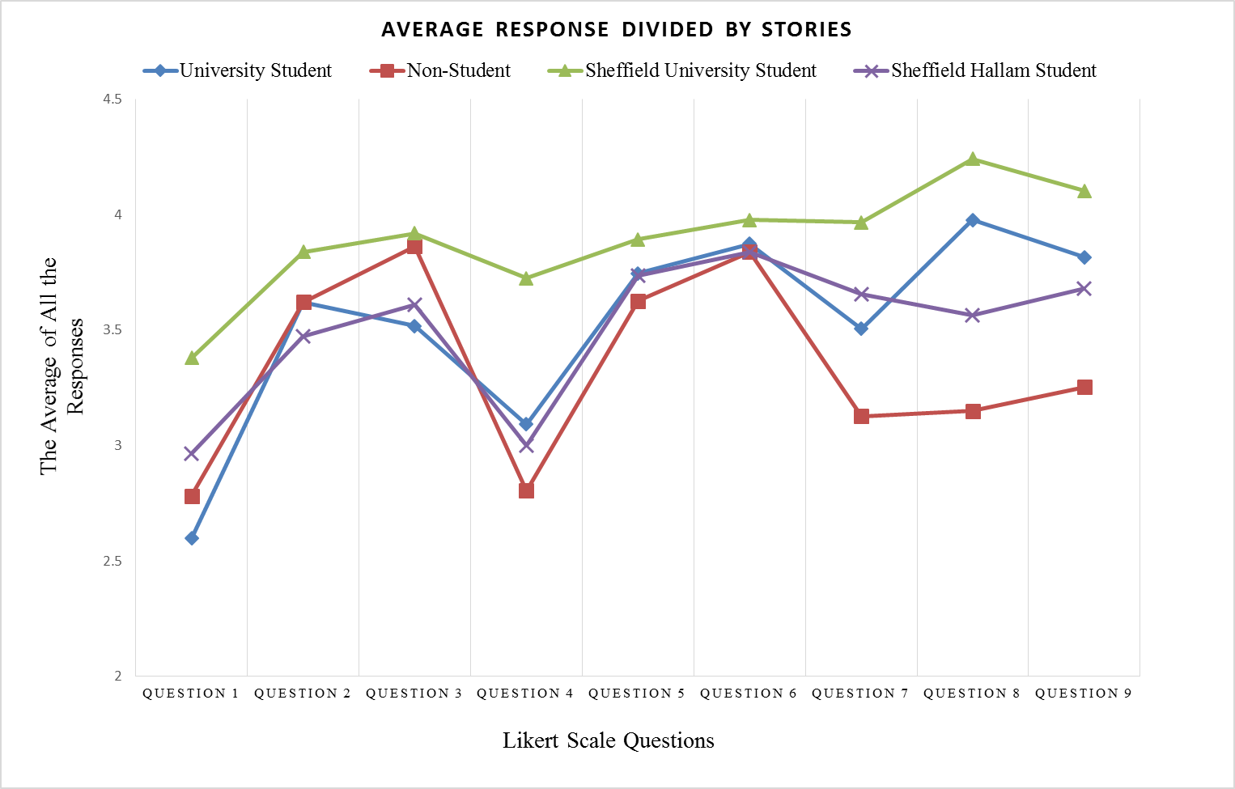
Note. Questions. 1. How close do you feel towards that person? 2. How trustworthy do you feel that person is? 3. How pleasant do you feel that person is? 4. Do you consider yourself to be in the same group with that person? 5. How cooperative you feel towards that person? 6. How nice do you think the members of this group of people are? 7. How creative do you think the members of this group of people are? 8. How smart do you think the members of this group of people are? 9. How good do you think the members of this group of people are at brainstorming?
Post-hoc comparisons were conducted using a Bonferroni correction to test for differences between the questions. Question 1 was scored significantly lower than questions 2 (MD=-.71 p = .00), 3 (MD=-.8 p = .00), 5 (MD=-.82 p = .00), 6 (MD=-.95 p = .00), 7 (MD=-.63 p = .00), 8 (MD=-.80 p = .00), and 9 (MD=-.78 p = .00). Question 4 was also scored significantly lower than questions 2 (MD=-.48 p = .00), 3 (MD=-.57 p = .00), 5 (MD=-.59 p = .??), 6 (MD=-.73 p = .00), 7 (MD=-.41 p = .00), 8 (MD=-.58 p = .00), and 9 (MD=-.56 p = .00). In addition, questions 2 (MD=-.24 p = .001) and 7 (MD=-.32 p = .001), were scored significantly lower than question 6 and question 7 was significantly lower lower than question 8 (MD=-.17 p = .04). All other differences between stories were non-significant.
The significant question x story interact was decomposed by conducting separate ANOVAs testing the effect of story on each of the nine questions. The ANOVAs were significant for question 1, F(2.98, 255.58) = 14.201, p = .00, question 2, F(2.88, 247.402) =3.2, p = .026, question 3, F(2.75, 236.61) = 4.760, p = .004, question 4, F(2.86,245.566 ) = 14.942, p = .00, question 7, F(2.558, 220.005) = 13.783, p = .00, question 8, F(2.719, 233.844) = 31.855, p = .00, and question 9, F(2.569, 220.951) = 15.604, p = .00. They were non-significant for question 5, F (2.930, 251.971) = 1.388, p = .247, and question 6, F(2.866, 246.485) = .708, p = .542.
Post-hoc comparisons were conducted using a Bonferroni correction to test for differences between the stories for questions 1, 2, 3, 4, 7, 8 and 9. For question 1, there were significant differences between story 1 and story 3 (MD=-.782 p =.00), story 1 and story 4 (MD=-.368 p = .028), story 2 and story 3 (MD=-.589 p =.00) and story 4 and story 3 (MD=-.414 p=.006). For question 2, there were significant differences between story 4 and story 3 (MD=-.368 p = .019). For question 3, there were significant differences between story 1 and story 3 (MD=-.402 p=.026). For question 4, there were significant differences between story 1 and story 3 (MD=-.632 p = .00), story 2 and story 3 (MD=-.920 p = .00) and story 4 and story 3 (MD=-.724 p = .00). For question 7, there were significant differences between story 1 and story 3 (MD=-.460 p = .003), story 2 and story 1 (MD=-.379 p = .035), story 2 and story 3 (MD=-.839 p = .00) and story 2 and story 4 (MD=-.529 p = .001). For question 8, there were significant differences between story 1 and story 2 (MD=.828 p = .00), story 1 and story 4 (MD=.414 p = .00), story 2 and story 3 (MD=-1.092 p = .00), story 2 and story 4 (MD=-.414 p = .006) and story 4 and story 3 (MD=-.678 p = .00). For question 9, there were significant differences between story 1 and story 2 (MD=.563 p = .00), story 2 and story 3 (MD=-.851 p < .00), story 2 and story 4 (MD=-.425 p = .026) and story 3 and story 4 (MD=.425 p = .001). In sum, the most consistent and largest difference across these questions was between stories 2 and 3.

Discussion
The objective of the study was to choose a pair of stories that would create a difference in the levels of social group belonging. To manipulate social group belonging two life stories were required; one to be the in-group story where participants felt the strongest as they are part of the group, and the other story were the out-group story where the participants felt least as being part of that group. Four different life stories were presented in the online experiment and two (statistically with the biggest difference on group belonging scores) were chosen to be used in behavioural study. The four stories were written for this study and the questionnaire was created for this specific purpose as well. The life-story number 2 "non-student” and the life-story number 3 “Sheffield university student” showed the biggest statistical difference on social group belonging scores measured by the questionnaire. The results indicated that University of Sheffield students most strongly associated with the “University of Sheffield student story” and were least associated with “non-student story”. Therefore, the combination of life-story 2 and life-story 3 was chosen to be later used in the behavioural experiment. A natural face was presented with each life story. The gazer faces that were shown were all Caucasian young faces. Physically similar faces were chosen to eliminate the effect of visual differences of gazers on the gaze cueing effect. Additionally, face-story combinations were counterbalanced to reduce order bias. Thus, the difference on social group belonging scores with Likert-type scale differed according to stories. Overall, results indicated that two life stories created the in-group and out-group effect, and consequently they were adequate to use in the behavioural study.
Social group belonging manipulation created with the life-stories were specific to this experiment and targeted a specific population, i.e., university students. This specific method was selectively chosen for the sample of University of Sheffield undergraduate students. Further research interested in the effect of group belonging on gaze cueing effect might choose a different methodology or story combinations tackle this question.

Behavioural study

Methods

Ethics
Ethical approval for the study was obtained from the Research Ethics Committee of the Department of Psychology, University of Sheffield.

Participants
Seventy University of Sheffield level one Psychology students were recruited through an online research participation system (ORPS). Participants were unpaid volunteers who were awarded course credit in compensation for their time. All participants self-reported normal or corrected vision. Of the 70 student volunteers (17 males, 53 female), 51 were British, eight were Chinese and 11 were reported other nationalities. The age of the participants ranged from 18 to 43 years (M = 21.5, SD = 4.1). Five participants were excluded from the analysis, as three participants did not give the correct answer to the control question during the first block (Sheffield University story) and two participants did not give the correct answer to the control question during the second block (Non-student story). The control question was "Was she a university student?” for both blocks. In the first block, they should have answered “Yes” and in the second block they should have answered “No." It was assumed that participants who were not able to answer this question were not paying attention; therefore, their data were excluded.

Stimuli and Apparatus
Face Stimuli: To eliminate the effect of facial features, the behavioural study used two of the neutral females faces that were previously utilized in the online study. These two faces were used because they had similar facial features and hair colour, and their presentation in the current study was counterbalanced to account for order effects. A third neutral female face from the online study was also used in the practice sessions, but only for the purpose of assisting participants to understand the instructions and nature of the behavioural task of the study.
Again, the faces originated from the Utrecht ECVP face database with a Resolution of 900 x 1200 pixels. The pictures were in coloured and can be accessed from: http://pics.psych.stir.ac.uk/2D_face_sets.htm. Additionally, the faces were altered in order to create the cued eye gaze versions. The eyes of the face stimuli were manipulated using Adobe Photoshop CS6 to reposition the irises to the corners of the eyes to produce a left and right gaze. Further, pictures contained an averted gaze manipulation; that is, a black dot (representing a target stimulus) was added to either the right or left side of each face picture. In this way, each image had an averted gaze without the target, an averted gaze with a congruent target (e.g., averted gaze was in the same direction as the target stimuli) and an averted gaze with an incongruent target (e.g., averted gaze was in the opposite direction as the target stimuli). These averted gaze and target conditions are presented in Figure 5.

Figure 5
Example face stimuli with averted gaze and A) non-target, B) congruent target and C) incongruent target

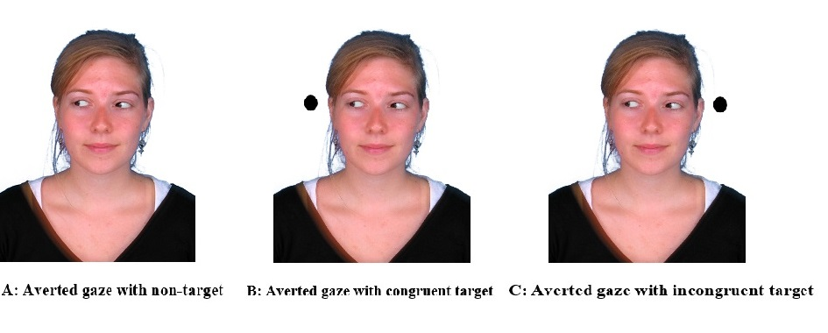
Life Stories: Prior to viewing the gaze cueing screen containing each face, the participants were presented with a life story. Two life-stories which differed the most in the online pilot study were used, i.e., non-student story (number 2) and University of Sheffield student (number 3) (see the previous section for more details).
Questionnaire: A total of four questions were asked. The first two questions were control questions used to ensure that participants read, understood, and correctly remembered the life stories. The first question was “Was her name (Emily/ Jessica)?”, and the second question was “Was she a university student?” These were yes/no questions and participants answered by pressing “1” for yes and “2” for no. The last two questions, which originated from the online study, were used to assess whether participants showed an in-group preference according to the stories. These questions were “Do you consider yourself to be in the same group with this person?” and “How smart do you think the members of this group of people are?” Participants rated their response using a 6-point Likert scale (from 1 = not at all to 6 = extremely) and were asked to press the keys “1” through “6” on their keyboard to indicate their response. Summary statistics for each life-story were calculated, and the results were used to indicate in-group preference. Higher scores indicated a stronger sense of belonging to the group.

Design
Using a within-participants design, participants completed two blocks of 80 trials each. There were three within-participants factors: (a) target congruency (congruent and incongruent), (b) the face stimuli from online experiment (Picture 1 and Picture 2), and (c) life story (Story 1 and Story 2). Participants saw one of four different versions of the same task, thus creating four different version of the same experiment. The order of the stories and the order of the faces that were presented to the participant were counterbalanced (see Table 3). The stimuli included in each version of the story was the same, but the order differed in which the stimuli were presented in order to potential biases. These versions are illustrated in Table 3. Each version consisted of one face stimuli and one life story, creating four different possible combinations of face stimuli x life story. Each participant completed the same task and was presented with the same pictures and stories. In each block, participants viewed congruent and incongruent target trials in combination with a face gazing either right or left. Therefore, counterbalancing was achieved. Each participant saw 20 trials of each condition resulting in 80 trials within each block (20 congruent to right, 20 congruent to left, 20 incongruent to right and 20 incongruent to left). All conditions were randomized and counterbalanced to account for order effects.
Before the experiment started, a practice block was conducted (consisting of 20 trials in total) to ensure that participants had a complete understanding of the required task. The practice block consisted of 20 trials with four conditions counterbalanced (5 congruent to right, 5 congruent to left, 5 incongruent to right and 5 incongruent to left).

Table 3
Face stimuli X life story combination versions for the counterbalancing procedure
 | Block 1 | Block 2
Version 1 | Story 1  Picture 1 | Story 2  Picture 2
Version 2 | Story 2  Picture 1 | Story 1  Picture 2
Version 3 | Story 1  Picture 2 | Story 2  Picture 1
Version 4 | Story 2  Picture 2 | Story 1  Picture 1

If the participant did not press any key after 30 seconds, the experiment automatically continued.

Procedure
The behavioural study was presented using Psychopy (Peirce, 2007), and the reaction times, accuracy responses and answers to the questions were recorded. The study had a duration of approximately 25 minutes. Participants were first provided with information (both verbally and in written format) about the experiment and were allowed to ask any questions. Once the participants provided informed consent, the experimenter left the room, and the experiment began.
First, participants saw a general overall introduction screen for the whole gaze cueing experiment. Next, they were asked to complete a practice trial of the gaze cueing experiment which consisted of 5 repetitions of 4 conditions (Left gaze X Right gaze, Congruent X Incongruent). This practice trial was not recorded. Next, they saw another introduction screen for the Story 1 (i.e., in-group or out-group story). They were informed to read some stories and look at some faces and they needed to remember the story because they will be asked some questions about it. The story with a face picture stayed on the screen for 10 seconds, after which they were allowed to press any key to move on to the next screen. Next, they were asked four questions about the story that they just seen. Two of these questions were control questions to make sure that they were engaging with the story and could remember critical details (see Participants). Two of the questions were group belonging questions. Questions were as listed: 1. “Was her name Emily?” “Yes-No”, 2. “Was she student?” “Yes-No”, 3. “Do you consider yourself to be in the same group with that person?” “1-totally agree,2,3,4,5,6-totally disagree”, 4. “How smart you think this group of people are?” “1-totally agree,2,3,4,5,6-totally disagree”.
Next, they saw another introduction screen explaining the gaze cueing task. They were only instructed to locate the target as quickly and accurately as possible (which is a black dot appearing either right or left side of the screen) while ignoring the direction of eye gaze. The experiment block consisted of 20 repetitions of 4 conditions. In the experiment, first a black cross appeared in the middle of the screen for 1000 ms. Then, a face picture with a direct gaze appeared for 500 ms. Afterwards, a face picture with averted gaze (either right side or the left side of the screen) appeared for 500 ms. The experiment therefore had 500 ms of stimulus onset asynchrony (SOA) between the non-predictive gaze cues and the target. Lastly, a third photo appeared with an averted gaze and the target either the right or the left side of the screen (congruent versus incongruent) for 300cms and then disappeared. Participants were allowed to respond after 200 ms (when the averted face picture with a target appeared on the screen) by pressing to the right or the left arrow key to locate the target. The target disappeared after 300 ms and another round of trials started after the participants responded. When the eye gaze and the target are on the same side of the screen it is a congruent trial, whereas when the eye gaze and the target image are on opposite sides of the screen, it is incongruent (see Figure 6).
At the end of the trial for the story 1 participants repeated the same steps for story 2. The order of the stories was fully randomised meaning some participants saw the in-group story first while other saw the out-group story. At the end of the experiment, participants were thanked for their time.

Figure 6
A congruent version of the gaze cueing trial with a left side eye gaze and target location
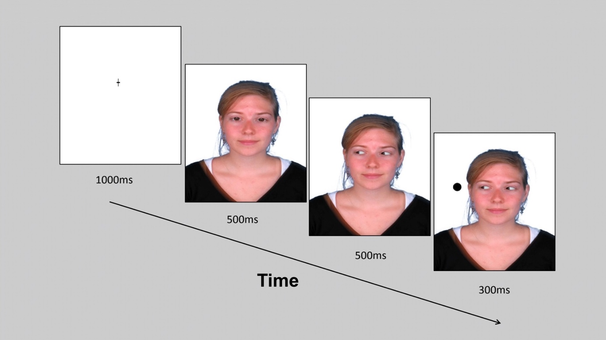

Results
The accuracy of responses (correct/not correct) and reaction times (RT) were recorded. RT measurements were used in the analyses. Incorrect responses were removed prior to analysis of reaction time data. Accuracy ratings were only used to remove errors before calculating each participant's mean RT. No further analyses were conducted on the accuracy responses. The analyses were conducted with mean RT scores.
For each participant, RT (reaction time) responses representing errors (e.g., the response to the target was right arrow when the back dot was in the left side of the screen and vice versa) and outliers (e.g., responses that are three standard deviations away from each participant’s mean) were removed from the data (Howitt & Cramer, 2005). After this process, two (congruent and incongruent) mean reaction times were calculated for each participant.
Next, participants who were outliers were identified using visual inspection of box plots. This analysis was repeated separately for each independent variable (IV) consisted of congruency (2: congruent X incongruent) and story type (2: University of Sheffield student X non-student). The analyses were repeated for each of the combinations which are: congruent trial Sheffield story, incongruent trial Sheffield story, congruent trial non-student story, and incongruent trial non-student story. The box plot analysis for congruent trial Sheffield story indicated that two participants (#40 and #60) were extreme outliers and that two participants (#11 and #61) were outliers. The box plot for incongruent trial Sheffield story indicated that four participants (#14, #40, #60, and #61) were outliers. The box plot analysis congruent trial non-student story indicated that two participants (#11 and #14) were extreme outliers and three participants (#20, #40, and #60) were outliers. The box plot analysis of incongruent trial non-student story indicated that two participants (#11 and #14) were extreme outliers, and two participants (#20 and #60) were outliers. Taken together, six participants (#11, #14, #20, #40, #60, and #61) were outliers, and therefore their data were excluded from any further analysis. The final analysis was carried out on the remaining 64 participants.
A Kolmogorov-Smirnov test was used to test for normality on the each IV. The K-S normality test indicated that sample was distributed normally for the congruent trial Sheffield story (D(63) = 0.102, p > .05), the incongruent trial Sheffield story (D(64) = 0.103, p > .05), the congruent trial non-student story (D(64) = 0.105, p > .05), and the incongruent trial non-student story (D(64) = 0.088, p > .05). Maulchy's test of sphericity was not needed, as there were only two levels within each of the within-participants factors (Field, 2009).
Data were analysed using a repeated (within-participants) measures ANOVA, where the within-participants factors were the story presented (Sheffield university student and non-student) and gaze congruency (congruent and incongruent). The two-way within-participants ANOVA revealed that there was a significant main effect of congruency with a large effect size, F(1, 63) = 15.967, p<.00 ηp²= 0.202, which indicates that there was a significant difference between congruent and incongruent trials.
An effect size is a measure of the magnitude of observed effect and can be used in conjunction with, but not a replacement for, significance testing (see Field, 2005a; 2005b). Effect sizes measure how much independent variable (IV) has affected the dependent variable (DV) in an experimental study. (Partial) eta square (ηp²) is widely cited as a measure of effect size and Cohen (1988) has suggested ηp² of 0.01, 0.059 and 0.138 to indicate small, medium and large effect sizes, respectively.
There was a significant difference between congruent and incongruent trials, indicating that gaze cueing accrued during the experiment. Participants were significantly faster to respond to congruent trials compared to incongruent trials with a difference of 11 ms (p <.05). This suggests that in incongruent trials (e.g., when the target and the eye gaze are on the same side of the screen) participants were significantly faster at detecting the location of the target than in incongruent trials (e.g., when the eye gaze and the target are opposite sides of the screen). The reaction time differences are referred to as gaze cueing effect. In contrast, there was no significant effect of story type on reaction times, indicating that participants showed similar reaction times to both stories, F(1, 63) = 0.011, p = .917, ηp² = 0.00. Additionally, the interaction between type of story and congruency was also non-significant, F(1, 63) = 1.761, p = .189, ηp²= 0.027. Figure 8 reports the mean response times for the congruent and incongruent conditions for the student and non-student stories. The manipulation of different life-stories did not affect the response time reactions on gaze cueing.

Figure 7
Mean reaction times (ms) and standard errors for University of Sheffield student story and Non-Student story by congruency type (congruent/incongruent)

A paired sample t-test was performed using Likert type question to determine if there was an effect of story type on social group belonging (see Figure 7). One question (Do you consider yourself to be in the same group with that person?) was used to determine whether the group belonging manipulation was successful (i.e., to see if the participants report themselves to belong to one group rather than another). Sheffield students identified themselves as belonging more when presented with the Sheffield student story (M = 4.4, SD = 1.22) than the nonstudent story (M = 2.9, SD = 1.15), t(63)= 9.93, p < .001.

Figure 8
Mean response to group belonging question scored 1 (not at all) to 6 (extremely) by story type
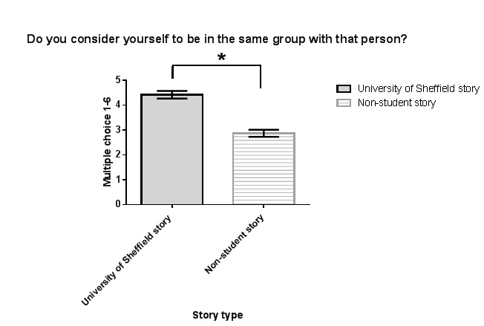

Discussion

Summary of Findings
This study investigated the effect of social group belonging on gaze-following behaviour. Overall, both the stimulus development study and the main behavioural study indicated that participants were more likely to report belonging to in-group compared to out-group, suggesting that the manipulation worked on this (explicit) level. However, the main behavioural study showed that manipulation of group belonging did not affect their response time to gaze cues (implicit level). These results are consistent with the literature and advance our understanding of the structure of group membership and its effects on social attention.
The main effect of congruency was significant, demonstrating that participants were able to more quickly and accurately respond to congruent trials compared to incongruent trials. When the eye gaze and the target were located on the same side of the screen, participants tended to respond faster compared to when the eye gaze and the target were positioned on opposite sides of the screen. This phenomenon is known as “gaze cueing effect” (Friesen & Kingstone, 1998). Thus, the current results are consistent with the previous literature (Cazzato et al., 2015; Dalmaso et al., 2016; Pavan et al., 2011) in finding evidence for the gaze cueing effect; our task measured gaze-following behaviour and we showed that participants were following the eye gaze automatically.
Social identity theory states that individuals put people into social groups based through a process of social categorization and the in-group will discriminate against the out-group to enhance their self-image (Tajfel., 1979; Tajfel et al., 1971). Hence, in line with social identity theory participants in the current study showed greater affinity to ingroup faces. Although lacking knowledge about the gazer face (other than whether they are the student or not) participants reported that in-group member would be significantly smarter compared to the out-group member. These results are in line with the literature and further suggest that people tent to perceive ingroup members positively.
Like social categorization studies (Dalmaso et al., 2014) where visual similarity was used to assign people to a specific social group, semantic knowledge can also play a role by causing people to respond more quickly to eye gaze of in-group faces. Familiar faces have been previously shown to be effective on the strength of gaze following behaviour (Hungr & Hunt, 2012). We predicted story type (i.e., ingroup versus outgroup) would have a significant effect, such that people would have a larger gaze cueing effect to faces belonging to the in-group condition. However, the main effect of type of story was non-significant. This suggests that although our task successfully produced a gaze cueing effect, and significantly manipulated social group belonging, this increase sense of (ingroup) belonging did not cause a stronger gaze cueing effect.

Overall Discussion
Overall, the results showed that the social group membership manipulation had a significant effect on attitudes (group belonging); nevertheless, it did not increase the gaze cueing effect. Participants reported finding in-group members to be more attractive and positive overall, but this did not impact on the strength of gaze cueing
In the current study, the physical similarity between the gazer and the observer was not manipulated. In real life experiences in-group faces are likely to be more familiar to participants as they are likely to interact with them more often. Hungr and Hunt (2012) achieved self-similarity by morphing the participant’s face to the gazer’s face. Their results showed that self-similar faces triggered enhanced gaze cueing effect by creating a larger difference between congruent and incongruent trials. In the current study, both conditions viewed the same faces (it was fully randomised); only life-stories were different for the ingroup and outgroup conditions. It is possible that the difference in gaze cueing reported in the literature concerns the visual system rather than top-down processes. Additionally, Chauhan et al. (2017) showed that personally familiar faces created faster recognition of gaze shifts but longer holds of attention on the face (due to its social relevance), therefore a personally familiar face slows down gaze cueing effect compared to unfamiliar faces. In the current study, the face stimulus was not personally familiar faces but were taken from a face database. The distinction between self-similar and familiar faces should be made clear, as self-similar faces have previously been shown to influence the strength of gaze cues. Future studies on this topic should consider using faces that are personally familiar to participants (i.e., from friends’ circle) rather than self-similar visually.
The present study examined social group belonging by creating two groups (ingroup/outgroup) and showing physically similar faces in both groups. All participants viewed both groups of faces and were required to complete a gaze cueing task. Showing ingroup and outgroup faces separately rather than randomising their order together might have an effect on the results. Indeed, Pavan et al. (2011) showed that the effect of racial group belonging on gaze cueing was context dependent. Thus, when they showed white versus mixed-race faces to white participants together in the same blog, participants selectively attended to white faces; however, when they showed two separate blocks of experiment (with only white and only mixed face faces in them), participants attended all the faces equally.
Having two separate blogs of experiment (one with ingroup/white faces other one with outgroup/ mixed faces) rather than randomising all the gazer faces into one blog of experiment regardless of whether they are ingroup or outgroup cancelled the differences on gaze cueing effect. People were attending whichever face was available to them when they saw only out-group faces. They concluded that the difference on gaze cueing effect only emerged when group membership was salient to participants meaning it is context dependent. The present results are consistent with this explanation (Pavan et al., 2011). In our study, two separate groups of faces one of which were in-group and one of which were outgroup were shown to participants as a design, therefore, out-group faces were processed similar to in-group ones.
In the current study, the ingroup-outgroup manipulation was not effective in producing attentional shifts when there is no threat in the environment. Chen and Zhao (2015) showed when primed with threat/no threat condition participants were able to process information more quickly from a threatening outgroup than a non-threatening outgroup. They also suggested that it took more time to suppress the influence of eye gaze from a threatening outgroup than a non-threatening outgroup, possibly because it is hard to disengage from such intergroup threatening cues once they are detected (Chen et al., 2017). Since in the design of the current study, the context of threat was not present, it can be concluded out outgroup manipulation included a non-threatening out-group. Hence, the present results are in line with the literature showing that non-threatening outgroup faces do not produce a significant difference on the gaze cueing effect. It is important to add that studies in the literature (See, Chen & Zhao, 2015; Chen et al., 2017) only measured the difference between threatening out-group and non-threatening outgroup. Future research would benefit from priming threat and examining differences between ingroup and outgroup faces. Additionally, studies that are interested in the context of threat should consider examining the effect of the source of the threat. Future studies might be interested in threatening context, but the source of the threat is not because of out-group faces but the environment (earthquake or a fire).
Lastly, one possible explanation for the non-significant effect of the manipulation on gaze cueing is that the sample for the present study consisted of university students. University students tend to have fairly liberal attitudes in general (Bailey & Williams, 2016). Studies have demonstrated that people with liberal attitudes tend to exhibit larger gaze cueing effect compared to conservatives (Dodd et al., 2011; Liuzza et al., 2011). Hence, the participants from this sample might be more susceptible to gaze cues overall. Also, sex differences have been found in the strength of gaze cueing. For example, Bayliss, Di Pellegrino, and Tipper (2005) showed that females tended to be more sensitive to social gaze cues. In this experiment, we did not control the gender of the participants and the sample comprised more female than male participants. Hence not having an equal number of male and female ratio in the sample might create an overall responsiveness to faces (regardless of the social group) and dampened any effect of the ingroup/outgroup manipulation on the strength of gaze cueing.
It is possible that group membership might be only effective when there is competition between groups for a limited source. It has been shown that competitive interactions increase the perceived difference between groups (Toma et al., 2010). Turner, (1981) showed that the perception of a social categorization is not sufficient to create ingroup favouritism or outgroup discrimination by itself. They concluded that the presence of an out-group did not provoke competitive or discriminatory responses. Thus, competitive interactions may disrupt the joint attention (Iani et al., 2011) and create a difference on cooperative behaviour depending the group dynamics (Ciardo et al., 2015). In the current study, participants were aware of the in-group/out-group context, and they were aware which faces belong to the perceived in-group. However, there were no competition between two groups. In line with the literature when there is no competition in the environment participants did not have any motivation that would affect their responsiveness to in-group or out-group faces. Additionally, Pavan, Dalmaso, Galfano, and Castelli (2011) concluded that racial group membership affects social attention. They showed that black participants shifted attention to the averted gaze of both in-group and out-group faces, whereas white participants only followed eye gaze of their in-group (white faces). Interestingly, this effect was present and only occurred when group membership was emphasized. Here, we showed that when the physical differences of the gazer were eliminated, the strength of gaze cues diminished even when group membership was emphasized. In the current study, social group belonging did not cause a stronger gaze cueing effect when physical similarity was controlled between the in-group and out-group.

Limitations and Future Research
The present study has a number of limitations that should be noted. First, colourful real face pictures were used in the experiments. In the literature, gaze cuing effect have been observed with schematic faces, real face pictures, and 3D faces. One study conducted by Hietanen and Leppänen (2003) compared the gaze cueing effect to schematic faces and real faces. Their results showed that although both type of faces produced a cueing effect, schematic faces produced a larger gaze cueing effect. Additionally, research suggests viewing dynamic faces versus static faces (or video record of a real face) produces a gaze cueing effect (Risko et al., 2012), although the effect of dynamic faces on gaze cueing was not as pronounced as for static faces (Hietanen & Leppänen, 2003). Although the precise nature and mechanisms of this distinction have yet to be fully investigated (Risko et al., 2012). Because the social and non-social mechanisms of gaze cuing are still not fully understood, it is recommended to investigate this difference when researching the bottom-up processes driving patterns in gaze cuing. Future research would benefit from comparing images of real faces or video recordings of real faces on the gaze cueing effect, specifically as it relates to real-world social interactions, to determine whether static gaze shifts are processed similarly to dynamic ones in real-world social situations.
In the current task, there was no motive to compete between the members of the in-group and out-group. For example, there was no conflicting environment that might lead to group belonging influencing social behaviour. Future research would benefit from focusing on varying social groups. Creating an in-group and out-group, where there is competition between groups, could be effective on creating an in-group/ out-group difference on the strength of gaze cueing. Lastly, it is important to add that targeting a specific sample creates difficulties in generalising the results to the general population. The chosen stories and the social group manipulation were targeted for University of Sheffield undergraduate students. The present study could be replicated with a different sample, for example with a sports team membership or a company. These might produce different results since the sample would include people from different age groups, gender, and race.
In conclusion, the social group belonging manipulation did not produce a significant difference on the strength on gaze cues. This might be related to the male/female profile of the sample and the context in which social group belonging was manipulated and assessed. The next study of this thesis will investigate this finding by comparing male and female participants as well as using the context of a threatening situation.

The Effect of Gender and Social Power on Gaze Cueing in Dangerous Scenarios

Introduction
Humans are often in environments that include other people from various backgrounds and settings (Foulsham et al., 2010). Within such environments, social hierarchy often influences social interactions. For instance, knowing where individuals rank in a hierarchy can help one to understand their position within that hierarchy (Emery, 2000) as well as identify which individuals have access to valuable resources and information (Dalmaso, Pavan, Castelli, & Galfano, 2012). Furthermore, those who have high social status have more influence on social attention and receive greater attention as a function of their rank (Chance, 1967; Emery, 2000). Evidence indicates that people are selectively more attentive towards individuals who are rated as having higher social status (Foulsham et al., 2010). Moreover, this tendency to be more selectively attentive to higher status individuals may be especially pronounced in threatening situations.
As an example, Ohlsen et al. (2013) primed their participants in a threat condition by showing pictures low in pleasure, and high in dominance and arousal (such as graphic displays of attacks, fighting situations and accidents), whereas participants in the non-threat condition were shown pictures high in pleasure, and low in dominance and arousal (such as smiling babies, pairs holding hands, beautiful scenes of nature and cute animals). Dominant looking male faces have been found to manipulate the social attention of the observer in both threat and non-threat conditions; in contrast, a non-dominant looking female face was only found to influence the social attention of the observer in the non-threat condition (Ohlsen et al., 2013). They concluded that gaze cueing effects can be moderated by facial features signalling social attributes (i.e., dominant vs non-dominant) depending on the context that they are engaged in (i.e., threat vs. non-threat). Therefore, social status and social attention are strongly associated with one another, but moderated by context (e.g., threat).
Hierarchical structuring of social groups formalizes coordination between group members and improves the group’s performance (King et al., 2009; Van Vugt, 2006). The hieratical structure within a social group also leads to efficient decision making (Van Vugt et al., 2008), creates collective locomotion (Blau, 1964; Hardy & Van Vugt, 2006; Keltner et al., 2008; Thibaut & Kelley, 1959; Willer, 2009) and increases performance (Anicich et al., 2015; Halevy et al., 2012; Ronay et al., 2012). Organizing groups hierarchically also reduces intragroup conflict and distributes resources systematically (Anderson et al., 2006; Bendersky & Hays, 2012). Conversely, a lack of structure impairs group performance (Bendersky & Hays, 2012; Greer et al., 2011; Greer & van Kleef, 2010). Furthermore, hierarchies exist across different human cultures (Sidanius & Pratto, 1999) and emerge naturally (Anderson et al., 2001; Berger et al., 1980; Chase et al., 2002; Gould, 2002; Magee & Galinsky, 2008). As a result, people show a high level of consistency when attributing status for themselves and other members of the groups (Anderson et al., 2006). The ability to rapidly perceive status information is an important skill for the individual to be able to function in everyday life. Indeed, humans rapidly perceive status information about other members of the group (Moors & De Houwer, 2005) and organize themselves into a hierarchical structure (Berger et al., 1980; Gould, 2002). A strong hierarchy serves as an adaptive function for structuring social groups to benefit as a whole and to function better.
Individuals in social groups may have different statuses based on their roles within specific social groups. Social status is an indicator of the specific role of that individual within the group. To establish communication and collaboration, information about the different roles and status must be recognizable. Understanding status information is an important ability for each member so that the group can function better and improve the chance of survival. The perception of social status can be gathered by visual information such as the dominance of face (Dalmaso et al., 2012), body size (Keating et al, 1981; Mueller & Mazur, 1996) and upper body strength (Vonrueden et al., 2008). Additionally, information about social status affects the social attention shared between members of the group in humans, and previous research has shown that status affects the social attention of humans (Galfano et al., 2012; Jones et al., 2010, 2011) as well as monkeys (Deaner & Platt, 2003). For instance, a study conducted with an eye tracker showed that males with high status attracted more attention than low-status males (Maner et al., 2008). High social status attracts more attention across species. It has been shown that humans also prefer to look at higher status individuals compared to low-status individuals more often and for longer periods (Foulsham et al., 2010). Additionally, faces with higher status are better encoded in memory (Ratcliff et al., 2011). People tend to look at high-status individuals more than low-status individuals (Cheng et al., 2013) specifically to the eye region (Foulsham et al., 2010) and follow the eye gaze of high-status individuals more compared to low-status individuals (Dalmaso et al., 2012). When the dominance of the observed face is used as a visual cue of social status, humans show enhanced gaze-cuing effects for masculinized faces compared to feminized faces (Jones et al., 2010). Additionally, people with high status were gazed more often and for a longer period even in video clips as short as 20 seconds (Foulsham et al., 2010). While the hierarchy within a group of nonhuman primates can be seen by how dominant the monkey´s face is (Shepherd, 2010), among humans, social interactions are more complex.
The perception of social status can be derived from verbal as well as social information about the specific roles within a social group. Dominance in monkeys can be established by physical features of the face whereas, for humans, we need to look at status, education level, income as well as position within the group, because social power positions are not necessarily occupied by the physically strongest individuals. In human social groups, the social hierarchy reflects an understanding of the level of members’ skills and intellectual capacities rather than just their perceived physical strength. Humans occupy many different social groups in daily life, hence different strategies may be necessary to navigate or assess social information among them. Unlike nonhuman primates, humans gather non-perceptual cues based on knowledge and use this information to navigate and assess status within the group. Labels and reputations about income, occupation, intelligence, popularity, and prestige are commonly used to assess status (Cheng et al., 2013; Dalmaso et al., 2012; Hymel, Closson, Caravita, & Vaillancourt, 2011; Zink et al., 2008). Indeed, Dalmaso et al. (2012) showed that individuals paid more attention to spatial locations gazed at by high-status individuals compared to low-status individuals even when the information of status were gathered from “episodic knowledge”. In their design, Dalmaso et al. (2012) asked participants to look at 16 faces and read CVs associated with the faces. The CVs described participants to have either high (university-educated/CEO) or low social status (high school dropout/do not have a regular job). In condition one, young faces had a high-status CV, but the old faces did not. In condition two, old faces had a high-status CV and young faces did not. Later, the same faces were used in a classical gaze cueing task. The results showed that regardless of face age, participants showed a greater gaze cueing effect to high-status faces compared to low-status faces. These results demonstrate that the gaze cueing can be affected by top-down influences such as episodic knowledge about the observed face (Dalmaso et al., 2012). However, in their design, Dalmaso et al. (2012) had a visual reminder of face age categorization in addition to social status information. The faces chosen from different age levels and status information in combination with the age categorization might have helped to build the episodic knowledge. In summary, these results show that there is a greater gaze-cuing effect for high-status faces than for low-status faces, regardless of the specific identity of the face, which means modulation of gaze cuing can be observed even when knowledge about social status is acquired through episodic learning. Still, most of the studies in the literature have overlooked social information about the gazer face and only focused on physical features. However, social status information has been shown to moderate the gaze cueing effect even when it was gathered through episodic knowledge. In previous research, participants were typically presented with a visible social cue from a face. It is not clear whether the gaze cueing effect was driven by the appearance of the social cue or the knowledge about the gazer’s social role.
It has been shown that one’s status influences one’s perception of the status of others. Males who score higher on the self-report dominance scale perform worse at perceiving the dominance of others, than males who score lower on the dominance scale (Watkins et al., 2010). It has been suggested that humans pay more attention to high-status individuals (Deaner, Khera, & Platt, 2005; Jones et al., 2010; Shepherd, Deaner, & Platt, 2006) because misinterpreting status cues cost humans more, specifically to those with lower status. Furthermore, subjective low social status was significantly associated with mentalizing regions of the brain while looking at social images (Muscatell et al., 2012). Galinsky, Magee, Inesi, and Gruenfeld (2006) showed that when primed with high social power, participants drew the letter “E” on their forehead in the orientation of their own perspective whereas, when primed with low social power they drew the letter ‘‘E’’ on their forehead in the orientation as seen from an observer’s perspective. Gazing at another and gazing with other members of the group is a way to check social rank within the group. Social status is a dynamic concept that is perceived during social interactions. The observer’s own interpretation of where they are in the social rank is as important as understanding the observed person’s status (the object of social interaction). Understanding the effect of perceived social power in social attention research is critical for addressing the dual processes of eye gaze following and joint attention. Together these studies show that social attention between humans is moderated by the beliefs of social relevance and the mental representations of those with social relevance.
One’s relative social status might affect receiving information from threatening facial expressions. For example, objective status has been shown to be associated with mentalizing networks when participants are looking at threatening facial expressions (Muscatell et al., 2012). Subjective social status may influence social perception in multiple ways. For example, it has been shown that people follow the eye gaze of fearful faces, compared to happy faces, but only when the context is threatening (Bayliss, Schuch, & Tipper, 2010; Friesen, Halvorson, & Graham, 2011; Kuhn & Tipples, 2011). Research suggests that the visible cues of threat affect the strength of gaze cueing when the level of threat or danger in the context is ‘sufficient’. Extensive research has demonstrated that especially at the time of crisis or danger (Spisak, Homan, et al., 2012) male leaders grab more attention (Little et al., 2007) by activating implicit leadership prototypes (Spisak, Dekker, et al., 2012). To investigate the relationship between threat and facial dominance (which was used as a signifier of status) in gaze following, Ohlsen, van Zoest, and van Vugt (2013) primed their participants with a threat or non-threat condition prior to a gaze cueing task. In their experiment, the gazers were either a dominant looking male or a non-dominant looking female. The results indicated that gaze cues of dominant males influenced the eye gaze-following behaviour both in the threat and non-threat conditions. However, the non-dominant looking female gazer only influenced eye-gaze following in the non-threat condition. The results showed that dominant male gaze cues influenced eye gaze-following behaviour in both threat and non-threat conditions whereas, the non-dominant looking female gazer only influenced eye-gaze following in the absence of a threat. Thus, when the context of the threat was salient, the non-dominant looking females did not have a significant effect on the strength of gaze following and participants only paid attention to dominant looking male gazers (Ohlsen et al., 2013). However, it is unclear whether the effect of this social information is related to low-level biases (such as the physical condition of the stimuli face-stimuli driven) or more high-level cognitive biases (such as mental representations about intention and attitude of the observed face - i.e., goal-driven) or combination of both factors depending on context (Main et al., 2009). Additionally, it is still unknown whether this effect can be generalized to the real-world social environment since the level of dominance of the face is not the only indicator of social hierarchy in humans.
When there is a threat to the well-being of the individual, this creates overall alertness in people’s social attention systems. Evolutionarily, operating as a coherent social group would be beneficial in the possibility of danger. It would be beneficial for the overall survival of the group to be able to react fast and appropriately. In such cases, minimalizing the conflict among group members and increasing the collaboration would improve both the individual's and the group's chances of survival. Cui, Zhang, and Geng (2014) used a well-known priming task, shown to work by Galinsky et al. (2013) and Lammers and Stapel (2009), to prime participants’ perceptions of their own social status. They achieved this by asking their participants to recall a personal experience in which they felt in charge and were not manipulated (high social status) or a past experience where they were controlled and manipulated (low social status). Later they asked their participants to complete a gaze cueing task. In the presence of high perceived social power, the gender difference in gaze cueing vanished. The gender difference in the reaction to perceived social power might indicate that males and females employ different techniques, particularly in threatening situations. The source of danger can be natural disasters or facial expression stimuli. A fearful looking face can be considered as a facial expression that signals danger. Danger from the environment (i.e., earthquakes or natural disasters) that is not detected by social-visual attention system creates an environment where the individual is on high alert mode.
Previous studies have investigated the effect of danger on social attention by manipulating the level of danger with the facial expressions of the gazer. For example, the threatening stimulus in these studies was a face expressing anger or fear (strong negative emotions). It should be noted that it has been suggested that strong negative emotional expressions cause a reaction and are strongly related to anxiety traits of the observer (Kuhn & Tipples, 2011). Hence, studies using facial expression as an indication of danger might be affected by some participants having high traits of anxiety or not. Most importantly, levels of anxiety have not been controlled for with statistical procedures in previous studies. To our knowledge, none of the above studies investigated how people respond to social stimuli when they are already on high alert mode because of a threatening environment. An environmental threat (that is a threat to an individual’s well-being) has not been tested to date in any context in lab studies or, specifically, in Western cultures. Only one study by Cui, Zhang, and Geng (2014) used a scenario of an earthquake because at the time of the experiment a recent earthquake had happened in China and this threat was an object of repeated exposure by the media and news channels. The participants were familiar with news and conversations about an earthquake. As a result, it is not clear whether the same results would be found in a Western culture with low daily exposure to environmental disasters. If the people of that culture are not exposed to environmental dangers daily and not primed to be highly vigilant to danger, then they may not be affected as much by cues of environmental danger.
Two important issues should be carefully addressed here; namely, daily exposure of the possibility of danger and culture. Cohen, Sasaki, and German (2015) showed that cultural background influences the processing of gaze cues by shifting the focus into a more narrow or broad perspective. Interesting results from cultural psychology research have shown that cultural differences can also influence basic cognitive processes (Nisbett et al., 2001). Such differences include the social attention system. For example, an interdependent culture requires people to be more conscious of individuals and the interaction between them, and they are better able to remember faces and objects than people from individualistic cultures (Masuda et al., 2008). The social attention system can automatically process gaze cues, but only to the extent that the connections between the cues are relevant to the person receiving the stimulus (called perceptual readiness; see, Bruner, 1957). In response to specific "bottom-up" stimuli, "top-down" interactions can calibrate social attention to engage more broadly or narrowly (Cohen et al., 2017). The social attention mechanism can be sensitive to contextual knowledge that is culturally significant such as the status of one group relative to another (Dalmaso et al., 2012) or one's social status relative to another individual (Cui et al., 2014). Most importantly, Cohen et al. (2017) provide evidence that differences in culture can shape habitual ways of attending to others. Evolutionary and cultural psychology suggest that in more interdependent cultures attention might be more focused on relations between individuals. The effect of threat has only been examined in Eastern cultures and not in Western cultures. As a result, it is unknown whether similar results would be obtained in a Western context.
The generalizability of social cognition studies, in some ways, are limited because majority of them have been conducted in a laboratory setting. According to Risko, Richardson, and Kingstone (2016), social cognition research puts a boundary between the participant and the stimuli they are observing. While this separation allows for experimental control, it also limits the generalizability of the research findings. Indeed, it has been shown that people were less likely to look at a provocative swimsuit calendar when they believed their eye gaze was being monitored (Risko & Kingstone, 2011) in real life. In another study, Freeth, Foulsham, and Kingstone (2013) discovered significant differences in social attention when viewing the same task in a live versus video recorded condition. In the live condition, the experimenter was physically in the room with the participants. In video record condition the same experiment was repeated but it was pre-recorded and viewed on a computer screen. It has been shown that participants were more likely to look at the face rather than the body of the experimenter when eye contact was made compared to when eye contact was not made; however, this difference did not emerge in pre-recorded video condition (Freeth et al., 2013). These results demonstrated that eye contact had a more profound effect on the attention of the observer in a real-life condition than in the pre-recorded condition. On the other hand, ingroup-outgroup studies have shown that the effect of group belonging occurs even in the lab environment with a minimal group paradigm. Hence, it is important to keep in mind that in some, but not all contexts, the generalisability of findings may be limited when conducting social attention research in controlled experimental settings.
Most of the laboratory-based social cognition studies are conducted at psychology departments in different institutions. The samples in these studies are generally female weighted (i.e., more female participants than male participants are tested) because psychology departments tend to have more female students than male students in undergraduate level education (Turpin & Fensom, 2004). In social attention studies, different sensitivity to social stimuli in males and females has been shown repeatedly. Females tend to show enhanced sensitivity to social cues perceived by eye gaze compared to males (Deaner, Shepherd, & Platt, 2007). Females also show an enhanced gaze cuing effect compared to males specifically at short viewing times (300 ms) (Bayliss, Di Pellegrino, & Tipper, 2005). Finally, females show enhanced gaze cueing to personally familiar faces whereas this difference has not been observed for males (Deaner et al., 2007). The conditions in which this difference between genders is observed provide information about the mechanisms of the social attention system. Hence, it is an essential component of social attention research. Despite the clear evidence from the literature showing that males and females have a tendency to show differences in the sensitivity to social stimuli, most studies have overlooked this by not having an equal number of males and females or not controlling for gender. Given that sensitivity to social information differs according to gender (Geary, 2010), the lack of attention on this topic may have led to misleading results regarding the generalisation of the gaze cueing effect.
Finally, the type of face stimuli that are used in eye gaze cueing studies also varies. There is no standard procedure for the stimuli face, such as whether it should be in colour or black and white, the colour of background or the type of the target (whether a dot or a letter). Additionally, some studies have only included male faces whereas in other studies both male and female faces have been used as stimuli. Differences in face stimuli may produce significant effects on eye gaze following, given the results of social power studies. For example, Dalmaso et al. (2012) showed that face pictures associated with high social power produced a stronger gaze cueing effect. In contrast, Ciardo, Marino, Actis-Grosso, Rossetti, and Ricciardell (2014) reported that visually observable social status had an effect on saccadic eye movements with higher latencies but had no effect on reaction time measures. Dalmaso et al. (2012) only used male pictures as a stimulus whereas Ciardo et al. (2014) used both male and female pictures. The differences in these results might be related to differences in the stimuli used. Importantly, the gender of the pictures might affect social status which is perceived implicitly. Indeed, it has been shown that male faces tend to be perceived to be more dominant (i.e., higher social status) than female faces (Jones et al., 2010). The effect of social status on gaze following may vary depending on how it is presented to the observer (implicit or explicit). Taken together, the effect of the gender of the stimuli on gaze following is an issue that has not been fully addressed in social cognition research.
The present study will investigate the effect of social power on social attention and how this effect interacts with gender (both of the participant and of the faces the participant is viewing). The study will replicate and extend Cui et al.'s (2014) study. First, social power will be experimentally manipulated by asking participants to imagine they are either a member of a group (low social power) or a group leader (high social power) in an office fire situation. In contrast, Cui et al.'s (2014) asked their participants to imagine that they were running from a mountain with their team, and their role was either the leader or a member. Second, social attention will then be measured with a gaze cueing task. In this task, participants see a face on a screen looking either to the left or the right and then they need to detect a target black dot either on the left or the right as soon as possible. Reaction times will be compared for congruent trials (black dot on the same side of the screen that the face had looked towards) and incongruent trials (black dot on the opposite side of the screen). Additional independent variables are the gender of the viewer as well as the gender of the faces being viewed (i.e., male/female participants viewing male/female faces). The addition of gender manipulation for the viewed faces is the extension of Cui et al.'s (2014) study. Third, the present study will, for the first time, use a scenario that investigates the effect of environmental danger in a Western context. The participants will be primed with high danger context by asking them to imagine a fire scenario in their office building while listening to fire sounds. After, participants will be asked to write down what they have imagined. The present experiment will include an equal number of male and female faces as stimuli, and all will be Caucasian and in a similar age range. Physical differences in faces have been shown to act as categorisation cues (Dalmaso et al., 2012); hence, similar faces will be used in the present experiment to prevent this.
The purpose of this study was to investigate the potential interaction between social power and gender in gaze following. The relationship between the participants and the cuing face was altered with a priming task (Cui et al., 2014; Galinsky et al., 2013; Lammers & Stapel, 2009) by assigning them to low or high social power before a standard gaze cueing task was employed. Whereas previous studies have manipulated social power by changing the physical features of the gazer’s face, the present study focused on social aspects of social power. The influence of social power was investigated in a dangerous situation (i.e., a fire scenario). Lastly, to address the problems about generalisability, similar numbers of male and female participants were recruited.

Aims and hypothesis
The current study firstly aimed to replicate Cui et al. (2014) which showed that perceived social power influences social attention evoked by gaze. The current study also aimed to extend Cui et al.'s (2014) work in several ways. First, while Cui et al. (2014) examined the effects of social power on social attention in a dangerous context, they did not investigate whether males and female participants would respond differently and under what conditions these differences would occur. Second, Cui et al. (2014) primed their participant with danger by asking their participants to imagine an earthquake. While the earthquake scenario was relevant for the culture in which the experimental procedure was initiated, it is not clear if the same reaction would be observed in another culture where the active emphasis of danger is different. Lastly, this study will examine the gender difference of the participants.
Studies have consistently shown that females tend to have higher overall sensitivity to social cues than males. It was hypothesised that the same pattern would occur regardless of the social power condition. The study will replicate and extend Cui et al.'s (2014) study. Cui et al. (2014) showed that female participants, who were primed with lower social power, showed a stronger gaze-cueing effect compared to male participants in the no danger context compared to high danger context. Again, in low danger context, participants who were primed with high social power did not show any difference according to their gender. This effect, however, did not occur for high danger conditions. Thus, in the high danger context, females who were primed with low social power did not show enhanced gaze cueing (Cui et al., 2014). The context of danger may create overall alertness in the attention system for their environment with lower resources for their own social factors, which could explain the lack of effect of these social factors. We hypothesized that we will be able to replicate this result showing that the effect was not culturally biased. In the current study, participants were exposed to high danger (fire in their office building) to manipulate the context of danger. It was hypothesised that females will show enhanced gaze cueing in the low social power condition but not in the high-power condition, but that this difference will not be observed with male participants. Previous research also failed to account for the impact of social power. Indeed, it has been shown that social power is important at a group level (Liuzza et al., 2011). This, however, has not been considered at the individual level; it is unclear whether the effect of social power at the individual level would be similar to or reflect the effect of social power at the group level. It was hypothesized that the same pattern would occur regardless of the social power condition. Thus, in the current study, the context of danger may create overall alertness in the attention system for their environment with lower resources for their own social factors, which could explain the lack of effect of these social factors.

Methods

Ethics
This research was approved by the Research Ethics Sub-Committee of the Department of Psychology, University of Sheffield.

Participants
In total, 77 University of Sheffield students took part in this study. However, six of the participants did not complete the learning phase and/or answer the control question before continuing with the gaze cueing task, indicating that they did not understand the priming condition. Remaining 71 participants (40 female, 31 male) with mean age of 20.9 years, ranging from 18 to 34 years (SD=3.05 years). Due to nature of the study participants were only asked to participants if they are British to be able to do cultural comparison and 51 (72%) participants identified as “British” whereas 20 (28%) identified as “other”. Participants were recruited through the Department of Psychology “Online Participant System” (OPS) scheme, University of Sheffield volunteers list and flyers advertising the study. All participants reported normal or normal to corrected vision. Participants who were recruited by OPS (online participant system) were unpaid undergraduate students who received credit for their time All other participants were entered into a prize draw to be compensated for their time.
Informed consent was obtained from all participants prior to the experiment. Participants had the right to withdraw from the study at any time without any consequences. At the end of the experiment participants were debriefed and thanked for their time.

Stimuli and apparatus
The gaze cueing task was presented, and the reaction times were recorded using PsychoPy software (Peirce, 2007). Microsoft excel was used to calculate the mean and standard deviations of reaction times for each participant and for each condition.
The study included four neutral looking faces (two female and two male) taken from Utrecht ECVP face database. The Utrecht ECVP face database consists of 131 images (49 men, 20 women), comprising pictures of neutral and smiling versions of each face. The photos were collected at the European Conference on Visual Perception in Utrecht in 2008. The resolution of the pictures was 900 x 1200 pixels and the pictures are in colour (Downloaded from: http://pics.psych.stir.ac.uk/2D_face_sets.htm). Two of the faces (one male, one female) were used in practice trials and two of the faces were used in the gaze cueing task. Each face was manipulated using Photoshop CS6. More specifically, the original faces contained a blue background, which was replaced with a white background to provide greater contrast between the image and negative space. This was done to direct as much attention as possible to the faces. The original eyes of each face looked directly ahead. Therefore, the eyes were also manipulated to create a face that looked to the left and right. This was done by cutting each iris and pasting them to the left and right corners of the eyes, respectively. Each face with a left and right gaze was also manipulated one more time to include a target (a black dot) stimulus. This target stimulus was in the same direct as the gaze and in the opposite direction of the gaze. This created several conditions with target and gaze being congruent and incongruent. That is, there was an averted gaze with a target, and an averted gaze without a target. The adverted gaze with a target either had the target in the same direction as the gaze (congruent condition) or in the opposite direction of the gaze (incongruent condition). These conditions can be seen in Figure 9.

Figure 9
Example of face gazing left and right side of the screen - congruent trials
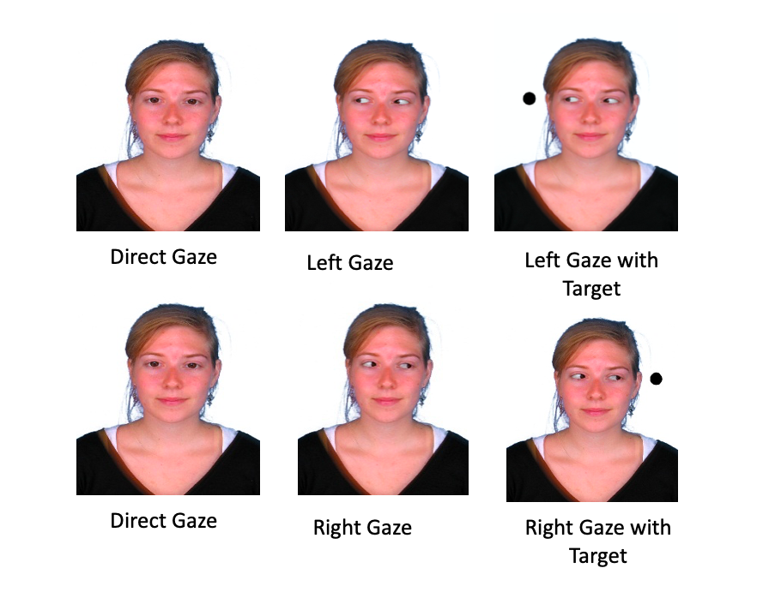
Lastly, participants were exposed to sound of a burning fire to prime a danger context. Sounds were obtained from the internet (https://www.youtube.com/watch?v=RDfjXj5EGqI) and consisted of crackling noises of a wood-burning fire. The participants listened this sound during priming phase of the study, while they were instructed to imagine a dangerous scenario and write down the details of what they have imagined.

Table 4
Sample size and percentage by gender and condition.
 |  | Males: |  | Females: |  | Total:
Condition: |  | n | % | n | % | n | %
High Social Power  Low Social Power  Total: |  | 16  15  31 | 22.54  21.13  43.67 | 20  20  40 | 28.17  28.17  56.34 | 36  35  71 | 50.7  49.3  100

Design
A 3-way mixed (2x2x2) design was used. The independent variables were perceived social power (high/low) as a between-participant factor, gender of the participant (male/female) as a between-participant factor and gender of the gazer (male/female) as within-participant factor.
The first between-participants independent variable was perceived social power (high social power/ low social power). One group of participants were primed to high social power and the other group was primed to low social power. Participants primed with high social power were asked to imagine themselves as a leader of the group and participants primed with low social power were asked to imagine themselves to be a member of a group during the priming task. Both high social power and low social power groups saw a male gazer and a female gazer. The second between-participants independent variable was participant gender (male/female). Lastly, the within-participants variable was the gender of the gazer picture (male/female) which was counterbalanced. On any trial, gaze cues showed either right or the left side of the screen. Additionally, the targets appeared on either the left or right side. The eye gaze cue direction and the target location were randomised and the gaze cues were uninformative of the location of the target.
An a priori power analysis was conducted using G*Power (Faul et al., 2007) to test the 3-way mixed design ANOVA with a small effect size (d = 0.25). The result of this analysis showed that a total sample of 76 participants was required to achieve the estimated effect size.

Procedure
Firstly, in high social power condition participants completed a priming task to imagine themselves as a leader of a group and in low social power they imagined themselves as a member of a group. Participants were asked to imagine they were in a dangerous fire situation while watching a video of flames with burning flame sounds for three minutes. They were asked to watch this video to help them imagine the given scenario. The participants were also asked to close their eyes and imagine a fire situation. They were asked to imagine working at an office with his/her team members (they were shown faces that will be used in the cuing task) then a fire starts to happen, and they needed to leave the building immediately. To help with the imagery of this situation, participants listened to sounds of burning flames for 3 minutes. When the imagining task finished, participants were then asked to write down what they had imagined during those 3 minutes. To check if the participants understood and completed the priming task correctly, they needed to answer questions asking them if they were member or a leader of their group. Participants who were not able to answer these questions in the imagined scenario automatically finished the study and their data not included in the analyses.
Next, they were asked to complete a gaze cueing task. In this task, they first completed a practise trial to understand the task. They saw a male and a female face with four conditions counterbalanced (congruent to right, congruent to left, incongruent to right and incongruent to left) which consisted of 20 trials. The response time was not recorded for practice trials.
After the practice trials, participants were informed that the experiment would start and that their answers would be recorded. All participants saw a male and a female picture (within-participants variable). The order of all trials was counterbalanced with the order of the pictures. Additionally, each trial had congruent and incongruent trials, also counterbalanced. They saw 20 repetitions of the cueing task for each picture. First, they saw a direct looking face for 500 milliseconds as a fixation at the start of the gaze cueing task. Then, the face gazed to either the right side or the left side for 300 milliseconds and the target appeared at 200th milliseconds in the averted gaze condition. So, in total averted gaze appeared at 500th ms and target appeared at 700th ms. If the participant did not press any key for longer than 2 seconds, the experiment automatically continued. The experiment was 35 minutes in total. At the end of the experiment, participants were thanked for their participation and given a debrief form.

Results
The mean reaction times for each gender and social status were compared across the four gaze cueing conditions (male gazer congruent, male gazer incongruent, female gazer congruent, female gazer incongruent). For each participant, responses representing errors (e.g., responses made before the presentation of the stimulus) and outliers (responses greater than two standard deviations from each participant’s mean) were removed. The mean and standard deviations of correct reaction times were then calculated for each condition. Table 5 reports the mean reaction times, standard deviations and sample size by gender of the gazer and social power.
All subsequent analyses were performed using SPSS. Using boxplot analysis, each condition was tested for outliers using the same criteria as above (+/- 2 SD away from the mean). This analysis was performed individually for each condition (high social power /male-difference, high social power /female-difference, low social power / male-difference and low social power / female-difference). The analysis identified six outliers total, there were two outliers for the male congruent condition, three outliers for the male incongruent condition and one outlier for the female congruent condition. Outlier scores only removed for these conditions and other scores were kept for other conditions. Thus, further analyses were carried out with the remaining 71 participants.
A paired sample t-test conducted to compare reaction times in congruent and incongruent trials. For the male gazer picture, there was a significant difference in the reaction times between congruent trials (M=0.36, SD=0.05) and incongruent trials (M=0.38, SD=0.05), t(70)=-11.18, p < .001. Additionally, for the female gazer picture, there was a significant difference in the reaction time between congruent trials (M=0.35, SD=0.05) and incongruent trials (M=0.38, SD=0.05), t(70)=-11.83, p < .001. These results indicated how fast people could detect the target stimuli and show that reaction times were significantly affected by the congruency of gaze cues. Participants’ reaction times were significantly faster for congruent trials, which the eye gaze and the target (black dot) at the same side of the screen, compared to incongruent trials, with the eye gaze and the target (black dot) at the opposite side of the screen. This result was shown for both male (M=0.26, SD=0.02) and female (M=0.29, SD=0.02) gazer pictures (see Figure 11). The gaze cueing effect was therefore present and consistent with the literature. Thus, there was a significant difference between congruent and incongruent trials, in which the target and eye gaze signals were on the same side of the screen, and incongruent trials, in which the eye gaze signals and the target were on the opposite sides of the screen. When compared to congruent trials, incongruent trials took significantly longer to react to, implying that observing another's gaze shifts may elicit a reflexive shift in the observer. A gaze cueing effect score was then calculated by abstracting mean incongruent score - mean congruent score. This gaze cueing score was used for further analyses using a 3-way mixed-measures ANOVA.

Table 5
Means and standard deviations for reaction times by social power and gender of the gazer and the number of participants that undertook each condition.
 | Mean | Standard  Deviation | Sample size
High Social Power- Male participants
Male congruent | 350.70 | 28.64 | 16
Male incongruent | 372.30 | 29.75 | 16
Female congruent | 353.56 | 37.55 | 16
Female incongruent | 377.46 | 34.93 | 16
Male difference | 21.60 | 18.30 | 16
Female difference | 23.96 | 21.97 | 16
High Social Power-Female participants
Male congruent | 363.73 | 49.06 | 20
Male incongruent | 393.31 | 45.99 | 20
Female congruent | 361.10 | 56.26 | 20
Female incongruent | 395.17 | 57.75 | 20
Male difference | 29.58 | 23.55 | 20
Female difference | 34.07 | 17.19 | 20
Low Social Power- Male participants
Male congruent | 354.61 | 37.74 | 15
Male incongruent | 375.21 | 40.62 | 15
Female congruent | 351.34 | 45.31 | 15
Female incongruent | 370.10 | 37.55 | 15
Male difference | 20.59 | 18.22 | 15
Female difference | 18.76 | 23.54 | 15
Low Social Power- Female participants
Male congruent | 353.65 | 56.02 | 20
Male incongruent | 384.40 | 61.75 | 20
Female congruent | 344.85 | 49.07 | 20
Female incongruent | 381.29 | 51.85 | 20
Male difference | 30.76 | 17.29 | 20
Female difference | 36.44 | 17.86 | 20

To test for normality, a Kolmogorov-Smirnov test was used. The K-S normality test indicated that the sample was normally distributed for 1) High social power /male-difference, [D(36) = 0.110, p > .05], 2) high social power /female-difference, [D(36) = 0.102, p > .05], 3) low social power / male-difference, [D(35) = 0.081, p > .05], and 4) low social power / female-difference, [D(35) = 0.102, p > .05]. Maulchy's test of sphericity was not needed, as there were only two levels within each of the within-participant factors (Field, 2009).

Figure 10
Gaze cueing effect divided by gender of the gazer, reaction time scores and standard error mean were presented
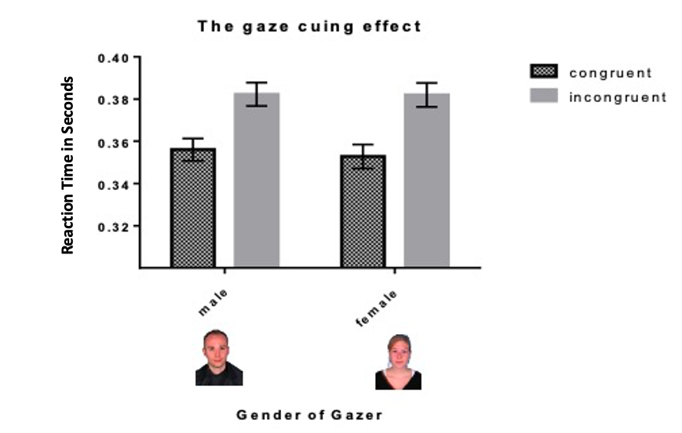
A 3-way mixed design ANOVA conducted on the gaze cueing effect (RT incongruent -RT congruent). Gender of the participants (male/female) and social power (high social power/ low social power) were the between-participant factors and gender of gazer (male/female) was the within-participant factor. Three way mixed measures ANOVA revealed that there was a significant main effect of gender of the participants (between-participant variable) with a small effect size, F(1, 67) = 8.36, p <.05, ηp ² = 0.111 which indicates that there was a significant difference between mean reaction time differences between males and females. Female participants showed a bigger difference between incongruent and congruent trials by .025 ms compared to male participants.
The ANOVA also revealed there was a non-significant main effect of social power (between-participant factor), F(1, 67) = 0.03, p = .87, ηp ² = 0.013, and a non-significant main effect of gender of the gazer (within-participant factor), F(1, 67) = 1.07 p = 0.30, ηp ² = 0.016. Additionally, there were non-significant two-way interactions between gender of gazer and gender of participant, F(1, 67) = 0.871, p =0.871, ηp ² = 0.013, gender of gazer and social power, F(1, 67) = 0.084, p =0.773, ηp ² = 0.01, as well as a non-significant three-way interaction, F(1, 67) = 0.271, p =0.604, ηp ² = 0.04. Figure 12 shows the mean response differences at reaction time for males and females by the social power and gender of gazer.

Figure 11
Gaze cueing effect by gender of the participant, gender of the gazer and social power
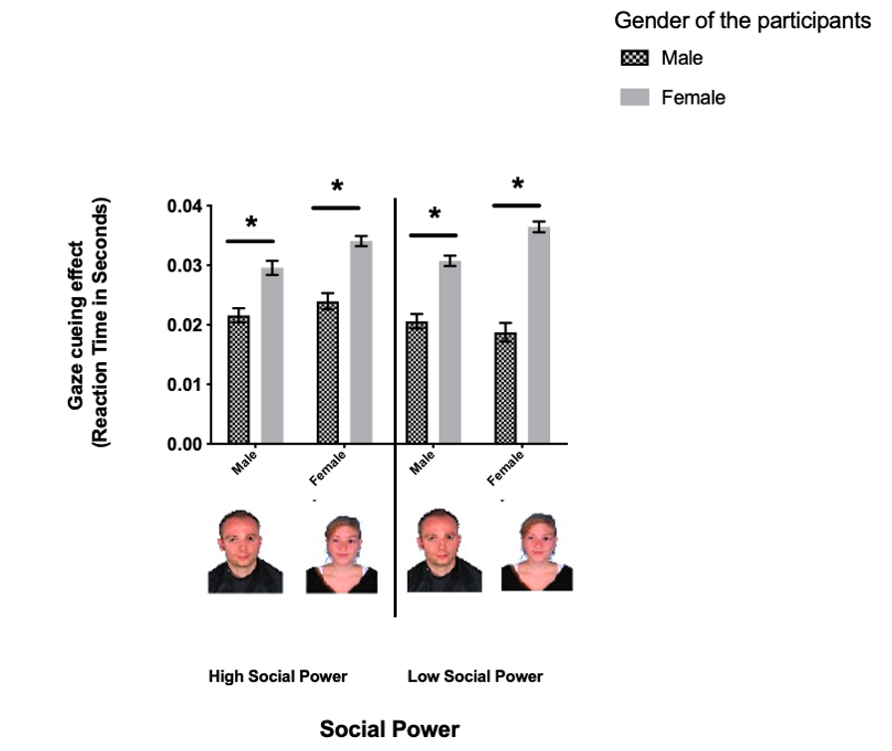
Note. Reaction time scores and standard error mean are presented. Gaze cueing effect on y axis calculated as mean RT of incongruent trials in seconds minus mean RT of congruent trials in seconds.
* p < .05.

Discussion
The purpose of this study was to measure the effect of perceived social power on the strength of the gaze cue effect in dangerous situations. Unlike the majority of previous research on social attention, we presented physically similar gazer faces in all social conditions to eliminate the visual representations of social relations. The results showed that, in line with previous research, the gaze cueing effect was significant, indicating that the task we used was able to measures the gaze cueing effect as participants were quicker to respond to congruent trials compared to incongruent trials. Overall, female participants showed a greater difference between incongruent and congruent trials (i.e., the gaze cueing effect) than male participants, in line with previous research. This enhanced gaze cueing effect was persistent in both the low and high social power conditions in female participants compared to male participants. The difference between males and females in high-danger conditions contradicts the findings of the Cui et al., (2014) study. Cui et al., (2014) showed that there was no difference between genders in high danger condition, but the gender difference existed in low danger condition. In the current study only the high danger condition replicated, and the current results discovered that males and females showed difference in Western-based culture. The difference between Cui et al., (2014) and the current study could be due to cultural differences. The current results shows that females from western Western-based did not change their social attention strategy in high danger scenarios. As a result, it can be argued that females from Western-based cultures may employ a social attention strategy in dangerous situations.
The gaze cueing effect was found in the present study, given that incongruent trials had significantly longer reaction times compared to congruent trials. Hence, consistent with the literature, the gaze cueing effect was present. Incongruent trials were significantly longer to react to compared to congruent trials, suggesting that observing another’s gaze shifts may evoke a similar reflexive shift in the observer. After showing that there is difference between incongruent and congruent trials, the gaze cueing effect was calculated by subtracting the mean reaction time of incongruent trails from the mean reaction time of congruent trials.
The present study aimed to investigate the potential interaction between the effect of social power in relation to the gender of the observer in gaze following in a dangerous scenario. Cui et al. (2014) discovered that female participants who were primed with low social power had higher reflexivity at gaze cueing effect compared to male or female participants who were primed with high social power. However, this occurred only when participants were primed with low danger scenarios such as a peaceful walk-in nature. Interestingly, this interaction diminished when participants were exposed to high danger condition - a scenario of an earthquake (Cui et al., 2014). The difference in the gaze cueing effect between males and females decreased in high danger scenarios compared to low danger scenarios condition. Importantly, Cui et al. (2014) demonstrated that this gender difference diminished when the perceived high social power condition was compared to perceived low power condition under a dangerous scenario. The authors argued that males and females have distinct strategies for allocating social attention; for example, when there is a danger in the environment, females shift their attention to themselves and pay less attention to social relations around them (Cui et al., 2014). In the current study, contrary to the findings of Cui et al. (2014), gender differences were consistent in both high and low social power conditions (after participants were primed with an office fire - a high danger scenario). In the current study, males and females therefore showed a difference in the magnitude of gaze cueing regardless of perceived social power.
The current study adds to previous research which has demonstrated that females are more sensitive to social cues when there is a competition in the environment (Ciardo et al., 2015). These findings, consistent with the literature, suggest that females tend to have a more reflexive gaze cueing effect compared to males (Bayliss et al., 2005) and this is not affected by social power or gender of the gazer in dangerous situations. In contrast to Cui et al. (2014), we have shown that females did not show a difference between the low-social power and high-social power conditions in relation to the gaze cueing effect in a dangerous scenario. An important detail is that Cui et al. (2014) collected data from participants from an Eastern culture, but our participants came from a Western culture. To our knowledge, the current study measured the impact of perceived social power on the gaze cueing effect in a dangerous scenario in the Western context for the first-time without visual categorization information about the gazer.
This cultural difference between the current and Cui at al.’s (2014) sample could explain the differences in the results. As previously explained, interdependent (i.e., collectivist) cultures require individuals to be more aware of people and the interaction between them (Cohen et al., 2015). The effects of perceived power may be magnified if participants are put in a context in which they have to rely on others in order to achieve their goals. Hence, the perceived social power might show enhanced importance in Eastern cultures as shown at Cui et al. (2014). However, the same social constructs would not show similar importance of context in a Western culture. Indeed, the current study showed that females show enhanced gaze cueing effect compared to males under both high-social power and low-social power conditions.
It has been suggested that humans have a tendency to locate more attention in high-status individuals. In a similar vein, Ohlsen et al. (2013) used 300ms - a relatively short SOA - to trigger the reflexive attentional shifts on gaze cueing and demonstrated that physical features of the face effectively manipulated the strength of gaze cueing. According to their findings, a dominant-looking male face has a stronger effect on gaze cueing in both threat and no-threat conditions, whereas a non-dominant female face only influences performance in a no-threat condition. They did, however, focused on the visual representation of dominance by showing dominant male face and non-dominant female as gazer faces. The perception of social status can be derived from verbal information as well as social information. Here, we discovered that without a visual representation of dominance, perceived social power did not effect on the strength of gaze cueing for both male and female participants. Based on the findings of this study, it is possible to conclude that when participants are exposed to visual stimuli, the effect of social power is more likely to be present. The strengthening effect of gaze cueing would be reduced if the physical features of the face were not manipulated and participants are not exposed to visual stimuli, at least in gaze cueing tasks with short SOAs.
Next, the findings indicated that female participants were more likely to follow the eye gaze of others regardless of their social status. The main effect of the gender of the participant was significant, suggesting that there was a significantly greater difference between congruent and incongruent trials among female participants and therefore they were more sensitive to social stimuli in a dangerous situation. Bayliss, Di Pellegrino, and Tipper (2005) showed a gender difference in gaze cueing, such that males had significantly weaker gaze-cueing effects than did female participants (see also Deaner, Shepherd, & Platt, 2007). Here, we replicated these results under conditions of high danger. Next, there was no interaction between gender and social power. The difference between male and female participants was persistent in all social power conditions. In addition, there was no interaction between gender of the gazer and gender of the participant; this suggests that females showed a stronger gaze cueing effect on both male and female faces compared to male participants.
Females tend to show enhanced sensitivity to social cues perceived by eye gaze compared to males. Females have been found to be more sensitive to social cues than males in various social contexts, including dangerous scenes, in the gaze cueing effect. It has been suggested that weaker responses from male participants can be explained through the theory of autism spectrum. According to Baron-Cohen (2003), males are more likely to display more autism-like traits in the normal population than females. And they speculated that there was a negative correlation between cueing effects and Autism Spectrum Traits (measured by AQ; Baron-Cohen et al., 2001). Thus, people with higher autism traits - which is more likely to be mal e- would have fewer social skills and tend to show a smaller gaze-cueing effect. The current study showed that female participants had a stronger gaze cueing effect compared to males; this is consistent with, and adds to, the literature. Unlike previous studies that used visual categorization cues to manipulate social power, this study focused on eliminating differences in the physical characteristics of the gazers, including their facial aspects, and measured the social aspect of social power. Previous studies have shown that facial dominance is effective in assigning social power to the gazer in both monkey and human populations; however, none of the studies has looked at the social relationship between the gazer and the observer. The current research has similar aspects to previous studies but offers additional attributes that indicate females are more sensitive to social cues in a dangerous environment unlike eastern context. Additionally, it is also unique as it was carried out for the first time in a Western context. As a result, this disparity in social sensitivity may not be universal and might be related to the social environment in which people were raised and lived.
Next, more female participants (40 females) than male participants (31 males) were present in the current study, as this is the case for the majority of the studies in the literature. Most psychology departments have easier access to female participants via departmental recruitment systems, resulting in most studies having more females than males. As repeatedly shown, females and males tend to demonstrate different strategies for social attention tasks. Most studies use female-based samples, and this is a major limitation in this field. Ultimately, this can affect the interpretation of outcomes, especially when building on hypotheses based on different studies. In the current study, the power analyses indicated that the sample size would need to be 78. Data from 31 males and 40 female participants were analysed after outliers were removed. The ratio was 44% and 56% respectively. The current study had a relatively equal sample ratio when compared to some other important studies in the literature. For instance, there were 4 male and 16 female participants (20% and 80%, respectively) in a recent research study of social gaze by Edwards and Bayliss (2019). Similarly, there were 12 male and 25 female participants (22% and 78%, respectively) in another influential study about group belonging conducted by Pavan et al. (2011). The influence of episodically learned social knowledge on the magnitude of the gaze cueing effect was investigated by Dalmaso et al. (2016) with 8 males 11 females (42% and 58 %, respectively). In the present study, the effect size was precalculated with G*Power and the male-female ratio is closer to being equal than previous studies on the gaze cueing effect. Future research would benefit from having an equal number of male and female participants and not having female-biased samples.
In the present study, it has been shown that there was a gender difference in the strength of the gaze cueing effect. There might be more than one explanation about why this difference occurred. Although results showed a clear difference between males and females on gaze cueing, it is not possible to determine why this difference was observed in this context. First, there was an emphasis on the danger in priming task, so the danger in the environment might trigger be triggering individuals to be hyper-alert. From an evolutionary perspective, it would be beneficial for the whole group’s survival if the males guide their attention to the environment to gather more information about where the danger is from and how to avoid it. Meanwhile, females in the group might be acting more sensitive to the social cue of others to provide security for the members of the group. From an evolutionary perspective, the explanation is overly simplified and explains only the biological ties of social attention. Additionally, a categorical distinction based on gender (male/female) may ignore the influence of important individual differences. Hence, it is not possible to assess whether other individual differences, such as self-esteem (Wilkowski et al., 2009) and introversion/ extraversion traits (Ponari et al., 2013) or autistic traits (Freeth et al., 2013), which have already been identified as related to the strength of gaze cueing, might also explain the gender difference. Future research should benefit from addressing this issue by focusing on individual differences across the population rather than focusing solely on gender.

Limitations and future research
First, we used an office building as a scenario that would represent a relatively familiar and safe environment for most participants. For the safety of participants’ psychological state, the scenario of fire in an office building was used; however, it is possible that other imagined scenarios where participants would feel a real threat to their physical well-being may have a stronger effect. Although we asked our participants to imagine the dangerous scenario by adding the possibility of a fire in the building, this scenario might not trigger the survival instincts like a scenario of an earthquake. Indeed, (Cui et al., 2014) used an earthquake scenario but a real earthquake occurred in China at the time of the experiment. Their participants had already been exposed to the dangers of natural disasters or had been primed with the danger by the media. The experimental priming manipulation used in the current study did not have the same connotation than that used by Cui et al. (2014). The current study measured the effectiveness of the primary task by asking participants about details of the task and checking to see if they remembered important details. Participants were asked if they were the leader or one of the followers, if the scenario was an office fire or a hike, and if they remembered correct faces that they had previously been shown to them. Participants who were unable to answer these questions correctly were excluded from the study. So, the future research would benefit from different scenarios based on a current natural disaster or environmental dangers.
Next, unlike previous studies, in the current study, the relationship between the participants and the cueing face was altered with a priming task. Physical differences in faces have been shown to act as categorisation cues. Research suggests that the visible cues of threat alter the strength of gaze cueing when the level of threat or danger in the context is 'sufficient'. Previous studies have examined the effect of danger on social attention by manipulating the level of danger with the facial expressions of the gazer. It is not clearly defined whether the effect of this visually informative social stimuli is related to low-level biases or more high-level cognitive biases. In the present study, the visual categorisation cues were eliminated, and we focused on the relationship between the gazer and the observer without clear visual signifiers. Risko et al., (2016) proposed that laboratory-based social cognition research observes people's behaviour through computer interaction. This allows the researcher to control the environment and eliminate any confounding variables, but it also creates a barrier between the participant and the stimuli they are observing. Participants are not interacting with real people, and not worried about how they will be perceived by another person. Yet this style of experimentation is generally considered to be appropriate for measuring real-world social interactions. Participants may be encountering real pictures, but they are aware that those pictures do not have agency. Participants do not need to be concerned about what their own gaze is communicating to the image when looking at a picture of a person as a social stimulus. This is also called the 4th wall problem (see, Risko et al., 2016 for details) meaning in real life eyes have a dual function both gather information as well as communicate it. The manipulation of the current study offers the possibility that it is not necessary to leave out the relational part of the human interactions in social attention studies conducted in a laboratory-based environment. This kind of manipulation of the social power was important as it gave the researchers an alternative method of analysing the plausibility of the study’s hypothesis.
This study controlled the gender of the gazer. There was no significant effect of gender of gazer on the strength of gaze cueing effect. Although the literature indicates that physical characteristics of the face have an effect on gaze cueing (Hungr & Hunt, 2012), there is no standard procedure across studies for social attention research. This may create complications for making interpretations across studies. Scientists would benefit from the current study's design when selecting appropriate stimuli for future research, because it has been previously demonstrated that the physical characteristics of the face image have an impact on the gaze cueing effect, rather than manipulating other socio-cognitive variables.
Finally, it's possible that our priming task did not produce a large enough effect on social power manipulation. There could be two main reasons for this. First, the current study used a semantic knowledge based priming task. Participants were instructed to memorize and remember the faces of group members, as well as whether or not they were the leader or a follower. However, there was no experiential information about the effects of the social power and no first-hand knowledge of the implications of social power. Secondly, we have no low threat condition unlike Cui et al., 2014), which could be considered to be a study limitation. This study answers an important question about whether visual information has an effect on its own or in combination with social relevance depending on the context. At least when participants were primed with our task, social attention on danger context is related to visual information. The effect of danger should be studied in conjunction with emotions, which may be a better representation of mental representation (Dalmaso et al., 2020). Lastly, further research should consider adding low-threat scenario for better comparison and understanding the effect of danger in social attention.

The Effect of Observation of Leadership on the Strength of Gaze Cueing

Introduction
Observers can learn to attend to or avoid something in the environment by following the eye gaze of others. They can also learn to attend to the mental state of others by following the eye gaze of others (as discussed in Chapter 1). The gaze cueing paradigm, which has been proposed to represent a reflexive shift in attention caused by the automatic code of observed gaze direction, can be used to investigate gaze following (Driver et al., 1999; Friesen & Kingstone, 1998). This reflexive shift of attention (gaze cueing) can be affected by social information about the gazer, a phenomenon known as socio-cognitive information. That is, social cues can be used to manipulate the information about the gazer, and it can influence the magnitude of gaze cueing. For instance, social cues have been shown to affect gaze cueing when the gazer`s face is familiar (only in females; Deaner, Shepherd, & Platt, 2007; see also Frischen, Bayliss, & Tipper, 2007) or belongs to a leader from one’s own political group (Liuzza et al., 2011).
Furthermore, Dalmaso et al. (2014) found that when social information was provided by manipulating visual features of unfamiliar faces, high social status faces had a greater gaze cueing effect (GCE) than low social status faces. Although extensive research has been conducted on the effect of gaze cueing, very few of these studies have focused on group context. It is unclear whether the strength of attentional shifts measured by gaze cueing is affected by a person taking different roles in a social group environment. In the previous study in this thesis, (see Chapter 3), we investigated the effect of the social status of the participants (same or higher social status to gazer) in a group context using a priming manipulation. In the current study, instead of using the priming method to manipulate social status in a group context, the gazer's previous behaviour patterns (gazer behaving as a leader or follower) are manipulated and the effect on the GCE observed. This may reflect more realistic settings in which we gather information about the social status of others (Capozzi et al.,2016).
Personal differences such as gender (Bayliss et al., 2005), autistic-like traits (Freeth et al., 2013) might influence this effect. The influence of social interactions on the GCE may differ between males and females. For example, on average, women tend to show a stronger gaze-cueing effect than men and familiarity enhances the gaze cueing effect only in female participants (Bayliss et al., 2005). Gender differences in the effects of familiarity, a type of social knowledge, on gaze cueing may reflect the greater adaptive significance of social information for females compared to males (Deaner et al., 2007). Also, Bayliss et al. (2005) showed that the gaze cueing effect was inversely associated with scores on the Autism Spectrum Quotient (AQ). It has previously been reported that there are differences between low and high AQ groups in several cognitive capacities (Lombard, 1998) as well as differences in social learning (Hudson et al., 2012). Hudson et al. (2012) claimed that the low AQ group learned and exhibited the social dispositions implicitly, whereas the high AQ group did not. They reported that those with a high AQ had faster overall reaction times to gaze cues than those with a low AQ. This is consistent with previous research on the impact of autistic traits on gaze cueing. Individuals who were typically developing were able to process additional information from the gaze direction of others, allowing them to observe or interpret the intentions and mental states of others (theory of mind). With autism spectrum disorder (ASD), this additional processing is reduced (Driver et al., 1999; Ristic & Kingstone, 2005). Given that this reduced processing affects people with ASD, it is reasonable to assume that it also affects people with high AQ, even if to a lesser degree, given that Bayliss and Tipper, (2005) noted that higher AQ scores are associated with smaller gaze cueing effects. Studies have shown gender differences in the strength of the gaze cueing effect but autistic traits (which impact on social attention) also need to be considered, since the prevalence of autistic traits in females is lower, and the tendency to be more responsive to social cues may be related to lower autistic traits. Taken together, these personal differences may influence the shift in social attention in a group context, particularly when gathering social information by observing past behaviours of group members. This is particularly important since autistic traits may affect the understanding of social cues based on group members' behaviour during social interactions.
Several social factors can influence gaze cueing, such as when the gazer face is rated positively to ingroup members (Pavan et al., 2011) or to a gazer with a similar political view (Liuzza et al., 2011), or when their gaze is regarded as more informative because the gazer is perceived to be trustworthy (Süßenbach & Schönbrodt, 2014) or when the gazer in a powerful position (Foulsham et al., 2010). Interestingly, the automatic tendency to pay attention to higher-ranking individuals' gaze cues appears to be involuntary in both humans and monkeys, indicating that it serves an evolutionary important function. This pattern is confirmed by the fact that low-status people receive less attention than high-status people (Foulsham et al., 2010; Pavan et al., 2011). Even when faces are unfamiliar and the status information is implied via fictional career information, the gaze of high-status individuals create an enhanced gaze cueing effect (Dalmaso et al., 2012). The enhanced attentional effect of gaze cueing has been observed both with a visual indication of social status as well as reputation-based status titles (Dalmaso et al., 2014), suggesting that it is highly salient.
Previous research has demonstrated that the gaze following system can be tuned to recognize a specific identity of the gazer when certain conditions are met and a strong memory representation is present (Frischen & Tipper, 2006). These effects are observed in response to both observable status cues (like visual cues) and reputation-based status titles (like social cues) (Koski et al., 2015), indicating that status cues are very important. GCE appears to be involuntary in both humans and monkeys, reflecting an automatic tendency to attend to the gaze cues of higher-ranking individuals. In humans, the advanced gaze of high-status individuals influences subtle immediate shifts in attention even when faces are unfamiliar and status information is implied via fictional career information (Dalmaso et al., 2012). It is unknown whether status information becomes embodied in our sematic representations of others, influencing our social attention and behaviour on a more implicit level.
Gaze cueing is typically measured individually in a lab environment, in front of a computer which lacks the social nature of human interaction. People react differently to real people than they do to images of people. There is a difference between looking at someone's photograph and meeting them in person. Laidlaw et al., (2011) found that when participants were in a chair with a stranger sitting across from them, they were less likely to look at that person than to look at an empty chair. However, when the image of that person sitting in a chair was displayed on the screen, the image of the person swayed the participants. Individuals looked at the image much more when they were looking at a computer screen because they did not need to be concerned about their own gaze communicating to the image when looking at a representation of a social stimuli. When the stimuli are real people, this possibility is not available.
In real-world settings, we automatically observe who follows the eye gaze of others and who causes eye gaze shifts. In a social circle, we observe the "leader" and the "follower," since it is important to detect who is the initiator and who is the respondent in a dynamic social context. For instance, if we observe a person who constantly leads the gaze of others, it is more likely that the same person would serve as a more powerful cue for our attention as well. The gazer`s previous behavioural patterns might be an important social cue in the later encounters. Indeed, a study conducted by Capozzi, Becchio, Willemse, and Bayliss, (2016) suggested that the role played (leader or follower) in previous social attention interactions modulated later gaze encounters, thereby demonstrating that person information derived from observed social orienting episodes modulates supposedly low-level social orienting mechanisms. Capozzi et al. (2016) found that faces that were previously observed as leaders elicited a gaze cueing effect in later social attention encounters, whereas faces that were previously observed as followers did not. The researchers primed participants by showing leader faces that were constantly followed by two other faces; however, the follower faces moved their eye gaze in the same manner as the other ingroup members and followed the gaze of others in the group during the experiment. Individuals who explore the environment independently, thereby attracting others' attention, are later used as gaze cues as a potentially trustworthy source of information. Individuals who only pay attention to other people, on the other hand, are eventually ignored. Capozzi et al. (2016) showed that people do not follow the gaze of people who follow crowds. As a result, observing a gazer's previous behavioural patterns may influence social attention shifts in subsequent encounters, as previous observation of an identity may be coded as a social cue for later social interactions. Rather than manipulating physical appearance (Olsen et al., 2010) or explicit information about the gazers (Dalmaso et al., 2012b), this was demonstrated through an evocation of leadership based on the demonstrated ability to explore the environment. The social attention system appears to work primarily through the processing of visual social cues (Bayliss et al., 2011; Stephenson et al., 2021). It is possible that it is based on the behavioural history of the identities, akin to the theory of mind.
Familiar faces briefly hold attention due to their social relevance. As a result, shifts in attention are slower, even though the direction of eye movements is detected faster in familiar faces. This is because of slow disengagement. Females, according to Bayliss et al., (2005), have a stronger gaze not only to social cue stimuli (like faces), but also to arrows. Bayliss et al. (2005) proposed a general gender difference in directional attentional processing (see also, Merritt et al., 2007; Ristic & Kingstone, 2005; Tipples, 2008). Because eye gaze and head position are processed even without awareness, any facilitation or slowing caused by familiarity may be acting upon a very early stage of processing (Gobbini et al., 2013). Slower response to targets with personally familiar face cues compared to unfamiliar face cues is due to the personally familiar face holding attention rather than due to slower eye gaze shifts (Chauhan et al., 2017). Slower attention disengagement from familiar faces overrides any disadvantage of faster detection of gaze changes in familiar faces versus unfamiliar faces (Chauhan et al., 2017). The cue and target should be 300 ms or less apart; if its longer than that, the effect fades. So, exogenous cueing of location is a short-term effect. The early attention network is more sensitive to stimuli in attended space than in unattended space.
Decoding social cues to successfully reorient attention in the environment is also related to observers’ gender. Interestingly, this gender difference is not confined to social cue stimuli, and it also observed with arrow cues. Bayliss et al., (2005) proposed a general gender difference when it comes to attentional processing of directional stimuli (see also, Merritt et al., 2007; Ristic & Kingstone, 2005; Tipples, 2008). It is possible that males are less sensitive to central cues. However, this is a categorical distinction and, as a result, does not mean that every female is more social than every male. Indeed, there might be other confounding variables which have been overlooked. For example, females and males might use different strategies in general, in computer and in real-life. The impact of other variables, such as AQ scores, should also be considered.
Individuals with high AQ scores have difficulties empathizing, i.e., recognizing the emotions and thoughts of others and responding appropriately (Baron-Cohen et al., 2001). Furthermore, Baron-Cohen et al. (2001) also suggested that individuals with higher autistic traits tend to systemize, i.e., the drive to analyse and construct a system. While some research has found a negative correlation between systemizing and empathizing (Goldenfeld et al., 2005), one study showed that when a mechanical (systemising) task was converted to an empathising task, performance was significantly improved (Bowler et al., 2005). For example, patients with schizophrenia display some abnormalities to the gaze direction of others. They show difficulties in disengaging from gazing at the location, once joint attention is established (Seymour et al., 2017). It is explained by the inferential concept that increasing the amount of effort required to draw inference improves one's ability to distinguish between inferred information and perceived information (Alba, 1984). Even though the individual understands that the threat does not exist, they react to it emotionally. This means that a person's thoughts become preoccupied with imaginary possibilities that do not exist in reality. Inferential confusion was emerged from the observation that people distrust sensory data in favour of imagined possibilities. For example, a person may wonder “did I lock my door?”. When they reflect on the occurrence, they remember closing the door and turning the key in the lock which is sensory-based information. However, they also consider the imagined possibility such as the lock mechanism malfunctioning. As a result, the inferential effort is increased when there is a decrease in recognition confidence and the inferential effort increases. Therefore, when there is sufficient and strong inferential implication, gazing information can lead to the generation of elaborative inferences by the individual.
The inferential confusion questionnaire-expanded version (ICQ-EV) is the main measure that has been used to assess inferential confusion, which occurs when a person confuses internal input with the external input due to subjective reasoning. Aardema, Emmelkamp, and O’Connor (2005) suggested that inferential confusion makes an individual confuse imagined possibilities with actual probability and it contributes to the distorted reasoning processes. The inferential confusion is higher in people suffering from obsessive-compulsive disorder compared to non-clinical and anxious controls. Therefore, it is critical to distinguish the context in which orientation of attention occurs because gaze cueing effects may be influenced by the coherence or perceptions of the target visual. According to Pierno et al. (2006), gaze direction does not assist autistic children in inferring the likely actions of others. Importantly, by 12 months of age, infants expect human eye gaze to convey referential information and comprehend the referential nature of the gaze cueing action (Moll & Tomasello, 2004). This implies that infants anticipate gaze to convey information about the object's location (i.e., referential information) and that they mentally understand that others see other things. In infants and monkeys, gaze following has been shown to have a function in inferring mental states (chimpanzees successfully followed human gaze direction behind barriers). Chimpanzees compete for food either in the open or behind barriers, implying that they have an understanding of what other people can and cannot see (Tomasello, Hare & Agnetta, 1999). Recent research has revealed that not all adolescents with ASD have difficulty inferring mental states (Back, 2019). Nonetheless, this has significant implications for research practices focusing on social cognition on autistic traits in the general population. Dawson, Kingstone and Foulsham (2021) demonstrated that participants attach minds to representations of other people's gaze (not just images of their eyes) and to the stimuli to which representations of eyes are directed, and that this attribution of mind influences where the participant looks. As a result, the findings suggests that the gaze following is related to inferring information about others but in which context it is not clear. Therefore, it is important/preferable to measure inferential confusion tendencies (Aerdema et al., 2005).
On the other hand, the Autistic Quotient test (AQ) is the mostly used analytical scale for testing autistic traits, although some of its functionalities are questionable (Lundqvist & Lindner, 2017). It is critical to consider the AQ because it is the most commonly used measurement of autistic traits (Lundqvist & Lindner, 2017), although its factorial validly has been questioned. Baron-Cohen (2001) suggested a unidimensional structure of the AQ across ASD and neurotypical samples. However, the proposed unidimensional model has not been replicated. For example, Lundqvist and Lindner (2017) showed that the AQ did not meet the criteria of a unidimensional measure of autistic traits. Lundqvist and Lindner (2017) translated the AQ into Swedish and administered it to 349 adults (130 ASD, 219 neurotypical participants). They used Roshe models to test whether the scale works similarly in men and women with and without autism spectrum disorders. They showed that it did not meet the criteria of a unidimensional measure of autistic traits.

Aims and hypothesis
The overall aim of the current study is to investigate the possible relationship between social attention shift and leadership in a group context where social information is obtained based on the observed social interactions within the group. This prediction was based on previous research on gaze cueing has also shown that facial cues such as trustworthiness, likability, attractiveness, and dominance of the observed face influence gaze cueing. which has indicated the mechanisms underlying reflexive gaze cuing are sensitive to facial cues of dominance because such a differential gaze cuing promotes a desirable outcome from encounters with dominant individuals (Jones et al., 2010). First, it was predicted that that leader faces would be perceived as more dominant, while follower faces would be perceived as more likeable. Mason, Tatkow, and Macrae (2005) found that (female) faces shifting their gaze toward the observer were rated as more attractive by male participants but not by female participants. Second, it was predicted that, the perceived facial cues gathered from the gazer appear to affect gaze cueing by creating longer reaction times (Süßenbach & Schönbrodt, 2014). We therefore also asked participants to rate each face they saw as a "leader" or a "follower" because leaders vs followers have different impact on the GCE.
In line with Capozzi et al. (2016), we predicted that observation of previous behaviour would significantly affect later social attention encounters. Capozzi et al. (2016) demonstrated that faces perceived to be followers did not elicit a gaze cueing effect in subsequent social attention encounters, whereas faces perceived to be leaders did. Furthermore, we also predicted that gender of the observed face will have an effect on gaze cueing, since women's appearance gathers more attention in mixed-gender social groups (Amon, 2015). According to Bayliss et al, (2005), the inhibition effects in facilitation cueing are unaffected by gender as a response to peripheral cues. However, it is difficult to determine whether gender differences exist within IOR (inhibition of return), particularly in response to gaze cues. To measure this, we created a mixed gender group by displaying a “leader” or a “follower” face and two other group member faces, one of which was always male, and the other was always female (3 in total). We predicted that the gender of the observed face would influence social attention.
We also predicted that there will be a relationship between AQ and ICQ-EV scores, given that they may assess overlapping attention system and social attention problems. Studies comparing infants' reactions to human and robot gaze provide more evidence that infants expect human eye gaze to convey referential information. 12-month-old infants reliably followed both human and robot gaze, but only when it was cued by human gaze did, they reliably predict an object at the target location (Okumura et al., 2013). Infants expect human eye gaze to convey referential information. Hence, inferring information is essential part of human social attention system. To test this notion, we asked our participants to fill out a questionnaire called inferential confusion. Autistic traits are generally researched with questionnaire scores which is consistent and reliable; however, the social attentional difficulties may be caused by more than one systematic difference of the individual. In a healthy population, the effect of inferential confusion on the social attention system has never been tested and this is the first time this questionnaire used in this manner.
This study used a group context which would help with the understanding of the real-world interactions. Being influenced by ingroup members who follow the specific individual's eye gaze would be an important and adaptive function to avoid danger and detect self-relevant stimuli in the environment. The overall goal of this study therefore was to investigate the possible link between social attention shift and leadership in a group setting where social information is obtained based on the observed social interactions within the group. Moreover, personal differences in autistic traits and inferential confusion might affect the social attention shift in a group context, especially when gathering social information by observing past behaviours of group members, since because autistic traits and inferential confusion might interfere with understanding social cues based on group members’ behaviour during social interactions.

Methods

Ethics
The Research Ethics Sub-Committee of the Department of Psychology, University of Sheffield approved the protocol for this study. Participants were recruited using ORPS (online research participation system). Participants were fully informed verbally and with a written information sheet. A written informed consent was obtained from all participants prior to the start of the experiment. At the end of the study, all participants received a debriefing form with details on the nature of the study.

Participants
There were 44 University of Sheffield psychology undergraduate students who took part in the study. All participants were females aged raging from 19 to 32 (Mean Age = 19.84, SD = 0.89). All participants were unpaid but received course credit for their time. All participants had normal or corrected to normal vision.

Apparatus and Stimuli
Stimulus presentation and the data collection were obtained from PsychoPy presentation software on a 23-inch monitor (1920x1080; 60Hz refresh rate) (Peirce, 2007). This program recorded demographics, reaction time (RT), accuracy ratings and faces rating measurements. Participants completed two questionnaires: The Autism Quotient (AQ) and Inferential Confusion Questionnaire-Extended Version (ICQ-EV) using Qualtrics (Qualtrics, Provo, UT).

The Autism Quotient (AQ)
The AQ is a self-report questionnaire that asks 50 Likert-type questions about social-communicative skills on a scale of 1 (strongly agree) to 4 (strongly disagree) (Baron-Cohen et al., 2001). In this questionnaire, each of the 50 items is coded by either 1 or 0 (see Baron-Cohen et al., 2001 for details). Higher scores indicate a greater frequency of autistic traits.
It is critical to understand that AQ is not a diagnostic tool for autism spectrum disorder (ASD). It is used in the neurotypical population, people who do not have an autism diagnosis, to measure the association with autistic traits. Ozonoff, Rogers, Farnham, and Pennington (1993), described this as a sub-clinical group of people who have different levels of traits associated with autism. Autism Quotient (AQ) is defined by Baron-Cohen, Wheelwright, Skinner, Martin, and Clubley (2001) as a brief self-administered instrument to “measure the degree to which an adult with normal intelligence has the traits associated with the autistic spectrum on the continuum from autism to normality”.
The AQ has found to be reliable both in terms of internal reliability and test-retest reliability (Baron-Cohen et al., 2001; Hoekstra et al., 2008). Cronbach’s alpha for the AQ has been found to be .81 for a student sample and .71 for the general population sample (Hoekstra et al., 2008). The questionnaire has a cut-off score, which is 35 and 38 for males and females, respectively. A score of more than 32 is taken to indicate a higher likelihood of having a clinical diagnosis of Autism Spectrum Disorder (Baron-Cohen et al., 2001) (For the full list of statements in the AQ, see appendix).
The AQ consists of five subscales with 10 items in each subscale, covering five different domains associated with the autism spectrum: social skills; communication skills; imagination; attention to detail; and attention switching/tolerance of change. These five subscales have high internal consistency (Baron-Cohen et al., 2001). However, factor analysis results have been inconsistent. Austin (2005) suggests that AQ consists of three subscales: social skills, detail/patterns, and communication/mind reading. A later study suggested that the AQ has two subscales: social interaction and attention to details (Hoekstra et al., 2008). As a result, while the AQ has high internal consistency, there is disagreement on the number of subscales it contains. In this study, we use the original five subscales proposed by Baron-Cohen et al. (2001). See Table 6 for these subscales.

Table 6
Number of items and example questions from each of the five subscales of the AQ.
Subscales of the AQ | Number of items |  | Example questions
Social Skills | 10 | “I prefer to do things with others rather than on my own.”
Attention Switching | 10 | “I prefer to do things the same way over and over again.”
Attention to detail | 10 | “I often notice small sounds when others do not.”
Communication | 10 | “Other people frequently tell me that what I’ve said is impolite, even though I think it is polite.”
Imagination | 10 | “If I try to imagine something, I find it very easy to create a picture in my mind.”

Inferential Confusion Questionnaire-Extended Version
The Inferential Confusion Questionnaire-extended version (ICQ-EV) was first developed by Connor and Robillard (1995) and revised by Aardema et al. (2005) and Aardema et al. (2010). It measures the inferential confusion of senses. The ICQ-EV uses self-reported Likert-type scales ranging from 1 (strongly disagree) to 6 (strongly agree). The ICQ-EV (Aardema et al., 2010) is a 30-item revision of the original 15-item ICQ (Aardema et al., 2005). Aardema et al. (2010) administered a 54-item version of ICQ by adding new items to expand its components. As a result of a frequency and principal component analysis, the 30-item ICQ-EV was taken from the 54-item ICQ. Therefore, this study used the 30-item ICQ-EV.
The ICQ-EV is a one-dimensional measure of inferential confusion used in both clinical and non-clinical populations. People with OCD score significantly higher than people with an anxiety disorder and non-clinical controls, thus the questionnaire appears to be a one-dimensional scale that lies in a continuum in the population. Higher scores indicate a tendency to have inferential confusion, which is the confusion between imagined possibilities and the actual probability of an event based on the senses. Therefore, people who score higher on this scale have a higher tendency to act as if the imagined possibility is real, where imagination overrides the senses. The ICQ-EV has been tested for internal consistency and retest reliability. It shows a good internal consistency (coefficient alpha = .97 for an OCD group and = .96 in a community group) and excellent 12-week test-retest reliability (r = .90). It has also been found to distinguish OCD patients from both students and non-OCD anxiety patients (Aardema et al., 2010). (For the full list of statements in the ICQ-EV, See Appendix C).

Faces and target objects
The face and target stimuli set was obtained from the previous work of Dalmaso et al. (2016). The stimuli set consisted of 12 faces created with Poser 9, Smith Micro Software. There were six male and six female faces. All faces had a neutral emotional expression. Each of the 12 faces had nine versions with different angles; either looking towards the right, left or central part of the screen. Furthermore, the faces could be located on the left, right, or center of the screen (in relation to other faces) (see Figure 12). Twelve images were used during the learning phase of the experiment, four of which (two males and two female) were used later during the face rating and testing phase of the experiment.
For each participant, one male and one female face were chosen as the “leader” identity and one male and one female were chosen as the “follower” identity. The "group" was made up of the remaining eight faces. Participants saw three faces (of mixed gender) at each trial during the learning phase (Phase 1). In the leader condition, the leader’s face looked at one side of the screen first, and the remaining two faces followed the leader’s face. The leader face either looked at the target (congruent condition) or looked away from the target (incongruent condition). In the follower condition, the follower’s face turned its gaze and head in the same direction after another identity. The leader or the follower identity remained the same but the other two faces (group members) changed throughout the trials. These leader and follower identities were used later used in phase 3 of the experiment by themselves without the rest of the group faces (see Figures 12 and 13).

Figure 12
Example of 9 versions of a face with all angles
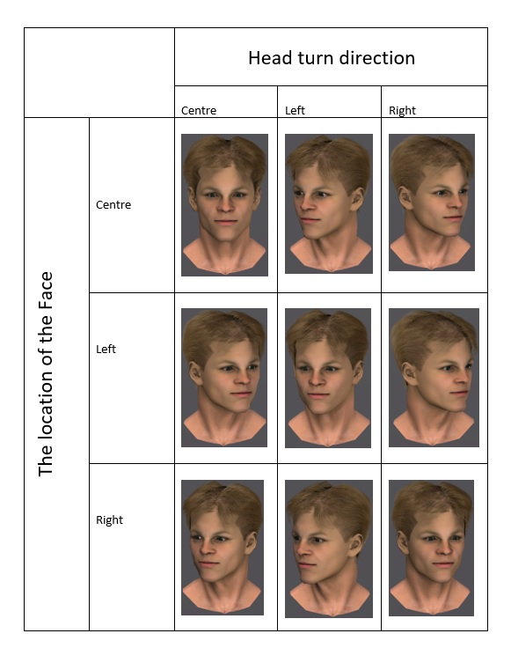

During the testing phase, four faces were chosen for the gaze cueing task. In this task, the head remained still, while the eyes either moved to the right or left side of the screen. In order to achieve this, the four faces were modified using Photoshop cs6. Adobe Photoshop CS6 was used to cut the irises of each image then paste the irises to the corners of the eyes to produce left and right eye gazing.
There were three different objects used only during the learning phase of the experiment. These objects included a cube, a cylinder and a sphere. The position of the objects was randomized and counterbalanced across trials. They were always positioned at the bottom of the screen. An upright “T” served as a target and was positioned at the top of one of these objects.

Design
Each participant completed the experiment in one sitting. At the start of the experiment, participants were informed about the study procedure and given time to ask questions. They were asked to sign a consent form after verbally agreeing to participate. They were then asked to complete phases one, two, and three of the experiment, which took 35-40 minutes in total. After that, they took a 5-minute break before moving on to the final phase of the experiment (phase four), where they completed two questionnaires.
A within-participant design with within-participant factors of leadership (leader/follower) X gender of the gazer (male/female) X congruency (congruent/ incongruent) were used. Each participant completed the same task. In addition, they all saw one male and one female identity for the “follower” condition and one male and one female identity for the “leader” condition. The only difference between them was which face they saw. We wanted to eliminate the effect of physical features of the face and only measure our manipulation of leadership. As a result, the faces were counter-balanced throughout the experiment. For example, some participants saw Female1 as the “leader” identity, while others saw Female2 as the “leader” identity.
Task1: Learning Phase. At the start of the experiment, participants completed the learning phase. PscyhoPy collected reaction time and accuracy ratings for this part of the experiment. At the start of each trial, three faces were seen fixating on the central object at the bottom of the screen for 1500 ms. There were two conditions in this phase. In the “Leader” condition, which was 50% of trials, the “leader” always moved first, turning his/her head towards the left or right direction for 300 ms. This was followed by the two other identities, the “group” turning in the same direction. In the "Follower" condition, the "group" turned their heads first, either to the right or left, for 300 ms, followed by the "Follower" identity turning towards in the same direction. The direction that they looked was either left or right and fully randomized. 50% of the trials looked left, while 50% of the trials looked right. Three objects (a cube, a sphere, and a cylinder) were positioned at the bottom of the screen and randomly varied in position across all the trials. All identities gazed in the same direction at the end of 300 ms, then a target appeared. This target appeared on top of one of the objects, which was located on either the left or right side of the screen, but never on the object that appeared in the middle of the screen. The target was cued (eyes looked in the direction of the target) by the eye gaze 50% of the time and uncued (eyes looked away from the target) 50% of the time (also fully randomized). This screen remained for 1500 ms, but the target disappeared after 500 ms (see Figure 14). The main identity (leader or follower) was placed at random on the left, right, or center of the screen. Two male faces and two female faces were chosen to be either the “Leader” or the “Follower”. All participants had the same four faces, but the role they played (leader or follower) was randomized. However, the arrangement of the faces that the participants saw was pseudo-randomized.
Participants first saw an introduction screen explaining what to do in the study. They were asked to press “” or “” using the keyboard to indicate the direction of the target. They were asked to press the right or left arrow as quickly and as accurately as possible. They were informed that 30 practice trials would be completed first, in which the participants saw a leader or a follower identity, positioned on the left, right or at the centre of the screen with 5 repetitions (identity 2 X placement 3 X repeats 5). After which they saw another information screen letting them know that the experiment was starting and would contain 240 trials. These 240 trials, all of which were randomized, included congruent versus incongruent, leader versus follower, and male versus female gazer conditions. The practice trials were not recorded and completed only for participants to understand the task. The overall learning phase was approximately 25 min, including the practise trials.

Figure 13
Example of leader versus follower trials, congruent versus incongruent versions and head turns.

 | Leader Condition
Congruent trial | 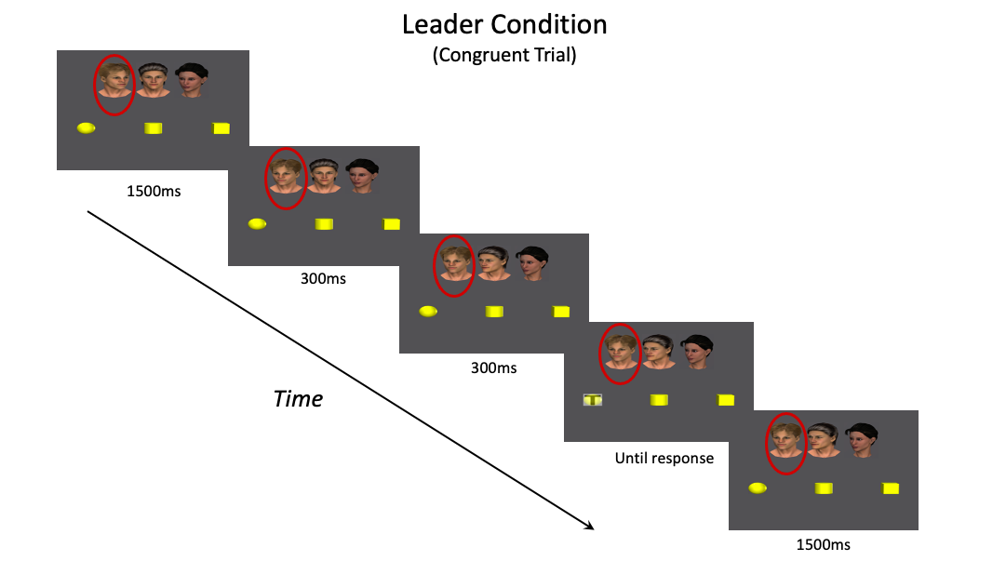
Incongruent trial | 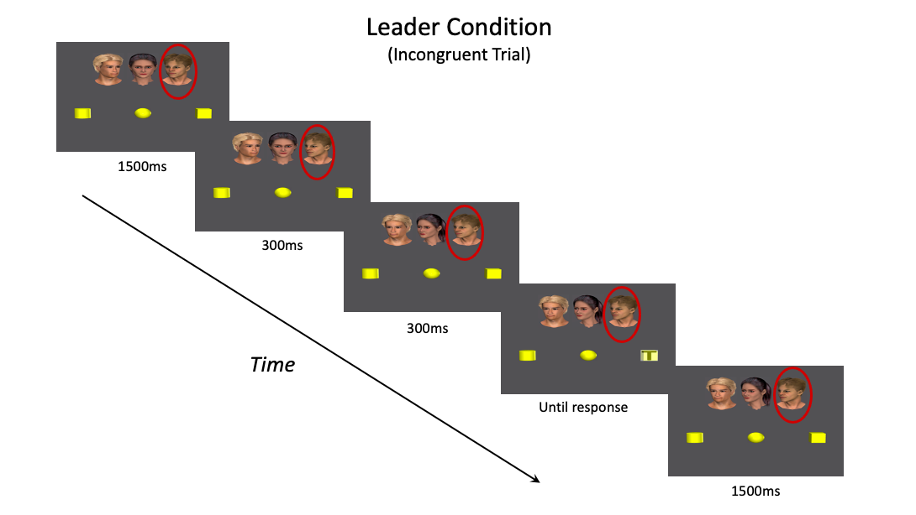
 | Follower Condition
Congruent trial | 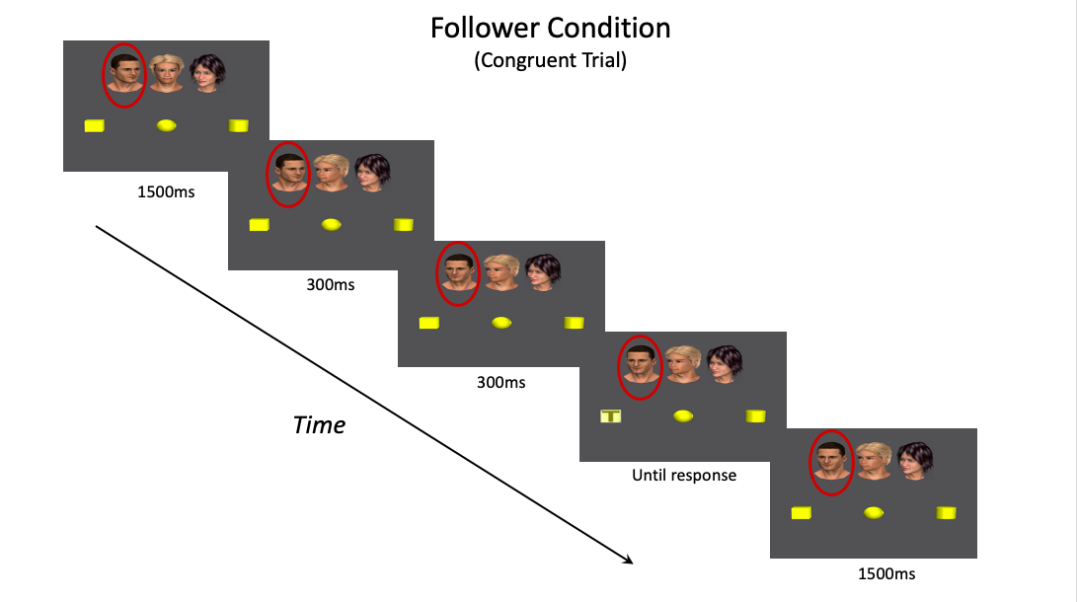
Incongruent trial | 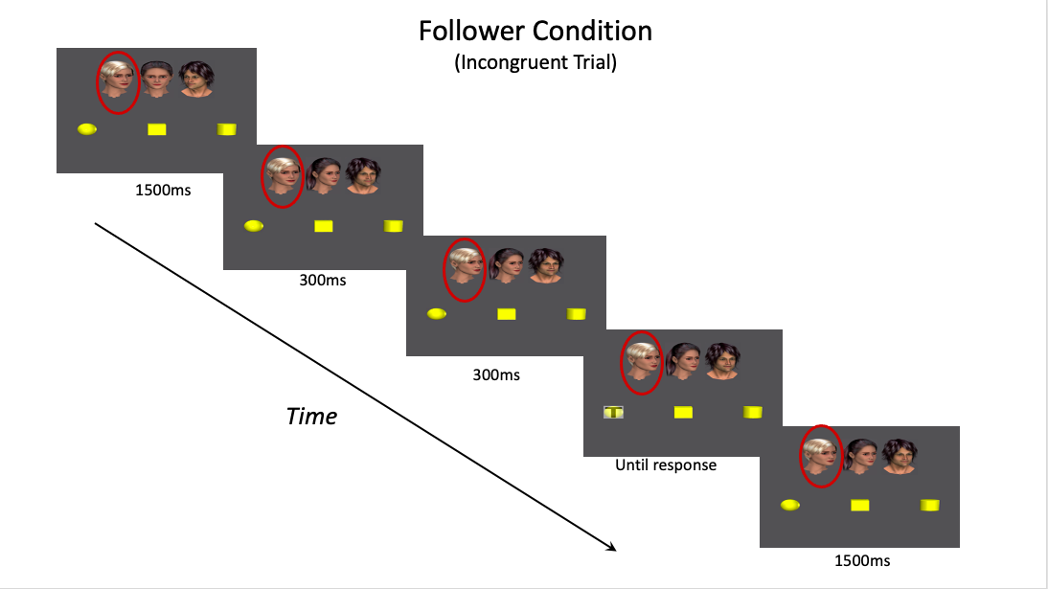

Task 2: Face Ratings. Next, participants rated each of the four faces that acted as a leader and a follower (1 male, 1 female each). PscyhoPy collected reaction time and rating scale responses for this part of the experiment. They were asked to rate each identity on a 1-7 scale based on how "Dominant," "Attractive," "Trustworthy," and "Likable" it was. The four chosen faces were presented in a fully randomized order. Participants were asked to do this by clicking the scale design on the screen using the mouse (see Figure 14). Higher scores indicated a higher perception of ratings for “Dominant”, “Attractive”, “Trustworthy” or “Likable”, respectively.

Figure 14
Example of face rating trials with leader or follower faces

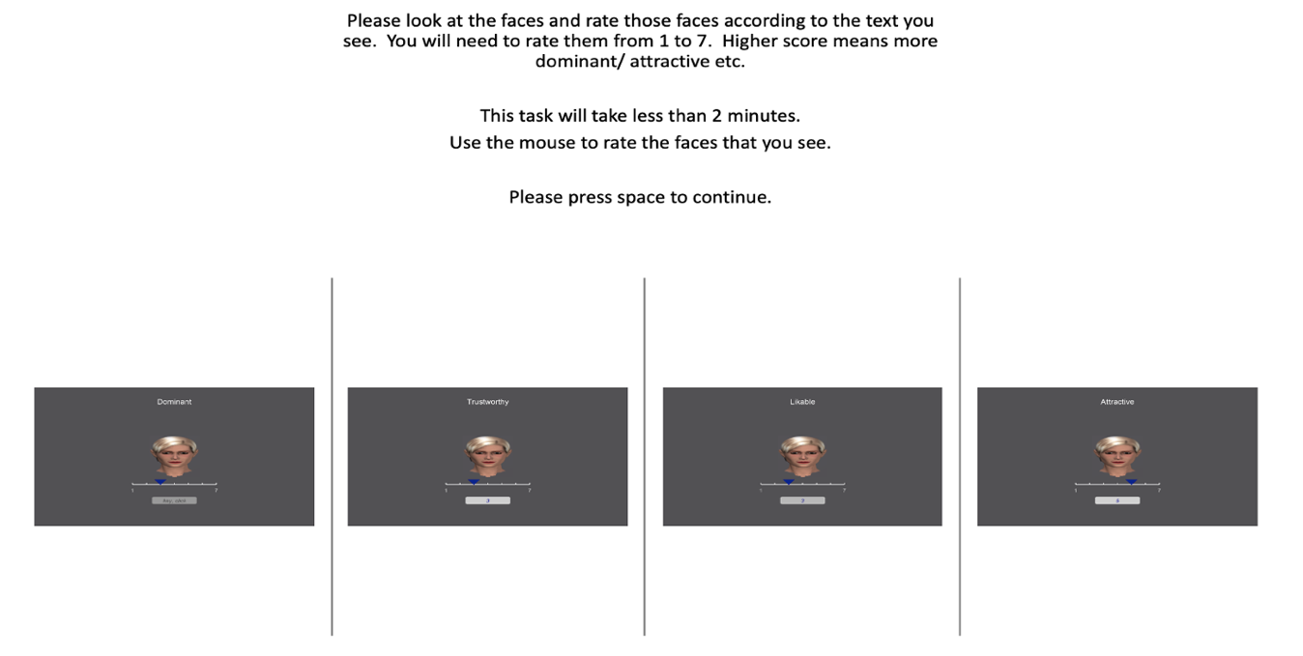
Task 3: Testing Phase. Third, participants saw one of the four faces that they rated in the Face Rating Phase (which also served as a “Leader” or “Follower” in the Testing Phase). First, they saw an information screen where they were asked to ignore the eye gaze and locate the target (appearing on the left or right side of the screen) by pressing “” or “”, as quick and as accurate as possible.
First, participants saw a fixation cross for 900 ms. Then the direct gaze of one of the identities appeared on the screen for 600 ms. After this, the eyes of the face turned either to the right side or left side of the screen (head stayed still, and only eyes moved) for 300 ms. Lastly, the target (a black dot) appeared on the screen for 300 ms. If the participant did not press any key for more than 1000 seconds, then experiment automatically continued.
Participants first saw 30 practice trials. The practice trials were not recorded. After practice trials, participants saw 240 experiment trials. The testing phase lasted about 15 minutes.

Figure 15
Gaze cueing task: An example of congruent and incongruent trials
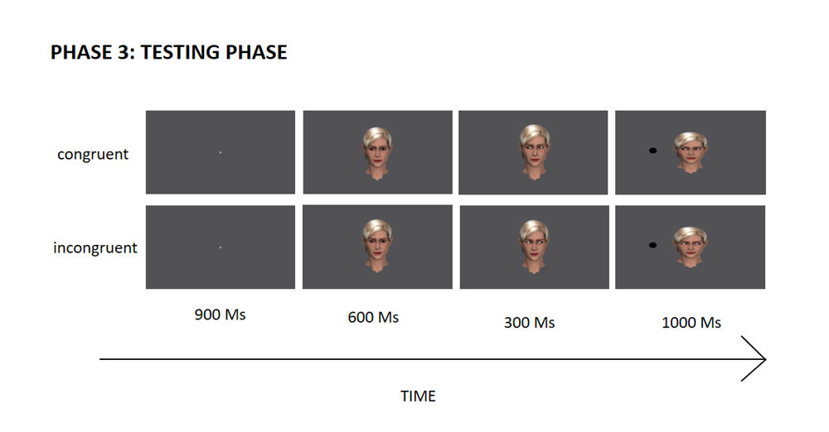
Task 4: Questionnaires. After completing the testing phase, participants took a five-minute break before completing the AQ and ICQ-EV questionnaires. This took approximately 15 minutes. All participants first completed the AQ afterwards the ICQ-EV. At the end of the study, participants were given a verbal debriefing as well as a written debriefing form. They were thanked for their time and given time to ask any questions about the nature of the study. This concluded the experiment, which took approximately 45-50 minutes in total.

Procedure
Phase 1, Phase 2 and Phase 3 parts of the study were presented using Psychopy (Peirce, 2007), and the reaction times, accuracy responses and answers to the ratings were recorded. Phase 4 included two questionnaires (AQ and ICQ-EV) and Likert type answers recorded using Qualtrics software. The study took approximately 45 minutes in total. All participants were first provided with verbal and written information about the nature of the experiment and they were allowed to ask any questions before consenting to participate. After the participants were provided with introductory information, they were asked to sign the informed consent and the experimenter left the room. Phase 1, 2 and 3 started and finished in one sitting. At the end of the Phase 3, examiner re-entered the experiment room, opened Qualtrics software, informed participants that this would be the last part of the study and would take around 15 minutes to complete, and the left the room.
First, the participants saw a general introduction screen for the whole experiment. Then, they saw an introduction screen for the practice trial. They were informed that this part of the experiment was so that could understand the task and that it would not be recorded. They then completed a practice trial which consisted of 5 repetitions of 3 positions and 2 genders (Gazer at right X Gazer at middle X Gazer at left, Male gazer X Female gazer). Next, they saw another introduction screen informing them that the experiment would be beginning. Participants saw three faces, three objects, and a black "T" as their target at the start of each trial. In the leader condition, which was 50% of the time, one of the three gazers’ (leader) head turned towards one of the three objects at the bottom of the screen. The other two gazers (group members) turned their heads towards the same object as the leader. In the follower condition, two of the faces turned their head towards to one of the three objects at the bottom of the screen and one of the gazers (follower) followed by turning his/her head. Then, the target (black “T”) appeared either for either left or right object. The three faces on the screen either looked at (congruent) or away (incongruent) to the target (black “T”) locating at the left or to the right object. The participants were asked to locate the target (which is a “T”) as quick and as accurate as possible by using the "right” or “left” arrows from the keyboard with their index and their middle fingers. The overall learning phase was approximately 25 minutes, including the practice trials. At the end of the learning phase, participants saw another screen informing them first part of the experiment was over.

Data pre-processing
Task1: Learning Phase. Reaction time and accuracy were recorded for each participant. Overall accuracy was calculated for each condition using excel sheets. For RT (reaction time) data, answers that were not accurate were excluded from the analysis. Average and SD (standard deviation) for each variable calculated and answers over or under 2SD were excluded from further analysis.
Task 2: Face Ratings. Reaction time and face rating data were recorded, and RT data processed by removing answers that were under or over 2SD. Averages were calculated for face rating data for each face and condition.
Task 3: Testing Phase. Like the learning phase, accuracy and RT were recorded and calculated. For RT (reaction time) data, answers that were not accurate were excluded from the analysis. Reaction times over and below 2SD were excluded and average RT for each condition recorded with excel sheets.
Task 4: Questionnaires. In the last task, Qualtrics used to record the data and the data directly transferred to SPSS. First, total AQ scores were calculated according to Baron-Cohen et al. (2001), followed by scores for AQ subcategories. Second, the overall score for ICQ-EV was calculated by summing scores for each answer (Aardema et al., 2010).

Data exclusion
A total of 44 participants completed the experiment. For each participant, responses representing errors (an inaccurate response) and outliers were removed from RT data. In Phase 1 (learning phase) RT and accuracy were measured. First, a boxplot analysis explored reaction time data for all conditions. From visual inspection of the boxplot data, one extreme outlier was identified. Then, the mean and standard deviations of correct RT were calculated for all participants (see Table 7). From these calculations, one participant (number 5) was removed due to being an extreme outlier (a mean that was greater than 2 standard deviations from the overall mean). In phase1, no outliers were identified based on visual and statistical inspection of the data. Furthermore, in phase 2 (face rating) no outliers were identified for face rating or reaction time data.

Table 7
Mean and standard deviation reaction times (RT) data for each condition in Phase 1
Condition | Mean | Standard Deviation
MaleLeaderCon | 0.41 | 0.10
MaleLeaderIncon | 0.46 | 0.14
MaleFollowerCon | 0.40 | 0.10
MaleFollowerIncon | 0.45 | 0.19
FemaleLeaderCon | 0.41 | 0.11
FemaleLeaderIncon | 0.43 | 0.10
FemaleFollowerCon | 0.41 | 0.13
FemaleFollowerIncon | 0.43 | 0.10

In phase 3 (testing phase) a boxplot analysis explored reaction time data for all conditions. From visual inspection of this boxplot data, two extreme outliers were identified. For each participant, the mean and standard deviations of correct RTs were calculated. This information is shown in Table 8. From these calculations, two participants (number 4 and number 5) were removed due to being extreme outliers. Based on visual and statistical inspection of the data no outliers were identified for accuracy data in phase 3. Furthermore, in phase 4 (questionnaire phase) no outliers were identified. Hence, no data were removed in the phase 4.

Table 8
Mean and standard deviation reaction times (RT) data for each condition in Phase 3.
Condition | Mean | Standard Deviation
MaleLeaderCon | 0.35 | 0.07
MaleLeaderIncon | 0.38 | 0.06
MaleFollowerCon | 0.35 | 0.06
MaleFollowerIncon | 0.38 | 0.06
FemaleLeaderCon | 0.34 | 0.05
FemaleLeaderIncon | 0.38 | 0.06
FemaleFollowerCon | 0.34 | 0.06
FemaleFollowerIncon. | 0.38 | 0.06

Results

Task 1: Learning Phase
In the learning phase of the task both (Reaction Time) RT and accuracy readings were measured. Outliers for these two measures were calculated separately. Considering the RT data, one outlier (number 4) was discovered and eliminated from further analyses. However, no outliers were found in the accuracy measurements. Two ANOVAs were conducted on both accuracy (number of accurate response) and reaction times (in ms) separately. These two repeated measures ANOVAs were conducted with leadership (leader / follower), gender of gazer (male / female) and congruency (congruent / incongruent) as within-participants factors. Capozzi et al., (2016) measured both accuracy response as well as reaction time (RT). We focused on RT measurements in previous chapters of this thesis, but here we also measured the accuracy response to try to replicate Capozzi et al. (2016) as closely as possible, to investigate the relationship between GCE and leadership manipulation, but also to test whether autistic traits might interfere with understanding social cues.

The accuracy response
The overall accuracy was 98.5%. The accuracy ANOVA showed that, there were no main effects of congruency, F(1, 43) = 0.289 , p = .593, ηp² = .007, leadership, F(1, 43) = 2.468 , p = .124, ηp ²=.54, or gender of the gazer, F(1, 43) = 12.313, p = .136, ηp ²=.51. The interaction between gender of the gazer and leadership was significant, F(1, 43) = 1.776, p = .024, ηp ²=.114 (see Figure 17). The error bars represent the mean’s standard error. This interaction was examined further with pairwise comparisons.

Figure 16
Crossover interaction between leadership (leader X follower) and gender of gazer (male X female)
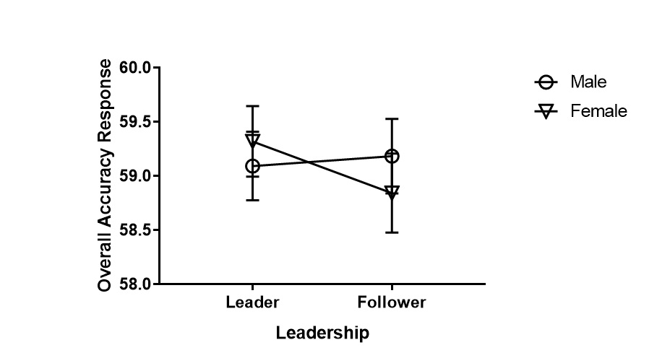
The pairwise comparison indicated that, there was a significant difference between male and female gazer in “follower” condition, but this difference was not observed for “leader” condition (see Figure 18). This means that participants responded with higher accuracy by.170 to male “follower” identity than female “follower” identity, p = .034. This difference was not present for leader female and leader male identities.

Figure 17
Learning phase: Mean total accuracy response of leader and follower conditions divided by gender. * p < .05

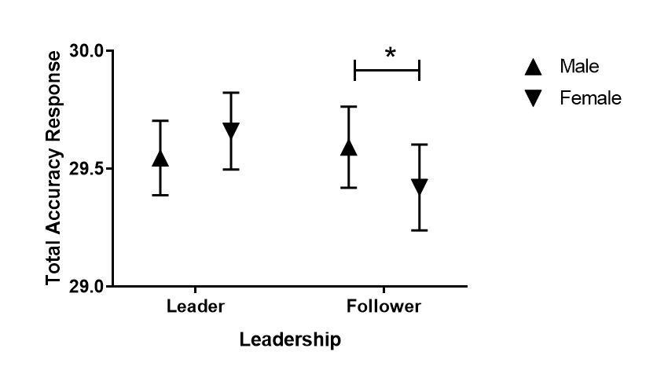
Furthermore, only female faces showed a significant difference between leader and follower conditions, but not male faces (see Figure 19). Participants responded more accurately to "leader" female identity by .239 when compared to "follower" female identity, p < .001. This difference was not observed for "leader" male and "follower" male identities. The mean percentages of overall accuracy for the leader and follower conditions were 98.67% and 98.35%, respectively.

Figure 18
Learning phase- The accuracy rating of male and female gazers divided by leadership.
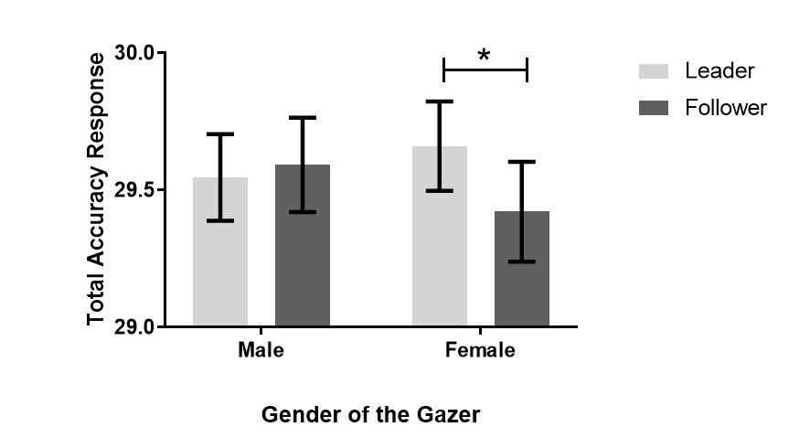
Note. * p < .05

Reaction time responses
Only correct responses were used for calculating the mean reaction time measurement for each condition. A repeated measures ANOVA was conducted with the within-participants factors of leadership (leader / follower), gender of gazer (male / female) and congruency (congruent / incongruent) for RT measurement. The results showed that there was a significant main effect of gender of gazer, F(1, 42) = 9.350, p < .001, η²_{p}=.182, such that participants were faster to response to a female gazer by .012 ms compared to a male gazer. Additionally, there were significant main effects of congruency, F(1, 42) = 22.159, p < .001, η²_{p}=.345, such that participants showed faster reaction at congruent trials by 31 ms compared to incongruent trials (see Figure 19). This means when the target and the eye gaze are at the same side of the screen participants were faster to locate the target compared to when the target and the eye gaze locate opposite side of the screen. There was a non-significant main effect of leadership, F(1, 42) = .197, p = .659, η²_{p}=.005, and non-significant interactions between leadership and congruency, F(1, 42) = 0.428, p = .516, η²_{p}=.010, leadership and gender of gazer F(1, 42) = 1.717 , p = .197, η²_{p}=.039.

Figure 19
Learning phase- The accuracy rating of male and female gazers divided by leadership.
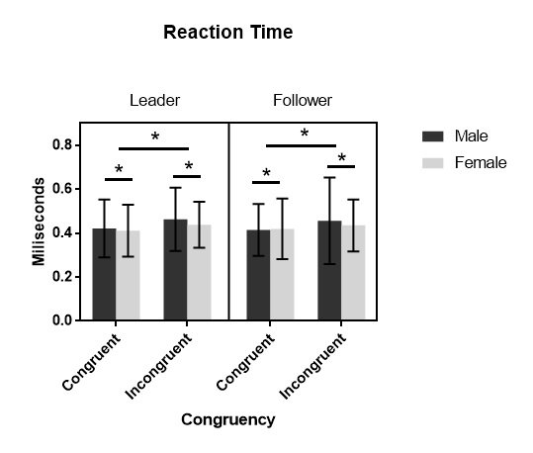
Note. * p < .05

Task 2: Face Ratings
Two separate repeated measures ANOVAs conducted with gender of gazer (2: male / female), leadership (2: leader / follower) and adjective (4: dominant / attractive / trustworthy / likable) as within-participant factors for face rating score and reaction time measurement.

Face rating score
For the face rating scores, a repeated measures ANOVA was conducted. This first showed that Mauchly's Test of Sphericity had been violated for adjective p < .001, gender of gazer-adjective interaction, p < .001, leadership-adjective interaction p< .001 and gender of gazer- leadership-adjective interaction, p < .001. Analyses for th these factors are therefore reported with GreenHouse-Geisser corrections. The analysis revealed significant main effect of gender of gazer, F(1, 43) = 7.337 , p < .001, η²_{p}=.146, such that female gazers had a significantly higher face rating score by .321 compared to males. The main effect of adjective was significant as well, F(2.185, 93.972) = 11.469 , p < .001, η²_{p}=.211. Leadership had a non-significant main effect, F(1, 43) = .888 , p = .575, η²_{p}=.007. Additionally, a significant interaction was found between gender of gazer and adjective, F(2.000, 87.026) = 10.153 , p<.000, η²_{p}=.156. Additional pairwise comparison tests between gender of gazer and adjective showed that female faces were rated to be more “Attractive” by .591, p < .001, “Trustworthy” by .648, p < .001, and “Likable” by .412, p < .001, compared to male faces. There was no significant difference for “Dominant” score between male and female faces (see Figure 19).

Figure 20
Learning phase- Overall average face rating scores divided by adjective and gender of gazer.
Non-significant interactions were found between leadership and gender of gazer, F(1, 43) = 3.695 , p = .351, η²_{p}=.020, and leadership and adjective, F(3, 129) = 1.100 , p = .511, η²_{p}=.156.

Reaction time measurement
All responses contributed for the main RT measurement in each condition in order to investigate whether gaze cueing effect has different correlation with gender and reaction time. A repeated measure ANOVAs conducted for RT measurement. This showed that Mauchly's Test of Sphericity had been violated for adjective, p < .001, gender of gazer-adjective interaction, p < .001, leadership-adjective interaction, p < .001, and gender of gazer-leadership-adjective interaction, p < .001. These analyses for this variable is reported with GreenHouse-Geisser corrections. The main effect of adjective was significant, F(1.973, 84.819) = 5.908 , p < .001, η²_{p}=.121 (see Figure 23). Non-significant main effects were found for leadership, F(1,43) = 0.221, p = .640, η²_{p}=.121, and gender of gazer, F(1,43) = 0.011, p = .918, η²_{p}=.000. Additionally, non-significant interactions were found between gender of gazer and leadership, F(1,43) = 2.313, p = .748, η²_{p}=.002, gender of gazer and adjective, F(2.361,101.511) = 2.207, p = .106, η²_{p}=.049, and leadership and adjective, F(2.381,102.365) = 2.250, p = .101, η²_{p}=.050.

Figure 21
Overall mean reaction times and error bars divided by adjective
Additional pairwise comparison test conducted for the main differences in gender of gazer (mean RT difference between male and female gazer) and adjective. The analysis indicated that female gazers were rated faster by 1.069 ms than male gazers p=.045 at dominance rating but no other adjective ratings. (See, figure 21)

Figure 22
Overall mean RT divided by gender and adjective.
Note. * p < .05

Task 3: Testing Phase
Accuracy and RT data were collected. Two participants (number 4, number 5) were excluded from the RT data due to being extreme outliers in multiple conditions. But both participants’ data were used in accuracy measurements. Two separate repeated measures ANOVAs were conducted on accuracy (number of accurate response) and reaction times (ms). The within-participants factors were leadership (leader X follower), gender of gazer (male X female) and congruency (congruent X incongruent).

Accuracy response
The overall accuracy was 96.5 %. The accuracy ANOVA showed a significant main effect of congruency, F(1,43) = 26.199, p < .001, η²_{p}=.379, such that participants were found to respond more accurately to congruent trials (where eye gaze and the target is at the same side of the screen) compared to incongruent trials (where the location of the target is opposite side of the screen from eye gaze) (see Table 9).

Table 9
Mean and standard deviation of accuracy rating response
 | Congruent |  |  |  | Incongruent
 | Leader |  | Follower |  | Leader |  | Follower
 | Male | Female | Male | Female | Male | Female | Male | Female
Mean | 39.25 | 39.25 | 39.25 | 39.27 | 37.68 | 37.98 | 38.25 | 38.00
SD | .84 | 1.01 | 1.14 | .90 | 2.53 | 2.33 | 2.22 | 2.25

Non-significant main effects were found for leadership, F(1,43) = 1.655, p = .205, η²_{p}=.037, and gender of gazer, F(1,43) = 0.023, p = .879, η²_{p}=.001. Additionally, non-significant interactions were found between congruency and gender of gazer, F(1,43) = 0.002, p = .964, η²_{p}=.000, and congruency and leadership, F(1,43) = 1.438, p = .237, η²_{p}=.032.

Figure 23
Overall mean accuracy ratings divided by gender congruency and leadership.
Note. * p < .05

Reaction time measurement
Only accurate corrected responses were used to calculate reaction time for each condition. Two participants were removed from the data because they were extreme outliers. A repeated-measures ANOVA was conducted with leadership (2: leader X follower), gender of gazer (2: male X female) and congruency (2: congruent X incongruent) as within-participants factors on RT. The main effect of congruency was significant, F(1,41) = 120.599, p < .001, η²_{p}=.746, meaning participants were faster to response to congruent (where eye gaze and the target is at the same side of the screen) trials by .034 ms than incongruent (where eye gaze and the target is at the opposite side of the screen) trials (see Figure 26). The main effects of leadership, F(1,41) = 0.05, p = .659, η²_{p}=.005, and gender of gazer, F(1,41) = .198, p = .659, η²_{p}=.005, were both non-significant. Additionally, non-significant interactions were found between leadership and congruency, F(1,41) = .206, p = .652, η²_{p}=.005, gender of gazer and congruency F(1,41) = 1.268, p = .267, η²_{p}=.030. That is, the primary effect of congruency was unaffected by group status (leader/follower) or gazer gender (male/female).

Task 4: Questionnaires

AQ Score

Table 10
Descriptive of AQ scores
AQ
Mean (n=43) | 17.09
Standard deviation | 0.93
Median | 17
Maximum score | 32
Minimum score | 4

One participant was excluded from analysis for being an extreme outlier in multiple conditions (number 4). The mean AQ score for the remaining sample was 17.09 (SD = 6.11). A Kolmogorov-Smirnov test was used to test for normality on the total AQ score which indicated that the data were normally distributed, D(44) = .108, p < .001. Cronbach's alpha was used to test the reliability of the total AQ measure. It was found to be highly reliable (50 items, α = .77).

ICQ_EV
One participant was excluded from analysis for being an extreme outlier in multiple conditions (number 4). The mean score on the ICQ-EV was 96.81 (SD = 24.13). A Kolmogorov-Smirnov test was used to test for normality on the total ICQ-EV score, which indicated that the data was normally distributed, D(44) = .091, p > .05. Cronbach's alpha was test was used to test the reliability of the ICQ-EV measure, which was found to be highly reliable (30 items; α = .95).

AQ ICQ-EV relationship.
Pearson’s correlation showed that there was a significant positive correlation between total score of AQ and total score of ICQ-EV, r = .37, p < .001; a medium effect size according to Cohen (1988). The correlation indicates that 13.5% of the variance in AQ is accounted for by ICQ-EV (and vice-versa).

Discussion

Summary of Findings
When the gazer was in a group setting, meaning there was more than one photo on the screen, there was a relationship between gazer gender and leadership. In the group setting version of the experiment (learning phase) participants responded more accurately to male followers than to female followers, as well as to female leaders than to female followers. This means that participants were more likely to follow people in high social positions within the group. The reaction time measurements from the experiment's learning phase revealed a significant main effect of congruency as well as the gazer's gender. In the group setting version of the experiment (learning phase), the gender of the gazer and the congruency of the gaze both had affected the reaction time of the participants. This finding was in line with our predictions and previous studies from the literature. Female gazer faces were found to be more attractive, trustworthy, and likeable than male gazer faces, according to the face rating scores. The reaction time measurement during the face rating phase revealed that adjectives had a significant effect. Female gazers rated faster compared to male gazers at dominance adjective but not on the other adjectives. At the testing phase of the experiment which there was only one face picture as gazer the gaze cueing effect was present but social variables was not affecting the results.
In the group setting version of the experiment (learning phase) the leadership manipulation was effective, but it was not effective later at the one face picture as gazer condition (testing phase). The leadership manipulation did not have an effect either the reaction time or the accuracy ratings during the testing phase. However, it had a significant effect during the learning phase. This difference between the learning phase of the experiment and the test phase of the experiment many be due to a couple of reasons. First, in the learning phase there were three faces presented on the screen. Participants observed three faces with one of them either constantly leading others’ gaze cues or one constantly following others’ gaze cues. However, in the testing phase there was only one face present on the screen during the gaze cueing task. It might be that in the learning phase participants were not only observing three faces but also how they are interacting with each other. In the testing phase, we examined whether this previous observation would have any effect on later encounters. Hence, there was only one face present in the testing phase. Participants were not comparing any other behaviour from the gazer. The effect of leadership might only be relevant in learning phase’s group context. Thus, it is possible that it only has an effect when there are other social beings present to compare with the gazer.

Overall discussion
A significant difference was found to male and female gazers during the learning phase but not during the testing phase in RT measurements. This result can be interpreted as follows: categorization happens after a certain amount of time, or categorization happens when there is something else in the environment to compare with (Macrae & Bodenhausen, 2000; Macrae, Milne, & Bodenhausen, 1994). There were many faces in the learning phase data meaning that more than one social agent was present. Inherent categorization used characteristics such as sex and reaction time to easily identify the participant’s cueing. On both accuracy ratings and RT analysis, there was a significant congruency effect in the experimental phases, which included both the learning and testing phases. The gaze cueing effect was consistent both in the learning and testing phases. The reaction time of the congruency effect was observed to be at 300 ms, which is quite short and reflective.
Surprisingly, females were rated as more attractive, trustworthy, and likable than males only in the follower condition. Female faces were rated as more trustworthy than male faces in the leader condition, but not as attractive or likable. There was no difference in scores for dominance between male and female gazers. Despite the fact that the dominance score did not differ by gazers gender, female gazers rated faster than male gazers only at dominance rating.
The AQ and ICQ-EV score measurements was correlated, as if they are measuring the same mechanisms. This demonstrates that there may be a common mechanism between the behavioural outcomes of those two mechanisms. However, females may have a different prognosis in terms of autistic traits and how they are diagnosed with ASD (Muhle et al., 2004). These findings are only correlational, and thus do not establish a causal relationship between those two traits, but it is intriguing to see that certain social and communicative subscales are associated with inferential confusion in females (Frith & Frith, 2007).
Specialized mechanisms for gaze cueing effects determine how a person looks and the socio-emotional consequences of leadership traits such as detecting any risk or threat. Such threats can be identified even when they are presented by the gazer, such as a direct gaze from an aggressive gazer. According to (Sato et al., 2009), the gaze cues and direction of observation can activate a broad overlapping cognitive system. Being attractive and likable for women, as identified in this study show that establishing eye contact can also act as a signal of attraction between people. As noted by Sato et al., (2009), when a person is seen to move their eyes to engage in eye contact, they are perceived to be more likable and attractive than if they are seen to disengage eye contact.

Conclusion
There are contradicting opinions and theories about the cognitive mechanisms of what triggers the gaze cueing effect. Most studies agree with this study’s notions that the neural map that is activated by the direction of gaze cuing resembles more exogenous orienting that endogenous orienting. The orienting behaviours are consistent with developmental and evolutionally theories of social cognition as they perceive that one must orient in the opposite direction of the gaze to achieve any state of shared attention. As opposed to the responses given to the social gaze, such ideas support the notion that neural mechanisms and distinct cognition are directly engaged when establishing joint attention.
The results did not replicate the of Capozzi et al. (2016) findings. Dalmaso, Edwards, & Bayliss, (2016) used a mixed gender student groups their sample. Our sample comprised only of female university students. Additionally, in the current study only had one SOA which is 300 ms. Maybe recognising facial features happens after 300 ms as noted by (Koivisto & Grassini, 2016). As a result, we would need more than 300 ms to see the effect of person perception.

Limitations and Future Directions
There was not a broad range of AQ scores and that could have affected results. We do not have high/low AQ groups to compare the difference between those who scored high on AQ and those who scored low on AQ. Therefore, it is not possible to make a direct comparison between two groups of participants. Future research should repeat the findings using a larger sample of participants and compare the two groups as categorical variables rather than as continuous variables. Including male participants, would be interesting to see since it may produce different results. We do not have high/ low AQ groups, to compare the difference between high AQ scorers and low AQ scorers. Therefore, it is not possible to make direct comparison between 2 groups. Future research should replicate this with larger sample and compare the two groups as a categorical variable rather than continuum.

General Discussion

Summary of main findings
In this chapter, the major findings of the three studies will be summarized, followed by a discussion that integrates the findings with the literature. The implications of the findings will also be discussed. Finally, the study's strengths and limitations will be discussed, as will future research suggestions. The overarching purpose of this thesis was to determine the role of personal traits and social-cognitive variables on the gaze-following. Thus, it investigated how attention to social information is influenced by being within a social group environment with the traits of the observer as well as the gazer.

1. Theoretical explanation:
As discussed in Chapter 1 (which is the review of the literature), socio-cognitive variables such as social power and visual cues such as dominance, as well as personal traits such as autistic-like traits, influence the automaticity of gaze-following behaviour. Although the visual features of the face are effective in manipulating the strength of gaze following, social environments for humans are much more complex, and social interactions in a social environment cannot simply be explained by visual information. That is, outside of the laboratory, the original behaviour is based on perceptual information rather than visual information like on the screen. To clarify what that percept is, an extensive literature search was conducted. It was found that the majority of studies in the literature focused on the gazer’s visual features to manipulate the social variables. However, to a gain more accurate understanding of human social interaction in a real-world social environment, Chapter 1 focused on socio-cognitive variables manipulated by episodically learned social knowledge about the behaviours performed by the individual and visual observation of the individual. The purpose of this literature review was to determine which variable was discovered to effectively manipulate the gaze-cueing effect. According to Chapter 1, visual cues, social factors, or personal differences can manipulate the automaticity of gaze following. The chapter achieved this in several steps.
First, the review of the literature revealed that 'Faces,' 'Race and Physical Similarity,' 'Dominance,' and 'Age' are visual stimuli that influence the magnitude of gaze following. The first experimental study (Chapter 2) was carried out to investigate the effect of social group membership on gaze cueing with visually similar gazer stimuli. Here, results showed that participants were aware which gazer face was ingroup and which gazer was outgroup. They showed significant difference in their attitudes, but this difference did not influence the gaze cueing effect.
Second, the outcome of a detailed literature search reveals that some social factors, such as "social group belonging”, “social similarity", "political/social status," and "social power" have been found to influence the magnitude of the gaze cueing effect. A second study was conducted (Chapter 3) to investigate the effect of social status on the strength of gaze cueing. In Chapter 3, we eliminated the combined effect of visual stimuli by using similar young Caucasian faces (counter-balanced between conditions) with no visual cue of the social power difference between them. Additionally, we only focused on episodic learning of social stimuli by telling them who is their group leader or group member. Here, results showed in line with the previous literature, female male difference was present.
Finally, individual differences such as personal traits (level of anxiety, introvert/extravert dimension), gender, and autistic traits were found to have a significant influence on the observant's gaze-following behaviour. The previous study in Chapter 3 as well as the other studies in the literature, females are overall more sensitive to social cues gathered by eye gaze following. In chapter 4, we examined only female participants and asked them to fill out a questionnaire to measure autism traits (Please refer to Chapter 4 for details). The results showed that participants showed faster response to female faces compared to male faces. Participants showed higher accuracy for male than female faces in follower condition but not in leader condition. In learning phase, we showed participants differentiate in line with social variables however this differentiation was not present for testing phase. Overall, this thesis investigated the socio-cognitive variables found in the literature, and each chapter answered one of the different effects that were found to be significant by other studies.

2. Experimental explanation:
The first experiment (Please refer to Chapter 2) was conducted to understand the effect of social group belonging in gaze-following behaviour. It was hypothesized that following in-group faces would produce more valuable information about the environment; what to attend and what to avoid than following out-group faces. The use of episodic learning produced the in-group, out-group effect; importantly, the participants had no visual cue of group belonging. Episodic learning means that participants were told which face pictures were in-group and which were out-group, but they had no experience being them in the group. Although the "minimal group effect" was present, which means that participants learned the in-group and out-group faces and rated themselves as similar to in-group members rather than out-group members, the results indicated that this did not affect the strength of gaze cueing. The social group belonging derived from episodic knowledge rather than visual cues, this knowledge did not affect the strength of gaze cues.
There may be several reasons for these results: first, there was no competition between the two groups for limited environmental resources; therefore, alerted sensitivity to group differences might not have occurred. Indeed, limited resources in the environment could lead to competition between groups (Puurtinen & Mappes, 2009). Second, in our study, there was no danger present in the environment that would trigger the participants and activate heightened alertness in their attention. When there is a danger in the environment, in-group faces may be the first to direct attention, because gaze following is important for both avoiding danger and attending to sources in the environment. Lastly, there were no social power differences between gazer faces. Whether the faces belonged to an in-group or an out-group, they all had comparable levels of social power. We did not provide any information about the social power level of the faces that were shown to participants. Some faces may be followed more than others due to differences in social power; indeed, it has been shown that higher social-powered faces cause greater gaze hits (Frith & Frith, 2007), possibly because they have more access to valuable sources than low social-powered faces (Zebrowitz & Montepare, 2008). To evaluate this, a second study was conducted (Please refer to Chapter 3 for details).
The second study (Chapter 3) investigated the impact of social power differences in dangerous situations. Although previous research on monkeys found that visual cues of dominance (an indicator of social status in monkeys) combined with danger in the environment made a significant difference in gaze following, this notion has never been tested with the human population (Shepherd et al., 2006). Human social interactions are more complex than what can be identified solely through visual cues. Because the level of facial dominance is not the only indicator of human social hierarchy, it is unclear whether this effect can be generalized to real-world social environments. Currently, no known studies in the literature considered the effect of social power gained only from episodic knowledge rather than visual indicators of dominance. Chapter 3 hypothesized that perceived social power in the dangerous environment would have a significant effect the magnitude of gaze, as a result of the creation of stronger gaze cues in leader conditions rather than follower conditions. The effect of the participant's and the gazer's genders was also measured to see if priming to danger in the environment affected males and females equally. Participants were instructed to be either a group leader or a group follower in order to manipulate perceived social power. The results revealed no main effect of the social power difference, but there was a significant effect of the gender of the participants. Visual cues were controlled, and only episodic learning was used to indicate social power differences. In both low and high social power situations, females were found to be more sensitive to gaze cues. This gender difference was consistent with gaze cueing literature; several studies showed that females tend to be more sensitive to social cues (Meyers-Levy et al., 2015). Our findings were consistent with the literature, which shows female participants exhibiting faster reaction time responses to the eye gaze of others in both high and low social power conditions as well as to both male and female faces. Yet, there is not enough explanation why females show this sensitivity to eye gaze cues, specifically on a behavioural level (measured by automatic shifts of attention). A plausible explanation is that the studies approach gender as a categorical variable, thus failing to recognize variables contributing across gender, such as autistic traits. To tackle this question, only female participants were invited to 3rd study and asked to fill out AQ.
Finally, a third study aimed to understand the impact of leadership learned by previously observed behaviour in a group context. The social attention system seems to be operating with perceptual effects of visual social cues of the gazer. Moreover, two of the studies (Chapter 2 and Chapter 3) in this thesis revealed that episodic learning of social context was not influencing automatic shifts of attention by itself in the behavioural level (measured by RT). Nonetheless, the modulation in the strength of gaze cues by the top-down episodic knowledge associated with the gazer face occurred only when a visual cue was also present as a categorizer between different gazers. Since the episodic learning of social power differences in a group context did not create a difference in gaze following behaviour, it was hypothesised that observations of the gazer's previous behaviour would influence low-level social orienting mechanisms. Informing participants about social relations but not exposing them to their effects resulted in a difference in the explicit level measured with a questionnaire (see Chapter 2 for details), but not in the behaviour level measured by RT. Indeed, Capozzi, Bayliss, Elena, & Becchio, (2015) showed that individuals who did not previously guide group attention in the environment were ineffective at leading social attention in later encounters. Since, it is probable that these effects are sensitive to modulation by contextual variables such as the gender of the gazer (Ohlsen et al., 2013), it is hypothesised there will be a difference in the strength of gaze cueing according to the gender of the gazer. Thus, in the third study (Chapter 4), participants were informed about the gazer based on prior observation rather than manipulation of the physical appearance of the face or explicit information about the individual.
Lastly, in Chapter 4 participants (neurotypical females) were asked to fill out two questionnaires to investigate the sensitivity to social cues obtained by eye gaze. These questionnaires were the AQ and the ICQ-EV. In the chapter, it was emphasized that the AQ test is not a test for autism but is administered to neurotypical members of the population to detect autism traits. This questionnaire was used in chapter 4 to measure low or high AQ scores. This is based on the premise, by Baron-Cohen et al., (2001) that autism is part of a continuum. Only those on the end of the autism continuum would be given a diagnosis. However, traits may be present in the general population. Individuals who achieve high scores on the AQ questionnaire often have a difficult time understanding the thoughts of others and being able to respond appropriately. The ICQ-EV test was also administered. In Chapter 4 observed gender difference in the gaze cueing effect researched by only collecting data from females and measuring the range of AQ tendencies within female population. It was hypothesised that categorical distinction between male and females is not insignificant, especially in administering the questionnaires. Men tend to be higher on autism traits, and females higher on social skills. To test the range of autism traits within neurotypical females, a single-gendered group was selected. This was done to explore both the range of autistic and psychotic traits amongst female participants and to explore how these two tendencies would overlap.
Overall, the goal of this thesis is to critically analyse the very individualist models that are used to investigate gaze cues. Rather than focusing solely on interpersonal traits alone, this thesis investigates how gender, social positionings such as in-group or out-group membership, and individual qualities such as empathy and systematic thinking interact to determine gaze cue responsiveness. The goal of this thesis was to find out how personal traits and social-cognitive variables affect gaze cues. Moreover, it looked into how being in a group environment and the observant's personality traits affect attention to social information. It does so because there is a need to investigate how female roles are modelled, as well as how this relates to clinical conditions and treatment options for women who struggle and are misdiagnosed as a result of gender norms. The purpose of this study was to determine whether social or environmental threats are associated with gaze cues, as well as how gaze cues are associated with power or dominance positions. According to research, gaze cues are frequently directed toward those perceived to be dominant. The study looked at how gender affects perceptions of dominance, both in terms of how women show more gaze and whether they are correctly perceived as leaders or followers.

Reflection on the measurements

SOA
Throughout the experiment, 300 ms of SOA was used to assess the presence of a significant gaze cueing effect. There are several reasons why this SOA was chosen in particular. The time course of the gaze cueing effect can be measured by varying the delay between the onset of the cue and the onset of the target (stimulus onset asynchrony, SOA). The minimum SOA at which a gaze cueing effect is reliably observed is 100 ms, whilst the longest is about 1000 ms (Friesen & Kingstone, 2003; Ristic & Kingstone, 2005). Hudson et al., (2012) found that modulation of the GCE occurred only in the short SOA condition, which reflects the involuntary exogenous system, but not in the longer SOA condition, which reflects the voluntary endogenous system. The involuntary/reflexive orienting of attention elicited in response to exogenous cues such as a peripheral transient is comparable to the effect's early onset. These effects are triggered by stimuli and have a bottom-up influence on attention orienting. Exogenous cueing, on the other hand, fades after SOAs of 300 ms. The prolonged influence of gaze cues beyond this time course suggests that orienting of attention to an agent’s gaze direction is also underpinned by voluntary top-down processes (Friesen et al., 2004). This is because such cues are endogenous and require interpretation of their meaning to be understood. In shorter SOAs the gaze cueing effect would be weakened since there is not enough time for the image to reach visual memory. The gaze cueing effect would disappear in longer SOAs as conscious awareness takes over and affects its reflexivity (Friesen & Kingstone, 1998).
Second, in the current study, we are interested in measuring the reflexive nature of the attentional shifts and how socio-cognitive variables affect the atomicity of attentional shifts. The goal was to quantify the gaze cueing effect and compare how much fixation and delay occurred in each condition. As mentioned in (Dalmaso et al., 2020) longer SOAs such as 1.000 ms are sensitive to features of face stimuli gathered by gaze cueing. Thus, studies conducted with longer SOAs show that the knowledge of the gazer can override the short-lived attentional shift. It can be concluded that longer SOAs, in the context of gaining knowledge about the gazer through episodic learning rather than visual representation, may yield different results; as demonstrated in Chapters 2 and 3. However, short SOAs are unaffected by episodic learning of social relations about the gazer, as shown in Chapters 2 and 3.
Third, it's that strong and reliable gaze cueing effects do not emerge until around 200 to 300 milliseconds, according to studies using face pictures (Bayliss & Tipper, 2005; Driver et al., 1999). Research comparing GCE of cartoon and real faces at 200 ms found that cartoon faces resulted in stronger GCE than real face pictures (Hietanen & Leppänen, 2003). They claim that the increased GCE for cartoon faces is due to differences in image complexity, as cartoon faces do not have any additional visual noise. According to Risko et al., (2012) enhanced attention orienting to cartoon faces’ gaze cues might also be due to non-social mechanisms such as motion detection. Increased attention orienting to cartoon faces' gaze cues could also be due to non-social mechanisms such as motion detection, according to (Risko et al., 2012). In detail, the non-social mechanism can be studied via arrow cues as well. However, it has been argued that arrow cues itself is a poor measurement of endogenous attention, as arrow cues can result in rapid and involuntary shifts of attention, which has been attributed to the directional meaning of these cues being overlearned in daily life. It is learned and gets easier with practice. As a result, studies that directly compare arrows and gaze without using a purely symbolic cue can only provide limited evidence about the role of endogenous attention in gaze cueing. Thus, using cartoon faces to compare the non-social and social mechanisms of gaze cueing would result in more accurate comparisons. When participants were given enough time to extract eye-gaze information from a photo of a real face (around 200-300 ms, Driver et al., 1999) the gaze direction began to influence responses, with faster target detection incongruent trials compared to incongruent trials. Furthermore, (Slessor et al., 2019) claim that when a photo of a real face gaze cue was used as an attention cue, endogenous shifts of attention emerged faster than involuntary gaze cueing. In contrast, it has not been demonstrated that involuntary GCE can override endogenous attention mechanisms. As a result, gaze direction should begin to have an effect around 200-300 ms (Driver et al., 1999), and the social mechanism should begin to kick in around 300 ms.
Others also showed 300 ms is effective. For example, social learning influences the earliest responses to another person's gaze cues at 300 ms (Hudson et al., 2012) or personal familiarity influences GC at 300 ms (Deaner et al., 2007). Hudson et al. (2012) proposed that an SOA of 300 reflected the optimal timing for reflexive exogenous gaze-cueing effects (typically between 150 and 450 ms), whereas gaze cueing at 800 ms would be governed by voluntary endogenous processes. Hudson et al. (2012) demonstrated that modulation of the cueing effect occurred only in the short SOA condition, which reflects involuntary exogenous orienting, but not in the longer SOA condition, which reflects voluntary endogenous orienting (Friesen et al., 2004). This suggests that implicit social learning influences the earliest responses to another's gaze direction, which is consistent with previous findings that personal familiarity influences gaze-cueing over comparable time spans (Deaner et al. 2007). Additionally, according to Hudson et al., (2012), greater GCE in low AQ individuals to faces who smiled at them during the learning phase (only at 300 ms and not al 800 ms). Hence, 300 ms can be counted as the minimal time required for the automatic processes of the gaze cueing effect to occur.

Faces
Faces shown to participants in all three experimental studies were chosen from face databases, so the stimuli used have already been proven to be suitable for gaze cueing studies. In addition, all faces were presented with a white background to eliminate visual noise in the data. Face stimuli in Chapter 4 did not depict real people's faces, but rather 3D avatar faces. Those 3D avatar faces had previously been created by (Capozzi et al., 2016). According to Pfeiffer et al., (2012), when avatars can offer direct or joint gaze, it fosters a sense of relatedness. Because our sample was young and thus of a similar age group, we chose young faces for the current thesis. Previously, it has been shown that the age of the face is effective on gaze cueing (Slessor et al., 2010), young participants had an advantage for processing the gaze cues of young gazer faces not older gazer faces. Hence, share that younger research participant's show a bias to their age group. To eliminate the effect of age differences, young faces were specifically chosen as a stimulus for gaze cueing tasks in this thesis. It has previously been demonstrated that the age of the face has an effect on gaze cueing (Slessor et al., 2010), with young participants having an advantage in processing the gaze cues of young gazer faces rather than older gazer faces. It has previously been demonstrated that the age of the face has an effect on gaze cueing Slessor et al., (2010), with young participants outperforming older participants in processing the gaze cues of young gazer faces. To eliminate the effect of age differences, young faces were specifically chosen as a stimulus for gaze cueing tasks in this thesis.

The gaze cueing task
In the current thesis, a classical gaze cueing task was administered, with one face on the screen looking either to the right or left side of the screen. The goal is to measure the effect of social relations on gaze following using episodic learning rather than a visual stimulus that could trigger the social representation of the gazer's faces. The gaze cueing in this manner did not create a difference in the strength of gaze cueing. However, this raises the question of how episodic learning affects the following behaviour. In chapter 2 and 3, there was only one face on the screen in the classical gaze cueing task, and there were no other stimuli on the screen to compare one face to hint at the societal rating of the face.
However, in chapter 4, there are three faces on the screen during the learning phase (refer to Chapter 4 for details), resulting in a significant difference in the strength of gaze cueing at the testing phase. Because the main aim of the learning phase of the experiment is to awaken social comparison using visual priming, the presence of three different faces on the screen may result in a comparison between those faces at the learning phase. When three faces were displayed on the screen, the participants were able to observe the social rating of the target face's social rating by comparing it to the other faces.In that case, social relations may be triggered not only by the face itself, but also by comparison to other faces. It also can be argued that the effect of social-cognitive variables gathered from memory can be effective not by observing one face but by observing the comparison of the face.

Computer versus real environment
Using a computer to measure gaze cues helps to create a standardized means of measuring reaction time responses that can be repeated or applied to different conditions. Indeed, Freeth, Foulsham, & Kingstone, (2013) showed that there are crucial differences in eye contact in real-life interactions compared to those who watch videos of gazers looking at/away from a target on a computer screen. This study explored the differences in gaze when participants gazed at a person in a live setting. It was only with live experimenters that participants modified their gaze known in the literature. When the gaze following task is carried out in real-life examples such as listening or responding to a live experimenter, the social presence of a real person has a significant effect on gaze cueing, according to this study (Freeth et al., 2013). The presence of a real person rather than a computer screen would have a different impact on participants with high AQ scores. Although computerized images give reliable results across different SOAs and various conditions such as cartoon images. Eye directions are not the only source of information gathered from human faces. Facial expressions or head positions give clues about a person and his/her relationship to the environment. The social context provides clues that may relate to social status, dominance, or adherence to social norms. All such situations may have an impact on the gaze cues by demonstrating social status (as explained in chapter 3) leadership roles (as explained in chapter 4) or group membership (as explained in chapter 2). This might provide further information to research participants and therefore provide new insights into results.

Themes Emerging from the Thesis

Theme 1: Gender difference of the observer
Females were found to have larger gaze cueing effect compared to males. This was not affected by the perceived social power or the leadership condition. Gender may play a variety of roles in increased sensitivity to gaze cueing. First, there are physiological elements that contribute to the gaze cueing effect. According to Tollenaar, Chatzimanoli, van Der Wee, & Putman, (2013) oxytocin plays a role in enhancing gaze cueing effect. Oxytocin is naturally present in women’s bodies and promotes mother-baby bonding. Interestingly, the first form of a conversation between a mother and her baby is the gaze (Flom et al., 2007). In respect to this, the gaze is the first form of communication between a mother and her baby (Flom et al., 2007). The presence of oxytocin therefore presents a physiological difference between men and women, which explains why women are more likely to show sensitivity on gaze cueing effect. Second, it has been suggested that autistic-like social deficiencies may be found to varying degrees throughout the entire population, with no clear boundary between normalcy and psychopathology, and clinical levels of autism at the high end of this continuum (Baron-Cohen et al., 2001; Constantino & Todd, 2003). Eye gaze cueing assists us in matching AQ scores to performance in neurotypical females. Third, social factors may influence the findings of gender differences in social attention studies. From a social perspective, females are taught the value of connectivity and relationships. Males, on the other hand, are expected to focus intellectual models or images of physical power or strength. These roles shape how men and women interact with one another and with the social environment in which they live. The social norm of gender, rather than the biology of gender, might be the determining factor in social attention differences between two genders. This means that socially learned gender roles result in a set of behaviours that result in a sensitivity to social information about others. Individual diversion differences are not taken into account when using a categorical grouping. Men are taller than women on average, but this does not imply that all men are taller than all women. Although it is beneficial in research to explain social attention sensitivities, overuse of this approach may cause some individual differences across both genders to be overlooked, such as introversion in personality or autistic traits.

Theme 2: Episodic learning
In this thesis, the knowledge about social relations was learned via reading and imagining about it or via exposure to knowledge of observation rather than visual perception which would trigger recognition of social relations to observed face. In chapter 2, Episodic learning was ineffective on reflexive shifts of attention. In-group/outgroup manipulation was ineffective because there was no computation in the environment. This study was conducted in a controlled setting, which is far more predictable than a real social environment. The study did not evoke images that would make participants feel threatened or competitive and there was no need for active categorization processes to occur. Being in a real social environment that would trigger the memory of social relations affect the memory of the observed face.
People might interpret the same social cues differently. For example, Dodd et al., (2011) introduce the idea of politics playing a role in social gaze, arguing that political liberalism has resulted in a very large gaze cueing effect. Dodd et al., (2011) shared that politically conservative participants showed no such effect. Dodd et al., (2011) defined political conservativism as largely individualistic and intellectual. Liberal people, in contrast, were seen to be empathic and concerned with the rights of others. Social learning is often linked to years and years of interaction. These interactions have an impact on how a person perceives himself in relation to other people. In this manner, the memory of social relations needs to be closely linked with a complex setting that has been observed and coded throughout the years. There are indications that there are distinct differences between individuals in the ability to implicitly learn about the provisions of others based on social cues.
We can, therefore, argue that power relationships are not only relevant while exploring whether the subject of the gaze is a ‘leader’ or ‘follower’ but can be related to the person doing the gazing. This begs the question ‘are power relationships less about social position and more about the given roles prescribed by social norms?”. Social group belonging, social power difference, observing previous behaviour/leadership was not significantly affecting the reflexivity of eye gaze following. However, chapter 4 indicated that participants who are observing either leader or a follower in a computer screen with three faces on the screen created a difference in the reaction time responses. It has been shown that participants were more likely to follow the eye gaze of “leader” compared to “follower”.
It can be argued that there was more than 1 face on the screen and 2 faces were following the eye gaze of the leader's face and the participants tend to do the same even without having any social information about the faces that they observe. Observing the “leader” face leading other faces eye gaze created the same reaction to participants. It can be argued that the visual stimuli of leadership were significant in this study. This shows that when performing an action or gesture, participants would relate more strongly, and have more resonance with in-group members. Socially learned messages have a powerful impact on how we shape identity and the messages absorbed about ourselves and other people. The reflexivity of the eye gaze following seems to be related to the visual information of learned social relationships.

Theme 3: Attention mechanisms
When researching the gaze cueing effect, it is critical to determine whether or not the effect is influenced by internal characteristics (bottom-up knowledge) or social learning (e.g. top-down influence) People’s memories, perceptions of their social environment, and assessments of their own abilities are all influenced by top-down influence, which is not based on their inherent characteristics. Social cognition refers to how a person makes sense of the environment, processes emotions and pays attention to other people. Our facial expressions, body posture, and memory, to name a few factors, all influence how we interpret our environment (Freeth, Ropar, Chapman, & Mitchell, 2010). Previous studies suggested differences on gaze cueing can occur with bottom-up cues that are not visual but socially important (Driver et al., 1999; Friesen & Kingstone, 1998; Langten et al., 2000). When analysing top-down effects on gaze following, it is important to take into account individual differences such as personality traits or internal characteristics. In fact, researchers have hypothesized that top-down attention guidance cannot overcome the influence of bottom-up attention guidance during short SOAs in non-social attentional tasks (Folk et al., 1992). Therefore, it can be concluded that, longer SOAs might be able to produce differences on gaze following gathered by episodic learning but have some kind influential effect as compared to short SOAs. This should be further researched in social attention tasks. This is something that should be looked into further in social attention tasks in the future.

Theme 4: Implicit versus Explicit
In Chapter 2, people explicitly rated themselves to be in the same group with in-group faces but they did not categorize themselves as belonging to the same group as outgroup faces. However, they were still able to shift their implicit attention without even realizing they were doing so. Following the presentation of minimally detailed in-group and out-group faces to the participants, they showed similar gaze following to minimal in-group and out-group faces. In laboratory settings, either completely absent or only minimally present, depending on the task. In a laboratory, what we perceive to be threatening, dangerous or simply different enough to be frightening may not be present. Social cues are subtle and often become a part of who we are or how we perceive ourselves to be. A laboratory setting is likely to be devoid of social cues to a significant degree, as is the case with most experiments. These social cues would largely not exist within a laboratory setting. Although the participants in this study were explicitly aware of their social context, the findings of this study suggest that participants in highly isolated settings may not have experienced differences in implicit reactions.

Implications
This thesis offered strong support for the idea that the dual relationship between the gazer and the observer is sometimes just as important as or even more so than visual information. Since humans are social creatures who work best in groups, it is crucial to measure how people behave when they are around others. Chapter 2 showed clear evidence that visual information was important in a group context in attitude but not cognitively. Participants showed a difference in group membership scores when the questionnaire was used but not when the gaze cueing task was employed. According to a recent article by Dalmaso et al., 2020, racial group membership is a significant factor affecting social attention and is mainly driven by the different social status cues associated with the various social groups. Chapter 2 showed strong evidence that visual differentiation is essential to have ingroup outgroup effect on gaze following and the social info about the gazer is not enough. We provided compelling evidence that social information is insufficient on its own and requires visual differentiation for group belonging on social attention.
When attempting to understand joint attention/gaze following, it is critical to consider the social status of the individual within the group since individuals do not function in isolation but rather within a social context. Depending on the situation, it is crucial to determine whether the visual information has an impact on its own or in combination with social relevance. According to Dalmaso et al. 2020, the effect of social status on the gaze cueing effect is comparable to dominance from an empirical standpoint. They argued that dominance mainly arises from physical strength but social status from intellectual abilities and respect, admiration. Hence, social power depends on an individual's internal state, but it is not the same with social status.
First, females who show early signs of ASD more likely to be able to maintain eye gaze following to a greater degree than males with developmental ASD. This could be due to females' increased sensitivity hence greater understanding of social cues. Cridland, Jones, Magee, & Caputi, (2014) share that because females with autism are often able to mask their difficulties because they can focus attention and have strong social skills. However, later in adulthood, social dynamics become more complicated and females without diagnosis would not be able to access necessary support for further emotional and social development (Cridland et al., 2014; Humphrey & Lewis, 2008). Baron-Cohen et al., (2001) noted that people with autism are largely able to tune into basic emotional expressions but are unable to read more complex emotions. There is therefore a great need to form a better understanding the relationship between ASD and social attention. Chapter 4 showed that Autism Questionnaire (AQ) mirrors the Inferential Confusion Questionnaire (ICQ-EV) in females. Inferential Confusion is often linked with Obsessive-Compulsive Disorder. Interestingly, Paula-Pérez, (2013) concluded that autism is frequently associated with obsessive-compulsive disorder because people with autism frequently have a limited range of specialized interests and engage in repetitive behaviours. As a result, autistic people are often diagnosed with having OCD. As demonstrated in Chapter 4, AQ and ICQ-EV have a positive correlation in a neurotypical female sample This is an original finding, but it is alarmingly important to understand a female phenotype of autistic-like traits before drawing out any overall conclusions. Further research about females with ASD and inferential confusion can lead to better understanding and thus possibility of creating better interventions. However, it is crucial to make a clinical distinction between autistic-like traits and ASD

Future Direction
Researchers of social attention would benefit from the importance of group context while designing laboratory-based studies. Although useful, laboratory conditions may not show the full range of interactions that would be available in a real-world setting with an interactive experimenter. This is particularly important when working with sample with high in autistic traits. Some social interactions can be quite automatic to neurotypical individuals, but it is not clear if people with high autistic-like traits use the same mechanisms and do not depend on the visual indicator of social group membership. In addition, a laboratory setting limits the social interactions which shape identity, in-group and out-group divisions and our associations, memories, and perceptions of out-group members. Interactions between group members may change if they are unable to perceive threat or danger (Liuzza et al., 2011). Extending the experimental setting to include dangerous scenario, threat or social ranking difference between gazer pictures might reveal a new dimension to gaze cues and Autistic-like traits in individuals.
Using milliseconds longer than 300 ms could be advantageous for future research. It is possible that person perception occurs later. As demonstrated in the study 3 testing phase, the presence of multiple faces on the screen and the use of 500 ms as SOA made a difference in the strength of the gaze cueing effect. As a result, recognising the face using memory-based representations rather than visual information may necessitate a longer SOA than 300 ms. This concept should be investigated further in social attention studies.
Without a competition in the environment, a social group belonging to itself may not create a difference in attention. Due to limited resources in the environment, competition between groups is possible. Tajfel, (1979) a group's social status falls, some members are motivated to seek power and join a higher status group. Others seek to become dominant and powerful members of an in-group. When conducting gaze studies, it is critical to consider the role of social context. Instead, viewing people as constantly adjusting and readjusting to their surroundings assists to a better understanding of how neurological, psychological, and social conditions interact.
When meaning the social attention in a laboratory setting, an eye tracker combined with reaction time measurement would be beneficial. This is particularly important because the ability to track eye movements is related to the ability to relate and shape meaningful conversations. As a result, using only reaction time to draw conclusions for social attention research would be limited for drawing conclusion about the population. Eye-tracking gives insight into how social relationships are formed by tackling the very first reactions to social stimuli such as eye gaze. The neural pathway responsible for eye movements would be mainly responsible for directing the eye gaze. Furthermore, the measurement of reaction time includes finger movements, which is a separate pathway. Additionally, no comparisons have been made between which neural structures are responsible when an eye-tracker is used, and RT-based behavioural measures are used. It would be beneficial to investigate the neural structures to determine whether the behavioural measurement is explicitly measuring reflexive attentional shifts.
Lastly, study 3 should be repeated with male participants. This will allow researchers to gain a better understanding of gender-based norms and how these modelled roles affect social cognition. Although female participants were able to understand the role of women as leaders rather than simply followers, male participants' results may differ. This will provide insight into the roles of social hierarchies, the impact of current role models on social cognition, gender norms and how males shape relational identity in a changing and unpredictable social world.
The use of avatars in shaping and developing gaze cues with participants who have high AQ scores may assist researchers when responding to autism. Furthermore, whether a researcher interacts directly with a participant, or a participant interacts with a video or avatar, social gaze cues have a different impact on people with autism and may have different impact on all participants depending on their AQ levels. Also, it would be helpful to explore and deepen research into autism and gaze cues when a scientist interacts directly with participants. Further research is needed to establish whether these results can be applied to a larger population of people.

Conclusion
The thesis demonstrates that gaze movements are subtle and can occur for a variety of reasons. Simultaneously, people who are fearful and threatened, hypervigilant, or of low social status frequently respond to gaze cues more. It can be speculated that, following a gaze cue can elicit feelings of empathy, it is also possible that following a gaze cue can elicit feelings of vulnerability. According to social messages, the role of in-group and out-group membership could be investigated further to determine which groups are perceived to be threatening rather than simply different from one another for the individual.
The role of in-group and out-group membership could be expanded to investigate which groups are perceived to be threatening, rather than simply different, based on social messages. The chapter 2 also looked at the role of social cognition in shaping individual experiences of belonging to an in-group or belonging to an out-group. It could therefore be argued that social beliefs shape identity, and identity or how we perceive ourselves in the world shapes social cues. As a result, we are constantly changing and evolving with the environment. Chapter 3 gave insight into how social norms shape social attentional processes and what this means for social relationships between groups, outgroups, and people of different genders. By investigating how social relationships are formed along embodied lines, we may be able to gain a better understanding of social cognition and how it influences the behaviour.
Chapter 4 explored the role of gender in constructing social relationships but used facial screenshots of younger women. When it comes to AQ scores, focusing on male gaze cues may help us gain insight into their behavioural pattern. It also investigated the role of social cognition in shaping individual experiences of being leader follower, as well as individual characteristics such as autistic may play a role in cognition. Also, studies on gaze cueing show that when a person feels in control of their gaze cues and how they respond, they can develop a sense of agency. This study, therefore, provides a social context to gaze studies, where it shows differences among the participants with high autistic traits.
The studies conducted in this thesis give insight into the role of social cognition in gaze cues. Creating a holistic definition of what it means to be a person in a social world is often reflected in eye gaze movements. Acknowledging dominant social beliefs or messages about 'others' would place the study within a deeper social context. As a result, this thesis adds a social context to gaze studies, demonstrating that we cannot simply focus on visual cues for creating social context in laboratory studies.

References

Aardema, F., Emmelkamp, P., & O’Connor, K. (2005). Inferential confusion, cognitive change and treatment outcome in Obsessive–Compulsive Disorder. In Clinical Psychology & Psychotherapy (Vol. 12). https://doi.org/10.1002/cpp.464
Aardema, F., Wu, K. D., Careau, Y., O’Connor, K., Julien, D., & Dennie, S. (2010). The expanded version of the inferential confusion questionnaire: Further development and validation in clinical and non-clinical samples. Journal of Psychopathology and Behavioral Assessment, 32(3), 448–462. https://doi.org/10.1007/s10862-009-9157-x
Adams, R. B., & Kleck, R. E. (2003). Perceived Gaze Direction and the Processing of Facial Displays of Emotion. Psychological Science, 14(6), 644–647. https://doi.org/10.1046/j.0956-7976.2003.psci_1479.x
Adolphs, R. (1999). Social cognition and the human brain. Trends in Cognitive Sciences, 3(12), 469–479. https://doi.org/10.1016/S1364-6613(99)01399-6
Akechi, H., Senju, A., Uibo, H., Kikuchi, Y., Hasegawa, T., & Hietanen, J. K. (2013). Attention to Eye Contact in the West and East: Autonomic Responses and Evaluative Ratings. PLoS ONE, 8(3). https://doi.org/10.1371/journal.pone.0059312
Akiyama, T., Kato, M., Muramatsu, T., Umeda, S., Saito, F., & Kashima, H. (2007). Unilateral Amygdala Lesions Hamper Attentional Orienting Triggered by Gaze Direction. Cerebral Cortex, 17(11), 2593–2600. https://doi.org/10.1093/cercor/bhl166
Allman, J. M., & Martin, B. (1999). Evolving brains (Issue 68). Scientific American Library New York.
Allport, A. (1993). Attention and control: Have we been asking the wrong questions? A critical review of twenty-five years. In Attention and performance 14: Synergies in experimental psychology, artificial intelligence, and cognitive neuroscience. (pp. 183–218). The MIT Press.
Allport, G. W., & Ross, J. M. (1967). Personal religious orientation and prejudice. Journal of Personality and Social Psychology, 5(4), 432–443. https://doi.org/10.1037/h0021212
Alwall, N., Johansson, D., & Hansen, S. (2010). The gender difference in gaze-cueing: Associations with empathizing and systemizing. Personality and Individual Differences, 49(7), 729–732. https://doi.org/10.1016/j.paid.2010.06.016
Amon, M. J. (2015). Visual attention in mixed-gender groups. FRONT PSYCHOL, 5. https://doi.org/10.3389/fpsyg.2014.01569 info:doi/10.3389/fpsyg.2014.01569
Anderson, C., John, O. P., Keltner, D., & Kring, A. M. (2001). Who attains social status? Effects of personality and physical attractiveness in social groups. Journal of Personality and Social Psychology, 81(1), 116–132. https://doi.org/10.1037/0022-3514.81.1.116
Anderson, C., Srivastava, S., Beer, J. S., Spataro, S. E., & Chatman, J. A. (2006). Knowing your place: Self-perceptions of status in face-to-face groups. Journal of Personality and Social Psychology, 91(6), 1094–1110. https://doi.org/10.1037/0022-3514.91.6.1094
Anicich, E. M., Swaab, R. I., & Galinsky, A. D. (2015). Hierarchical cultural values predict success and mortality in high-stakes teams. Proceedings of the National Academy of Sciences, 112(5), 1338–1343. https://doi.org/10.1073/pnas.1408800112
Argyle, M., & Cook, M. (1976). Gaze and Mutual Gaze. New York: Cambridge.
Austin, E. J. (2005). Personality correlates of the broader autism phenotype as assessed by the Autism Spectrum Quotient (AQ). Personality and Individual Differences, 38(2), 451–460. https://doi.org/https://doi.org/10.1016/j.paid.2004.04.022
Awh, E., Belepolsky, A. V., Theeuwes, J., & Belopolsky, A. V. (2012). Theoretical Dichotomy. Trends in Cognitive Science, 16(8), 437–443. https://doi.org/10.1016/j.tics.2012.06.010.Top-down
Back, E. (2019). Inferring Mental States From Dynamic Faces in Adolescents With Autism Spectrum Disorder: Insights From Eye Tracking. Child Development, 90(5), 1589–1597. https://doi.org/10.1111/cdev.13302
Bailey, M., & Williams, L. R. (2016). Are college students really liberal? An exploration of student political ideology and attitudes toward policies impacting minorities. The Social Science Journal, 53(3), 309–317. https://doi.org/https://doi.org/10.1016/j.soscij.2016.04.002
Baron-Cohen, S., Richler, J., Bisarya, D., Gurunathan, N., & Wheelwright, S. (2003). The systemizing quotient: an investigation of adults with Asperger syndrome or high-functioning autism, and normal sex differences. Philosophical Transactions of the Royal Society of London. Series B, Biological Sciences, 358(1430), 361–374. https://doi.org/10.1098/rstb.2002.1206
Baron-Cohen, S., Wheelwright, S., Skinner, R., Martin, J., & Clubley, E. (2001). The Autism Spectrum Quotient : Evidence from Asperger syndrome/high functioning autism, males and females, scientists and mathematicians. Journal of Autism and Developmental Disorders, 31(1), 5–17. https://doi.org/10.1023/A:1005653411471
Baron‐cohen, S., & Cross, P. (1992). Reading the Eyes: Evidence for the Role of Perception in the Development of a Theory of Mind. Mind &amp; Language, 7(1‐2), 172–186. https://doi.org/10.1111/j.1468-0017.1992.tb00203.x
Baron, R. A., Byrne, D. E., & Byrne, D. (1997). Social Psychology. Allyn and Bacon. https://books.google.com.tr/books?id=W30gAQAAMAAJ
BaronCohen, S., Wheelwright, S., & Jolliffe, T. (1997). Is there a “‘language of the eyes’”? Evidence from normal adults, and adults with autism or Asperger Syndrome. Visual Cognition, 4(3), 311–331. https://doi.org/10.1080/713756761
Barrett, L., & Henzi, P. (2005). The social nature of primate cognition. Proceedings of the Royal Society B: Biological Sciences, 272(1575), 1865–1875. https://doi.org/10.1098/rspb.2005.3200
Barrett, L., Henzi, P., & Rendall, D. (2007). Social Brains, Simple Minds: Does Social Complexity Really Require Cognitive Complexity? Philosophical Transactions: Biological Sciences, 362(1480), 561–575. https://doi.org/10.1098/rstb.2006.1995
Bayliss, A P, Di Pellegrino, G., & Tipper, S. (2005). Sex differences in eye gaze and symbolic cueing of attention. Q. J. Exp. Psychol. Sect A-Hum. Exp. Psychol., 58(4), 631–650. https://doi.org/10.1080/02724980443000124
Bayliss, Andrew P., Schuch, S., & Tipper, S. P. (2010). Gaze cueing elicited by emotional faces is influenced by affective context. Visual Cognition, 18(8), 1214–1232. https://doi.org/10.1080/13506285.2010.484657
Bayliss, Andrew P, Bartlett, J., Naughtin, C. K., & Kritikos, A. (2011). A Direct Link Between Gaze Perception and Social Attention. Journal of Experimental Psychology-Human Perception and Performance, 37(3), 634–644. https://doi.org/10.1037/a0020559
Bayliss, Andrew P, & Tipper, S. P. (2005). Gaze and arrow cueing of attention reveals individual differences along the autism spectrum as a function of target context. British Journal of Psychology, 96(1), 95–114. https://doi.org/10.1348/000712604X15626
Bayliss, Di Pellegrino, G., & Tipper, S. P. (2004). Orienting of attention via observed eye gaze is head-centred. Cognition, 94(1), B1. https://doi.org/10.1016/j.cognition.2004.05.002
Becker, M. (2010). The effectiveness of a gaze cue depends on the facial expression of emotion: Evidence from simultaneous competing cues. Attention, Perception, &amp; Psychophysics, 72(7), 1814–1824. https://doi.org/10.3758/APP.72.7.1814
Bendersky, C., & Hays, N. A. (2012). Status Conflict in Groups. Organization Science, 23(2), 323–340. https://doi.org/10.1287/orsc.1110.0734
Berger, J., Rosenholtz, S. J., & Zelditch, M. (1980). Status Organizing Processes. Annual Review of Sociology, 6(1), 479–508. https://doi.org/10.1146/annurev.so.06.080180.002403
Blais, C., Jack, R. E., Scheepers, C., Fiset, D., & Caldara, R. (2008). Culture Shapes How We Look at Faces. Plos One, 3(8). https://doi.org/10.1371/journal.pone.0003022
Blau, P. M. (1964). Justice in Social Exchange. Sociological Inquiry, 34(2), 193–206. https://doi.org/10.1111/j.1475-682X.1964.tb00583.x
Bowler, D. M., Briskman, J., Gurvidi, N., & Fornells-Ambrojo, M. (2005). Understanding the Mind or Predicting Signal-Dependent Action? Performance of Children With and Without Autism on Analogues of the False-Belief Task. Journal of Cognition and Development, 6(2), 259–283. https://doi.org/10.1207/s15327647jcd0602_5
Bristow, D., Rees, G., & Frith, C. D. (2007). Social interaction modifies neural response to gaze shifts. Social Cognitive and Affective Neuroscience, 2(1), 52–61. https://doi.org/10.1093/scan/nsl036
Brosnan, M., Ashwin, C., Walker, I., & Donaghue, J. (2010). Can an ‘Extreme Female Brain’ be characterised in terms of psychosis? Personality and Individual Differences, 49(7), 738–742. https://doi.org/https://doi.org/10.1016/j.paid.2010.06.018
Brothers, L. (1990). The neural basis of primate social communication. Motivation and Emotion, 14(2), 81–91. https://doi.org/10.1007/BF00991637
Brothers, L. (2002). The social brain: a project for integrating primate behavior and neurophysiology in a new domain. Foundations in Social Neuroscience, 367–385.
Bruner, J. S. (1957). On perceptual readiness. In Psychological Review (Vol. 64, Issue 2). American Psychological Association. https://doi.org/10.1037/h0043805
Burger, J., Gochfeld, M., & Murray, B. G. (1992). Risk Discrimination of Eye Contact and Directness of Approach in Black Iguanas ( Ctenosaura similis ). Journal of Comparative Psychology, 106(1), 97–101. https://doi.org/10.1037/0735-7036.106.1.97
Calder, A., Beaver, J. D., Winston, J., Dolan, R., Jenkins, R., Eger, E., & Henson, R. N. A. (2007). Separate coding of different gaze directions in the superior temporal sulcus and inferior parietal lobule. Curr. Biol., 17(1), 20–25. https://doi.org/10.1016/j.cub.2006.10.052
Calder, A. J., Lawrence, A. D., Keane, J., Scott, S. K., Owen, A. M., Christoffels, I., & Young, A. W. (2002). Reading the mind from eye gaze. Neuropsychologia, 40(8), 1129–1138. https://doi.org/10.1016/S0028-3932(02)00008-8
Capozzi, F., Bayliss, A., Elena, M., & Becchio, C. (2015). One is not enough: Group size modulates social gaze-induced object desirability effects. Psychon Bull Rev, 22(3), 850–855. https://doi.org/10.3758/s13423-014-0717-z
Capozzi, F., Becchio, C., Willemse, C., & Bayliss, A. P. (2016). Followers Are Not Followed: Observed Group Interactions Modulate Subsequent Social Attention. Journal of Experimental Psychology: General. https://doi.org/10.1037/xge0000167
Carraro, L., Dalmaso, M., Castelli, L., Galfano, G., Bobbio, A., & Mantovani, G. (2017). The appeal of the devil’s eye: social evaluation affects social attention. Cognitive Processing, 18(1), 97–103. https://doi.org/10.1007/s10339-016-0785-2
Carrasco, M. (2011). Visual attention: The past 25 years. Vision Research, 51(13), 1484–1525. https://doi.org/10.1016/j.visres.2011.04.012
Caruso, E. M., Mead, N. L., & Balcetis, E. (2009). Political partisanship influences perception of biracial candidates’ skin tone. Proceedings of the National Academy of Sciences of the United States of America, 106(48), 20168–20173. https://doi.org/10.1073/pnas.0905362106
Castelli, L., Zogmaister, C., Smith, E. R., & Arcuri, L. (2004). On the Automatic Evaluation of Social Exemplars. Journal of Personality and Social Psychology, 86(3), 373–387. https://doi.org/10.1037/0022-3514.86.3.373
Cazzato, V., Liuzza, M. T., Caprara, G. V., Macaluso, E., & Aglioti, S. M. (2015). The attracting power of the gaze of politicians is modulated by the personality and ideological attitude of their voters: a functional magnetic resonance imaging study. European Journal of Neuroscience, 42(8), 2534–2545. https://doi.org/10.1111/ejn.13038
Chaminade, T., & Okka, M. (2013). Comparing the effect of humanoid and human face for the spatial orientation of attention . In Frontiers in Neurorobotics (Vol. 7, p. 12). http://journal.frontiersin.org/article/10.3389/fnbot.2013.00012
Chance, M. R. A. (1967). Attention Structure as the Basis of Primate Rank Orders. Man, 2(4), 503–518. https://doi.org/10.2307/2799336
Chase, I. D., Tovey, C., Spangler-Martin, D., & Manfredonia, M. (2002). Individual differences versus social dynamics in the formation of animal dominance hierarchies. Proceedings of the National Academy of Sciences, 99(8), 5744–5749. https://doi.org/10.1073/pnas.082104199
Chauhan, V., Visconti di Oleggio Castello, M., Soltani, A., & Gobbini, M. I. (2017). Social Saliency of the Cue Slows Attention Shifts. Frontiers in Psychology, 8(MAY), 1–11. https://doi.org/10.3389/fpsyg.2017.00738
Chen, Y., & Zhao, Y. (2015). Intergroup threat gates social attention in humans. Biology Letters, 11(2). https://doi.org/10.1098/rsbl.2014.1055
Chen, Y., Zhao, Y., Song, H., Guan, L., & Wu, X. (2017). The neural basis of intergroup threat effect on social attention. Scientific Reports, 7(June 2016), 1–12. https://doi.org/10.1038/srep41062
Cheng, J. T., Tracy, J. L., Foulsham, T., Kingstone, A., & Henrich, J. (2013). Two ways to the top: Evidence that dominance and prestige are distinct yet viable avenues to social rank and influence. Journal of Personality and Social Psychology, 104(1), 103–125. https://doi.org/10.1037/a0030398
Ciardo, F., Marino, B. F. M., Actis-Grosso, R., Rossetti, A., & Ricciardelli, P. (2014). Face age modulates gaze following in young adults. Scientific Reports, 4(1), 4746. https://doi.org/10.1038/srep04746
Ciardo, F., Ricciardelli, P., Lugli, L., Rubichi, S., & Iani, C. (2015). Eyes keep watch over you! Competition enhances joint attention in females. Acta Psychologica, 160, 170–177. https://doi.org/10.1016/j.actpsy.2015.07.013
Cohen, A. S., Sasaki, J. Y., & German, T. C. (2015). Specialized mechanisms for theory of mind: Are mental representations special because they are mental or because they are representations? Cognition, 136, 49–63. https://doi.org/10.1016/j.cognition.2014.11.016
Cohen, A. S., Sasaki, J. Y., German, T. C., & Kim, H. S. (2017). Automatic Mechanisms for Social Attention Are Culturally Penetrable. Cognitive Science, 41(1), 242–258. https://doi.org/10.1111/cogs.12329
Constantino, J. N., & Todd, R. D. (2003). Autistic traits in the general population: a twin study. Archives of General Psychiatry, 60(5), 524–530. https://doi.org/10.1001/archpsyc.60.5.524
Corbetta, M., Miezin, F., Shulman, G., & Petersen, S. (1993). A PET study of visuospatial attention. The Journal of Neuroscience, 13(3), 1202–1226. https://doi.org/10.1523/JNEUROSCI.13-03-01202.1993
Corbetta, Maurizio, Patel, G., & Shulman, G. L. (2008). The Reorienting System of the Human Brain: From Environment to Theory of Mind. Neuron, 58(3), 306–324. https://doi.org/10.1016/j.neuron.2008.04.017
Corbetta, Maurizio, & Shulman, G. L. (2002). Control of goal-directed and stimulus-driven attention in the brain. Nature Reviews Neuroscience, 3(3), 201–215. https://doi.org/10.1038/nrn755
Cridland, E. K., Jones, S. C., Magee, C. A., & Caputi, P. (2014). Family-focused autism spectrum disorder research: a review of the utility of family systems approaches. Autism : The International Journal of Research and Practice, 18(3), 213–222. https://doi.org/10.1177/1362361312472261
Cui, G., Zhang, S., & Geng, H. (2014). The Impact of Perceived Social Power and Dangerous Context on Social Attention. PLoS ONE, 9(12), e114077. https://doi.org/10.1371/journal.pone.0114077
Dalmaso, M., Castelli, L., & Galfano, G. (2020). Social modulators of gaze-mediated orienting of attention: A review. Psychonomic Bulletin & Review, April. https://doi.org/10.3758/s13423-020-01730-x
Dalmaso, M., Edwards, S. G., & Bayliss, A. P. (2016). Re-encountering individuals who previously engaged in joint gaze modulates subsequent gaze cueing. Journal of Experimental Psychology: Learning, Memory, and Cognition, 42(2), 271–284. https://doi.org/10.1037/xlm0000159
Dalmaso, M., Galfano, G., Castelli, L., Carraro, L., Dalmaso, M., Castelli, L., Galfano, G., Bobbio, A., Mantovani, G., Frischen, A., Tipper, S. P., Kawakami, K., Williams, A., Sidhu, D., Choma, B. L., Rodriguez-Bailon, R., Canadas, E., Chung, D., & Hugenberg, K. (2017). The Impact of Same- and Other-Race Gaze Distractors on the Control of Saccadic Eye Movements. Cognitive Processing, 44(1), 1020–1028. https://doi.org/10.1177/0301006615594936
Dalmaso, M., Galfano, G., Coricelli, C., & Castelli, L. (2014). Temporal Dynamics Underlying the Modulation of Social Status on Social Attention. PLoS ONE, 9(3), e93139. https://doi.org/10.1371/journal.pone.0093139
Dalmaso, M., Pavan, G., Castelli, L., & Galfano, G. (2012a). Social status gates social attention in humans. Biology Letters, 8(3), 450–452. https://doi.org/10.1098/rsbl.2011.0881
Dalmaso, M., Pavan, G., Castelli, L., & Galfano, G. (2012b). Social status gates social attention in humans. Biology Letters, 8(3), 450–452. https://doi.org/10.1098/rsbl.2011.0881
Dawson, J., Kingstone, A., & Foulsham, T. (2021). Theory of mind affects the interpretation of another person’s focus of attention. Scientific Reports, 11(1), 17147. https://doi.org/10.1038/s41598-021-96513-2
De Souza, W. C., Eifuku, S., Tamura, R., Nishijo, H., & Ono, T. (2005). Differential Characteristics of Face Neuron Responses Within the Anterior Superior Temporal Sulcus of Macaques. Journal of Neurophysiology, 94(2), 1252–1266. https://doi.org/10.1152/jn.00949.2004
Deaner, R. O., Khera, A. V, & Platt, M. L. (2005). Monkeys Pay Per View: Adaptive Valuation of Social Images by Rhesus Macaques. Current Biology, 15(6), 543–548. https://doi.org/10.1016/j.cub.2005.01.044
Deaner, R. O., Shepherd, S. V, & Platt, M. L. (2007). Familiarity accentuates gaze cuing in women but not men. Biology Letters, 3(1), 65–68. https://doi.org/10.1098/rsbl.2006.0564
Deaner, R., & Platt, M. (2003). Reflexive social attention in monkeys and humans. Curr. Biol., 13(18), 1609–1613. https://doi.org/10.1016/j.cub.2003.08.025
Debruine, L. (2002). Facial resemblance enhances trust. Proc. R. Soc. Lond. Ser. B-Biol. Sci., 269(1498), 1307–1312. https://doi.org/10.1098/rspb.2002.2034
DeBruine, L. M., Jones, B. C., Little, A. C., & Perrett, D. I. (2008). Social perception of facial resemblance in humans (Vol. 37, pp. 64–77). https://doi.org/10.1007/s10508-007-9266-0
Dodd, M. D., Hibbing, J. R., & Smith, K. B. (2011). The politics of attention: gaze-cuing effects are moderated by political temperament. Attention, Perception, & Psychophysics, 73(1), 24–29. https://doi.org/10.3758/s13414-010-0001-x
Dodd, M. D., Stigchel, S. Van der, Adil Leghari, M., Fung, G., & Kingstone, A. (2008). Attentional SNARC: There’s something special about numbers (let us count the ways). Cognition, 108(3), 810–818. https://doi.org/10.1016/j.cognition.2008.04.006
Downing, P. E., Dodds, C. M., & Bray, D. (2004). Why does the gaze of others direct visual attention? Visual Cognition, 11(1), 71–79. https://doi.org/10.1080/13506280344000220
Driver, J., Davis, G., Ricciardelli, P., Kidd, P., Maxwell, E., & Baron-Cohen, S. (1999). Gaze perception triggers reflexive visuospatial orienting. Visual Cognition, 6(5), 509–540.
Dunbar, R. I. M. (1998). The social brain hypothesis. Evolutionary Anthropology: Issues, News, and Reviews, 6(5), 178–190. https://doi.org/10.1002/(SICI)1520-6505(1998)6:5<178::AID-EVAN5>3.3.CO;2-P
Dupierrix, E., de Boisferon, A., Meary, D., Lee, K., Quinn, P. C., Di Giorgio, E., Simion, F., Tomonaga, M., & Pascalis, O. (2014). Preference for human eyes in human infants. Journal Of Experimental Child Psychology, 123, 138–146. https://doi.org/10.1016/j.jecp.2013.12.010
Ecuyer-Dab, I., & Robert, M. (2004). Have sex differences in spatial ability evolved from male competition for mating and female concern for survival? Cognition, 91(3), 221–257. https://doi.org/10.1016/j.cognition.2003.09.007
Edwards, S. G., & Bayliss, A. P. (2019). Seeing eye-to-eye: Social gaze interactions influence gaze direction identification. Attention, Perception, & Psychophysics, 81(8), 2755–2765. https://doi.org/10.3758/s13414-019-01671-1
Egeth, H. E., & Yantis, S. (1997). VISUAL ATTENTION: Control, Representation, and Time Course. Annual Review of Psychology, 48(1), 269–297. https://doi.org/10.1146/annurev.psych.48.1.269
Emery, N J. (2000). The eyes have it: the neuroethology, function and evolution of social gaze. Neuroscience and Biobehavioral Reviews, 24(6), 581–604. https://doi.org/10.1016/s0149-7634(00)00025-7
Emery, Nathan J., Lorincz, E. N., Perrett, D. I., Oram, M. W., & Baker, C. I. (1997). Gaze following and joint attention in rhesus monkeys (Macaca mulatta). Journal of Comparative Psychology, 111(3), 286–293. https://doi.org/10.1037/0735-7036.111.3.286
Eriksen, C. W., & Colegate, R. L. (1971). Selective attention and serial processing in briefly presented visual displays. Perception & Psychophysics, 10(5), 321–326. https://doi.org/10.3758/BF03207451
Eriksen, C. W., & Hoffman, J. E. (1973). The extent of processing of noise elements during selective encoding from visual displays. Perception & Psychophysics, 14(1), 155–160. https://doi.org/10.3758/BF03198630
Farroni, T., Csibra, G., Simion, G., & Johnson, M. H. (2002). Eye contact detection in humans from birth. Proc. Natl. Acad. Sci. U. S. A., 99(14), 9602–9605. https://doi.org/10.1073/pnas.152159999
Farroni, T., Johnson, M. H., Menon, E., Zulian, L., Faraguna, D., & Csibra, G. (2005). Newborns&#039; preference for face- relevant stimuli: Effects of contrast polarity. Proc. Natl. Acad. Sci. U. S. A., 102(47), 17245–17250. https://doi.org/10.1073/pnas.0502205102
Faul, F., Erdfelder, E., Lang, A.-G., & Buchner, A. (2007). G*Power 3: A flexible statistical power analysis program for the social, behavioral, and biomedical sciences. Behavior Research Methods, 39(2), 175–191. https://doi.org/10.3758/BF03193146
Field, A. P. (2009). Discovering statistics using SPSS : (and sex and drugs and rock “n” roll). SAGE Publications.
Fiske, S. (2000). AGENDA 2000 - stereotyping, prejudice, and discrimination at the seam between the centuries: evolution, culture, mind and brain. European Journal of Social Psychology, 30(3), 299–322.
Flom, R., Lee, K., & Muir, D. (Eds.). (2007). Gaze-following: Its development and significance. In Gaze-following: Its development and significance. (pp. x, 327–x, 327). Lawrence Erlbaum Associates Publishers.
Folk, C. L., Remington, R. W., & Johnston, J. C. (1992). Involuntary covert orienting is contingent on attentional control settings. Journal of Experimental Psychology. Human Perception and Performance, 18(4), 1030–1044.
Foulsham, T., Cheng, J. T., Tracy, J. L., Henrich, J., & Kingstone, A. (2010). Gaze allocation in a dynamic situation: Effects of social status and speaking. Cognition, 117(3), 319–331. https://doi.org/10.1016/j.cognition.2010.09.003
Fox, E., Mathews, A., Calder, A. J., & Yiend, J. (2007). Anxiety and Sensitivity to Gaze Direction in Emotionally Expressive Faces. Emotion, 7(3), 478–486. https://doi.org/10.1037/1528-3542.7.3.478
FP de Araújo, M., A de Castro, W., Nishimaru, H., Urakawa, S., Ono, T., & Nishijo, H. (2021). Performance in a gaze-cueing task is associated with autistic traits. AIMS Neuroscience, 8(1), 148–160. https://doi.org/10.3934/Neuroscience.2021007
Freeth, M, Ropar, D., Chapman, P., & Mitchell, P. (2010). The eye gaze direction of an observed person can bias perception, memory, and attention in adolescents with and without autism spectrum disorder. Journal of Experimental Child Psychology, 105(1–2), 20–37. https://doi.org/10.1016/j.jecp.2009.10.001
Freeth, Megan, Foulsham, T., & Kingstone, A. (2013). What Affects Social Attention? Social Presence, Eye Contact and Autistic Traits. Plos One, 8(1). https://doi.org/10.1371/journal.pone.0053286
Friesen, C. K., Halvorson, K. M., & Graham, R. (2011). Emotionally meaningful targets enhance orienting triggered by a fearful gazing face. Cognition & Emotion, 25(1), 73–88. https://doi.org/10.1080/02699931003672381
Friesen, C. K., & Kingstone, A. (1998). The eyes have it! Reflexive orienting is triggered by nonpredictive gaze. Psychonomic Bulletin & Review, 5(3), 490–495. https://doi.org/10.3758/BF03208827
Friesen, C. K., & Kingstone, A. (2003). Covert and overt orienting to gaze direction cues and the effects of fixation offset. NeuroReport, 14(3), 489–493. https://doi.org/10.1097/00001756-200303030-00039
Friesen, C., Ristic, J., & Kingstone, A. (2004). Attentional effects of counterpredictive gaze and arrow cues. J. Exp. Psychol.-Hum. Percept. Perform., 30(2), 319–329. https://doi.org/10.1037/0096-1523.30.2.319
Frischen, A., Bayliss, A. P., & Tipper, S. P. (2007). Gaze cueing of attention: Visual attention, social cognition, and individual differences. Psychological Bulletin, 133(4), 694–724. https://doi.org/10.1037/0033-2909.133.4.694
Frischen, A., Smilek, D., Eastwood, J., & Tipper, S. (2007). Inhibition of return in response to gaze cues: The roles of time course and fixation cue. In Visual Cognition - VIS COGN (Vol. 15). https://doi.org/10.1080/13506280601112493
Frischen, A., & Tipper, S. P. (2004). Orienting attention via observed gaze shift evokes longer term inhibitory effects: Implications for social interactions, attention, and memory. Journal of Experimental Psychology: General, 133(4), 516–533. https://doi.org/10.1037/0096-3445.133.4.516
Frischen, A., & Tipper, S. P. (2006). Long-term gaze cueing effects: Evidence for retrieval of prior states of attention from memory. Visual Cognition, 14(3), 351–364. https://doi.org/10.1080/13506280544000192
Frith, C. D., & Frith, U. (2006). The Neural Basis of Mentalizing. Neuron, 50(4), 531–534. https://doi.org/10.1016/j.neuron.2006.05.001
Frith, C. D., & Frith, U. (2007). Social Cognition in Humans. Current Biology, 17(16), R724–R732. https://doi.org/10.1016/j.cub.2007.05.068
Galfano, G., Dalmaso, M., Marzoli, D., Pavan, G., Coricelli, C., & Castelli, L. (2012). Eye gaze cannot be ignored (but neither can arrows). Quarterly Journal of Experimental Psychology, 65(10), 1895–1910. https://doi.org/10.1080/17470218.2012.663765
Galinsky, A. D., Magee, J. C., Inesi, M. E., & Gruenfeld, D. H. (2006). Power and Perspectives Not Taken. Psychological Science, 17(12), 1068–1074. https://doi.org/10.1111/j.1467-9280.2006.01824.x
Galinsky, A. D., Wang, C. S., Whitson, J. A., Anicich, E. M., Hugenberg, K., & Bodenhausen, G. V. (2013). The Reappropriation of Stigmatizing Labels. Psychological Science, 24(10), 2020–2029. https://doi.org/10.1177/0956797613482943
Geary, D. C. (2010). Male, female: The evolution of human sex differences. American Psychological Association.
George, N., Driver, J., & Dolan, R. J. (2001). Seen gaze-direction modulates fusiform activity and its coupling with other brain areas during face processing. NeuroImage, 13(6 Pt 1), 1102–1112. https://doi.org/10.1006/nimg.2001.0769
Gibson, B. S., & Kingstone, A. (2006). Visual attention and the semantics of space: Beyond central and peripheral cues. Psychological Science, 17(7), 622–627.
Gilbert, S. J., Spengler, S., Simons, J. S., Steele, J. D., Lawrie, S. M., Frith, C. D., & Burgess, P. W. (2006). Functional Specialization within Rostral Prefrontal Cortex (Area 10): A Meta-analysis. Journal of Cognitive Neuroscience, 18(6), 932–948. https://doi.org/10.1162/jocn.2006.18.6.932
Gobbini, M. I., Gors, J. D., Halchenko, Y. O., Rogers, C., Guntupalli, J. S., Hughes, H., & Cipolli, C. (2013). Prioritized Detection of Personally Familiar Faces. PLoS ONE, 8(6), e66620. https://doi.org/10.1371/journal.pone.0066620
Goldenfeld, N., Baron-Cohen, S., & Wheelwright, S. (2005). Empathizing and systemizing in males, females, and autism. Clinical Neuropsychiatry: Journal of Treatment Evaluation, 2(6), 338–345.
Goldinger, S. D., He, Y., & Papesh, M. H. (2009). Deficits in Cross- Race Face Learning: Insights from Eye Movements and Pupillometry. Journal of Experimental Psychology: Learning, Memory, and Cognition, 35(5), 1105–1122. https://doi.org/10.1037/a0016548
Gould, R. V. (2002). The Origins of Status Hierarchies: A Formal Theory and Empirical Test. American Journal of Sociology, 107(5), 1143–1178. https://doi.org/10.1086/341744
Greene, D. J., Mooshagian, E., Kaplan, J. T., Zaidel, E., & Iacoboni, M. (2009). The neural correlates of social attention: automatic orienting to social and nonsocial cues. Psychological Research-Psychologische Forschung, 73(4), 499–511. https://doi.org/10.1007/s00426-009-0233-3
Greer, L. L., Caruso, H. M., & Jehn, K. A. (2011). The bigger they are, the harder they fall: Linking team power, team conflict, and performance. Organizational Behavior and Human Decision Processes, 116(1), 116–128. https://doi.org/10.1016/j.obhdp.2011.03.005
Greer, L. L., & van Kleef, G. A. (2010). Equality versus differentiation: The effects of power dispersion on group interaction. Journal of Applied Psychology, 95(6), 1032–1044. https://doi.org/10.1037/a0020373
Hadjikhani, N., Kveraga, K., Naik, P., & Ahlfors, S. P. (2009). Early (M170) activation of face-specific cortex by face-like objects. Lippincott, Williams &amp; Wilkins.
Halevy, N., Chou, E. Y., Galinsky, A. D., & Murnighan, J. K. (2012). When Hierarchy Wins. Social Psychological and Personality Science, 3(4), 398–406. https://doi.org/10.1177/1948550611424225
Hall, J. A. (1978). Gender effects in decoding nonverbal cues. Psychological Bulletin, 85(4), 845–857. https://doi.org/10.1037/0033-2909.85.4.845
Hamilton, D., & Gifford, R. (1976). Illusory correlation in interpersonal perception: a cognitive basis of stereotypic judgments. Journal of Experimental Social Psychology, 12(4), 392–407.
Hardy, C. L., & Van Vugt, M. (2006). Nice Guys Finish First: The Competitive Altruism Hypothesis. Personality and Social Psychology Bulletin, 32(10), 1402–1413. https://doi.org/10.1177/0146167206291006
Harries, M. H., & Perrett, D. I. (1991). Visual Processing of Faces in Temporal Cortex: Physiological Evidence for a Modular Organization and Possible Anatomical Correlates. Journal of Cognitive Neuroscience, 3(1), 9–24. https://doi.org/10.1162/jocn.1991.3.1.9
Harris, L. T., Todorov, A., & Fiske, S. T. (2005). Attributions on the brain: Neuro-imaging dispositional inferences, beyond theory of mind. NeuroImage, 28(4), 763–769. https://doi.org/10.1016/j.neuroimage.2005.05.021
Haxby, J. V, Hoffman, E. A., & Gobbini, M. I. (2002). Human neural systems for face recognition and social communication. Biol Psychiatry, 51(1), 59–67. https://doi.org/10.1016/S0006-3223(01)01330-0
Heider, F, & Simmel, M. (1944). An experimental study of apparent behavior. The American Journal of Psychology, 57, 243–259. https://doi.org/10.2307/1416950
Heider, Fritz. (1958). The psychology of interpersonal relations. In The psychology of interpersonal relations. John Wiley & Sons Inc. https://doi.org/10.1037/10628-000
Herlitz, A., & Yonker, J. E. (2002). Sex differences in episodic memory: the influence of intelligence. Journal of Clinical and Experimental Neuropsychology, 24(1), 107–114. https://doi.org/10.1076/jcen.24.1.107.970
Herrmann, E., Call, J., Hernandez-Lloreda, M. V., Hare, B., & Tomasello, M. (2007). Humans Have Evolved Specialized Skills of Social Cognition: The Cultural Intelligence Hypothesis. Science, 317(5843), 1360–1366. https://doi.org/10.1126/science.1146282
Hietanen, J. K., & Leppänen, J. M. (2003). Does Facial Expression Affect Attention Orienting by Gaze Direction Cues? Journal of Experimental Psychology: Human Perception and Performance, 29(6), 1228–1243. https://doi.org/10.1037/0096-1523.29.6.1228
Hoekstra, R. A., Bartels, M., Cath, D. C., & Boomsma, D. I. (2008). Factor Structure, Reliability and Criterion Validity of the Autism-Spectrum Quotient (AQ): A Study in Dutch Population and Patient Groups. Journal of Autism and Developmental Disorders, 38(8), 1555–1566. https://doi.org/10.1007/s10803-008-0538-x
Hoffman, E., & Haxby, J. (2000). Distinct representations of eye gaze and identity in the distributed human neural system for face perception. Nature Neuroscience, 3(1), 80–84.
Hommel, B., Pratt, J., Colzato, L., & Godijn, R. (2001). Symbolic control of visual attention. Psychological Science, 12(5), 360–365.
Hooker, C. I., Paller, K. A., Gitelman, D. R., Parrish, T. B., Mesulam, M.-M., & Reber, P. J. (2003). Brain networks for analyzing eye gaze. Cognitive Brain Research, 17(2), 406–418. https://doi.org/10.1016/S0926-6410(03)00143-5
Howitt, D., & Cramer, D. (2005). Introduction to Research Methods in Psychology. Pearson/Prentice Hall. https://books.google.com.tr/books?id=10zC_e97GSMC
Hudson, M., Nijboer, T. C. W., & Jellema, T. (2012). Implicit social learning in relation to autistic-like traits. Journal of Autism and Developmental Disorders, 42(12), 2534–2545. https://doi.org/10.1007/s10803-012-1510-3
Humphrey, N., & Lewis, S. (2008). “Make me normal”: the views and experiences of pupils on the autistic spectrum in mainstream secondary schools. Autism : The International Journal of Research and Practice, 12(1), 23–46. https://doi.org/10.1177/1362361307085267
Hungr, C. J., & Hunt, A. R. (2012). Physical self-similarity enhances the gaze-cueing effect. Quarterly Journal of Experimental Psychology, 65(7), 1250–1259. https://doi.org/10.1080/17470218.2012.690769
Hurley, R. S. E., Losh, M., Parlier, M., Reznick, J. S., & Piven, J. (2007). The broad autism phenotype questionnaire. Journal of Autism and Developmental Disorders, 37(9), 1679–1690. https://doi.org/10.1007/s10803-006-0299-3
Hymel, S., Closson, L. M., Caravita, S. C. S., & Vaillancourt, T. (2011). Social Status Among Peers: From Sociometric Attraction to Peer Acceptance to Perceived Popularity. In The Wiley-Blackwell Handbook of Childhood Social Development (pp. 375–392). Wiley-Blackwell. https://doi.org/10.1002/9781444390933.ch20
Iani, C., Anelli, F., Nicoletti, R., Arcuri, L., & Rubichi, S. (2011). The role of group membership on the modulation of joint action. Experimental Brain Research, 211(3–4), 439–445. https://doi.org/10.1007/s00221-011-2651-x
Itier, R. J., Villate, C., & Ryan, J. D. (2007). Eyes always attract attention but gaze orienting is task-dependent: Evidence from eye movement monitoring. Neuropsychologia, 45(5), 1019–1028. https://doi.org/10.1016/j.neuropsychologia.2006.09.004
Itti, L., & Koch, C. (2001). Computational modelling of visual attention. Nature Reviews Neuroscience, 2(3), 194–203. https://doi.org/10.1038/35058500
James, W. (2007). The principles of psychology. In The principles of psychology, Vol I. (Vol. 1). Henry Holt and Co. https://doi.org/10.1037/10538-000
Jenkins, R., Beaver, J. D., & Calder, A. J. (2006). I Thought You Were Looking at Me. Psychological Science, 17(6), 506–513. https://doi.org/10.1111/j.1467-9280.2006.01736.x
Jiang, Y., & He, S. (2006). Cortical Responses to Invisible Faces: Dissociating Subsystems for Facial-Information Processing. Current Biology, 16(20), 2023–2029. https://doi.org/10.1016/j.cub.2006.08.084
Jones, B. C., DeBruine, L. M., Main, J. C., Little, A. C., Welling, L. L. M., Feinberg, D. R., & Tiddeman, B. P. (2010). Facial cues of dominance modulate the short-term gaze-cuing effect in human observers. Proceedings of the Royal Society B: Biological Sciences, 277(1681), 617–624. https://doi.org/10.1098/rspb.2009.1575
Jones, B. C., Main, J. C., Little, A. C., & DeBruine, L. M. (2011). Further Evidence That Facial Cues of Dominance Modulate Gaze Cuing in Human Observers. Swiss Journal of Psychology, 70(4), 193–197. https://doi.org/10.1024/1421-0185/a000056
Jones, E. E., & Davis, K. E. (1965). From Acts To Dispositions The Attribution Process In Person Perception (L. B. T.-A. in E. S. P. Berkowitz (Ed.); Vol. 2, pp. 219–266). Academic Press. https://doi.org/10.1016/S0065-2601(08)60107-0
Jones, W., Carr, K., & Klin, A. (2008). Absence of preferential looking to the eyes of approaching adults predicts level of social disability in 2- year- old toddlers with autism spectrum disorder. Archives Of General Psychiatry, 65(8), 946–954.
Jonides, J. (1980). Towards a model of the mind’s eye’s movement. Canadian Journal of Psychology/Revue Canadienne de Psychologie, 34(2), 103–112. https://doi.org/10.1037/h0081031
Kawakami, K., Williams, A., Sidhu, D., Choma, B. L., Rodriguez-Bailon, R., Canadas, E., Chung, D., & Hugenberg, K. (2014). An Eye for the I: Preferential Attention to the Eyes of Ingroup Members. Journal of Personality and Social Psychology, 107(1), 1–20. https://doi.org/10.1037/a0036838
Kawashima, R., Sugiura, M., Kato, T., Nakamura, A., Hatano, K., Ito, K., Fukuda, H., Kojima, S., & Nakamura, K. (1999). The human amygdala plays an important role in gaze monitoring: A PET study. Brain, 122(4), 779–783. https://doi.org/10.1093/brain/122.4.779
Keating, C. F., & et al. (1981). Culture and the perception of social dominance from facial expression. Journal of Personality and Social Psychology, 40(4), 615–626. https://doi.org/10.1037/0022-3514.40.4.615
Keltner, D., Van Kleef, G. A., Chen, S., & Kraus, M. W. (2008). A Reciprocal Influence Model of Social Power: Emerging Principles and Lines of Inquiry. In Advances in Experimental Social Psychology (Vol. 40, pp. 151–192). https://doi.org/10.1016/S0065-2601(07)00003-2
Kendall, L. N., Raffaelli, Q., Kingstone, A., & Todd, R. M. (2016). Iconic faces are not real faces: enhanced emotion detection and altered neural processing as faces become more iconic. Cognitive Research: Principles and Implications, 1(1), 19. https://doi.org/10.1186/s41235-016-0021-8
King, A. J., Johnson, D. D. P., & Van Vugt, M. (2009). The Origins and Evolution of Leadership. Current Biology, 19(19), R911–R916. https://doi.org/10.1016/j.cub.2009.07.027
Kingstone, A, Friesen, C., & Gazzaniga, M. S. (2000). Reflexive joint attention depends on lateralized cortical connections. Psychological Science, 11(2), 159–166.
Kingstone, Alan, Tipper, C., Ristic, J., & Ngan, E. (2004). The eyes have it!: An fMRI investigation. Brain and Cognition, 55(2), 269–271. https://doi.org/10.1016/j.bandc.2004.02.037
Kleinke, C. L. (1986). Gaze and eye contact: A research review. Psychological Bulletin, 100(1), 78–100. https://doi.org/10.1037/0033-2909.100.1.78
Kobayashi, H., & Kohshima, S. (1997). Unique morphology of the human eye. Nature, 387(6635), 767–768.
Kobayashi, H., & Kohshima, S. (2001). Unique morphology of the human eye and its adaptive meaning: comparative studies on external morphology of the primate eye. Journal Of Human Evolution, 40(5), 419–435.
Koivisto, M., & Grassini, S. (2016). Neural processing around 200 ms after stimulus-onset correlates with subjective visual awareness. Neuropsychologia, 84, 235–243. https://doi.org/10.1016/j.neuropsychologia.2016.02.024
Koski, J. E., Xie, H., & Olson, I. R. (2015). Understanding social hierarchies: The neural and psychological foundations of status perception. Social Neuroscience, 10(5), 527–550. https://doi.org/10.1080/17470919.2015.1013223
Krupp, D., Debruine, L., & Barclay, P. (2008). A cue of kinship promotes cooperation for the public good. Evol. Hum. Behav., 29(1), 49–55. https://doi.org/10.1016/j.evolhumbehav.2007.08.002
Kuhn, G., & Kingstone, A. (2009). Look away! Eyes and arrows engage oculomotor responses automatically. Attention, Perception, and Psychophysics, 71(2), 314–327. https://doi.org/10.3758/APP.71.2.314
Kuhn, G., & Tipples, J. (2011). Increased gaze following for fearful faces. It depends on what you’re looking for! Psychonomic Bulletin & Review, 18(1), 89–95. https://doi.org/10.3758/s13423-010-0033-1
Kurzban, R., Tooby, J., & Cosmides, L. (2001). Can race be erased? Coalitional computation and social categorization. Proceedings of the National Academy of Sciences, 98(26), 15387–15392. https://doi.org/10.1073/pnas.251541498
LaFrance, M., & Mayo, C. (1978). Cultural aspects of nonverbal communication. International Journal of Intercultural Relations, 2(1), 71–89. https://doi.org/10.1016/0147-1767(78)90029-9
Laidlaw, K. E. W., Foulsham, T., Kuhn, G., & Kingstone, A. (2011). Potential social interactions are important to social attention. Proceedings of the National Academy of Sciences, 108(14), 5548–5553. https://doi.org/10.1073/pnas.1017022108
Lammers, J., & Stapel, D. A. (2009). How power influences moral thinking. Journal of Personality and Social Psychology, 97(2), 279–289. https://doi.org/10.1037/a0015437
Langdon, R., Seymour, K., Williams, T., & Ward, P. B. (2016). Automatic attentional orienting to other people’s gaze in schizophrenia. The Quarterly Journal of Experimental Psychology, 0(Advance online publication), 1–24. https://doi.org/10.1080/17470218.2016.1192658
Langten, S. R. H., Watt, R. J., & Bruce, V. (2000). Do the eyes have it? Cues to the direction of social attention. Trends in Cognitive Sciences, 4(2), 50–59. https://doi.org/10.1016/S1364-6613(99)01436-9
Langton, S., & Bruce, V. (1999). Reflexive visual orienting in response to the social attention of others. Visual Cognition, 6(5), 541–567.
Langton, S. R. H. (2000). The mutual influence of gaze and head orientation in the analysis of social attention direction. The Quarterly Journal of Experimental Psychology, 53A(3), 805–845. https://doi.org/10.1080/713755908
Lassalle, A., & Itier, R. J. (2015). Autistic traits influence gaze-oriented attention to happy but not fearful faces. Social Neuroscience, 10(1), 70–88. https://doi.org/10.1080/17470919.2014.958616
Lin, G., Cui, Y., Zeng, J., & Huang, L. (2020). The Effect of Autistic Traits on Social Orienting in Typically Developing Individuals. Frontiers in Psychology, 11(April), 1–8. https://doi.org/10.3389/fpsyg.2020.00794
Little, A. C., Burriss, R. P., Jones, B. C., & Roberts, S. C. (2007). Facial appearance affects voting decisions. Evolution and Human Behavior, 28(1), 18–27. https://doi.org/10.1016/j.evolhumbehav.2006.09.002
Liuzza, M. T., Cazzato, V., Vecchione, M., Crostella, F., Caprara, G. V., & Aglioti, S. M. (2011). Follow My Eyes: The Gaze of Politicians Reflexively Captures the Gaze of Ingroup Voters. Plos One, 6(9). https://doi.org/10.1371/journal.pone.0025117
Liuzza, M. T., Vecchione, M., Dentale, F., Crostella, F., Barbaranelli, C., Caprara, G. V., & Aglioti, S. M. (2013). A look into the ballot box: Gaze following conveys information about implicit attitudes toward politicians. Quarterly Journal of Experimental Psychology, 66(2), 209–216. https://doi.org/10.1080/17470218.2012.754909
Lombard, J. (1998). Autism: a mitochondrial disorder? Medical Hypotheses, 50(6), 497–500. https://doi.org/10.1016/S0306-9877(98)90270-5
Lundqvist, L.-O., & Lindner, H. (2017). Is the Autism-Spectrum Quotient a Valid Measure of Traits Associated with the Autism Spectrum? A Rasch Validation in Adults with and Without Autism Spectrum Disorders. Journal of Autism and Developmental Disorders, 47(7), 2080–2091. https://doi.org/10.1007/s10803-017-3128-y
Macrae, C. N., & Bodenhausen, G. V. (2000). Social cognition: Thinking categorically about others. Annual Review of Psychology, 51, 93–120.
Magee, J. C., & Galinsky, A. D. (2008). 8 Social Hierarchy: The Self‐Reinforcing Nature of Power and Status. Academy of Management Annals, 2(1), 351–398. https://doi.org/10.5465/19416520802211628
Main, J. C., Jones, B. C., DeBruine, L. M., & Little, A. C. (2009). Integrating Gaze Direction and Sexual Dimorphism of Face Shape When Perceiving the Dominance of Others. Perception, 38(9), 1275–1283. https://doi.org/10.1068/p6347
Maloney, L., & Dal Martello, M. (2006). Kin recognition and the perceived facial similarity of children. J. Vision, 6(10), 1047–1056. https://doi.org/10.1167/6.10.4
Maner, J. K., DeWall, C. N., & Gailliot, M. T. (2008). Selective Attention to Signs of Success: Social Dominance and Early Stage Interpersonal Perception. Personality and Social Psychology Bulletin, 34(4), 488–501. https://doi.org/10.1177/0146167207311910
Mason, M. F., Tatkow, E. P., & Macrae, C. N. (2005). The look of love: gaze shifts and person perception. Psychological Science, 16(3), 236–239. https://doi.org/10.1111/j.0956-7976.2005.00809.x
Masuda, T., Ellsworth, P. C., Mesquita, B., Leu, J., Tanida, S., & Van de Veerdonk, E. (2008). Placing the face in context: Cultural differences in the perception of facial emotion. Journal of Personality and Social Psychology, 94(3), 365–381. https://doi.org/10.1037/0022-3514.94.3.365
Merritt, P., Hirshman, E., Wharton, W., Stangl, B., Devlin, J., & Lenz, A. (2007). Evidence for gender differences in visual selective attention. Personality and Individual Differences, 43(3), 597–609. https://doi.org/10.1016/j.paid.2007.01.016
Meyers-Levy, J., Loken, B., Baron-Cohen, S., Richler, J., Bisarya, D., Gurunathan, N., & Wheelwright, S. (2015). Revisiting gender differences: What we know and what lies ahead. Journal of Consumer Psychology, 25(1), 129–149. https://doi.org/https://doi.org/10.1016/j.jcps.2014.06.003
Michotte, A. (1963). The perception of causality. In The perception of causality. Basic Books.
Moll, H., & Tomasello, M. (2004). 12- and 18-month-old infants follow gaze to spaces behind barriers. Developmental Science, 7(1), F1–F9. https://doi.org/10.1111/j.1467-7687.2004.00315.x
Moors, A., & De Houwer, J. (2005). Automatic Processing of Dominance and Submissiveness. Experimental Psychology, 52(4), 296–302. https://doi.org/10.1027/1618-3169.52.4.296
Morgan, E. J., Freeth, M., & Smith, D. T. (2018). Mental State Attributions Mediate the Gaze Cueing Effect. Vision, 2(1), 11. https://doi.org/10.3390/vision2010011
Morgan, E. J., Smith, D. T., & Freeth, M. (2021). Gaze cueing, mental States, and the effect of autistic traits. Attention, Perception, & Psychophysics, August. https://doi.org/10.3758/s13414-021-02368-0
Mueller, U., & Mazur, A. (1996). Facial Dominance of West Point Cadets as a Predictor of Later Military Rank. Social Forces, 74(3), 823–850. https://doi.org/10.1093/sf/74.3.823
Muhle, R., Trentacoste, S. V, & Rapin, I. (2004). The genetics of autism. Pediatrics, 113(5), e472-86.
Müller, H. J., & Findlay, J. M. (1988). The effect of visual attention of peripheral discrimination thresholds in single and multiple element displays. Acta Psychologica, 69(2), 129–155. https://doi.org/10.1016/0001-6918(88)90003-0
Müller, H. J., & Rabbitt, P. M. (1989). Reflexive and voluntary orienting of visual attention: Time course of activation and resistance to interruption. Journal of Experimental Psychology: Human Perception and Performance, 15(2), 315–330. https://doi.org/10.1037/0096-1523.15.2.315
Muscatell, K. A., Morelli, S. A., Falk, E. B., Way, B. M., Pfeifer, J. H., Galinsky, A. D., Lieberman, M. D., Dapretto, M., & Eisenberger, N. I. (2012). Social status modulates neural activity in the mentalizing network. NeuroImage, 60(3), 1771–1777. https://doi.org/10.1016/j.neuroimage.2012.01.080
Nakayama, K., & Mackeben, M. (1989). Sustained and transient components of focal visual attention. Vision Research, 29(11), 1631–1647. https://doi.org/10.1016/0042-6989(89)90144-2
Neil Macrae, C., B. Milne, A., & Bodenhausen, G. (1994). Stereotypes as Energy-Saving Devices: A Peek Inside the Cognitive Toolbox. In Journal of Personality and Social Psychology (Vol. 66). https://doi.org/10.1037/0022-3514.66.1.37
Nichols, K. A., & Champness, B. G. (1971). Eye gaze and the GSR. Journal of Experimental Social Psychology, 7(6), 623–626. https://doi.org/10.1016/0022-1031(71)90024-2
Nisbett, R. E., Peng, K., Choi, I., & Norenzayan, A. (2001). Culture and systems of thought: Holistic versus analytic cognition. Psychological Review, 108(2), 291–310. https://doi.org/10.1037/0033-295X.108.2.291
Nobre, A. (1997). Functional localization of the system for visuospatial attention using positron emission tomography. Brain, 120(3), 515–533. https://doi.org/10.1093/brain/120.3.515
Nosek, B. A., Banaji, M., & Greenwald, A. G. (2002). Harvesting implicit group attitudes and beliefs from a demonstration web site. Group Dynamics: Theory, Research, and Practice, 6(1), 101–115. https://doi.org/10.1037//1089-2699.6.1.101
Nuku, P., & Bekkering, H. (2008). Joint attention: Inferring what others perceive (and don’t perceive). Consciousness and Cognition, 17(1), 339–349. https://doi.org/10.1016/j.concog.2007.06.014
Nummenmaa, L, Passamonti, L., Rowe, J., Engell, A. D., & Calder, A. (2010). Connectivity Analysis Reveals a Cortical Network for Eye Gaze Perception. Cereb. Cortex, 20(8), 1780–1787. https://doi.org/10.1093/cercor/bhp244
Nummenmaa, Lauri, & Calder, A. J. (2009). Neural mechanisms of social attention. Trends in Cognitive Sciences, 13(3), 135–143. https://doi.org/10.1016/j.tics.2008.12.006
O’Connor, K., & Robillard, S. (1995). Inference processes in obsessive-compulsive disorder: some clinical observations. Behaviour Research and Therapy, 33(8), 887–896.
Ohlsen, G., van Zoest, W., & van Vugt, M. (2013). Gender and Facial Dominance in Gaze Cuing: Emotional Context Matters in the Eyes That We Follow. PLoS ONE, 8(4), e59471. https://doi.org/10.1371/journal.pone.0059471
Okumura, Y., Kanakogi, Y., Kanda, T., Ishiguro, H., & Itakura, S. (2013). Infants understand the referential nature of human gaze but not robot gaze. Journal of Experimental Child Psychology, 116(1), 86–95. https://doi.org/10.1016/j.jecp.2013.02.007
Olafsen, K. S., Ronning, J. A., Kaaresen, P. I., Ulvund, S. E., Handegard, B. H., & Dahl, L. B. (2006). Joint attention in term and preterm infants at 12 months corrected age: the significance of gender and intervention based on a randomized controlled trial. Infant Behavior & Development, 29(4), 554–563. https://doi.org/10.1016/j.infbeh.2006.07.004
Olsen, A., Smolentzov, L., & Strandvall, T. (2010). Comparing different eye tracking cues when using theretrospective think aloud method in usability testing. Proceedings of the 2010 British Computer Society Conference on Human-Computer Interaction, BCS-HCI 2010, July, 45–53. https://doi.org/10.14236/ewic/HCI2010.8
Ostrom, T. M., & Sedikides, C. (1992). Out- group homogeneity effects in natural and minimal groups. Psychological Bulletin, 112(3), 536–552.
Ozonoff, S., Rogers, S. J., Farnham, J. M., & Pennington, B. F. (1993). Can standard measures identify subclinical markers of autism? Journal of Autism and Developmental Disorders, 23(3), 429–441.
Pashler, H., & Harris, C. R. (2001). Spontaneous allocation of visual attention: Dominant role of uniqueness. Psychonomic Bulletin & Review, 8(4), 747–752. https://doi.org/10.3758/BF03196213
Paula-Pérez, I. (2013). Differential diagnosis between obsessive compulsive disorder and restrictive and repetitive behavioural patterns, activities and interests in autism spectrum disorders. Revista de Psiquiatría y Salud Mental (English Edition), 6(4), 178–186. https://doi.org/https://doi.org/10.1016/j.rpsmen.2012.07.006
Pavan, G., Dalmaso, M., Galfano, G., & Castelli, L. (2011). Racial Group Membership Is Associated to Gaze-Mediated Orienting in Italy. Plos One, 6(10). https://doi.org/10.1371/journal.pone.0025608
Peirce, J. W. (2007). PsychoPy—Psychophysics software in Python. Journal of Neuroscience Methods, 162(1–2), 8–13. https://doi.org/http://dx.doi.org/10.1016/j.jneumeth.2006.11.017
Pelphrey, K. A., Singerman, J. D., Allison, T., & McCarthy, G. (2003). Brain activation evoked by perception of gaze shifts: the influence of context. Neuropsychologia, 41(2), 156–170. https://doi.org/10.1016/S0028-3932(02)00146-X
Pennington, D. C. (2000). Social Cognition. Routledge. https://books.google.com.tr/books?id=nV84sNkG2aUC
Perrett, D. I., Harris, M. H., Mistlin, A. J., Hietanen, J. K., Benson, P. J., Bevan, R., Thomas, S., Oram, M. W., Ortega, J., & Brierly, K. (1990). Social Signals Analyzed at the Single Cell Level: Someone is Looking at Me, Something Moved!
Perrett, D. I., Lee, K. J., Penton-Voak, I., Rowland, D., Yoshikawa, S., Burt, D. M., Henzi, S. P., Castles, D. L., & Akamatsu, S. (1998). Effects of sexual dimorphism on facial attractiveness. Nature, 394(6696), 884. https://doi.org/10.1038/29772
Perrett, D. I., Smith, P. A. J., Mistlin, A. J., Chitty, A. J., Head, A. S., Potter, D. D., Broennimann, R., Milner, A. D., & Jeeves, M. A. (1985). Visual analysis of body movements by neurones in the temporal cortex of the macaque monkey: A preliminary report. Behavioural Brain Research, 16(2–3), 153–170. https://doi.org/10.1016/0166-4328(85)90089-0
Pfeiffer, U. J., Schilbach, L., Jording, M., Timmermans, B., Bente, G., & Vogeley, K. (2012). Eyes on the mind: investigating the influence of gaze dynamics on the perception of others in real-time social interaction. Frontiers in Psychology, 3. https://doi.org/10.3389/fpsyg.2012.00537
Pierno, A., MARI, M., GLOVER, S., GEORGIOU, I., & CASTIELLO, U. (2006). Failure to read motor intentions from gaze in children with autism. Neuropsychologia, 44(8), 1483–1488. https://doi.org/10.1016/j.neuropsychologia.2005.11.013
Pletti, C., Dalmaso, M., Sarlo, M., & Galfano, G. (2015). Gaze cuing of attention in snake phobic women: the influence of facial expression. Frontiers In Psychology, 6. https://doi.org/10.3389/fpsyg.2015.00454
Ponari, M., Trojano, L., Grossi, D., & Conson, M. (2013). “Avoiding or approaching eyes”? Introversion/extraversion affects the gaze- cueing effect. Cogn Process, 14(3), 293–299. https://doi.org/10.1007/s10339-013-0559-z
Porciello, G., Holmes, B. S., Liuzza, M. T., Crostella, F., Aglioti, S. M., & Bufalari, I. (2014). Interpersonal Multisensory Stimulation reduces the overwhelming distracting power of self-gaze: psychophysical evidence for “engazement.” Scientific Reports, 4(6669), 1–7. https://doi.org/10.1038/srep06669
Porciello, G., Liuzza, M., Minio-Paluello, I., Caprara, G., & Aglioti, S. (2016). Fortunes and misfortunes of political leaders reflected in the eyes of their electors. Exp Brain Res, 234(3), 733–740. https://doi.org/10.1007/s00221-015-4496-1
Posner, M. I. (1980). Orienting of attention. Quarterly Journal of Experimental Psychology, 32(1), 3–25. https://doi.org/10.1080/00335558008248231
Posner, M. I. (2014). Orienting of attention: Then and now. Quarterly Journal of Experimental Psychology (2006), 0218(September), 1–12. https://doi.org/10.1080/17470218.2014.937446
Posner, M. I., & Petersen, S. E. (1990). The Attention System of the Human Brain. Annual Review of Neuroscience, 13(1), 25–42. https://doi.org/10.1146/annurev.ne.13.030190.000325
Posner, M. I., Rafal, R. D., Choate, L. S., & Vaughan, J. (1985). Inhibition of return: Neural basis and function. In Cognitive Neuropsychology (Vol. 2, Issue 3, pp. 211–228). Taylor & Francis. https://doi.org/10.1080/02643298508252866
Posner, M., Walker, J., Friedrich, F., & Rafal, R. (1984). Effects of parietal injury on covert orienting of attention. The Journal of Neuroscience, 4(7), 1863–1874. https://doi.org/10.1523/JNEUROSCI.04-07-01863.1984
Pratt, J., & Hommel, B. (2003). Symbolic Control of Visual Attention: The Role of Working Memory and Attentional Control Settings. Journal of Experimental Psychology: Human Perception and Performance, 29(5), 835–845. https://doi.org/10.1037/0096-1523.29.5.835
Puurtinen, M., & Mappes, T. (2009). Between-group competition and human cooperation. Proceedings of the Royal Society B: Biological Sciences, 276(1655), 355–360. https://doi.org/10.1098/rspb.2008.1060
Ratcliff, N. J., Hugenberg, K., Shriver, E. R., & Bernstein, M. J. (2011). The Allure of Status: High-Status Targets Are Privileged in Face Processing and Memory. Personality and Social Psychology Bulletin, 37(8), 1003–1015. https://doi.org/10.1177/0146167211407210
Redcay, E., Dodell-Feder, D., Pearrow, M. J., Mavros, P. L., Kleiner, M., Gabrieli, J. D. E., & Saxe, R. (2010). Live face-to-face interaction during fMRI: A new tool for social cognitive neuroscience. NeuroImage, 50(4), 1639–1647. https://doi.org/10.1016/j.neuroimage.2010.01.052
Risko, E. F., & Kingstone, A. (2011). Eyes wide shut: implied social presence, eye tracking and attention. Attention, Perception, & Psychophysics, 73(2), 291–296. https://doi.org/10.3758/s13414-010-0042-1
Risko, E. F., Laidlaw, K., Freeth, M., Foulsham, T., & Kingstone, A. (2012). Social attention with real versus reel stimuli: toward an empirical approach to concerns about ecological validity. Frontiers in Human Neuroscience, 6, 143. https://doi.org/10.3389/fnhum.2012.00143
Risko, E. F., Richardson, D. C., & Kingstone, A. (2016). Breaking the Fourth Wall of Cognitive Science. Current Directions in Psychological Science, 25(1), 70–74. https://doi.org/10.1177/0963721415617806
Ristic, J, Friesen, C. K., & Kingstone, A. (2002). Are eyes special? It depends on how you look at it. Psychonomic Bulletin & Review, 9(3), 507–513. https://doi.org/10.3758/bf03196306
Ristic, Jelena, & Kingstone, A. (2005). Taking control of reflexive social attention. Cognition, 94(3), B55–B65. https://doi.org/10.1016/j.cognition.2004.04.005
Ristic, Jelena, & Kingstone, A. (2012). A new form of human spatial attention: Automated symbolic orienting. Visual Cognition, 20(3), 244–264. https://doi.org/10.1080/13506285.2012.658101
Ronay, R., Greenaway, K., Anicich, E. M., & Galinsky, A. D. (2012). The Path to Glory Is Paved With Hierarchy. Psychological Science, 23(6), 669–677. https://doi.org/10.1177/0956797611433876
Rozzi, S., & Fogassi, L. (2017). Neural Coding for Action Execution and Action Observation in the Prefrontal Cortex and Its Role in the Organization of Socially Driven Behavior. Frontiers in Neuroscience, 11(SEP), 1–9. https://doi.org/10.3389/fnins.2017.00492
Ruzich, E., Allison, C., Smith, P., Watson, P., Auyeung, B., Ring, H., & Baron-Cohen, S. (2015). Measuring autistic traits in the general population: a systematic review of the Autism-Spectrum Quotient (AQ) in a nonclinical population sample of 6,900 typical adult males and females. Molecular Autism, 6(1), 2. https://doi.org/10.1186/2040-2392-6-2
Sato, W., Kochiyama, T., Uono, S., & Yoshikawa, S. (2009). Commonalities in the neural mechanisms underlying automatic attentional shifts by gaze, gestures, and symbols. NeuroImage, 45(3), 984–992. https://doi.org/10.1016/j.neuroimage.2008.12.052
Seymour, K., Rhodes, G., McGuire, J., Williams, N., Jeffery, L., & Langdon, R. (2017). Assessing early processing of eye gaze in schizophrenia: measuring the cone of direct gaze and reflexive orienting of attention. Cognitive Neuropsychiatry, 0(0), 1–15. https://doi.org/10.1080/13546805.2017.1285755
Shepherd, S V, Deaner, R. O., & Platt, M. L. (2006). Social status gates social attention in monkeys. Current Biology, 16(4), R119–R120. https://doi.org/10.1016/j.cub.2006.02.013
Shepherd, Stephen V. (2010). Following gaze: Gaze- following behavior as a window into social cognition. Frontiers in Integrative Neuroscience, 2010. https://doi.org/10.3389/fnint.2010.00005
Sidanius, J., & Pratto, F. (1999). Social Dominance. In Social dominance: An intergroup theory of social hierarchy and oppression. Cambridge University Press. https://doi.org/10.1017/CBO9781139175043
Slessor, G., Finnerty, A., Papp, J., Smith, D. T., & Martin, D. (2019). Gaze-cueing and endogenous attention operate in parallel. Acta Psychologica, 192(May 2018), 172–180. https://doi.org/10.1016/j.actpsy.2018.11.006
Slessor, G., Laird, G., Phillips, L. H., Bull, R., & Filippou, D. (2010). Age-related differences in gaze following: does the age of the face matter? J GERONTOL B-PSYCHOL, 65(5), 536–541. https://doi.org/10.1093/geronb/gbq038
Slessor, G., Phillips, L. H., & Bull, R. (2008). Age-related declines in basic social perception: evidence from tasks assessing eye-gaze processing. PSYCHOL AGING, 23(4), 812–822. https://doi.org/10.1037/a0014348
Spisak, B. R., Dekker, P. H., Krüger, M., & van Vugt, M. (2012). Warriors and Peacekeepers: Testing a Biosocial Implicit Leadership Hypothesis of Intergroup Relations Using Masculine and Feminine Faces. PLoS ONE, 7(1), e30399. https://doi.org/10.1371/journal.pone.0030399
Spisak, B. R., Homan, A. C., Grabo, A., & Van Vugt, M. (2012). Facing the situation: Testing a biosocial contingency model of leadership in intergroup relations using masculine and feminine faces. The Leadership Quarterly, 23(2), 273–280. https://doi.org/10.1016/j.leaqua.2011.08.006
Sporer, S. L. (2001). Recognizing faces of other ethnic groups - An integration of theories. Psychology Public Policy and Law, 7(1), 36–97. https://doi.org/10.1038//1076-8971.7.1.36
Stephenson, L. J., Edwards, S. G., & Bayliss, A. P. (2021). From Gaze Perception to Social Cognition: The Shared-Attention System. Perspectives on Psychological Science, 16(3), 553–576. https://doi.org/10.1177/1745691620953773
Stevens, S. A., West, G. L., Al-Aidroos, N., Weger, U. W., & Pratt, J. (2008). Testing whether gaze cues and arrow cues produce reflexive or volitional shifts of attention. Psychonomic Bulletin & Review, 15(6), 1148–1153. https://doi.org/10.3758/PBR.15.6.1148
Süßenbach, F., & Schönbrodt, F. (2014). Not afraid to trust you: Trustworthiness moderates gaze cueing but not in highly anxious participants. Journal of Cognitive Psychology, 26(6), 670–678. https://doi.org/10.1080/20445911.2014.945457
Tajfel, H. (1979). Individuals and groups in social psychology*. British Journal of Social and Clinical Psychology, 18(2), 183–190. https://doi.org/10.1111/j.2044-8260.1979.tb00324.x
Tajfel, H., Billig, M. G., Bundy, R. P., & Flament, C. (1971). Social categorization and intergroup behaviour. European Journal of Social Psychology, 1(2), 149–178. https://doi.org/10.1002/ejsp.2420010202
Takahashi, K., & Watanabe, K. (2013). Gaze Cueing by Pareidolia Faces. I-Perception, 4(8), 490–492. https://doi.org/10.1068/i0617sas
Takao, S., Yamani, Y., & Ariga, A. (2018). The Gaze-Cueing Effect in the United States and Japan: Influence of Cultural Differences in Cognitive Strategies on Control of Attention. Frontiers in Psychology, 8(JAN), 1–8. https://doi.org/10.3389/fpsyg.2017.02343
Theeuwes, J. (2010). Top–down and bottom–up control of visual selection. Acta Psychologica, 135(2), 77–99. https://doi.org/10.1016/j.actpsy.2010.02.006
Theeuwes, J. (2018). Visual Selection: Usually Fast and Automatic; Seldom Slow and Volitional. Journal of Cognition, 1(1), 1–15. https://doi.org/10.5334/joc.13
Thibaut, J. W., & Kelley, H. H. (1959). The social psychology of groups. In The social psychology of groups. John Wiley.
Tipples, J. (2002). Eye gaze is not unique: Automatic orienting in response to uninformative arrows. Psychonomic Bulletin &amp; Review, 9(2), 314–318.
Tipples, J. (2006). Fear and fearfulness potentiate automatic orienting to eye gaze. Cognition & Emotion, 20(2), 309–320. https://doi.org/10.1080/02699930500405550
Tipples, J. (2008). Orienting to counterpredictive gaze and arrow cues. Perception & Psychophysics, 70(1), 77–87. https://doi.org/10.3758/PP.70.1.77
Tollenaar, M. S., Chatzimanoli, M., van Der Wee, N. J. A., & Putman, P. (2013). Enhanced orienting of attention in response to emotional gaze cues after oxytocin administration in healthy young men. Psychoneuroendocrinology, 38(9), 1797–1802. https://doi.org/10.1016/j.psyneuen.2013.02.018
Toma, C., Yzerbyt, V., & Corneille, O. (2010). Anticipated cooperation vs. competition moderates interpersonal projection. Journal of Experimental Social Psychology, 46(2), 375–381. https://doi.org/10.1016/j.jesp.2009.11.005
Tomasello, M., HARE, B., & AGNETTA, B. (1999). Chimpanzees, Pan troglodytes, follow gaze direction geometrically. Animal Behaviour, 58(4), 769–777. https://doi.org/10.1006/anbe.1999.1192
Turner, R. J. (1981). Social Support as a Contingency in Psychological Well-Being. Journal of Health and Social Behavior, 22(4), 357. https://doi.org/10.2307/2136677
Turpin, G., & Fensom, P. (2004). Widening access within undergraduate psychology education and its implications for professional psychology: Gender, disability and ethnic diversity. Report Published by The British Psychological Society, Division of Clinical Psychology.
van Leeuwen, E., van Knippenberg, D., & Ellemers, N. (2003). Continuing and changing group identities: The effects of merging on social identification and ingroup bias. Pers. Soc. Psychol. Bull., 29(6), 679–690. https://doi.org/10.1177/0146167203251210
van Nunspeet, F., Ellemers, N., Derks, B., & Nieuwenhuis, S. (2014). Moral concerns increase attention and response monitoring during IAT performance: ERP evidence. Soc. Cogn. Affect. Neurosci., 9(2), 141–149. https://doi.org/10.1093/scan/nss118
Van Vugt, M. (2006). Evolutionary Origins of Leadership and Followership. Personality and Social Psychology Review, 10(4), 354–371. https://doi.org/10.1207/s15327957pspr1004_5
Van Vugt, M., Hogan, R., & Kaiser, R. B. (2008). Leadership, followership, and evolution: Some lessons from the past. American Psychologist, 63(3), 182–196. https://doi.org/10.1037/0003-066X.63.3.182
Vecera, S. P., & Rizzo, M. (2004). What are you looking at? Impaired “social attention” following frontal-lobe damage. Neuropsychologia, 42(12), 1657–1665. https://doi.org/10.1016/j.neuropsychologia.2004.04.009
Vecera, S. P., & Rizzo, M. (2006). Eye gaze does not produce reflexive shifts of attention: Evidence from frontal-lobe damage. Neuropsychologia, 44(1), 150–159. https://doi.org/10.1016/j.neuropsychologia.2005.04.010
VONRUEDEN, C., Gurven, M., & Kaplan, H. (2008). The multiple dimensions of male social status in an Amazonian society☆. Evolution and Human Behavior, 29(6), 402–415. https://doi.org/10.1016/j.evolhumbehav.2008.05.001
Voss, J. L., Federmeier, K. D., & Paller, K. A. (2012). The Potato Chip Really Does Look Like Elvis! Neural Hallmarks of Conceptual Processing Associated with Finding Novel Shapes Subjectively Meaningful. Cerebral Cortex, 22(10), 2354–2364. https://doi.org/10.1093/cercor/bhr315
W. Alba, J. (1984). Nature of Inference Representation. In The American Journal of Psychology (Vol. 97). https://doi.org/10.2307/1422597
Watkins, C. D., Fraccaro, P. J., Smith, F. G., Vukovic, J., Feinberg, D. R., DeBruine, L. M., & Jones, B. C. (2010). Taller men are less sensitive to cues of dominance in other men. Behavioral Ecology, 21(5), 943–947. https://doi.org/10.1093/beheco/arq091
Weisbuch, M., Pauker, K., Adams, Jr., R. B., Lamer, S. A., & Ambady, N. (2017). Race, power, and reflexive gaze following. Social Cognition, 35(6), 619–638. https://doi.org/10.1521/soco.2017.35.6.619
Wicker, B., Michel, F., Henaff, M. A., & Decety, J. (1998). Brain regions involved in the perception of gaze: A PET study. Neuroimage, 8(2), 221–227.
Wilkowski, B. M., Robinson, M. D., & Friesen, C. K. (2009). Gaze-Triggered Orienting as a Tool of the Belongingness Self-Regulation System. Psychological Science, 20(4), 495–501. https://doi.org/10.1111/j.1467-9280.2009.02321.x
Willer, R. (2009). Groups Reward Individual Sacrifice: The Status Solution to the Collective Action Problem. American Sociological Review, 74(1), 23–43. https://doi.org/10.1177/000312240907400102
Yokoyama, T., Noguchi, Y., & Kita, S. (2013). Unconscious processing of direct gaze: Evidence from an ERP study. Neuropsychologia, 51(7), 1161–1168. https://doi.org/10.1016/j.neuropsychologia.2013.04.002
Yoshizaki, K., & Kato, K. (2011). Contrast polarity of eyes modulates gaze-cueing effect. Japanese Psychological Research, 53(3), 333–340. https://doi.org/10.1111/j.1468-5884.2011.00474.x
Young, A. W., Aggleton, J. P., Hellawell, D. J., Johnson, M., Broks, P., & Hanley, J. R. (1995). Face processing impairments after amygdalotomy. Brain, 118(1), 15–24. https://doi.org/10.1093/brain/118.1.15
Zebrowitz, L. A., & Montepare, J. M. (2008). Social Psychological Face Perception: Why Appearance Matters. In Social and Personality Psychology Compass (Vol. 2, Issue 3). Wiley/Blackwell (10.1111). https://doi.org/10.1111/j.1751-9004.2008.00109.x
Zink, C. F., Tong, Y., Chen, Q., Bassett, D. S., Stein, J. L., & Meyer-Lindenberg, A. (2008). Know Your Place: Neural Processing of Social Hierarchy in Humans. Neuron, 58(2), 273–283. https://doi.org/10.1016/j.neuron.2008.01.025

Appendix A
Ethical approval form for the study 1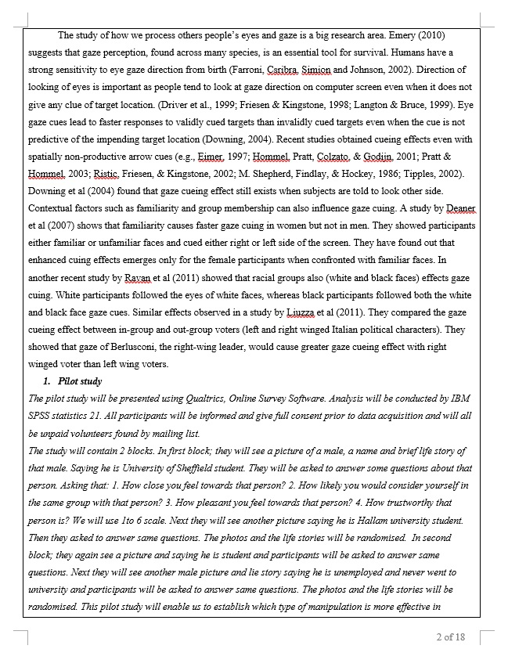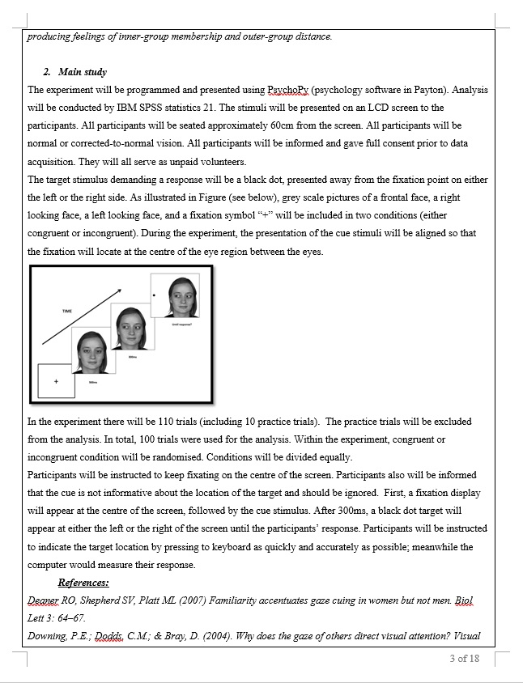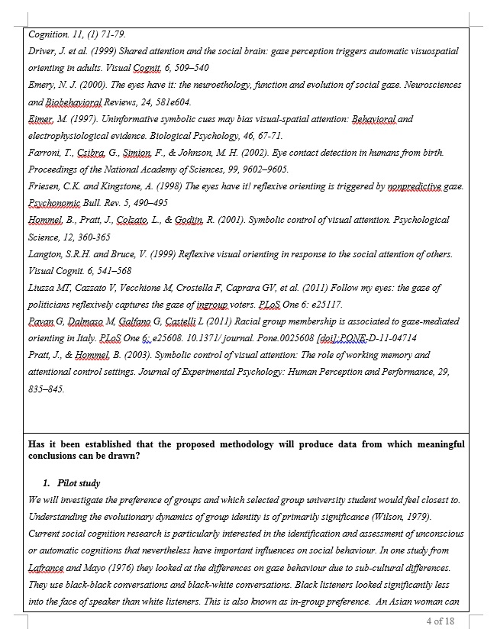

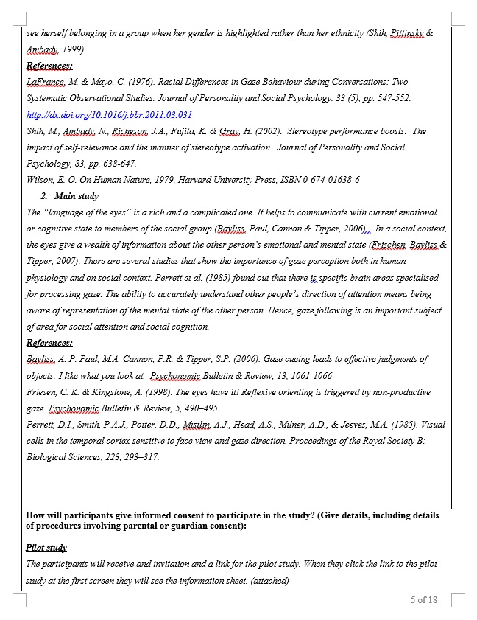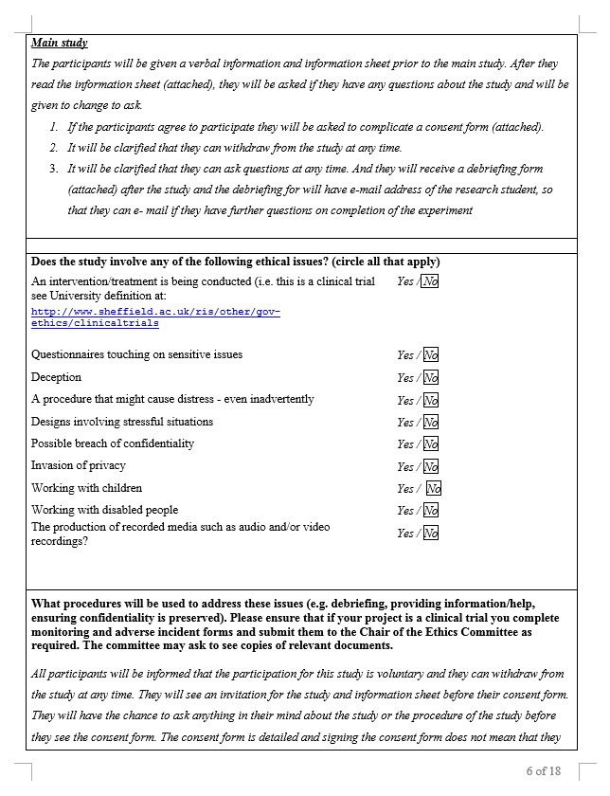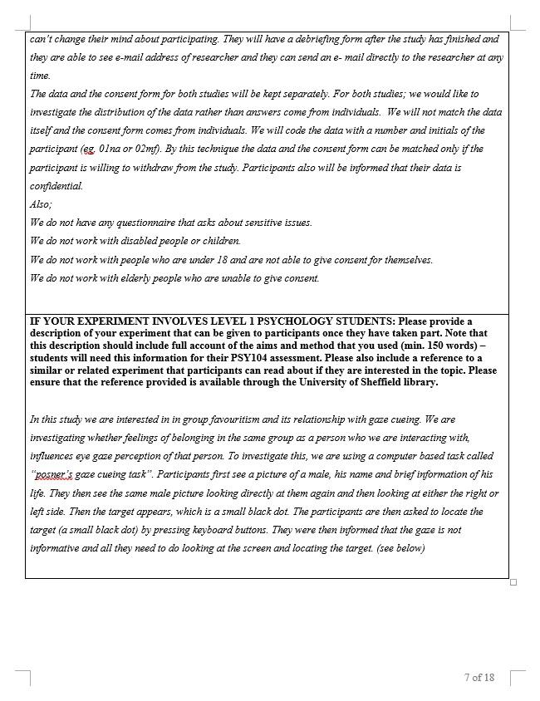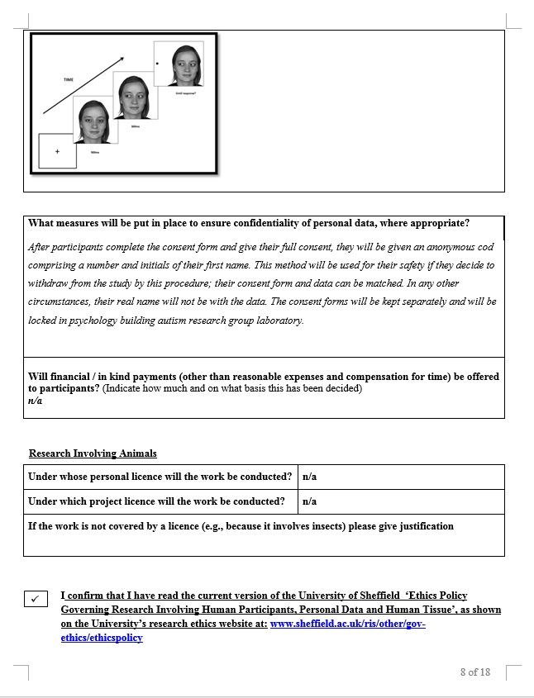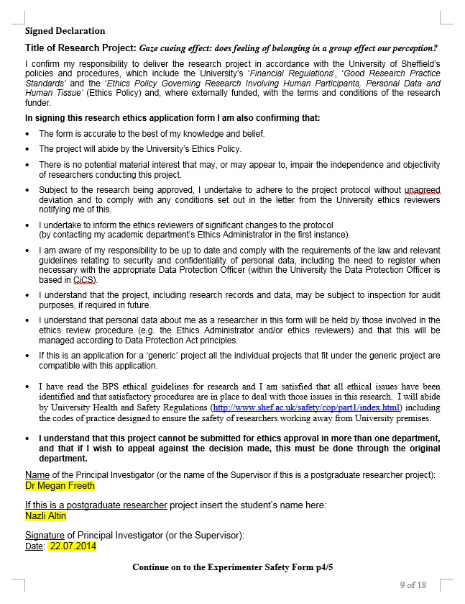



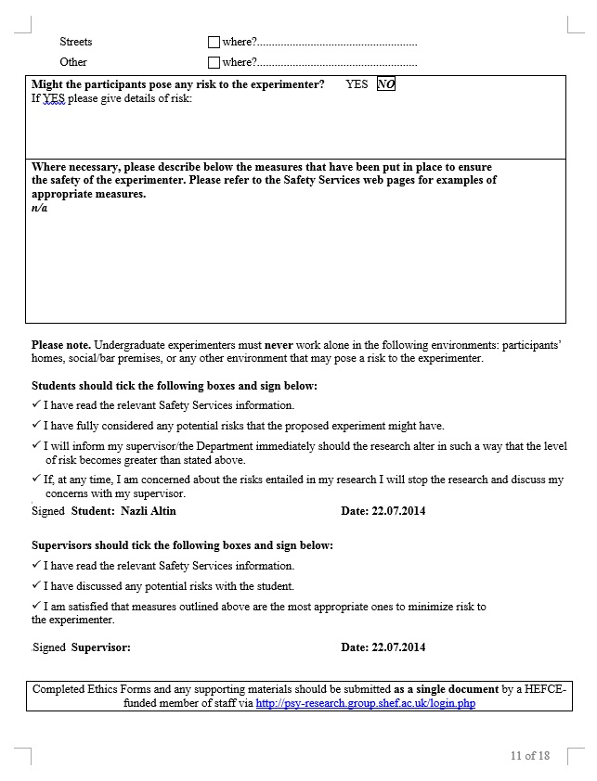



Recruitment e-mail for stimuli preparation study
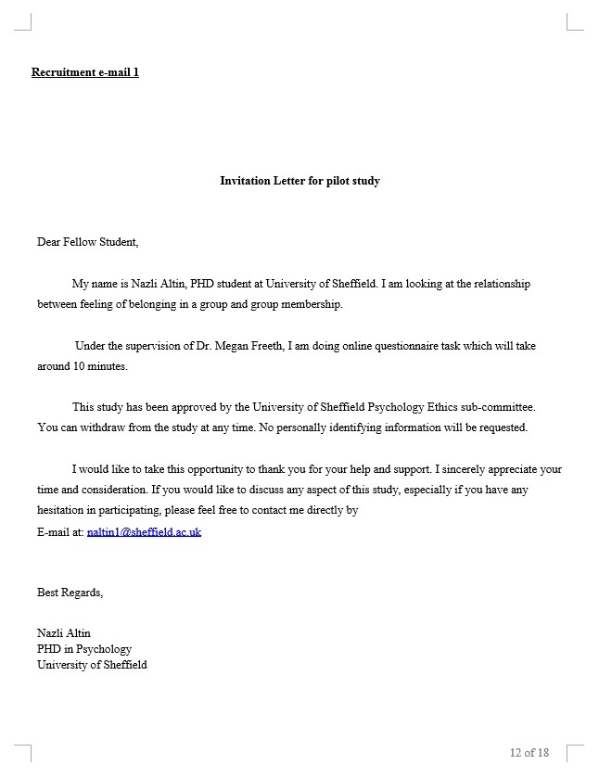

Recruitment e-mail for the behavioural study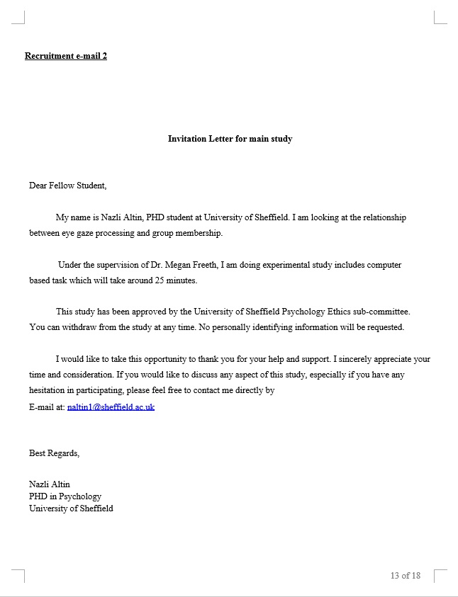

Informaton sheet for study 1:




Consent form for study 1
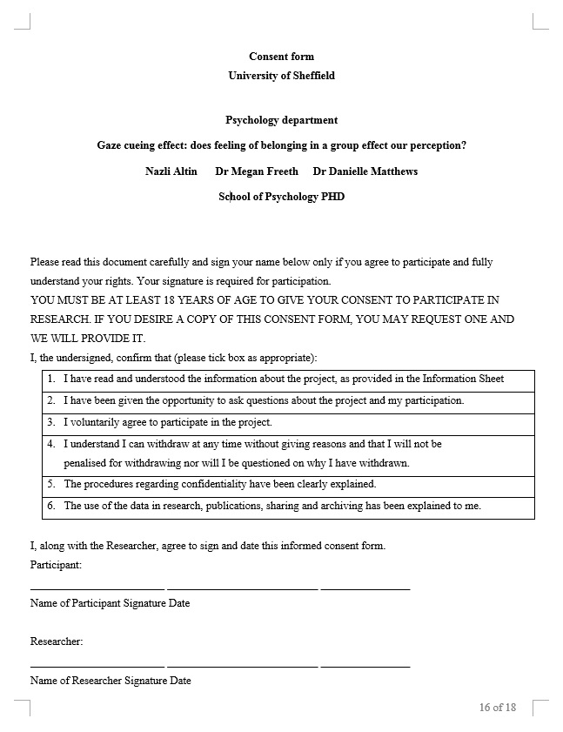

Demographic information form for behavioural study from Chapter 2
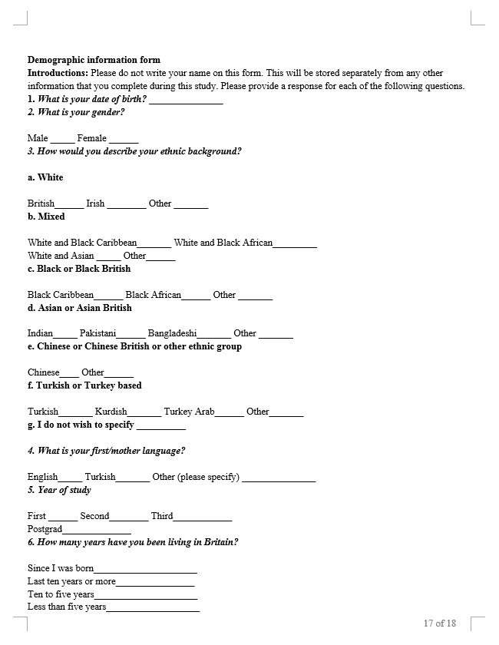
Debriefing form for behavioural study

Questionnaire from online study

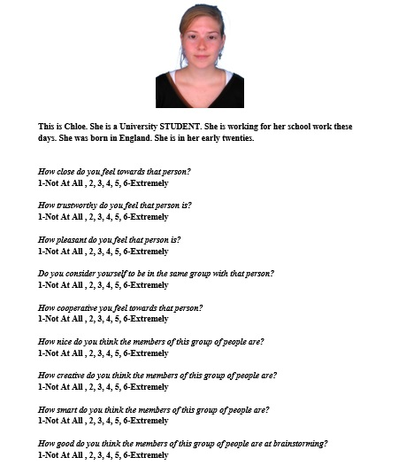

Appendix B
Ethical approval for study 2

Information sheet for study 2


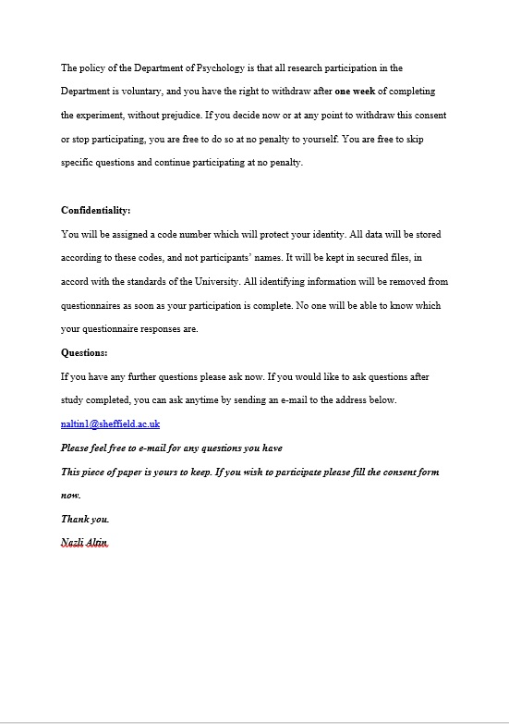

Debriefing form for study 2


Consent form study 2



Priming task participants’ writings
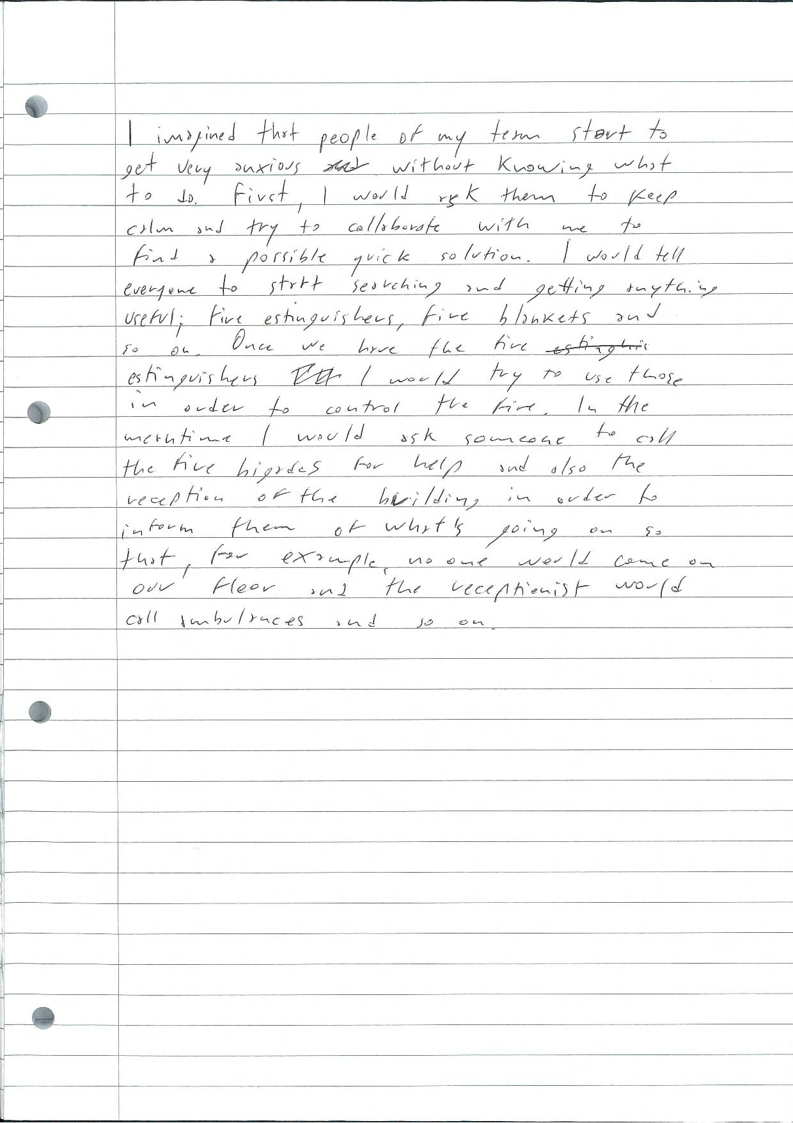
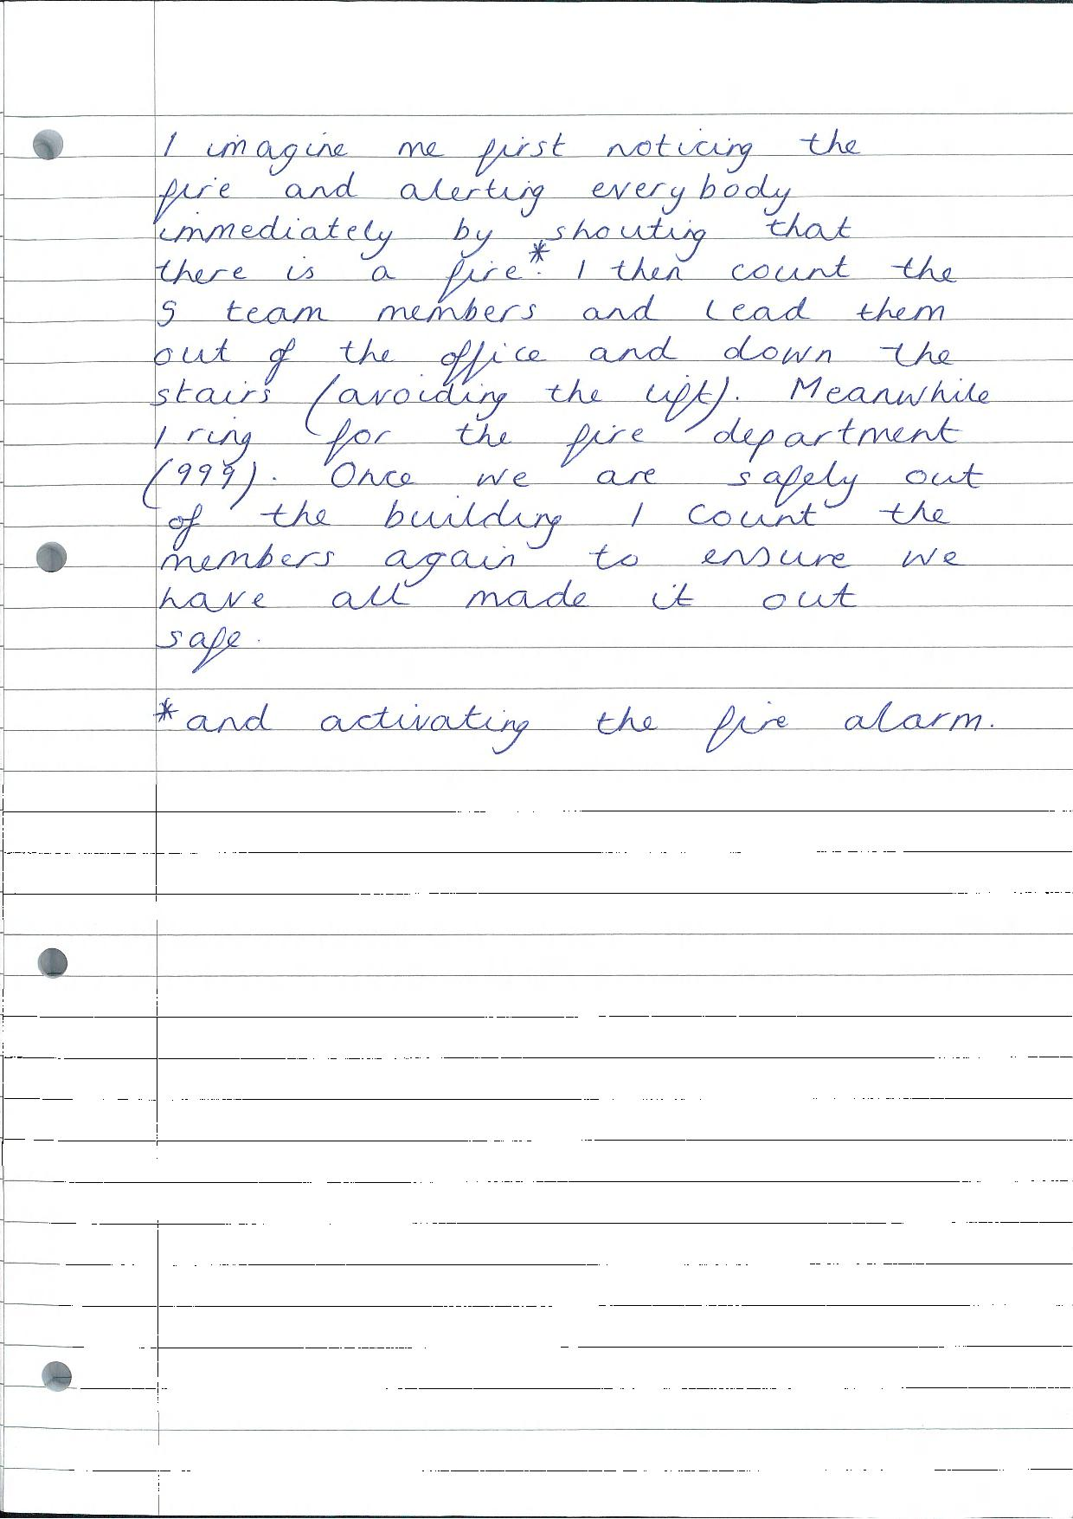
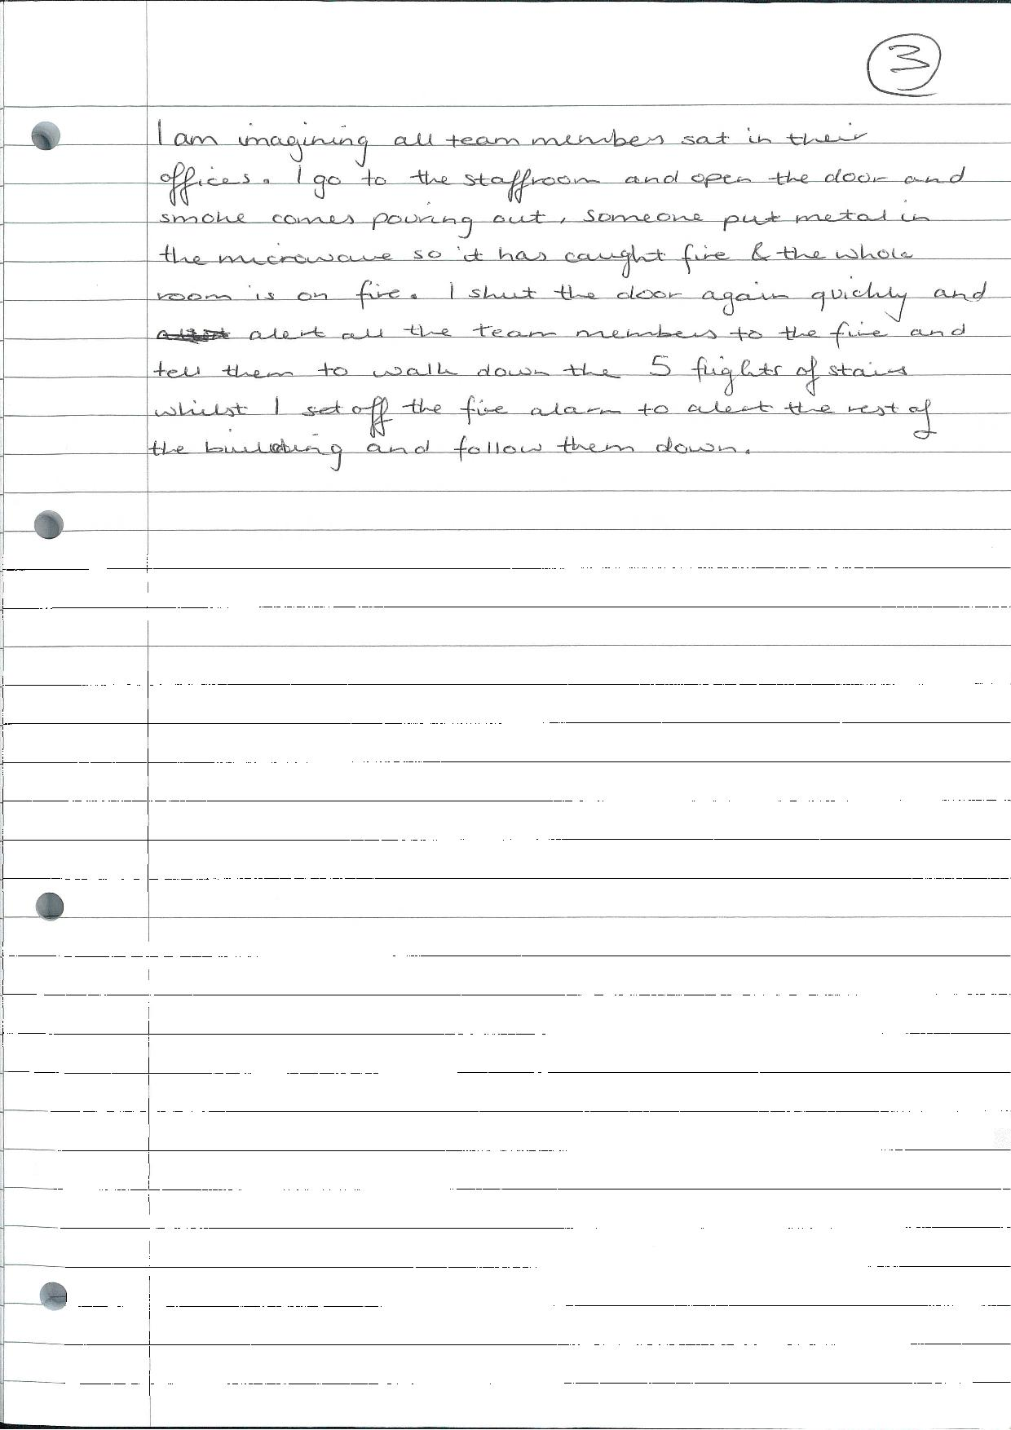

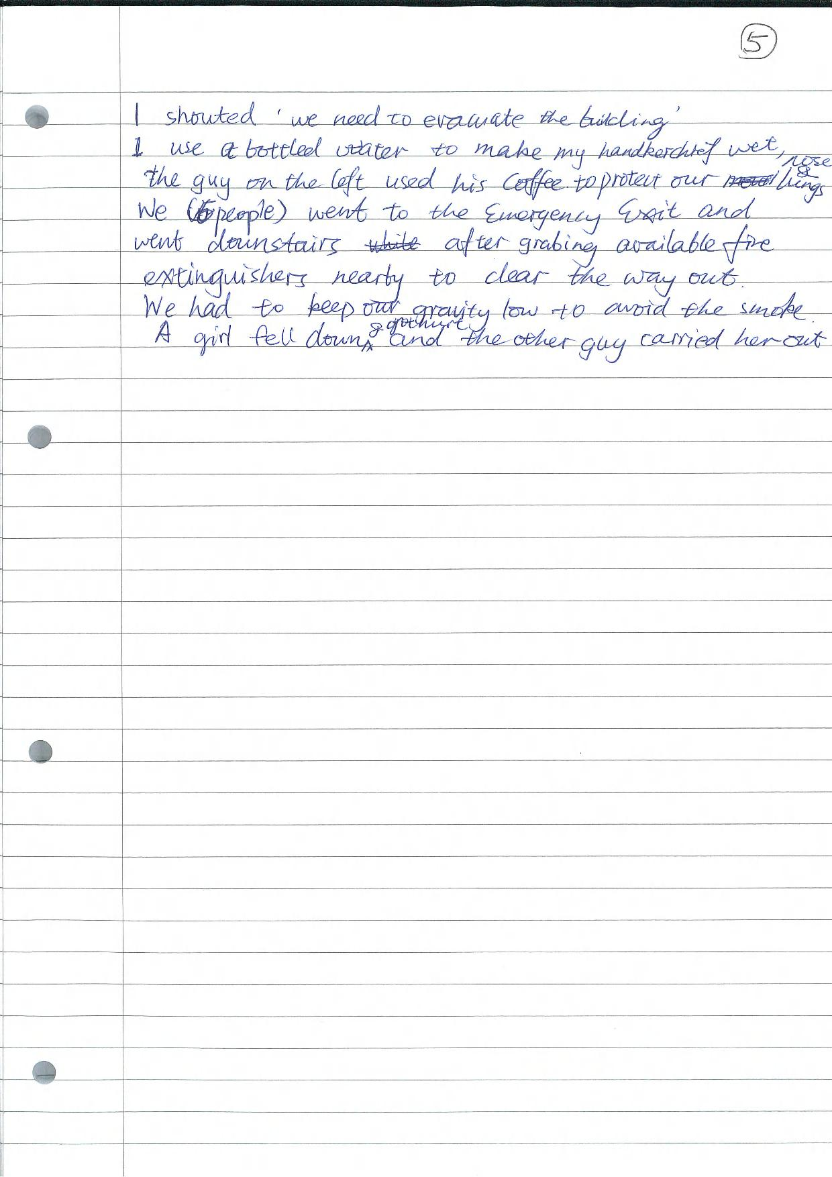
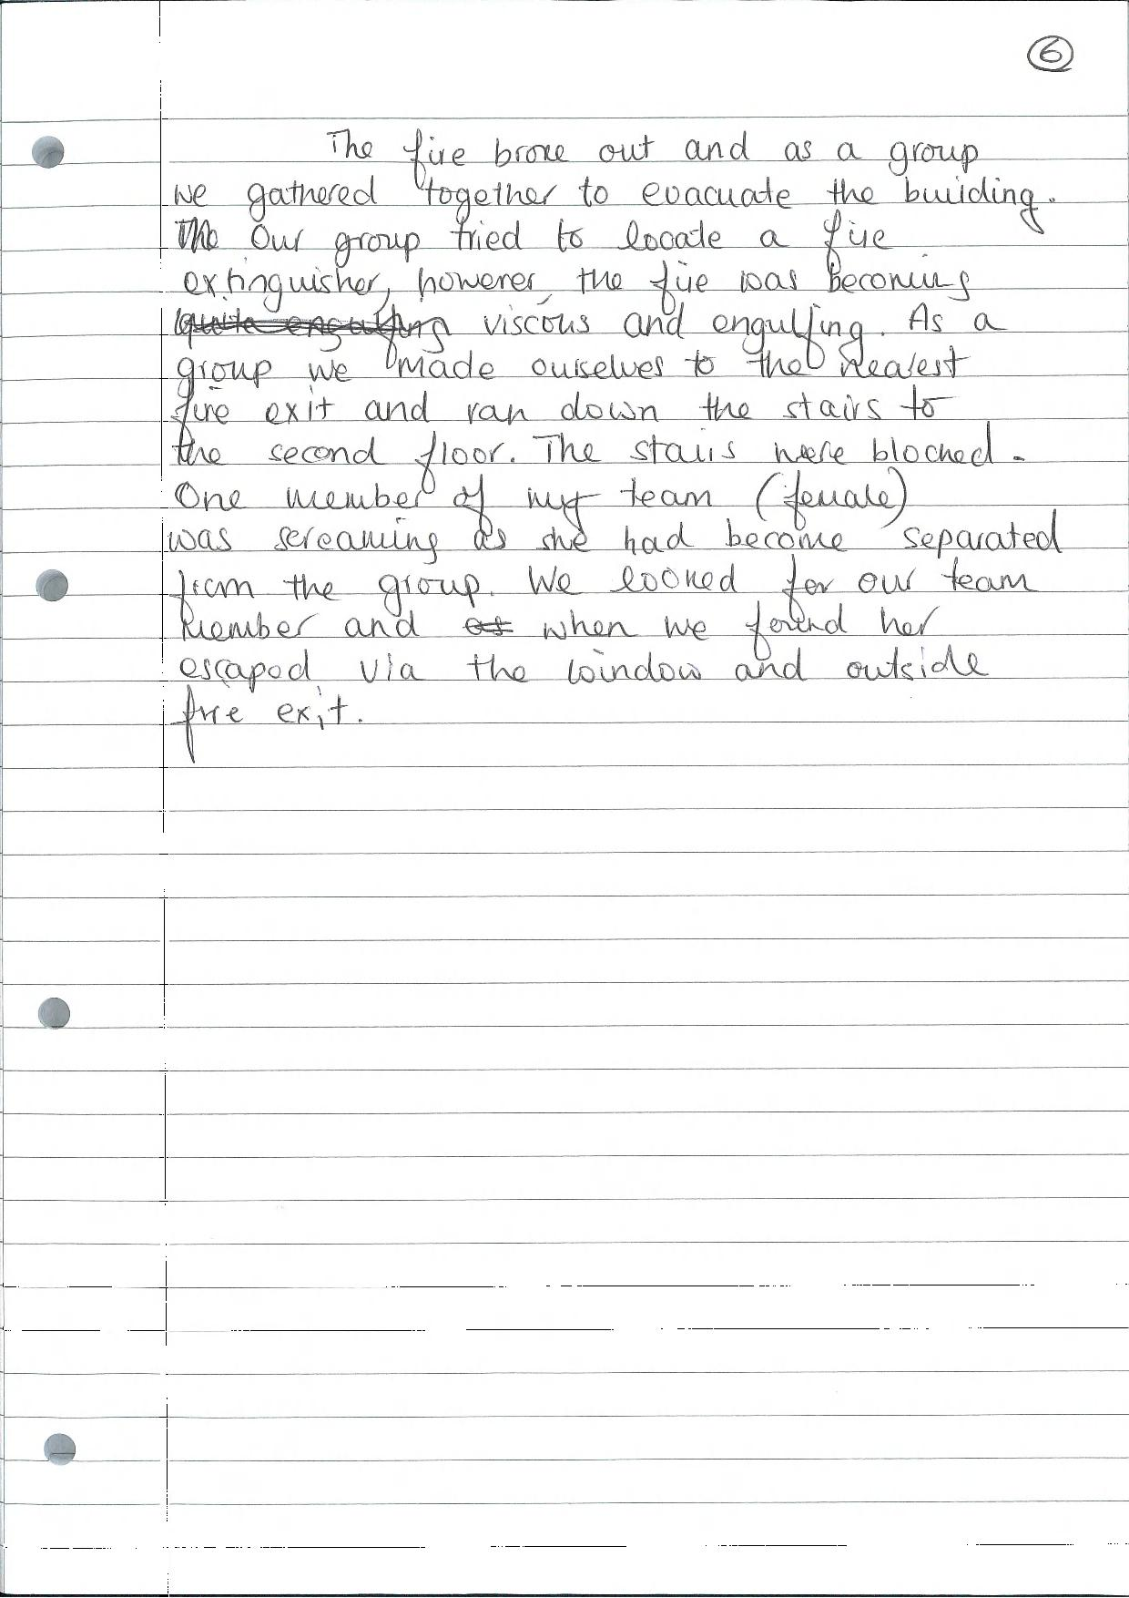


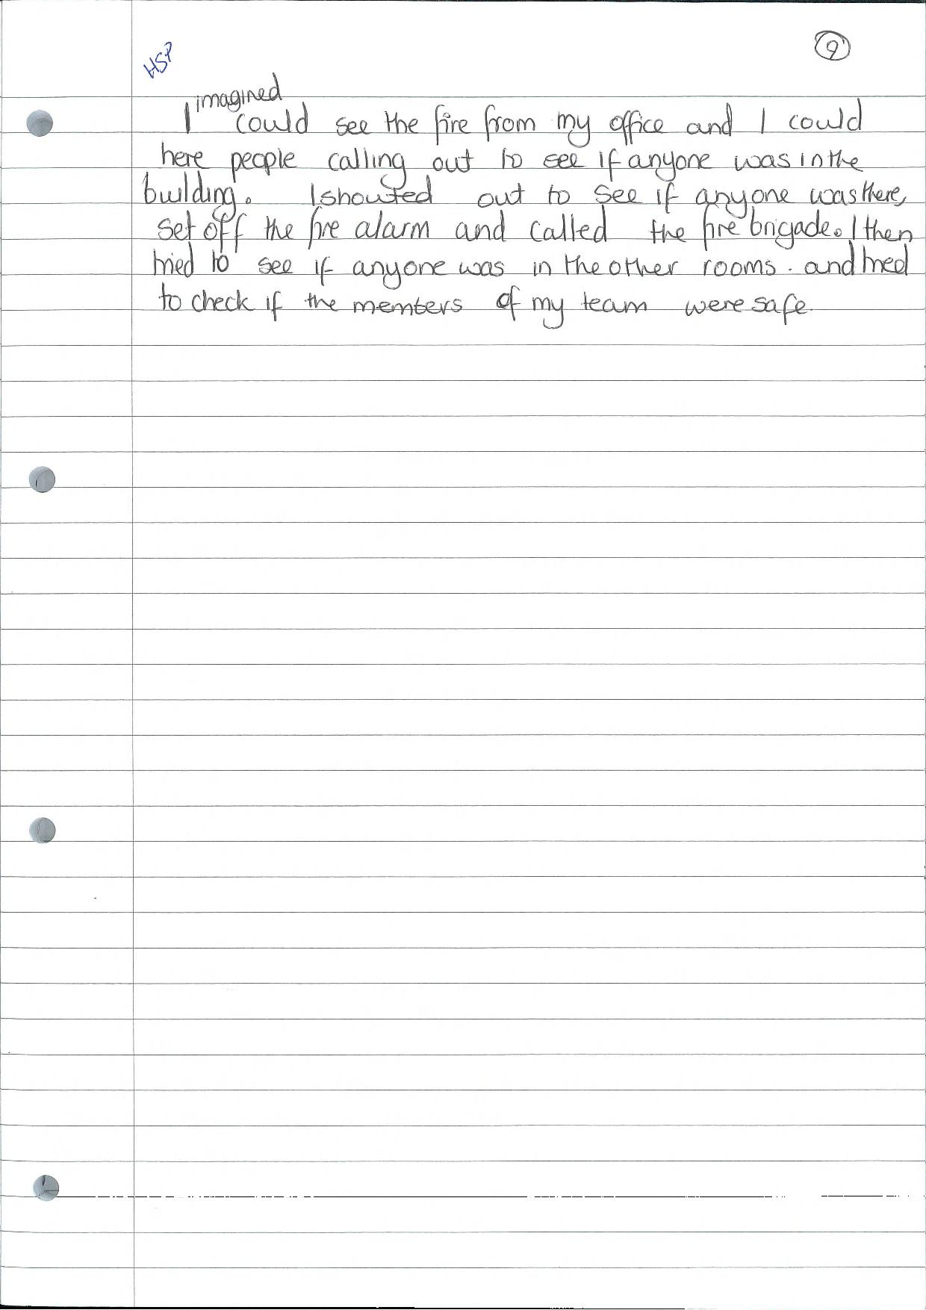
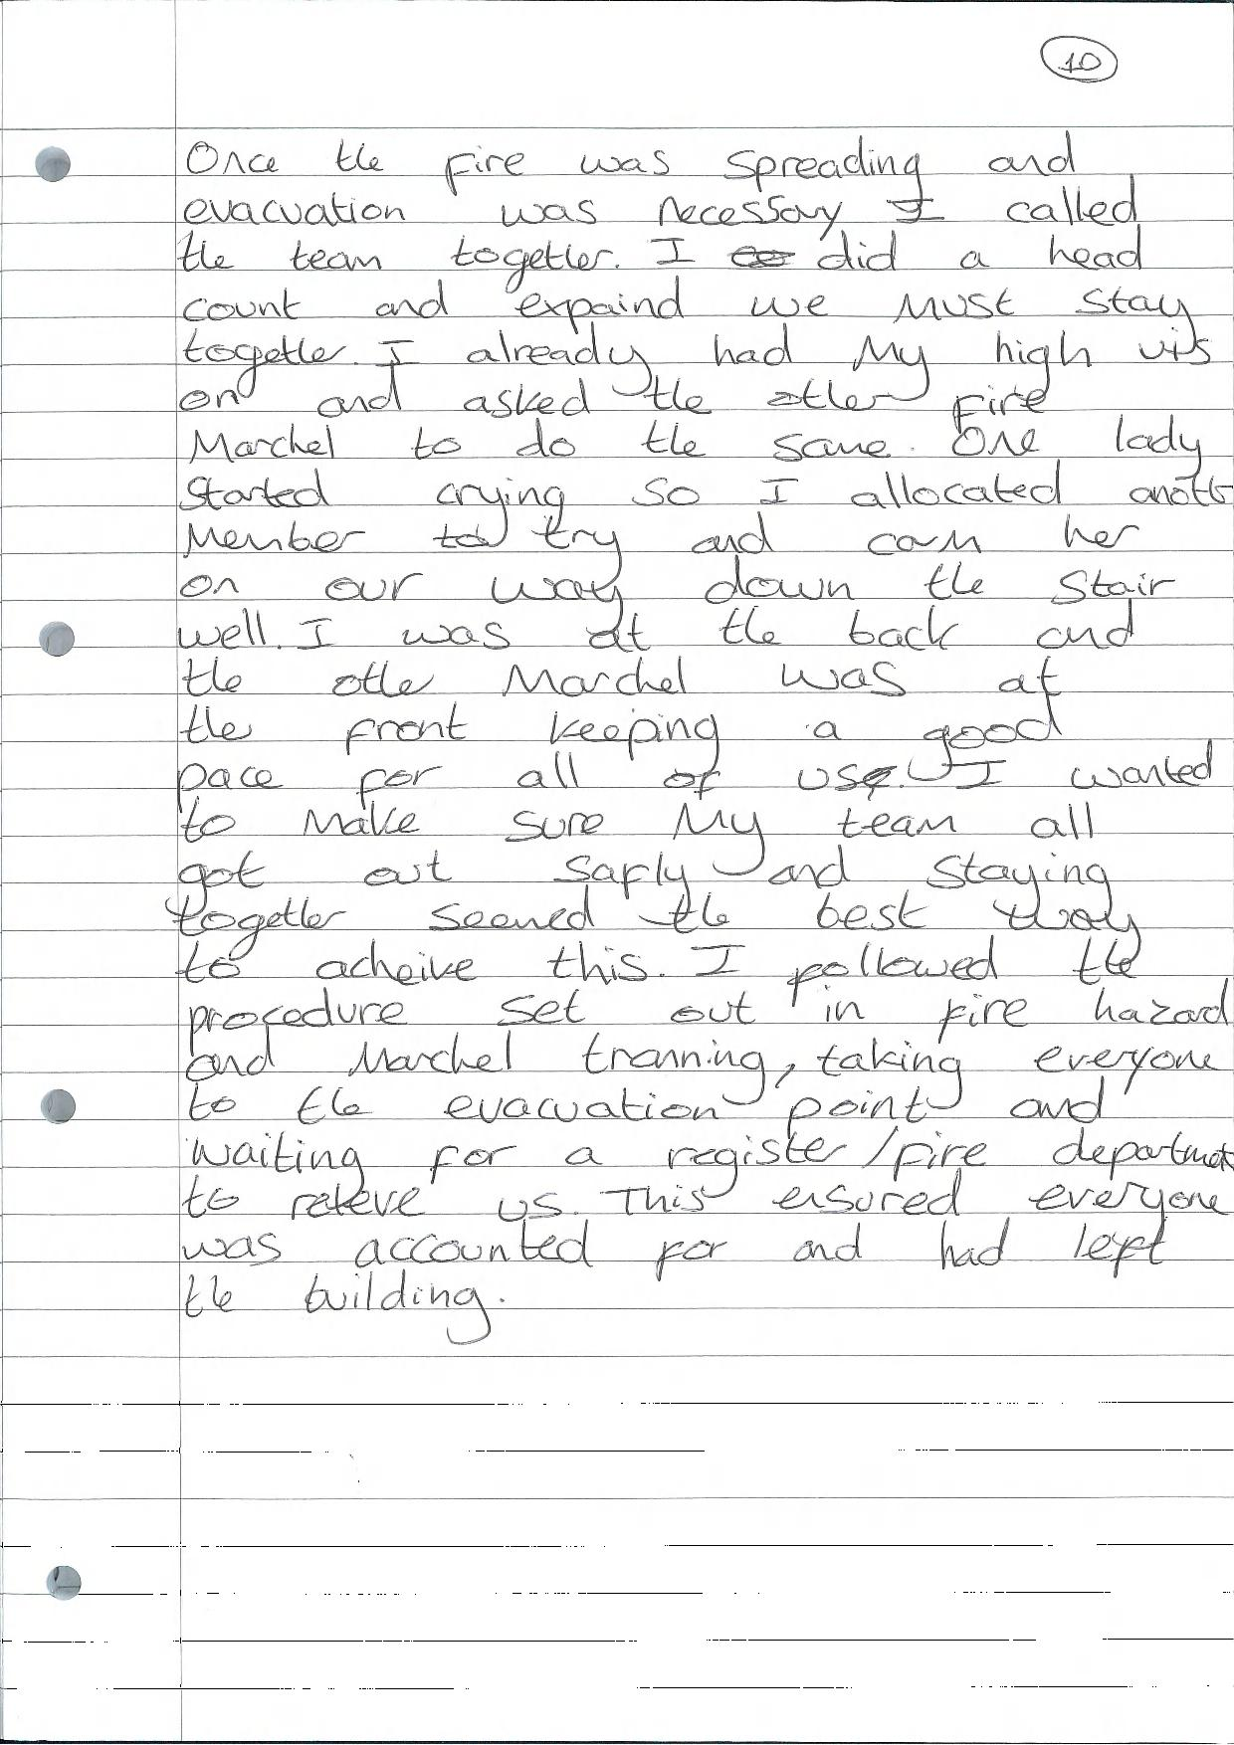
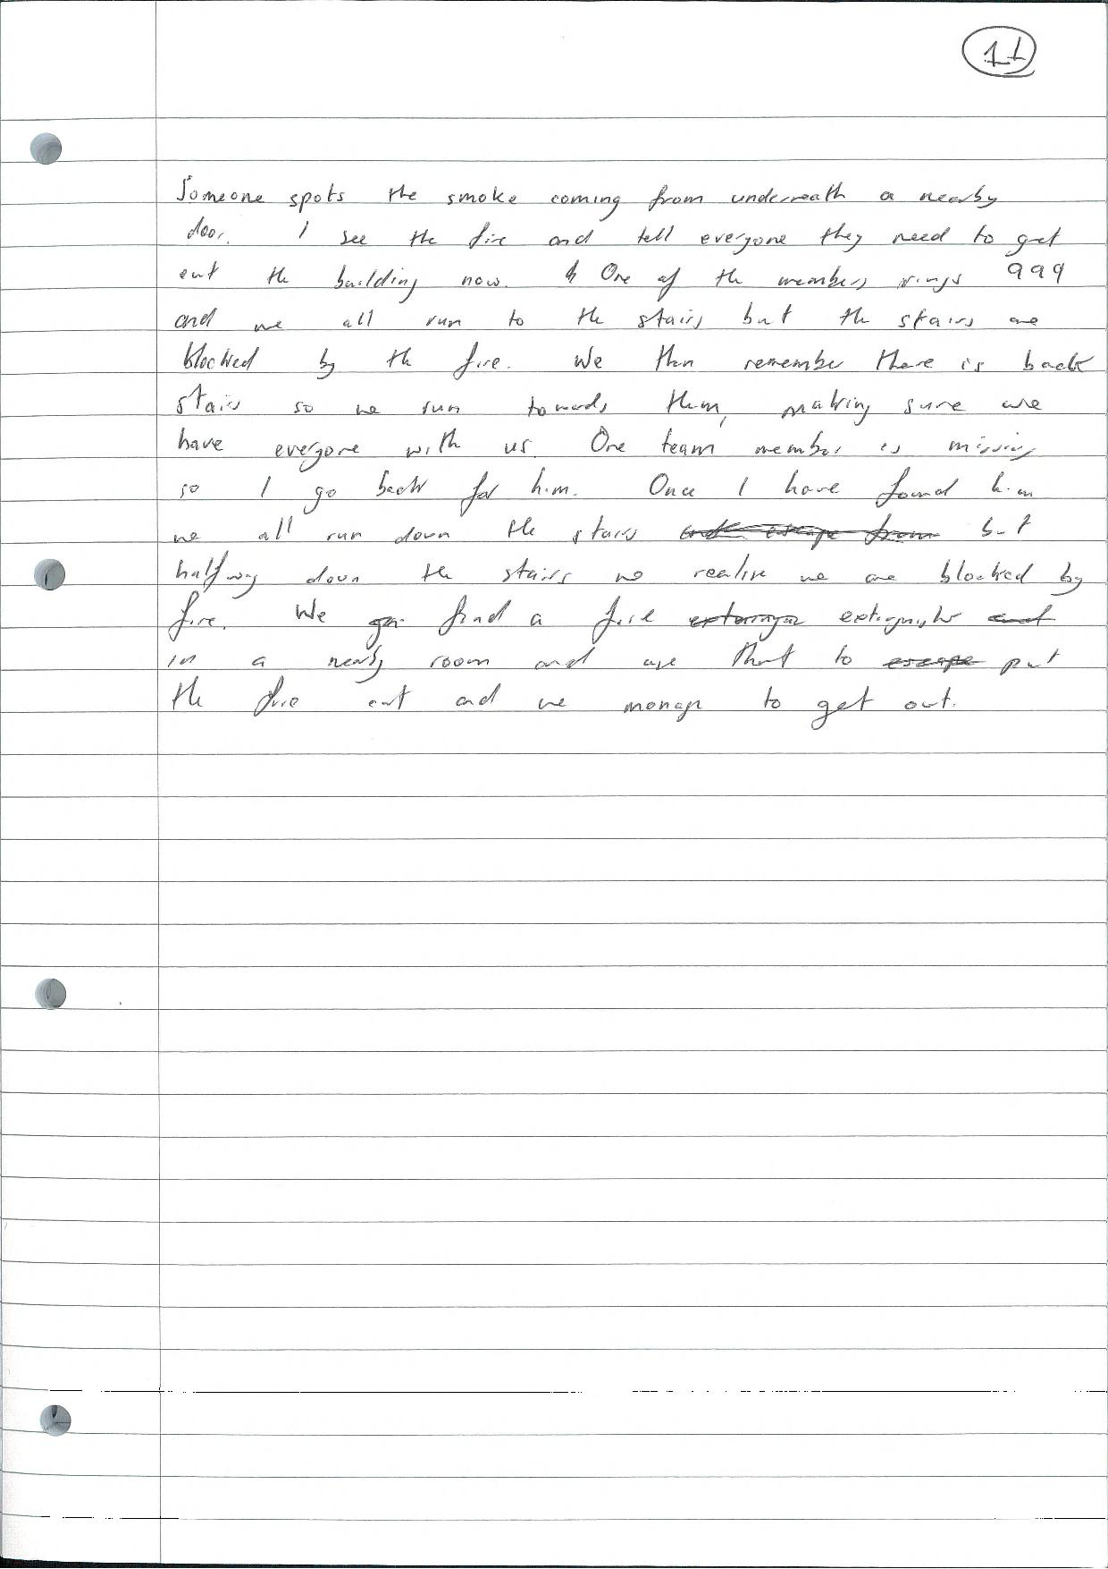
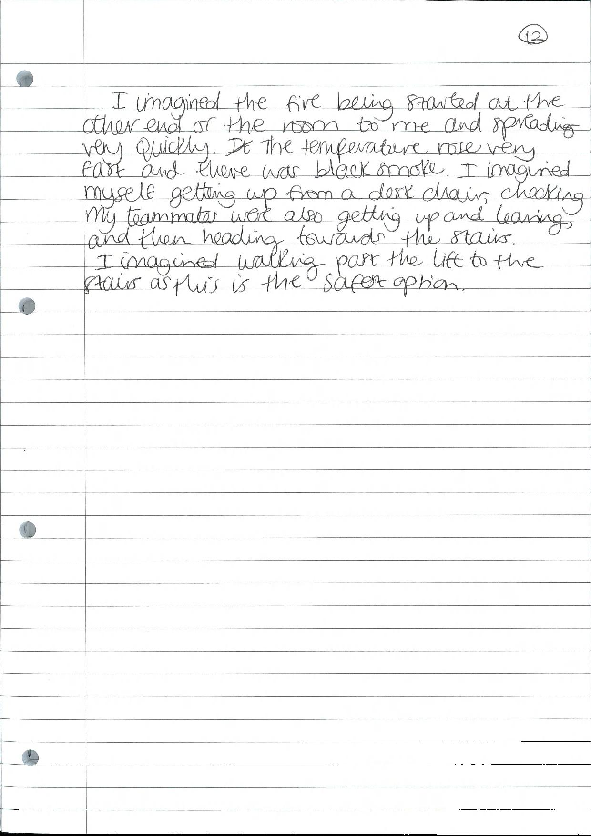
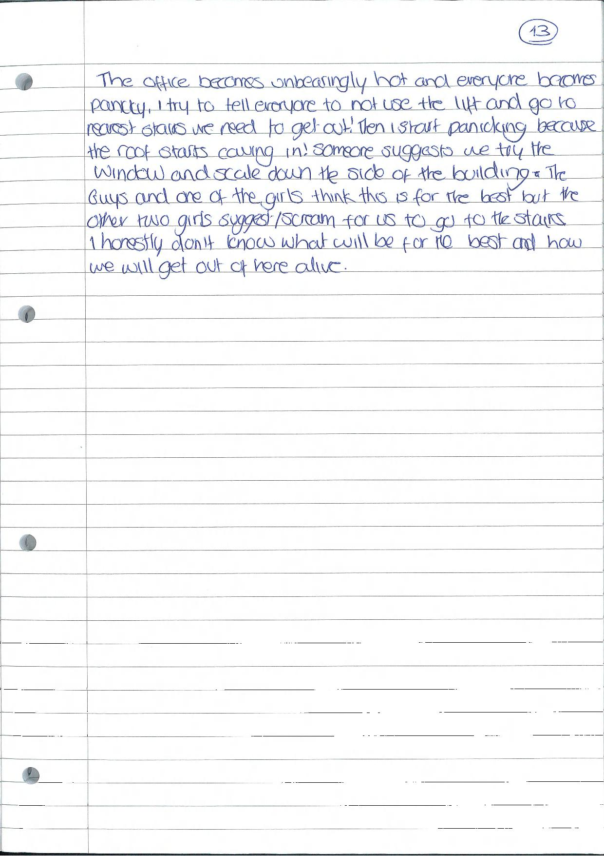
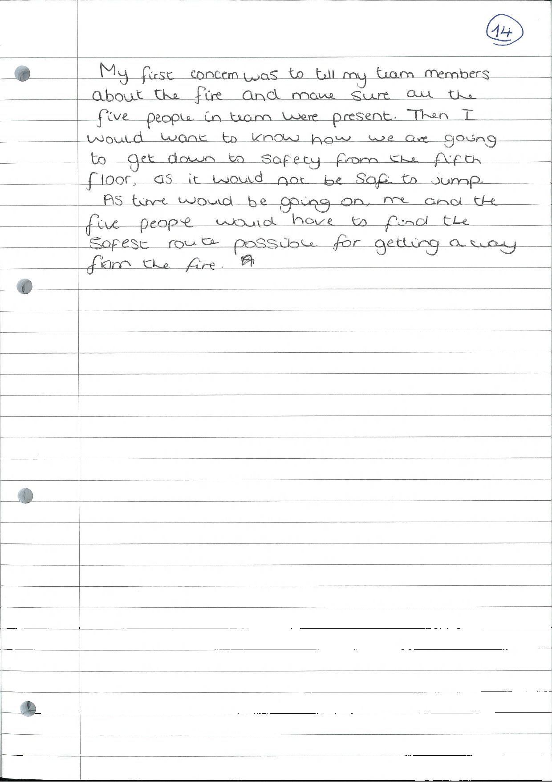
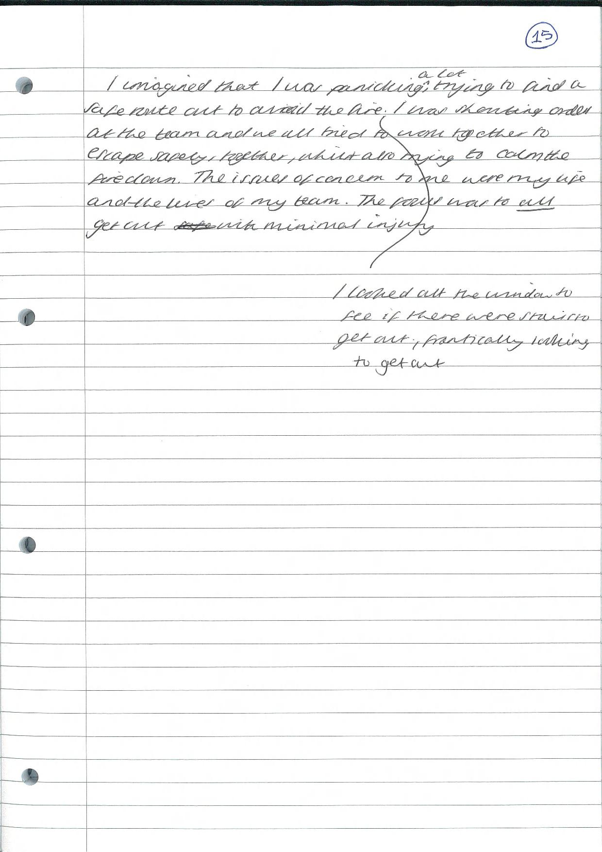
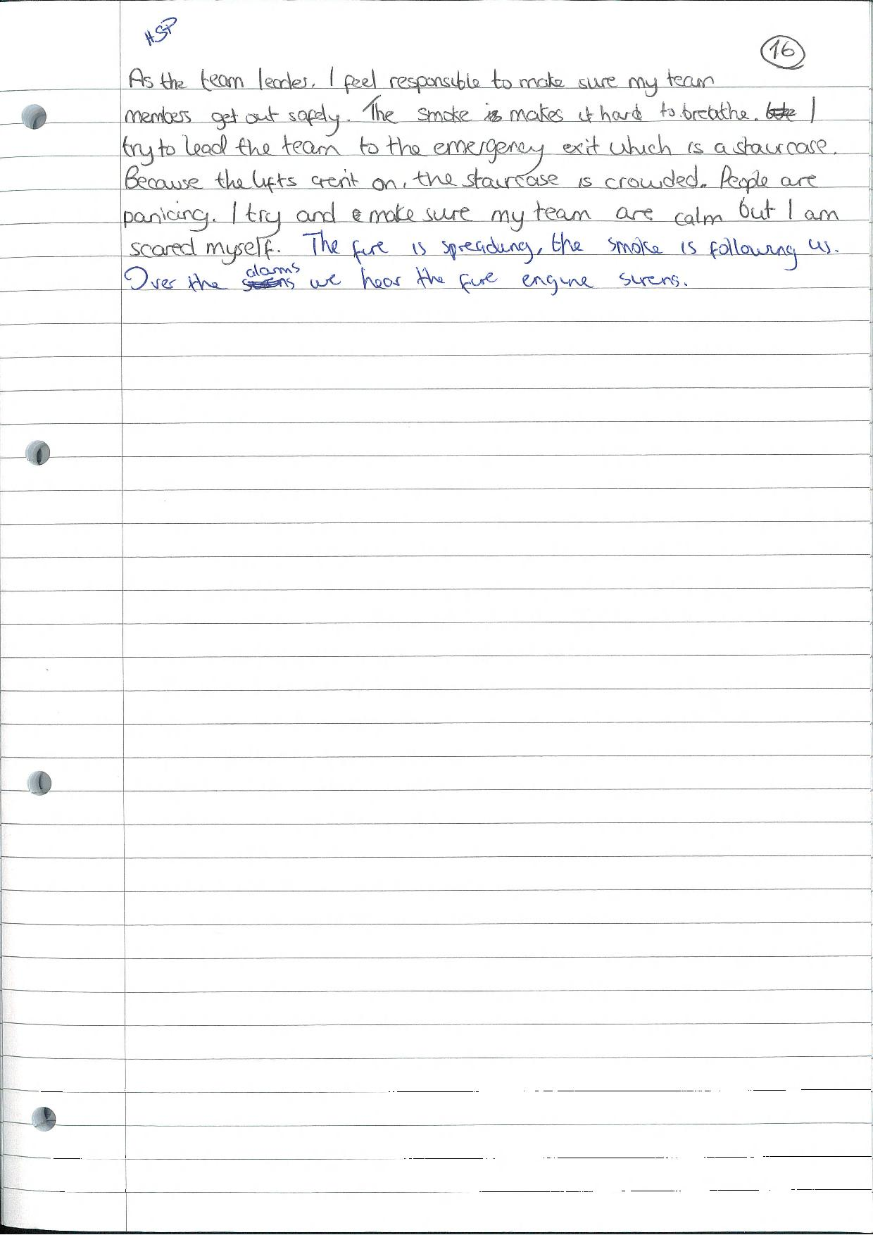
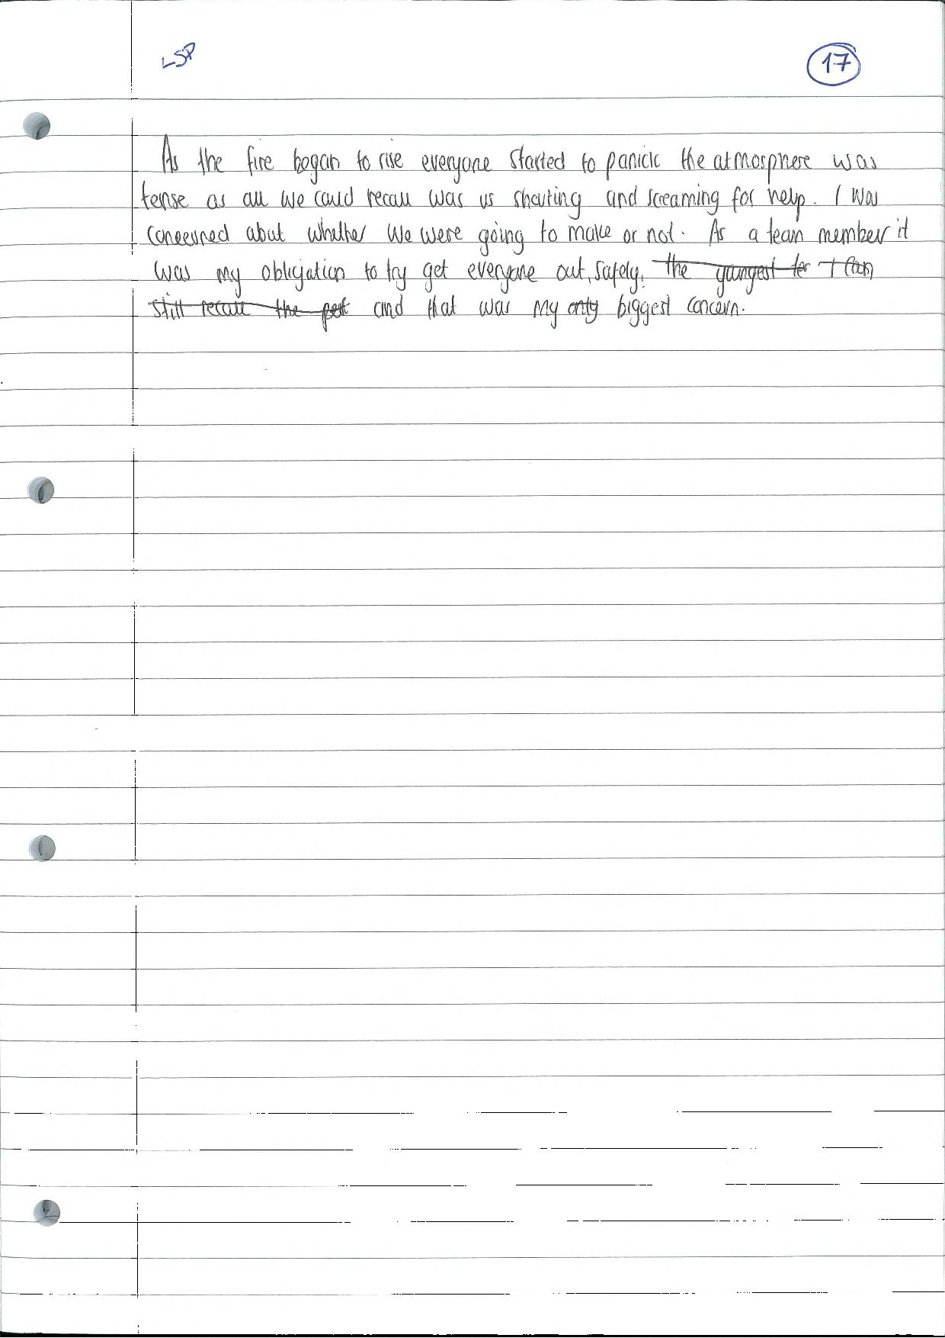
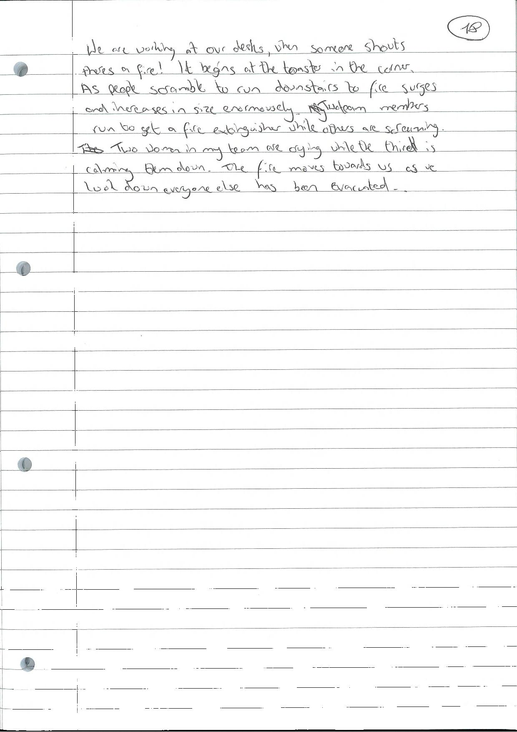
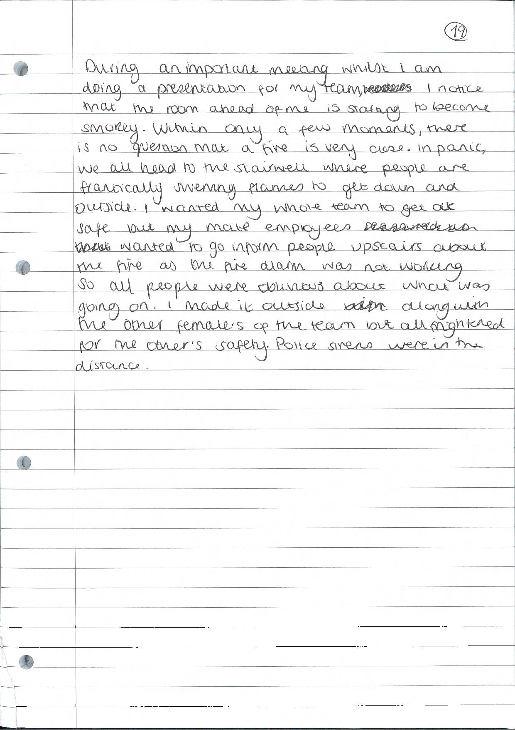
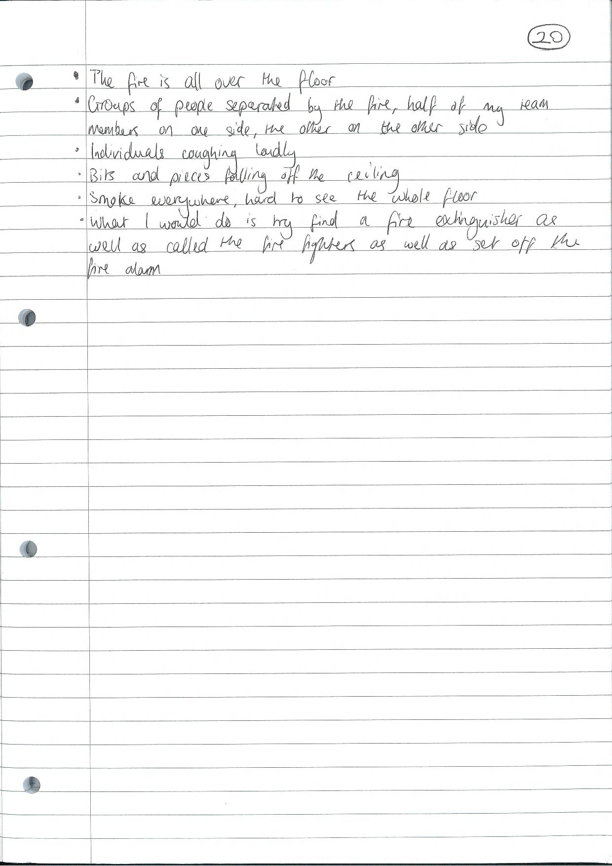
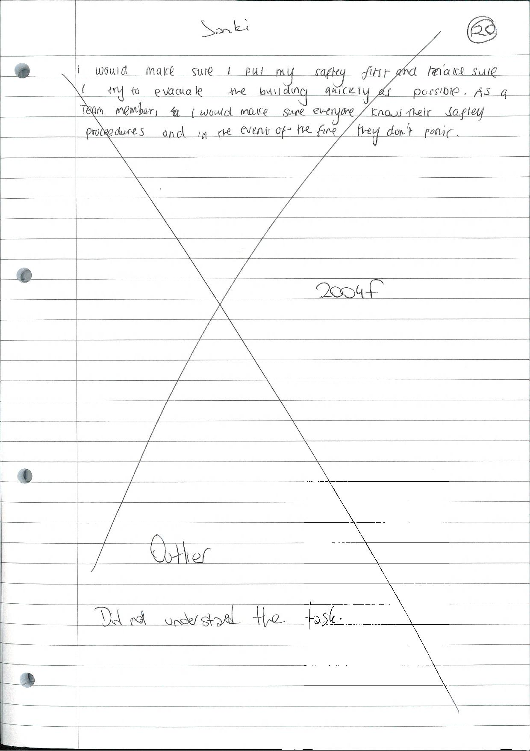
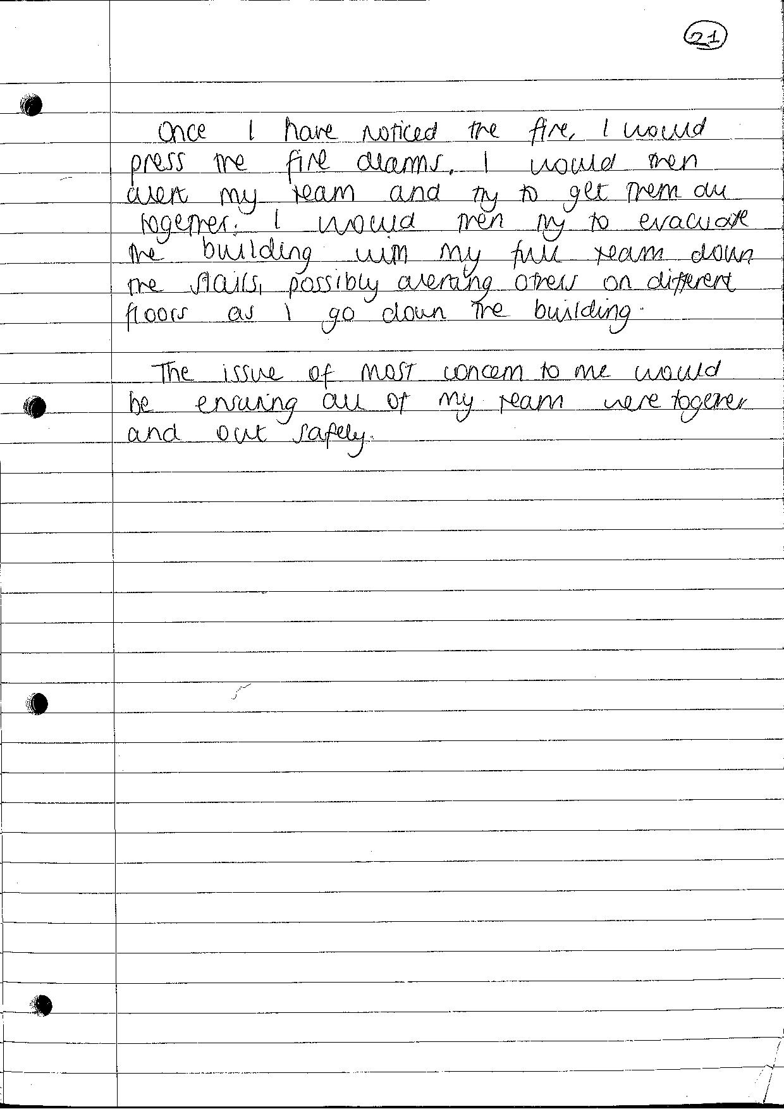
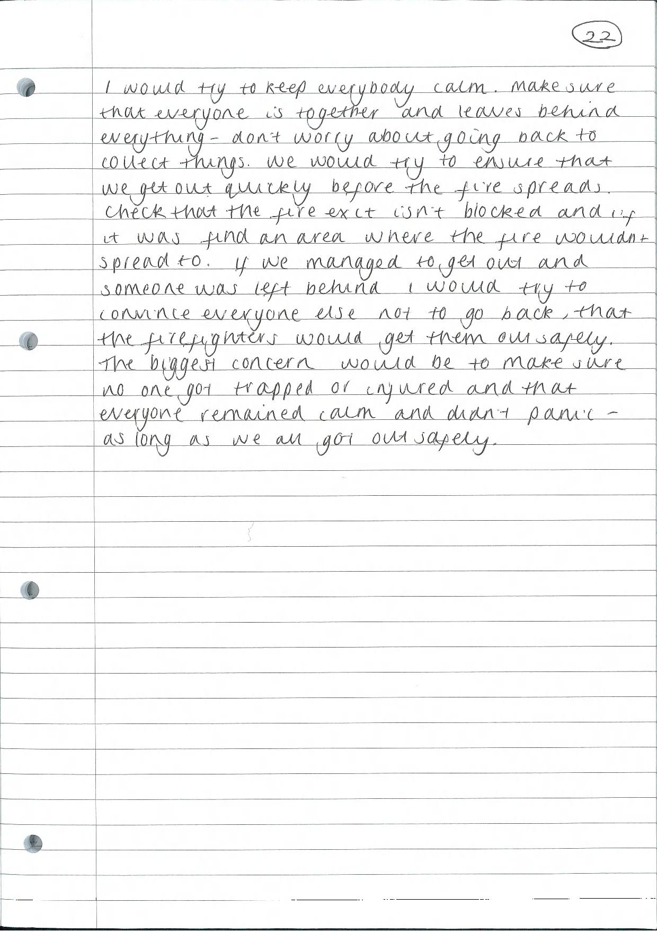
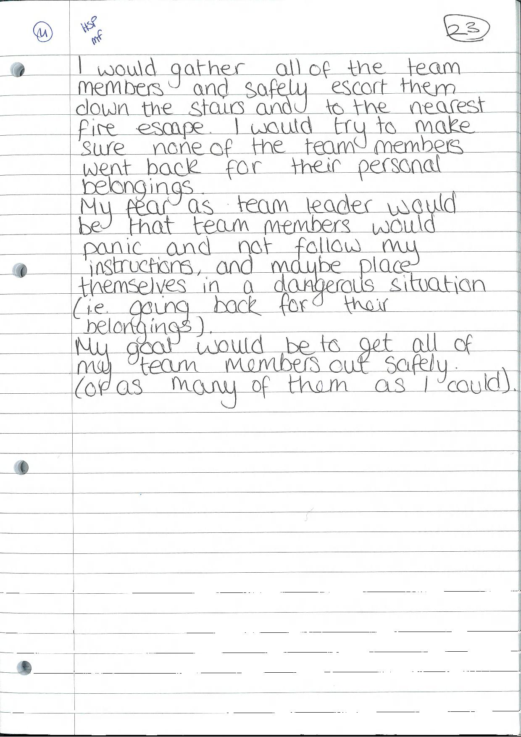
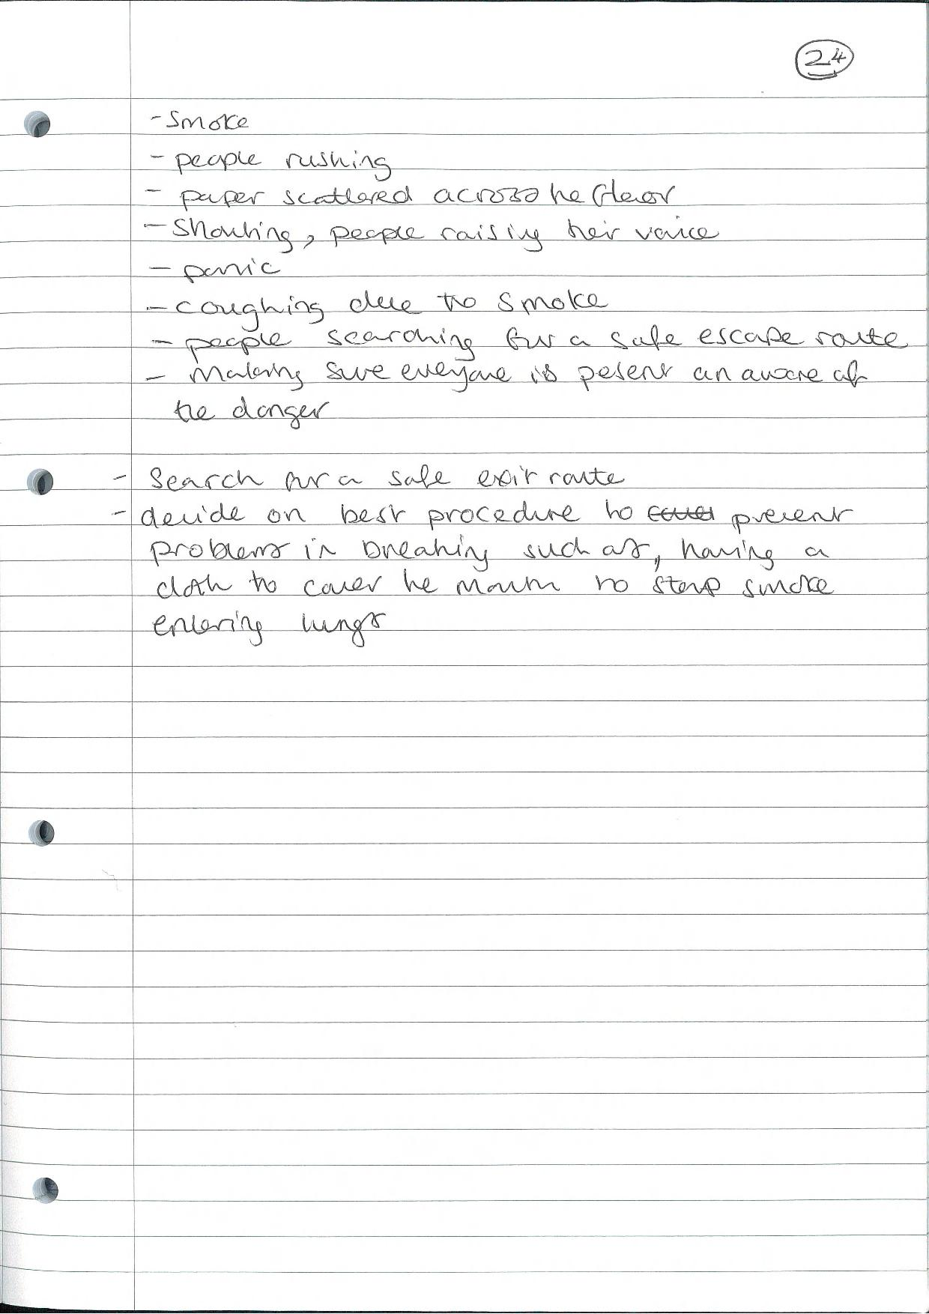
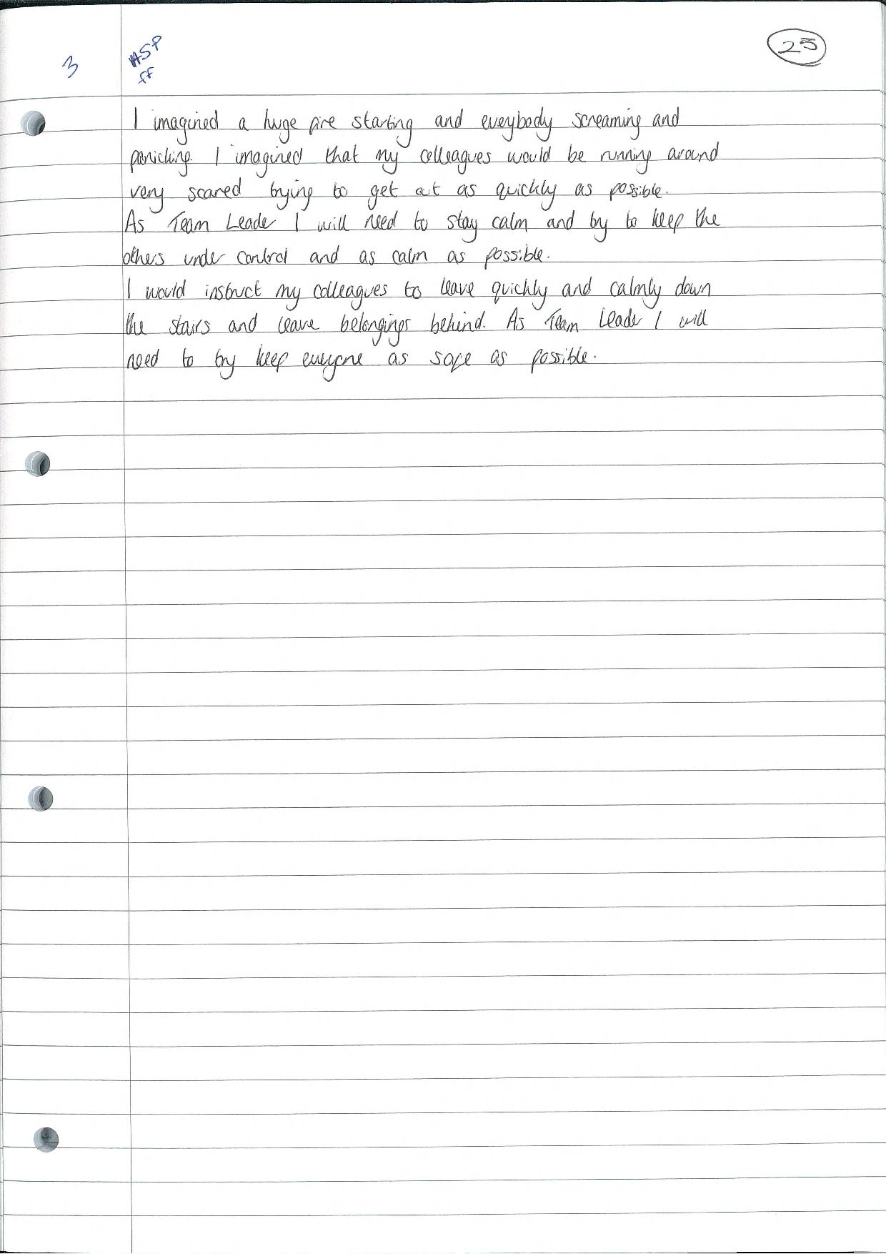
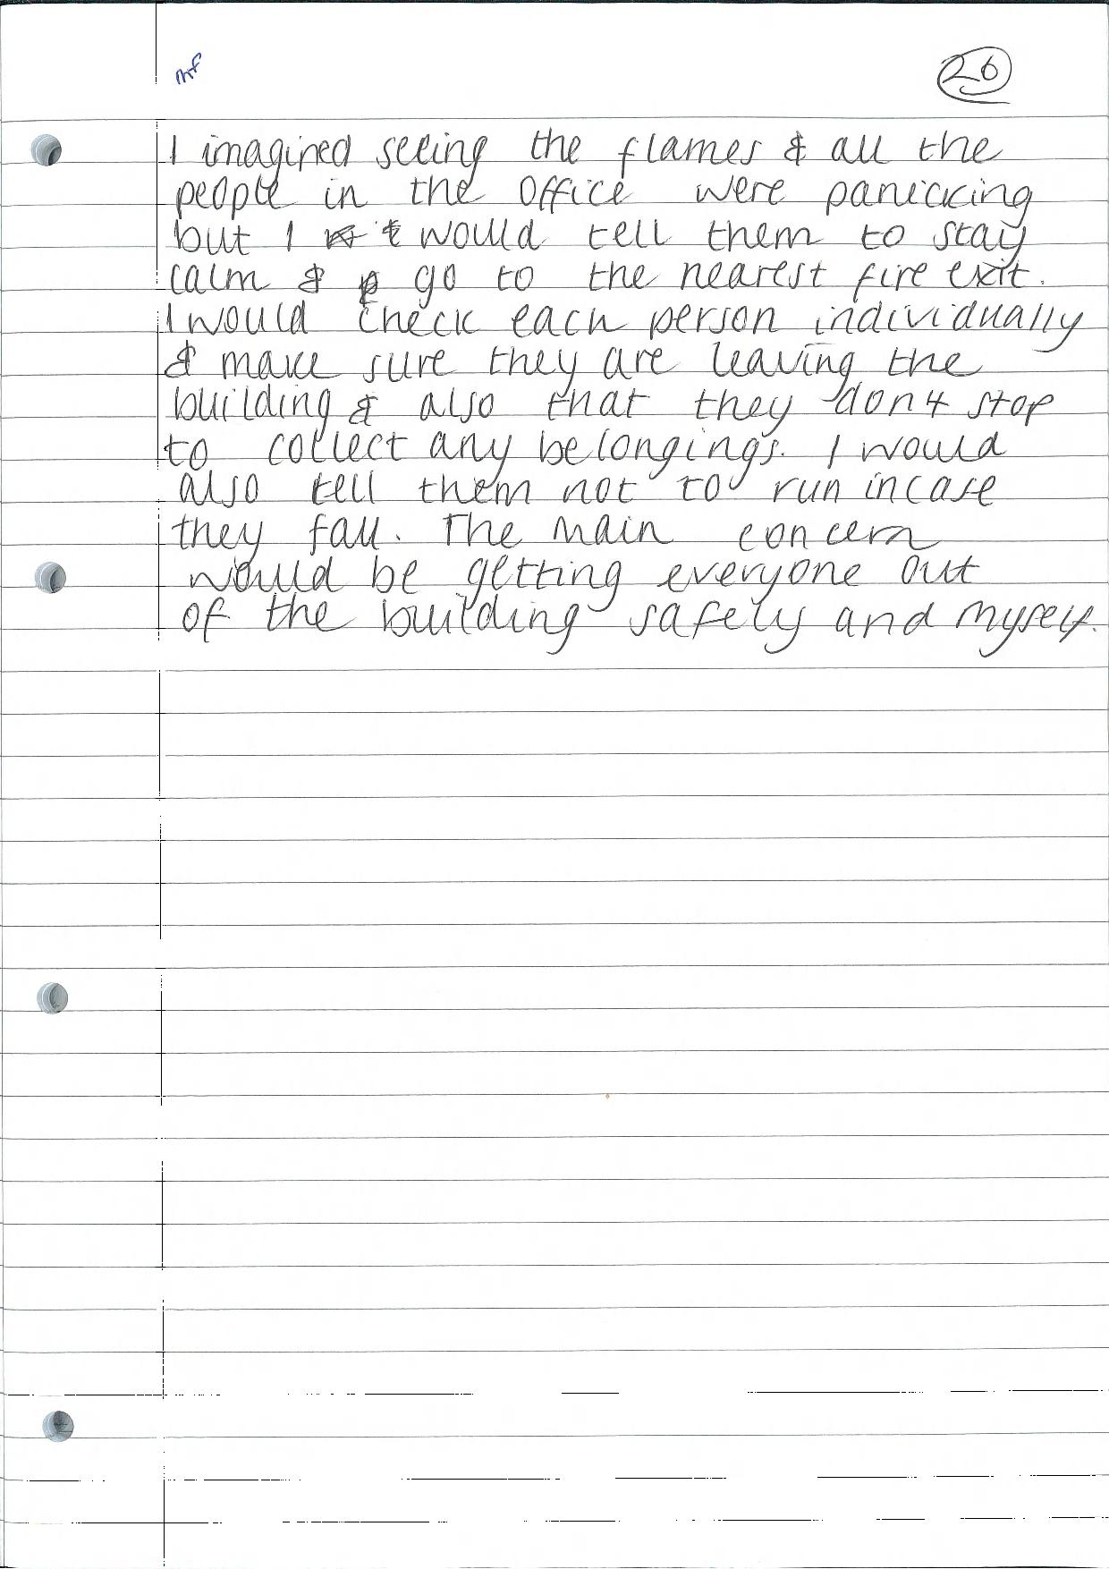
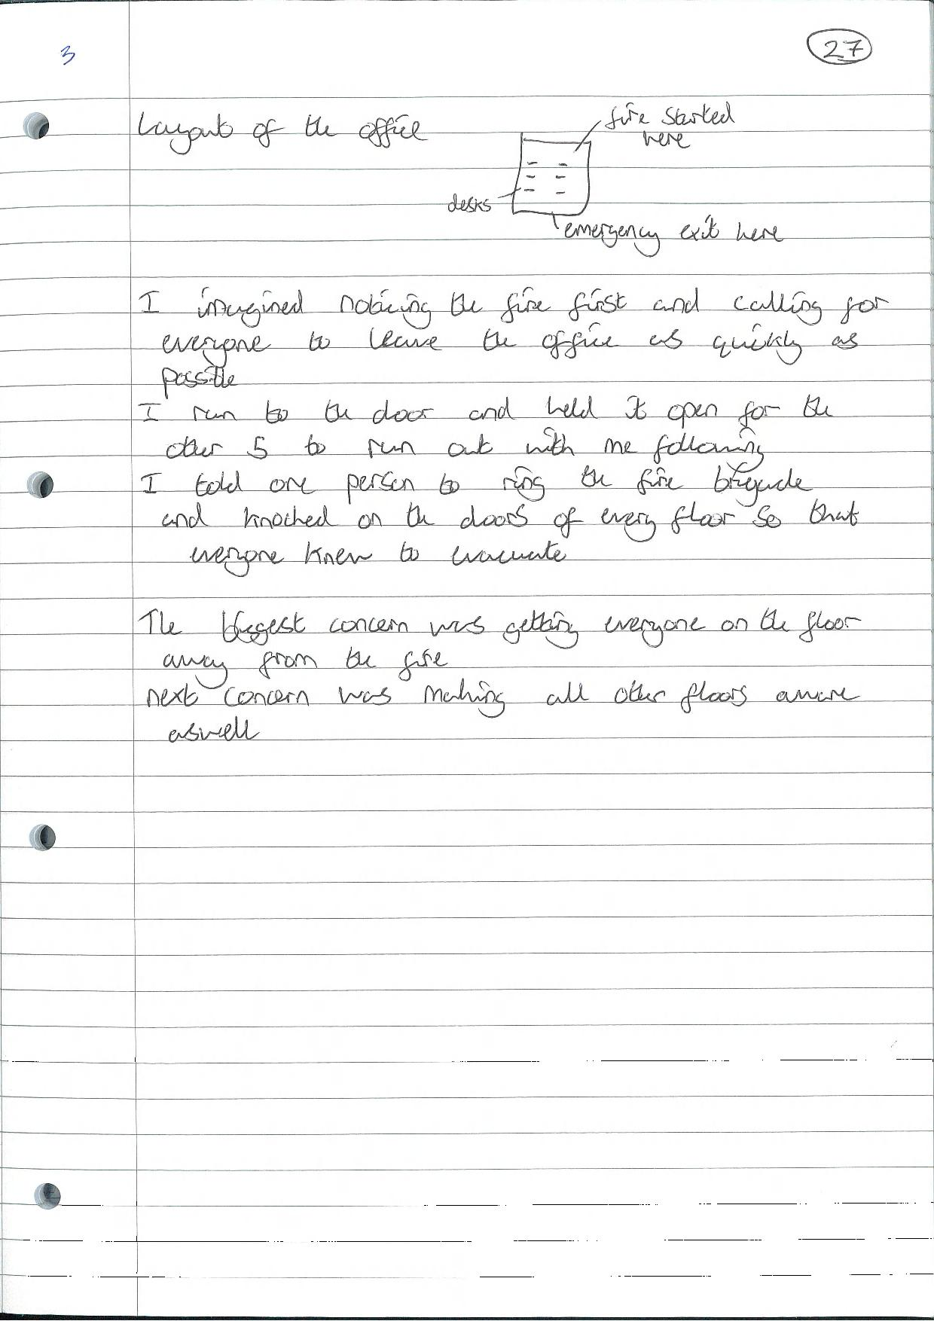
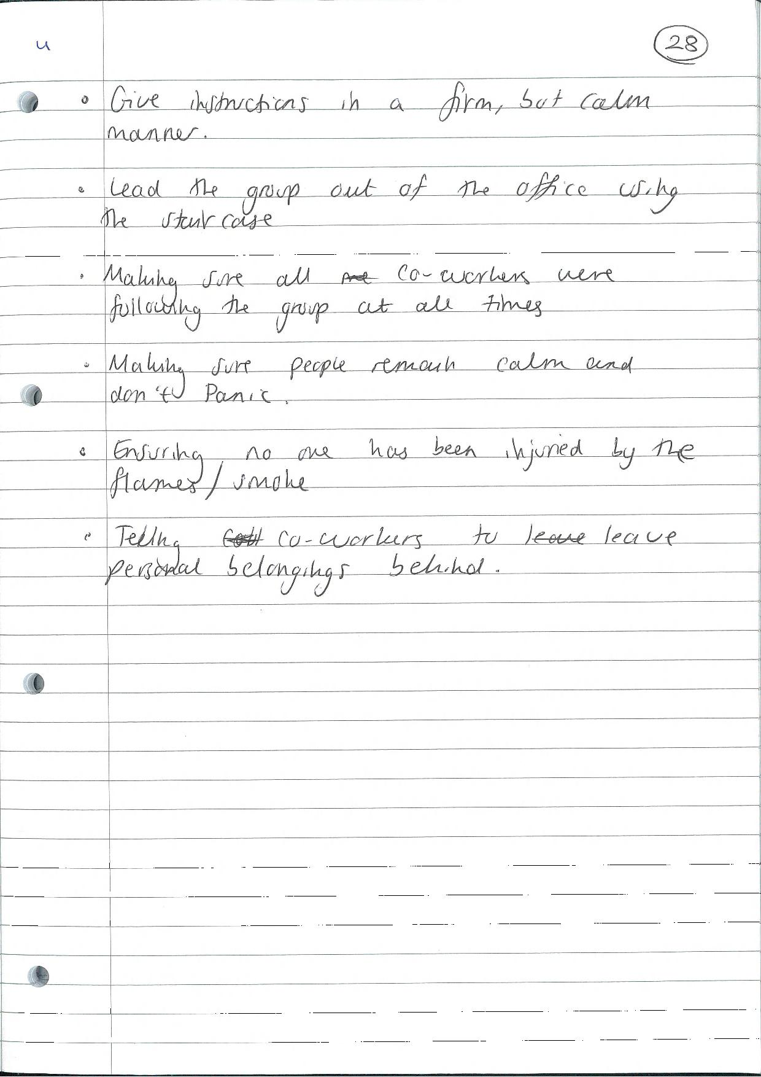
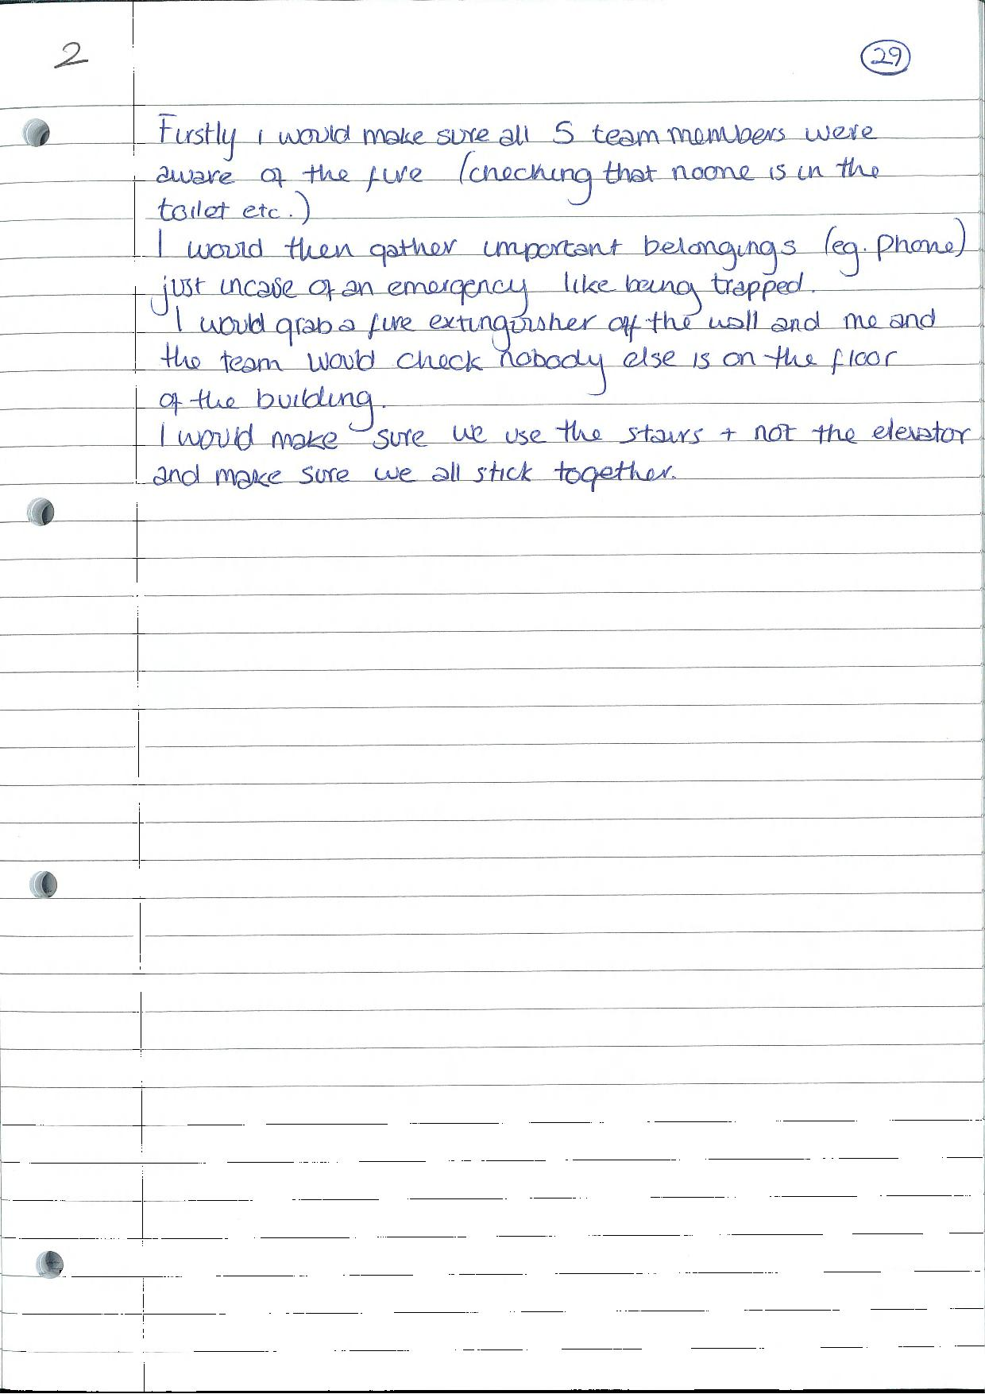
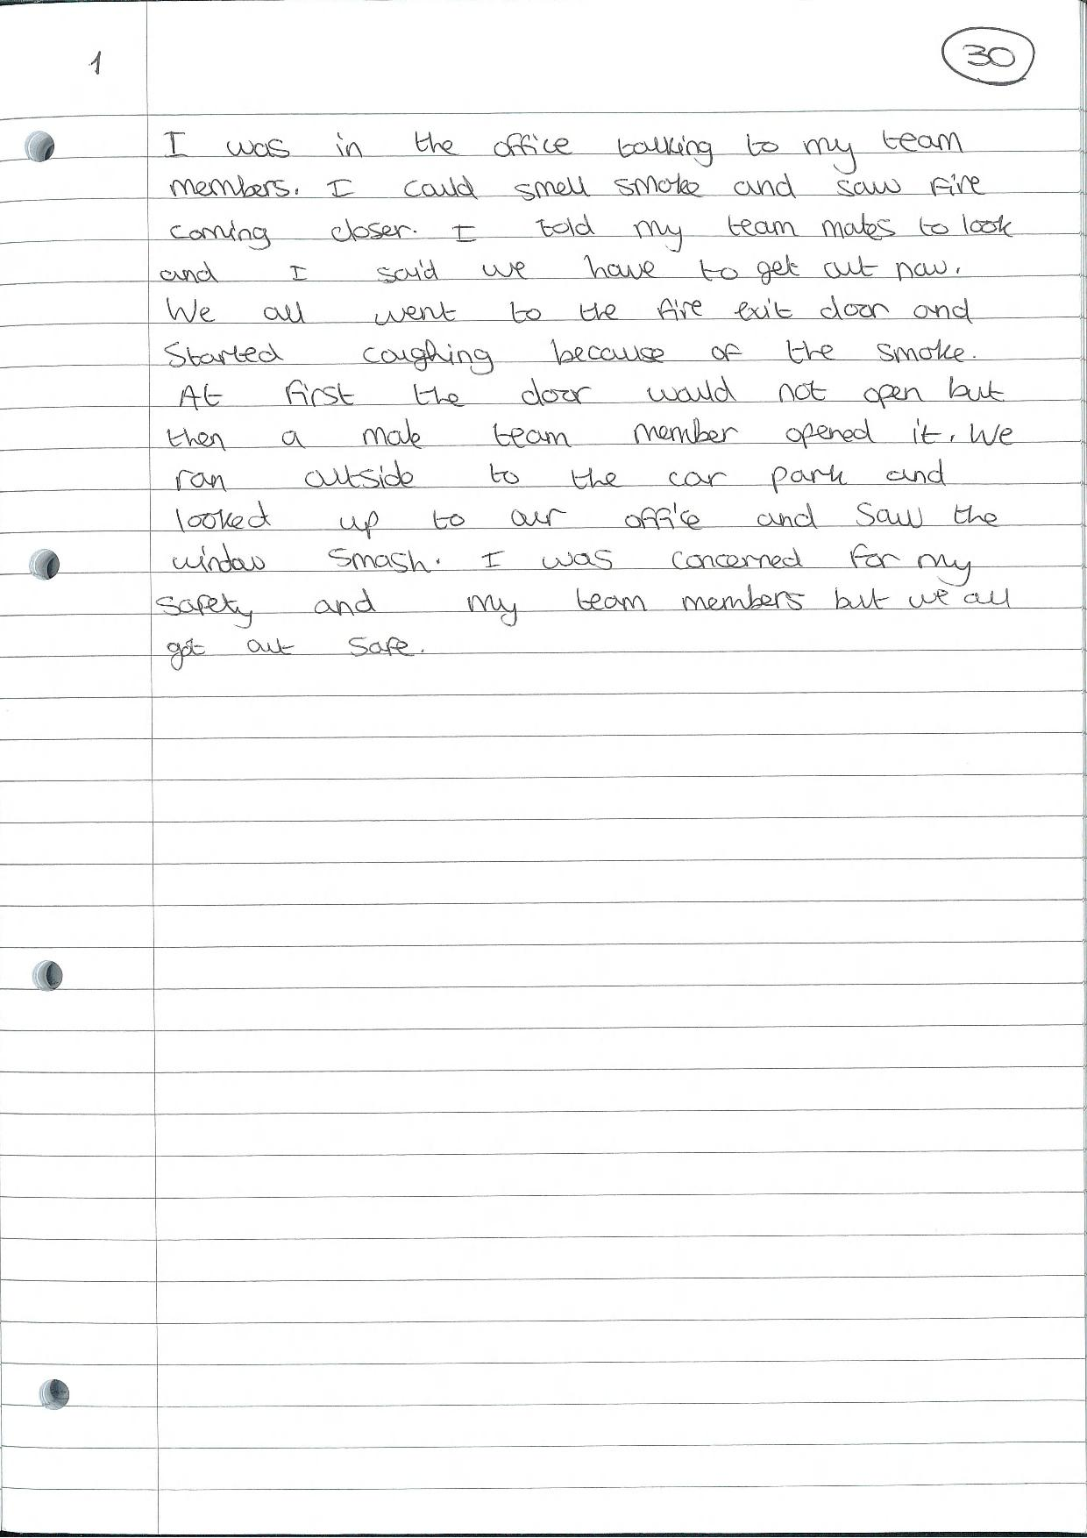
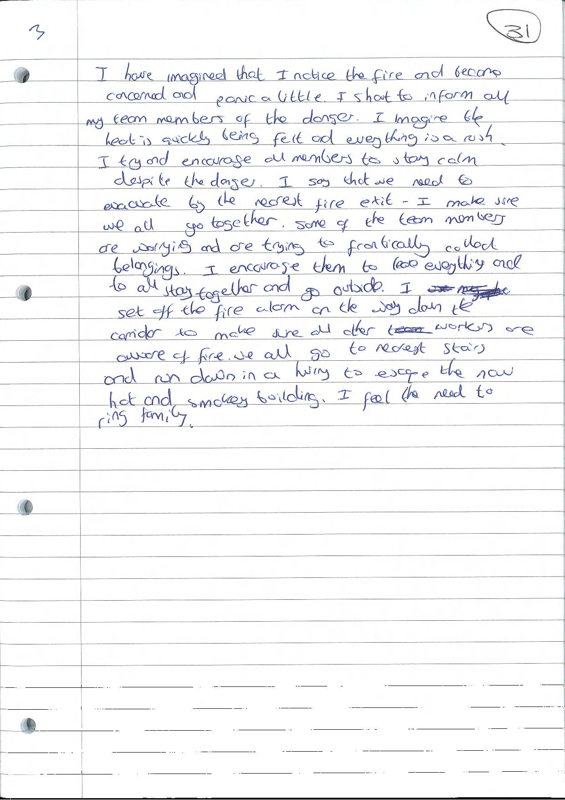
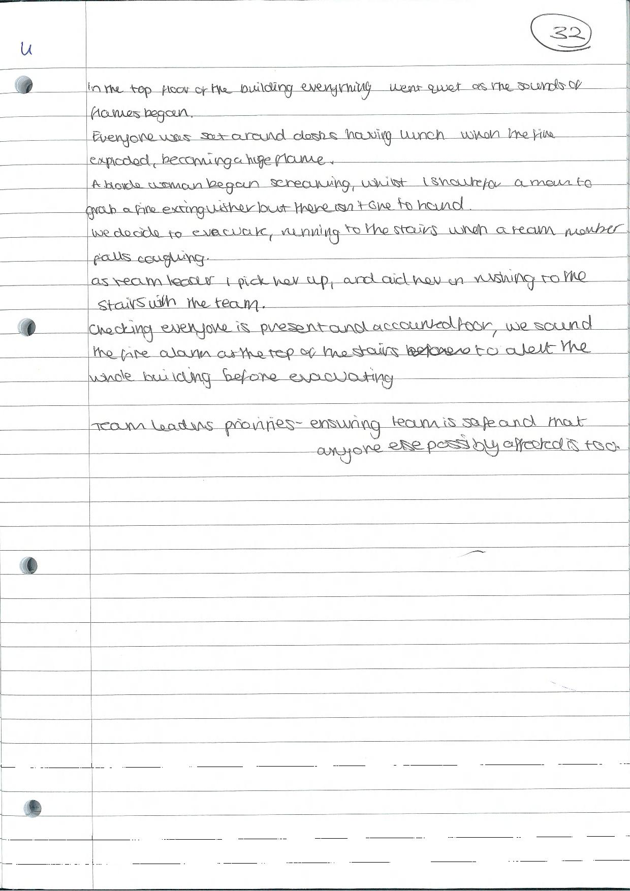

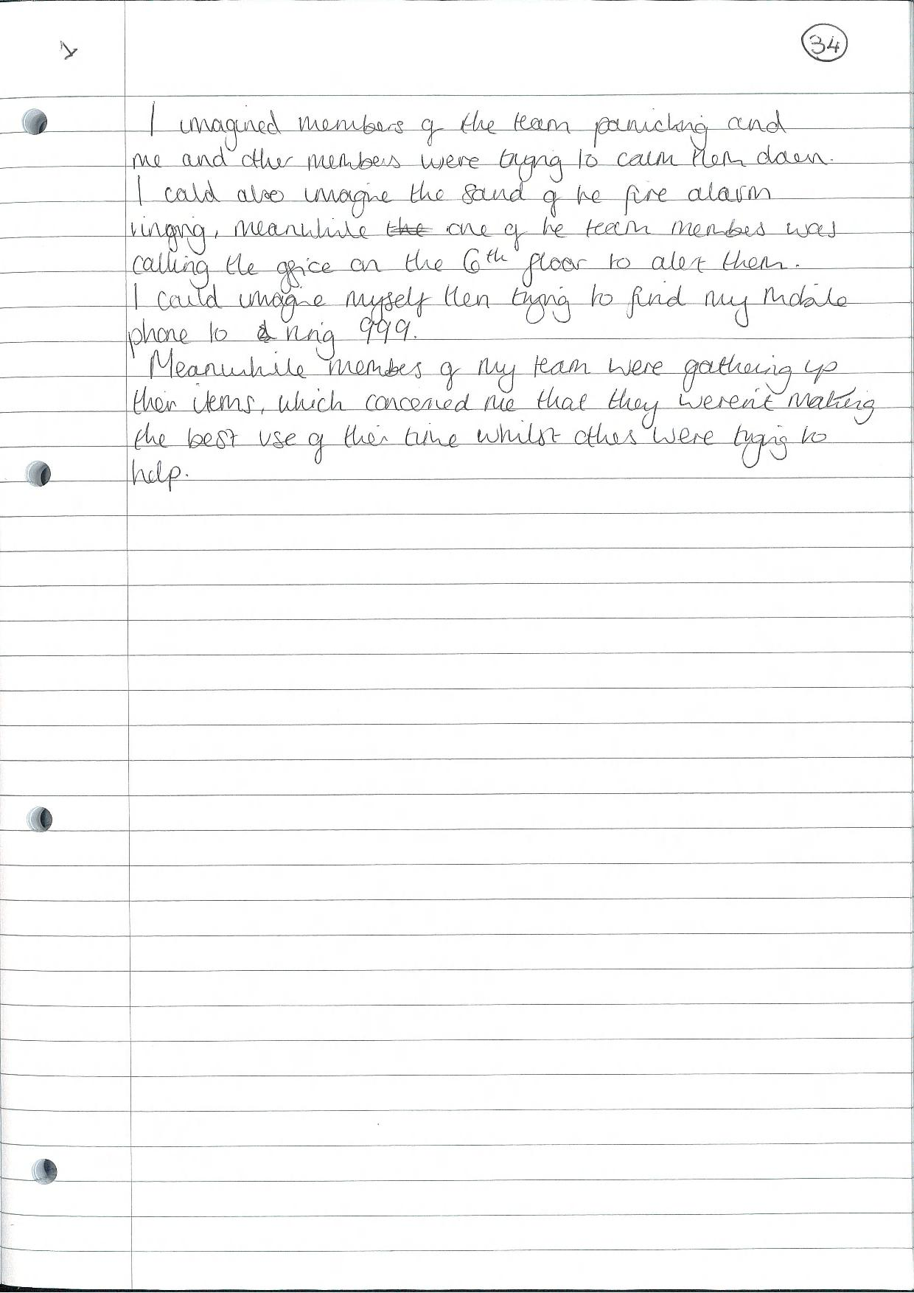
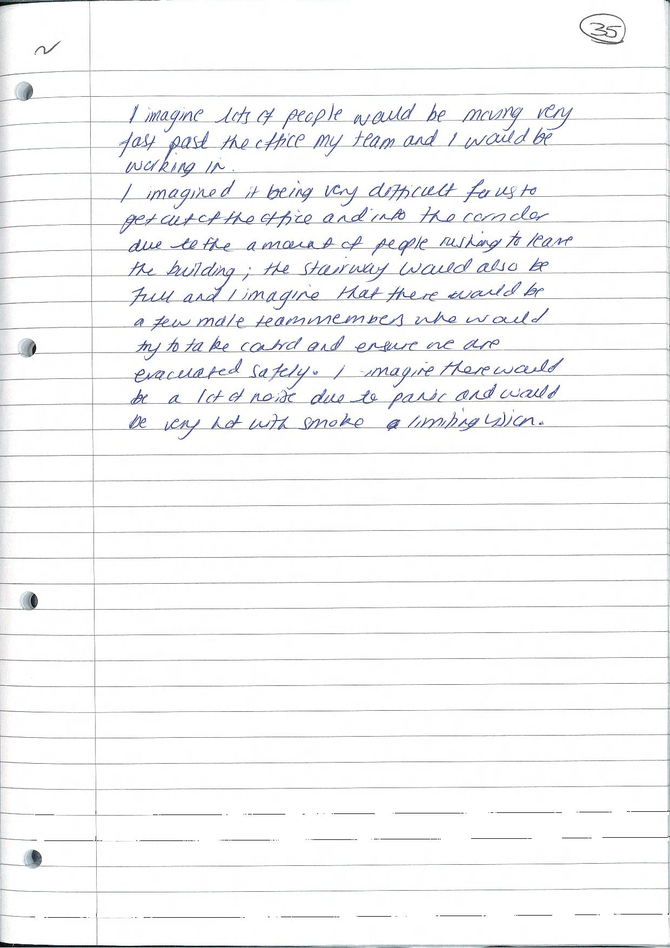
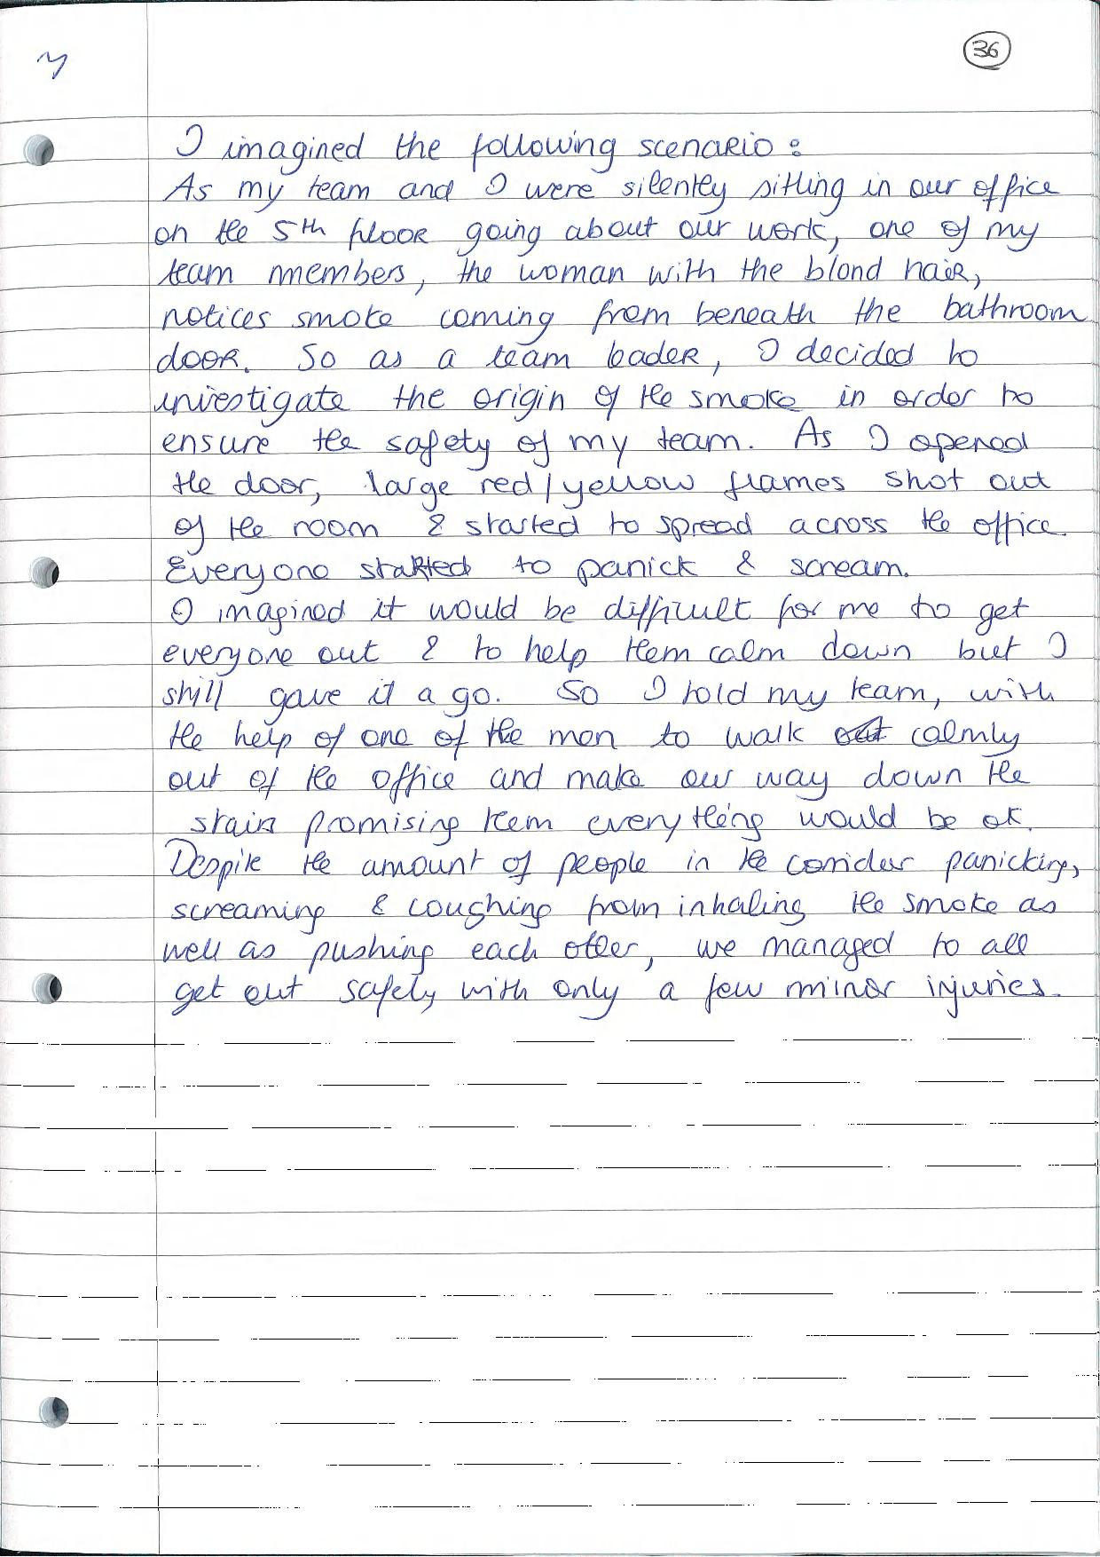
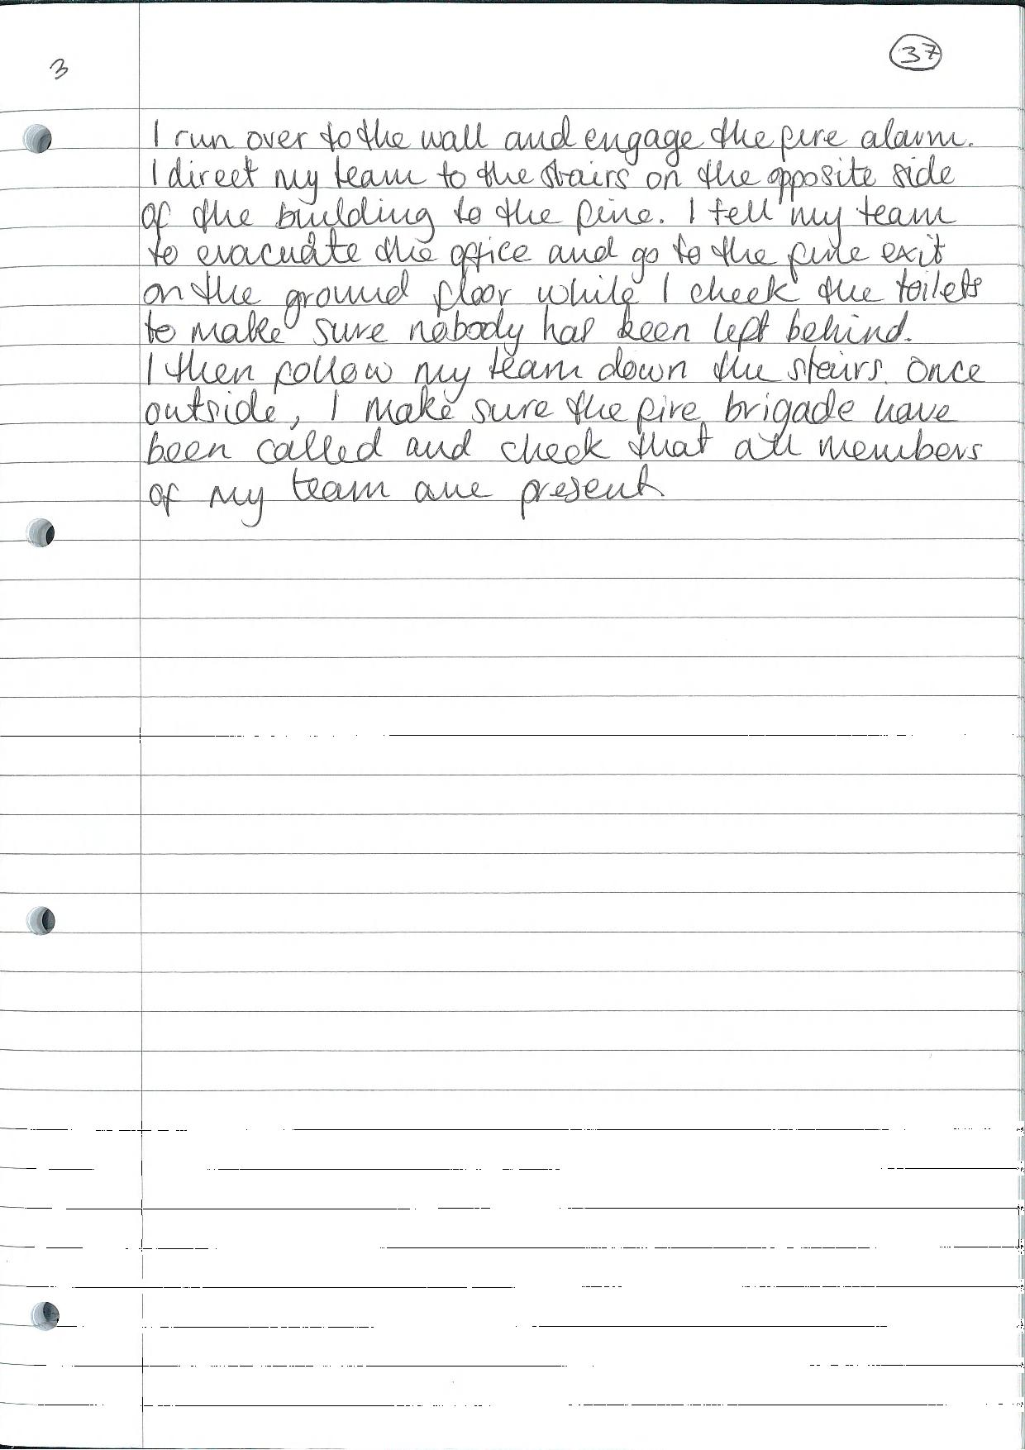
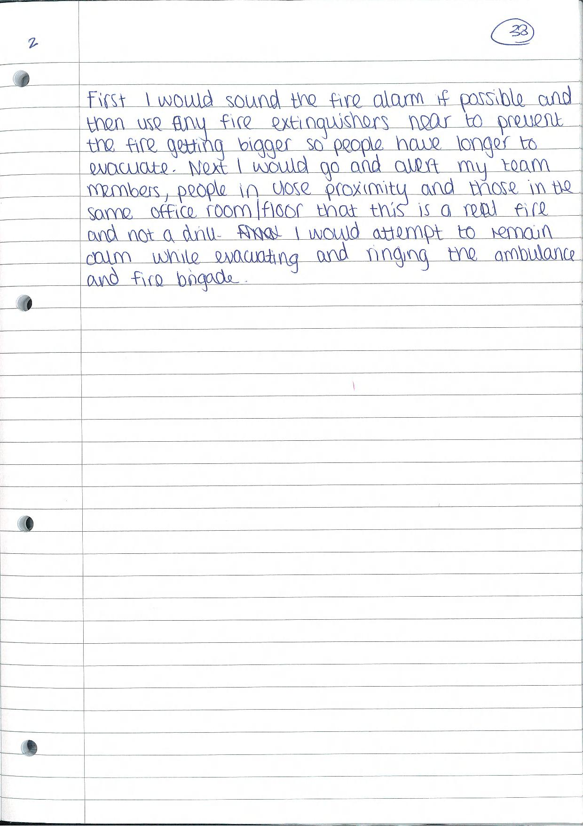
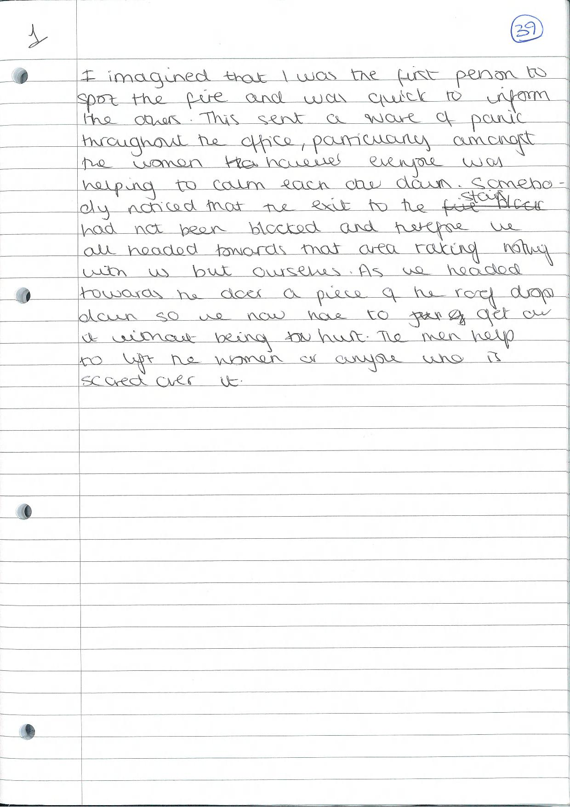
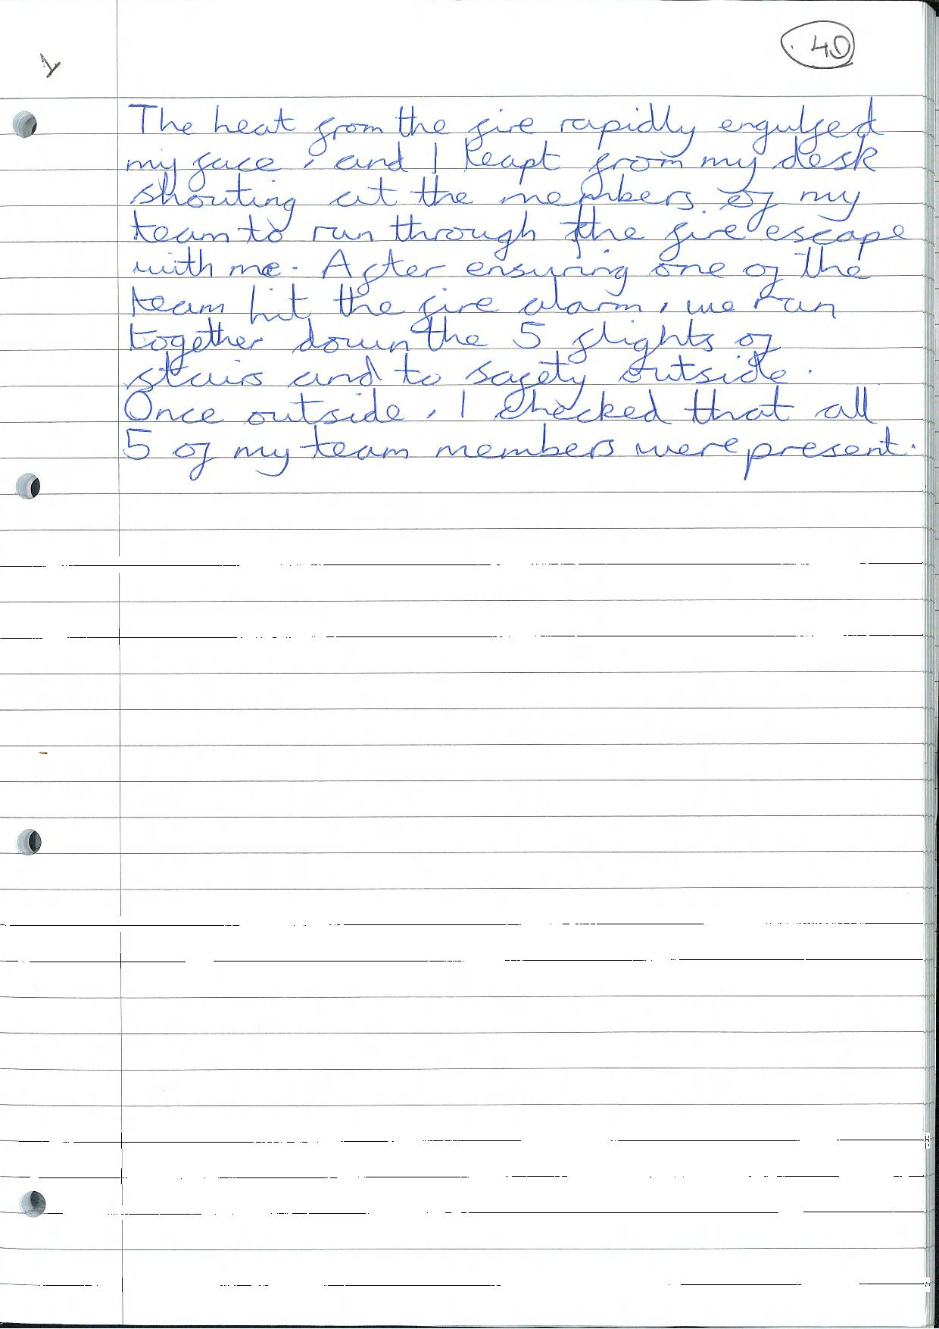
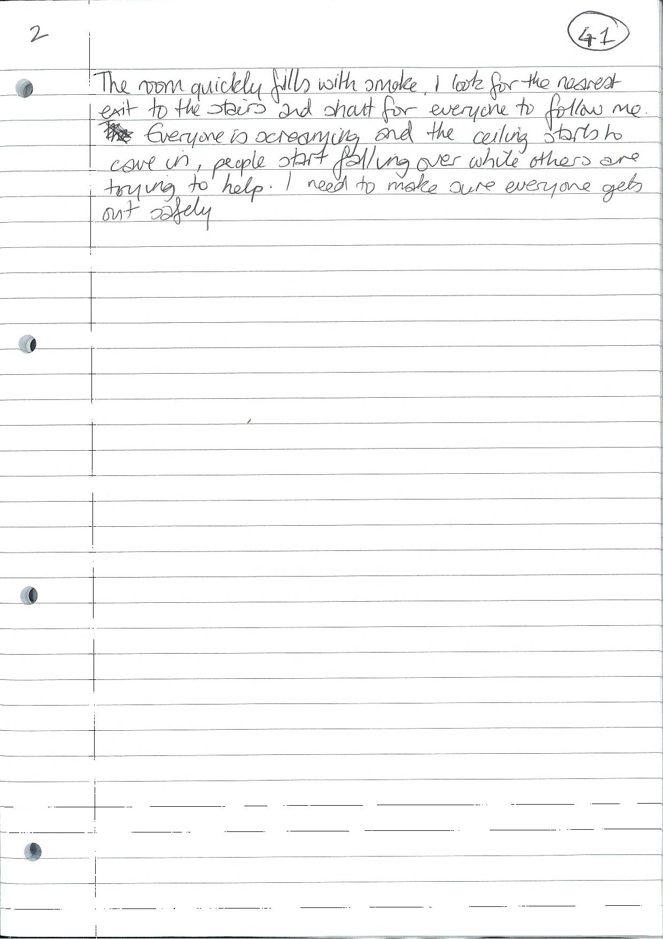
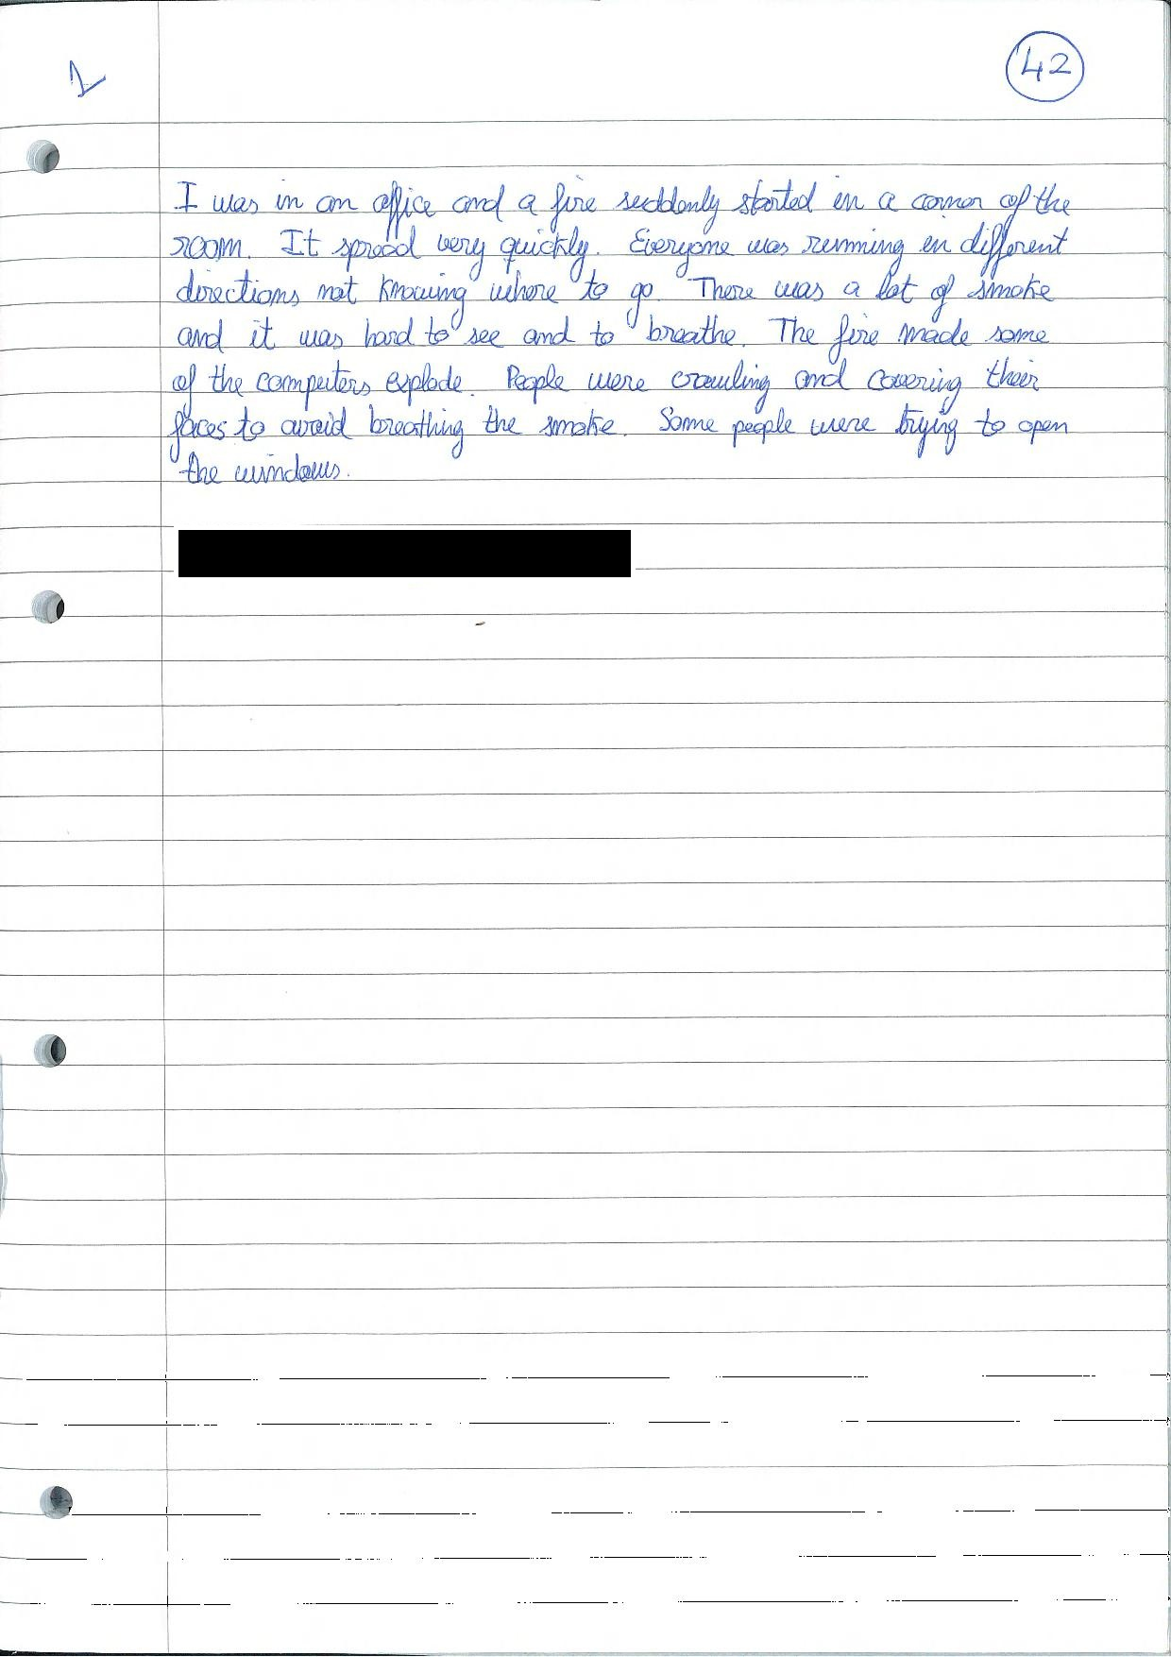
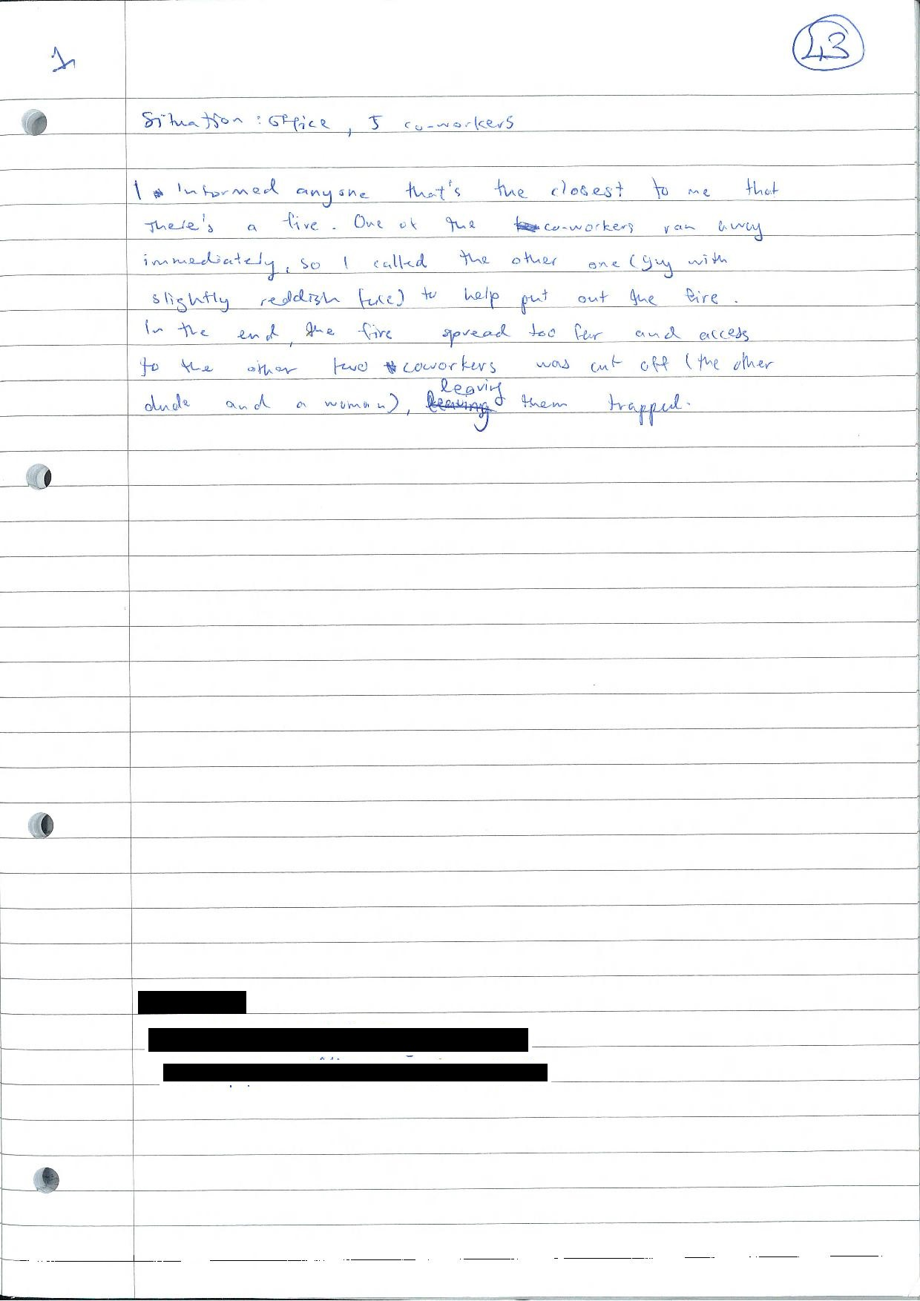
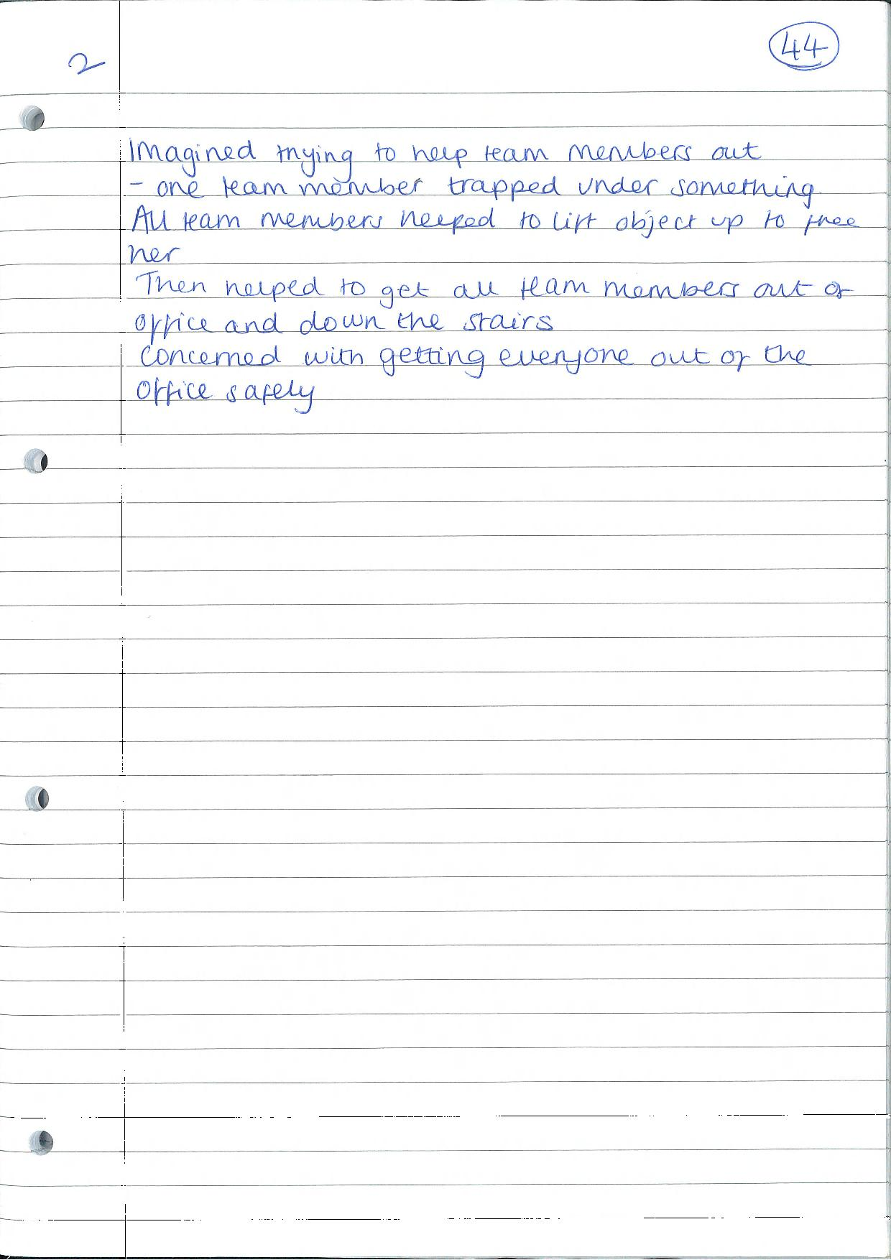
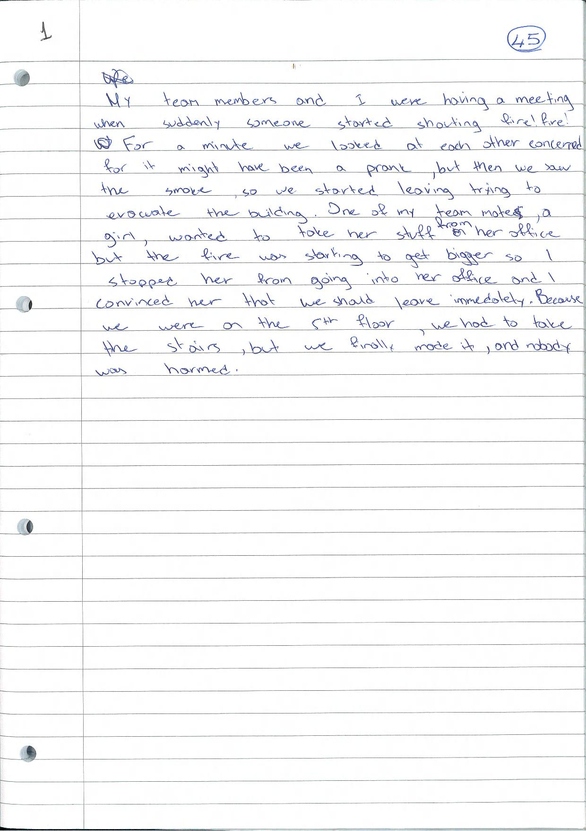
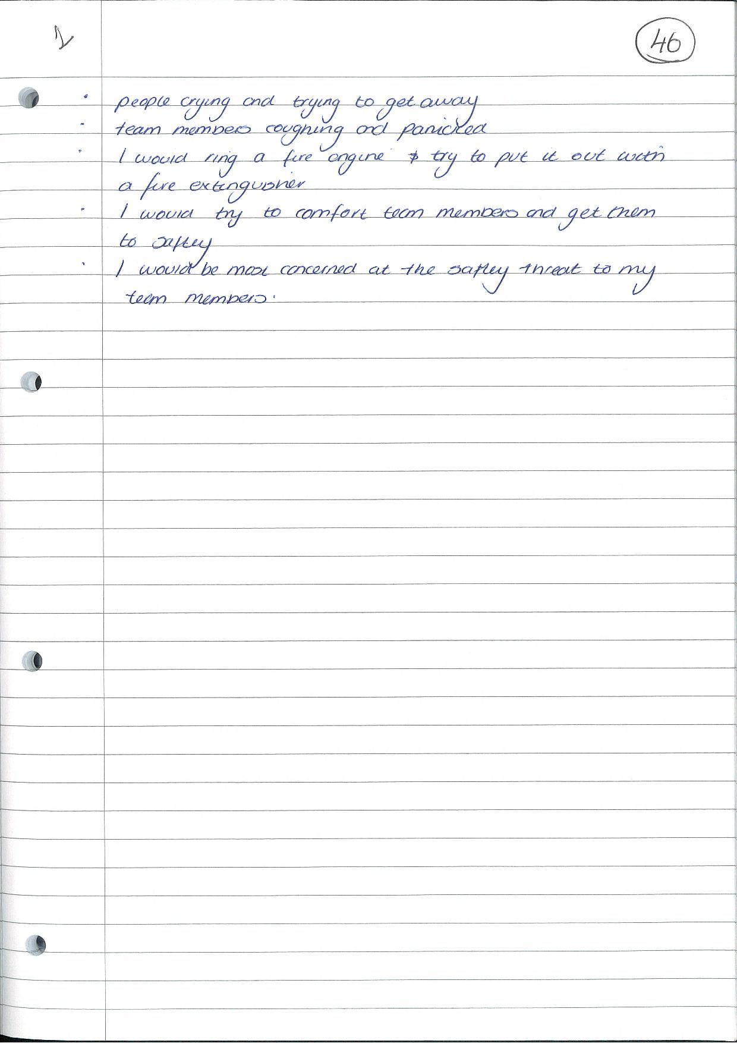
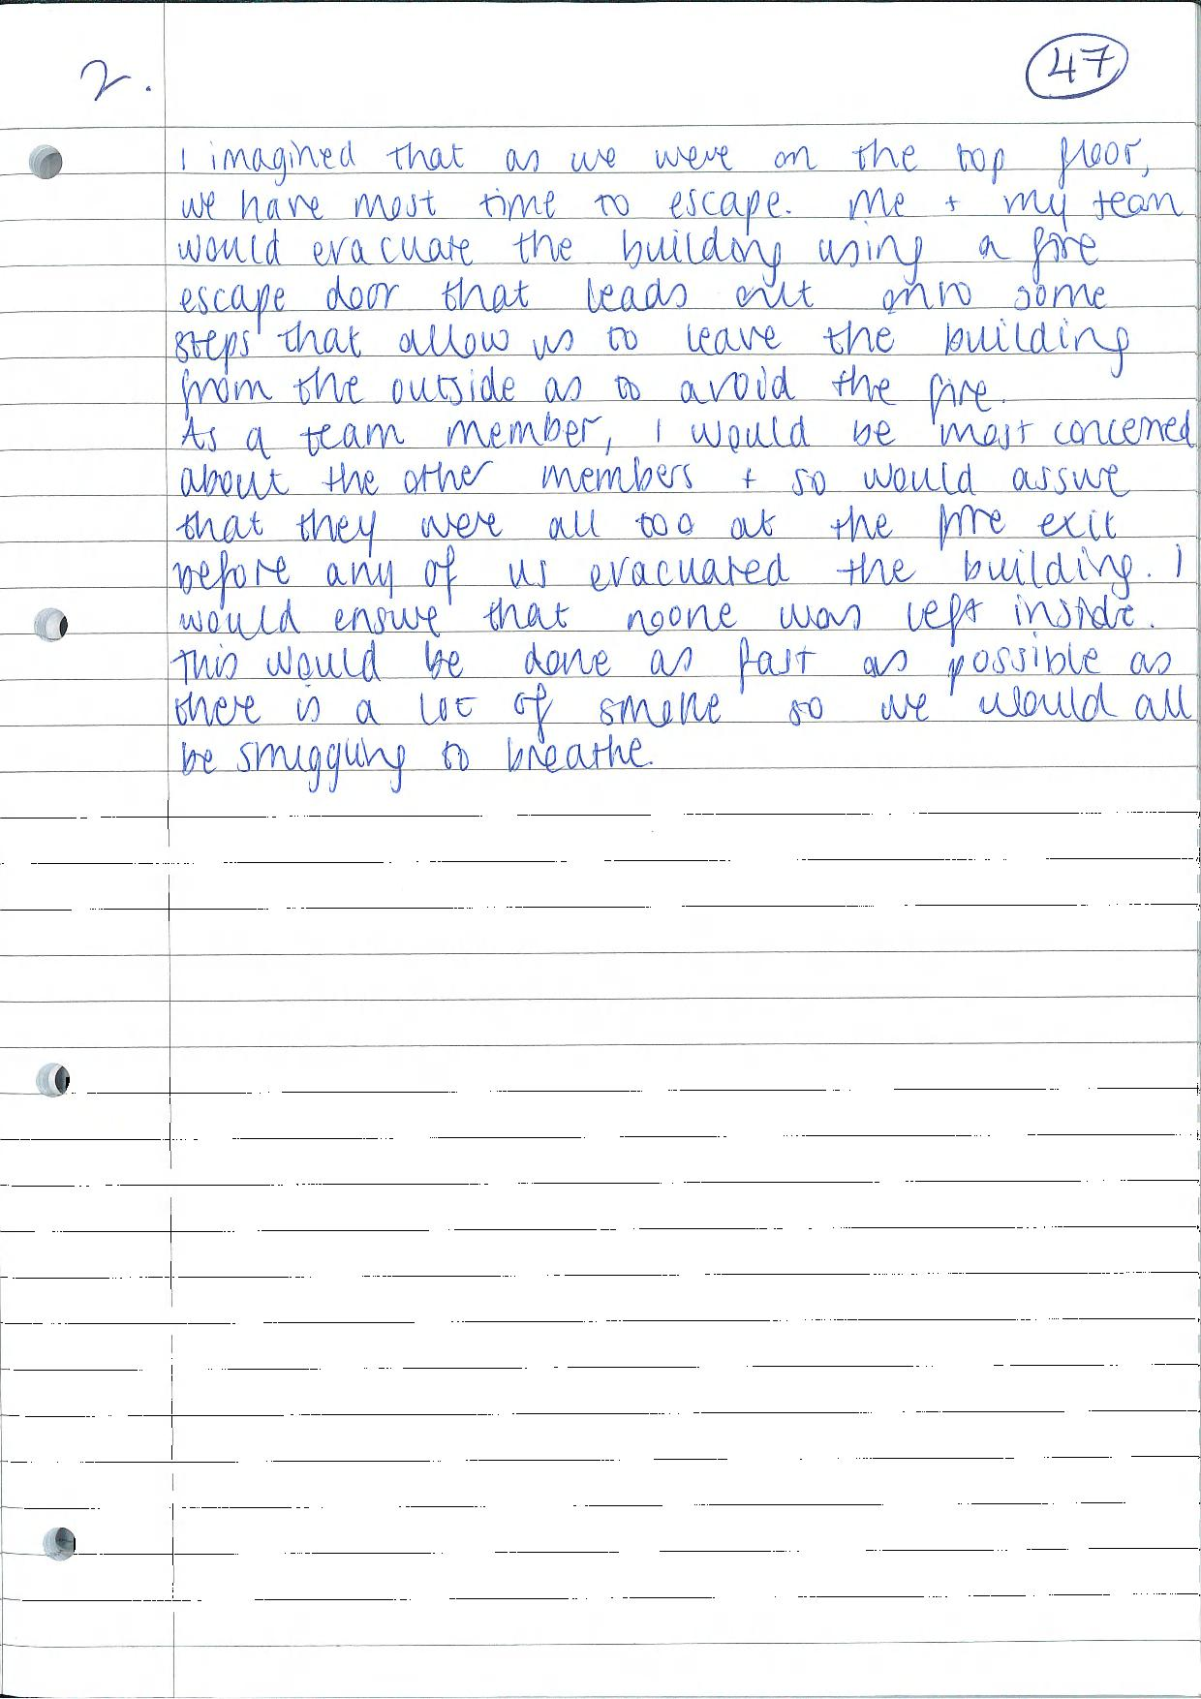
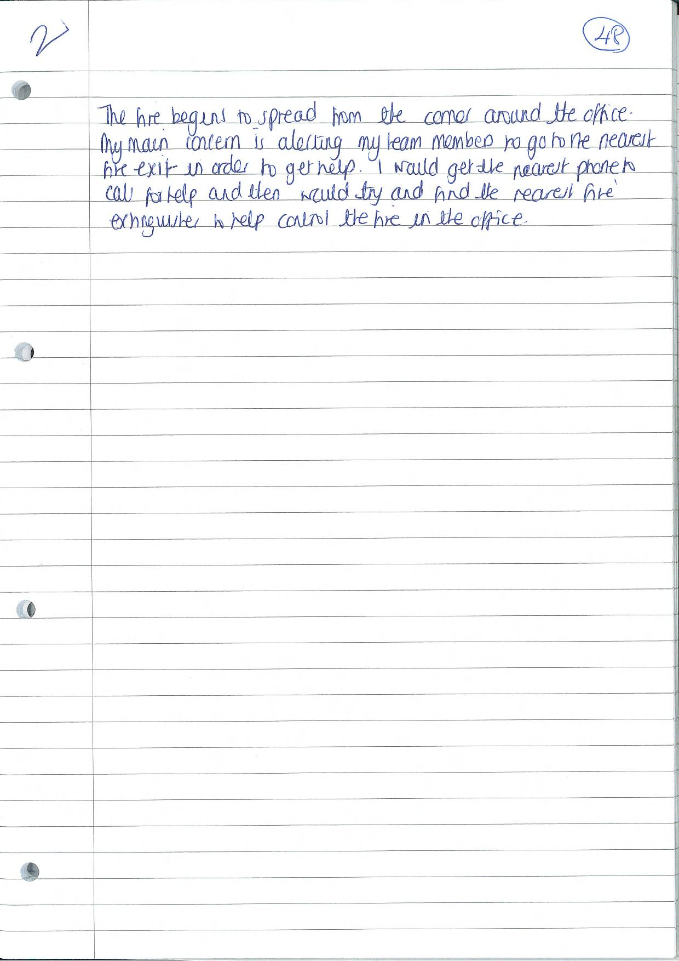
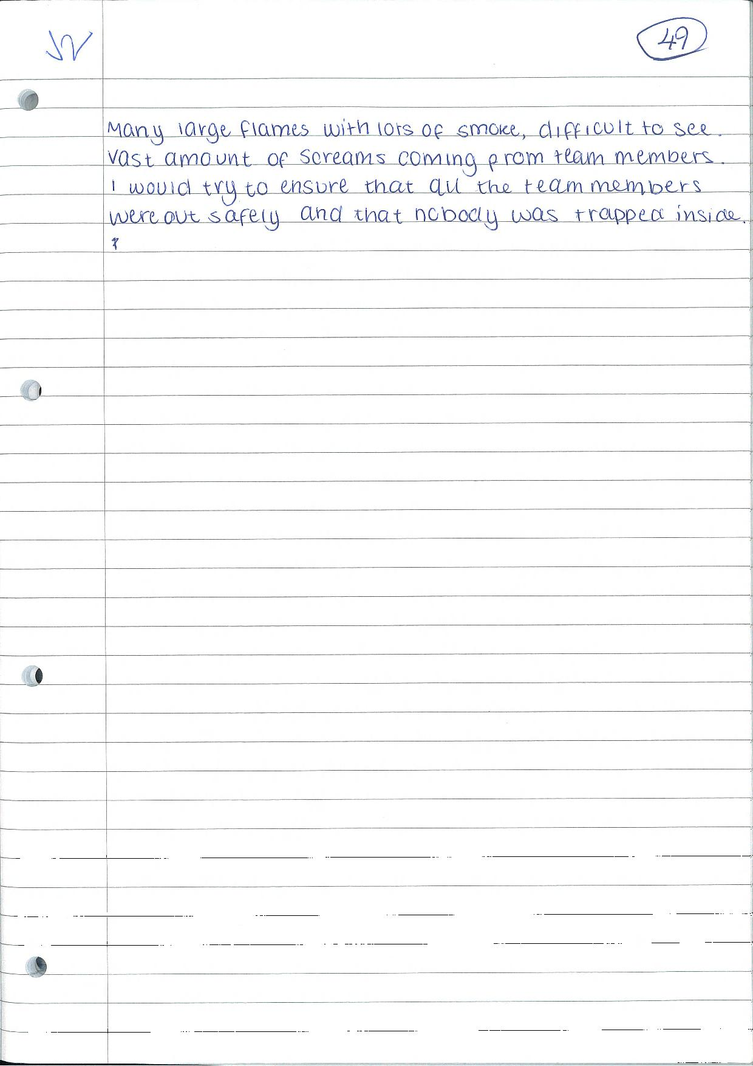
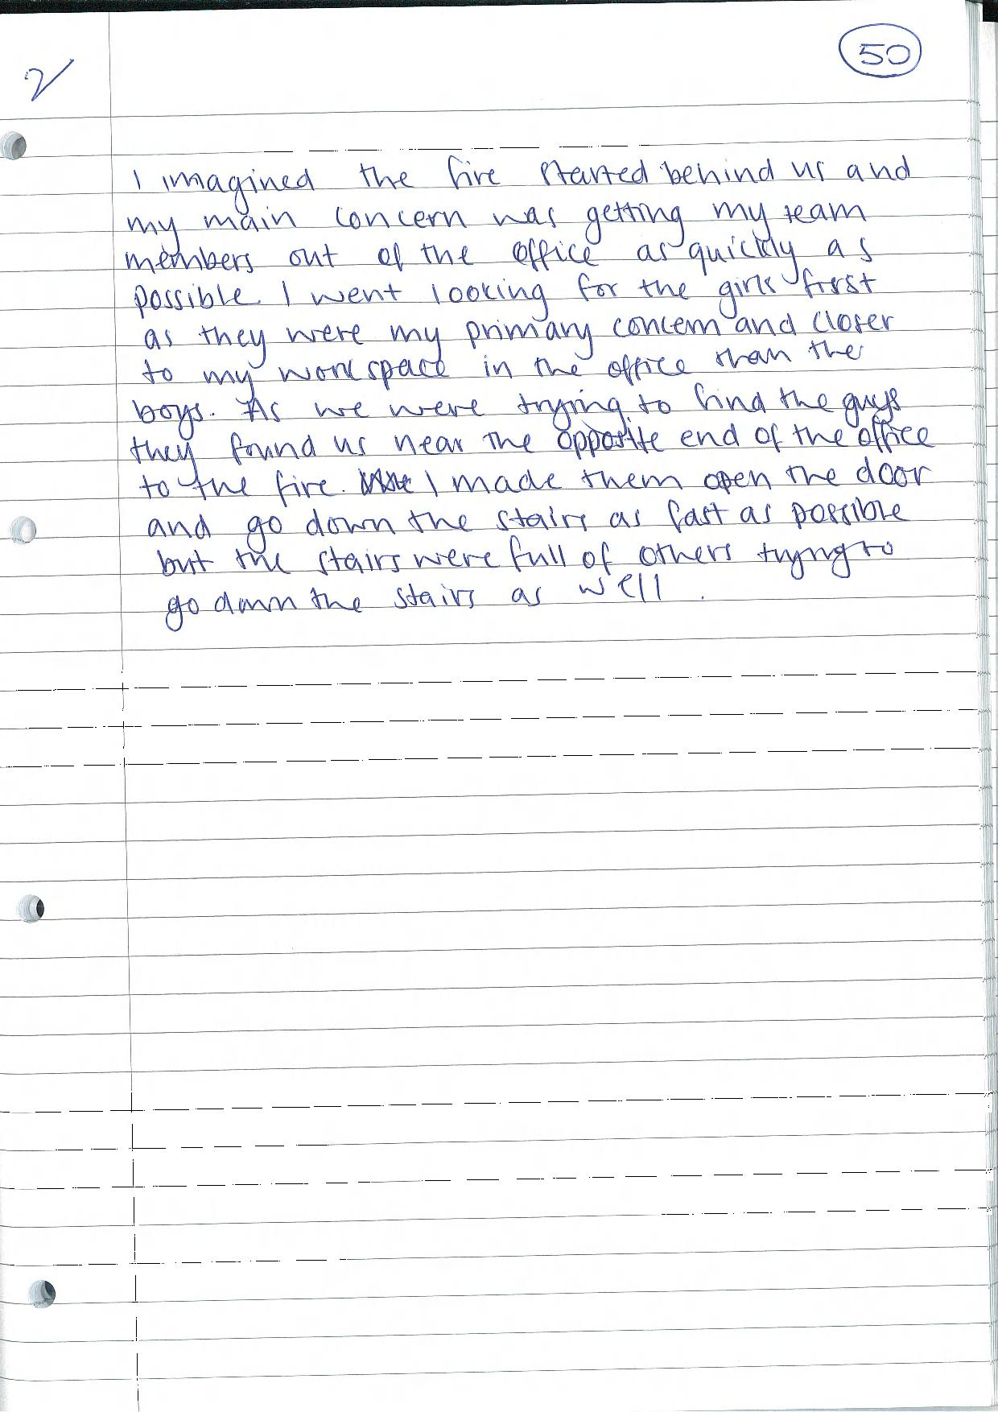
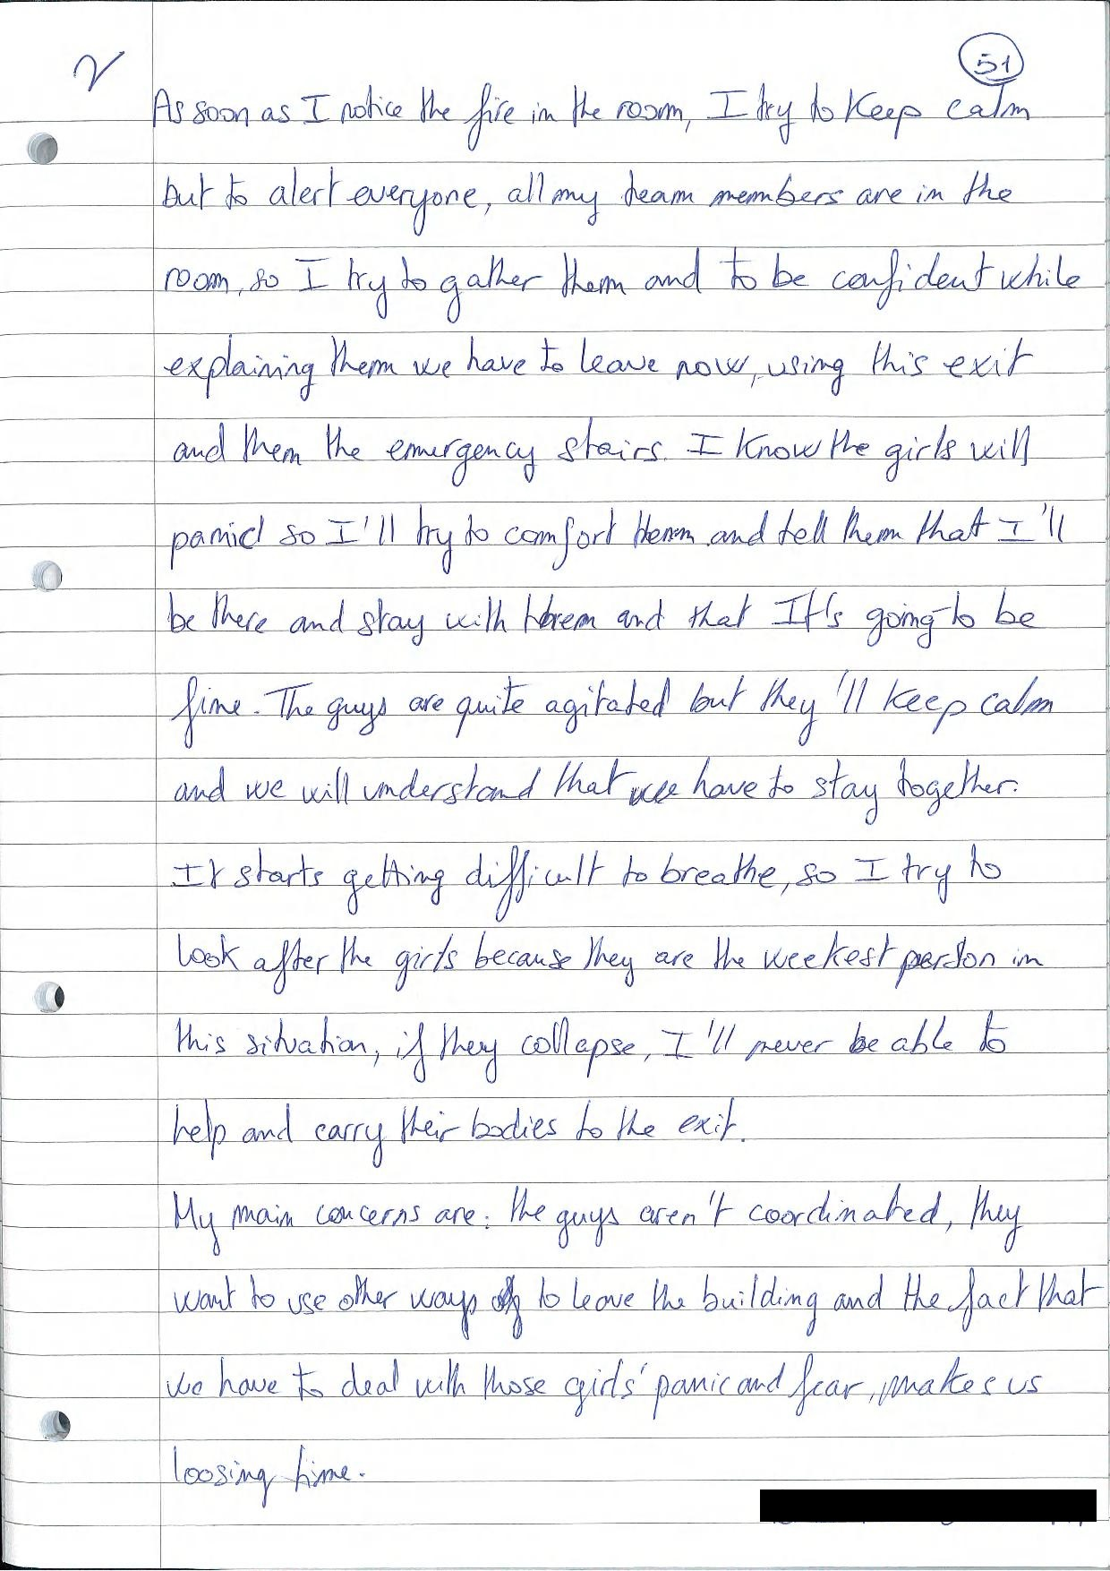
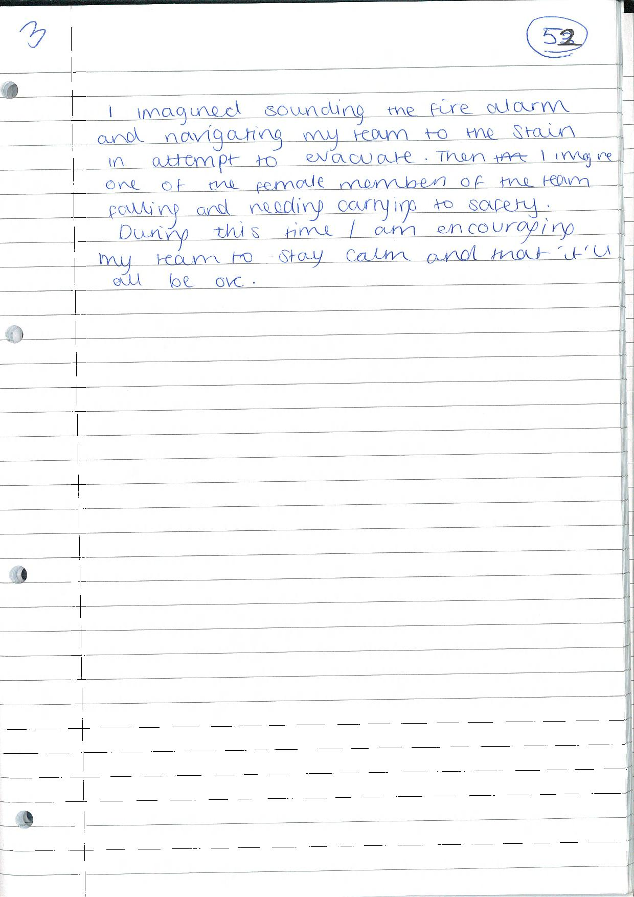
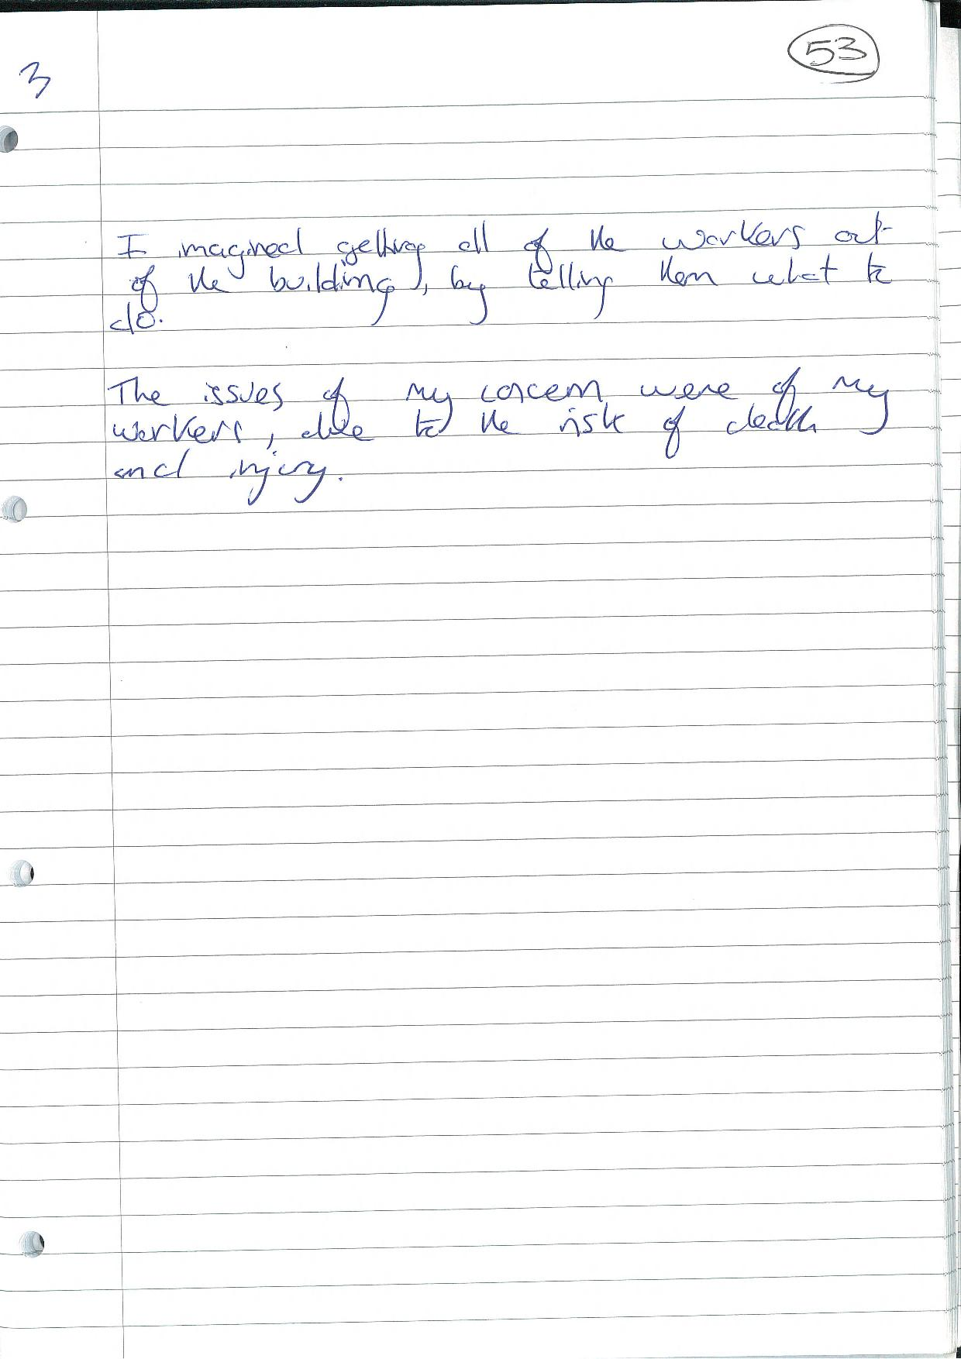
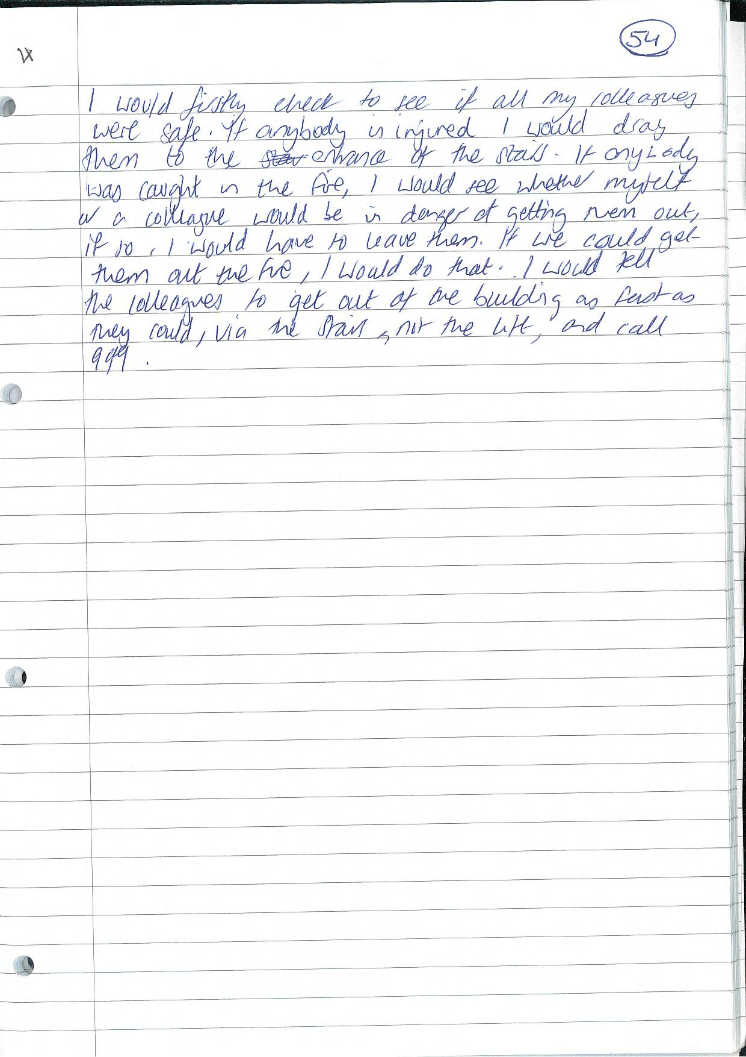
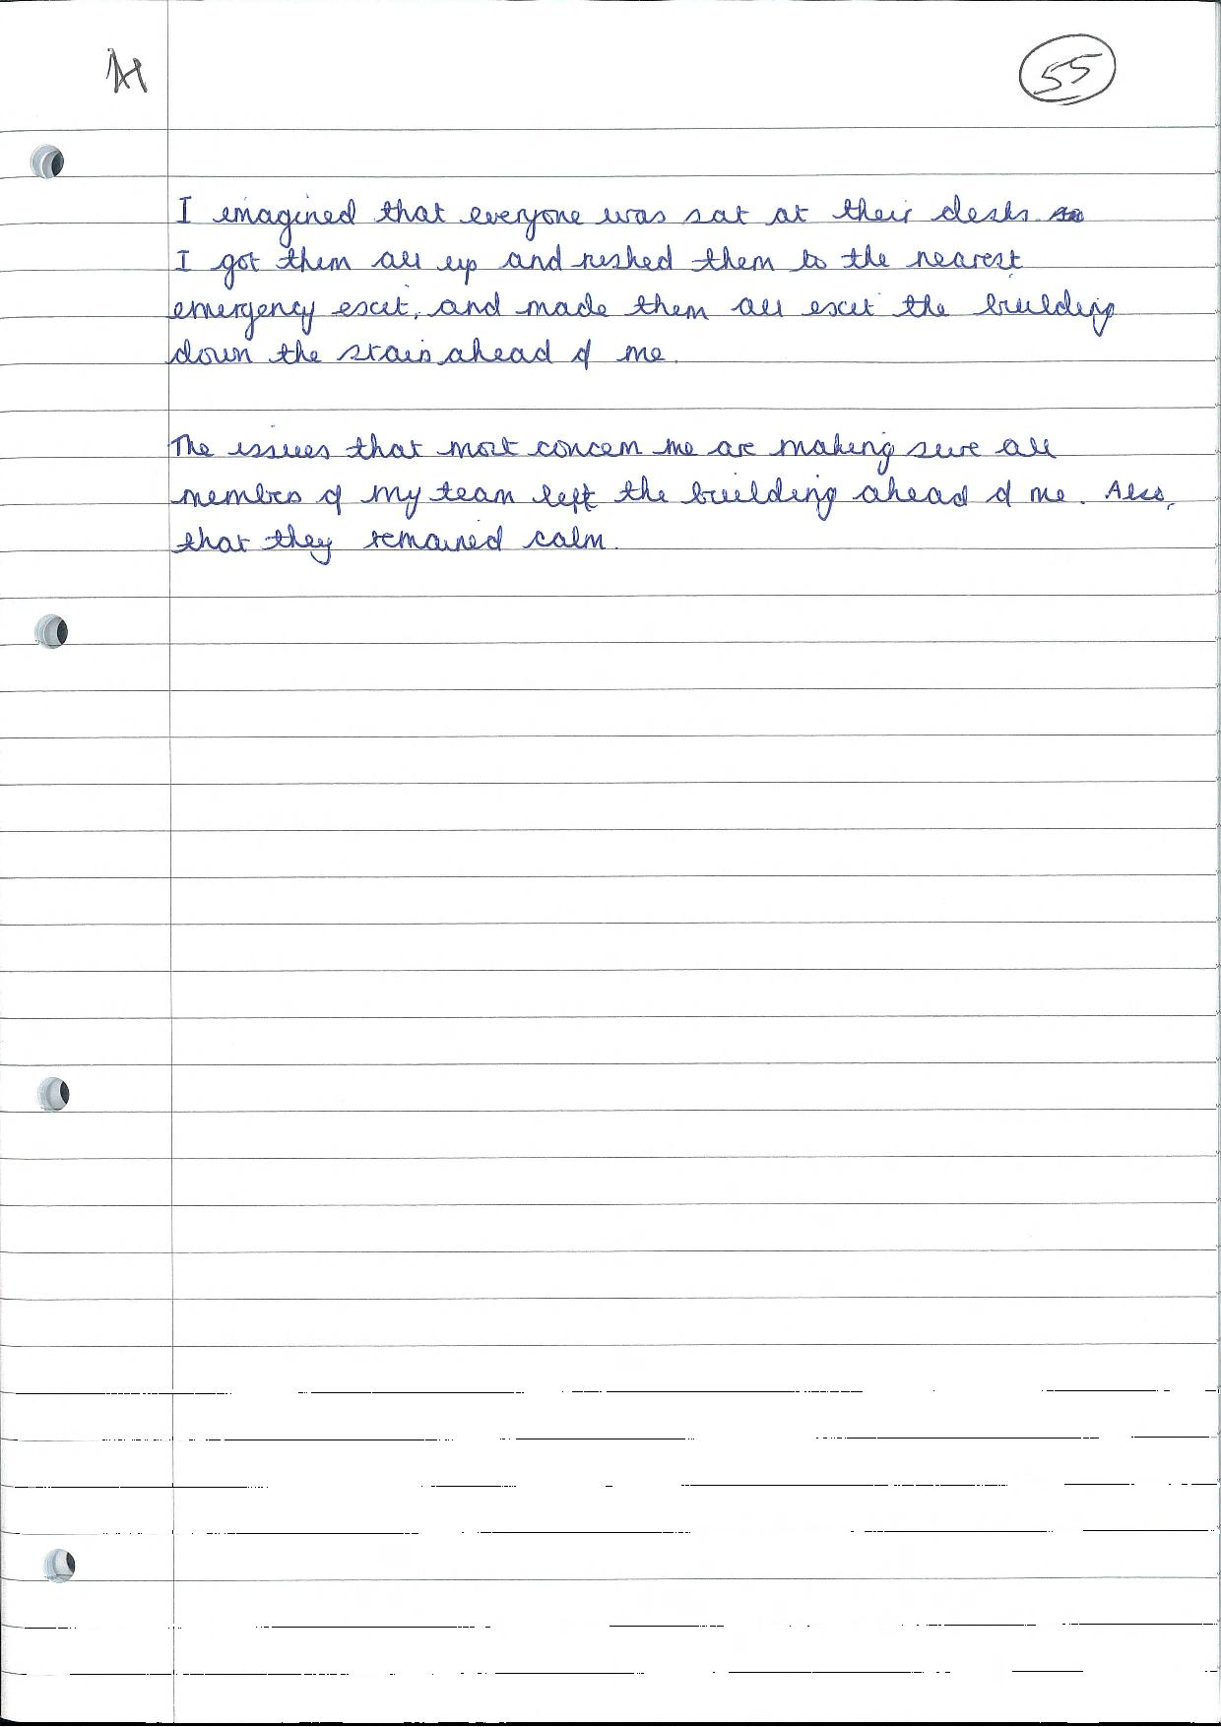
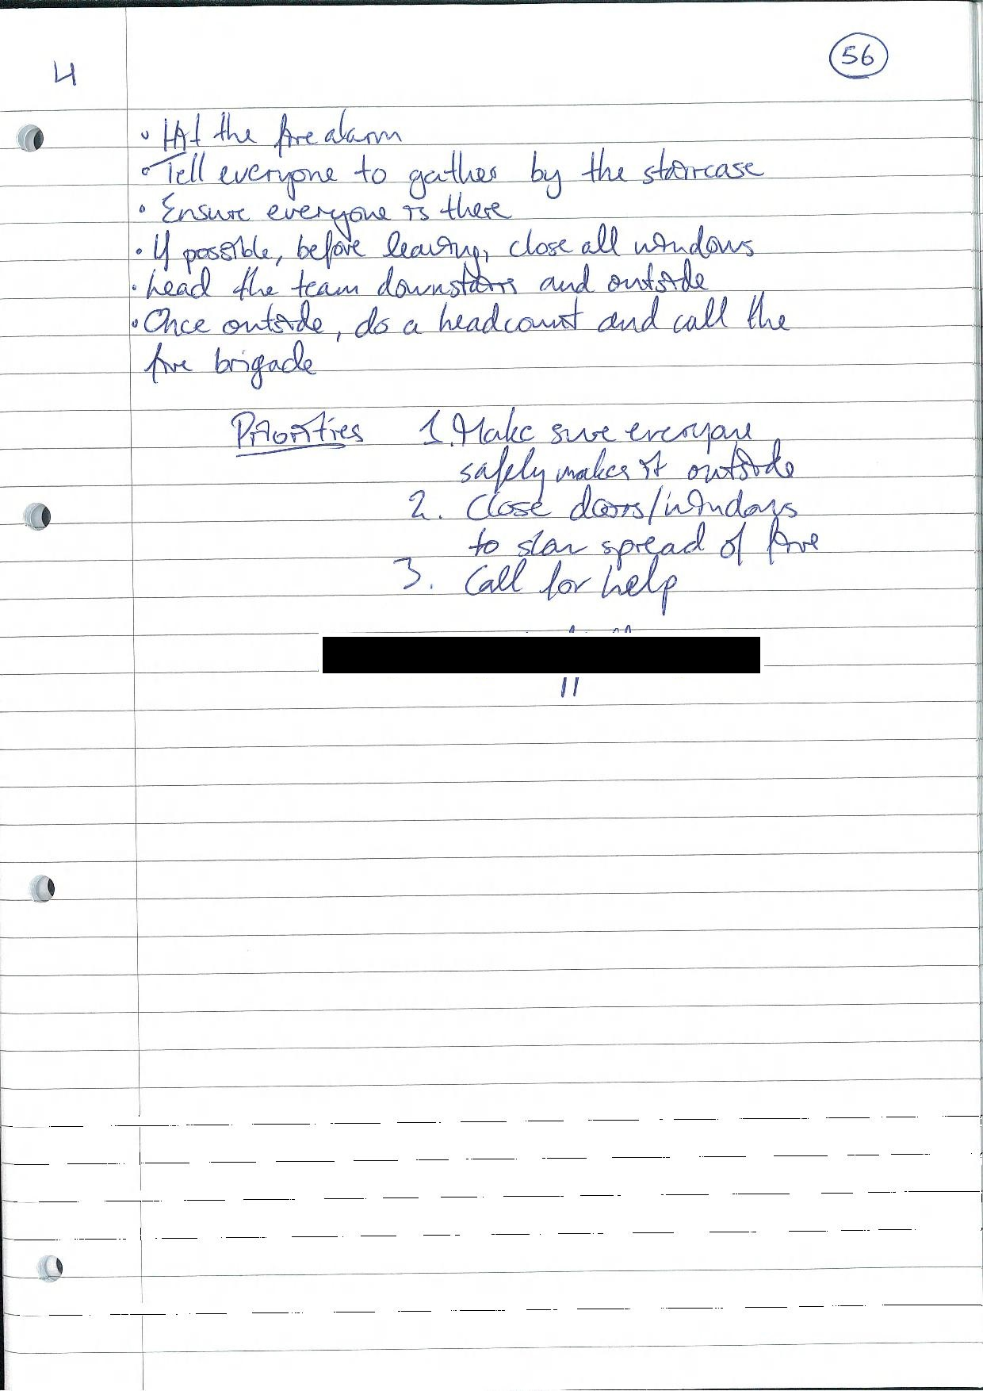

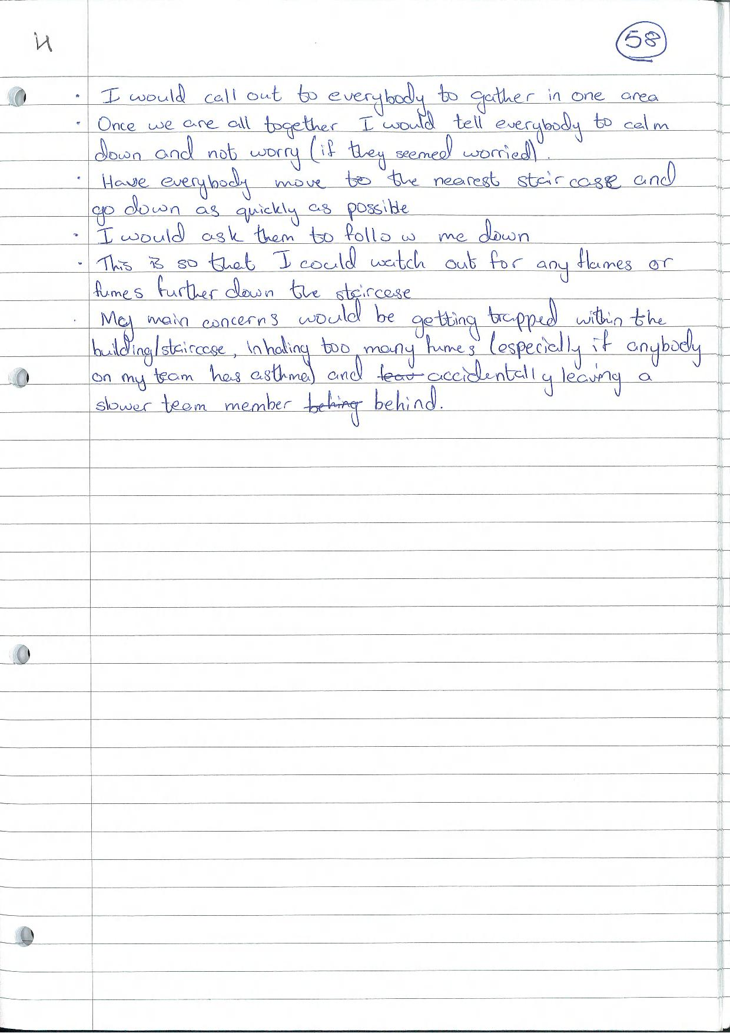
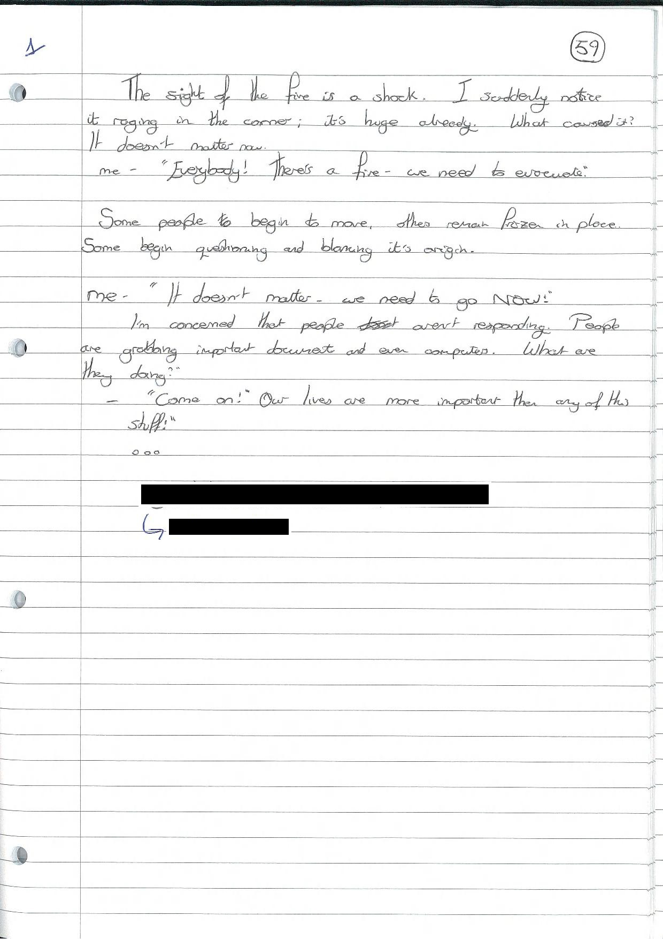
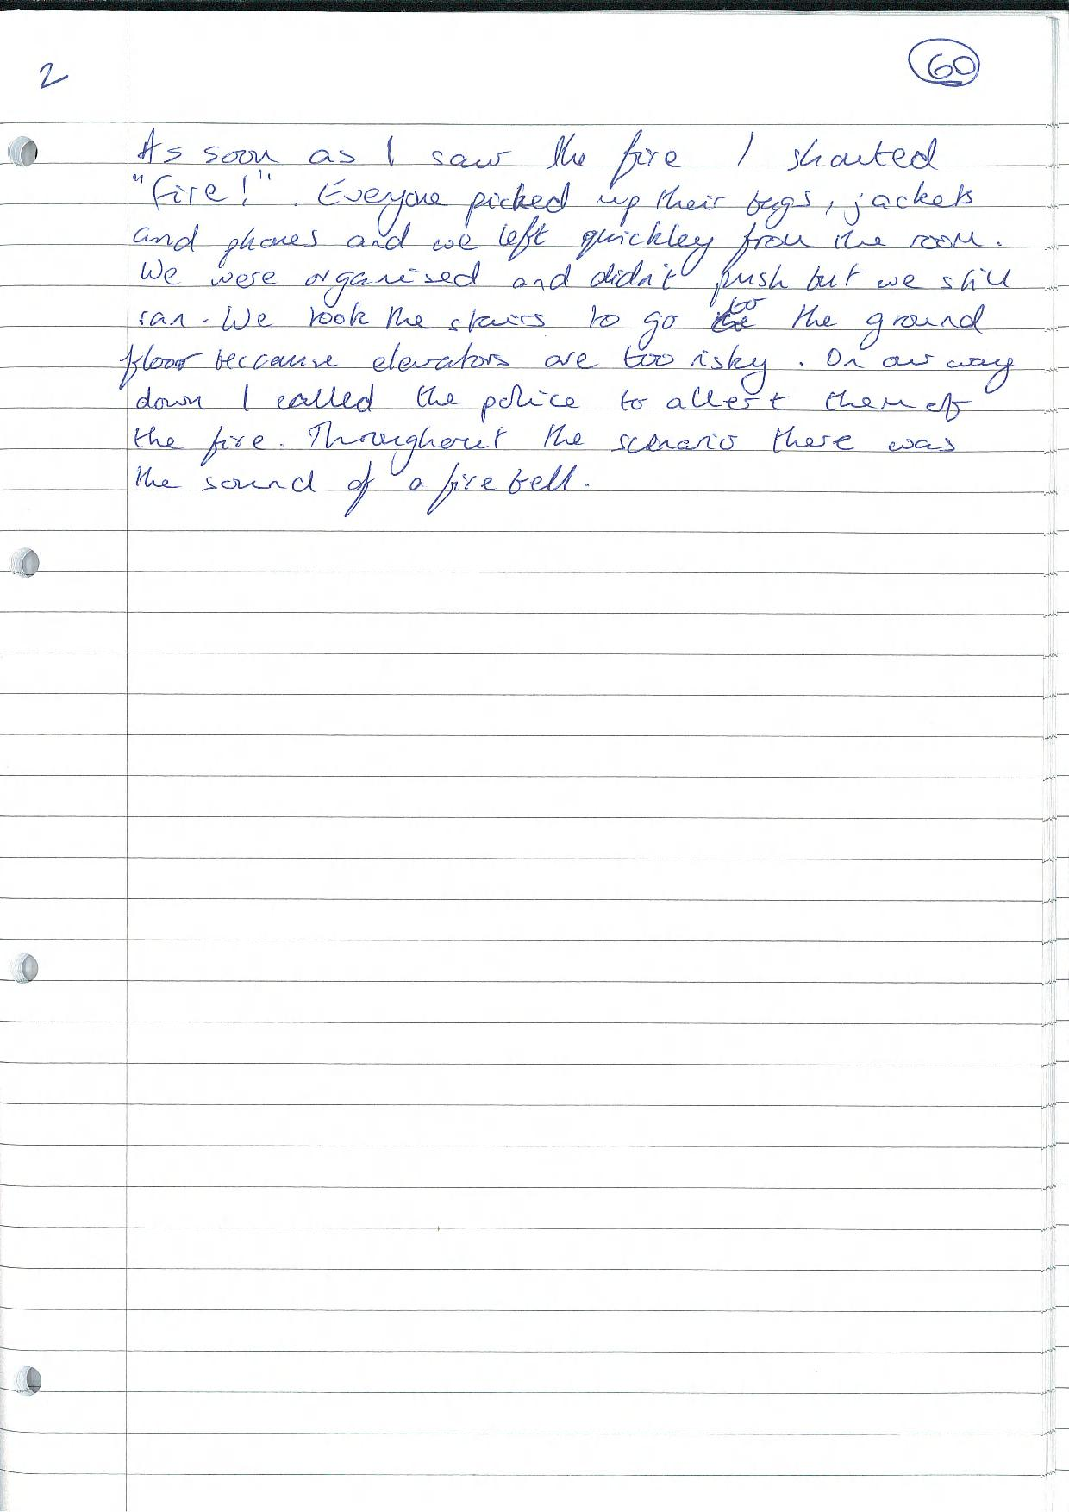
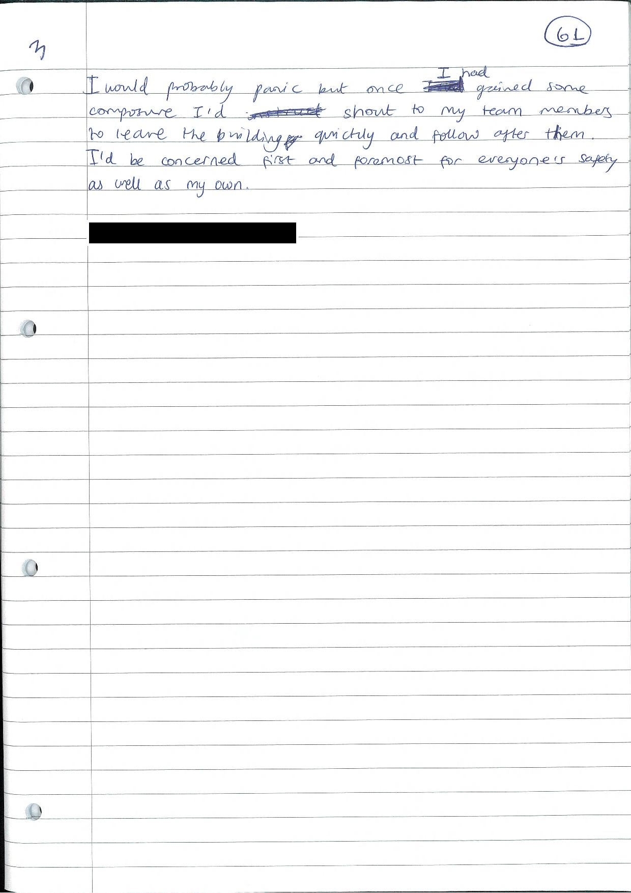
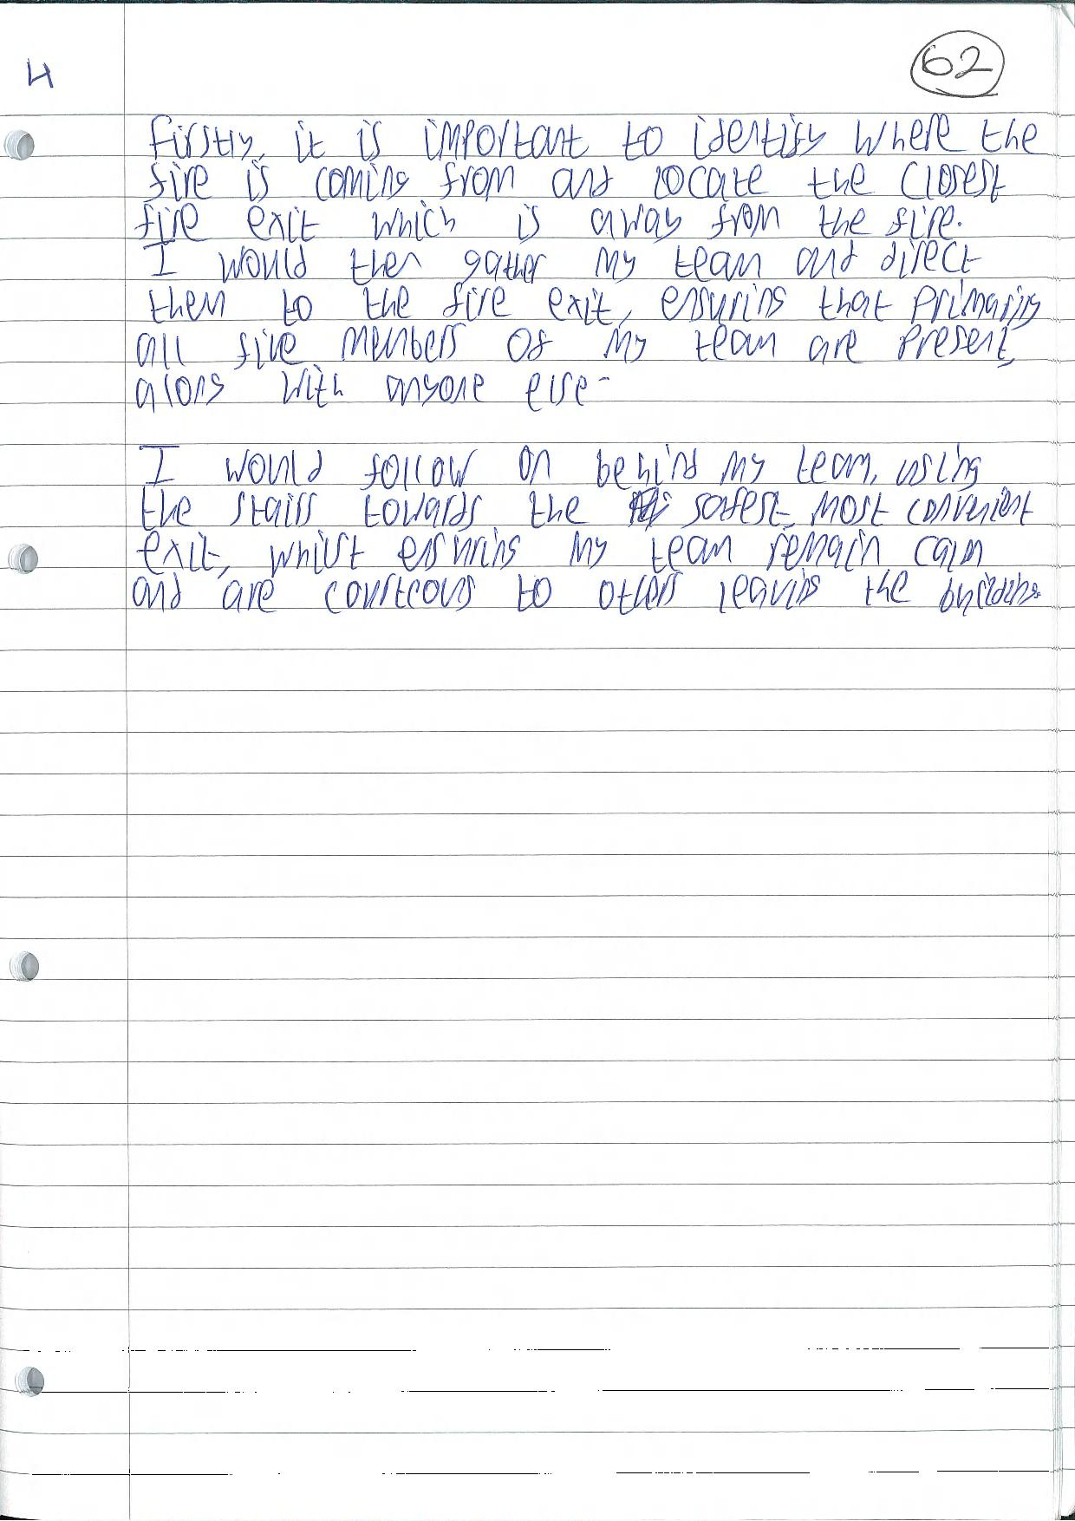
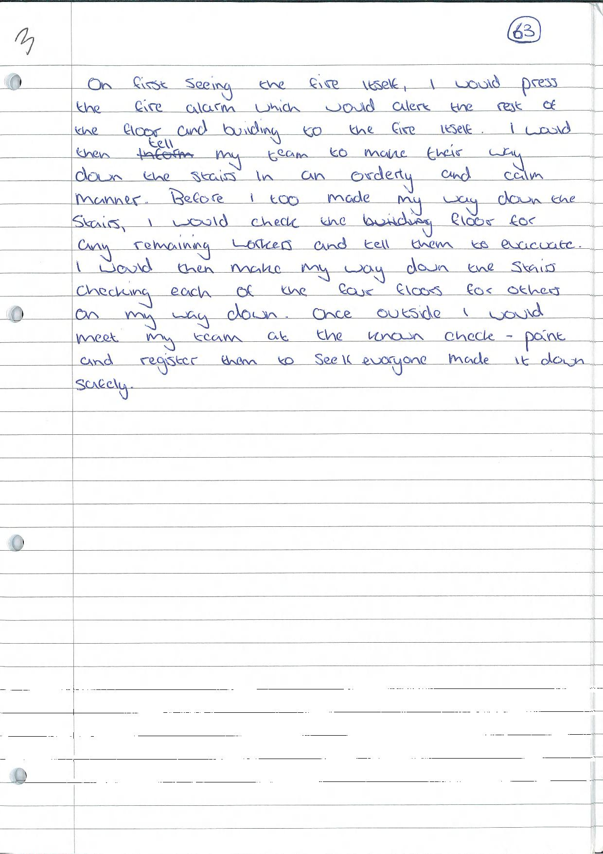
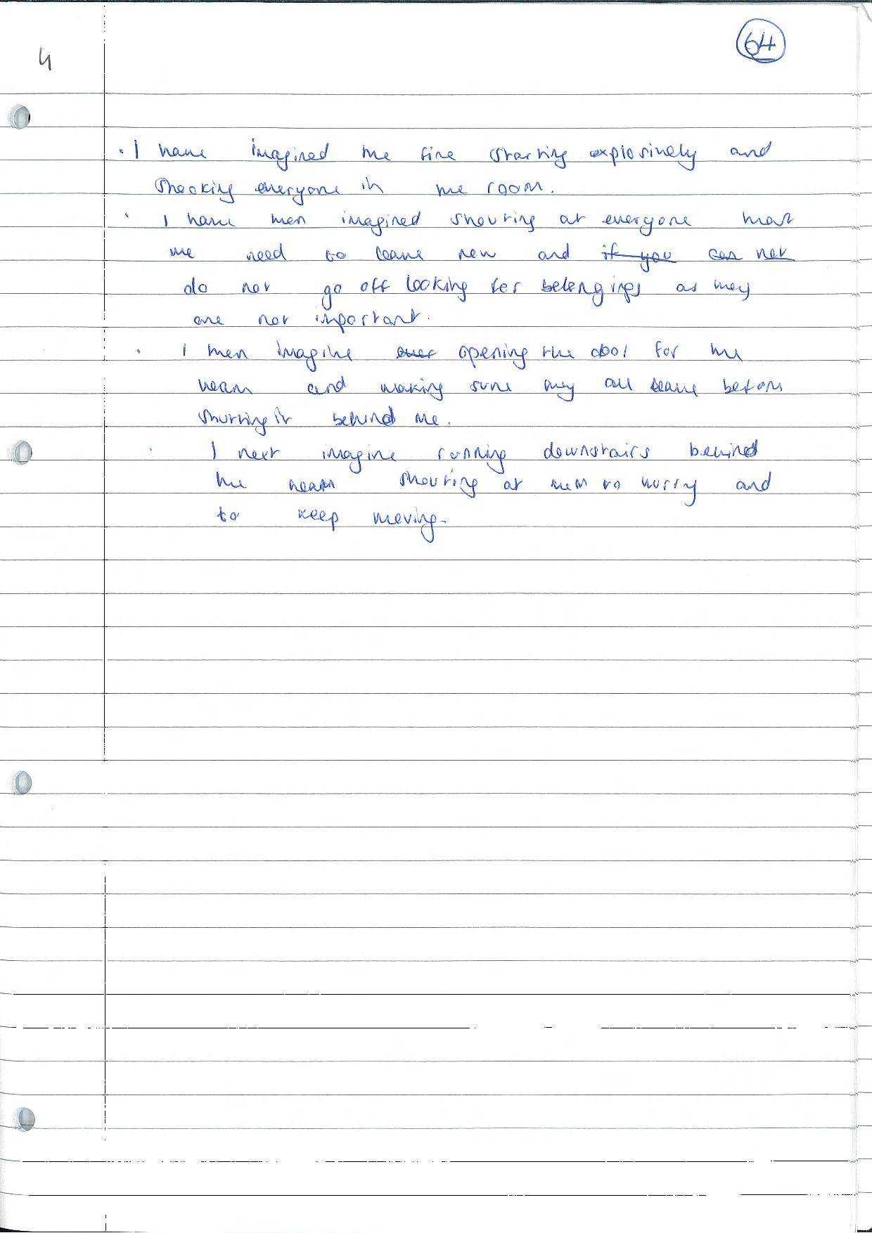
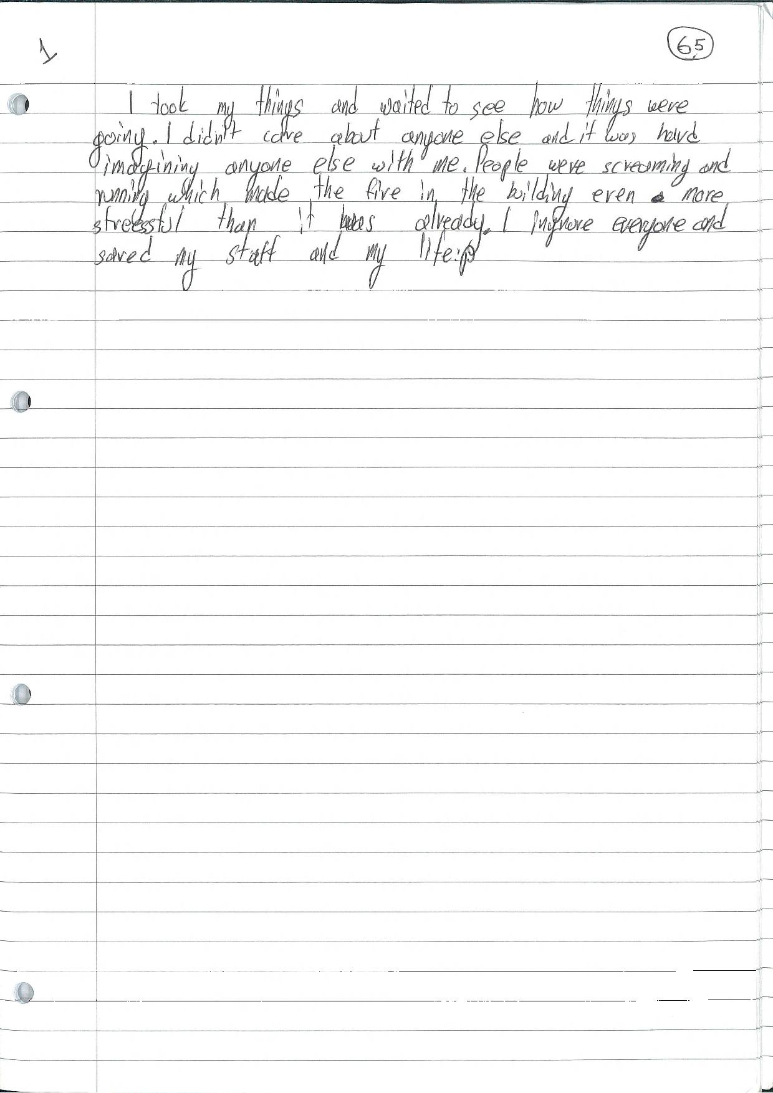
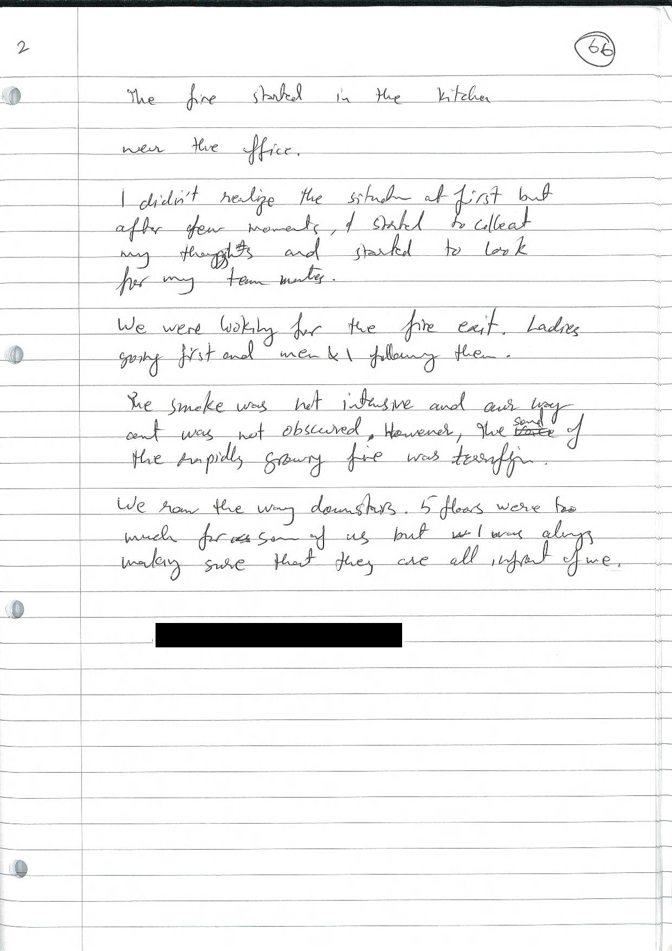
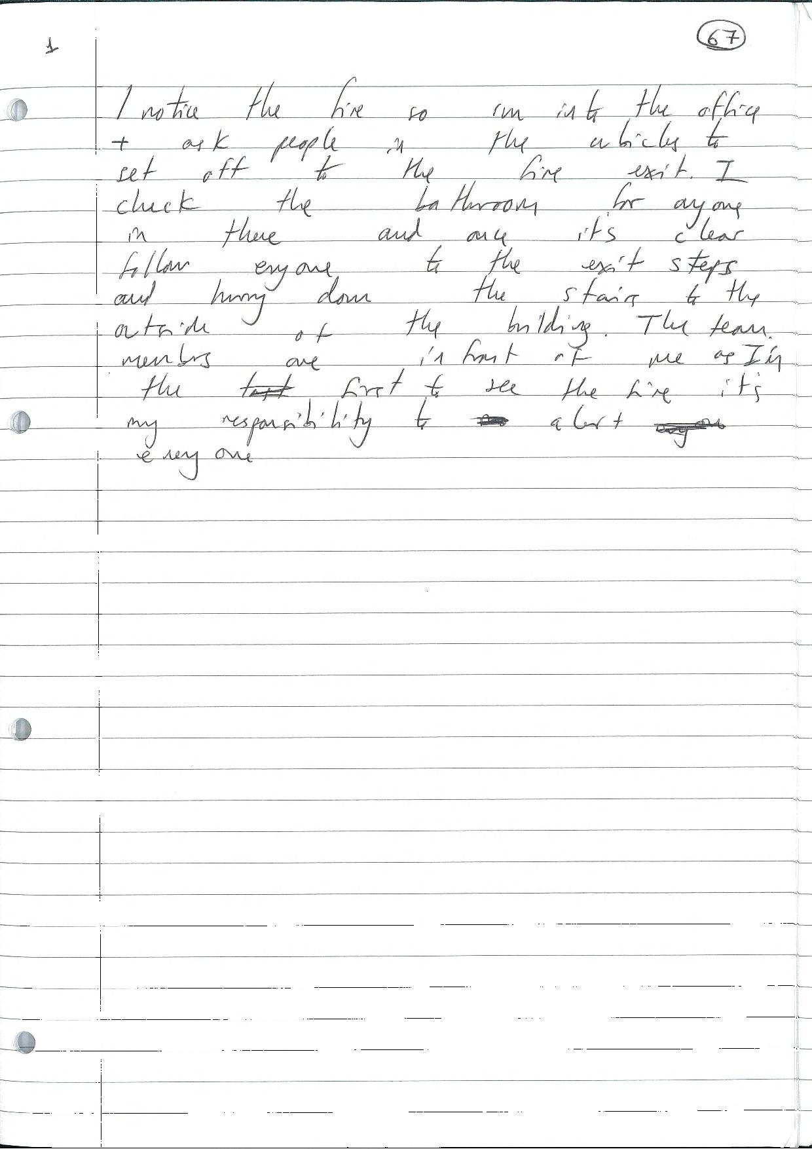
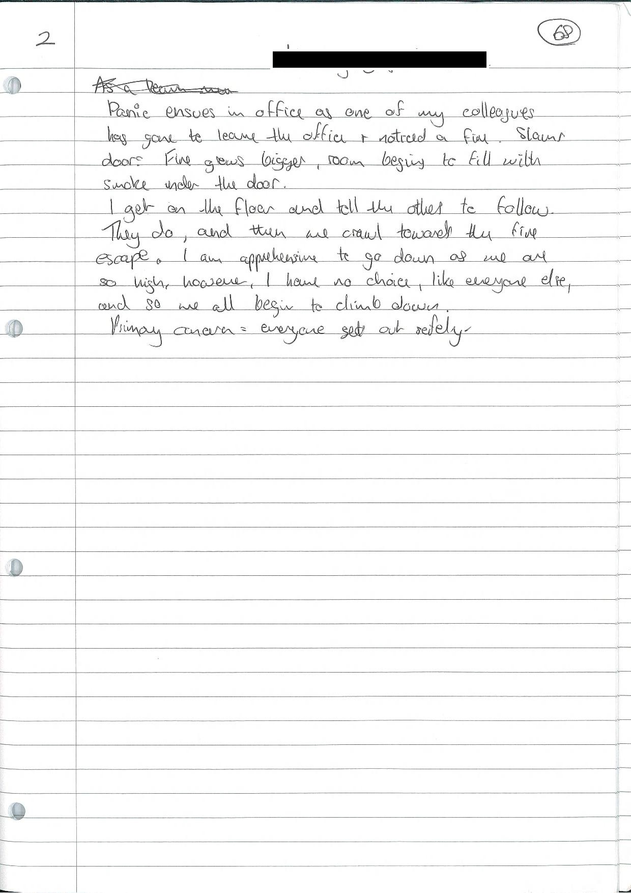
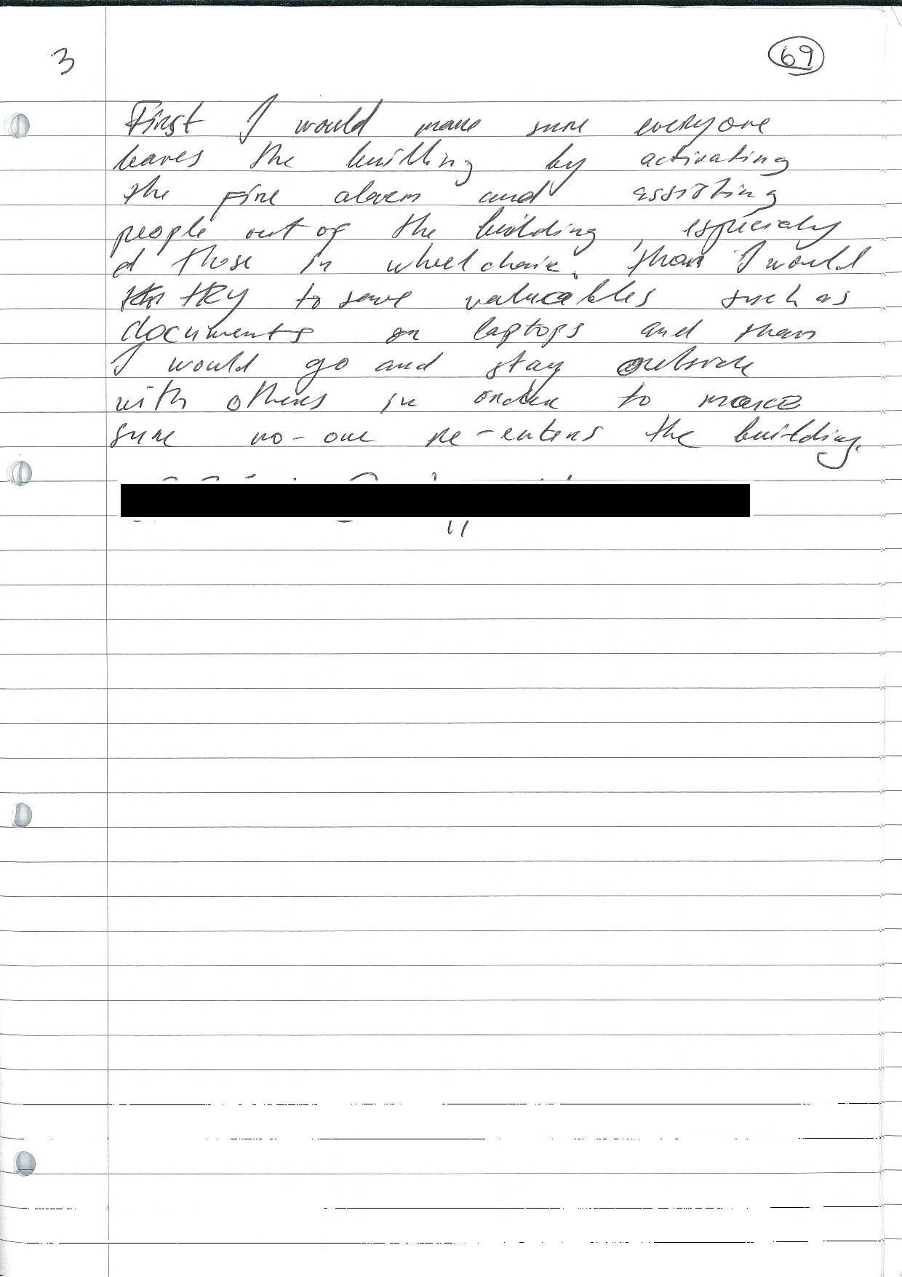
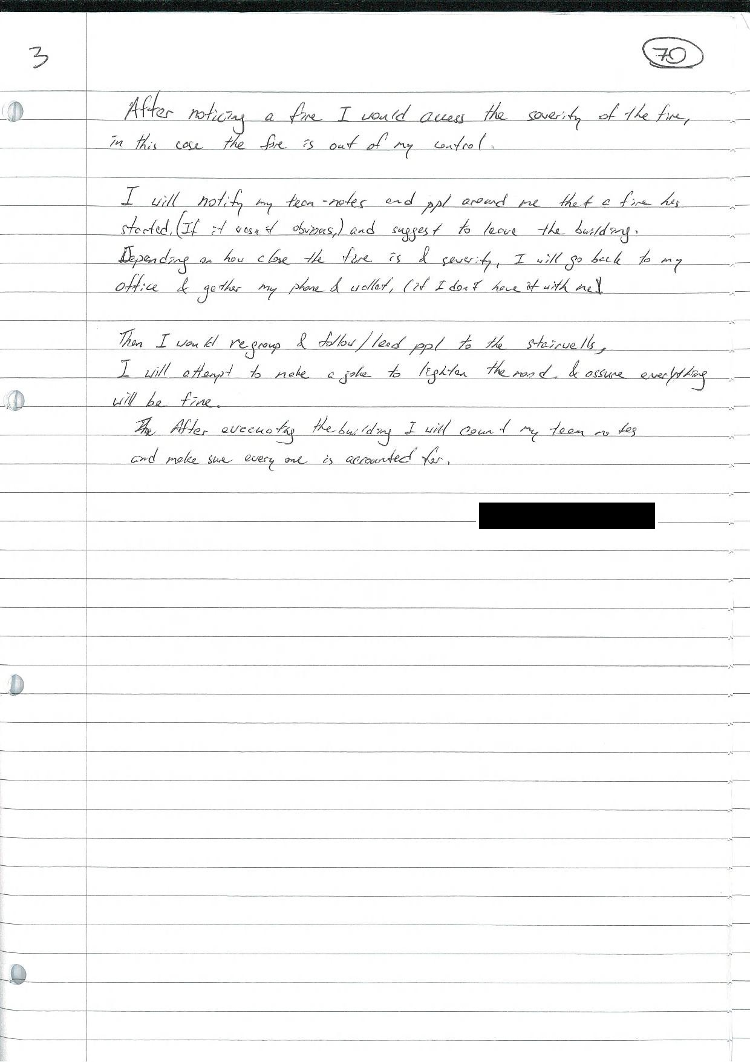
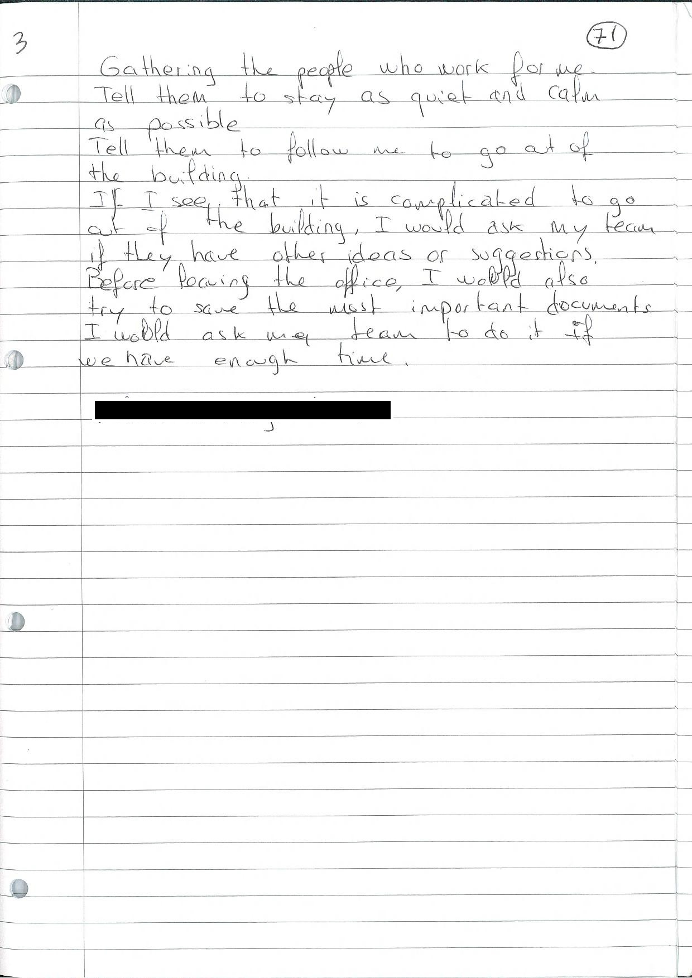
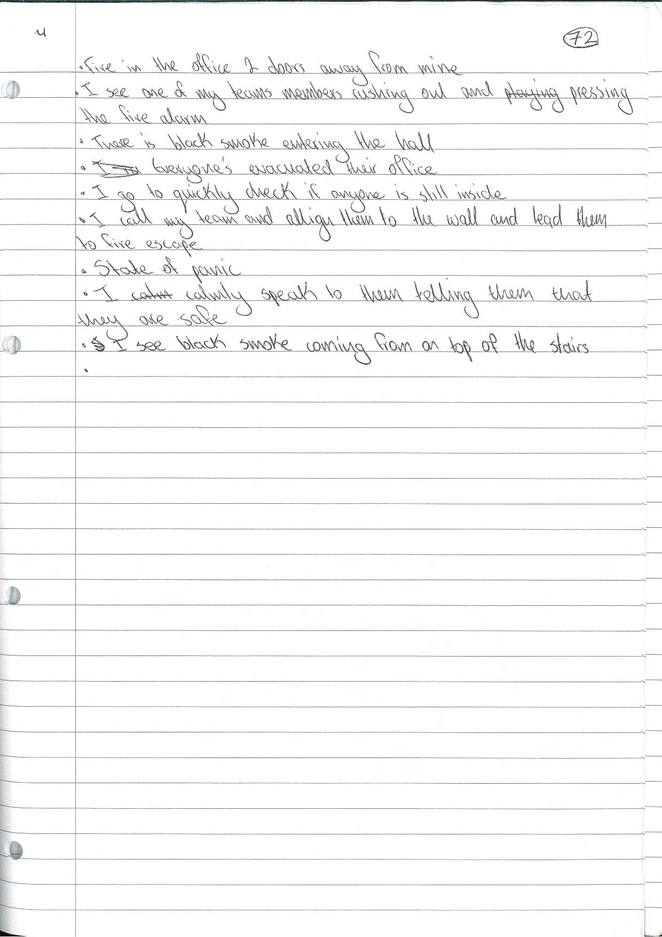

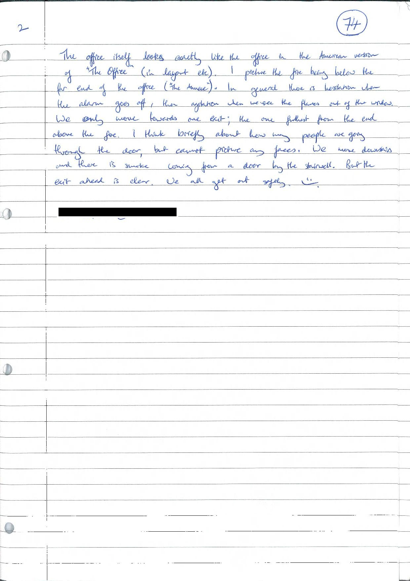
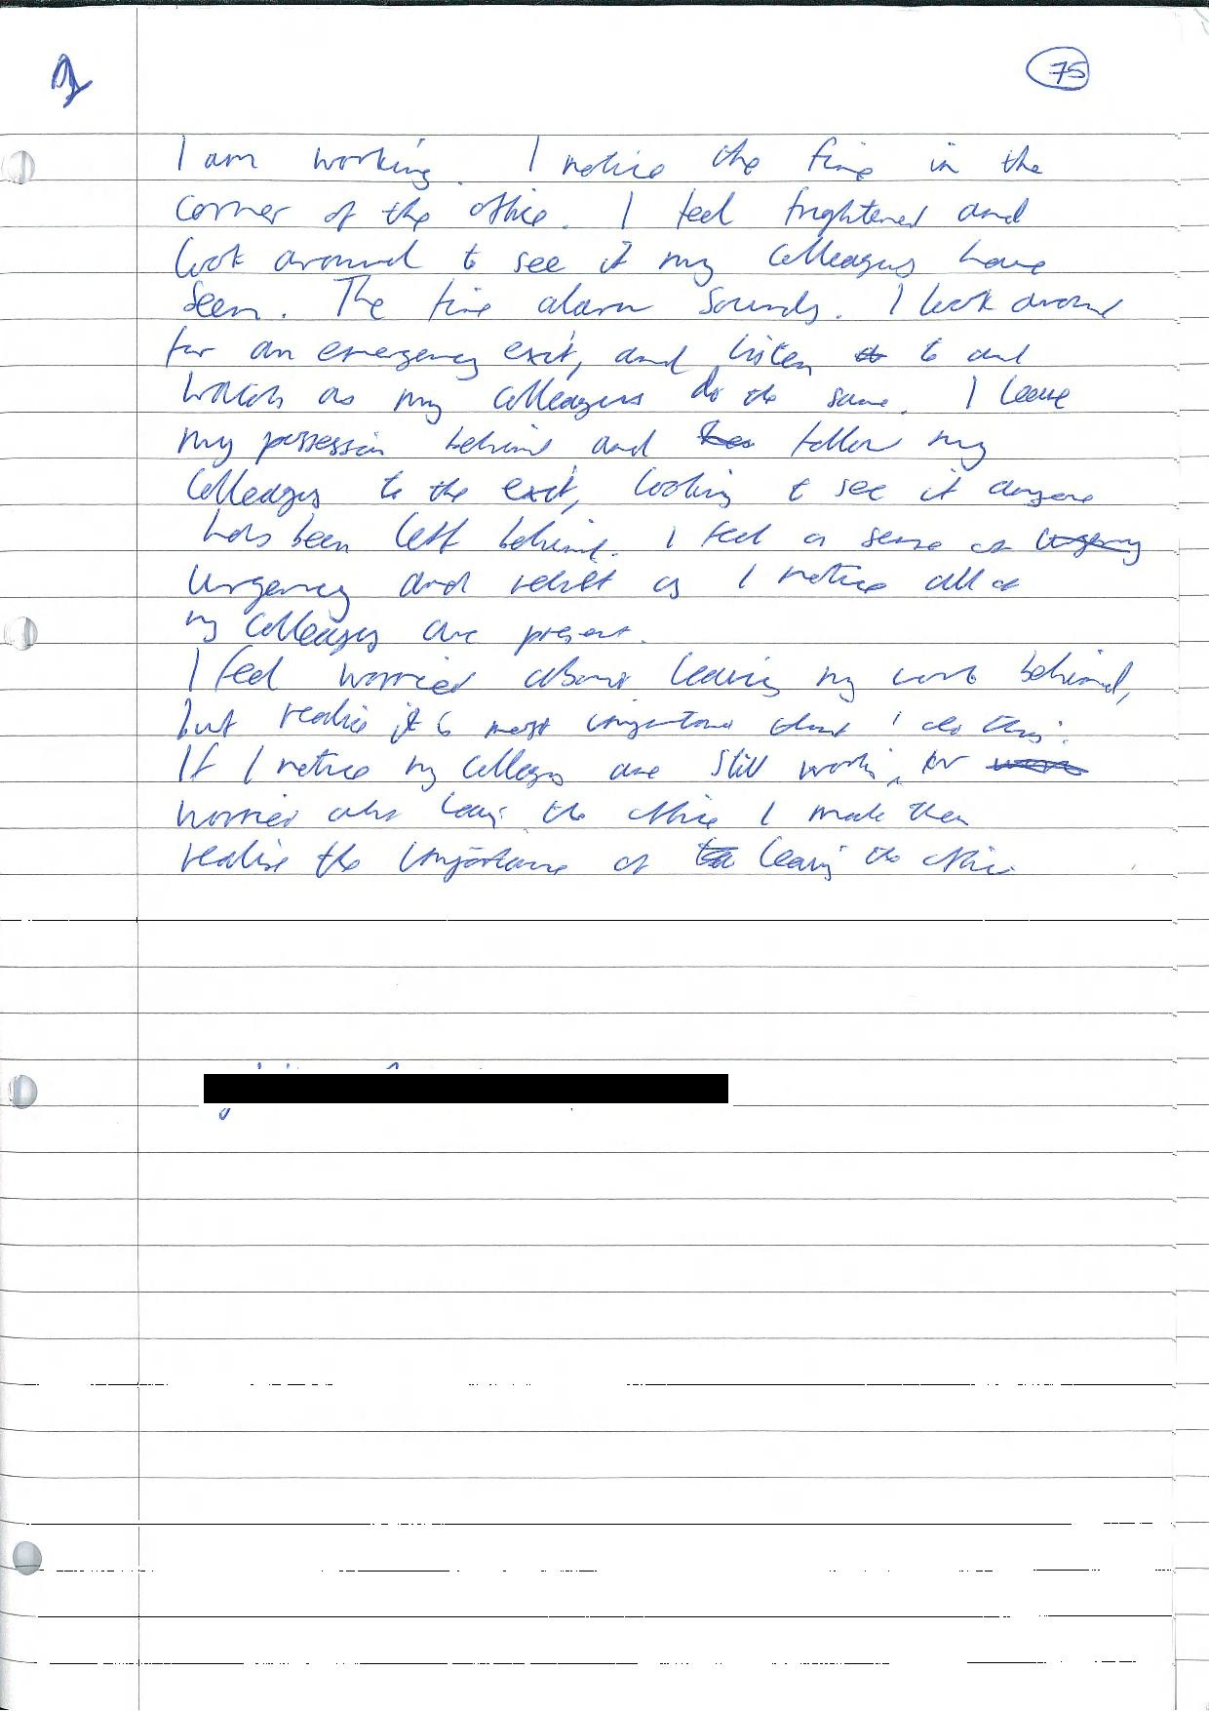
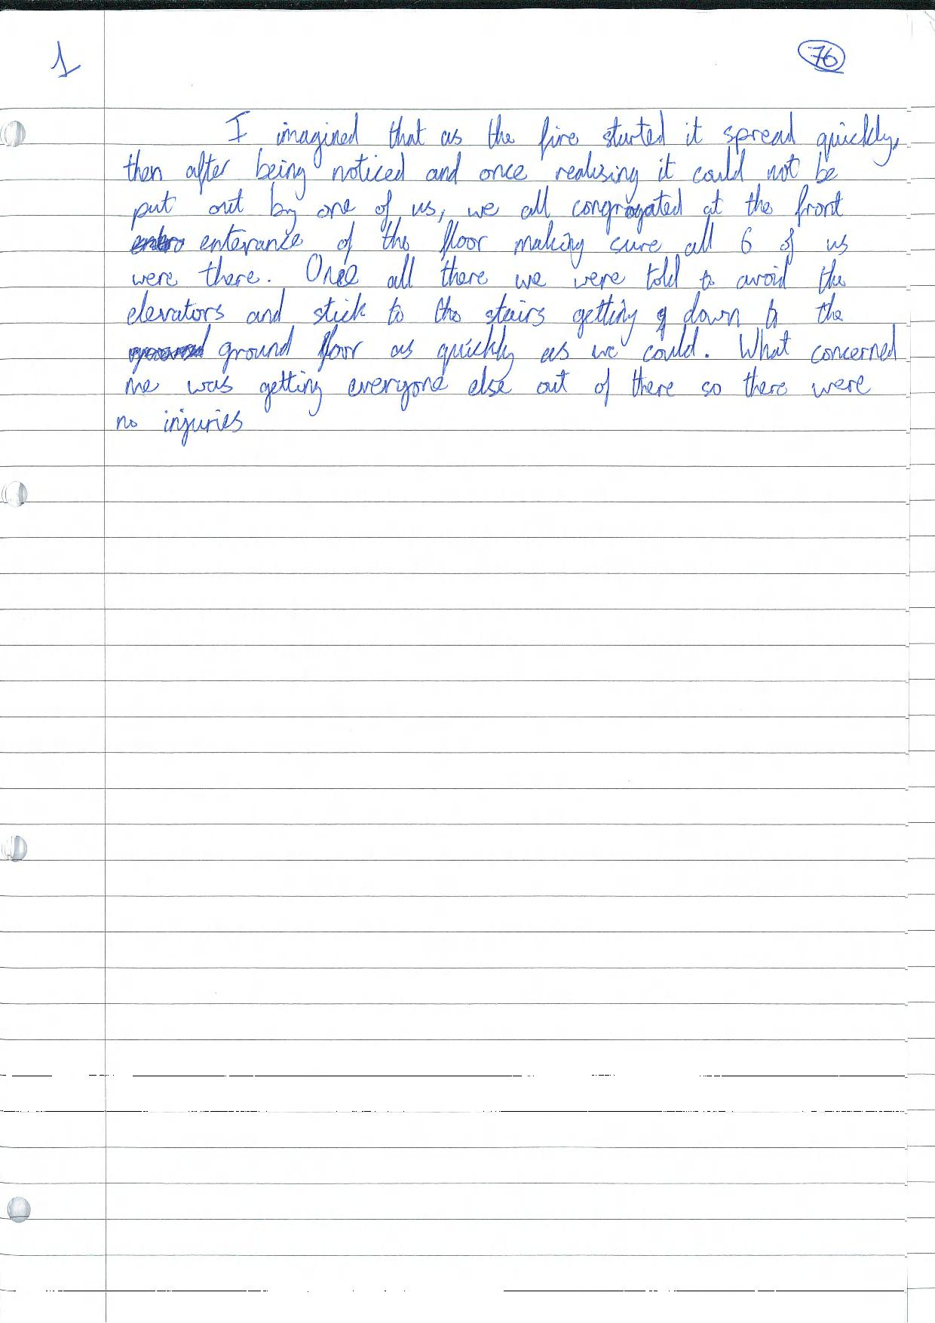
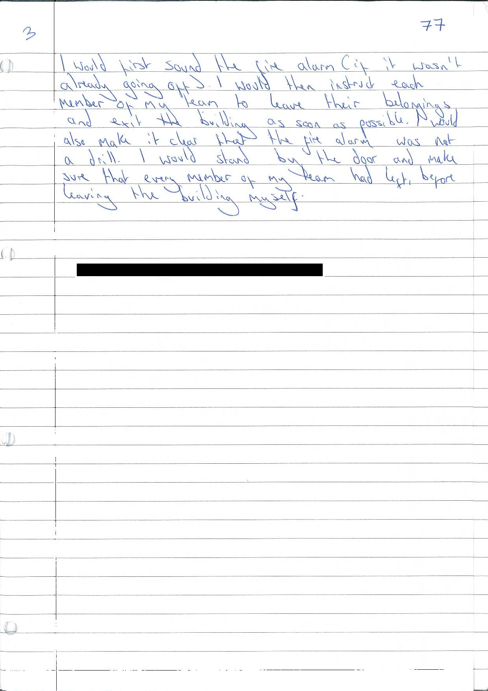*the identifiable information is redacted.
Appendix C
Ethical approval form for the study 3


Information sheet for study 3



Consent form for study 3

Debriefing form for study 3


Questionnaires used in study 3
The Autistic-Spectrum Quotient
1—Very rarely | 2—Rarely | 3—Occasionally
4—Somewhat often | 5—Often | 6—Very often

1. I prefer to do things with others rather than on my own.
2. I prefer to do things the same way over and over again.
3. If I try to imagine something, I find it easy to create a picture in my mind.
4. I frequently get so strongly absorbed in one thing that I lose sight of other things.
5. I often notice small sounds when others do not.
6. I usually notice car number plates or similar strings of information.
7. Other people frequently tell me that what I’ve said is impolite, even though I think it is polite.
8. When I’m reading a story, I can easily imagine what the characters might look like.
9. I am fascinated by dates.
10. In a social group, I can easily keep track of several different people’s conversations.
11. I find social situations easy.
12. I tend to notice details that others do not.
13. I would rather go to a library than a party.
14. I find making up stories easy.
15. I find myself drawn more strongly to people than to things.
16. I tend to have very strong interests, which I get upset about if I can’t pursue.
17. I enjoy social chit-chat.
18. When I talk, it isn’t always easy for others to get a word in edgeways.
19. I am fascinated by numbers.
20. When I’m reading a story, I find it difficult to work out the characters’ intentions.
21. I don’t particularly enjoy reading fiction.
22. I find it hard to make new friends.
23. I notice patterns in things all the time.
24. I would rather go to the theatre than a museum.
25. It does not upset me if my daily routine is disturbed.
26. I frequently find that I don’t know how to keep a conversation going.
27. I find it easy to “read between the lines” when someone is talking to me.
28. I usually concentrate more on the whole picture, rather than the small details.
29. I am not very good at remembering phone numbers.
30. I don’t usually notice small changes in a situation, or a person’s appearance.
31. I know how to tell if someone listening to me is getting bored.
32. I find it easy to do more than one thing at once.
33. When I talk on the phone, I’m not sure when it’s my turn to speak.
34. I enjoy doing things spontaneously.
35. I am often the last to understand the point of a joke.
36. I find it easy to work out what someone is thinking or feeling just by looking at their face.
37. If there is an interruption, I can switch back to what I was doing very quickly.
38. I am good at social chit-chat.
39. People often tell me that I keep going on and on about the same thing.
40. When I was young, I used to enjoy playing games involving pretending with other children.
41. I like to collect information about categories of things (e.g. types of car, types of bird, types of train, types of plant, etc.).
42. I find it difficult to imagine what it would be like to be someone else.
43. I like to plan any activities I participate in carefully.
44. I enjoy social occasions.
45. I find it difficult to work out people’s intentions.
46. New situations make me anxious.
47. I enjoy meeting new people.
48. I am a good diplomat.
49. I am not very good at remembering people’s date of birth.
50. I find it very easy to play games with children that involve pretending.

Inferential Confusion Questionnaire—Expanded Version
Please rate your agreement or disagreement with the following statements using this scale:
1 2 3 4 5 6
Strongly Disagree-Somewhat disagree- Somewhat disagree- Somewhat Agree- Strongly agree-agree

1. I am sometimes more convinced about what might bet here than by what
I actually see.
2. I sometimes invent stories about certain problems that might bet here
3. Sometimes certain far-fetched ideas feel so real they could just as well
4. Often my mind starts to race and I come up with all kinds of far-fetched
ideas.
5. I can get very easily absorbed in remote possibilities thatf eel as if they
are real.
6. I often confuse different events as if they were the same.
7. I often connect ideas or events in my mind that would seem far-fetched
to others or even to me.
8. Certain disturbing thoughts of mine sometimes cast a shadow on to
everything Iseearound me.
9. I sometime forget who or where I am when I get absorbed in to certain
ideas or stories.
10. My imagination is sometimes so strong that I feel stuck and unable to
see things differently.
11. I invent arbitrary rules,which I then feel I have to live by.
12. I often cannot tell whether something is safe, because things are not
what they appear to be.
13. Sometimes every far-fetched possibility my mind comes up with feels
real to me.
14. I sometimes get so absorbed in certain ideas that I am completely unable
to see things differently even if I try.
without paying attention to what I actually see.
be happening.
15. In order to tell whether there is a problem or not I tend to look more for
that which is hidden than what I can actually see.
16. Even if I don’t have any actual proof of a certain problem, my
imagination can convince me otherwise.
17. Just the thought that there could be a problem or something wrong is
proof enough for me that there is.
18. I can get so caught up in certain ideas of mine that I totally forget about
everything around me.
19. Often when I feel certain about something a small detail comes to mind
that puts everything into doubt.
20. I sometimes come up with far-fetched reasons why there is a problem or
something wrong,which then suddenly starts to feel real to me.
21. I often cannot get rid of certain ideas, because I keep coming up
possibilities that confirm my ideas.
22. My imagination can make me lose confidence in what I actually
perceive.
23. A mere possibility often has as much impact on me as reality itself.
24. Even if I have all sorts of visible evidence against the existence of a
certain problem, I still feel it will occur.
25. Even the smallest possibility can make me loose confidence in what
I know.
26. I can imagine something and end up living it.
27. I am more often concerned with something that I cannot see rather than
something I can see.
28. I sometimes come up with bizarre possibilities that feel real to me.
29. I often react to a scenario that might happen as if it is actually
happening.
30. I sometimes cannot tell whethe rall the possibilities that enter my mind
are real or not.

