

Acoustic Methods for Robot Communication in Pipes

Zhengwei Li

A thesis submitted in partial fulfilment of the requirements for the degree of
Doctor of Philosophy

The University of Sheffield
Faculty of Engineering
Department of Mechanical Engineering

26th March 2022

Acknowledgements
First of all, thanks to Prof. Kirill Horoshenkov for giving me this opportunity to work under his supervision. He has always been very patient, kind and responsible for me, not only putting effort into my academic training, but also paying attention to my mental health. Thanks to Dr. Andrew Nichols, my second supervisor, who provides me with software support and knowledge related to data acquisition. Thanks to Dr. Anton Krynkin who makes significant contribution to build mathematical models. Thanks to Mr. Paul Osborne for his helping in experiment preparation and risk assessment evaluation. Thanks to Dr. Yicheng Yu, it is really a pleasure to work together with him and his suggestions are always very helpful. He provided me with deep insight on the theory of sound propagation in pipes. Thanks to Dr, Viktor Doychinov (University of Leeds) who gives me lot of guidance in wireless communication techniques.
A deep appreciation is expressed to my parents Shinian Li and Jinxia Cheng who always support me quietly behind the scenes. As well as the author would like to thank my girlfriend Meiqi Wang who is always by my side.

Abstract
This research intends to develop communication techniques of using acoustic wave which can be adopted on a moving robot. Communication is important as autonomous robots are being developed to work in partially filled pipes such as sewers and drainage pipes. These robots need to change messages and communicate with the above ground control. The major challenge of sending message acoustically in the pipe are background noise and wave dispersion in the channel. In order to help the communication system overcome these effects the acoustic characteristic of the pipe need to be known. In this work, the frequency response functions (FRFs) of an empty pipe, partially water-filled pipe and pipe with artefacts (lateral connection/blockage/manhole) has been studied analytically and numerically. In addition, a computationally efficient empirical model for predicting the FRF of partially water filled pipe has been proposed in this thesis. The proposed models for empty pipe and partially water-filled pipe have been validated against an experiment. It has been shown that sound attenuation is a key factor that determines the communication range. In this report, the sound attenuation in empty pipe has been studied and maximum data and communication distance for a given acoustic communication technique have been estimated.
Four modulation techniques, binary amplitude/frequency/phase shift keying (2ASK/2FSK/2PSK) and chirp linear frequency modulation (CLFM) have been adapted for in-pipe acoustic communication for robotic system. Their performance in an empty and partially filled pipes has been evaluated numerically and experimentally against signal noise ratio (PER-SNR) and career frequency. The package error rate has been used as the measure of communication quality. The influence of typical artefacts such as blockage, lateral connection and pipe end has been studied numerically. The results suggest the presence of uncertainties in the pipe is likely to have strong impact on some communication techniques. It has been found that CLFM technique has got a relative high noise resistance and suffers least influence from the in-channel uncertainties making it a very competitive solution of in-pipe communication for robotic systems.

Publications
Journal Paper
[1] Y. Yu, A. Krynkin, Z . Li and K. V. Horoshenkov, “Analytical and empirical models for the acoustic dispersion relations in partially filled water pipes,” Applied Acoustics, pp. 179-193, 26 March 2021.
[2] Z. Li, K. V. Horoshenkov and Y. Yu, “A comparison of the performance of four acoustic techniques for robot communication in pipes,” Submitted for publication in Applied Acoustics, December 2021.

Declaration
I, the author, confirm that the Thesis is my own work. I am aware of the University’s Guidance on the Use of Unfair Means (www.sheffield.ac.uk/ssid/unfair-means). This work has not been previously been presented for an award at this, or any other, university.

Table of Contents
Chapter 1. Introduction to the project - 1 -
1.1 Background information - 1 -
1.2 Objectives and organisation of this study - 1 -
1.3 Structure of this thesis - 2 -
Chapter 2. Literature Review - 3 -
2.1 Acoustic characterisation - 3 -
2.2 Communication - 5 -
Chapter 3. Theories - 7 -
3.1 Sound propagation in an air-filled pipe. - 7 -
3.1.1 Experimental Validation - 8 -
3.2 Sound propagation in partially water-filled pipe. - 11 -
3.2.1 Numerical study: - 12 -
Mode Shape - 13 -
3.2.2 Analytical Study - 15 -
3.2.3 Empirical model - 20 -
3.2.4 Prediction of acoustic response due to monopole source excitation - 24 -
3.3 Acoustic attenuation in the pipe - 26 -
3.4 Effects of uncertainties in the pipe - 29 -
3.41 Lateral Connection - 31 -
3.42 Blockage - 34 -
3.43 Manhole - 38 -
Summary - 41 -
Chapter 4. The performance of Communication Techniques in an Empty Pipe - 43 -
4.1 Communication Procedures - 43 -
4.2 Modulation & Demodulation (MODEM) - 49 -
4.2.1 Binary Amplitude Shift Keying - 49 -
4.2.2 Binary Frequency Shift Keying - 51 -
4.2.3 Binary Phase Shift Keying - 55 -
4.2.4 Chirp Linear Frequency Modulation - 61 -
4.3 Simulation and Experimental Validation - 64 -
4.4 Communication Speed Evaluation - 70 -
Summary - 74 -
Chapter 5 Communication in the partially water-filled pipe - 75 -
5.1 Simulation - 75 -
5.1.1 2FSK: - 77 -
5.1.2 2ASK: - 78 -
5.1.3 2PSK: - 79 -
5.1.4 CLFM - 81 -
5.2 Frequency of Channel Re-calibration in response to water level change - 82 -
5.2.1 2FSK - 83 -
5.2.2 2ASK - 85 -
5.2.3 2PSK - 86 -
5.2.4 CLFM - 88 -
5.3 The influence of the source and receiver locations on communication - 89 -
5.3.1 2FSK: - 91 -
5.3.2 2ASK - 92 -
5.3.3 2PSK - 93 -
5.3.4 CLFM - 94 -
5.4 Experimental Validation - 95 -
5.4.1 Channel Validation: - 99 -
5.4.2 Communication Validation: - 100 -
5.4.2.1 2FSK - 100 -
5.4.2.2 2ASK - 106 -
5.4.2.3 2PSK - 110 -
5.4.2.4 CLFM - 113 -
Summary - 117 -
Chapter 6 The Numerical Studies for Communication in the Pipe with Artefacts - 118 -
6.1 Transfer Function - 118 -
6.1.1 Lateral Connection - 119 -
6.1.2 Half-size Blockage - 121 -
6.1.3 Manhole - 123 -
6.2 Noise Resistance - 125 -
6.2.1 2FSK - 125 -
6.2.2 2ASK - 126 -
6.2.3 2PSK - 127 -
6.2.4 CLFM - 128 -
6.3 Carrier Frequency Selection - 129 -
6.3.1 2FSK - 130 -
6.3.2 2ASK - 132 -
6.3.3 2PSK - 134 -
6.3.4 CLFM - 136 -
Summary - 140 -
Chapter 7. Conclusion - 142 -
Limitations and Future Work Suggestions - 145 -
References - 147 -

Table of Notations
$$J_{m}$$ | $m^{th}$ Bessel function
$$A_{mn}$$ | modal excitation coefficient
$$γ_{mn}$$ | wavenumber in z direction
$$ω$$ | angular frequency
$$c_{0}$$ | sound speed in air
$$ρ$$ | density
$$h$$ | water depth
$$R$$ | radius of pipe
$$v_{n}$$ | universal velocity
$$v_{θ}$$ | velocity on $θ$ direction
$$v_{r}$$ | velocity on radial direction
$$f_{mn}$$ | modal frequency
$$Ψ_{mn}^{(1)}$$ | anti-symmetric mode shape function
$$Ψ_{mn}^{(2)}$$ | symmetric mode shape function
$$U_{ϵ}\left(ω\right)$$ | normal acoustic velocity on the surface of sphere
$$Q_{(ω)}$$ | strength of the source
$$ε$$ | radius of the source (monopole)
$$δ(.)$$ | Dirac function
$$α_{air}$$ | sound absorption coefficient for air
$$α_{wall}$$ | sound absorption coefficient for pipe wall
$$v$$ | kinematic viscosity
$$γ$$ | heat capacity ratio
$$χ$$ | thermal diffusivity
$$κ$$ | heat conductivity of air
$p_{up}$/$p_{down}$ | upstream/downstream sound pressure
$R_{mn}$/$T_{mn}$ | reflection/transmission coefficient for mode (m,n)
$$N(f)$$ | spectral amplitude of noise
$$A_{RMS}$$ | root-mean square value of signal spectrum
$$ϕ(f)$$ | random frequency dependent phase
$$e_{ook}(t)$$ | on-off keying time domain sequence
$$T_{B}$$ | symbol period
$$a_{n}$$ | binary variable ("1"/"0")
$$f_{c}$$ | carrier frequency
$$f_{m}$$ | modulation frequency/bandwidth
$$φ_{n}$$ | absolute phase for 2PSK signal
$$e_{chirp}$$ | sub-chirp signal for CLFM in time domain
$$R_{b}$$ | bit rate
$$T_{message}$$ | total message pack period
$$T_{int}$$ | time interval between symbols of CLFM
$$c_{g}$$ | group velocity
$f_{c1}$,$f_{c2}$ | two sub carriers of 2FSK
$$f_{central}$$ | central frequency of sub-chirp for CLFM
$$p_{a}$$ | ambient atmospheric pressure
$$T$$ | atmospheric temperature
$$p_{r}$$ | atmospheric pressure
$$T_{r}$$ | reference atmospheric temperature
$$f_{rO}$$ | Oxygen relaxation  frequency
$$f_{rN}$$ | Nitrogen relaxation frequency
$$H$$ | molar concentration of water vapour

List of Tables
Table | Page
Table 3.1. Empirical model values for the prediction of cross-section wavenumber${\overline{k}}_{mn}^{\left(1\right)}/k_{mn}$ | 23
Table 3.2 Empirical model values for the prediction of cross-section wavenumber ${\overline{k}}_{mn}^{\left(2\right)}/k_{mn}$ | 23
Table 4.1 19 Binary Message Pack | 45
Table 4.2 Comparison among 4 communication systems when they are approaching their highest data transmission speed | 74

List of Figures
Figure | Page
Figure 3.1 The geometry of the problem of sound propagation in a pipe. | 8
Figure 3.2 Experiment setup for channel measurement. | 10
Figure 3.3 A comparison of the dispersion relation between the analytical model (eq. (3.4)) and experimental data. White dashed line is the analytical model. The colourmap is for experimental data. | 11
Figure 3.4 The cross-section of a partially water filled pipe | 12
Figure 3.5 The dispersion relations for a 150 mm diameter pipe with smaller water filling ratios: (a) h/R=0; (b) h/R=0.1; and (c) h/R=0.2. | 13
Figure 3.6 The dispersion relations for a 150 mm pipe with greater filling ratios: (a) h/R=1; (b) h/R=1.07; (c) h/R=1.2. | 14
Figure 3.7 The shapes of the first (row 1, mode (1,0)) and second (row 2, mode (2,0)) non-axisymmetric modes of a pipe with or without partially filled water layer h/R = 0.1: (a)mode (1,0) of empty pipe; (b) and (c) are the split anti-symmetric and symmetric modes respectively associated with the split of mode (1,0); (d) mode (2,0) of empty pipe; (e) and (f) are the split anti-symmetric and symmetric modes respectively associated with mode (2,0). | 15
Figure 3.8 The shape of first axisymmetric mode for an empty pipe (a), and pipe with partially filled water layer: (b) h/R=0.1; (c) h/R=0.2 | 16
Figure 3.9 The shape of first axisymmetric mode for partially filled pipe: (a) h/R=1; (b) h/R=1.07; (c) h/R=1.2. | 16
Figure 3.10. Dispersive curve of the cross-section of partially filled water pipe using models from equation. (3.11) and (3.22) compared with the FEM simulated model: (a) h/R=0.1; (b) h/R=0.2. | 21
Figure 3.11 Normalized cross-section wavenumbers for different filling ratios: (a) ${\overline{k}}_{mn}^{\left(1\right)}/k_{mn}$, (b) ${\overline{k}}_{mn}^{\left(2\right)}/k_{mn}$ | 25
Figure 3.12 The comparison between attenuation coefficients caused by visco-thermal effects (wall) and air absorption (air) in frequency range of 0 Hz~15000 Hz. | 30
Figure 3.13 The numerical experiment setup to study sound propagation in a pipe with a lateral connection | 33
Figure 3.14 Reflection coefficient for lateral connection (plane wave mode) | 33
Figure 3.15 Reflection coefficient for lateral connection (mode (1,0)) | 34
Figure 3.16 Reflection coefficient for lateral connection (mode (2,0) | 34
Figure 3.17 Reflection coefficient for lateral connection (mode (0,1) | 35
Figure 3.18 Numerical experiment set up for half size blockage (plane wave mode) | 36
Figure 3.19 Reflection coefficient for half size blockage (plane wave mode) | 36
Figure 3.20 Reflection coefficient for half size blockage (Mode (1,0)) | 37
Figure 3.21 Reflection coefficient for half size blockage (Mode (2,0)) | 38
Figure 3.22 Reflection coefficient for half size blockage (Mode (0,1)) | 38
Figure 3.23 Numerical experiment set up for 1m diameter manhole | 39
Figure 3.24 Reflection coefficient for manhole (plane wave mode) | 40
Figure 3.25 Reflection coefficient for manhole (Mode (1,0)) | 40
Figure 3.26 Reflection coefficient for manhole (Mode (2,0)) | 41
Figure 3.27 Reflection coefficient for manhole (Mode (0,1)) | 42
Figure 4.1 A diagram Illustrating in-pipe communication procedures | 45
Figure 4.2 (a) 2ASK signal excitation in time domain (Top). (b) Message package of the signal illustrated in top diagram (Bottom) | 46
Figure 4.3 (a) The spectrum of emitted 2ASK signal with 20 Hz bandwidth and 5000Hz carrier frequency （Top）. (b) The spectrum of the communicated 2ASK signal predicted in the pipe 4m away from the source with additive noise (Bottom). | 48
Figure 4.4 Message pack of 2ASK communication before and after deconvolution | 49
Figure 4.5 Synchronisation by cross-correlation | 50
Figure 4.6 2ASK modulation waveform | 51
Figure 4.7 A diagram explaining the process of 2ASK coherent demodulation | 52
Figure 4.8 2ASK coherent demodulation waveform and decision making. | 52
Figure 4.9 2FSK modulation process | 53
Figure 4.10 2FSK message package | 54
Figure 4.11 Process of 2FSK envelop demodulation. | 55
Figure 4.12 2FSK coherent demodulation waveform and decision making. | 55
Figure 4.13 2PSK OOK modulation process | 57
Figure 4.14 2PSK modulation waveform | 57
Figure 4.15 2PSK message pack | 58
Figure 4.16 Coherent demodulation waveform and decision making for 2PSK. | 59
Figure 4.17 Coherent Demodulation waveform and decision making for 2PSK with 0 dB SNR and 3119 Hz carrier frequency. | 60
Figure 4.18 Angle Demodulation waveform and decision making for 2PSK. | 61
Figure 4.19 CLFM modulation process | 63
Figure 4.20 An illustration of key stages in the CLFM modulation process: (a) Square wave S1(t) to show the binary change of sending “1” s.(b) Square wave S0(t) to show the binary change of sending “0” s ((Top second diagram). (c)Sub-chip with frequency | 63
Figure 4.21 (a) Cross-correlation results for CLFM. (b) Signal in window with high relevance. (c) Signal in the window with low relevance. | 64
Figure 4.22 A Diagram illustrating the PER for the four communication technologies with 20Hz modulation frequency (5000 Hz carrier frequency for 2ASK, 2PSK, 2FSK and 4000Hz-5000Hz modulation chirp for CLFM) as a function of the SNR: (a) analytically obtained FRF for the pipe (top). (b) measued FRF (bottom). | 67
Figure 4.23 Diagram illustrates the experimental validation for comparison of 4 communication systems with 20Hz modulation frequency and 5000 Hz carrier frequency and 4000Hz~5000Hz modulation chirp for CLFM under SNR in the range between -30dB~20dB | 68
Figure 4.23 Diagram illustrates the experimental validation for comparison of 4 communication systems with 20Hz modulation frequency and 5000 Hz carrier frequency and 4000Hz~5000Hz modulation chirp for CLFM under SNR in the range between -30dB~20dB | 69
Figure 4.24 A diagram showing the dependence of the PER on the dimensionless frequency for SNR = 0dB and f_m = 20 Hz. | 70
Figure 4.25 The diagram illustrating the sound attenuation as a function of frequency. | 73
Figure 5.1 The visualised numerical experimental set-up for FRFs predictions | 76
Figure 5.2 An example of the difference between the FRF for the 200 mm diameter empty pipe (blue line) and partially water-filled pipe with filling ratio of 0.1 (red line) predicted using the analytical approximation. | 76
Figure 5.3 The envelopes of a 2FSK message pack ($f_{c1}$=5000 Hz, $f_{c2}$=2500 Hz, bandwidth 20 Hz, SNR=10dB) with filling ratio of 0.1 (top), 0.2 (middle) and 0.3 (bottom). (a)-(c) analytical model, (d)-(f) empirical model. | 78
Figure 5.4 The envelopes of a 2ASK message pack ($f_{c}$=5000 Hz, bandwidth 20 Hz, SNR=10dB) with filling ratio of 0.1-0.3: (a) -(c) analytical model; (d)-(f) empirical model. | 79
Figure 5.5 The angle diagrams of 2PSK message pack (fc=5000 Hz, bandwidth 20 Hz, SNR=10dB) with filling ratio of 0.1-0.3: (a) -(c) analytical model; (d)-(f) empirical model. | 80
Figure 5.6 The cross-correlation diagrams of CLFM message pack (sub-chirp (4000 Hz~5000 Hz) bandwidth 20 Hz, SNR=10dB) with filling ratio of 0.1~0.3: (a)-(c) analytical model; (d)-(f) empirical model. | 81
Figure 5.7 The waveforms of 2FSK message pack envelope using 0.1 FRF to deconvolve the signal convolved with: (a) 0.2 FRF; (b) 0.3FRF; and (c) 0.4FRF | 84
Figure 5.8 The waveforms of 2ASK message pack envelope using 0.1 FRF to deconvolve the signal convolved with: (a) 0.2 FRF; (b) 0.3FRF; and (c) 0.4FRF | 86
Figure 5.9 The waveforms of 2PSK message pack angle diagram using 0.1 FRF to deconvolve the signal convolved with: (a) 0.2 FRF; (b) 0.3FRF; and (c) 0.4FRF | 88
Figure 5.10 The waveforms of CLFM message pack based on cross-correlation predicted with 0.1 FRF for the signal convolved with: (a) 0.2 FRF; (b) 0.3FRF; and (c) 0.4FRF | 89
Figure 5.11 An example of the FRFs predicted for the source and receiver being in the middle of cross-sectional area (blue line) and near the top of the pipe wall (red line). | 90
Figure 5.12 The Package Error Rate diagram for the 2FSK technique (SNR=10 dB) Illustrating the difference of placing the source and receiver in the middle of cross-sectional area of the pipe (blue line) and near the top wall (red line). | 92
Figure 5.13 The Frequency-Package Error Rate diagram for 2ASK system (SNR=8 dB) showing the difference of placing the source and receiver in the middle of cross-sectional area of the pipe (blue line) and near the top wall (red line). | 93
Figure 5.14 The Frequency-Package Error Rate diagram for the 2PSK technique (SNR=8 dB) showing the difference of placing the source & receiver in the middle of cross-sectional area of the pipe (blue line) and near the top wall (red line). | 94
Figure 5.15 The Frequency-Package Error Rate diagram for CLFM system (SNR=0 dB) to show the difference of placing the source & receiver in the middle of cross-sectional area of the pipe (blue line) and near the top wall (red line). | 95
Figure 5.16 The experimental set up to study communication in a partially filled pipe | 96
Figure 5.17 Photos to show the experiment rig. | 98
Figure 5.18 a). FRF of 200 mm diameter pipe with filling ratio of h/R=0.1 and b). FRF of 200 mm diameter pipe with filling ratio of h/R=0.2. | 99
Figure 5.19 The time domain 2FSK signal (0.1 filling ratio) including the sine sweeps and communication pack. | 101
Figure 5.20 The 2FSK message pack (see Figure 5.19) after demodulation. | 102
Figure 5.21 The envelope of the 2FSK message pack. | 102
Figure 5.22 The envelope of 2FSK message pack (Reshape). | 103
Figure 5.23 Examples of the reshaped envelopes of the 2FSK message obtained in the pipe with the filling ratios of 0.2-0.4 | 104
Figure 5.24 The reshaped envelopes of the 2FSK message recorded in the pipe with filling ratio from 0.2-0.4 but deconvolved with the FRF/0.1. | 106
Figure 5.25 The 2ASK message pack recorded in the pipe with the filling ratio of 0.1. | 107
Figure 5.26 Examples of the envelopes of a 2ASK message pack recorded in the pipe with the filling ratios from 0.1 to 0.4. | 107
Figure 5.27 The reshaped envelopes of the 2ASK message pack recorded in the pipe with the filling ratios from 0.2 to 0.4 and deconvolved with the FRF/0.1 | 109
Figure 5.28 An example of a 2ASK message pack recorded in the pipe with the filling ratio of 0.1. | 110
Figure 5.29 Envelopes of 2PSK angle diagrams with filling ratio from 0.1 to 0.4 | 111
Figure 5.30 The cross-correlation results for the CLFM message pack measured in the pipe with filling ratio from 0.1 to 0.4. | 115
Figure 5.31 The cross-correlation results for the CLFM message pack measured in the pipe with the filling ratio from 0.2 to 0.4 but deconvolved with the FRF/0.1. | 116
Figure 6.1 The comparison of FRFs of empty pipe, pipe with lateral connection, half-size blockage and manhole. | 119
Figure 6.2 The comparison between the absolute value of the FRF of the empty pipe and that for the pipe with a lateral connection. | 120
Figure 6.3 The comparison between the phase of FRF of the empty pipe and that for the pipe with lateral connection. | 121
Figure 6.4 The comparison between the FRF of the empty pipe and that for the pipe with half-size blockage. | 122
Figure 6.5 The comparison between the phase of FRF of the empty pipe and that with half-size blockage. | 122
Figure 6.6 The comparison between the FRF of the empty pipe and that for the pipe with manhole. | 123
Figure 6.7 The comparison between the phase of FRF of the empty pipe and that with manhole. | 124
Figure 6.8 The effect of the artefact in the pipe on the package error rate as a function of the SNR for the 2FSK communication technique. | 125
Figure 6.9 The effect of the artefact in the pipe on the package error rate as a function of the SNR for the 2ASK communication technique. | 126
Figure 6.10 The effect of the artefact in the pipe on the package error rate as a function of the SNR for the 2PSK communication technique. | 127
Figure 6.11 The effect of the artefact in the pipe on the package error rate as a function of the SNR for the CLFM communication technique. | 128
Figure 6.12 The effect of the carrier frequency in the 2FSK communication technique on the PER in the pipe with an artefact. | 130
Figure 6.13 An illustration of the threshold effect on the decision based on the 2FSK demodulated message pack, carrier frequency set at kR=6.79, lateral connection. | 131
Figure 6.14 The effect of the carrier frequency in the 2ASK communication technique on the PER in the pipe with an artefact. | 133
Figure 6.15 The effect of the carrier frequency in the 2PSK communication technique on the PER in the pipe with an artefact. | 134
Figure 6.16 A diagram illustrating the threshold for the waveform used in the process of phase demodulation of a 2PSK signal transmitted at the carrier frequency of kR=6.13. | 135
Figure 6.17 The effect of the carrier frequency in the CLFM communication technique on the PER in the pipe with an artefact. | 136
Figure 6.18 Cross-correlation results for CLFM communication in the pipe with manhole (normalised central frequency =5.36). | 137
Figure 6.19 An example to show the waveform for 16th bits (in principle) | 138
Figure 6.20 The waveform of 16th bit captured by the window (actual). | 139

Chapter 1. Introduction to the project

1.1 Background information
There are millions of kilometres of buried wastewater collection pipes around the globe. In the UK, the total length of sewer pipes is more than 300,000 km and the installation of major part of these pipes can be tracked back to early days of 20th century or even earlier. A considerable proportion of this system is ageing and failing resulting in blockages, pollution spills and flooding in urban areas. Real time condition data to prevent these failures proactively are rare and repair and rehabilitation of these assets are generally reactive via disruptive excavation. In order to address this problem, the British government invested heavily to develop the science of miniature, cooperating swarms of autonomous robots for the inspection of buried pipes [1]. The focus of the Pipebots team is on new science which is emerging from the latest advances in robotics, sensing, control, additive manufacturing and AI. Findings from the Pipebots project suggests that that the success of autonomous robotic sensing in a very large pipe network depends on the ability of these robots to communicate information on the position and local conditions wirelessly [2]. Robust communication in a robot swarm is essential to achieve good performance for a robotic swarm inspecting autonomously a large, buried pipe network.
It is common to use radio waves (RF) to communicate messages above ground. However, this is problematic in buried sewer pipes because the RF attenuation is too high. In a pressurized water pipe, optical waves have desirable advantage in terms of high data rate reaching Gbps. However, it only works as a line-of-sight communication and in the absence of scatterers such as fog, spray and dust. In this respect acoustic waves are attractive to use for communication, because they propagate relatively long distances with little attenuation [3]. In addition, relatively low cost, simple and robust acoustic sensors are more suitable to work in the harsh environment such as sewer pipes to deliver messages between robots and for being used for detecting a critical change.
However, there has been little or no studies into the use of sound waves to convey messages in buried pipes. In particular, there is a complete lack of published literature on acoustic communication in partially filled pipes such as sewers or drainage pipes. As a result, the potential range and quality of communication with acoustic waves in pipes is largely unknown. Key parameters which can affect the quality of acoustic communication in partially filled pipes are the presence of noise, various artefacts and multi-modal propagation. To the best of our knowledges the effect of these parameters on the quality of communication in a partially filled pipe has never been systematically studied.

1.2 Objectives and organisation of this study
The objectives of this research have been formulated to address the above knowledge gap. These are:
- To propose methods for acoustic channel characterisation of a partially filled pipe with and without an artefact.
- To propose a range of communication techniques that can be adapted for use in this type of pipes.
- To use the channel characterisation methods and experiment to estimate the maximum data rate, noise resistance and bit error rate of each of the proposed communication techniques.
- To develop recommendations for deploying the proposed acoustic communication techniques on cooperative robots in partially filled pipes.

1.3 Structure of this thesis
This thesis is organised in 7 chapters. Chapter 1 is the introduction. Chapter 2 reviews the relevant literature. Chapter 3 presents the theory of sound propagation in a pipe. It makes use of analytical, numerical and experimental methods to study propagation of acoustic waves in an empty, partially water-filled pipe and pipe with different artefacts. It also estimates the sound attenuation in the pipe. Chapter 4 introduces the theories of three binary communication techniques, amplitude/frequency/phase shift keying (2ASK/2FSK/2PSK) and a spread spectrum modulation technique, chirp linear frequency modulation (CLFM). These four techniques can be deployed on robots for in-pipe acoustic communication. Their communication performance in an empty pipe in terms of bit error rate is also studied in this chapter. Chapter 5 extends the findings from Chapter 4 into the pipe with variable water level. Chapter 6 reports on the simulation of acoustic communication in a pipe with different artefacts such as lateral connection, blockage and manhole. It discusses the influence of these artefacts on the bit error rate. Finally, Chapter 7 presents a summary of this research and prospects for the future work.

Chapter 2. Literature Review

2.1 Acoustic characterisation
Sonic waves, i.e. acoustic waves below 20 kHz and ultrasonic waves above 20 kHz, have been used extensively to monitor conditions of buried pipes, but not so much for communication. A comprehensive review of sonic sensing can be found in ref. [4]. Another review of pipeline structure health monitoring by Liu et al [5] states that acoustic emission testing is an efficient method to determine the location where the crack propagates. This method relies on detecting the sound wave generated with in the material itself, i.e. the acoustic transducers are normally placed in or on the pipe to monitor the acoustic activities and the signal captured by the transducers are typically compared to acoustic signatures of known events which stored in data base to identify activities. Datta et al [6] in 2016 pointed out that for pipeline inspection, pulse echo methodology is very attractive to use because it can quickly provide both length and the equivalent cross-sectional area of a blockage. In addition, this method only required a single microphone to capture the incident and reflected pulse. It also has been mentioned that the characteristics of blockage are produced by the combination of phase change of the reflected signal with respect to the incident signal and the power reflection ratio (i.e. ratio of square of amplitude for incident and reflected waves).
The literatures reviewed above share a common feature, it requires to determine the acoustic characteristics of the pipe in advance. For example, the acoustic pulse reflectometry technique is usually used to localise and identify the blockage and defects in sewer pipes [6], [7], [8]. The accuracy of the blockage characterisation depends on the defect size and pipe material properties, water level, pipe layout, frequency spectrum in the emitted acoustic signal and on the speed and attenuation of this signal in the pipe. The speed and attenuation of acoustic signals in pipes is dispersive, i.e. these quantities depend on the frequency of sound. Therefore, the prediction of the wave dispersion is necessary for the accurate defect identification, localisation, and classification. This knowledge is also vital for communication where achieving higher data rate is one of the most important goals. Transmitting data at high-speed needs considerable amount of band resource which require relative high frequency carrier. However, when the acoustic wavelength become comparable or smaller than the pipe diameter, there will be a plurality of paths for it to propagate. In this case sound propagation in a pipe is rather complex and called “multi-path or multi-modal propagation". It is likely to have serious impact on the communication because the delay caused by such phenomenon will cause the overlapping between symbols (inter-symbol interference) and increase the bit error rate [9].
In a linear, time-invariant channel such as a stationary pipe, i.e. pipe without flow, the inter-symbol interference can be compensated by a linear equalisation network which also requires to obtain the characteristic of the channel (impulse or frequency response of the pipe) in advance. The impulse response for a dispersive channel is not a single delta pulse but rather a sequence of pulses [9]. Therefore, determining acoustic characteristics of the pipe can be used, apart from defect identification, localisation and classification, also to equalise the communication signals. For prospective autonomous inspection robots, acoustical characterisation has multiple uses which will play a key role in practical application.
The investigation of acoustic wave propagation in cylindrical pipes hasa long history in literature [10] and numerous models have been proposed. Some of these models account for the coupling between the elastic wave in the pipe wall and compressional wave in the filling fluid (e.g. [11]), effects of surrounding soil (e.g. [12] ) and flow velocity (e.g. [13]). However, research of acoustic waves in partially filled cylindrical pipes is much more limited. To the best of our knowledge, there has not been published work on analytical or empirical methods that can be alternative to numerical modelling with either finite element (FE) or boundary element methods (BEM) which are typically used to predict acoustic wave propagation in a cylindrical pipe partially filled with water. The acoustics community has ignored this class of pipes by and large.
The buried pipeline networks usually have very complex structures such as different branches, junctions and sediment blockages. The presence of these artefacts are likely to have strong impact on acoustic field because these artefacts can be treated as a secondary source when it reflects the incident wave. The incident and reflected waves in the pipe will therefore enhance or cancel each other which make different extent of amplitude and phase distortion. For prospective of acoustic communication between robots, particularly when a robot approaching a certain artefact such as a blockage, the distortion in the amplitude or phase of the acoustically transmitted message can easily cause the failure of communication. Unfortunately, there are no open-source publications discussing the effects of artefacts in this class of pipes on acoustic communication. However, there has been some related works. For example, Graf and Pan [14] published a paper in 2015 to determine complex acoustic scattering matrix in a right-angle duct. This paper proposed to use reflection/transmission coefficient matrix to express the behaviour of sound pressure at upstream and downstream of the right-angle duct. This method can be used in the similar manner to obtain acoustic characteristics of the pipe with junctions such as lateral connection. Then such characteristics can be further used to determine the impact on the communication.

2.2 Communication
In the last two decades, there have been some studies into the in-pipe acoustic communication. In 1997, Li et al [15] used simulation-based approach to develop an underwater ultrasonic acoustic communication system for water tanks and pipes states the effects of multipath propagation, which reflects the challenges of sending messages acoustically in the pipe. He pointed out that the multi-path propagation in a pipe will be much stronger than in a tank which requires efficient equalization techniques and choosing modulation method wisely to overcome those effects. However, his work only presents the existing challenges and there was no demonstration of a successful in-pipe acoustic communication. The details of communication such as encoding and MODEM (Modulation/ Demodulation) were also not mentioned in this paper.
In 2000, Kokossalakis [16] has discussed the basic process of deploying acoustic wireless sensor networks to transmit data in multi-shape, air-filled pipe which illustrates the physical acoustics of a duct and method of encoding and decoding, MODEM and equalisation. His work elaborated on most of the details that need to be considered for in-pipe acoustic communication, and the simulation results were successfully verified by experiments. Unfortunately, from a realistic perspective, the reliability of the communication system needs to be tested and challenged via different parameters such as noise resistance, communication range and data rate, which were exactly what the work presented in ref. [16] lacks.
Jing et al [17] finished a study of using analytical and experimental method to determine a 1-50kHz wideband acoustic channel characterisation of straight gas and oil pipe. Their work reflects the importance of predicting and measuring the frequency response function (FRF) of the pipe for acoustic communication. In their another study in 2020 they developed an encoding method of Orthogonal Frequency Division Multiplexing (OFDM) for low and high SNR situations in a water filled pipe [18]. Jing' [6] papers suggest that the channel properties of a realistic pipe with different conditions could be predicted by non-experimental approaches which are accurate to support the further simulation-based study of in-pipe acoustic communication and in this case, the difficulty of getting access to the pipe will be minimised accordingly.
Acoustic communication has been widely used in underwater environments. Neasham and his team [19] have a wealth of experience in this field and one published paper mentioned a spread spectrum modulation technique, Chirp Linear Frequency Modulation (CLFM). It utilises the sinusoid sweep with frequency from low to high and from high to low to represent binary "1" or "0". In this paper, it has been suggested that spread spectrum has strong power to against influence of noise, even under -10 dB condition, the transducer is still to able to extract the correct information from the noise. In real application, the background noise is not a neglectable problem because most of pipeline networks are buried under the road which suffers the traffic noise intensively. In addition, the presence of flow in the pipe also could make a considerable amount of noise. Therefore, CLFM has very attractive feature to be adapted to in-pipe environment.
In addition, the background noise is not the only challenge for in-pipe acoustic communication. Lot of literature reviewed previous has pointed out that the channel for acoustic communication is dispersive when the frequency of incident wave is higher than first cross-sectional resonance. The cross-sectional resonance refers to the phenomenon that occurs at some certain frequencies which are relevant to the dimension of the cross-sectional area of the pipe, and they are so-called the cut-off frequencies. Since the CLFM is a spread spectrum technique, the bandwidth is far wider than the message band therefore in principle it should have better performance to against the cross-sectional resonance than the traditional widely used modulation techniques such as amplitude modulation or phase modulation. These traditional techniques only utilise a single carrier which is very easy to be affected by the complex acoustic condition in the pipe.
The relevant literatures published in last two decades mostly focused on the communication process and channel study for the in-pipe acoustic communication. However, the communication techniques of using acoustic wave which can be adopted on a moving robot is still not a well-studied topic. This work attempt to address the existing gaps by studying the performance of an acoustic communication system in a dry drainage pipe, partially water filled pipe and the pipe with artefacts (lateral connection, blockage and manhole) and influence of the SNR and cross-sectional resonances on the bit error rate.

Chapter 3. Theories

3.1 Sound propagation in an air-filled pipe.
An air-filled pipe forms a waveguide which enables sound to propagate long distances with a relatively small attenuation in comparison with that expected in a free space. This is of direct interest to this research that is focused on communication in pipes using sound waves.
It makes sense to believe that the propagation of a sound wave in a pipe is one-dimensional when $λ≫R$, where $λ$ is wavelength of the sound wave and $R$ is the pipe radius. However, if the cross-section of the pipe is larger than the wavelength, sound can be transmitted via different paths constrained by the pipe wall. These waves are called normal modes that are guided along the pipe so that the pipe becomes a waveguide. A system of cylindrical coordinates is used typically to describe sound propagation in a pipe.
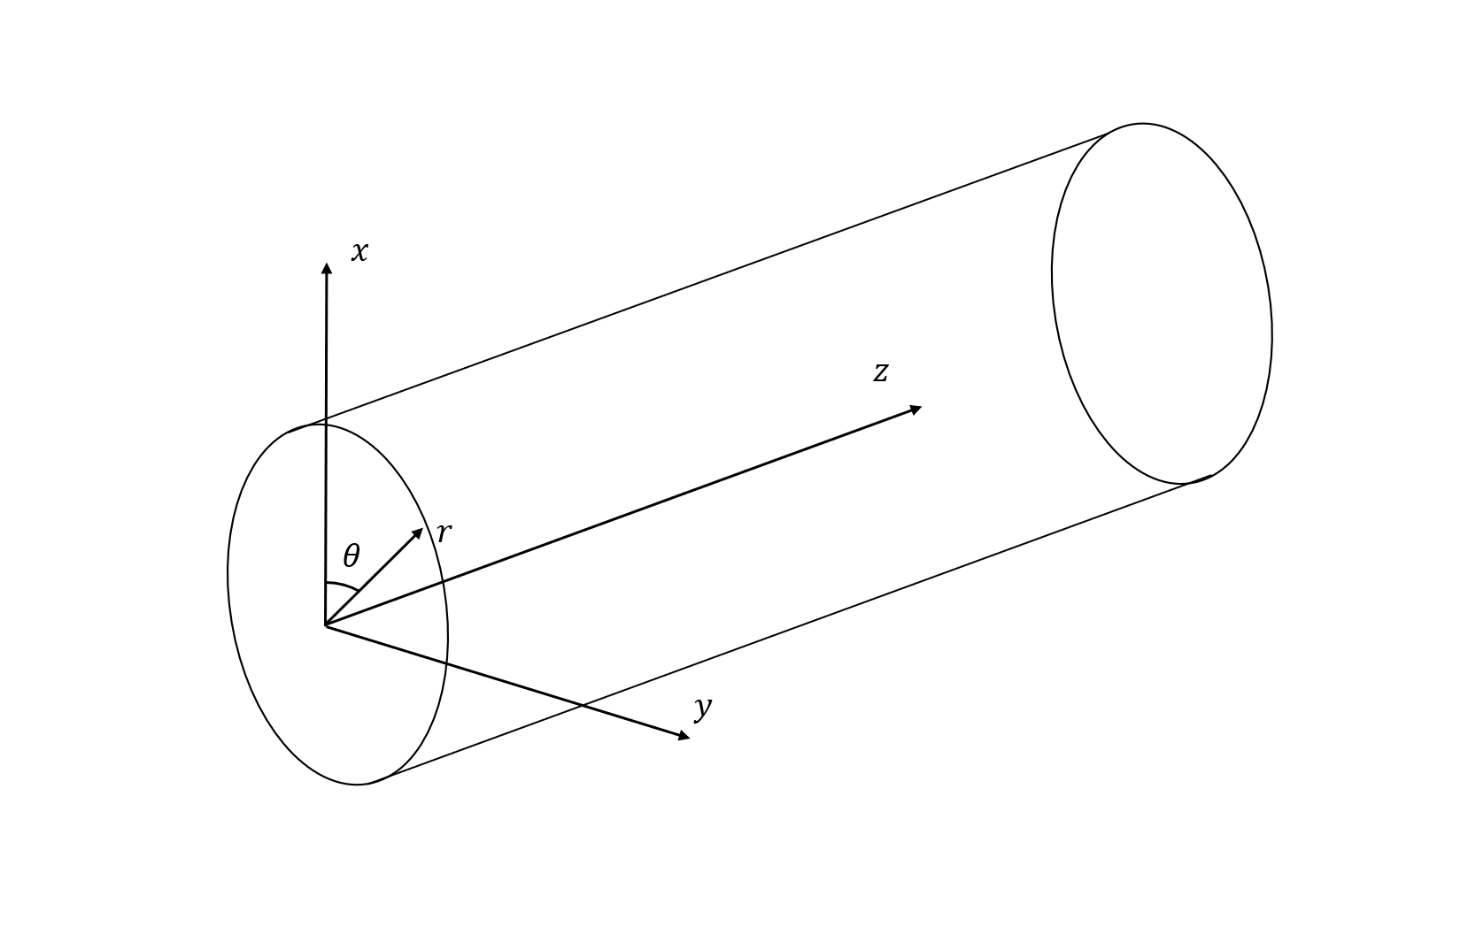
Figure 3.1 The geometry of the problem of sound propagation in a pipe.
Figure 3.1 illustrates the cylindrical coordinates system that describes the geometry corresponding to a typical pipe. In these coordinates the frequency dependent sound pressure at a point $\left(r, θ, z\right)$ can be written as a normal mode superposition, i.e.:
$p\left(r, θ, z\right)=∑p_{mn}$ (3.1)
where the modal sound pressure is
 | $$p_{mn}\left(r,θ,z\right)=A_{mn}J_{m}\left(k_{mn}r\right)\begin{matrix}cos \\ sin\end{matrix}(mθ)e^{-jγ_{mn}z}$$ | (3.2)
In the above equation $m$ and $n$ are mode indices, $k_{mn}$ is modal wavenumber, $J_{m}\left(k_{mn}r\right)$ is the $m^{th}$ order Bessel function and $A_{mn}$ is the modal excitation coefficient that depends on the type, strength and position of the source. If the pipe is filled with air and its walls are made from an elastic solid, e.g. PVC, then there is little or no coupling between the sound waves propagating in air and in the elastic solid. In this case the wall can be assumed acoustically rigid. The radial wavenumber, $k_{r}$, can be obtained from the rigid boundary condition:
 | $${\left.{J^{'}}_{m}\left(k_{mn}r\right)\right|}_{r=R}=0$$ | (3.3)
and $'$ denotes the partial derivative with respect to the pipe radius, $r$, $J_{m}^{'}\left(x\right)=J_{m-1}\left(x\right)-\frac{m}{x}J_{m}(x)$. The wavenumber in the $z$ direction is:
$$γ_{mn}=\sqrt{k^{2}-k_{mn}^{2}}$$ | (3.4)
where $k=\frac{ω}{c_{0}}$ is wavenumber in free space, $ω$ is angular frequency, $j=\sqrt{-1}$ and $c_{0}$ is sound speed in air.
The equations above predict the wavenumbers for the infinite number of modes propagating in the pipe. It is clear that sound velocity, phase and amplitude in these modes are frequency dependent. Eq. (3.4) is the dispersion relation which links the wavenumbers and frequency. When the frequency of sound approaches the so-called cut-off frequency, i.e., $k_{mn}=k$, the phase velocity for the sound waves in the mode $(mn)$ is infinite and considerable stretching of a sound waveform can occur.

3.1.1 Experimental Validation
In order to validate the above theory an experiment was carried out in a 150mm internal diameter, 15m long, rigid wall PVC pipe. In addtion, the thickness of pipe wall was 2 mm.This setup is shown schematically in Figure 3.2.
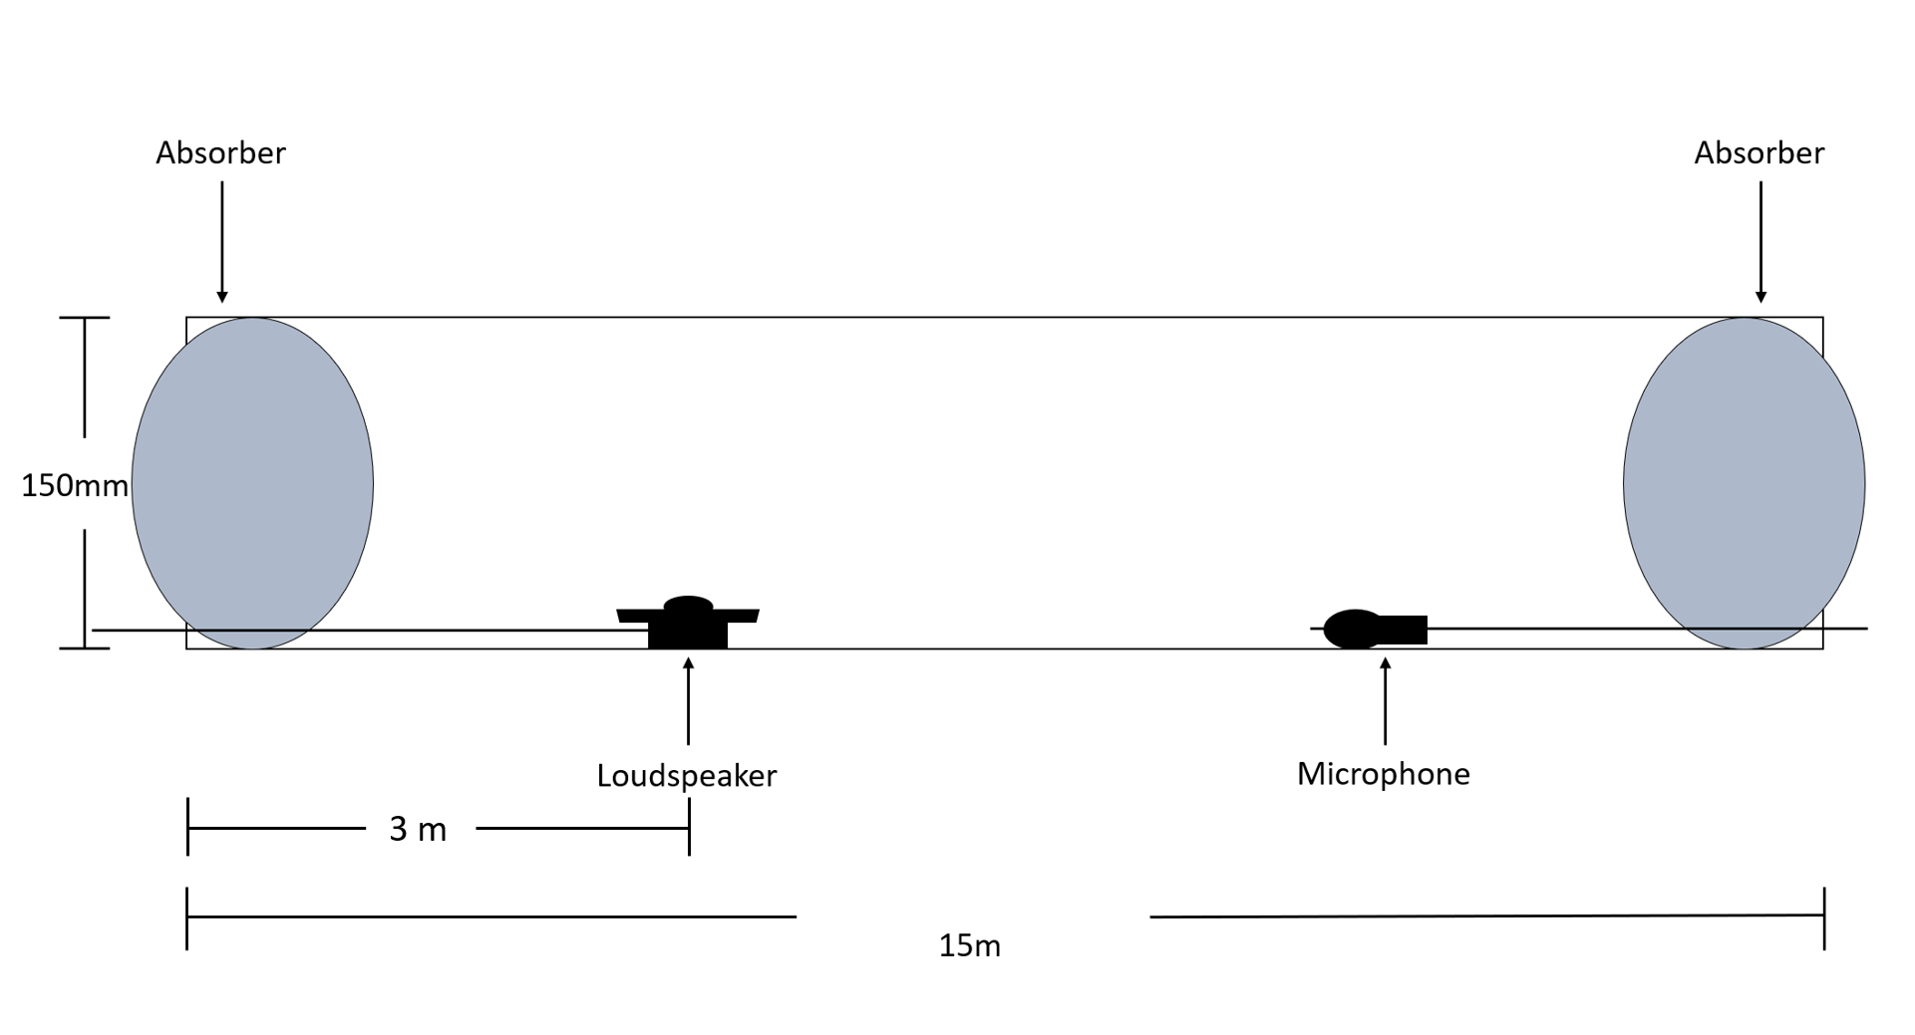
Figure 3.2 Experiment setup for channel measurement.
To simulate the infinitely long pipe, two absorbers made by IDEATEC foam were inserted on both sides of the pipe to absorb the reflections caused by the open ends. Then, a 32 mm diameter loudspeaker (Farnell Mini, Full Range, 3.2 cm, 2 W, 8-ohm, 78 dB, 150 Hz to 20 kHz) was placed at the bottom of the pipe 3 m away from the left end and faced up to ensure both non-axisymmetric and axisymmetric modes can be successfully excited. A 12 mm diameter microphone (Type 46AE GRAS) was placed in line with the loudspeaker to capture the signal. In this experiment the source's position was fixed at 3 m away from the left end of the pipe and distance between loudspeaker and microphone varied in the range between 20 mm and 7 m with step spacing of 20 mm. The data was collected by the National Instrument DAQ NI PXIE-6358 data acquisition card and the whole process was controlled by a LabVIEW based subroutine with sampling frequency of 48kHz.
The dispersion relation was obtained by measuring the impulse response of the channel at a plurality of microphone positions. In this experiment, a 10 s long sinusoid-sweep with frequency in the range between 100Hz and 5000Hz was excited and deconvolved with the recorded signal to determine the impulse response. This approach enabled us to achieve a relatively good signal-noise ratio of around 40dB to be achieved and was used subsequently for the synchronisation in the communication system (see section: 4.1 Procedures).

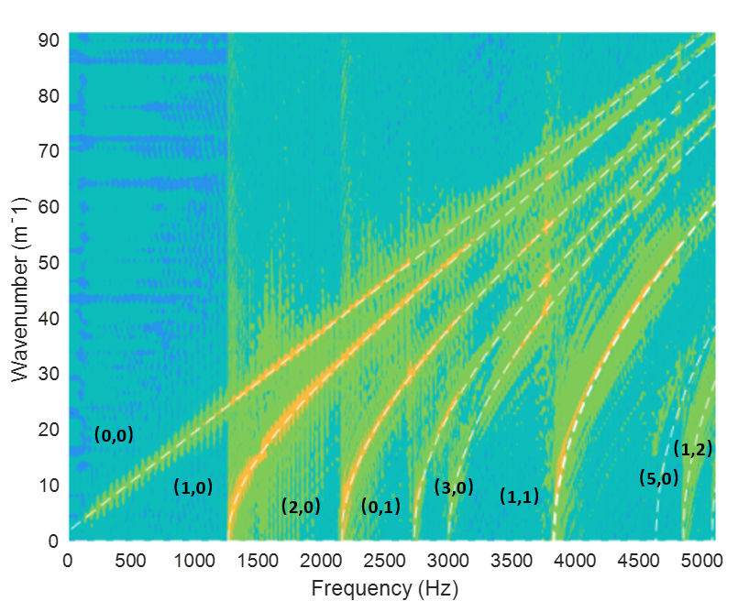
Figure 3.3 A comparison of the dispersion relation between the analytical model (eq. (3.4)) and experimental data. White dashed line is the analytical model. The colourmap is for experimental data.
Figure 3.3 presents the axial wavenumber, $γ_{mn}$, as a function of frequency obtained by applying 2D-FFT to the time-spatial impulse response measured at a plurality of positions in the pipe. The white dashed line denotes the analytical model, and the coloured background is for the experimental data. Figure 3.3 shows a close similarity between the analytical model and experiment especially for the first 6 modes. The root mean square error in the phase velocity for these modes is estimated within 4%. However, the higher order modes (e.g. (5,0)) do not appear clearly because of a relatively low excitation coefficients, $A_{mn}$, for these modes attained in the experiments. The first cut-off frequency corresponding to the mode (1, 0) was 1340 Hz. This is consistent with the model and measurements by Bin Ali [8] made in a 150mm diameter clay pipe (1358 Hz). Therefore, there was 2% error in comparison between two results which suggested that the model worked with the quoted accuracy.

3.2 Sound propagation in partially water-filled pipe.
In the previous section, the acoustic wave propagation in an empty pipe has been studied. However, the real sewer system is mostly represented by partially water-filled pipes. The water level in a sewer varies during the day from relatively low, e.g. 5-10% during the dry weather conditions, to relatively high, e.g. 10-50% during the peak flow or rainfall. The sound wave propagation in such pipes is likely to be different to that predicted for fully air-filled pipes because the water flow effectively bisects the bottom of the pipe reducing the cross-section of the air-filled part of the pipe and making it asymmetrical as shown in Figure 3.4. The characteristic acoustic impedance of water ($ρ_{w}c_{w}=1.5×{10}^{6} Pa s m^{-1}$) is much higher than that of the air ($ρ_{w}c_{w}=425 Pa s m^{-1}$) so the water surface can be assumed as acoustically rigid. Understanding of sound propagation in a partially filled pipe has been limited until recent work by the author [20]. Therefore, this section is focused on the effect of a fluctuating water level on the sound wave propagation in a partially water-filled pipe because the water level changes are likely to impact on the communication channel characteristics.
Figure 3.4 illustrates the cross-section of an air domain partially water-filled pipe. A dimensionless factor filling ratio: $h/R$ can be used to quantify the effect of water depth on the dispersion relations of the wave propagation in the pipe. For the filling ratio, $h$ is the water depth and $R$ is the diameter of the pipe. The universal velocity $v_{n}$ can be expressed by the combination of the velocity in the radial direction $v_{r}$ and $θ$ direction $v_{θ}$, Their relationship can be written as:
 | $$v_{n}=v_{r}cosθ-v_{θ}sinθ.$$ | (3.5)
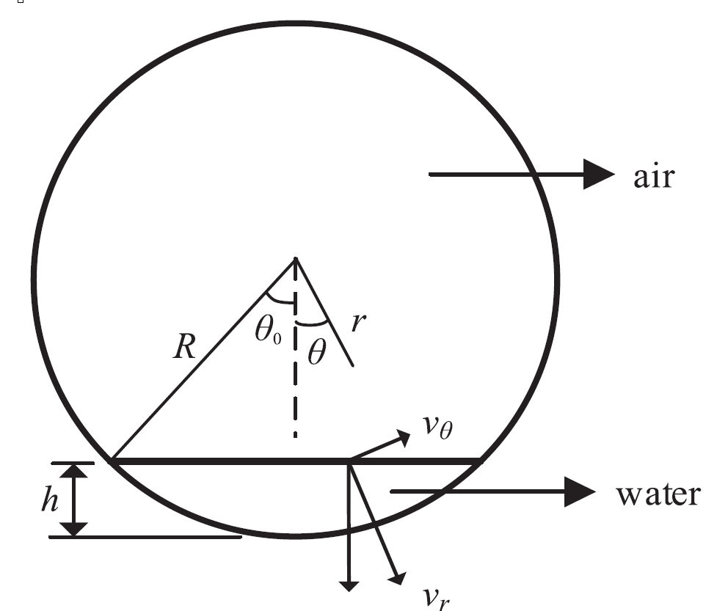
Figure 3.4 The cross-section of a partially water filled pipe
When the ratio $h/R$ becomes relatively large then the theory presented in the previous section is no longer valid. A numerical study for the dispersion relations for the air-filled domain of the partially water-filled pipe was carried out to understand this effect. This simulation is based on a 2-D FEM (Finite Element Method) implemented in COMSOL Multiphysics. An analytical approximation was also developed to provide an alternative and efficient calculation method for the dispersion relations.

3.2.1 Numerical study:

Dispersion Relation
In the proposed FEM method the maximum mesh size was below 5.7 mm which corresponded to 1/12 of the acoustic wavelength at 5 kHz. These simulations were based on a 150 mm diameter pipe. Figure 3.5 presents the dispersion relations predicted for the range of $0≤h/R≤0.2$ filling ratios. A dimensionless frequency (e.g., $f/f_{10}$, where $f_{10}$is the first non-axisymmetric mode frequency) and dimensionless wavenumber $k_{z}R$ were used to illustrate the dispersion relations for the partially filled pipe. The proposed dimensionalisation ensured that the dispersion relations can be generalised for any diameter of pipe. It is clear from the diagrams presented in Figure 3.5 that for each non-axisymmetric mode, the higher-order mode dispersion curves split. As the filling ratio Increases, this phenomenon becomes more and more obvious attributing to the fact that the dispersion is a geometrical phenomenon. However, it also has been shown in the diagram that the non-axisymmetric modes were affected significantly by the split phenomenon such as the modes (1,0) and (2,0) while the axisymmetric mode (0,1) does not split. These results suggest that the surface of water provides a new non-axisymmetric boundary which has a particularly significant effect on the non-axisymmetric modes propagation.
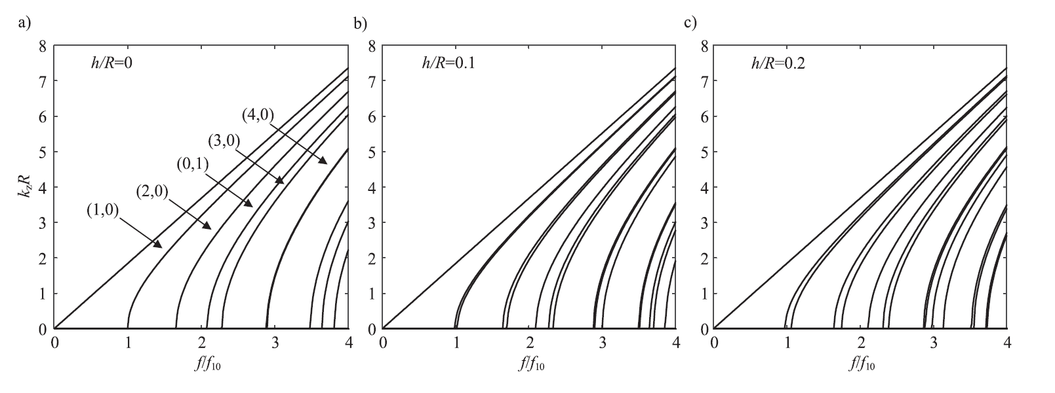
Figure 3.5 The dispersion relations for a 150 mm diameter pipe with smaller water filling ratios: (a) h/R=0; (b) h/R=0.1; and (c) h/R=0.2.
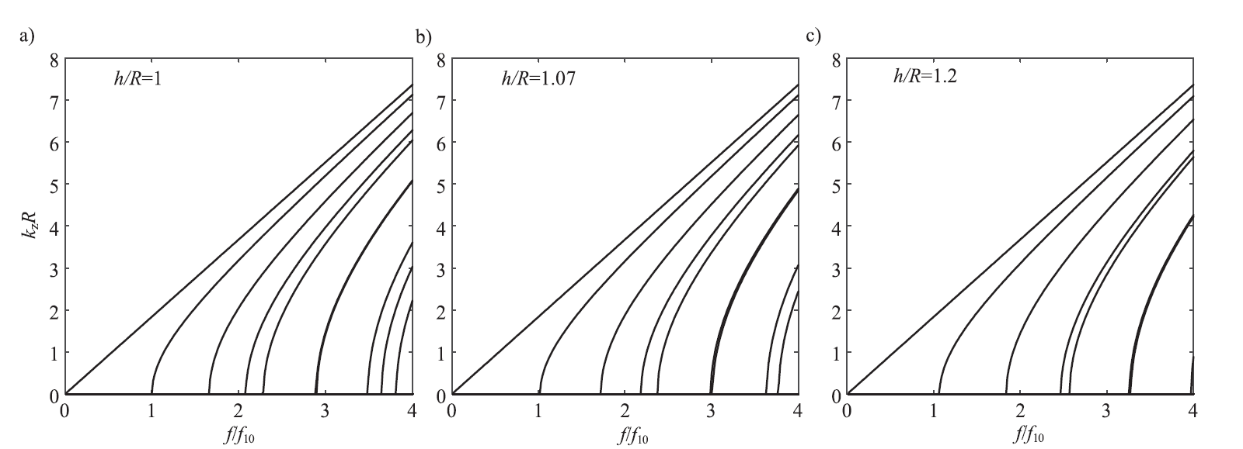
Figure 3.6 The dispersion relations for a 150 mm pipe with greater filling ratios: (a) h/R=1; (b) h/R=1.07; (c) h/R=1.2.
It is of interest to study sound propagation in a pipe with $h/R≥1$, i.e. in the pipe in which flow occupies over 50% of the cross-section. The dispersion curves for sound propagation in a pipe with such large filling ratios are shown in Figure 3.6. Under these circumstances, the split phenomenon did not occur obviously while the mode frequency shift shows up instead. This is caused by the shrinkage of the cross-section of the air region due to the water level is becoming more dominate and the cut-off frequencies will increase with the rise of the filling ratio. Comparing Figure 3.5(a) and 3.6(a), when the filling ratio equals to 1, the cross-section of the pipe is becoming semicircle and the modal shape and dispersion relations are identical to that of empty pipe (filling ratio=0) which has perfect cylinder cross-section. There are good physical reasons for this phenomenon. Let us recall the frequency dependent sound pressure for an empty pipe in cylinder coordinate system:
$$p_{mn}\left(r,θ,z\right)=A_{mn}J_{m}\left(k_{mn}r\right)\begin{matrix}cos \\ sin\end{matrix}(mθ)e^{-jγ_{mn}z}$$
the part $J_{m}\left(k_{mn}r\right)\begin{matrix}cos \\ sin\end{matrix}(mθ)$ in equation (3.6) is mode shape function and for $m^{th}$ mode. This meets the boundary condition for which the filling ratio $h/R=1$ (semicircle cross-section).

Mode Shape
The previous section studied the dispersionfor partially water-filled pipe by using numerical approaches. It was observed that the first two non-axisymmetric modes split due to the presence of water surface. Figure 3.7 compares the original mode and the split non-axisymmetric modes (1,0) and (2,0) in both empty and partially water-filled pipe. The red and blue colours represent the positive and negative sound pressures, respectively. Furthermore, as shown in Figure 3.7, the non-axisymmetric modes split into two modes one of which is anti-symmetric (Figure 3.7 (b) and (e)) and another is symmetric (Figure 3.7 (c) and (f)) with respect to the line $θ=0$.
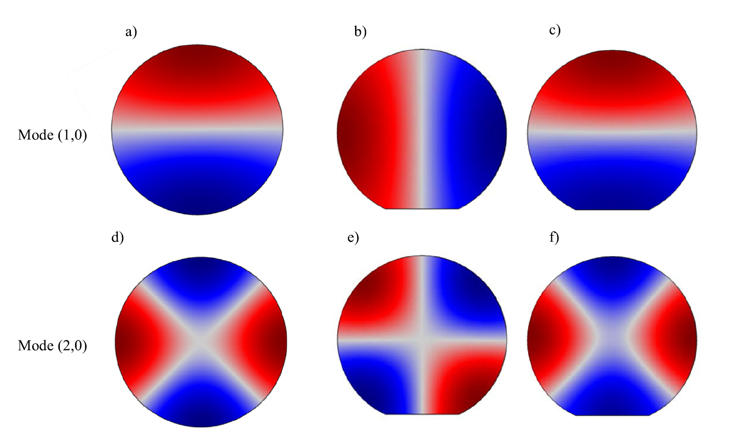
Figure 3.7 The shapes of the first (row 1, mode (1,0)) and second (row 2, mode (2,0)) non-axisymmetric modes of a pipe with or without partially filled water layer h/R = 0.1: (a)mode (1,0) of empty pipe; (b) and (c) are the split anti-symmetric and symmetric modes respectively associated with the split of mode (1,0); (d) mode (2,0) of empty pipe; (e) and (f) are the split anti-symmetric and symmetric modes respectively associated with mode (2,0).
Figure 3.8 illustrates the comparison between the mode shapes of the first axisymmetric mode for both empty pipe and partially water-filled pipe with the filling ratios 0.1 and 0.2. It was shown already that the presence of water does not split the axisymmetric modes but shifts the modal frequency and effects the modal pattern. These modes are symmetric respected to the line $θ$=0. This conclusion is still valid for filling ratio well above 1 as shown in Figure 3.9.

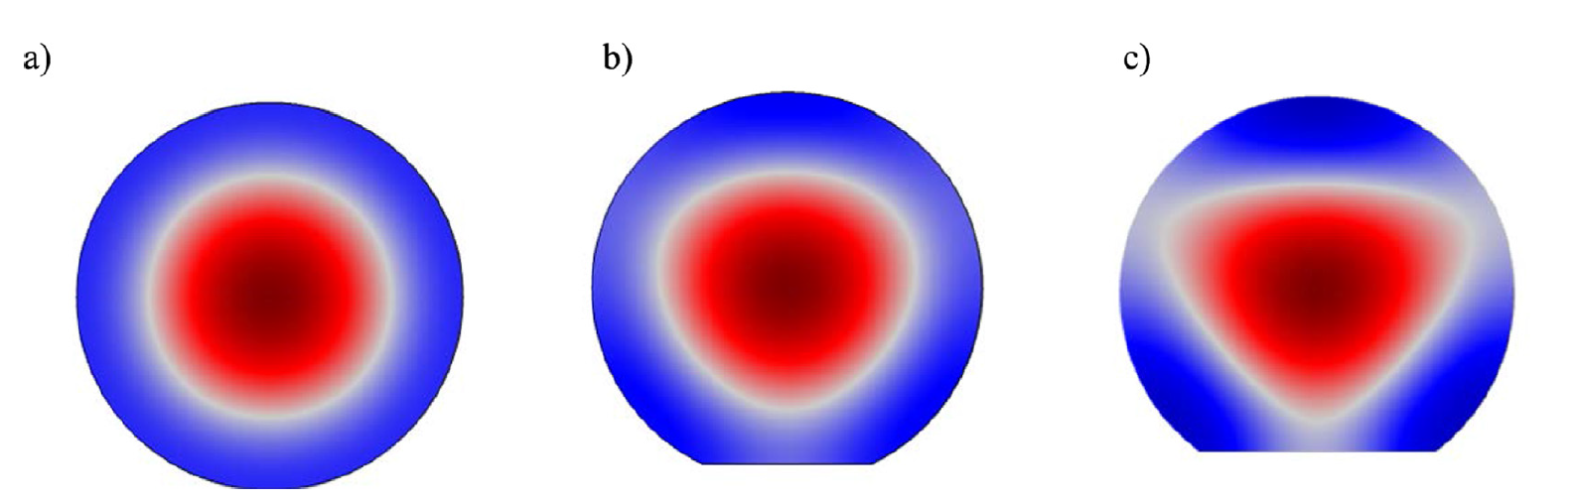
Figure 3.8 The shape of first axisymmetric mode for an empty pipe (a), and pipe with partially filled water layer: (b) h/R=0.1; (c) h/R=0.2

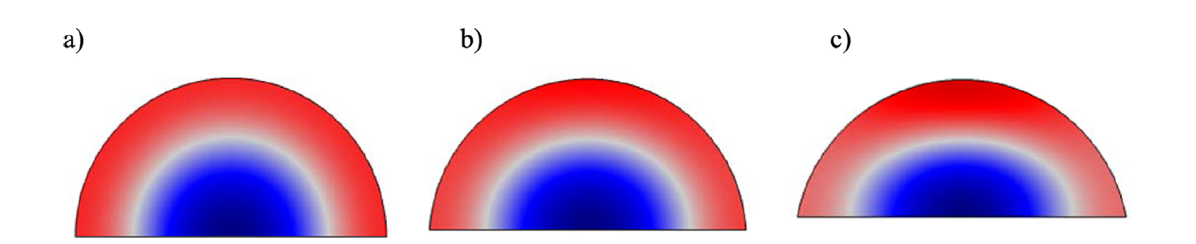
Figure 3.9 The shape of first axisymmetric mode for partially filled pipe: (a) h/R=1; (b) h/R=1.07; (c) h/R=1.2.

3.2.2 Analytical Study
The study of dispersion relation and mode shape for partially water-filled pipe based on 2-D FEM method implemented in COMSOL Multiphysics was carried out in the previous section. The results Indicate that the water surface in the pipe can be treated as a non-axisymmetric horizontal rigid boundary which can split non-axisymmetric modes. The presence of water does not affect the axisymmetric modes in same manner. Due to the increase in the water level, the air-filled region of pipe cross-section shrinks causing the cut-off frequencies shift. Another interesting finding is that when the filling ratio $h/R=1$, the dispersion curves look exactly as same as in the case of the empty pipe. This section will focus on using analytical method to explain the modal split and frequency shift phenomenon illustrated with the numerical model. The use of an analytical model as an alternative is attractive because it is much more efficient computationally and can be used on robots to estimate and compensate for the effect of fluctuating water level on the modal field in a partially filled pipe.
Three assumptions can be made to help get analytical approximated model for partially water- filled pipe.
1. There is no split caused by the presence of the water surface in the case of axisymmetric modes. Therefore, it reasonable to assume that the mode shape and dispersion relation are as same as in the empty pipe when filling ratio remains relatively low: $\frac{h}{R}≪$1. In this case, the shape of the boundary dependents on $θ$ and $r$ only and normal velocity component on this boundary is: ${\left.v_{n}\right|}_{r=R\left(θ\right)}=0$. This condition expressed that the modal shape function is coupling between $θ$ and $r$. In order to obtain a suitable analytical model, it makes sense to make three assumptions. Firstly, the filling ratio should be much smaller than 1 i.e., $\frac{h}{R}≪1$.
2.Themode shape function can still be approximated by the product of Bessel function and sine/cosine function which denote the anti-symmetric and symmetric modes with respect to the line $θ=0$.
3. Thevelocity on the flat water-air interface should equal to 0.
In the case of the empty pipe, the term $sin⁡(mθ)$ can be replaced by $cos⁡(mθ)$ in the mode shape function $Ψ_{mn}$ due to the axial symmetry. While for the partially water-filled pipe, according to assumption 2 these two cases should be discussed separately as follows:
 | $$Ψ_{mn}^{\left(1\right)}(r,θ)=J_{m}\left(k_{mn}^{(1)}r\right)sin(mθ)$$ | (3.6)
 | $$Ψ_{mn}^{\left(2\right)}(r,θ)=J_{m}\left(k_{mn}^{(2)}r\right)cos(mθ)$$ | (3.7)
In equation (3.6) and (3.7), $k_{mn}^{(1)}$ and $k_{mn}^{(2)}$ represent the anti-symmetric and symmetric modes which were split from the original mode $k_{mn}$ in the empty pipe. The normal $v_{n}=v_{r}$ on the water surface satisfied:$v_{n}=v∙n=\left(v_{r},v_{θ}\right)∙\left(cosθ,-sinθ\right)=v_{r}cosθ-v_{θ}sinθ$, which is equation (3.5). Based on the final assumption made before which states that the $v_{n}=0$ at water-air interface, the boundary condition can be written as:
 | $${\left.v_{n}\right|}_{r=R}=0 \underset{⇒}{modeorthogonality} ∇_{r}{\left.Ψ_{mn}^{\left(q\right)}\right|}_{r=R}=0 (θ_{0}<θ<2π-θ)$$ | (3.8)
 | $${\left.v_{n}\right|}_{r=\frac{R-h}{cosθ}}=0 \underset{⇒}{modeorthogonality} ∇_{r}Ψ_{mn}^{\left(q\right)}cosθ+{\left.\frac{∇_{θ}Ψ_{mn}^{\left(q\right)}}{r}sinθ\right|}_{r=\frac{h-R}{cosθ}}=0 (-θ_{0}<θ<θ_{0})$$ | (3.9)

where the top mark $q$ denotes the mode shape which is corresponding to the equation (3.6) and (3.7). $θ_{0}$ is the maximum angle on the water surface which has been shown in figure 1 and $∇$ is the vector differential operator. Substituting equation (3.6) and (3.7) into equation (3.8) could obtain the results that indicate the wavenumber $k_{mn}^{(q)}$ is thesame as that for empty pipe. However, for equation (3.9), it is difficult to get analytical solution for $k_{mn}^{(q)}$ explicitly. An equivalent solution can be calculated by averaging the boundary condition over $[{-θ}_{0},θ_{0}]$ when $θ_{0}$ is relatively small (based on the second assumption, $θ_{0}$ in this case should be less than 0.4 which corresponds to filling ratio $h/R<0.1$). Then substituting equation (3.6) into equation (3.9) and integrating as equation (3.10):
 | $$\int_{-θ_{0}}^{θ_{0}}{{\left.v_{n}\right|}_{r=\frac{R-h}{cosθ}}dθ=0}$$  $$⟺\int_{-θ_{0}}^{θ_{0}}{{\left.{[k}_{mn}^{\left(1\right)}sin\left(mθ\right){J'}_{m}\left(k_{mn}^{\left(1\right)}r\right)cosθ-\frac{m}{r}J_{m}\left(k_{mn}^{\left(1\right)}r\right)cos\left(mθ\right)sinθ\right|}_{r=\frac{R-h}{cosθ}}dθ=0}$$ | (3.10)
The integration in equation (3.10) is anti-symmetric function with respect to $θ=0$ and therefore the integral over range $[-θ,θ]$ equals to 0 and the only boundary condition expressed in equation (3.8) has been considered which can be used to determine the wavenumber for sine harmonic case $k_{mn}^{\left(1\right)}r$ :
 | $${\left.J_{m}^{'}(k_{mn}^{\left(1\right)}r)\right|}_{r=R}=0$$ | (3.11)
The content above suggests that mode wavenumber obtained by the equation (3.8) under the boundary condition in the equation (3.8) and (3.9) is as same as that for empty which indicates that in the partially water-filled pipe, there are mode frequencies which is as same as in empty pipe.
Similarly, apply boundary condition angular averaging for cosine harmonics can be expressed by substituting equation (3.6) into (3.9) and the integration over interval $[-θ,θ]$ should satisfied:
 | $$\int_{-θ_{0}}^{θ_{0}}{{\left.v_{n}\right|}_{r=\frac{R-h}{cosθ}}dθ=0}$$  $$⟺\int_{-θ_{0}}^{θ_{0}}{{\left.{[k}_{mn}^{\left(1\right)}cos\left(mθ\right){J'}_{m}\left(k_{mn}^{\left(2\right)}r\right)cosθ-\frac{m}{r}J_{m}\left(k_{mn}^{\left(2\right)}r\right)sin\left(mθ\right)sinθ\right|}_{r=\frac{R-h}{cosθ}}dθ=0}$$ | (3.12)
when $θ$ is small, $\frac{1}{cosθ}$ can be expanded by Tylor series:
 | $$\frac{1}{cosθ}=1+\frac{θ^{2}}{2}+O(θ^{4})$$ | (3.13)
The Bessel function can be rewritten as:
 | $${\left.J_{m}^{'}(k_{mn}^{\left(2\right)}r)\right|}_{r=\frac{R-h}{cosθ}}={\left.[J_{m}^{'}\left(k_{mn}^{\left(2\right)}r\right)+k_{mn}^{\left(2\right)}rJ_{m}^{''}\left(k_{mn}^{\left(2\right)}r\right)\frac{θ}{2}+O(θ^{4}) ]\right|}_{r=R-h}$$ | (3.14)

 | $${\left.J_{m}(k_{mn}^{\left(2\right)}r)\right|}_{r=\frac{R-h}{cosθ}}={\left.[J_{m}\left(k_{mn}^{\left(2\right)}r\right)+k_{mn}^{\left(2\right)}rJ_{m}^{'}\left(k_{mn}^{\left(2\right)}r\right)\frac{θ}{2}+O(θ^{4}) ]\right|}_{r=R-h}$$ | (3.15)
where $J_{m}^{''}(x)$ is the second order derivative of the $m^{th}$ order Bessel function defined as:
 | $$J_{m}^{''}\left(x\right)=J_{m-2}\left(x\right)-\frac{2m-1}{x}J_{m-1}+\frac{m^{2}+m}{x^{2}}J_{m}(x)$$ | (3.16)
Then the modal wavenumbers $k_{mn}^{\left(2\right)}$ for the solution of equation (3.12) can be simplified by ignoring the higher order of $θ$ and it can be expressed as:
 | $${\left.\left[J_{m}^{'}\left(k_{mn}^{\left(2\right)}r\right)\left(F_{1}+mF_{4}\right)+k_{mn}^{\left(2\right)}rJ_{m}^{''}\left(k_{mn}^{\left(2\right)}r\right)F_{2}+\frac{m}{k_{mn}^{\left(2\right)}r}J_{m}\left(k_{mn}^{\left(2\right)}r\right)F_{3}\right]\right|}_{r=R-h}=0$$ | (3.17)

in equation (3.17), $F_{1}\sim F_{4}$ are the integrals of $θ$ over interval $[0,θ_{0}]$:
 | $$F_{1}=\int_{0}^{θ_{0}}{\cos\left(mθ\right)\cos\left(θ\right)dθ}$$ | (3.18)
 | $$F_{2}=\int_{0}^{θ_{0}}{\frac{1}{2}\cos\left(mθ\right)\cos\left(θ\right)θ^{2}dθ}$$ | (3.19)
 | $$F_{3}=\int_{0}^{θ_{0}}{\frac{1}{2}\sin\left(mθ\right)\sin\left(θ\right)(1-\frac{θ^{2}}{2})dθ}$$ | (3.20)
 | $$F_{4}=\int_{0}^{θ_{0}}{\frac{1}{2}sin\left(mθ\right)\sin\left(θ\right)\left(1-\frac{θ^{2}}{2}\right)θ^{2}dθ}$$ | (3.21)
The integrations from equation (3.18) to (3.21) were solved numerically by using adaptive quadrature integration function in MATLAB. Equation (3.17) then can be solved numerically to determine the wavenumbers $k_{mn}^{(2)}$ in angular interval $[-θ_{0},θ_{0}]$. It should be noticed that substituting equation (3.7) into (3.8) and applying angular averaging could derive the expression of equation (3.11) of $k_{mn}^{(2)}=k_{mn}$. Furthermore, for the wavenumber $k_{mn}^{(2)}$ averaging the boundary conditions from equation (3.8) and (3.9) yields a piecewise function for modal shapes with respect to $θ$. To simplify the mode shape function and obtain the single wavenumber, $k_{mn}^{(2)}$ is also angularly averaged. Thus, the effective modal wavenumbers ${\overline{k}}_{mn}^{(2)}$ can be determined from:
 | $${\overline{k}}_{mn}^{\left(2\right)}=\frac{1}{2π}\int_{θ_{0}}^{2π-θ_{0}}{k_{mn}dθ+\frac{1}{2π}\int_{-θ_{0}}^{θ_{0}}{k_{mn}^{\left(2\right)}dθ=k_{mn}+\frac{θ_{0}}{π}}(k_{mn}^{\left(2\right)}-k_{mn})}$$ | (3.22)
Equation (3.11) and (3.22) could determine the effective wavenumber which can be used to study the dispersion relations of non-axisymmetric modes for partially water-filled pipe. The wavenumbers $k_{mn}^{(1)}$ and ${\overline{k}}_{mn}^{(2)}$ are the modes spitted at $k_{mn}$, which has been introduced in previous section. The wavenumber $k_{mn}^{(1)}$ calculated from antisymmetric modes is identical with the $k_{mn}$ when the water level is relatively low.
It can be suggested that the acoustic pressure is close to zero (node position with respect to angle) near the center of the water surface for the antisymmetric modes, which minimises the effects of water surface on the acoustic pressure distribution. Therefore, for the low filling ratio case, the acoustic pressure distribution can be approximated as same as the empty pipe. While in contrast, for ${\overline{k}}_{mn}^{(2)}$ the acoustic pressure distribution near the centre of the water surface reaches the highest value which maximises the effect of the water surface. Therefore, the presence of the water surface induces another mode ${\overline{k}}_{mn}^{(2)}$ which differ hugely from $k_{mn}$ at non-axisymmetric frequencies and mode split is becoming more obvious.
Figure 3.10 illustrates the comparison between dispersion relations calculated with the FEM (red solid line) and proposed analytical method (blue dash line: equation (3.11) and black dash line: equation (3.22)). The error is 1% in the prediction of cut-off frequency below $3.5f_{10}$ for 0.1 filling ratio and less than 3.5% below $3f_{10}$ for 0.2 filling ratio. The antisymmetric modes defined by $k_{mn}^{(1)}$is identical with that for empty pipe while the symmetric modes defined by $k_{mn}^{(-2)}$ will be split from the original eigen-frequencies and mode shapes.
It has been suggested that the above wavenumbers can be used to predict analytically the mode shapes in low water level partially filled pipe ($\frac{h}{R}<1$) as:
for axisymmetric modes:
 | $${\overline{Ψ}}_{0n}(r,θ)=J_{0}\left(k_{0n}r\right)$$ | (3.23)
for non-axisymmetric modes:
 | $${\overline{Ψ}}_{0n}(r,θ)=\left\{\begin{aligned}\sin\left(mθ\right)J_{m}({\overline{k}}_{mn}^{(1)}r) \\ \cos\left(mθ\right)J_{m}({\overline{k}}_{mn}^{(2)}r\end{aligned}\right.$$ | (3.24)
where ${\overline{k}}_{mn}^{(1)}$ equals to $k_{mn}$(according to equation (8)), ${\overline{k}}_{mn}^{(2)}$ can be obtained by equation (3.22).
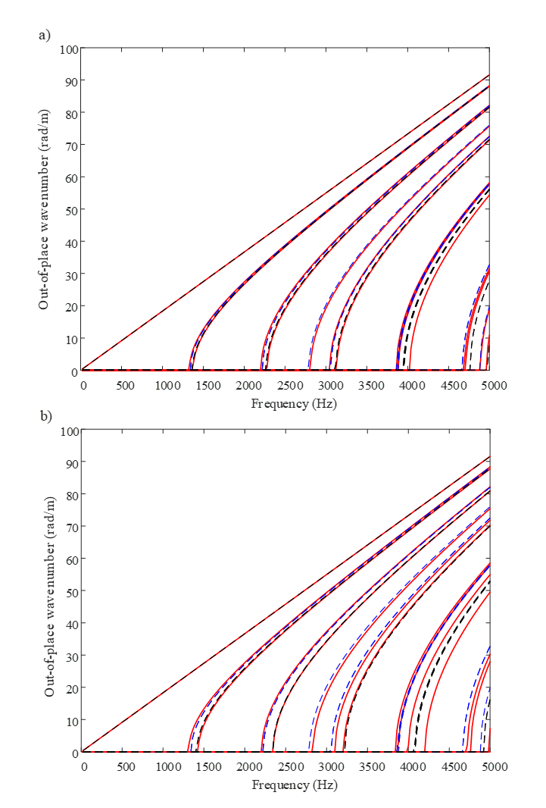
Figure 3.10. Dispersive curve of the cross-section of partially filled water pipe using models from equation. (3.11) and (3.22) compared with the FEM simulated model: (a) h/R=0.1; (b) h/R=0.2.

3.2.3 Empirical model
In section 3.2.1 the dispersion relation and mode shapes were studied via the FEM based simulation. This simulation can be used to create a numerical database for calculating the dispersion relation and mode shapes for any partially water filled pipe for a set of $h/R$ ratios. An empirical model can then be developed to make use of the database to predict the modal wavenumbers in a partially filled pipe.
Let us recall the modal shape function from equation (3.23) and (3.24):
axisymmetric modes:
$${\overline{Ψ}}_{0n}(r,θ)=J_{0}\left(k_{0n}r\right)$$
non-axisymmetric modes:
$${\overline{Ψ}}_{0n}(r,θ)=\left\{\begin{aligned}\sin\left(mθ\right)J_{m}({\overline{k}}_{mn}^{(1)}r) \\ \cos\left(mθ\right)J_{m}({\overline{k}}_{mn}^{(2)}r\end{aligned}\right.$$
The cross-section wavenumber of the empty pipe $k_{mn}$ is frequency independent and can be calculated analytically. It can be suggested to normalise the cross-section wavenumber for partially filled pipe, ${\overline{k}}_{mn}^{(q)}$ ($q=1$ or $2$), by $k_{mn}$, i.e. to express it as $\frac{{\overline{k}}_{mn}^{\left(q\right)}}{k_{mn}}$. This quantity can be used as a convention factor stored in database. Table 3.1 and Table 3.2 listed these convention factors used to predict the first 7 axisymmetric and non-axisymmetric modes for different filling ratios. Even though in Tables 3.1 and 3.2 those filling ratios are discrete, any arbitrary value between each discrete filling ratio in the range of $0≤\frac{h}{R}≤0.2$ can be obtained by applying linear polynomial interpolation.
Normalized filling ratio (h/R) | $$\frac{{\overline{k}}_{10}^{\left(1\right)}}{k_{10}}$$ | $$\frac{{\overline{k}}_{20}^{\left(1\right)}}{k_{20}}$$ | $$\frac{{\overline{k}}_{01}}{k_{01}}$$ | $$\frac{{\overline{k}}_{30}^{\left(1\right)}}{k_{30}}$$ | $$\frac{{\overline{k}}_{40}^{\left(1\right)}}{k_{40}}$$ | $$\frac{{\overline{k}}_{11}^{\left(1\right)}}{k_{11}}$$ | $$\frac{{\overline{k}}_{50}^{\left(1\right)}}{k_{50}}$$
0.013 | 1.001 | 1 | 1.001 | 1 | 1 | 1.001 | 1
0.02 | 1 | 1 | 1.001 | 0.999 | 0.999 | 1.001 | 0.999
0.267 | 0.999 | 0.999 | 1.002 | 0.998 | 0.998 | 1.001 | 0.999
0.033 | 0.999 | 0.998 | 1.002 | 0.998 | 0.998 | 1.001 | 0.999
0.04 | 0.999 | 0.997 | 1.003 | 0.997 | 0.998 | 1.001 | 0.999
0.047 | 0.998 | 0.997 | 1.003 | 0.997 | 0.998 | 1.001 | 0.999
0.053 | 0.997 | 0.996 | 1.004 | 0.996 | 0.998 | 1.001 | 1
0.06 | 0.997 | 0.995 | 1.004 | 0.996 | 0.998 | 1.001 | 1.001
0.067 | 0.996 | 0.995 | 1.005 | 0.996 | 0.999 | 1.001 | 1.002
0.073 | 0.995 | 0.994 | 1.005 | 0.996 | 0.999 | 1.001 | 1.003
0.08 | 0.995 | 0.993 | 1.006 | 0.996 | 0.999 | 1.001 | 1.005
0.087 | 0.994 | 0.993 | 1.007 | 0.996 | 0.999 | 1.001 | 1.006
0.093 | 0.993 | 0.992 | 1.007 | 0.996 | 0.998 | 1.001 | 1.005
0.1 | 0.993 | 0.992 | 1.008 | 0.997 | 0.998 | 1.001 | 1.005
0.107 | 0.992 | 0.991 | 1.008 | 0.997 | 0.997 | 1.003 | 1.005
0.113 | 0.991 | 0.991 | 1.009 | 0.998 | 0.997 | 1.004 | 1.004
0.12 | 0.990 | 0.990 | 1.009 | 0.998 | 0.996 | 1.006 | 1.004
0.127 | 0.989 | 0.990 | 1.010 | 0.999 | 0.995 | 1.007 | 1.004
0.133 | 0.988 | 0.990 | 1.011 | 1.000 | 0.995 | 1.009 | 1.004
0.147 | 0.987 | 0.990 | 1.012 | 1.002 | 0.994 | 1.013 | 1.005
0.16 | 0.984 | 0.990 | 1.013 | 1.005 | 0.993 | 1.017 | 1.005
0.173 | 0.983 | 0.990 | 1.014 | 1.008 | 0.993 | 1.021 | 1.007
0.187 | 0.981 | 0.991 | 1.015 | 1.011 | 0.993 | 1.026 | 1.008
0.2 | 0.979 | 0.992 | 1.016 | 1.014 | 0.993 | 1.031 | 1.011
0.213 | 0.977 | 0.993 | 1.017 | 1.018 | 0.994 | 1.035 | 1.013
0.227 | 0.976 | 0.994 | 1.019 | 1.022 | 0.995 | 1.040 | 1.016
0.267 | 0.970 | 1.000 | 1.023 | 1.035 | 0.999 | 1.056 | 1.015
0.333 | 0.963 | 1.014 | 1.033 | 1.059 | 0.994 | 1.083 | 1.014
Table 3.1. Empirical model values for the prediction of cross-section wavenumber${\overline{k}}_{mn}^{\left(1\right)}/k_{mn}$
Normalized filling ratio (h/R) | $$\frac{{\overline{k}}_{10}^{\left(2\right)}}{k_{10}}$$ | $$\frac{{\overline{k}}_{20}^{\left(2\right)}}{k_{20}}$$ | $$\frac{{\overline{k}}_{30}^{\left(2\right)}}{k_{30}}$$ | $$\frac{{\overline{k}}_{40}^{\left(2\right)}}{k_{40}}$$ | $$\frac{{\overline{k}}_{11}^{\left(2\right)}}{k_{11}}$$ | $$\frac{{\overline{k}}_{50}^{\left(2\right)}}{k_{50}}$$
0.013 | 1.003 | 1.002 | 1.002 | 1.002 | 1.002 | 1.002
0.02 | 1.004 | 1.004 | 1.004 | 1.002 | 1.004 | 1.003
0.267 | 1.005 | 1.005 | 1.005 | 1.002 | 1.006 | 1.005
0.033 | 1.006 | 1.006 | 1.007 | 1.002 | 1.009 | 1.005
0.04 | 1.008 | 1.008 | 1.008 | 1.002 | 1.011 | 1.006
0.047 | 1.009 | 1.01 | 1.01 | 1.001 | 1.014 | 1.006
0.053 | 1.011 | 1.012 | 1.012 | 1.001 | 1.017 | 1.007
0.06 | 1.013 | 1.014 | 1.014 | 1.001 | 1.02 | 1.007
0.067 | 1.014 | 1.015 | 1.015 | 1 | 1.022 | 1.007
0.073 | 1.017 | 1.018 | 1.017 | 1 | 1.025 | 1.006
0.08 | 1.019 | 1.02 | 1.019 | 1 | 1.028 | 1.006
0.087 | 1.021 | 1.022 | 1.021 | 1.001 | 1.031 | 1.006
0.093 | 1.023 | 1.023 | 1.022 | 1.002 | 1.034 | 1.007
0.1 | 1.026 | 1.025 | 1.024 | 1.003 | 1.037 | 1.009
0.107 | 1.028 | 1.028 | 1.026 | 1.003 | 1.04 | 1.01
0.113 | 1.031 | 1.03 | 1.028 | 1.003 | 1.043 | 1.012
0.12 | 1.033 | 1.032 | 1.029 | 1.003 | 1.046 | 1.013
0.127 | 1.035 | 1.034 | 1.031 | 1.003 | 1.049 | 1.014
0.133 | 1.038 | 1.036 | 1.032 | 1.003 | 1.052 | 1.016
0.147 | 1.043 | 1.040 | 1.036 | 1.003 | 1.058 | 1.018
0.16 | 1.049 | 1.044 | 1.039 | 1.002 | 1.064 | 1.019
0.173 | 1.055 | 1.048 | 1.043 | 1.002 | 1.071 | 1.020
0.187 | 1.061 | 1.052 | 1.046 | 1.002 | 1.077 | 1.020
0.2 | 1.067 | 1.056 | 1.049 | 1.001 | 1.084 | 1.020
0.213 | 1.073 | 1.059 | 1.052 | 1.001 | 1.090 | 1.019
0.227 | 1.079 | 1.063 | 1.056 | 1.001 | 1.097 | 1.018
0.267 | 1.099 | 1.072 | 1.067 | 1.000 | 1.118 | 1.025
0.333 | 1.135 | 1.085 | 1.088 | 1.015 | 1.155 | 1.042
Table 3.2 Empirical model values for the prediction of cross-section wavenumber ${\overline{k}}_{mn}^{\left(2\right)}/k_{mn}$
The diagram which illustrates the comparison between analytical model (dash lines) and empirical model (solid lines) for normalised filling ratios and ${\overline{k}}_{mn}^{\left(1\right)}/k_{mn}$ & ${\overline{k}}_{mn}^{\left(2\right)}/k_{mn}$ is presented in Figure 3.11. The diagram in Figure 3.11 (a) shows the dependence of these wavenumbers on the filling ratio in the range of 0 to 0.2. the first axisymmetric mode (0,1) increased around 1% and the wavenumber for first 6 non-axisymmetric modes changes by less than 3 %. Such small errors indicate that the analytical approximation given by equation 3.11 is reasonably practical. Furthermore, in Figure 3.11 (b) when the filling ratio is less than 0.1, there are less than 3 % errors between the analytical model and empirical model. However, with the increase of the filling ratio up to 0.2, higher modes such as (4,0) and (5,0) the errors of using analytical model become large, i.e. 10% and 11%, respectively. Therefore, it can be deduced that with higher filling ratio, the prediction of dispersion relations and mode shapes by using analytical approximation is no longer reliable.
Figure 3.11 Normalized cross-section wavenumbers for different filling ratios: (a) ${\overline{k}}_{mn}^{\left(1\right)}/k_{mn}$, (b) ${\overline{k}}_{mn}^{\left(2\right)}/k_{mn}$

3.2.4 Prediction of acoustic response due to monopole source excitation
The acoustic channel characterisation plays a key role in communication because it brings all the information about the pipe having huge impact in the quality of equalisation and the carrier frequency selection (See Chapter 4 and 5). Therefore, the study of acoustic response in the partially water-filled pipe is necessary for the later work. This section aims to build a model to predict the transfer function between the monopole source and receiver inserted in the pipe. This transfer function depends on the conditions of the pipe including the filling ratio as illustrated in the previous sections.
If the source of sound is small in comparison with the wavelength, then the source can be treated as an oscillating sphere (monopole) of radius $ε$ and the source strength can be expressed as [10]:
 | $$Q\left(ω\right)=4πε^{2}U_{ε}(ω)$$ | (3.25)
In equation (3.25), $U_{ε}(ω)$ is the normal acoustic velocity on the surface of the sphere with unit of $m/s$. The three-dimensional wave equation with this point source at $(x_{s},y_{s},z_{s})$ in the pipe is:
 | $$k_{0}^{2}p+∇^{2}p=S\left(r_{s},θ_{s},z_{s},ω\right)=-jωρ_{0}Q\left(ω\right)δ(x-x_{s})δ(y-y_{s})δ(z-z_{s})$$ | (3.26)

where $δ(∙)$ is the Dirac function. Equation (3.26) can be expanded by making use of equation (3.11) which gives:
 | $$S\left(r_{s},θ_{s},z_{s},ω\right)=\sum_{m=1}^{∞}{\sum_{n=0}^{∞}{a_{mn}^{\left(1\right)}}\sin\left(mθ\right)J_{m}\left({\overline{k}}_{mn}^{\left(1\right)}r\right)e^{jk_{z}^{(1)}Z_{s}}}$$ | (3.27)
where
 | $$a_{mn}^{\left(1\right)}=\frac{-jωρ_{0}Q\left(ω\right)J_{m}\left({\overline{k}}_{mn}^{\left(1\right)}r_{s}\right)sin{ mθ}_{s}}{\frac{π}{2}R_{e}^{2}J_{m}^{2}\left({\overline{k}}_{mn}^{\left(1\right)}R_{e}\right)[1-{\left(\frac{m}{{\overline{k}}_{mn}^{\left(1\right)}R_{e}}\right)}^{2}]}$$ | (3.28)
Equation (3.28) can be obtained by multiplying both sides of equation (3.27) by the shape function for the mode $(m,n)$and integrating the results over the cross-section of the pipe and assuming the modes are orthogonal. This method has been used in Refs. [10] and [16] which could help to find more details about procedures. However, it should be noticed that when the filling ratio $\frac{h}{R}>0$ the cross-section of the pipe is no longer the circle. In this study, an assumption is made that the integral is taken over a circle with radius $R_{e}$ which has equivalent cross-section for the different modes and conversion process can be expressed as: $R_{e}=k_{mn}R/{\overline{k}}_{mn}^{\left(1\right)}$. Additionally in equation (3.27), $k_{z}$ is the wavenumber on $z$ axis diection which can be calculated as: $\sqrt{k_{0}^{2}-{{\overline{k}}_{mn}^{\left(1\right)}}^{2}}$. Then the amplitude of symmetric modes can be obtained by the same process:
 | $$S\left(r_{s},θ_{s},z_{s},ω\right)=\sum_{m=0}^{∞}{\sum_{n=0}^{∞}{a_{mn}^{\left(2\right)}}\cos\left(mθ\right)J_{m}\left({\overline{k}}_{mn}^{\left(2\right)}r\right)e^{ijZ_{s}}}$$ | (3.29)
where
 | $$a_{mn}^{\left(2\right)}=\frac{-jωρ_{0}Q\left(ω\right)J_{m}\left({\overline{k}}_{mn}^{\left(2\right)}r_{s}\right)cos{ mθ}_{s}}{\frac{π}{2}R_{e}^{2}J_{m}^{2}\left({\overline{k}}_{mn}^{\left(2\right)}R_{e}\right)[1-{\left(\frac{m}{{\overline{k}}_{mn}^{\left(2\right)}R_{e}}\right)}^{2}]}$$ | (3.30)
For anti-symmetric modes with $m$=0, as it has been discussed in previous section, the wavenumber $k_{0n}^{(2)}$ can be approximated by $k_{0n}$. The fundamental modes (0,0) which refers to the plane wave should also be included as a special case of anti-symmetric modes and $k_{00}^{(2)}$ equals to 0. Furthermore, the amplitude of the modes for sound pressure $A_{mn}$ in equation (3.2) can be obtained by substituting equation (3.27) and (3.29) into equation (3.26) which gives:
 | $$\sum_{m=0}^{∞}{\sum_{n=0}^{∞}{\sum_{q=1}^{2}{(k_{0}^{2}-k_{z}^{2}+∇^{2})}}}\left[A_{mn}^{\left(q\right)}\left(\begin{matrix}χ_{q1}sin{mθ} \\ χ_{q2}\cos{mθ}\end{matrix}\right)J_{m}\left({\overline{k}}_{mn}^{\left(q\right)}r\right)\right]=\sum_{m=0}^{∞}{\sum_{n=0}^{∞}{\sum_{q=1}^{2}{{[a}_{mn}^{(q)}\left(\begin{matrix}χ_{q1}sin{mθ} \\ χ_{q2}\cos{mθ}\end{matrix}\right)J_{m}\left({\overline{k}}_{mn}^{\left(q\right)}r\right)]}}}$$ | (3.31)
where $χ_{ql}=1$ when $q=l$ otherwise $χ_{ql}=0$, ($l=1 \& l=2$ in this relation). Due to the mode shapes are orthogonal, the amplitude of mode shapes $A_{mn}^{(q)}$ can be obtained by using method form [16]:
 | $$A_{mn}^{\left(q\right)}=\frac{ia_{mn}^{(q)}}{2{(χ}_{m0}+1)\sqrt{k_{0}^{2}-{{\overline{k}}_{mn}^{\left(q\right)}}^{2}}}$$ | (3.32)
$χ_{m0}=1$ when $m=0$, otherwise $χ_{ql}=0$. Therefore, the frequency response function (FRF) between the acoustic pressure $p$ at $(r,θ,z)$ and the point source at $(r_{s},θ_{s},0)$ with the source strength $Q$ can be calculated from:
 | $$\frac{p\left(ω\right)}{Q\left(ω\right)}=\frac{ωρ_{0}}{πR_{e}}\sum_{m=0}^{∞}{\sum_{n=0}^{∞}{\sum_{q=1}^{2}{\frac{Λ}{Γ}}}}$$ | (3.33)
where
 | $$Λ=J_{m}\left({\overline{k}}_{mn}^{\left(q\right)}r_{s}\right)\left(\begin{matrix}χ_{q1}sin{mθ_{s}} \\ χ_{q2}{\cos{mθ}}_{s}\end{matrix}\right)[\left(\begin{matrix}χ_{q1}sin{mθ} \\ χ_{q2}\cos{mθ}\end{matrix}\right)J_{m}\left({\overline{k}}_{mn}^{\left(q\right)}r\right)e^{j\left|z\right|\sqrt{k_{0}^{2}-{{\overline{k}}_{mn}^{\left(q\right)}}^{2}}}]$$ | (3.34)
and
 | $$Γ={(χ}_{m0}+1)\sqrt{k_{0}^{2}-{{\overline{k}}_{mn}^{\left(q\right)}}^{2}}J_{m}^{2}\left({\overline{k}}_{mn}^{\left(q\right)}R_{e}\right)[1-{\left(\frac{m}{{\overline{k}}_{mn}^{\left(q\right)}R_{e}}\right)}^{2}]$$ | (3.35)

The FRF can be predicted by using equation (3.33) for both analytical model and empirical model. The analytical approximation uses equation to calculate the wavenumber and the empirical model uses the data interpolation from Table 1 and Table 2 or based on the diagram shown in Figure 3.11. In addition, the FRF of empty pipe has the form which is removing the sinusoidal term from the equation (3.33) and has been suggested in [16].

3.3 Acoustic attenuation in the pipe
The sound wave propagation in the empty pipe and partially filled pipe was studied by using the FEM, analytical approximation and empirical methods described in the previous sections. However, the sound attenuation is another vital phenomenon should be concerned about for the communication because it directly determines the communication range between the robots. To stabilise the communication quality and minimise the robots’ deployment density (for the cost reducing perspectives), it is important to understand the sound attenuation properties in the pipe.
The sound pressure in cylindrical coordinates with frequency-dependent air absorption can be expressed as:
 | $$p_{mn}\left(r,θ,z\right)=\sum{A_{m}J_{m}(k_{mn}r)}e^{j(ωt-γ_{mn}z+jα_{air}z+jα_{wall})}$$ | (3.36)
where the $α_{air}$ is the sound absorption coefficient for air which can be obtained from [21]:
 | $$α_{air}=8.686f^{2}(\left[1.84×{10}^{-11}{\left(\frac{p_{a}}{p_{r}}\right)}^{-1}{\left(\frac{T}{T_{r}}\right)}^{\frac{1}{2}}\right]+ {\left(\frac{T}{T_{r}}\right)}^{-\frac{5}{2}}×\{0.01275\left[e^{\frac{-2239.1}{T}}\right]\left[\frac{f_{rO}}{f_{rO}^{2}+f^{2}}\right]+0.1068[e^{\frac{-3352}{T}}][\frac{f_{rN}}{f_{rN}^{2}+f^{2}}]\})$$ | (3.37)

In equation (3.37), the values of $f_{rO}$ and $f_{rN}$ represent the relaxation frequencies of Oxygen and Nitrogen in the air and which can be calculated by:
 | $$f_{rO}=\frac{p_{a}}{p_{r}}\{24+[\frac{{4.04×10}^{4}H(0.02+H)}{0.391+H}]\}$$ | (3.38)
and
 | $$f_{rN}=\frac{p_{a}}{p_{r}}{\left(\frac{T}{T_{r}}\right)}^{-\frac{1}{2}}×\{9+280He^{\{-4.17\left[{\left(\frac{T}{T_{r}}\right)}^{-\frac{1}{3}}-1\right]\}}$$ | (3.39)
The variables in equations (3.37) and (3.38)can be found in nomenclature list .According to equations (3.36) -(3.38), the sound attenuation in air Is mainly affected by 3 parameters: air temperature; pressure and humidity. The attenuation coefficient is frequency dependent.
Due to the huge difference in characteristic impedance for pipe wall and air, the widely used pipe such as PVC pipe is normally assumed to have a rigid wall. Despite the wall being rigid, the attenuation caused by the visco-thermal effects in the fluid is also not negligible because of the finite values of the fluid viscosity and thermal conductivity. A model has been developed to account for the visco-thermal losses at the duct walls (e.g. Lahiri et al [22]). The attenuation coefficient for these losses is:
 | $$α_{wall}=\frac{1}{Rc}\sqrt{\frac{υω}{2}}+\frac{γ-1}{Rc}\sqrt{\frac{χω}{2}}$$ | (3.40)
where $R$ is radius of the pipe, $υ$ is kinematic viscosity, $γ$ is heat capacity ratio and $χ$ is thermal diffusivity $χ=κ/{ρC}_{P}$ and $κ$ is heat conductivity of air. The terms $\frac{1}{Rc}\sqrt{\frac{υω}{2}}$ and $\frac{γ-1}{Rc}\sqrt{\frac{χω}{2}}$ are the separate attenuation coefficients caused by viscosity and thermal conductivity losses at wall, respectively. Equation (3.40) is based on the assumptions of plane wave and wide tube. It can be found from equation (3.40) that $α_{wall}$ is also frequency-dependent and increases with the value of $\sqrt{ω}$.
To visualise the attenuation caused by both air absorption and visco-thermal effects, figure 3.12 illustrates the comparison of two different attenuation coefficients in frequency range of 0 Hz to 15000 Hz. The properties used to estimate $α_{air}$ and $α_{wall}$ were chosen that of air under STP and the radius of pipe was $0.075 m$. In this calculation, the humidity was set as 50.
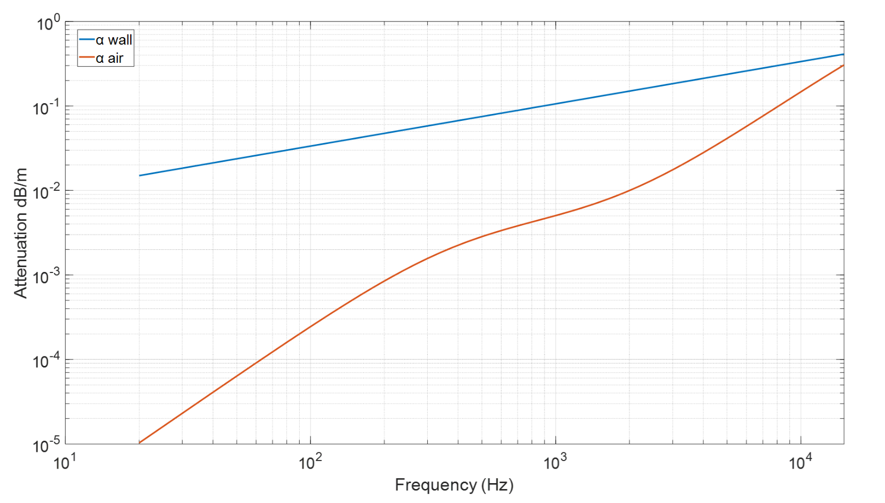
Figure 3.12 The comparison between attenuation coefficients caused by visco-thermal effects (wall) and air absorption (air) in frequency range of 0 Hz~15000 Hz.
In Figure 3.12, clearly $α_{air}$ and $α_{wall}$ rise with increase of frequency and the attenuation caused by visco-thermal effects is much higher (around ${10}^{1.6}$~ ${10}^{2}$dB) than that caused by the air absorption in the frequency range between $10 Hz$ ~ $1000 Hz$. However, they are getting closer in higher frequency range which denotes that in lower frequency range, the attenuation is dominated by the value $α_{wall}$ and with the increase of the frequency, the impact of $α_{air}$ is getting stronger and much obvious.

3.4 Effects of uncertainties in the pipe
A real sewer pipe consists of several manholes, junctions and other peculiar and uncertain artefacts distributed along the pipe network. These features can have strong impact on sound propagation. This section will discuss the effects of some of features/uncertainties through numerical experiments.
The sound pressure in a pipe with a feature between the sound and receiver can be expressed as:
 | $$\begin{matrix}p_{up}=p_{in}+p_{re} \\ p_{down}=p_{tr}\end{matrix}$$ | (3.42)
where the subscript $up$ and $down$ represents the upstream and downstream sections of the pipe which respect to the location of the feature. According to the equation (3.42), $p_{up}$ is summation of the incident wave $p_{in}$ and reflection wave $p_{re}$ and there is only transmission wave in downstream.
The sound pressure in this pipe can be expressed as a superposition of propagating modes, i.e.:
 | $$\begin{matrix}p_{up}\left(r,θ,z,ω\right)=p_{in}+p_{re}=\sum{(A_{mn}e^{ik_{z}z}{\text{+}R}_{mn}A_{mn}}e^{-ik_{z}z})Ψ_{mn}\left(r,θ\right) \\ p_{down}\left(r,θ,z,ω\right)=p_{tr}=\sum{(T_{mn}A_{mn}}e^{-ik_{z}z})Ψ_{mn}\left(r,θ\right)\end{matrix}$$ | (3.43)
where $Ψ_{mn}\left(r,θ\right)$ is the cross-sectional mode shape, $A_{mn}$ ,$R_{mn}A_{mn}$ and $T_{mn}A_{mn}$are the modal amplitude of incident, reflected and transmission waves related to the mode (m, n), respectively. $R_{mn}$ and $T_{mn}$ are the reflection and transmission coefficients, $z$ is the distance from the receiver position to the feature. Using the modal orthogonality, the amplitude of the mode (m, n) can be estimated as:
 | $$\begin{matrix}P_{mn-up}(z)= A_{mn}e^{ik_{z}z}{+R}_{mn}A_{mn}e^{-ik_{z}z}=\iint{p_{up}\left(r,θ,z,ω\right)Ψ_{mn}\left(r,θ\right)rdrdθ/S} \\ P_{mn-down}(z)= T_{mn}A_{mn}e^{-ik_{z}z}=\iint{p_{down}\left(r,θ,z,ω\right)Ψ_{mn}\left(r,θ\right)rdrdθ/S}\end{matrix}$$ | (3.44)
where $S$ is cross-sectional area of the pipe. Therefore, equation (3.44) can be used for the COMSOL simulation result to estimate the modal amplitude at different coordinates z. With the estimated modal amplitude $P_{mn-up}$, the sound reflection coefficient $R_{mn}$ can be predicted from [14]:
 | $$R_{mn}=\frac{\max\left(\left|P_{mn}(z)\right|\right)-\min\left(\left|P_{mn}\right|\right)}{\max\left(\left|P_{mn}(z)\right|\right)+\min\left(\left|P_{mn}\right|\right)}$$ | (3.45)

It should be noticed that when the frequency is above the first cut-off frequency, the reflection coefficient fluctuates and presents more complexity which is possibly due to the cross-modal reaction which also has been introduced by [14]. For example, the sound reflection of the plane wave mode over the frequency range 1.84<ka<3.05 is not only derived from the incident plane wave but also the incident first mode wave. Therefore, the total sound pressure in upstream should be converted by the sound reflection coefficient matrix:
 | $$\left[\begin{matrix}{\hat{p}}_{0,re} \\ {\hat{p}}_{1,re} \\ ⋮ \\ {\hat{p}}_{M,re}\end{matrix}\right]=\left[\left[\begin{matrix}R_{00} & R_{01} & ⋯ & R_{M1} \\ R_{10} & R_{11} & ⋱ & ⋮ \\ ⋮ & ⋱ & ⋱ & ⋮ \\ R_{M0} & ⋯ & ⋯ & R_{MM}\end{matrix}\right]\right]\left[\begin{matrix}{\hat{p}}_{0,in} \\ {\hat{p}}_{1,in} \\ ⋮ \\ {\hat{p}}_{M,in}\end{matrix}\right]$$ | (3.46)
where ${{\hat{p}}_{M,in}=A}_{mn}e^{-ik_{z}z}Ψ_{mn}\left(r,θ\right)$ is the incident sound pressure. The next 3 of sub-sections will indicates the reflection coefficients of first 4 modes as the function of normalised wavenumber $kR$ from 3 different artifacts in the pipe: lateral connection, blockage and manhole.

3.41 Lateral Connection
A simulation of sound propagation in a pipe in the presence of lateral connection was carried out using Comsol Mutiphysics. This numerical experiment is shown schematically in Figure 3.13. The point source was placed in line with the receiver which were 0.005 m away from the wall of pipe and 3 m from the connection. The receiver was placed 0.5 m from the connection of the pipe with 0.15 m in diameter. In order to reduce the unwanted reflections from the ends of this relatively short pipe sections 3 perfectly matched layers (PML, blue parts in Figure 3.13) were added. PML is an artificial absorbing layer for wave equation and is commonly used for open boundaries in numerical studies.
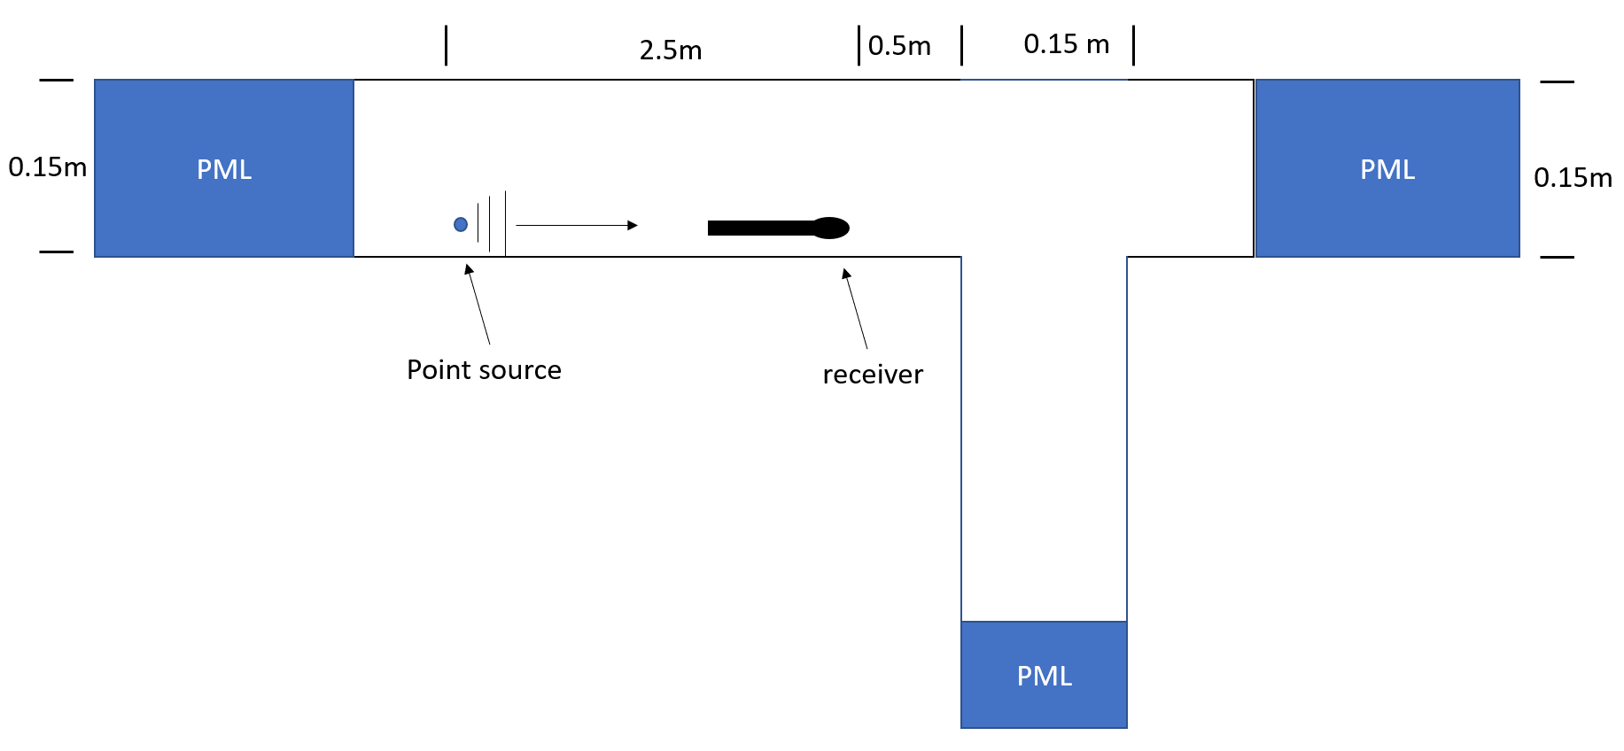
Figure 3.13 The numerical experiment setup to study sound propagation in a pipe with a lateral connection
Figure 3.14 presents the plane wave reflection coefficient (mode (0,0)) from the lateral connection plotted against the normalised wavenumber. The red dash lines denote the first 5 cut-off frequencies. Below the first cut-off frequency ($kR=1.841$), the sound reflected from the lateral connection decrease dramatically from 0.33 to 0.02 with the increase of the normalised wavenumber from 0.2 to 1.841. Around each resonance frequency the reflection coefficient increases significantly. Beyond the first cut-off frequency its behaviour is very complex.
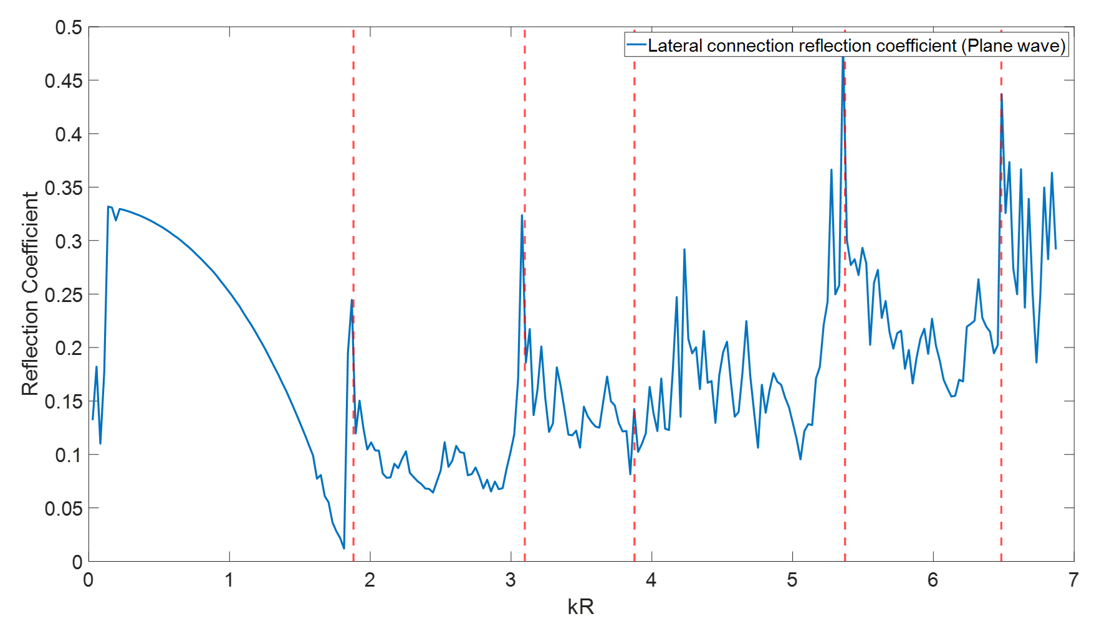
Figure 3.14 Reflection coefficient for lateral connection (plane wave mode)
For the first non-axisymmetric mode reflection coefficient (mode (1,0)), the same relation has been illustrated in Figure 3.15. Compare with the Figure 3.14, the region below the first cut-off frequency has been significantly increased and stabilised around 0.55 and in the region above the mode (1,0) also has been increased from approximately 0.25 to 0.45. However, the effects of last two modes (3,0), (1,1) become unclear. In contrast, in Figure 3.16 for the second non-axisymmetric modes, the reflection coefficients below the mode (2,0) remain the similar level and beyond this range, it suddenly drops from around 0.5 down to 0.1. In addition, the effects of last two modes become clear again with 0.47 and 0.35 respectively.
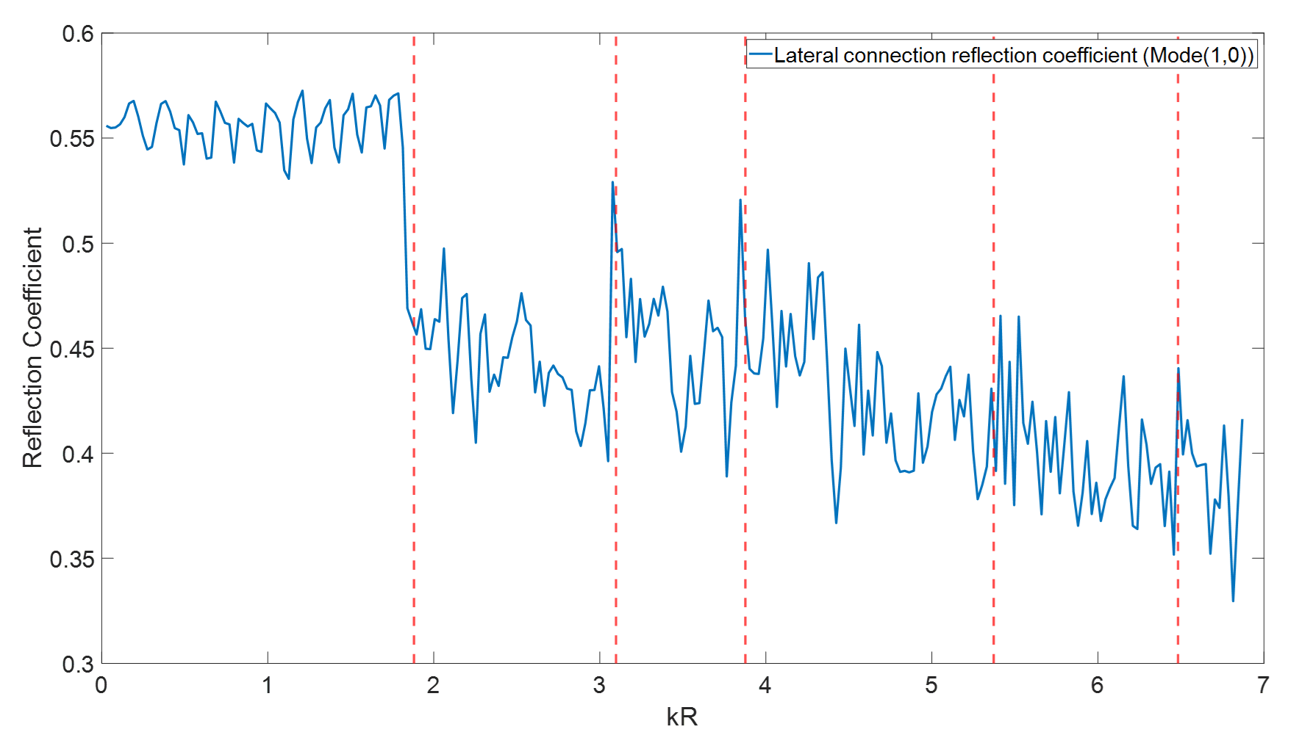
Figure 3.15 Reflection coefficient for lateral connection (mode (1,0))
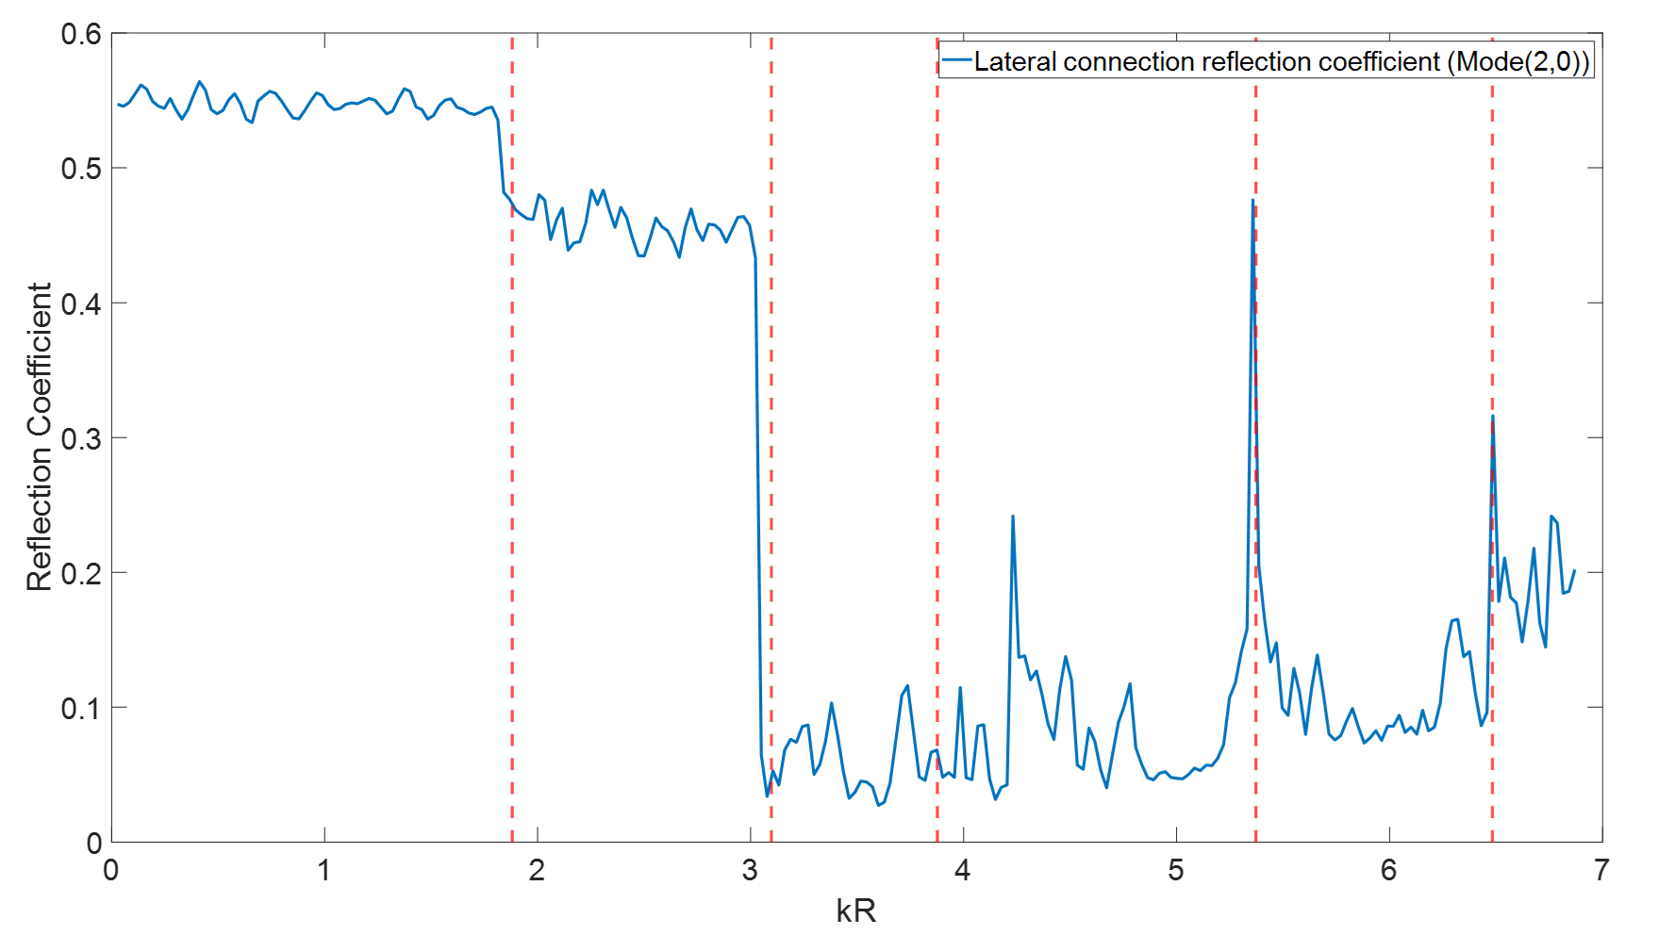
Figure 3.16 Reflection coefficient for lateral connection (mode (2,0)
The figure 3.17 indicates the reflection coefficients from lateral connection for the first axisymmetric mode (0,1). Differ with the non-axisymmetric modes introduced previously, the reflection coefficients around each resonance increased significantly apart from the axisymmetric mode itself. In the region below the first cut-off frequency, they are all stably under 0.1. In general, the trend of reflection coefficients is rising with the increase of the frequency.

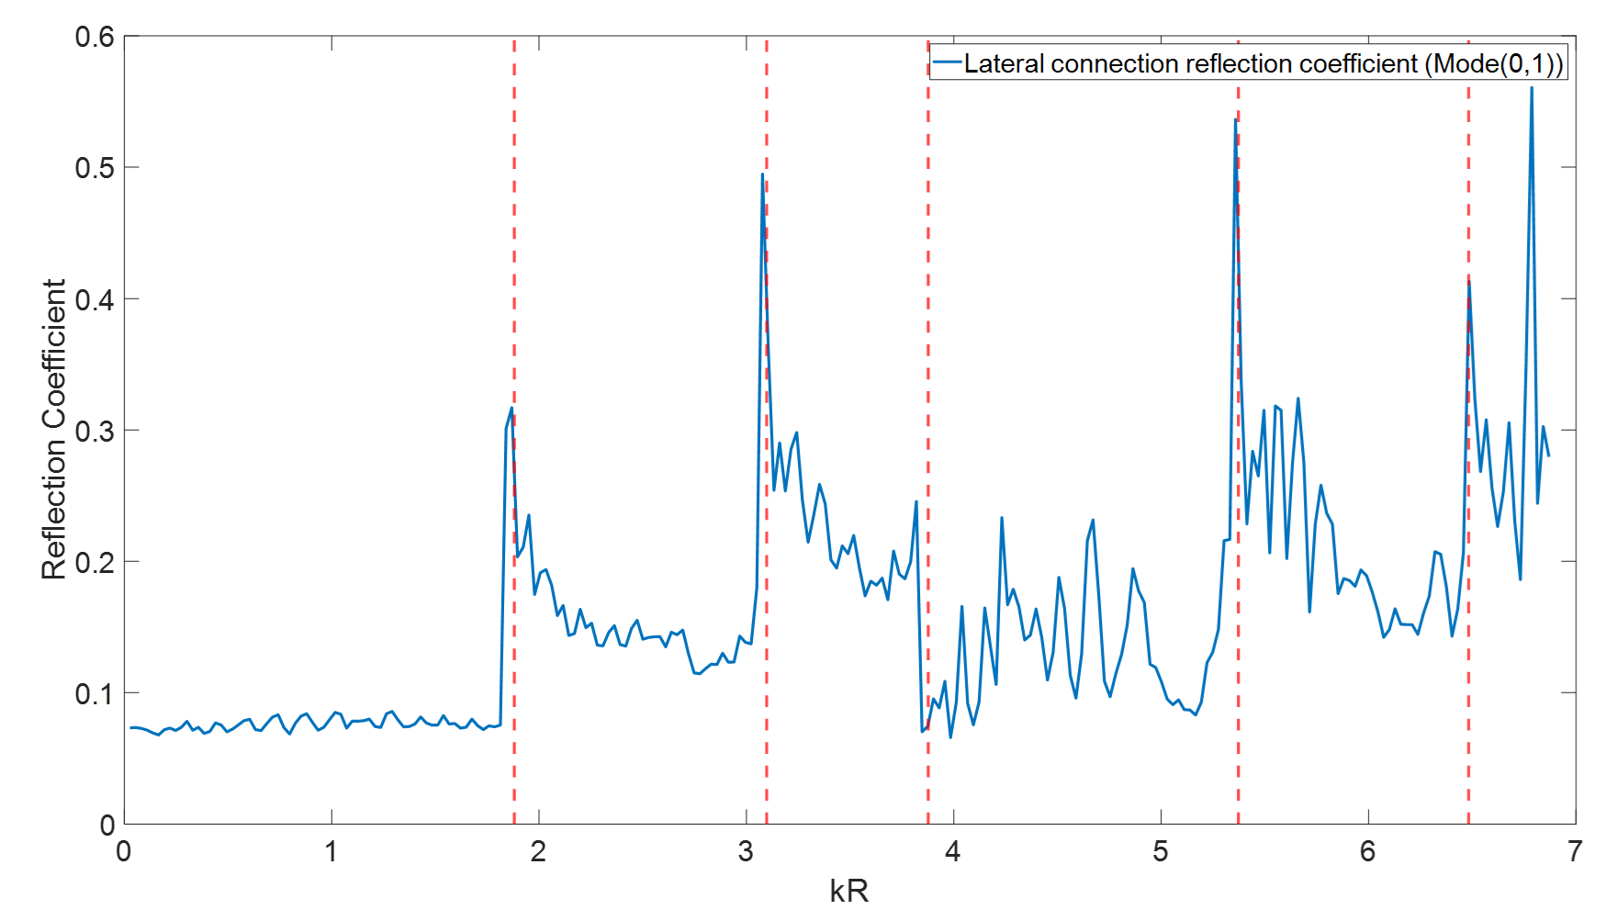
Figure 3.17 Reflection coefficient for lateral connection (mode (0,1)

3.42 Blockage
Another numerical experimental was set up to study the effect of a blockage on the sound pressure in the same pipe. This setup is shown schematically in Figure 3.18. The point source was placed at the same position as in the previous numerical experiment with the lateral connection. A 0.2 m long half-size blockage (height of blockage equals to half of the pipe diameter) was placed 3.5 m away from the source. The receiver was 0.8 m away from the blockage and 2.7 m away from the point source. The plane wave reflection coefficient spectrum is shown in Figure 3.19. It is plotted as a function of the dimension parameter $kR$.
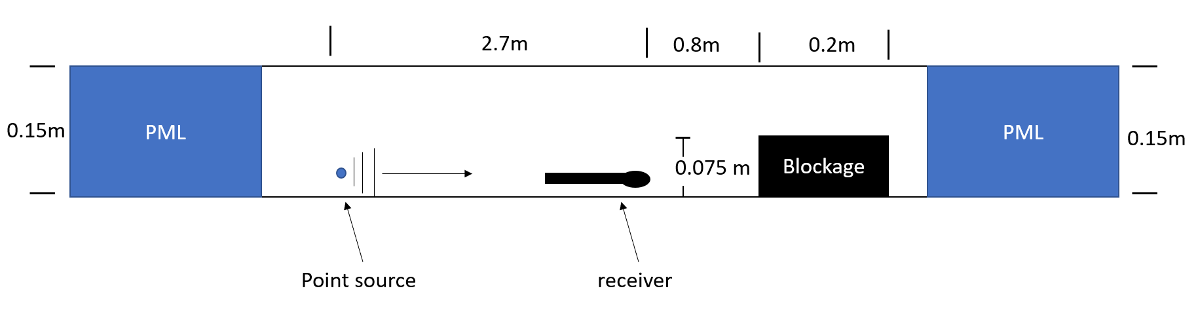
Figure 3.18 Numerical experiment set up for half size blockage (plane wave mode)
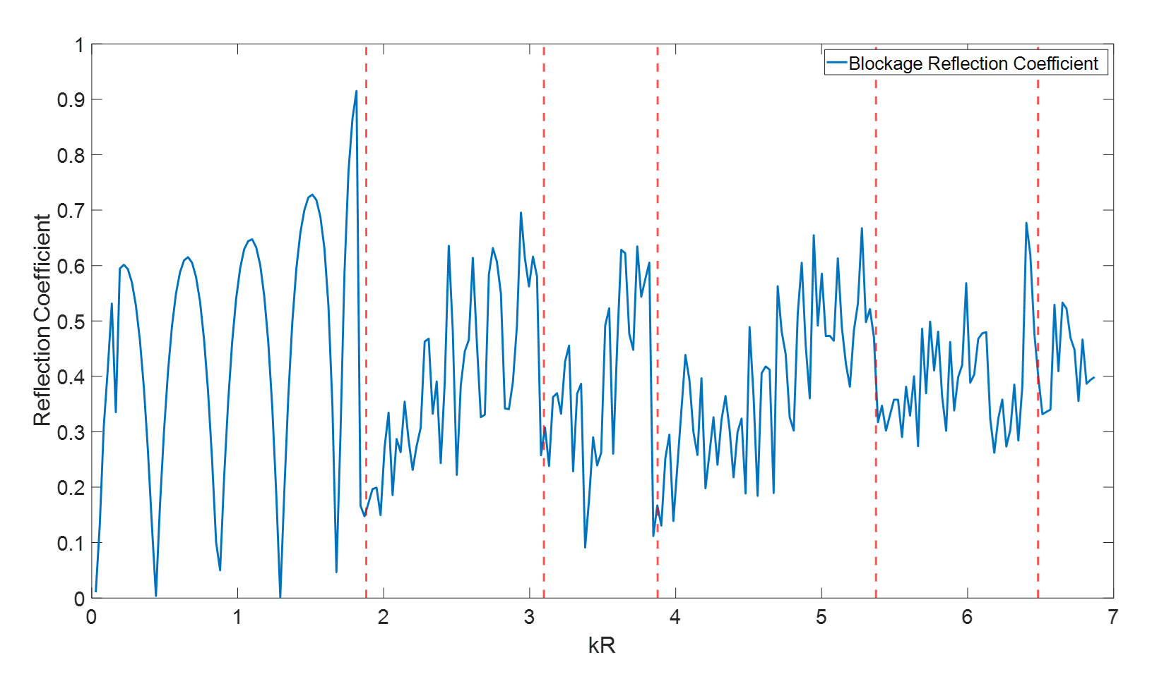
Figure 3.19 Reflection coefficient for half size blockage (plane wave mode)
According to the graph shown in Figure 3.19, the amplitude of the reflection coefficient for a half-size blockage fluctuates significantly below the first cut-off frequency ($kR<1.841$). Its amplitude tends to decrease near a cut-off frequency but increases progressively in a complex manner as the frequency increases. This trend is consistent for all the cut-off frequencies considered in this numerical experiment.

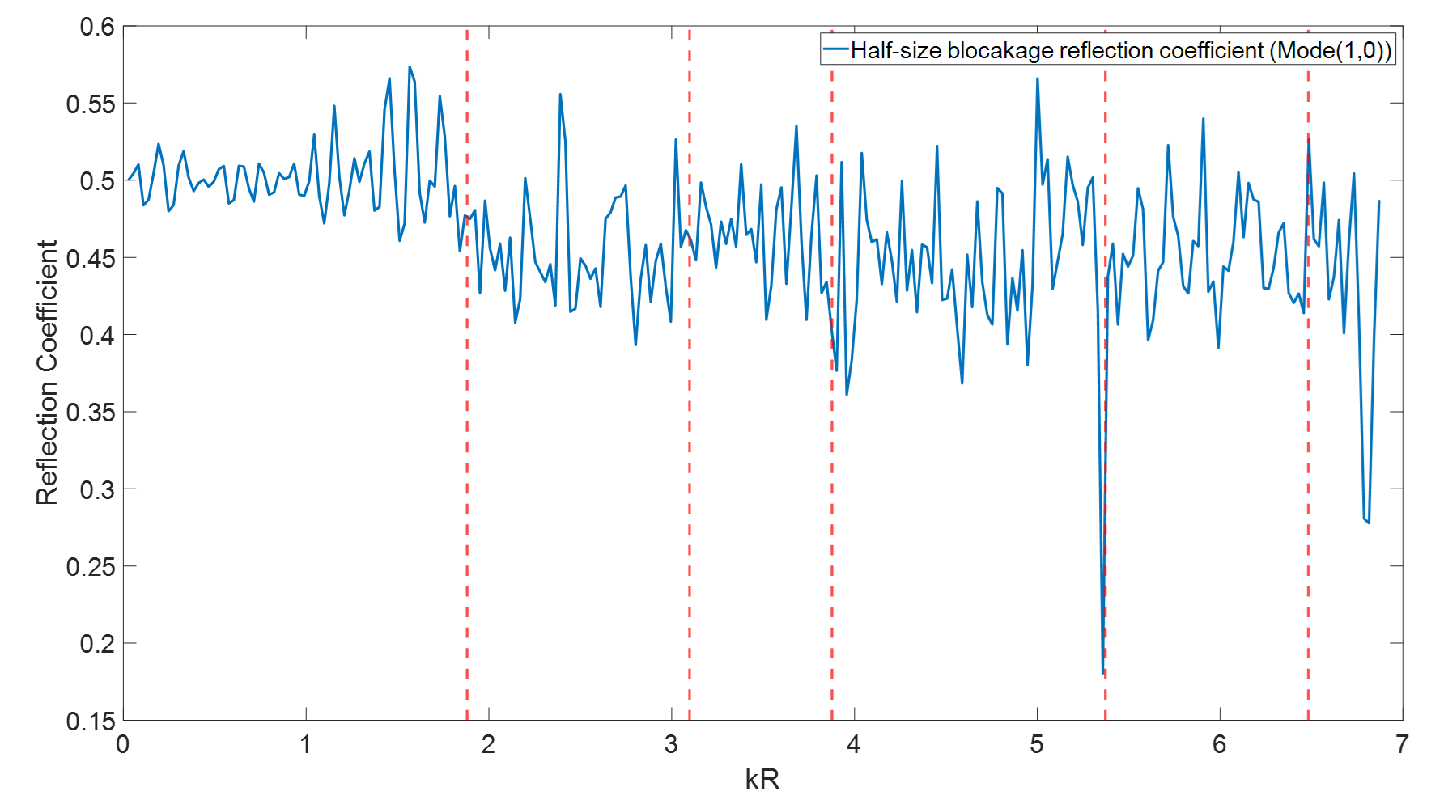
Figure 3.20 Reflection coefficient for half size blockage (Mode (1,0))
The diagram shown in figure 3.20 indicates the reflection coefficient for the first non-axisymmetric mode (1,0) with the presence of the half-size blockage in the pipe. It is very clear that apart from the area closed to the fourth cut-off frequency ($kR=5.37$), it remains around 0.5 which means half of the sound pressure for the mode (1,0) will be reflected back by the blockage. However, for the second non-symmetric mode (2,0) in Figure 3.21, the reflection coefficient initially keeps stable around 0.58 in plane wave region and then slightly drop to approximately 0.5 in the range between $kR=1.841$ and $kR=3.097$. When it reaches the mode (2,0), it suddenly decreases down to much less than 0.1 and then rise up with the increase of the frequency.
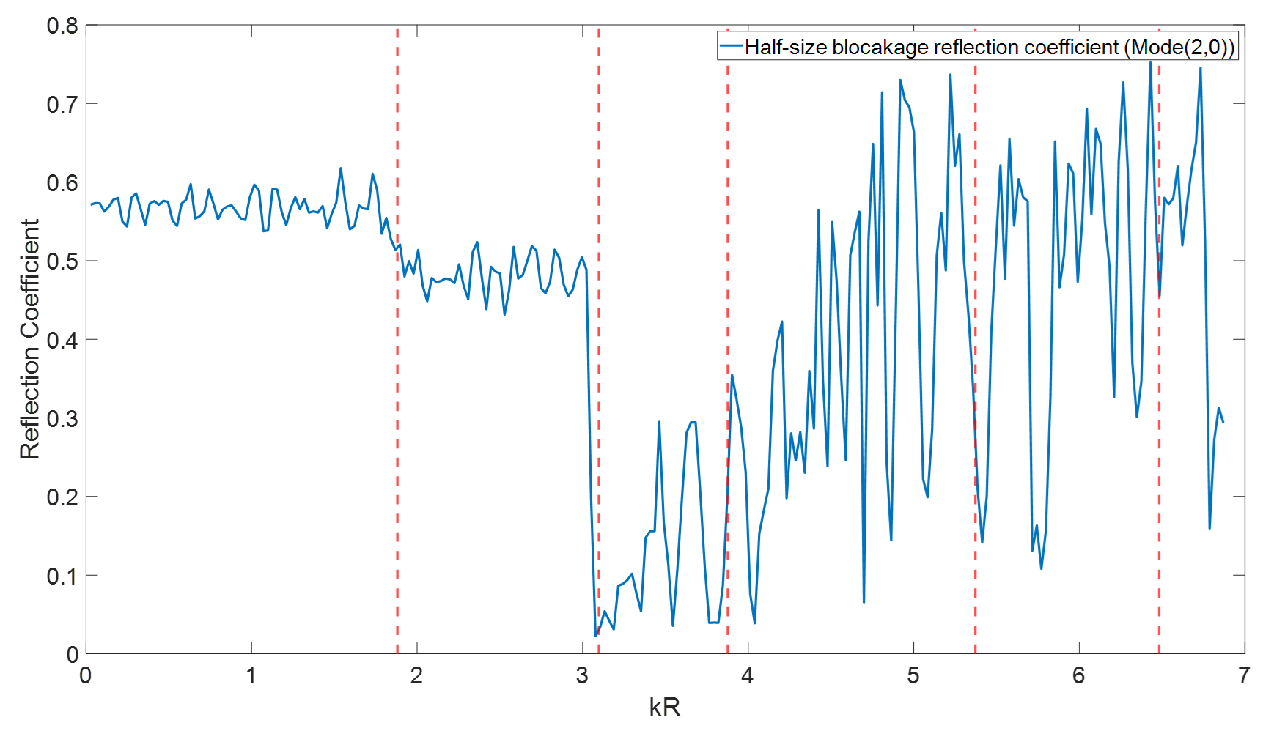
Figure 3.21 Reflection coefficient for half size blockage (Mode (2,0))
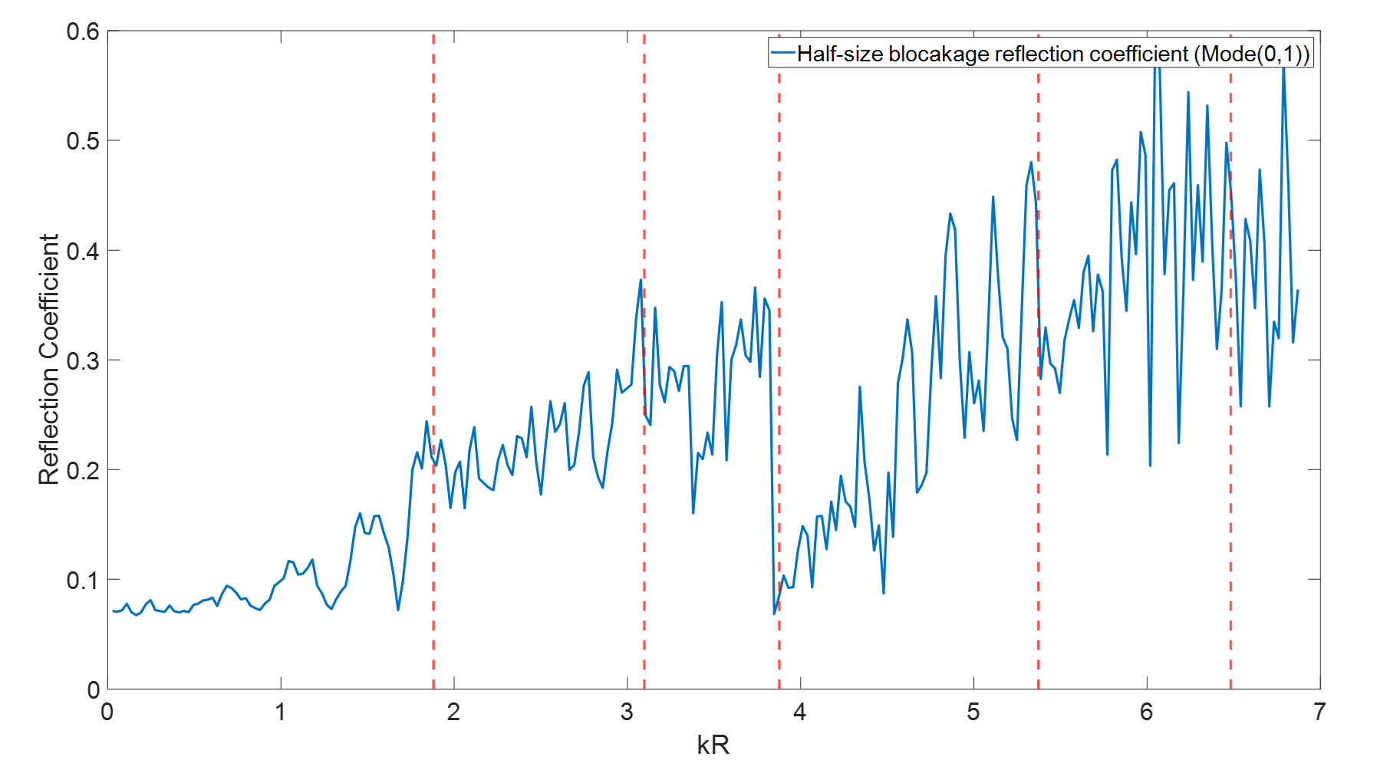
Figure 3.22 Reflection coefficient for half size blockage (Mode (0,1))
The last graph in this section has been shown in Figure 3.22 which indicates the first axisymmetric reflection coefficient (mode (0,1)) from the blockage plotted against the normalised wavenumber. It gradually Increases before $kR=3.88$, then falls sharply down to 0.08 and after that it rises up again.

3.43 Manhole
A sudden change of the effective diameter when the pipe connects to a manhole has a significant influence on the sound pressure in the pipe. The diagram shown in Figure 3.23 illustrates this situation. A numerical experiment on the same pipe was carried out to study this effect. The source and receiver were located in the pipe where there were 3 m and 0.5 m distance away from the 1 m diameter manhole, respectively.

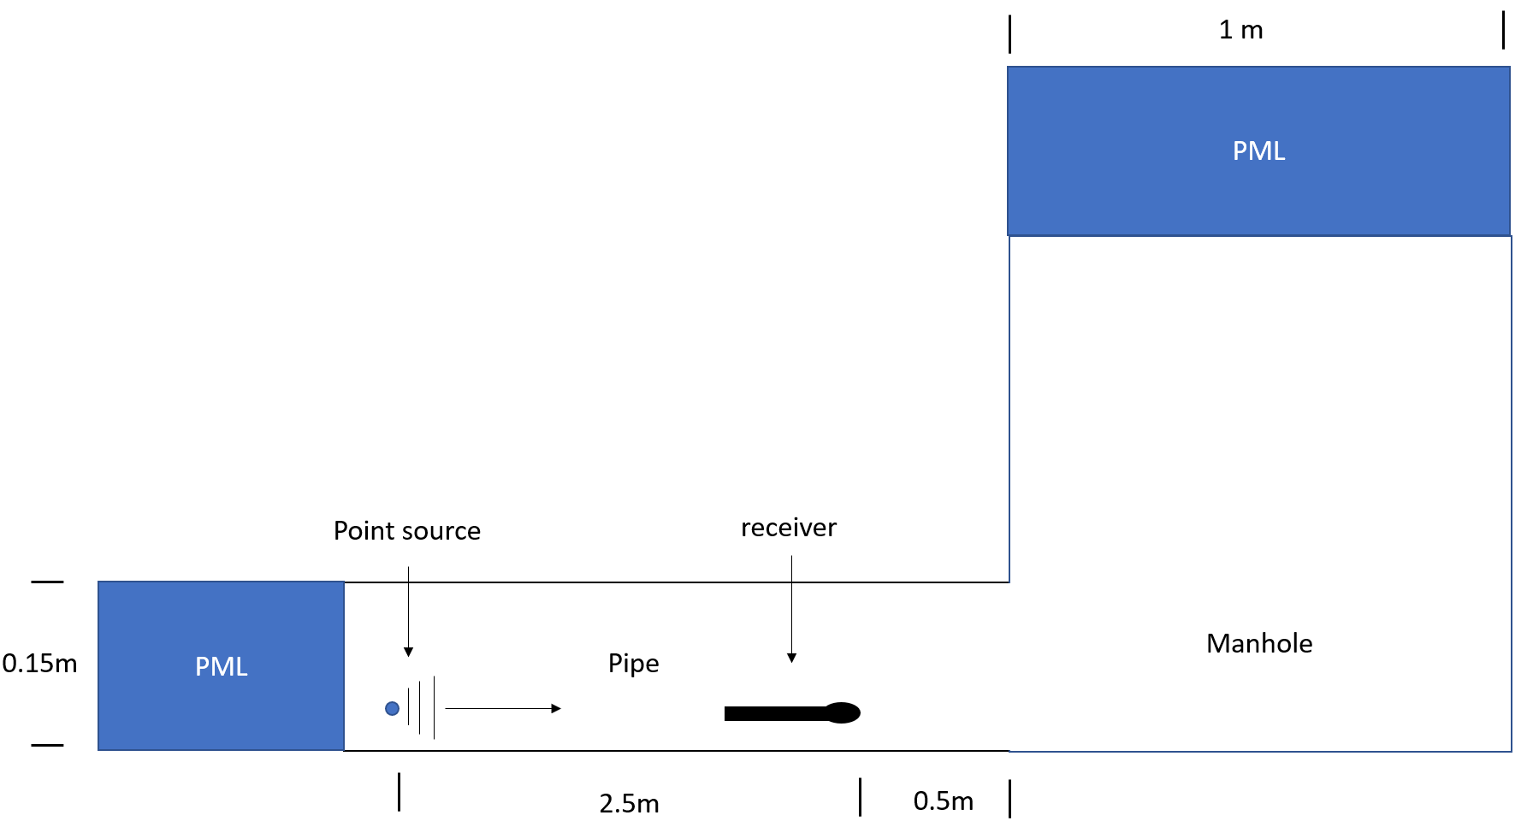
Figure 3.23 Numerical experiment set up for 1m diameter manhole
Figure 3.24 presents the plane wave reflection coefficients spectrum as a function of $kR$. When the acoustic wave with the frequency below the first cut-off frequency is incident onto the manhole, a considerable proportion of sound energy is reflected back. In this frequency range the manhole is almost perfect reflector. Similarly, to the two previous numerical experiments with a lateral connection and manhole, the reflection coefficient behaviour for the manhole is complex beyond the first cut-off frequency. This behaviour is caused by the modal conversion which occur in the vicinity of the interface and existence of evanescent modes. The total sound pressure predicted by equations (3.24) is likely to be strongly affected across the whole frequency range. This effect needs to be carefully considered when designing and analysing the acoustic communication channel in a realistic sewer pipe.
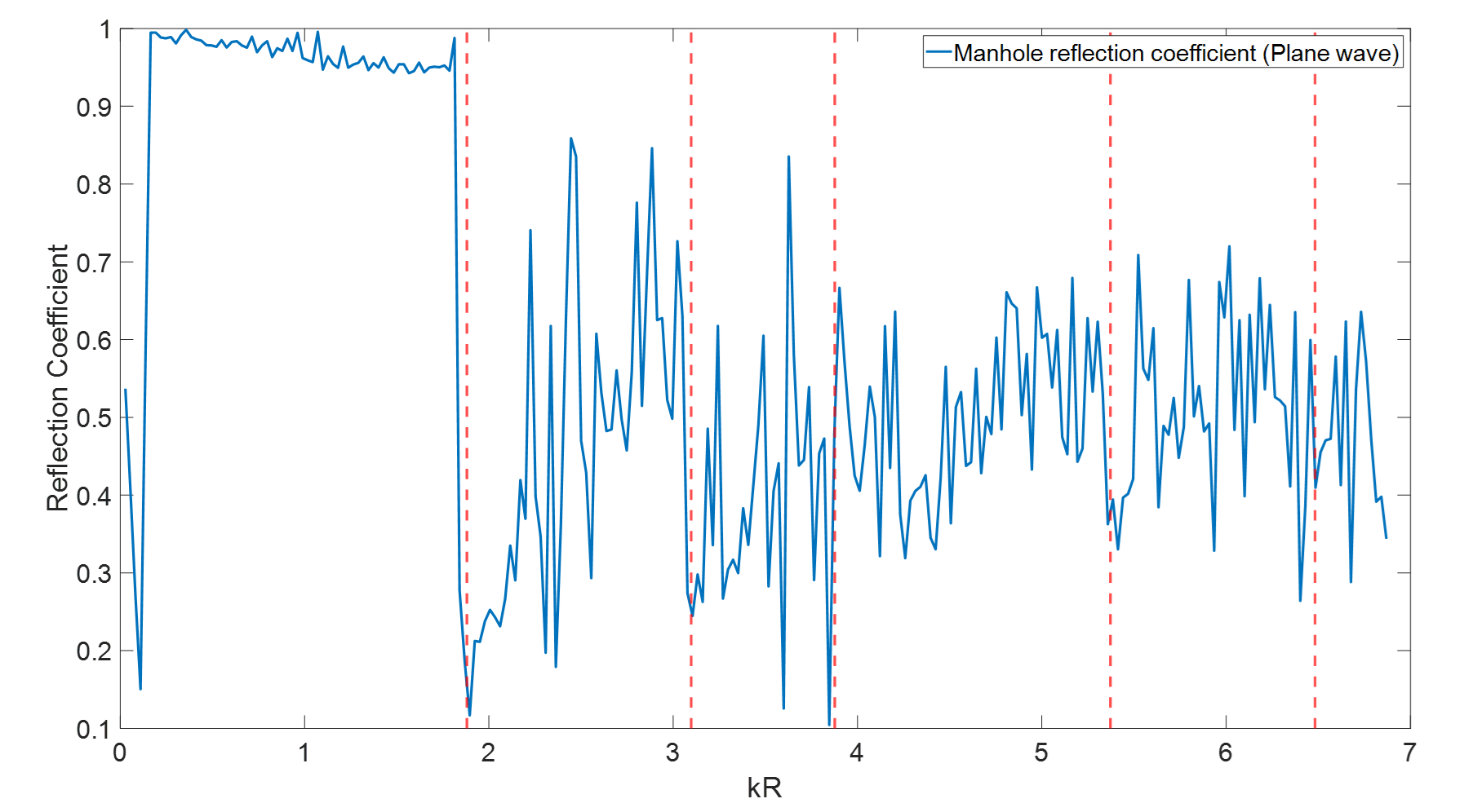
Figure 3.24 Reflection coefficient for manhole (plane wave mode)
The graph shown in figure 3.25 plotted the relations between the reflection coefficients of mode (1,0) from the manhole and normalised wavenumber $kR$. Similar to the case discussed in Section 3.24, It has very complex fluctuation cross the whole frequency range therefore a considerable amount of sound pressure of first non-symmetric mode will be reflected back into the pipe.
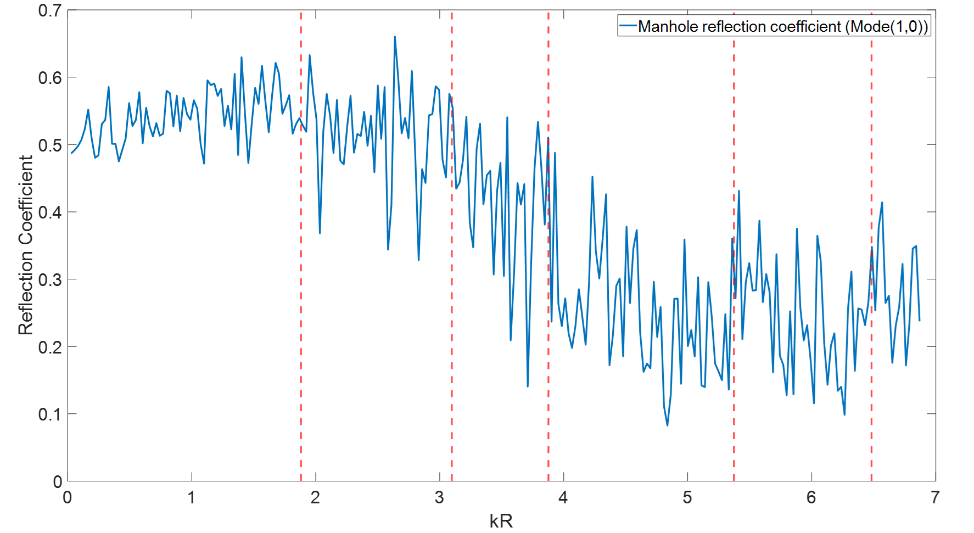
Figure 3.25 Reflection coefficient for manhole (Mode (1,0))
Furthermore, the diagram about the second non-axisymmetric mode (2,0) has been shown below in Figure 3.26. In the plane wave region ($kR<1.81$) and the area between the first mode and second mode (1.81$<kR<3.09$), the reflection coefficient slightly developed initially and then suddenly dropped when it was about to reaching the resonance. After this region, it fluctuates irregularly in the rest of area on the reflection coefficient spectrum in the figure.
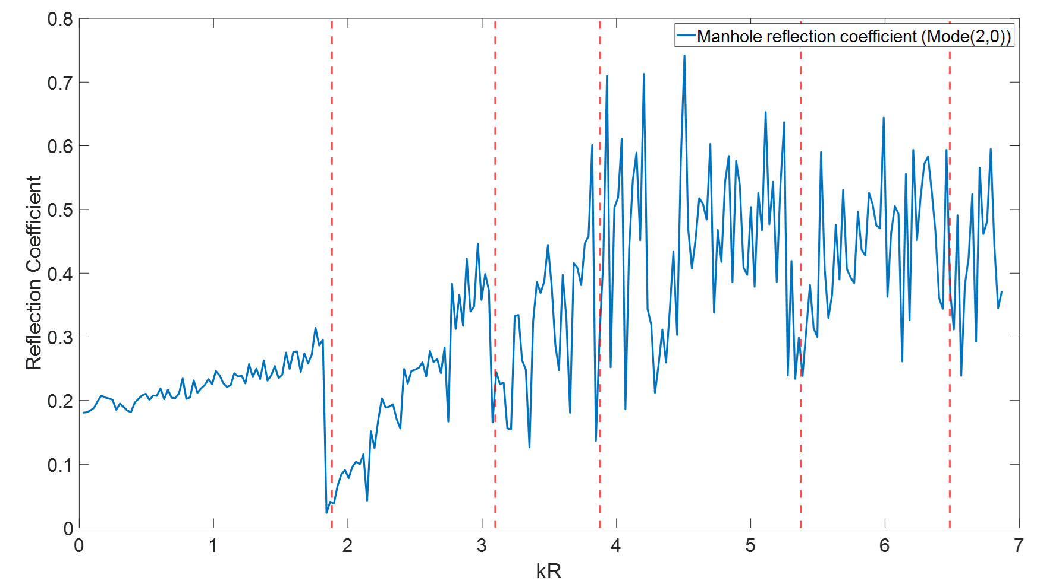
Figure 3.26 Reflection coefficient for manhole (Mode (2,0))
The last diagram shown in figure 3.27 is about mode (0,1) for the manhole. The trend of the curve in the region below the first cut-off frequency is as same as that shown in figure 3.26 but the reflection is much stronger with the value of around 0.4. Then the sudden decresae is no longer located at aroud the position where $kR=3.09$ but moved to the third red dash line in the figure ($kR=3.87$).
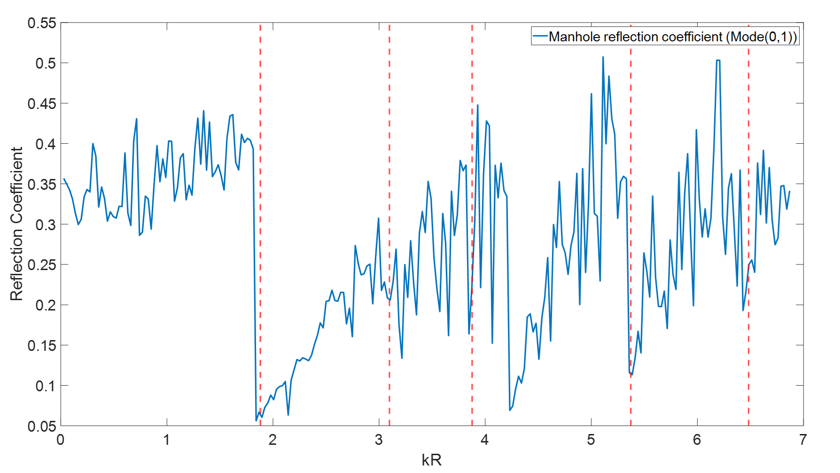
Figure 3.27 Reflection coefficient for manhole (Mode (0,1))

Summary
This chapter focused on the acoustic theory which needs to be used for the In-pipe communication and divided by 4 main parts. It starts with the simplest model: dry, clean uniform pipe, the dispersion relations have been studied analytically and validated by an experiment. The results show the error was lower than 5% which denotes that this model works with the quoted accuracy. Then it moves on to partially water-filled pipe which represent most sewers and drains buried underground. This study initially simulated the acoustic wave propagation in the partially water-filled pipe by 2D-FEM method in COMSOL Multiphysics and meanwhile the dispersion relation and mode shapes as the function of filling ratio $h/R$ have been studied. Then the mode split phenomenon has been observed which is believed has potential impact on the communication. Therefore, an analytical approximation has been carried out to explain the mode split. Another observation is that the results from FEM simulation can be used to create a database to calculate the sound pressure in the pipe which is so called empirical model here. Finally, the acoustic response due to the monopole source of 3 different modes: FEM, analytical and empirical have been predicted. It is also believed that sound attenuation plays an important role in in-pipe acoustic communication because it determines the communication range. The attenuation in the pipe is consisted by two parts, the first kind is caused by the air-absorption which is also called classic attenuation and the second kind is caused by the visco-thermal effects in the fluid which is close to the pipe wall. Both two types of attenuation are frequency dependents. It has been suggested that the latter is much stronger than the former. The last part is about discussing the effects of uncertainties in the pipe. It firstly gives the mathematical expression of sound pressure in the pipe with reflections and demonstrates how to calculate the reflection coefficient. Then the relation between normalised wavenumber $kR$ and reflection coefficient of first 4 mods from lateral connection, half size blockage and manhole has been studied numerically. According to the results, it can be suggested that the reflection coefficient of each mode fluctuated complexly with the increase of the frequency which has potential to trigger the Inter-symbol Interference (ISI) in the communication. The influence on the FRF of the pipe and the numerical experiments of communication in the pipe with the presence of artifacts will be discussed later in the chapter 6. Next chapter will focus on the communication techniques which will be on board for in-pipe Inspection robots.

Chapter 4. The performance of Communication Techniques in an Empty Pipe
Messages which are communicated acoustically are usually digitised and coded using a range of modulation techniques. In this study three binary modulation techniques were used: 2ASK, 2PSK and 2FSK (Amplitude/Phase/Frequency Shift Keying) [23]. These stand for the amplitude, phase and frequency modulation, respectively. Also, a widely used underwater communication method, Chirp Linear Frequency Modulation (CLFM) was adopted and modified to suit the in-pipe environment. This chapter consists of 3 main parts. The first part focuses on introducing the details of communication techniques which included how the information was encoded and how the signal was mapped, it also indicates the fundamentals of four communication techniques and the methodology of numerical studies. Then, the second part discussed the results of numerical studies and experimental validation which were used for evaluating the performance of those four communication techniques. This evaluation was based on comparing the curve plotted as the relations of $PER-SNR$ (package error rate against signal to noise ratio) and $PER-f_{c}$(package error rate against carrier frequency). Finally, the last part balances the relation between acoustic attenuation and communication range and estimated the maximum data rate for each communication technique.

4.1 Communication Procedures
These four techniques are based on several common procedures illustrated in Figure 4.1. The performance of these four modulation techniques for acoustically communicating messages in a pipe was studied through the channel characterisation. The acoustic channel characterisation was carried out via a MATLAB-based simulation and experiment. In this section, only the procedures of numerical study will be specified, and the simulation results will be compared and validated by experimental approach in section 4.3.

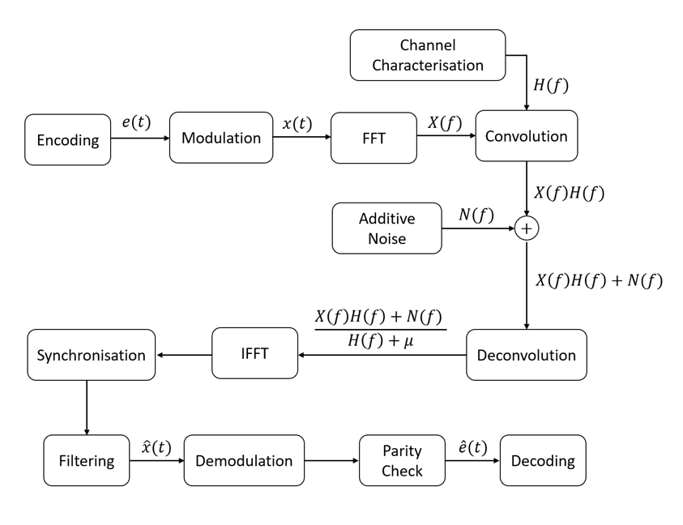
Figure 4.1 A diagram illustrating in-pipe communication procedures

In this simulation, the signal was encoded as 19 binaries consisting of 15 random binary message symbols and parity checking codes composed of four ‘ones’ – two at the start and two at the end of the message. The mapping of the message is shown in Table 4.1. It is usual to modulate one of the parameters of the sinusoidal carrier wave (e.g. frequency, phase or amplitude) with these encoded binaries.
1 | 1 | 15 random binaries | 1 | 1
Table 4.1 19 Binary Message Pack
Figure 4.2 (a) illustrates an example of the signal to broadcast a message using the binary Amplitude Shift Keying (2ASK) modulation method.
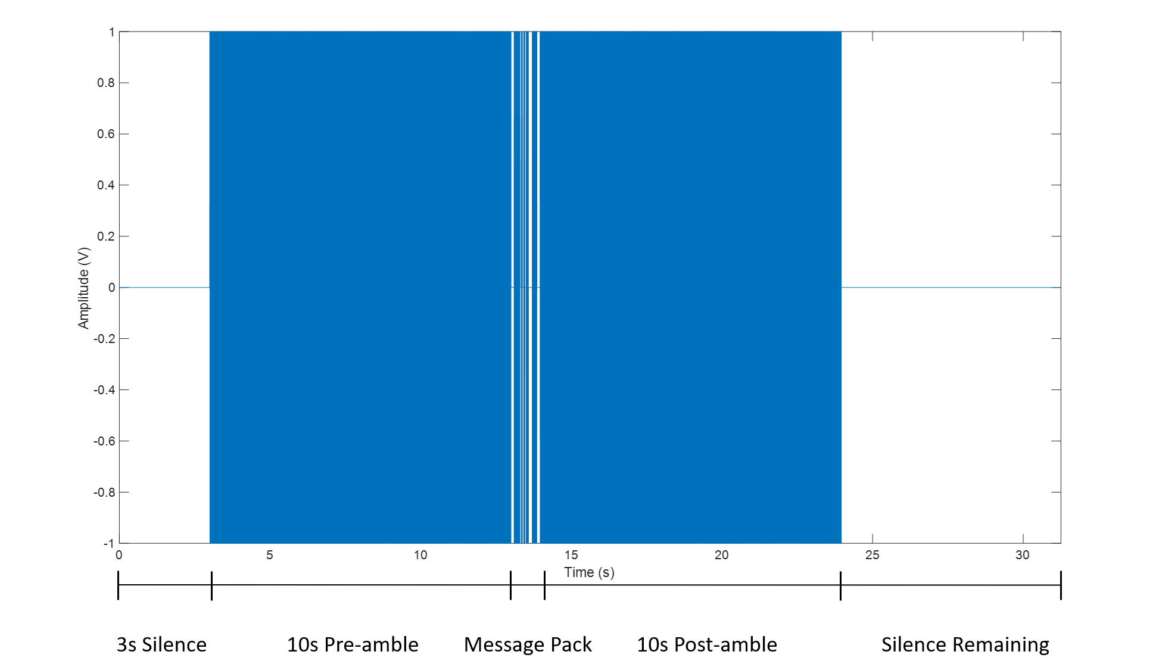
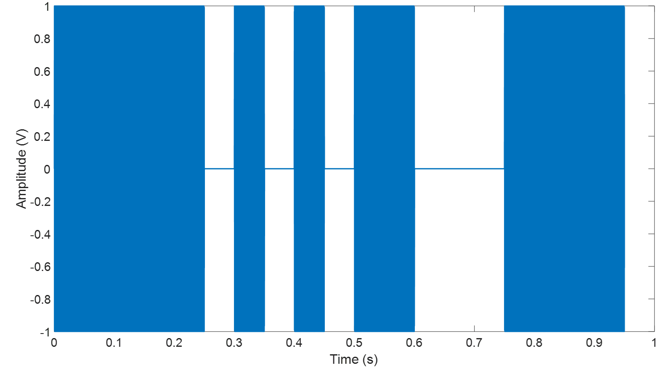
Figure 4.2 (a) 2ASK signal excitation in time domain (Top). (b) Message package of the signal illustrated in top diagram (Bottom)
This 2ASK signal starts with a 10s long sinusoid chirp pre-amble with the frequency range of 100 - 6000 Hz which signifies the beginning of the communication, after that is a 0.1s interval is broadcast and message pack (shown in Figure 4.2 (b)) is right on the back of the chirp. At the end of the message pack a 0.1s interval is added followed by an identical chip that works as the post-amble to denote the end of communication. The pre-amble and post-amble can also be used to measure the channel frequency and impulse responses.
The frequency and impulse responses of the pipe measured with the pre- and post-amble is the key to study the influence of channel properties on the modulation signal. In the analysis of linear time-invariant systems the convolution is the most commonly used method to understand the influence of the channel response on the signal. In Figure 4.1, the encoded signal $e(t)$ is modulated as $x\left(t\right)$ and the process of passing though the channel can be treated as it was convolved with the channel impulse response, $h(t)$. This process is written in the time domain as:
 | $$g\left(t\right)=\int_{-∞}^{+∞}{x\left(t\right)h(t-τ)dt}$$ | (4.1)
In the frequency domain Eq. (4.1) is becoming:
 | $$G\left(f\right)=X\left(f\right)H\left(f\right)$$ | (4.2)
where the capital letters denote the spectra. Usually, background, signal processing and electronic noise $N(f)$ is added to G$\left(f\right)$ to simulate the typical channel conditions which are rarely noise free. In this work the noise was only added around the carrier frequency for the 2AKS,2PSK and 2FSK techniques which operate in a narrow band. In the case of the C-LFM technique broadband noise covering the whole frequency range of the chirps was added. The details of modulation will be introduced in the section ‘Modulation & Demodulation’. The bandwidth of the noise was determined by $\frac{f_{m}}{n}$, where $f_{m}$ is bandwidth of modulation signal and $n$ is the number of binaries in message pack. According to the definition of Signal to Noise Ratio, $SNR=20\log_{10}{(\frac{\left|S\left(f\right)\right|}{\left|N\left(f\right)\right|})}$, where the form $\frac{\left|S\left(f\right)\right|}{\left|N\left(f\right)\right|}$ denotes the ratio of signal and noise. The noise $N(f)$ can be generated as a random sequence with the spectral amplitude of:
 | $$N\left(f\right)=\frac{1}{{A_{RMS}e^{iϕ(f)}10}^{\frac{SNR}{20}}}$$ | (4.3)

where $A_{RMS}$ is the root-mean square value of the signal spectrum and $ϕ(f)$ is random, frequency dependent phase taken between [$-π,$ $π$].
In order to let the reader have a clearer view on the process of simulation, Figure 4.3 (a) shows an example of the spectrum of the 20 Hz bandwidth, 5000 Hz carrier frequency 2ASK signal with a 100 -6000 Hz pre- and post-amble. Figure 4.3 (b) is the signal propagated through the pipe and predicted 4 m away from the source. Figure 4.3 (b) also presents the noise spectrum (red line) added to the signal convolution spectrum to study the performance of the communication technique in the presence of background noise. The thick red line denotes the noise level in 0dB with respect to the root mean square amplitude of the communicated signal. In this example, the bandwidth of the noise covers 80% energy distribution of the modulated signal.
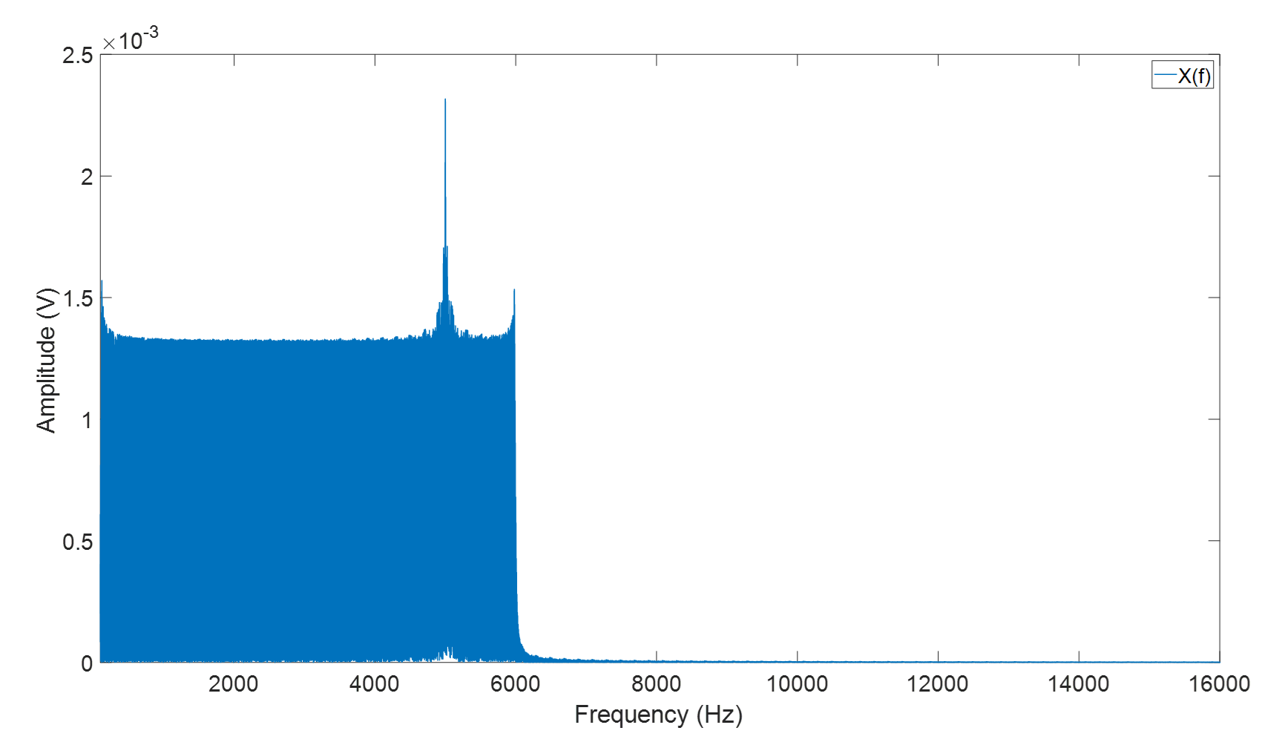
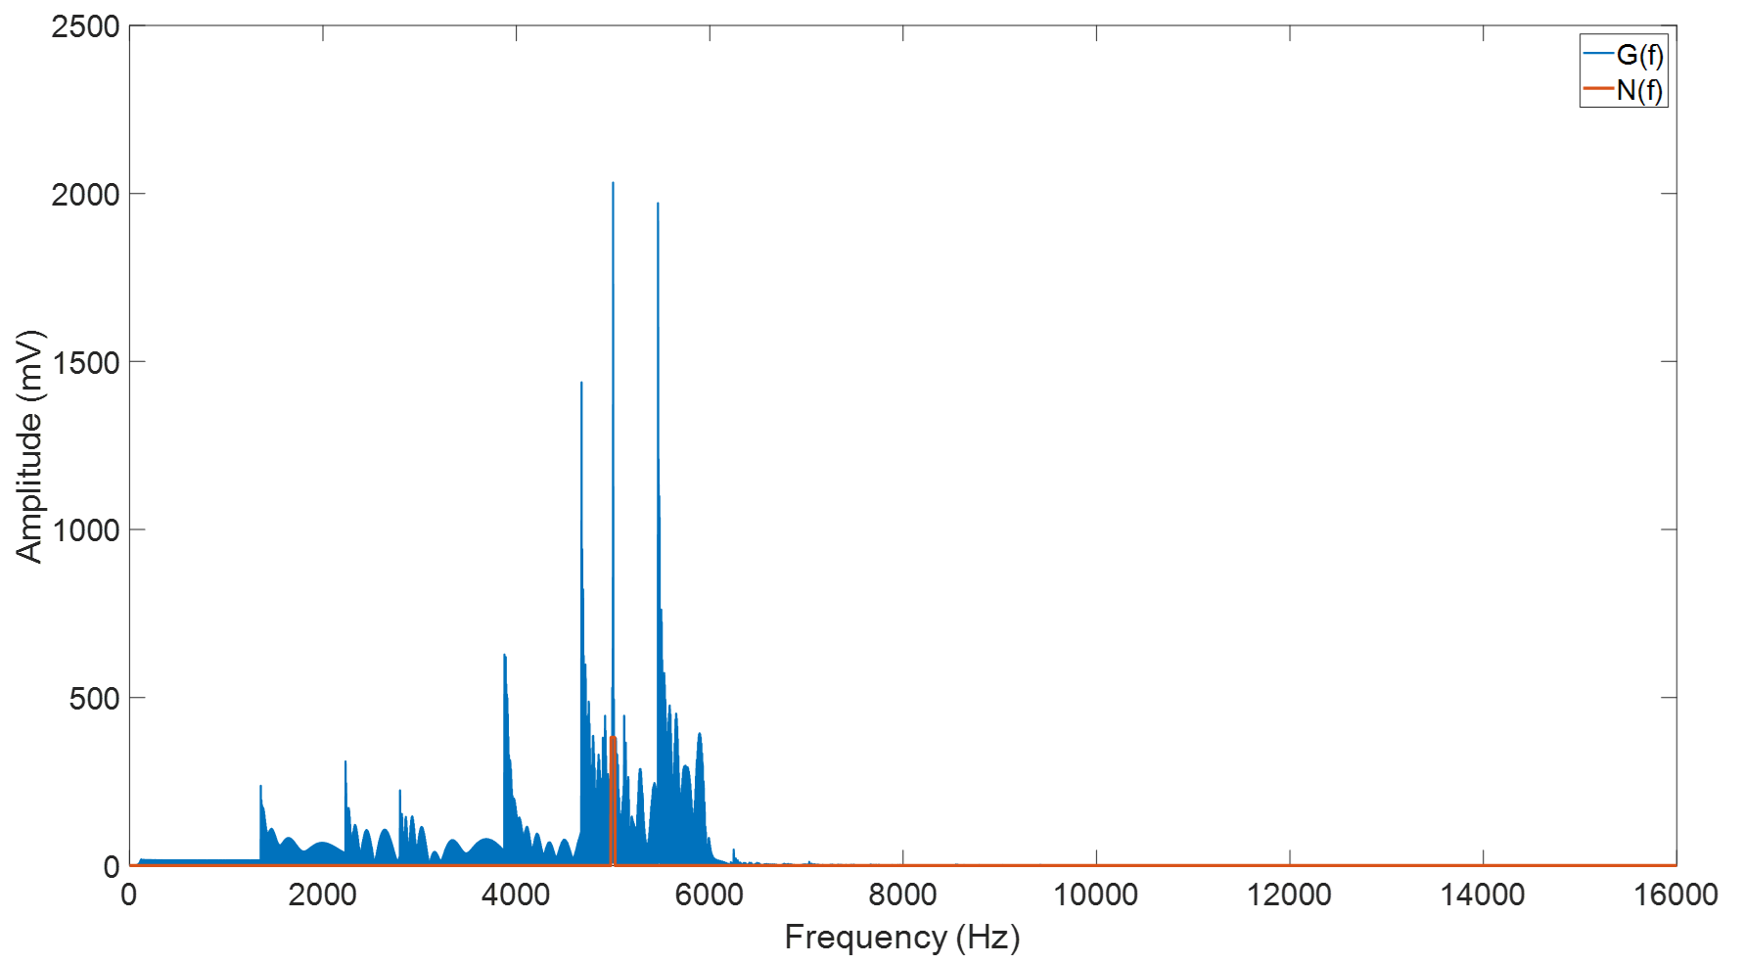
Figure 4.3 (a) The spectrum of emitted 2ASK signal with 20 Hz bandwidth and 5000Hz carrier frequency （Top）. (b) The spectrum of the communicated 2ASK signal predicted in the pipe 4m away from the source with additive noise (Bottom).
Then the deconvolution algorithm was applied to the sequence $\hat{G}\left(f\right)+N(f)$ to linearly equalise the undesired effects in the channel and its results can be written as:
 | $$Y\left(f\right)=\frac{X\left(f\right)H\left(f\right)+N(f)}{H\left(f\right)+μ}$$ | (4.4)
where $μ$ is the regulation factor to avoid the situation when the spectral amplitude of $H(f)$ is relatively small ($μ=0.001$ in this case). Finally, the output is required to be transformed back to time domain by IFFT: ${y(t)=F}^{-1}\left\{Y(f)\right\}$ and be ready for the synchronisation.
Deconvolution plays a key role in the in-pipe acoustic communication. The sound wave propagation in a pipe is dispersive when its frequency is higher than 1st cut-off frequency. This phenomenon can cause the signals to stretch and overlap between symbols causing inter-symbol interference (ISI) to occur increasing the difficulty with decoding. At long range communication, the effect of multi-mode propagation will be even more significant. However, the influence of these issues along with additive noise can be linearly equalised by deconvolution. Figure 4.4 illustrates the 2ASK message pack signal in time domain measured from the experiment before and after deconvolution to show their difference. After deconvolution, the fluctuation of the amplitude of the signal caused by the dispersion has been clearly reduced and quality of the transmitted bits has been significantly improved.
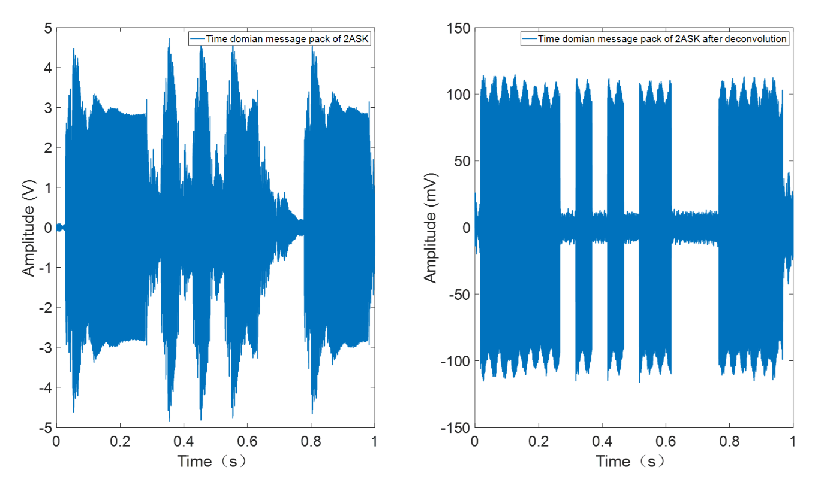
Figure 4.4 Message pack of 2ASK communication before and after deconvolution
Symbol synchronisation is another key factor that makes the demodulation successful. In this communication system, another useful aspect for the pre- and post-amble is that it can be cross correlated with the same chirp signal stored on board to give two sharp peaks which precisely illustrates the start and end points of the message pack. Figure 4.5 shows an example of signal synchronisation for the 2ASK communication. In Figure 4.5 the first and second peak above the threshold red line show the exact starting and ending points of the pre-amble and message pack around 3 seconds and 14.05 seconds, respectively. After cutting off the pre-amble and post-amble, the message pack can be extracted, passed through a filter to remove unwanted frequency components generated by the signal processing algorithm and noise in the channel. According to the adopted modulation technique, the corresponded demodulation method is then applied to decode the message. A parity check is commonly used to make sure that the binary ‘1’s and ‘0’s are not mis-recognised. The final step is to transfer the binaries back to its original form via the so called ‘decoding’ algorithm (see Figure 4.1).
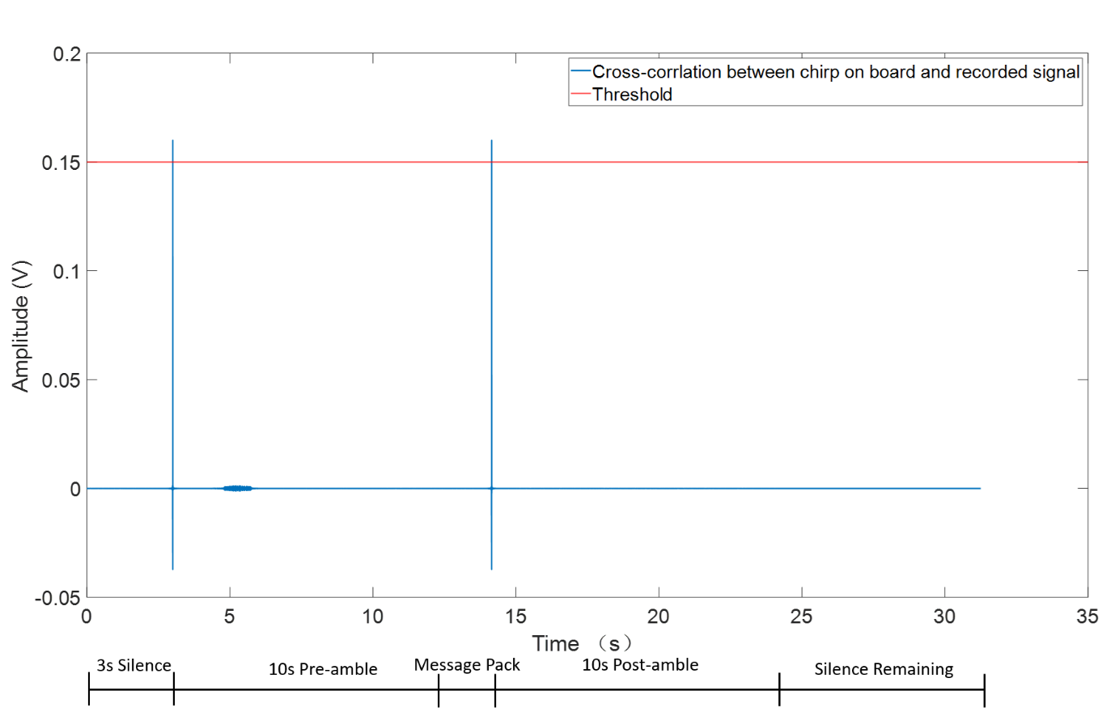
Figure 4.5 Synchronisation by cross-correlation

4.2 Modulation & Demodulation (MODEM)
In previous sections, the channel characterisation and common procedures of communications have been introduced. In this section, the MODEMs of four systems will be discussed which mainly include their mathematical expression and decision making after demodulation.

4.2.1 Binary Amplitude Shift Keying
2ASK modulation method makes use of the amplitude change in a continuous wave to transmit the digital information, while the frequency and phase of this wave are kept constant. The on-off keying (OOK) process can be expressed as:
 | $$e_{ook}\left(t\right) =\left\{\begin{aligned}Acosω_{c}t Sending \text{"1"}s by probability of P \\ 0 Sending \text{"0"}s by probability of 1-P\end{aligned}\right.$$ | (4.4)

An example of 2ASK modulation method is shown in Figure 4.6. The symbol period, $T_{B}$, in this example is 0.05s. The 2ASK signal is exactly the product of the square wave $s(t)$ (on-off sequence, top grain in Figure 4.6) and carrier wave $cosω_{c}$ (middle graph in Figure 4.6).
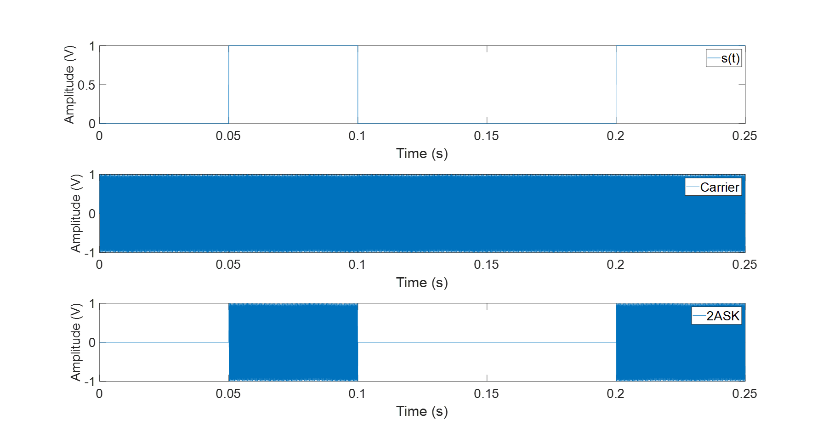
Figure 4.6 2ASK modulation waveform
Therefore, the general equation for a 2ASK signal is:
 | $$e_{2ASK}(t)=s\left(t\right)cosω_{c}t$$ | (4.5)

where
 | $$s\left(t\right)=\sum_{n}{a_{n}g(t-nT_{B})}$$ | (4.6)

and $ω_{c}=2πf_{c}$ is the career frequency. In eq. (4.6)$:$
 | $g\left(t\right)=\left\{\begin{aligned}1, \left(n-1\right)T_{B}≤t≤nT_{B} \\ 0, t>0 | T>T_{B}\end{aligned}\right.$. | (4.7)

and $a_{n}$ is a binary variable taking the value of either 1 or 0 depending on the position$n$ in the coded sequence. The symbol period, $T_{B}$, is controlled by the modulation frequency, $T_{B}=1/f_{m}$. An example of a 2ASK message waveform has already been shown in Figure 4.2 (a) in the previous section which has bandwidth of $f_{m}=$20 Hz and carrier frequency of $f_{c}=$5000 Hz. The SNR in this example is 50 dB.
The demodulation method for waveforms coded with the 2ASK method is to use coherent demodulation. The process of coherent demodulation is illustrated in Figure 4.7. This algorithm is to multiply the message pack by its local carrier wave, adding the threshold (normally 50% of the peak value for avoiding the threshold effect).
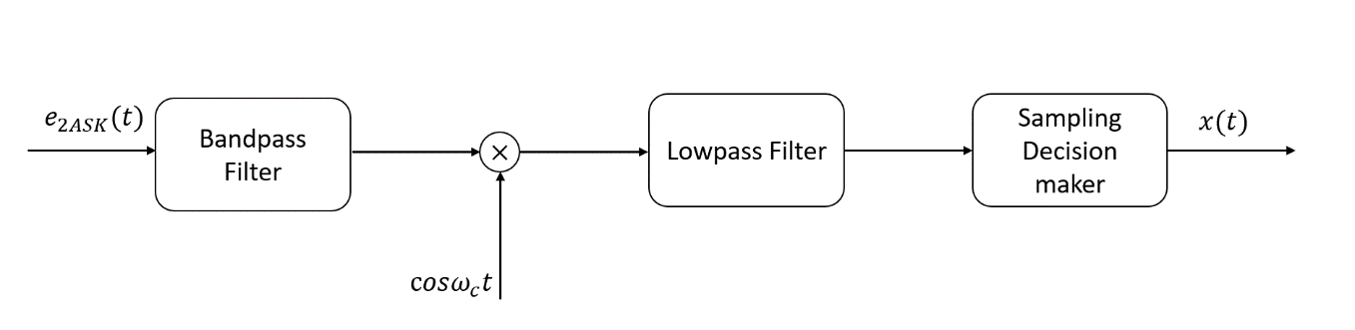
Figure 4.7 A diagram explaining the process of 2ASK coherent demodulation
Figure 4.8 shows the decision-making process for 2ASK coherent demodulation. The blue line is the waveform of 2ASK signal after demodulation, black circles indicate the sampling points used for decision making and the red line lies right in the middle (50% of peak value) is the threshold. According to the location of the sampling points, the ‘1’s and ‘0’s can be easily distinguished, and the result of demodulation has identical agreement with the binary sequences contained in excited signal.
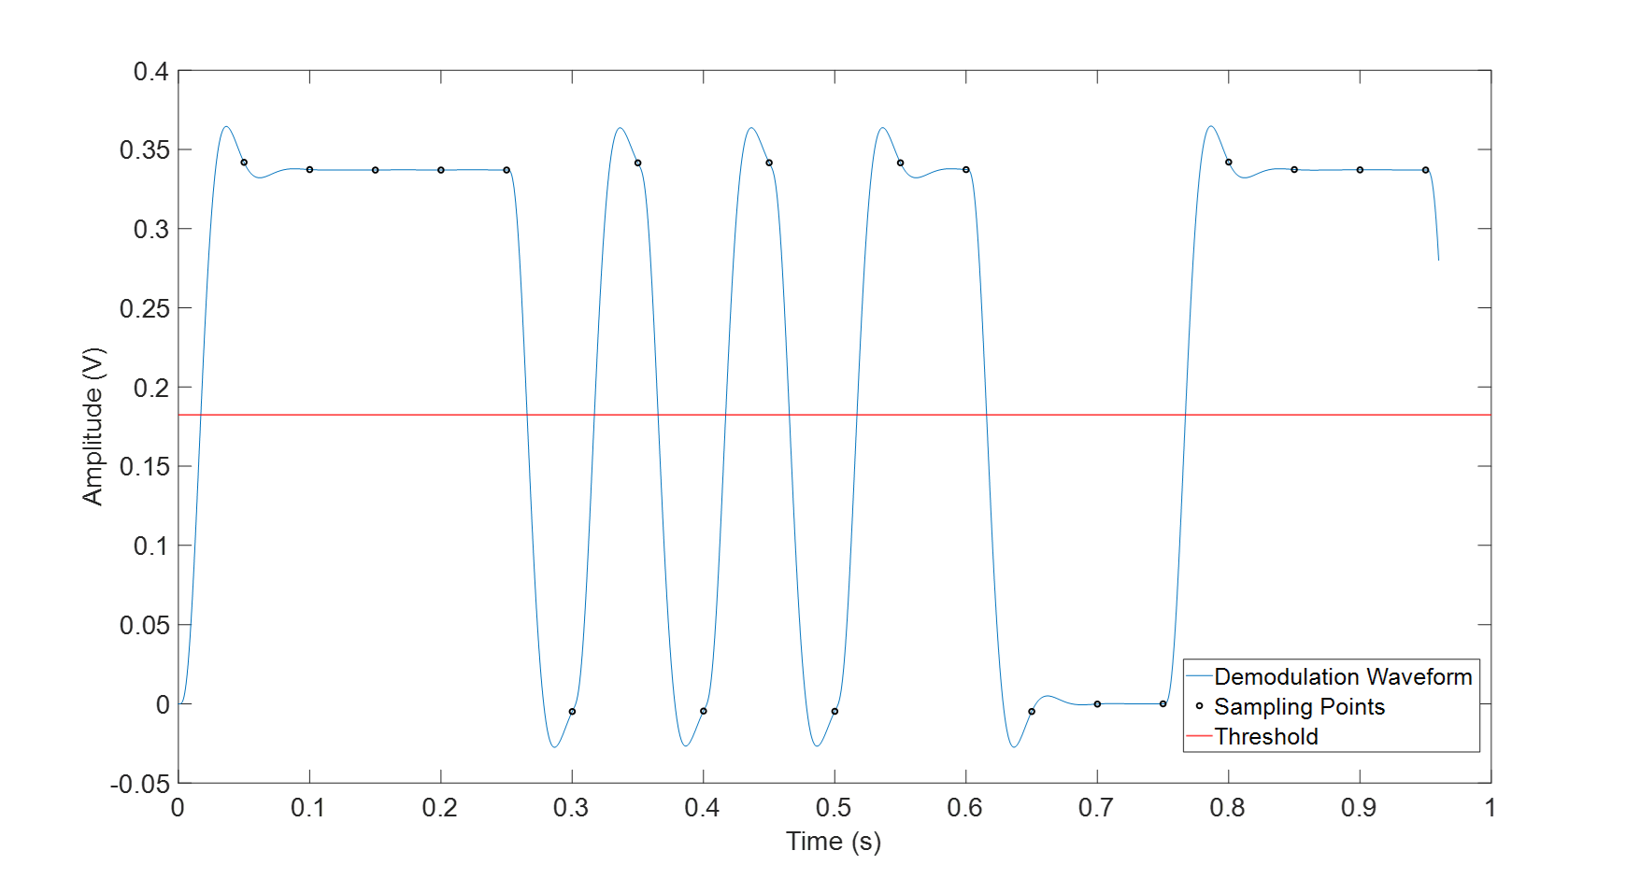
Figure 4.8 2ASK coherent demodulation waveform and decision making.

4.2.2 Binary Frequency Shift Keying
As its name, the binary Frequency Shift Keying is relying on the frequency change of the carrier and similar to 2ASK. It also can be generated by OOK method and the general mathematical form of 2FSK is:
 | $$e_{2FSK}(t) =\left\{\begin{aligned}Acosω_{c1}t Sending \text{"1"}s by probability of P \\ Acosω_{c2}t Sending \text{"0"}s by probability of 1-P\end{aligned}\right.$$ | (4.8)

Therefore, the 2FSK can be seen as being composed by two 2ASK carriers with different frequency and rewrite (4.8) in another form:
 | $$e_{2FSK}\left(t\right)=s_{1}\left(t\right)\cos\left(ω_{1}t+ϕ_{n}\right)+s_{2}(t)cos⁡(ω_{2}t+θ_{n})$$ | (4.9)
In equation (4.9), both $s_{1}(t)$ and $s_{2}(t)$ are unipolar pulse sequences and when one of them represents ‘1’, another sequence will be ‘0’ and vice versa. $ϕ_{n}$ and $θ_{n}$ are the initial phase of n^{th} symbol. However, in frequency shift keying, $ϕ_{n}$ and $θ_{n}$ can be zero because they do not deliver any information.
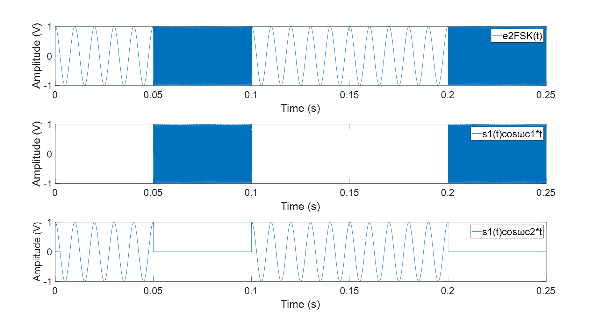
Figure 4.9 2FSK modulation process
Figure 4.9 illustrates the process of modulating a 2FSK signal. It was modulated by adding up two sub-carriers. It should be noticed that the phase between the symbols will not always be continuous because the signal was generated by OOK method. Whereas the analogue frequency circuit is capable for making phase continuous, but it also would increase the complexity of hardware design and power consuming. In this simulation, there is no such case about which the inter-symbol phase discontinuity affected the results of communication, so the OOK method has been selected.
The structure of excited signal for 2FSK is the same as 2ASK simulation which has 3s silence at the beginning, 10s sinusoid chirp pre-amble, message pack and post-amble. In addition, there are also 0.1s interval between the ambles and the message pack. However, it should be noticed that in 2FSK, the noise $N(f)$ should be added around on two sub-carrier frequencies by using same approach which has been introduced before. An example of 19 bits message pack for 2FSK has been show in Figure 4.10. The frequencies for two sub-carriers in this graph were 5000 Hz and 100 Hz respectively and the SNR was 50 dB.

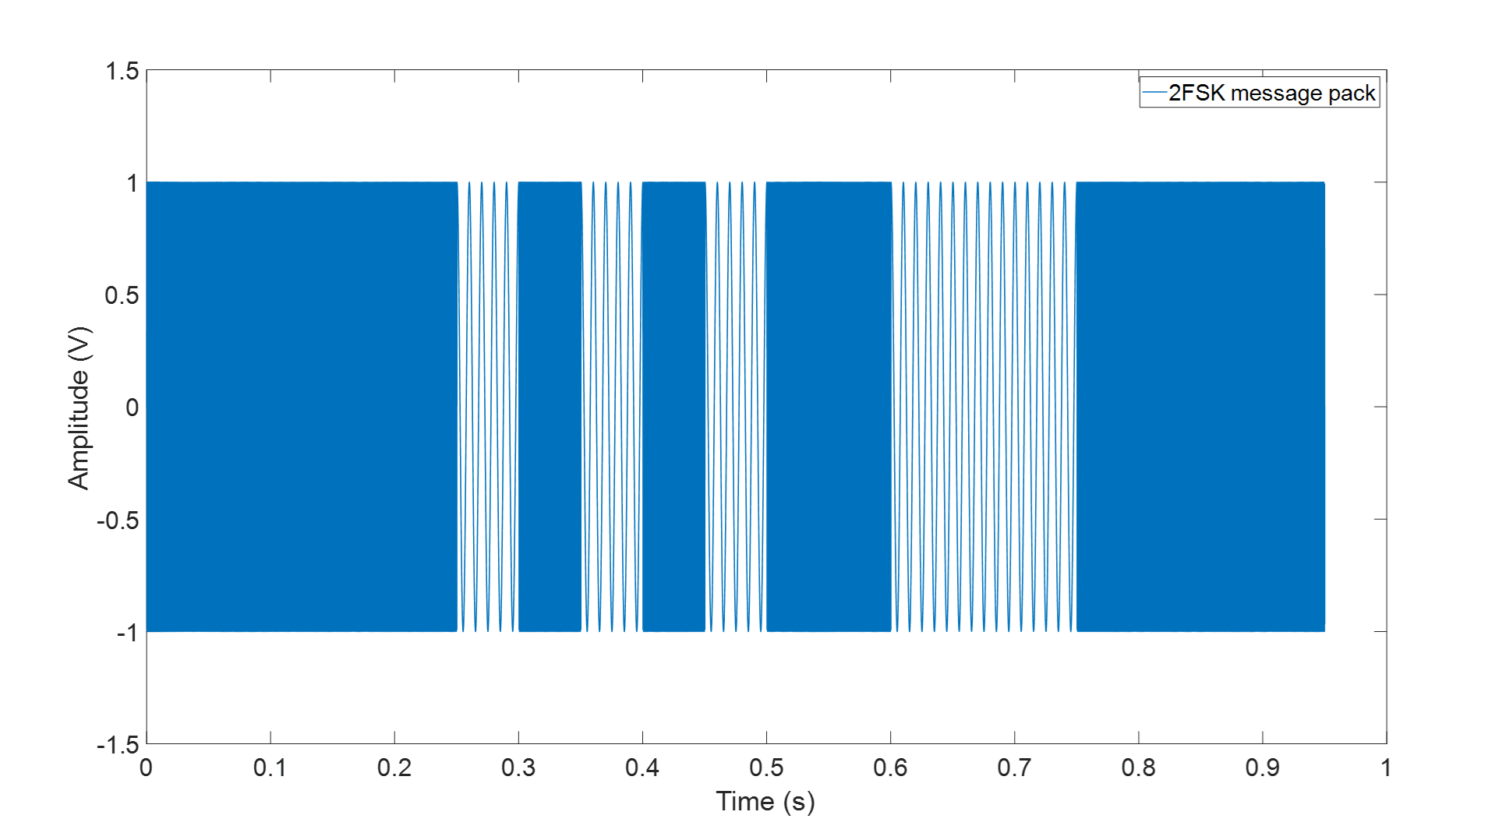
Figure 4.10 2FSK message package
In this study, 2FSK used envelop demodulation and the envelop of the received signal can be obtained by applying the Hilbert Transform. The flow diagram has been shown in Figure 4.11.
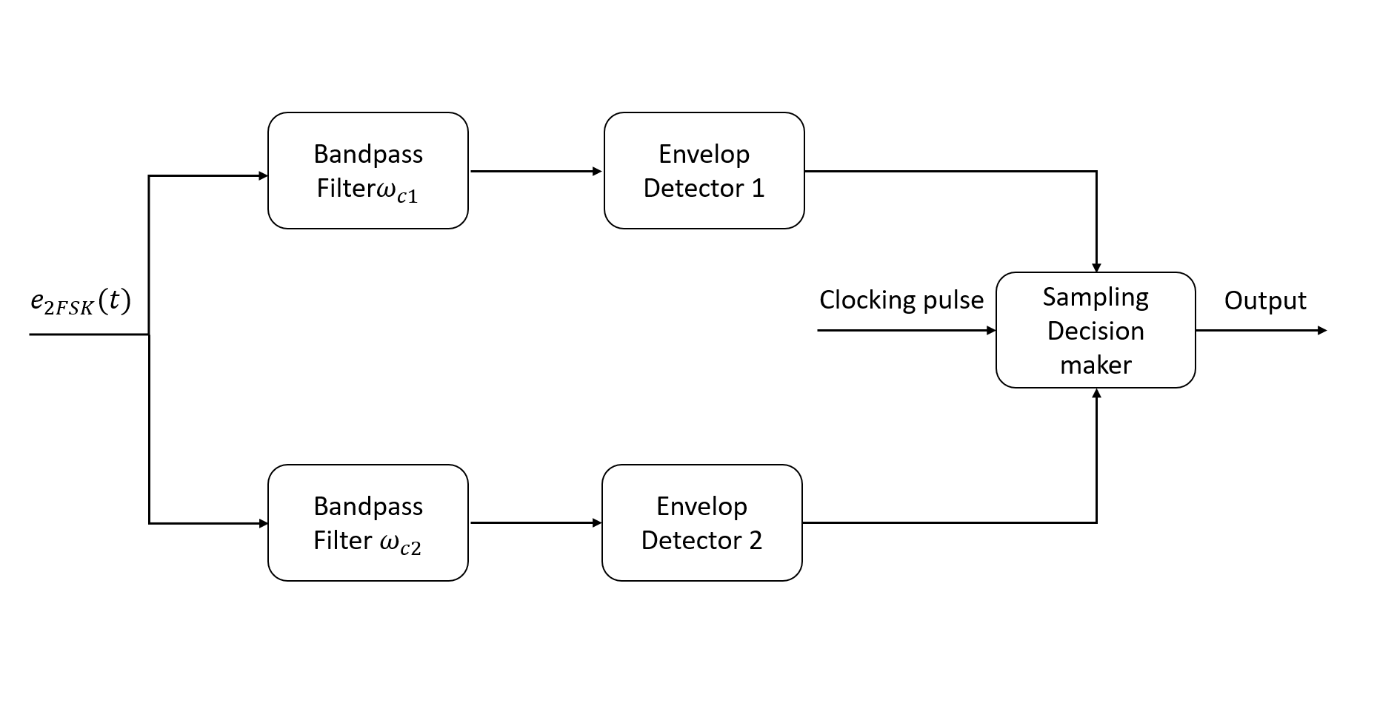
Figure 4.11 Process of 2FSK envelop demodulation.
The 2FSK signal on receiving end will be divided in two sub-signals after synchronisation and each of them will pass through a bandpass filter with their corresponding frequency band. Then their envelops will be picked up by the envelop detectors and in this simulation this step was done byHilbert Transform. The clocking pulse will help sampling decision maker to judge whether the symbol is ‘1’ or ‘0’. Finally, the results will be record as the output signal. Another advantage is that either of sub-signal can be checked by another one. The waveform of 2FSK for decoding has been shown in figure below:
Figure 4.12 2FSK coherent demodulation waveform and decision making.
Same as in 2ASK study, the blue line in the diagram is demodulation waveform which is the envelop of the 2FSK signal after passing though the bandpass filter1, red straight line is the threshold used for decision making and the black circles denotes the sampling points in the middle of each symbol. It is very clear that by comparing the threshold value and the sampling points, the binaries transmitted by 2FSK signal can be successfully recovered.

4.2.3 Binary Phase Shift Keying
The binary Phase Shift Keying utilises the adjustments of the phase of the carrier to transmit information while the amplitude and frequency are keeping constant. In general, the initial phase $0$ and $π$ are used to represent binaries ‘0’s and ‘1’s. Therefore, the mathematical expression of 2PSK in time domain can be written as:
 | $e_{2PSK}(t) =Acos(ω_{c}t+φ_{n})$ | (4.10)
where $φ_{n}$ is the absolute phase of the n^{th} symbol which has:
 | $$φ_{n}=\left\{\begin{aligned}0 Sending \text{"0"}s \\ π Sending \text{"1"}s \end{aligned}\right.$$ | (4.11)
and re-write equation (4.10):
 | $$e_{2PSK}\left(t\right)=\left\{\begin{aligned}Acosω_{c}t probability of P \\ -Acosω_{c}t probability of 1-P\end{aligned}\right.$$ | (4.12)
The 2PSK signal also can be denoted as the product of a bipolar and 100% duty ratio square wave and a sinusoidal carrier due to the two types of symbols in $e_{2PSK}\left(t\right)$ has same waveform but different polarities:
 | $e_{2PSK}(t) =s(t)cosω_{c}t$ | (4.13)

where
 | $s(t) =\sum_{n}{a_{n}g(t-nT_{B})}$ | (4.14)

and $g(t)$ is the single rectangular pulse with width $T_{B}$; the statistic property of $a_{n}$ is:
 | $$a_{n}=\left\{\begin{aligned}1 probability of P \\ -1 probability of 1-P\end{aligned}\right.$$ | (4.15)
which means when the symbol ‘0’ has been transmitted, $a_{n}=+1$, the phase of $e_{2PSK}(t)$ is $0$ while when the symbol ‘1’ has been transmitted,$a_{n}=-1$, the phase of $e_{2PSK}(t)$ is $π$. This method of directly representing corresponding binary digital signal by different phase of the carrier wave is so called absolute phase shifting approach. The principle of 2PSK modulation has been shown in Figure 4.13.
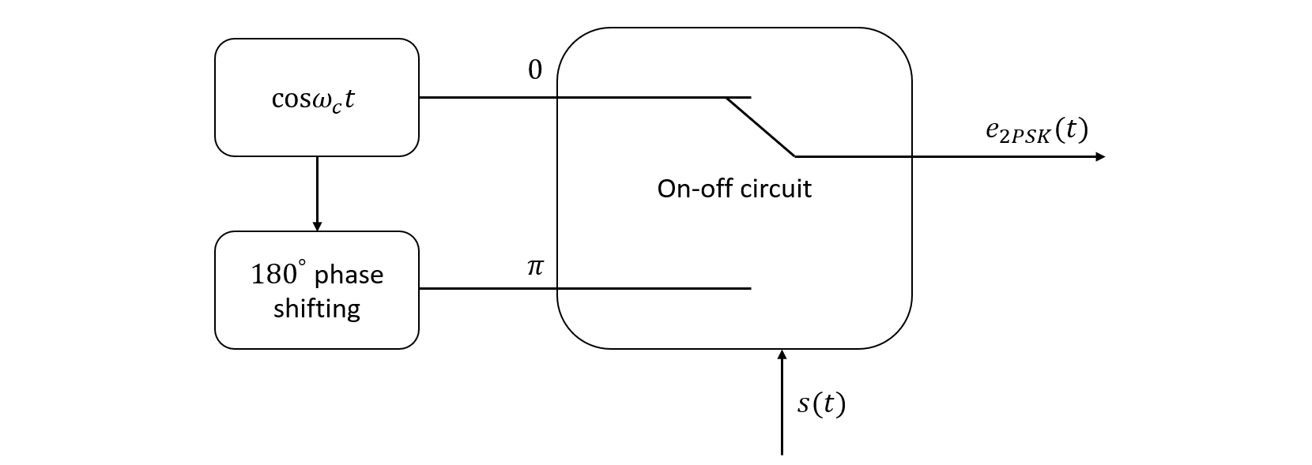
Figure 4.13 2PSK OOK modulation process
The phase of carrier $cos⁡ω_{c}t$ will be shifted ${180}^{°}$ and then the on-off circuit will control the whether the phase in symbol is $0$ or $π$. However, differ with the baseband signal in 2ASK, $s(t)$ in 2PSK is bipolar while unipolar in 2ASK.
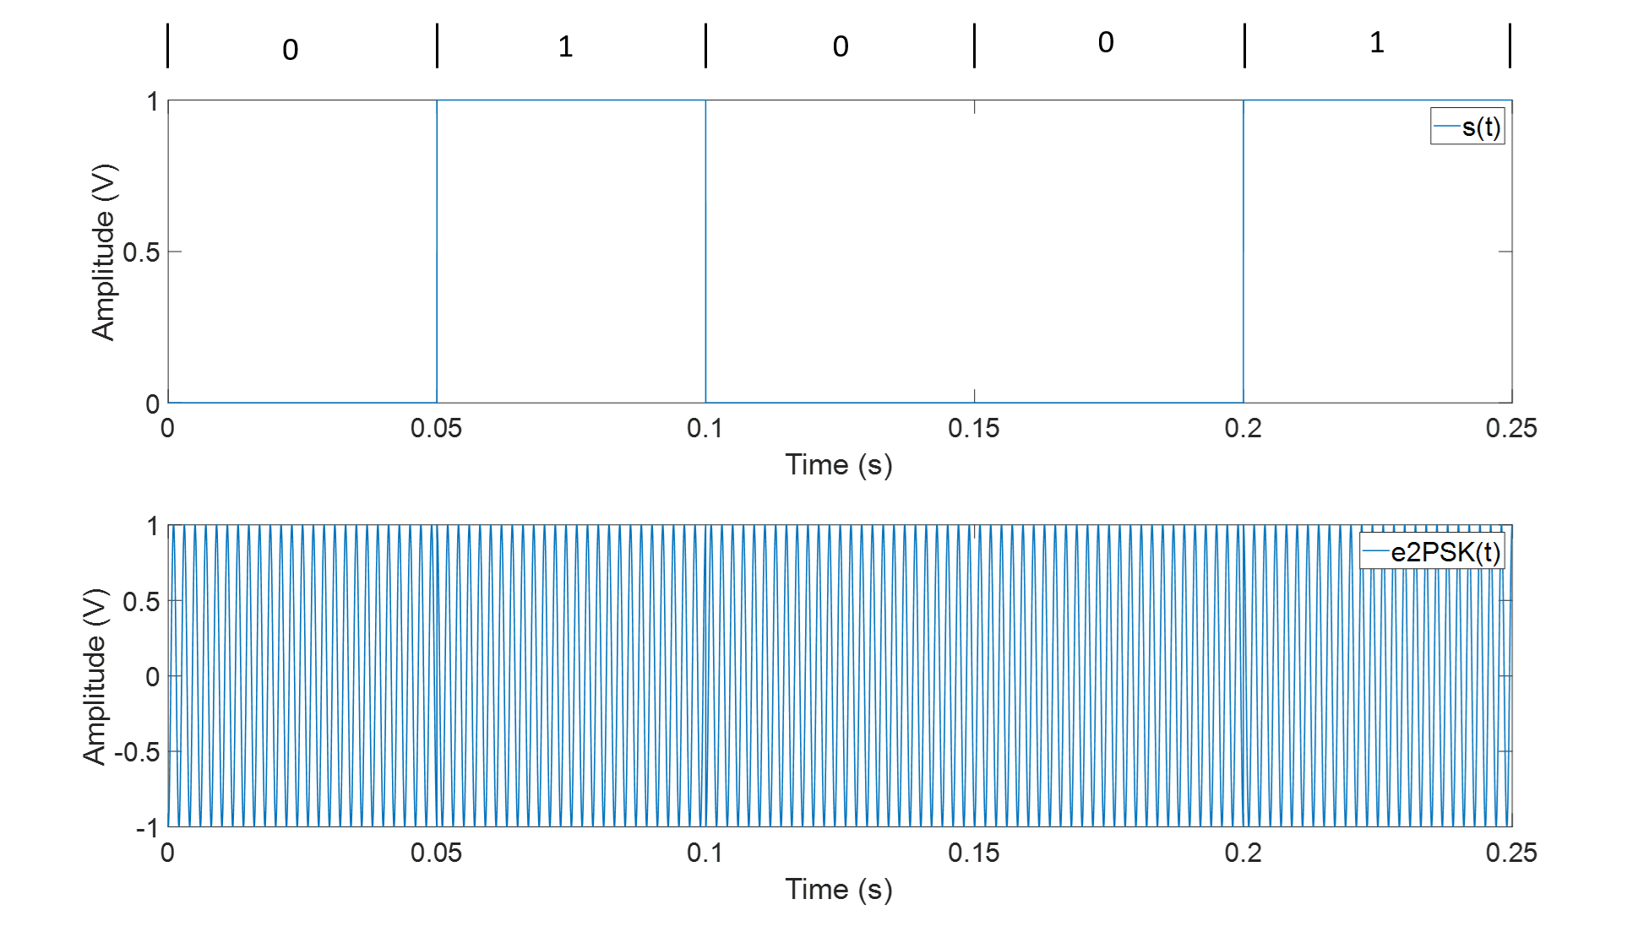
Figure 4.14 2PSK modulation waveform
Figure 4.14 shows the process of 2PSK modulation. The phase change of the carrier in the lower graph corresponds to the change of rectangular pulse above which represents the binary information.
As same as in 2ASK and 2FSK, Figure 4.15 indicates an example of 2PSK message under 50 dB SNR which contains 19 bits information and frequency of carrier is 5000 Hz and modulation frequency is 20 Hz.
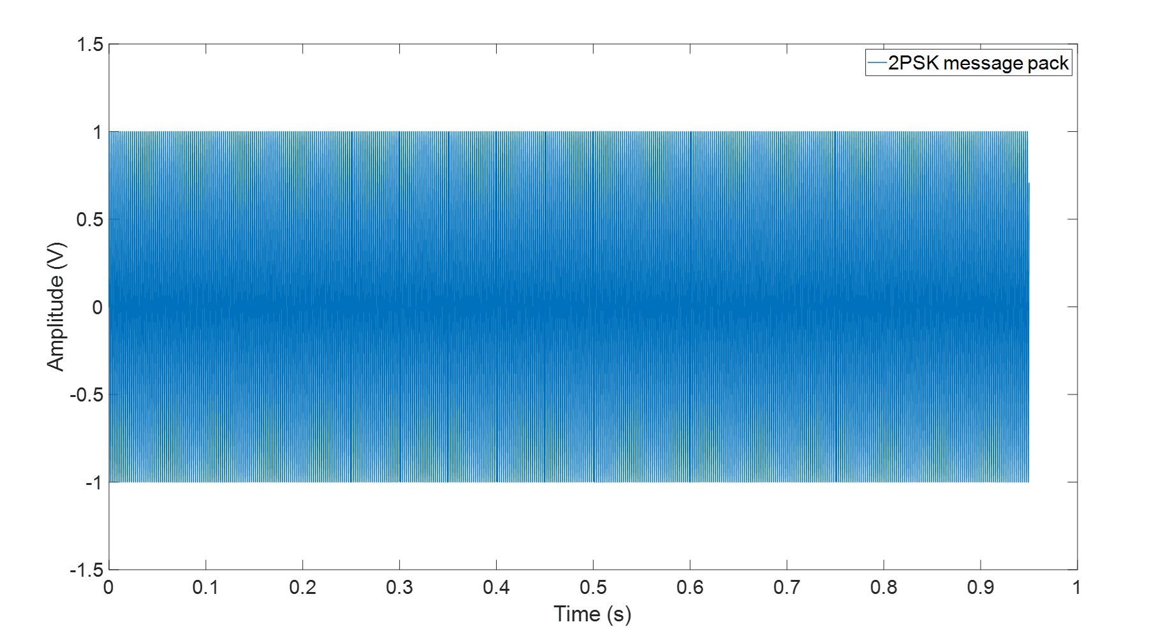
Figure 4.15 2PSK message pack
In addition, the excitation signal and the noise $N(f)$ adding procedure for 2PSK also keep the same with 2ASK and 2FSK in this simulation.
The most common demodulation method for 2PSK is coherent demodulation. Similar in 2ASK and 2FSK, the signal on receiving end firstly should pass though a bandpass filter and cancel the additive noise brought by the channel, then multiply by a local carrier. Next it will be sent into a highpass filter to remove the low frequency component. Finally, after the clocking, pick up the value at certain symbol points and compare with the threshold to make decision. The whole process is as same as which has been shown in Figure 4.12.
Figure 4.16 shows an example of coherent demodulation waveform and decision-making process of 2PSK. The carrier frequency is 5000 Hz, modulation frequency is 20 Hz and SNR is 50 dB. The blue line is the signal after lowpass filtering while the black circles and red straight line are the sampling points and threshold respectively.

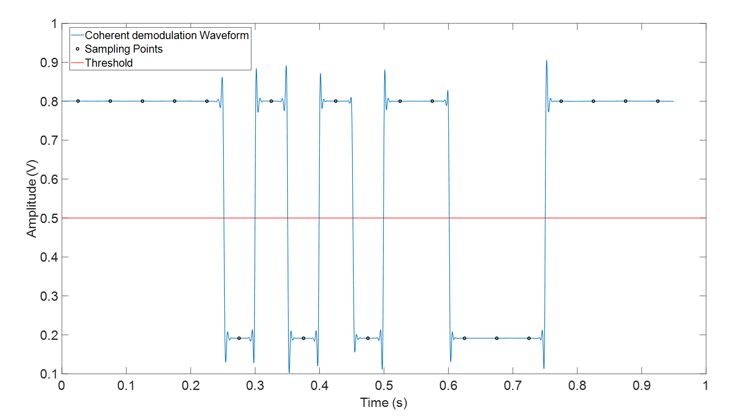
Figure 4.16 Coherent demodulation waveform and decision making for 2PSK.
In Figure 4.16, the value at sampling points and threshold can be easily distinguished due to the high SNR and the carrier frequency far away from the cut-off frequency. However, in practical application, there are always some extreme situations occur such as poor SNR, the phase properties of channel is not linear or ISI caused by multi-mode propagation. Either of them will distort the demodulation or decoding process. For example, Figure 4.17 shows that when it comes to 0 dB in SNR and modulation frequency keep constant at 20 Hz, if the carrier frequency is around 3119 Hz which is very close to the axisymmetric mode (0,1) with 12% off, the waveform will be extremely distorted. The decision making will no longer be reliable. Therefore, in order to compensate this situation, a new angle demodulation method called “Angle Demodulation “will be used for correcting the error caused by waveform distortion which has been introduced below:
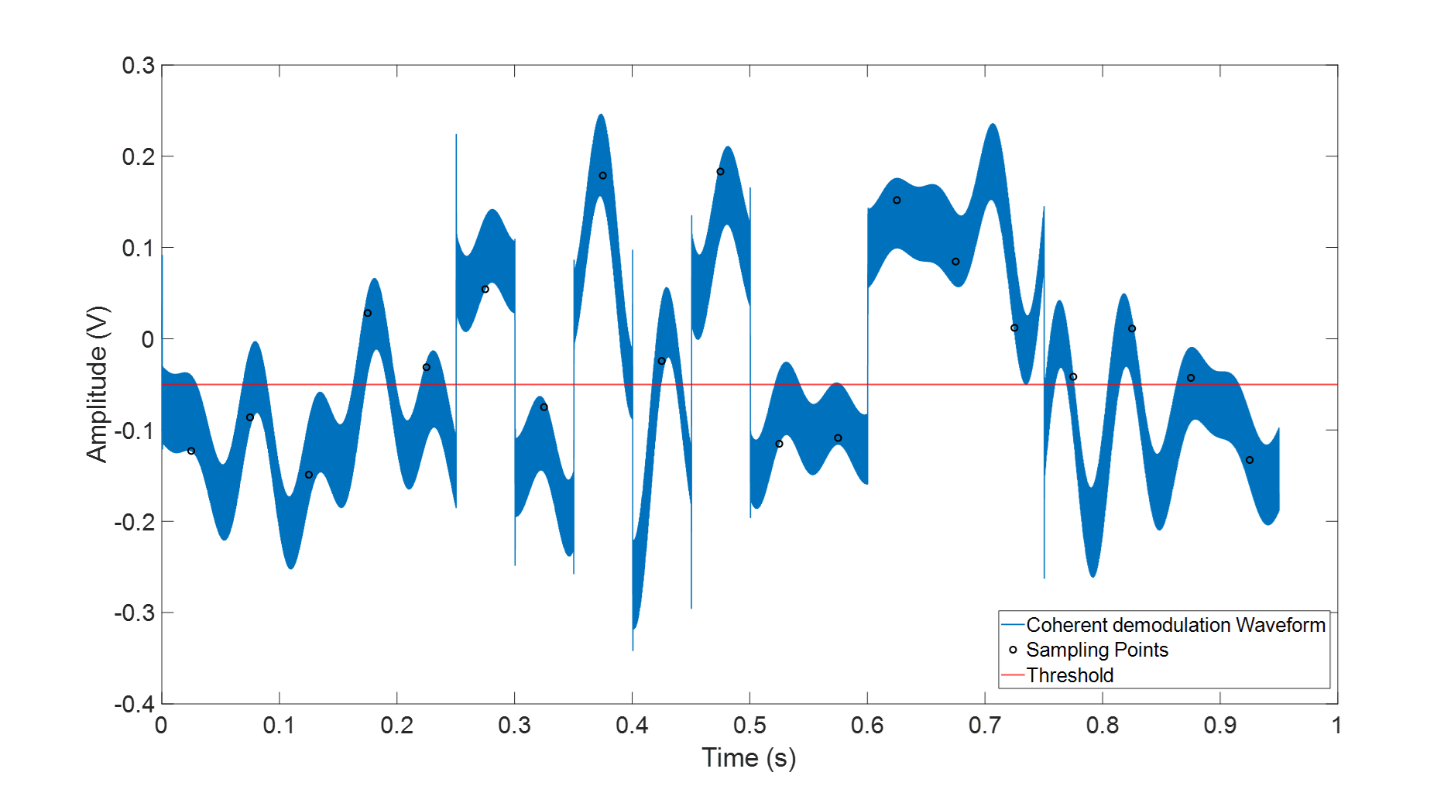
Figure 4.17 Coherent Demodulation waveform and decision making for 2PSK with 0 dB SNR and 3119 Hz carrier frequency.
Recall the general expression of 2PSK signal:
 | $$e_{2PSK}(t) =Acos(ω_{c}t+φ_{n})$$ | (4.16)
and the carrier wave with initial phase of 0:
 | $$e_{carrier}(t) =cosω_{c}t$$ | (4.17)
apply Hilbert Transform ($H()$) to both (4.16) and (4.17):
 | $${\check{e}}_{2PSK}=H\left(e_{2PSK}\left(t\right)\right)=Ae^{iω_{c}t+iφ_{n}}$$ | (4.18)
and
 | $${\check{e}}_{carrier}=H\left(e_{carrier}\left(t\right)\right)=e^{iω_{c}t}$$ | (4.19)
Then the phase difference between the symbols can be denoted as:
 | $${\check{y}}_{angle}=\frac{H\left(e_{2PSK}\left(t\right)\right)}{H(e_{carrier}(t))}=φ_{n}$$ | (4.20)
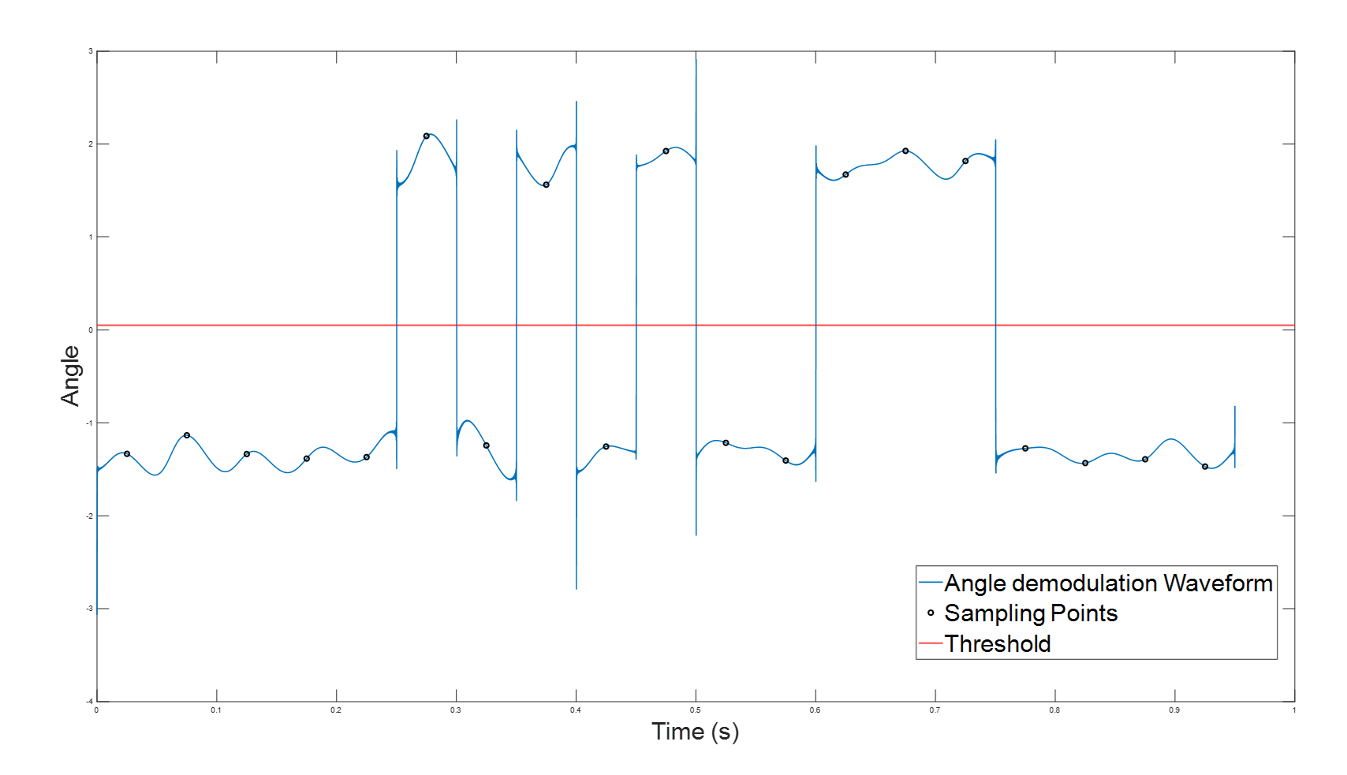
Figure 4.18 Angle Demodulation waveform and decision making for 2PSK.
Figure 4.18 illustrates the results of the angle demodulation approach for the signal with 3119 Hz carrier frequency, 20 Hz modulation frequency under 0 dB SNR. It is pretty clear that after comparing all the value at sampling points with the threshold, all binaries have been correctly recovered which means this method has successfully compensated the shortage of coherent demodulation.

4.2.4 Chirp Linear Frequency Modulation
Chirp Linear Frequency Modulation utilises the frequency of the sinusoid chirp from high to low and low to high to form a linearly modulated signal carrying a message. This method has been widely applied in underwater acoustic communication. The authors of Ref. [19] have done a considerable amount of work on this method and demonstrated that it had a great noise resistance to operate in a low SNR environment. Because each symbol in the message is modulated by a sinusoid sweep containing relative high energy, it is believed that there is also a potential to cope with the effect of multi-mode propagation to become one of the most reliable solutions for in-pipe acoustic communication.
The modulation process also can be achieved by the OOK method. However, in order to prevent the mis-synchronisation and ISI during the demodulation, there are 0.001s intervals added between each symbol.
 | $$e_{chirp}=s\left(t\right)*Asin(2πf\left(t\right)t+ϕ_{0})$$ | (4.21)
As same as previously $s\left(t\right)=\sum_{n}{a_{n}g(t-nT_{B})}$ which is the square wave with symbol period$T_{B}$. The transient frequency in equation (4.21) can be expressed as: $f\left(t\right)=\frac{1}{2π}\frac{dϕ_{1}(t)}{dt}$ and due to the change of the frequency for chirp signal is linear. So $f\left(t\right)=f_{0}+kt$ and $k=\frac{f_{1}-f_{0}}{T}$, $f_{1}$ and $f_{0}$ are the start and end frequency for the chirp and $T$ is the period of $e_{chirp}$. Therefore, the general form of CLFM can be written as:
 | $$e_{CLFM}(t)=\left\{\begin{aligned}Asin\left(2πf_{high\sim low}\left(t\right)t+ϕ_{0}\right) Sending \text{"1"}s \\ Asin\left(2πf_{low\sim high}\left(t\right)t+ϕ_{0}\right) Sending \text{"0"}s\end{aligned}\right.$$ | (4.22)
In addition, the initial phase for the CLFM $ϕ_{0}$ can be set as 0. The principle of CLFM modulation has been shown in Figure 4.19.
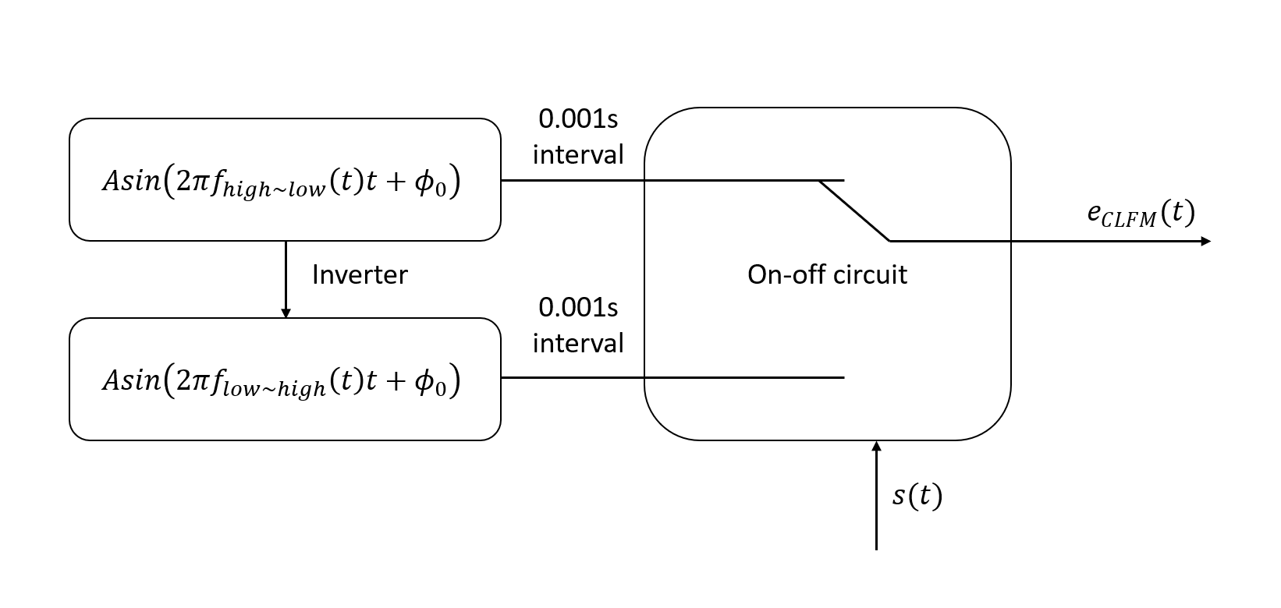
Figure 4.19 CLFM modulation process
The frequency of the sinusoid sweeps from high to will be used to represent binary ‘1’s and in contrast, low to high will be used for ‘0’s. Figure 4.20 indicates an example of the modulation of CLFM. In this example, the frequency range was chosen from 1500 to 5000 Hz. $s(t)$ is the square wave which contains the binary information. Two graphs in the middle are single chirp component which represents ‘1’s and ‘0’s and the last graph is the final waveform after the modulation.
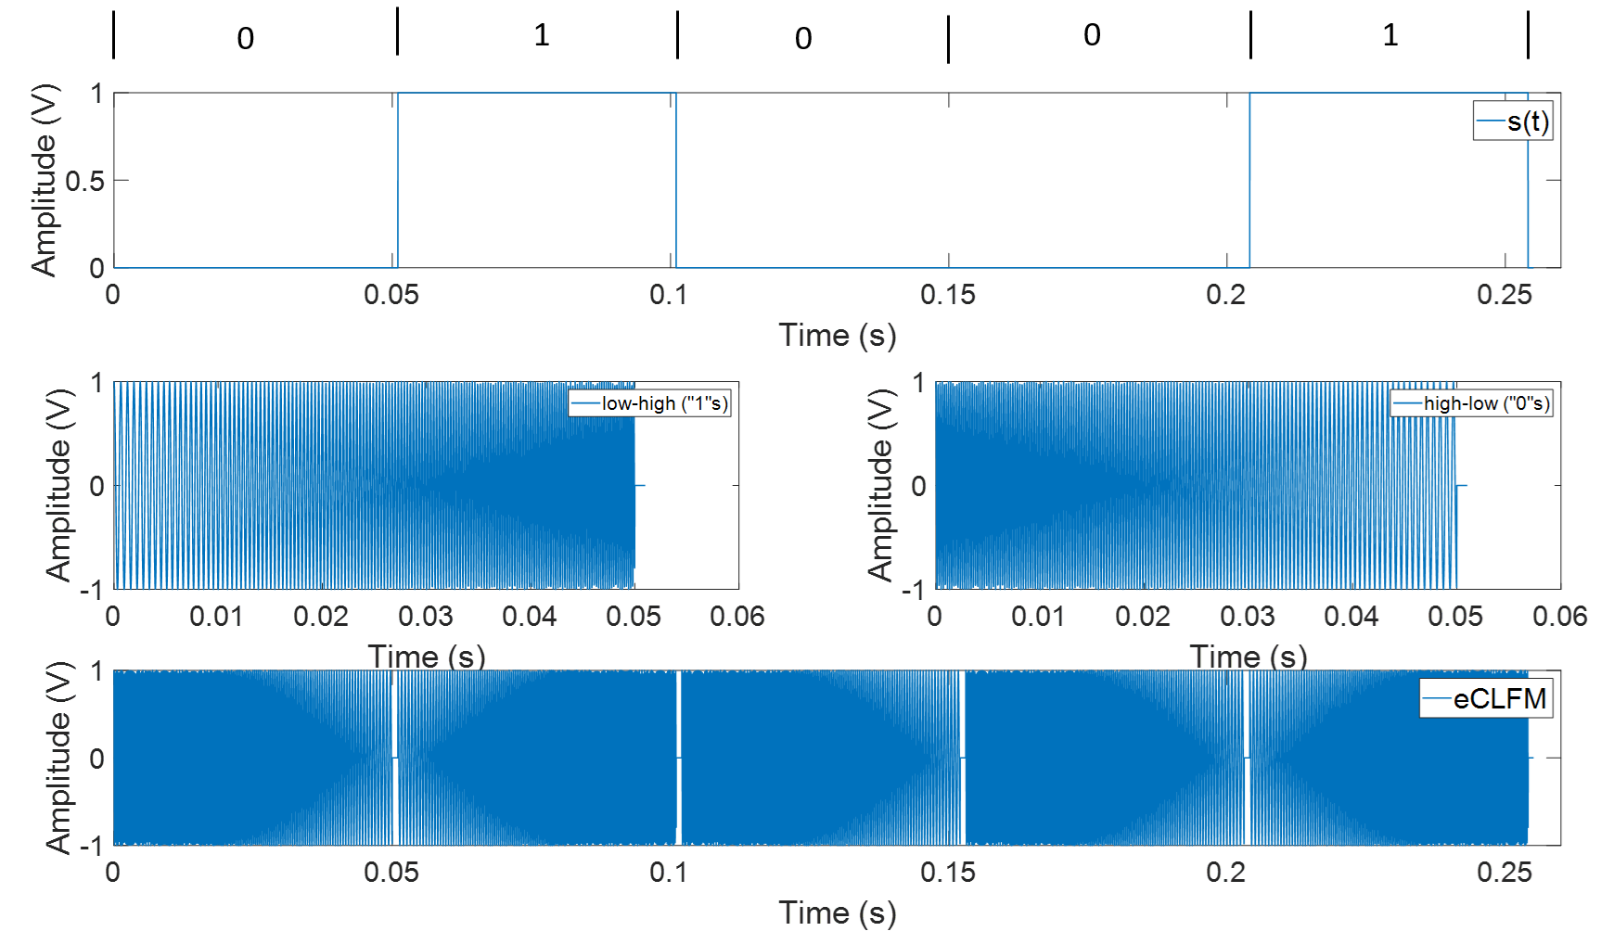
Figure 4.20 An illustration of key stages in the CLFM modulation process: (Top diagram) Square wave S1(t) to show the binary change of sending “1” s and "0"s.( ((Top second diagram). (Two middle diagrams)Sub-chips with frequency from low to high and high to low. (Bottom diagram) modulated CLFM signal.

Differ with the traditional demodulation process, CLFM utilises the cross-correlation decoding approach to distinguish between ‘1’s and ‘0’s in the message pack. The method is to store the two chirp signals on board and then cross-correlate them with the whole message pack signal on the receiving end. By doing so, the symbol which has high relevance will illustrate a high correlation with the right chirp whereas the cross-correlation results of other chirp will be very low. Figure 4.21 (a) indicates CLFM demodulation results under the SNR of 50dB, symbol period is 0.05s and frequency range for the sub-chirps is between 4000 and 5000 Hz.
In Figure 4.21 (b) and (c), the decision making can be based on detecting whether or not the sharp correlation maximum is within the time window. In addition, the peak value in Figure 4.21 (c) is around 0.001 V which is nearly 5 times as much as the averaging value in Figure 4.21 (b), therefore this modulation technique has very good noise resistance. The noise resistance can be further improved by widening the frequency range of the sub-chirps and symbol period even though it will cost the data transmission speed.
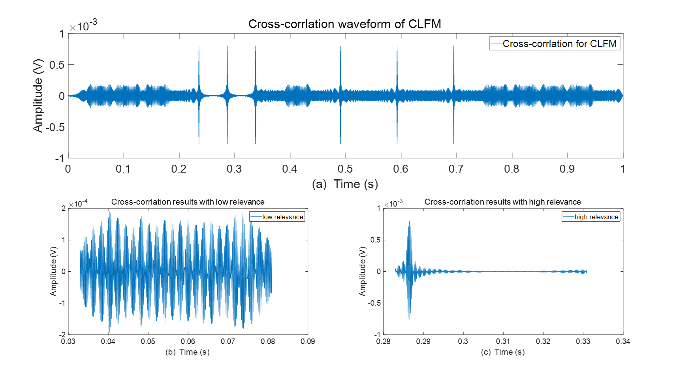
Figure 4.21 (a) Cross-correlation results for CLFM. (b) Signal in window with high relevance. (c) Signal in the window with low relevance.

4.3 Simulation and Experimental Validation
The last two sections discussed the importance of channel characterisation using an analytical method and MODEMs to support communication techniques in pipes. It was noted there may be some issues while transmitting information in the pipe at a carrier frequency that is higher than first cut-off frequency of the pipe. At these frequencies the sound wave is no longer a plane wave as it propagates in a plurality of way (multi-mode propagation) causing the signal to spread. Such phenomenon is likely to lead to some inter-symbol interference and increase in the number of error bits. Another reason for error bits is the wide band additive noise. It is generally believed that in real partially filled pipes, e.g. sewers and drainage pipes, there is a considerable amount of noise generated by the road traffic, water flow and nearby industrial installations. The effect of this noise on the quality of communication cannot be ignored. Finally, it should be noticed that the communication range and communication speed are controlled by the sound attenuation in the pipe. This section will focus on these challenges and explore through simulation and experiment how the four communication techniques cope with these challenges.

4.3.1 Simulation of the Effects of SNR
The reliability of each of the four communication techniques under different SNRs was tested through simulation by using the analytical model and measured response of the pipe. This evaluation was based on comparing the probability of package error rate (PER) for the four techniques as a function of the SNR and carrier frequency predicted through the signal processing algorithm described in section 4.1 and 4.2. In this study the signal with the message was not broadcast in the actual pipe, but analysed through a Matlab simulation.
Firstly, the carrier frequency and modulation frequency were keeping constant, but SNR was varied between -30 and 20 dB. The PER was calculated as:
 | $$PER=\frac{N_{error}}{N_{total}}$$ | (4.23)
where $N_{error}$ is the number of error bits and $N_{total}$ is the total number of bits in the message pack. In this simulation the length of the message pack was set to 19 bit which contained 15 random binary information bits and 4 extra parity check bits. For each type of system, the test was repeated 200 times. Each time the information bits were randomly changed, message was decoded, decoded messaged was compared to that initially sent and PER was calculated according to Eq. (4.23). The PER for each of the 200 runs were averaged to ensure that the final result makes good statistical sense.
In this study, the modulation frequency was chosen as 20 Hz, carrier frequency of 5000 Hz for 2AKS, 2FSK and 2PSK. The frequency of the modulation chirp for the CLFM was set in range between 4000 Hz and 5000 Hz. The reason for choosing this setup was that 20 Hz narrow band modulation could give relatively good noise resistance which ensured that the system was tested under a relatively low SNRs. This relatively low bit rate is sufficient for autonomous robots to communicate messages related to their location inside the pipe and operational status. The choice of the frequency range around 5000 Hz was based on the balance between the sound attenuation which increases with the frequency and number of carrier frequency period required to modulate a message with the bits transmitted at 20 Hz. The relation among attenuation, communication range and communication speed will be specifically discussed in the next section.
Figure 4.22 presents the package error rate as a function of the SNR. These results were obtained for the four communication techniques making use of the predicted frequency response function (FRF) (Figure 4.22 (a)) and experimentally measured FRF (Figure 4.22 (b)) for a dry 150 mm diameter pipe. The model and experiments are in section 1. The FRF of the pipe was used in the deconvolution to improve the quality of the signal with coded message (see section 4.1). The results presented in Figure 4.22 suggest that the package error rate (PER) depends strongly on the signal noise. There is some difference in the PER behaviour calculated with the two FRFs. According to these results the quality of the communication channel calculated with the predicted FRF improves much faster with the increased SNR than that calculated with the measured FRF. Also, the difference in the performance of the four communication techniques is relatively less when the FRF is predicted (around 5 dB between CLFM and 2FSK to reach 1% probability). The pattern in the behaviour of the PER as a function of the SNR is similar for all the four communication techniques. When the SNR reaches certain level, the PER begins to drop exponentially. For relatively low SNRs the PER reaches its theoretical limit of around 50%. In the case when the FRF was measured, the best performing method by far was the CLFM (see Figure 4.22 (b)). This method enables to reach a PER = 1% at SNR = -7.5 dB. This is almost 15 dB better than the 2 FSK. The performance of the 2ASK and 2PSK was found similar and between that calculated for the CLFM and 2 FSK.
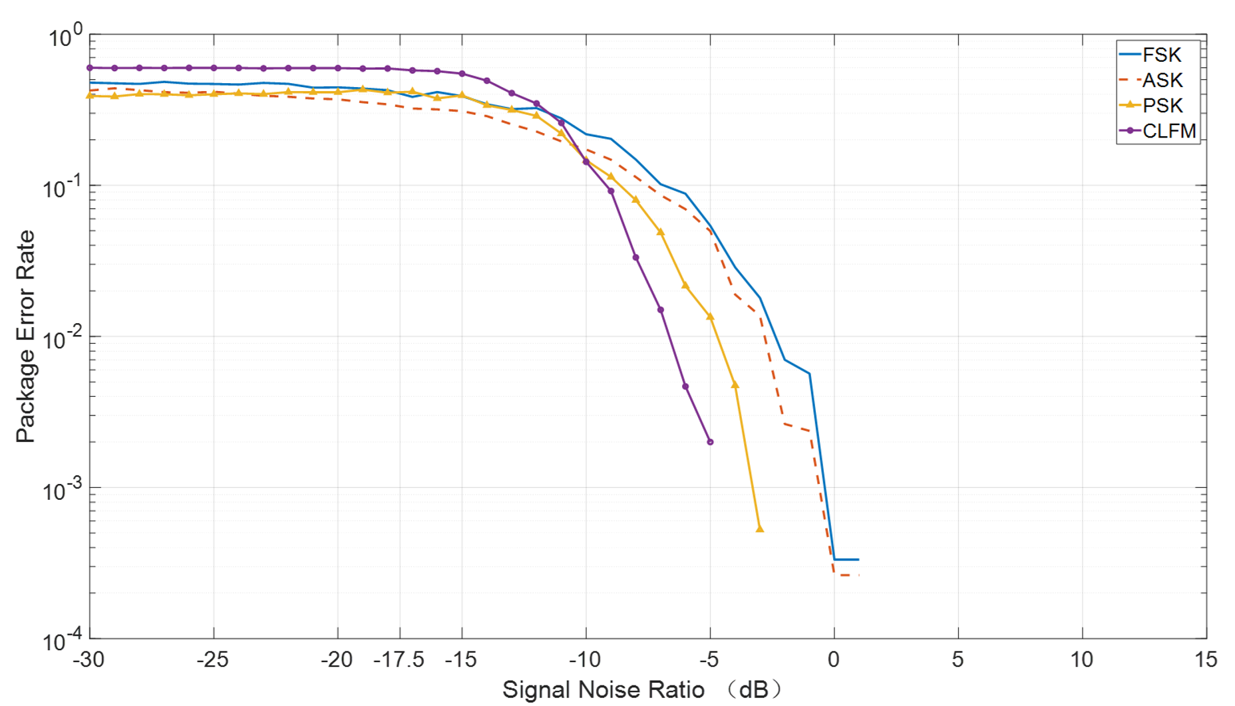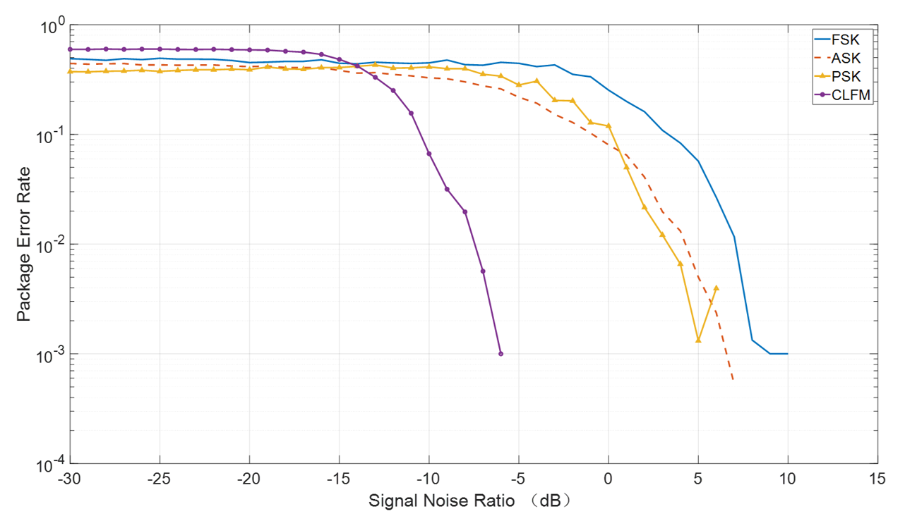
Figure 4.22 A Diagram illustrating the PER for the four communication technologies with 20Hz modulation frequency (5000 Hz carrier frequency for 2ASK, 2PSK, 2FSK and 4000Hz-5000Hz modulation chirp for CLFM) as a function of the SNR: (a) analytically obtained FRF for the pipe (top). (b) measued FRF (bottom).
There are several other conclusions can be made. Firstly, increasing the SNR can improve the quality of cross-correlation which is helpful to reduce the PER for the CLFM further. Secondly, the performance of 2FSK, 2ASK and 2PSK techniques drops relatively with the increased SNR suggesting that these three modulation methods can be more easily affected by the complexity of the pipe and ambient noise present. In real application, the three techniques would require a relatively high SNR to ensure transmitting data successfully. Finally, the results shown in Figure 4.22 suggest that a low SNR would directly increase the probability of error bits. The difference between using measured channel and using analytical will cause 5dB-10dB increase of lowest working SNR condition for binary digital modulation, however for CLFM, the difference was not very clear.

4.3.2 Experimental Validation of the Effects of SNR
In this section, the overall performances of four communication techniques were studied experimentally to verify the calculations presented in section 4.3.1. The message signal was emitted by the loudspeaker and received on the microphone using the experimental setup shown schematically in Chapter 3 (Figure 3.2). The distance between speaker and microphone was set to 10 m. The recorded signal was processed accordingly, demodulated and decoded to study the effect of the background noise on the PER. The initial SNR in the experiment was measured as 45 dB and this value was used subsequently as the reference representing the ‘no noise condition’. The SNR was reduced progressively to -30 dB by the introduction of artificial background noise. For each SNR the measurement was repeated 200 times, PER value for each of these measurements was calculated, and their average was presented as a final result.
The measured PER as a function of the SNR for each of the four communication techniques is shown in Figure 4.23. This figure confirms that the CLFM is the most robust communication technique in terms of its ability to cope with the background noise. The experimentally obtained PER for this technique reduces slightly slower than that calculated using the measured FRF and MATLAB simulation. The difference in performance between these cases is close to 5 dB (see Figure 4.22 (a) and Figure 4.23). This 5 dB decrease can be caused by the pipe ends, imperfect seals in the connections between the pipe sections. There also can be some differences associated with the microphone and speaker response attained at the time of the two sets of experiments. Even though the deconvolution method cancelled the influence of these factors to some extent, it may not be fully reliable for lower SNRs. Similar discrepancies were observed when the other three communication techniques were validated experimentally.
The results shown in Figures 4.22 and 4.23 generally validate the calculations made through the simulation. The acoustic signal passing through the pipe experiences strong multi-mode propagation. When the pipe has a finite length, the influence of multi-path effect and reflections caused by the open ends and connections cannot be ignored but hard to predict but can affect the quality of communication. They deserve more attention through more refined simulations and better controlled experiments. Those undesirable channel properties can be potentially equalised by applying deconvolution with the right FRF. Among the proposed four communication techniques the CLFM was proved to have the best noise resistance with the PER = 1% at SNR = -1.5 dB. This performance was attained with the 2ASK, 2PSK and 2FSK at SNR = 4, 7.5 and 8 dB, respectively.
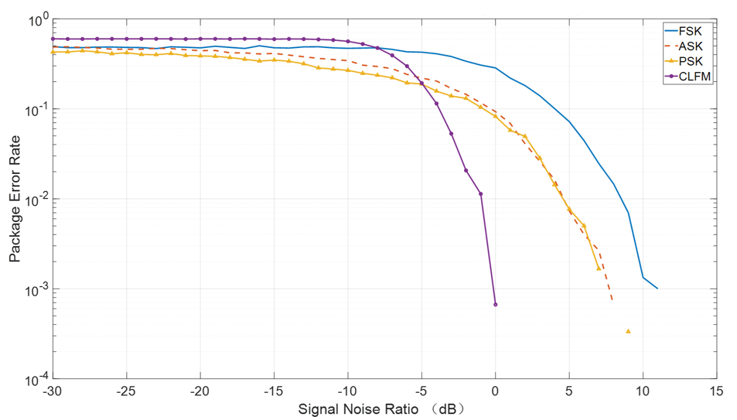
Figure 4.23 Diagram illustrates the experimental validation for comparison of 4 communication systems with 20Hz modulation frequency and 5000 Hz carrier frequency and 4000Hz~5000Hz modulation chirp for CLFM under SNR in the range between -30dB~20dB

4.3.3 The Effect of Carrier Frequency
In Chapter 3 it was noted that a pipe supports a number of modes which can be excited when the carrier frequency exceeds a certain threshold called the cut-off frequency. Beyond this frequency sound propagation is multi-modal and dispersive causing the waveform with the message to stretch and distort. A simulation was carried out to determine the relation between the carrier frequency and PER. In order to give a better view of this relation, the carrier frequency was nondimensionalised to the product of wavenumber and radius of the pipe:
 | $$kr=\frac{2πf_{c}}{c_{0}}$$ | (4.24)
This simulation also was repeated 200 times to make sure the results are statically reliable. The modulation frequency $f_{m}$ was set to 20 Hz and SNR was set as 0 dB. The testing range of carrier frequency $f_{c}$ was set from 500 to 5000 Hz for 2ASK, 2FSK and 2PSK. Different to the three binary digital modulation techniques, in the case of CLFM, the central frequency$f_{central}$ of sub chirp was changed between 800 Hz to 4500 Hz with a 10 Hz step. Then the frequency range of sub chirp was set as [$f_{central}$-500 Hz, $f_{central}$+500 Hz]. For example, a sub-chirp with $f_{central}$ of 1200 Hz, the frequency range was set form 700 Hz to 1700 Hz.
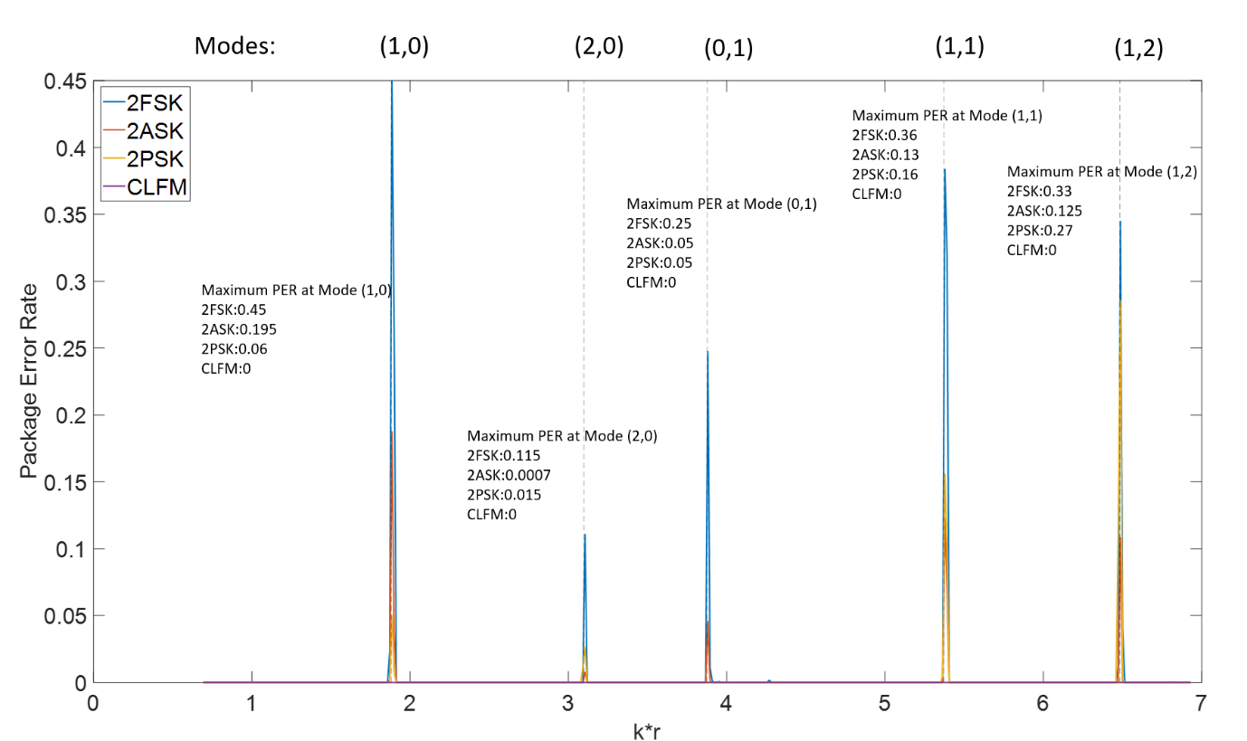
Figure 4.24 A diagram showing the dependence of the PER on the dimensionless frequency for SNR = 0dB and f_m = 20 Hz.
Figure 4.24 illustrates the results of this simulation. The modal frequencies are marked as grey dash lines. As it has been deduced previously, sending message at the carrier frequency close to a modal frequency result in high possibility to cause a high bit error close to its theoretical maximum. Therefore, it should be suggested that carrier frequency of in-pipe acoustic communication should be chosen to avoid being close to a modal frequency. Similar to the results shown in Figures 4.23 2FSK was found the most unstable among the four communication techniques when the carrier frequency is close to a cut-off frequency. The 2PSK was ranked the second most unstable technique and 2ASK works slightly better than the latter two. Most importantly, the PER of CLFM keep remaining 0 though the entire simulation which not only determine that this technique is able to overcome the effects of modes but also validate that compared with 2ASK, 2PSK and 2FSK, it has the best noise resistance.

4.4 Communication Speed Evaluation
In digital communication the speed of information transmission is calculated by the bit rate (bps)$, R_{b}=\frac{n}{T_{m}}$. The index $n$ denotes the number of bits contained in the message pack and $T_{m}$ is the period/duration of the message pack. In binary modulation one symbol period $\frac{1}{f_{m}}$ only represents one bit and bit rate $R_{b}$ is also equal to the modulation frequency $f_{m}$. Increasing the bit rate can be achieved through a higher modulation frequency. However, doing so would require wider bandwidth in frequency domain. Therefore, the carrier frequency $f_{c}$ needs to be as high as possible to ensure there will be sufficient blank space for the wide band communication.
For 2ASK and 2PSK, the bandwidths are twice as the symbol rate, therefore they have:
 | $$B_{2ASK/2PSK}=2f_{m}$$ | (4.25)
so that the maximum bit rate for 2ASK and 2PSK system is:
 | $$R_{b_{2ASK/2PSK}}{\left.​\right|}_{max}=\frac{1}{2}f_{c}$$ | (4.26)

In the case of the 2FSK 2 sub-carriers are adopted so that its bandwidth can be approximated with:
 | $$B_{2FSK}=\left|f_{2}-f_{1}\right|+2f_{m}$$ | (4.27)
and
$$f_{2}-f_{1}>f_{m}$$ | (4.28)
The centre frequency of this band is:
 | $$f_{centre}=\frac{f_{1}+f_{2}}{2}$$ | (4.29)

Let us assume that $f_{1}$ is always lower than $f_{2}$. Then we have:
 | $$\frac{f_{1}+f_{2}}{2}>f_{2}-f_{1}+2f_{m}$$ | (4.30)
 | $$R_{b_{2FSK}}=f_{m}<\frac{f_{1}}{2}$$ | (4.31)
Thus, combine Eq. (4.28) and Eq. (4.31), the maximum bit rate for the 2FSK is half of lower sub-carrier frequency while $f_{2}=\frac{3}{2}f_{1}$.
In the case of the CLFM the carrier wave is a chirp signal which spectrum covers a range of frequencies. In principle, its bandwidth could be infinitely wide and therefore the CLFM is also a spreading spectrum communication technique. However, according to the Nyquist sampling law, $f_{c_{max}}<\frac{1}{2}f_{sampling}$, the maximum frequency in the chirp should be lower than the half of the sampling frequency. In addition, there are a time interval $T_{int}$ between each symbol to avoid neighbour symbol overlap. In this case the total message pack period $T_{message}$will need to be:
 | $$T_{message}=\lim_{N→∞}{(\frac{1}{R_{b}}N+T_{int}\left(N-1\right))}$$ | (4.32)
where $N$ is the number of symbols in the message package. For the purpose of cancelling the ISI caused by the multi-mode propagation $T_{int}$ should be based on:
 | $$T_{int}=\frac{z}{c_{g}}$$ | (4.33)
In equation (4.33), $z$ is the distance between the source and receiver and $c_{g}$ is group velocity of the waveguide and the actual bit rate for CLFM is:
 | $$R_{b}{\left.​\right|}_{actual}=\frac{T_{message}}{N}$$ | (4.34)
The group velocity is usually frequency dependent in a multi-modal pipe. It is very clear that attempting to fully avoid ISI will sacrifice the communication speed and for the short range and period communication, the influence of time interval can be ignored while in long range and period message transmission, this effect has to be taken into account.
The attenuation of the sound in the pipe is not a negligible issue of using high frequency carrier wave for the in-pipe acoustic communication. It is mainly affected by two parameters: absorption coefficient and distance between the source and microphone while the former is proportionally frequency dependent. The method of calculating the sound absorption coefficients has been introduced in chapter 3, section 3.3.

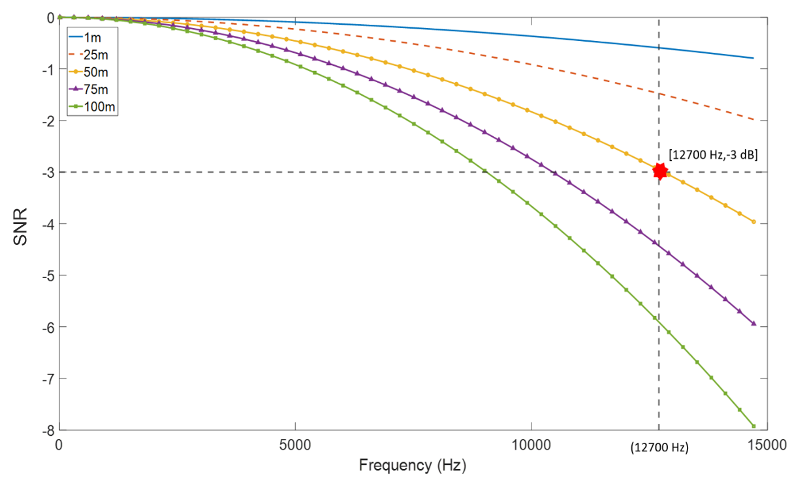
Figure 4.25 The diagram illustrating the sound attenuation as a function of frequency.
Figure 4.25 gives a clear view of the relationship between the sound attenuation and carrier frequency. Five lines with different colour denotes the different distances (1-100m) between the sound source and microphone. In this simulation the range of the carrier frequency was set below 15 kHz. According to Figure 4.25, when the source and receiver are 1-25 m apart, the effect of attenuation is small. If the communication range is extended to 25m, then the sound pressure of 1500 Hz carrier wave would drop by only 2 dB. If the speaker is 100 m away from the microphone, then the sound pressure would drop by 6-8 dB at frequencies above 12 kHz. This drop is more noticeable. It has been suggested in previous sections that a low SNR would lead the increase of bit error rate. The intersection with the horizontal grey dash line in Figure 4.25 shows the frequency and range at which the attenuation becomes greater than 3 dB. For example, at the 50m range this happens when the carrier frequency reaches 12700 Hz. Furthermore, the theoretical maximum communication speed for 4 systems can be estimated accordingly by the equation (4.25), (4.26) and (4.31) and has been listed in Table 4.2:
Communication Techniques | Carrier Frequency $f_{c}$ (Hz) | Modulation Frequency $f_{m}$ (Hz) | Bit Rate $R_{b}$ (bps)
2FSK | $f_{1}$=8466, $f_{2}$=12700 | 4233 | 4233
2ASK | 12700 | 6350 | 6350
2PSK | 12700 | 6350 | 6350
CLFM | 0~12700 | 6350 | 6.82
Table 4.2 Comparison among 4 communication systems when they are approaching their highest data transmission speed
For proposed four communication technqiues 2ASK and 2PSK in 50 m distance are capable of achieving the highest data transmission speed of 6350 bits/s, 2FSK ranked the third position with 4233 bits/s and due to the limitation of inter-symbol intervals, CLFM has lowest speed of only 6.82 bits/s.

Summary
This chapter introduced the fundamentals of four communication techniques: 2ASK, 2FSK, 2PSK and CLFM and their performance has been studied via numerical approach and experimental validation. These techniques can be potentially deployed on the robots inspecting in the pipe collaboratively and autonomously. The capabilities of these four techniques against noise and uncertainties such as multi-mode propagation in the pipe have been tested by simulation and experiments. The error between the analytical and experimental approaches has been found relatively small, i.e. below 2%.
The predicted performance of 2ASK, 2PSK and 2FSK modulation is good when the SNR is higher than 0dB while the experimental validation suggests that the ideal SNR for these three methods should be in the range between 7 dB and 15 dB. Therefore, it can be deduced that 2ASK, 2PSK and 2FSK are easily affected by the noise and uncertainties of the channel which needs relatively high SNR to function properly in the real application. However, it has been validated that not only in the simulation but also in the measurements, CLFM is the most stable system among the 4 systems which could operate in low SNR environment down from -5 dB to 0 dB. The influence of the cross-sectional modes can be significant. Sending message at frequencies close to modal is likely increase the bit error rate. The use of the channel FRF in deconvolution can reduce the effect of the modes. It makes sense to demand that the career frequency should not be selected close to a modal frequency when using 2ASK, 2PSK and 2FSK MODEMs. This seems less of an Issue when using the CLFM technique. The sound attenuation in the pipe due to the air absorption can cause the reduction in the SNR and negatively affect the bit error rate. One can expect a 3 dB attenuation at 50 m when communicating at the 12700 Hz carrier frequency. Based on this information, the highest communication speed can be estimated: 2ASK and 2PSK in 50 m distance has highest data transmission speed of 6350 bps, 2FSK ranked the third position with 4233 bps and even though CLFM is the most reliable system, due to the effect of inter-symbol intervals, it has the lowest communication speed which is only 6.82 bps.

Chapter 5 Communication in the partially water-filled pipe
Wastewater pipes, e.g. drainage pipes or sewers are rarely empty. This chapter studies the effect of changing water level on acoustic wave propagation and quality of the communication channel. A key phenomenon here is the modal split observed in frequency domain for non-axisymmetric modes when water Is present in the pipe. Such phenomenon is likely to make a huge change to the frequency response function to impact significantly on the deconvolution quality and carrier frequency choice used for communication. In this chapter the approximated analytical modal and empirical method (see Chapter 3) are used to study the effect of water level on the communication. These results are supported by the experiments carried out in a pipe with the variable water level.

5.1 Simulation
The MATLAB-based numerical studies were carried out to test the performance of the proposed four communication techniques in a 200mm diameter pipe partially filled with water. These studies were performed for the filling ratios of 0.1, 0.2 and 0.3 which are commonly found in real sewer pipes. The procedures such as signal mapping, encoding and synchronisation are described in section 4.1, Chapter 4. The FRFs used for the simulations were predicted by the analytical and empirical models. These models are introduced in section 3.2, Chapter 3. Figure 5.1 gives a visualised numerical experimental set-up for predicting the FRFs. Figure 5.1 shows that this work took place in an infinitely long pipe with 200 mm diameter. The water level was controlled by adjusting the filling ratio in the range between 0.1 and 0.3. The source and receiver were placed 2 m apart in the middle of the cross-sectional area of the pipe.
The frequency was set at $f_{c}=5000$ Hz for 2FSK, 2ASK and 2PSK. The central frequency for CLFM was selected at $f_{cental}=4500$ Hz. In addition, the bandwidth for each test was 20 Hz and the SNR was set to 10 dB. The purpose of selecting this carrier frequency, bandwidth and SNR is to make sure the excited signal could have a relative narrow band to overcome the effects caused by the changing of water level in the pipe. In addition, 10 dB is a critical SNR condition that has been tested in the empty pipe for all four communication techniques (See section 4.3, Chapter 4).

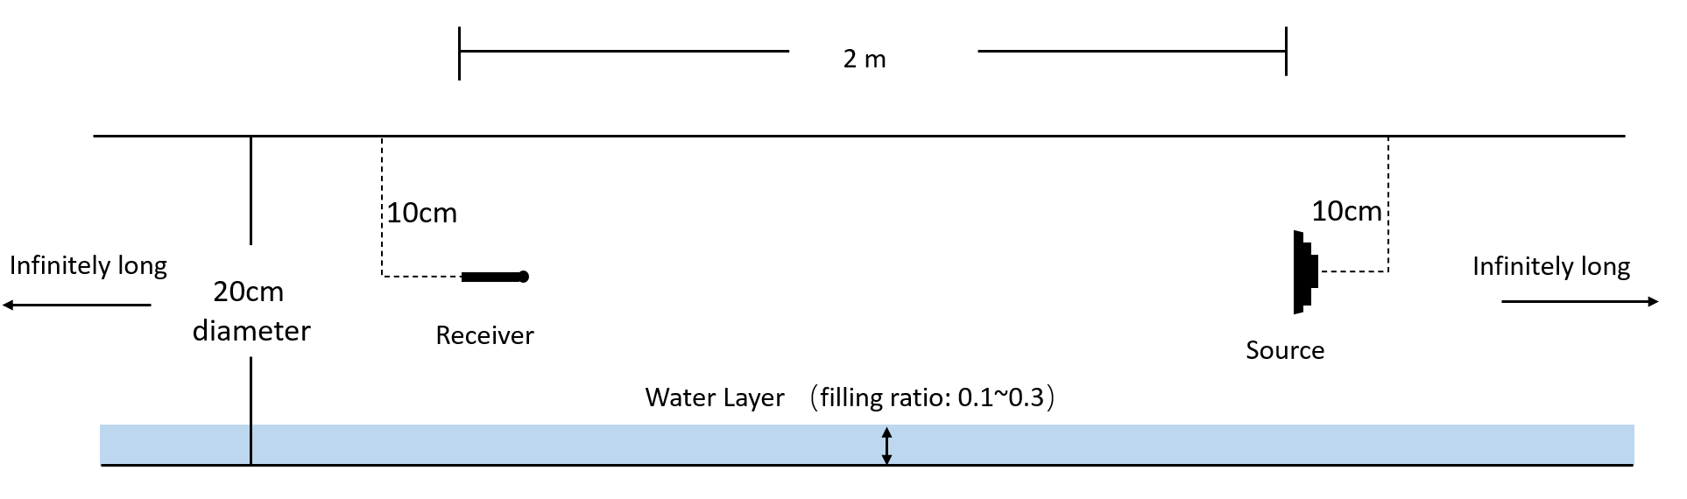
Figure 5.1 The visualised numerical experimental set-up for FRFs predictions
Figure 5.2 gives an example to show the difference between the FRF of 200mm diameter empty pipe (blue line) and partially water-filled pipe with filling ratio of 0.1 (red line). Bothoth FRFs were predicted by the analytical modal. It is very clear in the diagram that the presence of water in the pipe had an impact on the FRF. The modal split phenomenon occurred near the frequency of the first mode ((1,0), around 1000 Hz) and fourth mode (1,1) (around 3000 Hz). These splits are illustrated with black circles in Figure 5.2. It also has been suggested in Chapter 3 that the modal split phenomenon would become more pronounced with the increase in the water level that is very likely to affect the communication quality of the channel.
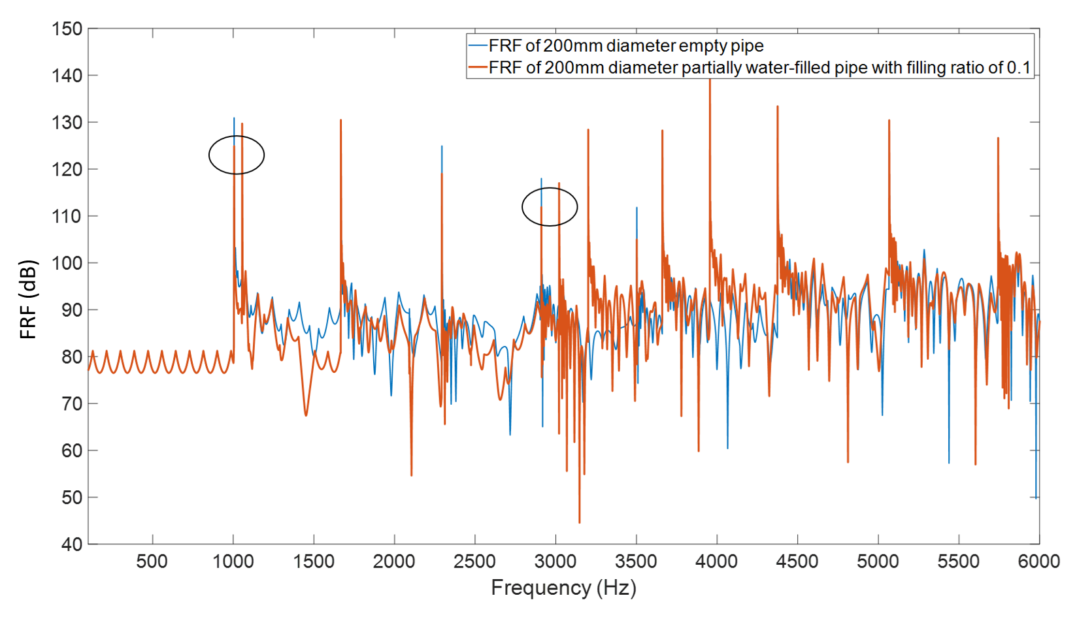
Figure 5.2 An example of the difference between the FRF for the 200 mm diameter empty pipe (blue line) and partially water-filled pipe with filling ratio of 0.1 (red line) predicted using the analytical approximation.

5.1.1 2FSK:
in this study the frequency shift keying (2FSK) signal is modulated by two sub-carriers represented by the two binaries, $f_{c1}=5000$ Hz and $f_{c2}=2500$ Hz. Figure 5.3 illustrates the envelopes of message pack for 2FSK signal at receiver end with filling ratios from 0.1 to 0.3. The results shown in sub-graphs (a), (b) and (c) were predicted with the analytical model, while (d), (e), and (f) with the empirical model. The method of obtaining these envelopes can be found in section 4.212, Chapter 4.
According to the graphs plotted in Figure 5.3, all the envelopes could provide clear waveform which can be used for signal decoding. Therefore, it can be suggested by Figure 5.3 that using either analytical modal or empirical modal will not make a significant change to the 2FSK communication since they have a very close agreement (0.2% error) and under ideal SNR condition, the filling ratio will also not affect the waveform of envelope which attribute to the success of linear equalisation (deconvolution).
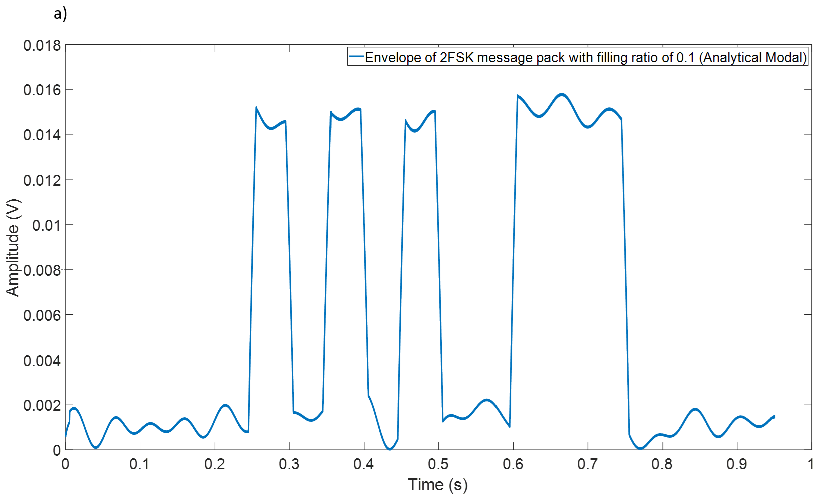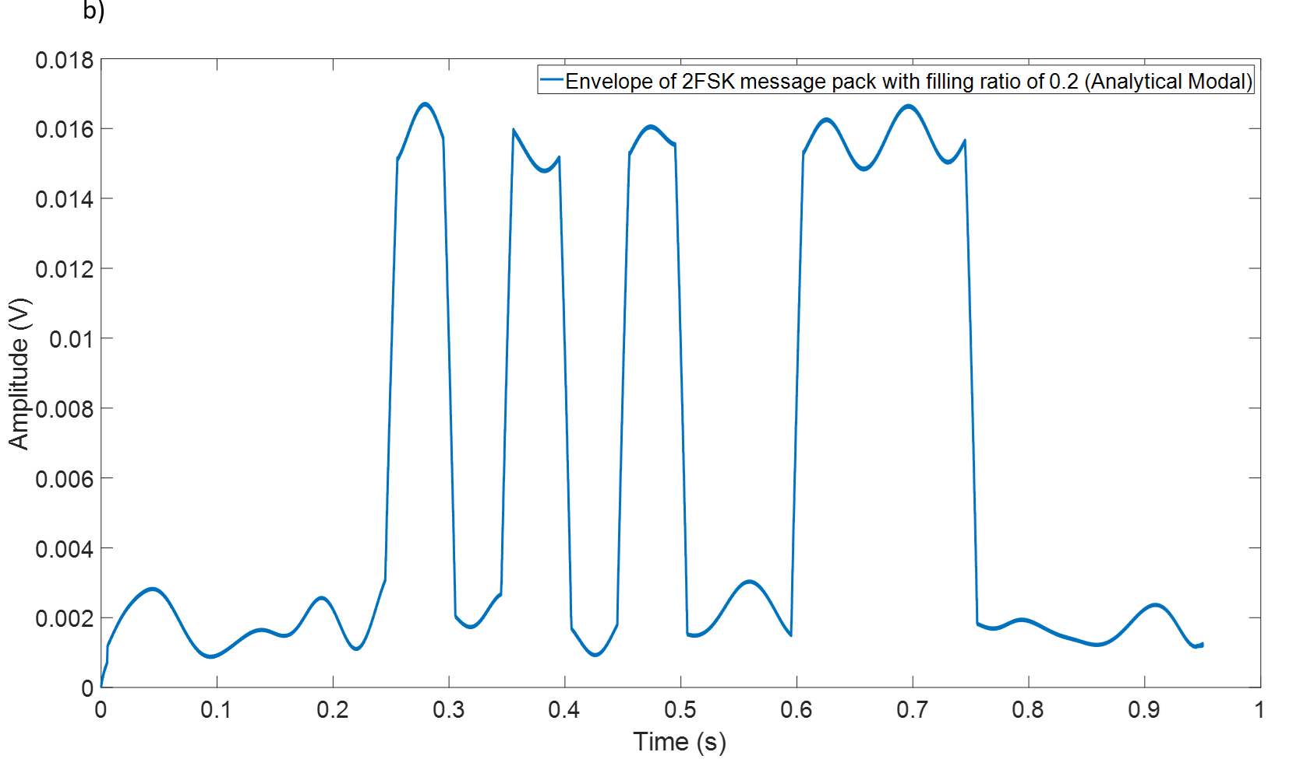
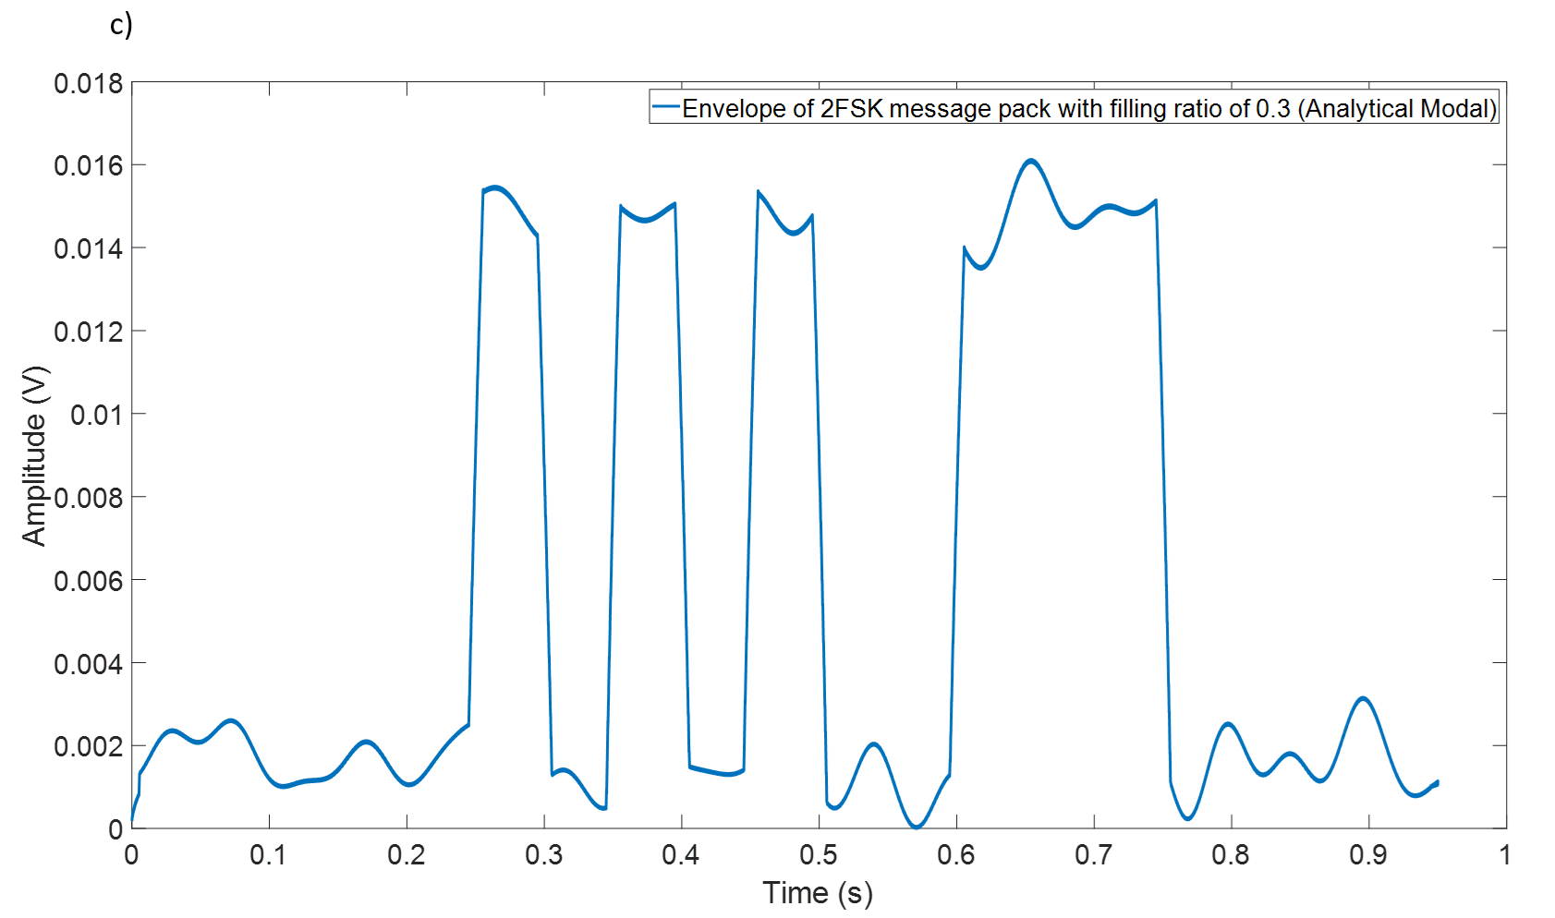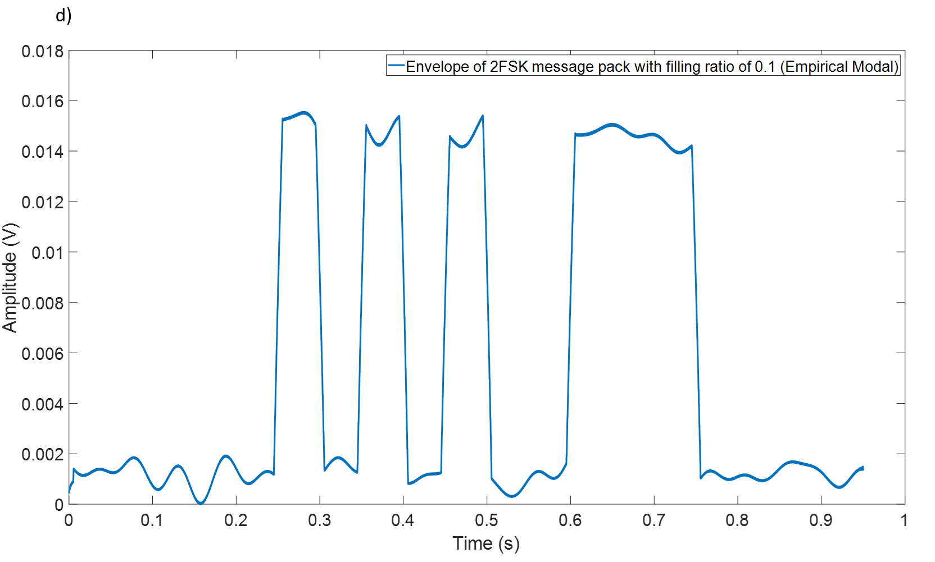
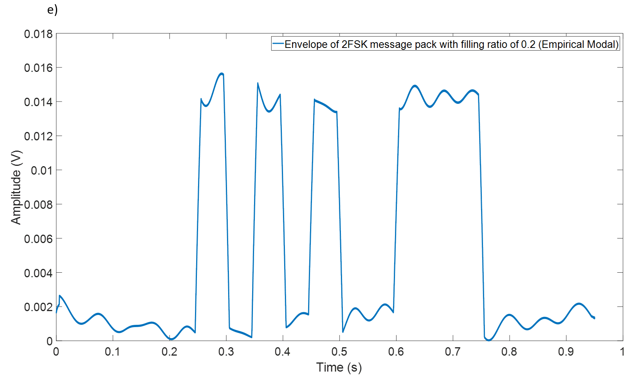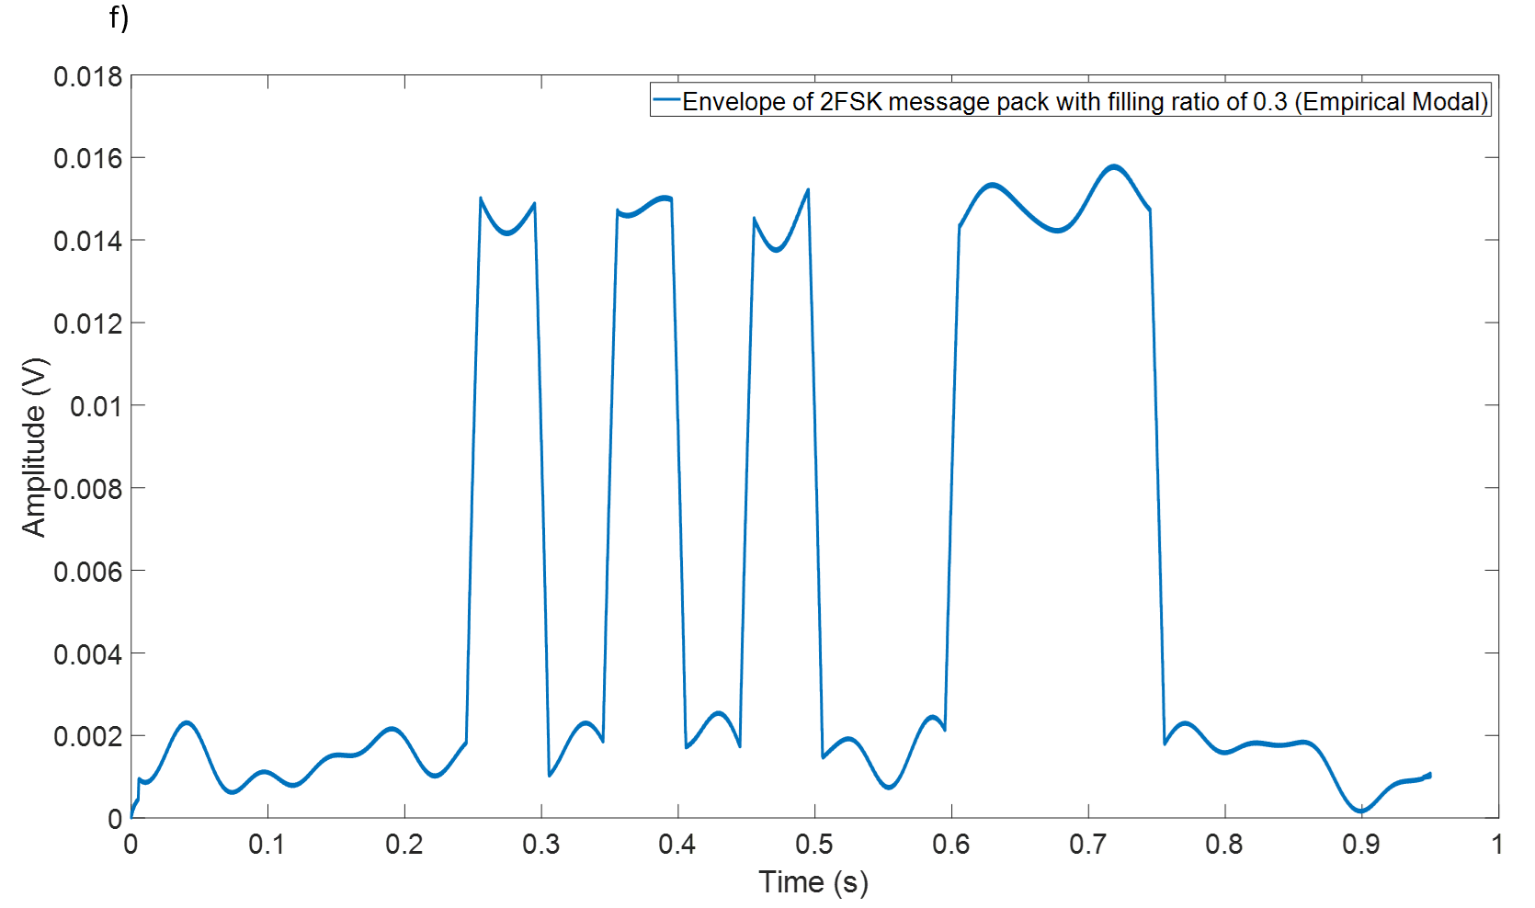
Figure 5.3 The envelopes of a 2FSK message pack ($f_{c1}$=5000 Hz, $f_{c2}$=2500 Hz, bandwidth 20 Hz, SNR=10dB) with filling ratio of 0.1 (top), 0.2 (middle) and 0.3 (bottom). (a)-(c) analytical model, (d)-(f) empirical model.

5.1.2 2ASK:
A similar simulation was done to study the communication performance of an amplitude shift keying signal (2ASK). The carrier frequency in this study was $f_{c}=5000$ Hz, bandwidth $f_{m}=20$ Hz, SNR= 10 dB and filling ratio was changed from 0.1~0.3.
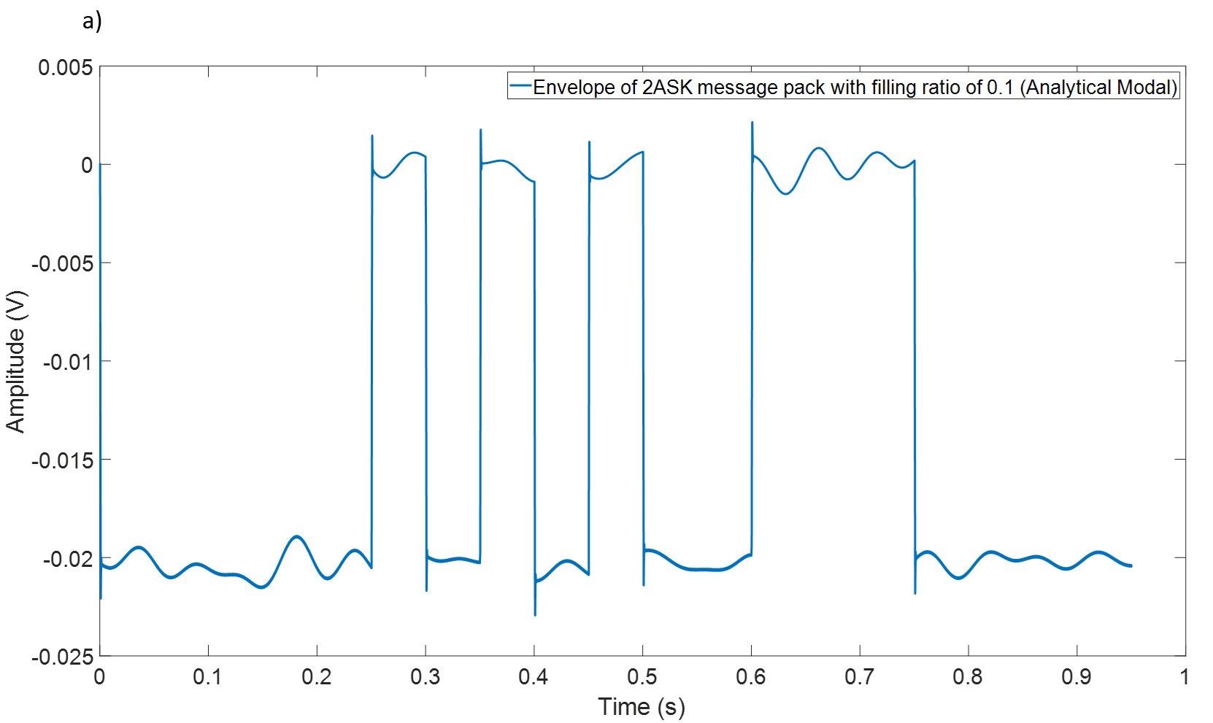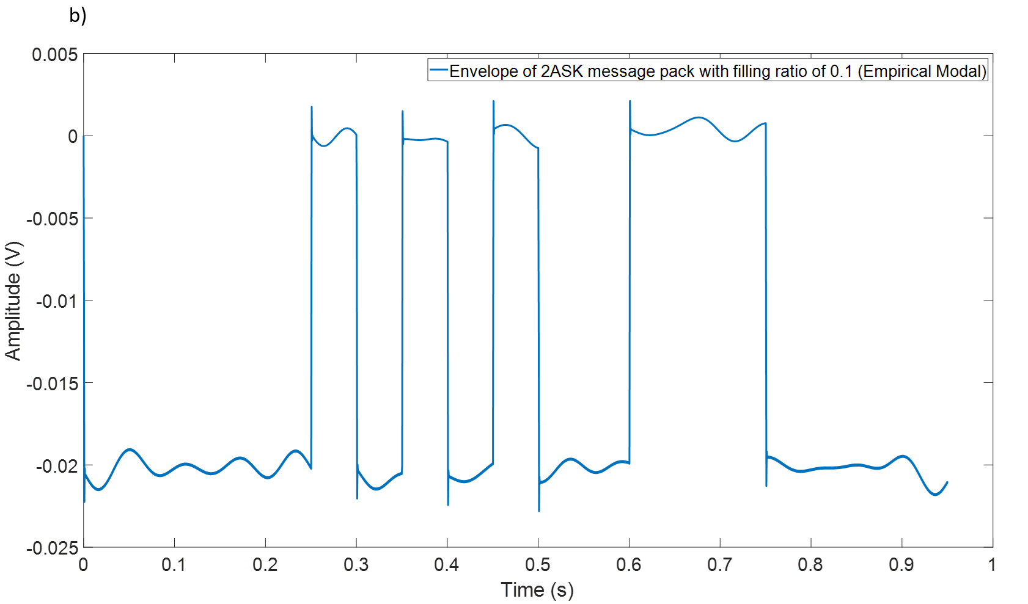
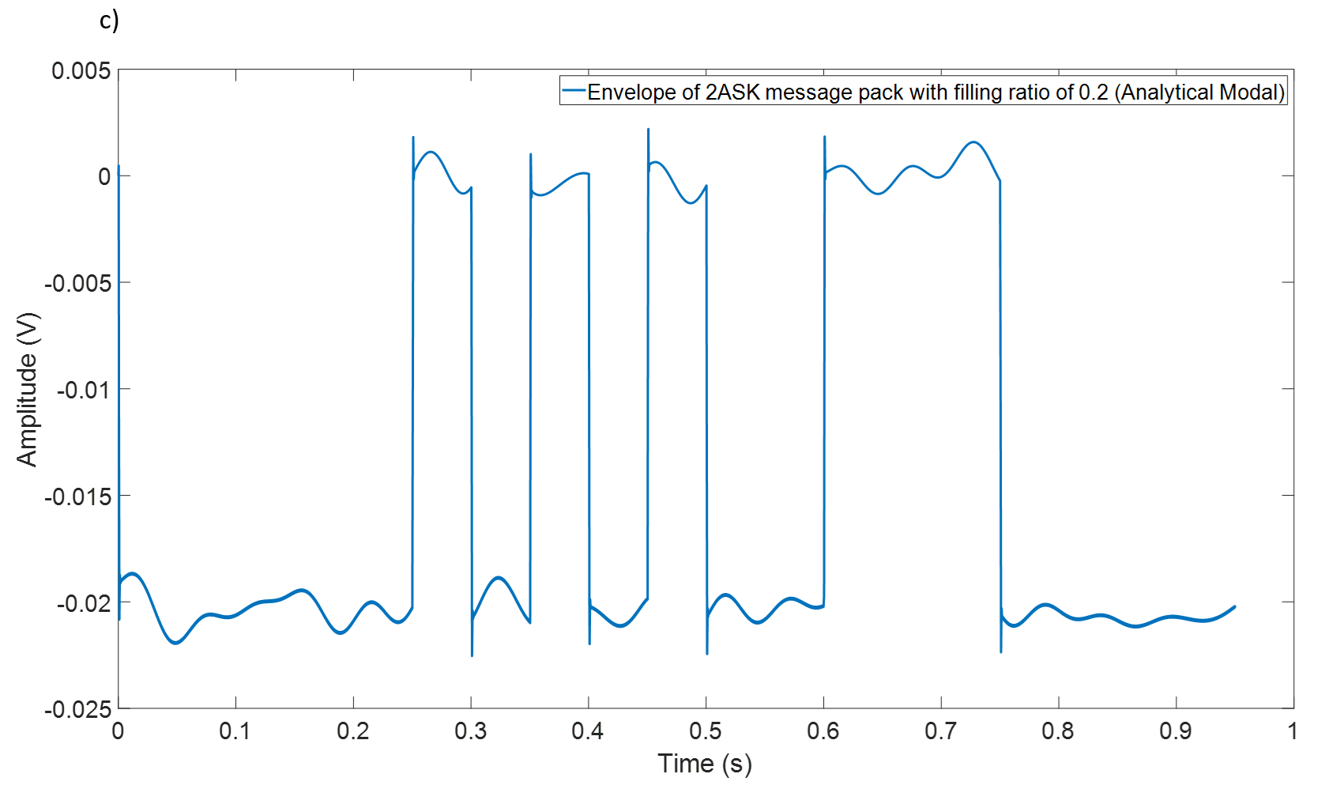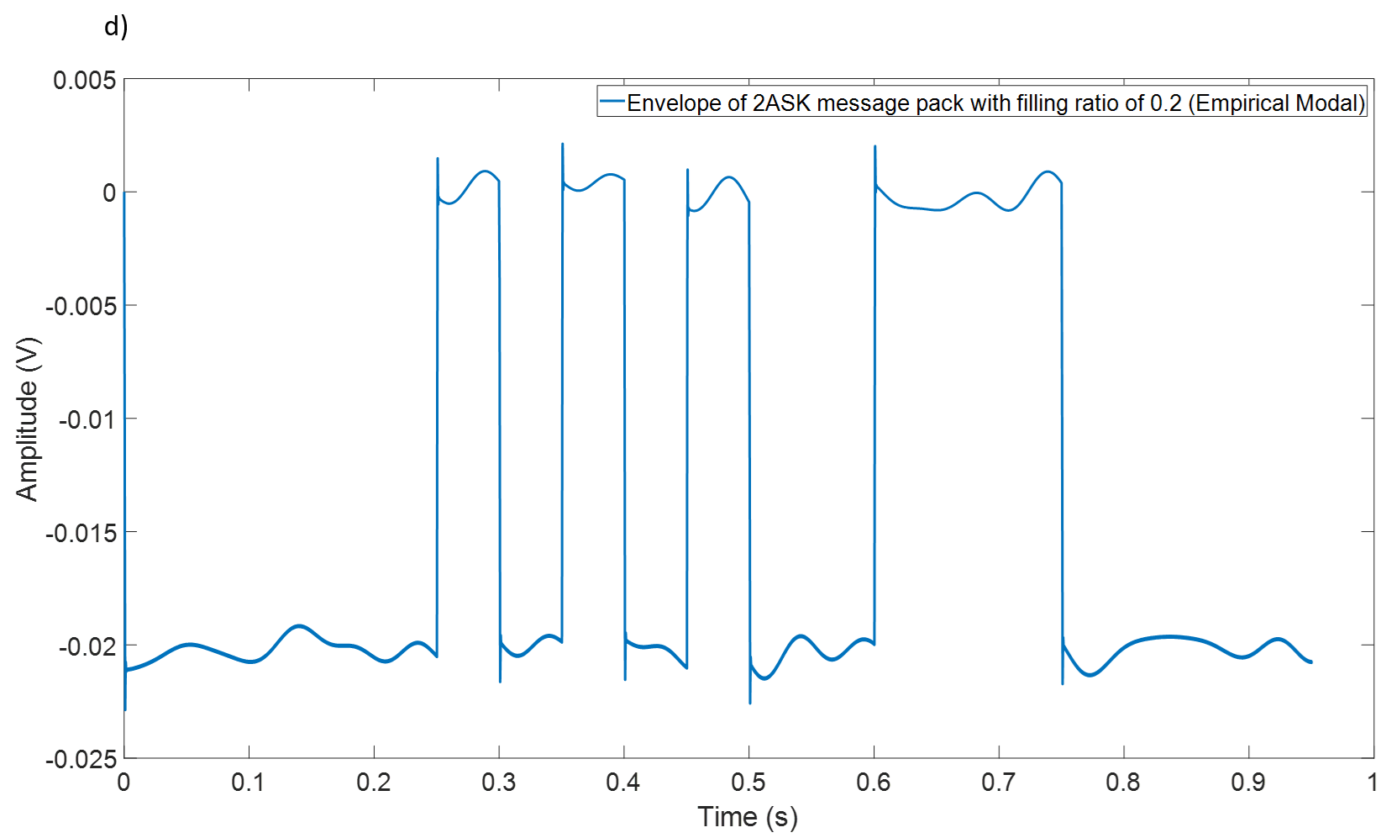
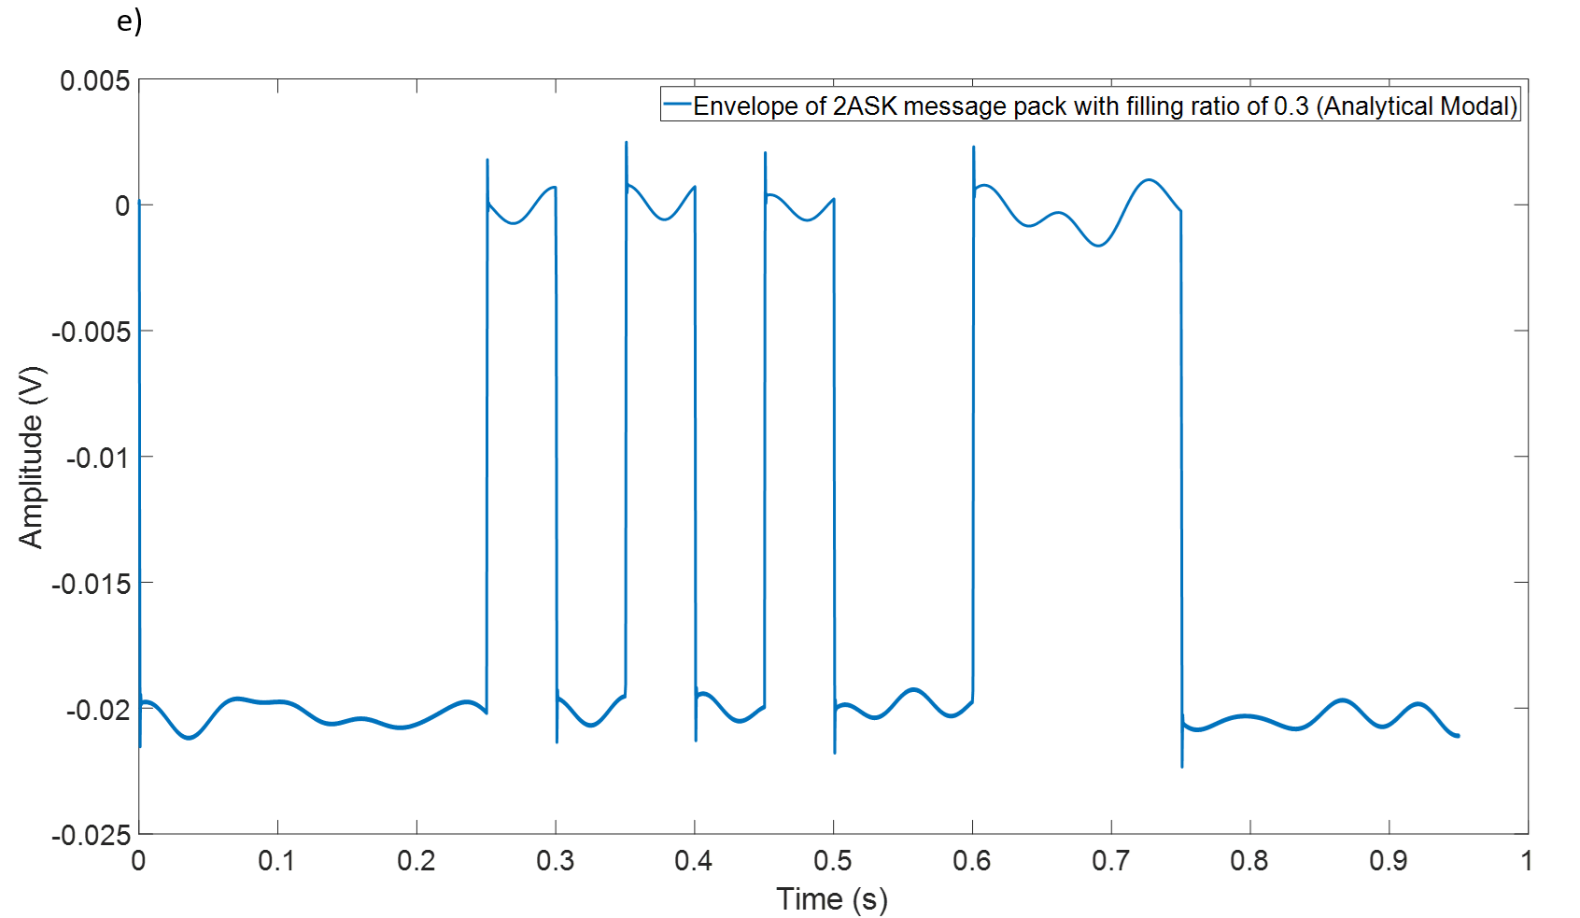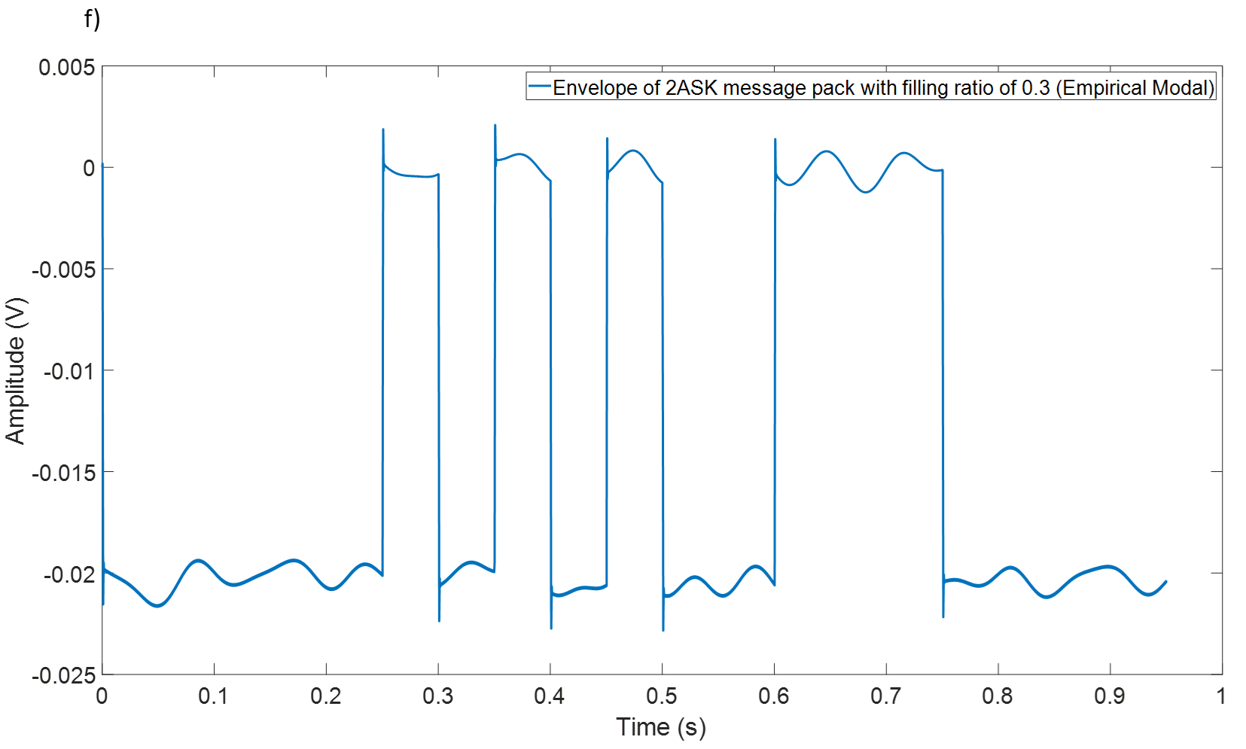
Figure 5.4 The envelopes of a 2ASK message pack ($f_{c}$=5000 Hz, bandwidth 20 Hz, SNR=10dB) with filling ratio of 0.1-0.3: (a) -(c) analytical model; (d)-(f) empirical model.
Figure 5.4 plots similar graphs to those shown in Figure 5.3 but for the 2ASK modulated signal. Clearly , the envelopes are all smooth enough for the decision making and there are hardly any effect caused by the changing filling ratio. The difference between analytical and empirical models is too small to affect the coherent demodulation required for robust 2ASK communicaiton.

5.1.3 2PSK:
The results shown in the previous sections for the 2FSK and 2ASK signals indicate that the filling ratio does not have obvious influence on signal decoding. However, the phase properties of the channel will also affect the traditional demodulation method for the 2PSK technique. Therefore, the 2PSK technique is more sensitive to the phase properties of the channel than any other type of communication. In Chapter 4 a special method of angle demodulation was proposed for 2PSK signals. It was reported that this demodulation method had a better performance than coherent and envelope demodulation methods in terms of overcoming the distortion caused by the channel response. This section presents and discusses the results of 2PSK angle demodulation waveform for filling ratio from 0.1 to 0.3. Figure 5.5 shows the waveform of angle demodulation for a 2PSK message pack of using analytical and empirical model.
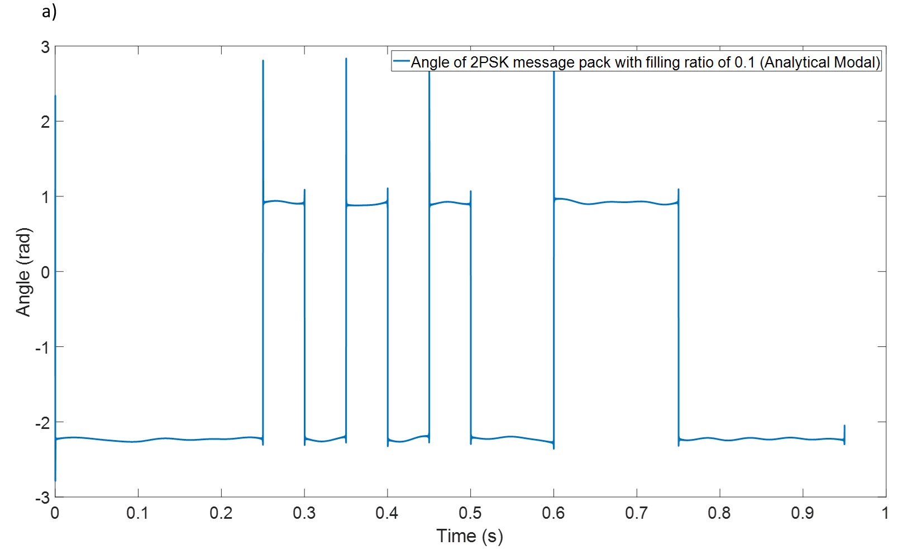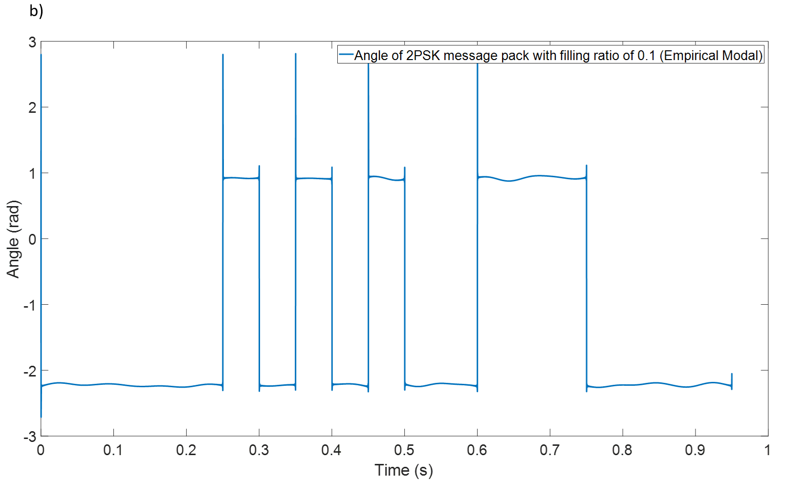
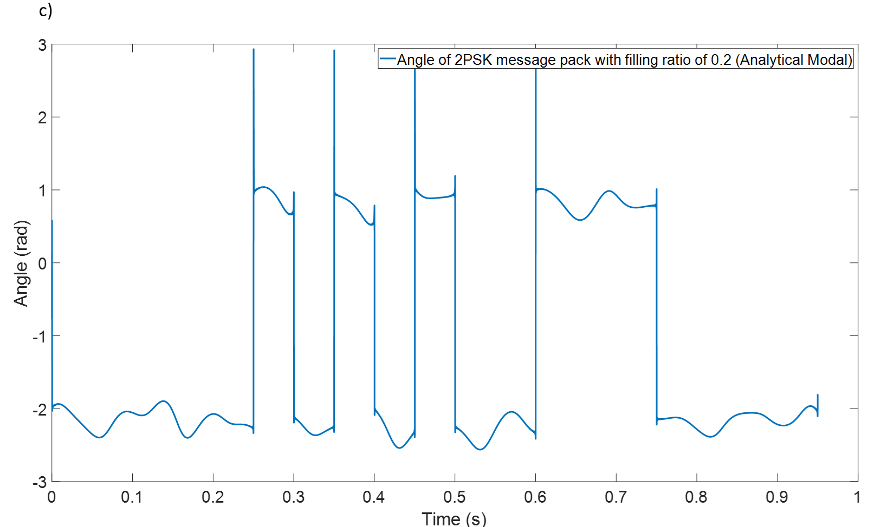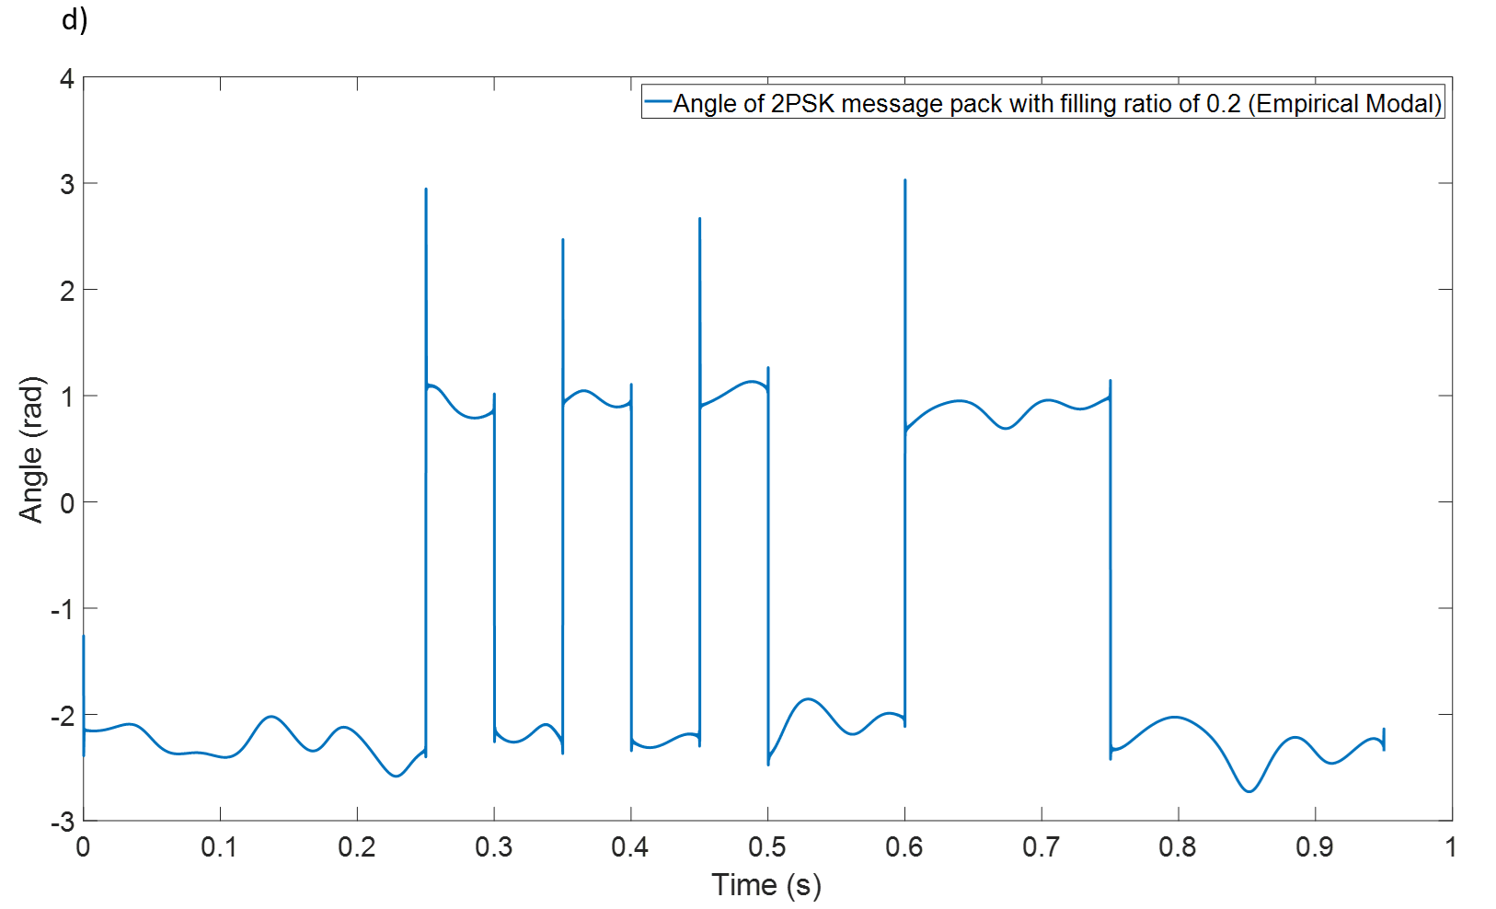
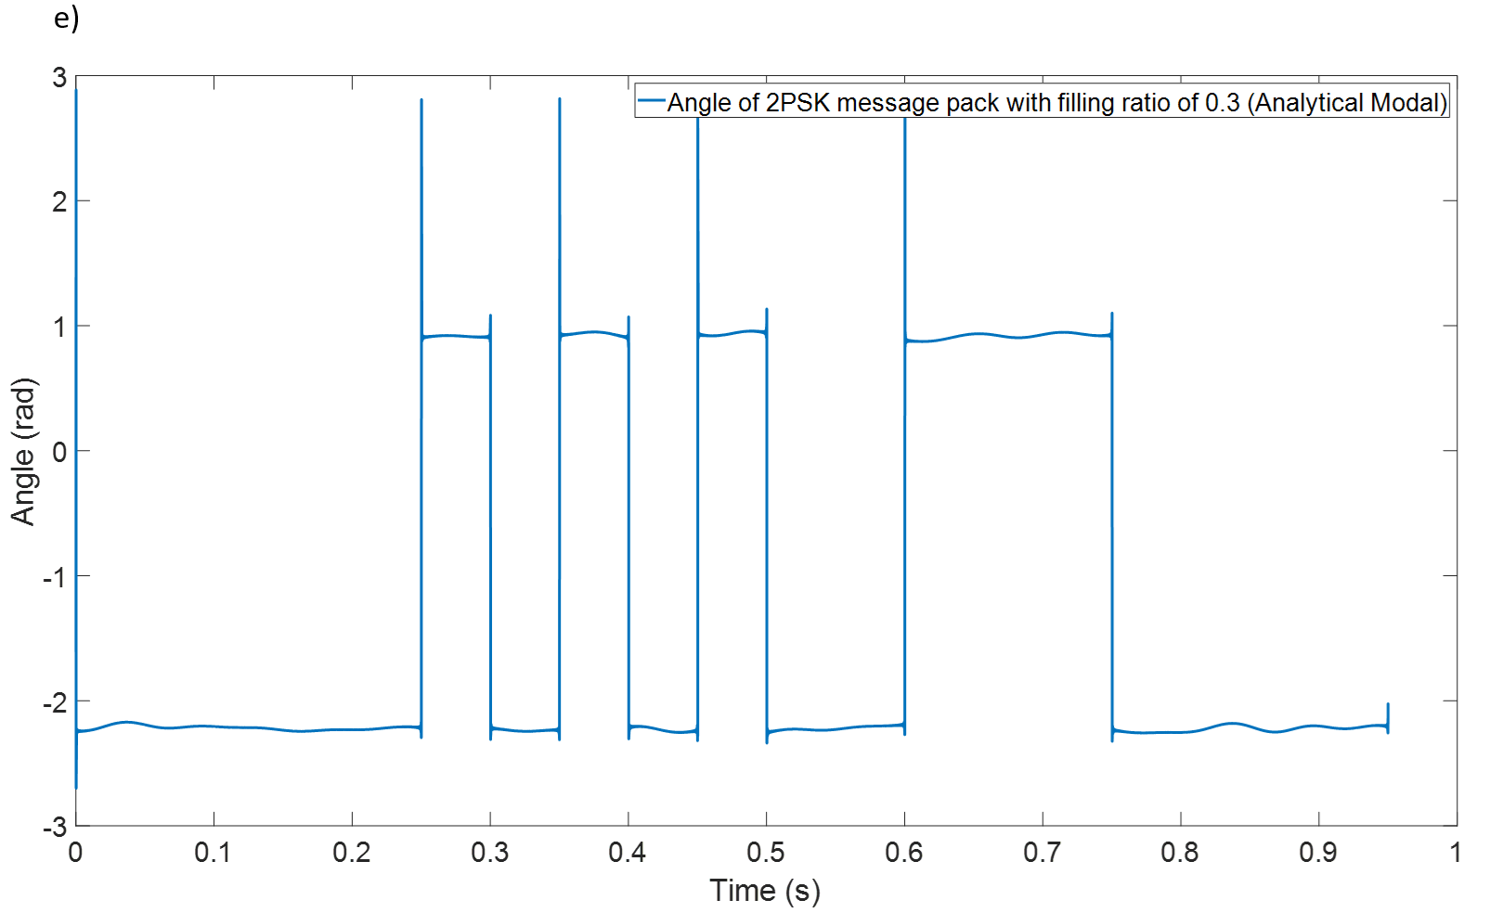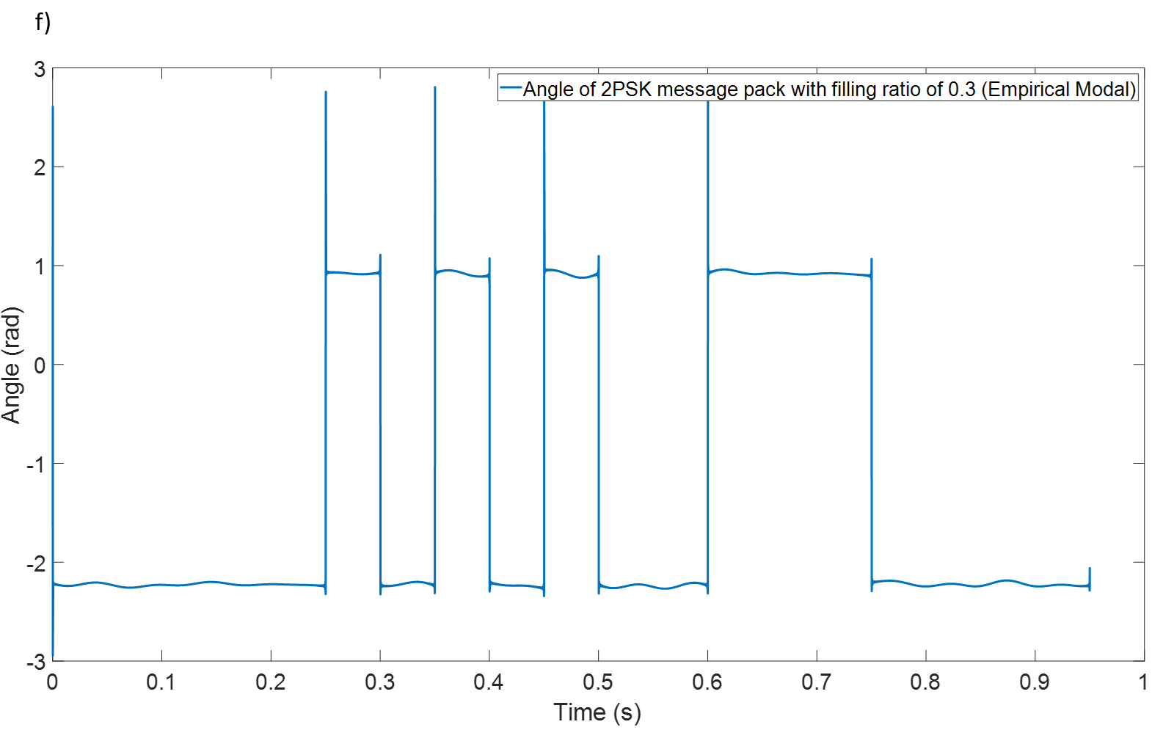
Figure 5.5 The angle diagrams of 2PSK message pack (fc=5000 Hz, bandwidth 20 Hz, SNR=10dB) with filling ratio of 0.1-0.3: (a) -(c) analytical model; (d)-(f) empirical model.
Overall, the angle diagrams shown in Figure 5.5 have perfect shapes for decision making under idea SNR. However, it should be noticed that due to the periodic properties of the phase, the waveform may be flipped during the demodulation (see Chapter 4, Figure 4.12). Therefore, the synchronisation process should be carefully applied even though there are parity checking codes to help avoid symbol flipping.
The results indicate that under an ideal SNR condition (10 dB in this case) the presence of water does not have a clear impact on the communication quality. In addition, both the empirical and analytical models used in this test give similar results. However, it should be noticed that the FRF estimated with the analytical approximation is likely to consume a much more considerable amount of computational resources that is not desirable for deploying on board of the robots. On the contrary, using data base stored on board obtaining with the empirical model is more attractive to use because it can be easily processed by a low-power micro-controller with a relative high power and computational efficiency. Therefore, due to the close agreement between their results, the empirical model would be recommended for implementation on the robots to predict the acoustic propagation in the pipe with the change of water level.

5.1.4 CLFM
In Chapter 4, it is suggested that the CLFM technique has overall the best performance in terms of noise and mode resistance in comparison with the other three modulation techniques. Its demodulation process is based on the cross-correlation which reduces the influence of the variation in the communication channel. Therefore, it is also believed that this technique is competitive for acoustic communication in a partially water-filled pipe. In this study, the aim is to test the influence of the water level on the CLFM system under a favourable SNR condition. In this simulation the filling ratio is varied from 0.1 to 0.3, bandwidth kept as 20 Hz, SNR maintained at 10 dB and sub-chirp frequency range set as 4000 to 5000 Hz.
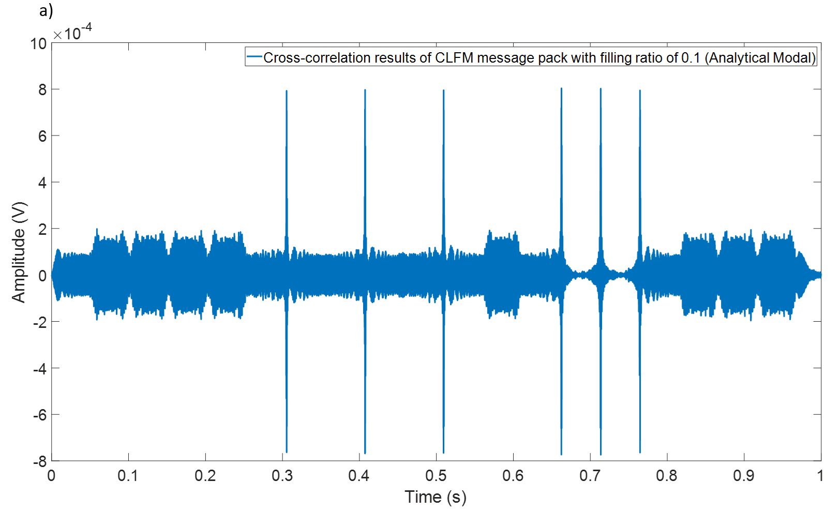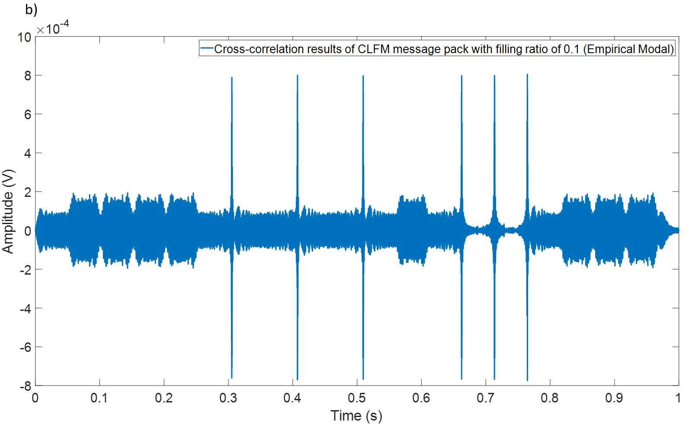
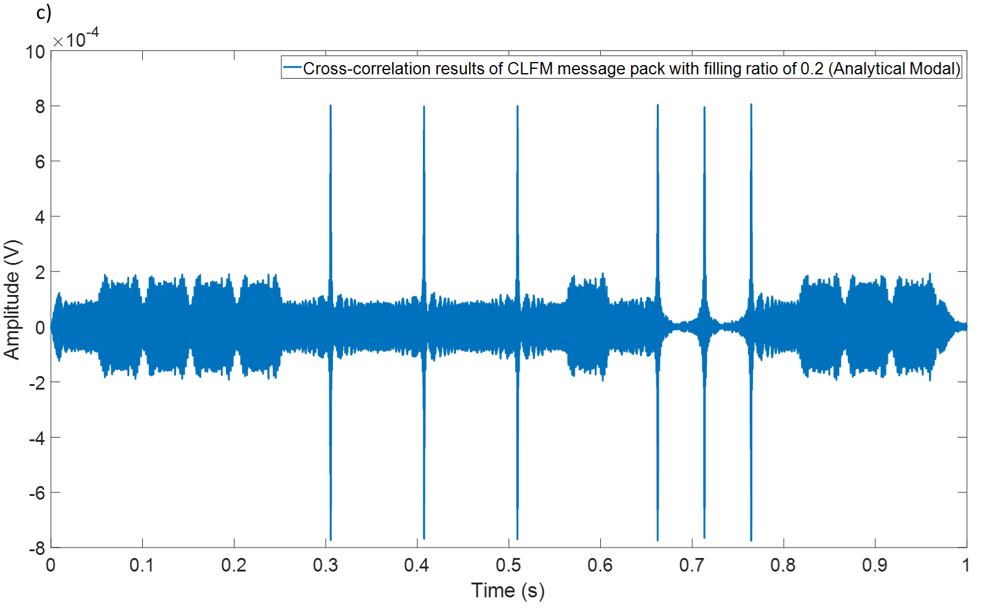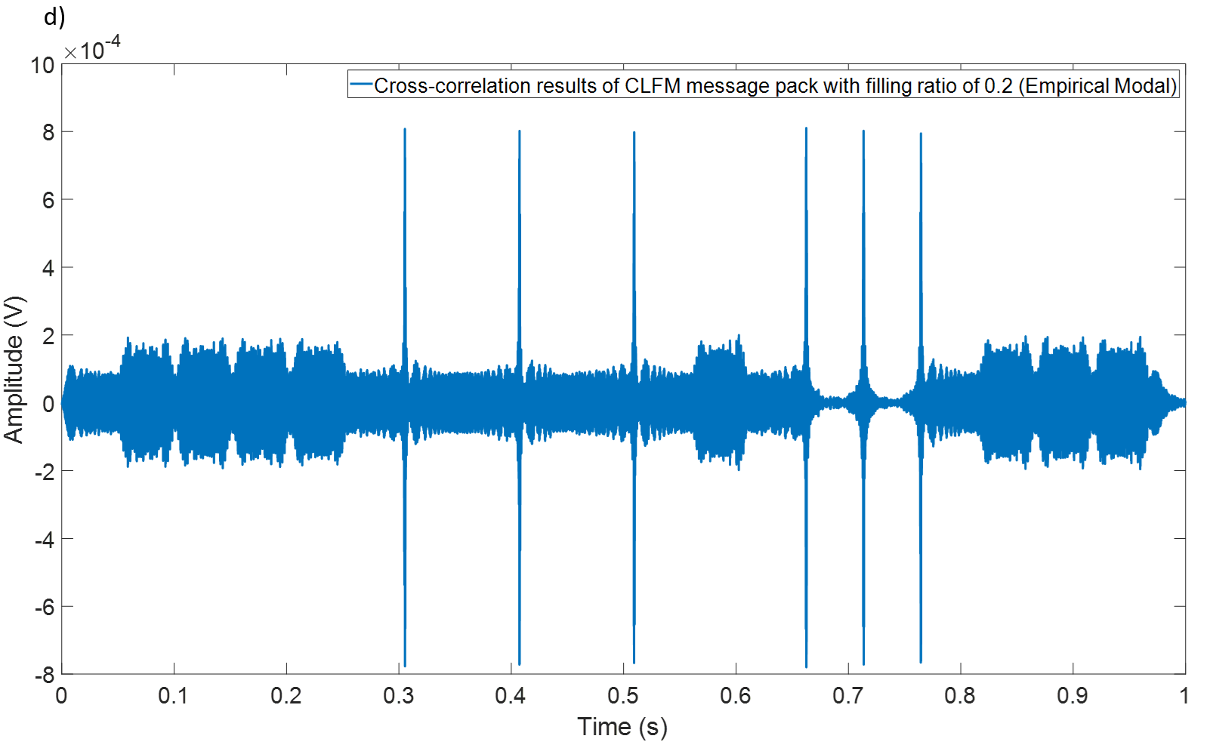
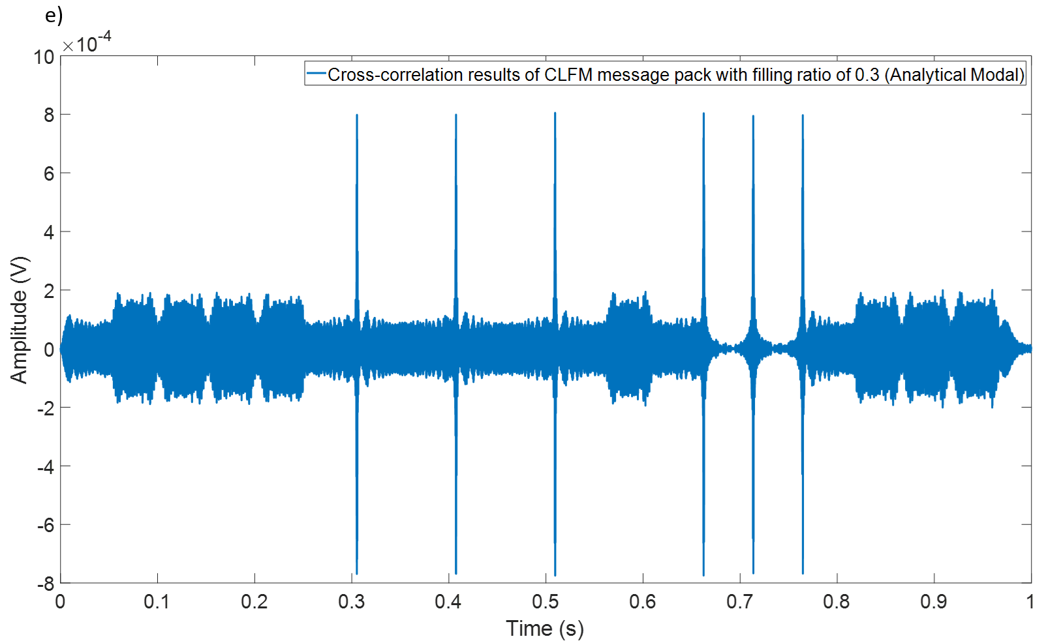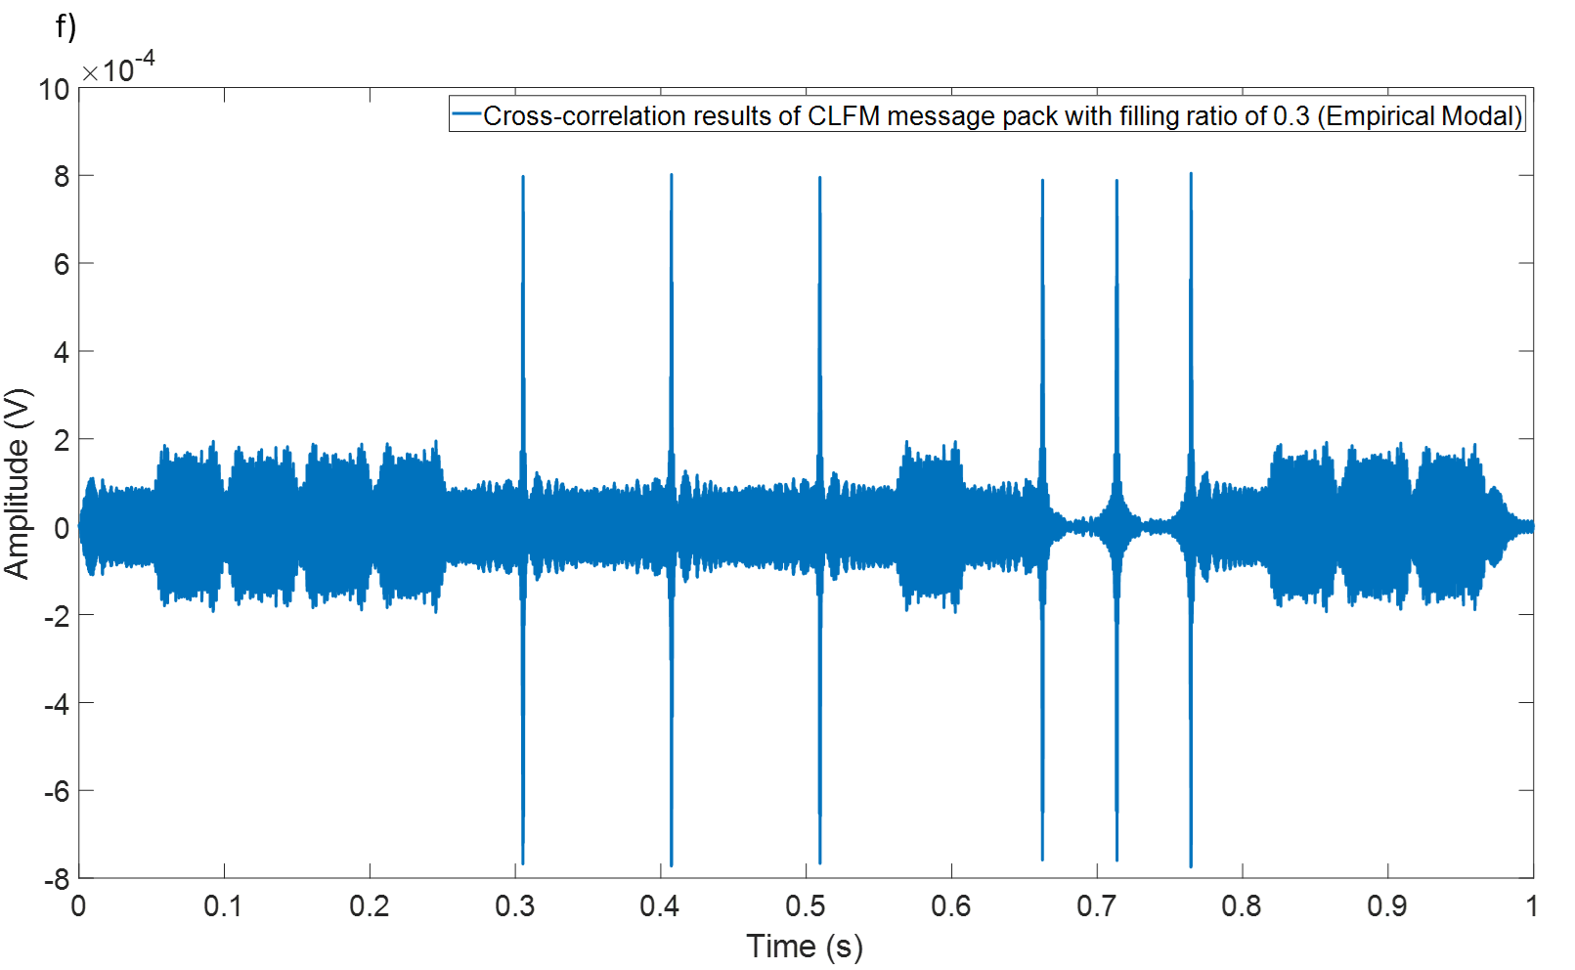
Figure 5.6 The cross-correlation diagrams of CLFM message pack (sub-chirp (4000 Hz~5000 Hz) bandwidth 20 Hz, SNR=10dB) with filling ratio of 0.1~0.3: (a)-(c) analytical model; (d)-(f) empirical model.
Figure 5.6 plots the cross-correlation results of CLFM message pack in the partially water-filled pipe with the variable filling ratio. The demodulation of CLFM utilised the correlation between message pack signal captured at receiver end and sub-chirp signal stored on board. The message pack was modulated by using sub-chirp with frequency from low to high to represent symbol "1" and using that with frequency from high to low to represent symbol "0". The cross-correlation results could produce flat and peak waveform to distinguish the "1"s and "0"s. For example, the waveform in the time interval roughly between 0.28 s and 0.33 s could be marked as symbol "1" while the waveform in the interval between 0.1 to 0.16 s can be recognised as symbol "0". All the diagrams in Figure 5.6 demonstrate that cross-correlation could give clear peaks which could be easily recognised by the decision maker. Therefore, the depth of the water layer has a negligible effect on the CLFM communication results.
The simulations carried out for all the four communication techniques suggest that the difference between the results obtained with the analytical and empirical model in terms of the predicted quality of communication is very small. It is a desirable feature to save memory storage space and computational efficient of robotic application. In addition, the presence of water is unlikely to affect the communication results because once the water level is stable, the whole channel can be treated as a linear time-invariant system for which the FRF can be predicted and used for channel equalisation. As long as the FRF of the pipe can be accurately measured or predicted, the message pack will be successfully equalised by the deconvolution and deliver the correct information.

5.2 Frequency of Channel Re-calibration in response to water level change
The result from the previous section suggests that the pipe with a stable water level can still be treated as a time-invariant system which means the water layer is unlikely to affect the communication quality as long as FRF can be accurately predicted or measured and SNR is carefully controlled. However, in practical situations it is not always the case because in most buried pipe network such as drainage pipe or sewers, the change of water level is a dynamic process which means the channel in this case is no longer a time-invariant constant parameter channel. And deconvolution method we rely on for now may lose its function to some extent in the real application. Even though keeping measuring the water level or characterising the channel acoustically may be an option to account for the signal distortion, it will affect the data rate and drain on the communication efficiency. Therefore, to quantify how often does the communication systems need to re-calibrate the FRF of the pipe is useful to deploy a robust acoustic communication system on robots.
This section will study the acoustic FRF of the pipe with different filling ratio from 0.1 to 0.4 predicted with the analytical model and to determine whether the four communication techniques are still reliable when the water level suddenly changed but this change is not accounted for computationally. The purpose of adding the FRF with filling ratio of 0.4 is to give a broad range of water levels and in this case, the impact of sudden change of water level on the communication quality can be more clearly understood. The simulations are based on the FRF predicted for the filling ratio of 0.1 but the signals are demodulated with transfer function with filling ratio of 0.2, 0.3 and 0.4 so that the influence of the water level on the decision making can be better understood. For example, when the water level is Increased from the filling ratio 0.1 to 0.2, the modulated signal therefore will be coloured by the FRF with filling ratio of 0.2. However, if the system still using the FRF with filling ratio of 0.1 to deconvolve the coloured modulated signal, the results may be distorted to some extent and when the filling ratio keeps increasing and at some critical point such as 0.3 or 0.4. In this case the system may lose its function and require recalibrating the FRF of the pipe. The properties of the modulated signals for each of the four techniques, i.e. bandwidth, carrier frequency and SNR are kept as per previous section.

5.2.1 2FSK
Figure 5.7 illustrates the envelopes of 2FSK message packs. The graphs in Figure 5.5 show the signals convolved with the FRF predicted for the filling ratios of 0.1, 0.2 and 0.3 but deconvolved with the FRF predicted for the filling ratio of 0.1. In the following text these FRFs will be abbreviated as 0.1 FRF, 0.2 FRF, 0.3 FRF and 0.4 FRF for brevity.
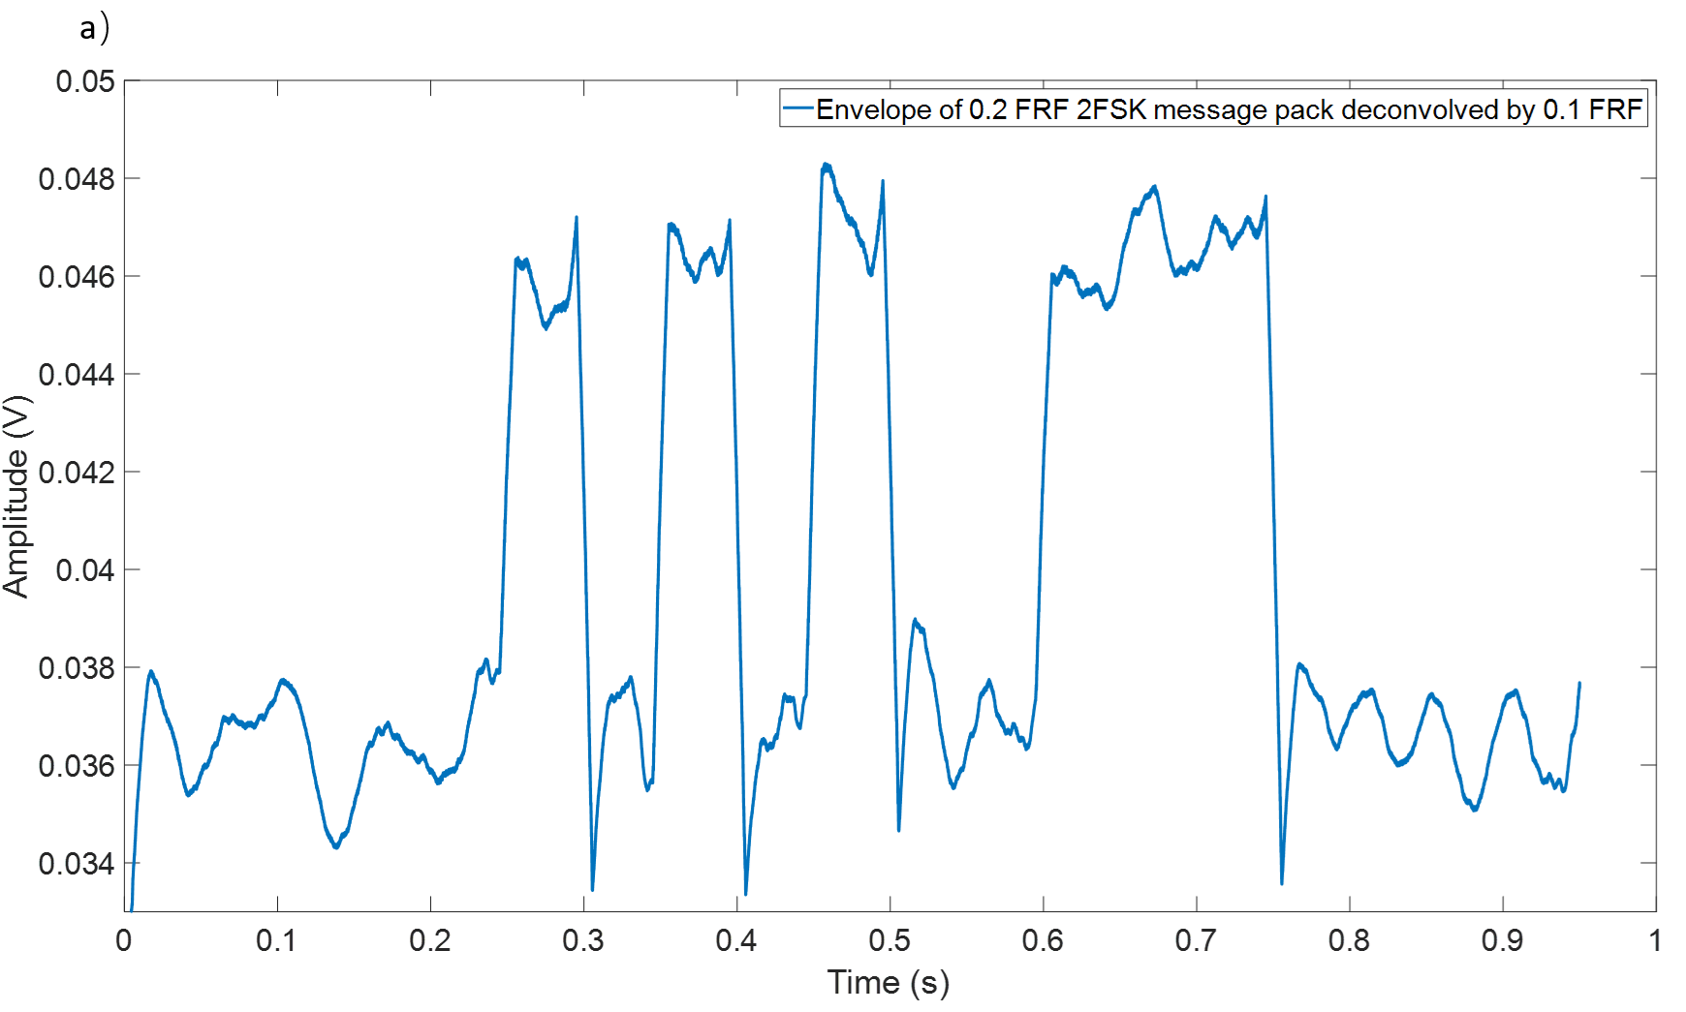
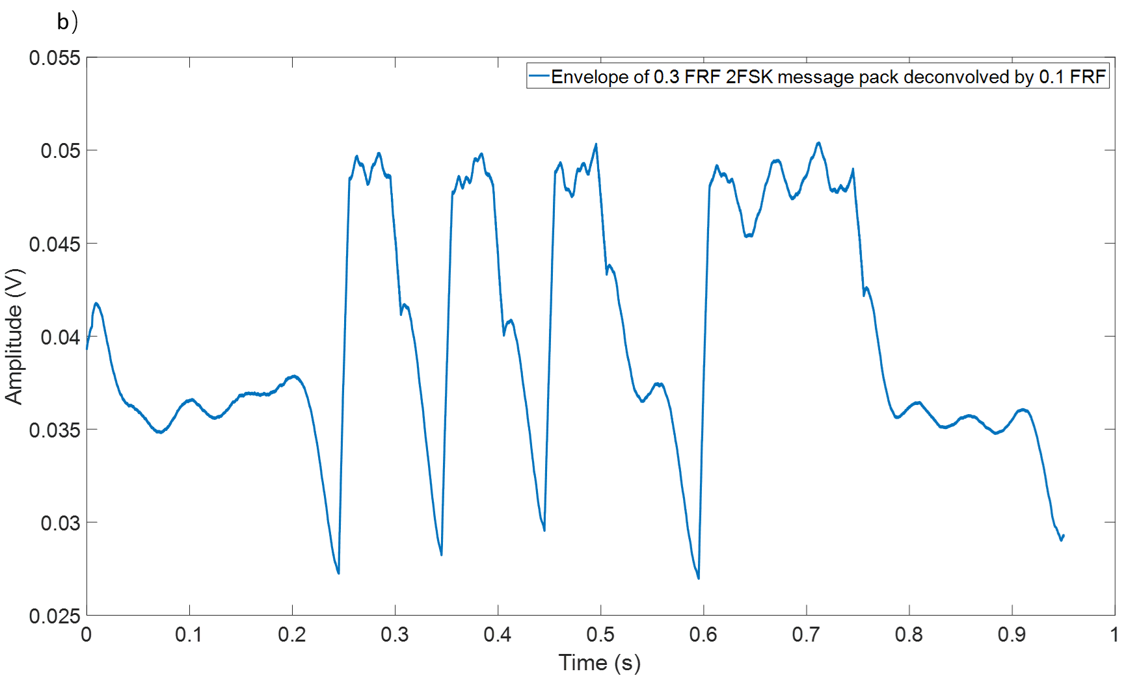
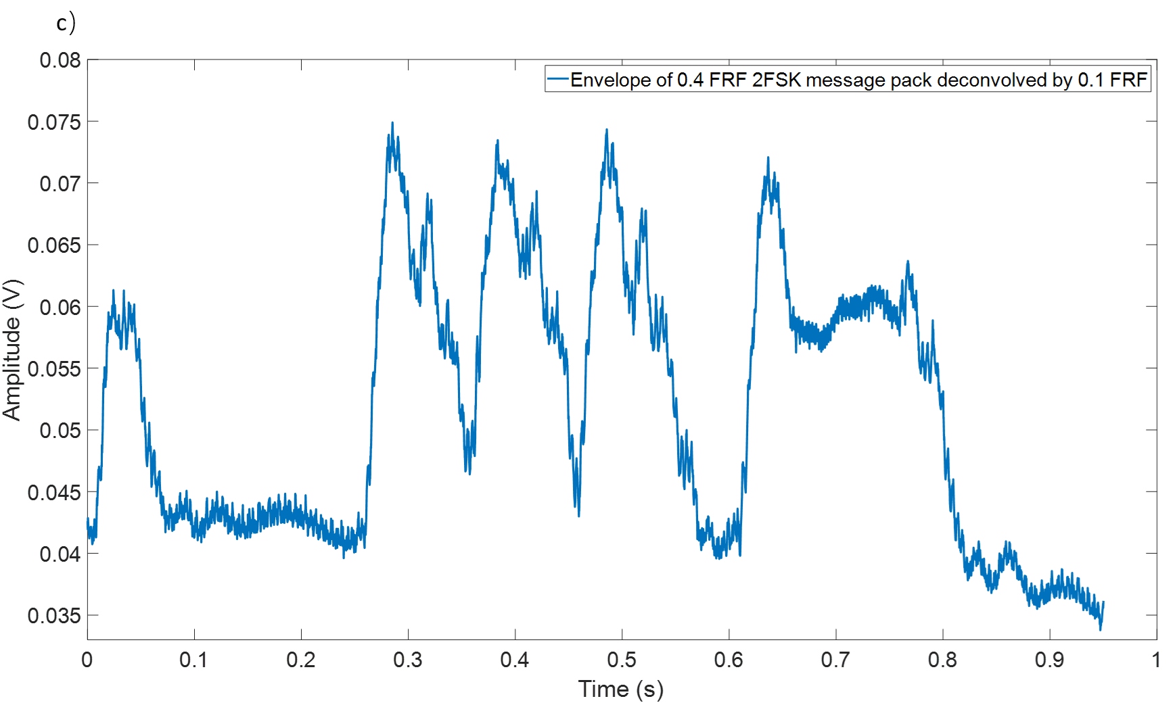
Figure 5.7 The waveforms of 2FSK message pack envelope using 0.1 FRF to deconvolve the signal convolved with: (a) 0.2 FRF; (b) 0.3FRF; and (c) 0.4FRF
According to the graphs plotted in Figure 5.7 (a), the system is still able to give a clean and recognisable waveform for decoding the message when the 0.1 FRF is used to deconvolve the modulated signal convolved with 0.2 FRF. I.e., the assumption is made that the filling ratio is 0.1, but the actual filling ratio is 0.2 so that a wrong FRF is used in the convolution process. In this case, the quality of the decoded signal is deteriorated in comparison with that presented in Figure 5.3 when the FRF for the correct filling ratio was used. In another words, the 2FSK communication technique is usable when the filling ratio suddenly risen up from 0.1 to 0.2, but the FRF used is based on the assumption that the water level has not changed.
When the filling increases to 0.3, the waveform of the decoded envelope becomes seriously distorted if the deconvolution is based on the 0.1 FRF. This is likely to result in an uncertainty to where to put the threshold and to increase the probability of package error rate, even though key features of the modulation are still visible in the graph (see Figure 5.7(b)). When the filling ratio increases further, e.g. to 0.4 (Figure 5.7 (c)), the waveform is strongly distorted, especially in the area between the symbols. In this case small fluctuation begin to occur suggesting the message demodulation is most likely to fail completely. Therefore, it can be suggested that for the 2FSK system, the tolerance of the filling ratio is less than 0.1. Beyond this filling ratio change the communication process would require re-sending the chirp signal for the channel re-calibration to measure the true FRF.

5.2.2 2ASK
The same numerical study was repeated for the 2ASK technique, and its results are illustrated in Figure 5.8. The graphs shown in Figures 5.8 (a) and (b) differ with the situation for the case of the 2FSK technique. The shapes of the envelopes were fairly clean and smooth for the 2 ASK message when using 0.1 FRF to deconvolve the signal coloured with 0.2 FRF and 0.3 FRF. Even when the filling ratio was increased from 0.1 to 0.3, 2ASK system was still to be able to recover correct information. In the case of 0.4 FRF (Figure 5.8 (c)), the message pack of 2ASK signal was completely messed up which means information was fully lost in the transmitted message. In conclusion, the 0.1 FRF of the partially water-filled pipe is still reliable when the filling ratio is below 0.3 and it needs to be remeasured when the water depth achieves higher.
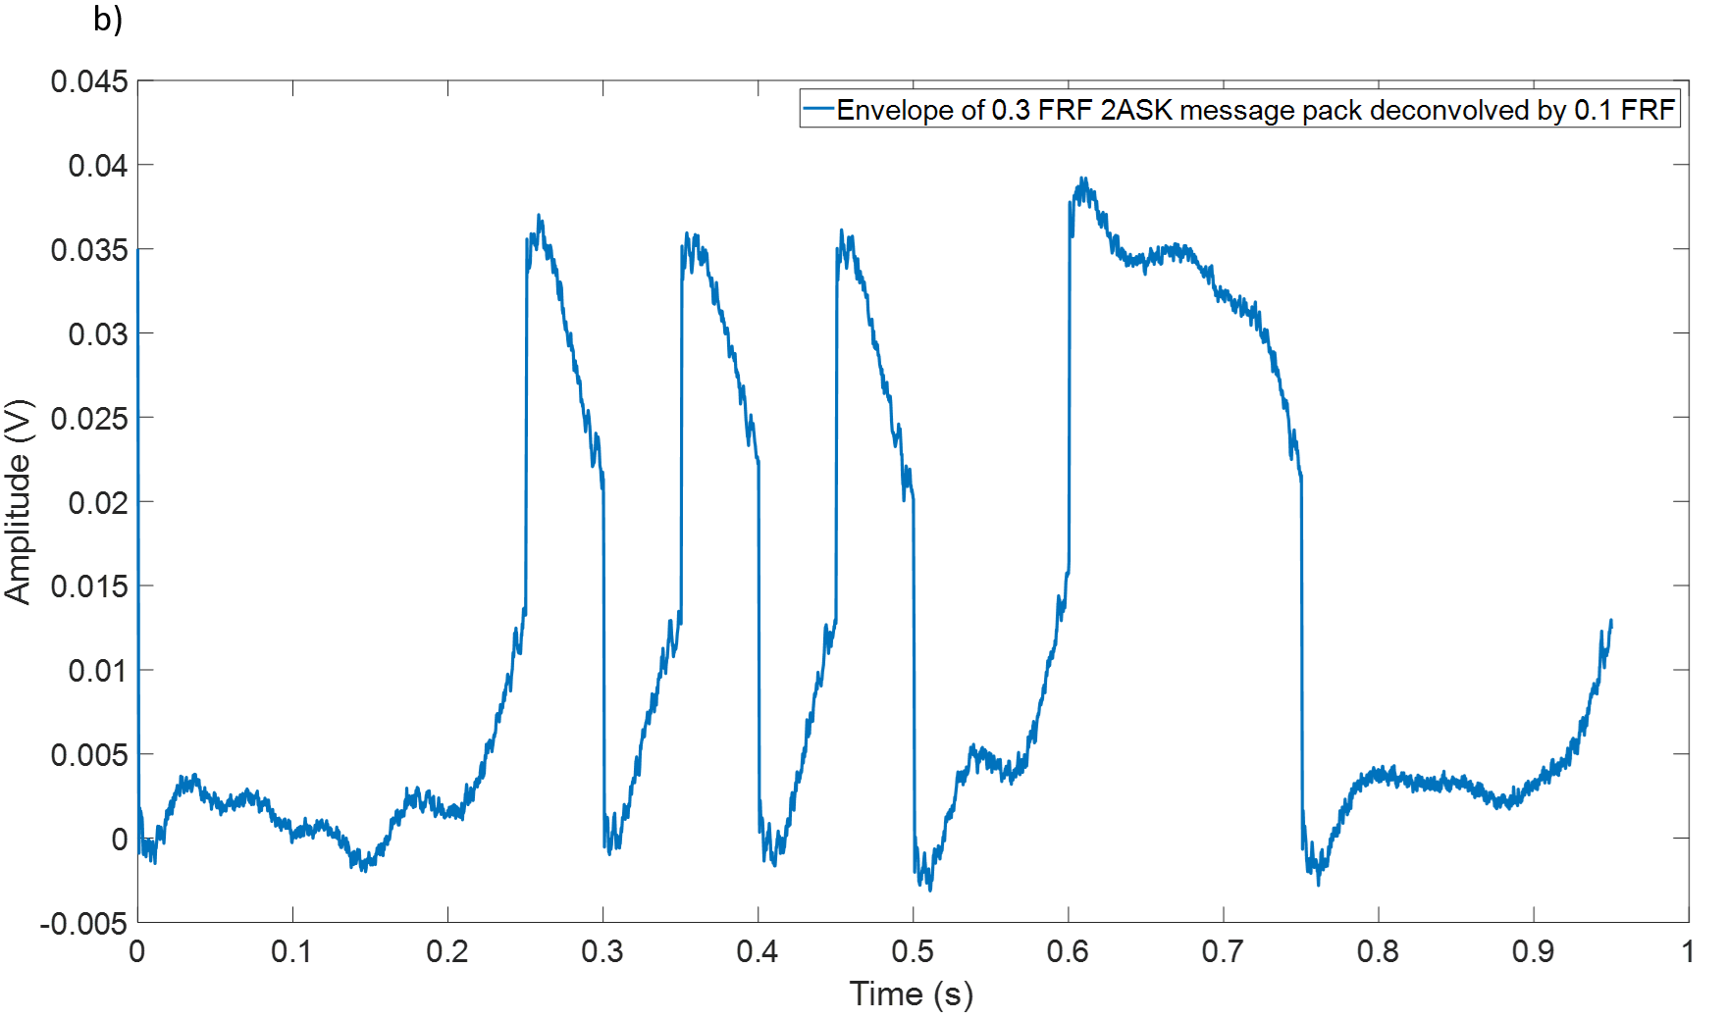
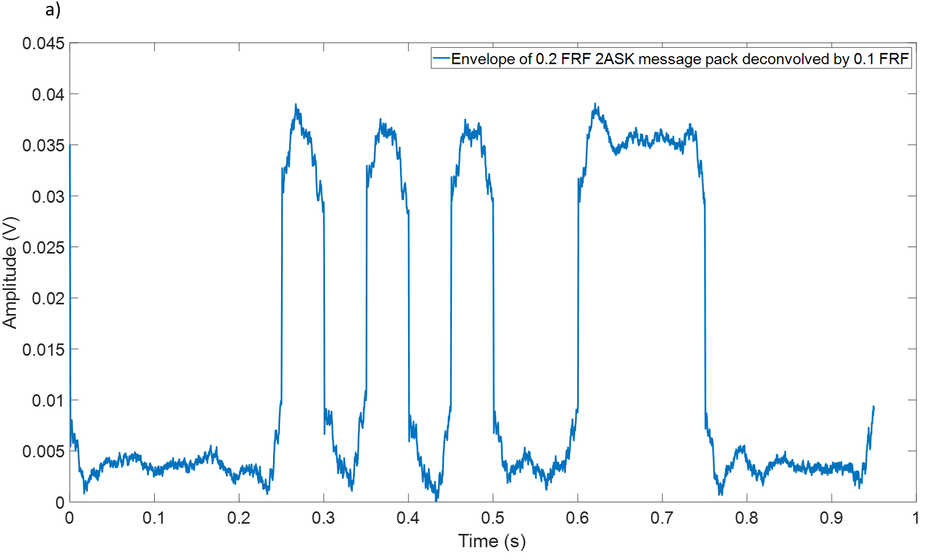
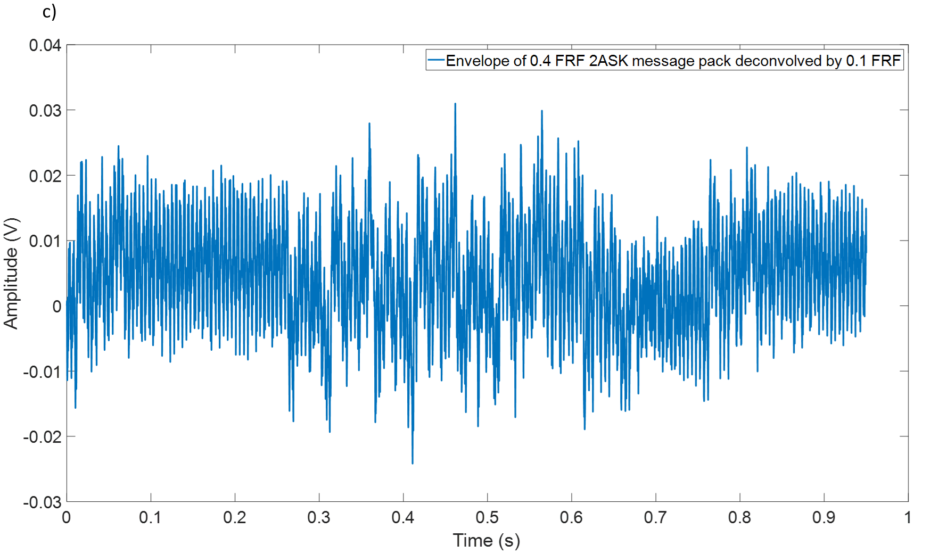
Figure 5.8 The waveforms of 2ASK message pack envelope using 0.1 FRF to deconvolve the signal convolved with: (a) 0.2 FRF; (b) 0.3FRF; and (c) 0.4FRF

5.2.3 2PSK
For 2PSK, the angle diagrams are shown in Figure 5.9. The situation is pretty similar to the case of 2ASK. According to Figures 5.9 (a) and (b), 2PSK communication technique is very reliable when the filling ratio is below 0.3. The angle demodulation could successfully provide clear waveform for adding threshold which is very helpful for decision making. However, the result shown in Figure 5.9 (c) for the filling ratio of 0.4, the use of 0.1 FRF to deconvolve the signal can cause a significant phase distortion so that the angle diagram can no longer be used to extract the information.
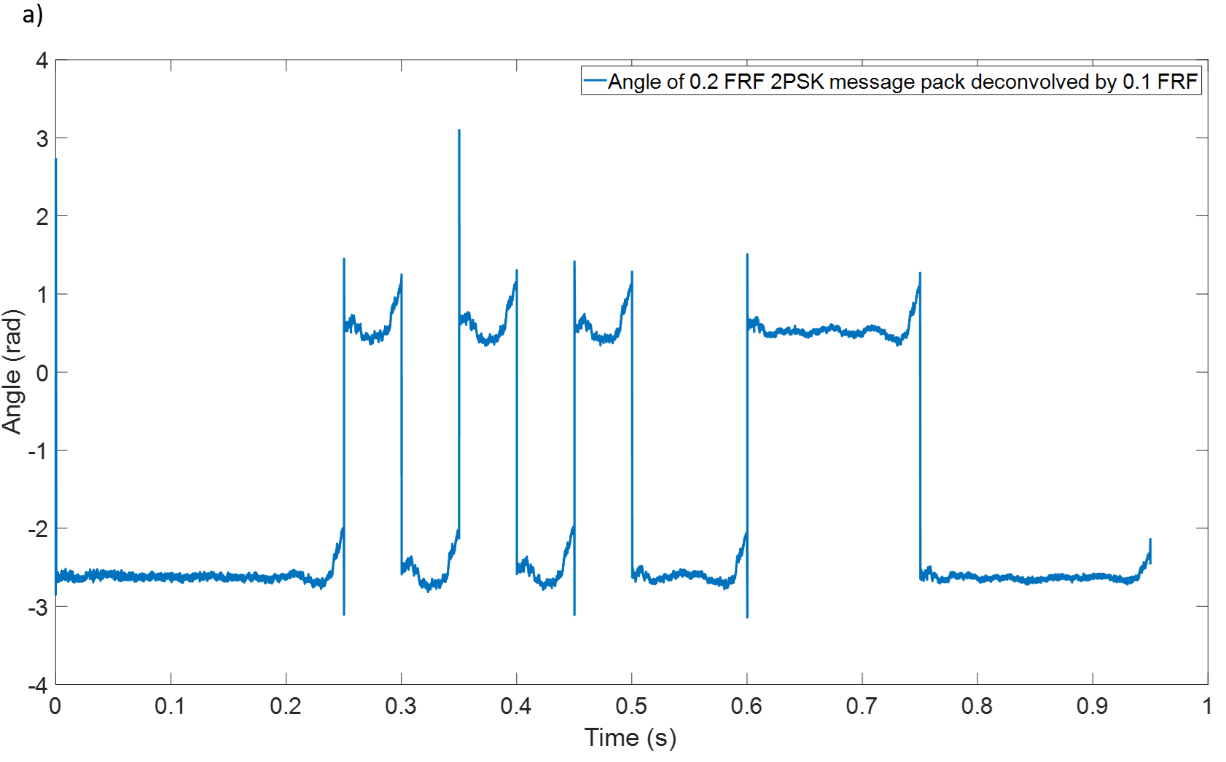
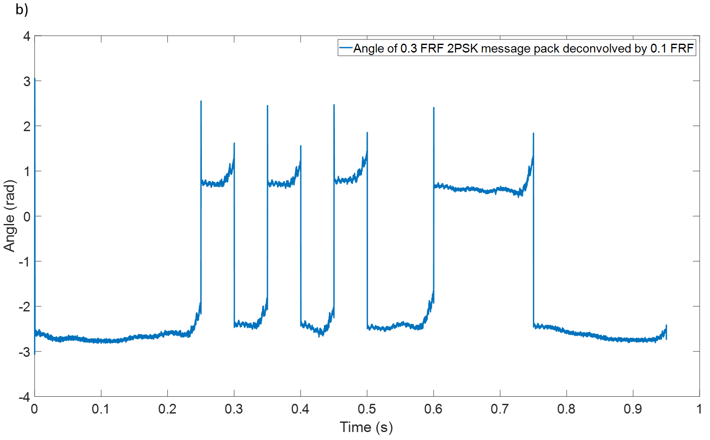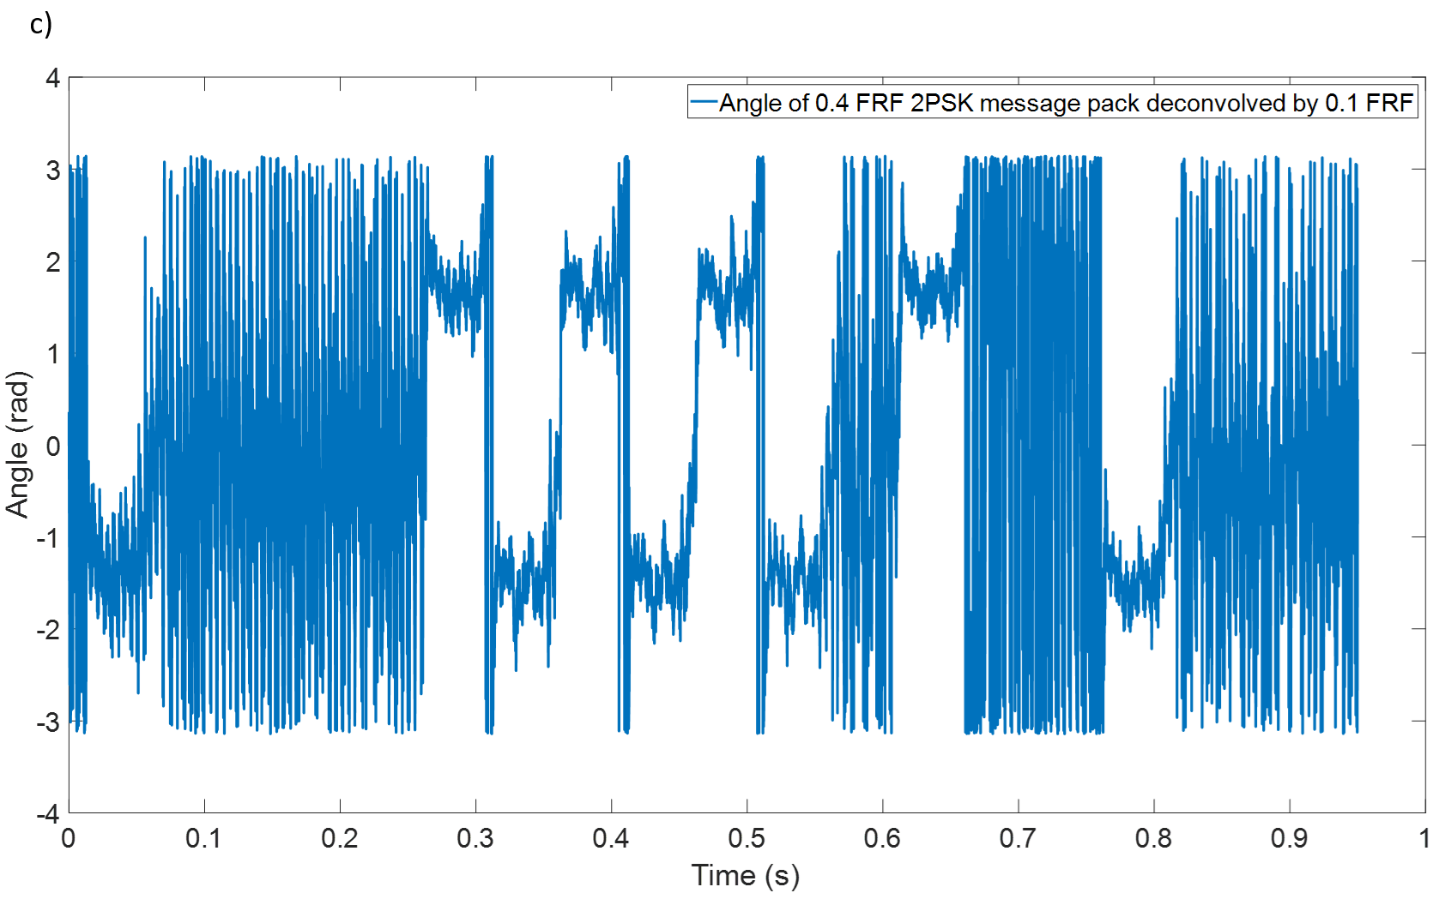
Figure 5.9 The waveforms of 2PSK message pack angle diagram using 0.1 FRF to deconvolve the signal convolved with: (a) 0.2 FRF; (b) 0.3FRF; and (c) 0.4FRF

5.2.4 CLFM
Figure 5.10 plots the cross-correlation results for CLFM, and message packs convolved with the FRF predicted for the filling ratio of 0.1, 0.2 and 0.3 but deconvolved with 0.1 FRF. The diagrams on the top and middle graphs (Figure 5.9) indicate that it is possible to perfectly recover the signals convolved by 0.2 and 0.3 FRF but deconvolved with 0.1 FRF. This finding suggests that below the filling ratio of 0.3 CLFM communication has a stable performance, but it will not be able to transmit message while the water depth rise above this level.
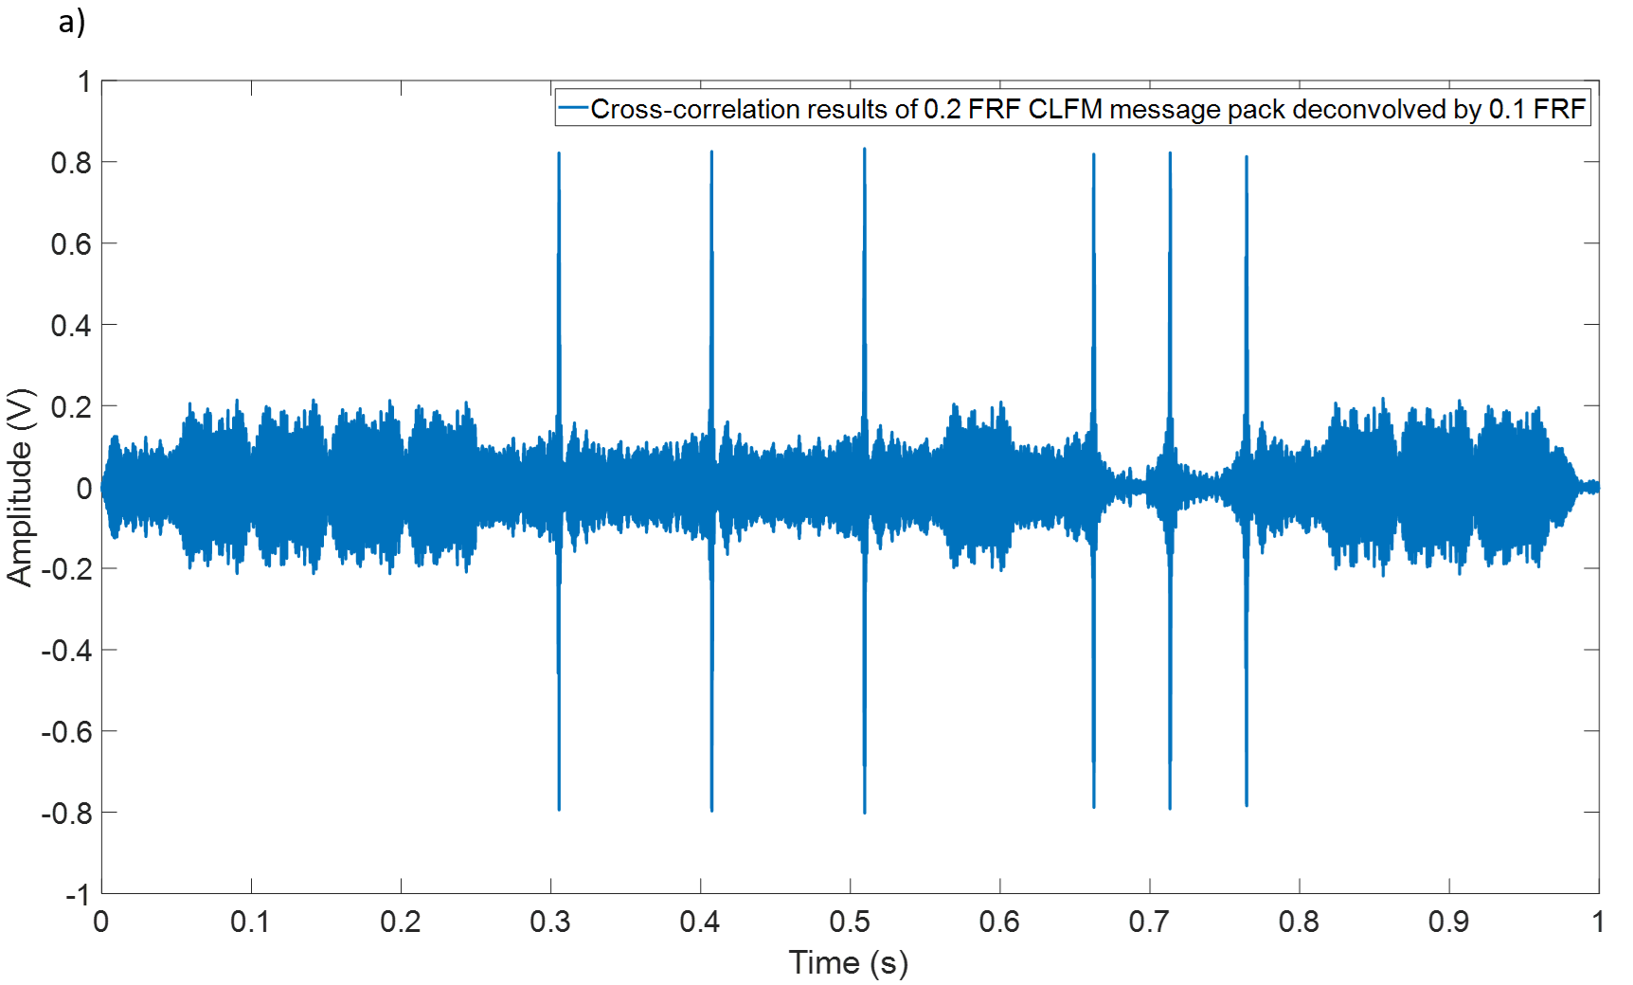
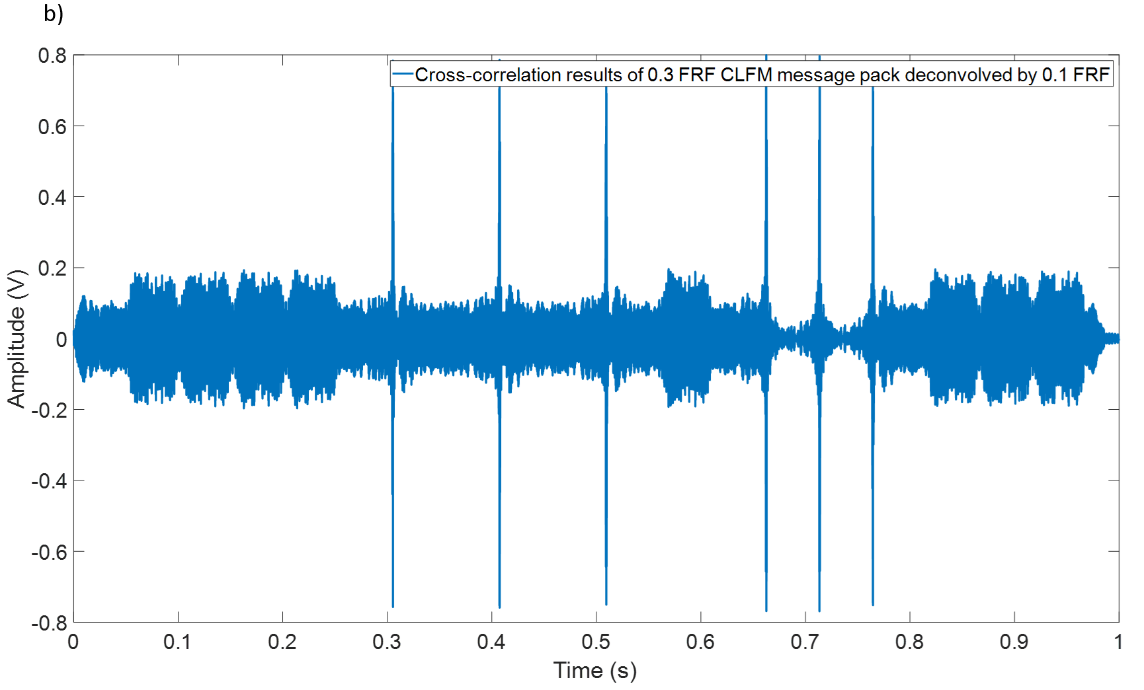
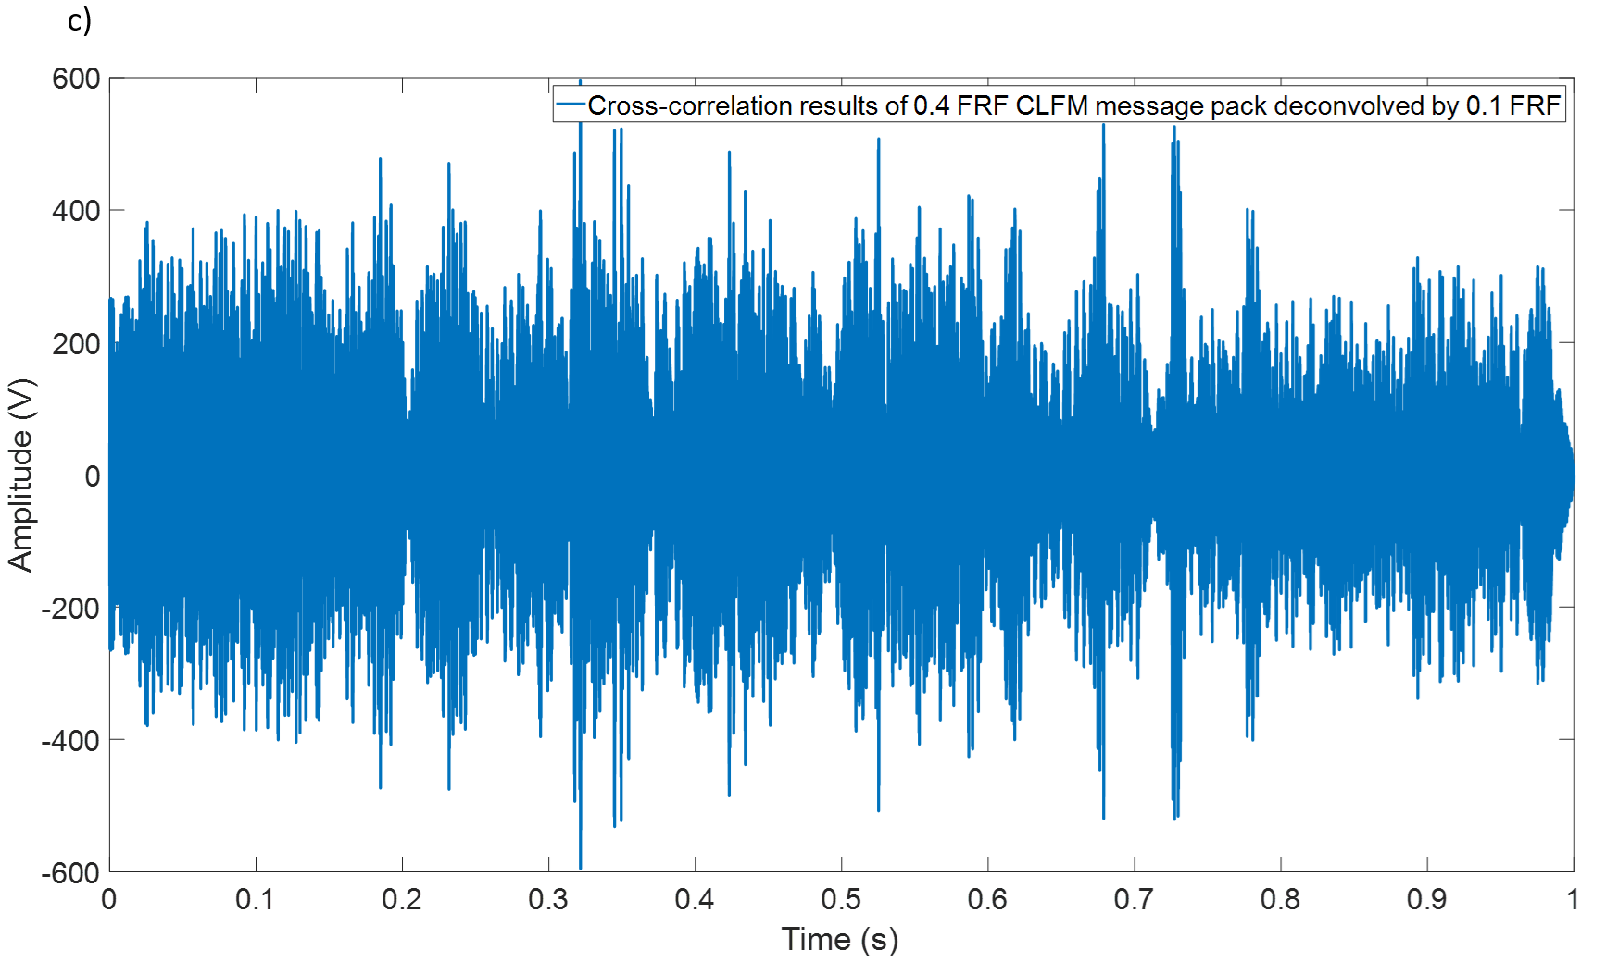
Figure 5.10 The waveforms of CLFM message pack based on cross-correlation predicted with 0.1 FRF for the signal convolved with: (a) 0.2 FRF; (b) 0.3FRF; and (c) 0.4FRF

5.3 The influence of the source and receiver locations on communication
The modal split phenomenon for the non-axisymmetric modes such as (1,0), (2,0), (1,1) in a partially water-filled pipe is discussed in Chapter 3 (e.g. Figure 3.6). The cause of such a phenomenon is that the flow of water in the pipe creates a flat boundary. As the level of water increases, the air domain region in the pipe shrinks accordingly resulting in the splitting and frequency shifting of non-axisymmetric modes. This phenomenon is illustrated with the FE numerical and analytical studies presented in Chapter 3.
In Chapter 4, four communication techniques, 2FSK, 2ASK, 2PSK and CLFM, are tested in an empty pipe. The results suggest that the cross-sectional (modal) resonances can have a considerable impact on the channel communication quality and carrier frequency selection for at least three traditional binary modulation techniques such as 2FSK, 2ASK and 2PSK. Using a carrier frequency close to the frequency of those modes is likely to trigger the signal distortion and to increase the package error rate (PER) significantly. In contrast, such effect can hardly be observed on the CLFM communication system in the case of an empty (dry) pipe. Therefore, it is suggested that sending messages acoustically in the pipe should be done at frequencies that do not coincide with the frequencies of the non-axisymmetric modes.
At the beginning of this chapter, it was shown that the acoustic communication in a partially water-filled pipe under a good SNR and wide-band condition is robust provided that the FRF is accurately measured or predicted. Moreover, when the water level varies in a limited range of filling ratios, the FRF and quality of the communication channel are not significantly affected. However, it should be noted that with the decrease of the SNR, the impact of cross-sectional modes can become much stronger. The modal split phenomenon can also make acoustic communication in the partially waterfilled pipe trickier because it narrows down the range of carrier frequencies at which the communication is stable. With the increase in the carrier frequency the carrier frequency selection range reduces because the modal density increases.
To overcome the influence of the modal split phenomenon, one optional solution is to move the source and receiver to the position near the top wall of the pipe. The reason is because the water layer in the pipe can be treated as a non-axisymmetric horizontal rigid boundary which could split the non-symmetric modes. The effect of the modal split phenomenon is strong when source and receiver are fairly close to the boundary and therefore putting source and receiver in the middle of the cross-sectional area of pipe (close to the boundary) will make the signal excitation easily to be affected by the modal split phenomenon. Thus, moving source and receiver to the region close to the pipe wall could probably solve this problem.
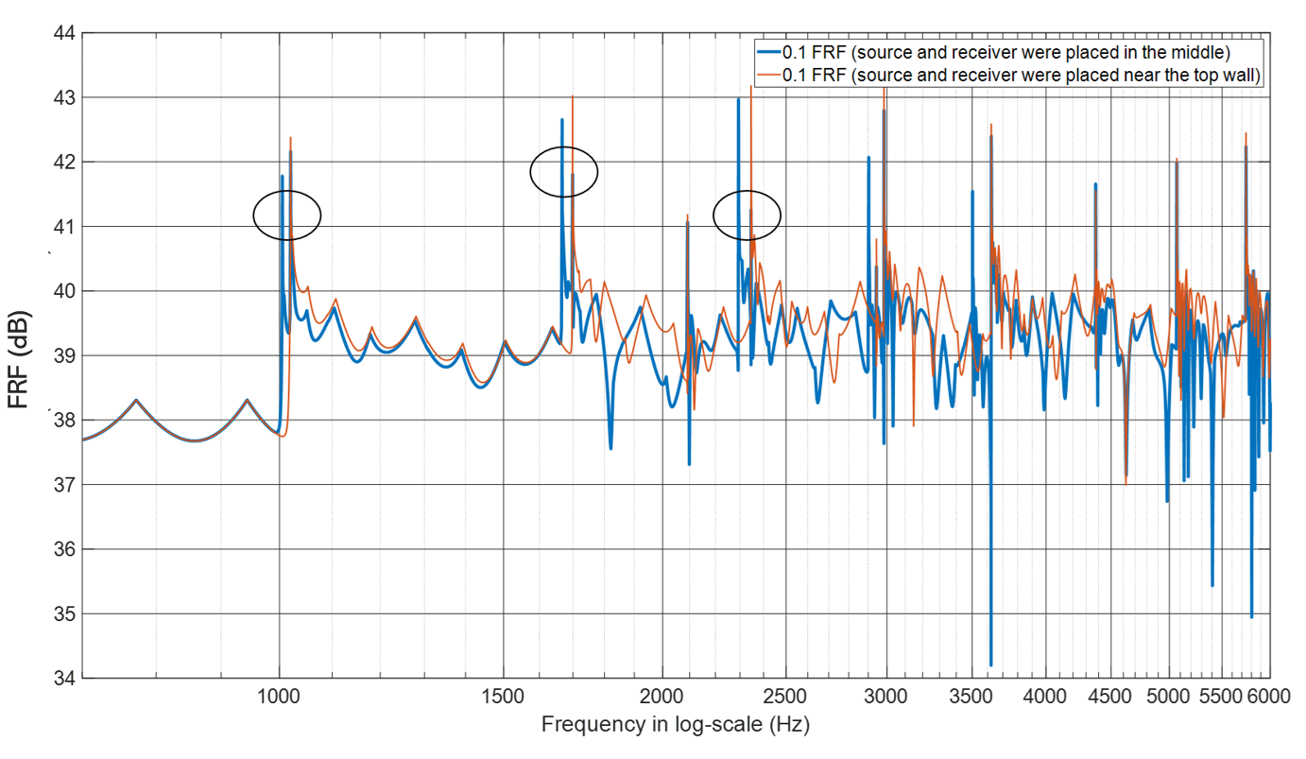
Figure 5.11 An example of the FRFs predicted for the source and receiver being in the middle of cross-sectional area (blue line) and near the top of the pipe wall (red line).
Figure 5.11 illustrates the FRFs in a 200 mm diameter partially water filled pipe with filling ratio of 0.1. The blue line represents the FRF predicted for the source and receiver being in the middle of the pipe cross-section. It is clear that the first, second and fourth non-axisymmetric modes, (1,0), (2,0) and (1,1) (marked by black circles), are split while the third axisymmetric mode, (0,1) is not. The red line in the diagram denotes the case when the source and receiver are placed near the top wall of the pipe (0.01 m away from the wall). For these source and receiver positions the non-axisymmetric modes do not show the modal split phenomenon. In addition, in the relative higher frequency range, e.g. 4000 - 5000 Hz, the red line did not fluctuate as strongly as the blue line, which means a set up with the speaker and microphone close to the pipe wall is able to reduce the difficulty of deconvolution in the higher frequency range.
In order to compare the difference in the quality of communication related to placing the source and receiver at different locations, several other simulations have been carried out. In these simulations the package error rate (PER) of the four communication technologies has been tested as a function of carrier frequency and these tests were finished separately by using two FRFs (source and receiver near the top wall or in the middle) to see the difference. All the simulations were repeated 200 times and averaged to make sure the results are statistically reliable.

5.3.1 2FSK:
Similar to the previous studies, the relation between the two sub-carriers was: $f_{c1}=2f_{c2}$ for 2FSK communication system and $f_{c1}$ has range from 500 Hz to 5000 Hz. In addition, in this test SNR was set at 10 dB and bandwidth was 20 Hz. Figure 5.12 plots the package error rate (PER) against the carrier wave frequency $f_{c1}$ to show the difference of placing source and receiver at different location. The black dash line in the graph denotes the frequencies of the cross-sectional modes in the pipe.
The results presented in Figure 5.12 suggest that although the PER remains below 0.2, the situation is much more complex than that in the empty pipe (see Chapter 4). In the partially filled pipe relatively high bit error rates occur at frequencies other than those modal frequencies predicted for the empty pipe. The modal split caused by the presence of water has an effect on the non-axisymmetric modes and quality of 2FSK communication. When the source and receiver are close to the pipe wall (red line in Figure 5.12), the overall PER value reduces especially in the frequency range below 3200 Hz and above the 4000 Hz. Therefore, it can be suggested that putting the source and receiver near the top wall could improve the quality of acoustic communication through the reduced effect of the modal split.
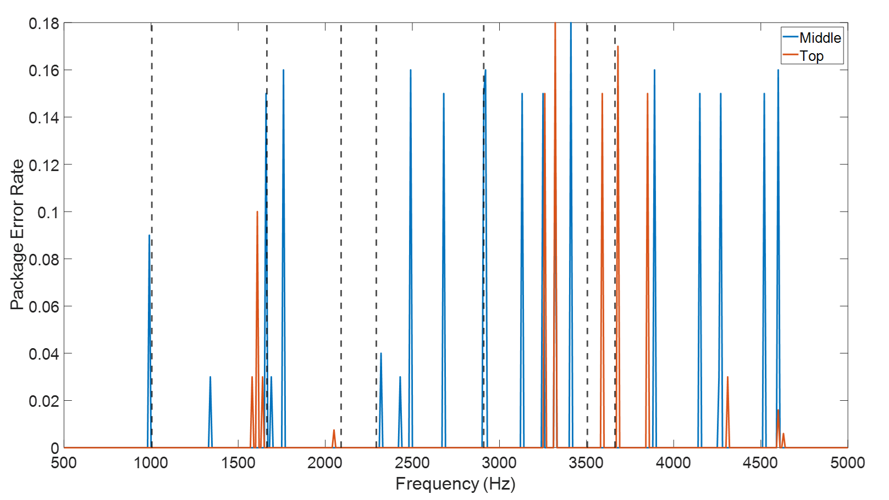
Figure 5.12 The Package Error Rate diagram for the 2FSK technique (SNR=10 dB) Illustrating the difference of placing the source and receiver in the middle of cross-sectional area of the pipe (blue line) and near the top wall (red line).

5.3.2 2ASK
Figure 5.13 presents the results of the simulation carried out for the 2ASK communication technique to understand the effect of the water level on the PER. The carrier frequency range for 2ASK was set from 500 Hz to 5000 Hz The graphs show that at SNR=10 dB, 2ASK has slightly better performance than 2FSK system because the value of PER is relatively low, the maximum value of these PERs is only 0.09 which is only half of that for 2FSK. In addition, even though there are still some peaks exist in the region where far from the modes, most of error bits occur around the mode frequencies for both cases. Comparing with red and blue line in the figure, the influence of the location of source and receiver is not very clear in the range which is higher than 4000 Hz. but below this frequency, the effect of putting source/receiver to the top is pretty obvious for 2ASK communication.
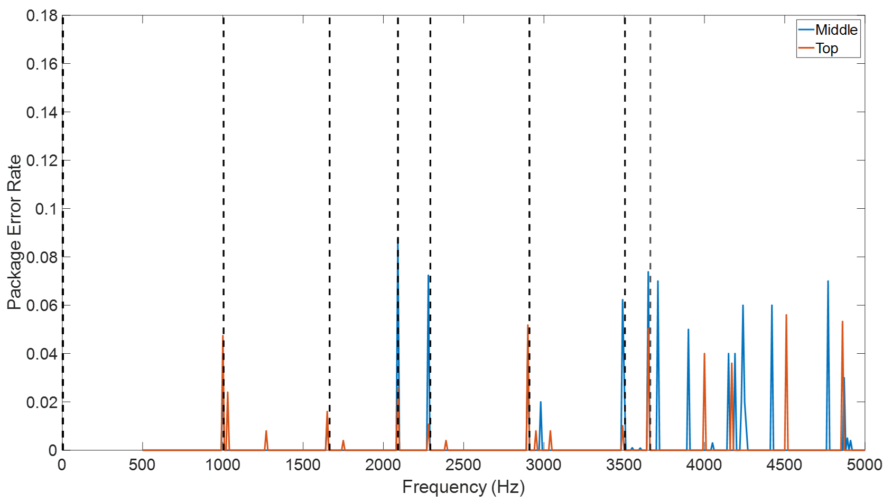
Figure 5.13 The Frequency-Package Error Rate diagram for 2ASK system (SNR=8 dB) showing the difference of placing the source and receiver in the middle of cross-sectional area of the pipe (blue line) and near the top wall (red line).

5.3.3 2PSK
The simulation suggests that the 2PSK communication technique worked perfectly (0 package error rate for all 200 times tests) for SNR=10 dB. Therefore, the SNR was subsequently adjusted down to 8 dB and results of this simulations are shown in Figure 5.14. The reason for adjusting the SNR down to 8 dB is because according to the results presented in Chapter 4, the performance of 2PSK in the empty pipe is slightly better than that for 2ASK and 2FSK (approximately 2 dB lower). Figure 5.14 used blue and red lines to illustrate the difference of placing the source and receiver near the top wall and in the middle of cross-sectional area of the pipe.
A majority of error bits occurred in the region between the frequency range roughly from 1600 Hz to 2500 Hz and the region between 3850 Hz to 5000 Hz. The reason caused such problem was the phase distortion under a relatively poor SNR even though the averaged PERs were very low. The first region wasin the space between axisymmetric mode (0,1) and non-axisymmetric mode (1,1). The diameter of the pipe for which this simulation was carried out was 200 mm. This was considerably larger than 150 mm, the second region contains more even higher modes which made the FRF in this frequency range was more complex. It makes sense that using carrier frequency in this region has relatively high potential to obtain higher PER. Another interesting point is the location of the source and receiver does have effects on the communication quality because the values in blue line were overall slightly higher than the values in red line.
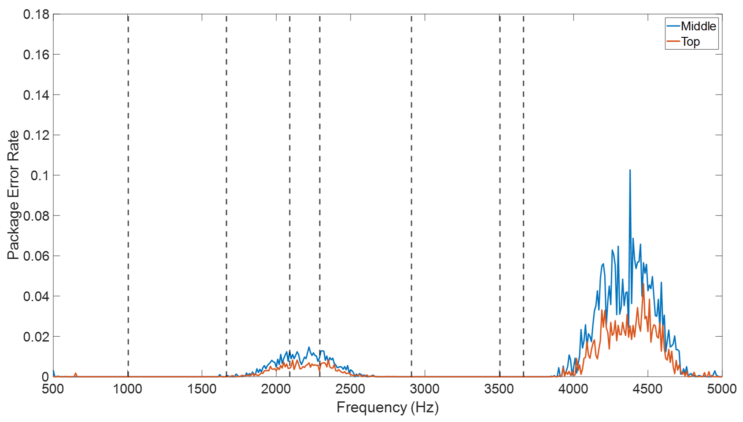
Figure 5.14 The Frequency-Package Error Rate diagram for the 2PSK technique (SNR=8 dB) showing the difference of placing the source & receiver in the middle of cross-sectional area of the pipe (blue line) and near the top wall (red line).

5.3.4 CLFM
due to the nature of CLFM the term "carrier frequency" cannot be used because this technique requires a broad frequency range to communicate a message. In previous sections, the sub-chirp signals of CLFM were determined by central frequency, $f_{central}$ and the frequency range of sub-chirp was defined as from $f_{central}-500 Hz$ to $f_{central}+500 Hz$. In this case, the simulation was able to control the frequency range of sub-chirps by controlling the central frequency. The bandwidth was 20 Hz and SNR was 0 dB. In comparison with the other three communication techniques, CLFM has the best noise resistance as demonstrated in Chapter 4. Therefore, the SNR was set to 0 dB to make the results comparable to that for 2FKS/2ASK/2PSK.
Figure 5.15 presents frequency dependence of the package error rate to illustrate the effect of the central frequency selection. The differences of positions of source and receiver has been distinguished by blue (in the middle of cross-sectional area) and red (near the top wall) lines, respectively. Overall, the PERs were lower than 0.1 which denotes these error bits occasionally and mainly occur in the range between modes (2,0) and (0,1) and cover the region from 3250 Hz to 4250 Hz. However, the placing the source and receiver near the top wall did not make obvious effect on the quality of communication when $f_{central}$ below than 4000 Hz. In contrast, above 4000 Hz putting the source and receiver near the top of the pipe could slightly improve the quality of CLFM communication as illustrated by the simulation results in Figure 5.15.
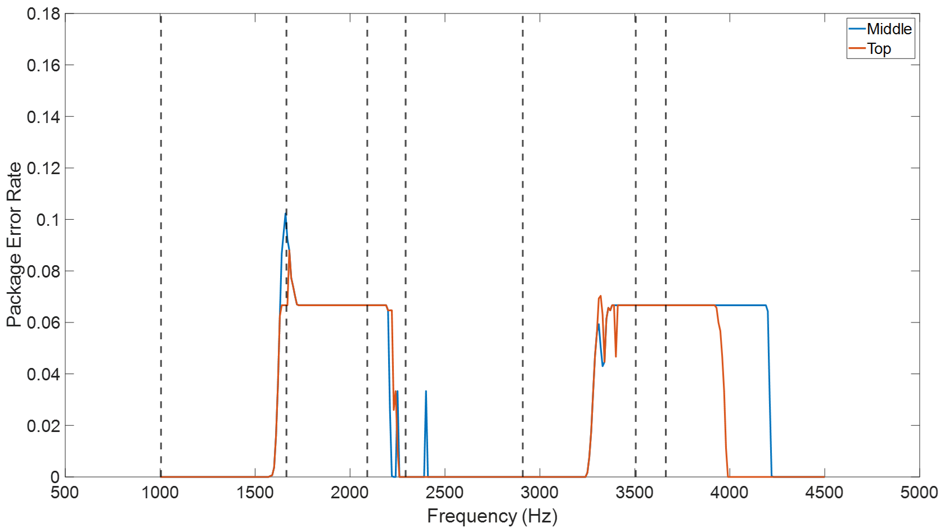
Figure 5.15 The Frequency-Package Error Rate diagram for CLFM system (SNR=0 dB) to show the difference of placing the source & receiver in the middle of cross-sectional area of the pipe (blue line) and near the top wall (red line).

5.4 Experimental Validation
The purpose of these experiments was to validate the simulation results to confirm that: 1. The presence of the water layer changes the mode shape causing the modal split phenomenon for non-axisymmetric modes while having much smaller effect on the axisymmetric modes. 2. Sudden change of filling ratio causes an increase in package error rate. These experiments also helped to estimate the frequency of re-calibrating the channel acoustic characterisation in practical application.
In the previous chapter the diameter of pipe used in the simulations was 150mm. However, it is very difficult to get access to a 150mm pipe and adjust the filling ratio accurately in such an experiment. Therefore, an experiment was carried out in a 200 mm diameter, 7 m long pipe which was partially filled with water. The rig is shown in Figure 5.16.
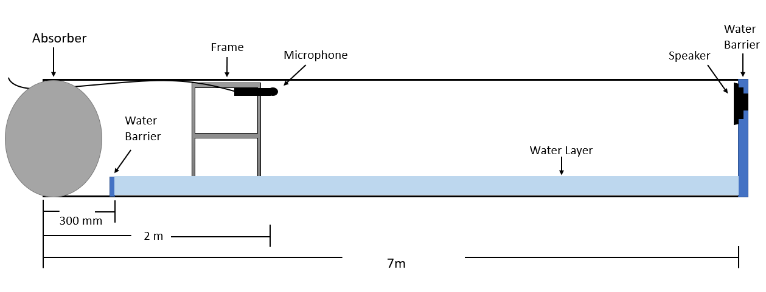
Figure 5.16 The experimental set up to study communication in a partially filled pipe
On the left-hand side, there was an absorber (fibrous material) plugged into the pipe end to cancel the echo generated by the pipe end. 300 mm away from this pipe end a water barrier was set on the pipe bottom to stop the water. There were 5 water barriers with different depths prepared to correspond to filling ratios of: 0.1, 0.2, 0.3, 0.4 and 0.5. The filling ratios was controlled accordingly by replacing the different water barrier. The microphone (GRAS 46AE 1/2'' free-field standard microphone) was fixed on a moveable frame which has 0.01 m gap with top wall of the pipe and 2 m away from left end of the pipe. It was suggested in the previous section that the location of the source and receiver can have a significant impact on the communication in the partially water-filled pipe because the non-axisymmetric modes split in the presence of the flat-water surface and their amplitude is the maximum close to the centre of the pipe. Therefore, to avoid the signal distortion caused by the mode splitting and to keep the microphone away from the water surface, it was suggested to place it at the top of the pipe 10 mm away from the wall. In addition, on the right-hand side, the speaker was fixed in a bigger plate (covering the whole cross-sectional are of the pipe) and in-line with the microphone to excite the acoustic signal.
Figure 5.17 shows photographs of the experiment setup. In the top photo, there was a transparent water barrier which can cover the whole cross-sectional area of the pipe was fixed on one side of 7m long, 200 mm diameter pipe and the speaker was inserted into the hole on the water barrier. Another side of the pipe has been shown in the middle diagram and in this photo, the water injection pipe, microphone cable has been highlighted and the tape measure was used for determining the location of each component such as small water barriers, frame and microphone. And the last photo demonstrates the panoramic view of the experiment rig which includes the pipe, pipe fixer and pipe supporter. This experimental rig was pre-tested by the Rolson 54462 spirit level to make sure the water layer in the pipe was perfect horizontal.

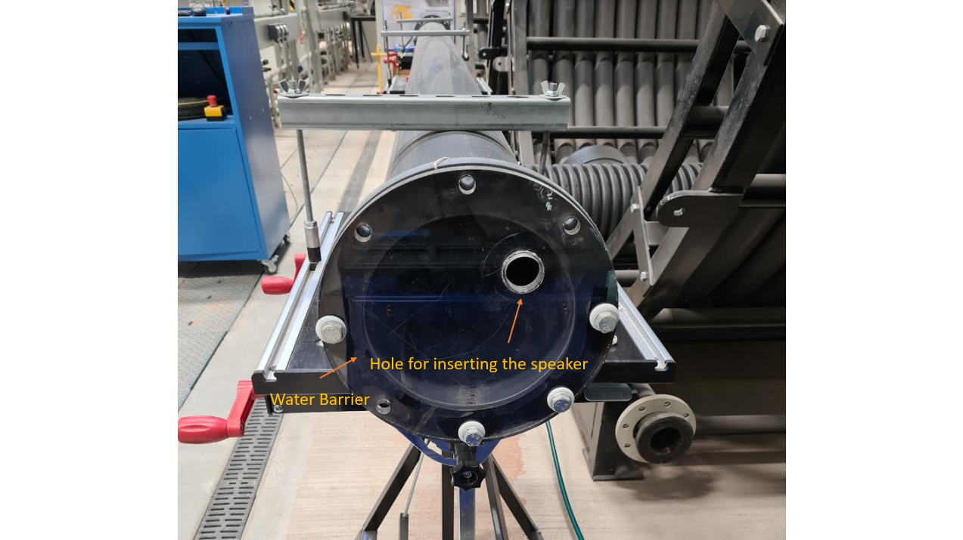

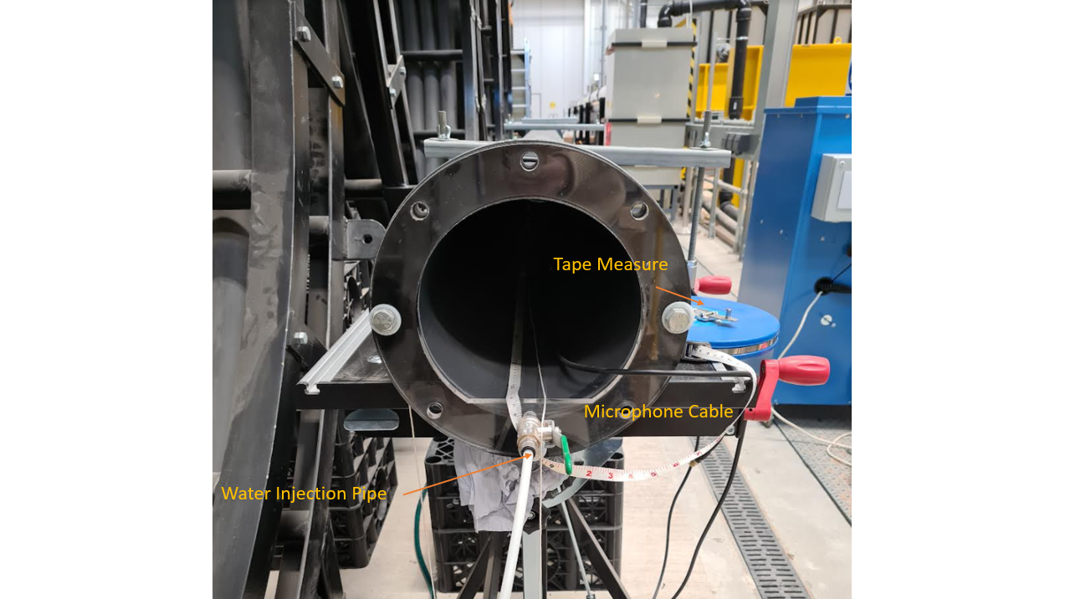
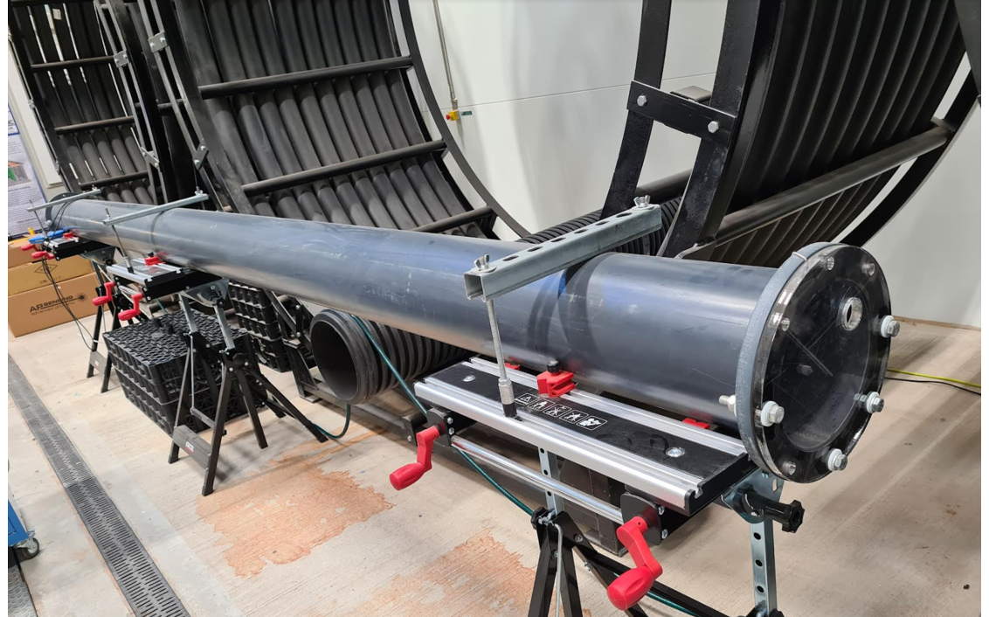
Figure 5.17 Photos to show the experiment rig.

In the experiment, the bandwidth and carrier frequency for 2ASK/2FSK/2PSK were 20 Hz and 5000 Hz, respectively. The modulation of CLFM was different, the bandwidth was still 20 Hz, but the frequency range of sub-chirps was controlled by the central frequency $f_{central}=4500 Hz$ with a 1000 Hz wideband ([$f_{central}-500 Hz ,f_{central}+500 Hz]$). This setup was designed to be identical to the simulation discussed in sections 5.1 and 5.2. The signal encoding and mapping were also as same as introduced in previous sections and details can be found in section 4.1, chapter 4. The SNR was measured as 45 dB in the laboratory which considerably high and can be used to representing no noise condition.

5.4.1 Channel Validation:
Figure 5.18 presents the comparison between the FRF measured in the 200 mm partially water-filled pipe with the filling ratio of 0.1 and 0.2. These FRFs were obtained from pre-amble signal which was mapped at the beginning of the excited communication signal. The red dash lines in those figures represents the first five modes which have been marked by the brackets on the top of the graphs. It is very clear that in Figure 5.18 (b), the peak values which occurred at the cross-sectional resonance right shifted a little in comparison of that in Figure 5.15 (a). It is reasonable because increasing the filling ratio of 0.1 subsequently shrink the air-domain area in the pipe and due to the massive miss-match of the impedances of air and water, it can be treated as the decrease of the cross-sectional area of the pipe and therefore, the cut-off frequencies will be increased accordingly. Moreover, in Figure 5.18 (a) and (b) for non-axisymmetric modes such as (1,0) and (3,0) two sub-frequencies peaks clearly Illustrate the mode split phenomenon even though it is not very clear on mode (2,0). In contrast, there is no mode split on axisymmetric mode (0,1) and therefore the conclusion which states the non-axisymmetric modes will split due to the presence of water layer while it has no impact on axisymmetric modes has been validated. 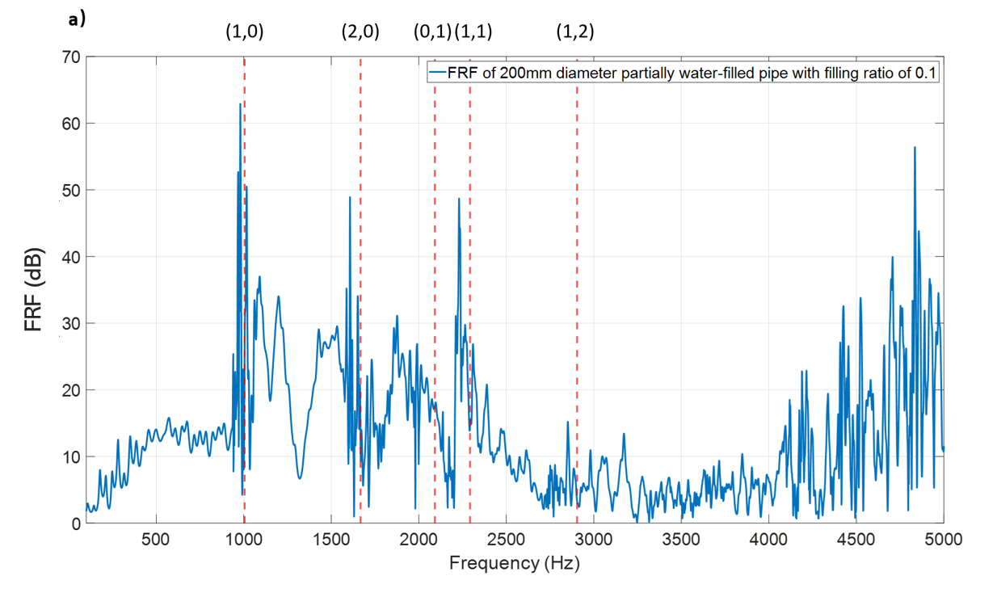
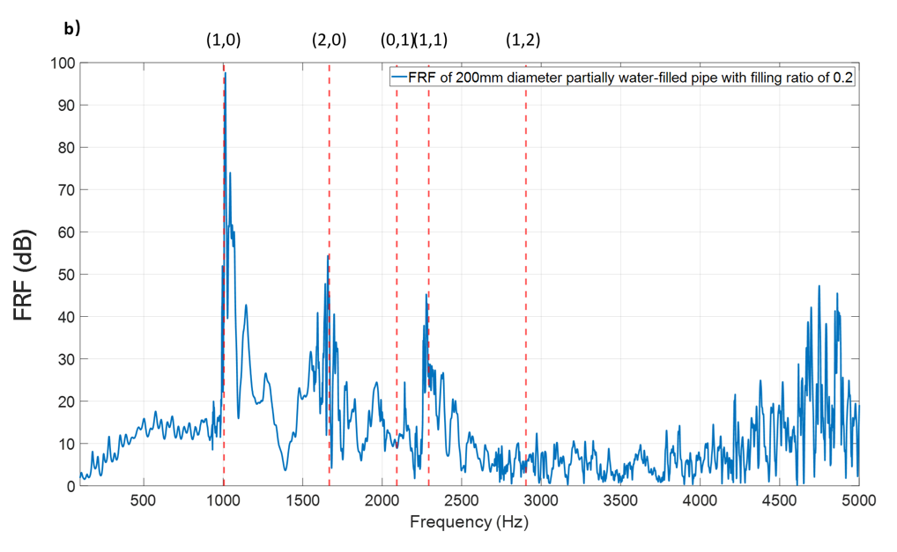
Figure 5.18 a). FRF of 200 mm diameter pipe with filling ratio of h/R=0.1 and b). FRF of 200 mm diameter pipe with filling ratio of h/R=0.2

5.4.2 Communication Validation:
In this section, the experiments will demonstrate the ability of acoustic communication to work when the water level is suddenly changed.

5.4.2.1 2FSK
The results of the experiment tested with the 0.1 filling ratio were used as an example of measured signals. The time domain signal is shown in the top graph of Figure 5.19. In this diagram, a 10 s long pre-amble and post-amble signals are marked on the top. The message pack is highlighted by red rectangular frame. The enlarge form of message is shown on the graph underneath. On the top graph in Figure 5.19 the mapping structure of the signal such as pre- and post-amble and the message pack can be easily distinguished. Apparently, the signal shown in bottom diagram is stretched and there are overlaps between each symbol which can be attributed to the multi-path effects. An attempt of to directly demodulate it would have a high risk of obtaining a large number error bits.
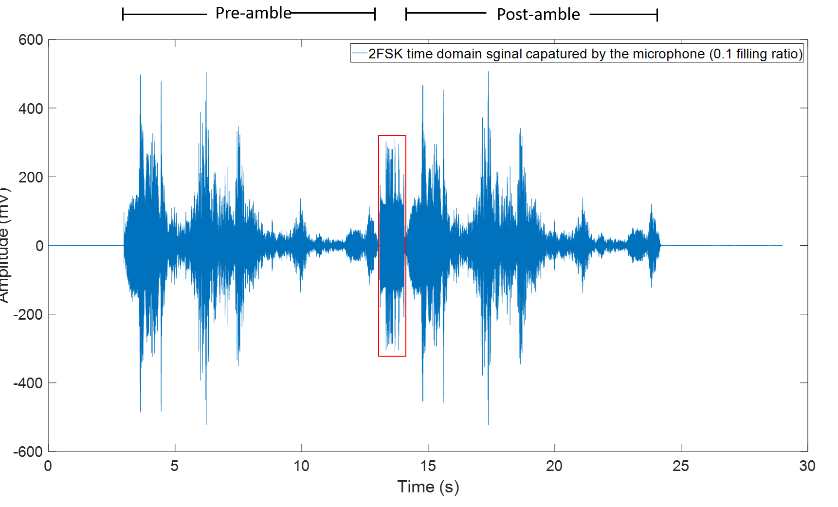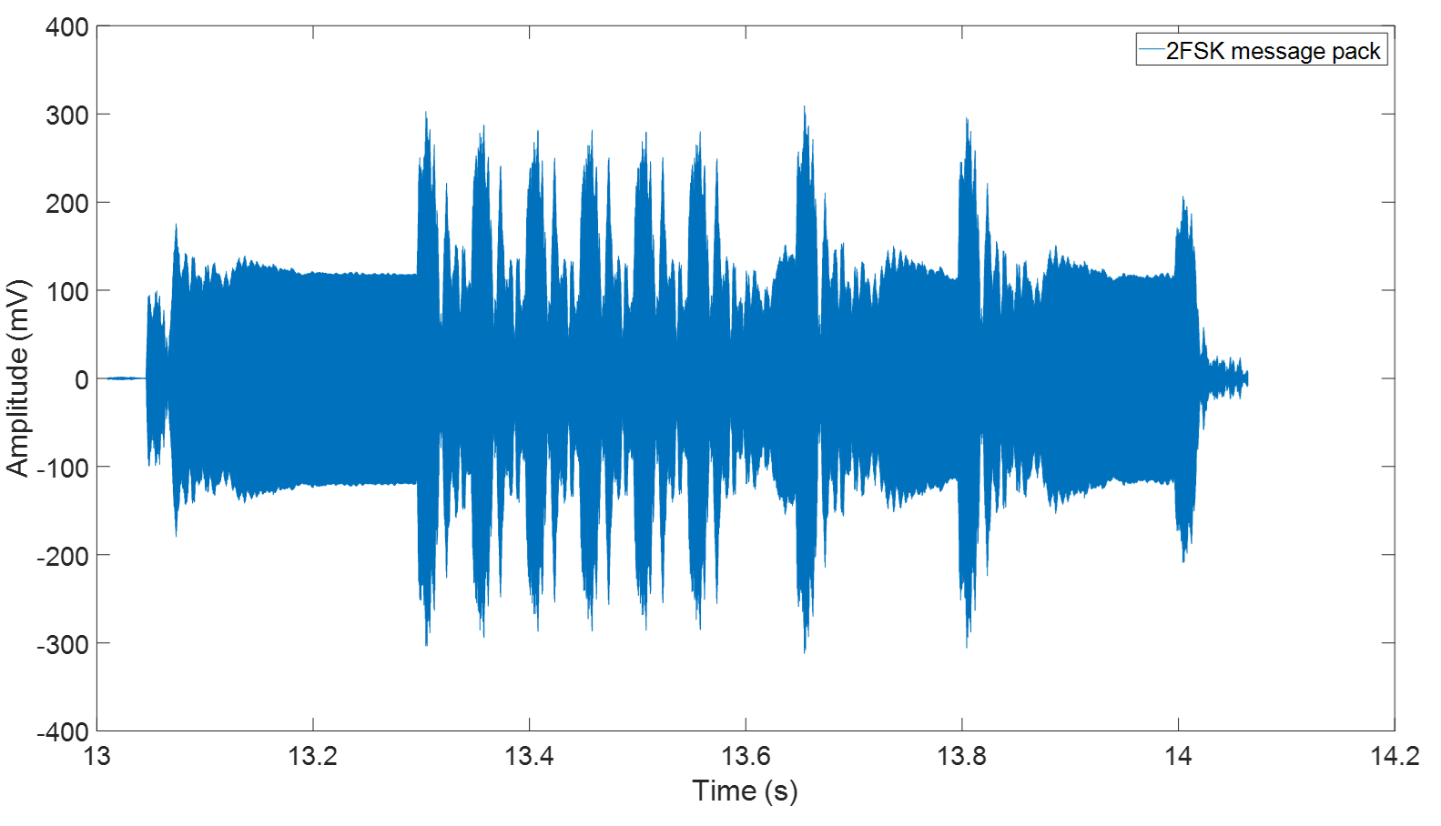
Figure 5.19 The time domain 2FSK signal (0.1 filling ratio) including the sine sweeps and communication pack
The diagram shown in Figure 5.20 presents the demodulation of 2FSK message pack (0.1 filling ratio) deconvolved using the preamble. It can be seen that the strong fluctuation of the amplitude which caused by the multi-path effects are effectively equalised through the deconvolution (compare this with the bottom graph in Figure 5.19). The flipped envelope of this message pack is shown in Figure 5.21 which has the right form for decision making even though it still contains some peaks that may affect adding threshold.
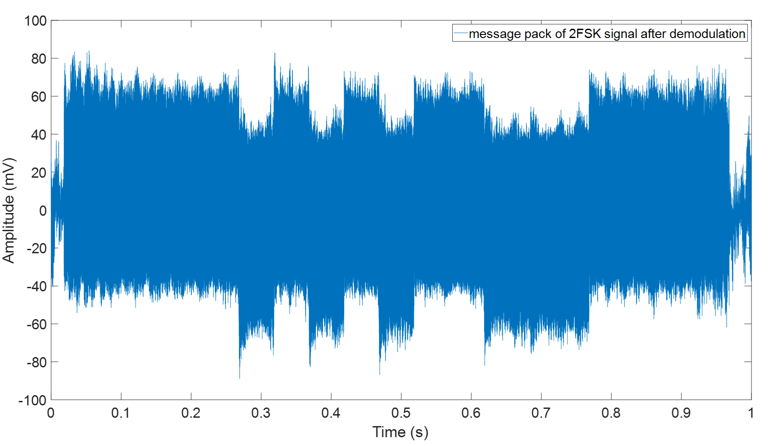
Figure 5.20 The 2FSK message pack (see Figure 5.19) after demodulation
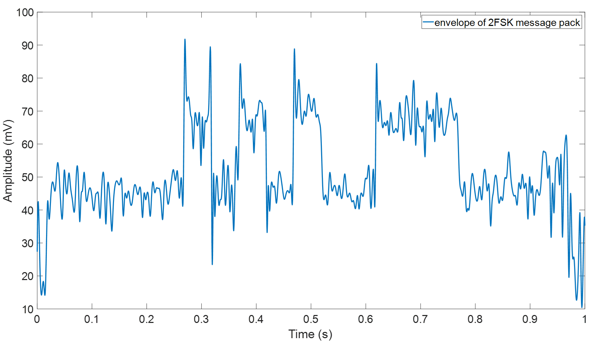
Figure 5.21 The envelope of the 2FSK message pack
In general, the threshold is normally added in the middle of the envelopes, Figure 4.12 in chapter 4 has given an example of adding threshold to the envelope of 2FSK message pack. In the case shown in figure 5.12, the threshold in principle should be placed around 60 mV. However, the peaks in time period roughly between 0.26s and 0.32s could easily distort the decision making.
Those peaks can be eliminated by using sliding window averaging method which is also known as "reshape". The principle of this method is to add a sliding window which contains certain number of elements from original signal sequence, averaging the elements in the window to rebuild the first element for the “reshaped” signal sequence. It has the form:
$$E_{reshape}(t)=\sum_{m}^{M}{\frac{S_{e\left(t\right)}}{m}}$$ | (5.1)
where $m$ is number of elements in a window and $S_{e\left(t\right)}$ is the summation of the elements in sub sequence $e(t)$, where $e(t)$ is the piece of message pack signal captured by the window. The reshaped envelope with $m=500$ has been illustrated in Figure 5.22 which validates that sliding window averaging method is effective for eliminate those peaks.
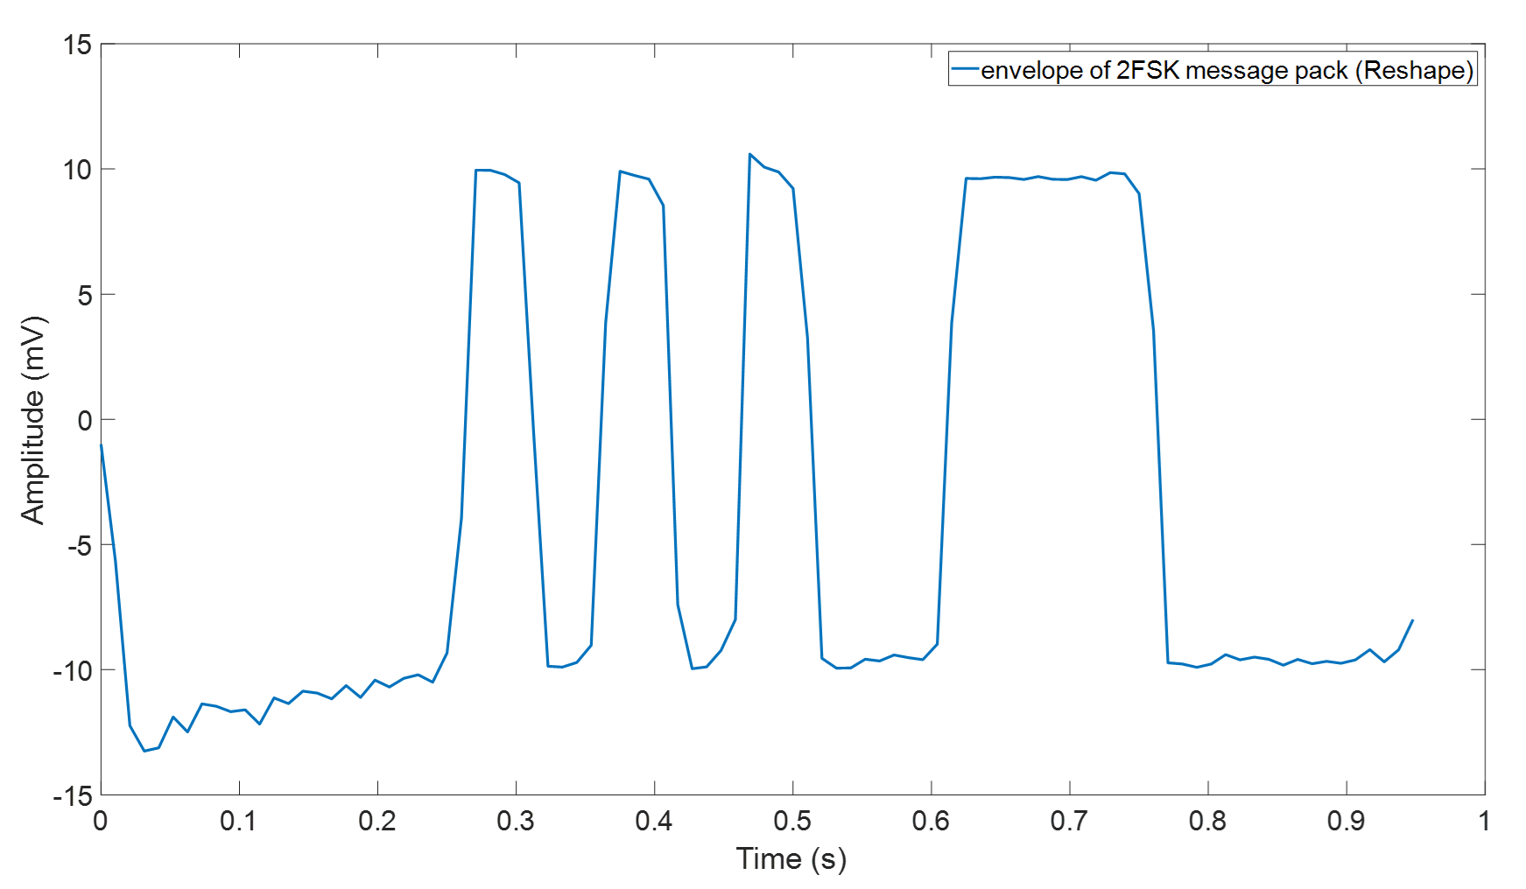
Figure 5.22 The envelope of 2FSK message pack (Reshape)
This example demonstrates that the communication in partially water-filled pipe with filling ratio 0.1 can be successful. The diagrams in Figure 5.23 show examples of the reshaped envelopes for the experiments with filling ratio of 0.2-0.4. These envelopes have the right form for message decoding because they allow for clear threshold setting.
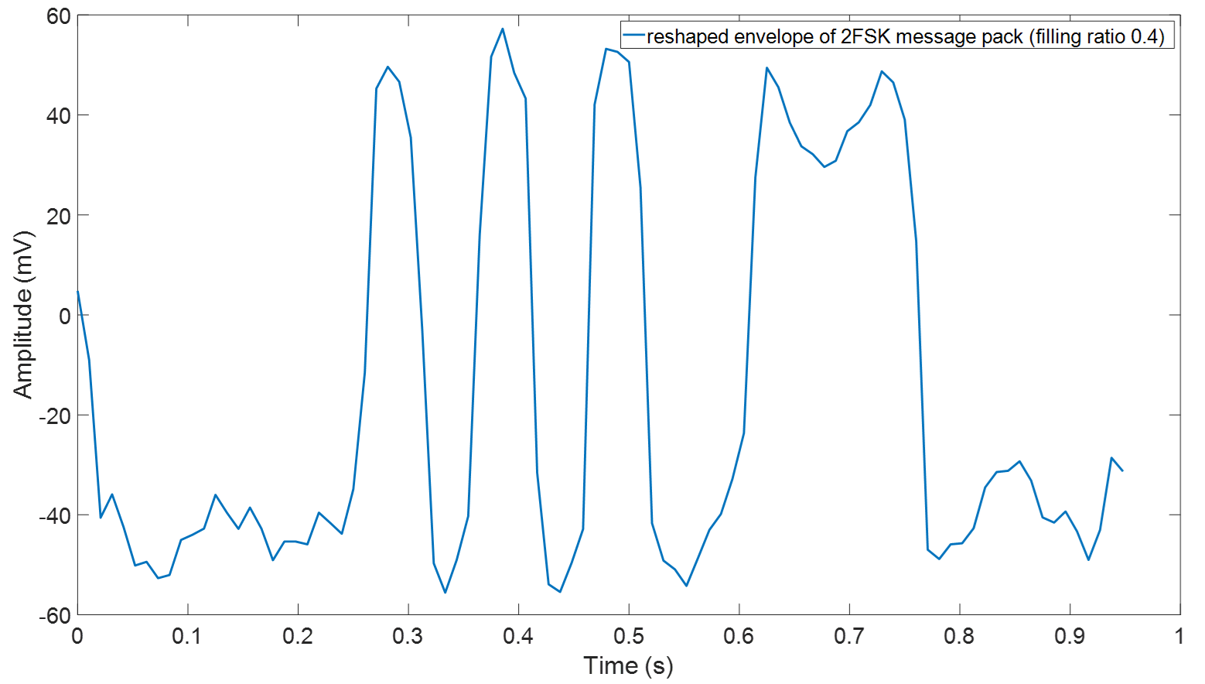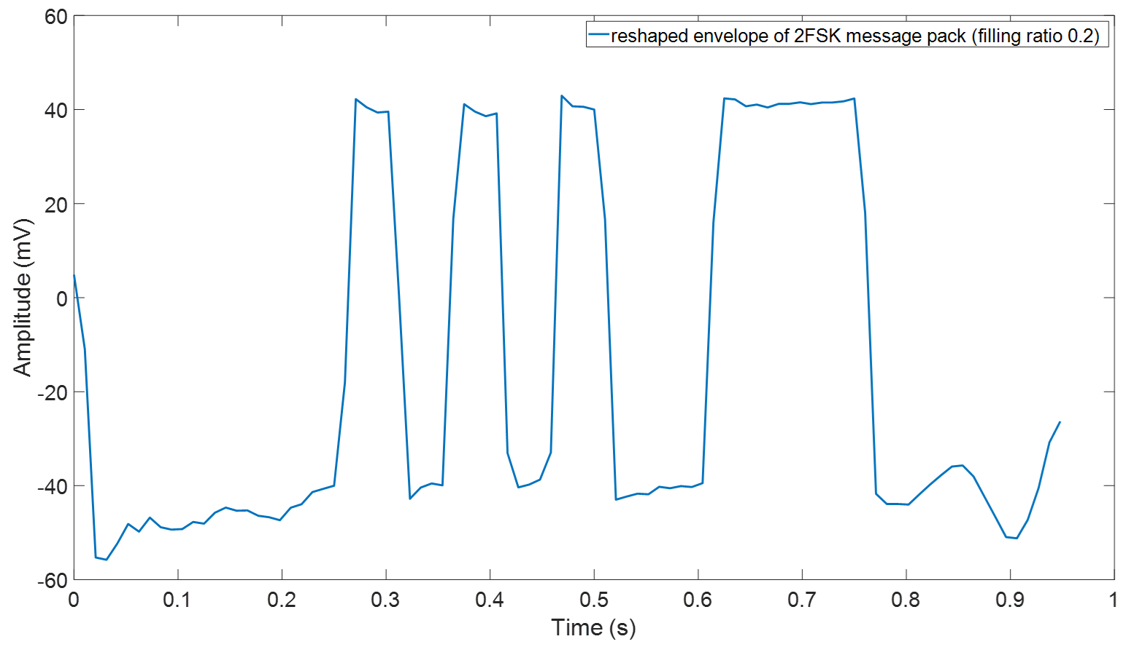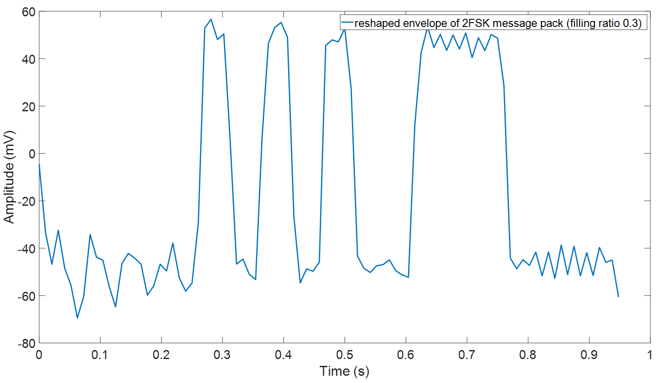

Figure 5.23 Examples of the reshaped envelopes of the 2FSK message obtained in the pipe with the filling ratios of 0.2-0.4
It has been validated by the results shown in Figure 5.22 and 5.23 that under the ideal SNR, the filling ratio will not affect the communication quality if using FRF measured by the preamble to equalise the signal. Figure 5.24 shows the envelopes of the reshaped 2FSK message measured in the pipe with the filling ratios of 0.2, 0.3 and 0.4 but deconvolved with the 0.1 FRF. In this figure the top and middle diagrams have shown that when the filling ratio increase to 0.2 and 0.3, the waveform is still recognisable while if the water level keeps increasing to 0.4 (Figure 5.21 bottom diagram), the waveform is significantly distorted which causes significant difficulties in extracting correct information from the message envelope. Form the point of view of adding threshold to the envelopes, in top and middle diagrams of figure 5.24 the threshold can be added as 0 mV which could make sure the correct binary sequency can still be extracted. However, in bottom diagram, adding threshold is becoming very tricky, the signal between 0.67 s and 0.83 s completely lost its original form (see Figure 5.22) which will certainly produce the wrong bits. This result suggests that the FRF of the partially water pipe should be re-calibrated for 2FSK system when the filling ratio is higher than 0.4 h is slightly better than the prediction made by numerical studies.
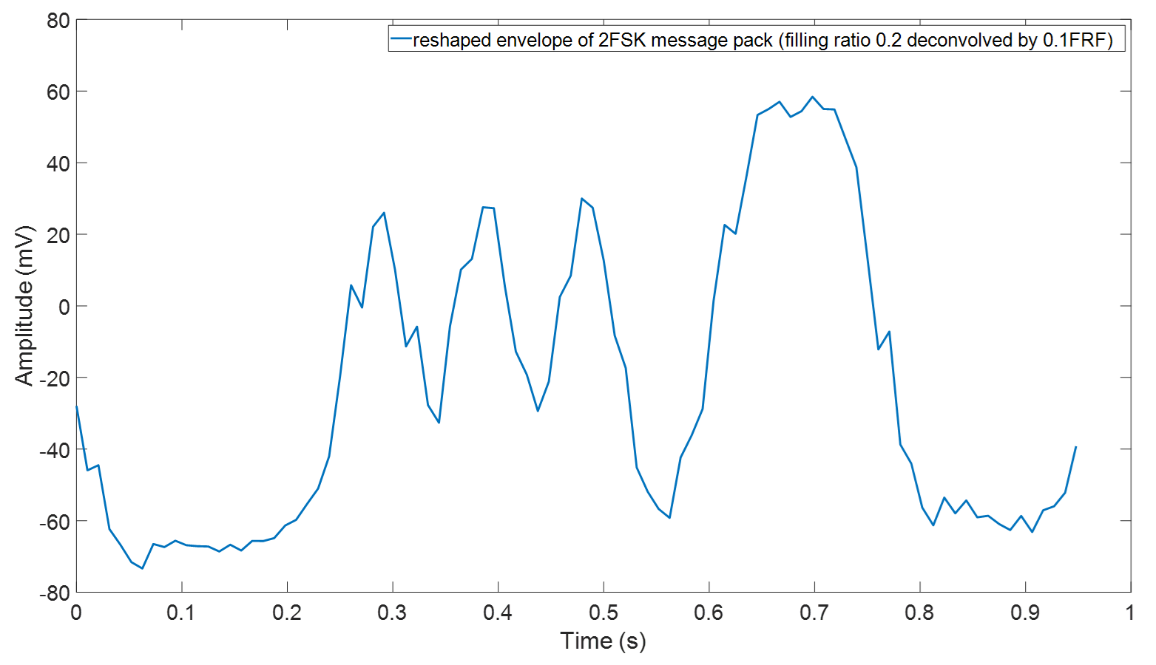
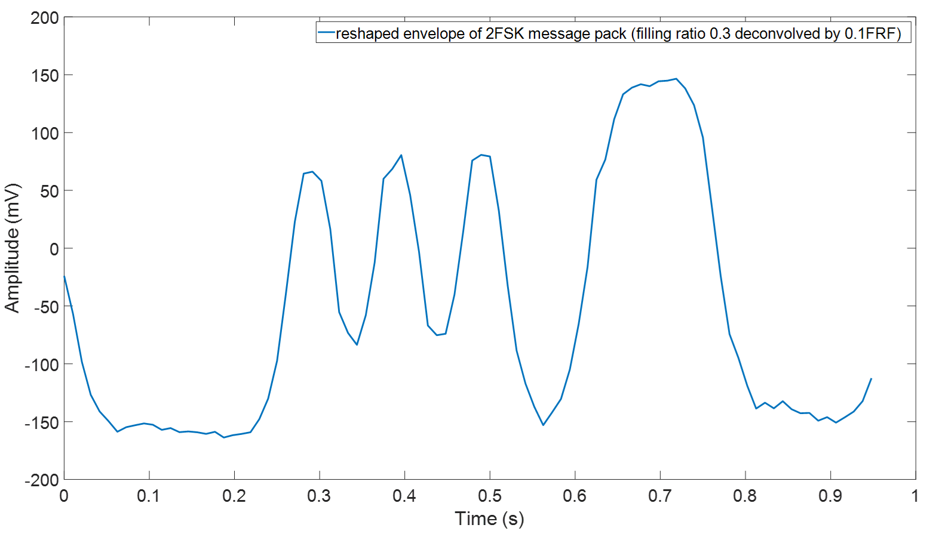
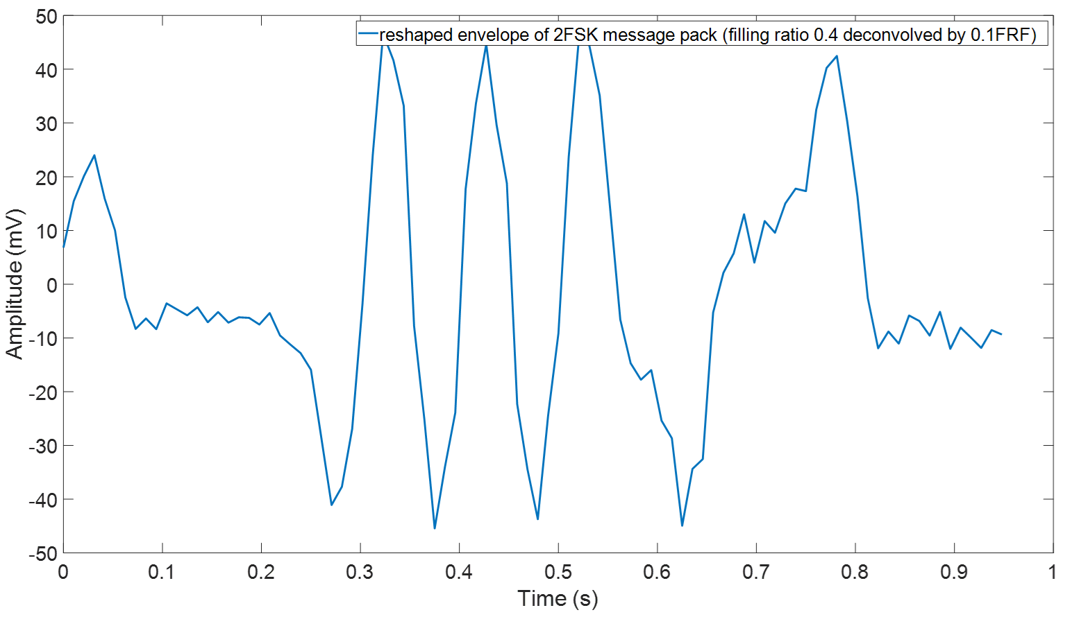
Figure 5.24 The reshaped envelopes of the 2FSK message recorded in the pipe with filling ratio from 0.2-0.4 but deconvolved with the FRF/0.1.

5.4.2.2 2ASK
In previous section the quality of the envelope obtained with the 2FSK technique was studied. It was shown that the 2FSK technique works for the communication in the partially water-filled pipe with any water level as long as the FRF can be accurately measured. This section studies the performance of the 2ASK modulation technique through a similar experiment by sending a message and recording it as shown in Figure 5.25.
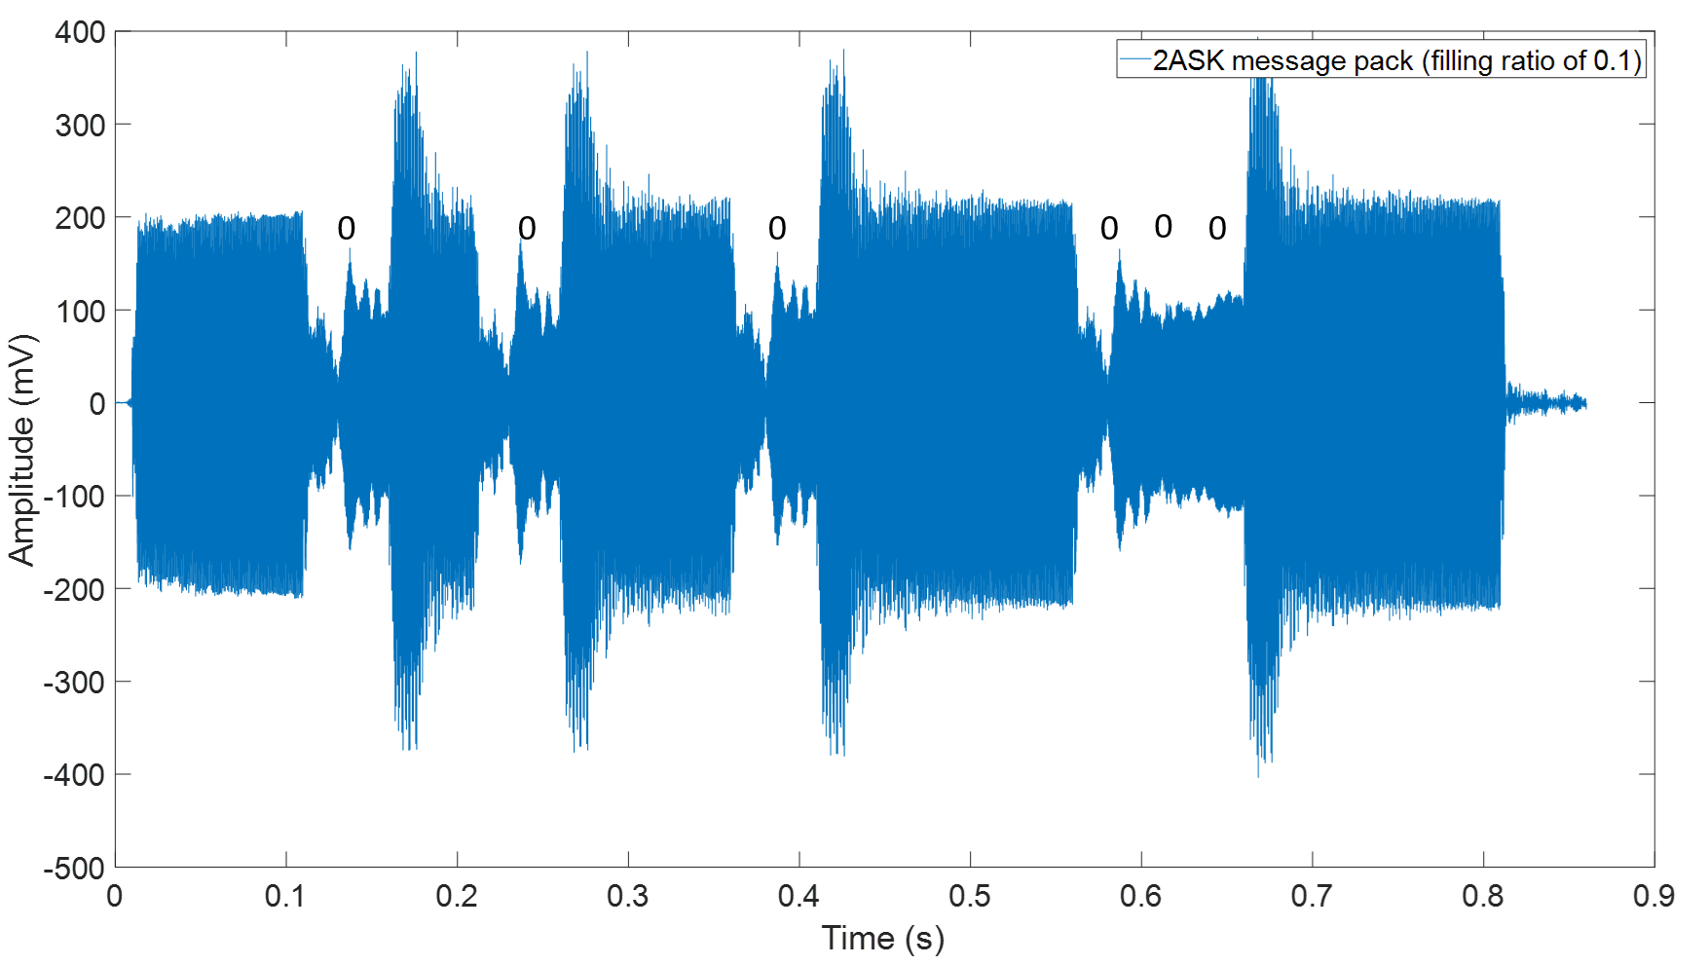
Figure 5.25 The 2ASK message pack recorded in the pipe with the filling ratio of 0.1
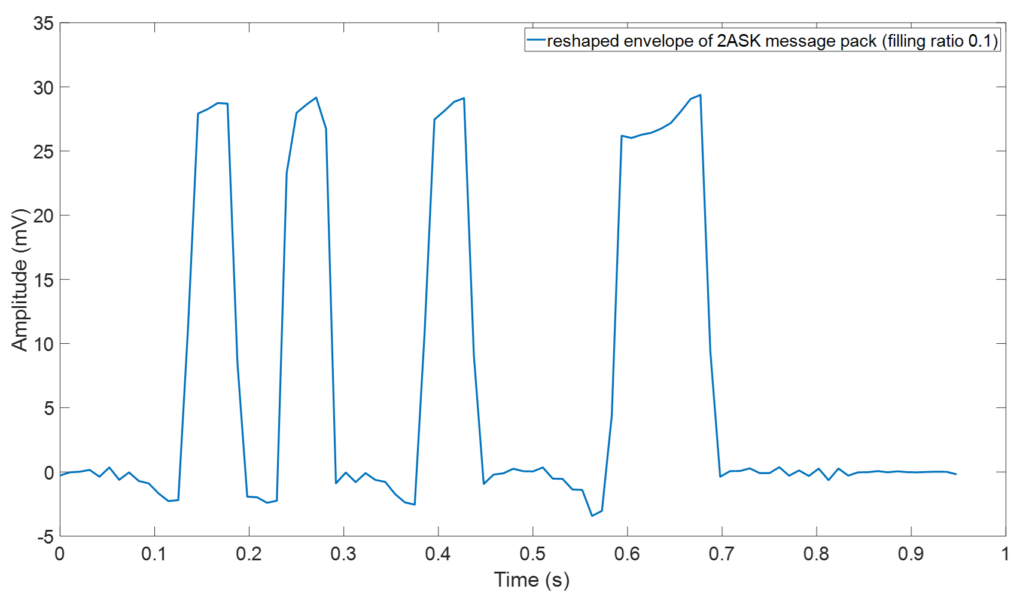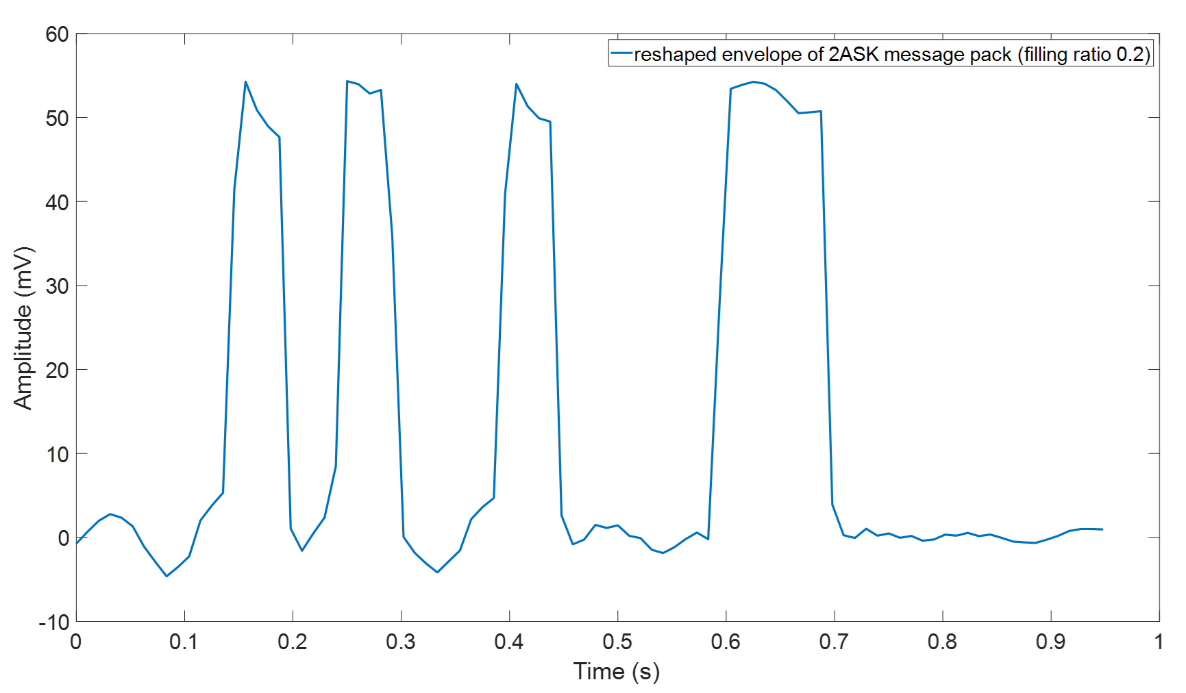
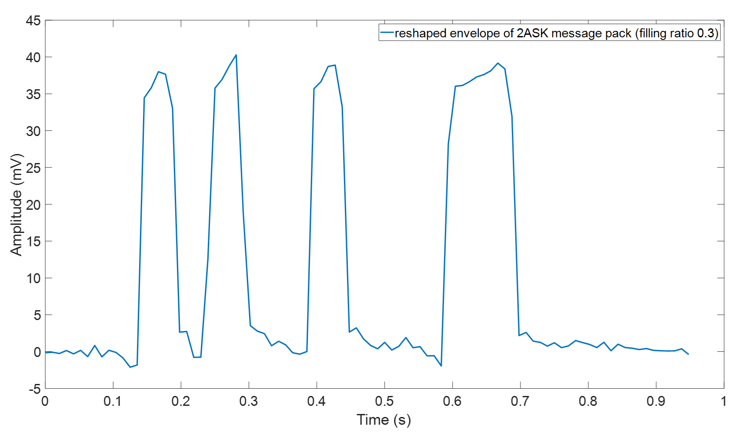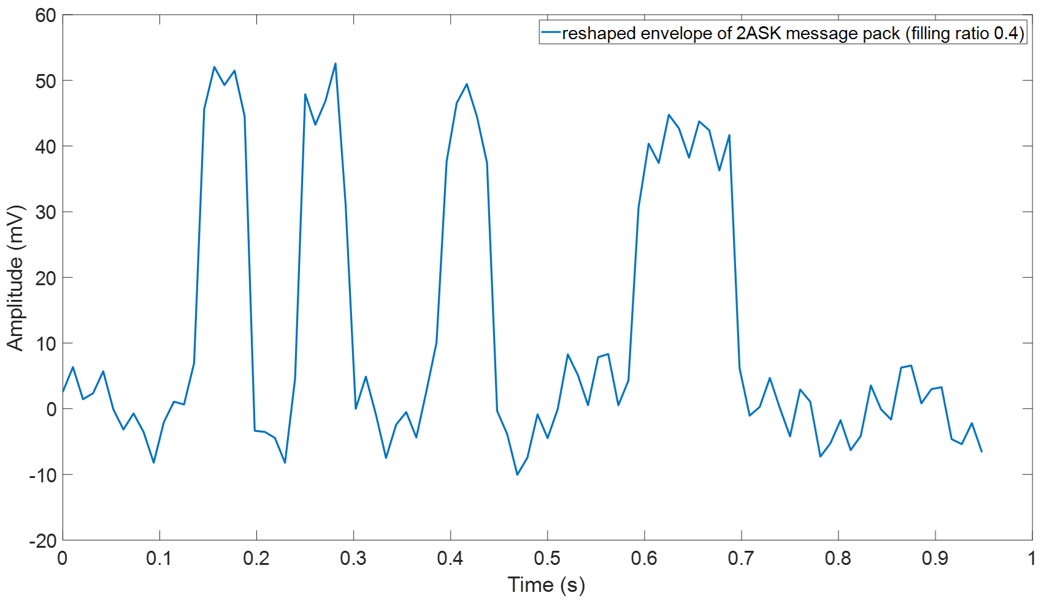
Figure 5.26 Examples of the envelopes of a 2ASK message pack recorded in the pipe with the filling ratios from 0.1 to 0.4
Figure 5.25 illustrates the 2ASK message pack measured in the pipe with 0.1 filling ratio. The part of signal which represent "0"s also have been marked in this figure. In principle, the amplitude of "0" symbols should equal to 0 for 2ASK. However, the former symbol suffered strong delay caused by the muti-path effects and causing it to overlap with the following symbol. This generates a certain degree of Inter-symbol Interference (ISI). By utilising the "reshape" method mentioned in previous sections can effectively eliminate the influence of ISI. The envelopes of the 2ASK message pack with filling ratio from 0.1 to 0.4 are plotted in Figure 5.26. These envelop was obtained from multiplying the message pack by a local carrier wave which as the same frequency as the modulated signal and this method is so called "coherent demodulation" (see Figure 4.7, chapter 4). In Figure 5.26, the diagrams indicate that the 2ASK communication technique for all filling ratios is successful even though the envelope for the message recorded in the pipe with the 0.4 filling ratio undergone some distortion and amplitude fluctuations.
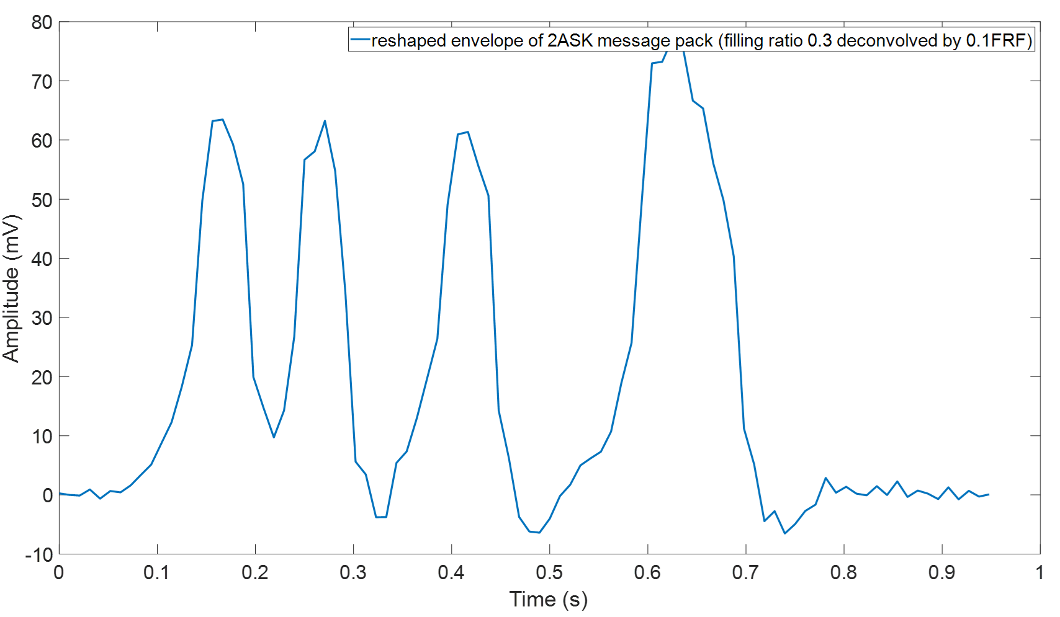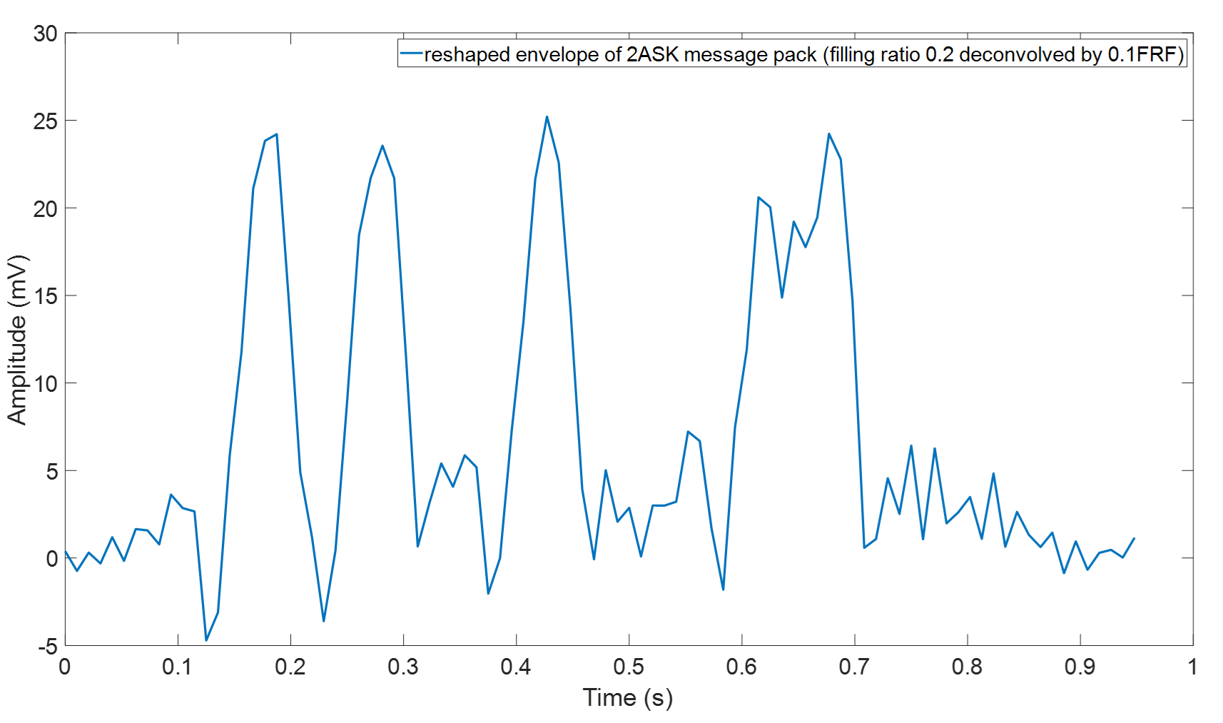
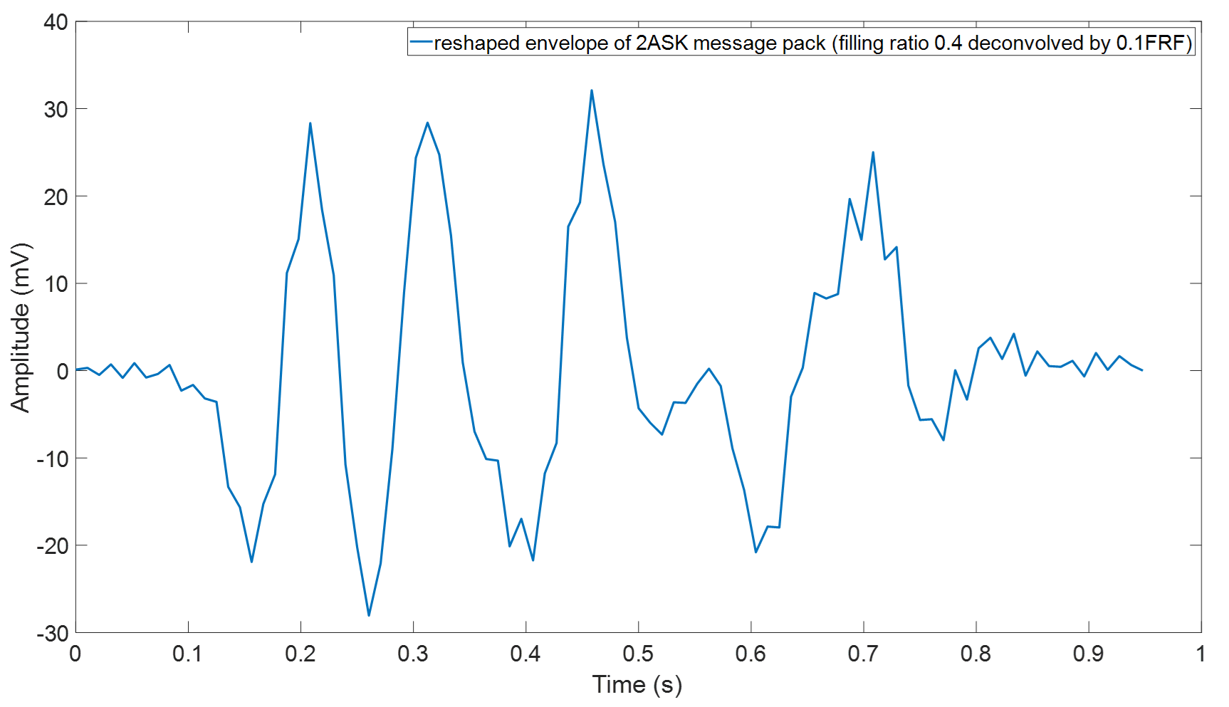
Figure 5.27 The reshaped envelopes of the 2ASK message pack recorded in the pipe with the filling ratios from 0.2 to 0.4 and deconvolved with the FRF/0.1
The graphs that present the reshaped envelopes of 2ASK signals tested in the pipe with filling ratios of 0.2-0.4 and deconvolved with the 0.1 FRF are shown in Figure 5.27. Unfortunately, they are all have stronger distortion which cannot deliver the correct message, even though the case of 0.1 and 0.2 could still roughly maintain the desired waveform. In the period between 0.5s and 0.75s, the waveforms were too narrow to distinguish the 3 continuous ‘’1’’s. Making communication successful under this circumstance would be very difficult and it would also require extremely precise synchronisation which hardly can be achieved in practical. However, for the 0.4 case, the signal was more seriously corrupted is its quality is too poor for being used in the message decoding.
The results show a fair disagreement with the simulation studies shown in the previous sections. Therefore, it can be deduced that the 2ASK communication technique is sensitive to the changes of the characterisation of channel. Reliable 2ASK communication in partially water-filled pipe would require real-time monitor of the water level and calibrate the FRFs accordingly. Therefore, 2ASK is believed not suitable for being used in partially water-filled pip with frequently changed water level such as sewers.

5.4.2.3 2PSK
The 2PSK communication technique makes use of angle demodulation. An example of the waveform of a 2PSK message pack measured in the pipe with the 0.1 filling ratio is given in Figure 5.28. This figure shows that the effects of the channel on the 2PSK signal cannot be visualised easily from the diagram. Therefore, further processing is required.
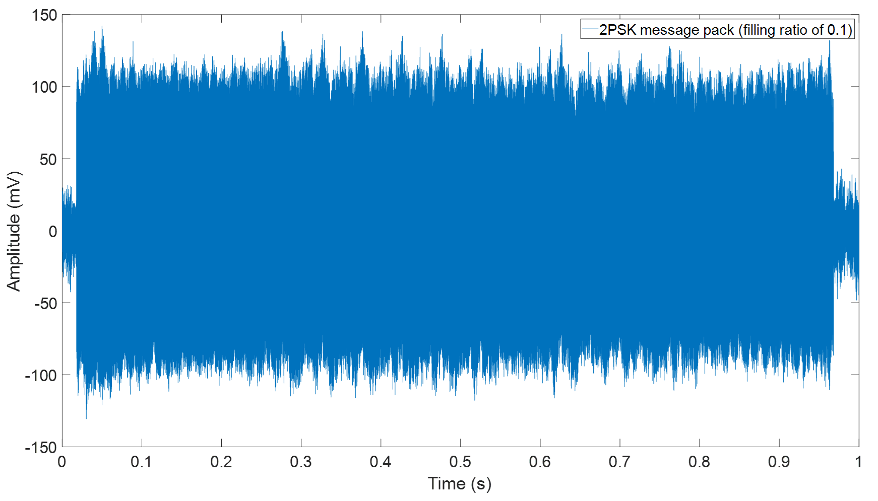
Figure 5.28 An example of a 2ASK message pack recorded in the pipe with the filling ratio of 0.1
After applying angle demodulation to the signal, the angle diagrams for the cases with filling ratio from 0.1~0.4 which deconvolved by the FRF obtained from preamble have been shown in Figure 5.29. This figure illustrates that the phase distortion of the propagated 2PSK signal can be linearly equalised with the true FRF extracted from the preamble sent together with the message. All the four graphs in Figure 5.29 show clean and smooth envelopes for the angle diagrams which make it possible to decode right information.
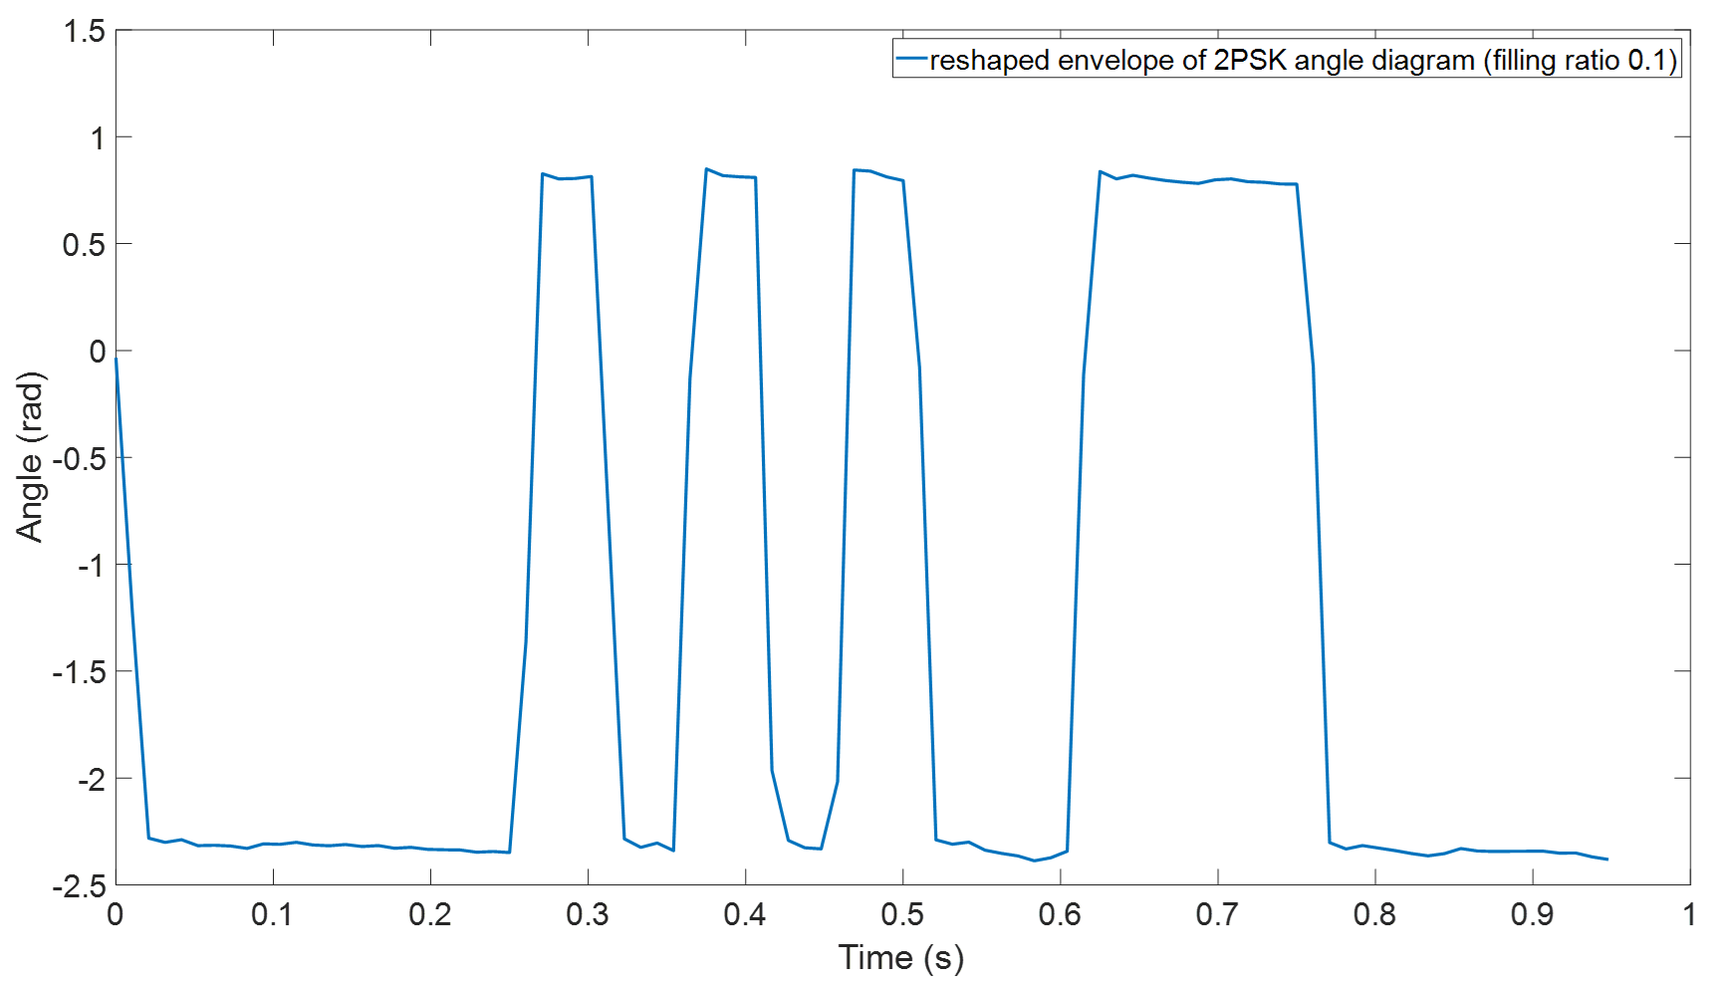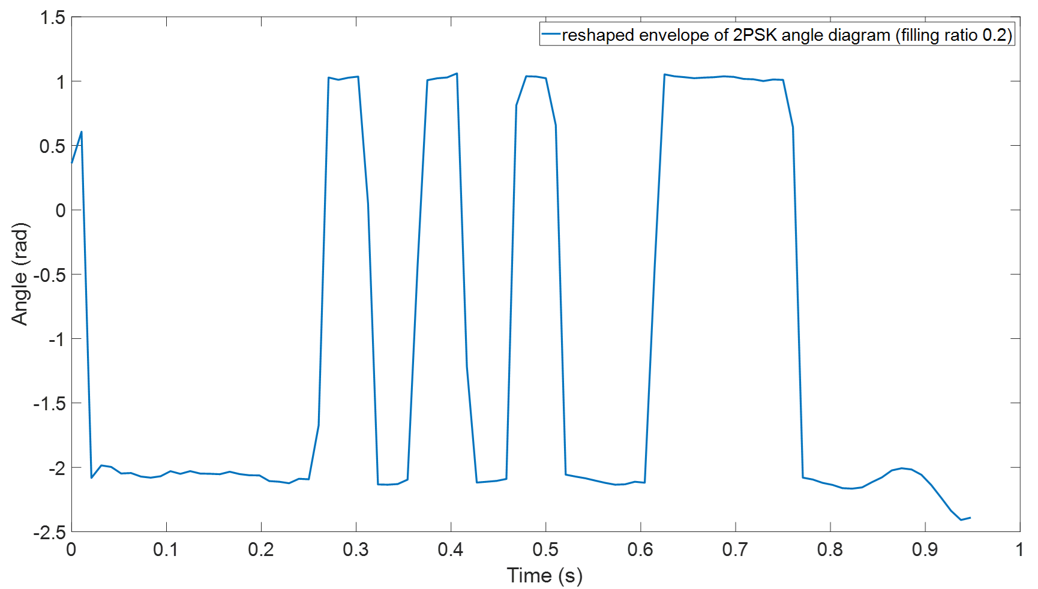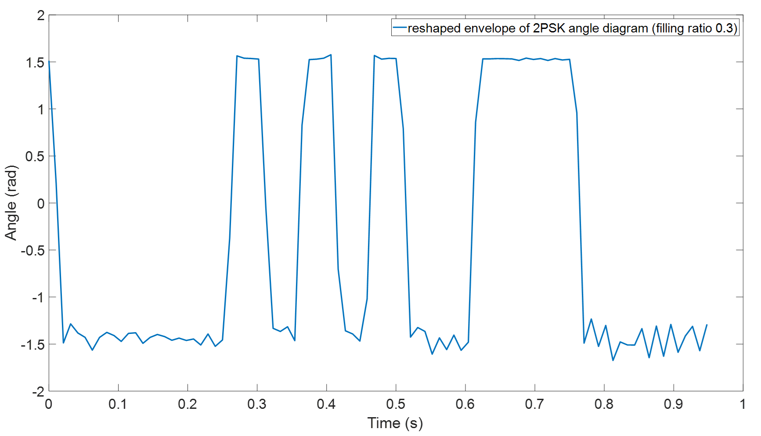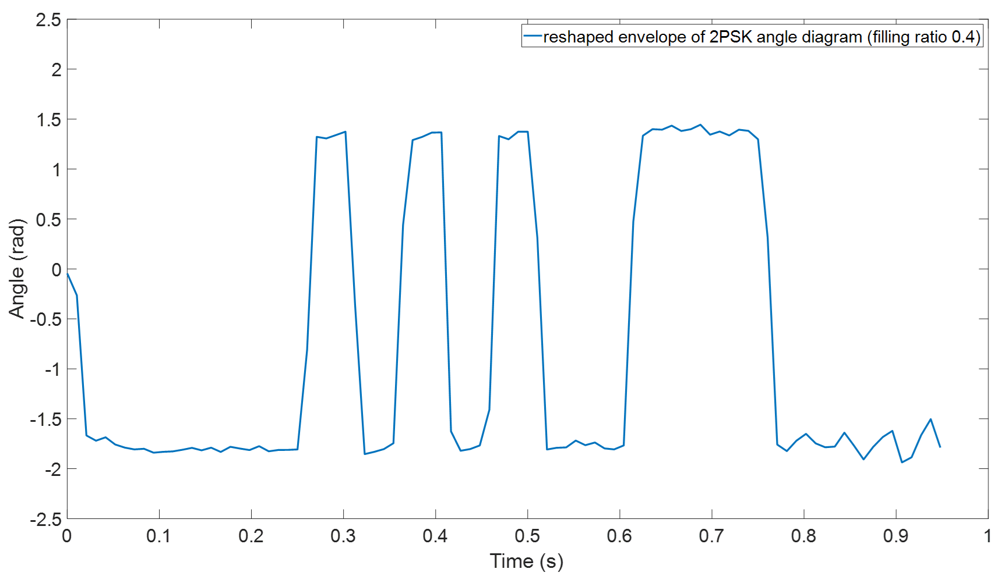
Figure 5.29 Envelopes of 2PSK angle diagrams with filling ratio from 0.1 to 0.4
It was suggested through the simulation (see section 5.23) that the signal deconvolution based on the 0.1 FRF can still be used successfully to decode the messages propagated in the pipe with the higher filling ratios. A similar experiment was carried out with the measured data. The results for the filling ratios of 0.2 , 0.3 and 0.4 are shown in Figure 5.30. However it should be noticed that for the 0.2 case plotted in top graph, in period between 0.2s and 0.5s the values of peaks and troughs were too close which means the space left for adding threshold was very narrow and should be done carefuly. The numerical study also suggested that when the filling ratio increases up to 0.4, the 0.1 FRF will no longer be reliable which is also true according to the bottom diagram shown in Figure 5.30. The envelope of the angle diagram in bottom diagram of Figure 30 totally lost its original form and re-calibration of the channel is necessary for this circumstance. Therefore, the results of experiment has agreement to the simulation that has been discussed in section 5.2.3, when the filling ratio increase above 0.3, 0.1 FRF can no longer be used for deconvolution.
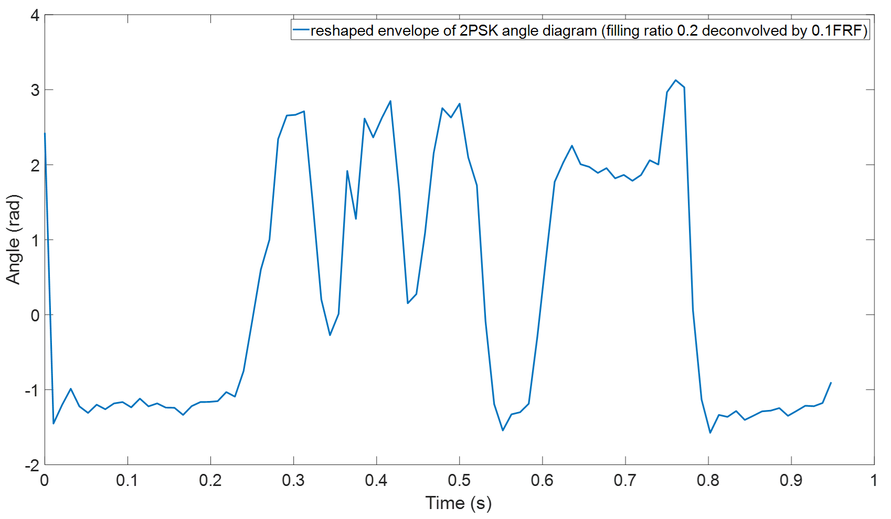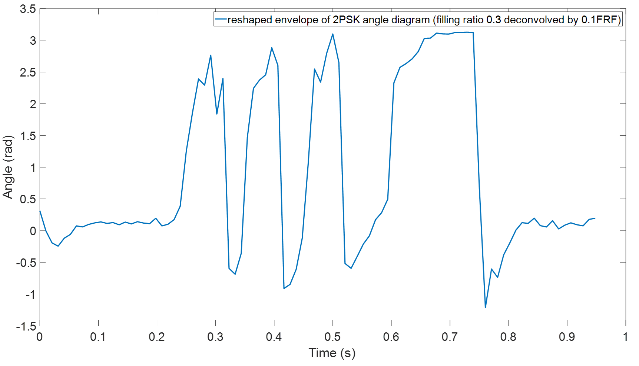
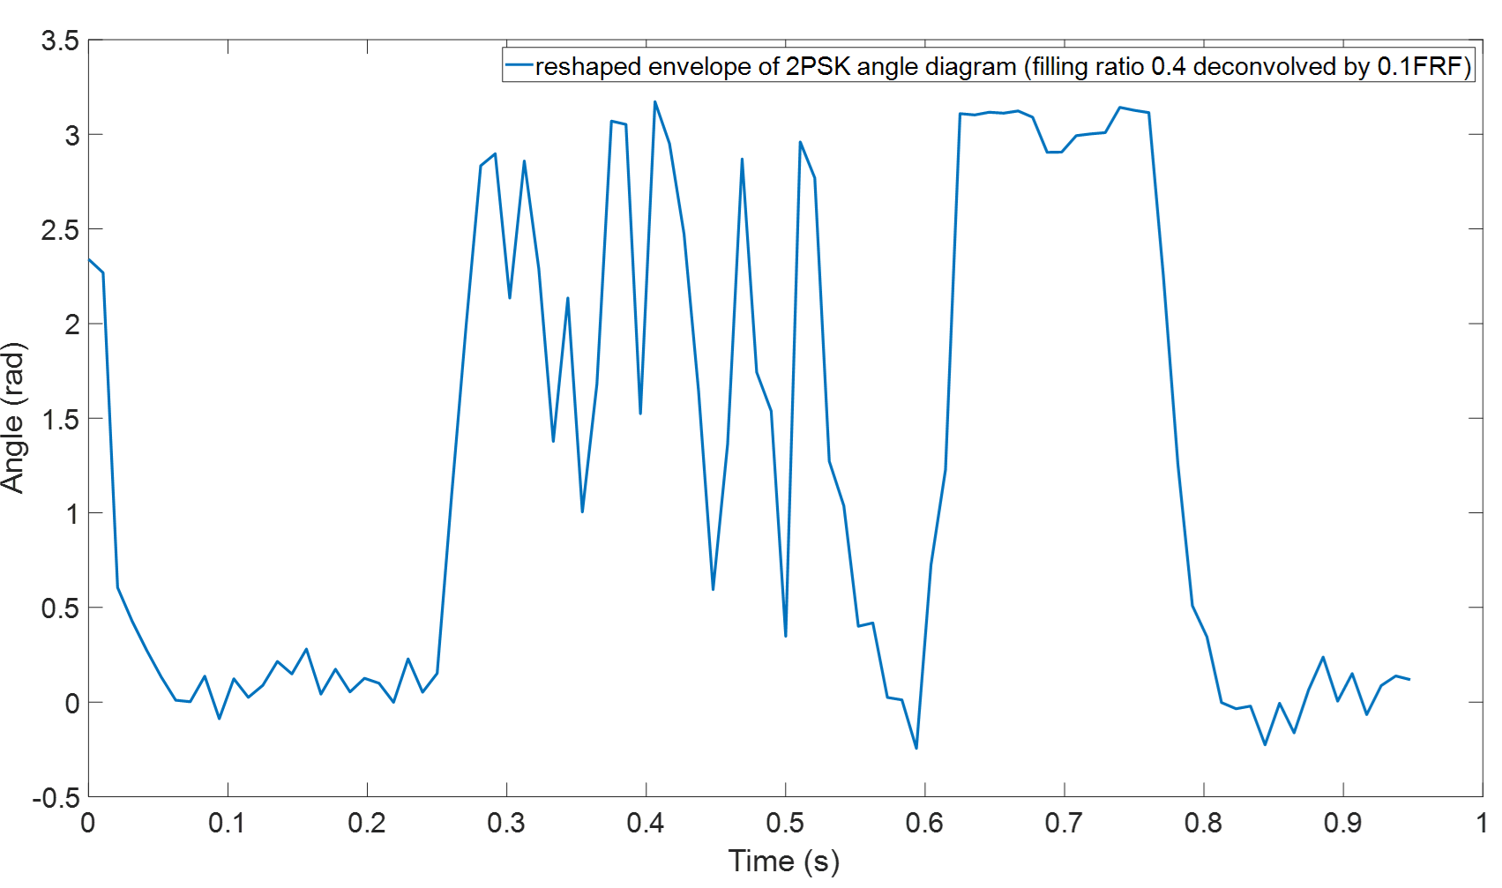
Figure 5.30 The reshaped envelopes of the 2PSK angle diagram recorded in the pipe with filling ratios of 0.2-0.4 and deconvolved with the 0.1 FRF

5.4.2.4 CLFM
An example of the message pack of a CLFM signal measured in the pipe with the filling ratio of 0.1 is illustrated in Figure 5.31. The message pack is coloured by the channel response. Using the FRF/0.1 to deconvolve the message can remove the effects of the channel and recover its true waveform. The result of this deconvolution is shown in Figure 5.32.
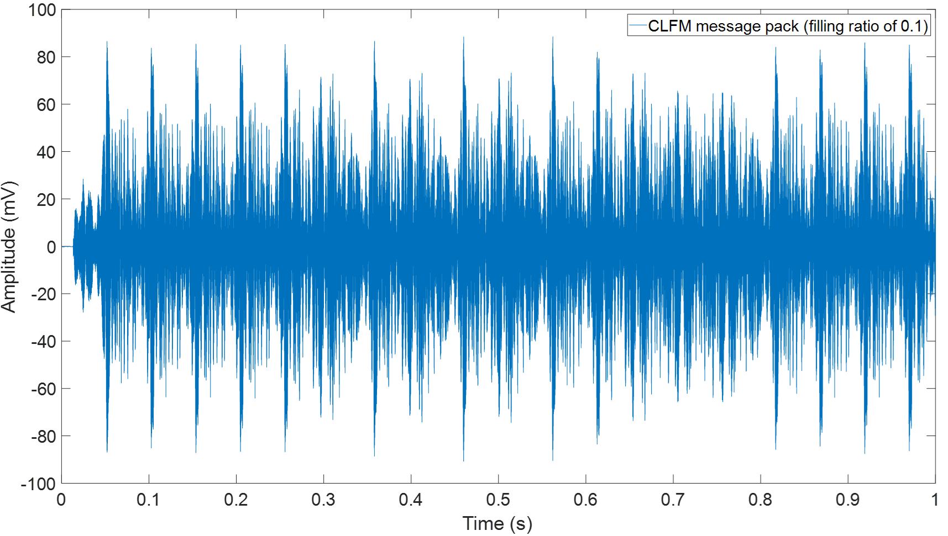
Figure 5.31 CLFM message pack with filling ratio of 0.1
The gaps between each sub-chirp can be clearly observed in Figure 5.32 while it hardly to be found in Figure 5.21. In addition, the fluctuation of each symbol shown in Figure 5.31 also has been flatted by the deconvolution which has been indicated in 5.32. Therefore, the deconvolution is an effective method to make sure the demodulation of CLFM be successful.
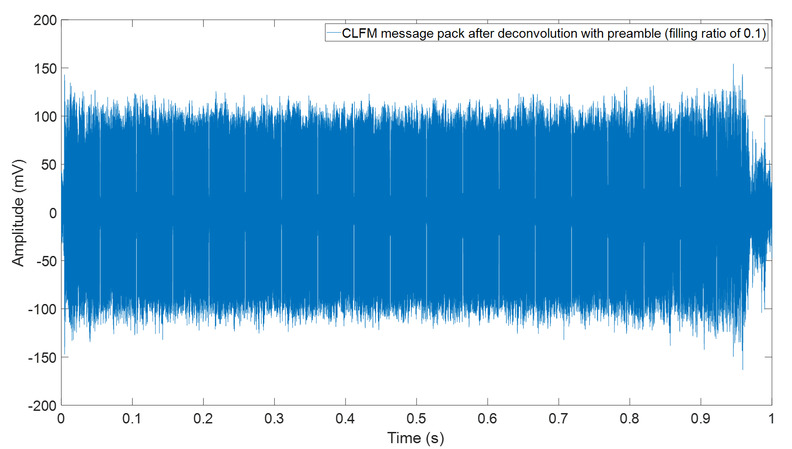
Figure 5.32 the CLFM message pack measured in the pipe with filling ratio of 0.1 and deconvolved using the right preamble
Figure 5.30 shows four diagrams which presents the cross-correlation results for CLFM communication in the pipe with filling ratio between 0.1 and 0.4. The symbols which represent "1"s and "0"s were flipped which is different to the cases discussed in section 5.24. The reason that causes such phenomenon is because in this experiment the message pack was cross-correlated with the sub-chirp with the frequency ramping from low to high while in the simulation it was cross-correlated with the opposite sub-chirp. Such difference will not make any influence on the final decoding.
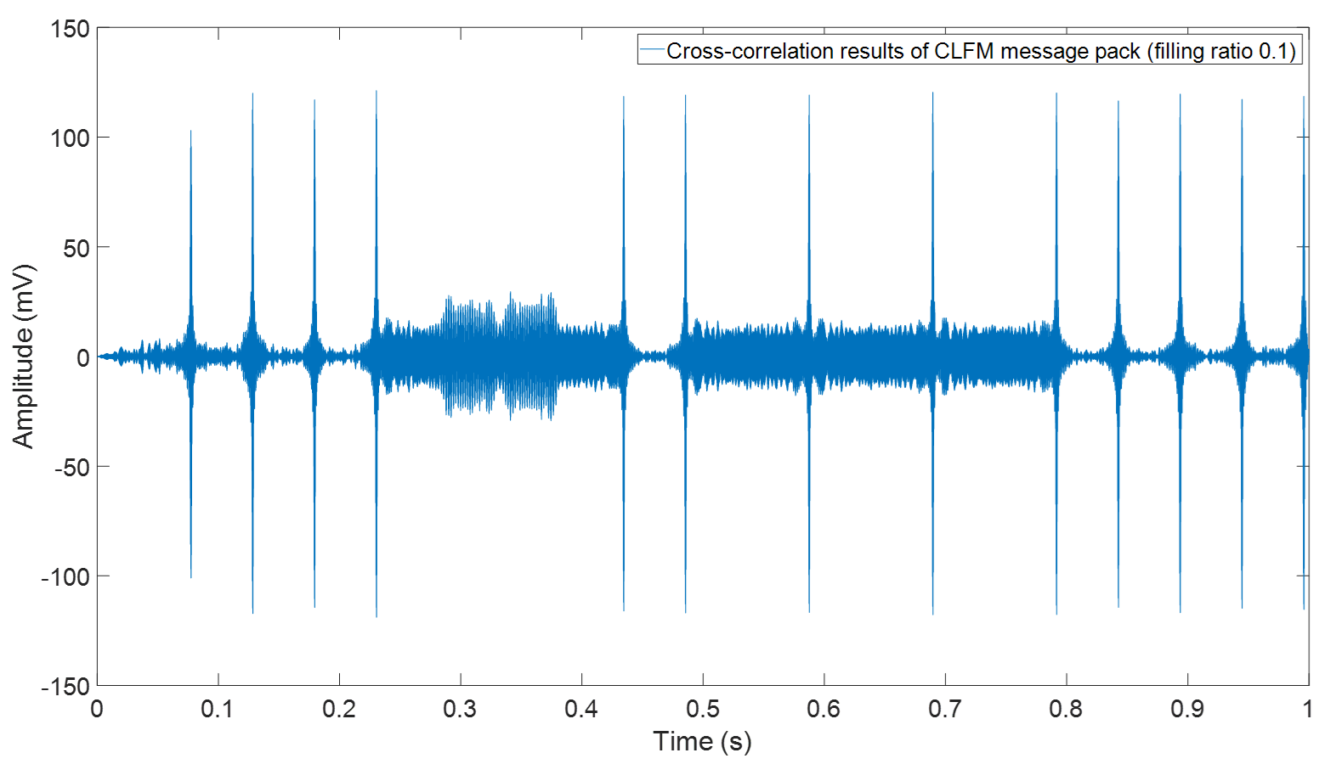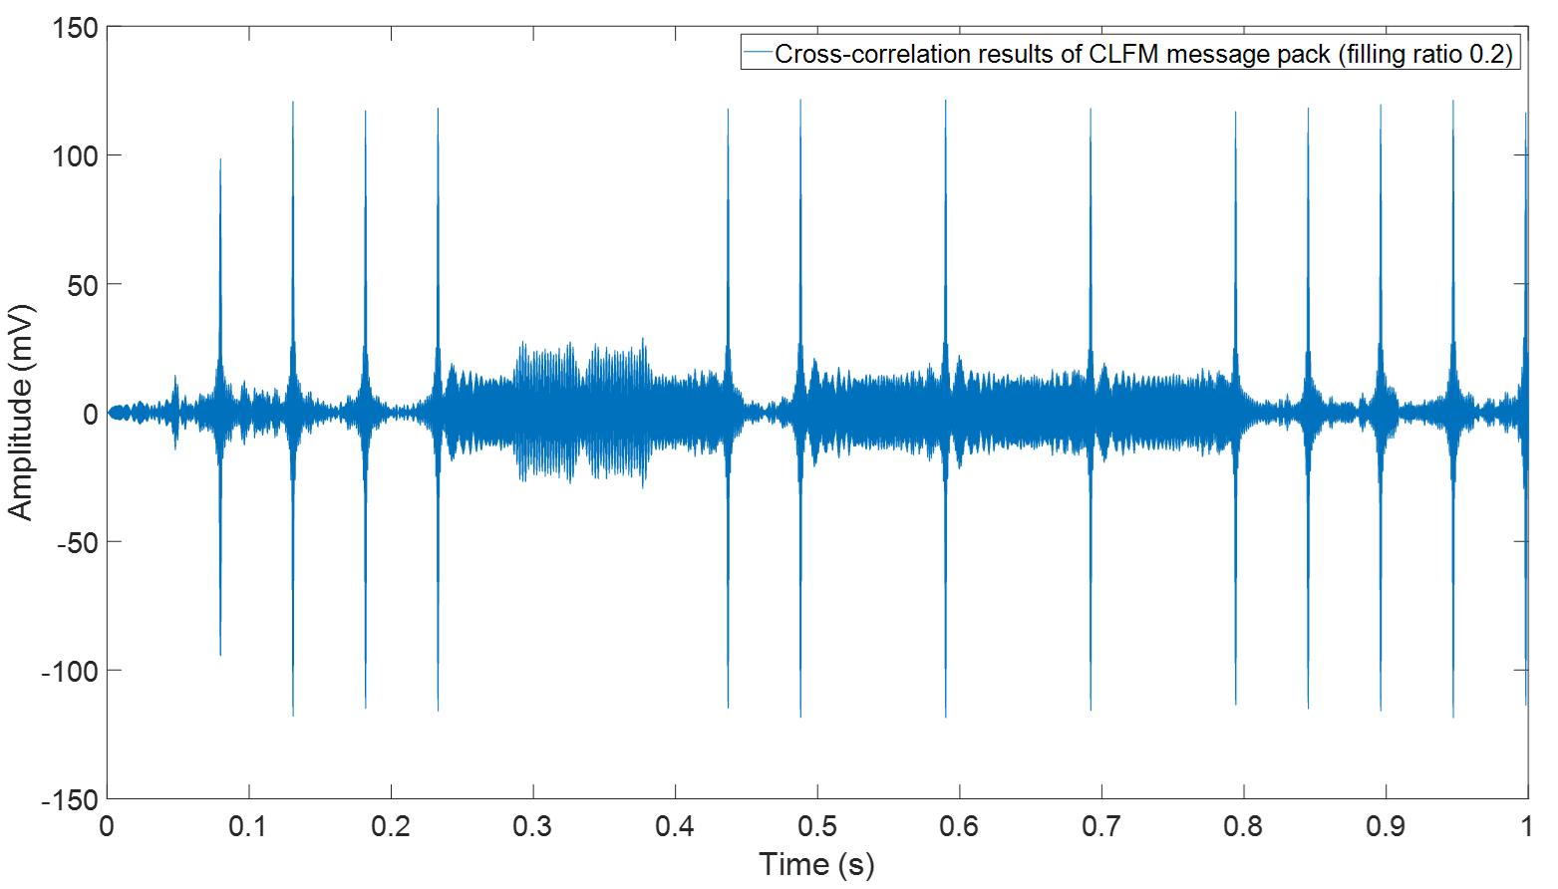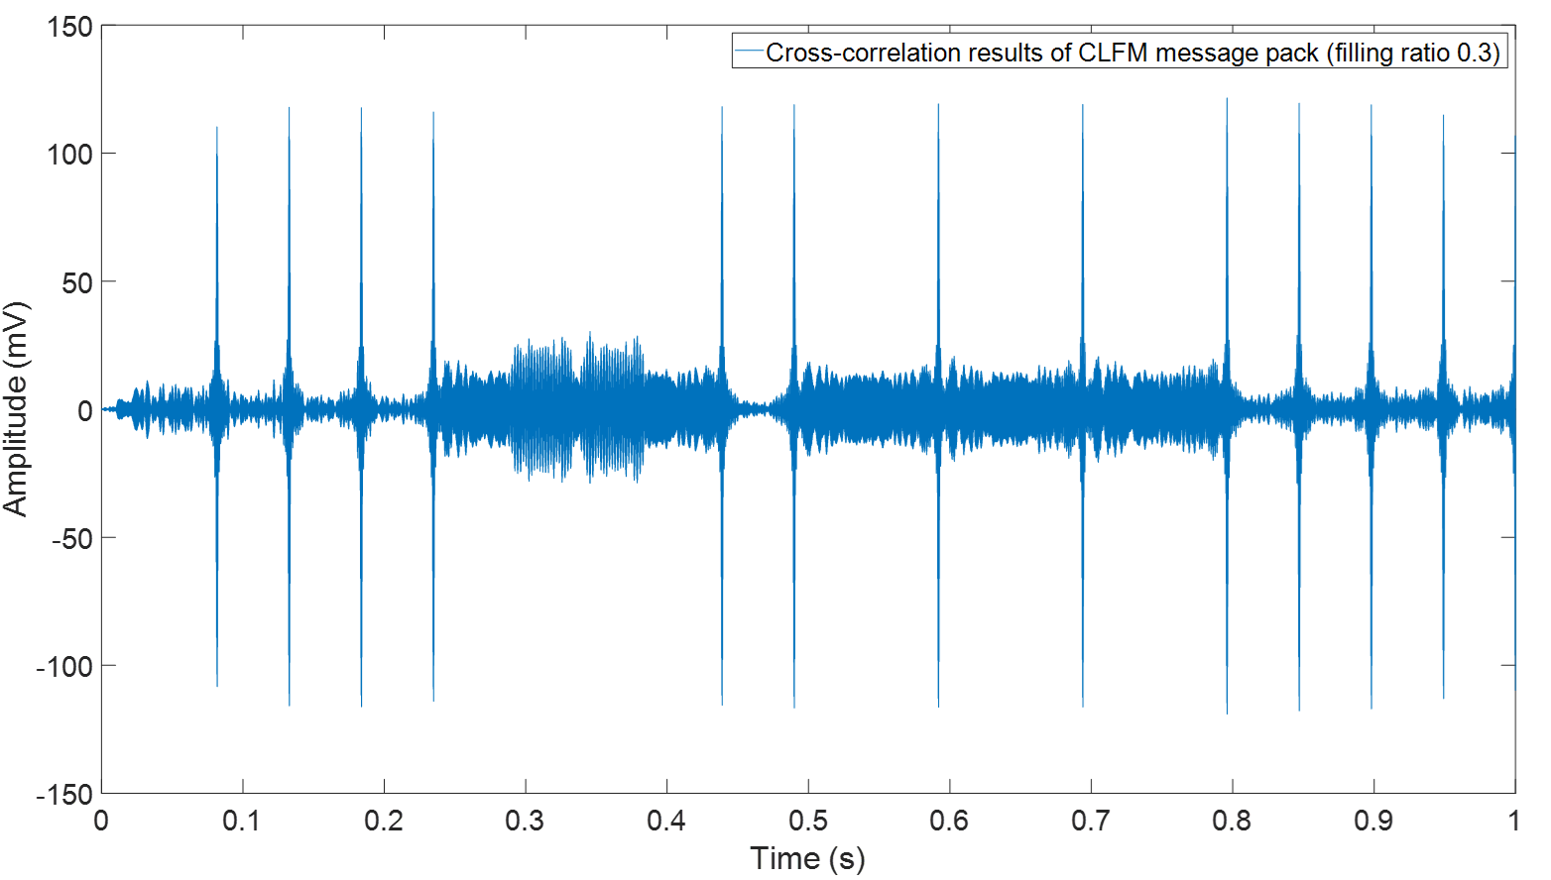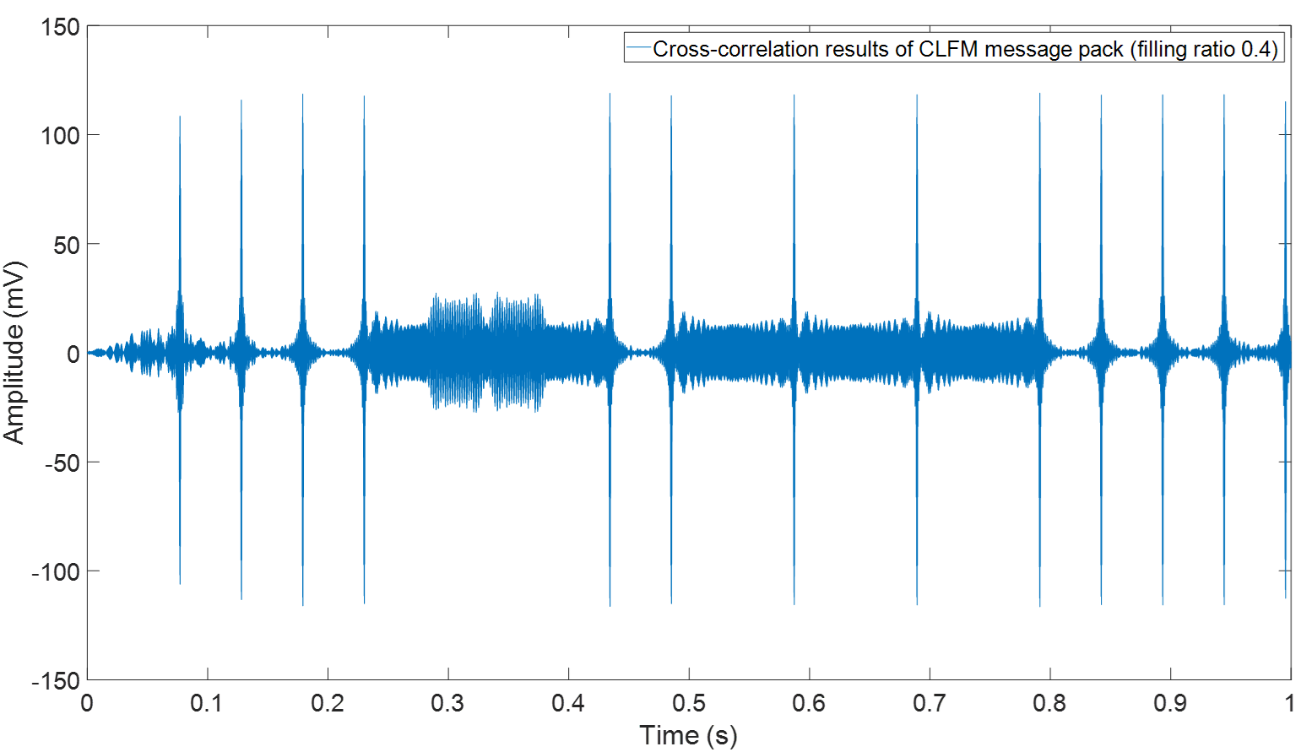
Figure 5.30 The cross-correlation results for the CLFM message pack measured in the pipe with filling ratio from 0.1 to 0.4
In Figure 5.30, all four diagrams clearly show the sharp peaks which could validate the conclusion made via the simulation (see section 5.1.4) suggesting that the filling ratio is unlikely to make a noticeable impact when the true FRF can be accurately measured.
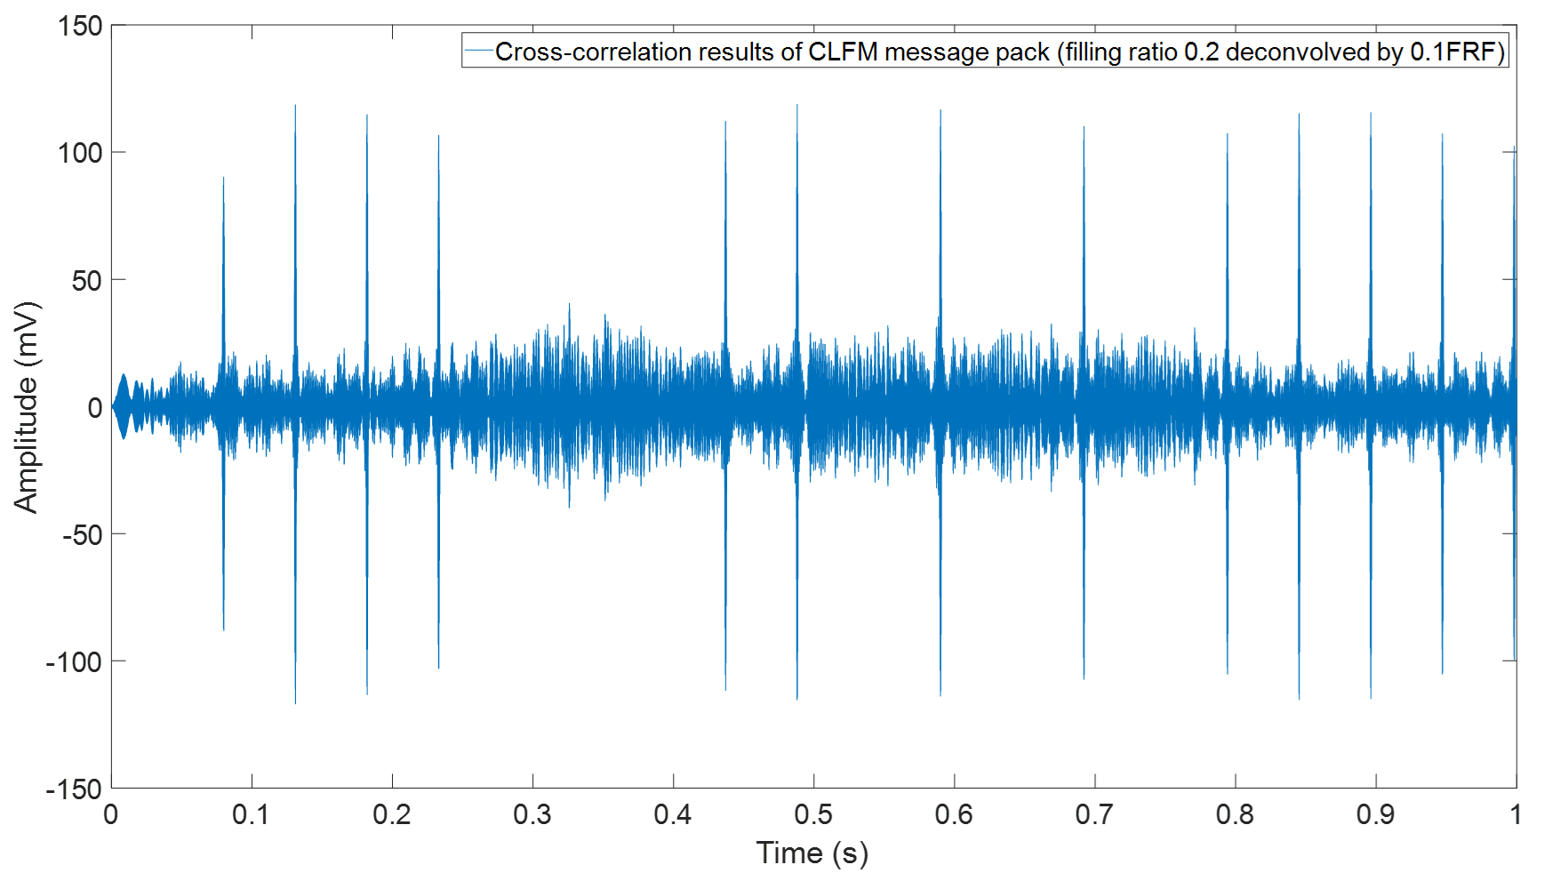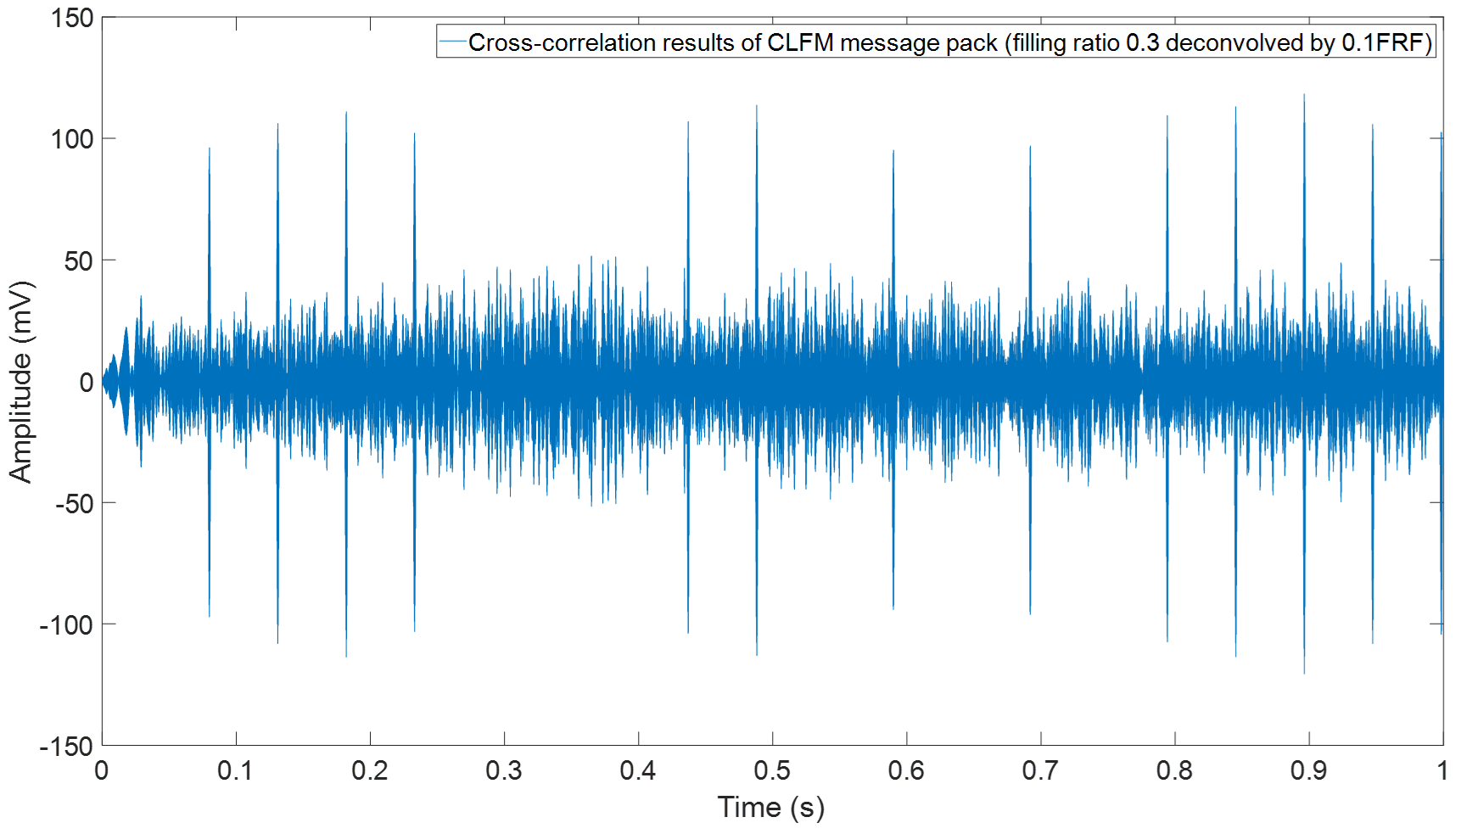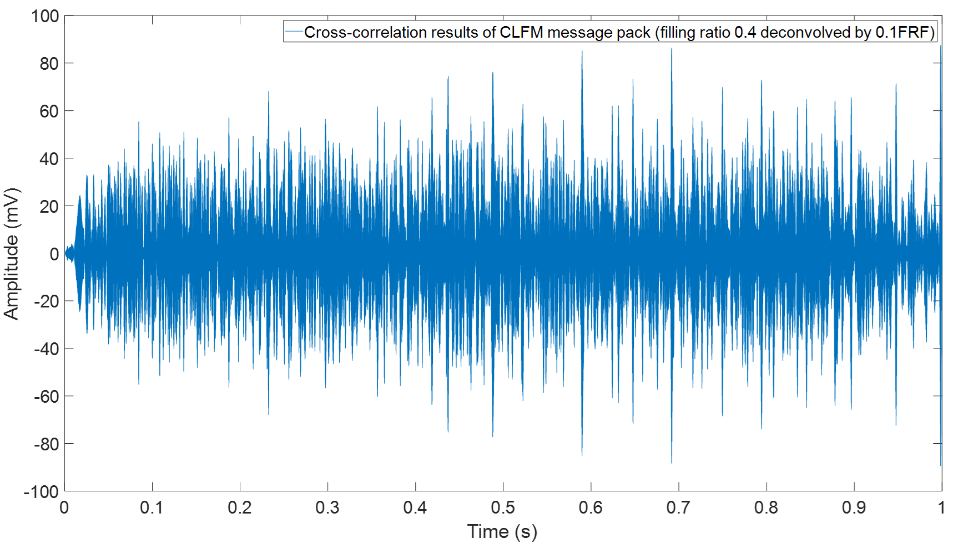
Figure 5.31 The cross-correlation results for the CLFM message pack measured in the pipe with the filling ratio from 0.2 to 0.4 but deconvolved with the FRF/0.1
This experiment was also carried out to study the effect of the water level change on the quality of the communication message. In this experiment the water level was changed from 0.1 to 0.2, 0.3 and 0.4 progressively. The measured 0.1FRF was used for message deconvolution. The results from this experiment shown in Figure 5.31 suggest that when the filling ratio increases to 0.2 and 0.3, the CLFM technique can still work properly even though there is a certain level of distortion. However, when the filling ratio further increases up to 0.4, the quality of equalisation Is lost so that the cross-correlated signal becomes unusable for decoding. These results have a close agreement with the conclusion made in section 5.24 via simulation.

Summary
This chapter initially compared the performance of analytical and empirical model for 4 communication techniques in the pipe with different water level. It suggested that both analytical and empirical works well which means empirical model is a reliable and efficient method for the deployment on the robot due to it would require less computational resource and power. It also suggested that the presence of water layer in the pipe will not affect the communication quality as long as the FRF of the pipe can be accurately obtained (either predicted by the models or measured by the preamble).
In addition, this chapter also evaluated the performance of 4 communication techniques when the water level was suddenly changed which can be used to determine the frequency of channel recalibration. It has been suggested that 2 FSK system could operate with filling ratio tolerance of 0.1 and for the change of filling ratio higher than 0.1, the waveform will have slightly fluctuation which would require further processing. In contrast, the filling ratio tolerance for 2ASK, 2PSK and CLFM is 0.2 which is higher than 2FSK. It denotes that the filling ratio varies in 0.2 will not affect these 3 types of communication techniques while beyond this value, the waveform used for decision making will be completely distorted which have to recalibrate the channel acoustic characterisation.
Finally, it has been stated in this chapter that the modal-split phenomenon would have strong impact on the communication quality which required choosing the carrier frequency should be even more careful than communicating in the empty pipe. However, moving source and receiver near the top wall could efficiently reduce the effect of "modal- split".

Chapter 6. The Numerical Studies for Communication in the Pipe with Artefacts
The effect of the reflections from a lateral connection, half size blockage (half of cross-section and 0.2 m long) and manhole (1 m diameter) on the quality of in-pipe communication is studied in this chapter via COMSOL multi-physics. More details on these artefacts can be found in Section 3.4 In Chapter 3. The influences of these artefacts on the four modulation techniques (see chapter 4) is examined in terms of the package error rate estimated as a function of the normalized carrier frequency ($kR$) and Signal Noise Ratio (SNR).

6.1 Transfer Function
It has been suggested in Section 3.4 that the presence of a lateral connection, blockage and manhole in the pipe would produce multiple echoes. These artifacts affect propagation of higher modes making the sound field in the pipe even more complex. In this case, the carrier frequency selection should be informed by the presence of these artefacts. In addition, more complex behaviour of the FRF usually signify that a relatively high SNR is required to make communication more robust. Finally, the reflections from the artifacts are likely to distort the phase in the predicted or measured FRF. This is of a concern because the phase modulation techniques are sensitive to the phase changes in the communicated signal. Therefore, it makes sense to predict the influence of these artefacts on the carrier frequency selection and study the noise resistance of the four modulation techniques considered in this work. For this purpose, the FRFs of a 150 mm diameter pipe with different artifacts were obtained via COMSOL simulation and used to study the influence of typical in-pipe artefacts on the quality of the communication channel.
The diagrams which illustrated the setup used in the simulation to predict the FRF of the pipe with lateral connection, half-size blockage and manhole can be found in section 3.4 (Chapter 3, Figures 3.13, 3.18 and 3.23). The signal used for the numerical simulation was sinusoidal chirp with frequency range from 100 Hz to 5000 Hz. The maximum mesh size in this study was below 5.7 mm which corresponded to $\frac{1}{12}$ of the acoustic wavelength at 5000 Hz.
Figure 6.1 plotted the level for 4 FRFs for the empty pipe, pipe with lateral connection, half-size blockage and manhole. In this frequency range there were 5 modes marked as black dash lines in this figure. It can be suggested from this diagram that the presence of artefacts will have obvious impact on the amplitude change of the FRFs and the effects are frequency dependent. However, the cures illustrated in Figure 6.1 are very messy which cannot be used to provide the information about the impact of each artefact on FRF of empty pipe. Therefore, in the following few sections, the graphs which present the difference between the FRF of the empty pipe and that of the pipe with an artefact will be used instead so that the impact of each artefact will be discussed separately.
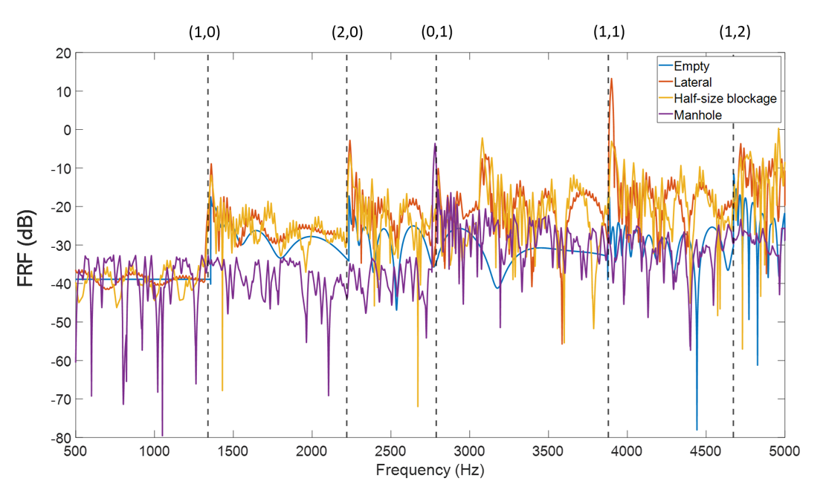
Figure 6.1 The comparison of FRFs of empty pipe, pipe with lateral connection, half-size blockage and manhole

6.1.1 Lateral Connection
In Figure 6.2 the difference between the FRFs of empty pipe and pipe with the lateral connection is plotted. The vertical dash lines represent the cut-off frequencies (modes). In plane wave region (before 1340 Hz) the effect of the lateral connection on the FRF is relatively small, i.e. less than 5 dB. Larger differences are at the modal frequencies and above the first cut-off frequency. After the third cut-off frequency (0,1), the effect of the lateral connection becomes much stronger. Such fluctuation in the amplitude are caused by the interference between the direct and reflected waves which will likely to cause strong amplitude variations in the communication signal at receiver end and affect the assumed SNR. For example, there are two dips in the FRF level difference between modes (0,1) and (1,1). At around 3700 Hz the level difference takes Its lowest value of approximately -22 dB. The frequency of these dips is likely move as the robots’ position with respect to the artefact changes. The carrier frequency choice should avoid these dips which would require to be adaptive. There is a significant peak in the FRF level difference at around 4450 Hz. This peak is associated with packets of waves propagating at a range of group velocities and it is likely to impact on the quality of communication.
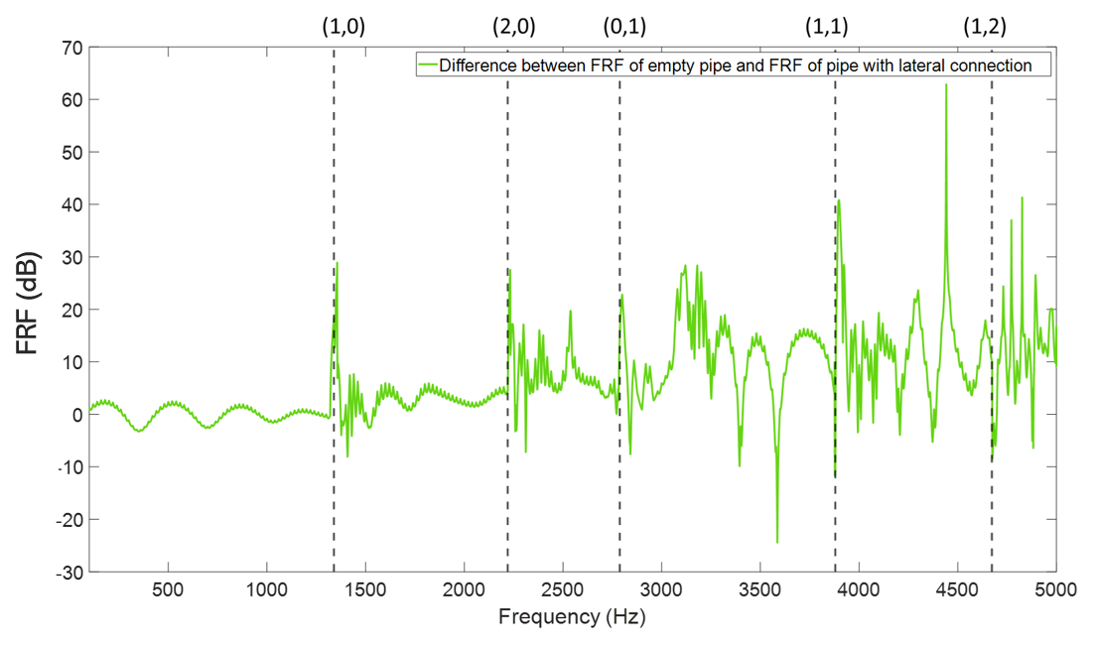
Figure 6.2 The comparison between the absolute value of the FRF of the empty pipe and that for the pipe with a lateral connection.
The phase difference between the two FRFs is presented in Figure 6.3. According to the diagram shown below, the phase was shifted consistently by $180°$ before the second cut-off frequency (2235 Hz) when there was the lateral connection in the pipe. Then as the frequency increased, the phase shift became more irregular and suffered sudden jumps. Thus, below the second cut-off frequency, the effects on 2PSK modulation are likely to be small because the phases are regularly about $180°$ out of place. While the irregular phase shift after second cut-off frequency will potentially have impact on implementing the 2PSK modulation techniques.

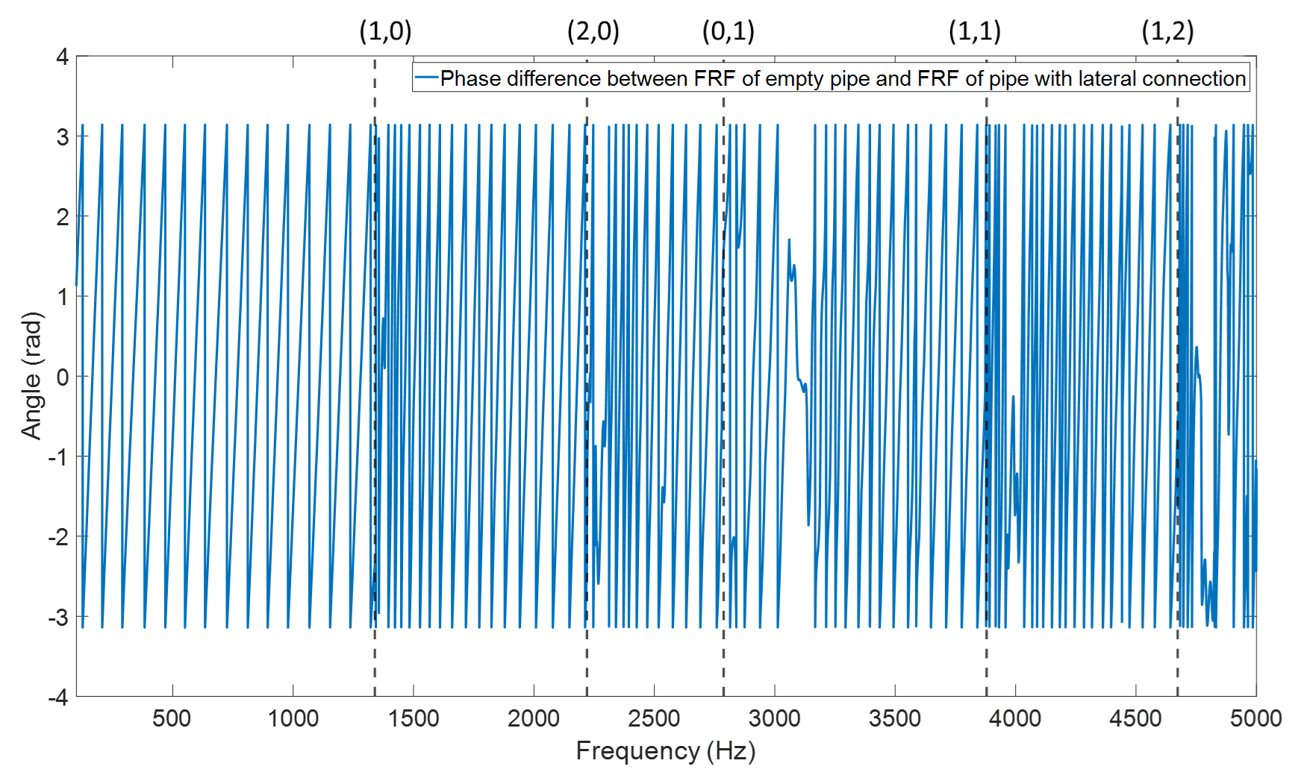
Figure 6.3 The comparison between the phase of FRF of the empty pipe and that for the pipe with lateral connection

6.1.2 Half-size Blockage
The results presented in the previous section suggest that the lateral connection has a relatively small effect on the level of the FRF and its phase below the second cut-off frequencies. As the frequency of sound increases, the influence of such type of connection is getting stronger developing the potential to have an impact on the package error rate. While compared with the lateral connection, the results from reflection coefficient diagram (see Section 3.4), the presence of half-size blockage is likely to have stronger influence than lateral connection on the FRF and phase. This section will focus on finding the difference between the FRFs and their phases of the empty pipe and the pipe with half-size blockage.
Figure 6.4 plots the difference between the FRFs of an empty pipe and that of a pipe with a half-size blockage. This difference fluctuates though the entire frequency range in line with the assumptions made in section 3.4. The effect of the blockage is similar to that of the lateral connection. In the plane wave regime, i.e. below the first cut-off frequency is relatively small. In contrast, this effect became dominating beyond this region causing a strong fluctuation in the FRF from that predicted for the empty pipe. In this region efficient equalisation techniques are likely to be required to compensate for the presence of the blockage.
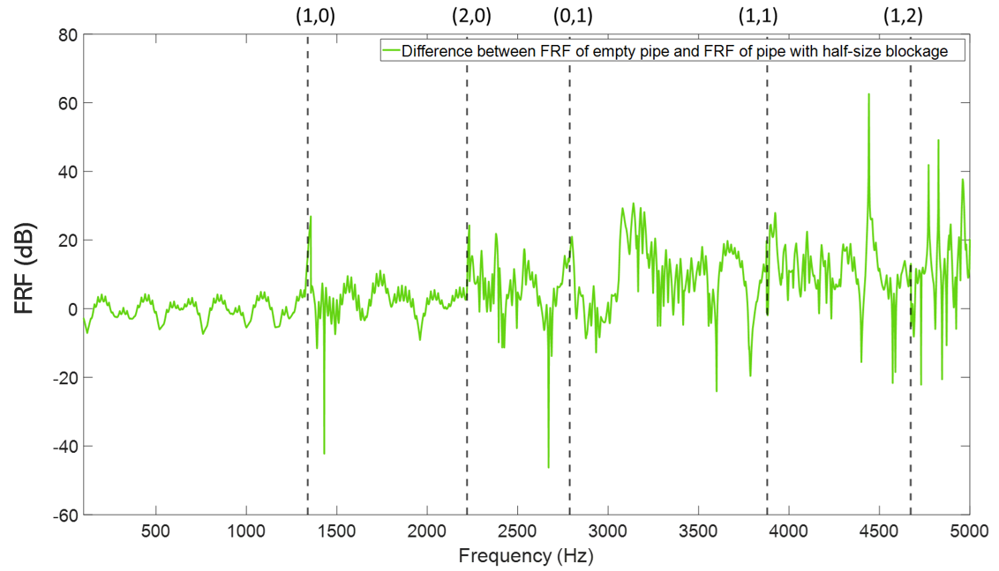
Figure 6.4 The comparison between the FRF of the empty pipe and that for the pipe with half-size blockage
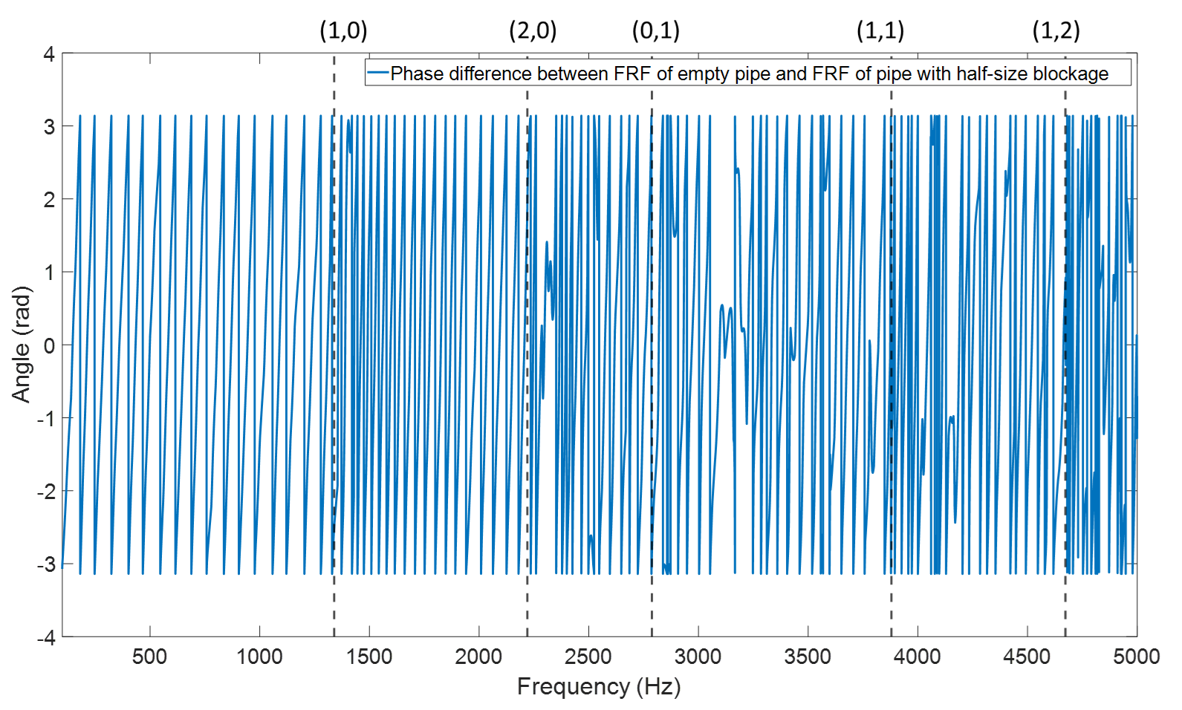
Figure 6.5 The comparison between the phase of FRF of the empty pipe and that with half-size blockage
the FRF phase difference for these situations is shown in Figure 6.5. Its behaviour is rather complex particularly after the first cut-off frequency. The phase shift also becomes stronger with the increase in frequency and at frequencies close enough to the modal frequencies (dash lines in the graph). In particular, the phase difference is rather large near mode (1,1). Therefore, presumably the communication of using phase relevant modulation technique will suffer stronger distortion than in the pipe with lateral connection.

6.1.3 Manhole
In buried pipeline networks, manholes serve as the entrance that people get access to and are one of the most common parts. It has been pointed out in Chapter 3 that a manhole functions like a perfect reflector for the low frequency sound wave because the reflection coefficient approaching -1. The effect of a manhole on the other modes is complex. These Influences is likely to make a huge impact on the FRF of the pipe. This section will focus on studying the changes of the FRF and phase caused by the manhole.
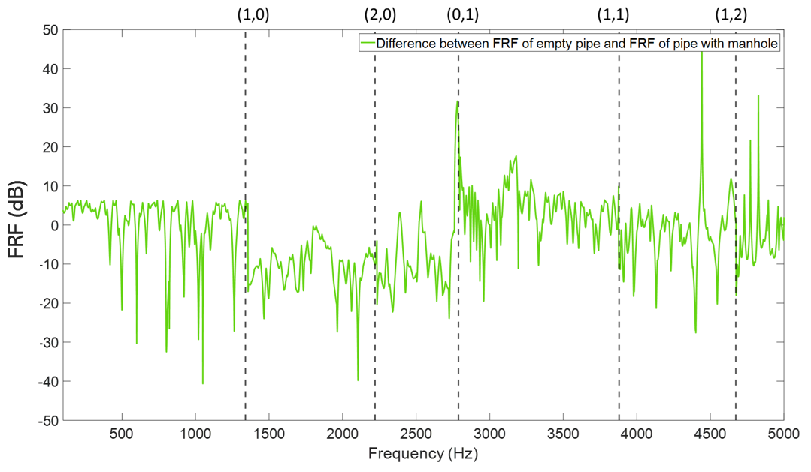
Figure 6.6 The comparison between the FRF of the empty pipe and that for the pipe with manhole
The level difference between the FRFs of the pipe with a manhole (purple line in Figure 6.1) and that for empty pipe (blue line in Figure 6.1) is plotted in Figure 6.6. Its behaviour is rather different to that predicted for the pipe with other artefacts. The level difference fluctuates intensively before the third cut-off frequency (around 2797 Hz) and peaks which represent near the first two modes are completely missing. The reason for causing such an effect is because the sudden change of the pipe diameter at the position of the manhole. When the acoustic wave incident onto the manhole, acoustic enegry was partially reflected back intoto the pipe and the other components transmitted into the manhole and reverberate or transmit to the pipe again. In Chapter 3 it has been pointed that the reflection coefficient fluctuates and presents more complexity which is possibly due to the cross-modal reaction [14]. For example, the sound reflection of the plane wave mode over the frequency range between the first and second modes is not only derived from the incident plane wave but also the incident first mode wave. Due to the manhole in this simulation was directly attached to the pipe and no further pipe was connected to the manhole, therefore most of sound wave will be reflected back into the manhole and partially cancel the incident wave, which makes the total sound field in upstream become very complex.
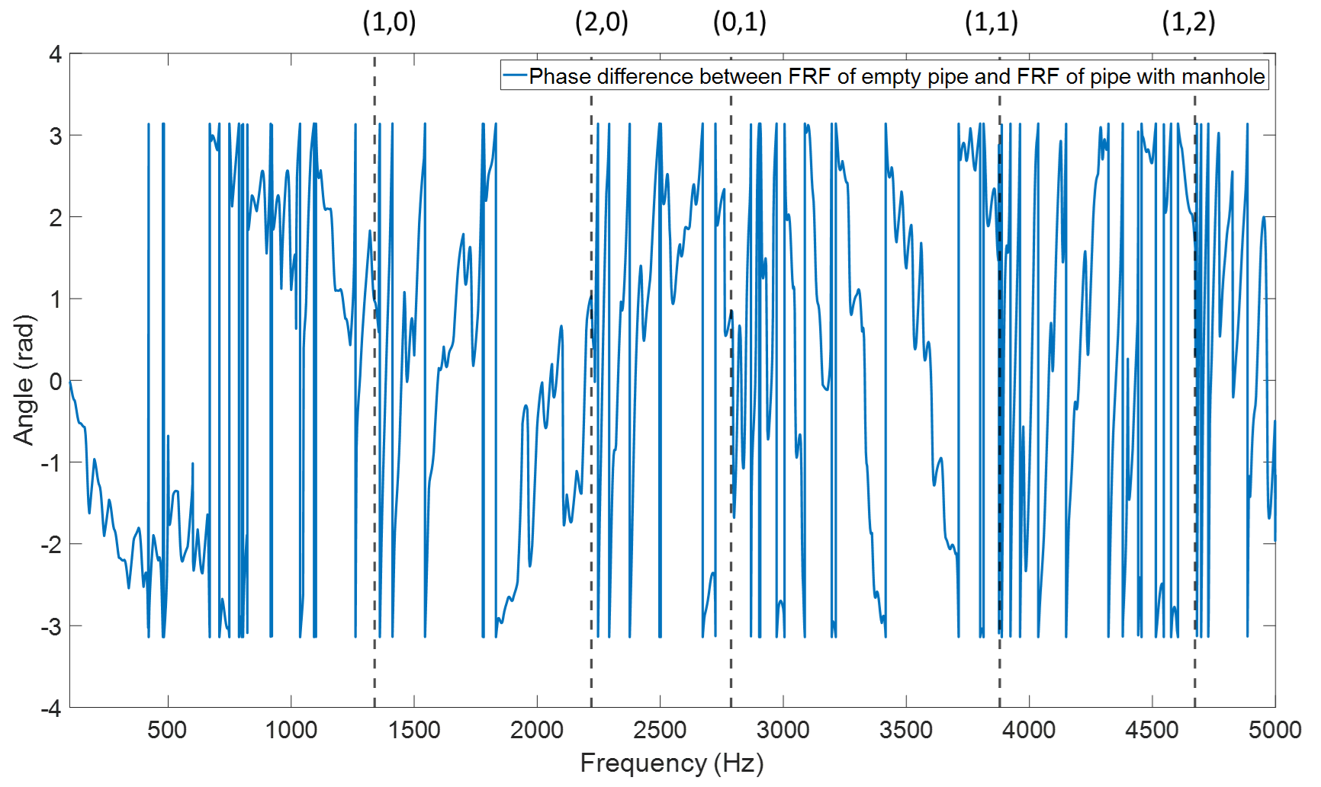
Figure 6.7 The comparison between the phase of FRF of the empty pipe and that with manhole
Figure 6.7 compares the phase of FRF of empty pipe and pipe with manhole as the function of frequency. The phase difference is close to random. This behaviour is likely to relate to the existence of a large number of evanescent modes which influence the phase in the vicinity of the manhole. Even in the plane wave region, there is a large phase difference between the two FRFs which means the presence of manhole attached to the pipe can have a significant impact on the whole frequency range for the phase of FRF. Such effects are likely to affect the 2PSK communication quality.

6.2 Noise Resistance
In this section, the noise resistance of each communication technique will be evaluated in the pipe with a lateral connection, half-size blockage and manhole. This bandwidth for each communication technique was set as 20 Hz, the carrier frequency for 2ASK and 2PSK were 5000 Hz. in the case of the 2FSK, the first carrier frequency was set to 5000 Hz and second was set to 2500 Hz, i.e. half of the first carrier frequency. Similar to the numerical studies in previous chapters, the frequency range of sub-chirps for CLFM was controlled by the central frequency $f_{central}=4500 Hz$ and the range of chirp frequency was from 4000 Hz to 5000 Hz which was determined by: $[f_{central}-500 Hz,f_{cenrtal}+500 Hz]$. The additive noise was applied to the signal in frequency domain to simulate the communication under SNR from -30dB to 20dB and methods of adding noise and defining the SNR for this study can be found in Chapter 4. All the tests were repeated by 200 times and averaged to make sure they are statistically meaningful.

6.2.1 2FSK
The 2FSK communication technique makes use of the frequency shift to code the message. The package error rate (PER) as a function of the SNR for this communication in the 150 mm pipe with different artifacts is plotted in Figure 6.8. In this diagram, the black triangles marked the points where the PER reaches 0 for each type of artefacts.
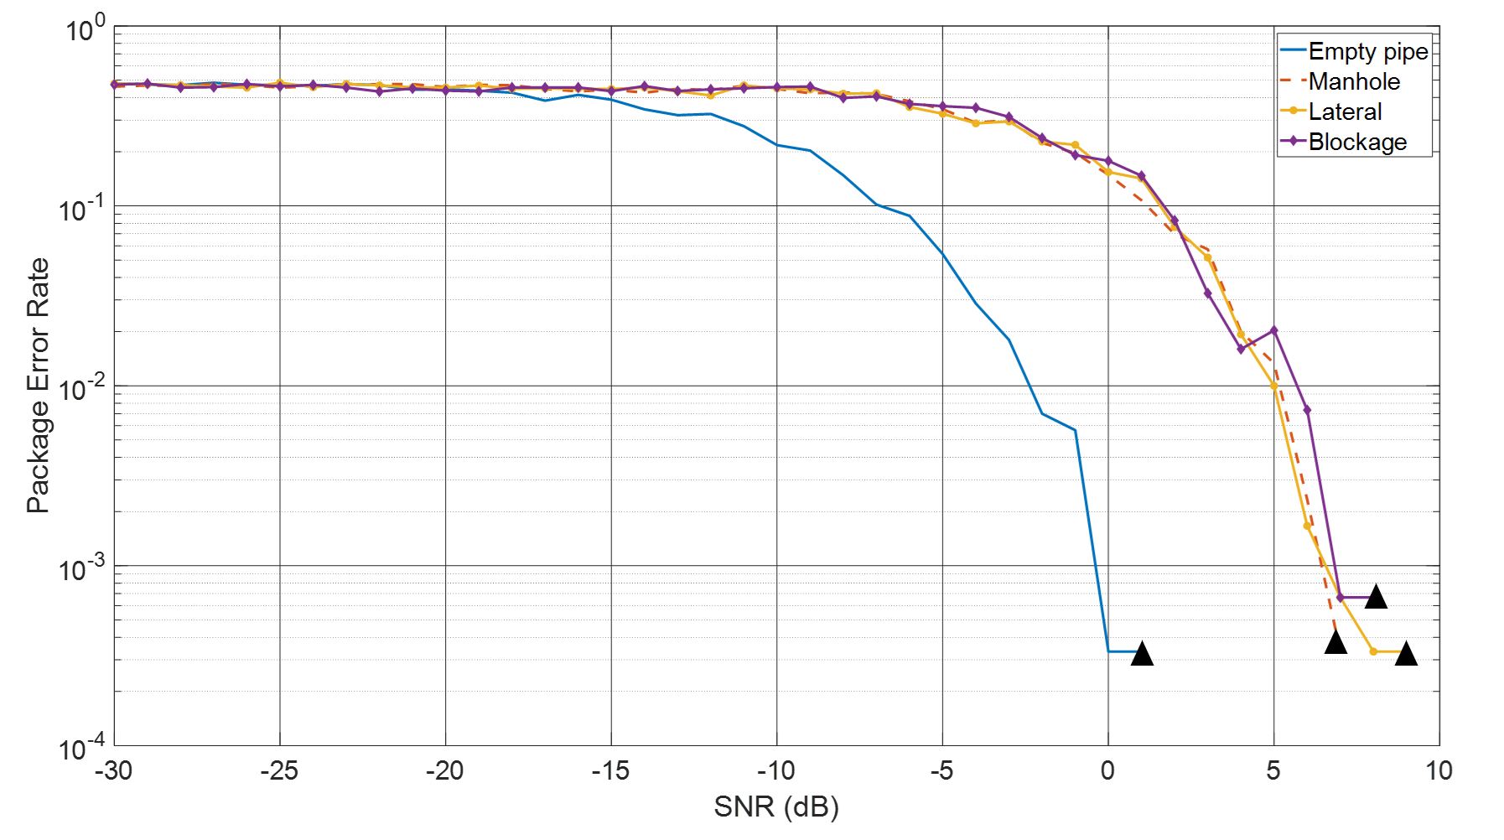
Figure 6.8 The effect of the artefact in the pipe on the package error rate as a function of the SNR for the 2FSK communication technique
The results suggest that the presence of an artefact does have a significant effect on the PER. The predicted PER is 0.0003 at SNR = 0 dB in the case of the empty pipe (blue line). However, the PER at this SNR in the presence of an artefact is almost three orders of magnitude higher. The trends in the behaviour of the PER in the presence of a manhole, blockage and lateral connection predicted for this particular communication technique are similar (see Figure 6.8). When an artefact is present in the pipe the signal to noise ratio needs to increase by around 7-9 dB above 0 dB to achieve the communication performance similar to that attained in the case of the empty pipe. Therefore, it can be suggested that these three types of artifacts would have a similar effect on the noise resistance of the 2FSK communication technique.

6.2.2 2ASK
The 2ASK communication technique makes use of the amplitude modulation to code the message. Figure 6.9 presents the dependence of the PER for this communication technique on the signal to noise ratio for the empty pipe and pipe with each of the three artefacts. Black triangles denote when will the PER reach 0.
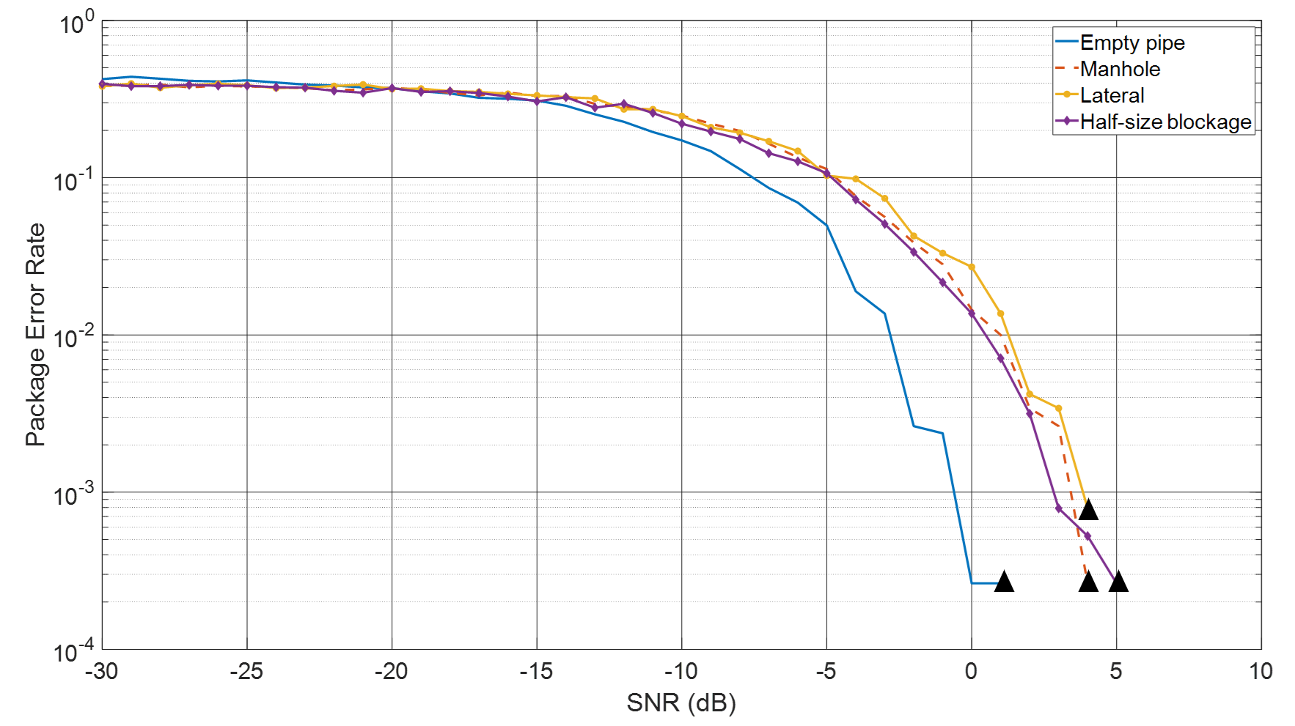
Figure 6.9 The effect of the artefact in the pipe on the package error rate as a function of the SNR for the 2ASK communication technique
The results presented in Figure 6.9 suggest that the communication performance of the 2ASK technique in the case of the empty pipe is similar to that predicted for the 2FSK technique. The PER reduces exponentially with the increases SNR and reduces to around 3x10⁻³ at SNR = 0 dB. The presence of an artefact in the pipe has a relatively small effect on the PER in the case of this communication technique. The results suggest that when an artefact is present in the pipe, it would require a 3-5 dB increase in the SNR above 0 dB to achieve the communication performance predicted for the case of an empty pipe. There is a small difference in the effects predicted for the three types of artefacts. The lateral connection has a marginally greater effect (i.e. within 1 dB) on the PER than the blockage and manhole (see Figure 6.9). The results also suggest that the desired safe condition for the 2ASK communication technique is at SNR = 5 - 6 dB and it has an overall better performance than 2FSK.

6.2.3 2PSK
The 2PSK communication technique makes use of the phase modulation to code the message within the acoustic signal. Figure 6.10 presents the results of the simulation of the performance of this communication technique in the empty 150 mm pipe and pipe with an artefact. The safe conditions for 2PSK communication in the pie with each type of artefacts have been marked as black triangles in this figure.
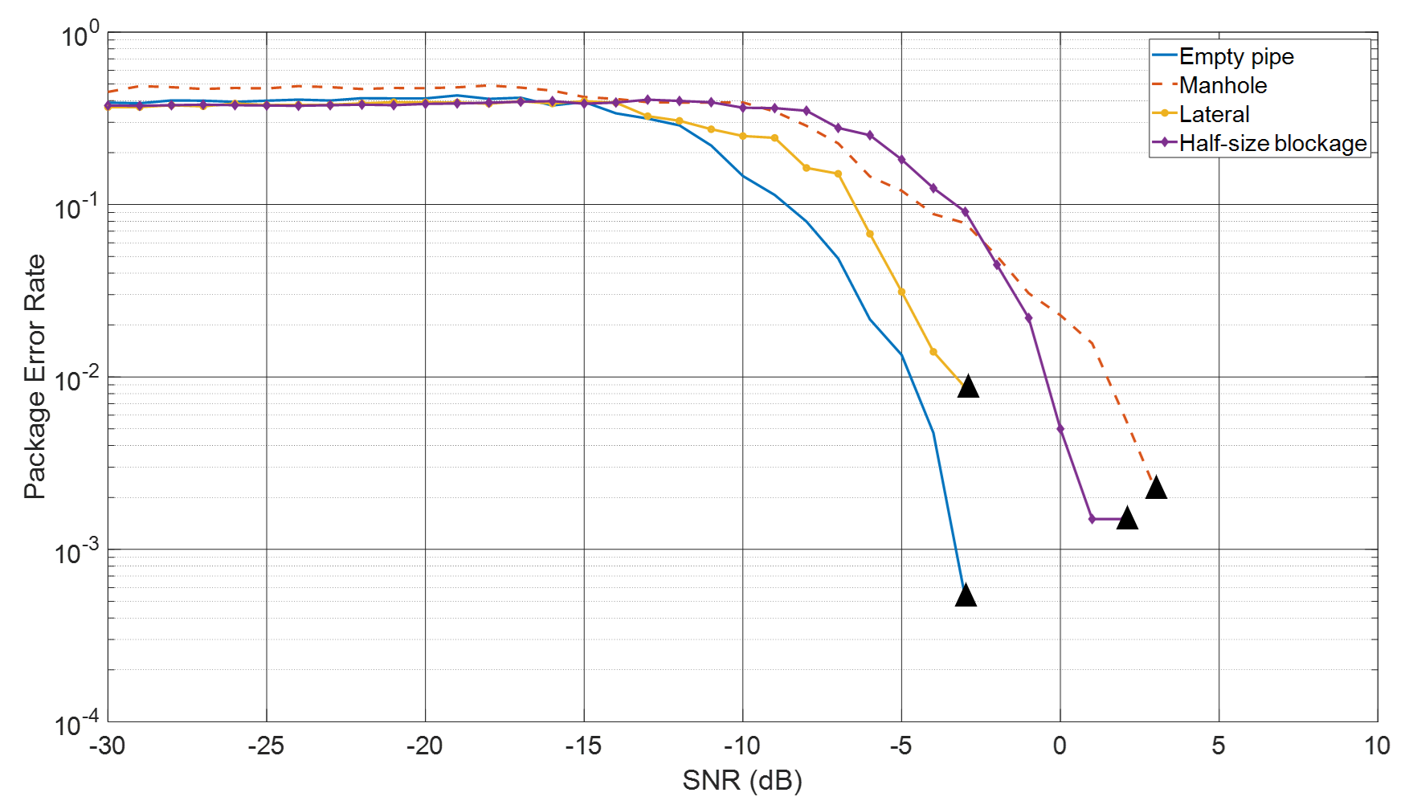
Figure 6.10 The effect of the artefact in the pipe on the package error rate as a function of the SNR for the 2PSK communication technique
Compared with the situations for 2FSK and 2ASK, the 2PSK has relatively better performance in the empty pipe because the blue line in Figure 6.10 ended to 0 for PER at -3 dB which was slightly lower than it in Figures 6.8 and 6.9. In addition, the influences caused by three types of artifacts began to show the difference. The yellow line which represents the performance of 2PSK in the pipe with lateral connection has safe condition at -2 dB which is very close to the blue line.
Then the presence of blockage in the pipe had stronger effect than lateral connection whose safe condition was 2 dB (purple line). Finally, the manhole had the most significant influence on 2PSK communication because the red line has the slowest converge speed and it also ended to 0 at 3 dB which was also higher than the rest 3 lines. The results make sense because if using the phase of the FRF of empty pipe as the reference, the phase difference at 5000 Hz (carrier frequency) shown in Figures 6.3, 6.5 and 6.7 were 0.57 rad, -6.69 rad and 0.91 rad which corresponded to lateral connection, blockage and manhole. Thus, it can be suggested that the signal of 2PSK is more easily to be distorted when the variation of the phase for the FRFs with artifacts is lager.

6.2.4 CLFM
Figure 6.11 plotted the diagram which indicates the results of SNR-PER for using CLFM communication system in the pipe with those four conditions (empty, lateral connection, half size blockage and manhole). In this figure, black triangles represent the safe conditions.
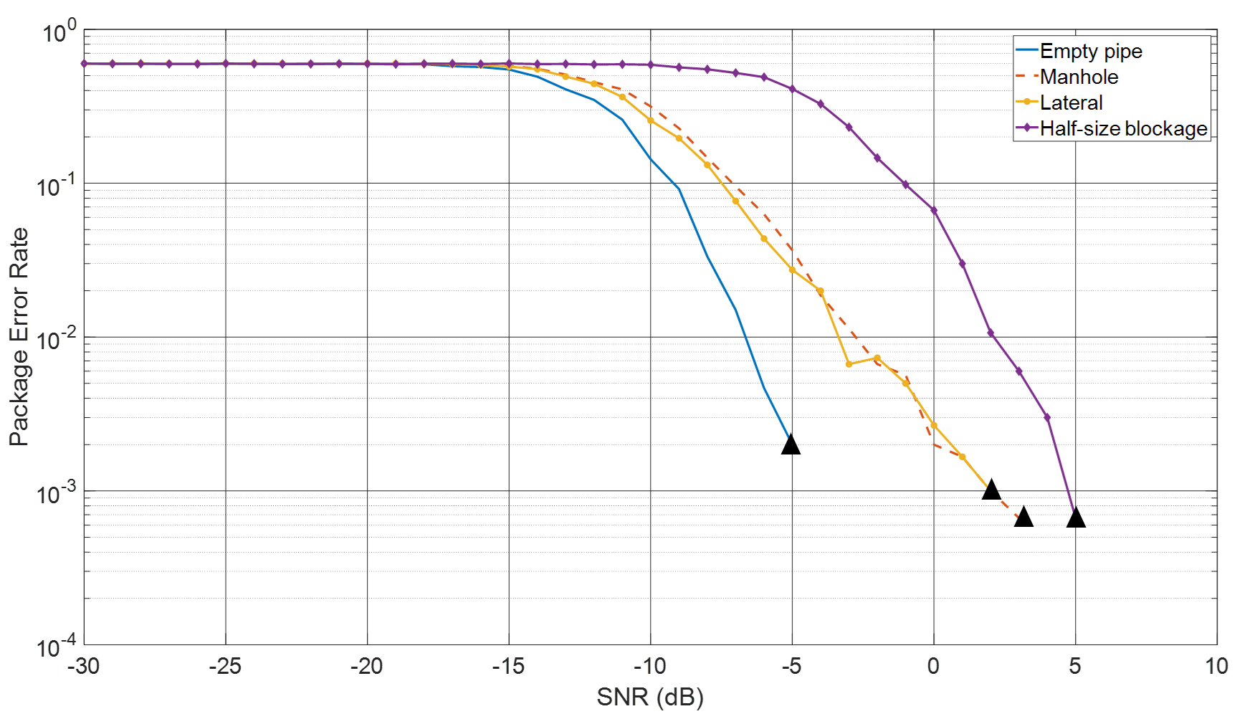
Figure 6.11 The effect of the artefact in the pipe on the package error rate as a function of the SNR for the CLFM communication technique
In Figure 6.11, the blue line has shown that the CLFM communication in the empty pipe has fastest converge speed and lowest safe condition (-5 dB). Then the effects of lateral connection and manhole are pretty similar, when the SNR increased to 2 dB and 3 dB the PER for each case will become 0. However, the blockage has most significant impact on the CLFM communication, it has the slowest converge speed and the safe condition is 5 dB which is also higher than the other cases. Therefore, in order to make CLFM system work properly and overcome the influence caused by the presence of those artifacts, the ideal SNR for this communication technique should be set higher than 5 dB. It also should be noted that in Figure 6.11, the blockage has most significant impact on the noise resistance of CLFM. This is because CLFM is modulated by several sub-chirps and on spectrum they cover a certain band. The additive noise was added to the whole band and this noise level is determined by the total energy contained in this frequency band. If the amplitude fluctuates violently in this frequency band, the overall performance of CLFM will be weaker.

6.3 Carrier Frequency Selection
In the previous sections, the noise resistance of each communication technique in the pipe with different artifacts has been discussed. The results clearly show that comparing with the communication in the empty pipe, the presence of artifacts in the pipe has an impact on the quality of communication channel which requires an increase in the SNR to work reliably. This section will be focused on the choice of carrier frequency for each of the communication techniques. In Chapter 4, a similar method has been applied to study the communication performance in the empty pipe to determine the effects of cross-sectional resonances and carrier frequency. Those results suggest that the PER mainly occurs at the frequency close to the modal frequencies for 2ASK/2FSK/2PSK system while CLFM system is notaffected by the modes. The COMSOL based numerical studies presented in section 6.1 suggest that the presence of a lateral connection, half-size blockage and manhole will change the transfer function dramatically (e.g. Figure 6.1). These changes in the amplitude and phase of the FRF cannot be ignored as they are likely to have an impact on the choice of the carrier frequency.
The MATLAB based simulations were carried out to determine the effect of the carrier frequency on the package error rate. In this study the bandwidth, message encoding and mapping were kept the same as in the previous sections. The carrier frequency was swept from 500 Hz to 5000 Hz for binary modulated systems, 2ASK/2FSK/2PSK. It also should be noticed that this frequency range set up was for the first sub-carrier $f_{c1}$ of 2FSK system and the second sub-carrier $f_{c2}$ was set in the relation of: $f_{c2}=\frac{1}{2}f_{c1}$. In the case of the CLFM communication technique, the frequency range of sub-chirps were also controlled by the central frequency: $[f_{central}-500 Hz,f_{cenrtal}+500 Hz]$ and the central frequency range for CLFM was set between 1000 Hz and 4500 Hz. In order to make sure the results were statistically reliable all the numerical tests were repeated 200 times and results were averaged. The results of simulations for each communication techniques were analysed in terms of the package error rate (PER) as the function of normalised carrier frequency ($kR$), where $k$ is the wavenumber and $R$ is diameter of the pipe. The first five mode frequencies also have been highlighted as black dash-lines and marked below the diagrams.

6.3.1 2FSK
Figure 6.12 Illustrates the PER as a function of the carrier frequency for the 2FSK communication technique and SNR = 9dB in the pipe with lateral connection (blue line), half-size blockage (red line) and manhole (yellow line).
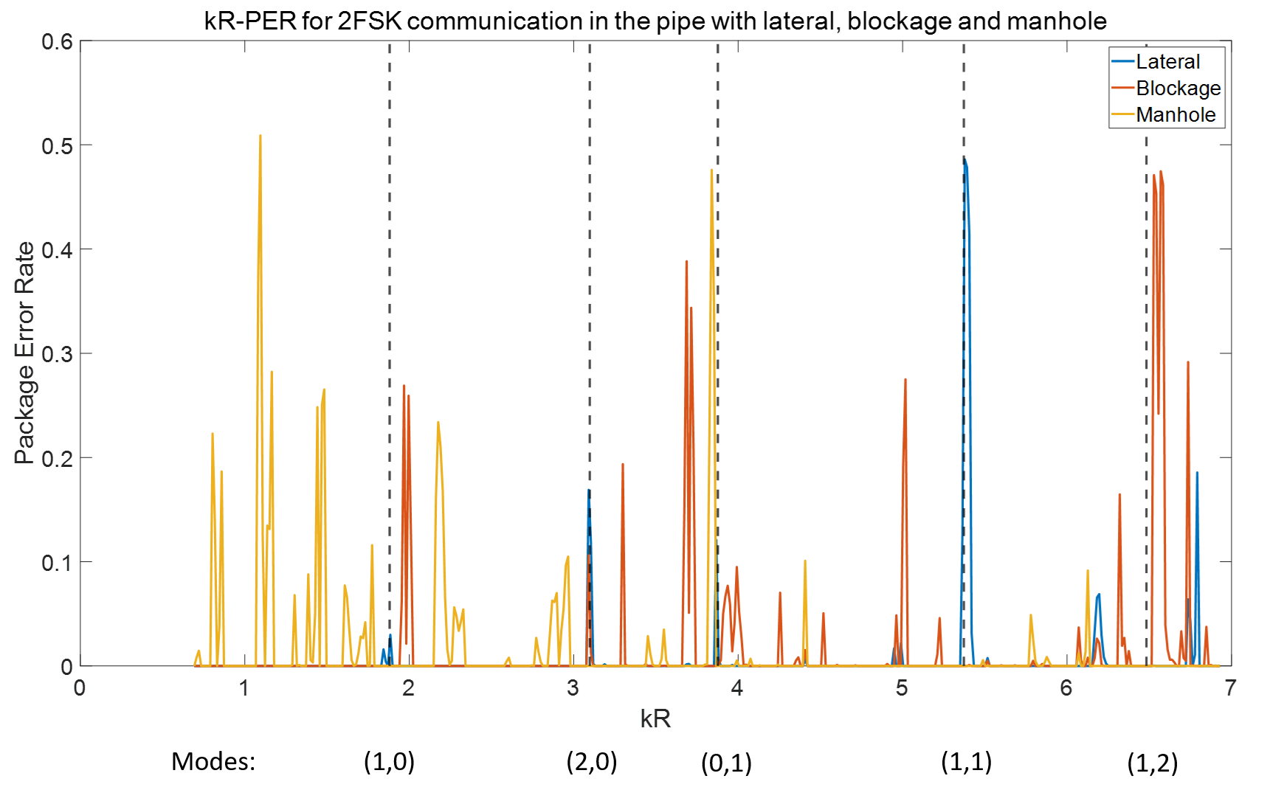
Figure 6.12 The effect of the carrier frequency in the 2FSK communication technique on the PER in the pipe with an artefact.
The results for the PER shown in Figure 6.12 suggest that in the plane wave region (below the frequency of mode (1,0)) there were no error bits occurred in the case of the lateral connection and blockage. It is reasonable because the FRFs for these two conditions (see Figures 6.2 and 6.4) indicate that the amplitude of the sound pressure predicted in this frequency range for the adopted microphone position is sufficient to provide a good signal to noise ratio to maintain a very low PER. In the case of the manhole there is a considerable variation in the amplitude of the FRF (see Figure 6.6). This can be caused by the existence of the evanescent modes which amplitude is relatively strong in the vicinity of the manhole. These modes are likely to cause stronger interference causing a relatively low SNR and relatively high PER.
The behaviour of the PER above the frequency of mode (1,0) is much more complex. In this frequency range the quality of communication depends on the SNR and effect of multi-path propagation, i.e. superposition of the same message but dispersed in time with a frequency-dependent delay. The 2FSK communication technique works relatively well in the presence of the lateral connection except when the carrier frequency coincides with a modal cut-off frequency (e.g. mode (1,1)) or when the SNR is low because of the dip in the FRF (e.g. at $kR$ = 6.2, see Figure 6.12).
Some peaks in the PER can be caused by a poor threshold choice. An example is at $kR=6.79$ for the PER predicted in the case of the lateral connection. The waveform for this simulation and threshold are shown in Figure 6.13. The red line in the diagram is the threshold which was set as $\frac{min\left(S\left(t\right)\right)+max(S(t))}{2}$. The terms $min(S(t))$ and $max(S(t))$ are the minimum and maximum values of the demodulated message pack, $S(t)$. The yellow and red points denote the sampling points used for decision making where yellow refers to the correct bits while red refers to the wrong bits. Clearly, the waveform can be visually considered as correct because it successfully represents the number "25431" in the binary form. However, the fluctuation of the waveform caused by muti-modal propagation and presence of the evanescent modes near the lateral connection will make some sampling points occasionally be above the threshold causing the so called "threshold effect". In Figure 6.13, there are two wrong bits out of 15 bits (remove 4 bits parity checking code) which will produce approximately 0.13 package error rate. Methods can be applied to avoid threshold effects and improve the overall performance of the system such as adaptive algorithm which could dynamically adjust the threshold. This is beyond the scope of this project therefore it will not be discussed and could be achieved in the future work.
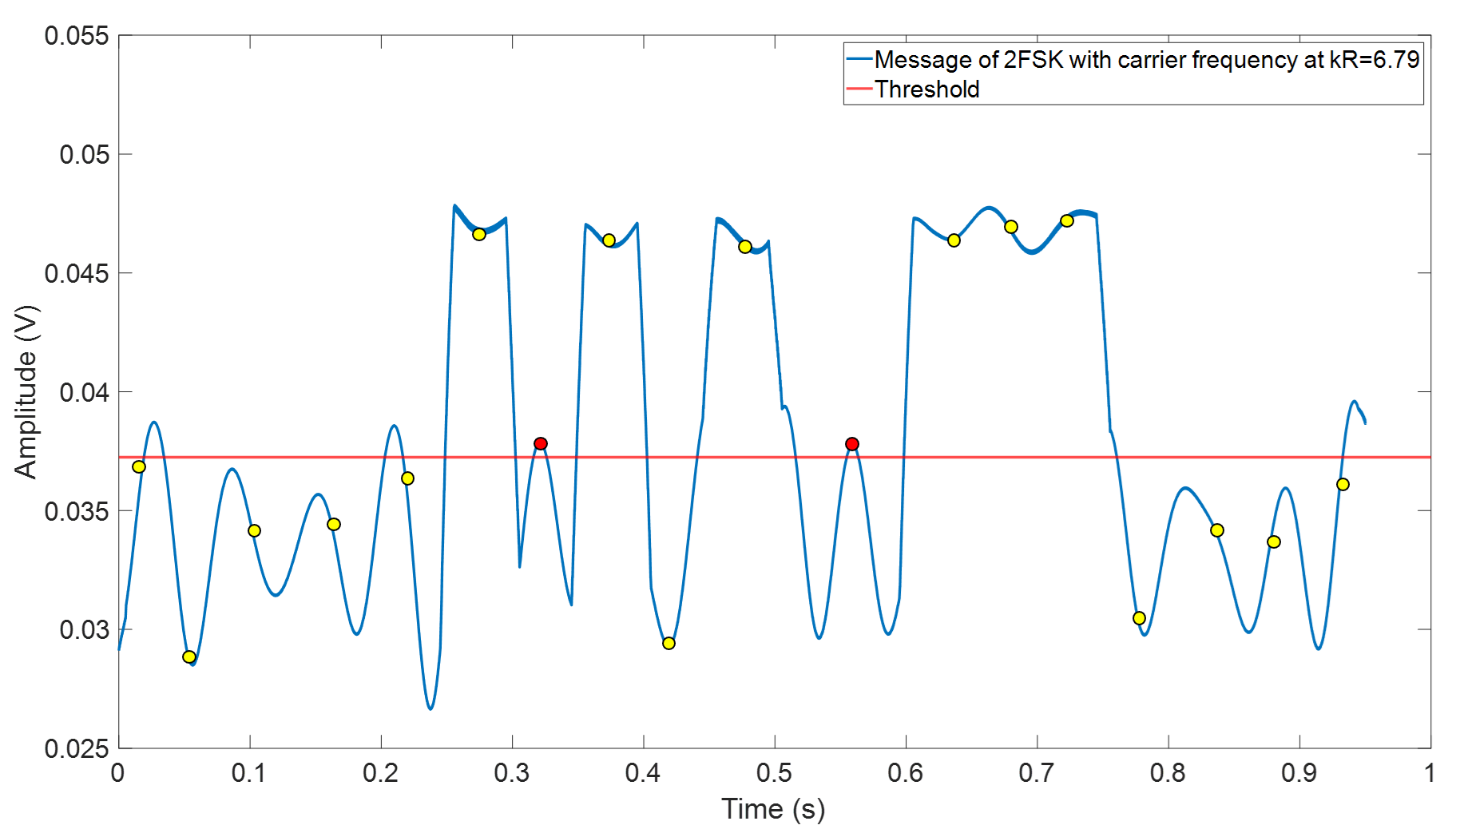
Figure 6.13 An illustration of the threshold effect on the decision based on the 2FSK demodulated message pack, carrier frequency set at kR=6.79, lateral connection
Figure 6.12 also illustrates that the effects caused by the presence of the half-size blockage were much stronger than that of the lateral connection. Error bits occurred around each of the cut-off frequencies in the PER spectrum and in the regions between the modes. The fluctuations in the amplitude of the FRF above the cut-off frequency of mode (1,0) (see Figure 6.4) caused by the presence of the blockage are much stronger than in the case of the empty pipe and pipe with the lateral connection at those frequency regions and these fluctuations may increase the difficulty of deconvolution. Therefore, it can be suggested that choosing the carrier frequency should keep away from those peaks plotted in Figure 6.12.
A similar observation can be made for the case of the manhole which has a significant effect on the quality of the 2FSK communication technique. In the plane wave region (see Figure 6.12), the 2FSK signal is easily distorted. Figure 3.24 in Chapter 3 illustrates that the manhole can be treated as a perfect reflector for the plane wave because the reflection coefficients were close to -1. The reflections will overlap with the incident wave which is the main reason caused the failure of communication. In contrast, with the increase of the carrier frequency, the effects of manhole have dramatically decreased and beyond the cut-off frequency of mode (0,1).

6.3.2 2ASK
Figure 6.14 illustrates the effect of the carrier frequency in the 2ASK communication technique on the PER in the pipe with an artefact. The SNR for this simulation was set as 5 dB suggested by the results shown in Figure 6.8. This simulation shows that the presence of an artifact has a strong influence in the plane wave region and beyond the first cut-off frequency of the pipe. In general, the 2ASK communication technique is easily affected by the changes in the amplitude of the FRF, noise present in the pipe and distortions of the transmitted message caused by the multi-modal propagation. Using such communication technique in such low frequency range would cause the amplitude of the message signal to reduce below the noise level. For example, the relatively high PER observed in the plane wave regime is likely to be caused by the poor SNR. Because 5 dB is the safe condition for 5000 Hz carrier frequency, 20 Hz bandwidth 2FSK communication and it would be a very harsh condition for the situation when the carrier frequency reduces down to plane wave region (below $kR=1.86$ in this case). Therefore, in Figure 6.14, high PER in plane wave region is reasonable.
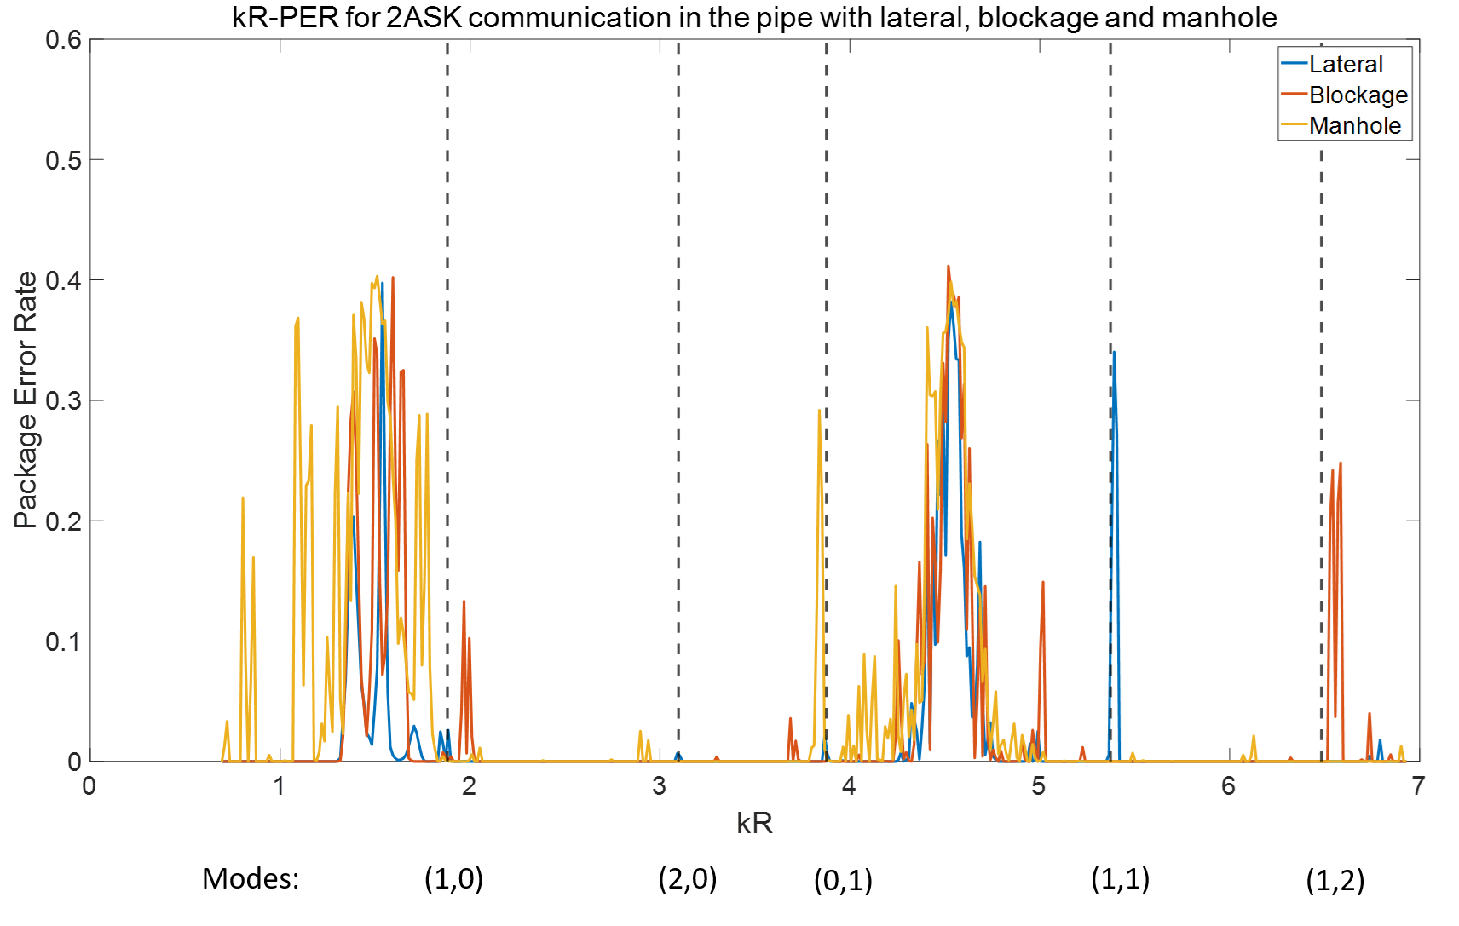
Figure 6.14 The effect of the carrier frequency in the 2ASK communication technique on the PER in the pipe with an artefact.
Another region on the normalised spectrum where the error bits likely occurred in this diagram is between mode (0,1) and (1,1). All three types of artifacts could produce a considerable amount of error bits roughly around $kR=4.5$ (3246 Hz). As it has been mentioned previously, the huge variation in the amplitude of FRF can significantly distort the 2ASK signal. According to the diagrams shown in Figure 6.1, the FRFs in this frequency region (between mode (0,1) and (1,1)) all suffer strong fluctuations in comparison with the FRF predicted for the empty pipe (blue lines). Such fluctuations can significantly reduce the quality of deconvolution and affect adversely the PER.
Peaks in the PER spectrum can also be observed close to the mode cut-off frequencies of modes (0,1), (1,1) and (1,2) (see Figure 6.14). These are commonly attributed to strong mode dispersion effects. Therefore, using 2ASK communication in the pipe with presence of artifacts not only should keep away from the mode frequencies and those two regions discussed, but also prefer using narrow band communication because doing so could make sure the massage pack contains enough energy to against the effects of noise and some distortion caused by the channel such as modal effects and strong amplitude fluctuation of the FRF.

6.3.3 2PSK
Figure 6.15 plotted the PER as a function of the normalised carrier frequency for the 2PSK communication technique used in the pipe with three different artifacts under SNR = 3 dB (see Figure 6.10).
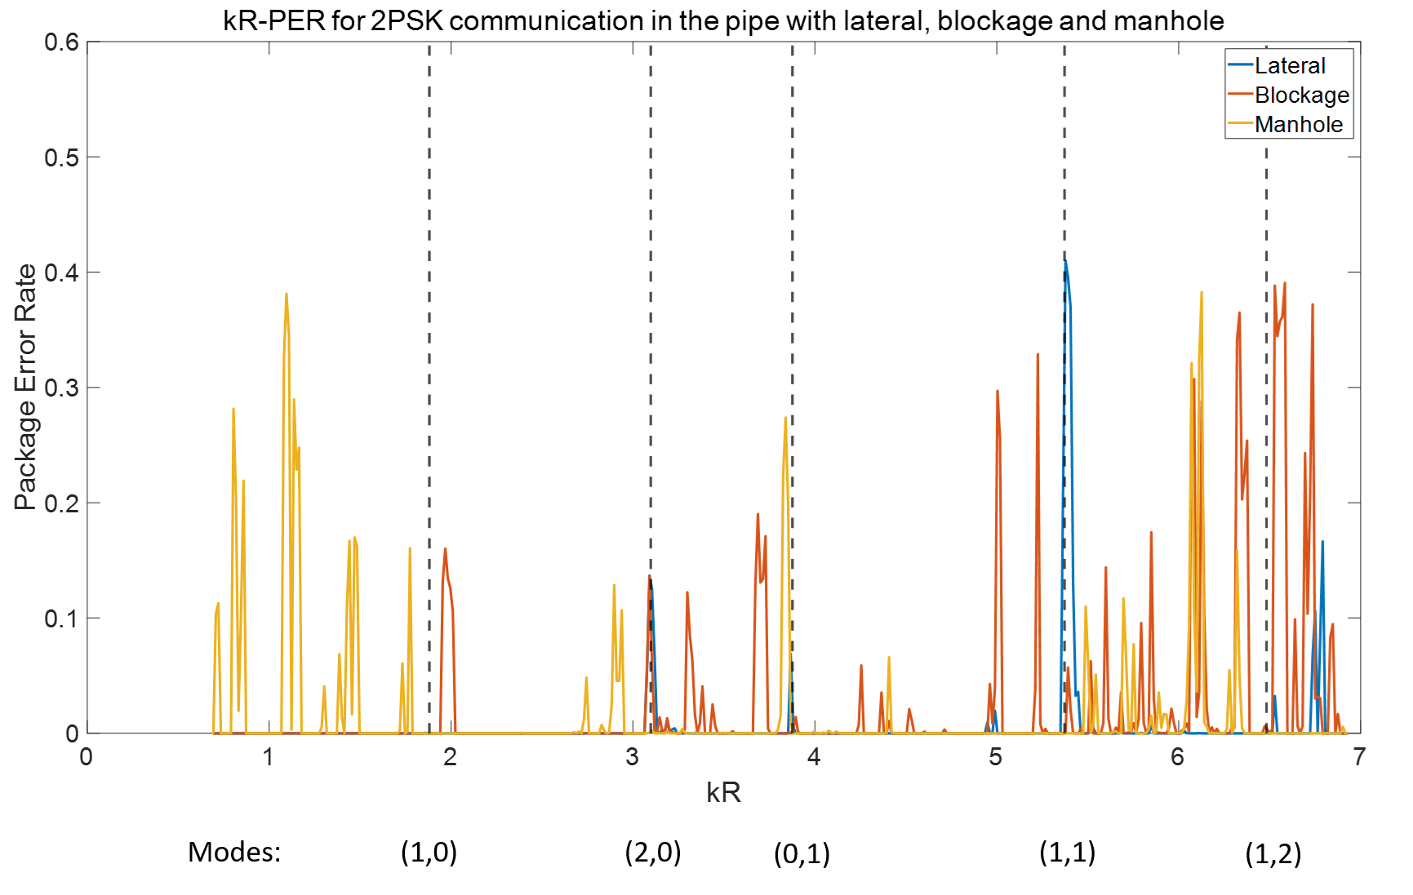
Figure 6.15 The effect of the carrier frequency in the 2PSK communication technique on the PER in the pipe with an artefact.
The presence of the lateral connection has a relatively small effect on the quality of 2PSK communication. High values of PER only occurred clearly at the cut-off frequencies of modes (2,0) and (1,1). There is also a peak in the PER (PER = 0.2) at around $kR=4730$. The presence of the blockage has a stronger effect on the quality of communication than lateral. In this case, peaks in the PER spectrum develop across the whole frequency range above the first cut-off frequency. These are especially strong beyond mode (1,1) where the effect of blockage is high because error bits occur more frequently.
The manhole is an artifact which was most likely to produce a large number of error bits when selecting the carrier frequency below the first mode (1,0). The reason is as same as which has been discussed previously. However, unlike in the case of the 2FSK and ASK communication techniques (see Figures 6.12 and 6.14) the peaks in the PER spectrum related to the presence of a manhole are spread over a relatively broad frequency band between modes (1,1) and (1,2). The reason which causes such problem is that the presence of the manhole significantly affects the phase of the FRF as illustrated in Figures 6.3, 6.5 and 6.7. Because the 2PSK communication technique utilises the phase changes of the carrier wave to transmit the message, the phase variation in the FRF cause the phase distortion during the process of demodulation resulting in the failure of correct decision making.
In principle, a good waveform of phase demodulation for the 2PSK communication technique should be similar to that shown in Figure 4.18 or its reversed form and it depends on the encoding process.
In the presence of phase distortion, the process of choosing the right sampling points for decision making becomes very tricky. This situation is shown in Figure 6.16.
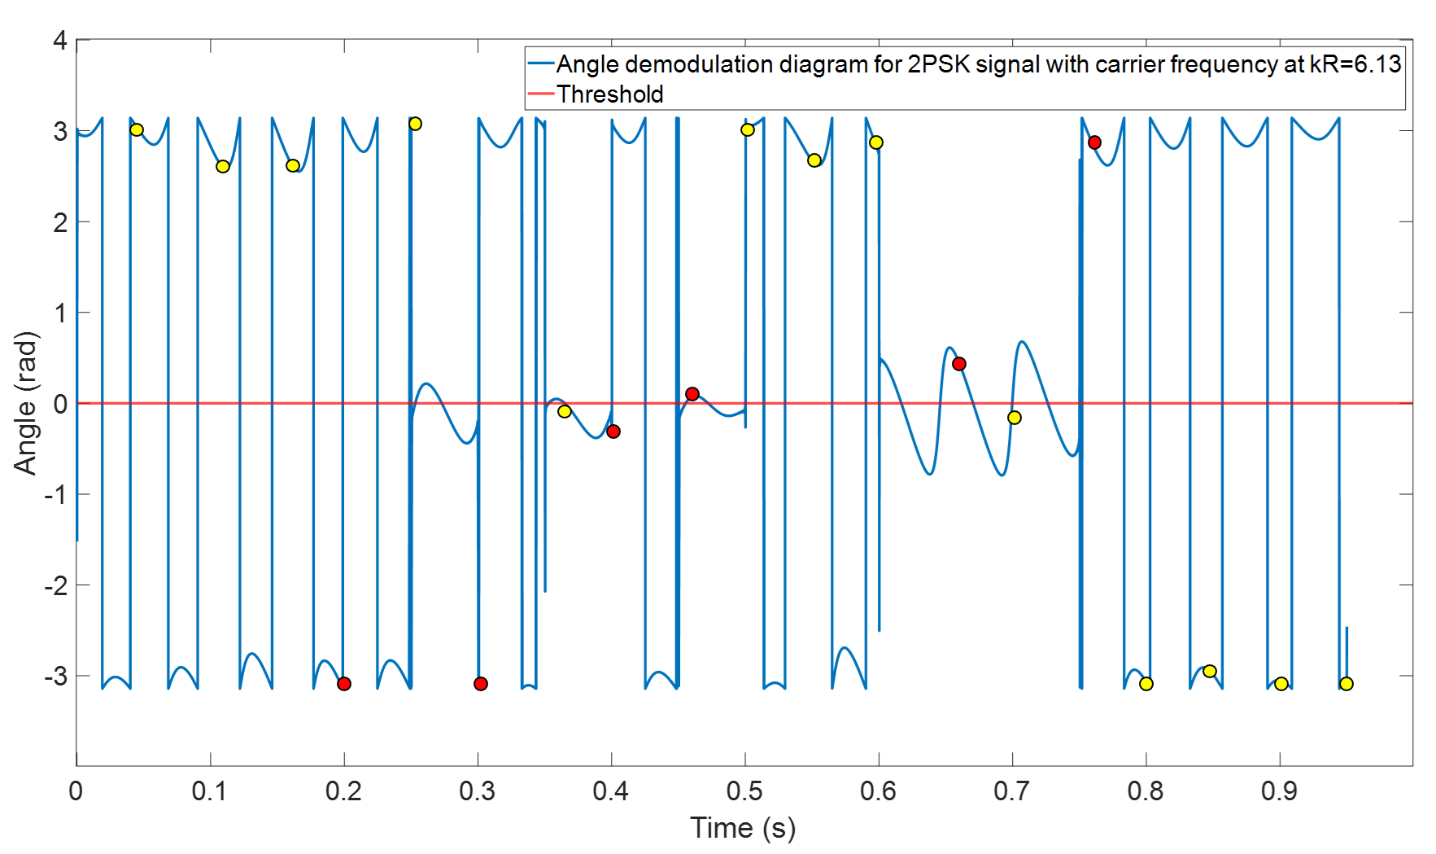
Figure 6.16 A diagram illustrating the threshold for the waveform used in the process of phase demodulation of a 2PSK signal transmitted at the carrier frequency of kR=6.13
Figure 6.16 gives an example of the phase distortion for the 2PSK message pack with normalised carrier frequency of $kR=6.13$ after the phase demodulation. The red line is the threshold. The yellow and red points are sampling points used for decision making similar to that shown in Figure 6.13. The yellow points represent correct bits while red points represent wrong bit. Clearly, the waveform illustrated In Figure 6.15 has huge difference with that shown in Figure 4.18 (the correct waveform of 2PSK demodulation) or its reversed form which produced 6 error bits out of 15 bits (removing parity checking code). Therefore, the PER is 0.4 in this case and the peaks illustrated in figure 6 mainly caused by this reason.

6.3.4 CLFM
Figure 6.16 illustrates the package error rate as a function of the normalised central frequency $f_{central}$ of sub-chirps used for CLFM communication in the pipe with the lateral connection, half size blockage and manhole under SNR of 5 dB (see Figure 6.10). It indicates that CLFM has overall best performance among the four communication techniques considered in this study. The effects of each artifact were very similar and concentrated in two regions in the PER spectrum: $2<kR<3.07$ and $4.25<kR<5.87$. The PERs in these two regions were relatively low, i.e. below 0.1, therefore it can be treated as a low probability random event. This bit error rate occasionally caused by some mis-synchronisation for sub-chirp.
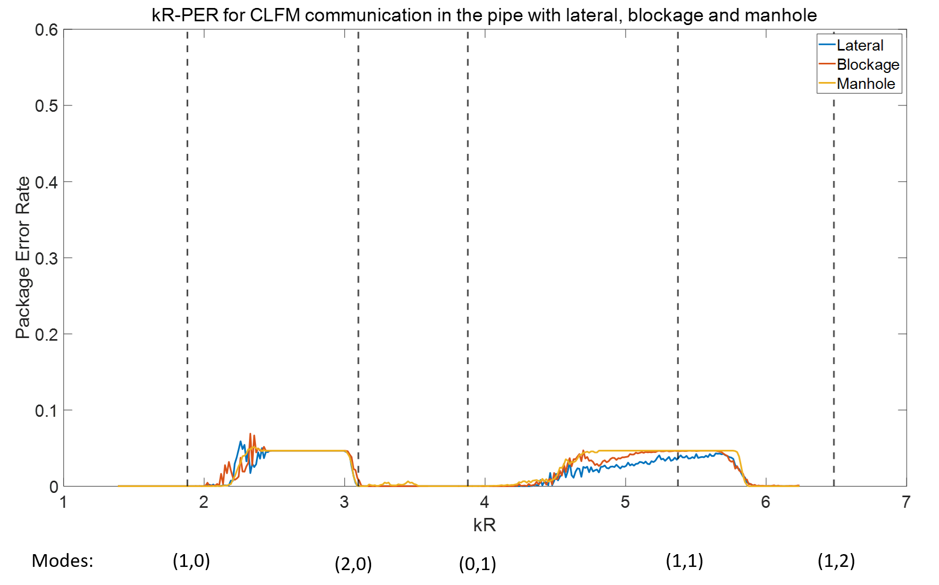
Figure 6.17 The effect of the carrier frequency in the CLFM communication technique on the PER in the pipe with an artefact.
Figure 6.18 gives an example diagram showing the cross-correlation for a CLFM communication signal in the pipe with the manhole. The normalised central frequency of the signal in this example was 5.36 which lied in the second error bit region as shown in Figure 6.17. The top diagram plotted the waveform produced by cross-correlating the CLFM signal after deconvolution with the sub-chirp with frequency from low to high ("1" bits) and bottom diagram plotted that cross-correlated with the sub-chirp with frequency from high to low ("0" bits). Visually, the whole waveforms shown in Figure 6.18 is correct and sharp peaks are matched and clear for decision making. However, occasionally even though the waveform visually is correct, the results obtained from decoding process still contains 1 error bits. It has been estimated that 1 error bit could be observed for each 6 times of test. For example, an error bit has been observed at 16th bits which is caused by the delay which produced by the muti-modal phenomenon. The explanation has been made in following text.
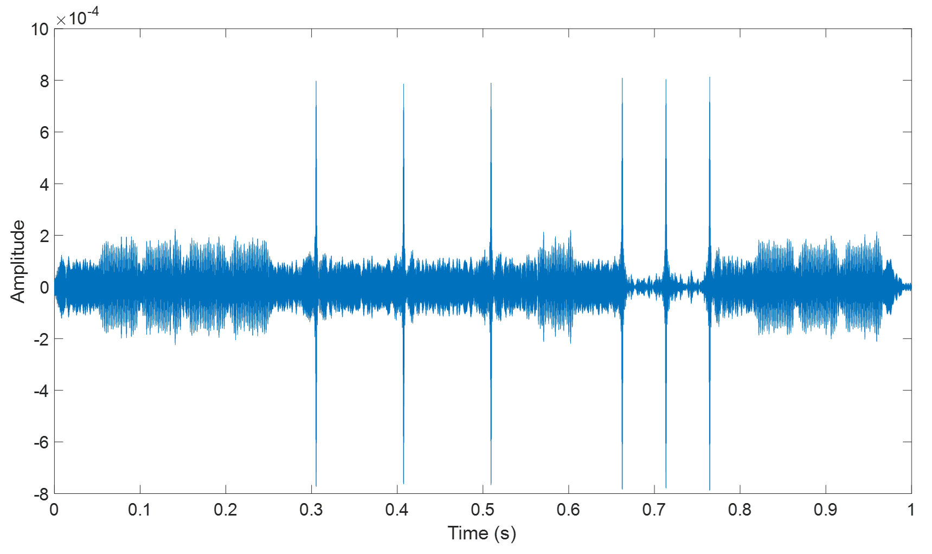
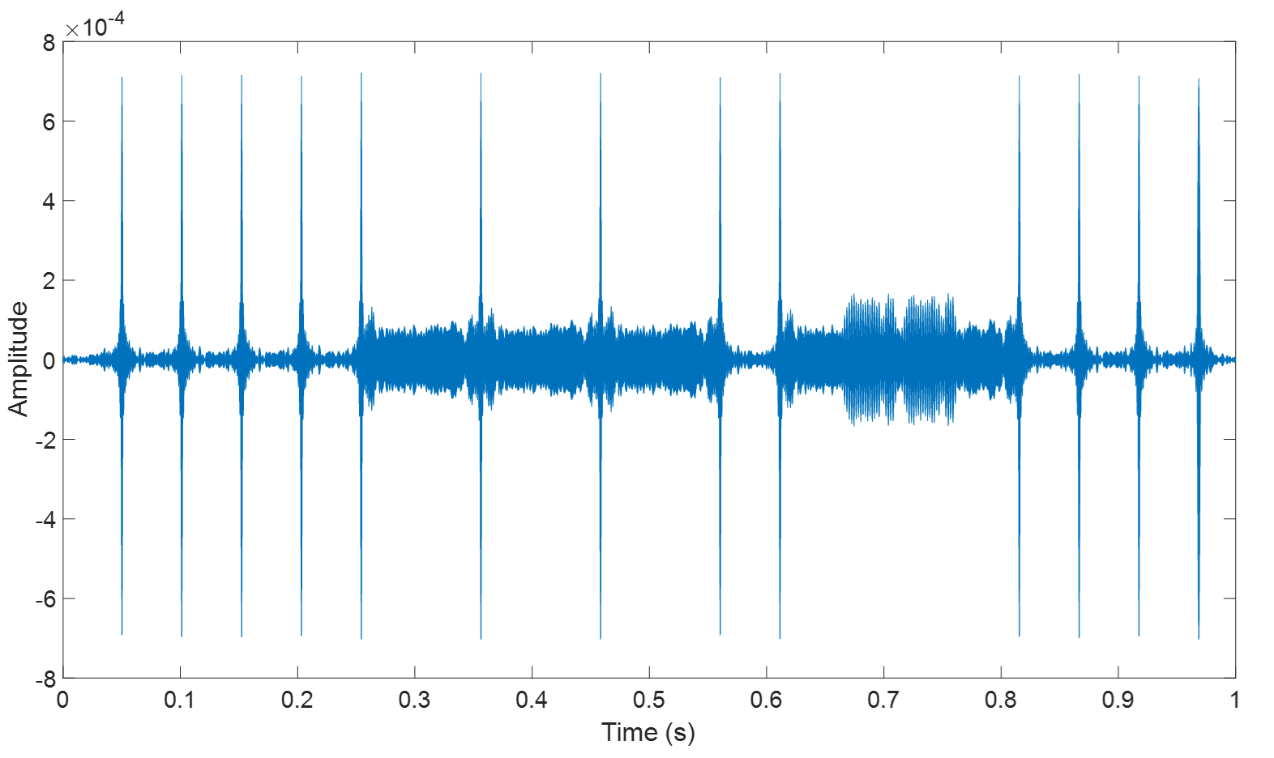
Figure 6.18 Cross-correlation results for CLFM communication in the pipe with manhole (normalised central frequency =5.36)
If we define the parity checking code as "1" bit and comparing two diagrams illustrated in Figure 6.18, the 16th bits of this signal should be recognized as "1". Recall the demodulation of CLFM, it utilises the cross-correlation in the sliding window to determine whether the signal in the window represent "1” or "0" and the details can be found in section 4.2.4. Therefore, if using top diagram in Figure 6.18 as reference, the waveform of the signal captured by 16th window should be similar to the Figure 6.19. However, the actually signal captured by the window has been shown in Figure 6.20.
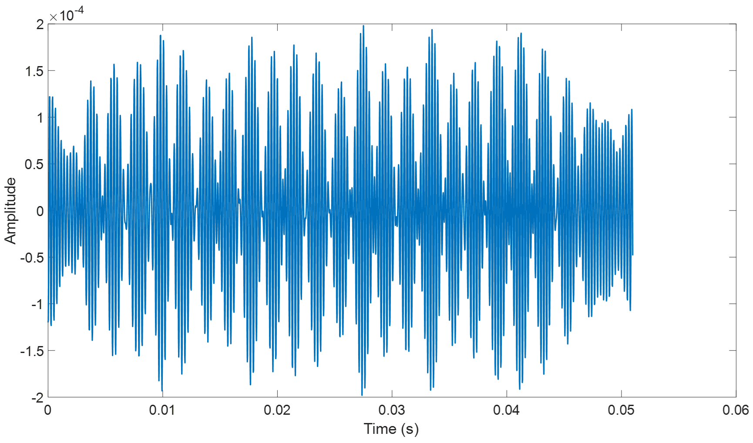
Figure 6.19 An example to show the waveform for 16th bits (in principle)
A comparison of the amplitudes and waveforms shown in Figures 6.19 and 6.20 suggests that the signal in Figure 6.20 contain a small peak at the beginning of the signal which can be believed as a part of 15th bit. This peak made the decision maker mis-recognize "1" as "0". The multi-modal effects could stretch the signal and the 'tail' of the former symbol will interfere with the "head" of later symbol and this is the reason why the peak shown in Figure 6.20 has been captured by the window. Even though the deconvolution could efficiently reduce this effect, occasionally the error can still occur when the frequency range of sub-chirps is relatively low (left bit error region in Figure 6.17) or when the central frequency is approaching the frequency where the amplitude of the FRF fluctuates significantly (right bit error region in Figure 6.17). The bit error especially is most likely happening when the adjacent symbols are different such as the situation mentioned above.

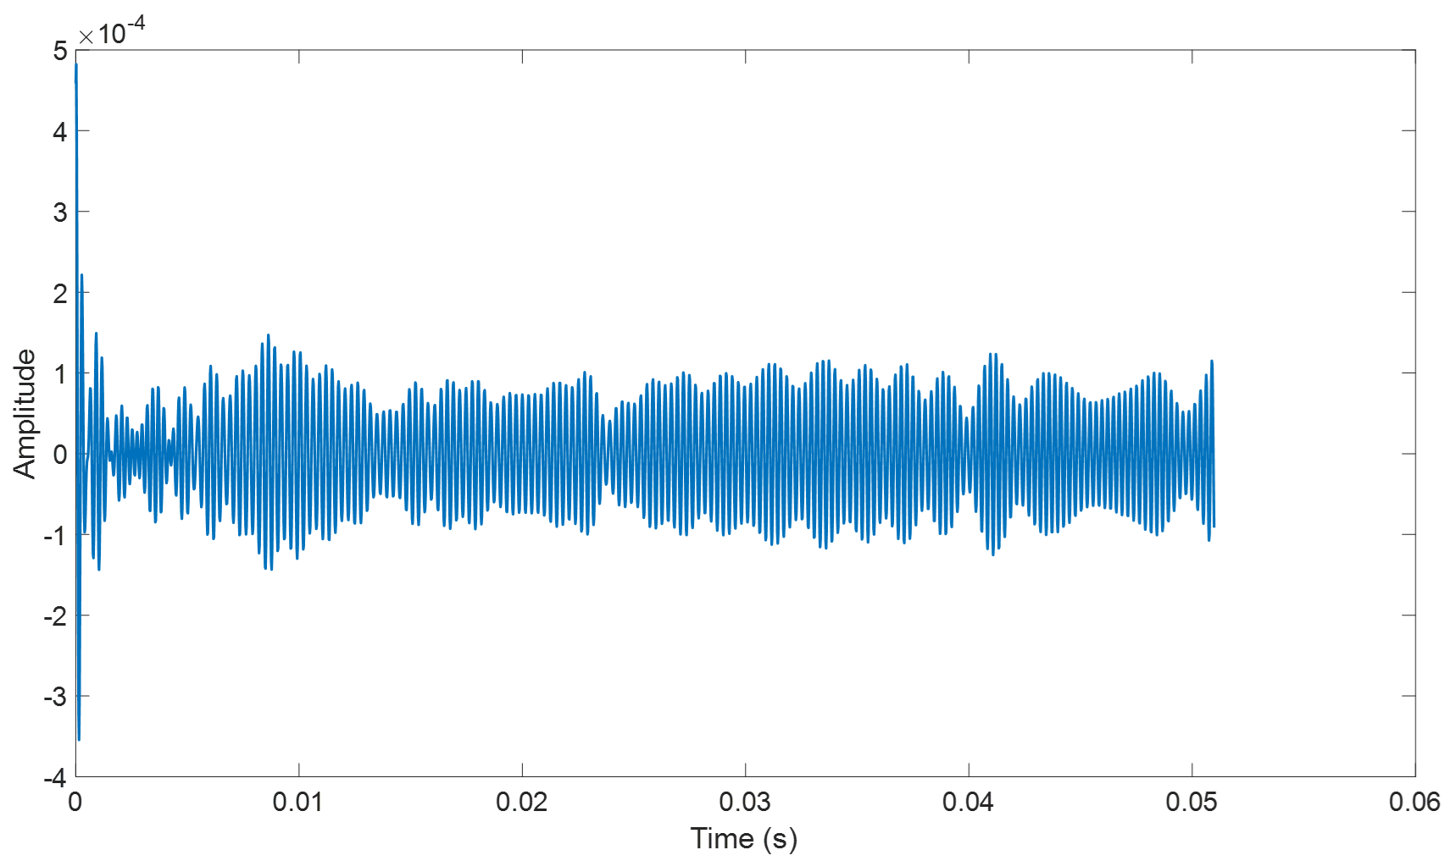
Figure 6.20 The waveform of 16th bit captured by the window (actual).

Summary
The results of the simulation presented in this chapter suggest that lateral connection has the smallest effect on the amplitude and phase of the FRF, especially below the third cut-off frequency (mode (0,1)). As the frequency increases, the effect of lateral connection becomes stronger. In addition, the presence of a half-pipe blockage will have a much larger influence on the FRF than that from the lateral connection in the frequency range above mode (0,1), even though the difference of FRFs in low frequency range is still small. In comparison with the effects of the lateral connection and blockage, the manhole has a significant effect on the transfer function. The fluctuation of the amplitude of the FRF is much stronger here, but the peaks which represent the first 2 modes are completely removed. The FRF for the pipe with manhole is completely out of phase with that for the empty pipe which means that using phase relevant communication system such as 2PSK in the pipe with manhole can be problematic when operating robots close to the manhole.
The results also suggest that communication in the pipe with artifacts requires a higher SNR than that in the case of the empty pipe. This is true for each communication techniques considered here: 2FSK (SNR>9dB), 2AKS (6dB), 2PSK (4dB), CLFM (6dB). The results also suggest that the effect of three artefacts on 2FSK and 2ASK is very similar, i.e. the three PER-SNR curves are all converged at around 8 dB and 5 dB respectively. The performance of 2PSK is slightly better than that for the other three communication technologies. However, the presence of the manhole has a strong impact on the phase of the FRF, i.e. it has a more significant influence on the quality of 2PSK than another two artefacts. Finally, even though the CLFM system has highest noise resistance in empty pipe, it’s ability to against noise has been challenged by the presence of the artifacts. The most obvious impact on such technique is made by the blockage, the reason is because the signal of CLFM is modulated by the sequence of chirp signal which covers a certain band on the spectrum and when the amplitude fluctuation in the frequency band is fairly strong, the quality of CLFM communication will be easily affected by the noise.
The final part of this chapter discussed the effects of three artefacts under safe condition on the carrier frequency selection. In the case of the 2FSK communication technqiue, the effect of lateral connection is small and observed only around the modal frequencies and at frequencies higher than the cut-ff frequency for mode (1,2). However, the blockage has a stronger impact than lateral connection. High values of PER between the modal frequencies and their amplitude increases with the increase in the carrier frequency. Furthermore, the error bits caused by the manhole mainly occur at low frequency region below mode (0,1), especially in the plane wave region. Chapter 3 has stated that for plane wave region, manhole can be treated as a perfect "reflector". The cancelation of incident wave and reflections will cause the strong variation of FRF and further cause the distortion on 2FSK signal. In addition, it has been mentioned that some small PER plotted in the diagrams can be attributed to the "threshold effect" which needs to be considered when extracting the information from the message pack. The most error bits are distributed in two main regions on the normalised spectrum for 2ASK which are plane wave region ($kR<1.86$ (1340 Hz)) and around $kR=4.5$ (3246 Hz). The error bits in the plane wave region can be attributed to the low noise resistance due to reduction of carrier frequency while for those in second region, the reason is the strong fluctuation of the amplitude of FRF. Moreover, the influence of artefacts on 2PSK is pretty similar to that of 2FSK, the differences is the impact of manhole is weaker in plane wave region while the effects of blockage and manhole are stronger in frequency range above mode (1,1). For CLFM, the overall error bits are fairly low (all below 0.1) in comparison with the other communication techniques, and they are fallen in two regions as well: between mode (1,0) and (2,0) and around mode (1,1). The error bits are rarely to be observed because there are two conditions needs to be satisfied: 1. The inter-symbol interference (ISI) for CLFM will only occur between two adjacent different symbols.The amplitude of later symbol should be significantly interfered by the "tail" of former symbol and this interference is strong enough to confuse the decision maker. Therefore, under safe condition, the probability of both conditions are satisfied is relatively low.

Chapter 7. Conclusions
Key findings from this research have been presented in Chapters 3-6. In Chapter 3 the dispersion relations have been studied analytically and validated by an experiment. The results show that the error in the proposed model is lower than 5% . The mode split phenomenon that is likely to have strong impact on the quality of acoustic communication has been demonstrated and new model has been proposed. An analytical approximation has been derived to predict the modal split. It has been shown how the results from a FEM simulation can be used to create a database to estimate the sound pressure in a partially filled pipe with an efficient empirical model. The role of sound attenuation on the communication range has been analysed. The attenuation in the pipe consists of two parts: the air-absorption which is also called classic attenuation; and visco-thermal effects in the fluid near the pipe wall. Both types of attenuation are frequency dependent. It has been suggested that the latter is much stronger than the former. The effects of uncertainties in the pipe has been discussed. The relation between the modal reflection coefficient from a lateral connection, half size blockage and manhole has been studied numerically and analysed as a function of the normalised wavenumber. It has been suggested that the reflection coefficient of each mode fluctuates complexly as a function of the frequency with a potential to trigger the Inter-symbol Interference (ISI) in the communication.
Chapter 4 studied the fundamentals of four communication techniques in a dry pipe via numerical approach and experimental validation. These techniques can be potentially deployed on the robots inspecting in the pipe collaboratively and autonomously. The capabilities of these four techniques against noise and uncertainties such as multi-mode propagation in the pipe have been tested through simulations and experiments. The error between the analytical and experimental approaches has been found relatively small, i.e. below 2%.
The predicted performance of 2ASK, 2PSK and 2FSK modulation has been found good when the SNR is higher than 0dB. The experimental validation suggests that the ideal SNR for these three methods should be in the range between 7 dB and 15 dB. Therefore, it can be deduced that 2ASK, 2PSK and 2FSK are easily affected by the noise and uncertainties of the channel which needs relatively high SNR to function properly in the real application. However, it has been validated that not only in the simulation but also in the measurements, CLFM is the most stable system among the 4 systems which could operate in low SNR environment down from -5 dB to 0 dB. The influence of the cross-sectional modes can be significant. Sending message at frequencies close to these modes is likely increase the bit error rate. The use of the channel FRF in deconvolution can reduce the effect of the modes and multi-path propagation. The career frequency should not be selected close to a modal frequency when using 2ASK, 2PSK and 2FSK MODEMs. This seems less of an issue when using the CLFM communication technique. The sound attenuation in the pipe due to the air absorption can cause the reduction in the SNR and negatively affect the bit error rate. One can expect a 3 dB attenuation at 50 m in a relatively clean pipe when communicating at the 12700 Hz carrier frequency. Based on this information, the highest communication speed can be estimated: 2ASK and 2PSK in 50 m distance has highest data transmission speed of 6350 bps, 2FSK ranked the third position with 4233 bps and even though CLFM is the most reliable system, due to the effect of inter-symbol intervals, it has the lowest communication speed which is only 6.82 bps.
Chapter 5 studies the performance of analytical and empirical model for the four communication techniques in the pipe with different water levels. It has been shown that careful equalisation is required to achieve sufficiently low bit error rates. The presented results suggest that both analytical and empirical models work well in a partially filled pipe which means that the empirical model is a reliable and efficient method for the deployment on the robot. Such a model is highly efficient as it would require much less computational resource and power than a full numerical simulation or analytical model. It has also been suggested that the presence of water layer in the pipe would not affect the communication quality as long as the FRF of the pipe can be accurately obtained (either predicted by the models or measured by the preamble).
The work presented in this chapter has also evaluated the performance of the four communication techniques when the water level was suddenly changed. It has been suggested that the 2FSK communication technique could operate with filling ratio tolerance of 0.1 and for the change of filling ratio higher than 0.1. The transmitted acoustic waveform is likely to fluctuate and it would require further processing and equalisation. In contrast, the filling ratio tolerance for 2ASK, 2PSK and CLFM has been found higher than that for 2FSK. For this communication technique the variation in the filling ratio of as large as 0.2 will not affect the quality of 2ASK, 2PSK and CLFM. Beyond this value of filling ration fluctuation, the waveform used for decision making will be completely distorted which have to recalibrate the channel acoustic characterisation. It has been demonstrated that the modal split phenomenon would have strong impact on the communication quality which required choosing the carrier frequency should be even more careful than communicating in the empty pipe. However, moving source and receiver near the top wall could efficiently reduce the effect of "modal- split".
The results of the simulations presented in Chapter 6 suggest that lateral connection has the smallest effect on the amplitude and phase of the FRF, especially below the third cut-off frequency (mode (0,1)). As the frequency increases, the effect of a lateral connection becomes stronger. In addition, the presence of a half-pipe blockage is likely to have a much larger influence on the FRF than that from the lateral connection in the frequency range above mode (0,1), even though the difference of FRFs in low frequency range is still small. In comparison with the effects of the lateral connection and blockage, the manhole has a significant effect on the transfer function. The fluctuation of the amplitude of the FRF is much stronger here, but the peaks which represent the first 2 modes are completely removed. The FRF for the pipe with manhole is completely out of phase with that for the empty pipe which means that using phase relevant communication system such as 2PSK in the pipe with manhole can be problematic when operating robots close to the manhole.
The results also suggest that communication in the pipe with artifacts requires a higher SNR than that in the case of the empty pipe. This is true for each communication techniques considered here. Specifically: 2FSK (SNR>9dB), 2AKS (6dB), 2PSK (4dB), CLFM (6dB). The results also suggest that the effect of the three artefacts on 2FSK and 2ASK is relatively similar, i.e. the three PER-SNR curves are all converged at around 8 dB and 5 dB respectively. The performance of 2PSK is slightly better than that for the other three communication technologies. However, the presence of the manhole has a strong impact on the phase of the FRF, i.e. it has a more significant influence on the quality of 2PSK than another two artefacts. Finally, even though the CLFM system has highest noise resistance in empty pipe, it’s ability to against noise has been challenged by the presence of the artifacts. The most obvious impact on such technique is made by the blockage, the reason is because the signal of CLFM is modulated by the sequence of chirp signal which covers a certain band on the spectrum and when the amplitude fluctuation in the frequency band is fairly strong, the quality of CLFM communication will be easily affected by the noise.
The final part of this chapter discussed the effects of three artefacts under safe condition on the carrier frequency selection. In the case of the 2FSK communication technique, the effect of lateral connection is relatively small and observed only around the modal frequencies and at frequencies higher than the cut-ff frequency for mode (1,2). However, the blockage has stronger impact than lateral connection. High values of PER between the modal frequencies and their amplitude increases with the increase in the carrier frequency. Furthermore, the error bits caused by the manhole mainly occur at low frequency region below mode (0,1), especially in the plane wave region. Chapter 3 has also stated that for plane wave region, manhole can be treated as a perfect "reflector". The cancelation of incident wave and reflections will cause the strong variation of FRF and further cause the distortion on 2FSK signal. In addition, it has been mentioned that some small PER plotted in the diagrams can be attributed to the "threshold effect" which needs to be considered when extracting the information from the message pack. The most error bits are distributed in two main regions on the normalised spectrum for 2ASK which are plane wave region ($kR<1.86$ (1340 Hz)) and around $kR=4.5$ (3246 Hz). The error bits in the plane wave region can be attributed to the low noise resistance due to reduction of carrier frequency while for those in second region, the reason is the strong fluctuation of the amplitude of FRF. Moreover, the influence of artefacts on 2PSK is pretty similar to that of 2FSK, the differences is the impact of manhole is weaker in plane wave region while the effects of blockage and manhole are stronger in frequency range above mode (1,1). For CLFM, the overall error bits are fairly low (all below 0.1) in comparison with the other communication techniques, and they are fallen in two regions as well: between mode (1,0) and (2,0) and around mode (1,1). The error bits are rarely to be observed because there are two conditions needs to be satisfied: (i) The inter-symbol interference (ISI) for CLFM will only occur between two adjacent different symbols. (ii) The amplitude of later symbol should be significantly interfered by the "tail" of former symbol and this interference is strong enough to confuse the decision maker. Therefore, under safe condition, the probability of both conditions are satisfied is relatively low.

Limitations and Future Work
It can be suggested that the future work is focused on the following topics:
From point view of acoustics, attenuation of sound propagation in the pipe is a key factor which directly affect the communication range and data rate because it is frequency dependent. Currently the work has only studied the attenuation in a dry, clean, uniform pipe. This work should be extended to those pipes which conditions are more complex, e.g. partially filled pipe with a dynamically rough flow surface and more realistic artefacts. There are many extra factors which will affect the sound attenuation in a more realistic pipe. For example, clay and concrete pipes are one of the most commonly used pipes for sewer system In the UK. These pipes are inherently rough, porous and contain a considerable number of uneven joints which mean that there a considerable amount of sound is likely to be scattered and absorbed.
Moreover, the models which used to predict the FRF of the pipe only valid when the pipe wall can be considered as rigid. If the impedance of pipe and fluid in the pipe are comparable, these models are no longer appliable which would require develop a better model to estimate the FRF more accurately.
The work about communication in the pipe with different artefacts has been limited to the three types of artefacts and particular source and receiver positions. It would be desirable to study the effects of other kinds of artefacts such as T-junction, L-junction, cross connection and their combinations. The blockage used in this study was half-size, therefore the influence of the size of the blockage to the sound field in the pipe is a meaningful topic can be determined in the future. In addition, this part of work only finished by MATLAB and COMSOL based simulation and it would require further experimental validation.
From the communications point of view, the presented work is based on four particular modulation techniques, 2ASK/2FSK/2PSK/CLFM which can be deployed on a robot. In fact, it is still limited at stage which was using fixed source and receiver to communicate. In the future, this system needs to be adapted to a robot. In addition, apart from CLFM which is widely used spread communication technique, 2ASK/2FSK/2PSK are relatively simple and limited by their data rate, ability to against noise and etc. Therefore, in future work, more advanced communication techniques such as orthogonal frequency division multiplexing (OFDM) and 4G are worth to be attempted for increasing the data rate and proficiently removing the inter-symbol interference.
In addition, the communication techniques proposed in this work are simplexing which has huge limitations for robots work as swarms. Therefore, multiplexing of in-pipe robot communication is a very challenging problem. And based on multiplexing, code division multiple access (CDMA) technique is also a very attractive function which should be achieved in the future. Therefore, multiplexing and CDMA are two fundamental features to show that the robots can work as a "team".

References

[1] | Pipebots, “Pervasive Sensing of Buried Pipes,” 2019. [Online]. Available: https://pipebots.ac.uk/.
[2] | C. Parrott, T. Dodd, J. Boxall and K. Horoshenkov, “Simulation of the behavior of biologically-inspired swarm robots for the autonomous inspection of buried pipes,” Tunnelling and Underground Space Technology, 27 April 2020.
[3] | I. F.Akyildiz and E. P.Stuntebeck, “Wireless underground sensor networks: Research challenges,” Ad Hoc Networks, pp. 669-686, November 2006.
[4] | T. Hao, C. Rogers, N. Metje, D. Chapman, J. Muggleton, K. Foo, P. Wang, S. Pennock, P. Atkins, S. Swingler and J. Parker, “Condition assessment of the buried utility service infrastructure.,” Tunnelling and Underground Space, vol. 28, pp. 331-344, 2012.
[5] | Z. Liu and Y. Kleiner, “State of the art review of inspection technologies for condition assessment of water pipes.,” Measurement, vol. 46, no. 1, pp. 1-15, 2013.
[6] | S. Datta and S. Sarkar, “A review on different pipeline fault detection methods.,” Journal of Loss Prevention in the Process Industries, vol. 41, pp. 97-106, 2016.
[7] | W. Duan, R. Kirby, J. Prisutova and K. Horoshenkov, “On the use of power reflection ratio and phase change to determine the geometry of a blockage in a pipe,” Applied Acoustics, vol. 87, pp. 190-197, 2015.
[8] | A. M. Bin, “Development of Acoustic sensor and signal processing technique, PhD Thesis,” University of Bradford, 2011.
[9] | A. F. Molisch, Wireless Communicaitons, UK: Chichester, 2011.
[10] | P. M. Morse and K. Ingard, Theoretical Acoustics, Princeton University Press, 1986.
[11] | C. Fuller and F. Fahy, “Characteristics of wave propagation and energy distributions in cylindrical elastic shells filled with fluid,” Journal of Sound and Vibration, vol. 81, pp. 501-518, 1982.
[12] | M. J. Brennan, M. Karimi, J. M. Muggleton, F. C. L. Almeida, F. K. de Lima, P. C. Ayala, D. Obata, A. Paschoalini and N. Kessissoglou, “On the effects of soil properties on leak noise propagation in plastic water distribution pipes.,” Journal of Sound and Vibratio, vol. 427, pp. 120-133, 2018.
[13] | R. Kirby and W. Duan, “Guided wave propagation in cylindrical ducts with elastic walls enclosing a fluid moving with a uniform velocity,” Wave Motion, vol. 85, pp. 1-9, 2019.
[14] | T. Graf and P. Jie, “Determination of the complex acoustic scattering matrix of a right-angled duct,” The Journal of the Acoustical Society of America, vol. 134, no. 1, pp. 292-299, 2013.
[15] | Y. Li, “Experimental study on ultrasonic signal transmission within the water-filled pipes,” in Mechatronics and Machine Vision in Practice, Proceedings, Fourth Annual Conference, 1997.
[16] | G. Kokossalakis, “Acoustic Data Communication System for In-Pipe Wireless Sensor Networks,” Ph.D. dissertation, Massachusetts Institute of Technology, Cambridge,MA,USA, 2006.
[17] | L. Jing, Z. Li, Y. Li and R. D. Murch, “Channel characterization of acoustic waveguides consisting of straight gas and water pipelines,” IEEE Access , vol. 6 , pp. 6807-6819, 2018.
[18] | L. Jing, M. Wang and Y. Lu, “Differential orthogonal frequency division multiplexing communication in water pipeline channels,” The Journal of the Acoustical Society of America, pp. 129-134, 04 August 2020.
[19] | C. C. Tsimenidis, B. Sherlock and J. A. Neasham, “Spread-Spectrum Techniques for Bio-Friendly Under Water Acoustic Communication,” IEEE Access, vol. 6, pp. 4506-4520, 2017.
[20] | Y. Yu, A. Krynkin, L. Zhengwei and K. Horoshenkov, “Analytical and empirical models for the acoustic dispersion relations in partially filled water pipes,” Applied Acoustics, pp. 179-193, 26 March 2021.
[21] | A. Accredited Standards Committee S1, “AMERICAN NATIONAL STANDARD-Methods for Calculation of the Absorption ofSound by the Atmosphere,” Acoustic Society of America, New York, 2014.
[22] | L. C., K. K., F., Bake and L. Enghardt, “Attenuation of sound in wide ducts with flow at elevated pressure and temperature,” Journal of Sound and Vibration, pp. 3440-3458, 2014.
[23] | Keysight, “Keysight Technologies, Digital Modulation in Communication System-An Introduction,” 31 July 2014. [Online]. Available: https://www.keysight.com/gb/en/assets/7018-09093/application-notes/5965-7160.pdf. [Accessed 6 10 2021].
[24] | D. Wenbo, R. Kirby, P. Mudge and T.-H. Gan, “A one dimensional numerical approach for computing the eigenmodes of elastic waves in buried pipelines,” Journal of Sound and Vibration, vol. 384, pp. 177-193, 2016.
[25] | “Amplitude-shift keying,” 30 10 2018. [Online]. Available: https://en.wikipedia.org/wiki/Amplitude-shift_keying. [Accessed 23 11 2018].
[26] | “Frequency Shift Keying,” 25 11 2018. [Online]. Available: https://en.wikipedia.org/wiki/Frequency-shift_keying. [Accessed 27 11 2018].
[27] | “Phase-shift keying,” 24 11 2018. [Online]. Available: https://en.wikipedia.org/wiki/Phase-shift_keying. [Accessed 26 11 2018].

Appendix
The supplementary data, documents and code can be found via the following google drive link.
https://drive.google.com/drive/folders/14GEX1krw5hT_oIzl_umDITaDeS-Euqg7?usp=sharing

