The University of Sheffield

Investigation of Stator Mounted Permanent Magnet Machines

By:

Tianyi Zhu

A thesis submitted for the degree of Doctor of Philosophy

Department of Electronic and Electrical Engineering
The University of Sheffield
Sheffield
UK

January 2022

ABSTRACT
Proposed thesis title: Electromagnetic Behaviour and Scaling Effects in Flux-Switching Permanent Magnet Machines for Electric Vehicle Drivetrains.
This thesis investigates the electromagnetic performance of flux-switching permanent magnet (FSPM) machines within the context of electric vehicle (EV) drivetrains. It investigates the various aspect of design and electromagnetic behaviour of this type of machine which influence torque density, with a focus on the effects of scaling and magnetic saturation.
The thesis describes a series of design, scaling and optimisation studies, including benchmarking against equivalent sized surface-mounted permanent magnet (SMPM) machines. These studies demonstrate the influence of various design parameters on torque capability and the significant non-linearity of the torque versus current relationships in this type of machine due to the onset of significant magnetic saturation, even at modest electric loadings. It is also shown that FSPMs have relatively poor short-term overload capability compared to SMPM machines and that to achieve useful short-term overload capability it is necessary to optimise the design for this overload condition with an inevitable penalty in performance at the continuous operating point. The scaling studies demonstrate that particular attention must be paid to the selection of the split-ratio as the machine diameter increases, with a tendency for the optimal split ratio to increase in larger machines as magnetic saturation in the stator core tends to limit the benefits of increasing stator mmf. The various studies show that from a torque density perspective, FSPM have a lower torque density that an equivalent SMPMs particularly at higher electric loadings.
The nature of the magnetic saturation in two FSPM machines is explored in detail and various modifications to the stator geometry to reduce localised flux density are investigated. The thesis then explores the benefits of a machine based on a series of single-phase modules and demonstrates that although these are competitive on a torque per unit length basis, end-effects and the additional end-winding result in an uncompetitive solution overall. The issue of magnet eddy current loss is investigated using three-dimensional finite element simulations in the magnets and the benefits of different segmentations of the magnets are quantified. The thesis concludes be reporting on the build of a 150mm diameter prototype.

Declaration

I, the author, confirm that the Thesis is my own work. I am aware of the University’s Guidance on the Use of Unfair Means. This work has not been previously been presented for an award at this, or any other, University.

Tianyi Zhu
31/01/2022

ACKNOWLEGEMENTS

Firstly, I would like to express my sincere gratitude to my supervisor Prof. Geraint Jewell for the continuous support of my PhD study and research, for his patience, inspiration, motivation and immense knowledge always give me confidence and strength. His guidance helped me in all the time of research and finishing of this thesis. I could not have imagined having a better supervisor and life mentor for my PhD study during the four years in Sheffield. I also like to thank my second supervisor Dr. Guang-Jin Li for his support and kindness.

Besides my supervisor, I would like to thank all members of the Electrical Machines & Drives Group for their advice, discussions and friendship. It also extended my gratitude to all technical support staff in University during the COVID – 19 periods for their time and efforts.

I would like to thanks to all my best friends and loved one in Sheffield who support me all the time during my research and study, especially Zhe Zhang and Haitong Zhang, Xiaoyong Sun, Jiale Li and Jie Ma.

Finally, I would like to thank my family for their immersive love and support. Especially, thanks to my mom for her horizon to support me study over nine years in other country.

CONTENTS
ABSTRACT I
Declaration II
ACKNOWLEGEMENTS III
Nomenclature VIII
Chapter 1- Introduction and Literature Review 1
1.1 Introduction 1
1.1.1 Review of the Electric Vehicle Market 1
1.1.2 Electrical machine types in electric vehicles 4
1.2 Review of stator-mounted PM machines 8
1.2.1 Flux-reversal permanent magnet (FRPM) machine 8
1.2.2 Doubly-salient PM (DSPM) machines 11
1.2.3 Flux-switching permanent magnet (FSPM) machine 14
1.2.4 Summary of stator-mounted PM machines 25
1.3 Thesis outline 26
Chapter 2 – Flux-switching permanent magnet machine baseline design 28
2.1 Introduction 28
2.2 Application of design methodology 28
2.2.1 Analytical sizing equations 28
2.2.2 Application to baseline 29
2.3 Finite-element analysis of baseline machine performance 33
2.3.1 Finite element model details 33
2.3.2 Cogging torque 33
2.3.3 Phase open-circuit flux-linkage and back-emf 34
2.3.4 Rated on-load torque 36
2.3.5 Flux density levels in the machine 38
2.4 Conclusion 40
Chapter 3 – Scaling effects in three-phase FSPM machines 42
3.1 Introduction 42
3.2 Baseline machine designs 43
3.2.1 Flux-switching PM machine baseline design 43
3.2.2 Surface-mounted PM machine baseline design 45
3.3 Scaling methodology 46
3.4 Effect of scaling on torque capability 47
3.4.1 First order scaling behaviour from basic sizing equations 47
3.4.2 Finite element torque calculation method 48
3.4.3 Scaling results for method 1 scaling with varying airgap 49
3.4.4 Scaling results for method 2 scaling with fixed airgap 53
3.4.5 Influence of copper loss on torque capability 54
3.4.6 Calculation of machine mass 59
3.4.7 Torque density comparison 61
3.5 Three-dimensional end effects 62
3.5.1 Introduction and description of model 62
3.5.2 Average torque comparisons 63
3.5.3 Torque density comparisons 65
3.6 Conclusion 66
Chapter 4 - An investigation into machine split- ratio and other aspects of design optimisation 67
4.1 Introduction 67
4.2 Influence of machine split-ratio 68
4.3 Optimisation of 296mm stator diameter baseline FSPM machine 70
4.3.1 Optimisation of the magnet thickness 73
4.3.2 Optimisation of stator back iron thickness 74
4.3.3 Optimisation of the rotor pole outer arc angle 75
4.3.4 Optimisation of the rotor pole inner arc angle 76
4.3.5 Optimisation of rotor tooth height 76
4.3.6 Application of Genetic Algorithm optimisation 77
4.3.7 Summary of optimisation 78
4.4 Optimisation of the 150mm FSPM machine 79
4.5 Investigation into short-term overload 80
4.5.1 Introduction to short-term overload operation 81
4.5.2 Optimisation of 296mm stator outer diameter for short-term overload 82
4.5.3 Optimisation of 150mm stator outer diameter design for short-term overload 85
4.5.4 Effect of machine scaling on short-term overload capability 87
4.6 Conclusion 87
Chapter 5 - Magnetic saturation effects in flux-switching permanent magnet machines 89
5.1 Introduction 89
5.2 Linear iron material and open circuit conditions for the baseline 296mm diameter FSPM machine 89
5.3 Investigation into flux density distributions in the baseline FPSM design 93
5.3.1 Flux density distributions under open-circuit conditions 93
5.3.2 On-load flux density distributions at the continuous current density rating 98
5.4 Investigation into flux density distributions in a 296 optimised design 101
5.4.1 Open-circuit flux density distributions in the 296mm GA optimized design 101
5.4.2 On-load flux density distributions in the 296mm GA optimized design 104
5.5 Investigation in flux density distributions in the 150mm baseline and GA optimised designs ………………………………………………………………………………………………………………………………..106
5.5.1 Open-circuit flux density variations 107
5.5.2 On-load flux density distributions 109
5.6 Investigation of design features to alleviate saturation 111
5.6.1 Symmetrical modifications to baseline design to manage magnetic saturation 111
5.6.2 Asymmetrical modifications to manage magnetic saturation 115
5.7 Conclusion 118
Chapter 6 - A study into FSPMs comprising multiple stacked single-phase modules 120
6.1 Introduction 120
6.2 Analysis of baseline 296mm stator diameter single-phase module 120
6.2.1 Baseline machine specification 120
6.2.2 Calculation of open-circuit cogging torque 122
6.2.3 Calculation of torque at rated current density of 7.5A/mm² rms 123
6.2.4 Integration into a multiple module machine 124
6.2.5 Assessment of over-load capability 127
6.3 Global optimisation of single-phase module 128
6.4 Comparison of single-phase and three-phase machines 132
6.5 Conclusion 135
Chapter 7- Stator permanent magnet eddy current losses 136
7.1 Introduction 136
7.2 Sources of eddy current loss 136
7.3 Modelling of magnet eddy currents 137
7.4 Magnet eddy current loss study of 296mm FSPM machine 138
7.4.1 Two-dimensional modelling 138
7.4.2 Three-dimensional modelling 142
7.5 Magnet eddy current loss study of 150mm optimised FSPM machine 146
7.5.1 Two-dimensional modelling 146
7.5.2 Three-dimensional modelling 149
7.6 Segmenting of magnet cross-section 152
7.7 Conclusion 154
Chapter 8 – Prototype Design and manufacture 155
8.1 Introduction 155
8.2 Flux weakening 155
8.3 Stator Core and Rotor Core Manufacture 157
8.4 Permanent magnet manufacture and assembly in stator core 158
8.5 Winding design and manufacture 160
8.5.1 Winding design 160
8.5.2 Practical winding of the coils 164
8.6 Conclusion 166
Chapter 9 – Conclusion and future works 167
9.1 Key conclusions from research 167
9.2 Key contributions and novelties of the research 168
9.3 Future work 169
References 170

Nomenclature
Chapter 1
None

Chapter 2
D_{so} | Stator outer diameter (mm)
D_{si} | Stator inner diameter (mm)
L_{a} | Active stack length (mm)
T | Rated torque (Nm)
N_{r} | Rotor pole number
N_{s} | Stator pole number
K_{s} | Skew factor
K_{d} | Leakage factor
k_{sio} | Split ratio
Q_{s} | Stator electric loading (A/mm)
B_{g} | Airgap flux density in region of stator teeth (T)
C_{s} | Stator tooth arc factor
$η$ | Efficiency
h_{ys} | Stator yoke thickness (mm)
h_{st} | Stator tooth height (mm)
h_{slot} | Stator Slot opening (mm)
$β_{s}$ | Stator tooth width (mm)
h_{pm} | Magnets thickness (mm)
$β_{r}$ | Rotor tooth width (mm)
h_{pr} | Rotor tooth height (mm)
g | Airgap length (mm)
R_{ro} | Rotor outer radius (mm)
Chapter 3
$α$ | Magnet pole width (mm)
$β$ | Stator tooth width (mm)
T | Rated torque (Nm)
D | Rotor diameter (mm)
L | Rotor axial length (mm)
B | Average airgap flux density (T)
Q | Electric loading (A/mm)
l_{off} | Offset distance (mm)
w_{tb} | Stator pole width (mm)
w_{slot} | Slot opening (mm)
l_{mean} | End winding mean length (mm)

Chapter 4
None

Chapter 5
B_{r} | Radial flux density (T)
B_{t} | Tangential flux density (T)
Chapter 6
D_{si} | Stator outer diameter (mm)
g | Airgap length (mm)
h_{st} | Stator tooth height (mm)
h_{pr} | Rotor pole height (mm)
h_{pm} | PM width (mm)
h_{ys} | Stator york thickness (mm)
L_{a} | Active stack length (mm)

Chapter 7
None

Chapter 8
L_{i} | Phase inductance (H)
ω | Angular frequency (rad/s)
X_{a} | Reactance (ohm)
I | Phase Current (A rms)
R | Phase Coil resistance (ohm)
V_{d} | d-axis voltage (V)
V_{q} | q-axis voltage (V)
i_{d} | d-axis current (A)
i_{q} | q-axis current (A)
L_{d} | d-axis inductances (H)
L_{q} | q-axis inductances (H)
R_{s} | Stator resistance (Ohm)
ω_{e} | Electrical angular velocity of rotor (rad/s)
Φ_{m} | Magnet flux linkage (Wb)
Chapter 9
None

Chapter 1- Introduction and Literature Review

Introduction

Review of the Electric Vehicle Market
Since those very earliest days of automotive developments, engineers have developed a series of propulsion technologies for road vehicles [1]. Internal combustion (IC) engines have dominated the market for over a hundred years and still remain the market leader with 71.4% of UK sales in 2020 being pure IC powertrains and a further 21.9% of various types of hybrid IC vehicles [2]. In recent years, there has been a growing recognition that exhaust emissions make a significant contribution to CO₂ emissions and can cause various health issues from pollution. Hence, there has been growing interest and innovation in alternative powertrains, with electrical drives being very prominent in both pure electric vehicles (EVs) and hybrid electric vehicles (HEV).
Although EVs and HEVs are currently dominating the market for alternative powertrain technologies, there are still on-going work and interest alternative fuel vehicles to alleviate concerns about traditional gasoline and diesel vehicle emissions. These include ammonia fuelled vehicles, biofuels, Hydrogen, wood gas, etc., [3]-[8]. Of these technologies, hydrogen fuel cell vehicles offer the most likely competitor to EVs in the next decade. However, there are significant cost challenges to overcome for fuel-cells and a need to establish supply infrastructure [9]. The sales of battery electric vehicles (BEVs) and plug-in hybrid electric vehicles (PHEVs) have grown strongly in recent years as shown in Figure 1.1 to sales of over 3 million vehicles worldwide in 2020 [10]. The combined sales of BEVs and PHEVs have grown from less than 1% of the vehicle market in 2016 to 4.2% in 2020. As shown, China is the major market for BEVs and PHEVs followed by Germany and the USA. A study reported in [11], notes that the Chinese EV market is dominated by domestic OEMs and that continued national and local subsidies and the offering of green plates is likely to drive continued growth in the Chinese market.
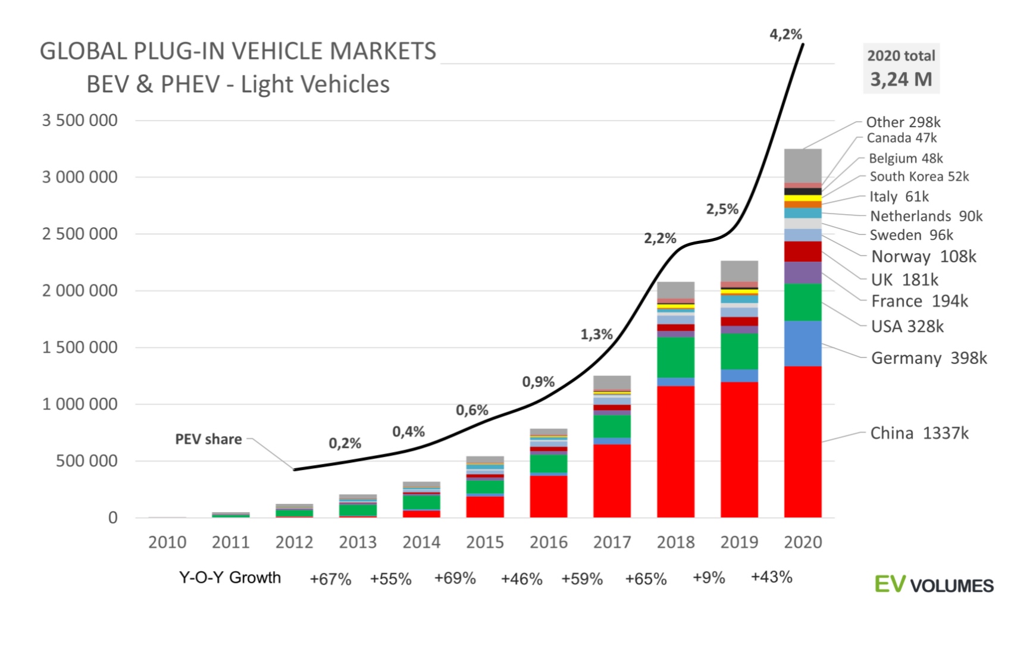
Figure 1.1 Growth of Battery electric vehicles (BEV) and Plug-in hybrid electric vehicle sales 2010-2020 (Source: [10])
The level of growth in Figure 1.1 is likely to continue due to legislation on the phasing out of internal combustion engines and the fact even with in the 2020 sales, the market remains dominated by internal combustion engines as noted previously in this chapter. However, there are differences between specific markets due to regulatory actions, customer potential choice and brand allegiance [11]. On a per-head of population basis Norway leads the growth in Europe with Germany leading in terms of sales.
A report published by Accenture [12] into EVs market attractiveness factors identified nine main factors that influence the EVs market as shown in Table 1.1. The end customer tends to have more concerns on the technical and economic factors, principally battery endurance, charging duration and purchase price, whereas manufacturers tend to have more concerns about government policy and charging infrastructure.

Table 1.1 Summary of key factors in EV market attractiveness study [12].
Political Factors | Economic Factors | Technological Factors
One-time government monetary subsidies at purchase | Purchasing price | Range
Post-purchase monetary government subsidies | Fuel price | Charging time
Non-monetary government regulations | Number of potential buyers | Efficiency
Charging infrastructure | Price of installation, mass of charger | Operating temperature

Although most of the technical challenges in bringing new EVs to the market are around the battery weight, cost, durability and charging performance, there is still a great deal of research and development on the electrical machines within the powertrains. There is pressure to reduce mass, increase efficiency and reduce cost. One set of targets for cost reduction, power density and efficiency for electric machines is shown in Table 1.2 which is taken from the UK Advanced Propulsion Centre and UK Automotive Council Roadmap published in 2020 [13].

Table 1.2 UK Automotive Council and APC Technology Roadmap for electrical machines (Source: [13])
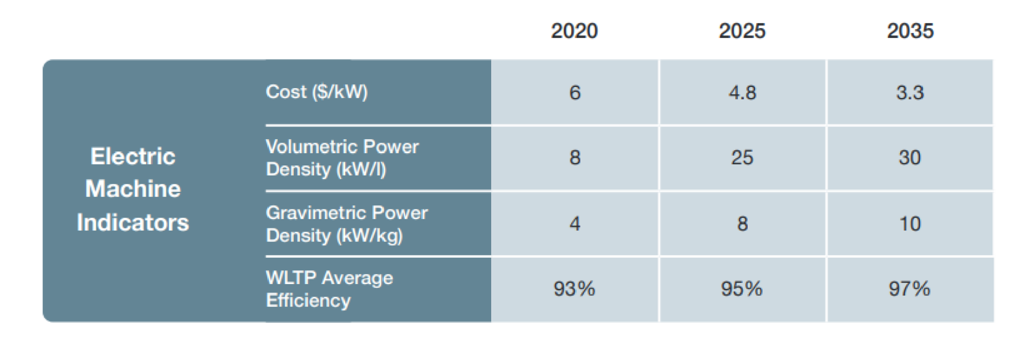
The targets set out in the roadmap of Table 1.2 are very challenging and are likely to be achieved by a combination of better thermal management and the adoption of improved machine topologies.

Electrical machine types in electric vehicles
A recent review of the technologies in EV drives [14] showed the dominance of permanent magnet (PM) machines in the market in terms of the number of manufacturers who have selected this technology as shown in Table 1.3. Although some EV drives are based on induction machines [15] and [16] such as the early products into the market such as the Tesla model S, PM synchronous machines (labelled as PMSM in Table 1.3) are now the dominant machine type due to a combination of high power density and high efficiency. These include Surface Mounted Permanent Magnet Machine (SMPM), Interior Permanent Magnet Machine (IPM) and induction machine [10] and [16]. This dominance has occurred despite widely recognised concerns over the supply, cost and environmental impact of the rare-earth materials that are key to high performance magnets [17].
The main topologies of PM machines used in automotive propulsion machines are interior permanent magnet machines (IPMs) and surface-mounted permanent magnet machine (SMPM). Both SMPM and IPM machines have permanent magnets in the rotor. This arrangement is still the dominant arrangement for brushless PM machines and typical examples of IPM and SMPM rotors are shown in Figure 1.3. By far the most common type of PM machines of these types are internal rotor machines (such as the examples in Figure 1.3) although there are some external rotor machines that have been developed for direct in-hub drives such as the example shown in Figure 1.4.
Table 1.3 Electrical machine types adopted in different electric vehicles (Source: [14])

EV Model | Power(kW) | Speed (r/min) | Torque (Nm) | Motor | Year
Mahindra e2o Plus | 19-30 | 3500 | 70 @  1050 r/min | IM | 2016
Renault Kangoo ZE | 44 | 12000 | 225 | PMSM | 2011
Mitsubishi i-MiEV | 47 | 9900 | 180 | PM | 2010
Volkswagen E-up | 60 | 3000-12000 | 210 | PMSM | 2019
Renault Zoe | 65 | 3750 | 245 | PMSM | 2012
LandRover | 70/105 | 2025/365 | 330/275 | SRM/SPM | 2013/2020
Renault Fluence Z.E. | 70 | 11000 | 226 | PMSM | 2012
Nissan Leaf | 80 | 3283-9795 | 320 | PMSM | 2010
BJEV EC5 | 80 | 3321 | 230 | PMSM | 2019
Hyundai Ioniq Electric | 88 | 4000 | 170 | PMSM | 2016
Hyundai Kona | 88 | 1500-4000 | 172 | PMSM | 2018
BYD E6 | 90 | 4775 | 180 | PMSM | 2014
BMW I3 | 125 | 11400 | 249 | PMSM | 2013
Xpeng G3 | 145 | 4615 | 300 | PMSM | 2018
Mercedes-Benz EQC | 150*2 | 3800 | 760 | PMSM | 2019
BJEV EU5 | 160 | 5100 | 300 | PMSM | 2018
Tesla Model X | 193-375 | 6100-6800 | 755 | IM | 2015
Tesla Model 3 | 137/220 | 6380/5000 | 219/404 | PMSM | 2020
Tesla Model S | 193/375 | 6100/5950 | 330/600 | IM | 2012
NIO EC6 | 320 | 5000 | 610 | PMSM | 2020
EIO ES6 | 400 | 5300 | 725 | PMSM | 2020
Toyota Prius | 60 | 2650-13900 | 200 | PM | 2010
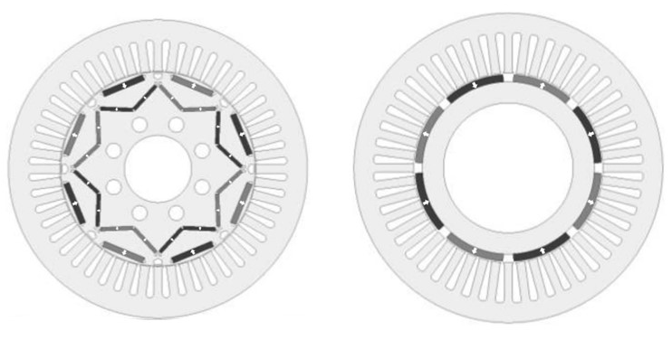
- IPM rotor | - SMPM rotor
Figure 1.3 Typical IPM and SMPM rotors (Source [18] and [19])

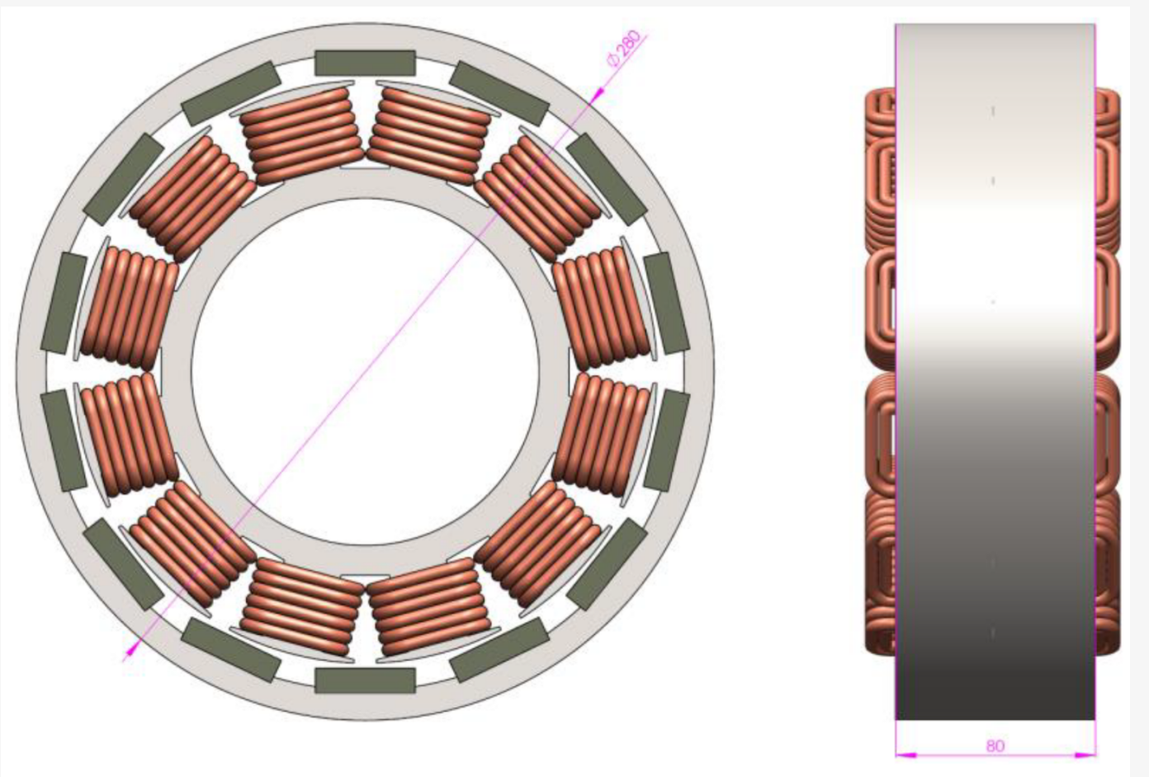
Figure 1.4 Typical external rotor brushless permanent magnet machine (Source:[19])
Although almost all commercial PM machines with internal or external rotors use magnets located on the rotor, there are some drawbacks in this approach:
- The rotor rotates synchronously with the fundamental of the rotating magnetic field produced by the stator and hence this fundamental appears a static field from the perspective of the rotor magnets. However, any spatial or time harmonics in the airgap field caused by the winding layout or slotting effects will result in magnet eddy current losses in the rotor [21].
- Any losses induced in the rotor magnets can cause significant heating of the magnets since removal of the losses from the rotor tends to be much more difficult and is usually reliant on conduction into the shaft or some forced-air cooling.
- The magnets on the rotor are subjected to centrifugal forces due to rotation [22]. In order to keep the magnets in place, some form of sleeve is usually required (although in some IPM machines the rotor core may provide sufficient mechanical restraint). Since any sleeve sits directly in the working airgap, there is an increase in the effective magnetic length of the airgap with a reduction in torque capability.
- Rotors fitted with permanent magnets are very complex structures to manufacture and often require complex magnet shapes with precise curved surfaces in the case of many SMPM machines.
It is likely that machines with magnets on the rotor will remain the dominant machine type despite the drawbacks highlighted above. However, there has been a growing interest in machine in which the PMs are located in the stator alongside the stator coils [23], due to merits such as ease manufacturing, ease of cooling alongside claims of competitive torque densities and high efficiencies.

Review of stator-mounted PM machines
There are several different concepts and topologies of electrical machine in which both the permanent magnets and the windings are located within the stator. These have attracted some attention from researchers in the past decades due the simple rotor structure, the use simple rectangular magnet blocks and claims of competitive torque density and efficiency. The first published stator-mounted PM machine can be traced back to 1955, with a so-called switched-flux alternator [24]. Although there have been many topologies proposed for incorporating the magnets into the stator, there are three main categories of stator-mounted PM machines, viz. flux-reversal PM machines (FRPM) [25], doubly salient PM machines (DSPM) [26] and flux switching machines (FSPM) [27]. The following sections review developments in these three machine types:

Flux-reversal permanent magnet (FRPM) machine
The permanent magnets in FRPM machines located on the surface of stator teeth as shown in the three-phase example of Figure 1.5. Each stator tooth has a pair of magnet poles of opposite polarities mounted on the front of the stator teeth next to the airgap. The PMs can be place on the stator tooth surface as shown in Figure 1.5 or inset into the inner stator teeth [23] and [28]. The rotor consists of a simple salient laminated rotor yoke. The basic operation involves modulation of the permeance under the N and S pole magnets. Over part of the cycle, the N pole flux is promoted to produce a net N pole flux in a tooth while later in the cycle, the S pole flux is promoted. Hence each tooth and hence each coil is exposed a bi-polar flux variation. The change in phase inductances with rotor position is relatively small resulting in a minimal contribution from reluctance torque to the overall torque [23].
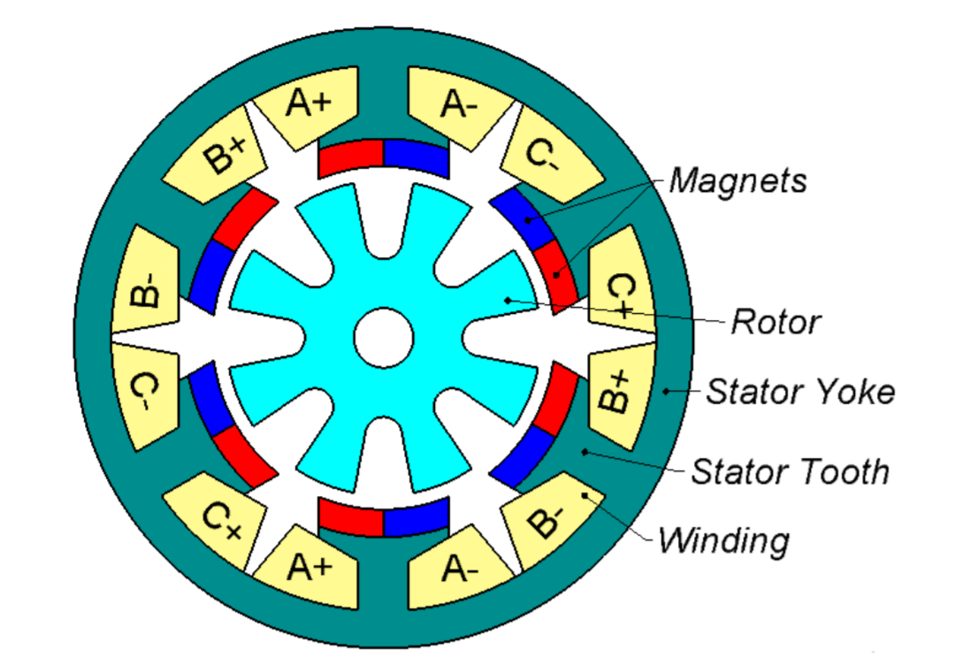
Figure 1.5 Schematic geometry of a three-phase flux-reversal machine [29]

A more sinusoidal EMF waveform can be produced by employing a skewed rotor which also minimises the cogging torque [23]. FRPM machines have a large effective magnetic air-gap length due to the magnets sitting in the main working airgap. Hence, the thickness and shape of the magnets and rotor poles have a significant impact on the electromagnetic performance. Various studies have been reported on adapting the geometry near the airgap, e.g. concave stator poles and additional flux barriers of the type shown in Figure 1.6 were investigated in [31], while [32] reported on a rotor-teeth pairing method, also shown in Figure 1.6 to minimize the cogging torque.
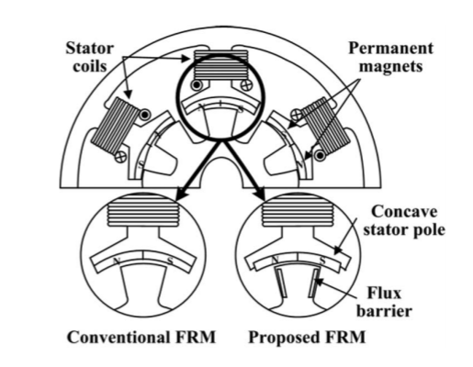 | 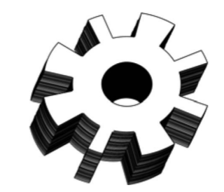
(a) Shaped pole and flux barriers [31] | (b) Paired rotor poles [32]
Figure 1.6 Shaped magnet pole and rotor poles in FRPM machines (Source: [31] and [32])
FRPM machines have been shown to be competitive for applications such as automotive generators [33] and low-speed servo drives [34]. The effect of the driving waveform, specifically a comparison between square wave and sine wave currents is reported in [35]. It was shown that rectangular drive currents and sinusoidal waveforms produce similar levels of torque and torque ripple after skewing but the square wave drive (which could be implemented at lower cost) produces 20% higher iron loss.
Outer rotor FRPM machine and an axial flux FRPM machines were investigated in [36] and [37]. A FRPM machine which it is claimed was developed for an EV application is reported in [30]. Large pole leakage flux, which is a well-known problem of FRPMs, was reduced in by incorporating consequent poles as shown in Figure 1.7. However, despite claiming to targeting EV applications the machine designed in [30] only had a power rating of 518W with a torque of 16.8Nm at a speed of 300rpm. This paper presents details on many aspects of the performance, including iron loss, and shows some benefits in terms of reduced permanent magnet volume compared to a conventional FRPM but the scale of the machine is small (stator outer diameter of 124mm) and hence it is difficult to extrapolate these findings to machines more suited to EVs, i.e. in the 50kW+ range.
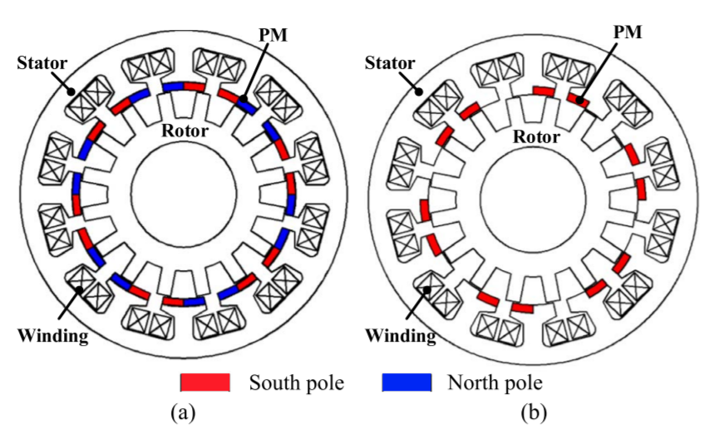
Figure 1.7 Comparison of flux-leakage paths in (a) conventional FRPM machine and (b) consequent pole FRPM machine (Source [30])

In summary, despite considerable research on various design features, there is little real evidence of FRPMs being a competitive machine topology for EV propulsion at ratings of ~50-100kW.

Doubly-salient PM (DSPM) machines
DSPMs are often regarded as a combination of a stator magnet machine and a switch reluctance machine [26]. The permanent magnets are located in the stator back-iron as shown in the example in Figure 1.8.
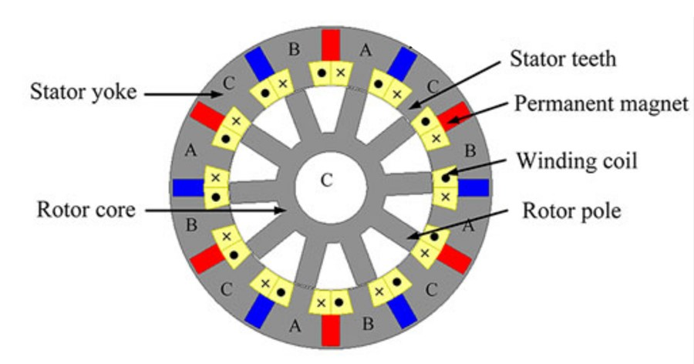
Figure 1.8 Cross-section through a doubly-salient 3 phase, 12 stator poles and 10 rotor pole permanent magnet (DSPM) machine (Source: [38])
The arrangement shown in Figure 1.8 results in a unipolar modulation of the flux in each stator hence coil. The flux variation in a DSPM tends to lead to trapezoidal emf which makes these machines suitable for operation in a brushless DC (BLDC) operating mode [39]. Quasi-sinusoidal back-EMFs can be achieved by using rotor skewing, which allow the machine to operate a brushless AC (BLAC) [40]. As well as various three-phase designs such as that shown previously in Figure 1.8, other phase numbers have been such as a single-phase four-slot/six-pole [41] and two phase four-slot/six-pole with dual stators [42]. Sizing equations for DSPM machines were reported in [43] and [44]. These studies considered the effect of different slot pole combinations on output power, and proposed methods for the initial calculation of the leading dimensions. A design study was performed in [38] comparing four different slot and pole combinations which led to the construction of an 18 slot/15 rotor pole design with a rated torque of 5.5Nm at 400rpm.
There has been some innovation in terms of different types of DSFM to address the issue of poor torque density. For example, Figure 1.9 shows a novel doubly salient flux memory machine (DSFMM) [45] with an external rotor which is aimed at EV applications. In this machine the Alnico PM magnetization level can be controlled by employing a dc current pulse to set the properties of the magnet at different levels to match the operating condition over the full torque speed curve. Although it is claimed in [45] that this new topology is a good fit to an EV applications, this is largely on the basis of the variable flux capability and there is no quantitative indication of torque density or any supporting experimental results.
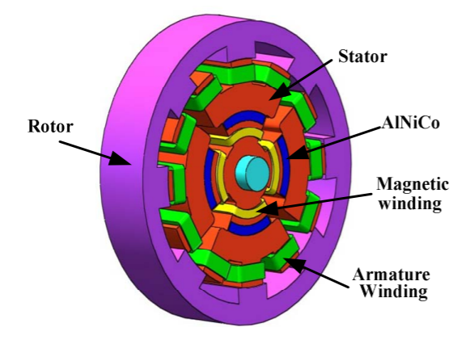
Figure 1.9 Doubly-salient flux memory machine (Source: [45])

Overall, DSPM machines show only modest torque capability which is largely a consequence of the flux variation being unipolar and although some claims are made in [45] suggest suitability for EV applications, there are no studies at sizes and torque ratings required for EVs.

Flux-switching permanent magnet (FSPM) machine
In flux-switching machines, the stator permanent magnets are located within the stator teeth as shown in Figure 1.10. This type of machine generally employs concentrated coils which are wound around a single stator tooth.

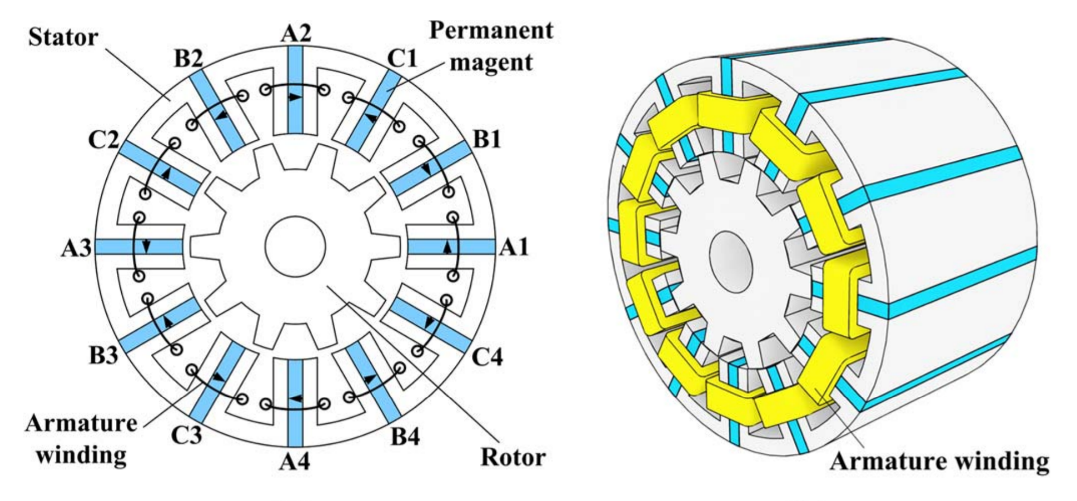
Figure 1.10 Cross-sectional and three-dimensional views of a typical 12 slot and 10 rotor pole FSPM [48]

The basic operating principles of this type of machine is described in [46] and can be explained with reference to Figure 1.11 which is from [46] and shows a series of open-circuit flux-plots and the corresponding flux-linkage waveforms. As will be apparent, when the salient rotor is in position (a) the flux passes through coil A1 in a direction which produces a negative maximum flux-linkage. When the rotor moves to position (b) the flux pattern in the tooth within coil A1 is symmetrical with no net flux-linkage. As the rotor moves to position (c) the flux-linkage is again a maximum but in the opposite direction to position (d) since flux from the other pole of the magnet is the flux passing into the rotor tooth.
This bipolar flux linkage variation in this coil leads to a near sinusoidal emf. The other emfs from the remaining coils in phase A, which have a some phase difference from coil A1, sum to produce a symmetrical emf waveform, although generally not free of some harmonic distortion. Hence, although individual coils back emfs often exhibit significant harmonics the phase emfs tend to be a good approximation to be sinusoidal [47]. The same study claims that the harmonics are minimised when the rotor arc is 1.4 times the stator tooth arc [47]. In terms of tools for the design of FSPM, a general sizing equation and design methods were derived systematically in [48] with arbitrary slot pole combinations. Moreover, a non-linear adaptive lumped parameter magnetic circuit model, an alternative method that derived from Fourier or harmonic model, and systematically revealed techniques to hybrid modelling with a magnetic equivalent circuit and Fourier transform analysis were published in [49]-[51], respectively.

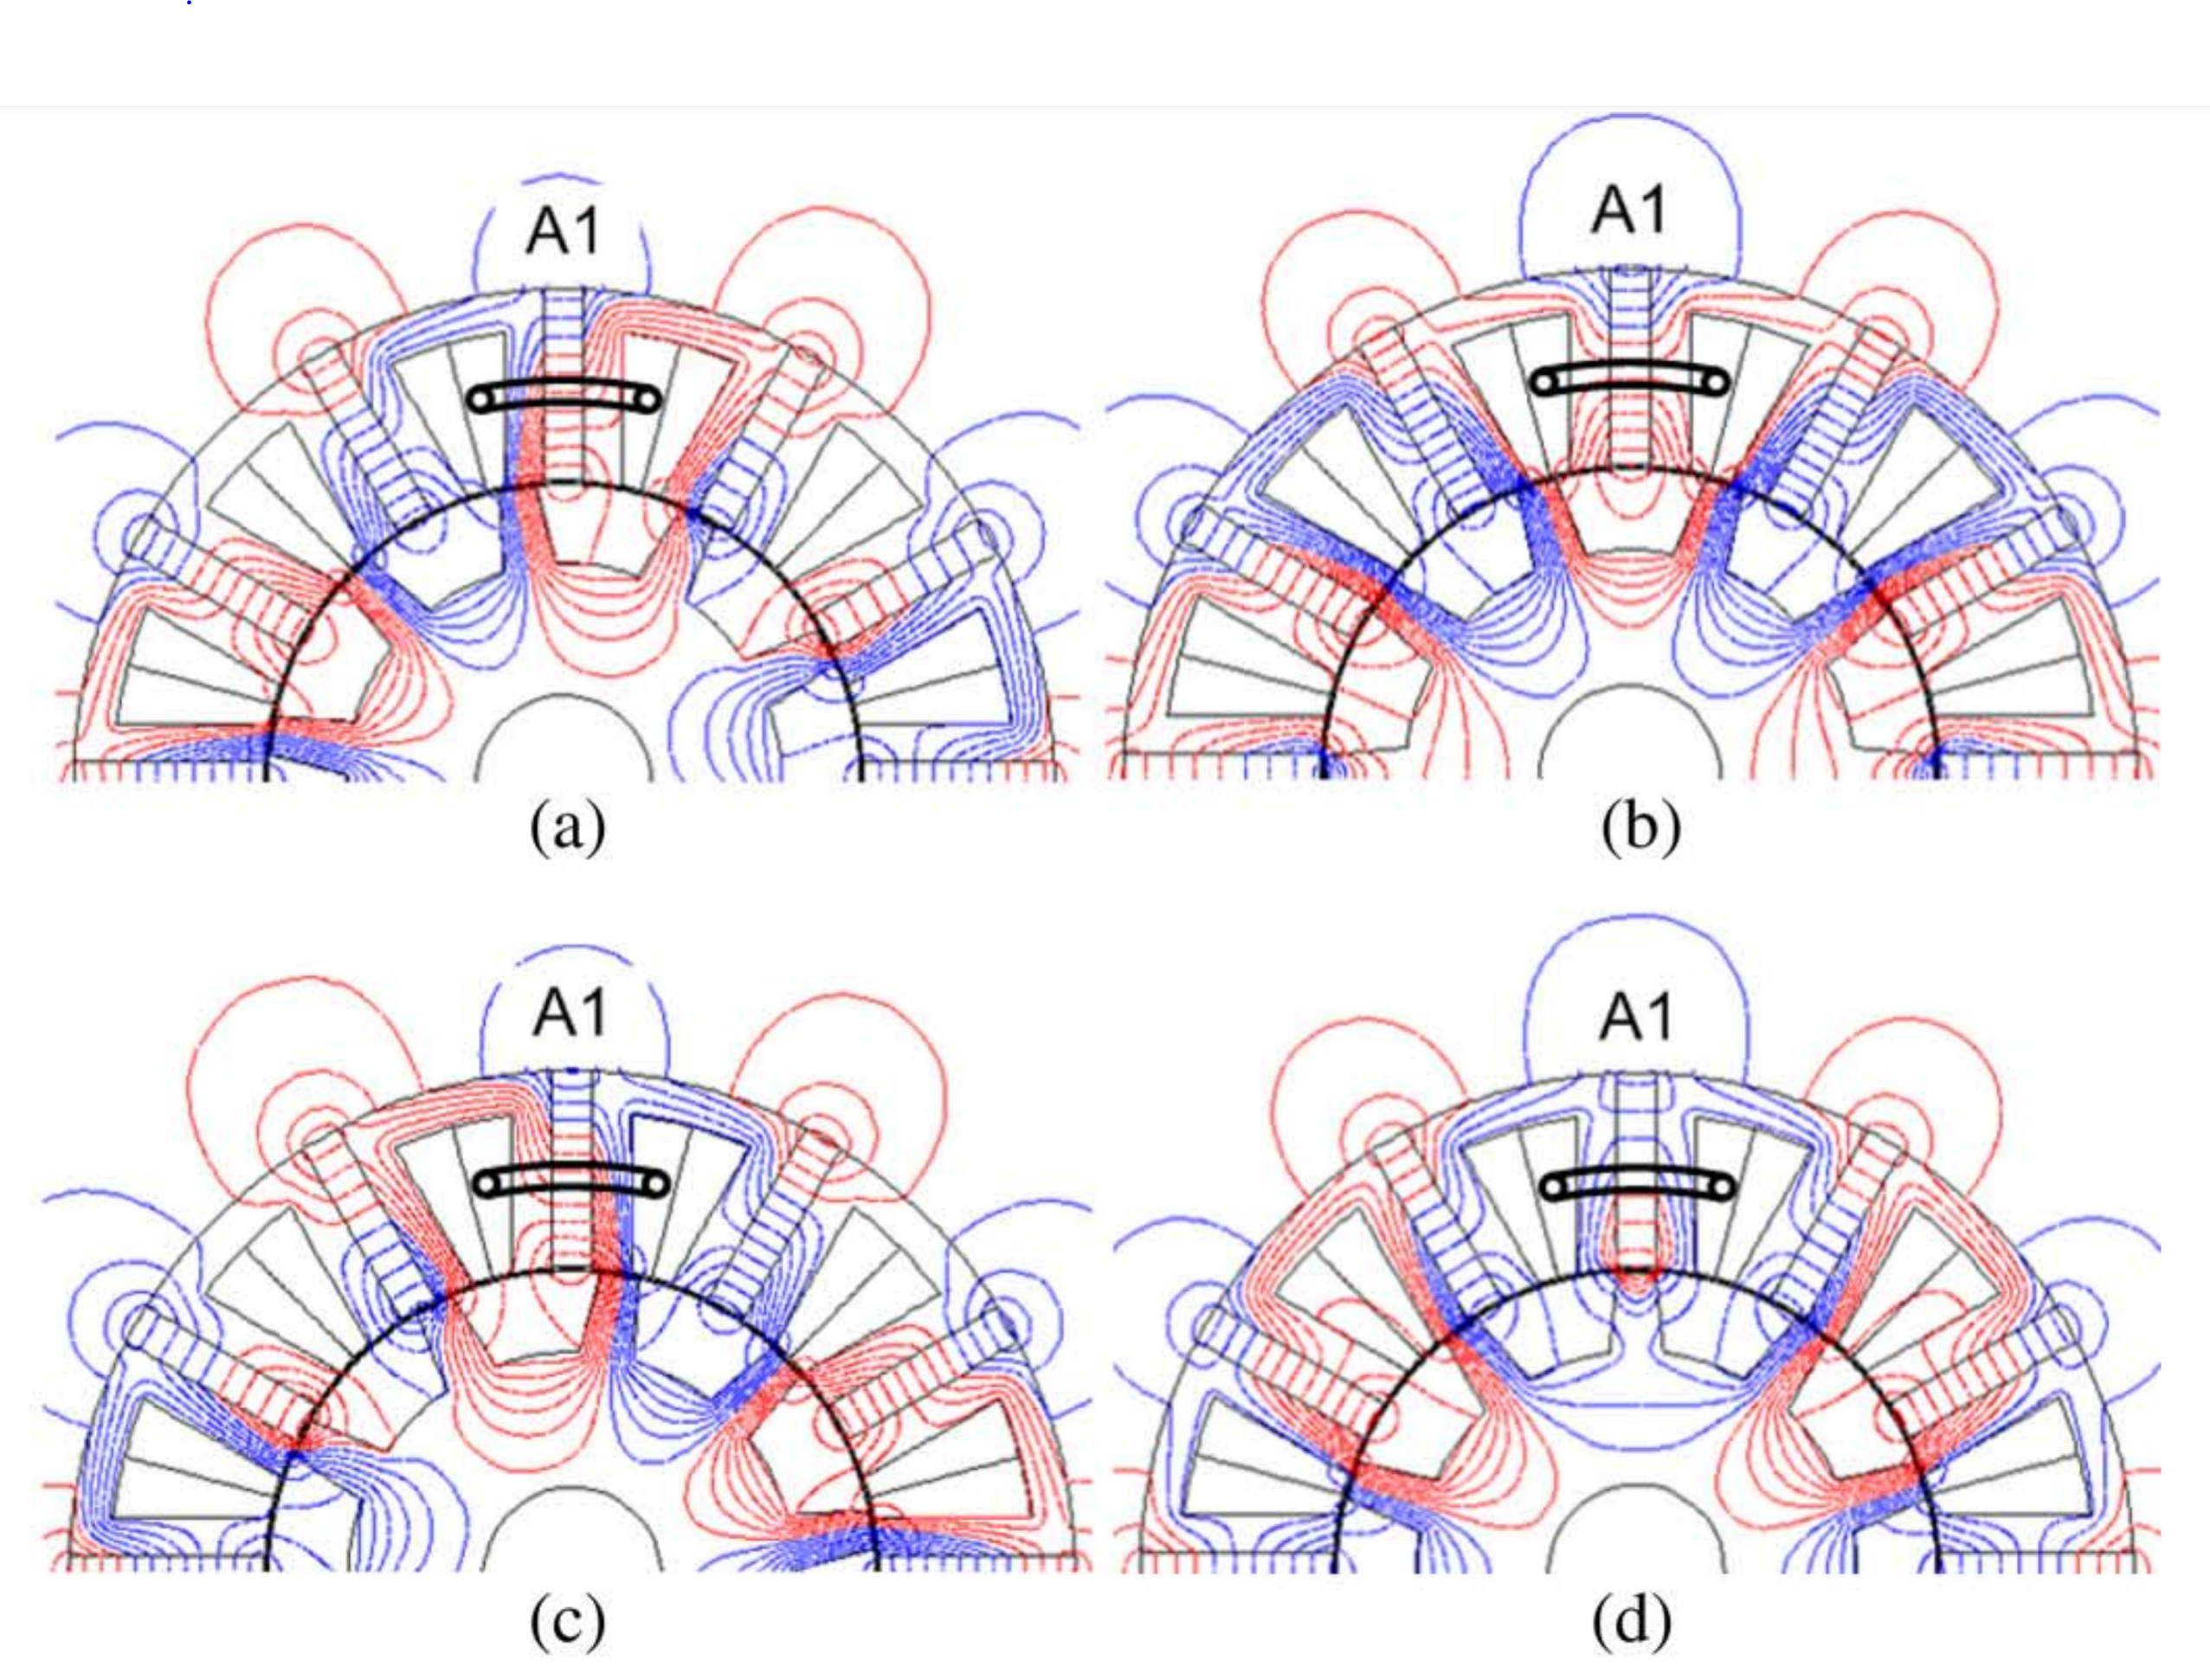
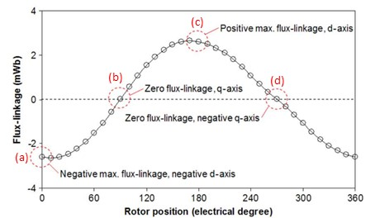
Figure 1.11 Open-circuit flux-plots and flux-linkage waveforms for a 12 stator pole and 10 rotor pole FSPM machine (Source: [47])
End-effects, which are investigated in chapter 3 and chapter 7 of this thesis, were shown to be significant in FSPMs in [52]. An analytical mode was developed in this study and supported by experimental measurements. The results presented showed that end-effects result in large axial flux leakage which affects the torque capability and magnetic saturation in the stator and rotor cores. A lumped parameter model was used in [53] to investigate the influence of end-effects and this study also showed the importance of end-effects and that the biggest discrepancies between two and three-dimensional models occur at higher levels of stator currents and hence magnetic saturation.
The behaviour shown previously in Figure 1.2 depends on very particular combinations of stator poles and rotor poles being used to maximise the changes flux-linkage as the rotor core rotates. It is also necessary to ensure that the contributions from the individual coils which make up a phase winding add up in a manner that maximises the magnitude and achieves a symmetrical emf waveform. The number of viable combinations of stator slots and rotor poles is much more limited than in IPM and SMPM machines. The most common FPSM combinations studied for 3-phase operation is 12 slot/10-pole with some studies on 12-slot/14-pole. It was shown in [54] that a 12-slot/14-pole combination was able to produce ~10% higher torque with lower torque ripple than a 12/10 combination with the same stator. When the stator was optimised for operation with a 14 pole rotor, the increase in torque was 19%. It is worth noting that this study was performed on a medium sized machine 210mm diameter and a rated torque of ~30Nm which makes the finding more relevant to typical EV specifications. The superior capability of a 12-slot/14-pole FSPM over a 12-slot/10-pole was also demonstrated in [55] which concluded that the highest toque tends to be achieved when the slot and pole numbers are close to each with benefits in terms of torque capability and torque ripple when the rotor pole number is higher than the slot number.
A study comparing a 6-slot/5-pole machine with a 12-slot/10-pole machine was reported in [47] with a particular focus on flux-weakening capability. The idea of using 6-slot/5-pole machine evolved from simply halving the geometry of 12-slot/10-pole machine, with claimed benefits in terms of a reduced magnet volume and hence cost. , which uses less magnets, presents a lower cogging torque, improved flux weakening capability and slightly higher back-EMF value than a corresponding 12-slot/10-pole machine.

Although the combination of stator slots and rotor poles for effective torque production is limited, even within these limits there are options over the winding arrangements and the number of magnets used for a particular slot number. The options and their effect on performance were studied in [57] and [60]. Figure 1.12 shows various combinations of stator geometries and matching rotors which cover: (a) all teeth wound and all teeth equipped with magnets; (b) only alternate teeth wound and all teeth equipped with magnets; (c) only alternate teeth wound and only the same alternate teeth equipped with magnets and (d) modular E-core based stator. These machines offer a range of performance versus cost trade-offs, e.g. in the study reported in [60] a 12/10 design of topology (a) produces 2.37Nm with a torque ripple of 0.22Nm whereas an equivalent design of topology with half the magnet volume produces 1.87Nm but with a torque ripple or 1.32Nm. Of all the topologies in Figure 1.12 and for the particular size and electric loadings adopted in [60], topology (a) which could be regarded as the conventional FSPM produces the highest average torque and the lowest torque ripple within a particular frame size.
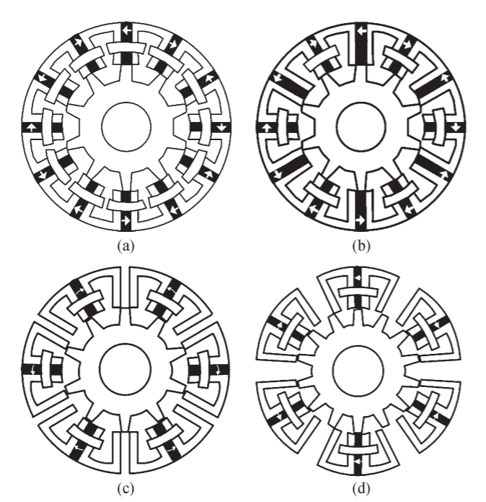
Figure 1.12 Alternative configuration of FSPM machines (Source: [57])
As is the case with most other machine types, the most studied FSPM machines are based on 3-phase winding. Higher phase number above three were considered in [58] for an aerospace application. The design specification used in the study was 430kW and 4,000rpm which corresponds to 1026Nm. This is by far the largest and highest torque FSPM machine studied in literature and indeed in torque terms is likely be greater than most machine rating considered for EVs. It was shown in [58] that using phase numbers above three resulted in some benefit in torque density with the 5-phase design having a ~15% greater torque density than its 3-phase equivalent. A finite element study within [58] demonstrated that in the preferred 5-phase design, magnetic saturation has a major impact on the torque versus current characteristic, in this case with a significant drop-off in torque constant beyond 5-6 A/mm². The prototyping and experimental measurements reported in [58] were based on scaled version of the design study machine, with a 90mm stator outer diameter prototype built.
In terms of tools for the design of FSPM, a general sizing equation and design methods were derived systematically in [48] with arbitrary slot pole combinations. Moreover, a non-linear adaptive lumped parameter magnetic circuit model, an alternative method that derived from Fourier or harmonic model, and systematically revealed techniques to hybrid modelling with a magnetic equivalent circuit and Fourier transform analysis were published in [49]-[51], respectively.
In all PM machines, irrespective of whether the magnets are located in the rotor or stator, the majority of the loss is generated in the stator by copper loss and iron loss. In a machine with stator-mounted magnets, there is also a contribution from the magnet eddy current loss [59]. In the design of a machine with magnets in the stator, steps must be taken to prevent excessive temperature rise in the magnets. This temperature rise occurs through a combination of direct heating from induced eddy currents in the magnet and heat passing from the stator coils and core. Any rise in magnet temperature results in a reduction in remanence (~0.1% per °C in NdFeB magnets) and a reduced resistance to irreversible demagnetisation. A design study presented in [61] included detailed thermal modelling of the proposed FSPM design, including incorporation of a water jacket.
The basic form of FSPMs shown previously in Figure 1.10 showed completely separate ‘C’ cores between magnets. Although this offers the best arrangement from an electromagnetic point of view, it does result in the stator core being made up from a large number of separate modules. It is possible to make a single-piece lamination for all poles by incorporating thin iron bridges at the back of the magnets as shown in Figure 1.13. However, this bridge promotes leakage flux from the permanent magnet, although magnetic saturation does limit the amount of leakage flux. The selection of the bridge thickness and the exact geometry involves a trade-off between mechanical considerations [61].
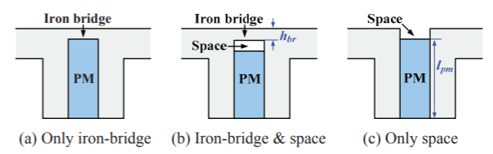
Figure 1.13 Three types of stator modular segment [61]

Whereas most FSPM machines in published studies are based on conventional PM excitation, Hybrid Excited Flux-Switching permanent magnet machines (HEFSPM) have been proposed and investigated in [62]. The machine studied is based on a conventional 12-slot/10-pole E-core FSPM machine but with additional DC coils incorporated into the stator as shown in Figure 1.14. The excitation flux contributed by the coils around the outer periphery allows some control over the net flux. This control ability could enhance the excitation flux to increase torque, but is more commonly used to improve the flux-weakening capability by reducing the back emf constant as the speed increases. The HEFSPM machine generally produces a lower torque per unit mass and per unit copper loss than the conventional FSPM machine, but the controllable emf and the superior field-weakening capability can make HEFSPM the ability to field-weaken and torque can be alternate easily.
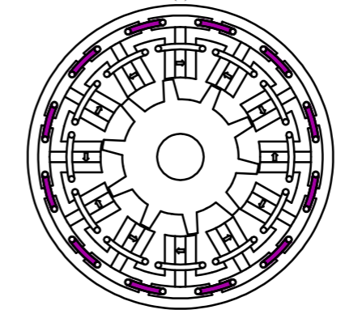
Figure 1.14 Hybrid-excited flux-switching permanent magnet (HEFSPM) machine (Source: [62])
As will be evident from the various FSPM designs shown previously in this section, one drawback of conventional FSPMs is the large quantity of permanent magnets in the stator. Since rare-earth magnets are often the most critical material cost in a machine, any reduction in either magnet mass of magnet cost per kg would be beneficial in terms of making FSPMs more cost-competitive with existing IPM and SMPM products. One proposed solution to reduce the material cost of FSPM is the replacement of the rare earth magnets with low-cost ferrite magnets working in combination with dc field excitation [63]. The proposed arrangement is shown in Figure 1.15. As will be apparent the ferrite permanent magnet in the stator are significantly larger than the stator coils, which is a consequence of the modest magnetic properties of ferrite magnets, e.g. typical remanence of 0.45T at room temperature. The particular topology shown in Figure 1.15 was proposed in [63] as a candidate topology for an EV application, although the torque capability of the specific design investigated was only ~11Nm and no comparisons with a rare earth equivalent designs was presented.
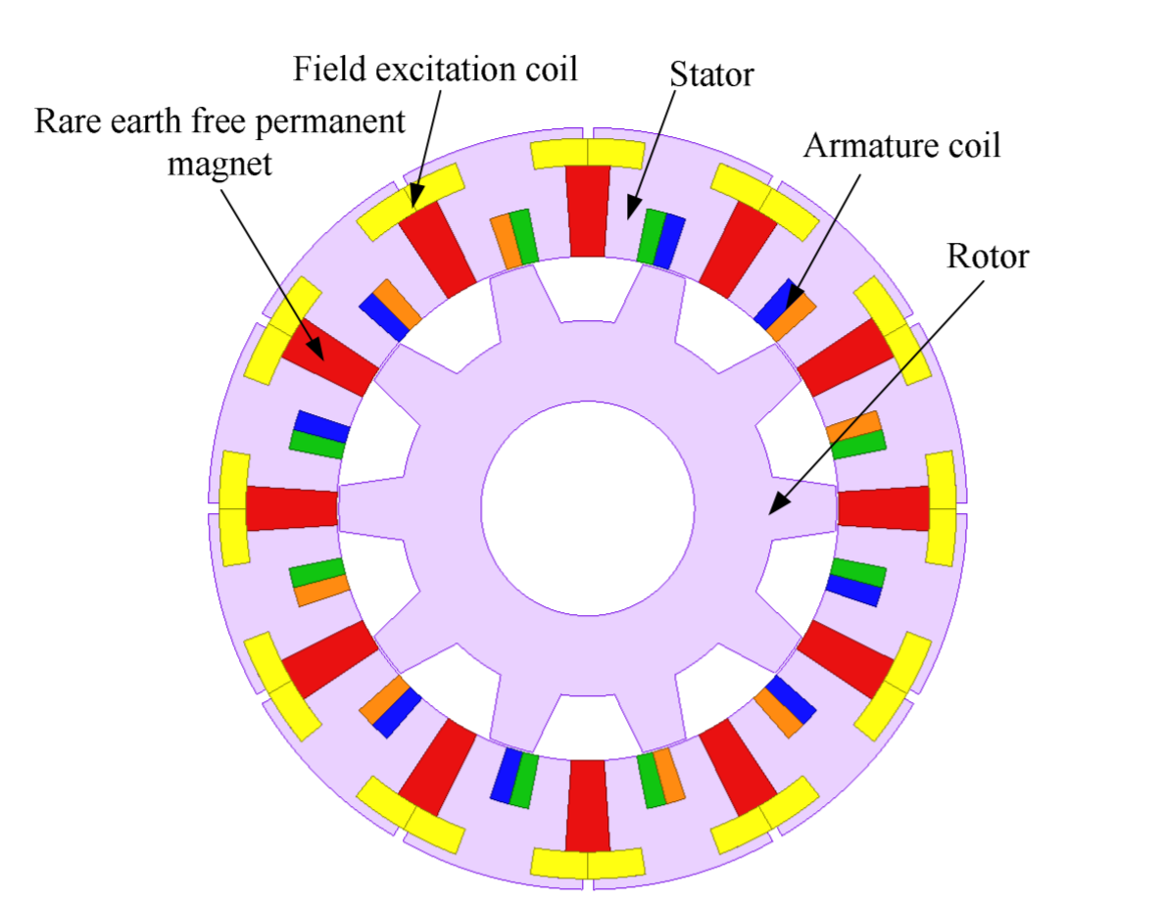
Figure 1.15 Proposed ferrite magnet and excitation coil hybrid FSPM (Source [63])
Although there are many published papers on different electromagnetic aspects of FSPM machines, the modelling and particularly the experimental testing has almost all been undertaken on small machines, with many prototypes having stator diameters of less than 100mm. Table 1.4 shows a summary of published studies on different aspects of FSPM behaviour. Although several paper cite EVs as applications, e.g. [62], with the exception of [61] and [58] these studies do not deal with machine sizes and torque ratings which are representative of mainstream EV specifications. Hence, there is some uncertainty over whether some of the claims from the studies on smaller machines scale to larger machines, particularly as there is evidence of significant non-linearity in torque versus current characteristics even in small machines [57] and [64].
Table 1.4 Summary of machine size and torque rating of published FSPM design and experimental studies

Reference | Stator outer diameter (mm) | Torque rating (Nm)
[27] | 90 | 2.5
[47],[48] | 128 | ~13.5
[49] | 90 | 2.5
[51] | 90 | 2.4
[52] | 90 | 2.5
[53] | 64 (single-phase) | ~0.2
[54] | 210 | ~35
[55] | 90 | 6.0-10.0
[56] | 128 | ~4.0
[57] | 90 | 6.0-10.0
[60] | 90 | 2.5-3.5
[61] | 260 | 96.0
[62] | 90 | 4.0-7.0
[63] | Not given | ~10
[64] | 128 | 5.5-6.5
[58] | 540 (simulation)  90 (experimental) | 1400 (simulation)  ~2(experimental)
[65] | 250 | ~100
[69] | 700 | 16500
[99] | 175.2 | 25.9/26.3
[100] | 129 | 30
There is very literature focussed on large FSPMs, i.e. stator diameters >250mm and rated torques in the 100s of Nm, although FSPM machine have been proposed and studied for wind turbine generators and aerospace applications [65] - [69]. Finally, it is worth noting almost all published papers on FSPM machines are concerned with electromagnetic performance and often demonstrated on small machines with only a few Nm of torque. It is perhaps a reflection of the very low take up of this machine technology in industrial applications, that there are very few papers on manufacturing and design studies which are directly related to ratings for EVs and hybrid electric vehicles (HEVs).

Summary of stator-mounted PM machines
This section has reviewed various aspects of three different types of PM machines with magnets incorporated in the stator. Although FRPMs and DSPM machines may have the properties which can be used for some applications they generally are not well suited to applications requiring torque densities which are competitive with conventional IPM and SMPM machines. FSPM machines have been shown to be competitive with SMPMs in some studies, although it should be recognised that this has been demonstrated almost entirely in smaller machines (<100mm diameter), at low to medium current densities (below ~8A/mm² rms) and usually with a larger volume of magnet. Arguably, there are no definitive studies which consider in depth the performance of FSPMs in the context of representative EV specifications. The research described in this thesis seeks to provide a contribution to this still open research question with a view to determining the role that FSPM may have in future EV drives.

Thesis outline
This thesis is concerned with several aspects of the performance of FSPMs for electric vehicle applications, particularly the issue of scaling and the various aspects of performance which change as the size and torque rating of this type of are increased up to the demands on a representative EV machine. This thesis is structured into the following chapters:
Chapter 1 – This chapter reviews the EV market and three types of PM machines with stator-mounted magnets.
Chapter 2 – This chapter describes the design and analysis of a baseline 70kW FSPM machine.
Chapter 3 – This chapter takes the baseline design from chapter 2 and investigates the effect of scaling the machine and the influence of machine size on the optimal split-ratio. This includes extensive use of three-dimensional finite element analysis to establish the influence of end-effects.
Chapter 4 – This chapter describes the design optimisation of the baseline design and 150mm scaled design. It considers several optimisation strategies and the issue of overload capability.
Chapter 5 – This chapter investigates the detailed behaviour of the baseline design in terms of localised magnetic saturation with the stator and assesses the merits of different approaches to reducing magnetic saturation.
Chapter 6 – This chapter investigates the performance of a flux-switching PM machine made up of a series of single-phase modules.
Chapter 7 – This chapter investigates eddy current loss in the magnets of both optimised 296mm diameter and 150mm diameter machines and explores the influence of magnet segmentation.
Chapter 8 – This chapter describes the design of a winding for a prototype machine and the construction of the demonstrator 150mm diameter machine.
Chapter 9 – This chapter draws a series of conclusions from the research undertaken and makes suggestions for future work.

Chapter 2 – Flux-switching permanent magnet machine baseline design

Introduction
FSPM machines have widely researched in terms of predicting performance such as torque and power density [70] - [77], but with very few publications focussed on sizing and dimensioning of the various elements of the machine. However, a systematic design method for FSPMs was proposed in [78] which developed a method and demonstrated utility of the method with a detailed design study.
This chapter draws on this published design methodology and design equations to establish a baseline design of an FSPM machine that is capable of producing a continuous motoring output power of 70kW at a base-speed of 2000rpm which corresponds to a torque of 334Nm. The specific slot-pole combination studied in [78] was the commonly favoured 3-phase, 12 slot / 10 pole FSPM machine. This slot pole number was adopted for the baseline design in this chapter. The exact thermal performance, which is usually the limiting factor on power density, would require detailed thermal modelling [79]. For this design study a continuous rms current density of 7.5A/mm² was adopted as this is typical of the value used for water jacket cooled machines in automotive applications [80].

Application of design methodology

Analytical sizing equations
The main sizing equation, which allows the overall machine volume to be determined is based on well-established sizing equation from [78]:

$D_{so}^{2}l_{a}=\frac{T}{\frac{\sqrt{2}π^{2}}{4} \frac{N_{r}}{N_{s}}k_{s}k_{d}k_{sio}^{2}Q_{s}B_{g}c_{s}η}$ (2.1)

Having calculated an estimate of the combination of the overall machine diameter and axial length, the various dimension which define the stator slots, stator magnets and rotor can be established. Figure 2.1 shows a rectilinear schematic of one slot pitch and a rotor tooth with the key dimensions that define the slot and the rotor tooth.
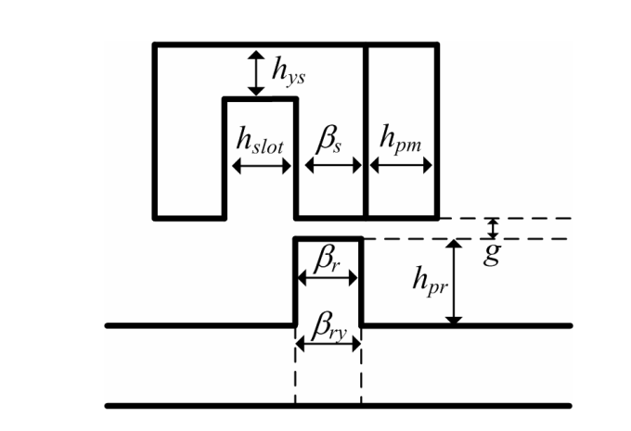
Figure 2.1 Rectilinear schematic of one rotor pole and one stator slot showing the key dimension [78].
The starting point for the relationships between several of these parameters proposed in [78] is:
$β_{s}= β_{r}=h_{ys}=h_{slot}=h_{pm}=\frac{πD_{si}}{4N_{s}}=\frac{πD_{so}k_{sio}}{4N_{s}}$ (2.2)
A key parameter in this expression is the split ratio,$k_{sio}$, which sets the ratio of the stator bore diameter to the stator outer diameter. The rotor pole height, h_{pr}, is chosen to be 1/4 of the rotor outer radius R_{ro} and can hence be defined in terms of the stator outer diameter and the split ratio [78] according to:
$h_{pr}=\frac{1}{4}R_{ro}=\frac{1}{8}\left(D_{si}-2g\right)=\frac{1}{8}(D_{so}k_{sio}-2g)$ (2.3)

Application to baseline
This sizing approach was used with the parameter set shown in Table 2.1. Adopting these values and selecting and axial length, $l_{a},$of 100mm leads to a stator outer diameter of 296mm.
Table 2.1 Parameter set used for initial machine sizing

Symbol | Description | Value adopted during machine sizing | Notes
$$T$$ | Rated torque | 334 Nm | From the 70kW and 2000rpm specification based on Zytek motor.
$$N_{r}$$ | Number of rotor teeth | 10
$$N_{s}$$ | Number of stator slots | 12
$$k_{s}$$ | Skew factor | 1.0 | Un-skewed stator
$$k_{d}$$ | Leakage factor | 0.92 | Leakage of magnet flux –i.e. 8% Magnet flux does not contribute to the back EMF.
$$k_{sio}$$ | Split ratio | 0.55
Q_{s} | Stator electric loading | 100,000 A/m | Typical continuous electric loading for a high power PM machine in the 300mm diameter range
$$B_{g}$$ | Airgap flux density in region of stator teeth | 2T | From [9]
c_{s} | Stator tooth arc factor | 0.25 | Width of the tooth normalised by slot pitch
$$η$$ | Efficiency | 0.95
Having fixed the stator outer diameter, the various stator slot and rotor dimensions can be calculated using equations (2.2) and (2.3). A summary of the resulting design is shown in Table 2.2 while a cross-section through the proposed machine design shown in Figure 2.2.
One important factor to note in equation 2.1 is that the stator mmf is expressed as a linear electric loading in A/m rather than a current density. Setting a value of electric loading fixes the stator outer diameter. The other stator dimensions are then calculated by equation 2.2 from the stator diameter, including the slot width and stator yoke thickness ($h_{ys}$). The combination of electrical loading and slot dimensions this will force the current density to a value which produces the required electric loading. In most other machine design strategies, the current density (which is limited by thermal consideration) is an input quantity. Hence, applying the design strategy based on the approach in [78] requires a check on the required current density to ensure that it is a reasonable value.
Table 2.2 Baseline machine design parameters

Parameter | Value
Stator outer diameter, $D_{so}$ | 296 mm
Active stack length, L_{a} | 100 mm
Airgap length, $g$ | 0.5 mm
Stator slot number, $N_{s}$ | 12
Rotor pole number $N_{r}$ | 10
Stator tooth height, $h_{st}$ | 56 mm
Rotor pole height, $h_{pr}$ | 20 mm
PM width, $h_{pm}$ | 10.6 mm
Stator yoke thickness, $h_{ys}$ | 10.6 mm
Figure 2.2 Baseline 296mm FSPM machine geometry

In this case, the specification of an electric loading of 100,000A/m led to a 296mm stator outer diameter design and a slot width (at the airgap) of 10.6mm and a slot depth of 56mm as summarised in Table 2.2. When the trapezoidal shape of the slot is taken into account the area of one slot is 1446mm². Hence the total slot area for all 12 slots is 17,352mm².

The electrical loading definition in [78] is based on the average electric loading. The periphery of the airgap for a 0.55 split ratio on a 296mm diameter stator is 0.5 mm. Hence the total average mmf required (strictly the rectified mean) in the stator slots to achieve an electric loading of 100,000A/m is 51,100 A.turns which corresponds to an rms value of 56,771 A.turns (based on a form factor of 1.11 for a sinusoid). The assumed packing factor is 0.6 and hence the total conductor area is 10,411mm². rms current density is therefore 5.45 A/mm² rms. This is a little low for a high power density machine with values nearer 8A/mm² being usual for a liquid jacket cooled machine as indicated by the 7.5A/mm² rms adopted in this study. This shows the difficulty in initial sizing using electrical loading as there is no direct method for setting the electrical to achieve a particular current density. However, as shown later in this chapter, although the sizing equation was useful in establishing initial sizes it does over-estimate the torque that can be produced. Hence, some increase beyond the current density calculated above is required to achieve the torque specification.

Finite-element analysis of baseline machine performance

Finite element model details

The finite element model was built with the ANSYS Maxwell package. The various quantities in this section were calculated using time-stepped, non-linear magneto-static field simulations with 60 steps over one electrical cycle. The stator and rotor cores were represented by the BH magnetisation curve for 1010 grade Silicon Iron which is shown later in chapter 3 and the cores were assigned the properties of a M27-29G grade, which are again detailed in chapter 3. Particular attention was paid to the mesh in the airgap and the leading edge of stator teeth since these regions have high field gradients and very localised saturation. The finite element mesh used to predict the machine performance is shown in Figure 2.3.

Figure 2.3 Finite-element mesh of 296mm baseline machine

Cogging torque
The open-circuit cogging torque of the baseline design was calculated using two-dimensional, magneto-static finite element analysis. The cogging torque waveform, which has a peak-to-peak value of 30Nm (8.7% of the rated torque at 7.5 A/mm² rms) is shown in Figure 2.4.

Figure 2.4 Finite element predicted open-circuit cogging torque for the baseline 296mm stator diameter FSPM machine
The cogging torque can be significant factor in the electrical machine performance some applications. Although this flux switching design has equal width stator and rotor teeth (which locally would produce a high alignment torque) the spacing of the teeth means that the net torque when the various contributions are summed up around the periphery is likely to be acceptable at <10% for many applications, including automotive traction. This could be reduced further by optimising the width of the stator teeth, but this is usually at the expense of average torque.

Phase open-circuit flux-linkage and back-emf
The two-dimensional finite element predicted open-circuit flux-linkage waveforms of the baseline machine (on a per turn basis) are shown in Figure 2.5 for a star-connected machine.

Figure 2.5 Finite-element predicted open-circuit phase to neutral flux-linkage (per turn for the baseline 296mm stator diameter FSPM machine
The resulting back-emf waveform in each phase is shown in Figure 2.6. As shown, these phase-to-neutrals back emf have significant harmonic content. Table 2.3 shows the harmonic content of the phase the neutral emf calculated from a Fourier Transform from which it can be seen that the most significant harmonic is the 5th harmonic. Figure 2.7 shows the corresponding line-to-line emfs.

Figure 2.6 Finite-element predicted open-circuit line to-neutral phase back-emf (per turn) for the baseline 296mm stator diameter FSPM machine at 2000rpm
Table 2.3 Harmonic spectrum of the phase to neutral back-emf waveforms
Harmonic | Fundamental | 3rd | 5th | 7th | 9th | 11th | 13th
Magnitude | 15.44 | 0.008 | 0.53 | 0.15 | 0.0012 | 0.043 | 0.034

Figure 2.7 Finite-element predicted open-circuit line to-line phase back-emf (per turn) for the baseline 296mm stator diameter FSPM machine at 2000rpm

Rated on-load torque
The key validation of the design equations is the finite-element predicted on-load torque as this is key part of the specification which determines the size of the machine. The torque waveform for a current density of 5.45A/mm² rms which corresponds to an electric loading of 100,000 A/m is shown in Figure 2.8. This has an average value of 271Nm with a peak-to-peak torque ripple of 12Nm. The ripple torque is lower than the open-circuit cogging torque due to some compensating excitation torque ripple.

Figure 2.8 Finite element predicted torque at rated current density of 5.45A/mm2 rms for the 296mm stator diameter baseline design

This average value in Figure 2.8 is 64Nm lower than the value predicted by design equation 2.1. There is therefore a need to increase the current density beyond 5.45A/mm2 rms to make up the shortfall in torque. As noted previously, this current density is lower than the value which is usually used in machines of this type and so rather than changes the dimensions the current density of the baseline design of Table 2.3 was increased in increments until the required torque of 334Nm was achieved. This was achieved at 7.3A/mm² which was close to the rated current density of 7.5A/mm² and so the rated torque of the machine was calculated at 7.5A/mm² rms, recognising that there was a small spare margin of torque, at least based on two-dimensional analysis. The torque waveform at 7.5A/mm² is shown in Figure 2.9. This baseline and this operating point were then adopted as the baseline performance, which is explored in more detail in chapter 3.

Figure 2.9 Finite element predicted torque at rated current density of 7.5A/mm² rms for the 296mm stator diameter baseline design

Flux density levels in the machine
The value of airgap flux density under the stator tooth was set to 2.0T in sizing equation 2.1 in order to calculate the stator outer diameter. The finite element model allows localised flux densities within the machine to be calculated. Figure 2.10 shows the finite element predicted flux density distributions at four positions within one electrical cycle along with the colour scale which spans 0 to 2T. As shown, there are significant regions of the machine in which the flux densities are 2T or higher (corresponding to red regions). This demonstrates that although 2T is well into saturation for the stator and rotor cores, the 2T proposed in [78] seems to offer a good basis for sizing the machine.

(a) | (b)
(c) | (d)

Figure 2.10 Finite-element predicted flux density distribution in the baseline 296mm FSPM machine under open-circuit conditions – (a) 0° (b) 120° (c) 240° (d) 360°

Figure 2.11 shows the corresponding flux density plots at the same four rotor angular positions but when operating at the rated current density of 7.5A/mm² rms. As shown, with stator excitation, there are many more regions of the stator which are operating at or beyond 2.0T including regions of the stator back-iron and further up the stator tooth bodies than with the open-circuit conditions. Cross-slot leakage flux from the stator coil is likely to be a major contributor to this additional level of saturation. As will be shown in later chapters, the issue of high flux density in FSPM machines is a major factor in limiting their torque density.
(a) | (b)
(c) | (d)
Figure 2.11 Finite-element predicted flux density distribution in the baseline 296mm FSPM machine under open-circuit conditions – (a) 0° (b) 120° (c) 240° (d) 360

Conclusion
This chapter has described the design of a baseline FSPM machine to meet the performance specification set out in chapter 1. A published design methodology was used to generate a set of dimensions using various assumptions for parameters in the design equations. The performance of the baseline was predicted using a series of finite element models which demonstrated the usefulness of the deign equations. The design of the baseline machine of 70kW / 2000rpm specification, and the resulting design was based on published guidance on split ratios, but it was shown later in chapter 4 in this thesis that whereas a split ratio of 0.55 may well be suited to smaller machines, for the 296mm diameter machine, it proved too low and significant improvements could be made to torque density by progressively increasing the split ratio in larger machines.

Chapter 3 – Scaling effects in three-phase FSPM machines

Introduction
High-performance, rare-earth PMs can produce the equivalent of high levels of magneto-motive force with small magnet volumes. Hence, it is a widely held view in electrical machines that PM excited machines are particularly competitive with coil excitation in smaller machines, but also that the torque density benefits of PM machines compared to various forms of coil excitation tend to diminish with increasing motor size [81] - [83].
As noted in chapters 1 and 2, FSPMs have been shown to have competitive torque densities in published case studies [23] and [65]. However, most of the studies supported by experimental validation were on small machines, generally with stator diameters below 100mm. Although these studies are useful in terms of demonstrating modes of operation, effect on torque capability of different slot/pole combinations and design feature, the scaling of these results up to machines with 1-2 order of magnitude greater torque requires an improved understanding of scaling effects in this type of machine. It is also worth noting that in order to be competitive in terms of torque density, FSPM machines tend to require the adoption of short effective magnetic air-gaps (i.e. fractions of a millimetre in small and medium sized machines) compared to the very large effective air-gaps of many millimetres theta are commonplace in SMPM machines. Hence, FSPM machines are likely to exhibit a greater sensitivity to the onset of magnetic saturation of the stator core with increasing stator current density than a corresponding SMPM machine, and to a lesser extent IPM machines. Hence, any meaningful comparison of the competitiveness of FSPMs compared to SMPMs must take account of both scale of the machines and the current density at which they operate. This chapter describes a comprehensive finite-element based investigation to better understand these various scaling issues.

Baseline machine designs

Flux-switching PM machine baseline design
The initial starting point for this study into scaling effects was a baseline reference design of three-phase FSPM machine equipped with 12 stator teeth and 10 rotor poles. This baseline design has a stator outer diameter of 296mm and an axial length of 100mm. The key dimensions for the baseline design, which was developed within the context of an electric vehicle traction application, along with the performance specification are summarised in Table 3.1. A cross-section through this design is shown in Figure 3.1.
This machine has a split ratio (defined as the ratio stator bore diameter to the overall stator diameter) of 0.55. This value has been shown in [84] to provide the optimal split-ratio for torque density in this topology, albeit for machines with an overall diameter of 128mm. The issue of optimal split-ratio is returned to in chapter 4 of this thesis. This machine has a two-dimensional finite element predicted average output torque of 340Nm for an rms current density of 7.5A/mm2 in the stator coils which is the specified rated current density for this machine. At this level of current density, this corresponds to a torque density of 7.5Nm/kg based on active mass only, i.e. it includes end-windings but neglects the stator casing, rotor hub and shaft.
Table 3.1 Leading dimensions of the baseline FSPM design

Stator outer diameter | 296mm |  | Coil packing factor | 0.6
Stator core axial length | 100mm |  | Rotor tooth radial height | 20.35mm
Stator split ratio | 0.55 |  | Rotor tooth pole arc (at airgap) | 3.75°
Stator core inner diameter | 162.8mm |  | Rotor tooth pole arc (at rotor core back) | 8.25°
Airgap length | 0.5mm |  | Rotor core-back thickness | 20mm
Stator core-back thickness | 10.6mm |  | Rated torque | 340Nm
Stator tooth width (β in Figure 3.1 ) | 10.6mm |  | Rated base speed | 2,000rpm
Magnet thickness (in direction of magnetisation) | 10.6mm |  | Rated power | 71.2kW
Magnet pole width (α in Figure 3.1 ) | 65.6mm |  | Rated continuous current density | 7.5A/mm² rms

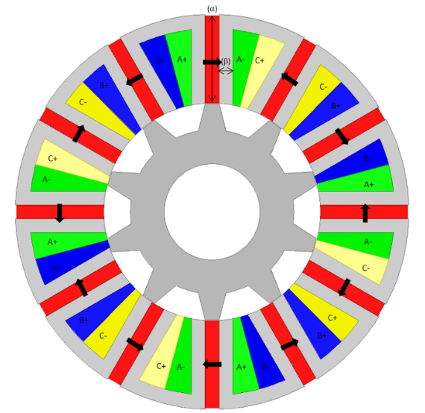
Figure 3.1 Cross-section through the 12/10 baseline FSPM machine
The stator and rotor cores were specified as M27_29G Silicon Iron which has the manufacturer published B-H magnetisation curve shown in Figure 3.2. The permanent magnet grade adopted for the design is NdFe35 NdFeB which has a room temperature remanence of 1.17T [85].

Figure 3.2 Magnetisation characteristic of M27_29G stator and rotor core material

Surface-mounted PM machine baseline design
In order to provide a direct comparison with the baseline FSPM machine, a concentrated winding 12 slot/8 pole SMPM design was established with the same stator outer diameter. The leading parameters of the 296mm diameter SMPM baseline machine design are summarised in Table 3.2 while Figure 3.3 shows a cross-section through the machine. This machine has the same split ratio of 0.55. It is recognised that this may not necessarily be the optimal value of split ratio for either topology (a topic which is discussed in detail in chapter 4). Nevertheless, for the time being, adopting a value of 0.55 in both cases ensures a consistent and systematic basis for a comparative study. The stator and rotor core and the permanent magnet properties were the same M27_29G and NdFeB 35 as the FSPM design.

Table 3.2 Leading dimensions of the baseline SMPM design

Stator outer diameter | 296mm |  | Stator tooth tip thickness | 1mm
Stator core axial length | 100mm |  | Coil packing factor | 0.6
Stator split ratio | 0.55 |  | Magnet pole arc | 45°
Stator core inner diameter | 162.8mm |  | Rotor tooth pole arc (at rotor core back) | 45°
Airgap length | 0.5mm |  | Rotor core-back thickness | 30.72mm
Stator core-back thickness | 10.96mm |  | Rated torque | 340Nm
Stator tooth pitch to pole pitch ratio | 0.9 |  | Rated base speed | 2,000rpm
Magnet radial thickness (in direction of magnetisation) | 11.44mm |  | Rated power | 71.2kW
Stator tooth body width | 21.32mm |  | Rated continuous current density | 7.5A/mm² rms

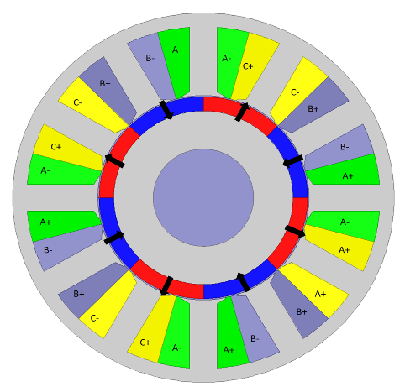
Figure 3.3 Cross-section through baseline design of a 296mm stator diameter 12/10 PMSM

Scaling methodology
Having established baseline FSPM and SMPM designs, a series of scaled machine designs were generated for further analysis using the following two methods:
Method 1 - The stator outer diameter was increased from 25mm up to the baseline value of 296mm in a series of steps while maintaining the same cross-sectional proportions shown in Figure 3.1 for the reference FSPM design and in Figure 3.3 for the SMPM design. This simple scaling, which is equivalent to the effect of a straightforward ‘zoom’, results in a proportionate change in the mechanical air-gap as the machine is scaled.
Method 2 - The second series of machines were again based on scaling the diameter but in this case maintaining a fixed mechanical air-gap of 0.5mm. The stator cross-section was simply scaled in the same manner as the first series of designs, but the rotor outer diameter was adjusted to maintain a fixed 0.5mm gap, i.e. it was scaled with a very slightly reduced scale factor compared to the stator. It was assumed that the windings in all machine design achieved coil packing factor (also known as slot fill-factor) of 0.6 irrespective of the machine size, which is recognised as being at the upper end of that achievable in manufacturing.

Effect of scaling on torque capability

First order scaling behaviour from basic sizing equations
A simple first order sizing equation which is widely used in permanent magnet machines is:
$T=\frac{π}{2}D^{2}LBQ$ (3.1)
Where D is the rotor diameter, L is the rotor axial length, B is the average airgap and Q is the electric loading which is defined as the stator mmf per unit of airgap periphery. Since the slot area increases with the square of the stator outer diameter in both the scaling methodologies adopted and the airgap periphery increases in proportion to the airgap, then the electric loading is proportional to the stator outer diameter. Since the split ratio is fixed then the stator outer diameter is proportional to the rotor diameter. Hence, the sizing equation of (3.1) suggests that for idealised case and for the particular scaling methodology adopted in this study, the torque should have a cubic relationship with rotor and hence stator diameter, at least for the scaled airgap case.

Finite element torque calculation method
For each series of scaled machines, the average torque over one complete cycle of the torque waveform was calculated using two-dimensional electromagnetic finite element analysis, specifically the ANSYS Maxwell package. This was achieved with time-stepped magnetostatic simulations spanning one electrical cycle for three values of rms current density, i.e. 2.5A/mm² rms, 5A/mm² rms and 7.5A/mm² rms. Although the first two are below the rated continuous current density of 7.5A/mm² rms, they are useful in showing the influence of magnetic saturation and the linearity of the torque versus current density characteristic for each machine design. To draw out the influence of the diameter on the torque capability, the axial length for all designs was fixed to the baseline design value of 100mm. It is recognised that this would result in some extreme aspect ratios for the smaller diameters considered, but it does simplify the process of comparing the performance. Since the finite element modelling at this stage is limited to two-dimensional analysis, the axial length is simply a scaling factor and does not affect the finite element calculation itself.

Scaling results for method 1 scaling with varying airgap
Table 3.4 summarises the predicted average torques for a 100mm axial length for the FSPM and SMPM machine designs scaled with method 1 with a scale dependant airgap length. Over this range of diameters, scaling method 1 produces airgap lengths from 0.042mm for the 25mm diameter machine up to 0.5mm for the baseline 296mm. Although the value at the lower end of the diameter range may be beyond the manufacturing tolerances that could be achieved in practice, it ensures a systematic scaling methodology. As shown by Table 3.3, in all cases the SMPM outperforms the corresponding FSPM, with the FSPMs only producing ~80% of the torque of the corresponding SMPM at the lowest current density, where the effects of magnetic saturation are lowest.

As noted earlier in this chapter, simple sizing equations suggest a cubic relationship between diameter and torque capability. This was tested by taking the finite element calculated variation in FSPM torque with diameter for the lowest current density and fitting a simple cubic curve with only a single cubic coefficient calculated to force agreement at 296mm. This result in the relationship in Figure 3.4 which also shows the individual finite element calculated points at discrete diameters and a square curve which is also assigned a coefficient which forces agreement at a 296mm diameter and the data set from table 3.3 transferred into graph. As shown, the cubic curve provides an excellent fit to the individual finite element calculated points.

Table 3.3 Finite-element predicted average torque for 100mm long sections of different diameter scaled designs (all scaled according to method 1 with varying airgap)
 | Calculated average torque (Nm) at 2.5A/mm² rms |  | Calculated average torque (Nm) at 5A/mm² rms |  | Calculated average torque (Nm) at 7.5A/mm² rms
Stator outer diameter (mm) | SMPM | FSPM | SMPM | FSPM | SMPM | FSPM
25 | 0.120 | 0.096 | 0.240 | 0.196 | 0.360 | 0.293
50 | 0.98 | 0.81 | 1.96 | 1.58 | 2.94 | 2.36
75 | 3.31 | 2.89 | 6.63 | 5.53 | 9.85 | 8.00
100 | 7.9 | 7.0 | 15.6 | 13.4 | 23.0 | 19.5
125 | 15.4 | 13.2 | 30.3 | 25.9 | 44.4 | 37.6
150 | 26.3 | 21.9 | 51.8 | 41.8 | 75.5 | 58.9
175 | 41.8 | 34.9 | 81.6 | 65.6 | 118.1 | 92.3
200 | 62.3 | 51.3 | 120.4 | 95.3 | 171.7 | 127.7
225 | 88.2 | 72.5 | 169.4 | 132.7 | 240.1 | 175.5
250 | 121.0 | 98.2 | 230.0 | 176.1 | 321.1 | 230.0
296 | 199.4 | 159.5 | 372.9 | 277.2 | 504.5 | 345.0

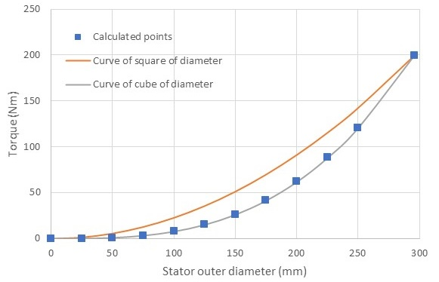
(a)

(b)
Figure 3.4 (a) Comparison between finite element predicted torque at discrete stator diameters and cubic and square curve-fits at a current density of 2.5A/mm²
(b) finite-element predicted average torque for 100mm long sections of different diameter scaled designs (all scaled according to method 1 with varying airgap) in rms value of current density
A similar process was applied to the 7.5A/mm² rms finite element calculated data for the FSPM. However, the cubic curve was defined by simply multiplying the cubic coefficient calculated for the 2.5A/mm² rms by a factor of 3 which assumes linear scaling of torque with current. The resulting curve fit and the finite element predicted torque at the discrete stator diameters considered are shown in Figure 3.5. As shown by Figure 3.5, the curve follows discrete data points well up to a diameter of ~125mm. However, beyond this point the increase in torque starts to fall well below the cubic behaviour based on the relationship established at 2.5A/mm² rms. This demonstrates the increasing effect that magnetic saturation has on the behaviour of FSPMs as the electric loading increases and suggests significant magnetic saturation in this FSPM design even at the continuous operating point of 7.5A/mm² rms. This topic of the influence of magnetic saturation is revisited in more detail in chapters 4 and 5.
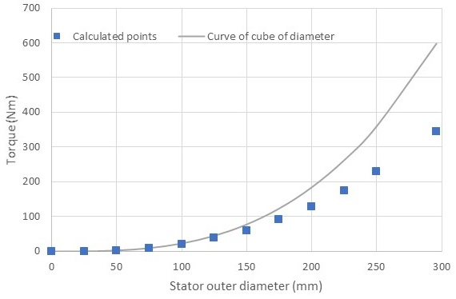
Figure 3.5 Comparison between finite element predicted torque at discrete stator diameters and cubic and square curve-fits at a current density of 7.5A/mm2
This tendency of larger FSPM machines operating at higher current densities suffering from the effects of magnetic saturation is also evident in the gap in performance between a 296mm diameter FSPM and the corresponding SMPM machine. At 2.5A/mm² rms the FSPM is capable of producing 80% of the torque of the corresponding SMPM, but at 7.5A/mm² rms the FSPM is only capable of producing 68% of the torque of the corresponding SMPM. It is worth noting that the 296mm diameter SMPM maintains is not immune to the effects of magnetic saturation at 7.5A/mm² rms. The torque produced by the SMPM at 7.5A/mm² rms is only 2.53 times that produce at 2.5A/mm² rms. This in part a consequence of the low split ratio of 0.55 adopted for this machine and hence the large stator electric loading even at 7.5A/mm² rms. The Figure 3.4 and 3.5 indicates the calculated points of proposed FSPM machines is lower than the cubic relationship and cubic relationship below the square relationship that prove the point of the scaling in this FSPM machine would tend to have cubic relationship instead of square relationship.

Scaling results for method 2 scaling with fixed airgap
The same two-dimensional finite element calculations were performed for a series of designs in which the airgap was maintained at a fixed 0.5mm airgap. The resulting variation in torque with diameter at three values of current is shown in Table 3.4. As would be expected, all the machine design except for the 296mm diameter design have lower torque capability than the corresponding machine design in Table 3.3. This is to be expected given that the scaled airgap machines except for 296mm diameter designs have smaller airgaps. This is most pronounced at the smaller diameters, e.g. a 25mm diameter FSPM at 7.5 A/mm² rms with a fixed 0.5mm airgap produces a torque which less than 1/3 of the torque of the scaled airgap. Figure 3.6 shows the variation in the ratio of torque for a scaled airgap to the torque of the corresponding fixed airgap diameter and the data set from table 3.4 into a graph for comparison.
Table 3.4 Finite-element predicted average torque for 100mm long sections of different diameter scaled designs (all scaled according to method 2 with fixed 0.5mm airgap)

 | Calculated average torque (Nm) at 2.5A/mm² rms |  | Calculated average torque (Nm) at 5A/mm² rms |  | Calculated average torque (Nm) at 7.5A/mm² rms
Stator outer diameter (mm) | SMPM | FSPM | SMPM | FSPM | SMPM | FSPM
25 | 0.08 | 0.034 | 0.16 | 0.062 | 0.240 | 0.093
50 | 0.85 | 0.55 | 1.69 | 1.08 | 2.54 | 1.63
75 | 3.04 | 2.31 | 6.05 | 4.62 | 9.00 | 6.78
100 | 7.42 | 6.00 | 14.8 | 11.6 | 21.8 | 16.8
125 | 14.7 | 12.1 | 29.0 | 23.2 | 42.6 | 32.9
150 | 25.5 | 20.9 | 50.0 | 39.8 | 73.4 | 55.8
175 | 41.0 | 33.6 | 80.0 | 63.1 | 115.2 | 86.1
200 | 61.1 | 50.1 | 118.5 | 92.9 | 169.9 | 124.0
225 | 87.3 | 71.6 | 168.5 | 131.0 | 235.7 | 171.1
250 | 119.8 | 98.2 | 230.0 | 176.1 | 319.9 | 228.8
296 | 199.4 | 159.5 | 372.9 | 277.2 | 504.5 | 345.0

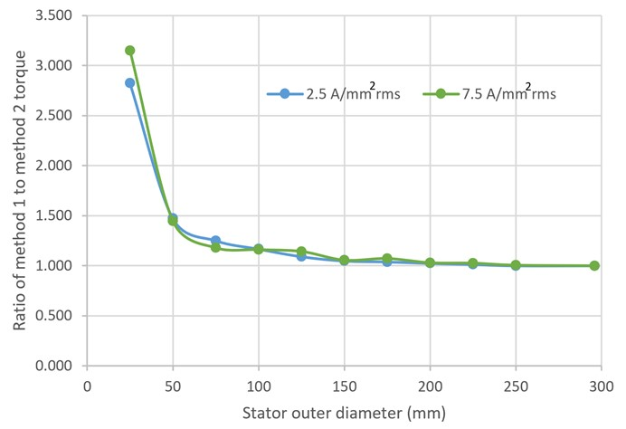
(a)
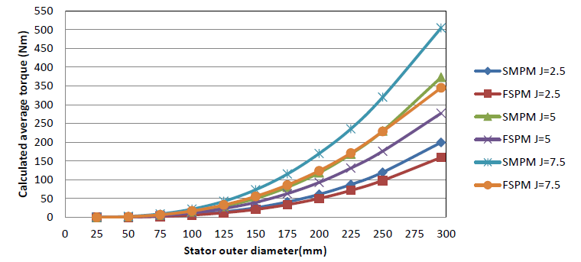
(b)
Figure 3.6 (a) Ratio of torque from scaled airgap (method 1) to fixed 0.5mm airgap at two different current densities
(b) Finite-element predicted average torque for 100mm long sections of different diameter scaled designs (all scaled according to method 2 with fixed 0.5mm airgap) in rms value of current density

Influence of copper loss on torque capability
One feature of FSPMs which contributes to the torque reduction compared to an SMPM machine when operating at a specified current density is that the stator cross-sectional area will tend to be smaller than in the corresponding SMPM because of the wider stator teeth required to accommodate the magnets. Hence, a comparison based on a fixed current density will tend to favour SMPM machines since there is a higher electric loading. However, this does not recognise the reduced copper loss in a FSPM which results from the reduced copper volume. It is important to recognise that loss density is often as important as total copper loss in determining temperature hot-spots within a winding, and loss density is only a function of the current density and the electrical resistivity.
In order to provide another comparison between FSPM and SMPM designs, a further series of finite element analysis was performed for the FSPM on the basis of equal copper loss with the SMPM. Given that each design is based on a simple scaling of the stator cross-section (even for the fixed air-gap case in which the adjustment is made to the rotor as detailed in section 3.3) a simple scaling of the current density can be employed to establish a prescribed level of copper loss. In the case of the scaled versions of the reference design (both variable and fixed air-gap), current density levels of 2.5A/mm² rms, 5A/mm² rms and 7.5A/mm² rms in the SPM increase to 2.88A/mm² rms, 5.76A/mm² rms and 8.65A/mm² rms respectively for the same copper loss in the FSPM. It is worth noting that this is somewhat simplistic as it does not account for the likelihood of a higher temperature rise in the FSPM because of the increased localised loss density. This temperature rise would increase the electrical resistivity and hence the loss for a given current density. Nevertheless, despite this simplification, the comparison provides a useful basis.
Table 3.5 and Figure 3.7 show a comparison between scaled airgap baseline SMPM and FSPM machines at the same level of copper loss. As would be expected, the torque difference narrows when the FSPM current density increases, but this effect is more significant in the smaller machines and at lower current density where the effects of magnetic saturation are lower. For example, for a 25mm diameter at the lowest current density, the FSPM produces 98% of the torque of the corresponding SMPM whereas for the 296mm diameter at the highest level of current density considered, the FSPM only produces 72% of the torque of the corresponding SMPM. This is a slight improvement over the 68% achieved with the same current density but reflects the problems with magnetic saturation at high electric loadings in FSPM machines.
Table 3.5 Comparison of FSPM and SMPM machines at the same level of copper loss for machines scaled with method 1 (scaled airgap)

 | Calculated average torque (Nm) |  | Calculated average torque (Nm) |  | Calculated average torque (Nm)
Stator outer diameter (mm) | SMPM at 2.5A/mm² rms | FSPM at 2.88 A/mm² rms | SMPM  at 5A/mm² rms | FSPM at 5.76 A/mm² rms | SMPM at 7.5A/mm² rms | FSPM at 8.65 A/mm² rms
25 | 0.120 | 0.118 | 0.240 | 0.233 | 0.360 | 0.348
50 | 0.98 | 0.94 | 1.96 | 1.86 | 2.94 | 2.78
75 | 3.31 | 3.19 | 6.63 | 6.26 | 9.85 | 9.30
100 | 7.9 | 7.49 | 15.6 | 14.7 | 23.0 | 21.1
125 | 15.4 | 14.6 | 30.3 | 28.1 | 44.4 | 39.7
150 | 26.3 | 25.0 | 51.8 | 47.4 | 75.5 | 65.5
175 | 41.8 | 39.4 | 81.6 | 73.8 | 118.1 | 98.8
200 | 62.3 | 58.0 | 120.4 | 106.3 | 171.7 | 139.3
225 | 88.2 | 82.1 | 169.4 | 146.7 | 240.1 | 187.7
250 | 121.0 | 112.6 | 230.0 | 194.1 | 321.1 | 243.2
296 | 199.4 | 181.5 | 372.9 | 301.1 | 504.5 | 362.9

Figure 3.7 Comparison of FSPM and SMPM machines at the same level of copper loss for machines scaled with method 1 (scaled airgap)

The same process was applied to the series of scaled designs with the fixed airgap of 0.5mm. Table 3.6 and Figure 3.8 show the predicted torques for this set of designs with each pair of SMPM and FSPM machines operating at the same copper loss with the current density in the FSPM adjusted as discussed previously. This shows a similar trend at the higher diameter (where in any case the airgap differs very little from 0.5mm) with little closing of the torque capability difference between SMPM and FSPM machines.

Table 3.6 Comparison of FSPM and SMPM machines at the same level of copper loss for machines with fixed airgap of 0.5mm in all designs

 | Calculated average torque (Nm) |  | Calculated average torque (Nm) |  | Calculated average torque (Nm)
Stator outer diameter (mm) | SMPM at 2.5A/mm² rms | FSPM at 2.88 A/mm² rms | SMPM  at 5A/mm² rms | FSPM at 5.76 A/mm² rms | SMPM at 7.5A/mm² rms | FSPM at 8.65 A/mm² rms
25 | 0.08 | 0.037 | 0.16 | 0.074 | 0.240 | 0.110
50 | 0.85 | 0.62 | 1.69 | 1.24 | 2.54 | 1.86
75 | 3.04 | 2.71 | 6.05 | 5.29 | 9.00 | 7.66
100 | 7.42 | 6.9 | 14.8 | 13.4 | 21.8 | 19.1
125 | 14.7 | 14.0 | 29.0 | 26.6 | 42.6 | 37.0
150 | 25.5 | 24.2 | 50.0 | 45.6 | 73.4 | 62.2
175 | 41.0 | 38.5 | 80.0 | 71.8 | 115.2 | 95.1
200 | 61.1 | 58.0 | 118.5 | 105.1 | 169.9 | 136.3
225 | 87.3 | 81.2 | 168.5 | 144.0 | 235.7 | 182.5
250 | 119.8 | 111.4 | 230.0 | 192.9 | 319.9 | 239.6
296 | 199.4 | 181.5 | 372.9 | 301.1 | 504.5 | 362.9

Figure 3.8 Comparison of FSPM and SMPM machines at the same level of copper loss for machines with fixed airgap of 0.5mm in all designs

Calculation of machine mass
In order to compare the torque density of FSPM and SMPM machines, it is necessary to have a reliable method for accounting for the end-winding length and hence mass. Since both the baseline PMSM and FSPM model used in this study have concentrated windings which are wound around a single tooth a simplified model in which the end winding is modelled a semi-circular region which is slightly offset from the end of the core by a distance $l_{off}$ from the end of the core as shown in Figure 3.9 for the case of the FSPM. The end winding geometry and calculation formulae are the same for a concentrated SMPM machine.

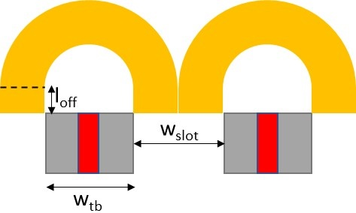
Figure 3.9 Schematic of offset semi-circular end-winding
The mean end-winding length for one end of each individual coil,$l_{mean}$, is given by:
$l_{mean}=2l_{off}+\frac{π\left(w_{tb}+w_{slot}\right)}{2}$ (3.1)

The end-winding cross-section is simply equal to the coil cross-section and hence the end-winding mass can be calculated. The resulting calculated total end-winding mass, i.e. for all 12 coils at both ends, for different scaled baseline designs of both SMPM and FSPM are shown in Table 3.7 for an offset length, $l_{off},$of 10mm . Since the differences between the varying and fixed airgap scaling only affects the rotor, these are the masses for both scaling methods. As shown, although the FSPM has a slightly longer mean length per turn because of the wider tooth, the smaller coil-cross-section results in a net reduction in the mass of the end-windings compared to an equivalent SMPM, with a mass reduction of ~25% for all diameters.

Table 3.7 Calculated total end-winding mass for different stator diameters
Diameter(mm) | SMPM end-winding(kg) | FSPM end-winding(kg)
25 | 0.0042 | 0.0031
50 | 0.034 | 0.025
75 | 0.115 | 0.083
100 | 0.273 | 0.198
125 | 0.533 | 0.386
150 | 0.920 | 0.668
175 | 1.462 | 1.061
200 | 2.182 | 1.583
225 | 3.107 | 2.254
250 | 4.261 | 3.092
296 | 7.083 | 5.098

The effect of this increased mass on the total machine mass is summarised in
Table 3.8. As shown, each FSPM is lighter than the corresponding SMPM machine with the main difference being in the coil mass. It is important to note that the total mass for each machine excludes casing and rotor shaft/hub.

Table 3.8 Total calculated active mass of SMPM and FSPM baseline designs for a range of diameters (values for varying airgap scaling)
Stator outer diameter (kg) | Permanent magnet mass (kg) |  | Stator core mass (kg) |  | Rotor core mass (kg) |  | Coil mass (kg) |  | Total mass (kg)
 | SMPM | FSPM | SMPM | FSPM | SMPM | FSPM | SMPM | FSPM | SMPM | FSPM
25 | 0.03 | 0.04 | 0.13 | 0.11 | 0.06 | 0.05 | 0.09 | 0.09 | 0.31 | 0.29
50 | 0.13 | 0.16 | 0.55 | 0.43 | 0.24 | 0.21 | 0.37 | 0.38 | 1.29 | 1.18
75 | 0.28 | 0.36 | 1.26 | 0.99 | 0.55 | 0.49 | 0.84 | 0.86 | 2.94 | 2.70
100 | 0.52 | 0.65 | 2.27 | 1.78 | 0.99 | 0.89 | 1.52 | 1.55 | 5.30 | 4.86
125 | 0.53 | 1.03 | 2.31 | 2.81 | 1.01 | 1.40 | 1.55 | 2.45 | 8.39 | 7.69
150 | 1.18 | 1.50 | 5.25 | 4.09 | 2.29 | 2.04 | 3.51 | 3.56 | 12.23 | 11.19
175 | 1.65 | 2.07 | 7.23 | 5.62 | 3.15 | 2.80 | 4.84 | 4.89 | 16.86 | 15.39
200 | 2.17 | 2.73 | 9.56 | 7.42 | 4.16 | 3.70 | 6.39 | 6.46 | 22.29 | 20.30
225 | 2.79 | 3.49 | 12.24 | 9.49 | 5.34 | 4.73 | 8.19 | 8.26 | 28.56 | 25.97
250 | 3.49 | 4.36 | 15.30 | 11.83 | 6.67 | 5.90 | 10.23 | 10.30 | 35.68 | 32.38
296 | 4.03 | 6.16 | 19.12 | 16.75 | 8.30 | 8.35 | 19.69 | 14.58 | 51.13 | 45.85

Torque density comparison
Using the torque predictions in Table 3.3 and Table 3.5 for the scaled airgap and the mass calculations in Table 3.8 allows the variation of torque density with stator diameter and current density to be calculated. Table 3.9 shows the calculated torque densities, which as expected shows the significant change in torque density with diameter which would be expected from the first order scaling discussed in section 3.4.1, i.e. the torque increases at constant current density with the cube of diameter whereas the mass increases at the square of diameter. As also shown in Table 3.9, at the lower current densities, the FSPM designs with equal copper loss (i.e. at 2.88A/mm² rms) have a higher torque density than the corresponding SMPM design across the full range of diameters, although the FSPM machines at the same current density have a lower torque density than the SMPM designs. At the higher current density, the behaviour is slightly different with FSPM designs at equal copper loss only having a torque density advantage up to diameters of 100mm. Beyond 100mm, SMPM designs despite having a higher mass and operating at a lower current density have a higher torque density. This again shows the difficulties that FSPM machines have with magnetic saturation at higher current density levels.
Table 3.9 Summary of calculated torque densities for scaled airgap designs

 | Torque density (Nm/kg) |  |  | Torque density (Nm/kg) |  |  | Torque density (Nm/kg)
Stator outer diameter (mm) | SMPM (2.5A/mm² rms) | FSPM (2.5A/mm² rms) | FSPM (2.88A/mm² rms) | SMPM (5A/mm² rms) | FSPM (5A/mm² rms) | FSPM (5.76A/mm² rms) | SMPM (7.5A/mm² rms) | FSPM (7.5A/mm² rms) | FSPM (8.65A/mm² rms)
25 | 0.377 | 0.333 | 0.408 | 0.754 | 0.680 | 0.807 | 1.130 | 1.015 | 1.207
50 | 0.757 | 0.683 | 0.798 | 1.521 | 1.337 | 1.574 | 2.278 | 1.998 | 2.350
75 | 1.126 | 1.069 | 1.182 | 2.252 | 2.048 | 2.319 | 3.347 | 2.960 | 3.444
100 | 1.484 | 1.450 | 1.541 | 2.940 | 2.762 | 3.021 | 4.340 | 4.013 | 4.349
125 | 1.840 | 1.721 | 1.893 | 3.610 | 3.366 | 3.653 | 5.292 | 4.896 | 5.163
150 | 2.149 | 1.961 | 2.235 | 4.235 | 3.740 | 4.242 | 6.175 | 5.268 | 5.861
175 | 2.479 | 2.262 | 2.555 | 4.836 | 4.259 | 4.791 | 6.999 | 5.989 | 6.415
200 | 2.798 | 2.530 | 2.861 | 5.403 | 4.698 | 5.240 | 7.707 | 6.294 | 6.866
225 | 3.086 | 2.789 | 3.159 | 5.928 | 5.107 | 5.645 | 8.403 | 6.754 | 7.224
250 | 3.390 | 3.033 | 3.477 | 6.444 | 5.437 | 5.992 | 8.995 | 7.102 | 7.509
296 | 3.899 | 3.479 | 3.957 | 7.291 | 6.044 | 6.566 | 9.864 | 7.523 | 7.914

Three-dimensional end effects

Introduction and description of model
The preceding analysis has been entirely based on two-dimensional magneto-static analysis. It is well known that end-effects can play an important role in the performance of FSPM, notably in terms of magnet flux leakage on the ends of the stator core [86] and [87]. In order to establish the extent to which end-effects impact on the scaling behaviour observed previously in this chapter, a series of three-dimensional finite element torque calculations were performed on a selected sub-set of the dimensions considered with the two-dimensional analysis.
The first case considered was the three-dimensional model for the baseline design with a stator outer diameter of 296mm. The geometry of this model, which exploits symmetry to reduce the problem domain, is shown in Figure 3.10. This model was formulated with the adaptive meshing option. Although this solution method results in a long solution time, the adaptive refinement of the mesh does ensure that the finite element mesh is suitable to provide a reliable torque value.
Figure 3.10 Geometry of 3D finite-element model of a 296mm stator diameter baseline design

Average torque comparisons
The average torque predicted over one cycle at the rated continuous current density of 7.5A/mm² rms from this three-dimensional model was 252Nm compared to 345Nm from a two-dimensional finite element model. Taking the two-dimensional value as a 100% reference, then there is a 27% reduction in torque due to end effects. This is of the same order as that identified in [81] but in that cases with much smaller machines and slightly different aspect ratios.
The first factor considered in terms of three-dimensional behaviour was the influence of current density and hence magnetic saturation in the 296mm diameter baseline design. The three-dimensional finite-element model was used to predict the average torque for the 296mm baseline at current densities of 2.5A/mm² rms and 5A/mm² rms. A summary of the resulting torques calculated by both two and three-dimensional finite element models is shown in Table 3.10. These predictions demonstrate that better agreement is achieved at the lower current densities, although the end-effects in the three-dimensional model remain very significant resulting in a ~15-20% reduction in torque. In terms of SMPM machine 3D to 2D ratio is around 90% that the end-effects has no major influence compared to FSPM machine at rated rms current density.
Table 3.10 Summary of torque calculations from 2D and 3D finite element simulations for 296mm baseline machine designs

 | 2D model | 3D model | Ratio of 3D/2D
Torque at 2.5A/mm2 rms | 159 Nm | 129 Nm | 81.1%
Torque at 5A/mm2 rms | 277 Nm | 231 Nm | 83.4%
Torque at 7.5A/mm² rms | 345 Nm | 252 Nm | 73.0%
SMPM Torque at 7.5A/mm² rms | 505Nm | 474 Nm | 93.8%

The influence of diameter on end-effects was investigated by further calculations on baseline 50mm and 150mm stator diameter machines. In these cases, the axial lengths of the stator cores were reduced to 16.9mm and 50.7mm respectively to maintain the same diameter to length aspect ratios. A comparison between the torque predicted for these two diameters are shown in Table 3.11. from which it can be seen that there is a much more consistent ratio of torque predicted from the two model, with ~20% torque reduction due to end-effects on FSPM machines. Compared to the SMPM machine the 3D to 2D ratio decreased almost 20%. This again demonstrates the influence of magnetic saturation as the only major difference from the 20% torque reduction is the highest current density and largest diameter case shown previously in Table 3.10 where a reduction of 27% was observed. All these result is based on the same aspect ratio in these simulation results.
Table 3.11 Summary of torque calculations from 2D and 3D finite element simulations for 50mm and 150mm baseline FSPM machine designs

50mm diameter / 16.9mm axial length
 | 2D model | 3D model | Ratio of 3D/2D
Torque at 2.5A/mm² rms | 0.137 Nm | 0.110 Nm | 80.3%
Torque at 5A/mm² rms | 0.267 Nm | 0.220 Nm | 82.4%
Torque at 7.5A/mm² rms | 0.399 Nm | 0.327 Nm | 82.0%
150mm diameter / 50.7mm axial length
 | 2D model | 3D model | Ratio of 3D/2D
Torque at 2.5A/mm² rms | 11.13 Nm | 8.82 Nm | 79.2%
Torque at 5A/mm² rms | 21.22 Nm | 17.09 Nm | 80.5%
Torque at 7.5A/mm² rms | 29.89 Nm | 23.9 Nm | 80.0%

Torque density comparisons
The two- and three-dimensional finite element predicted values of average torque can be converted to torque densities as shown in Table 3.13. These variations by definition follow exactly the same trends as the torque values in the previous section.
Table 3.13 Summary of torque densities
Stator outer diameter |  | 50mm | 150mm | 296mm
Axial length |  | 16.9mm | 50.7mm | 100mm
Mass |  | 1.18kg | 11.19kg | 45.85kg
Torque density at 2.5A/mm² rms | 2D | 0.116 Nm/kg | 0.99 Nm/kg | 3.48 Nm/kg
 | 3D | 0.093 Nm/kg | 0.79 Nm/kg | 2.82 Nm/kg
Torque density at 5A/mm² rms | 2D | 0.23 Nm/kg | 1.90 Nm/kg | 6.04 Nm/kg
 | 3D | 0.19 Nm/kg | 1.53 Nm/kg | 5.03 Nm/kg
Torque density at 7.5A/mm² rms | 2D | 0.34 Nm/kg | 2.67 Nm/kg | 7.52 Nm/kg
 | 3D | 0.28 Nm/kg | 2.14 Nm/kg | 5.40 Nm/kg

Conclusion
This chapter has investigated the nature of scaling of the behaviour of FSPM, including comparisons with the scaling behaviour of the more common SMPM machines. It is clear that the SMPM machine have more average torque compared to FSPM machine in different current density based on the both methods and the results are fixed to stay with the ratio of scaled geometry even it is not realistic to be manufactured in practice. The FSPM machine using more magnets mass but produce lower average torque. The magnetic saturation is a critical factor in determining the performance of FSPM machine operating at high current loading. In some cases, the FSPM can be competitive with SMPM machines in terms of torque capability up the point where the magnetic saturation starts to have major effect, particularly when the reduced copper loss for a given current density is exploited. This lead to FSPM machines are more prone to problems with magnetic saturation reducing the torque compared to corresponding SMPM design. The studies have shown the importance of three-dimensional modelling and the influence of magnetic saturation. 3-D effects are very significant in FSPM machine, particularly when there is significant magnetic saturation. These topics are investigated in more detail in the remaining chapters of this thesis. This includes design optimisation in chapter 4 as it is clear from the results in this chapter that the baseline designs are not well suited to large diameter and higher current densities.

Chapter 4 - An investigation into machine split- ratio and other aspects of design optimisation

Introduction

Chapter 2 described the sizing and performance predictions of an FSPM design to meet a 70kW / 340Nm performance specification. Although this baseline machine design was shown to be capable of meeting the specification for an rms current density of 7.5A/mm² rms, one feature of the design is that it had limited short-term overload due to the effects of heavy magnetic saturation.
One aspect of this baseline 296mm design which has a major effect on its performance was the adoption of a split ratio of 0.55. As noted in chapters 1 and 2, this split ratio had been shown in some previous studies to be an optimal split-ratio for torque density in FSPM [88]. However, as also noted in chapter 1, this optimum value was established for relatively small machines, i.e. stator diameters of ~90mm and torque ratings of 2.2Nm. In larger machines, this relatively low split ratio results in a large stator slot area and hence a high magnetic loading. Moreover, the short-term overload ability was not considered in these previous studies.
In this chapter, the influence of split ratio on the torque density of two machines with stator outer diameters of 150mm and the baseline 296mm is systemically investigated. Having established preferred split-ratios, several parameters are optimised to enhance the overload torque capability, including consideration of short-term overload.

Influence of machine split-ratio
A series of finite element simulations were performed for designs with the same 296mm stator outer diameter but with increasing split-ratio at three levels of rms current density. Figure 4.1 shows the resulting variation in average torque with split- ratio for rms current densities of 7.5A/mm² rms, 15A/mm² rms and 30A/mm² rms. At the continuous design current density of 7.5A/mm² rms, the average torque meets or exceeds the 340Nm requirement for split-ratios between 0.55 to 0.675 while increases in the split-ratio beyond 0.675 results in a drop in average torque below 340Nm. The maximum torque at a current density of 7.5A/mm² rms is 372Nm which occurs at a split-ratio of 0.625. This corresponds to an improvement of 9.5% compared to the original baseline split-ratio of 0.55.
The corresponding characteristics for twice and four-times the continuous current density are also shown in Figure 4.1. For a current density 15A/mm² rms, the maximum average torque is achieved at the split ratio of 0.7 with a value of 535Nm. A further doubling of the current density to 30A/mm² rms results in a maximum torque of 654Nm at a split-ratio of 0.75. This trend of an increasing split ratio being the optimal split-ratio at higher levels of current density is expected since magnetic saturation has a major influence of machine performance. Better use of the available space is achieved by increasing the proportion occupied by the rotor rather than further increasing the electric loading.
Clearly, any practical design can only have one value of split ratio and its selection will be a trade-off between continuous operation efficiency and short-term overload capability. For example, adopting the 7.5A/mm² rms optimum split ratio of 0.625, results in a torque of only 543Nm with four times rated current, which is only 146% of the torque of 372Nm at rated current. In contrast, adopting a split ratio of 0.75 (optimum for 4 × rated current) results in a torque of 654Nm at 4 × rated current which is 246% of the torque at rated current for this split ratio. However, this high value of split ratio gives poor torque capability at rated torque of 266Nm at 7.5 A/mm² rms compared to 372Nm for the 0.625 split ratio which is the optimum for continuous operation at the rated current density of 7.5 A/mm² rms.

Figure 4.1 Average torque versus split ratio for the 296mm FSPM machine

The corresponding set of characteristics for a 150mm stator outer diameter machine is shown in Figure 4.2. This shows a similar trend, although the corresponding split ratios for maximum torque are lower than for the 296mm machine.

Figure 4.2 Average torque versus split ratio for the 150mm FSPM machine
The analysis presented in this section has demonstrated that the optimal split ratio is both a function of machine size and operating current density and can go as high as 0.75 in the case of the 296mm machine at four-times rated current. It is also interesting to note that in none of the combinations of operating current density and stator outer diameters result in the optimal split-ratio go as low as 0.55, the lowest being 0.8 for the smaller 150mm diameter stator at the lowest current density of 7.5A/mm² rms. The analysis presented in this section has demonstrated that there is no single and universal optimal split ratio for FSPM machines and that the optimal split ratio tends towards higher values as the machine size and electrical loading increase.

Optimisation of 296mm stator diameter baseline FSPM machine
Having established the preferred split-ratios for the continuous current density rating of 7.5A/mm² rms for both 296mm and 150mm diameter machines, a series of further optimizations were performed. Three strategies were considered for the optimization of several key dimensions of the machines, in all cases starting with the optimized split ratio of 0.625 and 0.575 for the 296mm and 150mm designs respectively:
Strategy 1 – Isolated single parameter optimisation – In this strategy, each design parameter of the baseline designs is optimized in isolation with all other machine parameters remaining the same as in the baseline design. The individually optimized parameters are then all collected together at the end to produce a set of design parameters.
Strategy 2 - Cumulative sequential optimisation – In this strategy, the design parameters are again optimized one at a time. However, as each parameter is considered in sequence, the optimum value is then adopted in subsequent parameter optimisations and hence the design cumulatively builds up a set of optimal parameters.
Strategy 3 - Global optimization – This strategy uses the built-in Genetic Algorithm (GA) tool in ANSYS Maxwell to undertake a formal search of the design space.
The Genetic Algorithm (GA) (random search) in ansys mawell use an optimisation method called stochastic optimizers. The main difference is it use type of random search and applied in a structured manner instead of the cost function or experiments to explore the design space. The GA optimizer may run much iteration and slow the process, but the random search has the benefit to jump out of the local minima that have no significant improvement towards the goal result a much faster process.
The figure 4.3 below from ansys help website indicates the GA search is an iterative process that runs through numerous generations. In each of them will produce new set of data that called Children or number of individuals and then reducing the population since its natural-selection process to a desired level called next generation or number of individuals.
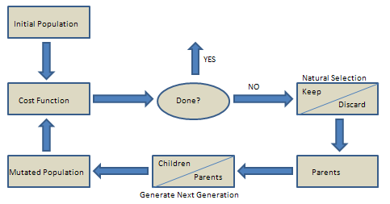
Figure 4.3 GA search flow chart [89]
The GA would choose the original set of individuals during the process of smaller set of individuals must be created from the bigger set. In this process, the cost function would define the better fit individuals. Turning on the roulette selection would allow the selection process gets relaxed, but the elitist selection would simply choose the best individuals. The iterative process begins to selecting the individuals and fills up the resulting set, the Maxwell will use a roulette wheel that made the entire selection individuals candidate to proportional to the fitness level which relate to the cost function. In other words, a fitter individual has high chance to survival the search [89].

Optimisation of the magnet thickness
In an FSPM the thickness of the magnet in the direction of magnetization (DOM) has a direct influence on the stator core dimensions and the pole arc of the stator teeth. Increasing the magnet thickness at a particular rotor diameter requires a smaller slot and/or thinner tooth sections in the stator core. Hence, there is a complex trade-off in FSPMs design, and some optimum value of permanent magnet thickness is inevitable. The two-dimensional finite element predicted variation of torque with magnet thickness is shown in Figure 4.4 for the 296mm machine with the previously established split ratio of 0.625. It can be seen there is an optimum magnet thickness of 11.73mm which is predicted to produce a torque of 374.5Nm. This compares with the value of 10.6mm in the original design that produced a torque of 371.8Nm for the updated split ratio of 0.625. Since this is the first dimensional parameter to be optimised, this variation and hence optimum value of magnet thickness applies to both optimisation strategies 1 and 2.

Figure 4.4 Variation in average torque with magnet thickness for a 296mm overall diameter FSPM machine with at an rms current density of 7.5A/mm2 and a split ratio of 0.625 (all other dimensions the same as the baseline design of chapter 2)

Optimisation of stator back iron thickness
The next dimension considered was the stator back-iron thickness. Since the outer diameter is fixed at 296mm and the split-ratio is fixed, then any increase in the stator back iron thickness requires a corresponding decrease in the slot depth and hence the variation in back-iron thickness has a direct impact on the stator mmf for a given current density. There is some effect in overall mass as the back-iron thickness is increased since the stator core has higher density than the sot region because of the packing factor of the coil, but the changes are not very significant in the context of the overall machine mass. The two-dimensional finite element predicted variation in the average torque of the 296mm as a function of the stator core back-iron thickness is shown in Figure 4.5 for both isolated single parameter optimisation and with cumulative optimisation using the value of magnet thickness of 11.73mm identified in Figure 4.5 (b). In both cases the split ratio was the updated split ratio of 0.625 identified in section 4.2.
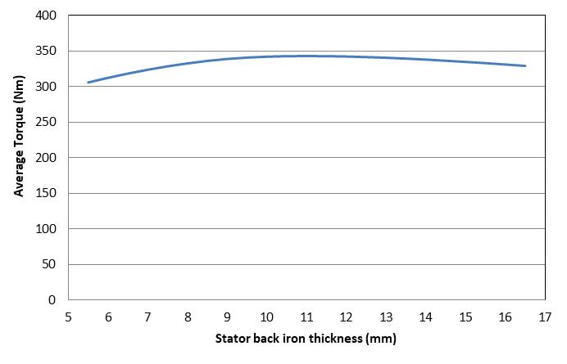 | 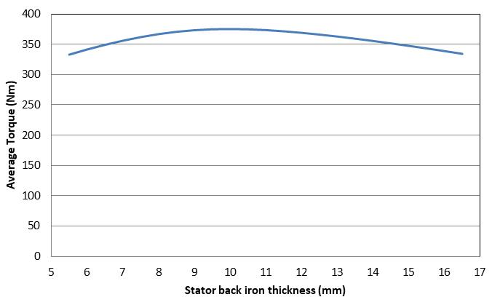
- Isolated parameter optimisation | (b) Cumulative parameter optimisation
Figure 4.5 Two-dimensional finite element predicted variation in average with stator back-iron thickness
As shown by Figure 4.5, there is a shallow optimum in both cases. In the case of the isolated single parameter optimisation a maximum torque of 342.95Nm was achieved with a back-iron thickness of 11mm while for the cumulative optimization a maximum torque of 375.13Nm was achieved with a back-iron thickness of 10mm.

Optimisation of the rotor pole outer arc angle
A similar procedure was then carried out on the rotor outer pole arc for both isolated single parameter and cumulative optimisation (carrying forward a magnet thickness of 11.73mm and a back-iron thickness of 10mm). The two-dimensional finite element predicted variation in the average torque with outer rotor pole arc angle for both optimisation strategies is shown in Figure 4.6. As shown by Figure 4.6, there is an optimum in both cases. In the case of the isolated single parameter optimisation a maximum torque of 365Nm was achieved with a rotor pole arc angle of 5.75º while for the cumulative optimization a maximum torque of 404Nm was achieved with a rotor pole arc angle of 6º. Both of these increases relative to the previous best designs demonstrate that the rotor pole arc is a critical dimension in determining the torque.
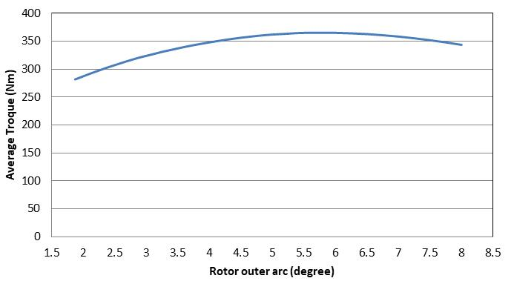 | 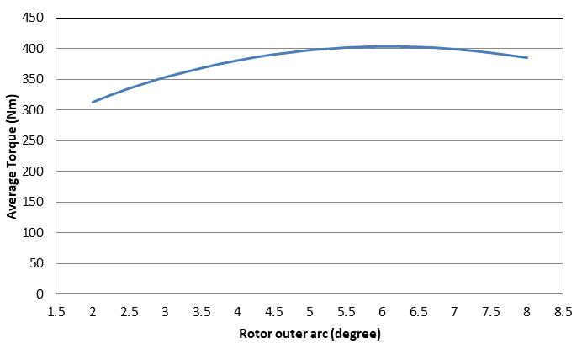
- Isolated parameter optimisation | (b) Cumulative parameter optimisation
Figure 4.6 Two-dimensional finite element predicted variation in average with rotor outer pole arc angle

Optimisation of the rotor pole inner arc angle
The same procedure was then carried out on the rotor inner pole arc for both isolated single parameter and cumulative optimisation (carrying forward a magnet thickness of 11.73mm, a back-iron thickness of 10mm and a rotor outer pole arc of 6º). The two-dimensional finite element predicted variation in the average torque with outer rotor pole arc angle for both optimisation strategies is shown in Figure 4.7. In this case, once the rotor inner pole arc angle is greater than ~6º there is only a very small variation and although there are optimal values of 11º for the isolated parameter case and 8.75º for the cumulative parameter case, the optimum is very shallow which demonstrates that providing this angle is not set too low, this is not a critical dimension in terms of maximising torque.
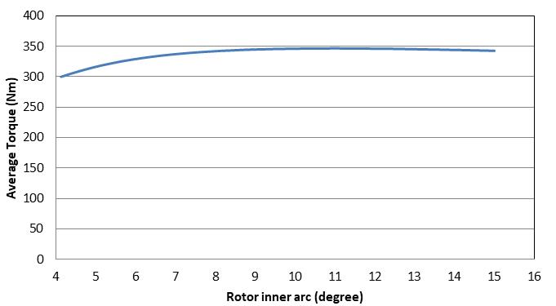 | 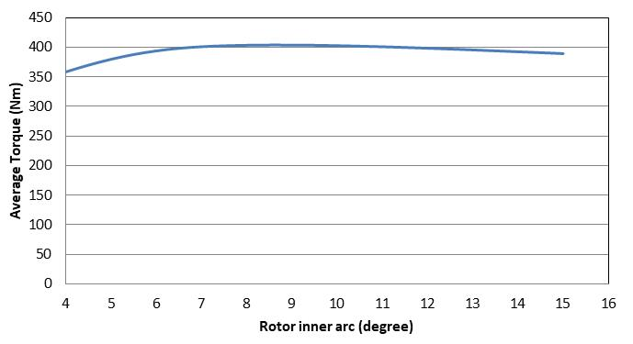
- Isolated parameter optimisation | (b) Cumulative parameter optimisation

Figure 4.7 Two-dimensional finite element predicted variation in average with rotor inner pole arc angle

Optimisation of rotor tooth height
The same procedure was then carried out on the rotor tooth for both isolated single parameter and cumulative optimisation (carrying forward a magnet thickness of 11.73mm, a back-iron thickness of 10mm and a rotor outer pole arc angle of 6º and a rotor inner pole arc angle of 8.75º). The two-dimensional finite element predicted variation in the average torque with outer rotor pole arc angle for both optimisation strategies is shown in Figure 8. Again, providing the rotor tooth height is not set too low so that the saliency ratio starts to reduce significant, then once it is beyond a certain value the torque is almost insensitive to the rotor tooth height. The values selected from Figure 4.8 (a) and (b) are 20mm and 25mm respectively.
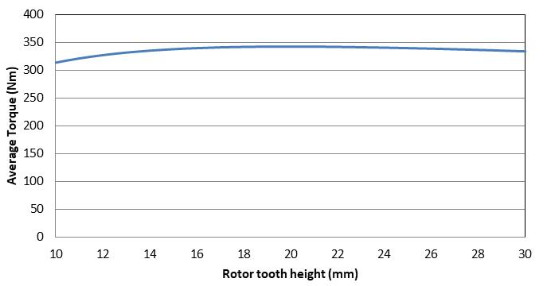 | 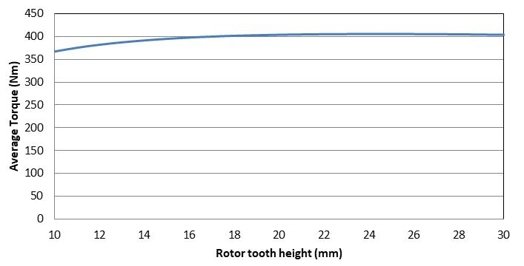
- Isolated parameter optimisation | (b) Cumulative parameter optimisation

Figure 4.8 Two-dimensional finite element predicted variation in average with rotor tooth height
This final optimisation parameter completes the set for the 296mm design

Application of Genetic Algorithm optimisation
The electromagnetic finite element package used throughout the research in this thesis was ANSYS Maxwell. Within the ANSYS Maxwell package there is automated optimisation tool which uses a genetic algorithm to evolve and analyse a number of designs to arrive at an optimal design.

Summary of optimisation

Table 4.1 summarises the evolution of the torque capability of baseline machine as the different optimisation strategies were applied. Also shown in
Table 4.1 is the calculated copper loss at a copper temperature of 150°C. Although torque capability was the sole performance objective and a fixed design current was employed, some of the changes made by the various optimisation approaches result in some increase in copper loss due to increased slot area.

As shown by
Table 4.1, the single parameter optimisation achieves a 15% increase in the torque compared to the baseline and a 6% increase compared to the design in which only the split ratio was optimised. The cumulative and genetic algorithm optimisations perform very similarly with a further 4% increase in torque respectively. It is worth noting that in the single parameter and cumulative optimisation, the split ratio was incremented in steps of 0.025. The genetic algorithm method was not restricted to these increments, and this method identified a split ratio of 0.635 which is between the increments used in the other methods (i.e. 0.625 and 0.65) but this only resulted in 0.14% increase in torque compare to the cumulative optimisation.

Table 4.1 FSPM Optimisation summary for 296mm stator outer diameter operating at 7.5A/mm² rms current density
 | Baseline | Optimised split ratio only (other parameters same as baseline) | Isolated Single parameter-by-parameter optimisation of baseline | Cumulative optimisation – starting from baseline | Global optimisation using genetic algorithm
Split Ratio | 0.55 | 0.625 | 0.625 | 0.625 | 0.635
Magnet thickness in DOM (mm) | 10.6 | 10.6 | 12.47 | 11.73 | 11.58
Stator back iron thickness (mm) | 10.6 | 10.6 | 11 | 10 | 10.58
Rotor tooth outer arc (°) | 3.75 | 3.75 | 5.75 | 6 | 5.96
Rotor tooth inner arc (°) | 10 | 10 | 10.87 | 8.75 | 9.24
Rotor tooth height (mm) | 20 | 20 | 20 | 25 | 26.85
Calculated average torque (Nm) | 342 | 371.8 | 394.6 | 405.6 | 406.2
Calculated average torque normalised by baseline torque | 100% | 109% | 115% | 119% | 119%
Calculated copper loss at 150°C (W) for a packing factor of 0.6 | 4465 | 3141 | 3057 | 3545 | 3396

In summary, the different strategies all produced a significant improvement in torque capability compared to the baseline design and although the Genetic Algorithm did result in the highest torque, the benefit over the more straightforward method of cumulative optimisation was marginal.

Optimisation of the 150mm FSPM machine
The same procedure was applied to the 150mm machine design and the corresponding summary table of the evolution of the design is shown in Table 4.2. As would be expected, there is a similar trend in terms of the benefits of the various optimisation strategies with all machines showing some improvement over the baseline. However, since the change in split-ratio from the 0.55 adopted in the baseline is less in this case of this optimisation, i.e. 0.55 is closer to the optimum in a 150mm design than a 296mm design. Since split-ratio proved to be the most significant parameter in terms of the torque capability, it is not surprising that the benefits of optimisation are reduced in this smaller machine, with only a 11% increase in torque capability compared to the baseline with the genetic algorithm optimisation. Again, the major parameters determine the average torque could list as split ratio and rotor tooth outer arc.
Table 4.2 FSPM Optimisation summary for 150mm stator outer diameter operating at 7.5A/mm2 rms current density
 | Baseline | Optimised split ratio only (other parameters same as baseline | Isolated Single parameter-by-parameter optimisation of baseline | Cumulative optimisation – starting from baseline | Global optimisation using genetic algorithm
Split Ratio | 0.55 | 0.575 | 0.575 | 0.575 | 0.59
Magnet thickness in DOM (mm) | 5.40 | 5.40 | 5.65 | 5.65 | 5.51
Stator back iron thickness (mm) | 5.37 | 5.37 | 4.5 | 4.5 | 4.37
Rotor tooth outer arc (°) | 3.75 | 3.75 | 6.0 | 6.0 | 5.45
Rotor tooth inner arc (°) | 10.0 | 10.0 | 11.0 | 9.0 | 9.18
Rotor tooth height (mm) | 10.0 | 10.0 | 11.0 | 11.0 | 11.96
Calculated average torque (Nm) | 27.4 | 27.6 | 29.9 | 30.0 | 30.5
Calculated average torque normalised by baseline torque | 100% | 101% | 109% | 109% | 111%
Calculated copper loss at 150°C (W) | 559 | 512 | 540 | 540 | 550

Investigation into short-term overload

Introduction to short-term overload operation
As noted in chapter 1, electrical machines are able to operate for short periods at currents which are much higher than the continuous current rating by exploiting the thermal mass of the winding, although care must be taken in PM machines to avoid irreversible demagnetisation of the magnets. Providing irreversible demagnetisation is avoided, the magnitude of the short-term current can be increased to many multiples of the continuous current providing the duration of operation is managed. Many commercial machines are supplied with specified short-term ratings using the standards set out in [90]. As an example, a machine specification could include a continuous rating (S1 rating), a periodic s rating (S2) and etc.

In most applications, the machine is optimised for the continuous rated current operating condition and its short-term capability depends on the design choices made to optimise continuous torque. In general, optimisation of an electrical machine to maximise torque density at rated current tends to result in the flux density in the stator core being close to magnetic saturation as otherwise the stator core volume is not being fully exploited. Hence, short-term overload currents tend immediately drive the stator core into magnetic saturation causing a reduction in the torque per amp and hence diluting the benefits of the additional current.

It is possible to optimise the machine for operation at the short-term overload condition. This is likely to result in a machine that is further away from significant magnetic saturation at rated continuous current, and so this short-term overload optimised machine will usually have inferior performance at the continuous current operating point.

Optimisation of 296mm stator outer diameter for short-term overload
The trade-offs involved in designing for short-term overload can be illustrated by optimising a 296mm design to operate at 30A/mm² rms using a global optimisation approach which uses Genetic Algorithms. Table 4.3 shows a comparison between the parameters of the baseline, the machine optimised by the Genetic Algorithm for 7.5A/mm² rms, the machine optimised by the Genetic Algorithm for 15A/mm² rms and 30A/mm² rms. Cross-sections through these optimised 3 designs are shown in Figure 4.9, while Figure 4.10 shows the predicted average torque versus current density characteristics for the 3 designs.

Table 4.3 Comparison of global optimised 296mm stator diameter designs using a Genetic Algorithm at current densities of 7.5A/mm² rms and 7.5A/mm² rms
 | Baseline | Global optimisation by Genetic Algorithm for 7.5A/mm² rms | Global optimisation by Genetic Algorithm for 15A/mm² rms | Global optimisation by Genetic Algorithm for 30A/mm² rms
Split Ratio | 0.55 | 0.635 | 0.693 | 0.733
PM thickness (mm) | 10.6 | 11.58 | 13.68 | 15.37
Stator back iron thickness (mm) | 10.6 | 10.58 | 10.82 | 13.82
Rotor tooth outer arc (º mechanical) | 3.75 | 5.96 | 5.34 | 5.01
Rotor tooth inner arc (º mechanical) | 10 | 9.24 | 8.25 | 11.14
Rotor tooth height (mm) | 20 | 26.85 | 25.74 | 27.79
Calculated average torque at 7.5A/mm² (Nm) | 340 | 406 | 357 | 246
Calculated average torque normalised by baseline torque at 7.5A/mm² rms | 100% | 119% | 105% | 72%
Calculated average torque normalised by baseline torque at 15A/mm² rms (Nm) | 408 | 513 | 570 | 468
Calculated average torque at 15A/mm² rms normalised by baseline torque at 7.5A/mm² rms | 120% | 151% | 168% | 138%
Calculated average torque at 30A/mm² (Nm) | 425 | 536 | 665 | 706
Calculated average torque at 30A/mm² rms normalised by baseline torque at 7.5A/mm² rms | 128% | 158% | 196% | 207%

Baseline | Optimised for 7.5A/mm² rms
Optimised for 15A/mm² rms | Optimised for 30A/mm² rms

Figure 4.9 Cross-sections through the 3 designs of Table 4.12

Figure 4.10 Two-dimensional finite element predicted variation in average torque versus current density for the 3 designs of Table 4.12

As would be expected, the design optimised for 30A/mm² rms has the highest split-ratio. At 30A/mm² rms, the optimised machine for short-term overload produces 706Nm compared to 536Nm for the design optimised for continuous operation and 425Nm for the original baseline design. However, this significant advantage at 30A/mm² rms is achieved by comprising the performance at lower current densities. As shown by figure 4.10, the machine optimised for operation at 30A/mm² rms has a significant advantage over the other three designs at 30A/mm² rms (and beyond 25A/mm² rms) but is inferior at the continuous operating condition of 7.5A/mm² rms producing only 247Nm compared to the 406Nm for the design optimised for continuous operation. This shows the challenge of optimising FSPMs to operate over a range short-term current density ratings because of the influence of magnetic saturation. This analysis also demonstrates that the optimal design is very dependent on the selection of the most important operating point in the driving cycle of the machine.

Optimisation of 150mm stator outer diameter design for short-term overload
The same short-term overload optimisation was also applied to a 150mm design machine, again using the Genetic Algorithm approach to optimise the torque capability at 30A/mm² rms. A comparison of this short-term overload optimised design, the baseline design and the design optimised for continuous operation at 7.5A/mm² rms is shown in Table 4.4. As would be expected, the design optimised for short-term overload offers a significant improvement of in torque capability at 30A/mm² rms compared to all other designs but at the expense of a large reduction of 15% in the torque at 7.5A/mm² rms. It is also interesting to note from Table 4.4 that all the machine designs suffer from significant magnetic saturation as can be seen from the fact that the torque increase between 7.5A/mm² rms and 30A/mm² rms is much lower than the factor of 4 which would be expected if the torque versus current characteristic were linear.
Table 4.4 Comparison of global optimised 150mm stator diameter designs using a Genetic Algorithm at current densities of 7.5A/mm² rms and 7.5A/mm² rms
 | Baseline | Global optimisation for 7.5A/mm² | Global optimisation for 15A/mm² | Global optimisation for 30A/mm²
Split Ratio | 0.55 | 0.59 | 0.63 | 0.70
PM magnet thickness (mm) | 5.47 | 5.58 | 6.02 | 6.96
Stator back iron thickness (mm) | 5.37 | 4.37 | 4.95 | 5.44
Rotor tooth outer arc  (º mechanical ) | 3.75 | 5.45 | 6.12 | 5.49
Rotor tooth inner arc (º mechanical ) | 10 | 9.18 | 10.11 | 13.24
Rotor tooth height (mm) | 10 | 11.96 | 18.556 | 19.78
Calculated average torque at 7.5A/mm² rms (Nm) | 27.4 | 30.5 | 29.13 | 23.3
Calculated average torque normalised by baseline torque at 7.5A/mm² rms (Nm) | 100% | 111% | 106% | 85%
Calculated average torque normalised by baseline torque at 15A/mm² rms (Nm) | 40.38 | 44.49 | 47.3 | 43.38
Calculated average torque at 15A/mm² rms normalised by baseline torque at 7.5A/mm² rms | 147% | 162% | 173% | 158%
Calculated average torque  at 30A/mm² rms (Nm) | 48.2 | 53.60 | 59.23 | 65.3
Calculated average torque at 30A/mm² rms normalised by baseline torque at 7.5A/mm² rms | 176% | 196% | 216% | 238%

Effect of machine scaling on short-term overload capability
The result presented in Table 4.3 and Table 4.4 can be used to establish the effect of machine size on short-term torque capability.

Short-term overload torque at 30A/mm² rms normalised by continuous torque at 7.5A mm² rms for that design
 | Baseline  For 30A/mm² | Global optimisation for 7.5A/mm² rms | Global optimisation for 15A/mm² rms | Global optimisation for 30A/mm² rms
150mm | 176% | 196% | 216% | 238%
296mm | 128% | 158% | 196% | 207%

Conclusion
This chapter has considered the optimisation of both 296mm and 150mm baseline design by various methods and for different operating points ranging from continuous operation to short-term overload. It has been shown that the significant influence of magnetic saturation in FSPM machines results in the optimal design parameters being strongly linked to the specific operating point in terms of continuous or over-load conditions. In previous chapters, the literature stated the 0.55 split ratio is well suited for FSPM machines, however, the split ratio fixed at 0.55 would more tend to match with smaller machines. Therefore, the optimal split ratio tends to increase with machine size and is the main factor for which optimisation is beneficial. Through careful optimisation, significant improvements of up to 10% in torque density were achieved compared the baseline for the same frame size and approximately the same copper loss. The cumulative optimisation proved to be almost effective as the global optimisation. This may be specific to FSPMs rather than a more general finding for all machine types due two dominance parameters, i.e. split ratio and rotor pole arc. Magnetic saturation has significant influence on the performance on FSPMs and the non-linear behaviour means that the operating at which performance is being optimised must be carefully considered. The overload ability of FSPMs is limited even when they are designed for overload conditions. Again the optimised FSPM machine is still present lower average torque compared to SMPM machine at same current density, but a lower magnet volume mainly because its higher split ratio after optimised for FSPM,

Chapter 5 - Magnetic saturation effects in flux-switching permanent magnet machines

Introduction
The results from previous chapters have shown that the performance of FSPM machines is affected to a significant degree by magnetic saturation of the stator and/or rotor core and that this limits their ability to achieve high torque density and good short-term overload performance. This chapter explores in detail the flux density distributions in a representative FPSMs with a view to understanding the key pinch-points in the stator core design and explores design features that may offer some benefits in terms of managing saturation.

Linear iron material and open circuit conditions for the baseline 296mm diameter FSPM machine

The first set of simulations represents an idealised theoretical FSPM machine in which the stator and rotor cores were represented as linear high permeability materials. Two values of fixed relative permeability of 2,000 and 10,000 were considered. The performance of these machines is not affected by any saturation of the stator or rotor cores. The dimensions of these idealised machines were the same as those of the original 296mm diameter baseline (split ratio of 0.55) which were summarised previously in chapter 2.

Figure 5.1 and Figure 5.2 show the torque waveforms at different current densities levels for machines equipped with linear rotor and stator cores having fixed relative permeabilities of 2,000 and 10,000 respectively. A comparison between these idealised linear machines and the same machine design equipped with M27 Silicon-iron is summarised in Table 5.1. As shown by Table 5.1, the difference between the two linear models is relatively small but the difference between linear models and non-linear models is very significant, even at the lowest current density.

Figure 5.1 Baseline 296mm FSPM machine idealised stator core with fixed relative permeability of 2,000 (interval is to one electrical cycle at 2000 rpm)

Figure 5.2 Baseline 296mm FSPM machine idealised stator core with fixed relative permeability of 10,000 (time interval is one electrical cycle at 2000 rpm)

Table 5.1 Comparison of average torque between two linear fixed permeability cores and a non-linear M27 Silicon-iron core
 | Average torque (Nm)
Stator core model | Current density = 2.5A/mm² rms | Current density = 5A/mm² rms | Current density = 7.5A/mm² rms
Fixed relative permeability of 2000 | 431 | 862 | 1292
Fixed relative permeability of 10000 | 440 | 906 | 1383
Non-linear M27 Silicon-iron | 160 | 277 | 342

The linear analysis is useful in showing the very significant drop in performance which is caused by magnetic saturation, but it is based on unobtainable magnetic properties. A more realistic upper limit on performance can be established by replacing the M27 Silicon-iron by a high performance magnetic alloy such as Carpenter Hiperco 50 Cobalt-iron which is type of alloy with 49-50% Cobalt content that have the highest commercially available saturation flux density. The magnetisation characteristics for M27 and Hiperco 50 are shown in Figure 5.3. This shows that Cobalt-iron alloys of this type have saturation flux densities that are ~0.3T higher than a typical Silicon-iron and much improved behaviour around the onset of saturation. However, this improvement in magnetic saturation is achieved at a very significant increase in cost (by a factor 50-100 times) and hence material such as Hiperco50 tend to only be used in aerospace or motorsport applications.
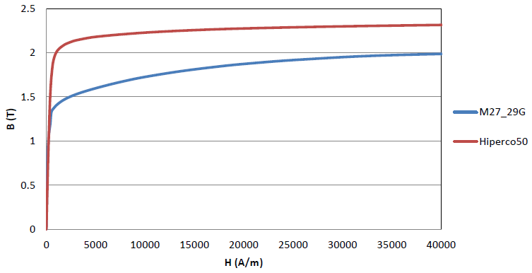
Figure 5.3 Magnetisation curves of M27_29G and Hiperco 50
The Figure 5.4 shows the variation in average torque as a function of current density for machines with the M27 and Hiperco 50 cores, in both cases with the same dimensions as the 296mm baseline design with a split ratio of 0.55. As would be expected, the Hiperco 50 machine produces a higher torque, e.g.~100Nm more at a current density of 7.5A/mm² rms, but still shows the effect of saturation for current densities above 6A/ mm² rms. Although this is a significant improvement in torque capability, for ordinary mass-market automotive applications the Hiperco 50 cores would be nowhere near cost-effective despite this increase in torque capability.
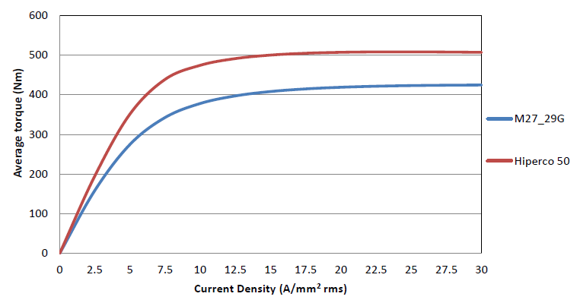
Figure 5.4 Two-dimensional finite element predicted variation in average torque verses current density for baseline FSPM machine (split ratio of 0.55)

Investigation into flux density distributions in the baseline FPSM design

Flux density distributions under open-circuit conditions
Figure 5.5 shows the flux density distribution for the baseline 296mm FSPM machine equipped with M27 Silicon-iron rotor and stator cores under open circuit conditions at one specific rotor angular position. This shows significant regions of the stator teeth are operating at flux densities of 2T and above when the start and rotor teeth are aligned (regions coloured red in accordance with the scale).
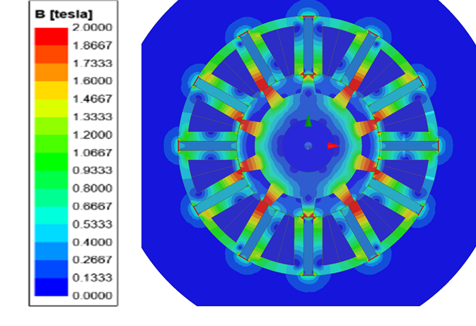
Figure 5.5 Baseline 296mm flux density distribution under open-circuit conditions
Although flux density snapshot such as that shown in Figure 5.5 is useful in highlighting the regions which are most prone to saturation, more detailed information on the behaviour of the FPSMs can be obtained by tracking the time variation of flux density at specific locations.
The flux density variation at 10 locations within the stator core was extracted from time-stepped magneto-static FEA simulations which span on electrical cycle. The 10 sampling locations are shown in Figure 5.6 for both baseline 296mm and global optimised 296mm designs (At current density of 7.5A/mm² rms). At each of these 10 sampling locations, radial (B_{r}) and tangential (B_{t}) flux density components waveforms were extracted from a time stepped series of two-dimensional finite element magneto-static calculations.
A and A’
B and B’
C and C’
D and D’
E and E’
- Baseline 296mm FSPM (split ratio of 0.55)
A and A’
B and B’
C and C’
D and D’
E and E’
- Global optimised 296mm FSPM (split ratio of 0.635)
Figure 5.6 Definition of sampled point locations in machine
Figure 5.7 and Figure 5.8 show the predicted variations in the radial and tangential components of flux density respectively while Figure 5.9 shows the corresponding variation in the net magnitude of the flux density, in all cases for open-circuit conditions. As would be expected, under open-circuit conditions the flux density waveforms for symmetrical locations (e.g. A and A′) exhibit symmetry. It is also worth noting that even under open-circuit conditions, localised flux densities at locations D and D′ are well in excess of 3T. The locations are in the corner of the stator tooth and hence always likey to experience very high flux densities as the rotor tooth starts to overlap or leave the corners of the stator teeth.
Although these high values of flux density at the corners of teeth are interesting and lead to very high localised iron losses, the more important feature in terms of overall torque capability is bulk saturation of the main tooth body (B and B′) and back-iron (A and A′). As shown in Figure 5.9, the peak flux density at location B in the tooth body is 1.36T and only 1.03T at location A. The peak flux density in the main central section of the tooth body occurs at electrical angles of 108°and 252° for the particular angle convention and reference adopted. As would be expected, these angles correspond to a rotor tooth being fully aligned with each of the stator teeth sections as shown in Figure 5.10.
This series of flux density variations demonstrate that under these open-circuit conditions, bulk magnetic saturation of the main central section of the tooth body and back-iron is not signifcant, although saturation is already extreme near the front of the teeth, particularly in the corners.

Figure 5.7 Variation in radial component of flux density (B_{r}) at sampling locations for the baseline 296mm FSPM operating under open-circuit conditions

Figure 5.8 Variation in tangential component of flux density (B_{t}) at sampling locations for the baseline 296mm FSPM operating under open-circuit conditions

Figure 5.9 Variation in the magnitude of flux density at sampling locations for the baseline 296mm FSPM operating under open-circuit conditions

- 108°(elec) (b) 252°(elec)

Figure 5.10 Rotor orientations for maximum flux density in the stator teeth central sections

On-load flux density distributions at the continuous current density rating
For on-load simulations, the phase of the current relative to rotor position has been set to achieve maximum motoring torque and has the relationship with rotor angle shown in Figure 5.11.
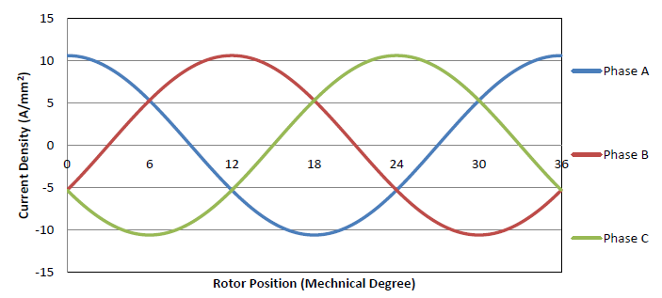
Figure 5.11 Current density waveforms in the three phases as a function of rotor angle
Figure 5.12 to Figure 5.14 shows a similar series of flux density variation but in this case for the baseline 296mm FSPM machine operating in motoring mode and rotating anticlockwise current density equal to 7.5A/mm² rms value. As would be expected, the flux densities near the front of the stator teeth exhibit significant asymmetry over the cycle due to the difference in magnetizing and demagnetizing effects in the leading and trailing tips.

Figure 5.12 Variation in radial component of flux density (Br) at sampling locations for the baseline 296mm FSPM operating in motoring mode with an rms current density of 7.5A/mm²

Figure 5.13 Variation in tangential component of flux density (B_{t}) at sampling locations for the baseline 296mm FSPM operating in motoring mode with an rms current density of 7.5A/mm²

Figure 5.14 Variation in the magnitude of flux density at sampling locations for the baseline 296mm FSPM operating in motoring mode with an rms current density of 7.5A/mm²
Table 5.2 shows a comparison between the peak flux densities under open-circuit and on-load conditions. As will be apparent, the stator currents contribute significant additional flux density, driving all regions into magnetic saturation.

Table 5.2 Comparison of peak magnitudes in the flux density in the baseline design for open-circuit and on-load conditions
Location | Peak magnitude of flux density (T) |  | Ratio of on-load to open-circuit (%)
 | Open-circuit | On-load at 7.5A/mm² rms
A | 1.03 | 1.86 | 181%
A′ | 1.03 | 1.86 | 181%
B | 1.36 | 1.91 | 140%
B′ | 1.36 | 1.90 | 140%
C | 2.62 | 2.81 | 107%
C′ | 2.62 | 2.57 | 98%
D | 3.39 | 3.43 | 101%
D′ | 3.39 | 3.80 | 112%
E | 3.39 | 2.27 | 68%
E′ | 3.39 | 3.60 | 107%

Investigation into flux density distributions in a 296 optimised design
As shown in chapter 4, there is significant scope for improvement in the torque capability of the baseline. Specifically, whereas the baseline 296mm design produces a two-dimensional finite element predicted average torque of 342Nm at a current density of 7.5 A/mm² rms, the design optimised using the Genetic Algorithm is predicted to produce 406Nm at the same current density. In order to establish the extent to which magnetic saturation is a factor in this improvement, the series of on-load calculations reported in section 5.3.2 were repeated for the 296mm optimized design.

Open-circuit flux density distributions in the 296mm GA optimized design

Figure 5.15 to Figure 5.17 show the corresponding flux density variations over one cycle for the genetic algorithm optimised 296mm FSPM machine design under open-circuit conditions. As with the baseline design, there are very high flux densities at certain points in the cycle around the corners of teeth, e.g. locations D and D′ .As might be expected given the higher torque capability of this globally optimized machine, a greater magnitude of flux density in the central section of the stator tooth (point B) with a maximum of 1.52T around 108°. Table 5.3 shows a comparison between the peak values of flux density under open-circuit flux conditions for the baseline and GA optimized 296mm diameter machines. As will be seen, in general the flux densities in the optimized designs are larger except at the very edges of the stator teeth. Since there is no significant difference between D,D’ and E, E’ the E and E’ would not present in the figures and table.

Figure 5.15 Variation in radial component of flux density (B_{r}) at sampling locations for the GA optimised 296mm FSPM operating under open-circuit conditions

Figure 5.16 Variation in tangential component of flux density (B_{t}) at sampling locations for the GA optimised 296mm FSPM operating under open-circuit conditions

Figure 5.17 Variation in the magnitude of flux density at sampling locations for the GA optimised 296mm FSPM operating under open-circuit conditions

Table 5.3 Comparison of peak magnitudes in the flux density between baseline and optimised 296mm diameter designs operating in open-circuit conditions
Location | Peak magnitude of flux density (T) |  | Ratio of optimized to baseline (%)
 | Baseline design | Optimised design
A | 1.03 | 1.11 | 108%
A′ | 1.03 | 1.11 | 108%
B | 1.36 | 1.57 | 115%
B′ | 1.36 | 1.57 | 115%
C | 2.62 | 2.54 | 97%
C′ | 2.62 | 2.44 | 93%
D | 3.39 | 2.93 | 86%
D′ | 3.39 | 3.11 | 92%

On-load flux density distributions in the 296mm GA optimized design
Figure 5.18 to Figure 5.20 show the flux density variations at the corresponding 10 locations for the optimized 296mm design. As would be expected given the similarity between the baseline and optimized design, there are also several regions near the fronts of the tooth tips of very high localised flux densities, e.g. regions D’ and E’. Table 5.4 shows a comparison between the maximum flux densities over the electrical cycle in the baseline and optimised designs. The important regions in terms of bulk flux density and the impact on torque is the main tooth body (regions B and B′) and the core back (A and A′). As shown in Table 5.4, the flux density in the core back is 6% lower in the optimised design than in the baseline machine. The most notable difference is at point D which is right in the corner of the tips. The results in Table 5.4 suggest that the improvement in torque density of the optimised design is not solely down to better management of magnetic saturation, but is more likely a consequence of the increased split ratio as discussed in chapter 3.

Figure 5.18 Variation in radial component of flux density (Br) at sampling locations for the GA optimised 296mm FSPM design operating in motoring mode with an rms current density of 7.5A/mm2

Figure 5.19 Variation in tangential component of flux density (Bt) at sampling locations for the GA optimised 296mm FSPM design operating in motoring mode with an rms current density of 7.5A/mm2

Figure 5.20 Variation in the magnitude of flux density at sampling locations for the GA optimised 296mm FSPM design operating in motoring mode with an rms current density of 7.5A/mm²

Table 5.4 Comparison of peak magnitudes in the flux density between baseline and optimised 296mm diameter designs operating on-load at 7.5A/mm² rms
Location | Peak magnitude of flux density (T) |  | Ratio of optimized to baseline (%)
 | Baseline design | Optimised design
A | 1.86 | 1.75 | 94%
A′ | 1.86 | 1.75 | 94%
B | 1.91 | 1.90 | 99%
B′ | 1.90 | 1.84 | 97%
C | 2.81 | 2.67 | 95%
C′ | 2.57 | 2.72 | 106%
D | 3.43 | 2.17 | 63%
D′ | 3.80 | 3.71 | 98%
E | 2.27 | 2.38 | 105%
E′ | 3.60 | 3.49 | 97%

Investigation in flux density distributions in the 150mm baseline and GA optimised designs
The scaling study in chapter 3 suggested that magnetic saturation was a more significant issue in large machines, at least in terms of the contribution from the stator currents. To investigate this further, the same process of tracking flux density at the key points defined in Figure 5.6 was undertaken for both the 150mm diameter design (which was derived from simple scaling of the 296mm baseline with a fixed airgap) and the optimised 150mm diameter design.

Open-circuit flux density variations
The variations in the magnitude of the flux density at the 10 key points over 1 cycle for both the 150mm baseline and GA optimised designs under open-circuit conditions are shown in Figure 5.21 and Figure 5.22 respectively. As will be apparent, the flux density levels under open-circuit conditions are lower than the corresponding values for the 296mm machines, but are still well into saturation at some points in the cycle near the front of the teeth.

Figure 5.21 Variation in the magnitude of flux density at defined sampling locations for the baseline 150mm diameter FSPM machine operating under open-circuit conditions

Figure 5.22 Variation in the magnitude of flux density at defined sampling locations for the GA optimised 150mm diameter FSPM machine operating under open-circuit conditions

Table 5.5 shows a comparison between the 296mm and 150mm designs for the baseline designs. As shown, the main difference is in the tooth body region which in part reflects the fixed airgap which given that the other parameters are scaled tends to reduce the airgap flux. It is interesting to note that the peak flux density in the back iron is much closer in value. The difference in behaviour with scaling between the main tooth body and the core back illustrates the complex nature of the flux paths in FSPMs and why simple uniform dimensioning of the stator based on a single dominant flux path has limitations in this type of machine.

Table 5.5 Comparison of peak values of open-circuit flux densities between 296mm baseline designs
Location | Peak magnitude of flux density (T) |  | Ratio of 150mm to 296mm (%)
 | 296mm baseline | 150mm baseline
A | 1.03 | 0.98 | 95%
A′ | 1.03 | 0.98 | 95%
B | 1.36 | 0.99 | 73%
B′ | 1.36 | 0.99 | 73%
C | 2.62 | 2.33 | 89%
C′ | 2.62 | 2.33 | 89%
D | 3.39 | 2.85 | 84%
D′ | 3.39 | 2.70 | 80%

On-load flux density distributions
Finite-element simulations were performed the 150mm baseline and GA optimised design in motoring mode with a current density of 7.5A/mm² rms, again with the phase of the current set for maximum torque as shown previously in Figure 5.11. The predicted variations in flux density are shown in Figure 5.23 and Figure 5.24.
Figure 5.23 Variation in the magnitude of flux density at sampling locations for the 150mm baseline FSPM design operating in motoring mode with an rms current density of 7.5A/mm2

Figure 5.24 Variation in the magnitude of flux density at sampling locations for the 150mm baseline FSPM design operating in motoring mode with an rms current density of 7.5A/mm2
A summary of the on-load peak flux densities is shown in Table 5.6. As will apparent, the difference in flux densities is much greater than in corresponding open-circuit values, which demonstrates the much greater contribution to the overall flux level in the machine from the stator current in the larger 296mm, with bulk regions of the stator core (A, A′, B, B′) being driven well into magnetic saturation.
Table 5.6 Comparison of peak values of on-load flux densities between 296mm baseline and GA optimised designs at a current density of 7.5A/mm² rms
Location | Peak magnitude of flux density (T) |  | Ratio of 150mm to 296mm (%)
 | 296mm optimised | 150mm optimised
A | 1.75 | 1.29 | 74%
A′ | 1.75 | 1.29 | 74%
B | 1.90 | 1.08 | 57%
B′ | 1.84 | 1.08 | 59%
C | 2.67 | 2.36 | 88%
C′ | 2.72 | 2.36 | 87%
D | 2.17 | 2.13 | 98%
D′ | 3.71 | 2.43 | 65%
E | 2.38 | 2.27 | 95%
E′ | 3.49 | 3.04 | 87%

Investigation of design features to alleviate saturation
The detailed insight into the flux density variations with the stator core presented in the last section provide some indications of changes in dimensions and geometry within the core that might reduce magnetic saturation. It is important to recognise that it is increased torque that is important rather than reduced saturation in itself, although reducing the flux density in the core will be beneficial in terms of reduced core loss.

Symmetrical modifications to baseline design to manage magnetic saturation
As seen in the previous section, the key location is terms of magnetic saturation in the main tooth body region. A series of minor modifications shown in Figure 5.25 were made to this region in the 296mm baseline design in order to investigate the scope to reduce the effects of magnetic saturation. The first modification, which is shown in Figure 5.25(a) involves introducing a 0.5mm gap half-way along the tooth to reduce the flux from the back of the magnet. The modification in Figure 5.25(b) involves a small reduction in the radial width of the magnet by introducing a small gap at the outer edge of the magnet. The cases in (c) and (d) involve a simple reduction in the magnet thickness with a corresponding increase in the total width of the core teeth on either side, i.e. the overall width of the entire tooth structure is kept the same as the baseline design. The final two cases in (e) and (f) involve a tapering of the magnet from the outer edge to the inner edge, in order to increase the width of the stator core near the airgap while maintaining the magnet thickness at the outer edge.
The resulting two-dimensional finite element predicted torque waveforms for each of these modifications over one electrical cycle at 2,000rpm is shown in Figure 5.26 while a summary is shown in Table 5.7.
- 0.5mm gap introduced into tooth body | (b) 5% decrease in radial width of magnet
 | 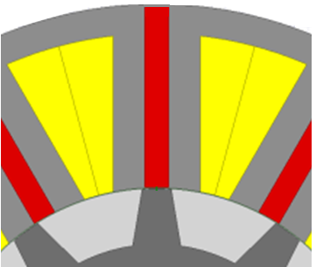
(c) Reduced magnet thickness by 10% | (d) Reduced magnet thickness by 20%
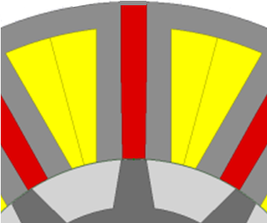 | 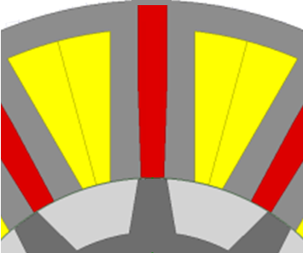
(e) Tapered 10% from outer edge to airgap | (f) Tapered 20% from outer edge to airgap
Figure 5.25 Variations to stator core tooth and magnet geometry

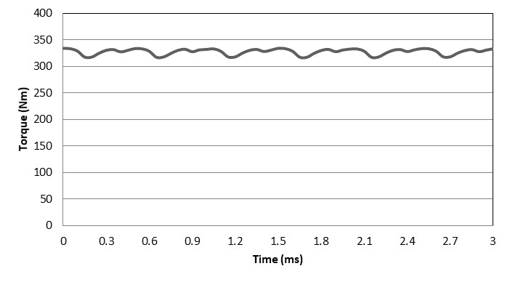 | 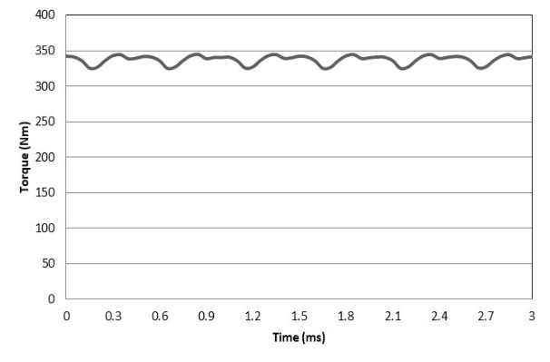
- 0.5mm gap introduced into tooth body | (b) 5% decrease in radial width of magnet
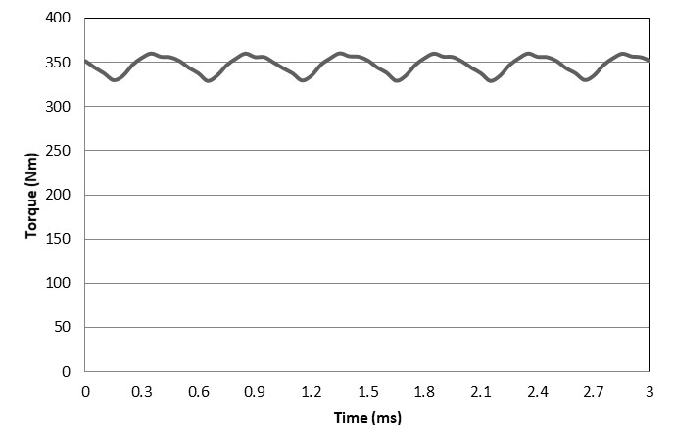 | 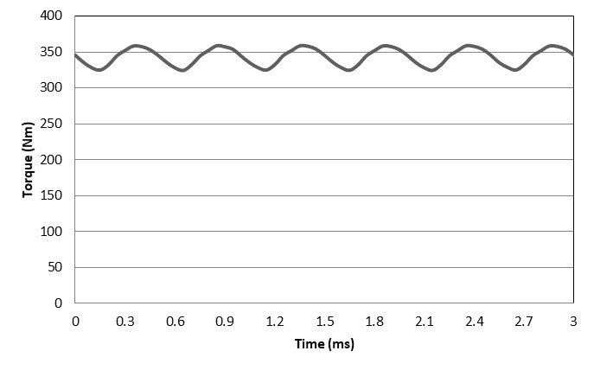
(c) Reduced magnet thickness by 10% | (d) Reduced magnet thickness by 20%
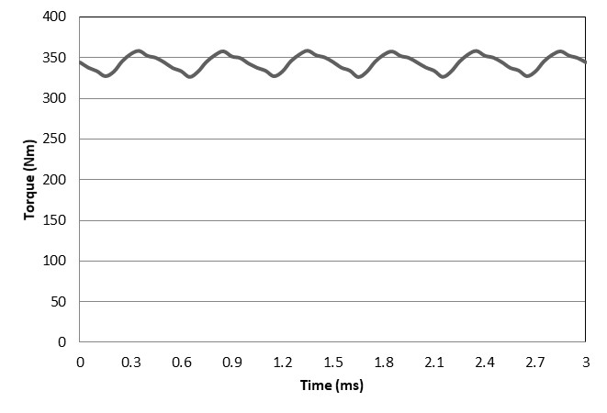 | 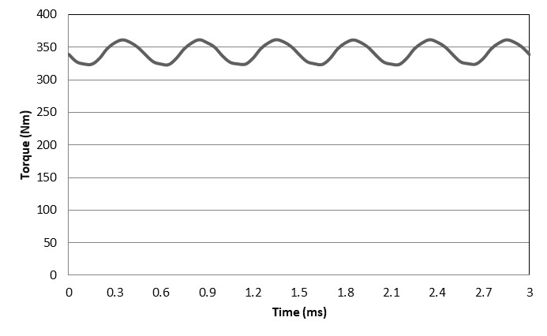
(e) Tapered 10% from outer edge to airgap | (f) Tapered 20% from outer edge to airgap
Figure 5.26 Two-dimensional finite element predicted torque waveforms over one electrical cycle at 2,000rpm for a stator current density of 7.5A/mm² (all plotted to the same 0-400Nm scale)

Table 5.7 Summary of finite element predicted torques
 | Feature | Average torque (Nm) at a current density of 7.5 A/mm² rms | Peak-to-peak torque ripple (Nm)
 | Baseline design | 342 | 22
(a) | 0.5mm gap introduced into tooth body | 327 | 16
(b) | 5% decrease in radial width of magnet | 337 | 19
(c) | Reduced magnet thickness by 10% | 347 | 30
(d) | Reduced magnet thickness by 20% | 343 | 35
(e) | Tapered 10% from outer edge to airgap | 343 | 31
(f) | Tapered 20% from outer edge to airgap | 341 | 39
As shown, the improvements in average torque from these various modifications are small, with the highest increase in torque being 347Nm in the case of modification (c). It also apparent from Table 5.7 that the machines with thinner magnets produce almost the same torque at the rated current density as the baseline but with a reduced magnet volume. However, the modified designs do not maintain the same performance as the baseline when the current is increased as shown in Table 5.8.

Table 5.8 Influence of current density on torque competitiveness of modifications (c) and (d)
 | Average torque at 7.5 A/mm2 rms (Nm) | Average torque at 10 A/mm² rms (Nm) | Average torque at 15A/mm² rms (Nm)
Baseline | 342 | 378 | 408
Modification (c) | 347 | 376 | 398
Modification (d) | 343 | 367 | 381
Table 5.20 also shows that there is no benefit in tapering the magnets and since this would introduce additional manufacturing costs, this does not appear to be an useful modification in this case.

Asymmetrical modifications to manage magnetic saturation
The various modifications in Figure 5.25 are symmetrical in the tooth regions on either side of the magnet. However, when a machine is rotating in a particular direction and in either motoring mode or generating mode, there is an asymmetry between the leading and edge and the trailing edge due to the phase difference between the coil flux and the magnet flux. This was evident in the flux density variations taken at key points within the stator where pairs of points located symmetrically within the stator have different peak Figure 5.27 flux densities.
In some applications which only require one-quadrant operation, e.g., only clockwise rotation and only in motoring mode, there may be scope to modify the tooth asymmetrically to manage saturation. This would not be advisable in a machine required to operate as both a motor and a generator during a driving cycle or is required to provide reversing capability as any benefit in one quadrant would be balanced by a penalty in another. However, if the ratings in the four quadrants were very different then there may be some scope to introduce some asymmetry into the stator teeth.

Figure 5.27 shows four asymmetric arrangements in which the width of the stator tooth bodies are narrowed by 1mm or 2mm and on either sides of the magnet. The resulting torque waveforms for these four modifications are shown in
Figure 5.28 while Table 5.9 summarises the predicted average torque at a current density of 7.5 A/mm² rms for the various modifications. As will be apparent from Table 5.9, although there is some variation in the average torque and the various modifications are made, the increase in average torque compared to the baseline 296mm FSPM machine are relatively small, with the highest value achieved being 347Nm compared to the baseline machine value of 342 Nm average torque, i.e. an increase of ~1%. It is interesting to note that there is no significant benefit from introducing asymmetry in the machine.
 | 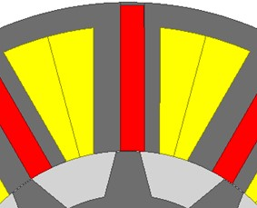
(a) +1mm on trailing tooth; -1mm on leading tooth | (b) +2mm on trailing tooth; -2mm on leading tooth
 | 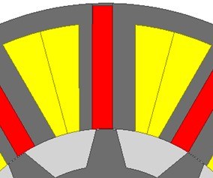
(c) -1mm on trailing tooth; +1mm on leading tooth | (c) -2mm on trailing tooth; +2mm on leading tooth
Figure 5.27 Close-ups of stator showing various asymmetric tooth geometries (definition of leading and trailing based on anti-clockwise rotation)
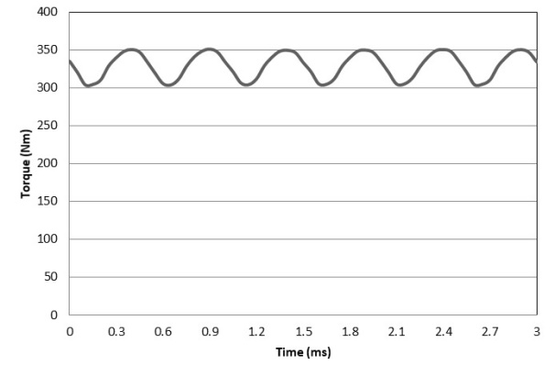 | 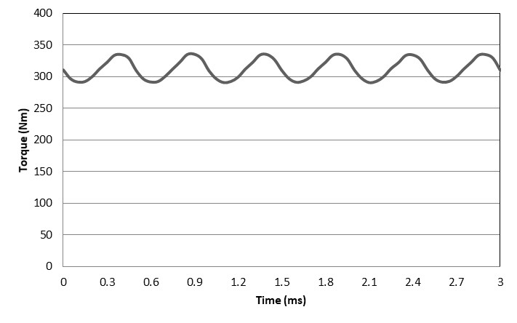
(a) +1mm on trailing tooth; -1mm on leading tooth | (b) +2mm on trailing tooth; -2mm on leading tooth
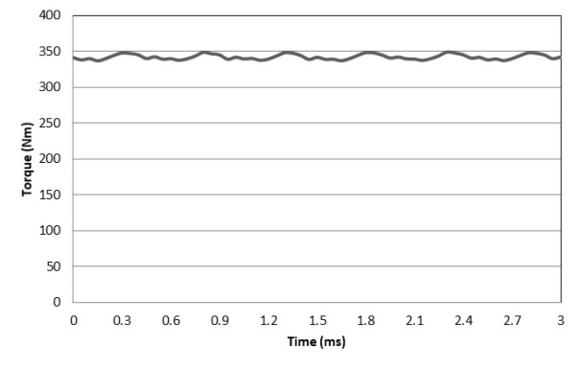 | 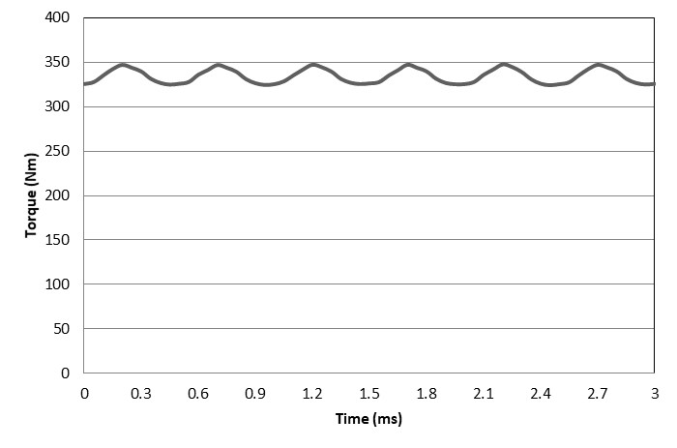
(c) -1mm on trailing tooth; +1mm on leading tooth | (c) -2mm on trailing tooth; +2mm on leading tooth

Figure 5.28 Two-dimensional finite element predicted torque waveforms for different asymmetric tooth geometries (definition of leading and trailing based on anti-clockwise rotation)

Table 5.9 Summary of the influence of various design changes on average torque at a current density of 7.5A/mm² rms
Geometry | Figure showing geometry | Average Torque (Nm)
Baseline design | Figure 5.6a | 342
Gaps in stator | Figure 5.37a | 327.6
Height reduced 5% | Figure 5.37b | 337.2
Magnet Thickness reduced 10% | Figure 5.37c | 347.0
Magnet Thickness reduced 20% | Figure 5.37d | 343.2
Tapered magnet 10% | Figure 5.37e | 343.5
Tapered magnet 20% | Figure 5.37f | 341.8
Asymmetry with +1mm on trailing tooth; -1mm on leading tooth | Figure 5.39a | 329.4
Asymmetry with +2mm on trailing tooth; -2mm on leading tooth | Figure 5.39b | 312.6
Asymmetry with -1mm on trailing tooth; +1mm on leading tooth | Figure 5.39c | 342.7
Asymmetry with -2mm on trailing tooth; +2mm on leading tooth | Figure 5.39d | 334.7

Conclusion
This chapter investigated the flux density distributions and magnetic saturation in several machine spanning both baseline and optimized designs of both 150mm and 296mm. It more concerned with a detailed investigation into the flux density distributions. It was shown that FSPMs are particularly prone to magnetic saturation in both the leading edge of the teeth where the magnetic saturation is extreme and in the bulk regions. The tooth tips of both machine sizes, exhibit often extreme levels of magnetic saturation with predictions of flux density at very corners of >3T, particularly in 296mm machine. It is however important to note that some caution needs to be used when interpreting the exact values around sharp corners in finite element meshes as the spatial gradient of the field can be very steep and even a fine mesh can lead to some averaging effects. It is also well known that edge effects from lamination cutting can degrade the magnetic properties at the edge. Hence, although these very high flux densities inevitably attract significant interest, from the point of torque capability, the flux density levels away from the corners, i.e. bulk saturation effects, are likely to be more important. In the case of the larger machine diameter of 296mm, there was saturation even under open-circuit conditions which is consistent with torque versus current densities characteristics from earlier chapters in which the linearity of the torque versus current characteristics starts to fall away even at low current densities. A series of modifications to the stator geometry were examined and none produced any meaningful improvement in torque capability which shows the challenges in larger FSPMs of managing magnetic saturation.

Chapter 6 - A study into FSPMs comprising multiple stacked single-phase modules

Introduction
Chapter 5 has demonstrated the complex flux density waveforms in standard three-phase FSPMs and the complex flux paths involved. This chapter is concerned with a study into the performance of a machine which is made from a stack of single-phase FSPM modules, with a focus on establishing whether the effects of magnetic saturation caused by multi-phase operation can be reduced in equivalent single-phase modules.

Single-phase permanent magnet machines are widely used in low cost and low power applications and generally produce lower torque than an equivalent sized three-phase machine [91] and [92]. However, conventional single-phase machines only produce torque from one phase. In the machine investigated in this chapter, the overall machine consists of a series of single-phase modules (each of which has its own stator and rotor). Each of the single-phase modules in the machine would be displaced is angle to produce continuous and near smooth torque.

Analysis of baseline 296mm stator diameter single-phase module

Baseline machine specification

The starting point for the analysis is a single phase FSPM machine which has the same 12 slot stator geometry and dimensions as the baseline 3-phase design but with a 12-pole rotor. To provide a direct comparison between the average torque capabilities of a 12/12 single phase module with the more conventional 3-phase 12/10 baseline, the calculated torque in this section is reported for the same 100mm stack. In practice, the axial length of each single-phase module would be reduced as the number of modules is increased, e.g. 33.3mm axial length for 3 modules etc. A cross-section through the baseline single-phase module is shown in Figure 6.1 while the main dimensions are summarised in Table 6.1.

Figure 6.1 Cross-section through 296mm diameter single phase FSPM 12-slot/12-pole module

Table 6.1 Dimensions of baseline single-phase module of Figure 6.1

Parameter | Design data
Stator outer diameter, D_{si} (mm) | 296
Split-ratio | 0.55
Airgap length, g (mm) | 0.5
Rotor pole number | 12
Stator tooth height, h_{st} (mm) | 10.6
Rotor pole height, h_{pr} (mm) | 20
PM width, h_{pm} (mm) | 10.6
Stator york thickness, h_{ys} (mm) | 10.6
Active stack length, L_{a} (mm) for FE comparison | 100

Calculation of open-circuit cogging torque

The selection of the same slot and rotor pole number in a single-phase module will inevitably lead to a very large cogging torque which could be a significant factor in determining the ripple torque even when contributions from other displaced single-phase modules are added in. Figure 6.2 shows the two-dimensional finite element predicted cogging torque waveform of the 100mm long baseline single phase FSPM module. As would be expected, the net torque is zero over one cycle but includes large peaks of ~400Nm which is comparable to the average torque capability of the baseline 3-phase machine.

Figure 6.2 Two-dimensional finite element predicted open-circuit cogging torque waveform for a 100mm long section of a 296mm stator diameter single-phase FSPM module

Calculation of torque at rated current density of 7.5A/mm² rms

The two-dimensional finite element predicted torque waveform for the baseline single-phase module at rated current density of 7.5 A/mm² rms is shown in Figure 6.3. This clearly includes a significant contribution from the cogging torque and the fact that the excitation torque in a symmetrical single-phase machine will fall to zero twice during an electrical cycle. As shown, the waveform includes a short interval of braking torque (between 4º and 11.5º) and several instances of zero torque. Clearly a machine with this variation in torque over one electrical would not be a usable machine for most applications as it could not guarantee self-starting capability and would result in very large torque ripple. It is interesting that the average predicted torque for this machine is 389Nm which is 49Nm higher than the corresponding 3-phase machine of the same core axial length.

Figure 6.3 Two-dimensional finite element predicted torque waveform single phase module at 7.5A/mm2 for a 100mm long section of a 296mm stator diameter single-phase FSPM module

Integration into a multiple module machine

As noted in the introduction section, the machine concept proposed in this chapter is based on stacking up a series of single-phase modules with an angular shift between modules and time phase shifting of the currents in each module to smooth out the torque waveform. Since the modules are magnetically coupled to each other the net torque produced any combination of module numbers and phase shift can be done by simply scaling the waveform of Figure 6.3 to a specific axial length and summing phase-shifted versions of the waveform. As an example,
Figure 6.4 shows the individual phase-shifted torque waveforms for each phase in 3, 4, 5 and 6 phase machines in which the module stators are mechanically shifted and fed with appropriately phase displaced sinusoidal currents.

From an average torque perspective, all these multiple phase machines were calculated from the 100mm stacked length 296mm single phase FSPM machine and divided by number of phase. Therefore, the average torque is the same at 389Nm. However, these machine has huge different on the torque ripples due its add up by several individual machines as mentioned above.

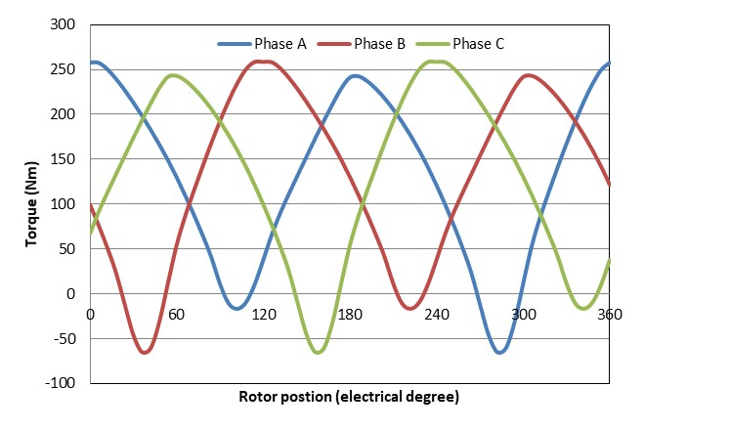 | 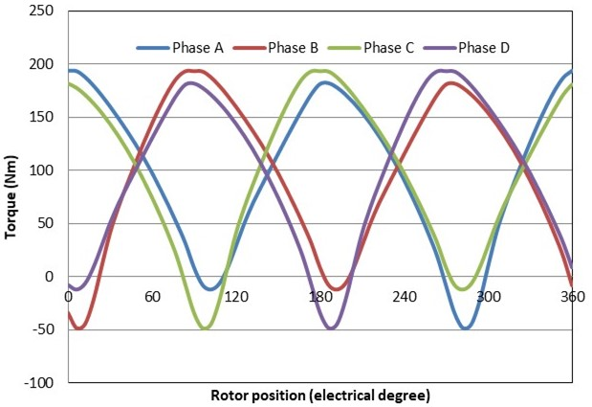
- Three-phase | - Four-phase
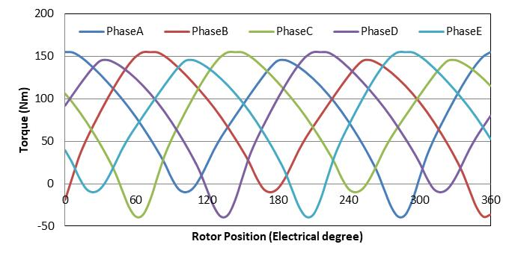 | 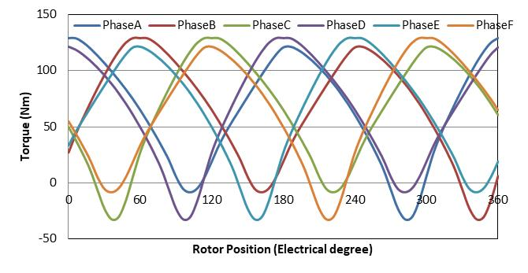
(c) Five-phase | (d) Six-phase

Figure 6.4 Individual torque waveforms for different module numbers (all scaled for an overall machine axial length of 100mm)

The net torque waveform produced by machines made up of different number of modules for a total machine active axial length of 100mm are shown together in Figure 6.5. As would be expected given the mechanical superposition approach adopted and the reliance on two-dimensional finite element analysis, all these combinations produced the same average torque of 388Nm, but with different levels of ripple torque as summarised in Table 6.2. As shown in Table 6.2, all these multi-module machines are effective in significantly reducing the torque ripple and although a 5 module machine achieves the lowest torque peak to peal ripple of 41Nm (10.6% of the average torque) all of these combinations have levels of torque ripple that would be acceptable for many applications where this was not a critical part of the performance specification.

Figure 6.5 Two-dimensional finite element predicted net torque waveforms for different phase numbers

Table 6.2 Two-dimensional finite element predicted ripple torque for different number of modules
Number of single-phase modules | 3 | 4 | 5 | 6
Peak-to-peak torque ripple | 133Nm | 148Nm | 41Nm | 88Nm

Assessment of over-load capability
One motivation for considering a machine made up of single-phase modules is the potential to reduce the sensitivity to magnetic saturation. The various 296mm stator diameter machines made up of single phase modules produce an average torque of 389Nm at the rated continuous current density of 7.5A/mm² rms compared to 340Nm for the corresponding baseline conventional 3-phase machine. In order to establish whether this enhanced torque capability further improves at higher current densities, the average torque for a 100mm long single-phase machine was predicted using two-dimensional finite element analysis for a range of rms current densities up to 30A/mm² rms. Figure 6.6 shows the resulting predicted variation in torque up to 30A/mm2 rms while Table 6.3 shows a summary of torque capability at some key operating points. It is clear from Table 6.3 that for an overall active length of 100mm, the single phase based machine offer a significant improvement in torque capability and that this torque benefit increases at higher current density. For example the increase in torque at 7.5A/mm² rms is 14% which increases to 10.6% at 30A/mm² rms.
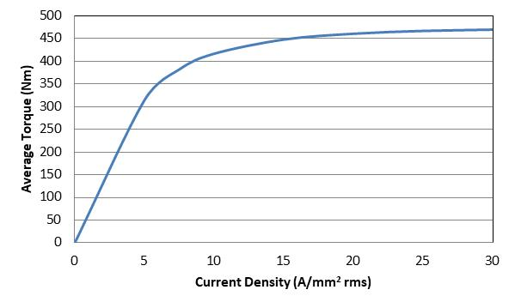
Figure 6.6 Two-dimensional finite element predicted average torque for a 100mm long single-phase 12/12 FSPM module based on the baseline 12 slot stator as function of rms current density

Table 6.3 Comparison of over-load capability of the baseline conventional 3-phase machines with its multiple single-phase counterparts

 | Average torque at 7.5A/mm2 rms | Average torque at 15A/mm² rms | Average torque at 30A/mm² rms
Conventional 3-phase baseline machine | 340Nm | 408Nm | 425Nm
Single phase stacked machine | 389Nm | 455Nm | 470Nm

Global optimisation of single-phase module

Although the comparison between the baseline machines indicates that a machine made up from single-phase modules offers a useful advantage in terms of torque capability for the same active length, it was shown in chapter 4 that the baseline machine design was far from optimal in terms of torque capability within the overall 296mm diameter and 100mm axial length. It was shown in chapter 4 that a global optimisation of the baseline 3-phase machine using a Genetic Algorithm resulted in an increase in torque from 340Nm to 406Nm which can be taken as a more robust indicator of the torque capability of a conventional FSPM 3-phase machine for this current density specification.
In order to provide a similar indicator of the torque capability for a single-phase module, a series of global optimisations was performed with the Genetic Algorithm feature within ANSYS at different levels of current density for a single-phase 12/12 machine. As was the case with earlier optimisations, the maximum average torque was adopted as the optimisation objective and setting parameter with reasonable range (For example, the split ratio range from 0.4-0.8). Separate global optimal designs were established for the rated current of 7.5A/mm² rms and for twice and four times this current rating, i.e. 15A/mm² rms and 30A/mm² rms. The dimensions of these various optimised designs established for different current density operating points are summarised in Table 6.4 while Figure 6.7 shows cross-sections through the various designs.
The performance predictions in Table 6.4 show a similar trend as the chapter 4, the best optimised machine at 30A/mm² rms current density would produce a lower average torque at the rated current density of 7.5A/mm² rms and present its potential to achieve higher average torque without significant saturation at rated current density.
The increased torque in the single phase machine could do with the teeth aligning at the same time, so the total torque is sum of individual teeth and they placed all in phase. It lead to a higher torque compared with baseline 296mm FSPM machine with the 296mm single phased FSPM machine.
Table 6.4 Summary of global optimisation outcomes

 | 12/12 design based on baseline stator | Global optimisation by Genetic Algorithm for 7.5A/mm² rms | Global optimisation by Genetic Algorithm for 15A/mm² rms | Global optimisation by Genetic Algorithm for 30A/mm² rms
Split Ratio | 0.550 | 0.635 | 0.700 | 0.747
PM thickness (mm) | 10.6 | 11.58 | 13.83 | 15.49
Stator back iron thickness (mm) | 10.6 | 10.58 | 10.58 | 11.31
Rotor tooth outer arc  (º mechanical) | 3.75 | 5.96 | 4.41 | 4.95
Rotor tooth inner arc  (º mechanical) | 8.25 | 9.24 | 7.68 | 7.90
Rotor tooth height (mm) | 20 | 26.85 | 24.47 | 19.94
Calculated average torque at 7.5A/mm² (Nm) | 389 | 447 | 415 | 324
Calculated average torque normalised by baseline torque at 7.5A/mm² rms | 100% | 150% | 107% | 83%
Calculated average torque at 15A/mm² (Nm) | 455 | 541 | 631 | 579
Calculated average torque at 15A/mm² rms normalised by baseline torque at 7.5A/mm² rms | 117% | 139% | 162% | 149%
Calculated average torque at 30A/mm² (Nm) | 470 | 571 | 734 | 771
Calculated average torque at 30A/mm² rms normalised by baseline torque at 7.5A/mm² rms | 121% | 147% | 189% | 198%

(a) Design based on baseline 12/12 stator | (b) Design optimised at 7.5A/mm² rms
(c) Design optimised at 15A/mm² rms | (d) Design optimised at 30A/mm² rms
Figure 6.7 Cross-sections through designs of Table 6.26
The two-dimensional finite element predicted variation in average torque with current density for the four optimised designs is shown in Figure 6.8. As would be expected, these characteristics show that the designs optimised for operation at the higher current densities maintain a linear torque versus current density characteristics to higher current densities.
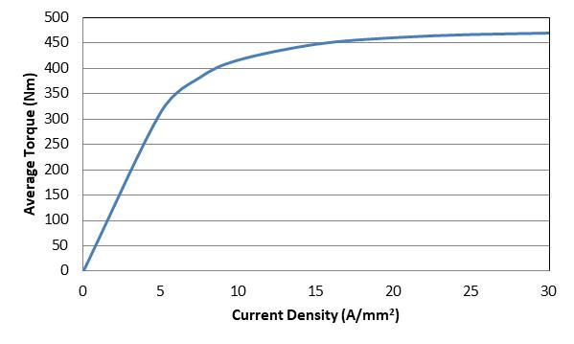 | 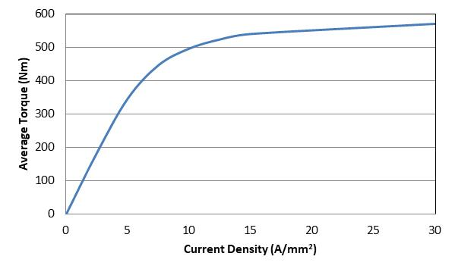
(a) Design based on baseline 12/10 stator | (b) Design optimised at 7.5A/mm² rms
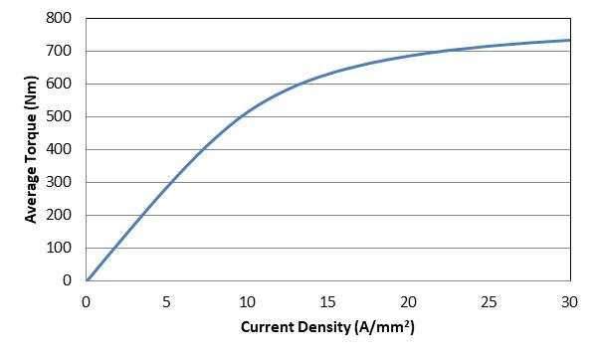 | 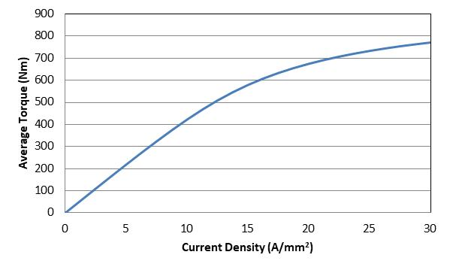
(c) Design optimised at 15A/mm² rms | (d) Design optimised at 30A/mm² rms
Figure 6.8 Two-dimensional finite element predicted torque versus current density for 100mm long sections of the 12/12 baseline single-phase module and a series of optimised designs

Comparison of single-phase and three-phase machines

A summary of the performance single-phase optimal designs and their conventional three-phase counterparts in shown Table ‎6.5. The torque values shown are for the operation at the optimised point only. As demonstrated in this table, for all the combinations shown, the single-phase design has a higher average torque than the equivalent conventional three-phase design, although the advantage drops slowly as the current density is increased. This suggests that single-phase modules have an inherently better torque constant that a three-phase machine of the same active length but that they are not any better in terms of limiting the effects of magnetic saturation.
Table ‎6.5 Comparison of 3-phase and single-phase optimum designs
 | Baseline at 7.5A/mm² rms | Global optimum for 7.5A/mm² rms | Global optimum for 15A/mm² rms | Global optimum for 30A/mm² rms
Average torque for a conventional 3-phase FSPM at optimisation operating point | 340 Nm | 406 Nm | 570Nm | 706 Nm
Average torque for 100mm long single-phase module at optimisation operating point | 389 Nm | 453 Nm | 631 Nm | 771Nm
Ratio of single-phase torque to three-phase torque | 114% | 112% | 111% | 109%
The improvements in torque capability shown in Table ‎6.5 are based on results from two-dimensional finite element analysis which does not include end-effects. As shown previously in chapter 3, end-effect can have a significant influence on the torque capability. Hence, the reductions in torque due to end-effects are likely to be more significant in a machine with a series of stacked single-phase modules than in the corresponding conventional stator.
The impact of end-effects was assessed by performing a three-dimensional, magneto-static finite element simulation of a 12/12 single-phase module in a 296mm diameter machine which is 33.3mm long. The specific design considered was the global optimum design for operation at 7.5A/mm² rms. The three-dimensional model of this single-phase module is shown in Figure ‎6.9. This shows the significant contribution that end-windings make to the overall length of this module. Although the modules could be spaced along the shaft to fit in these end-windings, the overall machine axial length will increase significantly. This model predicted a torque for this 33.3mm long section of 51Nm which compares with 135Nm based on scaling the two-dimensional value of torque which is a 62% decrease. In comparison, the end-effects in a 100mm long, 296mm diameter conventional three-phase machines was shown to be 20% in chapter 3. Hence, as expected, end-effects will have a much more significant impact on single-phase modules.
Figure ‎6.9 Three-dimensional geometry of a 296mm diameter and 33.3mm long 12/12 single-phase FSPM module

Conclusion
This chapter has explored the potential of using multiple single-phase modules on a common shaft to produce multi-phase machines. A 12/12 single-phase module offered a 10-15% increase in average torque compared to the same axial length of a 12/10 three-phase machine for the specific case of a 296mm outer diameter. This comparison was however based on a two-dimensional model. The phase shifting of single-phase modules is very effective in reducing torque ripple, with even three modules producing usable levels of torque ripple at 32% at the rated continuous currents. Although two-dimensional finite element analysis indicated some benefits of single phase modules compared to a three-phase machine, when the increased influence electromagnetic end-effects are taken into account, it is unlikely that the 10-15% improvement in torque which was predicted by two-dimensional analysis would be realised and indeed the single-phase module based machine has a lower torque density than a standard three-phase machine for the particular case of this stator diameter and axial length. Another factor which would reduce the benefits of a machine based on a stack of single-phase modules is the extra mass, axial length and loss from the additional end-winding. For example, a machine based on three single-phase modules will have three times the end-winding mass and loss penalty of an equivalent three-phase machine. In terms of the increased torque related to the increase of pole number and alignment of the stator teeth. The multiple stacked single phase machines do not outperform the single three phase machine since the effects outweigh the benefits.

Chapter 7- Stator permanent magnet eddy current losses

Introduction
Although many topologies of PM machines can have problems with eddy current losses in the magnets, this is a particular concern in FSPM machines because they have stationary magnets embedded in the stator core which are exposed to significant time-varying magnetic fields.
Eddy current losses have been widely studied in machines with magnets on the rotor e.g. IPM and SPM machines [93] - [97]. In these machines eddy current losses are the result of the non-synchronous time and spatial flux density harmonics to which the rotor magnets are exposed. The nature of magnetic field variations in FSPMs is very different to these rotating magnet machines are there are only a few papers that have analysed this issue, particularly in larger machines even though it is recognised as a drawback of FSPMs. This chapter investigates the stator magnet eddy current behaviour of the 296mm global optimised at current density of 7.5A/mm² rms design and the 150mm global optimised at current density of 7.5A/mm² rms design.

Sources of eddy current loss
These magnets will therefore be exposed to time varying magnetic fields due to two contributions:
- Modulation of the magnet working point as the salient rotor passes each stator. This will result in a modulation of the localised flux density within the magnet even under open-circuit conditions..
- Time varying therefore, the magnet eddy current loss should be managed properly in case of overheating and demagnetisation.

Modelling of magnet eddy currents
Since eddy currents induced in the magnets are very dependent on the detailed field distribution in the magnets rather than average flux level, finite element analysis is usually used to calculate eddy current losses. The finite-element calculations used up to this point in the thesis used time-stepped magnetostatic calculations. A series of time-stepped magnetostatic calculation can be used to calculate the localised flux density variations from which eddy currents could be calculated as a post-processing operation, but this would not include the effects of the reaction field produced by the eddy currents. Magnetostatic analysis can be used up to a certain frequency for cases in which the eddy currents are said to be resistance limited [98]. However, it is not always possible to determine if a combination of dimensions and frequencies results in resistance limited eddy currents and so it is more usual to use a magneto-dynamic field solution in which the eddy current contribution is included in the field calculation.
However, a full magneto-dynamic simulation can have a longer solution time as more time steps are need to run the simulation over a longer interval as there is usually some initial transient from the eddy current effect even in simulations with imposed currents.
Two-dimensional finite element calculation of eddy-current will always tend to result in an overestimate of the eddy current magnitudes and hence loss as there are no end effects in which the current is forced to turn around to form a loop within the magnet block. Three-dimensional finite element models are able to model end-effects and will tend to give an improved estimate of loss. In this chapter, both two and three dimensional models are used.

Magnet eddy current loss study of 296mm FSPM machine

Two-dimensional modelling
The first set of simulations were performed on the 296mm stator diameter machine design which was optimised for operation at 7.5A/mm² rms and whose details were shown previously in chapter 4. This simulation used a two-dimensional finite element of the machine running in motoring mode for speeds up to 2000rpm (in 100rpm steps) with at a stator current density of 7.5A/mm² rms. Each simulation was done with 60 time steps spanning 1 electrical cycle. In every case, the torque and magnet eddy current loss were calculated over a full cycle after any initial transients had died down.
Figure 7.1 shows the calculated phase flux-linkage waveforms for both a magneto-static (no eddy current) and magneto-dynamic (with eddy current) simulations. Although the waveforms are very close, there are some small differences which the effect of eddy currents on the net field in the machines. Although there is some contribution to the overall field and hence flux-linkage from the eddy currents this is still small in comparison to the PM and excitation fields, i.e. the eddy current screening or field redistribution effect is small at this frequency.

Figure 7.1 Comparison of phase flux-linkage waveforms with and without magnet eddy currents at 2000rpm and 7.5A/mm² rms for a 296mm stator FSPM
Figure 7.2 shows the predicted torque waveforms for simulation both with and without eddy currents. The average torque of without eddy current effect is ~10Nm higher than with eddy current effects included.

Figure 7.2 Comparison of torque with and without magnet eddy currents at 2000rpm and 7.5A/mm² rms

The eddy current losses can be calculated automatically within the ANSYS Maxwell package by integrating the calculated Joule loss in each magnet segment. At 2000rpm, the total loss in a 12 magnets in this 296mm diameter 100mm long machine is 5936W. This is an unsustainable level of loss from the point of view of temperature rise and in terms of efficiency since it corresponds to ~10% of the output power.
A series of similar simulations for speeds from 100rpm to 2000rpm were used to predict the variation in magnet eddy current loss versus speed characteristic shown in Figure 7.3. As shown, with increasing speed, the eddy current loss increases dramatically almost being proportional to the square of the speed. However, it does fall below a speed squared relationship at the higher frequencies as eddy current re-distribution or skin-effect starts to have an influence.

Figure 7.3 Finite element predicted variation in magnet eddy current loss with speed at 7.5A/mm² rms for the 296mm stator diameter FSPM
The predicted variation in instantaneous eddy current loss over one electrical cycle at 2,000rpm at a current density of 7.5A/mm² rms is shown in Figure 7.4 (a). As shown, the loss varies by ~2kW over the cycle. The Figure 7.4 (b) presents the magnets loss at zero current density and the current induced field is driving the magnet loss in this case as the total magnets eddy current loss is below 2kW would not lead a big problem.

(a)

(b)
Figure 7.4 Two-dimensional finite-element predicted variation in instantaneous eddy current loss at 2,000pm (a) at 7.5A/mm² rms (b) zero current density

Three-dimensional modelling
As shown previously in Figure 7.3, over most much of the speed range, these levels of eddy current loss in the magnet would not be sustainable, but it is well recognised that two-dimensional finite element models over-estimate magnet eddy current loss. Hence, a three-dimensional, magneto-dynamic (with eddy current) time-stepped simulation was performed for the machine operating at its rated current of 7.5A/mm² rms. In the first case considered, each pole had a single 100mm long magnet. The three-dimensional model used to predict the losses typically had 886224 elements and a simulation with 60 time steps covering 7ms of operation took times longer to solve that the same two-dimensional model. Figure 7.5 shows a view of the three-dimensional finite element model used in the simulation
Figure 7.5 Three-dimensional finite-element mesh of 296mm diameter FSPM

As noted previously in chapter 3, three-dimensional finite element modelling results in a significant reduction in the predicted torque compared to two-dimensional models even without accounting for eddy current due to end-effects. To understand any further reductions in torque due to eddy currents, three-dimensional magneto-static and magneto-dynamic simulations were performed for the machine. Figure 7.6 shows a comparison between the three-dimensional calculated torque waveforms both with and without eddy currents. As was the case with the two-dimensional analysis, the reduction in torque is modest.

Figure 7.6 Comparison of torque with and without magnet eddy currents at 2000rpm and 7.5A/mm² rms

Figure 7.7 shows the three-dimensional finite element predicted instantaneous magnet eddy current loss over one electrical cycle for the speed of 2,000 rpm at a current density of 7.5A/mm² rms. As will be apparent, the three-dimensional predicted eddy current loss shows the same periodic ripple with 6 cycles of loss variation per electrical cycle as the two-dimensional value. However, there is much more significant variation within the individual loss cycles. The most significant factor is the reduction in the average loss from 5936W from the two-dimensional model to 2083W for the three-dimensional model.

Figure 7.7 Three-dimensional finite-element predicted variation in instantaneous eddy current loss at 2,000pm and at 7.5A/mm² rms in the 296mm diameter FSPM
Simulations were then performed on rotors equipped with two and then four separate magnets along the axial length. Sub-division of a magnet pole along its length into many pieces is often required for practical manufacturing and cost reasons as producing very large single piece magnets is not common or cost-effective. It is important to note that the separate magnet pieces should be electrically insulated from each other for this sub-division to be effective. Figure 7.8 and Figure 7.9 show the predicted time variations of the magnet eddy current loss for these two magnet axial sub-divisions while Table 7.1 summarises the value of loss calculated for the different magnet arrangements. As expected, even segmentation down to 25mm results in a very significant reduction in loss. Given that 25mm may well the size selected from a mechanical assembly point of view, the resulting loss of 616W is still likely to be excessive for a viable machine in terms of temperature rise and efficiency.

Figure 7.8 Three-dimensional finite-element predicted variation in instantaneous eddy current loss at 2,000pm and at 7.5A/mm2 rms for a rotor with two separate magnet pieces along the length of the machine

Figure 7.9 Three-dimensional finite-element predicted variation in instantaneous eddy current loss at 2,000pm and at 7.5A/mm2 rms for a rotor with four separate magnet pieces along the length of the machine
Table 7.1 Summary of finite element magnet eddy current loss for 296mm diameter design

Model | 2D | 3D single 100mm long magnets per pole | 3D – two 50mm long magnets per pole | 3D- four 25mm long magnets per pole
Total average magnet loss (W) | 5396 | 2083 | 1285 | 616

Magnet eddy current loss study of 150mm optimised FSPM machine

Two-dimensional modelling
A similar series of simulations were performed for the 150mm to determine the influence on machine scale on eddy current loss. Figure 7.10 shows the influence of magnet eddy current in permanent magnets on the phase flux linkage when operating at the rated current density of 7.5A/mm² rms. As was the case in the larger 296mm diameter machine, the effects on the flux-linkage are minimal. Figure 7.11 shows the two-dimensional finite element predicted torque waveforms for the 150mm FSPM machine both with and without eddy currents in the magnets. The average torque of this 150mm FSPM machine design in the absence of eddy currents ~ 1Nm higher than it with eddy currents, which corresponds to a 3.4% difference.

Figure 7.10 Comparison of phase flux-linkage waveforms with and without magnet eddy currents at 2000rpm and 7.5A/mm² rms for a 150mm stator FSPM

Figure 7.11 Comparison of torque waveforms with and without magnet eddy currents at 2000rpm and 7.5A/mm² rms for a 150mm stator FSPM

The variation in magnet eddy current loss with rotor speed at the rated current density of 7.5 A/mm2 rms in this 150mm design is shown in Figure 7.12. As would be expected the total loss is much lower in this smaller machine than the corresponding 296mm, e.g. at 2000rpm in this case, the average eddy current loss in magnets is 96W compared to 5396W in the 296mm for the two-dimensional model. The magnet eddy current loss density in the 150mm and 296mm is 133W/kg and 9.3W/kg respectively, which shows that the large increase in eddy current loss is not simply due to the larger volume of magnet. The larger magnet cross-section and the higher electric loading in the larger machine also contribute to this loss. It is also interesting to note that the two-dimensional magnet eddy current loss in the 150mm diameter machine is 2% of the output power compared to 8% in the 296mm diameter machine.

Figure 7.12 Finite element predicted variation in magnet eddy current loss with speed at 7.5A/mm² rms for the 150mm stator diameter FSPM
The variation in magnet eddy current loss from the two-dimensional finite-element model for the 150mm diameter machine at 2,000rpm and a current density of 7.5A/mm2 rms is shown in Figure 7.13 (a). This simulation shows the last 2 full electrical cycles of duration 6ms which was taken form a simulation of total duration 7ms. The first 1ms was discarded as it contained some evidence of the initial transient in the simulation.

Figure 7.13 Two-dimensional finite element predicted variation in eddy current magnet loss over two electrical cycles for 150mm diameter FSPM at 2,000rpm and at a current density of 7.5A/mm² rms

Three-dimensional modelling
As was the case with the 296mm diameter machine, three-dimensional finite element analysis was used with the 150mm stator diameter design to establish the effect of end-effects and the benefits of making up the axial length from a number of separate magnet pieces. Figure 7.14 shows the three-dimensional finite element predicted variation in the eddy current loss over two electrical cycles for a machine with the 50mm long magnet pole comprising a single-piece magnet. As was the case, with the larger machine, the three-dimensional waveform includes many more harmonics than the two-dimensional variation but with the same underlying 6 peaks per electrical cycle. The average loss of the waveform of Figure 7.14 is 62W compared to 100W from the two-dimensional model. The proposed machine is based on Chapter 4 best optimised machine at current density of 7.5A/mm² rms. This difference of 38% between the two-dimensional and three-dimensional models which is 33% than the corresponding difference in the 296mm diameter stator.

Figure 7.14 Three-dimensional finite-element predicted variation in instantaneous eddy current loss at 2,000pm and at 7.5A/mm² rms in the 150mm diameter FSPM with a single-piece magnet pole

Three-dimensional models were then used to model the effect on splitting the single-piece magnet pole model above into 2 and then 4 pieces. Figure 7.15 and Figure 7.16 show the eddy current loss waveform over 1 electrical cycle for a pole comprising two magnet pieces and four magnets pieces.

Figure 7.15 Three-dimensional finite-element predicted variation in instantaneous eddy current loss at 2,000pm and at 7.5A/mm² rms in the 150mm diameter FSPM with a two-piece magnet pole
A summary of the predicted losses for the 150mm machine is shown in Table 7.2. As was the case with 296mm design, there is a significant benefit in using more magnet pieces to make up a magnet pole.

Figure 7.16 Three-dimensional finite-element predicted variation in instantaneous eddy current loss at 2,000pm and at 7.5A/mm² rms in the 150mm diameter FSPM with a four-piece magnet pole
Table 7.2 Summary of finite element magnet eddy current loss for 150 mm diameter design
Model | 2D | 3D single 50mm long magnets per pole | 3D – two 25mm long magnets per pole | 3D – Four 12.5mm long magnets per pole
Total average magnet loss (W) | 96 | 62 | 33 | 16

Segmenting of magnet cross-section
As well as using several individual magnet pieces along the axial length, it is also possible to segment the magnet in the other directions to reduce the eddy currents. Figure 7.17 shows the six segmentations arrangements that were simulated for the 296mmm diameter baseline design using two-dimensional finite element model. This only allows a relative assessment of the effect of segmentation of magnet cross-section since, as shown previously, there are significant end effects in the z-direction. The average loss predicted from two-dimensional models of these 6 segmentation arrangements are shown in
Table 7.3.
As shown, segmentation in the y-axis direction has limited effect in terms of loss reduction. This is a consequence of the dominant flux to which most of the magnet is exposed (except the region near the airgap) being oriented in the y-direction and hence the induced currents largely flow in the x- and z-directions and hence the insulating gap does not break up the main eddy current path. This is evident from the much bigger reduction when the magnet is divided into 2 pieces in the x-direction. As would be expected, the greater the level of segmentation employed, the greater the reduction in loss, with segmentation in the x-direction being most effective.
(a) Two pieces in y-direction | (b) Two pieces in both x and y directions
(c) Two pieces in x-direction | (d) Four pieces in x-direction
(e) Eight pieces in x-direction | (f)Eight pieces in both x and y directions
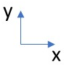
Figure 7.17 Magnet segmentation arrangements

Table 7.3 Summary of the benefits from different magnet segmentation (predicted from two-dimensional finite element analysis)
Segmentation | Average torque (Nm) | Magnet eddy current loss (W)
(a) Two pieces in y-direction | 331.9 | 5921
(b) Two pieces in both x and y directions | 337.2 | 2406
(c) Two pieces in x-direction | 327.3 | 2404
(d) Four pieces in x-direction | 340.6 | 833
(e) Eight pieces in x-direction | 340.5 | 312
(f) Eight pieces in both x and y directions | 339.5 | 775
Unsegmented | 342 | 5936

Conclusion
This chapter has investigated eddy currents in the stator mounted magnets of FSPMs using two-dimensional and three-dimensional finite element models and demonstrated the very significant effect that magnet geometry has on the magnitude of the loss. It dealt with one of the widely recognised drawbacks of moving the PMs to the stator, i.e. exposure of the magnets to localised time-varying flux densities and hence eddy current loss. These time-varying fields are due to a combination of fields produced by the time varying stator currents and the modulation of the localised working point. As would be expected, two-dimensional finite element analysis tends to significantly overestimate magnet losses compared to three-dimensional analysis even with magnet blocks with long axial lengths. For the machines considered, even relatively coarse sub-division of the magnets resulted in a reduction of the loss to manageable levels. It has demonstrated that magnet eddy current loss can become a very significant problem in larger machines and that segmentation of a pole piece into many separate parts may be required to reduce the losses to manageable level.

Chapter 8 – Prototype Design and manufacture

Introduction
In order to provide some validation of the outcomes of the research in the previous chapters, one specific design was selected for manufacture of a prototype. The FSPM design selected was the 12-slot / 10-pole, 150mm outer diameter and 50mm stack length design, specifically the global optimised FSPM design which was optimised using a Genetic Algorithm for operation at 7.5A/mm² rms. This chapter describes the various processes employed to manufacture the prototype, including the design of the winding for connection to a commercial converter.
The manufacture of this machine was severely delayed by COVID-19 lock-down, which affected both the lead-time and delivery of components supplied by external suppliers and especially laboratory and workshop access for manufacture of in-house components, coil winding and assembly. Hence, at the conclusion of this project, some final aspects of the build and all the test procedures remain uncompleted. Despite these challenges, most of the manufacture was completed and some recommendations for future work on testing are described in Chapter 9.

Flux weakening
Motors employed in industrial automation mostly designed to operating within the base speed, i.e., within the constant torque region. In this applications, a simple vector control strategy is arranged, where the abc axis transferred to dq axis. The d-axis is magnets-aligned current component is set to zero, where the q-axis current used to produce torque will increase depending to the torque requirements. However, in modern EVs applications the flux weakening is key factor to allow the machine operate at different speed and more likely to run above the base speed of a motor. The mathematical model of reference frame is given below:
$V_{d}=R_{s}i_{d}-ω_{e}L_{d}i_{q }V_{q}=R_{s}i_{q}+ω_{e}L_{q}i_{d}+ω_{e}φ_{m}$ (8.1)
Where V_{d}, V_{q}, i_{d}, i_{q}, L_{d}, and L_{q} are d-axis and q-axis voltages, currents and inductances, respectively. R_{s,} $ω_{e}$ and $φ_{m}$ are stator resistance, electrical angular velocity of rotor and magnet flux linkage, respectively. The figure 8.1 presents the proposed FSPM machine with torque speed curve with constant torque region that speed below 2000 rpm and set the maximum speed at 10,000 rpm which the field weakening taking place after 2000 rpm and the voltage supply in the lab is 600V. The detailed power factor will be discussed later in this chapter.
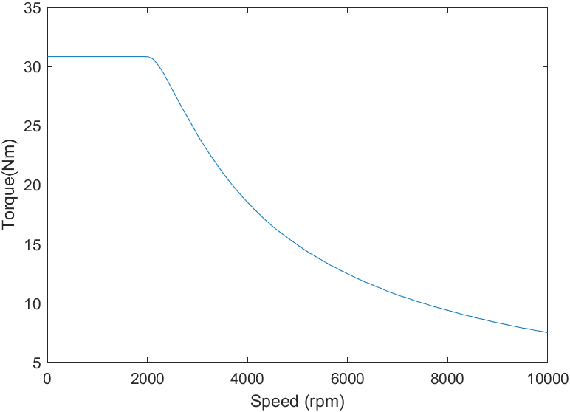
Figure 8.1 Torque speed curve of 150mm global optimised at current density of 7.5A/mm² rms value.

Stator Core and Rotor Core Manufacture
The machine stator core and rotor core were externally manufactured from supplied drawings by an external company (H.V. Wooding Ltd). This stator and rotor cores, which are shown in Figure 8.2 and Figure 8.3 were manufactured by wire electro-discharge machining (EDM) which is also sometimes called wire-erosion. Wire EDM was done on a full 50mm tall stack of laminations that had been bonded before cutting. The laminations used were pre-coated with a Backlack type insulation and consolidated into a single bonded stack through a combination of heat and pressure. The built machine was selected with a 2mm iron bridge at the top of the each magnet close to the outer stator surface, the iron bridge selected according to the manufacture on lamination cutting and 2mm iron bridge FEA results have no major influence on the average torque (less than 1%).
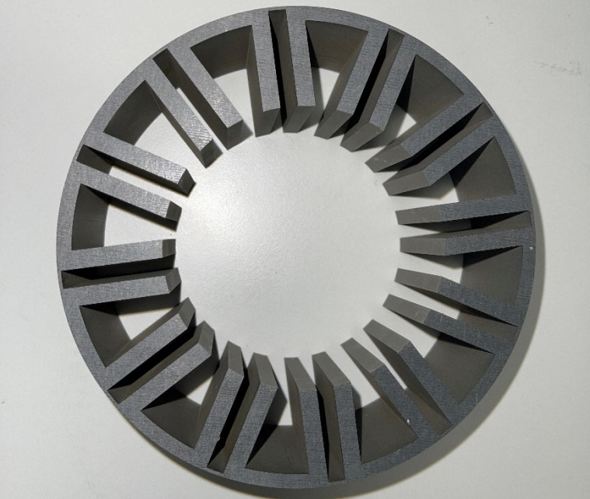
Figure 8.2 Manufactured stator core stack for 150mm diameter GA optimised design
Figure 8.3 Manufactured rotor core stack for 150mm diameter GA optimised design

Permanent magnet manufacture and assembly in stator core
The magnet blocks used in the prototype consisted of 24 rectangular blocks, each 25mm × 29.2mm ×5.4mm, with the 5.4mm dimension being the direction of magnetisation. Each tooth in the stator requires two of the magnet blocks to make up the 50mm axial length of the stator. The magnets were manufactured by slicing and grinding from larger blocks of N35 grade NdFeB and then magnetised by Cermag Ltd. The supplied magnet blocks before incorporation into the stator are shown in Figure 8.4. The white rings are simply plastic foam divider to prevent damage to the magnets during transportation and during handling.

Figure 8.4 Blocks of NdFeB before installation in the prototype FSPM

The magnets individual magnet pieces were manually glued into the stator core and clamped in place while the glues cured. The glue used was Loctite 648 which is a rapid curing and high strength adhesive which cures anaerobically. This was a challenging task as the large attractive forces between the magnet blocks and the core and the attractive and repulsive forces between magnet blocks. Very careful handling of the magnets was required to avoid damage to the magnets from collisions with the core and/or other magnets. Figure 8.5 shows the stator core with the full set of magnets installed, a process that took many hours spread over several days to complete because of the need to clamp individual magnet blocks in place for the glue to cure before inserted adjacent magnets. The two-piece nature of the magnets within a single tooth is clear in Figure 8.5, and in some cases very small residual gaps were present due to tolerancing and the fact the magnets could only be clamped to be lined up with the ends of the core.
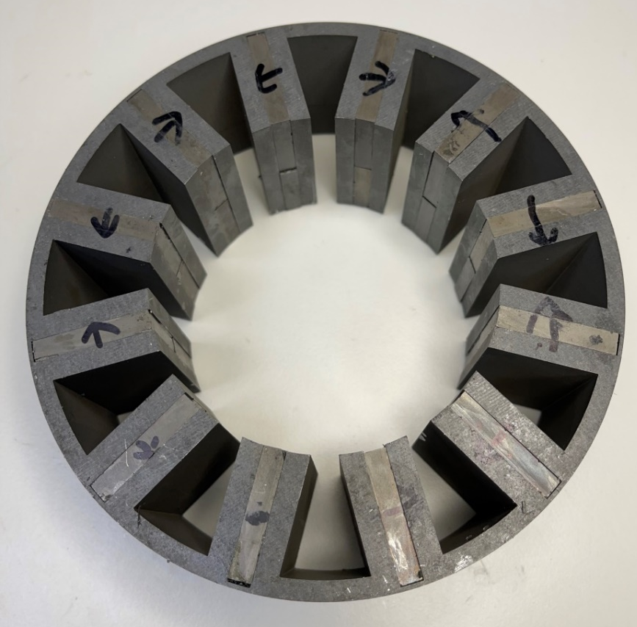
Figure 8.5 Stator core with full set of magnets fitted (arrows indicates the magnetisation direction)

Winding design and manufacture

Winding design
In all the finite element analysis presented up to this point in the thesis, it was not necessary to specify a particular combination of the number of turns and current. The winding in any design was simply modelled as regions with a specified current density scaled to account for a packing factor (with a value of 0.6 adopted in all the analysis). In any practical machine, it is however necessary to produce the specified mmf or total current per slot with a particular combination of number of turns and current to match the supply or converter voltage. Providing the required product of current and number of turns is maintained (often called the ampere-turns) the machine produces the rated torque. The same stator design can be used to produce the rated torque and power for many different supply voltages providing the winding is wound to match the particular voltage being used.
The first stage of the winding design for this machine was to use the finite element results from chapter 4 to calculate the induced voltage per turn at the rated speed of 2000rpm and the inductance per turn for the machine. Figure 8.6 shows the back-emf waveform per turn, which shows a peak phase emf of 10.2V per turn.

Figure 8.6 Back-emf waveform for one phase of the 150mm GA optimised design at 2000rpm for 1 turn per coil
For testing this machine, a commercial converter with a peak line-to-line voltage of 600V was to be used. The output voltage of this converter would correspond to a line to neutral voltage in a star-connected machine of 346V. Matching the back-emf to some proportion of the available voltage provides a starting point for a first estimate of the number of turns, but it is necessary to calculate the influence of the stator impedance and the voltage drop from this impedance using the single-phase phasor diagram shown in Figure 8.7 for the case of no phase difference between the current and back-emf. This condition represents a machine operating in motoring mode with no phase advance or field weakening, which in d-q axis terms corresponds to zero d-axis current.

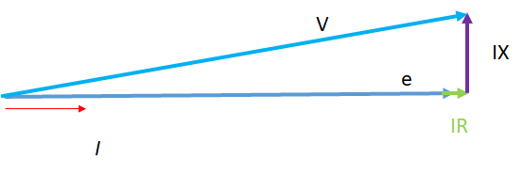
Figure 8.7 Schematic representation of a phasor diagram of one-phase of the FPSM machine

In order to calculate the various voltage drops in the phasor diagram, it is necessary to calculate the q-axis inductance. A finite element simulation was performed with DC currents to calculate the q-axis inductance of 0.50µH per turn. The resistance per turn 0.48mΩ per turn. The values of back-emf per turn, inductance (and hence reactance) per turn and resistance per turn were then used with increasing values of the number of turns (noting that reactance and resistance scale with the square of the number of turns) to establish the number of turns for which the terminal voltage required approaches the available converter voltage.
The number of turns per coil then fixes the current required to meet the overall slot mmf. The area of half a slot into which each individual coil must fit is 170mm². For a packing factor of 0.6, this results in a copper cross-sectional area of 102mm². The rms current density of 7.5A/mm² rms corresponds to a peak current of current density of 10.6 A/mm² and hence the peak mmf per slot is 1081A. Current required in a coil with specified number of turns can hence be calculated. This process resulted in the selection of 30 turns per coil with the final winding parameters shown in Table 8.1 which leaves a small margin.
The power factor of an electrical machine determines its field weakening ability and therefore the overload ability of the proposed electrical machine. The power factor used to describe of an AC power system is defined as the ratio of the real power used by the load to the apparent power flowing inside the circuit and called the ratio of working power. The active power is the useful power that the energy is doing work, and the reactive power is the wasted power or lost power that contributes to any load. The apparent power is the demand power as the product of the RMS values of the voltage and current. The equation below used to calculate the power factor of the three phase machine:
$$PF=\left|cos∅\right|=P_{kW}/\left(3×V_{L-N}×I_{A}\right)$$
Where the PF is power factor, P_{kw} is active power (W), V_{L-N} is the line to neutral voltage (V) and I_{A} is the current (A).
The proposed FSPM machine calculated as the power factor is 0.574 (The active power is 11574W and Line to neutral voltage is 186.7V) which is relative low in this case which lead to a poor field weakening. The proposed FSPM machine is not ideal for the flux weakening operation and not suitable for an EV system traction motor.

Table 8.1 Final winding parameters
Number of series turns per coil | 30
Rated peak current | 36.0 A
Total phase resistance | 0.43Ω
Total phase inductance | 0.45mH
Total phase reactance at 2000rpm | 0.94Ω
Resistive voltage drop per phase at rated current | 15.5V
Peak reactive volts drop per phase at rated current | 33.9V
Back-emf | 306V
Peak terminal voltage required | 323.3V
Fundamental frequency (speed at 2000 rpm) | 333.3Hz
Skin depth of wires (speed at 2000rpm) | 3571µm

Practical winding of the coils

Having selected the number of turns as being 30, the exact configuration of conductors for practical winding the coils needed to be established. In general, it is more difficult to achieve a high packing factor in hand-winding a one-off machine compared to production process using optimised coil winding equipment. The key difference if the ability to control tension on the windings. Despite these challenges, the first attempt at manual winding was aimed at achieving the 0.6 packing factor used in earlier chapters. As noted earlier, the cross-sectional area of 102mm². For 30 turns per coil, this leads to a cross-sectional area per coil of 3.4mm². Although this cross-sectional area could be achieved with a single 2.08mm diameter conductor, this would be far too stiff to winding into such a compact coil and might also have problems with AC losses.
In order to produce a more flexible conductor to wind a coil, it is common use to use several smaller parallel strands to produce the same cross-sectional area. In the first attempt to produce a packing factor, a conductor made up from 8 parallel strands of 0.75mm diameter wire was used. Since commercial wires are produced in standard discrete sizes it is usually not possible to exactly achieve a specific packing factor. For this 8 parallel strand arrangement, 30 turns would result in a packing factor of 0.6. Despite several trails to produce a winding with this packing factor by hand-winding, the full winding could not be fitted within the slot. Hence, for this prototype, it was decided to reduce the packing factor to 0.5 which would require an increase in the current density during testing to reproduce the combination of 7.5 A/mm² rms and a packing factor of 0.6.
The final winding comprise 30 series turns per coil made up of 6 parallel strands of 0.75mm wire. The final winding before follow the shrink fitting of the stator into an Aluminium casing is shown in Figure 8.8. As will be evident, there is some further work in terms of terminating the coils and the fitting of rigid slot wedges required to compress the winding in the slot opening to prevent it from protruding into the airgap and this would form part of future work to complete the build. Figure 8.9 shows the stator casing components before the fitting of the stator.
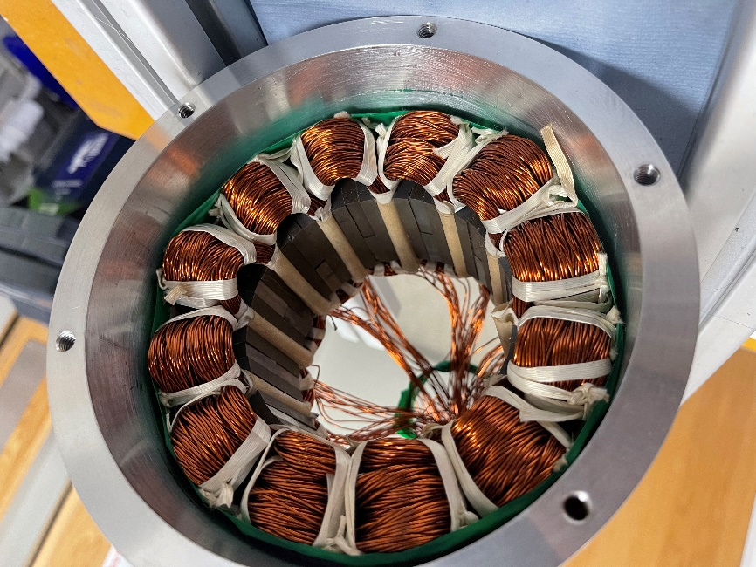
Figure 8.8 Completed winding and stator in Aluminium casing

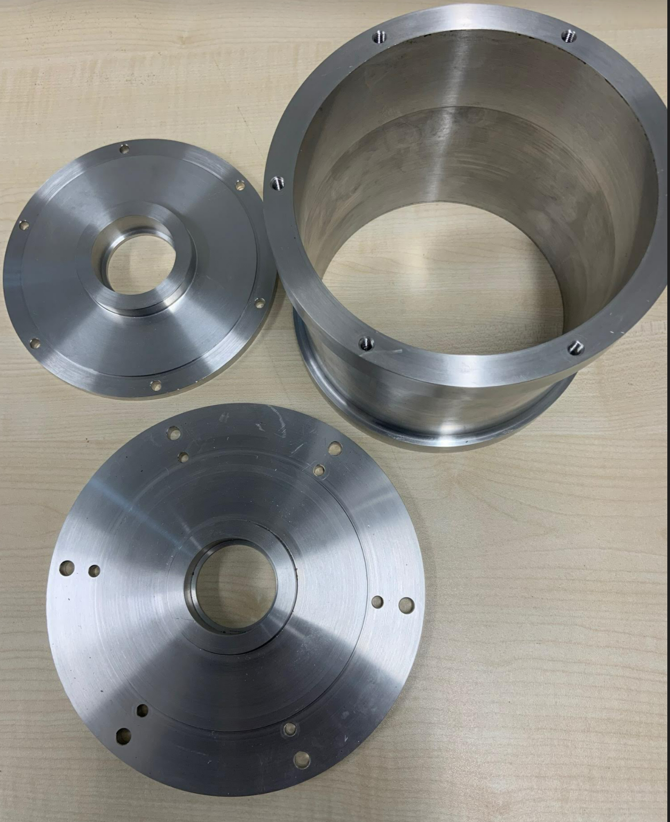
Figure 8.9 Stator casing components

Conclusion
This chapter has described the manufacture of a prototype stator of the GA optimised 150mm design. It detailed the build of the machine within the timeframe of the project and discussed the winding design and the outcome of trials to achieve a packing factor of 0.6. It did not prove possible to achieve this packing factor in the one-off hand-wound prototype and eventually it was necessary to settle on a packing factor of 0.5, and the skin depth of proposed machine is 3.571mm therefore the wire used in design can negligible the AC loss in this case. The power factor is 0.574 which is relative low for application as the EVs and the flux weakening is investigated based on the lab environment of power supply 600V.

Chapter 9 – Conclusion and future works

9.1 Key conclusions from research
This thesis has reported on a study in the several aspects of the torque capability of FSPM machines in the context of a typical automotive application. The literature review identified that although there are numerous published studies on various electromagnetic aspects of performance, almost all existing literature is based on small machines. Various authors have claimed that FSPM machines are competitive with more conventional PM machine topologies such as SMPM and IPM machines. The research in this thesis has considered several of FSPM performance in larger machines with ratings that are more representative of typical commercial EV drive-trains and demonstrated that as the size increases, FSPM becoming increasingly uncompetitive with SMPM and IPM machines and that various optimisation and innovative design features can achieve very little to close this fundamental gap. The main research question that this research set out to answer was whether FSPM machines offer a competitive machine choice for EV traction machines. The various studies in this thesis established the following overall conclusions in this regard. At a typical continuous current density of 7.5A/mm² rms then like-for-like comparison between 296mm diameter SMPM and an FSPM machines (i.e. both baseline designs) resulted in a predicted torque capability from 3D finite element analysis of 440Nm and 252Nm respectively. The gap in torque capability between these machine types narrows slightly in smaller machines, but over the full range of diameters and current densities considered in this thesis, FSPM machines are always inferior to a corresponding SPM machine. This gap in torque capability between these machine types widens with electric loading since FSPM machines are far more prone to magnetic saturation. In general, FSPM machine will tend to contain a larger volume of PM material than an equivalently rated SMPM or IPM, although the use of simple rectangular blocks in an FSPSM may narrow the overall manufacturing cost difference a little. Whereas the main cited advantages of FSPMs remain unchallenged by the findings of this thesis, i.e. more robust rotor and ease of heat extraction from the magnets, the very significant penalty in torque capability is unlikely to make them a preferred in the vast majority of applications unless rotor mechanical strength and/or temperature resistance are major considerations.

9.2 Key contributions and novelties of the research
The main contributions and novelties of this research are the following:
- Addressed the issue of scaling in FSPM machine in a systematic way so as produce well-founded conclusions on the relative torque density of SMPM and FSPM machines for a typical EV specification.
- Demonstrated systematically that FSPM machines have poor overload capability.
- Explored in detail the influence of magnetic saturation in larger FSPM machines that have featured in published studies.
- Evaluated a novel topology of FSPM based on a series of single-phase modules

9.3 Future work
The main unresolved issue at the end of this research was the build and, in particular, the testing of the machine. This would take the existing stator, casing and rotor core and manufacture a shaft. Static torque could be measured in an existing test-rig and then the machine could be connected to an existing dynamometer for dynamic testing.
The research in this thesis has been focussed on torque capability with some consideration of induced magnet loss in chapter 7. However, the flux density waveforms in chapter 5 which contain both high peak values and significant harmonics would likely result in high levels of iron loss. The impact of these losses on the machine and the temperature could further diminish the performance of FSPMs.
The scaling methods should also include with different slot pole combination that would able to scale the machine in fair geometry i.e.- Not direct scale the stator tooth or magnet thickness with increased stator outer diameter. The optimisation of SMPM machine according to its fair comparison along with FSPM machine would be interesting to see the magnet/torque value. The works on field weakening, demagnetisation, efficiency calculation and different operating points for stator mounted PM machine should develop as the further topic. Thermal modelling of FSPMs has received relatively little attention beyond the few published studies discussed in chapter 2 and hence this is a further topic of interest.

References
- Popular Science. 115 (5): 84. November 1929.
- Statista. (2013). Fuel new car market share 2013-2018 | Statista. [online] Available at: https://www.statista.com/statistics/299031/fuel-types-of-new-cars-registered-in-the-united-kingdom/.
- Lu, L.; Han, X.; Li, J.; Hua, J.; Ouyang, M. (2013). "A review on the key issues for lithium-ion battery management in electric vehicles". Journal of Power Sources. 226: 272–288.
- David B. Sandalow ed. (2009). Plug-In Electric Vehicles: What Role for Washington? (1st. ed.). The Brookings Institution. pp. 2–5. ISBN 978-0-8157-0305-1. See definition on pp. 2
- Plug-in Electric vehicles Center for Sustainable Energy, California. Retrieved 2010-03-31.
- Vaughan, Adam (2017-12-25). "Electric and plug-in hybrid cars whiz past 3m mark worldwide". The Guardian. Retrieved 2018-01-20. "The number of fully electric and plug-in hybrid cars on the world's roads passed the 3 million mark in November 2017.
- Cobb, Jeff (2016-08-10). "Global 10 Best-Selling Plug-In Cars Are Accelerating Forward". HybridCars.com. Retrieved 2016-08-13. As of June 2016, cumulative global sales of the top selling plug-in electric cars were led by the Nissan Leaf (over 228,000), followed by the Tesla Model S (129,393), Votl/Ampera family (about 117,300), Mitsubishi Outlander PHEV (about 107,400), Toyota Prius PHV (over 75,400), BYD Qin (56,191), Renault Zoe (51,193), BMW i3 (around 49,500), Mitsubishi i-MiEV family (about 37,600) and BYD Tang (37,509).
- Cobb, Jeff (2016-06-06). "Americans Buy Their Four-Millionth Hybrid Car". HybridCars.com.
- Preston, N. (n.d.). Integration of Hydrogen Technology into Large Scale Industrial Manufacturing in Ontario. [online] Available at: https://uwspace.uwaterloo.ca/bitstream/handle/10012/17863/Preston_Nicholas.pdf?sequence=5&isAllowed=y [Accessed 25 Jan. 2022].
- Irle, R. (2020). EV-Volumes - The Electric Vehicle World Sales Database. [online] www.ev-volumes.com. Available at: https://www.ev-volumes.com/.
- McKinsey&Company (May, 2018). [online] Available at: https://www.mckinsey.com/industries/automotive-and-assembly/our-insights/the-global-electric-vehicle-market-is-amped-up-and-on-the-rise [Accessed 1 Oct. 2018].
- Accenture.com. (2016). [online] Available at: https://www.accenture.com/t00010101T000000__w__/gb-en/_acnmedia/PDF-37/accenture-electric-vehicle-market-attractiveness.pdf [Accessed 1 Oct. 2018].
- Automotive Council UK; Advanced Propulsion Centre UK, “Electric Machines Roadmap 2020,” February 2021. [Online]. Available: https://www.apcuk.co.uk/app/uploads/2021/02/Exec-summary-Technology-Roadmap-Electric-Machines-final.pdf.
- Z. Wang, T. W. Ching, S. Huang, H. Wang and T. Xu, "Challenges Faced by Electric Vehicle Motors and Their Solutions," in IEEE Access, vol. 9, pp. 5228-5249, 2021, doi: 10.1109/ACCESS.2020.3045716
- EV, H., Technologies, M., Technologies, M. and Technologies, M. (2018). McLaren Applied Technologies. [online] Mclaren.com. Available at: https://www.mclaren.com/appliedtechnologies/products/item/e-motor-120kw-130nm/ [Accessed 1 Oct. 2018].
- Markus Schiefer, Martin Doppelbauer, “Indirect Slot Cooling for High-Power-Density machine with Concentrated Winding” #Presentaiton by M. Doppelbauer in Airbus ymposium, Ottobrun, March 11, 2016.
- Bailey, G., Mancheri, N. & Van Acker, K. Sustainability of Permanent Rare Earth Magnet Motors in (H)EV Industry. J. Sustain. Metall. 3, 611–626 (2017). https://doi.org/10.1007/s40831-017-0118-4
- N. Zhao, N. Schofield, Y. Hu, ‘Phase voltage distortion of IPM and SPM machines with distributed windings in field weakening region’, The Journal of Engineering, Volume 2019, Issue 17, p. 3872-3877.
- Y. Uta Nugraha, A. Cahyadi, M.N. Yuniarto, I. Sidharta,'Design optimization for torque density in brushless DC motor with IPM V-type using PSO Method', IOP Conference Series: Materials Science and Engineering, Vol.694, 2019.
- Łebkowski, A. Design, Analysis of the Location and Materials of Neodymium Magnets on the Torque and Power of In-Wheel External Rotor PMSM for Electric Vehicles. Energies 2018, 11, 2293. https://doi.org/10.3390/en11092293
- J. Wang, K. Atallah, R. Chin, W. M. Arshad and H. Lendenmann, "Rotor Eddy-Current Loss in Permanent-Magnet Brushless AC Machines," in IEEE Transactions on Magnetics, vol. 46, no. 7, pp. 2701-2707, July 2010, doi: 10.1109/TMAG.2010.2042963.
- A. Borisavljevic, H. Polinder, and, J. A. Ferreira, “On the speed limits of permanent-magnet machines,” IEEE Trans. Ind. Electron., vol. 57, no. 1, pp. 220-227, 2010.
- M. Chen, W. Hua, J. Zhang and W. Zhao, “Overview of stator-permanent Magnet Brushless Machines,” IEEE Trans. Ind. Electron., vol. 58, no. 11, pp. 5087-5101, 2011.
- S. E. Rauch and L. J. Johnson, “Design principles of flux-switching alternators,” AIEE Trans., vol. 74, no. 3, pp. 1261–1268, Jan. 1955.
- R. P. Deodhar, S. Andersson, I. Boldea, and T. J. E. Miller, “The fluxreversal machine: A new brushless doubly-salient permanent-magnet machine,” in Conf. Rec. IEEE IAS Annu. Meeting, 1996, pp. 786–793.
- Y. Liao, F. Liang, and T. A. Lipo, “A novel permanent magnet machine with doubly salient structure,” in Conf. Rec. IEEE IAS Annu. Meeting, 1992, pp. 308–314.
- Z. Q. Zhu and J. T. Chen, “Advanced flux-switching permanent magnet brushless machines,” IEEE Trans. Magn., vol. 46, no. 6, pp. 1447–1453, Jun. 2010.
- Y. Gao, R. Qu, D. Li, and G. Zhou, “Consequent-Pole Flux-Reversal Permanent-Magnet Machine for Electric Vehicle Propulsion,” IEEE Trans. Ind. Appl., vol.26. no.4, pp. 5200105. June. 2016.
- Prakht, V.; Dmitrievskii, V.; Kazakbaev, V.; Oshurbekov, S.; Ibrahim, M.N. Optimal Design of a Novel Three-Phase High-Speed Flux Reversal Machine. Appl. Sci. 2019, 9, 3822. https://doi.org/10.3390/app9183822
- Y. Gao, R. Qu, D. Li, and G. Zhou, “Consequent-Pole Flux-Reversal Permanent-Magnet Machine for Electric Vehicle Propulsion,” IEEE Trans. Ind. Appl., vol.26. no.4, pp. 5200105. June. 2016.
- T. H. Kim and J. Lee, “A study of the design for the flux reversal machine,” IEEE Trans. Magn., vol. 40, no. 4, pp. 2053–2055, Jul. 2004.
- T. H. Kim, S. H. Won, K. Bong, and J. Lee, “Reduction of cogging torque in flux-reversal machine by rotor teeth pairing,” IEEE Trans. Magn., vol. 41, no. 10, pp. 3964–3966, Oct. 2005.
- C. X. Wang, I. Boldea, and S. A. Nasar, “Characterization of three phase flux reversal
machine as an automotive generator,” IEEE Trans. Energy Convers., vol. 16, no. 1, pp. 74–80,Mar. 2001.
- I. Boldea, L. Zhang, and S. A. Nasar, “Theoretical characterization of flux reversal machine in low-speed servo drives-the pole-PM configuration,” IEEE Trans. Ind. Appl., vol. 38, no. 6, pp. 1549–1557, Nov./Dec. 2002.
- T. H. Kim, K. B. Jang, Y. D. Chun, and J. Lee, “Comparison of the characteristics of a flux reversal machine under the different driving methods,” IEEE Trans. Magn., vol. 41, no. 5, pp. 1916–1919, May 2005.
- M. Topor, Y. Chun, D. Koo, P. Han, and B. Woo, “Application of flux reversal principle for axial flux permanent magnet machines,” J. Appl. Phys., vol. 103, no. 7, pp. 07F127:1–07F127:3, Apr. 2008.
- D. S. More, H. Kalluru, and B. G. Fernandes, “Outer rotor flux reversal machine for rooftop wind generator,” in Conf. Rec. IEEE IAS Annu. Meeting, 2008, pp. 1–6.
- S.Warat, S.Pattasad, S. Apirat, F.Nuwantha, D.Yuttana, K.Pirat, 'Electromagnetic Torque Improvement of Doubly Salient Permanent Magnet Machine Using Pole Ratio Adjustment Technique', Frontiers in Energy Research, Vol.9, 2021, DOI: 10.3389/fenrg.2021.726164.
- Y. Li and C. C. Mi, “Doubly salient permanent-magnet machine with skewed rotor and six-state commutating mode,” IEEE Trans. Magn., vol. 43, no. 9, pp. 3623–3629, Sep. 2007.
- M. Cheng, K. T. Chau, C. C. Chan, and Q. Sun, “Control and operation of a new 8/6-pole doubly salient permanent magnet motor drive,” IEEE Trans. Ind. Appl., vol. 39, no. 5, pp. 1363–1372, Sep. 2003.
- B. Sarlioglu, Y. Zhao, and T. A. Lipo, “A novel doubly salient single phase permanent magnet generator,” in Conf. Rec. IEEE IAS Annu. Meeting, 1994, pp. 8–15.
- X. Luo, D. Qin, and T. A. Lipo, “A novel two phase doubly salient permanent magnet motor,” in Conf. Rec. IEEE IAS Annu. Meeting, 1996, pp. 808–815.
- S. Huang, J. Luo, F. Leonardi, and T. A. Lipo, “A general approach to sizing and power density equations for comparison of electrical machines,” IEEE Trans. Ind. Appl., vol. 34, no. 1, pp. 92–97, Jan./Feb. 1998.
- M. Cheng, K. T. Chau, and C. C. Chan, “Design and analysis of a new doubly salient permanent magnet motor,” IEEE Trans. Magn., vol. 37, no. 4, pp. 3012–3020, Jul. 2001.
- L. Qiao, F. Kong, X. Zhu, Y. Ge and L. Quan, "Investigation on the Dynamic Performances of a Doubly Salient Flux Memory Motor under On-Line Flux Regulation for Electric Vehicles," 2013 IEEE Vehicle Power and Propulsion Conference (VPPC), Beijing, 2013, pp. 1-5. doi: 10.1109/VPPC.2013.6671686.
- Z. Q. Zhu and J. T. Chen, "Advanced Flux-Switching Permanent Magnet Brushless Machines," in IEEE Transactions on Magnetics, vol. 46, no. 6, pp. 1447-1453, June 2010, doi: 10.1109/TMAG.2010.2044481
- W. Hua, M. Cheng, Z. Q. Zhu, and D. Howe, “Analysis and optimization of back EMF waveform of a flux-switching permanent magnet motor,” IEEE Trans. Energy Convers., vol. 23, no. 3, pp. 727–733, Sep. 2008.
- W. Hua, M. Cheng, Z. Q. Zhu, and D. Howe, “Design of flux-switching permanent magnet machine considering the limitation of inverter and flux-weakening capability,” in Conf. Rec. IEEE IAS Annu. Meeting, 2006, pp. 2403–2410.
- Z. Q. Zhu, Y. Pang, D. Howe, S. Iwasaki, R. Deodhar, and A. Pride, “Analysis of electromagnetic performance of flux-switching permanent magnet machines by non-linear adaptive lumped parameter magnetic circuit model,” IEEE Trans. Magn., vol. 41, no. 11, pp. 4277–4287, Nov. 2005.
- G. Zhang, M. Cheng, W. Hua, and X. Sun, “Analysis of flux-switching permanent-magnet machine by an improved nonlinear magnetic network model considering saturation,” presented at the 14th Biennial IEEE Conf. Electromagnetic Field Computation (CEFC), Chicago, IL, 2010, Paper CEFC2010-1049.
- E. Ilhan, B. L. J. Gysen, J. J. H. Paulides, and E. A. Lomonova, “Analytical hybrid model for flux switching permanent magnet machines,” IEEE Trans. Magn., vol. 46, no. 6, pp. 1762–1765, Jun. 2010.
- Z. Q. Zhu, Y. Pang, W. Hua, M. Cheng, and D. Howe, “Investigation of end-effect in PM brushless machines having magnets in the stator,” J. Appl. Phys., vol. 99, no. 8, pp. 08R319:1–08R319:3, Apr. 2006.
- Y. Chen, Z. Q. Zhu, and D. Howe, “Three-dimensional lumped-parameter magnetic circuit analysis of single-phase flux-switching permanent magnet motor,” IEEE Trans. Magn., vol. 44, no. 6, pp. 1701–1710, Nov. 2008.
- A. Chen, N. Rotevatn, R. Nilssen, and A. Nysveen, “Characteristic investigations of a new three-phase flux-switching permanent magnet machine by FEM simulations and experimental verification,” in Proc. Int. Conf. Elect. Mach. Syst., 2009, pp. 1–6.
- J. T. Chen, Z. Q. Zhu, A. S. Thomas, and D. Howe, “Optimal combination of stator and rotor pole numbers in flux-switching PM brushless ac machines,” in Proc. Int. Conf. Elect. Mach. Syst., 2008, pp. 2905–2910.
- W. Hua, M. Cheng, Z. Q. Zhu, and D. Howe, “Comparative study of 2-phase flux-switching and doubly-salient permanent magnet brushless machines,” in Proc. Int. Conf. Elect. Mach., 2006, pp. 242.
- J. T. Chen and Z. Q. Zhu, “Winding configurations and optimal stator and rotor pole combination of flux-switching PM brushless ac machines,” IEEE Trans. Energy Convers., vol. 25, no. 2, pp. 293–302, Jun. 2010.
- A. S. Thomas, Z. Q. Zhu, R. L. Owen, G. W. Jewell and D. Howe, "Multiphase Flux-Switching Permanent-Magnet Brushless Machine for Aerospace Application," in IEEE Transactions on Industry Applications, vol. 45, no. 6, pp. 1971-1981, Nov.-dec. 2009, doi: 10.1109/TIA.2009.2031901.
- Z. Q. Zhu et al., "Analysis and reduction of magnet eddy current loss in flux-switching permanent magnet machines," 2008 4th IET Conference on Power Electronics, Machines and Drives, 2008, pp. 120-124, doi: 10.1049/cp:20080495.
- R. L. Owen, Z. Q. Zhu, A. S. Thomas, G. W. Jewell, and D. Howe, “Alternate poles wound flux-switching permanent-magnet brushless ac machines,” IEEE Trans. Ind. Appl., vol. 46, no. 2, pp. 790–797, Mar./Apr. 2010.
- G. Zhang, W. Hua, M. Tong and M. Cheng, "Design and manufacturing considerations of flux-switching permanent magnet motors for mass productions used in EVs and HEVs," 2015 18th International Conference on Electrical Machines and Systems (ICEMS), Pattaya, 2015, pp. 1757-1763. doi: 10.1109/ICEMS.2015.7385325.
- J. T. Chen, Z. Q. Zhu, S. Iwasaki and R. Deodhar, "A novel hybrid excited flux-switching brushless AC Machines for EV/HEV applications," 2010 IEEE Vehicle Power and Propulsion Conference, Lille, 2010, pp. 1-6.
- J. Yin, L. Quan, X. Zhu, Z. Xiang and H. Zhou, "The performance of a hybrid excitation flux switching motor with ferrite magnets for EVs," 2014 IEEE Conference and Expo Transportation Electrification Asia-Pacific (ITEC Asia-Pacific), Beijing, 2014, pp. 1-4. doi: 10.1109/ITEC-AP.2014.6941227.
- G. Zhang, W. Hua, M. Cheng, J. Zhang and W. Jiang, "Investigation of an improved hybrid-excitation flux switching brushless machine for HEV/EV applications," 2014 IEEE Energy Conversion Congress and Exposition (ECCE), Pittsburgh, PA, 2014, pp. 5852-5857.
- A. S. Thomas, Z. Q. Zhu and G. W. Jewell, "Comparison of flux switching and surface mounted permanent magnet generators for aerospace applications," 5th IET International Conference on Power Electronics, Machines and Drives (PEMD 2010), 2010, pp. 1-5, doi: 10.1049/cp.2010.0060.
- A. Zohoori, A. Vahedi and M. A. Noroozi, "Design study of FSPM generator with novel outer rotor configuration for small wind turbine application," 2014 14th International Conference on Environment and Electrical Engineering, Krakow, 2014, pp. 275-279.
- A. Zohoori, A. Vahedi and M. A. Noroozi, "Sensitivity analysis of 6–19 pole outer rotor configuration of FSPM generator for wind turbine application," 2014 5th Conference on Thermal Power Plants (CTPP), Tehran, 2014, pp. 132-136.
- C. Sanabria-Walter, H. Polinder, J. A. Ferreira, P. Jänker and M. Hofmann, "Torque enhanced Flux-Switching PM machine for aerospace applications," 2012 XXth International Conference on Electrical Machines, Marseille, 2012, pp. 2585-2595.
- C. Sanabria-Walter, "Design of a 600kW ring-type direct-drive Flux-Switching Permanent Magnet machine for aerospace main propulsion," 2014 16th European Conference on Power Electronics and Applications, Lappeenranta, 2014, pp. 1-10.
- S. E. Rauch and L. J. Johnson, “Design principles of flux-switching alternators,” AIEE Trans. Vol. 74III, pp. 1261-1268, 1955.
- E. Hoang, A. H. Ben-Ahmed, J. Lucidarme, “Switching flux permanent magnet polyphased synchronous machines,” Proc. 7th Eur. Conf. Power Electron. and Applicat., vol. 3, pp. 903-908, 1997.
- E. Hoang, M. Gabsi, M. Lecrivain, and B. Multon, “Influence of magnetic losses on maximum power limits of synchronous permanent magnet drives in flux-weakening mode,” Proc. IEEE Ind. Applicat. Society Annu. Conf., vol. 1, pp. 299-303, 2000.
- Z. Q. Zhu, Y. Pang, Howe, D., S. Iwasaki, R. Deodhar, and A. Pride, “Analysis of electromagnetic performance of flux-switching permanent magnet machines by non-linear adaptive lumped parameter magnetic circuit model,” IEEE Trans. Magn., vol. 41, no. 11, pp. 4277-4287, 2005.
- W. Hua, Z. Q. Zhu, M. Cheng, Y. Pang, and D. Howe, “Comparison of flux-switching and doubly-salient permanent magnet brushless machines,” Proc. 8th International Conf. on Electrical Machines and System, vol. 1, 2005, pp. 165-170.
- W. Hua, M. Cheng, X. Zhu and J. Zhang, “Investigation of end-effect in brushless machines having magnets in the stator with doubly salient structure,” Proc. International Magnetic Conf. (Intermag2006), vol. 1, 2006, pp. 197.
- Z. Q. Zhu, Y. Pang, W. Hua, M. Cheng, D. Howe, “Investigation of endeffect in PM brushless machines having magnets in the stator”, Journal of Applied Physics, vol. 99, no.8, 08R319, April 2006.
- Y. Amara, E. Hoang, M. Gabsi, M. Lecrivain, and S. Allano, “Design and comparison of different flux-switch synchronous machines for an aircraft oil breather application,” Proc. 2nd IEEE International Conf. on Signals, Systems, Decision and Information Technology, pp. 26-26, 2003.
- W. Hua, M. Cheng, Z. Q. Zhu, and D. Howe, “Design of flux-switching permanent magnet machine considering the limitation of inverter and flux-weakening capability,” in Conf. Rec. IEEE IAS Annu. Meeting, 2006, pp. 2403–2410.
- Cai, X. et al. (2016) ‘Thermal Modeling of Flux-Switching Permanent-Magnet Machines Considering Anisotropic Conductivity and Thermal Contact Resistance’, IEEE transactions on industrial electronics (1982), 63(6), pp. 3355–3365. doi:10.1109/TIE.2016.2522942.
- Liu, M. et al. (2020) ‘Influence of winding topologies and encapsulation materials on FSPM machine thermal performance’, IET electric power applications, 14(9), pp. 1604–1611. doi:10.1049/iet-epa.2019.1058.
- Z. Q. Zhu, Y. Pang and D. Howe, “Analysis of electromagnetic performance of flux-switching permanent magnet machines by non-linear adaptive lumped parameter magnetic circuit model,” IEEE Trans. Magnetics, vol.41, no.11, pp.4277-4287, 2005.
- E. Hoang, A. H. Ben-Ahmed, and J. Lucidarme, “Switching flux permanent magnet polyphased synchronous machines,” in Proc. 7th Eur. Conf. Power Electronics and Applications, vol. 3, 1997, pp. 903–908.
- Z. Q. Zhu and J. T. Chen, “Advanced flux-switching permanent magnet brushless machines,” IEEE Trans. Magn., vol. 46, no. 6, pp. 1447–1453, Jun. 2010.
- W. Hua, M. Cheng, Z. Q. Zhu, and D. Howe, “Design of flux-switching permanent magnet machine considering the limitation of inverter and fluxweakening capability,” in Conf. Rec. IEEE
- Sintered Neodymium-Iron-Boron Magnets. (n.d.). [online] Available at: https://www.arnoldmagnetics.com/wp-content/uploads/2017/11/N35-151021.pdf.
- Z. Q. Zhu, J. T. Chen, Y. Pang, D. Howe, S. Iwasaki and R. Deodhar, "Modeling of end-effect in flux-switching permanent magnet machines," 2007 International Conference on Electrical Machines and Systems (ICEMS), Seoul, 2007, pp. 943-948.
- Z. Q. Zhu, Y. Pang, W. Hua, M. Cheng, and D. Howe, “Investigation of end-effect in PM brushless machines having magnets in the stator,” J. Applied Physics, vol.99, no.8, 08R319, 1-3, 2006.
- Z. Q. Zhu, Y. Pang, D. Howe, S. Iwasaki, R. Deodhar and A. Pride, "Analysis of electromagnetic performance of flux-switching permanent-magnet Machines by nonlinear adaptive lumped parameter magnetic circuit model," in IEEE Transactions on Magnetics, vol. 41, no. 11, pp. 4277-4287, Nov. 2005, doi: 10.1109/TMAG.2005.854441.
- Ansys Online help [online] Available at: https://ansyshelp.ansys.com/account/secured?returnurl=/Views/Secured/Electronics/v202/en/home.htm%23../Subsystems/Mechanical/Content/Optimetrics/GeneticAlgorithmRandomSearch.htm?Highlight=genetic%20algorithm [Accessed 10 Jan. 2022].
- Portal, E.-E.E. (2017). Ten different duty types (load cycle) of a three-phase asynchronous motors | EEP. [online] EEP - Electrical Engineering Portal. Available at: https://electrical-engineering-portal.com/10-duty-types-three-phase-asynchronous-motors [Accessed 10 Jan. 2022].
- Prakht, V. A. and Dmitrievskii, V. A. and Kazakbaev, V. M. and Oshurbekov, S. Kh., Comparative Analysis of Two High-Speed Single-Phase Electrical Machines with Permanent Magnets on the Stator (April 16, 2020). Electrical Engineering & Electromechanics, (2), 20–25, 2020. https://doi.org/10.20998/2074-272X.2020.2.03, Available at SSRN: https://ssrn.com/abstract=3818849
- Q. A. S. Syed, H. Kurtović and I. Hahn, "New Single-Phase Flux Switching Axial Flux Permanent Magnet Motor," in IEEE Transactions on Magnetics, vol. 53, no. 11, pp. 1-5, Nov. 2017, Art no. 8209505, doi: 10.1109/TMAG.2017.2704659.
- Mecrow, B.C., Jack, A.G., and Masterman, J.M.: ‘Determination of rotor eddy current losses in permanent magnet machines’. Proc. Int. Conf. on electrical machines and drives, Oxford, UK, 1993, pp. 299–304
- Yoshida, K., Kesamaru, K., and Hita, Y.: ‘Eddy currents analysis of surface-mounted PMSM by finite element method’. Proc. Int. Conf. on electrical machines, Istanbul, Turkey, 1998, pp. 1821–1825
- Polinder, H., and Hoeijmakers, M.J.: ‘Eddy-current losses in the permanent magnets of a PM machine’. Proc. Int. Conf. on electrical machines and drives, 1997, Cambridge, UK, pp. 138–142
- Yoshida, K., Kesamaru, K., and Hita, Y.: ‘Eddy current analysis of surface-mounted PMSM by finite element method’. Proc. Int. Conf. electrical machines, Istanbul, Turkey, 1998, pp. 1821–1825
- Zhu, Z. Q., et al. "Improved analytical modelling of rotor eddy current loss in brushless machines equipped with surface-mounted permanent magnets." IEE Proceedings-Electric Power Applications 151.6 (2004): 641-650.
- J. D. Ede, K. Atallah, G.W. Jewell, J. B. Wang, D. Howe, ’’Effect of Axial Segmentation of Permanent Magnets on Rotor Loss in Modular Permanent –Magnet Brushless Machines”, IEEE Transactions on Industry Applications, vol. 43, n° 5, September 2007, p.1207-1213.
- W. Chen, L. Xu, Z. Xiang, M. Jiang, W. Pu and X. Zhu, "Analysis of Thermal Performance in FSPM Motor Considering Multi-driving Mode," 2019 22nd International Conference on Electrical Machines and Systems (ICEMS), 2019, pp. 1-5, doi: 10.1109/ICEMS.2019.8922111.
- K. R. Kamil, J. I. Kamil and Q. C. Wang, "Optimization of Flux Switching Permanent Magnet Motor to enhance the traction of an Electric Vehicle," 2021 12th International Renewable Energy Congress (IREC), 2021, pp. 1-6, doi: 10.1109/IREC52758.2021.9624760.

