Phenotypes in pulmonary arterial hypertension:
impact on outcomes

Sheila Davinia Ramjug

A thesis submitted in partial fulfilment of the requirements for the degree of
Doctor of Medicine

The University of Sheffield
Faculty of Medicine
Department/School of Infection, Immunity and Cardiovascular Medicine

10th August 2020

List of contents

Acknowledgements page 2
Abstract page 3
Foreword page 5
Declaration page 8
Table of Contents page 9
List of Tables page 18
List of Figures page 19
Abbreviations page 168
Bibliography page 173

Acknowledgements

To my beautiful boys, Zain, Omar and Nehal

I would also like to acknowledge Dr Judith Hurdman for her diligence in compiling the ASPIRE registry between 2001-2010. Dr Robin Condliffe, who as my clinical supervisor aided with study proposals, hypothesis generation, study design, advice and checking of analyses as well as inspection of writing. Professor Ian Sabroe as my academic supervisor who aided with hypothesis generation and study design.

The Sheffield University drop-in statistics service for offering advice with analyses involving adjustment for variables. Dr Catherine Billings who provided lung function and execise test results out-with the dates of the ASPIRE registry.

To summarise I devised the studies and hypotheses. Data entry was perfomed solely by myself and date transferred from the ASPIRE regsirty was checked against the original records. All statistically analyses were performed personally. The writing of this thesis was a reflection of the work undertaken and it s composition by my own hand.

Abstract

This thesis explores the outcomes of three distinct forms of pulmonary arterial hypertension (PAH). Idiopathic pulmonary arterial hypertension (IPAH) the rarest form, systemic sclerosis (SSc) associated pulmonary arterial hypertension and finally adult congenital heart disease (CHD) associated pulmonary arterial hypertension. Despite the advancements in available therapies in the last decade for PAH, the disease course continues to be devastating, with the only cure being cardiopulmonary/pulmonary transplantation.

This alternative format thesis, of seven main chapters, explores potentially overlooked features which may confer a poorer prognosis in this group of PAH patients. The overall objective is to establish the importance of accurate phenotyping of the PAH patient to assist in improving overall morbidity and mortality of this group.

This work corroborates the well-established poor prognostic indicators, such as male gender in IPAH and the sub-group of SSc-PAH in comparison to IPAH with previous large studies. A more novel finding, is the deleterious effect of features in keeping with left heart and lung disease in patients with IPAH and SSc-PAH. As well as the clinical presence of a left to right defect e.g., Atrial septal defect, in those with CHD-PAH.

Another established predictor of poor outcome in IPAH and SSc-PAH, is a reduced diffusing capacity of the lung for carbon monoxide (DLco), work within this thesis explores this finding and suggests that the mechanistic pathway of a reduced DLco in IPAH and SSc-PAH is likely to differ.

The main conclusion therefore, of this thesis, is in order to offer the best management to our group of PAH patients, the correct clinical phenotyping is essential to accurately assess risk of mortality. This allows either a change to a patient’s outcome with judicious use of pulmonary vasodilator therapies or if this is not a suitable option for a patient, it allows the clinical team to have an early open an honest discussion about their prognosis so that our PAH patient can be fully informed and prepared.

Foreword

The first chapter “Characterisation of Idiopathic PAH” demonstrates the detrimental effect of comorbidities in those with PAH and evidence of minimal lung disease or risk factors for left heart disease upon survival. Our single centre cohort had 322 IPAH patients. By combining the information available in the ASPIRE database from 2001-2010 and by utilising PVDU databases to identify patients from 2010- 2015, this resulted in a large IPAH group to study.

In an attempt to phenotype this group, I identified those with evidence of lung disease by reviewing the CT thorax, smoking history and pulmonary function tests. To recognise concomitant left heart disease if two of the following risk factors: higher BMI, systemic hypertension diabetes, atrial fibrillation, history of IHD and finally an enlarged left atrium on echocardiography were present, then a IPAH patient was categorised as at risk of left heart disease. These features were specifically employed to identify potential left heart disease, as they are established risk factors for left heart disease and were also all used in AMBITION trial to identify those at risk of left heart disease in PAH. This Chapter also explores and demonstrates the adverse effect of a low transfer factor on this population of patients.

The second chapter investigates the complex relationship of gender and survival in IPAH. It is commonly known as the ‘sex paradox’ whereby females have an increased incidence of IPAH but males have inferior survival. This is hypothesised to be due to more severe haemodynamics, increased co-morbidities, and older age in males. By exploring the differences between the sexes, in our small cohort of 183 well phenotyped iPAH patients of similar ages and haemodynamics we showed that still despite this, males still had a worse prognosis. Suggesting that the poor prognosis of males is an interaction of various different factors.

By utilising the knowledge gained in the previous chapters we extended our theory of precise phenotyping in those with a diagnosis of SSc-PAH. We also explored the variation in survival between the two well categorised groups of 183 IPAH patients and 192 SSc-PAH patients. Those with ‘pure’ SSc-PAH continued to have a significantly worse prognosis when compared to ‘pure’ IPAH patients. Despite comparing demographics, haemodynamics and cardiac magnetic resonance measurements between the two well phenotyped groups, no clear single causative factor was revealed, again suggesting a relationship between differing variables.

This next chapter explores the impact of the two suggested classification systems of those with PAH in association with adult congenital heart disease, i.e., clinical or anatomical- pathophysiological classification. Utilising a robust classification method is important in this cohort of patient, as often it is challenging to pinpoint the exact date/time of the development of PAH and patients with CHD-PAH often underestimate their symptom burden. In our PVDU centre where the majority of adult CHD patients are referred from national congenital centres – Leeds, Birmingham and Manchester – of the 240 patients included in the study their overall survival was significantly superior than those with IPAH. Interestingly though, from point of referral only the anatomical- pathophysiological classification system, identified significantly different survival between the three CHD defect-type groups. By hopefully combining this knowledge with the other poor prognostic features identified in this study, this will aid the decision making of the PH clinician in terms of PAH specific therapies.

In the last 5 years there has been an encouragement from the 2015 ERS/ESC PH guidance to utilise multi-variate risk stratification tools, in order to identify those with high risk factors for morbidity and mortality. The aim is therefore, to help inform the PH clinician of those with higher risk scores so as to consider more aggressive institution or escalation of PAH therapies, resulting in an improved outcome for the PAH patient. Several multi-faceted risk stratification scores, based on the original ERS/ESC assessment tool have been developed. The aim of this chapter was to compare the different risk scores with our single centre cohort of 584 incident patients with IPAH and SSc-PAH. Of the three scores compared, the REVEAL 2.0 was the superior scoring system at baseline, this outcome may be a reflection of this score including weighted modifiable and non-modifiable factors.

The penultimate chapter, Chapter VI, investigates the use of domiciliary intravenous iloprost, dosing regimens and outcomes of those patients receiving this therapy. In our centre intravenous iloprost was the preferred therapy due to its better stability at room temperature. In recent years however the use of domiciliary iloprost has been replaced with a more stable intravenous epoprostenol preparation, which has recently been developed. Eighty patients with IPAH or SSc-PAH were identified as receiving long-term intravenous iloprost between January 1999to April 2015. We found an improved survival of these patients when compared with current reports. We hypothesised this was due to the higher doses utilised when compared to other reported studies.

The final chapter, “Gas transfer measurement in SSc-PAH”, explored the hypothesis of FVC/DLco % predicted and Kco (DLco/alvelolar volume) % predicted offering a superior correlation with haemodynamics and survival than DLco % predicted. With a cohort 408 IPAH and SSc-PAH individuals, corelation analyses were performed, this demonstrated that DLco % predicted was the superior predictor of survival and correlated best with mean pulmonary artery pressure in those patents with SSc-PAH. There was also a significantly lower DLco % predicted in SSC-PAH in comparison to IPAH cohort suggesting perhaps a difference in mechanism resulting in a lower DLco between the two groups.

Declaration

I, Sheila Davinia Ramjug, confirm that the Thesis is my own work. I am aware of the University’s Guidance on the Use of Unfair Means (www.sheffield.ac.uk/ssid/unfair-means). This work has not been previously been presented for an award at this, or any other, university.

Publications arising from this study:

Idiopathic and Systemic Sclerosis-Associated Pulmonary Arterial Hypertension: A Comparison of Demographic, Hemodynamic, and MRI Characteristics and Outcomes.
Ramjug S, Hussain N, Hurdman J, Billings C, Charalampopoulos A, Elliot CA, Kiely DG, Sabroe I, Rajaram S, Swift AJ, Condliffe R.Chest. 2017 Jul;152(1):92-102. doi: 10.1016/j.chest.2017.02.010. Epub 2017 Feb 20.PMID: 28223154

Long-term outcomes of domiciliary intravenous iloprost in idiopathic and connective tissue disease-associated pulmonary arterial hypertension.
Ramjug S, Hussain N, Hurdman J, Elliot CA, Sabroe I, Armstrong IJ, Billings C, Hamilton N, Kiely DG, Condliffe R.Respirology. 2017 Feb;22(2):372-377. doi: 10.1111/resp.12899. Epub 2016 Sep 20.PMID: 27651181

Pulmonary arterial hypertension associated with congenital heart disease: Comparison of clinical and anatomic-pathophysiologic classification.
Ramjug S, Hussain N, Hurdman J, Billings C, Charalampopoulos A, Elliot CA, Sabroe I, Kiely DG, Condliffe R.J Heart Lung Transplant. 2016 May;35(5):610-8. doi: 10.1016/j.healun.2015.12.016. Epub 2016 Jan 7.PMID: 26880324

Presentations to learned societies:

Risk stratification of pulmonary arterial hypertension (PAH) associated with adult congenital heart disease (ACHD)
SRamjug, CBillings, S, Bowater, A, Charalampopoulos, P, Clift, C, Elliot, J, Hurdman, P, JenkinD, Kiely, R, Lewis, J, Oliver, I, Sabroe, R, Condliffe
European Respiratory Journal 2019 54: OA498; DOI: 10.1183/13993003.congress-2019.OA498

Gas transfer measurement in systemic sclerosis associated pulmonary hypertension
Ramjug, Hussain, Billings, A, Charalampopoulos, Cellist, Kiely, Hurdman, I, Smith, Condliffe
European Respiratory Journal 2016 48: PA2427; DOI: 10.1183/13993003.congress-2016.PA2427

Table of Contents
Introduction 21
Normal pulmonary circulation 21
Definition of pulmonary hypertension vs pulmonary arterial hypertension 22
Pathological changes of pulmonary arterial hypertension 23
Classification of PH 24
Clinical manifestations of pulmonary hypertension 26
Investigations 26
Electrocardiogram 26
Echocardiography 27
Lung function testing 28
Exercise testing 29
Haemodynamic investigation 30
IPAH - definitions 30
IPAH - epidemiology 31
CTD-PAH - definitions 32
CTD-PAH - epidemiology and pathophysiology 32
Risk factors for developing PAH in SSc 33
Screening programmes 33
Survival 37
Congenital heart defects - epidemiology and pathophysiology 39
Classification of congenital heart defects 39
Natural History 41
Classification of CHD-PAH 42
Group A : Eisenmenger’s Syndrome 44
Group B: CHD-PAH - Large Defects with Left to Right Shunts 39
Group C: CHD-PAH - Small Defects 39
Group D: CHD-PAH - Closed defects 40
Risk stratification 41
ESC/ERS risk stratification 41
Risk stratification scores 42
PAH-treatments 48
Prostacyclin and prostacyclin analogues 48
Endothelin receptor antagonists (ERAs) 55
Phosphodiesterase-type (PDE-5) inhibitors 56
Soluble guanylate cyclase stimulators 57
Dual oral therapies 57
Methods 59
Identification of patients with PAH 59
Lung function testing 61
Characteristics by DLco % predicted 61
Exercise testing - ISWD 62
Right heart catheterisation 62
Cardiac MR 62
Risk-stratification 62
Intravenous iloprost in the management of IPAH and SSc-PAH 64
Chapter I: 66
Characterisation of idiopathic pulmonary arterial hypertension 66
Abstract 66
Introduction 66
Method 67
Identification of PAH patients 67
Study cohort: 68
Analysis 68
Results 69
General characteristics 69
PAH specific therapy 70
Characteristics by DLco% 45 71
PAH-targeted therapies dependent on Dlco% 45 73
Survival Outcomes 73
Effect of DLco% <45 on survival 73
Prognostic factors 74
Discussion 75
Chapter II: 77
Gender and idiopathic pulmonary arterial hypertension 77
Abstract 77
Introduction 78
Methods 78
Identifying the study population 78
Categorising of the IPAH cohort 79
Diagnosis 79
Analysis 79
Overall study cohort 80
Results 80
General characteristics 80
Targeted PAH therapies 81
Survival 82
Prognostic factors 83
Discussion 86
Limitations 89
Conclusion 89
Chapter III: 90
Idiopathic and systemic sclerosis-associated pulmonary arterial hypertension: A comparison of demographic, hemodynamic, and MRI characteristics and outcomes 90
Abstract 90
Introduction 92
Methods 92
Derived Hemodynamic Calculations 93
Cardiac Magnetic Resonance Imaging 94
Statistical Analysis 94
Results 95
Patient Characteristics 95
PAH specific therapy 95
Measures of Pulmonary Artery C and Right Ventricular Function 99
Relationship Between sPAP and mPAP 99
Survival Outcomes 100
Prognostic Factors in Isolated PAH 102
CMR Subgroup 103
Discussion 104
Chapter IV: 109
Pulmonary arterial hypertension associated with congenital heart disease: Comparison of clinical and anatomical-pathophysiological classification 109
Abstract 109
Introduction 111
Methods 112
Statistics 114
Results 118
Clinical classification - Patient characteristics 118
Anatomical-pathophysiological classification- Patient characteristics 118
Combining clinical and anatomical-pathophysiological classification 118
Survival Outcomes 120
Prognostic factors 122
Discussion 125
Classification method 125
Survival analysis 127
Limitations 128
Conclusion 129
Chapter V: 130
A comparison of risk stratification models in pulmonary arterial hypertension 130
Abstract 130
Introduction 131
Methods 132
Patient identification 132
Included available variables 132
Analysis 132
Calculation of risk scores 133
Results 134
Survival of PAH cohort 134
Risk scores 135
Comparison of risk scores 135
Discussion 140
Limitations 141
Conclusions 142
Chapter VI: 143
Long-term outcomes of domiciliary intravenous iloprost in pulmonary arterial hypertension 143
Abstract 143
Introduction 144
Methods 145
Statistical analysis 146
Results 146
Pulmonary arterial hypertension targeted therapy 147
Effect upon WHO Functional Class & exercise capacity 149
Survival 149
Survival Analysis 150
Discussion 152
Limitations 153
Conclusion 154
Chapter VII: 155
Gas transfer measurement in SSc-PAH 155
Abstract 155
Introduction 156
Methods 157
Patient identification 157
Phenotyping of PAH cohort 157
Lung function measurements 157
Analysis 158
Results 158
General characteristics 158
Correlation at baseline between non-invasive and invasive measures 161
Survival 161
Prognostic factors 161
Discussion 163
Limitation 164
Conclusion 165
Closing remarks 166
Abbreviations 168
Bibliography 173
Error! Hyperlink reference not valid.
Error! Hyperlink reference not valid.
Error! Hyperlink reference not valid.
Error! Hyperlink reference not valid.
Error! Hyperlink reference not valid.
Error! Hyperlink reference not valid.
Error! Hyperlink reference not valid.
Error! Hyperlink reference not valid.
Error! Hyperlink reference not valid.
Error! Hyperlink reference not valid.
Error! Hyperlink reference not valid.
Error! Hyperlink reference not valid.
Error! Hyperlink reference not valid.
Error! Hyperlink reference not valid.
Error! Hyperlink reference not valid.
Error! Hyperlink reference not valid.
Error! Hyperlink reference not valid.
Error! Hyperlink reference not valid.
Error! Hyperlink reference not valid.
Error! Hyperlink reference not valid.
Error! Hyperlink reference not valid.
Error! Hyperlink reference not valid.
Error! Hyperlink reference not valid.
Error! Hyperlink reference not valid.
Error! Hyperlink reference not valid.
Error! Hyperlink reference not valid.
Error! Hyperlink reference not valid.
Error! Hyperlink reference not valid.
Error! Hyperlink reference not valid.
Error! Hyperlink reference not valid.
Error! Hyperlink reference not valid.
Error! Hyperlink reference not valid.
Error! Hyperlink reference not valid.
Error! Hyperlink reference not valid.
Error! Hyperlink reference not valid.
Error! Hyperlink reference not valid.
Error! Hyperlink reference not valid.
Error! Hyperlink reference not valid.
Error! Hyperlink reference not valid.
Error! Hyperlink reference not valid.
Error! Hyperlink reference not valid.
Error! Hyperlink reference not valid.
Error! Hyperlink reference not valid.
Error! Hyperlink reference not valid.
Error! Hyperlink reference not valid.
Error! Hyperlink reference not valid.
Error! Hyperlink reference not valid.
Error! Hyperlink reference not valid.
Error! Hyperlink reference not valid.
Error! Hyperlink reference not valid.
Error! Hyperlink reference not valid.
Error! Hyperlink reference not valid.
Error! Hyperlink reference not valid.
Error! Hyperlink reference not valid.
Error! Hyperlink reference not valid.
Error! Hyperlink reference not valid.
Error! Hyperlink reference not valid.
Error! Hyperlink reference not valid.
Error! Hyperlink reference not valid.
Error! Hyperlink reference not valid.
Error! Hyperlink reference not valid.
Error! Hyperlink reference not valid.
Error! Hyperlink reference not valid.
Error! Hyperlink reference not valid.
Error! Hyperlink reference not valid.
Error! Hyperlink reference not valid.
Error! Hyperlink reference not valid.
Error! Hyperlink reference not valid.
Error! Hyperlink reference not valid.
Error! Hyperlink reference not valid.
Error! Hyperlink reference not valid.
Error! Hyperlink reference not valid.
Error! Hyperlink reference not valid.
Error! Hyperlink reference not valid.
Error! Hyperlink reference not valid.
Error! Hyperlink reference not valid.
Error! Hyperlink reference not valid.
Error! Hyperlink reference not valid.
Error! Hyperlink reference not valid.
Error! Hyperlink reference not valid.
Error! Hyperlink reference not valid.
Error! Hyperlink reference not valid.
Error! Hyperlink reference not valid.
Error! Hyperlink reference not valid.
Error! Hyperlink reference not valid.
Error! Hyperlink reference not valid.
Error! Hyperlink reference not valid.
Error! Hyperlink reference not valid.
Error! Hyperlink reference not valid.
Error! Hyperlink reference not valid.
Error! Hyperlink reference not valid.
Error! Hyperlink reference not valid.
Error! Hyperlink reference not valid.
Error! Hyperlink reference not valid.
Error! Hyperlink reference not valid.
Error! Hyperlink reference not valid.
Error! Hyperlink reference not valid.
Error! Hyperlink reference not valid.
Error! Hyperlink reference not valid.
Error! Hyperlink reference not valid.
Error! Hyperlink reference not valid.
Error! Hyperlink reference not valid.
Error! Hyperlink reference not valid.
Error! Hyperlink reference not valid.
Error! Hyperlink reference not valid.
Error! Hyperlink reference not valid.
Error! Hyperlink reference not valid.
Error! Hyperlink reference not valid.
Error! Hyperlink reference not valid.
Error! Hyperlink reference not valid.
Error! Hyperlink reference not valid.
Error! Hyperlink reference not valid.
Error! Hyperlink reference not valid.
Error! Hyperlink reference not valid.
Error! Hyperlink reference not valid.
Error! Hyperlink reference not valid.
Error! Hyperlink reference not valid.
Error! Hyperlink reference not valid.
Error! Hyperlink reference not valid.
Error! Hyperlink reference not valid.
Error! Hyperlink reference not valid.
Error! Hyperlink reference not valid.
Error! Hyperlink reference not valid.
Error! Hyperlink reference not valid.
Error! Hyperlink reference not valid.
Error! Hyperlink reference not valid.
Error! Hyperlink reference not valid.
Error! Hyperlink reference not valid.
Error! Hyperlink reference not valid.
Error! Hyperlink reference not valid.
Error! Hyperlink reference not valid.
Error! Hyperlink reference not valid.
Error! Hyperlink reference not valid.
Error! Hyperlink reference not valid.
Error! Hyperlink reference not valid.
Error! Hyperlink reference not valid.
Error! Hyperlink reference not valid.
Error! Hyperlink reference not valid.
Error! Hyperlink reference not valid.
Error! Hyperlink reference not valid.
Error! Hyperlink reference not valid.
Error! Hyperlink reference not valid.
Error! Hyperlink reference not valid.
Error! Hyperlink reference not valid.
Error! Hyperlink reference not valid.
Error! Hyperlink reference not valid.
Error! Hyperlink reference not valid.
Error! Hyperlink reference not valid.
Error! Hyperlink reference not valid.
Error! Hyperlink reference not valid.
Error! Hyperlink reference not valid.
Error! Hyperlink reference not valid.
Error! Hyperlink reference not valid.
Error! Hyperlink reference not valid.
Error! Hyperlink reference not valid.
Error! Hyperlink reference not valid.

Table 1. Normal haemodynamic measurements obtained at right heart catheterisation (RHC)
Table 2. Planned new definitions of PH by haemodynamics
Table 3: Cyanotic Congenital Defects - adapted from the IPCCC shortlist

Table 4. Acyanotic Heart Defects - adapted from IPCCC shortlist
Table 5. Clinical Characteristics of CHD-PAH

Table 6. Anatomical and pathophysiological determinants of CHD-PAH

Table 7: Demonstrating incidence of underlying defects in Eisenmengers

Table 8. Defect type in CHD-PAH-CD
Table 9. Risk strata variables for low, intermediate and high-risk categories

Table 10. Summary of key prostanoid randomized controlled trials in PAH patients

Table 11. Available parameters for the risk score comparison

Table 12. Reference calculation ranges for lung function: males & females
Table 13. Clinical characteristics of the study population
Table 14. Breakdown of PH-targeted therapies by sub-group
Table 15. Clinical characteristics dependent on DLco% >45 or DLco% <45
Table 16. PH targeted therapies according to DLco% 45 subgroup
Table 17. Cox regression of IPAH cohort
Table 18. Cox regression analysis of iPAH sub-group
Table 19. Cox regression analysis of the IPAH-lhd cohort
Table 20. General characteristics of the iPAH cohort
Table 21. Breakdown of census PH therapies in the iPAH sub-group
Table 22. Formulation of ERA in oral dual therapy iPAH patients
Table 23. Regression analysis of the iPAH group by gender
Table 24. Baseline clinical, haemodynamic and pulmonary function characteristics
Table 25. PAH-specific therapy in primary analysis set
Table 26. Cox regression of the primary analysis set
Table 27. Baseline characteristics of CMR group
Table 28. Clinical classification: baseline clinical, haemodynamic and laboratory characteristics
Table 29. Therapy at census
Table 31: Anatomical-Pathophysiological classification: Baseline characteristics of all PAH-CHD
Table 30. Clinical classification v Anatomical-Pathophysiological classification
Table 32: Eisenmenger patients: Baseline characteristics
Table 33. Survival analysis of CHD-PAH cohort.
Table 34. General characteristics of the PAH analysis cohort
Table 35. Number of patients in each REVEAL 2.0 three category risk score
Table 36. Sub-group of PAH in each three-category risk score.
Table 37: Baseline characteristics and PAH therapy prior to commencement of intravenous iloprost
Table 38: Pulmonary arterial hypertension targeted therapy prior to commencing intravenous iloprost
Table 39: Pulmonary arterial hypertension therapy at census
Table 40. Survival analysis from commencement of iv iloprost in iPAH and CTD-PAH
Table 41. Clinical, pulmonary function and haemodynamic characteristics of the study cohort
Table 42. Cox regression analysis of the measured lung function parameters
Table 43. C-statistic at census for DLco%, Kco% and FVC/DLco%

Figure 1. Normal pulmonary circulation 10
Figure 2. The pathological features of PAH. 13
Figure 3. Classification of PH into five groups. 14
Figure 4. Echocardiographic features to define probability of pulmonary hypertension 17
Figure 5. Right heart changes associated with pulmonary arterial hypertension 19
Figure 6. The two-step DETECT algorithm 25
Figure 7. Risk scores variables required for COMPERA, REVEAL 2.0 & 1.0, FPHR and SPAHR 38
Figure 8. The REVEAL 2.0 risk calculator (Benza et al., 2019) 40
Figure 9. COMPERA risk scoring system (Hoeper et al., 2017; Kylhammar et al., 2017) 41
Figure 10. FPHR low risk criteria tool (Nazzareno Galiè et al., 2015) 42
Figure 11. The molecular, signalling and modes of action of PH therapies, from (Humbert & Ghofrani, 2016) 43
Figure 12. Current therapy recommendations in the UK 51
Figure 13. Combination of PH therapies randomised controlled trials 52
Figure 14. Staging system to define extent of lung fibrosis 54
Figure 15. Study cohort 60
Figure 16. Kaplan Meier curves of the study population 66
Figure 17. Distribution of gender in the study population 74
Figure 18. Survival differences between the genders 78
Figure 19. Study cohort iPAH vs SSc-PAH 89
Figure 20. Relationship between resistance and compliance 93
Figure 21. Relationship between mean pulmonary artery pressure and systolic pulmonary arterial pressure in SSc-PAH and IPAH 94
Figure 22. Survival from diagnostic right heart catheterisation 95
Figure 23. Ventricular mass index vs pulmonary vascular resistance according to PAH group 98
Figure 24. Classification of CHD-PAH 106
Figure 25. Study cohort of CHD-PAH 108
Figure 26. Cumulative survival of CHD-PAH 115
Figure 27. Survival estimates at 12- and 60-months 131
Figure 28. a) Overall cohort survival; b) ROC curves at 12 months for four risk scores 132
Figure 29. Survival curves of iloprost groups 145
Figure 30. Survival curves of the study cohort 155

Introduction

Normal pulmonary circulation

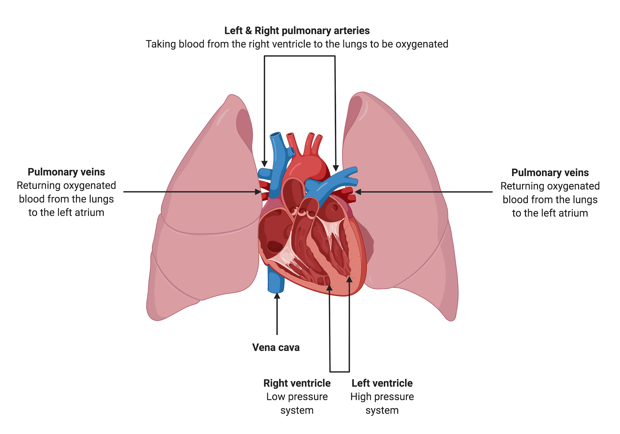
Figure 1. Normal pulmonary circulation

The pulmonary circulation is a high volume, low pressure and resistance system. Deoxygenated blood from the lower and upper body return to the right atrium via the inferior and superior vena cava respectively. The blood is then ejected via the tricuspid valve into the right ventricle, which is relatively thin walled, meaning that the right ventricle is unable to adapt quickly to significant changes in pre-load and after-load (Naeije et al., 2014). The blood then travels into the pulmonary artery via the pulmonary valve. The vessel walls are also thin and highly elastic to accommodate the whole cardiac output. From the pulmonary arteries the blood is directed to each lung. The pulmonary circulation comprises of parallel capillary networks, to allow the carbon dioxide to be exchanged for oxygen. The measure of the resistance in the pulmonary circulation is known as the pulmonary vascular resistance and is a tenth of the resistance found in the systemic circulation, table 1. The now oxygenated blood is returned to the left atrium via the pulmonary veins, where the blood is transported to the left ventricle before being ejected through the aortic valve into the systemic circulation, figure 1.

Haemodynamic variable | Method of measurement / derivation | Range in healthy subjects | Additional notes
Right atrial pressure (RAP), mmHg | Pressure waveforms | 1-6
Systolic pulmonary artery pressure (sPAP), mmHg | Pressure waveforms | 18-25
Diastolic pulmonary artery pressure (dPAP), mmHg | Pressure waveforms | 4-12
Mean pulmonary artery pressure (mPAP), mmHg | dPAP+(sPAP-dPAP)/3 | 14±3
Pulmonary arterial wedge pressure (PAWP), mmHg | Pressure waveforms | 4-12 | Surrogate marker of left atrial pressure
Pulmonary vascular resistance (PVR), WU.m⁻² | 80x(mPAP-PAWP)/CO | ≤ 3 | If measured in dynes.s.cm⁻⁵ divide by 80 for WU
Cardiac output (CO), L.min⁻¹ | Measure of pulmonary blood flow | 4-6 | Measured via thermodilution or on oxygen consumption (Fick’s principle)
Cardiac index (CI), L.min⁻¹.m⁻² | CO/Body surface area (BSA) | 2.4-4
Table 1. Normal haemodynamic measurements obtained at right heart catheterisation (RHC) -adapted from (Rosenkranz & Preston, 2015)
Abbreviations: RAP, Right atrial pressure; sPAP, systolic pulmonary artery pressure; dPAP, diastolic pulmonary artery pressure; mPAP, mean pulmonary arterial pressure; PAWP, pulmonary arterial wedge pressure; PVR, pulmonary vascular resistance; CO, cardiac output; CI, cardiac index; BSA, body surface area; mmHg, millimetre of mercury; WU.m⁻², wood units; L.min⁻¹, litre per minute; L.min⁻¹.m⁻², litre per minute per metre squared.

Definition of pulmonary hypertension vs pulmonary arterial hypertension
The term pulmonary hypertension (PH) is related to any condition which causes a high pressure or mean pulmonary artery pressure (mPAP) ≥25mmHg in the pulmonary circulation. Pulmonary arterial hypertension (PAH) is a distinct class of PH which has distinguishable pathological features, figure 2, as well as haemodynamic definitions: mPAP ≥ 25mmHg, pulmonary arterial wedge pressure (PAWP) ≤ 15mmHg and a pulmonary vascular resistance (PVR) ≥ 3WU (Galiè et al., 2016). This distinction is important as the four available classes of PH therapies are only proven to be beneficial for those with PAH and PH associated with chronic thromboembolic disease - the only potential curable form of PH.

In 1973, the first World Symposium in Pulmonary Hypertension (WSPH) took place in Geneva, Switzerland in response to an epidemic of pulmonary arterial hypertension in young females associated with the use of appetite suppressants (Hatano & Strasser, 1976). Pulmonary hypertension was defined in Geneva as a mPAP of ≥ 25mmHg, when measured at right heart catheterisation (RHC). This arbitrary value was to differentiate between those with and without significant PH and thus avoiding overdiagnosis. This continues to be the current standard (Galiè et al., 2016).

Pathological changes of pulmonary arterial hypertension

At the intra-acinar level, healthy distal pulmonary arterioles intima consists of a single layer of epithelial cells, and these arterioles are non-muscularised. The more proximal arteries vessel walls do include a thin muscular medial layer which normally becomes more pronounced towards the main pulmonary arteries (Feen et al., 2019).

The exact causative mechanisms which initiates the changes within the pulmonary arteries to cause PAH are unknown. It is suggested that there is predominately endothelial cell injury of the distal pulmonary arteries with consequential vascular remodelling, resulting in medial hypertrophy and intimal thickening with a loss of the smaller capillary arteries, Figure 2.

The damaged endothelial cells release less nitric oxide and prostacyclin resulting in vasoconstriction, there is also an overexpression of thromboxane A₂ and endothelin-1 further promoting this vasoconstriction and pro-thrombotic tendency (Humbert et al., 2004). Morphologically severe PAH is typified by plexiform lesions, which are complex vascular formations within the damaged pulmonary arteries (Jonigk et al., 2011).
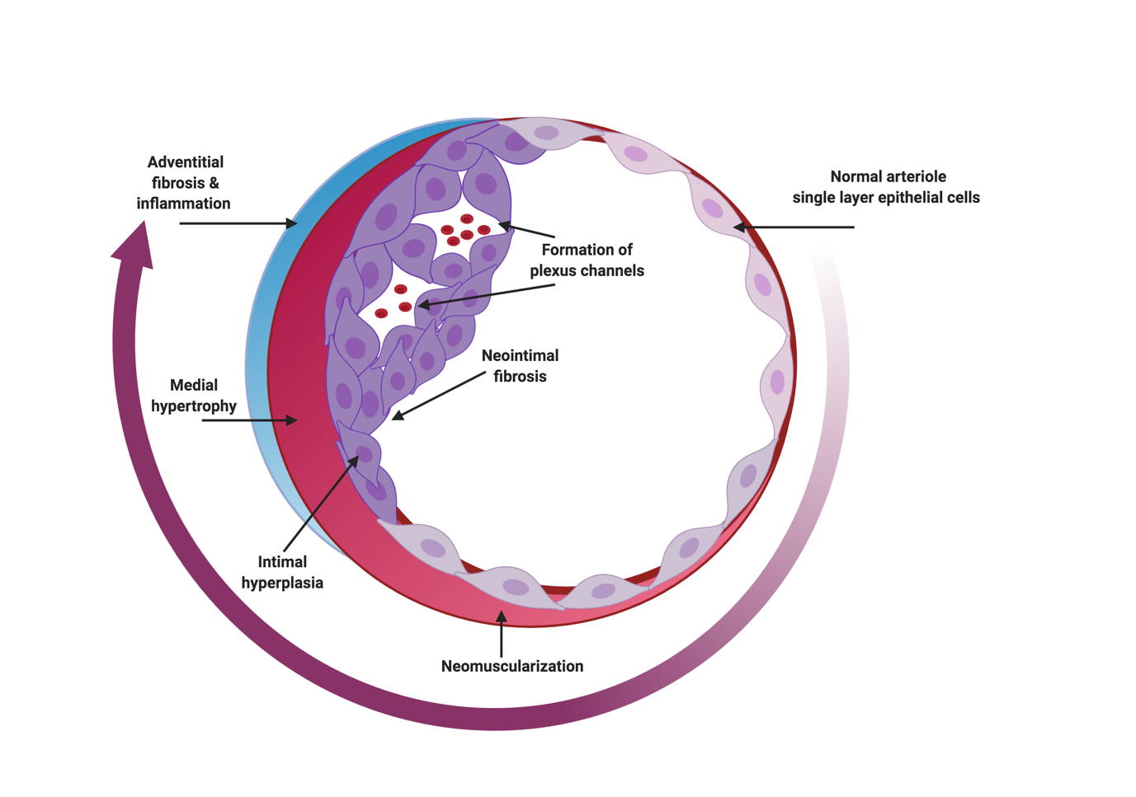
Figure 2. The pathological features of PAH.
Adapted from (Feen et al., 2019) showing on the right-hand side of the diagram a normal pulmonary arteriole and the changes which ensue with the development of PAH

Classification of PH
PH was described in the 70s as ‘primary pulmonary hypertension’ now called idiopathic pulmonary arterial hypertension (IPAH) and ‘secondary pulmonary hypertension’ (Hatano & Strasser, 1976). These two classes have evolved into five distinct categories (Galiè et al., 2016). These groups of patients have shared clinical and pathophysiological features, figure 3. Broadly speaking PH can be divided into those with pre capillary PH (Groups 1, 3, 4 and 5), isolated post-capillary PH (group 2 and 5) and finally combined pre and post capillary PH (Groups 2 and 5) (Simonneau et al., 2019).

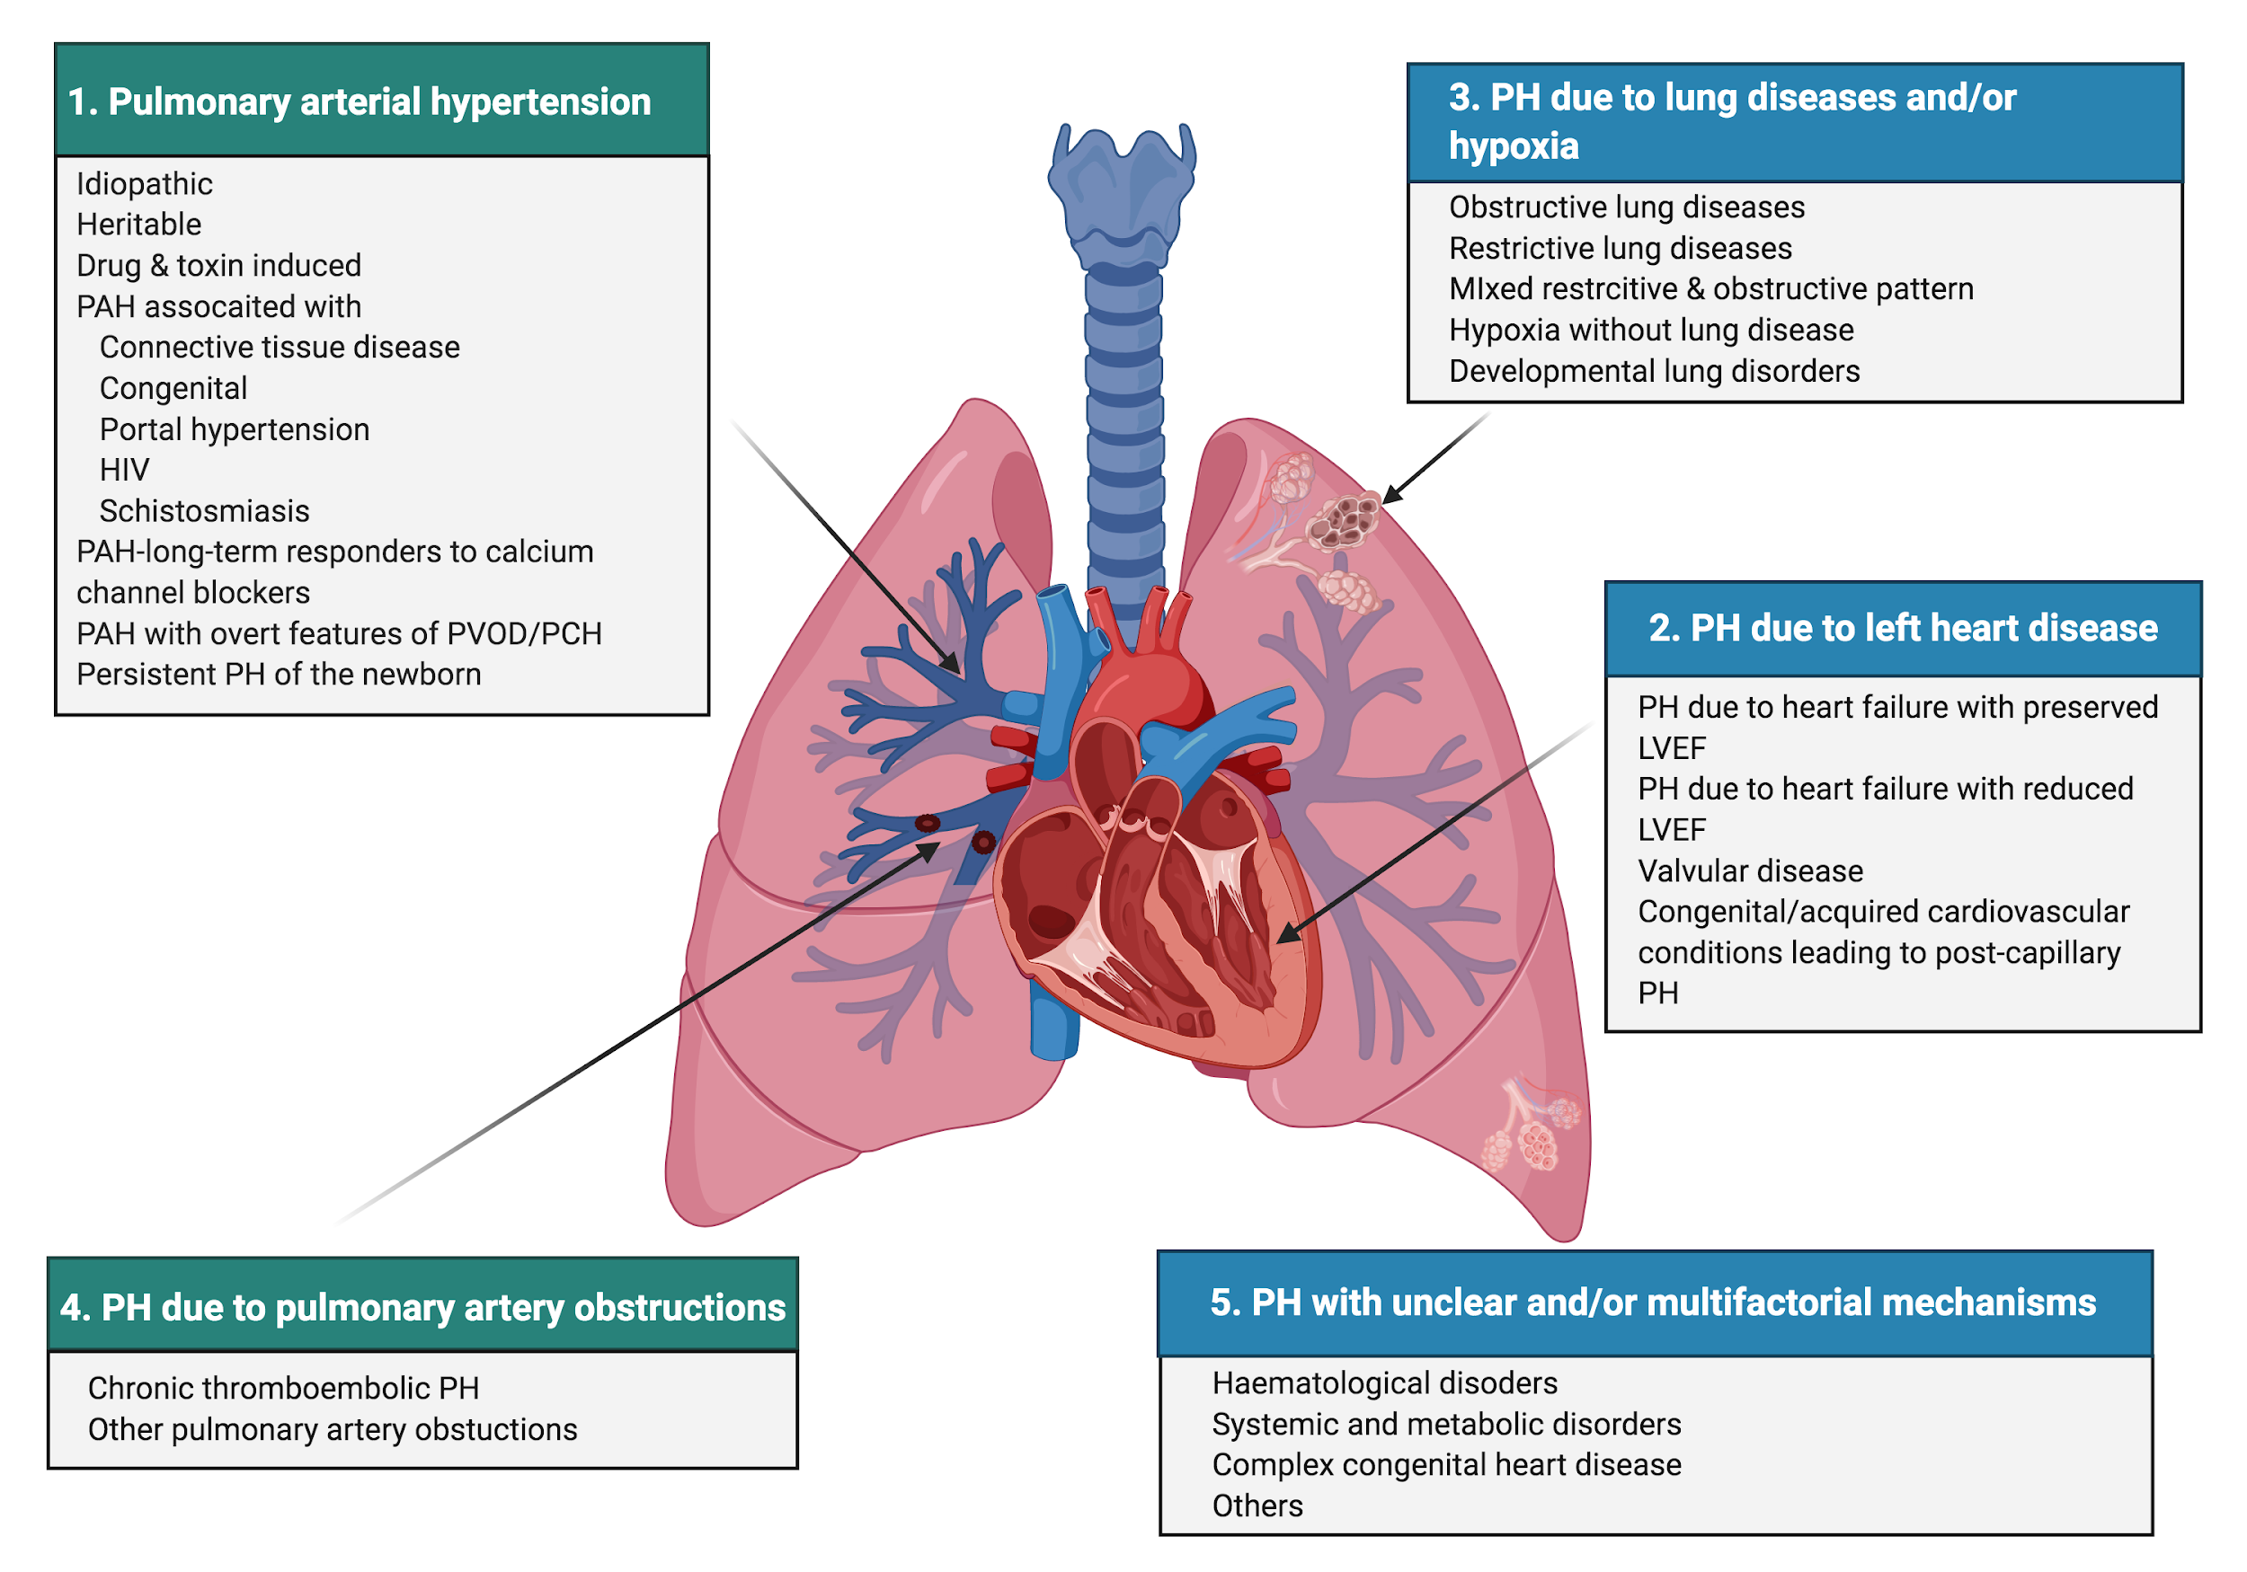
Figure 3. Classification of PH into five groups.
Groups on the left-hand side of the diagram have proven therapies.
Abbreviations: PAH, pulmonary arterial hypertension; PVOD: pulmonary veno-occlusive disease; PCH: pulmonary capillary haemangiomatosis; LVEF: left ventricular ejection fraction.

At the recent 6th WSPH, Nice 2018, the diagnostic value of a mPAP of ≥ 25mmHg to define PH has come under scrutiny ⁵. A systematic review performed by Kovacs et al, 2009, demonstrated by including 47 studies with 1187 healthy volunteers, the normal mPAP at rest, as measured by right heart catheterisation was 14.0 士 3.3mmHg (Kovacs et al., 2009). This value was not influenced by gender or ethnicity but was slightly by age. Retrospective studies have also demonstrated that those with “borderline PH”- mPAP 20-24mmHg - suffer worse outcomes when compared to the normal population (Assad et al., 2017; Douschan et al., 2018; Maron et al., 2016) with increased hospitalisations and mortality, this is especially true in those patients with systemic sclerosis (SSc) (Stamm et al., 2016). Therefore, after much discussion, the new guidance will define PH as a mPAP > 2ommHg (i.e., 14.0mmHg + two standard deviations). This new definition will also take into consideration PVR and a diagnosis of precapillary PH will include a PVR ≥ 240dynes/sec/cm-5 or ≥ 3 Wood units (WU) (Simonneau et al., 2019)

Definitions | Characteristics | Clinical groups
Pre-capillary PH | mPAP > 20mmHg  PAWP ≤ 15mmHg  PVR ≥ 3WU | 1, 3, 4 and 5
Isolated post capillary PH (IpcPH) | mPAP > 20mmHg  PAWP > 15mmHg  PVR < 3WU | 2 and 5
Combined pre & post-capillary Ph (CpCPH) | mPAP > 20mmHg  PAWP > 15mmHG  PVR ≥ 3WU | 2 and 5
Table 2. Planned new definitions of PH by haemodynamics
Adapted from (Simonneau et al., 2019)
Abbreviations: PH, pulmonary hypertension; IpcPH, isolated capillary PH; CpCPH, combined pre and post capillary PH

Clinical manifestations of pulmonary hypertension

The delayed diagnosis of PH in many patients is a consequence of its non-specific symptoms. They include lethargy, dyspnoea, angina, dizziness related to exertion and syncope. Clinical signs include those of right sided failure in the more advanced cases as well as potential clues for the cause of PH e.g., signs of connective tissues disease. Therefore, when faced with the suspicion of PH in a patient, it is of paramount importance to organise the most appropriate non-invasive investigations to confirm the diagnosis.

Investigations

Electrocardiogram

An electrocardiogram (ECG) may be normal but this does not exclude a diagnosis of PH. ECGs may demonstrate evidence of right atrial dilatation and right ventricular strain, in a study of ECGs of idiopathic pulmonary arterial hypertension (IPAH) patients, right ventricular hypertrophy was found in 87%, and right axis deviation in 79% (Rich et al., 1987).

Echocardiography

Generally, the initial suspicion of PH is made in secondary care facilities after a transthoracic echocardiogram has been performed. The diagnostic criteria of PH are seen in figure 4.

In health there is a degree of tricuspid regurgitation (TR), and the maximal velocity measurement of this flow across the valve can be an indication of an intermediate or high probability of pulmonary hypertension (Galie et al., 2009). In those however, with unmeasurable TR jet it is important to look for other echographic parameters of PH as listed in figure 4. In a study of SSc patients with suspicion of PAH, 20% of PAH-SSc patients were reported to have a tricuspid regurgitant velocity (TRV) of < 2.5 m/s and 36% with a TRV ≤ 2.8 m/s (Coghlan et al., 2014) reiterating the importance of looking for other parameters suggestive of PH.

Echocardiography also allows the estimation of systolic PAP (sPAP), PVR, right ventricular (RV) function as well as the delineation of underlying cardiac defects. Caution however must be used with estimates of moderately to severely elevated sPAPs, as they correlate poorly with mPAP at right heart catheterisation (Champion et al., 2009).

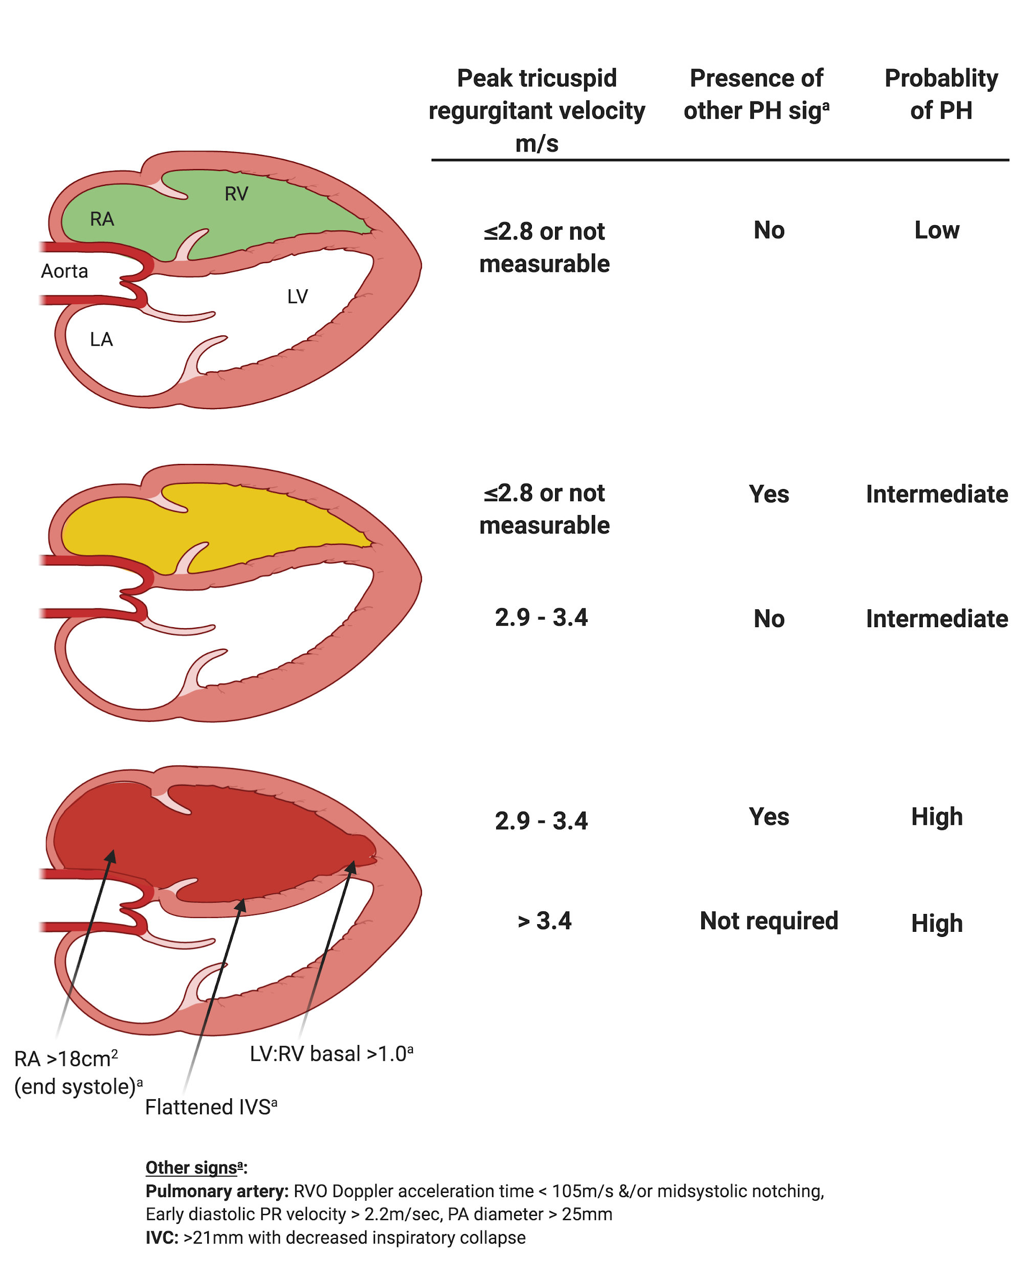
Figure 4. Echocardiographic features to define probability of pulmonary hypertension
(Galiè et al., 2016)

Lung function testing

The diffusion factor of the lung for carbon monoxide (DLco) is an important prognostic factor in IPAH and connective tissue disease associated with PAH (CTD-PAH) (Benza et al., 2010) and is typically reduced in these groups. DLco is a function of pulmonary capillary volume (Vc) and pulmonary membrane diffusion capacity (Dm), consequently in those patients with pulmonary arterial hypertension associated with congenital heart disease (CHD-PAH) and an associated systemic to pulmonary shunt (left to right), this value may be elevated. It is also imperative when measuring this value that a person’s forced vital capacity (FVC) is greater than 1 litre so that a single breath DLco can be measured.

In patients with systemic sclerosis an isolated reduction in DLco is a frequent finding (Hoeper & Vonk-Noordegraaf, 2017). By comparing a person’s DLco to their FVC, investigators were able to significantly predict “isolated pulmonary hypertension” in a cohort of SSc patients (Steen et al., 1992) . In this group the DLco was disproportionately low when compared to the FVC, hence the notion of FVC%/DLCO% measurement used in systemic sclerosis PH screening tools e.g., DETECT (Coghlan et al., 2014). Steen at al also demonstrated that 22% of patients with systemic sclerosis developed PAH with an FVC/DLco >1.4 (Steen et al., 1992). This ratio is rarely utilised in the IPAH population but one study has suggested its positive predictive value in 61 patients with evidence of PH, however only 28 of these patients belonged to Group 1 i.e., true PAH (Donato et al., 2017).

Exercise testing

The six-minute walk distance (6MWD) has been widely used as an endpoint in clinical drug trials of PH specific therapy but it has modest correlation with haemodynamics and oxygen consumption (MIYAMOTO et al., 2000). Concerns regarding its robustness are well documented (Hassoun et al., 2013; McLaughlin, 2012; Savarese et al., 2012). Peak oxygen consumption (VO₂) measured at cardiopulmonary exercise testing (CPET) has been shown to predict prognosis in PAH patients. CPET requires specialist equipment and is not available in all PH centres. The incremental shuttle walk distance (ISWD) is a simpler way of assessing maximal exercise capacity which has been shown to have prognostic importance in patients with cardiopulmonary disease (Morales et al., 2000; Singh et al., 1992). It is an externally paced symptom limited test and studies have also demonstrated that peakVO₂ can be predicted from ISWD results in the COPD population (Arnardóttir et al., 2006; Singh et al., 1994). In a small PH cohort ISWD correlates better with peak oxygen consumption than 6MWD (Irisawa et al., 2014).

Haemodynamic investigation

Right heart catheterisation is usually mandatory for the assessment of PAH apart from in a select group of patients with established Eisenmenger's syndrome (Es). Right heart catheterisation measures directly right atrial (RA), RV and mPA pressure, but cardiac output (CO) and peripheral vascular resistance (PVR) are derived values. There are two methods routinely used to measure CO, are thermodilution and Fick’s (Rosenkranz & Preston, 2015). Pulmonary vascular resistance, however, may be underestimated by Fick’s principle when oxygen saturations in the pulmonary artery are high (Rabinovitch et al., 1978) i.e., a systemic to pulmonary shunt.

Cardiac magnetic resonance imaging (MRI) is a gold standard technique for assessing RV function, mPAP, CO and PVR, it can also be utilised to quantify left to right shunts (Champion et al., 2009; Stevens et al., 2012; Swift et al., 2013) . Over the last decade it has become a more widely accepted tool to help monitor patients with PH and its obvious benefits are related to it being a non-invasive modality with minimal radiation, however it is not easily accessible by all, may not suitable for larger patients and those with claustrophobia.

IPAH - definitions

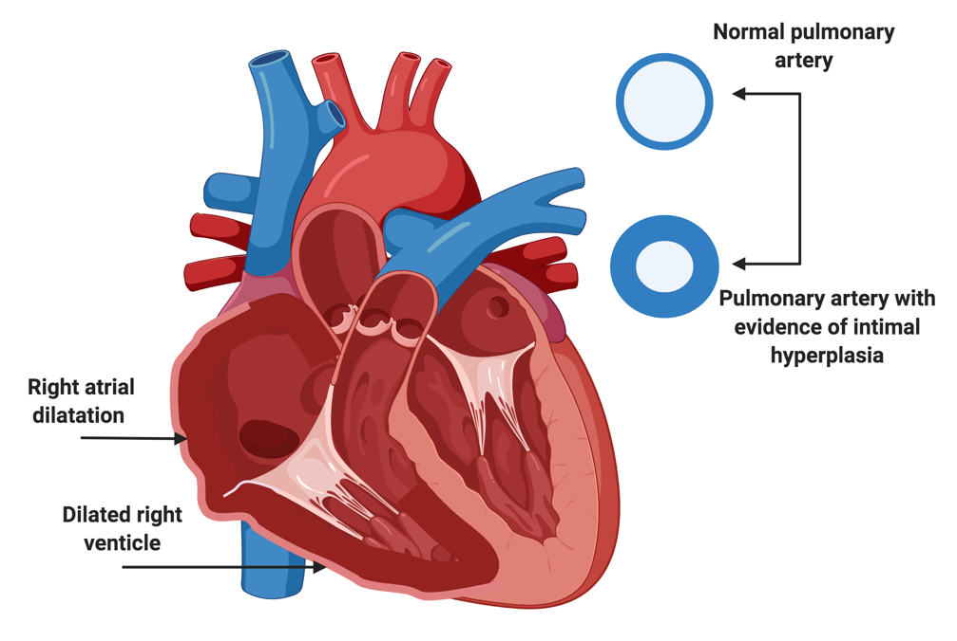
Figure 5. Right heart changes associated with pulmonary arterial hypertension

Pulmonary arterial hypertension is characterised by high pulmonary artery pressures and an elevated pulmonary vascular resistance, these changes to the pulmonary vasculature results in a reduced cardiac output, right ventricular failure (figure 5) and premature death.

In the last 30 years there have been significant advances in pulmonary hypertensive medical therapies as well as the advent of curative surgery for those with pulmonary hypertension in relation to chronic thromboembolic disease. Despite these developments’ PAH continues to be a poorly understood and devastating disease with no known cure except cardiopulmonary transplantation.

As previously documented, PAH is currently defined as a mPAP ≥ 25mmHg, and a PAWP ≤15mmHg and post-mortem examination of the pulmonary vasculature of patients with PAH demonstrate the typical pathological features seen in Group 1 patients (figure 2).

IPAH - epidemiology

IPAH classically is a disease of young females, and when examining worldwide PH registries this still holds true (Hurdman et al., 2011). It is fortunately a rare disorder, and the incidence of IPAH is roughly 2.5-7.1 cases per million (Kiely et al., 2013; Peacock et al., 2007) with a median survival of 2.8 years without treatment (D’Alonzo et al., 1991); more recently the National Audit of Pulmonary Hypertension 10th Annual Report has suggested that approximately 49% of people with IPAH are alive 6 years after diagnosis and those with other illnesses and IPAH have worse survival prospects, 43% of these patients are still alive at 3 years (Digital, 2019).

With increasing awareness of PAH, we are seeing a changing demographic in the patients with IPAH, with some patients being diagnosed with IPAH in their sixties and seventies. This is perhaps not surprising given our aging population, for example in a large US based registry (REVEAL) their mean age of diagnosis was 50 years of age (Hoeper et al., 2012). With this increase in age comes a population with IPAH and concomitant comorbidities. The effect of these comorbidities upon morbidity and mortality have previously not been well studied.

Known features which are associated with a poorer prognosis at initial presentation to a PH centre include being of the male sex, higher symptom burden, lower exercise tolerance and DLco as well as more severe haemodynamics i.e., higher PVR, lower CI and pulmonary arterial saturations (SvO2) (Benza et al., 2019).

CTD-PAH - definitions

The term connective tissue disease encompasses a range of autoimmune processes which broadly speaking have specific antibodies to aid with diagnosis. Connective tissue diseases, such as systemic sclerosis, systemic lupus erythematosus and mixed CTDs are the most common conditions associated with PAH (Chung et al., 2010; Condliffe et al., 2012).

In a large cohort of 1,344 patients assessed at a pulmonary hypertension centre, PAH associated with CTD accounted for a third of their PAH population (n = 600), this group was predominantly composed of patients with systemic sclerosis (Hurdman et al., 2011). Systemic sclerosis is commonly associated with vasculopathy, fibrosis of the skin and internal organs with a high morbidity and mortality (Pavec et al., 2012).

CTD-PAH - epidemiology and pathophysiology

The prevalence of systemic sclerosis in the UK is 48 per million with an annual incidence of 6 per million in females (SILMAN et al., 1988). It has been suggested that the incidence of PAH in SSc is 8-12% (N Galiè et al., 2005) with a cumulative incidence is 15% over 15 years (Nihtyanova et al., 2014).

SSc-PAH has worse survival rates when compared to IPAH patients despite less severe haemodynamics and the judicious use of PH targeted medications (Chung et al., 2010; Hsu et al., 2019; Hurdman et al., 2011).

Risk factors for developing PAH in SSc

There are several risk factors which predispose SSc patients to develop PAH, those with limited skin involvement, severity of Raynaud phenomenon (Zhao et al., 2017), older age of onset and longer duration of disease (Pavec et al., 2012). Being post-menopausal is also a factor, thought to be due to the loss of the protective vascular effects of oestrogen.

Vascular phenomena of SSc such as digital ulcers, pseudo-tumoral cutaneous telangiectasia (telangiectasia >5mm) or an increased number of telangiectasia are also associated with PAH (Hurabielle et al., 2016; SHAH et al., 2009)

Several clinically available autoantibodies are also prognostic of the development of PAH in SSc – namely anticentromere antibodies (ACA), nucleolar (NUC) antibodies, anti-U1-ribonucleoprotein (RNP) antibodies, anticardiolipin (aCL) antibodies, beta2-glycoprotein I (beta2-GPI). Though, the absence of anti-scleroma-70 (anti-Scl70) antibody conveys a worse prognosis (Yaqub & Chung, 2012) conversely in a UK study of Anti-U1 RNP, positivity of this marker actually offered a degree of protection to patients with SSc-PAH from sooner mortality (Sobanski et al., 2016).

Non-invasive predictive measures of the development of SSc-PAH includes an isolated low DLco <50% predicted (i.e., no evidence of overt lung disease) and an FVC%/DLco% ratio of >1.6 as well as a diffusing capacity for carbon monoxide/alveolar volume (DLco/VA) <70% (Allanore et al., 2008). Unsurprisingly the association of interstitial lung disease with SSc is related to the development of SSc-PAH or PH associated with lung disease (Morrisroe et al., 2016).

Screening programmes
Historically the biggest cause of mortality in SSc was related to renal cell crisis, however since the improvements of medical therapies, an American study encompassing 30 years has shown that currently the main reason of death in SSc is interstitial lung disease and/ or PAH. Steen at al demonstrated that over a 25-year period survival improved from 54% to 66% during each of the time points, mortality from renal crisis fell from 42% to 6%, whereas deaths from ILD and PAH rose from 6% to 33% and 21% to 30% respectively (p<0.001 & p=0.05) (Steen & Medsger, 2007). Given the high risk these patients have of developing PAH, screening programmes have been developed across the world.

Theoretically, any designed screening programmes would aim to diagnose patients earlier and institute medical therapies sooner in order to improve morbidity and mortality. Humbert et al demonstrated that in a cohort of people with SSc-PAH identified via a screening programme were instituted on PH-targeted therapies sooner which resulted in improved survival rates in those patients (Humbert et al., 2011).

Several screening algorithms have been suggested over the years. As previously mentioned, right heart catheterisation is the gold standard investigation for the diagnosis of PAH. It is however, an invasive procedure which requires specialist equipment and expertise. Consequently, the screening programmes developed aimed to use common non-invasive measures to evaluate whether a patient with SSc was at risk of PAH.

Over a decade ago a French national study, the ItinerAIR Sclerodermie PAH detection study was one of the first to demonstrate the merits of DLco in identifying those at risk of PAH. Of the 160 patients with a low DLco% predicted (<60%), 8% of these patients had PAH (Hachulla et al., 2005).

In 2012, the Australian Scleroderma Interest Group ASIG suggested the use of a blood biomarker in combination with non-invasive screening investigations to ascertain whether an echocardiogram was required for suspected PH. The markers utilised were N-terminal pro–brain natriuretic peptide (NT-proBNP), DLco and FVC. Thakkar et al demonstrated if DLco % predicted <70.7%, FVC/DLCO % predicted ≥1.82 and/or NT-proBNP is >209.8pg/ml this was suggestive of a high probability of PAH. This screening tool had a sensitivity of 100% and specificity of 77.8% for SSc-PAH (Thakkar et al., 2012). An elevated NT-proBNP and a DLCO/VA % predicted of <70% conferred a 47.2 hazard ratio of developing PAH at 36 months in the Australian SSc cohort (Allanore et al., 2008).

The current 2015 ESC/ERS guidelines for the diagnosis and investigation of PAH in SSc are based on signs, symptoms and probability upon echocardiography. If the tricuspid regurgitation velocity is ≤ 2.8 with no other signs of pulmonary hypertension upon the echocardiogram the likelihood of PH is low. If, however, the clinical probability is intermediate then dependent on associated clinical signs it is suggested that the patient be referred for a right heart catheterisation (Nazzareno Galiè et al., 2016).

The DETECT study introduced the concept of a two-step algorithm identifying those firstly requiring an echocardiogram and after an assessment of the echocardiogram parameters an algorithm to ascertain if a patient with SSc required a right heart catheter for suspected PAH.

This study was a prospective international multicentre study. It focused on those patients with a history of scleroderma for greater than 3 years. This is identified as the first non-Raynaud’s symptom and those with a DLco% predicted <60% and an FVC% predicted ≥40%.

In the first step of the algorithm routine non-invasive variables were evaluated – FVC%/DLco% predicted, current or past telangiectasia, serum ACA, serum NT-proBNP, serum urate and right axis deviation on ECG. A risk score is obtained and if >300, an echocardiogram is performed.

During echocardiography the right atrial area and tricuspid regurgitant velocity are measured, these two results are added to the total risk points from Step 1 and if a threshold is met it is suggested that the patient is referred for a right heart catheter (figure 6). This multicentre study recommended a RHC in 62% of its cohort missing a diagnosis of PAH in 4% (Coghlan et al., 2014).

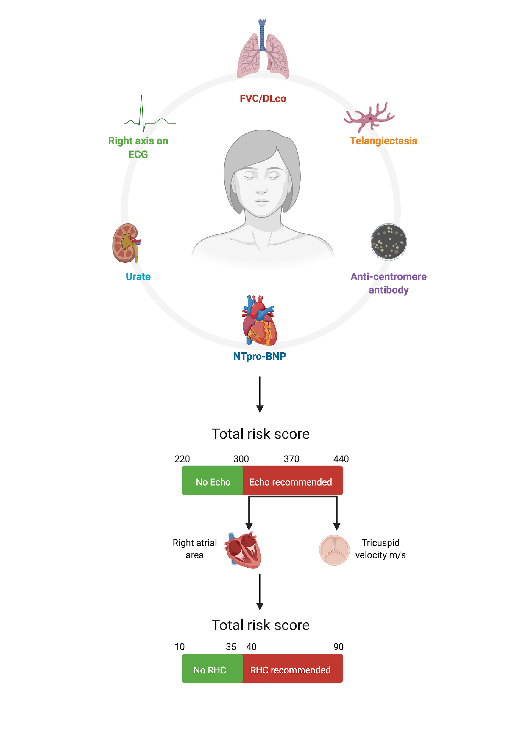
Figure 6. The two-step DETECT algorithm

A recent Norwegian study of 161 patients highlighted that since the advent of the DETECT algorithm, the risk profile of SSc patients with PAH had changed. More cases of SSc-PAH had lower pulmonary artery pressures at baseline right heart catheterisation, identifying those with early PAH, hence offering the opportunity for these patients to be commenced on earlier targeted therapies (Hoffmann-Vold et al., 2017).

By comparing three screening programmes, namely the ASIG 2012 (Thakkar et al., 2012), DETECT 2014 (Coghlan et al., 2014), and the ESC/ERS 2009 guidelines (Galie et al., 2009)- a study of 73 SSc patients with suspected PAH found that DETECT and ASIG were superior to the ERS/ESC guidance. DETECT and ASIG had a sensitivity and negative predictive value of 100% whereas the ESC/ERS guidance sensitivity was 96.3% with a negative predictive value of 91% (Hao et al., 2015).

Despite the apparent success of screening programmes correctly identifying SSc patients with a high risk of PAH, a large Australian study by Morrisroe et al suggested that the adherence to the recommendation of annual echocardiogram, full lung function testing and NT-proBNP measurement (Khanna et al., 2013) was poorly adhered to (Morrisroe et al., 2017). Less than 45% of clinicians screen on an annual basis in those with an established diagnosis of SSc, with an annual screening rate of less than 60% in early SSc; the reasoning for such poor observance of the guidelines were due to clinician lack of understanding of the results as well as the financial implication of the investigations (Morrisroe et al., 2017; Vandecasteele et al., 2017).

Survival
The most recent published data of large prospective registry, first established in 2006 – The Pulmonary Hypertension Assessment and Recognition of Outcomes in Scleroderma (PHAROS) – suggested 1, 2- and 3-year cumulative survival rates of 93%, 88% and 75% in SSc-PAH (Chung et al., 2014). The REVEAL registry suggested 3-year survival rates of previously diagnosed SSc-PAH of 61.4% and 51.2% for newly diagnosed SSc-PAH (Chung, Farber, et al., 2014).

The prospective French PAH network suggested a survival of 90%, 78% and 56% at 1 ,2- and 3-years respectively in their small cohort (Launay et al., 2013). A recent retrospective UK study of 192 patients with SSc-PAH an extension of the ASPIRE registry (Hurdman et al., 2011) also found a 3-year survival of around 50% (Ramjug et al., 2017). Similar to IPAH, the inferior prognostic markers included male sex, lower DLco%, anaemia and evidence of desaturation upon exercise (Hsu et al., 2019).

Congenital heart defects - epidemiology and pathophysiology

Congenital heart defects affect 1% of new-borns and 0.4% of adults (Marelli et al., 2007). Ventricular septal defects (VSDs) are the most frequently seen (Galiè et al., 2004). Commonly, if these defects are identified and corrected during childhood the development of pulmonary arterial hypertension (PAH) is prevented.

Over recent decades, with advancing knowledge and surgical techniques, many individuals with congenital heart disease survive into adulthood (Khairy et al., 2010), including those patients with more complex defects who have undergone palliative or corrective surgery.

It is generally thought that PAH develops in 5-10% of CHD patients (Diller & Gatzoulis, 2007; Duffels et al., 2007; Engelfriet et al., 2007). A European retrospective cohort study suggested that 28% of patients with septal defects had associated PAH. In this study however PAH was diagnosed by echocardiography and a high proportion of patients attended tertiary centres (Engelfriet et al., 2007). The Dutch, CONCOR registry derived a more conservative prevalence of PAH in the general adult congenital heart disease (ACHD) population with septal defects accounting for 6.1% (Duffels et al., 2007).

Defects associated with PAH include VSDs, atrial septal defects (ASDs) and patent ductus arteriosus (PDAs), complex congenital heart disease and surgical shunts e.g., Potts, Waterson and Blalock-Taussig (Adatia et al., 2010; Galiè et al., 2004). These individuals can present with varying degrees of severity of symptoms, which can have considerable impact upon their lives, as well as increasing risk of morbidity and mortality.

Classification of congenital heart defects

Congenital heart defects can be classified as acyanotic or cyanotic. Acyanotic heart defects are so called as arterial (oxygenated) blood is shunted to the venous (deoxygenated) system; this is also termed a left to right shunt (L-R). Conversely cyanotic defects involve shunting of venous (deoxygenated) blood to the arterial system - right to left shunt (R-L) - resulting in a characteristic blue or ‘cyanotic’ coloration.
In the late nineties The European Association of Cardiothoracic Surgeons and The Society of Thoracic Surgeons developed the more complex International Paediatric and Congenital Cardiac Code (IPCCC) with the aim of improving diagnosis, patient care and research, (“STS/EACTS Short List Mapping to European Paediatric Cardiac Code Short List with ICD-9 & ICD-10 Crossmapping,” 2002) tables 3 & 4.

Kingdom | Phylum | Diagnostic Term
Septal Defects | Truncus Arteriosus | Truncus arteriosus
 | AP Window | Pulmonary artery originating from ascending aorta (Hemi truncus)
Right Heart Lesions | Tetralogy of Fallot (ToF) | ToF
 |  | ToF & AVSD
Transposition of the Great Arteries (TGA) | Congenitally Corrected TGA | CCTGA*
 |  | CCTGA & VSD
 | TGA | TGA
 |  | TGA & VSD

Table 3: Cyanotic Congenital Defects - adapted from the IPCCC shortlist (“STS/EACTS Short List Mapping to European Paediatric Cardiac Code Short List with ICD-9 & ICD-10 Crossmapping,” 2002)
Abbreviations: AP, aortopulmonary window; AVSD, atrioventricular septal defect; VSD, ventricular septal defect. * CCTGA the heart tube instead rotates to the left resulting in the morphologic right ventricle in the systemic position and the morphologic left ventricle in the pulmonary position.
i.e., the ventricles have switched.

Kingdom | Phylum | Diagnostic term
Septal Defects | ASD | Patent foramen ovale (PFO)
 |  | ASD, Secundum
 |  | ASD, Sinus venosus
 |  | ASD, Coronary sinus
 |  | ASD, Single atrium
 | VSD | VSD, Type I - Supracristal
 |  | VSD, Type II - Perimembranous
 |  | VSD, Type III - AV canal
 |  | VSD, Type IV - Muscular
 |  | VSD, Multiple
 | AV Canal | AVSD, Complete
 |  | AVSD, Partial - ASD, primum
Pulmonary Venous Anomalies | Partial Anomalous Pulmonary Venous Connection | Partial anomalous pulmonary venous connection (PAPVC)
 | Total Anomalous Pulmonary Venous Connection | Total anomalous pulmonary venous connection (TAPVC)  Types I-IV*
Thoracic Arteries and Veins | Patent Ductus Arteriosus | Patent ductus arteriosus (PDA)

Table 4. Acyanotic Heart Defects - adapted from IPCCC shortlist
Abbreviations: ASD, atrial septal defect; PFO, patent foramen ovale; VSD, ventricular septal defect; AV, atrioventricular; AVSD, atrioventricular septal defect; PAPVC, Partial anomalous pulmonary venous connection; TAPVC, Total anomalous pulmonary venous connection; PDA, Patent ductus arteriosus. *relates to anatomical site

Natural History

Those with cyanotic defects present in infancy, and are offered either corrective or palliative surgical options. Conversely, those with acyanotic defects may not present until much later in life due to adaptation of their cardiopulmonary circulation. Furthermore, some septal defects such as ASDs and VSDs may spontaneously close.

Two important variables define the clinical effect of L-R shunts: the size of the defect and the PVR. The PVR is fundamentally the resistance offered to the circulation from the pulmonary vasculature, which is a low-pressure system. The systemic circulation also offers resistance and termed systemic vascular resistance (SVR). The ratio of SVR to PVR determines the magnitude of flow across a defect. A small defect will restrict the amount of blood flow across it whereas a large defect is unable to restrict it.

In the context of a VSD if there is a large defect and the PVR is low (i.e., the pulmonary circulation/vessels compensate for the additional blood passing from the right ventricle to the pulmonary arteries), then this will promote a large L-R shunt. Subsequent increase in PVR in response to this high pulmonary blood flow can lead to a reduced L-R shunt and if PVR becomes higher than SVR, then reversal of the shunt from L-R to R-L ensues.

This is termed as Eisenmenger’s (Es) syndrome, the most advanced form of CHD-PAH. In this situation surgical closure of the defect is contraindicated (Galie et al., 2009) as if the defect is closed the right ventricular pressure generated will not be high enough to overcome PVR leading to right ventricular failure.

Classification of CHD-PAH

In the 4th World Pulmonary Hypertension Symposium an alternative grouping of CHD-PAH was developed in light of shared clinical characteristics, table 5. Also, the more detailed classification based on precise anatomical and physiological characteristics was revised, table 6, (Galie et al., 2009). Those with evidence of congenital inflow/outflow tract obstruction and congenital cardiomyopathies as well as pulmonary vein stenosis were classified into Group 2 PH (PH due to left heart disease).

Clinical Phenotype | Clinical characteristics
A. Eisenmenger’s syndrome | Includes all systemic-to-pulmonary shunts due to large defects leading to a severe increase in PVR and resulting in a reversed (pulmonary-to-systemic) or bidirectional shunt. Cyanosis, erythrocytosis, and multiple organ involvement are present.
B. Pulmonary arterial hypertension associated with systemic-to-pulmonary shunts | Moderate to large defects, the increase in PVR is mild to moderate, systemic-to-pulmonary shunt is still largely present, and no cyanosis is present at rest.
C. Pulmonary arterial hypertension with small defects | Small defects (usually ventricular septal defects <1cm and atrial septal defects <2cm of effective diameter assessed by echocardiography) the clinical picture is very similar to idiopathic PAH.
D. Pulmonary arterial hypertension after corrective cardiac surgery | Congenital heart disease has been corrected but PAH is either still present immediately after surgery in the absence of significant postoperative residual congenital lesions or defects that originate as a sequela to previous surgery.

Table 5. Clinical Characteristics of CHD-PAH (Galie et al., 2009)
Abbreviations: PVR, pulmonary vascular resistance; PAH, pulmonary arterial hypertension

Type | Simple pre-tricuspid shunts | Atrial septal defect (ASD) ostium secundum  sinus venosus  ostium primum
 |  | Total or partial unobstructed anomalous pulmonary venous return
 | Simple post-tricuspid shunts | Ventricular septal defect (VSD)
 |  | Patent ductus arteriosus (PDA)
 | Combined shunts | Describe combination and define predominant defect
 | Complex congenital heart disease | Complete atrioventricular septal defect
 |  | Truncus arteriosus
 |  | Single ventricular physiology with unobstructed pulmonary blood flow
 |  | Transposition of the great arteries with VSD (without pulmonary stenosis) and/or patent ductus arteriosus
 |  | Other
Dimension | Specify for each defect if more than one congenital heart defect exists | Haemodynamic (specify Qp/Qs*)  - Restrictive (pressure gradient across the defect)  - Non-restrictive  Anatomic∝  - Small to moderate (ASD ≤ 2.0cm and VSD ≤1.0cm  - Large (ASD > 2.0cm and VSD > 1.0cm)
Direction of shunt |  | Predominantly systemic-to-pulmonary  Predominantly pulmonary-to-systemic  Bidirectional
 |  | Associated cardiac and extra-cardiac abnormalities
Repair status |  | Unoperated  Palliated [specify type of operation(s), age at surgery  Repaired [specify type of operation(s), age at surgery

Table 6. Anatomical and pathophysiological determinants of CHD-PAH
Abbreviations: ASD, atrial septal defect; VSD, ventricular septal defect, PDA, patent ductus arteriosus; * ratio of pulmonary blood flow (Qp) to systemic blood flow (Qs); ∝ relates to size of defect in an adult patient (Galie et al., 2009)

Group A: Eisenmenger’s Syndrome

Victor Eisenmenger first described Eisenmenger’s complex in 1897 in a 32-year-old man with a membranous VSD and overriding aorta (Eisenmenger’s defect). This was associated with cyanosis, clubbing and polycythaemia. Despite meticulous examination and note of a raised PVR, Eisenmenger did not appreciate the reversed shunt. It was in 1958 that Paul Wood defined Eisenmenger’s syndrome (Es) as we understand it today - “pulmonary hypertension at the systemic level due to high pulmonary vascular resistance with reversed flow through a septal defect” (Wood, 1958).

In the Western world due to significant advances in paediatric cardiology and surgical techniques it is estimated that the incidence of Es has reduced by approximately 50% (Diller & Gatzoulis, 2007), but the prevalence remains static in those living in developing countries (Adatia et al., 2010). In the future Es patients will predominantly be those with complex CHD who are likely to have received palliative surgery in infancy. The prevalence of Es is estimated to be approximately 1-4% of those with adult congenital heart disease (ACHD) (Duffels et al., 2007; Oechslin et al., 2000). Approximately 50% of uncorrected ventricular septal defects; ~10-17% open ASDs; 90% of unrepaired atrioventricular septal defects (AVSD) and almost all patients with truncus arteriosus are associated with Es (Duffels et al., 2007; Engelfriet et al., 2007; Manes et al., 2014), table 7.

Study | Study number  (population studied) | PAH patients, n  (% of population) | Es patients, n  (% of population) | Underlying Defect  (% of Es patients) | Mean PAP mmHg (±SD)
Duffels et al. (2007)¹ | 1824  (septal defects) | 112 (6) | 65 (4) | VSD 31 (48)  AVSD 23 (35)  ASD II 8 (12)  ASD I 3 (5) | 89  (±21)
Engelfriet et al. (2007)² | 1877  (septal & cyanotic defects) | 531 (28) | 231 (12) | Other 138 (60)  VSD 83 (35)  ASD 15 (5)
Manes et al. (2013)³ | 192  (PAH-CHD) | 192 (100) | 90 (47) | VSD 36 (40)  PDA 15 (17)  Complex 15 (17)  Other combined 11 (12)  ASD 10 (11)  PAPVC & ASD 3 (3) | 80  (±20)

Table 7: Demonstrating incidence of underlying defects in Eisenmengers
Data are presented as a number or % unless otherwise stated. Abbreviations: ASD, atrial septal defect; AVSD, atrioventricular septal defect; I, primum; II, secundum; PAPVC, partial anomalous pulmonary venous connection; PDA, patent ductus arteriosus; VSD, ventricular septal defect. 1. (Duffels et al. 2007); 2. (Engelfriet et al. 2007); 3. (Manes et al. 2013)

The mechanism of PAH differs depending on the type of defect. It was observed in the CONCOR registry of ACHD that once a patient with a VSD developed PAH it soon led to Es. Individuals with post tricuspid shunts such as VSDs are at risk of both volume and pressure overload with subsequent remodelling of the pulmonary vascular bed. Thus, the development of PAH is at an earlier age when compared to other defects (Wood, 1958). If these changes occur at a young age, it is thought that the heart is able to remodel and adapt to this extra volume and pressure leading to a right ventricular hypertrophy without loss of function. With the increased pressure and vascular bed changes the shunt is reversed i.e., Es. These potentially protective adaptations bear striking similarities to the fetal heart and circulation.

PAH secondary to ASDs (a pre-tricuspid shunt) will be predominantly due to an insidious volume overload with subsequent right ventricular dilatation. Reversal of shunt may therefore be a consequence of the right atrial overload due to the failing right ventricle (RV). These patients present later in life and due to lack of RV adaptation are potentially more symptomatic (Engelfriet et al., 2007; Steele et al., 1987). Some will progress to true Es syndrome but this is not as frequent as with post-tricuspid shunts.

Compared to healthy individuals, Es median survival is reduced by approximately 20 years (Diller et al., 2006). The most common causes of death included sudden cardiac event, cardiac failure and massive haemoptysis. Es patients with complex defects have a 10-12-fold increased risk of mortality (Beghetti & Galiè, 2009). Survival in Es is however significantly superior to idiopathic PAH (Diller et al., 2006; Hurdman et al., 2011).

This is likely related to a well-conditioned right ventricle due to an adaptive hypertrophy in response to chronic increased afterload. The presence of a R-L shunt may also improve prognosis in Es. In the normal circulation the PVR falls in response to exercise, allowing increased blood flow through the lungs, thus increasing cardiac output. In idiopathic PAH patients this cannot occur due to a relatively fixed afterload. Es patients, however, may increase their cardiac output at the expense of becoming more cyanosed by increasing the R-L shunt (Sietsema, 1991).

Group B: CHD-PAH - Large Defects with Left to Right Shunts

This group is predominantly made up of pre-tricuspid defects (Manes et al., 2014), with secundum ASDs being the most common. Sinus venosus defects are associated with higher levels of pulmonary artery pressure (PAP) and PVR (Vogel et al., 1999). Closure of these defects prior to the onset PAH is recommended (Swan & Gatzoulis, 2003). As discussed above closure of defects following the development of Es is contraindicated due to the deleterious effect on right ventricular function. In clinical practice patients with more modest elevations in PAP and PVR present significant management quandaries.

Few studies have reported survival of those patients with CHD-PAH associated with L-R shunts (CHD-PAH:L-R), but a recent study comparing the survival between the four different phenotypes suggested CHD-PAH associated L-R shunts have a 1, 5, 10 and 20 year survival of 100%, 93%, 93% and 86% respectively. Interestingly in this study there was no significant difference when compared to the survival of Es (Manes et al., 2014).

Group C: CHD-PAH - Small Defects
Clinically these patients resemble idiopathic PAH. If shunting occurs through the small defect (SD) it potentially portrays an overlap between idiopathic PAH with a patent foramen ovale (PFO) - a small intra-atrial communication - and CHD-PAH associated with L-R shunting.

Few data regarding prevalence of this specific group exists. Many studies have classed CHD-PAH patients by type of defect, defect closure or shunt direction, rather than size of defect. Manes et al. found that this group comprised only 5% of the total CHD-PAH cohort. It was also noted that PVR was significantly higher when compared to CHD-PAH:L-R shunting (Manes et al., 2014). In this study survival in CHD-PAH:SD was superior to IPAH raising the possibility of a survival advantage associated with the ability to develop a right to left shunt in the compromised heart. This study demonstrated a survival benefit when compared to idiopathic PAH at 15 years, but not when compared to Es and CHD-PAH large defects. Suggesting that a small ‘relief valve’ protects this group but not to the extent of the larger defects (D’Alto & Mahadevan, 2012). Up to 30% of the general population have a PFO, which is of no haemodynamic significance; it has been proposed that this may provide a survival benefit in IPAH patients due to the mechanism above. This has not been demonstrated conclusively (Nootens et al., 1993; Rozkovec et al., 1986), however the formation of an artificial ASD via an atrial septostomy is a well-recognised palliative procedure in severe PAH (Galie et al., 2009).

Group D: CHD-PAH - Closed defects

PAH may be present immediately postoperatively or developed months or years following defect closure. Some of these patients will also have a residual shunt. The Euro Heart Study suggested the prevalence of PAH in closed defects to be 12% (45/377) in ASDs and 13% (35/275) in VSDs (Engelfriet et al., 2007). The Dutch CONOR study suggested this group was made up predominantly of secundum ASDs 40% (Duffels et al., 2007), table 8. Importantly it has been observed that age of correction is independently related to the development of PAH (Duffels et al., 2007). The majority of studies have observed the poorest outcomes in CHD-PAH to be that of closed defects (CD) (Barst et al., 2012; Haworth & Hislop, 2009; Manes et al., 2014) however, the Euro Heart Study observed the converse.

Study | Duffels et al. (2007) ¹ | Manes et al. (2013) ³
PAH patients, n | 112 | 192
Closed Defect (% of PAH) | 30 (27) | 44 (23)
Type of Defect Closed  (% of PAH-CD) | ASD I 5 (17)  ASD II 12 (40)  AVSD 5 (17)  VSD 8 (27) | ASD 12 (27)  Complex 6 (13)  Other combined 2 (5)  PAPVC & ASD 3 (7) PDA 3 (7)  VSD 18 (41)
Mean PAP mmHg (±SD) | 49 (±12) | 64 (±18)

Table 8. Defect type in CHD-PAH-CD
Data are presented as a number or % unless otherwise stated. ASD, atrial septal defect; AVSD, atrioventricular septal defect; I, primum; II, secundum; PAPVC, partial anomalous pulmonary venous connection; PDA, patent ductus arteriosus; VSD, ventricular septal defect. 1. (Duffels et al. 2007); 3. (Manes et al. 2013)

Risk stratification

Despite newer PH targeted therapies, the 5-year survival of PAH remains poor. Therefore the 2015 ESC/ERS Guidelines for the diagnosis and treatment of pulmonary hypertension (Nazzareno Galiè et al., 2016) recommended a multifaceted risk assessment should be performed at a patient's initial visit and on subsequent consultations. The aim of this assessment is to guide a clinician’s decisions, in an attempt to improve morbidity and mortality in those PAH patients whom fall in the higher risk categories. This risk assessment is divided into low, intermediate and high risk strata, with an estimated 1 year mortality risk of <5% if in the low category, 5-10%: intermediate and >10% in the high risk patients.

“The key considerations when reviewing a patient with PAH are:
- Is there any evidence of deterioration?
- If so, is it related to PAH or concurrent comorbidities?
- Is the right ventricular function stable?
- Does the patient have clinical signs in keeping with a good long-term prognosis? Or do they meet the majority of the criteria in the low-risk criteria (Table 9)” (Nazzareno Galiè et al., 2016)

ESC/ERS risk stratification
The parameters which are used in the risk assessment, are known to convey prognostic significance and are a combination of clinical, functional capacity, echocardiography and haemodynamic variables. Those features associated with an improved prognosis include no clinical signs of right heart failure, World health organisation functional class (WHO FC) I-II, 6MWD >440m, BNP <50ng/l (NT-proBNP <300ng/l), RA area <18cm2, no pericardial effusion, and haemodynamics of a right atrial pressure (RAP) <8mmHg, cardiac index (CI) ≥ 2.5l/min/m⁻² and pulmonary artery saturations (SvO₂) >65%. (Table 9)

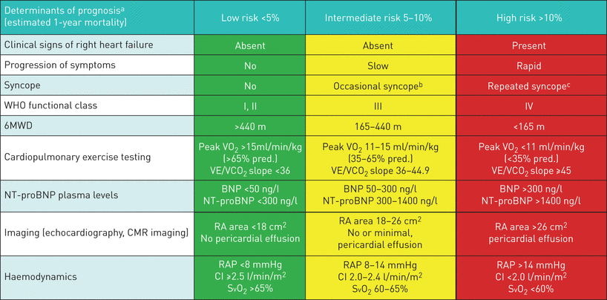

Table 9. Risk strata variables for low, intermediate and high-risk categories
(Nazzareno Galiè et al., 2016)
Abbreviations: WHO, world health organisation; 6MWD, six minute walk distance; VO₂, oxygen consumption; VE/VCO₂, minute ventilation/carbon dioxide; BNP, brain natriuretic peptide; NT-proBNP, N-terminal pro–brain natriuretic peptide; RA, right atrial; RAP, right atrial pressure; CI, cardiac index; SvO₂, pulmonary arterial saturations

When assessing a patient not all variables may be in one category, this further helps the clinician to individualise a patient’s therapy regime. The guidance also suggests that the risk stratification of a patient can be further improved by considering a patient’s PAH subgroup, age, gender and comorbidities.

Data from registries have aided the PH community to derive algorithms to help predict a patient's survival. One of the first algorithms was developed by the National Institutes of Health Primary Pulmonary Hypertension Registry investigators in 1991 by D’Alonzo et al. This study of 192 patients (pre-PH-targeted therapy) demonstrated a median survival of 2.8 years and created an equation to estimate survival based on three haemodynamic variables: mean pulmonary artery pressure, mean right atrial pressure and cardiac index (D’Alonzo et al., 1991).

Risk stratification scores
Since the ESC/ERS 2015 guidance, 4 risk scores have been proposed: the updated Registry to Evaluate Early and Long-term PAH Disease (REVEAL 2.0) from the USA; the Comparative, Prospective Registry of Newly Initiated Therapies for Pulmonary Hypertension (COMPERA) compromising of centres over Europe but 80% of the participant centres are from Germany; the French PH registry (FPHR) and the Swedish PAH registry (SPAHR) tools (Benza et al., 2019; Boucly et al., 2017; Hoeper et al., 2017; Kylhammar et al., 2017).

The European risk scores, figure 7, utilise an abbreviated version of those suggested by the ESC/ERS guidance. There has been much interest surrounding these risk stratification tools, especially in those which include predominantly non-invasive parameters. Studies have also demonstrated their prognostic utility not only at baseline but perhaps to a greater degree at subsequent visits (Boucly et al., 2017).

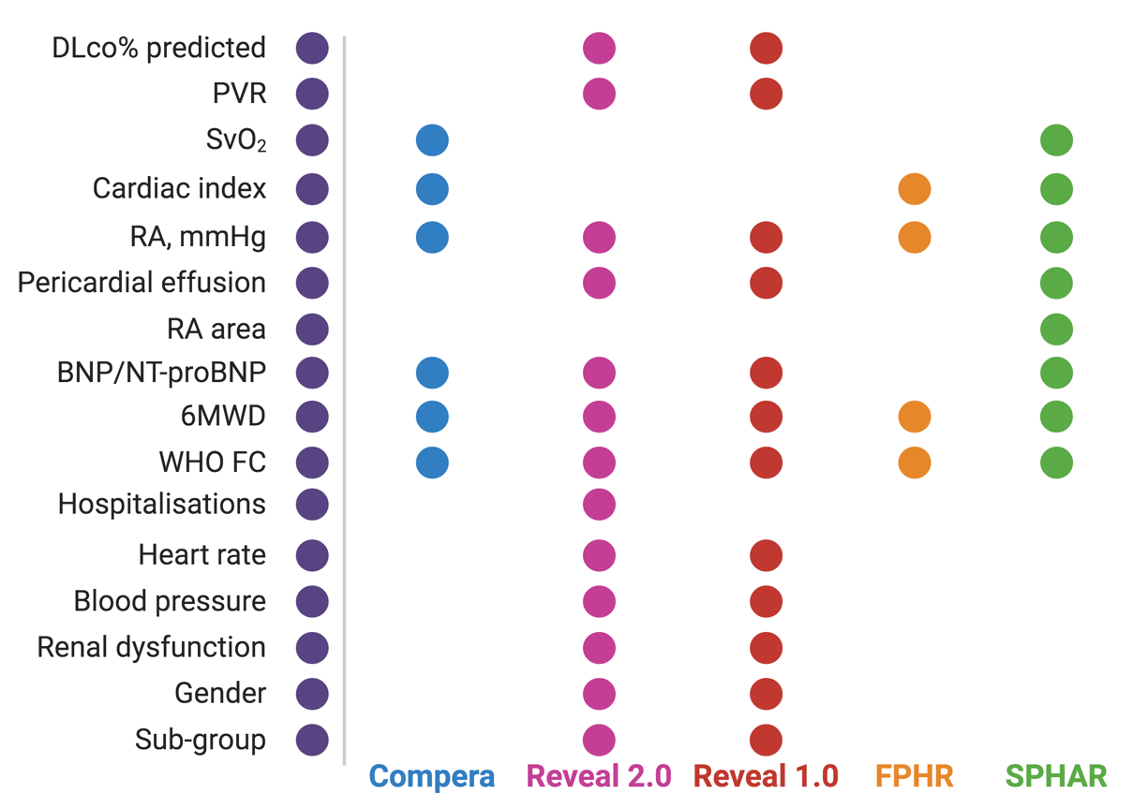
Figure 7. Risk scores variables required for COMPERA, REVEAL 2.0 & 1.0, FPHR and SPAHR
Abbreviations: DLco, diffusing capacity of the lung for carbon monoxide; PVR, pulmonary vascular resistance, SvO₂, pulmonary artery saturations; RA, right atrial; BNP, brain natriuretic peptide; NT-proBNP, N-terminal pro–brain natriuretic peptide; 6MWD, six-minute walk distance; WHO FC, world health organisation functional class

REVEAL 2.0
REVEAL 2.0, included an analysis cohort of 2,529 patients (80% females) with IPAH (46.3%), hereditary (2.9%), congenital (9.6%), CTD (25.7%) and portopulmonary hypertension (PoPH) - (5.5), HIV (1.9%) and other (8%) forms of PAH. This population was a sub-population of cases who had survived ≥ 12 months post diagnosis. Therefore, the baseline for these patients and score validation was at 12 months (Benza et al., 2019). This risk stratification tool also differed as it employs weighted scores for different variables, figure 8.
These available scores are summed and 6 is added to give the final score. A higher score relates to an increased risk of morality. Benza et al, also suggested a three-category risk score group: Low = score ≤ 6, Intermediate = Score 7-8, High score ≥ 9.

PAH risk score
PAH Subgroup | CTD-PAH | PoPH | Hereditary
 | +1 | +3 | +2
Demographics | Male age >60 years
 |  | +2
Comorbidities | eGFR < 60mL.min.1.73m² or a history of renal insufficiency
 |  | +1
WHO FC | I | III | IV
 | -1 | +1 | +2
Vital signs | SBP < 110mmHg |  | HR > 96BPM
 | +1 |  | +1
Hospitalisations | All cause hospitalisations ≤ 6months
 |  | +1
6MWD | ≥ 440m | 320 to < 440m | < 165m
 | -2 | -1 | +1
BNP | <50pg/ml or NT-proBNP  <300pg/ml | 200 to < 800pg/mL | ≥ 800 pg/mL or NT-proBNP ≥ 1,100 pg/mL
 | -2 | +1 | +2
Echocardiogram | Pericardial effusion
 |  | +1
PFTs | DLco% predicted < 40%
 |  | +1
RHC | mRAP > 20mmHg within 1 year |  | PVR < 5 WU
 | +1 |  | -1
Figure 8. The REVEAL 2.0 risk calculator (Benza et al., 2019)
Abbreviations: CTD, connective tissue disease; PAH, pulmonary arterial hypertension, PoPH, portopulmonary hypertension; eGFR, estimated glomerular filtration rate; WHO FC, world health organisation functional class; SBP, systolic blood pressure; HR, heart rate; BPM, beats per minute; 6MWD, six minute walk distance; BNP, brain natriuretic peptide; NT-proBNP, N-terminal pro–brain natriuretic peptide; PFTs, pulmonary function test; DLco%, diffusing capacity of the lung for carbon monoxide; mRAP, mean right atrial pressure; PVR, pulmonary vascular resistance

COMPERA
COMPERA initiated in 2007, included patients diagnosed between 1st January 2009 and 1st December 2016 (Hoeper et al., 2017). Their study cohort included: 1588 patients (64% females) with idiopathic/ hereditary /drug – (67%), CTD (22%), CHD (4%) other (7%) including PoPH, (6%) and HIV (1%). The COMPERA risk tool was based upon the Swedish group’s SPAHR score (Kylhammar et al., 2017), Figure 9.

The parameters were graded as either 1=low, 2=intermediate, 3= high risk - the scores were combined then divided by the number of available variables. This mean was then rounded up to the next integer. This COMPERA group observed mortality rates 12 months after diagnosis of low 2.8% (n=196), intermediate 9.9% (n= 1116) and high risk 21.2% (n=276).

Variables | Low risk | Intermediate risk | High risk
WHO FC | I, II | III | IV
6MWD | >440m | 165-440m | <165m
NT-proBNP | <300ng/L | 300-1400ng/L | >1400ng/L
Imaging (echo) | RA area <18cm² | RA area 18-26cm² | RA area >26cm²
 | No pericardial effusion | No or minimal pericardial effusion | Pericardial effusion
Haemodynamics | RAP <8mmHg | RAP 8-14mmHg | RAP >14mmHg
 | CI ≥2.5 L.min.m² | CI 2.0-2.4 L.min.m² | CI <2.1 L.min.m²
 | SvO2 >65% | SvO2 60-65% | SvO2 <60%
Figure 9. COMPERA risk scoring system (Hoeper et al., 2017; Kylhammar et al., 2017)
Abbreviations: WHO FC, world health organisation functional class; 6MWD, six-minute walk distance; m, metres; NT-proBNP, N-terminal pro–brain natriuretic peptide; RA, right atrial; RAP, right atrial pressure; CI, cardiac index; SVO₂, pulmonary arterial saturations

The SPAHR, launched in 2008 included 530 PAH (65% females), IPAH (261), Hereditary (7), CTD, (162), CHD (67), drug/toxin induced (16), HIV (3), PoPH (14). Their study also included incident patients between 1st January 2008 to 1st March 2016, and their survival rates at 1 year for their low risk cohort was 99%, 83% for the intermediate group and 74% for those categorised into the high-risk group at baseline (Kylhammar et al., 2017).

FPHR
The FPHR analysis cohort included 1017 PAH patients of which (59% females) with idiopathic (75%), heritable (9%), drug induced (16%) PAH. These patients were diagnosed between 1st January 2006 and 30th March 2016 with both baseline and 12 months follow-up data (Boucly et al., 2017). The FPHR evaluated the number of low risk criteria which a patient exhibited based on the ESC/ERS guidelines at baseline and at their subsequent consultation, Figure 10.

A total score of 4 being classed low risk and a total score of 0 equating to high risk with an elevated risk of mortality. Patients with 3-4 low risk variables had a 1-year mortality risk of 0-1%, intermediate risk classed as 1-2 low risk variables exhibited a 1-year survival between 4% and those patients with 0 low risk criteria i.e., high-risk patients had a 1-year mortality of greater than 13% (Boucly et al., 2017).

Variables | Low risk
WHO FC | I, II
6MWD | > 440m
Haemodynamics | RAP <8mmHg
 | CI ≥2.5 L.min.m⁻²
Figure 10. FPHR low risk criteria tool (Nazzareno Galiè et al., 2015)
Abbreviations: WHO FC, world health organisation functional class; 6MWD, six-minute walk distance; RAP, right atrial pressure; CI, cardiac index

PAH-treatments

There are currently three key mechanisms which available PH therapies target. Namely, the endothelin, nitric oxide (NO) and prostacyclin pathway. Endothelin receptor antagonists (ERAs), phosphodiesterase type 5 inhibitors (PDE5-i), soluble guanylate cyclase stimulators and prostacyclin/prostacyclin analogs are available for the management of PAH and chronic thromboembolic disease (CTEPH). Their mechanism of action is detailed in figure 11, (Humbert & Ghofrani, 2016)

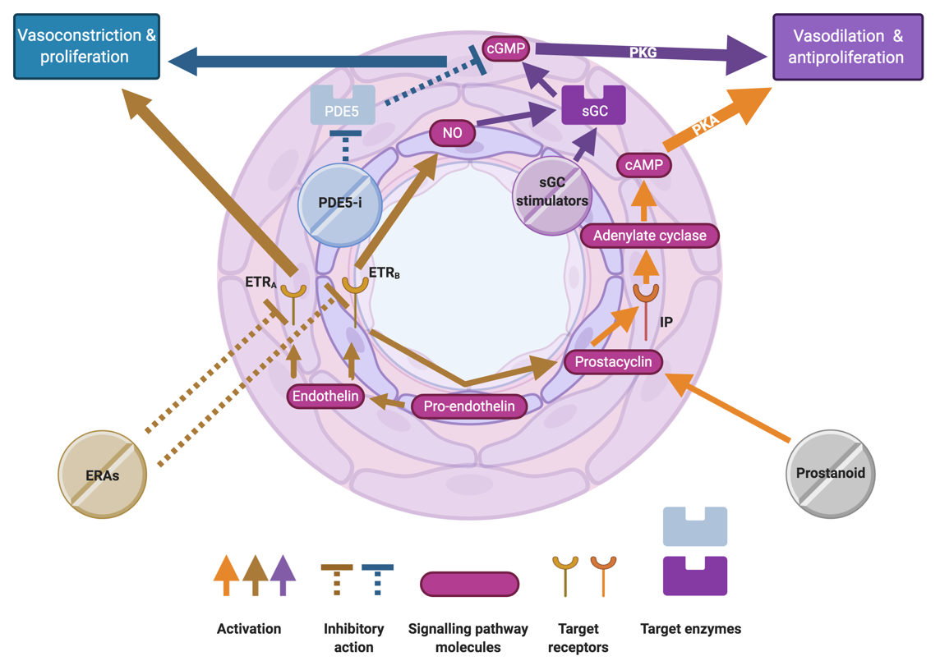
Figure 11. The molecular, signalling and modes of action of PH therapies, from (Humbert & Ghofrani, 2016)
Abbreviations: ERA; endothelin receptor antagonist, PDE5-i, phosphodiesterase type 5 inhibitors; sGC, soluble guanylate cyclase; NO, nitric oxide; cGMP, cyclic guanosine monophosphate; cAMP, cyclic adenosine monophosphate; PKG, cGMP dependent protein kinase; PKA, phosphate kinase; IP, prostacyclin, ETR_{A}, endothelin receptor A; ETR_{B}, endothelin receptor B

Prostacyclin and prostacyclin analogues

Prostacyclin, a metabolite of arachnoid acid is a potent vasodilator with anti-platelet aggregatory activity. The diminished amount of prostacyclin has been implemented in the pathogenesis of PAH. To date intravenous prostacyclin is the only therapeutic option in PAH with proven survival benefits. Prostanoid therapy is generally commenced when patients have failed traditional oral therapies and are in WHO functional class III/IV, figure 11. Synthetic prostanoid therapy is however complicated by the need for continuous infusion or numerous inhalations due to the short half-life of the drugs. Table 10 shows the key prostanoid randomised controlled trials in PAH populations.

Epoprostenol
Epoprostenol was the first synthetic prostacyclin licensed for the treatment of PAH. It is delivered as a continuous infusion via an indwelling venous catheter as its half-life is only 3-5minutes. Epoprostenol has been proven to have a positive effect upon haemodynamics, exercise capacity, and survival. It was in the nineties that the first 12-week randomized, open label trial utilising continuous intravenous epoprostenol demonstrated a reduction in mortality when compared to conventional therapy (R J Barst et al., 1996).

Iloprost
Historically, epoprostenol’s instability in solution and short half-life promoted the search for alternative prostanoid forms. Iloprost is a synthetic prostacyclin analogue, which can be delivered either by frequent inhalation (6-12 nebulisers) or continuous intravenous infusion, with a half-life of thirty minutes. There have been no comparative studies of epoprostenol and intravenous iloprost.

The long-term results of intravenous iloprost therapy in the IPAH population so far have been disappointing suggesting poor outcomes (Knudsen et al., 2011), but it has been postulated that this may be due to the late initiation of such therapies. More recently in COMPERA and the French network have demonstrated improved survival rates (Boucly et al., 2017; Hoeper et al., 2017)– suggesting that due to less restrictions to therapy in France and Germany dual therapy is commenced earlier and prostanoids are added promptly when deterioration occurs, resulting potentially in an improved prognosis (Bartolome et al., 2018).

Treprostinil
Continuous intravenous prostacyclin therapy increases the possibility of catheter related infections, thromboembolic events as well as accidental dislocation of the catheter. Treprostinil has a half-life of three-four hours which allows it to be delivered as a continuous subcutaneous infusion (Gerald Simonneau et al., 2002), as an intravenous preparation, inhaled and via an oral route (Jing et al., 2013; Tapson et al., 2013). Subcutaneous and intravenous treprostinil studies have demonstrated an improvement in haemodynamics, exercise capacity and functional capacity but a high incidence of site pain when being delivered subcutaneously (Lang et al., 2006; Oudiz et al., 2004; Gerald Simonneau et al., 2002). Results from the FREEDOM C & C2 study have shown oral treprostinil to be well tolerated but the relatively short randomized controlled trials failed to demonstrate a significant improvement in exercise capacity or survival (Tapson et al., 2012, 2013).

Beraprost
Beraprost was the first stable oral preparation of a prostacyclin, unfortunately despite an improvement in exercise capacity at 3 months, beraprost failed to demonstrate sustained long-term benefits on clinical and haemodynamic parameters (Robyn J Barst et al., 2003; Nazzareno Galiè et al., 2002).

Selexipag
Selexipag is a prostacyclin receptor agonist and an oral preparation. In 2015 the results of the GRIPHON study were released. GRIPHON was a multi-centre randomised placebo-controlled, event driven phase III trial of selexipag. The study enrolled 1,156 patients with PAH. The drug resulted in a 40% risk reduction in death and/or a complication related to PAH. It however did not show any difference in mortality between the placebo and selexipag groups (Sitbon et al., 2015).

The drug was utilised in those who were treatment-naïve (20% of the population), as well in those who were stable on either a phosphodiesterase inhibitor and/or endothelin receptor antagonist. In the selexipag group, 14% ceased therapy due to side effects commonly associated with prostacyclins – such a gastrointestinal disturbance, headaches and jaw pain.

Study/Author | Drug | Study, n | PAH, n | Study design | Primary Endpoint* | Result | Follow-up
Simmoneau et al 2002¹ | Subcutaneous Treprostinil | 470 | IPAH 270  CTD PAH 90  CHD PAH 109 | RDBPC | 6MWD  (Mortality, RHC, QoL) | 6MWD + 16m  Improved mRA, mPA, PVR, CI & QoL | 3 months
McLaughin et al. 2003² | Subcutaneous Treprostinil | 26 | IPAH 26 | RDBPC | 6MWD  (RHC, QoL) | Non-significant improvement 6MWD + 17m, PVR & CI | 2 months
TRUST  Hiremath et al. 2010³ | Intravenous Treprostinil | 44 | IPAH 42  CTD PAH 2 | RDBPC | 6MWD  (QoL, biomarkers) | 6MWD + 23m  Improved FC & QoL | 3 months
TRIMUPH 1  McLaughin et al. 2010⁴ | Inhaled Treprostinil | 235 | IPAH 131  CTD PAH 77  Other 27 | RDBPC | 6MWD  (CW, FC, QoL, NT-proBNP) | 6MWD + 14m  Improved Qol & NT-proBNP | 3 months
FREEDOM-C  Tapson et al. 2013⁵ | Oral Treprostinil background mono/dual therapy | 350 | IPAH 232  CTD PAH 92  CHD PAH 22 | RDBPC | 6MWD  (CW, FC) | Non-significant improvement 6MWD + 11m | 4 months
FREEDOM-M  Jing et al. 2013⁶ | Oral Treprostinil | 349 | IPAH 259  CTD PAH 67  CHD PAH 18  HIV PAH 4 | RDBPC | 6MWD  (QoL, FC) | 6MWD + 26m peak  6MWD + 17m trough | 3 months
AIR  Olschewski et al. 2002⁷ | Inhaled Iloprost | 203 | IPAH 111  CTD PAH 35  CTEPH 57 | RDBPC | 6MWD & FC  (RHC, CW, QoL) | 6MWD + 34.6m  Improved FC & QoL and mPA and PVR (post inhalation) | 3 months
COMBI  Hoeper et al. 2006⁸ | Inhaled Iloprost background Bosentan | 40 | IPAH 40 | OLRCT | 6MWD  (RHC, FC, CW, QoL) | Trial terminated early, no improvement | 3 months
STEP  McLaughlin et al. 2006⁹ | Inhaled Iloprost background Bosentan | 67 | IPAH 37  APAH 40 | RDBPC | 6MWD  (RHC, FC, CW) | Non-significant 6MWD + 26m  but improved CW, mPA and PVR (post inhalation) | 3 months
Rubin et al. 1990¹⁰ | Intravenous Epoprostenol | 23 | IPAH 23 | OLRCT | 6MWD  (RHC) | Improvement in mPA & PVR | 2 months
Barst et al 1996¹¹ | Intravenous Epoprostenol | 81 | IPAH 81 | OLRCT | 6MWD  (RHC, FC, CW) | 6MWD + 31m  Improved mPA, PVR, CW & Survival | 3 months
Badesch et al. 2000¹² | Intravenous Epoprostenol | 111 | CTD PAH 111 | OLRCT | 6MWD  (RHC, FC, CW) | 6MWD + 46m  Improved mPA, PVR & FC | 3 months
BREATHE-2  Humbert et al. 2004¹³ | Intravenous Epoprostenol & Bosentan | 33 | IPAH 27  CTD PAH 6 | RDBPC | TPR  (RHC, 6MWD, FC) | Non-significant improvement in 6MWD & FC | 4 months
ALPHABET  Gaile et al. 2002¹⁴ | Beraprost | 130 | IPAH 63  CHD PAH 24  CTD PAH 13  HIV PAH 9 | RDBPC | 6MWD  (RHC, FC & QoL) | 6MWD + 25.1m  Improved FC | 3 months
Barst et al. 2003¹⁵ | Beraprost | 116 | IPAH 86  CTD PAH 12  CHD PAH 18 | RDBPC | CW & VO₂  (6MWD, RHC & QoL) | No significant improvements at 12 months | 12 months
Sitbon et al  2015¹⁶ | Selexipag | 1156 | IPAH 649  Heritable 26  CTD PAH 334  CHD PAH 110  HIV PAH 10  Drug PAH 27 | RDBPC | CW  (6MWD, WHO FC, NT-proBNP, Death) | Improved CW | 6 months

Table 10. Summary of key prostanoid randomized controlled trials in PAH patients
IPAH: idiopathic pulmonary arterial hypertension; CTD: connective tissues disease; CHD: congenital heart disease; HIV: human immunodeficiency virus; CTEPH: chronic-thromboembolic pulmonary hypertension; APAH: associated PAH; OLRCT: open label randomized controlled trial; RDBPC: randomised double blind placebo controlled study; 6MWD: 6 minute walk distance; RHC: right heart catheterisation; mPAP: mean pulmonary artery pressure; PVR: pulmonary vascular resistance; CI: cardiac index; TPR: total pulmonary resistance; CW: clinical worsening; QoL: quality of life; FC: functional capacity; NT-proBNP, pro brain natriuretic peptide; VO₂: peak oxygen consumption. *Primary endpoint in bold text.
(R J Barst et al., 1996; Robyn J Barst et al., 2003; Nazzareno Galiè et al., 2002; Hiremath et al., 2010; M M Hoeper, 2006; M Humbert, 2004; Jing et al., 2013; McLaughlin et al., 2003, 2006, 2010; Olschewski et al., 2002; Rubin et al., 1990; Gerald Simonneau et al., 2002; Sitbon et al., 2015; Tapson et al., 2013)

Endothelin receptor antagonists (ERAs)
ERAs cause a reduction in the amount of circulating endothelin allowing relaxation of the vessels. In PAH, it has been shown that patients have higher levels of endothelin 1 (ET-1) which causes vasoconstriction and promotes cell proliferation of the pulmonary arteries. There are two types of Endothelin 1 receptor subtypes: Endothelin A and B. ETR_{A} is expressed in a vascular smooth muscle cell and promotes ET-1 driven vasoconstriction and smooth muscle proliferation. ETR_{B} are mainly found on the endothelial surface of vessels, and when activated by ET1 they cause vasodilation through the production of prostacyclin and NO. They also stimulate the pulmonary clearance of ET-1. ETR_{B} however, are also found upon vascular smooth muscle cells where upon activation they cause the same effects as ETR_{A} (Marc Humbert & Ghofrani, 2016). Historically, the main adverse effects of ERAs are the risk of a hepatic toxicity which is much improved with the newer agent, Macitentan (Pulido et al., 2013).

Bosentan
Bosentan is an unselective ERA. It blocks both ETR_{A} and ETR_{B} preventing an ET-1 mediated response. BREATHE-1 in 2002 showed in 213 treatment naive patients with IPAH or PAH-CTD a positive effect on 6MWD (44m, CI: 21-67m, p<0.001) as well as significant improvements in WHO FC, Borg score and time to clinical worsening (Lewis J Rubin et al., 2002). The EARLY study, a double-blind randomised control trial, in 2008 also demonstrated the positive effects of Bosentan in patients with mildly symptomatic PAH in a cohort 185 patients in WHO FC II PAH with a 22% reduction in PVR 6 months post therapy (N Galiè et al., 2008).

Ambrisentan
Ambrisentan is a selective ETR_{A} antagonist. It is administered once daily due to its longer half-life than Bosentan. In single therapy trials it was not found to be non-inferior to bosentan but was less associated with liver toxicity. Its significant adverse effect however was that of peripheral oedema, headaches and nasal congestion as well as anaemia probably due to vasodilation and haemodilution.

ARIES-1 and ARIES-2 a randomised double-blind placebo controlled multicentre study in patients with PAH met their primary endpoint in an improvement in 6MWD with also an improvement in BNP and Borg score (Galiè et al., 2008). ARIES-E was an extension of these studies including 383 patients with IPAH, CTD-PAH and HIV-PAH and anorexigen induced PAH which demonstrated as sustained benefit for up to 24 months with continued improvements in exercise capacity and less frequent clinical worsening (Oudiz et al., 2009). ARIES 3 confirmed the results of the previous ARIES trials of the benefit of Ambrisentan in PAH but also demonstrated the lack of benefit in none PAH cases such as chronic hypoxia and other aetiologies (Badesch et al., 2012).

Macitentan
Macitentan is a dual receptor antagonist approved for the treatment of PAH in those in WHO FC II/III. It has ten times more binding affinity for ET-1 than Bosentan. Also, studies have demonstrated that age, sex, ethnicity, renal impairment and hepatic impairment do not affect the efficacy of macitentan (Correale et al., 2018).

The SERAPHIN trial demonstrated the efficacy of macitentan in IPAH, hereditary PAH, CTD-PAH and CHD-PAH related to corrected congenital shuts (closed defects), HIV-PAH and drug/toxin driven PAH (Pulido et al., 2013). SERAPHIN was a multicentre double blind, randomised placebo-controlled event driven trial. It enrolled 742 people with three arms placebo vs 3mg macitentan vs 10mg macitentan. The trial duration was a median duration of 115 weeks. The composite primary endpoint of morbidity, mortality, institution of prostanoid, or clinical worsening of PAH. It included patients in WHO FC II-III and also had 63.7% patients who were stable on inhaled therapy or oral therapy. SERAPHIN showed that the composite end point was significantly reduced in those taking 10mg daily of macitentan. The effect was seen in those who were treatment naive as well as those established on other therapies (Channick et al., 2015).

Phosphodiesterase-type (PDE-5) inhibitors
Production of nitric oxide promotes intracellular cyclic guanosine monophosphate (cGMP) via an enzyme called guanylate cyclase, which causes relaxation of smooth muscle vasculature. PDE-5 is an enzyme found within the blood vessel wall which degrades cGMP. Thus PDE-5 inhibitors interrupt this process promoting vasodilation. Tadalafil and sildenafil are generally well tolerated and common side effects include headache, flushing and myalgia (Feldman et al., 2010).

Soluble guanylate cyclase stimulators
Riociguat, is licensed for use in PAH and Group 4 patients. By utilising a dual approach, it sensitises guanylate cyclase to low levels of NO, prompting binding, as well as directly stimulating the enzyme itself. This results in increased production of cGMP (Grimminger et al., 2009). PATENT 1, 2 demonstrated that Riociguat was well tolerated by patients and demonstrated sustained benefits in WHO FC and 6MWD at 1 year (Lewis J. Rubin et al., 2015).

Dual oral therapies
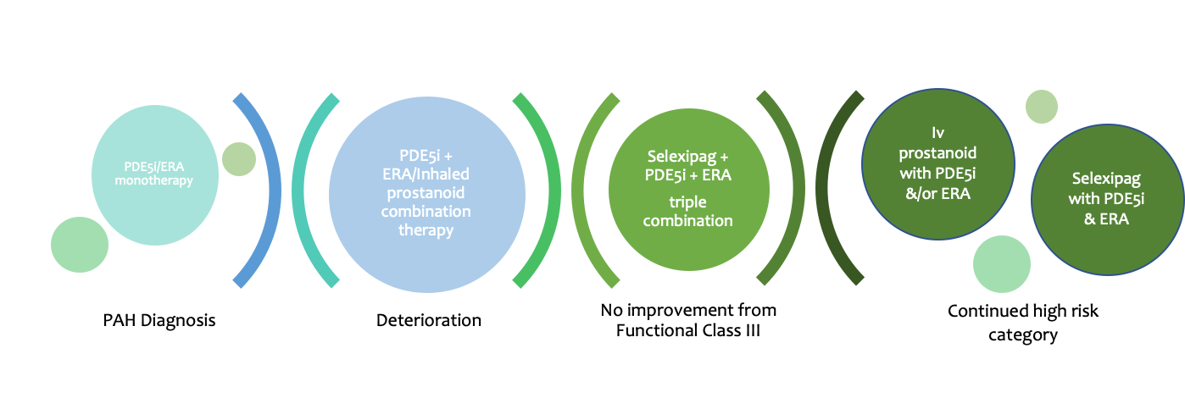
Figure 12. Current therapy recommendations in the UK
Abbreviations: PDE5i, phosphodiesterase type 5 inhibitors ERA; endothelin receptor antagonist

Current NHS guidance suggests the above approach, figure 12, when offering PH targeted therapies to a patient (Commissioning, 2018). The rationale and approach to combination therapies are summarised in Figure 13, adapted from (Marc Humbert & Ghofrani, 2016).

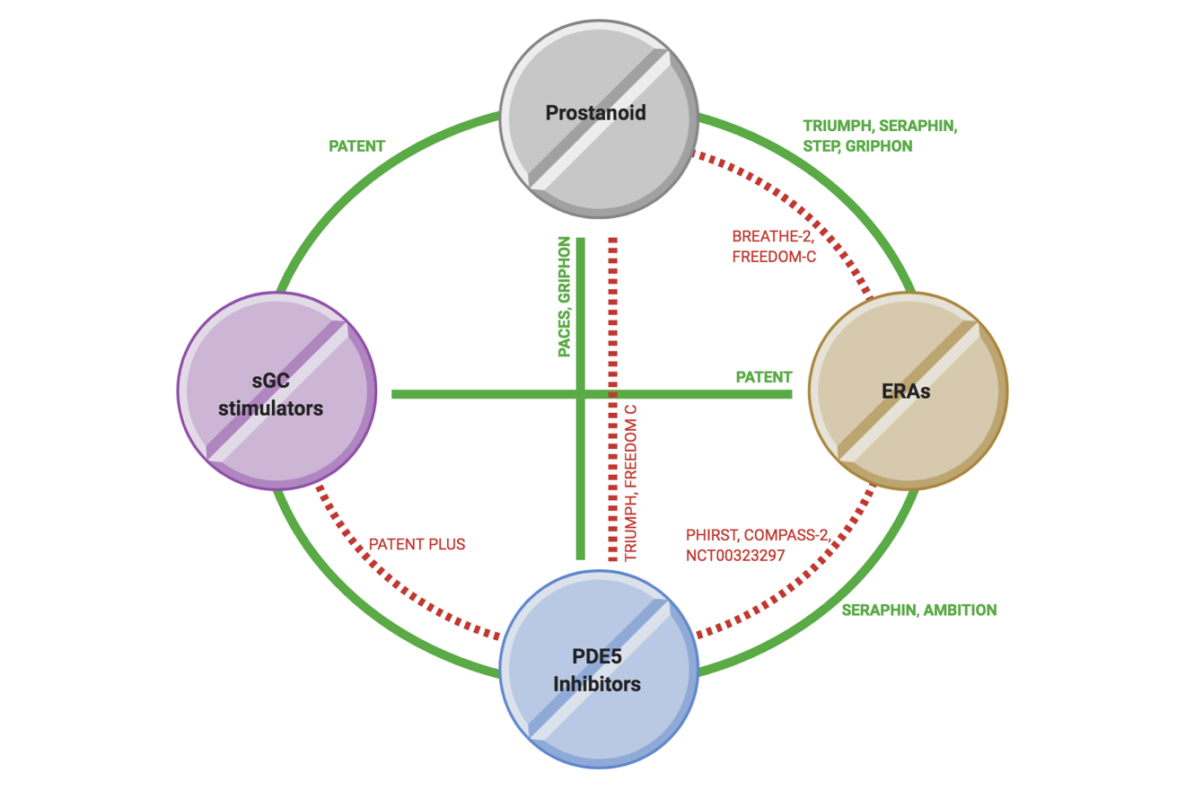

Significantly beneficial trials | ------------------------ | Trials demonstrating no benefit | -------------------------
PACES¹ | Epoprostenol + sildenafil | FREEDOM-C*⁸ | ERAs/non-intravenous prostanoids + oral treprostinil
TRIUMPH*² | Bosentan + inhaled treprostinil | TRIUMPH*² | Sildenafil + inhaled treprostinil
PATENT*³ | ERAs/non-intravenous prostanoids + riociguat | PHIRST*⁹ | Bosentan + tadalafil
SERAPHIN*⁴ | PDE5i/non-intravenous prostanoids + macitentan | COMPASS-2¹⁰ | Sildenafil + bosentan
AMBITION⁵ | First-line ambrisentan + tadalafil | NCT00323297¹¹ | Bosentan + sildenafil
STEP⁶ | Bosentan + inhaled iloprost | BREATHE-2¹² | Epoprostenol + bosentan
GRIPHON*⁷ | PDE5i/ERAs + selexipag | PATENT PLUS¹³ | Sildenafil + riociguat
Figure 13. Combination of PH therapies randomised controlled trials
Abbreviations: PDE5i, phosphodiesterase type 5 inhibitors ERA; endothelin receptor antagonist; sGC, soluble guanylate cyclase; *, subgroup analyses (Robyn J. Barst et al., 2011; Nazzareno Galiè, Barberà, et al., 2015; Nazzareno Galiè, Müller, et al., 2015; M M Hoeper, 2006; V. McLaughlin et al., 2015; V. V. McLaughlin et al., 2010; Pulido et al., 2013; Lewis J. Rubin et al., 2015; Gérald Simonneau et al., 2008; Sitbon et al., 2015; Tapson et al., 2012; Vizza et al., 2017)

Methods

Identification of patients with PAH
The Sheffield pulmonary vascular disease unit (PVDU) registry - Assessing the spectrum of pulmonary hypertension identified at a Pulmonary Hypertension REferral centre (ASPIRE registry) - REC reference 16/YH/0352 – initially included all treatment naive patients consecutively referred to Sheffield PVDU between 2001-2010 - initially enrolling 1,344 patients. All those undergoing assessment for potential PH were followed until November 2010 as part of the initial registry. Regarding data acquisition, all but two parameters – CI and DLco (<90%) – had less than 95% capture.

The measures of WHO FC, lung function and exercise capacity closest to the initial right heart catherisation were taken as baseline measures.

This registry was firstly interrogated to identify patients with PAH associated with idiopathic, CTD and congenital heart disease. Out with these dates, 1999-2001 and 2010-2015 departmental databases were searched, and baseline demographics, functional measures, lung function, imaging and haemodynamic data was acquired by reviewing the original cases notes.

After identifying a cohort of patients. Each case was carefully assessed to ensure they met the following criteria:
- All patients had precapillary PH as defined by mean pulmonary arterial pressure (mPAP) ≥25 mm Hg and pulmonary arterial wedge pressure (PAWP) ≤15 mmHg
- Adults were >18 years of age
- All CTD-PAH patients were further defined by only including those with a diagnosis of SSc-PAH (scleroderma associated PAH)
- All CHD-PAH patients were assigned to one of the four groups described in Table 5: Es, L-to-R shunts, Small defects (SD), Closed/Corrected defects (CD). Any patient with complex congenital pathology e.g., associated left ventricular dysfunction was excluded from the cohort.

In the IPAH and CTD-PAH group, clinical records, and non-invasive investigations were reviewed. This allowed further classification of the IPAH and CTD-PAH into three subgroups. Those with minimal other past medical history - iPAH/SSc-PAH, IPAH-risk of left heart disease (lhd) - IPAH-lhd, and IPAH-risk of lung disease (lung) - IPAH-lung.

To identify a patient at risk of left heart disease they had to have at least two of the following criteria: systemic hypertension, diabetes, atrial fibrillation, BMI > 35, an enlarged left atrium on echocardiography or any history of ischemic heart disease, these criteria were utilised in the AMBITION trial to identify those at risk of lhd (V. V. McLaughlin et al., 2019).

Those identified at risk of lung disease either had a history of smoking, with evidence of obstructive spirometry (FEV1/FVC < 70%) and/or emphysema on CT thorax. In those with a degree of lung fibrosis with scleroderma, an approach based on Goh et al was employed (Goh et al., 2012). Goh et al utilised a combination of HRCT and lung function parameters to develop a simple staging system to assess the extent of lung involvement/fibrosis in patients with SSc, figure 14, this system also had the additional benefit of providing prognostic information in this group of patients.

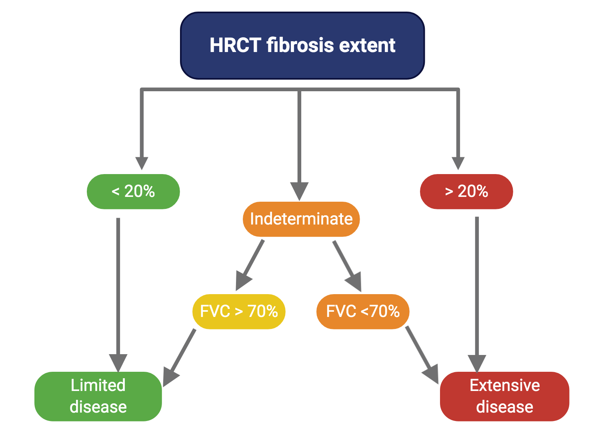
Figure 14. Staging system to define extent of lung fibrosis
Abbreviations: FVC, forced vital capacity

Date of diagnosis
In patients with IPAH and CTD-PAH the date of diagnosis was taken as the date of the first diagnostic right heart catheterization. In patients with CHD-PAH, the date of initial presentation to the Sheffield PVDU was accepted as the date of diagnosis.

(dose of iloprost (mcg) over 24 hours÷100)×72000weight (kg) ÷ 1000

Lung function testing

All lung functions performed at the Sheffield PVDU lung function laboratory were as per ATS/ERS guidance (Miller, 2005), using the following reference formulae based upon – European Community for Steel and Coal (ECSC) guidance, (H et al., 1983)see table 12.

 | Unit | Gender | Regression equation
FVC | Litres | Male | 5.76H - 0.026A - 4.34
 |  | Female | 4.43H - 0.026A - 2.89
FEV1 | litres | Male | 4.30H - 0.029A - 2.49
 |  | Female | 3.95H - 0.025A - 2.60
DLco | mmol.min⁻¹.kPA⁻¹ | Male | 11.11H - 0.066A - 6.03
 |  | Female | 8.18H - 0.049A - 2.74

Table 12. Reference calculation ranges for lung function: males & females
Abbreviations: FVC, forced vital capacity; FEV₁, forced expiratory volume in one second; DLco, diffusing capacity of the lung for carbon monoxide; H, height in metres; A, age in years

Characteristics by DLco % predicted
In this thesis, the effect of a lower DLco is studied. By investigating our large cohort of IPAH patients it was evident that the median value of DLco % predicted was 48.8% and a trimmed mean of 49.4%. This measure was skewed with a bimodal distribution (DLco% predicted of 36 and 60%), a DLco% predicted of 45% was the optimal cut-off value.

Exercise testing - ISWD
The ISWD was conducted as per Singh et al’s method (Singh et al., 1992). No practice walk was performed and patients performed the 12-level test on room air, even if they normally received supplemental oxygen. Patients were asked to walk as far as they could on a ten-metre course, keeping time with the audio signal until they were too breathless or unable to keep up with the ‘beep’. The initial speed equated to 0.5m/s to a maximal speed of 2.37m/s.

Right heart catheterisation
A right heart catheterisation at baseline was generally performed at the Sheffield PVDU via a jugular approach. A balloon tipped 7.5-French thermodilution catheter was introduced via a Swanz Ganz catheter. Cardiac output was measured with thermodilution and PVR was calculated using the following equation $\frac{mPAP-PAWP}{CO}$ .
As routine, at the start of the procedure blood pressure (BP), HR, height and weight were measured. Body surface area (BSA) was calculated via the Dubois & Dubois equation: 0.20247 x height (m)^{0.725} x weight (kg)^{0.425}. This allowed haemodynamic measurements to be indexed i.e., cardiac index.

Cardiac MR
Images were acquired on a GE HDx 1.5T whole body scanner (GE Healthcare, USA) using a cardiac gated balanced steady-state free precession imaging with the patient in a supine position.

Risk-stratification
The proposed risk stratification scores developed by the Americans, Germans and Swedish had a very small proportion (4%-13%) of patients with CHD-PAH in their total PAH cohorts and the French group had none. Consequently, when performing a comparison between the risk scores only forms of PAH related to idiopathic, heritable, and scleroderma were included. As this was a retrospective analysis, some variables were not available for the analysis. Historically, some of these measurements were not collected. Thus, for the comparison study of the risk scores the available parameters are seen in Table 11:
 | Variable | Availability
Lung function testing | DLco% predicted | ✓
Haemodynamics | PVR, WU | ✓
 | SvO2 % | ✓
 | Cardiac index | ✓
 | RAP mmHg | ✓
Echo findings | Pleural effusion | X
 | RA area | X
Blood marker: cardiac | BNP/NT-proBNP | X
Exercise capacity | 6MWD, m | ✓* - variation with ISWD
 | WHO FC | ✓
 | Hospitalisations | ✓* - baseline cohort = 0
Observations | Heart rate, bpm | ✓
 | Blood pressure | ✓
Blood marker | Renal dysfunction | ✓
Demographics | Gender | ✓
 | Subgroup | ✓

Table 11. Available parameters for the risk score comparison
Abbreviations: DLco, diffusing capacity of the lung for carbon monoxide; PVR, pulmonary vascular resistance; SvO₂%, pulmonary artery saturations; RAP, right atrial pressure; RA, right atrial; BNP, brain natriuretic peptide; NT-proBNP, N-terminal brain natriuretic peptide; 6MWD, 6-minute walk distance; WHO FC, world health organisation functional class

Blood markers
Within the study period at the Sheffield PVDU, it was standard practice to perform full blood count, renal, liver and thyroid function as well as a connective tissue disease screen. Unfortunately, during the time period of the studies included in this thesis BNP or NT-proBNP was not routinely collected.

ISWD estimation of 6MWD
At the Sheffield PVDU it is standard practice to perform ISWD as a measure of exercise capacity, instead of 6MWD. The rationale is that the ISWD is a simple measure of maximal exercise capacity with no ceiling effect as opposed to the 6MWD which does have a ceiling effect and may not identify early pulmonary vascular disease.
A study by Billings et al of a large cohort of PAH patients suggested the following cut-offs based on Gaussian distribution: ISWD ≥ 420m, ISWD < 420 - 130m, < 130m (Billings et al., 2017). Those PAH patients therefore, with an ISWD ≥ 420m were classed as ‘low risk’, ISWD between 420m-130m - ‘intermediate risk’ and finally those able to walk < 130m as ‘high risk’.

Management of missing variables
To ensure a robust comparison between the risk scores if ≥ 2 variables were missing in any normally available variable at the Sheffield PVDU, that case was excluded from the analysis.

Intravenous iloprost in the management of IPAH and SSc-PAH
After identification of patients who had received domiciliary intravenous iloprost for either IPAH or SSc-PAH the iloprost dosing regime was calculated in ng/kg/min based on patient weight at each visit. Concurrent PH targeted therapies were also noted. Dates of commencement and cessation of iloprost were also identified.
An intravenous (iv) iloprost dose calculator was utilised to determine the dosing regime in ng/kg/min. The calculator follows this equation: (dose of iloprost (mcg) over 24 hours÷100)×72000weight (kg) ÷ 1000

Statistical methods
Statistical analyses were performed using IBM SPSS Statistics, version 21-27 (SPSS, Inc) and GraphPad Prism version 7.0 for Windows, GraphPad software, La Jolla California. Initially all data acquired were assessed for normality by calculating the skewness and kurtosis as well as the Kolmogorov-Smirnov statistic.

Data thereafter were expressed as mean ± standard deviation (SD) or median ± interquartile range for non-parametric data. Generally, categorical data was expressed as number and percentage.

One-way analysis of variance and post-hoc analysis with Bonferroni were used to determine significant differences between continuous data in three or more groups. Variables with hyperbolic relationships were compared using analysis of
covariance following log transformation

Comparison between two groups was performed utilising a t-test (parametric data) or Mann-Whitney (non-parametric) test for continuous data and the χ2 test for categorical data. Wilcoxon signed rank test were used to compare pairwise statistics. Correlation testing was conducted with Pearson’s test for continuous data and Spearman’s rank order correlation for ordinal data.

Survival analyses was performed using Kaplan-Meier method, and univariate and multivariate Cox regression analysis to identify prognostic variables. Parameters with >15% missing data were not included in multivariate analysis. A p-value <0.05 was considered statistically significant throughout.

Chapter I:

Characterisation of idiopathic pulmonary arterial hypertension

Abstract
Background:
Current characterisation of IPAH is based on parameters which may not adequately capture disease diversity and this lack of clinical phenotyping may be a potential cause for this continued poor prognosis.
Methods:
Departmental databases identified 322 patients with evidence of PAH. These PAH patients were further phenotype into patients with iPAH - idiopathic disease, IPAH-lung, at risk of possible lung disease, and a further sub-group with at least two risk factors for left heart disease - IPAH-lhd. We also divided the iPAH and IPAH-lhd into further subcategories of those with a DLco% >45 and those with a DLco% <45
Results:
Our study cohort included 183 patients with iPAH, 25 with IPAH-lung and 114 with IPAH-lhd. Patients with iPAH were younger with superior exercise capacity but worse haemodynamics when compared to the other sub-groups. Survival was also superior in iPAH patients. In patients with a DLco% < 45 there were older and more men were included in this sub category. They also had significantly worse prognosis.
Conclusion:
This study has demonstrated the adverse effects of minimal lung disease or potential left heart disease upon an aging IPAH population, with IPAH-lung patients having the worst prognosis. It has also corroborated other studies and registry data demonstrating that IPAH should no longer be thought of as a disease of homogeneity.

Introduction
PAH is progressive disease characterised by a pulmonary artery vasculopathy resulting in dysfunctional remodelling and right ventricular failure causing early death. Despite advancements made in therapies, life expectancy has improved but overall, it remains poor (Benza et al., 2019).

Current characterisation of IPAH is based on parameters which may not adequately capture disease diversity and this lack of clinical phenotyping may be a potential cause for this continued poor prognosis (Badagliacca et al., 2020).

The aim of this study was to perform a precise and comprehensive analysis of our IPAH patients in order to ascertain the effects of comorbidities upon a patient's presentation functional status, lung function, haemodynamics and long-term survival.

Method

Identification of PAH patients
Between the periods of February 2001 to July 2014 departmental databases and the ASPIRE registry were interrogated to identify patients with a diagnosis of IPAH.

All patients had pre-capillary PH as defined by an mPAP ≥ 25mmHg and a PAWP ≤ 15mmHg at a baseline RHC. Any patient with possible atypical disease with evidence of significant left heart or lung disease were excluded from the analysis.

Remaining patients were assigned to one of three groups.
- iPAH - isolated PAH
- IPAH - lung: defined if any evidence of parenchymal disease, or a diagnosis of COPD with an FEV1/FVC ratio < 0.7, and FEV1 <80% with a smoking history
- IPAH - lhd: presence of at least 2 risk factors: Systemic hypertension, diabetes, atrial fibrillation, BMI >35, and enlarged left atrium on echocardiogram or a history of ischaemic heart disease.

Date of diagnosis was defined as the date of the baseline RHC with a transplant-free census date of the 1st of February 2015. Deaths were noted via the National Health death reporting system.

Study cohort:
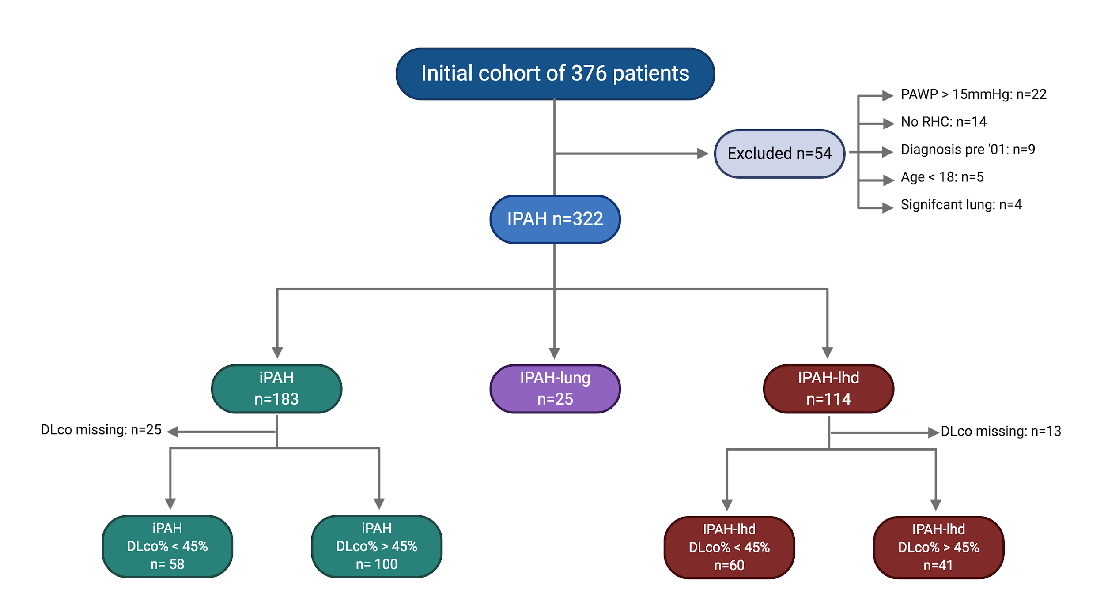
Figure 15. Study cohort

Analysis
Statistical analyses were performed using IBM SPSS Statistics, version 25 (SPSS, Inc.) and GraphPad Prism version 7.00 for Windows, GraphPad Software, La Jolla California USA. Data were expressed as mean ± SD or median ± interquartile range. Categorical data were expressed as number and percentage.

One-way analysis of variance and Bonferroni post hoc analysis were used to determine significant differences between continuous data in three or more groups. Comparison between two groups was performed using a t test or the Mann-Whitney test for continuous data and the χ2 test for categorical data. Transplant-free survival from the date of the initial RHC was calculated using the Kaplan-Meier method. Univariate and multivariate Cox regression analysis was performed to identify prognostic factors. A P value of < .05 was considered statistically significant throughout.

Results

General characteristics
Of 322 iPAH cases, 114 patients had evidence of IPAH-lhd, 25 cases of IPAH-lung and 183 people with iPAH. Fifteen patients in the IPAH-lung group also had evidence of ischaemic heart disease. The majority of the iPAH and IPAH-lhd groups were females. There was also a significant difference between the ages of the three groups, and the iPAH group was the youngest group. The majority of patients were in WHO FC III however, there was a significant difference in exercise capacity between the groups with iPAH patients having a greater baseline distance (249m± 187). Those patients in the iPAH group had more severe perturbations of pulmonary haemodynamics with significantly higher mPAP and PVR. The DLco% predicted was highest in the iPAH group and unsurprisingly lowest in those with evidence of lung disease, IPAH-lung. At census only 5 of the 322 IPAH patients had been transplanted and all these patients were from the iPAH category, table 13.

Clinical characteristics | iPAH  (n=183) | IPAH-lung  (n=25) | IPAH-lhd  (n=114) | p-value
Female, n (%) | 127, (69) | 11, (44) | 66, (58) | 0.015
Age, yrs | 49.7±16.1 ^{ϕ,ϑ} | 62.7±17.1 ^{λ} | 68.1±11.1 ^{λ} | <0.001
BMI, kg.m⁻² | 25.7±6.8 ^{ϕ} | 28.5±6.6 | 31.6±6.9^{λ} | <0.001
WHO FC I, n (%) | 1, (1)
WHO FC II, n (%) | 23, (13) | 3, (12) | 4, (4)
WHO FC III, n (%) | 122, (67) | 14, (56) | 76, (67)
WHO FC IV, n (%) | 33, (18) | 8, (32) | 34, (30)
ISWD, m | 249±187 ^{ϕ} | 157±101 | 124±130 ^{λ} | <0.001
Haemodynamics
mRAP, mmHg | 10±6 ^{ϕ} | 12±6 | 12±6 ^{λ} | 0.004
sPAP, mmHg | 86±21 | 80±18 | 84±15 | 0.175
dPAP, mmHg | 36±11 ^{ϕ} | 33±6 | 32±9 ^{λ} | 0.006
mPAP, mmHg | 55±14 ^{ϕ} | 50±10 | 51±10 ^{λ} | 0.013
PP, mmHg | 50±15 | 44±15 | 51±12 | 0.383
CI, L.min.m⁻² | 2.4±0.7 | 2.3±0.6 | 2.4±0.7 | 0.872
PAWP, mmHg | 10±3 ^{ϕ} | 10±3 | 11±3 ^{λ} | <0.001
PVR, WU | 12.4±5.8 ^{ϕ} | 10±3.3 | 10±4 ^{λ} | <0.001
Pulmonary function
FEV₁ % pred | 87±15 ^{ϑ,ϕ} | 71±12 ^{λ,ϕ} | 81±18 ^{λ,ϑ} | < 0.001
FVC % pred | 98±18 ^{ϕ} | 89±17 | 90±23 ^{λ} | 0.003
FEV₁/FVC | 0.75±0.08 ^{ϑ} | 0.64±0.10 ^{λ,ϕ} | 0.73±0.09 ^{ϑ} | <0.001
DL_{CO} % pred | 54±20 ^{ϑ,ϕ} | 35±19 ^{λ} | 44±20 ^{λ} | <0.001
Alive:Dead:Tx at census % | 107:71:5 (58:39:3) | 7:18:0 (28:72:0) | 51:63:0 (45:55:0)

Table 13. Clinical characteristics of the study population
Data are presented as mean ± SD or % unless otherwise stated. Abbreviations: iPAH, idiopathic pulmonary arterial hypertension; IPAH-lung, IPAH with evidence of lung disease; IPAH-lhd, at risk of left heart disease due to ≥2 risk factors for left heart disease; BMI, body mass index; WHO FC, World Health Organisation functional class; ISWD, incremental shuttle walk distance; mRAP, mean right atrial pressure; mPAP, mean pulmonary artery pressure; CI, cardiac index; PAWP, pulmonary arterial wedge pressure; PVR, pulmonary vascular resistance; SvO2%, pulmonary arterial saturations; %pred, percent predicted; FEV1, forced expiratory volume in 1 second; FVC, forced vital capacity; DLco, transfer factor of the lung for carbon monoxide; λ: p <0.05 in comparison to IPAH; ϑ: p <0.05 in comparison to IPAH-lung; ϕ: p <0.05 in comparison to IPAH-lhd

PAH specific therapy
The majority of the iPAH group, 38%, were on dual therapy at census with 26% of patients on prostanoid based therapy. A higher proportion, 48%, of the IPAH-lung group were on dual oral therapy, with 16% of patients on either nebulised or intravenous prostanoid. In the IPAH-lhd group a larger proportion of patients were on monotherapy, 36%, when compared to the other groups. This high proportion of patients on monotherapy perhaps represents previous practice, of a more conservative management strategy in the earlier years of this study. Or perhaps even, a concern to prescribe PH therapies due to interactions with concurrent medications. Continuing with the IPAH-lhd cohort 37% were on dual oral therapy and 16% on a prostanoid based regime. It is noteworthy that a small proportion of patients are listed as not being on specific PH therapy. In this case these patients were prescribed calcium channel blockers as they were nitric oxide responders, table 14.

 | iPAH | IPAH-lung | IPAH-lhd
No therapy | 3 (2%) | 2 (8%) | 1 (1%)
Monotherapy | 49 (27%) | 6 (24%) | 41 (36%)
Dual therapy | 70 (38%) | 12 (48%) | 42 (37%)
Prostanoid | 3 (2%) |  | 1 (1%)
Prostanoid & oral monotherapy | 29 (16%) | 3 (12%) | 15 (13)
Triple therapy | 15 (8%) | 1 (4%) | 2 (2%)

Table 14. Breakdown of PH-targeted therapies by sub-group
Missing data for iPAH: 14 cases, IPAH-lung: 1 missing, IPAH-lhd: 12 missing. iPAH, idiopathic pulmonary arterial hypertension; IPAH-lung, IPAH with evidence of lung disease; IPAH-lhd, at risk of left heart disease due to ≥2 risk factors for left heart disease

Characteristics by DLco% 45
In both the iPAH and IPAH-lhd those with DLco% <45 were older with a larger proportion of the subgroups being male. They also had a significantly lower exercise capacity. The iPAH DLco% <45 sub-group exhibited a surprisingly lower PVR when compared to iPAH DLco% >45, with a significantly lower SvO2 despite similar CIs. The IPAH-lhd DLco% <45 sub-group patients are significantly older, with a lower CI and SvO2. A larger proportion of patients in the iPAH DLco% <45 were on prostanoid based therapy (33%), reflecting perhaps their increased burden of symptoms, tables 15 & 16.

 | iPAH  DLco% >45  (n=100) | iPAH  DLco% <45  (n=58) | p-value | IPAH-lhd DLco% >45  (n=41) | IPAH-lhd DLco% <45  (n=60) | p-value
Clinical characteristics
Female, n (%) | 77 (77%) | 32 (33%) | <0.001 | 27, (66) | 29, (48) | 0.274
Age, yrs | 45.0±14.2 | 60.1±14.3 | <0.001 | 60.6±11.8 | 72.0±8.2 | <0.001
BMI, kg.m⁻² | 26±6 | 27±7 | 0.715 | 36±5 | 30±6 | <0.001
WHO FC I, n (%) | 1, (1%)
WHO FC II, n (%) | 17, (17%) | 5, (9%) |  | 3, (7) | 1, (2)
WHO FC III, n (%) | 72, (10%) | 32, (55%) |  | 30, (73) | 39, (65)
WHO FC IV, n (%) | 10, (10%) | 21, (36%) |  | 8, (20) | 20, (33)
ISWD, m | 301±192 | 142±135 | <0.001 | 184±149 | 96±118 | 0.002
Haemodynamics
mRAP, mmHg | 10±6 | 12±6 | 0.061 | 13±7 | 11±3 | 0.011
mPAP, mmHg | 56±15 | 52±10 | 0.04 | 53±10 | 50±8 | 0.090
PP, mmHg | 52±16 | 48±14 | 0.170 | 52±12 | 52±11 | 0.628
CI, L.min.m⁻² | 2.4±0.7 | 2.3±0.7 | 0.582 | 2.6±0.6 | 2.2±0.6 | 0.13
PAWP, mmHg | 9.2±3.1 | 9.8±2.8 | 0.302 | 11±3 | 11±3 | 0.765
PVR, WU | 12.5±6.0 | 11.5±4.9 | 0.115 | 8.9±3.7 | 10.5±4.1 | 0.199
SvO2% | 63±8 | 58±9 | 0.008 | 61±9 | 60±8 | 0.655
Pulmonary function
FEV₁ % pred | 89±15 | 86±16 | 0.337 | 76±16 | 85±18 | 0.014
FVC % pred | 98±17 | 99±19 | 0.707 | 84±19 | 96±23 | 0.008
FEV₁/FVC | 0.78±0.07 | 0.71±0.08 | <0.001 | 0.75±0.09 | 0.71±0.09 | 0.052
DLco% pred | 67±13 | 32±7 | <0.001 | 64±14 | 31±7 | <0.001
Table 15. Clinical characteristics dependent on DLco% >45 or DLco% <45
Data are presented as mean ± SD or % unless otherwise stated. Abbreviations. iPAH, idiopathic pulmonary arterial hypertension; IPAH-lhd, at risk of left heart disease due to ≥2 risk factors for left heart disease; BMI, body mass index; WHO FC, World Health Organisation functional class; ISWD, incremental shuttle walk distance; mRAP, mean right atrial pressure; mPAP, mean pulmonary artery pressure; CI, cardiac index; PAWP, pulmonary arterial wedge pressure; PVR, pulmonary vascular resistance; SvO2%, pulmonary arterial saturations; %pred, percent predicted; FEV1, forced expiratory volume in 1 second; FVC, forced vital capacity; DLco, transfer factor of the lung for carbon monoxide

PAH-targeted therapies dependent on Dlco% 45

 | iPAH DLco% >45  (n= 92) | iPAH DLco% <45 (n=52) | IPAH-lhd DLco% >45 (n=35) | IPAH-lhd DLco% <45 (n=56)
No therapy | 1, (1) |  | 1, (2)
Monotherapy | 28, (28) | 15, (26) | 15, (37) | 22, (37)
Dual therapy | 40, (40) | 18, (31) | 12, (30) | 23, (38)
Prostanoid |  | 3, (5) |  | 1, (2)
Prostanoid & oral monotherapy | 14, (14) | 14, (24) | 6, (15) | 9, (15)
Triple therapy | 9, (9) | 2, (4) | 1, (2) | 1, (2)
Table 16. PH targeted therapies according to DLco% 45 subgroup
Data are presented as number, (%). Abbreviations. iPAH, idiopathic pulmonary arterial hypertension; IPAH-lhd, at risk of left heart disease due to ≥2 risk factors for left heart disease; DLco, transfer factor of the lung for carbon monoxide

Survival Outcomes
Of 322 IPAH patients, there were a total of 152 deaths and 5 pulmonary transplants. In the iPAH group there were 76 deaths, 18 deaths in the IPAH-lung cohort and finally 63 deaths in the IPAH-lhd group. Those patients in the iPAH cohort had superior survival, median survival of 7.8 years (p < 0.001) when compared to the survival of IPAH-lung and IPAH-lhd groups (median survival, 2.1 years; P < .001 and median survival, 3.4 years; P <0.001 respectively. The 1-, 3-, 5- and 10- year survival rates were as follows: iPAH - 90%, 75%, 63% and 39% ; IPAH-lung - 84%, 36%, 26% and 0%; IPAH-lhd - 83%, 54%, 38% and 6%, Figure 16.

Effect of DLco% <45 on survival
iPAH cohort
Of the 158 patients included in this analysis, the 1-, 3-, 5- and 10-year survival of those with a DLco% >45 vs DLco% <45 was 98% vs 72%, 89% vs 44%, 75% vs 34%, and 49% vs 10%. There was a significant difference in survival between the two groups with iPAH patients with a DLco% >45 being superior (30 deaths as opposed to 39 in the iPAH DLco% <45).

IPAH-lhd cohort
Of the 101 IPAH-lhd patients with available DLco% predicted, those with a DLco >45% predicted had a significantly superior survival than those patients with a DLco < 45% predicted (log rank p < 0.001), i.e., 17 deaths versus 38 deaths. 1-, 3- and 5- year survival was 90% vs 78%, 76% vs 35% and 55% vs 20%.
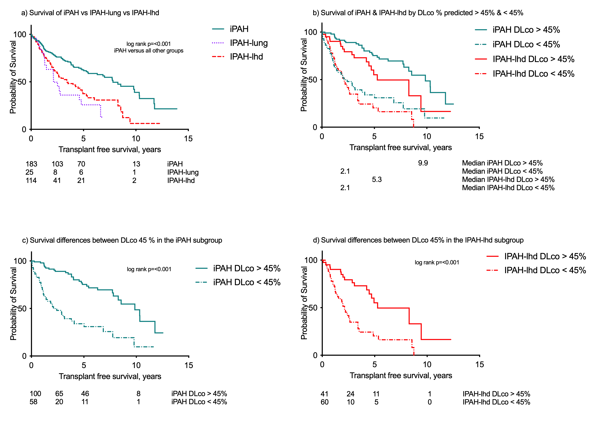
Figure 16. Kaplan Meier curves of the study population by DLco % predicted cut off of 45%

Prognostic factors
Whole IPAH cohort

Regression analysis demonstrated that in the total cohort of 322 IPAH patients’ independent prognostic indicators included older age, exercise capacity, lower DLco and lower SvO2% with male sex verging on being an independent negative predictor, table 17.

Univariate analysis of the well phenotyped iPAH cohort of 183 patients demonstrated that advancing age, male sex, higher functional class and right atrial pressure lower distance, DLco, and cardiac index conveyed a worse prognosis, table 18. Multivariate analysis of both the iPAH and IPAH-lhd group revealed that a lower DLco% predicted was an independent prognostic indicator, table 19.

IPAH - 322 | Univariate HR | p-value | Multivariate HR | p-value
Age, yrs | 1.04 (1.03-1.05) | <0.001 | 1.02 (1.00-1.04) | 0.047
Sex  (Ref Female) | 1.56 (1.13-2.13) | 0.007 | 1.51 (0.97-2.34) | 0.068
WHO FC (I-IIvsIII-IV)  (Ref WHO I-II) | 1.96 (1.09-3.55) | 0.025
ISWD, m | 0.99 (0.99-1.00) | <0.001 | 1.00 (0.99-1.00) | 0.028
FEV₁% pred | 1.00 (0.99-1.01) | 0.667
FVC% pred | 1.00 (0.99-1.01) | 0.995
FEV₁/FVC | 0.07 (0.01-0.43) | 0.004
DL_{CO}% pred | 0.96 (0.95-0.97) | <0.001 | 0.98 (0.97-1.00) | 0.005
mRAP, mmHg | 1.03 (1.00-1.06) | 0.023
mPAP, mmHg | 0.99 (0.98-1.00) | 0.183
PAWP, mmHg | 1.03 (0.97-1.08) | 0.368
CI, L.min.m⁻² | 0.62 (0.48-0.81) | <0.001
PVR, WU | 1.01 (0.98-1.04) | 0.537
SvO₂ % | 0.97 (0.95-0.99) | 0.001 | 0.97 (0.95-0.99) | 0.015
SV, mL | 0.99 (0.98-0.99) | 0.002
Table 17. Cox regression of IPAH cohort

iPAH-183 | Univariate HR | p-value | Multivariate HR | p-value
Age, yrs | 1.03 (1.02-1.05) | <0.001
Sex,  (Ref Female) | 1.61 (1.01-2.56) | 0.046 | 1.78 (0.99-3.16) | 0.052
WHO FC (I-IIvsIII-IV)  (Ref WHO I-II) | 2.57 (1.11-5.95) | 0.027
ISWD, m | 0.99 (0.99-1.00) | <0.001
FEV₁% pred | 1.00 (0.98-1.01) | 0.595
FVC% pred | 1.00 (0.99-1.02) | 0.751
DL_{CO}% pred | 0.96 (0.95-0.98) | <0.001 | 0.97 (0.96-0.98) | <0.001
mRAP, mmHg | 1.04 (1.00-1.08) | 0.045
mPAP, mmHg | 1.00 (0.98-1.01) | 0.641
PAWP, mmHg | 1.01 (0.94-1.10) | 0.731
CI, L.min.m⁻² | 0.54 (0.37-0.79) | 0.001
PVR, WU | 1.02 (0.99-1.06) | 0.216
SvO₂, % | 0.96 (0.94-0.98) | 0.001 | 0.94 (0.91-0.97) | <0.001
SV, mL | 0.98 (0.97-0.99) | 0.001
Table 18. Cox regression analysis of iPAH sub-group Data are presented as mean ± SD or % unless otherwise stated. Abbreviations. IPAH, idiopathic pulmonary arterial hypertension; WHO FC, World Health Organisation functional class; ISWD, incremental shuttle walk distance; mRAP, mean right atrial pressure; mPAP, mean pulmonary artery pressure; CI, cardiac index; PAWP, pulmonary arterial wedge pressure; PVR, pulmonary vascular resistance; SvO2%, pulmonary arterial saturations; SV,stroke volume; %pred, percent predicted; FEV1, forced expiratory volume in 1 second; FVC, forced vital capacity; DLco, diffusing capacity of the lung for carbon monoxide

IPAH-lhd | Univariate HR | p-value | Multivariate HR | p-value
Age, yrs | 1.05 (1.02-1.08) | <0.001
Sex,  (Ref Female) | 1.19 (0.72-1.97) | 0.499
BMI, kg.m-2 | 0.98 (0.96-1.01) | 0.291
WHO FC (I-IIvsIII-IV)  (Ref WHO I-II) | 0.90 (0.28-2.89) | 0.859
ISWD, m | 0.99 (0.99-1.00) | 0.011
FEV₁% pred | 1.02 (1.00-1.03) | 0.045 | 1.02  (1.00-1.04) | 0.035
FVC% pred | 1.01 (1.01-1.02) | 0.167
DL_{CO}% pred | 0.97 (0.95-0.98) | <0.001 | 0.97  (0.96-0.99) | 0.001
mRAP, mmHg | 0.99 (0.95-1.04) | 0.796
mPAP, mmHg | 1.00 (0.97-1.02) | 0.773
PAWP, mmHg | 0.97 (0.90-1.08) | 0.753
CI, L.min.m⁻² | 0.75 (0.51-1.10) | 0.139
PVR, WU | 1.04 (0.98-1.11) | 0.234
SvO₂, % | 0.99 (0.96-1.02) | 0.334
SV, mL | 0.99 (0.98-1.00) | 0.116
Table 19. Cox regression analysis of the IPAH-lhd cohort
Data are presented as mean ± SD or % unless otherwise stated. Abbreviations. IPAH, idiopathic pulmonary arterial hypertension; WHO FC, World Health Organisation functional class; ISWD, incremental shuttle walk distance; mRAP, mean right atrial pressure; mPAP, mean pulmonary artery pressure; CI, cardiac index; PAWP, pulmonary arterial wedge pressure; PVR, pulmonary vascular resistance; SvO2%, pulmonary arterial saturations; SV, stroke volume; %pred, percent predicted; FEV1, forced expiratory volume in 1 second; FVC, forced vital capacity; DLco, transfer factor of the lung for carbon monoxide

Discussion
Improving the phenotyping of patients by clinical characteristics may offer clinical benefits such as personalised PH-targeted therapy regimes and individualised treatment goals. Older patients in the IPAH-lung and IPAH-lhd disease group may be diagnosed late in the course of their disease due to the non-specific symptoms of PAH and their comorbidities masking underlying symptoms. In the UK/Ireland registry it was reported that older patients waited a median time of 24 months to be diagnosed as opposed to 12 months of younger patients (Ling et al., 2012).

Typically thought of as a disease of the young female, registries are now showing an advancing age in the IPAH population. Females still make-up the majority population but more comorbid males are being diagnosed with advancing age. As with our study the most common comorbidities reported include systemic hypertension, diabetes, arrhythmias and ischemic heart disease (Ginoux et al., 2018; Ling et al., 2012). As described previously the IPAH-lung subgroup also had 15 patients with concomitant IHD as well as signs of COPD further worsening their prognosis (Andrew J Peacock et al., 2020).

Studies also corroborate our findings of older comorbid patients having less severe haemodynamics with poorer exercise capacity with potentially a poorer response to PAH-targeted therapies (Marius M. Hoeper et al., 2013; Ling et al., 2012). It may also be that the PAH clinician may not be as aggressive with PAH-targeted therapy considering monotherapy rather than dual therapy or prostanoids as with younger patients (Sitbon & Howard, 2019). As to whether patients have a reduced response of PAH-targeted therapies the studies are conflicting. It is postulated that with age the pulmonary vasculature is stiffer and less likely to vasodilate.

In our study despite a preserved FEV1% and FVC% IPAH-lhd patients had a surprisingly low DLco% predicted. This is after ensuring there were no obvious cases of PVOD. A study by Trip et al demonstrated an IPAH group with a DLco% <45 was associated with a higher age, tobacco exposure worse exercise capacity despite similar haemodynamics to the IPAH DLco% >45. They also confirmed that death in this population was related to older age, male sex and coronary artery disease (Trip et al., 2013). When investigating both our iPAH and IPAH-lhd groups, categorising them into those with DLco% >45 and those with a DLco% <45 it was evident that our findings were similar to Trip et al. We also observed that at census both groups had a similar distribution of PAH-targeted therapies perhaps suggesting that those with a lower DLco% predicated may not have responded as well to therapy. Studies have also demonstrated that older patients may not be as tolerant to the side effects of PAH-targeted therapies, certainly this was something which was noticed clinically. There is also the issue of poly-pharmacy and drug interaction in the more comorbid, older patient which may affect adherence (I. M. Lang & Palazzini, 2019).

The topic of IPAH and evidence of minor lung disease is an area with increasing interest. Two recently published studies (Lewis et al., 2020; Andrew J Peacock et al., 2020) have suggested that the response to therapy differs to IPAH patients with no evidence of lung disease. Peacock et al in a UK/Ireland national study demonstrated that 355 patients had IPAH- no lung disease and 137 patients with IPAH=lung disease. Those with lung disease had a lower survival, as in our study even after correcting for age, gender, comorbidities and haemodynamics (72% compared with 93% - IPAH-no-lung-disease) despite even an apparent improvement in 6MWD after PAH-targeted therapy.

Management of the older, comorbid patient with IPAH is clearly challenging. These patients are also often excluded from clinical trials. The GRIPHON investigators however performed a post-hoc analysis to identify those at risk of cardiovascular disease from their cohort of enrolled patients. They found that 99 people out of a sub-group of 752 PAH cases were at risk of cardiovascular disease. Interesting those with suspected cardiovascular disease were less likely to be on a PH-targeted therapy at baseline. The investigators found that those both with and without cardiovascular disease benefited equally from selexipag therapy and the side effect profiles was similar in both groups (S Rosenkranz et al., 2019).

This study has demonstrated the deleterious effects of minimal lung disease or potential left heart disease upon an aging IPAH population, with IPAH-lung patients having the worst prognosis. It has also corroborated other studies and registry data demonstrating that IPAH should no longer be thought of as a disease of homogeneity.

Chapter II:

Gender and idiopathic pulmonary arterial hypertension

Abstract
Background:
Female gender is an established risk factor for PAH. It is generally thought that females present with worse haemodynamics than males yet males have inferior survival. This is thought of as the sex paradox. The hypothesis is that males are older and more comorbid hence their survival is inferior. The aim of this study was to ascertain if males’ survival was inferior by attempting to account for risk factors such as possible lung and heart disease.
Methods:
A cohort of well phenotype iPAH patients were identified by utilising departmental databases. Any patient with risk factors for lung or left heart disease were excluded from the analysis. This left a cohort of 183 iPAH patients of which 30% were males.
Results:
These 56 males were a similar age to their female counterparts and had similar haemodynamics. Lung function most notable DLco% was also similar between the cohorts. Despite these findings’ males continued to have inferior survival when compared to females (log rank p=0.044). The 1-, 3-, 5- and 10-years survival rates (females vs males) were 90% vs 88%, 79% vs 66, 68% vs 51% and 45% vs 24% respectively.
Conclusion:
This study has established despite similar ages, inferiority of male survival persists. The causation of this conclusion is likely related to many factors including the maladaptive features of the right ventricle, the response to PH-targeted therapies as well as the role of sex hormones.

Introduction
Over the last decade with the advancement in PH treatment strategies there has been an improvement in PAH survival. Registry data shows that survival at 5 years exceeds 60% (Benza et al., 2012; Ling et al., 2012; Thenappan et al., 2009) as opposed to the studies of pre-PH targeted therapies where life expectancy was 2.8 years (D’Alonzo et al., 1991). Commonly IPAH is considered a diagnosis of young females, whilst this remains true in the younger cohort of PH registries in the older population there is a more equal distribution (Hurdman et al., 2011; Ling et al., 2012).

Female sex is established as a risk factor for pulmonary arterial hypertension (Badesch et al., 2010) and this predilection of PAH in females has sparked many theories such as the role of sex hormones, autoimmunity or an X-linked locus in disease predisposition. There appears also to be a paradoxical effect of oestrogen, as animal studies have actually demonstrated that oestrogen therapy actually ameliorates both pulmonary vasculopathy and RV function in animal models with PH (Umar et al., 2012; Yuan et al., 2012).

Registry studies show that females generally present with worse haemodynamics when compared to males but conversely their survival is superior. Studies examining this phenomenon of inferior survival in males have suggested that advancing age and males being more comorbid as a possible explanation. There has also been a suggestion that males may respond differently to certain PAH-therapies. The aim of this study is to determine whether males had worse haemodynamics at presentation which could explain their inferior survival by also adjusting for factors such as age and comorbidities.

Methods

Identifying the study population
The identification of PAH patients has already been described, but departmental databases and the ASPIRE registry were utilised. Three hundred and twenty-two patients were diagnosed with IPAH between February 2001 and July 2014. Patients were included in the IPAH cohort if they were >18years of age, and had pre-capillary PH as defined as a mPAP ≥ 25mmHg and a PAWP ≤ 15mmHg.

Categorising of the IPAH cohort
This cohort was further defined by reviewing clinical history, radiology and non-invasive investigations such as lung function testing and echocardiography:
iPAH: isolated IPAH with no signs of concomitant cardiac or pulmonary disease
IPAH-lung: CT thorax evidence of parenchymal lung disease or a diagnosis of COPD with and FEV1/FVC <0.70 and FEV1 <80% predicted with a history of smoking.
IPAH-lhd: risk of left heart disease was defined as having two of the following risk factors - systemic hypertension, diabetes, atrial fibrillation, BMI>35, an enlarged left atrium on echocardiography and a history of ischaemic heart disease. In an attempt to focus upon the effect of gender on the IPAH population this study focused on the well phenotyped iPAH cohort - leaving a cohort of 183 patients. Approval for the study of observational clinical data was granted by the North Sheffield Research Ethics Committee (Ref 06/Q2308/8)

Diagnosis
Date of diagnosis was defined as the date of the first diagnostic right heart catheter with a transplant free survival census date of 1st, February 2015 confirmed from the National Health Service death reporting system.

Analysis
Statistical analyses were performed using IBM SPSS Statistics, version 25 (SPSS, Inc.) and GraphPad Prism version 7.00 for Windows, GraphPad Software, La Jolla California USA. Data were expressed as mean ± SD or median ± interquartile range. Categorical data were expressed as number and percentage. One-way analysis of variance and Bonferroni post hoc analysis were used to determine significant differences between continuous data in three or more groups. Comparison between two groups was performed using a t test or the Mann-Whitney test for continuous data and the χ2 test for categorical data.

Transplant-free survival from the date of the initial RHC was calculated using the Kaplan-Meier method. Univariate and multivariate Cox regression analysis was performed to identify prognostic factors. A P value of <.05 was considered statistically significant throughout.

Overall study cohort

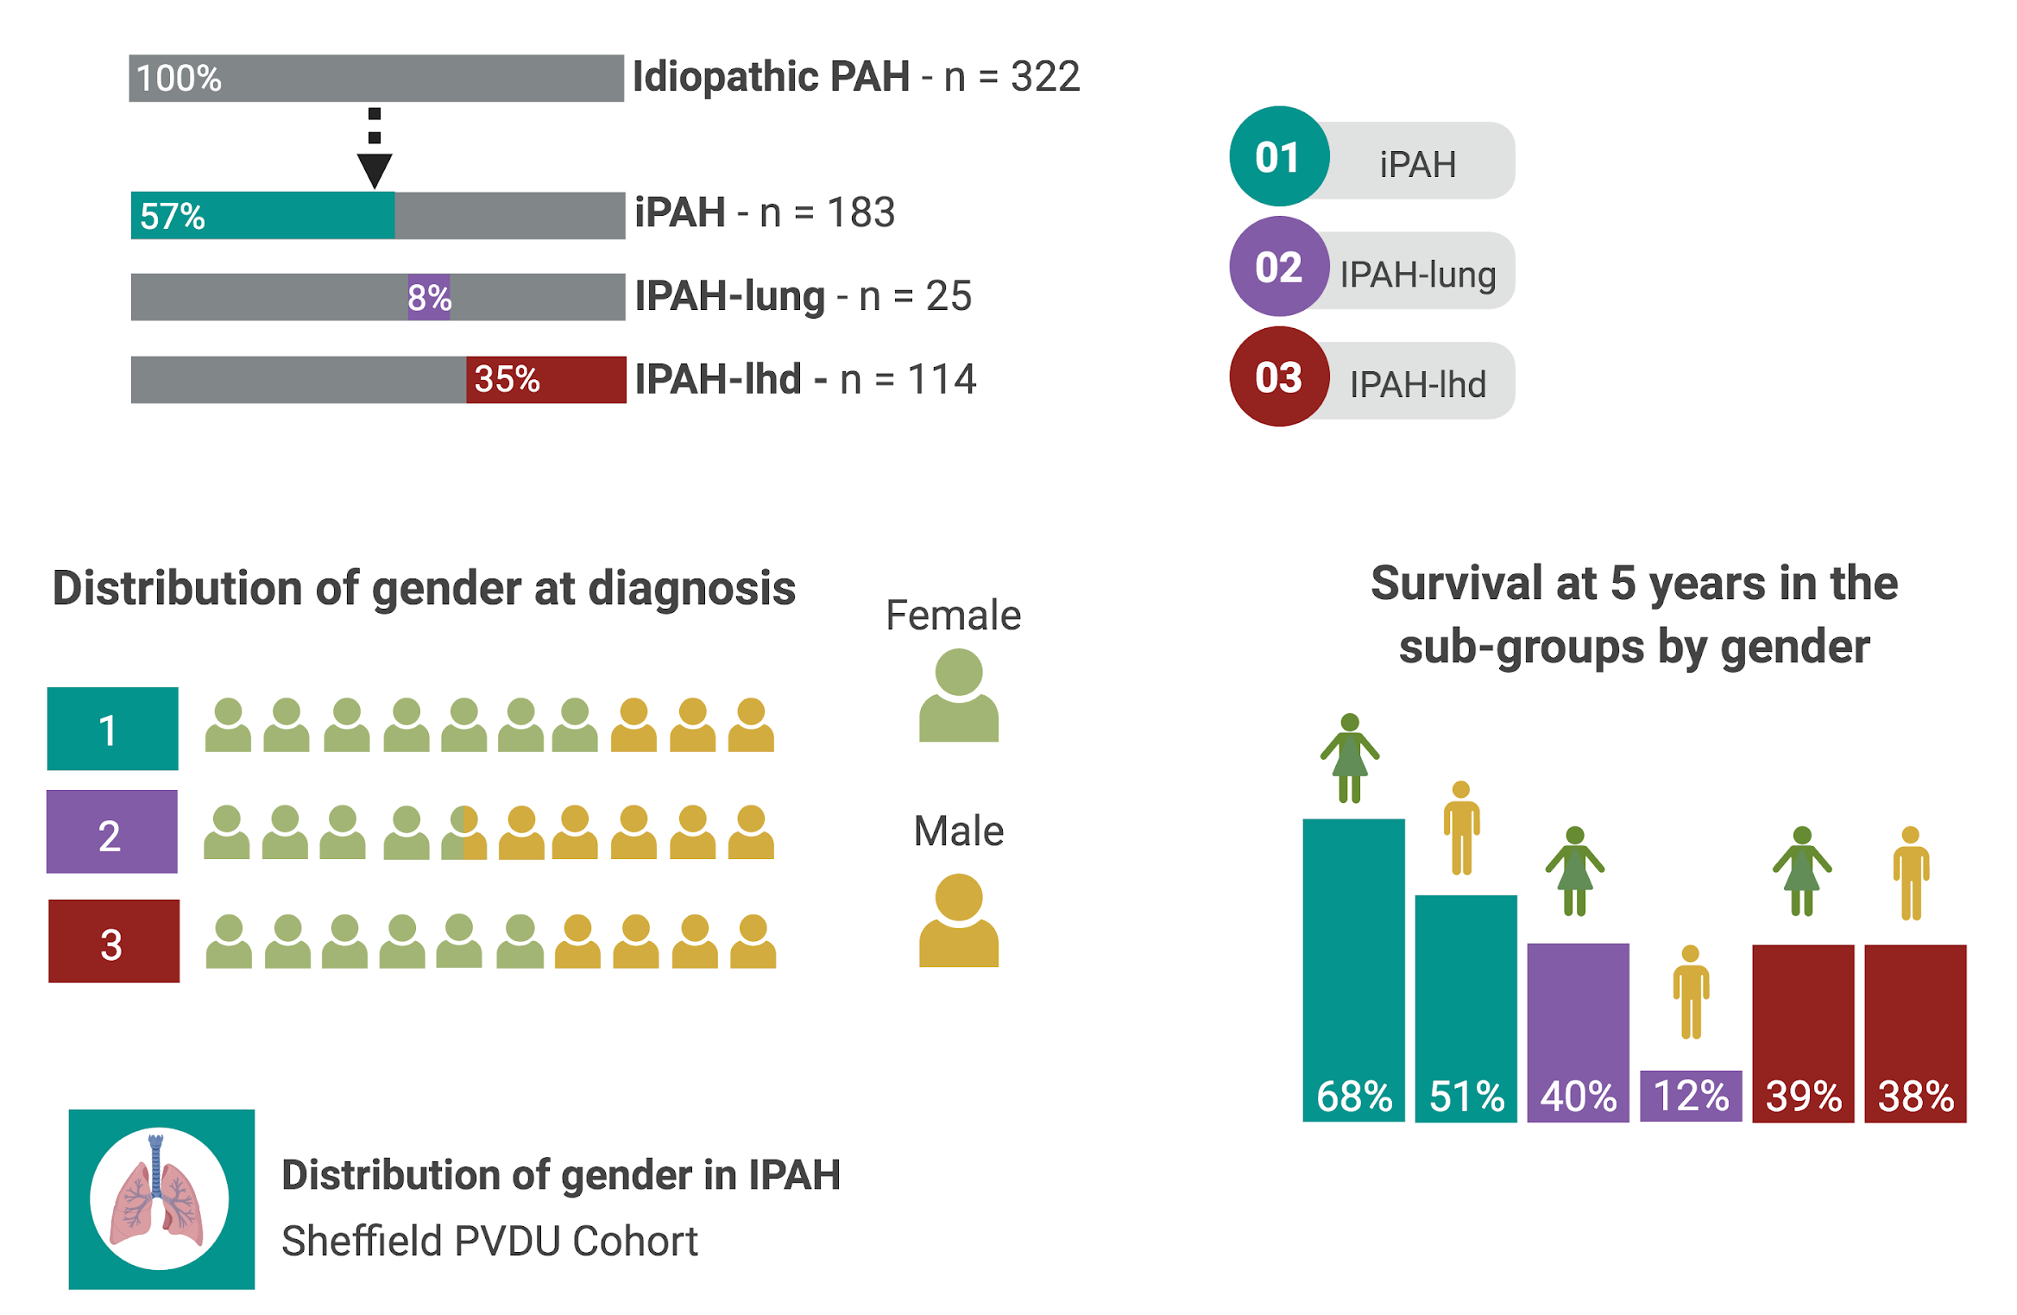
Figure 17. Distribution of gender in the study population

Results

General characteristics
Three hundred and twenty-two patients were identified as having IPAH. Of these 322 patients, 204 (63.4%) are females. Those patients with evidence of left heart or lung disease appeared to be older and have less severe haemodynamics when compared to those with iPAH.

The well phenotype iPAH group demonstrated no significant difference between the genders in terms of age, exercise capacity or pulmonary function, table 20. The primary difference was that females had a significantly higher PVR but all other haemodynamic parameters were similar between the groups, (13.4 vs 9.9, p<0.001).

 | Female, n=127 | Male, n = 56 | p-value
Age, years | 48.4+15.5 | 52.7+17.1 | 0.089
WHO FC I, n (%) | 3, (2) | 1, (2)
WHO FC II, n (%) | 11, (9) | 12, (21)
WHO FC III, n (%) | 89, (70) | 33, (59)
WHO FC IV, n (%) | 24, (19) | 9, (16)
FEV1% pred | 86.3+14.3 | 89.6+17.3 | 0.191
FVC% pred | 97.7+17.4 | 97.7+17.6 | 0.994
FEV1/FVC | 0.76+0.08 | 0.73+0.08 | 0.078
DLco% pred | 55.0+18.4 | 51.4+24.2 | 0.301
ISWD, m | 238+173 | 273+215 | 0.287
mRAP, mmHg | 10.0+5.6 | 10.3+5.5 | 0.716
mPAP, mmHg | 59+14 | 51+12 | 0.010
PAWP, mmHg | 9.5+2.9 | 9.7+2.9 | 0.587
PVR, WU | 13.4+5.9 | 9.9+4.7 | 0.000
SVO2 % | 60.6+9.5 | 61.5+7.6 | 0.536
CI, L.min.m⁻² | 2.3+0.7 | 2.4+0.7 | 0.552
Table 20. General characteristics of the iPAH cohort
Data are presented as mean ± SD or % unless otherwise stated. Abbreviations. WHO FC, world health organisation functional class; ISWD, incremental shuttle walk distance; mRAP, mean right atrial pressure; mPAP, mean pulmonary artery pressure; CI, cardiac index; PAWP, pulmonary arterial wedge pressure; PVR, pulmonary vascular resistance; SvO2%, pulmonary arterial saturations; %pred, percent predicted; FEV1, forced expiratory volume in 1 second; FVC, forced vital capacity; DLco, diffusing capacity of the lung for carbon monoxide

Targeted PAH therapies
iPAH males tended to be more likely on oral therapies (65%), with a smaller proportion being on a prostanoid at census (25%) - see table 21. Due to the study period the majority of our iPAH population were on bosentan, table 22. Given these small numbers it is challenging to ascertain if a patient's response was superior or inferior due to the formulation of ERA.

 | Males, n=56 | Females, n=127
Nil, n (%) |  | 3 (2)
Monotherapy, n (%) | 13 (23) | 36 (28)
Dual therapy, n (%) | 23 (41) | 47 (37)
Prostanoid, n (%) | 1 (2) | 2 (2)
Prostanoid & monotherapy, n (%) | 9 (16) | 20 (16)
Prostanoid & dual therapy, n (%) | 4 (7) | 11 (9)
Table 21. Breakdown of census PH therapies in the iPAH sub-group
Data presented as number then %. Male – 6 missing census therapy, Female 8 missing census therapy

 | Male, n=23 | Female, n=47
Bosentan n, (%) | 15 (65) | 21 (45)
Ambrisentan n, (%) | 6 (26) | 21 (45)
Macitentan n, (%) | 2 (8.7) | 5 (10)
Table 22. Formulation of ERA in oral dual therapy iPAH patients
Data presented as number then %.

Survival
A survival analysis of the whole IPAH cohort (n=322) demonstrated the superior survival of females compared to males (log rank p= 0.006), with a 1-, 3-, 5- and 10- years survival of - 88% vs 85%, 70% vs 54%, 57% vs 41%, 31 % vs 19% (females vs males).

This finding remained when analysing survival in the well phenotype iPAH cohort, the inferior survival in males with iPAH - log rank p=0.044 (figure 18). The 1-, 3-, 5- and 10- years survival rates (females vs males) were 90% vs 88%, 79% vs 66, 68% vs 51% and 45% vs 24%. In this cohort of 183 patients there were 47 vs 29 deaths, females vs males and 5 pulmonary transplants 3 of which were in female patients.

Survival of IPAH patients on dual therapy:
Although there are many confounders such as age and comorbidities in the whole IPAH cohort there is superior survival of women on dual oral therapy (log 0.042).

Despite the small numbers (females n=47 vs males n= 23), comparing survival of females and males on dual therapy (PDE5i and an ERA) visually males appear to have worse outcomes, but it is not statistically significant (log rank 0.211)

Prognostic factors
iPAH group
A cox regression analysis demonstrated that in the iPAH cohort prognostic indicators were similar at univariate level between females and males. Both groups show DLco% predicted to be an independent significant prognostic marker, table 23.

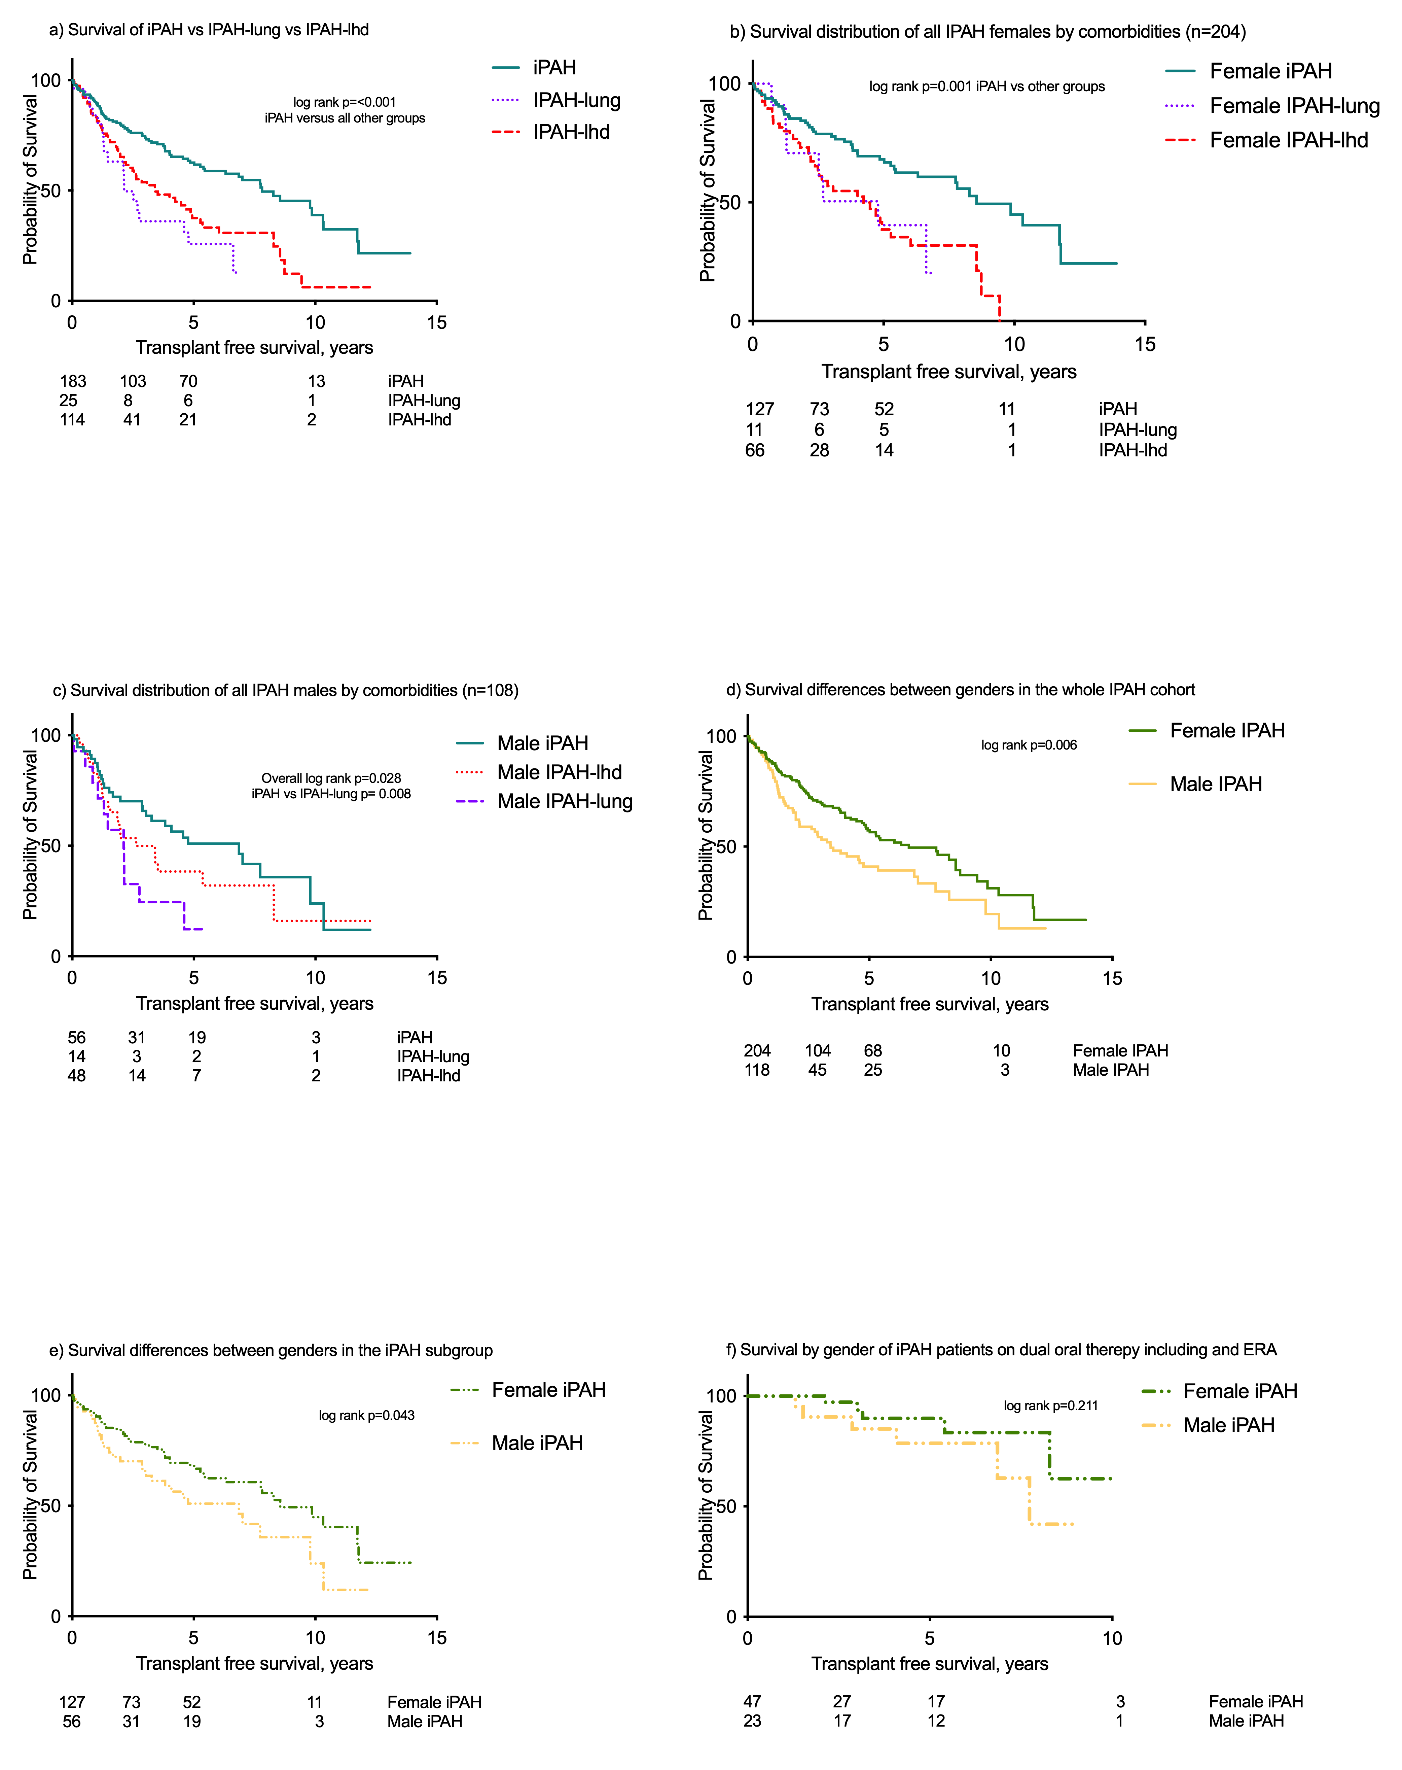
Figure 18. Survival differences between the genders

Males, n=56 |  |  |  |  | Females, n=127
p-value | multivariate | p-value | univariate |  | univariate | p-value | multivariate | p-value
 |  | 0.001 | 1.05 (1.02-1.08) | Age | 1.02 (1.00-1.04) | 0.019
0.022 | 0.18 (0.4-0.78) | 0.018 | 0.27 (0.09-0.80) | WHOFC  (Ref WHO I-II) | 0.35 (0.08-1.44) | 0.144
 |  | 0.005 | 1.00 (0.99-1.00) | ISWD, m | 1.00 (0.99-1.00) | 0.001
0.040 | 0.98 (0.96-1.0) | 0.001 | 0.70 (0.57-0.87) | DLco% pred | 0.96 (0.95-0.98) | <0.001 | 0.97 (0.95-0.99) | 0.002
 |  | 0.974 | 1.00 (0.94-1.07) | mRAP, mmHg | 1.06 (1.01-1.12) | 0.016
 |  | 0.716 | 1.00 (0.97-1.02) | mPAP, mmHg | 1.00 (0.98-1.02) | 0.930
 |  | 0.645 | 0.97 (0.85-1.11) | PAWP, mmHG | 1.02 (0.92-1.13) | 0.685
 |  | 0.735 | 1.00 (0.99-1.00) | PVR, WU | 1.00 (1.00-1.00) | 0.015
 |  | 0.784 | 0.92 (0.51-1.66) | CI, L.min.m⁻² | 0.33 (0.19-0.60) | <0.001
 |  | 0.117 | 0.96 (0.92-1.01) | SvO₂% | 0.95 (0.92-0.98) | 0.001 | 0.93 (0.89-0.97) | 0.002
 |  | 0.016 | 0.37 (0.17-0.83) | Compliance | 0.57 (0.33-0.98) | 0.042
Table 23. Regression analysis of the iPAH group by gender
Abbreviations. WHO FC, world health organisation functional class; ISWD, incremental shuttle walk distance; %pred, percent predicted; DLco, diffusing capacity of the lung for carbon monoxide mRAP, mean right atrial pressure; mPAP, mean pulmonary artery pressure; CI, cardiac index; PAWP, pulmonary arterial wedge pressure; PVR, pulmonary vascular resistance; CI, cardiac index; SvO2%, pulmonary arterial saturations; Compliance, is a measure of how able the vessel is able to accommodate blood in systole and recoil in diastole –i.e. the pulsatile component

Discussion
It known as the ‘sex paradox’ in PAH, as more females are affected by the disease but male sex is an independent predictor of inferior survival which is also evident from our total study cohort and the iPAH subgroup.

Explanations offered include increasing age as well as males who present with PAH being more comorbid (Kjellström et al., 2019). After attempting to compensate for these factors, males still appeared to have an inferior survival to females with no obvious difference at presentation in age, exercise capacity, or haemodynamics.

Our study, unlike other reports by Jacobs et al and Ventelulo et al, (Jacobs et al., 2014; Ventetuolo et al., 2011) did not find males to have worse pulmonary haemodynamics, actually females had a worse PVR but still demonstrated superior survival in the well phenotyped iPAH group.

A possible explanation for males' worse prognosis could be related to their response to ERAs. Men are known to have a higher circulating levels of ET-1 and from cardiac studies it has also been established that males exhibit greater ET-mediated coronary vasoconstriction (Gohar et al., 2016). A study in 2012 pooled the analyses of six clinical randomised placebo- controlled trials of ERAs including Ambrisentan: ARIES-1; ARIES2 - Bosentan: BREATHE-1; Sitaxsentan: STRIDE-1; STRIDE-2 & STRIDE-4. The primary outcome was the change in 6MWD and the secondary outcomes included clinical worsening. The trials combined included 1,130 patients, with a combination of idiopathic, connective tissue disease, HIV, anorexigen use and congenital heart disease, of these patients 773 had an ERA and 153 were men.

It transpired that the treatment response was a 6MWD that was increased by 27.4m (95% CI, 1.3-53.5m) more in women than in men and this outcome did not change when adjusted for confounders such as haemodynamics. This study, interestingly also found an indication of less clinical events in females and Caucasians (Gabler et al., 2012).

Macitentan the newest ERA, OrPHeUS study in the US included 2982 patients enrolled between October 2013 - March 2017 to trial macitentan, females accounted for 73.9% of the cohort. Currently there is no breakdown looking at any variances between the sexes in terms of response to therapy. From our small cohort the number of patients on macitentan were small as the drug was licensed towards the end of the patient identification (V McLaughlin et al., 2019).

An additional potential explanation for the inferior prognosis could be related to the differences of the right ventricle in response to PAH between the sexes. Kawut et al in a study of 84 patients at presentation with IPAH, suggested that females have higher RVEF when compared to males. Older age also accounted for a lower RVEF when corrected for LVEF and PVR (Kawut et al., 2009).

An age case matched study by Swift et al, whose 40 pairs of IPAH patients underwent cardiac MRI and RHC within a 48 hours period demonstrated also, that treatment naive males have worse RVEF when compared to females. The haemodynamics did not differ between the groups and these indices were corrected for age, sex and BSA. They hypothesised that potentially the adaptive response to increased afterload is more effective in the PAH female (Swift et al., 2015).

A retrospective study by Jacobs el, 2014 also using haemodynamics obtained from RHC and cardiac MRI, attempted to ascertain if there were any RV differences between the genders at baseline and after one year of pulmonary hypertensive therapy. The study included 101 patients, 26 of whom were men, with comparable PVRs 903+/-545 vs 963=/-473 p=0.61 and right ventricular ejection fractions (RVEF) 31=/- 13% vs 33=/- 11% p=0.44. This study showed that despite a reduction in PVR with PAH targeted therapy in both sexes at 1 year the RVEF did not improve in men, but actually deteriorated (RVEF decrease median, IQR -1.0% (-11.9% to +6.9%)).

At follow-up males had a higher NT-proBNP, WHO FC and lower 6MWD. On review of the PAH treatment regimens for these 101 patients the majority of patients were on an ERA as first line therapy (Males 13 (50%) versus Females 30(40%)) with a PDEi5 add-on (Jacobs et al., 2014).
Oestrogen may be protective as it induces insulin-like growth factor which has been associated with improved myocardial contractility (Vitale, Clin Endo 2008). Oestrogen at higher doses acts to suppress oxidative stress. Healthy women have lower RV mass, smaller RV volumes and higher RVEF than men (Ventetuolo et al., 2011). Studies, however, have suggested that higher oestradiol levels are independently associated with higher mortality in men with PAH (Wu et al., 2018) in a case-control study of 95 patients with IPAH versus 95 healthy age matched volunteers. In 2011 the MESA- Right Ventricle Study showed an association between higher oestradiol levels and improved RVEF in post-menopausal women using hormone therapy and an association between increased androgen levels and increased RV mass and volumes in both sexes (Ventetuolo et al., 2011).

BMP is a multifunctional protein working through (bone morphogenetic protein receptors) BMPRs, which are serine/threonine kinase receptors. They have an important role in homeostasis and embryonic development. BMP type II receptor (BMPR2), deficiency worsens endothelial inflammatory responses, consequently contributing to adverse remodelling.

An autosomal dominant mutation of BMPR2 is the most common cause of PAH. Studies have reported more than 298 BMPR2 mutations responsible for 11-40% of IPAH (Liu & Morrell, 2013). Interestingly in those patients without proven BMPR2 mutations in PAH, the BMPR2 signalling pathway is still impaired.

In a meta-analysis conducted by Ge et al 457 of 1554 patients with BMPR2 mutations were women, however proportionally more males had BMPR2 mutation (224/644) - 29% vs 35% - OR =0.130, (95% CI 1.06-1.60, p =0.01). In males it was statistically significant that those with the mutation had higher rates of mortality or need for transplantation (Ge et al., 2020).

The relationship between BMPR2 and oestrogen signalling, examined by Austin et al demonstrated that BMPR2 gene expression was reduced in females as the oestrogen receptor alpha binds to the BMPR2 promoter possibly promoting the prevalence of PAH in females (Austin et al., 2012). Austin’s group have also suggested that the SRY (sex determining region on the Y gene) binds and positively regulates BMPR2 expression again offering a reason why women are more affected by PAH but not why males survival is inferior in comparison

Limitations
The main limitations of this analysis are the small numbers of iPAH males and the retrospective nature of the study. There is also the difficultly in drawing firm conclusions regarding ERA therapies and gender due to the small numbers involved and the availability of preparations during the study period.

Conclusion
The cause of males’ inferior prognosis is not clear from our study or from other published works. It is particularly interesting when removing variables such as age and comorbidities that this inferiority of male survival persists. There are likely to be an interplay of many different factors, including the maladaptive features of the right ventricle and the effects of PAH-targeted therapies upon the vasculature as well as the interaction between BMPR2 and sex hormones. This certainly warrants further investigation.

Chapter III:

Idiopathic and systemic sclerosis-associated pulmonary arterial hypertension: A comparison of demographic, hemodynamic, and MRI characteristics and outcomes

Abstract

Background:
Previous studies have identified survival in systemic sclerosis (SSc)-associated pulmonary arterial hypertension (SSc-PAH) as being worse than in idiopathic pulmonary arterial hypertension (IPAH). We investigated differences between these conditions by comparing demographic, hemodynamic, and radiological characteristics and outcomes in a large cohort of incident patients.

Methods:
Six hundred fifty-one patients diagnosed with IPAH or SSc-associated precapillary pulmonary hypertension were included. Patients with pulmonary disease or two or more risk factors for left heart disease were identified, leaving a primary analysis set of 375 subjects. Subgroup analysis using cardiac magnetic resonance (CMR) imaging was performed.

Results:
Median survival was 7.8 years in IPAH and 3 years in SSc-PAH (P < .001). Patients with SSc-PAH were older with less severe haemodynamics but lower gas transfer. Independent prognostic factors were age, SSc, DLco, pulmonary artery saturation, and stroke volume. After excluding patients with normal or only mildly elevated resistance, there was no difference in the relationship between pulmonary vascular resistance (PVR) and compliance in IPAH and SSc-PAH. The relationship between mean pulmonary arterial pressure (mPAP) and systolic pulmonary arterial pressure (sPAP) in IPAH was identical to that previously reported (mPAP = 0.61 sPAP + 2 mmHg). The relationship in SSc-PAH was similar: mPAP = 0.58 sPAP + 2 mm Hg (P value for difference with IPAH = 0.095). The correlation between ventricular mass index assessed at CMR imaging and PVR was stronger in SSc-PAH.

Conclusions:
The reasons for poorer outcomes in SSc-PAH are likely to be multifactorial, including but not limited to older age and reduced gas transfer.

Introduction
Pulmonary arterial hypertension (PAH) is characterized by pulmonary arterial vasculopathy resulting in increased right ventricular (RV) afterload with subsequent RV failure and premature death. The two most common forms are idiopathic PAH (IPAH) and systemic sclerosis (SSc)- associated PAH (SSc-PAH) . Previous studies have demonstrated that although pulmonary haemodynamics are less severe in SSc-PAH, survival is poorer than in IPAH (Chung et al., 2010; Clements et al., 2012; Fisher et al., 2006; Hurdman et al., 2011; Kawut et al., 2003; Ramjug, Hussain, Hurdman, Elliot, et al., 2017)

Various explanations for the disparity in outcomes have been proposed, including the nature of the underlying pulmonary vasculopathy (Overbeek et al., 2009) and the ability of the right ventricle to adapt to the increased afterload (Mathai et al., 2009; Overbeek et al., 2008; Tedford et al., 2013). Other potential factors that may contribute to the differences in outcomes include age, gas transfer, and coexisting cardiorespiratory disease (Condliffe & Howard, 2015). We therefore sought to explore and validate previously identified explanations by studying demographic, hemodynamic, and MRI characteristics and outcomes in a large incident cohort of patients with IPAH and SScPAH.

Methods
Six hundred fifty-one patients assigned a diagnosis of IPAH or precapillary SSc-associated pulmonary hypertension (PH) between February 2001 and July 2014 were identified from departmental databases including the ASPIRE registry (Hurdman et al., 2011). All patients had precapillary PH as defined by mean pulmonary arterial pressure (mPAP) ≥ 25 mm Hg and pulmonary arterial wedge pressure (PAWP) ≤ 15 mm Hg (Marius M. Hoeper, Bogaard, et al., 2013).

Clinical records and radiological investigations were then reviewed to identify patients with “atypical” disease possibly related to pulmonary or left heart disease (figure 19); these patients were then excluded from the primary analysis set (PAS). Patients with an original diagnosis of IPAH were therefore either assigned to PAS with isolated IPAH (hereafter referred to as IPAH) or excluded from PAS due to pulmonary disease (IPAH:exLung) or the risk of left heart disease (IPAH:exLHD).

Similarly, patients with precapillary PH associated with SSc were either assigned to PAS with isolated SSc-PAH (hereafter referred to as SSc-PAH) or excluded from the PAS due to pulmonary disease (SSc:exLung) or the risk of left heart disease (SSc:exLHD). IPAH:exLung was diagnosed if CT revealed any evidence of parenchymal pulmonary disease or if a patient had a diagnosis of COPD with an FEV1/FVC < 0.70, an FEV1 < 80% predicted, and a history of smoking.

An approach based on the method of Goh et al13 was used to identify SSc:exLung when extensive fibrosis (20%) was present on high-resolution CT scanning or the FVC was < 70% if the extent of fibrosis was intermediate (Goh et al., 2012). Patients were defined as being at risk of left heart disease (LHD) in the presence of two or more risk factors: systemic hypertension, diabetes, atrial fibrillation, BMI > 35, an enlarged left atrium on echocardiography or any history of ischemic heart disease.

The date of diagnosis was taken as the date of the first diagnostic right heart catheterization (RHC). Transplant-free survival to a census date of February 1, 2015 was ascertained from the National Health Service death reporting system. Approval for the study of observational clinical data was granted by the North Sheffield Research Ethics Committee (Ref 06/Q2308/8).

Derived Hemodynamic Calculations
The following parameters were calculated from baseline RHC results: compliance (C) = stroke volume (SV)/pulse pressure (PP) (Lankhaar et al., 2006), RC-time = C x pulmonary vascular resistance (PVR) (Lankhaar et al., 2008; Mahapatra et al., 2006; Tedford et al., 2013), right ventricular stroke work (RVSW) = (1.25 mPAP – mean right atrial pressure [mRAP]) x SV, pulsatile RVSW = 0.25 mPAP x SV, and the wasted pulsatile fraction of RVSW = 100 x (0.25 mPAP)/ (1.25 mPAP-RAP) (Chemla et al., 2013).

Cardiac Magnetic Resonance Imaging
Forty-six patients with IPAH and 37 patients with SSc-PAH who had undergone CMR and RHC within 14 days were identified. Images were acquired on a GE HDx 1.5T scanner (GE Healthcare) using cardiac-gated balanced steady-state free precession imaging. Volumetric, mass, and flow analysis was performed as previously described (Swift et al., 2013, 2015). Ventricular mass index (VMI) was defined as the ratio of RV to left ventricular mass (Hagger et al., 2009).

Statistical Analysis
Statistical analyses were performed using IBM SPSS Statistics, version 22 (SPSS, Inc.) and GraphPad Prism (GraphPad). Data were expressed as mean SD or median interquartile range. Categorical data were expressed as number and percentage. One-way analysis of variance and Bonferroni post hoc analysis were used to determine significant differences between continuous data in three or more groups. Comparison between two groups was performed using a t test or the Mann-Whitney test for continuous data and the χ2 test for categorical data. Variables with hyperbolic relationships were compared using analysis of covariance following log transformation. Transplant-free survival from the date of the initial RHC was calculated using the Kaplan-Meier method. Univariate and multivariate Cox regression analysis was performed to identify prognostic factors. A P value of < .05 was considered statistically significant throughout.

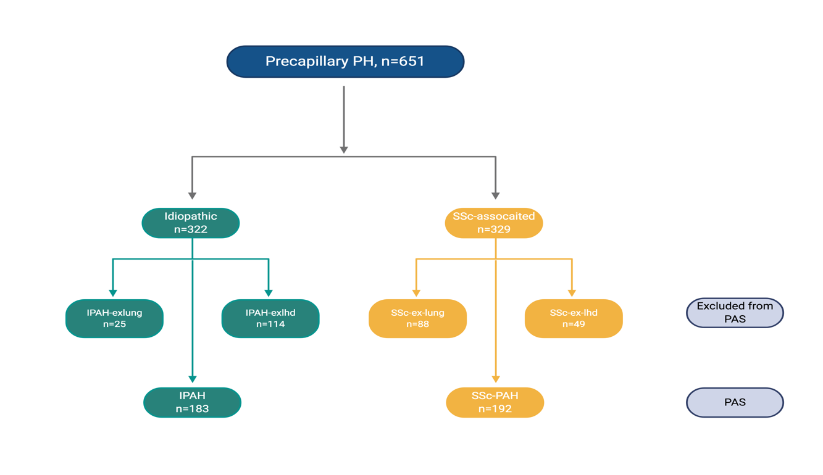
Figure 19. Study cohort iPAH vs SSc-PAH
Abbreviations: PAS, primary analysis set; IPAH, idiopathic pulmonary arterial hypertension; IPAH:exLHD, IPAH excluded from primary analysis set due to two or more risk factors for left heart disease; IPAH:exLung, IPAH excluded from primary analysis set due to pulmonary disease; SSc, systemic sclerosis; SSc:exLHD, SSc-associated pulmonary hypertension excluded from primary analysis set due to two or more risk factors for left heart disease; SSc:exLung, SSc-associated pulmonary hypertension excluded from primary analysis set due to pulmonary disease; SSc-PAH, SSc-associated pulmonary arterial hypertension

Results

Patient Characteristics
The composition of the 651 patients included in the study is shown in Figure 19. Haemodynamics were less severe in the whole SSc group compared with the whole idiopathic group (Table 24). Individuals with IPAH were significantly younger with more severe perturbations in pulmonary haemodynamics and superior exercise capacity. Patients defined as at risk of LHD were older. Diffusion capacity for carbon monoxide (DLco) was lower in SSc-PAH than in IPAH and was also lower in patients excluded from the PAS.

PAH specific therapy
All patients were treatment naive at the time of diagnostic RHC. Patients were subsequently treated with PAH-specific therapies in keeping with contemporaneous guidelines (Policy, 2014). There was no difference in the proportion of patients with SSc-PAH and IPAH receiving oral combination therapy, whereas patients with IPAH were less likely to receive oral monotherapy and more likely to receive therapy including inhaled, subcutaneous, or IV prostanoids (Table 25). At univariate analysis, receiving oral combination therapy was associated with a reduced risk of mortality when compared with receiving oral monotherapy (HR, 0.5; 95% CI, 0.36-0.72; P < .001).

 | IPAH (183) | IPAHexlung  (25) | IPAHexlhd  (114) | SSc-PAH (192) | SScexlung  (88) | SScexlhd  (49) | p-value
Clinical characteristics
Female, n (%) | 127, (69) | 11, (44) | 66, (58) | 171, (89) | 64, (73) | 38, (78)
Age, yrs | 49.7±16.1 ^{ϕ,ϑ,χ,Ψ,Ω} | 62.7±17.1 ^{λ,Ω} | 68.1±11.1 ^{λ} | 66.1±9.1 ^{λ,Ω} | 64.5±11.6 ^{λ,Ω} | 72.2±6.7 ^{λ,ϑ,χ,Ψ} | <0.001
BMI, kg/m² | 25.7±6.8 ^{χ} | 28.5±6.6 ^{χ,Ω} | 31.6±6.9 | 25.7±5.2 ^{λ,} | 25.0±7.0 ^{λ} | 27.7±6.1^{λ} | <0.001
WHO FC I, n (%) | 1, (1) |  |  |  |  | 1, (2)
WHO FC II, n (%) | 23, (13) | 3, (12) | 4, (4) | 21, (11) | 8, (9) | 9, (18)
WHO FC III, n (%) | 122, (67) | 14, (56) | 76, (67) | 155, (81) | 51, (58) | 30, (61)
WHO FC IV, n (%) | 33, (18) | 8, (32) | 34, (30) | 16, (8) | 27, (32) | 9, (18)
ISWD, m | 249±187 ^{ϕ,χ,Ψ,Ω} | 157±101 | 124±130 ^{λ} | 168±130 ^{λ} | 138±122 ^{λ} | 102±109 ^{λ} | <0.001
Haemodynamics
mRAP, mmHg | 10±6 ^{ϕ,Ψ} | 12±6 ^{χ,Ψ} | 12±6 ^{λ,χ,Ψ} | 9±5 ^{ϕ,ϑ,Ψ} | 7±5 ^{λ,ϕ,ϑ,χ,Ω} | 10±6 ^{Ψ} | <0.001
sPAP, mmHg | 86±21 ^{χ,Ψ,Ω} | 80±18 ^{Ψ} | 84±15 ^{χ,Ψ,Ω} | 70±21 ^{λ,ϕ,Ψ} | 62±18 ^{λ,ϕ,ϑ,χ} | 67±18 ^{λ,ϕ} | <0.001
dPAP, mmHg) | 36±11 ^{ϕ,χ,Ψ,Ω} | 33±6 ^{χ,Ψ,Ω} | 32±9 ^{λ, χ,Ψ,Ω} | 25±10 ^{λ,ϕ,ϑ} | 22±9 ^{λ,ϕ,ϑ} | 25±9 ^{λ,ϕ,ϑ} | <0.001
mPAP, mmHg | 55±14 ^{χ,Ψ,Ω} | 50±10 ^{Ψ,Ω} | 51±10 ^{χ,Ψ,Ω} | 43±13 ^{λ,ϕ,Ψ} | 38±11 ^{λ,ϕ,ϑ,χ} | 41±11 ^{λ,ϕ,ϑ} | <0.001
CI, L/min/m² | 2.4±0.7 ^{χ,Ψ,Ω} | 2.3±0.6 ^{χ,Ψ} | 2.4±0.7 ^{χ,Ψ} | 2.8±0.8 ^{λ,ϕ,ϑ} | 2.9±0.8 ^{λ,ϕ,ϑ} | 2.8±1.0 ^{λ} | <0.001
PAWP, mmHg | 10±3 ^{ϕ} | 10±3 | 11±3 ^{λ,χ,Ψ} | 9±3 ^{ϕ} | 9±4 ^{ϕ} | 10±4 | <0.001
PVR, WU | 12.4±5.8 ^{ϕ,χ,Ψ,Ω} | 10±3.3 | 10±4 ^{λ,Ψ} | 8.3±5 ^{λ} | 6.8±4.6 ^{λ,ϕ} | 7.8±4.9 ^{λ} | <0.001
SvO₂, % | 61.0±8.9 ^{χ,Ψ} | 59.5±11.3 ^{Ψ} | 60.2±8.3 ^{χ,Ψ} | 64.8±8.8 ^{λ,ϕ} | 66.3±8.6 ^{λ,ϕ,ϑ} | 62.6±9.6 | <0.001
RHC Calculations
C, mL/mmHg⁻¹ | 1.14±0.80 ^{χ,Ψ,Ω} | 1.31±0.62 | 1.15±0.51 ^{χ,Ψ,Ω} | 1.55±0.92 ^{λ,ϕ} | 1.75±1.02 ^{λ,ϕ} | 1.62±1.03 ^{λ,ϕ} | <0.001
PVR, mmHg/s/mL⁻¹ | 0.74±0.35 ^{ϕ,χ,Ψ,Ω} | 0.60±0.20 | 0.60±0.24 ^{λ,Ψ} | 0.50±0.30 ^{λ} | 0.41±0.28 ^{λ,ϕ} | 0.47±0.29 ^{λ} | <0.001
RC time, seconds | 0.66±0.15 ^{χ,Ψ,Ω} | 0.66±0.19 ^{Ψ} | 0.61±0.16 ^{Ψ} | 0.56±0.14 ^{λ} | 0.52±0.16 ^{λ,ϕ,ϑ} | 0.55±0.14 ^{λ} | <0.001
SV, mLs | 50.8±21.2 ^{χ,Ψ} | 58.1±21.8 | 56.7±20.9 | 59.0±20.9 ^{λ} | 60.1±20.6 ^{λ} | 60.4±22.1 | 0.003
SVI, mL/m² | 28.4±10.3 ^{χ,Ψ,Ω} | 30.6±8.9 | 30.0±9.7 ^{χ,Ψ} | 35.1±11.2 ^{λ,ϕ} | 35.3±10.6 ^{λ,ϕ} | 35.1±12.2 ^{λ} | <0.001
PP, mmHg | 50±15^{,χ,Ψ,Ω} | 4±15 | 51±12^{,χ,Ψ,Ω} | 44±14 ^{λ,ϕ} | 40±13 ^{λ,ϕ} | 42±13 ^{λ,ϕ} | <0.001
RVSW, mmHgmL | 2877±1122 ^{χ,Ψ,Ω} | 3034±1460 | 2891±1122 ^{Ψ,Ω} | 2523±954 ^{λ} | 2295±650 ^{λ,ϕ} | 2357±917 ^{λ,ϕ} | <0.001
Pulsatile RVSW, mmHgmL | 668±233 ^{Ψ} | 734±350 ^{Ψ} | 719±252 ^{χ,Ψ,Ω} | 599±214 ^{ϕ} | 534±144 ^{λ,ϑ,ϕ} | 589±210 ^{ϕ} | <0.001
Wasted pulsatile fraction RVSW, % | 23.8±2.8 ^{ϕ, Ω} | 25.3±3.6 | 25.0±2.7 ^{λ, Ψ} | 24.1±2.4 ^{Ω} | 23.6±3.3 ^{ϕ,Ω} | 25.4±3.5 ^{λ,χ,Ψ} | <0.001
Pulmonary function
FEV₁ % pred | 87±15 ^{ϕ,ϑ,Ψ} | 71±12 ^{λ,χ,Ω} | 81±18 ^{λ,Ψ} | 86±18 ^{ϑ,Ψ} | 64±17 ^{λ,ϕ,χ,Ω} | 86±20 ^{ϑ,Ψ} | <0.001
FVC % pred | 98±18 ^{ϕ,Ψ} | 89±17 ^{Ψ} | 90±23 ^{λ,χ,Ψ} | 99±20 ^{ϕ,Ψ} | 65±19 ^{λ,ϕ,ϑ,χ,Ω} | 96±21 ^{Ψ} | <0.001
FEV₁/FVC | 0.75±0.08 ^{ϑ,Ψ,Ω} | 0.64±0.10 ^{λ,ϕ,χ,Ψ} | 0.73±0.09 ^{ϑ,Ψ} | 0.72±0.08 ^{ϑ,Ψ} | 0.81±0.09 ^{λ,ϕ,ϑ,χ,Ω} | 0.70±0.15 ^{λ,Ψ} | <0.001
DL_{CO} % pred | 54±20 ^{ϕ,ϑ,χ,Ψ,Ω} | 35±19 ^{λ} | 44±20 ^{λ,Ψ} | 40±10 ^{λ,Ψ} | 30±11 ^{λ,ϕ,χ,Ω} | 41±14 ^{λ,Ψ} | <0.001
Table 24. Baseline clinical, haemodynamic and pulmonary function characteristics
Data are presented as mean ± SD or % unless otherwise stated. IPAH: idiopathic pulmonary arterial hypertension – including six patients who were nitric oxide responders; IPAHexlung: idiopathic pulmonary arterial hypertension with a predisposition to lung disease excluded from primary analysis set due to pulmonary disease; IPAHexlhd: idiopathic pulmonary arterial hypertension with a predisposition to left heart disease, ≥ 2 risk factors for left heart disease excluded from primary analysis; SSc-PAH: systemic sclerosis associated with pulmonary arterial hypertension; SScexlung: systemic sclerosis with pulmonary hypertension in association with lung disease excluded from primary analysis; SScexlhd: systemic sclerosis with pulmonary arterial hypertension with a predisposition to left heart disease, ≥ 2 risk factors for left heart disease excluded from primary analysis ; WHO FC: world health organisation functional class; ISWD: incremental shuttle walk distance; mRAP: mean right atrial pressure; mPAP: mean pulmonary artery pressure; CO: cardiac output; CI: cardiac index; PAWP: pulmonary arterial wedge pressure; PVR: pulmonary vascular resistance; SvO₂: pulmonary arterial saturations; Ca: pulmonary artery compliance; SV: Stroke volume; SVI: Stroke volume index; RC: resistance-compliance; RVSW: Right ventricular stroke work; %pred: percent predicted; FEV₁: forced expiratory volume in 1 second; FVC: forced vital capacity; DL_{CO}: diffusing capacity of the lung for carbon monoxide; K_{CO} the carbon monoxide transfer coefficient; ^{λ}: p <0.05 in comparison to isolated iPAH; ^{ϑ}: p <0.05 in comparison to iPAH-lung; ^{ϕ}: p <0.05 in comparison to iPAH-lhd; ^{χ}: p <0.05 in comparison to SSc-PAH; ^{Ψ}: p <0.05 in comparison to SSc-PH-lung; ^{Ω}: p <0.05 in comparison to SSc-PH-lhd; *: p < 0.05

Timing of therapy | Disease type | Oral monotherapy | Oral combination | Prostanoid based
Maximum | SSc-PAH | 77 (40) | 71 (37) | 36 (19)
 | IPAH | 51 (27) | 67 (38) | 59 (32)
Census | SSc-PAH | 79 (41) | 71 (37) | 31 (16)
 | IPAH | 44 (24) | 73 (40) | 50 (27)

Table 25. PAH-specific therapy in primary analysis set
Data presented as No. (%). IPAH, idiopathic pulmonary arterial hypertension; SSc-PAH, systemic sclerosis associated with pulmonary arterial hypertension

Measures of Pulmonary Artery C and Right Ventricular Function
Plotting PVR against C to calculate the RC time demonstrated an exponential relationship (Figure 20a). For a given PVR, C was significantly lower in SSc-PAH than in IPAH, even when adjusting for age or mPAP or PAWP (P < .001 for all). A significant difference between the RC relationship persisted when adjusted for age and mPAP, age and PAWP, or mPAP and PAWP. However, no significant difference in the RC relationship was observed when adjustment for all three parameters was made (P = 0.61).

As it has previously been demonstrated that patients with normal or mildly elevated PVR have lower RC times, we then reanalysed the relationship between PVR and C in patients with PVR greater than thresholds of 3 and 4 Woods units (WU) (Hadinnapola et al., 2015; Tedford, 2014). There was a borderline difference when patients with a PVR < 3 WU were excluded (P = 0.05) and a lack of significant difference when patients with a PVR < 4 WU were excluded (P =0 .11) (Figure 20b). There was no significant difference in wasted pulsatile fraction of RVSW between IPAH and SSc-PAH.
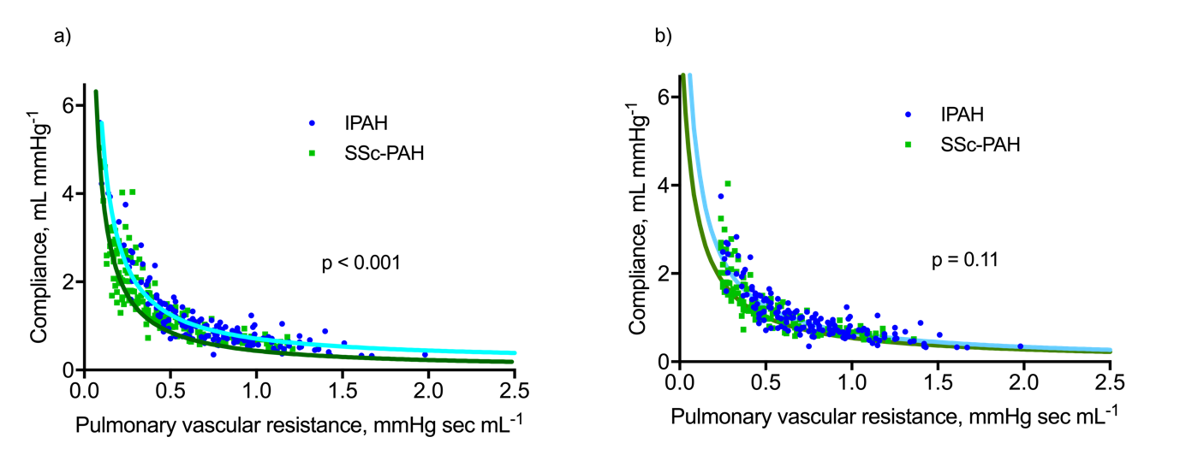
Figure 20. Relationship between resistance and compliance
- SSc-PAH and IPAH (p ≤0.001)
- SSc-PAH and IPAH and pulmonary vascular resistance > 4 wood units (p = 0.11)
Abbreviations: IPAH, idiopathic pulmonary arterial hypertension; SSc-PAH, systemic sclerosis associated with pulmonary arterial hypertension

Relationship Between sPAP and mPAP
The relationship between systolic pulmonary arterial pressure (sPAP) and mPAP in patients with IPAH (mPAP = 0.61 sPAP + 2 mm Hg) was identical to that previously described by Chemla et al, (Chemla et al., 2004). The relationship in SSc-PAH was similar: mPAP = 0.58 sPAP + 2 mm Hg (P for difference = .095), figure 21.

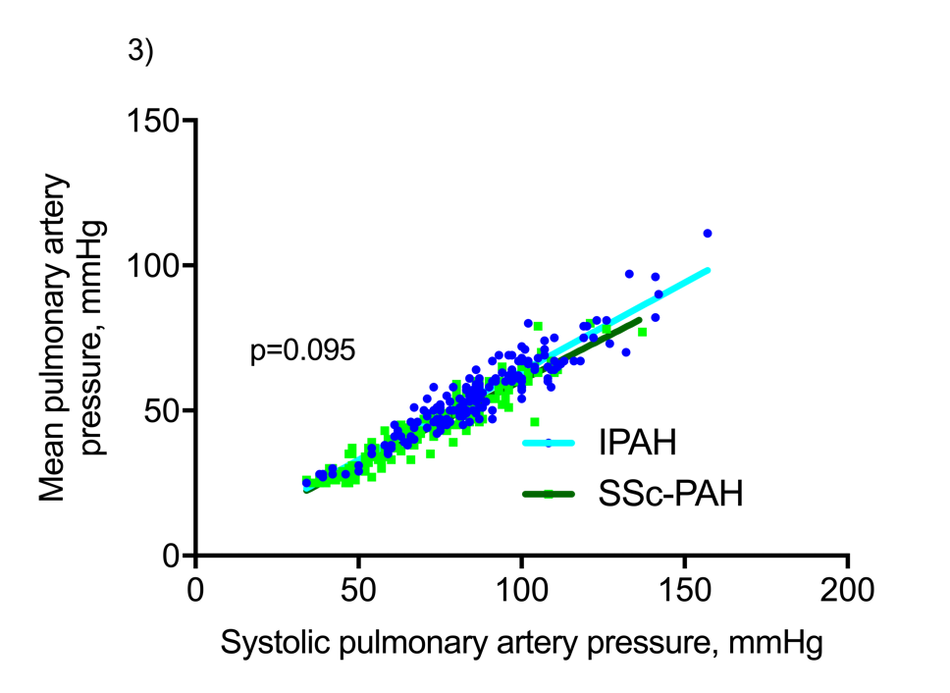
Figure 21. Relationship between mean pulmonary artery pressure and systolic pulmonary arterial pressure in SSc-PAH and IPAH
Abbreviations: IPAH, idiopathic pulmonary arterial hypertension; SSc-PAH, systemic sclerosis associated with pulmonary arterial hypertension

Survival Outcomes
In the 651 patients, there were 374 deaths and five lung transplantations. Patients with IPAH had the best survival, with a median survival of 7.8 years (P < .001) (Figure 22a). In the idiopathic group, survival in IPAH:exLHD (median survival, 3.4 years; P < .001) and IPAH:exLung (median survival, 2.1 years; P < .001) (Figure 22b) was inferior to that in IPAH. In the SSc group, median survival in SSc-PAH was 3 years, which was not significantly different from that of SSc:exLHD. There was a trend toward poorer survival in patients with SSc:exLung compared with those with SSc-PAH (P = 0.07), figure 22c.

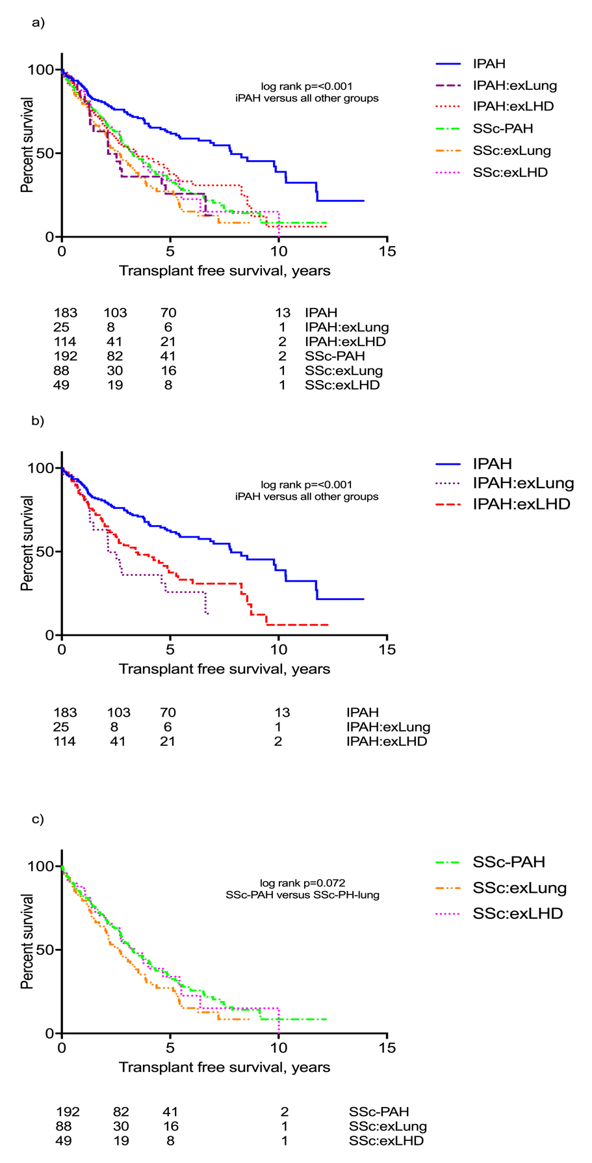

Figure 22. Survival from diagnostic right heart catheterisation
a) whole study cohort; b) idiopathic cohort; c) systemic sclerosis cohort
Abbreviations: IPAH, idiopathic pulmonary arterial hypertension; IPAH-lung: idiopathic pulmonary arterial hypertension with a predisposition to lung disease; IPAH-lhd: idiopathic pulmonary arterial hypertension with a predisposition to left heart disease; SSc-PAH: systemic sclerosis associated with pulmonary arterial hypertension; SSc-PH-lung: systemic sclerosis with pulmonary hypertension in association with lung disease; SSc-PAH-lhd: systemic sclerosis with pulmonary arterial hypertension with a predisposition to left heart disease

Prognostic Factors in Isolated PAH
Results of Cox regression analysis for the PAS are shown in table 26. At univariate analysis, higher age, World Health Organization functional class, mRAP, and lower exercise capacity, FEV1/FVC, DLCO, cardiac index, pulmonary artery saturations (SvO2), SV, and C were associated with poorer outcome. The diagnosis of SSc-PAH as opposed to IPAH was also associated with poorer outcome. The five independent prognostic factors identified at multivariate analysis were age, SSc, DLco, SvO2, and SV. The independent predictors in isolated IPAH were DLco and SvO2 and in isolated SSc-PAH they were DLco and SV index.

Variable | Univariate HR (95% CI) | p-value | Multivariate HR (95% CI) | p-value
Age, yrs | 1.03 (1.02-1.04) | 0.000* | 1.02 (1.00-1.03) | 0.026
WHO FC (I-IIvsIII-IV)  (Ref WHO I-II) | 2.16 (1.33-3.51) | 0.002*
Diagnosis  (Ref Isolated iPAH) | 2.28 (1.70-3.04) | 0.000* | 1.55 (1.02-2.35) | 0.040
ISWD, m | 0.99 (0.99-1.00) | 0.000*
FEV₁% pred | 1.00 (0.99-1.00) | 0.246
FVC% pred | 1.00 (0.99-1.01) | 0.707
FEV₁/FVC ratio | 0.04 (0.01-0.24) | 0.000*
DL_{CO}% pred | 0.96 (0.95-0.97) | 0.000* | 0.974 (0.96-0.99) | 0.000
mRAP, mmHg | 1.04 (1.01-1.07) | 0.002*
mPAP, mmHg | 1.00 (0.99-1.01) | 0.640
PAWP, mmHg | 0.99 (0.95-1.04) | 0.632
CI, L/min/m² | 0.72 (0.60-0.87) | 0.001*
PVR, WU | 1.00 (1.00-1.00) | 0.062
SVO₂, % | 0.97 (0.96-0.98) | 0.000* | 0.97 (0.95-1.00) | 0.018
SV, mL | 0.98 (0.98-0.99) | 0.000* | 0.98 (0.97-0.99) | 0.002
C, mL/mmHg⁻¹ | 0.69 (0.58-0.83) | 0.000*
RC time, seconds | 0.77 (0.28-2.11) | 0.613
Table 26. Cox regression of the primary analysis set
Abbreviations: HR, hazard ratio; CI, confidence interval; WHO FC: world health organisation functional class; ISWD: incremental shuttle walk distance; mRAP: mean right atrial pressure; mPAP: mean pulmonary artery pressure; CO: cardiac output; CI: cardiac index; PAWP: pulmonary arterial wedge pressure; PVR: pulmonary vascular resistance; SvO₂: pulmonary arterial saturations; C: pulmonary artery compliance; SV: Stroke volume; RC: resistance-compliance; %pred: percent predicted; FEV₁: forced expiratory volume in 1 second; FVC: forced vital capacity; DL_{CO}: diffusing capacity of the lung for carbon monoxide

Variable | IPAH, n=46 | SSc-PAH, n=37 | p-value
Female, n (%) | 28, (67) | 29, (91)
Age, yrs | 49.0±16.3 | 65.4±8.6 | <0.001
WHO FC III-IV, n (%) | 38, (91) | 28, (88)
ISWD, m | 272±170 | 192±143 | 0.036
Right heart catheter
mRAP, mmHg  mPAP, mmHg  PAWP, mmHg  CI, L/min/m²  PVR, WU | 10±5  58±12  9.9±2.5  2.4±0.6  12.1±4.6 | 10±7  42±13  10.2±2.9  2.9±0.8  7.7±5.1 | 0.920  <0.001  0.63  0.009  <0.001
Pulmonary function
DL_{CO} % pred | 53±20 | 39±11 | 0.001
CMR
RVESV (mls) | 114.9±46.2 | 82.0±42.7 | 0.001
RVEDV (mls) | 162.5±48.1 | 132.2±40.7 | 0.003
RVSV (mls) | 49.1±19.0 | 50.2±17.6 | 0.789
LVESV (mls) | 28.7±13.2 | 24.8±11.5 | 0.160
LVEDV (mls) | 77.7±25.8 | 86.4±26.6 | 0.134
LVSV (mls) | 40.0±16.1 | 45.0±21.8 | 0.240
RVEF (%) | 31.7±11.9 | 40.5±15.6 | 0.005
RVM, g | 64.5±33.0 | 46.3±29.1 | 0.012
RVM/PVR | 6.58±6.67 | 6.83±3.60 | 0.842
VMI | 0.75±0.35 | 0.58±0.34 | 0.031
VMI/PVR | 0.072±0.056 | 0.080±0.028 | 0.446
Table 27. Baseline characteristics of CMR group
Abbreviations: WHO FC: world health organisation functional class; ISWD: incremental shuttle walk distance; mRAP: mean right atrial pressure; mPAP: mean pulmonary artery pressure; CI: cardiac index; PAWP: pulmonary arterial wedge pressure; PVR: pulmonary vascular resistance; SV: Stroke volume; DL_{CO}: diffusing capacity of the lung for carbon monoxide; RV: right ventricular; ESV: end systolic volume; EDV: end diastolic volume; SV: stroke volume; LV: left ventricular; EF: ejection fraction; VMI: ventricular mass index

CMR Subgroup
There was no significant difference in left ventricular volume between the two groups, table 27. RV volumes were significantly larger in IPAH than in SSc-PAH. RV mass was higher in IPAH in keeping with the higher afterload. There was, however, no significant difference in mean RV mass or mean VMI between the two groups when adjusted for PVR.

We then investigated the relationship between VMI and PVR over the range of PVR (Figure 23). We observed a steeper slope and stronger correlation in SSc-PAH (r²= 0.69; P < .001) than in IPAH (r²= 0.07; P = 0.1). When a single IPAH outlier with a PVR of 4.4 WU but a VMI of 1.3 was excluded, a significant correlation between VMI and PVR was observed (r²= 0.13; P= 0.022), figure 23, although this relationship was still much weaker than in SSc-PAH. Adjusting for age and sex had a negligible effect on these correlations.

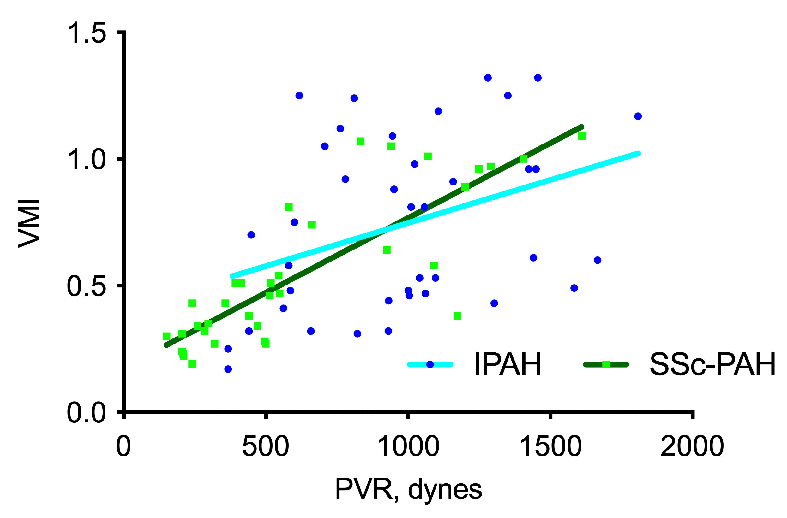
Figure 23. Ventricular mass index vs pulmonary vascular resistance according to PAH group
(SSc-PAH, r² = 0.69; P < .001; IPAH, r² = 0.13; P = 0.022). PVR, pulmonary vascular resistance; VMI, ventricular mass index

Discussion
In this study, we describe results from the largest published single-centre comparison of patients with IPAH and those with SSc-PAH. We have confirmed previous observations that survival in isolated SSc-PAH is worse than in IPAH, despite the presence of less severe haemodynamics (Campo et al., 2010; Chung, Farber, et al., 2014; Condliffe et al., 2012; Fisher et al., 2006; Kawut et al., 2003; Ling et al., 2012). Although age is an important factor in this poorer outcome, the presence of systemic sclerosis also independently predicts poorer survival.

Other possible reasons for poorer outcomes include both the nature of RV afterload and the ability of the right ventricle to compensate for this increased afterload. RV afterload largely has two components: PVR and C. PVR represents static or resistive afterload and is estimated to account for 75% of total RV afterload (Chemla et al., 2015).

C represents the pulsatile afterload and is distributed throughout the pulmonary vascular bed, with the proximal pulmonary arteries thought to be responsible for 19% (Saouti et al., 2009). The RC time represents diastolic decay time and was previously thought to have a constant hyperbolic distribution in both PH and health (Lankhaar et al., 2006, 2008; Saouti et al., 2009). It was hypothesized that increased resistance resulted in increased intravascular pressure with a subsequent reduction in C.

Subsequent studies demonstrated exceptions to this constancy, with lower RC times being reported in older patients and those with elevated PAWP, normal pulmonary pressure, and proximal chronic thromboembolic PH (Hadinnapola et al., 2015; Ross et al., 2013; Tedford, 2014; Tedford et al., 2011).

On initial analysis, we were unable to replicate the previous observations of Tedford et al, (Tedford et al., 2013) who studied 166 patients with SSc-PAH and 67 patients with IPAH and found no significant difference in RC curves. Instead, we observed that for a given PVR, C was significantly lower in SSc-PAH than in IPAH, even when adjusting for age or mPAP or PAWP.

Overbeek et al observed pulmonary arterial intimal fibrosis in eight of eight patients with SSc-PAH but in only three of 11 patients with IPAH (Overbeek et al., 2009). Similarly, Dorfmuller et al observed marked intimal fibrosis in muscular pulmonary arteries in four of four patients with SSc-PAH compared with four of 29 patients with IPAH (Dorfmüller et al., 2007).

We therefore hypothesized that the reduced RC time we observed in SSc-PAH may have resulted from increased pulmonary arterial fibrosis leading to stiffer less compliant vessels. In contrast with the study of Tedford et al, (Tedford et al., 2013), there was an uneven distribution of patients with normal or mildly elevated PVR in our study.

Previous investigators have demonstrated that RC times are reduced in patients with no or only mild abnormalities in pulmonary haemodynamics (Hadinnapola et al., 2015; Tedford, 2014). We therefore reanalysed our data by excluding patients with normal or mildly increased PVR and found that in patients with more established PAH, there was indeed no significant difference in RC time.

We have therefore confirmed the difference in RC relationship between patients with normal or mildly increased PVR and those with more severely elevated PVR. Since a shorter RC time represents more rapid diastolic pressure decay, if a true difference in RC relationship was present, a greater PP would therefore be required to produce an identical mPAP (Ross et al., 2013)

Theoretically, this increase in pulsatile pressure in relation to mPAP would lead to increased pulsatile afterload with the subsequent increase in wave reflections resulting in reduced efficiency of RV contractility.

To our knowledge, this is the first study to assess the relationship between sPAP and mPAP in SSc-PAH. Our finding in IPAH was almost identical to that observed by Chemla et al (mPAP = 0.61 sPAP + 2 mm Hg) (Chemla et al., 2004). The relationship we observed in SSc-PAH differed only slightly (mPAP = 0.58 sPAP + 2.2 mm Hg), and this difference did not quite meet statistical significance. Nevertheless, we were therefore interested in whether we could find evidence of impairment and inefficiency in RV function.

Previous studies involving small numbers of patients have suggested differences in RV function. Overbeek et al reported increased myocardial inflammatory infiltrate and poorer RV contractility in SSc-PAH (M J Overbeek et al., 2008; Maria J. Overbeek et al., 2010). The group of Tedford et al, (Tedford et al., 2013), and Hsu et al, (S. Hsu et al., 2016), subsequently observed poorer RV contractility, greater uncoupling of RV to pulmonary arterial elastance, and decreased RV contractile reserve in SSc-PAH. They hypothesized that this might result from an inability of the right ventricle to hypertrophy in response to increased afterload.

Although we observed lower mean RV mass in SSc-PAH, this difference did not persist when adjusted for PVR. We were unable to validate the findings of Kelemen et al, who observed reduced compensatory RV hypertrophy at higher afterload in SSc-PAH (Kelemen et al., 2014). Indeed, in patients with SSc-PAH, we found a stronger relationship between PVR and VMI (a parameter that we have previously shown in SSc-PAH to be superior to PVR in its correlation with RV mass) across the whole range of PVR.

We also found no significant difference in the wasted fraction of RVSW (a marker of wasted RV work) between IPAH and SSc-PAH. In keeping with previous observations, DLco was significantly lower in SSc-PAH than in IPAH (Chung et al., 2010; Fisher et al., 2006; Hurdman et al., 2011). DLco is composed of two main components: pulmonary capillary blood volume and membrane conductance which reflects the diffusion properties of the alveolar capillary membrane. Langleben et al previously observed a lower functional capillary surface area in connective tissue disease-associated PAH compared with IPAH (Langleben et al., 2008). We previously demonstrated impaired uptake of hyperpolarized xenon into the pulmonary capillaries of patients with SSc (Stewart et al., 2015). Although we excluded patients with significant interstitial pulmonary disease, it is possible that subclinical interstitial fibrosis resulted in diffusion impairment. Overbeek et al noted fibrosis of veins/venules in eight of eight patients with SSc-PAH but in only three of 11 patients with IPAH. In four patients with SSc-PAH, the venous involvement resembled pulmonary veno-occlusive disease (PVOD) (M J Overbeek et al., 2009). Similarly, Dorfmuller et al noted obstructive pulmonary vein/venule lesions in four of four patients with SSc-PAH compared with only five of 29 patients with non-connective tissue disease-associated PAH (Dorfmüller et al., 2007). It is therefore possible that the reduced DLco in SSc-PAH may also reflect an increased PVOD component.

Limitations
C was assessed using SV/PP. This assumes that the whole of RV output is held within the pulmonary arterial tree, whereas in reality, a proportion of the SV will be ejected from the pulmonary arterial tree during systole. Furthermore, because of artefacts inherent in fluid-filled catheters, the measurement of sPAP and diastolic PAP may be prone to error, although mPAP will be reliable (Chemla et al., 2015). Despite these limitations, since the same techniques were used for both IPAH and SSc-PAH, the observed difference in the RC relationship should be robust. Due to the observational nature of this study, invasive measurement of RV function could not be performed, so we were unable to fully investigate differences in RV contractility.

Although mean DLco was higher in IPAH than in SSc-PAH, it was still lower than may have been expected compared with other registries (Marc Humbert et al., 2012; Ling et al., 2012). It is possible that a small number of patients with an actual diagnosis of PVOD were assigned a diagnosis of PAH. If so, this would be expected to occur in both IPAH and SSc-PAH and so would not be expected to affect our main findings. Furthermore, survival in the IPAH group far exceeded that which would be expected if large numbers of patients with PVOD had been misdiagnosed.

Conclusions
Survival in SSc-PAH is worse than in IPAH. This difference is not just a reflection of the older age of patients with SSc-PAH. When patients with normal or only mildly elevated PVR were excluded, we did not observe a difference in the relationship between PVR and C in patients with SSc-PAH, suggesting that increased stiffness of the pulmonary arterial bed is unlikely to be responsible for differences in outcomes.

The relationship between sPAP and mPAP in SSc-PAH is similar to that previously described in other forms of PH. We were unable to validate previous observations regarding reduced compensatory RV hypertrophy in SSc-PAH. Although our data do not exclude differences in RV function being associated with the different outcomes in IPAH and SSc-PAH, they do suggest that other factors are also responsible. DLco is lower in SSc-PAH and is an important prognostic factor in both forms of PAH. The reason for the lower DLco in SSc-PAH merits further investigation.

Chapter IV:

Pulmonary arterial hypertension associated with congenital heart disease: Comparison of clinical and anatomical-pathophysiological classification

Abstract
Background:
Between five and ten percent of patients with congenital heart disease (CHD) develop pulmonary arterial hypertension (PAH-CHD). Patients can be classified using either a clinical or anatomical-pathophysiological classification system. No study has previously utilised both systems in a large cohort of patients.
Methods:
240 consecutive PAH-CHD patients diagnosed at a pulmonary hypertension referral centre during 1995-2014 were identified from our unit database. Baseline characteristics, treatment and survival data were retrieved and survival analyses was performed.
Results:
Both systems identified clear differences in baseline characteristics between subgroups. The anatomical-pathophysiological system identified patients with post-tricuspid defects as having superior survival from point of referral to those with pre-tricuspid or complex defects (p<0.05). Survival from point of referral was, however, not significantly different when patients were grouped using the clinical classification, although survival in all 4 groups was superior to 175 patients with idiopathic pulmonary arterial hypertension. Higher age and creatinine, lower transfer factor of the lung for carbon monoxide percent predicted and FEV₁ percent predicted were independent adverse prognostic factors.
Conclusion:
Both PAH-CHD classification systems identified groups of patients distinct in terms of baseline characteristics. In our cohort, however, only the anatomical-pathophysiological classification identified significantly different survival from point of referral. The presence of adverse prognostic markers may be useful in identifying patients requiring more aggressive pulmonary vascular therapy.

Introduction
Pulmonary arterial hypertension (PAH) is a rare condition characterized by progressive pulmonary arterial vasculopathy resulting in increased right ventricular (RV) afterload, subsequent right heart failure and death. PAH can be idiopathic in nature or associated with other conditions including congenital heart disease (CHD). The prevalence of PAH in patients with CHD is 5-10% (Diller & Gatzoulis, 2007; Duffels et al., 2007; Engelfriet et al., 2007); this is likely to rise due to more patients with complex congenital defects surviving into adulthood as a consequence of improved knowledge and management of adult congenital heart defects (Khairy et al., 2010).

Four distinct clinical phenotypes of patients with pulmonary arterial hypertension associated with congenital heart disease (PAH-CHD) have been proposed, figure 24. Group A: Eisenmenger syndrome (Es) characterized by a reversal in shunt (pulmonary to systemic) or bidirectional shunt through a large defect, typically a ventricular septal defect (VSD), as a result of significant elevation in pulmonary vascular resistance (PVR). Group B: pulmonary arterial hypertension associated with a systemic-to-pulmonary shunt characterized by a left to right (L-R) shunt through a moderate to large defect, usually an atrial septal defect (ASD), with a mild elevation of PVR. Group C: pulmonary arterial hypertension associated with coincidental small defects (SD: ventricular septal defect <1cm or atrial septal defect <2cm). Group D: pulmonary arterial hypertension persisting or developing after corrective surgery – closed defects (CD) (Galie et al., 2009; Gérald Simonneau et al., 2009).

Current guidelines suggest that PAH-CHD patients can be also be categorised on an anatomical-pathophysiological basis: simple pre-tricuspid shunts such as ASDs and anomalous pulmonary venous return (APVR), post-tricuspid shunts including VSDs and patent ductus arteriosus (PDA), combined shunts and lastly complex defects including atrioventricular septal defects (AVSDs) and single ventricular pathology, figure 24b. There are few data describing the consequence of both clinical and anatomical-pathophysiological classification. We therefore report characteristics and outcomes in CHD-PAH patients managed in a large PAH referral centre.
Figure 24. Classification of CHD-PAH
a) Clinical classification of CHD-PAH
b) Anatomic-pathophysiologic classification of CHD-PAH

Methods
240 patients diagnosed with PAH-CHD at a large PAH referral centre between 1st of January 1995 and the 1st of June 2014, figure 25, were identified from departmental databases including the ASPIRE registry (Hurdman et al., 2011). Included individuals were assigned a clinical and an anatomical-pathophysiological classification. Adults with evidence of concomitant left ventricular dysfunction and/or elevated pulmonary arterial wedge pressure (PAWP) >15 mmHg were excluded. Patients in group B were referred to their regional adult congenital heart disease centre for further assessment regarding suitability for closure in keeping with contemporaneous guidelines ((AEPC) et al., 2010; Nazzareno Galiè et al., 2016; Gerald Simonneau et al., 2013). Patients who could not be assigned a single clinical classification were also excluded, including 7 patients diagnosed as group B (L-R) who subsequently proceeded to defect closure.

Baseline characteristics retrieved from hospital databases included: World Health Organization functional class (WHO FC); exercise capacity; and pulmonary function tests (PFTs). Pulmonary function testing was performed according to contemporary guidelines. Predicted values were calculated by standard equations accounting for a patient’s age, height and sex. Incremental shuttle walk testing was conducted according to the protocol of Singh et al in a dedicated area with trained staff (Singh et al., 1992). We have recently reported that the incremental shuttle walking distance (ISWD) predicts outcome and is sensitive to change with no ceiling effect in patients with PAH (C. Billings et al., 2014; Judith Hurdman et al., 2012).

In keeping with a previous paper from the REVEAL group, we defined, date of enrolment into the study, as date of first assessment at our unit (Robyn J. Barst et al., 2014). Other groups have used the date of PAH diagnosis as their date of enrolment, however as many patients with Es do not undergo diagnostic right heart catheterisation (RHC) the exact date of a formal diagnosis of PAH can be difficult to define. Data for a comparative cohort of idiopathic PAH (IPAH) patients were retrieved from the previously published ASPIRE registry. Transplant-free survival to a census date of 1st January 2015 was ascertained from the National Health Service death reporting system.

In view of concerns regarding reproducibility of exercise and pulmonary function testing in patients with Down’s syndrome, sub-group analysis was performed with and without Down’s patients. Similarly, to investigate the effect of abnormal spirometry related to adult congenital heart disease (ACHD), subgroup analysis excluding chronic obstructive pulmonary disease (COPD) (defined as forced expiratory volume in one-second (FEV₁) /forced vital capacity (FVC) ratio < 0.7 with a significant smoking history) or significant chest wall deformities resulting in a restrictive defect (FEV₁/FVC > 0.8) was also performed (figure 25). To assess the effects of comorbidities on survival we defined a group of patients with multiple (≥2) comorbidities (systemic hypertension, atrial fibrillation, ischaemic heart disease, type II diabetes, peripheral vascular disease, obstructive sleep apnoea, and COPD). Ethical approval for analysis of routinely collected clinical data was granted by the North Sheffield Research Ethics Committee.

Statistics
Statistical analyses were performed utilising SPSS 22 (IBM, USA). Data were expressed as mean ± standard deviation or median ± interquartile range. Categorical data is expressed as number and percentage. One-way ANOVA and Bonferroni post-hoc analysis was used to determine significant differences between continuous data in the three or more groups. Comparison between two groups was performed using a t-test or Mann-Whitney for continuous data and via Χ² test for categorical data. Transplant-free survival from date of initial pulmonary vascular disease unit (PVDU) assessment was calculated using the Kaplan-Meier method. Cox regression analysis was performed to identify prognostic factors. Parameters with >15% missing data were not included in multivariate analysis. A p-value of < 0.05 was considered statistically significant throughout.
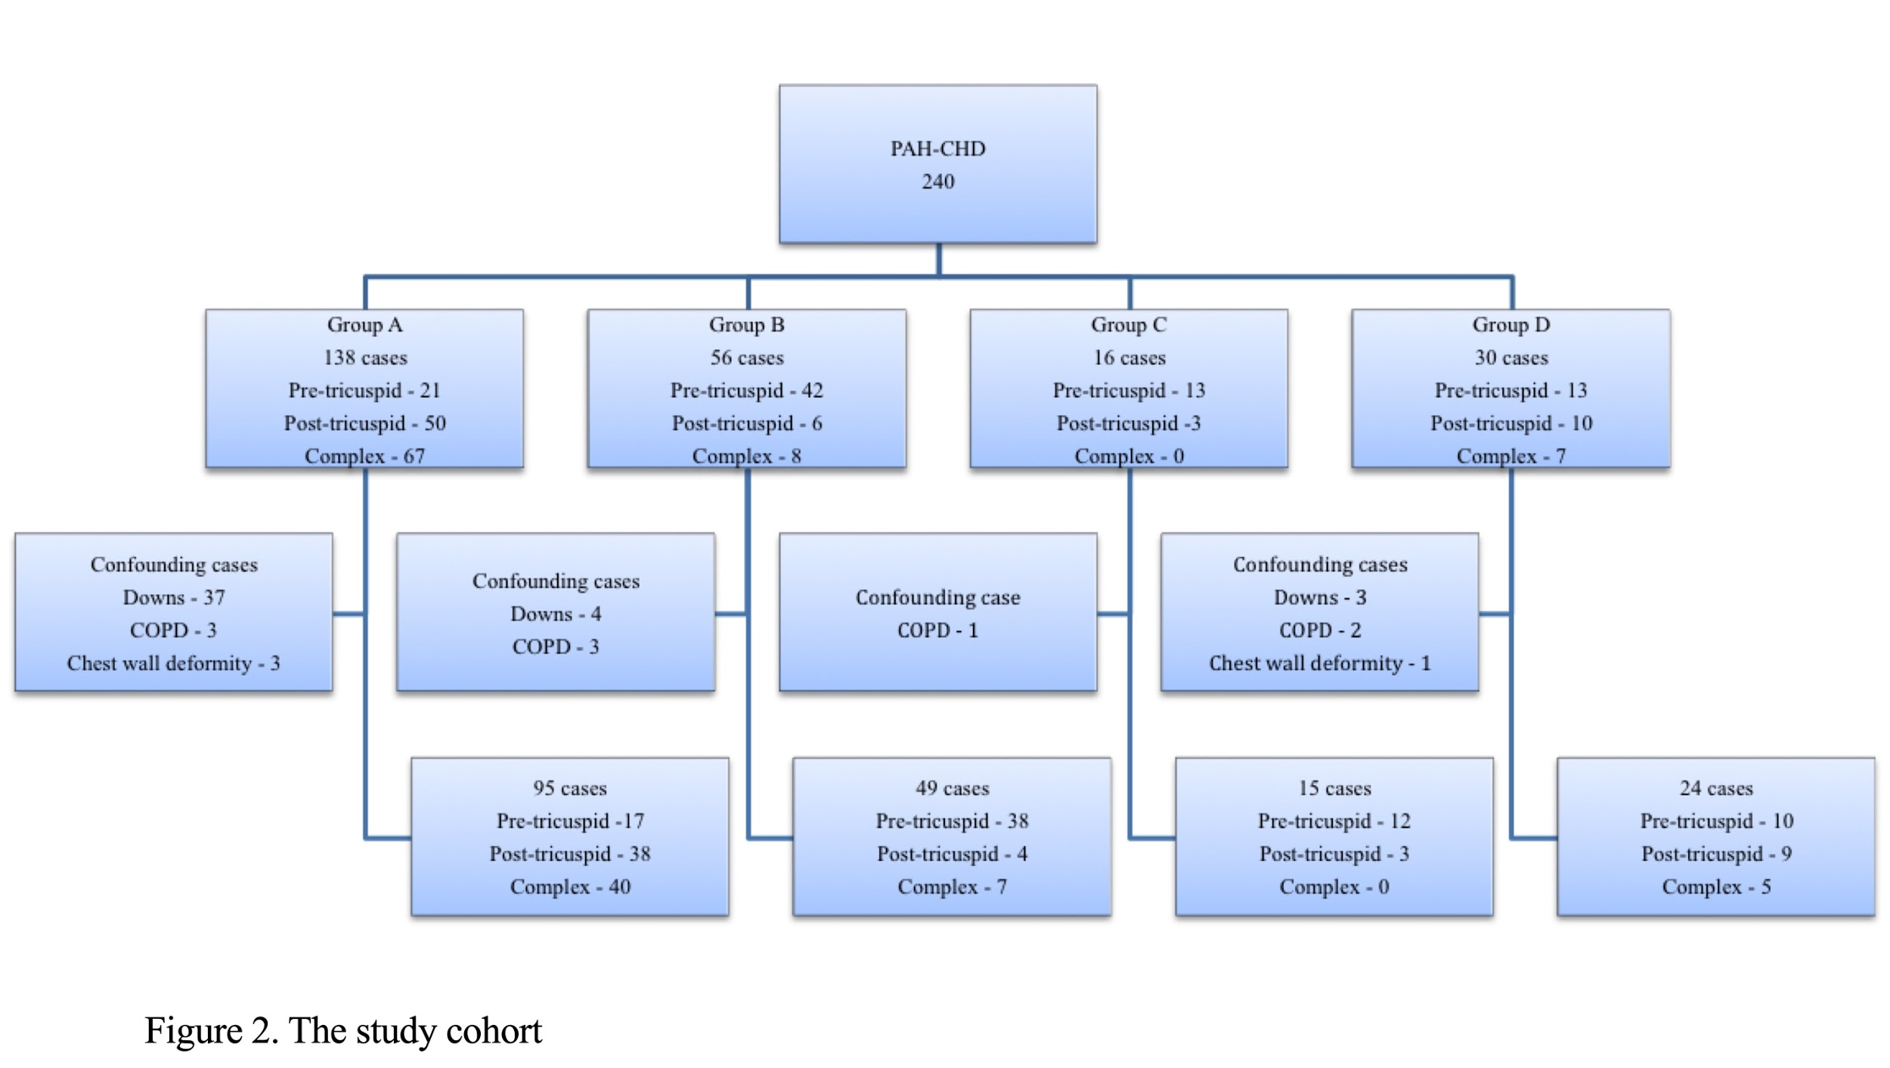
Figure 25. Study cohort of CHD-PAH

 | Group A, n=138 | Group B, n=56 | Group C, n=16 | Group D, n=30 | IPAH, n=175 | p-value
Female, n (%) | 81, (59) | 41, (73) | 11, (69) | 24, (80) | 115, (66) | 0.236
Age, yrs | 37.4±15.3 ^{ϕ, Ψ} | 48.7±17.2 ^{λ} | 48.3±15.8 | 44.3±18.2 ^{Ψ} | 55.2±16.2 ^{λ, χ} | 0.000*
Down’s syndrome, n (%) | 37, (27) | 4, (7) | 0, (0) | 3, (10) | 0, (0) | 0.000*
Height, m | 1.59±0.1 ^{Ψ} | 1.60±0.1 | 1.61±0.1 | 1.59±0.1 | 1.63±0.1 ^{λ} | 0.007*
Weight, kg | 61.9±14.7 ^{Ψ} | 69.6±21.0 | 68.0±15.8 | 65.3±17.8 | 75.4±18.5 ^{λ} | 0.000*
WHO FC I, n (%) | 4 (3) | 1, (2) | 0 (0) | 0 (0) | 4, (2)
WHO FC II, n (%) | 33, (24) | 18, (32) | 4, (25) | 8, (27) | 22, (13)
WHO FC III, n (%) | 95, (69) | 35, (63) | 10, (63) | 20, (66) | 132, (75)
WHO FC IV, n (%) | 6, (4) | 2, (3) | 2, (12) | 2, (7) | 17, (10)
ISWD, m | 192±120 | 234±175 | 203±136 | 254±208 | 196±183 | 0.233
mRAP, (mmHg)  mPAP, (mmHg)  PAWP, (mmHg)  PVR, (dyne/s/cm⁵) | §  §  §  § | 9±5  48±15  11±4  471±243 ^{ϑ, Ψ} | 8±6  58±11  9±4  917±284 ^{ϕ} | 10±5  53±18  11±3  768±494 | 11±6  53±13  10±3  964±463 ^{ϕ} | 0.153  0.069  0.200  0.000*
FEV₁ % pred | 62.4 ±18.5^{Ψ} | 68.7±20.4 ^{Ψ} | 69.8±22.7 ^{Ψ} | 63.9±19.5 ^{Ψ} | 85.6 ±15.5^{λ, ϕ, ϑ, χ} | 0.000*
FVC % pred | 71.1±22.4 ^{ϕ, Ψ} | 81.0 ±24.0^{λ, Ψ} | 82.2±22.5 | 72.9±22.6 ^{Ψ} | 95.8±18.0 ^{λ, ϕ, χ} | 0.000*
FEV₁/FVC | 0.76±0.11 | 0.72±0.11 | 0.71±0.10 | 0.75±0.10 | 0.74±0.9 | 0.093
DLco % pred | 69.7 ±18.6^{Ψ} | 76.3±25.5 ^{χ, Ψ} | 67.9±25.0 | 60.7±15.0 ^{ϕ, Ψ} | 52.3±20.8 ^{λ, ϕ} | 0.000*
Haemoglobin, g/dl | 19.1±3.0 ^{ϕ, ϑ, χ} | 14.9±1.7 ^{λ} | 14.8±2.4 ^{λ} | 14.0±2.5 ^{λ} |  | 0.000*
Platelets, x10⁹/L | 165±71 ^{ϕ, ϑ, χ} | 235±74 ^{λ} | 278±69 ^{λ} | 230±81 ^{λ} |  | 0.000*
Albumin, g/L | 39±5 ^{ϕ} | 41±5 ^{λ} | 40±4 | 40±6 |  | 0.029*
Alanine aminotransferase, iu/L | 25±16 | 22±9 | 24±15 | 24±10 |  | 0.701
Bilirubin, μmol/L | 21±11 | 18±11 | 17±7 | 20±13 |  | 0.242
Urea, mmol/L | 5.6±2.4 | 5.0±1.8 | 5.2±2.2 | 6.2±4.1 |  | 0.213
Creatinine, μmol/L | 85±22 | 80±19 | 83±26 | 94±50 |  | 0.184
Table 28. Clinical classification: baseline clinical, haemodynamic and laboratory characteristics
Data are presented as mean ± SD or % unless otherwise stated. Group A: Eisenmenger syndrome; Group B: PAH associated with systemic to pulmonary shunts; Group C: PAH associated with coincidental small defects; Group D: PAH persisting or post corrective surgery; IPAH: idiopathic pulmonary arterial hypertension; WHO FC: World Health Organisation functional class; ISWD: incremental shuttle walk distance; §:right heart catheterisation not routinely performed in Eisenmenger syndrome mRAP: mean right atrial pressure; mPAP: mean pulmonary artery pressure; PAWP: pulmonary arterial wedge pressure; PVR: pulmonary vascular resistance; %pred: percent predicted; FEV₁: forced expiratory volume in 1 second; FVC: forced vital capacity; DL_{CO}: transfer factor of the lung for carbon monoxide; ^{λ}: p <0.05 in comparison to Group A; ^{ϕ}: p <0.05 in comparison to Group B; ^{ϑ}: p <0.05 in comparison to Group C; ^{χ}: p <0.05 in comparison to Group D; ^{Ψ}: p <0.05 in comparison to IPAH; *: p < 0.05

 | Group A, n=138 | Group B, n=56 | Group C, n=16 | Group D, n=30 | Pre-tricuspid, n=89 | Post-tricuspid, n=69 | Complex, n=82
No therapy, n (%) | 32, (23) | 20, (36) | 1, (6) | 6, (20) | 18, (20) | 17, (25) | 24, (29)
Oral mono therapy, n (%) | 69, (50) | 16, (29) | 8, (50) | 10, (34) | 32, (37) | 26, (38) | 45, (55)
Oral dual therapy, n (%) | 29, (21) | 18, (31) | 5, (32) | 9, (30) | 30, (34) | 22, (32) | 9, (12)
Prostanoid, n (%) | 4, (3) | 2, (4) |  | 1, (3) | 4, (4) | 1, (1) | 2, (2)
Prostanoid & oral monotherapy, n (%) | 4, (3) |  | 1, (6) | 3, (10) | 4, (4) | 2, (3) | 2, (2)
Prostanoid & oral dual therapy, n (%) |  |  | 1, (6) | 1, (3) | 1, (1) | 1, (1)

Table 29. Therapy at census

 | Pre-tricuspid, n=89 | Post-tricuspid, n=69 | Complex, n=82 | p-value
Female, n (%) | 70, (79) ^{ϑ} | 39, (57) | 48, (59) ^{λ} | 0.018
Age, years | 50±18 ^{ϕ, ϑ} | 39±14 ^{λ} | 35±14 ^{λ} | <0.001
Down’s syndrome, n (%) | 5, (6) ^{ϑ} | 12, (17) | 27, (33) ^{λ} | <0.001
WHO FC I, n (%) | 1, (1) | 0, (0) | 0, (0)
WHO FC II, n (%) | 21, (24) | 25, (36) | 17, (21)
WHO FC III, n (%) | 58, (65) | 40, (58) | 56, (68)
WHO FC IV, n (%) | 9, (10) | 4, (6) | 9, (11)
ISWD, m | 203±155 | 246±155 | 188±135 | 0.062
Baseline Saturations, % | 91±7 ^{ϕ, ϑ} | 88±7 ^{λ, ϑ} | 83±9 ^{λ, ϕ} | <0.001
Lowest Saturations, % | 80±14 ^{ϕ, ϑ} | 72±15 ^{λ, ϑ} | 65±15 ^{λ, ϕ} | <0.001
FEV₁% pred | 70.0±20.6 ^{ϑ} | 64.1±17.4 | 58.7±18.4 ^{λ} | 0.001
FVC% pred | 81.9±23.6 ^{ϑ} | 74.1±20.8 | 66.0±21.9 ^{λ} | <0.001
FEV₁/FVC ratio | 0.72±0.10 ^{ϑ} | 0.74±0.11 | 0.77±0.11 ^{λ} | 0.027
DL_{CO}% pred | 73.2±23.3 | 69.6±15.2 | 66.9±19.3 | 0.873
Haemoglobin, g/dl | 15.2±2.3 ^{ϕ, ϑ} | 17.8±3.7 ^{λ} | 18.8±3.2 ^{λ} | <0.001
Platelets, x10⁹/L | 234±74 ^{ϕ, ϑ} | 190±83 ^{λ} | 164±75 ^{λ} | <0.001
Table 31: Anatomical-Pathophysiological classification: Baseline characteristics of all PAH-CHD
Data are presented as mean ± SD unless otherwise stated. WHO FC: World Health Organisation functional class; ISWD: incremental shuttle walk distance; %pred: percent predicted; FEV₁: forced expiratory volume in 1 second; FVC: forced vital capacity; DL_{CO}: transfer factor of the lung for carbon monoxide; ^{λ}: p <0.05 in comparison to pre-tricuspid defects; ^{ϕ}: p <0.05 in comparison to post-tricuspid defects; ^{ϑ}: p <0.05 in comparison to complex defects; *: p < 0.05.

Results

Clinical classification - Patient characteristics
Two hundred and forty patients met the inclusion criteria (figure 25). The underlying form of PAH-CHD was: Group A: 138 Es patients, Group B: 56 moderate to large defects with systemic to pulmonary shunts (L-R), Group C: 16 small defects (SD), and Group D: 30 patients with a closed defect (CD). 175 patients fulfilling criteria for IPAH were included for comparison. Patients with Down’s syndrome comprised 18% (n=44) of the total PAH-CHD cohort. Clear differences in baseline parameters between the 4 groups were observed. Patients with Es were younger and more hypoxemic with a higher haemoglobin, table 28. Patients in group B had lower PVR and higher transfer factor of the lung for carbon monoxide (DLco) than other groups. There was no difference in exercise capacity as assessed by the ISWD between the PAH-CHD groups, table 28. The majority of patients received monotherapy with an endothelin receptor antagonist or phosphodiesterase inhibitor, table 29. Twenty-five percent of patients received oral combination therapy.

Anatomical-pathophysiological classification- Patient characteristics
Types of congenital defects within each group are summarized in table 30. Pre-tricuspid defects were composed of 21-Es, 42 L-R, 13-SD, 13-CD patients. Post-tricuspid defects were comprised of 50-Es, 6-L-R, 3-SD, 10-CD patients. Complex defects were comprised of 67-Es, 8-L-R, & 7-CD patients. Again, clear differences in patient characteristics were observed between the 3 groups. Patients with pre-tricuspid defects presented at an older age and demonstrated a lower exercise capacity than post-tricuspid and complex defects (table 31). Those with complex defects presented at a younger age and had the lowest FEV₁% predicted and DLco was higher in pre-tricuspid defects.

Combining clinical and anatomical-pathophysiological classification
ASD was the commonest underlying defect in groups B-D whereas complex defects were the most common abnormality in group A (Es). In the Es group exercise capacity was significantly lower in pre-tricuspid defects while patients with complex defects had lower lung volumes, table 32.

Defect type, n (%) | Group A, n=138 | Group B, n= 56 | Group C, n= 16 | Group D, n= 30
Pre-Tricuspid  ASD  APVR  Post-Tricuspid  VSD  PDA  Complex  APVR+ASD  VSD+PDA  AVSD  Other Combined ª  Complex ^{b} | 21, (15)  38, (28)  12, (9)  2, (1)  20, (14)  5, (4)  40, (29) | 36, (64)  6, (11)  4, (7)  2, (4)  7, (13)  1, (1) | 11, (69)  2, (13)  3, (18) | 13, (43)  7, (23)  3, (10)  2, (7)  3, (10)  2, (7)
Table 30. Clinical classification v Anatomical-Pathophysiological classification
Data are presented as number or % unless otherwise stated. Group A: Eisenmenger syndrome; Group B: PAH associated with left to right shunts; Group C: PAH associated with small defects; Group D: PAH associated with corrective surgery; ASD: atrial septal defect; VSD: ventricular septal defect; PDA: patent ductus arteriosus; APVR: anomalous pulmonary venous return; AVSD: atrioventricular septal defect; ª – any combined defects apart from AVPR+ASD & VSD + PDAs; ^{b} – complex defects and univentricular pathology.

 | Pre-tricuspid (n=21) | Post-tricuspid (n=50) | Complex (n=67) | p-value
Age, yrs | 49±19 ^{ϕ, ϑ} | 39±15 ^{λ, ϑ} | 32±12 ^{λ, ϕ} | <0.001
WHO FC II, n (%) | 2, (10) | 19, (38) | 12, (18)
WHO FC III, n (%) | 16, (76) | 29, (58) | 48, (72)
WHO FC IV, n (%) | 3, (14) | 2, (4) | 7, (10)
ISWD, m | 135±91 ^{ϕ} | 237±129 ^{λ, ϑ} | 175±109 ^{ϕ} | 0.002
Baseline Sats, % | 83±7 | 85±7 ^{ϑ} | 81±8 ^{ϕ} | 0.007
Lowest Sats, % | 63±12 | 65±15 ^{ϑ} | 57±13 ^{ϕ} | 0.032
FEV₁% pred | 71.0±17.0 ^{ϑ} | 64.6±17.1 | 57.6±19.0 ^{λ} | 0.015
FVC% pred | 87.2±21.2 ^{ϑ} | 79.7±18.7 ^{ϑ} | 67.9±21.7 ^{λ, ϕ} | 0.001
FEV₁/FVC ratio | 0.73±0.10 | 0.74±0.11 | 0.79±0.12 | 0.064
DL_{CO}% pred | 62.7±17.9 | 70.6±14.8 | 71.6±21.9 | 0.235
Haemoglobin, g/dl | 17.1±2.6 | 18.9 ±3.2 | 19.7±2.8 ^{λ} | 0.005
Platelets, _{x}10⁹/l | 217.0±90.5 ^{ϕ, ϑ} | 168.4±63.5 ^{λ, ϑ} | 148.4±62.1 ^{λ} | 0.001
Table 32: Eisenmenger patients: Baseline characteristics
Data are presented as mean ± SD unless otherwise stated. WHO FC: World Health Organisation functional class; ISWD: incremental shuttle walk distance; Sats: saturations; %pred: percent predicted; FEV₁: forced expiratory volume in 1 second; FVC: forced vital capacity; DL_{CO}: diffusing capacity of the lung for carbon monoxide; ^{λ}: p <0.05 in comparison to pre-tricuspid defects; ^{ϕ}: p <0.05 in comparison to post-tricuspid defects; ^{ϑ}: p <0.05 in comparison to complex defects; *: p < 0.05.

Survival Outcomes
Clinical classification
There were 72 deaths and 2 bilateral lung transplants with cardiac defect repairs in the PAH-CHD groups and 105 deaths and 6 bilateral lung transplantations in the IPAH cohort. There was no significant difference in survival from initial PVDU assessment between the 4 PAH-CHD sub-groups (p=0.85). Survival in IPAH patients was significantly worse than in the 4 sub-groups of PAH-CHD (figure 26a, p all <0.05).

Anatomical-pathophysiological classification
Survival in the 240 patients in the PAH-CHD cohort was superior in those with post-tricuspid defects when compared with either pre-tricuspid or complex defects (p=0.019, figure 26b). Age-adjusted survival in patients with post-tricuspid as compared to a pre-tricuspid or complex lesion remained significantly superior with a hazard ratio of (HR 0.53 (0.29, 0.97), p=0.04).

Combining clinical and anatomical-pathophysiological classification.
In the 138 Es patients, survival of those with post-tricuspid defects was again superior to individuals with a pre-tricuspid defect (p=0.035, figure 26c). In the 102 non-Es population there was a survival advantage in those with a post-tricuspid defect when compared to pre-tricuspid and complex defects, p=0.045 and p=0.022 respectively (figure 26d).

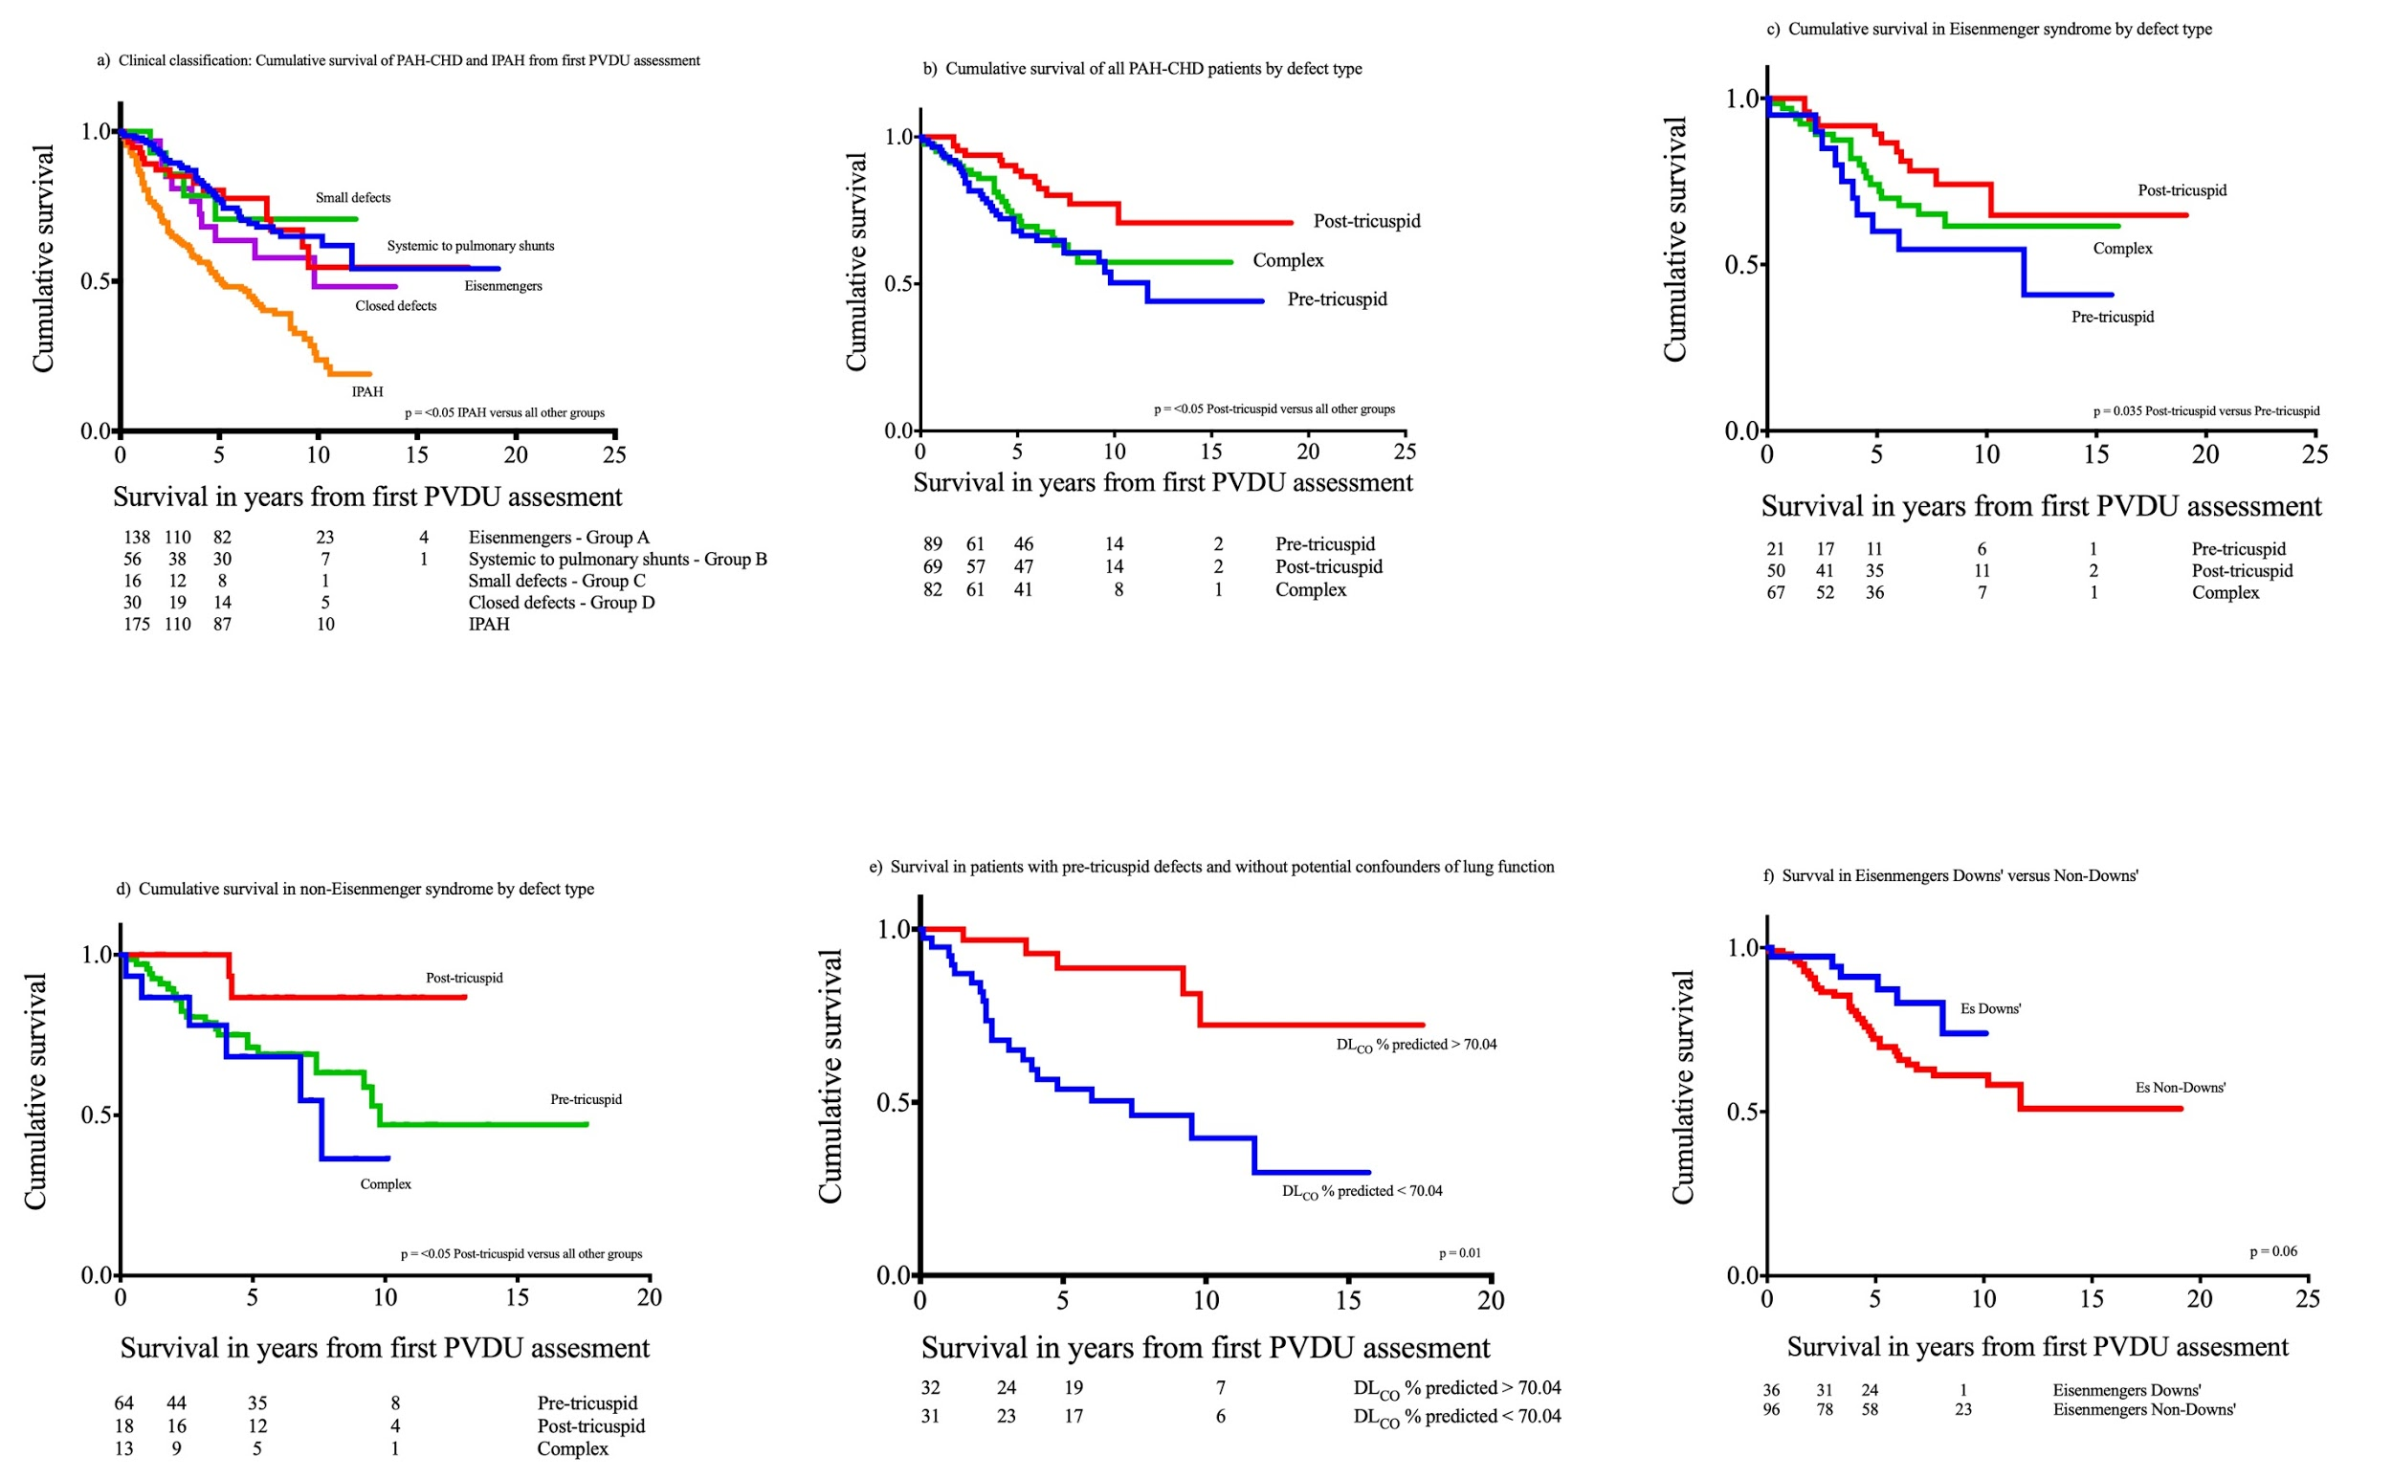

Figure 26. Cumulative survival of CHD-PAH

Prognostic factors
Whole PAH-CHD Cohort
Higher age, WHO FC, creatinine and bilirubin and lower FEV₁ % predicted, FVC % predicted, FEV₁/FVC and ISWD were associated with poorer survival at univariate analysis, table 33. The presence of a pre-tricuspid or complex versus a post-tricuspid defect and the presence of multiple cardio-pulmonary comorbidities were also associated with poorer outcome. At multivariate analysis the independent predictors of survival were age, defect type, creatinine and DLco. When patients with confounding factors (COPD, chest wall deformity and Down’s syndrome) were excluded similar results were observed.

Clinical classification: Eisenmenger patients
Higher age and creatinine were independently associated with poorer outcome in the Es group, (HR 1.04 (1.02-1.06), p<0.005 and HR 1.02 (1.01-1.03) p=0.005 respectively). Although exercise capacity as assessed by the ISWD did not predict outcome at univariate analysis in the whole group, when the 37 Down’s patients were excluded then lower ISWD was associated with poorer outcome (HR 0.997 (0.993-0.999), p=0.029). In the 95 Es patients with no confounding factors, higher age and creatinine and lower FEV₁% predicted independently predicted survival.

Anatomical-pathophysiological classification: Pre-tricuspid defects
Multivariate analysis revealed lower DLco% predicted and older age to be independent predictors of survival (HR 0.97 (0.94-0.99), p=0.002 and HR 1.04 (1.01-1.07), p=0.003 respectively). Five-year survival of patients with a DLco% predicted < the median value of 70% was 62% compared with 85% in patients with a DLco% predicted ≥ the median value (figure 26e, p=0.01).

Anatomical-pathophysiological classification: Post-tricuspid and complex
Higher age and creatinine independently predicted poorer outcome in both the post-tricuspid and complex groups. In the complex group higher bilirubin also independently predicted poorer survival. When patients with confounding factors were excluded, lower FEV₁ % predicted was an independent marker of poor prognosis (HR 0.97 (0.94-0.99) p=0.01).

Down’s syndrome
The majority of patients with Down’s syndrome (22 male vs 15 female) were in the Es group with 3 being pre-tricuspid, 9 being post-tricuspid and 25 having complex disease. When compared with non-Down’s patients, Es patients with Down’s syndrome were younger at presentation (27.8±9.4 versus 40.9±15.6, p <0.001) with lower ISWD (125±79 versus 215±123, p <0.001). There was also a significant difference in haemoglobin and platelet count (20.8±2.3 versus 18.4±3.0, p <0.001; 116±51 versus 184±68, p <0.001 respectively). There was a visual trend toward superior survival in the Es patients with Down’s syndrome, but this was not statically significant (3-year survival 94% versus 85%, p=0.06, figure 26f).

 | All PAH-CHD |  | All PAH-CHD |  | Confounders excluded |  | Confounders excluded
 | Univariate HR | p-value | Multivariate HR | p-value | Univariate HR | p-value | Multivariate HR | p-value
Age, yrs | 1.05 (1.03-1.06) | <0.001 | 1.02 (1.01-1.04) | 0.014 | 1.04 (1.02-1.06) | <0.001 | 1.02 (1.00-1.04) | 0.02
WHO FC (I-IIvsIII-IV)  (Ref WHO I-II) | 2.46 (1.35-4.50) | 0.003 |  |  | 2.27 (1.20-4.30) | 0.012
Defect type  (Ref Post-tricuspid) | 2.28 (1.25-4.16) | 0.007 | 2.65 (1.22-5.76) | 0.014 | 2.36 (1.23-4.55) | 0.010 | 2.41 (1.09-5.30) | 0.029
Co-morbidity  (Ref <2 co-morbidities) | 3.33 (1.83-6.09) | <0.001 |  |  | 3.06 (1.55-6.04) | 0.001
FEV₁% pred | 0.98 (0.97-0.99) | 0.003 |  |  | 0.97 (0.96-0.99) | 0.001
FVC% pred | 0.99 (0.98-1.00) | 0.072 |  |  | 0.98 (0.97-1.00) | 0.008
FEV₁/FVC ratio | 0.02 (0.01-0.24) | 0.001 |  |  | 0.04 (0.01-0.65) | 0.024
DL_{CO}% pred | 0.97 (0.96-0.99) | 0.001 | 0.98 (0.96-0.99) | 0.003 | 0.98 (0.96-1.00) | 0.012 | 0.98 (0.96-0.99) | 0.006
ISWD, m | 0.99 (0.99-1.00) | 0.002 |  |  | 1.0 (0.99-1.0) | 0.003
Haemoglobin, g/dl | 0.95 (0.88-1.02) | 0.177 |  |  | 0.97 (0.89-1.01) | 0.487
ALT, iu/L | 0.98 (0.96-1.01) | 0.160 |  |  | 0.99 (0.98-1.02) | 0.765
Bilirubin, μmol/L | 1.03 (1.01-1.05) | 0.004 |  |  | 1.03 (1.01-1.05) | 0.011
Table 33. Survival analysis of CHD-PAH cohort.
Data are presented as hazard ratio (HR) (95% confidence intervals). WHO FC: World Health Organisation functional class; ISWD: incremental shuttle walk distance; %pred: percent predicted; FEV₁: forced expiratory volume in 1 second; FVC: forced vital capacity; DL_{CO}: diffusing capacity of the lung for carbon monoxide; ALT alanine aminotransferase

Discussion
This is the first study to fully apply both the clinical and anatomical-pathophysiological methods of classification in a large cohort of PAH-CHD patients.

Classification method
In this cohort of 240 with pre-tricuspid, post-tricuspid and complex PAH-CHD patients we observed that the anatomical-pathophysiological classification was effective in identifying a group of patients with superior survival from point of referral while the clinical classification was not. Diller et al previously observed that in a cohort of 171 Es patients those with complex lesions had a significantly poorer survival to those with non-complex lesions (Diller et al., 2006). Moceri et al studied 191 Es patients and found a trend towards poorer survival in patients with pre-tricuspid lesions (Moceri et al., 2015). Of note, the anatomical-pathophysiological classification was not strictly followed in that study, with AVSD patients being classified as post-tricuspid. Furthermore, patients with other forms of complex anatomy were excluded and in neither study were comprehensive Cox survival analysis reported. More recently the Spanish REHAP group studied 240 patients across 3 clinical groups (A, C and D) and also found that patients with pre-tricuspid defects had poorer outcomes (Alonso-Gonzalez et al., 2015).

In the present study we have demonstrated that individuals with post-tricuspid defects have superior survival when compared to those with either pre-tricuspid or complex defects. Individuals with post-tricuspid shunts are at risk of both volume and pressure overload with subsequent early remodelling of the pulmonary vascular bed and development of PAH at an earlier age when compared to other defects (Wood, 1958). Compensatory RV remodelling allows adaptation to this pressure overload while right to left shunting through the post-tricuspid defect reduces RV afterload. It was interesting to note that survival in the pre-tricuspid group was inferior despite almost a half of these patients having a L-R shunt with lower PVR. This is likely related to a volume loaded right ventricle with less potential to compensate for subsequent pulmonary vasculopathy. PAH secondary to a pre-tricuspid shunt develops following insidious volume overload with subsequent atrial dilatation and hence presents later in life than post-tricuspid disease, as in the current study. The right ventricle is less able to adapt to increasing pressures leading to greater dilatation and poorer contractility as compared with post-tricuspid defects, as demonstrated by Moceri et al (Moceri et al., 2015). A reversal of shunt and development of Eisenmenger physiology may therefore be a consequence of right atrial overload due to a failing right ventricle (Engelfriet et al., 2007; Steele et al., 1987).

Although we observed superior survival in PAH due to post-tricuspid as opposed to pre-tricuspid defects (anatomical-pathophysiological classification) we did not observe superior survival from date of initial attendance at our unit in patients with Es as opposed to patients with a L-R shunt, small defect or closed defect (clinical classification). Three previous large studies have reported survival in different clinical PAH-CHD classes. Manes et al reported superior survival from initial hemodynamic confirmation of PAH at their unit in 90 Es patients when compared with 10 patients in group C (SD) and 44 patients in group D (CD) (Manes et al., 2014). The REHAP investigators observed superior survival in 163 Es patients compared with 57 corrected patients (group D) (Alonso-Gonzalez et al., 2015). Both these studies enrolled patients at the time of PAH diagnosis. Conversely, the REVEAL investigators found no difference in survival from enrolment or diagnosis between 151 Es patients, 105 CD patients and 91 presumed combined L-R and SD patients (Robyn J. Barst et al., 2014). Importantly the majority of the REVEAL patients were enrolled a number of years following diagnosis of PAH. In the current study we also found no difference in survival between Es and non-Es from point of referral. These data suggest that although overall survival from initial PAH diagnosis may well be superior in Es patients this survival advantage is lost by the time of referral for consideration of PAH-specific therapy. Dimopoulos et al have previously demonstrated that earlier initiation of PAH-specific therapy in Es appears to be associated with improved survival (Dimopoulos et al., 2010). It will therefore be interesting to see in the future whether referral practice and subsequent survival in Es improves.

We observed that outcome in complex defects trended towards being worse than post-tricuspid shunts but similar to pre-tricuspid shunts. Diller et al previously observed that outcomes in patients with complex defects were inferior to that of simple defects but did not differentiate between pre- and post-tricuspid defects (Diller et al., 2006). One third of our complex group consisted of AVSD. Moceri et al demonstrated that patients with AVSDs had better RV systolic and diastolic function compared with VSDs (Moceri et al., 2015) and the inclusion of AVSD in the complex group in our study (in keeping with the recognised anatomical-pathophysiological classification system) may have improved outcomes in the complex group somewhat.

In the current paper we observed poorer survival in IPAH compared with group D (CD). Patients with IPAH were older (55 versus 44 years) with similar pulmonary artery pressure but higher pulmonary vascular resistance. The REHAP investigators reported no significant survival difference between these 2 groups. Limited data regarding the IPAH group are provided however their IPAH cohort were younger than in our study (mean 48 years) (Alonso-Gonzalez et al., 2015). The REVEAL registry observed no difference in 4-year survival between IPAH and group D (CD) and a trend towards poorer survival in IPAH at 7 years. Their IPAH group had similar haemodynamics to group D patients but were significantly older (50 versus 37 years) (Robyn J. Barst et al., 2014).

Survival analysis
Increasing age was a consistent adverse prognostic factor across all the diagnostic groups. This has been well recognised in other forms of PAH including IPAH (Ling et al., 2012) and PAH associated with systemic sclerosis (Condliffe et al., 2012) and may often be in part due to increased prevalence of medical comorbidities. Nevertheless, age-adjusted survival in the whole cohort was significantly superior in patients with post-tricuspid defects. We also noted that higher creatinine was independently associated with worse outcome. Impaired renal function has previously been identified as being prognostically important in other forms of PAH and likely reflects poor cardiac output and oxygen delivery (Shah et al., 2008). We also found higher bilirubin to be an independent predictor of survival in patients with complex disease. It is likely reflects hepatic congestion secondary to a failing sub-pulmonary ventricle (Takeda et al., 2010).

Several studies have investigated the impact of pulmonary function tests in ACHD. A recent study of patients with all forms of ACHD, which excluded patients with obstructive spirometry, demonstrated that restrictive spirometry was a predictor of mortality and that reduced FVC correlated with previous thoracic surgery, complexity of underlying defect, low body mass index, and scoliosis (Alonso-Gonzalez et al., 2013). The same group recently published data on a small cohort of Es patients (n=32) and observed airflow obstruction in 42%, (Broberg et al., 2014). Interestingly, in our study lower FEV₁ % predicted was independently associated with poorer outcome in the Es and complex groups when patients with confounding factors (such as potentially poor technique in Down’s syndrome, known thoracic wall abnormalities or previous diagnosis of COPD) were excluded. The cause for airflow obstruction in patients with Es is not clear. Alveolar growth is dependent on the pulmonary microvasculature and therefore disruption of angiogenesis may lead to impaired alveolarisation with subsequent reduction in FEV_{1,} (Thébaud & Abman, 2007). Pulmonary arterial dilation may also result in compression of accompanying bronchi.

Limitations
The major limitation to this study is the lack of right heart catheterisation data in the Es group. Although right heart catheterisation is essential for the diagnosis of the majority of forms of PAH and was performed in patients with non-Es physiology, we do not routinely perform it in patients with Es in the context of an appropriate cardiac defect on imaging. This meant we were unable to incorporate pulmonary haemodynamics in the survival analysis for the whole cohort. PVR was, however, not a significant prognostic factor in patients with pre-tricuspid defects and a L-R shunt at univariate analysis (data not shown). Differing practices of referring ACHD centres in their assessment of suitability for defect closure may have influenced outcomes in group B. As patients were enrolled at the time of referral, we have been unable to define survival from date of PAH diagnosis.

Conclusion
In a large cohort of patients with PAH-CHD we have observed that both the anatomical-pathophysiological and clinical classification systems identified groups of patients distinct in baseline characteristics. In our cohort, however, only the anatomical-pathophysiological classification identified significantly different survival from point of referral to our pulmonary hypertension centre, between the major groups. Higher age and creatinine, lower DLco% and FEV₁% predicted and non-post-tricuspid defect type are important independent predictors of poor survival from point of referral. The presence of these adverse prognostic markers may be useful in identifying patients requiring more aggressive pulmonary vascular therapy.

Chapter V:

A comparison of risk stratification models in pulmonary arterial hypertension

Abstract
Background
The current ESC/ERS guidance has suggested that clinicians perform serial risk assessments when reviewing patients with pulmonary arterial hypertension (PAH) to identify those with a high-risk of mortality and morbidity. Four risk scores have been developed based on the original ESC/ERS assessment tool. The aim of this study was to compare these risk stratification tools of an incident population of PAH patients as well as to review the effect of co-morbidities on the risk scores.

Methods
Departmental databases identified 584 patients with PAH: 268 IPAH, 12 with HPAH, and 304 with SSc-PAH. Patients with CHD-PAH were excluded from the study due to their superior survival rates when compared to other forms of PAH. The REVEAL 2.0, COMPERA and FPHR risk scores were compared.

Results
In our cohort of newly diagnosed PAH patients the full REVEAL 2.0 score offered the best prognostication as measured at 12 months, with a c score of 0.73. The COMPERA scoring system was the least effective on this cohort of PAH patients.

Conclusions
The REVEAL 2.0 risk score is a valid tool in incident PAH patients and its superiority may be a reflection of the score including both weighted modifiable and nonmodifiable factors

Introduction
Data from registries have aided the PH community to derive algorithms to help predict a patient's disease course. One of the first algorithms was developed by the National Institutes of Health Primary Pulmonary Hypertension Registry investigators in 1991 by D’Alonzo et al. This study of 192 patients (pre-PH-targeted therapy) demonstrated a median survival of 2.8 years and created an equation to estimate survival based on three haemodynamic variables: mean pulmonary artery pressure, mean right atrial pressure and cardiac index (D’Alonzo et al., 1991).

Despite an improvement in available targeted PH therapies the prognosis of PAH patients remains poor (J Hurdman et al., 2011). Consequently, in 2015, the ESC/ERS ‘guidelines for the diagnosis and treatment of pulmonary hypertension’, suggested PH clinicians applied a multivariate risk assessment tool when evaluating PH patients. This risk tool is based on known predictive variables in order to offer prognostication for the PH patient. The tool uses variables commonly acquired at a PH patient’s consultation, namely measures of symptom burden - WHO FC; exercise capacity - 6MWD; and measures of right ventricular function with echocardiographic variables or BNP levels (Nazzareno Galiè et al., 2016).

By following this recommendation clinicians are able to ascertain if a PH patient has a higher risk of a poor prognosis which offers the clinician the ability to tailor a patient’s PH therapy regime and if appropriate prompt referral for transplantation (Boucly et al., 2017).

Four risk scores have been proposed based on the ESC/ERS 2015 guidance: the updated REVEAL 2.0 from the USA, COMPERA compromising predominantly of German patients, the French registry - FPHR and SPAHR from the Swedish group (Benza et al., 2019; Boucly et al., 2017; Marius M. Hoeper et al., 2017; Kylhammar et al., 2017). The aim of this study was to investigate which risk score had the best predictive value in our PAH cohort.

Methods

Patient identification
This method has been previously described. Three hundred and twenty-two patients were diagnosed with IPAH, and three hundred and twenty-nine with SSc-PAH (systemic sclerosis associated with PAH) between February 2001 and July 2014. Patients were included in the PAH cohort if they were >18years of age, and had pre-capillary PH as defined as a mPAP ≥ 25mmHg and a PAWP ≤ 15mmHg. Patients with CHD-PAH were excluded from the cohort due to comprising a third of the total PAH population in Sheffield and with that the possibility of skewing the comparisons.

Included available variables
In this study we did not have access to the following data/variables: BNP / pro-NT BNP, pericardial effusion, or right atrial area. Instead of 6MWD, the ISWD was used to measure exercise capacity. A study by Billings et al had identified potential cut off values which in theory would correlate with the 6MWD parameters: ISWD ≥ 420m, ISWD < 420 - 130m, < 130m (C. G. Billings et al., 2017). PAH patients with an ISWD ≥ 420m were classed as ‘low risk’, ISWD between 420m-130m - ‘intermediate risk’ and finally those able to walk < 130m as ‘high risk’. To ensure a robust comparison, patients with ≥ 2 missing variables in our study were excluded. Our study population was reduced to 584 patients: 268 with IPAH, 12 with heritable pulmonary arterial hypertension (HPAH), and 304 with SSc-PAH.

Analysis
Statistical analyses were performed using IBM SPSS Statistics, version 25 (SPSS, Inc.) and GraphPad Prism version 7.00 for Windows, GraphPad Software, La Jolla California. Data were expressed as mean ± SD or median ± interquartile range. Categorical data were expressed as number and percentage.

One-way analysis of variance and Bonferroni post hoc analysis were used to determine significant differences between continuous data in three or more groups. Comparison between two groups was performed using a t test or the Mann-Whitney test for continuous data and the χ2 test for categorical data. Transplant-free survival from the date of the initial RHC was calculated using the Kaplan-Meier method. Univariate and multivariate Cox regression analysis was performed to identify prognostic factors. A P value of < .05 was considered statistically significant throughout.

Calculation of risk scores

COMPERA - uses up to 6 variables based on the ERC/ERS 2015 guidance. Each variable is assigned a grade of: low risk = 1, intermediate risk = 2, high risk = 3 - these grades are summed and then divided by the number of available variables. This value is then rounded up to the next integer (Marius M. Hoeper et al., 2017).

FPHR - risk strategy uses only 4 variables. The category a PAH patient enters is determined by how many low-risk criteria they have as determined by the 2015 ESC/ERS guidance. They also suggested a three-risk score strategy - 4-3 low risk criteria = low risk, 2 low risk criteria = intermediate risk, 0-1 low risk criteria = high risk (Boucly et al., 2017).

REVEAL 2.0 - A REVEAL 2.0 score was calculated for each patient based on the REVEAL 2.0 weighted scores based on risk of a variable result - i.e., low risk, intermediate or high risk - these values were summed and 6 added to give the final score (Benza et al., 2019).

A three category REVEAL 2.0 risk score was utilised to allow comparison between the scores. Low risk is determined by a score ≤ 6 (12-month mortality risk ≤ 2.6%), an intermediate risk = 7-8 (12-month mortality risk of 6.2% and 7.0%) and finally a high risk was categorised as a score ≥ 9 (12-month mortality of ≥ 10.7%).

Survival was then evaluated for each scoring system at either 12 or 60 months for the three risk strata. Comparison of these risk scores was performed by utilising a receiver operating characteristic curves at 12 months. A c-statistic was produced which evaluates the concordance between the model’s predictions (1 = perfect concordance, 0.5 = random concordance).

Results

Survival of PAH cohort

Variables | PAH cohort, n=584
PAH  SSc-PAH  HPAH | 268
 | 304
 | 12
Gender: Females n, (%) | 427 (73%)
Age, years | 62.3±14.1
DLco% predicted | 43% ±17
PVR, WU | 9.4 ± 5.3
SvO2 % | 63±9
Cardiac index, mL.min.m⁻² | 2.5±0.8
RAP, mmHg | 10±6
ISWD, m | 172±152
WHO FC | 2 (0.3)
II | 65 (11)
III | 409 (70)
IV | 108 (19)
Heart rate, bpm | 83±15
Renal dysfunction | 96 (17)
Table 34. General characteristics of the PAH analysis cohort
Data presented as mean ± standard deviation, unless otherwise documented. Abbreviations: PAH, pulmonary arterial hypertension; SSc-PAH, systemic sclerosis associated pulmonary arterial hypertension; HPAH, hereditary pulmonary arterial hypertension; WHO FC: world health organisation functional class; ISWD: incremental shuttle walk distance; mRAP: mean right atrial pressure; mPAP: mean pulmonary artery pressure; CI: cardiac index; PVR: pulmonary vascular resistance; DL_{CO}: diffusing capacity of the lung for carbon monoxide; SvO₂, pulmonary arterial saturations

In our cohort of 584 PAH patients, which comprised of 268 people with IPAH, 304 with SSc-PAH and 12 people with heritable PAH whose clinical characteristics are in table 34; the 6- months, 12- months and 60- months survival percentages were 92%, 85% and 40% respectively, figure 28a.

Risk scores
The REVEAL 2.0 risk scoring strategy in PAH patients at point of diagnosis, figure 27a-b, at 12- and 60- months demonstrated good separation of risk strata with an overall log rank p <0.001. This was further exhibited when using the three-category risk score suggested by Benza et al of low risk = ≤ 6, intermediate risk 7-8, high risk ≥ 9, figure 27c-d. At 12 and 60 months in both FPHR and COMPERA there again was good separation of the risk categories with a p value < 0.001, figure 27e-f.

Comparison of risk scores
All three risk scores demonstrated a superior survival at 12 and 60 months for those with a lower risk score or higher number of low risk variables (FPHR), (p <0.001). The majority of patients appeared to fall into the intermediate category in all three scores.
At 12 months the REVEAL 2.0 three risk category score vs COMPERA risk score vs FPHR- 3 risk score, the following risk of mortality were observed:
Low risk (estimated < 5% mortality at 12 months) = 2% vs 3% vs 0%; Intermediate risk (estimated 5-10% mortality at 12 months) = 7% vs 15% vs 11%; High risk (estimated >15% mortality at 12 months) = 21% vs 28% vs 19%
Reveal risk score | n |  | FPHR risk score, n | COMPERA risk score, n
Low  (score ≤6) | 56 | Low | 22 | 29
 |  | Intermediate* | 16 | 25
 |  | High* | 17 | 2
Intermediate  (score 7-8) | 172 | Low^ | 20 | 58
 |  | Intermediate | 58 | 99
 |  | High* | 94 | 15
High  (score ≥9) | 356 | Low^ | 3 | 28
 |  | Intermediate^ | 85 | 224
 |  | High | 267 | 104
Table 35. Number of patients in each REVEAL 2.0 three category risk score. Subdivided into risk categorisation of the three-risk score FPHR - French high risk score = no or 1 criteria, intermediate risk = 2 criteria, low risk = 3-4 criteria, * over estimation, ^ under estimation – and COMPERA
Abbreviations: COMPERA = Comparative, Prospective Registry of Newly Initiated Therapies for Pulmonary Hypertension; FPHR = French Pulmonary Hypertension Registry; REVEAL = Registry to Evaluate Early and Long-Term PAH Disease Management

In our combined cohort of patients with IPAH and SSc-PAH the best predictor of actual intermediate risk appeared to be the REVEAL 2.0 score. It is noteworthy that in the intermediate group COMPERA score appeared to be inferior as it underestimated the risk of mortality in 34% of patients - compared to REVEAL 2.0.

ROC demonstrated that in our mixed PAH cohort REVEAL 2.0 full score had the best discrimination (c-statistic 0.732), figure 28b. The least discriminatory was the FPHR risk score, c-statistic 0.644. This did not improve when all patients with SSc-PAH were excluded from the analysis - FPHR IPAH c-statistic was 0.631.

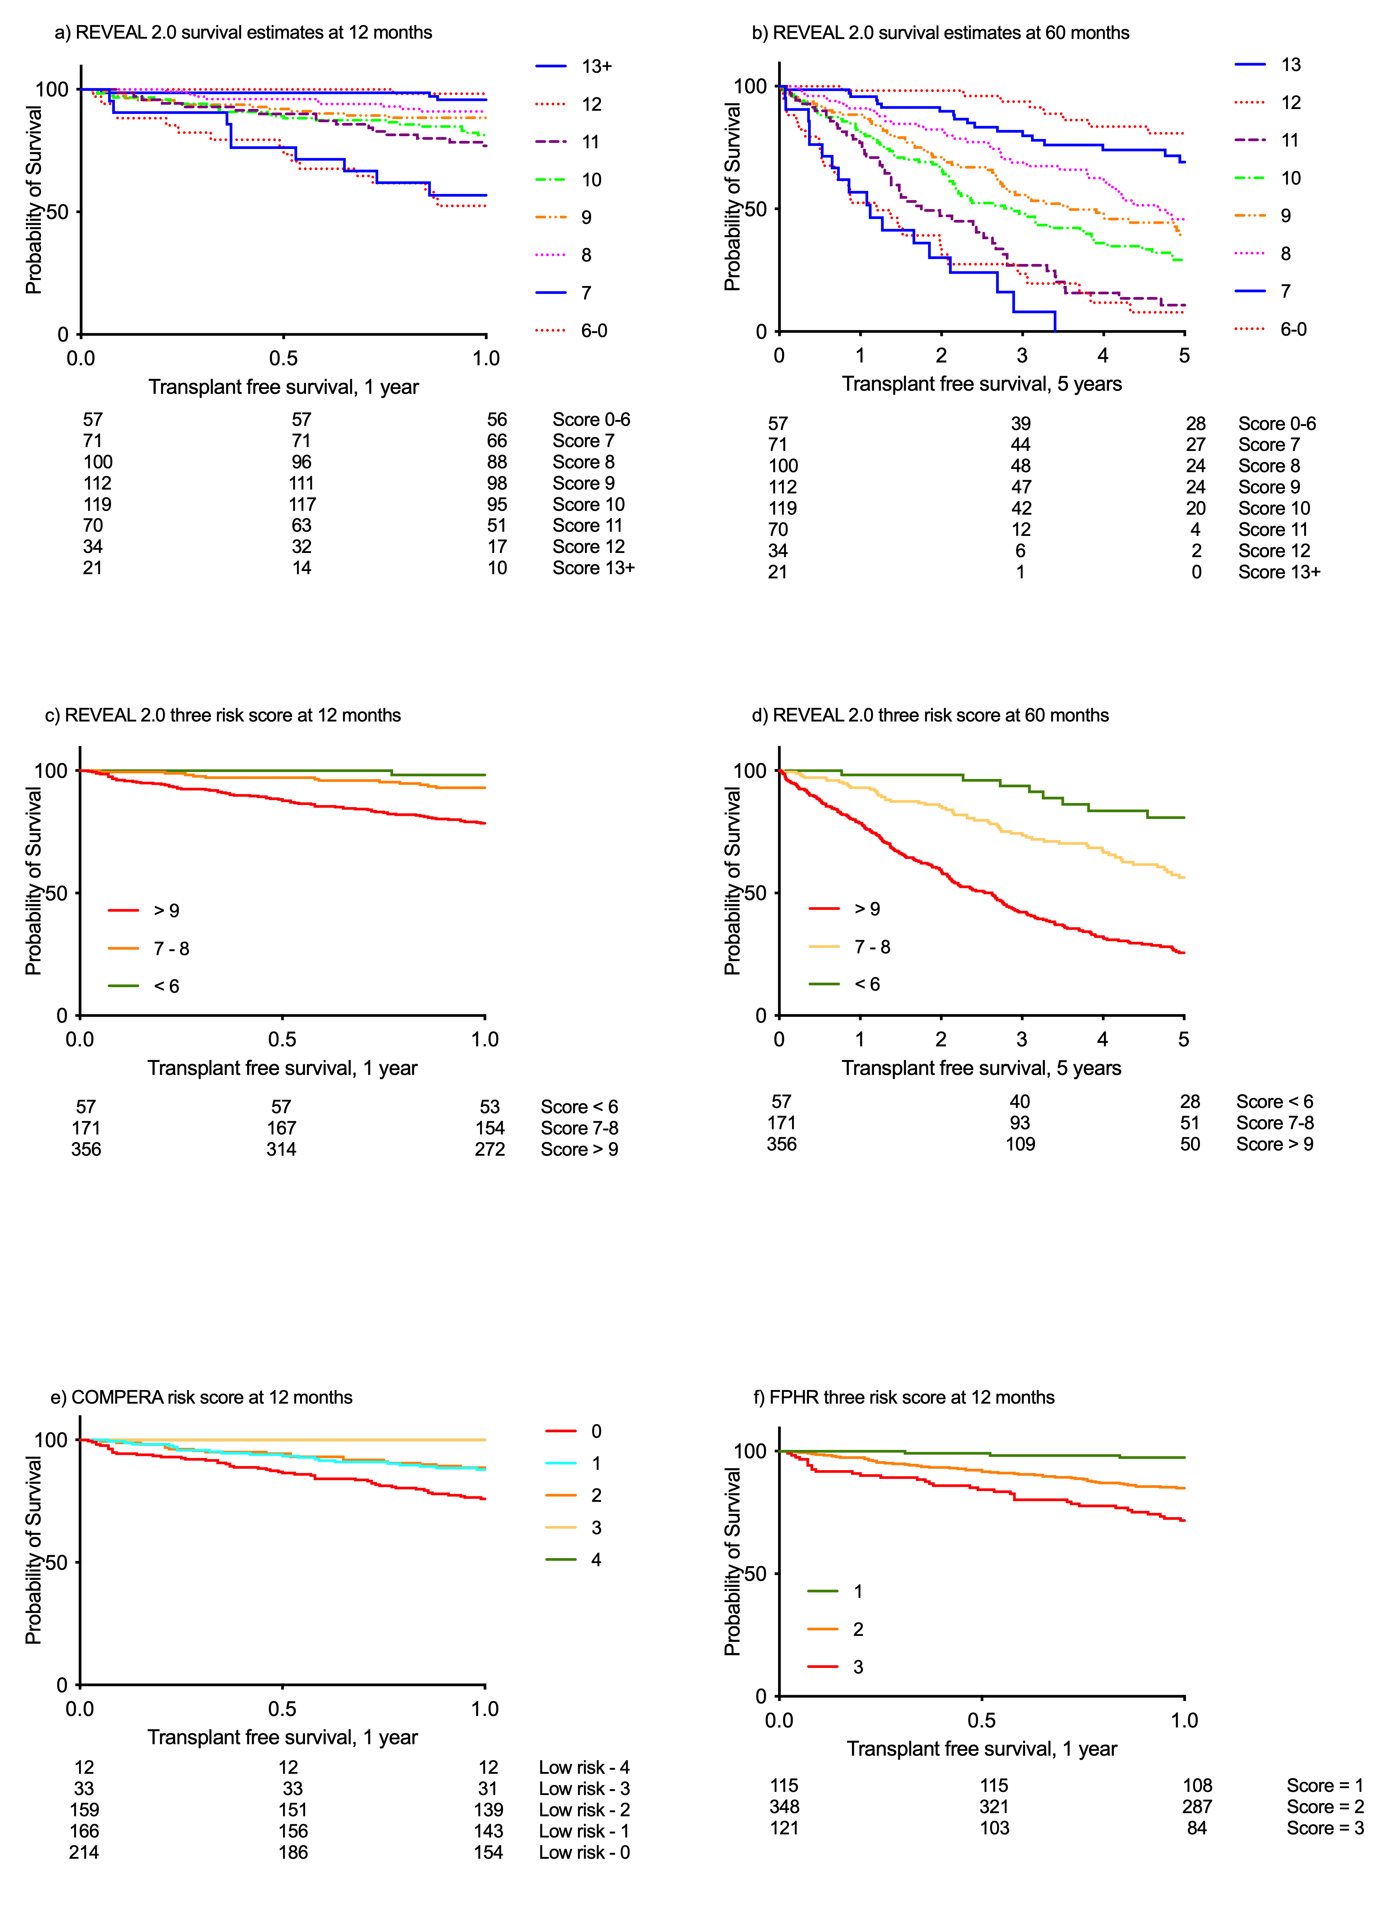
Figure 27. Survival estimates at 12- and 60-months of the three risk scores

Abbreviations: COMPERA = Comparative, Prospective Registry of Newly Initiated Therapies for Pulmonary Hypertension; FPHR = French Pulmonary Hypertension Registry; PAH = pulmonary arterial hypertension; REVEAL = Registry to Evaluate Early and Long-Term PAH Disease Management

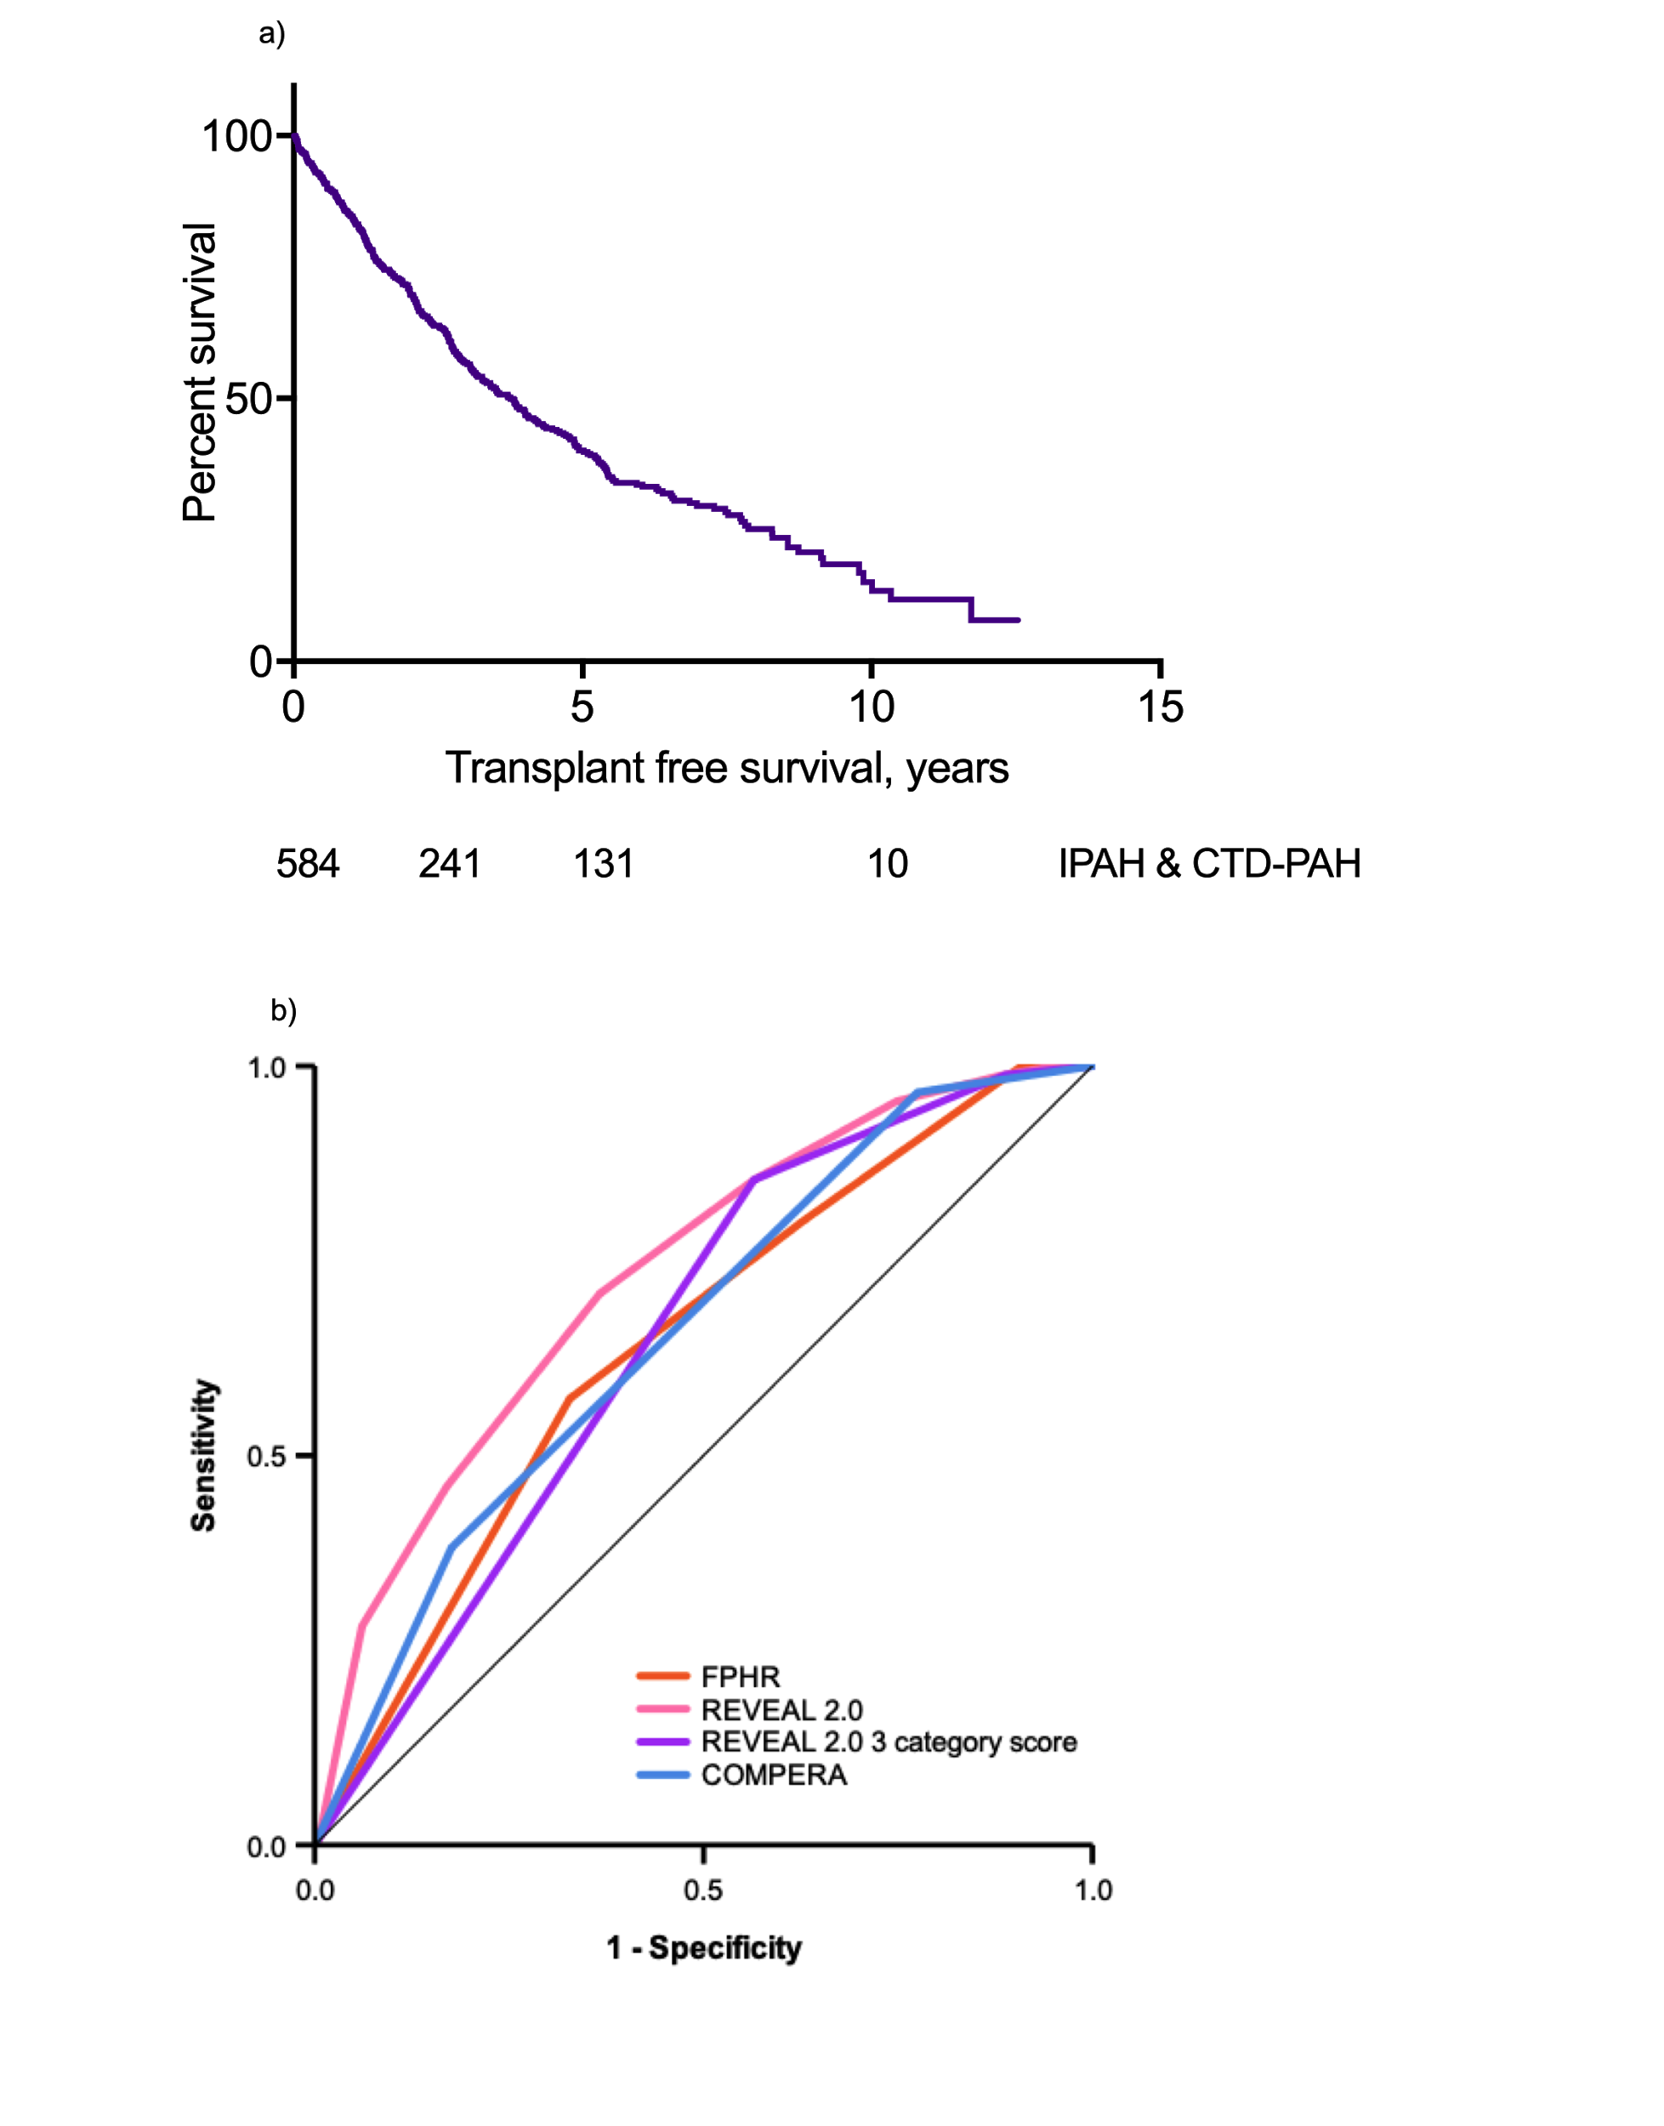
Figure 28. a) Overall cohort survival; b) ROC curves at 12 months for four risk scores
C-statistic: FPHR = 0.644; Full Reveal 2.0 = 0.732; Reveal 2.0 three category risk = 0.650;
COMPERA = 0.659
Abbreviations: COMPERA = Comparative, Prospective Registry of Newly Initiated Therapies for Pulmonary Hypertension; FPHR = French Pulmonary Hypertension Registry; REVEAL = Registry to Evaluate Early and Long-Term PAH Disease Management

The distribution of our patients at baseline in the Reveal 2.0 score unsurprisingly demonstrated that the majority of the PAH patients with risk factors for lung and left heart disease were in a higher risk category as well as the majority of the SSc-PAH cohort being in the high-risk category. COMPERA appeared to discriminate less between patients with systemic sclerosis and those with comorbidities, table 36.

Sub-group of PAH | Risk group | REVEAL 2.0 n, (%) | COMPERA n, (%) | FPHR n, (%)
iPAH  (n=155) | low | 40 (26) | 26 (17) | 15 (10)
 | intermediate | 64 (41) | 90 (58) | 31 (20)
 | high | 51 (33) | 39 (25) | 109 (70)
IPAH-lung  (n=22) | low | 1 (5) | 1 (5) | -
 | intermediate | 6 (27) | 14 (64) | 2 (9)
 | high | 15 (68) | 7 (31) | 20 (91)
IPAH-lhd  (n=103) | low | 3 (3) | 6 (6) | 2 (2)
 | intermediate | 25 (24) | 63 (61) | 11 (11)
 | high | 75 (73) | 34 (33) | 90 (87)
PAH-SSc  (n=180) | low | 9 (5) | 51 (28) | 16 (9)
 | intermediate | 55 (31) | 105 (59) | 68 (38)
 | high | 116 (64) | 24 (13) | 96 (53)
PAH-SSc-lung (n=79) | low | 1 (1) | 23 (29) | 8 (10)
 | intermediate | 15 (19) | 48 (61) | 37 (47)
 | high | 63 (80) | 8 (10) | 34 (43)
PAH-SSc-lhd  (n=45) | low | 2 (4) | 8 (18) | 8 (10)
 | intermediate | 7 (16) | 28 (62) | 37 (47)
 | high | 36 (80) | 9 (20) | 34 (43)
Table 36. Sub-group of PAH in each three category risk score.
Sub-divided into risk categorisation of the three-risk score REVEAL 2.0: low risk = ≤ 6, intermediate risk 7-8, high risk ≥ 9; FPHR, French high-risk score = no or 1 criterion, intermediate risk = 2 criteria, low risk = 3-4 criteria
Abbreviations: COMPERA = Comparative, Prospective Registry of Newly Initiated Therapies for Pulmonary Hypertension; FPHR = French Pulmonary Hypertension Registry; REVEAL = Registry to Evaluate Early and Long-Term PAH Disease Management

Discussion
The developers of REVEAL 1.0 have suggested that this prediction score maintains its predicted strength when variables are missing and with our cohort and available variables (Benza, Gomberg-Maitland, et al., 2012), we have also established this when using REVEAL 2.0. We have used these risk tools on a newly diagnosed cohort of patients as did the COMPERA and FPHR (Boucly et al., 2017; Marius M. Hoeper et al., 2017). REVEAL initially used patients who were 12 months post enrolment, but in a separate analysis REVEAL 2.0 showed that in 666 newly diagnosed PAH patients their c-statistic was still 0.76 (CI, 0.72-0.79), ours was 0.72 (CI, 0.68-0.79) (Benza et al., 2019).

A recent retrospective validation of REVEAL 2.0 by the Australian and New Zealand registry found that the full REVEAL 2.0 score and three category score effectively discriminated between the risk profiles of their mixed cohort of prevalent and incident cases (Anderson et al., 2019).

By comparing the risk strategies and the different variables used, it was evident that REVEAL 2.0 score discriminates best between the three tested in our population of newly diagnosed PAH patients. When studying the trends of COMPERA and FPHR scores in our cohort of patients, they appear to underestimate risk. This can have serious implications in terms of upfront therapy including the potential use of prostanoids as well as in for example, the CTD-PAH population as they tend to present with less severe disturbances in pulmonary haemodynamics.

There could be many reasons why the full REVEAL 2.0 score was superior at assessing risk in our cohort of PAH patients. Firstly, the calculator includes both modifiable and non-modifiable risk factors, such as a person's gender, age and sub type of PAH these factors are inherently important in producing a personalised risk profile. REVEAL also includes factors related to other comorbidities e.g., renal dysfunction and hospitalisations as well as weighting scores which again helps to identify those a higher risk of poor prognosis. The ECS/ERS risk stratification assessment tool does not account for these factors but the guidance states that these variables should be considered in order to help inform a clinician’s management strategy (Nazzareno Galiè et al., 2016).

The FPHR score however, is simpler to use in everyday practice. It uses clinical as well as haemodynamic variables and during its conception, aetiologies other than IPAH, heritable or drug induced were purposely excluded to avoid the confounding effects upon survival of other diseases associated with PAH such as CTD-PAH and CHD-PAH (Boucly et al., 2017). The strengths of this French study were that it included 1017 IPAH patients seen at baseline and at their first re-evaluation - a median follow-up time of 34 months (23% of patients had died) including all clinical and haemodynamic variables.

The COMPERA risk score was also based on a large population of 1588 newly diagnosed patients. They also utilised an approach using both haemodynamic and clinical variables. They did include patients with CTD-PAH, CHD-PAH, PoPH and HIV-PAH but interestingly their variables did not include DLco which has been shown to be a significant predictive indicator (McGoon et al., 2013). The investigators did however also demonstrate the validity of their score at baseline and at follow-up.

From our cohort of patients, it appears that the full REVEAL 2.0 risk calculator currently offers the best prognostic information at baseline as it utilises both modifiable and non-modifiable risk factors offering a more individualised form of PH targeted management.

Limitations
The limitations of this study were the small cohort size and the unavailable baseline variables not normally collected in our cohort of PVDU patients in Sheffield, this includes variables such as BNP/pro-NTBNP, which may have a detrimental effect upon our analysis. Also, there is the substitution of ISWD for 6MWD despite the carefully chosen cut-off values which has the potential to influence the risk scoring of patients. The SPHAR score was not calculated or compared as it bore a very close resemblance with COMPERA. Another major flaw in this study was that we do not have available the follow-up consultation variables of this cohort. This would have been incredibly interesting to review to ascertain if in those who clinically improved if this was reflected in their risk scores and vice versa.

Conclusions
From our study we have demonstrated that risk scores which include both weighted modifiable and nonmodifiable factors are a valuable tool as they provide quantifiable measures to track a patient's course and to prompt early intervention if presented with a deteriorating score. In the future we hope that developed PAH risk scores include more non-invasive measured haemodynamic variables especially when considering follow-up consultations. Certainly, one non-invasive modality which has been gaining momentum and is proven to be comparable to some PH haemodynamic measures is that of cardiac MR. We also encourage the PH clinician to continue to perform these personalised risk assessments to help offer more individualised care to the PH patient.

Chapter VI:

Long-term outcomes of domiciliary intravenous iloprost in pulmonary arterial hypertension

Abstract
Background
There are few published data on the efficacy of intravenous (iv) iloprost in pulmonary arterial hypertension (PAH). We present long-term outcomes in PAH patients receiving iv iloprost in a large UK referral centre.

Methods
Eighty patients with idiopathic PAH (iPAH, n=46) or PAH associated with connective tissue disease (CTD-PAH, n=34) were identified as receiving domiciliary iv iloprost between January 1999 and April 2015. Baseline characteristics, doses achieved, functional class at follow-up and survival data were retrieved from hospital databases.

Results
Median maximum dose achieved was 4.6ng/kg/min in the iPAH group and 5.0ng/kg/min in CTD-PAH patients. Exercise capacity significantly improved in the first 6 months of therapy in IPAH patients. 1, 3 & 5-year overall survival was 78%, 64% and 52% in iPAH (p=0.002) and 64%, 26% and 21% in CTD-PAH. Independent predictors of survival were age and exercise capacity.

Conclusions
We report improved survival to that previously reported in iPAH patients treated with domiciliary iv iloprost. This may be in part related to higher administered doses. Patients with CTD-PAH had poorer survival, reinforcing the need for early transplantation referral in suitable patients.

Introduction
Pulmonary arterial hypertension (PAH) is a rare condition characterised by progressive narrowing of the pulmonary vasculature leading to increased pulmonary vascular resistance, right ventricular failure and premature mortality (Kiely et al., 2013). Current therapies aim to reduce right ventricular afterload via vasodilatory and anti-proliferative effects on the pulmonary arteries and currently consist of phosphodiesterase-5 inhibitors (Galiè et al., 2009; Nazzareno Galiè et al., 2005), endothelin receptor antagonists (Galiè et al., 2008; Pulido et al., 2013; Lewis J Rubin et al., 2002) and prostanoids (R J Barst et al., 1996; Olschewski et al., 2002; L J Rubin et al., 1990; Gerald Simonneau et al., 2002).

Current management guidelines recommend intravenous (iv) prostanoid therapy for patients in WHO functional class (FC) IV and for patients in FC III with inadequate clinical response to other agents (Nazzareno Galiè & Simonneau, 2013). Intravenous epoprostenol has been shown to improve exercise capacity, pulmonary haemodynamics and survival (R J Barst et al., 1996). Epoprostenol is inherently unstable with a short half-life (3-5 mins) and has traditionally required 12-hourly syringe changes or the use of cold packs. Consequently, alternative iv prostanoids are also in clinical use.

The use of iv Iloprost, which is stable at room temperature with a half-life of 30 mins, was initially reported in 1998 (Higenbottam et al., 1998). It is currently only licensed for use in PAH in New Zealand. Recent data also suggests a positive inotropic effect on the right ventricle in a rat model of pulmonary hypertension (Zeineh et al., 2014). Two observational studies from Germany have reported poor outcomes in patients treated with iv iloprost (M M Hoeper et al., 2009; Knudsen et al., 2011), however there are no other data on long-term outcomes in patients treated elsewhere. We have therefore examined characteristics, dosing and outcomes of patients treated with iv iloprost in a large UK PAH referral centre.

Methods
Eighty patients with idiopathic PAH (iPAH, n=46) or PAH associated with connective tissue disease (CTD-PAH, n=34) who were treated with iv iloprost in a domiciliary setting between 1st January 1999 and 1st April 2015 were identified from departmental databases. In keeping with the study of McLaughlin et al, who previously assessed long-term response to iv epoprostenol, only those individuals who received >30 days of iv iloprost were included in the study cohort - i.e., those patients only receiving treatment as short-term rescue therapy in an in-patient setting were excluded (V. V. McLaughlin et al., 2002). Date of diagnosis was defined as the date of first diagnostic right heart catheter or date of first presentation to the unit if the patient was too unstable for immediate right heart catheterisation. Baseline characteristics, dosing and exercise capacity during follow-up were retrieved. Exercise capacity was assessed using the incremental shuttle walking distance (ISWD). Date of death was ascertained using the National Health Service (NHS) mortality data, while to allow comparison with previous studies survival was analysed in 4 ways:
- Overall survival from date of diagnosis to a census date of 1st October 2015 or date of transplantation versus date of death.
- Overall survival from initiation of therapy to a census date of 1st October 2015 or date of transplantation versus date of death.
- Survival to discontinuation of iv iloprost was defined as survival from initiation of therapy to a census date of 1st October 2015 or cessation of iv iloprost or date of transplantation (whichever was earlier) versus date of death.
- Transplant-free survival to discontinuation of iv iloprost was defined as survival from initiation of therapy to a census date of 1st October 2015 or cessation of iv iloprost (whichever was earlier) versus date of death or date of transplantation.

Transplant-free survival from date of initial diagnostic right heart catheterisation of patients with iPAH was compared with that predicted by the National Institute NIH equation(D’Alonzo et al., 1991):
P(t) = [H(t)]^{A(x,y,z)},
where H(t) = 0.88–0.14t+0.01t²
and A(x,y,z) = e^{(0.007325x+0.0526y–0.3235z)}
Where x is mean pulmonary artery pressure, y is mean right atrial pressure and z is cardiac index. The probabilities of survival at 1, 2, and 3 years are given by the following: P(1)=0.75^{A}; P(2)=0.65^{A}; and P(3)=0.55^{A}. Ethical approval for analysis of routinely collected clinical data was granted by North Sheffield Research Ethics Committee - Improving the investigation of Pulmonary Hypertension REC Ref 06/Q2308/8 STH Ref 14169. This was permitted without the need for written consent as patient information was anonymised and de-identified prior to analysis.
Iloprost was supplied in preconstituted 100 mcg/ml vials (Ilomedin, Bayer, Germany), which were diluted into 19ml 0.9% saline and infused via an indwelling central line at 2ml/hr by a portable Graseby pump (Smiths Medical, UK) until October 2014, when the delivery device was changed to the T60 pump (CME, UK). Iloprost dosing was calculated in ng/kg/min based on patient weight at each visit. Intravenous iloprost was commenced as clinically indicated and doses were escalated at the discretion of the treating clinician.

Statistical analysis
Statistical analyses were performed using SPSS 21 (IBM, USA). Date of diagnosis was defined as the date of first diagnostic right heart catheter or date of first presentation to the unit if the patient was too unstable for immediate right heart catheterisation. The Kolmogrov-Smirnov test was utilised to ascertain whether data was parametric or non-parametric and data were expressed as mean (standard deviation) or median (range) as appropriate. Wilcoxon signed rank test were used to compare pairwise statistics. Survival was assessed using both the Kaplan-Meier method and Cox regression analysis.

Results
Baseline characteristics of the 80 patients included are shown in table 37. Eighty-two percent (n=28) of the CTD-PAH group had systemic sclerosis. Patients with iPAH were younger with more severe perturbations in pulmonary haemodynamics. Median (range) time from diagnosis to commencement of iv iloprost was 1.3 years (0, 11.3) in iPAH and 1.2 years (0, 7.0) in CTD-PAH. Forty-three patients (54%) died and 4 (5%) underwent lung transplantation.

 | iPAH (n= 46) | CTD-PAH (n= 34) | p-value
Age at diagnosis (yrs) | 47 ± 14 | 57 ± 12 | 0.001*
Age pre-Iloprost (yrs) | 49 ± 14 | 59 ± 12 | 0.001*
Female (%) | 28, (61) | 27, (80)
WHO FC pre-Iloprost (III/IV%) | 24/22 (52/48) | 14/20 (41/59)
Haemodynamics at Baseline
mRAP (mmHg) | 14 ± 7.0 | 12 ± 7.3 | 0.240
mPAP (mmHg) | 58 ± 12 | 48 ± 14 | 0.002*
PAWP (mmHg) | 10 ± 4 | 9 ± 4 | 0.348
CI (L/min/m²) | 2.0 ± 0.6 | 2.4 ± 0.8 | 0.006*
PVR (dynes/s/cm⁵) | 1101 ± 425 | 790 ± 416 | 0.005*
ISWD pre-Iloprost  Median distance at commencement of iv iloprost (m) | 160 | 100 | 0.122
Table 37: Baseline characteristics and PAH therapy prior to commencement of intravenous iloprost
Data are presented as mean ± SD or % unless otherwise stated. iPAH: idiopathic pulmonary arterial hypertension; CTD-PAH: connective tissues diseases associated with PAH; WHO FC: World Health Organisation functional class; mRAP: mean right atrial pressure; mPAP: mean pulmonary artery pressure; PAWP: pulmonary arterial wedge pressure; CI: cardiac index; PVR: pulmonary vascular resistance; ISWD: incremental shuttle walk distance; *: p < 0.05

Pulmonary arterial hypertension targeted therapy
One third of patients with iPAH and CTD-PAH were treatment naïve at institution of iv iloprost (table 38). Thirteen percent of iPAH patients and 38% of CTD-PAH patients were treated with combined oral phosphodiesterase-5 inhibitor and endothelin receptor antagonist therapy prior to transition to iv iloprost, whilst 39% of iPAH patients and 21% of CTD-PAH patients had received nebulised iloprost in combination with an oral agent prior being escalated to iv therapy. PAH therapy at census is described in table 39. Twenty-eight percent of iPAH patients and 8% of CTD-PAH patients received triple therapy following addition of iv iloprost, since in the UK funding for triple therapy is only available for patients suitable for transplantation. At census 13 patients (6-iPAH and 7-CTD-PAH) had successfully transitioned from iv iloprost therapy onto oral therapies, the median dose of iv iloprost at initial hospital discharge was 2.6ng/kg/min (1.6-7.3) and 2.5ng/kg/min (1.6-5.8) for iPAH and CTD-PAH patients respectively. Ongoing escalations of treatment according to need resulted in maximum doses of 4.6ng/kg/min (2.3-18.3) in the iPAH group and 5.0ng/kg/min (range 2.5-9.0) in CTD-PAH.

 | iPAH (n= 46) | CTD-PAH (n= 34)
None, n (%) | 16, (35) | 9, (27)
PDE5-I monotherapy, n (%) | 0, (0) | 0, (0)
ERA monotherapy, n (%) | 1, (2) | 2, (6)
Oral dual therapy, n (%) | 6, (13) | 13, (38)
Nebulised Iloprost, n (%) | 1, (2) | 1, (2)
Nebulised Iloprost & PDE5-I, n (%) | 14, (30) | 4, (12)
Nebulised Iloprost & ERA, n (%) | 1, (2) | 3, (9)
Nebulised Iloprost & dual oral, n (%) | 3, (7) | 0, (0)
Subcutaneous prostanoid, n (%) | 3, (7) | 2, (6)
Subcutaneous prostanoid & oral dual therapy, n (%) | 1, (2) | 0, (0)
Table 38: Pulmonary arterial hypertension targeted therapy prior to commencing intravenous iloprost Data presented as number on treatment or %. PDE5-I: phosphodiesterase-5 inhibitor; ERA: endothelin receptor antagonist; oral dual therapy: combination phosphodiesterase-5 inhibitor and endothelin receptor antagonist

 | iPAH (n=46) | CTD-PAH (n=34)
Oral therapy, n (%) | 4, (9) | 5, (15)
Nebulised iloprost & oral therapy, n (%) | 3, (7) | 2, (6)
Subcutaneous prostanoid, n (%) | 1, (2) | 0, (0)
Monotherapy iv iloprost, n (%) | 2, (4) | 4, (12)
PDE5-I & iv iloprost, n (%) | 23, (50) | 19, (56)
ERA & iv iloprost, n (%) | 0, (0) | 1, (3)
Oral dual therapy & iv iloprost, n (%) | 13, (28) | 3, (8)
Table 39: Pulmonary arterial hypertension therapy at census
Data presented as number on treatment or %. PDE5-I: phosphodiesterase-5 inhibitor; ERA: endothelin receptor antagonist; oral dual therapy: combination phosphodiesterase-5 inhibitor and endothelin receptor antagonist.

Effect upon WHO Functional Class & exercise capacity
Prior to commencement of iloprost therapy, 48% of iPAH and 59% of CTD-PAH patients were in WHO FC IV. Improvement in FC by ≥1 class occurred in 68% of iPAH and 41% of CTD-PAH patients at one month and was sustained in 47% of iPAH and 35% of CTD-PAH patients alive at 6 months following commencement of iloprost therapy. Median (range) ISWD prior to iloprost therapy was 160m (0,620) in iPAH and 100m (0,340) in CTD-PAH. ISWD significantly increased at 3-6 months following commencement of iv iloprost only in patients with iPAH, with a median (range) increase of 40m (-100,470; p=0.014).

Survival
Overall, 1, 3, and 5-year survival from commencement of iv iloprost was 78%, 64% and 52% in iPAH and 64%, 26% and 21% in CTD-PAH (figure 29) (p=0.008, fig b). Transplant-free survival at 1, 3 and 5 years from commencement of iv iloprost was 76%, 56% and 46% in iPAH and 64%, 26%, 21% in CTD-PAH (p=0.026, fig c). Survival to discontinuation at 1, 3 and 5 years from commencement of iv iloprost was 77%, 61%, 47% in iPAH and 58%, 18%, 9% in CTD-PAH (p = 0.002, fig d). Observed transplant-free survival from diagnosis in the iPAH group was 91%, 84% and 80% at 1,2 and 3 years. This was superior to that predicted using the NIH equation (60%, 48% and 37%), figure f

Survival Analysis
At univariate analysis of the combined iPAH and CTD-PAH cohort, lower age at commencement of iloprost, type of PAH (iPAH) and higher ISWD predicted superior survival from commencement of iv iloprost (table 40). At multivariate analysis age and exercise capacity remained important prognostic factors.

 | Univariate HR | p-value | Multivariate HR | p-value
Type of PAH  Ref = iPAH | 2.26 (1.22-4.16) | 0.009*
Age at Iloprost (yrs) | 1.05 (1.02-1.07) | 0.001* | 1.05 (1.02-1.07) | 0.001*
mRAP (mmHg) | 0.99 (0.96-1.03) | 0.744
mPAP (mmHg) | 0.99 (0.96-1.01) | 0.261
PVR (dyn/s/cm⁵) | 1.00 (0.99-1.00) | 0.518
ISWD pre iv iloprost (m) | 0.99 (0.99-1.00) | 0.011* | 0.99 (0.99-1.00) | 0.031*
Dose of iv iloprost at hospital discharge (ng/kg/min) | 1.14 (0.87-1.49) | 0.355
Maximum dose of iv iloprost (ng/kg/min) | 0.95 (0.83-1.09) | 0.462
Table 40. Survival analysis from commencement of iv iloprost in iPAH and CTD-PAH
Data presented as hazard ratio (HR) (95% confidence interval). PAH: pulmonary arterial hypertension; CTD-PAH: connective tissues diseases associated with PAH; mRAP: mean right atrial pressure; mPAP: mean pulmonary artery pressure; PVR: pulmonary vascular resistance; ISWD: Incremental shuttle walk distance; *: p < 0.05

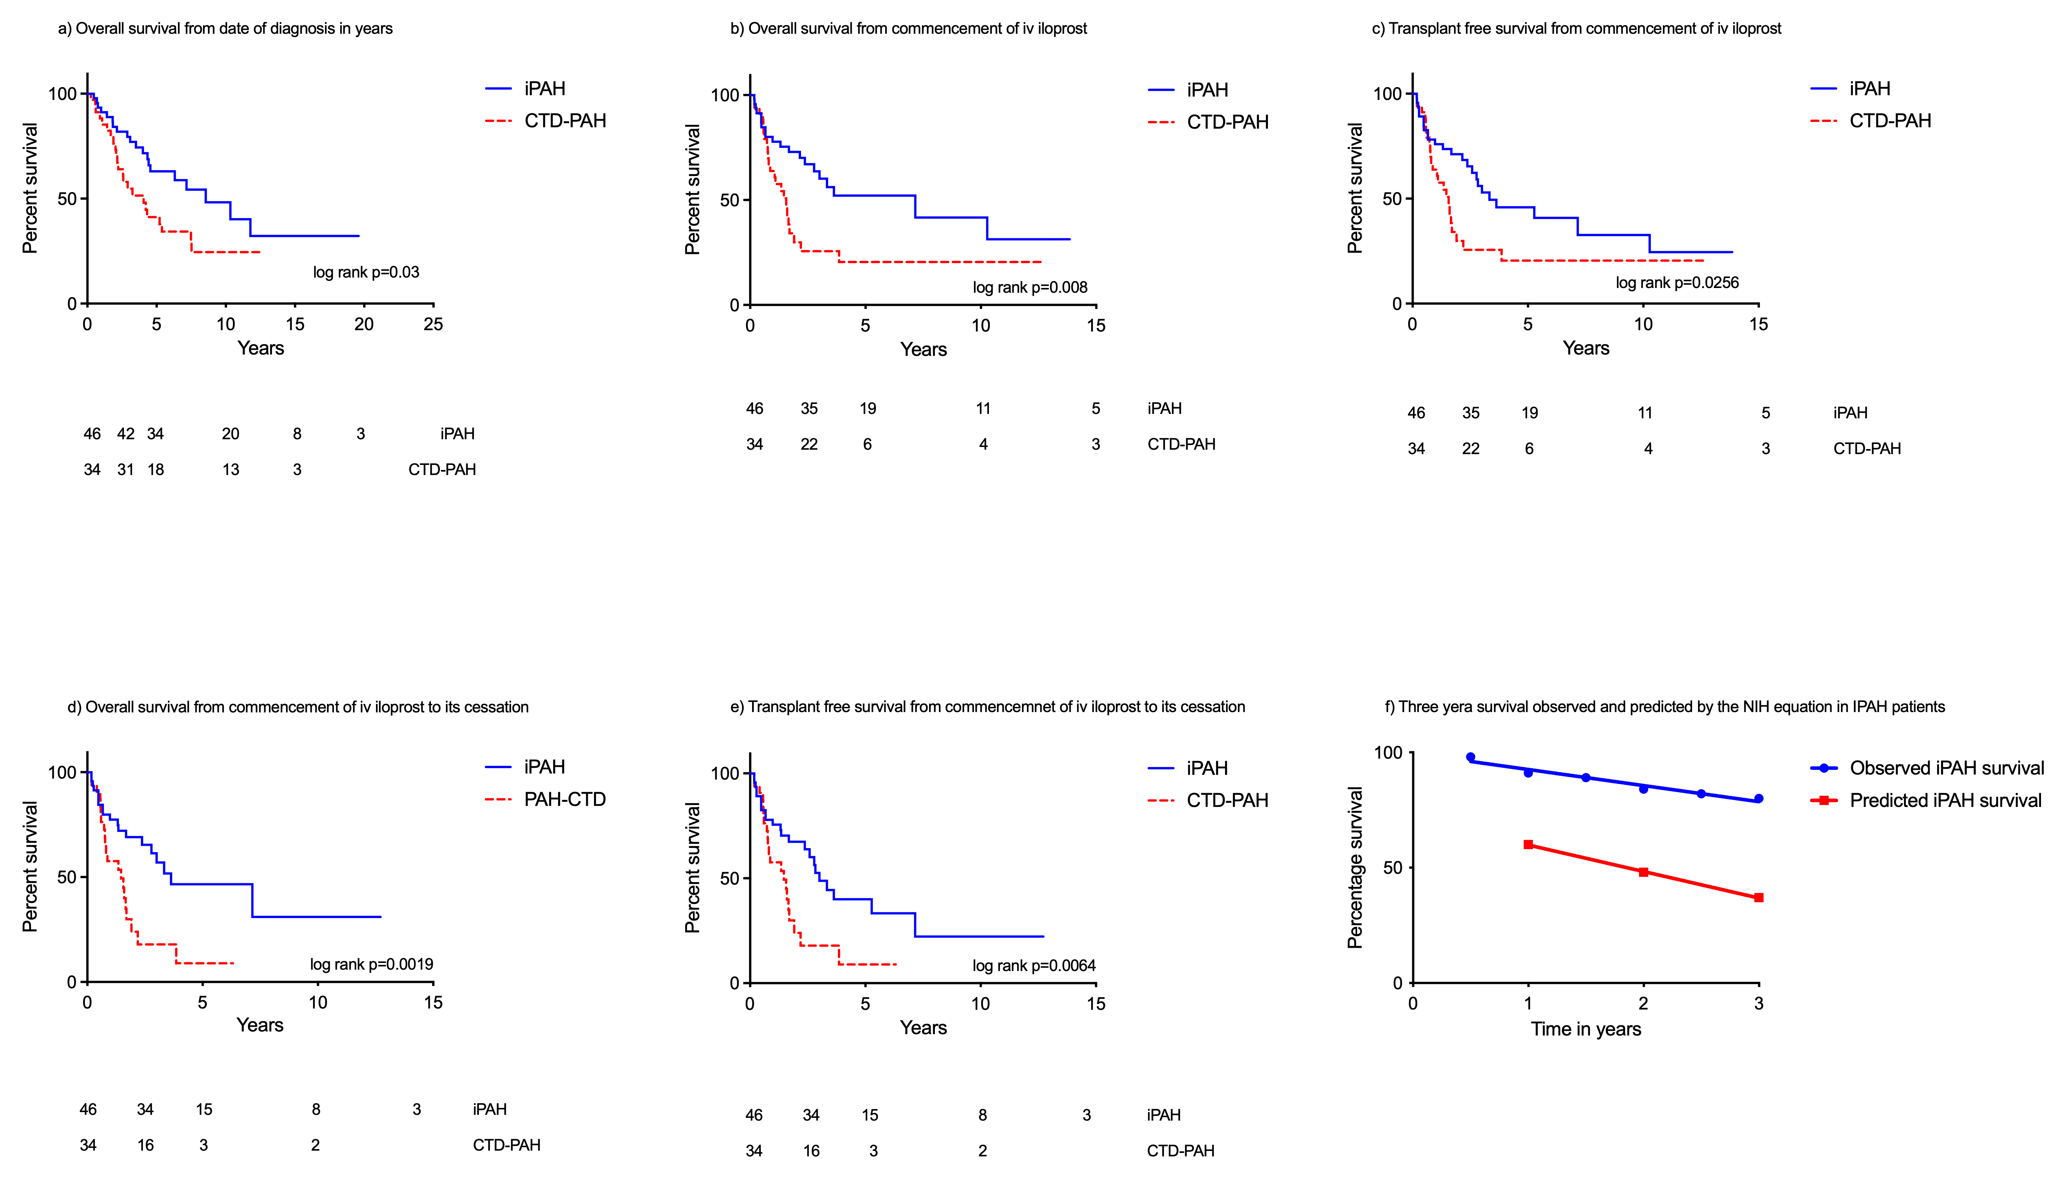
Figure 29. Survival curves of iloprost groups
a) Overall survival from date of diagnosis; b) overall survival from initiation of iv iloprost therapy; c) transplant-free survival from initiation of i.v. iloprost therapy; d) overall survival while receiving i.v. iloprost from initiation of i.v. therapy; e) transplant-free survival while receiving i.v. iloprost from initiation of i.v. therapy; f) Three-year survival observed and predicted by the NIH equation in IPAH patients

Discussion
We report superior survival in patients with iPAH treated with domiciliary iv iloprost compared to previous published series. We have also observed improved exercise capacity in patients with iPAH receiving iv iloprost. Lastly, survival in patients receiving domiciliary iv iloprost for iPAH is markedly superior to that of patients with CTD-PAH.

During the last decade 2 studies from Germany reported poor outcomes associated with long-term iv iloprost use. Hoeper et al reported outcomes in 79 PAH patients (including 62 iPAH and 10 CTD-PAH) who commenced treatment with iv iloprost following first-line nebulised iloprost between 1997-2001 in 5 German PAH centres (M M Hoeper et al., 2009). Median time from diagnosis to commencement of iv iloprost was 12 months, similar to the present study. In that study patients with iPAH had severe PAH at diagnosis with mean pulmonary artery pressure (mPAP) of 57 mmHg, cardiac index (CI) 1.7 L.min.m² and pulmonary vascular resistance (PVR) 1533 dyns.cm.s⁵, again similar to our cohort. Despite this, survival in iPAH observed by Hoeper et al was poor with 1, 3 and 5-year transplant-free survival from initiation of iv iloprost of 57%, 32% and 18%. A subsequent study by Knudsen et al reported survival in 50 IPAH patients treated with iv iloprost in addition to oral therapy in 7 German referral centres between 2002-09 (Knudsen et al., 2011). In their study baseline haemodynamics were again severe with mean mPAP of 59 mmHg, CI 2.0 L.min.m² and PVR 1251 dyns.cm.s⁵. Median time from diagnosis to commencement of iv iloprost was slightly longer at 34 months. Overall survival at 1-, 3- and 5- years from initiation of therapy was 54%, 39% and 39% while transplant-free survival was 38%, 17% and 17%. In the current study we observed superior overall 1-, 3- and 5- year survival in iPAH of 78%, 64% and 52% and transplant-free survival of 76%, 56% and 46%.

The superior outcome of patients in this study may be a reflection of overall higher doses of iloprost used in our population. In the study by Hoeper et al mean dose of iloprost used was 2.6ng/kg/min at 6 months while Knudsen et al reported a median dose achieved at 12 months of 1.8ng/kg/min. Median dose at discharge from hospital in our study was 2.6ng/kg/min, increasing at home to a maximum median dose of 4.6ng/kg/min. The lack of incremental survival benefit, at Cox regression analysis, related to the individual maximum dose received in our cohort may be explained by the confounding fact that deteriorating patients with end-stage disease will often have their iloprost dose increased. Concerns have been raised elsewhere regarding potential delaying of parenteral prostanoid therapy by nebulised therapy(Delcroix et al., 2009). It is therefore interesting to note that in the study of Hoeper et al only 5% of patients were treated with iv iloprost de novo (95% of patients commencing nebulised iloprost as first-line therapy) compared with 35% of patients receiving iv iloprost de novo in the current study(M M Hoeper et al., 2009). Overall median time from diagnosis to iv therapy was similar and so lead-time bias is unlikely to explain the superior survival we observed.

Long term outcomes in iPAH patients treated with iv epoprostenol have been studied in larger number of patients(V. V. McLaughlin et al., 2002; Sitbon et al., 2002). Sitbon et al observed 1-, 3- and 5-year overall survival from commencement of therapy in 178 patients to be 85%, 63% and 55% while Mclaughlin et al observed 1- and 3- year survival of 88% and 63% in 162 patients. Survival was comparable in our cohort of patients, suggesting that the two prostanoids are capable of exerting similar long-term clinical effect in patients with iPAH.

Survival in CTD-PAH patients was significantly poorer than in iPAH despite time from diagnosis to institution of iv therapy being similar. Differences in survival between these 2 disease-groups have previously been described elsewhere (J Hurdman et al., 2011; Kawut et al., 2003) and may reflect differences in cardiac contractility and underlying pulmonary vasculopathy between the groups (M J Overbeek et al., 2008, 2009). Intravenous therapy and transplantation therapy should be considered early in suitable patients with severe PAH at diagnosis.

Limitations
During the study period sub-cutaneous treprostinil became available in the UK and consequently the number of patients receiving iv therapy was smaller than would have been expected. We have used iv iloprost in our centre since the mid-1990s, prior to the publication of the landmark randomized controlled trial of iv epoprostenol by Barst et al. As discussed above, due to the practical benefits of iv iloprost over iv epoprostenol we have continued to use this form of iv therapy. The availability of the more stable form of epoprostenol in the form of Veletri™ antedated the period of this study (Chin et al., 2014). Exercise capacity in this study was assessed by the ISWD rather than the six-minute walk distance (6MWD). Our group has recently demonstrated the ISWD to correlate with pulmonary haemodynamics and functional class, to be sensitive to treatment effects with no ceiling effect and to predict outcomes in PAH (C. Billings et al., 2014) In the current study we were specifically interested in outcomes of patients receiving domiciliary iv iloprost as part of a long-term therapeutic strategy and so patients receiving short-term “rescue” therapy as an in-patient were excluded from analysis. A similar approach has been adopted elsewhere; for example, Mclaughlin et al excluded patients who died within 30 days of commencing iv epoprostenol from their survival analysis(V. V. McLaughlin et al., 2002).

Conclusion
Patients with IPAH treated with domiciliary iv iloprost in our centre have survival superior to that previously described elsewhere and comparable to that reported in similar patients treated with epoprostenol. Patients with CTD-PAH have poorer survival and therefore early intravenous therapy and referral for transplantation should be considered in suitable patients in the presence of severe haemodynamics.

Chapter VII:

Gas transfer measurement in SSc-PAH

Abstract
Introduction:
Diffusion capacity of the lung for carbon monoxide (DLco) reflects - alveolar membrane diffusing capacity (Dm) and pulmonary capillary blood volume (Vc). It is normally reduced in SSc-PAH, perhaps reflecting reduction in Vc, and is frequently used in screening. Pulmonary fibrosis is common in SSc and may reduce DLco by reducing Dm. Carbon monoxide transfer coefficient (Kco = DLco/VA – where VA is the alveolar volume) and FVC%/DLco% incorporate lung volume. We therefore hypothesised that Kco% predicted and FVC%/DLco% are superior to DLco% predicted in correlating with haemodynamics and survival in SSc-PAH-Lung as well as FVC%/DLco% being a superior prognostic marker in iPAH.

Methods:
The study cohort included 179 SSc-PAH, 71 SSc-PAH-lung, and 158 iPAH patients, identified from hospital databases. Correlation analysis was performed to ascertain which pulmonary function marker offered the best correlation to pulmonary haemodynamics and survival.

Results:
SSc-PAH-lung had poorer lung function but milder haemodynamics. DLco% predicted had superior correlation with mPAP in both scleroderma groups and with PVR in SSc-PAH, while Kco% predicted had a superior correlation to PVR in SSc-PAH-lung. Surprisingly in iPAH there was no correlation found between the pulmonary function tests and pulmonary haemodynamic measurements. At bivariate Cox regression analysis, DLco% predicted was superior to both Kco% predicted and FVC%/DLCO% in SSc-PAH (HR 0.95 (0.93-0.97)) and in SSc-PAH-Lung (HR 0.96 (0.93-0.98)).

Conclusion:
Correlation of DLco with mPAP and survival is superior to Kco or FVC%/DLco% in both SSc-PAH and SSc-PH-Lung. The lower DLco found in SSc-PAH may be attributable to different mechanistic pathways than found in iPAH.

Introduction
The diffusion capacity of the lung for carbon monoxide (DLco) reflects alveolar membrane diffusing capacity (Dm) and pulmonary capillary blood volume (Vc). Many large PAH studies have demonstrated a lower DLco is an independent poor survival prognosticator (Benza, Miller, et al., 2012; Coghlan et al., 2018; Ramjug, Hussain, Hurdman, Billings, et al., 2017). In SSc-PAH and IPAH one might assume that the alveolar membrane is intact and low DLcos are a consequence of decreased pulmonary capillary blood volumes (Vc), whereas in SSc-PAH-lung there is a degree of disruption to both the alveolar membrane as well the pulmonary capillary bed, consequently possibly causing an effect on both Vc and Dm, through destruction or loss of the alveolar membrane (N. S. Goh et al., 2017).

The diffusing capacity of the lung is routinely measured as a single-breath DLco. The principle of this measurement is based on two physically different gases, carbon monoxide and helium - which stays in the lung alveolar space - being inhaled. The proportion of the mixture is 0.3% carbon monoxide and 10% helium. After ten seconds of breath holding the patient exhales and the first portion of this exhalation is discarded as it represents dead space ventilation. The next 1 litre exhaled is analysed and its composition of gases compared to the initial preparation. This difference accounts for the gases transported across the lung alveolar surface i.e., the DLco. The diffusion coefficient (Kco) is derived from the DLco by its division of the volume ventilated and more specifically represents diffusion, as it reflects how efficiently the lung decreases carbon monoxide during breath holding from the accessible alveolar volume (VA) (Hughes & Pride, 2012).

Large studies in patients with scleroderma have demonstrated the utility of FVC%/DLco%. The rationale is that in those with PAH the DLco is disproportionately lower than the corresponding FVC and studies in scleroderma patients have demonstrated a higher FVC%/DLco% ratio positively identifies those at risk of PH (Coghlan et al., 2014; Steen et al., 1992). Thus, the hypothesis of this study is that Kco% and FVC%/DLco% are superior to DLco in correlating with baseline haemodynamics and survival in iPAH, SSc-PAH and SSc-PAH-lung.

Methods

Patient identification
As previously described, patients with PAH were identified from departmental databases between February 2001 and July 2014. Patients were included in the cohort if they were >18years of age, and had pre-capillary PH as defined as a mPAP ≥ 25mmHg and a PAWP ≤ 15mmHg. Three hundred and twenty-two patients were diagnosed with IPAH, and three hundred and twenty-nine with SSc-PAH. These patients were further characterised for any risks of lung or left heart disease. Date of diagnosis was defined as the date of the first diagnostic right heart catheter with a transplant free survival census date of 1st, February 2015 confirmed from the National Health Service death reporting system.

Phenotyping of PAH cohort
All patients with risk factors for left heart disease (lhd) i.e., the presence of two or more of the following risk factors: systemic hypertension, diabetes, atrial fibrillation, BMI > 35, an enlarged left atrium on echocardiography or any history of ischemic heart disease were excluded from the study.

To identify lung disease in the SSc-PAH cohort CT thorax imaging was utilised looking for any evidence of parenchymal pulmonary disease. An approach based on the method of Goh et al was used to identify lung fibrosis in the SSc-PAH population (N. S. L. Goh et al., 2012). These patients were included in this analysis and known as SSc-PAH-lung.

Lung function measurements
The majority of PAH patients at baseline attending the Sheffield PVDU perform full spirometry and transfer factor measurements. This was performed in a standardised fashion as per ATS/ERS guidance (Miller, 2005). The reference formulae used were based upon - ECSC guidance (Standardised lung function testing (H et al., 1983). Those patients with a vital capacity less than 1 litre were unable to perform to DLco, and thus were excluded from the study as well as those with lung function results performed outside the Sheffield PVDU.

Analysis
Statistical analyses were performed using IBM SPSS Statistics, version 25 (SPSS, Inc.) and GraphPad Prism version 7.00 for Windows, GraphPad Software, La Jolla California. Data were expressed as mean ± SD or median ± interquartile range. Categorical data were expressed as number and percentage. Comparison between two groups was performed using a t test or the Mann-Whitney test for continuous data and the χ2 test for categorical data. Transplant-free survival from the date of the initial RHC was calculated using the Kaplan-Meier method. Spearman’s rank correlation was performed to ascertain if there were any significant relationships between lung function results and pulmonary haemodynamic measures obtained at baseline RHC. Univariate and multivariate Cox regression analysis was performed to also identify prognostic factors. A P value of < .05 was considered statistically significant throughout.

Results

General characteristics
The iPAH population were younger with superior exercise tolerance and lung function testing including FVC%/DLco%. iPAH pulmonary haemodynamics were however worse when compared to the systemic sclerosis subgroups. The compliance was shorter in the iPAH population with a significantly increased RC time. Compared to SSc-PAH patients the SSc-PAH-lung subgroup had a larger proportion of males, with lower lung volumes and DLco but higher Kco volumes, with no significant difference between compliance and RC time, also their pulmonary haemodynamics were noticeably less severe, table 41.

 | SSc-PAH, n=179 | SSc-PAH-lung, n= 71 | p-value  SSc-PAH vs SSc-PAH-lung | iPAH  158 | p-value  all subgroups
Gender, Ref: female. N, (%) | 160, (89) | 50, (70) | <0.001 | 108, (69)
Age, years | 66±9 | 64±11 | 0.171 | 50±16^{χΨ} | <0.001
WHO I | - | - |  | 1, (1)
WHO II | 21 (12) | 7, (10) |  | 22, (14)
WHO III | 147, (82) | 46, (65) |  | 104 (66)
WHO IV | 11, (6) | 18, (25) |  | 30, (19)
ISWD, m | 174±129 | 150±126 | 0.149 | 250±190^{χΨ} | <0.001
FEV1% pred | 87±17 | 65±17 | <0.001 | 88±15^{Ψ} | <0.001
FVC% pred | 100±19 | 66±19 | <0.001 | 98±18^{Ψ} | <0.001
DLco% pred | 40±10 | 30±11 | <0.001 | 54±20^{χΨ} | <0.001
Kco% pred | 53±14 | 59±19 | 0.021 | 66±24^{χ} | <0.001
FVC/DLco% | 2.7±0.9 | 2.5±0.9 | 0.030 | 2.15±1.1^{χ} | <0.001
mRAP, mmHg | 9±5 | 6±4 | <0.001 | 10±6^{χΨ} | <0.001
mPAP, mmHg | 43±13 | 38±11 | <0.005 | 55±13^{χΨ} | <0.001
PVR, WU | 8.1±4.9 | 6.4±4.2 | 0.009 | 12.3±5.7^{χΨ} | <0.001
CI, mL.min.m⁻² | 2.8±0.8 | 3.0±0.8 | 0.058 | 2.3±0.7^{χΨ} | <0.001
SvO2 % | 65±8 | 67±8 | 0.095 | 61±9^{χΨ} | <0.001
PAWP, mmHg | 9.5±3.3 | 8.6±3.8 | 0.037 | 9.5±2.9 | 0.103
Compliance, mL.mmHg | 1.59±0.93 | 1.84±1.06 | 0.082 | 1.14±0.79^{χΨ} | <0.001
RC time, s | 0.56±0.14 | 0.52±0.15 | 0.064 | 0.66±0.15^{χΨ} | <0.001
Table 41. Clinical, pulmonary function and haemodynamic characteristics of the study cohort
Data are presented as mean ± SD or % unless otherwise stated. Abbreviations. iPAH, well characterised idiopathic pulmonary arterial hypertension; SSc-PAH, SSc-associated pulmonary arterial hypertension; SSc-PAH-lung, SSc-associated pulmonary hypertension with evidence of lung disease; WHO FC, world health organisation functional class; ISWD, incremental shuttle walk distance; mRAP, mean right atrial pressure; mPAP, mean pulmonary artery pressure; CI, cardiac index; PAWP, pulmonary arterial wedge pressure; PVR, pulmonary vascular resistance; SvO₂, pulmonary arterial saturations; C, pulmonary artery compliance; RC, resistance compliance time; %pred, percent predicted; FEV₁, forced expiratory volume in 1 second; FVC, forced vital capacity; DL_{CO}, diffusing capacity of the lung for carbon monoxide; Kco, carbon monoxide transfer coefficient; λ: p <0.05 in comparison to iPAH; ^{χ}: p <0.05 in comparison to SSc-PAH; ^{Ψ}: p <0.05 in comparison to SSc-PAH-lung;

Correlation at baseline between non-invasive and invasive measures
In the SSc-PAH subgroup there was a strong negative correlation between baseline DLco% predicted and PVR, rho = -0.53, p <0.001. The SSc-PAH-lung subgroup demonstrated also a negative correlation between DLco% predicted and PVR, mPAP (rho = -0.52, -0.61; p <0.001 respectively). Kco% predicted however had a stronger correlation with baseline PVR - rho -0.61, p< 0.001. In the iPAH subgroup unexpectedly there were no significant correlations found. Overall lung function markers did not correlate well with CI or SvO₂ measurements.

Survival

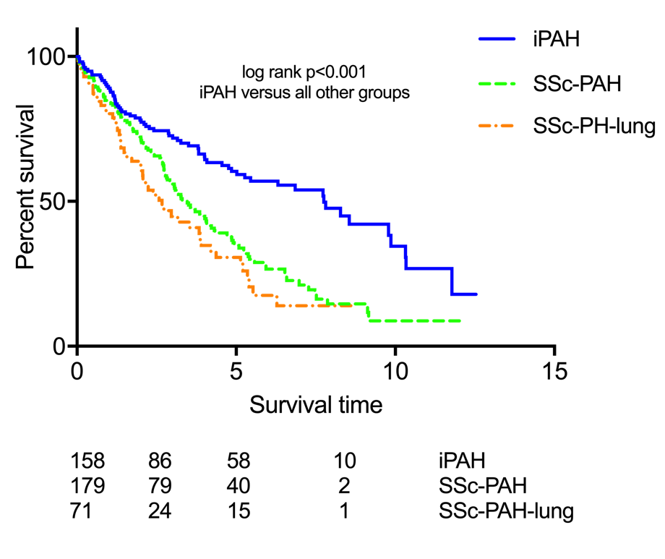
Figure 30. Survival curves of the study cohort
Abbreviations. iPAH, well characterised idiopathic pulmonary arterial hypertension; SSc-PAH, SSc-associated pulmonary arterial hypertension; SSc-PAH-lung, SSc-associated pulmonary hypertension with evidence of lung disease

PAH associated with systemic sclerosis patients had significantly inferior prognosis when compared to iPAH patients, figure 30.

Prognostic factors

SSc-PAH | Univariate HR | p-value | Multivariate HR | p-value
DLco% | 0.95 (0.93-0.97) | <0.001 | 0.95 (0.93-0.97) | <0.001
Kco% | 0.97 (0.96-0.98) | <0.001
FVC/DLco% | 1.64 (1.33-2.02) | <0.001

SSc-PAH-lung | Univariate HR | p-value | Multivariate HR | p-value
DLco% | 0.95 (0.93-0.98) | 0.002 | 0.96 (0.93-0.98) | 0.002
Kco% | 0.98 (0.96-0.99) | 0.004
FVC/DLco% | 1.48 (1.12-2.00) | 0.006

iPAH | Univariate HR | p-value | Multivariate HR | p-value
DLco% | 0.96 (0.95-0.98) | <0.001
Kco% | 0.97 (0.96-0.98) | <0.001 | 0.98 (0.96-0.98) | <0.001
FVC/DLco% | 1.61 (1.35-1.93) | <0.001
Table 42. Cox regression analysis of the measured lung function parameters
Data are presented as hazard ratio (HR) (95% confidence intervals). Abbreviations: iPAH, well characterised idiopathic pulmonary arterial hypertension; SSc-PAH, SSc-associated pulmonary arterial hypertension; SSc-PAH-lung, SSc-associated pulmonary hypertension with evidence of lung disease; %pred, percent predicted; FEV₁, FVC, forced vital capacity; DL_{CO}, diffusing capacity of the lung for carbon monoxide; Kco, carbon monoxide transfer coefficient

Cox regression analysis revealed that DLco% predicted was an independent predictor of mortality in the systemic sclerosis groups. In iPAH, Kco% predicted appeared to have a more significant predictive value. This is visually apparent when performing ROCs of the three groups and lung function parameters, table 43.

 | DLco% | Kco% | FVC/DLco%
iPAH | 0.708  p <0.001 | 0.709  p <0.001 | 0.691  p <0.001
SSc-PAH | 0.592 p=0.044 | 0.584 p=0.065 | 0.575 p=0.103
SSc-PAH-lung | 0.675 p=0.023 | 0.632 p=0.084 | 0.611 p=0.136
Table 43. C-statistic at census for DLco%, Kco% and FVC/DLco%
Data are presented as c-statistic and p-value. Abbreviations: iPAH, well characterised idiopathic pulmonary arterial hypertension; SSc-PAH, SSc-associated pulmonary arterial hypertension; SSc-PAH-lung, SSc-associated pulmonary hypertension with evidence of lung disease; %pred, percent predicted; FEV₁, FVC, forced vital capacity; DL_{CO}, diffusing capacity of the lung for carbon monoxide; Kco, carbon monoxide transfer coefficient

Discussion
As a non-invasive marker of SSc-PAH, DLco% has demonstrated superiority over FVC%/DLco%, and has correlated well with PVR and mPAP in both SSc-PAH and SSc-PAH-lung. That said, in the SSc-PAH-lung Kco% had an even better affinity with PVR at baseline. Surprisingly, unlike Donato et al we could not demonstrate any correlation between FVC%/DLco% and mPAP, PVR in any of the groups tested (Donato et al., 2017). Cox regression analysis also reinforced the independent predictive value of DLco% in those with PAH, associated with no lung disease.

DLco is a reflection of two factors, the alveolar membrane diffusing capacity and pulmonary capillary blood volume. In PAH this reduction of DLco is historically attributed to progressive remodelling and destruction of the pulmonary arterial vasculature. Studies using simultaneously inhaled nitric oxide and carbon monoxide to measure DLco and the diffusion of nitric oxide (DLno) have demonstrated this deterioration of DLco is actually a combination of loss of pulmonary vasculature but also a reduced pulmonary capillary blood volume(Sivova et al., 2013). The rationale of utilising nitric oxide is that it has a greater affinity for haemoglobin and can be used as a direct measure of Dm (Farha et al., 2013).

In our SSc-PAH and SSc-PAH-lung population they had significantly lower DLco% and Kco% predicted when compared to the iPAH cohort, with the iPAH subgroup demonstrating inferior pulmonary haemodynamics. This perhaps suggests that the reduced DLco in the SSc-PAH and SSc-PAH-lung cohort may be predominantly due to loss of pulmonary vasculature and in the iPAH population due to reduced pulmonary capillary blood flow.

This hypothesis is corroborated when examining the differences in compliance/pulmonary capacitance and RC-time between iPAH and SSc-PAH groups. Compliance or pulmonary capacitance is a calculated measure of the distensibility of vasculature. Hence it reflects the ability to accommodate more blood during systole and recoil in diastole. This value is higher in those with SSc-PAH and SSc-PAH-lung compared to iPAH patients suggesting the pulmonary arteriolar system is able to function allowing improved exchange of blood. The RC time is also shorter in the SSc-PAH groups suggesting that the cardiac function is better as demonstrated in our cohort by the superior pulmonary haemodynamics.

A small study by Kanski et al showed that pulmonary blood flow indexed to lung volume was lower in patients with scleroderma compared to a healthy population and that there was no change in pulmonary vascular distensibility. The PBV was measured as the cardiac output x the pulmonary transit time (i.e., contrast enhanced blood from pulmonary artery to left atrium). Interesting in this small cohort where out of 27 scleroderma patients, only 1 had evidence of PAH, there was no correlation with reduced PBVI and DLco or Vc. Lung fibrosis was evident in 63% of the patients but this did not appear to affect the PBVI measurement. The authors hypothesised that this finding suggests early changes of the pulmonary vasculature before changes are noted in DLco or echocardiography (Kanski et al., 2013). This potentially also corroborates our findings of a lower Kco in this group as it takes longer for the carbon monoxide coefficient to lessen due to less blood flow indexed to lung volumes. One could also postulate that the higher CI in the SSc-PAH and SSc-PAH-lung might suggest that the diffusion is not as efficient due to defects in the alveolar lung membrane.

In patients with scleroderma and PH, it is important to consider that the PH could be caused by precapillary disease, especially if there is evidence of significant lung disease, postcapillary - relating to covert cardiac disease and even PH related to PVOD. All these factors can cause a low DLco. Another area of interest is the concept of ‘vanishing pulmonary capillary syndrome’ (Marius M Hoeper & Vonk-Noordegraaf, 2017). Studies have shown that a subset of patients with PAH have significant disturbance to their DLco which almost appears out of proportion to the rest of their haemodynamics with no overt signs of lung disease on CT thorax. Those with a low DLco were predominantly male with a smoking history (Marius M Hoeper & Vonk-Noordegraaf, 2017; Olsson et al., 2017; Trip et al., 2013), suggesting a different phenotype should be coined for these types of patients.

Limitation
Patients with lower lung volumes and potentially more severe disease were excluded from this study as they would have no measurable DLco or Kco. Also, these findings are based on a very small population of patients. Smoking history also was not entirely complete in this subset of the study also and this history could have a significant bearing on the results.

Conclusion
The correlation of DLco with mPAP and survival is superior to Kco% or FVC%/DLCO% in both SSc-PAH and SSc-PAH-lung groups. DLco% also correlated well with PVR in the systemic sclerosis groups. Interestingly DLco% and Kco% did not correlate well with mPAP or PVR in the iPAH cohort suggesting a different mechanism is causing the reduction in DLco and Kco. This study has also highlighted the significantly lower DLco found in SSc-PAH and suggested that this may be due to the so-called vanishing pulmonary capillary syndrome. Further prospective studies are required with potentially histopathological analysis to further understand these patients’ course and consequently their response to PH-targeted therapy.

Closing remarks

When conducting research in a single centre, an initial concern was the external validity of the data or the patients in our cohort. The generalisability is incredibly important ss some PVDUs in the country do attract patients with specific types of PH, e.g., Brompton – CHD-PAH, Papworth PVDU – CTEPH. Fortuitously, our cohort and thus data is comparable to large PH registries from the US, and Europe.

With this series of seven studies, they have highlighted the importance of considering our PAH patients in a more comprehensive fashion in order to offer them personalised, PAH targeted therapy, with the aim to improve survival outcomes in our population of PAH patients.

In the first two chapters we have highlighted the ill-effects of gender and co-morbidities related to left heart and lung disease upon survival. The comparative study of IPAH and SSc-PAH again demonstrated the effects of co-morbidities but unfortunately did not find the single reason why SSc-PAH patients fair significantly worse, when compared to those with IPAH. Conceivably it is due to a relationship between age, comorbidities, the maladaptation of the right ventricle as well as dysfunction of the pulmonary vasculature itself. In our CHD-PAH cohort from point of referral a single most important predictor of inferior outcome was the type of congenital defect.

By utilising these poor prognostic indicators, we are able to better assess a PAH patients’ risk of morbidity and mortality i.e., by the use of multi-faceted risk scores, which takes into account functional status, haemodynamic data as well as concomitant comorbidities. The fifth chapter demonstrated from the three scores tested, based on the original ERS/ESC PH risk score, the risk assessment tool with the best correlation with our incident population of IPAH and SSc-PAH was a tool which had both weighted modifiable and non-modifiable variables i.e., REVEAL2.0 risk assessment tool.

With the advent of the risk assessment scores it encourages a clinician to perhaps be more aggressive with PAH targeted therapies, in order to reduce a patient’s risk of morbidity and mortality. With this in mind, our sixth chapter regarding the use of intravenous iloprost in those with severe PAH in relation to either idiopathic or systemic sclerosis disease, established that higher doses of intravenous iloprost was tolerated by our cohort with improved survival when compared with other European case series.

Finally, our last chapter, attempted to investigate the correlation of baseline gas transfer values to initial haemodynamic data, and whether there was a superior prognosticator to DLco % predicted. In our first chapter we demonstrated the deleterious effects of a DLco % predicted of <45%, as well as introducing the concept of the vanishing pulmonary capillary syndrome. In patients with SSc a screening tool used to detect PAH is that of FVC%/DLco%, if this value ≥1.82 there is a higher probability of PAH. It was therefore curious to learn in our cohort of IPAH and SSc-PAH patients FVC%/DLco% did not correlate as well with haemodynamics or survival. A noteworthy finding in the IPAH cohort was that DLco % predicted did not correlate well with PVR or mPAP as in SSc-PAH suggesting perhaps a differing mechanism resulting in the low DLco% predicted.

Pulmonary arterial hypertension is a devastating disease with a poor prognosis, as with any disease process prevention is better than any cure, but unfortunately at this moment in time the PH community are unable to offer this. By improving awareness of PAH in the general medical community this will avoid the years in delay to diagnosis, so that PAH targeted therapies if appropriate can be instituted earlier, to improve a patient’s overall risk of morbidity and mortality. This risk, as highlighted by this research, should be based on multiple factors and comorbidities should also be included in this tool, with the expectation to direct the clinician to consider more upfront therapies, even in those with comorbidities. By also changing the current definition of PAH to >20mmHg mPAP, this will also aid with more timely management. PAH associated with CHD and SSc may have differing pathologies as highlighted by survival rates, baseline haemodynamics and lung function hence an improved understanding of the pulmonary vasculature and right ventricle are of paramount importance to help direct our future management strategies in PAH.

Abbreviations
ACA: Anticentromere antibodies
aCL: Anticardiolipin
ACHD: Adult congenital heart disease
Anti-scleroma-70: Anti-Scl70
AP: Aortopulmonary window
ASD: Atrial septal defect
ASD I: Primum atrial septal defect
ASD II: Secundum atrial septal defect
ASPIRE: Assessing the Spectrum of pulmonary hypertension identified at a Pulmonary Hypertension REferral centre
AV: Atrioventricular
AVSD: Atrioventricular septal defect
Beta2-GPI: Beta2-glycoprotein I
BMPR2: Bone morphogenetic protein type 2 receptors
BNP: Brain natriuretic peptide
C: Compliance
CC: Congenitally corrected
CD: Closed defect
CHD: Congenital heart disease
CHD-PAH: Pulmonary arterial hypertension associated with congenital heart disease
CI: Cardiac index
CO: Cardiac output
COMPERA: Comparative, Prospective Registry of Newly Initiated Therapies for Pulmonary Hypertension
COPD: Chronic obstructive pulmonary disease
CPET: Cardiopulmonary exercise test
CT: Computerised tomography
CTD: Connective tissue disease
CTD-PAH: Pulmonary arterial hypertension associated with connective tissue disease
CTEPH: Chronic thromboembolic pulmonary hypertension
DLco: Diffusing capacity of the lung for carbon monoxide
DLno: Diffusing capacity of the lung for nitric oxide
Dm: Alveolar membrane diffusing capacity
ECG: Electrocardiogram
ERA: Endothelin receptor antagonist
Es: Eisenmenger’s syndrome - Severe pulmonary hypertension with an intra-cardiac defect
FEV₁: Forced expiratory volume in 1 second
FPHR: French PH registry
FVC: Forced vital capacity
iPAH: Well characterised IPAH sub-group
IPAH: Idiopathic pulmonary arterial hypertension
IPAH-lhd: IPAH, with at least two risk factors for left heart disease
IPAH-lung: IPAH with risk factors for lung disease
ISHLT: International Society for Heart and Lung Transplantation
ISWD: Incremental shuttle walk distance
IV: Intravenous
Kco: Carbon monoxide transfer coefficient
L-R: Left to right
mPAP: Mean pulmonary artery pressure
MRI: Magnetic resonance imaging
NT-proBNP: N-terminal pro–brain natriuretic peptide

NUC: Nucleolar antibodies
PA: Pulmonary artery
PAH: Pulmonary arterial hypertension
PAPVC: Partial anomalous pulmonary venous connection
PACP: Pulmonary arterial capillary pressure
PAWP: Pulmonary arterial wedge pressure
PDA: Patent ductus arteriosus
PDE5i: Phosphodiesterase-5 inhibitor
PFO: Patent foramen ovale
PFT: Pulmonary function testing
Peak VO2: Peak oxygen consumption
PH: Pulmonary hypertension
PoPH: Portopulmonary pulmonary hypertension
PVDU: Pulmonary vascular disease unit
PVR: Pulmonary vascular resistance
Qp: Pulmonary blood flow
Qs: Systemic blood flow
RA: Right atrium
RAP: Right atrial pressure
REVEAL: Registry to Evaluate Early and Long-term PAH Disease
RHC: Right heart catheterisation
R-L: Right to left
RNP: Ribonucleoprotein antibodies
RV: Right ventricular
RVEF: Right ventricular ejection fraction
SD: Small defect
6MWD: Six minute walk distance
SPAHR: Swedish PAH registry
SSc: Systemic sclerosis
SSc-PAH: Systemic sclerosis with associated PAH
SSc -PAH-lhd:
SSc-PAH-lung:
SVR: Systemic vascular resistance
sPAP: Systolic pulmonary artery pressure
TAPVC: Total anomalous pulmonary venous connection
TGA: Transposition of the great arteries
ToF: Tetralogy of fallot
TR: Tricuspid regurgitation
TRV: Tricuspid regurgitation velocity
Va: Alveolar volume
Vc: Pulmonary capillary blood volume
VE/VCO₂: minute ventilation/carbon dioxide production
VSD: Ventricular septal defect
WHO FC: World Health Organisation functional class – I: no limitation; II: slight limitation; III: marked limitation; IV: severe limitation

Bibliography

Adatia, I., Kothari, S. S., & Feinstein, J. A. (2010). Pulmonary Hypertension Associated With Congenital Heart Disease Pulmonary Vascular Disease: The Global Perspective. Chest, 137(6), 52S-61S. https://doi.org/10.1378/chest.09-2861
(AEPC), E. by the A. for E. P. C., Members, A. F., Baumgartner, H., Bonhoeffer, P., Groot, N. M. S. D., Haan, F. de, Deanfield, J. E., Galie, N., Gatzoulis, M. A., Gohlke-Baerwolf, C., Kaemmerer, H., Kilner, P., Meijboom, F., Mulder, B. J. M., Oechslin, E., Oliver, J. M., Serraf, A., Szatmari, A., Thaulow, E., … Westby, J. (2010). ESC Guidelines for the management of grown-up congenital heart disease (new version 2010)The Task Force on the Management of Grown-up Congenital Heart Disease of the European Society of Cardiology (ESC). European Heart Journal, 31(23), 2915–2957. https://doi.org/10.1093/eurheartj/ehq249
Allanore, Y., Borderie, D., Avouac, J., Zerkak, D., Meune, C., Hachulla, E., Mouthon, L., Guillevin, L., Meyer, O., Ekindjian, O. G., Weber, S., & Kahan, A. (2008). High N‐terminal pro–brain natriuretic peptide levels and low diffusing capacity for carbon monoxide as independent predictors of the occurrence of precapillary pulmonary arterial hypertension in patients with systemic sclerosis. Arthritis & Rheumatism, 58(1), 284–291. https://doi.org/10.1002/art.23187
Alonso-Gonzalez, R., Borgia, F., Diller, G.-P., Inuzuka, R., Kempny, A., Martinez-Naharro, A., Tutarel, O., Marino, P., Wustmann, K., Charalambides, M., Silva, M., Swan, L., Dimopoulos, K., & Gatzoulis, M. A. (2013). Abnormal Lung Function in Adults With Congenital Heart Disease. Circulation, 127(8), 882–890. https://doi.org/10.1161/circulationaha.112.126755
Alonso-Gonzalez, R., Lopez-Guarch, C. J., Subirana-Domenech, M. T., Ruíz, J. M. O., González, I. O., Cubero, J. S., Cerro, M. J. del, Salvador, M. L., Subira, L. D., Gallego, P., Escribano-Subias, P., & investigators, on behalf of R. (2015). Pulmonary hypertension and congenital heart disease: An insight from the REHAP National Registry. International Journal of Cardiology, 184, 717–723. https://doi.org/10.1016/j.ijcard.2015.02.031
Anderson, J. J., Lau, E. M., Lavender, M., Benza, R., Celermajer, D. S., Collins, N., Corrigan, C., Dwyer, N., Feenstra, J., Horrigan, M., Keating, D., Kermeen, F., Kotlyar, E., McWilliams, T., Rhodes, B., Steele, P., Thakkar, V., Williams, T., Whitford, H., … Strange, G. (2019). Retrospective validation of the REVEAL 2.0 Risk Score with the Australian and New Zealand Pulmonary Hypertension Registry Cohort. Chest, 157(1), 162–172. https://doi.org/10.1016/j.chest.2019.08.2203
Arnardóttir, R. H., Emtner, M., Hedenström, H., Larsson, K., & Boman, G. (2006). Peak exercise capacity estimated from incremental shuttle walking test in patients with COPD: a methodological study. Respiratory Research, 7(1), 127. https://doi.org/10.1186/1465-9921-7-127
Assad, T. R., Maron, B. A., Robbins, I. M., Xu, M., Huang, S., Harrell, F. E., Farber-Eger, E. H., Wells, Q. S., Choudhary, G., Hemnes, A. R., & Brittain, E. L. (2017). Prognostic Effect and Longitudinal Hemodynamic Assessment of Borderline Pulmonary Hypertension. JAMA Cardiology, 2(12), 1361. https://doi.org/10.1001/jamacardio.2017.3882
Austin, E. D., Hamid, R., Hemnes, A. R., Loyd, J. E., Blackwell, T., Yu, C., Iii, J. A. P., Gaddipati, R., Gladson, S., Gu, E., West, J., & Lane, K. B. (2012). BMPR2 expression is suppressed by signaling through the estrogen receptor. Biology of Sex Differences, 3(1), 6. https://doi.org/10.1186/2042-6410-3-6
Badagliacca, R., Rischard, F., Papa, S., Kubba, S., Vanderpool, R., Yuan, J. X.-J., Garcia, J. G. N., Airhart, S., Poscia, R., Pezzuto, B., Manzi, G., Miotti, C., Luongo, F., Scoccia, G., Sciomer, S., Torre, R., Fedele, F., & Vizza, C. D. (2020). CLINICAL IMPLICATIONS OF IDIOPATHIC PULMONARY ARTERIAL HYPERTENSION PHENOTYPES DEFINED BY CLUSTER ANALYSIS. The Journal of Heart and Lung Transplantation, 39(4), 310–320. https://doi.org/10.1016/j.healun.2019.12.012
Badesch, D. B., Feldman, J., Keogh, A., Mathier, M. A., Oudiz, R. J., Shapiro, S., Farber, H. W., McGoon, M., Frost, A., Allard, M., Despain, D., Dufton, C., & Rubin, L. J. (2012). ARIES‐3: Ambrisentan Therapy in a Diverse Population of Patients with Pulmonary Hypertension. Cardiovascular Therapeutics, 30(2), 93–99. https://doi.org/10.1111/j.1755-5922.2011.00279.x
Badesch, D. B., Raskob, G. E., Elliott, C. G., Krichman, A. M., Farber, H. W., Frost, A. E., Barst, R. J., Benza, R. L., Liou, T. G., Turner, M., Giles, S., Feldkircher, K., Miller, D. P., & McGoon, M. D. (2010). Pulmonary Arterial Hypertension Baseline Characteristics From the REVEAL Registry. Chest, 137(2), 376–387. https://doi.org/10.1378/chest.09-1140
Barst, R J, Rubin, L. J., Long, W. A., McGoon, M. D., Rich, S., Badesch, D. B., Groves, B. M., Tapson, V. F., Bourge, R. C., Brundage, B. H., Koerner, S. K., Langleben, D., Keller, C. A., Murali, S., Uretsky, B. F., Clayton, L. M., Jöbsis, M. M., Blackburn, S. D., Shortino, D., … Group, P. P. H. S. (1996). A Comparison of Continuous Intravenous Epoprostenol (Prostacyclin) with Conventional Therapy for Primary Pulmonary Hypertension. New England Journal of Medicine, 334(5), 296–301. https://doi.org/10.1056/nejm199602013340504
Barst, Robyn J., Ivy, D. D., Foreman, A. J., McGoon, M. D., & Rosenzweig, E. B. (2014). Four- and Seven-Year Outcomes of Patients With Congenital Heart Disease–Associated Pulmonary Arterial Hypertension (from the REVEAL Registry). The American Journal of Cardiology, 113(1), 147–155. https://doi.org/10.1016/j.amjcard.2013.09.032
Barst, Robyn J., McGoon, M. D., Elliott, C. G., Foreman, A. J., Miller, D. P., & Ivy, D. D. (2012). Survival in Childhood Pulmonary Arterial Hypertension. Circulation, 125(1), 113–122. https://doi.org/10.1161/circulationaha.111.026591
Barst, Robyn J, McGoon, M., McLaughlin, V., Tapson, V., Oudiz, R., Shapiro, S., Robbins, I. M., Channick, R., Badesch, D., Rayburn, B. K., Flinchbaugh, R., Sigman, J., Arneson, C., Jeffs, R., & Group, B. S. (2003). Beraprost therapy for pulmonary arterial hypertension. Journal of the American College of Cardiology, 41(12), 2119–2125. https://doi.org/10.1016/s0735-1097(03)00463-7
Barst, Robyn J., Oudiz, R. J., Beardsworth, A., Brundage, B. H., Simonneau, G., Ghofrani, H. A., Sundin, D. P., Galiè, N., & Group, P. A. H. and R. to T. (PHIRST) S. (2011). Tadalafil monotherapy and as add-on to background bosentan in patients with pulmonary arterial hypertension. The Journal of Heart and Lung Transplantation, 30(6), 632–643. https://doi.org/10.1016/j.healun.2010.11.009
Bartolome, S. D., Sood, N., Shah, T. S., Styrvoky, K., Torres, F. T., & Chin, K. M. (2018). Mortality in Pulmonary Arterial Hypertension Patients Treated with Continuous Prostanoids. Chest, 154(3), 532–540. https://doi.org/10.1016/j.chest.2018.03.050
Beghetti, M., & Galiè, N. (2009). Eisenmenger Syndrome A Clinical Perspective in a New Therapeutic Era of Pulmonary Arterial Hypertension. Journal of the American College of Cardiology, 53(9), 733–740. https://doi.org/10.1016/j.jacc.2008.11.025
Benza, R. L., Gomberg-Maitland, M., Elliott, C. G., Farber, H. W., Foreman, A. J., Frost, A. E., McGoon, M. D., Pasta, D. J., Selej, M., Burger, C. D., & Frantz, R. P. (2019). Predicting Survival in Patients with Pulmonary Arterial Hypertension: The REVEAL Risk Score Calculator 2.0 and Comparison with ESC/ERS-Based Risk Assessment Strategies. Chest. https://doi.org/10.1016/j.chest.2019.02.004
Benza, R. L., Gomberg-Maitland, M., Miller, D. P., Frost, A., Frantz, R. P., Foreman, A. J., Badesch, D. B., & McGoon, M. D. (2012). The REVEAL Registry Risk Score Calculator in Patients Newly Diagnosed With Pulmonary Arterial Hypertension. Chest, 141(2), 354–362. https://doi.org/10.1378/chest.11-0676
Benza, R. L., Miller, D. P., Barst, R. J., Badesch, D. B., Frost, A. E., & McGoon, M. D. (2012). An Evaluation of Long-term Survival From Time of Diagnosis in Pulmonary Arterial Hypertension From the REVEAL Registry. Chest, 142(2), 448–456. https://doi.org/10.1378/chest.11-1460
Benza, R. L., Miller, D. P., Gomberg-Maitland, M., Frantz, R. P., Foreman, A. J., Coffey, C. S., Frost, A., Barst, R. J., Badesch, D. B., Elliott, C. G., Liou, T. G., & McGoon, M. D. (2010). Predicting Survival in Pulmonary Arterial Hypertension. Circulation, 122(2), 164–172. https://doi.org/10.1161/circulationaha.109.898122
Billings, C. G., Hurdman, J. A., Condliffe, R., Elliot, C. A., Smith, I. A., Austin, M., Armstrong, I. J., Hamilton, N., Charalampopoulos, A., Sabroe, I., Swift, A. J., Rothman, A. M., Wild, J. M., Lawrie, A., Waterhouse, J. C., & Kiely, D. G. (2017). Incremental shuttle walk test distance and autonomic dysfunction predict survival in pulmonary arterial hypertension. The Journal of Heart and Lung Transplantation, 36(8), 871–879. https://doi.org/10.1016/j.healun.2017.04.008
Billings, C., Hurdman, J., Condliffe, R., Armstrong, I., Smith, I., Elliot, C., & Kiely, D. (2014). S121 The Utility Of The Incremental Shuttle Walking Test In Pulmonary Hypertension: Results From The Aspire Registry. Thorax, 69(Suppl 2), A65–A65. https://doi.org/10.1136/thoraxjnl-2014-206260.127
Boucly, A., Weatherald, J., Savale, L., Jaïs, X., Cottin, V., Prevot, G., Picard, F., Groote, P. de, Jevnikar, M., Bergot, E., Chaouat, A., Chabanne, C., Bourdin, A., Parent, F., Montani, D., Simonneau, G., Humbert, M., & Sitbon, O. (2017). Risk assessment, prognosis and guideline implementation in pulmonary arterial hypertension. European Respiratory Journal, 50(2), 1700889. https://doi.org/10.1183/13993003.00889-2017
Broberg, C. S., Woerkom, R. C. V., Swallow, E., Dimopoulos, K., Diller, G.-P., Allada, G., & Gatzoulis, M. A. (2014). Lung function and gas exchange in Eisenmenger syndrome and their impact on exercise capacity and survival. International Journal of Cardiology, 171(1), 73–77. https://doi.org/10.1016/j.ijcard.2013.11.047
Campo, A., Mathai, S. C., Pavec, J. L., Zaiman, A. L., Hummers, L. K., Boyce, D., Housten, T., Champion, H. C., Lechtzin, N., Wigley, F. M., Girgis, R. E., & Hassoun, P. M. (2010). Hemodynamic Predictors of Survival in Scleroderma-related Pulmonary Arterial Hypertension. American Journal of Respiratory and Critical Care Medicine, 182(2), 252–260. https://doi.org/10.1164/rccm.200912-1820oc
Champion, H. C., Michelakis, E. D., & Hassoun, P. M. (2009). Comprehensive Invasive and Noninvasive Approach to the Right Ventricle–Pulmonary Circulation Unit. Circulation, 120(11), 992–1007. https://doi.org/10.1161/circulationaha.106.674028
Channick, R. N., Delcroix, M., Ghofrani, H.-A., Hunsche, E., Jansa, P., Brun, F.-O. L., Mehta, S., Pulido, T., Rubin, L. J., Sastry, B. K. S., Simonneau, G., Sitbon, O., Souza, R., Torbicki, A., & Galiè, N. (2015). Effect of Macitentan on Hospitalizations Results From the SERAPHIN Trial. JACC: Heart Failure, 3(1), 1–8. https://doi.org/10.1016/j.jchf.2014.07.013
Chemla, D., Castelain, V., Humbert, M., Hébert, J.-L., Simonneau, G., Lecarpentier, Y., & Hervé, P. (2004). New Formula for Predicting Mean Pulmonary Artery Pressure Using Systolic Pulmonary Artery Pressure. Chest, 126(4), 1313–1317. https://doi.org/10.1378/chest.126.4.1313
Chemla, D., Castelain, V., Zhu, K., Papelier, Y., Creuzé, N., Hoette, S., Parent, F., Simonneau, G., Humbert, M., & Herve, P. (2013). Estimating Right Ventricular Stroke Work and the Pulsatile Work Fraction in Pulmonary Hypertension. Chest, 143(5), 1343–1350. https://doi.org/10.1378/chest.12-1880
Chemla, D., Lau, E. M. T., Papelier, Y., Attal, P., & Hervé, P. (2015). Pulmonary vascular resistance and compliance relationship in pulmonary hypertension. European Respiratory Journal, 46(4), 1178–1189. https://doi.org/10.1183/13993003.00741-2015
Chin, K. M., Badesch, D. B., Robbins, I. M., Tapson, V. F., Palevsky, H. I., Kim, N. H., Kawut, S. M., Frost, A., Benton, W. W., Lemarie, J.-C., Bodin, F., Rubin, L. J., & McLaughlin, V. (2014). Two formulations of epoprostenol sodium in the treatment of pulmonary arterial hypertension: EPITOME-1 (epoprostenol for injection in pulmonary arterial hypertension), a phase IV, open-label, randomized study. American Heart Journal, 167(2), 218-225.e1. https://doi.org/10.1016/j.ahj.2013.08.008
Chung, L., Domsic, R. T., Lingala, B., Alkassab, F., Bolster, M., Csuka, M. E., Derk, C., Fischer, A., Frech, T., Furst, D. E., Gomberg‐Maitland, M., Hinchcliff, M., Hsu, V., Hummers, L. K., Khanna, D., Medsger, T. A., Molitor, J. A., Preston, I. R., Schiopu, E., … Steen, V. D. (2014). Survival and Predictors of Mortality in Systemic Sclerosis‐Associated Pulmonary Arterial Hypertension: Outcomes From the Pulmonary Hypertension Assessment and Recognition of Outcomes in Scleroderma Registry. Arthritis Care & Research, 66(3), 489–495. https://doi.org/10.1002/acr.22121
Chung, L., Farber, H. W., Benza, R., Miller, D. P., Parsons, L., Hassoun, P. M., McGoon, M., Nicolls, M. R., & Zamanian, R. T. (2014). Unique Predictors of Mortality in Patients With Pulmonary Arterial Hypertension Associated With Systemic Sclerosis in the REVEAL Registry. Chest, 146(6), 1494–1504. https://doi.org/10.1378/chest.13-3014
Chung, L., Liu, J., Parsons, L., Hassoun, P. M., McGoon, M., Badesch, D. B., Miller, D. P., Nicolls, M. R., & Zamanian, R. T. (2010). Characterization of Connective Tissue Disease-Associated Pulmonary Arterial Hypertension From REVEAL Identifying Systemic Sclerosis as a Unique Phenotype. Chest, 138(6), 1383–1394. https://doi.org/10.1378/chest.10-0260
Clements, P. J., Tan, M., McLaughlin, V. V., Oudiz, R. J., Tapson, V. F., Channick, R. N., Rubin, L. J., & Langer, A. (2012). The pulmonary arterial hypertension quality enhancement research initiative: comparison of patients with idiopathic PAH to patients with systemic sclerosis-associated PAH. Annals of the Rheumatic Diseases, 71(2), 249. https://doi.org/10.1136/annrheumdis-2011-200265
Coghlan, J. G., Denton, C. P., Grünig, E., Bonderman, D., Distler, O., Khanna, D., Müller-Ladner, U., Pope, J. E., Vonk, M. C., Doelberg, M., Chadha-Boreham, H., Heinzl, H., Rosenberg, D. M., McLaughlin, V. V., & Seibold, J. R. (2014). Evidence-based detection of pulmonary arterial hypertension in systemic sclerosis: the DETECT study. Annals of the Rheumatic Diseases, 73(7), 1340. https://doi.org/10.1136/annrheumdis-2013-203301
Coghlan, J. G., Wolf, M., Distler, O., Denton, C. P., Doelberg, M., Harutyunova, S., Marra, A. M., Benjamin, N., Fischer, C., & Grünig, E. (2018). Incidence of pulmonary hypertension and determining factors in patients with systemic sclerosis. European Respiratory Journal, 51(4), 1701197. https://doi.org/10.1183/13993003.01197-2017
Commissioning, N. E. S. (2018). Clinical Commissioning Policy: Selexipag for treating pulmonary arterial hypertension (adults).
Condliffe, R., & Howard, L. S. (2015). Connective tissue disease-associated pulmonary arterial hypertension. F1000Prime Reports, 7, 06. https://doi.org/10.12703/p7-06
Condliffe, R., Kiely, D. G., Peacock, A. J., Corris, P. A., Gibbs, J. S. R., Vrapi, F., Das, C., Elliot, C. A., Johnson, M., DeSoyza, J., Torpy, C., Goldsmith, K., Hodgkins, D., Hughes, R. J., Pepke-Zaba, J., & Coghlan, J. G. (2012). Connective Tissue Disease–associated Pulmonary Arterial Hypertension in the Modern Treatment Era. American Journal of Respiratory and Critical Care Medicine, 179(2), 151–157. https://doi.org/10.1164/rccm.200806-953oc
Correale, M., Ferraretti, A., Monaco, I., Grazioli, D., Biase, M. D., & Brunetti, N. D. (2018). Endothelin-receptor antagonists in the management of pulmonary arterial hypertension: where do we stand? Vascular Health and Risk Management, 14, 253–264. https://doi.org/10.2147/vhrm.s133921
D’Alonzo, G. E., Barst, R. J., Ayres, S. M., Bergofsky, E. H., Brundage, B. H., Detre, K. M., Fishman, A. P., Goldring, R. M., Groves, B. M., & Kernis, J. T. (1991). Survival in Patients with Primary Pulmonary Hypertension. Annals of Internal Medicine, 115(5), 343. https://doi.org/10.7326/0003-4819-115-5-343
D’Alto, M., & Mahadevan, V. S. (2012). Pulmonary arterial hypertension associated with congenital heart disease. European Respiratory Review, 21(126), 328–337. https://doi.org/10.1183/09059180.00004712
Delcroix, M., Spaas, K., & Quarck, R. (2009). Long-term outcome in pulmonary arterial hypertension: a plea for earlier parenteral prostacyclin therapy. European Respiratory Review, 18(114), 253–259. https://doi.org/10.1183/09059180.00003109
Digital, N. (2019). National Audit of Pulmonary Hypertension Great Britain, 2018-19.
Diller, G.-P., Dimopoulos, K., Broberg, C. S., Kaya, M. G., Naghotra, U. S., Uebing, A., Harries, C., Goktekin, O., Gibbs, J. S. R., & Gatzoulis, M. A. (2006). Presentation, survival prospects, and predictors of death in Eisenmenger syndrome: a combined retrospective and case–control study. European Heart Journal, 27(14), 1737–1742. https://doi.org/10.1093/eurheartj/ehl116
Diller, G.-P., & Gatzoulis, M. A. (2007). Pulmonary Vascular Disease in Adults With Congenital Heart Disease. Circulation, 115(8), 1039–1050. https://doi.org/10.1161/circulationaha.105.592386
Dimopoulos, K., Inuzuka, R., Goletto, S., Giannakoulas, G., Swan, L., Wort, S. J., & Gatzoulis, M. A. (2010). Improved Survival Among Patients With Eisenmenger Syndrome Receiving Advanced Therapy for Pulmonary Arterial Hypertension. Circulation, 121(1), 20–25. https://doi.org/10.1161/circulationaha.109.883876
Donato, L., Elisiana, C. G., Giuseppe, G., Pietro, S., Michele, C., Brunetti, N. D., Valentina, V., Matteo, D. B., & Pia, F. B. M. (2017). Utility of FVC/DLCO ratio to stratify the risk of mortality in unselected subjects with pulmonary hypertension. Internal and Emergency Medicine, 12(3), 319–326. https://doi.org/10.1007/s11739-016-1573-9
Dorfmüller, P., Humbert, M., Perros, F., Sanchez, O., Simonneau, G., Müller, K.-M., & Capron, F. (2007). Fibrous remodeling of the pulmonary venous system in pulmonary arterial hypertension associated with connective tissue diseases. Human Pathology, 38(6), 893–902. https://doi.org/10.1016/j.humpath.2006.11.022
Douschan, P., Kovacs, G., Avian, A., Foris, V., Gruber, F., Olschewski, A., & Olschewski, H. (2018). Mild Elevation of Pulmonary Arterial Pressure as a Predictor of Mortality. American Journal of Respiratory and Critical Care Medicine, 197(4), 509–516. https://doi.org/10.1164/rccm.201706-1215oc
Duffels, M. G. J., Engelfriet, P. M., Berger, R. M. F., Loon, R. L. E. van, Hoendermis, E., Vriend, J. W. J., Velde, E. T. van der, Bresser, P., & Mulder, B. J. M. (2007). Pulmonary arterial hypertension in congenital heart disease: An epidemiologic perspective from a Dutch registry. International Journal of Cardiology, 120(2), 198–204. https://doi.org/10.1016/j.ijcard.2006.09.017
Engelfriet, P. M., Duffels, M. G. J., Möller, T., Boersma, E., Tijssen, J. G. P., Thaulow, E., Gatzoulis, M. A., & Mulder, B. J. M. (2007). Pulmonary arterial hypertension in adults born with a heart septal defect: the Euro Heart Survey on adult congenital heart disease. Heart, 93(6), 682. https://doi.org/10.1136/hrt.2006.098848
Farha, S., Laskowski, D., George, D., Park, M. M., Tang, W. W., Dweik, R. A., & Erzurum, S. C. (2013). Loss of alveolar membrane diffusing capacity and pulmonary capillary blood volume in pulmonary arterial hypertension. Respiratory Research, 14(1), 6. https://doi.org/10.1186/1465-9921-14-6
Feen, D. E. van der, Bartelds, B., Boer, R. A. de, & Berger, R. M. F. (2019). Assessment of reversibility in pulmonary arterial hypertension and congenital heart disease. Heart, 105(4), 276. https://doi.org/10.1136/heartjnl-2018-314025
Feldman, J., Buckley, M., Wicks, L., Staib, R., & Feldman, J. (2010). Phosphodiesterase-5 inhibitors in management of pulmonary hypertension: safety, tolerability, and efficacy. Drug, Healthcare and Patient Safety, 2, 151–161. https://doi.org/10.2147/dhps.s6215
Fisher, M. R., Mathai, S. C., Champion, H. C., Girgis, R. E., Housten‐Harris, T., Hummers, L., Krishnan, J. A., Wigley, F., & Hassoun, P. M. (2006). Clinical differences between idiopathic and scleroderma‐related pulmonary hypertension. Arthritis & Rheumatism, 54(9), 3043–3050. https://doi.org/10.1002/art.22069
Gabler, N. B., French, B., Strom, B. L., Liu, Z., Palevsky, H. I., Taichman, D. B., Kawut, S. M., & Halpern, S. D. (2012). Race and Sex Differences in Response to Endothelin Receptor Antagonists for Pulmonary Arterial Hypertension. Chest, 141(1), 20–26. https://doi.org/10.1378/chest.11-0404
Galiè, N., Brundage, B. H., Ghofrani, H. A., Oudiz, R. J., Simonneau, G., Safdar, Z., Shapiro, S., White, R. J., Chan, M., Beardsworth, A., Frumkin, L., & Barst, R. J. (2009). Tadalafil Therapy for Pulmonary Arterial Hypertension. Circulation, 119(22), 2894–2903. https://doi.org/10.1161/circulationaha.108.839274
Galie, N., Hoeper, M. M., Humbert, M., Torbicki, A., Vachiery, J.-L., Barbera, J. A., Beghetti, M., Corris, P., Gaine, S., Gibbs, J. S., Gomez-Sanchez, M. A., Jondeau, G., Klepetko, W., Opitz, C., Peacock, A., Rubin, L., Zellweger, M., Simonneau, G., (CPG), E. C. for P. G., … Zamorano, J. L. (2009). Guidelines for the diagnosis and treatment of pulmonary hypertensionThe Task Force for the Diagnosis and Treatment of Pulmonary Hypertension of the European Society of Cardiology (ESC) and the European Respiratory Society (ERS), endorsed by the International Society of Heart and Lung Transplantation (ISHLT). European Heart Journal, 30(20), 2493–2537. https://doi.org/10.1093/eurheartj/ehp297
Galiè, N, Manes, A., Farahani, K. V., Pelino, F., Palazzini, M., Negro, L., Romanazzi, S., & Branzi, A. (2005). Pulmonary arterial hypertension associated to connective tissue diseases. Lupus, 14(9), 713–717. https://doi.org/10.1191/0961203305lu2206oa
Galiè, N., Olschewski, H., Oudiz, R. J., Torres, F., Frost, A., Ghofrani, H. A., Badesch, D. B., McGoon, M. D., McLaughlin, V. V., Roecker, E. B., Gerber, M. J., Dufton, C., Wiens, B. L., & Rubin, L. J. (2008). Ambrisentan for the Treatment of Pulmonary Arterial Hypertension. Circulation, 117(23), 3010–3019. https://doi.org/10.1161/circulationaha.107.742510
Galiè, N, Rubin, L., Hoeper, M., Jansa, P., Al-Hiti, H., Meyer, G., Chiossi, E., Kusic-Pajic, A., & Simonneau, G. (2008). Treatment of patients with mildly symptomatic pulmonary arterial hypertension with bosentan (EARLY study): a double-blind, randomised controlled trial. The Lancet, 371(9630), 2093–2100. https://doi.org/10.1016/s0140-6736(08)60919-8
Galiè, N., Torbicki, A., Barst, R., Dartevelle, P., Haworth, S., Higenbottam, T., Olschewski, H., Peacock, A., Pietra, G., Rubin, L. J., & Simonneau, G. (2004). Guidelines on diagnosis and treatment of pulmonary arterial hypertensionThe Task Force on Diagnosis and Treatment of Pulmonary Arterial Hypertension of the European Society of Cardiology. European Heart Journal, 25(24), 2243–2278. https://doi.org/10.1016/j.ehj.2004.09.014
Galiè, Nazzareno, Barberà, J. A., Frost, A. E., Ghofrani, H.-A., Hoeper, M. M., McLaughlin, V. V., Peacock, A. J., Simonneau, G., Vachiery, J.-L., Grünig, E., Oudiz, R. J., Vonk-Noordegraaf, A., White, R. J., Blair, C., Gillies, H., Miller, K. L., Harris, J. H. N., Langley, J., & Rubin, L. J. (2015). Initial Use of Ambrisentan plus Tadalafil in Pulmonary Arterial Hypertension. The New England Journal of Medicine, 373(9), 834–844. https://doi.org/10.1056/nejmoa1413687
Galiè, Nazzareno, Ghofrani, H. A., Torbicki, A., Barst, R. J., Rubin, L. J., Badesch, D., Fleming, T., Parpia, T., Burgess, G., Branzi, A., Grimminger, F., Kurzyna, M., Simonneau, G., & Group, S. U. in P. A. H. (SUPER) S. (2005). Sildenafil Citrate Therapy for Pulmonary Arterial Hypertension. New England Journal of Medicine, 353(20), 2148–2157. https://doi.org/10.1056/nejmoa050010
Galiè, Nazzareno, Humbert, M., Vachiery, J.-L., Gibbs, S., Lang, I., Torbicki, A., Simonneau, G., Peacock, A., Noordegraaf, A. V., Beghetti, M., Ghofrani, A., Sanchez, M. A. G., Hansmann, G., Klepetko, W., Lancellotti, P., Matucci, M., McDonagh, T., Pierard, L. A., Trindade, P. T., … Hoeper, M. (2015). 2015 ESC/ERS Guidelines for the diagnosis and treatment of pulmonary hypertension. European Respiratory Journal, 46(4), 903–975. https://doi.org/10.1183/13993003.01032-2015
Galiè, Nazzareno, Humbert, M., Vachiery, J.-L., Gibbs, S., Lang, I., Torbicki, A., Simonneau, G., Peacock, A., Noordegraaf, A. V., Beghetti, M., Ghofrani, A., Sanchez, M. A. G., Hansmann, G., Klepetko, W., Lancellotti, P., Matucci, M., McDonagh, T., Pierard, L. A., Trindade, P. T., … Hoeper, M. (2016). 2015 ESC/ERS Guidelines for the diagnosis and treatment of pulmonary hypertensionThe Joint Task Force for the Diagnosis and Treatment of Pulmonary Hypertension of the European Society of Cardiology (ESC) and the European Respiratory Society (ERS): Endorsed by: Association for European Paediatric and Congenital Cardiology (AEPC), International Society for Heart and Lung Transplantation (ISHLT). European Heart Journal, 37(1), 67–119. https://doi.org/10.1093/eurheartj/ehv317
Galiè, Nazzareno, Humbert, M., Vachiéry, J.-L., Vizza, C. D., Kneussl, M., Manes, A., Sitbon, O., Torbicki, A., Delcroix, M., Naeije, R., Hoeper, M., Chaouat, A., Morand, S., Besse, B., Simonneau, G., & Group, A. P. H. and B. E. (ALPHABET) S. (2002). Effects of beraprost sodium, an oral prostacyclin analogue, in patients with pulmonary arterial hypertension: a randomized, double-blind, placebo-controlled trial. Journal of the American College of Cardiology, 39(9), 1496–1502. https://doi.org/10.1016/s0735-1097(02)01786-2
Galiè, Nazzareno, Müller, K., Scalise, A.-V., & Grünig, E. (2015). PATENT PLUS: a blinded, randomised and extension study of riociguat plus sildenafil in pulmonary arterial hypertension. European Respiratory Journal, 45(5), 1314–1322. https://doi.org/10.1183/09031936.00105914
Galiè, Nazzareno, & Simonneau, G. (2013). The Fifth World Symposium on Pulmonary Hypertension. Journal of the American College of Cardiology, 62(25), D1–D3. https://doi.org/10.1016/j.jacc.2013.10.030
Ge, X., Zhu, T., Zhang, X., Liu, Y., Wang, Y., & Zhang, W. (2020). Gender differences in pulmonary arterial hypertension patients with BMPR2 mutation: a meta-analysis. Respiratory Research, 21(1), 44. https://doi.org/10.1186/s12931-020-1309-2
Ginoux, M., Turquier, S., Chebib, N., Glerant, J.-C., Traclet, J., Philit, F., Sénéchal, A., Mornex, J.-F., & Cottin, V. (2018). Impact of comorbidities and delay in diagnosis in elderly patients with pulmonary hypertension. ERJ Open Research, 4(4), 00100–02018. https://doi.org/10.1183/23120541.00100-2018
Goh, N. S., Hoyles, R. K., Denton, C. P., Hansell, D. M., Renzoni, E. A., Maher, T. M., Nicholson, A. G., & Wells, A. U. (2017). Short‐Term Pulmonary Function Trends Are Predictive of Mortality in Interstitial Lung Disease Associated With Systemic Sclerosis. Arthritis & Rheumatology, 69(8), 1670–1678. https://doi.org/10.1002/art.40130
Goh, N. S. L., Desai, S. R., Veeraraghavan, S., Hansell, D. M., Copley, S. J., Maher, T. M., Corte, T. J., Sander, C. R., Ratoff, J., Devaraj, A., Bozovic, G., Denton, C. P., Black, C. M., Bois, R. M. du, & Wells, A. U. (2012). Interstitial Lung Disease in Systemic Sclerosis. American Journal of Respiratory and Critical Care Medicine, 177(11), 1248–1254. https://doi.org/10.1164/rccm.200706-877oc
Gohar, E. Y., Giachini, F. R., Pollock, D. M., & Tostes, R. C. (2016). Role of the endothelin system in sexual dimorphism in cardiovascular and renal diseases. Life Sciences, 159, 20–29. https://doi.org/10.1016/j.lfs.2016.02.093
Grimminger, F., Weimann, G., Frey, R., Voswinckel, R., Thamm, M., Bolkow, D., Weissmann, N., Muck, W., Unger, S., Wensing, G., Schermuly, R. T., & Ghofrani, H. A. (2009). First acute haemodynamic study of soluble guanylate cyclase stimulator riociguat in pulmonary hypertension. European Respiratory Journal, 33(4), 785–792. https://doi.org/10.1183/09031936.00039808
H, Q. P., A, D., & B, V. Z. (1983). Standardized lung function testing. Bull Eur Physiopathol Respir.
Hachulla, E., Gressin, V., Guillevin, L., Carpentier, P., Diot, E., Sibilia, J., Kahan, A., Cabane, J., Francès, C., Launay, D., Mouthon, L., Allanore, Y., Tiev, K. P., Clerson, P., Groote, P. de, & Humbert, M. (2005). Early detection of pulmonary arterial hypertension in systemic sclerosis: A French nationwide prospective multicenter study. Arthritis & Rheumatism, 52(12), 3792–3800. https://doi.org/10.1002/art.21433
Hadinnapola, C., Li, Q., Su, L., Pepke‐Zaba, J., & Toshner, M. (2015). The resistance‐compliance product of the pulmonary circulation varies in health and pulmonary vascular disease. Physiological Reports, 3(4), e12363. https://doi.org/10.14814/phy2.12363
Hagger, D., Condliffe, R., Woodhouse, N., Elliot, C. A., Armstrong, I. J., Davies, C., Hill, C., Akil, M., Wild, J. M., & Kiely, D. G. (2009). Ventricular mass index correlates with pulmonary artery pressure and predicts survival in suspected systemic sclerosis-associated pulmonary arterial hypertension. Rheumatology, 48(9), 1137–1142. https://doi.org/10.1093/rheumatology/kep187
Hao, Y., Thakkar, V., Stevens, W., Morrisroe, K., Prior, D., Rabusa, C., Youssef, P., Gabbay, E., Roddy, J., Walker, J., Zochling, J., Sahhar, J., Nash, P., Lester, S., Rischmueller, M., Proudman, S. M., & Nikpour, M. (2015). A comparison of the predictive accuracy of three screening models for pulmonary arterial hypertension in systemic sclerosis. Arthritis Research & Therapy, 17(1), 7. https://doi.org/10.1186/s13075-015-0517-5
Hassoun, P. M., Nikkho, S., Rosenzweig, E. B., Moreschi, G., Lawrence, J., Teeter, J., Meier, C., Ghofrani, A. H., Minai, O., Rinaldi, P., Michelakis, E., & Oudiz, R. J. (2013). Updating clinical endpoint definitions. Pulmonary Circulation, 3(1), 206–216. https://doi.org/10.4103/2045-8932.109920
Hatano, S., & Strasser, T. (1976). Primary pulmonary hypertension. Report on a WHO meeting. American Heart Journal, 91(5), 680. https://doi.org/10.1016/s0002-8703(76)80167-6
Haworth, S. G., & Hislop, A. A. (2009). Treatment and survival in children with pulmonary arterial hypertension: the UK Pulmonary Hypertension Service for Children 2001–2006. Heart, 95(4), 312. https://doi.org/10.1136/hrt.2008.150086
Higenbottam, T. W., Butt, A. Y., Dinh-Xaun, A. T., Takao, M., Cremona, G., & Akamine, S. (1998). Treatment of pulmonary hypertension with the continuous infusion of a prostacyclin analogue, iloprost. Heart, 79(2), 175–179. https://doi.org/10.1136/hrt.79.2.175
Hiremath, J., Thanikachalam, S., Parikh, K., Shanmugasundaram, S., Bangera, S., Shapiro, L., Pott, G. B., Vnencak-Jones, C. L., Arneson, C., Wade, M., White, R. J., & Group, T. S. (2010). Exercise improvement and plasma biomarker changes with intravenous treprostinil therapy for pulmonary arterial hypertension: A placebo-controlled trial. The Journal of Heart and Lung Transplantation, 29(2), 137–149. https://doi.org/10.1016/j.healun.2009.09.005
Hoeper, M M. (2006). Combining inhaled iloprost with bosentan in patients with idiopathic pulmonary arterial hypertension. European Respiratory Journal, 28(4), 691–694. https://doi.org/10.1183/09031936.06.00057906
Hoeper, M M, Gall, H., Seyfarth, H. J., Halank, M., Ghofrani, H. A., Winkler, J., Golpon, H., Olsson, K. M., Nickel, N., Opitz, C., & Ewert, R. (2009). Long-term outcome with intravenous iloprost in pulmonary arterial hypertension. European Respiratory Journal, 34(1), 132–137. https://doi.org/10.1183/09031936.00130408
Hoeper, Marius M., Bogaard, H. J., Condliffe, R., Frantz, R., Khanna, D., Kurzyna, M., Langleben, D., Manes, A., Satoh, T., Torres, F., Wilkins, M. R., & Badesch, D. B. (2013). Definitions and Diagnosis of Pulmonary Hypertension. Journal of the American College of Cardiology, 62(25), D42–D50. https://doi.org/10.1016/j.jacc.2013.10.032
Hoeper, Marius M., Huscher, D., Ghofrani, H. A., Delcroix, M., Distler, O., Schweiger, C., Grunig, E., Staehler, G., Rosenkranz, S., Halank, M., Held, M., Grohé, C., Lange, T. J., Behr, J., Klose, H., Wilkens, H., Filusch, A., Germann, M., Ewert, R., … Pittrow, D. (2013). Elderly patients diagnosed with idiopathic pulmonary arterial hypertension: Results from the COMPERA registry. International Journal of Cardiology, 168(2), 871–880. https://doi.org/10.1016/j.ijcard.2012.10.026
Hoeper, Marius M., Kramer, T., Pan, Z., Eichstaedt, C. A., Spiesshoefer, J., Benjamin, N., Olsson, K. M., Meyer, K., Vizza, C. D., Vonk-Noordegraaf, A., Distler, O., Opitz, C., Gibbs, J. S. R., Delcroix, M., Ghofrani, H. A., Huscher, D., Pittrow, D., Rosenkranz, S., & Grünig, E. (2017). Mortality in pulmonary arterial hypertension: prediction by the 2015 European pulmonary hypertension guidelines risk stratification model. European Respiratory Journal, 50(2), 1700740. https://doi.org/10.1183/13993003.00740-2017
Hoeper, Marius M, & Vonk-Noordegraaf, A. (2017). Is there a vanishing pulmonary capillary syndrome? The Lancet Respiratory Medicine, 5(9), 676–678. https://doi.org/10.1016/s2213-2600(17)30291-6
Hoffmann-Vold, A.-M., Fretheim, H., Midtvedt, Ø., Kilian, K., Angelshaug, M., Chaudhary, A., Gunnarsson, R., Brunborg, C., Garen, T., Andreassen, A. K., Gude, E., & Molberg, Ø. (2017). Frequencies of borderline pulmonary hypertension before and after the DETECT algorithm: results from a prospective systemic sclerosis cohort. Rheumatology, 57(3), 480–487. https://doi.org/10.1093/rheumatology/kex435
Hsu, S., Houston, B. A., Tampakakis, E., Bacher, A. C., Rhodes, P. S., Mathai, S. C., Damico, R. L., Kolb, T. M., Hummers, L. K., Shah, A. A., McMahan, Z., Corona-Villalobos, C. P., Zimmerman, S. L., Wigley, F. M., Hassoun, P. M., Kass, D. A., & Tedford, R. J. (2016). Right Ventricular Functional Reserve in Pulmonary Arterial Hypertension. Circulation, 133(24), 2413–2422. https://doi.org/10.1161/circulationaha.116.022082
Hsu, V. M., Chung, L., Hummers, L. K., Shah, A., Simms, R., Bolster, M., Hant, F. N., Silver, R. M., Fischer, A., Hinchcliff, M. E., Varga, J., Goldberg, A. Z., Derk, C. T., Schiopu, E., Khanna, D., Shapiro, L. S., Domsic, R. T., Medsger, T., Mayes, M. D., … Steen, V. D. (2019). Risk Factors for Mortality and Cardiopulmonary Hospitalization in Systemic Sclerosis Patients At Risk for Pulmonary Hypertension, in the PHAROS Registry. The Journal of Rheumatology, 46(2), 176–183. https://doi.org/10.3899/jrheum.180018
Hughes, J. M. B., & Pride, N. B. (2012). Examination of the Carbon Monoxide Diffusing Capacity (DlCO) in Relation to Its Kco and Va Components. American Journal of Respiratory and Critical Care Medicine, 186(2), 132–139. https://doi.org/10.1164/rccm.201112-2160ci
Humbert, M. (2004). Combination of bosentan with epoprostenol in pulmonary arterial hypertension: BREATHE-2. European Respiratory Journal, 24(3), 353–359. https://doi.org/10.1183/09031936.04.00028404
Humbert, Marc, & Ghofrani, H.-A. (2016). The molecular targets of approved treatments for pulmonary arterial hypertension. Thorax, 71(1), 73. https://doi.org/10.1136/thoraxjnl-2015-207170
Humbert, Marc, Sitbon, O., Chaouat, A., Bertocchi, M., Habib, G., Gressin, V., Yaici, A., Weitzenblum, E., Cordier, J.-F., Chabot, F., Dromer, C., Pison, C., Reynaud-Gaubert, M., Haloun, A., Laurent, M., Hachulla, E., & Simonneau, G. (2012). Pulmonary Arterial Hypertension in France. American Journal of Respiratory and Critical Care Medicine, 173(9), 1023–1030. https://doi.org/10.1164/rccm.200510-1668oc
Humbert, Marc, Sitbon, O., & Simonneau, G. (2004). Treatment of Pulmonary Arterial Hypertension. New England Journal of Medicine, 351(14), 1425–1436. https://doi.org/10.1056/nejmra040291
Humbert, Marc, Yaici, A., Groote, P. de, Montani, D., Sitbon, O., Launay, D., Gressin, V., Guillevin, L., Clerson, P., Simonneau, G., & Hachulla, E. (2011). Screening for pulmonary arterial hypertension in patients with systemic sclerosis: Clinical characteristics at diagnosis and long‐term survival. Arthritis & Rheumatism, 63(11), 3522–3530. https://doi.org/10.1002/art.30541
Hurabielle, C., Avouac, J., Lepri, G., Risi, T. de, Kahan, A., & Allanore, Y. (2016). Skin Telangiectasia and the Identification of a Subset of Systemic Sclerosis Patients With Severe Vascular Disease. Arthritis Care & Research, 68(7), 1021–1027. https://doi.org/10.1002/acr.22766
Hurdman, J, Condliffe, R., Elliot, C. A., Davies, C., Hill, C., Wild, J. M., Capener, D., Sephton, P., Hamilton, N., Armstrong, I. J., Billings, C., Lawrie, A., Sabroe, I., Akil, M., O’Toole, L., & Kiely, D. G. (2011). ASPIRE registry: Assessing the Spectrum of Pulmonary hypertension Identified at a REferral centre. European Respiratory Journal, 39(4), 945–955. https://doi.org/10.1183/09031936.00078411
Hurdman, Judith, Condliffe, R., Elliot, C. A., Swift, A., Rajaram, S., Davies, C., Hill, C., Hamilton, N., Armstrong, I. J., Billings, C., Pollard, L., Wild, J. M., Lawrie, A., Lawson, R., Sabroe, I., & Kiely, D. G. (2012). Pulmonary hypertension in COPD: results from the ASPIRE registry. European Respiratory Journal, 41(6), 1292–1301. https://doi.org/10.1183/09031936.00079512
Irisawa, H., Takeuchi, K., Inui, N., Miyakawa, S., Morishima, Y., Mizushima, T., & Watanabe, H. (2014). Incremental Shuttle Walk Test as a Valuable Assessment of Exercise Performance in Patients With Pulmonary Arterial Hypertension. Circulation Journal, 215–221. https://doi.org/10.1253/circj.cj-13-0238
Jacobs, W., Veerdonk, M. C. van de, Trip, P., Man, F. de, Heymans, M. W., Marcus, J. T., Kawut, S. M., Bogaard, H.-J., Boonstra, A., & Noordegraaf, A. V. (2014). The Right Ventricle Explains Sex Differences in Survival in Idiopathic Pulmonary Arterial Hypertension. Chest, 145(6), 1230–1236. https://doi.org/10.1378/chest.13-1291
Jing, Z.-C., Parikh, K., Pulido, T., Jerjes-Sanchez, C., White, R. J., Allen, R., Torbicki, A., Xu, K.-F., Yehle, D., Laliberte, K., Arneson, C., & Rubin, L. J. (2013). Efficacy and Safety of Oral Treprostinil Monotherapy for the Treatment of Pulmonary Arterial Hypertension. Circulation, 127(5), 624–633. https://doi.org/10.1161/circulationaha.112.124388
Jonigk, D., Golpon, H., Bockmeyer, C. L., Maegel, L., Hoeper, M. M., Gottlieb, J., Nickel, N., Hussein, K., Maus, U., Lehmann, U., Janciauskiene, S., Welte, T., Haverich, A., Rische, J., Kreipe, H., & Laenger, F. (2011). Plexiform Lesions in Pulmonary Arterial Hypertension Composition, Architecture, and Microenvironment. The American Journal of Pathology, 179(1), 167–179. https://doi.org/10.1016/j.ajpath.2011.03.040
Kanski, M., Arheden, H., Wuttge, D. M., Bozovic, G., Hesselstrand, R., & Ugander, M. (2013). Pulmonary blood volume indexed to lung volume is reduced in newly diagnosed systemic sclerosis compared to normals--a prospective clinical cardiovascular magnetic resonance study addressing pulmonary vascular changes. Journal of Cardiovascular Magnetic Resonance : Official Journal of the Society for Cardiovascular Magnetic Resonance, 15(1), 86. https://doi.org/10.1186/1532-429x-15-86
Kawut, S. M., Al-Naamani, N., Agerstrand, C., Rosenzweig, E. B., Rowan, C., Barst, R. J., Bergmann, S., & Horn, E. M. (2009). Determinants of Right Ventricular Ejection Fraction in Pulmonary Arterial Hypertension. Chest, 135(3), 752–759. https://doi.org/10.1378/chest.08-1758
Kawut, S. M., Taichman, D. B., Archer-Chicko, C. L., Palevsky, H. I., & Kimmel, S. E. (2003). Hemodynamics and Survival in Patients With Pulmonary Arterial Hypertension Related to Systemic Sclerosis*. Chest, 123(2), 344–350. https://doi.org/10.1378/chest.123.2.344
Kelemen, B. W., Mathai, S. C., Tedford, R. J., Damico, R. L., Corona-Villalobos, C., Kolb, T. M., Chaisson, N. F., Harris, T. H., Zimmerman, S. L., Kamel, I. R., Kass, D. A., & Hassoun, P. M. (2014). Right Ventricular Remodeling in Idiopathic and Scleroderma-Associated Pulmonary Arterial Hypertension: Two Distinct Phenotypes. Pulmonary Circulation, 5(2), 327–334. https://doi.org/10.1086/680356
Khairy, P., Ionescu-Ittu, R., Mackie, A. S., Abrahamowicz, M., Pilote, L., & Marelli, A. J. (2010). Changing Mortality in Congenital Heart Disease. Journal of the American College of Cardiology, 56(14), 1149–1157. https://doi.org/10.1016/j.jacc.2010.03.085
Khanna, D., Gladue, H., Channick, R., Chung, L., Distler, O., Furst, D. E., Hachulla, E., Humbert, M., Langleben, D., Mathai, S. C., Saggar, R., Visovatti, S., Altorok, N., Townsend, W., FitzGerald, J., & McLaughlin, V. V. (2013). Recommendations for Screening and Detection of Connective Tissue Disease–Associated Pulmonary Arterial Hypertension. Arthritis & Rheumatism, 65(12), 3194–3201. https://doi.org/10.1002/art.38172
Kiely, D. G., Elliot, C. A., Sabroe, I., & Condliffe, R. (2013). Pulmonary hypertension: diagnosis and management. BMJ (Clinical Research Ed.), 346(apr16 1), f2028. https://doi.org/10.1136/bmj.f2028
Kjellström, B., Nisell, M., Kylhammar, D., Bartfay, S.-E., Ivarsson, B., Rådegran, G., & Hjalmarsson, C. (2019). Sex-specific differences and survival in patients with idiopathic pulmonary arterial hypertension 2008–2016. ERJ Open Research, 5(3), 00075–02019. https://doi.org/10.1183/23120541.00075-2019
Knudsen, L., Schurawlew, A., Nickel, N., Tiede, H., Ghofrani, H. A., Wilkens, H., Ewert, R., Halank, M., Klose, H., Bäzner, C., Behr, J., & Hoeper, M. M. (2011). Long-term effects of intravenous iloprost in patients with idiopathic pulmonary arterial hypertension deteriorating on non-parenteral therapy. BMC Pulmonary Medicine, 11(1), 56. https://doi.org/10.1186/1471-2466-11-56
Kovacs, G., Berghold, A., Scheidl, S., & Olschewski, H. (2009). Pulmonary arterial pressure during rest and exercise in healthy subjects: a systematic review. European Respiratory Journal, 34(4), 888–894. https://doi.org/10.1183/09031936.00145608
Kylhammar, D., Kjellström, B., Hjalmarsson, C., Jansson, K., Nisell, M., Söderberg, S., Wikström, G., & Rådegran, G. (2017). A comprehensive risk stratification at early follow-up determines prognosis in pulmonary arterial hypertension. European Heart Journal, 39(47), 4175–4181. https://doi.org/10.1093/eurheartj/ehx257
Lang, I., Gomez-Sanchez, M., Kneussl, M., Naeije, R., Escribano, P., Skoro-Sajer, N., & Vachiery, J.-L. (2006). Efficacy of Long-term Subcutaneous Treprostinil Sodium Therapy in Pulmonary Hypertension. Chest, 129(6), 1636–1643. https://doi.org/10.1378/chest.129.6.1636
Lang, I. M., & Palazzini, M. (2019). The burden of comorbidities in pulmonary arterial hypertension. European Heart Journal Supplements, 21(Supplement_K), K21–K28. https://doi.org/10.1093/eurheartj/suz205
Langleben, D., Orfanos, S. E., Giovinazzo, M., Hirsch, A., Baron, M., Senécal, J., Armaganidis, A., & Catravas, J. D. (2008). Pulmonary capillary endothelial metabolic dysfunction: Severity in pulmonary arterial hypertension related to connective tissue disease versus idiopathic pulmonary arterial hypertension. Arthritis & Rheumatism, 58(4), 1156–1164. https://doi.org/10.1002/art.23405
Lankhaar, J.-W., Westerhof, N., Faes, T. J. C., Gan, C. T.-J., Marques, K. M., Boonstra, A., Berg, F. G. van den, Postmus, P. E., & Vonk-Noordegraaf, A. (2008). Pulmonary vascular resistance and compliance stay inversely related during treatment of pulmonary hypertension. European Heart Journal, 29(13), 1688–1695. https://doi.org/10.1093/eurheartj/ehn103
Lankhaar, J.-W., Westerhof, N., Faes, T. J. C., Marques, K. M. J., Marcus, J. T., Postmus, P. E., & Vonk-Noordegraaf, A. (2006). Quantification of right ventricular afterload in patients with and without pulmonary hypertension. American Journal of Physiology-Heart and Circulatory Physiology, 291(4), H1731–H1737. https://doi.org/10.1152/ajpheart.00336.2006
Launay, D., Sitbon, O., Hachulla, E., Mouthon, L., Gressin, V., Rottat, L., Clerson, P., Cordier, J.-F., Simonneau, G., & Humbert, M. (2013). Survival in systemic sclerosis-associated pulmonary arterial hypertension in the modern management era. Annals of the Rheumatic Diseases, 72(12), 1940. https://doi.org/10.1136/annrheumdis-2012-202489
Lewis, R. A., Thompson, A. A. R., Billings, C. G., Charalampopoulos, A., Elliot, C. A., Hamilton, N., Hill, C., Hurdman, J., Rajaram, S., Sabroe, I., Swift, A. J., Kiely, D. G., & Condliffe, R. (2020). Mild parenchymal lung disease and/or low diffusion capacity impacts survival and treatment response in patients diagnosed with idiopathic pulmonary arterial hypertension. European Respiratory Journal, 55(6), 2000041. https://doi.org/10.1183/13993003.00041-2020
Ling, Y., Johnson, M. K., Kiely, D. G., Condliffe, R., Elliot, C. A., Gibbs, J. S. R., Howard, L. S., Pepke-Zaba, J., Sheares, K. K. K., Corris, P. A., Fisher, A. J., Lordan, J. L., Gaine, S., Coghlan, J. G., Wort, S. J., Gatzoulis, M. A., & Peacock, A. J. (2012). Changing Demographics, Epidemiology, and Survival of Incident Pulmonary Arterial Hypertension. American Journal of Respiratory and Critical Care Medicine, 186(8), 790–796. https://doi.org/10.1164/rccm.201203-0383oc
Liu, D., & Morrell, N. W. (2013). Genetics and the Molecular Pathogenesis of Pulmonary Arterial Hypertension. Current Hypertension Reports, 15(6), 632–637. https://doi.org/10.1007/s11906-013-0393-9
Mahapatra, S., Nishimura, R. A., Sorajja, P., Cha, S., & McGoon, M. D. (2006). Relationship of Pulmonary Arterial Capacitance and Mortality in Idiopathic Pulmonary Arterial Hypertension. Journal of the American College of Cardiology, 47(4), 799–803. https://doi.org/10.1016/j.jacc.2005.09.054
Manes, A., Palazzini, M., Leci, E., Reggiani, M. L. B., Branzi, A., & Galiè, N. (2014). Current era survival of patients with pulmonary arterial hypertension associated with congenital heart disease: a comparison between clinical subgroups. European Heart Journal, 35(11), 716–724. https://doi.org/10.1093/eurheartj/eht072
Marelli, A. J., Mackie, A. S., Ionescu-Ittu, R., Rahme, E., & Pilote, L. (2007). Congenital Heart Disease in the General Population. Circulation, 115(2), 163–172. https://doi.org/10.1161/circulationaha.106.627224
Maron, B. A., Hess, E., Maddox, T. M., Opotowsky, A. R., Tedford, R. J., Lahm, T., Joynt, K. E., Kass, D. J., Stephens, T., Stanislawski, M. A., Swenson, E. R., Goldstein, R. H., Leopold, J. A., Zamanian, R. T., Elwing, J. M., Plomondon, M. E., Grunwald, G. K., Barón, A. E., Rumsfeld, J. S., & Choudhary, G. (2016). Association of Borderline Pulmonary Hypertension With Mortality and Hospitalization in a Large Patient Cohort. Circulation, 133(13), 1240–1248. https://doi.org/10.1161/circulationaha.115.020207
Mathai, S. C., Bueso, M., Hummers, L. K., Boyce, D., Lechtzin, N., Pavec, J. L., Campo, A., Champion, H. C., Housten, T., Forfia, P. R., Zaiman, A. L., Wigley, F. M., Girgis, R. E., & Hassoun, P. M. (2009). Disproportionate elevation of N-terminal pro-brain natriuretic peptide in scleroderma-related pulmonary hypertension. European Respiratory Journal, 35(1), 95–104. https://doi.org/10.1183/09031936.00074309
McGoon, M. D., Benza, R. L., Escribano-Subias, P., Jiang, X., Miller, D. P., Peacock, A. J., Pepke-Zaba, J., Pulido, T., Rich, S., Rosenkranz, S., Suissa, S., & Humbert, M. (2013). Pulmonary Arterial Hypertension Epidemiology and Registries. Journal of the American College of Cardiology, 62(25), D51–D59. https://doi.org/10.1016/j.jacc.2013.10.023
McLaughlin, V, Channick, R., Chin, K., Leary, P., Miller, C., Brand, M., Flynn, M., Leroy, S., Morganti, A., & Kim, N. (2019). P3674Patient characteristics and treatment patterns in the multicentre, retrospective chart review of first-time Opsumit (macitentan) users in the United States (OrPHeUS). European Heart Journal, 40(Supplement_1). https://doi.org/10.1093/eurheartj/ehz745.0529
McLaughlin, V. V. (2012). Has the 6-Min Walk Distance Run Its Course? Chest, 142(6), 1363–1365. https://doi.org/10.1378/chest.12-1110
McLaughlin, V. V., Benza, R. L., Rubin, L. J., Channick, R. N., Voswinckel, R., Tapson, V. F., Robbins, I. M., Olschewski, H., Rubenfire, M., & Seeger, W. (2010). Addition of Inhaled Treprostinil to Oral Therapy for Pulmonary Arterial Hypertension A Randomized Controlled Clinical Trial. Journal of the American College of Cardiology, 55(18), 1915–1922. https://doi.org/10.1016/j.jacc.2010.01.027
McLaughlin, V. V., Gaine, S. P., Barst, R. J., Oudiz, R. J., Bourge, R. C., Frost, A., Robbins, I. M., Tapson, V. F., McGoon, M. D., Badesch, D. B., Sigman, J., Roscigno, R., Blackburn, S. D., Arneson, C., Rubin, L. J., Rich, S., & Group, T. S. (2003). Efficacy and Safety of Treprostinil: An Epoprostenol Analog for Primary Pulmonary Hypertension. Journal of Cardiovascular Pharmacology, 41(2), 293–299. https://doi.org/10.1097/00005344-200302000-00019
McLaughlin, V. V., Oudiz, R. J., Frost, A., Tapson, V. F., Murali, S., Channick, R. N., Badesch, D. B., Barst, R. J., Hsu, H. H., & Rubin, L. J. (2006). Randomized Study of Adding Inhaled Iloprost to Existing Bosentan in Pulmonary Arterial Hypertension. American Journal of Respiratory and Critical Care Medicine, 174(11), 1257–1263. https://doi.org/10.1164/rccm.200603-358oc
McLaughlin, V. V., Shillington, A., & Rich, S. (2002). Survival in Primary Pulmonary Hypertension. Circulation, 106(12), 1477–1482. https://doi.org/10.1161/01.cir.0000029100.82385.58
McLaughlin, V. V., Vachiery, J.-L., Oudiz, R. J., Rosenkranz, S., Galiè, N., Barberà, J. A., Frost, A. E., Ghofrani, H.-A., Peacock, A. J., Simonneau, G., Rubin, L. J., Blair, C., Langley, J., Hoeper, M. M., & Group, for the A. S. (2019). PULMONARY ARTERIAL HYPERTENSION PATIENTS WITH AND WITHOUT CARDIOVASCULAR RISK FACTORS: RESULTS FROM THE AMBITION TRIAL. The Journal of Heart and Lung Transplantation, 38(12), 1286–1295. https://doi.org/10.1016/j.healun.2019.09.010
McLaughlin, Vallerie, Channick, R. N., Ghofrani, H.-A., Lemarié, J.-C., Naeije, R., Packer, M., Souza, R., Tapson, V. F., Tolson, J., Hiti, H. A., Meyer, G., & Hoeper, M. M. (2015). Bosentan added to sildenafil therapy in patients with pulmonary arterial hypertension. European Respiratory Journal, 46(2), 405–413. https://doi.org/10.1183/13993003.02044-2014
Miller, M. R. (2005). Standardisation of spirometry. European Respiratory Journal, 26(2), 319–338. https://doi.org/10.1183/09031936.05.00034805
MIYAMOTO, S., NAGAYA, N., SATOH, T., KYOTANI, S., SAKAMAKI, F., FUJITA, M., NAKANISHI, N., & MIYATAKE, K. (2000). Clinical Correlates and Prognostic Significance of Six-minute Walk Test in Patients with Primary Pulmonary Hypertension. 161(2), 487–492. https://doi.org/10.1164/ajrccm.161.2.9906015
Moceri, P., Kempny, A., Liodakis, E., Gonzales, R. A., Germanakis, I., Diller, G.-P., Swan, L., Marino, P. S., Wort, S. J., Babu-Narayan, S. V., Ferrari, E., Gatzoulis, M. A., Li, W., & Dimopoulos, K. (2015). Physiological differences between various types of Eisenmenger syndrome and relation to outcome. International Journal of Cardiology, 179, 455–460. https://doi.org/10.1016/j.ijcard.2014.11.100
Morales, F. J., Montemayor, T., & Martinez, A. (2000). Shuttle versus six-minute walk test in the prediction of outcome in chronic heart failure. International Journal of Cardiology, 76(2–3), 101–105. https://doi.org/10.1016/s0167-5273(00)00393-4
Morrisroe, K., Huq, M., Stevens, W., Rabusa, C., Proudman, S. M., & Nikpour, M. (2016). Risk factors for development of pulmonary arterial hypertension in Australian systemic sclerosis patients: results from a large multicenter cohort study. BMC Pulmonary Medicine, 16(1), 134. https://doi.org/10.1186/s12890-016-0296-z
Morrisroe, K., Stevens, W., Sahhar, J., Rabusa, C., Nikpour, M., & Proudman, S. (2017). Epidemiology and disease characteristics of systemic sclerosis-related pulmonary arterial hypertension: results from a real-life screening programme. Arthritis Research & Therapy, 19(1), 42. https://doi.org/10.1186/s13075-017-1250-z
Naeije, R., Brimioulle, S., & Dewachter, L. (2014). Biomechanics of the Right Ventricle in Health and Disease (2013 Grover Conference Series). Pulmonary Circulation, 4(3), 395–406. https://doi.org/10.1086/677354
Nihtyanova, S. I., Schreiber, B. E., Ong, V. H., Rosenberg, D., Moinzadeh, P., Coghlan, J. G., Wells, A. U., & Denton, C. P. (2014). Prediction of Pulmonary Complications and Long‐Term Survival in Systemic Sclerosis. Arthritis & Rheumatology, 66(6), 1625–1635. https://doi.org/10.1002/art.38390
Nootens, M. X., Berarducci, L. A., Kaufmann, E., Devries, S., & Rich, S. (1993). The Prevalence and Significance of a Patent Foramen Ovale in Pulmonary Hypertension. Chest, 104(6), 1673–1675. https://doi.org/10.1378/chest.104.6.1673
Oechslin, E. N., Harrison, D. A., Connelly, M. S., Webb, G. D., & Siu, S. C. (2000). Mode of death in adults with congenital heart disease. The American Journal of Cardiology, 86(10), 1111–1116. https://doi.org/10.1016/s0002-9149(00)01169-3
Olschewski, H., Simonneau, G., Galiè, N., Higenbottam, T., Naeije, R., Rubin, L. J., Nikkho, S., Speich, R., Hoeper, M. M., Behr, J., Winkler, J., Sitbon, O., Popov, W., Ghofrani, H. A., Manes, A., Kiely, D. G., Ewert, R., Meyer, A., Corris, P. A., … Group, A. I. R. S. (2002). Inhaled Iloprost for Severe Pulmonary Hypertension. New England Journal of Medicine, 347(5), 322–329. https://doi.org/10.1056/nejmoa020204
Olsson, K. M., Fuge, J., Meyer, K., Welte, T., & Hoeper, M. M. (2017). More on idiopathic pulmonary arterial hypertension with a low diffusing capacity. European Respiratory Journal, 50(2), 1700354. https://doi.org/10.1183/13993003.00354-2017
Oudiz, R. J., Galiè, N., Olschewski, H., Torres, F., Frost, A., Ghofrani, H. A., Badesch, D. B., McGoon, M. D., McLaughlin, V. V., Roecker, E. B., Harrison, B. C., Despain, D., Dufton, C., Rubin, L. J., & Group, A. S. (2009). Long-Term Ambrisentan Therapy for the Treatment of Pulmonary Arterial Hypertension. Journal of the American College of Cardiology, 54(21), 1971–1981. https://doi.org/10.1016/j.jacc.2009.07.033
Oudiz, R. J., Schilz, R. J., Barst, R. J., Galié, N., Rich, S., Rubin, L. J., Simonneau, G., & Group, on behalf of the T. S. (2004). Treprostinil, a Prostacyclin Analogue, in Pulmonary Arterial Hypertension Associated With Connective Tissue Disease. Chest, 126(2), 420–427. https://doi.org/10.1378/chest.126.2.420
Overbeek, M J, Lankhaar, J.-W., Westerhof, N., Voskuyl, A. E., Boonstra, A., Bronzwaer, J. G. F., Marques, K. M. J., Smit, E. F., Dijkmans, B. A. C., & Vonk-Noordegraaf, A. (2008). Right ventricular contractility in systemic sclerosis-associated and idiopathic pulmonary arterial hypertension. European Respiratory Journal, 31(6), 1160–1166. https://doi.org/10.1183/09031936.00135407
Overbeek, M J, Vonk, M. C., Boonstra, A., Voskuyl, A. E., Vonk-Noordegraaf, A., Smit, E. F., Dijkmans, B. A. C., Postmus, P. E., Mooi, W. J., Heijdra, Y., & Grunberg, K. (2009). Pulmonary arterial hypertension in limited cutaneous systemic sclerosis: a distinctive vasculopathy. European Respiratory Journal, 34(2), 371–379. https://doi.org/10.1183/09031936.00106008
Overbeek, Maria J., Mouchaers, K. T. B., Niessen, H. M., Hadi, A. M., Kupreishvili, K., Boonstra, A., Voskuyl, A. E., Belien, J. A. M., Smit, E. F., Dijkmans, B. C., Vonk-Noordegraaf, A., & Grünberg, K. (2010). Characteristics of Interstitial Fibrosis and Inflammatory Cell Infiltration in Right Ventricles of Systemic Sclerosis-Associated Pulmonary Arterial Hypertension. International Journal of Rheumatology, 2010, 604615. https://doi.org/10.1155/2010/604615
Pavec, J. L., Humbert, M., Mouthon, L., & Hassoun, P. M. (2012). Systemic Sclerosis-associated Pulmonary Arterial Hypertension. American Journal of Respiratory and Critical Care Medicine, 181(12), 1285–1293. https://doi.org/10.1164/rccm.200909-1331pp
Peacock, A J, Murphy, N. F., McMurray, J. J. V., Caballero, L., & Stewart, S. (2007). An epidemiological study of pulmonary arterial hypertension. European Respiratory Journal, 30(1), 104–109. https://doi.org/10.1183/09031936.00092306
Peacock, Andrew J, Ling, Y., Johnson, M. K., Kiely, D. G., Condliffe, R., Elliot, C. A., Gibbs, J. S. R., Howard, L. S., Pepke-Zaba, J., Sheares, K. K. K., Corris, P. A., Fisher, A. J., Lordan, J. L., Gaine, S., Coghlan, J. G., Wort, S. J., & Gatzoulis, M. A. (2020). Idiopathic pulmonary arterial hypertension and co-existing lung disease: is this a new phenotype? Pulmonary Circulation, 10(1), 204589402091485. https://doi.org/10.1177/2045894020914851
Policy, N. E. C. C. (2014). National policy for targeted therapies for the treatment of pulmonary hypertension in adults.
Pulido, T., Adzerikho, I., Channick, R. N., Delcroix, M., Galiè, N., Ghofrani, H.-A., Jansa, P., Jing, Z.-C., Brun, F.-O. L., Mehta, S., Mittelholzer, C. M., Perchenet, L., Sastry, B. K. S., Sitbon, O., Souza, R., Torbicki, A., Zeng, X., Rubin, L. J., & Simonneau, G. (2013). Macitentan and Morbidity and Mortality in Pulmonary Arterial Hypertension. The New England Journal of Medicine, 369(9), 809–818. https://doi.org/10.1056/nejmoa1213917
Rabinovitch, M., Haworth, S. G., Castaneda, A. R., Nadas, A. S., & Reid, L. M. (1978). Lung biopsy in congenital heart disease: a morphometric approach to pulmonary vascular disease. Circulation, 58(6), 1107–1122. https://doi.org/10.1161/01.cir.58.6.1107
Ramjug, S., Hussain, N., Hurdman, J., Billings, C., Charalampopoulos, A., Elliot, C. A., Kiely, D. G., Sabroe, I., Rajaram, S., Swift, A. J., & Condliffe, R. (2017). Idiopathic and Systemic Sclerosis-Associated Pulmonary Arterial Hypertension A Comparison of Demographic, Hemodynamic, and MRI Characteristics and Outcomes. Chest, 152(1), 92–102. https://doi.org/10.1016/j.chest.2017.02.010
Ramjug, S., Hussain, N., Hurdman, J., Elliot, C. A., Sabroe, I., Armstrong, I. J., Billings, C., Hamilton, N., Kiely, D. G., & Condliffe, R. (2017). Long‐term outcomes of domiciliary intravenous iloprost in idiopathic and connective tissue disease‐associated pulmonary arterial hypertension. Respirology, 22(2), 372–377. https://doi.org/10.1111/resp.12899
Rich, S., Dantzker, D. R., Ayres, S. M., Bergofsky, E. H., Brundage, B. H., Detre, K. M., Fishman, A. P., Goldring, R. M., Groves, B. M., & Koerner, S. K. (1987). Primary Pulmonary Hypertension: A National Prospective Study. Annals of Internal Medicine, 107(2), 216. https://doi.org/10.7326/0003-4819-107-2-216
Rosenkranz, S, Channick, R., Chin, K., Jenner, B., Gaine, S., Galie, N., Ghofrani, H. A., Hoeper, M. M., McLaughlin, V. V., Preiss, R., Rubin, L. J., Simonneau, G., Sitbon, O., Tapson, V., & Lang, I. M. (2019). 4973Efficacy and safety of selexipag in pulmonary arterial hypertension (PAH) patients with and without significant cardiovascular (CV) comorbidities. European Heart Journal, 40(Supplement_1). https://doi.org/10.1093/eurheartj/ehz746.0032
Rosenkranz, Stephan, & Preston, I. R. (2015). Right heart catheterisation: best practice and pitfalls in pulmonary hypertension. European Respiratory Review, 24(138), 642–652. https://doi.org/10.1183/16000617.0062-2015
Ross, R. V. M., Toshner, M. R., Soon, E., Naeije, R., & Pepke-Zaba, J. (2013). Decreased time constant of the pulmonary circulation in chronic thromboembolic pulmonary hypertension. American Journal of Physiology-Heart and Circulatory Physiology, 305(2), H259–H264. https://doi.org/10.1152/ajpheart.00128.2013
Rozkovec, A., Montanes, P., & Oakley, C. M. (1986). Factors that influence the outcome of primary pulmonary hypertension. Heart, 55(5), 449–458. https://doi.org/10.1136/hrt.55.5.449
Rubin, L J, Mendoza, J., Hood, M., McGoon, M., Barst, R., Williams, W. B., Diehl, J. H., Crow, J., & Long, W. (1990). Treatment of primary pulmonary hypertension with continuous intravenous prostacyclin (epoprostenol). Results of a randomized trial. Annals of Internal Medicine, 112(7), 485–491. https://doi.org/10.7326/0003-4819-112-7-485
Rubin, Lewis J, Badesch, D. B., Barst, R. J., Galiè, N., Black, C. M., Keogh, A., Pulido, T., Frost, A., Roux, S., Leconte, I., Landzberg, M., & Simonneau, G. (2002). Bosentan Therapy for Pulmonary Arterial Hypertension. New England Journal of Medicine, 346(12), 896–903. https://doi.org/10.1056/nejmoa012212
Rubin, Lewis J., Galiè, N., Grimminger, F., Grünig, E., Humbert, M., Jing, Z.-C., Keogh, A., Langleben, D., Fritsch, A., Menezes, F., Davie, N., & Ghofrani, H.-A. (2015). Riociguat for the treatment of pulmonary arterial hypertension: a long-term extension study (PATENT-2). European Respiratory Journal, 45(5), 1303–1313. https://doi.org/10.1183/09031936.00090614
Saouti, N., Westerhof, N., Helderman, F., Marcus, J. T., Stergiopulos, N., Westerhof, B. E., Boonstra, A., Postmus, P. E., & Vonk-Noordegraaf, A. (2009). RC time constant of single lung equals that of both lungs together: a study in chronic thromboembolic pulmonary hypertension. American Journal of Physiology-Heart and Circulatory Physiology, 297(6), H2154–H2160. https://doi.org/10.1152/ajpheart.00694.2009
Savarese, G., Paolillo, S., Costanzo, P., D’Amore, C., Cecere, M., Losco, T., Musella, F., Gargiulo, P., Marciano, C., & Perrone-Filardi, P. (2012). Do Changes of 6-Minute Walk Distance Predict Clinical Events in Patients With Pulmonary Arterial Hypertension? A Meta-Analysis of 22 Randomized Trials. Journal of the American College of Cardiology, 60(13), 1192–1201. https://doi.org/10.1016/j.jacc.2012.01.083
SHAH, A. A., WIGLEY, F. M., & HUMMERS, L. K. (2009). Telangiectases in Scleroderma: A Potential Clinical Marker of Pulmonary Arterial Hypertension. The Journal of Rheumatology, 37(1), 98–104. https://doi.org/10.3899/jrheum.090697
Shah, S. J., Thenappan, T., Rich, S., Tian, L., Archer, S. L., & Gomberg-Maitland, M. (2008). Association of Serum Creatinine With Abnormal Hemodynamics and Mortality in Pulmonary Arterial Hypertension. Circulation, 117(19), 2475–2483. https://doi.org/10.1161/circulationaha.107.719500
Sietsema, K. E. (1991). Cyanotic congenital heart disease: Dynamics of oxygen uptake and ventilation during exercise. Journal of the American College of Cardiology, 18(2), 322–323. https://doi.org/10.1016/0735-1097(91)90573-r
SILMAN, A., JANNINI, S., SYMMONS, D., & BACON, P. (1988). AN EPIDEMIOLOGICAL STUDY OF SCLERODERMA IN THE WEST MIDLANDS. Rheumatology, 27(4), 286–290. https://doi.org/10.1093/rheumatology/27.4.286
Simonneau, Gerald, Barst, R. J., Galie, N., Naeije, R., Rich, S., Bourge, R. C., Keogh, A., Oudiz, R., Frost, A., Blackburn, S. D., Crow, J. W., Rubin, L. J., & Group, T. S. (2002). Continuous Subcutaneous Infusion of Treprostinil, a Prostacyclin Analogue, in Patients with Pulmonary Arterial Hypertension: A Double-blind, Randomized, Placebo-controlled Trial. American Journal of Respiratory and Critical Care Medicine, 165(6), 800–804. https://doi.org/10.1164/ajrccm.165.6.2106079
Simonneau, Gerald, Gatzoulis, M. A., Adatia, I., Celermajer, D., Denton, C., Ghofrani, A., Sanchez, M. A. G., Kumar, R. K., Landzberg, M., Machado, R. F., Olschewski, H., Robbins, I. M., & Souza, R. (2013). Updated Clinical Classification of Pulmonary Hypertension. Journal of the American College of Cardiology, 62(25), D34–D41. https://doi.org/10.1016/j.jacc.2013.10.029
Simonneau, Gérald, Montani, D., Celermajer, D. S., Denton, C. P., Gatzoulis, M. A., Krowka, M., Williams, P. G., & Souza, R. (2019). Haemodynamic definitions and updated clinical classification of pulmonary hypertension. European Respiratory Journal, 53(1), 1801913. https://doi.org/10.1183/13993003.01913-2018
Simonneau, Gérald, Robbins, I. M., Beghetti, M., Channick, R. N., Delcroix, M., Denton, C. P., Elliott, C. G., Gaine, S. P., Gladwin, M. T., Jing, Z.-C., Krowka, M. J., Langleben, D., Nakanishi, N., & Souza, R. (2009). Updated Clinical Classification of Pulmonary Hypertension. Journal of the American College of Cardiology, 54(1), S43–S54. https://doi.org/10.1016/j.jacc.2009.04.012
Simonneau, Gérald, Rubin, L. J., Galiè, N., Barst, R. J., Fleming, T. R., Frost, A. E., Engel, P. J., Kramer, M. R., Burgess, G., Collings, L., Cossons, N., Sitbon, O., Badesch, D. B., & Group, P. S. (2008). Addition of sildenafil to long-term intravenous epoprostenol therapy in patients with pulmonary arterial hypertension: a randomized trial. Annals of Internal Medicine, 149(8), 521–530. https://doi.org/10.7326/0003-4819-149-8-200810210-00004
Singh, S. J., Morgan, M. D., Hardman, A. E., Rowe, C., & Bardsley, P. A. (1994). Comparison of oxygen uptake during a conventional treadmill test and the shuttle walking test in chronic airflow limitation. The European Respiratory Journal, 7(11), 2016–2020.
Singh, S. J., Morgan, M. D., Scott, S., Walters, D., & Hardman, A. E. (1992). Development of a shuttle walking test of disability in patients with chronic airways obstruction. Thorax, 47(12), 1019. https://doi.org/10.1136/thx.47.12.1019
Sitbon, O., Channick, R., Chin, K. M., Frey, A., Gaine, S., Galiè, N., Ghofrani, H.-A., Hoeper, M. M., Lang, I. M., Preiss, R., Rubin, L. J., Scala, L. D., Tapson, V., Adzerikho, I., Liu, J., Moiseeva, O., Zeng, X., Simonneau, G., & McLaughlin, V. V. (2015). Selexipag for the Treatment of Pulmonary Arterial Hypertension. The New England Journal of Medicine, 373(26), 2522–2533. https://doi.org/10.1056/nejmoa1503184
Sitbon, O., & Howard, L. (2019). Management of pulmonary arterial hypertension in patients aged over 65 years. European Heart Journal Supplements, 21(Supplement_K), K29–K36. https://doi.org/10.1093/eurheartj/suz206
Sitbon, O., Humbert, M., Nunes, H., Parent, F., Garcia, G., Hervé, P., Rainisio, M., & Simonneau, G. érald. (2002). Long-term intravenous epoprostenol infusion in primary pulmonary hypertension. Journal of the American College of Cardiology, 40(4), 780–788. https://doi.org/10.1016/s0735-1097(02)02012-0
Sivova, N., Launay, D., Wémeau-Stervinou, L., Groote, P. D., Remy-Jardin, M., Denis, G., Lambert, M., Lamblin, N., Morell-Dubois, S., Fertin, M., Lefevre, G., Sobanski, V., Rouzic, O. L., Hatron, P.-Y., Wallaert, B., Hachulla, E., & Perez, T. (2013). Relevance of Partitioning DLCO to Detect Pulmonary Hypertension in Systemic Sclerosis. PLoS ONE, 8(10), e78001. https://doi.org/10.1371/journal.pone.0078001
Sobanski, V., Giovannelli, J., Lynch, B. M., Schreiber, B. E., Nihtyanova, S. I., Harvey, J., Handler, C. E., Denton, C. P., & Coghlan, J. G. (2016). Characteristics and Survival of Anti–U1 RNP Antibody–Positive Patients With Connective Tissue Disease–Associated Pulmonary Arterial Hypertension. Arthritis & Rheumatology, 68(2), 484–493. https://doi.org/10.1002/art.39432
Stamm, A., Saxer, S., Lichtblau, M., Hasler, E. D., Jordan, S., Huber, L. C., Bloch, K. E., Distler, O., & Ulrich, S. (2016). Exercise pulmonary haemodynamics predict outcome in patients with systemic sclerosis. European Respiratory Journal, 48(6), 1658–1667. https://doi.org/10.1183/13993003.00990-2016
Steele, P. M., Fuster, V., Cohen, M., Ritter, D. G., & McGoon, D. C. (1987). Isolated atrial septal defect with pulmonary vascular obstructive disease--long-term follow-up and prediction of outcome after surgical correction. Circulation, 76(5), 1037–1042. https://doi.org/10.1161/01.cir.76.5.1037
Steen, V. D., Graham, G., Conte, C., Owens, G., & Medsger, T. A. (1992). Isolated diffusing capacity reduction in systemic sclerosis. Arthritis & Rheumatism, 35(7), 765–770. https://doi.org/10.1002/art.1780350709
Steen, V. D., & Medsger, T. A. (2007). Changes in causes of death in systemic sclerosis, 1972–2002. Annals of the Rheumatic Diseases, 66(7), 940. https://doi.org/10.1136/ard.2006.066068
Stevens, G. R., Fida, N., & Sanz, J. (2012). Computed tomography and cardiac magnetic resonance imaging in pulmonary hypertension. Progress in Cardiovascular Diseases, 55(2), 161–171. https://doi.org/10.1016/j.pcad.2012.07.009
Stewart, N. J., Leung, G., Norquay, G., Marshall, H., Parra‐Robles, J., Murphy, P. S., Schulte, R. F., Elliot, C., Condliffe, R., Griffiths, P. D., Kiely, D. G., Whyte, M. K., Wolber, J., & Wild, J. M. (2015). Experimental validation of the hyperpolarized 129Xe chemical shift saturation recovery technique in healthy volunteers and subjects with interstitial lung disease. Magnetic Resonance in Medicine, 74(1), 196–207. https://doi.org/10.1002/mrm.25400
STS/EACTS Short List mapping to European Paediatric Cardiac Code Short List with ICD-9 & ICD-10 crossmapping. (2002). Cardiology in the Young, 12(S2), 50–62. https://doi.org/10.1017/s1047951100012245
Swan, L., & Gatzoulis, M. A. (2003). Closure of atrial septal defects: is the debate over? European Heart Journal, 24(2), 130–132. https://doi.org/10.1016/s0195-668x(02)00527-4
Swift, A. J., Capener, D., Hammerton, C., Thomas, S. M., Elliot, C., Condliffe, R., Wild, J. M., & Kiely, D. G. (2015). Right Ventricular Sex Differences in Patients with Idiopathic Pulmonary Arterial Hypertension Characterised by Magnetic Resonance Imaging: Pair-Matched Case Controlled Study. PLOS ONE, 10(5), e0127415. https://doi.org/10.1371/journal.pone.0127415
Swift, A. J., Rajaram, S., Hurdman, J., Hill, C., Davies, C., Sproson, T. W., Morton, A. C., Capener, D., Elliot, C., Condliffe, R., Wild, J. M., & Kiely, D. G. (2013). Noninvasive Estimation of PA Pressure, Flow, and Resistance With CMR Imaging Derivation and Prospective Validation Study From the ASPIRE Registry. JACC: Cardiovascular Imaging, 6(10), 1036–1047. https://doi.org/10.1016/j.jcmg.2013.01.013
Takeda, Y., Takeda, Y., Tomimoto, S., Tani, T., Narita, H., & Kimura, G. (2010). Bilirubin as a prognostic marker in patients with pulmonary arterial hypertension. BMC Pulmonary Medicine, 10(1), 22. https://doi.org/10.1186/1471-2466-10-22
Tapson, V. F., Jing, Z.-C., Xu, K.-F., Pan, L., Feldman, J., Kiely, D. G., Kotlyar, E., McSwain, C. S., Laliberte, K., Arneson, C., Rubin, L. J., & Team, on behalf of the F.-C. S. (2013). Oral Treprostinil for the Treatment of Pulmonary Arterial Hypertension in Patients Receiving Background Endothelin Receptor Antagonist and Phosphodiesterase Type 5 Inhibitor Therapy (The FREEDOM-C2 Study) A Randomized Controlled Trial. Chest, 144(3), 952–958. https://doi.org/10.1378/chest.12-2875
Tapson, V. F., Torres, F., Kermeen, F., Keogh, A. M., Allen, R. P., Frantz, R. P., Badesch, D. B., Frost, A. E., Shapiro, S. M., Laliberte, K., Sigman, J., Arneson, C., & Galiè, N. (2012). Oral Treprostinil for the Treatment of Pulmonary Arterial Hypertension in Patients on Background Endothelin Receptor Antagonist and/or Phosphodiesterase Type 5 Inhibitor Therapy (The FREEDOM-C Study) A Randomized Controlled Trial. Chest, 142(6), 1383–1390. https://doi.org/10.1378/chest.11-2212
Tedford, R. J. (2014). Determinants of Right Ventricular Afterload (2013 Grover Conference Series). Pulmonary Circulation, 4(2), 211–219. https://doi.org/10.1086/676020
Tedford, R. J., Hassoun, P. M., Mathai, S. C., Girgis, R. E., Russell, S. D., Thiemann, D. R., Cingolani, O. H., Mudd, J. O., Borlaug, B. A., Redfield, M. M., Lederer, D. J., & Kass, D. A. (2011). Pulmonary capillary wedge pressure augments right ventricular pulsatile loading. Circulation, 125(2), 289–297. https://doi.org/10.1161/circulationaha.111.051540
Tedford, R. J., Mudd, J. O., Girgis, R. E., Mathai, S. C., Zaiman, A. L., Housten-Harris, T., Boyce, D., Kelemen, B. W., Bacher, A. C., Shah, A. A., Hummers, L. K., Wigley, F. M., Russell, S. D., Saggar, R., Saggar, R., Maughan, W. L., Hassoun, P. M., & Kass, D. A. (2013). Right Ventricular Dysfunction in Systemic Sclerosis–Associated Pulmonary Arterial Hypertension. Circulation: Heart Failure, 6(5), 953–963. https://doi.org/10.1161/circheartfailure.112.000008
Thakkar, V., Stevens, W. M., Prior, D., Moore, O. A., Byron, J., Liew, D., Patterson, K., Hissaria, P., Roddy, J., Zochling, J., Sahhar, J., Nash, P., Tymms, K., Celermajer, D., Gabbay, E., Youssef, P., Proudman, S. M., & Nikpour, M. (2012). N-terminal pro-brain natriuretic peptide in a novel screening algorithm for pulmonary arterial hypertension in systemic sclerosis: a case-control study. Arthritis Research & Therapy, 14(3), R143. https://doi.org/10.1186/ar3876
Thébaud, B., & Abman, S. H. (2007). Bronchopulmonary Dysplasia. American Journal of Respiratory and Critical Care Medicine, 175(10), 978–985. https://doi.org/10.1164/rccm.200611-1660pp
Thenappan, T., Shah, S. J., Rich, S., Tian, L., Archer, S. L., & Gomberg-Maitland, M. (2009). Survival in pulmonary arterial hypertension: a reappraisal of the NIH risk stratification equation. European Respiratory Journal, 35(5), 1079–1087. https://doi.org/10.1183/09031936.00072709
Trip, P., Nossent, E. J., Man, F. S. de, Berk, I. A. H. van den, Boonstra, A., Groepenhoff, H., Leter, E. M., Westerhof, N., Grünberg, K., Bogaard, H.-J., & Vonk-Noordegraaf, A. (2013). Severely reduced diffusion capacity in idiopathic pulmonary arterial hypertension: patient characteristics and treatment responses. European Respiratory Journal, 42(6), 1575–1585. https://doi.org/10.1183/09031936.00184412
Umar, S., Rabinovitch, M., & Eghbali, M. (2012). Estrogen Paradox in Pulmonary Hypertension. American Journal of Respiratory and Critical Care Medicine, 186(2), 125–131. https://doi.org/10.1164/rccm.201201-0058pp
Vandecasteele, E., Drieghe, B., Melsens, K., Thevissen, K., Pauw, M. D., Deschepper, E., Decuman, S., Bonroy, C., Piette, Y., Keyser, F. D., Brusselle, G., & Smith, V. (2017). Screening for pulmonary arterial hypertension in an unselected prospective systemic sclerosis cohort. European Respiratory Journal, 49(5), 1602275. https://doi.org/10.1183/13993003.02275-2016
Ventetuolo, C. E., Ouyang, P., Bluemke, D. A., Tandri, H., Barr, R. G., Bagiella, E., Cappola, A. R., Bristow, M. R., Johnson, C., Kronmal, R. A., Kizer, J. R., Lima, J. A. C., & Kawut, S. M. (2011). Sex Hormones Are Associated with Right Ventricular Structure and Function. American Journal of Respiratory and Critical Care Medicine, 183(5), 659–667. https://doi.org/10.1164/rccm.201007-1027oc
Vizza, C. D., Jansa, P., Teal, S., Dombi, T., & Zhou, D. (2017). Sildenafil dosed concomitantly with bosentan for adult pulmonary arterial hypertension in a randomized controlled trial. BMC Cardiovascular Disorders, 17(1), 239. https://doi.org/10.1186/s12872-017-0674-3
Vogel, M., Berger, F., Kramer, A., Alexi-Meshkishvili, V., & Lange, P. E. (1999). Incidence of secondary pulmonary hypertension in adults with atrial septal or sinus venosus defects. Heart, 82(1), 30–33. https://doi.org/10.1136/hrt.82.1.30
Wood, P. (1958). The Eisenmenger Syndrome: II. BMJ, 2(5099), 755–762. https://doi.org/10.1136/bmj.2.5099.755
Wu, W.-H., Yuan, P., Zhang, S.-J., Jiang, X., Wu, C., Li, Y., Liu, S.-F., Liu, Q.-Q., Li, J.-H., Pudasaini, B., Hu, Q.-H., Dupuis, J., & Jing, Z.-C. (2018). Impact of Pituitary–Gonadal Axis Hormones on Pulmonary Arterial Hypertension in Men. Hypertension, 72(1), 151–158. https://doi.org/10.1161/hypertensionaha.118.10963
Yaqub, A., & Chung, L. (2012). Epidemiology and Risk Factors for Pulmonary Hypertension in Systemic Sclerosis. Current Rheumatology Reports, 15(1), 302. https://doi.org/10.1007/s11926-012-0302-2
Yuan, P., Wu, W.-H., Gao, L., Zheng, Z.-Q., Liu, D., Mei, H.-Y., Zhang, Z.-L., & Jing, Z.-C. (2012). Oestradiol ameliorates monocrotaline pulmonary hypertensionviaNO, prostacyclin and endothelin-1 pathways. European Respiratory Journal, 41(5), 1116–1125. https://doi.org/10.1183/09031936.00044112
Zeineh, N. S., Bachman, T. N., El-Haddad, H., & Champion, H. C. (2014). Effects of Acute Intravenous Iloprost on Right Ventricular Hemodynamics in Rats with Chronic Pulmonary Hypertension. Pulmonary Circulation, 4(4), 612–618. https://doi.org/10.1086/677358
Zhao, J., Wang, Q., Liu, Y., Tian, Z., Guo, X., Wang, H., Lai, J., Huang, C., Yang, X., Li, M., & Zeng, X. (2017). Clinical characteristics and survival of pulmonary arterial hypertension associated with three major connective tissue diseases: A cohort study in China. International Journal of Cardiology, 236, 432–437. https://doi.org/10.1016/j.ijcard.2017.01.097

